

Health-Related Quality of life for Economic Evaluation in Dementia:
Integrating Self and Proxy Reports

By:
Hannah Hussain

A thesis submitted to The University of Sheffield for the degree of
Doctor of Philosophy (PhD)

Date of submission: April 2024

The University of Sheffield
Faculty of Health
School of Medicine and Population Health
Sheffield Centre for Health and Related Research

Abstract

Dementia is a neurodegenerative condition that mostly affects older adults. Given the inevitably ageing population and limited health care resources, the need for reliable and cost-effective dementia interventions are an increasingly important health and social care challenge. As dementia progresses, people with dementia face specific challenges associated with cognitive deterioration which can result in difficulties with self-reporting health status, meaning that, often, there is an increased reliance upon proxy (i.e., formal or informal caregiver) reports for health-related quality of life (HRQoL) assessments. We know that self-report and proxy report often result in different assessments of the health of a person with dementia (PwD), but it is less clear which of the reports is most suitable, whether this differs according to the stage of dementia, or if some combination of the two should be used. Ultimately, these reports are used in assessments of cost effectiveness of heath technologies which in turn are used to inform pricing and policy decisions. Recognised discrepancies between PwD and proxy reports highlight the need for an integrated approach in estimating QALYs for dementia populations.

This thesis aims to analyse differences between HRQoL reports from the PwD and their proxy, with the overarching goal of determining which respondent’s data are optimal for utility score estimations. The thesis includes a review of existing evidence on self and proxy HRQoL assessment, aiming to define the key principles already established in this field. A systematic review is undertaken to assess the psychometric properties of EQ-5D-5L in the context of dementia, aiming to build upon prior findings suggesting the suitability of EQ-5D for dementia evaluation, albeit primarily based on EQ-5D-3L data. Additionally, dementia symptom measures are identified, and a systematic review uses the identified measures to assess convergent validity by contrasting them with EQ-5D's dimensions. The established relationships are used in subsequent analysis chapters. Three distinct dementia trial datasets that collected both PwD and proxy-reported EQ-5D are analysed through psychometric techniques to determine the optimal source of dimension-level data for utility estimations. Additionally, response mapping methods are applied to predict either respondent's data in scenarios where their reports are unavailable.

Key findings can inform data collection decisions and methodologies for future dementia studies. Patient and public involvement and engagement exercises (PPIE) conducted during the PhD reveal challenges associated with reporting specific EQ-5D dimensions, mirroring the subsequent data analysis findings, which demonstrate floor/ceiling effects and missing observations. Proxy reports are found to closely align with symptom measure scores, particularly for "observable" dimensions such as "mobility" and "self-care". Psychometric analyses suggest that these dimensions are best reported by proxies. However, there is insufficient evidence to deviate from PwD reports for the more "non-observable", personally experienced EQ-5D dimensions. Therefore, the evidence suggests that the ideal source for reporting HRQoL for people with dementia may be a combination of PwD and proxy reported EQ-5D dimensions.

In many clinical studies, EQ-5D responses are only obtained from either the PwD or the proxy. Statistical mapping methods are applied to PwD and proxy data by EQ-5D dimension to allow analysts to estimate the full target EQ-5D in such situations. This approach potentially offers a more accurate reflection of dementia experience by integrating both respondent’s reports when estimating HRQoL scores.

The findings also highlight the importance of considering the type of proxy in different residential settings. Staff proxies are deemed more favourable for institutionalised dementia populations. Pragmatic aspects such as instrument administration are appraised for optimising data quality and usability for analyses. This thesis makes a novel contribution to understanding the complexities of HRQoL assessment in dementia populations for use in economic evaluations. A methodologically robust way to integrate PwD and proxy reports via statistical mapping is identified which provides a more comprehensive perspective and a mechanism to overcoming the PwD-proxy gap. This approach provides a valuable tool for future researchers in navigating the challenges inherent in HRQoL research in the context of dementia.

Outline of chapters

Chapter one

The thesis begins by outlining the NICE guidance on economic evaluation practices within the UK. The clinical area of dementia is summarised, and the challenges associated with self and proxy assessed HRQoL are introduced, along with the central research question, aims and objectives.

Chapter two

In chapter two, the existing evidence on HRQoL assessment in the context of dementia research is appraised. The broad challenges related to self and proxy HRQoL reports are explored via a pearl-growing review. A systematic review of the psychometric properties of EQ-5D-5L for use in dementia populations is presented which reinforces previously drawn conclusions that EQ-5D is a suitable measure for use in dementia populations.

Chapter three

Chapter three examines the wider outcomes considered in dementia trials and studies, with particular focus on core outcomes that capture dementia symptomology. To better explore the applicability of EQ-5D for use in dementia populations, a systematic review of the convergent validity of EQ-5D with core outcomes in dementia is undertaken.

Chapter four

Chapter four provides detailed descriptive statistics of three existing dementia trial datasets. This includes an analysis of sample characteristics, missing data and proxy reports, and addresses the convergent validity evidence gaps identified by the prior systematic review.

Chapter five

In chapter five, psychometric analyses of responsiveness, inter-rater agreement and floor and ceiling effects are conducted on the three dementia trial datasets with the goal of identifying which respondent’s EQ-5D dimension reports best reflect the health status of the PwD in line with dementia symptom measure scores. A target combination of EQ-5D dimensions is established by respondent type.

Chapter six

Chapter six presents response mapping methodology, used to predict the target combination of EQ-5D dimensions when data from either respondent type is unavailable. This serves as a valuable tool for future researchers in estimating utility scores.

Chapter seven

Chapter seven discusses the contribution of the research presented in this thesis for understanding the complexities of HRQoL assessment in dementia populations for use in economic evaluations. Data collection recommendations for dementia trials and studies are presented, as well as future research suggestions and limitations of the thesis.

List of abbreviations

ACTIFCARE | Access to Timely Formal dementia Care in Europe
AD | Alzheimer’s disease
ADAS-Cog | Alzheimer’s Disease Assessment Scale-Cognitive Subscale
ADCS-ADL | Alzheimer’s Disease Cooperative Study – Activities of Daily Living inventory
ADL | Activities of daily living
AD-5D | Alzheimer’s Disease Five Dimensions
BADLS | Bristol Activities of Daily Living
CHTE | Centre for Health Technology Evaluation
CDR | Clinical Dementia Rating
CMAI | Cohen-Mansfield Agitation Inventory
CSDD | Cornell Scale for Depression in Dementia
CUA | Cost utility analysis
DQoL | Dementia Quality of Life instrument
DEEP | Dementia Engagement and Empowerment Project
DEMQoL | Dementia Quality of Life Scale
DEMQoL-U | Dementia Quality of Life – Utility
DLB | Dementia with Lewy Bodies
DRAiSY | The Dementia Research Advisory Group South Yorkshire
EEPRU | Policy Research Unit in Economic Evaluation of Health and Care Interventions
EPIC | Enhancing Person Centred Care in Care homes
EQ-5D | EuroQoL Five Dimension
EQ-5D-3L | EuroQoL Five Dimension three level version
EQ-5D-5L | EuroQoL Five Dimension five level version
FAST | Functional assessment staging tool
GDS | Geriatric Depression Scale
HRQoL | Health related quality of life
HTA | Health technology assessment
IADL (scale) | Lawton’s instrument activities of daily living scale
ICC | Intra-class correlation coefficient
ICECAP-O | ICEpop CAPability measure for Older people
ICER | Incremental cost-effectiveness ratio
IPD | Individual patient data
ISRCTN | International Standard Randomised Controlled Trial Number
JPND | Joint Programme - Neurodegenerative Disease
PBM | Preference-based measure
PPIE | Patient and public involvement and engagement
PRISMA | The Preferred Reporting of Items for Systematic Review and Meta-Analysis
PROM | Patient-Reported Outcome Measure
PSMS | Physical Self-Maintenance Scale
PwD | Person with Dementia
MMSE | Mini-Mental State Examination
MoCA | Montreal Cognitive Assessment
NICE | National Institute for Health and Care Excellence
NPI | Neuropsychiatric inventory
QALY | Quality Adjusted Life Year
QoL | Quality of Life
QoL-AD | Quality of Life – Alzheimer’s Disease scale
QUALID | The Quality of Life in Late-Stage Dementia scale
QUALIDEM | Quality of Life in Late-Stage Dementia scale proxy
QWB | Quality of Well-Being scale
RCT | Randomised Controlled Trial
REMCARE | REMiniscence groups for people with dementia and their family CAREgivers
SF-36 | Short Form 36 Health Survey Questionnaire
UK | United Kingdom
VAS | Visual Analogue Scale
VD | Vascular Disease

Publications and presentations

Publications

Keetharuth, A. D., Hussain, H., Rowen, D., & Wailoo, A. (2022). Assessing the psychometric performance of EQ-5D-5L in dementia: a systematic review. Health and Quality of Life Outcomes, 20(1), 139.

Hussain, H., Keetharuth, A., Rowen, D., & Wailoo, A. (2022). Convergent validity of EQ-5D with core outcomes in dementia: a systematic review. Health and Quality of Life Outcomes, 20(1), 1-18.

Hussain, H., Keetharuth, A., Rowen, D., & Wailoo, A. (2024). Enhancing Health Related Quality of Life (HRQoL) Assessment for Economic Evaluation in Dementia Populations: Challenges and Recommendations for Future Research. Submitted to Value in Health

Refereed Conference Papers – in Print

Hussain, H., Keetharuth, A., Rowen, D., & Wailoo (2023). A25, Convergent validity of EQ-5D with core outcomes in dementia: a systematic review. Proceedings of the 6th National Patient Reported Outcome Measures (PROMs) Annual UK Research Virtual Conference, Bridgend, Wales 2022. Qual Life Res 32 (Suppl 1), 1–21 (2023). https://doi.org/10.1007/s11136-023-03353-w

Conference presentations

Oral presentation at the ScHARR PGR Conference, 2021 – prize awarded for best “Gone in 60 Seconds” presentation

Oral presentation at the 7th UK Patient Reported Outcome Measures Research Conference (PROMs), June 2023. Hussain, H., Keetharuth, A., Rowen, D., & Wailoo, A. Recommendations for HRQoL data collection in dementia populations

Oral presentation at the Dementia Futures Conference, Sheffield, September 2022. Hussain, H., Keetharuth, A., Rowen, D., & Wailoo, A. Measuring quality of life in people living with dementia and its challenges

Acknowledgements

I would like to thank my exceptional and supportive supervisors: Professor Allan Wailoo, Dr. Anju Keetharuth, and Professor Donna Rowen. A double mention to Anju for her friendship, advice and support, which have played a pivotal role in shaping my research journey. I also extend my gratitude to Professor Monica Hernandez Alava for her invaluable technical support and assistance during critical moments. Together, their profound insights, unwavering guidance, and constant encouragement throughout my PhD journey have instilled in me the motivation and confidence necessary to navigate this academic pursuit.

This project was funded by the Policy Research Unit in Economic Methods of Evaluation in Health and Care Interventions (EEPRU) at the University of Sheffield. Without this funding, this thesis would not have been possible. I am extremely thankful for the funding provided by EEPRU and for the invaluable opportunity it has afforded me.

This research also would not have been possible without data shared with me from previous trials. My sincere appreciation goes to each clinical trial unit involved, as well as to Professor Claire Surr for facilitating access to the EPIC trial dataset and Professor Bob Woods for his support in accessing the REMCARE and ACTIFCARE study datasets, with additional thanks to Professor Frans Verhey and Professor Ron Handels in acquiring the ACTIFCARE study data.

Lastly, I extend my deepest gratitude to my family for their unwavering support, love and constant encouragement. To my parents, Azra and Najabat, who have always believed in my abilities, encouraged me to achieve my goals and reminded me to take a break! – a huge thank you.

To my siblings, Adam, Zainab, and Frances, your positivity and uplifting energy have been a constant source of strength – I thank you.

And to my life partner, Ammer, your interest in my work, patience and affection have been immeasurable. Despite the demands of your own busy life, you have consistently provided me with the support and encouragement that I needed to persevere. For you, I am eternally grateful.

Table of Contents
Abstract i
Outline of chapters iii
List of abbreviations iv
Publications and presentations vi
Acknowledgements vii
1 Introduction 1
1.1 Dementia 1
1.2 The role of economic evaluation 2
1.3 The National Institute for Health and Care Excellence guidance on economic evaluation 2
1.4 Quality of life for quality-adjusted-life-years 3
1.5 EQ-5D 4
1.6 Self vs. proxy assessments of health-related quality of life 4
1.7 Aims and objectives 5
2 Measuring health-related quality of life in dementia populations: existing evidence 6
2.1 Introduction 6
2.2 Summary of existing utility-based instruments review 6
2.3 Assessing the psychometric performance of EQ-5D-5L in dementia: a systematic review 7
2.3.1 Role and reporting methods 7
2.3.2 Study eligibility and data extraction 8
2.3.3 Methods of assessing psychometric performance 8
2.3.4 Quality appraisal 10
2.3.5 Summary of review results and key findings 12
2.4 The key concepts around self and proxy reported quality of life: a pearl growing literature review 13
2.4.1 Introduction 14
2.4.2 Methods 14
2.4.3 Aims and objectives 14
2.4.4 Results 15
2.5 Patient and public involvement and engagement session one: specific challenges associated with quality of life assessments in dementia populations 18
2.5.1 Introduction 19
2.5.2 Methods 20
2.5.3 Results 20
2.5.4 Key findings 22
3 Wider outcomes considered in dementia trials 23
3.1 Introduction 23
3.2 Methods 24
3.3 Results 24
3.3.1 Core outcome sets 28
3.3.2 Policy perspective on outcomes to consider in dementia trials and studies 29
3.4 Summary of dementia outcomes 30
3.5 Core health-related quality of life measures 31
3.5.1 Core dementia specific health-related quality of life measures 31
3.5.2 Core generic health-related quality of life measures 32
3.5.3 Dementia-specific quality of life instrument items by EQ-5D dimension 33
3.5.4 Content validity versus feasibility of health-related quality of life measures in dementia populations 36
3.6 Dementia symptoms measures 36
3.6.1 Cognition 37
3.6.2 Function 38
3.6.3 Behaviour/mood 40
3.7 Convergent validity of EQ-5D with core outcomes in dementia: a systematic review 42
3.7.1 Introduction 42
3.7.2 Systematic review aim 44
3.7.3 Methods 44
3.7.4 Results 45
3.7.5 Discussion 63
3.7.6 Conclusion 66
4 Descriptive statistics of dementia trial data 67
4.1 Introduction 67
4.2 Aim and objectives 68
4.3 Methods 68
4.3.1 Statistical analysis 69
4.3.2 Data 70
4.4 Results 75
4.4.1 Sample characteristics 75
4.4.2 Missing data analysis 78
4.4.3 Inter-rater comparison of EQ-5D dimension reports 81
4.4.4 Utility scores 85
4.4.5 Convergent validity analyses 92
4.5 Discussion 96
4.5.1 Missing data 96
4.5.2 Proxy selection and administration 97
4.5.3 Comparing PwD and proxy EQ-5D 98
4.5.4 Convergent validity 100
4.5.5 Strengths 101
4.5.6 Limitations 101
4.6 Conclusion 102
5 Assessing the performance of PwD and proxy EQ-5D responses by dimension 103
5.1 Introduction 103
5.2 Aims and objectives 104
5.3 Methods 104
5.3.1 Methods for objective one 104
5.3.2 Methods for objective two 106
5.3.3 Methods for objective three 107
5.4 Results 108
5.4.1 Mobility 108
5.4.2 Self-care 115
5.4.3 Usual activities 121
5.4.4 Pain/discomfort 127
5.4.5 Anxiety/ depression 132
5.4.6 EQ-5D index scores 138
5.5 Discussion 147
5.5.1 Objective one: interpretation of change analysis 148
5.5.2 Objective two: interpretation of inter-rater agreement analysis 150
5.5.3 Objective three: recommendations for combining EQ-5D dimensions by respondent-type 152
5.5.4 Implication for economic evaluations 153
5.5.5 Strengths 154
5.5.6 Limitations 155
5.6 Patient and public involvement and engagement session two: analysing quality of life in dementia - deciding what matters together 157
5.6.1 Summary of PPIE results and discussion 157
5.7 Conclusion 158
6 Mapping to the combined-EQ-5D utility score 159
6.1 Introduction 159
6.2 Aims and objectives 160
6.3 Methods 160
6.3.1 ACTIFCARE and EPIC trial data 161
6.3.2 Ordered probit regression models 161
6.3.3 Marginal effects for model iterations 163
6.3.4 Model fit statistics 163
6.3.5 Trial indicator variable 164
6.3.6 Comparing observed and predicted data 164
6.3.7 Estimating utility 165
6.4 Results 167
6.4.1 Mapping to the “mobility” dimension 167
6.4.2 Mapping to the “self-care” dimension 170
6.4.3 Mapping to the “usual activities” dimension 174
6.4.4 Mapping to the “pain/discomfort” dimension 177
6.4.5 Mapping to the “anxiety/depression” dimension 181
6.4.6 Summary of dimension models 184
6.4.6.1 Pragmatic models 184
6.4.7 Estimating utility scores 185
6.5 Discussion 192
6.5.1 Response mapping models 194
6.5.2 Dimension level differences 196
6.5.3 Impact of EQ-5D-5L Value Set 197
6.5.4 Research and policy implications 197
6.5.5 Strengths 198
6.5.6 Limitations 199
6.6 Conclusion 200
7 Discussion 202
7.1 Main findings 202
7.1.1 Interpretation 203
7.1.2 Contribution to evidence base 203
7.2 Recommendations for data collection methods in dementia studies 208
7.3 Limitations 209
7.4 Suggestions for future research 210
7.5 Conclusion 212
Appendices 213
Appendix 1 EQ-5D-5L instrument 213
Appendix 2a Systematic review search strategy 215
Appendix 2b Quality assessment of included papers adapted from the GRADE assessment tool 215
Appendix 2.1 Summary characteristics of included studies 217
Appendix 2.2 Known-group validity 220
Appendix 2.3 Convergent validity 223
Appendix 2.4 Responsiveness 226
Appendix 2.5 Inter-rater reliability 227
Appendix 2.6 Acceptability and Feasibility 228
Appendix 2.7 Reference list of papers included in psychometric properties of EQ-5D-5L systematic review 230
Appendix 2.8 Summary of research project provided to PPIE group 232
Appendix 2.9 PPIE session tasks and feedback tables 232
Appendix 3 Extended summary of identified dementia trial features 236
Appendix 3.1a DEMQoL suite conceptual framework 243
Appendix 3.1b QoL-AD conceptual framework 245
Appendix 3.1c QUALID conceptual framework 245
Appendix 3.1d QUALIDEM conceptual framework 246
Appendix 3.2 Summary of reviewing the literature for content validity and feasibility evidence of HRQoL measures in dementia populations 247
Appendix 3.3 Item components of dementia symptom measures 250
Appendix 3.4 Search strategy used for convergent validity review 252
Appendix 3.5 Table of the inclusion/exclusion criteria 253
Appendix 3.6 Adapted GRADE quality appraisal tool 254
Appendix 3.7 Study characteristics table 257
Appendix 3.8 Details of the empirical relationship between cognition and EQ-5D 262
Appendix 3.9 Details of the empirical relationship between function and EQ-5D 266
Appendix 3.10 Details of the empirical relationship between behaviour/mood and EQ-5D 271
Appendix 4 Overview of the trials from which data has been acquired 277
Appendix 4.1 Instrument validation details alongside clinical indications 288
Appendix 4.2 EQ-5D dimension level cross-tables 292
Appendix 5 Summary of convergent validity evidence by EQ-5D dimension 294
Appendix 5.1 Proportion of PwD-informal proxy dyads and PwD-staff proxy dyads reporting change in the same/opposing directions by EQ-5D dimension 296
Appendix 5.2 Floor and ceiling effects of EQ-5D dimensions 297
Appendix 5.3 Inter-rater agreement 298
Appendix 5.4 Responsiveness evidence 300
Appendix 5.5 Line graph of mean EQ-5D index scores by CDR stage 311
Appendix 5.6 Change scores of dementia symptom measures 311
Appendix 5.7 PPIE session two feedback and notes 314
Appendix 6 EQ-5D dimension response frequency tables 315
Appendix 6.1 Correlations between variables 317
Appendix 6.2 Iterations of ordered probit dimension-models 321
Appendix 6.3 Marginal effects tables for the final models 349
Appendix 6.4 Including a trial indicator variable 370
Appendix 6.5a Pragmatic models 372
Appendix 6.5 Utility score estimations using 2018 EQ-5D-5L value set for England 378
Appendix 6.6 Scatterplots of observed vs. predicted EQ-5D index scores 383
Appendix 6.7a MMSE grouping distribution plots, ACTIFCARE 385
Appendix 6.7b Number of utility observations per MMSE stage, ACTIFCARE 386
Appendix 6.8 CDR distribution plots 387
Appendix 6.9 Summary of mapping chapter key findings 389
References 390

1 Introduction

This introduction chapter begins with an outline of dementia as a condition, before discussing the role of economic evaluation, the current guidance set out by the National Institute for Health and Care Excellence (NICE) and health-related quality of life (HRQoL) assessment. The EQ-5D instrument is of particular interest and is briefly summarised before an introduction to the use of proxy assessments is provided. The chapter concludes by stating the aims and objectives of the PhD thesis.

1.1 Dementia

Dementia is an umbrella term used to describe multiple conditions. In general, these conditions are defined by progressive neurodegeneration that mostly affects older adults. Neurons of the brain are gradually and irreversibly damaged, resulting in disorder of mental processes. Dementia is typically considered to be a mental condition, characterised by symptoms of cognitive deterioration such as memory loss and speech and language impairments. However, there are a wide range of symptom areas that can be affected by dementia such as behaviour/mood and functional changes (Green and Zhang, 2016).

The most common form of dementia is Alzheimer’s disease (AD) and may contribute to 60-70% of cases, followed by vascular dementia (VD) (World Health Organisation, 2023). There are different types of dementia with slightly different presentations, for example, dementia with Lewy bodies (DLB) tends to present with neuropsychiatric disturbances such as hallucinations and sleep disorders (Prasad et al., 2023). Making a clear diagnosis can be difficult because the different forms of dementia are indistinct and people may have more than one type in combination, known as mixed dementia.

As dementia progresses, the care needs of people with dementia become more complex as their ability to independently perform activities of daily living (ADLs) becomes increasingly difficult. With over 60% of people with dementia estimated to be in community dwelling residential settings (living in the community as opposed to within an institutionalised setting) (Albanese et al., 2007), there is an increased reliance upon informal caregivers such as family members, friends and neighbours to provide ongoing support and care. As the PwD (person with dementia) progresses through various stages of disease severity, care provision increases and may be required over a 24-hour period.

As the population ages, the number of people classified as “very old” (aged 85 years and over) is projected to double over the next 25 years (ONS, 2017), resulting in an inevitable rise in the prevalence of dementia. The average annual cost of dementia care in the UK is estimated at £34.7 billion a year (Alzheimer’s Society, 2020). By the year 2035 there will be a predicted one million people living with dementia in the United Kingdom (UK) alone (Kingston et al., 2018), reinforcing dementia as the highest costing health condition (ARUK, 2019). Consequently, dementia presents an important health and social care priority. Given the ageing population and limited health care resources, reliable and cost-effective strategies are needed to manage both dementia care, and the economic demand associated with it.

1.2 The role of economic evaluation

Economic evaluation describes a set of health economic methodologies that are used to evaluate the cost-effectiveness of new and existing health interventions. This analytic approach serves as a tool for policy and decision makers, guiding them to maximise achievable health gains from the available resources by endorsing cost-effective strategies for healthcare systems. The aim is to manage various health conditions within resource constraints, ensuring that all conditions are recognised and treated to the best of the budget's ability, with the ultimate goal of promoting overall health and well-being for the population.

Economic evaluation involves comparing the costs and the benefits of alternative health interventions. There are four main types of economic evaluation that are distinguished by their methods and resulting outputs. These are: cost-minimisation analysis (CMA) (focused on monetary saving), cost-effectiveness analysis (CEA) (expressed in natural units), cost-utility analysis (CUA) (measuring quality of life in utility) and cost-benefit analysis (CBA) (quantified in monetary terms) (Drummond et al., 2015).

An economic evaluation typically generates an incremental cost-effectiveness ratio (ICER), a key summary statistic that provides a comparative value of health interventions. The ICER is a ratio of the additional cost per additional unit of health benefit. It is calculated by dividing the incremental costs (the difference in costs of the treatment alternatives) by the incremental benefits (the difference in health outcomes of the treatment alternatives) (York Health Economics Consortium, 2016a). The ICER of competing interventions are compared against predefined cost-effectiveness thresholds which describe the maximum willingness to pay for additional units of health gain. Whether an intervention falls above or below this threshold aids decision makers when formulating policy recommendations. These comparisons can also be graphically presented via a cost-effectiveness acceptability curve (CEAC) (Van Hout et al., 1994).

Economic evaluation is increasingly recognised as a fundamental aspect of healthcare research, signified by its growing integration into clinical trials. To enable high quality economic evaluations, it must be considered even at the earlier stages to facilitate the proactive design of trials, such as selecting relevant measures and optimising data collection processes. Economic evaluation contributes to the development of effective and sustainable healthcare interventions and provides complementary and distinct insights to those derived from clinical research alone.

1.3 The National Institute for Health and Care Excellence guidance on economic evaluation

The National Institute for Health and Care Excellence (NICE) is an independent organisation with the role of improving outcomes for the users of the National Health Service (NHS) and social care systems. NICE performs this role by producing unbiased evidence-based recommendations about new and existing interventions and treatments for use by the NHS. It does this via NICE technology appraisal guidance, which rigorously evaluates the clinical and cost-effectiveness of candidate technologies against predefined criteria. These criteria include factors such as the potential impact on patient outcomes, cost-effectiveness and alignment with NHS priorities and values. Technology appraisals conducted by NICE are informed by comprehensive reviews of clinical and economic evidence, ensuring robust and transparent decision-making processes. NICE recommendations are widely regarded as the gold standard in healthcare guidance, and the NHS is legally obliged to fund treatments that are endorsed by NICE’s technology appraisals (NICE, 2020b).

Common practice in the UK, as per NICE guidelines (NICE, 2013), is to perform CUA with units of benefit expressed as quality-adjusted life years (QALYs). The QALY is a summary metric that combines the impact an intervention has upon both quality and quantity of life. The ICER threshold in the UK is set at £20,000 – £30,000 per QALY. Interventions with an ICER of less than £20,000 per QALY gained are considered by NICE to be cost-effective in the UK, however interventions above the range may still be considered subject to the judgement of an advisory body (NICE, 2013).

NICE guidelines recommend measuring health related quality of life (HRQoL) for QALY estimation via a generic measure, for which EQ-5D (EuroQol Group, 1990) is preferred (NICE, 2022). A benefit of using a generic HRQoL measure is that the resulting QALYs are comparable across disease areas. This is particularly useful for policy makers when considering across-the-board resource allocation decisions.

1.4 Quality of life for quality-adjusted-life-years

Preference-based measures (PBMs) are commonly used in economic evaluations to capture HRQoL to calculate QALYs. They typically comprise a descriptive set of dimensions which include aspects of health that affect quality of life (QoL). These measures are also defined as patient reported outcome measures (PROMs), as they are traditionally completed by the patient themselves to generate profile scores. If the measure is generic like EQ-5D, it will include items related to broad domains of health. There are also disease specific measures that can be used such as the Dementia Quality of Life Utility-Score (DEMQoL-U) for people with dementia (Mulhern et al., 2013), which contains items that are specific to the dementia experience.

The key element that makes these measures “preference based” is that the profile scores of respondents may be converted to index scores using value sets. Value sets reflect society’s preferences for different health states and are often country specific. Health states define combinations of responses for the items of the measure. Preferences, typically from the public, are elicited for different health states, and are analysed to produce a value between zero and one, where one reflects perfect health and zero is death. For certain measures, scores below zero are possible and reflect health states considered by society as “worse than dead”. The resulting value is commonly known as an “index score” or “utility” (York Health Economics Consortium, 2016b).

1.5 EQ-5D

EQ-5D is the preferred measure of HRQoL recommended by NICE and is globally used in health research due to its generic and concise nature. It is comprised of two components, a descriptive system, and a visual analogue scale (VAS). The descriptive system includes five dimension items that reflect generic aspects of HRQoL, these are: “mobility”, “self-care”, “usual activities”, “pain/discomfort” and “anxiety/depression” (EuroQol Research Foundation, 2018).

There are two main versions of EQ-5D: EQ-5D-3L (EuroQol Group, 1990) and the EQ-5D-5L (Herdman et al., 2011). EQ-5D-3L provides three response level options of severity for each of the five dimensions. The EQ-5D-5L version was later introduced with the goal of enhancing sensitivity of the instrument by increasing the number of severity level options (Herdman et al., 2011). It contains the same five dimension items but has five levels of severity options for respondents to choose from when providing their reports. There is an increasing preference for EQ-5D-5L driven by its enhanced granularity and potential to address ceiling effects. A sample copy of the EQ-5D-5L instrument can be found in Appendix 1.

EQ-5D can be self-completed or administered by an interviewer by asking respondents to choose the severity level in each dimension that best reflects their health status on that day. The visual analogue scale (VAS) component is a 20cm vertical thermometer-like scale that ranges from 0 – “the worst health you can imagine” to 100 – “the best health you can imagine”. Respondents indicate where on this scale their health is with an X. Both components ask for reports about health “today”. EQ-VAS is not used to generate utility scores.

1.6 Self vs. proxy assessments of health-related quality of life

PBMs for use in economic evaluations typically rely on self-reported assessments, whereby the respondent themselves provide answers about their health status. Proxy assessments are defined as when a person is asked to report on behalf of someone else in relation to that person’s health status. A proxy should be someone that knows the person of interest well for example, a family member or friend, caregiver or healthcare professional (Pickard and Knight, 2005). Proxy assessments can be used to complement self-assessments or may be used as substitutes in circumstances or conditions where a participant may not be able to provide reports themselves, for example, young children.

A key consideration when measuring HRQoL in the context of dementia is whether it should be completed by self-report by the PwD, or via a proxy (Orgeta et al., 2015b). As informal caregivers often live alongside the PwD and directly observe the impact of the condition, they are thought to provide valuable insight into the PwD’s condition and health status. Proxy reports are particularly important in dementia research as there are specific challenges associated with collecting outcomes from a population with cognition deterioration, including impaired recall and judgement (O’Shea et al., 2020). However self-report measures are generally preferred whenever possible as they directly reflect the individual's experience, promote autonomy and empowerment, minimise potential bias and facilitate communication between individuals and healthcare providers. It is well established that HRQoL assessments made by people with dementia and proxies do not always align (Orgeta et al., 2015b, Banerjee et al., 2006, Hounsome et al., 2011, O’Shea et al., 2020, Farina et al., 2020), resulting in conflict when deciding which reports to use in subsequent evaluations and analyses.

It has been recommended to collect both self and proxy reports of HRQoL where possible in dementia studies (Smith et al., 2005b), however there is no clear consensus on how to interpret, integrate or combine them. Due to this misalignment, evaluations may consider the PwD and proxy reports distinctly, resulting in two ICERs or a single ICER that neglects the information provided by one respondent type. The key challenge is that the extent to which either PwD or proxy reports reflect “true” utility is still unknown. Empirically investigating the disparities between proxy, self-report and other symptom measures would pave the way for identifying the optimal measurement source, and potentially offer a solution to the debate regarding which respondent’s data to use when estimating QALYs in dementia economic evaluations.

1.7 Aims and objectives

The aim of this thesis is to generate an empirical evidence base that advances the understanding of how HRQoL can be effectively applied for use in economic evaluations of dementia interventions.

This thesis addresses five key objectives to:

- Define the key principles related to self and proxy reported HRQoL through published studies
- Examine the appropriateness of EQ-5D for use in dementia economic evaluations through appraisal of published studies
- Establish the optimal respondent (PwD or proxy) for HRQoL dimension assessments of EQ-5D in dementia, to achieve a “target combination”
- Estimate mapping models of the “target” EQ-5D dimension responses
- Provide HRQoL data collection recommendations for dementia studies

2 Measuring health-related quality of life in dementia populations: existing evidence

As discussed in Chapter One, this thesis focuses on optimising HRQoL assessment for use in dementia economic evaluations, taking into account reports from both people with dementia and their proxies. It is therefore important to evaluate the performance of PBMs commonly used in these settings to ascertain their suitability for use in dementia trials and studies, and to define the key principles associated with self-report versus proxy report in HRQoL assessments. This chapter presents this evidence through an updated systematic review assessing the performance of EQ-5D-5L, and a pearl growing literature review defining the challenges and debate surrounding self and proxy reports of HRQoL. The chapter concludes by presenting the first of two PPIE exercises conducted during the PhD. This session was conducted early in the PhD programme with the aim of consolidating the literature's findings and guiding the ongoing research.

2.1 Introduction

Preference-based measures (PBMs) are designed to quantify the impact of health conditions on an individual’s HRQoL by assigning values to different health states based on societal preference. This process results in the generation of a “utility” or index score, which is used for QALY estimation. QALYs are a vital component of economic evaluation as they enable the comparison of the effectiveness of different interventions by considering both the length and quality of life.

A recent systematic review was identified that appraised the relevant literature: Li et al.'s "Utility-based instruments for people with dementia: a systematic review and meta-regression analysis", published in Value in Health in 2018 (Li et al., 2018); a summary of which is provided within this chapter. The authors concluded that EQ-5D is the most valid utility-based instrument for people with dementia (Li et al., 2018), a conclusion drawn mainly from evidence of the three-level version. To update upon this literature, a systematic review was conducted to appraise the psychometric properties of EQ-5D-5L specifically, motivated by its growing use in trials and studies. The EQ-5D-5L descriptive system is now in widespread use. Therefore, updated papers are available to add an assessment of EQ-5D-5L to the existing review.

Finally, addressing the other key element of the overarching research question, a pearl growing literature review was conducted to assess the principles and challenges involved in self and proxy reported HRQoL assessments (Section 2.4).

2.2 Summary of existing utility-based instruments review

Li et al. (2018) published a systematic review examining utility-based instruments that have been used in dementia research. The authors compared the psychometric properties of the instruments with the aim of assessing their performance and conducted a meta-analysis to explore factors that influence heterogeneity in generated health state values.

In total 64 studies were included within the review, where six PBMs were identified. EQ-5D was the most commonly used measure in cost-effectiveness analyses (n=45), followed by the Health-Utility Index Mark 3 (HUI-3) (n=13), HUI-2 (n=5), Quality of Well-being (QWB) (n=4), 15-Dimensional scale (15-D) (n=3), DEMQoL-U/ DEMQoL-Proxy-U (n=2) and Assessment of Quality of life (AQoL) (n=2).

It was reported that the EQ-5D demonstrated the best psychometric performance for use in people with dementia. This conclusion is drawn from assessments of its feasibility and acceptability, evaluated through completion time, response rate and proportion of missing items; test-retest reliability; validity assessed through content, convergent and known-group validity and responsiveness of scores. Overall, it was deemed that because EQ-5D is concise and straightforward in nature, it presents as a particularly strong candidate for use in dementia populations, where challenges related to cognitive impairment are a particularly important consideration when deciding which outcome measures to collect (Michalowsky et al., 2020, Bhattacharya et al., 2010). The EQ-5D-5L is increasingly used in evaluations due to the enhanced sensitivity provided by the two additional levels of severity (over the three level version) (Janssen et al., 2018). The conclusions drawn by Li et al. (2018) on the EQ-5D’s psychometric properties in dementia were mainly based on evidence of the three-level version due to a lack of EQ-5D-5L data at the time of review (Li et al., 2018), which has therefore motivated the subsequent systematic review.

2.3 Assessing the psychometric performance of EQ-5D-5L in dementia: a systematic review

The following systematic review focuses solely on evidence related to the five-level version of EQ-5D (EQ-5D-5L); the previously summarised systematic review conducted by Li et al. (2018) concluded that EQ-5D has strong psychometric properties for use in dementia populations. However, this conclusion was primarily based on evidence related to EQ-5D-3L due to the lack of published EQ-5D-5L papers at the time. This review, therefore, aims to bridge that gap by assessing whether the same conclusions can be extended to EQ-5D-5L. EQ-5D-5L is an increasingly popular utility instrument due to its greater number of severity level options, which allows for more precise measurement of health outcomes. Additionally, it is designed to reduce ceiling effects and improve sensitivity, making it a potentially more robust tool for capturing the health-related quality of life in dementia populations. The overall objectives of the following review are twofold. Firstly, to systematically identify records containing information on the psychometric properties of EQ-5D-5L in dementia populations. Secondly, to review the literature with the aim of identifying potential datasets for subsequent analyses.

2.3.1 Role and reporting methods

This systematic review was conducted as part of a wider EEPRU project with the thesis supervisory team: Anju Keetharuth (AK), Donna Rowen (DR), Allan Wailoo (AW). HH and the supervisory team collaboratively developed the systematic search strategy. HH subsequently reviewed the search results to determine which articles to include or exclude. HH extracted data for half of the references, developed the methodology for the quality assessment and significantly contributed to the analysis, as well as the writing of the results and discussion sections of the systematic review, which was then formulated into a journal article. All authors participated in refining various drafts of the manuscript and approved the final version. During the peer-review process, AK and HH jointly responded to reviewer comments.

This review was accepted for publication in Health and Quality of Life Outcomes in 2022

https://link.springer.com/article/10.1186/s12955-022-02036-3

Keetharuth, A. D., Hussain, H., Rowen, D., & Wailoo, A. (2022). Assessing the psychometric performance of EQ-5D-5L in dementia: a systematic review. Health and Quality of Life Outcomes, 20(1), 139.

2.3.2 Study eligibility and data extraction

A developed search strategy was applied to three electronic databases (Medline (Ovid), the Web of Science Core Collective Science Citation Index Expanded (Clarivate Analytics) and PsycINFO). The final applied search strategy is provided in Appendix 2a. This generated 286 unique records; four additional records were identified through other sources (n=290).

The titles and abstracts were screened independently against the following pre-defined inclusion/exclusion criteria by both AK and HH. The study: investigated dementia populations (studies of elderly populations reporting a distinct subgroup with dementia were also included), collected EQ-5D-5L (studies that used EQ-5D-3L or EQ-VAS only were excluded), any study design was considered (including any papers from which psychometric information could be extracted) and were English language. This stage resulted in 226 records being excluded. The remaining 64 articles were screened in full by AK and HH, and any discrepancies were discussed before deciding whether the record(s) should be included within the review.

A data extraction form was used which collected information such as: study aim, country, stage of dementia severity, language of EQ-5D, mode of administration as well as specific psychometric details. To ensure consistency in the quality and standard of the data extracted, the three reviewers: AK, HH and DR independently double extracted the psychometric data for three of the papers. This step enabled discussion prior to further data extraction, thereby ensuring a standard approach was adopted for the remaining papers. The remaining papers were then equally divided, and single extracted by both HH and DR (total n=20, a further two texts were later excluded (as shown in Figure 1)). The outcome of the literature search and screening is shown in Figure 1.

2.3.3 Methods of assessing psychometric performance

To capture the psychometric properties of EQ-5D-5L, summary data reported within the publications related to known-group validity, convergent validity, responsiveness, reliability and acceptability were extracted, the definitions of which are described below.

2.3.3.1 Known-group validity

Known-group validity assesses the instrument's ability to distinguish between distinct groups with different degrees of severity. To investigate this, a hypothesis is first formulated, testing a measure of severity—for example, people with more significant functional impairments are expected to exhibit lower QoL. Known-group validity is confirmed if a statistically significant difference is reported across known-groups, aligning with prior expectations. Standardised effect sizes (ES) can be used to quantify known-group validity (Cohen, 2013).

2.3.3.2 Convergent validity

Convergent validity assesses the relationship between the target measure (such as EQ-5D) and other related measures through statistically significant regression analyses, or more commonly via correlation coefficients. This review used standardised thresholds that consider a correlation coefficient of >0.70 as taken as strong evidence of convergent validity, with the additional categories :<0.40—weak correlation and moderate correlation fell between 0.41 and 0.70 (Fitzpatrick et al., 1998). This assessment can be conducted at the item/dimension level or by using sum scores of relevant scales when applicable.

2.3.3.3 Responsiveness

Responsiveness describes the instrument’s ability to measure changes over time in circumstances where change is expected, for example clinical deterioration of a condition or post-treatment. Typically, responsiveness is evaluated by analysing the instrument's sensitivity to change using statistical methods such as the standardised response mean (SRM) and standardised effect sizes (SES). The SRM is calculated by dividing the mean change on the measure by the standard deviation of the change, while SES is estimated by dividing the mean difference by the standard deviation of one of the two groups. A statistically significant change over time indicates the measure's responsiveness.

2.3.3.4 Reliability

There are three key types of reliability. Test-retest reliability examines the ability of the instrument to generate consistent values in cases where no changes in condition are expected or observed. Inter-rater reliability describes whether different assessors completing the measure produce consistent values. Internal consistency describes the consistency of responses across items in a multiple-item instrument where the underlying construct is the same. Intra-class correlation coefficients (ICC) statistically quantify the degree of agreement between different sets of measurements and are often used to measure both test-retest and inter-rater reliability.

2.3.3.5 Acceptability and feasibility

Acceptability and feasibility refer to pragmatic aspects of instrument delivery, and how easy or difficult it is for the participants completing it. This includes factors such as: time taken to complete the measure, amount of missing data and whether guided instructions are required (or whether a participant can complete it independently).

2.3.4 Quality appraisal

This review considered all study types, including clinical studies, cost-effectiveness analyses, and observational studies. Rather than relying on existing quality appraisal tools, which are often tailored to specific study types, the standardised GRADE assessment tool was adopted, serving as a less formal quality appraisal of the papers (Meader et al., 2014). The assessment involved 11 questions relating to population characteristics, study sample size, and outcome administration methods, along with considerations of analysis details, data quality, and discussion of selection bias. Each question received a score, and the total score was used to categorise papers as either high, medium or low quality (additional details are reported in Appendix 2b).

Figure 1, PRISMA flow diagram of screening and study selection process

Records identified through database searching after de-duplication
(n = 286)

Screening
Eligibility
Identification
Additional records identified through other sources
(n = 4)
Retrieved articles for detailed examination
(n =64)
Records screened by title and abstract
(n = 290)
Excluded by title and abstract
(n =226)
Included
Included papers
(n = 20)
Full-text articles, n= 20
Papers excluded, with reasons
(n = 44)
Reasons:
Did not contain EQ-5D-5L
(n = 15)
No data could be extracted
(n = 21)
Wrong population (n =8)

2.3.5 Summary of review results and key findings

In total 20 papers were included within the review that related to 14 unique studies. These studies were conducted in several countries, most predominantly they were from the UK (n=7), and the English version for EQ-5D (n=13) was most frequently used. The studies recruited participants from various residential settings: care home (n=8), community dwelling (n=6), nursing home (n=4) and memory clinics (n=2). There were a range of dementia severity stages assessed across the studies (where specified): mild (n=3), mild-to-moderate (n=4), moderate-to-severe (n=2), advanced (n=1) and mild AD (n=1). A summary table of the extracted information of the study characteristics is provided in Appendix 2.1.

The studies assessed EQ-5D in a range of ways: index score alone (n=10), dimensions alone (n=1), index score and dimensions (n=8), qualitative exploration (n=1). Twelve of the studies reported using UK specific utilities via the crosswalk from EQ-5D-5L to EQ-5D-3L (Van Hout et al., 2012) and the value set for England produced by Devlin et al. (2016) (n=4). One study used both sets mentioned, and for the remaining UK articles it is unclear though there is some reference to UK values (n=3). Of the international studies the following value sets were used: Australian value set (n=1), crosswalk from the Singaporean 3L value set (n=1) and Spanish value set (n=1). The value set used is unclear in a further four articles, and one qualitative paper does not use any value set, while another only analysed dimensions. Summary tables of the extracted data from the review studies are provided in Appendix 2.2 – 2.6.

Although a quality assessment was conducted, it did not influence the findings, as only three of the papers were determined to be of low quality. The primary purpose of the quality appraisal was not to exclude any papers, but to provide a contextual understanding of the available evidence by including all relevant studies, irrespective of their quality. If a greater number of papers had been deemed low quality, it would have indicated a more significant concern regarding the psychometric evidence available in the field.

Known group validity was explored by seven of the studies, the data from which is presented in Appendix 2.2. The findings indicated that EQ-5D-5L scores can distinguish between different severities as measured by cognitive impairment, depression, level of dependence and pain. Five of the seven studies reported clear differences in the expected direction, one study reported some opposing findings (but overall, as expected) (Ratcliffe et al., 2017) and another study found that while the results are in the expected direction (EQ-5D correlation with cognition and functional impairment), EQ-5D scores were higher in those with a dementia diagnosis than those without (Easton et al., 2018).

Convergent validity was explored in nine of the studies, whereby all of the studies reported significant correlations between EQ-5D scores and scores on other key measures such as: DEMQoL-U, DEMQoL-U-Proxy, QUALID, ICECAP-O and QoL-AD-NH. However, the strength of the associations was mixed, whereby four studies reported weak correlation coefficients (r<0.4) despite their significant associations (Easton et al., 2018, Martin et al., 2019, Griffiths et al., 2020, Sopina et al., 2019). Convergent validity evidence is reported in Appendix 2.3.

Extracted responsiveness data is reported in Appendix 2.4; six of the studies explored responsiveness with all of the studies assessing EQ-5D-5L index score from baseline to one or more follow-up points. Five of the six studies reported clear change in the expected direction, however one study reported evidence of responsiveness for proxy-reported EQ-5D-5L (completed by informal or staff proxies), but not when self-completed by the PwD themselves (Martin et al., 2019).

Inter-rater reliability was assessed by seven of the studies, which compared PwD self and proxy reported (staff proxies (n=2), informal caregivers (family member/friend) (n=4), both (n=1)) EQ-5D. All studies show clear evidence for the lack of inter-rater reliability between PwD and proxy reports. Across the studies, people with dementia self-reported higher EQ-5D scores than those provided by proxies. This information is provided in Appendix 2.5.

Ten of the studies explored acceptability and feasibility, as presented in Appendix 2.6. Five of the studies reported EQ-5D-5L to be acceptable for use in dementia populations, however one study reported that self-completion is feasible for only part of the population (Easton et al., 2018). It was generally found that as dementia severity increases, the feasibility of EQ-5D-5L data collection decreases due to issues with severe cognitive impairment and fatigue.

Overall, the findings suggest that EQ-5D-5L possesses good psychometric performance in dementia populations. However, it is important to interpret the results with caution due to the relatively limited availability of published evidence. Only a subset of studies directly aimed to investigate psychometric properties, highlighting a gap in the existing literature and evidence base. One significant finding relates to the impact of dementia progression on the PwD’s ability to self-complete EQ-5D. Although it is common practice to rely on proxy reports under these cases, the review highlighted another key finding - the poor inter-rater agreement between PwD-reported and proxy-reported EQ-5D. This finding mirrors similar observations in the broader literature, emphasising the need for further exploration to understand the intricacies of PwD and proxy reported HRQoL outcomes in the context of dementia.

2.4 The key concepts around self and proxy reported quality of life: a pearl growing literature review

The purpose of this literature review is to evaluate existing literature surrounding participants’ self-reported HRQoL assessments, in contrast with reports made by proxies on their behalf. To include a range of perspectives, an article with no fixed clinical area has been selected as the “pearl”. It is beneficial to gain insights across health condition as this knowledge may be applied to the context of dementia. The findings from dementia-specific studies can subsequently validate and enrich this broader knowledge. As this section relates specifically to the nuances of different types of respondent’s reports, a broader definition of QoL is included, as opposed to purely HRQoL. This approach expands the scope, offering greater potential for gaining insights into the differences observed when comparing respondent reports.

2.4.1 Introduction

QoL assessments may be provided by a proxy to either supplement or replace self-assessments when necessary. However, using proxies presents several practical challenges, including the selection of an appropriate proxy and determining the perspective they should adopt when providing reports. To gain insight into these challenges and the established concepts regarding self and proxy-reported QoL, a pearl-growing literature search was conducted. This serves as an important preliminary step for the subsequent chapters, as it facilitates an understanding of the theories and concepts surrounding self and proxy reporting – a central aspect throughout this thesis aimed at optimising HRQoL assessments for use in dementia economic evaluations. Knowledge of these challenges and principles can later be drawn upon and recognised when appraising dementia studies that have collected both PwD and proxy data, and when analysing such data. Whenever feasible, the identified principles have been related to findings from dementia research.

2.4.2 Methods

Pearl growing is a literature-searching technique that builds upon information that one already has. It relies on identifying a key article (referred to as “the pearl”) which is central to the topic, and chain searching the references of this article. The article is then forward searched to identify articles that have been cited by the primary article (Papaioannou et al., 2010). Conducting this type of review enables an understanding of the key concepts that have been established within the research area of interest via recurrent reporting and confirmatory analyses.

The primary “pearl” article identified was Rand, S. E., and Caiels, J. "Using proxies to assess quality of life: a review of the issues and challenges." (2015) (Rand and Caiels, 2015). This reference was selected as it provides a comprehensive summary of the literature on the use of proxy assessments of QoL and is not limited by clinical area.

2.4.3 Aims and objectives

The aim of this literature review is to summarise the existing evidence on the use of proxy rated QoL. The findings are presented by division into key themes that have been identified within the “pearl” article. Where possible, literature linking these themes to dementia through the chain searched references is reported.

Rand and Caiels (2015) conducted a literature search between 2004 and 2014 with the aim of identifying methodological challenges and issues associated with the use of proxy reports to collect QoL data in adult populations. They identified 79 articles that met their inclusion/exclusion criteria, of which five were other literature reviews. The clinical group varied, including both mental and physical conditions, such as: dementia (n=30), cancer (n=11), intellectual disabilities (n=5) and stroke (n=5). The QoL instruments assessed by the selected studies included both disease specific and generic measures, such as QoL-AD (n=17), EQ-5D (n=14) and SF-36 (n=3). The authors highlighted an article by Pickard and Knight titled “Proxy evaluation of health-related quality of life: a conceptual framework for understanding multiple proxy perspectives”, published in Medical Care in 2005, (Pickard and Knight, 2005) as being central to the conceptualisation of proxy assessments for HRQoL; therefore, this article is also summarised separately within this section.

2.4.4 Results

The following section summarises the findings of the pearl-growing literature review.

2.4.4.1 General comparison of self and proxy reported quality of life
The review reports evidence from the studies of various conditions (for example, dementia, cancer and stroke) regarding inter-rater disparity between self and proxy reported QoL, which the authors describe as “proxy bias”. Rand and Caiels (2015) explain that proxy-bias can manifest as an underestimation or overestimation of scores when compared with self-reports, and that proxies may exhibit a tendency to moderate their QoL reports, leaning toward a middle-ground response, rather than extremes of very good or very poor QoL (Rand and Caiels, 2015). This pattern aligns with the concept of central tendency bias, which describes the occurrence of individuals to provide middle/central item responses on scales of surveys and questionnaires. Central tendency bias has been reported to be driven by factors such as uncertainty, desire for social acceptance and hesitance to express strong opinions (Crosetto et al., 2020). These driving factors may similarly contribute to the observed proxy bias in proxy reports.
A pessimistic proxy bias is frequently reported in dementia-specific literature. Two prior systematic reviews with a focus on dementia consistently found that self-reported QoL scores by people with dementia tend to be more optimistic when compared to proxy reports about the same person (Shearer et al., 2012, Hounsome et al., 2011). Several theories attempt to explain the occurrence of proxy bias in the context of dementia. Many widely used (HR)QoL measures are designed for self-report, with subsequent proxy instructions. These measures include “non-observable” or subjectively experienced dimensions, such as anxiety and depression. It has been suggested that proxies may overestimate difficulties in these less observable QoL dimensions (Haywood et al., 2005), making proxy completion more challenging and less reliable for these specific areas (Griffiths et al., 2020). Another theory relates to the idea of proxies projecting their own experienced caregiving burden onto their reports of the QoL about the PwD (Shearer et al., 2012), also known as “projection bias”. This is particularly relevant for informal proxies, as research indicates that caregivers with high perceived burden scores, as measured by specific instruments such as the Caregiver Burden Scale (Graessel et al., 2014) and the Zarit Burden-Interview (Higginson et al., 2010), reported significantly lower mean proxy EQ-5D scores (Shearer et al., 2012, Andren and Elmståhl, 2008).

2.4.4.2 Domains of quality of life

The degree of agreement between proxy and self-reported QoL may differ according to the health domain being assessed. For EQ-5D in dementia populations in particular, it has been reported that there is stronger agreement for the “observable” dimensions such as “mobility”, compared with the non-observable dimensions such as “anxiety/depression” and “usual activities”, which may involve greater subjective interpretation in reporting (Hounsome et al., 2011, Selai et al., 2001).
This finding has been reported for other patient groups and QoL measures, for example, a study of patients with cardiac disease with their next-of-kin serving as proxies reported the strongest agreement on physical domains of the 36-item Short Form Survey (SF-36), another generic measure of HRQoL. These dimensions included “physical functioning” and the “physical component scale”. The lowest agreement was observed for domains such as “bodily pain” and “vitality”, where there is a greater element of subjective personal experience (Rand and Caiels, 2015, Elliott et al., 2006).

Some of the pearl review studies indicated that the impact of domain type is influenced by the characteristics of the proxy respondent; suggesting that proxies with more frequent social interaction with the person of interest are better able to report on subjective domains (Rand and Caiels, 2015). It was highlighted that reports by relatives have smaller discrepancies on psychological domains compared to those completed by non-relatives. This finding is again reiterated within the dementia literature, whereby higher construct validity is observed for informal proxy reports of less observable dimensions such as “usual activities” and “anxiety/depression”, when compared with health-care professional reports (Bryan et al., 2005).

2.4.4.3 Relationship of proxy and respondent characteristics

Rand and Caiels (2015) indicate that QoL reports completed by different types of proxies are not necessarily interchangeable. Higher construct validity has been observed for clinician reports of observable dimensions of EQ-5D such as “mobility” and “self-care” when compared with informal proxy reports (Bryan et al., 2005). This principle is echoed in the dementia literature where Hounsome et al. (2011) reported that inter-rater agreement between informal and formal proxy reports of the non-observable dimensions is noted to be particularly poor (Coucill et al., 2001, Hounsome et al., 2011).

The frequency of contact between the person of interest and the proxy is thought to play a key role. In a study conducted in residential care settings, QoL and well-being were measured via the ICEpop CAPability measure for Older people (ICECAP-O). It was observed that nurses with greater proximity and contact with the PwD produced scores with stronger associations to self-reported QoL scores, when compared with scores from family proxies with less interaction (Makai et al., 2012). The authors of the pearl article recommend that the proxy should have a high-level of contact with the person, so that they may understand their experience and preferences as best possible. For dementia populations, an important consideration is the PwD’s residential status.

The results of the pearl review also highlight that the characteristics of both respondents (the person of interest and proxy) affect proxy-assessment of QoL. External and overtly observable aspects of a person’s QoL are strongly associated with proxy assessment, for example ability to conduct activities of daily living (ADLs).

Characteristics related to the proxies themselves are also reported to impact their ratings such as caregiving burden. This principle has been reported in multiple dementia studies (Gräske et al., 2014, Gómez-Gallego et al., 2012, Shearer et al., 2012, Landeiro et al., 2020), and is previously explained in section 2.4.4.1 as “projection bias”. Additional proxy related characteristics reported as playing a role in their QoL reports include their own health status and depression scores, whereby it was noted that female proxy reports were more strongly aligned with their own QoL, while male proxy reports were aligned with the patient’s depression scores (Schiffczyk et al., 2010). In addition, informal caregivers such as spouse and partner proxies are often elderly themselves in the context of dementia and are at risk of health problems worsened by caregiving responsibilities (Shearer et al., 2012). These variables become notably relevant when selecting a proxy. While it is important for the proxy to have a good understanding of the PwD’s daily condition, certain factors such as serving as a caregiver may introduce bias into their reports, potentially further compromising their objectivity.

Various characteristics have been reported to be associated with self-reported QoL scores, including depression, anxiety, functional abilities, cognitive impairment and stress (Rand and Caiels, 2015). While it may be the case that self and proxy reports are guided by different factors, these findings indicate significant overlap in the key variables associated with QoL reports.

2.4.4.4 Perspective
Rand and Caiels (2015) highlighted the importance of the perspective adopted by proxies when making their assessments, noting that this notion was conceptualised in a prior article (Pickard and Knight, 2005). The proxy may adopt a “proxy-patient” perspective, where they are asked to report based on what they believe the person would rate themselves, aiming to capture the person’s own perspective. Alternatively, the proxy may adopt the “proxy-proxy” perspective, where they are asked to provide their own assessment of the person’s QoL based on their knowledge, experience and judgement.
Pickard and Knight (2005) explain the importance and distinction between the inter-rater and intra-proxy gaps. The inter-rater gap describes the difference between self-reports and the proxy reports that have adopted the “proxy-patient” perspective. The intra-proxy gap describes the difference between proxy reports provided via a “proxy-patient” and “proxy-proxy” perspective. Lack of clear instrument instructions regarding which perspective a proxy should adopt has resulted in relying on proxy discretion, which has the potential to confound results. Some evidence shows that proxy-patient perspective reports are more consistent with self-reports (Pickard and Knight, 2005), but that this may risk overlooking key information that the (proxy is aware that the) person may be reluctant to share or is not aware of, for example pains that present at night when the patient is sleeping.
The intra-proxy gap is therefore useful for providing clinically meaningful information; a person may be bedbound and report no issues with mobility. A proxy may replicate this from the proxy-patient perspective, but from a proxy-proxy perspective would disagree. This is a particularly important consideration when using informal proxy reports in dementia populations. The proxy may have a greater understanding of the PwD’s own preferences and perception and may match self-reports. What is ultimately in question is the PwD’s awareness and understanding of their condition, which may alter their fundamental ability to judge and assesses their own QoL. This prompts the question about whether the primary objective is indeed alignment with PwD reports.

2.4.4.5 The National Institute for Health and Care Excellence stance on using proxy reports of quality of life

There is one key technology appraisal published by NICE for the management of Alzheimer’s disease. The report was first published by NICE in 2011 and was later updated in 2018, assessing the pharmacological therapies of: donepezil, galantamine, rivastigmine and memantine as options for managing mild to moderate Alzheimer’s disease (NICE, 2011a). As part of the cost-effectiveness analyses, the committee acknowledged differences in HRQoL reports provided by the PwD themselves and their caregivers serving as proxies. It was advised by clinical specialists that at early stages of dementia, it might be considered more appropriate for patients to self-report, and at more severe stages - to use proxy utility provided by a caregiver (NICE, 2011a). For the base-case model, EQ-5D utility values were derived from proxies, and utilities generated from self-reports were used in the sensitivity analyses. The justification provided for this was that the literature highlights that people with dementia self-report much higher utilities than those estimated by caregivers, particularly in populations with severe dementia (NICE, 2011b).

The NICE committee highlighted that utility values for HRQoL reported by people with dementia themselves and by their caregivers are both relevant (NICE, 2011b). More broadly, the NICE Centre for Health Technology Evaluation (CHTE) produced a recent (July 2020) task and finish group report investigating current methods and cases for change related to HRQoL within economic evaluation (NICE, 2020a). Although proxy-reports within dementia were not explicitly discussed within this report, the use of proxy reports in measuring and valuing children’s HRQoL was acknowledged. It was highlighted that where both self and proxy reports are available, the data chosen for use within subsequent economic models should be clearly reported, and a rationale to support this choice in data should be provided.

The methods guide also indicates that informal caregivers should provide the proxy-reports (over formal caregivers or healthcare professionals). The methods adopted when generating utility scores has an impact on the estimation of QALYs and the resultant ICER, inevitably impacting the allocation of resources for health interventions. NICE has however taken no definitive stance regarding how to interpret or integrate proxy-reports and inter-rater disparities, despite proxy-reports being collected within studies and used within analyses (NICE, 2020a).

2.5 Patient and public involvement and engagement session one: specific challenges associated with quality of life assessments in dementia populations

Patient and public involvement and engagement (PPIE) describes the active partnership between patients/ the public and researchers in research processes, which is distinct from participating within a study. The central outcome is to conduct research with the input of the research user, as opposed to about or for them (Hoddinott et al., 2018).

2.5.1 Introduction

There is growing recognition of the significance of patients and the public in shaping the course of research. PPIE in research fosters a more inclusive, patient-centred approach to research practice that integrates the voice of the target research user (otherwise referred to as a “patient expert”), by feeding their input into developmental stages and helping to ensure appropriate research design and content (Carlton et al., 2022). The significance of PPIE is further emphasised in healthcare research, including quantitative studies, which are typically driven by empirical data (de Graaff et al., 2021, Biggane et al., 2019). Here, the integration of patient and public perspectives becomes even more critical for ensuring that the quantitative findings correspond with the lived experiences and priorities of those directly impacted.

As previously stated, PPIE members are not research participants. Their role serves more in steering and guiding ongoing research, helping to refine research questions and priorities, and aiding design such as identifying appropriate materials and methods (NHS HRA, 2024). Integrating PPIE enhances the methodological robustness of the research by enabling it to be guided by patient expert opinion and promoting a meaningful interpretation of quantitative outcomes. The inclusion of both people with dementia and their caregivers in the PPIE process holds particular importance by acknowledging their distinct perspectives. In this research, “patient and public” is defined as people with dementia and their caregivers (who would serve as informal proxies).

2.5.1.1 PPIE session one objectives

Two PPIE exercises were conducted as part of this thesis. Session one, as reported within this section, occurred sixteen months into the PhD programme in March 2022. The aim of this session was to gather direct insights from people with dementia and their caregivers about their perspectives of an inter-rater gap in the reports that they provide about the PwD. The session aimed to explore their opinions regarding whose HRQoL reports should be focused upon for use in analyses, particularly when considering the intricacies of dementia research.

The focus was not on evaluating whether the group members believed certain HRQoL measures are effective or comprehensive for use in dementia studies. As previously mentioned, EQ-5D has been identified as a suitable measure for use in dementia populations. With a specific focus on the "usual activities" dimension of EQ-5D, the session had the following objectives:

- Request members to respond to the "usual activities" dimension, either reporting upon themselves as people with dementia or providing a proxy report as caregivers. Followed by discussions on their experiences with the task and their perceptions of the alignment of reports
- Engage in a discussion about the remaining EQ-5D dimensions ("mobility", "self-care", "pain/discomfort" and "anxiety/depression") with a focus on the ease or difficulty of reporting
- Introduce terminologies for grouping EQ-5D dimensions and seek the groups opinions on which (if any) terminology resonates most with them

2.5.2 Methods

The Dementia Research Advisory Group South Yorkshire (DRAiSY) was contacted to identify patient experts (DRAiSY, 2021) as this group already consists of people with dementia and caregivers that actively participate in public involvement within research. The framework set out by the DRAiSY group was adopted for planning and conducting the PPIE session (DRAiSY, 2021). In particular, the framework refers to guidance from the Dementia Engagement and Empowerment Project (DEEP) around sharing information in a suitable and accessible way for people with dementia. This includes considerations such as language and images to avoid, and methods for making presentation more accessible for people with dementia (DEEP, 2021).

Materials were distributed prior to the session via email and were circulated by the chair for the DRAiSY group (Dr Jane McKeown at the time). The materials included a copy of the EQ-5D questionnaire (same version as provided in Appendix 1) and a brief lay summary of the research project which is provided in Appendix 2.8.

The PPIE session adopted the format of a focus group, whereby open conversation was encouraged. The session was planned to last no longer than 45 minutes in duration to ensure optimal comfort for the group. A maximum of four PwD-proxy dyads was proposed to allow equal opportunity for members to contribute and provide input.

2.5.3 Results

Due to COVID restrictions (at the time – March 2022), the meeting was conducted virtually via Zoom. In attendance were Hannah Hussain (researcher) and Dr McKeown (chair for the DRAiSY group). Dr McKeown helped to facilitate the discussion and took meeting notes. The group members included: three people with dementia and three spousal caregivers. Feedback tables and the images used on the slides are provided in Appendix 2.9.

2.5.3.1 Results for objective one

When focusing on the “usual activities” dimension specifically, there were some concerns raised by the group. People with dementia within the group overall fed-back that the question was vague and difficult to understand. They reported that the answer may vary depending on the activity being considered and that more specific examples would be beneficial, as well as visual prompts to foster inclusion of people with non-verbal dementia. Informal proxies within the group reported that the question was not challenging to proxy report upon, but that the PwD that they cared for may have either omitted the question or that their answers would have differed.

2.5.3.2 Results for objective two

Shifting the group's focus to the remaining EQ-5D dimensions revealed further discussions. The consensus was that "mobility" might be more straightforward for proxy reporting, given its visible nature. However, a unique situation arose when a member with dementia shared challenges with their sense of direction (impacted by their dementia), making independent walking unsafe for them. It was discussed that challenges like this may potentially lead to different interpretations that extend beyond physical movement.

Concerns were flagged during the discussion in relation to the "anxiety/depression" dimension as members with dementia expressed frustration associated with their condition. The impact of respondents providing reports in the same room was discussed, whereby the PwD may answer differently to avoid upsetting their caregiver. This discussion highlighted a practical consideration for data collection methods.

Overall, people with dementia strongly felt the need to report for themselves, but that steps could be taken to encourage accurate self-reporting. Informal proxy caregivers also believed that their opinions are valuable, as they may offer alternative and insightful perspectives.

2.5.3.3 Results for objective three

With the aim of standardising the terminology used for referring to EQ-5D dimensions, the PPIE group was presented with two hypothetical titles for the grouped dimensions, as illustrated in Figure 2 below.

This objective yielded less input when compared to the previous two tasks, suggesting that the group might have encountered conceptual challenges with the assignment. Additionally, being the final task could have contributed to potential fatigue among the participants. While specific comments on the terminologies were not prompted, there was an agreement within discussions that the proposed groupings themselves were logically structured.

Figure 2, EQ-5D dimension groups

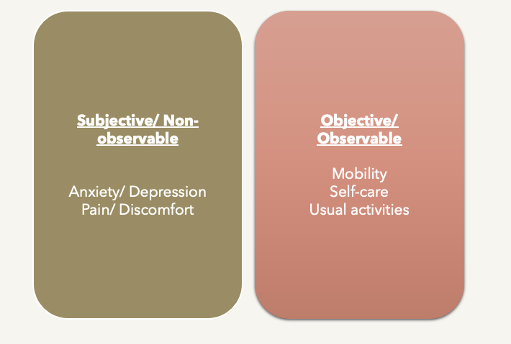

2.5.4 Key findings

In summary, the group discussions on inter-rater agreement mirrored findings from the existing literature. It is evident that both people with dementia and informal caregivers (as proxies) recognise the presence of a gap in their reports. However, both respondent types equally emphasise the validity and importance of their reports in assessing HRQoL for dementia research. This input will be considered during subsequent analyses when incorporating both respondents' reports. It is apparent, both from the literature and from the group’s discussions, that relying solely on one type of respondent neglects crucial insights into the HRQoL of people with dementia.

Specific concerns were raised regarding the interpretation of the "usual activities" and "anxiety/depression" dimensions. Even the "mobility" dimension was acknowledged to face potential interpretation differences. As further investigation into the EQ-5D dimensions is conducted, attention will be given to understanding and addressing potential discrepancies in interpretation between respondent types that may be influencing how and why they provide different reports about the same person.

The group highlighted pragmatic factors that play a central role in how HRQoL reports are provided. These factors include the proximity of the other respondent and the potential benefit of visual aids and prompts. This feedback highlights the importance of consistently considering this additional layer in PROM assessments – the pragmatic aspects of data collection and administration methods.

3 Wider outcomes considered in dementia trials

The primary focus of this thesis relates to the measurement of HRQoL for QALY estimation in the evaluation of dementia interventions, where different respondent’s data may be collected about the same person (PwD and proxy). In Chapter Two, it was established that the EQ-5D instrument is suitable for use in dementia populations, and the fundamental principles governing self and proxy assessments were outlined. To further evaluate the appropriateness of EQ-5D in dementia populations, an understanding of the key symptomology of dementia is essential to gauge how effectively a generic HRQoL measure like EQ-5D captures and aligns with dementia symptoms.

This chapter examines existing practices of dementia trials and studies, identifying key outcome measures used to assess dementia symptoms. Additionally, it compares the constructs included within dementia-specific HRQoL measures with EQ-5D’s dimensions, thereby providing additional assessment of EQ-5D’s efficacy within dementia populations. The insights gathered regarding core dementia symptom measures inform the systematic review presented in this chapter, guiding the search strategy. This systematic review aims to assess the convergent validity of EQ-5D (both its dimensions and overall score) with scores from dementia symptom measures. The review aims to identify relationships between EQ-5D dimensions and these symptom measure scores to be applied in subsequent analyses and to evaluate whether EQ-5D's dimensions adequately capture the key domains of dementia symptoms despite its generic nature.

3.1 Introduction

HRQoL is recognised as pivotal for health economic evaluation, however the outcomes selected from clinical studies can vary based on several factors including the intervention under investigation, target population and clinical endpoints. The selected outcome measures should possess the ability to detect changes in symptoms important enough that people with the condition would be willing to trade off length of life, for condition improvement. Despite dementia being traditionally hallmarked by cognitive deterioration, reviewing the frequent and recurring outcome measures integrated within dementia studies provides insights into the core symptom domains of dementia that extend beyond cognitive impairment.

In the development of economic models, an important element involves assigning utilities to health states within the model structure. These health states play a key role in characterising disease progression and should accurately reflect experience of the condition. Current research has highlighted that evidence supporting a clear and consistent association between impaired cognitive status and lower HRQoL is limited (Banerjee et al., 2009). Therefore, relying on a model that uses cognitive classification alone as the predictive variable for dementia severity and progression may have restricted abilities to estimate the impact of dementia and the potential benefits gained from interventions (Green and Zhang, 2016).

It has been discussed in the wider literature that the central clinical features of dementia are broadly categorised by the effects of cognition and function and behaviour/mood symptoms (Jutkowitz et al., 2017), and that changes in one or more of these domains can provide the basis for assessing the severity and progression of dementia (Green and Zhang, 2016). The aim of this chapter is to offer a condensed overview of the primary outcomes incorporated in dementia trials, thereby presenting what is currently regarded as standard practice. This information will then inform the subsequent systematic review that is presented within this chapter by identifying measures that can be used to assess convergent validity of EQ-5D in the context of dementia.

3.2 Methods

A pragmatic search aimed at identifying literature reviews focusing on outcomes in dementia was conducted and a relevant focused literature review was identified and appraised: Harrison et al.'s "Outcomes measures in a decade of dementia and mild cognitive impairment trials," published in Alzheimer's Research & Therapy in 2016 (Harrison et al., 2016). This paper was deemed a suitable starting point, however due to the year of publication (2016), it would now be considered outdated. To bridge the gap between its findings and current practices, a search for dementia trials was conducted using the International Standard Randomised Controlled Trial Number (ISRCTN) registry database. This step enables an informal assessment while still gathering sufficient information for this stage of the thesis. The ISRCTN database includes study designs beyond randomised controlled trials (RCT) alone, including observational and interventional trials (BMC, 2021). The search strategy solely included the keyword “dementia”, and was then limited to completed and ongoing trials with no specified time constraints. To supplement the outcomes and measures identified from these trials, core outcome sets were searched for and summarised by intervention type. Additionally, NICE guidelines were consulted to incorporate a policy perspective when selecting outcomes to be considered in dementia trials and studies.

3.3 Results

Harrison et al. (2016) conducted a focused review of the literature to identify outcome measures used in dementia and mild cognitive impairment studies between 2004-2014, spanning a decade of research. They incorporated 805 original records into their review, with dementia trial records comprising over 80% of the total. The majority of these records consisted of peer-reviewed publications (n=630, 78%) and focused primarily on pharmacological interventions (n=487, 60%).

QoL outcome measures were included in only 13% of the studies, the assessments tools for which were the Quality of Life in Alzheimer’s Disease scale (QoL-AD), EQ-5D, Dementia Quality of Life Scale (DEMQoL/DEMQoL proxy for proxy assessed version) and the Quality of Life in Late-Stage Dementia scale (QUALID/QUALIDEM for proxy assessed version). However, the authors indicated an interesting trend – highlighting that the measurement of QoL was more common in the more recent trials (Harrison et al., 2016). This observation prompts the notion that the significance of QoL assessments is gaining recognition over time within the dementia research landscape. Updating the search strategy may show a continued upward trajectory of the integration of QoL measures in contemporary trials, reinforcing the growing importance of QoL assessment in the field.

Rather than undertaking a formal update of the review, a search was conducted using the ISRCTN database. The condensed summary of this search, with a specific emphasis on the primary and secondary outcome measures gathered in dementia trials is presented in Table 1. Supplementary details were obtained by accessing the trial's respective site pages and publications as necessary. For a comprehensive overview, the complete data extraction table is available in Appendix 3. Four QoL measures emerged as primary or secondary outcomes across the identified trials, all focusing on health-related QoL. DEMQoL, in either its self-report or proxy version was the most commonly used (n=15), followed by EQ-5D and/or EQ-5D proxy (n=9), and QoL-AD and/or QoL-AD proxy (n=6). Additionally, one study incorporated the Short Form Health Survey (SF-12).

Table 1, Summary of identified dementia trials

Trial name | Is the trial complete? | Intervention type | Primary outcomes | HRQoL: primary or secondary outcome? | Measures both PwD and proxy HRQoL?
ACTIFCARE | ✓ | NI | Needs assessment, resource use | ✓ | ✓
AD2000 | ✓ | Ph | Cognition, function | × | N/A
ADEX | ✓ | N-Ph | Cognition | ✓ | ✓
ATTILA | ✓ | N-Ph | Time to institutionalisation, HRQoL | ✓ | ✓
CALM-AD | ✓ | Ph | Behaviour/mood (agitation) | × | N/A
DADE | ✓ | NI | Function | ✓ | ✓
DCM EPIC | ✓ | N-Ph | Behaviour/mood (agitation) | ✓ | ✓
DOMINO-AD | ✓ | Ph | Cognition, function | ✓ | ×
DPACT | ✓ | N-Ph | HRQoL, function, behaviour/mood | ✓ | ✓
DREAMS-START | × | N-Ph | Sleep quality | ✓ | ×
EVIDEM-E | ✓ | N-Ph | Behaviour/mood | ✓ | ×
EVIDEM-ED | ✓ | N-Ph | Counts of reviews | ✓ | ×
GREAT | ✓ | N-Ph | Goal setting | ✓ | ×
HTA-SADD | ✓ | Ph | Behaviour/mood (depression), resource use | ✓ | ✓
Trial name | Is the trial complete? | Intervention type | Primary outcomes | HRQoL: primary or secondary outcome? | Measures both PwD and proxy HRQoL?
iCST | ✓ | N-Ph | Cognition | ✓ | ×
IDEAL | × | NI | HRQoL, Well-being | ✓ | ×
mCST | ✓ | N-Ph | Cognition, HRQoL | ✓ | ✓
PRESIDE | ✓ | N-Ph | Feasibility | ✓ | ✓
REMCARE | ✓ | N-Ph | HRQoL, behaviour/mood | ✓ | ✓
SENSE-Cog | ✓ | N-Ph | HRQoL | ✓ | ✓
WHELD | ✓ | N-Ph | Behaviour/mood (agitation) | ✓ | ×
Intervention type code: Ph, pharmacological, N-Ph, non-pharmacological; NI, non-interventional, i.e., observational study with no intervention; N/A not applicable

Table 2 details the instruments used to measure the primary outcomes in the dementia trials. The table illustrates that there are a diverse range of instruments used to capture the same outcome. The range of instruments expands further when also examining secondary outcomes, as presented in Appendix 3.

Table 2, Instruments used to capture the primary outcomes in identified dementia trials

Primary outcome | Instrument/measurement (count if >1)
Behaviour/mood | CMAI (3), NPI (2), CSDD
Cognition | MMSE (2), CAMDOG-DS, SDMT, ADAS-Cog
Feasibility | Recruitment, retention and acceptability
Function | BADLS (3), Dependence Scale
Goal setting | Bangor Goal-setting interview
HRQoL | DEMQoL (4), QoL-AD (2), EQ-5D (2)
Needs assessment | CANE
Other | Number of reviews, Time to institutionalisation, WHO-5
Resource use | CSRI, RUD
Sleep quality | SDI
ADAS-Cog, Alzheimer’s Disease Assessment Scale – Cognitive subscale; BADLS, Bristol Activities of Daily Living scale; CAMDOG-DS, Cambridge cognitive examination for older adults with Down’s syndrome; CANE, Camberwell Assessment of Needs for the Elderly; CMAI, CMAI, Cohen Mansfield Agitation Inventory; CSRI, Client Services Receipt Inventory; CSDD, Cornell Scale for Depression in Dementia; DEMQoL, Dementia Quality of life scale; NPI, Neuropsychiatric Inventory; QoL-AD, Quality of Life in Alzheimer’s Disease scale; RUD, Resource Utilisation in Dementia; SDI, Sleep Disorders Inventory; SDMT, Symbol Digit Modalities Test; WHO-5, The World Health Organisation Five Well-Being Index

For all types of trials and studies, the primary and secondary outcomes considered for collection are related to the type of intervention and its goals as a treatment. Through the search for dementia trials, both interventional and non-interventional studies were identified, leading to the concept of categorising dementia trials into three key types: pharmacological, non-pharmacological and non-interventional studies. All of which have specific objectives that are relevant within their respective classifications.

There is no known cure for dementia. Therefore pharmacological interventions such as drug therapies aim to slow down dementia progression and/or manage the symptoms of dementia. There are two main drug classes in terms of dementia medication: cholinesterase inhibitors and NMDA (N-Methyl-D-Aspartate) receptor antagonists (Jones, 2011). Both drug classes have slightly different mechanisms of action, but similarly affect receptors in the brain and can be used in combination. Both of these drug classes have the shared goal of slowing down cognitive decline, therefore trials of these interventions may typically opt to measure cognition as the primary outcome.

Non-pharmacological interventions are evidence-based treatments with a non-drug focus. Key types of non-pharmacological interventions for dementia are psychosocial treatments such as cognitive behavioural therapy (CBT) and occupational therapy (Oyebode and Parveen, 2019). These types of treatments typically involve working with the PwD to problem solve and to teach them new skills to modify dysfunctional thinking and behaviours (Patel et al., 2014). While they may have a range of goals, these psychosocial interventions mainly centre around promoting living independently (via improving basic daily functioning) and general well-being. These outcomes may be captured by a range of measures, including PROMs.

Other non-pharmacological interventions such as exercise programmes, music, dance and multi-sensory therapies generally have broader non-clinical aims such as impacting well-being and promoting living well with dementia. These types of interventions are often considered in addition to pharmacological and psychosocial interventions. Although they have broad applications and address the non-cognitive symptoms of dementia such as agitation, aggression and sleep disorders (Douglas et al., 2004), they are often difficult to show as cost effective due to limitations in the quality of the available evidence (Nickel et al., 2018).

Non-interventional studies are considered to be clinical studies, other than clinical trials (Francisconi et al., 2020). In the context of dementia research, they often involve observing people with dementia in natural environments without introducing specific treatments. These observational studies tend to focus on understanding disease progression and symptoms, and use real-world data such as medical records and memory clinic assessments. The goal is to gain insights into dementia's natural course, patterns and risk factors without necessarily implementing an external intervention. These studies may measure a range of outcomes, largely dependent on the setting, for example comparing needs assessments of people with dementia living in community dwelling or in institutionalised settings (Meaney et al., 2005).

The results from the ISRCTN database search align with Harrison et al.'s (2016) systematic review on outcomes measures, indicating a focus on cognitive measures in dementia trials. QoL was commonly selected as a secondary outcome, with DEMQoL emerging as the most frequently used instrument, including a mix of self and proxy administration. There was significant heterogeneity in the chosen outcome measures across trials, echoing concerns raised by Harrison et al (2016). This inconsistency limits the comparability and interpretation of findings across studies. Efforts to address this issue by standardising outcome measures, possibly through the development of core outcome sets, have been proposed in the literature. Standardisation of outcomes aims to improve the useability of data for meta-analysis and secondary analyses, therefore enabling more robust conclusions to be drawn across trials.

3.3.1 Core outcome sets

The purpose of core outcome sets are to define agreed standarised sets of outcomes that are recommended for inclusion when assessing interventions in trials. The process of core outcome set development involves engaging various stakeholders, in the case of dementia for example, people with dementia, caregivers, healthcare professionals and policy makers.

Due to the high degree of variability in outcome measures adopted across dementia trials, there has been growing interest in establishing core outcome sets for dementia studies. However, due to the different types of dementia interventions, there is to date no singular core outcome set. Core outcome sets were identified for both pharmacological and non-pharmacological dementia interventions, which are summarised within this section.

3.3.1.1 Core outcomes for pharmacological interventions

Webster et al. (2017) generated a core outcome set for disease modifying pharmacological interventions (Webster et al., 2017). Primarily a systematic review was conducted, whereby 81 outcome measures were detected from 125 dementia trials. Outcomes were then differentiated by measurement domain, such as cognition, QoL and biological markers. Various aspects related to the identified outcome measures were considered, including the measure’s psychometric properties and the frequency of use across trials.

People with dementia, caregivers and conference experts were consulted and highlighted cognition via the Mini-Mental State Examination (MMSE) or the Alzheimer’s Disease Assessment Scale-Cognitive Subscale (ADAS-Cog), and biological markers (such as magnetic resonance imaging (MRI) scans and fluid markers) as core and fundamental for measurement. Other non-core, but recommended outcomes were: neuropsychiatric symptoms via the Neuropscychiatric Inventory (NPI), activities of daily living via the Disability Assessment for Dementia (DAD) and QoL via DEMQoL.

The importance of measuring QoL was emphasised for phase three trials where there are economic considerations and QALYs are to be considered. However the conference experts did not include an economist, therefore DEMQoL was recommended solely on the basis that it can be used to estimate QALYs and that it can be administered via both PwD and proxy assessment. When discussing QoL measurement, the authors additionally noted the need to measure both PwD and proxy reports for the case of participant deterioration (Webster et al., 2017).

3.3.1.2 Core outcomes for non-pharmacological interventions

In 2015, the EU Joint Programme - Neurodegenerative Disease (JPND) working group report (JPND, 2015) updated a 2008 core outcome set (Moniz-Cook et al., 2008) with the scope of psychosocial intervention research in dementia care. The development process involved a mix of methods, including conducting consensus workshops and systematic literature reviewing. They divided domains into those related to people with dementia, caregivers and staff.

The primary study identified mood, QoL, activities of daily living, behaviour and global disease as core domains for measurement in people with dementia (Moniz-Cook et al., 2008). This was since updated to the following domains and outcome measures: mood via the Cornell Scale for Depression in Dementia (CSDD) or Geriatric Depression Scale 15-item version (GDS-15); QoL via Quality of Life in Alzheimer’s Disease (QoL-AD), the Dementia Quality of Life instrument (DQoL), the Quality of Life in Late-stage Dementia Scale (QUALID/QUALIDEM) or DEMQOL; HRQoL via EQ-5D and activities of daily living via the Lawton Instrumental Activities of Daily Living (IADL) Scale, the Katz Index of Activities of Daily Living (Katz ADL), the Alzheimer’s disease cooperative study – activities of daily living inventory (ADCS-ADL), Bristol Activities of Daily Living Scale (BADLS) or the Disability Assessment for Dementia (DAD) (JPND, 2015).

Another core outcome set was identified and was published in 2020. This study focused on non-pharmacological health and social care community based interventions (Reilly et al., 2020), with the broad scope of covering different types of interventions and social programmes, such as memory cafes, art-based activities and educational programmes.

The development process involved literature reviewing to detect outcomes, followed by consultation with various stakeholders to establish the identified outcome’s relevance through interviews and focus groups. This resulted in a long-list of outcome items, which were refined under four umbrella domains: self-managing dementia symptoms, QoL, friendly neighbourhood and home and independence (Harding et al., 2019). Upon further analyses and application of mixed-methods, 13 outcome items were identified to be considered “core” (Reilly et al., 2020). These items included meaningful activities, feeling safe and secure and vision and hearing.

A systematic literature review of measurement instruments to identify appropriate tools that capture the 13 core outcomes was conducted (Harding et al., 2021). It was reported that none of the instruments met face validity threshold criteria, however the following instruments were highlighted as being the most relevant: Older Americans’ Resources and Services Instrumental Activities of Daily Living, The Adult Social Care Outcome Toolkit, The Nottingham Health Profile and Engagement and Independence in Dementia Questionnaire (Reilly et al., 2020).

3.3.2 Policy perspective on outcomes to consider in dementia trials and studies

NICE guidelines and appraisal documents were consulted to incorporate a policy perspective regarding outcomes to be measured in dementia intervention studies. In 2010, a multiple technology appraisal was submitted to NICE by Eisai and Pfizer (pharmaceutical companies) (NICE, 2011a, NICE, 2010) which evaluated acetylcholinesterase inhibitors (AChEI) for use in Alzheimer’s disease. To date, AChEI’s are still considered to be first line drug therapies for the management and treatment of dementia (BNF, 2021).

As part of the technology appraisal, systematic literature reviewing was conducted to identify and summarise relevant trials. The authors highlighted that typically only one measure was selected as the primary outcome measure, which was reductive because different symptom domains are impacted to different degrees by treatments and disease progression (NICE, 2011a). In the final appraisal document, it was noted that despite MMSE traditionally dominating outcome measurement of dementia disease progression, it is fundamental that it is not considered the sole determinant of treatment decisions. It was recommended that a range of tools should be used that can provide a clinically meaningful evaluation of the patient’s health state, such as cognition plus global disease, function and behavioural impairment (NICE, 2011c).

When broadening the policy lens beyond the UK, the United States Food and Drug Administration (FDA) propose that dementia clinical trials should use co-primary outcome measures, including cognition and function or global assessment measures in drug trials (U.S. FDA, 2013). The International Consortium for Health Outcomes Measurement (ICHOM) have also recommended the following outcome measures in their standard set for dementia: Neuropsychiatric Inventory (NPI) (behaviour/mood), MoCA (cognition), Bristol Activities of Daily Living Scale (BADLS) (activities of daily living), QoL-AD (QoL), Quality of Well Being Scale (QWB) (well-being), EQ-5D (HRQoL) and Clinical Dementia Rating scale (CDR) (global disease severity) (ICHOM, 2016).

3.4 Summary of dementia outcomes

Core outcome sets are available; however, they are relatively recent, and their recommendations may not yet be integrated and reflected in dementia trial practices. It is evident that cognition is a characteristic symptom area in dementia and is therefore frequently measured via cognitive tests as a primary outcome measure. However, the relevance of performance in standardised cognitive tests is unclear, as translating such scores into practical and operative outcomes is not yet universally established (Tsoi et al., 2015). Therefore, the growing interest in measuring wider outcomes in dementia research is not unexpected. QoL and functional outcomes such as abilities to conduct daily activities have been discussed as potentially more relevant outcomes, particularly when considering economic impacts, as they reflect how an intervention impacts how a person feels and what they are able to do (Harrison et al., 2016).

The range of symptoms associated with dementia, coupled with the different types of interventions involved in its care and management, has resulted in the observed heterogeneity in the outcome domains considered for evaluation and the instruments used to measure them. In addition to the discussed outcomes, beyond-health outcomes are also applicable for measuring impacts of dementia interventions. These include aspects such as time to institutionalisation and service/resource use, as these are central objectives of dementia interventions that aim to maintain independence - a key driver of costs (Harrison et al., 2016), and are important concerns commonly reported by people with dementia and informal caregivers. Table 3 summarises the recurring outcome areas and instruments identified from the ISRCTN trial search, the core outcome sets and policy recommendation documents.

Table 3, Outcomes and instruments in dementia studies

Outcome | Instrument
Cognition | MoCA, MMSE, ADAS-Cog, SIB
Activities of daily living | BADLS, DAD, ADCS-ADL, Lawton, Katz Index, Barthel Index
Dementia specific HRQoL | DEMQoL, DEMQoL-proxy, QoL-AD, QUALID, QUALIDEM
Generic HRQoL | EQ-5D
Behaviour and mood | NPI, CMAI, CSDD, GDS-15
ADAS-Cog, The Alzheimer's Disease Assessment Scale-Cognitive Subscale; ADCS-ADL, Alzheimer’s Disease Cooperative Study Activities of Daily Living Scale; BADLS, Bristol Activities of Daily Living Scale; CMAI, Cohen-Mansfield Agitation Inventory; CSDD, Cornell Scale for Depression in Dementia; DAD, Disability Assessment for Dementia; GDS-15, Geriatric Depression Scale 15 items; MoCA, Montreal Cognitive Assessment; MMSE, Mini-Mental State Examination; NPI, Neuropsychiatric Inventory; QoL-AD, Quality of Life in Alzheimer's disease scale; QUALID, Quality of Life in Late-Stage Dementia Scale; QUALIDEM, Quality of Life in Late-Stage Dementia Scale proxy; SIB, Severe Impairment Battery

3.5 Core health-related quality of life measures

To enable a complete understanding of HRQoL measurement in dementia evaluations, the instruments that were identified as core are explored in detail, as reported in Table 3. These instruments included five dementia-specific QoL measures (DEMQoL and DEMQoL-proxy, QoL-AD, QUALID and QUALIDEM) and one generic measure (EQ-5D), all characterised by a health-related focus. EQ-5D measures generic aspects of HRQoL and is therefore applied across conditions. The dementia-specific measures provide a more focused assessment of the health-related challenges associated with dementia, including aspects such as cognition, emotional well-being and physical function. These HRQoL measures contrast with more general QoL measures, which typically include a broader range of life domains such as material, social and emotional well-being (Karimi and Brazier, 2016).

3.5.1 Core dementia specific health-related quality of life measures

Despite their shared goal in measuring dementia specific HRQoL, the domains and individual item components vary between the instruments. This section aims to summarise these domains by consulting the distinct instrument’s development and conceptual framework. This step involved identifying primary development papers and chain searching their references for any additional related information.

3.5.1.1 The DEMQoL Suite

The DEMQoL suite comprises of a PwD self-reported and a proxy-reported measure. Both measures include a similar but distinct item set. The proxy-version is intended for completion by either a formal or informal caregiver, granted they have sufficient knowledge of the person’s condition and experience. This inclusive approach to proxy completion allows for flexibility in obtaining valuable insights into the PwD’s QoL across different care settings. There are five overarching QoL domains across both instruments, these are: daily activities and looking after yourself, health and well-being, cognitive functioning, social relationship, and self-concept (Smith et al., 2005a). A summary of the developmental framework is provided in Appendix 3.1a, as well as tables displaying the items of the two instruments and their related domains.

3.5.1.2 QoL-AD

The QoL-AD measure can be completed by the PwD or a proxy, using the same instrument and identical item set for both respondent types. The instrument’s development and included items are based upon Lawton’s domains of QoL: behavioural competence, the objective environment, psychological well-being and perceived QoL (Logsdon et al., 2002, Jonker et al., 2004). A concise summary of the developmental details and framework can be found in Appendix 3.1b, accompanied by a table presenting the items of the measure.

3.5.1.3 QUALID

The QUALID is a proxy-reported measure specifically designed for assessing institutionalised populations with late-stage dementia. Its development was based upon Lawton’s domains of QoL in AD research (Lawton, 1994) and Logsdon’s pleasant event schedule in AD patients (Logsdon and Teri, 1997), including: cognitive functioning, the ability to perform activities of daily living and to engage in meaningful time use and social behaviour, and a favourable balance between positive emotion and absence of negative emotion and pleasant events. A summary of the QUALID’s framework and items is provided in Appendix 3.1c.

3.5.1.4 QUALIDEM

The QUALIDEM is again a proxy-reported measure intended for use in institutionalised populations. The measures conceptualisation was based upon adaptive tasks outlined in the “adaptation coping model” (Dröes, 1991), leading to the following domains: care relationships, positive affect, negative affect, restless tense behaviour, positive self-image, social relations, social isolation, feeling at home and having something to do (Dichter et al., 2016). Further details about the QUALIDEM measure and the instrument’s items are provided in Appendix 3.1d.

3.5.2 Core generic health-related quality of life measures

The sole generic HRQoL measure that was detected as core for consideration in dementia trials and studies is EQ-5D. EQ-5D comprises two parts: a descriptive system and a visual analogue scale (VAS). It can be administered in several ways including paper-and-pen, telephone interview and face-to-face, for which there are different versions with different sets of instructions for administration (EuroQol Research Foundation, 2023b). EQ-5D can be completed via self or proxy response. There are two proxy versions. In version one the proxy adopts their own perspective, and in version two proxies are asked to adopt a proxy-patient perspective (EuroQol Research Foundation, 2023a).

EQ-5D is widely used in trials globally, and there are a range of value sets available by country/region which enable index scores (or utilities) to be estimated that reflect the societal preferences of the given country (EuroQol Research Foundation, 2023c). These scores can then be integrated into country-specific economic evaluations. The development and item selection process for EQ-5D involved reviewing existing generic health measures at the time. It was reported that item content did not vary greatly between existing measures, mainly just by nomenclature, therefore the focus was to refine dimension categories (Devlin and Brooks, 2017). Each item reflects a different fundamental dimension of HRQoL; these are shown in Figure 3.

Figure 3, EQ-5D dimensions

3.5.3 Dementia-specific quality of life instrument items by EQ-5D dimension

Although it has been established that EQ-5D is a suitable HRQoL measure for dementia populations due to its good psychometric properties and concise nature (Li et al., 2018, Keetharuth et al., 2022), a deeper exploration into the association between EQ-5D and the dementia specific QoL measures was undertaken. This involved comparing EQ-5D dimensions with the four core dementia-specific instruments as presented in Table 4, thereby providing a cross-table of EQ-5D’s dimensions and each of the dementia-specific measures.

Table 4, Dementia specific QoL items by EQ-5D dimension

^{Instrument name}  _{EQ-5D dimension} | DEMQoL | DEMQoL-proxy | QoL-AD | QUALID | QUALIDEM
M |  |  |  |  | ✓  “Lays in bed”
SC | ✓  “Toileting” | ✓  “Cleaning, looking nice”
UA | ✓  “Things to do”, “Enjoying life” | ✓  “Useful part” | ✓  “Chores”, “Fun” | ✓  “Pleasant events” | ✓  “Enjoys daily life”, “Able to do things”
P/D |  |  |  | ✓  “Physically uncomfortable”, “Sounds of discontent”
A/D | ✓  “Worried/ anxious” | ✓  “Worried/anxious” | ✓  “Mood” | ✓  “Sad”, “Irritable”, “Calm” | ✓  “Anxious”
M, mobility; SC, self-care; UA, usual activities; P/D, pain/ discomfort; A/D, anxiety/ depression

This assessment indicates that none of the dementia-specific instruments directly incorporate items that cover all EQ-5D dimensions. However, all of the instruments do measure "anxiety/depression", and include an item related to conducting "usual activities", highlighting the particular importance attributed to these aspects in dementia. These dimensions specifically align with other core outcomes of function and behaviour/mood to consider in dementia research, as outlined in Table 3. Notably, "self-care" is exclusively addressed within the DEMQoL suite, while the aspects of "pain/discomfort" and "mobility" are considered within the QUALID and QUALIDEM scales, respectively.

The next step involved comparing the domains of the dementia-specific instruments against EQ-5D dimensions. Table 5 lists the domain categories present in the four identified core dementia specific instruments. Hypothetical corresponding EQ-5D dimensions are suggested and presented alongside, highlighting potential areas of measurement overlap.

Table 5, Dementia specific QoL domains by theoretical corresponding EQ-5D dimension

Dementia specific QoL domains | Theoretical corresponding EQ-5D dimension
Health and wellbeing | VAS, Index score
Daily activities and looking after yourself | Self-care, Mobility, Usual activities
Cognitive functioning | N/A
Social relationships | Usual activities
Self-concept | VAS, Index score*
Behavioural competence | Anxiety/depression, Usual activities
Psychological well-being | Anxiety/depression
Objective environment | Usual activities
Perceived QoL | VAS, Index score
Positive emotion | Anxiety/depression (absence of)
Negative emotion | Anxiety/depression (presence of)
Pleasant event | Usual activities
Positive affect | Anxiety/depression (absence of)
Restless tense behaviour | Anxiety/ depression
Care relationship | N/A
Negative affect | Anxiety/depression (presence of)
Social isolation | Anxiety/depression
Feeling at home | N/A
Having something to do | Usual activities
Positive self-image | VAS, Self-care
VAS, visual analogue scale
*association is unclear, but theorised for the purpose of this task

The objective here was not to hypothesise correlations between domain categories, but rather to identify conceptual overlap in measurement. This evaluation indicates that the EQ-5D has the potential to capture most of the overarching dementia-specific quality of life domains found in the cited instruments. However, there is a noted lack of corresponding dimensions for the dementia-specific domains of "cognitive functioning", "care relationship", and "feeling at home". In certain instances, a direct equivalence was observed, such as between negative emotion and “anxiety/ depression”. The absence and presence of positive/negative emotions/affects has been applied in this task, acknowledging that these concepts are not strictly interchangeable; however, for the purposes of this exercise, they were deemed equivalent. Additionally, while not strictly a dimension, in some cases the EQ-VAS presented as the most comparable feature and was therefore included for the purposes of this task. Despite the generic nature of EQ-5D, it becomes evident that it has the potential to capture most of the key overarching domains identified in the dementia-specific instruments within its own dimension categories.

3.5.4 Content validity versus feasibility of health-related quality of life measures in dementia populations

Content validity describes the psychometric property that examines the extent to which an instrument measures what it proposes to measure, and the relevance of an instrument’s items to its target respondents. This property can be verified by referring to the methods used to develop and test questionnaire items (Silberfeld et al., 2002).
There is typically a trade-off between content validity and the practicality of an instrument, determined by its feasibility and acceptability. These properties can be demonstrated by the time it takes to complete a measure, and comprehension of questions (Brazier and Deverill, 1999). The lack of these psychometric properties can have detrimental impacts on data quality, presenting as large proportions of missing data. When considering measures in dementia populations, the burden of extensive questioning can be especially challenging due to cognitive issues such as concentration and judgement.

Previously conducted systematic reviews were identified to understand this balance, summaries of which are provided in Appendix 3.2. From this information it was concluded that when considering HRQoL for use in dementia economic evaluations, the trade-off between content validity and feasibility is inevitable. Using an instrument with many items that covers multiple QoL domains may appear advantageous to avoid neglecting any areas, however this volume of questions can over-burden the respondent, resulting in poor quality data.

Another important trade-off to consider is the decision between using dementia specific or generic HRQoL measures. This choice involves balancing sensitivity to the clinical context, as reflected in dementia-specific measures, against the advantages of generalisability and comparability, which are achievable only with the use of generic measures. While this is a consideration across all disease areas, the literature highlights that there were already 15 different dementia specific HRQoL instruments before 2011 (Perales et al., 2013). This highlights the lack of consensus in conceptualising HRQoL for dementia and shows that there is no current “gold standard” for measuring and quantifying HRQoL in dementia, a point that is echoed within the wider literature (Perales et al., 2013, Gräske et al., 2014, Edelman et al., 2005).

In light of this, the prior research endorsing EQ-5D’s suitability for use in dementia populations, coupled with NICE guidelines advocating for EQ-5D utility scores to enable cross-comparison between intervention and disease areas (NICE, 2013), provides substantial support for prioritising EQ-5D in this thesis.

3.6 Dementia symptoms measures

Measures of dementia symptoms are considered core for collection in dementia trials and studies, including cognition, function and broadly behaviour/mood. These symptoms areas are well established clinical features in dementia, each contributing to the progression of the condition (Jutkowitz et al., 2017, Green and Zhang, 2016). There are frequently used instruments for measuring these symptom domains, some of which are designed specifically for use in dementia populations.

Due to the complex, multi-faceted nature of dementia symptoms, their impact can significantly influence the QoL of people with dementia. HRQoL instruments intended for this population should adequately capture these aspects. To investigate the potential of EQ-5D to concurrently detecting the impact of key dementia symptoms (cognition, function, and behaviour/mood), it was imperative to comprehend the instruments used to assess these outcomes. This section aims to present a summary of the core measures for dementia symptoms listed in Table 3.

3.6.1 Cognition

The core cognition instruments were: MMSE, MoCA, ADAS-Cog and SIB. Table 6 summarises the key features of these four cognition tools, all of which have the shared aim of assessing cognitive domains and providing quantitative insights into an individual's cognitive abilities and potential impairments. Two of these measures (ADAS-Cog and SIB) have been designed specifically for use in dementia populations and can be used as assessment tools to monitor and evaluate cognitive function and provide valuable information about the progression of dementia over time.

Table 6, Summary of cognition instruments

Name | Estimated duration (mins) | Intended purpose | Designed specifically for dementia | Number of items | Format | Scoring
MMSE | 5 – 10 | Dementia diagnosis |  | 30 | Questionnaire plus drawing task | 24-30, normal  19-23, MCI  10-18, moderate  <9, severe
MoCA | 10 | Detect cognitive impairment |  | 30 | Questionnaire plus drawing task | 26+, normal  18-25, MCI  10-17, moderate  <10, severe
ADAS-Cog | 45 – 60 | Assess cognitive symptoms of dementia | ✓ | 10 | Series of physical tasks | Range for 0 – 70, >18 indicating greater cognitive impairment
SIB | 20 | Assess skills in people with severe dementia | ✓ | 40 | One-step commands | Range 0 – 100, <63 indicates very severely impaired
MMSE, mini-mental state examination; MoCA, Montreal cognition assessment; ADAS-Cog, Alzheimer's Disease Assessment Scale–Cognitive Subscale; SIB, Severe Impairment Battery

MMSE and MoCA both involve administering standardised questions to the person for assessment via a questionnaire format – but may also include a drawing task to assess orientation (depending on the modification/version) (MoCA Cognition, 2021, Tidy, 2022). Both instruments have wider applications than dementia alone, for example they can be used as cognitive screening tools for other neurological conditions such as Parkinson’s and Huntington’s disease.

Unlike MMSE and MoCA, ADAS-Cog includes a series of physical tasks (under the headings: constructional and ideational praxis), such as sealing an envelope and making a fist (Heerema, 2021). ADAS-Cog may be considered more sensitive and reliable for use in populations already diagnosed with dementia (Kaufman et al., 2016), however it has the longest duration to administer. SIB was designed for use in populations with severe dementia, where standardised neurological tests are not suitable (Fish, 2011). There are therefore no cut-off points for “normal cognition”. Table 6 shows the cognitive item components by instrument.

A table listing the item components of the four cognition measures is provided in Table A3.3a in Appendix 3.3 and shows that there is an overlap in domains across the instruments, such as orientation, attention, calculation, recall and language. Cognitive domains requiring direct observation by a researcher for measurement are distinct features found exclusively in dementia-specific instruments, specifically categorised under ideation praxis and construction.

3.6.2 Function

There are two key types of activities of daily living (ADL) that can be measured to assess function: basic and instrumental. Basic ADL (BADL) describes tasks that are fundamental to survival and generally centre around self-care, such as bathing and feeding. Instrumental ADL (IADL) are complex skills that enable a person to live independently, such as managing finances and using a phone.

ADL performance scores can define a person’s functional or dependence status. These terms are often used interchangeably, the key distinction is that dependence defines a person’s reliance upon others. There are six identified core function instruments for dementia studies: BADLS, DAD, ADCS-ADL, Lawton IADL Scale, Katz Index of ADL and Barthel index. Table 7 provides a summary of the key features of these instruments.

Table 7, Summary of function instruments

Name | Estimated duration (mins) | Intended purpose | Designed for dementia | Format | Type of ADL | Number of items | Scoring
BADLS | Unclear | Measure ability of the PwD to carry out ADL | ✓ | Proxy-reported questionnaire | Both | 20 | 0 – 60: totally independent – totally dependent
DAD* | 15 – 20 | Measure ability of the PwD to carry out ADL | ✓ | Interview-based proxy questionnaire | Both | 40 | 0 – 100: most severe – without dependence
ADCS-ADL | 15 – 30 | Evaluate ADL abilities over time and detect changes in the PwD | ✓ | Proxy-reported questionnaire | Both | 23 | 0 – 78: higher scores are better functioning
Lawton  scale | 10 – 15 | Assess function in older people |  | Interview-based proxy questionnaire | IADL | 8 | 0 – 8: low function – high function
Katz index | 10 – 15 | Measure ADL ability and dependence |  | Observer or proxy report | BADL | 6 | 0 – 6: 6, full function, 4, moderate impairment, <2, severe functional impairment
Barthel | 20 | Measure function and need for assistance in BADL |  | Medical records, direct observation or interview | BADL | 10 | 0 – 100: totally dependent – completely independent
BADLS, Bristol activities of daily living scale; DAD, disability assessment for dementia; ADCS-ADL, Alzheimer's Disease Cooperative Study ADL Scale

*10 item version commonly used in practice; however full version includes 40 items

Three of the six ADL instruments are designed specifically for use in dementia populations, all of which are proxy-reported questionnaires that consider both BADL and IADL. The Lawton IADL scale is targeted for use in older adults. The Katz index of ADL and the Barthel index have wider clinical applications such as disability and rehabilitation, and the data for these instruments can either be collected via questionnaire or direct observation.

A list of ADL item domains for the six instruments is provided in Appendix 3.3, Table A3.3b. For the purposes of this exercise the 10-item DAD scale was considered, and items were collapsed into an overarching category, for example the ADCS-ADL inventory has a distinct item for “use of household appliances to do chores”, which here has been considered the same as “housekeeping/chores”. Independent of whether the instrument was targeted specifically for use in people with dementia, there are item domains that frequently recur; for example, five of the six instruments include items related to feeding, personal hygiene, dressing and using the toilet.

3.6.3 Behaviour/mood

Four core behaviour/mood measures were identified for use in dementia trials and studies. These were: the Neuropsychiatric Inventory (NPI), Cohen-Mansfield Agitation Inventory (CMAI), Cornell Scale for Depression in Dementia (CSDD) and Geriatric Depression Scale short form (15 items) (GDS-15).

The instruments measure different aspects of behaviour, mood and general mental health. The NPI has the broadest scope of the measures as it aims to measure behavioural disturbance via 12 neuropsychiatric symptoms that present in dementia, including depression and agitation (Cummings, 2020). The CMAI specifically assesses agitation alone (Cohen-Mansfield, 1991), and both the CSDD and GDS-15 measure depressive symptoms (Kørner et al., 2006).

Table 8, Summary of behavioural instruments

Name | Estimated duration (mins) | Intended purpose | Designed specifically for dementia | Format | Number of items | Scoring
NPI | 20 – 30 | Assess dementia-related behavioural symptoms | ✓ | Interview-based proxy questionnaire | 12 | 0 – 144, higher scores indicate greater severity
CMAI | 20 | Assess agitation in institutionalized older adults |  | Proxy-reported questionnaire | 29 | 29 – 203, higher scores indicate greater severity
CSDD | 20 | Assess the severity of depressive symptoms in people with dementia | ✓ | Interview-based proxy questionnaire | 19 | 0 – 38, higher scores indicate greater severity, >12 indicates probable depression
GDS-15 | <10 | Screening for depression symptoms in the elderly |  | Interview based questionnaire | 15 | 0 – 15; 0-4, normal, 5-8, mild depression, 9-11, moderate depression, 12-15 severe depression
NPI, Neuropsychiatric inventory; CMAI, Cohen Mansfield agitation inventory; CSDD, Cornell scale for depression in dementia; geriatric depression scale 15 items, GDS-15

NPI and CSDD are designed specifically for use in populations with dementia; CMAI and GDS are intended for use in general older adults. Three of the measures rely solely on proxy-reports. A cross-comparison of the instrument’s item domains is provided in Table A3.3c of Appendix 3.3. The only domain assessed by all of the measures is related to depression/depressive symptoms. However, the following five domains occur in three of the four instruments: agitation/aggression, anxiety/fear, apathy/indifference, night-time/sleep disturbance and appetite and eating disorders; highlighting the importance of these concepts across measures for measuring behaviour/mood in dementia.

3.7 Convergent validity of EQ-5D with core outcomes in dementia: a systematic review

This systematic review was specifically conducted for this thesis with the support of the supervisory team: Anju Keetharuth (AK), Donna Rowen (DR), and Allan Wailoo (AW). As first author, HH independently developed the systematic search strategy, reviewed the search results to determine inclusion or exclusion of articles, completed the full data extraction of the references and developed and conducted the quality appraisal assessment. HH also wrote the full paper, including the introduction, methodology, results and discussion sections of the systematic review. All authors contributed to refining various drafts of the manuscript and approved the final version. During the peer-review process, AK and HH jointly addressed reviewer comments.

This systematic review was accepted for publication in Health and Quality of Life Outcomes in 2022

https://hqlo.biomedcentral.com/articles/10.1186/s12955-022-02062-1

Hussain, H., Keetharuth, A., Rowen, D., & Wailoo, A. (2022). Convergent validity of EQ-5D with core outcomes in dementia: a systematic review. Health and Quality of Life Outcomes, 20(1), 1-18.

3.7.1 Introduction
As previously discussed, dementia is characterised by cognitive symptoms such as memory loss and speech and language impairments – but also impacts behaviour/mood, function (Green and Zhang, 2016), and general quality of life (QoL) (Banerjee et al., 2006). For decision-making to be optimal, the instrument used to measure HRQoL should be responsive and representative of the population in question, and the greatest comparability is produced when the same measure is used across studies. Previous reviews concluded that EQ-5D demonstrates strong acceptability and feasibility within this population due to its concise nature, and that the three-level version displays good overall psychometric properties in dementia research settings (Landeiro et al., 2020, Li et al., 2018). Given that EQ-5D is widely used, is acceptable in dementia populations and recommended by NICE guidelines (EuroQol Group, 1990), this systematic review will focus on the EQ-5D measure. There are additional measures that are considered core for collection in dementia studies as they distinctly measure the impact of the key dementia outcomes of: cognition, function, and behaviour/mood (Green and Zhang, 2016), and therefore together reflect dementia symptomology (as reported in Table 3). Evidence regarding convergent validity of EQ-5D with these core outcome measures would address the question of how effectively EQ-5D reflects the experience of dementia by capturing symptoms assessed by symptom measures, and therefore dementia-HRQoL.
Two previous recent systematic reviews that have explored HRQoL in dementia have commonly concluded that EQ-5D was the most appropriate utility instrument for use in dementia populations (Li et al., 2018, Landeiro et al., 2020). Although these reviews highlight the value of EQ-5D in dementia research, both reviews broadly investigated psychometric properties, as opposed to specifically focusing on the convergent validity with dementia clinical trial outcomes, which is an important consideration as EQ-5D is increasingly used in dementia populations. A recent review (2022) broadly assessed the psychometric performance of EQ-5D in dementia populations, however it focused solely on EQ-5D-5L (Keetharuth et al., 2022). An earlier review (2011) (Hounsome et al., 2011) directly explored EQ-5D-3L as a QoL measure in people with dementia, investigating various psychometric properties including feasibility, reliability, responsiveness and validity. However, the authors highlighted a key recurring theme in the lack of association between self-reported and proxy-reported EQ-5D, indicating problems with inter-rater reliability (Hounsome et al., 2011).
As previously discussed, proxy-report is when someone is asked to report on behalf of someone else, typically performed by a family member, caregiver or healthcare professional. Proxy-reports are particularly important in dementia research as there are specific challenges associated with collecting outcomes within a population of deteriorating cognition, including impaired recall and judgement (O’Shea et al., 2020). It is established within the literature that HRQoL reports made by people with dementia and proxies do not align, with self-reports often reflecting more optimistic responses (Banerjee et al., 2006, Smith et al., 2020, Pickard and Knight, 2005, Rand and Caiels, 2015, Hounsome et al., 2011). This divergence may be more pronounced for some aspects of HRQoL than others. Certain dimensions of HRQoL i.e., “anxiety/depression” and “pain/discomfort” in EQ-5D may be considered “less/non-observable” and therefore more difficult to proxy-report upon. The “mobility”, “self-care” and “usual activities” dimensions in EQ-5D are more “observable” and are therefore considered to be less subjective (Hounsome et al., 2011, Pickard and Knight, 2005). This issue is particularly important in dementia, since people with more severe cognitive impairment may not be able to reliably self-report their HRQoL. Therefore, while self-report is usually considered preferable, this may not be feasible for all people with dementia.
In light of the challenges surrounding the use of self and proxy reported HRQoL in dementia, there is the need to develop ways of overcoming these issues to ensure accurate and reliable analyses. It is important to retain the patient as the focus, therefore self-reports are considered default. However, to understand when it is better to use proxy-reports, dementia severity and dimension specific data should be explored. Therefore, there is a gap in the research to investigate the convergent validity of EQ-5D against core outcome measures in dementia for both self and proxy-reports.
Previous systematic reviews have explored the psychometric properties of EQ-5D (Landeiro et al., 2020, Li et al., 2018, Hounsome et al., 2011, Keetharuth et al., 2022), however these do not specifically focus on convergent validity and hence the level of detail provided on convergent validity is limited. Convergent validity is an important property that when explored in detail can highlight an instrument’s ability to measure defined constructs. Therefore, this review will focus specifically on convergent validity of EQ-5D. This research adds to the existing psychometric literature of EQ-5D in dementia populations, and aids in addressing the question of how well EQ-5D captures dementia outcomes in light of its widespread use. Therefore, a systematic literature review of the existing evidence was conducted, which to our knowledge is the first of its kind.

3.7.2 Systematic review aim
The aim of this systematic review was to assess the convergent validity of the five EQ-5D dimensions (both 3L and 5L versions) with pre-defined core outcomes in dementia, taking into consideration the potential impacts of respondent type (self vs. proxy EQ-5D reports).

3.7.3 Methods
The systematic review adopted the methodology outlined by the Centre for Review and Dissemination (CRD) (University of York CRD, 2009). The Preferred Reporting of Items for Systematic Review and Meta-Analysis guidance (PRISMA) (Moher et al., 2009) were followed for reporting the results, and a narrative approach adopted for reporting the main analysis.

3.7.3.1 Convergent validity
Convergent validity defines the strength of association between the measure of interest (in this case EQ-5D) and other measures via statistical significance of regression analyses or correlation coefficients. If the correlation with a measure capturing the same construct (kappa) is: >0.4 it is considered as moderate and convergent validity is established (>0.2: slight, >0.6: good and >0.8: very high) (Fayers and Machin, 2013).

3.7.3.2 Core dementia outcomes
Although cognition is the hallmark feature of dementia, the original description and diagnosis also include functional and behavioural deficits, whereby dementia severity and progression are assessed by changes in one or more of these outcome areas (Green and Zhang, 2016). Current practice for outcome collection in dementia clinical trials and studies has been previously explored within this chapter, whereby the ISRCTN database and core outcome sets were appraised and collated. Table 3 provides a summary of the key recurring outcome areas and measurement instruments identified as recommended, and considered as core for collection in dementia studies and trials.

3.7.3.3 Literature searching
The literature search was conducted in three electronic databases (Medline, PsycINFO and CINAHL) by one author (HH) initially in April 2021 from database inception, and later re-ran and updated to September 2022. Search terms included those related to dementia, EQ-5D and core measure names. The full search strategy is provided in Appendix 3.4. Title and abstract screening were conducted by one author (HH) and verified independently by another author (AK, Anju Keetharuth) to check for discrepancies and establish study inclusion. Included studies were then screened in full text by one author (HH) against pre-defined inclusion and exclusion criteria to determine eligibility for the review. If at this point a text did not include extractable data, it was excluded from the review. Any discrepancies were discussed between the authors and resolved prior to data extraction.

3.7.3.4 Inclusion/exclusion criteria
Studies were considered eligible for inclusion within the review if they included individual level data from people with dementia of any type (as opposed to general ageing or mild cognitive impairment alone), they collected self and/or proxy reported EQ-5D-3L or EQ-5D-5L and they collected at least one of the predefined core dementia outcome measures (see Table 3). Studies reporting only EQ-VAS were excluded as the purpose of the review is to focus on measures for use in economic evaluation, and EQ-VAS cannot be used for this purpose. Studies collecting outcomes related to caregivers alone were excluded. To allow for diversity of the study types, all study designs were considered eligible for the review (e.g., observational studies and RCTs) but were limited to those published in English (see Appendix 3.5 for a table of the inclusion/exclusion criteria). Protocol papers, feasibility studies, conference abstracts, grey literature and previous systematic reviews were excluded, but were chain searched for additional eligible references.

3.7.3.5 Data extraction
Data on the study characteristics, settings, aspects of dementia (i.e., type and stage) and study objectives was synthesised using pre-defined extraction tables. Convergent validity of EQ-5D was captured against the reported core dementia outcome measures. Statistical data on relationships between the outcomes and EQ-5D index scores as well as with the EQ-5D dimensions were extracted. EQ-VAS data were not extracted. A narrative synthesis was used to interpret the extracted data.

3.7.3.6 Quality appraisal
The standardised GRADE assessment tool was adapted and used to assess the quality of the papers included in the review (Meader et al., 2014). Although this method is less formal than using a pre-existing quality appraisal tool, it was deemed the most appropriate as the review allowed for the inclusion of all study types. The quality appraisal included nine items regarding the study’s population, sample, outcome assessment, analysis and data resulting in a score of either high, medium or low quality (see Appendix 3.6 full details).

3.7.4 Results
The outcome of the literature search and screening is shown in Figure 4. The initial search strategy retrieved 282 records. Following the removal of duplicates there were 236 records remaining, for which the titles and abstracts were screened. After re-running and updating the search, 30 articles met the inclusion criteria for the review.

Figure 4, PRISMA flow diagram of literature searching hits

3.7.4.1 Study characteristics
Appendix 3.7 provides a summary of the characteristics of the selected studies. Of the 30 studies included, they were predominantly from European countries (n=15) (Ankri et al., 2003, Bhattacharya et al., 2010, Boström et al., 2007, Castro-Monteiro et al., 2014, Diaz‐Redondo et al., 2014, Érsek et al., 2010, Garre-Olmo et al., 2017, González‐Vélez et al., 2015, Haaksma et al., 2018, Heßmann et al., 2016, Kunz, 2010, Schiffczyk et al., 2010, Van De Beek et al., 2019, Vogel et al., 2006, Michalowsky et al., 2021) and the UK (n=7) (Bryan et al., 2005, Farina et al., 2020, Orgeta et al., 2015a, Sheehan et al., 2012, Trigg et al., 2015, King et al., 2022, Martin et al., 2019). There were a total of 17 papers published since 2012 (Bhattacharya et al., 2010, Bonfiglio et al., 2019, Castro-Monteiro et al., 2014, Diaz‐Redondo et al., 2014, Easton et al., 2018, Farina et al., 2020, Garre-Olmo et al., 2017, González‐Vélez et al., 2015, Haaksma et al., 2018, Heßmann et al., 2016, Orgeta et al., 2015a, Sheehan et al., 2012, Trigg et al., 2015, Van De Beek et al., 2019, Ashizawa et al., 2021, King et al., 2022, Michalowsky et al., 2021, Martin et al., 2019) (last ten years), and the most recent study included was from 2022 (King et al., 2022). Less than a fifth of the studies used data from RCTs (n=5) (Bhattacharya et al., 2010, Boström et al., 2007, Kunz, 2010, Martin et al., 2019, Orgeta et al., 2015a). Alzheimer’s disease (AD) was the most included type of dementia, and it was the sole subtype evaluated in over a third of the studies (n=11) (Bhattacharya et al., 2010, Garre-Olmo et al., 2017, Haaksma et al., 2018, Heßmann et al., 2016, Karlawish et al., 2008a, Karlawish et al., 2008b, Naglie et al., 2011b, Naglie et al., 2011a, Trigg et al., 2015, Vogel et al., 2006, Ashizawa et al., 2021); four studies considered AD in combination with dementia with Lewy Bodies (DLB) (Boström et al., 2007, Van De Beek et al., 2019), vascular dementia (VD) (Bryan et al., 2005) or mixed (Schiffczyk et al., 2010). Seven of the studies considered any type of dementia (Ankri et al., 2003, Érsek et al., 2010, Farina et al., 2020, Orgeta et al., 2015a, Sheehan et al., 2012, King et al., 2022, Michalowsky et al., 2021), and eight studies did not specify the type of dementia under investigation (Castro-Monteiro et al., 2014, Diaz‐Redondo et al., 2014, Bonfiglio et al., 2019, González‐Vélez et al., 2015, Kunz, 2010, Kuo et al., 2010, Easton et al., 2018, Martin et al., 2019).
The studies included samples across all stages of dementia, from very mild to severe, which was typically characterised by MMSE scores. Most of the studies defined dementia severity via MMSE scores, however some studies did not collect MMSE, thereby using an alternative outcome, i.e., CDR (Castro-Monteiro et al., 2014, Diaz‐Redondo et al., 2014, Bryan et al., 2005, González‐Vélez et al., 2015, Orgeta et al., 2015a, Sheehan et al., 2012). The lowest mean MMSE reported was 12.8 (Ankri et al., 2003), and the highest was 24.9 (Bonfiglio et al., 2019, Vogel et al., 2006). The study sample sizes ranged from 48 (Vogel et al., 2006) – 1004 (Griffiths et al., 2020) participants. EQ-5D-3L was most commonly collected (n=27), and only four studies collected EQ-5D-5L (Bonfiglio et al., 2019, Easton et al., 2018, Michalowsky et al., 2021, Ashizawa et al., 2021) (one study considered both EQ-5D-3L and EQ-5D-5L (Michalowsky et al., 2021)). There was a mix of study settings; eleven studies focused solely on community dwelling people with dementia (Bhattacharya et al., 2010, Bonfiglio et al., 2019, Bryan et al., 2005, Karlawish et al., 2008a, Kunz, 2010, Karlawish et al., 2008b, Naglie et al., 2011b, Naglie et al., 2011a, Orgeta et al., 2015a, Schiffczyk et al., 2010, Michalowsky et al., 2021), while six studies collected data from institutionalised residents alone (Griffiths et al., 2020, González‐Vélez et al., 2015, Castro-Monteiro et al., 2014, Diaz‐Redondo et al., 2014, Easton et al., 2018, Ashizawa et al., 2021). Quality of life data were collected entirely via a proxy (n=9) (Bryan et al., 2005, Castro-Monteiro et al., 2014, Diaz‐Redondo et al., 2014, Garre-Olmo et al., 2017, González‐Vélez et al., 2015, Haaksma et al., 2018, Naglie et al., 2011b, Karlawish et al., 2008b, Ashizawa et al., 2021) or self-report (n=3) (Naglie et al., 2011a, Van De Beek et al., 2019, Karlawish et al., 2008a) in some studies, however over half of the studies used both proxy and self-report (n=17) (Ankri et al., 2003, Bhattacharya et al., 2010, Bonfiglio et al., 2019, Boström et al., 2007, Easton et al., 2018, Farina et al., 2020, Heßmann et al., 2016, Karlawish et al., 2008a, Kunz, 2010, Karlawish et al., 2008b, Griffiths et al., 2020, Orgeta et al., 2015a, Schiffczyk et al., 2010, Sheehan et al., 2012, Trigg et al., 2015, Vogel et al., 2006, King et al., 2022, Michalowsky et al., 2021). Where self-report was exclusively used, the studies explored people with mild dementia. Of the seventeen studies that included people with severe dementia within their sample, ten studies used both self and proxy reports (Trigg et al., 2015, Sheehan et al., 2012, Schiffczyk et al., 2010, Griffiths et al., 2020, Kuo et al., 2010, Heßmann et al., 2016, Farina et al., 2020, Boström et al., 2007, Ankri et al., 2003, King et al., 2022), six studies used proxy-reports alone (González‐Vélez et al., 2015, Garre-Olmo et al., 2017, Diaz‐Redondo et al., 2014, Castro-Monteiro et al., 2014, Naglie et al., 2011b, Ashizawa et al., 2021) and one study did not report the rater type (Érsek et al., 2010). The proxy-type was most commonly an informal caregiver (i.e., family member, friend, or neighbour), however four studies also included formal caregivers (Ankri et al., 2003, Bonfiglio et al., 2019, González‐Vélez et al., 2015, Griffiths et al., 2020) and one study additionally used clinicians to proxy report (Bryan et al., 2005). EQ-5D was mainly administered via an interview (n=21) (Ankri et al., 2003, Bhattacharya et al., 2010, Boström et al., 2007, Castro-Monteiro et al., 2014, Easton et al., 2018, Garre-Olmo et al., 2017, Haaksma et al., 2018, Heßmann et al., 2016, Karlawish et al., 2008a, Karlawish et al., 2008b, Kunz, 2010, Kuo et al., 2010, Griffiths et al., 2020, Naglie et al., 2011a, Naglie et al., 2011b, Orgeta et al., 2015a, Schiffczyk et al., 2010, Sheehan et al., 2012, Trigg et al., 2015, Vogel et al., 2006, King et al., 2022, Michalowsky et al., 2021), three studies did not report this detail (Diaz‐Redondo et al., 2014, Érsek et al., 2010, Van De Beek et al., 2019), and one study used interviews for PwD and self-administration for proxies (Vogel et al., 2006). Of the four studies that solely used PwD self-reported EQ-5D, two collected this via interview (Naglie et al., 2011b, Karlawish et al., 2008a), one used self-administration booklets (Ashizawa et al., 2021) and one did not report this information (Van De Beek et al., 2019).

3.7.4.2 Core dementia outcome measures
Table 9 lists the measures that were used to measure the core dementia outcomes in the studies. Details of the measures have been previously reported within this chapter. In total there were 12 distinct measures: Two cognition measures (MMSE and ADAS-Cog), six measures of function (Katz ADL, ADCS-ADL, Barthel index, Lawton scale, DAD and BADLS) and four behaviour/mood measures (NPI, CSDD, GDS and CMAI). Where it was reported, the measures were completed either by proxy, researcher observation, or a combination of information such as self or proxy information and recent care records. The most predominant measure was the MMSE (n=25), followed by the NPI (n=12).

Table 9, Core dementia outcome measures
 | Cognition |  | Function |  |  |  |  |  | Behaviour/mood
Author | MMSE | ADAS-Cog | Katz index | ADCS-ADL | Barthel index | Lawton scale | DAD | BADLS | NPI | CSDD | GDS | CMAI
Ankri, 2003 (Ankri et al., 2003) | ✓ |  | ✓
Ashizawa, 2021 (Ashizawa et al., 2021) | ✓ |  |  |  | ✓
Bhattacharya, 2010 (Bhattacharya et al., 2010) | ✓ |  |  | ✓ |  |  |  |  | ✓ | ✓
Bonfiglio, 2019 (Bonfiglio et al., 2019) | ✓ |  |  |  | ✓ | ✓ |  |  |  |  | ✓
Bostrom, 2007 (Boström et al., 2007) |  | ✓ |  |  |  |  | ✓ |  | ✓
Bryan, 2005 (Bryan et al., 2005) | ✓ |  |  |  |  |  |  | ✓ | ✓
Castro-Monteiro, 2014 (Castro-Monteiro et al., 2014) | ✓ |  |  |  | ✓ |  |  |  |  | ✓
Diaz-Redondo, 2014 (Diaz‐Redondo et al., 2014) | ✓ |  |  |  | ✓ |  |  |  |  | ✓
Easton, 2018(Easton et al., 2018) |  |  |  |  | ✓ |  |  |  | ✓
Ersek, 2010 (Érsek et al., 2010) | ✓
Farina, 2020 (Farina et al., 2020) | ✓ |  |  |  |  |  |  |  | ✓
Garre-Olmo, 2017 (Garre-Olmo et al., 2017) | ✓ |  |  |  |  |  | ✓ |  | ✓
Gonzalez-Velez, 2015 (González‐Vélez et al., 2015) | ✓ |  |  |  | ✓ |  |  |  |  | ✓
Haaksma, 2018 (Haaksma et al., 2018) | ✓ |  |  |  |  |  | ✓ |  | ✓
Heßmann, 2018 (Heßmann et al., 2016) | ✓ |  |  | ✓ |  |  |  |  | ✓
Karlawish, 2008 [1] (Karlawish et al., 2008a) | ✓ |  |  |  |  | ✓ |  |  |  |  | ✓
Karlawish, 2008 [2] (Karlawish et al., 2008b) | ✓ |  |  |  |  | ✓ |  |  |  |  | ✓
King, 2022 (King et al., 2022) | ✓ |  |  |  |  |  |  | ✓
Kunz, 2010 (Kunz, 2010) | ✓ |  |  |  | ✓
Kuo, 2010 (Kuo et al., 2010) | ✓ |  |  |  | ✓
Martin, 2019 (Martin et al., 2019) |  |  |  |  |  |  |  |  |  |  |  | ✓
Michalowsky, 2021 (Michalowsky et al., 2021) | ✓ |  |  |  |  |  |  |  |  |  | ✓
Naglie, 2011 [1] (Naglie et al., 2011a) | ✓ | ✓ |  |  |  |  | ✓ |  | ✓ |  | ✓
Naglie, 2011 [2] (Naglie et al., 2011b) | ✓ | ✓ |  |  |  |  | ✓ |  | ✓
Orgeta, 2015 (Orgeta et al., 2015a) |  |  |  |  |  |  |  | ✓ |  | ✓
Schiffczyk, 2010 (Schiffczyk et al., 2010) | ✓ | ✓ |  |  |  |  |  |  |  |  | ✓
Sheehan, 2012 (Sheehan et al., 2012) |  |  |  |  |  | ✓ |  |  |  |  | ✓
Trigg, 2015 (Trigg et al., 2015) | ✓ |  |  |  |  |  | ✓ |  | ✓
van de Beek, 2019 (Van De Beek et al., 2019) | ✓ |  |  |  |  |  | ✓ |  | ✓ |  | ✓
Vogel, 2006 (Vogel et al., 2006) | ✓ |  |  |  |  |  |  |  |  |  | ✓
Number of studies | 25 | 4 | 1 | 2 | 8 | 4 | 7 | 3 | 12 | 5 | 9 | 1

3.7.4.3 EQ-5D convergent validity with cognition
It was hypothesised that cognition would have a positive correlation with EQ-5D whereby greater cognitive impairment would be associated with lower EQ-5D index scores (lower MMSE scores indicate greater cognitive impairment). Appendix 3.8 provides complete details of the empirical relationship between cognition and EQ-5D. In total, eighteen studies assessed the convergent validity between EQ-5D index scores and the cognitive measures (MMSE, n=17; ADAS-Cog, n=2; one study collected both measures (Bonfiglio et al., 2019)). Three studies reported a different relationship between cognition and EQ-5D by respondent type (Farina et al., 2020, Heßmann et al., 2016, Bonfiglio et al., 2019).
Within only seven distinct studies a statistically significant relationship (p<0.05) between cognition and EQ-5D was reported, all of which were positive correlations (Bonfiglio et al., 2019, Farina et al., 2020, Heßmann et al., 2016, Naglie et al., 2011b, Schiffczyk et al., 2010, Ashizawa et al., 2021, King et al., 2022), and three of these seven studies had a sample size of greater than 300 (Farina et al., 2020, Heßmann et al., 2016, Naglie et al., 2011b). Of the studies that reported statistically significant findings, the respondent type was predominantly an informal caregiver (five of seven studies) and were studies that had included participants spanning the entire dementia severity range (mild-to-severe). The one study that reported a statistically significant association between self-reported EQ-5D and cognition was within a mild-stage study sample (Bonfiglio et al., 2019). Figure 5 shows the proportion of studies that demonstrated a relationship between cognition and EQ-5D in both directions (see Appendix 3.8 for more details).
Figure 5, Direction of convergent validity between EQ-5D and cognition
*Total number of studies is n=19 as 2 studies report convergent validity twice

3.7.4.4 EQ-5D convergent validity with function
For the convergent validity between EQ-5D and the measures of function, a positive correlation was hypothesised whereby greater functional independence would be associated with higher EQ-5D index score. Twenty distinct studies provided empirical evidence of the convergent validity between EQ-5D and the measure of function within the study (ADCS-ADL, n=2; BADLS, n=2; Barthel index, n=7; DAD, n=6; Lawton scale, n=4; one study collected both Barthel index and Lawton scale (Bonfiglio et al., 2019)).
Two studies reported a difference in relationship between function and EQ-5D by respondent type, whereby the Lawton index showed a positive and significant correlation with proxy EQ-5D and a negative and non-significant correlation with self-rated EQ-5D (Bonfiglio et al., 2019, Sheehan et al., 2012). These two studies were the only reports of a negative association; both of these studies had a mainly mild-stage sample size of <200 participants. The remaining studies all reported a positive correlation between function and EQ-5D, of which the majority (15/16 studies) were statistically significant. Two studies explored function as a dependent variable within regression analyses, both of which found it to be a significant (p<0.01) determinant of proxy reported EQ-5D (Ashizawa et al., 2021, King et al., 2022), but not self-reported EQ-5D (King et al., 2022). One study had reported a positive correlation between ADCS-ADL and EQ-5D for both respondent types but was only statistically significant for proxy-report (Bhattacharya et al., 2010), and was again within a mild-stage study sample (Bhattacharya et al., 2010). Figure 6 shows the characteristics of the studies that reported convergent validity evidence between function and EQ-5D (Appendix 3.9 provides complete details).

3.7.4.5 EQ-5D convergent validity with behaviour/mood
For the behaviour/mood measures, higher scores indicate greater severity. Therefore, it was hypothesised that the measures would have negative correlations with EQ-5D, whereby more behavioural disturbance is associated with lower EQ-5D index scores. Seventeen distinct studies reported empirical evidence of the convergent validity between EQ-5D and the measure of behaviour/mood, four studies collected multiple measures (Bhattacharya et al., 2010, Heßmann et al., 2016, Naglie et al., 2011b, Naglie et al., 2011a) (CSDD, n=2; CMAI, n=1; GDS, n=8; NPI, n=10). Only one study captured agitation (via CMAI), reporting a negative correlation with EQ-5D which was only statistically significant for proxy-report (Martin et al., 2019).
Ten studies measured depression (via CSDD and GDS). All ten studies reported a negative correlation between the measure of depression and EQ-5D, whereby statistically significant results were found with self-rated EQ-5D only n=4 (Bonfiglio et al., 2019, Karlawish et al., 2008a, Naglie et al., 2011a, Van De Beek et al., 2019); proxy-EQ-5D only, n=2 (Naglie et al., 2011b, Orgeta et al., 2015a) and both respondent types, n=2 (Bhattacharya et al., 2010, Heßmann et al., 2016). One study did not report statistical significance, but rather strength of correlation coefficients – indicating moderate convergent validity between EQ-5D index scores and GDS (Michalowsky et al., 2021).
The NPI captures 12 broad neuropsychiatric symptoms and was administered in ten of the reviewed studies. Two of these studies reported a difference in relationship between NPI and EQ-5D by respondent type; one study found a negative correlation with self-rated EQ-5D, but a positive correlation with proxy-EQ-5D (Easton et al., 2018), while the other study found the inverse (Trigg et al., 2015). However, neither of these findings were statistically significant. The remaining studies all reported negative correlations, whereby statistical significance was found only with proxy-EQ-5D (Bhattacharya et al., 2010, Boström et al., 2007, Farina et al., 2020, Garre-Olmo et al., 2017, Haaksma et al., 2018, Heßmann et al., 2016, Naglie et al., 2011b). Figure 7 shows the characteristics of the studies that reported convergent validity evidence between the behaviour/mood measure and EQ-5D (Appendix 3.10 provides complete details).

Figure 6, Characteristics of studies reporting convergent validity between EQ-5D and function
*Indicates non-significant correlation (p>0.05). Y axis = sample size
Figure 7, Characteristics of studies reporting convergent validity between EQ-5D and behaviour/mood
*Indicates non-significant correlation (p>0.05). Y axis = sample size

3.7.4.6 Convergent validity evidence by EQ-5D dimension
A total of seven distinct studies reported empirical evidence of convergent validity of the pre-defined core dementia outcome measures with EQ-5D dimensions – summarised in Table 10. Cognition (via MMSE) was associated with self-reported “anxiety/depression” (Ankri et al., 2003), and people with more cognitive impairment self-reported fewer problems across all EQ-5D dimensions (Easton et al., 2018).
Function via the Katz index was associated with self-reported “mobility”, “self-care”, “usual activities”, and “pain/discomfort”; no relation was found with “anxiety/depression” (Ankri et al., 2003). Function via BADLS was correlated with proxy rated mobility, self-care and usual activities. Stronger correlations were observed for informal carer reports of self-care and usual activities, while the clinician rated mobility correlation was stronger (Bryan et al., 2005). Function via Barthel index was significantly correlated with self and proxy mobility, self-care and usual activities (Easton et al., 2018), and was associated with reporting problems in all EQ-5D dimensions minus anxiety/depression (Diaz‐Redondo et al., 2014).
Depression (via CSDD) was associated with reporting problems in “anxiety/depression” (Diaz‐Redondo et al., 2014); and depression (via GDS) showed evidence of moderate convergent validity with “mobility”, “self-care”, “usual activities” and “anxiety/depression” (Michalowsky et al., 2021). NPI summary scores were associated with proxy reported “anxiety/depression” (Bryan et al., 2005, Easton et al., 2018) and “mobility” (Easton et al., 2018).

3.7.4.7 Inter-rater agreement
In this section, respondent is taken to mean the respondent type, that is PwD or proxy. To further understand the potential impacts of respondent-type upon EQ-5D assessment, information related to the inter-rater agreement was extracted and is summarised in Table 11.
Nine studies, representing samples across the entire dementia-severity range, commented on the inter-rater agreement between self and proxy reported EQ-5D index scores (Ankri et al., 2003, Orgeta et al., 2015a, Vogel et al., 2006, Bonfiglio et al., 2019, Kunz, 2010, Farina et al., 2020, Heßmann et al., 2016, Griffiths et al., 2020, Sheehan et al., 2012). Proxy-EQ-5D index scores were found to be significantly lower than self-report (Kunz, 2010, Bonfiglio et al., 2019, Heßmann et al., 2016, Orgeta et al., 2015a, Sheehan et al., 2012) and had stronger correlations with clinical variables (Bhattacharya et al., 2010, Farina et al., 2020, Griffiths et al., 2020).
Of the EQ-5D dimensions, it was reported in two distinct studies that the “mobility” dimension had the strongest inter-rater agreement, produced at an acceptable level (kappa >0.4) (versus the other dimensions) (Ankri et al., 2003, Orgeta et al., 2015a). One of the studies reported that agreement between formal and informal proxies was also highest for “mobility” (kappa =0.61), and all other dimensions remained below the usually accepted level (Ankri et al., 2003).
Agreement between reports of the “usual activities” dimension was the lowest, with self-report reflecting more optimistic reports (Orgeta et al., 2015a, Kunz, 2010, Bonfiglio et al., 2019, Vogel et al., 2006). Agreement in the pain/discomfort dimension was low, whereby proxies rated more problems than people with dementia themselves (Orgeta et al., 2015a, Bonfiglio et al., 2019, Vogel et al., 2006). Evidence of agreement in the “anxiety/depression” dimension was mixed; one study found that PwD self-rated this dimension more optimistically than proxies (Bonfiglio et al., 2019), while another study reported that this was the only dimension that people with dementia had self-rated more problems (than proxies) (Vogel et al., 2006).

3.7.4.8 Quality appraisal
Of the 30 papers included within the review, 18 were of high quality, and the remaining 12 were considered to be of medium quality (Appendix 3.6 provides the full quality appraisal details).

Table 10, Empirical evidence of relationship between outcome measures and EQ-5D dimensions
Broader domain | Empirical evidence of association with EQ-5D dimensions | Proxy | Self | Reference
Cognition | Positive association between MMSE and anxiety/ depression (F=6.86, p= .001) |  | ✓ | Ankri et al (2003)
Cognition | People with severe cognitive impairment (MMSE 0-9) reported considerably fewer problems in all EQ-5D dimensions – compared with the less cognitively impaired. People with MMSE 20-30 reported the most problems with pain/discomfort. People with MMSE 10-19 had the most problems with usual activities |  | ✓ | Heßmann et al (2016)
ADL | Positive association between Katz indicator and mobility (F = 16.4, p < .0001) |  | ✓ | Ankri et al (2003)
ADL | Positive association between Katz indicator and self-care (F = 6.3, p < .0001) |  | ✓ | Ankri et al (2003)
ADL | Positive association between Katz indicator and usual activities (F = 6.8, p < .002) |  | ✓ | Ankri et al (2003)
ADL | Positive association between Katz indicator and pain/discomfort (F = 6.8, p < .002) |  | ✓ | Ankri et al (2003)
ADL | Boxplots indicate positive association between BADLS and mobility. Observed associations: all carers 0.44; clinician 0.59; live-in carers 0.38; (p<0.01) | ✓ |  | Bryan et al (2005)
ADL | Boxplots indicate positive association BADLS and self-care. Observed associations: all carers 0.57; clinician 0.62; live-in carers 0.65; (p<0.01) | ✓ |  | Bryan et al (2005)
ADL | Boxplots indicate positive association BADLS and usual activities. Observed associations: all carers 0.62; clinician 0.50; live-in carers 0.75; (p<0.01) | ✓ |  | Bryan et al (2005)
ADL | Reporting problems in all EQ-5D dimension (minus anxiety/depression) was significantly associated with worse scores on the Barthel index (p<0.01) | ✓ |  | Diaz-Redondo et al (2014)
ADL | Negative association between Barthel index score and self-reported mobility (-0.499), self-care (-.0609) and usual activities (-0.374) = p<0.01 |  | ✓ | Easton et al (2018)
ADL | Negative association between Barthel index score and proxy reported mobility (-0.555), self-care (-0.627), usual activities (-0.577) = p<0.01 | ✓ |  | Easton et al (2018)
Behaviour/mood | NPI summary score and EQ-5D anxiety/depression show positive association. Observed associations seen between clinician proxy rating = 0.46, p<0.01. No association for other proxy types | ✓ |  | Bryan et al (2005)
Behaviour/mood | Reporting problems in EQ-5D anxiety/depression dimension was significantly associated with Cornell scale score (p<0.01) | ✓ |  | Diaz-Redondo et al (2014)
Behaviour/mood | NPI negatively association with mobility (-0.177) and anxiety/depression (0.160) = p<0.01 | ✓ |  | Easton et al (2018)
Behaviour/mood | GDS demonstrated moderate convergent validity via strength of correlation coefficients with the following EQ-5D dimensions: mobility (3L), 0.310; self-care (3L), 0.446; usual activities (3L), 0.414; anxiety/depression (5L), 0.317; poor correlation with pain/discomfort – p values not reported |  | ✓ | Michalowsky et al (2021)

Table 11, Evidence of inter-rater agreement
 | Inter-rater agreement (PwD and proxy)
EQ-5D dimension | Evidence | Source
Mobility | Mobility was the only dimension to produce an acceptable level of agreement (kappa = 0.53 formal, 0.44 informal proxy) | Ankri et al (2003)
Mobility | Mobility dimension produced the best agreement on the dimensions (kappa coefficient indicate moderate agreement) | Orgeta et al (2015)
Mobility | Proxies rated more problems in the mobility dimension (than PwD had self-rated) | Vogel et al (2006)
Self-care | PwD self-rated self-care significantly more optimistically than proxies (1.0 +/- 0.2 vs 1.1 +/- 0.4, P = 0.031 | Bonfiglio et al (2019)
Self-care | Self-care was the only EQ-5D dimension to show a significant correlation between self and proxy report (r=0.51, p<0.01) | Vogel et al (2006)
Usual activities | Agreement (across proxy type) was lowest with PwD for usual activities dimension | Orgeta et al (2015)
Usual activities | The difference between the kappa-coefficients in the subgroups of mild vs moderate PwD was statistically significant (p>0.05) | Kunz et al (2010)
Usual activities | PwD self-rated usual activities significantly more optimistically than proxies (1.1 +/- 0.4 vs 1.6 +/- 0.8, P = 0.000) | Bonfiglio et al (2019)
Usual activities | Proxies rated more problems in the usual activities dimension (than PwD had self-rated) | Vogel et al (2006)
Usual activities | PwD self-rated pain/discomfort significantly more optimistically than proxies (1.5 +/- 0.7 vs 1.7 +/- 0.9, P = 0.015) | Bonfiglio et al (2019)
Usual activities | Proxies rated more problems in the pain/discomfort dimension (than PwD had self-rated) | Vogel et al (2006)
Anxiety/depression | PwD self-rated anxiety/depression significantly more optimistically than proxies (1.1 +/- 0.5 vs 1.3 +/- 0.5, P = 0.008) | Bonfiglio et al (2019)
Anxiety/depression | Anxiety/depression was the only dimension that PwD self-rated more problems than proxies | Vogel et al (2006)
EQ-5D index score | Intraclass correlation coefficient for EQ-5D total scores on PwD and proxy responses reflected average concordance – informal: ICC = 0.41, p<0.001), formal: ICC = 0.42, p<0.001) | Ankri et al (2003)
EQ-5D index score | Proxy EQ-5D ratings were significantly worse, with a mean difference of 0.1 in total score | Kunz et al (2010)
EQ-5D index score | Relationships between EQ-5D scores and clinical variables (CSDD, NPI, ADCS-ADL) were stronger for proxy assessments | Bhattacharya et al (2010)
EQ-5D index score | Proxy EQ-5D index scores were significantly lower than self-report (0.8 +/- 0.1 vs 0.9 +/- 0.1, P = 0.000) | Bonfiglio et al (2019)
EQ-5D index score | MMSE and NPI scores were significantly associated with EQ-5D proxy (p=0.00), but not EQ-5D self-report (p=0.63 | Farina et al (2020)
EQ-5D index score | EQ-5D index scores were significantly different based on the rater: 0.67 (+/- 0.33) for self-report and 0.45 (+/- 0.36) for proxy, p<0.001 | Heßmann et al (2016)
EQ-5D index score | Self-completed EQ-5D was poor at reflecting clinically important differences and changes in clinical measures, vs EQ-5D proxy which did capture these changes | Martin et al (2019)
EQ-5D index score | EQ-5D proxy index scores were significantly lower than self-scores | Orgeta et al (2015)
EQ-5D index score | Self-rated EQ-5D scores were significantly higher than proxy EQ-5D (patient mean EQ-5D score 0.71, 95% CI 0.64–0.77, proxies mean EQ-5D score 0.30, 95% CI 0.22–0.38), mean difference 0.40 (95% CI 0.32–0.48, p 5 0.001) | Sheehan et al (2012)

3.7.5 Discussion
There is a growing recognition of the wide use and acceptability of EQ-5D within dementia populations, thereby capturing generic HRQoL that can be converted to utilities for use in cost-effectiveness analyses. An important factor in exploring the use of such a measure is its psychometric properties. This targeted literature review identified 30 studies which contained empirical evidence related to the convergent validity of EQ-5D with at least one pre-defined core measure of: cognition (n=18), function (n=20), or behaviour/mood (n=17), the main symptom outcomes in studies of people with dementia. The findings indicate that EQ-5D convergent validity with clinical measures of function, behaviour/mood and cognition were in the expected direction. There is strong evidence of low inter-rater agreement between self and proxy report. Evidence at the dimension-level was limited, however there were some data to support convergent validity between specific EQ-5D dimensions and clinical outcomes, and differences in inter-rater agreement by dimension type.
It was hypothesised that as cognition deteriorates, EQ-5D would also deteriorate. If a switch in reporting occurs from self to proxy report when a PwD is no longer able to accurately self-report, this relationship would still be sustained. Only seven studies reported evidence of statistically significant associations with cognition, and they were all with a positive correlation, therefore agreeing with the a priori hypothesis. As observed and expected, proxy-reports showed stronger associations with the symptom measures. Where a negative but non-significant correlation with self-reported EQ-5D (within the same dyad) was reported (Bonfiglio et al., 2019, Farina et al., 2020); this finding could indicate that self-reported EQ-5D was collected until a certain stage of dementia severity before a switch to proxy-EQ-5D was initiated. However, papers did not tend to report this substitution. A negative relationship between self-reported EQ-5D and cognition would only be anticipated at the more severe stages of dementia progression if self-report were to still be used (where the PwD’s self-awareness has deteriorated) (Farina et al., 2020, Banerjee et al., 2006). In addition, a relationship between cognition and EQ-5D dimension “anxiety/depression” was observed – whereby reporting more problems in this dimension corresponded with greater MMSE scores (less cognitive impairment) (Ankri et al., 2003). These findings potentially highlight the greater self-awareness at earlier cognitive stages, whereby the person can recognise their own deterioration, as well as newly identifying with the label of the dementia diagnosis (thereby inducing “anxiety/depression”).
The evidence on the convergent validity between EQ-5D and function was more robust. Fifteen studies reported a statistically significant positive association between the outcomes, whereby greater functional impairment was correlated with lower EQ-5D as hypothesised. This finding is echoed within the wider literature whereby using ADL as a marker of disease progression within economic models has been suggested, due to its importance within dementia disease experience and its alignment with HRQoL (Sopina and Sørensen, 2018). Only two studies reported a negative association with self-reported EQ-5D, however both findings were from mild-stage study samples, where it would be expected that functional impairment would be relatively low. Overall, the studies that reported non-significant results were mainly (75%) from sample sizes of <200, further highlighting the challenges associated with considering smaller studies for psychometric appraisals. As previously outlined, there are two fundamental types of ADL: BADLs and IADLs. Where there were mixed reports such that proxy-EQ-5D correlated with the measure of function, but self-reported EQ-5D did not, the instruments were measures of IADL (ADCS-ADL (Bhattacharya et al., 2010, Heßmann et al., 2016) and Lawton Scale (Bonfiglio et al., 2019, Sheehan et al., 2012)). As IADLs are daily tasks that are not necessary for functional living, e.g., handling finances, it may be that people with dementia do not recognise their impairments in conducting these activities as they are now being performed by a proxy, and that the proxy is more aware of these impairments and their impact. All the studies that measured BADLs showed evidence of convergent validity with EQ-5D. In dementia progression, IADL impairment is experienced sooner and BADLs are not impacted until the more severe stages of disease (McLaughlin et al., 2010, Desai et al., 2004). Therefore, the relationship between EQ-5D with BADLs is not unanticipated, with EQ-5D being a measure of health status, it has been found to be more responsive to changes in severe stages of disease (Payakachat et al., 2015b).
It was hypothesised that lower EQ-5D scores would be associated with greater behavioural/mood disturbances, as demonstrated by a negative correlation. The included measures captured different aspects of behaviour/mood. The only study where agitation (via CMAI) was measured reported a statistically significant relationship with EQ-5D-proxy (Martin et al., 2019). Similarly, the evidence of convergent validity between neuropsychiatric disturbance (via NPI) and EQ-5D index scores was only statistically significant for proxy-report. Whereas evidence of EQ-5D convergent validity with measures of depression was observed to a greater extent with self-report. As depression is a more personal experience, and the NPI additionally captures broader neuropsychiatric symptoms, this pattern of association is predictable. However, this finding should be interpreted with caution as it is important to consider the impact of the administration of these symptom measures. The measures of depression are self-reported by the PwD themselves, while the broader symptom measures such as the NPI are proxy reported. Therefore, the relationships observed may be impacted by who is completing both measures, as opposed to the content of the measures themselves.
A key objective of this review was to explore the evidence surrounding convergent validity of EQ-5D dimensions with the core dementia outcome measures. The findings show that while the “observable” dimensions “mobility”, “self-care” and “usual activities” were associated with functional measures, the “non-observable” dimension “anxiety/depression” was associated with the measures of cognition and behaviour/mood. Although these findings indicate relationships between the symptom measures and the appropriate corresponding EQ-5D dimensions (thus demonstrating convergent validity of EQ-5D at the dimension-level), they should be interpreted with caution. Firstly, one paper reported that GDS had moderate convergent validity with all EQ-5D dimensions (minus “pain/discomfort”) (Michalowsky et al., 2021). Secondly, as highlighted by Karlawish et al (2008), 41% of EQ-5D scores were at 1.0 (perfect health), and people did not self-report impairment in dimensions such as “usual activities”, where one would typically expect to see disability in this population (Karlawish et al., 2008a). Lastly, the number of papers reporting evidence at the EQ-5D dimension level was low (n=7) and as indicated by Michalowsky et al (2021), there are additional factors to consider when observing dimensions on both EQ-5D-3L and EQ-5D-5L (Michalowsky et al., 2021).
Evidence assessing inter-rater agreement between self and proxy reports of EQ-5D index scores and where possible, EQ-5D dimensions mirrors the existing evidence – inter-rater agreement was generally poor, particularly for EQ-5D index scores. People with dementia self-reported fewer problems than their proxies. This finding is established within the literature (Hounsome et al., 2011, Shearer et al., 2012, Rand and Caiels, 2015) and is theorised to be the result of various factors such as response-shift (Römhild et al., 2018, Sprangers and Schwartz, 1999) and/or proxy burden resulting in “projection bias” (Shearer et al., 2012, Gräske et al., 2014, Gómez-Gallego et al., 2012).
When analysing inter-rater agreement at the dimension-level the findings were mixed. For the “non-observable” dimensions of “pain/discomfort” and “anxiety/depression”, agreement was low. This was also the case for the “self-care” dimension. The “observable” dimension of “mobility” was reported to have the strongest inter-rater agreement. Bonfiglio et al (2019) commented on this phenomenon, highlighting the difficulty in establishing agreement between people with dementia and proxies for non-observable factors such as “pain/discomfort” and “anxiety/depression” (Bonfiglio et al., 2019). Overall, proxy-assessments tend to show a higher degree of association with the symptom measures, an observation that has been recurrently noted in the wider literature (Muus et al., 2009, Elliott et al., 2006, Pickard and Knight, 2005, Rand and Caiels, 2015) and may be influenced by disease severity. Garre-Olmo et al (2017) reported that strength of the relationship between function (via DAD) and EQ-5D increased with increasing disease severity (Garre-Olmo et al., 2017). However, exploring the impact of disease severity was beyond the scope of this review.

3.7.5.1 Strengths and limitations
A key strength of this review is that it addresses a research area that has not been fully explored, and is to my knowledge, the first review of its kind to specifically synthesise the relevant evidence of EQ-5D convergent validity with dementia outcomes. However, the search strategy was only applied to limited electronic databases and therefore there may have been relevant studies that were not identified for this review (additional chain-searching of references was performed in an aim to minimise this). Only published journal articles in English language were included, resulting in a total of only 30 papers, and 25 papers were excluded solely because of the absence of extractable data. This highlights the lack of research focusing exclusively on psychometric properties, as this was a specified objective of only n=16 papers, with the review evidence originating mainly from trials and observational studies. However, despite the lack of studies with a specific psychometric focus, over half of the included studies were deemed as high quality for evaluating convergent validity. In addition, as the core dementia outcome measures considered within this review were pre-determined, it is possible that not all measures were covered in the evaluation. However, to mitigate against this potential bias, a methodological approach was adopted in selecting the core outcome measures for consideration.
The inclusion criteria were broad, a range of study types were included, and no date restriction was applied to the online databases. Another strength was the exploration of inter-rater reliability and extracting this information at the EQ-5D dimension-level where available. Lastly, there are several factors that were not explored as they were beyond the scope of this review. The characteristics of the proxy (i.e., sociodemographic factors) and pragmatic aspects i.e., instrument administration method were not explored, which could potentially impact the findings. A previously published study reported that where caregivers themselves were in pain (Orgeta et al., 2015b), they reported more problems with pain in the PwD, inferring projection bias. Additionally, one of the studies commented on the difference in validity by proxy type, reporting that the data provided by clinician-proxies, when compared to that of informal caregivers, had higher construct validity for the more “observable” dimensions of EQ-5D (i.e., “mobility” and “self-care”). On the other hand, data from informal caregivers had higher construct validity for the less observable dimensions (i.e., “anxiety/depression”).

3.7.6 Conclusion
This systematic literature review concludes that there is published evidence to indicate convergent validity between EQ-5D and the core dementia outcome measures of function, behaviour/mood, and cognition in the expected directions. Additionally, at the dimension-level, EQ-5D dimensions show associations with specific symptom measures, whereby the degree of association differed by respondent-type (PwD-self vs. proxy respondents). Overall inter-rater agreement was poor, particularly for the “non-observable” dimensions of EQ-5D (i.e., “pain/discomfort”, “anxiety/depression”). It should, however, be noted that these conclusions are based on very limited published data, and this review highlights the lack of studies investigating the psychometric properties of measures for use in dementia populations.
Measuring HRQoL in dementia populations is a complex issue, particularly when considering the challenges with both PwD and proxy reporting. This review revealed that, despite the limited evidence pool, EQ-5D exhibits convergent validity with other dementia outcomes, and that for “observable” dimensions (i.e., “mobility”, “self-care”, “usual activities”), the associations are stronger when using proxy-EQ-5D. There is currently no guidance on which report to use in evaluations and how to integrate scores. Future studies could explore whether a combination of EQ-5D dimensions reports from both respondent types could be considered for use in evaluations.

4 Descriptive statistics of dementia trial data

In the context of dementia research, assessing HRQoL presents challenges when considering self and proxy evaluations. Chapter Two highlights these challenges, noting a discrepancy in scores and establishing EQ-5D as a suitable HRQoL instrument for use in dementia populations. The central aim of this thesis is to delve into the debate surrounding which respondent’s EQ-5D data (PwD or proxy) should be used to inform QALY estimations in dementia evaluations.

Chapter Three investigates dementia outcome measures, aiming to gauge existing practices in trials and studies while identifying key symptom areas. Core outcome sets are identified which include symptom measures across cognition, function, behaviour/mood, and quality of life domains. This chapter also contrasts EQ-5D with dementia-specific measures, further appraising the value of EQ-5D in the context of dementia research and acknowledging the trade-off between specificity and generalisability of HRQoL measures. Additionally, Chapter Three includes a systematic review to assess EQ-5D's convergent validity with dementia symptom measures, revealing stronger associations with proxy reports. However, here it was shown that there are limited published studies that apply psychometric analyses to explore the inter-rater gap, particularly at the dimension-level of EQ-5D (a research gap that was identified in the systematic review of Chapter Three (presented in Section 3.7)). Dimension-level evidence could support the development of a solution to the PwD-proxy problem by assessing if there are particular dimensions at which differences occur, and their correspondence with changes in dementia symptom progression.

Chapter Four provides an in-depth examination of three dementia trial datasets that are used in this thesis. It presents detailed insights into trial characteristics, sample demographics, missing data analyses and inter-rater comparisons of EQ-5D dimensions. Building upon Chapter Three's findings, this chapter addresses the convergent validity gap at the dimension level, guiding subsequent analyses within the thesis.

4.1 Introduction

Both the PwD and a proxy that knows them well and understands their condition provide valuable information about the QoL of the PwD. The role of the proxy in dementia studies is of vital importance and is often served by a family member or friend who is involved in the PwD’s care. The key reason for turning to proxies in conditions like dementia is due to impaired cognition of the PwD, which in turn impacts aspects such as judgement, awareness and recall – traits that are fundamental for reliable HRQoL self-assessment.

It is therefore acknowledged that proxy-reports on behalf of the PwD may be appealing to researchers as a mechanism to bypass these challenges. However, self-report is generally preferred as a direct reflection of the user’s experience, and therefore sole use of proxy reports is a sub-optimal option. There is currently no consensus regarding which respondents’ HRQoL reports are considered to be a more accurate reflection of dementia experience in line with clinical presentation. Current practice in studies that have collected both PwD and proxy HRQoL data has been to perform distinct analyses using both sets of reports, ultimately resulting in distinct cost-effectiveness estimates. This sensitivity analysis approach requires decision makers to choose between the outputs of the analyses, thereby neglecting the insights contained in the reports from a key respondent type.

Empirical analyses to determine which respondent’s data most accurately reflects the HRQoL of the PwD would serve as a value tool in informing how to estimate QALYs for use in dementia economic evaluations. To achieve this objective, datasets from three distinct dementia studies were acquired for secondary analysis. These studies were identified through the previously reported systematic review processes and specifically selected for their inclusion of both PwD and proxy-reported EQ-5D data, longitudinal data collection points, core dementia symptom outcome measures, and a diverse sample of people with dementia in different residential settings (e.g., community dwelling and institutionalised). In addition, the selection of studies conducted within the UK and Europe enhances pragmatic considerations and facilitates greater accessibility to data sharing among authors.

4.2 Aim and objectives

The following chapter aims to provide detailed descriptive statistics of three dementia studies datasets (study names: REMiniscence groups for people with dementia and their family CAREgivers (REMCARE (Woods et al., 2012), Access to Timely Formal dementia Care in Europe (ACTIFCARE (Kerpershoek et al., 2016)) and Enhancing Person Centred Care in Care homes (EPIC (Surr et al., 2020)). The purpose of exploring the datasets in detail is to inform the analysis of subsequent chapters, in order to establish which respondent’s EQ-5D data is optimal for use in dementia economic evaluations.

The three key objectives of this chapter are to:

- Provide detailed descriptive statistics for the three datasets to understand the characteristics, variability and distribution within the study populations
- Robustly investigate the properties and quality of the data, including their limitations, in order to inform subsequent analyses effectively
- Conduct psychometric analyses to assess the validity of EQ-5D data at the dimension-level, addressing gaps identified in the previously reported systematic review. These analyses will contribute to understanding the inter-rater gap (between people with dementia and proxies), and enhance the overall understanding of the data’s psychometric properties

4.3 Methods

The following section outlines the statistical methods applied to the datasets of the three studies (REMCARE, ACTIFCARE and EPIC), aiming to present detailed descriptive statistics beyond those initially reported in the original study papers which tend to focus on clinical effectiveness. The objective is to offer an in-depth analysis of the data that is tailored to the purpose of the subsequent secondary analyses. At the end of this section, a summary of the key information for each study is presented. For a more comprehensive synopsis of the studies, refer to the detailed summaries provided in Appendix 4.

4.3.1 Statistical analysis

Feasibility is examined by the percentage of missing data, including the proportion of missing item level data for self-rated EQ-5D. Independent samples T-tests are used to assess whether there is a difference in dementia severity (via CDR) of people with and without missing data.

Convergent validity of EQ-5D is tested by correlating EQ-5D dimensions with clinical instruments collected within the studies. Statistical significance via p values, and Pearson’s correlation coefficients are used to explore this, whereby according to published thresholds, a correlation coefficient of >0.4 is considered as moderate and convergent validity is established (>0.2: slight, >0.6: good and >0.8: very high) (Fayers and Machin, 2013). Construct validity of EQ-5D within dementia populations is explored via the relationship between EQ-5D index scores and dementia specific QoL measures collected within the studies. The same threshold criteria are applied for considering the strength of these relationships. A p value <0.05 is considered statistically significant for all analyses. Where applicable, additional levels of significance are indicated within the results tables.

Spearman’s rank correlation is used for comparing PwD self and proxy reported EQ-5D dimension responses, and Pearson’s correlation is used to compare EQ-5D utility/index scores. Paired T-tests are used to assess differences between EQ-5D utility reports from people with dementia and their proxies. The paired T-tests highlight whether there are significant differences in how people with dementia and proxies report upon HRQoL. Independent samples T-tests are used when comparing mean utilities across subgroups, such as different administration methods or proxy relationships. These tests help identify factors influencing the agreement or discrepancy between PwD self-reports and proxy reports within distinct groups. Paired T-tests assess overall agreement or divergence, while independent samples T-tests explore variations within subgroups, applied together to gauge a deeper understanding of aspects impacting inter-rater agreement – within the limits of the available data. Although T-tests assume that the distribution of the populations from which the samples are drawn are approximately normal, because of the larger number of observations with the datasets, Central Limit Theorem ensures that the sampling distribution of the mean is approximately normal – regardless of the sample of the population distribution (Moore and McCabe, 1989). Therefore, the use of T-tests for comparing mean EQ-5D index scores is justified.

To test the impact of clinical and demographic variables on PwD and proxy reports of EQ-5D, multivariate linear regression analyses are conducted. This type of regression is selected because the dependent variable, EQ-5D index score, is treated as a continuous variable. This approach allows examination of the relationships between multiple independent variables and the dependent variable (EQ-5D index scores) while accounting for potential confounding factors. EQ-5D index scores estimated from PwD and proxy reports respectively are entered as dependent variables, and the various demographic and clinical measures that are included within the study datasets are entered as predictor variables, as well as any additional variables of interest, for example the proxies’ own HRQoL via EQ-5D within the REMCARE study. While multivariate linear regression may not align with the assumption of normality in the distribution of EQ-5D, its application primarily serves to identify important variables and their directional impact, rather than for predictive purposes. Acknowledging this limitation, the choice of linear regression is deemed suitable for the exploratory nature of this analysis.

Health utility/index scores are estimated from EQ-5D data from both respondent types (PwD and proxy). The EQ-5D-3L value set for England (Dolan, 1997) is used for REMCARE study data. Current NICE guidelines recommend mapping EQ-5D-5L responses onto the EQ-5D-3L value set, in the absence of a suitable UK EQ-5D-5L value for use (NICE, 2019b). Therefore, for the ACTIFCARE and EPIC study data, where EQ-5D-5L has been collected, utility scores are calculated using the mapping approach recommended by NICE which is conditional on age and gender (NICE, 2020b, Hernández Alava et al., 2023).

All three studies collected the dementia specific measure, QoL-AD. At the time of analysis, a value set was available that converts QoL-AD data to health utility scores, known as Alzheimer’s Disease Five Dimensions (AD-5D) utility (Comans et al., 2020). It includes the following five QoL-AD dimensions: physical health, mood, living situation and ability to do things for fun. The value set used is representative of the general population in Australia (Comans et al., 2020). QoL-AD instrument scores are also calculated for the three datasets by summing the item scores. Where both PwD and proxy reports are collected (within the REMCARE and ACTIFCARE study), the QoL-AD weighted composite score is also calculated (Logsdon et al., 1999).

DEMQoL and DEMQoL-proxy are included in ACTIFCARE and EPIC datasets. These are converted into two preference-based index measures: the DEMQoL-U from the PwD-reported DEMQoL, and the DEMQoL-Proxy-U from proxy-reported DEMQoL-proxy. This estimation uses published utility decrements elicited from members of the UK general population (Rowen et al., 2012).

The ACTIFCARE study collected the ICECAP-O (ICEpop CAPability measure for Older people), a measure of well-being for older people. A published value set is used to convert ICECAP-O data to a capability index score (Coast et al., 2008).

In some instances, data of the measures are only available in the datasets as item scores. Total measure scores are calculated using the methodologies outlined in the related instrument development and scoring publications. This step is conducted for: DEMQoL and DEMQoL-proxy (Smith et al., 2005a), QoL-AD (Logsdon et al., 1999) QUALID (Weiner et al., 2000), BADLS (BUCKS et al., 1996), CSDD (Alexopoulos et al., 1988), NPI (Connor et al., 2008), IADL (Graf, 2008) and PSMS (Lawton, 1988).

All calculations are performed using STATA 17.0 (version for Mac).

4.3.2 Data

It is important to note that the datasets made available for these analyses from the distinct clinical trials units are not exhaustive, and therefore exclude some measures that had been originally collected by the studies. Table 12 below provides a summary of the key characteristics of the three studies.

As shown in Table 12, both the REMCARE and the EPIC studies are RCTs, whereas the ACTIFCARE study is an observational cohort study. The key difference in the study designs highlights that within the ACTIFCARE study participants are not assigned treatments, instead researchers observe and gather data based on the participants’ natural exposures and conditions. Both of the interventions within the REMCARE and EPIC studies are non-pharmacological in nature. The REMCARE study investigates “reminiscence groups” within community settings for community dwelling people with dementia. The EPIC study explores the application of Dementia Care Mapping (DCM) alongside usual care in care-homes for institutionalised people with dementia.

Of the three studies, the EPIC trial recruited the largest number of PwD-proxy dyads (n=734). The REMCARE study collected the three-level version of EQ-5D from people with dementia and informal care givers acting as proxies for the PwD; it also collected the caregiver’s own HRQoL via EQ-5D-3L. The ACTFICARE and EPIC studies both collected the five-level version of EQ-5D, also collecting data from the PwD and an informal proxy, with the EPIC study also collecting data from a staff member serving as a proxy for the PwD. This data, along with various other outcome measures was collected at three time points by each study, with the EPIC study collecting the most longitudinal data (final follow-up at 16 months). While both the REMCARE and ACTIFCARE studies concentrate on the recruitment of people with dementia within the mild-to-moderate stages of dementia, the EPIC study extends its inclusion criteria to encompass individuals with severe dementia. A full summary of each trial’s study design, instruments collected, and the key findings is provided in Appendix 4.

Table 12, Summary table of study characteristics

Study name | REMCARE | ACTIFCARE | EPIC
Study type | RCT of non-pharmacological intervention | Prospective cohort study for best-practice development | RCT of non-pharmacological intervention
PwD recruited (n) | 488 | 451 | 734
Residential status of PwD | Community dwelling |  | Institutionalised
Version of EQ-5D | EQ-5D-3L | EQ-5D-5L
Participants recruited | PwD and informal proxy |  | PwD, informal and staff proxy
Dementia severity stage* | Mild-to-moderate |  | Mild-to-severe
Longitudinal EQ-5D data | T0 (baseline),  T1 (3 months),  T2 (10 months) | T0 (baseline),  T1 (6 months),  T2 (12 months) | T0 (baseline),  T1 (6 months),  T2 (16 months)
CDR, Clinical Dementia Rating Scale; PwD, person with dementia; T0, baseline; T1, first follow-up; T2, final follow-up; *Dementia severity stage of sample defined by CDR at T0

Table 13 below presents a summary of the measures provided by the data sharing agreements across the three dementia studies. All of the studies collected the clinical dementia rating scale (CDR) that is often used to define the severity stage of the PwD, however the REMCARE study only collected CDR at baseline assessment as part of the eligibility criteria. All three studies included a measure of function and behaviour/mood, however only ACTIFCARE collected a measure of cognition.

The instruments measuring cognition, function and behaviour/mood capture the main symptom areas of dementia, as established in Chapter Three. Technically these instruments are not classified as “clinical” measures, but rather instruments that can measure clinical symptoms. For a detailed overview of the key validation information linking the specific symptom measures from the trials to their clinical indications, please refer to Appendix 4.1.

All three studies included dementia specific QoL measures in addition to EQ-5D. Only the EPIC study dataset provided additional details regarding instrument administration method, however it did not collect demographic data related to the caregiver within the study (i.e., caregiver’s age and sex). All three datasets commonly included data regarding the relationship of the informal proxy to the PwD, age and sex of the PwD.

Table 13, Summary of available measures from the dementia datasets

Instrument details |  |  |  |  | Variable used in analyses
Instrument name | What it measures | Included in which studies? |  |  | Conversion of questionnaire data to numerical score | Interpretation of scores
Instrument name | What it measures | REMCARE | EPIC | ACTIFCARE | Conversion of questionnaire data to numerical score | Interpretation of scores
Preference-based measures
EQ-5D-5L | Generic HRQoL instrument via five items |  | ✓ | ✓ | Index utility score calculated via mapping to EQ-5D-3L value set (Hernández Alava et al., 2023) | Scores at 1 represent perfect health and 0 represents a state equivalent to dead. Negative values are considered as indicating health states worse than dead
EQ-5D-5L proxy | Generic HRQoL instrument via five items |  | ✓ | ✓
EQ-5D-3L | Generic HRQoL instrument via five items | ✓ |  |  | Index utility scores calculated using general population value set for England (Dolan, 1997)
EQ-5D-3L proxy | Generic HRQoL instrument via five items | ✓
EQ-5D-3L (carer) | Generic HRQoL instrument via five items
DEMQoL | Dementia specific QoL via 28 items |  | ✓ | ✓ | Five items of the DEMQoL converted to index utility scores (DEMQoL-U) using general population values (Rowen et al., 2012) | Higher scores reflect better health staters, and there are no negative scores
DEMQoL-proxy | Dementia specific QoL via 31 items |  | ✓ | ✓ | Four items of the DEMQoL converted to index utility scores (DEMQoL-U) using general population values (Mulhern et al., 2013) | Higher scores reflect better health states, and there are no negative scores
QoL-AD | Dementia specific QoL via 13 items. The adapted version for care homes includes 15 times | ✓ |  | ✓ | Five items of the QoL-AD converted to index utility scores (AD-5D) using general population values for Australia (Comans et al., 2020) | Scores equal to 1 represent perfect health, negative scores are possible
QoL-AD NH |  |  | ✓
QoL-AD proxy |  | ✓ |  | ✓
Other HRQoL measures
QUALID | Dementia specific QoL via 11 indicators |  | ✓ |  | Individual scores are summed with a 5-point response scale (Weiner et al., 2000) | Higher scores indicate lower QoL
ICECAP-O | Capability in older people via 5 dimensions |  |  | ✓ | Capability index scores are calculated using preference-based tariffs of people ages 65+ (Coast et al., 2008) | Scores range from 0 – 1, higher scores indicate greater wellbeing
Clinical severity measures
CDR | Cognitive and functional impairment on 6 key categories | ✓ | ✓ | ✓ | The six domains are summed to create a 0- 18 “sum of boxes” score (Morris, 1991) | CDR scale of 0-3: 0, no dementia;  0.5, very mild;  1, MCI;  2, moderate;  3, severe
Cognitive measures
MMSE | Cognition via a 30-point questionnaire |  |  | ✓ | The sum of the correct answers equals the test-takers score (Galea and Woodward, 2005) | Maximum score is 30. >24 normal; 19 – 23, mild dementia; 10 – 18, moderate dementia; >9, severe dementia
Behavioural measures
NPI-NH | Neuropsychiatric symptoms of nursing home residents 12 domains |  | ✓ |  | Scores are calculated by considering the frequency and severity of symptoms, and summing the scores of the first 10 domains (Cummings, 2020) | Higher scores indicate more significant behavioural and psychological issues
NPI-Q | Neuropsychiatric symptoms via 12 domains |  |  | ✓ | Scores are calculated by summing the subscale scores for all 12 domains (Cummings, 2020)
CSDD | Depressive symptoms in PwD via 5 domains (19-items) | ✓ |  |  | Scores are summed, each item has a severity range of 0-2 (Alexopoulos et al., 1988) | Higher scores indicate greater depression symptoms
Functional measures
FAST | Functional impairment on a scale of 1 (no difficulties) – 7 (severe dementia) |  | ✓ |  | FAST scores of <4 were combined into a single category (Reisberg, 1988) | 1, normally functioning adult; 2, normally functioning senior adult; 3, early dementia; 4, mild dementia; 5, mid-stage dementia; 6, moderately severe dementia; 7, severe (end stage) dementia
BADLS | Functional impairment via 20-items | ✓ |  |  | Scores are summed, each item has a severity range of 0-4 (BUCKS et al., 1996) | Higher scores indicate greater independence/ better function
IADL (Lawton Scale) | Instrumental ADLs via 8 domains |  |  | ✓ | Items are rated dichotomously, and the 8 responses are summed (Graf, 2008) | Higher scores indicate greater independence/ better function
PSMS | Basic ADLs via 6 domains |  |  | ✓ | Items are dichotomously, and the 6 responses are summed (Lawton, 1988) | Higher scores indicate greater independence/ better function
BADLS, Bristol activities of daily living scale; CDR, clinical dementia rating scale; CSDD, Cornell scale for depression in dementia; DEMQoL, Dementia quality of life instrument; FAST, Functional assessment staging tool; IADL, Lawton’s instrument activities of daily living scale; ICECAP-O, ICEpop Capability measure for Older people; MMSE, mini-mental state examination; NPI-Q, neuropsychiatric inventory questionnaire; NPI-NH, neuropsychiatric inventory nursing home version; PSMS, physical self-maintenance scale; QoL-AD, quality of life in Alzheimer’s disease scale; QoL-AD NH, quality of life in Alzheimer’s disease in nursing homes; QUALID, quality of life in late-stage dementia scale

4.4 Results

The following section provides the results of the statistical analyses applied to the three study datasets.

4.4.1 Sample characteristics

Table 14 includes an overview of the descriptive statistics of the study samples using a cross-section of baseline data. The demographic characteristics of people with dementia and their informal proxies are presented, offering insights into the composition of the participant groups in the EPIC, REMCARE and ACTIFCARE studies.

The mean age of people with dementia was oldest in the EPIC study, with adult children (including children-in-law) being the dominant relationship with informal proxies. Approximately 74% of people with dementia in the EPIC study were female, reflecting a notable gender bias. The REMCARE and ACTIFCARE studies recruited near equal proportions of male and female people with dementia, with spouses being the dominant relationship for informal proxies in these two studies. The sex distribution of informal proxies was nearly the same for these studies too (approximately 67% female), with a similar mean proxy age of just below 70 years.

The REMCARE and ACTIFCARE studies exhibited similar profiles in terms of dementia severity stage, with the majority of people with dementia having mild dementia. The EPIC trial had a higher proportion of people with dementia in the moderate or severe stages (nearly 70% of the sample). The type of dementia was largely unreported in the REMCARE study, while the EPIC trial did not collect this information.

Comorbidity prevalence collected by the EPIC study showed that approximately 90% of the PwD sample had comorbidities at baseline. In the ACTIFCARE study, around 72% of the people with dementia cohabited with the informal caregivers who served as the proxy, and approximately 40% had regular daily contact. This information is not reported in the table.

Table 14, Descriptive statistics of the three dementia study samples

 | Study name
n (%) | REMCARE | EPIC | ACTIFCARE
Number of dyads | 488 | 734 | 451
Residential status of PwD  Community dwelling  Institutionalised | 488 (100) | 734 (100) | 426 (94.5)  25 (5.5)
Sex of PwD  Male  Female | 245 (50.3)  242 (49.7) | 188 (26.2)  529 (73.8) | 205 (45.5)  246 (54.5)
Age of PwD  Mean (SD)  Range | 77.5 (7.3)  54 – 95 | 85.6 (7.6)  58 – 102 | 77.8 (7.9)  47 – 98
Sex of informal proxy  Male  Female | 160 (33.0)  325 (67.0) | - | 151 (33.6)  299 (66.4)
Age of informal proxy  Mean (SD)  Range | 69.6 (11.6)  23 – 91 | - | 66.4 (13.3)  25 – 92
Relationship of informal proxy  Spouse  Adult child  Other relative  Friend  Other | 345 (71.0)  101 (20.8)  10 (2.1)  15 (3.1)  15 (3.1) | n=171  44 (25.7)  99 (57.9)  21 (12.3)  7 (4.1) | 287 (63.6)  144 (31.9)  14 (3.1)  4 (<1)  1 (<1)
CDR stage  0, no dementia  0.5, very mild  1, mild  2, moderate  3, severe | 30 (6.2)  328 (67.4)  129 (26.5) | 3 (<1)  40 (5.5)  180 (25.0)  271 (37.5)  228 (31.6) | 9 (2.0)  345 (78.2)  87 (19.7)
Dementia type  Alzheimer’s disease  Vascular dementia  Dementia with Lewy bodies  Mixed  Unknown  Not reported | 106 (21.8)  24 (5.0)  1 (0.2)  17 (3.5)  36 (7.3)  304 (62.2) | - | 218 (48.6)  52 (11.6)  6 (1.3)  56 (12.5)  90 (20.0)  27 (6.0)
MMSE  Mean (SD)  Range | - | - | 19.0 (5.0)  3 –30
Function  BADLS: Mean (SD); Range  IADL: Mean (SD); Range  PSMS: Mean (SD); Range  FAST stage: 1 – 7 | 16.1 (9.6); 0-47 | 1-3: 6 <1  4: 97 (13.6);  5: 75 (10.5);  6: 387 (54.4);  7: 147 (20.7) | 5.2 (2.2); 0-8  3.6 (1.9); 0 -6
Behaviour/mood  CSDD: Mean (SD); Range  NPI-NH: Mean (SD); Range  NPI-Q: Mean (SD); Range | 6.96 (5.0); 0-23 | 12.2 (13.0); 0-84 | 17.9 (18.5); 0-124
BADLS, Bristol activities of daily living scale; CDR, clinical dementia rating scale; CSDD, Cornell scale for depression in dementia; FAST, Functional assessment staging tool; IADL, Lawton’s instrument activities of daily living scale; MMSE, mini-mental state examination; NPI-Q, neuropsychiatric inventory questionnaire; NPI-NH, neuropsychiatric inventory nursing home version; PSMS, physical self-maintenance scale; PwD, person with dementia; SD, standard deviation

4.4.1.1 Additional proxy-related information

The EPIC trial provided additional information regarding the administration method of EQ-5D adopted by informal proxies; Table 15a below summarises this information across all three time points. Postal completion was the most popular form of administration method.

Table 15a, Informal proxy EQ-5D administration method: EPIC

Administration method | n (%)
Face-to-face | 122 (35.2)
Telephone | 21 (6.0)
Postal | 203 (58.8)

Table 15b subdivides the administration method selected by the relationship of the informal proxy to the PwD. Spouses and offspring were the most predominant proxy relationship types in the trial. Spouse-proxies tended to opt for face-to-face administration, whereas the majority (nearly 70%) of offspring proxies utilised the postal method.

Table 15b, EQ-5D administration method by informal proxy type: EPIC

n (%) | Relationship of informal proxy to PwD
Administration method | Spouse | Offspring | Other relative | Friend
Face-to-face | 52 (55.3) | 53 (24.8) | 15 (34.9) | 2 (18.1)
Telephone | 3 (3.1) | 16 (7.4) | 2 (4.7) | -
Postal | 39 (41.4) | 145 (67.8) | 26 (60.4) | 9 (81.9)
*Offspring proxy includes adult children and children-in-law

The ACTIFCARE trial provided data on the frequency of visits made by informal proxies to the PwD. As shown in Table 15c where the data is presented by relationship type, there may be a potential trend where offspring proxies may visit less frequently (with over 25% visiting weekly or less) than spouse proxies. However, the data is largely missing (especially for spouse proxies), and without complete data, drawing meaningful conclusions from this information is not achievable.

Table 15c, Visit frequency by proxy type: ACTIFCARE

n (%) | Spouse/partner | Offspring | Other relative | Other
Daily | 16 (43.2) | 95 (32.9) | 13 (48.2) | 2 (22.2)
Every few days | 17 (46.0) | 119 (41.2) | 3 (11.1) | 3 (33.4)
Weekly | 1 (2.7) | 55 (19.0) | 7 (25.9) | 2 (22.2)
Fortnightly | 2 (5.4) | 11 (3.8) | 1 (3.7) | 2 (22.2)
Monthly | 1 (2.7) | 6 (2.1) | 2 (7.4)
Other | - | 3 (1.0) | 1 (3.7)
*Offspring proxy includes adult children and children-in-law

4.4.2 Missing data analysis

Table 16 shows the proportion of missing data for each of the EQ-5D items as reported by the PwD and proxies for all three studies using data from all timepoints. The total number of possible participant observations for the REMCARE, EPIC and ACTIFCARE studies were n=1464, n=2202 and n=1353 respectively (the recruited number multiplied by three data collection time points). The first row in the table indicates the number of participants who had EQ-5D completely missing (missing all item reports) or had been lost at either follow-up point (T1 or T2). The second row indicates the total number of complete EQ-5D instruments, with no missing observations for any dimension. For the REMCARE study, this value also reflects the number of EQ-5D index score estimations (note that all EQ-5D dimensions need to be complete for the utility/index scores to be calculated). The EPIC and ACTIFCARE studies collected EQ-5D-5L, and its estimation is conditional upon additional variables of PwD sex and age (Hernández Alava et al., 2023), therefore the total number of utility estimations is in these instances may be lower due to missing demographic data for some participants. The rows in the table with dimension reports reflect the number of missing observations for specific EQ-5D dimensions. These values are presented distinctly from cases where the entire instrument is missing, whereby respondents may have omitted only the specified dimension or multiple dimensions, but the entire set of item-reports is not missing.

The EPIC study saw high attrition of people with dementia (around 43.0% of people with dementia were lost to follow-up mainly due to death, reported in Appendix 4). For the EPIC study, recruitment of informal proxies was low from the outset (n=171), and by the final follow-up assessment, only informal proxies (n = 66) remained in the trial. Similarly, for the REMCARE and ACTIFCARE studies , proxies provided a larger number of complete EQ-5D cases when compared with PwD-reports. Proxies in all three studies had higher proportions of complete EQ-5D reports when compared with the PwD.

Overall, proxy-reported EQ-5D has less missing item data when compared with PwD-reports, particularly staff-proxy reports where none of the dimensions show more than two missing observations. The “usual activities” dimension has the most missing data across the trials and respondents, whereby nearly 5% of people with dementia did not complete this item in the EPIC trial, followed by the “anxiety/depression” dimension.

Table 16, Missing data by EQ-5D dimension

Study | REMCARE |  | EPIC |  |  | ACTIFCARE
Respondent, n (%) | PwD | Proxy | PwD | Proxy | Staff | PwD | Proxy
Missing all EQ-5D dimensions/  lost to follow-up | 276 (19.3) | 247 (17.0) | 1380  (62.7) | 104 (23.0) | 501  (22.8) | 213 (16.2) | 158  (11.8)
Complete EQ-5D reports, n (%) | 1153 (80.7) | 1206 (83.0) | 765 (34.6) | 349 (77.0) | 1696 (77.2) | 1105 (83.8) | 1182 (88.2)
Mobility | 4  (0.3) | 0 (0) | 20 (2.6) | 4  (1.1) | 2  (0.1) | 1 (<0.1) | 0  (0)
Self-care | 5  (0.4) | 0  (0) | 22 (2.9) | 6  (1.7) | 1 (<0.1) | 8  (0.8) | 1 (<0.1)
Usual activities | 23 (2.0) | 5  (0.4) | 37 (4.8) | 6  (1.7) | 0  (0) | 25 (2.2) | 3  (0.3)
Pain/discomfort | 6  (0.5) | 3  (0.2) | 17 (2.2) | 5  (1.4) | 1 (<0.1) | 8  (0.8) | 4  (0.3)
Anxiety/depression | 15 (1.3) | 4  (0.3) | 30 (4.0) | 3  (0.9) | 2  (0.1) | 9  (0.9) | 8  (0.7)
Proxy, informal proxy; PwD, person with dementia; Staff, staff proxy

Table 17 presents missing EQ-5D dimension level data for all three trials by informal proxy relationship to the PwD. The table values reflect the number of cases in which at least one EQ-5D dimension is missing, not counting reports where all dimensions are missing/proxy is lost to follow-up. The majority of missing dimension-level data is attributed to spouse/partner proxy reports; however, this may also be because for two of the trials (REMCARE and ACTIFCARE), this type of proxy was the most predominant type.

Table 17, Missing EQ-5D data by relationship of informal proxy

Relationship | Complete EQ-5D reports  (n, %) | Missing at least one item  (n, %)
Spouse/partner | 1699 (62.2) | 25 (48.0)
Adult child | 837 (30.6) | 14 (27.0)
Other relative | 97 (3.6) | 7 (13.4)
Friend/other | 99 (3.6) | 6 (11.6)
Total | 2732 | 52

Using a baseline cross section of the data from all three of the dementia trials, missing EQ-5D data is reported in Table 18 by CDR stage (at baseline). A baseline cross-section has been used because the REMCARE study collected CDR at this time point only. Baseline missing data from informal proxies was generally low. It can be seen that for all respondent types, the missingness of data tends to increase with CDR severity stage, whereby 51% of PwD-reported cases where all EQ-5D items are missing are for people with severe dementia. However, it must be noted that data related to staff proxies and for people within severe CDR stages are mainly from the EPIC trial only (as REMCARE and ACTIFARE focused on recruitment of people with mild-to-moderate dementia). Therefore, this finding may be influenced by trial factors as well as dementia severity stage.

Table 18, Missing EQ-5D data by CDR stage

n (%) | Missing all EQ-5D items |  |  | Missing at least one EQ-5D item
CDR stage | PwD | Informal proxy | Staff proxy | PwD | Informal proxy | Staff proxy
Very mild (0.5) | 2  (<1) | 1  (16.7) | 2  (<1) | 6  (1.6) | 2  (8.7) | 6  (1.7)
Mild  (1) | 37  (11.1) | 5  (83.3) | 33  (10.1) | 55  (14.2) | 9  (39.1) | 40  (11.1)
Moderate (2) | 124 (37.3) | - | 120 (37.0) | 146 (37.8) | 7  (30.4) | 134 (37.3)
Severe  (3) | 169 (51.0) | - | 169 (52.1) | 179 (46.4) | 5  (21.8) | 179 (49.9)

To further assess the impact of dementia severity stage on the missingness of EQ-5D reports, an independent samples T-test was conducted on the merged data from the EPIC and ACTIFCARE datasets (for all three timepoints). This T-test compares the CDR stage for people with dementia missing all EQ-5D dimensions – to those with complete EQ-5D data. It was found that people with dementia with missing EQ-5D have significantly worse dementia severity than people with dementia with complete data (2.42 vs 1.44, p=0.00). Although this difference is statistically significant, it is unconfirmed whether it is considered to be clinically meaningful.

Using the EPIC dataset, Table 19 presents missing EQ-5D data reported by informal proxies according to the administration method. As informal proxy recruitment was low, and loss of complete EQ-5D instrument was due to loss to follow-up, the table reflects the number of proxy EQ-5D reports that are missing at least one EQ-5D dimension. It can be seen that the majority of cases in which proxies omitted an item response were via postal administration.

Table 19, Missing EQ-5D data by administration method

Administration method | Complete EQ-5D reports (n) | Missing at least one EQ-5D item (n)
Face-to-face | 122 (35.3) | 1 (4.2)
Telephone | 21 (6.0) | -
Postal | 203 (58.7) | 23 (95.8)
Total | 346* | 24
*administration method missing, n=3

4.4.3 Inter-rater comparison of EQ-5D dimension reports

To compare how the respondent types (PwD and proxies) report EQ-5D dimensions, Tables 20a and 20b below enlist the proportion of level responses for the three trials. For this comparison, data from all three time points has been included, and because the REMCARE study used the 3L version, this data has been presented in a distinct table (Table 20a).

In all the three trials, over 55% of people with dementia reported level one (no problems) across all EQ-5D dimensions. People with dementia also consistently reported higher proportions of level one responses compared with proxies across all dimensions.

For the REMCARE trial data, the “usual activities” dimension appears to show the widest inter-rater agreement whereby nearly 70% of people with dementia reported “no problems”, while over 20% of informal proxies reported “extreme problems” with performing usual activities. For all EQ-5D dimensions, over 40% of proxy reports were at level two, potentially indicating central tendency bias (Saal et al., 1980, Douven, 2018).

Table 20a, EQ-5D response level proportions, REMCARE

EQ-5D-3L Dimension | Response level | REMCARE  n (%)
EQ-5D-3L Dimension | Response level | PwD | RP
Mobility | No problems (1) | 776 (65.5) | 605 (49.7)
Mobility | Some problems (2) | 405 (34.2) | 608 (50.0)
Mobility | Extreme problems (3) | 3 (0.3) | 4 (0.3)
Self-care | No problems (1) | 971 (82.1) | 609 (50.0)
Self-care | Some problems (2) | 187 (15.8) | 533 (43.8)
Self-care | Extreme problems (3) | 25 (2.1) | 75 (6.2)
Usual activities | No problems (1) | 803 (68.9) | 275 (22.7)
Usual activities | Some problems (2) | 314 (27.0) | 682 (56.3)
Usual activities | Extreme problems (3) | 48 (4.1) | 255 (21.0)
Pain/discomfort | No problems (1) | 660 (55.8) | 502 (41.3)
Pain/discomfort | Some problems (2) | 473 (40.0) | 632 (52.1)
Pain/discomfort | Extreme problems (3) | 49 (4.2) | 80 (6.6)
Anxiety/depression | No problems (1) | 731 (63.3) | 469 (38.7)
Anxiety/depression | Some problems (2) | 419 (35.7) | 677 (55.8)
Anxiety/depression | Extreme problems (3) | 23 (2.0) | 67 (5.5)
PwD, person with dementia; RP, informal/relative proxy

For the ACTIFCARE data, informal proxy responses tend to be distributed across levels one to three. Again, the “usual activities” dimension saw the largest proportion of “extreme problems” proxy ratings (over 9%), while nearly 60% of people with dementia reported “no problems” with usual activities.

The EPIC trial data compares data from three respondent types (PwD, informal and staff proxies), however as previously indicated, informal proxy recruitment was low from the offset. Table 20b shows that for the “mobility” and “self-care” dimensions, proxy-reports tend to align more closely with each other than with PwD reports, whereby over 30% of both proxy types reported that the PwD was unable to walk (level five), while nearly 60% of people with dementia reported no problems with walking. For the “usual activities” dimension, there was a notable disparity between proxy reports. Nearly 50% of informal proxies reported that the PwD was unable to perform their usual activities, while only approximately 15% of staff proxies provided this response. In this instance, and for the remaining two dimensions, PwD and staff proxy reports more closely align (when compared with PwD-informal proxy dyad reports).

Table 20b, EQ-5D response level proportions, ACTIFCARE and EPIC

EQ-5D-5L Dimension | Response level | ACTIFARE, n (%) |  |  | EPIC, n (%)
EQ-5D-5L Dimension | Response level | PwD | RP |  | PwD | RP | SP
Mobility | No problems (1) | 641 (56.3) | 469 (39.3) |  | 462 (57.6) | 56 (15.4) | 590 (34.7)
Mobility | Slight problems (2) | 233 (20.5) | 288 (24.1) |  | 149 (18.5) | 48 (13.2) | 252 (14.8)
Mobility | Moderate problems (3) | 189 (16.6) | 267 (22.3) |  | 79 (9.9) | 80 (22.0) | 175 (10.3)
Mobility | Severe problems (4) | 68 (6.0) | 147 (12.3) |  | 40 (5.0) | 69 (18.9) | 117 (6.9)
Mobility | Unable to walk (5) | 8 (0.7) | 24 (2.0) |  | 72 (9.0) | 111 (30.5) | 565 (33.3)
Self-care | No problems (1) | 853 (75.4) | 523 (43.8) |  | 538 (67.2) | 22 (6.1) | 228 (13.4)
Self-care | Slight problems (2) | 152 (13.4) | 314 (26.3) |  | 130 (16.2) | 34 (9.4) | 214 (12.6)
Self-care | Moderate problems (3) | 78 (6.9) | 208 (17.4) |  | 90 (11.3) | 64 (17.7) | 219 (12.9)
Self-care | Severe problems (4) | 26 (2.3) | 83 (7.0) |  | 23 (2.9) | 33 (9.1) | 135 (7.9)
Self-care | Unable to wash/ dress (5) | 23 (2.0) | 66 (5.5) |  | 19 (2.4) | 209 (57.7) | 904 (53.2)
Usual activities | No problems (1) | 646 (57.9) | 248 (20.8) |  | 601 (76.5) | 71 (19.7) | 1065 (62.6)
Usual activities | Slight problems (2) | 251 (22.5) | 288 (24.1) |  | 108 (13.8) | 26 (7.2) | 134 (7.9)
Usual activities | Moderate problems (3) | 138 (12.4) | 325 (27.3) |  | 46 (5.9) | 46 (12.7) | 164 (9.6)
Usual activities | Severe problems (4) | 59 (5.3) | 219 (18.4) |  | 11 (1.4) | 42 (11.9) | 76 (4.5)
Usual activities | Unable to do UA (5) | 21 (1.9) | 112 (9.4) |  | 19 (2.4) | 175 (48.5) | 262 (15.4)
Pain/discomfort | No P/D (1) | 647 (57.2) | 439 (36.9) |  | 579 (71.9) | 159 (43.9) | 1263 (74.3)
Pain/discomfort | Slight P/D (2) | 262 (23.1) | 380 (31.9) |  | 139 (17.3) | 118 (32.6) | 264 (15.5)
Pain/discomfort | Moderate P/D (3) | 172 (15.2) | 295 (24.8) |  | 57 (7.1) | 70 (19.3) | 149 (8.8)
Pain/discomfort | Severe P/D (4) | 44 (3.9) | 66 (5.5) |  | 27 (3.3) | 9 (2.5) | 20 (1.2)
Pain/discomfort | Extreme P/D (5) | 7 (0.6) | 11 (0.9) |  | 3 (0.4) | 6 (1.7) | 4 (0.2)
Anxiety/depression | No A/D (1) | 673 (59.5) | 457 (38.5) |  | 614 (77.5) | 182 (50.0) | 1286 (75.7)
Anxiety/depression | Slight A/D (2) | 299 (26.4) | 344 (29.0) |  | 117 (14.8) | 81 (22.3) | 266 (15.7)
Anxiety/depression | Moderate A/D (3) | 131 (11.6) | 301 (25.4) |  | 45 (5.7) | 79 (21.7) | 114 (6.7)
Anxiety/depression | Severe A/D (4) | 25 (2.2) | 60 (6.7) |  | 11 (1.4) | 14 (3.8) | 27 (1.6)
Anxiety/depression | Extreme A/D (5) | 3 (0.3) | 5 (0.4) |  | 5 (0.6) | 8 (2.2) | 6 (0.3)
A/D, anxiety/depression; P/D, pain/discomfort; PwD, person with dementia; RP, informal/relative proxy; SP, staff proxy; UA, usual activities

The proportion of people with dementia and proxies that reported no problems with their HRQoL (a level one for all five EQ-5D dimensions) were as follows for the three trials: REMCARE: PwD, 29.1%, informal proxy, 6.3%; ACTICARE: PwD, 22.2%, informal proxy, 5.1%; EPIC: PwD, 34.2%, informal proxy, 0.6%, staff proxy, 7.8%. These reports potentially indicate similarity between the REMCARE and ACTICARE samples (in terms of perfect health responses); both of these trials explored community dwelling people with dementia with informal proxies, while the EPIC trial was based in institutionalised settings.

To further compare how the different respondents provide EQ-5D dimension reports, Tables A4.2a – A4.2d in Appendix 4.2 focus on cases where the PwD has self-reported “no problems”/level one, presenting the corresponding proportion of proxy responses for each of the EQ-5D levels. Looking at the REMCARE trial data, the greatest correspondence is seen for the “mobility” dimension, whereby nearly 70% of informal proxies provided a matched level one report and there are no level three/ “extreme problems” with walking proxy reports. The least agreement is seen for the “usual activities”. Despite the PwD self-reporting perfect health in this dimension, 15% of informal proxies reported the worst possible score (level three).

For the ACTIFCARE dataset, the greatest correspondence is again seen for the “mobility” dimension (approximately 62% of informal proxies reported a matched level one report, with no level five/ “unable to walk” reports). Similarly, the lowest agreement is seen with “usual activities” reports, as only approximately 30% of informal proxies also provide a level one report.

The EPIC data has been presented over two tables (Tables A4.2c and A4.2d in Appendix 4.2) reflecting both PwD-proxy dyad types. For PwD-informal proxies in the EPIC trial the greatest correspondence is seen for the “anxiety/depression” dimension, whereby over 55% of informal proxies also provide a level one report. Notably for the “self-care” and “usual activities” dimensions, nearly 33% of proxies provided level five/ “extreme problems” reports in these instances (where the PwD has reported “no problems”). For the PwD-staff proxy dyad, noticeable correspondence is seen for the “usual activities”, “pain/discomfort” and “anxiety/depression” dimensions alike, whereby over 75% of staff proxies matched the PwD’s “no problems” report. The “self-care” dimension shows the least agreement as 33% of staff proxies report the worst health state (level five) about the PwD, even though the PwD reports “no problems”.

4.4.3.1 Correlation between PwD and proxy EQ-5D dimension reports

The correlation between PwD and proxy reported EQ-5D dimensions was assessed through Spearman’s rank correlation coefficient and is presented in Table 21. This assessment used data from all timepoints and reveals that all EQ-5D dimensions are statistically significantly correlated between respondent reports, with the direction of the coefficients in the expected positive direction. The coefficients are largest in magnitude for the “mobility” dimension. For the EPIC study, the correlation between PwD and staff proxy reported “self-care” is notably low (ρ=0.11).

Table 21, correlation between EQ-5D dimension reports

EQ-5D dimension | Trial name, ρ
EQ-5D dimension | REMCARE  PwD-RP | ACTIFCARE  PwD-RP | EPIC  PwD-RP | EPIC  PwD-SP
Mobility | 0.48* | 0.63* | 0.39* | 0.34*
Self-care | 0.33* | 0.47* | 0.29* | 0.11*
Usual activities | 0.21* | 0.35* | 0.21* | 0.18*
Pain/discomfort | 0.37* | 0.22* | 0.23* | 0.21*
Anxiety/depression | 0.28* | 0.22* | 0.21* | 0.19*
*p<0.05; correlation used is spearman’s rank; PwD, person with dementia; RP, relative proxy; SP, staff proxy; EQ-5D-3L for REMCARE; EQ-5D-5L for ACTIFCARE and EPIC

The association between PwD and proxy EQ-5D dimension reports is assessed by CDR stage and presented in Table 22, using data from the three trials and across time points. It can be observed that the strength of association between EQ-5D dimension reports decreases with increasing dementia severity of the PwD (except for PwD-staff proxy dyad reports of “mobility” and “anxiety/depression”). However, it is important to note that this trend may be influenced by the smaller sample size of people with severe CDR stage dementia.

Table 22, correlation between EQ-5D dimension reports by CDR stage

EQ-5D dimension | PwD-informal proxy
EQ-5D dimension | Mild CDR  (n=1219) | Moderate CDR  (n=507) | Severe CDR  (n=33)
Mobility | 0.60* | 0.53* | 0.41*
Self-care | 0.43* | 0.34* | 0.20
Usual activities | 0.33* | 0.24* | 0.04
Pain/discomfort | 0.43* | 0.39* | 0.38*
Anxiety/depression | 0.32* | 0.26* | 0.02
 | PwD-staff proxy
 | Mild CDR  (n=337) | Moderate CDR  (n=342) | Severe CDR  (n=112)
Mobility | 0.44* | 0.30* | 0.30*
Self-care | 0.16* | 0.06 | 0.00
Usual activities | 0.18* | 0.24* | 0.10
Pain/discomfort | 0.29* | 0.21* | -0.05
Anxiety/depression | 0.18* | 0.19* | 0.18*
*p<0.05; correlation used is spearman’s rank; PwD, person with dementia; CDR, clinical dementia rating

4.4.4 Utility scores

The three datasets collected different preference-based measures, for which index scores could be estimated according to the value sets as outlined in Section 4.3.1. Table 23 below presents the utility scores for the three trials as estimated using a baseline cross-section of the data. In all three dementia studies, it can be seen that PwD utility scores are higher for all of the preference-based measures when compared with proxy scores. The EPIC trial data houses the highest EQ-5D utility scores for PwD reports when compared to the other two studies, and also saw the largest disparity between PwD and informal proxy scores (mean difference of 0.49 points). The EQ-5D utility scores provided by staff align more closely with the proxy-reported scores observed in REMCARE and ACTIFCARE, than with the informal proxy scores in EPIC.

T-tests were performed to compare mean utility scores estimated from PwD and proxy data. For all three studies, the scores are statistically significantly different (REMCARE: p=0.00, 0.77 vs. 0.58 (n=1130); ACTIFCARE p=0.00, 0.77 vs. 0.62 (n=1086); EPIC: p=0.00, 0.75 vs. 0.38 (n=154).

Table 23, Utility scores estimated from preference-based measures

Preference-based measure | Trial name, mean (SD)
Preference-based measure | REMCARE | ACTIFCARE | EPIC
EQ-5D | 0.75 (0.25) | 0.77 (0.19) | 0.82 (0.24)
EQ-5D proxy | 0.59 (0.28) | 0.62 (0.23) | 0.33 (0.38)
EQ-5D proxy (staff) | - |  | 0.52 (0.39)
Preference-based measure | REMCARE | ACTIFCARE | EPIC
AD-5D* | 0.67 (0.23) | 0.62 (0.28) | 0.66 (0.25)
AD-5D-proxy* | 0.38 (0.32) | 0.39 (0.33) | -
DEMQoL-U | - | 0.87 (0.10) | -
DEMQoL-proxy-U | - | 0.74 (0.13) | 0.68 (0.10)
DEMQoL-proxy-U (staff) | - | - | 0.64 (0.10)
ICECAP-O | - | 0.82 (0.15) | -
ICECAP-O-proxy | - | 0.69 (0.17) | -
*AD-5D is estimated using QoL-AD instrument data; EQ-5D-3L for REMCARE; EQ-5D-5L for ACTIFCARE and EPIC; SD, standard deviation

EQ-5D proxy index scores are reported by relationship to the PwD as shown in Table 24 below using data collected at all three timepoints. Spouse and offspring proxies were the most predominant type of proxy-relationship; when comparing their utility scores in the REMCARE and EPIC studies, spouses provided more optimistic scores. In the ACTIFCARE study, spouse-proxy scores were only slightly lower than those of offspring.

Mean utility scores estimated from spouse and offspring data are compared with scores from PwD using an independent samples T-test of the REMCARE data, showing that the scores are statistically significantly different (p=0.00, 0.59 vs. 0.49). For the ACTIFCARE and EPIC studies, the scores are not significantly different (ACTIFCARE: p=0.74, 0.59 vs. 0.60; EPIC: p=0.29, 0.28 vs. 0.23).

Table 24, informal-proxy EQ-5D index score by proxy relationship

Relationship of proxy to PwD | Trial name, mean (SD), n
Relationship of proxy to PwD | REMCARE | ACTIFCARE | EPIC
Spouse | 0.59 (0.29), 850 | 0.59 (0.26), 760 | 0.28 (0.37), 88
Adult child | 0.49 (0.27), 252 | 0.60 (0.25), 377 | 0.23 (0.35), 207
Other family member | 0.68 (0.26), 24 | 0.65 (0.20), 33 | 0.31 (0.43), 40
Friend/Neighbour | 0.58 (0.28), 40 | 0.42 (0.26), 9 | 0.66 (0.29), 11
Other | 0.58 (0.24), 36 | 0.83 (0.14), 3 | -
Staff | - | - | 0.49 (0.41), 1679
EQ-5D-3L for REMCARE; EQ-5D-5L for ACTIFCARE and EPIC; SD, standard deviation

Using a baseline cross-section of the data, mean EQ-5D utility scores have been further subdivided by CDR stage of the PwD and presented in Table 25. Paired T-tests are used to compare mean values from people with dementia and proxies at each CDR stage. In this case, the null hypothesis is that there is no difference between the means of the paired observations. In all instances the scores are statistically significantly different from each other, therefore rejecting the null hypotheses. The t-values/t-statistics are also presented in the table and provide an idea of the magnitude of the difference relative to variability in the data. For REMCARE and ACTIFCARE, the t-values are larger in the mild dementia subgroup (compared to moderate dementia) indicating a greater difference between the sample mean and null hypothesis value at this stage. The inverse is true for the EPIC trial data; however, it must be noted that the t-value is impacted by sample size and the values generated for PwD-informal proxy comparisons in EPIC include comparatively low observation numbers.

Table 25, EQ-5D index scores by respondent type and CDR stage

 | REMCARE |  | ACTIFCARE |  | EPIC
CDR stage | Utility score | t | Utility score | t | Utility score | t (PwD-RP) | t (PwD-SP)
Overall  Self  Proxy  Staff | 0.75 (0.25)  0.59 (0.28) | 11.84*  n=466 | 0.77 (0.19)  0.62 (0.23) | 13.91*  n=431 | 0.82 (0.24)  0.33 (0.38)  0.52 (0.39) | 7.83*  n=74 | 10.42*  n=359
ª Mild dementia  Self  Proxy  Staff | 0.77 (0.24)  0.61 (0.28) | 10.08*  n=346 | 0.78 (0.18)  0.68 (0.21) | 11.71*  n=342 | 0.80 (0.23)  0.51 (0.31)  0.69 (0.33) | 3.51*  n=37 | 4.19*  n=170
Moderate dementia  Self  Proxy  Staff | 0.70 (0.28)  0.51 (0.27) | 6.22*  n=119 | 0.76 (0.22)  0.56 (0.24) | 7.79*  n=84 | 0.81 (0.25)  0.36 (0.36)  0.59 (0.35) | 7.37*  n=31 | 7.27*  n=136
Severe dementia  Self  Proxy  Staff | - | - | - | - | 0.87 (0.20)  0.13 (0.33)  0.28 (0.40) | - | 8.99*  n=48
ª CDR stage 0.5 and 1 have been grouped together to form the mild dementia group
*p<0.001; t, t-value/t-statistics; PwD, person with dementia; RP, informal/relative proxy; SP, staff proxy

The table (Table 26) below shows the mean EQ-5D index scores provided by the proxy in cases where the PwD has self-reported no problems with their HRQoL (a level one for all five EQ-5D dimensions). The reports are also further subdivided by dementia severity (via CDR) of the PwD. Overall, the proportion of people with dementia that report no problems with their HRQoL is lower in the more severe CDR subgroups, however it can also be seen that the proportion of aligned higher value proxy EQ-5D index scores is larger where the PwD has less severe dementia (comparing mild with moderate dementia, and severe dementia for the EPIC trial data).

Table 26, Mean proxy-reported EQ-5D index scores by PwD reports of “no problems” with their HRQoL

Dementia severity | Corresponding proxy EQ-5D index scores  (%)
Dementia severity | <0.01 | 0.01 – 0.3 | 0.31 – 0.5 | 0.51 – 0.7 | 0.71 – 1 | Full health**
REMCARE  Full sample, n=329  Mild, n=260  Moderate, n=78 | 4 (1.2)  1 (0.4)  3 (3.9) | 24 (10.0)  21 (8.0)  13 (16.7) | 23 (6.8)  11 (4.3)  11 (14.1) | 75 (22.1)  57 (22.0)  18 (23.0) | 203 (59.9)  170 (65.3)  33 (42.3) | 41 (12.5)  37 (14.2)  4 (5.1)
ACTIFCARE  Full sample, n=246  Mild, n=176  Moderate, n=67 | 2 (0.8)  2 (3.0) | 7 (2.9)  3 (1.7)  4 (6.0) | 20 (8.1)  11 (6.2)  9 (13.4) | 65 (26.4)  32 (18.2)  32 (47.8) | 152 (61.8)  130 (73.9)  20 (29.8) | 41 (16.7)  38 (21.6)  2 (3.0)
EPIC*  Full sample, n=265  Mild, n=99  Moderate, n=127 | 11 (4.2)  2 (1.6) | 37 (14.0)  7 (7.1)  20 (15.8) | 12 (4.5)  5 (5.0)  6 (4.7) | 30 (11.3)  6 (6.0)  22 (17.3) | 175 (66.0)  81 (81.9)  77 (60.6) | 43 (16.2  30 (30.3)  15 (11.8)
*For EPIC study, proxy used in solely staff proxy due low number of observations for informal proxies; CDR, Clinical Dementia Rating; EQ-5D-3L for REMCARE; EQ-5D-5L for ACTIFCARE and EPIC; ** full health reflecting proxy scores of 1 for all five di

4.4.4.1 Predictors of EQ-5D index scores

To gauge whether there are specific factors (as captured by the outcome measures) that play a role in predicting EQ-5D index scores estimated via PwD and proxy reports alike, multivariate linear regression analysis has been performed upon the three datasets distinctly and reported in Tables 27a – 27c below. This evaluation considers data from all data collection timepoints.

For all three trials, the R-squared is larger for the proxy model, indicating that the independent variables explain a larger proportion of the variance in EQ-5D index scores in the proxy models. This feature is mirrored by the finding that the regression coefficients tend to be larger in the proxy model and that a larger number of the variables appear to be statistically significantly affecting proxy-scores (when compared to PwD data).

The functional measure captured in all three studies is flagged as a significant variable for predicting proxy EQ-5D index scores. For PwD index scores, function is also a significant predictor in the REMCARE data (via BADLS). Within the ACTIFCARE data, only the PSMS functional measure is a statistically significant predictor of PwD index scores (while both the PSMS and the IADL measures are significant for predicting proxy index scores).

The EPIC study did not collect demographic data about the proxy; for the REMCARE and ACTIFCARE studies alike the sex of the proxy is a significant predictor whereby male carers are associated with lower proxy EQ-5D scores in REMCARE, and the inverse is true for the ACTIFCARE data (where EQ-5D proxy scores are higher for males compared to females). Dementia severity stage (via CDR) is a significant variable for predicting proxy EQ-5D index scores in the ACTIFCARE and EPIC datasets (and for both proxy types in EPIC) but is not for PwD self-reported scores.

The behaviour/mood measures of CSDD and NPI are significant predictors of proxy index scores in REMCARE and ACTIFCARE (but not of PwD-self reported scores). The REMCARE study also measured the proxies own HRQoL via EQ-5D which is shown to be a significant predictor of proxy EQ-5D index scores.

Table 27a, Predictors of EQ-5D index score regression output, REMCARE

Measure | Coefficient | Std. err. | t | R²
PwD, n=910
BADLS | -0.003* | 0.009 | -3.64 | 0.07
CDR | 0.100 | 0.019 | 0.52 | 0.07
CSDD | -0.010 | 0.002 | -6.26 | 0.07
Carer’s own EQ-5D utility | -0.014 | 0.034 | -0.41 | 0.07
Age (PwD) | 0.001 | 0.001 | 0.81 | 0.07
Sex of PwD (male) | -0.006* | 0.016 | -0.36 | 0.07
Proxy, n=944
BADLS | -0.013* | 0.001 | -18.51 | 0.45
CDR | 0.020 | 0.016 | 1.21 | 0.45
CSDD | -0.016* | 0.001 | -11.74 | 0.45
Carer’s own EQ-5D utility | 0.101* | 0.030 | 3.41 | 0.45
Age (RP) | 0.001* | 0.001 | 2.37 | 0.45
Sex of RP (male) | -0.042* | 0.566 | 13.43 | 0.45
*p<0.05; BADLS, Bristol activities of daily living scale; CDR, clinical dementia rating scale; CSDD, Cornell scale for depression in dementia; RP, informal/relative proxy; uses EQ-5D-3L

Table 27b, Predictors of EQ-5D index score regression output, ACTIFCARE

Measure | Coefficient | Std. err. | t | R²
PwD, n=958
IADL | 0.007 | 0.004 | 1.65 | 0.11
CDR | 0.008 | 0.017 | 0.48 | 0.11
PSMS | 0.030* | 0.005 | 6.61 | 0.11
NPI | 0.000 | 0.000 | 0.45 | 0.11
MMSE | -0.005* | 0.001 | -3.44 | 0.11
Age (PwD) | -0.003* | 0.001 | -2.98 | 0.11
Sex of PwD (female) | -0.020 | 0.014 | -1.39 | 0.11
Measure | Coefficient | Std. err. | t | R²
Proxy, n=971
IADL | 0.024* | 0.004 | 6.00 | 0.36
CDR | -0.039* | 0.016 | -2.44 | 0.36
PSMS | 0.010* | 0.004 | 9.47 | 0.36
NPI | -0.003* | 0.000 | -7.45 | 0.36
MMSE | -0.005* | 0.001 | -4.09 | 0.36
Age (RP) | 0.001 | 0.000 | 1.05 | 0.36
Sex of RP (female) | 0.051* | 0.013 | 3.82 | 0.36
*p<0.05; CDR, clinical dementia rating scale; IADL, Lawton instrumental activities of daily living scale; MMSE, mini-mental state examination; NPI, neuropsychiatric inventory; PSMS, physical self-maintenance scale; RP, informal/relative proxy; uses EQ-5D-5L

Table 27c, Predictors of EQ-5D index score regression output, EPIC

Measure | Coefficient | Std. err. | t | R²
PwD, n=749
CDR | 0.019 | 0.013 | 1.50 | 0.02
NPI | -0.001 | 0.001 | -1.88 | 0.02
FAST | -0.009 | 0.011 | -0.87 | 0.02
Age (PwD) | 0.003* | 0.001 | 2.43 | 0.02
Sex of PwD (female) | -0.021 | 0.020 | -1.08 | 0.02
Informal proxy, n=334
CDR | -0.100* | 0.028 | -3.47 | 0.22
NPI | -0.000 | 0.002 | -0.29 | 0.22
FAST | -0.114* | 0.024 | -4.83 | 0.22
Age (PwD) | -0.002 | 0.002 | -0.78 | 0.22
Sex of PwD (female) | -0.081* | 0.041 | -1.96 | 0.22
Staff proxy, n=1627
CDR | -0.135* | 0.014 | -9.79 | 0.22
NPI | -0.000 | 0.001 | -0.04 | 0.22
FAST | -0.131* | 0.013 | -10.21 | 0.22
Age (PwD) | -0.001 | 0.001 | -0.59 | 0.22
Sex of PwD (female) | -0.024 | 0.021 | -1.16 | 0.22
*p<0.05; Age and sex relate to PwD only as this information was not collected about the proxies; CDR, clinical dementia rating scale; FAST, functional assessment staging tool for Dementia; NPI, neuropsychiatric inventory; uses EQ-5D-5L

Table 28 presents the multivariate regression analysis conducted to explore any potential differences in the predictors of proxy EQ-5D index scores by the two key informal proxy types: spouse and offspring proxies. The key difference is the presence of predictors for spouse proxy scores, that are absent for offspring utility scores. In the REMCARE data these are proxy demographics and for ACTIFCARE, these variables are CDR and MMSE.
Table 28, Predictors of EQ-5D index scores regression output by informal proxy type

 | Coefficient | Std. err. | T | R² | Coefficient | Std. err. | t | R²
REMCARE
Spousal proxy, n=676 |  |  |  | 0.50 | Offspring proxy, n=178 |  |  | 0.36
BADLS | -0.014* | 0.001 | -17.06 | 0.50 | -0.011* | 0.002 | -6.04 | 0.36
CDR | 0.023 | 0.029 | 1.22 | 0.50 | 0.033 | 0.037 | 0.91 | 0.36
CSDD | -0.018* | 0.003 | -10.58 | 0.50 | -0.015* | 0.003 | -5.54 | 0.36
Carer’s own EQ-5D utility | 0.096* | 0.051 | 2.86 | 0.50 | 0.221* | 0.073 | 3.03 | 0.36
Age (carer) | -0.003* | 0.002 | -2.49 | 0.50 | 0.002 | 0.002 | 0.86 | 0.36
Sex (carer) | -0.012* | 0.026 | -2.35 | 0.50 | 0.038 | 0.037 | 1.03 | 0.36
ACTIFCARE
Spousal proxy, n=605 |  |  |  | 0.42 | Offspring proxy, n=329
IADL | 0.028* | 0.005 | 5.30 | 0.42 | 0.024* | 0.007 | 3.65 | 0.32
CDR | -0.040* | 0.019 | -2.10 | 0.42 | -0.002 | 0.029 | 0.04 | 0.32
PSMS | 0.048* | 0.005 | 8.63 | 0.42 | 0.026* | 0.007 | 3.65 | 0.32
NPI | -0.003* | 0.000 | -6.62 | 0.42 | -0.003* | 0.008 | -4.43 | 0.32
MMSE | -0.006* | 0.002 | -3.90 | 0.42 | -0.003 | 0.003 | -1.33 | 0.32
Age (carer) | -0.001 | 0.001 | 3.42 | 0.42 | -0.003* | 0.001 | -2.30 | 0.32
Sex (carer) | 0.057* | 0.017 | -0.90 | 0.42 | 0.049* | 0.025 | 2.01 | 0.32
EPIC
Spousal proxy, n=88 |  |  |  | 0.31 | Offspring proxy, n=201
CDR | -0.126* | 0.063 | -2.01 | 0.31 | -0.126* | 0.033 | -3.77 | 0.24
NPI-NH | -0.003 | 0.003 | -0.95 | 0.31 | -0.001 | 0.002 | -0.60 | 0.24
FAST | -0.174* | 0.060 | -2.93 | 0.31 | -0.087* | 0.027 | -3.23 | 0.24
*p<0.05; BADLS, Bristol activities of daily living scale; CDR, clinical dementia rating scale; CSDD, Cornell scale for depression in dementia; IADL, Lawton’s instrumental activities of daily living scale; FAST, functional assessment staging tool for dementia; MMSE, mini-mental state examination; NPI, neuropsychiatric inventory; PSMS, physical self-maintenance scale; EQ-5D-3L for REMCARE; EQ-5D-5L for ACTIFCARE and EPIC

4.4.5 Convergent validity analyses

Pairwise correlation using Pearson’s correlation coefficient has been applied to explore the relationship between EQ-5D index scores and the scores generated from the other preference-based measures (PBMs) included in the studies. This evaluation considers data collected at all time points and is presented in Tables 29a – 29c by study.

For the REMCARE trial data, all of the PBMs are statistically significantly correlated with each other. However, as outlined in the methods section, the magnitude of the correlation is fundamental for meaningful convergent validity interpretations. Moderate correlations are found between the instrument scores when assessed by the same respondent (concurrent validity). This suggests that EQ-5D and AD-5D potentially measure the same construct of utility when completed by the same respondent type.

Table 29a, Convergent validity of preference-based measures, REMCARE

 | EQ-5D PwD | EQ-5D proxy | AD-5D PwD | AD-5D proxy
EQ-5D PwD | 1
EQ-5D proxy | 0.35* | 1
AD-5D PwD | 0.43* | 0.27* | 1
AD-5D proxy | 0.23* | 0.57* | 0.31* | 1
*p<0.05; AD-5D, Alzheimer’s disease five dimensions; uses EQ-5D-3L

Similarly, with the ACTIFCARE data concurrent validity is shown between measures completed by the same respondent. The correlation between PwD reported EQ-5D utility scores and ICECAP-O index is notably high (r=0.60). In this dataset, the correlation between PwD and proxy reported AD-5D and EQ-5D index scores are also of a moderate strength. DEMQoL-U and DEMQoL-proxy-U exhibit only a slight correlation with each other (r=0.27).

Table 29b, Convergent validity of preference-based measures, ACTIFCARE

 | EQ-5D PwD | EQ-5D RP | AD-5D PwD | AD-5D RP | DEMQoL-U PwD | DEMQoL-proxy-U | ICECAP-O  PwD | ICECAP-O-proxy
EQ-5D PwD
EQ-5D proxy | 0.51*
AD-5D PwD | 0.49* | 0.23*
AD-5D proxy | 0.36* | 0.45* | 0.44*
DEMQoL-U PwD | 0.44* | 0.16* | 0.53* | 0.31*
DEMQoL-proxy-U | 0.28* | 0.33* | 0.28* | 0.44* | 0.27*
ICECAP-O  PwD | 0.60* | 0.34* | 0.56* | 0.38* | 0.54* | 0.25*
ICECAP-O-proxy | 0.29* | 0.52* | 0.26* | 0.51* | 0.24* | 0.35* | 0.38*
*p<0.05; AD-5D, Alzheimer’s disease five dimensions; DEMQoL-U, Dementia-Related Quality of Life utility score; ICECAP-O, ICEpop CAPability measure for Older people; uses EQ-5D-5L; RP = relative proxy

For the EPIC trial data, the only correlation coefficient that met the moderate association threshold (of r>0.4) was observed between EQ-5D index scores reported by both proxy types. Notably, negative correlations are shown between proxy reported EQ-5D index scores and proxy DEMQoL-U (where positive correlations would be expected); however, these correlations are weak, therefore changes in one variable do not strongly predict change in the other. This weak association indicates that the dementia-specific utility score (via DEMQoL-proxy-U) and EQ-5D proxy index scores do not demonstrate strong convergent validity. However, this particular pattern is not observed with the ACTIFCARE data, suggesting that there may be a specific factor related to the EPIC sample contributing to this finding. A key difference between the trials is the residential setting of the PwD.

Table 29c, Convergent validity of preference-based measures, EPIC

 | EQ-5D PwD | EQ-5D proxy (RP) | EQ-5D proxy (SP) | AD-5D PwD | DEMQoL-U-proxy (RP) | DEMQoL-U-proxy (SP)
EQ-5D SR
EQ-5D RP | 0.35*
EQ-5D staff | 0.32* | 0.61*
AD-5D PwD | 0.32* | 0.14 | 0.07
DEMQoL-U RP | -0.15 | -0.22* | -0.05 | -0.10
DEMQoL-U staff | 0.04 | -0.19* | -0.11* | -0.05 | 0.26*
*p<0.05; RP, informal/relative proxy; SP, staff proxy; AD-5D, Alzheimer’s disease five dimensions; DEMQoL-U, Dementia-Related Quality of Life utility score; uses EQ-5D-5L

4.4.5.1 Convergent validity of EQ-5D dimensions

A research deficit was identified during the systematic review (reported in Section 3.7), whereby there is a clear lack of published psychometric evidence that assesses convergent validity at the dimension level of EQ-5D. To bridge this gap, a series of correlation analyses are performed using Spearman’s rank which are reported in Tables 30a – 30c below distinctly for the trials. This analysis uses PwD and proxy EQ-5D reports from all three data collection time points and focuses on relationships between the dimensions and the symptom measures.

Across all three dementia trials, it is clear that the strength of the relationship between EQ-5D dimension reports and the related symptom measures is consistently stronger with proxy reports when compared with PwD-reports.

For the REMCARE study data, informal proxy reported “self-care” (r=0.71) and “usual activities” (r=0.65) show notably strong positive correlations with BADLS (a measure of function). In addition, proxy reported “anxiety/depression” shows moderate correlation (r=0.47) with CSDD (measure of depression), while PwD reports show only slight association (r=0.22). Here, none of the correlations with PwD reported EQ-5D dimensions meet the moderate strength threshold. As higher EQ-5D index scores indicate better health, negative correlations would be expected and are found between informal proxy scores with BADLS (r=-0.59) and CSDD (r=-0.45) scores - showing moderate associations.

Table 30a, Convergent validity of EQ-5D dimension with symptoms measures, REMCARE

EQ-5D-3L dimension by respondent type | BADLS | CDR | CSDD
Mobility  PwD  Informal proxy | 0.15*  0.37* | 0.03  0.11* | 0.18*  0.25*
Self-care  PwD  Informal proxy | 0.33*  0.71* | 0.22*  0.38* | 0.12*  0.21*
Usual activities  PwD  Informal proxy | 0.18*  0.65* | 0.10*  0.30* | 0.16*  0.27*
Pain/discomfort  PwD  Informal proxy | -0.00  0.11* | -0.02  -0.03 | 0.20*  0.27*
Anxiety/depression  PwD  Informal proxy | -0.00  0.15* | -0.00  -0.02 | 0.22*  0.47*
EQ-5D index score  PwD  Informal proxy | -0.17*  -0.59* | -0.05  -0.22* | -0.25*  -0.45*
*p<0.05; spearman’s rank correlation for EQ-5D dimensions and Pearson’s correlation for utility; BADLS, Bristol activities of daily living scale; CDR, clinical dementia rating; CSDD, Cornell scale for depression in dementia

In the ACTIFCARE study, it can be seen that there are no notable relationships with the “pain/discomfort” and “anxiety/depression” dimensions reported by either respondent. Proxy reported “self-care” and “usual activities” show moderate and strong associations with CDR (dementia severity scale) (r=0.42 and r=0.39), IADL (r=-0.60 and r=-0.51) and PSMS (r=-0.74 and r=-0.50) (both measures of function). As higher scores indicate better function/more independence for both measures of function, a negative correlation is expected. There are no notable associations between EQ-5D dimension reports and MMSE scores. For EQ-5D index scores, there are moderate correlations between informal proxy reports and CDR, IADL and PSMS, and PwD index scores show slight association with IADL and PSMS (all with the expected direction).

Table 30b, Convergent validity of EQ-5D dimension with symptoms measures, ACTIFCARE

EQ-5D-5L dimension by respondent type | CDR | IADL | MMSE | NPI | PSMS
Mobility  PwD  Informal proxy | 0.00  0.14* | -0.16*  -0.29* | -0.11*  0.02 | 0.05  0.10* | -0.31*  -0.42*
Self-care  PwD  Informal proxy | 0.16*  0.42* | -0.28*  -0.60* | -0.11*  -0.28* | 0.09*  0.32* | -0.41*  -0.74*
Usual activities  PwD  Informal proxy | 0.09*  0.39* | -0.22*  -0.51* | 0.00  -0.22* | 0.05  0.25* | -0.31*  -0.50*
Pain/discomfort  PwD  Informal proxy | -0.04  0.05 | 0.02  -0.07* | 0.11*  -0.01 | 0.02  0.30* | -0.03  -0.09*
Anxiety/depression  PwD  Informal proxy | 0.00  0.03 | -0.00  -0.09* | -0.00  0.06* | 0.05  0.20* | -0.04  -0.09*
EQ-5D index score  PwD  Informal proxy | -0.09*  -0.41* | 0.22*  0.54* | -0.02  0.17* | -0.06*  -0.36* | 0.30*  0.56*
*p<0.05; spearman’s rank correlation for EQ-5D dimensions and Pearson’s correlation for utility; CDR, clinical dementia rating; IADL, Lawton’s instrumental activities of daily living scale; MMSE, mini-mental state examination; NPI, neuropsychiatric inventory; PSMS, physical self-maintenance scale

For the EPIC study data, the convergent validity evidence is mixed. PwD self-reported EQ-5D dimensions and index scores show no notable associations with any of the symptom measures. The strength of the correlations observed for the different proxy types varied across the dimensions/measures. For “mobility” and “self-care” reports, staff proxy correlations were slightly stronger with the CDR and FAST measures (FAST is a measure of function); here, informal proxy reports of these dimensions also showed slight and moderate correlation with NPI (measure of neuropsychiatric disturbances). Informal proxy “usual activities” reports were more strongly correlated with all three dementia symptom measures. There were no notable associations with “pain/discomfort” reports across the respondents. For “anxiety/depression” dimension reports, only staff-proxy scores showed near moderate (r=0.38) correlation with the NPI measure. Both informal and staff proxy EQ-5D index scores were moderately correlated with CDR and FAST scores.

Table 30c, Convergent validity of EQ-5D dimension with symptoms measures, EPIC

EQ-5D-5L dimension by respondent type | CDR | FAST | NPI
Mobility  PwD  Informal proxy  Staff proxy | -0.04  0.27*  0.31* | 0.05  0.31*  0.37* | -0.05  0.31*  -0.07*
Self-care  PwD  Informal proxy  Staff proxy | 0.05  0.51*  0.55* | 0.10*  0.53*  0.54* | 0.03  0.53*  0.15*
Usual activities  PwD  Informal proxy  Staff proxy | 0.02  0.36*  0.32* | 0.03  0.36*  0.31* | -0.01  0.36*  0.18*
Pain/discomfort  PwD  Informal proxy  Staff proxy | -0.02  -0.07  -0.01 | 0.03  -0.09  -0.00 | 0.04  -0.03  0.13*
Anxiety/depression  PwD  Informal proxy  Staff proxy | -0.06  -0.07  0.02 | -0.05  -0.08  -0.00 | 0.13*  0.10  0.38*
EQ-5D index score  PwD  Informal proxy  Staff proxy | 0.04  -0.39*  -0.42* | -0.02  -0.42*  -0.42* | -0.08*  -0.10  -0.10*
*p<0.05; spearman’s rank correlation for EQ-5D dimensions and Pearson’s correlation for utility; CDR, clinical dementia rating; FAST, functional assessment staging tool for dementia; NPI, neuropsychiatric inventory

4.5 Discussion

This chapter presents a detailed description of the datasets acquired from three distinct dementia trials (REMCARE, ACTIFCARE and EPIC). The summary statistics and preliminary analyses provide a report of the data that is tailored to the research interests of this thesis -distinct to the original trial papers, namely exploring dimension level evidence of EQ-5D and distinguishing between PwD and proxy reports.

4.5.1 Missing data

When reviewing the missing data report, a consistent trend emerges showing that proxies provide a higher number of complete EQ-5D reports compared to the
PwD. The “usual activities” dimension saw a higher number of missing observations across all three trial datasets. The increased missingness of this dimension could be attributed to challenges in interpretation. This challenge was explicitly raised and discussed during the PPIE group session, as reported in Section 2.5. The discussions highlighted the potential for different interpretations of the "usual activities" dimension. For example, people may consider this item in terms of how the PwD's usual activities have been affected since their dementia diagnosis or changes in residential setting. The PPIE group recommended providing clarifications for this dimension, acknowledging the challenges in its interpretation and the potential for respondents to skip items due to these difficulties. The PwD’s “usual activities” may have involved a wider range of pursuits in the past, however if no clear benchmark is proposed for how far back one is to report upon, issues in consistency are inevitable. It is important to be clear that the instrument asks about the person’s health on that particular day, and that response shift is to be expected.

In addition to challenges with interpreting items, missingness of EQ-5D was found to be impacted by dementia severity. Specifically, people with more severe dementia were more likely to have missing EQ-5D responses. These factors may be interlinked, suggesting a potential connection between increased cognitive impairment and difficulties encountered by the PwD in completing PROMs – leading to omitted items. This finding highlights the importance of considering proxy assessments, particularly in the severe stages of dementia. Relying solely on PwD reports becomes increasingly difficult and potentially less reliable as cognitive impairment worsens, a finding that has been reported elsewhere (Keetharuth et al., 2022, Orgeta et al., 2015a).

As previously noted, it was evident from the analysis that the missingness of EQ-5D reports was associated with dementia severity. The finding that people with dementia who had missing EQ-5D data were significantly more likely to have worse dementia severity suggests that the data is not missing at random (NMAR). Given this NMAR nature, imputation methods such as multiple imputation or pattern mixture models were not considered to be suitable as the missing data at more severe dementia stages represents a pragmatic issue rather than a statistical anomaly. Addressing this missing data through imputation could introduce biases, misrepresenting the true condition and progression of dementia in the study population. Therefore, it was decided to maintain the integrity of the observed data patterns without imputation, acknowledging the practical challenges that led to the missing data.

4.5.2 Proxy selection and administration

The REMCARE and ACTIFCARE studies were based in community dwelling settings, while the EPIC study took place in residential care settings. This distinction in settings influenced the recruitments of proxies. In the community dwelling studies, spouses/partners were the most predominant relationship of informal proxy, representing over 60% of the samples. For the EPIC study, offspring proxies were more prevalent. It is also important to note that informal proxy recruitment faced challenges in the EPIC study from the outset, with low initial recruitment and less than 40% retained to the final follow-up point (n=66 out of the initial recruitment of n=171). The EPIC study also recruited staff proxies whose data accounted for the highest number of complete EQ-5D cases. This highlights the importance of carefully selecting the type of proxy and recognises that in certain circumstances collecting data from multiple proxies may not be practical or necessary. Instead, there should be a focus on selecting the most appropriate proxy and maximising data quality in that particular context.

The dataset from the EPIC trial included information on the method of instrument administration. Postal completion emerged as the most popular method, with nearly 70% of offspring proxies opting for this method (compared with approximately 40% of spouse proxies). While providing various methods of instrument administration to fit the proxy’s needs may be motivated by a desire to maximise the amount of data collected, the findings indicate that administration method is an important factor to consider when obtaining proxy-reports; notably the majority of cases with missing EQ-5D data were obtained via postal administration. Ideally, EQ-5D should be administered in-person as the instructions ask the respondent to report about the person in question’s health state on that particular day. Although in-person administration may appear more resource intensive, it does not necessarily imply interviewer administration. However, it does ensure that the instrument is being completed on the same day, which may be critical when comparing PwD and proxy assessments. This factor is of particular importance in dementia as symptom progression can be unpredictable and cognitive decline is complex - not necessarily occurring in a linear fashion (Mitnitski et al., 1999). In-person completion also enables the respondent to seek clarifications if required, therefore potentially minimising missing data resulting from difficulties with item interpretation. A focus on the quality of the data is key to ensure its useability in later analyses.

The responses to different measures can be influenced by both the relationship between the proxy and the PwD, and by how respondents are assisted in completing the measures in different settings. The role of the proxy in the PwD’s care and dementia management is often linked to their relationship; for instance, spousal proxies may have a more direct and intimate caregiving role compared to offspring proxies who might be visiting caregivers. As a result, a spousal proxy might have a deeper awareness of the PwD’s needs and preferences, but could also be limited by their own biases, expectations and the burden of caregiving. The method of administering these measures is crucial and may vary depending on the PwD's residential setting. Face-to-face administration increases the likelihood of same-day responses, providing a more current reflection of the PwD’s condition. However, it is important to ensure that both the PwD and the proxy are comfortable and confident during the assessment process to guarantee accurate and honest reporting. With the support of patient and empathetic researchers, a conducive environment for truthful and precise responses can be fostered. Conversely, a rushed or impersonal approach may lead to data that fails to accurately represent the PwD’s true condition.

4.5.3 Comparing PwD and proxy EQ-5D

An overview of the data reveals evidence of ceiling effects in PwD reports. Across all studies, more than 50% of PwD reports for EQ-5D dimensions consistently are at level one/”no problems”. A notable difference between PwD and informal proxy reports is seen for the “self-care” dimension; in the REMCARE, ACTIFCARE and EPIC trials respectively over 82%, 75% and 67% of people with dementia reported “no problems” in this dimension, while proxy reports saw evidence of floor effects (particularly in the EPIC dataset where over 50% of both informal and staff proxy reports were level five). It may be reasonable to assume that people with dementia, especially those in the EPIC sample that are institutionalised, could face challenges with “self-care”, however their self-reports do not reflect these difficulties. While it is important to keep the PwD at the centre of the discussion around their own health, it is also necessary to collect accurate and realistic reports of HRQoL. This accuracy is fundamental for effectively measuring the impact of potential interventions that could benefit both the PwD and caregiving proxies.

Another clear discrepancy in reports is seen for the “usual activities” dimension, whereby people with dementia tend to report “no problems” with this dimension, while proxy reports do not typically match. Interestingly, for the EPIC trial where there are both informal and staff proxy reports, this dimension shows a greater alignment between PwD and staff proxy reports. Nearly 77% of people with dementia reported level one and approximately 63% of staff also reported level one. This is in contrast to informal proxy reports, as this dimension saw floor effects with nearly 50% of informal proxies reporting a level five. As previously highlighted, there are various challenges surrounding the “usual activities” dimension rooted around its interpretation and perception. The clear discrepancy within proxy ratings implies that this item is not only perceived differently by people with dementia and proxies, but also varies among different proxy types. This observation may be due to response shift within the context of dementia experience (Byrne-Davis et al., 2006), whereby care-home staff may be more primed to changes in expectations and goals of what constitutes “usual activities” than informal proxies.

The results on scoring proportions for item levels and the correlation analyses highlight that the "mobility" dimension demonstrates the highest level of agreement among respondent reports. This dimension is categorised as "observable", unlike "non-observable" dimensions such as "pain/discomfort" and "anxiety/depression," which are more subjectively experienced and may therefore pose challenges for reliable proxy reporting (Bonfiglio et al., 2019, Hounsome et al., 2011). The correlation evidence also indicates that dementia severity may influence inter-rater agreement, with a widening gap between reports seen at the more severe stages. These findings emphasise the importance of considering both the nature of the dimension and the stage of dementia when comparing respondent reports in dementia research.

At all stages of dementia severity there are statistically significant differences between utility scores derived from PwD and proxy assessments. A key finding is that proxy index scores exhibit a more pronounced decline with worsened dementia severity when compared to self-reported scores by the PwD. In the EPIC trial data, PwD self-reported scores actually increase as severity worsens, a trend not replicated in proxy reports. The results indicate a stronger alignment at the mild stages compared to moderate dementia.

These findings suggest that, despite the pessimism often observed in proxy assessments relative to PwD reports, dementia severity plays a role in proxy interpretation – a crucial consideration when measuring HRQoL. HRQoL assessments enable the measurement of how health and quality of life are impacted by specific conditions. Despite the generic nature of EQ-5D, the goal remains to detect changes in conditions and sensitivity to severity markers (Payakachat et al., 2015a). In addition, preliminary regression analyses reveal that symptom measure scores more frequently serve as predictors of proxy index scores than they do for PwD scores, particularly the measures of function. These findings highlight the importance and value of incorporating proxy assessments in dementia research settings.

4.5.4 Convergent validity

Convergent validity of EQ-5D was assessed both at the index score and dimension level. The systematic review reported in Section 3.7 identified a gap in the existing evidence regarding the convergent validity of EQ-5D dimensions with dementia symptom measures. This specific type of evidence is crucial for assessing the effectiveness of EQ-5D in capturing the range of dementia symptoms and can shed light on whether a dementia-specific measure may be more preferable in certain instances.

4.5.4.1 Construct validity of EQ-5D index scores

Construct validity evaluates the association between instruments that aim to measure the same underlying construct (Krabbe, 2016). These analyses showed poor inter-rater agreement. However, there was evidence of convergent validity between generic (via EQ-5D) and dementia specific utility scores reported by the same respondent. Previous conclusions have supported the suitability of EQ-5D for use in dementia populations, citing its combination of reliability, feasibility, and overall validity (Li et al., 2018, Keetharuth et al., 2022). These associations additionally show that EQ-5D, which is designed to assess generic HRQoL, aligns with the dementia-specific utility scores, indicating that the instruments are capturing similar aspects of HRQoL of the PwD. This enhances confidence in using EQ-5D in dementia populations. Additionally, the analyses showed evidence of poor inter-rater agreement across all utility measures (between PwD and proxy reports). This finding is consistent within the wider literature (Keetharuth et al., 2022, Hounsome et al., 2011, Ankri et al., 2003, Michalowsky et al., 2020). Because this issue occurs across measures and is not specific to EQ-5D itself, it highlights the need for a comprehensive solution to interpret the discrepancies between reports and address the inter-rater disparity challenge in dementia research.

4.5.4.2 Convergent validity at EQ-5D dimension level

At the dimension level of EQ-5D, it was clear that associations with the related symptom measures were consistently stronger with proxy assessments (when compared with PwD self-reports). The functional measures across the three studies showed notable associations with proxy “mobility” and “self-care” dimension reports (otherwise categorised as “observable” dimensions). The ACTIFCARE study collected two measures of function, the IADL and PSMS. The PSMS measures “basic” activities of daily life, which include essential skills required to manage one’s basic needs, for example, bathing and feeding (Lawton and Brody, 1969). Whereas the IADL measure captures “instrumental” activities of daily life, which are more complex in terms of planning and thinking, and enable a person to live independently, for example, using a telephone and preparing a meal (Graf, 2008). The PSMS showed notably stronger associations with proxy-rated “mobility” and “self-care”, potentially demonstrating construct validity of these dimensions.

Even for the more subjectively experienced dimensions, categorised as "non-observable", such as "pain/discomfort" and "anxiety/depression", associations with behaviour/mood symptom measures consistently showed greater strength in proxy-reports. Proxy-reported index scores demonstrated moderate associations with CDR, function, and behaviour/mood, with no notable association observed with PwD reported index scores. Although dementia is commonly hallmarked by changes in cognitive status, there are no apparent relationships with MMSE scores for either PwD or proxy index scores or dimension reports. This indication aligns with observations made in the wider literature, where it has been discussed that cognitive progression may not necessarily follow a linear path parallel to QoL (Banerjee et al., 2006, King et al., 2022).

4.5.5 Strengths

One of the key strengths of this chapter is that it has used individual patient level trial data to bridge a previously identified gap in the research by performing convergent validity analyses at the dimension level of EQ-5D. In doing so, it is shown that when considering proxy-assessments, the dimensions do show moderate associations with the corresponding dementia symptom measures.

Presenting the data in this way offers a clear picture of the properties of the data and indicates where further analyses are required to establish which respondent’s data should be used to generate utility scores for use in economic evaluations. The analyses in this chapter demonstrate that there are strengths in proxy reports, providing a basis for endorsing their ongoing use and reliance in dementia research. However, there is a need for further investigation to understand their role and distinguish situations where PwD self-reports are warranted. As emphasised throughout, self-reported HRQoL data is often preferred. Assessment of how respondents provide reports alongside changes in symptom measures (responsiveness) is an extension of this work that may be of value.

I also find that whilst there are clear differences between PwD and proxy reports, other issues become relevant. These include how to determine the optimal proxy to recruit and the most effective method for EQ-5D administration. In addition, the analyses have reinforced the challenges associated with the “usual activities” dimension, echoing the discussions from the previously reported PPIE session.

4.5.6 Limitations

Some of the key limitations of this chapter are linked with the availability and quality of the data. It would have been preferable to perform analyses on subgroups across the range of dementia severities, thereby making distinctions on this basis. Unfortunately, there were limited numbers of people with severe dementia which precluded this type of analysis. In addition, the low recruitment and retention of informal proxies in the EPIC trial made exploring this dyadic relationship for the institutionalised sample less precise.

Benefiting from additional information in the trial datasets such as information about proxy instrument administration provided opportunities for analyses that explored practical aspects. However, the quality of some of this additional information was poor and largely missing (for example, the visit frequency data in the ACTIFCARE trial). The data transfer agreements were not able to include certain measures that were captured within the trials. Measures related to the informal proxy themselves, like caregiver burden or the resource utilisation in dementia (RUD) instrument (Wimo et al., 2013), could have offered valuable insights into understanding the potential impact of proxy bias. Access to this data could prove key to providing evidence to inform decisions about the types of informal proxies to target and could contribute to recommendations for future research.

The studies collected different versions of EQ-5D. REMCARE collected the three-level version (EQ-5D-3L), while EPIC and ACTIFCARE both collected EQ-5D-5L. Any potential differences between the instrument’s performance or sensitivity have not been appraised within this chapter, lending itself as a limitation. This highlights a future research area as this type of analysis was not within the remit of this thesis.

4.6 Conclusion

This chapter provides detailed descriptive and summary statistics of the data derived from three existing dementia trials. Throughout this exploration, various pragmatic considerations have been assessed, including proxy selection and instrument administration methods. The EPIC trial demonstrated robust staff proxy recruitment, showing minimal missing data in contrast to the challenges in recruiting and retaining informal proxies for this trial. The interpretation of convergent validity analyses reveals associations between EQ-5D dimensions and dementia symptom measures when examining proxy reports. For a complete understanding of the proxy's role and identification of cases where reliance on PwD reports may be appropriate, correlation analyses alone are deemed insufficient. The analyses presented in this chapter provide a foundational framework for further and more detailed investigations to be undertaken in the subsequent chapter (Chapter Five).

5 Assessing the performance of PwD and proxy EQ-5D responses by dimension

Chapter Four provided detailed descriptive statistics of the three dementia studies from which data was acquired, and the quality and completeness of the data was appraised. Preliminary exploratory analyses were conducted to better understand the sample characteristics of the study datasets. A key knowledge gap was identified in the systematic review of Chapter Three regarding the lack of evidence related to EQ-5D dimension level convergent validity with dementia symptom measures. Therefore, in Chapter Four, correlation-based analyses were performed to bridge this knowledge gap. It was reported that measures of function showed evidence of association with the “mobility” and “self-care” dimensions, and the measures of behaviour/mood correlated with “anxiety/depression”. In general, these associations were stronger with proxy-reported EQ-5D dimensions than with PwD self-reports. However, these analyses alone do not establish which respondent provides the most accurate reflection of HRQoL in dementia, and due to their cross-sectional nature, they do not provide information about change over time.

The analyses presented within this chapter build upon Chapter Four by applying psychometric and statistical techniques to the available individual patient level trial data to generate novel evidence that helps assess the performance of PwD and proxy responses, by EQ-5D dimension, in a variety of ways.

5.1 Introduction

In most settings, it is the patient that provides the descriptive aspect of their current health status, for example, by self-reported EQ-5D. However, this may not always be feasible or the most accurate assessment in dementia populations, often resulting in the sole use of proxy-reports on behalf of the PwD. Currently, there is no consensus on whether PwD or proxy HRQoL responses should be used in dementia studies, or who should act as the proxy. The recommendations may differ according to the degree of the severity of symptoms. It is possible that some EQ-5D dimensions are more reliably reported by the PwD themselves, while others are better reported by a proxy, and that the degree of dementia severity beyond which responses are not reliably attained from the PwD is not the same for each of the five EQ-5D dimensions.

The analysis presented within this chapter extends the findings of Chapter Four by using the individual patient level data to determine the most effective respondent type for assessing each EQ-5D dimension. This assessment is based on the alignment of dimension reports with external measures of dementia symptomology, where an association has been previously identified. Particular attention is given to the direction of reporting and observing longitudinal changes over time. This approach will contribute valuable insights to QALY estimations in dementia evaluations, particularly in the decision-making process regarding whether to use EQ-5D reports from the PwD or a proxy. As previously discussed, there are differences between HRQoL reports provided by people with dementia and proxies about the PwD. By considering the accounts from both sources and determining which respondent provides the optimal report for each dimension, a true representation of the PwD's HRQoL status can be applied in economic evaluations.

The methodologies are applied separately to each EQ-5D dimension and to utility scores, resulting in six sections. The findings of this research will inform recommendations regarding whose reports to use for each EQ-5D dimension and are presented at the end of the chapter.

5.2 Aims and objectives

The overall aim of this chapter is to use statistical and psychometric techniques to make recommendations for a “target” combination of responses to EQ-5D dimensions by respondent-type. This target combination may then be used when estimating HRQoL in dementia populations.

The key objectives of this chapter are to:

- Identify whose EQ-5D dimension reports most accurately reflect change in dementia symptom status (undertaken separately for each dimension)
- Analyse similarities and/or differences in how the PwD and proxy report EQ-5D at the individual dimension level, and ultimately for utility scores
- Provide recommendations regarding which respondent’s EQ-5D dimension reports to use for utility score estimations, based on an interpretation of the presented analyses

5.3 Methods

The dementia-symptom measures collected by each of the trials are included within the analyses, as well as demographic information about the PwD and proxy where available. Two of the trials, ACTIFCARE and EPIC used EQ-5D-5L, and EQ-5D-3L was administered in REMCARE. Variables have been generated to indicate residential status and to distinguish which study the observations have originated from. Pooled data from the three trials is used within the analyses where possible to maximise on the observations, for example where mean EQ-5D index scores are assessed. Excluding the REMCARE study data from certain dimension-based analyses was necessary as it collected the three-level version of EQ-5D and merging EQ-5D data with varying levels would confound some of the analyses, particularly when examining direction of movement and discrepancy scores. Therefore, the datasets that have been used for the analyses are indicated in the methods sections below.

5.3.1 Methods for objective one

Analysing change reported by the dyads (PwD and proxy pairs) provides insight into how EQ-5D ratings may or not may not be responding to changes in dementia symptoms as captured by measures (where one might expect change, i.e., where clinical disease has progressed). By examining this objective, a better understanding of which respondent’s HRQoL reports (about the PwD) are more accurately reflecting dementia-disease experience is being appraised.

Dyadic change is explored via change scores from baseline (T0) to the final follow-up point (T2) using counts and proportions of PwD-proxy dyad-reports exhibiting change in the following directions: no change, improvement, or worsening. Observations at the final follow-up point are selected for consideration as it is necessary for sufficient time to have passed (from baseline) to detect any changes in dementia symptoms by the measures. To demonstrate this, the proportion of people with dementia who experienced a progression in their dementia severity stage (measured via CDR) from baseline to the middle data collection point (T1), and baseline to T2, are compared using a two-sample test of proportions. It is found that the proportions are statistically different from each other (p=0.00), whereby a significantly higher proportion of the sample had experienced dementia severity stage progression by the later time point (to T2). Although the final follow-up points varied between the studies (REMCARE: 10 months, EPIC: 16 months and ACTIFCARE: 12 months), this was not considered likely to impact the results as often within trials there is a range in the timeframe for which data is actually collected. As the direction of change recorded by reports is impacted by the number of levels available to a respondent to select from, data from the two trials that collected EQ-5D-5L were solely used for this analysis.

Dyadic change is explored for each of the EQ-5D dimensions and for utility scores. An important factor of these analyses is deciding which dementia symptom measures to compare against the dyadic change in EQ-5D reports. For this, the convergent validity findings that have been undertaken and reported in the previous chapters are drawn upon. Appendix 5 provides a condensed summary of the convergent validity findings by EQ-5D dimension that have been identified via the systematic review (in Section 3.7), and the correlation-analyses of Chapter Four. The outcomes included within Appendix 5 are used to guide the selection of dementia symptom measures to use when evaluating change (of EQ-5D dimension reporting). In the ACTIFCARE study, two measures of function were collected: the Instrumental Activities of Daily Living (IADL) and the Physical Self-Maintenance Scale (PSMS). These measures assess distinct types of activities of daily living (ADLs). For the purpose of these analyses, the IADL and PSMS scores were combined to generate a single comprehensive score. This approach is standard practice in order to capture the full spectrum of ADL activities, providing a more holistic assessment of functional abilities (Graf, 2008). Combining these measures helps to encompass both the complex tasks required for independent living and the basic self-care tasks, offering a thorough evaluation of a person's capabilities. However, it is worth noting that in other studies and trials, this merging of measures may not always occur, as some may choose to collect only one of these measures.

Responsiveness captures sensitivity to changes and is an important psychometric property when considering longitudinal assessments. To explore responsiveness, effect size calculations are performed using the Cohen’s D equation:

$$Cohen^{'}s D=\frac{T2 mean-T0 mean}{pooled standard deviation}$$

Effect sizes depict both the direction and magnitude of change. The interpretation thresholds outlined by Cohen et al. (1989) are applied, whereby an effect size of 0.2 reflects a small effect; 0.5 a moderate effect and 0.8 a large effect (Cohen, 2013). Furthermore, the change between T0 and T2 EQ-5D assessments (index and dimension score) are correlated with the change in dementia symptom measure scores (for the same time points) using Pearson’s correlation. For these calculations, improvements and stability in the dementia-symptom measures are considered the same and are therefore merged and compared with worsening of the symptom. Responsiveness assessments at the dimension-level used EQ-5D-5L data only, therefore including data from the ACTIFCARE and EPIC datasets. Responsiveness analyses of utility scores considered the mean scores from all three trials.

5.3.2 Methods for objective two

Inter-rater agreement between the PwD and the informal and staff proxy is examined to analyse any potential similarities and differences in their reports. Exploring inter-rater agreement at the dimension-level aids in assessing whether there is sufficient
evidence to deviate from using PwD-self reports of EQ-5D, and for which dimensions a switch to proxy-report may be recommended.

Inter-rater agreement is assessed by estimating Kappa coefficients and percentage of exact agreement for each of the EQ-5D dimensions using a cross-section of the baseline appended data from the two trials that administered EQ-5D-5L; and these calculations are completed by dementia severity defined by CDR stage at T0. A baseline cross-section of the data is used within this analysis as this data collection point is consistent across the studies, baseline data has the least missing responses and there are a sufficient number of baseline observations for these analyses. The equation presented below is used to estimate Kappa coefficients. “Observed agreement” is the term for the relative observed agreement among respondents and is estimated by the frequency with which two measurements agree; “chance agreement” defines the hypothetical probability of agreed-observations occurring by chance (Kempf-Leonard, 2004).

$$Kappa= \frac{observed agreement-chance agreement}{1-chance agreement}$$

Linear weighted Kappa is used in order to discriminate between small and larger differences in the reports provided, therefore only EQ-5D-5L data has been assessed at the dimension-level for these analyses. Unweighted Kappa would assign equal rank to disagreement between different levels of each dimension (McHugh, 2012). The standard thresholds outlined by Landis and Koch (1977) (Landis and Koch, 1977) have been used for interpretation of the degree of agreement, whereby <0 indicates poor; 0-0.2 indicates slight; 0.21-0.4 indicates fair; 0.41-0.6 indicates moderate and >0.6 indicates strong agreement. For comparing the agreement between EQ-5D index scores, the intra-class correlation coefficients (ICCs) using one-way random-effects analysis of variance (ANOVA) are calculated. The ICC describes how strongly two grouped units resemble each other, operating on data structured as groups as opposed to paired observations. It is commonly used to quantify the extent to which respondents with a specified relationship resemble each other in terms of a quantitative trait (Liljequist et al., 2019). When interpreting the ICC, a minimum coefficient of 0.7 is recommended for group comparisons of inter-rater agreement (Lohr, 2002).

To supplement the ICC calculations, Bland-Altman plots have been constructed to show a graphical representation of the relative difference between PwD and proxy reported EQ-5D index scores by the average of the two ratings. These plots used the baseline data from the three trials and have been generated for both informal and staff proxies. A difference of zero would indicate perfect agreement between ratings (as indicated by a black line on the graph). The average difference between PwD and proxy reports is shown by a green line. A shaded box on the plot indicates the limits of agreement (upper limit and lower limit), which are: the mean difference +/- (1.96 x standard deviation of difference). There are no predefined acceptable limits of agreement for EQ-5D index score reports, therefore a range of +/- 0.2 has been applied for interpretation purposes and would be considered a generous range on such scale.

To gauge the magnitude of differences between PwD and proxy reported EQ-5D, absolute discrepancy scores are calculated as the total EQ-5D index score of the PwD minus the proxy score. These calculations use a cross-section of the baseline appended data and are estimated for both informal and staff proxies. Histograms have been used to represent this data by displaying the magnitude and direction of discrepancies visually. Scores above zero indicate that the PwD’s self-report is more optimistic than that by the proxy, whereas scores below zero represent a pessimistic PwD self-report (compared to proxy reports). The same calculations are performed for the EQ-5D dimensions and plotted as bar charts; however, these estimates used EQ-5D-5L data only and the direction of the differences is inversed (as higher dimension scores indicate more problems).

Floor and ceiling effects reflect the proportion of respondents that report either the highest (no problems) or the lowest (extreme problems) reports across all EQ-5D dimensions. Assessing this property enables a greater understanding of how the scale options are used by the respondents, and if their use impacts upon inter-rater agreement. To assess this property, a baseline cross-section of data from the two trials that collected EQ-5D-5L is used. As shown within previous studies exploring EQ-5D use in dementia, the thresholds used to define floor and ceiling effects are arbitrary and dependent upon the data (Keetharuth et al., 2022, Kunz, 2010, Diaz‐Redondo et al., 2014). For this analysis, the thresholds are based upon those used in existing dementia studies: a proportion of >60% for “no problems” reports, and >15% for “extreme problems” reports (Ankri et al., 2003). It is recognised that the thresholds used in the referenced study were derived from EQ-5D-3L data alone, and it is reasonable to anticipate that due to the additional response options available in the EQ-5D-5L instrument, these proportions may potentially be lower. However, in the absence of a suitable and up-to-date alternative, it was decided that this approach serves as a reference point for interpretation and discussion.

5.3.3 Methods for objective three

The findings of the presented analyses are interpreted and summarised in Section 5.5 to provide recommendations for combining PwD and proxy EQ-5D reports by dimension. The ultimate goal is to generate a utility score using the appropriate respondent’s reports of each dimension, which, when combined best reflect the dementia-disease experience. This combined utility score is proposed for use within economic evaluations, with the aim of effectively capturing the benefits or limitations of dementia interventions under evaluation.

All of the methodologies listed are applied to the PwD-informal proxy and PwD-staff proxy dyad (unless otherwise stated), however it must be noted that staff proxy assessments were only collected by one of the studies (the EPIC trial). The studies collected different dementia-symptom measures and therefore these data cannot be pooled. As responsiveness via the correlation between changes in EQ-5D reports and changes in dementia symptom measures assess the magnitude of change scores, these analyses are conducted by study to retain scale score information. For the dyadic change analyses, variables have been generated that combine the dementia-symptom data to reflect the overall direction of change for the outcome (i.e., function and behaviour/mood), and do not consider specific magnitude. This step has been undertaken to maximise the number of observations that are being considered within these analyses by enabling use of the pooled data where possible.

The results reported in “Section 5.4.1 Mobility” are presented in the format of a guide for interpreting the results of the other dimension sections. Particular focus has been placed on the interpretation of the results graphs and tables. This first section therefore contains more detail than the following sections, as the reporting format for the subsequent dimensions is repeated. All calculations are performed using STATA 17.0 (version for Mac).

5.4 Results

The following section presents the results of the analyses applied by EQ-5D dimension.

5.4.1 Mobility

Figure 8 shows the direction of change in “mobility” dimension reporting by all three categories of respondent. Responses from the PwD and informal proxy show a closer alignment in direction of change compared to those of staff proxies, whereby a slightly larger proportion of staff proxies reported a worsening in this dimension, approximately 5-12% higher than the other respondents.

Figure 8, Direction of mobility change from T0 to T2

The data described can be found within Appendix 5.1. Just over half of the PwD-informal proxy dyads reported a consistent direction of change in the “mobility” dimension (51%). This alignment was mostly attributed to the majority of dyads reporting a matched no change in “mobility” status (75%). For PwD-staff-proxy dyads, over 55% of respondents reported change in opposing directions to one another (from T0 to T2).

The findings from floor and ceiling effect analyses are presented in Appendix 5.2. According to the pre-defined thresholds provided in Section 5.3.2, ceiling effects were observed for PwD-self reported “mobility” (60% of reports). 35% of both proxy types also reported “no problems” in this dimension and floor effects were seen in staff proxy reports (around 28% of reports).

5.4.1.1 Mobility change alongside dementia symptom measures

The dementia symptom measures that are used to compare changes in EQ-5D dimension scores have been summarised and presented in Appendix 5. These measures were identified via the systematic review reported in Chapter Three and the convergent validity findings presented in Chapter Four. For the “mobility” dimension, the following outcomes were identified to have an association with this dimension and have therefore been assessed in this section: function and behaviour/mood. Where these outcomes have been collected within multiple studies, the direction of the overall outcome’s score change (between T0 and T2) has been merged and used for these analyses.

Figure 9a shows the association between the direction of mobility score reporting and changes in functional status. A variable was generated which reflected whether the trial’s specific functional measure score stayed the same, worsened or improved over the assessed time period. This step was undertaken because the measure scores could not be merged due to the trials capturing different function instruments (see Section 5.3.3). The X-axis is divided by respondent type, and further divided by the PwD’s functional status change from T0 to T2, i.e., the functional status either remains the same, worsens or improves in this time frame. The change in dementia symptom measure score always refers to the condition of the PwD, and the respondent type indicates which respondent the EQ-5D report originates from (on behalf of the PwD). The coloured bars sum to the total proportion of EQ-5D reports for each direction of change, i.e., from the left third of the chart, the blue bars represent reports from the people with dementia that reported no change in their own “mobility” status: 22.9% of which experienced no change in their functional status, 63.8% experienced a worsening in their functional status and for 13.3%, their functional status improved from T0 to T2. The red and grey bars indicate the proportion of the different respondents reporting a worsening and an improvement in “mobility” between timepoints respectively. The middle third shows informal proxy reports, and the right third holds staff proxy reports.

Figure 9a shows that informal proxies (shown in the middle third) were the respondent type for which the greatest proportion of worsened “mobility” reports corresponded with worsened functional status of the PwD (71%, vs. 62% for people with dementia and 43% for staff proxies). 53% of staff proxies reported a worsening in “mobility” where PwD-function remained stable; however, the greatest proportion of stable “mobility” ratings in line with no change in functional status were also reported by staff proxies (60%, vs. 23% for people with dementia and 28% for informal proxies). 57% of people with dementia and 62% of informal proxy reports of an improvement in “mobility” were where PwD functional status had worsened.

Figure 9b displays the same type of associations, but between behaviour/mood status and direction of “mobility” reporting. Similarly, the two EQ-5D-5L trials both collected NPI as the measure of behaviour/mood; a variable recording whether the NPI score remained the same, worsened or improved between T0 and T2 was generated for these analyses. Staff proxies were the respondent type that provided the relative greatest proportion of improved “mobility” reports that corresponded with improved behaviour/mood scores (59%, vs. 37% for people with dementia and 43% for informal proxies). Proportional reports reflecting a stable “mobility” score alongside stability in behaviour/mood status were provided by all three respondents (between 9-14%).

Figure 9a, Direction functional status progression by mobility change

Figure 9b, Direction behaviour/mood status progression by mobility change

PR, informal proxy; ST, staff proxy

5.4.1.2 Inter-rater agreement – mobility

The results of the inter-rater agreement analyses are summarised in this section and are presented in Appendices 5.1 and 5.3. The “mobility” dimension produced the second largest percentage (approximately 50%) of exact agreement of all five dimensions between PwD and informal proxy reports, and a moderate Kappa coefficient (k=0.55). This was the EQ-5D dimension with the strongest agreement (in terms of Kappa coefficients) for PwD-informal proxy dyads. The Kappa coefficient was larger for dyads of people with mild dementia (k=0.60 – compared with the PwD in the moderate (k=0.53) and severe (k=0.04) stages). For the PwD-staff proxy dyads, the percentage of exact agreement was slightly lower compared to that of PwD-informal proxy dyads – at 43%. The Kappa coefficient across all severity stages indicates only fair agreement (k=0.31), although this value is larger and moderate strength (k=0.52) in people with mild dementia (k=0.26 for people with moderate dementia and k=0.08 for people with severe dementia).

5.4.1.2.1 Discrepancy scores – mobility

To further assess inter-rater agreement, and to evaluate the magnitude of differences between “mobility” dimension reports provided by the different respondents, absolute discrepancy scores were calculated and plotted as bar charts for comparisons between responses from the PwD versus responses from both proxy types for baseline data (PwD-informal proxy, Figure 10a; PwD-staff proxy, Figure 10b).

Scores above zero, represented by a negative skew on the charts, indicate that the proxy score of the dimension is higher than that given by the PwD. As shown within the figures below, comparisons with both types of proxies’ result in a large proportion of dyads at zero/exact agreement, with a larger relative proportion for PwD-informal proxy dyads at this point (50%, vs. 43%). Exact agreement indicates that the PwD and proxy have provided the same score for the dimension. Of the 50% of PwD-informal proxy dyads with exact agreement, 33% were where both respondents had provided a perfect health dimension score (score of one) and 2% were where both respondents had provided a worst health dimension score (score of five). For PwD-staff proxies, 67% of dyads with exact agreement both provided a perfect health score for mobility, while 15% of these dyad-respondents both provided a worst health dimension score.

Staff proxies have a larger proportion of negative ratings. This indicates that a higher number of staff proxies report lower “mobility” scores compared with PwD-self scores (in contrast to informal proxies). There is also more variability in responses made by staff proxies.

Figure 10a, Bar chart for absolute discrepancy scores of mobility dimension, PwD-informal proxies

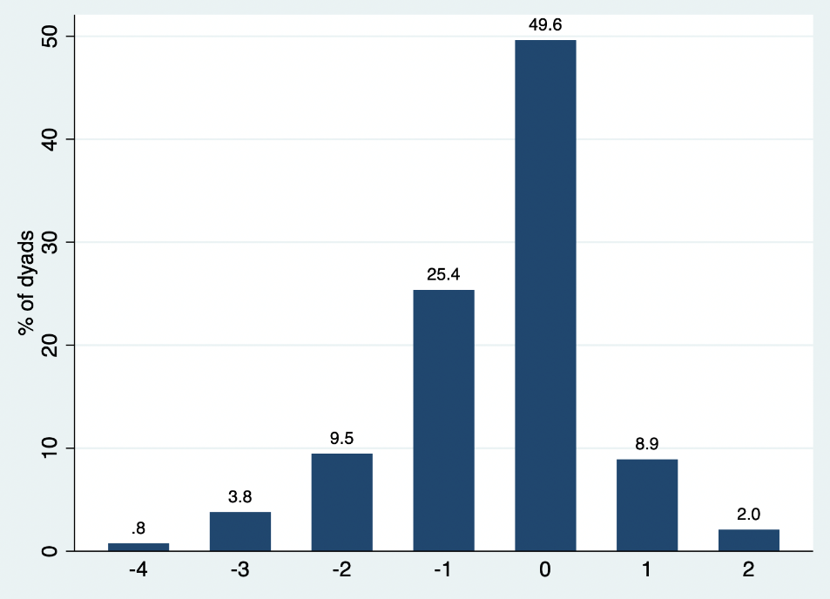

Figure 10b, Bar chart for absolute discrepancy scores of mobility dimension, PwD-staff proxies

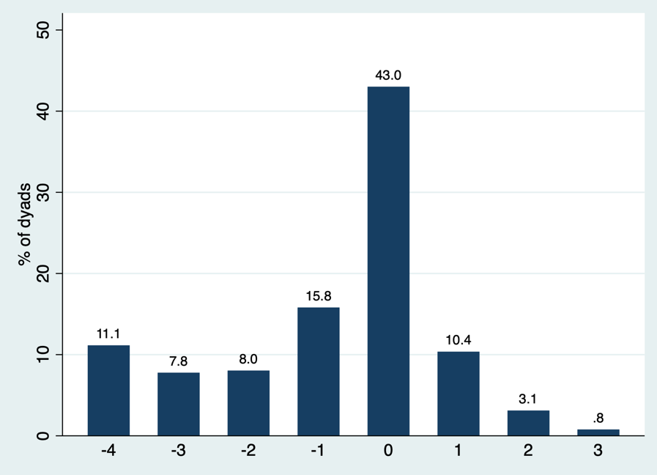

The difference between the amount of change reported by PwD and proxy dimension scores (between the two time points (T0 to T2)) is reflected in Figure 11a and Figure 11b. A possible score range of -8 to +8 is possible. A score of -8 would indicate that the PwD has reported a dimension score of one at baseline (perfect health) and five at follow-up (worst health) (resulting in -4), while the proxy has simultaneously reported the inverse (resulting in +4), therefore the PwD is reporting pessimistically while the proxy is reporting optimistically about the same dimension. A score of +8 would indicate that the PwD has reported a dimension score of five at baseline (worst health) and a one at follow-up (perfect health) (resulting in +4), while the proxy has reported the inverse (resulting in -4), therefore the PwD is reporting optimistically while the proxy is reporting pessimistically. As shown in Figure 11a and Figure 11b below, the variability in scores is larger when observing the data from PwD-staff proxy dyads; 35% of staff-proxy scores are positive (compared with 24% of PwD-informal proxy dyads) – which indicates greater pessimistic change scores for this respondent type.

Figure 11a, bar chart for difference between change score for mobility, PwD-informal proxy dyads

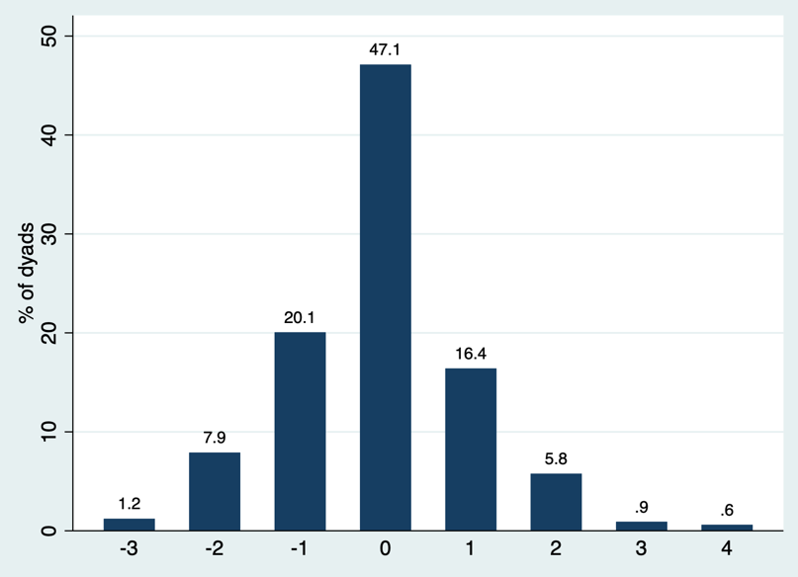

Figure 11b, bar chart for difference between change score for mobility, PwD-staff proxy dyads

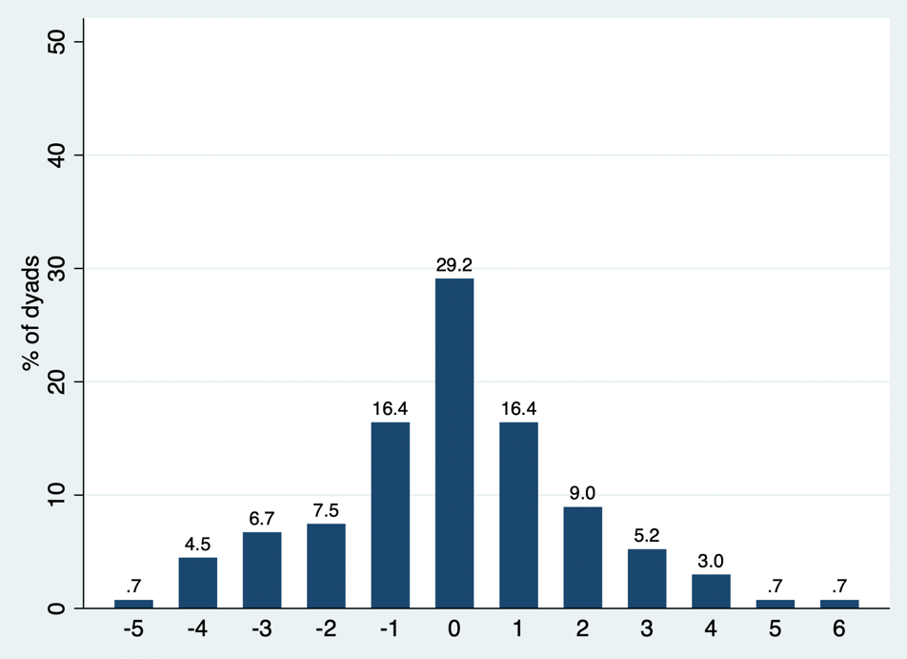

5.4.1.3 Responsiveness evidence – mobility

As outlined within Section 5.3.1, responsiveness was estimated via effect size calculations using the Cohen’s d formula. The thresholds used for interpretation of the findings are also reported in Section 5.3.1. The complete results of the responsiveness analyses are reported in Appendix 5.4. The same dementia symptom measures for comparison that were used in Section 5.4.1.1 and summarised in Appendix 5, have been used to assess the responsiveness of EQ-5D dimension reports.

Staff proxy effect size estimates tended to be of a larger magnitude than PwD and informal proxy reports. For people with dementia whose CDR stage had progressed, there was a moderate effect size of -0.56 associated with staff proxy rated “mobility”. The effect size estimates produced for people with dementia and informal proxies were comparable to one another. Similarly, for those with progressed function, staff proxy reports produced a near moderate effect size of -0.49, which was not observed for the other two respondent types.

The findings of correlation between change in EQ-5D dimension scores and change in dementia symptom measure scores used the pre-defined outcomes summarised in Appendix 5. Table A5.4h within the appendices shows the Pearson correlation coefficients between the changes in “mobility” dimension reports and the dementia symptom measures (baseline/final follow-up). Correlations were generally low and were somewhat higher for proxy reports than for PwD-self reports. The strongest correlations were seen for changes in the functional measures. The sample was further divided by CDR stage to explore any potential differences by dementia severity. It can be seen that within the moderate CDR stages, changes in BADLS scores produce larger correlations with changes in “mobility” reports, particularly for PwD-self report (r=0.40).

5.4.2 Self-care

Figure 12 shows the direction of change for reports provided for the “self-care” dimension. The majority (nearly 65%) of people with dementia reported no change within this dimension, whereas 40% of both proxy types have reported a worsening.

Figure 12, Direction of self-care change from T0 to T2

Similar to with “mobility”, over half of the PwD-informal proxy dyads reported change in the same direction, which was again because over 75% of these dyads reported a matched no change in “self-care” status from T0 to T2. Of the PwD-informal proxy dyads that reported change in opposing directions, 70% were such that the informal proxy provided a pessimistic rating (the proxy reported a worsening in condition while the PwD either reported no change or an improvement). For staff-proxy dyads, again over 55% reported change in opposing directions. See Appendix 5.1 for these findings.

The “self-care” dimension exhibited both the highest proportion of ceiling and floor effects of all of the five EQ-5D dimensions. 75% of people with dementia self-reported “no problems” with “self-care”, while 50% of staff proxies reported “extreme problems” with this dimension. There was also evidence of floor effects in informal proxy responses. For this data, see Appendix 5.2.

5.4.2.1 Self-care change alongside dementia symptom measures

Dyadic change in “self-care” was explored alongside change in functional status, behaviour/mood and CDR, according to the metrics outlined in Appendix 5.

Figure 13a shows the association between the direction of “self-care” dimension reporting and functional score progression between T0 and T2. As shown, informal proxies produced larger proportions of worsened “self-care” reports corresponding with worsened functional status of the PwD (80% for informal proxies, 50% for staff proxies and 63% of PwD). Where an improvement in “self-care” was reported by informal proxies, 27% of these cases were where the PwD’s functional status had also improved, however 43% of these cases were positive ratings where the PwD’s functional status had actually worsened. The largest proportion of stable “self-care” reports in line with no change in functional status were provided by staff proxies (61% vs. 24% for people with dementia and 34% for informal proxies).

Figure 13b shows the “self-care” dimension associations with behaviour/mood status and shows similar reporting patterns across the respondent types. Where reports reflect a worsening in “self-care” scores, responses from all three respondent-types align in that around 50% of these cases are where the PwD’s behaviour/mood status has actually worsened. Over 50% of informal and staff proxies reports of improved “self-care” aligned with improved behaviour/mood (compared with only 29% of PwD-reports). Staff proxies reported the most stability in this dimension in line with no clinical changes in behaviour/mood.

Figure 13c displays the associations between CDR status and “self-care” dimension reporting and shows that staff proxies were the respondent type that reported the largest proportion of worsened “self-care” ratings in line with a worsening in CDR status (54%, vs. 43% for both people with dementia and staff proxies). Where CDR remained the same over time, the greatest proportion of informal proxies reported stable “self-care” dimension scores compared with the other respondent types (80%, vs. 60% for staff proxies and 71% for people with dementia).

Figure 13a, Direction of functional status progression by self-care change

Figure 13b, Direction of behaviour/mood status progression by self-care change

Figure 13c, Direction of CDR status progression by self-care change

PR, informal proxy; ST, staff proxy

5.4.2.2 Inter-rater agreement – self-care

“Self-care” produced the second largest proportion of exact agreement (51%) of all dimensions for PwD-informal proxy dyads. The Kappa coefficient indicates moderate agreement (k=0.42) and is stronger in mild dementia (k=0.45) (compared with the moderate (k=0.28) and severe (k=0.04) dementia stages). For PwD-staff proxy dyads, the percentage of exact agreement on this dimension was low at 20% (and was the lowest of all five dimensions); the Kappa coefficients also indicate no evidence of agreement for PwD-staff proxies across all stages (k<0.1 for all); Refer to Appendix 5.3 for this information.

5.4.2.2.1 Discrepancy scores – self-care

As shown within Figures 14a and 14b below, the variability between the responses to the “self-care” dimension provided by the respondents is higher (when compared with “mobility”). For the PwD-informal proxy dyads, similarly to “mobility”, 80% of the discrepancy scores are concentrated around +/- one, and a large proportion of scores are at zero (51% = exact agreement)). Of the PwD-informal proxy dyad scores at zero, around 82% were where both the PwD and proxy had reported the dimension a score of one (compared with approximately 2% with a matching score at the worst possible score of five). Of the PwD-staff proxy dyad scores at zero, 70% were where both the PwD and proxy had provided a perfect health dimension score, and approximately 10% were where both scores were at the worst possible level for the dimension.

For the PwD-staff proxy data, there is greater variability in responses - with only 20% of discrepancy scores at zero and 24% of scores at the maximum negative score value. Similarly, to “mobility”, this finding indicates that a larger proportion of staff proxies provide a lower dimension score compared with PwD-self scores (than informal proxies).

Figure 14a, Bar chart for absolute discrepancy scores of self-care dimension, PwD-informal proxies

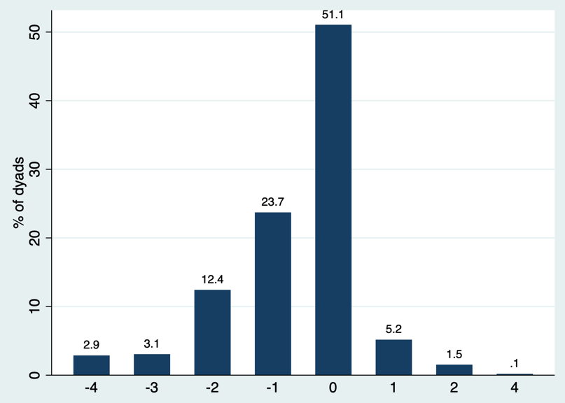
Figure 14b, Bar chart for absolute discrepancy scores of self-care dimension, PwD-staff proxies

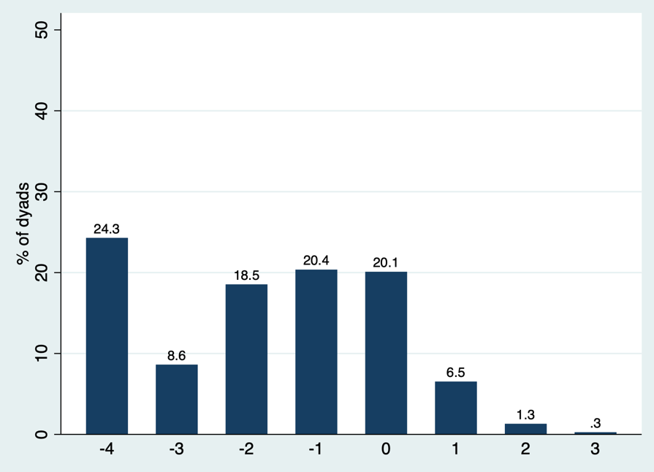

The difference between the amount of change reported for the “self-care” dimension by both respondents is shown in Figure 15a and 15b below. Similarly, to “mobility”, the variability in scores is larger for PwD-staff proxy dyads. For PwD-informal proxy dyads, 48% of scores are at zero compared with 25% for PwD-staff proxy dyads. 36% of PwD-staff proxy scores are positive, which indicates a greater proportion of pessimistic change scores for staff proxies, compared with only 17% of PwD-informal proxy positive scores.

Figure 15a, bar chart for difference between change score for self-care, PwD-informal proxy dyads

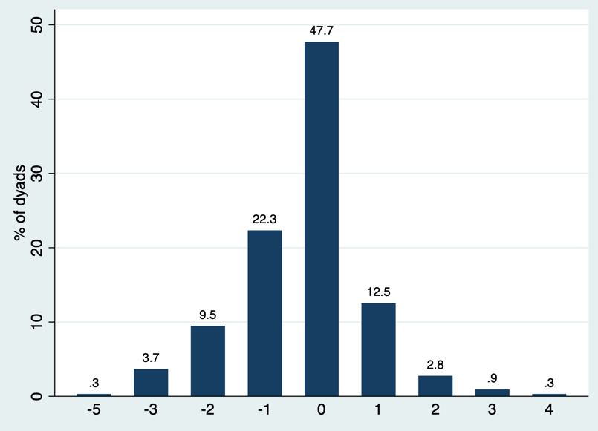

Figure 15b, bar chart for difference between change score for self-care, PwD-staff proxy dyads

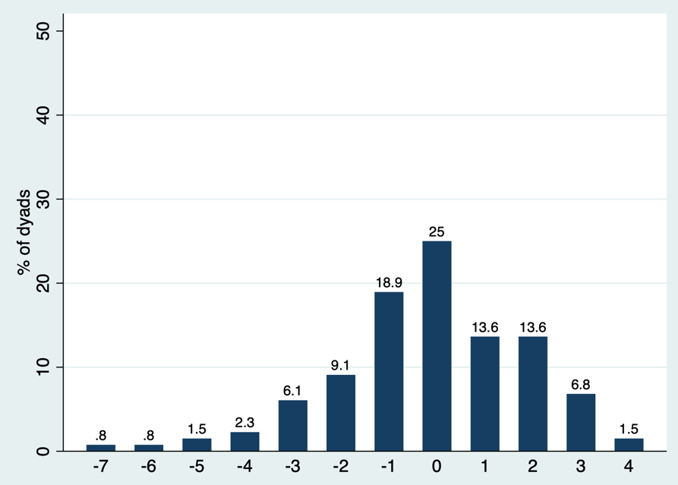

5.4.2.3 Responsiveness evidence – self-care

As with “mobility”, the effect size estimates produced when exploring “self-care” were of a larger magnitude for staff proxy ratings compared with the other respondents. As shown in Table A5.4c of Appendix 5.4, for people with dementia whose CDR had progressed, moderate-to-large effect sizes were found with informal proxy (-0.66) and staff proxy (-0.72) reports of “self-care”. Where function had progressed, again staff proxy reports of “self-care” produce a larger effect size of -0.61, compared with the other respondents (although the informal proxy effect size estimate is near moderate at -0.49, and the PwD effect size estimate was -0.19). Where NPI score had worsened, only staff proxy reports reached the responsiveness threshold (at -0.55).

For the correlation coefficients between the changes in “self-care” dimension reports and the dementia symptom measure scores (shown in Table A5.4i of Appendix 5.4), proxy correlations were always larger. The most notable correlations were those between changes in “self-care” and the functional measures of BADLS and IADL-PSMS, where informal proxy correlations of r=0.47 and r=-0.46 were found respectively. It can be seen that within the mild dementia subgroup, changes in these functional measures produced larger correlation coefficients compared with moderate dementia (for associations with proxy ratings: with BADLS, r=0.50 in mild dementia vs. r=0.39 in moderate dementia; with IADL-PSMS, r=-0.39 in mild dementia vs. r=-0.34 in moderate dementia).

5.4.3 Usual activities

Figure 16 shows the direction of change for reports provided for the “usual activities” dimension. It can be seen that reports by both proxy types most closely align with each other, with less than 50% of both types of proxy reporting no change in this dimension and over 33% reporting a worsening; compared to people with dementia, where over 50% have reported no change in their condition and fewer than 30% have reported a worsening in this dimension over time.

Figure 16, Direction of usual activities change from T0 to T2

The majority of PwD-informal proxy dyads reported change in “usual activities” in opposing directions (over 65%), of which, a large proportion (over 60%) were pessimistic ratings from the proxy. For PwD-staff proxy dyads, the direction of dimension reporting was near balanced (50% either way); of PwD-staff proxy dyads that reported change in the same direction, the majority reported a matched no change in “usual activities” from T0 to T2. See Appendix 5.1 for this information.

Ceiling effects were observed for the “usual activities” dimension for both PwD-self ratings, and staff proxy ratings (over 60% for both). This dimension also exhibited evidence of floor effects via informal (16%) and staff (15%) proxy ratings according to the predefined thresholds (see Appendix 5.2).

5.4.3.1 Usual activities change alongside dementia symptom measures

Dyadic change in “usual activities” was explored alongside change in functional status, behaviour/mood and CDR, refer to Appendix 5 for outcome summaries.

Figure 17a displays the associations for functional status and shows that informal proxies were the respondent type for which the greatest proportion of worsened “usual activities” reports corresponded with worsened functional status of the PwD (74%, vs. 63% for PwD and 37% for staff proxies). 58% of staff proxies reported a worsening in “usual activities” where the PwD’s function remained stable. However, the greatest proportion of stable “usual activities” ratings in line with no change in functional status was also reported by staff proxies (53%, vs. 28% for people with dementia and 30% for informal proxies). The relative largest proportion of informal proxies provided an improved “usual activities” dimension score in line with improved functional status (17%, vs. 12% of people with dementia and less than 2% for staff proxies); 68% of PwD reports of an improved “usual activities” dimension score were where function had worsened for the PwD. 59% of staff proxy reports of an improved “usual activities” dimension score were for people with dementia whose function had remained the same.

Figure 17b displays the associations between “usual activities” reporting and behaviour/mood status and shows a similar pattern for reporting for all three categories of respondent. Where reports reflect a worsening in “usual activities” scores, 51%/53%/46% of people with dementia, informal and staff proxy’s reports are where the PwD’s behaviour/mood status has worsened; similarly, 42%/40%/47% of people with dementia, informal and staff proxy’s reports of worsened “usual activities” lay where the PwD’s behaviour/mood status has improved. Where respondents have reported an improvement in “usual activities”, over 50% of these ratings were provided by informal and staff proxies where the PwD’s behaviour/mood had improved, vs. 43% for PwD-self ratings.

Figure 17c displays the associations for CDR status and shows that staff proxies were the respondent type for which the greatest proportion of worsened “usual activities” reports corresponded with a worsening in CDR status (51%, vs. 35% of people with dementia and 38% for informal proxies). Where an improvement in “usual activities” was reported by respondents, 74% of people with dementia and informal proxies had provided these ratings where CDR had remained stable for the PwD. Of the stable “usual activities” ratings provided by respondents, the greatest proportion of informal proxy responses were where the PwD’s CDR remained the same over time (74%, vs. 64% for people with dementia and 57% for staff proxies).

Figure 17a, Direction of functional status progression by usual activities change

Figure 17b, Direction of behaviour/mood status progression by usual activities change

Figure 17c, Direction of CDR status progression by usual activities change

PR, informal proxy; ST, staff proxy

5.4.3.2 Inter-rater agreement – usual activities

“Usual activities” produced the lowest percentage of exact agreement for PwD-informal proxy dyads (36%) of all five EQ-5D dimensions; it also resulted in the lowest kappa-coefficient (k=0.26). For PwD-staff proxy dyads, “usual activities” was the dimension with the relative highest percentage of exact agreement at 59%, however the kappa-coefficient indicates poor agreement (k=0.15). See Appendix 5.3 for this data.

5.4.3.2.1 Discrepancy scores – usual activities

Unlike for “mobility” and “self-care”, Figures 18a and 18b below show that for “usual activities” informal proxies are more pessimistic than staff proxies in their reports when compared to PwD self-reports. For staff proxies, nearly 60% of the discrepancy scores are at zero, compared with less than 40% of scores for informal proxies. Of the scores at exact agreement, 53% were where both the PwD and informal proxy reported the dimension at perfect health and 3% were where both respondents provided the worst possible dimension score. For the PwD-staff proxy dyad scores at zero, 95% were where both respondents provided a perfect health dimension score, while 2% were where both respondents provided a worst possible dimension score of five. The observed variability in scoring is reduced with staff proxies.

Figure 18a, Bar chart for absolute discrepancy scores of usual activities dimension, PwD-informal proxies

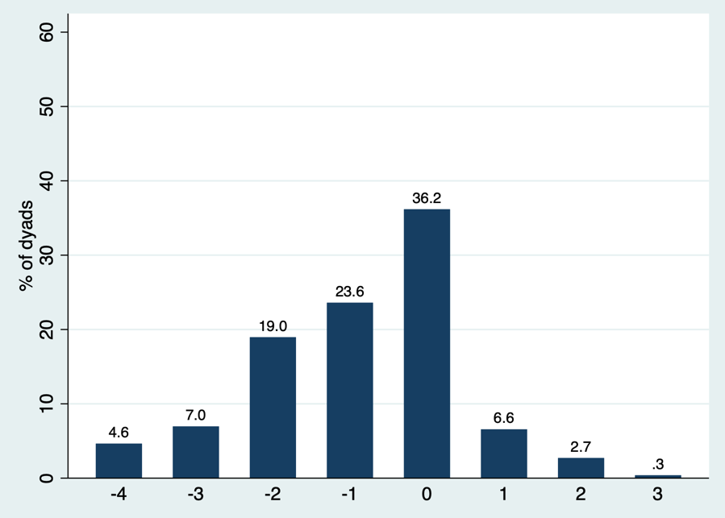

Figure 18b, Bar chart for absolute discrepancy scores of usual activities dimension, PwD-staff proxies

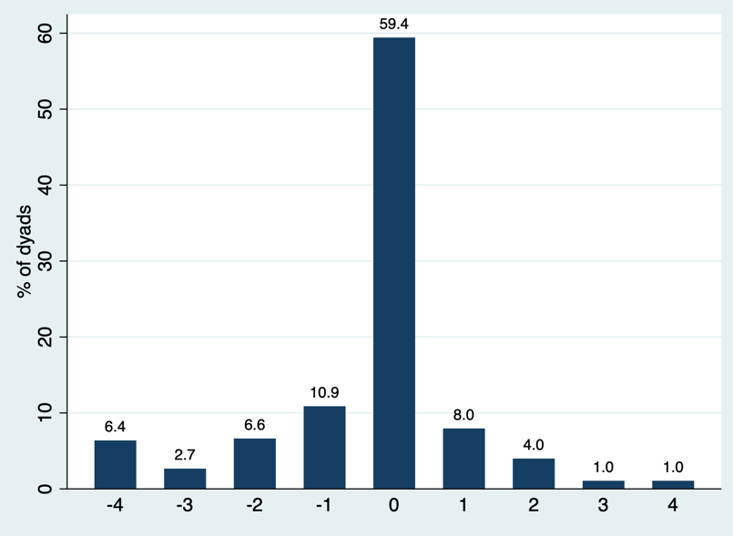

Figures 19a and 19b below show the difference between the amount of change reported by PwD and proxy scores for the “usual activities” dimension. As shown in these figures, a greater proportion of PwD-staff proxy dyad change scores are at zero (41% vs. 26% for PwD-informal proxy dyads). 31% and 29% of PwD-staff proxy and PwD-informal proxy dyad scores are positive respectively. Positive scores indicate a more pessimistic change-in-scores reported by the proxy compared with PwD reports.

Figure 19a, bar chart for difference between change score for usual activities, PwD-informal proxy dyads

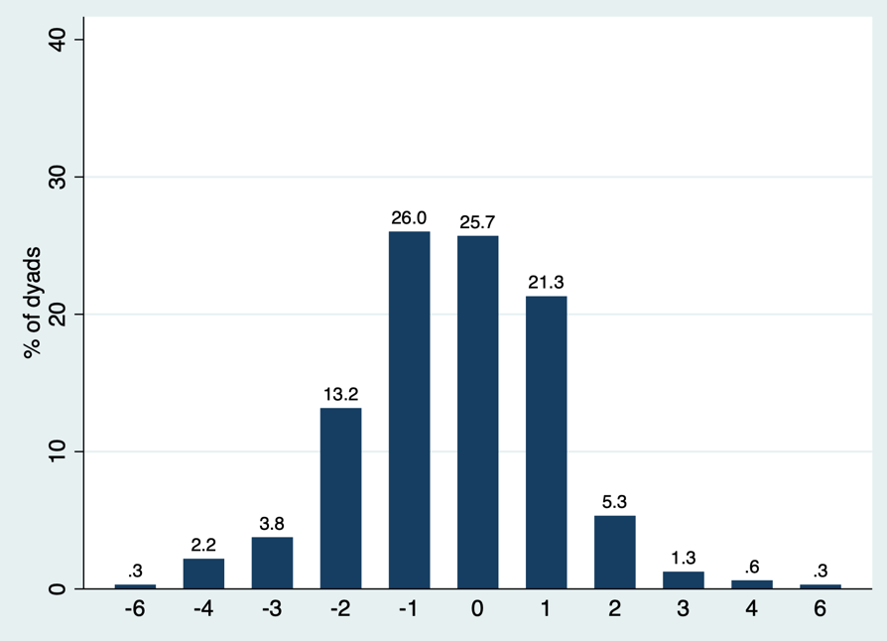

Figure 19b, bar chart for difference between change score for usual activities, PwD-staff proxy dyads

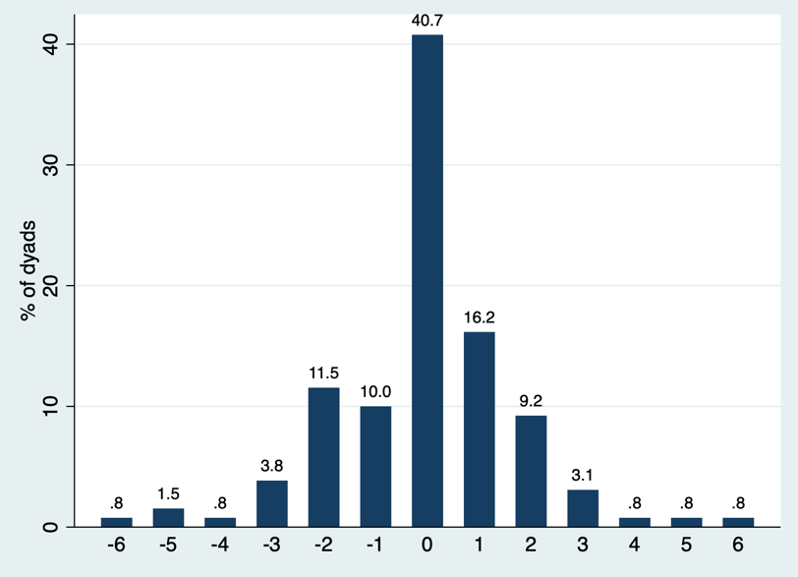

5.4.3.3 Responsiveness evidence – usual activities

The effect size estimations for the “usual activities” dimension ratings are provided in Table A5.4d in Appendix 5.4. As shown, effect size estimates generated from proxy reports were larger than those from PwD-self reports. The changes in “usual activities” that were associated with worsened CDR stage produced moderate effect size estimates when rated by informal (-0.66) and staff (-0.64) proxies. The effect size estimates associated with change in functional status were equal for both proxy types (at -0.33).

Although the correlation coefficients for changes with this dimension were generally small, they were consistently larger for proxy ratings. The largest correlation was seen for changes in function measured via IADL-PSMS and changes in informal proxy rated “usual activities” (r=-0.31). “Usual activities” changes alongside depression (via CSDD) did not produce any notable correlations. The full summary is provided in Table A5.4j of Appendix 5.4.

5.4.4 Pain/discomfort

Figure 20 shows the direction of change for reports provided for the “pain/discomfort” dimension. Reports provided by all three respondents present a relatively similar pattern for the direction of change over time, with over 50% of all three respondents reporting no change in this dimension from T0 to T2. A slightly larger proportion of staff proxies reported no change in “pain/discomfort”, alongside fewer reports of worsening change.

Figure 20, Direction of pain/discomfort change from T0 to T2

There was a near balanced split of PwD-informal proxy dyads reporting change in either the same or opposing directions from one another for the “pain/discomfort” dimension from T0 to T2. Of the dyads reporting change in the same direction, the majority (66%) have reported a matched response of no change in “pain/discomfort” status. For PwD-staff proxy dyads, a slightly larger proportion of dyads reported change in the same direction, similarly over 77% have reported matched no change in this dimension. See Appendix 5.1 for this information.

Ceiling effects were observed for the “pain/discomfort” dimension, whereby over 60% of people with dementia and over 70% of staff-proxies reported “no problems” in this EQ-5D dimension. A large proportion of informal proxies (over 40%) also reported “no problems” in this dimension, refer to Appendix 5.2.

5.4.4.1 Pain/discomfort change alongside dementia symptom measures

Dyadic change in “pain/discomfort” was explored alongside change in functional status and behaviour/mood of the PwD, as per the outcomes presented in Appendix 5.

Figure 21a displays the associations with functional status and shows that 65% of people with dementia and informal proxies alike who reported a worsening in “pain/discomfort” were in cases where the PwD’s functional status had worsened (compared with 38% of staff proxies). However, again, 60% of people with dementia and informal proxies who reported no change in “pain/discomfort” were where the PwD’s function had worsened (vs. 38% of staff proxy reports of no change in “pain/discomfort” where the PwD’s functional status had worsened). Where the PwD’s functional status remained stable, around 54% of staff proxy reports of no change in “pain/discomfort” aligned (vs. 27% for people with dementia and 29% for informal proxies).

Figure 21b displays the associations between the direction of “pain/discomfort” dimension reports and changes in behaviour/mood status. Where reports reflected a worsening in “pain/discomfort” scores, over 50% of people with dementia, informal and staff proxies provided this response where the PwD’s behaviour/mood had also worsened. Similarly, where the respondents reported no change in “pain/discomfort” this corresponded with stable behaviour/mood status for 10% of people with dementia, informal and staff proxies. Staff proxies were the respondents for whom the largest proportion of improved “pain/discomfort” status corresponded with an improvement of behaviour/mood for the PwD (56%, vs. 39% for people with dementia and 45% for informal proxies).

Figure 21a, Direction of function status progression by pain/discomfort change

Figure 21b, Direction of behaviour/mood status progression by pain/discomfort change

PR, informal proxy; ST, staff proxy
5.4.4.2 Inter-rater agreement – pain/discomfort

The percentage of exact agreement for the “pain/discomfort” dimension was at 51% for PwD-informal proxy dyads and 57% for PwD-staff proxy dyads. However, the Kappa coefficient for PwD-informal proxy dyads was considerably larger (k=0.42) – indicating moderate agreement (compared to k=0.16 for PwD-staff proxies). When observing PwD-informal proxy dyads, this was the only dimension that saw an increase in the Kappa coefficient within people with severe dementia (k=0.61, vs. k=0.43 in mild CDR and k=0.35 in moderate CDR subgroups). See Tables in Appendix 5.3.

5.4.4.2.1 Discrepancy scores – pain/discomfort

As shown in Figures 22a and 22b below, the pattern of discrepancy scores for the “pain/discomfort” dimension is relatively similar for both proxy types. For PwD-staff proxies and PwD-informal proxies alike, 57% and 51% of scores are at zero respectively, with over 80% of scores within the +/- one score range for both proxy types. Of the PwD proxy dyad scores at exact agreement (zero), 58% were where the PwD and informal proxy both provided a score of one and 91% were where the PwD and staff proxy both provided a score of one.

Figure 22a, Bar chart for absolute discrepancy scores of pain/discomfort dimension, PwD-informal proxies

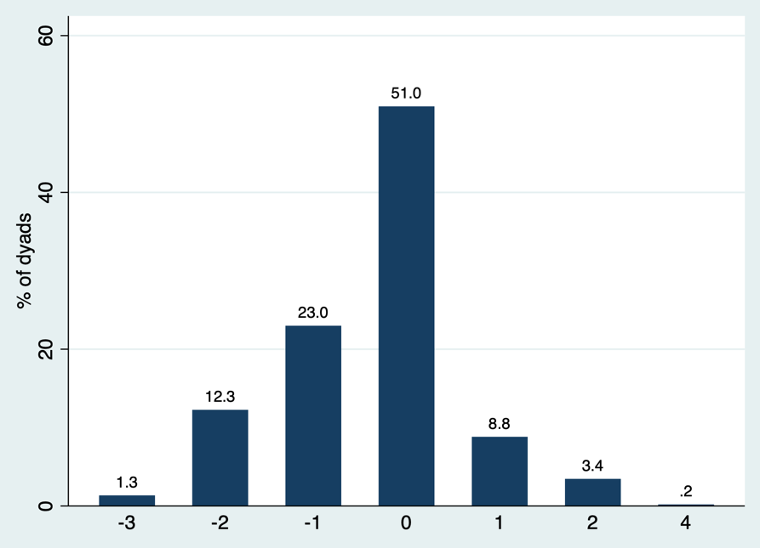

Figure 22b, Bar chart for absolute discrepancy scores of pain/discomfort dimension, PwD-staff proxies

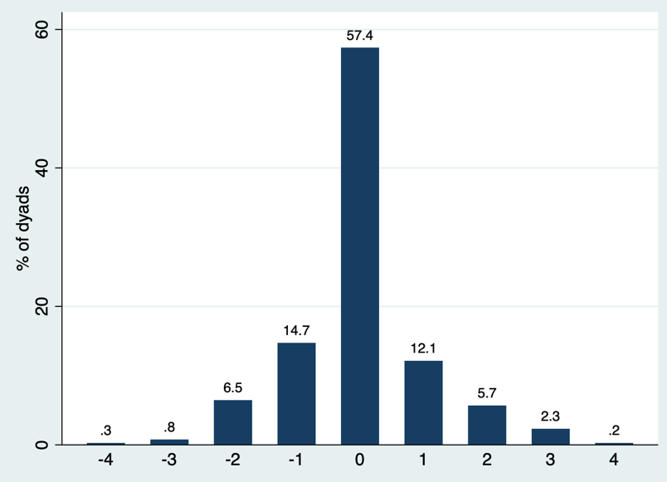

Figures 23a and 23b below show the difference between the amount of change reported for the “pain/discomfort” dimension by people with dementia and proxies over time. It can be seen that the pattern of scores is relatively similar for both types of dyads. Negative scores indicate that the proxy is reporting an optimistic change in scores when compared with the PwD. 29% of PwD-informal proxy dyads and 24% of PwD-staff proxy dyads had positive difference-between-change scores. There was slightly more variability for PwD-informal proxy dyads, as the scale extended to minus four (compared to minus three for PwD-staff proxies), however the proportion of scores at these end points were minimal.

Figure 23a, Bar chart for difference between change score for pain/discomfort, PwD-informal proxy dyads

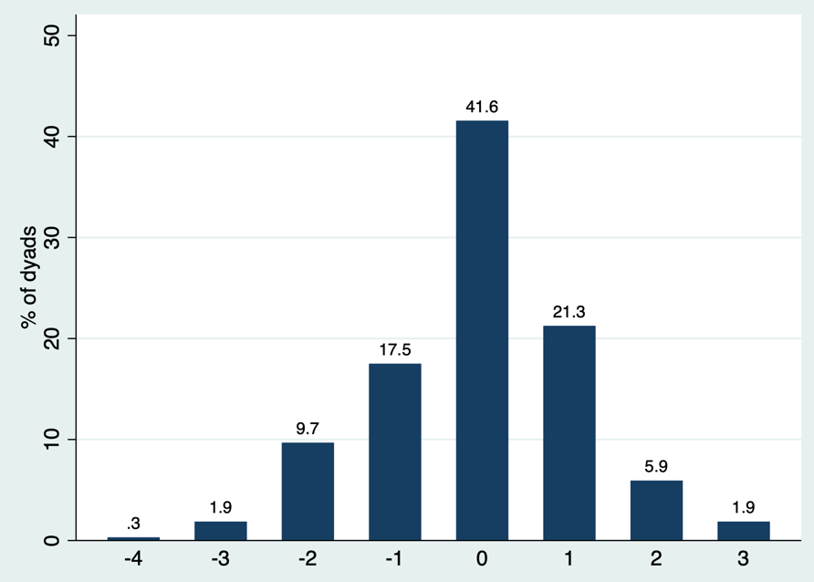

Figure 23b, Bar chart for difference between change score for pain/discomfort, PwD-staff proxy dyads

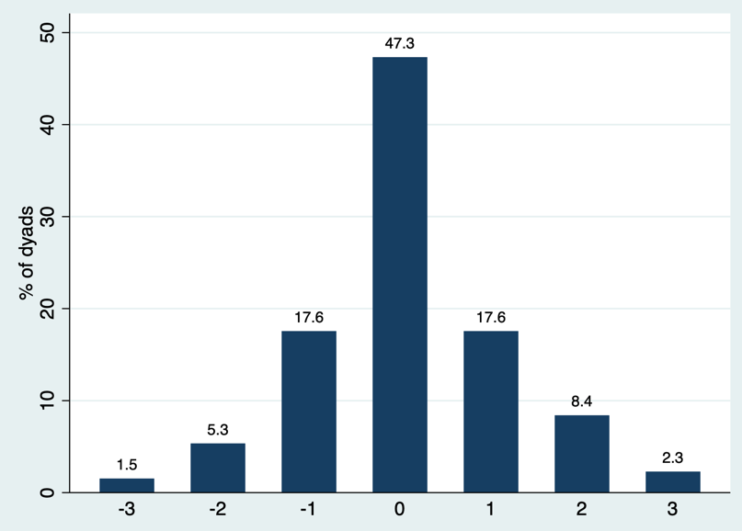

5.4.4.3 Responsiveness evidence – pain/discomfort

Unlike the previous EQ-5D dimensions, the effect size estimates for change in “pain/discomfort” responses were low across respondents and did not produce any notable findings. The largest observed effect size was for staff proxy reports of this dimension for people with dementia whose CDR had progressed (at 0.22). However, this effect size is still considered to be small and does not meet the minimum threshold for consideration. See Table A5.4e within Appendix 5.4.

As with the effect size evidence, there were no notable correlation coefficients between changes in “pain/discomfort” responses and changes in the dementia symptom measures for all three respondents; see Table A5.4k in Appendix 5.4 for full information.

5.4.5 Anxiety/ depression

Figure 24 shows the direction of change for responses provided for the “anxiety/depression” EQ-5D dimension. All three respondent types reported comparable proportions of improvements with "anxiety/depression”, while informal proxies reported the most worsening and staff proxies provided the most stable dimension scores.

Figure 24, Direction of anxiety/depression change from T0 to T2

Similar to the “pain/discomfort” dimension, there was a balance of PwD-informal proxy dyads reporting change in either the same or opposing directions to one another. Of the 51% that reported change in the same direction, 70% reported a matched no change in “anxiety/depression” status. Likewise, for staff-proxy dyads, the proportion of dyads reporting change in either direction was near balanced (53% same direction vs. 47% in opposing directions), and of the 53% of dyads that reported change in the same direction –86% reported no change in “anxiety/depression” status for T0 to T2 (refer to Appendix 5.1).

According to the predefined thresholds, ceiling effects were observed for the “anxiety/depression” dimension, whereby over 60% of people with dementia and nearly 70% of staff proxies rated “no problems” in this dimension (compared with 39% of informal proxies). No floor effects were observed for any of the respondent’s reports; See Appendix 5.2.

5.4.5.1 Anxiety/depression change alongside dementia symptom measures

Dyadic change in “anxiety/depression” was explored alongside change in behaviour/mood status and cognition using the ACTIFCARE trial data (see Appendix 5 for outcome determination). As a result, there are no staff proxy comparisons with cognition.

Figure 25a displays the associations between “anxiety/depression” reporting over time and behaviour/mood status. It can be seen that where respondents reported a worsening in “anxiety/depression”, 70% of staff proxy responses corresponded with a worsening in behaviour/mood, making them the respondent type with the highest associated proportion (vs. 61% for people with dementia and 58% for informal proxies). Similarly, where the PwD’s behaviour/mood had improved – the greatest proportion of staff proxy responses reflecting an improvement in “anxiety/depression” aligned (65%, vs. 43% for people with dementia and 58% for informal proxies). 48% of people with dementia self-reported a conflicting improvement in their “anxiety/depression” dimension score where their behaviour/mood status had shown a worsening in condition (vs. 39% of informal and 28% of staff proxies).

Figure 25b displays the associations for cognition and shows where respondents reported a worsening in “anxiety/depression”, a greater proportion of these reports corresponded with worsened cognition over time (65% for people with dementia and 51% for informal proxies). This finding opposes the results reported in the convergent validity systematic review of Chapter Three, whereby people with dementia with higher levels of cognitive impairment self-reported fewer problems in “anxiety/depression” (see Section 3.7.4.6).

Figure 25a, Direction of behaviour/mood status progression by anxiety/depression change

Figure 25b, Direction of cognition status progression by anxiety/depression change

PR, informal proxy; ST, staff proxy

5.4.5.2 Inter-rater agreement – anxiety/depression

The percentage of exact agreement for the “anxiety/depression” dimension was relatively high for PwD-informal proxy dyads (43%) but was higher for PwD-staff proxy dyads (57%). The Kappa coefficient of PwD responses had a stronger degree of agreement with informal proxies (k=0.30, vs. k=0.20 with staff proxies), however the Kappa coefficient was the same (k=0.30) for agreement with both proxy types for the subgroup of people with mild dementia. See Tables in the Appendix 5.3.

5.4.5.2.1 Discrepancy scores – anxiety/depression

For the “anxiety/depression” dimension, there is a greater proportion of staff-proxy dyad discrepancy scores at zero (57%), compared to informal-proxies (43%). As a result, there are more negative discrepancy scores for informal proxies; although the pattern observed for both plots is similar (see Figure 26a and 26b below). Of the scores at zero, 57% of PwD-informal proxy dyads, and 90% of PwD-staff proxy dyads are where both respondents provided a perfect health score.

Figure 26a, Bar chart for absolute discrepancy scores of anxiety/depression dimension, PwD-informal proxies

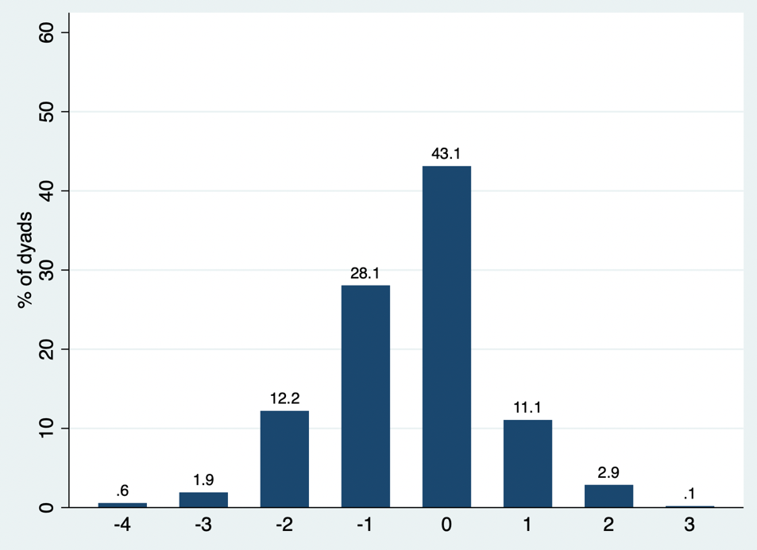

Figure 26b, Bar chart for absolute discrepancy scores of anxiety/depression dimension, PwD-staff proxies

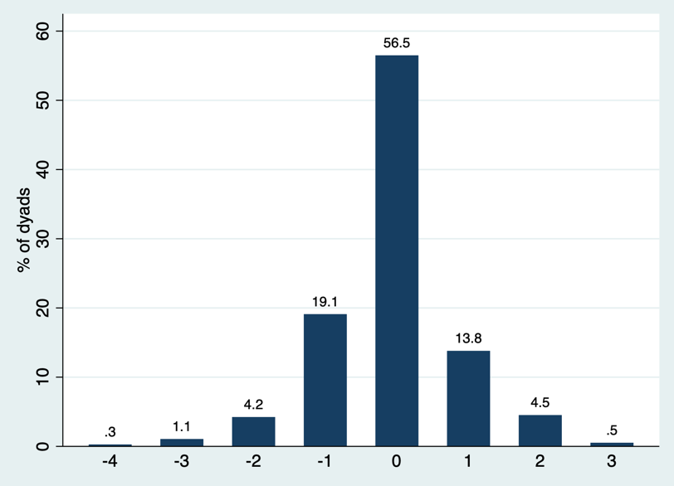

The difference between the amount of change of PwD and proxy scores for the “anxiety/depression” dimension over time is reflected in Figures 27a and 27b. The variability between scores is wider for PwD-informal proxy dyads, whereby the scale extends to +/- 5, whereas for PwD-staff proxy dyads, the scale is narrower at +4 to -2. Positive scores indicate a more pessimistic change reported by the proxy compared with PwD-self report of change. Approximately 26% and 27% of the scores are positive for PwD-informal proxy dyads and PwD-staff proxy dyads respectively.
Figure 27a, bar chart for difference between change score for anxiety/depression, PwD-informal proxy dyads

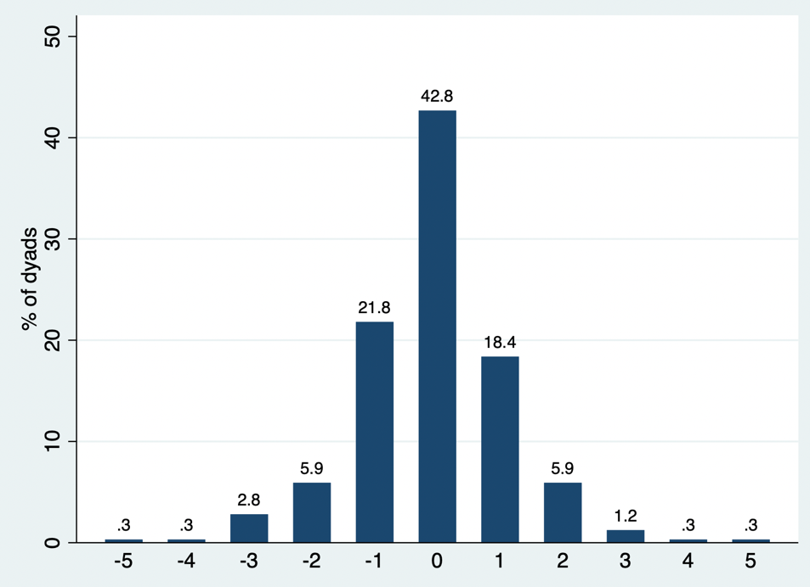

Figure 27b, bar chart for difference between change score for anxiety/depression, PwD-staff proxy dyads

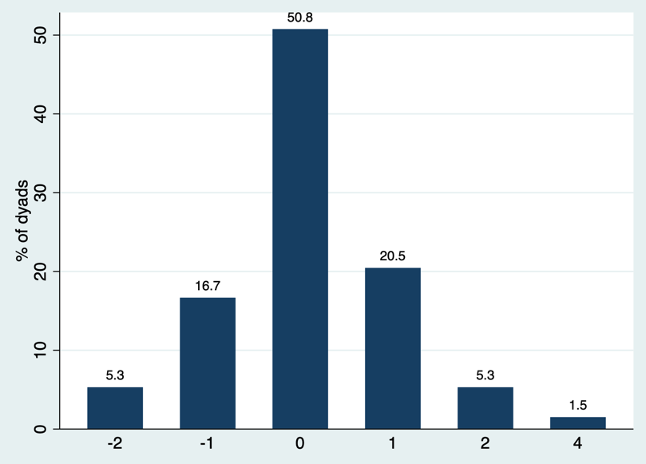

5.4.5.3 Responsiveness evidence – anxiety/depression

The effect size estimates generated for the “anxiety/depression” dimension are provided in Table A5.4f of Appendix 5.4. It can be seen that staff proxy dimension responses produce larger effect size estimates. For changes in depression (measured by CSDD), the effect size estimates were low across respondent types. The largest effect size estimate for the responsiveness of “anxiety/depression” was seen with staff proxy responses of this dimension for people with dementia whose behaviour/mood status had improved via measurement on the NPI (0.44).

The correlations between change in “anxiety/depression” and changes in dementia symptom measures were consistently larger for proxy ratings compared with PwD-self ratings, although the correlations were generally low. The largest coefficients were seen between changes in NPI-NH (r=0.35) and NPI-Q (r=0.28) scores respectively. Overall, the correlation observed with cognition is stronger for people with dementia and is negative (r=-0.20) (compared to informal proxies) – indicating that at better cognitive states, “anxiety/depression” responses are more favourable. For informal proxies of people with moderate dementia, a near moderate positive correlation (r=0.39) is produced between MMSE and “anxiety/depression” – indicating the inverse relationship (see Table A5.4l in Appendix 5.4), that at better cognitive states, responses are less favourable.

5.4.6 EQ-5D index scores

The EQ-5D index scores analysed within the following section have been previously estimated for the individual value sets as outlined in Section 4.3.1 of Chapter Four. Two of the studies (ACTIFCARE and EPIC) collected the five-level version of EQ-5D, for which the mapping method recommended within the current NICE guidelines was used to estimate the utility scores of these samples (mapping from EQ-5D-5L health states to the EQ-5D-3L value set) (Hernández Alava et al., 2023). The REMCARE study collected the three-level version of EQ-5D; for this sample, utility scores were calculated using the value set for England (Dolan, 1997). For this section, the EQ-5D index scores have been analysed together, using the mean scores across the three studies (unless otherwise stated).

Figure 28 shows the direction of change for the EQ-5D index scores estimated from PwD and proxy assessments. It can be seen that over 15% fewer PwD scores report a worsening in utility when compared to scores produced via the two proxy types, and a larger proportion of PwD scores remained the same across time.

Figure 28, Direction of EQ-5D index score change from T0 to T2

Table 31 below provides the mean EQ-5D index scores for each of the respondent types that reported either an improvement or a worsening over the timepoints (from T0 to T2). The largest magnitudes for both worsening (-0.37) and improvements (+0.24) of scores were seen when reported by staff proxies. In both cases, the mean baseline and follow-up scores reported by staff proxies were the lowest of all respondent types.

Table 31, Mean EQ-5D index scores by respondent type

Respondent type | Baseline (T0) | Final follow-up (T2) | Difference in mean EQ-5D index scores
EQ-5D improved; mean (SD)
PwD, n=289 | 0.66 (0.23) | 0.84 (0.17) | 0.18
Informal proxy, n=231 | 0.51 (0.28) | 0.67 (0.24) | 0.16
Staff proxy, n=147 | 0.42 (0.40) | 0.66 (0.38) | 0.24
EQ-5D worsened
PwD, n=298 | 0.85 (0.16) | 0.64 (0.24) | -0.21
Informal proxy, n=225 | 0.66 (0.24) | 0.42 (0.31) | -0.24
Staff proxy = 413 | 0.63 (0.35) | 0.26 (0.37) | -0.37

The proportion of PwD-proxy dyads that have reported in either the same or in opposing directions is visually displayed in Figure 29a and 29b. It can be seen in Figure 29a that approximately 60% of PwD-informal proxy dyads report in opposing directions for EQ-5D index score change, of which around 60% were such that the proxy was the pessimistic respondent (i.e., the proxy reported a worsening in EQ-5D index score over time, while the PwD either reported no change or an improvement). Of the 40% of PwD-informal proxy dyads that report index score changes in the same direction, the majority (over 50%) reported a matched worsening.

Exploring these associations for PwD-staff proxy dyads shows that approximately 50% of dyads report index score changes in the same direction, of whom, again, the majority (around 70%) report a matched worsening. Unlike the comparison with informal proxy responses, of the proportion of dyads that possess opposing directions for index score changes, the majority (around 60%) of cases are where the PwD is pessimistic.

Figure 29a, Proportion of PwD-informal proxy dyads reporting the same/opposing direction for EQ-5D index scores

Figure 29b, Proportion of PwD-staff proxy dyads reporting the same/opposing direction for EQ-5D index scores

The proportion of each of the respondent types reporting either: no change, an improvement, or a worsening in EQ-5D index scores over time was plotted by whether the PwD’s CDR stage remained stable or progressed (within Figure 30 below). It can be seen that where CDR remained stable, approximately 15% of people with dementia had the same EQ-5D index scores (the highest proportion of stable ratings when compared to informal (around 7%) and staff (around 9%) proxies). Due to the progressive nature of dementia, it would not be expected that a PwD’s CDR stage would reverse or improve over time, however no progression/change in dementia severity stage over time is considered a clinical success. Of the subgroup where the PwD’s CDR remained stable, approximately 42% of people with dementia reported EQ-5D index scores reflected an improvement (however the same proportion of PwD scores also reflected a worsening). Where the PwD’s dementia stage had progressed, approximately 72% of informal and 62% of staff proxies EQ-5D index scores estimate to a worsening.

Figure 30, Proportions of respondents reporting EQ-5D index score change in different directions by CDR change from T0 to T2

The mean EQ-5D index scores reported by the different respondents by dementia severity stage of the PwD (across timepoints) were estimated using the data pooled from the three trials and are summarised in Table 32 below. As the trials were pooled, the sample size for the PwD sample is proportionally the largest, as all three trials collected data from a PwD (while solely the EPIC trial collected staff proxy responses, and although all three trials collected informal proxy responses, this data was minimal from the EPIC trial).

Mean PwD reported utility scores were highest for people with severe dementia (mean score: 0.80), compared to the other stages. Utility scores generated by both informal and staff proxy EQ-5D responses were the lowest for people with severe dementia (visually plotted in Appendix 5.5). For PwD, mean index scores were higher for those that were institutionalised (compared with community dwelling people with dementia, mean difference in score of 0.03), the inverse relationship was found for informal proxy reported index scores.
Table 32, Mean utility scores by CDR stage

Mean EQ-5D index score by respondent-type
N, mean (SD) | Mild (0.5/1) | Moderate (2) | Severe (3)
PwD | n=1466  0.78 (0.22) | n=737  0.77 (0.25) | n=120  0.80 (0.22)
Informal proxy | n=1239  0.64 (0.25) | n=589  0.45 (0.30) | n=152  0.13 (0.31)
Staff | n=428  0.70 (0.32) | n=661  0.56 (0.37) | n=575  0.26 (0.40)
Mean EQ-5D index score by residential status of PwD
N, mean (SD) | Community dwelling | Institutionalised | Other
PwD | n=2160  0.77 (0.22) | n=807  0.80 (0.24) | n=53  0.72 (0.29)
Informal proxy | n=2268  0.59 (0.27) | n=414  0.30 (0.37) | n=53  0.60 (0.23)
Staff | n/a | n=1679  0.49 (0.41) | n/a
Mean EQ-5D index score by trial
N, mean (SD) | REMCARE | EPIC | ACTIFCARE
PwD | n=1153  0.77 (0.24) | n=762  0.80 (0.23) | n=1105  0.77 (0.21)
Informal proxy | n=1206  0.57 (0.29) | n=347  0.27 (0.37) | n=1182  0.59 (0.26)
Staff | n/a | n=1679  0.49 (0.41) | n/a

5.4.6.1 Inter-rater agreement – EQ-5D index scores

The ICC was calculated to explore inter-rater agreement between PwD and proxy EQ-5D index scores. For PwD-informal proxy dyads the ICC indicates poor agreement (r=0.35); the ICC is slightly stronger in dyads of people with mild dementia and has a narrower confidence interval (r=0.36 [0.31-0.41]) compared with the moderate and severe stages (see Table A5.3a in Appendix 5.3). For PwD-staff proxy dyads, the ICC also reflects poor agreement (r=0.14). The ICC for this relationship is strongest in dyads of people with moderate dementia (r=0.21 [0.00-0.36]), although the confidence interval is wide and includes zero, indicating that the correlation observed at moderate dementia may not be statistically significantly different to the correlation for the other stages (see Table A5.3.b in Appendix 5.3).

5.4.6.1.1 Bland Altman plots for inter-rater agreement

Figures 31a and 31b below are the Bland-Altman plots that have been constructed for comparing PwD-informal and PwD-staff proxy EQ-5D index scores. As outlined previously in Section 5.3.2, there are no pre-defined acceptable limits of agreement when comparing PwD-proxy EQ-5D index scores. Therefore, a range of +/- 0.2 was applied for the purposes of interpretation as is represented by the red lines on the figures. As shown in Figure 31a and 31b, both plot’s limit by far exceed this deviation.

Although there are no clear patterns in the differences of paired observations denoted within these plots, for comparisons with both proxy types, agreement is generally poor (with 7% of values falling outside of the 95% limits of agreement). Variability is inconsistent across the plots; the largest disagreement occurs approximately at an index score of 0.5, and the difference between measurements tends to get smaller as the average increases, with a cluster at EQ-5D index score one on the zero/perfect agreement line.

The pattern is similar for both proxy-types, although staff proxies have a slightly larger mean difference (0.21 vs 0.17) and therefore a wider limit of agreement. The plots were also constructed to observe any potential differences by dementia severity stage (for PwD-informal proxy dyads); the mean difference was larger in moderate dementia when compared to in mild dementia and had a wider limit of agreement. These plots did not indicate any important patterns by severity stage and are provided within Appendix 5.3.

Figure 31a, Bland-Altman plot for agreement between PwD-informal proxy EQ-5D index scores

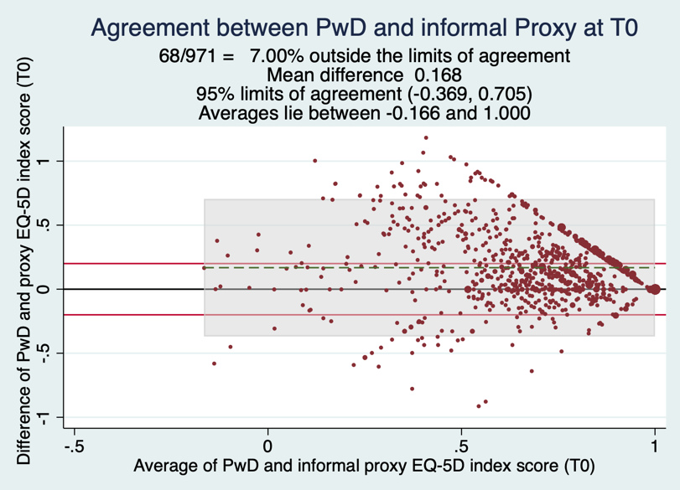

Figure 31b, Bland-Altman plot for agreement between PwD-staff proxy EQ-5D index scores

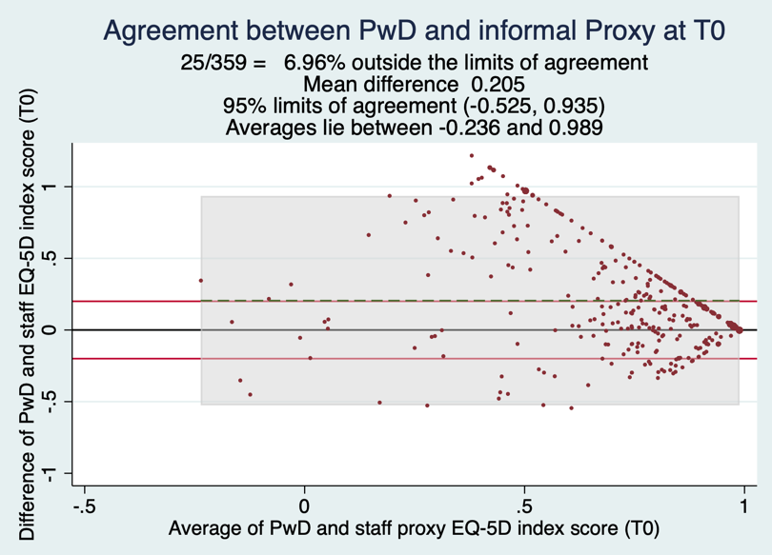

5.4.6.1.2 Histograms for inter-rater agreement

Figures 32a and 32b below are the histograms generated to represent absolute discrepancy scores between PwD-proxy EQ-5D index scores. Scores above zero (negative skew distribution) indicate that the PwD’s self-report is more optimistic, whereas scores below zero (positive skew distribution) represent a pessimistic PwD self-report (compared to proxy reports). For comparisons with both proxy types, the majority (approximately 70%) of discrepancy scores fall between -0.2 and +0.4, with a cluster of values around the zero mark (indicating no difference (around 9% for PwD-informal proxy and 4% for PwD-staff proxy discrepancy scores)). Of the discrepancy scores, over 70% were positive for comparisons with both proxy types. This indicates that the majority of proxies report negatively in comparison to the PwD (for both proxy types). However, the range of negative discrepancy scores extends further for informal proxies than for staff proxies (the lower limit reaches approximately -0.5 for staff proxies and -0.9 for informal proxies).

Figure 32a, Histogram for absolute discrepancy scores, PwD-informal proxies

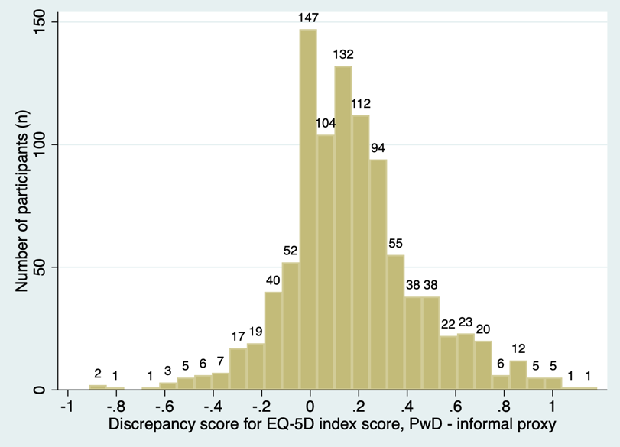

Figure 32b, Histogram for absolute discrepancy scores, PwD-staff proxies

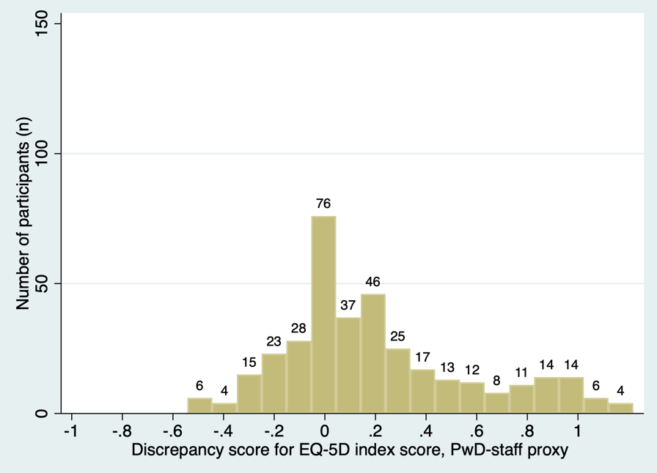

5.4.6.2 Responsiveness evidence – EQ-5D index scores

Figures A5.4a and A5.4b in Appendix 5.4 show the effect size estimations for changes in EQ-5D index scores generated by the different respondent types, alongside changes in the dementia symptom measures. As shown, improvements in symptom measure scores do not translate to changes in EQ-5D index scores. For worsening symptom measure scores, informal and staff proxy responses produce above moderate effect sizes in line with worsening of CDR stage (of the PwD) – while PwD-self report does not. Similar effect sizes are produced alongside changes in function and NPI scores, although these do not reach the moderate effect size threshold.

Similar to the correlation of change evidence presented for each of the EQ-5D dimensions, the strength of the correlations for index score changes were generally low. The largest correlation coefficients observed were for those associated with BADLS changes (PwD, r=-0.18; informal proxy, r=-0.42). See Table A5.4g in Appendix 5.4 for the full results.

5.5 Discussion

This chapter provides evidence to help guide judgements about which respondent is the optimal choice for each of the EQ-5D dimensions when collected during dementia studies; defined as the respondent whose dimension-report is the most responsive to changes in condition measured by dementia symptom measures. To assess this, analyses were conducted on longitudinal data collected from three distinct dementia trials which included people with dementia across mainly mild and moderate stages, and of institutionalised and community dwelling residential settings.

As previously discussed, there are specific challenges surrounding judgement, recall and comprehension that are associated with collecting HRQoL data from people with cognitive impairment. This has often led to the sole reliance on proxies for such information. Although the assessments made are still based on the PwD’s health state, this assumes that the PwD has no ability to accurately report their own HRQoL at any stage of dementia or on any dimension. This notion was discussed during the PPIE session (reported within Section 2.5), where it was clear that the group, in particular the members with dementia, felt strongly that their responses should be considered when assessing their own HRQoL. Issues surrounding poor PwD-proxy inter-rater agreement have been repeatedly flagged within the literature (for example, (Pickard and Knight, 2005, Rand and Caiels, 2015, Keetharuth et al., 2022, Hounsome et al., 2011)). It is known that different respondents provide reports differently, however there is no indication regarding which respondent provides optimal reports. Therefore, for the interpretation of the results provided within this section regarding whose reports to use per EQ-5D dimension, unless sufficient findings are presented to deviate from using the PwD’s self-report of their own health status, the PwD is retained as the default choice.

As highlighted in Chapter Four, there are specific challenges associated with data collection in dementia trials and studies, particularly when collecting longitudinal data from multiple respondents. The merged dataset included PwD-self reports, informal proxy reports and staff-proxy reports; however, acquiring three distinct sets of HRQoL data about one person may limit the feasibility of data collection, and increase resource use and researcher burden. Such challenges were observed within the EPIC dataset, where it was highlighted that recruitment of informal proxies was considerably low, and the missingness of informal proxy reported EQ-5D data was high – particularly in contrast to that of staff proxies. In light of these pragmatic considerations, it is recommended that assigning respondents for EQ-5D dimension assessments should be based on the PwD’s residential status, whereby a single proxy-type is recruited as opposed to obtaining data from both informal and staff proxies for institutionalised people with dementia. The selected proxy assessor should be someone who knows the PwD, and their condition well and has direct (and if feasible) daily contact with the PwD.

Therefore, where the PwD is institutionalised, the recommended proxy is a member of care staff. As stated, the main steering factor is that the proxy should be someone who has close contact with the PwD and has an awareness of their relative condition, perspectives, and general performance. Members of care staff have this type of contact, they are generally on-site for researchers to attain HRQoL instrument data from (alongside the PwD), whereas data from informal proxies tended to be less frequently collected via face-to-face administration. Staff-proxy data also had significantly lower rates of missingness when compared to informal proxy data (observed via the descriptive analyses from the EPIC study, see Section 4.4.2). For community-dwelling people with dementia, the proxy-respondent should be an informal proxy (family member or friend) that ideally lives with the PwD or has direct regular contact, as opposed to a health-care professional or visiting professional caregiver with minimal interaction and relative condition awareness.

5.5.1 Objective one: interpretation of change analysis

Objective one centred on identifying which respondent’s EQ-5D dimension reports most accurately reflected change in dementia symptom status. Methods of analysing change in dimension-ratings of dyads and responsiveness of reports were applied to explore this objective; and the methods were also applied to EQ-5D index scores.

For the “mobility” dimension, the direction of change evidence reported in Section 5.4.1.1 showed that while the largest proportion of informal proxy dimension reports of worsened health status corresponded with worsened functional outcomes, a large proportion (approximately 62%) of informal proxy reports of an improvement in “mobility” were in cases where the PwD’s function had worsened, indicating that informal proxy reports may not be valid. The largest proportion (around 60%) of staff proxy reports of no change in “mobility” corresponded with stable functional status when compared with the other respondents. Informal proxy “mobility” reports were only slightly more responsive than PwD self-reports, with effect size estimates of -0.34 for people with dementia and -0.36 for informal proxies where CDR had worsened, both of which do not meet the minimum threshold value for consideration. Whereas for staff proxy “mobility” reports, the effect size estimates were moderate alongside changes in CDR (-0.56) and function (-0.49).

For the “self-care” dimension, the direction of change evidence reported in Section 5.4.2.1 was stronger for informal and staff proxy reports, when compared with PwD self-reports. Alongside worsening in functional scores, the greatest proportion of informal proxy dimension-reports (respectively) corresponded, and for stability in function, the greatest proportion of staff proxy dimension reports reflected no change. Alongside changes in CDR, worsening in condition saw the greatest proportion of corresponding staff “self-care” dimension reports (and for stability, by informal proxy reports). The patterns were relatively similar for changes alongside behaviour/mood status, although a larger proportion of proxy reports (approximately 50% for informal and 53% for staff proxies, vs. around 29% for people with dementia self-ratings) of an improvement in this dimension corresponded with improved behaviour/mood. The responsiveness evidence shows that where the PwD’s CDR and function had progressed, informal and staff proxy effect size estimates were moderate-to-large (informal proxy: CDR, -0.66, function, -0.49; staff proxy: CDR, -0.72, function, -0.61) – in contrast to the weak effect sizes observed for PwD self-reports.
For the “usual activities” dimension, informal and staff proxy reports were more aligned with clinical changes when compared with PwD self-reports. Where a large proportion (approximately 68%) of people with dementia had reported an improvement in this dimension, their functional score had actually worsened. Informal proxies reported the most worsening in line with functional progression (around 74%), while staff proxies reported the most stable dimension-scores where PwD function has remained the same (approximately 53%). Where CDR has progressed, more staff proxy reports of “usual activities” reflect this change (51%). Informal and staff proxy reports were more responsive to changes in CDR stage than PwD self-reports were and produced moderate-to-large effect sizes (informal proxy, -0.66; staff proxy, -0.64; PwD, -0.11).

For the “pain/discomfort” dimension, the direction of change evidence associated with behaviour/mood status revealed similar patterns of reporting across respondent types. For associations with functional status, the pattern of reporting was similar for people with dementia and informal proxies whereby just over 25% of stable reports were in cases where the PwD’s function has remained the same, and around 65% of worsened reports were where the PwD’s function has worsened. Generally, the findings were mixed between respondent types and difficult to draw strong and definitive conclusions from. The responsiveness evidence for the different respondents was also immaterial, showing weak effect size estimates across respondent types. The correlations between change-in-scores were also low across the respondents.

For the “anxiety/depression” dimension, a large proportion of PwD self-reports of an improvement in health status (around 48%) were in cases where their behaviour/mood outcome score had actually worsened. The largest proportion of improved and worsened dimension reports tallied in the same direction with behaviour/mood changes for staff-proxy reports (compared with people with dementia and informal proxies). “Anxiety/depression” was the only dimension to observe convergent validity with cognition, where it was initially found (via systematic review in Section 3.7) that greater cognitive impairment was correlated with improved “anxiety/depression” reports; however, the results were in the inverse direction of this prior relationship. Similar to “pain/discomfort”, the responsiveness evidence was immaterial, with none of the respondent’s effect size estimates reaching the 0.5 minimum threshold for consideration. The correlations between change-in-dimension and symptom measure scores were also low across respondents.

When these analyses were applied to EQ-5D index scores, where the PwD’s CDR stage had progressed from baseline to the final follow-up point, a greater proportion of informal (around 72%) and staff (around 62%) proxy index scores had worsened compared with PwD-scores (approximately 58%). Mean utility scores were reported by dementia severity stage, in which both informal and staff proxy EQ-5D scores worsened with progression of CDR, while PwD self-reports did not. The more consistent PwD self-reports could be due to the near equal proportion of people with dementia who reported either an improvement or a worsening in EQ-5D (approximately 40% for both); and that the difference between the mean utility scores of those reporting an improvement or a worsening from baseline to follow-up was only 0.03 points (difference in means (PwD reports): improved EQ-5D, 0.18; worsened EQ-5D, -0.21). The proportion of worsened EQ-5D index scores over time was greater for both proxy types, and the difference in means of proxy reports of a worsening was of a larger magnitude (than the improved proxy EQ-5D scores). The responsiveness analyses showed that improvements in dementia symptom measures did not translate to improvements in EQ-5D index scores, however informal and staff proxy reports were responsive to a worsening in CDR stage over time.

5.5.2 Objective two: interpretation of inter-rater agreement analysis

Objective two involved analysing similarities and differences in how people with dementia and proxies provide EQ-5D dimension and index score reports via the application of inter-rater agreement methodologies and assessing floor and ceiling effects.

The second largest proportion of exact agreement of all dimensions was found for the “mobility” dimension (around 50%), and a moderate kappa coefficient was observed for agreement (k=0.55) between PwD-informal proxy dyads, indicating good inter-rater agreement. The proportion of exact agreement and the kappa coefficient were lower for PwD-staff proxy dyads (43% and k=0.31 respectively). The discrepancy scores for “mobility” highlighted that staff proxies more often provided negative scores in contrast to the PwD, when compared with informal-proxy dyads. However, this dimension saw ceiling effects for PwD self-report (60% at perfect health) and floor effects for staff-proxy report (approximately 28% at worst possible health), thereby explaining the contrast in reports observed via the discrepancy analyses. For the difference between the amount of change reported between timepoints, there were a greater proportion of pessimistic change scores provided by staff proxies (than the PwD of the dyad). These reported changes align with the progression in dementia symptom measures, particularly CDR stage and functional status, as evaluated via the responsiveness analyses earlier.

For the “self-care” dimension, the largest proportion of exact agreement was observed for PwD-informal proxy dyads and a moderate kappa-coefficient for agreement (k=0.42). For PwD-staff proxy dyads, the lowest proportion of exact agreement was observed (around 20%). The “self-care” dimension saw evidence of ceiling effects when reported by the PwD (approximately 76% of people with dementia reported no problems) and floor effects when staff-proxy reported (nearly 50% reporting “extreme problems”), which explains the lack of agreement and low kappa coefficient (k=0.05). The discrepancy scores for “self-care” highlight that staff-proxy scores had a greater degree of variability (when compared with informal proxy scores), with around 24% of scores at the maximum negative score value of minus four. Similarly to with “mobility”, a larger proportion of PwD-staff dyads reported pessimistic change scores (compared with PwD-informal proxies). Overall, inter-rater agreement was lower between people with dementia and staff proxies than it was with PwD-informal proxy dyads.

For the “usual activities” dimension, the lowest proportion of exact agreement (approximately 36%) and the lowest kappa coefficient (k=0.26) of all five EQ-5D dimensions was observed for PwD-informal proxy dyads. In contrast, the highest proportion of exact agreement of all EQ-5D dimensions was observed for PwD-staff proxy dyads (at nearly 60%) – although the kappa coefficient was low (k=0.15). This dimension saw evidence of ceiling effects for PwD and staff proxy ratings, and floor effects for informal proxy ratings, which explains the observed inter-rater agreement patterns. The discrepancy scores for “usual activities” do not show the same patterns as the previous dimensions. Variability in scoring is narrower for staff-proxy dyad reports, and a larger proportion of informal-proxy dyad scores had negative scores, although they are mainly concentrated at minus one.

For the “pain/discomfort” dimension, the proportion of exact agreement between PwD-informal proxy dyads was 51%, and between PwD-staff proxy dyads was 57%. The kappa coefficient indicated moderate agreement (k=0.42) for PwD-informal proxy dyads, but weak agreement for PwD-staff proxy dyads (k=0.16). The discrepancy scores indicated very similar patterns for both dyad types, akin to the scores for the amount of difference between time-point reports for the dyads. Here, approximately 29% of PwD-informal proxy dyads and 24% of PwD-staff proxy dyads had positive difference scores which indicate a pessimistic change score provided by the proxy. This dimension also saw evidence of ceiling effects for both PwD and staff proxy respondents (approximately 64% and 72% perfect health reports respectively). Overall, the findings were weak and alike for both types of proxy.

For the “anxiety/depression” dimension, the proportion of exact agreement was around 43% of PwD-informal proxy dyads, and 57% for PwD-staff proxy dyads, with kappa coefficients that indicate fair agreement for both (k=0.20; k=0.30 respectively). This dimension saw evidence of significant ceiling effects for staff proxy (69% perfect health reports) and PwD-self report (64% perfect health reports) – but not for informal proxy reports. The discrepancy scores show a larger proportion of negative PwD-informal proxy scores, highlighting that more informal proxies provided pessimistic reports compared to the PwD (than staff proxies did). However, the scores for the difference between the amount of change reported between timepoints for dyads showed similar proportions of PwD-informal proxy and PwD-staff proxy dyads with positive scores (where the proxy provides a more pessimistic dimension change report).

Inter-rater agreement was also analysed for EQ-5D index scores. According to the intraclass correlation coefficients and the Bland-Altman plots, it was identified that PwD-informal proxy dyads had a greater degree of inter-rater agreement than PwD-staff proxy dyads. Bland-Altman plots are not traditionally applied in HRQoL research but are a method for assessing agreement between measurements by studying mean differences and applying limits of agreement (Giavarina, 2015). In doing so, a visual depiction of agreement has been constructed, although the plots give the impression of a (near) perfect correlation between PwD and proxy reports at higher EQ-5D scores, this narrowing in the distribution is due to the x-axis reflecting an average of the respondent-scores which is therefore limited to one i.e., full health.

It is important to highlight that the relationship between PwD and proxy-reported EQ-5D dimensions and total scores may change as dementia progresses. As dementia advances, the role of the proxy become increasingly important, as the PwD finds it progressively more difficult to reliably and accurately self-report. Chapter Four highlighted that missing data was more common among people with severe dementia, underscoring the practical challenges of data collection in severe dementia stages. Mixed-effects regression analysis of panel data could have been applied to explore changes in these associations over time, however this method was not adopted due to the complexity of the analysis and the limited availability of data for people in the severe stages of dementia. Most data from people with severe dementia were missing, and only one of the three trials (EPIC) recruited participants at this stage, further contributing to the data gaps. Therefore, the analysis focused on the available data at specific time points and used a cross-sectional approach when appropriate. This approach was chosen to maintain consistency and reliability in the analyses, while acknowledging the evolving role of proxies and avoiding additional complexity.

5.5.3 Objective three: recommendations for combining EQ-5D dimensions by respondent-type

Objective three involves summarising the interpretation of the findings to provide recommendations for combining PwD and proxy EQ-5D reports by dimension. These recommendations are to be used within the subsequent chapter which applies statistical mapping methods to combine PwD and proxy EQ-5D reports to generate a single combined utility score for use in dementia economic evaluations.

Overall, the results showed that there is sufficient evidence to deviate from using PwD self-report for certain dimensions. It is determined that the PwD remains the optimal respondent for the “pain/discomfort” and “anxiety/depression” dimensions. For “pain/discomfort” the responsiveness findings are weak, the patterns for reporting change in dimension health status were inconclusive and the findings do not substantiate using proxy report over PwD self-report. For “anxiety/depression”, inter-rater agreement between the PwD and proxy was generally satisfactory, however the remaining evidence was not substantial, therefore PwD self-report is retained as recommended for use. The conclusion of relying on PwD self-report for these two dimensions is consistent with prior expectations. It has been discussed in the wider literature that these dimensions are considered to be more difficult to reliably proxy-report upon due to their inherent subjectivity (Bonfiglio et al., 2019, Hounsome et al., 2011); this concept, in addition to the empirical evidence reported in this chapter affirm the use of PwD-self reports for the “pain/discomfort” and “anxiety/depression” EQ-5D dimensions.

For the remaining dimensions, in some cases the findings have been interpreted to recommend using the proxy’s data, and the proxy selected is dependent on the PwD’s residential status. For “mobility”, PwD-self reports were not as responsive to changes in dementia symptoms as staff proxy report. Informal proxies and PwD had evidence of inter-rater agreement and were therefore both considered less valid than staff proxy reports, which showed the greatest degree of responsiveness (and also less agreement with PwD self-reports). There was not sufficient evidence to deviate from PwD self-report for community dwelling dementia populations, however for those that are institutionalised, staff proxy reports are considered the most valid.

For the “self-care” dimension, reports on change in this dimension alongside changes in dementia symptom measures were strongest for both proxy types. The responsiveness evidence from the proxy data was strong, producing moderate-to-large effect size estimates. These findings were not observed with PwD self-reports of “self-care”, in fact this dimension saw significant ceiling effects for PwD self-report. It was concluded that in both residential settings, the proxy is the most valid respondent for “self-care”.

For “usual activities”, in both instances the proxy was seen to be the most valid respondent in contrast to the PwD. Both proxies showed strong proportion-evidence for change in “usual activities” reports and responsiveness alongside dementia symptom measure scores, while PwD-self reports did not. As with the “self-care” dimension, “usual activities” saw ceiling effects for PwD self-report. It has been concluded that there was sufficient empirical evidence to deviate from PwD self-report for this dimension, and that a proxy assessor would be more suitable for “usual activities” reports.

Table 33 below provides a summary of the interpreted results regarding which respondent’s reports for each EQ-5D dimension has been concluded to be the most effective. This classification will be used in the mapping analysis presented in the next chapter.

Table 33, EQ-5D target dimension reports by respondent and residential status of PwD

 | Residential setting of PwD
EQ-5D dimension | Community dwelling | Institutionalised
Mobility | PwD | Staff proxy
Self-care | Informal proxy | Staff proxy
Usual activities | Informal proxy | Staff proxy
Pain/ discomfort | PwD | PwD
Anxiety/ depression | PwD | PwD

5.5.4 Implication for economic evaluations

In this chapter, it has been identified that proxy reports demonstrate greater efficacy for specific EQ-5D dimensions, especially those categorised as "observable”, while for the "non-observable” dimensions, PwD self-report is preferred. As a result, a combined score has been suggested. In this section, the impact of applying the combined score is investigated. Table 34 presents mean EQ-5D index scores from PwD self-report, from proxies and from estimating combined scores based on the target dimension reports outlined in Table 33. The scores presented are estimated from dyads where complete data are available and are presented by CDR stage for the two datasets, ACTIFCARE and EPIC. Paired samples T-tests are used to test whether the combined score is statistically significantly different to either PwD or proxy score alone. In the ACTIFCARE dataset, the combined scores were higher than proxy assessments and lower than self-report scores. For the EPIC dataset, the combined scores are not a midpoint between staff proxy and PwD self-reports. The combined scores is lower than either of the two "pure" scores and is only statistically significantly different to PwD-reported scores. This observation highlights the distinct nature of the combined scoring method, suggesting a stronger correlation with staff proxy ratings across all CDR stages.

ACTIFCARE data reveals that the change in scores observed when using the combined utility score is below proxy report, but above self-report by people with dementia. In the EPIC dataset, the combined utility score showcases a more pronounced decline in EQ-5D index scores compared to either self-reports or proxy reports alone. This trend arises from the integration of dimensions most sensitive to change from either respondent, thereby theoretically the combined utility score is more sensitive to changes. The combined score generated for EPIC integrates three (staff) proxy dimension reports, in contrast to ACTIFCARE, where only two proxy dimension reports replace self-reports from the PwD.

Additionally, the difference in utilities appears to be larger between CDR stable and CDR progressed from baseline to final follow-up when using the combined score, suggesting that the difference in utilities may be larger taking this combined approach. It is important to note that this observation is based on the datasets analysed within this thesis and may not be generalisable to all contexts. These findings highlight the different impact of applying a combined score across datasets, suggesting potential dataset-dependent variations. The heightened sensitivity in detecting benefits of treatments, or lack thereof, may impact decision-making processes. A more sensitive EQ-5D change score may translate to larger incremental QALY gains, thereby influencing ICER estimations and subsequent decisions regarding treatment funding.

Table 34, Mean EQ-5D by respondent type and disease severity stage

Severity stage, ACTIFCARE | PwD | Relative Proxy | Combined score |  | Severity stage,  EPIC | PwD | Staff proxy | Combined score
All stages n=1086 | 0.77 (0.21) | 0.62 (0.24) | 0.68*  (0.22) |  | All stages n=760 | 0.80 (0.23) | 0.62 (0.36) | 0.61** (0.36)
CDR 1 n=770 | 0.78 (0.19) | 0.67 (0.21) | 0.75*  (0.20) |  | CDR 1  n=327 | 0.79 (0.24) | 0.71 (0.32) | 0.70** (0.31)
CDR 2 n=293 | 0.75 (0.24) | 0.50 (0.26) | 0.61*  (0.26) |  | CDR 2  n=323 | 0.81 (0.23) | 0.60 (0.35) | 0.61** (0.35)
CDR 3  n=16 | 0.66 (0.30) | 0.35 (0.27) | 0.49**  (0.20) |  | CDR 3  n=104 | 0.82 (0.20) | 0.38 (0.40) | 0.37**  (0.42)
Change in EQ-5D index score from T0 to T2 according to CDR stage
If CDR is stable n=209 | -0.007 (0.19) | -0.043 (0.18) | -0.035 (0.18) |  | If CDR is stable  n=76 | -0.087 (0.28) | -0.045  (0.32) | -0.049 (0.32)
If CDR has progressed n=85 | -0.041 (0.20) | -0.131 (0.23) | -0.129 (0.21) |  | If CDR has progressed n=50 | -0.080 (0.24) | -0.179  (0.32) | -0.193 (0.29)
Values presented in this table use matched pair observations
*Combined score is statistically significantly different to PwD and proxy scores (p<0.05)
** Combined score is statistically significantly different to PwD score (p<0.05), but not proxy score (p>0.05)

5.5.5 Strengths

One of the strengths of this chapter is that it applies various analyses to evaluate the predetermined objectives. The combination of results from the different analyses mitigates the risk of bias associated with relying solely on one type of analysis. Therefore, more robust conclusions can be derived regarding the validity of the respondent’s reports.

The analyses used data from distinct dementia trials, which when pooled, enabled a generous sample size to conduct the analyses upon. Using a larger sample size allows for greater precision when estimating effects. In addition, the trial data was longitudinal, which enabled exploring change over time and responsiveness, which would not have been possible with cross-sectional data.

Acquiring data from different trials which evaluated different populations with dementia has allowed interpretation to be based on the residential status of the PwD. The relationship of the proxy is an important consideration when collecting HRQoL data in dementia populations and is greatly influenced by the residential status of the PwD. It is fundamental that the proxy has frequent contact with the PwD. When the PwD is institutionalised, this form of contact is more likely to occur with formal care staff than it is with informal proxies and obtaining survey data from staff proxies is less demanding and likely to result in fewer missing data observations. These principles together have motivated subdividing the validity judgements by the PwD’s residential status.

5.5.6 Limitations

One limitation of the analyses is that where staff proxy comparisons have been made, the data used was limited to that of one study and were solely people within residential care. Therefore, the comparability of responses between PwD-informal proxy dyads and PwD-staff proxy dyads may be confounded by the residential status of the PwD which was not controlled for within the analyses. This may also explain why staff-reported “self-care” saw significant floor effects (while informal proxy reports of this dimension did not). People may have become institutionalised due to increased impairments with their ability to self-care and a requirement for round the clock care, which is not necessarily generalisable to the wider dementia population. In addition, the relationship and role that the proxy upholds in the PwD’s care plan are influential in how they provide HRQoL ratings (Rand and Caiels, 2015, Pickard and Knight, 2005). If the proxy experiences particular burden associated with the PwD, this is more likely to be reflected in their reports leading to proxy-bias; however, it is also important that the proxy has complete awareness of the PwD’s condition.

Another potential bias to consider is the use of staff proxies in trial settings. Their professional perspectives and potential conflicts of interest may influence their reports, potentially contributing to the differences observed compared with informal proxy reports, especially in dimensions like “usual activities”. Staff proxies may believe that the quality of their care is being indirectly evaluated. These potential biases could be mitigated by standardising data collection methods, anonymising the sources of responses to ensure confidentiality, and assuring staff proxies that their assessments will not impact their performance evaluations. Additionally, rotating different staff members to provide input at various times can help balance subjective biases.

Exploring any potential differences in reporting by dementia severity stage was initially intended. However, due to a lack of data from people with more severe dementia, this proposal was not able to be executed. There were issues with data quality as the proportion of missing data increased by CDR stage (as indicated in Chapter Four), and final follow-up point observations for people with severe dementia (CDR 3) were largely missing. Although this is unfortunate, it is acknowledged that this is the nature of using patient survey data and that in doing so, the risk of additional challenges such as recall bias are also introduced (Blome and Augustin, 2015). Where analyses used a baseline cross-section of the data (i.e., inter-rater agreement analyses), division by dementia severity stage was possible and has been reported within the results but has not been explicitly discussed. The reason for this is because when further dividing the sample by dementia severity stage, the distinct sample sizes dropped considerably. There was not sufficient data to determine any potential differences between mild and moderate dementia with precision. As a result, the validity judgements best reflect people categorised as having mild-to-moderate stage dementia. Although this was not what was initially anticipated for, grouping people with mild and moderate dementia is standard practice within dementia trials and is likely due to limitations with study enrolment (Schneider et al., 2014). Challenges with recruitment of people with dementia in clinical trials is a major barrier to advancing clinical dementia and outcome-based research. Recruitment is generally slower and more resource intensive (i.e., takes longer to complete) than for other disease areas. In addition to recruitment, retention is more difficult, and mortality is a particular challenge with longitudinal dementia studies (Clement et al., 2019, Langbaum et al., 2023).

The analyses that used longitudinal data have been conducted for the period between baseline (T0) and the final follow-up point (T2). The T2 timepoint varied slightly between the studies, but this was not considered to be problematic. The motivation for using T2 data was so that sufficient time (from baseline collection) may have occurred in order to detect any changes in the dimension-reports. Therefore, data collected at T1/the middle follow-up point was neglected; its inclusion could have potentially increased the number of observations for consideration. The purpose of this chapter was to determine validity judgements (that are summarised with Table 33), and it is believed that despite this limitation, the data presented are robust and effectively answer the research question.

Of the inter-rater agreement analyses, particularly when exploring PwD-staff proxy dyads, some of the EQ-5D dimensions produced a high proportion of exact agreement but a low kappa coefficient which complicates the interpretation. However, this is not an uncommon occurrence and is as a result of the smaller sample size associated with staff proxies, therefore producing a higher chance agreement (p_{c}). There are alternative chance-adjusted indexes that make different assumptions than Cohen’s kappa coefficient that may be applied (Feinstein and Cicchetti, 1990), however application of these were considered beyond the remit of this chapter’s focus.

As summarised in Table 33, it was concluded that informal and staff proxies should rate the “usual activities” dimension on behalf of the PwD. Although the empirical evidence supports this validity judgement, there is still an element of uncertainty associated with this particular dimension that has been previously highlighted by the PPIE group discussions (reported in Section 2.5). Qualitative analyses would enable a better understanding of the content validity and function of this dimension to measure the health of people with dementia, however conducting such analyses were beyond the scope of this thesis.

5.6 Patient and public involvement and engagement session two: analysing quality of life in dementia - deciding what matters together

Good practice for PPIE is to conduct follow-up meetings, if feasible with the same group of people and feedback any considerations integrated as a result of their contributions (NIHR, 2019). A second PPIE session was conducted with the DRAiSY group in December 2023.

The principles and overarching purpose of PPIE has been outlined in Section 2.5, and the same methods that were described in this section were adopted for the second session too. The second PPIE exercise had the following objectives:

- To present the established target combination of respondents by EQ-5D dimension and engage in discussion regarding whether people with dementia and/or proxies within the group felt comfortable with this arrangement
- Present to the group the impact of their contribution from the first session on shaping the research thus far and how the feedback from the second session would be utilised in further guiding the research

5.6.1 Summary of PPIE results and discussion

As with the first session, the meeting was conducted in the style of a focus group to encourage open discussion, the key difference is that session two was conducted in-person (as opposed to virtually) at the University of Sheffield. In attendance were Hannah Hussain (researcher), Dr Gray (research administrator) and Dr McKeown (chair for the DRAiSY group). Dr McKeown helped to facilitate the discussion and Dr Gray took meeting notes. The group members included: two people with dementia, one current spousal caregiver, two former caregivers and one healthcare worker. The full notes and feedback from this meeting are provided in Appendix 5.7.

The group was shown Table 33. Overall, the consensus among the members was that using proxy HRQoL reports makes sense, especially when the proxy is a close relative of the PwD. The idea of combining reports from both respondents was well-received and praised. It was reported that the panel would be supportive of this approach, and the empirical findings further strengthened this proposal.

The group engaged in further discussions on additional concepts. Members with dementia highlighted the importance of the timeline, expressing that recalling memories for self-report may introduce additional complexities. They stated a preference for reporting about the current moment, aligning well with EQ-5D's survey of health status on that specific day.

The group explored additional ideas, particularly focusing on the "usual activities" dimension. A member with dementia pointed out that when asked similar questions during clinical appointments, they often realise they have unintentionally reported based on how they used to carry out daily activities or how they would like to. The potential unreliability of self-report was recognised and acknowledged.
Building on group discussions, members were briefed on the impact of their contributions to the research. It was explained that insights from the initial session played a role in validating literature claims and ensuring that reports from both respondent types were acknowledged as vital at each step of the research. Additionally, they were informed that certain ideas, such as the suggestion of visual prompts (even though beyond the scope of this thesis), would be valuable for future research recommendations when considering how best to collect data in dementia trials and studies. Overall, the group expressed satisfaction that a follow-up session had taken place and that their voices had been considered in shaping the research.

5.7 Conclusion

This chapter’s analyses have outlined a series of applied methodologies aimed at establishing a target-combination of EQ-5D dimension assessments based on the respondent, within the context of the PwD-proxy dynamic. The interpretations of these analyses have yielded a specific target-combination dependent upon residential setting, distinguishing between community-dwelling and institutionalised people with dementia via the trial settings of the available data. The use of a respondent-specific combination of EQ-5D dimensions fosters confidence that an improved reflective account of dementia experience is being captured via better accuracy of HRQoL scores (when compared to relying solely on data from either respondent). Both the PwD and their proxies provide vital information, central to many types of dementia research. Through these analyses, the perspective of both respondent’s is being acknowledged, where their report is deemed to be the most applicable according to clinical metrics. It is crucial to note that these findings are constrained by the available data, and while there is no gold standard for arriving at such value judgements, clinical measures alongside various metrics and thresholds have been employed to assess the performance of dimension reporting.

6 Mapping to the combined-EQ-5D utility score

The analysis presented in Chapter Four bridged an evidence gap by examining the convergent validity of EQ-5D at the dimension level with measures of dementia symptoms. This was further supplemented with analyses investigating this psychometric property across different respondent types, using individual patient level data from existing trials. This analysis aided in guiding the analyses presented in Chapter Five, which used the established relationships between EQ-5D dimensions and dementia outcomes to assess responsiveness and changes in reporting over time. As a result, the work presented in Chapter Five identified that the most effective report of HRQoL for people with dementia is obtained from the responses to EQ-5D from people with dementia for some dimensions, and from proxies for others, thereby leading to a combination of EQ-5D dimension reports by respondent type. Additionally, Chapter Five discussed the policy implications of employing a combined utility score.

This chapter builds upon the value judgements established in Chapter Five and uses statistical mapping methods to investigate the predictability of the combined utility score when data for only one respondent type (either PwD or proxy) is available. Given that future dementia studies are expected to use EQ-5D-5L rather than EQ-5D-3L, the analyses in this chapter focus exclusively on datasets from the ACTIFCARE and EPIC trials, which collected EQ-5D-5L data.

6.1 Introduction

A key and recurring theme throughout this thesis has been the focus on the discrepancies observed between PwD and proxy reports. Frequently it is found that people with dementia provide more optimistic self-reports compared to proxy reports. A range of reasons for this occurrence have been debated in the wider literature, including proxy burden, impairments in self-awareness of the PwD and response shift of the PwD to their own dementia condition (Hounsome et al., 2011, Burks et al., 2021, Hussain et al., 2022). Specific challenges arise for researchers and investigators in deciding whose data to use in trials when measuring HRQoL, compounded by the lack of guidelines for interpreting these distinct sets of data.

As previously noted, the analysis in Chapter Five highlighted that incorporating EQ-5D dimension reports from both the PwD and proxies could lead to a more accurate depiction of HRQoL for dementia populations, thereby resulting in a combined utility score. However, it is recognised that not all dementia studies have historically collected both PwD and proxy EQ-5D reports, and future studies may face logistical restrictions in doing so. Even on occasions when both PwD and proxy reports have been collected, their use may be limited in allowing an economic model to be parameterised, for example, if the follow-up period is short or if data have not been collected from a sufficient range of respondents across the relevant spectrum of disease severity. Therefore, the analyses in this chapter employ statistical mapping methods to arrive at the recommended target combination of EQ-5D dimensions where EQ-5D reports are available from only one respondent type.

Mapping techniques serve to link outcomes from different measures and have gained increasing popularity and value, particularly in scenarios where studies have not collected health-related utility data. In such cases, where specific preference-based measures, such as EQ-5D, are recommended but not collected, mapping enables the prediction of health-related utility values by using scores derived from alternative measures (Longworth and Rowen, 2013). This approach proves particularly valuable in studies that have collected disease-specific measures, aligning with preferences stated by NICE for health-related utility estimates used in QALY calculations to be derived from EQ-5D (NICE, 2022). Through mapping models, scores from such measures can be linked, thereby enabling the prediction of EQ-5D scores. For mapping to occur, both the target (the measure being predicted) and the source (the predictive measure) measure must be present within the dataset. From available data, mapping models can be constructed to estimate a statistical relationship between the target and predictive measures, using any other relevant outcomes. There are two key types of statistical mapping: direct mapping, and indirect mapping – also referred to as "response" mapping. Direct mapping estimates the summary utility score directly. Whereas response mapping estimates utility as part of a two-stage process, first a series of models are used to estimate the level on each distinct domain of the descriptive system of the target measures. Stage two then calculates the expected utility score using probabilities assigned to each of the health states in the descriptive system and their associated utilities (Wailoo et al., 2017).

By applying statistical mapping methods, studies can still derive the target combination of dimension reports, thereby generating the combined EQ-5D utility score. This combined EQ-5D score may therefore be used in economic evaluations of dementia interventions. The methodologies are first described, and six results sections follow – one for each dimension of EQ-5D and a section where utility scores are estimated.

6.2 Aims and objectives

The central aim of this chapter is to apply statistical mapping methods to predict the target combination of responses for each of the EQ-5D-5L dimensions (as established in Chapter 5, see Table 33). This is achieved by using responses from the other half of the PwD-proxy dyad and any additional relevant variables. The key objective is to determine whether the target combination of EQ-5D-5L dimension responses could be achieved (through direct observation for some dimensions and predicted responses for other dimensions, using EQ-5D responses from one respondent) without relying on both members of the dyad. In doing so, existing or future dementia trials may be equipped to apply the target combination, even if they exclusively collect EQ-5D-5L data from either the PwD or the proxy in their study.

6.3 Methods

The ACTIFCARE and EPIC trials both collected EQ-5D-5L data. ACTIFCARE recruited participants from community-dwelling settings, while EPIC collected data from institutionalised people with dementia. This chapter’s analyses draw exclusively from these two studies. Incorporating the data from the REMCARE study, which collected EQ-5D-3L, would have added complexity to the analyses due to differences in response level options for the different versions of EQ-5D and in the value sets used to generate utility scores. This is not a limitation as it is also more likely that future studies will collect EQ-5D-5L instead of EQ-5D-3L.

6.3.1 ACTIFCARE and EPIC trial data

As established in the previous chapter, the target combination of respondents for these two trials differed for the “mobility” dimension. In the ACTIFCARE study, the PwD was considered the target respondent, while in the EPIC study the target respondent was the staff proxy. This difference in target combinations, alongside the fact that both trials collected different dementia symptom measures, meant that it was deemed most appropriate to conduct the mapping analyses on separate datasets for each trial. The proportion of scoring level responses from the PwD and the proxy for each EQ-5D dimension were then tabulated and are presented within Appendix 6. Preliminary correlations were estimated using Spearman’s rank for EQ-5D dimensions and Pearson’s correlation for symptom measures. The aim of the correlation analyses was to assess whether any of the variables had particularly high correlations with each other, so as to avoid model overspecification. The detailed correlation tables for both trials can be found in Appendix 6.1.

6.3.2 Ordered probit regression models

The basis of this analysis is rooted in arriving at the target combination of EQ-5D-5L dimensions, as described in Chapter 5. Ideally an optimal model for each EQ-5D-5L dimension (across the trials) would have been aimed for, however the target respondent for the dimensions differed, meaning this was not feasible. The focus is on response mapping because the separation of dimension responses allows analysts to use the dimension responses that they have that are from the “target” respondent directly, with no loss of information from a statistical model. Response mapping methods also have the ability to deal with dimension-level specificity; they are inherently flexible in that different sets of predictors may be used for predicting responses to the distinct dimensions if required. The overall objective is to estimate a combined-utility score, which uses different respondent’s data by EQ-5D-5L dimension. This approach allows the specific dimension models to be applied where needed, ensuring that studies that collected data solely from one respondent type can still generate the combined-utility score by predicting what the other respondent would have reported for their target dimensions – had their data been collected.

Another advantage of response mapping lies in its two stage process, enabling the application of any EQ-5D-5L value set when estimating utility scores. This is particularly relevant in the current research landscape, given the lack of an UK EQ-5D-5L tariff for application. When an appropriate UK EQ-5D-5L tariff becomes available, there may be an opportunity to explore direct mapping methods to predict the combined-utility score as a function of PwD or proxy responses (along with other relevant variables). However, until that point, challenges arise with mapping to the mapped data (further details provided in Section 6.3.7).

Response mapping was conducted by using a series of ordered probit models via the “oprobit” command in STATA. Ordered probit models are appropriate for mapping to EQ-5D-5L data due to the ordinal nature of the EQ-5D-5L response levels. Response mapping emphasises the importance of partnering the statistical method used with the ordinal nature and structure of the data that is being modelled and mapped. As the EQ-5D-5L instrument captures severity across five response levels (from "no problems" to "extreme problems"), the use of ordered models ensures that the inherent ordering of the levels is appropriately preserved and considered. Ordered probit models do this by calculating the probability of an observation falling into a particular level or below, acknowledging the ordinal structure of the responses. The models assume that there is a latent continuous variable underlying the observed ordinal responses, and that this latent variable is influenced by predictors in a linear fashion (Greene and Hensher, 2010). Therefore, by using ordered probit models for EQ-5D-5L dimensions, it is ensured that predictions remain consistent with the ordinal nature of the EQ-5D-5L, complementing the interpretability of the mapping results (Alava et al., 2012).

In the mapping models, the STATA “cluster” command was used to control for potential intra-patient correlations in the data. Given that multiple observations are associated with the same PwD-proxy dyad (represented by the patient identifier) there is a chance that these observations are not independent and are correlated within patients. Intra-patient correlations can arise due to a variety of reasons, such as consistent behaviours, patient-specific effects or external environmental factors that could influence measurements over a time period. By using cluster-robust standard errors, the analysis adjusts for this type of correlation and ensures that standard errors are correctly estimated.

The distinct dimension models were first constructed using all theoretically relevant and viable variables from the dataset, taking into account the correlations between variables. Refinements of the models were on the basis of the magnitude, direction and the statistical significance of the variable coefficients (p<0.05). This refinement was coupled with consideration of the marginal effects outputs and model fit statistics as outlined in the sections to follow. A comprehensive approach ensured that these factors were considered simultaneously when determining the inclusion or exclusion of variables, with an additional awareness on aiming for consistency in the predictor variables and/or outcomes included in the dimension models. The guiding criteria adopted are reported in the sections below, and the various model iterations for each of the dimension-models are presented in the results sections and in Appendix 6.2. For dimension-models from ACTIFCARE, scenario analyses were conducted to assess the performance of the two collected functional measures (IADL and PSMS). This approach aimed to mitigate potential overspecification derived from the inclusion of two function variables that exhibit a strong correlation to one another (r=0.65, p<0.05; as detailed in Table A6.1a).

Due to differences in the outcome measures collected across datasets, it was not feasible to merge them for a combined analysis, therefore the models were re-run focusing exclusively on the most commonly collected pragmatic variables, specifically, demographic data of the PwD and EQ-5D dimension reports from other respondents. The purpose of this step was to evaluate the feasibility of predicting EQ-5D dimension scores using only these pragmatic variables, with the aim of making the models more applicable for future research in dementia trials.

6.3.3 Marginal effects for model iterations

After each model refinement and consideration of the variables to include, the marginal effects outputs were examined, ensuring that the model performed as expected and that its resulting outputs remained both theoretically consistent and statistically robust. There are different types of marginal effects with distinctive estimation methods. The Average Marginal Effects (AME) were calculated using the “margins, dydx(*)” command in STATA. AMEs assess the average discrete impact of each predictor (independent variable) in a model on the probability of predicting each level of an ordinal outcome (the dependent variable). The results obtained reflect the average discrete changes in the predicted probability of transitioning to each level of the ordinal dependent variable for a one-unit change in the particular independent variable, with comparisons made against the base level. This calculation is performed while all other variables are held constant at their respective means.

AMEs are particularly useful for interpreting the ordered probit models produced in this research as they provide insights into the changes to the probability of transitioning to each severity level of the EQ-5D-5L dimensions. They show the practical impact of predictors beyond the statistical relationships indicated by the coefficients. This verification process was important for ensuring that the predicted impacts on probabilities aligned with the expected EQ-5D-5L dimension severity levels, thereby validating the models’ abilities to capture expected relationships. Examination of the marginal effects outputs considered the direction of the values (sign), magnitude and statistical significance, thereby ensuring that the outcomes retained in the model equations provided results that were statistically sound, theoretically consistent, and empirically credible. AMEs for the final selected dimension-models are presented in Appendix 6.3.

Within the main text of the results, the predictive margins for the independent EQ-5D-5L dimension used in the dimension-model equations are reported. These margins have been obtained using the “margins” command in STATA and reflect the average predicted probabilities of each level of the dependent variables for the various values of the independent variable. While additional variables such as PwD demographics and clinical outcome scores are included in the model equations, their roles are secondary to that of the EQ-5D-5L dimension, serving to enhance model fit and predictive abilities. The main focus remains on predicting EQ-5D-5L reports from one respondent type as a function of EQ-5D-5L reports from another respondent type. The estimations of predictive margins consider the observed values of the other variables in the model equations, therefore providing insight into how changes in the independent variables are associated with changes in the predicted probabilities across different response levels.

6.3.4 Model fit statistics

For ordered probit models, Akaike Information Criterion (AIC) and the Bayesian Information Criterion (BIC) are key measures of model fit, and they provide insight into the quality of the model, considering how well the model fits the data and the complexity of the model. AIC and BIC balance the number of parameters within the model and the fit of the model to the data, penalising for overfitting (Vrieze, 2012). Lower values of AIC and BIC are reflective of more favourable model fits. It is important to note that while AIC and BIC are key in model refinement, they are most relevant for comparing iterations of the same model, rather than across models. They are therefore valuable tools for model refinement, where variables are iteratively included or omitted to assess how these changes impact model performance.

The iterative process of variable selection involved checking for changes to AIC and BIC. If the inclusion of a variable, particularly PwD demographics i.e., age or sex, resulted in a minor deterioration to model fit (a shift of around 10-20 points in AIC and BIC), but its inclusion enabled consistency across models and was supported by underlying theory, the variable was retained. There are published guidelines on how to use AIC and BIC information criteria for comparing models, but there are no specific thresholds (Anderson and Burnham, 2004). Despite the potential subjectivity in applying a 10-20 point threshold to be considered a minor deterioration to model fit, this approach represents a balance between empirical model fit and theoretical coherence, ensuring that the final model is both statistically robust and meaningful in the context of the research.

6.3.5 Trial indicator variable

The dimension-level ordered probit models were re-run on a merged dataset including data from both trials and a trial indicator variable. Because the trials collected different measures, the re-run models could only include variables that were common across both datasets. The objective of this exercise was to assess the significance of the trial indicator variable, highlighting whether there were differences in the performance of the core models (the preferred final models) across the two trials. The trials differed in terms of their residential care settings, they used different proxy-types and the EPIC sample generally recruited people with more severe dementia. While the statistical significance of this trial variable could shed light on the presence of differences in model performance, it cannot provide insight into any potential underlying reasons for such differences. This step was performed to assess whether it is possible to estimate a universal model across different trial settings, particularly in the absence of consistent measures across datasets.

6.3.6 Comparing observed and predicted data

To assess the performance of the ordered probit models at the dimension level, STATA’s “predict” command was used to generate the predicted frequencies for the responses to each level. This data is compared to the observed frequencies and presented in tables for each EQ-5D-5L dimension in the results, offering insight into how closely the model predictions align with the observed data and where there are disparities.

Given that the EPIC trial did not collect a measure of cognition, the finalised models for ACTIFCARE were re-run without MMSE at this stage to examine whether the omission of MMSE aligned the predicted frequencies more closely with observed data, adversely impacted the predictions, or had no effect. This evaluation serves as an additional measure beyond standard model fit statistics, aiming to confirm the significance of MMSE within the dimension models and to inform data collection recommendations.

6.3.7 Estimating utility

There are two stages to response mapping, as illustrated in the flow diagram below (Figure 33).

Figure 33, Flow diagram for two-stage process for deriving utility values
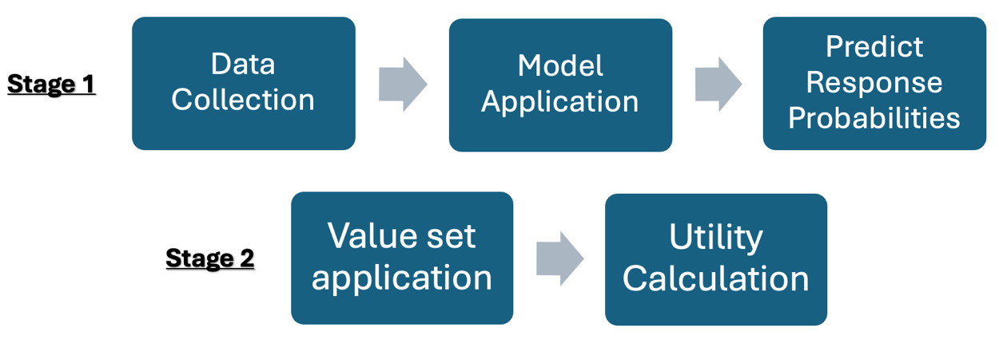

The first stage begins with collecting or acquiring EQ-5D-5L data from either the PwD or the proxy. The choice of proxy depends upon the residential setting of the PwD: for those living in the community, an informal caregiver such as a family member or friend should serve as the proxy. For those that are institutionalised, the proxy should be a staff member. This data, along with demographic information and other measures of dementia symptoms, serve as the basis for modelling and predicting responses for each EQ-5D dimension. Since the final utility score is a combination of responses from both respondents, observed data collected at this stage can be used for certain dimensions, and predicted are made for dimension where the other respondent is the optimal reported. This approach is detailed in Chapter Five and summarised in Table 33.

The next step involves applying predefined statistical models, developed and chosen based on theoretical considerations and previous research, to predict responses for each of the five EQ-5D-5L dimensions. The development and selection of these models are discussed in the results section of this chapter. These models, which already include specified parameters, are used to ensure consistency and reliability in predictions. The final step of Stage 1 is to use these fitted models to predict the probabilities of different response levels for each EQ-5D-5L dimension. At this point, frequency tables may be generated to compare the likeness of observed and predicted data when both are available. These predictions will then be used in Stage 2 to allocate utility scores, representing the predicted health state distributions.

The second stage does not involve modelling, but rather assigning the relevant utility scores to the predictions. For each set of predicted responses, the corresponding dimension level score/decrement is applied according to the desired value set. Lastly, the overall utility score may be estimated by combining the dimension level scores/decrements for each dimension according to the established value set. The overall utility score provides a single measure of HRQoL, derived from the combined scores of individual dimensions (from both observed and predicted data).

As noted, utility calculations were performed using the target combination of respondents for the EQ-5D dimensions for the observed data and the predictions. These calculations followed current NICE recommendations of mapping EQ-5D-5L responses onto the well-established EQ-5D-3L value set (Hernández Alava et al., 2023, NICE, 2019b), and have been presented within the main text. A 2018 EQ-5D-5L value set for England was available (Devlin et al., 2018). However, it has since been discredited, as emphasised by NICE's position statement, there have been concerns raised by an independent quality assessment regarding the data quality and modelling of the value set (NICE, 2019b) (Hernández-Alava et al., 2018), and it is therefore not currently recommended for use. As an example of a future application for when an approved EQ-5D-5L value set becomes available, utility calculations have been conducted using the Devlin 2018 EQ-5D-5L value set for England and are presented within Appendix 6.5.

When using direct mapping methods, a caveat to note is that the outputs from any prediction models do not represent raw data but are instead predictions. This presents challenges when applying mapping techniques to “data” that has already been mapped (Wailoo et al., 2017) regarding the loss of information such as multimodality, which may have been smoothed via the initial mapping process and reduced variance, which distorts the distribution (this scenario arises when direct mapping methods are applied, and the model is used to estimate utility scores by mapping EQ-5D-5L responses to the EQ-5D-3L value set). However, response mapping operates differently in that instead of attempting to directly predict utility scores for specific health states, response mapping predicts the probability of different response level options, therefore the entire distribution of utility scores is not attempted to be reproduced. In this approach, the challenges related to the distribution of the data becomes less relevant, further justifying the use of response mapping in the absence of an approved EQ-5D-5L value set.

To assess the overall performance of the dimension models combined for utility score generation, the mean observed and mean predicted utility scores were plotted across the distributions of dementia symptom measure scores. For the ACTIFCARE study, these plots were based on MMSE scores. In the absence of a cognitive measure in the EPIC trial, FAST scores (function measure) were used instead. To maintain a degree of comparability, the utility plots were also conducted across the distribution of PSMS scores (another measure of function) for the ACTIFCARE trial.

6.4 Results

The following section presents the results of the mapping analyses applied by EQ-5D dimension.

6.4.1 Mapping to the “mobility” dimension

The following section presents the results for mapping to the “mobility” dimension of EQ-5D. As established in Chapter 5, the target respondent for “mobility” differed between the trials, with the target being the PwD for ACTIFCARE and the staff proxy for EPIC. According to the methodologies previously outlined, various model iterations were conducted to arrive with the finalised models. The regression outputs for these model iterations are provided in Appendix 6.2, as well as a summary table of the coefficients of the final selected models for both datasets.

6.4.1.1 Marginal effects of the final selected models: EQ-5D Mobility

As highlighted in the methods section, AMEs played a key role in the model iteration and variable selection process, tables for which can be found in Appendix 6.3. The main independent variable of interest is the “mobility” dimension report that is used to predict the corresponding “mobility” report of the other target respondent. Therefore, due to their intuitive and focused nature, predictive margins of the variable of interest are reported and examined from the final selected model; these have been graphically presented – however full tables are also provided in Appendix 6.3.

As the target “mobility” response was different for the two trials, the model’s predictive margins cannot be directly compared. However, it can be seen that for the two datasets, the probability of predicting a level one target response is greatest for level one and two predictor responses, whereby the 95% confidence intervals do not overlap with the probabilities of predicting any other levels.

In ACTIFCARE, level five informal proxy responses correspond with the greatest probability of a level four PwD prediction, however the confidence intervals for the probabilities overlap indicating that they are not statistically significantly different (see Figure 33a). It is important to note that in the ACTIFCARE study, less than 1% of PwD self-rated at level five for this dimension (see table A6a). This characteristic of the data is therefore mirrored by the probabilities, indicating a reduced likelihood of predicting a level five PwD “mobility” response.

For the EPIC data, where staff proxy responses are predicted as a function of PwD “mobility” scores, the probability of predicting level five responses is greatest at both level four and five PwD responses. The confidence intervals also do not overlap with those of any of the other probabilities – indicating the distinct significance of these probabilities. A third of staff proxies provided a level five rating for this dimension, and the predictive margins displayed in Figure 33b are reflective of this higher likelihood of an “extreme problems” response for proxy-reports (when compared with the ACTIFCARE data).
Figure 33a, “Mobility” predictive margins for ACTIFCARE data

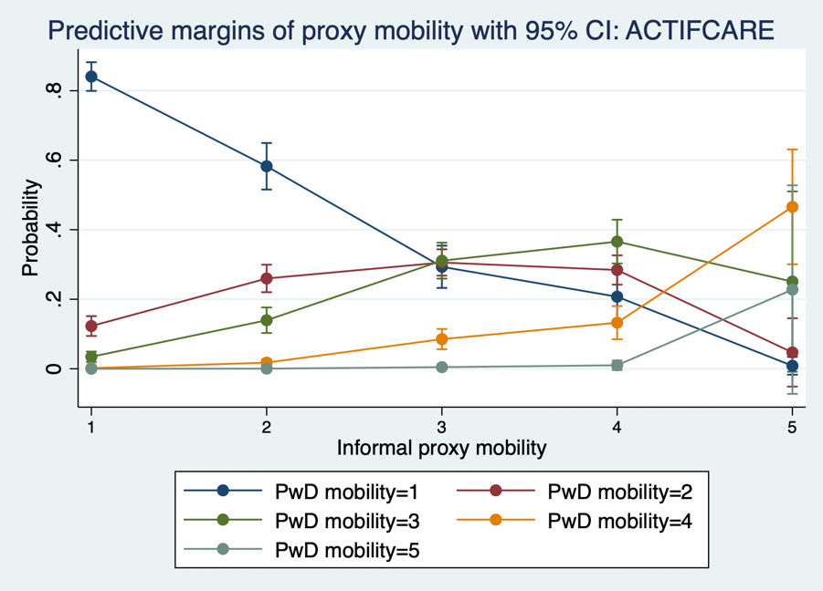

Figure 33b, “Mobility” predictive margins for EPIC data

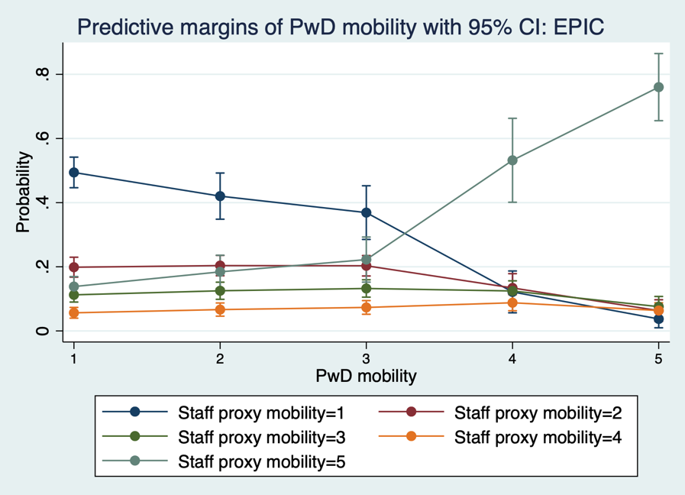

6.4.1.2 Marginal effects of the additional model variables: EQ-5D-5L Mobility

The following section refers to the AME outputs for the final selected “mobility” dimension models for both trials, aiming to highlight any similarities and differences observed between them (see Tables A6.3a - A6.3d in Appendix 6.3).

The functional measures collected by the two studies were different, however the AMEs for the function variables are mainly statistically significant for both models, whereby the changes in probabilities increase and decrease across the “mobility” levels for the EPIC and ACTIFCARE datasets respectively (according to the function measure’s scoring mechanism). The AMEs for MMSE observed with the ACTIFCARE data are statistically significant across the prediction levels, but do not show a clear pattern in terms of their magnitude, whereby the largest impact is associated with level 3 PwD predictions. The model coefficients for PwD age are statistically significant for both trials (see summary Table A6.2c, in Appendix 6.2), however the AMEs associated with PwD age are negligible. The same is true for PwD sex, however both of these demographic variables have been retained because they provide the models with context regarding the PwD, they impact model fit statistics positively and they enable consistency across the models in terms of the measures included – therefore allowing for more direct comparisons and potential for pooled analyses.

6.4.1.3 Observed vs. predicted data: EQ-5D-5L Mobility models

The tables below display the response frequencies for each level of the "mobility" dimension (as provided by the target respondent). They also contain the predicted response frequencies for each level, as derived from the mapping model for each respective trial. As noted in the methods (see section 6.3.6), the ACTIFCARE models were re-run without MMSE to evaluate any impacts upon predictions. As shown in Table 35a below, after removing the MMSE variable, the predictions for levels four and five became more accurate, while the predictions for levels one to three were slightly less precise. Therefore, the impact of removing MMSE from the model is inconclusive.

Table 35a, Observed vs. predicted data for the “mobility” dimension from the ACTIFCARE study

Response options | Observed frequency (%)  n=1139 | Predicted frequency (%)  (With MMSE) | Predicted frequency (%)  (Without MMSE)
No problems | 56.28 | 56.81 | 55.47
Slight problems | 20.46 | 20.40 | 20.23
Moderate problems | 16.59 | 17.05 | 16.91
Severe problems | 5.97 | 5.22 | 6.62
Unable to walk | 0.70 | 0.52 | 0.77

Table 35b of the EPIC trial data shows that there were differences between the observed and predicted frequencies. The predictions tended to overestimate frequencies at levels one to three, while underestimating at level five.

Table 35b, Observed vs. predicted data for “mobility” dimension from the EPIC study

Response options | Observed frequency (%)  n=1699 | Predicted frequency (%)
No problems | 34.73 | 41.10
Slight problems | 14.83 | 18.43
Moderate problems | 10.30 | 11.36
Severe problems | 6.89 | 6.19
Unable to walk | 33.25 | 22.92

6.4.1.4 Including a trial indicator for the “mobility” dimension

Using the variables that are commonly available within the two datasets, the two “mobility” models were re-run in a merged dataset (of the two trials) including a trial indicator variable. Full tables of these outputs including model coefficients are provided in Appendix 6.4.

For the ACTIFCARE-model, which uses proxy “mobility” reports to predict PwD dimension-data, the trial indicator coefficient is non-significant (p=0.928), showing that there are no trial effects upon this basic model structure. The second model structure that uses PwD data to predict proxy “mobility” reports (originating from the EPIC study data) also generated a non-significant coefficient for the trial indicator variable (p=0.288).

An absence of trial effects when predicting “mobility” dimension reports indicates no average difference between the trials in terms of the output of these core models. This suggests that there is no statistically significant average difference in predicting the dependent variable of the two trials, after accounting for the effects of other variables in the model (i.e., the two trials do not differ significantly in terms of the predicted outcome, conditional on the covariates). This does not equate to there being no differences between the data from the trials. It rather implies that after adjusting for the other predictors in the model, the trial’s own characteristics do not provide additional information about the dependent variable. As this was the case for both “mobility” models, it could suggest that the model structures may be universally applicable across the different settings despite the target respondent differing.

6.4.2 Mapping to the “self-care” dimension

This section presents the results for mapping to the “self-care” dimension of EQ-5D-5L. The target respondent for “self-care” was the proxy in both trials. The outputs containing the full results (including coefficients) for the various model iterations and summary table of the selected dimension-models are provided in Appendix 6.2.

6.4.2.1 Marginal effects of the final selected models: EQ-5D-5L Self-care

The following section graphically presents the predictive margins of PwD-reported “self-care”, the full tables for which are provided in Appendix 6.3. There are clear differences between the predictive margins produced by the trials. For the ACTIFCARE data, the probabilities for predicting level one proxy “self-care” responses were the largest for PwD reports at levels one, two and three, whereby the 95% confidence intervals do not overlap with the probabilities of any other levels. For the EPIC data, the probability of predicting a level one proxy response remains low across all PwD level-responses. The “self-care” dimension displayed both ceiling and floor effects in PwD and staff-proxy responses respectively (in the EPIC data), therefore when using PwD data to predict proxy responses, the likelihood of a level one rating is consistently low, mirroring the data’s tendencies.

For both datasets, the probability of a level five proxy predicted score increases in line with PwD reported levels. This pattern is clear for the EPIC data, whereby at PwD level five responses, proxy level five predictions produce the largest probabilities, and despite the wide confidence interval, it does not overlap with those of any other levels. Unlike in the ACTIFCARE data, where the confidence intervals for multiple predicted levels overlap at this point. The proportion of level five reports for “self-care” were low for both respondent types in ACTIFCARE (2% of PwD reports; 6% of proxy reports), therefore potentially hindering the model’s ability to predict these responses using this data.

Figure 34a, “Self-care” predictive margins for ACTIFCARE data

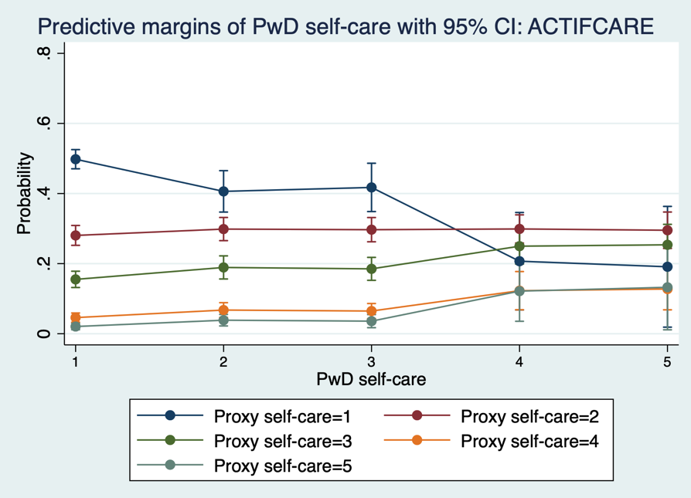

Figure 34b, “Self-care” predictive margins for EPIC data

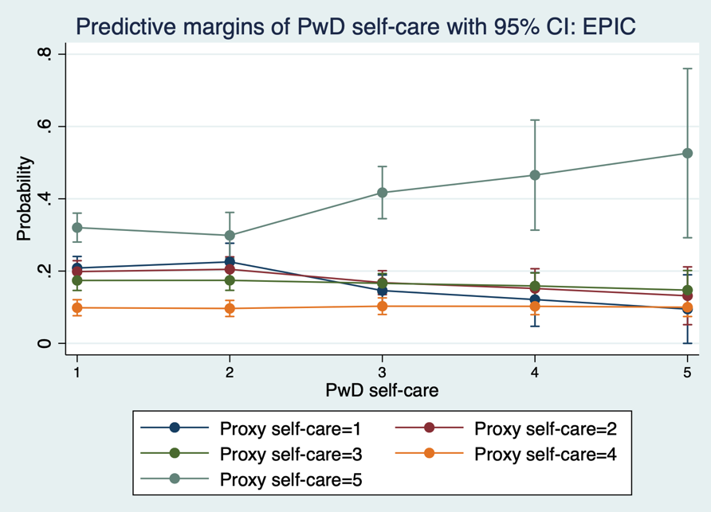

6.4.2.2 Marginal effects of the additional model variables: EQ-5D Self-care

The following section uses the AME outputs for the selected “self-care” dimension models for both trials – reported in Tables A6.3e - A6.3h in Appendix 6.3.

The AMEs for the functional measures are statistically significant for both trials’ models, as seen with “mobility”, they increase and decrease across the prediction levels in line with the measures scoring mechanism. The AMEs for MMSE observed within ACTIFCARE are not statistically significant. PwD age produced small and insignificant AME impacts. As previously explained, PwD demographic factors were retained across the models for theoretical and consistency reasons. For PwD sex, the AMEs are non-significant across both datasets but do increase across the levels. While these impacts are small for the EPIC trial, the ACTIFCARE output shows that the effect of being a female (PwD) results in a reduced likelihood of predicting a level one proxy-rated “self-care” response when compared to male people with dementia. However, this change is not statistically significant (p-value = 0.178).

6.4.2.3 Actual data vs. predicted data for “self-care” dimension

The tables below show the frequencies for the levels of the “self-care” dimension as rated by the proxy, and the predicted frequencies derived from the mapping models for both datasets. The findings from removing the MMSE variable from the ACTIFCARE model (as shown in Table 36a) were similar to those seen within the “mobility” section. The predictions for levels three to five became slightly closer to the actual frequencies. However, the prediction for level one moved slightly away from its observed frequency. Given these mixed results, it is inconclusive whether the removal of MMSE would be beneficial to the model's accuracy.

Table 36a, Observed vs. predicted data for “self-care” dimension from the ACTIFCARE study

Response options | Observed frequency (%)  n=1194 | Predicted frequency (%)  (With MMSE) | Predicted frequency (%)  (Without MMSE)
No problems | 43.80 | 47.97 | 46.67
Slight problems | 26.30 | 26.78 | 26.67
Moderate problems | 17.42 | 15.81 | 16.30
Severe problems | 6.95 | 5.63 | 6.26
Unable to wash or dress | 5.53 | 3.81 | 4.10

For the EPIC data, as shown in Table 36b, the predictions overestimate the frequency for levels one to four, and substantially underestimate at level five. While this is a noticeable discrepancy particularly in the most severe level, the predictions provide a general direction. It is fundamental to note that these models are limited by the available data. The “self-care” dimension exhibited ceiling effects for PwD responses (67% of PwD self-rated level one, see Table A6b), which were used for predicting staff proxy responses, thereby potentially hindering the predictions by underrepresenting the extreme values.

Table 36b, Observed vs. predicted data for “self-care” dimension from the EPIC study

Response options | Observed frequency (%)  n=1700 | Predicted frequency (%)
No problems | 13.41 | 20.01
Slight problems | 12.59 | 19.25
Moderate problems | 12.88 | 17.13
Severe problems | 7.94 | 9.84
Unable to wash or dress | 53.18 | 33.77

6.4.2.4 Including a trial indicator for the “self-care” dimension

Using the available variables within the datasets, the “self-care” model was re-run on a merged dataset that included a trial indicator variable. The coefficients table for this is available in Appendix 6.4. The coefficient of the trial indicator is statistically significant (r=0.833, p=0.000), whereby the EPIC sample are associated with worse predictive proxy “self-care” reports. This observation is consistent with characteristics of the EPIC trial data, which showed floor effects for staff proxy reports of this dimension. This result highlights the differences in how the core model operates across the two distinct trials and residential settings.

6.4.3 Mapping to the “usual activities” dimension

This section presents the results for mapping to the “usual activities” dimension of EQ-5D-5L. As with “self-care”, the target response for “usual activities” was from the proxy in both cases. The coefficient outputs for the prior model iterations are provided in Appendix 6.2, alongside a summary table (Table A6.2i) of the coefficients of the final selected models.

6.4.3.1 Marginal effects of the final selected models: EQ-5D-5L Usual activities

AME outputs for the variables included in the final selected models are reported in Appendix 6.3. The following section presents the predictive margins of PwD-reported “usual activities”, the tables reporting the full predictive margins are also provided in Appendix 6.3.

From the ACTIFCARE data (see Figure 35a below), at PwD level one the probabilities for predicting proxy levels of four and five are comparatively lower and with non-overlapping confidence intervals. Level three predictions produce the highest probabilities across PwD levels. Although the probability of predicting a level five response is largest at PwD level five than it is at all other levels, it does not surpass the consistently heightened probabilities for predicting levels three and four. While the majority (approximately 58%) of people with dementia in this study self-reported perfect health for this dimension, informal proxy reports were more balanced across levels one to four (see Table A6a), with the largest proportion of reports at level three (27%). Therefore, the model’s bias to predicting a level three proxy response is contingent to the data’s characteristics.

The predictive margins produce a distinct pattern for the EPIC data (displayed in Figure 35b) when compared to the ACTIFCARE data. The probability of predicting a level one staff proxy “usual activities” score is the highest across all levels, whereby the confidence intervals do not overlap with any other levels at PwD levels one, two and three. For level five proxy predictions, the probabilities increase at PwD levels four and five (however the confidence intervals overlap) and at PwD level four, the probability of predicting a level one (p=0.303) and level five proxy (p=0.305) response is near equal.

As shown in Table A6b of Appendix 6, staff proxy reports of this dimension resembled reports from the PwD (when compared with the informal proxy-PwD dyad reports of ACTIFCARE). Challenges related to the interpretation of the “usual activities” item have been previously acknowledged, as highlighted during the PPIE session reported in Section 2.5, whereby inter-proxy interpretation may vary or may be influenced by personal biases and experiences, daily routines, and expectations regarding what constitutes the PwD’s “usual activities” particularly in relation to their residential setting.

Figure 35a, “Usual activities” predictive margins for ACTIFCARE data

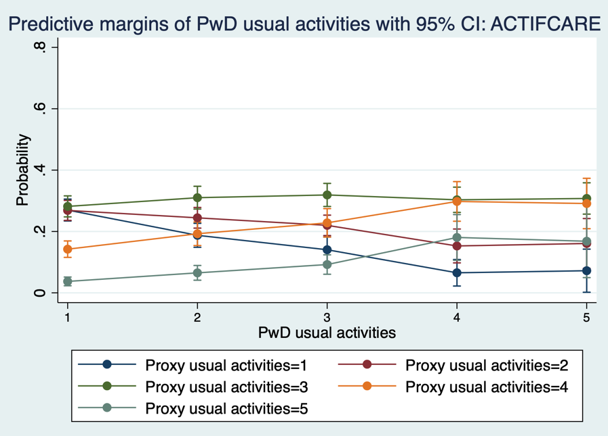

Figure 35b, “Usual activities” predictive margins for EPIC data

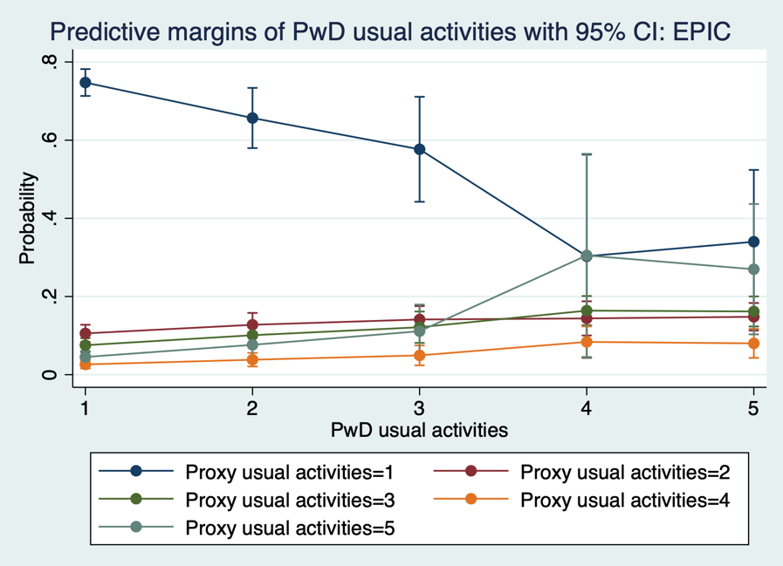

6.4.3.2 Marginal effects of the additional model variables: EQ-5D-5L Usual activities

The following sections reports upon the AME outputs for the final selected “usual activities” dimension models, full tables for which are provided in Tables A6.3i - A6.3l in Appendix 6.3.

The AMEs for NPI are small but statistically significant, and generally increase in line with the scoring levels indicating an increased likelihood of worse predicted scoring levels as symptoms worsen. For MMSE from ACTIFCARE, the AMEs are negligible and non-significant. The functional measure included within this model for ACTIFCARE (where there was a choice between IADL and PSMS) was different to that used within the “mobility” and “self-care” dimension models. Here the IADL measure was chosen via the scenario analyses as it produced a more favourable model fit. The AMEs associated with the functional measures from both trials are statistically significant and correspond with the expected direction. PwD age produced small and non-significant AMEs for both datasets. For the PwD sex variable, the AMEs are not statistically significant within EPIC. They are significant for ACTIFCARE, whereby being a female (PwD) has a reduced likelihood of level one and two predictions, while increasing the likelihood of the remaining worse response options.

6.4.3.3 Observed vs. predicted data: EQ-5D Usual activities models

Within the tables below, the frequencies for “usual activities” responses are reported. As with the previous dimensions, the MMSE variable was removed to assess any impacts upon the predictions. It can be seen that there are changes to the predicted frequencies; for level one and two, predictions frequencies become slightly closer to the observed data. Level three experienced a negligible increase and the predictions for level four and five also edged closer to their observed values (but remained below the actual rates). The removal of the MMSE variable may subtly improve the model's predictive accuracy.

Table 37a, Observed vs. predicted data for the “usual activities” dimension from the ACTIFCARE study

Response options | Observed frequency (%)  n=1192 | Predicted frequency (%)  (With MMSE) | Predicted frequency (%)  (Without MMSE)
No problems | 20.81 | 23.05 | 22.39
Slight problems | 24.16 | 24.64 | 24.27
Moderate problems | 27.27 | 28.37 | 28.41
Severe problems | 18.37 | 17.20 | 17.66
Unable to do usual activities | 9.40 | 6.73 | 7.27

Table 37b from the EPIC data shows that the model overestimates level one and two responses. The prediction for level three is relatively close to the observed data, showing only a slight underestimation. However, the model underestimates the responses for both levels four and five. While the model provides a general alignment, it tends to underestimate severity and overpredict the absence of problems. The data shows ceiling effects for PwD responses (with 76.6% reporting "No problems", see Table A6b). Staff proxies, who may have heightened sensitivity to the challenges faced by those within their care, reported a larger proportion (15.4%) of worst health ratings compared to just 2.4% in PwD data. This discrepancy between PwD and proxy perspectives could be a key factor behind the differences seen in the model's predictions.

Table 37b, Observed vs. predicted data for the “usual activities” dimension from the EPIC study

Response options | Observed frequency (%)  n=1701 | Predicted frequency (%)
No problems | 62.21 | 70.90
Slight problems | 7.88 | 11.23
Moderate problems | 9.64 | 8.50
Severe problems | 4.47 | 3.13
Unable to do usual activities | 15.40 | 6.24

6.4.3.4 Including a trial indicator for the “usual activities” dimension

Using the variables available in both datasets, the “usual activities” model was re-run in a dataset of the merged trial data and a trial indicator variable was included. Coefficient tables of this output are provided in Appendix 6.4.

A trial effect is indicated as the variable’s coefficient is statistically significant (r=-0.929, p=0.000). This effect shows that participants from the EPIC cohort are associated with better predictive proxy “usual activities” reports. As previously noted, informal proxy responses from ACTIFCARE were near-evenly distributed across levels one to four (see Table A6a). In contrast, the EPIC proxy responses are concentrated at level one, aligning more closely with PwD reports. The residential status of the PwD may play a key role regarding this dimension in terms of the expectations of people with dementia of community dwelling settings, whereby what are considered "usual activities" may shift based on environment. Proxy biases further complicate this, as staff proxies may have different expectations for people with dementia compared to relative proxies, where personal experiences and connections could influence perceptions. These observations suggest that the core model behaves differently across the two trials/residential settings.

6.4.4 Mapping to the “pain/discomfort” dimension

The results for mapping to the “pain/discomfort” dimension of EQ-5D-5L are presented in this section. The target respondent for “pain/discomfort” was the PwD in both trials. The coefficient output for the various model iterations is provided in Appendix 6.2. Unlike the previous dimension, there is a notable difference between the final models for this dimension between the trials. For the ACTIFCARE trial, relative proxy reported “anxiety/depression” presented as a more effective predictor of PwD “pain/discomfort”. For the EPIC trial data, staff proxy reports of "pain/discomfort" remained the chosen variable for the final model, however in this case proxy-responses from levels four and five were merged for predicting PwD reports.

6.4.4.1 Marginal effects of the final selected models: EQ-5D-5L Pain/discomfort

The following section presents the predictive margins of proxy-reported “pain/discomfort”, tables for which are provided in Appendix 6.3. AME outputs for the final selected models are also reported in Appendix 6.3.

The ACTIFCARE dataset uses the "anxiety/depression" dimension to predict PwD reported "pain/discomfort” and omits the direct use of proxy-reported "pain/discomfort" altogether. The probability of predicting a level one PwD “pain/discomfort” response reduces in a linear-like fashion across proxy levels. At proxy levels one and two, the probability of a level one PwD prediction is noticeably higher than that of the other levels, with no overlapping confidence intervals. Less than one percent of PwD reported a level five response to this dimension (see Table A6a of Appendix 6), which may explain why at proxy level five, the confidence intervals of multiple prediction scores overlap, with levels three and four indicating the largest probabilities here.

In the EPIC trial 0.2% (n=4) of staff proxies provided level five reports (see Table A6b in Appendix 6), therefore, for analytical purposes combining "pain/discomfort" staff-proxy responses from levels four and five was deemed most appropriate for predicting PwD reports. This dimension saw evidence of ceiling effects from both respondents (approximately 72% of people with dementia and 74% of staff proxies reported “perfect health” for “pain/discomfort”). Therefore, although the probabilities for predicting PwD-levels increase in line with proxy responses, the probabilities for level one consistently remain the highest across all proxy levels. The probabilities for PwD level five predictions are non-significant at all levels and are negligible (see Table A6.3o within Appendix 6.3), again likely an artifact of the data due to a low proportion of responses.

Figure 36a, “Pain/discomfort” predictive margins for ACTIFCARE data

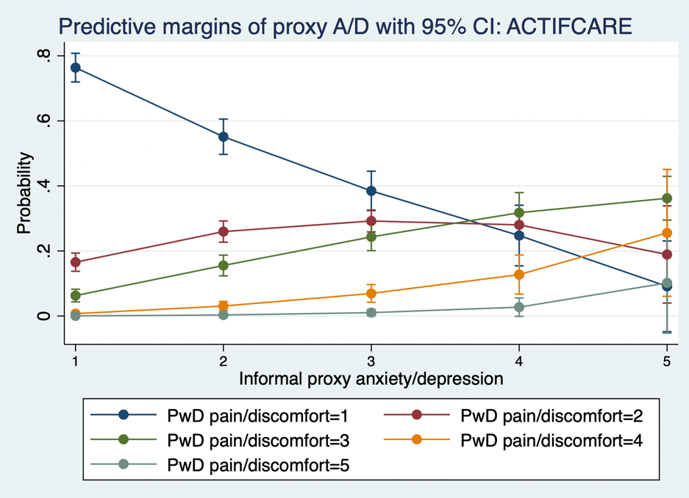

Figure 36b, “Pain/discomfort” predictive margins for EPIC data

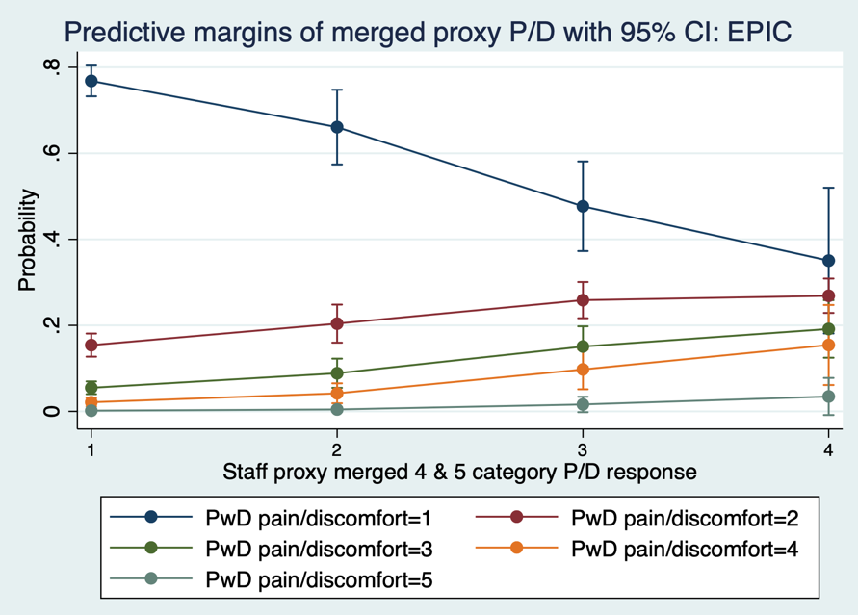

6.4.4.2 Marginal effects of the additional model variables: EQ-5D-5L Pain/discomfort

To scrutinise the variables beyond the EQ-5D-5L dimension included within the final model, the AME output reported in Tables A6.3m - A6.3p in Appendix 6.3 are referred to in this section. The “pain/discomfort” model presents as the first dimension model to not include the function variable.

In the ACTIFCARE dataset, the AMEs for MMSE are statistically significant, however their magnitude is small, and they follow no clear pattern (similar to as observed with “mobility”). for PwD sex, the AMEs are statistically non-significant for both datasets, showing similarity in terms of the increasing magnitude down the scoring levels. For the EPIC dataset, the AME associated with a level one report is positive (compared to the base outcome which is male PwD), and of a larger magnitude, implying that female people with dementia have a higher likelihood of level one predicted “pain/discomfort” reports compared with male people with dementia. This feature in AMEs underscores the sex-related variations in the prediction of "pain/discomfort" within the EPIC dataset.

6.4.4.3 Observed vs. predicted data: EQ-5D-5L: Pain/discomfort models

The ACTIFCARE dimension-model was re-run without the MMSE variable to assess any potential impacts upon the predictions. Table 38a below shows that for levels one and two, the prediction frequencies remained consistent with or without the MMSE variable, suggesting its limited role within the model. Some deviations were observed in the level three and four predictions, with a slight reduction and increase respectively via MMSE’s exclusion. Level five responses saw a slight decrease in prediction without MMSE. While the MMSE variable does influence the model to some extent, its removal results in predictions that still closely mirror the original data, highlighting the reliability of the other incorporated variables.

Table 38a, Observed vs. predicted data for “pain/discomfort” dimension from the ACTIFCARE study

Response options | Observed frequency (%)  n=1132 | Predicted frequency (%) (With MMSE) | Predicted frequency (%) (Without MMSE)
No pain/discomfort | 57.16 | 57.26 | 57.04
Slight pain/discomfort | 23.14 | 23.06 | 23.37
Moderate pain/discomfort | 15.19 | 15.24 | 14.93
Severe pain/discomfort | 3.89 | 3.86 | 4.13
Extreme pain/discomfort | 0.62 | 0.58 | 0.52

For the EPIC data model, the predictions show a strong alignment with the observed frequencies. Specifically, for categories one to three, the predicted values are virtually identical to the observed frequencies. For level four and five responses, the deviations were small, highlighting the precision of the model and the robustness of its incorporated variables in predicting the “pain/discomfort” dimension.

Table 38b, Observed vs. predicted data for “pain/discomfort” dimension from the EPIC study

Response options | Observed frequency (%)  n=805 | Predicted frequency (%)
No pain/discomfort | 71.93 | 71.92
Slight pain/discomfort | 17.27 | 17.31
Moderate pain/discomfort | 7.08 | 7.08
Severe pain/discomfort | 3.35 | 3.31
Extreme pain/discomfort | 0.37 | 0.38

6.4.4.4 Including a trial indicator for the “pain/discomfort” dimension

The objective of re-running the core model in the merged dataset with the trial indicator was to assess the potential for an optimal model across the two trials/residential settings, and to highlight whether there are any significant trial differences. The chosen predictors of PwD “pain/discomfort” were relative proxy reported “anxiety/depression” and staff proxy reports of "pain/discomfort" in the final models for the ACTIFCARE and EPIC trial respectively. Therefore, given the different predictor variables in the two trial models, performing this additional step was considered inappropriate.

6.4.5 Mapping to the “anxiety/depression” dimension

The results for mapping to the “anxiety/depression” dimension of EQ-5D-5L are presented in this section. The PwD was the target respondent for “anxiety/depression” in both trials. The coefficient tables for the model iterations are provided in Appendix 6.2.

6.4.5.1 Marginal effects of the final selected models: EQ-5D-5L Anxiety/depression

The following section presents the predictive margins of proxy-reported “anxiety/depression”, tables for which are provided in Appendix 6.3. AME outputs for the final selected models are also reported in Appendix 6.3. The probabilities associated with predicting level one PwD responses are consistently the highest across proxy levels one to four, with non-overlapping confidence intervals. The same is true for level two predictions, producing the second highest probabilities. Nearly 90% of PwD reports were of scores one and two, therefore the model’s bias in predicting these two scores corresponds with the data. Across both respondent types (for both trials), level four and five reports were particularly low (see Tables A6a and A6b), and the predictive margins reflect this detail.

For the EPIC data, there is a gradual reduction in level one PwD predictions across proxy responses, at level five, the confidence intervals for which are very wide, and the probability is no longer statistically significant. The predictive margins for the remaining levels show a gradual increase in line with proxy responses, however for level five predictions the probabilities remain negligible and non-significant. As with ACTIFCARE, the proportion of level five responses were particularly low, therefore potentially hindering both the model’s ability to use level five scores as predictors and to predict level five responses.

Figure 37a, “Anxiety/depression” predictive margins for ACTIFCARE data

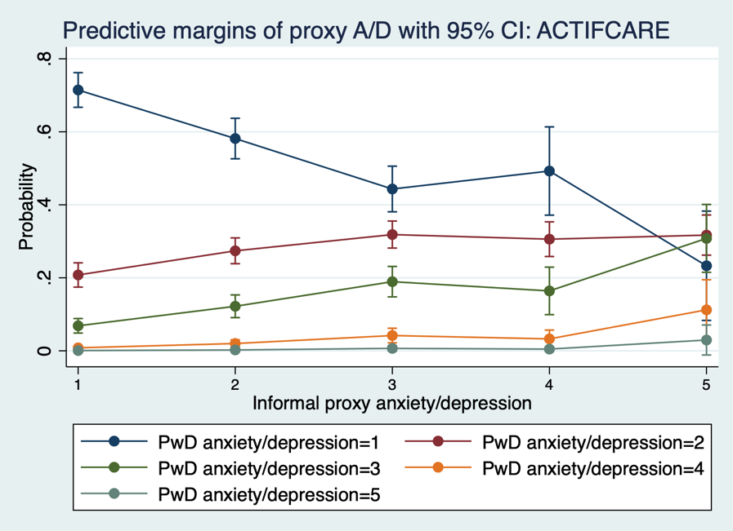

Figure 37b, “Anxiety/depression” predictive margins for EPIC data

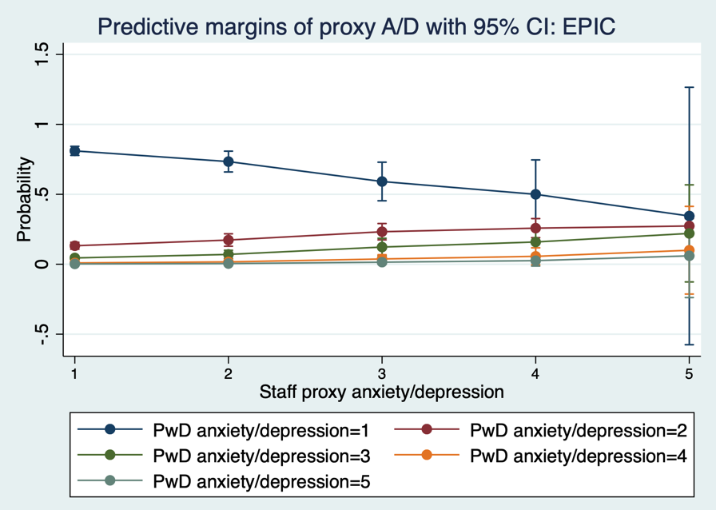

6.4.5.2 Marginal effects of the additional model variables: EQ-5D-5L Anxiety/depression

The following section uses the AME outputs for the final selected “anxiety/depression” dimension models, aiming to highlight any similarities and differences observed between them (see Tables A6.3q - A6.3t in Appendix 6.3).

For the MMSE variable in ACTIFCARE, the associated AMEs are negligible and not statistically significant, paralleling trends observed in previous dimension models. For the NPI measure, though the AMEs remain small across both trials, they are statistically significant within the EPIC model. The PwD demographic variables present AMEs of small magnitudes that are not statistically significant for both trials. In the EPIC analysis these AMEs exhibit a slightly greater magnitude yet remain non-significant. Specifically, there is a negative change at level one predictions indicating that female PwD are less likely to achieve a predicted “anxiety/depression” dimension score of level one compared to male PwD, with the latter serving as the base outcome.

6.4.5.3 Observed vs. predicted data: EQ-5D Anxiety/depression models

The ACTIFCARE-model exhibited a notable alignment between the observed and predicted frequencies, as shown in Table 39a. For level one and two predictions, the frequencies were very close to the observed data, with and without the MMSE variable, suggesting a marginal influence of MMSE in predicting PwD responses of this dimension. For level three predictions, there was a slight overestimation in the model incorporating MMSE, whereby the exclusion of MMSE brought the prediction closer to the actual value. The level four and five predictions saw only slight deviations in their predictions. Therefore, the precision of the model's predictions across the scoring levels highlights its robustness, with the MMSE variable playing a seemingly inconsequential role in this specific dimension.

Table 39a, Observed vs. predicted data for “anxiety/depression” dimension from the ACTIFCARE study

Response options | Observed frequency (%)  n=1131 | Predicted frequency (%) (With MMSE) | Predicted frequency (%)  (Without MMSE)
No anxiety/depression | 59.50 | 59.35 | 59.71
Slight anxiety/depression | 26.44 | 26.14 | 26.14
Moderate anxiety/depression | 11.58 | 12.05 | 11.70
Severe anxiety/depression | 2.21 | 2.16 | 2.18
Extreme anxiety/depression | 0.27 | 0.30 | 0.27

For the EPIC-model, there is a noticeable alignment between the observed frequencies and predicted values. The level one predicted value closely mirrors the observed percentage, highlighting the model’s precision for the dominant response category. Similarly, the level two and three predictions exhibit only marginal deviations from their respective observed frequencies. Predictions for level four slightly overestimate compared to the observed data, though the difference is minor. The level five response shows a slight underestimation in the model’s prediction. Overall, the model demonstrates accuracy in capturing the distribution of responses within the “anxiety/depression” dimension.

Table 39b, Observed vs. predicted data for “anxiety/depression” dimension from the EPIC study

Response options | Observed frequency (%)  n=792 | Predicted frequency (%)
No anxiety/depression | 77.53 | 77.10
Slight anxiety/depression | 14.77 | 14.92
Moderate anxiety/depression | 5.68 | 5.94
Severe anxiety/depression | 1.39 | 1.51
Extreme anxiety/depression | 0.63 | 0.53

6.4.5.4 Including a trial indicator for the “anxiety/depression” dimension

As with the previous three dimensions, the common core model was re-run in the merged trial dataset with a trial indicator variable, the coefficient tables of this output are provided in Appendix 6.4.

The coefficient for the trial indicator variable is statistically significant (r=-0.241, p=0.001), whereby the EPIC cohort is associated with better/lower predictive PwD “anxiety/depression” reports. As previously noted, PwD and staff proxy reports of this dimension were more closely aligned and showed evidence of ceiling effects in the EPIC trial whereby 77.5% of people with dementia and 75.7% of staff proxies provided a level one response for this dimension (see Table A6b). The observed trial effect could potentially be attributed to this similarity in reporting, whereby the model performed better due to the underlying data as opposed to any external or residential setting based differences.

6.4.6 Summary of dimension models

The final preferred models for each EQ-5D-5L dimension were developed and are summarised in the table below. These models were selected based on their ability to reliably predict responses using routinely collected data, ensuring both practicality and accuracy. The following table provides a detailed overview of the specific models used for each EQ-5D-5L dimension across the ACTIFCARE and EPIC studies:

Table 40, Final preferred EQ-5D-5L dimension models

EQ-5D dimension | ACTIFCARE | EPIC
Mobility | oprobit eq1SR_ i.eq1RP_ MMSE_Total_ PSMS_ PwD_age_ i.PwDs_sex, vce(cluster PatNo) | oprobit eq1staff_ i.eq1SR_ numeric_FAST_ age_ i.sex_, vce(cluster PatNo)
Self-care | oprobit eq2RP_ i.eq2SR_ MMSE_Total_ PSMS_ PwD_age_ i.PwDs_sex_, vce(cluster PatNo) | oprobit eq2staff_ i.eq2SR_ numeric_FAST_ age_ i.sex_, vce(cluster PatNo)
Usual activities | oprobit eq3RP_ i.eq3SR_ MMSE_Total_ NPI_ IADL_ PwD_age_ i.PwDs_sex_, vce(cluster PatNo) | oprobit eq3staff_ i.eq3SR_ NPItotal_ numeric_FAST_ age_ i.sex_, vce(cluster PatNo)
Pain/discomfort | oprobit eq4SR_ i.eq5RP_ MMSE_Total_ PwD_age_ i.PwDs_sex_, vce(cluster PatNo) | oprobit eq4SR_ i.merg_eq4staff i.sex_ age_, vce(cluster PatNo)
Anxiety/depression | oprobit eq5SR_ i.eq5RP MMSE_Total_ NPI_ PwD_age_ i.PwDs_sex_, vce(cluster PatNo) | oprobit eq5SR_ i.eq5staff_ NPItotal_ i.sex_ age_, vce(cluster PatNo)

6.4.6.1 Pragmatic models

The output of the pragmatic models is presented in Appendix 6.5a. The pragmatic models revealed that it is possible to predict EQ-5D dimension scores using only the selected pragmatic/routinely collected variables, indicating that these simplified models do have some utility. However, when compared to more extensive models that include additional symptom variable scores, the performance of the pragmatic models was noticeably lower. Specifically, the predicted utility score distributions from the pragmatic models showed greater error, highlighting the trade-off between model simplicity and predictive accuracy.

6.4.7 Estimating utility scores

As outlined in the methods section (section 6.3.2), there are two stages to response mapping. The first stage involves predicting responses for each item/dimension of the instrument, for which the process has been summarised in the previous sections. The second stage involves assigning utility scores to the predictions. In line with current NICE guidelines, the recommended method of mapping EQ-5D-5L health states to the established EQ-5D-3L value set is applied to generate utility scores and is presented within this section (Hernández Alava et al., 2023). As an application for when a validated EQ-5D-5L value set becomes available, all utility calculations have also been estimated using the 2018 EQ-5D-5L value set for England (Devlin et al., 2018) and have been presented within Appendix 6.5 for reference.

6.4.7.1 Utility distributions: ACTIFCARE

Table 41 presents the utility estimations from the ACTIFCARE trial for the target combination of EQ-5D-5L dimensions by respondent type. It is observed that the mean predicted utility scores match the observed data.

Table 41, ACTIFCARE utility estimations

Target response | N | Mean | SD | Min – Max
Mapped from 5L to 3L value set
Observed data | 962 | 0.69 | 0.21 | -0.28 – 0.99
Predicted data | 962 | 0.69 | 0.12 | 0.22 – 0.89

Figures 38a and 38b illustrate the distribution of utility scores estimated for the target combination of respondents, comparing observed data with predicted data mapped to EQ-5D-3L health states (Hernández Alava et al., 2023). Utility values derived from the prediction models exhibit a noticeably more condensed spread as is inevitably the case when using data derived from mapping models. Utility scores from both origins do not reach full health at utility value one. This outcome is a result of mapping to the EQ-5D-3L value set for utility estimations. In these instances, both the observed and predicted data essentially consist of mapped predictions. The scatterplot reported in Appendix 6.6 (Figure A6.6b) displays both predicted and observed EQ-5D-5L utility scores, indicating a slight positive correlation between the two sets of scores, and an overestimation is observed at the lower range of utility scores.

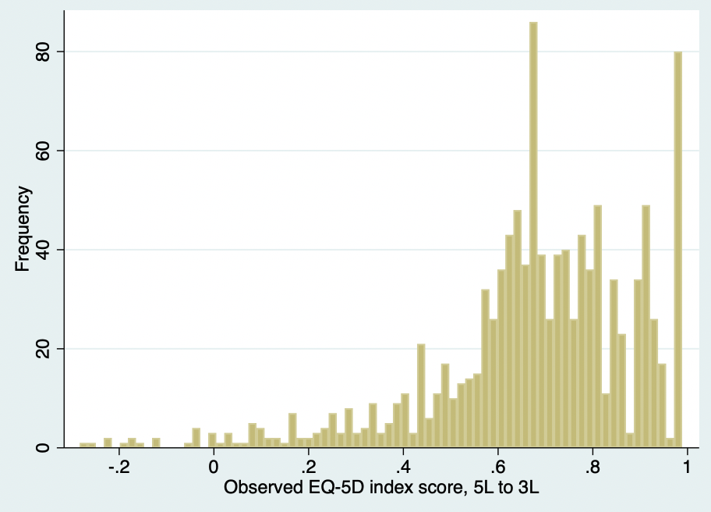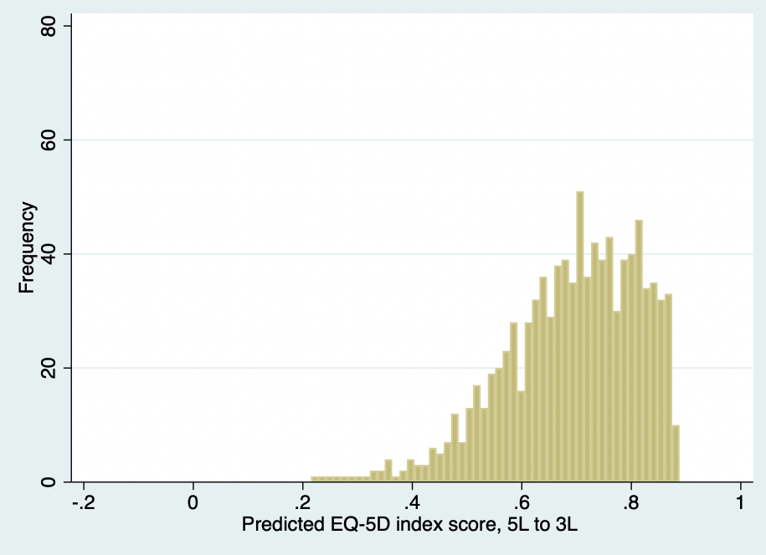
38A 38B

Figure 38a, EQ-5D-5L index score distribution: actual data via target respondents
Figure 38b, EQ-5D-5L index score distribution: prediction model data

Figures 39a and 39b below show the mean observed versus mean predicted EQ-5D-5L utility scores over the distribution of MMSE values, with Figure 39b also showing the error in the mean predictions via the absolute difference. The graphs trends show similarities to those derived using the 2018 5L value set for utility score estimation (see Figure A6.5c in Appendix 6.5). Notably, the mean predicted utility scores are overestimated at the extremes of MMSE scores, and prediction error is more apparent for scores associated with people with dementia of an MMSE score below ten (severe cognitive impairment). Overall, a similar distribution pattern is shown for both the observed and predicted data, and the absolute difference/error is minimal for people with dementia of MMSE scores between ten to twenty, suggesting that the model functions best for people with mild-to-moderate stage dementia.

To further explore this relationship and model fit, figures with the same information but by MMSE groupings are provided and reported in Appendix 6.7. These figures show that for MMSE groupings, the alignment of the observed data and the model predictions improves. The jumps seen in the data in Figure 39a below, for example at an MMSE score of four, could be explained by the lack of observations with this scale score (n=1). It is acknowledged that drawing comparisons between utility scores at MMSE values with a limited number of observations (particularly those with MMSE scores below eight) may not be statistically fair or robust due to the inherent constraint of a low observation count in this dataset, as reported in Appendix 6.7b.

Figure 39a, mean predicted vs. mean observed EQ-5D-5L utility over MMSE

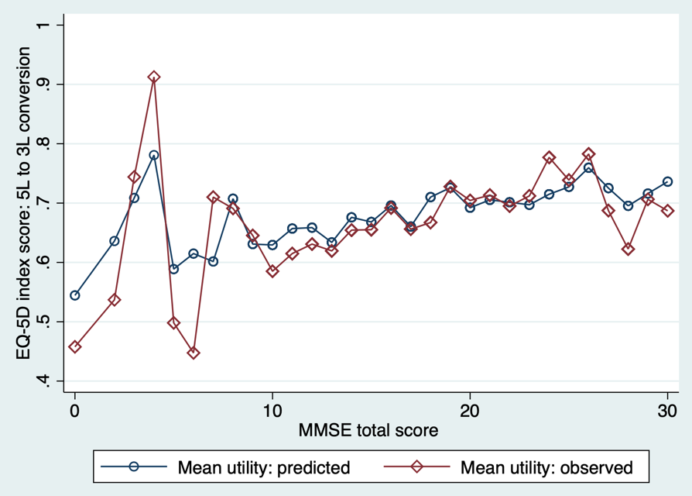

Figure 39b, mean predicted vs. mean observed EQ-5D-5L utility, with error/ absolute difference over MMSE

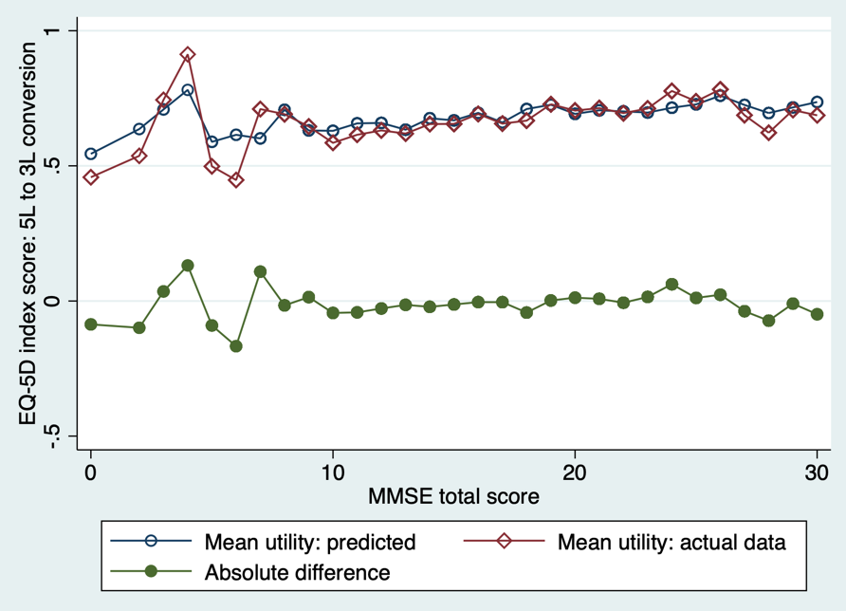

Because the EPIC trial did not collect a measure of cognition, the mean observed versus the mean predicted EQ-5D utility scores were plotted over the scale scores for the measure of function (PSMS) (see Figures 40a and 40b below). As observed across MMSE scores, the utility distribution patterns show similarities for both estimations. At lower/worse function scores, the prediction error slightly widens compared with better functional/health states. At the lower spectrum of PSMS scores, both the mean observed and mean predicted utility values are lower than those derived using the 2018 5L value set (see Figure A6.5e in Appendix 6.5). In addition, there is a marginally larger error in the predictions at this lower end.

Although both trials collected a measure of function, the instrument used was different. Therefore, there is no common measure to use to directly compare utility score distributions from the two trials. Therefore, the utility distributions for CDR scale stages are provided in Appendix 6.8 and show that model prediction error is greatest at CDR stage three, compared to the other stages – where the absolute difference is near zero.

Figure 40a, mean predicted vs. mean observed EQ-5D-5L utility over PSMS

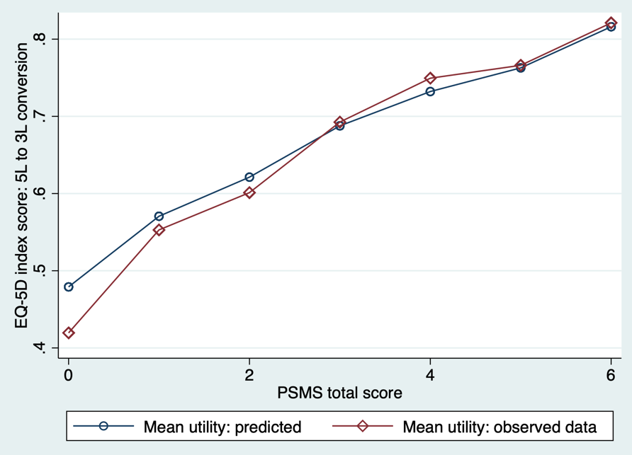

Figure 40b, mean predicted vs. mean observed EQ-5D-5L utility, with error/ absolute difference over PSMS

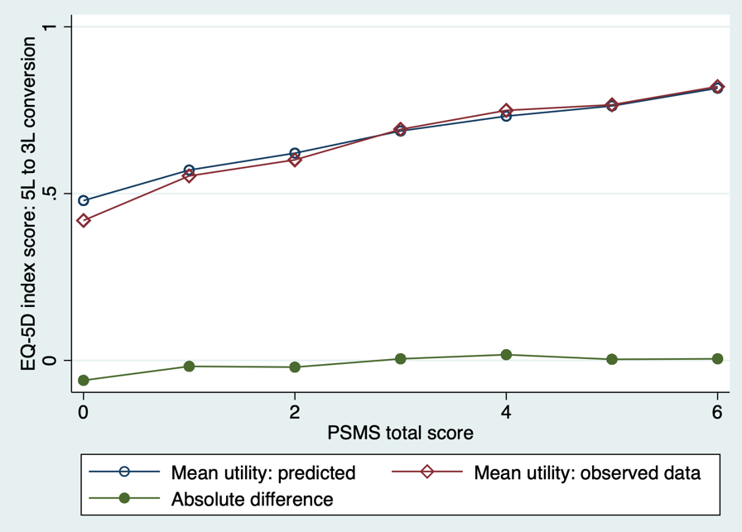

6.4.7.2 Utility distributions: EPIC

The following section details the EQ-5D-5L utility estimations derived from the EPIC trial data, comparing the observed data from the trial against the predicted utility scores generated through the ordered probit dimension models for the target combined utility score. As shown in Table 42, there is a discrepancy between the mean observed and predicted scores, indicating a slight over-prediction when using the prediction models to generate utility scores.

Table 42, EPIC utility estimations

Target response | N | Mean | SD | Min – Max
Mapped from 5L to 3L value set
Observed data | 758 | 0.62 | 0.36 | -0.34 – 0.99
Predicted data | 758 | 0.65 | 0.15 | 0.07 – 0.91

Figures 41a and 41b show the distribution of EQ-5D utility scores for the target combination of responses estimated via mapping to the EQ-5D-3L value set, for the observed and predicted EPIC data. The predicted data show a different distribution in comparison to the observed data. Mirroring the pattern observed with the ACTIFCARE data, utility scores from both origins do not reach full health at one.

Figure A6.6d in Appendix 6.6 presents a scatterplot of utility scores for the observed data and predictions, whereby a dispersion is observed, suggesting a lack of a direct linear relationship. The spread observed indicates a higher degree of variability in how the predicted scores correspond with the observed data points. This variability could stem from several factors, including impacts of any unaccounted variables or potentially limitations of the mapping models. It is important to bear in mind that comparing real-life data with predictions is not a straightforward assessment. In addition, the interpretative scope of scatterplots in this context is somewhat limited.

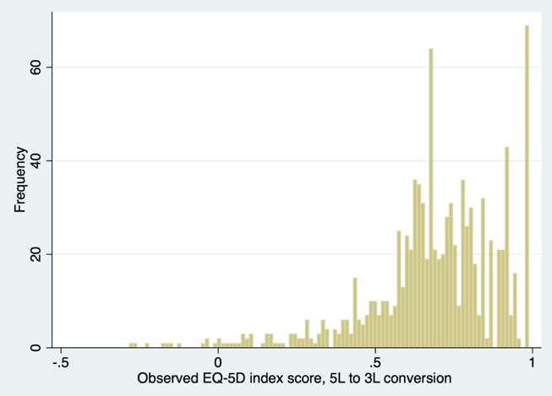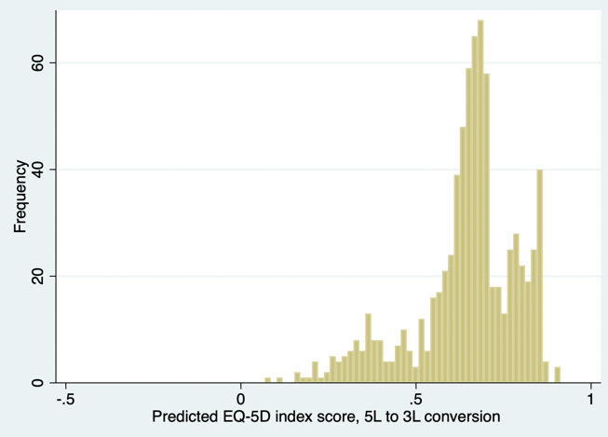
41A 41B

Figure 41a, EQ-5D-5L index score distribution: actual data via target respondents
Figure 41b, EQ-5D-5L index score distribution: predicted data

Figures 42a and 42b show the mean observed and mean predicted EQ-5D utility scores across the distribution of FAST scale scores (the measure of function collected in the EPIC trial). In contrast to the distribution plots derived using the 2018 EQ-5D-5L value set (see Figure A6.5i in Appendix 6.5), these figures reveal a different pattern in that the mean predicted utility scores are overestimated at both extremes of the FAST scale. However, consistently the predicted utility values smooth out the variability observed in the data, and similarly the greatest convergence between mean observed and predicted utilities occurs at the FAST scale scores corresponding to mild stage dementia (i.e., stages three to five) (Reisberg, 1988)). As evidenced in the ACTIFCARE section, the prediction model's error was at its lowest between MMSE stages 10-20, potentially suggesting that the models may show optimal performance when applied in populations with mild-to-moderate stage dementia. The number of utility score estimations were highest for FAST scale scores of four and six (four, n=114; six, n=510). For FAST scores one and two, the number of observations were very low (n=2). These data have however been retained in the graphs to maintain transparency in reporting, but it is important to highlight the potential limitations associated with the statistical robustness of utility comparisons in cases with a minimal number of observations.

The mean utility scores for the CDR stages (presented in Appendix 6.8 (Figure A6.8d)) showed that mean scores mainly diverged at CDR stage three. This graph therefore closely resembles the ACTIFCARE data.

Figure 42a, mean predicted vs. mean observed EQ-5D-5L utility over FAST

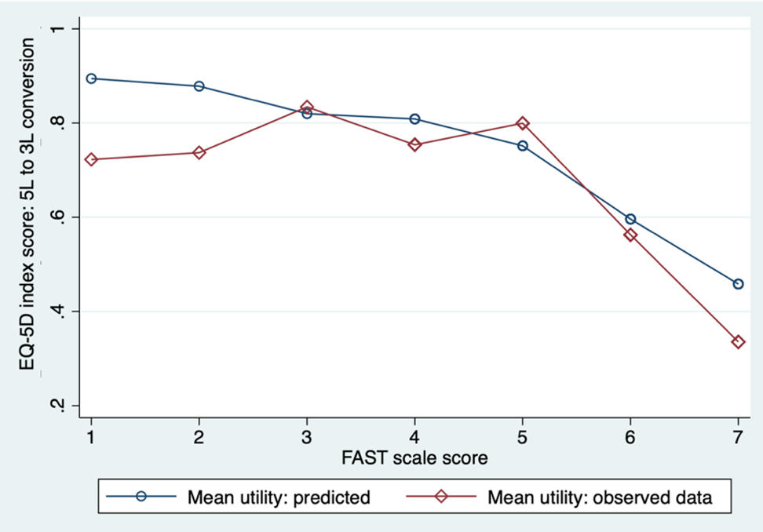

Figure 42b, mean predicted vs. mean observed EQ-5D-5L utility, with error/ absolute difference over FAST

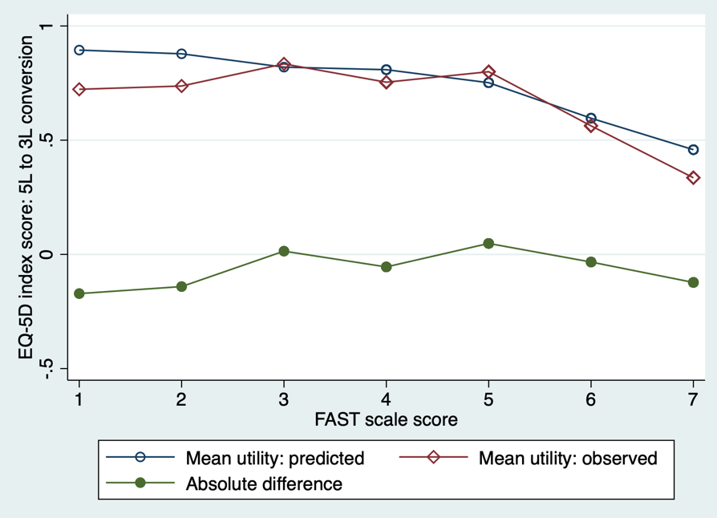

6.5 Discussion

In this chapter, a series of ordered probit mapping models have been developed and applied to derive EQ-5D-5L utility estimates for the target combination of responses by dimension (as presented in Chapter 5) – using data from the ACTIFCARE and EPIC trials. The overall goal was that in the absence of either member of the PwD-proxy dyad, the target combination of EQ-5D-5L dimensions may still be achieved by analysts. The results provide insights into combining EQ-5D-5L responses from people with dementia and proxies, which may have implications for future research and economic evaluations for dementia interventions. A table is provided below (Table 43) summarising the empirical findings of this chapter, as well as a general summary Table in Appendix 6.9.

Table 43, Summary of mapping analyses

 | ACTIFCARE | EPIC
Mobility dimension
Target | PwD | Staff proxy
Marginal effects | Level five proxy responses correspond with the greatest probability of a level four PwD prediction; not statistically significantly different | Probability of predicting level five responses is greatest at both level four and five PwD responses. The confidence intervals do not overlap with those of any of the other probabilities – statistical significance
Marginal effects of key additional model measures | AMEs for the function measure are mainly statistically significant - whereby the changes in probabilities increase and decrease across the “mobility” levels as expected
Observed versus predicted frequencies | After removing MMSE, predictions for levels four and five became more accurate; predictions for levels one to three were slightly less precise. Impact of removing MMSE from the model is inconclusive | Predictions tended to overestimate frequencies at levels one to three, while underestimating at level five
Trial indicator variable | Not significant
Self-care dimension
Target | Proxy | Proxy
Marginal effects | Probabilities for predicting level one proxy “self-care” responses were the largest for PwD reports at levels one, two and three - 95% confidence intervals do not overlap with any other probabilities | Probability of a predicting a level one proxy response remains low across all PwD level-responses and is greatest for level five responses – likely attributable to floor/ceiling effects
Marginal effects of key additional model measures | AMEs for the function measure are mainly statistically significant - whereby the changes in probabilities increase and decrease across the “self-care” levels as expected
Observed versus predicted frequencies | After removing MMSE, predictions for levels three to five became more accurate; prediction for level one was slightly less precise. Inconclusive Impact of removing MMSE from the model | The predictions overestimate the frequency for levels one to four, and underestimate at level five
Trial indicator variable | Significant
Usual activities dimension
Target | Proxy | Proxy
Marginal effects | At PwD level one, probabilities for predicting proxy levels four and five are lower with non-overlapping confidence intervals. Level three predictions consistently yield the highest probabilities across levels. While predicting a level five response has the highest probability at PwD level five, it doesn't exceed the consistently elevated probabilities for predicting levels three and four | Probability of predicting a level one staff proxy report is highest across all levels, with non-overlapping confidence intervals at PwD levels one to three. For level five proxy predictions, probabilities increase at PwD levels four and five, although the confidence intervals overlap. At PwD level four, the likelihood of predicting a level one and level five proxy response is nearly equal
Marginal effects of key additional model measures | AMEs for NPI generally increase in line with the scoring levels indicating an increased likelihood of worse predicted scoring levels as symptoms worsen  AMEs for the included functional measures are statistically significant and correspond in the expected direction
Observed versus predicted frequencies | After removing MMSE, predictions generally became more precise. Removal of MMSE variable may subtly improve predictive abilities of the model | The predictions overestimate the frequency for levels one and two, and underestimate at levels three to five
Trial indicator variable | Significant
Pain/discomfort dimension
Target | PwD | PwD
Marginal effects | Probability of predicting a level one PwD response reduces in linear-like fashion across proxy levels. At proxy levels one and two, the probability of a level one PwD prediction is noticeably higher than that of the other levels, with no overlapping confidence intervals – significant | Probabilities for predicting all PwD-levels increase in line with proxy responses. Probabilities for level one remains the highest across all proxy levels. Probabilities for PwD level five predictions are non-significant at all levels and are negligible – likely attributable to ceiling effects
Marginal effects of key additional model measures | N/A (no additional symptom measures were included in the preferred models)
Observed versus predicted frequencies | Removal of MMSE had minimal impact on level one and two prediction frequencies. Deviations were observed for level three and four predictions. Inconclusive Impact of removing MMSE from the model | Predictions are strong and show alignment with the observed frequencies, specifically for categories one to three
Trial indicator variable | N/A (was not applied due to differences in the core models)
Anxiety/depression dimension
Target | PwD | PwD
Marginal effects | Probabilities associated with predicting level one PwD responses are the highest across proxy levels one to four, with non-overlapping confidence intervals – significant | A gradual decrease in level one PwD predictions across proxy responses is observed, with wide CIs at level five - no longer statistically significant. Predictive margins for the other levels show gradual increase in line with proxy responses, however for level five predictions the probabilities are negligible and non-significant – likely attributable to ceiling effects
Marginal effects of key additional model measures | AMEs for NPI are small across both trials, but statistically significant within the EPIC model
Observed versus predicted frequencies | Strong alignment between the observed and predicted frequencies with minimal impact upon removal of MMSE variable | Noticeable alignment between observed and predicted frequencies – slight overestimation at level four and underestimation at level five
Trial indicator variable | Significant
AME, average marginal effect; CI, confidence interval; MMSE, mini-mental state examination; N/A, not applicable; NPI, neuropsychiatric inventory; PwD, person with dementia

6.5.1 Response mapping models

The analysis reveals that the utility distributions derived from the ordered probit models were narrower compared to those of the observed data, a characteristic observed in mapping analyses (Wailoo et al., 2017). Predictions generated by these models represent the conditional mean based on the predictors, offering an average estimation of EQ-5D. By nature, these predictions smooth out the unpredictable variations inherent in patient-level data. Therefore even with strong model fit, the distributions will not closely resemble each other. Therefore, a comparison of the conditional means is more meaningful. It has been demonstrated that together the dimension mapping models produce mean utility score estimates that closely correspond to observed mean scores, particularly for the ACTIFCARE trial data.

Model performance varied by dementia severity. For the ACTIFCARE trial data, the error in predictions was minimised when MMSE scores were within the 10 to 20 score range, suggesting that the ordered probit models worked better for patients with mild-to-moderate stage dementia. The models were less effective in capturing HRQoL at the extremes of the MMSE scale, potentially due to the specific challenges presented by severe dementia or due to limitations with the data as there were fewer respondents with severely progressed dementia (MMSE scores below ten). This reduced effectiveness is likely due to the low number of observations in these severe response categories. With fewer respondents in the severely progressed dementia group, the models had less data to accurately estimate the relationship between dementia severity and utility scores, leading to less reliable predictions. A similar finding was identified in the EPIC dataset as the mean observed and predicted utility scores converged when FAST scores reflected mild and moderate dementia. However, the EPIC distributions also showed that models tended to overestimate utility values. This occurrence has been discussed in the wider literature, potentially attributable to the distribution of EQ-5D data which is characterised by its left skew with fewer severe health states (Chuang and Whitehead, 2012). The low number of observations in these severe response categories impacts the reliability of estimates because the models cannot adequately learn from a sparse dataset, leading to increased uncertainty and potential bias in the predictions. Therefore, the effectiveness of mapping models must be interpreted in the context of the data, with particular attention to the population characteristics of the participants, including the severity stage of dementia. It highlights the need for more comprehensive data collection across all severity stages to improve model reliability and accuracy.

Validation is a crucial step to ensure the robustness and generalisability of the mapping models. Ideally, this involves both in-sample (using a portion of the current data) and out-of-sample (using an independent dataset) approaches to verify the models’ predictive performance. However, due to the limitation of having only two datasets that routinely collect EQ-5D-5L data, out-of-sample validation was not feasible at this stage. Instead, a rigorous development process was undertaken, leveraging the theoretical foundations established earlier in this thesis. Model fit statistics were employed to refine variable selection and enhance model accuracy, thereby providing confidence in the model predictions. This approach is supported by the good practice guidelines outlined for mapping work within the field (Wailoo et al., 2017).

In addition to the ordered probit models used in this study, there are several other mapping models that could be employed to derive utility values. Two-part models, for instance, are particularly useful when dealing with data that includes a substantial proportion of zero values or when the outcome variable is highly skewed. These models first use a logistic regression to model the probability of a non-zero outcome and then apply a secondary model, such as linear regression, to predict the non-zero values. This approach can improve the accuracy of predictions by addressing the distributional characteristics of the data. Other potential models include mixture models, which account for heterogeneity in the population by assuming that the data is generated from a mixture of several distributions, and generalized linear models (GLMs), which offer flexibility by allowing for different link functions and error distributions. Each of these alternative models has unique strengths and can be selected based on the specific characteristics of the data and the research objectives.

6.5.2 Dimension level differences

The results have revealed differences in the mapping models’ performances at the dimension-level. The predicted response frequencies for the “anxiety/depression” and “pain/discomfort” dimensions exhibited particularly strong alignment with the observed data. PwD-proxy dyad responses for these dimensions were already alike in the EPIC trial data (see Table A6b). However, the predictions for the “mobility” dimension in the ACTIFCARE trial also demonstrated strong alignment. Commonly for these dimension models, proxy data was being used to predict PwD reports. The observed strength of proxy data in predicting PwD responses suggests a potential preference for the collection of proxy EQ-5D-5L data. For EQ-5D-5L dimensions where proxy responses were not considered the target, PwD responses may still be reliably predicted using proxy data.

For the other dimensions, the “self-care” and “usual activities” models saw variations in the alignments achieved using the ACTIFCARE and EPIC datasets. In the ACTIFCARE data, the alignment of responses was notably stronger when compared with the EPIC data, where alignment was relatively poor. In these cases, PwD data was being used to predict proxy reports, and it is essential to acknowledge the presence of both ceiling effects for PwD reports and floor effects by staff proxy reports of these dimensions. The limitations of these models (when applied to the EPIC data) are to some extent inherent to the characteristics of the data. The "self-care" and “usual activities” model's performances were comparatively superior in the ACTIFCARE dataset, therefore indicating that the effectiveness of these models may not be completely undermined, but rather accepted as a reflection of the features present in the data.

Differences at the dimension level have implications for utility scores, as these scores are derived from the responses to the EQ-5D-5L dimensions. As discussed in the wider literature related to response mapping, when inaccurate predictions are made when using this approach, they can have relatively large impacts depending on the related utility decrement of the applied EQ-5D value set. As a result, when predictions deviate from observed responses, there is an increased chance of higher errors occurring in the overall utility score (Gray et al., 2006). As the dimension models more accurately predicted observed frequencies in the ACTIFCARE trial data, this explains why the mean predicted utility was also closer for this dataset. These dimension-level differences highlight the importance of considering the specific context and characteristics of the trial data for modelling to generate utility.

6.5.3 Impact of EQ-5D-5L Value Set

The choice of value set impacted the results. When using the 2018 EQ-5D-5L value set for England, higher mean utility values were observed, while mapping to the 3L value set generated lower mean utility values. The valuation methods of the EQ-5D-5L value set have been criticised, therefore this value set is not recommended for use in NICE HTA submissions (NICE, 2019a), however it was applied within this chapter as an application for when a validated value set does become available. It is important for researchers to carefully consider the choice of EQ-5D-5L value set when estimating HRQoL. A complete understanding of the implications of these choices is necessary to ensure the comparability of results across different studies and settings. This choice can have a direct impact on decision-making and health policy, and the discrepancy in mean utility values highlights the need for further discussion and research into the best approach to apply when using predicted/mapped EQ-5D-5L data.

6.5.4 Research and policy implications

As discussed throughout this thesis, the utility estimates derived from HRQoL assessments have a central role in the economic evaluation of dementia interventions, and ultimately on decision-making and resource allocation. The analyses of this chapter have been aimed at drawing together the concepts discussed throughout the thesis by finding a solution to the PwD-proxy gap. Due to variability in the measures collected by the trials, it was not possible to attempt an optimal model across the datasets for each EQ-5D dimension, hence the merged data could not be analysed in this way. As a result, two sets of dimension mapping models have been generated, which have been defined by the difference in residential settings of the trials: community dwelling (ACTIFCARE) and residential care (EPIC).

The models based upon and using the ACTIFCARE data exhibited stronger overall performance. This difference in performance may not necessarily imply a downside, particularly when considering the strengths of data collected from staff proxies in the EPIC trial (as reported in Chapter 4) in terms of low levels of missing data. It is possible that the approach of adopting dimension-level mapping models could have greater relevance and usefulness for community dwelling populations, potentially streamlining data collection procedures by enabling a focus on either the PwD or the proxy. This approach would ultimately reduce researcher burden. However, in order for these models to be relevant to wider research, it is vital to highlight the need for standardisation in the measurement instruments collected in dementia trials. Achieving uniformity in the collected instruments would support the comparability of results and strengthen the applicability of any models developed for use across trials.

Population differences might also highlight the relevance of such models in future research. As noted, the models tended to exhibit superior performance via reduced error in the context of mild-to-moderate dementia stages. Given that the predicted utility estimations from the ACTIFCARE trial were generally more precise, this may be attributed to the trial's recruitment of people in milder stages of dementia (compared with EPIC). Therefore, the relevance of using such models in the more severe dementia stages remains unconfirmed by these analyses, despite the possibility that they may be most required and useful as people with dementia become progressively unable to self-report.

The pragmatic models used a reduced set of variables and demonstrated that it is possible to predict EQ-5D dimension scores with simplified models. However, these models showed reduced accuracy compared to the more detailed models that included additional symptom variables. In particular, each trial included a "pragmatic" model that did not incorporate clinical measures, designed for instances where only sex and age were available. However, the absence of clinical measures led to larger prediction errors. Consequently, predictions from the pragmatic model need to be interpreted with caution. While the use of the pragmatic model is limited, the purpose of this thesis has been achieved as it still provides an exploration of the possibility of using a combined score for more precise estimates of benefits in economic evaluation. This trade-off between simplicity and predictive accuracy suggests that while pragmatic models may be useful in certain settings, they should be applied with caution. Moreover, this adds further justification to what has already been indicated in Chapter 5: that future dementia trials should focus on collecting unified clinical measures to enhance the reliability of this type of analysis.

When looking at the differences in mean utility scores for both trials, it is evident that applying the target combination of dimensions by respondent, either through predictions or observed data, alters utility scores when compared to PwD or proxy reports alone (as discussed in Section 5.5.4). In doing so, the utility scores may more accurately represent the PwD’s HRQoL than when using responses from either respondent alone; thereby enhancing the function of dementia economic evaluations and eventual QALY estimations. This approach has the potential to better illustrate the benefit, or indeed absence of benefit, of dementia interventions via changes in EQ-5D utility scores which may otherwise have gone undetected by using either PwD or proxy reported data alone. The perspectives of both parties are considered in a statistically fair and robust manner which bypasses the inherent abstract nature that is commonly associated with HRQoL research, resulting in improved clarity of the experiences of individuals living with dementia.

6.5.5 Strengths

The analyses showed that the mean predicted utility scores generated by the mapping models closely reflected those of the mean observed data, particularly for the ACTIFCARE trial data. This alignment highlights the efficacy of this approach in achieving the intended goal, emphasising a major strength of the analysis.

The methods applied in this analysis are robust and have been transparently detailed in the methods section. The process of model generation was iterative and involved numerous attempts and considerations before arriving at the final selected models. Extensive efforts were made to ensure that the models could perform as best possible, whereby the marginal effects outputs were examined, model fit statistics were considered and going beyond standard model fit statistics - trial indicator variables were applied to merged trial data.

The resulting set of dimension-level mapping models display strength via consistency of the included variables across the trials, enhancing their potential applicability in trials that have collected similar instruments. It is not possible to state whether the models would function using different outcome instruments or in different populations, but the relative consistency of the dimension-models across the two datasets strengthens their potential applicability for use in different trial data. Additionally, the predictor variables included in the models are consistent with the theory outlined in the previous chapters, as demonstrated by the scenario analyses of the different function measures collected in the ACTIFCARE study. None of the included independent variables contradicted the previously established findings.

Another strength of this analysis is rooted in its innovative use of existing data from two established and published dementia trials. By attempting to resolve the long-standing challenge of poor-inter rater agreement between PwD and proxies, this analysis provides a unique and valuable contribution to the field. This reflects a purposeful reutilisation of data that has been gathered by many researchers and study participants, highlighting the sustained importance and usefulness of these datasets long after their initial collection.

6.5.6 Limitations

Despite the strengths of the analyses, there were some noted limitations. Only one mapping technique (response mapping) has been applied within this analysis, which is not typical to statistical mapping studies. It is common practice to perform various mapping techniques and to compare their performance and applicability through the results. Although this traditional comparison did not take place in this chapter, the rationale for conducting only response mapping has been reported in Section 6.3.2, centring around the flexibility that response mapping offers and the specific requirement for dimension-level responses (as opposed to predicting an overall utility score).

Furthermore, it has not been possible to establish an optimal model for each dimension across the trials/residential settings, although this would have been an ideal outcome. It therefore leaves unresolved the query regarding the appropriate approach when faced with a dataset containing a mix of community dwelling and institutionalised people with dementia. The scope of the analyses has been limited to the data that it has been possible to acquire. The trials included different outcome measures. Despite the merging of datasets and application of a trial effect variable, it is not possible to discern whether any impacts detected by this variable (via statistical significance) can be solely denoted to the different residential settings in the trials. Differences may potentially be as a result of other external factors, such as the different proxy types, the overall dementia severity within the sample, or other unidentified sources. It is also important to note that even when this step was executed, it was only possible to run the core models, thus still reflecting an incomplete indication of trial effects upon the models. In the absence of consistent outcomes measures across the datasets, exploring a single model for both datasets was not feasible. In addition, an optimal model for each dimension is not recommended, as the development necessitated a tailored and flexible approach to accommodate the variability in the data.

In addition, both of the trials lacked an ideal measure for graphing mean observed and predicted utility scores. In the ACTIFCARE study, distribution plots were conducted using the MMSE measure. However, the relationship between cognition and HRQoL is not clearly linear, especially with PwD self-reports (Hussain et al., 2022) – as previous findings conclude that cognitive deterioration is not a sole driver of declining HRQoL scores over time (King et al., 2022). Therefore, the choice to assess changes in HRQoL alongside changes in cognition may not have been ideal. Function was also used with both trial’s data for consistency. Function proved to be a better measure, as it showed a linear relationship that could be reflected alongside EQ-5D. However, in both cases, whether using MMSE or the distinct measures of function, these measures were all discrete. While this is a limitation, in the absence of a suitable continuous measure within the datasets, they were considered the most viable options.

As previously noted, it is evident that the mean predicted utility values demonstrated a greater degree of alignment with the observed values in the ACTIFCARE data when compared with the EPIC data. In fact, as shown by the frequency tables, specific dimension models (mainly “mobility”, “self-care” and “usual activities”) within the EPIC dataset exhibited comparatively poor performance. It is essential to acknowledge that the quality and availability of the data inevitably impose limits on the extent to which precise alignments can be achieved. Attempts to maximise the use of the available data have been undertaken.

The residential status of people with dementia (community dwelling vs. institutionalised) often serves as a surrogate for the severity of dementia, with those in residential care typically more severely affected. However, this distinction can be problematic, particularly when considering the role of proxies. In community settings, where proxies are indicated to be informal caregivers like family members or friends, there are instances where formal/staff proxies also provide care. This can introduce variability in reporting, as formal proxies might report differently than informal caregivers. Additionally, individuals with severe dementia living at home may struggle to accurately report on aspects such as anxiety/depression and pain/discomfort, thereby leading to inconsistencies in the data. These challenges highlight the complexities of using living status as an indicator of disease severity and underscore the need for careful consideration of these factors. It is not always clear-cut who provides the care and the role of the proxy, indicating that this approach may need further thought when considering such populations or mixed populations.

6.6 Conclusion
The analyses have shown that it is possible to reliably predict EQ-5D dimension scores for people with dementia and/or their respective proxies when only data from the opposite respondent is available. These dimension models have exhibited better performance within the ACTIFCARE dataset, potentially attributed to the relatively less progressed dementia severity among the study's participants in comparison to the EPIC trial, or due to other contributing factors such as residential status or proxy type. For both trial’s data, the dimension models that used proxy data to predict PwD responses were more closely aligned with the observed data (when compared with dimensions where the proxy was the target respondent). The combined utility score has the potential to offer a more complete reflection of dementia related HRQoL. The application of these mapping models enables the estimation of the combined utility score, even when data is available from only one party. The combined utility score may therefore be used in economic evaluations of dementia interventions, serving as a valuable tool in capturing the multifaceted perspectives of HRQoL within this population. The definitive selection of preferred models for each EQ-5D dimension in both dataset applications is provided in Section 6.4.6.

7 Discussion

The following chapter begins by summarising the main findings from the reviews and empirical studies presented in this PhD thesis. It outlines the strengths and limitations, contributions to the evidence base and suggestions for future research.

7.1 Main findings

This thesis has generated an empirical evidence base aimed at advancing the understanding of how assessments of HRQoL can be effectively applied in dementia economic evaluations. Specifically, it focused on the use and application of HRQoL reports from both the PwD themselves and from proxies, reporting on the same individual (the PwD). The suitability of EQ-5D for economic evaluations within dementia populations was appraised through previously published studies. Additionally, empirical investigations were conducted to determine whether specific EQ-5D dimensions are best reported by the PwD themselves, while others are better captured through proxy reports. This analysis resulted in the identification of a combination of EQ-5D dimension reports based on the respondent. Mapping methods were then employed to enable analysts to predict these target dimension reports in scenarios where reports from either respondent type are unavailable, which may be relevant in both existing and future studies.

This thesis finds that both versions of the EQ-5D instrument (three or five levels) are suitable measures for assessing HRQoL in dementia populations. The instrument exhibits robust psychometric properties, particularly in terms of known group validity and responsiveness. Its acceptability and feasibility are strong, addressing concerns related to survey burden management in dementia populations. These conclusions are drawn from the findings in Chapter Two (Section 2.2 and Section 2.3) and Chapter Three (Section 3.7). Challenges in inter-rater reliability were identified; however, these issues are not isolated to EQ-5D and rather attributed to poor agreement between the PwD and proxy (PwD-proxy gap), as revealed through literature reviews (see Section 2.4) and data analysis (as in Section 4.4.5). A detailed exploration of EQ-5D at the dimension level indicates its convergent validity with core outcomes measuring dementia symptoms, particularly function and behaviour/mood, suggesting its ability to capture the primary impacts of dementia (as detailed in Section 3.7 and Section 4.4.5.1). However, none of the EQ-5D dimensions comprehensively capture cognitive changes.

Initial observations highlight the strengths of proxy reports over PwD self-reports, particularly for "observable" dimensions such as "mobility" and "self-care" that exhibited stronger alignment with symptom measure scores, as detailed in Chapter Four. Subsequent psychometric analyses confirm this observation (shown in Chapter Five), revealing that PwD reports are more suitable for "non-observable" dimensions like "pain/discomfort" and "anxiety/depression", as reinforced by PPIE group discussions (see Section 5.7). The outcome is an empirically supported combination of PwD and proxy reported EQ-5D dimension responses (with PwD responses used for some dimensions and proxy responses used for remaining dimensions), that can be integrated to generate a combined utility score. This score considers the intrinsic value of both respondent perspectives and acknowledges the invaluable insights offered by both people with dementia and proxies. In doing so, it is emphasised that neglecting either respondent’s data compromises the accuracy of estimating a truly reflective utility score, particularly in the context of economic evaluations. Response mapping analyses demonstrate the viability of generating the combined-utility score from responses provided by only one respondent type (either PwD or proxy), along with other variables commonly collected in dementia trials and studies.

7.1.1 Interpretation

The analyses propose that using the combined-utility score derived from EQ-5D dimension reports provided by both PwD and proxy respondents potentially results in a utility score that more accurately mirrors reality. This approach aligns more closely with symptom measure scores, enhancing its suitability for use in economic evaluations. This approach is thought to offer a more comprehensive representation of the HRQoL of the PwD. By integrating dimension-level data from the respondent who exhibits greater psychometric robustness, it acknowledges the intrinsic value that both respondent types—PwD and proxy—bring to HRQoL reporting about the PwD. The PwD-proxy gap is complex and influenced by various factors which impact how both respondents provide their reports. The response mapping analysis demonstrates the feasibility of deriving the combined-utility score from reports of either respondent type. This finding suggests the potential for streamlining data collection methods, as only one set of data may be required to effectively capture the essential information.

7.1.2 Contribution to evidence base

The findings of this thesis provide important contributions to the existing knowledge and literature regarding the psychometric performance of EQ-5D in dementia populations, the PwD-proxy gap and integrating HRQoL dimension reports from different respondents. The contributions of the studies are summarised below.

7.1.2.1 Literature and systematic reviews

Chapter Two of this thesis addresses a previously identified evidence gap by conducting a systematic review. A previous review of utility-based instruments for dementia populations concluded that EQ-5D exhibits the strongest psychometric performance, based on evidence derived from studies of the three-level version (Li et al., 2018). To bridge this gap, the systematic review in Chapter Two identified studies with the five-level version (EQ-5D-5L) to assess its psychometric properties within the same population. By doing so, this review contributes to the existing knowledge by addressing an evidence gap, enabling a comprehensive assessment of the suitability of the EQ-5D instrument (in either version) for application in dementia populations.

The findings of this review provide important insights into the psychometric performance of EQ-5D-5L in dementia trials and studies. Strong evidence demonstrating known group validity and responsiveness suggests the measure's sensitivity in distinguishing between severities and detecting changes in health status. Convergent validity evidence with other HRQoL measures was identified, although some correlations were of lower strengths - below established thresholds for determining convergent validity associations, despite their reported statistical significance. Overall, the acceptability and feasibility of EQ-5D-5L was deemed satisfactory. However, there was clear evidence of poor inter-rater agreement in the identified studies. This study also highlights a notable gap in the literature, as there were relatively few publications (n=20) to extract psychometric evidence from. The review’s findings emphasise that EQ-5D-5L demonstrates favourable psychometric performance in dementia populations. This extends the conclusions drawn by Li et al. (2018) that were based upon EQ-5D-3L (Li et al., 2018), now including EQ-5D-5L as a strong utility measure for use in dementia populations.

In Chapter Three, the informal literature search for dementia outcomes identified core outcome sets categorised by intervention type. Combining these sets with the dementia trial search conducted in the ISCTRN database yielded a refined compilation of core outcomes applicable to a broad spectrum of dementia trials, studies and interventions. These outcomes were related to cognition, activities of daily living, HRQoL (both dementia specific and generic) and behaviour/mood. This contributes to the evidence base by offering an extensive list of specific measures for dementia outcomes. This resource could prove valuable for researchers in the early stages of trial planning when deciding which measures to incorporate to measure the range of symptom areas impacted by dementia. In light of the substantial variability observed across dementia trials and studies regarding included measures, this step was undertaken in the absence of a singular, unifying core outcome set. Encouraging movement towards heterogeneity in the included measures could facilitate additional secondary analyses from existing trial datasets, such as pooling outcome scores for meta-analyses. These types of analyses allow for continued and meaningful studies well after the conclusion of a trial, fostering ongoing research and innovation.

Chapter Three also included a systematic review which further examines EQ-5D in dementia populations by investigating convergent validity with core dementia symptom measures. Additional layers of this review involved assessing the impact of respondent type (PwD or proxy) and extracting and appraising EQ-5D dimension-level convergent validity where identified. This review contributes to the evidence base by presenting a detailed synthesis of this specific psychometric property and extends the exploration of EQ-5D's ability to indirectly measure symptom areas impacted by dementia. This study is distinct from other systematic reviews that may have briefly touched upon convergent validity.

The review's findings highlight the significant role of EQ-5D in dementia research, reinforcing its effectiveness despite its generic nature. EQ-5D's convergent validity with dementia symptom measures related to cognition, function, and behaviour/mood aligned with expected directions. The strength of association was consistently stronger when derived from proxy reports compared to PwD self-reports in all instances (where reported). At the dimension level, expected associations emerged between the "observable" dimensions (“mobility”, “self-care”, and “usual activities”) and the core measures of function. Additionally, "anxiety/depression" correlated with measures of cognition and behaviour/mood. At the dimension level, stronger inter-rater agreement was seen for the observable dimension of "mobility", whereas for "pain/discomfort" and "anxiety/depression", agreement was low. However, there were a notably low number of papers (n=7) from which to extract dimension-level evidence, revealing a research gap in examining the specific psychometric performance of EQ-5D's dimensions and potential differences between respondent types. This identified gap in the literature was subsequently addressed through secondary analyses on acquired dementia trial datasets.

7.1.2.2 Data analysis

There are three key empirical chapters (Chapters Four, Five and Six) focused on data analysis presented in this thesis. Chapter Four provides an in-depth description of the acquired dementia trial datasets, beyond the analyses conducted and reported in the original trial papers. Chapter Four contributes crucial empirical information to the evidence base regarding PwD and proxy EQ-5D reports from dementia trials. It also discusses practical considerations related to HRQoL data collection, providing valuable insights for researchers regarding methods of data collection.

The convergent validity systematic review highlights the lack of evidence examining the psychometric performance of EQ-5D's dimensions. Dimension-level evidence provides valuable insights into the specific functioning of instrument dimensions that may be overlooked when focusing solely on overall instrument scores. This thesis uses item-level convergent validity analysis to achieve an interpretable and nuanced understanding of how each EQ-5D dimension contributes to the overall measurement of HRQoL. In the context of conditions like dementia, where ongoing debate regarding whose data should be used for HRQoL assessments, this type of granular information proves valuable for researchers in revealing differences in relationships between individual items and other measures that capture similar constructs, particularly when considering respondent types. The analyses reveal that symptom measures are consistently more strongly associated with proxy assessments, when compared to PwD self-reports.

This chapter also explores pragmatic aspects of HRQoL data collection, including instrument administration method and proxy type. Findings indicate that postal administration of EQ-5D, although popular, results in the most missing data. The study emphasises the trade-off between providing various administration methods to maximise volume of data and compromising data quality due to missing items. Additionally, the choice of proxy may vary by residential setting, with staff proxies demonstrating fewer missing observations compared to informal proxies. For the "usual activities" dimension, alignment between PwD and staff proxy reports is closer than with informal proxies. The results suggest that staff proxies may be more appropriate for understanding the "usual activities" of institutionalised dementia populations, particularly where interpretability issues (raised via PPIE) and increased missingness have been identified. The selection of staff proxies is also supported by previous findings in the literature indicating that staff caregivers with closer proximity and frequent interaction with the PwD provide assessments more closely aligned with self-reported QoL when compared to family proxies who have less frequent interaction (Makai et al., 2012). As a result, the rationale for selecting staff proxies is further supported.

Chapter Five builds upon the foundation reported in Chapter Four, expanding the scope of analysis beyond correlation-based methods to incorporate more advanced statistical and psychometric techniques. This chapter makes key contributions to the field by addressing the challenge of the gap between PwD-proxy reports, seeking to determine which respondent's data provides the most effective and accurate EQ-5D dimension reports for integration in utility score estimations.

This chapter exploits the longitudinal data in an innovative way to investigate how respondents' EQ-5D responses align with changes in related dementia symptoms by drawing upon the convergent validity evidence reported in the systematic review and analyses of Chapter Four. Multiple robust approaches are applied to ensure the reliability of findings before presenting a concept of target responses for forming a combined utility score. This study represents the first attempt, to my knowledge, to conceptualise the integration of respondent reports in this manner, offering a methodological alternative to simplistic averaging or adjusted scoring methods. Throughout the analyses, emphasis is placed on retaining the focus on the PwD, with proxy reports considered only if compelling evidence suggests deviation from using PwD self-reports.

The only difference observed between the datasets, defined by the residential setting of the PwD, was for the “mobility” dimension – where PwD self-reports were preferred for community dwelling populations, while care-home staff proxy reports were selected for institutionalised populations. For the more personally experienced and “non-observable” dimensions of "pain/discomfort" and "anxiety/depression", PwD reports are deemed most appropriate, consistent with prior literature but now empirically validated. However, the optimal reporting source for the "usual activities" dimension remains less clear, with proxies considered most suitable from these analyses, though the dimension's interpretational ambiguity warrants further attention, particularly regarding the timelines for assessment. In the second PPIE session, the idea of allowing a proxy to report on the PwD’s behalf about their “usual activities” was discussed and was well received.

7.1.2.3 Contribution of PPIE

As part of this thesis, PPIE exercises were conducted, facilitating discussions with people with dementia, caregivers of people with dementia and other stakeholders. The first session was early in the research process and aimed to explore concepts related to the research questions and context. The initial session was focused on discussing groupings for EQ-5D dimensions and fostering dialogue on differences observed between PwD and proxy HRQoL reports. The session was marked by active engagement, reinforcing the importance of prioritising the perspectives and autonomy of people with dementia. Discussions highlighted inter-rater disparities, particularly evident for specific dimensions, echoing existing literature findings. Discussions highlighted the significance of differing perspectives on the "usual activities" dimension, which informed subsequent data analysis. This connection between real conversations and academic analysis enriched the thesis, emphasising its relevance to real-world experiences.

Recognising the value of ongoing engagement, a follow-up PPIE session was conducted later in the research process. During this session, the empirical findings regarding the combination of EQ-5D dimension reports by respondent type was shared and received positively. The proposal to integrate reports from both respondents was praised, further validating the significance and applicability of the research findings. These engagements highlighted the importance of integrating patient and public perspectives in health research, ensuring that the voices and experiences of those affected by the research are acknowledged. In the context of this thesis, PPIE played a role in shaping the research by reinforcing literature findings and directing attention to key areas for analysis.

7.1.2.4 Mapping

Chapter Six presents the final analytical chapter of this thesis. This chapter holds both methodological and empirical value as it contributes knowledge to the evidence base regarding the prediction of EQ-5D dimension reports from different respondents within dementia research. It investigates whether a target combined utility score can be estimated when data is available solely from one respondent type (i.e., either the PwD or proxy) by applying the target combination of respondents for each EQ-5D dimension established in Chapter Five. Distinct prediction models are developed for each dimension using response mapping methods, with careful consideration of which independent variables to include based on marginal effects and model fit statistics.

Results indicate that when the dimension mapping models are combined to generate a combined utility score, they produce predicted mean score estimations closely aligned with observed mean combined utility scores across functional score distributions for both datasets and cognitive scores (via MMSE) for ACTIFCARE. This was shown across the distribution of functional scores for both datasets and cognition (via MMSE) scores for ACTIFCARE. Enhanced predictive abilities observed at the mild-to-moderate dementia severity range suggests greater applicability at this disease stage, potentially limited via less access to data of people in severe stages. At the dimension-level, predictive response frequencies for the “non-observable” dimensions of “pain/discomfort” and “anxiety/depression” were particularly aligned across both datasets. The target respondent for these dimensions were the PwD. This could potentially suggest in cases where data collection methods must be streamlined, collecting proxy data alone is optimal as the dimensions where it was concluded previously that the PwD’s perspective should be used for the combined score – can still be reliably predicted using proxy reports. Challenges were encountered regarding quality of the data, floor/ceiling effects and which EQ-5D value set to apply. These challenges were addressed with transparency and the potential impacts have been reported within the Chapter’s discussion section.

This mapping chapter demonstrates the feasibility of predicting EQ-5D dimension reports for people with dementia and/or their proxies using selected independent predictor variables commonly collected in dementia trials. The resulting combined utility score offers the potential for a more accurate reflection of HRQoL in dementia, integrating perspectives from both people with dementia and proxies, acknowledging the inherent value in both data sources. This combined utility score may be applied in economic evaluations of dementia interventions, where impacts upon function, ability to “self-care” and conduct “usual activities” may be more sensitively detected and represented in QALYs, particularly as using PwD self-reports for these dimensions may be limited by ceiling effects.

7.2 Recommendations for data collection methods in dementia studies

A key underlying theme that emerged from this thesis is methods for data collection, motivated by their heterogeneity documented within the literature. Recommendations for a unified approach for collecting HRQoL data in particular in dementia trials and studies could serve to improve the comparability between studies and the useability of trial data for secondary analyses. This section outlines recommendations to fill the existing research gap in this area.

In-person administration is recommended as the preferred method due to several advantages, including lower levels of missing data, clarification opportunities for respondents and ensuring data collection on the same day – a crucial factor when considering the variable nature of dementia. Administering in-person also maximises the likelihood that both respondents have engaged with each other on that day – and therefore the proxy has an updated awareness of the PwD’s condition. Clear instructions are emphasised to mitigate challenges in recall and judgment among people with dementia. Additionally, the proximity of the PwD and the proxy during assessment is identified as impactful upon the likelihood of respondents to disclose certain information to avoid upsetting the other respondent, necessitating consideration of geographical proximity during HRQoL assessments.

Selecting the optimal proxy is an important consideration. The EPIC dataset collected three sets of EQ-5D data about the PwD from: the PwD, an informal proxy and a staff proxy. This approach may be burdensome for researchers – particularly when observing challenges with informal proxy recruitment and higher levels of missing data in the EPIC dataset. The frequency of contact between the PwD and proxy is an important factor, as highlighted by Pickard and Knight (2005) (Pickard and Knight, 2005). Considering such factors, it was concluded that staff proxies are the preferrable proxy for institutionalised people with dementia; while for community dwelling populations – an informal proxy serves as the better choice. Mapping analyses demonstrates the ability to reliably predict the PwD’s EQ-5D dimension reports using proxy data. If streamlining of data collection procedures becomes necessary, particularly in severe stages of dementia in which obtaining reliable reports directly from people with dementia may be burdensome or less feasible, prioritising proxy EQ-5D data would be recommended over PwD self-report. It is important to emphasise that while optimising data collection methods, the focus remains on integrating the perspectives of people with dementia. This approach is not intended to substitute PwD reports altogether, but rather to enhance efficiency, recognising that their perspectives still contribute to a combined-utility score via predictions.

Finally, the list of core dementia outcomes to consider for inclusion and the specific measures identified (reported in Table 33) may be consulted and recommended in an attempt to reduce heterogeneity between studies and improve uniformity. In doing so, improvements may be observed via more accurate assessments of dementia symptom progression, enhanced comparability of research findings across studies, and ultimately better decision-making regarding treatment strategies and care interventions that serve dementia populations.

7.3 Limitations

It is important to highlight the limitations of the research presented within this thesis.

Firstly, it was not feasible within the remit of this thesis to apply a combined-utility score to an economic model to explore its impacts on QALYs and ICERs. The policy implications of the combined-utility score have been discussed in Section 5.5.4, whereby it was proposed that the impact of a more sensitive change score may translate to larger incremental QALY gains, thereby influencing ICER estimations. However this thesis did not examine the application by analysing cost-effectiveness decisions. This analysis could be pursued by using an existing dementia economic model and re-running it using a newly generated combined-utility score, yet this was not feasible within the timeframe of the thesis.

Another limitation concerns the mapping analyses. Traditionally, mapping work and publications involve employing multiple techniques and comparing their effectiveness and predictive abilities. However, this study solely focused on response mapping methods, deeming them the most appropriate. Future research exploring combined utility scores, either in dementia or broader clinical contexts, may involve assessing direct mapping methods to determine their optimality. The application of direct mapping methods may be more feasible once a UK EQ-5D-5L value set is confirmed and validated for use and could prove beneficial and less complicated than distinct dimension models. Moreover, variability in the independent variables included for each dimension model limits their usability for future research. A single set of predictor variables across EQ-5D dimensions would be preferable. In addition, the "pain/discomfort" model for the EPIC trial dataset involved merged proxy responses for levels four and five to predict PwD reports. This approach may lack methodological appropriateness when applied to broader datasets.

Another limitation concerns the methods applied within the thesis. Although PPIE was incorporated and yielded interesting findings and suggestions for future research, conducting a formal qualitative work package was not feasible within the time constraints of this PhD programme. Qualitative analysis could have provided valuable insights into how and why individuals with dementia and their proxies report differently on the same health dimensions. This understanding would have been especially useful for the "usual activities" dimension, where notable discrepancies are observed even among proxies. A mixed-methods approach could have helped to further elucidate the factors influencing these assessments.

Some of the limitations of the empirical research are related to the dementia trial datasets. Particularly poor quality data was observed in the EPIC trial dataset, limiting the usability of observations from people with severe dementia. This restriction limited the appraisal of any differences that may occur in severe stage dementia within the thesis, thereby constraining its applicability to mild and moderate stages only. In addition, not all of the variables collected in the datasets were made available in the data sharing agreements, limiting the range of exploratory and descriptive analyses that could be performed. Heterogeneity between outcomes and measures collected in the studies prevented data pooling, resulting in separate analyses on the datasets for the mapping work. This meant that a single dimension model across the datasets/residential settings could not be established – particularly as EPIC did not collect a cognitive measure, while ACTIFCARE did.

Neglecting subsets of data also emerged as a limitation. For instance, the REMCARE dataset was excluded from the mapping analyses, focusing solely on EQ-5D-5L datasets. Additionally, the analyses conducted to establish the target respondent per EQ-5D dimension (reported in Chapter 5) overlooked observations from the first follow-up point, potentially limiting the exhaustiveness of the findings.

Both systematic reviews were limited to English-language studies exclusively, potentially resulting in the omission of key records from other languages. In addition, the literature reviews conducted to identify the list of dementia core outcomes lacked formal and systematic methodologies. This represents a significant limitation of this study, as the absence of rigorous methodologies may restrict the depth of the identified outcomes. With the implementation of proper methodologies, it is possible that different results may be yielded, potentially resulting in a more extensive list of dementia core outcomes and measures. This list was also used for developing the search strategy for the subsequent systematic review on convergent validity, which may further limit the scope of that work.

7.4 Suggestions for future research

The limitations of this thesis and its key findings provide the basis for suggestions for future research.

As previously discussed, a key limitation of the mapping analysis lies in its sole application of response mapping methodologies. Future research could explore the efficacy of employing direct mapping methods tailored to the data’s requirements. Adopting direct mapping approaches could offer advantages by streamlining the process, eliminating the two-step process inherent in indirect/response mapping to utility scores. This approach may prove to be particularly advantageous when a UK EQ-5D-5L value set recommended for use by NICE becomes available, given the current absence thereof. In the interim, direct mapping techniques could still be tested using either the previous value set or even EQ-5D-3L data. Following this, an examination of various mapping methodologies can be presented.

An important priority in this area of research is the collection of high quality EQ-5D data, from people with dementia and proxies, spanning the full spectrum of dementia severity as this factor represents a limitation encountered in the analyses conducted for this thesis. The data should ideally be collected longitudinally to allow for the assessment of responsiveness and score changes, and it would be advantageous for it to be collected alongside core dementia outcome measures. This approach would facilitate the examination of the persistence of the gap between the PwD and proxy assessments. Moreover, it would provide empirical support for determining whether, at the severe dementia stages, relying solely on proxy assessments would be more preferable for economic evaluations. However, challenges related to the recruitment, retention and mortality of people with all types of dementia in clinical trials pose significant barriers to longitudinal data collection, especially for those with severe dementia, where these challenges are further compounded. Thus, collecting such data would require significant expertise and investment.

To further investigate the pragmatic challenges associated with collecting dementia HRQoL data, recording such details within standardised clinical trial case report forms could be considered for future trials and research. The EPIC trial collected data related to instrument administration method, allowing some analysis on its influence on the resultant data. Other important variables to incorporate for this type of research could include visit frequency of the proxy and variables related to the proxy’s own health status and well-being. These variables could aid in evaluating the specific characteristics of proxies that influence the PwD-proxy gap, beyond that of relationship type alone.

This thesis has focused specifically on EQ-5D in the context of dementia research. However, the challenges related to inter-rater agreement are not exclusive to this context and are observed in other clinical areas, such as between child and parent proxy reports in paediatric care, aphasia and other conditions associated with cognitive impairment including traumatic brain injury and developmental disabilities. Therefore the methodology within this thesis has potential application in other populations. Furthermore, they extend to other utility measures, beyond EQ-5D. Future research could expand this scope by considering other clinical conditions, to assess whether similar patterns of agreement persist across different domains. It may be empirically demonstrated that in other conditions where a proxy is also necessary, self-reports remain preferable for aspects that are not directly observable, or for alternative utility measures.

Some of the issues discussed with the PPIE group also serve as opportunities for future research. Throughout the thesis it has been highlighted that the “usual activities” dimension presents some ambiguity in terms of respondent interpretation and timelines for making assessments. Within the EPIC dataset, this dimension exhibited significant ceiling effects from PwD self-report and floor effects from informal-proxy reports. However, floor effects were not observed from staff-proxy reports, indicating a difference in perception between proxy types. Qualitative analyses could offer deeper insights into the intricacies of the particular dimension, aiming to understand what respondents take into consideration when providing their reports. This may motivate the development of additional instructions to enhance consistency in reporting and reduce instances of missing observations, which were notably higher for this dimension. In addition, the group emphasised the importance of advocating for people with non-verbal dementia, a condition which often arises in the later, more severe stages of dementia in which communicating verbally becomes increasingly difficult. The group suggested exploring the potential use of visual prompts for all EQ-5D dimensions as these aids may facilitate the inclusion of people with severe dementia. Traditional survey methods tend to exclude them from participation, but with the assistance of additional tools, they could still engage effectively.

If I were to approach this research from scratch with a team of researchers possessing different skills, several aspects might be done differently. Firstly, I would incorporate an extensive and structured qualitative research component from the outset. This would involve interviews and focus groups with people with dementia, their caregivers, and healthcare professionals to gain deeper insights into the nuances of HRQoL reporting and the PwD-proxy gap. If I were collecting primary data, I would ensure detailed information are gathered on variables related to proxy characteristics, to better explore and control for their influence on HRQoL reports. It would also be crucial to collect data from mixed populations, including those with severe dementia, to ensure that the full range of dementia severity is assessed. Additionally, I would apply a variety of mapping models, such as two-part models or mixture models, to compare their predictive abilities and identify the most effective approach. Consistency in variables across community and care home settings would be maintained to generate optimal pragmatic models, ensuring comprehensive and comparable data across different residential situations.

While several aspects of the approach would be reconsidered if starting from scratch, many elements would remain the same due to their proven effectiveness. The use of detailed quantitative and psychometric methods would still be integral, as they provide robust and reliable data on HRQoL in dementia populations. Incorporating PPIE sessions would remain a key component to ensure that the perspectives of people with dementia and their caregivers are reflected in the research. Additionally, future research could explore adding the cognitive bolt-on to the EQ-5D-5L instrument to better capture the cognitive changes associated with dementia. Another consideration for future work would be to use weighting estimates to account for different respondent types and adjust for potential biases in proxy reports. These methodological approaches, though not implemented in this thesis, could enhance the robustness and accuracy of utility scores and may be considered in future research.

7.5 Conclusion

The literature indicates a notable gap in the inter-rater agreement of HRQoL assessments made by people with dementia and proxies about the PwD’s health status. While both sources offer valuable insights and unique perspectives on the PwD's health, there are no guidelines on how to interpret or integrate these different reports when estimating utilities for economic evaluations.

The findings of this thesis revealed that proxy reports are preferable for certain EQ-5D dimensions that are more "observable", whereas PwD self-reports are more suitable for dimensions that are considered "non-observable". By combining EQ-5D dimension reports in this manner, there is potential to portray the benefits of dementia interventions more accurately through changes in EQ-5D utility scores. Mapping methods have been proposed to enable the estimation of combined utility scores even in scenarios where reports are obtained solely from one respondent type. In doing so, the perspectives of both parties are statistically accounted for in a robust manner.

Appendices

Appendix 1 EQ-5D-5L instrument
EQ-5D instrument sample sourced from: EuroQoL group EQ-5D Samples/ Demonstration versions. Available at: https://euroqol.org.eq-5d-instruments/samples-demo/ (Last accessed: January 2023)

Appendix 2a Systematic review search strategy

Final MEDLINE search strategy

# | Searches
1 | (dementia or Alzheimer*).mp.
2 | (euro qual or euro qual5d* or euro qol5d* or eq-5d* or eq5-d* or eq5d* or euroqual or euroqol or euroqual5d* or euroqol5d*).ti,ab,kf.
3 | 1 and 2
4 | limit 3 to (English language and yr.="2009 -Current")

Appendix 2b Quality assessment of included papers adapted from the GRADE assessment tool

 | Population | Sample |  |  | Outcome assessment |  | Analysis |  | Data |  | Limitations | Quality score
 | 1. | 2. | 3. | 4. | 5. | 6. | 7. | 8. | 9. | 10. | 11.
Easton 2018 | Y | High | Y | Y | U | Y | Y | Y | N | U | N | Medium
Engel 2020 | Y | Low | Y | Y | N/A | Y | Y | N/A | N/A | N/A | N/A | Undetermined
Griffiths 2020 | Y | High | Y | Y | U | Y | Y | Y | N | Y | N | High
Handels 2018 | Y | High | Y | U | N/A | Y | Y | Y | N | Y | Y | High
Harrison 2018 | Y | High | Y | N | U | N | Y | Y | N | N | N | Medium
Hurley 2020 | Y | Low | N | U | N/A | Y | Y | Y | U | N/A | N | Low
Janssen 2018 | Y | High | Y | Y | N/A | Y | Y | Y | N | N | Y | High
Jurkeviciute 2019 | Y | Low | Y | U | N | Y | Y | Y | N | N/A | N | Low
Maidment 2020 | Y | Low | Y | Y | N | Y | N | Y | Y | N/A | Y | Medium
Martin 2019 | Y | High | Y | N | U | Y | Y | Y | N | Y | Y | High
Meads 2020 | Y | High | Y | N | U | N | Y | Y | N | Y | N | Medium
Perry-Duxbury 2020 | Y | High | Y | U | N/A | Y | Y | Y | N | N | Y | Medium
Ratcliffe 2017 | Y | Medium | Y | Y | N | Y | Y | Y | N | N | N | Medium
Rombach 2020 | Y | High | N/A | U | N/A | Y | Y | Y | N | N | N | Medium
Sopina 2019 | Y | Medium | Y | N | Y | Y | Y | Y | U | N/A | Y | Medium
Sopina 2017 | Y | Medium | Y | Y | U | N | Y | Y | N | Y | N | Medium
Toh 2020 | Y | Medium | Y | Y | N/A | Y | Y | Y | N | Y | N | Medium
Umegaki 2020 | Y | Low | N | Y | N/A | N | Y | Y | U | N | N | Low
Usman 2019 | Y | Medium | N | U | U | Y | Y | Y | U | N | N | Medium
van de Rijt 2020 | Y | Low | Y | Y | N/A | N | Y | Y | U | N/A | N | Medium
ª U – Undetermined Questions: 1. Is the study population clearly defined? 2. What is the magnitude of the sample size? High >300 = 2, intermediate 100-300 = 1, low >100 = 0 3. Are sample groups clearly defined? 4. Are >80% of participants enrolled in the study included in the analysis? 5. Was there blinding of outcome assessments? 6. Are administration details clearly indicated? 7. Are details of analyses 8. Are relationships measured via statistical methods i.e., correlation, p value, 95% CI provided? 9. Is the data complete? 10. Have the authors provided thresholds for missing data? 11. Was selection bias discussed?
Each question was scored 1 if Y, 0 if no or undetermined for all questions except question 2 where sample >300; 100- 300; <100 score 2, 1 and 0 respectively. The score was then calculated for the 11 questions = 12 points, Can define >9 = high, 5-8 = medium, <5 = low?

Appendix 2.1 Summary characteristics of included studies

Study reference | Country | Index or dimensions or both | Preference weights | Setting | Health Condition as reported by author | Self-report | Proxy report, details | Mean age (SD) | % female | N
Easton, 2018 | Australia | Both | England (Devlin et al,2016) | Residential care homes (n=17) across 4 states | Cognitive impairment, dementia and disability | Yes | Yes | 85.5 (8.5) | 74.5 | 541
Engel, 2020 | Australia | Dimensions | Not applicable | Community dwelling | Mild dementia and carers of people with dementia | N/A | N/A | 74.9 | 44.0 | 26
Griffiths, 2020 | UK | Both | England (Devlin et al,2016) | Residential care homes (n=50) | Formal diagnosis of dementia (or >4 on the FAST) | Yes | Yes | 85.6 (7.6) | 73.8 | 726
Handels, 2018 | 8 European countries | Index | van Hout crosswalk UK (2012) | Community dwelling | Mild to moderate dementia | Yes | Yes | 78.0 (8.0) | 55.0 | 451 dyads
Harrison, 2018 | Australia | Index | England (Devlin et al,2016) | Residential care homes (n=17) across 4 states | Older adults 64.3% of whom had a dementia diagnosis | Yes | Yes | 85.5 (8.5) | 74.5 | 541
Hurley, 2020 | UK | Neither | Not applicable | Residential care homes (n = 3) | Care home residents (majority with mild dementia) | Yes | No | 89.0 | 82.9 | 35
Janssen, 2018 | 8 European countries | Both | England (Devlin et al,2016) | Community dwelling | Mild to moderate dementia | No | Yes | 77.4 (7.8) | 53.0 | 390 dyads
Jurkeviciute, 2019 | Italy | Both | Spain (no reference provided) | Community dwelling | Elderly with Mild Cognitive Impairment and Mild Dementia | Not reported | Not reported | 79.0 (6.0) | 57.4 | 107
Maidment, 2020 | UK | Index | van Hout crosswalk UK (2012) | Residential care homes (n = 5) | Moderate to severe dementia | No | Yes | 83.6 (9.3) | 62.1 | 29
Martin, 2019 | UK | Index | England (Devlin et al,2016) | Residential care homes (n=50) | Dementia | Yes | Yes | 85.5 | 73.2 | 1004
Meads, 2020 | UK | Index | England (Devlin et al,2016)  van Hout crosswalk UK (2012) | Residential care homes (n=50) | Dementia | Yes | Yes | 85.6 (7.6) | 74.0 | 726
Perry-Duxbury, 2020 | 8 European countries | Index | England (Devlin et al,2016) | Community dwelling | Mild to moderate dementia | No | Yes | 77.7 | 54.5 | 451
Ratcliffe, 2017 | Australia | Index | England (Devlin et al,2016) | Nursing Care Facilities (n =3) | Frail older adults, 92.5% of whom had moderate to severe dementia | Yes | Yes | 88.6 (5.6) | 74.2 | 240
Rombach, 2020 | 8 European countries | Index | van Hout crosswalk UK (2012) | Memory clinics, general practices, community mental health teams | Dementia | Yes | Yes | 78.0 (8.0) | 55.0 | 451
Sopina, 2019 | Australia | Both | Australia (Viney et al, 2011) | Nursing homes (n=20) | Advanced dementia (palliative stages of care) | No | Yes | 85.0 (8.0) | 63.0 | 284
Sopina, 2017 | Denmark | Index | Wittrup-Jensen KU et al 2009 Danish TTO | Memory clinics | Mild Alzheimer's disease | Yes | Yes | 70.0 (7.4) | 43.0 | 200
Toh, 2020 | Singapore | Both | van Hout crosswalk (2012) Singapore | Nursing homes (n=3) | Nursing home residents (% with dementia not reported) | No | Yes | 73.4 (13.5) | 51.3 | 229
Umegaki, 2020 | Japan | Both | Not reported | Memory Clinic (n = 1) | Mild to moderate dementia | Yes | Yes | 80.1 (5.4) | 54.1 | 74
Usman, 2019 | UK | Both | van Hout crosswalk UK (2012) | Residential care homes (n =24) | Dementia and cognitive impairment | Yes | Yes | 86.8 (7.6) | 68.0 | 117
van de Rijt, 2020 | UK | Index | Not reported | Nursing homes (n=4) | Dementia (63.1% were categorised as "severe") | Yes | No | 83.9 (8.0) | 62.2 | 111

Appendix 2.2 Known-group validity

Study reference (author, year) | Index or dimensions or both assessed | Groups defined as | Mean differences across groups in direction consistent with clinical expectation | Difference between groups statistically significant | Details if applicable
Easton, 2018 | Both | By cognition impairment via PAS-Cog score: Mild (0-9), moderate (10-15) and severe (16-21)  By functional impairment in terms of dependence via MBI: no (>100), slight (91-99), moderate (61-90), severe (21-60), total dependence (0-20).  By dementia status: with a diagnosis vs. without a diagnosis. | Dimensions: Yes  Index: Yes for cognitive and functional impairment and No for dementia diagnosis | Yes | Dimensions: differences as expected - Yes- for physical function severity groups (from both self-report and proxy). No - for cognitive impairment defined groups (no strong relationship for proxy report and inverse relationship for self-report).  Mean EQ-5D-5L scores were higher for residents with a diagnosis of dementia compared to those without.
Handels, 2018 | Index | Unmet need: no unmet need, 1 or 2 unmet needs, and 3 or more unmet needs | Yes | Yes. Fewer were significant for proxy compared with self-report. | Albeit significant, the differences for self-report were small. Similar pattern for the proxy ratings (and the carer self-report) with fewer of the differences being significant
Ratcliffe, 2017 | Index | Self-reported and proxy EQ-5D-5L scores according to: a. cognitive impairment measured by MMSE score: Mild ( >20), Moderate (10–20), Severe (<10); b. Depression measured by CSDD score: Non-case (<11), Probable (11–17), Definite ( >17); c. Self-care measured by MBI dependence score: Independence (100), Slight (MBI score 91–99), Moderate (61–90), Severe (21–60), Total dependence (0–20); d. Pain measured by PainAd score: No pain (0), Mild (1–3), Moderate (4–6), Severe (7–10) | Mixed but overall yes | Mixed but overall yes | All effect sizes were below 0.3 indicating small to moderate overall effect. Differences were significant at baseline for self-reported EQ-5D-5L across all known-groups; significant for all known groups except cognitive impairment.  Differences were non- significant at 4 weeks for self-reported EQ-5D-5L across all known-groups; significant across depression and self-care for proxy completed and non-significant for cognitive impairment and pain
Sopina, 2019 | Both | Facilitated family case conferencing (similar to care planning) versus with usual care | Yes | No
Toh, 2020 | Both | Differing health status based on levels of physical function and communication ability. RAF - Resident Assessment Form Categories - 1) cognitively and physically independent, Category 2) semi-ambulant, Category 3) wheelchair or bedbound, Category 4) highly dependent. | Yes | Yes | Residents with the ability to communicate effectively (P < 0.01) and residents who belonged to RAF categories of 2 and 3 (P < 0.01) had higher EQ-5D-5L index scores than those who were unable to communicate effectively and those of RAF category 4 respectively. All EQ-5D-5L domain scores were better in residents with the ability to communicate and better physical function. The median severity of health problems in the mobility domain was 3 (moderate problems) and 4 (severe problems) for residents with and without communication ability, respectively (p < 0.01); the median pain/discomfort level was 1 (no pain/discomfort) and 2 (slight pain/discomfort) for residents in RAF category 2/3 and 4, respectively (p < 0.01).
Umegaki, 2020 | Both | People with and without sarcopenia | Yes | Yes | Proxy-rated utility values were significantly lower in sarcopenia participants; proxy-rated mobility and pain/discomfort domains and both self and proxy-rated anxiety/depression domains were significantly lower in those with sarcopenia; A significant negative association in those with sarcopenia with both self- (p=0.036) and proxy-rated (p=0.002) EQ-5D-5L utility values independent of potential confounding factors.
van de Rijt, 2020 | Index | People with and without dementia | Yes | No | EQ-5D index score in dementia group: 0.075 (0.279) and non-dementia group: 0.199 (0.344), p = 0.060
Notes: CSDD- The Cornell Scale for Depression in Dementia, MBI – Modified Barthel Index, MMSE - Mini-Mental State Examination, PainAd - Pain Assessment in Advanced Dementia Scale, PAS-Cog – Cognitive Impairment Scale of the Psychogeriatric Assessment Scale, RAF – Resident Assessment Form.

Appendix 2.3 Convergent validity

Study reference (author, year) | Other HRQoL measures examined for correlation | Significant correlations | Regression analysis undertaken | Details of analysis | Regression analysis shows significant relationship yes/no
Easton, 2018 | DEMQoL-U and DEMQoL-proxy-U. | Yes - EQ-5D-5L and DEMQOL-U; EQ-5D-5L utilities and DEMQOL-U. | No
Griffiths, 2020 | QUALID, DEMQoL-proxy, QoL-AD nursing home | Yes - EQ-5D-5L self-report significantly correlated with QUALID staff proxy, QUALID relative proxy, QoL-AD self- report , DEMQoL and DEMQoL relative proxy (0.39 <0.01). EQ-5D-5L staff proxy significantly correlated with QUALID staff proxy, QUALID relative proxy, DEMQoL staff proxy. EQ-5D-5L relative proxy significantly correlated with QUALID, QUALID relative proxy, QoL-AD and DEMQoL relative proxy. | No
Janssen, 2018 | ICECAP-O | Yes - positive significant correlation between ICECAP-O and EQ-5D- 5L utilities at baseline | No (not for EQ-5D-5L)
Martin 2019 | DEMQoL-Proxy-U, QOL-AD-NH, QUALID | Yes - resident-reported EQ-5D-5L and formal- carer–completed QUALID. | Yes - Spearman's rank (Bonferroni adjusted) regression analysis | Panel data regression models with random effects to measure association between HRQoL measures (QUALID and QOL-AD-NH) | Significant relationship between both EQ-5D-5L-proxy utility scores and the FAST and CDR measures.
Perry-Duxbury, 2020 | ICECAP-O in the informal caregiver | Yes - ICECAP-O tariff significantly associated with EQ-5D-5L utility tariff score | Yes |  | Yes - Significant association between EQ-5D-5L and ICECAP-O
Ratcliffe, 2017 | DEMQOL-Proxy U | Yes - Proxy completed EQ-5D-5L and DEMQOL-Proxy U; Yes - EQ-5D-5L and MMSE | No
Rombach, 2020 | QoL-AD scores and EQ-5D-5L utilities. In supplementary materials also reported for QOL-AD items and EQ-5D-5L dimensions. | Yes - between similar dimensions in QOL | Yes
Sopina, 2019 | QUALID | Yes - significant correlations between QUALID and EQ-5D-5L. | Yes | Linear regressions to investigate the relationship between changes in EQ-5D-5L and QUALID over 3-month intervals, and controlled for age, gender, as well as the EQ-5D-5L and QUALID scores at the start of each interval being assessed | Yes
Toh, 2020 | Domains of EQ-5D-5L and DCM WIB | Yes - significant correlation between EQ-5D-5L index and the DCM Well/Ill being value | No

Notes: CDR: Clinical Dementia Rating, DCM WIB - Dementia care Mapping Well/Ill being (score), CDR - DEMQOL- Dementia Quality of Life, DEMQOL-U Dementia Quality of Life Utility measure, FAST – Functional Assessment Screening Tool, ICECAP-O - ICEpop CAPability measure for Older people, QoL-AD - Quality of Life – Alzheimer Disease, ), QoL- AD NH - Quality of Life – Alzheimer Disease Nursing Home version, QUALID - Quality of Life in late-stage dementia

Appendix 2.4 Responsiveness

Study reference (author, year) | Index or dimensions or both assessed | Comparison e.g. change over time | Comparison in direction consistent with clinical/expected expectation | Responsiveness of measure is statistically significant
Jurkeviciute, 2019 | Both | Change over time from baseline to 6 months follow-up | No | No
Martin 2019 | Index | Change over time from baseline to 2 follow-up points (exact timings not specified) | Yes | No for self-report and Yes for EQ-5D-5L-proxy and the informal-carer EQ-5D-5L-proxy.
Meads, 2020 | Index | Change over time from baseline to 6 and 16 months follow-up | Yes | Not reported
Ratcliffe, 2017 | Index | Change over time from baseline to 4 weeks follow-up | Yes | Yes
Sopina, 2019 | Index | Change over time from baseline to 6, 9 and 12 months follow-up | Yes | No
Sopina, 2017 | Index | Change from baseline to 16 weeks follow-up | Yes | No

Appendix 2.5 Inter-rater reliability

Study reference (author, year) | Index or dimensions or both assessed | Analysis | Reliability observed yes/no
Griffiths, 2020 | Both | Inter-rater reliability by self, proxy (relatives or friends or care staff); weighted Cohen’s Kappa statistic | No
Handels, 2018 | Index | Inter-rater reliability by self and proxy (informal caregiver); paired t-tests | No
Martin 2019 | Index | Inter-rater reliability by self, proxy (formal and informal carers) assessed by spearman rank-order correlation and Bland Altman plots | Overall No
Sopina, 2019 | Both | Inter-rater reliability; self and proxy (nurse). Intra- class correlation coefficients for residential facilities and two-way mixed effects model regression. | No
Sopina, 2017 | Index | Inter-rater reliability; self and proxy (main caregiver); Probability of being cost-effective - sensitivity analysis | No
Umegaki, 2020 | Both | Correlation analysis between self and proxy (main caregiver) | No
Usman, 2019 | Both | Inter-rater reliability staff proxy and self-complete at three time points. Weighted kappa statistics and intra-class correlation coefficients (ICCs) adjusted for clustering at the care home level were used to measure agreement between resident and staff proxies for each time point | No

Appendix 2.6 Acceptability and Feasibility

Study reference (author, year) | Analysis | Acceptability and feasibility observed
Easton, 2018 | Not reported | Yes partly
Engel, 2020 | Interviews | Yes
Griffiths, 2020 | Missing data | Yes
Handels, 2018 | Missing data | Yes
Harrison, 2018 | Proportion of people in the study not able to self-complete assessments therefore proxy was used | No
Hurley, 2020 | Ability to complete | No for self-complete; Yes for proxy
Janssen, 2018 | Missing data | Yes
Martin 2019 | Missing data | No
Meads, 2020 | Missing data | No
Toh, 2020 | The feasibility criteria for missing data and ceiling/floor effects were ≤ 5% and ≤ 15% respectively. | Yes

Appendix 2.7 Reference list of papers included in psychometric properties of EQ-5D-5L systematic review

Easton, T., Milte, R., Crotty, M. and Ratcliffe, J., 2018. An empirical comparison of the measurement properties of the EQ-5D-5L, DEMQOL-U and DEMQOL-Proxy-U for older people in residential care. Quality of Life Research, 27, pp.1283-1294.

Engel, L., Bucholc, J., Mihalopoulos, C., Mulhern, B., Ratcliffe, J., Yates, M. and Hanna, L., 2020. A qualitative exploration of the content and face validity of preference-based measures within the context of dementia. Health and Quality of Life Outcomes, 18(1), pp.1-19.

Griffiths, A.W., Smith, S.J., Martin, A., Meads, D., Kelley, R. and Surr, C.A., 2020. Exploring self-report and proxy-report quality-of-life measures for people living with dementia in care homes. Quality of Life Research, 29, pp.463-472.

Handels, R.L., Sköldunger, A., Bieber, A., Edwards, R.T., Gonçalves-Pereira, M., Hopper, L., Irving, K., Jelley, H., Kerpershoek, L., Marques, M.J. and Meyer, G., 2018. Quality of life, care resource use, and costs of dementia in 8 European countries in a cross-sectional cohort of the actifcare study. Journal of Alzheimer's Disease, 66(3), pp.1027-1040.

Harrison, S.L., Kouladjian O’Donnell, L., Bradley, C.E., Milte, R., Dyer, S.M., Gnanamanickam, E.S., Liu, E., Hilmer, S.N. and Crotty, M., 2018. Associations between the drug burden index, potentially inappropriate medications and quality of life in residential aged care. Drugs & aging, 35, pp.83-91.

Hurley, M.V., Wood, J., Smith, R., Grant, R., Jordan, J., Gage, H., Anderson, L.W., Kennedy, B. and Jones, F., 2020. The feasibility of increasing physical activity in care home residents: Active Residents in Care Homes (ARCH) programme. Physiotherapy, 107, pp.50-57.

Janssen, N., Handels, R.L., Sköldunger, A., Woods, B., Jelley, H., Edwards, R.T., Orrell, M., Selbæk, G., Røsvik, J., Goncalves-Pereira, M. and Marques, M.J., 2018. Impact of untimely access to formal care on costs and quality of life in community dwelling people with dementia. Journal of Alzheimer's Disease, 66(3), pp.1165-1174.

Jurkeviciute, M., Van Velsen, L. and Trimarchi, P., 2019. An Italian business case for an eHealth platform to provide remote monitoring and coaching services for elderly with mild cognitive.

Maidment, I.D., Barton, G., Campbell, N., Shaw, R., Seare, N., Fox, C., Iliffe, S., Randle, E., Hilton, A., Brown, G. and Barnes, N., 2020. MEDREV (pharmacy-health psychology intervention in people living with dementia with behaviour that challenges): the feasibility of measuring clinical outcomes and costs of the intervention. BMC Health Services Research, 20(1), pp.1-9.

Martin, A., Meads, D., Griffiths, A.W. and Surr, C.A., 2019. How should we capture health state utility in dementia? Comparisons of DEMQOL-proxy-U and of self-and proxy-completed EQ-5D-5L. Value in Health, 22(12), pp.1417-1426.

Meads, D.M., Martin, A., Griffiths, A., Kelley, R., Creese, B., Robinson, L., McDermid, J., Walwyn, R., Ballard, C. and Surr, C.A., 2020. Cost-effectiveness of dementia care mapping in care-home settings: evaluation of a randomised controlled trial. Applied health economics and health policy, 18, pp.237-247.

Perry-Duxbury, M., van Exel, J., Brouwer, W., Sköldunger, A., Gonçalves-Pereira, M., Irving, K., Meyer, G., Selbæk, G., Woods, B., Zanetti, O. and Verhey, F., 2020. A validation study of the ICECAP-O in informal carers of people with dementia from eight European Countries. Quality of Life Research, 29, pp.237-251.

Ratcliffe, J., Flint, T., Easton, T., Killington, M., Cameron, I., Davies, O., Whitehead, C., Kurrle, S., Miller, M., Liu, E. and Crotty, M., 2017. An empirical comparison of the EQ-5D-5L, DEMQOL-U and DEMQOL-Proxy-U in a post-hospitalisation population of frail older people living in residential aged care. Applied health economics and health policy, 15, pp.399-412.

Rombach, I., Iftikhar, M., Jhuti, G.S., Gustavsson, A., Lecomte, P., Belger, M., Handels, R., Castro Sanchez, A.Y., Kors, J., Hopper, L. and Olde Rikkert, M., 2021. Obtaining EQ-5D-5L utilities from the disease specific quality of life Alzheimer’s disease scale: development and results from a mapping study. Quality of Life Research, 30, pp.867-879.

Sopina, E., Chenoweth, L., Luckett, T., Agar, M., Luscombe, G.M., Davidson, P.M., Pond, C.D., Phillips, J. and Goodall, S., 2019. Health-related quality of life in people with advanced dementia: a comparison of EQ-5D-5L and QUALID instruments. Quality of Life Research, 28, pp.121-129.

Sopina, E., Sørensen, J., Beyer, N., Hasselbalch, S.G. and Waldemar, G., 2017. Cost-effectiveness of a randomised trial of physical activity in Alzheimer’s disease: a secondary analysis exploring patient and proxy-reported health-related quality of life measures in Denmark. BMJ open, 7(6).

Toh, H.J., Yap, P., Wee, S.L., Koh, G. and Luo, N., 2021. Feasibility and validity of EQ-5D-5L proxy by nurses in measuring health-related quality of life of nursing home residents. Quality of Life Research, 30, pp.713-720.

Umegaki, H., Bonfiglio, V., Komiya, H., Watanabe, K. and Kuzuya, M., 2020. Association between sarcopenia and quality of life in patients with early dementia and mild cognitive impairment. Journal of Alzheimer's Disease, 76(1), pp.435-442.

Usman, Adeela, et al. "Measuring health-related quality of life of care home residents: comparison of self-report with staff proxy responses." Age and Ageing 48.3 (2019): 407-413.

van de Rijt, L.J., Feast, A.R., Vickerstaff, V., Lobbezoo, F. and Sampson, E.L., 2020. Prevalence and associations of orofacial pain and oral health factors in nursing home residents with and without dementia. Age and Ageing, 49(3), pp.418-424.

Appendix 2.8 Summary of research project provided to PPIE group

Questionnaires are used to measure quality of life and produce quality of life scores in dementia studies. Sometimes these questionnaires can be specific to dementia, but to allow comparisons between different medical conditions, generic measures of quality of life are used.

The EQ-5D is commonly used in the UK, and it has the following 5 dimensions: mobility, self-care, usual activities, pain/discomfort and anxiety/depression. Often in study settings, either the person with dementia OR their caregiver (proxy) will be asked to complete the EQ-5D questionnaire.

We understand that both the person with dementia AND their caregiver provide value insight and perspective into the condition, therefore we want to investigate whether we can use information provided by both respondents to produce quality of life scores.

To do this, we need feedback on how people with dementia and caregivers interpret the different EQ-5D dimensions and how they reflect other symptoms of dementia and how best to group these dimensions in future research.

Appendix 2.9 PPIE session tasks and feedback tables

- Section one started with a brief introduction of the EQ-5D dimensions and scoring mechanism. Then, directed focus at the usual activities dimension alone and asked attendees to provide a rating for themselves (if PwD) or their care partner. We asked the group how they found this task, and if they believe that the ratings that they have provided would correspond?

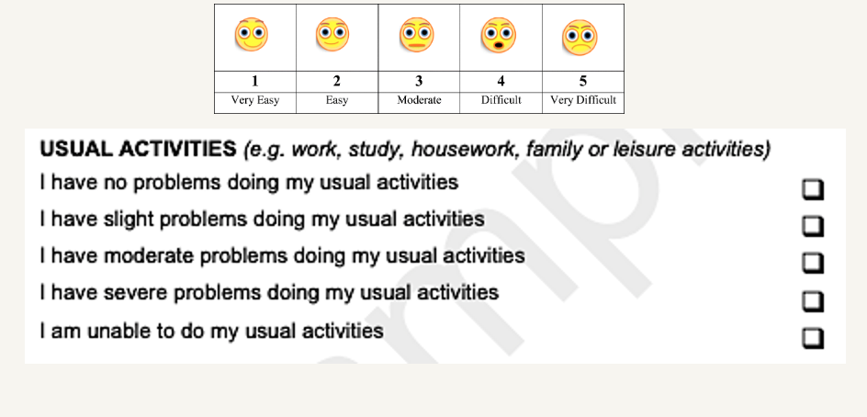

- Feedback

PwD | Informal caregiver
But what are usual activities? Would provide different answers for different activities? – so the response would depend on which activity he was thinking about. Hard to give just one rating for the entire “activity” dimension | The person she cares for in a care home, and so it would be easy for her to rate that his ability to perform activities would be severe. He is unable to do most things, so this is easy to answer
Would need a larger font and cream/ yellow paper for some people to be able to read it clearly | As her husband progressed through the stage of dementia, UA became worse. She felt she would have been quite capable of rating on behalf of her husband. She says their answers may have differed or that if her husband had been asked, he may have avoided answering or said he could not say
Some people with dementia are non-verbal. Visual prompts might help to help people think about ‘what are my usual activities’ and then point – would include a wider range of people. | Thought he could have represented his wife. As her dementia deteriorated so did her ability to perform activities. If she had been asked, she would have looked to him to answer
The question is vague and difficult to understand
It might be helpful to have examples of the range of activities the question refers to – or ask people to try and rate based on an ‘overall’ basis rather than individual activities

- The group was then asked to turn their focus to the other dimensions, and to discuss which of these would be easier or harder to self/proxy rate; and whether they believe any dimensions should be either self or proxy rated?

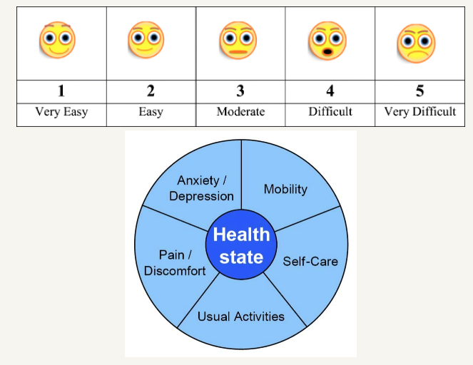
- Feedback

PwD | Informal caregiver
Anxiety / Depression was more difficult as it can get mixed up with feeling frustrated about having dementia | Mobility was probably an easier one to rate as it’s more visible. Certainly, carers felt they could see how mobile the person they cared for was and record accordingly
A/D: Might not answer accurately as might want to present as if feeling OK when I’m not | Perhaps people with dementia might answer more optimistically and a carer might see things more as they really are
Should always be the PwD providing the answer. He said his wife would answer differently, if they were in separate rooms – they would likely provide different answers | carers should be asked for their opinions, even if the person with dementia has answered as the carer may have a different viewpoint
People with dementia need to answer for themselves and ways to make it more visual so people have a better chance of understanding what is being asked and pointing to respond. He said that the research is about PwD, therefore it should be PwD providing the answers
People with dementia may answer differently when asked in front of their carers – they might want to not upset carer. For example, people with dementia may talk openly with one another about sensitive topics such as dying – but would not want to talk as openly in front of their carer.
Really complex, as again, I am not going to say the same thing as my wife. Some of the questions around mental health people may struggle with
Mobility has a confounder. I have lost my sense of direction, but I can get up and move. Does this mean what can you do safely? It’s all in the mindset

- The group was them shown the hypothetical grouping of EQ-5D dimensions as subjective vs objective, and observable vs non-observable; and were asked for their opinion on what terminology for this proposed grouping would resonate most

- Feedback

- Feelings vs. visual – PwD
- Emotions vs. physical – PwD

Feedback from Dr Jane McKeown

People struggled with the discussion regarding terminology and perhaps this was a bit too conceptual to ask in a short space of time and online. People spoke of terms like – strengths; feelings; visual, physical, emotional.

Overall, the consensus was that it did not seem possible to be able to compare responses from people living with dementia from responses from family carers as both groups were rating their experiences from their personal perspectives.

Where possible people living with dementia should be given every opportunity to answer for themselves. Where this is not possible carers should be asked to rate the experience but these rating should be dealt with separately.

Appendix 3 Extended summary of identified dementia trial features
Study name | Primary investigator | Country | Trial Setting | Intervention type | Type of dementia | Primary outcome | Secondary outcomes | Self vs. proxy QoL? | Funding
SENSE-Cog, 2022 | Iracema Leori | 5 EU countries | Community | Non-pharmacological (behavioural) | AD, VD or mixed | DEMQoL | -DEMQoL  -DEMQoL-proxy  -BADLS  -MoCA  - NPI  -RSS  - Clinical measures of: hearing & vision (related to Tx) | Both | EU Horizon 2020
DCM EPIC, 2018 | Claire Surr | UK | Care home | Service delivery | AD | CMAI | -DEMQoL-Proxy  -EQ-5D  -NPI  -PAS | Both | Health Technology Assessment Programme, HTA
AD2000, 2009 | Richard Gray | UK | Hospital | Pharmacological: donepezil & aspirin | AD | MMSE,  BADLS | -Time to institutional care  -Progress of disability (number of ADL impairments)  -NPI  -carer wellbeing: (GHQ-30)  -deaths  -compliance | n/a | West Midlands NHS Research & Development Executive (UK)
DOMINO-AD, 2017 | Robert Howard | UK | Not specified | Pharmacological: donepezil & memantine | AD | sMMSE,  BADLS | -NPI  -EQ-5D  -DEMQoL-proxy  -carer burden: (GHQ-12) | Proxy | MRC
Study name, year | Primary investigator | Country | Trial Setting | Intervention type | Type of dementia | Primary outcome | Secondary outcomes | Self vs. proxy QoL? | Funding
iCST, 2022 | Afia Ali | UK | Community learning | Non-pharmacological (behavioural) | Dementia & down syndrome | CAMCOG-DS | -Modified memory for objects test  -Cognitive scale for down syndrome  -ADCS-ADL  -QoL-AD proxy  -Carer Burden: -Caregiver Burden Scale  -SCIDS  -Carer Anxiety & Depression: HADS | Proxy | Baily Thomas Charitable Fund UK
GREAT, 2019 | Linda Clare | UK | Hospitals | Non-pharmacological (behavioural) | AD, vascular or mixed | Bangor Goal-Setting interview | -DEMQoL  -GSE  - HADS  -RBMT  - Test of Everyday Attention  - D-KEFS  - CSRI  -Carer Outcomes: Relatives’ Stress Scale, EQ-5D, WHOQoL-BREF | Self | NIHR Health Technology Assessment Programme
DPACT, 2020 | Richard Byng | UK | GP practices | Service delivery (support workers) | All | DEMQoL, BADLS, NPI | -MMSE  -Carer wellbeing and support scale | Both | NIHR Programme Grant for Applied Research
Study name, year | Primary investigator | Country | Trial Setting | Intervention type | Type of dementia | Primary outcome | Secondary outcomes | Self vs. proxy QoL? | Funding
ADEX, 2013 | Gunhild Waldemar | Denmark | Memory clinics | Non-pharmacological (exercise) | AD | Symbol Digit Modalities Test  (cognition) | -ADAS-Cog  -verbal fluency, Stroop colour and world test  -MMSE  -EQ-5D  -EQ-VAS  -ADCS-ADL  -HDR-17  - PASE | Both | Danish Council for Strategic Research
mCST SHEILD, 2018 | Martin Orrell | UK | Dementia care and NHS Trusts | Non-pharmacological (behavioural) | Any | ADAS-Cog  QoL-AD  EQ-5D  DEMQoL | -HCS  -CDR  -CSDD  -RAID  -NPI  -ADCS-ADL  -SF-12 | Both | NIHR
EVIDEM-E, 2018 | David Lowery | UK | Other | Non-pharmacological (exercise) | Any | NPI | -GHQ  -DEMQoL-proxy  -ZBI  -Physical activity and compliance  -Interviews  -Mortality | Proxy | NIHR PGfAR
Study name, year | Primary investigator | Country | Trial Setting | Intervention type | Type of dementia | Primary outcome | Secondary outcomes | Self vs. proxy QoL? | Funding
EVIDEM-ED, 2013 | Steve Iliffe | UK | GP practices | Educational | Any | Proportion of dementia reviews | -Concordance with treatment  -Depression  -Social Service Referral  -Signposting  -Drug Information  -DEMQoL  -Carer Strain Index  -Interviews | Self | NIHR-PGfAR
ATTILA, 2021 | Robert Howard | UK | Other | Non-pharmacological (telecare) | Any | Time to institutionalisation  QALYs (EQ-5D, DEMQoL) | -ZBI  -DEMQoL  -DEMQoL-proxy  -Serious Adverse Events  -Acceptability | Both | NIHR-HTA
CALM-AD, 2009 | Robert Howard | UK | Not specified | Pharmacological: donepezil | AD | CMAI | -NPI  -MMSE  -SIB  -Clinical Global impression of severity/ change | n/a | MRC UK
WHELD, 2019 | Clive Ballard | UK | Hospitals | Non-pharmacological (complex) | Any | Antipsychotic use, CMAI | -NPI-NH  -CSDD  - CANE  -QoL-AD  -DEMQoL  -QUIS  -Falls | Self | NIHR
Study name, year | Primary investigator | Country | Trial Setting | Intervention type | Type of dementia | Primary outcome | Secondary outcomes | Self vs. proxy QoL? | Funding
HTA-SADD, 2013 | Sube Banerjee | UK | Not specified | Pharmacological (anti-depressants: mirtazapine, sertraline) | AD | CSDD, CSRI | -DEMQoL  -DEMQoL-proxy  -EQ-5D-proxy  -MMSE  -Adherence  -Serious Adverse Events  -SF-12  -ZBI  -Withdrawal from treatment | Both | NIHR HTA
DREAM-START, ongoing | Penny Rapaport | UK | Community dwelling | Non-pharmacological (behavioural) | Any | Sleep (SDI) | -NPI  -ESS  -DEMQoL-proxy  -DEMQoL-proxy-U  -CSRI  -EQ-5D-5L-proxy  -Medication use  -Side effects | Proxy | NIHR HTA
PRESIDE, 2021 | Justine Schneider | UK | Community | Non-pharmacological (singing therapy) | Any | Recruitment, retention and acceptability | -QoL-AD  -EQ-5D-5L  -DEMQoL  -CDR  -GDS  -ADAS-Cog  -CSDD  -Music engagement questionnaire  -BADLS  -CSRI | Both | Alzheimer’s Society & NIHR
Dementia observational studies:
Study name, year of results | PI | Country | Setting | Study type & focus | Type of dementia | Primary outcome | Secondary outcome | Self vs. proxy QoL? | Funding
DADE, 2015 | Roy Jones | UK | Not specified | Cross-sectional observational; dependence in dementia | AD | DS | -MMSE  -DAD  -NPI  -CDR-SOB  -EQ-5D  -EQ-5D-proxy  -DEMQoL  -DEMQoL-proxy(-U)  -BASQID  -ZBI | Both | Pfizer Inc and Janssen Alzheimer Immunotherapy Research & development
IDEAL, ongoing | Linda Clare | UK | Not specified | Longitudinal cohort study | Any | QoL-AD, WHO-5 Wellbeing index | N/A | Not clear | ESRC & NIHR
ACTIFCARE, 2016 | Liselot Kerpershoek | 8 EU countries | Community dwelling | Longitudinal cohort study | Any | CANE, RUD | -QoL-AD  -QoL-AD proxy  -MMSE  -DEMQoL  -DEMQoL-proxy  -ICECAP-O  -PAI | Both | EU Joint Programme - Neurodegenerative Disease Research (JPND)
AD, Alzheimer’s Disease; ADAS-Cog, Alzheimer’s disease assessment scale – cognitive subscale; ADL, activities of daily living; ADCS-ADL, Alzheimer's Disease Cooperative Study - Activities of Daily Living; BADLS, Bristol activities of daily living; BASQID, Bath Assessment of Subjective Quality of Life in Dementia; CAMCOG-DS, Cambridge cognitive examination for older adults with down’s syndrome; CANE, Camberwell Assessment of Needs for the Elderly; CMAI, Cohen Mansfield agitation inventory; CSRI, Client Services Receipt Inventory; CSDD, Cornell Scale for depression in dementia; CDR (SOB), clinical dementia rating (sum of boxes); D-KEFS, Delis-Kaplan Executive Function System; Disability assessment for dementia, DAD; DEMQoL, Dementia Quality of life scale; Dependence scale DS; ESS, Epworth Sleepiness Scale; EU, European Union; GDS, Geriatric Depression Scale; GHQ, general health questionnaire; GP, general practitioner; GSE, Generalised Self-Efficacy Scale; HDRS, Hamilton Depression Rating Scale; HADS, Hospital Anxiety and Depression Scale; HCS, Holdens communication scale; HTA, health technology assessment; ICECAP-O, The ICEpop CAPability measure for Older people; NPI(-NH), neuropsychiatric inventory (nursing home); (s)MMSE, (standardised) mini-mental state examination; MRC, medical research council; PAS, MoCA, Montreal Cognitive Assessment; NIHR, national institute for health research; PAI, Positive Affect Index; PGfAR, programme grants for applied research; Pittsburgh Agitation Scale; PASE, Physical Activity Scale for the Elderly; QALYs, quality adjusted life years; QoL-AD, quality of life in Alzheimer’s disease scale; QUIS, Quality of interactions schedule; RAID, Rating Anxiety in Dementia; RBMT, Rivermead Behavioural Memory Test; RSS, relationship satisfaction survey; RUD, resource utilisation in dementia; SCIDS, Sense of competence in Dementia Care Staff scale; SF-12, short form health survey 12 items; SIB, Severe Impairment Battery; TX, treatment; UK, united kingdom; VD, Vascular dementia; WHOQoL-BREF, world health organisation quality of life brief version; ZBI, Zarit burden interview

Appendix 3.1a DEMQoL suite conceptual framework

The DEMQoL suite was developed for use in mild/moderate and severe dementia populations in the UK. The framework for the suite was developed via mixed methods including literature reviewing, interviews with PwD and caregivers and expert consensus discussions. Through these rigorous processes, the final conceptual framework included 5 overarching domains: daily activities and looking after yourself, health and well-being, cognitive functioning, social relationship, and self-concept (Smith et al., 2005a).

Two distinct instruments are housed within the DEMQoL suite: DEMQoL (29 items) and DEMQoL-proxy (32 items). The DEMQoL-proxy is intended for proxy completion by caregivers, it asks proxies to adopt a proxy-patient perspective where possible and can be self-administered. The DEMQoL self-report is intended for interviewer administration. The instruments possess different item components to each other under the same 5 domain constructs. Items on both instruments are scored on a 4-point scale, ranging from “a lot” to “not at all”. Since its development, preference-based indices (DEMQOL-U and DEMQOL-Proxy-U) have been published for DEMQoL and DEMQoL-proxy which enable the generation of health-state utility values for use in economic evaluations (Mulhern et al., 2013).

DEMQoL items and domains

Item component | Domain
Cheerful | Health and wellbeing
Worried/ anxious | Health and wellbeing
Enjoying life | Health and wellbeing
Frustrated | Health and wellbeing
Confident | Health and wellbeing
Full of energy | Health and wellbeing
Sad | Health and wellbeing
Lonely | Health and wellbeing
Distressed | Health and wellbeing
Lively | Health and wellbeing
Irritable | Health and wellbeing
Fed-up | Health and wellbeing
Things wanted to do but couldn’t | Daily activities and looking after yourself
Forgetting things that happened recently | Cognitive functioning
Forgetting who people are | Cognitive functioning
Forgetting what day it is | Cognitive functioning
Muddled thoughts | Cognitive functioning
Difficult making decisions | Cognitive functioning
Poor concentration | Cognitive functioning
Not having enough company | Social relationships
How you get on with people close to you | Social relationships
Getting the affection you want | Social relationships
People not listening | Social relationships
Making self understood | Cognitive functioning
Getting help when you need it | Social relationships
Getting to the toilet in time | Daily activities and looking after yourself
How you feel in yourself | Self-concept
Health overall | Health and wellbeing

DEMQoL-proxy items and domains

Item component | Domain
Cheerful | Health and wellbeing
Worried/ anxious | Health and wellbeing
Frustrated | Health and wellbeing
Full of energy | Health and wellbeing
Sad | Health and wellbeing
Content | Health and wellbeing
Distressed | Health and wellbeing
Lively | Health and wellbeing
Irritable | Health and wellbeing
Fed-up | Health and wellbeing
Having things to look forward to | Self-concept
Memory in general | Cognitive functioning
Forgetting things that happened long ago | Cognitive functioning
Forgetting things that happened recently | Cognitive functioning
Forgetting people’s names | Cognitive functioning
Forgetting where he/she is | Cognitive functioning
Forgetting what day it is | Cognitive functioning
Thoughts being muddled | Cognitive functioning
Difficult making decisions | Cognitive functioning
Making self understood | Cognitive functioning
Keeping self clean | Daily activities and looking after yourself
Keep self looking nice | Daily activities and looking after yourself
Getting what want from shops | Daily activities and looking after yourself
Using money to pay for things | Daily activities and looking after yourself
Looking after finances | Daily activities and looking after yourself
Things taking longer than they used to | Health and wellbeing
Getting in touch with people | Daily activities and looking after yourself
Not having enough company | Social relationships
Not being able to help other people | Social relationships
Not playing a useful part in things | Self-concept
Physical health | Health and wellbeing

Appendix 3.1b QoL-AD conceptual framework

QoL-AD is a dementia specific QoL PROM developed for use in people with Alzheimer’s disease and their caregivers. The framework for its development was based on Lawton’s domains of quality of life, an existing established framework which includes 4 domains that are considered to reflect QoL in older adults (Logsdon et al., 1999). These are: behavioural competence, the objective environment, psychological well-being and perceived QoL (Logsdon et al., 2002, Jonker et al., 2004), and each item component of the QoL-AD corresponds to one of these domains.

There are a total of 13 items which are scored on a 4-point scale ranging from poor to excellent. The instrument is intended for interviewer administration for self-completion and can be self-administered by proxies. Proxies can be formal or informal and are asked to adopt a proxy-proxy perspective where possible (Logsdon et al., 1999). A PBM, the Alzheimer’s Disease Five Dimensions (AD-5D), has since been derived from the QoL-AD to enable utility estimation for use in economic evaluation (Logsdon et al., 1999).

QoL-AD items and domains

Item component | Domain
Physical health | Behavioural competence
Energy | Psychological well-being
Mood | Psychological well-being
Living situation | Objective environment
Memory | Behavioural competence
Family | Behavioural competence
Marriage | Behavioural competence
Friends | Behavioural competence
Self as a whole | Perceived QoL
Ability to do chores around the house | Objective environment
Ability to do things for fun | Perceived QoL
Money | Objective environment
Life as a whole | Perceived QoL

Appendix 3.1c QUALID conceptual framework

The QUALID is a dementia specific measure developed to aid in assessing the effects of clinical management decisions and treatment plans on QoL, in people with late-stage dementia residing in long-term institutions (Weiner et al., 2000). The framework for its development was based on a combination of 2 existing scales, the Lawton assessment of QoL in AD research and the Logsdon pleasant event schedule in AD patients. The Lawton assessment contains the following domains: cognitive functioning, the ability to perform activities of daily living and to engage in meaningful time use and social behaviour, and a favourable balance between positive emotion and absence of negative emotion (Lawton, 1994). The Logsdon schedule enlists pleasant activities specific to AD populations (Logsdon and Teri, 1997).

The QUALID is a proxy-reported outcome measure, intended for administration by a trained researcher to professional caregivers/nursing home personnel. It contains 11 items of observable behaviours, indicating activities and emotional states. Ratings are made by observation over a one-week period and are rated on a 5-point Likert scale (Weiner et al., 2000).

QUALID items and domains

Item component | Domain
Smiles | Positive emotion
Physically uncomfortable | Negative emotion
Sad | Negative emotion
States/sounds of discontent | Negative emotion
Cries | Negative emotion
Irritable or aggressive | Negative emotion
Facial expression of discomfort | Negative emotion
Enjoys eating | Pleasant event
Enjoys touching | Pleasant event
Enjoys interacting | Pleasant event
Emotionally calm and comfortable | Positive emotion

Appendix 3.1d QUALIDEM conceptual framework

The QUALIDEM is a dementia specific QoL measure with two versions, both with a different number of items. The conceptualisation was based on adaptive tasks outlined in the adaptation coping model by RM Dröes (Dröes, 1991), eventually including the following 9 domain subscales: care relationships, positive affect, negative affect, restless tense behaviour, positive self-image, social relations, social isolation, feeling at home and having something to do(Dichter et al., 2016).

The 37-item version is targeted for use in people with mild-to-severe dementia and contains items to cover all 9 domains. The 18-item version is for those with very severe dementia and does not assess the following domains: positive self-image, feeling at home and having something to do. Both versions are intended for use in nursing home populations. Items within each domain can be summed to provide a summary subscale score (Ettema et al., 2007). The QUALIDEM is a proxy-reported outcome measure, containing observable items and is scored on a 4-point rating scale from never-to-often (Dichter et al., 2016).

QUALIDEM items and domains

Item component | Domain
Cheerful | Positive affect
Restless movements* | Restless tense behaviour
Contact with residents* | Social relations
Rejects help | Care relationship
Satisfaction* | Positive affect
Anxious* | Negative affect
Angry* | Care relationship
Enjoying daily life* | Positive affect
Not want to eat* | *not defined (not scaled)
Good mood | Positive affect
Sad | Negative affect
Positive response* | Social relations
Bored | Feeling at home
Conflicts* | Care relationship
Enjoys meals* | *not defined (not scaled)
Rejected* | Social isolation
Accusing | Care relationship
Takes care of others | Social relations
Restless* | Restless tense behaviour
Rejects contact* | Social isolation
Smile* | Positive affect
Tense body language* | Restless tense behaviour
Cries* | Negative affect
Appreciates help | Care relationship
Cut from environment* | Social relations
Things to do without help | Having something to do
Asks for help | Positive self-image
Locked up | Feeling at home
Friendly with 1+ resident | Social relations
Lays in bed* | *not defined (not scaled)
Accepts help* | Care relationship
Calls out* | Social isolation
Criticizes | Care relationship
Ease in company | Social relations
Not able to do anything | Positive self-image
Feels at home | Feeling at home
Worthlessness | Positive self-image
Helps with chores | Having something to do
Wants off the ward | Feeling at home
Positive mood* | Positive affect

Appendix 3.2 Summary of reviewing the literature for content validity and feasibility evidence of HRQoL measures in dementia populations

Summary of the literature on content validity

Literature searching identified a recent (2020) and comprehensive article that used qualitative research methods to explore the content validity of PBMs in dementia (Engel et al., 2020). The authors conducted focus groups and interviews with PwD and caregivers and first explored their general understanding of QoL, and the impact of dementia upon it. This exercise indicated domains of QoL that are considered important to PwD and caregivers. Following this, participants assessed a mix of generic (EQ-5D-5L and AQoL-8D) and dementia specific (DEMQoL-U and AD-5D) QoL measures, and broader measures of wellbeing (ICECAP-O and ASCOT) for content and face validity. The following nine domain themes were identified by participants as central: activity, autonomy, cognition, communication, coping, emotions, end-of-life, physical functioning and relationships (Engel et al., 2020).

It was reported that none of the six PBMs captured all of the QoL domains that were identified as important, distinctly the measures captured some of the domains but not all of them. This premise is reinforced by the findings of a review of utility-based instruments for PwD(Li et al., 2018). Here, the authors reported that there was a divergence of domains highlighted by PwD and their caregivers and the content of three generic PBMs– EQ-5D, HUI2/3 and QWB. The original study found that there were 44 and 45 QoL domains highlighted by PwD and caregivers respectively, whereby 33 domains overlapped. These 33 domains were collapsed under the following 6 broad domain headings: global impression of QoL, disease-specific physical well-being, social/family well-being, emotional well-being, functional well-being and cognition (Silberfeld et al., 2002). It was found that the QWB contained the most individual domains (n=25), making it the most favourable measure of the three measures in terms of content validity (EQ-5D, n=10; HUI3, n=11) (Silberfeld et al., 2002).

Literature searching identified two further reviews that explored factors that influence QoL in PwD (Jing et al., 2016, O'rourke et al., 2015). One of which conducted a meta-synthesis of qualitative studies and grey literature with the aim of identifying, from the perspective of the PwD themselves, factors that affect QoL. The authors identified the following four factors, that even in the situation of progressing cognition, have the potential to impact QoL for the PwD: relationships, agency in life today, wellness perspective and sense of place (O'rourke et al., 2015). This article highlights the importance of non-health related domains of QoL to PwD.

The other identified review conducted a systematic search of literature related to QoL and dementia between 2000 – 2015 (Jing et al., 2016). The authors commented on the complexity in how factors interplay with the residential setting of the person; environmental factors (e.g., familiar objects and access to open windows) played a more central role to institutionalised people, whereas religion seemed a predominant influence only to those that are community dwelling. Overlapping factors (impacting both institutionalised and community dwelling PwD) were functional independence, challenging behaviours, general health, cognition, neuropsychiatric symptoms i.e., mood and depression, relationship, social interaction, finances and taking psychotropic medication (Jing et al., 2016). The authors also aimed to identify specific influences by stages of severity however were not able to due to lack of evidence across disease stages. Both studies provide rich insight into the multidimensional nature of QoL in the context of dementia, however their objectives were not what should constitute QoL measurement, but rather what affects QoL.

A review of HRQoL instruments in Alzheimer’s disease and mixed dementia identified 15 dementia-specific measures (search conducted up to December 2011) (Perales et al., 2013). The authors reported factors such as country of development, scoring and data collection method (i.e., proxy, patient, or researcher observation), as influencing the homogeneity between measures. The most frequently included domains across the identified measures were mood, self-esteem, social interaction, and enjoyment of activities. Other recurring domains were cognitive ability, activities of daily living, health, living conditions and sense of usefulness (Perales et al., 2013). The results of this review emphasized the disparity between measures, and the lack of a conceptual consensus of HRQoL in dementia research. Furthermore, it was highlighted that there is no method for evaluating the different domains across instruments, which therefore limits comparability of studies that utilise different measures.

The beyond-health measures included in the study by Engel et al (2020)(Engel et al., 2020) provided challenging in terms of their face validity. The participants generally found the broader concepts and questions difficult to understand. EQ-5D-5L was found to be well accepted but did not capture domains that are considered important to the population such as cognition and well-being (Engel et al., 2020). It may be assumed that the dementia specific measures presented as the most favourable, however the results of the study indicate that key QoL domains such as activity and self-care are not included in them (despite their inclusion in their affiliated non-preference-based measures, DEMQoL and QoL-AD). Overall, AQoL-8D was considered the most extensive of the measures as it included the greatest number of the identified domains (Engel et al., 2020). However, this is a 35-item questionnaire, and this raises issues surrounding feasibility and acceptability in the given population.

Summary of the literature on feasibility and acceptability

A review of utility instruments for PwD determined the feasibility of a combination of six dementia-specific and generic utility measures (EQ-5D, HUI2/3, QWB, DEMQoL-U, DEMQoL-Proxy-U, AQoL and 15D) that were detected in the literature as being used to evaluate health state values in dementia populations (Li et al., 2018). The authors assessed the instrument’s time to complete, rate of response and proportion of missing items across studies. From this, it was concluded that EQ-5D was the most feasible measure amongst the sample, as it had the lowest time to complete and lowest proportion of missing data, and the greatest rate of completion (self and proxy) (Li et al., 2018).

This finding is reinforced in a primary study that compared acceptability of EQ-5D and the QoL-AD using data from a large multicentre observational study of PwD and their caregivers in Germany. The authors reported that EQ-5D-3L demonstrated satisfactory acceptability in measuring HRQoL in people with moderate dementia, and that due to its precise nature, it is suitable for use in economic evaluations of dementia interventions (Michalowsky et al., 2020).

Proxy-ratings provide a route to addressing feasibility and acceptability issues of instruments in dementia populations, this is highlighted across the literature. A qualitative study evaluated the feasibility of routinely measuring QoL of care-home residing people with dementia via care-staff rated DEMQoL-CH (care home). Interviews and focus groups elicited that staff were positive about doing so, and data collected fit acceptability criteria (missingness and floor/ceiling effects within acceptable range). Staff confidence in reporting ability was varied in the sample but was directly related to time spent with the PwD(Hughes, 2018). Similarly, studies in the wider literature have reported fewer missing data for proxy reporting across various HRQoL measures (vs. self-report) (Kunz, 2010, Harrison et al., 2018, Hoe et al., 2007, Diaz‐Redondo et al., 2014, Gräske et al., 2014, Martin et al., 2019).

Trade-off between content validity and feasibility and acceptability

There are other distinctive trade-offs which need to be evaluated when considering QoL measures in dementia economic evaluations. It is often the case that content validity studies include both PwD and their caregivers. As a result, when reviewing such evidence, it is important to distinguish between attributes highlighted by PwD themselves, and those highlighted by caregivers. They may often overlap; however in the literature is has been seen that different stakeholders emphasise different domains (Silberfeld et al., 2002), and that there is a mismatch between what is considered critical to caregivers and to PwD (Li et al., 2018). This conflict was encountered when developing the established DEMQoL and DEMQoL-Proxy measures. The conceptual framework development highlighted the need for separate measures, with distinct items, from the perspective of the person with dementia and for caregivers (Smith et al., 2005b). Both the DEMQoL and DEMQoL-Proxy also have preference-based measures derived from them, making them candidates for use in economic evaluation. However, having two separate utility estimations leads to the inevitability of policy makers having to differentiate between QALY values elicited via different measures, and orbits the need for a single empirical solution.

Appendix 3.3 Item components of dementia symptom measures

Table A3.3a, Core cognitive measure item list
^{Scale}  _{Item component} | MMSE | MoCA | ADAS-Cog | SIB
Orientation time/ place | ✓ | ✓ | ✓ | ✓
Orientation to name |  |  |  | ✓
Registration | ✓ | ✓ | ✓
Attention and calculation | ✓ | ✓ | ✓ | ✓
Recall | ✓ | ✓ | ✓ | ✓
Language | ✓ | ✓ | ✓ | ✓
Repetition | ✓
Abstraction |  | ✓
Complex commands* | ✓ | ✓ | ✓
Abstract reasoning
Ideational Praxis |  |  | ✓ | ✓
Word finding |  |  | ✓
Social interaction |  |  |  | ✓
Visuospatial |  | ✓ |  | ✓
Construction |  |  | ✓ | ✓
*e.g., drawing task or maze

Table A3.3b, Core function measure item list

^{Scale}  _{Item component} | BADLS | DAD | ADCS-ADL | Lawton | Katz | Barthel
Feeding | ✓ | ✓ | ✓ |  | ✓ | ✓
Preparing food | ✓ | ✓ | ✓ | ✓
Drinking | ✓
Preparing drinks | ✓ |  | ✓
Personal hygiene | ✓ | ✓ | ✓ |  | ✓ | ✓
Dressing/ grooming | ✓ | ✓ | ✓ |  | ✓ | ✓
Toilet use | ✓ | ✓ | ✓ |  | ✓ | ✓
Transfer | ✓ |  |  |  | ✓ | ✓
Mobility | ✓ |  | ✓ |  |  | ✓
Stairs |  |  |  |  |  | ✓
Telephone | ✓ | ✓ | ✓ | ✓
Shopping | ✓ |  | ✓ | ✓
Housekeeping/ chores | ✓ | ✓ | ✓ | ✓
Laundry |  |  |  | ✓
Transport | ✓ | ✓ | ✓ | ✓
Medication |  | ✓ |  | ✓
Finances | ✓ |  |  | ✓
Television |  |  | ✓
Conversation | ✓ |  | ✓
Finding things |  |  | ✓
Appointments |  |  | ✓
Can be alone |  |  | ✓
Current events |  |  | ✓
Reading and writing |  |  | ✓
Hobbies/games | ✓ | ✓ | ✓
Orientation (time/space) | ✓

Table A3.3c, Core behaviour/mood measure item list

^{Scale}  _{Item component} | NPI | CMAI | CSDD | GDS-15
Delusions | ✓
Hallucinations | ✓
Agitation/aggression | ✓ | ✓ | ✓
Dysphoria/depression | ✓ | ✓ | ✓ | ✓
Anxiety/fear | ✓ | ✓ | ✓
Elation/euphoria | ✓
Apathy/indifference | ✓ |  | ✓ | ✓
Disinhibition | ✓ | ✓
Irritability/lability | ✓
Motor disturbances | ✓ |  | ✓
Night-time behaviour disturbances/ sleep disturbance | ✓ |  | ✓ | ✓
Appetite and eating disorders | ✓ | ✓ | ✓
Resistiveness to care |  | ✓
Wandering |  | ✓
Catastrophic reactions |  | ✓
Ideation disturbance |  |  | ✓
Energy level |  |  | ✓ | ✓
Mood/boredom |  |  |  | ✓
Self-appraisal |  |  |  | ✓

Appendix 3.4 Search strategy used for convergent validity review

Run: 20/04/2021, Ovid MEDLINE ® (1996-April Week 2 2021) & APA PsycINFO (1987-April Week 2 2021)
# | Searches | Results
1 | (MoCA or Montreal Cognitive Assessment).mp | 6974
2 | (MMSE or mini mental state examination or mini-mental state examination).mp | 59159
3 | (ADAS-Cog or Alzheimer's Disease Assessment Scale-Cognitive Subscale).mp | 2059
4 | (SIB or severe impairment battery).mp | 6440
5 | (BADLS or Bristol activities of daily living scale).mp | 236
6 | (DAD or disability assessment for dementia scale).mp. | 7323
7 | (ADCS-ADL or Alzheimer's disease cooperative study ADL scale).mp. | 217
8 | Alzheimer's disease cooperative study activities of daily living scale.mp. | 103
9 | (Lawton scale or Lawton index or Lawton instrumental ADL scale or Lawton instrumental activities of daily living scale or Lawton IADL scale).mp. | 436
10 | (Katz ADL or Katz index or Katz index of independence in ADL or Katz index of independence in activities of daily living).mp. | 845
11 | (Barthel Index or Barthel scale or Barthel index for activities of daily living).mp | 8110
12 | (NPI or Neuropsychiatric Inventory or Neuropsychiatric inventory questionnaire).mp. | 7544
13 | (CMAI or cohen-mansfield agitation inventory or Cohen Mansfield agitation inventory).mp. | 939
14 | (CSDD or Cornell scale for depression in dementia).mp. | 1144
15 | (GDS or geriatric depression scale).mp. | 15117
16 | (euro qual or euro qual5d or euro qol5d or eq-5d or eq5-d or eq5d or euroqual or euroqol or euroqual5d or euroqol5d or European QoL-5 dimensions or European quality of life 5 dimensions).mp. | 13752
17 | exp Dementia/ | 220550
18 | dement*.mp. | 171942
19 | (Alzheimer* or AD).mp | 261540
20 | 17 or 18 or 19 | 375766
21 | 7 or 8 | 284
22 | 1 or 2 or 3 or 4 or 5 or 6 or 9 or 10 or 11 or 12 or 13 or 14 or 15 or 21 | 96986
23 | 16 and 20 and 22 | 228
24 | Limit 23 to English language | 218
Additional search – CINAHL, terms:
Eq-5d or eq5d AND dementia or Alzheimer’s – limited to abstract, generated 66 references – limited to English language = 64
Total hits = 284, 46 were duplicate = remaining 236 records

Appendix 3.5 Table of the inclusion/exclusion criteria

Inclusion | Exclusion
Population with formal dementia diagnosis (any type of dementia) | Mild cognitive impairment alone
Must report one of the key outcome instruments AND EQ-5D | Non-English language
EQ-5D-5L or EQ-5D-3L | EQ-5D VAS alone
Self-report and/or proxy report EQ-5D | Caregiver studies (where outcomes were collected
Any study design i.e., RCT, observational | Previous systematic reviews (although chain search of references will be completed)
Contains extractable data | Grey literature
 | Conference abstracts
 | Protocols

Appendix 3.6 Adapted GRADE quality appraisal tool

 | Population | Sample |  |  | Outcome assessment | Analysis |  |  | Data  Limitations | Quality score
 | 1. Is the study population clearly defined? | 2. Are the sample characteristics clearly summarised? | 3. What is the magnitude of the sample size? High>300, Medium 100-300, Low<100 | 4. Are sample groups clearly defined? | 5. Are instrument administration details clear? | 6. Are details of analyses provided? | 7. Are relationships measured via statistical methods i.e., correlation, p value, 95% CI? | 8.Are strength of association thresholds included within the study? | 9.Have the authors noted or discussed missing data? | Quality score
Ankri 2003 | Y | Y | 142 | Y | Y | Y | Y | Y | Y | HIGH
Ashizawa 2021 | Y | Y | 287 | Y | Y | Y | Y | N | N | MEDIUM
Bhattacharya 2010 | Y | Y | 321 | N/A | Y | Y | Y | N | N | MEDIUM
Bonfiglio 2019 | Y | Y | 141 | Y | Y | Y | Y | N | N | MEDIUM
Bostrom 2007 | Y | Y | 68 | Y | Y | Y | Y | N | Y | MEDIUM
Bryan 2005 | Y | Y | 64 | Y | Y | Y | Y | Y | Y | HIGH
Castro-Monteiro 2014 | Y | Y | 274 | Y | Y | Y | Y | N | Y | HIGH
Diaz-Redondo 2014 | Y | Y | 545 | Y | N | Y | Y | Y | Y | HIGH
Easton 2018 | Y | Y | 541 | Y | Y | Y | Y | Y | N | HIGH
Ersek 2010 | Y | Y | 88 | Y | N | Y | Y | N | Y | MEDIUM
Farina 2020 | Y | Y | 307 | Y | Y | Y | Y | N | Y | HIGH
Garre-Olmo 2017 | Y | Y | 343 | Y | Y | Y | Y | N | N | HIGH
Gonzalez-Velez 2015 | Y | Y | 412 | Y | N | Y | Y | N | N | MEDIUM
Haaksma 2018 | Y | Y | 331 | N/A | Y | Y | Y | N | N | MEDIUM
HeBmann 2016 | Y | Y | 395 | Y | Y | Y | Y | N | Y | HIGH
Karlawish 2008 [1] | Y | Y | 110 | Y | Y | Y | Y | Y | Y | HIGH
Karlawish 2008 [2] | Y | Y | 110 | Y | Y | Y | Y | Y | Y | HIGH
King 2022 | Y | Y | 243 | Y | Y | Y | Y | N | Y | HIGH
Kunz 2010 | Y | Y | 399 | Y | Y | Y | Y | Y | Y | HIGH
Kuo 2010 | Y | Y | 140 | Y | Y | Y | Y | N | N | MEDIUM
Martin 2019 | Y | Y | 1004 | N/A | Y | Y | Y | Y | Y | HIGH
Michalowsky 2021 | Y | Y | 77 | Y | Y | Y | Y | Y | Y | HIGH
Naglie 2011 [1] | Y | Y | 370 | Y | Y | Y | Y | N | Y | HIGH
Naglie 2011 [2] | Y | Y | 412 | Y | Y | Y | Y | N | Y | HIGH
Orgeta 2015 | Y | Y | 478 | Y | Y | Y | Y | Y | Y | HIGH
Schiffczyk 2010 | Y | Y | 137 | Y | Y | Y | Y | N | N | MEDIUM
Sheehan 2012 | Y | Y | 112 | Y | Y | Y | Y | N | Y | HIGH
Trigg 2015 | Y | Y | 145 | Y | Y | Y | Y | N | N | MEDIUM
van de Veek 2019 | Y | Y | 138 | Y | N | Y | Y | N | Y | MEDIUM
Vogel 2006 | Y | Y | 48 | Y | Y | Y | Y | N | Y | MEDIUM

Appendix 3.7 Study characteristics table

Author, year | Country | Study design (of data origin) | n | Type dementia | Stage of dementia | Severity proportion (%) | Mean MMSE (SD) | Mean age (SD) | EQ-5D: 3L or 5L | Residence (% institutionalised) | Self or proxy QoL | Proxy type | Mode of administration
Ankri, 2003 | France | Non-interventional | 142 | Any | Mild-to-severe | 24.3% mild; 47.1% moderate; 27.9% severe | 12.8 (5.6) | 82.9 (8.32) | 3L | 41 | Both | FC & IC | I
Ashizawa 2021 | Japan | Prospective cohort study | 287 | AD | Mild-to-severe | NR | NR | 86.1 (6.4) | 5L | 100 | Proxy | FC & IC | SA
Bhattacharya, 2010 | Denmark | RCT | 321 | AD | Mild | NR | 24.0 (2.7) | 76.2 (7.1) | 3L | 0 | Both | IC | I
Bonfiglio, 2019 | Japan | Cross-sectional | 141 | NR | Mild | NR | 24.9 (2.6) | 78.8 (6.3) | 5L | 0 | Both | FC & IC | SA
Bostrom, 2007 | Sweden | RCT | 68 | DLB or AD | Mild-to-severe | NR | 16.9 (0-30) | 77.8 (63-92)ª | 3L | 28 | Both | IC | I
Bryan, 2005 | UK | Non-interventional | 64 | AD and VD | Very mild-to-moderate* | 5% very mild; 56% mild, 39% moderate | 18.0 (5.8) | 76 (53-91)ª | 3L | 0 | Proxy | IC & C | SA
Castro-Monteiro, 2014 | Spain | Multicentre longitudinal cohort | 274 | NR | Mild-to-severe* | 18% mild; 26% moderate; 56% severe | NR | 84.7 (6.51) | 3L | 100 | Proxy | IC | I
Diaz-Redondo, 2014 | Spain | Cross-sectional | 525 | NR | Mild-to-severe* | 14% mild; 25% moderate; 62% severe | NR | 85.6 (6.7) | 3L | 100 | Proxy | IC | NR
Author, year | Country | Study design (of data origin) | n | Type dementia | Stage of dementia | Severity proportion (%) | Mean MMSE (SD) | Mean age (SD) | EQ-5D: 3L or 5L | Residence (% institutionalised) | Self or proxy QoL | Proxy type
Easton, 2018 | Australia | Cross-sectional | 541 | NR | Very mild-to-moderate | 55% very mild; 42% mild; 4% moderate | NR | 85.5 (8.5) | 5L | 100 | Both | IC | I
Ersek, 2010 | Hungary | Cross-sectional | 88 | Any | Very mild-to-severe | 16% very mild; 27% mild; 25% moderate’; 16% severe | 16.7 (7.2) | 77.4 (9.2) | 3L** | NR | NR | IC | NR
Farina, 2020 | UK | Cohort | 307 | Any | Mild-to-severe | 36% mild; 33% moderate; 32% severe | 14.9 (9.1) | 80.9 (8.4) | 3L | 21 | Both | IC | SA
Garre-Olmo, 2017 | Spain | Cross-sectional multicentre | 343 | AD | Mild-to-severe | 32.1% mild; 36.7% moderate; 31.2% severe | 14.2 (6.3) | 78.9 (7.4) | 3L | NR | Proxy | IC | I
Gonzalez-Velez, 2015 | Spain | Multicentre longitudinal cohort | 412 | NR | Mild/moderate-to-severe* | 44% mild/moderate; 56% severe | 13.0 (8.5) | 84.7 (6.5) | 3L** | 100 | Proxy | FC & IC | SA
Author, year | Country | Study design (of data origin) | n | Type dementia | Stage of dementia | Severity proportion (%) | Mean MMSE (SD) | Mean age (SD) | EQ-5D: 3L or 5L | Residence (% institutionalised) | Self or proxy QoL | Proxy type
Haaksma, 2018 | Netherlands | Multicentre longitudinal prospective cohort | 331 | AD | Mild-to-moderate | 65% very mild | 21.9 (3.7) | 74.9 (10.2) | 3L | NR | Proxy | IC | I
Heßmann et al, 2016 | Germany | Non-interventional | 395 | AD | Mild-to-severe | 13% very mild; 33% mild; 27% moderate; 28% severe | 18.8 (8.3) | 79 | 3L | 31 | Both | IC | I
Karlawish, 2008 [1] | USA | Non-interventional | 110 | AD | Very mild-to-moderate | 32% very mild; 39% mild; 29% moderate | 21.3 (4.3) | 76.8 (2.7) | 3L | 0 | Self | n/a | I
Karlawish, 2008 [2] | USA | Non-interventional | 110 | AD | Very mild-to-moderate | 28% very mild; 37% mild; 35% moderate | 20.8 (4.4) | 76.8 (2.7) | 3L | 0 | Proxy | IC | I
King 2022 | UK | Cohort study | 243 | Any | Mild-to-severe | ~33% each for mild, moderate and severe | 15.9 (9.1) | 80.1 (8.6) | 3L | 18.7 | Both | IC | I
Kunz, 2010 | Germany | RCT | 399 | NR | Mild-to-moderate | 65% mild; 35% moderate | 18.6 (3.8) | 80.2 (6.7) | 3L | 0 | Both | IC | I
Kuo, 2010 | Taiwan | Cost analysis | 140 | NR | Mild-to-severe | 24% mild; 30% mild-moderate; 21% moderate; 25% severe | NR | 79.7 | 3L** | 36 | Both | IC | I
Author, year | Country | Study design (of data origin) | n | Type dementia | Stage of dementia | Severity proportion (%) | Mean MMSE (SD) | Mean age (SD) | EQ-5D: 3L or 5L | Residence (% institutionalised) | Self or proxy QoL | Proxy type
Martin, 2019 | UK | RCT | 1004 | NR | Mild-to-severe | 4% very mild; 23% mild; 39% moderate; 34% severe* | NR | 85.5 (58-102.6)ª | 3L | 100 | Both | FC & IC | I
Michalowsky, 2021 | Germany | Interventional study | 77 | Any | Mild-to-moderate | NR | 18.6 (7.4) | 80.2 (6.4) | Both | 0 | Both | FC & IC | I
Naglie, 2011 [1] | Canada | Longitudinal cohort | 370 | AD | Very mild-to-moderate | 71% very mild; 20% mild; 9% moderate | 22.3 (4.3) | 80.7 (7.8) | 3L | 0 | Self | n/a | I
Naglie, 2011 [2] | Canada | Longitudinal cohort | 412 | AD | Very mild-to-severe | 64% very mild; 18% mild; 10% moderate; 8% severe | 20.8 (6.2) | 80.7 (7.9) | 3L | 0 | Proxy | IC | I
Orgeta, 2015 | UK | RCT | 478 | Any | Mild-to-moderate* | 75% mild; 25% moderate | NR | 75.5 (7.3) | 3L | 0 | Both | IC | I
Schiffczyk, 2010 | Germany | Prospective cohort | 137 | AD or mixed | Mild-to-severe | 37% mild; 48% moderate; 15% severe | 16.9 (6.4) | 69.9 (7.6) | 3L | 0 | Both | IC | I
Author, year | Country | Study design (of data origin) | n | Type dementia | Stage of dementia | Severity proportion (%) | Mean MMSE (SD) | Mean age (SD) | EQ-5D: 3L or 5L | Residence (% institutionalised) | Self or proxy QoL | Proxy type
Sheehan, 2012 | UK | Non-interventional | 112 | Any | Mild-to-severe* | 2% very mild; 13% mild; 59% moderate; 27% severe | NR | 85 (66-99)ª | 3L | 25 | Both | IC | I
Trigg, 2015 | UK | Multicentre cohort | 145 | AD | Very mild-to-severe | NR | 15.0 (7.0) | 77.8 (9.2) | 3L | NR | Both | Unclear | I
van de Beek, 2019 | Netherlands | Multicentre cohort | 138 | AD and DLB | MCI or dementia | NR | 25 [22-27] | 69.7 (5.9) | 3L | NR | Self | n/a | NR
Vogel, 2006 | Denmark | Prospective cohort | 48 | AD | Very mild | NR | 24.9 (2.3) | 77.0 (5.8) | 3L | NR | Both | IC | PwD – I; Proxy – SA
AD, Alzheimer’s disease; C, clinician; DLB, dementia with Lewy bodies; FC, formal caregiver; IC, informal caregiver; QoL, quality of life; RCT, randomised controlled trial; UK, United Kingdom; USA, united states of America; VD, vascular dementia; 3L, three-level; 5L, five-level; NR, not reported; n/a, not applicable; MCI, mild cognitive impairment; I, interviewer; SA, self-administered
*Disease severity defined by CDR (versus MMSE in all other studies)
**EQ-5D version not reported, however due to year of the studies – EQ-5D-3L has been assumed
ª study reported range (not standard deviation)

Appendix 3.8 Details of the empirical relationship between cognition and EQ-5D

Study reference | Cognition measure | Evidence of association | Regression analysis (y/n) | Regression details and results | Dimension specific evidence
Ankri et al | MMSE | Anxiety/ depression EQ-5D dimension associated with MMSE score; moderately anxious/ depressed subjects have higher MMSE scores (F=6.86, p=0.001) (proxy rated) | N | n/a | MMSE score was only associated with anxiety/ depression dimension
Ashizawa et al | MMSE | MMSE was grouped into severity stages of mild, moderate, and severe. Z statistic = 9.22, p<0.001. EQ-5D was significantly lower in severe dementia | Y | Multiple linear regression used to identify factors impacting EQ-5D-5L proxy ratings: MMSE was not a significant determinant in the multiple regression model. Coefficient = -0.00533, p=0.883 | n/a
Bhattacharya et al | MMSE | Neither proxy (r=-0.025) nor self (r=-0.087) reported EQ-5D correlated with MMSE (p>0.001) | N | n/a | n/a
Bonfiglio et al | MMSE | No significant correlation with self (r=-0.157) or proxy reported (r=-0.113) EQ-5D index scores (p>0.05) | Y | No MMSE evidence reported | No MMSE evidence reported
Bonfiglio et al | ADAS-Cog | Self-rated EQ-5D index score correlation with ADAS-cog (Rho=0.173, p=0.041), but proxy rated scores did not (Rho=-0.160, p=0.188) | Y | No ADAS-Cog evidence reported | No MMSE evidence reported
Bostrom et al | MMSE | No MMSE evidence reported | Y | No MMSE evidence reported | n/a
Bryan et al | MMSE | No MMSE evidence reported | N | n/a | No MMSE evidence reported
Castro-Monteiro et al | MMSE | No MMSE evidence reported | Y | No MMSE evidence reported | No MMSE evidence reported
Diaz-Redondo et al | MMSE | No MMSE evidence reported | Y | No MMSE evidence reported | No MMSE evidence reported
Ersek et al | MMSE | EQ-5D scores (proxy rated) correlated significantly with MMSE score (Rho=0.361, p=0.01) | N | n/a | n/a
Farina et al | MMSE | Reported in regression | Y | MMSE was significantly associated with EQ-5D proxy scores in both the uncontrolled (β = 0.42, p < 0.001) and controlled model (β = 0.23, ΔR² = 0.04, p < 0.001), however was not associated with self-rated EQ-5D in the uncontrolled model (β = − 0.02, p = 0.83), or controlled model (β = − 0.04, ΔR² = 0.001, p = 0.63) | n/a
Garre-Olmo et al | MMSE | MMSE was not significantly correlated to proxy EQ-5D score at any CDR defined severity: 1, r=0.110; 2, r=0.139; 3, r=0.080 (p>0.05) | Y | No MMSE evidence reported | n/a
Gonzalez-Velez et al | MMSE | No MMSE evidence reported | Y | No MMSE evidence reported | n/a
Haaksma et al | MMSE | EQ-5D (proxy) does not correlate with MMSE (r=0.029, p=0.61) | N | n/a | n/a
Heßmann et al | MMSE | EQ-5D scores decreased with increasing cognitive impairment (as defined by MMSE). This change was not significant for self-ratings, but was for proxy-ratings: 0-9, 0.21+/-0.27; 10-19, 0.41+/-0.34; 20-26, 0.61+-/-0.33; >26, 0.75+/-0.30; p<0.001 | Y | Multivariate linear regression showed that self-reported EQ-5D index was considerably correlated with diminished cognitive capacity (but not for proxy scores) (β =-0.010, p<0.05) | Severely demented (MMSE 0-9) reported considerably fewer problems in almost all dimensions vs. less cognitively impaired patients
Karlawish et al (1) | MMSE | No statistically significant differences were found between self-rated EQ-5D index scores at different MMSE defined severities: 24-29, 0.780; 20-23, 0.800; 11-19, 0.885 (p=0.16) | Y | No MMSE evidence reported | A notable proportion of patients did not report disability in domains where one might reasonably expect disability, specifically the usual activities item
Karlawish et al (2) | MMSE | No statistically significant differences were found between proxy-rated EQ-5D index scores at different MMSE defined severities: 24-29, 0.720; 20-23, 0.630; 11-19, 0.604 p=0.13) | Y | In least-squares regression, MMSE score did not predict EQ-5D scores | n/a
King et al | MMSE | EQ-5D proxy was significantly associated with severe cognitive impairment as measured by the MMSE for both regression models, but not for EQ-5D self-report. Model 1 = -0.16, p<0.01; Model 2 = 0,29, p<0.01 | Y | Linear regression, results in previous box | n/a
Kunz et al | MMSE | Weak correlation between MMSE with EQ-5D (Pearson correlation coefficients and 95% confidence intervals: self-rated EQ-5D, 0.18 [0.08-0.27] and proxy rated EQ-5D, 0.24 [0.14-0.34] | Y | No MMSE evidence reported | No MMSE evidence reported
Kuo et al | MMSE | Reported in regression | Y | Multiple regression model showed that cognitive impairment stages, as classified by MMSE, show no significant determinant of QOL (p>0.001): mild-to-moderate, β -0.038, t -0.72; moderate, β -0.032, t -0.51; severe, β -0.074, t -1.1 | n/a
Michalowsky et al | MMSE | Neither EQ-5D-5L or EQ-5D-3L were able to discriminate between of cognitive impairment 3L p = 0.267, 5L p = 0.057 | N | n/a | Y – but no results related to cognition
Naglie et al (1) | MMSE | No significant relationship between mean EQ-5D (self-rated) scores and MMSE scores [results not shown] (p>0.05) | Y | MMSE scores (results not shown) were not significant independent predictors of EQ-5D ratings | n/a
Naglie et al (1) | ADAS-Cog | No significant relationship between mean EQ-5D (self-rated) scores and ADAS-Cog [results not shown] | Y | ADAS-cog scores (results not shown) were not significant independent predictors of EQ-5D ratings | n/a
Naglie et al (2) | MMSE | Mean EQ-5D ratings were consistently lower with more severe cognitive impairment (MMSE results not shown) | Y | No MMSE evidence reported | n/a
Naglie et al (2) | ADAS-Cog | Increasing cognitive impairment – as defined by ADAS-Cog scores, resulted in lower mean EQ-5D: 8-21, 0.82 (0.16); 22-25, 0.80 (0.16); 26-34, 0.76 (0.17); 35-70, 0.68 (0.22). All of which are significant at p<0.0001 | Y | Multiple linear regression showed that ADAS-Cog was not a significant predictor of EQ-5D (proxy-rated) scores: B -0.020, p=0.070, R²=0.05 | n/a
Schiffczyk et al | MMSE | MMSE severity was not significantly associated with patient-self ratings, p=0.148; but was significantly associated with proxy ratings of patient, p=0.002 | N | n/a | n/a
Schiffczyk et al | ADAS-Cog | No ADAS-Cog evidence reported | N | n/a | n/a
Trigg et al | MMSE | No significant association between MMSE change and EQ-5D change (r=0.02) or EQ-5D proxy change (r=0.22), p>0.01 (exact p values not reported) | Y | For changes in EQ-5D proxy ratings, MMSE change scores were significant explanatory variables- improvement in cognition was associated with larger increases in proxy utility ratings (p<0.05) | n/a
van de Beek et al | MMSE | Reported in regression | Y | Linear mixed models show that MMSE has no significant association with (self-rated) EQ-5D utility. Model 1 – B 0.06 (0.27) (p>0.05) | n/a
Vogel et al | MMSE | No MMSE evidence reported | N | n/a | No MMSE evidence reported

Appendix 3.9 Details of the empirical relationship between function and EQ-5D

Study reference | ADL measure | Evidence of correlation | Regression analysis (y/n) | Regression details and results | Dimension specific evidence
Ankri et al | Katz | Correlation between Katz and mobility (F = 16.4, P < .0001), self-care (F = 6.3, P < .0001), usual activities (F = 6.8, P <.002), and pain (F = 6.8, P <.002) | N | n/a | Katz correlates with mobility, self-care, usual activities and pain/discomfort – but not anxiety/ depression
Ashizawa et al | Barthel index | BI was the only significant determinant in the multiple regression analysis - coefficient 0.880, p<0.001 | Y | Multiple regression analysis used to identify factors impacting EQ-5D-5L proxy ratings, results in previous box | n/a
Bhattacharya et al | ADCS-ADL | ADCS-ADL and EQ-5D index score correlation: proxy, r=0.284, p<0.001; self, r=0.061, p>0.001 | N | n/a | n/a
Bonfiglio et al | Barthel index | Barthel index and EQ-5D index score correlation: proxy, r=0.470, p=0.000; self, r=0.203, p=0.016 | Y | Multivariate linear regression analyses showed that Barthel ADL was a significant independent factor affecting patient QoL. In both models, BADL was a significant predictor of self (model 1: p=0.018, model 2: p=0.008) and proxy rated EQ-5D scores (model 1: p=0.008, model 2: p=0.023) | No Barthel index evidence reported
Bonfiglio et al | Lawton index | Lawton index and EQ-5D index score correlation: proxy, r=0.339, p=0.005; self, r=-0.054, p=0.531 | Y | No Lawton index evidence reported | No Lawton index evidence reported
Bostrom et al | DAD | Reported in regression | Y | Linear regression analyses showed that independency in IADL was a significant determinant of (proxy rated) EQ-5D (β, 0.019, p=0.015) | n/a
Bryan et al | BADLS | At a group level, proxies describe patients as having poorer overall EQ-5D where there are greater limitations in ADL (assessed by BADLS) | N | n/a | EQ-5D mobility and self-care (proxy rated) dimensions show positive association with BADLS summary scores – association p<0.01
Castro-Monteiro et al | Barthel index | Reported in regression | Y | In multiple linear regression models the Barthel Index was shown to have a significant association with EQ-5D (proxy) index scores (β =0.35; p<0.001) | n/a
Diaz-Redondo et al | Barthel index | EQ-5D (proxy) index scores were significantly lower for people with lower Barthel index | Y | In multiple linear regression, the Barthel index was a significant determinant for EQ-5D (proxy) index (β=0.70, p<0.05) | Reporting problems (as opposed to no problems) in all EQ-5D dimensions except for anxiety/depression was significantly associated with Barthel index score p<0.01
Easton et al | Barthel index | Barthel index and EQ-5D index scores correlation: proxy, r=0.560, p=0.01; self, r=0.492, p=0.01 | N | n/a | Barthel index was correlated with EQ-5D self-rated dimensions: mobility, -0.499, self-care, -0.609, usual activities, -0.374; and proxy rated dimensions: mobility, -0.555, self-care, -0.627, usual activities, -0.577. All p<0.01
Garre-Olmo et al | DAD | DAD was significantly correlated to proxy EQ-5D score at all CDR defined severity: 1, r=0.264; 2, r=0.400; 3, r=0.450 (p<0.05) | Y | No DAD evidence reported | n/a
Gonzalez-Velez et al | Barthel | EQ-5D (proxy) index scores were 0.5 points greater in those with moderate (>40) vs. severe (<40) dependency defined with Barthel index scores (p<0.001) | Y | No Barthel index evidence reported | n/a
Haaksma et al | DAD | EQ-5D (proxy) was significantly correlated with increased daily functioning (r=0.302, p<0.0001). One SD increase in EQ-5D was associated with an average 2.97% increase in DAD score | N | n/a | n/a
Heßmann et al | ADCS-ADL | Total ADCS-ADL score was correlated with self (r=0.241, p<0.001) and proxy (r=0.682, p<0.001) EQ-5D index scores in bivariate analyses | Y | Multivariate regression analysis found that ADCS-ADL was a significant predictor of proxy rated EQ-5D (β=0.012, p<0.05), but not self-rated (β=0.002, p>0.05) | No ADCS-ADL evidence reported
Karlawish et al (1) | Lawton scale | Correlation between lower EQ-5D (self) scores and greater IADL impairment (p=0.03). Self-rated EQ-5D scores were associated with BADL insight (p=0.05), but not IADL insight (p=0.11) | Y | Regression models showed that greater awareness of BADL deficits is an independent predictor of lower EQ-5D | 41% of the EQ-5D were a 1.0, which represents perfect health. Participants did not report disability in domains where one might reasonably expect disability – specifically the EQ-5D item usual activities
Karlawish et al (2) | Lawton scale | Greater IADL and BADL deficits were associated with decline in proxy EQ-5D ratings (p=0.0000). | Y | Least-squares regression showed that proxy ratings of PwD BADLs remained a strong independent predictor of EQ-5D scores (β=-0.023, p=0.000) | n/a
King et al | BADLS | EQ-5D proxy was significantly associated with level of disability as measured by BADLS for both regression models, but not for EQ-5D self-report. Model 1 = -0.25, p<0.01; Model 2 = -0.20, p<0.01 | Y | Linear regression, results reported in previous box | n/a
Kunz et al | Barthel index | EQ-5D self and proxy correlated with Barthel index (r=0.50 [0.41-0.57], r=0.67 [0.61-0.72] respectively, as the confidence intervals do not overlap – indicated statistically significant difference | Y | Generalised linear regression explored factor impact on inter-rater agreement | No Barthel index evidence reported
Kuo et al | Barthel index | Reported in regression | Y | Multiple regression models showed that dependence, as defined by Barthel index scores, was a significant determinant of (self-rated) QoL (p<0.001): medium, β=-0.119, t=-2.28; high, β=-0.441, t=7*, low, β=-0.629, t=8.36*, p<0.001* | n/a
Naglie et al (1) | DAD | No significant relationship between mean EQ-5D (self) ratings and DAD scores (p>0.05), no correlation reported | Y | Multiple linear regression showed that DAD score was not a significant predictor of EQ-5D (self) ratings (p>0.05) | n/a
Naglie et al (2) | DAD | With increasing function threshold brackets, as defined by DAD, there were significantly greater mean EQ-5D (proxy) scores (p<0.0001): 0-49, 0.65 (0.20); 50-68, 0.76 (0.14); 69-88, 0.79 (0.18); 89-100, 0.85 (0.17) | Y | Multiple linear regression showed that DAD score was a consistent significant independent predictor of EQ-5D (proxy) scores; β=0.051, p<0.0001, R²=0.09 | n/a
Orgeta et al | BADLS | Reported in regression | Y | Multiple linear regression showed that BADLS was an independent predictor of both self: β=-0.257, and proxy: β=-0.463 (p<0.01) EQ-5D index scores | No BADLS evidence reported
Sheehan et al | Lawton scale | Reported in regression | Y | Linear regression models showed that Lawton score was a significant predicter of EQ-5D proxy (0.007 (0.028, 0.126) p=0.0034), but not self-rated EQ-5D (-0.014 (-0.059, 0.030) p=0.5316) | n/a
Trigg et al | DAD | No significant association between changes on DAD and EQ-5D self or proxy – r=0.06, r=0.13, p>0.05 respectively | Y | Multiple linear regression showed that DAD change did not account for EQ-5D (self) scores | n/a
van de Beek et al | DAD | Lower EQ-5D (self) scores were associated with lower DAD scores ±SE = 0.2 ± 0.1, p < 0.05 | Y | In multivariate models with backward selection, DAD remained an independent determinant of EQ-5D (self) score (±SE=0.1±0.1, p<0.05) | n/a

Appendix 3.10 Details of the empirical relationship between behaviour/mood and EQ-5D

Study reference | Behaviour/ mood measure | Evidence of correlation | Regression analysis (y/n) | Regression details and results | Dimension specific evidence
Bhattacharya et al | NPI | NPI-Q displayed negative correlations EQ-5D: self, r=-0.144, p>0.001; proxy, r=-0.385, p<0.001 | N | n/a | n/a
Bhattacharya et al | CSDD | CSDD displayed negative correlations with EQ-5D: self, r=-0.297, p<0.001; proxy, r=-0.308, p<0.001 | N | n/a | n/a
Bonfiglio et al | GDS | GDS showed negative correlations with EQ-5D: self, r=-0.279, p=0.000; proxy, r=-0.132, p=0.279 | Y | Multivariate linear regression analyses showed GDS was a significant predictor of self-rated EQ-5D (β=-0.182, p=0.042) | No GDS evidence reported
Bostrom et al | NPI | Reported in regression | Y | Linear regression analyses showed that NPI was a significant determinant of (proxy rated) EQ-5D (β=-0.008, p=0.003) | n/a
Bryan et al | NPI | At a group level, proxies describe patients as having poorer overall EQ-5D where there is a higher presence of behavioural and psychological symptoms (assessed by NPI) | N | n/a | Higher NPI scores are seen (on average) in level 2 than level 1 anxiety/depression item rating
Castro-Monteiro et al | CSDD | No CSDD evidence reported | Y | No CSDD evidence reported | n/a
Diaz-Redondo et al | CSDD | There was no statistically significant difference in EQ-5D index (proxy) score between known groups of depression (CSDD <6 vs. CSDD >6) | Y | No CSDD evidence reported | Reporting problems in the anxiety/depression dimension was significantly associated with CSDD defined known groups (p<0.01)
Easton et al | NPI | NPI showed a negative correlation with EQ-5D self, r=-0.099; but a positive correlation with EQ-5D proxy, r=0.056 or proxy ratings. P>0.05 for both | N | n/a | Proxy rated EQ-5D dimensions: mobility and anxiety/depression show significant association with NPI (-0.177, 0.160 <0.01 respectively). No significant associations found with self-reported EQ-5D dimensions
Farina et al | NPI | Reported in regression | Y | Within the regression model having neuropsychiatric symptoms (β =−0.26, p < 0.00) was significantly associated with poor EQ-5D proxy scores, but no significance with self-rated EQ-5D (β =−0.13, p < 0.09) | n/a
Garre-Olmo et al | NPI | A negative correlation was found between NPI and EQ-5D at all dementia stages, however this was only statistically significant in mild dementia (r=-0.135, p<0.05) | Y | No NPI evidence reported | n/a
Gonzalez-Velez et al | CSDD | There was no statistically significant difference in EQ-5D index (proxy) score between known groups of depression (CSDD <6 vs. CSDD >6), p>0.05 | Y | No CSDD evidence reported | n/a
Haaksma et al | NPI | EQ-5D (proxy) was significantly correlated with fewer neuropsychiatric symptoms (r=-0.258, p<0.0001). One SD increase in EQ-5D was associated with a 2.41% point decrease in NPI | N | n/a | n/a
Heßmann et al | NPI | Negative correlation seen between NPI scores and EQ-5D index scores: proxy, r=-0.492, p<0.01; self, r=-0.064, p=0.476 | Y | Multivariate regression analysis found that NPI was associated with proxy rated EQ-5D (β=-0.008, p=0.002) | No NPI evidence reported
Heßmann et al | GDS | Negative correlation between mean GDS score and EQ-5D index scores: self, r=-0.557, p<0.01; proxy, r=-0.295, p<0.01 | Y | Multivariate regression analysis found that GDS was associated with EQ-5D self-score (β=-0.025, p<0.05) | No GDS evidence reported
Karlawish et al (1) | GDS | Mean EQ-5D (self) decreased with increasing GDS score: 0-1, 0.886; 2-3, 0.872; 4-11, 0.695; p=0.0004 | Y | No GDS evidence reported for EQ-5D prediction | No GDS evidence reported
Karlawish et al (2) | GDS | GDS evidence related to caregiver | Y | No GDS evidence reported | n/a
Martin et al | CMAI | A statistically significant relationship was observed between the self-rated EQ-5D-5L and CMAI (rho=-0.0663, p<0.05) (not for proxy rated) however the effect size was very small (8-unit increase in CMAI associated with 0.01 reduction in utility) | Y | The relationship between the proxy EQ-5D-5L utility scores and CMAI was statistically significant in regression results (empirical data not reported) | n/a
Michalowsky et al | GDS | Correlation coefficients of >0.3 were considered to indicate moderate convergent validity. GDS showed a greater degree of correlation with index scores of EQ-5D-3L (co= -0.372) than index scores than 5L (co= -0.311). In addition, both EQ-5D-5L and EQ-5D-3L were able to discriminate between groups of GDS depression states, p=0.001 for both measures | N | n/a | GDS correlation coefficient with mobility (3L) = 0.310; self-care (3L) = 0.446; UA (3L) = 0.414; poor correlation with pain/discomfort; anxiety/depression (5L) = 0.317.
Naglie et al (1) | GDS | With increasing GDS scores, there were significantly lower mean EQ-5D (self) ratings: 0-4, 0.94; 5-10, 0.88; 11-13, 0.80; 14-30, 0.70 (p<0.0001) | Y | Multiple linear regression showed that GDS score was the only consistent significant independent predictor of self-rated EQ-5D (p<0.0001) | n/a
Naglie et al (1) | NPI | With increasing NPI scores, there were lower EQ-5D mean scores, however they were not statistically significantly different p>0.05 | Y | Multiple linear regression found that NPI was not a significant predictor of EQ-5D (self) scores | n/a
Naglie et al (2) | GDS | With increasing GDS scores, there were significantly lower mean EQ-5D (proxy) ratings: 0-10, 0.84; 11-13, 0.77; 14-20, 0.72; 21-30, 0.65 (p<0.0001) | Y | Multiple linear regression showed that GDS was a consistent statistically significant independent predictor of proxy rated EQ-5D (p<0.0001) | n/a
Naglie et al (2) | NPI | With increasing NPI scores, there were significantly lower mean EQ-5D (proxy) scores: 0, 0.84; 1-6, 0.81; 7-14, 0.75; 15-73, 0.68 (p<0.0001) | Y | NPI was not a statistically significant predictor of EQ-5D (proxy) scores | n/a
Orgeta et al | CSDD | Reported in regression | Y | Multivariate linear regression showed that CSDD was not a significant predictor of self-rated EQ-5D (β=-0.303), but was for proxy rated EQ-5D (β=-0.132) p<0.05 | No CSDD evidence reported
Schiffczyk et al | GDS | No GDS evidence reported | Y | n/a | n/a
Sheehan et al | GDS | GDS had negative correlation with EQ-5D index scores: self, r=-0.016, p=0.0814; proxy, r=-0.004, p=0.6868 | Y | Linear regression models showed that GDS was not a predictor of EQ-5D self β=-0.016, p=0.0814; or proxy β=-0.004, p=0.6868 | n/a
Trigg et al | NPI | No significant association between changes on NPI and changes on EQ-5D: self, r=0.09 or proxy r=-0.05; p>0.05 | Y | Multiple linear regression showed that NPI change did not account for EQ-5D (self) scores | n/a
van de Beek et al | GDS | Reported in regression | Y | In multivariate models with backward selection, GDS remained an independent determinant of EQ-5D (self) score (±SE = -3.7 ± 0.4, p < 0.001) | n/a
van de Beek et al | NPI | NPI subscales only: presence of depression and anxiety on NPI were associated with lower EQ-5D (self) scores (depression ±SE =-5.6 ± 2.5, p<0.05; anxiety ±SE =-5.4±2.6, p<0.05) | Y | Multivariate models showed that NPI was not a significant predictor of EQ-5D (self) scores | n/a
Vogel et al | GDS | No GDS evidence reported | no | n/a | n/a

Appendix 4 Overview of the trials from which data has been acquired

4A) REMinisence groups for people with dementia and their family CAREgivers (REMCARE) trial summary

The REMCARE trial (ISRCTN42430123) took place across eight UK sites in Bangor, Bradford, London, Manchester, Newport, and Hull. The funding for the study was provided by the HTA programme of the NIHR (Woods et al., 2012).

The REMCARE study team aimed to explore whether reminiscence groups with PwD and caregivers together, followed by reminiscence-based maintenance was a (cost) effective strategy in improving the QoL of PwD and in reducing stress for their caregivers, compared to usual care alone.

4A1) REMCARE intervention and trial design

The intervention consisted of joint reminiscence groups that were held weekly for twelve consecutive weeks, followed by maintenance sessions received monthly for seven additional months.

Sessions were held in social settings (i.e., community centres and museums), lasting two hours and had different themes each week including: childhood and schooldays, working life, marriage, and holidays. Participant dyads (the PwD and their caregiver) would bring materials into the sessions such as photographs, recordings, music, and sentimental belongings. Sessions would involve activities such as cooking, art, signing, oral reminiscence and re-enactment of memories in groups. Sessions were guided by group facilitators and volunteers – the participation of the PwD was central.

The REMCARE trial was designed as a multi-centre, pragmatic randomised controlled trial with eight-centres. There were two parallel arms: an intervention group and a control group that received usual care. After baseline assessments, PwD and caregiver dyads were randomised to one of the two trial arms. Primary and secondary measures were completed at baseline, 3 months after baseline (1st follow-up – after the completion of the weekly joint reminiscence sessions) and 10 months after baseline (2nd follow-up and primary end point – after the final monthly maintenance session).

Intention-to-treat analysis was used; therefore, all available data was included. Ten months post randomisation was the primary endpoint for evaluating intervention effectiveness.

4A2) Study recruitment

Recruitment took place between June 2008 – July 2010. Participants were recruited via mental health services for older people in each area i.e., memory clinics, and via day services and the voluntary sector i.e., Alzheimer’s Society. People with (any type of) dementia at the mild-to-moderate stage and were community dwelling at the time of recruitment were eligible for the trial.

4A2a) Proxy selection

Proxies were relatives or friends that maintained regular contact and could act as an informant. They had to be willing and able to participate in the intervention with the PwD, as well as provide proxy-data.

4A2b) Attrition

488 people with dementia were randomised – 268 to the intervention arm and 220 to the control arm. 350 dyads completed the study (206 in the intervention arm and 144 in the control arm). There was a final sample of 350 dyads at 10 months, which was equal to 95% of the revised target sample size. Overall attrition rate was 28% (of which 6% was due to death). The overall retention rate was 72%. Although all participants were community dwelling at baseline, they could remain in the study if they were subsequently moved to a care home (however <10% of participants did so even by the final follow-up point). “Now in residential care” was listed as a reason for loss between referral and randomisation.

4A3) Data collection methods

Primary and secondary outcomes were collected at baseline, 3 months after baseline and at 10 months. Baseline assessments were collected within a 2-month window prior to the first therapy session. 3-month assessments were completed within 2 months of the completion of the 12-weekly joint group session course, and the 10-month assessments were within 2 months of the final monthly session.

Interviews were usually carried out in the person’s family home. Questionnaire booklets were arranged so that self-rated caregiver instruments and proxy-rated measures (about the PwD) were combined into a single booklet for self-completion. Two assessors would visit a dyad so that one could interview the PwD and the other the caregiver in a separate room – although local resource did not always allow for this. Where there was only one assessor – caregivers would be asked to self-complete their questionnaire booklet in a separate room while the PwD was interviewed.

4A4) Measures

As the intervention was concerned with both PwD and informal caregivers alike, there were two primary outcomes. They were QoL of the PwD via QoL-AD (Logsdon et al., 1999), and mental health of the caregiver via GHQ-28 (Sterling, 2011). The secondary outcomes were autobiographical memories of the PwD, relationship quality and depression and anxiety for both the PwD and their caregiver. The table below enlist all of the measures included within the REMCARE trial, highlighting the measures that were included within the dataset transfer agreement.

Summary of measures collected in the REMCARE study

Instrument | Completed by? | Administration details | Time points | Additional information
AMI(E)± | PwD | Interview | 0, 3, 10 | Related to memory recall function
BADLS | Caregiver | Self-completed | 0, 3, 10 | About PwD
CDR | Details not reported | Details not reported | 0, 3, 10 | The necessary information to make each rating is obtained through semi-structured interview of the patient and a reliable informant (e.g., family member)
CSDD | PwD & caregiver | Interviews with PwD and caregivers | 0, 3, 10 | About PwD. Where there is a discrepancy between carer's and clinician's ratings, the interviewer re-interviews the carer before making a final judgment
CSRI± | PwD & caregiver | Face-to-face interview | 0, 3, 10 | Records use of health, social care and voluntary services
EQ-5D-3L (self) | PwD | Interview schedules | 0, 3, 10
EQ-5D-3L proxy | Caregiver | Interview schedules | 0, 3, 10 | About PwD
EQ-5D-3L | Caregiver | Interview schedules | 0, 3, 10 | About caregiver themselves
GHQ-28*± | Caregiver | Self-completed | 0, 3, 10 | About the caregiver themselves
HADS± | Caregiver | Self-complete | 0, 3, 10 | About caregiver themselves
QoL-AD* | PwD | Structured interviews with trained interviewer | 0, 3, 10 | With PwD themselves
QoL-AD proxy | Caregiver | Self-completed | 0, 3, 10 | About PwD
QCPR± | PwD & caregiver | Interview | 0, 3, 10 | Assessed separately by PwD and caregiver
RAID± | PwD & caregiver | Interviews with PwD and caregivers | 0, 3, 10 | About PwD
RSS± | Caregiver | Self-complete | 0, 3, 10 | About caregiver themselves
*Primary outcomes; ±Not included in transferred dataset
Autobiographical memory interview, AMI(E); Quality of the carer-patient relationship (QCPR); Cornell scale for depression in dementia (CSDD); Rating anxiety in dementia (RAID); the hospital anxiety and depression scale (HADS); relative’s stress scale (RSS); Client Services Receipt Inventory (CSRI)

4A5) Clinical and cost effectiveness of the REMCARE intervention

Effectiveness was evaluated through the primary outcomes: self-reported QoL-AD (of PwD) and GHQ-28 (of caregiver) at 10 months.

ITT analysis showed no difference in the primary or secondary outcomes between the trial arms. QoL-AD self-report had a mean difference of 0.07 (-1.21 to 1.35; f=0.48, p=0.53) at 10 month follow-up, however caregivers in the intervention group showed a significant increase in anxiety on the GHQ-28 sub-scale at 10 months, mean difference 1.25 (0.25 to 2.26; f=8.28, p=0.04) (and those allocated to the control group showed a reduced level of anxiety at this point). This difference was not seen at 3 months. At the 3-month end point there were no group differences in the primary or secondary outcomes: QoL-AD self-report =0.76 (0.59), p=0.63; GHQ-28 = 0.02 (0.05) p=0.86.

Interestingly, the number of sessions attended was linked to a significant improvement in self-reported EQ-5D-3L at 10 months for PwD in the intervention group (p=0.01). However, the number of sessions attended was associated with worse scores on the RSS (Relative Stress Scale, p=0.01). Therefore, any possible beneficial effects for PwD that attended session was offset by the increased anxiety and stress experienced by their caregivers.

A multi-sectoral public sector perspective (including NHS, dementia services, primary and secondary care, and local government) was adopted for the cost-effectiveness analysis, with a focus on dementia specific QoL instruments. Intervention costing adopted a local dementia services perspective.

The cost per 19 session (12 x weekly and 7 x monthly) programme ranged from £4,215 - £14,579. The mean cost/dyad was £964 (based on a mean of ~10 dyads per programme). In addition, the intervention group used more NHS and local authority day-care services than the control group over the 10-month period (this may be due to increased social contact resulting in an uptake of services as a result of greater awareness and knowledge).

Therefore, as the cost of the intervention was high, and there was a lack of clinical effectiveness, the intervention was not seen to be cost-effective. A cost utility analysis, though planned, was not estimated due to the absence of suggestive results, and CEACs were not derived as they were deemed inappropriate.

4B) Enhancing person centred care in Care homes (EPIC) trial summary

The EPIC trial (ISRCTN82288852) took place across 50 care homes within the UK. The funding for the study was provided by the HTA programme of the NIHR (Surr et al., 2021).

The EPIC study team aimed to explore whether Dementia Care Mapping (DCM) in addition to usual care was a (cost) effective strategy at reducing agitation in the PwD, compared to usual care alone.

4B1) EPIC intervention and trial design

The EPIC intervention involved training two care home staff in the use of DCM, followed by implementing three full mapping cycles. DCM is a five-cycle observational tool for use in institutions that is integrated within a practice development cycle:

- Briefing
  - Consulting other staff members about selection of appropriate residents to be mapped
- Observation
  - Continuous observation of 2-5 PwD over a 4-6 hour period in communal areas where resident behaviour every 5 minutes is recorded via codes, as well as examples of staff care (good and poor) and communication with residents
- Analysis
  - Data collected via observation is analysed and presented in a report
- Feedback
  - The report is then be fed back to the staff team
- Action planning
  - During the feedback session, an action plan is produced in collaboration with the staff team based on the DCM data

The progress of these actions is then monitored during the next mapping cycle. For the EPIC trial, cycle one should be completed by ~3 months post-randomisation, 2nd cycle by 8 months and the 3rd cycle by 13 months. The cycle should be repeated every 4-6 months to revise actions and monitor progress.

The EPIC trial was designed as a pragmatic, multi-centre, cluster-randomised controlled trial within residential, nursing and dementia-specialist care homes across West Yorkshire, Oxfordshire, and London. There were two parallel arms: an intervention group that received DCM plus usual care, and a control group that received usual care alone. Outcome measure were to be captured at 6 months and 16 months post-randomisation.

A single final analysis was planned for when all follow-up data were collected, the primary analysis used an intention-to-treat basis, including all available follow-up data and comparing treatment allocations.

Due to a high loss to follow-up (mainly due to death), the study team recruited additional residents in each care home at 16 months. This allowed a cross-sectional analysis at baseline and 16 months to be performed as the primary analysis, therefore enabling them to assess the effects of the intervention on all eligible residents in the homes during the intervention period, not just those that had survived for long enough.

4B2) Study recruitment

There were four types of participants: residents, their friend/relative (proxy), care home staff members and care homes. People with dementia that were permanent residents within the care homes were eligible for recruitment.

From the original cohort/ primary recruitment, 726 participants consented and registered at the point of care home randomisation. Subsequently, at 16 months, a further 261 additional residents were recruited (99 control, 162 intervention) (totalling 675 residents included in the cross-sectional sample which was used for the primary analysis: 414 residents from the original cohort who reached the 16 month follow-up points, and 261 additionally recruited residents).

Proxy recruitment took place at baseline and continued at the 6-month follow-up until the decision to cease further recruitment was made due to low overall relative/ friend proxy recruitment. If the informal proxy withdrew from the trial, an additional proxy was not recruited as a replacement.

4B2a) Proxy selection

Staff proxy informants were permanent or contracted staff members that knew the resident well (as described by their key worker status or judgement of the home manager). Staff participants (providing data about themselves) were permanent or contracted staff members and provided consent to providing data for the trial through return of the Staff Measures booklet. Recruitment for all staff roles took place at baseline and at each further data point due to annual turnover of staff.

Informal proxies (friend/relative) must: have visited the resident on a regular basis over the prior month (minimum once per week) and be willing the provide data at a convenient time to them. The relative/ friend proxy was identified in discussion with the resident or the care home manager/ senior member of staff. They were required to have visited the resident at least once per week over the previous month and be willing to provide data by either interview, telephone, or post during the data collection week. They were approached either in person by the care home manager or researcher, or by post – depending on visiting patterns and times.

4B2b) Attrition

Loss to follow-up at 16 months in the original cohort was 312/726 (43.0%), mainly 272/312 (87.2%) due to deaths.

4B3) Data collection

Data collection took place from June 2014 – May 2017. Assessments were taken at screening, baseline (over ~3 weeks in each home), 6 months post randomisation and 16 months post randomisation (follow-up visits over a 1–2-week period). The 2nd follow-up assessment (at 16 months) for relative/ friend informants was only completed if they had consented at baseline and still met the eligibility criteria.

To minimise the potential for bias, the trained mappers were not involved in providing any outcome data. Where possible, the same staff members were asked to proxy-rate the same resident at each time point. Staff reporting on staff measures were able to post their questionnaire answers back to the Clinical Trials Research Unit (at the University of Leeds) directly.

4B4) Measures

The primary outcome was agitation (via CMAI) at 16 months post-randomisation. Secondary outcomes at 6- and 16-months post randomisation related to the residents included NPI-NH (Cummings, 2020), DEMQoL-Proxy (Smith et al., 2005a), QUALID (Weiner et al., 2000), QoL-AD (Logsdon et al., 1999), EQ-5D-5L (Herdman et al., 2011); relating to the staff included GHQ-12 (Hankins, 2008) and Sense of Competence in Dementia care Staff (SCIDS) (Schepers et al., 2012), and related to the home as a whole include intervention fidelity and Quality of interactions schedule (QUIS) (Dean et al., 1993).

Summary of measures collected in the EPIC study

Instrument | Completed by? | Administration details | Time points | Additional information
CDR | Researcher | Via discussion with staff proxy | 0, 6, 16 | Completed by a trainer assessor (researcher) via informal interview/conversation with person/proxy (staff proxy)
CMAI*± | Staff proxy | Interview with trained researcher | 0, 6, 16 | About PwD
DEMQoL relative proxy | Informal proxy | Interview with trained researcher | 0, 6, 16 | About PwD. Relative was recruited to provide complimentary additional data
DEMQoL staff proxy | Staff proxy | Interview with trained researcher | 0, 6, 16 | About PwD
EAT± | Researcher | Researcher observation | 0, 6, 16 | About the care home. Information attained via a senior staff member
EQ-5D-5L resident | PwD | Interview with trained researcher | 0, 6, 16
EQ-5D-5L relative proxy | Informal proxy | Interview with trained researcher | 0, 6, 16 | About PwD. Relative was recruited to provide complimentary additional data
EQ-5D-5L staff proxy | Staff | Interview with trained researcher | 0, 6, 16 | About PwD
FAST | Researcher | Via information from a staff informant | 0, 6, 16 | Designed for use in moderate-to-severe dementia
GHQ-12± | Staff proxy | Self-complete booklet | 0, 6 | About staff caregivers themselves
NPI-NH | Staff proxy | Interview with trained researcher | 0, 6, 16 | Nursing home version of NPI
PAS± | Independent researcher | Observation based rating | 0, 6, 16 | About PwD. Standardised administration between 10.00-17.00 hours in communal areas
QUALID relative | Informal proxy | Interview with trained researcher | 0, 6, 16 | About PwD. Relative was recruited to provide complimentary additional data
QUALID staff | Staff proxy | Interview with trained researcher | 0, 6, 16 | About PwD
QoL-AD | PwD | Interview with trained researcher | 0, 6, 16
SCIDS± | Staff proxy | Self-complete booklet | 0, 6, 16 | About staff caregivers themselves.
QUIS± | Researcher | Researcher observation | 0, 6, 16 | About the care home via observation of the quality of interactions between staff and PwD. Uses time-sampling approach: 15-minute periods in communal areas in the care home, during 2x2 hour observations during a 7-day period
*Primary outcomes; ±Not included in transferred dataset
Sense of Competence in Dementia Care Staff (SCIDS); Quality of interactions schedule (QUIS); Environmental Audit Tool (EAT)

4B5) Clinical and cost effectiveness of the DCM EPIC intervention

Analyses on the cross-sectional sample and the closed cohort identified no significant difference in mean agitation scores between arms at 16 months. DCM was not better than control in any outcomes. The adjusted mean CMAI score difference was -2.11 points (95% CI -4.66 to 0.44, p=0.104, adjusted ICC control = 0, intervention 0.001). The treatment effect was neither clinically meaningful, nor statistically significantly different (p=0.099). Analyses via NPI-NH, QoL-AD, QUALID via staff and informal proxy all showed no benefit of the intervention over control.

Very few care homes implemented more than one DCM cycle, therefore intervention compliance was low. Only 8/31 (25.8%) completed more than the first external expert mapper supported DCM cycle. There was some exploration of a dose-response relationship, however this relied upon multiple imputed data for a large proportion of participants and was therefore not considered to be reliable.

A cost-utility analysis over 16 months presenting ICERs for intervention vs control, with effects expressed as QALYs was conducted (closed-cohort including residents recruited at baseline only). A cost effectiveness analysis of cost per unit of improvement in CMAI at 16 months was also conducted. The analyses adopted the health care and personal social services perspectives.

Utility was captured via EQ-5D-5L and DEMQoL-Proxy-U. Where self-reported EQ-5D was available this was used. Resident and proxy reported data were reported and analysed separately.

The costs included aspects related to delivery and receipt of DCM training and implementation of DCM processes in care homes. The main analysis assumes that the local authority pays for the provision of care home care for residents. The total cost of DCM was estimated to be £421.07/resident (~£9,290.30/care home). Incremental cost per unit improvement in CMAI was £289 and per QALY was £60,627 (DCM vs control). Overall, the intervention was not seen to be cost-effective.

4C) Access to Timely Formal dementia Care in Europe (ACTIFCare) study summary

The ACTIFCARE study was a multinational study that took place across 8 European countries: Germany, Netherlands, Sweden, Norway, Ireland, United Kingdom, Portugal, and Italy. The funding for the study was provided by various organisations under the aegis of the Neurodegenerative Disease Research (JPND) EU joint programme (Kerpershoek et al., 2018).

The ACTIFCARE study team aimed to examine the costs related to formal and informal care use, and quality of life for PwD, and to explore the associations with unmet need. The study focused on middle stage dementia (where well-organised access to formal care is particularly important due to an increased need of care at this stage), with the aim of identifying best-practice strategies regarding access to formal care for PwD.

4C1) ACTIFCare trial design

This was an observational study with no intervention, however there were subgroups of dyads using vs. not using formal care services.

The ACTIFCARE study was a longitudinal prospective cohort study conducted in 8 European countries. Assessments took place at baseline, with follow-up measures at 6 and 12 months.

4C2) Study recruitment

PwD and their informal caregivers were recruited in 2014 and 2015. Participants were recruited via general practices, memory clinics and community mental health teams, as well as through local ads in national newspapers. 451 dyads were recruited, totalling ~55 per country.

People with (any type of) dementia at the middle-stage and were community dwelling at the time (and for at least 6 months prior) were eligible for recruitment. Additionally, they were to be judged by a professional as likely to be requiring/ considering additional assistance with personal care within 1 year.

4C2a) Proxy selection

Proxies were a person that had contact with the PwD at least once per week. They did not have to be residing with the PwD, and they could be a relative, friend or neighbour in regular contact.

4C3) Data collection

Neither the study paper (Kerpershoek et al., 2018) nor the protocol paper (Kerpershoek et al., 2016) provide details regarding the administration of the outcome instruments. The protocol paper states that all questionnaires were to be administered in the hospital or at home to ensure that the participants were in a comfortable environment (Kerpershoek et al., 2016). The wording of the study paper (within the table below, under administration details) suggests that the outcomes were administered with the PwD and caregiver present together.

4C4) Measures

As this was not an interventional study, there was no direct primary outcome. However, the main focus of the study was unmet needs of the PwD which was measured via the CANE instrument.

Summary of measures collected in the ACTIFCARE study

Instrument | Completed by? | Administration details | Time points | Additional information
CANE± | PwD, caregiver, interviewer |  | 0, 6, 12 | Scored by the researcher taking into account both the perspectives of the PwD and caregiver
CarerQoL-7D± | Caregiver |  | 0, 6, 12 | Developed to measure the impact of informal care by assessing happiness and burden – validation taking place during the study
CDR | Interviewer |  | 0, 6, 12
DEMQoL-U | PwD |  | 0, 6, 12
DEMQoL-U-Proxy | Caregiver |  | 0, 6, 12
EQ-5D-5L (self) | PwD |  | 0, 6, 12 | UK index values used
EQ-5D-5L (proxy) | Caregiver |  | 0, 6, 12
HADS± | Caregiver |  | 0, 6, 12
IADL | Caregiver |  | 0, 6, 12
ICECAP-O | PwD |  | 0, 6, 12 | Validation taking place during the study in relation to the timing of formal care in Europe
MMSE | PwD |  | 0, 6, 12
NPI-Q | Caregiver |  | 0, 6, 12
PAI± | PwD, caregiver |  | 0, 6, 12
PSMS | Caregiver |  | 0, 6, 12
QoL-AD (self) | PwD
QoL-AD (proxy) | Caregiver
RSS± | Caregiver |  | 0, 6, 12
RUD± | Caregiver |  | 0, 6, 12 | Collects data on resource use consumed by both the PwD and the informal caregiver
*Primary outcomes; ±Not included in transferred dataset
Camberwell Assessment of Needs for the Elderly, CANE; Hamilton Anxiety and Depression Scale, HADS; Instrumental Activities of Daily Living, IADL; Positive Affect Index, PAI; Physical Self-Maintenance Scale, PSMS; Quality of Life-Alzheimer’s Disease scale (QoL-AD); Resource Utilisation in Dementia, RUD; Relative Stress Scale, RSS

4C5) ACTIFCare key findings

As the study was non-interventional, there was no clinical or cost-effectiveness analyses. However, the ACTIFCare study reported that they did not find a relationship between unmet needs and quality of life or care costs alike – although the results were sensitive to various factors, such as assumptions regarding unit cost prices, and self or proxy ratings of QoL.

Appendix 4.1 Instrument validation details alongside clinical indications

Instrument name | Development and validation details | Validation in people with and without cognitive impairment? | Validation alongside clinical markers?
CDR, Clinical Dementia Rating scale | CDR was first developed in 1982 to denote the presence and stage the severity of AD. Specifications to the rules that are mostly used today were established in 1993.  CDR has undergone various psychometric assessments of validation, including inter-rater agreement. Its main validation is alongside clinical markers of dementia. | N/A – instrument is solely proxy administered & dementia specific | The CDR is directly linked to validated clinical diagnostic criteria for AD, including “an extensive psychometric battery, cranial computed tomography, and analysis of blood samples for chemistry, cell count, serology, thyroid function and vitamin B₁₂ levels. Neuropathy was examined using coronal slabs and tissue blocks for macroscopic inspection. Neuritic plaque and neurofibrillary tangle density was also assessed(Morris, 1997, Rockwood et al., 2000)
MMSE, Mini-mental state examination | MMSE was developed in 1975 as a brief cognitive screening tool for assessing functions such as memory, attention, and language, comprising of questions and tasks. It has undergone comprehensive validation including assessments of: test-retest reliability, inter-rater reliability, internal consistency, concurrent validity, construct validity, criterion validity, sensitivity, specificity, and cross-cultural validity, ensuring its reliability as a cognitive screening tool across diverse populations. | Validated for assessing cognitive function in both people with and without dementia, serving as a versatile screening tool across age groups and cognitive states | Studies have assessed the MMSE's ability to accurately predict or correlate with clinical diagnoses of cognitive impairment, dementia, or other neurological conditions. Its criterion validity is established through comparisons with established clinical criteria (Folstein et al., 1975)
BADLS, Bristol activities of daily living scale | BADLS development was undertaken in 3 phases: 1) possible scale items were identified, on which carers then commented; 2) the revised scale was validated against observed task performance and test-retest reliability was established and 3) the final scale was readministered, and validity established by the principal components analysis and correlation with cognitive test performance.  Scale validity was established by correlating ADL scores with MMSE and with observed task performance on the Observational Scale. | N/A – instrument is solely proxy administered & dementia specific | The draft scale was administered by a nurse researcher alongside a series of ADL tasks, rated on an observational scale. The subjects were required to carry out tasks which corresponded as closely as possible to those on the ADL questionnaire. Their ability to undertake these tasks was rated by one of the researchers. The tasks were in the subject’s own home and were designed to be as naturalistic as possible – reducing the subject’s awareness of being assessed.
PSMS, physical self-maintenance scale & IADL, Lawton’s instrumental activities of daily living scale | The scale was developed using the Langley-Porter scale as it’s basis (1964). Several versions were tried, before resulting in the final version of the PSMS.  It had been noted that measurement of instrumental competence in “old age” is extremely complicated, and that previous attempts had been unsatisfying. Subjects (265) were obtained from a variety of sources to test the measures. Validity was tested by determining the correlation of PSMS and IADL with: PC (outlined in the other box), a mental status questionnaire and a behaviour and adjustment rating scale. | Scales are not dementia specific and were developed and validated for the assessment of “older people” | Validity was tested by determining the correlation of PSMS and IADL with Physical Classification (PC) – a 6-point rating scale of functional health, rated by physicians on the basis of complete medical history, physical examination, and laboratory studies (Lawton and Brody, 1969)
FAST, Functional assessment staging tool | Developed in 1982 as part of a broader effort to create a comprehensive tool for staging dementia based on functional impairment. The scale was designed to assess the progressive decline in functional abilities across seven stages, providing a framework for understanding the course of dementia. Development included considering domains of function, staging criteria, the progression framework and clinical utility. | N/A – instrument is solely proxy administered & dementia specific | Beyond the initial development, the instrument developer conducted 3 additional studies designed to contribute further information regarding psychometric and clinical utility of FAST. Here it was reported that the results suggest that the FAST can expose patterns of progressive, ordinal and functional decline in AD (Reisberg et al., 1982, Sclan and Reisberg, 1992)
NPI-Q & NPI-NH | The NPI is a validated clinical instrument for evaluating psychopathology in dementia. The NPI is an informant-based interview that asks the informant about the frequency, severity and distress associated with each symptom domain; it has adequate test-retest and interrater reliability, and good convergent validity with items from the Behave-AD and Hamilton rating scale for depression. Content validity was shown to be high as rated by a panel of experts in geriatric psychiatry.  The NPI-Q was based upon the NPI, with the goal of producing a brief questionnaire form intended for use in routine clinical practice, and two additional domains were added. It differs from the standard NPI as it is self-administered (as opposed to interviewed), questions are shortened and only symptom severity is assessed (as opposed to frequency and severity). The NPI-Q was cross-validated with the NPI in 60 AD patients, test-retest reliability and inter-scale correlation was examined and convergent validity with NPI subscales.  The NPI-NH was derived from the NPI, as the NPI was originally developed to assess symptoms in community-dwelling PwD via interview with an informal caregiver. The content is unchanged, and it is still to be interview administered; however, the phrasing is different as the questions are now asked to professional caregivers. | N/A – instrument is solely proxy administered & dementia specific | The NPI has been shown to be sensitive to cholinergic drug treatment effects in several clinical studies, including one large prospective double blind placebo-controlled trial. The NPI has also been studied in samples of cognitively intact older adults, whereby the NPI is sensitive at distinguishing between healthy people and those with dementia (Kaufer et al., 2000, Wood et al., 2000, APA, 2011)
CSDD, Cornell Scale for depression in dementia | The CSDD was designed for the rating of symptoms of depression in demented patients. Items were constructed so that they can be rated on the basis of observation. Validity was established by interrater reliability of scores given by two psychiatrists, and measurement of internal consistency. Convergent validity was established via correlation with the rank order of the Research Diagnostic Criteria (RDC) measure of depression. | N/A – instrument is dementia specific | CSDD scores for people living with dementia hospitalised for major depression were significantly lower upon discharge than those obtained on admission (Aged Care Tests, 2024)

Appendix 4.2 EQ-5D dimension level cross-tables

Table A4.2a) EQ-5D dimension-level cross-table, REMCARE data

Dimension | Self-rating perfect health  n (%) | Informal proxy rating  n (%)
Dimension | Self-rating perfect health  n (%) | No problems | Some problems | Extreme problems
Mobility | 776 (65.5) | 522 (68.0) | 246 (32.0)
Self-care | 971 (82.1) | 565 (58.7) | 369 (38.4) | 26 (2.9)
Usual activities | 803 (68.9) | 223 (28.1) | 451 (56.9) | 119 (15.0)
Pain/ discomfort | 660 (55.8) | 365 (56.3) | 269 (41.5) | 14 (2.2)
Anxiety/ depression | 731 (63.3) | 356 (49.2) | 343 (47.4) | 24 (3.3)

Table A4.2b) EQ-5D dimension-level cross table, ACTIFCARE data

Dimension | Self-rating perfect health  n (%) | Informal proxy rating  n (%)
Dimension | Self-rating perfect health  n (%) | No problems | Slight problems | Moderate problems | Severe problems | Unable/extreme problems
Mobility | 641 (56.3) | 397 (62.6) | 157 (24.8) | 60 (9.5) | 20 (3.1) | -
Self-care | 853 (75.4) | 483 (57.0) | 217 (25.6) | 104 (12.3) | 34 (4.0) | 9 (1.1)
Usual activities | 646 (57.9) | 193 (30.2) | 177 (27.7) | 169 (26.4) | 74 (11.6) | 26 (4.1)
Pain/ discomfort | 647 (57.2) | 295 (46.1) | 191 (29.8) | 122 (19.1) | 27 (4.2) | 5 (0.8)
Anxiety/ depression | 673 (59.5) | 301 (46.5) | 196 (29.4) | 123 (18.4) | 37 (5.5) | 1 (0.2)

Table A4.2c) EQ-5D dimension-level cross table, EPIC data (PwD-informal proxy)

Dimension | Self-rating perfect health  n (%) | Informal proxy rating  n (%)
Dimension | Self-rating perfect health  n (%) | No problems | Slight problems | Moderate problems | Severe problems | Unable/extreme problems
Mobility | 462 (57.6) | 25 (27.2) | 15 (16.3) | 22 (23.9) | 17 (18.5) | 13 (14.1)
Self-care | 538 (67.2) | 16 (15.1) | 19 (17.9) | 29 (27.4) | 8 (7.5) | 34 (32.1)
Usual activities | 601 (76.5) | 40 (34.5) | 11 (9.5) | 19 (16.4) | 8 (6.9) | 38 (32.7)
Pain/ discomfort | 579 (71.9) | 50 (43.9) | 39 (34.2) | 20 (17.5) | 3 (2.6) | 2 (1.8)
Anxiety/ depression | 614 (77.5) | 60 (55.6) | 27 (25.0) | 16 (14.8) | 2 (1.8) | 3 (2.8)

Table A4.2d) EQ-5D dimension-level cross table, EPIC data (PwD-staff proxy)

Dimension | Self-rating perfect health  n (%) | Staff proxy rating  n (%)
Dimension | Self-rating perfect health  n (%) | No problems | Slight problems | Moderate problems | Severe problems | Unable/extreme problems
Mobility | 462 (57.6) | 235 (50.9) | 85 (18.4) | 41 (8.9) | 29 (6.3) | 72 (15.6)
Self-care | 538 (67.2) | 125 (23.3) | 99 (18.4) | 96 (17.9) | 40 (7.4) | 177 (33.0)
Usual activities | 601 (76.5) | 452 (75.2) | 59 (9.8) | 45 (7.5) | 13 (2.2) | 32 (5.3)
Pain/ discomfort | 579 (71.9) | 457 (78.9) | 83 (14.3) | 35 (6.1) | 3 (0.5) | 1 (0.2)
Anxiety/ depression | 614 (77.5) | 482 (78.6) | 95 (15.5) | 28 (4.6) | 7 (1.1) | 1 (0.2)

Appendix 5 Summary of convergent validity evidence by EQ-5D dimension

To guide decisions regarding which dementia symptom measures to examine against changes in EQ-5D dimension score reports, the convergent validity evidence presented in the earlier sections has been summarised in the Table A5 below. The second column houses the evidence from the systematic review reported in section 3.7, while the latter three columns summarise the findings from analysing the three studies distinctly within Chapter 4. For the purpose of this analysis, a minimum correlation threshold of r=0.30 with either respondent type was deemed as evidence to support exploring the relationships hereafter. Although this selected threshold is more generous than those outlined within the literature for evidence of convergent validity, (typically a minimum threshold correlation coefficient value of >0.4 for moderate association; r=0.2 typically indicates slight association (Fayers and Machin, 2013)) this threshold was chosen to maximise any potential dimension-level findings.

Table A5, Summary of EQ-5D dimension level convergent validity evidence

 |  | Convergent validity
Dimension | Systematic review evidence | REMCARE | EPIC | ACTIFCARE
Mobility | Function (basic ADL), behaviour/mood (depression), Behaviour/mood (NPI), function (mixed), function (basic ADL) | Function (mixed) | Function (mixed) | Function (both)
Self-care | Function (basic ADL), behaviour/mood (depression), function (mixed), function (basic ADL) | Function (mixed), CDR | CDR, Function (mixed) | CDR, Function (both), Behaviour/mood (NPI)
Usual activities | Function (basic ADL), behaviour/mood (depression), function (mixed), function (basic ADL) | Function (mixed), CDR, behaviour/mood (depression) | CDR, Function (mixed) | CDR, function (both)
Pain/ discomfort | Function (basic ADL) | Behaviour/mood (depression) | N/A | N/A
Anxiety/ depression | Cognition (MMSE), Behaviour/mood (depression), Behaviour/mood (NPI) | Behaviour/mood (depression) | Behaviour/mood (NPI) | Behaviour/mood (NPI)

Appendix 5.1 Proportion of PwD-informal proxy dyads and PwD-staff proxy dyads reporting change in the same/opposing directions by EQ-5D dimension

Table A5.1a, EQ-5D dimension change for PwD-informal proxy dyads

Proportions, n (%) |  | N (%), M | M  n=329 | N (%), SC | SC  N=327 | N (%), UA | UA  N=319 | N (%), PD | PD  N=320 | N (%), AD | AD  N=321
PwD-proxy dyads: same direction | Both no change | 168 (51.0) | 126 (75.0) | 177 (54.1) | 137 (77.4) | 103 (32.3) | 59 (57.3) | 150 (46.9) | 99 (66) | 156 (51.4) | 109 (70)
PwD-proxy dyads: same direction | Both improved | 168 (51.0) | 33 (19.6) | 177 (54.1) | 38 (21.4) | 103 (32.3) | 31 (30.0) | 150 (46.9) | 28 (18.7) | 156 (51.4) | 24 (15.3)
PwD-proxy dyads: same direction | Both Worse | 168 (51.0) | 9 (5.4) | 177 (54.1) | 2 (1.2) | 103 (32.3) | 13 (12.7) | 150 (46.9) | 23 (15.3) | 156 (51.4) | 23 (14.7)
PwD-proxy dyads: opposing direction | Proxy pessimistic | 161 (48.9) | 93 (57.8) | 150 (45.9) | 106 (70.7) | 216 (67.7) | 137 (63.4) | 170 (53.1) | 88 (51.8) | 165 (48.6) | 92 (55.8)
PwD-proxy dyads: opposing direction | PwD pessimistic | 161 (48.9) | 68 (42.2) | 150 (45.9) | 44 (29.3) | 216 (67.7) | 79 (36.6) | 170 (53.1) | 82 (48.2) | 165 (48.6) | 73 (44.2)

Table A5.1b, EQ-5D dimension change for PwD-staff proxy dyads*

Proportions, n (%) |  | N (%), M | M  n=134 | N (%), SC | SC  N=132 | N (%), UA | UA  N=130 | N (%), PD | PD  N=131 | N (%), AD | AD  N=132
PwD-staff dyads: same direction | Both no change | 58 (43.2) | 24 (41.3) | 58 (44.0) | 21 (36.2) | 66 (50.8) | 47 (71.2) | 75 (57.3) | 58 (77.3) | 70 (53.0) | 60 (85.8)
PwD-staff dyads: same direction | Both improved | 58 (43.2) | 25 (43.1) | 58 (44.0) | 33 (56.9) | 66 (50.8) | 18 (27.2) | 75 (57.3) | 8 (10.7) | 70 (53.0) | 5 (7.1)
PwD-staff dyads: same direction | Both Worse | 58 (43.2) | 9 (15.6) | 58 (44.0) | 4 (6.9) | 66 (50.8) | 1 (1.6) | 75 (57.3) | 9 (12.0) | 70 (53.0) | 5 (7.1)
PwD-staff dyads: opposing direction | Proxy pessimistic | 76 (56.8) | 39 (51.3) | 74 (56.0) | 35 (47.2) | 64 (49.2) | 26 (40.6) | 56 (42.7) | 25 (44.6) | 62 (47.0) | 28 (45.1)
PwD-staff dyads: opposing direction | PwD pessimistic | 76 (56.8) | 37 (48.7) | 74 (56.0) | 39 (52.8) | 64 (49.2) | 38 (59.4) | 56 (42.7) | 31 (55.4) | 62 (47.0) | 34 (54.9)
*Table A5.1b is limited to data from the EPIC study only.

Appendix 5.2 Floor and ceiling effects of EQ-5D dimensions

Dimension | Category | n (%) PwD | N (%) informal proxy | N (%) staff proxy
Mobility | No problem (1) | 501 (60.0) | 211 (34.3) | 268 (36.6)
Mobility | Extreme problems (5) | 31 (3.7) | 42 (6.8) | 207 (28.2)
Self-care | No problem (1) | 632 (76.1) | 249 (40.7) | 95 (13.0)
Self-care | Extreme problems (5) | 16 (1.9) | 100 (16.3) | 355 (48.4)
Usual activities | No problem (1) | 549 (67.0) | 148 (24.2) | 461 (62.8)
Usual activities | Extreme problems (5) | 16 (2.0) | 96 (15.7) | 108 (14.7)
Pain/discomfort | No problem (1) | 529 (63.6) | 247 (40.4) | 525 (71.7)
Pain/discomfort | Extreme problems (5) | 6 (0.7) | 4 (0.7) | 2 (<1)
Anxiety/depression | No problem (1) | 530 (64.2) | 237 (38.6) | 503 (68.7)
Anxiety/depression | Extreme problems (5) | 1 (0.1) | 9 (1.5) | 3 (<1)

Appendix 5.3 Inter-rater agreement

Table A5.3a and A5.3b show the results of the inter-rater agreement analyses produced as a result of the methods outlined in Chapter 5, Section 5.3.2 using EQ-5D-5L data. The interpretation of these tables is provided within each of the results sections. Figure A5.3a was produced to visually depict the kappa-coefficients for the EQ-5D dimensions by severity stage for PwD-informal proxy dyads. Figure A5.3b and A5.3c show the Bland-Altman plots of PwD-informal proxy dyad EQ-5D index score agreement by dementia severity stage, showing mild (A5.3b) and moderate (A5.3c) dementia respectively. The interpretation for these figures is located within the relevant sections of the results.

Table A5.3a, Inter-rater agreement results, PwD-informal proxy dyad

 | % Of exact agreement | Kappa-coefficient
 | % Of exact agreement | Sum | Mild | Moderate | Severe
Mobility | 49.6 | 0.55 | 0.60 | 0.53 | 0.04
Self-care | 51.1 | 0.42 | 0.45 | 0.28 | 0.04
Usual activities | 36.2 | 0.26 | 0.28 | 0.20 | 0.05
Pain/ discomfort | 51.0 | 0.42 | 0.43 | 0.35 | 0.61
Anxiety/depression | 43.1 | 0.30 | 0.30 | 0.36 | -0.13
ICC
Utility score | – | 0.35 [0.31 – 0.38] | 0.36 [0.31 – 0.41] | 0.18 [0.08 – 0.27] | 0.10 [0.00 – 0.44]

Table A5.3b, Inter-rater agreement results, PwD-staff proxy dyad

 | % Of exact agreement | Kappa-coefficient
 | % Of exact agreement | Sum | Mild | Moderate | Severe
Mobility | 43.0 | 0.31 | 0.52 | 0.26 | 0.08
Self-care | 20.1 | 0.05 | 0.09 | 0.03 | 0.01
Usual activities | 59.4 | 0.15 | 0.23 | 0.17 | 0.11
Pain/ discomfort | 57.4 | 0.16 | 0.21 | 0.20 | -0.08
Anxiety/depression | 56.5 | 0.20 | 0.30 | 0.15 | 0.14
ICC
Utility score | – | 0.14 [0.01 – 0.25] | 0.05 [0.00 – 0.22] | 0.21 [0.00 – 0.36] | 0.00 [0.00 – 0.05]

Figure A5.3a, Line plot of kappa-coefficients

Figure A5.3b, Bland-Altman plot for agreement – mild dementia

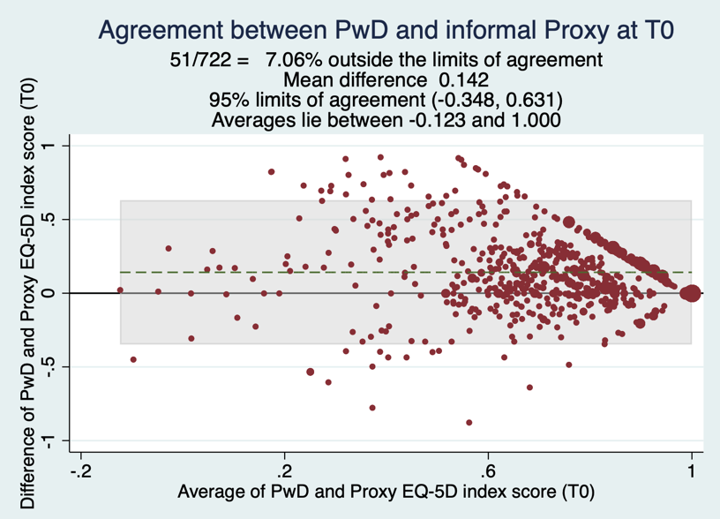

Figure A5.3c, Bland-Altman plot for agreement – moderate dementia

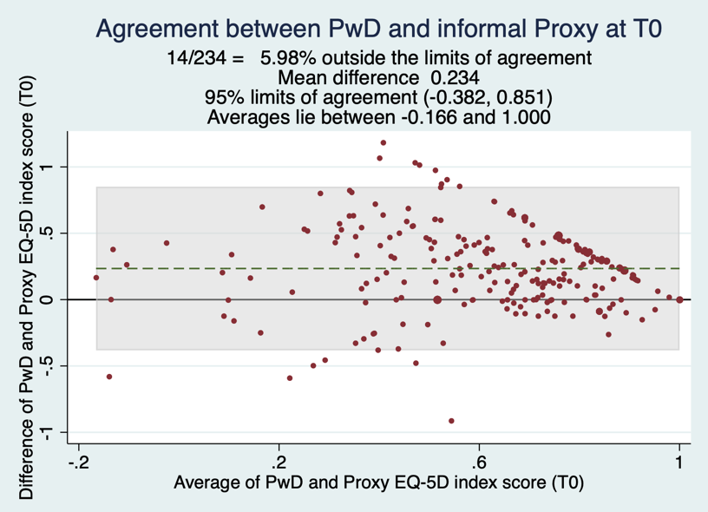

Appendix 5.4 Responsiveness evidence

Table A5.4a summarises the proportion of PwD that saw either an improvement or a worsening in condition for each of the symptom measures between baseline and the final follow-up point. For this evaluation, the condition “improved” category included people whose condition also remained stable. For “function”, NPI and CDR changes – data collected by the two EQ-5D-5L trials (EPIC and ACTIFCARE) were merged. To maximise the available data, CSDD (measure of depression) collected only within the REMCARE study was also evaluated. It must be noted that comparisons using CSDD considered EQ-5D-3L data, and PwD and informal proxies. Similarly, MMSE was collected only within the ACTIFCARE study, and its comparisons consider EQ-5D-5L data, and PwD and informal proxies only. Although CDR was collected by all three studies, this evaluation included data from ACTIFCARE and EPIC only, and therefore solely uses EQ-5D-5L data.

Table A5.4a, Summary of change in dementia symptom measures

N (%) | CDR | Function | NPI | MMSE* | CSDD**
Worsened | 249 (33.8) | 377 (52.3) | 341 (45.2) | 164 (59.6) | 111 (47.2)
Improved | 487 (66.2) | 344 (47.7) | 413 (54.8) | 111 (40.4) | 124 (52.8)
Total | 736 | 721 | 754 | 275 | 235
*ACTIFCARE only; ** REMCARE only

Figures A5.4a and A5.4b plot the effect size estimations for the changes in EQ-5D index scores between baseline and the final follow-up point, and the changes in the symptom measures summarised in Table AA.

Tables A5.4b-A5.4f summarise the effect size calculations for each of the EQ-5D dimensions by changes in the symptom measure scores. For these analyses, the dementia symptoms measures chosen for comparison were those established by the convergent validity evidence summarised earlier in Appendix 5.

Table A5.4g summarises the correlation between change in EQ-5D index scores and changes in the dementia symptom measure scores. Tables A5.4h-A5.4l provide the same information by EQ-5D dimension. As before, the dementia symptom measures chosen for comparison were previously established and have been summarised in Appendix 5.

Figure A5.4a, EQ-5D index score responsiveness with worsening in health condition

Figure A5.4b, EQ-5D index score responsiveness with improvement in health condition

Table A5.4b, Mobility dimension responsiveness with worsening health condition

 | CDR |  | Function |  |  | Neuropsychiatric symptoms- |  |  | Depression*
d | No change in CDR | Worse CDR | No change in function | Worse function | Improved function | No change in neuropsychiatric symptoms | Worse neuropsychiatric symptoms | Improved neuropsychiatric symptoms | Worse depression | Improved depression
PwD | -0.15 | -0.34 | -0.36 | -0.11 | 0.09 | -0.23 | -0.07 | -0.44 | 0.02 | -0.02
Informal proxy | -0.11 | -0.36 | -0.13 | -0.21 | 0.14 | -0.04 | -0.24 | -0.17 | -0.14 | -0.02
Staff proxy | -0.29 | -0.56* | -0.39 | -0.49 | - | -0.09 | -0.41 | -0.33 | - | -
*Using EQ-5D-3L data
Table A5.4c, Self-care dimension responsiveness with worsening health condition

Self-care

 | CDR |  | Function
d | No change in CDR | Worse CDR | No change in function | Worse function | Improved function
PwD | -0.17 | -0.36 | -0.22 | -0.19 | 0.04
Informal proxy | -0.24 | -0.66* | -0.05 | -0.49 | 0.02
Staff proxy | -0.17 | -0.72* | -0.22 | -0.61* | -

Table A5.4d, Usual activities dimension responsiveness with worsening health condition

Usual activities

 | CDR |  | Function |  |  | Depression*
d | No change in CDR | Worse CDR | No change in function | Worse function | Improved function | Worse depression | Improved depression
PwD | 0 | -0.11 | -0.08 | 0 | 0.04 | 0.03 | 0.09
Informal proxy | -0.22 | -0.66* | -0.10 | -0.33 | -0.04 | -0.31 | -0.11
Staff proxy | -0.11 | -0.64* | -0.22 | -0.33 | - | - | -
*Using EQ-5D-3L data

Table A5.4e, Pain/discomfort dimension responsiveness with worsening health condition

Pain/discomfort

 | CDR |  | Function |  |  | Depression*
d | No change in CDR | Worse CDR | No change in function | Worse function | Improved function | Worse depression | Improved depression
PwD | 0.04 | -0.03 | 0.06 | 0.06 | 0.05 | 0.17 | 0.14
Informal proxy | -0.03 | -0.07 | -0.04 | -0.03 | 0.06 | -0.11 | -0.04
Staff proxy | -0.04 | 0.22 | 0.04 | 0.11 | - | - | -
*Using EQ-5D-3L data

Table A5.4f, Anxiety/depression dimension responsiveness with worsening health condition

Anxiety/ depression

 | CDR |  | Cognition |  | Depression* |  | Neuropsychiatric symptoms
d | No change in CDR | Worse CDR | Worse cognition | Improved cognition | Worse depression | Improved depression | No change in NPI | Worse NPI | Improved NPI
PwD | 0 | 0.16 | -0.01 | 0.06 | 0.11 | 0.07 | 0.12 | 0 | 0.05
Informal proxy | 0.06 | 0.16 | 0.05 | -0.07 | -0.19 | 0.24 | -0.16 | -0.19 | 0.13
Staff proxy | 0.13 | 0.22 | - | - | - | - | 0.33 | -0.22 | 0.44
*Using EQ-5D-3L data

Table A5.4g, Correlation between change in EQ-5D index score and change in dementia symptom measure scores

Correlation coefficient; CI |  | CDR severity stage at T2**
Instrument and rater-type | N | Sum | Mild | Moderate
CDR change  PwD  Informal proxy  Staff proxy | 420  388  398 | -0.05  [-0.14; 0.05]  -0.21*  [-0.30; -0.11]  -0.26*  [-0.35; -0.17] | 0.01  0.05  -0.22 | 0.03  -0.08  -0.07
MMSE change  PwD  Informal proxy | 263  269 | -0.02  [-0.14; 0.10]  0.07  [-0.05; 0.19] | 0.10  0.06 | -0.16  0.03
NPI-NH change  PwD  Informal proxy  Staff proxy | 126  58  398 | -0.02  [-0.19; 0.16]  -0.04  [-0.29; 0.23]  -0.16*  [-0.25; -0.06] | 0.06  -  -0.11 | -0.13  -  -0.26*
NPI-Q change  PwD  Informal proxy | 296  345 | -0.03  [-0.14; 0.08]  -0.23*  [-0.33; -0.13] | 0.09  -0.20* | -0.09  -0.39*
CSDD change  PwD  Informal proxy | 212  229 | -0.01  [-0.14; 0.13]  -0.17*  [-0.30; -0.05] | -0.06  -0.25* | 0.08  -0.03
BADLS change  PwD  Informal proxy | 276  307 | -0.18*  [0.06; 0.29]  -0.42*  [0.32; 0.51] | -0.12  -0.42* | -0.34*  -0.38*
IADL-PSMS change  PwD  Informal proxy | 282  328 | -0.03  [-0.15; 0.08]  0.33  [0.23; 0.42] | -0.02  0.31* | -0.04  0.17
FAST change  PwD  Informal proxy  Staff proxy | 121  56  378 | 0.07  [-0.11; 0.24]-0.14*  [-0.39; 0.13]  -0.12*  [-0.21; -0.02] | 0.10  0.08  -0.23 | 0.05  -0.23  -0.08
**CDR at T0 for CSDD and BADLS assessments due to lack of follow-up CDR data in REMCARE

Table A5.4h, Correlation between change in mobility dimension score and change in dementia symptom measure scores
Correlation coefficient; CI |  | CDR severity stage at T2**
Instrument and rater-type | N | Sum | Mild | Moderate
CDR change  PwD  Informal proxy  Staff proxy | 439  397  396 | 0.07  [-0.02; 0.16]  0.11*  [0.02; 0.21]  0.20*  [0.10; 0.29] | -0.10  -0.01  0.19 | 0.07  0.01  -0.00
BADLS change  PwD  Informal proxy | 289  311 | 0.16*  [-0.27; -0.04]  0.24*  [-0.34; -0.13] | 0.11  0.22* | 0.40*  0.25*
IADL-PSMS change  PwD  Informal proxy | 294  334 | 0.01  [-0.11; 0.12]  -0.23*  [-0.33; -0.13] | 0.03  -0.22* | 0.02  -0.10
FAST change  PwD  Informal proxy  Staff proxy | 129  61  379 | -0.13  [-0.30; 0.05]  0.07  [-0.18; 0.32]  0.09  [-0.01; 0.19] | -0.13  -0.25  0.30* | -0.09  0.10  -0.06
NPI-NH change  PwD  Informal proxy  Staff proxy | 134  63  399 | -0.12  [-0.28; 0.05]  -0.06  [-0.19; 0.30]  -0.02  [-0.12; -0.08] | -0.12  -  -0.01 | -0.06  -  -0.01
NPI-Q change  PwD  Informal proxy | 310  351 | -0.01  [-0.12; 0.10]  -0.03  [-0.13; 0.08] | -0.14*  0.03 | 0.07  0.07
CSDD change  PwD  Informal proxy | 221  238 | 0.04  [-0.09; 0.17]  0.14*  [0.01; 0.27] | 0.12  0.16* | -0.14  0.09
**CDR at T0 for CSDD and BADLS assessments due to lack of follow-up CDR data in REMCARE

Table A5.4i, Correlation between change in self-care dimension score and change in dementia symptom measure scores
Correlation coefficient; CI |  | CDR severity stage at T2**
Instrument and rater-type | N | Sum | Mild | Moderate
CDR change  PwD  Informal proxy  Staff proxy | 435  397  396 | 0.07  [-0.03; 0.16]  0.29*  [0.20; 0.38]  0.32*  [0.23; 0.41] | -0.01  0.11  0.28* | -0.01  0.05  0.15
BADLS change  PwD  Informal proxy | 288  311 | 0.14*  [-0.25; -0.03]  0.47*  [-0.55; -0.38] | 0.12  0.50* | 0.21  0.39*
IADL-PSMS change  PwD  Informal proxy | 293  334 | -0.02*  [-0.13; -0.10]  -0.46*  [-0.55; -0.38] | -0.08  -0.39* | -0.06  -0.34*
FAST change  PwD  Informal proxy  Staff proxy | 127  61  379 | -0.03  [-0.20; 0.15]  0.26*  [0.01; 0.48]  0.26*  [0.16; 0.35] | 0.04  -  0.37* | -0.09  -  0.19*
**CDR at T0 for BADLS assessments due to lack of follow-up CDR data in REMCARE

Table A5.4j, Correlation between change in usual activities dimension score and change in dementia symptom measure scores

Correlation coefficient; CI |  | CDR severity stage at T2**
Instrument and rater-type | N | Sum | Mild | Moderate
CDR change  PwD  Informal proxy  Staff proxy | 427  397  396 | 0.02  [-0.08; 0.11]  0.18*  [0.09; 0.28]  0.19*  [0.10; 0.29] | -0.15*  0.11  0.06 | 0.05  0.08  0.18*
BADLS change  PwD  Informal proxy | 283  308 | 0.19*  [-0.30; -0.08]  0.30*  [-0.40; -0.20] | 0.17*  0.33* | 0.27*  0.23*
IADL-PSMS change  PwD  Informal proxy | 286  333 | -0.01  [-0.12; 0.11]  -0.31*  [-0.41; -0.21] | 0.05  -0.19* | -0.04  -0.27*
FAST change  PwD  Informal proxy  Staff proxy | 125  61  379 | -0.08  [-0.25; 0.10]  0.08  [-0.18; 0.32]  0.03  [-0.07; 0.13] | -0.17  -  0.01 | 0.00  -  0.14
CSDD change  PwD  Informal proxy | 217  231 | 0.03  [-0.10; 0.16]  0.10  [-0.03; 0.22] | -0.01  0.12 | 0.13  0.05
**CDR at T0 for CSDD and BADLS assessments due to lack of follow-up CDR data in REMCARE

Table A5.4k, Correlation between change in pain/discomfort dimension score and change in dementia symptom measure scores

Correlation coefficient; CI |  | CDR severity stage at T2**
Instrument and rater-type | N | Sum | Mild | Moderate
CDR change  PwD  Informal proxy  Staff proxy | 431  394  395 | 0.00  [-0.09; 0.10]  -0.03  [-0.13; 0.07]  -0.04  [-0.14; 0.06] | -0.01  -0.04  0.01 | -0.03  0.05  -0.12
BADLS change  PwD  Informal proxy | 289  310 | 0.08*  [-0.19; 0.04]  0.09*  [-0.20; 0.02] | 0.05  0.05 | 0.17  0.18
IADL-PSMS change  PwD  Informal proxy | 287  332 | 0.08  [-0.04; 0.19]  -0.02*  [-0.13; 0.09] | 0.02  -0.10 | 0.11  -0.05
FAST change  PwD  Informal proxy  Staff proxy | 126  60  378 | 0.09  [-0.09; 0.26]  -0.08  [-0.33; 0.17]  -0.03  [-0.13; 0.08] | 0.07  -  -0.02 | 0.05  -  -0.06
CSDD change  PwD  Informal proxy | 220  233 | -0.03  [-0.17; 0.10]  0.08  [-0.05; 0.21] | -0.03  0.10 | -0.05  0.04
**CDR at T0 for CSDD and BADLS assessments due to lack of follow-up CDR data in REMCARE

Table A5.4l, Correlation between change in anxiety/depression dimension score and change in dementia symptom measure scores

Correlation coefficient; CI |  | CDR severity stage at T2**
Instrument and rater-type | N | Sum | Mild | Moderate
CDR change  PwD  Informal proxy  Staff proxy | 433  395  395 | -0.03  [-0.12; 0.07]  0.02  [-0.08; 0.12]  0.06  [-0.04; 0.15] | -0.04  -0.18*  0.26* | -0.02  0.13  0.15
MMSE change  PwD  Informal proxy | 269  271 | -0.20*  [-0.14; 0.10]  0.08*  [-0.04; 0.20] | -0.07  0.02 | 0.21  0.39*
NPI-NH change  PwD  Informal proxy  Staff proxy | 132  63  398 | 0.15  [-0.02; 0.31]  0.07  [-0.18; 0.31]  0.35*  [0.26; 0.44] | 0.01  -  0.28* | 0.27*  -  0.52*
NPI-Q change  PwD  Informal proxy | 304  348 | -0.02  [-0.13; 0.09]  0.28*  [0.18; 0.37] | -0.10  0.21* | 0.08  0.46*
CSDD change  PwD  Informal proxy | 218  233 | 0.03  [-0.10; 0.16]  0.21*  [0.08; 0.33] | 0.13  0.27* | -0.19  0.09
**CDR at T0 for CSDD assessments due to lack of follow-up CDR data in REMCARE

Appendix 5.5 Line graph of mean EQ-5D index scores by CDR stage

Appendix 5.6 Change scores of dementia symptom measures

The data for CDR change is limited to that from the EPIC and ACTIFCARE studies as the REMCARE study collected CDR at baseline only (as an eligibility criteria check). As shown in Figure A5.6a, ~60% of PwD’s dementia severity status has remained stable from T0 to T2, however over 33% have experienced dementia progression within this timeframe.

Figure A5.6a, Direction of CDR change from T0 to T2

Functional status change over time was estimated by generating a variable for change in the function measures for both of the EQ-5D-5L studies separately, and then merging these variables together (because the studies collected a different functional measure). As shown in Figure A5.6b, >50% of PwD’s function has worsening between T0 and T2.

Figure A5.6b, Direction of functional status change from T0 to T2

Behaviour/mood status change was generated in the same way – by merging NPI data from the two EQ-5D-5L studies. As shown in Figure A5.6c, <10% of PwD’s behaviour/mood status remained constant, whereas there is an equal split of PwD whose behaviour/mood has worsened or has improved over this timeframe.

Figure A5.6c, Direction of behaviour/mood status change from T0 to T2

Cognition was only measured within the REMCARE study; therefore, Figure A5.6d shows the change in cognitive status for this sample only. As shown, the majority of PwD’s (~60%) cognition worsened over this timeframe, although ~30% have experienced an improvement in cognition (which is unexpected).

Figure A5.6d, Direction of cognitive status change from T0 to T2

Appendix 5.7 PPIE session two feedback and notes

Hannah Hussain – Quality of Life in Dementia
Feedback from the DRAiSY PPI panel Thursday 14th December 2023

The idea of using a proxy to help complete the questionnaire came from the DRAiSY panel. Does the group still think this is a good idea?

Definitely! Asking a proxy to complete the questionnaire may be the easiest way to collect the data you require, but the person with dementia should still be central.

The responses must come from the PWD – if non-verbal perhaps they could use picture cards etc?

Is it likely to be accurate data if collected via a proxy rather than the PWD themselves?

If a close relative, then yes.

The person with dementia might report on what they USED to do or how they WOULD LIKE to be, rather than the reality. For example, they may be unwilling to admit that they can no longer perform everyday activities such as personal care.

Does it need to be an either/or proxy or carer? Could you use a combination of both?

Carers may provide a more pessimistic view of the situation, depending on their emotional state and what they perceive their burden of care to be.

The PWD needs to be asked a question in the moment – it is possible they may have no concept of the past or a timeline of events relating to themselves.

Access to memories can be “a bit wonky” – will you be able to mitigate for this when the questionnaire is being completed?

Yes, if the PWD is happy for a close relative to help them complete it.

The panel member would not have a problem with this.

Will you be taking into account that there may be a subset of participants who have completed the questionnaire themselves with a degree of help?

Thank you from Jane on behalf of the DRAiSY panel for coming back to us with your study – it is really good to hear how what the group has fed back previously has been incorporated into the research.

Appendix 6 EQ-5D dimension response frequency tables

Table A6a, Response frequency table: ACTIFCARE

PwD | N | % | Proxy | N | %
Mobility
1 | 641 | 56.3 | 1 | 469 | 39.3
2 | 233 | 20.4 | 2 | 288 | 24.1
3 | 189 | 16.6 | 3 | 267 | 22.3
4 | 68 | 6.0 | 4 | 147 | 12.3
5 | 8 | 0.7 | 5 | 24 | 2.0
Self-care
1 | 853 | 75.4 | 1 | 523 | 43.8
2 | 152 | 13.4 | 2 | 314 | 26.3
3 | 78 | 6.9 | 3 | 208 | 17.4
4 | 26 | 2.3 | 4 | 83 | 7.0
5 | 23 | 2.0 | 5 | 66 | 5.5
Usual Activities
1 | 646 | 57.9 | 1 | 248 | 20.8
2 | 251 | 22.5 | 2 | 288 | 24.2
3 | 138 | 12.4 | 3 | 325 | 27.3
4 | 59 | 5.3 | 4 | 219 | 18.4
5 | 21 | 1.9 | 5 | 112 | 9.4
Pain/discomfort
1 | 647 | 57.2 | 1 | 439 | 36.9
2 | 262 | 23.1 | 2 | 380 | 31.9
3 | 172 | 15.2 | 3 | 295 | 24.8
4 | 44 | 3.9 | 4 | 66 | 5.5
5 | 7 | 0.6 | 5 | 11 | 0.9
Anxiety/depression
1 | 673 | 59.5 | 1 | 457 | 38.6
2 | 299 | 26.4 | 2 | 344 | 29.1
3 | 131 | 11.6 | 3 | 301 | 25.4
4 | 25 | 2.2 | 4 | 80 | 6.8
5 | 3 | 0.3 | 5 | 1 | 0.1
EQ-5D index score | 0.77 (0.21) |  | EQ-5D index score | 0.59 (0.26)

Table A6b, Response frequency table: EPIC

PwD | N | % | Staff proxy | N | %
Mobility
1 | 462 | 57.6 | 1 | 590 | 34.7
2 | 149 | 18.6 | 2 | 252 | 14.8
3 | 79 | 9.9 | 3 | 175 | 10.3
4 | 40 | 5.0 | 4 | 117 | 6.9
5 | 72 | 9.0 | 5 | 565 | 33.3
Self-care
1 | 538 | 67.3 | 1 | 228 | 13.4
2 | 130 | 16.3 | 2 | 214 | 12.6
3 | 90 | 11.3 | 3 | 219 | 12.9
4 | 23 | 2.9 | 4 | 135 | 7.9
5 | 19 | 2.4 | 5 | 904 | 53.2
Usual activities
1 | 601 | 76.6 | 1 | 1065 | 62.6
2 | 108 | 13.8 | 2 | 134 | 7.9
3 | 46 | 5.9 | 3 | 164 | 9.6
4 | 11 | 1.4 | 4 | 76 | 4.5
5 | 19 | 2.4 | 5 | 262 | 15.4
Pain/discomfort
1 | 579 | 71.9 | 1 | 1263 | 74.3
2 | 139 | 17.3 | 2 | 264 | 15.5
3 | 57 | 7.1 | 3 | 149 | 8.8
4 | 27 | 3.4 | 4 | 20 | 1.2
5 | 3 | 0.4 | 5 | 4 | 0.2
Anxiety/depression
1 | 614 | 77.5 | 1 | 1286 | 75.7
2 | 117 | 14.8 | 2 | 266 | 15.7
3 | 45 | 5.7 | 3 | 114 | 6.7
4 | 11 | 1.4 | 4 | 27 | 1.6
5 | 5 | 0.6 | 5 | 6 | 0.4
EQ-5D index score | 762 | 0.80 (0.23) | EQ-5D index score | 1679 | 0.49 (0.41)

Appendix 6.1 Correlations between variables
Table A6.1a, Correlations between independent variables and EQ-5D dimension: ACTIFCARE

 |  | Self-report
 |  | M | SC | UA | PD | AD | CDR | MMSE | NPI | IADL | PSMS | PwD age | PwD sex | Proxy age | Proxy sex | Live
Proxy | M | 0.63* | 0.32* | 0.41* | 0.23* | 0.11* | 0.14* | 0.03 | 0.11* | -0.30* | -0.43* | 0.32* | 0.05 | 0.05 | 0.04 | 0.05
Proxy | SC | 0.31* | 0.46* | 0.32* | 0.06* | 0.03 | 0.44* | -0.28* | 0.31* | -0.65* | -0.77* | 0.14* | -0.01 | 0.05 | 0.04 | -0.04
Proxy | UA | 0.27* | 0.30* | 0.35* | 0.09* | 0.08* | 0.39* | -0.22* | 0.26* | -0.52* | -0.50* | 0.13* | 0.00 | 0.10* | 0.00 | -0.03
Proxy | PD | 0.15* | 0.07* | 0.19* | 0.23* | 0.28* | 0.05 | -0.00 | 0.30* | -0.09* | -0.10* | 0.05 | 0.04 | 0.02 | -0.08* | 0.04
Proxy | AD | 0.25* | 0.08* | 0.20* | 0.41* | 0.22* | 0.07* | 0.07 | 0.20* | 0.22* | -0.11* | 0.10* | 0.02 | 0.05 | -0.01 | 0.03
 | CDR | 0.04 | 0.21* | 0.13* | -0.02 | -0.01
 | MMSE | 0.11* | -0.12* | 0.00 | 0.11* | -0.00 | -0.50*
 | NPI | 0.06 | 0.10* | 0.06 | 0.03 | 0.06 | 0.24* | -0.15*
 | IADL | -0.19* | -0.31* | -0.25* | -0.00 | -0.00 | -0.54* | 0.38* | -0.30*
 | PSMS | -0.33* | -0.44* | -0.33* | -0.05 | -0.03 | -0.43* | 0.33* | -0.31* | 0.65*
 | PwD age | 0.26* | 0.11* | 0.15* | 0.09* | 0.02 | 0.08* | 0.00 | -0.04 | -0.16* | -0.19*
 | PwD sex | 0.04 | -0.03 | 0.01 | 0.03 | -0.06 | 0.05 | -0.16* | -0.12* | 0.25* | 0.07* | 0.07*
 | Proxy age | 0.06 | -0.01 | 0.04 | 0.08* | 0.00 | 0.04 | -0.00 | -0.00 | -0.20* | -0.06 | 0.21* | -0.25*
 | Proxy sex | 0.04 | 0.07* | -0.01 | -0.01 | -0.06 | -0.03 | 0.11* | 0.10* | -0.14* | -0.12* | -0.12* | -0.52* | -0.19*
 | Live | 0.02 | -0.04 | 0.02 | 0.03 | 0.04 | -0.05 | 0.04 | -0.11* | 0.19 | 0.08* | 0.08* | -0.32* | -0.55* | 0.13*
M, mobility; SC, self-care; UA, usual activities; PD, pain/discomfort; AD, anxiety/depression; CDR, clinical dementia rating scale; MMSE, mini-mental state examination; IADL, Lawton’s instrumental activities of daily living scale; PSMS, physical self-maintenance scale; PwD, person with dementia
*, p<0.05; Spearman’s rank correlation for EQ-5D dimensions; Pearson’s correlation for other outcomes; live, do the PwD and proxy live together? (1=yes, 2=no); sex (1=Male, 2=Female).

Table A6.1b, Intra-rater correlations for EQ-5D dimension: ACTIFCARE

PwD | M | SC | UA | PD | AD | Proxy | M | SC | UA | PD | AD
M |  |  |  |  |  | M
SC | 0.43* |  |  |  |  | SC | 0.44*
UA | 0.50* | 0.49* |  |  |  | UA | 0.41* | 0.60*
PD | 0.39* | 0.18* | 0.24* |  |  | PD | 0.20* | 0.14* | 0.25*
AD | 0.24* | 0.18* | 0.30* | 0.23* |  | AD | 0.30* | 0.14* | 0.25* | 0.29*
*, p<0.05; Spearman’s rank correlation

Table A6.1c, Correlations between independent variables and EQ-5D dimension: EPIC

 |  | SR
 |  | M | SC | UA | PD | AD | CDR | NPI | FAST | PwD age | PwD sex
Proxy | M | 0.34* | 0.22* | 0.11* | 0.12* | 0.05 | 0.20* | -0.05 | 0.27* | 0.11* | 0.01
Proxy | SC | 0.08* | 0.11* | 0.05 | 0.05 | -0.10* | 0.45* | 0.12* | 0.44* | 0.01 | -0.02
Proxy | UA | 0.16* | 0.16* | 0.20* | 0.11* | 0.09* | 0.19* | 0.16* | 0.19* | -0.04 | 0.03
Proxy | PD | 0.02 | -0.01 | 0.05 | 0.22* | 0.09* | -0.02 | 0.14* | -0.02 | 0.05 | 0.01
Proxy | AD | 0.00 | 0.02 | 0.09* | 0.15 | 0.19* | 0.05 | 0.39* | 0.01 | -0.06 | -0.01
 | CDR | -0.04 | 0.04 | 0.15 | -0.02 | -0.06
 | NPI | -0.05 | 0.03 | -0.00 | 0.04 | 0.13* | 0.23*
 | FAST | 0.05 | 0.10* | 0.03 | 0.04 | -0.04 | 0.56* | 0.14*
 | PwD age | 0.00 | -0.05 | -0.03 | -0.04 | -0.02 | -0.03 | -0.07* | -0.09*
 | PwD sex | -0.01 | 0.03 | -0.02 | -0.03 | 0.04 | 0.03 | 0.01 | -0.02 | 0.25*
*, p<0.05; Spearman’s rank correlation for EQ-5D dimensions; Pearson’s correlation for other outcomes;
(1=yes, 2=no); sex (1=Male, Z=X).

Table A6.1d, Intra-rater correlations for EQ-5D dimension: EPIC

PwD | M | SC | UA | PD | AD | Staff proxy | M | SC | UA | PD | AD
M |  |  |  |  |  | M
SC | 0.55* |  |  |  |  | SC | 0.55*
UA | 0.37* | 0.44* |  |  |  | UA | 0.34* | 0.35*
PD | 0.25* | 0.24* | 0.22* |  |  | PD | 0.15* | 0.09* | 0.24*
AD | 0.17* | 0.16* | 0.23* | 0.27* |  | AD | 0.01 | 0.03 | 0.23* | 0.35*

Appendix 6.2 Iterations of ordered probit dimension-models

Table A6.2a, “Mobility” dimension model iterations: ACTIFCARE

 | (1) | (2) | (3) | (4) | (4)
VARIABLES | Model 1 | Model 2 | Model 3 | Model 4 | Model 5
2.eq1RP_ | 0.844*** | 0.830*** | 0.824*** | 0.840*** | 0.825***
 | (0.591 - 1.097) | (0.593 - 1.067) | (0.590 - 1.058) | (0.617 - 1.063) | (0.591 - 1.059)
3.eq1RP_ | 1.656*** | 1.626*** | 1.611*** | 1.692*** | 1.614***
 | (1.369 - 1.944) | (1.369 - 1.883) | (1.355 - 1.867) | (1.447 - 1.938) | (1.358 - 1.870)
4.eq1RP_ | 1.938*** | 1.873*** | 1.896*** | 1.974*** | 1.899***
 | (1.580 - 2.297) | (1.561 - 2.186) | (1.583 - 2.209) | (1.662 - 2.285) | (1.587 - 2.210)
5.eq1RP_ | 3.238*** | 3.525*** | 3.542*** | 3.321*** | 3.536***
 | (2.150 - 4.326) | (2.336 - 4.714) | (2.372 - 4.712) | (2.437 - 4.205) | (2.382 - 4.689)
2.eq2RP_ | 0.024
 | (-0.260 - 0.308)
3.eq2RP_ | 0.102
 | (-0.252 - 0.455)
4.eq2RP_ | -0.044
 | (-0.557 - 0.469)
5.eq2RP_ | 0.666**
 | (0.063 - 1.268)
2.eq3RP_ | -0.076
 | (-0.330 - 0.178)
3.eq3RP_ | -0.200
 | (-0.482 - 0.082)
4.eq3RP_ | -0.174
 | (-0.521 - 0.173)
5.eq3RP_ | -0.044
 | (-0.615 - 0.528)
2.eq4RP_ | -0.026
 | (-0.248 - 0.195)
3.eq4RP_ | 0.025
 | (-0.204 - 0.253)
4.eq4RP_ | 0.240
 | (-0.153 - 0.633)
5.eq4RP_ | -0.627
 | (-1.815 - 0.561)
2.eq5RP_ | 0.114
 | (-0.091 - 0.319)
3.eq5RP_ | 0.267**
 | (0.032 - 0.502)
4.eq5RP_ | 0.226
 | (-0.144 - 0.597)
5.eq5RP_ | 2.064***
 | (1.519 - 2.608)
1.CDR_new_ | 0.427
 | (-0.129 - 0.982)
2.CDR_new_ | 0.149
 | (-0.479 - 0.776)
3.CDR_new_ | 0.430
 | (-0.567 - 1.427)
MMSE_Total_ | 0.041*** | 0.047*** | 0.045*** |  | 0.045***
 | (0.018 - 0.063) | (0.027 - 0.068) | (0.025 - 0.065) |  | (0.026 - 0.064)
NPI_ | -0.005*
 | (-0.011 - 0.000)
IADL_ | 0.021
 | (-0.045 - 0.088)
PSMS_ | -0.145*** | -0.129*** | -0.123*** | -0.072*** | -0.121***
 | (-0.227 - -0.063) | (-0.186 - -0.072) | (-0.179 - -0.066) | (-0.121 - -0.023) | (-0.177 - -0.065)
PwD_age_ | 0.024** | 0.013 | 0.012* | 0.015** | 0.012*
 | (0.004 - 0.043) | (-0.002 - 0.028) | (-0.002 - 0.026) | (0.001 - 0.028) | (-0.002 - 0.026)
2.PwDs_sex_ | 0.178 | 0.063 | 0.026 | -0.053
 | (-0.156 - 0.511) | (-0.162 - 0.288) | (-0.179 - 0.231) | (-0.237 - 0.131)
carer_age_ | -0.015*
 | (-0.032 - 0.001)
2.proxy_sex_ | 0.131
 | (-0.170 - 0.432)
2.PwD_live_with_carer_ | -0.064
 | (-0.369 - 0.241)
2.carer_relationship_merged | -0.494* | -0.069
 | (-1.082 - 0.093) | (-0.311 - 0.173)
3.carer_relationship_merged | -0.837** | -0.618**
 | (-1.512 - -0.162) | (-1.112 - -0.124)
4.carer_relationship_merged | 0.080 | 0.485**
 | (-0.584 - 0.744) | (0.052 - 0.917)
/cut1 | 2.525*** | 2.454*** | 2.422*** | 1.939*** | 2.419***
 | (1.070 - 3.979) | (1.180 - 3.728) | (1.216 - 3.629) | (0.902 - 2.975) | (1.215 - 3.623)
/cut2 | 3.404*** | 3.291*** | 3.254*** | 2.758*** | 3.250***
 | (1.935 - 4.873) | (1.999 - 4.583) | (2.028 - 4.479) | (1.716 - 3.799) | (2.028 - 4.472)
/cut3 | 4.610*** | 4.440*** | 4.393*** | 3.827*** | 4.389***
 | (3.136 - 6.084) | (3.140 - 5.741) | (3.157 - 5.628) | (2.779 - 4.876) | (3.156 - 5.621)
/cut4 | 5.945*** | 5.755*** | 5.702*** | 5.242*** | 5.701***
 | (4.401 - 7.488) | (4.408 - 7.101) | (4.406 - 6.998) | (4.132 - 6.353) | (4.407 - 6.994)
Observations | 961 | 1,019 | 1,019 | 1,120 | 1,019
Wald Chi² | 459.16 | 306.14 | 292.33 | 349.99 | 292.35
Pseudo R² | 0.2431 | 0.2224 | 0.2189 | 0.2140 | 0.2189
AIC | 1716.562 | 1819.796 | 1821.820 | 2036.519 | 1819.919
BIC | 1906.413 | 1893.695 | 1880.939 | 2091.751 | 1874.112
Log likelihood (model) | -819.281 | -894.898 | -898.910 | -1007.26 | -898.960
Robust ci in parentheses
*** p<0.01, ** p<0.05, * p<0.1

Table A6.2b, “Mobility” dimension model iterations: EPIC

 | (1) | (2) | (3)
VARIABLES | Model 1 | Model 2 | Model 3
2.eq1SR_ | 0.207* | 0.197* | 0.197*
 | (-0.034 - 0.447) | (-0.014 - 0.408) | (-0.013 - 0.408)
3.eq1SR_ | 0.334** | 0.338*** | 0.338***
 | (0.019 - 0.650) | (0.086 - 0.590) | (0.086 - 0.590)
4.eq1SR_ | 1.284*** | 1.226*** | 1.226***
 | (0.865 - 1.703) | (0.874 - 1.578) | (0.875 - 1.578)
5.eq1SR_ | 1.920*** | 1.891*** | 1.890***
 | (1.449 - 2.390) | (1.515 - 2.266) | (1.514 - 2.266)
2.eq2SR_ | -0.041
 | (-0.279 - 0.198)
3.eq2SR_ | 0.190
 | (-0.101 - 0.482)
4.eq2SR_ | -0.210
 | (-0.764 - 0.343)
5.eq2SR_ | -0.085
 | (-0.773 - 0.603)
2.eq3SR_ | -0.122
 | (-0.378 - 0.133)
3.eq3SR_ | -0.172
 | (-0.558 - 0.214)
4.eq3SR_ | -0.042
 | (-0.562 - 0.477)
5.eq3SR_ | 0.476*
 | (-0.013 - 0.965)
2.eq4SR_ | 0.189
 | (-0.039 - 0.418)
3.eq4SR_ | 0.249
 | (-0.057 - 0.556)
4.eq4SR_ | -0.183
 | (-0.748 - 0.381)
5.eq4SR_ | 4.208***
 | (3.590 - 4.826)
2.eq5SR_ | -0.030
 | (-0.265 - 0.206)
3.eq5SR_ | 0.060
 | (-0.276 - 0.397)
4.eq5SR_ | -0.137
 | (-0.806 - 0.533)
5.eq5SR_ | 0.240
 | (-0.476 - 0.955)
NPItotal_ | -0.008*
 | (-0.017 - 0.001)
1.CDR_new_ | -0.083
 | (-0.381 - 0.215)
2.CDR_new_ | 0.147
 | (-0.168 - 0.462)
3.CDR_new_ | 0.628***
 | (0.218 - 1.038)
numeric_FAST_ | 0.292*** | 0.358*** | 0.358***
 | (0.176 - 0.407) | (0.258 - 0.457) | (0.258 - 0.457)
age_ | 0.016** | 0.020*** | 0.020***
 | (0.000 - 0.032) | (0.005 - 0.034) | (0.005 - 0.034)
2.sex_ | -0.013 | 0.011
 | (-0.268 - 0.243) | (-0.226 - 0.248)
/cut1 | 3.083*** | 3.681*** | 3.682***
 | (1.594 - 4.572) | (2.304 - 5.058) | (2.306 - 5.058)
/cut2 | 3.668*** | 4.226*** | 4.228***
 | (2.169 - 5.167) | (2.841 - 5.611) | (2.843 - 5.612)
/cut3 | 4.051*** | 4.600*** | 4.601***
 | (2.550 - 5.553) | (3.214 - 5.986) | (3.216 - 5.987)
/cut4 | 4.300*** | 4.838*** | 4.839***
 | (2.799 - 5.801) | (3.450 - 6.226) | (3.452 - 6.227)
Observations | 749 | 789 | 789
Wald Chi² | 1670.16 | 166.80 | 166.23
Pseudo R² | 0.1187 | 0.0989 | 0.0989
AIC | 1949.802 | 2062.118 | 2060.131
BIC | 2092.983 | 2113.496 | 2106.839
Log likelihood (model) | -943.901 | -1020.059 | -1019.065
Robust ci in parentheses
*** p<0.01, ** p<0.05, * p<0.1

Table A6.2c, Summary table of coefficients for the selected “mobility” models

Regression variables | ACTIFCARE (target PwD) | EPIC (target staff proxy)
Mobility (2) | 0.824* | 0.197*
Mobility (3) | 1.611* | 0.338*
Mobility (4) | 1.896* | 1.226*
Mobility (5) | 3.542* | 1.891*
Function | -0.123* | 0.358*
PwD age | 0.012* | 0.020*
PwD sex | 0.026 | 0.011
MMSE | 0.045* | -
Model fit statistics | AIC: 1821.820; BIC: 1880.939  Ll(model): -898.910 | AIC: 2062.118; BIC: 2113.469  Ll(model): -1020.059

Table A6.2d, “Self-care” dimension model iterations: ACTIFCARE

 | (1) | (2) | (3) | (4) | (5) | (6)
VARIABLES | Model 1 | Model 2 | Model 3 | Model 4 | Model 5 | Model 6
2.eq2SR_ | 0.368*** | 0.366*** | 0.369*** | 0.374*** | 0.637*** | 0.447***
 | (0.115 - 0.620) | (0.137 - 0.595) | (0.137 - 0.601) | (0.138 - 0.610) | (0.404 - 0.870) | (0.228 - 0.666)
3.eq2SR_ | 0.228 | 0.344** | 0.331** | 0.328** | 0.929*** | 0.389***
 | (-0.080 - 0.536) | (0.061 - 0.626) | (0.047 - 0.616) | (0.056 - 0.599) | (0.664 - 1.193) | (0.140 - 0.638)
4.eq2SR_ | 1.286*** | 1.205*** | 1.198*** | 1.242*** | 1.653*** | 1.273***
 | (0.404 - 2.168) | (0.445 - 1.964) | (0.444 - 1.952) | (0.575 - 1.910) | (0.922 - 2.384) | (0.694 - 1.852)
5.eq2SR_ | 0.766* | 1.254*** | 1.276*** | 1.323*** | 1.722*** | 1.525***
 | (-0.091 - 1.622) | (0.343 - 2.165) | (0.390 - 2.161) | (0.452 - 2.194) | (0.883 - 2.561) | (0.763 - 2.287)
2.eq1SR_ | 0.139
 | (-0.083 - 0.361)
3.eq1SR_ | 0.179
 | (-0.090 - 0.448)
4.eq1SR_ | 0.501**
 | (0.014 - 0.989)
5.eq1SR_ | 0.514
 | (-0.696 - 1.724)
2.eq3SR_ | -0.092
 | (-0.315 - 0.132)
3.eq3SR_ | 0.073
 | (-0.217 - 0.363)
4.eq3SR_ | 0.284
 | (-0.224 - 0.792)
5.eq3SR_ | 1.201***
 | (0.389 - 2.014)
2.eq4SR_ | 0.086
 | (-0.120 - 0.292)
3.eq4SR_ | -0.096
 | (-0.381 - 0.190)
4.eq4SR_ | -0.401
 | (-0.905 - 0.104)
5.eq4SR_ | -0.606
 | (-1.920 - 0.708)
2.eq5SR_ | -0.104
 | (-0.302 - 0.095)
3.eq5SR_ | -0.159
 | (-0.431 - 0.113)
4.eq5SR_ | -0.092
 | (-0.638 - 0.454)
5.eq5SR_ | -0.028
 | (-2.528 - 2.472)
1.CDR_new_ | 0.350
 | (-0.232 - 0.931)
2.CDR_new_ | 0.578*
 | (-0.063 - 1.218)
3.CDR_new_ | 0.335
 | (-0.608 - 1.279)
MMSE_Total_ | 0.019* | 0.017 | 0.015 | -0.006 | 0.001
 | (-0.002 - 0.040) | (0.001 - 0.035) | (-0.003 - 0.033) | (-0.023 - 0.012) | (-0.016 - 0.019)
NPI_ | 0.006**
 | (0.001 - 0.010)
IADL_ | -0.198*** | -0.209*** | -0.205*** |  | -0.365***
 | (-0.259 - -0.137) | (-0.266 - -0.153) | (-0.262 - -0.148) |  | (-0.414 - -0.316)
PSMS_ | -0.478*** | -0.505*** | -0.500*** | -0.599*** |  | -0.599***
 | (-0.571 - -0.385) | (-0.587 - -0.422) | (-0.578 - -0.421) | (-0.678 - -0.521) |  | (-0.669 - -0.528)
PwD_age_ | 0.004 | -0.008 |  | -0.002 | 0.003 | -0.000
 | (-0.014 - 0.022) | (-0.020 - 0.005) |  | (-0.014 - 0.010) | (-0.009 - 0.015) | (-0.011 - 0.011)
2.PwDs_sex_ | 0.348* | 0.399*** | 0.367*** | 0.139 | 0.410*** | 0.090
 | (-0.018 - 0.714) | (0.173 - 0.606) | (0.154 - 0.580) | (-0.063 - 0.340) | (0.205 - 0.614) | (-0.089 - 0.269)
carer_age_ | -0.012
 | (-0.028 - 0.004)
2.proxy_sex_ | -0.082
 | (-0.396 - 0.232)
2.PwD_live_with_carer_ | 0.205
 | (-0.166 - 0.577)
2.carer_relationship_merged | -0.450
 | (-1.095 - 0.196)
3.carer_relationship_merged | 0.066
 | (-0.662 - 0.794)
4.carer_relationship_merged | -1.375
 | (-3.229 - 0.479)
/cut1 | -2.281*** | -2.599*** | -2.112*** | -2.307*** | -1.282*** | -2.098***
 | (-3.654 - -0.909) | (-3.694 - -1.504) | (-2.540 - -1.684) | (-3.374 - -1.241) | (-2.246 - -0.319) | (-3.077 - -1.120)
/cut2 | -0.885 | -1.222** | -0.736*** | -1.032** | -0.201 | -0.824*
 | (-2.213 - 0.443) | (-2.272 - -0.172) | (-1.139 - -0.334) | (-2.041 - -0.024) | (-1.163 - 0.761) | (-1.755 - 0.106)
/cut3 | 0.420 | 0.007 | 0.490** | 0.089 | 0.819* | 0.308
 | (-0.912 - 1.752) | (-1.042 - 1.055) | (0.072 - 0.909) | (-0.907 - 1.085) | (-0.153 - 1.792) | (-0.614 - 1.229)
/cut4 | 1.248* | 0.775 | 1.258*** | 0.837 | 1.504*** | 1.112**
 | (-0.112 - 2.609) | (-0.300 - 1.850) | (0.793 - 1.724) | (-0.184 - 1.858) | (0.511 - 2.496) | (0.176 - 2.048)
Observations | 949 | 981 | 981 | 1,015 | 985 | 1113
Wald Chi² | 574.19 | 481.61 | 472.35 | 441.12 | 452.74 | 486.88
Pseudo R² | 0.3606 | 0.3423 | 0.3417 | 0.3154 | 0.2419 | 0.3169
AIC | 1634.441 | 1689.465 | 1688.835 | 1820.145 | 1978.914 | 2010.698
BIC | 1823.802 | 1762.017 | 1752.387 | 1879.216 | 2037.626 | 2065.861
Log likelihood (model) | -778.220 | -836.233 | -831.418 | -898.072 | -977.914 | -994.349
Robust ci in parentheses
*** p<0.01, ** p<0.05, * p<0.1

Table A6.2e, “Self-care” dimension model iterations: EPIC

 | (1) | (2) | (3) | (4) | (5)
VARIABLES | Model 1 | Model 2 | Model 3 | Model 4 | Model 5
2.eq2SR_ | -0.019 | -0.009 | -0.067 | -0.056 | -0.074
 | (-0.262 - 0.223) | (-0.241 - 0.224) | (-0.279 - 0.145) | (-0.270 - 0.158) | (-0.285 - 0.138)
3.eq2SR_ | 0.110 | 0.153 | 0.283** | 0.248** | 0.276**
 | (-0.176 - 0.396) | (-0.112 - 0.418) | (0.062 - 0.504) | (0.011 - 0.486) | (0.055 - 0.496)
4.eq2SR_ | -0.047 | 0.025 | 0.419* | 0.492** | 0.411*
 | (-0.602 - 0.508) | (-0.503 - 0.552) | (-0.012 - 0.851) | (0.073 - 0.911) | (-0.025 - 0.846)
5.eq2SR_ | -0.161 | 0.241 | 0.589* | 0.565* | 0.633*
 | (-0.903 - 0.581) | (-0.367 - 0.848) | (-0.082 - 1.261) | (-0.088 - 1.219) | (-0.003 - 1.270)
2.eq1SR_ | -0.140 | -0.160
 | (-0.380 - 0.100) | (-0.385 - 0.066)
3.eq1SR_ | -0.311* | -0.311**
 | (-0.626 - 0.004) | (-0.599 - -0.022)
4.eq1SR_ | 0.449** | 0.507***
 | (0.030 - 0.868) | (0.129 - 0.886)
5.eq1SR_ | 0.810*** | 0.817***
 | (0.395 - 1.224) | (0.431 - 1.203)
2.eq3SR_ | 0.024
 | (-0.207 - 0.256)
3.eq3SR_ | -0.022
 | (-0.345 - 0.300)
4.eq3SR_ | 0.474
 | (-0.142 - 1.091)
5.eq3SR_ | 0.906***
 | (0.248 - 1.565)
2.eq4SR_ | 0.194*
 | (-0.027 - 0.415)
3.eq4SR_ | 0.091
 | (-0.201 - 0.384)
4.eq4SR_ | 0.138
 | (-0.386 - 0.662)
5.eq4SR_ | 5.043***
 | (4.371 - 5.716)
2.eq5SR_ | -0.404***
 | (-0.630 - -0.177)
3.eq5SR_ | -0.281
 | (-0.635 - 0.074)
4.eq5SR_ | -0.331
 | (-1.051 - 0.389)
5.eq5SR_ | 0.633**
 | (0.006 - 1.259)
NPItotal_ | 0.001
 | (-0.007 - 0.009)
1.CDR_new_ | 0.031 | 0.011 |  | 0.008
 | (-0.258 - 0.320) | (-0.273 - 0.295) |  | (-0.269 - 0.285)
2.CDR_new_ | 0.565*** | 0.551*** |  | 0.502***
 | (0.261 - 0.870) | (0.260 - 0.841) |  | (0.210 - 0.794)
3.CDR_new_ | 1.449*** | 1.431*** |  | 1.352***
 | (1.050 - 1.848) | (1.054 - 1.808) |  | (0.984 - 1.719)
numeric_FAST_ | 0.445*** | 0.454*** | 0.603*** | 0.463*** | 0.597***
 | (0.335 - 0.555) | (0.348 - 0.560) | (0.500 - 0.706) | (0.355 - 0.570) | (0.495 - 0.699)
age_ | -0.003 | -0.004 | 0.001 | -0.003
 | (-0.018 - 0.012) | (-0.017 - 0.010) | (-0.013 - 0.015) | (-0.018 - 0.011)
2.sex_ | -0.028 | -0.055 | 0.005 | -0.046
 | (-0.237 - 0.180) | (-0.256 - 0.146) | (-0.192 - 0.203) | (-0.250 - 0.158)
/cut1 | 1.647** | 1.620** | 2.521*** | 1.689** | 2.429***
 | (0.318 - 2.977) | (0.357 - 2.884) | (1.228 - 3.814) | (0.381 - 2.996) | (1.870 - 2.987)
/cut2 | 2.383*** | 2.345*** | 3.181*** | 2.385*** | 3.085***
 | (1.037 - 3.728) | (1.067 - 3.623) | (1.877 - 4.485) | (1.063 - 3.707) | (2.507 - 3.662)
/cut3 | 2.940*** | 2.898*** | 3.672*** | 2.919*** | 3.572***
 | (1.591 - 4.289) | (1.618 - 4.178) | (2.365 - 4.979) | (1.595 - 4.244) | (2.992 - 4.152)
/cut4 | 3.272*** | 3.229*** | 3.960*** | 3.236*** | 3.865***
 | (1.917 - 4.627) | (1.941 - 4.517) | (2.648 - 5.272) | (1.903 - 4.568) | (3.280 - 4.451)
Observations | 748 | 770 | 786 | 782 | 790
Wald Chi2 | 16.28 | 280.30 | 151.64 | 243.12 | 151.29
Pseudo R2 | 0.1280 | 0.1294 | 0.0717 | 0.1123 | 0.0708
AIC | 2042.389 | 2095.274 | 2260.686 | 2157.658 | 2271.441
BIC | 2185.528 | 2178.909 | 2312.023 | 2222.924 | 2313.489
Log likelihood (model) | -990.194 | -1029.637 | -1119.343 | -1064.829 | -1126.72
Robust ci in parentheses
*** p<0.01, ** p<0.05, * p<0.1

Table A6.2f, Summary table of coefficients for the selected “self-care” models

Regression variables | ACTIFCARE | EPIC
Self-care (2) | 0.374* | -0.067
Self-care (3) | 0.328* | 0.283*
Self-care (4) | 1.242* | 0.419*
Self-care (5) | 1.323* | 0.589*
Function | -0.599* | 0.603*
PwD age | -0.002 | 0.001
PwD sex | 0.139 | 0.005
MMSE | -0.006 | -
Model fit statistics | AIC: 1820.145; BIC: 1879.216  Ll(model): -898.072 | AIC: 2260.686; BIC: 2312.023  Ll(model): -1119.343

Table A6.2g, “Usual activities” dimension model iterations: ACTIFCARE

 | (1) | (2) | (3) | (4) | (5) | (6) | (7)
VARIABLES | Model 1 | Model 2 | Model 3 | Model 4 | Model 5 | Model 6 | Model 7
2.eq3SR_ | 0.232** | 0.300*** | 0.305*** | 0.307*** | 0.277*** | 0.321*** | 0.323***
 | (0.049 - 0.416) | (0.129 - 0.471) | (0.133 - 0.477) | (0.135 - 0.478) | (0.100 - 0.455) | (0.143 - 0.499) | (0.154 - 0.492)
3.eq3SR_ | 0.471*** | 0.485*** | 0.474*** | 0.477*** | 0.473*** | 0.542*** | 0.489***
 | (0.231 - 0.711) | (0.266 - 0.704) | (0.256 - 0.692) | (0.260 - 0.695) | (0.254 - 0.693) | (0.326 - 0.759) | (0.271 - 0.707)
4.eq3SR_ | 1.027*** | 1.017*** | 1.012*** | 1.014*** | 0.925*** | 1.038*** | 1.054***
 | (0.609 - 1.445) | (0.659 - 1.375) | (0.655 - 1.370) | (0.657 - 1.371) | (0.544 - 1.307) | (0.659 - 1.418) | (0.680 - 1.427)
5.eq3SR_ | 0.966** | 0.723** | 0.677** | 0.682** | 0.759*** | 0.980*** | 0.828***
 | (0.228 - 1.704) | (0.069 - 1.378) | (0.090 - 1.265) | (0.097 - 1.268) | (0.202 - 1.317) | (0.407 - 1.554) | (0.287 - 1.369)
2.eq1SR_ | 0.116
 | (-0.077 - 0.310)
3.eq1SR_ | 0.096
 | (-0.166 - 0.357)
4.eq1SR_ | 0.278
 | (-0.195 - 0.751)
5.eq1SR_ | 1.060
 | (-0.600 - 2.720)
2.eq2SR_ | 0.151
 | (-0.069 - 0.372)
3.eq2SR_ | -0.269*
 | (-0.544 - 0.007)
4.eq2SR_ | -0.181
 | (-0.556 - 0.194)
5.eq2SR_ | -0.897*
 | (-1.826 - 0.033)
2.eq4SR_ | -0.073
 | (-0.258 - 0.113)
3.eq4SR_ | -0.082
 | (-0.322 - 0.158)
4.eq4SR_ | 0.098
 | (-0.308 - 0.504)
5.eq4SR_ | 1.336***
 | (0.548 - 2.125)
2.eq5SR_ | 0.123
 | (-0.062 - 0.308)
3.eq5SR_ | -0.140
 | (-0.389 - 0.108)
4.eq5SR_ | -0.136
 | (-0.834 - 0.562)
5.eq5SR_ | 0.193
 | (-1.156 - 1.541)
1.CDR_new_ | 0.058
 | (-0.403 - 0.519)
2.CDR_new_ | 0.413
 | (-0.104 - 0.931)
3.CDR_new_ | 1.070*
 | (-0.004 - 2.144)
MMSE_Total_ | 0.011 |  |  |  | 0.003 | -0.001 | -0.019**
 | (-0.009 - 0.031) |  |  |  | (-0.015 - 0.022) | (-0.019 - 0.017) | (-0.037 - -0.002)
NPI_ | 0.006** | 0.008*** | 0.008*** | 0.008*** | 0.008*** | 0.009*** | 0.009***
 | (0.001 - 0.011) | (0.003 - 0.013) | (0.003 - 0.013) | (0.003 - 0.012) | (0.002 - 0.013) | (0.004 - 0.014) | (0.004 - 0.013)
IADL_ | -0.183*** | -0.207*** | -0.206*** | -0.206*** | -0.204*** | -0.258***
 | (-0.242 - -0.124) | (-0.255 - -0.160) | (-0.253 - -0.158) | (-0.254 - -0.159) | (-0.258 - -0.150) | (-0.305 - -0.212)
PSMS_ | -0.141*** | -0.126*** | -0.127*** | -0.128*** | -0.129*** |  | -0.233***
 | (-0.207 - -0.075) | (-0.185 - -0.067) | (-0.186 - -0.068) | (-0.186 - -0.070) | (-0.191 - -0.068) |  | (-0.286 - -0.180)
PwD_age_ | 0.002 | 0.001 | 0.002 |  | -0.001 | 0.002 | 0.003
 | (-0.014 - 0.018) | (-0.010 - 0.011) | (-0.008 - 0.012) |  | (-0.012 - 0.010) | (-0.009 - 0.013) | (-0.008 - 0.013)
2.PwDs_sex_ | 0.269* | 0.235** | 0.251*** | 0.254*** | 0.239** | 0.262*** | 0.002
 | (-0.005 - 0.542) | (0.054 - 0.415) | (0.080 - 0.421) | (0.083 - 0.424) | (0.049 - 0.429) | (0.073 - 0.451) | (-0.180 - 0.184)
carer_age_ | -0.004
 | (-0.018 - 0.010)
2.proxy_sex_ | -0.017
 | (-0.269 - 0.234)
2.PwD_live_with_carer_ | 0.389*** | 0.055
 | (0.111 - 0.668) | (-0.134 - 0.243)
2.carer_relationship_merged | -0.526**
 | (-1.015 - -0.037)
3.carer_relationship_merged | -0.599*
 | (-1.273 - 0.074)
4.carer_relationship_merged | -0.671*
 | (-1.383 - 0.042)
/cut1 | -1.753*** | -1.911*** | -1.817*** | -1.971*** | -1.990*** | -1.586*** | -1.520***
 | (-2.852 - -0.653) | (-2.783 - -1.039) | (-2.666 - -0.969) | (-2.254 - -1.687) | (-2.847 - -1.133) | (-2.427 - -0.745) | (-2.377 - -0.663)
/cut2 | -0.875 | -1.043** | -0.948** | -1.101*** | -1.128*** | -0.741* | -0.679
 | (-1.961 - 0.211) | (-1.913 - -0.173) | (-1.795 - -0.101) | (-1.368 - -0.835) | (-1.981 - -0.275) | (-1.583 - 0.101) | (-1.526 - 0.169)
/cut3 | 0.157 | -0.034 | 0.064 | -0.090 | -0.128 | 0.246 | 0.254
 | (-0.929 - 1.244) | (-0.901 - 0.834) | (-0.784 - 0.911) | (-0.359 - 0.179) | (-0.977 - 0.722) | (-0.597 - 1.088) | (-0.588 - 1.096)
/cut4 | 1.265** | 1.020** | 1.118** | 0.964*** | 0.910** | 1.280*** | 1.236***
 | (0.170 - 2.360) | (0.145 - 1.894) | (0.265 - 1.970) | (0.665 - 1.263) | (0.058 - 1.761) | (0.439 - 2.120) | (0.387 - 2.086)
Observations | 949 | 1,046 | 1,056 | 1,056 | 968 | 972 | 1,001
Wald Chi² | 410.38 | 320.96 | 320.20 | 320.09 | 286.32 | 261.62 | 232.29
Pseudo R² | 0.1625 | 0.1523 | 0.1523 | 0.1522 | 0.1430 | 0.1353 | 0.1262
AIC | 2503.634 | 2747.017 | 2772.010 | 2771.197 | 2561.749 | 2594.979 | 2725.516
BIC | 2692.995 | 2816.355 | 2836.579 | 2892.744 | 2630.082 | 2658.41 | 2789.329
Log likelihood (model) | -1212.817 | -1359.509 | -1373.005 | -1373.009 | -1266.875 | -1248.489 | -1349.758
Robust ci in parentheses
*** p<0.01, ** p<0.05, * p<0.1

Table A6.2h, “Usual activities” dimension model iterations: EPIC

 | (1) | (2) | (3) | (4)
VARIABLES | Model 1 | Model 2 | Model 3 | Model 4
2.eq3SR_ | 0.300** | 0.278** | 0.277** | 0.266**
 | (0.016 - 0.584) | (0.034 - 0.522) | (0.033 - 0.521) | (0.024 - 0.508)
3.eq3SR_ | 0.473** | 0.500*** | 0.501*** | 0.489**
 | (0.049 - 0.896) | (0.126 - 0.874) | (0.126 - 0.875) | (0.115 - 0.862)
4.eq3SR_ | 1.154*** | 1.251*** | 1.249*** | 1.239***
 | (0.344 - 1.964) | (0.458 - 2.044) | (0.458 - 2.040) | (0.454 - 2.024)
5.eq3SR_ | 0.916*** | 1.141*** | 1.150*** | 1.129***
 | (0.227 - 1.605) | (0.600 - 1.682) | (0.615 - 1.685) | (0.593 - 1.665)
2.eq1SR_ | 0.147
 | (-0.119 - 0.414)
3.eq1SR_ | 0.019
 | (-0.354 - 0.392)
4.eq1SR_ | 0.562**
 | (0.096 - 1.028)
5.eq1SR_ | 0.425**
 | (0.053 - 0.797)
2.eq2SR_ | -0.079
 | (-0.356 - 0.199)
3.eq2SR_ | -0.066
 | (-0.398 - 0.267)
4.eq2SR_ | -0.099
 | (-0.703 - 0.505)
5.eq2SR_ | 0.236
 | (-0.400 - 0.872)
2.eq4SR_ | 0.123
 | (-0.123 - 0.369)
3.eq4SR_ | -0.003
 | (-0.387 - 0.381)
4.eq4SR_ | 0.089
 | (-0.572 - 0.750)
5.eq4SR_ | 0.441
 | (-0.180 - 1.062)
2.eq5SR_ | -0.178
 | (-0.481 - 0.125)
3.eq5SR_ | 0.368*
 | (-0.007 - 0.742)
4.eq5SR_ | -0.195
 | (-1.217 - 0.827)
5.eq5SR_ | 0.896**
 | (0.074 - 1.719)
NPItotal_ | 0.015*** | 0.018*** | 0.018*** | 0.018***
 | (0.007 - 0.024) | (0.010 - 0.026) | (0.010 - 0.026) | (0.010 - 0.026)
1.CDR_new_ | -0.315
 | (-0.709 - 0.078)
2.CDR_new_ | -0.091
 | (-0.488 - 0.306)
3.CDR_new_ | 0.539**
 | (0.056 - 1.022)
numeric_FAST_ | 0.199*** | 0.302*** | 0.300*** | 0.304***
 | (0.066 - 0.331) | (0.179 - 0.424) | (0.178 - 0.423) | (0.182 - 0.427)
age_ | -0.005 | -0.004
 | (-0.019 - 0.009) | (-0.017 - 0.009)
2.sex_ | 0.158 | 0.128 | 0.115
 | (-0.070 - 0.386) | (-0.089 - 0.346) | (-0.100 - 0.330)
/cut1 | 1.704** | 2.323*** | 2.638*** | 2.563***
 | (0.374 - 3.033) | (1.056 - 3.590) | (1.917 - 3.360) | (1.853 - 3.272)
/cut2 | 2.140*** | 2.728*** | 3.043*** | 2.964***
 | (0.815 - 3.465) | (1.469 - 3.987) | (2.329 - 3.757) | (2.262 - 3.665)
/cut3 | 2.642*** | 3.167*** | 3.482*** | 3.403***
 | (1.304 - 3.979) | (1.902 - 4.432) | (2.754 - 4.210) | (2.686 - 4.120)
/cut4 | 2.928*** | 3.408*** | 3.722*** | 3.639***
 | (1.583 - 4.272) | (2.136 - 4.679) | (2.991 - 4.454) | (2.917 - 4.361)
Observations | 749 | 771 | 771 | 775
Wald Chi² | 318.29 | 82.53 | 82.93 | 79.02
Pseudo R² | 0.0941 | 0.0576 | 0.0574 | 0.0502
AIC | 1358.359 | 1443.861 | 1442.202 | 1453.083
BIC | 1501.54 | 1499.633 | 1493.326 | 1499.612
Log likelihood (model) | -648.180 | -709.931 | -710.101 | -716.542
Robust ci in parentheses
*** p<0.01, ** p<0.05, * p<0.1

Table A6.2i, Summary table of coefficients for the selected “usual activities” models

Regression variables | ACTIFCARE | EPIC
Usual activities (2) | 0.321* | 0.278*
Usual activities (3) | 0.542* | 0.500*
Usual activities (4) | 1.038* | 1.251*
Usual activities (5) | 0.980* | 1.141*
Function | -0.258* | 0.302*
NPI | 0.009 | 0.018*
PwD age | 0.002 | -0.004
PwD sex | 0.262* | 0.128
MMSE | -0.001 | -
Model fit statistics | AIC: 2594.979; BIC: 2658.41  Ll(model): -1248.489 | AIC: 1443.861; BIC: 1499.633  Ll(model): -709.931

Table A6.2j, “Pain/discomfort” dimension model iterations: ACTIFCARE

 | (1) | (2) | (3) | (4) | (5)
VARIABLES | Model 1 | Model 2 | Model 3 | Model 4 | Model 5
2.eq4RP_ | 0.223** | 0.243** | 0.259***
 | (0.020 - 0.427) | (0.046 - 0.440) | (0.065 - 0.452)
3.eq4RP_ | 0.424*** | 0.415*** | 0.397***
 | (0.194 - 0.655) | (0.199 - 0.631) | (0.192 - 0.602)
4.eq4RP_ | 0.420** | 0.370** | 0.273
 | (0.032 - 0.809) | (0.011 - 0.730) | (-0.073 - 0.620)
5.eq4RP_ | -0.082 | -0.089 | -0.306
 | (-1.040 - 0.877) | (-0.816 - 0.638) | (-1.096 - 0.484)
2.eq1RP_ | 0.253**
 | (0.048 - 0.459)
3.eq1RP_ | 0.195
 | (-0.060 - 0.450)
4.eq1RP_ | 0.389**
 | (0.055 - 0.723)
5.eq1RP_ | 1.347**
 | (0.144 - 2.550)
2.eq2RP_ | -0.091
 | (-0.343 - 0.161)
3.eq2RP_ | 0.070
 | (-0.258 - 0.397)
4.eq2RP_ | -0.085
 | (-0.633 - 0.463)
5.eq2RP_ | 0.016
 | (-0.564 - 0.597)
2.eq3RP_ | -0.153
 | (-0.384 - 0.078)
3.eq3RP_ | -0.158
 | (-0.411 - 0.094)
4.eq3RP_ | -0.158
 | (-0.501 - 0.186)
5.eq3RP_ | -0.236
 | (-0.736 - 0.265)
2.eq5RP_ | 0.575*** | 0.559*** | 0.541*** | 0.596***
 | (0.377 - 0.772) | (0.363 - 0.754) | (0.351 - 0.731) | (0.406 - 0.785)
3.eq5RP_ | 0.970*** | 0.982*** | 0.932*** | 1.022***
 | (0.744 - 1.195) | (0.764 - 1.200) | (0.726 - 1.138) | (0.816 - 1.227)
4.eq5RP_ | 1.317*** | 1.351*** | 1.311*** | 1.415***
 | (0.958 - 1.676) | (1.010 - 1.693) | (0.980 - 1.642) | (1.091 - 1.740)
5.eq5RP_ | 2.171*** | 2.144*** | 2.076*** | 2.073***
 | (1.340 - 3.001) | (1.211 - 3.077) | (1.060 - 3.092) | (1.203 - 2.943)
1.CDR_new_ | 0.300
 | (-0.382 - 0.981)
2.CDR_new_ | 0.260
 | (-0.471 - 0.990)
3.CDR_new_ | 0.875*
 | (-0.032 - 1.782)
MMSE_Total_ | 0.014 | 0.018* | 0.019** | 0.020** | 0.024***
 | (-0.007 - 0.036) | (-0.002 - 0.037) | (0.002 - 0.037) | (0.002 - 0.037) | (0.006 - 0.041)
NPI_ | -0.004 | -0.004
 | (-0.011 - 0.002) | (-0.011 - 0.002)
IADL_ | 0.045 | 0.028
 | (-0.011 - 0.100) | (-0.023 - 0.078)
PSMS_ | -0.035 | -0.051
 | (-0.116 - 0.046) | (-0.113 - 0.011)
PwD_age_ | 0.001 | 0.010 | 0.012** | 0.012** | 0.016***
 | (-0.018 - 0.019) | (-0.002 - 0.023) | (0.000 - 0.024) | (0.000 - 0.024) | (0.004 - 0.027)
2.PwDs_sex_ | 0.093 | -0.003 | 0.011 | 0.017 | -0.006
 | (-0.213 - 0.399) | (-0.199 - 0.193) | (-0.174 - 0.195) | (-0.169 - 0.202) | (-0.192 - 0.181)
carer_age_ | 0.011
 | (-0.004 - 0.026)
2.proxy_sex_ | 0.123
 | (-0.162 - 0.409)
2.PwD_live_with_carer_ | 0.024
 | (-0.324 - 0.371)
2.carer_relationship_merged | 0.044
 | (-0.530 - 0.618)
3.carer_relationship_merged | -0.031
 | (-0.743 - 0.682)
4.carer_relationship_merged | -1.199**
 | (-2.316 - -0.083)
/cut1 | 2.406*** | 1.899*** | 2.194*** | 2.032*** | 2.151***
 | (0.920 - 3.892) | (0.848 - 2.950) | (1.220 - 3.167) | (1.072 - 2.992) | (1.196 - 3.105)
/cut2 | 3.191*** | 2.670*** | 2.964*** | 2.792*** | 2.858***
 | (1.695 - 4.688) | (1.605 - 3.735) | (1.975 - 3.954) | (1.816 - 3.768) | (1.892 - 3.823)
/cut3 | 4.205*** | 3.642*** | 3.938*** | 3.748*** | 3.774***
 | (2.701 - 5.710) | (2.568 - 4.717) | (2.940 - 4.937) | (2.762 - 4.735) | (2.801 - 4.746)
/cut4 | 5.091*** | 4.549*** | 4.840*** | 4.663*** | 4.590***
 | (3.574 - 6.608) | (3.471 - 5.627) | (3.826 - 5.854) | (3.662 - 5.664) | (3.606 - 5.573)
2.merg_eq4RP |  |  |  |  | 0.394***
 |  |  |  |  | (0.204 - 0.583)
3.merg_eq4RP |  |  |  |  | 0.660***
 |  |  |  |  | (0.452 - 0.867)
4.merg_eq4RP |  |  |  |  | 0.591***
 |  |  |  |  | (0.262 - 0.919)
Observations | 956 | 972 | 1,012 | 1,013 | 1,018
Wald Chi² | 235.81 | 152.15 | 152.48 | 142.79 | 56.52
Pseudo Chi² | 0.1089 | 0.0931 | 0.0885 | 0.0813 | 0.0341
AIC | 1950.047 | 1979.47 | 2056.784 | 2070.851 | 2183.568
BIC | 2139.694 | 2067.298 | 2130.579 | 2124.978 | 2232.824
Log likelihood (model) | -936.0233 | -971.349 | -1013.392 | -1024.425 | -1081.784
Robust ci in parentheses
*** p<0.01, ** p<0.05, * p<0.1

Table A6.2k, “Pain/discomfort” dimension model iterations: EPIC

 | (1) | (2) | (3) | (4) | (5) | (6)
VARIABLES | Model 1 | Model 2 | Model 3 | Model 4 | Model 5 | Model 6
2.eq4staff_ | 0.214
 | (-0.065 - 0.492)
3.eq4staff_ | 0.616***
 | (0.291 - 0.940)
4.eq4staff_ | 0.970***
 | (0.331 - 1.610)
5.eq4staff_ | 0.130
 | (-1.428 - 1.687)
2.eq1staff_ | 0.029
 | (-0.268 - 0.327)
3.eq1staff_ | 0.329**
 | (0.043 - 0.614)
4.eq1staff_ | 0.033
 | (-0.403 - 0.469)
5.eq1staff_ | 0.364**
 | (0.055 - 0.672)
2.eq2staff_ | 0.296*
 | (-0.031 - 0.623)
3.eq2staff_ | 0.372**
 | (0.025 - 0.719)
4.eq2staff_ | 0.177
 | (-0.255 - 0.609)
5.eq2staff_ | 0.083
 | (-0.310 - 0.476)
2.eq3staff_ | -0.121
 | (-0.420 - 0.177)
3.eq3staff_ | 0.057
 | (-0.275 - 0.390)
4.eq3staff_ | 0.063
 | (-0.497 - 0.623)
5.eq3staff_ | 0.119
 | (-0.314 - 0.553)
2.eq5staff_ | 0.166
 | (-0.084 - 0.415)
3.eq5staff_ | 0.598***
 | (0.204 - 0.993)
4.eq5staff_ | -0.188
 | (-0.874 - 0.499)
5.eq5staff_ | 0.973
 | (-0.464 - 2.411)
numeric_FAST_ | -0.038
 | (-0.172 - 0.097)
NPItotal_ | 0.003
 | (-0.007 - 0.014)
2.sex_ | -0.095 | -0.121 | -0.110 | -0.140
 | (-0.333 - 0.142) | (-0.352 - 0.110) | (-0.338 - 0.118) | (-0.361 - 0.082)
age_ | -0.012 | -0.008 | -0.009 |  | -0.010
 | (-0.027 - 0.003) | (-0.022 - 0.007) | (-0.024 - 0.005) |  | (-0.025 - 0.004)
1.CDR_new_ | -0.059
 | (-0.461 - 0.342)
2.CDR_new_ | -0.147
 | (-0.573 - 0.278)
3.CDR_new_ | -0.190
 | (-0.707 - 0.327)
/cut1 | -0.310 | 0.041 | -0.132 | 0.630*** | -0.161 | 0.731***
 | (-1.708 - 1.088) | (-1.179 - 1.261) | (-1.356 - 1.093) | (0.426 - 0.833) | (-1.395 - 1.072) | (0.614 - 0.848)
/cut2 | 0.416 | 0.741 | 0.559 | 1.319*** | 0.529 | 1.421***
 | (-1.000 - 1.832) | (-0.492 - 1.974) | (-0.679 - 1.797) | (1.092 - 1.545) | (-0.719 - 1.776) | (1.281 - 1.560)
/cut3 | 1.036 | 1.332** | 1.139* | 1.895*** | 1.107* | 1.994***
 | (-0.380 - 2.453) | (0.098 - 2.565) | (-0.101 - 2.379) | (1.634 - 2.157) | (-0.142 - 2.357) | (1.804 - 2.184)
/cut4 | 2.010*** | 2.297*** | 2.078*** | 2.824*** | 2.045*** | 2.918***
 | (0.565 - 3.454) | (0.991 - 3.603) | (0.746 - 3.410) | (2.386 - 3.262) | (0.704 - 3.386) | (2.515 - 3.321)
2.merg_eq4staff |  | 0.279** | 0.320** | 0.317** | 0.319** | 0.315**
 |  | (0.008 - 0.550) | (0.059 - 0.580) | (0.057 - 0.577) | (0.058 - 0.580) | (0.054 - 0.576)
3.merg_eq4staff |  | 0.681*** | 0.795*** | 0.782*** | 0.790*** | 0.759***
 |  | (0.394 - 0.968) | (0.519 - 1.070) | (0.506 - 1.057) | (0.516 - 1.065) | (0.485 - 1.033)
4.merg_eq4staff |  | 0.973*** | 1.122*** | 1.104*** | 1.117*** | 1.095***
 |  | (0.455 - 1.491) | (0.653 - 1.590) | (0.646 - 1.562) | (0.646 - 1.588) | (0.636 - 1.554)
2.merg_eq5staff |  | 0.146
 |  | (-0.093 - 0.386)
3.merg_eq5staff |  | 0.562***
 |  | (0.203 - 0.920)
4.merg_eq5staff |  | 0.280
 |  | (-0.381 - 0.941)
Observations | 784 | 800 | 801 | 801 | 801 | 805
Wald Chi2 | 81.99 | 58.62 | 51.64 | 51.50 | 48.91 | 47.26
Pseudo R2 | 0.0603 | 0.0411 | 0.0331 | 0.0316 | 0.0323 | 0.0296
AIC | 1329.866 | 1349.602 | 1355.341 | 1355.442 | 1354.449 | 1361.531
BIC | 1474.463 | 1405.817 | 1392.514 | 1392.929 | 1391.936 | 1394.366
Log likelihood (model) | -633.933 | -662.801 | -668.671 | -669.721 | -669.225 | -673.765
Robust ci in parentheses
*** p<0.01, ** p<0.05, * p<0.1

Table A6.2l, Summary table of coefficients for the selected “pain/discomfort” models

Regression variables | ACTIFCARE (target PwD) | EPIC (target PwD)
Pain/discomfort (2) | - | 0.320*
Pain/discomfort (3) | - | 0.795*
Pain/discomfort (4/5) | - | 1.122*
Pain/discomfort (4/5) | - | 1.122*
Anxiety/depression (2) | 0.596* | -
Anxiety/depression (3) | 1.022* | -
Anxiety/depression (4) | 1.415* | -
Anxiety/depression (5) | 2.073* | -
PwD age | 0.012* | -0.009
PwD sex | 0.017 | -0.110
MMSE | 0.020* | -
Model fit statistics | AIC: 2070.851; BIC: 2124.978  Ll(model): -1024.425 | AIC: 1355.341; BIC: 1392.514  Ll(model): -668.671

Table A6.2m, “Anxiety/depression” dimension model iterations: ACTIFCARE

 | (1) | (2) | (3) | (4) | (5)
VARIABLES | Model 1 | Model 2 | Model 3 | Model 4 | Model 5
2.eq5RP_ | 0.259*** | 0.361*** |  | 0.359*** | 0.327***
 | (0.065 - 0.453) | (0.179 - 0.543) |  | (0.174 - 0.544) | (0.151 - 0.503)
3.eq5RP_ | 0.569*** | 0.710*** |  | 0.707*** | 0.672***
 | (0.355 - 0.783) | (0.514 - 0.906) |  | (0.511 - 0.903) | (0.486 - 0.858)
4.eq5RP_ | 0.514*** | 0.586*** |  | 0.583*** | 0.596***
 | (0.162 - 0.866) | (0.257 - 0.915) |  | (0.252 - 0.914) | (0.282 - 0.910)
5.eq5RP_ | 1.075*** | 1.297*** |  | 1.300*** | 1.229***
 | (0.406 - 1.743) | (0.792 - 1.802) |  | (0.788 - 1.811) | (0.812 - 1.646)
2.eq1RP_ | 0.014
 | (-0.190 - 0.217)
3.eq1RP_ | 0.082
 | (-0.168 - 0.331)
4.eq1RP_ | -0.124
 | (-0.448 - 0.201)
5.eq1RP_ | 1.080***
 | (0.460 - 1.699)
2.eq2RP_ | -0.115
 | (-0.363 - 0.133)
3.eq2RP_ | 0.078
 | (-0.257 - 0.413)
4.eq2RP_ | 0.048
 | (-0.418 - 0.514)
5.eq2RP_ | 0.169
 | (-0.404 - 0.742)
2.eq3RP_ | 0.033
 | (-0.179 - 0.245)
3.eq3RP_ | -0.133
 | (-0.374 - 0.107)
4.eq3RP_ | -0.139
 | (-0.467 - 0.189)
5.eq3RP_ | -0.018
 | (-0.448 - 0.412)
2.eq4RP_ | 0.322***
 | (0.117 - 0.527)
3.eq4RP_ | 0.647***
 | (0.413 - 0.882)
4.eq4RP_ | 1.148***
 | (0.808 - 1.488)
5.eq4RP_ | 0.729
 | (-0.396 - 1.854)
1.CDR_new_ | 0.146
 | (-0.272 - 0.564)
2.CDR_new_ | 0.078
 | (-0.419 - 0.575)
3.CDR_new_ | -0.497
 | (-1.453 - 0.460)
MMSE_Total_ | -0.011 | -0.005 | -0.005 | -0.005
 | (-0.031 - 0.008) | (-0.021 - 0.012) | (-0.021 - 0.011) | (-0.021 - 0.011)
NPI_ | -0.006** | -0.001 | -0.001 | -0.001 | -0.001
 | (-0.011 - -0.001) | (-0.005 - 0.003) | (-0.005 - 0.003) | (-0.006 - 0.003) | (-0.005 - 0.003)
IADL_ | 0.016
 | (-0.048 - 0.080)
PSMS_ | -0.030
 | (-0.108 - 0.049)
PwD_age_ | 0.006 | -0.001 | -0.001 |  | 0.000
 | (-0.012 - 0.023) | (-0.013 - 0.010) | (-0.013 - 0.010) |  | (-0.011 - 0.012)
2.PwDs_sex_ | -0.135 | 0.008 | 0.009 |  | 0.032
 | (-0.398 - 0.129) | (-0.173 - 0.189) | (-0.174 - 0.191) |  | (-0.143 - 0.207)
carer_age_ | -0.009
 | (-0.023 - 0.004)
2.proxy_sex_ | -0.212
 | (-0.495 - 0.072)
2.PwD_live_with_carer_ | 0.112
 | (-0.209 - 0.434)
2.carer_relationship_merged | -0.188
 | (-0.702 - 0.325)
3.carer_relationship_merged | -0.389
 | (-1.064 - 0.286)
4.carer_relationship_merged | -0.249
 | (-1.080 - 0.583)
/cut1 | 0.155 | 0.365 | 0.348 | 0.458*** | 0.598
 | (-1.098 - 1.408) | (-0.574 - 1.303) | (-0.590 - 1.285) | (0.120 - 0.796) | (-0.293 - 1.489)
/cut2 | 1.079* | 1.220** | 1.202** | 1.313*** | 1.459***
 | (-0.176 - 2.334) | (0.279 - 2.161) | (0.262 - 2.143) | (0.964 - 1.662) | (0.563 - 2.354)
/cut3 | 2.124*** | 2.167*** | 2.149*** | 2.260*** | 2.388***
 | (0.870 - 3.378) | (1.217 - 3.116) | (1.200 - 3.097) | (1.865 - 2.654) | (1.487 - 3.290)
/cut4 | 2.953*** | 2.982*** | 2.964*** | 3.075*** | 3.228***
 | (1.644 - 4.263) | (1.967 - 3.996) | (1.951 - 3.978) | (2.557 - 3.592) | (2.260 - 4.195)
2.merg_eq5RP |  |  | 0.362***
 |  |  | (0.180 - 0.544)
3.merg_eq5RP |  |  | 0.710***
 |  |  | (0.514 - 0.906)
4.merg_eq5RP |  |  | 0.622***
 |  |  | (0.306 - 0.937)
Observations | 957 | 1013 | 1013 | 1013 | 1,111
Wald Chi² | 231.33 | 71.70 | 55.45 | 70.66 | 78.41
Pseudo R² | 0.0734 | 0.0289 | 0.0283 | 0.0289 | 0.0276
AIC | 1861.399 | 2022.598 | 2021.941 | 2019.676 | 2196.93
BIC | 2051.087 | 2081.646 | 2076.068 | 2077.883 | 2252.073
Log likelihood (model) | -891.700 | -999.299 | -999.970 | -999.338 | -1087.465
Robust ci in parentheses
*** p<0.01, ** p<0.05, * p<0.1

Table A6.2n, “Anxiety/depression” dimension model iterations: EPIC

 | (1) | (2) | (3) | (4) | (5)
VARIABLES | Model 1 | Model 2 | Model 3 | Model 4 | Model 5
2.eq5staff_ | 0.139 | 0.258** | 0.259** | 0.250* | 0.251*
 | (-0.125 - 0.402) | (0.002 - 0.514) | (0.003 - 0.515) | (-0.004 - 0.504) | (-0.003 - 0.504)
3.eq5staff_ | 0.573*** | 0.656*** | 0.659*** | 0.667*** | 0.666***
 | (0.176 - 0.969) | (0.283 - 1.029) | (0.288 - 1.031) | (0.299 - 1.035) | (0.297 - 1.035)
4.eq5staff_ | 0.589 | 0.890*** | 0.909*** | 0.928*** | 0.920***
 | (-0.145 - 1.323) | (0.262 - 1.519) | (0.279 - 1.539) | (0.289 - 1.567) | (0.282 - 1.558)
5.eq5staff_ | 0.740 | 1.294 | 1.277 | 1.329 | 1.337
 | (-1.780 - 3.259) | (-1.230 - 3.818) | (-1.250 - 3.805) | (-1.201 - 3.859) | (-1.189 - 3.863)
2.eq1staff_ | 0.367**
 | (0.072 - 0.661)
3.eq1staff_ | 0.601***
 | (0.277 - 0.925)
4.eq1staff_ | 0.157
 | (-0.382 - 0.695)
5.eq1staff_ | 0.279*
 | (-0.051 - 0.608)
2.eq2staff_ | -0.177
 | (-0.446 - 0.091)
3.eq2staff_ | -0.386**
 | (-0.711 - -0.060)
4.eq2staff_ | -0.472**
 | (-0.925 - -0.019)
5.eq2staff_ | -0.465**
 | (-0.823 - -0.107)
2.eq3staff_ | 0.053
 | (-0.254 - 0.359)
3.eq3staff_ | 0.189
 | (-0.191 - 0.568)
4.eq3staff_ | 0.376
 | (-0.230 - 0.982)
5.eq3staff_ | 0.324
 | (-0.168 - 0.816)
2.eq4staff_ | -0.128
 | (-0.428 - 0.173)
3.eq4staff_ | 0.014
 | (-0.354 - 0.382)
4.eq4staff_ | 0.140
 | (-0.455 - 0.735)
5.eq4staff_ | -3.883***
 | (-4.441 - -3.326)
numeric_FAST_ | -0.062
 | (-0.199 - 0.074)
NPItotal_ | 0.018*** | 0.012** | 0.012*** | 0.012** | 0.012**
 | (0.008 - 0.027) | (0.003 - 0.021) | (0.003 - 0.021) | (0.003 - 0.020) | (0.003 - 0.021)
2.sex_ | 0.127 | 0.156 | 0.144
 | (-0.119 - 0.373) | (-0.091 - 0.404) | (-0.094 - 0.382)
age_ | -0.005 | -0.004 |  |  | -0.002
 | (-0.019 - 0.009) | (-0.017 - 0.010) |  |  | (-0.015 - 0.011)
1.CDR_new_ | -0.140
 | (-0.512 - 0.232)
2.CDR_new_ | -0.179
 | (-0.568 - 0.210)
3.CDR_new_ | -0.358
 | (-0.854 - 0.138)
/cut1 | 0.133 | 0.807 | 1.109*** | 0.992*** | 0.844
 | (-1.204 - 1.471) | (-0.328 - 1.942) | (0.881 - 1.337) | (0.854 - 1.131) | (-0.299 - 1.986)
/cut2 | 0.871 | 1.515*** | 1.818*** | 1.703*** | 1.551***
 | (-0.476 - 2.219) | (0.375 - 2.655) | (1.567 - 2.068) | (1.532 - 1.874) | (0.403 - 2.699)
/cut3 | 1.606** | 2.212*** | 2.514*** | 2.398*** | 2.246***
 | (0.227 - 2.985) | (1.027 - 3.397) | (2.216 - 2.812) | (2.148 - 2.647) | (1.054 - 3.438)
/cut4 | 2.123*** | 2.778*** | 3.076*** | 2.957*** | 2.808***
 | (0.719 - 3.527) | (1.517 - 4.040) | (2.651 - 3.501) | (2.561 - 3.353) | (1.537 - 4.078)
Observations | 772 | 786 | 786 | 789 | 786
Wald Chi² | 601.41 | 40.09 | 39.88 | 36.49 | 36.67
Pseudo R² | 0.0692 | 0.0399 | 0.0396 | 0.0380 | 0.0383
AIC | 1105.987 | 1123.015 | 1121.295 | 1125.853 | 1122.798
BIC | 1250.106 | 1174.351 | 1169.196 | 1167.890 | 1169.468
Log likelihood (model) | -521.997 | -550.504 | -550.648 | -553.927 | -551.399
Robust ci in parentheses
*** p<0.01, ** p<0.05, * p<0.1

Table A6.2o, Summary table of coefficients for the selected “anxiety/depression” models

Regression variables | ACTIFCARE | EPIC
Anxiety/depression (2) | 0.361* | 0.258*
Anxiety/depression (3) | 0.710* | 0.656*
Anxiety/depression (4) | 0.586* | 0.890*
Anxiety/depression (5) | 1.297* | 1.294
NPI | -0.001 | 0.012*
PwD age | -0.001 | -0.004
PwD sex | 0.008 | 0.156
MMSE | -0.005 | -
Model fit statistics | AIC: 2022.598; BIC: 2081.646  Ll(model): -999.299 | AIC: 1123.015; BIC: 1174.351  Ll(model): -550.504

Appendix 6.3 Marginal effects tables for the final models

Table A6.3a, Mobility dimension average marginal effects: ACTIFCARE

 | dy/dx | std. err. | Z | P>z | 95% conf. interval
Relative proxy mobility level 1 (= base outcome)
Relative proxy mobility level 2, predict:
1 | -.258 | .038 | -6.86 | 0.000 | -0.332 | -0.184
2 | .137 | .021 | 6.43 | 0.000 | 0.095 | 0.179
3 | .105 | .018 | 5.91 | 0.000 | 0.070 | 0.140
4 | .016 | .004 | 3.54 | 0.000 | 0.007 | 0.024
5 | .000 | .000 | 1.00 | 0.315 | 0.000 | 0.001
Relative proxy mobility level 3, predict:
1 | -.547 | .039 | -13.95 | 0.000 | -0.624 | -0.470
2 | .183 | .021 | 8.70 | 0.000 | 0.142 | 0.224
3 | .276 | .027 | 10.32 | 0.000 | 0.224 | 0.329
4 | .083 | .015 | 5.67 | 0.000 | 0.055 | 0.112
5 | .005 | .003 | 1.44 | 0.150 | -0.002 | 0.011
Relative proxy mobility level 4, predict:
1 | -.633 | .044 | -14.29 | 0.000 | -0.720 | -0.547
2 | .161 | .023 | 7.12 | 0.000 | 0.117 | 0.206
3 | .331 | .033 | 10.12 | 0.000 | 0.267 | 0.396
4 | .131 | .024 | 5.38 | 0.000 | 0.083 | 0.178
5 | .010 | .007 | 1.44 | 0.151 | -0.004 | 0.024
Relative proxy mobility level 5, predict:
1 | -.832 | .025 | -32.84 | 0.000 | -0.882 | -0.783
2 | -.076 | .051 | -1.48 | 0.140 | -0.177 | 0.025
3 | .216 | .132 | 1.63 | 0.102 | -0.043 | 0.476
4 | .464 | .084 | 5.50 | 0.000 | 0.298 | 0.629
5 | .228 | .153 | 1.49 | 0.137 | -0.072 | 0.528
MMSE total score, predict:
1 | -.012 | .003 | -4.67 | 0.000 | -0.017 | -0.007
2 | .003 | .001 | 3.99 | 0.000 | 0.001 | 0.004
3 | .006 | .001 | 4.46 | 0.000 | 0.003 | 0.008
4 | .003 | .001 | 4.10 | 0.000 | 0.002 | 0.005
5 | .0005 | .000 | 1.96 | 0.050 | 0.000 | 0.001
PSMS score, predict:
1 | .033 | .008 | 4.37 | 0.000 | 0.018 | 0.048
2 | -.007 | .002 | -3.84 | 0.000 | -0.011 | -0.003
3 | -.015 | .004 | -4.27 | 0.000 | -0.023 | -0.008
4 | -.009 | .002 | -3.90 | 0.000 | -0.014 | -0.005
5 | -.001 | .001 | -1.83 | 0.067 | -0.003 | 0.000
Age of PwD, predict:
1 | -.003 | .002 | -1.71 | 0.088 | -0.007 | 0.000
2 | .001 | .000 | 1.70 | 0.088 | 0.000 | 0.001
3 | .002 | .001 | 1.71 | 0.088 | 0.000 | 0.003
4 | .001 | .001 | 1.67 | 0.095 | 0.000 | 0.002
5 | .000 | .000 | 1.20 | 0.228 | 0.000 | 0.000
PwD sex (base outcome = male)
PwD sex, female predict:
1 | -.007 | .028 | -0.25 | 0.806 | -0.062 | 0.048
2 | .001 | .006 | 0.24 | 0.807 | -0.010 | 0.013
3 | .003 | .013 | 0.25 | 0.806 | -0.023 | 0.029
4 | .002 | .008 | 0.25 | 0.806 | -0.014 | 0.017
5 | .000 | .001 | 0.25 | 0.803 | -0.002 | 0.002

Table A6.3b, “Mobility” predictive margins for ACTIFCARE data

 | Predictive margins | SE | z | P>z | [95% conf.  interval]
Predicted Probability of PwD 'Mobility' by proxy 'Mobility' Level Reports
Predicted PwD: level one
From level one proxy | 0.841 | 0.021 | 39.91 | 0.000 | 0.800 | 0.882
From level two proxy | 0.583 | 0.034 | 17.05 | 0.000 | 0.516 | 0.650
From level three proxy | 0.293 | 0.031 | 9.44 | 0.000 | 0.232 | 0.354
From level four proxy | 0.207 | 0.037 | 5.67 | 0.000 | 0.136 | 0.279
From level five proxy | 0.008 | 0.013 | 0.65 | 0.514 | -0.017 | 0.034
Predicted PwD: level two
From level one proxy | 0.123 | 0.015 | 8.44 | 0.000 | 0.094 | 0.151
From level two proxy | 0.260 | 0.020 | 12.87 | 0.000 | 0.220 | 0.299
From level three proxy | 0.306 | 0.019 | 15.83 | 0.000 | 0.268 | 0.344
From level four proxy | 0.284 | 0.021 | 13.24 | 0.000 | 0.242 | 0.326
From level five proxy | 0.047 | 0.050 | 0.94 | 0.349 | -0.051 | 0.145
Predicted PwD: level three
From level one proxy | 0.034 | 0.008 | 4.49 | 0.000 | 0.019 | 0.050
From level two proxy | 0.140 | 0.019 | 7.45 | 0.000 | 0.103 | 0.176
From level three proxy | 0.311 | 0.027 | 11.78 | 0.000 | 0.2595 | 0.363
From level four proxy | 0.366 | 0.032 | 11.39 | 0.000 | 0.303 | 0.429
From level five proxy | 0.251 | 0.132 | 1.9 | 0.058 | -0.009 | 0.510
Predicted PwD: level four
From level one proxy | 0.002 | 0.001 | 2.45 | 0.014 | 0.000 | 0.003
From level two proxy | 0.018 | 0.005 | 3.65 | 0.000 | 0.008 | 0.027
From level three proxy | 0.085 | 0.015 | 5.71 | 0.000 | 0.056 | 0.114
From level four proxy | 0.133 | 0.024 | 5.44 | 0.000 | 0.085 | 0.180
From level five proxy | 0.466 | 0.084 | 5.52 | 0.000 | 0.301 | 0.631
Predicted PwD: level five
From level one proxy | 0.000 | 0.000 | 0.83 | 0.406 | -0.000 | 0.000
From level two proxy | 0.000 | 0.000 | 1 | 0.317 | -0.000 | 0.001
From level three proxy | 0.005 | 0.003 | 1.44 | 0.151 | -0.002 | 0.011
From level four proxy | 0.010 | 0.007 | 1.43 | 0.151 | -0.004 | 0.024
From level five proxy | 0.228 | 0.153 | 1.49 | 0.137 | -0.072 | 0.528

Table A6.3c, Mobility dimension average marginal effects: EPIC

 | dy/dx | std. err. | Z | P>z | [95% conf. | interval]
PwD mobility level 1 (= base outcome)
PwD mobility level 2, predict:
1 | -.074 | .040 | -1.84 | 0.066 | -0.152 | 0.005
2 | .005 | .003 | 1.87 | 0.061 | 0.000 | 0.010
3 | .013 | .007 | 1.86 | 0.063 | -0.001 | 0.026
4 | .010 | .006 | 1.79 | 0.074 | -0.001 | 0.021
5 | .046 | .026 | 1.74 | 0.081 | -0.006 | 0.098
PwD mobility level 3, predict:
1 | -.125 | .046 | -2.7 | 0.007 | -0.216 | -0.034
2 | .005 | .003 | 1.3 | 0.192 | -0.002 | 0.011
3 | .020 | .007 | 2.84 | 0.004 | 0.006 | 0.034
4 | .017 | .006 | 2.71 | 0.007 | 0.005 | 0.029
5 | .084 | .0352 | 2.39 | 0.017 | 0.015 | 0.153
PwD mobility level 4, predict:
1 | -.372 | .038 | -9.9 | 0 | -0.446 | -0.299
2 | -.065 | .021 | -3.04 | 0.002 | -0.106 | -0.023
3 | .012 | .012 | 1 | 0.319 | -0.012 | 0.036
4 | .031 | .007 | 4.44 | 0 | 0.017 | 0.045
5 | .394 | .065 | 6.02 | 0 | 0.265 | 0.522
PwD mobility level 5, predict:
1 | -.457 | .027 | -17.02 | 0 | -0.509 | -0.404
2 | -.135 | .020 | -6.79 | 0 | -0.174 | -0.096
3 | -.037 | .016 | -2.3 | 0.021 | -0.068 | -0.005
4 | .007 | .010 | 0.69 | 0.488 | -0.013 | 0.027
5 | .622 | .054 | 11.45 | 0 | 0.515 | 0.728
FAST score, predict:
1 | -.121 | .016 | -7.69 | 0 | -0.152 | -0.090
2 | .004 | .003 | 1.58 | 0.114 | -0.001 | 0.010
3 | .017 | .003 | 6.05 | 0 | 0.011 | 0.022
4 | .014 | .003 | 5.44 | 0 | 0.009 | 0.019
5 | .086 | .013 | 6.62 | 0 | 0.061 | 0.112
Age of PwD, predict:
1 | -.007 | .002 | -2.67 | 0.008 | -0.011 | -0.002
2 | .000 | .000 | 1.31 | 0.191 | 0.000 | 0.001
3 | .001 | .000 | 2.52 | 0.012 | 0.000 | 0.002
4 | .001 | .000 | 2.5 | 0.012 | 0.000 | 0.001
5 | .005 | .002 | 2.66 | 0.008 | 0.001 | 0.008
PwD sex (base outcome = male)
PwD sex, female predict:
1 | -.004 | .041 | -0.09 | 0.926 | -0.084 | 0.076
2 | .000 | .002 | 0.09 | 0.929 | -0.003 | 0.003
3 | .001 | .006 | 0.09 | 0.926 | -0.011 | 0.012
4 | .000 | .005 | 0.09 | 0.926 | -0.009 | 0.010
5 | .003 | .029 | 0.09 | 0.926 | -0.054 | 0.059

Table A6.3d, “Mobility” predictive margins for EPIC data

 | Predictive margins | SE | z | P>z | [95% conf.  interval]
Predicted Probability of proxy 'Mobility' by PwD 'Mobility' Level Reports
Predicted proxy: level one
From level one PwD | 0.494 | 0.024 | 20.300 | 0.000 | 0.446 | 0.542
From level two PwD | 0.420 | 0.037 | 11.440 | 0.000 | 0.348 | 0.492
From level three PwD | 0.369 | 0.043 | 8.650 | 0.000 | 0.285 | 0.453
From level four PwD | 0.122 | 0.033 | 3.660 | 0.000 | 0.056 | 0.187
From level five PwD | 0.037 | 0.014 | 2.650 | 0.008 | 0.010 | 0.065
Predicted proxy: level two
From level one PwD | 0.199 | 0.016 | 12.510 | 0.000 | 0.167 | 0.230
From level two PwD | 0.204 | 0.016 | 12.570 | 0.000 | 0.172 | 0.235
From level three PwD | 0.203 | 0.016 | 12.490 | 0.000 | 0.171 | 0.235
From level four PwD | 0.134 | 0.023 | 5.910 | 0.000 | 0.090 | 0.179
From level five PwD | 0.063 | 0.017 | 3.670 | 0.000 | 0.029 | 0.097
Predicted proxy: level three
From level one PwD | 0.112 | 0.011 | 9.780 | 0.000 | 0.090 | 0.135
From level two PwD | 0.125 | 0.014 | 9.180 | 0.000 | 0.098 | 0.152
From level three PwD | 0.132 | 0.014 | 9.570 | 0.000 | 0.105 | 0.159
From level four PwD | 0.125 | 0.016 | 7.740 | 0.000 | 0.093 | 0.156
From level five PwD | 0.076 | 0.016 | 4.670 | 0.000 | 0.044 | 0.107
Predicted proxy: level four
From level one PwD | 0.057 | 0.009 | 6.610 | 0.000 | 0.040 | 0.073
From level two PwD | 0.067 | 0.010 | 6.340 | 0.000 | 0.046 | 0.087
From level three PwD | 0.073 | 0.011 | 6.740 | 0.000 | 0.052 | 0.094
From level four PwD | 0.088 | 0.013 | 6.900 | 0.000 | 0.063 | 0.113
From level five PwD | 0.064 | 0.012 | 5.170 | 0.000 | 0.039 | 0.088
Predicted proxy: level five
From level one PwD | 0.138 | 0.016 | 8.710 | 0.000 | 0.107 | 0.169
From level two PwD | 0.184 | 0.026 | 6.990 | 0.000 | 0.133 | 0.236
From level three PwD | 0.222 | 0.036 | 6.200 | 0.000 | 0.152 | 0.293
From level four PwD | 0.532 | 0.067 | 7.970 | 0.000 | 0.401 | 0.663
From level five PwD | 0.760 | 0.053 | 14.240 | 0.000 | 0.655 | 0.865

Table A6.3e, Self-care dimension average marginal effects: ACTIFCARE

 | dy/dx | std. err. | Z | P>z | 95% conf. interval
PwD self-care level 1 (= base outcome)
PwD self-care level 2, predict:
1 | -.092 | .031 | -2.98 | 0.003 | -0.152 | -0.031
2 | .018 | .006 | 3.25 | 0.001 | 0.007 | 0.029
3 | .034 | .012 | 2.84 | 0.004 | 0.011 | 0.058
4 | .022 | .008 | 2.68 | 0.007 | 0.006 | 0.037
5 | .018 | .007 | 2.63 | 0.008 | 0.005 | 0.031
PwD self-care level 3, predict:
1 | -.080 | .035 | -2.32 | 0.020 | -0.148 | -0.013
2 | .016 | .006 | 2.55 | 0.011 | 0.004 | 0.029
3 | .030 | .013 | 2.32 | 0.021 | 0.005 | 0.055
4 | .019 | .009 | 2.17 | 0.030 | 0.002 | 0.036
5 | .015 | .008 | 1.96 | 0.050 | 0.000 | 0.031
PwD self-care level 4, predict:
1 | -.291 | .072 | -4.07 | 0.000 | -0.431 | -0.151
2 | .019 | .016 | 1.16 | 0.246 | -0.013 | 0.050
3 | .095 | .022 | 4.25 | 0.000 | 0.051 | 0.138
4 | .077 | .025 | 3.01 | 0.003 | 0.027 | 0.127
5 | .101 | .044 | 2.30 | 0.022 | 0.015 | 0.187
PwD self-care level 5, predict:
1 | -.307 | .087 | -3.52 | 0.000 | -0.478 | -0.136
2 | .015 | .024 | 0.62 | 0.535 | -0.032 | 0.062
3 | .099 | .025 | 3.90 | 0.000 | 0.049 | 0.148
4 | .082 | .029 | 2.84 | 0.005 | 0.025 | 0.138
5 | .112 | .062 | 1.82 | 0.069 | -0.009 | 0.233
MMSE total score, predict:
1 | .001 | .002 | 0.66 | 0.507 | -0.003 | 0.005
2 | -.000 | .000 | -0.66 | 0.507 | -0.001 | 0.001
3 | -.000 | .001 | -0.66 | 0.507 | -0.002 | 0.001
4 | -.000 | .000 | -0.67 | 0.506 | -0.001 | 0.001
5 | -.000 | .000 | -0.66 | 0.511 | -0.001 | 0.001
PSMS score, predict:
1 | .140 | .004 | 31.48 | 0.000 | 0.131 | 0.149
2 | -.033 | .003 | -12.13 | 0.000 | -0.038 | -0.028
3 | -.047 | .004 | -12.41 | 0.000 | -0.054 | -0.039
4 | -.029 | .004 | -7.64 | 0.000 | -0.037 | -0.022
5 | -.031 | .004 | -7.33 | 0.000 | -0.039 | -0.023
Age of PwD, predict:
1 | .000 | .00 | 0.29 | 0.771 | -0.002 | 0.003
2 | -.000 | .000 | -0.29 | 0.772 | -0.001 | 0.001
3 | -.000 | .000 | -0.29 | 0.771 | -0.001 | 0.001
4 | -.000 | .000 | -0.29 | 0.771 | -0.001 | 0.000
5 | -.000 | .000 | -0.29 | 0.772 | -0.001 | 0.001
PwD sex (base outcome = male)
PwD sex, female predict:
1 | -.032 | .024 | -1.35 | 0.178 | -0.079 | 0.015
2 | .008 | .006 | 1.32 | 0.187 | -0.004 | 0.019
3 | .011 | .008 | 1.34 | 0.181 | -0.005 | 0.027
4 | .007 | .005 | 1.32 | 0.187 | -0.003 | 0.017
5 | .007 | .005 | 1.35 | 0.176 | -0.003 | 0.018

Table A6.3f, “Self-care” predictive margins for ACTIFCARE data

 | Predictive margins | SE. | z | P>z | [95% conf.  interval]
Predicted Probability of proxy ‘Self-care’ by PwD ‘Self-care’ Level Reports
Predicted proxy: level one
From level one PwD | 0.498 | 0.014 | 35.700 | 0.000 | 0.471 | 0.525
From level two PwD | 0.406 | 0.030 | 13.480 | 0.000 | 0.347 | 0.465
From level three PwD | 0.417 | 0.035 | 11.870 | 0.000 | 0.349 | 0.486
From level four PwD | 0.207 | 0.071 | 2.920 | 0.004 | 0.068 | 0.346
From level five PwD | 0.191 | 0.088 | 2.170 | 0.030 | 0.019 | 0.363
Predicted proxy: level two
From level one PwD | 0.281 | 0.014 | 19.410 | 0.000 | 0.252 | 0.309
From level two PwD | 0.299 | 0.017 | 17.710 | 0.000 | 0.266 | 0.332
From level three PwD | 0.297 | 0.018 | 16.840 | 0.000 | 0.262 | 0.331
From level four PwD | 0.299 | 0.020 | 14.590 | 0.000 | 0.259 | 0.339
From level five PwD | 0.295 | 0.027 | 11.140 | 0.000 | 0.243 | 0.347
Predicted proxy: level three
From level one PwD | 0.155 | 0.012 | 13.060 | 0.000 | 0.132 | 0.178
From level two PwD | 0.189 | 0.017 | 11.250 | 0.000 | 0.156 | 0.222
From level three PwD | 0.185 | 0.017 | 11.090 | 0.000 | 0.152 | 0.218
From level four PwD | 0.250 | 0.026 | 9.560 | 0.000 | 0.199 | 0.301
From level five PwD | 0.254 | 0.030 | 8.520 | 0.000 | 0.195 | 0.312
Predicted proxy: level four
From level one PwD | 0.046 | 0.007 | 6.880 | 0.000 | 0.033 | 0.059
From level two PwD | 0.068 | 0.011 | 6.290 | 0.000 | 0.046 | 0.089
From level three PwD | 0.065 | 0.011 | 5.910 | 0.000 | 0.043 | 0.086
From level four PwD | 0.123 | 0.028 | 4.410 | 0.000 | 0.068 | 0.177
From level five PwD | 0.128 | 0.030 | 4.210 | 0.000 | 0.068 | 0.187
Predicted proxy: level five
From level one PwD | 0.021 | 0.005 | 4.380 | 0.000 | 0.011 | 0.030
From level two PwD | 0.039 | 0.008 | 4.600 | 0.000 | 0.022 | 0.055
From level three PwD | 0.036 | 0.010 | 3.760 | 0.000 | 0.017 | 0.054
From level four PwD | 0.121 | 0.044 | 2.770 | 0.006 | 0.035 | 0.208
From level five PwD | 0.132 | 0.062 | 2.140 | 0.032 | 0.011 | 0.254

Table A6.3g, Self-care dimension average marginal effects: EPIC

 | dy/dx | std. err. | z | P>z | [95% conf. | interval]
PwD self-care level 1 (= base outcome)
PwD self-care level 2, predict:
1 | .017 | .028 | 0.61 | 0.541 | -0.037 | 0.071
2 | .006 | .010 | 0.63 | 0.529 | -0.013 | 0.026
3 | .000 | .001 | 0.55 | 0.581 | -0.001 | 0.001
4 | -.002 | .003 | -0.59 | 0.557 | -0.008 | 0.005
5 | -.022 | .035 | -0.62 | 0.533 | -0.089 | 0.046
PwD self-care level 3, predict:
1 | -.063 | .023 | -2.68 | 0.007 | -0.108 | -0.017
2 | -.031 | .013 | -2.34 | 0.019 | -0.056 | -0.005
3 | -.008 | .005 | -1.66 | 0.098 | -0.017 | 0.001
4 | .004 | .002 | 2.48 | 0.013 | 0.001 | 0.008
5 | .097 | .039 | 2.46 | 0.014 | 0.020 | 0.174
PwD self-care level 4, predict:
1 | -.087 | .039 | -2.26 | 0.024 | -0.163 | -0.012
2 | -.047 | .026 | -1.76 | 0.078 | -0.099 | 0.005
3 | -.015 | .013 | -1.16 | 0.246 | -0.041 | 0.010
4 | .004 | .003 | 1.55 | 0.121 | -0.001 | 0.009
5 | .145 | .079 | 1.85 | 0.064 | -0.009 | 0.299
PwD self-care level 5, predict:
1 | -.114 | .050 | -2.29 | 0.022 | -0.211 | -0.016
2 | -.067 | .041 | -1.63 | 0.102 | -0.147 | 0.013
3 | -.027 | .025 | -1.06 | 0.291 | -0.076 | 0.023
4 | .001 | .007 | 0.19 | 0.848 | -0.013 | 0.016
5 | .206 | .122 | 1.69 | 0.09 | -0.032 | 0.444
FAST score, predict:
1 | -.143 | .011 | -12.75 | 0 | -0.165 | -0.121
2 | -.059 | .007 | -8.53 | 0 | -0.073 | -0.046
3 | -.009 | .004 | -2.08 | 0.038 | -0.018 | -0.001
4 | .013 | .003 | 4.84 | 0 | 0.008 | 0.019
5 | .198 | .016 | 12.46 | 0 | 0.167 | 0.229
Age of PwD, predict:
1 | -.000 | .002 | -0.08 | 0.933 | -0.003 | 0.003
2 | -.000 | .000 | -0.08 | 0.933 | -0.001 | 0.001
3 | -.000 | .000 | -0.08 | 0.933 | 0.000 | 0.000
4 | .000 | .000 | 0.08 | 0.933 | 0.000 | 0.000
5 | .000 | .002 | 0.08 | 0.933 | -0.004 | 0.005
PwD (base outcome = male)
PwD sex, female predict:
1 | -.001 | .024 | -0.05 | 0.96 | -0.048 | 0.046
2 | -.000 | .010 | -0.05 | 0.96 | -0.020 | 0.019
3 | -.000 | .001 | -0.05 | 0.96 | -0.003 | 0.003
4 | .000 | .002 | 0.05 | 0.96 | -0.004 | 0.004
5 | .002 | .033 | 0.05 | 0.96 | -0.063 | 0.067

Table A6.3h, “Self-care” predictive margins for EPIC data

 | Predictive Margins | SE | z | P>z | [95% conf.  interval]
Predicted Probability of proxy ‘Self-care’ by PwD ‘Self-care’ Level Reports
Predicted proxy: level one
From level one PwD | 0.208 | 0.016 | 12.800 | 0.000 | 0.177 | 0.240
From level two PwD | 0.225 | 0.026 | 8.550 | 0.000 | 0.174 | 0.277
From level three PwD | 0.146 | 0.022 | 6.630 | 0.000 | 0.103 | 0.189
From level four PwD | 0.121 | 0.038 | 3.210 | 0.001 | 0.047 | 0.195
From level five PwD | 0.095 | 0.048 | 1.960 | 0.050 | 0.000 | 0.190
Predicted proxy: level two
From level one PwD | 0.199 | 0.015 | 12.920 | 0.000 | 0.168 | 0.229
From level two PwD | 0.205 | 0.018 | 11.630 | 0.000 | 0.170 | 0.239
From level three PwD | 0.168 | 0.017 | 9.950 | 0.000 | 0.135 | 0.201
From level four PwD | 0.152 | 0.028 | 5.460 | 0.000 | 0.097 | 0.206
From level five PwD | 0.132 | 0.041 | 3.230 | 0.001 | 0.052 | 0.212
Predicted proxy: level three
From level one PwD | 0.174 | 0.014 | 12.310 | 0.000 | 0.146 | 0.202
From level two PwD | 0.174 | 0.014 | 12.330 | 0.000 | 0.147 | 0.202
From level three PwD | 0.166 | 0.014 | 12.040 | 0.000 | 0.139 | 0.193
From level four PwD | 0.159 | 0.018 | 8.640 | 0.000 | 0.123 | 0.195
From level five PwD | 0.147 | 0.028 | 5.330 | 0.000 | 0.093 | 0.202
Predicted proxy: level four
From level one PwD | 0.099 | 0.011 | 8.720 | 0.000 | 0.076 | 0.121
From level two PwD | 0.097 | 0.011 | 8.510 | 0.000 | 0.074 | 0.119
From level three PwD | 0.103 | 0.012 | 8.770 | 0.000 | 0.080 | 0.126
From level four PwD | 0.102 | 0.012 | 8.690 | 0.000 | 0.079 | 0.126
From level five PwD | 0.100 | 0.013 | 7.610 | 0.000 | 0.074 | 0.126
Predicted proxy: level five
From level one PwD | 0.320 | 0.020 | 15.690 | 0.000 | 0.280 | 0.360
From level two PwD | 0.299 | 0.032 | 9.220 | 0.000 | 0.235 | 0.362
From level three PwD | 0.417 | 0.037 | 11.330 | 0.000 | 0.345 | 0.489
From level four PwD | 0.466 | 0.078 | 5.990 | 0.000 | 0.313 | 0.618
From level five PwD | 0.526 | 0.119 | 4.410 | 0.000 | 0.292 | 0.760

Table A6.3i, Usual activities dimension average marginal effects: ACTIFCARE

 | dy/dx | std. err. | Z | P>z | 95% conf. interval
PwD usual activities level 1 (= base outcome)
PwD usual activities level 2, predict:
1 | -.082 | .022 | -3.66 | 0 | -0.126 | -0.038
2 | -.024 | .008 | -2.97 | 0.003 | -0.040 | -0.008
3 | .028 | .008 | 3.62 | 0 | 0.013 | 0.044
4 | .050 | .015 | 3.35 | 0.001 | 0.021 | 0.080
5 | .028 | .009 | 3.04 | 0.002 | 0.010 | 0.046
PwD usual activities level 3, predict:
1 | -.129 | .024 | -5.38 | 0 | -0.176 | -0.082
2 | -.049 | .013 | -3.64 | 0 | -0.075 | -0.022
3 | .037 | .008 | 4.86 | 0 | 0.022 | 0.052
4 | .086 | .020 | 4.37 | 0 | 0.047 | 0.124
5 | .055 | .014 | 3.91 | 0 | 0.027 | 0.082
PwD usual activities level 4, predict:
1 | -.204 | .026 | -7.88 | 0 | -0.255 | -0.154
2 | -.116 | .028 | -4.09 | 0 | -0.172 | -0.060
3 | .021 | .016 | 1.33 | 0.184 | -0.010 | 0.053
4 | .156 | .030 | 5.27 | 0 | 0.098 | 0.214
5 | .143 | .038 | 3.76 | 0 | 0.069 | 0.218
PwD usual activities level 5, predict:
1 | -.198 | .038 | -5.23 | 0 | -0.272 | -0.124
2 | -.108 | .042 | -2.54 | 0.011 | -0.191 | -0.025
3 | .026 | .021 | 1.22 | 0.223 | -0.016 | 0.067
4 | .149 | .040 | 3.75 | 0 | 0.071 | 0.227
5 | .131 | .060 | 2.18 | 0.029 | 0.013 | 0.249
MMSE total score, predict:
1 | .000 | .002 | 0.11 | 0.911 | -0.004 | 0.005
2 | .000 | .001 | 0.11 | 0.911 | -0.001 | 0.001
3 | -.000 | .001 | -0.11 | 0.912 | -0.001 | 0.001
4 | -.000 | .001 | -0.11 | 0.911 | -0.003 | 0.002
5 | -.000 | .001 | -0.11 | 0.911 | -0.002 | 0.002
NPI total score, predict:
1 | -.002 | .0001 | -3.66 | 0 | -0.003 | -0.001
2 | -.001 | .000 | -3.38 | 0.001 | -0.001 | 0.000
3 | .001 | .000 | 3.37 | 0.001 | 0.000 | 0.001
4 | .001 | .000 | 3.66 | 0 | 0.001 | 0.002
5 | .001 | .000 | 3.38 | 0.001 | 0.000 | 0.001
IADL score, predict:
1 | .064 | .006 | 11.53 | 0 | 0.054 | 0.075
2 | .017 | .002 | 7.05 | 0 | 0.012 | 0.021
3 | -.020 | .002 | -8.34 | 0 | -0.025 | -0.015
4 | -.036 | .004 | -8.92 | 0 | -0.044 | -0.028
5 | -.026 | .003 | -7.3 | 0 | -0.032 | -0.019
Age of PwD, predict:
1 | -.000 | .001 | -0.32 | 0.746 | -0.003 | 0.002
2 | -.000 | .000 | -0.32 | 0.747 | -0.001 | 0.001
3 | .000 | .000 | 0.32 | 0.746 | -0.001 | 0.001
4 | .000 | .001 | 0.32 | 0.746 | -0.001 | 0.002
5 | .000 | .001 | 0.32 | 0.747 | -0.001 | 0.001
PwD sex (base outcome = male)
PwD sex, female predict:
1 | -.065 | .024 | -2.71 | 0.007 | -0.113 | -0.018
2 | -.016 | .006 | -2.73 | 0.006 | -0.028 | -0.005
3 | .020 | .008 | 2.57 | 0.01 | 0.005 | 0.035
4 | .036 | .013 | 2.66 | 0.008 | 0.009 | 0.062
5 | .026 | .009 | 2.75 | 0.006 | 0.007 | 0.044

Table A6.3j, “Usual activities” predictive margins for ACTIFCARE data

 | Predictive Margins | SE | z | P>z | [95% conf.  interval]
Predicted Probability of proxy ‘Self-Usual activities’ by PwD ‘Usual activities” Level Reports
Predicted proxy: level one
From level one PwD | 0.270 | 0.018 | 14.830 | 0.000 | 0.234 | 0.306
From level two PwD | 0.187 | 0.020 | 9.410 | 0.000 | 0.148 | 0.227
From level three PwD | 0.141 | 0.021 | 6.660 | 0.000 | 0.099 | 0.182
From level four PwD | 0.065 | 0.022 | 2.970 | 0.003 | 0.022 | 0.109
From level five PwD | 0.072 | 0.036 | 2.010 | 0.044 | 0.002 | 0.142
Predicted proxy: level two
From level one PwD | 0.269 | 0.017 | 16.120 | 0.000 | 0.236 | 0.301
From level two PwD | 0.245 | 0.017 | 14.240 | 0.000 | 0.211 | 0.278
From level three PwD | 0.220 | 0.017 | 12.930 | 0.000 | 0.187 | 0.253
From level four PwD | 0.153 | 0.028 | 5.430 | 0.000 | 0.098 | 0.208
From level five PwD | 0.161 | 0.041 | 3.880 | 0.000 | 0.080 | 0.242
Predicted proxy: level three
From level one PwD | 0.282 | 0.017 | 16.130 | 0.000 | 0.248 | 0.316
From level two PwD | 0.310 | 0.019 | 16.360 | 0.000 | 0.273 | 0.347
From level three PwD | 0.319 | 0.019 | 16.630 | 0.000 | 0.282 | 0.357
From level four PwD | 0.303 | 0.021 | 14.430 | 0.000 | 0.262 | 0.344
From level five PwD | 0.308 | 0.026 | 11.800 | 0.000 | 0.257 | 0.359
Predicted proxy: level four
From level one PwD | 0.142 | 0.014 | 10.420 | 0.000 | 0.116 | 0.169
From level two PwD | 0.193 | 0.020 | 9.820 | 0.000 | 0.154 | 0.231
From level three PwD | 0.228 | 0.024 | 9.640 | 0.000 | 0.182 | 0.275
From level four PwD | 0.298 | 0.033 | 9.040 | 0.000 | 0.233 | 0.363
From level five PwD | 0.291 | 0.042 | 6.950 | 0.000 | 0.209 | 0.373
Predicted proxy: level five
From level one PwD | 0.037 | 0.007 | 5.120 | 0.000 | 0.023 | 0.051
From level two PwD | 0.065 | 0.012 | 5.320 | 0.000 | 0.041 | 0.089
From level three PwD | 0.092 | 0.016 | 5.710 | 0.000 | 0.061 | 0.124
From level four PwD | 0.181 | 0.038 | 4.740 | 0.000 | 0.106 | 0.255
From level five PwD | 0.168 | 0.060 | 2.780 | 0.005 | 0.050 | 0.287

Table A6.3k, Usual activities dimension average marginal effects: EPIC

 | dy/dx | std. err. | Z | P>z | [95% conf. | interval]
PwD usual activities level 1 (= base outcome)
PwD usual activities level 2, predict:
1 | -.094 | .042 | -2.14 | 0.032 | -0.174 | -0.008
2 | .022 | .010 | 2.26 | 0.024 | 0.003 | 0.041
3 | .026 | .012 | 2.14 | 0.033 | 0.002 | 0.049
4 | .012 | .006 | 1.94 | 0.053 | 0.000 | 0.024
5 | .031 | .016 | 1.97 | 0.049 | 0.000 | 0.062
PwD usual activities level 3, predict:
1 | -.171 | .070 | -2.44 | 0.015 | -0.308 | -0.034
2 | .036 | .011 | 3.14 | 0.002 | 0.013 | 0.058
3 | .046 | .018 | 2.59 | 0.01 | 0.011 | 0.081
4 | .023 | .011 | 2.19 | 0.029 | 0.002 | 0.044
5 | .066 | .034 | 1.96 | 0.05 | 0.000 | 0.132
PwD usual activities level 4, predict:
1 | -.445 | .133 | -3.34 | 0.001 | -0.706 | -0.183
2 | .038 | .019 | 2.05 | 0.041 | 0.002 | 0.075
3 | .088 | .013 | 6.55 | 0 | 0.062 | 0.115
4 | .058 | .017 | 3.35 | 0.001 | 0.024 | 0.091
5 | .260 | .132 | 1.96 | 0.05 | 0.000 | 0.519
PwD usual activities level 5, predict:
1 | -.407 | .095 | -4.29 | 0 | -0.593 | -0.221
2 | .042 | .011 | 3.74 | 0 | 0.020 | 0.065
3 | .0864131 | .014 | 6.09 | 0 | 0.059 | 0.114
4 | .054 | .016 | 3.46 | 0.001 | 0.023 | 0.084
5 | .225 | .084 | 2.66 | 0.008 | 0.059 | 0.390
NPI total score, predict:
1 | -.006 | .001 | -4.61 | 0 | -0.008 | -0.003
2 | .001 | .000 | 4.29 | 0 | 0.001 | 0.002
3 | .002 | .000 | 4.22 | 0 | 0.001 | 0.002
4 | .001 | .000 | 3.56 | 0 | 0.000 | 0.001
5 | .002 | .001 | 3.97 | 0 | 0.001 | 0.003
FAST score, predict:
1 | -.095 | .019 | -5 | 0 | -0.132 | -0.058
2 | .023 | .005 | 4.95 | 0 | 0.014 | 0.032
3 | .026 | .006 | 4.33 | 0 | 0.014 | 0.038
4 | .012 | .003 | 3.68 | 0 | 0.006 | 0.019
5 | .033 | .008 | 4.19 | 0 | 0.018 | 0.049
Age of PwD, predict:
1 | .001 | .002 | 0.58 | 0.564 | -0.003 | 0.005
2 | -.000 | .001 | -0.57 | 0.566 | -0.001 | 0.001
3 | -.000 | .001 | -0.58 | 0.565 | -0.001 | 0.001
4 | -.000 | .000 | -0.58 | 0.563 | -0.001 | 0.000
5 | -.000 | .001 | -0.58 | 0.565 | -0.002 | 0.001
PwD sex (base outcome = male)
PwD sex, female predict:
1 | -.040 | .034 | -1.18 | 0.238 | -0.105 | 0.026
2 | .010 | .009 | 1.13 | 0.257 | -0.007 | 0.027
3 | .011 | .009 | 1.17 | 0.243 | -0.008 | 0.030
4 | .005 | .004 | 1.17 | 0.241 | -0.003 | 0.014
5 | .014 | .011 | 1.2 | 0.231 | -0.009 | 0.036

Table A6.3l, “Usual activities” predictive margins for EPIC data

 | Predictive Margins | SE | z | P>z | [95% conf.  interval]
Predicted Probability of proxy ‘Usual activities’ by PwD ‘Usual activities’ Level Reports
Predicted proxy: level one
From level one PwD | 0.748 | 0.018 | 42.650 | 0.000 | 0.713 | 0.782
From level two PwD | 0.657 | 0.039 | 16.710 | 0.000 | 0.580 | 0.734
From level three PwD | 0.577 | 0.069 | 8.420 | 0.000 | 0.442 | 0.711
From level four PwD | 0.303 | 0.133 | 2.280 | 0.022 | 0.043 | 0.563
From level five PwD | 0.340 | 0.094 | 3.630 | 0.000 | 0.156 | 0.524
Predicted proxy: level two
From level one PwD | 0.106 | 0.011 | 9.400 | 0.000 | 0.084 | 0.128
From level two PwD | 0.128 | 0.015 | 8.240 | 0.000 | 0.097 | 0.158
From level three PwD | 0.141 | 0.017 | 8.120 | 0.000 | 0.107 | 0.175
From level four PwD | 0.144 | 0.022 | 6.450 | 0.000 | 0.100 | 0.188
From level five PwD | 0.148 | 0.018 | 8.250 | 0.000 | 0.113 | 0.183
Predicted proxy: level three
From level one PwD | 0.075 | 0.009 | 8.290 | 0.000 | 0.058 | 0.093
From level two PwD | 0.101 | 0.015 | 6.880 | 0.000 | 0.072 | 0.130
From level three PwD | 0.121 | 0.020 | 5.930 | 0.000 | 0.081 | 0.162
From level four PwD | 0.164 | 0.019 | 8.600 | 0.000 | 0.127 | 0.201
From level five PwD | 0.162 | 0.020 | 8.250 | 0.000 | 0.123 | 0.200
Predicted proxy: level four
From level one PwD | 0.026 | 0.005 | 4.980 | 0.000 | 0.016 | 0.036
From level two PwD | 0.038 | 0.009 | 4.320 | 0.000 | 0.021 | 0.056
From level three PwD | 0.049 | 0.013 | 3.800 | 0.000 | 0.024 | 0.075
From level four PwD | 0.084 | 0.020 | 4.150 | 0.000 | 0.044 | 0.123
From level five PwD | 0.080 | 0.019 | 4.220 | 0.000 | 0.043 | 0.117
Predicted proxy: level five
From level one PwD | 0.045 | 0.008 | 5.640 | 0.000 | 0.030 | 0.061
From level two PwD | 0.076 | 0.017 | 4.600 | 0.000 | 0.044 | 0.109
From level three PwD | 0.111 | 0.035 | 3.200 | 0.001 | 0.043 | 0.179
From level four PwD | 0.305 | 0.133 | 2.300 | 0.021 | 0.045 | 0.565
From level five PwD | 0.270 | 0.085 | 3.170 | 0.002 | 0.103 | 0.437

Table A6.3m, Pain/discomfort dimension average marginal effects: ACTIFCARE

 | dy/dx | std. err. | Z | P>z | [95% conf. | interval]
Relative proxy anxiety/depression level 1 (= base outcome)
Relative proxy anxiety/depression level 2, predict:
1 | -.213 | .034 | -6.27 | 0 | -0.279 | -0.146
2 | .094 | .016 | 5.72 | 0 | 0.061 | 0.126
3 | .093 | .016 | 5.84 | 0 | 0.061 | 0.124
4 | .023 | .006 | 3.82 | 0 | 0.011 | 0.035
5 | .003 | .001 | 1.92 | 0.055 | -0.000 | 0.005
Relative proxy anxiety/depression level 3, predict:
1 | -.379 | .036 | -10.35 | 0 | -0.451 | -0.307
2 | .127 | .016 | 7.73 | 0 | 0.095 | 0.159
3 | .180 | .021 | 8.6 | 0 | 0.139 | 0.222
4 | .062 | .0128 | 4.86 | 0 | 0.037 | 0.087
5 | .010 | .005 | 2.13 | 0.033 | 0.001 | 0.019
Relative proxy anxiety/depression level 4, predict:
1 | -.516 | .051 | -10.02 | 0 | -0.617 | -0.415
2 | .115 | .021 | 5.57 | 0 | 0.074 | 0.155
3 | .255 | .031 | 8.3 | 0 | 0.195 | 0.315
4 | .120 | .030 | 4.02 | 0 | 0.061 | 0.179
5 | .027 | .014 | 1.88 | 0.06 | -0.001 | 0.055
Relative proxy anxiety/depression level 5, predict:
1 | -.673 | .074 | -9.03 | 0 | -0.817 | -0.527
2 | .024 | .077 | 0.31 | 0.758 | -0.126 | 0.174
3 | .300 | .034 | 8.8 | 0 | 0.233 | 0.366
4 | .248 | .099 | 2.51 | 0.012 | 0.054 | 0.442
5 | .101 | .079 | 1.29 | 0.198 | -0.053 | 0.256
MMSE total score, predict:
1 | -.007 | .003 | -2.2 | 0.028 | -0.013 | -0.001
2 | .002 | .001 | 2.18 | 0.03 | 0.000 | 0.004
3 | .003 | .001 | 2.15 | 0.032 | 0.000 | 0.006
4 | .001 | .001 | 2.07 | 0.038 | 0.000 | 0.003
5 | .000 | .000 | 1.71 | 0.086 | -0.000 | 0.001
Age of PwD, predict:
1 | -.004 | .002 | -2.02 | 0.043 | -0.008 | -0.000
2 | .001 | .001 | 1.99 | 0.047 | 0.000 | 0.002
3 | .002 | .001 | 2.03 | 0.042 | 0.000 | 0.004
4 | .001 | .000 | 1.92 | 0.055 | -0.000 | 0.002
5 | .000 | .000 | 1.45 | 0.147 | -0.000 | 0.000
PwD sex (base outcome = male)
PwD sex, female predict:
1 | -.006 | .033 | -0.17 | 0.861 | -0.070 | 0.059
2 | .002 | .010 | 0.17 | 0.862 | -0.017 | 0.021
3 | .003 | .015 | 0.17 | 0.862 | -0.027 | 0.033
4 | .001 | .006 | 0.18 | 0.861 | -0.012 | 0.014
5 | .000 | .001 | 0.18 | 0.861 | -0.003 | 0.003

Table A6.3n, “Pain/discomfort” predictive margins for ACTIFCARE data

 | Predictive Margins | SE | z | P>z | [95% conf.  interval]
Predicted Probability of PwD “pain/discomfort” by proxy “Anxiety/depression” Level Reports
Predicted PwD: level one
From level one proxy | 0.764 | 0.022 | 33.950 | 0.000 | 0.720 | 0.808
From level two proxy | 0.551 | 0.028 | 19.900 | 0.000 | 0.497 | 0.606
From level three proxy | 0.385 | 0.031 | 12.470 | 0.000 | 0.324 | 0.445
From level four proxy | 0.247 | 0.048 | 5.210 | 0.000 | 0.154 | 0.341
From level five proxy | 0.091 | 0.071 | 1.280 | 0.200 | -0.048 | 0.231
Predicted PwD: level two
From level one proxy | 0.166 | 0.014 | 11.610 | 0.000 | 0.138 | 0.194
From level two proxy | 0.260 | 0.017 | 15.590 | 0.000 | 0.227 | 0.292
From level three proxy | 0.292 | 0.017 | 17.030 | 0.000 | 0.259 | 0.326
From level four proxy | 0.280 | 0.021 | 13.570 | 0.000 | 0.240 | 0.321
From level five proxy | 0.189 | 0.076 | 2.480 | 0.013 | 0.040 | 0.339
Predicted PwD: level three
From level one proxy | 0.063 | 0.010 | 6.340 | 0.000 | 0.043 | 0.082
From level two proxy | 0.155 | 0.016 | 9.550 | 0.000 | 0.123 | 0.187
From level three proxy | 0.243 | 0.022 | 11.270 | 0.000 | 0.201 | 0.286
From level four proxy | 0.318 | 0.032 | 10.070 | 0.000 | 0.256 | 0.379
From level five proxy | 0.362 | 0.034 | 10.550 | 0.000 | 0.295 | 0.429
Predicted PwD: level four
From level one proxy | 0.007 | 0.002 | 3.250 | 0.001 | 0.003 | 0.012
From level two proxy | 0.031 | 0.007 | 4.220 | 0.000 | 0.016 | 0.045
From level three proxy | 0.069 | 0.014 | 4.980 | 0.000 | 0.042 | 0.097
From level four proxy | 0.127 | 0.031 | 4.150 | 0.000 | 0.067 | 0.188
From level five proxy | 0.256 | 0.100 | 2.570 | 0.010 | 0.061 | 0.451
Predicted PwD: level five
From level one proxy | 0.000 | 0.000 | 1.530 | 0.125 | 0.000 | 0.001
From level two proxy | 0.003 | 0.002 | 1.910 | 0.056 | 0.000 | 0.006
From level three proxy | 0.010 | 0.005 | 2.120 | 0.034 | 0.001 | 0.020
From level four proxy | 0.027 | 0.014 | 1.880 | 0.060 | -0.001 | 0.056
From level five proxy | 0.102 | 0.079 | 1.290 | 0.197 | -0.053 | 0.257
Table A6.3o, Pain/discomfort dimension average marginal effects: EPIC

 | dy/dx | std. err. | z | P>z | [95% conf. | interval]
Staff proxy pain/discomfort (merged 4/5 levels) level 1 (= base outcome)
Staff proxy pain/discomfort level 2, predict:
1 | -.107 | .0470 | -2.28 | 0.022 | -0.200 | -0.015
2 | .050 | .020 | 2.46 | 0.014 | 0.010 | 0.090
3 | .034 | .016 | 2.13 | 0.033 | 0.003 | 0.065
4 | .021 | .011 | 1.96 | 0.05 | 0.000 | 0.042
5 | .003 | .002 | 1.25 | 0.21 | -0.002 | 0.007
Staff proxy pain/discomfort level 3, predict:
1 | -.291 | .054 | -5.39 | 0 | -0.397 | -0.185
2 | .105 | .016 | 6.68 | 0 | 0.074 | 0.135
3 | .096 | .021 | 4.47 | 0 | 0.054 | 0.138
4 | .076 | .022 | 3.5 | 0 | 0.034 | 0.119
5 | .014 | .008 | 1.73 | 0.083 | -0.002 | 0.031
Staff proxy pain/discomfort level 4/5, predict:
1 | -.418 | .087 | -4.78 | 0 | -0.589 | -0.246
2 | .115 | .014 | 8.2 | 0 | 0.087 | 0.142
3 | .137 | .032 | 4.27 | 0 | 0.074 | 0.200
4 | .133 | .047 | 2.85 | 0.004 | 0.042 | 0.225
5 | .033 | .021 | 1.54 | 0.123 | -0.009 | 0.075
PwD sex (base outcome = male)
PwD sex, female predict:
1 | .036 | .039 | 0.93 | 0.352 | -0.040 | 0.112
2 | -.016 | .017 | -0.96 | 0.339 | -0.049 | 0.017
3 | -.011 | .012 | -0.92 | 0.358 | -0.035 | 0.013
4 | -.008 | .008 | -0.89 | 0.375 | -0.024 | 0.009
5 | -.001 | .002 | -0.82 | 0.413 | -0.004 | 0.002
Age of PwD, predict:
1 | .003 | .002 | 1.23 | 0.218 | -0.002 | 0.008
2 | -.001 | .001 | -1.24 | 0.214 | -0.003 | 0.001
3 | -.001 | .001 | -1.21 | 0.225 | -0.002 | 0.001
4 | -.001 | .000 | -1.21 | 0.227 | -0.002 | 0.000
5 | -.000 | .000 | -0.98 | 0.328 | 0.000 | 0.000

Table A6.3p, “Pain/discomfort” predictive margins for EPIC data

 | Predictive Margins | SE | z | P>z | [95% conf.  interval]
Predicted Probability of PwD “pain/discomfort” by proxy “pain/discomfort” Level Reports when level four and five responses are merged
Predicted PwD: level one
From level one proxy | 0.768 | 0.018 | 42.150 | 0.000 | 0.733 | 0.804
From level two proxy | 0.661 | 0.044 | 14.920 | 0.000 | 0.574 | 0.748
From level three proxy | 0.477 | 0.053 | 8.970 | 0.000 | 0.373 | 0.581
From level four proxy | 0.351 | 0.086 | 4.060 | 0.000 | 0.181 | 0.520
Predicted PwD: level two
From level one proxy | 0.154 | 0.014 | 11.240 | 0.000 | 0.127 | 0.181
From level two proxy | 0.204 | 0.023 | 9.030 | 0.000 | 0.160 | 0.248
From level three proxy | 0.259 | 0.022 | 12.020 | 0.000 | 0.216 | 0.301
From level four proxy | 0.269 | 0.020 | 13.170 | 0.000 | 0.229 | 0.309
Predicted PwD: level three
From level one proxy | 0.055 | 0.008 | 7.240 | 0.000 | 0.040 | 0.070
From level two proxy | 0.089 | 0.017 | 5.120 | 0.000 | 0.055 | 0.123
From level three proxy | 0.151 | 0.024 | 6.290 | 0.000 | 0.104 | 0.198
From level four proxy | 0.192 | 0.034 | 5.610 | 0.000 | 0.125 | 0.258
Predicted PwD: level four
From level one proxy | 0.021 | 0.005 | 4.290 | 0.000 | 0.011 | 0.031
From level two proxy | 0.042 | 0.012 | 3.540 | 0.000 | 0.019 | 0.065
From level three proxy | 0.098 | 0.024 | 4.140 | 0.000 | 0.051 | 0.144
From level four proxy | 0.154 | 0.047 | 3.250 | 0.001 | 0.061 | 0.247
Predicted PwD: level five
From level one proxy | 0.002 | 0.001 | 1.530 | 0.127 | 0.000 | 0.004
From level two proxy | 0.004 | 0.003 | 1.470 | 0.142 | -0.001 | 0.010
From level three proxy | 0.016 | 0.009 | 1.760 | 0.079 | -0.002 | 0.034
From level four proxy | 0.035 | 0.022 | 1.580 | 0.115 | -0.008 | 0.078

Table A6.3q, Anxiety/depression dimension average marginal effects: ACTIFCARE

 | dy/dx | std. err. | Z | P>z | [95% conf. | interval]
Relative proxy anxiety/depression level 1 (= base outcome)
Relative proxy anxiety/depression level 2, predict:
1 | -.133 | .034 | -3.91 | 0 | -0.120 | -0.066
2 | .066 | .017 | 3.9 | 0 | 0.033 | 0.099
3 | .053 | .015 | 3.63 | 0 | 0.025 | 0.082
4 | .012 | .004 | 2.94 | 0.003 | 0.004 | 0.020
5 | .002 | .001 | 1.5 | 0.133 | -0.001 | 0.004
Relative proxy anxiety/depression level 3, predict:
1 | -.271 | .037 | -7.31 | 0 | -0.344 | -0.199
2 | .111 | .016 | 6.79 | 0 | 0.079 | 0.143
3 | .121 | .0120 | 6.14 | 0 | 0.082 | 0.159
4 | .034 | .009 | 3.81 | 0 | 0.016 | 0.051
5 | .006 | .003 | 1.81 | 0.07 | -0.000 | 0.012
Relative proxy anxiety/depression level 4, predict:
1 | -.222 | .065 | -3.39 | 0.001 | -0.350 | -0.094
2 | .098 | .023 | 4.23 | 0 | 0.053 | 0.144
3 | .096 | .033 | 2.94 | 0.003 | 0.032 | 0.159
4 | .024 | .011 | 2.13 | 0.033 | 0.002 | 0.047
5 | .004 | .003 | 1.33 | 0.183 | -0.002 | 0.010
Relative proxy anxiety/depression level 5, predict:
1 | -.482 | .079 | -6.07 | 0 | -0.637 | -0.326
2 | .109 | .027 | 4.04 | 0 | 0.056 | 0.162
3 | .240 | .047 | 5.1 | 0 | 0.147 | 0.332
4 | .104 | .042 | 2.51 | 0.012 | 0.023 | 0.185
5 | .029 | .021 | 1.4 | 0.162 | -0.012 | 0.069
MMSE total score, predict:
1 | .002 | .003 | 0.56 | 0.575 | -0.004 | 0.008
2 | -.001 | .001 | -0.56 | 0.576 | -0.003 | 0.002
3 | -.001 | .001 | -0.56 | 0.574 | -0.003 | 0.002
4 | -.000 | .000 | -0.55 | 0.58 | -0.001 | 0.001
5 | -.000 | .000 | -0.54 | 0.588 | -0.000 | 0.000
NPI score, predict:
1 | .00043 | .0008247 | 0.52 | 0.602 | -0.001 | 0.002
2 | -.0001772 | .0003396 | -0.52 | 0.602 | -0.001 | 0.000
3 | -.0001888 | .0003612 | -0.52 | 0.601 | -0.001 | 0.001
4 | -.0000539 | .0001052 | -0.51 | 0.608 | -0.000 | 0.000
5 | -.0000101 | .0000204 | -0.5 | 0.62 | -0.000 | 0.000
Age of PwD, predict:
1 | .000 | .002 | 0.22 | 0.826 | -0.004 | 0.005
2 | -.000 | .001 | -0.22 | 0.827 | -0.002 | 0.002
3 | -.000 | .001 | -0.22 | 0.827 | -0.002 | 0.002
4 | -.000 | .000 | -0.22 | 0.826 | -0.001 | 0.000
5 | -.000 | .0001 | -0.22 | 0.828 | -0.000 | 0.000
PwD sex (base outcome = male)
PwD sex, female predict:
1 | -.003 | .034 | -0.09 | 0.93 | -0.070 | 0.064
2 | .0012 | .014 | 0.09 | 0.93 | -0.027 | 0.029
3 | .0013 | .015 | 0.09 | 0.93 | -0.028 | 0.031
4 | .0004 | .004 | 0.09 | 0.93 | -0.008 | 0.001
5 | .0001 | .001 | 0.09 | 0.93 | -0.002 | 0.002

Table A6.3r, “Anxiety/depression” predictive margins for ACTIFCARE data

 | Predictive Margins | SE | z | P>z | [95% conf.  interval]
Predicted Probability of PwD “anxiety/depression” by proxy “Anxiety/depression” Level Reports
Predicted PwD: level one
From level one proxy | 0.715 | 0.024 | 29.520 | 0.000 | 0.667 | 0.762
From level two proxy | 0.582 | 0.028 | 20.540 | 0.000 | 0.526 | 0.637
From level three proxy | 0.443 | 0.032 | 13.910 | 0.000 | 0.381 | 0.506
From level four proxy | 0.493 | 0.062 | 7.980 | 0.000 | 0.372 | 0.614
From level five proxy | 0.233 | 0.076 | 3.050 | 0.002 | 0.083 | 0.383
Predicted PwD: level two
From level one proxy | 0.208 | 0.017 | 12.220 | 0.000 | 0.174 | 0.241
From level two proxy | 0.274 | 0.018 | 15.230 | 0.000 | 0.239 | 0.309
From level three proxy | 0.319 | 0.019 | 16.870 | 0.000 | 0.282 | 0.356
From level four proxy | 0.306 | 0.024 | 12.640 | 0.000 | 0.258 | 0.353
From level five proxy | 0.317 | 0.028 | 11.300 | 0.000 | 0.262 | 0.372
Predicted PwD: level three
From level one proxy | 0.069 | 0.010 | 6.760 | 0.000 | 0.049 | 0.088
From level two proxy | 0.122 | 0.016 | 7.690 | 0.000 | 0.091 | 0.153
From level three proxy | 0.189 | 0.021 | 8.910 | 0.000 | 0.148 | 0.231
From level four proxy | 0.164 | 0.033 | 4.940 | 0.000 | 0.099 | 0.229
From level five proxy | 0.308 | 0.047 | 6.490 | 0.000 | 0.215 | 0.401
Predicted PwD: level four
From level one proxy | 0.008 | 0.002 | 3.320 | 0.001 | 0.003 | 0.013
From level two proxy | 0.020 | 0.005 | 3.840 | 0.000 | 0.010 | 0.030
From level three proxy | 0.042 | 0.010 | 4.120 | 0.000 | 0.022 | 0.062
From level four proxy | 0.033 | 0.012 | 2.660 | 0.008 | 0.009 | 0.057
From level five proxy | 0.112 | 0.042 | 2.670 | 0.008 | 0.030 | 0.195
Predicted PwD: level five
From level one proxy | 0.001 | 0.001 | 1.380 | 0.169 | 0.000 | 0.002
From level two proxy | 0.002 | 0.002 | 1.530 | 0.125 | -0.001 | 0.005
From level three proxy | 0.007 | 0.004 | 1.78 | 0.074 | -0.001 | 0.014
From level four proxy | 0.005 | 0.003 | 1.4 | 0.161 | -0.002 | 0.011
From level five proxy | 0.030 | 0.021 | 1.41 | 0.157 | -0.011 | 0.071

Table A6.3s, Anxiety/depression dimension average marginal effects: EPIC

 | dy/dx | std. err. | z | P>z | [95% conf. | interval]
Staff proxy anxiety/depression level 1 (= base outcome)
Staff proxy anxiety/depression level 2, predict:
1 | -.077 | .041 | -1.86 | 0.063 | -0.157 | 0.004
2 | .041 | .021 | 1.92 | 0.054 | -0.001 | 0.083
3 | .025 | .014 | 1.77 | 0.077 | -0.003 | 0.053
4 | .008 | .005 | 1.59 | 0.113 | -0.002 | 0.017
5 | .003 | .002 | 1.24 | 0.216 | -0.002 | 0.007
Staff proxy anxiety/depression level 3, predict:
1 | -.219 | .072 | -3.05 | 0.002 | -0.360 | -0.078
2 | .101 | .027 | 3.71 | 0 | 0.047 | 0.154
3 | .078 | .030 | 2.56 | 0.01 | 0.018 | 0.137
4 | .029 | .014 | 2.01 | 0.044 | 0.001 | 0.056
5 | .012 | .007 | 1.68 | 0.094 | -0.002 | 0.027
Staff proxy anxiety/depression level 4, predict:
1 | -.311 | .126 | -2.46 | 0.014 | -0.558 | -0.064
2 | .126 | .032 | 3.99 | 0 | 0.064 | 0.188
3 | .114 | .054 | 2.12 | 0.034 | 0.008 | 0.220
4 | .047 | .030 | 1.56 | 0.118 | -0.012 | 0.107
5 | .023 | .019 | 1.2 | 0.23 | -0.015 | 0.061
Staff proxy anxiety/depression level 5, predict:
1 | -.466 | .470 | -0.99 | 0.322 | -1.387 | 0.455
2 | .142 | .022 | 6.35 | 0 | 0.098 | 0.185
3 | .175 | .177 | 0.99 | 0.322 | -0.171 | 0.522
4 | .091 | .160 | 0.57 | 0.569 | -0.222 | 0.404
5 | .058 | .152 | 0.38 | 0.703 | -0.240 | 0.357
NPI total score, predict:
1 | -.003 | .001 | -2.59 | 0.01 | -0.006 | -0.001
2 | .002 | .007 | 2.53 | 0.011 | 0.000 | 0.003
3 | .001 | .000 | 2.52 | 0.012 | 0.000 | 0.002
4 | .000 | .000 | 2.07 | 0.039 | 0.000 | 0.001
5 | .000 | .000 | 1.84 | 0.066 | 0.000 | 0.000
PwD sex (base outcome = male)
PwD sex, female predict:
1 | -.043 | .034 | -1.28 | 0.201 | -0.109 | 0.023
2 | .023 | .019 | 1.25 | 0.213 | -0.013 | 0.060
3 | .014 | .011 | 1.3 | 0.193 | -0.007 | 0.035
4 | .004 | .004 | 1.24 | 0.215 | -0.003 | 0.011
5 | .002 | .002 | 1.14 | 0.255 | -0.001 | 0.005
Age of PwD, predict:
1 | .001 | .002 | 0.52 | 0.601 | -0.003 | 0.005
2 | -.001 | .001 | -0.52 | 0.601 | -0.003 | 0.001
3 | -.000 | .001 | -0.53 | 0.599 | -0.002 | 0.001
4 | -.000 | .000 | -0.52 | 0.607 | -0.001 | 0.000
5 | -.000 | .000 | -0.49 | 0.626 | 0.000 | 0.000

Table A6.3t, “Anxiety/depression” predictive margins for EPIC data

 | Predictive Margins | SE | z | P>z | [95% conf.  interval]
Predicted Probability of PwD “anxiety/depression” by proxy “anxiety/depression” Level Reports
Predicted PwD: level one
From level one proxy | 0.811 | 0.016 | 49.240 | 0.000 | 0.779 | 0.843
From level two proxy | 0.734 | 0.038 | 19.340 | 0.000 | 0.660 | 0.809
From level three proxy | 0.592 | 0.070 | 8.410 | 0.000 | 0.454 | 0.729
From level four proxy | 0.500 | 0.126 | 3.980 | 0.000 | 0.254 | 0.746
From level five proxy | 0.345 | 0.469 | 0.730 | 0.462 | -0.575 | 1.265
Predicted PwD: level two
From level one proxy | 0.132 | 0.013 | 10.490 | 0.000 | 0.108 | 0.157
From level two proxy | 0.173 | 0.023 | 7.640 | 0.000 | 0.129 | 0.218
From level three proxy | 0.233 | 0.030 | 7.810 | 0.000 | 0.174 | 0.291
From level four proxy | 0.258 | 0.035 | 7.420 | 0.000 | 0.190 | 0.326
From level five proxy | 0.274 | 0.027 | 10.290 | 0.000 | 0.222 | 0.326
Predicted PwD: level three
From level one proxy | 0.045 | 0.007 | 6.130 | 0.000 | 0.031 | 0.060
From level two proxy | 0.070 | 0.015 | 4.680 | 0.000 | 0.041 | 0.100
From level three proxy | 0.123 | 0.032 | 3.840 | 0.000 | 0.060 | 0.186
From level four proxy | 0.159 | 0.055 | 2.880 | 0.004 | 0.051 | 0.268
From level five proxy | 0.221 | 0.177 | 1.240 | 0.213 | -0.127 | 0.568
Predicted PwD: level four
From level one proxy | 0.009 | 0.003 | 2.950 | 0.003 | 0.003 | 0.015
From level two proxy | 0.017 | 0.006 | 2.740 | 0.006 | 0.005 | 0.029
From level three proxy | 0.038 | 0.015 | 2.460 | 0.014 | 0.008 | 0.068
From level four proxy | 0.057 | 0.031 | 1.830 | 0.068 | -0.004 | 0.117
From level five proxy | 0.100 | 0.160 | 0.630 | 0.531 | -0.213 | 0.414
Predicted PwD: level five
From level one proxy | 0.002 | 0.001 | 1.710 | 0.088 | 0.000 | 0.005
From level two proxy | 0.005 | 0.003 | 1.620 | 0.105 | -0.001 | 0.011
From level three proxy | 0.015 | 0.008 | 1.820 | 0.068 | -0.001 | 0.030
From level four proxy | 0.026 | 0.020 | 1.290 | 0.196 | -0.013 | 0.065
From level five proxy | 0.061 | 0.152 | 0.400 | 0.691 | -0.238 | 0.359

Appendix 6.4 Including a trial indicator variable

List of equations

EQ-5D dimension | Ordered probit equation
Mobility (1, predicting PwD report) | oprobit eq1SR_ i.eq1proxy_ PwD_age_ i.PwD_sex_ i.trial_name_
Mobility (2, predicting proxy report) | oprobit eq1proxy_ i.eq1SR_ PwD_age_ i.PwD_sex_ i.trial_name_
Self-care | oprobit eq2proxy_ i.eq2SR_ PwD_age_ i.PwD_sex_ i.trial_name_
Usual activities | oprobit eq3proxy_ i.eq3SR_ NPI_ PwD_age_ i.PwD_sex_ i.trial_name_
Anxiety/depression | oprobit eq5SR_ i.eq5proxy_ NPI_ PwD_age_ i.PwD_sex_ i.trial_name_
NB. Clustering via the patient identifier was not possible as the “PatNo” variable recurred between the study datasets for all three data collection time points, which would have therefore interfered with the clustering command function

Regression outputs

Regression variables | Mobility 1 | Mobility 2
Mobility (2) | 0.626* | 0.612*
Mobility (3) | 1.269* | 0.931*
Mobility (4) | 1.446* | 1.465*
Mobility (5) | 1.731* | 2.426*
PwD age | 0.008* | 0.026*
PwD sex | -0.068 | 0.010
Trial name | -0.006 | 0.065
Model fit statistics | AIC: 4112.22; BIC: 4173.41  Ll(model): -2045.11 | AIC: 5032.92; BIC: 5094.11  Ll(model): -2505.46

Regression variables | Self-care
Self-care (2) | 0.415*
Self-care (3) | 0.748*
Self-care (4) | 1.301*
Self-care (5) | 1.561*
PwD age | 0.014*
PwD sex | -0.072
Trial name | 0.833*
Model fit statistics | AIC: 5225.43; BIC: 5286.56  Ll(model): -2601.71

Regression variables | Usual activities
Usual activities (2) | 0.346*
Usual activities (3) | 0.582*
Usual activities (4) | 1.281*
Usual activities (5) | 1.289*
NPI | 0.015*
PwD age | 0.009*
PwD sex | 0.050
Trial name | -0.929*
Model fit statistics | AIC: 4814.94; BIC: 4881.41  Ll(model): -2395.47

Regression variables | Anxiety/depression
Anxiety/depression (2) | 0.334*
Anxiety/depression (3) | 0.688*
Anxiety/depression (4) | 0.662*
Anxiety/depression (5) | 1.400*
NPI | 0.001
PwD age | -0.002
PwD sex | 0.068
Trial name | -0.241*
Model fit statistics | AIC: 3321.76; BIC: 3388.34  Ll(model): -1648.88

Appendix 6.5a Pragmatic models

ACTIFCARE

Mobility

oprobit eq1SR_ i.eq1RP_ PwD_age_ i.PwDs_sex, vce(cluster PatNo)

Response options | Observed frequency (%)  n=1139 | Predicted frequency (%)
No problems | 56.28 | 55.63
Slight problems | 20.46 | 20.22
Moderate problems | 16.59 | 16.65
Severe problems | 5.97 | 6.51
Unable to walk | 0.70 | 0.99

Self-care

oprobit eq2RP_ i.eq2SR_ PwD_age_ i.PwDs_sex_, vce(cluster PatNo)

Response options | Observed frequency (%)  n=1194 | Predicted frequency (%)
No problems | 43.80 | 46.18
Slight problems | 26.30 | 27.02
Moderate problems | 17.42 | 16.47
Severe problems | 6.95 | 6.03
Unable to wash or dress | 5.53 | 4.30

Usual activities

oprobit eq3RP_ i.eq3SR_ PwD_age_ i.PwDs_sex_, vce(cluster PatNo)

Response options | Observed frequency (%)  n=1192 | Predicted frequency (%)
No problems | 20.81 | 22.17
Slight problems | 24.16 | 25.02
Moderate problems | 27.27 | 27.82
Severe problems | 18.37 | 17.57
Unable to do usual activities | 9.40 | 7.42

Pain/discomfort

oprobit eq4RP_ i.eq5RP_ PwD_age_ i.PwDs_sex_, vce(cluster PatNo)

Response options | Observed frequency (%)  n=1132 | Predicted frequency (%)
No pain/discomfort | 57.16 | 57.04
Slight pain/discomfort | 23.14 | 23.37
Moderate pain/discomfort | 15.19 | 14.94
Severe pain/discomfort | 3.89 | 4.13
Extreme pain/discomfort | 0.62 | 0.52

Anxiety/depression

oprobit eq5SR_ i.eq5RP PwD_age_ i.PwDs_sex_, vce(cluster PatNo)

Response options | Observed frequency (%)  n=1131 | Predicted frequency (%)
No anxiety/depression | 59.50 | 59.75
Slight anxiety/depression | 26.44 | 26.10
Moderate anxiety/depression | 11.58 | 11.70
Severe anxiety/depression | 2.21 | 2.18
Extreme anxiety/depression | 0.27 | 0.27

Observed vs. predicted EQ-5D index scores using pragmatic models (ACTIFCARE)

Target response | N | Mean | SD | Min – Max
Mapped from 5L to 3L value set
Observed data | 962 | 0.69 | 0.21 | -0.28 – 0.99
Predicted data | 962 | 0.67 | 0.09 | 0.14 – 0.82

Utility distribution produced using pragmatic models, across MMSE scores

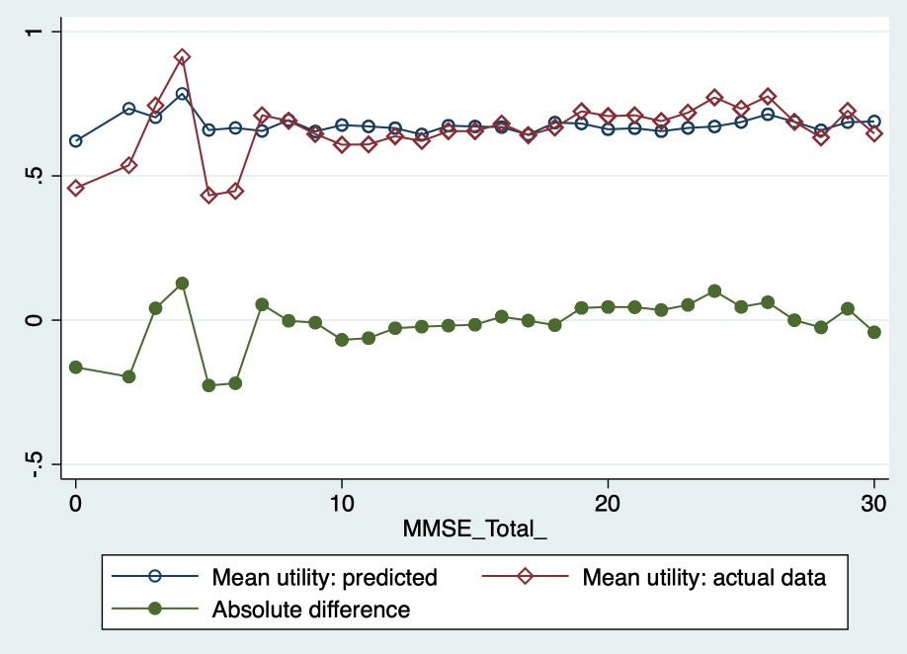

Utility distribution produced using pragmatic models, across PSMS scores

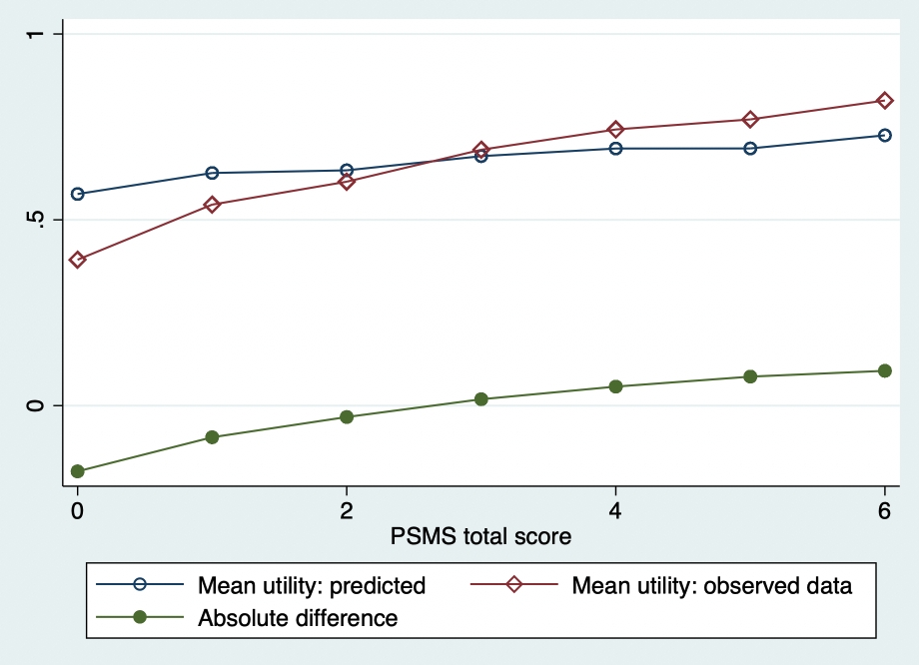

Pragmatic model generation – EPIC

Mobility

oprobit eq1staff_ i.eq1SR_ age_ i.sex_, vce(cluster PatNo)

Mobility response level | Observed frequency (%)  n=1699 | Predicted frequency (%)
1 | 34.73 | 41.15
2 | 14.83 | 18.59
3 | 10.30 | 11.13
4 | 6.89 | 6.13
5 | 33.25 | 23.00

Self-care

oprobit eq2staff_ i.eq2SR_ age_ i.sex_, vce(cluster PatNo)

Mobility response level | Observed frequency (%)  n=1700 | Predicted frequency (%)
1 | 13.41 | 20.13
2 | 12.59 | 19.58
3 | 12.88 | 17.02
4 | 7.94 | 9.66
5 | 53.18 | 33.61

Usual activities

oprobit eq3staff_ i.eq3SR_ age_ i.sex_, vce(cluster PatNo)

Response options | Observed frequency (%)  n=1701 | Predicted frequency (%)
No problems | 62.21 | 71.06
Slight problems | 7.88 | 11.13
Moderate problems | 9.64 | 8.35
Severe problems | 4.47 | 3.07
Unable to do usual activities | 15.40 | 6.39

Pain/discomfort

oprobit eq4SR_ eq4staff i.sex_ age_, vce(cluster PatNo)

Response options | Observed frequency (%)  n=805 | Predicted frequency (%)
No pain/discomfort | 71.93 | 71.92
Slight pain/discomfort | 17.27 | 17.31
Moderate pain/discomfort | 7.08 | 7.07
Severe pain/discomfort | 3.35 | 3.31
Extreme pain/discomfort | 0.37 | 0.38

Anxiety/depression

oprobit eq5SR_ i.eq5staff_ i.sex_ age_, vce(cluster PatNo)

Response options | Observed frequency (%)  n=792 | Predicted frequency (%)
No anxiety/depression | 77.53 | 77.48
Slight anxiety/depression | 14.77 | 14.71
Moderate anxiety/depression | 5.68 | 5.78
Severe anxiety/depression | 1.39 | 1.41
Extreme anxiety/depression | 0.63 | 0.62

Observed vs. predicted EQ-5D index scores using pragmatic models (EPIC)

Target response | N | Mean | SD | Min – Max
Mapped from 5L to 3L value set
Observed data | 758 | 0.62 | 0.36 | -0.34 – 0.99
Predicted data | 758 | 0.65 | 0.12 | 0.10 – 0.77

Utility distribution produced using pragmatic models, across FAST scores

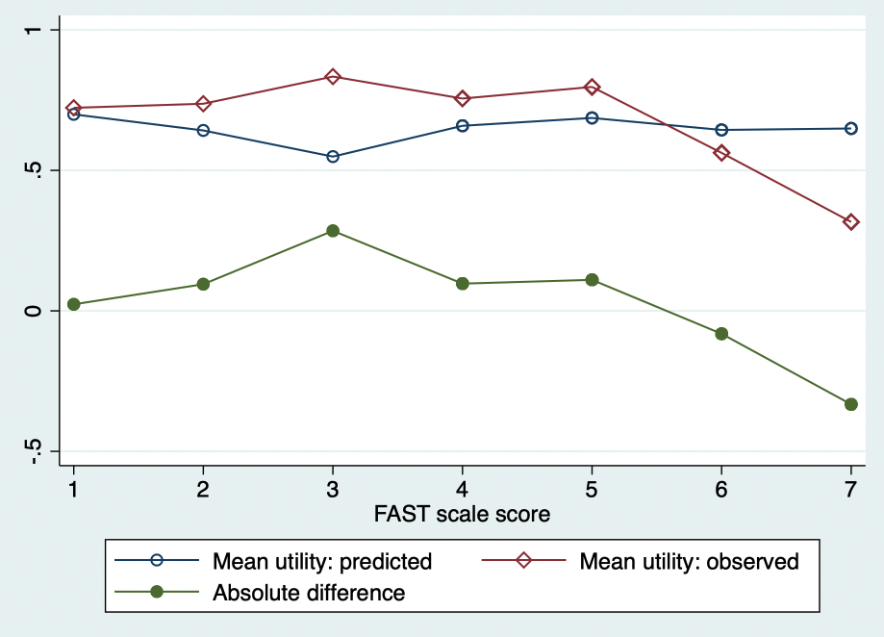

Appendix 6.5 Utility score estimations using 2018 EQ-5D-5L value set for England

Table 6.5a, ACTIFCARE utility estimations using 2018 EQ-5D-5L value set for England

Using the EQ-5D-5L value set
Target response | N | Mean | SD | Min – Max
Observed data | 962 | 0.77 | 0.18 | -0.16 – 1
Predicted data | 962 | 0.77 | 0.10 | 0.38 – 0.93

Figures A6.5a and A6.5b below display the distribution of utility scores from the combined target respondents for the observed and predicted data respectively when calculated using the 2018 EQ-5D-5L value set for England (Devlin et al., 2018). Figure A6.5a shows the characteristic gap of scores before full health (at score one), typical to EQ-5D distributions generated from observed data (Devlin et al., 2020). As shown, the variability of utility values derived from the observed data versus those predicted by the ordered probit models shows a wider range of spread, as is inevitably the case when using data derived from predictive mapping models.

Figure A6.6a in Appendix 6.6 plots the EQ-5D index scores from the observed data and the predictions as estimated via the 2018 EQ-5D-5L value set. The plot suggests a weak positive correlation between the scores, and clustering at the higher end of scores makes definitive interpretation challenging.

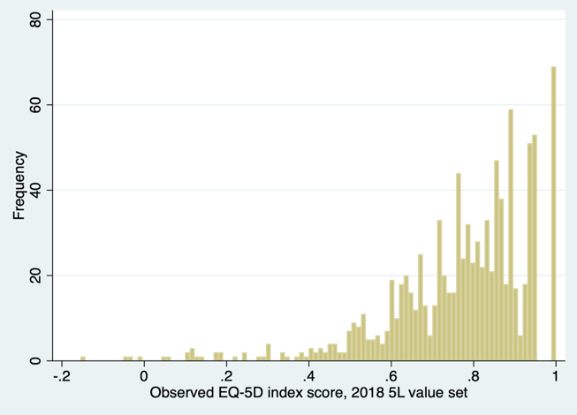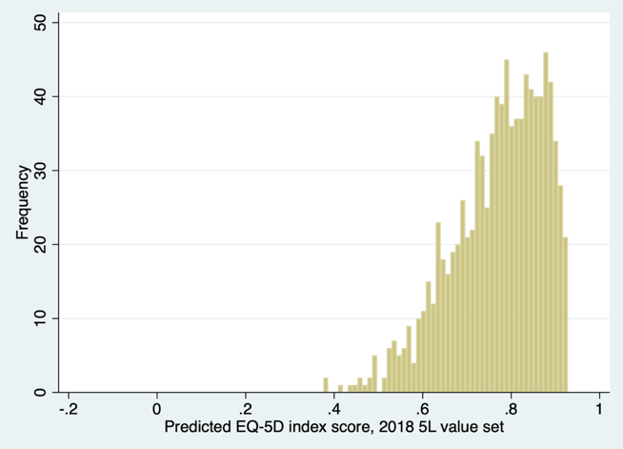
A6.5a A6.5b

Figure A6.5a, EQ-5D index score distribution: actual data via target respondents
Figure A6.5b, EQ-5D index score distribution: predicted data

Figure A6.5c displays the mean observed versus mean predicted EQ-5D-5L utility scores over the distribution of MMSE scores; Figure A6.5d displays the same information while additionally plotting the error in the predictions generated using the models. As shown, the utility values from the predictions are overestimated at both extremes of the MMSE scale.

Figure A6.5c, mean predicted vs. mean observed EQ-5D utility over MMSE

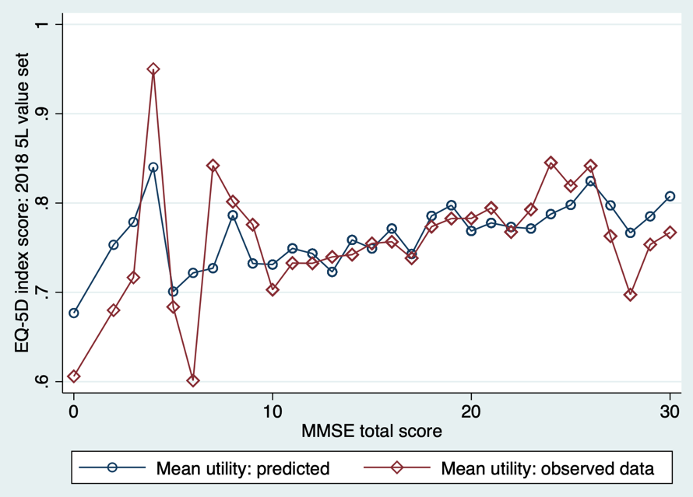

Figure A6.5d, mean predicted vs. mean observed EQ-5D utility, with error/ absolute difference over MMSE

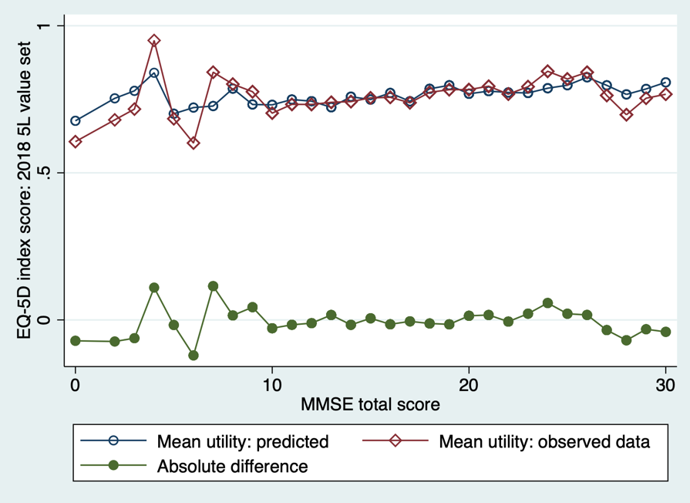

The utility distribution plots are also presented over PSMS (function) scores, displayed in Figures A6.5e and A6.5f. As observed across MMSE scores, the utility distribution patterns show likeliness for both estimations. Prediction error slightly widens at lower/worse function scores. Mean utilities are also reported for CDR stages. These graphs are available in Appendix 6.8, and they show that model prediction error is at its widest at CDR stage three, compared to the other stages, where the absolute difference is near zero.

Figure A6.5e, mean predicted vs. mean observed EQ-5D utility over PSMS

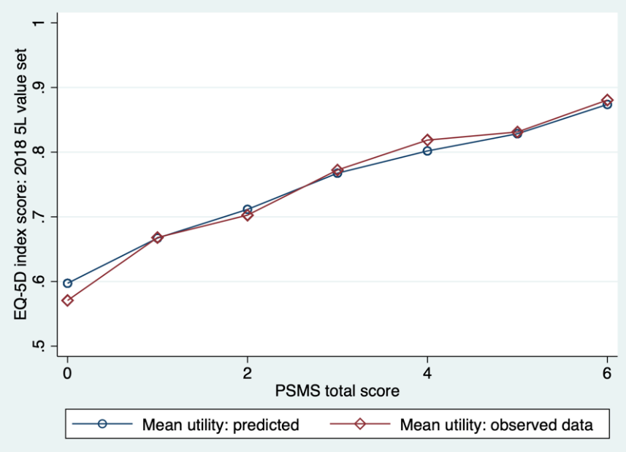

Figure A6.5f, mean predicted vs. mean observed EQ-5D utility, with error/ absolute difference over PSMS

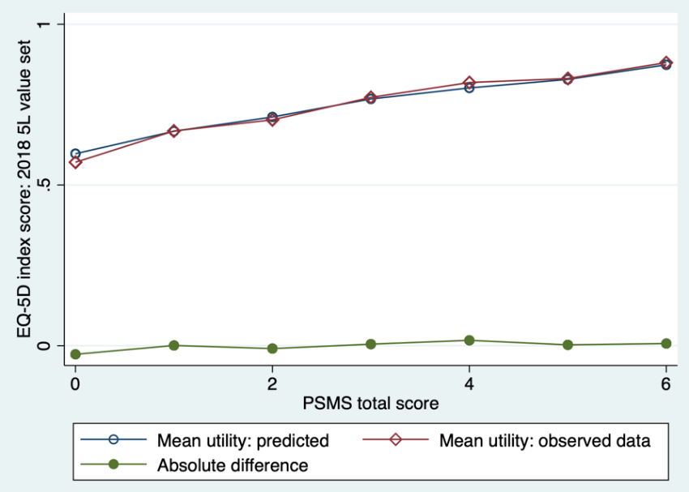

Table 6.5b, EPIC utility estimations using 2018 EQ-5D-5L value set for England

Using the EQ-5D-5L value set
Target response | N | Mean | SD | Min – Max
Observed data | 758 | 0.77 | 0.19 | -0.16 – 1
Predicted data | 758 | 0.72 | 0.09 | 0.33 – 0.95

Figures A6.5g and A6.5h below display the distribution of utility scores generated from both the observed and predicted data when applying the 2018 EQ-5D-5L value set. As was observed in the ACTIFCARE trial, the variability of utility scores from the predicted data is compressed when compared to those of the observed data; this is a consequence of all mapped data-predictions and does not necessarily reflect the models’ predictive performances.

The scatterplot (Figure A6.6c of Appendix 6.6) of the predicted and observed EQ-5D index scores resembles Figure A6.6a from the ACTIFCARE data by showing a weak positive correlation. Similarly, scores at the lower range appear to overestimate predictions, with evidence of underestimation at the higher range of utility scores.

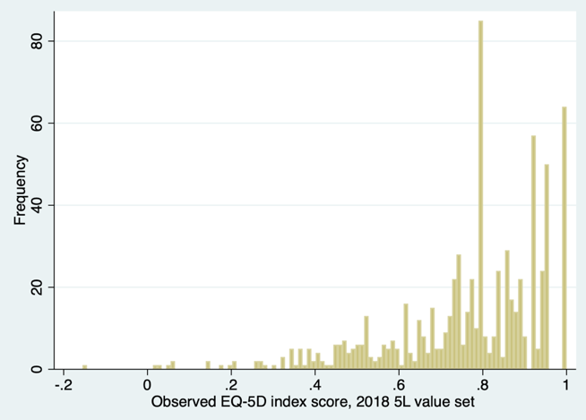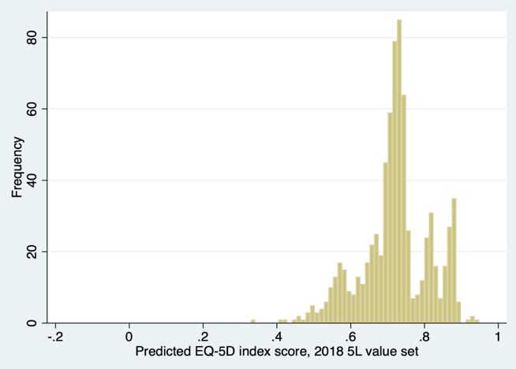
A6.5g A6.5h

Figure A6.5g, EQ-5D-5L index score distribution: actual data via target respondents
Figure A6.5h, EQ-5D-5L index score distribution: predicted data

Figures A6.5i and A6.5j below illustrate the comparison between mean observed EQ-5D-5L utility values and mean predicted EQ-5D-5L utility values across the distribution of the FAST scale scores. The graphs show that the predicted utilities tend to smooth out variations by normalising the means. In addition, the predicted utilities exhibit a tendency to overestimate utility values at better health/functional states and underestimate those at lower/worse levels of health. A notable point of convergence between the mean observed and mean predicted utilities is seen around a FAST score of four. This score corresponds to moderate dementia (whereby higher scores reflect greater functional impairment) (Reisberg, 1988).

The differences between the mean utility scores for the CDR stages exhibit a different pattern for the EPIC trial data (when compared with the ACTIFCARE data). The graphs (which are provided in Appendix 6.8) show that model prediction error is at its narrowest at CDR stage three compared to at stages one and two. Although this is the case, even at stages one and two, the absolute difference in predicted utility remains below 0.1.

Figure A6.5i, mean predicted vs. mean observed EQ-5D-5L utility over FAST

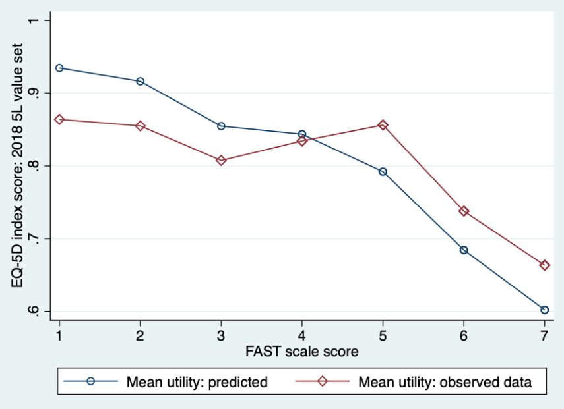

Figure A6.5j, mean predicted vs. mean observed EQ-5D-5L utility, with error/ absolute difference over FAST

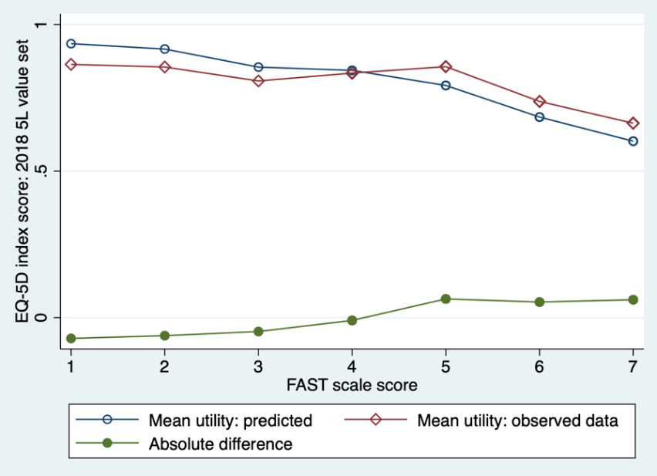

Appendix 6.6 Scatterplots of observed vs. predicted EQ-5D index scores

Figure A6.6a, Scatterplot of observed vs. predicted EQ-5D index score: ACTIFCARE (2018 5L value set)

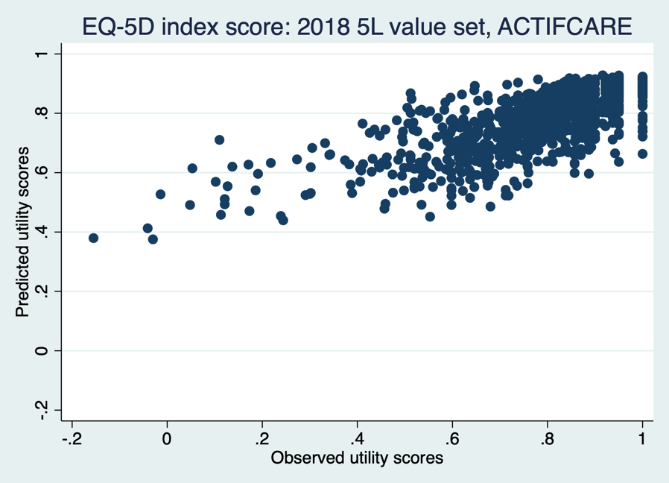

Figure A6.6b, Scatterplot of observed vs. predicted EQ-5D index score: ACTIFCARE (5L. to 3L conversion)

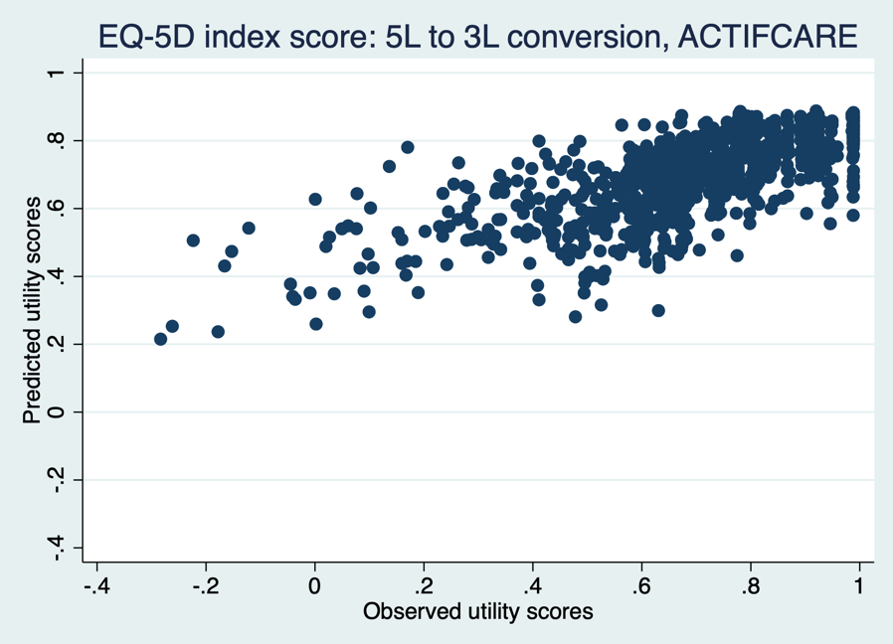

Figure A6.6c, Scatterplot of observed vs. predicted EQ-5D index score: EPIC (2018 5L value set)

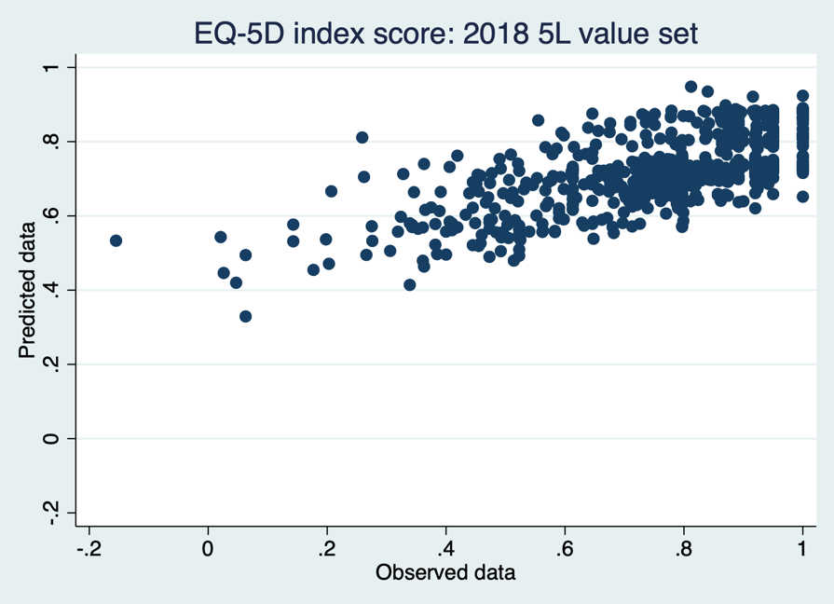

Figure A6.6d, Scatterplot of observed vs. predicted EQ-5D index score: EPIC (5L. to 3L conversion)

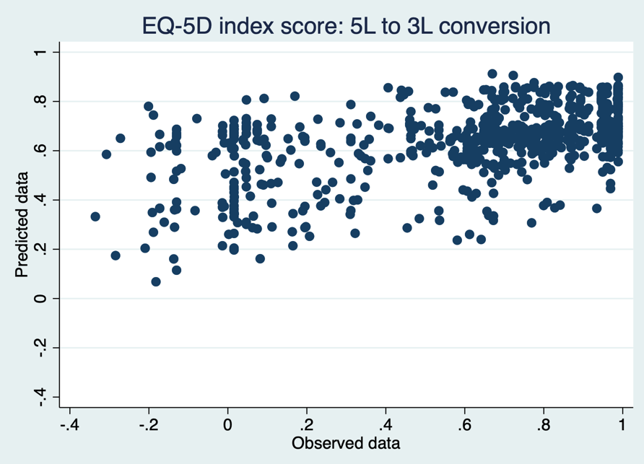

Appendix 6.7a MMSE grouping distribution plots, ACTIFCARE

Figure A6.7a, mean predicted vs. mean observed EQ-5D utility over MMSE groups: ACTIFCARE (2018 5L value set)

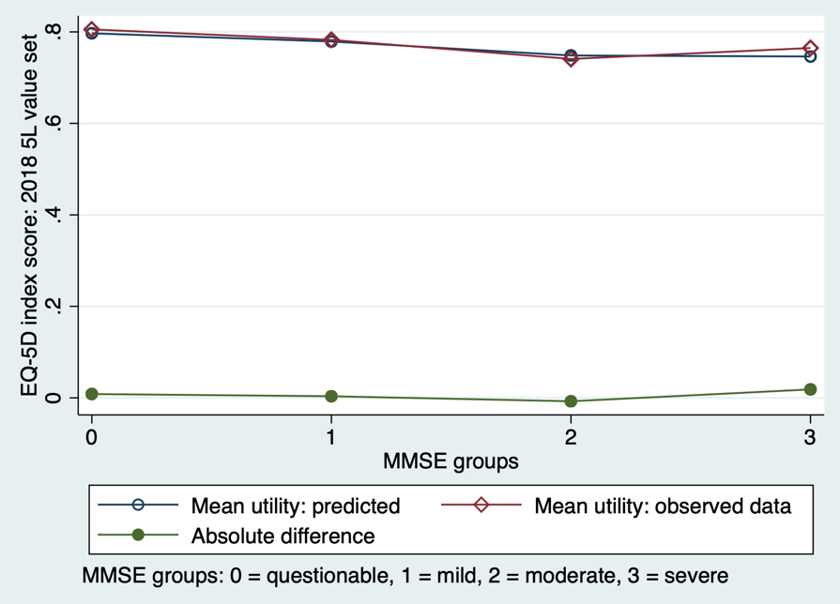

Figure A6.7b, mean predicted vs. mean observed EQ-5D utility over MMSE groups: ACTIFCARE (5L to 3L conversion)

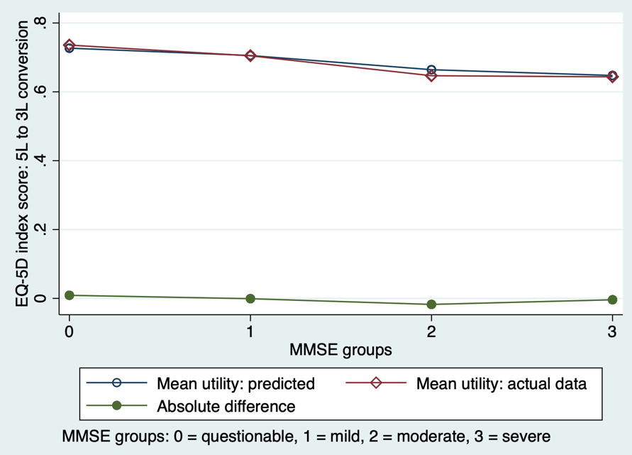

Appendix 6.7b Number of utility observations per MMSE stage, ACTIFCARE

MMSE stage | Utility Obs (n)
0 | 2
1 | -
2 | 1
3 | 3
4 | 1
5 | 4
6 | 4
7 | 8
8 | 15
9 | 16
10 | 21
11 | 26
12 | 39
13 | 36
14 | 54
15 | 49
16 | 52
17 | 58
18 | 56
19 | 69
20 | 72
21 | 79
22 | 66
23 | 53
24 | 52
25 | 29
26 | 38
27 | 26
28 | 19
29 | 7
30 | 7

Appendix 6.8 CDR distribution plots

Figure A6.8a, mean predicted vs. mean observed EQ-5D utility, with error/ absolute difference over CDR: ACTIFCARE

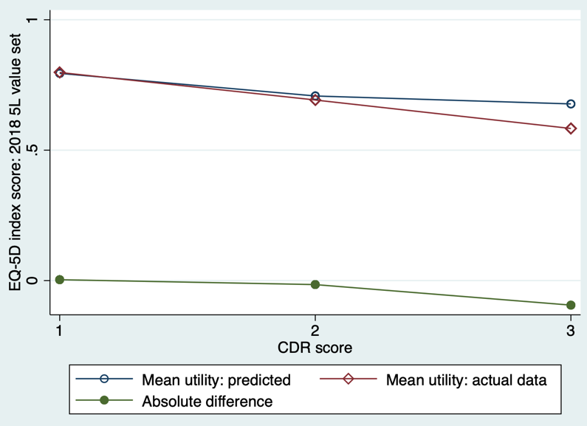

Figure A6.8b, mean predicted vs. mean observed EQ-5D utility, with error/ absolute difference over CDR: ACTIFCARE

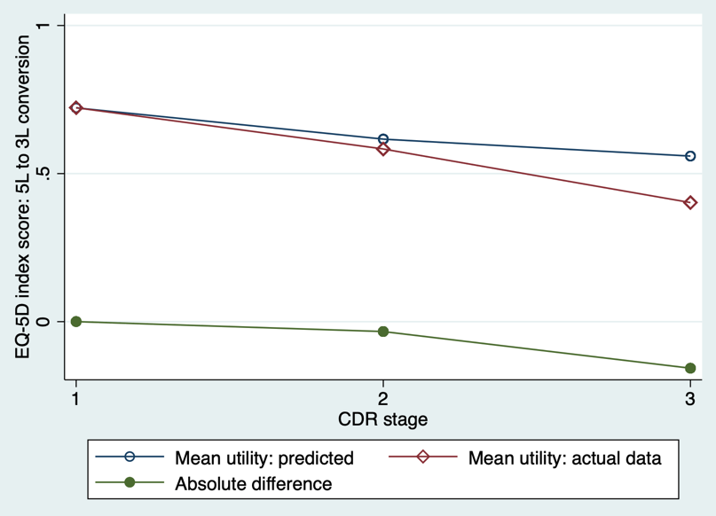

Figure A6.8c, mean predicted vs. mean observed EQ-5D utility, with error/ absolute difference over CDR: EPIC

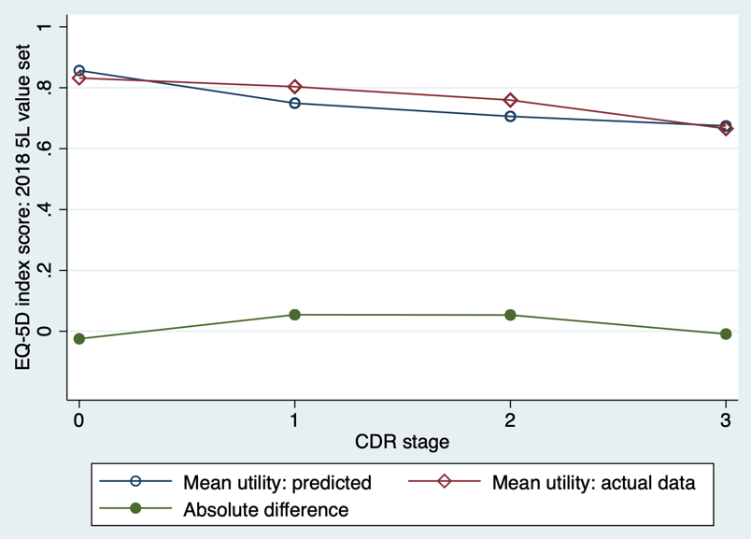

Figure A6.8d, mean predicted vs. mean observed EQ-5D utility, with error/ absolute difference over CDR: EPIC

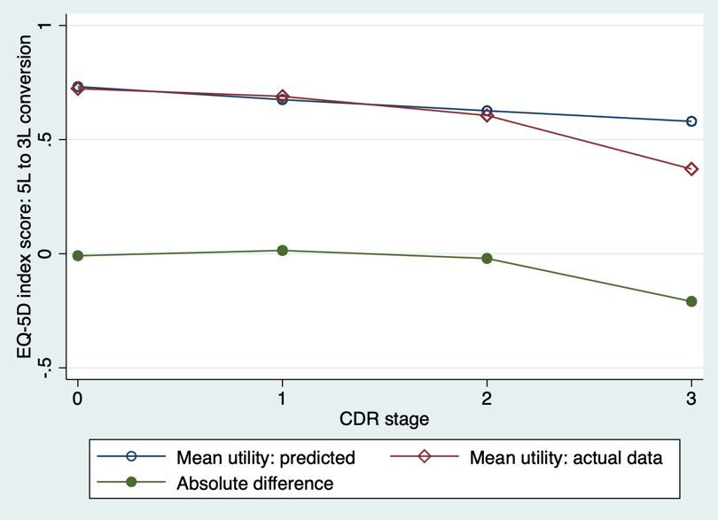

Appendix 6.9 Summary of mapping chapter key findings

Key Findings | Implications
Dementia severity influenced model performance, whereby optimality was seen for mild-to-moderate stages | Model predictions were less effective at extreme MMSE scores, influenced by low response proportions and highlighting challenges in severe dementia
Dimension-level differences in model performance were observed; strong alignment was seen for "anxiety/depression" and "pain/discomfort" predictions | Proxy EQ-5D data may more reliably predict PwD responses for specific dimensions
Choice of utility estimation method (2018 EQ-5D-5L vs. 5L to 3L value set) influences mean utility values | Researchers must carefully consider EQ-5D value set choice when estimating HRQoL using mapped “data”
Predicted utility distributions were narrower than observed data due to mapping analyses | Mapping models aim to estimate mean EQ-5D values, therefore minimising variability in scores
Community dwelling (ACTIFCARE) and residential care (EPIC) settings showed different model performances | Dimension-level mapping models may have increased relevance in community settings, but require further efforts to standardise data collection
The trial indicator variable showed significance in “self-care”, “usual activities” and “anxiety/depression” | Although it is not possible to determine the specific reason for the trial effects, it highlights the role that tailoring the dimension-models played
Both trials exhibit ceiling effects in reports, particularly for “pain/discomfort” and “anxiety/depression” | It is important to consider ceiling effects in interpretation of the findings, and to acknowledge that model performance is dependent on characteristics of the data
MMSE shows varied significance across dimensions | The presence of a cognitive measure in EPIC may have enhanced predictions for certain dimensions

References

AGED CARE TESTS. The Cornell Scale for Depression in Dementia (CSDD) [Online]. Available: https://www.agedcaretests.com/The_Cornell_Scale_for_Depression_in_Dementia_%28CSDD%29_Sample.pdf [Accessed January 2024].
ALAVA, M. H., WAILOO, A. J. & ARA, R. 2012. Tails from the peak district: adjusted limited dependent variable mixture models of EQ-5D questionnaire health state utility values. Value in Health, 15, 550-561.
ALBANESE, E., BANERJEE, S., DHANASIRI, S., FERNÁNDEZ, J.-L., FERRI, C., KNAPP, M., MCCRONE, P., PRINCE, M., SNELL, T. & STEWART, R. 2007. Dementia UK. Alzheimer’s Disease Society, London, UK.
ALEXOPOULOS, G. S., ABRAMS, R. C., YOUNG, R. C. & SHAMOIAN, C. A. 1988. Cornell scale for depression in dementia. Biological psychiatry, 23, 271-284.
ALZHEIMER’S SOCIETY. 2020. How much does dementia care cost? [Online]. Available: https://www.alzheimers.org.uk/blog/how-much-does-dementia-care-cost [Accessed 2024].
ANDERSON, D. & BURNHAM, K. 2004. Model selection and multi-model inference. Second. NY: Springer-Verlag, 63, 10.
ANDREN, S. & ELMSTÅHL, S. 2008. The relationship between caregiver burden, caregivers’ perceived health and their sense of coherence in caring for elders with dementia. Journal of clinical nursing, 17, 790-799.
ANKRI, J., BEAUFILS, B., NOVELLA, J.-L., MORRONE, I., GUILLEMIN, F., JOLLY, D., PLOTON, L. & BLANCHARD, F. 2003. Use of the EQ-5D among patients suffering from dementia. Journal of clinical epidemiology, 56, 1055-1063.
APA. 2011. Neuropsychiatric Inventory [Online]. Available: https://www.apa.org/pi/about/publications/caregivers/practice-settings/assessment/tools/neuropsychiatric-inventory [Accessed January 2024].
ARUK 2019. The Economic Impact of Dementia
ASHIZAWA, T., IGARASHI, A., SAKATA, Y., AZUMA, M., FUJIMOTO, K., KOBAYASHI, T., TAKASE, Y. & IKEDA, S. 2021. Impact of the Severity of Alzheimer’s Disease on the Quality of Life, Activities of Daily Living, and Caregiving Costs for Institutionalized Patients on Anti-Alzheimer Medications in Japan. Journal of Alzheimer's Disease, 81, 367-374.
BANERJEE, S., SAMSI, K., PETRIE, C. D., ALVIR, J., TREGLIA, M., SCHWAM, E. M. & DEL VALLE, M. 2009. What do we know about quality of life in dementia? A review of the emerging evidence on the predictive and explanatory value of disease specific measures of health related quality of life in people with dementia. International Journal of Geriatric Psychiatry: A journal of the psychiatry of late life and allied sciences, 24, 15-24.
BANERJEE, S., SMITH, S., LAMPING, D., HARWOOD, R., FOLEY, B., SMITH, P., MURRAY, J., PRINCE, M., LEVIN, E. & MANN, A. 2006. Quality of life in dementia: more than just cognition. An analysis of associations with quality of life in dementia. Journal of Neurology, Neurosurgery & Psychiatry, 77, 146-148.
BHATTACHARYA, S., VOGEL, A., HANSEN, M.-L. H., WALDORFF, F. B. & WALDEMAR, G. 2010. Generic and disease-specific measures of quality of life in patients with mild Alzheimer’s disease. Dementia and geriatric cognitive disorders, 30, 327-333.
BIGGANE, A. M., OLSEN, M. & WILLIAMSON, P. R. 2019. PPI in research: a reflection from early stage researchers. Research Involvement and Engagement, 5, 1-9.
BLOME, C. & AUGUSTIN, M. 2015. Measuring change in quality of life: bias in prospective and retrospective evaluation. Value in Health, 18, 110-115.
BMC. 2021. ISRCTN registry [Online]. Available: https://www.isrctn.com/page/about [Accessed 05/03/2021 2021].
BNF. 2021. Dementia [Online]. NICE BNF Available: https://bnf.nice.org.uk/treatment-summary/dementia.html [Accessed 2021].
BONFIGLIO, V., UMEGAKI, H. & KUZUYA, M. 2019. Quality of life in cognitively impaired older adults. Geriatrics & gerontology international, 19, 999-1005.
BOSTRÖM, F., JÖNSSON, L., MINTHON, L. & LONDOS, E. 2007. Patients with dementia with Lewy bodies have more impaired quality of life than patients with Alzheimer disease. Alzheimer Disease & Associated Disorders, 21, 150-154.
BRAZIER, J. & DEVERILL, M. 1999. A checklist for judging preference‐based measures of health related quality of life: learning from psychometrics. Health economics, 8, 41-51.
BRYAN, S., HARDYMAN, W., BENTHAM, P., BUCKLEY, A. & LAIGHT, A. 2005. Proxy completion of EQ-5D in patients with dementia. Quality of Life Research, 14, 107-118.
BUCKS, R. S., ASHWORTH, D., WILCOCK, G. & SIEGFRIED, K. 1996. Assessment of activities of daily living in dementia: development of the Bristol Activities of Daily Living Scale. Age and ageing, 25, 113-120.
BURKS, H. B., DES BORDES, J. K., CHADHA, R., HOLMES, H. M. & RIANON, N. J. 2021. Quality of life assessment in older adults with dementia: a systematic review. Dementia and geriatric cognitive disorders, 50, 103-110.
BYRNE-DAVIS, L., BENNETT, P. & WILCOCK, G. 2006. How are quality of life ratings made? Toward a model of quality of life in people with dementia. Quality of Life Research, 15, 855-865.
CARLTON, J., PEASGOOD, T., MUKURIA, C., JOHNSON, J., OGDEN, M. & TOVEY, W. 2022. The role of patient and public involvement and engagement (PPIE) within the development of the EQ Health and Wellbeing (EQ-HWB). Journal of Patient-Reported Outcomes, 6, 35.
CASTRO-MONTEIRO, E., FORJAZ, M. J., AYALA, A., RODRIGUEZ-BLAZQUEZ, C., FERNANDEZ-MAYORALAS, G., DIAZ-REDONDO, A. & MARTINEZ-MARTIN, P. 2014. Change and predictors of quality of life in institutionalized older adults with dementia. Quality of Life Research, 23, 2595-2601.
CHUANG, L.-H. & WHITEHEAD, S. J. 2012. Mapping for economic evaluation. British medical bulletin, 101.
CLEMENT, C., SELMAN, L. E., KEHOE, P. G., HOWDEN, B., LANE, J. & HORWOOD, J. 2019. Challenges to and facilitators of recruitment to an Alzheimer’s disease clinical trial: a qualitative interview study. Journal of Alzheimer's Disease, 69, 1067-1075.
COAST, J., FLYNN, T. N., NATARAJAN, L., SPROSTON, K., LEWIS, J., LOUVIERE, J. J. & PETERS, T. J. 2008. Valuing the ICECAP capability index for older people. Social science & medicine, 67, 874-882.
COHEN, J. 2013. Statistical power analysis for the behavioral sciences, Academic press.
COHEN-MANSFIELD, J. 1991. Instruction manual for the Cohen-Mansfield agitation inventory (CMAI). Research Institute of the Hebrew Home of Greater Washington, 1991.
COMANS, T. A., NGUYEN, K.-H., RATCLIFFE, J., ROWEN, D. & MULHERN, B. 2020. Valuing the AD-5D dementia utility instrument: an estimation of a general population tariff. PharmacoEconomics, 38, 871-881.
CONNOR, D. J., SABBAGH, M. N. & CUMMINGS, J. L. 2008. Comment on administration and scoring of the Neuropsychiatric Inventory in clinical trials. Alzheimer's & Dementia, 4, 390-394.
COUCILL, W., BRYAN, S., BENTHAM, P., BUCKLEY, A. & LAIGHT, A. 2001. EQ-5D in patients with dementia: an investigation of inter-rater agreement. Medical care, 760-771.
CROSETTO, P., FILIPPIN, A., KATUŠČÁK, P. & SMITH, J. 2020. Central tendency bias in belief elicitation. Journal of Economic Psychology, 78, 102273.
CUMMINGS, J. 2020. The neuropsychiatric inventory: development and applications. Journal of geriatric psychiatry and neurology, 33, 73-84.
DE GRAAFF, B., KLEINHOUT‐VLIEK, T. & VAN DE BOVENKAMP, H. 2021. In the works: patient and public involvement and engagement in healthcare decision‐making. Health Expectations: an International Journal of Public Participation in Health Care and Health Policy, 24, 1903.
DEAN, R., PROUDFOOT, R. & LINDESAY, J. 1993. The quality of interactions schedule (QUIS): development, reliability and use in the evaluation of two domus units. International Journal of Geriatric Psychiatry, 8, 819-826.
DEEP. 2021. Making things more accessible [Online]. Available: https://www.dementiavoices.org.uk/deep-resources/making-things-more-accessible/ [Accessed 2021].
DESAI, A. K., GROSSBERG, G. T. & SHETH, D. N. 2004. Activities of daily living in patients with dementia. CNS drugs, 18, 853-875.
DEVLIN, N., PARKIN, D., JANSSEN, B., DEVLIN, N., PARKIN, D. & JANSSEN, B. 2020. Analysis of EQ-5D values. Methods for analysing and reporting EQ-5D data, 61-86.
DEVLIN, N. J. & BROOKS, R. 2017. EQ-5D and the EuroQol group: past, present and future. Applied health economics and health policy, 15, 127-137.
DEVLIN, N. J., SHAH, K. K., FENG, Y., MULHERN, B. & VAN HOUT, B. 2018. Valuing health‐related quality of life: An EQ‐5 D‐5 L value set for E ngland. Health economics, 27, 7-22.
DIAZ‐REDONDO, A., RODRIGUEZ‐BLAZQUEZ, C., AYALA, A., MARTINEZ‐MARTIN, P., FORJAZ, M. J., LIFE, S. R. G. O. Q. O. & AGING 2014. EQ‐5D rated by proxy in institutionalized older adults with dementia: Psychometric pros and cons. Geriatrics & gerontology international, 14, 346-353.
DICHTER, M., ETTEMA, T., SCHWAB, C., MEYER, G., BARTHOLOMEYCZIK, S., HALEK, M. & DRÖES, R. 2016. QUALIDEM User Guide. DZNE/VUmc, Witten/Amsterdam.
DOLAN, P. 1997. Modeling valuations for EuroQol health states. Medical care, 1095-1108.
DOUGLAS, S., JAMES, I. & BALLARD, C. 2004. Non-pharmacological interventions in dementia. Advances in psychiatric treatment, 10, 171-177.
DOUVEN, I. 2018. A Bayesian perspective on Likert scales and central tendency. Psychonomic bulletin & review, 25, 1203-1211.
DRAISY. 2021. Dementia Research Advisory Group South Yorkshire [Online]. Sheffield Institute for Traditional Neuroscience. Available: https://draisy.sites.sheffield.ac.uk [Accessed 11/07/2021 2021].
DRAISY. 2021 Information for Researchers [Online]. Available: https://draisy.sites.sheffield.ac.uk/for-researchers [Accessed 2021].
DRÖES, R. 1991. In movement; on psychosocial care for elderly people with dementia [In beweging: over psychosociale hulpverlening an demente ouderen].
DRUMMOND, M. F., SCULPHER, M. J., CLAXTON, K., STODDART, G. L. & TORRANCE, G. W. 2015. Methods for the economic evaluation of health care programmes, Oxford university press.
EASTON, T., MILTE, R., CROTTY, M. & RATCLIFFE, J. 2018. An empirical comparison of the measurement properties of the EQ-5D-5L, DEMQOL-U and DEMQOL-Proxy-U for older people in residential care. Quality of Life Research, 27, 1283-1294.
EDELMAN, P., FULTON, B. R., KUHN, D. & CHANG, C.-H. 2005. A comparison of three methods of measuring dementia-specific quality of life: perspectives of residents, staff, and observers. The gerontologist, 45, 27-36.
ELLIOTT, D., LAZARUS, R. & LEEDER, S. R. 2006. Proxy respondents reliably assessed the quality of life of elective cardiac surgery patients. Journal of clinical epidemiology, 59, 153-159.
ENGEL, L., BUCHOLC, J., MIHALOPOULOS, C., MULHERN, B., RATCLIFFE, J., YATES, M. & HANNA, L. 2020. A qualitative exploration of the content and face validity of preference-based measures within the context of dementia. Health and Quality of Life Outcomes, 18, 1-19.
ÉRSEK, K., KOVÁCS, T., WIMO, A., KÁRPATI, K., BRODSZKY, V., PÉNTEK, M., JÖNSSON, L., GUSTAVSSON, A., MCDAID, D. & KENIGSBERG, P. 2010. Costs of dementia in Hungary. The journal of nutrition, health & aging, 14, 633-639.
ETTEMA, T. P., DRÖES, R. M., DE LANGE, J., MELLENBERGH, G. J. & RIBBE, M. W. 2007. QUALIDEM: development and evaluation of a dementia specific quality of life instrument. Scalability, reliability and internal structure. International Journal of Geriatric Psychiatry: A journal of the psychiatry of late life and allied sciences, 22, 549-556.
EUROQOL GROUP 1990. EuroQol-a new facility for the measurement of health-related quality of life. Health policy, 2023, 199-208.
EUROQOL RESEARCH FOUNDATION 2018. EQ-5D-3L User Guide. https://euroqol.org/publications/user-guides.
EUROQOL RESEARCH FOUNDATION. 2023a. HOW ARE THE SELF-COMPLETE, INTERVIEWER AND PROXY EQ-5D VERSIONS DIFFERENT? [Online]. Available: https://euroqol.org/faq/how-are-the-self-complete-interviewer-and-proxy-eq-5d-versions-different/ [Accessed January 2024].
EUROQOL RESEARCH FOUNDATION. 2023b. Instrument delivery [Online]. Available: https://euroqol.org/register/instrument-delivery/ [Accessed 2024].
EUROQOL RESEARCH FOUNDATION. 2023c. Value sets [Online]. Available: https://euroqol.org/information-and-support/resources/value-sets/ [Accessed January 2024].
FARINA, N., KING, D., BURGON, C., BERWALD, S., BUSTARD, E., FEENEY, Y., HABIBI, R., COMAS-HERRERA, A., KNAPP, M. & BANERJEE, S. 2020. Disease severity accounts for minimal variance of quality of life in people with dementia and their carers: analyses of cross-sectional data from the MODEM study. BMC geriatrics, 20, 1-13.
FAYERS, P. M. & MACHIN, D. 2013. Quality of life: the assessment, analysis and interpretation of patient-reported outcomes, John Wiley & Sons.
FEINSTEIN, A. R. & CICCHETTI, D. V. 1990. High agreement but low kappa: I. The problems of two paradoxes. Journal of clinical epidemiology, 43, 543-549.
FISH, J. 2011. Severe Impairment Battery. In: KREUTZER, J. S., DELUCA, J. & CAPLAN, B. (eds.) Encyclopedia of Clinical Neuropsychology. New York, NY: Springer New York.
FITZPATRICK, R., DAVEY, C., BUXTON, M. J. & JONES, D. R. 1998. Evaluating patient-based outcome measures for use in clinical trials.
FOLSTEIN, M. F., FOLSTEIN, S. E. & MCHUGH, P. R. 1975. “Mini-mental state”: a practical method for grading the cognitive state of patients for the clinician. Journal of psychiatric research, 12, 189-198.
FRANCISCONI, S., BOSCO, J. & PARMENTER, L. 2020. Interventional or Non-Interventional? Analyzing the Differences Between Clinical Studies Using Medicines in the European Union.
GALEA, M. & WOODWARD, M. 2005. Mini-mental state examination (MMSE). Australian Journal of Physiotherapy, 51, 198.
GARRE-OLMO, J., VILALTA-FRANCH, J., CALVÓ-PERXAS, L., LÓPEZ-POUSA, S. & GROUP, C.-A. S. 2017. A path analysis of dependence and quality of life in Alzheimer’s disease. American Journal of Alzheimer's Disease & Other Dementias®, 32, 108-115.
GIAVARINA, D. 2015. Understanding bland altman analysis. Biochemia medica, 25, 141-151.
GÓMEZ-GALLEGO, M., GÓMEZ-AMOR, J. & GÓMEZ-GARCÍA, J. 2012. Determinants of quality of life in Alzheimer's disease: perspective of patients, informal caregivers, and professional caregivers. International psychogeriatrics, 24, 1805.
GONZÁLEZ‐VÉLEZ, A. E., FORJAZ, M. J., GIRALDEZ‐GARCÍA, C., MARTÍN‐GARCÍA, S., MARTÍNEZ‐MARTÍN, P., LIFE, S. R. G. O. Q. O. & AGEING 2015. Quality of life by proxy and mortality in institutionalized older adults with dementia. Geriatrics & gerontology international, 15, 38-44.
GRAESSEL, E., BERTH, H., LICHTE, T. & GRAU, H. 2014. Subjective caregiver burden: validity of the 10-item short version of the Burden Scale for Family Caregivers BSFC-s. BMC geriatrics, 14, 1-9.
GRAF, C. 2008. The Lawton instrumental activities of daily living scale. AJN The American Journal of Nursing, 108, 52-62.
GRÄSKE, J., MEYER, S. & WOLF-OSTERMANN, K. 2014. Quality of life ratings in dementia care–a cross-sectional study to identify factors associated with proxy-ratings. Health and Quality of Life Outcomes, 12, 1-11.
GRAY, A. M., RIVERO-ARIAS, O. & CLARKE, P. M. 2006. Estimating the association between SF-12 responses and EQ-5D utility values by response mapping. Medical Decision Making, 26, 18-29.
GREEN, C. & ZHANG, S. 2016. Predicting the progression of Alzheimer's disease dementia: a multidomain health policy model. Alzheimer's & Dementia, 12, 776-785.
GREENE, W. H. & HENSHER, D. A. 2010. Modeling ordered choices: A primer, Cambridge University Press.
GRIFFITHS, A. W., SMITH, S. J., MARTIN, A., MEADS, D., KELLEY, R. & SURR, C. A. 2020. Exploring self-report and proxy-report quality-of-life measures for people living with dementia in care homes. Quality of Life Research, 29, 463-472.
HAAKSMA, M. L., LEOUTSAKOS, J.-M. S., BREMER, J. A., AALTEN, P., RAMAKERS, I. H., VERHEY, F. R., RIKKERT, M. G. O. & MELIS, R. J. 2018. The clinical course and interrelations of dementia related symptoms. International psychogeriatrics, 30, 859-866.
HANKINS, M. 2008. The reliability of the twelve-item general health questionnaire (GHQ-12) under realistic assumptions. BMC public health, 8, 1-7.
HARDING, A. J., MORBEY, H., AHMED, F., OPDEBEECK, C., ELVISH, R., LEROI, I., WILLIAMSON, P. R., KEADY, J. & REILLY, S. T. 2021. A core outcome set for nonpharmacological community-based interventions for people living with dementia at home: a systematic review of outcome measurement instruments. The Gerontologist, 61, e435-e448.
HARDING, A. J., MORBEY, H., AHMED, F., OPDEBEECK, C., LASRADO, R., WILLIAMSON, P. R., SWARBRICK, C., LEROI, I., CHALLIS, D. & HELLSTROM, I. 2019. What is important to people living with dementia?: the ‘long-list’of outcome items in the development of a core outcome set for use in the evaluation of non-pharmacological community-based health and social care interventions. BMC geriatrics, 19, 1-12.
HARRISON, J. K., NOEL-STORR, A. H., DEMEYERE, N., REYNISH, E. L. & QUINN, T. J. 2016. Outcomes measures in a decade of dementia and mild cognitive impairment trials. Alzheimer's research & therapy, 8, 1-10.
HARRISON, S. L., O’DONNELL, L. K., BRADLEY, C. E., MILTE, R., DYER, S. M., GNANAMANICKAM, E. S., LIU, E., HILMER, S. N. & CROTTY, M. 2018. Associations between the drug burden index, potentially inappropriate medications and quality of life in residential aged care. Drugs & aging, 35, 83-91.
HAYWOOD, K. L., GARRATT, A. M. & FITZPATRICK, R. 2005. Quality of life in older people: a structured review of generic self-assessed health instruments. Quality of life Research, 14, 1651-1668.
HEEREMA, E. 2021. Use and Scoring of the ADAS-Cog Test. Very Well Health 2021.
HERDMAN, M., GUDEX, C., LLOYD, A., JANSSEN, M., KIND, P., PARKIN, D., BONSEL, G. & BADIA, X. 2011. Development and preliminary testing of the new five-level version of EQ-5D (EQ-5D-5L). Quality of life research, 20, 1727-1736.
HERNÁNDEZ ALAVA, M., PUDNEY, S. & WAILOO, A. 2023. Estimating the relationship between EQ-5D-5L and EQ-5D-3L: results from a UK population study. PharmacoEconomics, 41, 199-207.
HERNÁNDEZ-ALAVA, M., PUDNEY, S. & WAILOO, A. 2018. Quality review of a proposed EQ-5D-5L value set for England. EEPRU report [online].
HESSMAN, P., SEEBERG, G., REESE, J. P., DAMS, J., BAUM, E., MÜLLER, M. J., DODEL, R. & BALZER-GELDSETZER, M. 2016. Health-related quality of life in patients with Alzheimer’s disease in different German health care settings. Journal of Alzheimer's Disease, 51, 545-561.
HIGGINSON, I. J., GAO, W., JACKSON, D., MURRAY, J. & HARDING, R. 2010. Short-form Zarit Caregiver Burden Interviews were valid in advanced conditions. Journal of clinical epidemiology, 63, 535-542.
HODDINOTT, P., POLLOCK, A., O'CATHAIN, A., BOYER, I., TAYLOR, J., MACDONALD, C., OLIVER, S. & DONOVAN, J. L. 2018. How to incorporate patient and public perspectives into the design and conduct of research. F1000Research, 7.
HOE, J., KATONA, C., ORRELL, M. & LIVINGSTON, G. 2007. Quality of life in dementia: care recipient and caregiver perceptions of quality of life in dementia: the LASER‐AD study. International Journal of Geriatric Psychiatry: A journal of the psychiatry of late life and allied sciences, 22, 1031-1036.
HOUNSOME, N., ORRELL, M. & EDWARDS, R. T. 2011. EQ-5D as a quality of life measure in people with dementia and their carers: evidence and key issues. Value in health, 14, 390-399.
HUGHES, L. J. 2018. An evaluation of the feasibility of the routine measurement of quality of life of people with dementia in care homes using DEMQOL-Proxy. University of Brighton.
HUSSAIN, H., KEETHARUTH, A., ROWEN, D. & WAILOO, A. 2022. Convergent validity of EQ-5D with core outcomes in dementia: a systematic review. Health and Quality of Life Outcomes, 20, 1-18.
ICHOM. 2016. Dementia [Online]. Available: http://www.ichom.org/medical-conditions/dementia/. [Accessed 2021].
JANSSEN, M. F., BONSEL, G. J. & LUO, N. 2018. Is EQ-5D-5L better than EQ-5D-3L? A head-to-head comparison of descriptive systems and value sets from seven countries. Pharmacoeconomics, 36, 675-697.
JING, W., WILLIS, R. & FENG, Z. 2016. Factors influencing quality of life of elderly people with dementia and care implications: A systematic review. Archives of Gerontology and Geriatrics, 66, 23-41.
JONES, R. W. 2011. Drug treatment for people with dementia. Clinical medicine, 11, 67.
JONKER, C., GERRITSEN, D., BOSBOOM, P. & VAN DER STEHEN, J. 2004. A model for quality of life measures in patients with dementia: Lawton’s next step. Dementia and geriatric cognitive disorders, 18, 159-164.
JPND. 2015. Dementia outcome measures: Charting new territory. European Union: JPND. [Online]. Available: https://www.neurodegenerationresearch.eu/ wp-content/uploads/2015/10/JPND-Report-Fountain.pdf [Accessed 2021].
JUTKOWITZ, E., KUNTZ, K. M., DOWD, B., GAUGLER, J. E., MACLEHOSE, R. F. & KANE, R. L. 2017. Effects of cognition, function, and behavioral and psychological symptoms on out-of-pocket medical and nursing home expenditures and time spent caregiving for persons with dementia. Alzheimer's & Dementia, 13, 801-809.
KARIMI, M. & BRAZIER, J. 2016. Health, health-related quality of life, and quality of life: what is the difference? Pharmacoeconomics, 34, 645-649.
KARLAWISH, J. H., ZBROZEK, A., KINOSIAN, B., GREGORY, A., FERGUSON, A. & GLICK, H. A. 2008a. Preference-based quality of life in patients with Alzheimer's disease. Alzheimer's & Dementia, 4, 193-202.
KARLAWISH, J. H., ZBROZEK, A., KINOSIAN, B., GREGORY, A., FERGUSON, A., LOW, D. V. & GLICK, H. A. 2008b. Caregivers' assessments of preference-based quality of life in Alzheimer's disease. Alzheimer's & Dementia, 4, 203-211.
KAUFER, D. I., CUMMINGS, J. L., KETCHEL, P., SMITH, V., MACMILLAN, A., SHELLEY, T., LOPEZ, O. L. & DEKOSKY, S. T. 2000. Validation of the NPI-Q, a brief clinical form of the Neuropsychiatric Inventory. The Journal of neuropsychiatry and clinical neurosciences, 12, 233-239.
KAUFMAN, D. M., GEYER, H. L. & MILSTEIN, M. J. 2016. Kaufman's Clinical Neurology for Psychiatrists E-Book, Elsevier Health Sciences.
KEETHARUTH, A., HUSSAIN, H., ROWEN, D. & WAILOO, A. 2022. Assessing the psychometric performance of EQ-5D-5L in dementia: a systematic review. Health and Quality of Life Outcomes.
KEMPF-LEONARD, K. 2004. Encyclopedia of social measurement.
KERPERSHOEK, L., DE VUGT, M., WOLFS, C., JELLEY, H., ORREL, M., WOODS, B., STEPHAN, A., BIEBER, A., MEYER, G. & ENGEDAL, K. 2016. Access to timely formal dementia care in Europe: protocol of the Actifcare (ACcess to Timely Formal Care) study. BMC health services research, 16, 1-7.
KERPERSHOEK, L., DE VUGT, M., WOLFS, C., WOODS, B., JELLEY, H., ORRELL, M., STEPHAN, A., BIEBER, A., MEYER, G. & SELBAEK, G. 2018. Needs and quality of life of people with middle-stage dementia and their family carers from the European Actifcare study. When informal care alone may not suffice. Aging & mental health, 22, 897-902.
KING, D., FARINA, N., BURGON, C., FEENEY, Y., BERWALD, S., BUSTARD, E., GALLAHER, L., HABIBI, R., WITTENBERG, R. & COMAS-HERRERA, A. 2022. Factors associated with change over time in quality of life of people with dementia: longitudinal analyses from the MODEM cohort study. BMC geriatrics, 22, 1-13.
KINGSTON, A., ROBINSON, L., BOOTH, H., KNAPP, M., JAGGER, C. & PROJECT, M. 2018. Projections of multi-morbidity in the older population in England to 2035: estimates from the Population Ageing and Care Simulation (PACSim) model. Age and ageing, 47, 374-380.
KØRNER, A., LAURITZEN, L., ABELSKOV, K., GULMANN, N., MARIE BRODERSEN, A., WEDERVANG-JENSEN, T. & MARIE KJELDGAARD, K. 2006. The geriatric depression scale and the cornell scale for depression in dementia. A validity study. Nordic journal of psychiatry, 60, 360-364.
KRABBE, P. 2016. The measurement of health and health status: concepts, methods and applications from a multidisciplinary perspective, Academic Press.
KUNZ, S. 2010. Psychometric properties of the EQ-5D in a study of people with mild to moderate dementia. Quality of life research, 19, 425-434.
KUO, Y.-C., LAN, C.-F., CHEN, L.-K. & LAN, V. M. 2010. Dementia care costs and the patient's quality of life (QoL) in Taiwan: home versus institutional care services. Archives of gerontology and geriatrics, 51, 159-163.
LANDEIRO, F., MUGHAL, S., WALSH, K., NYE, E., MORTON, J., WILLIAMS, H., GHINAI, I., CASTRO, Y., LEAL, J. & ROBERTS, N. 2020. Health-related quality of life in people with predementia Alzheimer’s disease, mild cognitive impairment or dementia measured with preference-based instruments: a systematic literature review. Alzheimer's research & therapy, 12, 1-14.
LANDIS, J. R. & KOCH, G. G. 1977. The measurement of observer agreement for categorical data. biometrics, 159-174.
LANGBAUM, J. B., ZISSIMOPOULOS, J., AU, R., BOSE, N., EDGAR, C. J., EHRENBERG, E., FILLIT, H., HILL, C. V., HUGHES, L. & IRIZARRY, M. 2023. Recommendations to address key recruitment challenges of Alzheimer's disease clinical trials. Alzheimer's & Dementia, 19, 696-707.
LAWTON, M. P. 1988. Physical self-maintenance scale (PSMS). Psychopharmacol Bull, 24, 793-794.
LAWTON, M. P. 1994. Quality of life in Alzheimer disease. Alzheimer disease and associated disorders, 8, 138-150.
LAWTON, M. P. & BRODY, E. M. 1969. Assessment of older people: self-maintaining and instrumental activities of daily living. The gerontologist, 9, 179-186.
LI, L., NGUYEN, K.-H., COMANS, T. & SCUFFHAM, P. 2018. Utility-based instruments for people with dementia: a systematic review and meta-regression analysis. Value in Health, 21, 471-481.
LILJEQUIST, D., ELFVING, B. & SKAVBERG ROALDSEN, K. 2019. Intraclass correlation–A discussion and demonstration of basic features. PloS one, 14, e0219854.
LOGSDON, R. G., GIBBONS, L. E., MCCURRY, S. M. & TERI, L. 1999. Quality of life in Alzheimer's disease: patient and caregiver reports. Journal of Mental health and Aging, 5, 21-32.
LOGSDON, R. G., GIBBONS, L. E., MCCURRY, S. M. & TERI, L. 2002. Assessing quality of life in older adults with cognitive impairment. Psychosomatic medicine, 64, 510-519.
LOGSDON, R. G. & TERI, L. 1997. The Pleasant Events Schedule-AD: Psychometric properties and relationship to depression and cognition in Alzheimer's disease patients. The Gerontologist, 37, 40-45.
LOHR, K. N. 2002. Assessing health status and quality-of-life instruments: attributes and review criteria. Quality of life research, 11, 193-205.
LONGWORTH, L. & ROWEN, D. 2013. Mapping to obtain EQ-5D utility values for use in NICE health technology assessments. Value in health, 16, 202-210.
MAKAI, P., BROUWER, W. B., KOOPMANSCHAP, M. A. & NIEBOER, A. P. 2012. Capabilities and quality of life in Dutch psycho-geriatric nursing homes: an exploratory study using a proxy version of the ICECAP-O. Quality of life research, 21, 801-812.
MARTIN, A., MEADS, D., GRIFFITHS, A. W. & SURR, C. A. 2019. How should we capture health state utility in dementia? Comparisons of DEMQOL-proxy-U and of self-and proxy-completed EQ-5D-5L. Value in Health, 22, 1417-1426.
MCHUGH, M. L. 2012. Interrater reliability: the kappa statistic. Biochemia medica, 22, 276-282.
MCLAUGHLIN, T., FELDMAN, H., FILLIT, H., SANO, M., SCHMITT, F., AISEN, P., LEIBMAN, C., MUCHA, L., RYAN, J. M. & SULLIVAN, S. D. 2010. Dependence as a unifying construct in defining Alzheimer's disease severity. Alzheimer's & Dementia, 6, 482-493.
MEADER, N., KING, K., LLEWELLYN, A., NORMAN, G., BROWN, J., RODGERS, M., MOE-BYRNE, T., HIGGINS, J., SOWDEN, A. & STEWART, G. 2014. A checklist designed to aid consistency and reproducibility of GRADE assessments: development and pilot validation. Systematic reviews, 3, 1-9.
MEANEY, A., CROKE, M. & KIRBY, M. 2005. Needs assessment in dementia. International Journal of Geriatric Psychiatry: A journal of the psychiatry of late life and allied sciences, 20, 322-329.
MICHALOWSKY, B., HOFFMANN, W. & XIE, F. 2021. Psychometric Properties of EQ-5D-3L and EQ-5D-5L in Cognitively Impaired Patients Living with Dementia. Journal of Alzheimer's Disease, 83, 77-87.
MICHALOWSKY, B., XIE, F., KOHLMANN, T., GRÄSKE, J., WÜBBELER, M., THYRIAN, J. R. & HOFFMANN, W. 2020. Acceptability and Validity of the EQ-5D in Patients Living With Dementia. Value in Health, 23, 760-767.
MITNITSKI, A. B., GRAHAM, J. E., MOGILNER, A. J. & ROCKWOOD, K. 1999. The rate of decline in function in Alzheimer's disease and other dementias. Journals of Gerontology Series A: Biomedical Sciences and Medical Sciences, 54, M65-M69.
MOCA COGNITION. 2021. FAQ [Online]. Montreal Cognitive Assessment Available: https://www.mocatest.org/faq/ [Accessed 06/04/21].
MOHER, D., LIBERATI, A., TETZLAFF, J., ALTMAN, D. G. & GROUP, P. 2009. Preferred reporting items for systematic reviews and meta-analyses: the PRISMA statement. PLoS medicine, 6, e1000097.
MOORE, D. S. & MCCABE, G.P. 1989. Introduction to the practice of statistics, WH Freeman/Times Books/ Henry Holt & Co.
MONIZ-COOK, E., VERNOOIJ-DASSEN, M., WOODS, R., VERHEY, F., CHATTAT, R., VUGT, M. D., MOUNTAIN, G., O’CONNELL, M., HARRISON, J. & VASSE, E. 2008. A European consensus on outcome measures for psychosocial intervention research in dementia care. Aging and Mental Health, 12, 14-29.
MORRIS, J. C. 1991. The clinical dementia rating (cdr): Current version and. Young, 41, 1588-1592.
MORRIS, J. C. 1997. Clinical dementia rating: a reliable and valid diagnostic and staging measure for dementia of the Alzheimer type. International psychogeriatrics, 9, 173-176.
MULHERN, B., ROWEN, D., BRAZIER, J., SMITH, S., ROMEO, R., TAIT, R., WATCHURST, C., CHUA, K., LOFTUS, V. & YOUNG, T. 2013. Development of DEMQOL-U and DEMQOL-PROXY-U: generation of preference-based indices from DEMQOL and DEMQOL-PROXY for use in economic evaluation. Health Technology Assessment (Winchester, England), 17, v.
MUUS, I., PETZOLD, M. & RINGSBERG, K. C. 2009. Health-related quality of life after stroke: reliability of proxy responses. Clinical nursing research, 18, 103-118.
NAGLIE, G., HOGAN, D. B., KRAHN, M., BEATTIE, B. L., BLACK, S. E., MACKNIGHT, C., FREEDMAN, M., PATTERSON, C., BORRIE, M. & BERGMAN, H. 2011a. Predictors of patient self-ratings of quality of life in Alzheimer disease: cross-sectional results from the Canadian Alzheimer's Disease Quality of Life Study. The American Journal of Geriatric Psychiatry, 19, 881-890.
NAGLIE, G., HOGAN, D. B., KRAHN, M., BLACK, S. E., BEATTIE, B. L., PATTERSON, C., MACKNIGHT, C., FREEDMAN, M., BORRIE, M. & BYSZEWSKI, A. 2011b. Predictors of family caregiver ratings of patient quality of life in Alzheimer disease: cross-sectional results from the Canadian Alzheimer's Disease Quality of Life Study. The American Journal of Geriatric Psychiatry, 19, 891-901.
NHS HRA. 2024. Public Involvement in research? [Online]. Available: https://www.hra.nhs.uk/planning-and-improving-research/best-practice/public-involvement/#:~:text=Public%20involvement%20in%20research%20means,taking%20part%20in%20a%20study. [Accessed January 2024].
NICE 2010. ARICEPT (DONEPEZIL) SUBMISSION TO THE NATIONAL INSTITUTE FOR HEALTH AND CLINICAL EXCELLENCE MULTIPLE TECHNOLOGY APPRAISAL (MTA).
NICE 2011a. Donepezil, Galantamine, Rivastigmine and Memantne for the Treatment of Alzheimer's Disease: Review of NICE Technology Appraisal Guidance 111: National Institute for Health and Clinical Excellence 2011.
NICE 2011b. Final Appraisal Determination. Donepezil, galantamine, rivastigmine and memantine for the treatment of Alzheimer's disease (review of NICE technology appraisal guidance 111).
NICE 2011c. Final Appraisal Determination. Donepezil, galantamine, rivastigmine and memantine for the treatment of Alzheimer’s disease (review of NICE technology appraisal guidance 111). 2023.
NICE. 2013. Updated guide to the methods of technology appraisal [Online]. London: NICE; 2013. Available: https://www.nice.org.uk/process/pmg9/chapter/foreword [Accessed 2023].
NICE 2019a. Position statement on use of the EQ-5D-5L value set for England (updated October 2019). Technology appraisal guidance 2022.
NICE 2019b. Position statement on use of the EQ-5D-5L value set for England (updated October 2019). 2024.
NICE 2020a. CHTE Methods Review: Health-related quality of life.
NICE. 2020b. NICE technology appraisal guidance [Online]. Available: https://www.nice.org.uk/about/what-we-do/our-programmes/nice-guidance/nice-technology-appraisal-guidance30/01/2021. [Accessed 28/01/2021].
NICE 2022. NICE health technology evaluations: the manual. Process and methods [PMG36] 2022.
NICKEL, F., BARTH, J. & KOLOMINSKY-RABAS, P. L. 2018. Health economic evaluations of non-pharmacological interventions for persons with dementia and their informal caregivers: a systematic review. BMC geriatrics, 18, 1-18.
NIHR 2019. PPI (Patient and Public Involvement) resources for applicants to NIHR research programmes. 2024.
O'ROURKE, H. M., DUGGLEBY, W., FRASER, K. D. & JERKE, L. 2015. Factors that affect quality of life from the perspective of people with dementia: a metasynthesis. Journal of the American Geriatrics Society, 63, 24-38.
O’SHEA, E., HOPPER, L., MARQUES, M., GONÇALVES-PEREIRA, M., WOODS, B., JELLEY, H., VERHEY, F., KERPERSHOEK, L., WOLFS, C. & DE VUGT, M. 2020. A comparison of self and proxy quality of life ratings for people with dementia and their carers: a European prospective cohort study. Aging & mental health, 24, 162-170.
ONS. 2017. National Population Projections: 2016-based statistical bulletin [Online]. Available: https://www.ons.gov.uk/peoplepopulationandcommunity/populationandmigration/populationprojections/bulletins/nationalpopulationprojections/2016basedstatisticalbulletin#:~:text=This%20partly%20reflects%20the%201960s,to%20double%20to%203.2%20million. [Accessed February 2024].
ORGETA, V., EDWARDS, R. T., HOUNSOME, B., ORRELL, M. & WOODS, B. 2015a. The use of the EQ-5D as a measure of health-related quality of life in people with dementia and their carers. Quality of Life Research, 24, 315-324.
ORGETA, V., ORRELL, M., HOUNSOME, B., WOODS, B. & TEAM, R. 2015b. Self and carer perspectives of quality of life in dementia using the QoL‐AD. International journal of geriatric psychiatry, 30, 97-104.
OYEBODE, J. R. & PARVEEN, S. 2019. Psychosocial interventions for people with dementia: An overview and commentary on recent developments. Dementia, 18, 8-35.
PAPAIOANNOU, D., SUTTON, A., CARROLL, C., BOOTH, A. & WONG, R. 2010. Literature searching for social science systematic reviews: consideration of a range of search techniques. Health Information & Libraries Journal, 27, 114-122.
PATEL, B., PERERA, M., PENDLETON, J., RICHMAN, A. & MAJUMDAR, B. 2014. Psychosocial interventions for dementia: from evidence to practice. Advances in psychiatric treatment, 20, 340-349.
PAYAKACHAT, N., ALI, M. M. & TILFORD, J. M. 2015a. Can the EQ-5D detect meaningful change? A systematic review. Pharmacoeconomics, 33, 1137-1154.
PAYAKACHAT, N., ALI, M. M. & TILFORD, J. M. 2015b. Can the EQ-5D detect meaningful change? A systematic review. Pharmacoeconomics, 33, 1137-1154.
PERALES, J., COSCO, T. D., STEPHAN, B. C., HARO, J. M. & BRAYNE, C. 2013. Health-related quality-of-life instruments for Alzheimer’s disease and mixed dementia. Int Psychogeriatr, 25, 691-706.
PICKARD, A. S. & KNIGHT, S. J. 2005. Proxy evaluation of health-related quality of life: a conceptual framework for understanding multiple proxy perspectives. Medical care, 43, 493.
PRASAD, S., KATTA, M. R., ABHISHEK, S., SRIDHAR, R., VALISEKKA, S. S., HAMEED, M., KAUR, J. & WALIA, N. 2023. Recent advances in Lewy body dementia: A comprehensive review. Disease-a-Month, 69, 101441.
RAND, S. & CAIELS, J. 2015. Using proxies to assess quality of life: a review of the issues and challenges.
RATCLIFFE, J., FLINT, T., EASTON, T., KILLINGTON, M., CAMERON, I., DAVIES, O., WHITEHEAD, C., KURRLE, S., MILLER, M. & LIU, E. 2017. An empirical comparison of the EQ-5D-5L, DEMQOL-U and DEMQOL-Proxy-U in a post-hospitalisation population of frail older people living in residential aged care. Applied health economics and health policy, 15, 399-412.
REILLY, S. T., HARDING, A. J., MORBEY, H., AHMED, F., WILLIAMSON, P. R., SWARBRICK, C., LEROI, I., DAVIES, L., REEVES, D. & HOLLAND, F. 2020. What is important to people with dementia living at home? A set of core outcome items for use in the evaluation of non-pharmacological community-based health and social care interventions. Age and Ageing, 49, 664-671.
REISBERG, B. 1988. Functional assessment staging (FAST). Psychopharmacology bulletin.
REISBERG, B., FERRIS, S. H., DE LEON, M. J. & CROOK, T. 1982. The Global Deterioration Scale for assessment of primary degenerative dementia. The American journal of psychiatry, 139, 1136-1139.
ROCKWOOD, K., STRANG, D., MACKNIGHT, C., DOWNER, R. & MORRIS, J. C. 2000. Interrater reliability of the Clinical Dementia Rating in a multicenter trial. Journal of the American Geriatrics Society, 48, 558-559.
RÖMHILD, J., FLEISCHER, S., MEYER, G., STEPHAN, A., ZWAKHALEN, S., LEINO-KILPI, H., ZABALEGUI, A., SAKS, K., SOTO-MARTIN, M. & SUTCLIFFE, C. 2018. Inter-rater agreement of the Quality of Life-Alzheimer’s Disease (QoL-AD) self-rating and proxy rating scale: Secondary analysis of RightTimePlaceCare data. Health and quality of life outcomes, 16, 1-13.
ROWEN, D., MULHERN, B., BANERJEE, S., VAN HOUT, B., YOUNG, T. A., KNAPP, M., SMITH, S. C., LAMPING, D. L. & BRAZIER, J. E. 2012. Estimating preference-based single index measures for dementia using DEMQOL and DEMQOL-Proxy. Value in health, 15, 346-356.
SAAL, F. E., DOWNEY, R. G. & LAHEY, M. A. 1980. Rating the ratings: Assessing the psychometric quality of rating data. Psychological bulletin, 88, 413.
SCHEPERS, A. K., ORRELL, M., SHANAHAN, N. & SPECTOR, A. 2012. Sense of competence in dementia care staff (SCIDS) scale: development, reliability, and validity. International psychogeriatrics, 24, 1153-1162.
SCHIFFCZYK, C., ROMERO, B., JONAS, C., LAHMEYER, C., MÜLLER, F. & RIEPE, M. W. 2010. Generic quality of life assessment in dementia patients: a prospective cohort study. BMC neurology, 10, 1-8.
SCHNEIDER, L. S., MANGIALASCHE, F., ANDREASEN, N., FELDMAN, H., GIACOBINI, E., JONES, R., MANTUA, V., MECOCCI, P., PANI, L. & WINBLAD, B. 2014. Clinical trials and late‐stage drug development for A lzheimer's disease: an appraisal from 1984 to 2014. Journal of internal medicine, 275, 251-283.
SCLAN, S. G. & REISBERG, B. 1992. Functional assessment staging (FAST) in Alzheimer's disease: reliability, validity, and ordinality. International psychogeriatrics, 4, 55-69.
SHEARER, J., GREEN, C., RITCHIE, C. W. & ZAJICEK, J. P. 2012. Health state values for use in the economic evaluation of treatments for Alzheimer’s disease. Drugs & aging, 29, 31-43.
SHEEHAN, B. D., LALL, R., STINTON, C., MITCHELL, K., GAGE, H., HOLLAND, C. & KATZ, J. 2012. Patient and proxy measurement of quality of life among general hospital in-patients with dementia. Aging & mental health, 16, 603-607.
SILBERFELD, M., RUEDA, S., KRAHN, M. & NAGLIE, G. 2002. Content validity for dementia of three generic preference based health related quality of life instruments. Quality of Life Research, 11, 71-79.
SMITH, S., HENDRIKS, A., CANO, S. & BLACK, N. 2020. Proxy reporting of health-related quality of life for people with dementia: a psychometric solution. Health and quality of life outcomes, 18, 1-10.
SMITH, S., LAMPING, D., BANERJEE, S., HARWOOD, R., FOLEY, B., SMITH, P., COOK, J., MURRAY, J., PRINCE, M. & LEVIN, E. 2005a. Measurement of health-related quality of life for people with dementia: development of a new instrument (DEMQOL) and an evaluation of current methodology. Health Technology Assessment (Winchester, England), 9, 1-iv.
SMITH, S. C., MURRAY, J., BANERJEE, S., FOLEY, B., COOK, J. C., LAMPING, D. L., PRINCE, M., HARWOOD, R. H., LEVIN, E. & MANN, A. 2005b. What constitutes health‐related quality of life in dementia? Development of a conceptual framework for people with dementia and their carers. International Journal of Geriatric Psychiatry: A journal of the psychiatry of late life and allied sciences, 20, 889-895.
SOPINA, E., CHENOWETH, L., LUCKETT, T., AGAR, M., LUSCOMBE, G. M., DAVIDSON, P. M., POND, C. D., PHILLIPS, J. & GOODALL, S. 2019. Health-related quality of life in people with advanced dementia: a comparison of EQ-5D-5L and QUALID instruments. Quality of Life Research, 28, 121-129.
SOPINA, E. & SØRENSEN, J. 2018. Decision modelling of non-pharmacological interventions for individuals with dementia: a systematic review of methodologies. Health economics review, 8, 1-12.
SPRANGERS, M. A. & SCHWARTZ, C. E. 1999. Integrating response shift into health-related quality of life research: a theoretical model. Social science & medicine, 48, 1507-1515.
STERLING, M. 2011. General health questionnaire–28 (GHQ-28). Journal of physiotherapy, 57, 259.
SURR, C. A., HOLLOWAY, I., WALWYN, R. E., GRIFFITHS, A. W., MEADS, D., KELLEY, R., MARTIN, A., MCLELLAN, V., BALLARD, C. & FOSSEY, J. 2020. Dementia Care Mapping™ to reduce agitation in care home residents with dementia: the EPIC cluster RCT. Health Technology Assessment (Winchester, England), 24, 1.
SURR, C. A., HOLLOWAY, I., WALWYN, R. E., GRIFFITHS, A. W., MEADS, D., MARTIN, A., KELLEY, R., BALLARD, C., FOSSEY, J. & BURNLEY, N. 2021. Effectiveness of Dementia Care Mapping™ to reduce agitation in care home residents with dementia: an open-cohort cluster randomised controlled trial. Aging & mental health, 25, 1410-1423.
TIDY, C. 2022. Mini Mental State Examination. Patient Info 2021.
TRIGG, R., JONES, R., KNAPP, M., KING, D. & LACEY, L. 2015. The relationship between changes in quality of life outcomes and progression of Alzheimer’s disease (AD): results from the Dependence in AD in England 2 (DADE2) longitudinal study. Running Head: Changes in quality of life outcomes and progression of AD.
TSOI, K. K., CHAN, J. Y., HIRAI, H. W., WONG, S. Y. & KWOK, T. C. 2015. Cognitive tests to detect dementia: a systematic review and meta-analysis. JAMA internal medicine, 175, 1450-1458.
U.S. FDA. 2013. Center for Drug Evaluation and Research (CDER). Guidance for industry: Alzheimer’s disease: developing drugs for the treatment of early stage disease [Online]. Silver Spring, MD: U.S. Department of Health and Human Services. Available: http://www.fda.gov/downloads/drugs/guidancecomplianceregulatory information/guidances/ucm338287.pdf. Accessed 9 Aug 2016. [Accessed].
UNIVERSITY OF YORK, C. F. R. A. D. 2009. CRD's guidance for undertaking reviews in healthcare, York Publ. Services.
VAN DE BEEK, M., VAN STEENOVEN, I., RAMAKERS, I. H., AALTEN, P., KOEK, H. L., OLDE RIKKERT, M. G., MANNIËN, J., PAPMA, J. M., DE JONG, F. J. & LEMSTRA, A. W. 2019. Trajectories and determinants of quality of life in dementia with Lewy bodies and Alzheimer’s disease. Journal of Alzheimer's Disease, 70, 389-397.
VAN HOUT, B., JANSSEN, M., FENG, Y.-S., KOHLMANN, T., BUSSCHBACH, J., GOLICKI, D., LLOYD, A., SCALONE, L., KIND, P. & PICKARD, A. S. 2012. Interim scoring for the EQ-5D-5L: mapping the EQ-5D-5L to EQ-5D-3L value sets. Value in health, 15, 708-715.
VAN HOUT, B. A., AL, M. J., GORDON, G. S. & RUTTEN, F. F. 1994. Costs, effects and C/E‐ratios alongside a clinical trial. Health economics, 3, 309-319.
VOGEL, A., MORTENSEN, E. L., HASSELBALCH, S. G., ANDERSEN, B. B. & WALDEMAR, G. 2006. Patient versus informant reported quality of life in the earliest phases of Alzheimer's disease. International Journal of Geriatric Psychiatry: A journal of the psychiatry of late life and allied sciences, 21, 1132-1138.
VRIEZE, S. I. 2012. Model selection and psychological theory: a discussion of the differences between the Akaike information criterion (AIC) and the Bayesian information criterion (BIC). Psychological methods, 17, 228.
WAILOO, A. J., HERNANDEZ-ALAVA, M., MANCA, A., MEJIA, A., RAY, J., CRAWFORD, B., BOTTEMAN, M. & BUSSCHBACH, J. 2017. Mapping to estimate health-state utility from non–preference-based outcome measures: an ISPOR good practices for outcomes research task force report. Value in Health, 20, 18-27.
WEBSTER, L., GROSKREUTZ, D., GRINBERGS-SAULL, A., HOWARD, R., O’BRIEN, J. T., MOUNTAIN, G., BANERJEE, S., WOODS, B., PERNECZKY, R. & LAFORTUNE, L. 2017. Core outcome measures for interventions to prevent or slow the progress of dementia for people living with mild to moderate dementia: Systematic review and consensus recommendations. PLoS One, 12, e0179521.
WEINER, M. F., MARTIN-COOK, K., SVETLIK, D. A., SAINE, K., FOSTER, B. & FONTAINE, C. 2000. The quality of life in late-stage dementia (QUALID) scale. J Am Med Dir Assoc, 1, 114-116.
WIMO, A., GUSTAVSSON, A., JÖNSSON, L., WINBLAD, B., HSU, M.-A. & GANNON, B. 2013. Application of Resource Utilization in Dementia (RUD) instrument in a global setting. Alzheimer's & dementia, 9, 429-435. e17.
WOOD, S., CUMMINGS, J. L., HSU, M.-A., BARCLAY, T., WHEATLEY, M. V., YAREMA, K. T. & SCHNELLE, J. F. 2000. The use of the neuropsychiatric inventory in nursing home residents: characterization and measurement. The American Journal of Geriatric Psychiatry, 8, 75-83.
WOODS, R. T., BRUCE, E., EDWARDS, R., ELVISH, R., HOARE, Z., HOUNSOME, B., KEADY, J., MONIZ-COOK, E., ORGETA, V. & ORRELL, M. 2012. REMCARE: reminiscence groups for people with dementia and their family caregivers-effectiveness and cost-effectiveness pragmatic multicentre randomised trial. Health Technology Assessment, 16.
WORLD HEALTH ORGANISATION. 2023 Dementia [Online]. Available: https://www.who.int/news-room/fact-sheets/detail/dementia [Accessed].
YORK HEALTH ECONOMICS CONSORTIUM. 2016a. Incremental Cost-Effectiveness Ratio (ICER) [online] [Online]. Available: https://yhec.co.uk/glossary/incremental-cost-effectiveness-ratio-icer/ [Accessed].
YORK HEALTH ECONOMICS CONSORTIUM. 2016b. Utility [online] [Online]. Available: https://yhec.co.uk/glossary/utility/ [Accessed 2022].

