

‘I’m confused, is Kirchberg a commune or is it part of the city?’:
An Exploration of Passer-by Perspectives on Space, Place and Linguistic Landscapes
in the district of Kirchberg, Luxembourg City

Cian Hurley

A thesis submitted in partial fulfilment of the requirements for the degree of Doctor of Philosophy

Department of Germanic Studies
School of Languages and Cultures
November 2023

This work was supported by the Arts and Humanities Research Council (grant number AH/R012733/1) through the White Rose College of the Arts & Humanities.
Abstract
As the world is becoming more globally interconnected, and local populations are becoming more socioculturally and linguistically diverse as a response to the diversification of global migration trajectories, challenges, and opportunities for the material representation of perceived sociolinguistic realities are apparent in the spatial dimension. In the case of the officially recognised multilingual country of Luxembourg, these points of tension are particularly evident in the district of Kirchberg, the financial district of Luxembourg City, which is materially constructed as reflecting the simultaneous global and local influences in the district as part of its spatial identity. Nevertheless, Kirchberg is often perceived by the people who navigate through the space, or the passers-by, as globally connected yet locally disconnected and, as such, a separate entity from the rest of Luxembourg City. This thesis is a geosemiotic examination of the notions of space, place, and linguistic landscape (LL) in Kirchberg from the perspective of the passer-by, in order to provide insights into how passer-by perceptions contribute to the construction of space.

Through an ethnographically-inspired methodological combination of photographic spatial documentation and interviews with 21 people living, working and/or socialising in Kirchberg over two six-week periods, visual and interview data were gained and thematically analysed. This research foregrounds, in particular, the examination of passer-by perceptions and insights into notions of space, place, and LL, with the understanding that the construction of space and perceptions thereof are multi-faceted and underpinned by the specific combination of different social experiences. In the case of Kirchberg, this research draws attention to the perceptions of the connection between the global and the local in the district as more interconnected on closer inspection. The findings of this research contribute to the increasing examination of the passer-by within the field of LL studies as an important stakeholder in the construction of space. Therefore, its contributions have implications for sociolinguistic and LL research, particularly in the areas of multilingualism, small languages, and globalisation. Finally, it is hoped that findings from this research will be able to contribute to the continued developmental growth of the district of Kirchberg, as well as to similar sites beyond the Luxembourgish borders.

Key words: space and place, linguistic landscapes, passer-by perspective, multilingualism, sociolinguistics of globalisation, geosemiotics, Luxembourg
Acknowledgements

First and foremost, I would like to thank my partner, Craig, for his constant love and support during this PhD and for the past (almost) 6 years. The road has not been easy and yet you have stood by me the whole way no question. ‘Thank you’ and ‘I love you’ will never be enough but it’s a good start.

To my supervisors, Prof. Kristine Horner and Prof. Neil Bermel, thank you for putting up with me for four years (through a pandemic no less!) and for being the most patient and most academically inspiring mentors. It has been an absolute pleasure. Merci villmools!

I would not be here without my parents. From a young age, they never forced me to do things that I didn’t want to do. Instead, they always encouraged me to follow my passions and realise my dreams. Mum and dad, you are the true example of what it means to be parents. Go raibh maith agat, le grá x.

Thank you to my brother and sister for always being there for me, no matter where we all were in the world. I love you both so much.

As all my friends know, I consider my friends to be my family. Thank you all so much for being my friends and my family. Special shout out to my Level 4, Level 1 and ‘Drunk in Like’ families for being the most incredible and supportive people through the toughest of times.

To the SLC and to Germanic Studies, I have been with you for 10 years and they have been the best 10 years of my life. Thank you for inspiring me. To the WRoCAH team, thank you for your constant going above and beyond for me, especially with regard to my fieldwork and actually being able to get abroad. Thank you from the bottom of my heart.

And finally, I have to thank every single person who agreed to take part in this study. You have no idea how much I appreciate our time together and your contributions to this thesis.

Table of figures

Fig. 1: Tram stop sign ‘Nationalbibliothéik/Bibliothèque nationale’, in Luxembourgish and French
Fig. 2: Tram stop sign ‘Coque’, in French
Fig. 3: COVID-19 sign on a worker’s door in the Kirchberg bus station, in French
Fig. 4: Noticeboard outside a construction site in Kirchberg, with COVID-19 signage, in French and Portuguese (bottom image is an enlarged version of the COVID-19 signage on the left-hand side of the top image)
Fig. 5: COVID-19 sign on a government building for the governmental campaign “Net Ouni Meng Mask” (lit. “Not WithoutMy Mask”), in Luxembourgish
Fig. 6: Small COVID-19 sign on the door of a restaurant in a Kirchberg residential area, written in Luxembourgish, French, German and English
Fig. 7: COVID-19 sign on the door of the Kirchberg-Pfaffenthal transport hub, written in French, German and English
Fig. 8: Vaccination centre outside the Auchan shopping centre, written in French and Luxembourgish
Fig. 9: Sign for the government initiative ‘COVID Check’ located in Kinepolis cinema and restaurant complex, in French and English
Fig. 10: Sign for the government initiative ‘COVID Check’ located in Kinepolis cinema and restaurant complex, in French and English
Fig. 11: Public containers for donating and recycling clothes in residential area in Kirchberg, in French, English, German and Portuguese (all three images are from different angles and the bottom image is a zoom in of the small green sticker on the front
Fig. 12: A wider photo of the vaccination centre outside the Auchan shopping centre, written in French and Luxembourgish
Fig. 13: COVID-19 sign outside a government building, in French
Fig. 14: COVID-19 notices on the door of a school – top: German, bottom: French and Luxembourgish
Fig. 15: COVID-19 signs on the door of a business in Kirchberg, all in French (company name blurred out)
Fig. 16: Fig. 16: COVID-19 sign on the door of a business in Kirchberg, all in French and English
Fig. 17: COVID-19 sign in a public announcement box on the street in Kirchberg, in French, German and English
Fig. 18: COVID-19 sign in the window of one of the Université du Luxembourg Kirchberg campus buildings, in English
Fig. 19: Tram stop sign “Universitéit”, in Luxembourgish
Fig. 20: Tram stop sign “Rout Bréck – Pafendall”, in Luxembourgish
Fig. 21: Entrance to Kirchberg funicular, in German
Fig. 22: Rout Bréck (lit. ‘Red Bridge’)
Fig. 23: “Lëtzebuerg léisst sech impfen” (lit. “Luxembourg can be vaccinated”) COVID-19 campaign slogan outside vaccination centre, in Luxembourgish
Fig. 24: “Luxembourg Let’s Make It Happen” state slogan on Rout Bréck
Fig. 25: “Luxembourg Let’s Make It Happen” state slogan on side of tram

Table of Contents
Abstract 2
Acknowledgements 3
Table of Figures 4

Chapter 1: Introduction 8
1.1 Research rationale 12
1.2 Why Kirchberg, Luxembourg? 16 1.3 Research questions and thesis structure 20

Chapter 2: Theoretical framework: language and space in a globalising world 23
2.1 Sociolinguistics of globalisation through a spatial lens 23
2.2 What is space? 35
2.3 Linguistic Landscapes 43
2.4 The role of the passer-by in the construction of space 54
2.5 Summarising remarks 60

Chapter 3: The Case of Kirchberg, Luxembourg City 61
3.1 The European Union and Europeanisation 61
3.2 Luxembourg, language and the European Union 66
3.3 The Kirchberg Plateau 72

Chapter 4: Methodology 77
4.1 Qualitative ethnographic methods 78
4.1.1 Qualitative versus quantitative methods 78
4.1.2 Ethnographic methods 80
4.1.3 Researcher positionality 82
4.2 Linguistic landscapes research methods 84
4.2.1 Spatial documentation 86
4.2.2 Interviews and thematic analysis 94
4.3 Limitations 111

Chapter 5: Understanding Kirchberg 115
5.1‘The Place to Work’ 116
5.2 (In)authenticity in a globalising Kirchberg 125
5.3 The ‘Island’ of Kirchberg 136
5.4 Summarising remarks 144

Chapter 6: Presence and absence on the Kirchberg Linguistic Landscape 146
6.1 The multiple indexicalities of French 147
6.2 Noticing Luxembourgish is (not) there 157
6.3 The growing presence of English in Kirchberg and beyond 169
6.3.1 Perceptions of English’s role in Kirchberg 170
6.3.2 The increase of English in Kirchberg and wider Luxembourg (City) 175
6.3.3 English and officiality in Luxembourg 180
6.4 Summarising remarks 189

Chapter 7: Motivations behind the construction of the Kirchberg LL 191
7.1 Ordinary and extraordinary multilingualism 192
7.2 Reflecting and reinforcing linguistic realities 198
7.3 The importance of linguistic hospitality in Kirchberg 207
7.4 Perspective in naming and branding 217
7.4.1 What’s in a name? 217
7.4.2 Luxembourgish and English, the unlikely marketing duo? 228
7.5 Summarising remarks 234

Chapter 8: Conclusion 237
8.1 Discussion of findings 239
8.2 Implications of findings 256
8.3 Theoretical and methodological contributions 259
8.4 Further directions and concluding remarks 263

Bibliography 265
Appendices 280
Appendix A - additional photograph prompts shown during the interviews 280
‘Shopping centre’ 280
‘Clothes bank’ 281
‘Construction sites’ 281
‘COVID signs’ 282
‘Public transport’ 282
‘Schools in Kirchberg’ 283
Appendix B – Interview Documents 285
Participant Information Sheet (English) 285
Participant Information Sheet (French) 286
Participant Information Sheet (German) 287
Participant Information Sheet (Luxembourgish) 288
Consent Form (only available in English) 289
Interview Pre-Prepared Questions 290

Chapter 1:

Introduction

This doctoral thesis explores the construction of space, place, and the linguistic landscape (LL) in the district of Kirchberg in Luxembourg City, Luxembourg, from the perspective of the passer-by. As a country with three officially recognised languages at the state level, as well as a highly linguistically diverse population with their own personal linguistic repertoires and capabilities, Luxembourg, and Kirchberg in particular, are fruitful places for LL exploration. This is especially true when engaging with the people navigating these spaces themselves. Before I draw greater attention to the intricacies of my research project and outline how this introductory chapter is organised, I would like to discuss how I came to do research on the Kirchberg LL in the first place in an effort to demonstrate my personal motivation for doing this project.

I was born and raised in the north of England to Irish parents. My hometown where I grew up was, or at least presented itself as, a decidedly and almost proudly monolingual English-speaking space. Whether you were in the classroom, in the workplace or in public spaces, it was taken for granted that you would be able to use English to navigate your way through your daily life. This contrasted with my home life, where my parents made conscious effort to raise my siblings and me in an Irish household in an effort to establish and maintain personal connections to Irishness. We ate Irish food, celebrated Irish holidays and my parents spoke some Irish in the home. While it was not the primary language of communication in our home, many phrases were part and parcel of our family’s linguistic repertoire; “Suigh síos!” (Sit down), “Ciúnas, más é do thoil é!” (Be quiet please) or “Brostaigh!” (Hurry up) were all typical things I would hear growing up. In a place where English was so dominant, Irish made me feel different and special.

The most important thing we did to maintain our connection to Irishness, however, was actually going to Ireland, what we called “going home.” We would go home several times during the year and visit grandparents, aunts, uncles, and cousins. My parents would love to drive us around and show us all the places they used to live, work, go to school and hang out with their friends. I always used to think that England and Ireland felt similar in many ways. There were similar houses, similar shops, similar cars, similar streets. Nonetheless, what made me feel that I was truly in another country was seeing the Irish street signs, which feature both English and Irish. Mum and dad would point out the Irish place names on the signs and pronounce them for my siblings and me because we could not read Irish. I was always mesmerised by the fact that everywhere had two names, and I would constantly ask my parents questions about it and about the Irish language in general, to which they would often reply that it was just the way it was. For them, it was normal, yet for me, it was exciting and so different to where we lived in the U.K.

My interest in Irish was in effect an expression of the general love of languages that I have had for as long as I can remember. In fact, my parents have a DVD at home in the U.K., featuring me and the rest of my primary school class talking about the excitement of moving from primary to secondary school. Everyone in the class was asked the question “what are you most excited about in secondary school?”. My answer was “learning French.” My love of languages was encouraged by my parents – for example, they made me the official Keeper of the Phrasebook while on holiday – and has affected practically every decision I have made in my academic life, from the subject choices I made for my GCSE and A Level examinations, to the decision of which university to attend for my undergraduate degree. My ultimate decision to go to the University of Sheffield was predicated on my ability to continue learning French and German, as well as broadening my linguistic repertoire through learning of Dutch and eventually Luxembourgish. It is this decision to learn about Luxembourgish language and culture, which illuminated the beginning of a clear path for me to eventually conduct the research in this thesis.

An especially impactful aspect of learning about Luxembourgish language and culture during my undergraduate degree was the fact that it was underpinned by learning about sociolinguistic issues, such as language policy, small languages, and multilingualism, through the lens of Luxembourg. Simultaneously, I was developing an appreciation for the scholarship around Luxembourg and the language situation there, while also expanding my keen interest in the wider sociolinguistic connections between language, people, and place. In other words, at the same time as learning about the specific Luxembourgish language situation, I was also given the tools to look back at my own experiences and examine the fundamental underpinnings of different situations. I was able to challenge my own perceptions of monolingualism and critique my own perceptions of my hometown being a strictly English-speaking space, when in reality it was linguistically diverse. I was able to re-examine my questions about the Irish signage and place names, by considering the historical and sociocultural developments of Ireland and the Irish language situation. In short, studying Luxembourg became my vehicle for studying sociolinguistics.

At the end of my undergraduate degree in July 2017, I made the decision to pause my academic career for a year with a view to pursuing a master’s degree starting in October 2018. During this year away from academia, I decided to go on my first ever trip to Luxembourg with my mum, in order to finally visit the country that I had learned so much about. In a reversal of roles, I became my mum’s tour guide on this trip, telling her all about the things that I had learned during my studies. It was not lost on me that, even though I was my mum’s tour guide, I had not actually been to the country myself and was therefore introducing my mum to a country that I was introducing myself to at the same time. It was on this trip that I began to develop questions from my first-hand experience of the space.

A perfect example of my initial experiences of Luxembourg happened in the district of Kirchberg, the research site in this thesis. My mum and I had been walking around and exploring the city when we ended up in the Kirchberg McDonald’s at the far end of the district. We decided to stop there for a quick drink and a bite to eat before heading back to the city centre. While in the queue, I noticed that the menus on the big signs behind the counter were all in German. I prepared myself with my order ready to be said in German. However, as I got closer, I noticed that the people behind the counter were all speaking French and the customers in front of me were pointing at the German menu while simultaneously ordering in French without batting an eyelid. At this point, I was sweating from panic because I did not know the French-specific McDonald’s vocabulary and I did not have time to quickly look it up on my phone. I got to the counter and decided to try my luck in German but the person behind the counter did not speak German. However, as I paused to reset my brain to start speaking French (I was not used to switching between the different languages in Luxembourg at that time), the person behind the counter simply smiled and said “English?”. I felt a disappointment in myself at that moment because I wanted to do it like a local and not be a typical English-speaking tourist, but instead, I gave in and ordered in English, flustered and embarrassed.

I left that experience, and Luxembourg, wondering why I was struggling to navigate and make sense of this place, while others were able to do so with ease. I returned to university later that year to do my Master’s, during which I started my application for the doctorate. I had many ideas of what I could research but I kept coming back to the question I asked myself in the Kirchberg McDonald’s – why was I struggling to understand and navigate Luxembourgish public spaces, while others did not seem to struggle at all? It was then that I realised that the thing I had attempted to distance myself in that moment – being perceived as a monolingual English speaker – and the site of my embarrassment in Luxembourg – Kirchberg – were in fact the keys to defining my project. It became clear that my project needed to incorporate the intersection of language, people, and place. This formed the basis for this project and the research unfolding in this thesis, which I will now outline in this introductory chapter.

In this chapter, section 1.1 will explain the rationale behind the research undertaken in this thesis, outlining a brief summary of the sociolinguistics of globalisation and of linguistic landscape (LL) studies. Section 1.2 will outline a brief introduction to the district of Kirchberg and to the Luxembourgish language situation. In section 1.3, I will outline the research questions underpinning this research and provide an overview of the structure of this thesis.

1.1 Research rationale
It is important at this point of thesis to situate this project in terms of wider scholarship and outline the rationale behind the research. Because this research is founded upon the intersection of language, people, and place, it is necessary to discuss the sociolinguistics of globalisation. Two prominent scholars in this field, Blommaert (2010) and Pennycook (2010), are of particular importance to this research. In their work, both scholars examine processes of globalisation as interconnected with and inseparable from sociolinguistic issues, with particular attention brought to linguistic inequalities perpetuated in a globalising world. Furthermore, these inequalities are generally perpetuated at the local level, juxtaposing the global and the local dimensions against each other and highlighting the salience of this global-local relationship in considerations of sociolinguistic challenges and issues.

Of particular importance in research on the sociolinguistics of globalisation is the consideration of the position of so-called ‘small’ languages in a globalising world (Pietikäinen et al, 2016). In this case, the smallness of a language is not necessarily a reference to issues of minoritisation, peripheralisation or undervaluation. Rather, it is often a (to an extent) comparative reference to demographics related to specific languages and varieties, positioned or perceived as more or less dominant within a particular situation. This dominance is highly dependent on specific circumstances, as well as the scope of the research being undertaken, and the perceptions of people represented by these languages. Moreover, smallness is not necessarily intended to be a fixed term or label because this term itself is the intentional subject of much debate, such as in the Luxembourgish language situation as will be outlined later on.

The notion of ‘small’ languages suggests the existence of ‘big’ languages within situations along this axis of linguistic dominance. As is the case in other research sites beyond Luxembourg, the ‘big’ language of particular note in this thesis is English, given its perceived role as the global lingua franca (cf. Rassool, 2012; Seargeant, 2012; Fehlen & Heinz, 2017). In short, perceptions of the position of English within certain linguistic situations and of its interactions with smaller languages are akin to throwing the cat among the pigeons. However, what Pietikäinen et al (2016: 4) argue is for a readdressing of these perceptions, which are built on a foundation of modernist approaches to small languages as endangered and big languages, especially English, as threatening. Instead, they argue for a move away from this restrictive approach towards a more comprehensive look at linguistic situations on a case-by-case basis, and at the nuanced roles languages play within them, and the opportunities for ‘playfulness, creativity and contestation’ with regard to often-regarded small languages.

This is where the field of Linguistic Landscapes (LL) becomes an important aspect to research. LL research finds its beginnings with Landry and Bourhis’ (1997) original work on ethnolinguistic vitality in Québec. Since the first introduction of the term ‘linguistic landscape’, the field has become increasingly inspired by and interconnected with the intersecting fields of ethnography and social and cultural geography, spawning several volumes of pivotal work, such as Linguistic Landscape: Expanding the Scenery (Shohamy & Gorter, 2009) and Linguistic Landscape in the City (Shohamy et al, 2009), and even a fully dedicated journal, Linguistic Landscape, starting in 2015. Fundamentally, however, there has emerged a consistent key tenet and question, which underpins research into the LL – how do social actors contribute to the construction of space?

As the field has developed, different ways of approaching and investigating this question. In the early stages, there was a focus on counting signs within a space in order to provide data for analysis and to gain insights into the linguistic situations of that space, often looked at through a lens of language policy. Seminal work by Jaworski and Thurlow (2010) contributed to a re-evaluation and expansion of perceptions of the LL, moving beyond the idea of the linguistic landscape, which initially focused on written language on signage, towards the idea of a semiotic landscape, which includes considerations of material, sculpture and form. While LL remains the dominant term for the field, this expansive definition of semiotic landscapes and what constitutes language-in-space have come to be underpinning factors in LL research.

In addition to looking at the signage itself, considerations of and interactions with the social actors physically contributing these LL items to the space became important in the understanding of how signage came to be. A key player in this and the underpinning work in this thesis is that of Discourses in Place by Scollon and Scollon (2003). Coming from the field of semiotics, Scollon and Scollon propose their framework of geosemiotics. This features a similarly expansive view of what constitutes language-in-space, considerations of the creative trajectory of sign from the initial conception of the idea to the material emplacement of the sign in the real world, and an understanding of the social actors involved in these processes. Scollon and Scollon foreground the inseparability of language, people, and space, when discussing emplaced meanings in the world.

At the time of the publication of Discourses in Place, what set Scollon and Scollon (2003) apart from scholars investigating the LL was their approach to the question of who contributes to the construction. They did not restrict the focus of contributing social actors to those materially contributing to the space along the trajectory of conceptualisation to emplacement. Instead, they stated that contributions to the public space come from all directions, including from the direction of people navigating the space, and that contributions are not restricted to material but also include discursive. This is most evident in their theoretical distinction between space and place, which is a fundamental distinction between the ideologically influenced physical dimensions and the perceptions or interpretation of a space by the people using and navigating said space. This conceptualisation of valuing the individual interpretation of space became highly influential in the field of LL and is an underpinning theoretical inspiration of this thesis.

It is these notions of interpretating space and discursive LL contributions that form the foundation of this research, especially with regard to the people navigating the space as opposed to materially contributing, henceforth referred to as the ‘passer-by’ (Shohamy et al, 2010). This notion of the passer-by is by no means underexplored in LL research, with influential work by Garvin (2010), Trumper-Hecht (2010) and Bock and Stroud (2019), among others, highlighting the value of interpretation in drawing attention to points of tension or contestation within a space. Nonetheless, this research situates itself as contributing to the wider body of research constituting a significant turn towards the centralisation of the passer-by and empowerment of research of passer-by contributions to the LL. This complements Scollon and Scollon’s (2003) geosemiotic framework with the aforementioned “passer-by-centric” research in order to centralise the passer-by perspective as a key component and point of consideration in LL research. The question now then is how this connects with the decision to choose the Kirchberg Plateau in Luxembourg City as the research site for this project, which I will explore in the following section.

1.2 Why Kirchberg, Luxembourg?
This research is located within the country of Luxembourg, a founding European Union (EU) member state and one of the three EU capitals, alongside Brussels and Strasbourg. The country is located to the northeast of France, the south of Belgium and the west of Germany, therefore at the border between Romance and Germanic sides of Europe (Fehlen, 2002; 2015). The resident population of Luxembourg is made up of approximately 53% Luxembourgish citizens and approximately 47% foreign residents according to official statistics (Statec.lu, 2023). In terms of the Luxembourgish workforce, residents and citizens of Luxembourg make up around 55% of the working population in the country. The other 45% is represented by cross-border commuters, or frontaliers, who come into Luxembourg from France, Germany, and Belgium for work and then leave Luxembourg at the end of the working day.

Since 1984, Luxembourg has been officially recognised as a multilingual country, with French, German and Luxembourgish all recognised as judicial and administrative languages of the country; French recognised as the legislative language; and Luxembourgish singled out and recognised as the national language (Horner & Weber, 2008). In addition to the officially recognised trilingualism, English and Portuguese also play significant roles in the country. Portuguese is the language representing the largest migrant population in the country (approximately 14% of the population being of Portuguese descent), while English is a language of recent importance due to a diversification in migrant trajectories in the current era of globalisation, as well as the language synonymous with global integration.

From this, it is clear that the people navigating Luxembourg on a daily basis represent a linguistically diverse population composed of people bringing their own personal social lives and linguistic repertoires to the country and to the workplace. Therefore, strategies of coping with this linguistic diversity include an encouragement of multilingual practices, as well as the prominent use of French and, increasingly, English as languages of communication in the workplace (Kingsley, 2013). As such, the enshrinement of Luxembourgish into law as the national language of Luxembourg is often perceived as in stark contrast to the perceived position of Luxembourgish in the workplace, and by extension daily life, which is often underpinned by discourses of endangerment and threat (Hawkey & Horner, 2021). In this way, discussions of Luxembourgish as a ‘small’ language (Pietikäinen et al, 2016) are relevant to this thesis, not because it is minoritised, but rather because it is perceived to be.

The district of Kirchberg has come to be perceived as a microcosm of the working world in Luxembourg City, as well as associated with perceptions of the foregrounding of English and the backgrounding of Luxembourgish. The district of Kirchberg is built on the Kirchberg Plateau under the maintenance of Fonds Kirchberg, a municipal organisation in charge of the development of the district since its establishment in the 1960s. It has developed from a largely agricultural, low-density plot of land into a thriving urban space, where international financial institutions and several EU institutions find themselves located. Kirchberg is geographically located in Luxembourg City and physically connected to the district of Limpertsberg and the rest of Luxembourg City by Rout Bréck, or the Red Bridge, spanning across the Alzette river and the Pfaffenthal valley below. Nevertheless, Kirchberg is often considered to be its own entity and not a fully integrated part of Luxembourg City. As such, an aim of this thesis is to provide insights into why the district of Kirchberg is perceived as different from the rest of the city from a sociolinguistic and spatial perspective.

The presence of English in Kirchberg, in particular, is seen as representative of sociolinguistic shifts occurring in the linguistic practices typically associated with Luxembourg and Luxembourgishness, that is, the prominence of French, German and Luxembourgish. These practices are felt in other parts of the city but not necessarily as strongly in Kirchberg itself. In order to assess this influence, it is necessary to examine the Kirchberg LL from the perspective of the passer-by. This serves as a way of illuminating perceptions of what is going on linguistically in this space and how these perceptions contribute to the discursive depictions of the spatial identity of Kirchberg. While LL research has been conducted in Luxembourg, largely spearheaded by Purschke at the Université du Luxembourg, there is a noticeable gap in the literature from the perspective of the passer-by. Therefore, this thesis presents an opportunity for the exploration of passer-by perceptions and sense of place focused in Kirchberg, a fundamental inspiration for this research.

An important point of discussion in any LL research project is the reflexive understanding of the positionality of myself, as the researcher, to investigate this particular case study. As a native English-speaker and an effective outsider to Luxembourg, this presented me with the challenge of reconciling my positionality with the intricacies of engaging with local participants. I felt able to engage with the intricacies of the Luxembourg language situation to a degree because I have studied the Luxembourgish language situation extensively; I have developed my linguistic repertoire to reflect the practices most associated with Luxembourgishness; and I have been able to challenge my own perceptions of monolingualism and multilingualism. Nevertheless, I also understood that my positionality would affect the entirety of this project, from the way I selected Kirchberg as a research site, due to feelings of connection to the space as an English-speaking outsider, to the line of questioning I undertook during the interviews with participants and to the recurrent themes I perceived as noteworthy enough to comment on (cf. Clarke & Braun, 2017; Braun & Clarke, 2019; 2020). This, however, is a fundamental part of why the passer-by perspective is so valuable and important to LL research. My perspectival insights only serve to contribute to the larger picture of the sociolinguistics of Kirchberg and the wider Luxembourg and to complementing insider perceptions. Therefore, it is appropriate to now discuss the research questions underpinning this thesis and the thesis structure in the following section.

1.3 Research questions and thesis structure
This research was underpinned by one overarching question:

How do passer-by perceptions of the linguistic landscape of Kirchberg contribute to the spatial identity of the district?

In order to engage with this question effectively, three further questions were used in support of this question, guiding the analysis of the data collected through spatial documentation and interviews with users of the space in Kirchberg:
- What are the perceptions of Kirchberg as a space by the people who use the space?
- What are the perceptions of language use on signage on the Kirchberg LL by the people who use the space and what significance (or lack thereof) do they attach to the language use they observe?
- How do the passer-by perceptions of space and language in Kirchberg connect to wider social discourses and ideologies, which underpin their own expressions and perceptions of Luxembourgishness?

This thesis, therefore, is structured in the following way. In Chapter 2, I explore the theoretical underpinnings of this project. Firstly, I examine the sociolinguistics of globalisation from a spatial perspective in section 2.1. I explore the concepts of space and place, drawing particular attention to the work of Scollon and Scollon (2003) in section 2.2. I outline the literature surrounding linguistic landscapes and their construction in section 2.3, and the specific role of the passer-by in the construction of space in section 2.4. In Chapter 3, I explore the specifics of Luxembourg and Kirchberg. I outline their positions within Europe and the EU in sections 3.1 and 3.2, as well as the European influence on the construction of Kirchberg in section 3.3. In Chapter 4, I outline the methodological approach of this project in section 4.1, examining qualitative and quantitative methods in section 4.1.1 and the ethnographic influence on this project including a discussion of positionality section 4.1.2. I then go on to discuss linguistic landscape research methods in line with the phases of my fieldwork in section 4.2, with a discussion of spatial documentation methods, such as photography and ethnographic fieldnotes in section 4.2.1, and a discussion of interviewing and thematic analysis in section 4.2.2. I end Chapter 4 by acknowledging the limitations of the project in section 4.3.

In Chapters 5, 6 and 7, I unpack my findings from my analysis of the interviews with participants. In Chapter 5, I provide an analysis of perceptions among the participants of Kirchberg as a space. Firstly, I explore perceptions of Kirchberg as a place for work in section 5.1. Then, I investigate perceptions of Kirchberg as an (in)authentic space in terms of expressing Luxembourgishness and its reputation as an international space in section 5.2. Finally, I examine perceptions of Kirchberg as an ‘island’ within Luxembourg City and its perceived separation from the rest of the city in section 5.3.

In Chapter 6, I discuss the presence and absence of different languages on the Kirchberg LL and the interpretations of the participants of why different languages are rendered (in)visible within Kirchberg. Firstly, I highlight the discussions surrounding French and its perceived ubiquity in Luxembourg and Kirchberg and its associations with social class in section 6.1. Secondly, I draw attention to the discussions surrounding Luxembourgish, its presence and absence, and its role as a prominent force in expressing Luxembourgishness within an apparently international space like Kirchberg in section 6.2. Thirdly, I provide insights into the discussion of the presence of English in Kirchberg in section 6.3, in terms of its connections to globalising processes in section 6.3.1; its growing presence and prominence in Kirchberg and Luxembourg City in section 6.3.2; and discussions surrounding the potential officiality of English in section 6.3.3.

In Chapter 7, I discuss the perceived motivations behind the linguistic design of the Kirchberg LL, bringing together the strands outlined in Chapter 6. Firstly, I explore perceptions of multilingualism as simultaneously ordinary and extraordinary and therefore normalised on the Kirchberg LL in section 7.1. Then, I discuss how linguistic design can be interpreted as simultaneously a reflection of linguistic practices in a given space and a reinforcement of linguistic expectations in section 7.2. I move on to outline the concept of linguistic hospitality and its underpinning role in Luxembourgish LL construction in section 7.3. Finally, I discuss the naming and branding practices in Kirchberg in section 7.4, beginning with interpretations of the reasoning behind naming practices in Kirchberg in section 7.4.1 and then concluding with drawing attention to the relationship between English and Luxembourgish in their roles for branding Luxembourg at both a national and international level in section 7.4.2.

In Chapter 8, I conclude the thesis. I engage in a discussion of the findings from the analysis of the interviews in section 8.1; discuss the implications of the findings in section 8.2); and outline the theoretical and methodological contributions of the project to wider literature in section 8.3. I then conclude the thesis with a discussion of potential avenues for further research in section 8.4.

Chapter 2:

Theoretical framework: language and space in a globalising world

In this chapter, it is necessary to present a coherent theoretical underpinning to this thesis, exploring analyses of passer-by contributions to the construction of space from a sociolinguistic perspective. In order to do this, it is necessary to tease apart and examine strands of theory relating to the interaction between language and space in a globalising world. In section 2.1, I explore the inextricability of sociolinguistic issues from processes of globalisation and begin with the tentative approach to the inclusion of considerations of the spatial dimension in this complex relationship. In section 2.2, I examine the spatial dimension more deeply, discussing the complex concepts of space and place, and in section 2.3, I discuss the concept of linguistic landscapes (LL). In both chapters, I draw attention to the concept of geosemiotics (Scollon & Scollon, 2003), which is a key theoretical framework of significant importance to this thesis. In section 2.4, I analyse the role of the passer-by in the construction of the spatial dimension, providing further insights into the deeply interconnected yet individually examinable processes of material and discursive construction of the spatial dimension.

2.1 Sociolinguistics of globalisation through a spatial lens
When discussing the interaction between language and space, one must consider a number of things, most importantly the impact of the considerations of a globalising world, where this interaction takes place. More than simply background information, however, scholars across myriad disciplines recognise the inextricable influence that globalising processes have on the development of language and space, both as entities considered separately and together. Firstly, therefore, it is necessary to begin with an understanding of the concept of ‘globalisation.’

Fundamentally, globalisation is a highly complex and unpredictable system of dynamic processes of movement and change (Mac Giolla Chríost, 2007). This confluence of processes involves and affects every aspect of society and finds its foundations in the global ‘flows of capital, goods, people, images and discourses’ (Blommaert, 2010: 13). These processes, such as the mobility of people, transnational trade of resources and the spread of culturally specific values and norms, have always existed and therefore are not ‘new in substance’, but can be considered to be ‘new in intensity, scope and scale’ (ibid: 1). In other words, in the world that we are currently experiencing, processes of globalisation and their consequences, both positive and negative, can perhaps be considered more acutely noticeable in more regions of the world than ever before. This is due to the increasing sociopolitical, geographical, and economic interconnectedness of the global community and the speed at which developmental changes are occurring.

At this juncture, I must call attention to a distinction drawn by Blommaert (2010) between the slower, deeper and older globalising processes, which he refers to as geopolitical globalisation, and the newer, quicker and more intense processes, which he refers to as geocultural globalisation. As Blommaert (ibid.: 13) writes, the former processes have always happened during the existence of humans and affect ‘the deep social, political and economic fabric of societies’ that result in ‘new patterns of global activity, community organization and culture’. The latter processes, on the other hand, refer to the rapid and unpredictable social changes that are happening in any particular period of time. In the current era of fast-paced global capitalist expansion, technology, transnational communication, and the possibilities of migration for some have now advanced to a greater extent than ever before, at the expense of perpetuating large-scale socio-economic, and indeed sociolinguistic, inequalities for others, unfolding over a narrower period of time.

The reason for this distinction is significant because it demonstrates the divergent ways that particular global social processes are characterised as processes of globalisation and therefore presents an opportunity for epistemological clarification. While geopolitical and geocultural processes are both often considered to be processes of globalisation, it is more accurate to understand the geocultural processes as constituting an emergent phase during the broader geopolitical globalisation. Geocultural processes are not necessarily unprecedented. In fact, one can often observe these developments in previous time periods emerging under the constraints or innovations of emerging technologies. This distinction, therefore, allows us to position the currently globally observed phenomena ‘as part of the larger, slower and more profound changes in society’ (Blommaert, 2010: 14), helping us to understand where certain geocultural processes ‘fit in the grand scheme of things’ (Wallerstein, 2004: ix) and to not exceptionalise processes occurring in this current phase of globalisation as new or different.

One aspect of particular focus in this thesis is the social and geographical migration of people. Since this thesis examines the country of Luxembourg, a country one could describe as a melting pot of different people with varying migration trajectories, an understanding of the particular globalising processes associated with mobility and migration is particularly relevant. While migration as a concept is nothing new (see Appadurai, 1996), Juffermans (2019: 201), in his work on micro-landscapes in the Global South, highlights the intensity of the processes associated with the current period of geocultural globalisation as expanding what it means to be a migrant in the modern world. He states that migrants are
‘no longer [considered] just émigrés and immigrants but ‘transmigrants’, that is mobile persons going back and forth and sustaining multiple engagements and relationships between homelands and new homes.’
This demonstrates an epistemological shift in emphasis when discussing contemporary issues of migration and mobility. That is, a shift away from considerations of migrants as simply people from one place now relocated somewhere else and towards considerations of migrants maintaining connections with multiple places simultaneously and interconnectedly, ‘confound[ing] theories that depend on the continued salience of the nation-state as the key arbiter of important social changes’ (Appadurai, 1996).

This shift in considerations of migrants as increasingly mobile is reminiscent of the concept of superdiversity, or the ‘diversification of diversity’ (Vertovec, 2007: 1025). Superdiversity highlights how ‘more people [are] now migrating from more places [with] significant new conjunctions and interactions of variables […] through [emergent] patterns of immigration’ (ibid.). While terms like ‘transmigrant’ and ‘superdiversity’ are indeed useful for highlighting certain complexities of migration in our current time period of rapid social change and greater interconnection through technological innovation, these terms are not regularly used throughout this thesis. Instead, this thesis is underpinned by the belief that these complexities are, and always have been, fundamental to and inextricable from the experiences of migrants and the processes of migration. Therefore, incorporating these considerations into more expansive and inclusive perspectives of ‘migrant’ and ‘migration’ is the priority of this thesis, as opposed to applying terminology that potentially only serves to complicate or exceptionalise processes simply because they are happening now (cf. Horner & Weber, 2018; Pavlenko, 2019).

With this shifting academic approach towards migrants and migration in mind, it is at this point that one can see the inequalities in its application to real-world challenges currently facing migrants with an understanding of the geocultural processes currently at play. On the one hand, the movement of capital, resources and people continues to be possible and is, in many ways, more possible and accessible than ever before due to social and technological advances during this current era of globalisation. On the other hand, however, certain peoples and groups are still routinely excluded from benefiting in small or large part from many of these global shifts due to geocultural processes, such as highly politicised immigration and language policies and inequalities in wealth distribution on global and regional scales, among others. In brief, this era of geocultural globalisation has bestowed many people with a socio-economic or sociopolitical ‘transmigrational’ privilege only attainable through some degree of functional international connection. Furthermore, this is often to the detriment of others, who are effectively rendered ‘involuntarily immobile’ or constrained by asymmetrical processes and outcomes (cf. Carling, 2002; Tonkin, 2003; Mac Giolla Chríost, 2007; Vigouroux & Mufwene, 2009; Juffermans, 2019).

From a sociolinguistic perspective, it is necessary to outline how the concept of language relates to issues of globalisation, with particular regard to migration. Blommaert (2010) and Pennycook (2010) both propose understanding globalisation as a system of processes that produces, and is inseparable from, language, replacing the ineffective understanding of globalisation as merely contextual information, which can be separated from language. Blommaert (2010: 2) asserts that language (or more specifically linguistic practices) and globalisation cannot be considered separate from and ‘unaffected’ by each other because the two are ‘intrinsically connected' along ‘fundamentally cultural, social, political and historical’ lines. Similarly, Pennycook (2010: 1) proposes a shift away from the notion of language as a static phenomenon towards the understanding of language as a dynamic ‘product of the deeply social and cultural activities in which people engage’. This is more in line with the view of linguistic practices as interconnected with migration and the delimitation of relationships with multiple interconnected locales.

There are a number of discussions to be had surrounding aspects of the sociolinguistics of globalisation, which are relevant to this thesis and its theoretical underpinning. First to be discussed is multilingual practices and the notion of the linguistic repertoire in relation to discussions of contemporary migration trajectories. Then, I discuss the ideologies of linguistic authority, namely linguistic anonymity and authenticity; the symbolic and instrumental functions of language; linguistic hospitality; and the challenges presented by these ideologies within the framework of globalising processes. Finally, I draw attention to the case of global English as the emergent language of global interconnectedness and its position within complex multilingual configurations.

Let us begin with multilingual practices and the linguistic repertoire. It should be stated, however obvious it may appear at first glance, that when discussing language, it is always important to remember what different linguistic varieties represent – people. In this way, multilingualism refers to the ‘gradient phenomenon’ of linguistic diversity in relation to people across various scales, ranging from the linguistic tendencies of entire countries or communities (often referred to as societal multilingualism) to the linguistic capabilities and practices of an individual person (often referred to as individual multilingualism) (Deumert, 2011). Furthermore, when dealing with people, we must also consider the social implications of multilingual practices and the fact that we are dealing with ‘socio-politically rather than linguistically defined units’ (Horner & Weber, 2012: 6). That is to say, the conventional or traditional conceptualisations of language as rigid uniform countable communicative systems ought to be replaced with a more dynamic or fluid understanding of translanguaging, or an ‘expanded version of language[, which transcends] predefined notions of language’ (Pennycook, 2017: 269). This expanded understanding of language deals with the expanded linguistic or ‘semiotic resources’ and practices observable across the various ‘spheres of life’ (Blommaert, 2010: 102), while also highlighting the multimodality of engaging with space as a fully multisensory experience (Pennycook & Otsuji, 2015).

At the individual level, the notion of an individual’s linguistic repertoire is a useful concept to explore. It refers to the linguistic capabilities and resources available to the individual which reflect the complex and ‘peculiar biographical trajectory of the speaker’ (Blommaert, 2008, in [Busch, 2012: 506]). The salience of the biographical aspect of one’s linguistic repertoire places high importance on an individual’s personal experiences and circumstances ‘temporally and spatially’ or, as Busch (2012) explains, historically and culturally. No two individual’s experiences are the same, meaning that leaning into the complexity and potential contradictions among different individual experiences is not only unavoidable but a requirement in any research undertaken (see Jaffe, 2009).

Deumert (2011: 268-270), in her outline of key aspects regarding multilingual practices, pays particular attention to the aspect of language choice. In this world where migration is so interwoven into the fabric of everyday life, conventional conceptions of multilingual linguistic repertoires at an individual level are commonplace. Many people maintain migrant relationships across multiple locales through engagement with linguistic resources indexical of affiliations with social groups and identities. This leads to the emergence of ‘abstract or ephemeral sociolinguistic space[s]’ through the construction of complex social and linguistic identities informed by their migration trajectories (Horner & Dailey-O’Cain, 2020: 4).

The maintenance of these multilingual repertoires of practices and resources at a societal level often comes with limitations. This is done through more informal horizontal processes, such as widespread adherence to language ideologies pervasive in the region that tend to lean more towards monolingual (or at the very least strictly prescribed and delineated multilingual) ideals, or through more formal or institutionalised vertical processes, such as immigration and citizenship policies, the education system and, of particular interest for this research, the physical representation of language in public spaces, otherwise known as linguistic landscapes (for further information, see section 2.3). For both flows of processes (that is, vertical and horizontal) at both individual and societal levels, choice plays (and always has played) a significant role in the engagement with certain linguistic resources and practices and in the construction of multilingual repertoires, to varying degrees of intentionality. The broadening of migration trajectory possibilities nowadays has only increased the breadth of possibilities to choose from.

This is an opportune moment to look at the dynamic ideologies of linguistic authority; linguistic anonymity and authenticity (Gal & Woolard, 1995; Woolard & Frekko, 2013). Both ideologies concern the derivation of linguistic capital from a particular source of perceived legitimate authority. On the one hand, linguistic anonymity refers to the quality of a linguistic variety or specific linguistic resources to represent everybody through the construction of a ‘disembodied’ and ‘aperspectival’ authority (Gal & Woolard, 1995: 134) that derives its value from perceptions of neutrality and equal accessibility to everyone (Woolard & Frekko, 2013: 135). On the other hand, linguistic authenticity refers to the quality of linguistic resources representing the ‘essential, distinctive nature of a community or a speaker’ (ibid.), which contrasts against the authority of anonymity in that it appeals to personal connections to language (Gal & Woolard, 1995: 134), such as heritage, inheritance, and socialisation (König, 2020; Rubino, 2020). Although these two forms of authority may on the face of it seem to be in opposition with each other and mutually exclusive, on closer inspection it is evident that they exist on a spectrum, whereby one tends to be purposefully foregrounded over the other, instead of replacing the other.

In tandem with linguistic anonymity and authenticity, one can also look at the instrumental and symbolic functions of language (Horner & Weber, 2012). Instrumental functions refer to the communicative aspect of linguistic varieties or resources, that is the role they play in conveying information. In contrast, symbolic functions do not necessarily refer to linguistic content but rather to the indexical relationship between linguistic resources and the social groups and identities they represent. Similar to the relationship between anonymity and authenticity, symbolic and instrumental functions do not exist strictly in opposition to each other and are more helpfully considered to be two sides of the same coin, wherein linguistic resources can simultaneously be selected for symbolic and instrumental functions without being considered detrimental to the other function.

There are superficial and temptingly neat parallels between anonymity and instrumentality, and authenticity and symbolism, respectively. However, strict adherence to these parallels comes at the expense of a deeper, more nuanced understanding of how these ideological perceptions of language interact with each other; how these interactions manifest themselves on a case-by-case basis; and the choices behind the functions. As observed by Woolard and Frekko (2013) in their case study of shifting linguistic value boundaries between authenticity and anonymity in Catalonia, the perceived and imposed boundaries between these ideological standpoints are continuously and dynamically shifting in flow with globalising processes. Migration trajectories are constantly highlighting underrepresented identities and presenting different opportunities for reimagining once-considered static identities more appropriate for a globalising world.

When looking at migration trajectories, it is also necessary to engage with the linguistic relationship between people perceived as locals or ‘hosts’ and people perceived as migrants or ‘guests’ in a particular space (Vigouroux, 2019). The concept of ‘linguistic hospitality’ (cf. Ricoeur, 2007; Phipps, 2012; Vigouroux, 2019; Pöyhönen & Simpson, 2021) is built upon the recognition of such a divide between ‘host’ and ‘guest’, which simultaneously ‘implies both opening and closing movements’ (Vigouroux, 2019: 34). On the one hand, hospitality implies a recognition of the need to bridge linguistic gaps and be inclusive. On the other hand, it implies a differentiation between ‘host’ and ‘guest’ and presupposes a social hierarchy, which positions hosts as decision-makers regarding the extent of that inclusivity and burdens guests with high expectations of cooperation at the risk of exclusion.

Furthermore, Ricoeur (2007: 111, in [Phipps, 2012: 590]), in his original conception of linguistic hospitality as an aspect of translation, describes it as an ‘ethical problem’ of simultaneously ‘bring[ing] the reader to the author and the author to the reader, at risk of serving two masters.’ By substituting ‘author’ and ‘reader’ with the corresponding terms ‘host’ and ‘guest’ respectively, it highlights the imperfections of linguistic hospitality (Phipps, 2012: 590). Firstly, the ‘host-guest dyad’ is dynamic, fluid and ‘mutually constitutive’ (Vigouroux, 2019: 35), meaning that the closeness of the relationship between ‘host’ and ‘guest’ (and even who is considered a ‘host’ or a ‘guest’ in the first place) is co-constructed in the interactions between them. Secondly, attempts to be linguistically hospitable are always going to favour some groups and cause problems for others because ‘hosts’ and ‘guests’ are not meeting on equal terms. Linguistic choices are made, which can offer benefits to both ‘hosts’ and ‘guests’ but they often, if not always, reinforce the host-guest hierarchy with ‘hosts’ on top. From this, it is clear that being hospitable is not synonymous with being inclusive. In fact, to the contrary – examinations of linguistic hospitality reveal insights into emplaced perceptions of linguistic value through the push and pull of inclusion and exclusion as linguistic tools.

One of the most salient examples of this benefit of the more nuanced understanding of linguistic value is in the discussions surrounding the emergence of global English as the “poster language” for global interconnectedness. In this current era of geocultural globalisation, the use of English has become more prominent in explicit and implicit language policies of countries or regions not traditionally considered “English-speaking”. That is to say, English is considered a language of high importance by many institutions across the world, from financial to governmental, who encourage knowledge of English as a necessary means of accessing and participating in the increasingly integrated global community (Seargeant, 2012). Ideological connections drawn between the use of English and socio-economic advantage are more and more commonplace, with perceptions of English revolving around its strong linguistic capital and instrumental value. For example, the ability to speak English is often cited as helpful in the search for employment or to help attract talent and economic investment to certain areas for rejuvenating or developmental purposes.

Having said that, to connect English only to anonymous and instrumental functions and notions of linguistic hospitality is to ignore the authentic and symbolic values of English. Firstly, one must recognise the multiple indexicalities of English; firstly, as the primary everyday language of people all over the world and, secondly, as the global lingua franca representative of globalising processes and indicative of deepening global integration. Because of the nuances of the indexicalities, discourses of linguistic authenticity are highly pervasive in discussions of English. This is particularly the case from more traditionally monolingual Anglophone perspectives, for whom global discourses of English have consequences for and are in tension with more localised or regional discourses of English (ibid.). Moreover, global English is often used symbolically as opposed to instrumentally in certain situations to specifically index internationalism and a more outward-facing and global perspective, as opposed to the transmission of any information (Scollon & Scollon, 2003; Horner & Weber, 2012: 259).

Because of the pervasiveness of English, however, it is necessary to acknowledge discourses regarding perceptions of English as a challenge to linguistic diversity, particularly at the expense of ‘small’ languages. In this case, the term ‘small languages’ refers to languages that are more often associated with more localised identities and are traditionally juxtaposed against ‘big languages’ in a minority-majority relationship (Pietikäinen et al, 2016). The perceived challenges associated with the inclusion and embracing of English are often perceived as barriers for small languages, such as Luxembourgish, to be present on the global stage. Pietikäinen et al, however, critique this view of minority-majority language relationships and the barriers preventing small-language participation as insufficient in expressing ‘the idea that smallness can be a valuable feature in globalised, late modern society’ (ibid: 3). This reassessment of circumstances surrounding small languages in a globalising world allows us to do two things. It encourages us not to presuppose that small languages, such as Luxembourgish, are always endangered, threatened or minoritised, and that big languages, such as English, are always existential threats to small languages and linguistic diversity. Instead, it allows us to look at how languages exist together within a particular space, with converging and diverging roles, challenges and opportunities.

2.2 What is space?
Thus far, I have called attention to the interactions between globalising processes and sociolinguistics and hinted at their interactions with space without exploring them in further detail. Thus, where and how do these different aspects of globalisation, language and space converge?

Spatial theory is a complex field to discuss. The title of this section is a question that, at first glance, may seem easy to answer. However, upon further analysis, it becomes clearer that the concept of space, or more precisely spatiality, is not as easily explained as it would appear. What is perhaps the most important point fundamental to our approach towards the examination of spatiality is the understanding that, in order to effectively provide insights into how the spatial is constructed, we must firstly recognise a significant shift within the field of spatial theory, from space to spatialisation. Jaworski and Thurlow (2010: 7) summarise this shift from well, stating that
‘the focus of scholarly interest [in the interdisciplinary field of spatial theory] is nowadays often less on space per se as it is on spatialization, the different processes by which space comes to be represented, organized and experienced.’ (their italicisation)
Notions of ‘the spatial’ have moved away from its conceptualisation as static, physical and immutable, to its conceptualisation as the delicate interplay between physical materiality, social systems underpinned by ideology and discourse and, importantly, the social actors who uphold or challenge them.
Social actors perform social actions informed by social discourses in social spatialities (see Crang, 2001 for a particularly comprehensive overview of the history of the field). In fact, one of the most influential works on notions of spatialisation, particularly in sociolinguistic circles, is that of Scollon and Scollon (2003). In their book Discourses in Place, they assert that, in order to ensure the production and maintenance of control over physical spaces, one must have ‘control of the discourses in those spaces’ (ibid.: x). This underscores the relationship between the materiality of space, its ideological and discursive “constructedness” and the baked-in involvement of social actors, positioning them all as inseparable with regard to conceptualising spatiality. This overview of the relationships is, however, a simplification of a more complex and dynamic arrangement of social actors, social systems and materialisation processes, which produce multiple layers of social meaning at different levels, an assertion central to Scollon and Scollon’s work on geosemiotics.

Before we discuss in further detail these complex aspects involved in the construction of space, it is important to understand why the shift in approach from space to spatialisation is necessary. Massey (1994) exposes the flaws in approaches to the spatial as a static entity by explaining that such conceptualisations are dependent on a number of pre-made assumptions that underplay the importance of spatiality to society. Assumptions that the spatial is ‘bounded’, ‘fixed’ and ‘singular’ tend to ignore two aspects that Massey emphasises are key in spatial theory research, namely social experience and temporality.

Firstly, these assumptions presuppose that social spaces represent the same things to all people and that all social actors experience spatiality in the same way. Consequently, this precludes a discussion of how perceptions of spatiality are affected by differences in how people are socialised, and the opportunities afforded by differing social positions. Massey (2007: 23) details in her book World City, about conceptualisations of spatiality of London, that ‘geographical imaginations are most often [considered] implicit’ and thereby the same for everyone. However, these very imaginations are heavily influenced by what Massey refers to as the ‘political’, which could also be referred to as the ideological, bearing in mind that there is of course overlap between the two. These political or ideological influences in conceptualisations of spatiality are complex, dynamic, and informed by social experience. While these static geographical imaginations may well serve a purpose from the perspective of simplifying something complex for ease of digestion, they are but idealised snapshots of a chaotic complex system of spatialisation processes constructed from infinite social perspectives. In other words, these geographical imaginations are just that – imaginary.

Secondly, these assumptions that the spatial is ‘bounded’, ‘fixed’ and ‘singular’ presuppose that the spatial, and by extension, representations and perceptions of the spatial, are unchanging as though unaffected by time. Not only is the spatial affected by time, but Massey (1994: 4) asserts that temporality is crucial to the construction of the spatial because space is simply made up of social processes ‘stretched out’ over time. At this point, I point to the work of Lefebvre (1991) and his concept of the trialectics of space. This conceptual triad of ‘perceived-conceived-lived’ space refers to the interconnected processes of ‘spatial practice’ of society and its interaction with space; ‘representations of space’ by certain social actors who conceptualise space through deep understandings of the space; and ‘representational spaces’ or the lived experience of space by those who inhabit or use the space (ibid: 38-40). Building on this Lefebvre’s work, Soja (2010) clarifies that spatialities and social processes exist in a ‘socio-spatial dialectic’, symbiotically affecting each other in a multitude of ways at different scales over differing timeframes.

Moreover, Soja (2010: 2) refers to the concept of ‘consequential geographies’, where the spatial is ‘not just the outcome of social and political processes, [but] also a dynamic force affecting these processes in significant ways’ as opposed to a ‘fixed background, a physically formed environment that […] remains external to the social world’. This echoes Massey’s (1994: 4) assertion that ‘the spatial organization of society is integral to the production of the social, and not merely its result[,] fully implicated in both history and politics’. This ‘critical spatial perspective’ (Soja, 2010), where spatiality and social processes are seen to shape each other and therefore encourages the examination of all social processes through a spatial lens, can only be fully appreciated with the understanding that spatiality and temporality are inseparable (Massey, 1994: 2).

From this, it is clear that scholars like Scollon and Scollon, Massey, Lefebvre, and Soja reject conceptualisations of a passive spatiality that acts as an immutable receptacle or container for social processes and actions. They instead acknowledge how spatialisation processes and the dynamism of spatiality play key roles in the construction of society as a whole. As this is a complex subject, it is necessary to introduce the debate surrounding the distinction between space and place. The debate centres on how the two terms are used, with some scholars using the terms confidently to mean two very distinct social phenomena and other scholars proceeding somewhat more cautiously or tentatively with regards to how one would define the distinction or even whether one needs to make the distinction in the first place.

Let us first tackle the notion of space. The definition of space (and indeed place) that will be followed in the remit of this thesis is that of Scollon and Scollon (2003: 216), who state that space is ‘the objective, physical dimensions and characteristics of a portion of the earth or built environment; often defined by socio-political ideologies and powers.’ In other words, a space may be socially constructed and its boundaries of where it begins and ends demarcated through social processes underpinned by power, ideology and discourse, but the physical reality of said space cannot be ignored. This definition foregrounds the importance of the relationship between social actors, social processes and the materiality of space, emphasising their inseparability from one another. By contrast, Massey (2005: 31) defines space as the
‘sphere of the possibility of the existence of multiplicity in the sense of contemporaneous plurality; as the sphere in which distinct trajectories coexist; as the sphere, therefore of coexisting heterogeneity.’
Two years later, she refines this definition by saying that it is a ‘field of multiple actors, trajectories, stories with their own energies – which may mingle in harmony, collide, even annihilate each other’ (Massey, 2007: 22). The influence of dynamic social processes on the construction of space is marked in Massey’s definition of space, while material processes are unmarked.

At the other end of the spectrum, Mowl (2001: 52) asserts in his work on the geography of leisure that space ‘has absolute and relative dimensions and can be seen as distinct, objective and real’, and is ‘therefore measurable, [has] clear, indisputable boundaries and [is] identifiable on conventional maps’. What is, from initial readings, most notable is that Massey’s use of the term space is centred on social actors and social processes, while Mowl’s use of space is in reference to an immutable entity with a physical, material presence. For the purposes of this research, Scollon and Scollon’s (2003) definition of space, which specifies the interconnectedness and inextricability of materiality and social processes and thereby marks both of these aspects as important, forms the foundational cornerstone of this project.

How, then, is the distinction made between space and place? Firstly, it must be noted that this distinction of place from space is widely contested, as scholars, such as Soja (2010), do not seem to recognise a need to distinguish between the two. However, for the purposes of this project, the distinction is made in line with Scollon and Scollon (2003: 214), who define place as ‘the human or lived experience or sense of presence in a space.’ Furthermore, they underscore the influence of ‘all of [an individual’s] history of experience, knowledge (whether conscious or unconscious), and interests, motivations, and dispositions’, or ‘sociocultural-psychological knowledge’ (ibid: 15), on their perception of a particular space. Mowl (2001: 52), in a similar fashion, distinguishes place from space as a phenomenon with ‘no […] objective dimensions and is perceptually or socially produced’ and has ‘different boundaries and different qualities for different individuals and groups.’ This assertion is corroborated by Pain et al (2001: 4), who stipulate that ‘notions of place are not fixed nor universally shared, [with] dominant forms of power and social identities affect[ing] what places mean to different individuals and groups.' The key idea for Scollon and Scollon, Mowl and Pain et al that separates notions of place from notions of space is that materiality is left unmarked in the former, while being a distinctly marked feature of the latter.

As the materiality of space is not the primary focus of her work, Massey (2005: 265) juxtaposes her definition of place against her definition of space, by stating that ‘if space is rather a simultaneity of stories-so-far, then places are collections of stories, articulations within the wider power-geometries of space’. Put another way, if space is the chaotic collection of all possible social processes involved in the construction of spatiality, then place is a specific configuration or ‘meeting-place’ of specific social processes, arranged by the individual in relation to their perceived social positions within the world around them (Massey, 2007: 13). Moreover, as these social positions are dynamic, so too are notions of place, constantly being (re)negotiated depending on the positionality of the speaker. Notions of place, therefore, bear significant similarities to research into identity construction, which also emphasises the dynamism of one’s perceptions of identity and its nature as a phenomenon co-constructed and (re)negotiated through interactions with other social actors.

Crang (2001: 103), along similar lines to Massey, explains this as a matter of culture, where a place ‘[stands] for a set of cultural characteristics.’ For him, notions of place are heavily intertwined with processes of socialisation and how ‘[as] we go about our daily lives, we learn patterns of interaction, patterns of behaviour, that become taken for granted’ (ibid.). In other words, as we become socialised through interactions with social actors within particular social spatialities, we learn how to appropriately interact with it, becoming aware of the specific socio-cultural practices that are acceptable to these social actors in accordance with their notions of place associated with this spatiality. This also demonstrates how notions of place can be not only individualised but also shared (to varying extents) among a collective of people who share similar cultural backgrounds.

A further consideration for this debate around space and place is the concept of non-place (Augé, 2009). This concept is defined by Augé (ibid.: 30-31) as ‘a space which cannot be defined as relational, or historical, or concerned with identity’, such as airports and travel networks, hospitals, chain hotels and restaurants, among others. Discussions of non-places, therefore, underscore the importance of temporality in the construction of spatialities. That is, they underscore the necessity of the sociotemporal trajectory of a space to be evident in its construction in order to be considered a place. Moreover, there is the further understanding that spaces, where sociotemporal trajectories are not evident, could be considered non-places.

The term ‘non-place’ does raise interesting and necessary lines of investigation due to its connections with perceptions of modernity. However, it is not a term without criticism. Firstly, use of this term runs the risk of suggesting that temporality and spatiality are separate or separable, which is not the case. Even ostensibly generic spaces, such as airports and chain hotels, may appear unrelated to, and even at odds with, the environment around them, but they have not been constructed in a vacuum. They have actually been constructed in a globalising world. They respond to, reflect, reinforce and even reject aspects of the world and the ways, in which it is perceived to function. Simply put, they are still a product of now. Secondly, the term ‘non-place’ appears at odds with geosemiotics, which upholds considerations of temporality as fundamental to understanding the social meaning of space and place, among other aforementioned considerations (Scollon & Scollon, 2003: 2). From a geosemiotic perspective, therefore, I would argue that a non-place is simply not possible. Rather, our understandings of space and place simply have expanded.

The discussion of space and place thus far leaves us with an important consideration to bear in mind. Social actors construct notions of place based on how they position themselves or interact with the material world, as well as to tangible, highly visible social processes, particularly in this era of geocultural globalisation. This is a central argument of Scollon and Scollon’s (2003) work on geosemiotics, which, as mentioned previously, is built on the understanding that the spatial is constructed at the point where materialisation processes, sociotemporal process and social actors meet. This, therefore, means that, while notions of place do not mark materiality, materiality is not inconsequential because social actors who construct their own notions of place are not doing so in a vacuum, in a reaction to nothing. It is at this point we must turn our attention to the field of linguistic landscapes.

2.3 Linguistic Landscapes
When discussing studies on the linguistic landscape (henceforth, LL), it is important to look at the term in its fundamental components, landscape and language, in order to gain an appreciation of what exactly we as researchers are looking at. LL studies is a field of research undergoing a boom in popularity. Nevertheless, scholarly insights into landscape as a concept have long existed within cultural and social geography, in which understandings of landscape have developed from the initial definition of ‘a [highly value-laden] view over a relatively extensive tract of land…situated in specific social contexts’ (Pain et al, 2001: 195).

Often juxtaposed in contrast to the concepts of space, landscape pertains to conceptualisations of the spatialisation of social discourses and the inextricable link between social actors and spatiality (Malinowski, 2020), as well as how social actors physically and discursively interact with and organise the world around them, through physical interactions with it and through carefully made decisions regarding how one materially indexes, or points to, the spatial (Scollon & Scollon, 2003). Put more simply, studies surrounding landscape encompass
‘mediated representations of […] how we view and interpret space in ways that are contingent on geographical, social, economic, legal, cultural and emotional circumstances, as well as our practical uses of the physical environmental as nature and territory, aesthetic judgements, memory and myth’ (Jaworksi & Thurlow, 2010b: 3).

Jaworski and Thurlow, and the contributors to their book Semiotic Landscapes (2010), draw attention to the many resources that social actors employ to construct meaning in public spaces. The term ‘semiotic landscape’ came into existence as a response to the perceived limitations surrounding the term ‘linguistic landscape’. However, according to Barni and Bagna (2015: 7), the range of ‘objects, methods, and tools’ of LL scholarship has broadened significantly in an effort to satisfy calls for an expansion of the scope of the field among many sociolinguists, social anthropologists and semioticians, to incorporate a more multimodal approach, from visuals and sound to sculpture and cyberspace, and a more rigorous grounding in spatial theory and semiotics (Spolsky, 2020).

While ‘linguistic landscape’ is the most prominent term for the field (and the term which will be used in the remit of the thesis), these calls have not been in vain as there is continued discussion of the importance of these extra-linguistic resources in addition to language. In fact, the discussion around the diversity of semiotic resources for consideration in LL studies has opened up avenues for further, enlightening discussions about the field’s fundamental aspects and potential for future investigations. The differentiations in the field are heavily influenced by the diversity in academic approaches to the study of LL. While not explicitly stated as LL study, Scollon and Scollon’s (2003) work from a discourse perspective is highly influential to the field, but there are numerous other influences from other areas of sociolinguistics, ranging from language policy to multilingualism and language economy (cf., Ben-Rafael & Ben-Rafael, Gorter & Cenoz, Pennycook, Shohamy, Spolsky). In the following sections, I will break down these approaches through a lens of analysing the LL.

It has been routinely highlighted that, when studying the LL, a comprehensive and thorough examination of the processes that have contributed to their construction must be considered (cf. Malinowski, 2009; 2020; Gorter & Cenoz, 2020; Järlehed, 2017). An appreciation of unavoidable elements has been highlighted as vital to the reinforcement of the field’s significance and impact in social practice and in academic circles. These unavoidable elements include sociality and human interaction (Scollon & Scollon, 2003), spatiality, place, temporality, materiality, spatial and temporal mobility, mediation and ‘semiotics of embodiment and affect’, authorship (Malinowski, 2020: 24-25), and the interconnection of these elements as semiotic assemblages, which ‘describe the way things are brought together and function in new ways’ in the spatial dimension (Pennycook, 2017: 276). This focus on interdisciplinarity is eloquently summarised by Massey’s (2007) assertion for specificity, as opposed to context.

The complex yet highly rewarding act of ensuring that LL studies take into account all salient aspects of the construction of an LL and their interconnection has indeed led to a highly diversified and interdisciplinary spectrum of research focuses and projects. LL research often engages with different elements individually through ‘innovative’ methodologies and theory associated with seemingly separate academics disciplines, ranging from economics and politics to history and education (Barni & Bagna, 2015). Simultaneously, it has also encouraged a broader consensus on the direction of the field’s development, leaning into ‘immense interdisciplinary value’ and ‘encourag[ing] the kaleidoscopic nature’ of LL studies, a quality routinely touted as one of its strongest advantages (cf. Shohamy & Gorter, 2009; Shohamy et al, 2010; Blommaert, 2013; Gorter & Cenoz, 2020). This encouragement of interdisciplinarity is promising, and as the direction of the field has become somewhat more defined, the acknowledgment of the aforementioned unavoidable elements is fast becoming a central and defining feature of LL studies.

It is important at this point to explain my reticence to using the word context when referring to these elements. Following what has already been said about the inseparability of spatiality and temporality in my writing, it is vital that we, as researchers, recognise that certain features cannot be viewed as contextual information. The elements mentioned above are inseparable aspects from the LL, integral to its construction, that cannot be ignored or be left unacknowledged. This inseparability is a concept that has been discussed thus far (cf. Massey, 2005; 2007; Blommaert, 2010; 2013; Pennycook, 2017). Scollon and Scollon (2003: 175) address this particularly well with their concept of ‘semiotic aggregates’, or the interweaving of separate discursive and materialisation processes into one greater social meaning of what happens in that specific spatiality or how particular social identities has been spatialised, a concept not dissimilar to Massey’s (2007) notion of place. Of course, due to the sheer number of features, it would be absurd to expect an in-depth analysis of every feature in a single academic article.

However, it is important that these features are acknowledged as having influenced the construction of the LL, even if it is not the sole focus of the study at hand. For example, Pavlenko and Mullen (2015) and Moore (2019) both draw attention to the importance of acknowledging temporality through diachronic studies of LL and simultaneously criticise its exclusion from systematic analysis outside of history-specific LL research. Changes to the LL over time are unavoidable. They permeate and affect every part of the process of constructing the LL, from its material construction to perceptions of it by the ‘crowd’, which is explored as a concept later on in greater detail. This demonstrates the gaps in LL theory that researchers regularly run into. Certainly, the aforementioned, and by no means exhaustive, list of unavoidable elements could be something to build on (cf. Scollon & Scollon, 2003; Pennycook, 2017; Malinowski, 2020). How, then, do we ensure a rigorous analysis of the LL?

The main focus of Scollon and Scollon’s (2003) framework of geosemiotics postulates that
‘any and all social actions take place at some intersection of the interaction order (a conversation, a meeting, a walk with a friend in a city park or square or in a shopping mall, a single reading a newspaper in a café) of visual semiotics (the design, layout and production of all signs, pictures, books, newspaper, poster, and other images which are either being used by the interaction order or being ignored by them), and place semiotics (the built environment along with the ‘natural’ landscape within which action takes place)’ (ibid: 8-9; my italicisations).

Place semiotics, in particular, considers both perceptions of the material world as well as social processes that exist within particular spatialities, looking at the ‘emplacement’ of meaning into the spatial dimension, in other words, how social meaning is materially constructed in the public space. As already mentioned, the geosemiotic framework provides a rigorous tool for analysing the LL. However, there are certainly influences from other work that offer interesting and important insights into the analysis and will inform this project.

Shohamy et al (2010) propose a four-point system of approaches to LL structural analysis, consisting of the analysis of the power relations between social actors (in)visible in the LL; the analysis of the ‘good reasons’ producers of LL items employ to appeal to public interest; the analysis of the influence that subjective and heterogeneous responses to the LL have on those contributing to the LL and therefore the construction of LL items; and of collective identity markers used to express particular social realities and experiences. Considerations towards the countless social actors involved in the construction of the LL, from producers or authors of the LL to the passers-by or readers of the LL, play a significant role in the conceptualisation of this four-point system, and notions of trajectory from creator to consumer, of human-human and human-space interactions are embedded in the essence of this analytical system. Gorter and Cenoz (2020: 18) propose their own system, namely their ‘model of multilingual inequality in public spaces’, which incorporates various aspects of the construction of the LL, including language and other semiotic resources, such as images, sounds, colour and materials, among others. It follows a similar pattern of ‘policy processes, production of signage, meaning of signs, as well as perception and use’, particularly underscoring the cyclical nature of the processes and, thereby, emphasising the power of the passers-by in their ability to influence the LL.

It is necessary to clarify that, while we are discussing the cyclical nature of these processes, the processes happening in the LL are far more complex than a single cycle. Rather, they are a complex and intricate web of processes leading to multiples branches setting off their own chain of events. Looking at all three of these approaches to spatial structural analysis, there seem to be two main perspectives, which come to the fore and are therefore of particular note when examining the LL. These perspectives are from a production standpoint and from a reaction standpoint, which I will examine further.

The first point encompasses the processes of production. Gorter and Cenoz (2020) split this phase into two crucial parts, those being the ‘sign-making processes’ and ‘language policy processes.’ The former refers to the materiality, multimodality and design of the LL item, employing a consideration of the visual semiotics of the LL item (Scollon & Scollon, 2003) and, further to this, incorporating ideas of the locality of craftsmanship and sourcing of materials (Sebastian, 2019). In their model, Gorter and Cenoz (2020: 18) refer primarily to issues of ‘why, how and which languages show up’ in the LL, addressing concerns attached to decisions social actors make surrounding language. However, this can certainly be expanded to include other semiotic resources, be they ideological, power-related or from another perspective entirely (Ben-Rafael et al, 2006; Shohamy, 2015). In addition to this, from the perspective put forth by Shohamy et al’s (2010) system, processes of production, particularly (but not limited to) the language policy processes, also reflect and reinforce certain social relationships. They highlight power relations or (to use a term from a social geography perspective) power geometries (Massey, 2005), as well as incorporate identity markers to ‘[testify] to the special ties binding a priori actors and given categories of clients’ (Shohamy et al, 2010: xix).

A salient example of this is that of the Ha’apala Memorial in Tel Aviv (Shohamy & Waksman, 2009; 2010). A team of local sculptors was commissioned to design a memorial, commemorating a moment in Israeli history in order to (re)construct a particular perception of events from a governmentally-approved perspective. This is demonstrated in, among other decisions, the choice of included and excluded languages in the design of the monument, namely Hebrew and English, and Arabic, respectively. Shohamy and Waksman use this case study to address the persistent themes of ownership and authorship of space and the LL, issues that continue to this day. Shohamy (2015: 155), in her work detailing the beneficial relationship between LL research and research into language policy, draws a direct correlation between ownership and authorship, raising the question of who owns public space and therefore has the ‘right to write’ in it or contribute to it.

The issue of authorship and ownership is further explored in Lou’s (2010; 2012) work on Washington D.C.’s Chinatown. The ‘corporate-driven gentrification’ of the district has led to limited communicative function and visual presence of Chinese in the LL, while maintaining its symbolic function. Underpinning this shift in the function and presence of Chinese are efforts to blur the line between corporate and community voices in order to trojan-horse corporate-led LL decisions and interests into the community space. By using supposed community voices, corporations attempt to legitimise the LL decisions and interests as representative of the community itself. Here, Lou (2010: 628) makes the point that, even though there is a ‘multiplicity of stories’ in the construction of the Chinatown LL, there are also notable inequalities among the voices and social actors in relation to the extent of their ability to contribute to the construction of the LL. By drawing attention to these inequalities in LL research, one can more accurately understand the ‘complexity of [the] power’ of language in placemaking (ibid: 643), pinpointing different agents and stakeholders, and deeper motivations behind the construction of space.

In this current era of geocultural globalisation, there seem to be actions (whether concerted or laissez-faire) at the government or corporate level that appear to encourage dominant language discourses, such as the linguistic hierarchy or ‘big language’ (often global English) monolingualism, as a path to national unity and the key to accessing international economic relations. These actions are juxtaposed against renewed and mounting pressures for recognition from the sub-government, local level (e.g. regional, local, minority, etc.). This situation often leads to what Johnstone (2016) calls the ‘paradox of globalisation’. In essence, it is the understanding that efforts to unify people under a common cause tend to also divide people who have become increasingly aware of ‘politicized identities, of ethnolinguistic nationalism and of national chauvinism.’ Troublingly, under the “right” circumstances, these divisions may even lead to ‘the rise of the reactionary, racist or fascist right-wing groups’ (Blommaert, 2010: 3), something worryingly familiar at the time of writing. It is not all bad news though.

Barni and Bagna (2015), in their assessment of the ‘critical turn’ in LL studies, assert that anyone has the potential to contribute to the LL when we think of the LL as more than a collection of officially sanctioned signs and monuments (ibid.: 11). Furthermore, addressing issues of authorship and ownership ‘embraces the complexity of semiotic spaces’ (ibid.: 7) by encouraging considerations of the LL as a dynamic and complex system of social processes, rather than a static entity. This has previously also been asserted by Malinowski (2009: 108), who highlights the importance of assessing ‘human agency’ in the LL, labelling it the ‘object of, and background to, unceasing and diverse human activity’ (ibid.). This sentiment is echoed by Shohamy (2015: 158), who designates the LL the setting of ‘linguistic and ideological conflict’ and indeed reconciliation. As we have seen, issues of authorship, ownership and the ability to contribute to the production of the LL incorporate more than a consideration of top-down LL items and contributions. Certainly, it is pertinent at this point to raise issues of transgressive acts on the LL.

Shohamy (2015: 158) describes official ‘top-down’ LL items (though this description, from my point of view, should not be limited to just ‘top-down’ items items) as a ‘device to impose the hegemonic national or regional languages especially in areas of linguistic and ideological conflicts’, and therefore a tool to assert and reinforce the dominance of a particular social group, most notably through the imposition of a particular linguistic variety. I contrast this against research by Moriarty (2019: 146), who, in her analysis of ‘refugeescapes’ in Ireland, defines transgressive acts on the LL as a ‘means to expose a hegemonic framework where processes of intentional separation of ‘us’ and ‘them’ is uncovered [sic]’. From this, one can see that perceptions of and, therefore prospective actions towards, what is “hegemonic” and what is “transgressive” are very much in the eye of the beholder. This sentiment is echoed by Scollon and Scollon (2003: 147) in their outline of transgressive semiotics, where they note the influence of culture on a group of American university students’ interpretations of sacred Buddhist public inscriptions in a park in Hong Kong as ‘graffiti’ and transgressive of public indecency.

Furthermore, this sentiment is supported by anonymous street artist and anti-capitalist social commentator, Banksy (2006: 8) in commentary complementing his catalogue of work. In it, he considers ‘the wall’ as not only a blank canvas, on which to simply ‘publish your work’, but also ‘the weapon of choice’ when disseminating socio-political discourses and ideologies, underscoring the active role materiality plays in the overall construction of space. Sebastian (2019) is one of many LL scholars to point out the use of stickering in the LL to challenge social discourses, and in his study of the interactions between pro-Asturian language activists and the Asturian LL, he draws our attention to a seemingly mass-produced protest sticker featuring the Asturian language. As the production issue is about producing social meaning, it would be equally fair to say that the, in this case, transgressive act of layering one item over another in an effort to ‘deny’ certain social discourses (Scollon & Scollon, 2003) is an interesting consideration to highlight because acts of transgression on the LL can be as much about disrupting the production of social meanings as it is about producing meaning in the first place. The fact these transgressive acts include the act of stickering leads us nicely onto the next point of consideration for examinations of the LL – the interplay between passer-by reactions to the LL and emplacement.

As mentioned above, Sebastian (2019) examines the efforts of pro-Asturian language activists to make the language more visible on the LL by stickering and layering over particular “marginalising” elements. Indeed, this leans into notions of the production of meaning. However, it also highlights the role that perceptions of the LL and consequent emplacement of LL items and social discourses into the LL has in the construction of social meaning. Firstly, as these stickers seem to be mass-produced, it is fair to assume that the producer of the stickers and the person emplacing them are not necessarily the same people and yet the act of stickering is no less transgressive or impactful. Secondly, it highlights the power of those who perceive and react to the space, or passers-by, and how emplacement can serve a material extension to perceptions because where and why they emplace LL items can procure as much social meaning as the content of the LL item.

Moriarty (2019) demonstrates how rewarding it is to consider aspects of emplacement as an extension of passer-by interpretations when analysing the LL. She uses the example of a curator of an art project, the Asylum Archive, to which people with experience of living in Irish detention centres could contribute audio-visual recordings of themselves discussing their experiences. These recordings were then curated into an online archive and into public exhibitions. Although the curator did not produce these items, he played a vital role in their selection, emplacement and the dissemination of the myriad messages they represent. This was done in an effort to give a voice to people, whose reactions to space are often left unheard. What we see here is how emplacement as a particular aspect within, or indeed separate from, the processes of production is a vital consideration in our efforts to analyse LLs with specificity in mind. Shohamy et al’s (2010) assertion of collective identity markering and Ben-Rafael and Ben-Rafael’s (2015; 2016) concept of ‘multiple globalisations’ demonstrate effectively how powerful the relationship between passer-by reaction to the LL and consequent material emplacement can be, particularly within regional or minority ethnic and/or language communities. It is from here that it is necessary to engage in following discussion of the role of the passer-by.

2.4 The role of the passer-by in the construction of space
As we have learned from Scollon and Scollon’s (2003) geosemiotic framework and from complementary work outlined in section 2.3 (cf. Shohamy et al, 2010; Gorter & Cenoz, 2020), social actors interact with spatiality from every perspective, including those using or “passing through” the spatiality. I must begin this section by further unpacking the notion of the passer-by, a term that is prominently used in the remit of this thesis. As simultaneously individuals and a part of ‘the crowd’ or the intended targets of the construction of space (Shohamy et al, 2010: xxiv), passers-by navigate spaces as part of their daily lives and possess feelings, perceptions, and expectations of the spaces they are passing through. In this thesis, passers-by do not necessarily contribute materially to space. The focus of the examination of the passers-by is on how they primarily contribute to the discursive construction of space through their perceptions and discussions of said space.

In Scollon and Scollon’s (2003) geosemiotic approach to language and space, they state how important all social actors are to the spatial construction of social meaning, as human interaction is marked as a key contributor to the construction of space. For Scollon and Scollon, social meaning is constructed in all directions and, therefore, constitutes a meeting in the middle. Shohamy et al similarly postulate that passers-by or “crowd” reactions are important to the construction of the LL because LL contributors (or actors) ‘aspire to illustrate their individual singularity vis-à-vis their competitors in their struggle for the attention of the ‘crowd’’ (xviii). They also clarify, however, that analysis should be taken from the perspective that it impacts the behaviour of LL actors, therefore, to certain degrees, peripheralising or de-prioritising the agency of the passers-by as contributors to the LL in their own right.

Both of these approaches are still markedly different from the approach by Gorter and Cenoz (2020). In their model, Gorter and Cenoz (2020: 18) make a distinction between what passers-by ‘see and read’ and what passers-by ‘think and do’. While it is stated that both are heavily intertwined with each other and do not necessarily follow each other in a linear progression, as perceptions of the LL are not static but rather dynamic and constantly renegotiated social processes, this distinction is not a consistently supported distinction with the field of LL study but is a useful distinction to bear in mind in analysis, if informally.

Let us take three notable examples of how one can investigate reactions of passers-by to the LL and how fruitful these reactions can be. Our first example comes from Garvin (2010), who assesses interactions between passers-by and the LL through the novel methodology of ‘walking tour’ interviews through Memphis, Tennessee in order to ‘collect and analyze the self-reported emotional understandings and visual perceptions’ of the participants in relation to ‘migrant or minority language discourses’ (ibid.: 258). From this, Garvin is able to gauge the social positions, into which the participants placed themselves in relation to the LL and is also able to document the (at least performative aspects of) processes of (re)negotiating social positionality, evidenced by actions such as stopping or examining particular LL items more closely. By centralising the passer-by in the methodological approach of the study, Garvin is able to observe more closely the participant reactions to the space and the role of the passer-by in reinforcing discourses central to the (re)construction of the space.

Our second example comes from Trumper-Hecht (2010), who approaches the issue of the passer-by with another, more traditional methodology of a survey. In the project, she poses questions about the presence of languages on the LL in the ‘mixed city’ of Upper Nazareth in Israel to both Arab and Jewish residents. The perceptions of the Arab and Jewish respondents are then compared to each other to provide deeper insights into differing social realities and conceptions of space and place between different demographics, in this case, those of Jewish-Israelis, Arab-Israelis and Palestinians. Trumper-Hecht brings in the concept of the cognitive map, which is a ‘mental representation’ of an individual’s ‘geographic surrounding […] that enable[s] them to construct a distinct representation of the space they share with another group’ (ibid: 247). This concept allows her to describe the differences in the collective perceptions of Upper Nazareth by the Arab and Jewish resident populations. In this way, Trumper-Hecht foregrounds the importance of discursive contributions of the passer-by to the construction of the space, by demonstrating the co-existence of diametrically opposed perceptions and underscoring the tensions of the space in question.

An appropriate theory to bring in here is that of ‘multiple globalisations’ from Ben-Rafael and Ben-Rafael (2015; 2016), in which they underscore this fundamental idea that globalisation impacts different situations in differing ways and to various extents through an analysis of various spaces in Berlin. This is achieved by drawing a distinction between economic centres, or major ‘downtowns’, and primarily residential neighbourhoods and suburbs, or ‘secondary downtowns’, and analysing the spatialisation of language as a means of constructing identity. In their work on the heterogeneity of the Berlin linguistic landscape, Ben-Rafael and Ben-Rafael (2016: 199) explain that
‘The universalization of Western standards that powerfully forward cultural uniformization takes place conjunctively with the development, in the West, of new cleavages setting culturally contrastive populations face to face.’
Experiences of space, much like experiences of globalising processes such as migration and language, are not uniform because of differences in social trajectories of people because, of course, people are dynamic and influenced by socialisation processes. As different people experience the world around them differently, so too will their interactions with the world around them differ, and in the case of the passer-by, contribute to the discursive construction of the world around them.

Similar to Trumper-Hecht and her discussion of cognitive maps, the third example comes from Bock and Stroud (2019) and their work on ‘zombie landscapes’ in post-apartheid South Africa. In this research, Bock and Stroud conduct focus groups and interviews with young South Africans, many of whom do not have first-hand experience of the formalised state policy of apartheid but who still ‘remember’ apartheid as a ‘mental landscape bounded by time [...] and space’ (ibid: 22). For the participants, apartheid has shifted away from being the politically endorsed and state enforced ‘system of legalised oppression’ to an ‘enduring lens for the racial classification of people’, spaces, places and situations, and an experience which continues to this day (ibid.). In this way, Bock and Stroud centre the passer-by experience through an examination of the ‘imaginary semiotic landscape’ constructed discursively by the participants, further demonstrating the value and inextricability of the passer-by discursive contributions to the LL and the space itself.

Of particular relevance to this thesis, passer-by reactions have come into recent prominence in LL research by way of research into so-called COVID-19 LLs or ‘Covidscapes’ (cf. Zhu, 2020; Lou et al, 2022; Modan & Wells, 2022; Phyak & Sharma, 2022; Theng et al, 2022; Gu, 2024). The period of the pandemic became a particular flashpoint for LL research because of the myriad complex social challenges presented by the onset of the virus and the evident inequalities in the responses to those challenges, sociolinguistic and otherwise. Furthermore, the pandemic was a time of rapid social upheaval that ‘changed our behaviours, communication patterns, and mobilities in several ways’ as part of the ‘new normal’, especially in the ways, in which it ‘reconfigured the signs and symbols of our spaces’ (Phyak & Sharma, 2022: 219). In short, the pandemic had a profound and immediate effect on the ways we interacted with and observed the world around us.

Interestingly, debates of ‘top-down’ and ‘bottom-up’ signage appear to be centralised in the literature surrounding LLs during the pandemic. In their analysis of ‘unofficial or bottom-up [COVID-19] LLs’ in Nepal, documented through photographing public spaces and interviewing creators of LL items, Phyak and Sharma (ibid.) refer to the ‘citizen linguistic landscapes.’ These were constructed by Kathmandu Valley locals, who took on the responsibility of community pandemic outreach in public spaces in response to the perceived ineffective efforts of the authorities to inform the public of public health concerns. Similarly, Theng et al (2022), through their analysis of photographs they took of the Hong Kong LL at the beginning of the pandemic, discuss the choices of different businesses to align with or reject governmental ‘top-down’ messages of solidarity through their ‘bottom-up’ choice of LL items. In both of these examples, ‘bottom-up’ signage is reconceptualised as the material extension of individuals’ reactions to the LL ‘as part of human subjectivities, ideologies, and politics’, centring the ‘agency and awareness of the individuals who create, emplace, and interpret the signs’ (Phyak & Sharma, 2022: 222 – my italicisation). This echoes the distinction between Lefebvre’s (1991) concepts of conceived space and lived space, further exemplifying the extent of the concept of the passer-by.

Although the data collection for this project took place during the pandemic, I am tentative in my discussion of the pandemic in relation to this project for two reasons. Firstly, the intent of this thesis is not to exceptionalise the period of the pandemic as unprecedented or responsible for the creation of new social behaviours. In fact, on the contrary, the aim of this thesis to gain insights into passer-by interactions with the LL with the understanding that the processes involved in the construction of space long predate the onset of the pandemic, or indeed other major events in history, and have continued long after the end of it. Secondly, in this thesis, the discussion of the literature around LLs during the pandemic centres on the value of the literature in clarifying the concept of the passer-by as an individual who uses and reacts to a space and thereby contributes to the discursive construction of the space. Material contributions to the LL can be conceptualised as extensions of the discursive contributions of passers-by without negating their position as passers-by in ‘lived space’ (Lefebvre, 1991). This is because of the profound and immediately visible changes to social behaviour during the period of the pandemic, during which engagement with the LL became a prominent medium of public outreach and social interaction as face-to-face interactions changed.

From these studies, we are able to discern the importance of passer-by reactions to the LL are to the passers-by’s constructions of their place in the world, and also to gaining deeper insights into the possible social discourses that underpin particular spaces and become discursively fixed to those spaces. The common thread through these studies is the enrichment and value placed on the passer-by perspective by centralising their experience and acknowledging their discursive contributions to the LL, which, according to Scollon and Scollon, are and should be considered equally as important to the construction of space and processes of materialisation.

2.5 Summarising remarks
From everything we have examined thus far it can be effectively summarised in the following way. Firstly, from a sociolinguistic perspective, it is important that we consider the interactions between social processes of globalisation, particularly those of migration, and language when considering how space is constructed, emphasising that these three elements, namely globalisation, language and space, are inextricably linked. Secondly, it is important that we recognise that space is constructed of many parts and is best regarded as the convergence of social actors, social processes and physical materiality. Thirdly, for the purposes of this thesis, a distinction between the concepts of space and place is necessary in order that we have the terminology to discuss the objective physical dimensions and the infinite number of social processes that come together to form the world around us, as well as the highly personalised perception of the world around us, influenced by an individual’s personal social experience. These are best encapsulated in the framework of geosemiotics put forward by Scollon and Scollon (2003). Fourthly, this perspective also provides insights into how space and the world around us is represented through an exploration of LL studies. Analyses of the LL are becoming increasingly more influenced by social geography and other disciplines dealing with spatial theory, leading to more creative and effective studies of the material world around us. When studying the LL (and indeed space as a whole), it is important to recognise the multiple aspects that have contributed to its existence, what we designated the ‘specificity’ of the LL. Finally, it is important to acknowledge the co-existence of the perspectives of social actors who materially contribute to the production of space and those who contribute discursively to the construction of space by passing through. This research focuses on the discursive contributions of the passer-by, highlighting a particular need to foreground the passer-by in LL and spatial research. It is, at this point, necessary to turn our attention to this project’s research site; Kirchberg, Luxembourg City.

Chapter 3:

The Case of Kirchberg, Luxembourg City

The Kirchberg Plateau (often referred to simply as Kirchberg) is a district within Luxembourg City, the capital of Luxembourg. It has come to be known as the capital’s business and financial district and plays a heavy role in the country’s status as an up-and-coming global financial centre (luxembourg-city.com, 2023), undergoing a period of rapid urbanisation (Weilacher, 2007). A truly modern area of the city, Kirchberg is a nexus point of many contrasting aspects of the imagined Luxembourgish identity.

In order to appreciate any discussions surrounding the linguistic landscape of Kirchberg and to explore the contrasting aspects in further detail, one must understand the country of Luxembourg as a whole, particularly focusing on its sociolinguistic situation. Furthermore, any discussion of Kirchberg, and indeed Luxembourg, is inseparable from discussions of the European Union (henceforth referred to as the EU), due to its significant presence in and impact on both the country in general and specifically relating to Kirchberg. Therefore, in section 3.1, I begin with a discussion of the EU and processes of Europeanisation. In section 3.2, I discuss the sociolinguistic situation in Luxembourg and the relationship between the country and the EU. Finally, in section 3.3, I explore further considerations of Luxembourg, the sociolinguistic situation and the EU, focusing on the site of the Kirchberg Plateau.

3.1 The European Union and Europeanisation
The EU describes itself as a ‘unique economic and political union between 27 European countries […] created [in 1958] in the aftermath of the Second World War’ (European Commission, 2022: 7). Its goal at its initial conception as the European Economic Community (EEC) were to foster a sense of unity throughout Europe through ‘economic interdependence and [and] cooperation’ between the six founding members Belgium, Germany, France, Italy, Luxembourg and the Netherlands in an attempt to rebuild and stave off further conflict on the continent (ibid.). Since these initial stages, the EU has expanded in terms of size through numerous periods of expansion and its scope has widened from focusing only on economic causes to including social, political and environmental causes (ibid.), in an effort to construct the concept of ‘Europe as a cultural phenomena [sic]’ through the enactment of social processes towards a unifying European identity which transcends national identities and divisions (Delanty, 2005: 406). These processes contributing to the goals of the EU can be defined as processes of Europeanisation.

Europeanisation is a difficult term to define due to the numerous aspects at play regarding Europe and Europeanness, or the European identity (Delanty, 2005). Therefore, it is important to attempt to define the term in order to provide a helpful starting point. Flockhart (2006: 86) summarises this well in her article on the issues facing academic scholarship on the topic, saying that the scholarship is ‘divided between a narrow and broad conception’ of Europeanisation. Those who work with the “narrow” conception, also referred to as EU-isation (ibid.) or European integration (cf. Delanty, 2005; Horner, 2009b), see it as ‘a two-way process, involving the impact of the EU on domestic politics and the influence of member states on the EU’, whereas those working from the “broad” conception see it in much more general terms as ‘a process of cultural, political and organisational change along European lines, within and beyond the borders of Europe’ (Flockhart, 2006: 86). The narrow conception of Europeanisation acknowledges the varying degrees of impact of one of the most economically, politically and socially influential forces in Europe and the world despite a tendency to conflate ‘Europe’ and ‘the EU’ and to construct Europeanness as an EU-centric idea, which does not factor into many European nation-states’ understanding of their own Europeanness (Flenley & Mannin, 2018). Conversely, the broader conception encourages scholars to appreciate that different nation-states construct notions of Europeanness separate to the EU. However, compared to the specific remit of the narrow definition of Europeanisation, the broader conception is perhaps too vague a concept to be useful within the remit of the project. For this reason, attention shall be focussed on the narrow concept of Europeanisation, with the understanding that the EU and Europeanness are not a one-size-fits-all static phenomena, but rather constantly being (re)interpreted differently by different people and in different situations.

When conducting investigations into notions of Europeanisation and Europeanness, much research has exposed many contradictions through considerations of Europeanisation as a process of either interconnectedness or expansion. On the one hand, we see the visa-less freedom of movement between all EU member states reflected in a large spate of changes to citizenship requirements across Europe, especially during post-conflict periods (Horner, 2015a: 363). These changes to citizenship access encourage more “transmigrant” trajectories, in addition to being facilitated by such agreements as the deconstruction of internal border control between certain member states as part of the Schengen Accords and is an enticing bargaining chip with those seeking membership. Furthermore, EU member states are able to pave their own ways from differing autonomous perspectives that have to varying degrees been influenced by the EU and its pledge to protect multicultural and multilingual diversity in Europe as an example of equality, demonstrating that the simultaneous construction and maintenance of both EU and national identities is possible (Siklodi, 2018; Stoicheva, 2018).

On the other hand, research done by the European Commission (European Union, 2023) shows us that the highest proportion of EU internal migration trajectories in particular are from southern, central and eastern to western and northern European countries, particularly towards highly urbanised areas. These particular trends in migration trajectories coupled with the current rise in “push-back” politics built on a platform of tightening immigration policies sweeping through Europe (Horner, 2015a) paints a picture of severe inequality where perceptions of national abandonment or overload are a driving force behind domestic protectionism and nationalism. Moreover, these simultaneous identities of ‘EU citizen’ and ‘national citizen’ clash when it comes to the enactment of policy. Certain Europeanising processes (such as migration) may expose disparities between EU and domestic interests. Challenges to the assumed bilateral relationship between the institutions of the EU and its member states may appear, exposing internal struggles with unilateralism and the forced assimilation of EU values (Merheim-Eyre, 2018). Furthermore, these same core EU values are based on particularly Western experiences, thereby forcing some members to undergo significantly greater fundamental domestic changes than other members in order to receive the same or less, at the expense of some domestic multicultural and multilingual diversity as many strive for the perceived European ideal of national unity via EU-supported linguistic models (Flenley & Mannin, 2018). As we can see, the EU is having a profound impact on language at the local level.

While there are many language policy initiatives and clear support for multilingualism in the EU, these are not obligatory or vertical mechanisms of Europeanisation transmitted down from the institutional level to the domestic, to which all member states must conform. On the contrary, they are horizontal mechanisms based on emulation of model behaviour from model EU member states and other slower-paced processes of socialisation and value dissemination. These horizontal mechanisms are not there to exert pressure on member states to conform, instead leaving definitive language policy and interpretations of EU encouragements to national governments at the domestic level. As Mar-Molinero and Stevenson (2006: 240) state, ‘it is therefore no surprise that European language policy is developing at different speeds and even in different directions.’

It would at this point be fair to designate EU language policy a patchwork of policies as opposed to a uniform one-size-fits-all policy. This, naturally, has its benefits, as it could be perceived as allowing certain countries to control their own linguistic destiny in contrast to oppressive language policies from Europe’s past, but ultimately it does lead us to call into question the EU’s assumed commitment to linguistic diversity. For example, there are 24 official languages of the EU and horizontal policies, such MT+2, suggesting a preservation of European linguistic diversity and encouraging (individual) multilingualism. However, current EU language policies also appear to disproportionately encourage the use of global English for the sake of facilitating “easier” international cooperation, attributed to its perceived status as a neutral linguistic medium (Mar-Molinero & Stevenson, 2006; Phillipson, 2008; Stoicheva, 2018).

It is important to note, however, that the spread of global English should not be considered neutral nor be conflated with equality (Phillipson 2008: 250-251), despite interpretations of English as the language most synonymous with, and needed for, economic openness, modernisation and cosmopolitanism, to varying extents with regard to differing implementations by nation-states (Stoicheva, 2018). From this, it may indicate two potential motivations behind horizontal EU language policy processes. It may demonstrate a commitment to linguistic and cultural diversity and a shift towards a more tolerant multilingual EU language policy, as well as a desire to protect and promote smaller autochthonous linguistic varieties. It may also demonstrate the development of a linguistic system of parallel monolingualisms at an EU level, which consequently requires the development of strategies for translation and interpretation and, by extension, excludes certain minority groups from even being able to represent themselves in the conversation at all, therefore encouraging linguistic universalisation, as opposed to diversification (see Phillipson, 2017). With all of this in mind, let us focus more closely on the specific case of Luxembourg.

3.2 Luxembourg, language and the European Union
Luxembourg is a small and wealthy western European country, with a geographical area of 2586km² (Statec.lu, 2023). Its population is approximately 660,800, 47.4% of which are foreign residents, and the majority of these foreign residents are Romanophone, most notably of Portuguese and Italian extraction (ibid.). Luxembourg also possesses the highest GDP per capita in the EU (Eurostat, 2022), of which it is one of the six founding members and within which it possesses a central role despite its small size. In addition to this, the Luxembourgish capital, Luxembourg City, is one of three EU ‘capital’ cities, along with Strasbourg and Brussels, where one can find a number of EU institutions, such as ‘the Court of Justice, the Court of Auditors, the European Investment Bank, the Publications Office, the General Secretariat of the European Parliament and the General Directorate of the European Commission’ (Horner & Weber, 2008; 75).
Luxembourg’s strong economy can be attributed to its relatively rapid transition towards a ‘flourishing international banking industry […] dependent on foreign capital’ and a particular focus on the service sector, as well as a competitive employment market benefitting from free movement agreements as part of EU membership and participation in the Schengen Agreement (ibid.: 75-6). A significant proportion (approximately 45%) of the workforce in Luxembourg consists of daily border-crossing commuters, or frontaliers, coming in from Belgium (to the northwest), Germany (to the east) and France (to the south), where just over half of frontaliers originate from (Statec.lu, 2023). This highly diverse multinational population and workforce as well as the noteworthy visibility of EU institutions in the area have significant implications on the sociolinguistic situation. Moreover, these implications are exacerbated when considered in conjunction with Luxembourg’s small geographical size as this seems to only intensify the manner, in which people in such a small country experience globalising processes, in particular sociolinguistic issues (Horner & Weber, 2011; ibid, 2015).
Luxembourg is often described as being at the border between Romance- and Germanic-language communities (Fehlen, 2002). With regard to its geographical location, as well as the long and complex history of its national sovereignty and the country’s relationships with neighbouring countries and political regimes (Horner & Weber, 2008), the sociolinguistic situation in Luxembourg presents some potential challenges to essentialist ideologies connecting language and space, such as ‘one nation, one language’.

At the institutional level, French, German and Luxembourgish are the officially recognised languages in Luxembourg, ratified in the 1984 language law, in which the three languages have their own function (legilux.lu, 1984). According to this law, all three languages are recognised as administrative and judicial languages (les langues administratives et judiciaires), with French also serving as the legislative language (la langue de la legislation). Furthermore, Luxembourgish is recognised as the national language (la langue nationale). The establishment of this law is in part associated with the rapid increase in the 1970s of Romanophone migration into Luxembourg using French as a lingua franca and the national response seeking official recognition of Luxembourgish as the national language (cf. Kalocsányiová, 2020: 1906; Horner & Weber, 2015: 233). These three languages are often presented together as forming the ‘trilingual ideal’ linguistic model (Horner & Weber, 2008: 87), a ‘strictly defined’ linguistic framework that is perceived to underpin (at least in part) expressions of Luxembourgishness, or feelings of connection to Luxembourgish national and social identities, due to its enshrinement in law.

Furthermore, the roles of the three languages reflect a commonly held belief regarding a spoken-written distinction, where French and German are perceived as primarily serving written functions, and Luxembourgish as primarily serving spoken functions (Horner & Weber, 2008: 70). This spoken-written distinction, however, belies the fact that there has been a ‘partial inversion’ of these roles with an ‘increasing use of French as a spoken language’ and a ‘more frequent appearance of Luxembourgish as a written language’ (Horner, 2005: 166). Moreover, the presence of migrant languages, such as Portuguese, and the increased use of English in the country underline the dynamic, as opposed to static, nature of the linguistic situation in Luxembourg. In this light, it is important to look beyond the idealised notion of the trilingual Luxembourger to the heterogeneity of Luxembourgish linguistic practices. Luxembourgish can, therefore, be effectively described as a ‘space in which there exist different communities of practice and/or a community of multiple practices’ (Horner & Weber, 2008: 84), highlighting the myriad different perceptions of Luxembourgishness at different levels and from external and internal perspectives.

At the EU level, Luxembourg tends to be represented as a ‘model for other EU member states’ with regard to the institutionalised multilingualism, which frequently and increasingly encompasses both the Luxembourgish trilingual ideal and global English, the language interlinked with globalising processes and growing in terms of social capital, demand and instrumental functions with Luxembourg (Horner & Weber, 2008: 93). As the EU does not vertically mandate any specific language policies, instead encouraging national governments to implement their own interpretations of horizontal policies, such as MT+2 and the protection of internationally underrepresented ‘small autochthonous languages’ (Horner & Weber, 2015: 250), Luxembourgish multilingualism is often externally represented and perceived as a functional example of the European ideal, with the officially recognised languages (and increasingly English) presented as serving particular purposes within Luxembourgish society. Multilingualism and Europeanness are often associated with notions of openness, tolerance and being accommodating to foreign workers and residents, qualities perceived by many as central to Luxembourgishness (Hurley, 2019).

These external representations contrast significantly to internal discussions of the language situation, where Luxembourgish finds itself increasingly being promoted by the national government, such as within citizenship testing (Kremer, 2017), as well as serving more social functions, such as foreign integration with support from Luxembourgish nationals and immigrants alike (Kalocsányiová, 2020) and increasingly in news outlets and social media (Belling & de Bres, 2014; Hurley, 2019). This increase in promotion, however, occurs simultaneously with discourses of endangerment that are prominent in internal discussions of Luxembourgish as a small language (Horner, 2015a; Hurley, 2019), as well as to comparisons with European countries and European notions of national linguistic homogeneity (Horner, 2015b: 210).

The increased promotion of Luxembourgish is also perceived by some as a countermeasure to the significant presence of French, often characterised as a threat to Luxembourgish and further contributing to the aforementioned prevalent endangerment discourses. The position of French in the Luxembourgish language hierarchy, in particular, is complex. Although there are positive associations with education and tolerance, French is also discursively constructed as a foreign (or more accurately non-Luxembourgish) language and often perceived as a barrier to integration and citizenship (cf. Hurley, 2019; Kalocsányiová, 2020; Kremer, 2017), and the increasing use of ‘vernacular French’ as a lingua franca is ‘frequently stigmatised in the public sphere’ (Horner & Weber, 2015: 234) and perceived as ‘less prestigious’ (Kremer, 2017: 27).

This duality is complex, and it is important to highlight that the two prongs (both as individual prongs and as a two-prong system) refer to specific ideals, which are the product of a specifically Luxembourgish perspective and trajectory. On the one hand, Luxembourgish multilingualism does not tend to refer to a flexible notion of general multilingualism but rather to the specific trilingual ideal of French, German and Luxembourgish in equal measures (Horner & Weber, 2008; Hurley, 2019). Languages with a significant presence within the country without officially recognised status, such as Portuguese, are excluded from this multilingual model. However, the increasing presence of English, in particular, in Luxembourg does appear to present a challenge to the trilingual ideal through the increased reference to ‘multilingualism’ instead of ‘trilingualism’ (Horner & Weber, 2008: 93), suggesting a potential expansion of the idealised Luxembourgish linguistic practices.

On the other hand, discourses of Luxembourgish monolingualism are specifically in reference to the idealisation of Luxembourg as a monolingual Luxembourgish-speaking country without the use of so-called “foreign” languages, with particular negative attention drawn to the perceived domination of French in the country. This monolingual model also tends to incorporate a specific rejection of monolingual French speakers as acceptable in the country because of its negative connotations with disrespect, intolerance and rudeness (Hurley, 2019). From this, one can infer that, while these two ideals are often discursively constructed as competing language ideological frameworks, there are underlying influences of anti-French and anti-foreign sentiment to both frameworks, in which the use of French should either be diluted or simply removed, which suggests that these differences in approach towards language use in Luxembourg are in fact working towards a similar goal.

With this in mind, when it comes to the material and discursive representation(s) of language on the Luxembourgish linguistic landscape (LL), the intricacies of the linguistic situations present potential challenges and opportunities. It is important to be aware that there is no Luxembourgish law enforcing particular protocols with regard to displaying language in public spaces, with the exception the regulation of municipal and street signage (Purschke, 2021). Therefore, decisions regarding representations of language on the LL tend to be made based on case-by-case interpretations of the language situation (Purschke, 2020), which find their roots in the 1984 language law. This suggests that discussions of the Luxembourgish LL are heavily impacted by notions of individual agency.

While there has been little research done on the Luxembourgish LL, a few salient insights can be (tentatively) drawn from the few studies done. Firstly, it is apparent that French dominates signage from a top-down perspective whereas bottom-up signage tends to demonstrate more ‘multilingual heterogeneity’ (Purschke, 2017[Gilles et al, 2010]: 188). Secondly, the use of Luxembourgish is increasing and can be interpreted as being in the early stages of replacing the use of German in certain domains as literacy in the former continues to grow, most likely due to their linguistic similarities (Purschke, 2017[Heissler, 2008]: 189). Thirdly, monolingual signs (surprisingly) appear to outnumber multilingual signs, suggesting the notion of parallel monolingualisms (Purschke, 2017[Garand, 2011]: 189). These insights provide researchers in this field with a useful foundation, on which to build, suggesting interesting insights about how the language situation has been and is being interpreted by individual social actors and entities, such as passers-by. In this vein, we turn to a closer examination of the research site for this project; the Kirchberg Plateau.

3.3 The Kirchberg Plateau
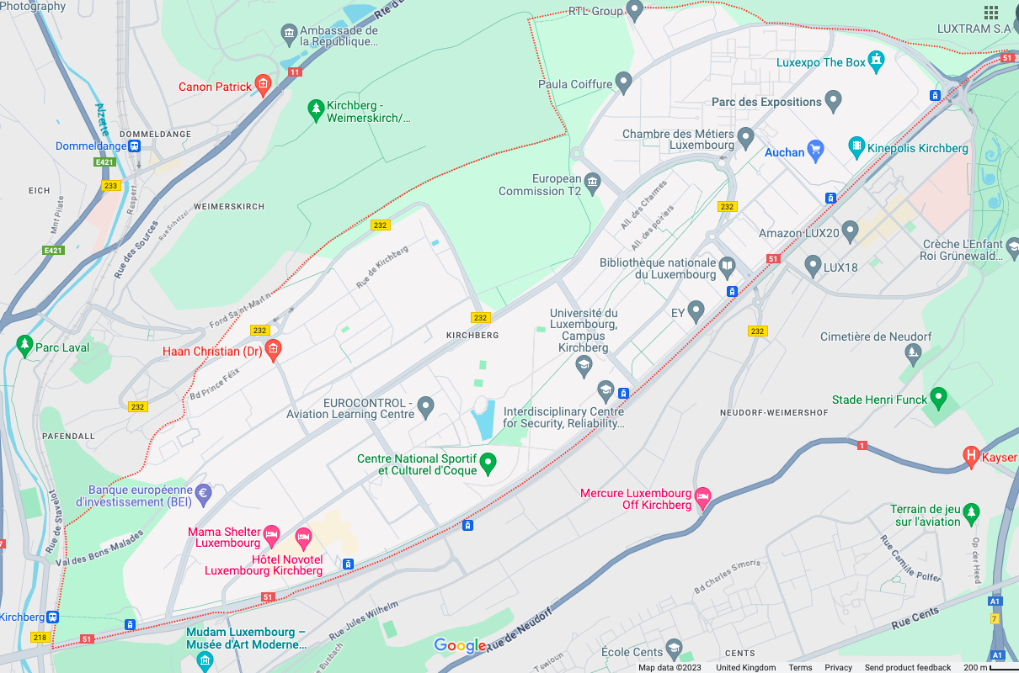
The District of Kirchberg (taken from Google Maps © 2023)
In this section, the focus will now be drawn to the district of the Kirchberg Plateau (henceforth referred to as simply Kirchberg) in Luxembourg City, the capital of Luxembourg. Located in the northeast of the city, Kirchberg is split into five quarters: Européen Nord, Européen Sud, Quartier du Parc, Quartier du Kiem and Quartier du Grünewald, which ‘align themselves with the Kirchberg ridge running along the Avenue John F. Kennedy for a little over three kilometres’ (Weilacher, 2007: 59). Known for its intentionally distinct European identity and purpose and juxtaposition against other parts of Luxembourg City, Kirchberg is the home of the majority of Luxembourg-based EU institutions (see section 3.2 for a list of which institutions are located in Kirchberg) and is the central business district of Luxembourg City. It is also the site of many cultural institutions, such as Philharmonie Luxembourg (the concert hall designed by French architect, Christian de Portzamparc), MUDAM (the Grand Duke Jean Museum of Modern Art designed by Ieoh Ming Pei, the renowned architect known for creating the glass pyramid at the Louvre) and the RTL Group (the home of the international broadcasting group and a large contributor to Luxembourgish-language print media), among many other institutions, ranging from broadcasting to leisure to retail. This begs the questions: who is the district of Kirchberg for?

Weilacher (2007: 58), who discusses Kirchberg from an architectural point of view, states that plans to reinvigorate the district from an ‘essentially rural area’ centred on the coal and steel industry into the ‘new urban district’ we see it as today began in the 1960s. The Fonds d’Urbanisation et d’Aménagement du Plateau de Kirchberg (tr.: ‘Fund for the Urbanisation and Development of the Kirchberg Plateau’), or simply Fonds Kirchberg, was commissioned in 1961 after the area had been scouted to become host to numerous European Community institutions (Fonds Kirchberg, 2021a). The district began to develop into a site to house numerous national and international banking institutions, starting in the 1980s and 1990s with the arrival of mainly German banks, located closer to the airport and away from the EU institutions (Fonds Kirchberg, 2021b). This led to a reassessment of the way, in which Kirchberg as a space was developed towards a more urbanised outlook. To this day, the 365-hectare-sized area is still undergoing significant urban planning projects, such as the recently constructed tram line connecting the Plateau with the central train station, with predictions of large increases in the size of the workforce and resident populations facilitated by such significant construction projects.

Hesse (2016: 623) refers to the size of Luxembourg City in terms of ‘borrowed size’ and hails the city as a ‘micro-metropolis’ with increasing global importance on the global economy, of which Kirchberg is an integral part. The government-funded development of the district began with a view to localise EU institutions and financial institutions in Luxembourg, as a way to create an ‘office town, highly accessible for commuters by car’ coming in from the greater region encompassing parts of Belgium, Germany and France (Hesse, 2016: 618). This focus on international commuter accessibility is a continuing influence on the construction of Kirchberg as both a financial district but also a residential area. Evidence of Luxembourg’s highly international population can be characterised as more intense here than in other places, given the nature of the intended function of the area and the ever-developing makeup of demographics of the residents and the workforce. Little data has been made publicly available detailing the demographic breakdown of the workforce in Kirchberg. However, with an estimated resident population of 8746 as of 2022, approximately 74% are resident foreigners (Ville de Luxembourg, 2022). This is just above the resident foreigner population of Luxembourg City (just under 71%), demonstrating the highly diverse workforce in the city and specifically in Kirchberg.

It is here where one can see interesting points of contact between simultaneous constructions of both European and Luxembourgish national identity within the district. As far as original designs are concerned, the district was initially envisioned as a ‘purely European’ area (Weilacher, 2007: 59) as evidenced by the names of spaces within the area, such as Place de l’Europe, Européen Nord and Européen Sud (all notably in French, the language used by Luxembourg at the EU level), and the eclectic mix of European artists and architects commissioned to design aspects of the district. However, perceptions of the space are dynamic and multifaceted. A particularly salient example would be the Pont Grande-Duchesse Charlotte, the bridge designed by German architect, Egon Jux, and constructed to connect Kirchberg Plateau with the neighbouring district of Limpertsberg in the centre of the city in 1963. Even though the bridge has an official name in French, among locals it is known as Rout Bréck or ‘Red Bridge’ due to its colour, an example of the interplay between Europeanness and Luxembourgishness. As suggested thus far, Europeanness and Luxembourgishness are heavily intertwined. Nevertheless, interpretations of Kirchberg suggest that, while particularly European influences have been foregrounded in the construction of the district, facets of the district have also been incorporated into local Luxembourgish constructions of place and local identity.

An external view of Luxembourg as an international melting pot with multilingualism at the heart of national identity is contrasted against opposing forces that see Luxembourg as uniquely Luxembourgish where authenticity is predicated on ties to the Luxembourgish language and culture. This contrast is mirrored in the construction of Kirchberg, which has been constructed as a multicultural European-facing place, but which also exists within a space where local constructions of place will, to varying extents, incorporate notions of where Kirchberg fits in the larger picture. Furthermore, the common struggle between perceptions of Luxembourg as a model European state and its identity as an individual country in its own right as opposed to a hybrid of other cultures is mirrored effectively in the construction of Kirchberg. On the one hand, Kirchberg is constructed and presented in such a way as to draw on expressions of Europeanness, while on the other hand, it is incorporated into expressions of local Luxembourgish identity. From this, it is clear that Kirchberg is an ideal site to investigate what it means to be Luxembourgish.

Chapter 4:

Methodology

In this section, the methodology of this research will be discussed and will be split into three sections. In section 4.1, qualitative methods and ethnography are introduced, with comparisons between qualitative and quantitative analysis being drawn in section 4.1.1, a discussion of ethnography in section 4.1.2, and discussions of the importance of positionality and reflexivity as well as a discussion of my own researcher positionality taking place in section 4.1.3. Although ethnography does have influences on the way I am approaching this research, it is important to point that I am not conducting a fully-fledged ethnographic study of the district of Kirchberg. I am conducting explicitly LL research with influences taken from ethnography.

In section 4.2, the LL research methods used in this project are introduced. This introduction leads into discussions of two methods in two separate sections. Section 4.2.1 consists of a discussion of the spatial documentation methods of photography, videography and ethnographic field notes and their co-ordinated use in this project. Section 4.2.2 is a discussion of interviewing as a research method and thematic analysis as an approach to analysing the data gathered from interviews with participants. In section 4.3, I discuss the limitations of the respective methodological approach taken in the research, as well as more general limitation.

4.1 Qualitative ethnographic methods
This section will focus on the methodological approach taken in this thesis. The discussion in section 4.1.1 focuses on the perceived distinction between qualitative and quantitative methods, with reference to discussions on the notions of subjectivity and objectivity, and how the two pairs of terms often perceived as opposites compare and contrast with each other. This is an important discussion for this thesis because the methods (and indeed theoretical framework) employed in this project could be seen to have both qualitative and quantitative influences and require deeper understandings of objectivity and subjectivity. The focus of section 4.1.2 is an exploration of ethnography as a qualitative approach to research. In section 4.1.3, the fundamental aspects of ethnographic research, reflexivity, and positionality, will be examined. Particular attention will be paid to my positionality as someone coming from a British university and conducting research in Luxembourg in an effort to highlight how my personal experiences may impact the research undertaken.

4.1.1 Qualitative versus quantitative methods
Before providing deeper insights into qualitative research methods, it is necessary to understand how it contrasts with its counterpart, quantitative methods. According to Cooper et al (2012), the line between quantitative and qualitative approaches is blurred and conceptualisations of the quantitative-qualitative distinction have undergone numerous (re)interpretations over the past century. During the early 20th century, the distinction was understood in large part as a difference in methodological approach. However, contemporary reinterpretations have attributed this difference in methodological approach as symptomatic of a fundamental distinction in epistemological and ontological approaches between the two means of enquiry. In other words, the questions asked and the approach to answering them is the fundamental distinction between qualitative and quantitative methods. Cooper et al (ibid.: 6) do, however, state an important caveat. There are, indeed, tendencies in qualitative research to begin from ‘relatively broad and open-ended research problems’ with the aim of developing ‘descriptive and theoretical ideas through the collection and analysis of data’, and tendencies in quantitative research to be influenced by ‘the testing of closely defined hypotheses.’ However, this perceived difference in approach is better perceived as a spectrum from one to the other, where differences are ‘a matter of degree’ (ibid.) and are not fixed in place, as both approaches are to varying extents influenced by each other.

One of the most often cited distinctions between these two approaches is that of discussions of objectivity and subjectivity. This distinction suggests that quantitative approaches routinely aim to be objective, while qualitative approaches ‘explicitly embrace subjectivity’ (ibid: 7). This distinction, however, is disputed due to the problems with defining these terms because of the understandings of the terms in both schools of thought. From a qualitative perspective, objectivity is often not the aim of research because it is often viewed as the removal of judgement from decision-making, which is viewed as generally not possible (Hammersley, 2012: 33). However, from a quantitative perspective, objectivity is not necessarily viewed this way. Objectivity is often associated with notions of minimising error by ‘following a set of explicit, standard procedures’ (Cooper et al, 2012: 7), a valuable approach not without flaws but certainly an understandable and important research aim.

Similarly, subjectivity from a qualitative perspective is often (though not always) embraced as inclusive to different social experiences regarding social groups, especially minoritized groups (Hammersley, 2011: 30). However, it is not uncommon for subjectivity to be viewed from a quantitative perspective as synonymous with speculation and personal bias (Hammersley, 2012: 52). These are, of course, simplified understandings, not fixed rules. They should be taken as tendencies among researchers that lie on a spectrum between wholly subjective and wholly objective, with most, if not all, research lying somewhere in between. In the remit of this research, I have opted to take a qualitative approach because this research places significant value in different passer-by perspectives as underpinned differing social experiences, both on the individual and collective levels. The goal of the research is not to seek anything close to objective truth, but rather to provide insights into perceptions of a space from the diverse perspectives of the people who use the space. An interesting qualitative approach to explore in light of this discussion is that of ethnography, which I will now turn to in the following section.

4.1.2 Ethnographic methods
Ethnography is an ‘empirical methodology that is devoted to the analysis of research data acquired by means of first-hand interactions with members of a local community over a substantial period of time’ (Mullings, 1999: 337). Interaction, it is important to note, does not necessarily only refer to entering into a dialogue with community members as it can also refer to observing and/or integrating with the community. This is dependent on how involved the researcher wishes to be in cultural practices, which requires a careful reflexive examination of the researcher’s own positionality in relation to the group, in which
‘all the assumptions, value commitments, feelings, etc., [which] underpin one’s research [are made explicit,] so that readers can understand the path by which [any] conclusions were reached’ as a ‘substitute for objectivity’ (Hammersley, 2011: 32).
It also requires significant and careful attention to be paid to the project objectives and an understanding of how best to achieve these objectives in terms of the extent of their interaction with the group at hand, all of which would be reflected in the thesis.

The definition by Mullings (ibid.) demonstrates effectively what Rampton (2007) points to as the two general principles at the core of ethnographic research. Firstly, it is important to be aware that ‘analysis of the internal organisation of verbal (and other kinds of semiotic) data is essential to understanding its significance and position in the world’ (ibid: 585). In other words, it is argued that insights into the sociocultural practices of a particular social group can only be gained through direct contact with people, institutions and other social actors perceived to represent a unifying sociocultural group identity. This first-hand awareness is considered essential within ethnography as cultural practices are formed and influenced by the specific configuration of socio-cultural issues, such as power and stance.

Prominent methods for ethnographic data collection include myriad different intertwining modes of data collection. Firstly, there is the employment of ethnographic fieldnotes, which are the recording of ‘not only those occurrences and details that are prescribed by tradition, but also the actual actions that are observed as they occur’ (O’Reilly, 2005: 10). Secondly, semi-structured interviews are prominent and tend to be informal in nature, ‘with open-ended questions on topics raised from within the research setting’ and above all are flexible and reactive to the unfolding path of the discussions (ibid.: 74). Thirdly, there is the recording of visual data through photography and videography as another form of ethnographic ‘writing,’ complementing the ethnographic fieldnotes in different ways (ibid.: 103). It is important to note that, while this research in this thesis does take on methodological approaches inspired by these, as will be outline in section 4.2, it is still not appropriate to refer to this research as an ethnography, but rather more simply, as ethnographically inspired.

This leads to the second tenet, which sets out a clear epistemological approach of ethnography, highlighting that particular emphasis is to be placed on the processes of data collection. Rampton (ibid.) outlines that ‘contexts for communication should be investigated rather than assumed.’ This has two implications for the researcher. Firstly, ethnographic methods force the researcher to think critically about and challenge their own pre-conceived beliefs and ideas about the community in question and to compare these beliefs with first-hand ethnographic observations. Secondly, in addition to reflecting on their understanding of who or what is being investigated, the researcher is encouraged to reflect on how they are investigating the subject. This is because different ethnographic methods of interaction, ranging from observational to interactional to integrational, will have an impact on knowledge production and are therefore highly dependent on the research objectives of the project at hand. While the degree to which ethnographers are implicated (or perhaps more appropriately, implicate themselves) in their research is a matter of interpretation of these tenets on the part of the individual ethnographer, there is no doubt that the positionality of the ethnographer will have a significant impact on the research, as will be explored in section 4.1.3.

4.1.3 Researcher positionality
It is clear that positionality within ethnographic research is a fundamental part of the approach, particularly within sociolinguistic research (Wells et al, 2019). Mullings (1999: 337) defines positionality as one’s ‘perspective shaped by his/her unique mix of race, class, gender, nationality, sexuality, and other identifiers’ as well as one’s ‘location in time and space’, which influences how one views and interprets the world. Chacko (2004: 52) complements this definition, adding that these identifiers are ‘markers of relational positions in society, rather than intrinsic qualities’ and interwoven with notions of power and social inequalities, echoing Rampton’s (2007) the key aforementioned tenets of ethnographic research.

Mullings (1999: 340) draws attention to the ‘outsider/insider’ binary, a discussion of whether it is more rewarding for researchers to position themselves as ‘insiders’ and ‘outsiders’ in relation to the group being observed. On the one hand, ‘insiders’ who ‘study the group to whom they belong’ are able to ‘use their knowledge of the group to gain more intimate in- sights into their opinions.’ On the other hand, ‘outsiders’ who do not belong to the group ‘under study’ are ‘more likely to be perceived as neutral and therefore be given information that would not be given to an outsider,’ entering a perceived third space of objectivity.

According to Mullings, however, this debate is problematic because the insider/outsider binary conceptualises one’s positionality as a fixed attribute, when in reality, it is a dynamic and co-constructed phenomenon that is heavily influenced by time and space. It is therefore important for ethnographers to be acutely aware of their positionality throughout their fieldwork, and that reflexivity is an ongoing process as opposed to pre-determined decision, an aspect that will now be explored with regard to me as the researcher. Though the notion of the insider/outsider binary has its flaws, as outlined by Mullings (1999), it also provides an effective starting point for dissecting my positionality within this project. In fact, Wells et al (2019: 4) reflect on the dynamic nature of the insider/outsider distinction from a sociolinguistic perspective and discuss how scholars approaching a situation from this sociolinguistic perspective often have ‘particularly embodied and voiced relationship[s] to their objects of study’ and are therefore able to occupy a ‘border territory of “inbetweenness”’, which ‘speaks to our hybrid and shifting stance as both insider and outsider’.

As someone who does come from and does not live nor work in Luxembourg, my position as an outside researcher from a British university was certainly of significance to the research. However, the line between insider and outsider was somewhat blurred by my capability of speaking French, German, Luxembourgish in addition to English, and by my extensive knowledge of and interest in Luxembourg. Furthermore, as a dual national of two countries, one inside the EU and one having recently left the EU, this also informed my positionality, both in terms of how I perceived and interpreted the research site of Kirchberg and in terms of how I interacted with people during interviews. According to Mullings (ibid.: 340), ‘no individual can consistently remain an insider and few ever remain complete outsiders’, thus my aim was to avoid positioning myself as entirely one or the other. I shall expand on my positionality later throughout section 4.2.

4.2 Linguistic landscapes research methods
Data collection for this project took place in two phases. In section 4.2.1, the first phase will be discussed, which was an ethnographically influenced approach to documenting language and discourse in public spaces in the district of Kirchberg through the use of photography, with a selection of photographs used as evidentiary support within the thesis. A reflexive diary, inspired by ethnographic fieldnotes, and video recordings were used as secondary modes of documentation and supplementary to photography, in order to aid in the analysis of the space and encourage the consideration of multimodality and information beyond the frame of the photograph. The data collected from the spatial documentation was then analysed with Scollon and Scollon’s (2003) framework of geosemiotics in mind, in particular the semiotic system of place semiotics, incorporating ethnographic considerations of temporality (Massey, 2005; 2007) and multimodality (Thomson, 2014).

Before data collection began, it should be noted that I sought ethical approval from the university ethics committee, which involved detailing the two phases of data collection and providing relevant documents produced, such as consent forms for interviews (see Appendix B for a full list of submitted documents). This was approved before starting data collection. Ethical considerations continued throughout the data collection phases. During the spatial documentation phase, the main concern was avoiding including people in any pictures of the LL where possible and, as became apparent while documenting Kirchberg, avoiding arousing suspicion from security around many of the buildings, for which I had a letter from university stating my business in Kirchberg in case anything happened.

During the interview phase, there were a few ethical points to consider. Firstly, a consent form was given to every participant before starting the interview to read and sign, which outlined their involvement in the project. It stated (and I reiterated) that they would decide for themselves the extent of their involvement, or even if they wanted to end the interview early. A particular point I reinforced to participants was that they were in charge of their candour during the interview. As language can be a contentious in Luxembourg, I encouraged participants to only say what they were comfortable with saying, but also not to feel that they cannot say something for fear of repercussion. Moreover, feelings of unease were expected due to a culmination of factors, such as the potential contentiousness of the topic, the small size of Kirchberg and Luxembourg as a whole and the positions of some of the participants as foreigners to Luxembourg. These were, however, mitigated through an assertion of privacy on my part, in terms of both identity of the participants and the content of our interviews. This thesis, therefore, only features anonymised snippets of interviews.

In section 4.2.2, the second phase will be discussed, which was a series of semi-structured interviews, with people who live, work and/or socialise in the district. The data collected from interviews was then thematically analysed due to the flexibility of thematic analysis as a ‘tool or technique, unbounded by theoretical commitments’ and its production of ‘rigorous and high-quality analysis’ (Clarke & Braun, 2017: 297), complementing the aforementioned geosemiotic approach to space and ‘‘fit[ting]’ the project’s purpose (Braun & Clarke, 2020: 38).

4.2.1 The spatial documentation phase
Much like general trends in contemporary works in linguistic landscape (LL) research, the first phase of this project took an ethnographically influenced approach to the documentation of public spaces. This approach primarily consisted of the taking of photographs, with video recordings and ethnographic field notes (see Emerson et al, 2011) being used as supplementary secondary methods, in an effort to incorporate the effective inclusion of multimodal data, a staple of contemporary LL research, which I will now discuss in greater detail.

In the weeks running up to the commencement of this first phase of spatial documentation, I engaged in several pilot runs of spatial documentation in my local area, in order to become more comfortable with what I was doing and how best to use my equipment, such as cameras. As a result of this, I decided to use my phone camera, which I felt to be a less intrusive presence in the space than an actual camera and contributed to an easing of my own personal feelings of being intrusive. The spatial documentation phase itself took place over a six-week period in November and December 2021 in Kirchberg. Below is a table outlining the research design of the first phase:

Research design table – spatial documentation phase
Activity | Time frame | Data collected
Begin the reflexive diary, documenting initial explorations of and reactions to Kirchberg | Entire duration of time in Luxembourg – 6 weeks, beginning in first week | 67 pages of notes (incl. 2 sketches of signage where I could not take photos)
Exploring Area 1 (see map below), taking photos of the space | First half of the second week | ~241 photos (+ 10 videos and supplementary reflexive diary entries)
Exploring Area 2 (see map below), taking photos of the space | Second half of the second week | ~146 photos (+ 3 videos and supplementary reflexive diary entries)
Exploring Area 3 (see map below), taking photos of the space | First half of the third week | ~160 photos (+ 2 videos and supplementary reflexive diary entries)
Exploring Area 4 (see map below), taking photos of the space | Second half of the third week | ~316 photos (+ 5 videos and supplementary reflexive diary entries)
Exploring Area 5 (see map below), taking photos of the space | First half of the fourth week | ~205 photos (+ 3 videos and supplementary reflexive diary entries)
Exploring Area 6 (see map below), taking photos of the space | Second half of the fourth week | ~75 photos (+ 2 videos and supplementary reflexive diary entries)
Exploring Area 7 (see map below), taking photos of the space | First half of the fifth week | ~150 photos (+ 2 videos and supplementary reflexive diary entries)
Exploring Area 8 (see map below), taking photos of the space | Second half of the fifth week | ~78 photos (+ 3 videos and supplementary reflexive diary entries)
Revisiting all 8 areas, plus visiting neighbouring districts to Kirchberg | Sixth week (the final week) | ~243 photos (+ supplementary reflexive diary entries)

Upon arrival in Luxembourg, my first decision was to begin with a reflexive diary in the first week, inspired by the ethnographic convention of fieldnotes. My decision to do so first was because I felt that initial observation and experience of Kirchberg was needed before I started taking photographs in order to develop my ‘first-hand familiarity’ with the district (Themistocleous, 2020: 162), a fundamental part of LL research. This decision helped me simply explore and experience the space and begin building an idea of where I needed to start taking photographs.

3
1
6
75
4
2
55
85

The District of Kirchberg (taken from Google Maps © 2023), labelled with my research divisions

This diary was particularly effective at capturing those elements that cannot be fully captured through photographic or videographic means, such as smells, feelings, and personal interpretations (Thomson, 2014). Taken in coordination with each other, the combined use of photography, videography and a reflexive diary inspired by ethnographic field notes is a methodological framework in line with more recent research into the construction of space, place, and the LL. This combination provides insights into considerations of space as a complex interconnected system of meaning-making processes, as opposed to less contemporaneous research, which viewed signs as a series of disconnected artefacts that can simply be counted (cf. Pütz & Mundt, 2019; Peck et al, 2020). This diary was added to during the entirety of this spatial documentation phase.
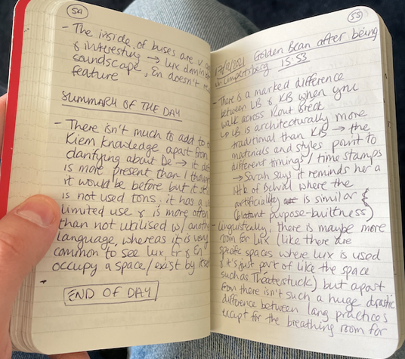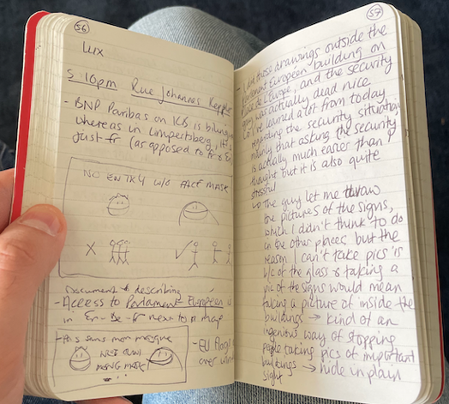

Example extract from one day in the reflexive diary (with dates, times, and locations)

Commencing in the second week, I began taking photographs of Kirchberg and LL items with my phone. This is a core method of LL research and one supported by the geosemiotic framework of analysis (Scollon & Scollon, 2003: 17). The use of photography as a follow-up to a reflexive diary is documented many examples of LL scholarship, such as in Themistocleous (2020), in her examination of the LL of the UN buffer zone in Cyprus and Vilijärvi & Kahn (2020) in their examination of the LL of Nuuk, Greenland. Photography is a central method to LL research because, in addition to providing visual multimodal evidence for what is being discussed in the analysis and aiding in further distribution and dissemination, photographs constitute a data set that can be analysed in its own right. Collins and Durington (2020: 75) stipulate that it is important to understand that photographs should considered as subjective interpretations of their subjects and, when using photography as a method of documentation, the ‘empirical authority of photography [is deceptive and] should never be relied upon completely in its static form’. Consequently, one ought to consider photographs as representations of the social world, heavily influenced by the specific sociocultural perspective of the photographer, and in need of further sociocultural information in order to be analysed effectively.

Over the course of the five remaining weeks, I had taken approximately 1600 photographs of the entire district using my phone camera. In order to facilitate this, I initially divided the district up into five sections, corresponding the number of weeks to do the photography portion of the fieldwork, using the T1 tramline, which prominently passes through the district, as an anchor. However, during the initial observation period in the first week, it became apparent that I needed to reassess the way I had divided the space. I decided to redivide the space into seven smaller sections, according to the major roads, in order to make the space more digestible. This also meant changing the amount of time spent in each part of Kirchberg, from exploring one subdivision per week, to exploring two subdivisions per week and the use of my final week to revisit places I felt needed to be revisited or further explored. I also decided to explore the spaces neighbouring Kirchberg during that final week, in order to draw comparisons between Kirchberg and other parts of the city. Because I had taken the photos using my phone, the photos were automatically shared to my laptop. This facilitated in the organisation of the photos because it organised my photos according to where I had taken the photo, geotagging it to exact location, and timestamped every photo with the date and time it was taken. This meant that I was able to search for photos based on (i) where and (ii) when they were taken.
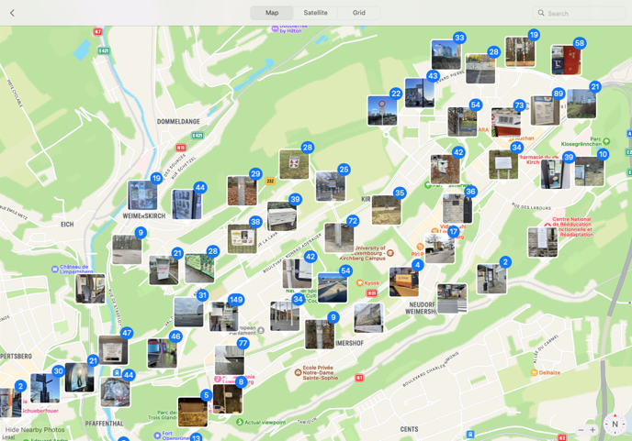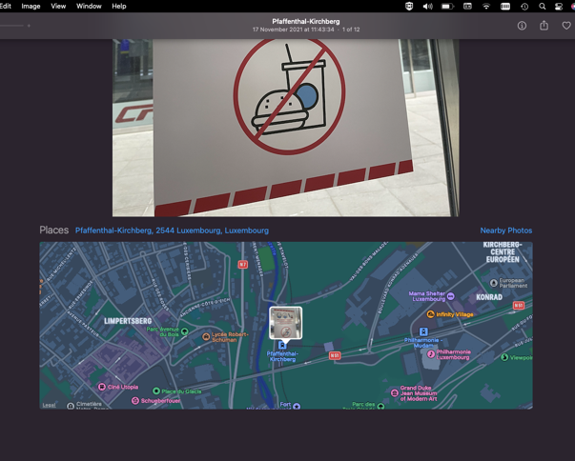
Screenshot of all photos geotagged Screenshot example of one photo’s geotagged location and timestamp (at the top)

In complement to the photographs, I also recorded a few videos using my phone as well. This is often employed as a method for data collection for two important reasons. Firstly, similarly to photography, videography provides researchers with multimodal information to work with, such as language and images, with the additional benefit of providing further multisensory evidence, such as sound and movement (Cekaite, 2020: 86). Secondly, it documents authentic practices embedded in social life with the understanding that social actions are ‘inextricably interwoven with, and done through, visuality’ (ibid.: 83). Where photography and videography differ is in their primary focus. Taking photographs tends to focus on representing the dynamic social world in a static image. While there are of courses elements of representation to consider when recording video, such as decisions about how, where and in which direction to film, the focus of videography can be primarily seen as an effective tool for the observation of ‘authentic, emergent, and situated occurrences, unarranged by research practices’ (ibid.: 84). While videography was originally intended to play a larger part in the fieldwork, I decided to reassess the need for the videos in the remit of this research. They proved to be more of an unnecessary complication in the field. I, therefore, decided to focus almost exclusively on photography as the method of capture, except in circumstances where a recording of the soundscape, for example, proved relevant for consideration.

During the second week of the fieldwork and the first week of photographing the space, I had an experience, which forced me to rethink my approach to documenting the space. While photographing the exteriors of one of the EU buildings on the main boulevard in Kirchberg, I was accosted by a security guard, who was alarmed by my presence and began questioning me about what I was doing before and where I was from before ultimately telling me to leave. He spoke to me immediately in French and, in a panic, I tried to explain myself in English in order to feel more comfortable in the situation. However, he refused to speak English to me and forced me to explain myself in French, which I was able to after I relaxed. After I was told to leave the space, I became significantly more aware of my presence in the district, as well as of the plethora of security cameras in the district and significantly more tentative and even hesitant in how I moved about the space and what I took photographs of.

In the initial consideration of the fieldwork, the intention was to analyse the data collected from spatial documentation methods, such as photography, videography and the reflexive diary, using the geosemiotic framework of analysis (Scollon & Scollon, 2003). This, however, did not end up being the case. As the direction of the project moved more towards an examination of the passer-by perspective, my focus for the photographs became more supplementary to the interviews to come. Following the lead of Kallen’s (2010) analysis of ‘spatial frameworks’, underpinned by the principles of thematic analysis (Braun & Clarke, 2020), I decided to informally tease out different spatial frames as themes from the photographs and organise some of the photographs into groups. The thematic spatial frames were selected and grouped in terms of similar locations or part of a wider campaign. These groups were labelled ‘Shopping centre’, ‘Tram stops’ (signs of the tram stop names along the same tramline), ‘Construction sites’, ‘Schools in Kirchberg’, ‘Public transport’ (signs from in around public transport, such as on buses and trams and around the stops), ‘Clothes bank’ (signs from all around one particular clothes in Kirchberg) and ‘COVID signs’ (signs from the same COVID public health campaign). These groups were then used as prompts in the interviews for the participants to react to, which I discuss in greater detail in section 4.2.2.
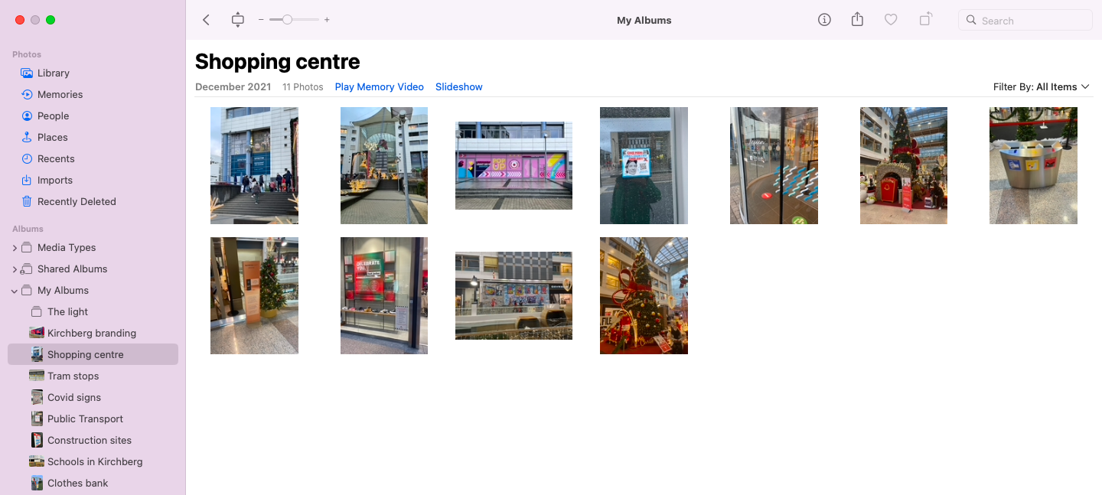
Screenshot of the 7 photo groupings (highlighted in red) and the photos in the group ‘Shopping centre’

4.2.2 Interviews and thematic analysis
During the second phase of the fieldwork, I conducted 21 semi-structured interviews using the photographs as prompts. Using the LL as a prompt for discussion in interviews is a popular method, particularly in investigations of passer-by perceptions of the LL. Typically, it is found in the ‘walking tour’ method (Garvin, 2010) or ‘walk-and-talk interviews’ (Grey, 2021), in which the researcher and participants engage in a conversation about the space, through which they are walking, using the perceptions of the LL they see around them as ‘triggers’ for discussion (Phan, 2021: 94).

In this project, I opted to conduct the interviews in a more traditional way, with me and the participant sitting across from each other at a table and me showing the participant photos of the LL. In her research into perceptions of the Zhuang minority language as part of Chinese LLs, Grey (2021) offers her participants the option of either doing ‘walk-and-talk interviews’ to discuss the LL in person or ‘seated interviews’ to discuss the LL mediated through photos, depending on comfort and ease on the part of the participant. In this way, ‘seated interviews’ are positioned as equivalent to ‘walk-and-talk interviews.’ I would argue for a reconceptualisation of ‘seated interviews’ as simulated walk-and-talk interviews, where participants are guided around Kirchberg by way of photo groupings representing ‘spatial frames’ (Kallen, 2010) with the added benefit of encouraging feelings of informality, putting participants at ease. Furthermore, it allowed me as the researcher to maintain a sharp focus of research objectives. This flexibility in terms of methodology is at the core of LL research because of the inherent interdisciplinarity and innovative nature of LL scholarship (Barni & Bagna, 2015).

The interviews took place in Kirchberg in person (except for two, which were conducted via videoconferencing because the participants were unable to attend in person at the last minute due to scheduling conflicts). I aimed to conduct the interviews for around 90 minutes. However, some interviews lasted just over an hour and others lasted well over two hours. This was primarily dictated by participants’ availability. As the interviews were semi-structured, I prepared a number of open-ended questions in advance of the interviews but was also prepared to be flexible and responsive to the development of the interview and the participants (O’Reilly, 2005).

Qualitative interviewing as a method fits well within the geosemiotic framework because it places high value on the personal experiences of interviewees, positioning them as ‘expert[s] concerning personal experience’, as opposed to looking for right or wrong answers (Brinkmann, 2013: 16). Qualitative interviewing is an appropriate method for this project because it fits with the research goals, which aimed to provide insights into how people construct and interpret space and place and encourages the researcher to step away from relying solely on their own interpretations of spaces and consider ‘insider’ interpretations (cf. Shohamy et al, 2010; Blackwood et al, 2016). Before discussing the participants and the recruitment process, it is necessary to outline the general structure of the interviews and the use of the photographs as prompts.

Research design table – interview (see Appendix B for comprehensive list of questions asked)
Order of interview | General topic of discussion | Goal of discussion
Part 1(a) | Personal linguistic and social backgrounds, migration trajectories to Luxembourg | (1) To provide necessary background information of the participant that contributes to understanding discuss  (2) To build rapport between researcher and participant
Part 1(b) | Personal relationship of the participant to Kirchberg | To establish participant perceptions of Kirchberg before being shown any photos
Part 2 | Discussions prompted by photos of Kirchberg LL | To understand participant perceptions of Kirchberg through (mediated) engagement with the LL

The interviews were organised into two halves. In the first half, the participants were invited to discuss their own personal linguistic and social backgrounds, their migration histories, as well as their initial perceptions of Kirchberg, as I also shared my own personal background. This was done to get to know each other and for me to build rapport with the participants in order to ‘generat[e] trust [and] increase[e] cognitive empathy’ between us (Small & Calarco, 2022: 47). It also provided me with the background information and baseline perceptions of Kirchberg and Luxembourg, which would in some form contribute to participant perceptions. This gave me insights into their perspectives and therefore how to respond appropriately and engage effectively. After this, we then moved on to the second half of the interview.

In the second half, participants were shown photographs taken during the first phase as prompts on my laptop. The use of visual prompts as a method of ‘facilitat[ing] talk’ is often viewed as ‘drawing out tacit knowledge’ and ‘deeper elements of human consciousness’ (Edwards and Holland, 2013: 59), and to aid in the expressions of topics that are difficult to articulate or taken for granted, as with discussions of language in public spaces. In addition to the photographs, I asked the participants open-ended questions in relation to the photographs, allowing the participants to discuss the photos and use them as evidentiary support in wider discussions. The use of the laptop was important as well because it allowed the participants to interact with the photographs, such as zooming in to clarify smaller or unclear details. The question I started with was a variation of “Can you describe this photo to me?”, and I encouraged the participants to essentially say what they saw and think out loud.

The first photograph I showed every participant was the image shown below, labelled Fig. 7. This was selected as the first photograph prompt to show the participants after I conducted a pilot interview, in order to practise my interview skills and also see which photographs worked as prompts and which did not. The pilot interviewee informed me that Fig. 7 was the photograph they found to be more interesting and easier to describe and talk about because it was a newer sign compared to more established or permanent signs (see Scollon & Scollon’s (2003) discussion of temporariness and permanence of signs for further information). Once the participant had said all they could say about this particular photograph, I then presented the participants with more photographs, organised into the aforementioned thematic spatial frames, as groups of photographs on my laptop. I encouraged them to look through this first group of photographs, consisting of COVID-related signage, and to stop on the photographs that struck them as interesting to discuss. Each particular participant was given the freedom to discuss what they found to be of interest or note to them.

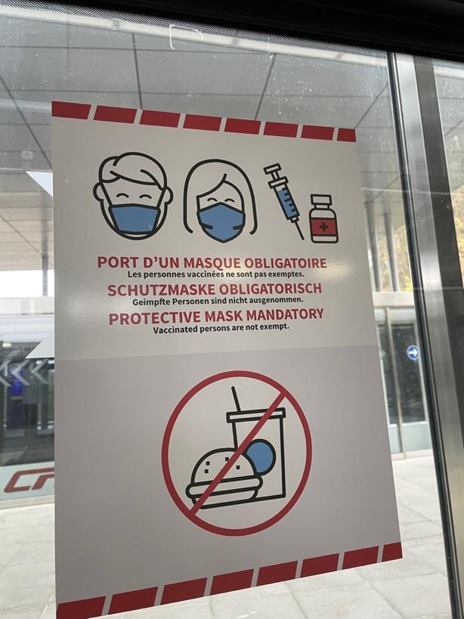

Fig. 7: COVID-19 sign on the door of the Kirchberg-Pfaffenthal transport hub, written in French, German and English

The prompts and initial line of questioning of describing the images were then followed up by more open-ended questions, encouraging the participants to discuss where they thought the signs might be located and even to begin to discuss their personal perceptions of why the signs in the photographs were designed in the way they were. Discussions of certain prompts ended when the participant felt they had nothing more to say, and we simply moved on to another group of photographs. In this way, participants were given significant amounts of freedom to discuss whatever they felt to be most important, which is built on the idea of the responsive interviewer (O’Reilly, 2006). Further to this, the next group of photographs for discussion was selected by me as a response to something the participant had brought up. For example, if the participant started to discuss their experiences of the education system in Luxembourg, I would use this as a pivot towards looking at photographs taken around schools and university buildings. Or if the participant had started to discuss the presence or absence of Portuguese, I would pivot to showing them photographs of signs with Portuguese on them, which were either construction sites or clothes banks. The aim of this flexible interview structure was to allow myself as the interviewer ‘more leeway for following up on whatever angles are deemed important by the interviewee’ while maintaining a level of control over the interviews, guiding them towards discussions of topics relevant to the project (Brinkmann, 2013: 21; cf. DeWalt, 2011). Because the directions of the interviews were highly dependent on the individual participant and how they engaged with the interview process, it is necessary to discuss the participants in more detail.

In the Table of Participants below, I have outlined some key information regarding the participants. The backgrounds of the participants range from Luxembourgish citizens possessing Luxembourgish passports to foreign residents, both long-term and recently immigrated and other complex variations thereof, such as Luxembourgish citizens or nationals with recent migration histories. Among the participants, 15 nationalities were represented, as well as a diverse array of linguistic backgrounds and repertoires. 16 participants were European, 13 of whom were EU citizens and 7 of whom possessed Luxembourgish citizenship or were born and/or raised in Luxembourg. 5 participants were from outside Europe, specifically Oceania and Asia. 12 participants work in Kirchberg, 3 live in Kirchberg, 2 live and work in Kirchberg and 4 only socialise in Kirchberg. Each participant socialises in Kirchberg to varying extents. In other words, the participants in this study can be positioned as insiders (to varying extents with varying experiences), certainly in contrast to me as an outsider, which in this case would be described as someone who does not live, work, or socialise in Kirchberg or the wider Luxembourg.

Table of Participants
 | Participant Pseudonym | Age Range | Social Background | Linguistic Repertoire | Where do they live? | Where do they work?
1. | Amal | 18-30 | South Asian, moved to Luxembourg for work | Urdu, English, learning French | Kirchberg | Kirchberg
2. | Amelia | 18-30 | Portuguese, raised in Luxembourg | Portuguese, Luxembourgish, French, German, English | Outside Luxembourg City | Outside Luxembourg City
3. | Barney | 31-50 | Southeast Asian,  moved to Luxembourg for work | Southeast Asian language, English, some French, learning Luxembourgish | Luxembourg City | Kirchberg
4. | Dean | 31-50 | Oceanian, moved to Luxembourg with partner | English | Kirchberg | n/a
5. | Diane | 31-50 | Oceanian, moved to Luxembourg for work | English, some Oceanian languages, limited French | Kirchberg | Kirchberg
6. | Émile | 18-30 | Luxembourgish, with Belgian parents | French, Luxembourgish, English, German | Outside Luxembourg City | Kirchberg
7. | Gregory | 31-50 | Scottish, moved to Luxembourg for work | English, learning French | Outside Luxembourg City | Kirchberg
8. | Hugáceo | 31-50 | Spanish, grew up in Brussels, moved to Luxembourg for work | Spanish, French | Luxembourg City | Kirchberg
9. | Jane | 31-50 | British, moved to Luxembourg for work | English, some French, a little Luxembourgish, learning Dutch | Luxembourg City | Kirchberg
10. | Joe | 18-30 | Irish, moved to Luxembourg for a relationship | English | Kirchberg | n/a
11. | Katarina | 31-50 | Central European,  moved to Luxembourg for work | English, Central European language, another European language | Luxembourg City | Kirchberg
12. | Krisztián | 31-50 | Hungarian, moved to Luxembourg for work | Hungarian, English, some French | Kirchberg | Luxembourg City
13. | Lara | 18-30 | Luxembourgish | Luxembourgish, English, German, French, some Spanish | Outside Luxembourg City | Outside Luxembourg City
14. | Luc | 31-50 | French, moved to Luxembourg for work | French, English, some German, a little Luxembourgish | Outside Luxembourg City | Kirchberg
15. | Marie | 18-30 | Luxembourgish, with Chinese parents | Luxembourgish, English, German, French, some Chinese | Outside Luxembourg City | Kirchberg
16. | Nina | 31-50 | Chinese, moved to Luxembourg for work | Chinese, English, French, Italian, a little Luxembourgish | Outside Luxembourg City | Kirchberg
17. | Sofia | 18-30 | Luxembourgish, with Albanian parents | Luxembourgish, English, German, French, Albanian | Luxembourg City | n/a
18. | Stefan | 31-50 | Luxembourgish | Luxembourgish, French, German, English | Luxembourg City | Kirchberg
19. | Tom | 31-50 | British, moved to Luxembourg for work | English, some German | Outside Luxembourg City | Kirchberg
20. | Trisha | 18-30 | Luxembourgish | Luxembourgish, English, German, French | Outside Luxembourg City | Outside Luxembourg City
21. | Vittoria | 18-30 | Italian, moved to Luxembourg for work | Italian, English | Luxembourg City | Kirchberg

It is important to note that some information has been generalised in order to prevent identification and maintain anonymity of participants. Due to their connections with Kirchberg, which is a relatively small space, the ages, social backgrounds, and certain parts of the linguistic repertoire of certain participants have had to recorded in a less specific way because of how identifiable they were, according to demographic statistics from Ville de Luxembourg (2022) and STATEC (2023). Furthermore, where participants lived and worked have been reduced to three different categories, ‘Kirchberg’, ‘Luxembourg City’ and ‘Outside Luxembourg City’, in order to maintain anonymity.

Participants were recruited via internet forums and social networking, namely Reddit, Discord and LinkedIn, and through the snowballing technique, wherein participants were recruited through referrals from other participants (Streeton et al, 2004). According to Streeton et al, snowballing is a particularly effective method of recruitment when researching into potentially sensitive issues as the technique is dependent on referrals from participants who trust the researcher, therefore encouraging positive rapport-building. Before interviews took place, participants were asked to sign a consent form, in English, and read through an information sheet, available in English, French, German and Luxembourgish. This is because these are the languages that I, as the researcher, can speak, and the languages that I expected most participants to speak as well. Participant were given the freedom to choose whichever language version of the information sheet they wanted, in an effort to accommodate participants and encourage their comfort. Potential participants were able to decide at this point whether they wanted to continue with doing an interview. The majority of people who reached out to be interviewed opted to be interviewed, with only a few people ultimately being unable to participate, principally because of COVID.

Since the fieldwork was carried out towards the end of the pandemic during a period of easing of COVID restrictions, participants were given the option to meet in person, following all local and University guidance on maintaining personal safety, or via an online video-conferencing tool (OVCT), such as Google Meet or Zoom, in order to accommodate for personal circumstances, comfort of the participants and time constraints and to mitigate any potential discriminatory recruitment practices (Murthy, 2008). As mentioned previously, while the majority of interviews took place in person in Kirchberg, the interviews with Sofia and Luc took place via OVCT because of unavoidable scheduling problems.

It is important at this point to explore specific relevant aspects of my personal background that were outlined to the participants before or during the interviews, in order to gain insights into how I positioned myself in relation to the aforementioned interview participants and the flexibility thereof. I am a native English speaker and a dual Irish/British citizen, born and raised in the UK. I entered into these interviews with a broad prior knowledge of Luxembourgish society and culture, limited by having not lived in the country itself, and a multilingual repertoire consisting of French, German, Dutch and Luxembourgish, in addition to English. Because of this, I was able to take advantage of the “inbetweenness” position between insider and outsider (Wells et al, 2019) in order to flexibly achieve different goals.

As such, my relationship with each participant was different. My positionality as interviewer was co-constructed with the participants, depending on a multitude of factors, ranging from personal backgrounds to personality types. This led to interesting differences between interviews, wherein some participants would take on the role of informant and explain to me different aspects of insider knowledge, for example, how the Luxembourgish school system works or how a Luxembourgish workplace functions, particularly linguistically. In these moments, I would ask small questions of clarification, even if I already had knowledge on this topic, in order to encourage the informant participants to continue explaining things to me and to gain insights into their perspective on the matter at hand (DeWalt, 2011). Other participants, however, would take on the role of asking me questions and looking to me for explanations, such as why a sign was in French and not in Luxembourgish, positioning me as the one with (greater) insider knowledge. In these moments, I would explain certain concepts but with limitations, only confirming little details in order to push the conversation forward but never explaining things in detail. Instead, I would remind participants that there is no right or wrong answer and that I am more interested in their personal perceptions (ibid.). Notably and somewhat surprisingly, this did not fall neatly into participants from different demographics consistently taking on similar roles, such as Luxembourgers and foreign residents, as our interviewer-interviewee relationships were dynamic and constantly changing throughout the interview.

One unifying and somewhat surprising feature of every interview, however, was that every participant chose to conduct the interview in English. At the beginning of the interviews, participants were (re)informed of the linguistic flexibility of the interview and were given the option(s) of speaking English, French, German, or Luxembourgish during the interview, with the freedom to switch languages at any point in the process. The choice and freedom of language in interviews is a factor in how participants wish to position themselves and the interviewer in relation to each other, as well as a decision influenced by issues of practicality, such as comfort with the language being used and the mitigation of communicative problems through the use of a common language (Kremer, 2017: 80). Some participants did sometimes use a little Luxembourgish or French for clarification (e.g. Marie asked me what a Plakat was in English – tr. ‘poster’ in Luxembourgish), demonstrating the flexibility of the negotiated linguistic practices between me and the participant, but there were only a handful of instances of this across the interviews.

The choice of English was rarely discussed with any of the participants. However, there did seem to be many possible reasons behind this choice. In the method of recruitment, the language of initial interaction with potential participants on Reddit, Discord and LinkedIn was English, which is unsurprising due to its position as a prominent lingua franca in internet forums (Belling & de Bres, 2014). With the language of first contact being English, this is likely why some participants continued our in-person discussions in English. Generally speaking, participants spoke English with me out of reasons of convenience. For some, it was the main (or sometimes only) language they spoke in Luxembourg and was the obvious logical linguistic choice for us both. Other participants discussed during the interview how their working language in Kirchberg was English. Because the majority of the interviews took place during or after the working day, these participants continued speaking in English as part of their typical English-speaking working day. For example, before I began my interview with Émile, which took place at the end of his working day, I told him to feel free to speak any language (of the ones I knew) at any point in the interview, to which he replied that he wished to carry on speaking English as he had been doing all day at work. This was one of the only times a participant explicitly stated that they wanted to speak English. In the vast majority of cases, English was simply the default language of the interviews.

Once the interviews had been conducted, the data collected from the interviews went through processes of transcription and thematic analysis. Firstly, the interviews were transcribed using transcription software (in this case, transcribe.wreally.com), wherein pauses were generally marked with a (.), except the long periods of silence while the participants were looking at photographs, which were marked with a [long pause while looking at photos]. Laughing was marked with [laughs] and muffled or unintelligible sound was marked with [xxx]. However, I took a ‘denaturalized approach’ to the transcription (Oliver et al, 2005: 1277), which focuses on writing what has been said and less so on how it has been said. Understandings of accuracy are, therefore, primarily based on ‘the substance of the interview, that is, the meanings and perceptions created and shared during a conversation’. This approach does not, however, preclude the discussion of how something is said and within the remit of this project, how something was said will be discussed if perceived to be necessary for further analysis.

The interview data was then analysed using a thematic analysis (TA) approach, in which the development and interpretation of themes is a multi-staged, subjective and reflexive process that organically ‘evolve[s] to capture the researcher’s deepening understanding of the data (Braun & Clarke, 2020: 39). This is reflected in Clarke and Braun’s (2018: 108) clarification of how to conceptualise a ‘fully realised’ theme in line with their approach. Themes are defined as
‘active creations of the researcher (rather than just passively ‘emerging’ fully formed from the data) that unite data that at first sight might appear disparate, and often capture implicit meaning beneath the data surface’ (ibid.).

Working from this definition encourages the researcher to engage more closely with the data and produce more in-depth analysis, and to be conscious of their positionality in relation to the data and the influence of their unique social perspective on their interpretation of the data. Since TA as a qualitative analytic approach is flexible in relation to understandings of researcher positionality and reflexivity (Braun & Clarke, 2019), its application of the approach in this thesis was influenced by geosemiotic discussion points, particularly at the initial stages of analysis, as well as by my personal interpretation of worthwhile themes for further discussion informed by my positionality.

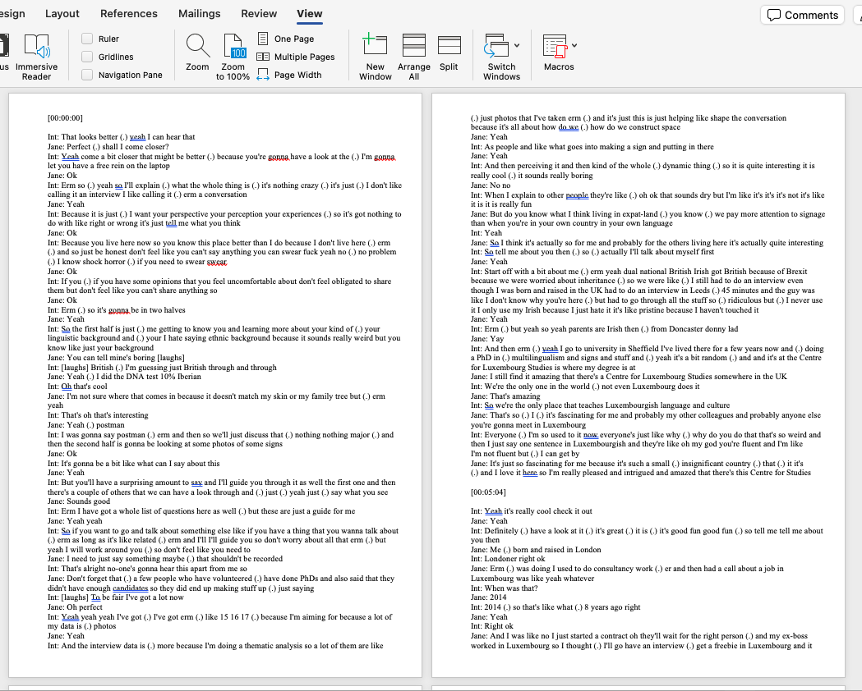

Extract from interview transcription

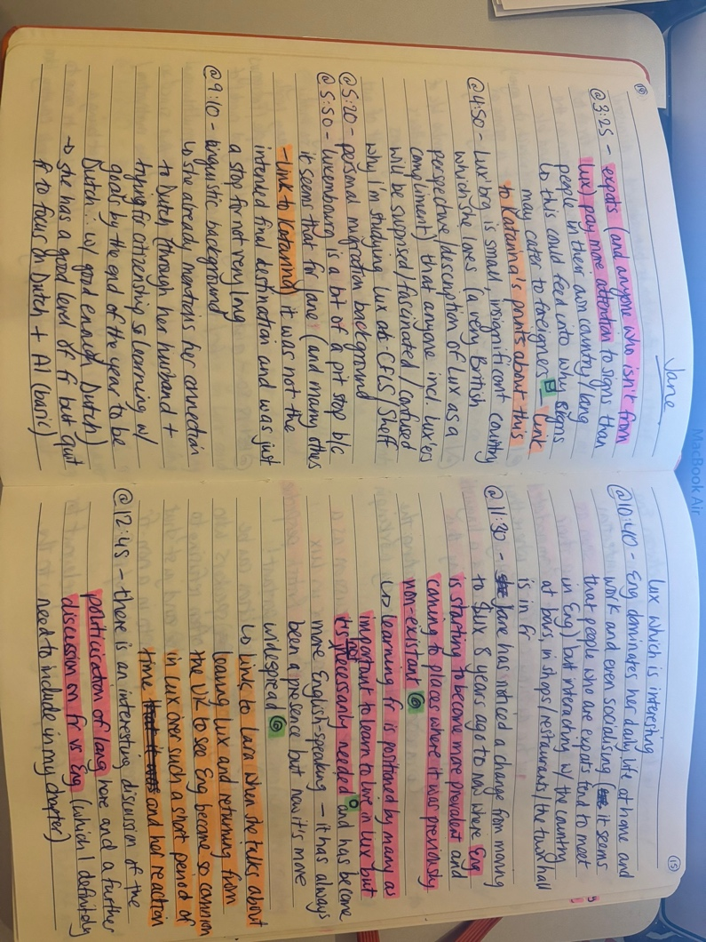

Extract from notebook for manual coding of interviews

The interview data was initially intended to be thematically analysed via NVivo. However, I decided to use manual coding of the interview data as the method of analysis (see image above). The coding process involved reading the transcription while listening to the interview. Detailed key points were then recorded with a time stamp (for ease of reference between the notes and the interview data), with additional notes on the key points detailed underneath. Emergent themes within and across interviews were then ‘generated’ from the data (Braun & Clarke, 2019: 593) through several stages of thematic generation, as the focus of the themes became clearer. As in the image of the coding notebook above, the themes were colour-coded. Points highlighted in pink were initial ideas of interest. Points highlighted in orange were connections drawn across interviews in the initial notetaking stage. Symbols highlighted in green referred to different initial workings of themes that were found across interviews in reviews of the notes. For example, as seen in the image above, a square represented discourses of catering to foreigners; a swirl represented discourses of the growth of English; and a circle represented discourses competition between English and French. These initial workings of themes were then put onto the page and organised into more solid themes, as initial thematic ideas came together, split apart or removed altogether. By doing this, I followed advice from Braun and Clarke’s (2019) work – to interpret the data through themes as ‘stories’; to go through several rounds of thematic generation in order to tell the stories coherently; and to underpin each round of thematic generation with reflexivity.

Within the body of the analysis, excerpts from the interviews are cited to demonstrate these themes, with emboldened text to highlight specific key points. These excerpts are, when relevant, accompanied by the photographs referred to in the excerpt. These themes are outlined in the following analysis chapters.

4.3 Limitations
There are several limitations to the research presented in this thesis, many of which present opportunities for further examination. Firstly, the primary focus of this research is the examination of the linguistic landscape from the perspective of the passer-by. The concept of the ‘passer-by’ is a broad church of considerations and, among LL scholars, is not a one-size-fits-all concept. A fundamental principle of it, however, is to ensure a consideration of the myriad different social actors using any particular space and their contributions to the space in question, whether they be material or discursive. In particular, this needs to be reflected in the participant recruitment process. The ideal outcome of this process is a diversity of perspectives among interview participants, who represent a reasonable cross-section of the demographics of the space in question, in this case Kirchberg. Nevertheless, this is highly dependent on a case-by-case basis, and on the respondents who can be reached as part of the recruitment process.

Secondly, nearly all of the interviews were conducted on site in Kirchberg. The choice of locale was my decision as the researcher. Many potential participants will have been put off or unable to participate because of the specific location of the interview, hence why I focused my recruitment efforts within Kirchberg to mitigate this. However, this had to be somewhat flexible in order to accommodate people’s working schedules and COVID restrictions in place at the time of fieldwork. I conducted the interviews in February 2022, as Luxembourg was relaxing its COVID restrictions. However, people were still being affected by the pandemic and a few potential interviewees were forced to cancel interviews due to contraction and mutual agreement to self-isolate. These were unfortunately interviews that were unable to be rescheduled because of my short stint of 6 weeks in Luxembourg to conduct interviews. Two of my interviews ended up having to be conducted via video conferencing because of last-minute unavoidable work commitments on the part of the participants. While the interviews were successful, I, as the researcher, did have to slightly adapt how I conducted the interviews, which may have affected the outcomes of the interviews.

Thirdly, when engaging with the LL through a discussion of photos in ‘seated interviews’, as opposed to ‘walk-and-talk interviews’ (Grey, 2021), one must acknowledge that participants are engaging with a mediated version of the LL. I, as the researcher, took the photos. I curated them into photo groupings. I guided the discussions by moving from topic to topic. What could be argued is that the participants are ultimately engaging with is my perception of the LL, instead of the LL in itself. While I stand by the choice to conduct ‘seated interviews’ and champion the unquestionable benefits of reconceptualising them as ‘simulated walk-and-talk interviews’, it would have proved fruitful to examine participants’ organic reactions to the LL itself. This would have been logistically more challenging for me as the researcher so I can see how my comfort played a role in the methodological design of this project.

Fourthly, English was fundamental to the recruitment and interview processes. All of the interviews were conducted in English. The decision to speak English was a choice that was left to the participants and not an enforcement on the part of the researcher. During the recruitment process, potential participants were given an information sheet detailing my linguistic repertoire as well as my native language and dual nationalities. Nevertheless, the (potential) use of English in the interviews will have undoubtedly had an effect on the interviews. Prospective participants may have been put off by my being a native English speaker out of concern that English would be the de facto language of the interview and that they may have assessed their own level of English to be insufficient in order to participate. Those who did participate who are not native English speakers may have felt unable to express themselves fully in English but still determined to speak English with me, out of courtesy or personal pressure.

Furthermore, the use of English as the primary medium of recruitment and interviewing definitely affected whose voices were foregrounded and backgrounded in this project. The majority of participants in this study worked in white-collar positions of power within financial or political institutions and all of the participants lived (somewhat) locally and were able to speak English. Significant efforts were made to reach people of different social experiences, which was certainly achieved to an extent in this thesis, such as meeting both Luxembourgers and foreign residents. However, the perspectives of frontaliers, or border-crossing commuters, an important perspective in sociolinguistic research conducted in Luxembourg, are notably absent from this project because frontaliers were also not able to be reached through the recruitment processes. Of greater concern is the notable absence of the voices of people working in manual jobs, such as cleaning and construction. This absence in particular inadvertently contributes to further marginalisation of working-class voices, ironically through efforts to be linguistically hospitable (see section 7.4 for an exploration of this concept).

Chapter 5:

Understanding Kirchberg

During the interviews, the participants discuss the spatiality and placeness of the Kirchberg Plateau, often referred to simply as Kirchberg. They discuss how they perceive and discursively construct the district as an entity in and of itself; in relation to other parts of Luxembourg City; and in relation to their place within Kirchberg. These interconnected social discourses or ‘separate realizations of different semiotic actions’ occurring in the same space ‘fall together’ and produce ‘semiotic aggregates’, or composite meanings of social and spatial realities, which are then read by the passer-by (Scollon & Scollon, 2003: 175; 215). Discussions of passer-by perceptions of the spatiality and placeness of Kirchberg among the participants prove particularly fruitful and highlight key (re)produced discourses in its construction as a district, which underpin understandings of how Kirchberg is or should be.

In this chapter, I discuss recurrent themes, raised by participants in relation to Kirchberg as a space and place. In section 5.1, I draw attention the widely held associations between Kirchberg and the working world, with particular attention drawn to discourses of internationalism. In section 5.2, I explore participants’ interpretations of the materiality and urban planning of the district and the connections with discourses of authenticity. In section 5.3, I examine the discursive positioning of Kirchberg in relation to Luxembourg City through discourses of separation and isolation. As a result, I discuss the participant insights into the Kirchberg semiotic aggregate, formed from the perceptions of the district by participants, which will serve as an underpinning for the ensuing analysis of the discussions of signage in Chapters 6 and 7.

5.1 ‘The Place to Work’
A commonly held perception of Kirchberg among the participants is that the district is built around work. As opposed to it simply being a place where work happens (which could describe any part of the city), the vibe of Kirchberg is presented as at its core rooted in working, which is ingrained in its urban organisation and spatial identity. For example, in the excerpt below, Amelia, a Portuguese woman raised, living and working in the south of Luxembourg, states that she feels that Kirchberg is the ‘perfect place to work’:

Excerpt 5.1/1: Amelia: Honestly I think it's a perfect place to work
Int: Right ok
Amelia: […] I actually find it really pretty and let's be honest if you work here and you wanna go to lunch for er 12 you have a lot of choices if you're going to do some shopping after work you have er Auchan and you have the commercial stuff centre commercial er
Int: Er shopping centre
Amelia: Shopping centre yeah (.) so I think it's perfect and also the transportation here it's good because people work here come from er many places so the transportation is also good
Int: Right
Amelia: So for me Kirchberg is the most perfect place to work

This association between Kirchberg and work is due to the good public transport connections and how the opening times of amenities in the district are perceived to closely accommodate and mirror the patterns of the working day, such as numerous eateries open for a working lunch and a shopping centre open after the end of the working day. The depiction of the temporality of Kirchberg as reflective of the working day is further echoed by Barney, a Southeast Asian man living in Luxembourg City and working in Kirchberg. In the excerpt below, Barney discusses his perceptions of the district as at its busiest during the working week and ‘quiet’ during the weekend, comparing restaurants in Kirchberg to restaurants in the city centre as his example:

Excerpt 5.1/2: Int: That’s interesting so (.) how does Kirchberg compare to other parts of the city (.) do you think?
Barney: Ok it’s more densely populated more traffic (.) yeah […] yeah so I think (.) a large part is for office space so people obviously don’t live in those spaces (.) the remaining space which is split between erm cultural areas, public areas, residential areas so yeah there are I would say (.) it’s comparable to a suburb because there are less people living here so on a weekend coming here it’s kind of quiet (.) it’s quiet
Int: Is it quieter than other places or generally quiet in the city?
Barney: It’s quieter than the city of Luxembourg itself yeah
Int: What makes you say that?
Barney: Because on the weekends when you go here sometimes when you go to a restaurant there’s plenty of space available (.) in the city it’s crowded
Int: Right so how come people don’t come here for those things?
Barney: To Kirchberg?
Int: Yeah
Barney: Maybe they kind of view it as a working place and for them to switch to weekend mode (.) they probably don’t want to associate it with ‘ah my place of work I’d like to stay away from that and see other things’

A key similarity between Amelia and Barney’s perceptions of Kirchberg as a working district is in the way in which they present discourses of work as fundamental to discussions of the spatiality and temporality of Kirchberg. In the excerpt with Amelia, she presents the spatial and temporal dimensions of work in Kirchberg as symbiotic, with clear influence on each other. In the excerpt with Barney, however, he appears to present the relationship between these two dimensions more deeply, as fundamentally influencing and influenced by each other and inextricably interconnected at the core of the Kirchberg spatial identity and development.

Firstly, Barney presents Kirchberg as spatially divided into a large ‘office space’ and the ‘remaining space’, designated for cultural, public or residential purposes. This description echoes Weilacher’s (2007: 58-59) research on the urban development of Kirchberg, in which he reports that the area of the Kirchberg Plateau was initially ‘compulsorily purchas[ed]’ by the Luxembourgish state in the 1960s as a much-needed site for expansion of office space at the time of the ‘expansion in the European Community’, the precursor to the European Union. Barney’s depiction of the contemporary prominence of discourse of work in Kirchberg as still evident in the district layout suggests that work continues to be the intended primary and dominant function of Kirchberg, with the other functions being positioned as secondary or additional, and peripheralised, both discursively and physically, into leftover space.

Barney then makes the connection between the district layout and the quietness of Kirchberg outside of working hours, stating that it is predicated on general passer-by perceptions of Kirchberg as a ‘working place’ incompatible with ‘weekend mode’, or the frame of mind among people away from work in personal time. This can also be seen in the excerpt below with Hugáceo, a Spanish man living in Luxembourg City and working in Kirchberg, who discusses his own personal recollection of his only time socialising in Kirchberg and his subsequent reluctance to return for social purposes because, in his view, it is not designed for recreational activities, explicitly because of its association with working:

Excerpt 5.1/3: Hugáceo: So it's not like (.) I mean I I I have [come to Kirchberg to socialise at the weekend] but I I didn't repeat but it's not really [laughs] a place to go to er to do a nice er to walk around the city no
Int: Right
Hugáceo: I mean I've done it just to try how much is the distance to my office and come back on a Sunday and do some sport but it's not like the most nice scenery or anything I mean it's like a (.) a downtown district that in the weekends is is empty so

The participants’ apparent reluctance to frequent Kirchberg outside working hours or to even consider it a space for socialising is indexical of the inextricable processes of discursive and physical spatialisation. In the above excerpts, one can see discourses of work underpinning depictions of Kirchberg as a ‘special use space’ specifically earmarked for work, which, in turn, affect the ways in which passers-by interact with the district (Scollon & Scollon, 2003: 171). Both Hugáceo and Barney refer to Kirchberg as a ‘working place’ when describing these interactions between passer-by and the physical space, which is in line with Scollon and Scollon’s (ibid.) conceptualisation of place as one’s personal experience of a space. This is an example of the complex interplay of discourse and materiality in the construction of both space and place, all of which comes together to (re)produce the spatial identity of Kirchberg as the working district.

‘Work’ as an important formative influence in the construction of the district is, in the case of Kirchberg, in specific reference to the prominence of the tertiary sectors of international finance and banking, as well as the presence of European Union (EU) institutions, all of which are well-documented for attracting multinational workforces (cf. Hesse, 2013; Kingsley, 2009; 2013; Weilacher, 2007). This is explored in the following excerpt with Tom, a British man living outside of Luxembourg City and working in Kirchberg, who discusses the limited presence of Luxembourgers and greater presence of an ‘international community’ in Kirchberg:

Excerpt 5.1/4: Tom: Literally as far as I know I guess erm (.) and also the percentage of Luxembourgers who work in Kirchberg I don't think is particularly high
Int: Oh really?
Tom: Yeah I don't think so
Int: Is it quite (.) non-Luxembourgish here? I hate using non-Luxembourgish but
Tom: In Kirchberg yeah yeah I would say
Int: Oh really
Tom: It's quite an international community here
Int: Why is that do you think?
Tom: (.) I don't know erm (.) maybe the Luxembourgers don't like finance [laughs]
Int: Maybe maybe [laughs]
Tom: Although to be fair I mean there's really good jobs to be had if you're Luxembourgish in (.) you know in er maybe local government or things like that
Int: Mm hmm (.) ah right
Tom: I don't know erm (.) but yeah it's (.) I mean in the office we've only ever had three or four Luxembourgish people in this office
Int: Right ok
Tom: In the in the seven years I've been here
Int: Wow
Tom: So and some of them have been like just contract staff
Int: Right
Tom: So I think I'm only aware of two members [of the team] that have ever been Luxembourgish
Int: Really?
Tom: And one left to go and work for the government and one came from working for the government here [laughs]

Tom attributes the disparity between Luxembourgers and non-Luxembourgers working in Kirchberg to the tendency among Luxembourgers to work long-term in the public sector for the ‘local government’ or state, as opposed to working in the private sector for international financial institutions, which, if done by Luxembourgers, tends to be more temporary. While Luxembourg has a highly diverse resident population and workforce in the country as a whole (Kingsley, 2013), fewer Luxembourgers working in Kirchberg appears to highlight a greater prominence of international workers in the district, contributing to perceptions of Kirchberg as a more international, less Luxembourgish space, and reinforcing perceptions of Kirchberg as a ‘special use space’ for banking and financial work.

Starting in the 1980s, Kirchberg rapidly developed from an initially ‘strictly functional, car-friendly administrative city’ for the then-newly expanding European Community into the ‘urban neighbourhood with a strong identity and lively links between housing, work, education and leisure functions’ we see today, as a response to rapid processes of internationalisation and the neo-liberalisation of the formal Luxembourgish economy towards the financial sector (Weilacher, 2007: 59). In the excerpts below, Hugáceo and Jane, a British woman living in Luxembourg City and working in Kirchberg, both describe Kirchberg as the ‘financial centre’ or ‘district’ of Luxembourg, by explicitly compare it to Canary Wharf in London with reference to the similar functions and vibes of the two districts:

Excerpt 5.1/5: Hugáceo: But maybe if I tried to compare [Kirchberg] with Canary Wharf in London which is also a financial centre
Int: Right yeah
Hugáceo: There erm (.) I would say there it is still a bit more compact and actually there in Canary Wharf you could not do with private transport so I could not have a car or you go (.) to wherever you need to go by public transport by tube whatever [xxx] but then er you just do everything by foot
Int: Right
Hugáceo: And and it's more a core city centre while Kirchberg is much more spread around no all the buildings
Int: Right
Hugáceo: No I would (.) I mean the area is also much bigger than than than Canary Wharf Canary Wharf is much more compact they don't have so much space so all the buildings are closer together no
Int: Right ok
Hugáceo: Here the buildings from one avenue to another are really far away from one another

Excerpt 5.1/6: Int: It's mad (.) it's mad so like (.) let's talk specifically about Kirchberg then because obviously you brought up about the property and everything (.) so (.) how does Kirchberg as a district compare to other parts of Luxembourg City (.) how would you say I know that's a big question so
Jane: Erm (.) I think (.) so here's obviously the financial district so even how it looks is very different to the rest of the city in terms of the tall buildings although we do now have Gasperich which is Kirchberg 2 (.) erm (.) I feel like places like Bonnevoie is more (.) it was more historically working class
Int: Mm hmm
Jane: And there's a lot more kind of Portuguese there
Int: Oh right
Jane: It's a lot more (.) vibey here is (.) somewhat similar to (.) if you used to go to Canary Wharf on a Sunday er (.) I don't know pre-2010 and everything was shut and it was dead
Int: Right
Jane: Erm the restaurants here are actually now busy on a Saturday night and they used to not be or just be closed

Both Hugáceo and Jane report having worked in and around Canary Wharf prior to migrating to Luxembourg and coming to work in Kirchberg. Similarly, Luc, a French man living in a village outside Luxembourg City and working in Kirchberg, describes it as a ‘business district’ and draws a comparison between Kirchberg and La Défense in Paris, having previously worked there while living in Paris:

Excerpt 5.1/7: Int: Yeah (.) so if you had to [laughs] I think you've done a good job of describing it already but
if you had to describe Kirchberg to someone who'd never been before in say 3 words or 3 phrases let's say how would you how would you describe it to someone?
Luc: I would say it's er (.) it's a business area un quartier d'affaires in French (.) you know French ok (.) erm so that's er for one er then the fact that it's er it's not high skyscrapers like you would have in the er La Défense near Paris for instance it remains not that high also the fact that it still remains quite (.) nice there I mean I prefer by far the Kirchberg to La Défense for instance because erm (.) because the the roads are wide I mean not only er Kennedy Avenue but it's it's very wide you also have trees(.) er in the in the different er different streets it's very easy to circulate by bike er yes I think it's much more than 3 sentences but yeah [laughs]
Int: No that's perfect that sounds er that's really good so how (.) how does it compare to other parts of Luxembourg City then (.) how would you-
[…]
Luc: […] There is the I think it compares well the Cloche d'Or is the new Kirchberg I would say it's really equivalent but I think they didn't make that I I (.) I prefer Kirchberg than Cloche d'Or
Int: Oh really
Luc: Yeah yeah because er (.) because there are more trees basically I'm a big fan of trees and I I I need to see something green in the day otherwise [xxx] so yeah I love this and I think yeah it's (.) they didn't do such a great job there for instance if you see er the Lycée Vauban (.) purely mineral [unnatural] no tree no nothing and I hate it basically

All three participants draw on their personal life experiences to illuminate their individual senses of place in Kirchberg through personal perceptions of the district as more focused on white-collar business, as opposed to other districts in Luxembourg City like Bonnevoie, which Jane states as being more ‘traditionally working class.’ Furthermore, Kirchberg is compared to other districts within Luxembourg City, such as Gasperich/Cloche d’Or, an emergent financial hub in the south of Luxembourg City, and outside of Luxembourg in the rest of Europe, namely the financial districts of Canary Wharf and La Défense. The interconnected social discourses of work, banking and finance, and internationalism underpin conceptualisations of Kirchberg and produce a semiotic aggregate apparently familiar to the participants – that of the European financial district (EFD).

EFDs are globally interconnected spaces with a significantly high concentration of global economic infrastructures, simultaneously symbolic of the dynamic processes of globalisation, while also being shaped by these processes, into ‘one-dimensional and synchronous’ spaces built and developed as a reflection of global influences (Burdett, 2012). By drawing the comparisons between Kirchberg, Canary Wharf and La Défense as EFDs, it suggests that the participants perceive an intertextuality between these urban spaces, with the semiotic aggregate of the EFD seemingly being (re)produced across multiple locales, with only superficial aesthetic distinctions made between the districts. All of this is perceived to be done at the expense of a certain amount of individuality and organic growth, further contributing to perceptions of Kirchberg as more international and less Luxembourgish.

In summary, passer-by perceptions of the spatial identity of Kirchberg are often founded on discourses of work, which run more deeply than simply being a space where work occurs. Rather, it is a space where discourses of work are central to the construction of its spatial identity, influencing the material and temporal developmental trajectory of the district from conceptualisation to materialisation, as well as passer-by perceptions of the space as a ‘working place.’ Working has been a prominent aspect of Kirchberg’s spatial identity since the initial creation of the district in 1960s during the expansion and early interconnection of the EU, and continues to be to this day, even as the district has changed its initial focus to house globally-focused economic infrastructures.

When one discusses ‘work’ in relation to Kirchberg, it is important to understand that ‘work’ primarily refers specifically to the private sectors of international banking and global financial services, which are heavily interconnected and indexical of globalising economic processes. This definition of ‘work’ invisibilises the prominent sectors of facility and building management, hospitality and healthcare. In this way, comparisons are drawn between Kirchberg and other EFDs, such as Canary Wharf and La Défense, along the lines of their aesthetics, functions and spatial identities, all of which seem to converge with each other to that extent that these spaces feel like replications of each other, as opposed to organically grown, individualised (or national) interpretations of the private financial sector. This leads to perceptions of Kirchberg as a less Luxembourgish and more international space, which is non-specific to Luxembourg, but rather a reproduction of districts found anywhere and everywhere else in Europe.

5.2 (In)authenticity in a globalising Kirchberg
When asked to describe Kirchberg, one of the most common words used is ‘modern’. This is in reference to myriad different aesthetic aspects, such as the materials prominently used, the architecture of the buildings and the urban planning of the district. In the excerpts below, Amelia, a Portuguese woman raised, living and working in the south of Luxembourg, and Lara, a Luxembourgish woman born and raised in the north-east of Luxembourg and working just outside Luxembourg City, both describe Kirchberg as ‘modern’ from contrasting perspectives:

Excerpt 5.2/1: Amelia: When someone tells me I work in Kirchberg I'm a bit jealous
Int: Oh really why?
Amelia: Because I feel like I find it really pretty it's modern because it's new it's er it wasn't built that long ago
Int: Yeah
Amelia: I have this thing where I hate when they mix the old with modern I like to keep both separate
Int: Oh really?
Amelia: Kirchberg is a perfect example of keeping the modern apart from the old […] but yeah for me Kirchberg I really love coming here when I can come here because (.) I feel like you're in a new place it's different er from the rest of Luxembourg I think
Int: Yeah (.) what is it about Kirchberg that makes you say it's really modern [and different] what is it about Kirchberg?
Amelia: It's the buildings it's the way they for example this part here it's the first time I've come here I never realised that they have like coffee shops like places to eat I never really realised (.) but the way it was built I find really pretty I think aesthetically speaking Kirchberg is really beautiful

Excerpt 5.2/2: Int: So how would you say Kirchberg compares to other parts of the city (.) like if you were to
put them next to each other?
Lara: […] I think maybe the vibe actually erm because I mean the architecture itself already is very different [laughs]
Int: In what way?
Lara: Well it’s all modern lots of (.) buildings with like glass walls and everything (.) high buildings as well
Int: Are there not high buildings in other parts of Luxembourg City?
Lara: Erm not that many (.) I mean I’m talking about the ones by the bridge [in the city centre] you know the high high ones [laughs] those (.) are some of the only ones that are that high (.) and it feels a bit you know how like there’s just the main street kind of like going all the way past Kirchberg which is where basically the main action happens and then you also have shops and restaurants out of the way but it’s kind of like (.) the easiest way to cross Kirchberg whereas when you’re in the city centre you have all these little alley ways and you have old houses and yeah kind of like hidden places everywhere erm

Interestingly, the discussion of the modernness of Kirchberg is in large part centred on its juxtaposition against other parts of Luxembourg City and the ways in which the more modern Kirchberg contrasts aesthetically against the more traditional parts of the city, particularly in the city centre. In the above excerpt, Amelia describes how Kirchberg is an example of ‘keeping the modern apart from the old’, which she finds to be ‘really beautiful’. This separation of modern and traditional aesthetics contributes to Amelia’s perceptions of the spatialisation of newness, which appear to be anchored in her perception that newness is highly concentrated in Kirchberg, as an intentional style decision to contrast it against the rest of the city, forming part of the spatial identity of Kirchberg (cf. Hesse, 2013; 2016).

Conversely, Lara appears to be more critical of modern aesthetic elements of Kirchberg. She highlights specific architectural and urban planning features representative of the ‘vibe’ in Kirchberg, such as a high density of tall buildings and the prominent use of materials like glass, as well as the urban organisation of the district focused along a large, centralised boulevard, different aspects of ‘die spezifische modernistische Formensprache’ of Kirchberg (Hesse, 2013: 18 – tr. ‘the specific modernist design language’), often referred to as the ‘International Style’ (Weilacher, 2007: 59). However, she implies that these different design elements come together to produce a space of ‘lifeless architecture’ (Burdett, 2012: 93) that is without the traditional charm of the city centre, with its ‘little alley ways[, old houses and] hidden places everywhere’ and incoherent with the rest of the city. Hesse (2016) describes this incoherence of urban styles as a ‘spatial mismatch’, the result of intentional design decisions to connect Kirchberg to other globalised spaces, at the expense of its connection to neighbouring localised spaces.

By using the description of a ‘spatial mismatch’, it is clear that the juxtaposition of the modernist design language of Kirchberg against the more traditional aesthetics of the city centre is inextricably linked to the criticisms thereof, and both are essential to the construction of passer-by perceptions of the district. While the modern design language elements are presented as indexical of the Kirchberg vibe and continuously reproduced as the district expands materially and in influence, so too are the well-established criticisms of the modern aesthetic (Hesse, 2013: 18) that have existed since the genesis of the construction of Kirchberg. In short, the criticisms of the Kirchberg urban aesthetic are as fundamental to its spatial identity as the urban aesthetic itself.

Furthermore, the discussions of the modernness and newness of Kirchberg are underpinned by a foundational awareness of the historical developmental trajectory of the district from ‘once essentially rural’ agricultural land (Weilacher, 2007: 58) to highly urbanised ‘office town’ where financial services and European institutions are localised (Hesse, 2016: 618), an awareness present among local Luxembourgers as well as newly arrived foreign residents. In the excerpt below, for example, Amal, a South Asian woman living and working in Kirchberg, succinctly lays out this trajectory, demonstrating an awareness of the development of the district, despite only having recently moved to Luxembourg for work:

Excerpt 5.2/3: Amal: It's confusing right it's it's fairly new I saw these pictures of Kirchberg from a few
decades ago and it was just green land with cows grazing [laughs] and now you have this [points around her]

Amal alludes to the fact that prior to the urbanisation of Kirchberg beginning in the 1960s, there was no urban development on the Plateau, an integral factor in the decision to earmark the area as the site for the expansion of Luxembourg City. In other words, it is widely perceived as a space that has suddenly and inorganically come from nothing with no connection to history or any semblance of a temporal trajectory – a non-place (Augé, 2009). This discourse of Kirchberg coming from nothing can further be seen in the above excerpt with Sofia, who compares it to Belair, another district of Luxembourg City:

Excerpt 5.2/4: Int: So if you had to describe Kirchberg to someone how would you describe it (.) say if
you only had three words?
Sofia: Erm (.) I think modern
Int: Modern ok
Sofia: Multicultural and (.) expensive
Int: Ooh ok why expensive?
Sofia: Because of the housing prices [laughs] it gets more people going there and like it’s more attractive now so it gets more expensive
Int: Is it more expensive than other parts of the city?
Sofia: You mean to live there?
Int: Yeah
Sofia: Erm (.) I mean (.) I don’t know I think Kirchberg is probably the part where most new apartments are being built so you see them being sold at super high prices compared to like ok Belair might be an expensive (.) like more expensive to live in but they’re just like mostly houses and the people who live there have been living there most of their entire lives
Int: Right
Sofia: Kirchberg is like still developing and (.) yeah
Int: I never thought about it like that yeah (.) so it’s just like expensive (.) like it always has been expensive whereas other places-
Sofia: I don’t know if it always has been expensive but it’s becoming more and more expensive the more attractive it gets and the more things get built there and there are a lot of international buildings and people (.) you would wanna live there because there’s everything [laughs]

Sofia describes the ‘super high prices’ of Kirchberg real estate in comparison to other parts of the city and focuses in on Belair, which is also considered to be an expensive area of Luxembourg City. She presents the difference between the two districts, however, along the lines of the extent to which the spatial identities of the districts are rooted in temporal expressions of Luxembourgishness. For Sofia, Belair has a developed spatial identity as a long-established Luxembourgish residential area, with long-term residents ‘who have been living there most of their entire lives’, implying a generational continuance.

Contrary to this, Sofia states that Kirchberg is ‘still developing’ in its construction and its spatial identity and is ‘the part [of the city] where most new houses are being built’ in order to attract people to live there. This, in turn, makes the district more expensive, thus creating a seemingly never-ending cycle of urban expansion to more investment to higher property prices to an increase in urban expansion, and so on. This cycle is, however, disconnected from expressions of Luxembourgishness because the desired investment is perceived as new and ‘international’, thereby suggesting that there is the perception that the development of Kirchberg is occurring independently from the development of the rest of the city and at different temporal scales. Sofia and Amal’s perceptions of Kirchberg as lacking an established spatiotemporal trajectory and a connection to senses of local history, culture and environment, as well as Sofia’s implication that the development of Kirchberg is primarily driven by financial gain as opposed to the people-centred establishment of community, makes a compelling case, at least upon initial consideration, that Kirchberg could be perceived as a non-place (Augé, 2009).

However, as previously stated, the concept of non-places is perhaps not the most compatible concept with a geosemiotic approach. As an alternative, the discussion of Kirchberg-from-nothingness comes together with the International Style design language and the semiotic aggregate of the European financial district to form the conceptualisation of the ‘instant city’ (Burdett, 2012: 93). Similar to the concept of non-places, these are rapidly constructed spaces ‘insulated and segregated from any sense of temporal or cultural accumulation’ and perceived as inorganic, instead requiring active and immediate large-scale urban planning intervention for the purpose of housing the ‘economic engines of […] global economies’ (ibid.). However, where these two concepts appear to diverge is in the perceived influence of temporality in their construction. While non-places are spaces that are ‘not relational, or historical, or concerned with identity’ (Augé, 2009: 30-31), the more specific ‘instant city’ is understood to be the product of its time. It is a place that feels temporally and spatially separate from the surrounding environment but that still reflects, whether positively or negatively, the time period, in which the place is constructed – a time of deepening global economic and sociocultural integration and interconnection between countries.

In the below extract, Katarina, a Central European woman living in Luxembourg City and working in Kirchberg, draws attention to this idea of the ‘instant city’ in her description of Kirchberg:

Excerpt 5.2/5: Int: Yeah that's really so (.) visually aesthetically how does this place compare to the rest of the
city?
Katarina: I mean like one thing is that in the city you still have like some older buildings
Int: Right
Katarina: So for me it's definitely that the architecture is different (.) here I don't really know the numbers but I know forty years ago I don't think here there was many buildings it was like one tall building (.) and that (.) that is all so this was really built very quickly erm
Int: Oh yeah yeah
Katarina: So the rest of the city or the city centre was just built (.) before [xxx] long time a long time ago [laughs] so there you kind of find older buildings and stuff […] so I don't really (.) I don't really (.) like it here that much I think yeah I think it should be more (.) I'm like in general I think that erm we just we should just have around a small green I mean like here there's just nothing (.) and every time you see like a tree like that kind of like put in you know just like meh it just you know it makes me sad you know it makes me completely melancholic it's like here you have some nature you know so that you (.) I don't know it just feels like too little
Int: Why do you think (.) the people who built Kirchberg have done it this way?
Katarina: Ooh I can't tell you
Int: I mean from your perspective I mean you don't have to give me an (.) there's no correct answer or anything
Katarina: Yeah yeah like I don't know obviously anything about it but my feeling is that it was just like really about erm (.) money I think they just wanted to build it er super quickly and er (.) I think the aesthetic part obviously I mean like because you have the institutions and stuff it's not like they were building like anything you know it's got to represent the institutions and the banks and stuff (.) but erm (.) I think the main thing is just to build something where you can put the people where they can work

Katarina mentions how Kirchberg was ‘built very quickly’ as means to ‘put people [somewhere] they can work’ and ‘represent the institutions and the banks and stuff’, compared to the rest of Luxembourg City, which is perceived to have developed more organically over a longer period of time, with older buildings from a ‘long time ago’ remaining preserved in the rest of the city as indices of the historical trajectory of the city. This continued juxtaposition of the modern Kirchberg and the traditional city is reminiscent of Hesse’s (2013: 17) discussion of the state-led ‘politische Modernisierungsstrategie’ (tr. – ‘political modernisation strategy’) to economically futureproof Luxembourg. This strategy manifested itself materially in the construction of the Kirchberg Plateau, representing a ‘zukünftweisendes europäisches Stadtmodell’ (tr. – future-oriented European city model), as well as in the establishment of new opportunities for the diversification of the Luxembourgish economy into industries perceived as more modern, such as the tertiary service sector. On the one hand, this illuminates the temporal influences on the construction of Kirchberg and the development of its spatial identity. On the other hand, this further reinforces the perceived disconnect between Kirchberg and other parts of the city by reinforcing, in Katarina’s case, the limited affective emotional quality of the district, which leaves her ‘completely melancholic.’

This limited emotional quality infused in the development and organisation of Kirchberg is, for many of the participants, a fundamental aspect of their perceptions of the modern aesthetic of Kirchberg. In the below excerpt, Hugáceo describes the district as ‘grey’ and ‘cold’:

Excerpt 5.2/6: Int: Right (.) what about erm aesthetically how would you compare Kirchberg and the rest of
the city and other parts of the city I should say
Hugáceo: Yeah I would say it would be more modern but also grey and cold [laughs]
Int: Oh really
Hugáceo: Erm (.) yeah I mean because the rest of the city is more like er it looks like the buildings are (.) I mean have more (.) yeah they are more classy let's say
Int: Yeah
Hugáceo: I don't know how to describe them (.) while Kirchberg er it looks more like er (.) yeah modern tall towers etc a bit colder

Here, Hugáceo interprets the modernness of Kirchberg as rooted in a lifelessness, similar to earlier discussions of quietness outside of the working day (see section 6.1) and of the decision to use the International architectural Style in its urban organisation. This is a point of discussion raised by Stefan, a Luxembourger born, raised and living in Luxembourg City and working in Kirchberg, who discusses how behind the newness of Kirchberg belies a lack of spatial character:

Excerpt 5.2/7: Int: So how does it (.) because you said about going to other places (.) how does Kirchberg
compare to other places like how would you compare them? (.) big question [laughs]
Stefan: Yeah I think in Kirchberg everything is kind of when it comes to bars and restaurants everything is new you know kind of like here [where we did the interview] so it lacks authenticity (.) if you go if you go to the city centre you just have buildings that have had a bar in them maybe not always the same one but at least a bar in the same place for decades you know and that gives the place a sort of atmosphere I think (.) if you go to Vis-à-Vis or even if you go to De Gudde Wëllen or like all those places (.) there’s just always been bars in those places (.) and that’s just different from a place like this that was just built a few years ago and it’s kind of (.) nice enough and shiny but it doesn’t really have character

Much like the participants, Stefan juxtaposes Kirchberg against other parts of Luxembourg City in terms of their temporalities. On the one hand, for Stefan, the city centre has an established ‘atmosphere’, which is the product of spatial developments, such as bars, temporally marinating for decades in the same space, contributing to the organic development of the space itself and of passer-by senses of place. On the other hand, Stefan perceives Kirchberg as ‘lacking authenticity’ precisely because it is so new and ‘shiny’ and therefore can only effectively judged at a superficial aesthetic level, further reinforcing perceptions of Kirchberg as an ‘instant city.’ Related the discussion of linguistic authenticity in Chapter 2, wherein the authenticity of linguistic resources is founded in part on appeals to one’s personal connections to them, Stefan’s perception of spatial authenticity appears to similarly be based on personal connections. By outlining his lack of personal emotional connection to Kirchberg, he demonstrates his perception of Kirchberg as fundamentally inauthentic.

To summarise, Kirchberg is often perceived as a modern space because of its aesthetic ‘design language’, the International architectural Style, which involves the construction of tall buildings, the use of more modernist construction materials and urban organisation centred around office buildings. Furthermore, Kirchberg is often juxtaposed against other parts of Luxembourg City, which are perceived to be more traditional and organically developed. This juxtaposition, whether favourable or critical, is an intentional by-product of the ‘spatial mismatch’ between the modern Kirchberg and traditional city, which is the result of a desire to orient the development of Kirchberg more internationally than locally, creating a disconnect between Kirchberg and the city, of which it supposed to be a part.

When examined more deeply, it becomes clear that the disconnect has in part contributed to perceptions of the rapid growth of Kirchberg from rural empty space to thriving highly globalised urban space as inorganic. This perceived lack of a historical urban developmental trajectory is presented as justification of perceptions of Kirchberg as lacking authenticity, which is underpinned by lacking emotional connection between people and place.
As such, perceptions of newness, difference and disconnection from history should not be conflated with actually lacking history or non-placeness. In this way, perceptions of newness, difference and disconnection from history are, in fact, understood as consequences of the emotional relationship between Kirchberg and the passer-by, rather than as evidence of Kirchberg as a non-place. This leads to further emotional disconnect between Kirchberg and local citizens, residents and even the city itself. It is the combination of these factors – the perceived inorganic rapid growth, the perceived newness and lack of history as a district, and the lacking emotional connection to the district – that reinforces perceptions of Kirchberg as a place cut off from the rest of the city, which is explored further in the following section.

5.3 The ‘Island’ of Kirchberg
A common emergent theme throughout discussions with the participants is that participants tend to suggest that one needs a specific reason to go to Kirchberg, as opposed to being a place to go to spontaneously. Hugáceo mentions in section 5.1 about how Kirchberg, for him, is not a place ‘to walk around’ in but rather to work and ‘do some sport’ at d’Coque sports centre, and these sentiments are shared by other participants, expressing similar reasonings why they or people in general would or would not go to Kirchberg:

Excerpt 5.3/1: Int: Yeah so do you come to qu- (.) start again do you come to Kirchberg often outside of work
or?
Luc: No almost never
Int: Yeah
Luc: Almost never it's very rare that I go to Kirchberg except for work (.) maybe maybe once yeah from time to time er if er (.) yeah if needing to go to H&M or Zara or something like this for the kids if we don't have the time to do so to go somewhere else but it's really more (.) for convenience rather than pleasure because the er yeah I don't think that the the neighbourhood is very nice in the weekend it's very cold it's very er cold meaning it's er quite mineral [inorganic] and quite empty during the weekend so

Excerpt 5.3/2: Lara: […] I feel like (.) to me Kirchberg still feels like it’s for professionals (.) like it’s where
people go to socialise after work maybe or where you have business meetings whatever whereas the city to me feels a bit more like (.) you just go there and you see what’s available and you go have fun whereas I feel like with Kirchberg you have a bit more like purpose of where you go (.) maybe that’s just because I don’t know a single person who goes to Kirchberg and is like ‘ok let’s go let’s go see what we can do here today’ whereas I know plenty of people who go to the city centre without a plan and kind of spontaneously what they wanna do whereas like Kirchberg is more like (.) you don’t wanna walk just three blocks with just offices you already kind of need to know where you’re going (.) so yeah

Similar to Hugáceo, Luc discusses how he ‘almost never’ goes to Kirchberg outside of work, because of how ‘cold’, ‘mineral [inorganic]’ and ‘empty’ the district is outside of working hours. When he does go, it is only in situations when it is absolutely necessary ‘for convenience rather than pleasure’, such as going to a shop that his children need to go to but have no time to go anywhere else. Lara, in a more general sense, discusses how people would spontaneously ‘go to the city centre without a plan’ and naturally come up with one on the fly, having it develop organically. This is in direct contrast to visiting Kirchberg, which she sees as more purpose-driven and less fun, with people needing to essentially pre-plan going to Kirchberg to justify walking past ‘blocks of offices’, which she does not perceive as something anyone she knows would do. This further highlights perceptions of Kirchberg as a ‘special use space’ (Scollon & Scollon, 2003: 171), actively causing passers-by to avoid the district unless for a particular purpose. It also suggests that these participants’ senses of place in Kirchberg are founded on limited contact with the space and appear to position their place as external to Kirchberg, further demonstrating the physical and discursive disconnect between Kirchberg and the rest of the city.

Interestingly, though many perceptions of Kirchberg tend to be static or fixed, some participants note how Kirchberg is changing in more meaningful ways, aside from aesthetically:

Excerpt 5.3/3: Int: That's so interesting so […] so if you were to describe Kirchberg in say (.) I usually say 3
words but people find it hard to stick to 3 so like between like 3 to 5 words to someone who had never been here before and you were having to explain the kind of place that you worked or whatever (.) how what what words would you use?
Jane: I think there'd be two descriptors for the two different years
Int: Oh that's interesting ok
Jane: So 2014 would have been soulless (.) quiet and empty
Int: Really ok
Jane: Yeah (.) and I think now (.) I think you would call it kind of professional you know because it's a lot of offices and people in suits and stuff (.) professional busy (.) and lively it is more lively round here even just walking the streets and you see people it used to just feel like (.) you know (.) everyone's been evacuated

Excerpt 5.3/4: Int: Oh (.) so has (.) saying that then has Kirchberg quite a lot?
Nina: Yeah it's changed quite a lot to be honest in substance I think it's changed a lot you can see many new erm residential buildings apartments that were built in the last 10 years and erm (.) I can really see that a lot if you go along the way you can see that many many new apartment buildings so although it's changing (.) yeah I think many people's impression it stays probably like yeah like the past 10 years or so and also of course there are more people more things happening and er still there are already of course in the past there are already people who come to Kirchberg for nightlife (.) er for the movie theatre for the Philharmonie concerts and that is because they are located in Kirchberg erm (.) also the LuxExpo they are very often host to the expo events so people also come there for that (.) er yeah but still you are mainly coming for this reason for this reason only you would not like still come just to come to Kirchberg for a drink for example (.) yeah that's not often in people's minds [xxx] unless it's attached to the work for example after work is more popular here after work drink then coming for dinner in Kirchberg unless you go because it's attached to the theatre

Jane discusses how she would describe Kirchberg in different ways depending on whether she was describing Kirchberg when she first moved to Luxembourg and the current Kirchberg, noting a change in the liveliness of the district. This is similar to the perception of Nina, a Chinese woman living outside Luxembourg City and working in Kirchberg, who says that ‘there are more people [and] more things happening’ in the district than in previous years, suggesting efforts in Kirchberg to appeal to people on a more local scale. Nonetheless, the working aspect of Kirchberg appears to prevail in and dominate passer-by perceptions, leading to little perceived change among passer-by perceptions and ‘impressions’ of the district. In other words, while Kirchberg continues to change and develop ‘in substance’, passer-by senses of place in Kirchberg remain relatively unchanged.

These unchanged senses of place are important in understanding perceptions of Kirchberg as a separate entity to the rest of Luxembourg City, such as in the excerpts below with Jane and Amal:

Excerpt 5.3/5: Int: Well not even differ just just kind of compare like (.) does it feel different does it feel like
its own thing or does it feel part of the city if you know what I mean?
Jane: No I think it definitely feels like its own thing (.) I think you don't come here unless (.) you need to go to the Auchan or you work here (.) erm whereas I feel in other parts you go there because there's a nice restaurant or something and when you look at Luxembourg City (.) Kirchberg is kind of like this bubble on the side that was kind of added on later

Excerpt 5.3/6: Amal: But definitely not in Kirchberg and then again I'm also confused is Kirchberg a
commune or is it a part of the city how do you define it I mean like you know Sandweiler is a separate place but is Kirchberg separate? You don't I can't really tell I've never been able to tell I know I've registered in Luxembourg City but is Kirchberg really separate? Or is it just the name of a neighbourhood?

Jane describes Kirchberg as ‘its own thing’ and a ‘bubble on the side’ of the city that one does not go to unless necessary, suggesting two simultaneous realities. Firstly, it suggests that Kirchberg is a space that functions differently to other parts of the city, leading to a divergence in their developmental trajectories. Secondly and somewhat paradoxically, it suggests that, even though it is an extension of the city, Kirchberg is nonetheless still a part of the city, in the same way that an extension to a house still forms part of the house as a whole. This corroborates a fundamental aspect of Kirchberg as a district laid out thus far in this chapter – that Kirchberg exists in direct and intentional opposition to the rest of the city, deriving much of its spatial identity from it being deliberately contrastive to other parts of Luxembourg City.

Amal expresses more outright confusion about how to describe Kirchberg, either as a commune in its own right or a part of Luxembourg City. Even after having registered with Luxembourg City when first arriving in Luxembourg and living in Kirchberg, there is still an uncertainty for Amal about the relationship between Kirchberg and Luxembourg City. This uncertainty can also be seen throughout this chapter, in the inconsistency on the part of participants when naming other spaces, against which Kirchberg is discursively juxtaposed. These spaces are often referred to as ‘the rest of the city’ or specifically spaces parts of the city like ‘the city centre’ or just simply ‘the city’. This demonstrates a tension between discourses of separation underpinning everyday passer-by perceptions of Kirchberg and discourses of (tentative) unity underpinning bureaucratic considerations of Kirchberg. By this, one can consider notions of separateness, when discussing Kirchberg, as a kind of semi-autonomy, positioning Kirchberg as in between independent and interconnected with the Luxembourgish capital.

Some participants, however, take these notions of separateness further through discursive constructions of Kirchberg as more isolated than separate from the rest of Luxembourg City. Isolation, in the case of Kirchberg, refers to a more extreme version of separateness, which is demonstrated and influenced by the aforementioned lack of emotional attachment and sense of place in Kirchberg for many people. This leads to the perceived occurrence, whether natural or procured, of two diverging senses of place, that is, one focused on Kirchberg and the other on the rest of Luxembourg City. These two sense of place proceed to grow further and further independent from each other. In the excerpt below, Katarina outlines her distaste for the district in terms of aesthetics and vibe:

Excerpt 5.3/7: Katarina: I mean so like I really like I'm really interested in (.) ok I really really like I always
pay attention to buildings
Int: I feel like me and you are the same person because like honestly architecture is like I love it as well
Katarina: [laughs] I love it too absolutely and also I come from [my hometown] where we have like a lot of nice like Art Nouveau you know kind of like buildings everywhere and stuff
Int: Oh gorgeous yeah
Katarina: So for me Art Nouveau is the best and obviously here there is no Art Nouveau anywhere [laughs]
Int: Yeah not quite not quite yeah
Katarina: Not many buildings like that (.) and er (.) so this one thing that I don't really like I don't like the I don't like actually how it looks I think it's too much of concrete everywhere like béton like concrete is it concrete?
Int: Yeah concrete yeah yeah
Katarina: And the buildings are just not very nice I think (.) and then erm I also don't like how (.) how (.) the people that work for those institutions and the banks are kind of like put at the spot and have been kind of like excluded from the rest of the (.) from the rest of the city
Int: Oh really?
Katarina: Mm hmm
Int: So (.) how how does Kirchberg compare to other parts of the city then because that was actually one of my questions was does it feel separate but obviously
Katarina: Oh absolutely I think (.) and I feel like it's also a feeling when you go over the bridge no you go over it and you enter another kind of universe nearly
Int: Ahhh
Katarina: And I think there are many Luxembourgish people that actually don't really work here I mean like yeah [xxx] but even before they were they were in the city centre but it just feels like here is really like all of the international people are concentrated here and like obviously I am also a foreigner so (.) I'm part of I'm one of them but I just really don't like erm (.) in Luxembourg and I'm not really that part of it I think but it's kind of like the vision how Luxembourg is a general it's kind of divided to Luxembourgish people and then all of the foreigners

Katarina describes the ‘feeling when you go over the bridge’ (that is, Rout Bréck, which spans across to the Alzette Valley over to the district of Limpertsberg) as ‘enter[ing] another kind of universe’, which Luxembourgers tend to avoid, and ‘international’ people are highly concentrated and even ‘excluded from the rest of the city’. Her description of Rout Bréck is interesting because it depicts the bridge, traditionally a construct for connecting spaces together, as a division between Kirchberg and Luxembourg City, pinpointing it as the visible spot where passers-by can feel the collision between two different senses of place.

Katarina’s use of the term ‘universe’ is reminiscent of Hesse (2016: 618), who refers the isolation of Kirchberg, describing the district as one of many ‘islands’ in Luxembourg that ‘tend to be well linked to their business partners world-wide, yet […] disconnected from their local environment’. This draws upon the perceived divergence in social trajectories, separated along the line between Luxembourgers and international people because of the global connections fostered and encouraged by Kirchberg. In this way, it is possible to refer to Kirchberg as a ‘special use island’, or a space that is isolated from other, more local spaces until needed for a particular specialist reason.

As a foreigner working in Kirchberg, who also feels well-integrated in Luxembourg with personal connections to many Luxembourgers, Katarina positions herself between these two worlds, able to see the problematic division of people, connecting it to wider discourses of division between Luxembourgers and foreigners in Luxembourg as a whole. This is an example of fractal recursivity (Irvine & Gal, 2000), where discursive relationships are reproduced on different scales. In this case, the social divisions between Luxembourgers and international people perceived as country-wide are perceived as being reproduced on the smaller scale of Kirchberg, where the division is particularly prominent in the perceived high concentration of foreigners in the district. Although she perceives the collision between different senses of places, Katarina’s sense of place is not founded on one or the other. In actuality, her acknowledgement highlights the ‘coexisting heterogeneity’ (Massey, 2005: 31) of stories and discourses in a space, and how senses of place are influenced and derived from individual perceptions of those stories and discourses.

Overall, the district of Kirchberg is depicted as an area that requires a specific reason to go there. As opposed to other districts in the city and other parts of the country, where one is perceived to be able to go to without forward planning, Kirchberg is perceived as a place where one must know what one wants to do there before going. In this way, this highlights the perceived disconnect between Kirchberg and the rest of Luxembourg City because of passer-by perceptions of Kirchberg as a ‘special use space’ with little emotional connection. Although Kirchberg, and even some perceptions thereof, are slowly changing, dominant perceptions of Kirchberg as the special use working district continue to inform the majority of people’s senses of place.

The recurrent perceptions among participants of Kirchberg referring to the district as changing suggest a cementing of Kirchberg’s discursive positioning in relation to the rest of Luxembourg City as separate or even isolated. While some participants note how there is still some interconnection between Kirchberg and Luxembourg City, despite a separateness in the functioning and aesthetics of the district, other participants note a deep isolation of Kirchberg from the rest of the city, which one could refer to as its status as a ‘special use island’, formed by the diverging social trajectories of the people who tend to frequent the space and those who tend to avoid it, which is often perceived to be ‘international’ people and Luxembourgers, respectively. This divergence of social trajectories in Kirchberg is fractally recursive of the perceived general division between Luxembourgers and foreigners in the country as a whole.

5.4 Summarising remarks
To summarise this chapter, perceptions of Kirchberg centre on perceptions of the district as fundamentally different from the rest of the city, in terms of aesthetics, development, and functionality. As a place primarily associated with the internationally interconnected working world, particularly with European Union institutions and the tertiary sector of international banking and financial services, Kirchberg is perceived by many of the participants as separate to the rest of Luxembourg City. This appears to be due to recurrent perceptions of Kirchberg being inorganically purpose-built for the working world.

The discursively constructed separation between Kirchberg and the rest of the city is also perceived in the aesthetics and urban planning of the district, which is interpreted as favouring more modern materials like glass and metal and the International Style architectural influences like tall buildings and wide central boulevards built around offices. This is in juxtaposition with the more traditional aesthetics found in other parts of Luxembourg City. All of these differences come together to characterise Kirchberg as a discursive and physical ‘island’ in stark contrast to the rest of the city, as a place that functions independently and differently with its own rules and expectations. These differences can be seen in many different aspects of Kirchberg, not least in the perceptions of the linguistic design of the district as will be discussed in the following chapter.

Chapter 6:

Presence and absence on the Kirchberg Linguistic Landscape

In Chapter 6, the focus centres primarily on the perceptions of the presence, and by extension the absence, of linguistic varieties as part of the LL in Kirchberg. This ‘principle of selection’ (Scollon & Scollon, 2003: 205) is a foundational aspect and guiding principle of geosemiotics, wherein social actors through their interactions with the world around them ‘foreground some subsets of meanings and background others.’ In this chapter, I examine the presence and absence of particular linguistic varieties and other LL items, which simultaneously index the foregrounding and backgrounding of particular social discourses. In this way, one cannot truly understand the spatial dimension without concerning oneself with the delicate and inextricable interplay of presence and absence, and the case presented in this thesis of Kirchberg is no different.

In this chapter, I explore this through the exploration of the perceptions among participants of the presence and absence of different linguistic varieties on the LL, namely French, Luxembourgish and English. While German and Portuguese, as previously detailed, do indeed play roles within the Luxembourgish language situation, the decision has been taken to not include individual discussions of these varieties in the remit of the analysis for this thesis because the discussions of these varieties with participants tended to be limited, infrequent and interwoven into larger discussions of the other languages included. Even though this thesis does not include individual discussions of German and Portuguese in the same way as French, Luxembourgish and English, references to German and Portuguese are routinely made, where appropriate in larger discussions.

In section 6.1, I explore the perceived multiple indexicalities of French regarding its presence on the Kirchberg LL and the simultaneous considerations of it as a language of anonymity and authenticity (Woolard & Frekko, 2013). In section 6.2, I examine perceptions of the presence and absence of Luxembourgish on the Kirchberg LL, drawing attention to the foregrounding of discussions of Luxembourgish and to the underpinning discourses of its presence and absence. In section 6.3, I detail the perceived physical and discursive prominence of English in the Kirchberg LL, examining its deep connections to the district, as well as its growing presence in wider Luxembourgish sociocultural identities.

6.1 The multiple indexicalities of French
For many of the participants, French is often considered as the language of utility in Luxembourg. On the one hand, it is considered to be widely used for myriad purposes across multiple social settings, ranging from everyday interactions in hospitality and commercial settings, such as restaurants and shops, to administrative purposes, such as correspondences with local government and banks. In this way, it is possible to characterise French as a ubiquitous and highly useful language. These perceptions of high utility in terms of both ubiquity and usefulness can be seen in participant interpretations of the presence of French in LL signage:

Excerpt 6.1/1: Amal: Erm I don't know why it's er I mean I understand why they went with French because it's a commonly spoken language but erm

Excerpt 6.1/2: Marie: […] Also like this sign down there also is like only in French because most people understand French in Luxembourg
Int: Right
Marie: And then here again it's also French because (.) most people speak French I think French is also the most important language yeah […] erm yeah French is basically the most important language in Luxembourg I think since we have so many franc- francophone people here

Excerpt 6.1/3: Jane: So there's no Luxembourgish on there (.) that's er French most commonly spoken (.) German English (.) er if I were to prioritise in terms of spoken languages I would probably do French English German or English French German

Excerpt 6.1/4: Amelia: Like I'm so used to if you go to a place and you have like instructions everything's in the three languages […] yeah it's very normalised here in Luxembourg I think
Int: And what three languages would they be in?
Amelia: Mainly French German and English
Int: Right so why those three?
Amelia: Well that's because most people who speak (.) 99% of the population speaks French […] it's a statistic I saw I don't know if it's correct or not it's what I read I don't wanna give er fake information to you […] that's what I read once that 99% of the population speaks French (.) erm (.) English it's because I think the tourists come here sometimes and can speak English like I said people who work here come from other countries English is easier for them to speak […] German it's because I think (.) they're our neighbours

Throughout the interviews, there are repeated assertions among the participants to justify the use of French on signage in Luxembourg, as being not only a commonly spoken or understood language but the most commonly spoken and understood language in Luxembourg. Perceptions of the commonness of French are often intertwined with perceptions of French as ‘the most important’ and highly ‘prioritised’ language due to the large presence of Francophone people and a well-educated local population, underscoring how the use of French in Luxembourgish daily life possesses both instrumental and symbolic appeal. Simultaneously, French is considered the useful, accessible and inclusive language of anonymity in Luxembourg, and also the language of authenticity representative of the large Francophone population in the country, similar to what Woolard and Frekko (2013) observe in the shifting linguistic boundaries in Catalonia.

Of particular note is the connection drawn between the presence of French and the positioning of Kirchberg. As stated in Chapter 5, Kirchberg is often considered somewhat separate to or independent from the rest of Luxembourg City. However, it is evident from the above extracts that a definitive distinction is not necessarily drawn between Kirchberg and the rest of Luxembourg (City). Perceptions of the linguistic anonymity of French appear to be applied to Kirchberg in the same way as they are to the rest of Luxembourg City (and Luxembourg as a whole), suggesting the discursive positioning of Kirchberg as an integrated other part of Luxembourg (City), subject to the same implicit linguistic practices as anywhere else.

An example of this is the following excerpt with Tom, a British man living outside Luxembourg City and working in Kirchberg, in which he describes the tram stops running through Kirchberg:

Excerpt 6.1/5: Tom: Erm but (.) the other thing that I always find amusing is on the tram they insist on saying everything in French and Luxembourgish even if it's the same (.) you know the name of the stops (.) so you'll be going along and it'll be like bibliothèque nationale (.) Nationalbibliothéik [laughs] so ok yeah I'm glad you did that because I wouldn't have known where I was going [laughs]
Int: Why do you think they do that?
Tom: Why?
Int: Yeah
Tom: I think just because (.) it I mean Luxembourgish is we're in Luxembourg so (.) they should really speak Luxembourgish I think it's only right and proper you know (.) then they add the French I don't know most people speak French here (.) I get why they do it because some of the stops are a bit different but [laughs] when they're exactly the same it's just [laughs] it's just in a slightly different accent
Int: Yeah
Tom: La coque (.) la coque [laughs]
Int: Yeah [laughs] that is true yeah (.) do you know what I've never even noticed it how mad is that
Tom: If you're on the tram have a listen (.) erm and each stop I think it's a woman who says it in (.) Luxembourgish and a guy says it in French if I remember rightly
Int: So weird
Tom: Erm (.) often I've got my headphones in so I'm not really listening but yeah (.) some of that's always amusing all the time roads are first in French and then in Luxembourgish

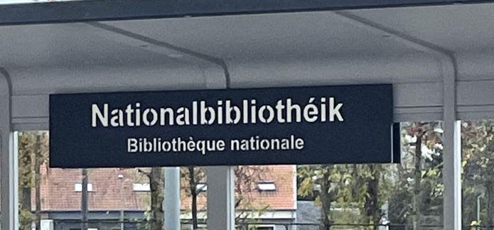
Fig. 1: Tram stop sign ‘Nationalbibliothéik/Bibliothèque nationale’, in Luxembourgish and French

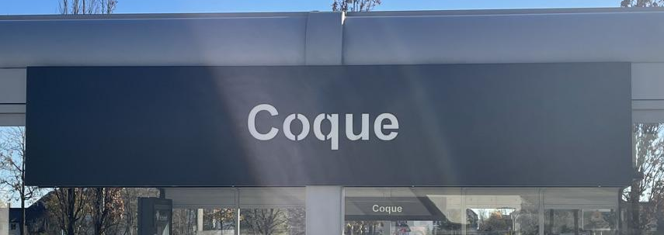
Fig. 2: Tram stop sign ‘Coque’, in French

Prior to this interaction, Tom and I discuss his perceptions of multilingualism in Kirchberg public spaces. Tom then begins to describe his amusement at the audio announcements used on the tram. These announcements tell passengers the name of the next stop on the tram journey, which is also materially inscribed at the stop itself (Figs 1 and 2), reflecting the interconnected multimodality of public transport LLs. Tom focuses on the use of Luxembourgish and French, where he perceives the use of Luxembourgish as having a localising effect and links with the ideological perception of one-nation-one-language, and the use of French is linked to universal utility because ‘most people speak French here’. The ‘here’ Tom refers to is not just Kirchberg, but Luxembourg City (and even Luxembourg) as a whole, thereby positioning Kirchberg as part of the wider city (and country), where perceived linguistic norms or rules are applicable on multiple scales.

On closer dissection, however, discursive representations of the universal utility of French are not as inclusive as superficial perceptions may appear. More specifically, considerations of social class present a challenge to perceptions of French as the language of anonymity, which locates the value of a language in its perceived neutrality (Woolard and Frekko, 2013: 135). In the following extracts, Hugáceo, a Spanish man living in Luxembourg City and working in Kirchberg, and Stefan, a Luxembourgish man born, raised and living in Luxembourg City and working in Kirchberg, both describe the specific associations they perceive of the use of French and ‘blue-collar’ workers in the sign below (Fig.3):

Excerpt 6.1/6: Hugáceo: Ok [long pause while looking at photos] so these are French only right (.) port d'un masque and this one [figuring out what he is looking at] ok so the title is in French only but then the instructions are in both in English and French (.) instructions here (.) this is not like the title is in English and French but (.) this one's in the three like the one we saw like er (.) German and the different languages (.) so maybe it's not always got it (.) masque obligatoire French only (.) prévention COVID maybe here (.) yeah I wonder also because this looks like more erm like for for for workers you know that are working in I don't know behind the door or something like that maybe there is a slight difference for the kind of staff that is there
Int: Ok yeah yeah (.) so for the people that work there?
Hugáceo: The people that work there yes so maybe like blue collar or or how do you say blue collar and white collar or something

Excerpt 6.1/7: Stefan: This sign here (.) yeah I don’t know but I mean this definitely looks like a kind of place where you would have more erm blue-collar workers and (.) immediately I have the sign only in French and you know like some some construction worker I imagine or someone doing something technical and very practical (.) where you probably have to get dirty hands or not use a computer to walk through this kind of door and it’s probably not the right kind of audience to (.) address in English so you have it in French also not in German
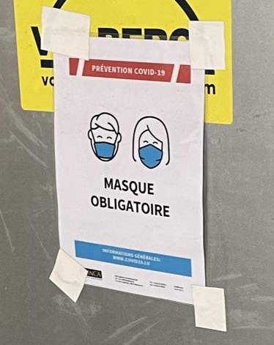

Fig. 3: COVID-19 sign on a worker’s door in the Kirchberg bus station, in French

In the extract with Hugáceo, he is looking through the photos and draws my attention to the photo in Fig.3. It is an image of a COVID sign taped onto a large steel door, featuring icons of people wearing masks and the monolingual French instruction ‘Masque Obligatoire’ underneath. He states that he believes the sign to be on the entrance to a ‘blue-collar’ workplace, due to both the use of French and the sign’s emplacement on a heavy steel door in a seemingly ‘blue-collar’ environment. This is echoed by Stefan, who also refers to this space as ‘blue-collar’, describing his perceived image of the type of person who would work here as someone essentially doing manual labour, such as a construction worker.

This connection between French and blue-collar work is further outlined in the following discussion with Amelia, who discusses the stereotypes about Portuguese people in Luxembourg and their connection to blue-collar work:

Excerpt 6.1/8: Int: I mean do you know what what about this I think this might be (.) interesting (.) partly interesting
Amelia: I mean you do know the stereotypes of the Portuguese immigrants in Luxembourg
Int: What are they? (.) I genuinely don't know them
Amelia: Men (.) men work in construction and the women work as cleaning ladies
Int: Right
Amelia: It's sad like you're in Luxembourg (.) because when the refugees came from Portugal it was in the 60s it was after the revolution (.) the revolution against a dictator […] anyway so it was after him it was in '64 I think the revolution
Int: Right
Amelia: And many Portuguese erm (.) ran away (.) and I think when they came to Luxembourg (.) the Italians came for the mines and the Portuguese came for construction (.) they have constructed the country
Int: Right
Amelia: And it became a stereotype
Int: Right and is that why then this is in [French and] Portuguese? Because obviously-
Amelia: Well yes because people work there who are Portuguese maybe so (.) for the construction workers (.) mee in the south when I go through a construction site I just hear Portuguese I hear a lot of Portuguese

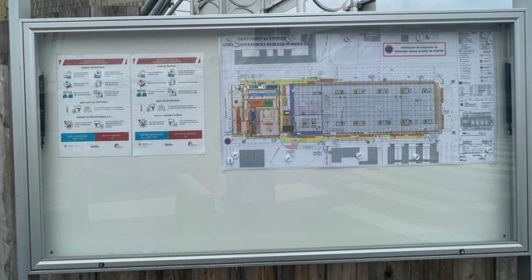

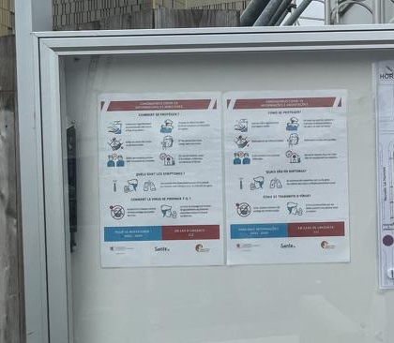
Fig. 4: Noticeboard outside a construction site in Kirchberg, with COVID-19 signage, in French and Portuguese (bottom image is an enlarged version of the COVID-19 signage on the left-hand side of the top image)

After showing her pictures from outside construction sites on Kirchberg, Amelia, a Portuguese woman raised, living and working in southern Luxembourg, immediately begins discussing stereotypes of Portuguese people in Luxembourg, specifically relating to the division of labour along gender lines. The signs are written in French and Portuguese (fig.4), which Amelia suggests is done specifically with the construction workers in mind, and to be representative of the language practices on the site. The use of Portuguese is presented as indexing a particular prominence of Portuguese people in construction work, reproducing the aforementioned stereotype of Portuguese men. However, the use of French here appears to index a generalised imagined workforce composed of Francophone or Romanophone migrant workers, who use French as the working language across national and linguistics backgrounds. From this, it is possible to perceive construction sites as migrant spaces. This further bolstered by the notable absence of Luxembourgish, German and English, which are languages perceived to have localising effects. The presence of Luxembourgish (on its own or in coordination with French and/or German) often defines a space as belonging to Luxembourg, while presence of English likely indexes an emplacement within Kirchberg. In this case, the configuration of French and Portuguese appears to denote a lack of ownership of the construction sites on the part of locals.

This association of French with the working class and employment in more manual physically demanding sectors is influenced in part by the high presence of Francophone frontaliers, or border-crossing commuters, and Romanophone immigrants in Luxembourg from Portugal and Italy. There is often the social perception that Francophone and Romanophone speakers in Luxembourg tend to favour learning and speaking French over Germanic varieties due to its proximity to the Romance languages they already speak. In particular, these speech communities represent more established linguistic communities in Luxembourg, such as many Portuguese and Italian immigrants coming to Luxembourg in the 1960s and 1970s, when they were encouraged by the Luxembourg government to speak French as a language of access to Luxembourgish daily life. Furthermore, Francophone and Romanophone speakers came to Luxembourg, often finding employment in traditionally less well-paid sectors such as hospitality and construction.

While the tendencies to favour French over Germanic varieties and to find employment in less well-paid sectors continue somewhat to this day but to a much lesser extent, social perceptions of this phenomenon persist and are maintained and reproduced discursively. Recognition of the difference between the tendencies and discursive reproductions is important. Both Hugáceo and Stefan acknowledge and address their perceived connection between French and working-class migrants as highly dependent on stereotypes throughout our discussions.

It is here that one can see the challenge to the universal utility of French. On the one hand, French is portrayed as the language of anonymity that is used by everyone because it is the language that ‘everyone knows.’ On the other hand, when discussed in association with blue-collar work, French is portrayed as a language of authenticity of the stereotypical blue-collar worker, who is often presented as having a migration background as speaking French due to the language’s proximity to other Romance languages, namely Portuguese, as part of the worker’s perceived migration journey. Here, ‘typical’ usage and blue-collar usage of French are differentiated from each other, contributing to an invisibilisation of working-class people in perceptions of the linguistic practices associated with Kirchberg, and bolstering the image of ‘work’ within the specific situation of Kirchberg.

In summary, perceptions of the use of French centre on its utility throughout the city and the country and is justified in Kirchberg through its positioning as just another part of Luxembourg (City). Despite the ubiquity of written French on the LL, perceptions of its presence are not simple, and instead French is perceived to possess multiple intertwined indexicalities, particularly in relation to issues of social class. When reading French-saturated spaces in Kirchberg, it is clear from participant observations that the emplacement of signage contributes significantly to one’s understanding of the function of the materialised language, and in turn to one’s understanding of the space in question.

6.2 Noticing Luxembourgish is (not) there
Among the participants, the presence and absence of written Luxembourgish on the Kirchberg LL is recurrently noticed and noteworthy. When Luxembourgish is present on signage, the discussions focus on its affective aspect and how its presence makes the participants feel. When absent, the discussions turn towards questioning whether it should be there in the first place. In the following extracts, some of the Luxembourgish participants describe written Luxembourgish on the LL, particularly in Kirchberg, as not necessarily common but unsurprising due to being in Luxembourg:

Excerpt 6.2/1: Lara: Aw (.) a Luxembourgish one [laughs] with a nice hashtag as well that I’m sure no one’s gonna use
Int: Why did you react like that when you saw the Luxembourgish?
Lara: I just don’t feel like it’s common [in Kirchberg]

Excerpt 6.2/2: Trisha: Ahhh they even have it in Luxembourgish nice (.) so I’d say that means it’s a small maybe family-run bar like (.) not really a bar but those you know those pubs a pub so (.) so I guess the chances are high that they do speak Luxembourgish that you could actually approach someone and speak Luxembourgish
Int: And what makes you say that then?
Trisha: Maybe because they put the Luxembourgish on like the sentence
Int: So you think that having the Luxembourgish there would indicate that the person in that building would speak Luxembourgish (.) do you think there’s that connection?
Trisha: Either that or they do have Luxembourgish guests and they value them maybe

Excerpt 6.2/3: Stefan: Yeah so there (.) Luxembourgish as a first that’s so interesting the first one you see […] erm (.) and the hashtag they also have in Luxembourgish […] yeah they’ve probably done that in Luxembourgish to kind of show that erm you are in Luxembourg after all
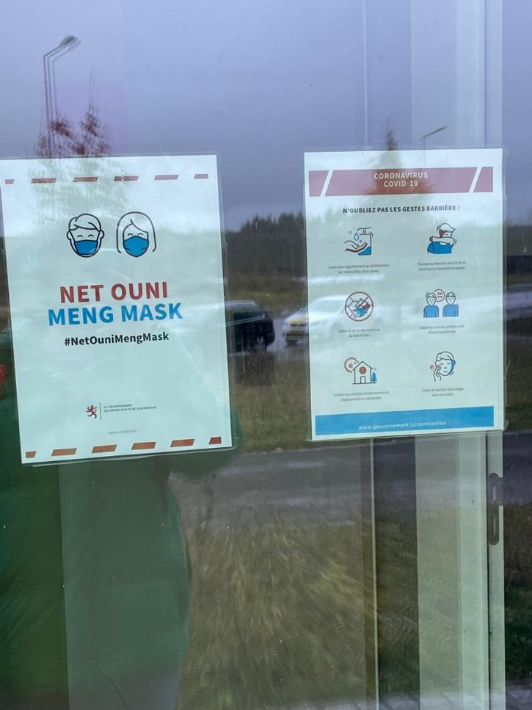

Fig. 5: COVID-19 sign on a government building for the governmental campaign “Net Ouni Meng Mask” (lit. “Not Without My Mask”), in Luxembourgish

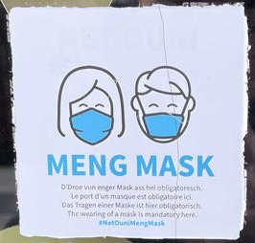

Fig. 6: Small COVID-19 sign on the door of a restaurant in a Kirchberg residential area, written in Luxembourgish, French, German and English

In the discussion with Lara, a Luxembourger from the east of the country near the German border now living near Luxembourg City, she reacts positively yet surprised to see Luxembourgish on the sign in Fig.2, a similar reaction to Trisha, a Luxembourger from northern Luxembourg living near Luxembourg City, when she sees the Luxembourgish on the sign in Fig. 5. These reactions demonstrate the emotional connection and affinity felt by many Luxembourgers when seeing Luxembourgish inscribed as part of the LL, while also demonstrating an undertone of acceptance of its limited role in written functions.

Trisha continues, drawing a connection between the presence of Luxembourgish on the sign and the presence of Luxembourgers (or at least Luxembourgish-speakers) in the establishment, to which it is attached. In stark contrast to the multiple indexicalities of French (see section 6.1), Trisha presents Luxembourgish as specifically indexical of Luxembourgishness and the specific demographic of Luxembourgish(-speaking) people. Furthermore, she perceives this presence of Luxembourgish as validating to Luxembourgish patrons and custom, marking the symbolic function of the language.

Stefan also discusses the symbolic function of Luxembourgish in reference to the hashtag in Fig. 5, in his case highlighting the connection between the language and Luxembourgish locatedness. From his perspective, the use of Luxembourgish on this sign has a localising function, connecting to his concept of place and how the emplacement of Luxembourgish in Kirchberg is a reminder that ‘you are in Luxembourg after all.’ This is an especially important message to convey in an international space such as Kirchberg, which can sometimes feel separate from the rest of the city and indeed the country (see Chapter 5 for further discussion of this).

This connection between language and locatedness can also be seen among the resident foreigners of the participants, whose reactions fall somewhere between surprised and not surprised, with surprise coming only as initial reactions to the use of Luxembourgish specifically in Kirchberg:

Excerpt 6.2/4: Tom: So erm (.) but yeah there are definitely places where it's Luxembourgish is (.) the de facto go-to language for a lot of people (.) not that they (.) won't speak the others it's just the day-to-day they don't (.) really need to I guess
Int: Right right
Tom: Now why that's in Kirchberg I don't know
Int: I was about to ask that question
Tom: Maybe it's just because they printed loads [laughs] I really don't know
Int: Do you think it's surprising that it's in Kirchberg?
Tom: Er no (.) no I'm not I'm never surprised when I see something written in Luxembourgish
Int: Oh that's cool
Tom: Because we're in Luxembourg so that makes sense to me (.) erm (.) I'm sometimes surprised when I see things other than the English Luxembourgish German or French
Int: Oh really ok like like what?
Tom: Like in an official kind of way

Excerpt 6.2/5: Jane: Yeah so I like that being in Luxembourgish
Int: That's nice (.) is it surprising that it's in Kirchberg? (.) That there's a bit of Luxembourgish in Kirchberg?
Jane: Yes (.) er for numerous reasons (.) there's 600,000ish people in Lux (.) er during the day 9 to 5 there's over a million
Int: Right
Jane: Because they all travel over from the borders so they might not know what this means it's an inside joke that only people registered in Luxembourg would know

Both Tom and Jane, British people living in Luxembourg, express initial confusion or surprise to the use of Luxembourgish as the slogan they see in Fig. 5. At first glance, the use of Luxembourgish to Tom does not immediately make sense in Kirchberg because he seems to associate other places with Luxembourgish, but not Kirchberg. However, when asked, he perceives the presence of Luxembourgish as a reinforcement that ‘we’re in Luxembourg’ even when in Kirchberg.

Jane, on the other hand, regards this use of Luxembourgish as surprising because the population makeup of Kirchberg leans more international, especially during the working day as frontaliers come into the country for work. She considers this use of Luxembourgish as the official governmental slogan for the COVID-19 pandemic an ‘inside joke’ among Luxembourgers and foreign residents, all of whom are considered to have at least an awareness of Luxembourgish and of this campaign. Through this, Jane appears to characterise this use of Luxembourgish as simultaneously an inclusive and exclusive tool, inclusive to Luxembourgers and those not considered Luxembourgish but are nonetheless perceived as permanent parts of Luxembourg’s demographic makeup, yet excluding those who are perceived as only temporary economic contributors to the country. The reactions from Tom and Jane regarding the presence of Luxembourgish in Kirchberg suggests an ongoing negotiation as to the extent that the semiotic aggregate of Kirchberg includes Luxembourgish signage.

This perception of Luxembourgish as simultaneously inclusive and exclusive is bolstered by its presence and emplacement in Kirchberg specifically, where the use of Luxembourgish as a localising language is discursively presented as potentially at odds with the perceived image of Kirchberg as international. The presence of Luxembourgish in Kirchberg public spaces can perhaps then be interpreted as indexical of efforts to mark the district from an outward-facing perspective as an explicitly Luxembourgish space to those coming into the country. From an inward-facing perspective, these efforts to present Kirchberg as Luxembourgish may seem in tension with insider perspectives of Kirchberg as an international space, separate to other parts of the city.

Along with discussing the presence of written Luxembourgish, it is also important to discuss its absence from the LL, which is also a common discussion point. In the following extracts, participants discuss the absence of Luxembourgish on the sign in Fig. 6, which became a recognisable sign during the pandemic in Luxembourg:

Excerpt 6.2/6: Trisha: What else do I see (.) the common languages French German English (.) I feel like they should’ve put something Luxembourgish as well but there might be a second sign I don’t know but erm yeah
Int: Why do you say that (.) why do you say there should be something in Luxembourgish?
Trisha: Because I feel it’s the national language like (.) it’s the the country’s language so we feel like it should be there as well (.) because on some signs you might have well you have something in Luxembourgish sometimes you don’t so it’s a bit you know (.) but yeah obviously French is the first language to go to so yeah

Excerpt 6.2/7: Luc: And indeed I find honestly strange that it's not er in er in Luxembourgish
Int: I was gonna ask you about that because you said
Luc: I think it should be I think it should be it's it's one of the official languages
Int: Tell me more
Luc: For different reasons (a) it's one of the official languages and (b) just out of respect for Luxembourgish people I mean of course there are over 50% foreigners in Luxembourg but still we are somehow invited here well I consider more than someone who is invited in the country because (.) I purchased my own house and so on and I project myself in the long term but still I know I know that I'm a foreigner and I respect a lot the Luxembourgish people and I think not having Luxembourgish is not respectful

Excerpt 6.2/8: Int: Do you think they should be there?
Jane: (.) I think they should I think Luxembourgish at least (.) the reason for that is because we are in Luxembourg and also I get to learn (.) a few little words whenever I see these signs […] just a couple of words at a time (.) and if it's you know a poster you walk past a lot it absorbs
Int: Yeah (.) and do you think that's an important thing?
Jane: (.) I think it is I think you know we are in Luxembourg let's not deny the existence of a language but (.) is it the official language no because nothing is done in Luxembourgish all official stuff is done in French erm (.) but I still think (.) it's cute it's cute for me it's cute to see it it's cute to learn and it (.) acknowledges the existence of (.) an entire demographic that have passports for this actual country (.) that's my view

Fig. 7: COVID-19 sign on the door of the Kirchberg-Pfaffenthal transport hub, written in French, German and English

Two recurring themes among the participants are that Luxembourgish should have been included on the sign, firstly for reasons of officiality and secondly out of respect for being in Luxembourg and the Luxembourgish people, further emboldening this connection between language, people, and place. On deeper inspection, all three of these participants also express different, more personal reasonings for their support for Luxembourgish visibility.

Trisha finds the visibility of Luxembourgish or ‘the country’s language’ validating and something that Luxembourgers like her want to see more of, using the collective pronoun ‘we’ to emphasise this as a collective desire, as opposed to an individualistic one. Luc, a French man living in Luxembourg, positions himself as a guest in the country, whose support for the visibility of Luxembourgish is a way for him to show his gratitude to the country he is settling in. Jane perceives the absence of Luxembourgish as an omission or even another example of ideological erasure (Irvine & Gal, 2000) equivalent to ‘deny[ing] the existence’ of the language and the people it represents. She perceives the presence of Luxembourgish as a way for her to learn ‘a couple of words at a time’ through immersion in the LL, perceiving language education on the part of the foreigner as a way to combat the perceived erasure and respect the people in the country.

Despite the reasoning presented in the above extracts supporting the presence of Luxembourgish, there are also many perceived reasons behind its absence, with many participants expressing reasons to explain both its presence and absence in the same discussion. In the following extracts, Jane and Luc, who both express support for a greater presence of written Luxembourgish, also outline their perceptions of why Luxembourgish is absent from the sign in Fig. 6:

Excerpt 6.2/9: Int: That makes sense that makes total sense so (.) you mentioned a little bit before about you know (.) Luxembourgers can probably speak these languages and more plus
Jane: Yeah
Int: Do you think that's the reason it's not there?
Jane: Yeah
Int: Is that the only reason that it's not there?
Jane: Yeah
Int: Right
Jane: I think you know (.) keep it short and sweet you can always (.) I'd say 90% of people maybe even more can speak one of these three languages (.) and so then you just clutter the sign with an additional (.) language

Excerpt 6.2/10: Int: Really (.) why do you think [Luxembourgish] isn't there then?
Luc: Because because of er because if you start having 4 languages it's a bit too much first and then Luxembourgish is so similar to German that there should I guess they consider that German is fine and they had to make a choice for really between Luxembourgish and German (.) and they said ok all Luxembourgish people will understand German whereas all German people will not understand Luxembourgish so let's go for Lux- er for German I guess

Both Jane and Luc refer to the idea of linguistic clutter on signage, where they express a belief that there is a limit to how multilingual signage can be before the sign becomes unnecessarily complicated, hard to read or counterproductive to the effective transmission of the message of the sign. This is noteworthy because of the way the language choice is presented as being between Luxembourgish and German, Germanic varieties with perceived similarities. The inclusion of German is portrayed as a pragmatic choice that benefits both monolingual German speakers and the idealised multilingual Luxembourger, who is able to understand German. Whereas the inclusion of Luxembourgish on this sign is portrayed as potentially superfluous and not adding any further pragmatic informative value, reinforcing discourses of uselessness regarding written Luxembourgish, and further exemplifying the ideological distinction drawn between spoken and written Luxembourgish.

As previously mentioned, many perceive Luxembourgish to be indexical of Luxembourgishness, however, from these extracts, it is also evident that the multilingual nature of the sign, particularly this specific linguistic configuration of French, German and (increasingly) English, can also be perceived as indexical of Luxembourgishness. This can be seen in the following extracts as well, in which Trisha and Lara are discussing multilingual signage in general, and they explain how not including Luxembourgish in multilingual signage does not impede the goal of reaching as many people as possible without excluding anyone:

Excerpt 6.2/11: Int: Why do you think it isn’t there (.) Luxembourgish I mean?
Trisha: Because we speak all the other three languages mentioned so maybe to save space (.) and for the rest (.) I’d say you could assume […] let’s assume a Luxembourgish person speaks French at least one of those languages but if you have some a German coming over here he she whatever might not speak Luxembourgish a French person might not speak Luxembourgish and English person might not speak English or either of the other languages stated a German might not speak French or English you never know (.) a French might not know German or English (.) and Luxembourgish is really it’s not that common so you don’t have all the foreigners speaking the language or (.) if there’s even someone across the border who speaks it maybe just the the basics you know like “hey” how are you?” “yes” “no” “bye” stuff like that so I’d say it’s not necessary to put the Luxembourgish because the (.) yeah yeah because there you have everyone getting it

Excerpt 6.2/12: Lara: Yeah so we have French German and English erm (.) it seems (.) I don’t know it just seems very typical to not put Luxembourgish on there [laughs]
Int: Why?
Lara: There’s just so many people who either can’t read it or don’t understand it so I just think well (.) realistically speaking they reach more people with those languages than they would with Luxembourgish (.) I don’t know they could’ve put a fourth languages on there but maybe it was not aesthetically pleasing or maybe it was just kind of not necessary really because if you speak Luxembourgish you’re gonna be proficient in at least one of those anyway (.) also no one knows how to write it like you know except for the people that study it [laughs]

Here, being multilingual can be interpreted as an equally Luxembourgish quality to speaking Luxembourgish, with both Trisha and Lara asserting that being able to speak Luxembourgish guarantees a proficiency in the other languages on the sign, i.e. French, German and increasingly English. Moreover, in contrast to the aforementioned exclusive quality of Luxembourgish, the “uncluttered” multilingual display, composed of languages that both play significant roles in Luxembourgish society and are presented as widely spoken by the international population of Kirchberg, is perceived as a more inclusive linguistic choice because ‘everyone [is] getting it.’ It would appear that these two linguistic designs are perceived as mutually exclusive. This is an important consideration for Kirchberg in particular because of its international population, where a linguistic model perceived as more inclusive and as more reflective of language practices in the district is a more pragmatic choice in the construction of the LL as a medium for the dissemination of information to the public.

In summary, the decision to include Luxembourgish in public signage is presented as requiring significant consideration. While it possesses significant symbolic functions in the country, Luxembourgish, more specifically in its written form, is perceived to possess less instrumental power, especially in comparison with the other frequently used written languages of French, German and English, a direct contrast to the instrumentality often associated with spoken Luxembourgish.

Furthermore, there is a perception that the presence of Luxembourgish potentially contributes to the exclusion of non-Luxembourgish speakers who are a significant presence in the country, and specifically in Kirchberg, which boasts highly diverse resident and worker populations. It is important to understand, however, the relative absence of Luxembourgish in Kirchberg is sometimes considered to be reflective of dominant language practices in the district, of which Luxembourgish plays a smaller role, and of the curation of the image of Kirchberg as an international space, which can seem at odds with the localising effect of Luxembourgish. That being said, the presence of Luxembourgish in Kirchberg is not perceived as unacceptable because Kirchberg, though somewhat unique compared to other parts of Luxembourg City in terms of language practices, is still considered part of the city, nonetheless.

The discussions surrounding the presence and absence of Luxembourgish in Kirchberg in effect presents an acknowledgement of deeper issues regarding the discursive positioning of the Luxembourgish language and Luxembourgish multilingualism as simultaneously indexical of Luxembourgishness. Though these discourses often form part of general discussions of language in Luxembourg, the site of Kirchberg in particular presents an effective example of the co-dependence and interconnection of these two strands, and how they can be considered alternative paths towards the same goal of constructing inarguably and quintessentially Luxembourgish spaces.

6.3 The growing presence of English in Kirchberg and beyond
The presence of English in Luxembourg has in recent years undergone a significant increase, so much so that any discussion of the linguistic situation in Luxembourg and particularly in Kirchberg would be incomplete without this discussion. In this section, it is important to address several different strands regarding the complexity of the presence of English in Kirchberg. In section 6.3.1, I explore the connections between English and Kirchberg, along the lines of connection with outward-looking internationalism and inward-looking Luxembourgishness. In section 6.3.2, I address justifications of the presence of English in Kirchberg through participant perceptions of the officiality of English in Luxembourg. In section 6.3.3, I discuss the increasing presence of English in Kirchberg and in the wider city and country, in order to demonstrate the increasingly complex position occupied by English in the Kirchberg LL and the wider Luxembourgish language situation.

6.3.1 Perceptions of role of English in Kirchberg
English plays a significant role in the district of Kirchberg, primarily due to its associations with internationalism and as an ‘ecolinguistic side effect’ of globalisation (Fehlen & Heinz, 2016). In the following extracts, participants clearly illuminate these connections between internationalism, English and Kirchberg, by highlighting the expectation of seeing English in public spaces in Kirchberg and presenting the potential addition of English to a sign as logical:

Excerpt 6.3.1/1: Sofia: […] Yeah erm (.) can you zoom in to the door like to the right of it where it says something? (.) Ah ok yeah (.) it’s just Luxembourgish and French (.) yeah I don’t know I would have thought that in Kirchberg they would put some (.) they would add some English
Int: Mm hmm why in Kirchberg?
Sofia: Because as I said there are a lot of people coming from all around the world and like a lot of international people working there

Excerpt 6.3.1/2: Nina: Mm hmm but because if you if you use that logic of yeah to arrive at more audience then you should put Portuguese then you should also put Italian they should also put Russian Polish whatever language there is (.) so I guess that's not the (.) the purpose right
Int: Right (.) so it's kind of like a slippery slope?
Nina: Yeah yeah you can put as much as you want you can arrive at 100 languages then if everyone says because yeah because we have an audience here (.) so yeah but er yeah English yeah I guess yeah if you put English I would say yes it's because it's still considered somehow as an international language everyone speaks it I think that's more the reason

Excerpt 6.3.1/3: Luc: I guess but I'm not sure er (.) and then and also again [French is] one of the official languages so (.) makes sense to to put French but then (.) English is really the international language so if you have to choose one you would put this one that's logical

Sofia, a Luxembourger of eastern European descent born, raised and living in Luxembourg City, and Nina, a Chinese woman living in Luxembourg, both describe English as a language that bridges the linguistic gap between people of different cultures. Furthermore, Sofia, Nina and Luc all use the word ‘international’ to describe English, with its presence being rationalised as efficient or ‘logical’. In particular, English is perceived as a much-needed lingua franca for a highly internationally diverse population, a marked aspect of Kirchberg that is often positioned at the forefront of descriptions of the district.

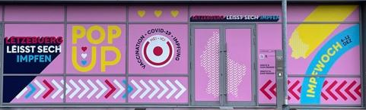Fig. 8: Vaccination centre outside the Auchan shopping centre, written in French and Luxembourgish
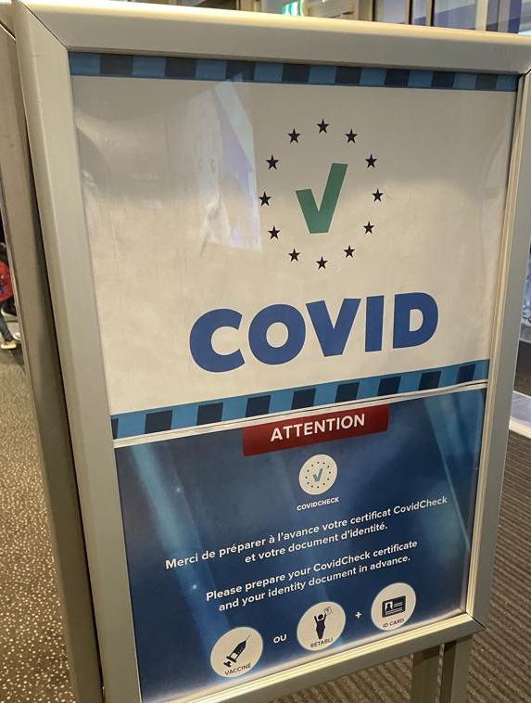

Fig. 9: Sign for the government initiative ‘COVID Check’ located in Kinepolis cinema and restaurant complex, in French and English

However, the arguments in favour of the inclusion of English on the Kirchberg LL do not argue for the replacement of multilingual signage with English by itself but rather highlight the benefit of incorporating English into the existing multilingual framework. Sofia, for example, notices that English is absent from the signage on the vaccination centre door front in Fig. 8 and opines that the people creating the signage should ‘add’ English because of its quality to reach more people. Similarly, Luc appears to take for granted the co-existence of French and English in Fig. 9, where the presence of one does not, in his view, appear to detract from presence of the other and are in fact serving different roles and are present for different reasons. When discussing the general problems surrounding linguistically targeting the audience of a sign, Nina suggests that the use of English is an effective placeholder for the languages representing social groups in Luxembourg not represented by the officially recognised languages of French, German and Luxembourgish.

This idea of the benefits of incorporating English is echoed by Lara, who, in her discussion of the sign in Fig. 6, says that a multilingual space like Kirchberg benefits from the additional use of English:

Excerpt 6.3.1/4: Int: So you said it’s pretty common to see the French the German the English
Lara: Yeah (.) oh well the English one is I think more recent actually
Int: Oh really ok
Lara: I wouldn’t say that English would have been included a lot a couple of years but now it does (.) and anyway it kind of makes sense it’s in Kirchberg I suppose Kirchberg is quite multilingual so putting English on there makes sense (.) at least to me

Lara explicitly describes Kirchberg as ‘multilingual’, but in such a way that appears to discursively construct Kirchberg as multilingual in a different way to other parts of Luxembourg City. According to Lara, the presence of English could be viewed as the result of an acknowledgement and response to a more descriptive or flexible view of multilingualism beyond perhaps the conceptualisations of the officially recognised trilingualism of the state. In other words, Lara seems to suggest that the multilingual practices reflected in signage found in Kirchberg are more reflective of a district with a particularly linguistically diverse population, with English discursively presented as (part of) a linguistic design more appropriate for Kirchberg. This can be interpreted as in contrast to other parts of the city, which are seemingly presented as multilingual in a more Luxembourgish sense, wherein the use of the more rigid trilingual regime of French, German and Luxembourgish is perceived as sufficient and reflective of a potentially more local population.

It is important to point out here that scholarship on English as a global language documents associations between English and internationalism, globalisation and intercultural communication as often taken for granted (Sergeant, 2012: 15). These beliefs are also reproduced and reinforced regularly among the participants in this research, who pinpoint this instrumental function of English generally without question. These perceptions of English, however, as a neutral instrument run the risk of problematically reinforcing discourses of the supposed neutrality of English and masking the ‘linguistic hegemony’ of English, which is regularly linked to the reinforcement of ‘socio-economic inequalities within and between societies’ (ibid.: 25). In the extract below, Hugáceo outlines his perceptions of English in Luxembourg as connected to internationalism but also materially visible on the ‘big buildings’ of large corporations on the Kirchberg Plateau:

Excerpt 6.3.1/5: Hugáceo: So I was saying maybe what I was saying maybe if something is more leaning towards like I guess to the airport or to the tram I don't know like these international connections there I would see English I think (.) erm maybe on on big buildings (.) international I mean let's say private corporate I would see also the English (.) er I have not thought but now I am thinking if some of those were taken in Kirchberg in European institutions you have the additional thing that (.) er not us at [my workplace] because we are more a brand new institution we er we work in English but the European institutions they work in the three languages er so

Hugáceo asserts a connection between English and notions of the ‘international, the ‘private’ and the ‘corporate’, all of which are considered part of the lifeblood of Kirchberg, which is the financial district of the country. Here, it is evident that there are further associations of English as a global language indexing deeply entrenched capitalist social structures, such as the prevalence of large multinational private corporations and the continuously growing influence of the private financial sector within more developed economies (Kingsley, 2013), which cannot be viewed as neutral. These associations between Kirchberg, English and deepening global socioeconomic integration contribute to perceptions of Kirchberg as the disconnected island separate from the rest of the city.

In short, among the participants, English is deeply connected to processes of internationalism and globalisation, in such ways as positioned as the solution to issues arising from populations with highly diverse linguistic backgrounds. In the case of Kirchberg, the presence of English is indicative of the simultaneity of Kirchberg as both an international and Luxembourgish space. On the one hand, English finds significant prominence in Kirchberg, due in large part to the associations of the district with greater global socioeconomic integration as well as its significant embrace of the capitalist social structures, potentially contributing to deepening perceptions of a disconnected Kirchberg. Simultaneously, the reference to multilingual practices including English is also perceived as a reflection of a decidedly Luxembourgish response to the challenge of linguistic inclusion in Kirchberg.

6.3.2 The increase of English in Kirchberg and wider Luxembourg (City)
According to testimonies from participants discussing the connections between English and Kirchberg, the presence and use of English is presented as having become a more accepted and integrated part of life for those living and working in the district:

Excerpt 6.3.2/1: Sofia: I think the English thing (.) that’s often not even on there I think mostly it’s French and German on signs (.) at least it used to be
Int: So why do you think the English is on there?
Sofia: Because nowadays there are more visitors (.) more foreign workers and stuff (.) students (.) so yeah English has basically become the universal language

Excerpt 6.3.2/2: Stefan: I wonder why this one is only in English (.) so I wonder where that is
Int: That’s in the Kinepolis
Stefan: Oh is it?
Int: In one of the restaurants
Stefan: Really ok (.) yeah that’s also kind of random to be honest because it’s not like you would only have English-speaking people there so (.) yeah yeah that kind of makes me think it’s run by people by someone who is native English speaker who maybe doesn’t speak French and puts up whatever he understands (.) which in a way I can also understand because you don’t want to put up a sign [laughs] when you don’t even know what it says (.) I mean you can assume I don’t know how this worked you know whether they got it in different [languages] you know [then chose which signs to put up]

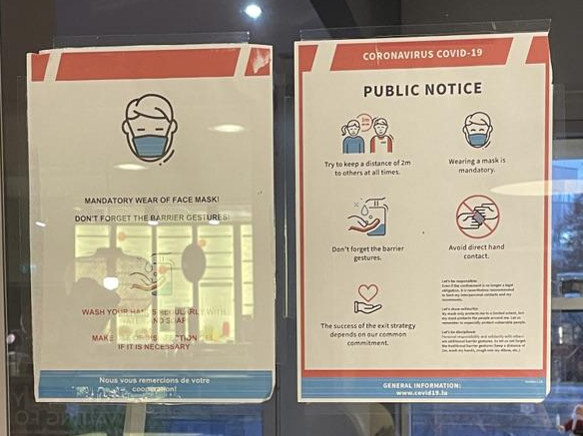

Fig. 10: COVID-19 sign on the door of a restaurant in Kinepolis in Kirchberg, in English

Sofia highlights how the use of English on signage in general in Kirchberg has become more typical in recent years as the number of international visitors, residents and workers has increased, so much so that English has become an integral part of the linguistic practices of those in the district. This is echoed by Stefan, who initially expresses a degree of surprise at seeing an English-only sign (Fig. 10), even in Kirchberg, something he is not used to seeing as he has an expectation that people in Luxembourg would not only speak English. Yet, he then thinks about it and concludes that this person is perhaps a native English-speaker who does not speak French, the language commonly considered to be the most useful in Luxembourgish daily life (see section 6.2). This demonstrates how the use of English is a fundamental the semiotic aggregate of discourses in Kirchberg as the initial language of outreach because even Luxembourgers like Stefan are able to surmise that it is an option in the first place. This disruption of the perceived traditional roles and language practice norms of Luxembourg taking place in Kirchberg only further adds to considerations of Kirchberg as different to other parts of the city.

This perceived change in the linguistic situation is perhaps best described by Katarina as ‘a shift in the air’ in Luxembourg, who attributes the growing use and acceptability of English to a fundamental change in the language roles of the country:

Excerpt 6.3.2/3: Katarina: But maybe this kind of policy is kind of new isn't it so (.) and the tradition is changing English is used more and more and so (.) maybe that's why there is this English yeah […] I think it's just kind of like the time (.) of some change in Luxembourg I suppose that maybe for a long time it was very (.) erm (.) like erm (.) very like yeah before it was just like er German Luxembourgish erm French (.) those three languages form the [xxx] so there's this tradition but now it's changing because here the last years it's just been a lot of people here that actually cannot speak French and cannot speak Luxembourgish and so I think it's just er (.) it's just some kind of (.) shift kind of in the (.) in the air er like language shift I suppose yeah

From Katarina’s statement, a further question arises, the question of whether the growing presence of English is limited to Kirchberg or if it is also being felt in the rest of the city. In the following extract, Stefan discusses how the use of English on the LL specifically in Kirchberg can be perceived as a response to a linguistic need in Kirchberg to communicate with a higher-than-average number of people who use English as their prominent part of their linguistic repertoire and daily communicative practices:

Excerpt 6.3.2/4: Int: […] What do you think about the languages that are being used?
Stefan: […] This is something that there’s some information that you want to bring across to people because you have a pandemic that you want to stop and there’s some practical information that you want to bring across and I think then those three languages definitely make sense (.) especially here in Kirchberg
Int: What do you mean especially here?
Stefan: Because er I mean for instance English is not an official language in Luxembourg but yeah we’ve been talking about it a lot now how many people work here in this area (.) yeah it’s maybe the only language they can communicate in here in Luxembourg (.) so it makes sense to include that one (.) I mean if you would not be in Kirchberg (.) in a place like Gare or in a place probably even more so in the south of the country like Esch somewhere in Differdange it probably makes sense to put it in Portuguese there

He presents this need for English in Kirchberg as comparable to a need for Portuguese in city districts like Gare (the area around Luxembourg Central train station), where large Portuguese-speaking communities reside, beyond which it is not necessary to use Portuguese. In other words, he appears to present the need to use English on the LL as perhaps confined to Kirchberg, where there is perceived to be the highest concentration of English-speaking people. Here, Stefan highlights his expectation that linguistic practices in a space should be reflected in the LL. Contrast this with Lara, who presents the presence of English quite differently:

Excerpt 6.3.2/5: Int: Would you not find the English in other parts of the city (.) or the country?
Lara: Hmm (.) maybe in other parts of the city but I don’t think necessarily in other parts of the country (.) if you go to rural places I don’t think they would have put the English there (.) yeah no I don’t think they would have [laughs] they’re fine with German and French (.) they would probably actually use more Luxembourgish in these rural places as well

Here, Lara asserts that the sign in Fig.6, which includes English, could possibly be found in other parts of the city, but not necessarily in other parts of the country outside of Luxembourg City. These parallel contrasts between district and city and between city and country are illustrated well in the following extracts with Trisha, who discusses the presence of English through comparisons on these two scales:

Excerpt 6.3.2/6: Trisha: Depending on where you go (.) erm usually let’s say outside of Luxembourg [City] (.) you have most of the restaurants like everything that’s hospitality basically like restaurants bars you know (.) I’d say most of them are French (.) in the north it’s more Luxembourgish I’d say
Int: Oh really that’s cool
Trisha: Yeah yeah I’d say Luxembourgish is more a thing in the north of the country and then the lower you get it’s more French but here in the centre of Luxembourg you have a lot of (.) I don’t know why but a lot of people that speak English (.) so actually if I’d rather go to a bar here in Luxembourg [City] my first language well my first thought would be to speak English
Int: Really?
Trisha: Yeah also French but I don’t know like a lot of bars here you have not necessarily English stuff but international stuff (.) so there’s one place I love to go and most of them speak English

Excerpt 6.3.2/7: Int: So you said about how like (.) how it’s got quite a lot of international businesses would you say that Kirchberg is quite international?
Trisha: Yeah
Int: More so than the city or how would you compare it to the city?
Trisha: I don’t know (.) I don’t exactly know what big companies there are in the centre (.) honestly I don’t particularly pay attention to that [laugh] so that’s why I don’t really know but the place I told you about before (.) if you go out for example on a Thursday night even any weekday night you see a lot of (.) you recognise the guys wearing suits you know speaking English together (.) so you do see erm (.) yeah I’d say there you have a lot of English present so because it’s quite international (.) erm I’d say yeah yeah more than the city centre I’d say

In the first extract, Trisha explains how English is used more so in Luxembourg City than in other parts of the country and, in the second extract, she explains how it is used more in Kirchberg than in other parts of Luxembourg City. This is an example of fractal recursivity (Irvine & Gal, 2000: 38), which is the ‘projection of an opposition, salient at some level of relationship, onto some other level.’ In this case, the perception of Kirchberg as the part of Luxembourg City where one could easily speak and see English is reproduced on a higher level with the perception of Luxembourg City as the part of Luxembourg where one could speak and see English. What this tells us is that perceptions of the otherness or separateness of Kirchberg in relation to the rest of the city (see Chapter 6) can actually be considered reproductions of perceptions of the separateness of Luxembourg City in relation to the rest of the country on a smaller scale.

To summarise, English is often perceived as becoming more integrated into daily life in Kirchberg, an increasingly acceptable (if still somewhat limited) facet of what is considered ordinary multilingualism in Luxembourg, emphasising the Luxembourgishness of Kirchberg. The interconnectedness of English with Kirchberg could perhaps be considered a symptomatic response to the needs of the district, that is, a need for a lingua franca to facilitate communication between a highly internationally diverse population of people, much like in other districts, such as Gare, which have differing social makeups and therefore linguistic needs. However, this growing presence of English is apparently not limited to Kirchberg, with its influence being felt to varying degrees in other parts of the city, allowing one to consider the perceptions of English in Luxembourg as fractally recursive, being felt on multiple scales and exemplifying the changing role of English in the country.

6.3.3 English and officiality in Luxembourg
As previously mentioned by Stefan in section 6.3.2, English is ‘not an official language in Luxembourg but […] it’s maybe the only language [workers in Kirchberg] can communicate in’. Participants generally discussed officiality as pertaining to the enshrined status as an officially recognised language at the Luxembourgish state level, namely French, German and Luxembourgish. Throughout the interviews, several participants routinely made reference to their perceptions of the potential officiality of English and how these contribute to justifications of the presence of English. For example, in the following excerpt with Luc, who is looking at the signs of the different tram stops (see Figs. 1 and 2 as examples) and comes to realise that Luxembourgish and French are present on these signs, but English in particular is not:

Excerpt 6.3.3/1: Luc: So it's in Luxembourgish and French
Int: Mm hmm
Luc: Er (.) so yeah no (.) no English I would say no English ok because it's that's something very official that the tram (.) about the tram stop's name
Int: Right
Luc: So no English it's not an official language fine er no German er again here (.) for me from my point of view it looks strange that there is no German whereas German is one of the official languages

On the one hand, Luc immediately comments on the absence of English, suggesting an initial expectation that, in Kirchberg, signage would at least contain some English because of aforementioned associations between Kirchberg, English and internationalism. However, he challenges his own initial beliefs by bringing in the consideration of officiality of language and signage. Luc observes the absence of German as ‘one of the official languages’ of Luxembourg, which for him is ‘strange’ of the perceived role of German in more traditional linguistic expressions of Luxembourgishness. He then states that English is ‘not an official language’, much like Stefan, and therefore its absence on the ‘very official’ tram stop signage makes sense, while the absence of German does not. This suggests that, according to Luc, while English has come to have a prominent and expected presence in Kirchberg, the presence of the state-level officially recognised languages of French, Luxembourgish and German is considered more appropriate for situations deemed more ‘official’, such as infrastructure projects sanctioned by or associated with governing bodies like the tram line. At the same time, the absence of languages that are not officially recognised, in this case English, is considered to be understandable, appropriate, and correct, reinforcing a perceived hierarchy of languages in Luxembourg based on the official recognition of a language, even potentially in spite of its prominence.

This somewhat more pragmatic perception of the officiality of English in accordance with official recognition at the state or governmental level belies, however, a more complex situation. As stated by Hawkey and Horner (2021: 197), ‘declarations of language officiality are shown to have both substantive and symbolic functions’, and this can be seen in further discussions of the proximity of English to officiality in Luxembourg, in which perceptions of the officiality of English are far less clean-cut and not only rooted in discourses of official recognition. In the following extract, Nina discusses the general inclusion of English on COVID-19 signage in Kirchberg during the height of the pandemic, which reminds her of an ongoing social conversation about the potential of recognising English as an ‘official language’ of Luxembourg:

Excerpt 6.3.3/2: Int: Right ok (.) so why do you think the English is here?
Nina: I guess it's because (.) they know that there are people who don't read any French or German which is very common in Luxembourg (.) and er yeah there's also the discussion of whether they should promote English as a (.) official language
Int: What do you think?
Nina: I think it's not a bad idea to be honest
Int: Really?
Nina: I think it's not a bad idea to be honest because in this way (.) there are many benefits for Luxembourg in doing this first (.) you can become you have an even more international image (.) very often very often people don't consider Luxembourg as international as other cities like Dublin London or maybe even Paris (.) erm because in London you know that English works and you know that there are so many people who only speak English work but Luxembourg if you see the reality I don't compare the statistics but I'm pretty sure it's such an international city as well (.) with the amount of people here the nationalities (.) and er I think that was like once I read 156 nationalities in Luxembourg
Int: Wow ok
Nina: And if you compare the percentage as well then there's a high percentage of Portuguese (.) erm yeah Italian (.) and er French German (.) erm yeah and er so often people meet here and they the only common language is English so very often people communicate with in English so I think the more you (.) English is more like (.) how to say (.) promoted or commonly used and that can attract more people to the city and er which helps always I think if you attract more talent

The discussion of making English an official language in Luxembourg from Nina’s perspective is centred on the associations between English and international discourses, which she presents as a positive and pragmatic choice. This is not a new discussion in Luxembourg, where Petitions 1414 and 1417 attracted significant media attention in 2019 and early 2020 respectively in their ultimately unsuccessful attempts to ‘formalise the status of English in Luxembourg’ (Petkus, 2019; Werner, 2019). While this formalisation may be presented as good sense, fulfilling at an official level the instrumental role of international lingua franca, unifying the diverse Kirchberg populace, it also indexes the symbolic value of English. English, according to Nina, is central to fostering a ‘more international image’ and promoting Luxembourg City to the same status as international hub cities like Dublin, London and Paris and therefore becoming more attractive to international talent. Simply put, the visual presence of English in and of itself, regardless of instrumental functions, indexes discourses of ‘economic and cultural value associated with globalisation’ and therefore success in a globalising world (Rassool, 2012: 64). Therefore, incorporating English into conceptions of Luxembourgish multilingualism through horizontal processes then officialising it through vertical processes is, in effect, presented as a good opportunity for more success.

The interplay of the instrumental and symbolic values of English can be seen in the following excerpt with Trisha, in which she discusses the signage on orange containers, found in residential areas all over the city where people can donate their old clothes to non-profit charity organisations for redistribution (Fig. 10), on which she sees Portuguese has been included:

Excerpt 6.3.3/3: Int: Why do you think there is Portuguese on this [container] (.) and what do you think of there being Portuguese?
Trisha: Erm (.) I assume there are a lot of Portuguese living in that area (.) because it doesn’t make sense to put a Portuguese description on something if there’s no Portuguese people living there (.) let’s say there has to be a reason why they put it so I assume there are a lot of Portuguese living there erm (.) I’d say that basically (.) it makes me feel a bit I don’t know mixed feelings (.) like another language why (.) this is not an official language well English is not an official language either but English is more official than Portuguese
Int: Right
Trisha: So (.) I mean I accept it I cannot change it I wouldn’t change it but you know
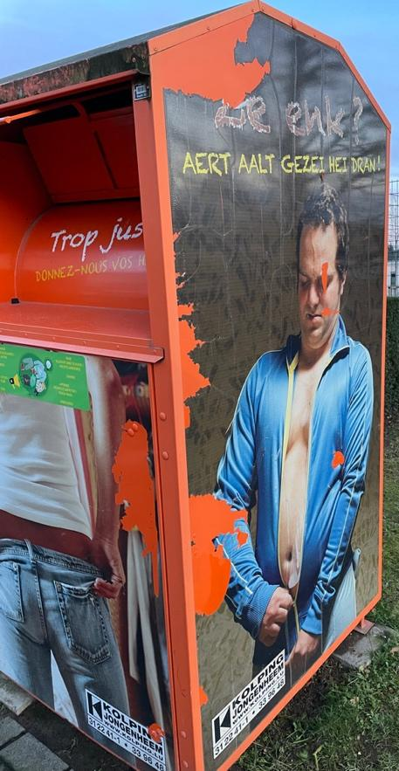
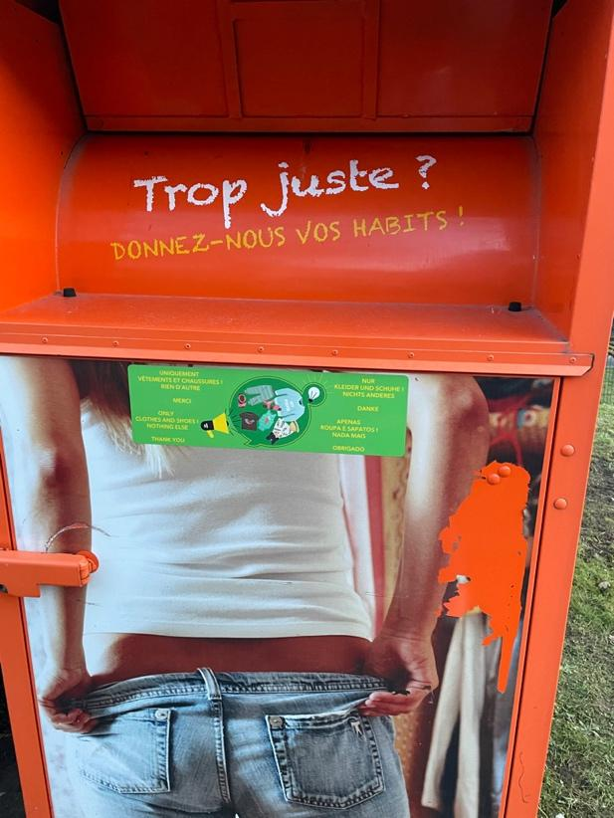

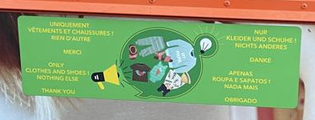

Fig. 11: Public container for donating and recycling clothes in residential area in Kirchberg, in French, English, German and Portuguese (all three images are from different angles of the same container and the bottom image is a zoom in of the small green sticker on the front)

Here, Trisha explicitly compares the presence of English to the presence of Portuguese, where she states that, while neither are ‘official’ languages, English is ‘more official than Portuguese’. This comparison suggests that there is a hierarchy of languages in Luxembourg that is not limited to the aforementioned delineation between official and unofficial languages, but among the unofficial languages themselves, where English is positioned above Portuguese (and by extension other languages). While expressing an acceptance of English as having a prominent presence in Luxembourg, she asserts limitations to the presence of Portuguese as only indexical of the presence of Portuguese people living in the area, and a significant presence at that. This is a major distinction between English and other unofficial languages, where the presence of other unofficial languages on the LL most often represents the presence of significant communities, such a migrant or heritage communities, while the presence of English is not perceived as representative of a specific community of people, but rather of an ability to communicate across sociocultural and linguistic backgrounds and of an idealised image of Luxembourg as an international space, thereby suggesting English’s position between official and unofficial as flexible for different purposes.

It is also necessary here to draw attention to Trisha’s emotional reaction to the presence of Portuguese in relation to her response to English. On a more general point, Portuguese was discussed by many of the participants but very rarely as its own topic of discussion. When Portuguese was not present in the photos, participants rarely, if ever, discussed Portuguese without prompting. Rather, it was most often discussed in relation to other languages, such as the case of Trisha in the above interaction. She discusses how she has ‘mixed feelings’ on the inclusion of Portuguese, but ultimately accepts and would potentially even defend its inclusion. The obvious discomfort she is demonstrating in her reaction, however, is worth investigating further. The connection she draws between the visibility of Portuguese on the LL and the presence of the Portuguese speakers in the area is underpinned by a perception that including Portuguese in the LL only serves one specific purpose; that is to inform a Portuguese-speaking audience.

This is where perceptions of Portuguese and English diverge. On the one hand, English is perceived to be a linguistic resource one can include on a multilingual sign that does not negate, and even bolsters, perceptions of multilingual signage as inclusive. In short, its presence on LL signage is perceived as complementary to Luxembourgish language practices, underscoring perceptions of English as a useful linguistic resource. On the other hand, the presence of Portuguese on multilingual signage (the same multilingual sign, no less) is perceived as undermining the inclusivity of the multilingual design because its perceived audience is a narrow social group, as opposed to the perceived audience of English (and indeed French and German), which is much broader.

Furthermore, throughout the interview, Trisha is vocal about her desire to see more written Luxembourgish in public spaces and her disappointment at what she perceives as the mistreatment of Luxembourgish in these spaces, that is, its absence or limited presence. This extract is an effective exemplification of how this sentiment affects every aspect of Luxembourgish language debates, such as the inclusion of ‘another language’ like Portuguese and the absence of Luxembourgish being perceived as cause-and-effect. Interestingly, however, this is not seen in her perceptions of English. This draws nuance to the concept of multilingualism and its role in constructing Luxembourgishness. The distinction demonstrates that, including when organising public spaces, Luxembourgish multilingualism indexes a strict configuration of the traditional linguistic resources associated with expressions of Luxembourgishness, namely Luxembourgish, French and German, with an increasing presence of English (Horner & Weber, 2008), as opposed to an all-encompassing system of total linguistic inclusion. Paradoxically, deviations from this strict configuration, such as the inclusion of migrant languages like Portuguese, are perceived as undermining the construction of the idealised multilingual Luxembourger because they no longer perceived to reflect the universal Luxembourgish linguistic experience, even detracting from it, such as through perceptions of the choice to include Portuguese at the expense of Luxembourgish.

The difference in consideration of English and Portuguese further demonstrates the flexibility and adaptability of the position of English between officiality and unofficiality, and the limitations of Portuguese, and indeed other migrant languages. The position of English could be described as honorary limited officiality, wherein English is informally recognised as an instrumentally and symbolically valuable and privileged linguistic resource (cf. Collins, 2016; de Bres & Lovrits, 2021), fulfilling a role that other officially recognised languages are not perceived as fulfilling, without recognising it in a formal way, thereby maintaining legal enshrinement and protection and officially-influenced considerations of Luxembourgish multilingualism. Simultaneously, the uplifting of English is indicative of the continued marginalisation and avoidance of Portuguese as a linguistic resource and highlights continued efforts to invisibilise certain migrant communities and the continued reluctance to accept material reflections of migration realities on the LL in Kirchberg and the wider Luxembourg.

To summarise, English is generally considered and understood to not be an officially recognised language at the state level. However, it is uniquely considered to possess certain qualities and affordances, more often associated with the officially recognised languages of French, German and Luxembourgish. This has led to discursive explorations of the flexibility of the position of English, which is perhaps best described as demonstrating honorary limited officiality. I use this term to refer to the sociolinguistic phenomenon of valuing and employing the instrumental and symbolic functions of English and of acknowledging its undeniable global social impact and influence, while simultaneously recognising its limitations in expressing feelings of Luxembourgishness, thereby reasserting an adherence to the cultural importance of the officially recognised Luxembourgish linguistic framework. Furthermore, the inclusion of English simultaneously indexes the continued exclusion of Portuguese and other migrant languages on the Luxembourgish LL.

6.4 Summarising remarks
In this chapter, analysis of the discussions with participants pertaining to the presence and/or absence of French, Luxembourgish, and English on the Kirchberg LL reveals key differences in the perceptions of the positions and roles that the individual languages occupy in relation to public space in Kirchberg. Firstly, the presence of French in Kirchberg is rarely questioned, if ever, by participants. While initial reactions may present French as the ubiquitous language of anonymity, deeper analysis reveals that it is also perceived as the language of authenticity, when representing the large Francophone community in the country. These dynamic ‘shifting boundaries’ between the anonymous and the authentic (Woolard & Frekko, 2013) outlined in the participant observations intersect heavily with notions of social class and are underpinned by the material emplacement of the language in different environments.

Secondly, participants routinely make reference to the presence and absence of Luxembourgish in Kirchberg, justifying both its presence and absence depending on what they are shown in the prompts. If there, participants tend to justify the presence of Luxembourgish as tied to expressions of respect, locatedness and the connections between Luxembourgish, expressions of Luxembourgishness. If not there, participants tend to argue its absence is justifiable because superfluous to meaning and one of the contributing factors to linguistic clutter on signage and therefore can be left out, especially in a more internationally-focused space like Kirchberg. This justification is built on the perceptions of a divergence between the spoken and written Luxembourgish, where the former is perceived as more socially valuable than the latter.

Finally, the presence of English in Kirchberg appears to be expected by the participants due to perceptions of Kirchberg as an international space and perceptions of English as the global lingua franca. However, this is juxtaposed against perceptions of the use of English in Luxembourg City more generally as a typical or ordinary linguistic practise as part of the wider multilingual practices associated with Luxembourg, as part of its growing influence in other parts of the city and contributing to the fractally recursive similarities between the Kirchberg-Luxembourg City relationship and the Luxembourg City-Luxembourg relationship. The increasing acceptance of English in everyday life and linguistic practices also gives way to discussions around the status of English in Luxembourg, where it is generally positioned by the participants below the officially recognised languages of the country, namely French, German and Luxembourgish, but above other not officially recognised languages, such as Portuguese, in a position of honorary limited officiality, simultaneously highlighting the continued marginalisation of Portuguese and other migrant languages.

At this point, it is necessary to recognise that these three strands of enquiry do not exist parallel to each other, but rather intertwined, interconnected, and inextricable from each other. The following chapter deals with this, focusing on the perceived underpinning motivations behind the construction of the Kirchberg LL.

Chapter 7:

Motivations behind the construction of the Kirchberg LL

In Chapter 7, I examine the connections between perceptions of the presence and absence of particular linguistic varieties to wider discourses surrounding issues of language in Luxembourg. I explore the perceived motivations behind linguistic design of the Kirchberg LL, which participants highlight throughout the interviews as ways on interpreting the visual stimuli documenting the space and explaining their perceptions of these visual stimuli. This chapter builds with the exploration in Chapter 6 of the concepts of the ‘principle of selection’ (Scollon & Scollon, 2003) and of presence and absence, bringing together the considerations of individual languages as separate strands and providing insights into the passer-by perceptions of the ideological motivations behind the construction of the Kirchberg LL and public spaces.

This interplay between presence and absence interconnects with Scollon and Scollon’s (2003) concept of ‘interdiscursive dialogicality’. Within the spatial dimension, social discourses underpin decisions regarding the curation of the LL and/or are materialised as LL items. These discourses, while coexisting independently from each other and ‘operat[ing] quite independently semiotically’, also simultaneously influence and are influenced by each other, taking part of their meaning from the co-presence of each other (ibid.: 193). The complex aggregate of discourses, in turn, affect the interpretations of social actors using the space, in the case of this study, the passer-by. In other words, specific emplaced cultural frameworks and perceptions of ‘placeness’ are not simply indexed by the presence or absence of any single discourse or LL item, but also in the convergence and coexistence of these discourses and items operating within the same space. This interdiscursive dialogicality can be observed in the case of the Kirchberg LL, as outlined in this chapter.

In section 7.1, the widely expressed belief among the participants is explored, wherein perceptions of multilingualism in Luxembourg are founded upon discourses of normalisation of multilingual practices in Luxembourgish society. In section 7.2, the focus centres on the feelings of inclusion and exclusion expressed in participant reactions to the linguistic design of signs in Kirchberg, forming part of the wider discussion of the linguistic design of material signage as a reflection or a reinforcement of perceptions of local linguistic practices, engaging with the complexity of who contributes to the social meaning of public spaces and the construction of the LL. In section 7.3, I demonstrate the importance of linguistic hospitality in the construction of the Kirchberg LL as a fundamental expression of Luxembourgishness. Finally, in section 7.4, I discuss the motivations behind naming practices, as well as the sloganisation of Luxembourgish and English and their role in nation branding in the district of Kirchberg, often perceived as a highly international space.

7.1 Ordinary and extraordinary multilingualism
During the course of the interviews with participants, participants’ perceptions of multilingualism in Luxembourg often centre on the juxtaposition of multilingualism as ‘normal’ or ordinary against multilingualism as ‘special’ or extraordinary. Simultaneously, multilingual practices are often identified as a part of everyday life in Luxembourg, while also as something that sets Luxembourg and those who identify to varying degrees with notions of Luxembourgishness apart from others outside it.

Firstly, multilingualism is portrayed as a normal part of being in Luxembourg and of Luxembourgishness, as in Lovrits’ (2022: 10) concept of multilingualism in Luxembourg as a ‘social effect’:

Excerpt 7.1/1: Amelia: As someone from Luxembourg I can speak up to five languages
Int: Which ones?
Amelia: I have the Portuguese because it's my mother language Luxembourgish German French and English
Int: That is five yes [laughs] I was like is that right five yes I can count ok
Amelia: Which is quite common here in Luxembourg I mean if you know how to speak up to four or five languages, you're still basic because almost everyone who works here knows like two or three
Int: Really?
Amelia: Yep

Excerpt 7.1/2: Marie: Hmm well (.) I like to learn languages I'm not (.) I'm pretty grateful that I'm actually actually able to learn so many languages here
Int: Yeah
Marie: But I feel like they're also (.) hmm it doesn't really bother me because I grew up like this

Amelia was born in Portugal but moved to Luxembourg with her family soon after her birth, growing up in the south of the country. She considers being multilingual ‘quite common’ and even ‘basic’ in Luxembourg because the majority of people in the country are multilingual so one does not stand out for this reason. She positions herself as ‘someone from Luxembourg’ and connects that to the fact that she speaks ‘up to five languages’, portraying a multilingual repertoire as a Luxembourgish quality. Furthermore, she draws a distinction between people from Luxembourg like herself and people who only work in Luxembourg in terms of the degree to which they are multilingual. While she describes herself as speaking five languages, she portrays ‘almost everyone who works’ in Luxembourg as speaking ‘two or three’ languages. By this, she simultaneously portrays the commonness of multilingual repertoires in Luxembourg, while also highlighting people from Luxembourg as being comparatively more multilingual than others and creating the connection between Luxembourgishness and a broader-than-average multilingual repertoire.

Marie, on the other hand, was born and raised in southern Luxembourg to Chinese parents. In the above extract, she discusses how she grew up in a multilingual environment and is so used to being multilingual in her daily life that it ‘doesn’t really bother [her]’ and is simply a fact of her life. Similar to Amelia, Marie draws a connection between Luxembourg and multilingualism, expressing how her circumstances, that is, her being and growing up in Luxembourg, have allowed her to ‘learn so many languages.’ It is noteworthy here that Marie portrays being multilingual as something she acquired through learning, emphasising that she grew up learning languages as opposed to being naturally multilingual. By not emphasising multilingualism in and of itself as an innate Luxembourgish quality, Marie instead highlights how Luxembourgish multilingualism is the outcome of normalised practices of language learning in Luxembourgish society.

Furthermore, in the above extract with Marie, she also describes how ‘grateful’ she is that she is ‘actually able to learn so many languages here.’ This demonstrates her perception of how the Luxembourgish language situation may diverge from other language situations in other places, where multilingualism may not be considered ‘normal’ or part of everyday life. This distinction in perceptions between multilingual Luxembourg and the non-multilingual places outside of Luxembourg can also be seen in the following excerpt, where Amelia discusses her experiences in Portugal and Luxembourg, and how the multilingualism she experiences in her daily life in Luxembourg, though normal and habitual for her, is not the case for those in Portugal or anywhere outside of Luxembourg:

Excerpt 7.1/3: Amelia: But then when I go back to Portugal and er or just somewhere else (.) I just hear
people speak in one language and it's really weird for me
Int: Yeah
Amelia: Because I'm so used to speaking so many languages and hearing so many
Int: Yeah
Amelia: That it's a bit weird for me and I thought it was normal to be like this then I found out that Luxembourg is quite special when it comes to languages
Int: What do you mean by that?
Amelia: Like in Portugal (.) first when I speak with my friends and even my parents they learn French Spanish and English mostly (.) but I think it was they could choose which language to er to learn
Int: Hmm ok
Amelia: I didn't have that choice I had to speak all those languages
Int: Right
Amelia: It was mandatory to have those classes and when I speak with a friend from Portugal they just speak like English and Portuguese

Amelia describes hearing ‘people speak in one language’ in everyday life as ‘really weird’ and contrary to what she is used to in Luxembourg, where she speaks and hears many languages throughout the day. She then explains that she ‘found out’ that Luxembourg is ‘quite special’ due to the multilingual nature of the country. This suggests that, seemingly according to people she interacts with, such as family and friends, the normalised multilingualism she experiences in Luxembourg is perceived a deviation from the perceived norm of monolingualism in countries outside it, with the word ‘special’ implying that multilingualism is a beneficial or positive attribute that makes Luxembourg stand out but is nonetheless out of the ordinary.

Lara is a Luxembourger born and raised in a small village near the German border to Luxembourgish parents, now living just outside Luxembourg City. In the excerpt above, Lara echoes two things previously discussed. She echoes the aforementioned lack of choice in knowing or learning languages as well as Marie’s description of growing up multilingual, by describing multilingualism among Luxembourgish people as ‘how you’re raised’ and ‘you don’t really have a choice.’ This further exemplifies the perception of Luxembourgish multilingual practices as ingrained in the fabric of Luxembourgish society and a normal yet obligatory part of Luxembourgish life.

This juxtaposition of multilingualism as ordinary and extraordinary is also reflected in the perceptions of participants, who immigrated to Luxembourg as adults. This can be seen in the following excerpts from interviews with Katarina, a Central Europe woman living in Luxembourg City and working in Kirchberg, and Tom, a British man living in Luxembourg and working in Kirchberg:

Excerpt 7.1/4: Katarina: Oh I really love it [in Luxembourg] yeah because (.) and especially because (.) as
someone who speaks a few languages for me it was just incredible that I could hear so many languages in a day and that I could actually use all of my all of my languages you know

Excerpt 7.1/5: Tom: Kirchberg erm (.) you hear a lot of different languages one thing I've always been
impressed with is in the supermarket at the tills they have the little flags with all the languages that the person on the till speaks and I just think do you know like sometimes there's like five flags there and you think if somebody in the UK spoke five languages there's no way they'd be sat at a till in a supermarket [laughs]
Int: No [laughs]
Tom: So it's quite impressive really

Katarina discusses how her love of Luxembourg is tied to her being able to ‘use all of [her] languages’ in her daily life. She prides herself on her broad linguistic repertoire and feels that being in Luxembourg has allowed her to use her repertoire to its fullest potential. Using the verb ‘use’, she compares her linguistic repertoire to a collection of tools and highlights the instrumentality of language as social capital in the country. This verb choice also encompasses the multimodality of the multilingualism she experiences daily, from hearing different languages in public spaces to speaking different languages with her international work colleagues to reading the multilingual signage and other LL items like newspapers. This juxtaposition of her excitement over normalised linguistic practices emphasises the relationship between the discursively constructed ordinariness and the extraordinariness of Luxembourgish multilingualism.

Tom discusses how multilingualism is a fundamental yet ‘impressive’ aspect of daily life in Luxembourg, using the example of how supermarket tills in Luxembourg often display several flags, reflecting the linguistic repertoire of the cashier. Tom describes the ability to speak multiple languages as ‘impressive’ and differentiates between how he perceives the UK and Luxembourg approach the valuation of multilingual repertoires. On the one hand, he perceives that the value of multilingual repertoires in Luxembourg seems to lie in how commonplace and important they are to the running of the country. On the other hand, he perceives the value of multilingual repertoires in the UK tends to be expressed in economic and employment terms. Although multilingualism is still a highly valued skill in economic terms in Luxembourg and certain languages or linguistic repertoires are still perceived as more or less valuable than others, much like in the UK, Tom highlights how multilingual practices are more tangible and ubiquitous in Luxembourg than in the UK, leading to his perception of multilingualism as notable.

In short, perceptions of multilingualism as simultaneously ordinary and extraordinary appear to be informed by perceptions of internal and external factors. Within the country, multilingual practices are presented as commonplace and part of the fabric of being in Luxembourg for an extended period of time, while perceived monolingual practices are presented as strange or at least unusual. However, when participants compare the situation of Luxembourg to places beyond its borders or experiences originating from outside the country, perceptions of multilingualism as extraordinary are often acknowledged. This is particularly relevant for participants who have immigrated to Luxembourg as adults or who have spent time in other parts of the world, therefore either way have experienced different linguistic paradigms and observed linguistic differences between Luxembourg and elsewhere.

7.2 Reflecting and reinforcing linguistic realities
In contrast to other specific situations (cf. Marten (2010) on Latvia; Pavlenko (2010) on Ukraine; Leimgruber (2020) on Quebec), Luxembourg does not appear to have explicit language policy prescribing linguistic practices in public spaces as part of the LL. In light of this, a recurrent theme in the interviews is the debate as to whether the visible language on the LL is intended to reflect the linguistic practices within a particular space – what is – or to reinforce the linguistic expectations of the space – what should be. For some participants, they sometimes interpret the languages on signage as a reflection of the linguistic practices of the people in the area or building they are emplaced on, as a way of reflecting and embracing the diversity in linguistic practices:

Excerpt 7.2/1: Sofia: The languages on the (.) in front of the building could also be like signs like “don’t come in [laughs] if you don’t speak our language” but no I don’t think it’s meant that way like I really think it’s (.) either in a specific language because they know people or that area speak language more or it’s what is spoken inside the building more (.) I don’t think it’s to like I don’t think the purpose is for people not to go inside but I mean (.) it’s their choice it already tells people what to expect so (.) maybe some people just don’t want to deal with speaking French or German or a specific language so it makes it easier in a way for them

Excerpt 7.2/2: Lara: […] If I wanted to seem a bit less intimidating as an official like government building like I would try to put something in Luxembourgish […] as someone who’s not [laughs] that good at French or not good enough to go to a government place and talk to them in French about important government stuff it would make me feel much more at ease if they like had a sign like that to kind of showcase a bit “listen we also speak other languages” it doesn’t need to be the truth (.) I mean you could still go up to the reception and it would turn out they don’t speak Luxembourgish but it would make me feel like maybe they would speak a language I am more comfortable in so I would have at least one choice if my French absolutely fails me (.) and I wouldn’t have that feeling if it were all said in French because that would kind of give me the feeling (.) “we don’t really expect people to speak other languages and we kind of expect them to know French if they come here” (.) and that would kind of put me on edge because I would not feel as comfortable to go in
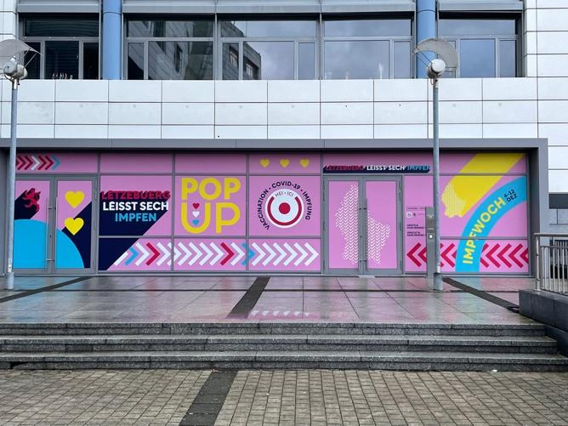

Fig. 12: A wider photo of the vaccination centre outside the Auchan shopping centre, written in French and Luxembourgish

Fig. 13: COVID-19 sign outside a government building, in French

Sofia discusses how the languages she sees on the front of the vaccination centre (Figs. 8 and 12) are simply intended as a reflection of the more common languages used inside the building. Interestingly, she acknowledges that the language choice is not a comprehensive display of every possible language spoken in the building, but rather an interpretation of the ‘more’ spoken languages, which also happen to be the three officially recognised languages of Luxembourg and English. This is an effective example of the ideological component involved in constructing material space (Scollon & Scollon, 2003). She believes that this particular linguistic configuration represents what one can expect linguistically upon entering the building, informing the public of these practices, and that people have a choice whether or not to enter the space and engage with the people and practices inside.

By contrast, Lara discusses how she feels when she sees French-only signs as a native Luxembourgish speaker. She expresses her potential discomfort when seeing the government COVID signs (Fig. 13) are monolingual French and that this would cause her to feel pressured to speak French, a language she does not feel entirely comfortable in, especially when explaining more complex issues that would be discussed in a government building. According to her, seeing more multilingual displays or signage would invoke feelings of comfort by giving her linguistic options, even if it turns out to not necessarily be true. Here, it is clear that linguistic choices on the LL affect Lara’s sense of place in Kirchberg (Scollon & Scollon, 2003). Furthermore, she appears to be idealising multilingual signage, and in turn multilingual practices, for both its practical and symbolic benefits, which allows her to understand and engage with informative functions of language and invokes positive feelings of comfort and preparedness.

In addition to her perception of multilingual signage, Lara also highlights that language choice can also play a role in the construction of discourses of linguistic expectations. She mentions how the presence of the monolingual French sign could point to both a reflection of personal practices and, by extension, an expectation of interpersonal practices. In other words, the linguistic choices may reveal the languages that the producer or disseminator of the sign is comfortable speaking and also the languages that they want to be spoken to in. This is also evident in the following extract from the same interview with Lara:

Excerpt 7.2/3: Lara: I feel like there might be a correlation between or in my perception there might be a correlation between (.) erm (.) the languages that people want to showcase that they speak versus the languages that they actually speak so if they put signs out with all different kinds of languages I would feel like I could go in there and speak any of them and they would be able to help with whatever problem I have whereas if they only put one out there I would feel like maybe they wouldn’t really want to speak another language or they don’t really they can’t really do it and then (.) I would feel like oh boy [laughs] erm now I need to communicate and it’s going to be less effective because I don’t actually speak what it looks like they want me to speak so yeah (.) in a way actually in a way now that I’m thinking about it it feels a bit like (.) the language in which they put out these signs (.) in my head is a bit associated with what language they want me to speak to them if I go to them […] or what they speak and what they are most comfortable in and then by extension want me to speak to them in [laughs]

This intersection of ability and expectation can also include reflections of the presumed practices of the passer-by. In my interview with Stefan, we discuss the variety of linguistic configurations on signage and why that may be, as opposed to a uniform one-size-fits-all top-down approach to the creation of signage. He first discusses the aforementioned challenge of representing multilingual diversity in the country and then goes on to state the role of the passer-by who uses and reads the space but who did not create or disseminate the signage:

Excerpt 7.2/4: Int: So going back to that question that I had before (.) you mentioned about how you need different signs for different contexts with different languages (.) can you kind of elaborate on that? (.) what different contexts would be appropriate for different languages (.) that’s a big question
Stefan: Yeah I mean for different reasons you know (.) just because yeah you have so many people with different language backgrounds (.) to put it in a nutshell it’s that (.) it depends of course on where you are and would encounter more people of certain backgrounds than in others and in some (.) yeah I guess you have some (.) yeah I don’t know the first one I was going to say (.) in something like a train station which is this that’s a place probably where everybody meets and mingles because everybody needs to use public transport at some point so there it makes sense that you would put it in all of [the languages] and keep it kind of simple
Int: So do you think it’s responding to (.) the people who come across it as in like for example a customer is it more for them?
Stefan: I think that’s the idea yeah (.) erm but then it’s obviously not (.) like I mean if I look at the school one it’s not very adapted to the audience (.) that’s what I think
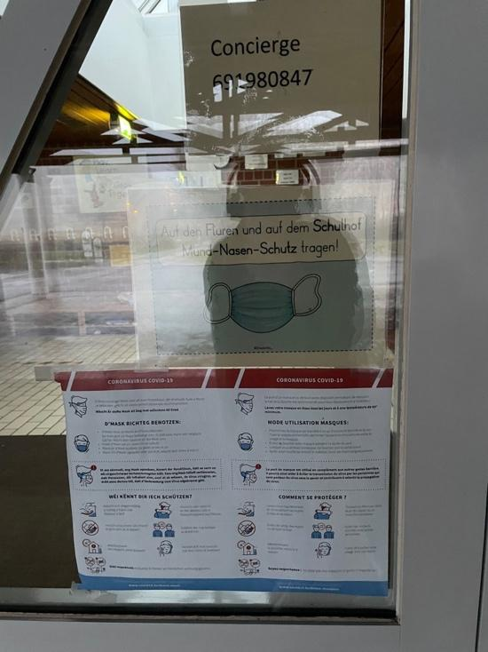

Fig. 14: COVID-19 notices on the door of a school – top: German, bottom: French and Luxembourgish

Here, Stefan is referring to the COVID sign outside the public transport hub (Fig. 7) and discusses how the languages used on this sign are intended to be reflective of the linguistic practices of the people using public transport, and therefore needs to appeal to the array of different people who pass through the station on a daily basis. He juxtaposes this against the signage on the door of a school in Kirchberg (Fig. 14), which he believes is not adapted to the passer-by, despite the fact the door facing the public. He explains that he does not believe the sign is well adapted to the audience because it does not seem to be reflective of what he perceives to be the expected linguistic practices of the audience, rather reinforcing the use of French, German and Luxembourgish, the officially recognised languages of the Luxembourgish state, especially German, the language of instruction in Luxembourgish state primary schools. Altogether, this demonstrates the importance of the emplacement of a sign as a contributing factor in passer-by interpretations of said sign.

Thus far, a specific nuance in the interpretation of whose linguistic practices are signs supposed to reflect and reinforce is emerging. From the above extract with Stefan, it could be suggested that this distinction runs along the lines of the distinction between public and private. In the extract with Stefan, the public transport hub is portrayed as a space open to the public and is therefore constructed around and responding to the public’s needs, whereas the school appears to walk the line between public-facing and non-public-facing, exposing a perceived tension between being reflective of the internally enforced linguistic practices in schools reinforced by the government, and being reflective of the linguistic practices of the wider school community in practical informative sense. This is an important and running theme of distinction and can be seen in the following excerpts with Trisha.

In the following extracts, Trisha points out this same public/private distinction as Stefan, where perceived public and private spaces are perceived to be constructed linguistically according to different functions:

Excerpt 7.2/5: Int: Is that weird [to have signs in French only]?
Trisha: Well (.) not really to be honest (.) maybe this is I assume this is some sort of company or whatever so maybe for them the main language is French so they don’t necessarily need to put any other language I’d say because if I take [my workplace] for example all the signs are in English
Int: Oh really
Trisha: Even though there are different languages but everything’s in English so I assume they only (.) use French because it’s important to them (.) but if you take the train sign for example any person can get into that train (.) so just to adapt I’d say to to you know
Int: Yeah makes sense
Trisha: I mean because this is for (.) it’s a public space I’d say so

Excerpt 7.2/6: Trisha: Here you have English as well English and (.) oh it’s the same place right [laughs]
Int: I think so yeah
Trisha: Erm yeah they just remind you of the procedures you have to to (.) to go through to enter the building or like here instructions you have to (.) maybe this is a public entrance so they put another language
Int: Oh right ok
Trisha: And the other one was maybe a staff entry I don’t know maybe erm (.) because here you have this sign what you have to do like you have to keep two metres distance and the other one was just you need to wear your mask

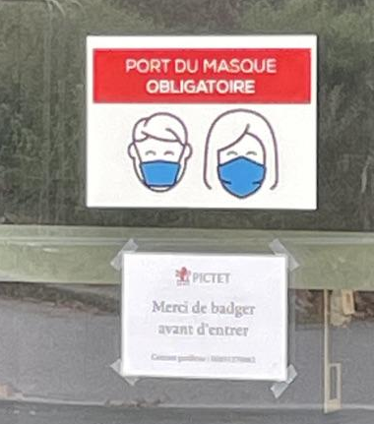

Fig. 15: COVID-19 signs on the door of a business in Kirchberg, all in French (company name blurred out)

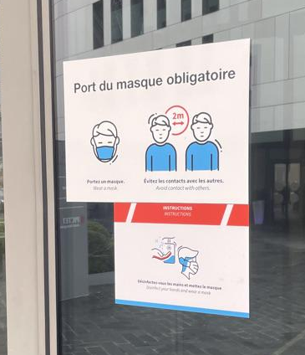

Fig. 16: COVID-19 sign on the door of a business in Kirchberg, all in French and English

In the first extract, she states that the use of monolingual French signs in Fig.9 are perhaps reflective of the importance of French to the workers within the building, onto which the sign is emplaced. She expands on this in the second extract, saying the monolingual French signs could possibly be on the staff entrance due to the content of the signs appearing as a reminder to wear a mask, as well as asking to ‘swipe’ for access to the building. This use of French is then perhaps more reflective of workplace language policy and therefore intended for staff entering the building. She juxtaposes this against the signs in Fig.10, which are on a different side of the same building, stating that the use of both French and English here, along with more in-depth instructions of expectations regarding COVID measures, could indicate that this is a public entrance, all in order to appeal to the passers-by who may be guests to the building and are therefore not necessarily bound by the rules of internal workplace language policy.

In summary, one can see here that language use on the LL, while not the only factor, simultaneously plays a role in shaping the functions and language practices associated with a space, while also being shaped by the perceived functions of the space, in a cycle of reflection and reinforcement. It is clear that the linguistic varieties present in the construction of the LL are perceived as being influenced by a number of factors, such as the intended function(s) of the space, the proximity to the public and the careful emplacement and location of the signs, all of which contribute to a passer-by’s understanding of where they are and their senses of places within the district of Kirchberg. It demonstrates how, even within a space such as Kirchberg, of which passers-by regularly express rather concrete perceptions, the LL is not a fixed, consistently uniform arena. In actuality, it reinforces the multifaceted complexity of Kirchberg as a space as a collection of senses of place (cf. Scollon & Scollon, 2003; Massey, 2005; 2007).

7.3 The importance of linguistic hospitality in Kirchberg
Throughout the interviews, many participants explain the way public signage is designed linguistically from the perspective of appealing to as many people as possible, in particular the highly diverse Kirchberg resident and working population across social, national and linguistic backgrounds. This is particularly relevant to Kirchberg, whose spatial identity is perceived to be built upon this dichotomy of local Luxembourgish and international, or ‘host’ and ‘guest’ (Vigouroux, 2019). As mentioned in section 7.2, one way in which this is achieved is through the use of English, such as in the example in the following excerpt with Luc, who perceives English as a positive part of the Kirchberg LL, drawing from discourses on English as the international lingua franca:

Excerpt 7.3/1: Luc: So and er well this says er so it's in French German and English
Int: Yes
Luc: And by the way I think it's a bit incoherent because (.) er (.) because the three official languages from Luxembourg are er French German and Luxembourgish (.) and English is not one of the official languages so I think it's great they put everything in English because there are so many foreigners it's a (.) so I think that's one of the very pragmatic aspects from Luxembourg and I I like it but if you think about it's a bit incoherent

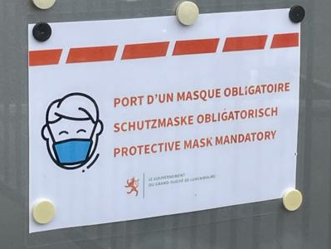

Fig. 17: COVID-19 sign in a public announcement box on the street in Kirchberg, in French, German and English

Luc, who explicitly positions himself as a foreigner throughout the interview (see excerpt 6.2/7), depicts the use of English in Fig. 17 as ‘pragmatic’ precisely because it appeals to the many foreigners living and working in Kirchberg. Furthermore, Luc presents this pragmatism as more than just a shrewd decision, instead highlighting this approach to decision-making as a fundamental quality of Luxembourgish people and culture. That being said, he also describes the use of English as ‘a bit incoherent’ when considered in relation to what he perceives as the traditional officially recognised language practices. This juxtaposition of pragmatism and incoherence appears to present the use of English as a method of linguistic hospitality at odds with, and even potentially detrimental to, traditional Luxembourgish language practices, such as with the absence of Luxembourgish, one of the ‘three official languages.’ In other words, Luc appears to present the linguistic design of signage like this, which incorporates English alongside selected elements of traditional Luxembourgish language practices, as either appealing to Luxembourgers or foreigners.

This discursive positioning of Luxembourgers versus foreigners, however, is not necessarily how other participants describe the situation. Other participants, by contrast, tend not to view the linguistic design of signs with regard to language choice as favouring foreigners at the expense of Luxembourgers, or vice versa. In fact, the linguistic designs are presented as reasserting a perceived central aspect of Luxembourgishness, that is the fundamental linguistic goal of Luxembourgish people is to communicate. The benefits of English in signage and the benefits of multilingual LL items appear to converge because both are perceived as aiding the public by reaching as many people as comprehensively and efficiently as possible, while also playing into the idealised linguistic capabilities of the everyday Luxembourger, appealing to both Luxembourgers and foreigners, not choosing between them.

An example of this is in the excerpt below with Marie, who sees a sign entirely in English (Fig. 18) for the first time:

Excerpt 7.3/2: Marie: But erm (.) that's like the first time I've seen something only in English
Int: Really?
Marie: Yeah it's always French and English or only in French I never saw something like this before here
Int: Do you have any idea where it might be?
Marie: Uni
Int: Yeah
Marie: Ok (.) that's ok that's more logical ok that makes sense basically because like in uni we don't actually have we have a lot of international students here and that's why perhaps and Luxembourgish people (.) almost all Luxembourgish people understand English in a certain to a certain degree so ok that makes sense yeah

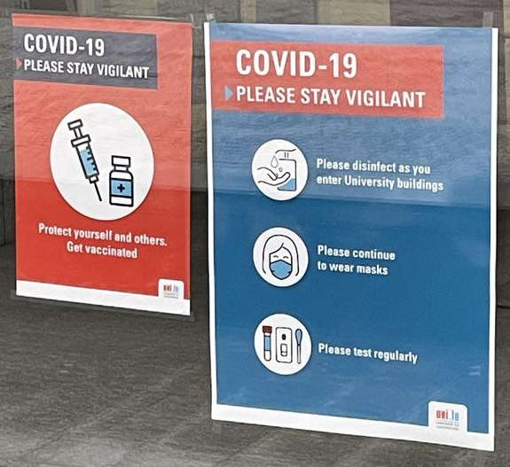

Fig. 18: COVID-19 sign in the window of one of the Université du Luxembourg Kirchberg campus buildings, in English

Marie acknowledges that the presence of monolingual English signs, even in Kirchberg, is highly unusual, if not unheard of as far as she is concerned. However, she rationalises its existence by stating, firstly, that a large part of the student body of the University of Luxembourg are international students and therefore may need to use English as their initial language of communication and, secondly, that ‘almost all Luxembourgers’ can understand some level of English and are therefore not excluded from the communicative function of the sign. In a similar way, Katarina, in the excerpt below, discusses her perception of the motivations behind why ‘big languages’ like English, French and German are present on signage in Kirchberg, while Luxembourgish is not:

Excerpt 7.3/3: Katarina: [laughs] I think it's maybe the Luxembourg well the Luxembourgish [people] they think about the foreigners or something like this [laughs]
Int: Oh ok so you think it's for foreign people to understand the sign?
Katarina: Yeah I think so yeah it's like because obviously this is the Luxembourgish state no kind of putting this up so they think “we're going to put it in the big languages so that all of the foreigners understand” (.) and I don't think that someone would understand the Luxembourgish so why would you put [it]
[…]
Int: Oh right (.) so when you say that the that they're probably looking out for the foreigners so they understand what's going on (.) what about the Luxembourgers how are the Luxembourgers going to understand this?
Katarina: Ah well they would probably because they speak all of those languages
Int: Right
Katarina: I think they are so used to seeing that so I don't think that they would even (.) they would even er (.) kind of think about it no just say that they understand and yeah

Here, one can see where Marie and Katarina both diverge from Luc’s perception of Luxembourgers versus foreigners, favouring a perspective of inclusive linguistic hospitality. Marie and Katarina seem to perceive a compatibility between the use of English and the expected Luxembourgish multilingual practices, where the choice between Luxembourgers and foreigners is at the very least not as stark as being mutually exclusive because both are catered to communicatively. Furthermore, Katarina indicates that she perceives an active openness as opposed to pragmatism among Luxembourgers to consider the needs of foreigners in an incorporative manner, which she states is reflected at various levels ranging from everyday people to the Luxembourgish state government.

Using English and the other ‘big languages’, while side-lining the use of written Luxembourgish, as a method of ensuring effective visual communication between institutions and foreigners is not perceived as exclusionary to Luxembourgers, who Katarina and Marie describe as innately multilingual as a matter of fact, and therefore unfazed by the multilingual displays, and not generally dependent on written Luxembourgish. In other words, linguistically catering to everyone in the country without alienating either Luxembourgers or foreigners is presented as entirely possible and in fact an everyday occurrence in ordinary Luxembourgish multilingual practices.

Moreover, Katarina raises an important point about linguistic hospitality and ‘big languages’, which is worth exploring in greater detail. While the increased use of English is often presented as an effective method of linguistic hospitality, it is not the only method. As stated thus far, multilingual practices that are reflective of idealised everyday Luxembourgish language practices are also effective, especially the use of French and Luxembourgish. Beyond their symbolic connections to traditional conceptualisations of Luxembourgishness and nationhood, French and Luxembourgish serve hospitable integrative functions, as seen in the below excerpt with Nina:

Excerpt 7.3/4: Int: So you mentioned before as well about how […] Portuguese-speaking people I should say erm (.) are maybe like second or third generation that they'll probably be more integrated what for you would be the language of that integration?
Nina: Hmm (.) I guess I think it's they are almost like the local (.) I think it's er Luxembourgish and French
Int: Luxembourgish and French right
Nina: Yeah I think they they they are both (.) they should both (.) have mastered those languages (.) and I think usually they follow the Luxembourgish school system so that's the two languages for sure they've mastered then by (.) that means also German then very often because Luxembourgish is very similar to close to German

In discussion with Nina about the integration of Portuguese-speakers into Luxembourgish society, she states that the languages of their path to integration are most likely French and Luxembourgish, therefore suggesting a need to use these languages on the LL. When examined with her statements on the officiality of English in mind, it is possible to surmise that she presents a differentiation in the role of French and Luxembourgish from the role of English.
While English has significant communicative potential particularly in Kirchberg, French and Luxembourgish are presented as languages with deeper and wider-cast roots in the migration trajectories of longer established migrant communities. The Portuguese community (and indeed other Romanophone migrant communities in Luxembourg), for example, has established roots in Luxembourg, where their initial integrative language is more often than not French and whose settling in Luxembourg over several generations is often characterised by an uptake of Luxembourgish (and even German) among post-arrival generations, in part through contact with the state education system. Evidently, the extent of the linguistic hospitality does not appear to extend to Portuguese in the same way it does to English. The burden of expectations is placed on the Portuguese community to speak a language that is still associated with Luxembourgishness, that is, French and/or Luxembourgish, in order to be considered integrated. Although speaking English is not firmly associated with full Luxembourgish integration, a path towards integration has certainly been carved for English speakers, a path that is not extended to Portuguese speakers, despite their deep roots in the country.

Nevertheless, the integrative function of Luxembourgish diverges between spoken and written, with more integrative power and usefulness focused on the former and less so on the latter, especially in Kirchberg compared to other parts of the city and country, with consequences on the usefulness of visual Luxembourgish on the LL. French, on the other hand, continues to be considered a useful language for this communicative function, even in Kirchberg. All of this is highlighted by Marie in following extract, in which she discusses the presence of French and Luxembourgish on school signage (Fig. 14), relating it to her parents’ experiences of moving to Luxembourg from China:

Excerpt 7.3/5: Marie: As I said there's always like French included it just basically says call this (.) number for when blah blah blah and then it's like in French again it's like Luxembourgish because we're in Luxembourg and then (.) maybe Luxembourgish people will feel more at ease when they see Luxembourgish […]
Int: Ah that makes (.) so like the Luxembourgish would be for Luxembourgers?
Marie: Luxembourgish people and they might feel more at ease when they see all this at least Luxembourgish in Luxembourg and then (.) that's like foreign people because most foreigners here speak a bit of French […] my parents also took French as their first lesson in Luxembourg (.) instead of Luxembourgish
Int: Do they speak Luxembourgish?
Marie: My mum speaks a bit of Luxembourgish she's studying Luxembourgish right now (.) but she learned also French first because if you know French here in Luxembourg you basically can go (.) everywhere (.) but Luxembourgish isn't actually very useful in Luxembourg in my opinion
Int: What do you mean?
Marie: Because in grocery stores or in hospitals (.) like nurses sometimes only speak French
Int: Mm hmm
Marie: Or they speak French and Luxembourgish it's like French is sometimes like the only option and then if they speak Luxembourgish there's also like the option of speaking French with them

When commenting on the different signs I had shown her, Marie says that the presence of Luxembourgish may be inclusive to Luxembourgers, rather a symbolic gesture to put them ‘at ease’ than an instrumental decision for communicative purposes, but for her it is ultimately presented as ‘not actually very useful’ for foreigners. Interestingly, however, she states that French is always on signage because most foreigners, in addition to the expected Luxembourgers, speak ‘a bit of French’, drawing potential parallels between French and English as lingua francas.

However, where these parallels start to discursively fade is when Marie describes her parents’ decision to learn French upon arrival in Luxembourg in order to be able to ‘go anywhere’. French is presented as a language one learns in order to facilitate communication, integration in and adaptation to Luxembourg, as a natural steppingstone in one’s migration trajectory towards Luxembourg. This is in stark contrast to how English has thus far been presented, as a language that foreigners often bring with them as part of their linguistic repertoires, to which Luxembourg has in part adapted by incorporating it more into everyday life, such as on the LL.

This means that, on the one hand, the role of learning and using French in public spaces is perceived as more integral to expressions of adapting to life in Luxembourg than that of English, which is still not considered a facet of expressing Luxembourgishness, merely compatible with it. On the other hand, the role of French is increasingly tied up with the other languages often considered part of Luxembourg’s language tradition, as the amount of English-language interactions in Luxembourg City increases, encroaching in certain circumstances on French as the sole initial integrative language of the country’s capital. It is important to note here that Marie’s parents live outside of Luxembourg City, where French undoubtedly still has significant influence of people’s abilities to participate in everyday life and where the influence of English is still growing and not necessarily the optimal language choice for communication with the public.

In summary, linguistic hospitality is perceived as a central consideration in the linguistic design of public signage on the LL. By some, it is considered a choice to favour foreigners over Luxembourgers by appealing to their linguistic needs at the expense of reflecting language practices associated with Luxembourgishness. By others, it is considered an everyday expression of ordinary Luxembourgish multilingualism, wherein appealing to both Luxembourgers and foreigners is entirely possible because of the perceived innate Luxembourgish quality of wanting to facilitate communication across linguistic backgrounds.

This linguistic hospitality is not just achieved through the use of English though, rather through a much more holistic approach to linguistic hospitality, in which the needs of the foreigner are considered alongside the needs of the Luxembourger. This often manifests itself as a turn towards an increased use of English, which is often perceived as an international lingua franca, particularly in Kirchberg. However, this use of English does tend to be somewhat limited to Luxembourg City and particularly concentrated in Kirchberg. Outside Kirchberg and certainly beyond the boundaries of the capital, French is perceived to play a significant role in linguistic hospitality as the language often chosen by foreigners to learn upon initial arrival in the country, with Luxembourgish perceived as reflective of longer and deeper integration in Luxembourg.

Importantly, it should be noted that English is not presented by the participants as an alternative to or replacement of multilingual practices. Instead, it is presented as one cog within the complex framework of multilingual practices as part of the specific Luxembourg situation, limited in certain respects and often to the district of Kirchberg yet still representing the dynamic shifting nature of the linguistic situation in Luxembourg. By contrast, despite its prominence as a language with deep-rooted connections to the largest migrant community in the country, notions of linguistic hospitality do not appear to be extended to Portuguese. This further indicates a limitation in the scope of Luxembourgish multilingualism to a strict configuration of the traditional Luxembourgish languages, with an increasing yet tentative incorporation of English.

7.4 Perspective in naming and branding
In this section, I examine the motivations behind naming and branding practices in Kirchberg (and beyond) in an effort to outline the importance of perspective in the reading of space. In section 7.4.1, I explore the tramline in greater detail and the perceptions of the thought processes behind the naming from the perspective of the passer-by. In section 7.4.2, I outline the sloganisation of Luxembourgish and English and perceptions of their symbiosis when applied to functions of nation branding.

7.4.1 What’s in a name?
The discussion of the tram stops in Kirchberg is an interesting part of the interviews, highlighting and exemplifying another motivation behind language choice on the Kirchberg LL, that being, how places are named. The tramline, which runs through Kirchberg into other parts of the city and a particularly iconic symbol of connection between Kirchberg and the rest of the city, is comprised of tram stops with names in French and/or Luxembourgish. Beyond the general regulation of municipal and street signage (Purschke, 2021), there appear to be no other formalised rules in terms of language when naming the stops. Some of the stops, such as Nationalbibliothéik/Bibliothèque nationale (Fig. 1), are in both Luxembourgish and French, some are in French only, such as Coque (Fig. 2), and others are in Luxembourgish only, such as Universitéit (Fig. 19). As Hugáceo among others alludes to in the excerpt below, these differences in naming are sometimes perceived as incoherent and unplanned as a perceived consequence of there being no formalised language policy regarding signage, at least from the perspective of the passer-by:

Excerpt 7.4.1/1: Hugáceo: Ok yeah like (.) yeah it’s not coherent there again like Universitéit in Luxembourgish but then Nationalbibliothéik in Luxembourgish and then in French [laughs] I guess they don’t really have a policy on how they are doing this
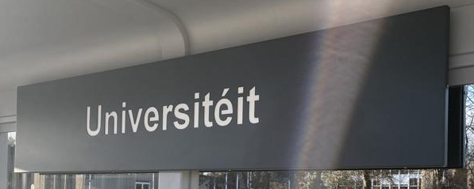

Fig. 19: Tram stop sign “Universitéit”, in Luxembourgish

However, on closer examination, the interpretations of the tram stop names as well as the differences between the interpretations among participants underscore two salient points. Firstly, participants posit potential emergent patterns of why certain tram stops signs in certain places follow certain linguistic designs. Secondly, when presented with the photos of the same place, participant interpretations are not uniform but are heavily informed by personal trajectories and experiences, in this case, proximity to and familiarity with the Kirchberg (and wider Luxembourg) language situation.

Beginning with Lara, in the following excerpt, she is discussing Rout Bréck, the iconic red bridge connecting Kirchberg to the district of Limpertsberg above the district of Pfaffenthal located in the valley below (Fig. 22), and the tram stop Rout Bréck – Pafendall, located at the Kirchberg end of the bridge (Fig. 20) next to the entrance to the funicular (Fig. 21). She discusses how the name of the stop appears to not follow the rules of the other stops, which in her opinion either have alternative names in different languages or are untranslatable:

Excerpt 7.4.1/2: Lara: […] Er some part of me wants to say that if you don't understand one you're at least going to understand the other but I don't really understand why they don't do it for that one
Int: For this one? The Rout Bréck – Pafendall?
Lara: Like I mean I don't know if they have like French or German names but I feel like that would be quite easy to translate no?
Int: Obviously like Rout Bréck is the common name for the bridge
Lara: Yeah
Int: Do they say le Pont Rouge ever? (.) Is that a thing?
Lara: I don't know
Int: Because you just call it Rout Bréck right?
Lara: Yeah but then there's like the two other bridges in like the city centre
Int: Which one’s that? Pont Adolphe
Lara: Yeah that one and the one near the cathedral
Int: Oh towards Gare
Lara: Yeah they have like official names like Pont Adolphe and stuff but in Luxembourgish you don’t call it that
Int: What do you call it?
Lara: We just call it the Aal Bréck and the Nei Bréck […] [pointing outside to Rout Bréck] so I feel like this one should have a Pont something something name which would make sense to put here (.) but I don't know if they actually have one but they probably should (.) I mean it would be weird if it was just like yeah Rout Bréck (.) and also Pafendall I don't know if that has a different name but
Int: They have it in German Pfaffenthal
Lara: Then why not put it on there? [laughs] I mean proper names and like […] this is so weird (.) I would understand if it was just proper names that didn't have other official names in that case what can you do? You can just put the proper name but (.) although does it make a difference that this is just like kind of like a bridge and a general area whereas like the the (.) the library is more like a building [laughs] I don't know
Int: Oh wait no that would make sense so do you mean like because Rout Bréck is just the name of a place whereas Nationalbibliothéik is an actual building that you might need translated to understand what it means do you mean like that?
Lara: Yeah like it has an official name as an actual building that needs maybe translation but then again Rout Bréck also kinda needs translation if you don't know Luxembourgish (.) I dunno I mean you could kind of infer it maybe if you see a red bridge so you might not necessarily know that that means this [laughs] it's so weird (.) I mean with the Coque I feel like that's what the building is called you don't (.) I don't know anyone who just calls it differently like everyone just calls it that I suppose they don't really need to put a translation there maybe there was never a translation in the first place and they were just like well (.) this is the only name it goes by
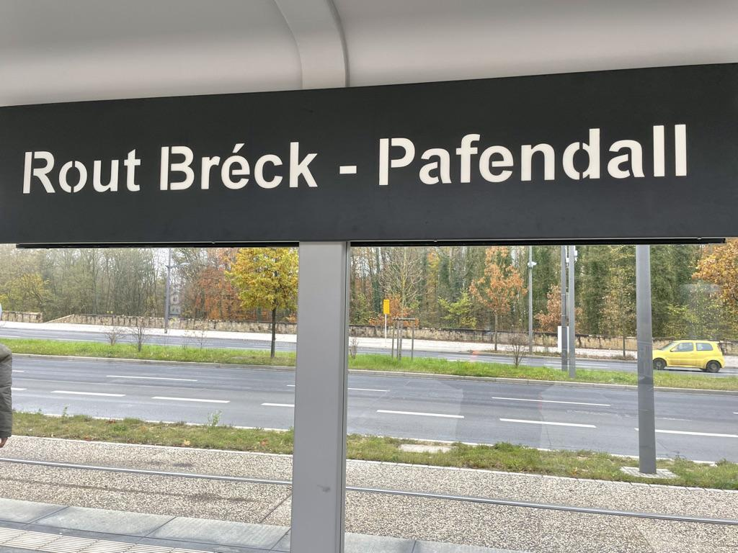

Fig. 20: Tram stop sign “Rout Bréck – Pafendall”, in Luxembourgish

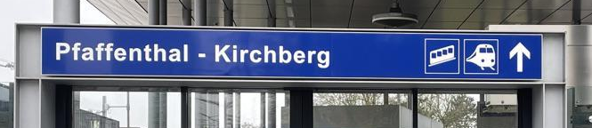

Fig. 21: Entrance to Kirchberg funicular, in German
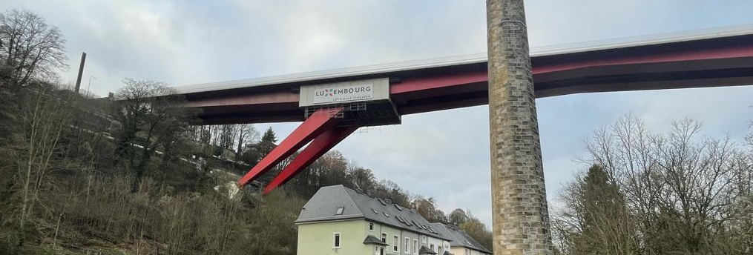

Fig. 22: Rout Bréck (lit. ‘Red Bridge’)

Lara states that she only knows Rout Bréck by its Luxembourgish name and Pfaffenthal by its Luxembourgish name Pafendall and is unaware (at least initially) of whether they have alternatives in other languages. However, she feels that there must be another name for Rout Bréck because the other major bridges in Luxembourg City have ‘official names’ in French but are only known by their local names of Aal Bréck (lit. “Old Bridge”) and Nei Bréck (lit. “New Bridge”). She expresses confusion at how the name of the stop Rout Bréck – Pafendall appears to be translatable and yet is not translated on the tram sign. Here, she makes a distinction between tram stop place names referring to ‘proper names’ of structures such as the bridge and general areas, where a translation is not necessary to understand what is happening there, and tram stop place names referring to the specific purpose or description of the nearby building, where a translation would shed light on what is happening there (such as Nationalbibliothéik/Bibliothèque nationale). Even with this distinction in mind, however, she still appears unsure of whether Rout Bréck would benefit from a translation.

Similarly, Luc also draws this distinction between tram stop with ‘proper names’ and tram stop named for purpose-driven buildings nearby, where specific places do not need to be translated because it is simply the name of the place, while what he calls ‘functional buildings’ should be translated because they have a function that needs to be further explained and understood:

Excerpt 7.4.1/3: Int: What about this one? [shows picture of Rout Bréck - Pafendall]
Luc: Rout Bréck - Pafendall ah that's a funny one yeah it's er it's er yeah I guess I guess it's the same logic then as the one before I think the Rout Bréck so le pont rouge it is also like a full name in itself although people would never say Rout Bréck in French for instance they wouldn't say let's meet near the Rout Bréck they would say let's meet near the red bridge so yeah it's er but again I think it's er one of the specific places in Luxembourg that er as [xxx] the Philharmonie, the Coque, the Rout Bréck - Pafendall so yeah I think that's the reasoning behind this
Int: Mmm so why do you think then erm for example like you just said Coque Rout Bréck and all those other places have only got them in one language but then you have Europaparlament and Nationalbibliothéik in two languages why why is why do you think that is?
Luc: It's because erm (.) it's the name of a location c'est le nom d'un endroit er whereas for the others it's a building it's like er a function er a functional building it's like Rout Bréck is like you would say I don't know erm (.) some things just don't translate like er yeah like er I was going to say le Tour Eiffel but you do translate that one but this is kinda the idea it's a specific location that you wouldn't translate and I think it makes sense like the name of a city you don't translate names of cities even in French too
Int: Yeah makes sense it's interesting it's interesting that (.) you say you wouldn't personally use Rout Bréck if you were to say let's meet there?
Luc: No I would say pont rouge
Int: Do you think it's strange then that le Pont Rouge c'est pas là it's not there?
Luc: I think er well Rout Bréck it depends if er if I tell you ok let's meet at the er Rout Bréck tram stop (.) it's the name of the tram stop whereas we can say ok let's meet near the red bridge but you know not on the side of the tram but on the other side you know this kind of thing so let's meet at the er middle of the bridge alright [...] I would never use the Rout Bréck except to say if I used the tram regularly and if I knew that this is the name of the stop I would say let's stop let's meet at the Rout Bréck tram stop

Interestingly, Luc’s perception of Rout Bréck differs significantly from Lara’s. In contrast to Lara’s perception of Rout Bréck as referring to the bridge and the area around it named after it, Luc discursively constructs Rout Bréck and Pont Rouge as referring to two different things. He uses Pont Rouge to refer specifically to the bridge itself, while Rout Bréck refers to the tram stop and surrounding area. He is clearly aware of the local Luxembourgish name for the bridge and, when discussing it in French (and interestingly also in English), he translates it as though it is a description of the bridge as opposed to a ‘proper name’ for the bridge. This has allowed Rout Bréck to take on a meaning of its own for Luc because it is inscribed on the tram stop sign, effectively giving that tram stop a ‘proper name.’

On the other side of this, Diane’s perception of Rout Bréck – Pafendall is drastically different from the perception of Lara and Luc. Diane is from Oceania and a native English speaker with limited French and no Luxembourgish, living and working in Kirchberg. With this in mind, her interpretation of the tram stop name proves fascinating:

Excerpt 7.4.1/4: Int: What about I'm gonna show you this first one this one
Diane: So I always translate this in my head as route break as in like a break in where you're changing
Int: Oh yeah
Diane: Erm I don't think that's necessarily correct but because it's like an interchange where you've got the tram, the bus and the train and I think that like that’s where you break up your route
Int: Oh that makes sense yeah I like that
Diane: That's how I think of it (.) and Pafendall that's spelt differently to the actual suburb isn't it?
Int: Well it depends it depends what you call it because this is the Luxembourgish spelling so Pafendall and then there's Pfaffenthal like the Germanic spelling the German spelling so there's Pfaffenthal and Pafendall
Diane: Right ok so that's the Luxembourgish version?
Int: That's the Luxembourgish version
Diane: [pointing outside to Rout Bréck] erm so I don't know really know what but that sounds more French to me but maybe it's Luxembourgish because they have an element of that
Int: Yeah that's Luxembourgish
Diane: It is?
Int: It means red bridge
Diane: Really?
Int: Yeah Rout Bréck
Diane: Really and that's because of the Charlotte bridge? Ok I always thought it was something to do with the train and like the fact that there’s multiple transport types there and I kind of thought it was French and it was like the route breaker where you redirect […] because I’ve used it as literally that sometimes […] oh well that's changed my perception ok (.) because I mean it it does look very much like route break […] and I just assumed because you've got the um what's the the little um (.) the little thing that goes up the hill?
Int: Oh the funicular yeah

Diane explains how she initially assumed Rout Bréck was French for ‘route breaker’ because of its location at a transport interchange, where the tram, the funicular, buses and trains all pass through and, for many commuters, is where one changes the mode of transport for their onward journey – in other words, where one breaks up one’s route. This interpretation is particularly fascinating because of its internal logic that is constructed from spatial, social and cultural clues unrelated to Luxembourgish influences and contact with local channels of information. In fact, her reference to the bridge as ‘Charlotte bridge’, an English translation of its official French name Pont Grand-Duchesse Charlotte, and not knowing the local Luxembourgish name can be interpreted as the result of limited integration in Luxembourg. This is a particularly effective corroboration of the perceptions of Kirchberg as an isolated district separate from the rest of Luxembourg City, in that it would appear that life in Kirchberg is insulated to an extent from outside influence, such as presumed common knowledge regarding the city and its iconic attractions.

By examining the experiences of Lara, Luc and Diane alongside each other, the geosemiotic distinction between space and place is effectively exemplified (Scollon & Scollon, 2003). All three participants are perceiving the same objective space – a tram stop comprised of a shelter structure, featuring a large metal sign bearing the name of the stop in Luxembourgish, Rout Bréck - Pafendall. All three of them are also aware of where this sign is emplaced in Kirchberg. However, all three of them interpret the space in three different ways, and these interpretations are influenced by their differing social experiences and migration trajectories, their proximity to Luxembourgishness and indeed their linguistic repertoires. In this way, while the ‘objective, physical dimensions’ (ibid: 216) of the space remain the same, the participants’ senses of place differ and affect the ways, in which each of the participants react to and, consequently, interact with the space around them.

In teasing apart the concepts of space and place, as well as the differing senses of place, it highlights three key points in the construction of spatialities. Firstly, it emphasises the chaotic complexity of space. On the surface, this may come across as a banal point. However, it is in fact a critical consideration in understanding how space functions. Here, one can see the value of incorporating Massey’s (2005: 31) considerations of space as the ‘sphere […] of coexisting heterogeneity’ and the multiplicity of stories that ‘mingle in harmony, collide, even annihilate each other’ (ibid, 2007: 22; cf. Lou, 2010). It gives nuance to Scollon and Scollon’s (2003) assertion that space is ‘objective’ – not only is space objective in the sense of its material construction, but it is also objective in the sense of the myriad social discourses that underpin its construction. By observing different people’s spatial experiences as simultaneous, individualised semiotic aggregates of specific social discourses underpinned by an individual’s positionality in relation to the world around them (cf. Scollon & Scollon, 2003; Massey, 2005; 2007), one comes to the realisation that a space can be considered a collection of places, which overlay each other to form a larger picture.

Secondly, by teasing apart space and place, it underscores the inseparable connection between social actors (in this case, passers-by), discursive processes contributing to passer-by perceptions and senses of place and to the ideological underpinnings of the construction of space and, crucially, materialising processes contributing to the physical construction of the objective space, to which the passers-by are reacting (Scollon & Scollon, 2003). This echoes Lefebvre’s (1991) spatial trialectic of ‘perceived-conceived-lived’ space, particularly the movement between ‘lived’ and ‘perceived’ space, wherein the lived experiences of Lara, Luc and Diane in relation to Rout Bréck are considered individually, and then considered together to provide insights into wider societal ‘spatial practices. One cannot ignore the fact that the participants are reacting to the material space and materialised discourses as part of the LL. Of course, they are drawing connections between the material space and wider social discourses. However, before drawing these connections, reacting to and interacting with a space, there appears to be an observation stage where they ‘see and read’ a material space (Gorter & Cenoz, 2020: 18), bolstering the concept of the passer-by and the value of their contributions to the construction of space.

Thirdly, examining the experiences of Lara, Luc and Diane underscores the undeniable and inseparable role of temporality in the construction of space (Scollon & Scollon, 2003). The participants’ senses of place are evidently informed by their proximity to, or depth of knowledge of, Luxembourgishness and Luxembourgish linguistic practices. These are three vastly different experiences of Rout Bréck; Lara, who is a born-and-raised Luxembourger; Luc, who has lived in Luxembourg for many years but has prior knowledge of the country due to the geographical proximity of Luxembourg and his home country, France; and Diane, who moved to Luxembourg from the other side of the world without any prior knowledge of the country during the pandemic, which presented further challenges to her ability to interact with her new environment. It would appear that the longer the participants have been able to marinade in and engage with Luxembourgishness, the deeper their appreciation for the choices made in the construction of Rout Bréck and the surrounding Kirchberg. That being said, proximity to Luxembourgishness does not correlate to “correct” or “incorrect” interpretations of Rout Bréck. On the contrary, to suggest this would be highly problematic. Differing levels of access to sociocultural resources, such as language practices, local history and cultural traditions, has ultimately not impeded the participants’ ability to navigate or use a space. Evidently, they have all found ways to do so and have developed their own personal senses of place.

In summary, the tramline that runs through Kirchberg and connects it to the rest of the city is a point of analytical interest regarding the plurality of perceptions among participants. On the surface, it would appear that there is an inconsistent application of linguistic design to the different tram stop names, which vary in language and structure. However, on further inspection, the motivations behind the naming are perceived as clearer and more understandable. On the one hand, tram stops that are named after ‘proper names’ of areas and structures are most often monolingual French or Luxembourgish because these ‘proper names’ are untranslatable, with translation being unnecessary for understanding. On the other hand, tram stops names after the functions or descriptions of nearby buildings and structures are often in Luxembourgish and French because translations are necessary for understanding the purpose of the place where the stop is located.

Individual interpretation, however, presents a challenge to any sense of perceived clarity of naming practices, as demonstrating in the case of the tram stop Rout Bréck – Pafendall, of which interpretations vary greatly between participants. For Lara, a Luxembourgish woman, Rout Bréck refers to the bridge and the area around it, therefore suggesting that, from her perspective, Rout Bréck treads the line between ‘proper name’ and descriptor. Luc, a French man, demonstrates divergent perceptions of Rout Bréck, the tram stop area, and Pont Rouge/Red Bridge, the bridge itself, based on personally outlined language use. Diane, an Oceanian woman, perceives Rout Bréck as a reference to the ‘route-breaking’ transport interchange, where the tram stop is located, which is internally logical, but also as a potential example of the isolation of monolingual English speakers whose lives are concentrated in Kirchberg and insulated from localised flows of information. In this light, perspective plays a significant role in the examination of the multi-faceted nature of space.

While the clarity of naming practices is affected by individual interpretation, examining these interpretations, or senses of place, together highlights three key aspects of Rout Bréck as a space. Firstly, it reminds us that space is chaotic and complex and formed at the intersection of different senses of place, which are informed by personal social trajectories and engagement with a specific configuration of social discourses, or semiotic aggregate. Secondly, it reinforces the connection and inseparability of social actors, social discourses and materiality in the construction of space. Thirdly, it challenges notions of correctness when it comes to one’s sense of place. Namely, it highlights that there is no one correct way to interpret a space because passers-by always find ways to navigate and make sense of a space, regardless of their proximity to local sociocultural resources. In fact, it is in the consideration of all senses of place together that truly provides insights into spatial identities and how these spaces function.

7.4.2 Luxembourgish and English, the unlikely marketing duo?
During my fieldwork in Luxembourg, which took place during the COVID-19 pandemic, it became apparent that, even though Luxembourgish enjoys a more limited role in Kirchberg than in other parts of Luxembourg City, it often still finds itself occupying the role of the language of slogans, especially when connected with top-down governmental causes like the COVID-19 response. This is a topic of conversation among many participants, who acknowledge this particular use of Luxembourgish slogans. In the following excerpts, both Jane and Hugáceo draw attention to the #NetOuniMengMask (lit. “Not Without My Mask) campaign that was ubiquitous during the pandemic, aimed at promoting the use of face masks in public spaces (Fig. 5 and 6):

Excerpt 7.4.2/1: Jane: See this (.) we all know what net ouni meng Mask means (.) because this was on the front of all of our pamphlets (.) erm and this net ouni meng Mask is a really in my view a really successful (.) erm
Int: Campaign
Jane: Yeah
Int: Yeah in what way?
Jane: […] All the people that live here know what that means (.) er because we don't speak anything but we have four words [in Luxembourgish]

Excerpt 7.4.2/2: Hugáceo: Net ouni meng Mask this is I think this is Luxembourgish right
Int: Yeah
Hugáceo: This yeah (.) but you see this (.) rings a bell [laughs] so I've seen it advertised maybe in the tram er and that's pure Luxembourgish […] so maybe it's kind of a slogan

As soon as Jane sees the poster in Fig. 5, she immediately begins to explain to me the successes of the campaign in how ubiquitous this campaign slogan has been over the course of the pandemic and how ingrained it has become in the consciousness of everyone living in Luxembourg. These successes are demonstrated in the response from Hugáceo, who recognises the slogan from seeing it somewhere but is unable to precisely pinpoint where he encountered it, the marker of a successful advertising campaign.

What Jane says after this is particularly noteworthy. She mentions how, despite the fact that she and many others living in the country speak little to no Luxembourgish, everyone in the country knows what the slogan means. This suggests that the slogan transcends any potential language barrier. The use of the collective pronoun ‘we’ and possessive adjective ‘our’ is demonstrative of the presumably intended symbolically unifying effect of the slogan being in Luxembourgish. As a result of her now ‘hav[ing] four words’ in Luxembourgish, Jane appears to feel empowered and included as part of the country, especially important during the period of intense isolation during the pandemic lockdowns.

As mentioned in section 7.2/2, Luxembourgish is perceived as having a localising function, as indexical of Luxembourgish nationhood and Luxembourgishness. It is, therefore, understandable how this function extends to the unification of people and also to nation branding. In the following excerpt with Luc, for example, he is talking about the tram line and the use of Luxembourgish on the Nationalbibliothéik/Bibliothèque nationale tram stop sign (Fig. 1):

Excerpt 7.4.2/3: Luc: But I mean that's probably a choice also saying that Nationalbibliothéik (.) it's almost the same in German so (.) it's fine and yeah the biggest one is in er Luxembourgish er which I think is also a matter of trending
Int: Right
Luc: They are they are a trademark I would say

Here, Luc refers to the linguistic design of the sign, on which the name of the tram stop is in both Luxembourgish and French, with the Luxembourgish name on top and in a larger font size. He opines that this was potentially a deliberate decision on the part of the sign-makers in order to contribute to Luxembourgish nation branding, that is, as a country with its own language. Luc’s perception contributes to the reproduction of discourses regarding the function of Luxembourgish being significantly more symbolic than instrumental. By regarding the use of Luxembourgish as a ‘trademark’, it suggests that it is not contributing to the communicative function of the sign, and is simply a visual tokenisation of Luxembourgishness whose reason for visibility lies in simply being present, as opposed to being understood or needed for its content, suggesting a sense of fetishistic commodification of Luxembourgish as a local language for expressing a local identity, institutionally influenced rather than from the ground up.

Regardless of the function, the importance of Luxembourgish in the creation and materialisation of slogans cannot be denied. Nevertheless, it is not the only important language used for governmental sloganising purposes, with English also playing a significant role. In the following excerpt, Sofia and I are discussing the different prominent governmental slogans in the country, when Sofia illuminates to me that these slogans are almost exclusively in Luxembourgish and English (Figs. 23, 24 and 25):

Excerpt 7.4.2/4: Int: Yeah you’ve just (.) you’ve just broken my brain a little I’ve never thought about that about the slogans (.) because I’ve only just realised now that a lot of the slogans are in [Luxembourgish and English] like “Let’s Make It Happen” (.) “Lëtzebuerg léisst sech impfen” (.) and whatever the other ones were I can’t remember
Sofia: “Net ouni meng Mask”
Int: “Net ouni meng Mask” yeah (.) so why are the slogans in Luxembourgish and English? (.) I don’t know if there is one in French and German
Sofia: Well yeah because (.) as I said they are marketed towards foreigners (.) people who want to visit Luxembourg and like (.) internationally to show our country (.) you know I don’t think [laughs] they need slogans in French or German because there are already Germans and French people in Luxembourg there’s already this erm (.) community you know (.) so this is directed towards people who are not from here who are just passing by you know (.) in English so they understand
Int: And Luxembourgish (.) why?
Sofia: To show that like we also speak Luxembourgish (.) that’s our language

Fig. 23: “Lëtzebuerg léisst sech impfen” (lit. “Luxembourg is getting vaccinated”) COVID-19 campaign slogan outside vaccination centre, in Luxembourgish
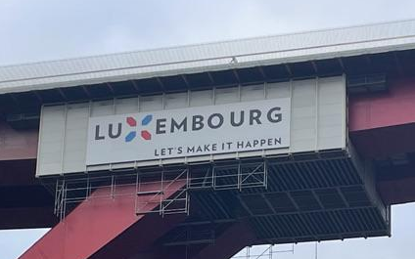

Fig. 24: “Luxembourg Let’s Make It Happen” state slogan on Rout Bréck
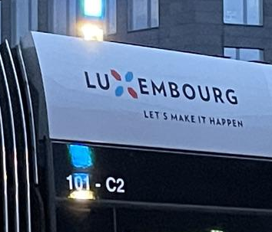

Fig. 25: “Luxembourg Let’s Make It Happen” state slogan on side of tram

Sofia is unsurprised by this and explains to me how compatible and mutually beneficial using these two languages for sloganising purposes actually is. When considered separately, Luxembourgish provides the localising and nation branding functions, while English appeals to an international audience, suggesting a potential clash of motivation. However, when considered together, the motivation is perceived as clearer. Although, on the surface, it may seem that the strength of this language combination lies in the fact that one language is outward-looking (i.e. English) and the other is inward-looking (i.e. Luxembourgish), Sofia presents both of these languages as outward-looking. Using Luxembourgish and English together projects an image of Luxembourg simultaneously as an internationally minded place open to the world that also has a unique and strong national identity and culture, symbolised succinctly by a national language.

It is important at this point to recognise that this discussion is not specific to Kirchberg. The COVID-19 campaigns, the tramline and the “Let’s Make It Happen” national campaign are all examples of projects that are present throughout the city by design, connecting Kirchberg to the rest of the city. Nonetheless, looking at the projects through a Kirchberg lens is particularly interesting because it provides us with an opportunity to compare local Kirchberg linguistic practices to practices in other parts of the city. In the case of branding, these slogans are seen throughout the city and yet when looked at within the boundaries of Kirchberg, differences appear. For example, the presence of sloganised Luxembourgish in other parts of the city (and indeed the country), where Luxembourgish is spoken and written more, can be interpreted as simply reflective of local practices. However, in Kirchberg, where Luxembourgish is generally spoken and visual incorporated into the LL in a more limited capacity, this sloganisation can be considered, on one end of the spectrum, as localising and a connecting thread between Kirchberg and the rest of the city, and on the other end of the spectrum, tokenistic and at odds with the perceived international image of Kirchberg. Furthermore, in terms of sloganised English, the inverse could be argued, where its presence in Kirchberg can be perceived as simply a local practise, yet its presence outside of Kirchberg can be interpreted as representative of the global integration of Luxembourg but also a tokenistic move at branding the country for an international rather than a local audience.

In short, Luxembourgish and English are featured prominently in slogans used throughout Luxembourg (City). Luxembourgish is perceived to provide a sense of unity and of nation branding and localising functions, while English is perceived as appealing to a wider, more international audience. Together, however, they outwardly project a carefully constructed image of Luxembourg as an international country with a strong sense of national identity. Even though these campaigns are city- and nationwide, looking at them from a Kirchberg perspective provides us with an opportunity to understand how the same thing present in all parts of the city can be interpreted in different ways.

7.5 Summarising remarks
In this chapter, analysis of the perceived motivations behind linguistic design choices of the Kirchberg LL reveals several intertwining potential key factors perceived by participants as integral to the construction of the LL. Firstly, the normalisation of multilingual practices in Luxembourgish daily life is a fundamental underpinning of many participants’ perceptions of Luxembourgish space. This normalisation is simultaneously juxtaposed against and interconnected with perceptions of the extraordinariness of Luxembourgish multilingual practices as different to other places. This interplay between perceptions of ordinary and extraordinary multilingualism is presented as a particularly Luxembourgish quality and a key facet in the construction of what could be regarded as a Luxembourgish space. Secondly, the flexibility of multilingual practices in Luxembourg is perceived to be echoed in the LL as demonstrated in the recurrent discussions of the LL as a reflection or a reinforcement of local linguistic practices. It is clear on further examination that an awareness of emplacement and spatial function, as well as notions of public and private, intersect with perceptions of reflection and reinforcement, indicating the dynamic nature of interpretations of space.

Thirdly, the idea of linguistic hospitality is perceived as an important principle in the construction of the Luxembourgish LL, in that material linguistic choices are often perceived as motivated primarily by a particularly Luxembourgish desire to facilitate communication among a linguistically highly diverse population. In this discussion, one can see a convergence in participant perceptions of both multilingual practices and the use of English because both linguistic models are perceived to have the ability to appeal to as many people as possible, while also highlighting a key development in the linguistic situation in Luxembourg. The addition of English into the linguistic mix is reflective of the diversification of migration trajectories towards Luxembourg, particularly towards Luxembourg City. However, it is important to note that the use of English is not perceived by participants as a replacement for the multilingual model but rather a complement to it. Furthermore, the inclusion of English in efforts to be linguistically hospitable is juxtaposed against the exclusion of Portuguese, the language associated with the largest migrant community in Luxembourg. This demonstrates the limitations of linguistic hospitality in Luxembourg, where integrative expectations and paths of Portuguese people in Luxembourg is expected to be done through French, and in some cases Luxembourgish.

Finally, considerations of perspective are important when it comes to the interpretation of space and the perception of motivation. In naming practices, it is clear that different participants from different backgrounds and with different connections to their local environment have differing interpretations of the same things, such as Rout Bréck (‘Red Bridge’). While overarching ideas can be drawn as to why certain names have been given to certain places, an understanding that individual passer-by interpretations can potentially be in contrast or in contradiction with each other must also be considered. Regarding branding practices, the local environment, in which one finds a particular LL item, contributes to perceptions of said LL item. In this case, the use of English and Luxembourgish in nation branding is seen throughout the city (and undoubtedly throughout the country), yet participants vocalise their interpretations of this branding in conversations around Kirchberg, which undoubtedly has an effect on how they in turn express these interpretations. Fundamentally, from this analysis, it is clear that it is important to lean into the diversity and complexity of perception in order to develop a clearer, more specific understanding of a given space.

Chapter 8:

Conclusion

This research has explored the construction of space, place and linguistic landscapes in the Kirchberg Plateau from the perspective of the passer-by. Discursively and physically positioned as an ‘island’ separate from the rest of Luxembourg City, the district of Kirchberg presents a rich area for insights into the spatial and linguistic complexity of Luxembourg and expressions of Luxembourgishness. As a relatively new part of the city with little settlement history, purpose-built on formerly agricultural land in order to house the expansion of the city during Luxembourg’s increasing socioeconomic integration at European level, the construction and development of Kirchberg are representative of tensions that exist between localising and globalising processes. That is to say, the district is representative of the challenges of constructing, maintaining, negotiating and representing local and global identities in Luxembourg. In this way, Kirchberg and the wider Luxembourg is an ideal site for LL and spatial research, in particular from the perspective of the people who use and interact with the space, which has been the focus of this research project. The aim of this research has been to address the overarching question of:
How do passer-by perceptions of the linguistic landscape of Kirchberg contribute to the spatial identity of the district?
In order to investigate this, three further research questions supported the investigation. The research process helped to shape and solidify these questions, particularly during the data collection phases and the thematic analysis of the interview data. The questions are as follows:
- What are the perceptions of Kirchberg as a space by the people who use the space?
- What are the perceptions of language use on signage on the Kirchberg LL by the people who use the space and what significance (or lack thereof) do they attach to the language use they observe?
- How do the passer-by perceptions of space and language in Kirchberg connect to wider social discourses and ideologies, which underpin their own expressions and perceptions of Luxembourgishness?
These three questions have been addressed in Chapters 5, 6 and 7 respectively, and will serve as a guide to the subsequent discussion of research findings, their implications, contributions and limitations throughout Chapter 8.

In section 8.1, I will discuss and summarise the findings in line with the above three research questions, as well as tackling the larger overarching research question underpinning the project as a whole. In section 8.2, I will explore the implications of the research findings for Kirchberg and the wider country of Luxembourg, as well as for other research sites beyond the Luxembourgish borders. Although this research takes place within the specificities of Luxembourg as a case study, the findings are relevant to the exploration of other research sites across the globe, as deepening global socioeconomic integration occurs simultaneously to strongly held desires to maintain heterogeneous authentic local identities perceived to be at risk due to homogenising globalising processes. I will also address the implications of the findings in relation to the interpretation and navigation of multilingual spaces by passers-by. These discussions will be of particular interest to urban planners and policymakers. In section 8.3, I will outline theoretical and methodological contributions made by this research to scholarship in the fields of study of linguistic landscapes and multilingualism, as well as the influential fields of social and cultural geographies, ethnography and urban planning. Theoretically, I will contribute to wider discussions of the usefulness of exploring spaces from the perspective of the passer-by, addressing the importance of addressing discursive contributions to perceptions of space, as on par with material contributions. Methodologically, I will discuss the implications of foregrounding interviews as a method of exploring linguistic landscapes through real-time interpretations by passers-by of the space itself. In section 8.4, I will outline the limitations of the research and then posit potential directions for further research.

8.1 Discussion of findings
It is clear from the analysis of passer-by perspectives of the material LL items found in Kirchberg and of the connections to social discourses underpinning the spatial identity of the district that perceptions of Kirchberg present the district as simultaneously an isolated island separate from yet geographically near the rest of Luxembourg City, yet also an increasingly integrated part of Luxembourg City influenced by and influencing the rest of the city. On the one hand, when asked to describe more generalised perceptions of Kirchberg and its ‘vibe’, participant perceptions tended to be built around the core ideas of internationalism and deeper integration into global socioeconomic structures. This was indexed by repeated references to the modernist International Style architectural and urban planning elements and the particular prominence of English in the district. These core ideas were juxtaposed against the core ideas underpinning their perceptions of the rest of the city, which centred on tradition, authenticity, and feelings of being lived in.

On the other hand, when shown and asked to discuss photographs of signage in Kirchberg as prompts during the interviews, participants tended to connect particular linguistic choices on the LL not only with discourses underpinning perceptions of Kirchberg, but also with wider discourses of the Luxembourgish linguistic situation, whether those choices pertained to the presence and/or absence of specific languages or to the multilingual configurations visible on signage. This distinction between more general perceptions of Kirchberg as a whole and perceptions of the more specific aspects of the Kirchberg LL can be viewed as evidence of significant and dynamic changes to the spatial identity of Kirchberg as it develops as a district and becomes more integrated into passer-by perceptions of Luxembourg City.

In order to support these assertions, I turn to the aforementioned three supporting research questions. The first question explored in Chapter 5 is:

- What are the perceptions of Kirchberg as a space by the people who use the space?

Before engaging with any meaningful sociolinguistic thematic analysis, it was important to lay a foundation for understanding the district of Kirchberg from the passer-by perspective, as an insight into participant understandings of Kirchberg as a space in and of itself and its vibe. Here, I explored participants’ descriptions of the Kirchberg aesthetic, discussions of what happens in the district and who frequents it and comparisons with other places in and outside Luxembourg City, both in terms of similarities and differences.

The key findings that emerged from the examination of participant understandings of Kirchberg hinged on the central perception that Kirchberg is aesthetically and functionally different from the rest of Luxembourg City. Firstly, participants highlighted their perception that the district is mainly associated with working - as a place where people go to work in the morning then leave in the evening. Participant perceptions of ‘work’, in relation to Kirchberg, solely referred to the tertiary sector of banking and financial services or work at European institutions, invisibilising the prominent sectors of hospitality, healthcare and building and facility management, such as cleaning. More than just an association, the concept of work was perceived as a central influence on the fabric of the district and its (primary) function as an international business space attracting global talent, drawing comparisons with places like Canary Wharf in London, La Défense in Paris and Cloche d’Or in southern Luxembourg City. Kirchberg’s primary function is juxtaposed against other parts of the city, which many participants perceived as districts where one can work, live and socialise and which generally feel more lived in.

Secondly, this sense of not being lived in was reflected the perceptions of Kirchberg as inauthentic because of its incongruence with the rest of Luxembourg City. These perceptions of incongruence were attributed to a number of factors, such as the modern architectural and repetitive International Style urban aesthetic of the district at odds with the more traditional architectural features of the rest of the city; perceptions of Kirchberg as coming from nothing and having no history as a district and therefore developing separately from the rest of the city; and Kirchberg’s rapid development from agricultural land to highly urbanised space, as opposed to organic growth over a longer period of time. This was attributed to an emotional connection between the passer-by and Kirchberg, and not evidence of Kirchberg as a non-place (Augé, 2009). This ‘spatial mismatch’ (Hesse, 2016) between Kirchberg and the rest of the city informed many participants’ perceptions of Kirchberg as a less authentically Luxembourgish space. Instead, it was perceived as more of an international or European space seen repeated in multiple places across Europe, such as in the comparisons drawn with Canary Wharf or La Défense.

Thirdly, the associations with work and the perceived inauthenticity of the district came together to underscore the perception of Kirchberg as a separate ‘bubble of the side’ of the city, as stated by Jane (Excerpt 5.3/5). In this separate bubble, the social trajectories of international residents, often attracted to live in the district because of work opportunities, were perceived as diverging from the social trajectories of people living in the rest of the city, who only go to Kirchberg for a specific reason. Building on Hesse’s (2016: 618) assertion of Kirchberg as an ‘island’ interconnected with global business partners but ‘disconnected from [its] local environment’ and on Scollon and Scollon’s (2003: 171) concept of ‘special use spaces’, I discussed how perceptions of Kirchberg among participants demonstrate the potential to designate Kirchberg a ‘special use island’ or a part of a city isolated from the rest of the city until needed for a particular purpose. Furthermore, this perceived separation of Kirchberg and Luxembourg City is a small-scale reproduction of a perceived division between the international population of Luxembourg and Luxembourgish people, as stated by Katarina (Excerpt 5.3/7).

With this understanding of general perceptions among participants of Kirchberg as a space now established, I then explored the second research question in Chapter 6:

- What are the perceptions of language use on signage on the Kirchberg LL by the people who use the space and what significance (or lack thereof) do they attach to the language use they observe?

In this chapter, I discussed the recurrent perceptions of the presence and absence of different languages in Kirchberg presented among the participants. The languages I focused on in the chapter are French, Luxembourgish and English because they were the languages that participants discussed the most. I made the decision not to include specific discussions around German and Portuguese, two prominent languages in Luxembourg, in the remit of this thesis because they were only discussed by some participants and most often in relation to the other more prominently discussed languages. In this way, my decision to not include these discussions reflected the side-lining of these languages in the interviews, therefore reinforcing their perceived positions as peripheral to the discussion at hand.

Firstly, the discussion of the presence of French surrounded the universal utility of the language in Luxembourg and its position in Kirchberg. Although often perceived as a district functioning separately from the rest of the city, signage in Kirchberg that included French was perceived by participants as unsurprising and ubiquitous throughout the district and throughout the city at large. Many participants justified the prominent visibility of written French in Kirchberg by positioning it as the language of anonymity (Woolard & Frekko, 2013), which ‘most people speak’ (Tom: Extract 6.1/5) in Luxembourg. By doing so, participants appeared to present Kirchberg as an integrated part of Luxembourg City, subject to the same linguistic rules regarding written French on signage as any other part of the city, which was at odds with the more general perceptions of Kirchberg being separate from the rest of the city.

The perceived ubiquity of French, however, belied a more complex situation regarding the multiple indexicalities of French and social class. Two separate discussions with two participants, Stefan (Excerpt 6.1/6) and Hugáceo (Excerpt 6.1/7), regarding the connection between the use of French and ‘blue-collar workers’ in Kirchberg highlighted that French was also depicted as a language often associated with ‘blue-collar workers’, who are often stereotyped as having Francophone or Romanophone migrant backgrounds. In this scenario, as opposed to being a language of anonymity accessible by all including blue-collar workers, French was depicted as a language authentic to and representative of certain migration experiences. Therefore, the emplacement of French in environments perceived as blue-collar, such as construction sites and a steel door in a bus station, were perceived as indexical of the presence of migrant workers in Kirchberg, rather than symptomatic of a ubiquitous language.

Secondly, analysis of the discussions about Luxembourgish highlighted recurrent discourses regarding its place on the Kirchberg LL, wherein participants tended to demonstrate a hyper-awareness of both the presence and absence of Luxembourgish. When participants noticed the presence of Luxembourgish on signage in Kirchberg, many participants justified its presence as connected to its material emplacement and locatedness in the country of Luxembourg. Many participants expressed an appreciation of seeing Luxembourgish in public spaces as a sign of respect to the local Luxembourgish population and as a reminder that ‘you are in Luxembourg after all’ (Stefan: Excerpt 6.2/3), foregrounding its importance in localisation processes, such as, in this case, the construction of public spaces. Similar to the analysis of discussions of French, Kirchberg was presented as an integrated part of Luxembourg City, a perception once again at odds with general perceptions of the separateness of Kirchberg.

The perceived tension between the presence of Luxembourgish, which possesses significant symbolic value and links with expressions of Luxembourgishness, in an international space like Kirchberg, however, illuminated some participant perceptions of the presence of Luxembourgish as simultaneously inclusive and exclusive. On the one hand, using Luxembourgish on public signage in Kirchberg was often interpreted as validating the local Luxembourgish population by giving prominence to written Luxembourgish, which is often perceived as limited in terms of presence and use in general as well as specifically in Kirchberg. Furthermore, the use of Luxembourgish was described as an ‘inside joke’ (Jane: Excerpt 6.2/5), which included Luxembourgers and even permanent foreign residents with a degree of Luxembourgish knowledge. On the other hand, this ‘inside joke’ was perceived as excluding people, who are not expected to possess any knowledge of Luxembourgish, such as frontaliers or newly arrived people, of which there is a significant living and working in Kirchberg. In this light, the presence of Luxembourgish in Kirchberg can be characterised as part of overall attempts to (even partly) claim Kirchberg as a Luxembourgish space yet the manifestations of these attempts are being perceived as, to an extent, out of place and detrimental to social cohesion.

Nevertheless, despite its symbolic value, the findings revealed that many participants were also able to justify the absence of written Luxembourgish as an issue of effective and efficient communication of information. Among the participants, written Luxembourgish was described as limited in its ability to be understood by many people, including Luxembourgers themselves, and therefore unnecessary in transmitting information to an audience made up of people who are either multilingual and therefore not reliant on Luxembourgish or unable to understand Luxembourgish in the first place. Similarly, the choice not to include Luxembourgish was often perceived as a pragmatic choice to avoid linguistic clutter, or having too many languages on a sign that could be unnecessarily complicated and therefore impede effective communication. Interestingly, the conversation of linguistic clutter often boiled down to a perceived choice between Luxembourgish and German, with the former sometimes portrayed as the more symbolic option and the latter as the more pragmatic option. In this way, while many participants discursively positioned Luxembourgish and multilingual practices as key to expressions of Luxembourgishness, they also underscored their perceptions of the one of the main functions of public spaces and signage, that is, to be understood by and to inform the public however possible. Overall, as far as the LL and visible language are concerned, pragmatism appears to be foregrounded as a key factor in perceptions of linguistic selection, while symbolicism is backgrounded yet also appreciated and perceived as having importance.

Thirdly, findings from the analysis of participant perceptions of English in Kirchberg revealed the dynamic complexity of the position of English within the wider Luxembourgish linguistic situation. Primarily, participants were unsurprised to see English in Kirchberg, tending to draw discursive interconnections between English, Kirchberg and the strong and growing global socioeconomic integration of Luxembourg. The presence of English was often depicted as prominent and as an instrument for facilitating communication as the global lingua franca in the highly internationalised space of Kirchberg. As highlighted by Lara (Excerpt 6.3.1/4), English was depicted as a linguistic tool for integrating an increasingly linguistically diverse population highly concentrated in Kirchberg, for whom the use of English is the key to social accessibility as opposed to French, the language arguably more often associated with this role. Interestingly, however, participants did not appear to perceive or present English as a replacement for other languages within the linguistic situation of Luxembourg. Instead, they presented it as an addition to the multilingual practices of the country. As such, the greater prominence of English in Kirchberg than in other parts of the city was often interpreted as a response to the linguistic needs of the Kirchberg population, underscoring the perceived integration of English into multilingual practices associated with Kirchberg.

Furthermore, this prominence of English on the LL was also perceived by participants to be growing within and spreading beyond the borders of Kirchberg to other parts of the city. While English-only signage was perceived to be unusual or atypical anywhere including in Kirchberg, participants pointed out that English on signage, including English-only signage, was representative of the linguistic needs in Kirchberg diverging from linguistic considerations felt in the rest of the city. Moreover, linguistic needs and challenges were also being perceived as changing outside Kirchberg in the rest of the city, where the use of English was also considered by some to be as more present in public spaces. However, the spread of English on the LL was perceived to be contained within Luxembourg City, whereas in the rest of the country, English was not considered an appropriate choice for communication, instead generally pointing to French or Luxembourgish as more appropriate choices.

Another finding revealed in the interviews was the regular reinforcement that, while English is prominent on the LL and indeed serves an important role, English is not a language with official status like French, German and Luxembourgish. It became clear that participants perceived there to be a linguistic hierarchy in Luxembourg, wherein English occupied a space below the officially recognised languages but above other languages, such as Portuguese, which was regularly perceived as explicitly a migrant or foreign language. While participants generally perceived the roles of most languages to be more or less fixed, perceptions of the role of English were underpinned by discourses of honorary limited officiality, justifying the presence of English in certain more ‘official’ capacities without the official recognition. In this way, the participants demonstrated the increasing acceptance of English as part of Luxembourgish multilingual practices while also highlighting how perceptions of Luxembourgishness do not appear to be challenged by nor do they explicitly include the use of English.

Analysis further revealed a parallel drawn by participants between two relationships; between Kirchberg and the rest of Luxembourg City, and between Luxembourg City and the rest of Luxembourg, highlighting an example of fractal recursivity (Irvine & Gal, 2000) or the reproduction of ideological relationships across multiple scales (Trisha: Excerpts 6.3.2/6; 6.3.2/7). One of the key differences that was perceived to separate Kirchberg from the rest of the city, namely the prominence of English, was also highlighted as a key difference between Luxembourg City and the rest of the country. Interestingly, this intersects with the discussion from Chapter 5 about the perceived lack of history of Kirchberg as a district, where Kirchberg is perceived as coming from nothing yet is perceived as developing in such a way that is a reproduction of other spatial relationships in Kirchberg. This echoes the sentiment of Pennycook (2010: 128) who asserts that ‘however global a practice may be, it still always happens locally’. This parallel suggests that, while perceptions of the spatial identity of Kirchberg were hinged upon separateness, otherness, and on disconnection from the local dimension, these perceptions were in fact reminiscent of other spatial identities and relationships being perceived within Luxembourg and therefore suggesting a Luxembourgish influence on the development of Kirchberg.

Building on the previous question, I then explored the third research question in Chapter 7, regarding the motivations behind the language choices on the LL:

- How do the passer-by perceptions of space and language in Kirchberg connect to wider social discourses and ideologies, which underpin their own expressions and perceptions of Luxembourgishness?

In this chapter, I looked beyond language choice and the perceived discourses indexed by the presence or absence of individual languages. Instead, I focused on the participants’ perceptions of potential motivations behind why the Kirchberg LL was constructed in the way it was and the inferred fundamental principles they perceived to underpin the construction of the Kirchberg LL.

Firstly, in response to the photograph prompts from Kirchberg, participants often explained multilingual signage to be underpinned by perceptions of multilingualism as ordinary in Luxembourg, normalising multilingual practices as part of daily life and thereby normalising the multilingual LL. Multilingualism was perceived as formative to Luxembourgishness, not as a generic innate quality but rather as the result of embedded social structures, such as the education system and daily navigation of public spaces and interactions, which encouraged multilingual practices through normalisation. Furthermore, multilingual practices were not perceived as restricted or limited to only native Luxembourgers, instead including foreign residents and cross-border workers who also exist within the space. Furthermore, perceptions of multilingualism as ordinary were often juxtaposed against perceptions of multilingualism as extraordinary. While multilingualism was perceived as ordinary when observed within the boundaries of Luxembourg, participants would often use their personal experiences of the linguistic situations in other areas, such as in their countries of origin or places they have been to as part of their migration trajectories, to draw attention to the perceived atypicality of Luxembourgish multilingual practices when compared to other places.

Certain participants, particularly (but not exclusively) the reactions by participants who had moved to Luxembourg as adults, expressed excitement or being impressed at the normalised multilingual practices in everyday life, underscoring the interconnectedness being these two discourses of ordinariness and extraordinariness of Luxembourgish multilingualism. It is also important at this point to recognise that these discourses also shaped my perceptions of the situation and my line of questioning in the interviews. As someone who generally positioned themselves in the interviews as an outsider in order to build rapport and position the participant as an insider, this point of discussion was an important one to unpack in the thesis.

Secondly, analysis of participant interpretations of the LL revealed the complexity of the debate surrounding whether the LL is a reflection of linguistic practices within a given space or a reinforcement of linguistic expectations for the space. On the one hand, participants often interpreted the signage in one area as reflecting the linguistic practices within a particular space, appealing to and therefore describing the linguistic repertoires of the people using the particular space in order to be as inclusive as possible within a linguistically diverse population, such as transport hubs or public buildings. In turn, this was interpreted as allowing people in public spaces to make informed decisions about whether or not they wish to enter said space and engage in its practices.

On the other hand, participants highlighted how reflections of linguistic practices within a particular space can also be interpreted as reinforcements of linguistic expectations within said space. Some participants highlighted feelings of linguistic comfort and ease as well as discomfort and pressure in certain situations where the languages visible on the LL in certain spaces procured certain reactions from different swathes of the public. They acknowledged that linguistic design may indeed often be a description of the linguistic capabilities of the people within certain spaces. However, it was simultaneously interpreted as an outlining of linguistic expectations, putting social pressures on individuals to conform to said expectations in order to facilitate interpersonal interactions. These expectations and pressures were described as potentially having unsettling effects for some individuals, instead leading to feelings of unpreparedness of discomfort, all of which is highly dependent on the space itself.

Upon further examination of this distinction, it became apparent that participant perceptions of the distinction between reflection and reinforcement appeared to coincide with their distinction between perceptions of public and private, a particularly relevant aspect of Kirchberg, whose modernist architecture often blurs the lines between public and private (see McQuire (2008) and his discussion of the politics of transparency). When engaging with prompts located in places with high public use, such as public transport hubs, the LL was interpreted as needing to be constructed as public-facing, therefore appealing to and reflecting linguistic practices of people using the space. When engaging with prompts located in places targeted to specific groups of people, such as workplaces, or associated with state institutions, such as schools, the LL was interpreted as needing to reinforce linguistic practices expected by the companies or institutions through internally mandated language policy. These differences could even be perceived on the same building at different entrances, depending on whether the entrance was for the public or outside visitors or for employees. In this way, the reflection-reinforcement and public-private distinctions were perceived as heavily intertwined with each other and with the concept of emplacement (Scollon & Scollon, 2003), with different parts of the distinction foregrounded and backgrounded in certain situations to procure certain reactions.

Thirdly, a recurrent discourse underpinning many participants’ interpretations of linguistic design was that of linguistic hospitality (Phipps, 2012; Vigouroux, 2019). While a few participants described perceiving multilingual signage on the LL as appealing to either Luxembourgers or foreigners depending on its linguistic design, most participants did not interpret the use of particular linguistic designs as appealing to one group or the other. Instead, most participants interpreted the differences in linguistic design across different signage as indicative of linguistic hospitality, or the desire for Luxembourgers to employ and materialise multilingual practices on the LL in order to facilitate communication among a linguistically diverse population of composed of both native Luxembourgers, foreign residents, and cross-border workers. Furthermore, this was presented as a quality at the core of expressions of Luxembourgishness. However, attempts to be linguistically hospitable through the use of English alongside traditional Luxembourgish multilingual practices were juxtaposed against the further marginalisation of the use and presence of Portuguese on the LL. In this case, Portuguese was perceived as undermining the intention of linguistic hospitality despite its clear use in communicating with local Portuguese-speaking communities because it was perceived as being at odds with expressions of Luxembourgishness.

Of particular prominence in this discussion in relation to Kirchberg was the use of English as the international lingua franca. As mentioned previously, participants tended to perceive the growing visibility of English as a result of globalising processes and representative of an international outlook, highly concentrated in Kirchberg. However, what became clear from the interviews was that the benefits of using English and multilingual resources on the LL were interpreted as converging because both linguistic frameworks were perceived as pragmatic methods of facilitating communication. Moreover, English was always presented as a part of the larger Luxembourgish linguistic framework alongside other languages, namely French, German and Luxembourgish. In terms of LL design, the presence of English alongside French and German and the absence of Luxembourgish were perceived as contributing to the overall goals of linguistic hospitality through the use of so-called ‘big languages’ or languages with broader communicative appeal.

The increased presence of English was highlighted as one of the signs of significant change happening in the linguistic situation in Luxembourg, particularly regarding its relationship with French, which occupies a significant role within Luxembourg. While English was sometimes presented as in competition with French for certain integrative functions, its perceived usefulness was often highlighted as concentrated within and limited to Kirchberg and, to an extent, Luxembourg City. By contrast, French was perceived as maintaining its role as a key integrative language particularly among newly arrived migrants to the country because of its associations with traditional conceptualisations of Luxembourgishness. Building on this, Luxembourgish was perceived as a language connected to deeper integration into Luxembourg especially among those choosing to lay down permanent roots in the country. English, while generally accepted as a complementary addition to linguistic practices and demonstrative of major changes, was not perceived as central to integration into Luxembourg and expressions of Luxembourgishness, echoing perceptions of the honorary limited officiality of English discussed in Chapter 6.

Finally, a recurring theme in the analysis of participant interviews was the theme of placemaking and branding. An interesting observation became apparent when analysing the differing interpretations among participants of place names in Kirchberg. The choice to use a particular language for place names was perceived to be connected to the function of the space the name was describing. I drew particular attention to the place of Rout Bréck (tr. ‘Red Bridge’) and the associations among the participants with what this name referred to. When shown the photograph of the Rout Bréck tram stop, the Luxembourgish person, Lara, interpreted the tram stop as named after Rout Bréck, the iconic red bridge located at the entrance to Kirchberg. The French person, Luc, felt that Rout Bréck referred to the tram stop specifically because he would refer to the bridge as Pont Rouge, the name translated into his native French. For Diane, the Oceanian woman, who spoke little French and no Luxembourgish, she interpreted the name of the tram stop as a ‘route breaker’ due to its proximity to a transport interchange, calling Rout Bréck ‘Charlotte Bridge’ in reference to its official name as the Grand Duchess Charlotte Bridge. Upon further analysis, the comparison of these three participants’ interpretations of place names were reflections of their personal experiences with the space and the level of access they had to local sociocultural and linguistic resources as a consequence of their time spent in Luxembourg. Furthermore, this comparison highlighted how different proximities to Luxembourgishness did not impede the participants from interacting with the space. Instead, it demonstrated how the participants found different ways to navigate the space and thereby constructing their own senses of place, underscoring the notion of space as a collection of places (cf. Scollon & Scollon, 2003; Massey, 2005; 2007).

With regard to branding, participants regularly highlighted Luxembourgish and English as prominent languages used to brand the country as simultaneously an international country with global connections and a place with a unique local identity. While the examples of branding were noted by the participants as part of larger city- and country-wide campaigns, not just present in Kirchberg, the examination of participant interpretations of them in Kirchberg presented an opportunity to look at how the emplacement of the same signage in different parts of the city can be interpreted differently.

With all of this mind, it is therefore important to tie together these disparate threads in order to answer the overarching research question:
How do passer-by perceptions of the linguistic landscape of Kirchberg contribute to the spatial identity of the district?
Upon initial analysis of the participant interviews, it was evident that passers-by did in fact contribute discursively to the spatial identity of Kirchberg. Through our discussions, participants reinforced perceptions of Kirchberg as a disconnected island on the edge of Luxembourg City, separate from the rest of the city and more focused on connecting with global partners than with the local population. Interpretations of the Kirchberg LL among participants highlighted key challenges to the traditional conceptualisations of the Luxembourgish linguistic situation and of the traditional understandings of migration trajectories towards Luxembourg and presented Kirchberg as at the centre of these challenges and changes. Participants perceived English to have a prominent role in Kirchberg, rivalling that of French, and perceived the use of Luxembourgish to be somewhat limited due to its localising function at odds with the international image of the district.

However, on deeper inspection, the situation in Kirchberg, though potentially different in appearance, was perceived to be underpinned by discourses expressing fundamental Luxembourgish qualities. The presence of French and Luxembourgish and multilingual signage in Kirchberg was still perceived as understandable because Kirchberg in certain respects was still considered an integrated part of Luxembourg City and therefore subject to the same linguistic considerations as other parts of the city. The prominence of English was interpreted as one part of the traditional multilingual system that seeks to accommodate all people in the country and facilitate efficient communication among a linguistically diverse population, complementing shifting demographics in light of emergent migration trajectories towards the country while still appealing to traditional Luxembourgish sensibilities. Feelings of disconnect were perceived to be indeed a result of the international image and appeal of Kirchberg but also due to the lack of emotional attachments locals expressed with the area due to it essentially coming from nothing. All of this comes together as an example of fractal recursivity, where the relationship between Kirchberg and the rest of the city is connected to the relationship between Luxembourg City and the rest of the country. Therefore, Kirchberg might feel more international and less local, and what is happening in Kirchberg might feel new, different and disconnected from the local surroundings, but upon closer examination, the situation is more nuanced, with perceptions of Kirchberg becoming increasingly intertwined with perceptions of Luxembourgishness, indicating an increasing integration of Kirchberg into perceptions of Luxembourg City.

8.2 Implications of findings
After having discussed the findings from this research project, it is necessary to explore the implications of these findings on the situation in Luxembourg and indeed beyond its borders. This project has highlighted the district of Kirchberg as an interesting research site for LL research, which is an often-overlooked district in terms of sociolinguistic study. Research into the Luxembourgish linguistic landscapes has been expertly spearheaded by Purschke (2017; 2020; 2021), and the in-depth exploration of the Kirchberg LL in this thesis serves as a complement to the research conducted by Purschke (and others) and hopefully as a starting point for future research conducted on the Luxembourgish LL.

These findings will be of use to scholars, conducting research on Kirchberg, the wider Luxembourg, as well as other places around the world. Because a key finding from this research was that the construction of the Kirchberg LL was underpinned by global and local discourses, and particularly discourses that underpin expressions of Luxembourgishness, this may have implications on a shift in perceptions of Kirchberg as a district built on Luxembourgish foundations with an international outlook. This has further implications for researchers investigating issues pertaining to similar globally interconnected spaces, such as other European financial districts (EFDs) or ‘instant cities’ (Burdett, 2012) within and outside of Luxembourg and indeed financial districts located all over the world, where issues of the global and the local are also undoubtedly interconnected.

With regard to the district itself, this thesis offers insights into the perceptions of Kirchberg as a space and of its LL, which may be of interest to many stakeholders beyond academia in the areas of policymaking and urban planning. In particular, the municipal body in charge of the development on the Kirchberg Plateau, Fonds Kirchberg, may be able to take the findings in this thesis into consideration when considering the future direction of the district. Firstly, when making potential further developments of the district, policymakers should consider the greater integration of Kirchberg into the rest of the city as a high priority by making it more of a destination outside of the working week. In this present study, there is evidence to suggest this integration has already started taking place to an extent, as evidenced by the perceptions of the material connections of Rout Bréck, the tramline and the city-wide campaigns of nation branding and of public health regarding COVID, as well as by the perceptions of a few participants, who acknowledged that Kirchberg is becoming a more frequented space. However, these perceptions were outweighed by continued dominant perceptions of Kirchberg as the isolated working district. By making a concerted effort to develop the identity of Kirchberg to incorporate evening and weekend activities, this could contribute to a significant change in perceptions of Kirchberg as a more well-rounded space.

Secondly, this thesis demonstrated that participants responded positively to the presence of Luxembourgish in Kirchberg, while also acknowledging (in some cases begrudgingly) its limitations in the space. In this light, policymakers should make a greater claim of Luxembourgish in Kirchberg by incorporating and using the language more as part of the visible Kirchberg LL. The benefits of a more significant presence of written Luxembourgish would be two-fold; it would strengthen the claim of Kirchberg as a Luxembourgish space, potentially encouraging more people to frequent the space as in any other district in the city; and it would also contribute to challenges to prevalent discourses of the superfluousness or uselessness of written Luxembourgish, instead encouraging and centring its use in the LL.

In order to combat perceptions of exclusion due to the use of Luxembourgish, policymakers should also feel encouraged to continue using English in the district. As indicated by participants, English and Luxembourgish were perceived as complementary languages to each other, particularly in cases of nation branding. Furthermore, the use of English in Kirchberg was perceived as serving a legitimate purpose in contributing to the facilitation of communication among a highly linguistically diverse population, therefore it should continue having a presence in Kirchberg.

Finally, while I am singling out the importance of Luxembourgish and English as points for further consideration, policymakers should regard the importance of these languages in Kirchberg as a response to the linguistic needs of the district and ultimately as cogs in a much larger system of linguistic practices. As contrasted against other situations (cf. Marten, 2010; Pavlenko, 2010; Leimgruber, 2020), there do not appear to be explicit rules or guidelines regarding the prescription of particular linguistic practices in Luxembourg. These decisions are made on a case-by-case basis through committees at the municipal level (Purschke, 2021). In the case of Luxembourg, this should be interpreted as an advantage because it circumvents potentially dogmatic approaches to the construction of the LL, which goes against the current system, which many participants perceived as ad hoc and potentially incoherent yet beneficially responsive to the needs of the local population. In this way, decisions around the use of particular languages or multilingual configurations on signage should considered from a perspective of expressing Luxembourgish qualities, such as the normalisation of multilingual practices or linguistic hospitality.

As such, although I have argued in favour of the specific use of Luxembourgish and English in Kirchberg, I am also arguing for their uses to be complementary or additive to overall linguistic practices, as opposed to replacing or erasing other languages to negative effect. In other words, the presence of Luxembourgish and/or English in Kirchberg should not come at the expense of the presence of other languages, as that appears to go against the perceptions of the participants. The avoidance of linguistic clutter on signage was highlighted by participants as a potential motivation behind certain linguistic designs and as a potential concern, which complicates the idea of addition over replacement. However, in line with Pietikäinen et al’s (2016) view of small languages, this should be seen as an opportunity for creativity on the Kirchberg LL, in order to truly represent the district as an international outward-looking space with roots of influence firmly set in its local environment.

8.3 Theoretical and methodological contributions
There have been a number of theoretical and methodological contributions proposed by this study, appealing not only to research areas of Luxembourg Studies, multilingualism, and LL studies but also in interrelated research areas of social and cultural geography, ethnography and urban planning.

This research presents an important theoretical nuance to LL studies by bringing together sociolinguistic considerations of how a space has come into existence by combining Scollon and Scollon’s (2003) geosemiotic approach with considerations by Malinowski (2009; 2020), Gorter and Cenoz (2020) and Järlehed (2017), as well as complementing Scollon and Scollon’s (2003) concept of semiotic aggregates with social geographical considerations of specificity (Massey, 2007) and Blommaert’s (2010) critique of context into one sociolinguistic approach to a particular space. These considerations include human interactional processes with space, temporality, materiality, authorship, among others. These considerations come together in order to provide an understanding of a space as rooted in and inseparable from its diachronic and synchronic development. In particular, by complementing Scollon and Scollon’s (2003: 175) concept of space and place with social geographical perspectives on space and place (cf. Lefebvre, 1991; Massey, 2005; 2007; Soja, 2010), this research emphasises the inextricability of social actors, materialising processes and discursive processes of spatial construction by providing important nuances that maintains the importance of considerations of material space and its ideological underpinnings. In this way, this overall stringing together of complementary considerations proved to be highly useful in analysing both the photographic and interview data as snapshots of a more complex situation.

In this thesis, the role of English in Luxembourg is also a prominent point of discussion but is overall under-researched in the scholarship around Luxembourg. The work of Collins (2016), de Bres & Lovrits (2021) and Lovrits (2022) stand out as particularly impactful contributions to the discussions of English in Luxembourg, particularly from the perspective of native English speakers and their experiences as an (often monolingual) Anglophone person in the multilingual environment of Luxembourg. This thesis further contributes to this area of research, focusing more on perceptions of written, as opposed to spoken, English and its presence in public spaces and connections to wider discourses of global English in Luxembourg.

Of particular importance in this research is the foregrounding of the passer-by perspective in LL studies. Often, the focus of many LL studies has centred on the material contributions to spatial meaning from the perspective of the creators and emplacers of LL items. Scollon and Scollon (2003) highlight the importance of a distinction between space and place, and the role that the passer-by interpretation of space plays in spatial construction, with Garvin (2010), Trumper-Hecht (2010) and Bock and Stroud (2019), among others, also corroborating the specific importance of passer-by discursive contributions to the construction of space. This research hopefully contributes to this wider movement within LL studies to examine passer-by perspectives, such as in the discussion of Rout Bréck (section 7.4.1) in order to acknowledge the influence of discursive contributions to the construction of space and in order to firmly position the passer-by as an influential, prominent, and legitimate stakeholder in the construction of spatial identity, alongside the material contributors to the LL. To do this, this thesis provides a fleshed-out definition of passer-by as a discursive contributor to the construction of space that is hopefully useful to other LL scholars when teasing out complexities in spatial identities.

Furthermore, this theoretical foregrounding of the passer-by perspective in this thesis intertwines with a methodological contribution to wider research, regarding the value of conducting interviews with passers-by within LL studies in order to gauge perceptions of space and how they contribute to overall spatial meaning. Theoretically, the value of acknowledging the passer-by perspective highlights the multifaceted and dynamic nature of space in line with the previously mentioned comprehensive list of considerations regarding space, particularly when looking at the prevalence and limitations of certain interpretations. Methodologically, this research highlights the reconceptualisation of ‘seated’ semi-structured interviews with passers-by as ‘simulated walk-and-talk interviews’ using the LL as prompts is an effective method of providing meaningful insights into perceptions of space, and as a way of ensuring participant comfort and maintaining a sharp focus of the data collection objectives. It is evident from this thesis that passers-by are able to engage in meaningful discussions of space, place and language through the use of photos of the LL. Furthermore, this thesis provides insights into the spatial identity of Kirchberg without having to rely on interviews with material contributors. As mentioned previously, material contributors to the LL have often been highly valued in LL studies because of their role in physically emplacing LL items into public spaces. This thesis aims to position passers-by as equally as valued in LL studies.

As the field of LL has developed and hopefully as this project attests, interviews with discursive contributors on the LL through ‘simulated walk-and-talk interviews’ should also be considered of significant value in LL research for two reasons. Firstly, interviews with discursive contributors do not rely on the analysis of official documentation that may be hard if not impossible to find regarding rules and regulations of the LL, as is the case of Luxembourg, where there does not appear to be rules regarding the specific use of linguistic varieties in public spaces. Instead, these interviews place value on perception and interpretation, fundamental to Scollon and Scollon’s (2003) interpretation of the concept of place. Secondly, this approach to interviews allows researchers to cast a large net in terms of recruitment because value is explicitly placed on the variety of perspectives, which is especially helpful in areas where it is perhaps difficult to find participants willing to contribute.

The contribution of this thesis, as sociolinguistic research, to the fields of social and cultural geography and urban planning should also be highlighted here. Research from these fields has bolstered the research in this thesis, which demonstrates the fundamental flexibility and interdisciplinarity of LL research as a growing field of enquiry. My hope is that this thesis, which is explicitly situated as ultimately a piece of sociolinguistic research, serves as a reminder to social and cultural geographers and urban planning researchers that language is an inseparable element in spatial research. Language choices visibilised in material space are important lines of enquiry and evidently contribute significantly to people’s perceptions, understandings and interactions with a space. As such, discussions of language-in-space should be considered a necessary line of enquiry in spatial research.

8.4 Further directions
For further research directions, this is a project that is replicable in other parts of Luxembourg City and indeed other research sites and complementary to other LL research methods. Therefore, a desired outcome of this research is a contribution to continued research by other scholars of LLs from the passer-by perspective. Primarily, further avenues of research would ideally focus on deepening our understanding of the passer-by perspective through the exploration of different methods, already established and innovative alike. For the case of Kirchberg specifically, hopefully this contributes to a growing relationship between academic scholars and policymakers in the district, especially in Fonds Kirchberg, in the hope of reflecting an on-the-ground perspective of the district in its future development. Furthermore, in terms of research dissemination, this project lays the groundwork for potential collaborations with Fonds Kirchberg and other public stakeholders, such as Zënter fir d’Lëtzebuerger Sprooch (The Centre for the Luxembourgish Language), in the form of exhibitions and other public engagement activities, a cyclical move presenting Kirchberg back to the passer-by.

Bibliography

Appadurai, A. (1996) Modernity at Large: Cultural Dimensions of Globalization. London:
University of Minnesota Press

Augé, M. (2009) Non-places. 2nd edn. London: Verso

Banksy (2006) Wall and Piece. London: Century

Barni, M. and C. Bagna (2015) ‘The critical turn in LL: New methodologies and new items in
LL’ Linguistic Landscape 1(1/2), pp.6-18

Belling, L. & J. de Bres (2014) ‘Digital superdiversity in Luxembourg: The role of
Luxembourgish in a multilingual Facebook group’ Discourse, Context and Media 4-5, pp.74-86

Ben-Rafael, E. and M. Ben-Rafael (2015) ‘Linguistic landscapes in an era of multiple
globalizations’ Linguistic Landscape 1(1/2), pp.19-37

Ben-Rafael, E. and M. Ben-Rafael (2016) ‘Berlin’s Linguistic Landscapes: Two Faces of
Globalization’ In: R. Blackwood et al (eds.) Negotiating and Contesting Identities in Linguistic Landscapes. London: Bloomsbury, pp.197-214

Ben-Rafael, E. et al (2006) ‘Linguistic Landscape as Symbolic Construction of the Public
Space: The Case of Israel’ International Journal of Multilingualism 3(1), pp.7-30

Blackwood, R. et al (2016) Negotiating and Contesting Identities in Linguistic Landscapes.
London: Bloomsbury

Blommaert, J. (2010) The Sociolinguistics of Globalization. New York: Cambridge
University Press

Blommaert, J. (2013) Ethnography, Superdiversity and Linguistic Landscapes: Chronicles of
Complexity. Multilingual Matters: Bristol.

Bock, Z. & C. Stroud (2019) ‘Zombie Landscapes: Apartheid Traces in the Discourses of
Young South Africans’ In: Peck, A. et al (eds.) Making Sense of People and Place in Linguistic Landscapes. London: Bloomsbury. pp.11-28

Braun, V. & V. Clarke (2019) ‘Reflecting on Reflexive Thematic Analysis’ Qualitative
Research in Sport, Exercise and Health 11(4), pp.589-597

Braun, V. & V. Clarke (2020) ‘Can I use TA? Should I use TA? Should I not use TA?
Comparing reflexive thematic analysis and other pattern-based qualitative analytic approaches’ Counselling and psychotherapy research. 21(3), pp.37-47

Brinkmann, S. (2013) Qualitative Interviewing: Understanding Qualitative Research.
Oxford: Oxford University Press

Burdett, R. (2012) 'Mapping Scales of Urban Identity' Architectural Design 82(6), pp.92-97

Busch (2012) 'The Linguistic Repertoire Revisited' Applied Linguistics 33(5), pp.503-523

Carling, J. (2002) ‘Migration in the age of involuntary immobility: Theoretical reflections
and Cape Verdean experiences’ Journal of Ethnic and Migration Studies 28(1),
pp.5-42

Cekaite, A. (2020) ‘Ethnomethodological approaches’ In: P. Vannini (ed.) The Routledge
International Handbook of Ethnographic Film. New York: Routledge, pp.83-94

Chacko, E. (2004) ‘Positionality and Praxis: Fieldwork Experiences in Rural India’
Singapore Journal of Tropical Geography 25(1), pp.5163

Clarke, V. & V. Braun (2017) ‘Thematic Analysis’ The Journal of Positive Psychology 12(3),
pp.297-298

Collins, C. (2016) ‘Global English and multilingual Luxembourg: A case study of native
English speakers’ In: M. Fernández-Villanueva & K. Jungbluth (eds.) Beyond
Language Boundaries: Multimodal Use in Multilingual Contexts. Berlin: de Gruyter, pp.235-250

Collins, S. G. & M. Durington (2020) ‘From ethnographic media to multimodality’ In: P.
Vannini (ed.) The Routledge International Handbook of Ethnographic Film. New York: Routledge, pp.71-80

Cooper, B. et al (2012) ‘Introduction: The Quantitative-Qualitative Divide’ In: B. Cooper et
al (eds.) Challenging the Quantitative-Qualitative Divide: Explorations in Case-focused Causal Analysis. London: Continuum, pp.1-24

Crang, M. (2001) Cultural Geography. New York: Routledge

DeWalt, K.M. (2011) Participant Observation: A Guide for Fieldworkers. Second Edition.
Lanham Md.: Rowman & Littlefield

de Bres, J. and V. Lovrits (2021) ‘Monolingual cringe and ideologies of English: Anglophone
migrants to Luxembourg draw their experiences in a multilingual society’ Journal of
Multilingual and Multicultural Development.
DOI: https://doi.org/10.1080/01434632.2021.1920965

Delanty, G. (2005) ‘The Idea of a Cosmopolitan Europe: On the Cultural Significance of
Europeanization’ International Review of Sociology-Revue Internationale de Sociologie, 15(3), pp.405-421

Deumert, A. (2011) ‘Multilingualism’ In: R. Mesthrie (ed.) The Cambridge Handbook of
Sociolinguistics. Cambridge: Cambridge University Press, pp.261-282

Edwards, R. & J. Holland (2015) ‘Chapter 5. What sort of research tools can be used in
conducting qualitative interviews?’ In: What is qualitative interviewing?. London: Bloomsbury, pp.53-64

Emerson et al (2011) Writing Ethnographic Fieldnotes. Second Edition. London: The
University of Chicago Press.

European Commission (2022) The European Union: What it is and what it does.
Luxembourg: Publications Office of the European Union

European Union (2023) ‘Key Figures on Europe: 2023 Edition’ Eurostat
<https://ec.europa.eu/eurostat/documents/15216629/17706595/KS-EI-23-001-EN-N.pdf/5df7a393-8461-9270-7eaa-91a4b1c2acc6?version=3.0&t=1697616189434> [accessed 26/11/2023]

Eurostat (2022) ‘GDP per capita, consumption per capita and price level indices’ Eurostat
<https://ec.europa.eu/eurostat/databrowser/view/TEC00114/bookmark/table?lang=en&bookmarkId=388837b6-18d3-422f-8339-fa23f0378454> [accessed 26/11/2023]

Fehlen, F. (2002) ‘Luxembourg, a Multilingual Society at the Romance/Germanic Language
Border’ Journal of Multilingual and Multicultural Development, 23(1-2), pp.80-97

Fehlen, F. & Heinz, A. (2017) ‘The irresistible rise of English in Luxembourg: A
demolinguistic and sociolinguistic approach’ Forum 377, pp.48-50.

Flenley, P. & M. Mannin (2018) The European Union and its Eastern Neighbourhood:
Europeanisation and its 21st Century Contradictions. Manchester: Manchester University Press

Flockhart, T. (2006) 'Europeanisation: the myths and the facts' Public Policy Research 13(2),
pp.86-91

Fonds Kirchberg (2021a) ‘Assignments and Operations’ Fonds Kirchberg
<https://fondskirchberg.public.lu/en/qui-sommes-nous/missions.html> [accessed 26/11/2023]

Fonds Kirchberg (2021b) ‘History of Kirchberg’ Fonds Kirchberg
<https://fondskirchberg.public.lu/en/decouvrir/histoire-kirchberg.html> [accessed 26/11/2023]

Gal, S., and K. Woolard (1995) ‘Constructing languages and publics: Authority and
representation’ Pragmatics 5(2), pp.129-138

Garvin, R. (2010) Responses to the Linguistic Landscape in Memphis, Tennessee: An Urban
Space in Transition. In: Shohamy et al (eds.) Linguistic Landscape in the City. Bristol: Multilingual Matters, pp.252-274

Google Maps (2023) ‘Kirchberg, Luxembourg City’. Available at:
https://www.google.com/maps/place/Kirchberg+Luxembourg/@49.6280095,6.1527935,15.06z/data=!4m6!3m5!1s0x47954f3e83f1e83d:0x2600d1d7cdbeb961!8m2!3d49.6278694!4d6.153422!16zL20vMDN2aGx2?entry=ttu. (Accessed: 27/11/2023)

Gorter, D. & J. Cenoz (2020) ‘Theoretical development of linguistic landscape studies’
Linguistic Landscape 6(1), pp.16-22

Gu, C. (2024) ‘Mask must wear at all times’: top-down and bottom- up multilingual COVID-
scape in Hong Kong as a prime site of epidemiological and public health knowledge (re)construction during the COVID-19 pandemic’ Language and Intercultural Communication, 24(3), pp.195-221

Hammersley, M. (2011) ‘Objectivity: A Reconceptualisation’ In: M. Williams & W. P. Vogt
(eds.) The SAGE Handbook of Innovation in Social Research Methods. London: SAGE, pp.25-43

Hammersley, M. (2012) ‘What’s wrong with quantitative research?’ In: Cooper et al (eds.)
Challenging the Quantitative-Qualitative Divide: Explorations in Case-focused Causal Analysis. Continuum: London

Hawkey, J. & K. Horner (2021) ‘Officiality and strategic ambiguity in language policy:
exploring migrant experiences in Andorra and Luxembourg’ Language Policy 21(2),
pp.195-215

Hesse, M (2013) ‘Das «Kirchberg-Syndrom»: grosse Projekte im kleinen Land: Bauen und
Planen in Luxemburg’ disP - The Planning Review 49(1), pp.14-28

Hesse (2016) ‘On borrowed size, flawed urbanisation and emerging enclave spaces: The
exceptional urbanism of Luxembourg, Luxembourg’ European Urban and Regional Studies, 23(4), pp.612-627

Horner, K. (2005) ‘Reimagining the Nation: Discourses of Language Purism in Luxembourg’
in: W. Davies et al (eds.) Linguistic Purism in the Germanic Languages. Berlin: De Gruyter. pp.166-187

Horner, K. (2009a) ‘Language, citizenship and Europeanization: Unpacking the discourse of
integration’ in: G. Hogan-Brun et al (eds.) Discourses on Language and Integration: Critical Perspectives on Language Testing Regimes in Europe. Amsterdam: John Benjamins. pp.109-128

Horner, K. (2009b) ‘Regimenting language, mobility and citizenship in Luxembourg’ in: G.
Extra et al (eds.) Language Testing, Migration and Citizenship: Cross-National Perspectives on Integration Regimes. London: Bloomsbury. pp.148-166

Horner, K. (2011) ‘Media representations of multilingual Luxembourg: Constructing
language as a resource, problem, right and duty’ Journal of Language and Politics, 10(4), pp.491-510

Horner, K. (2015a) ‘Language regimes and acts of citizenship in multilingual Europe’
Journal of Language and Politics, 14(3), pp.359-381

Horner, K. (2015b) ‘Discourses on Language and Citizenship in Europe’ Language and
Linguistics Compass, 9(5), pp.209-218

Horner, K. & J. Dailey-O’Cain (2020) Multilingualism, (Im)mobilities and Spaces of
Belonging. Bristol: Multilingual Matters

Horner, K. and J.-J. Weber (2008) ‘The Language Situation in Luxembourg’ Current Issues
in Language Planning, 9(1), pp.69-128

Horner, K. and J.-J. Weber (2011) ‘Not playing the game: Shifting patterns in the discourse
of integration’ Journal of Language and Politics, 10(2), pp.139-159

Horner, K. & J.-J. Weber (2012) Introducing Multilingualism: A Social Approach. Second
Edition. New York: Routledge

Horner, K. and J.-J. Weber (2015) ‘Chapter 10: Multilingual education and the politics of
language in Luxembourg’ in: C. Peersman et al (eds.) Past, Present and Future of a Language Border: Germanic-Romance Encounters in the Low Countries. Berlin: De Gruyter. pp.233-254

Hurley, C. (2019) Och wann ech eng aner Sproch schwätzen, am Häerz bleiwen ech
Lëtzebuerger!: The role of online media in the shaping of metalinguistic ideological discourses on French and Luxembourgish in Luxembourg. M.A. Dissertation. University of Sheffield.

Irvine, J. T. & S. Gal (2000) ‘Language Ideology and Linguistic Differentiation’ In: P.
Kroskrity(ed.) Regimes of Language: Ideologies, Polities and Identities. Oxford: James Currey, pp.35-67

Jaffe, A. (2009) Stance: Sociolinguistic Perspectives. Oxford: Oxford University Press

Jaworski, A. and C. Thurlow (2010a) Semiotic Landscapes. London: Continuum

Jaworski, A. and C. Thurlow (2010b) Introducing Semiotic Landscapes. In: A. Jaworski and
C. Thurlow (eds.) Semiotic Landscapes. London: Continuum, pp.1-40

Järlehed, J. (2017) ‘Genre and metacultural displays: the case of street-name signs’ Linguistic
Landscape 3(3), pp.286-305

Johnstone, B. (2016) ‘The Sociolinguistics of Globalization: Standardization and
Localization in the Context of Change’ Annual Review of Linguistics, pp.350-365

Juffermans, K. (2019) Micro-Landscapes and the Double Semiotic Horizon of Mobility in the
Global South. In: A. Peck et al (eds.) Making Sense of People and Place in Linguistic
Landscapes. London: Bloomsbury, pp.201-222

Kallen, J. (2010) ‘Changing Landscapes: Language, Space and Policy in the Dublin
Linguistic Landscape’ In: A. Jaworski and C. Thurlow (eds.) Semiotic Landscapes. London: Continuum, pp.41-58

Kalocsányiová, E. (2020) ‘At the borders of languages: the role of ideologies in the
integration of forced migrants in multilingual Luxembourg’ Journal of Ethnic and Migration Studies, 46(9), pp.1903-1920

Kingsley, L. (2009) ‘Explicit and implicit dimensions of language policy in multilingual
banks in Luxembourg: An analysis of top-down and bottom-up pressures on practices’ Language Problems & Language Planning 33(2), pp.153-173

Kingsley, L. (2013) ‘Language choice in multilingual encounters in transnational
workplaces’ Journal of Multilingual and Multicultural Development 34(6),
pp.533-548

König, K. (2020) ‘Speaking with or without an Accent: Language Ideologies and the
‘Problem’ of Linguistic Super-Mobility’ In: K. Horner & J. Dailey-O’Cain (eds.) Multilingualism, (Im)mobilities and Spaces of Belonging. Bristol: Multilingual Matters, pp.121-144

Kremer, J. (2017) Experiencing migration, language policy and citizenship ‘from below’: the
case of Luxembourg. Ph.D. thesis. University of Sheffield. [Viewed 10/2/2021]. Available from: https://etheses.whiterose.ac.uk/16669/1/JKremer_PhDThesis_Final_20170314.pdf

Landry, R. & R. Y. Bourhis (1997) 'Linguistic Landscape and Ethnolinguistic Vitality: An
Empirical Study’ Journal of Language and Social Psychology 16(1), pp.23-49

Lefebvre, H. (1991) The Production of Space. Translated from the French by D. Nicholson-
Smith. Oxford: Blackwell

Leimgruber, J. R. E. (2020) ‘Global multilingualism, local bilingualism, official
monolingualism: the linguistic landscape of Montreal's St. Catherine Street’ International Journal of Bilingual Education and Bilingualism 23(6), pp.708-723

Lou, J. J. (2010) ‘Chinatown transformed: Ideology, power and resources in narrative place-
making’ Discourse Studies, 12(5), pp. 625-647

Lou, J. J. (2012) ‘Chinatown in Washington, DC: the bilingual landscape’ World Englishes,
33(1), pp.34-47

Lou, J. J., et al (2022) ‘The Linguistic Landscape of Covid-19’ Linguistic Landscape, 8(2-3),
pp. 123-130

Lovrits, V. (2022) ‘Making meaning of multilingualism at work: From competence to
conviviality’ Journal of Multilingual and Multicultural Development
DOI: 10.1080/01434632.2022.2047987

Mac Giolla Chríost, D. (2007) Language and the City. Basingstoke: Palgrave Macmillan

Malinowski, D. (2009) ‘Authorship in the Linguistic Landscape: A multimodal-performative
View’ In: Shohamy et al (eds.) Linguistic Landscape: Expanding the Scenery. New York: Routledge, pp.107-125

Malinowski, D. (2020) ‘Linguistic Landscape: The semiotics of the public of public
signage?’ Linguistic Landscape 6(1), pp.23-28

Mar-Molinero, C. & P. Stevenson (2006) 'Language Policy in a Changing Europe –
Introduction' Language Policy 5, pp.239-245

Martin, H. F. (2010) ‘Linguistic Landscape under Strict State Language Policy: Reversing the
Soviet Legacy in a Regional Centre in Latvia’ In: Shohamy, E. et al (eds.) Linguistic Landscape in the City. Bristol: Multilingual Matters, pp.115-132

Massey, D. (1994) Space, Place and Gender. Minneapolis: University of Minnesota Press

Massey, D. (2005) For Space. London: SAGE

Massey, D. (2007) World City. Cambridge: Polity Press

McQuire, S. (2008) The Media City: Media, Architecture and Urban Space. Los Angeles:
SAGE

Merheim-Eyre, I. (2018) ‘The EU and the European Other: The Janus face of EU migration
and visa policies in the neighbourhood’ In: P. Flenley & M. Mannin (eds.) The European Union and its Eastern Neighbourhood: Europeanisation and its 21st Century Contradictions. Manchester: Manchester University Press, pp.167-180

Modan, G. & K. Wells (2022) ‘New labour relations and structures of feeling in Washington,
D.C.’s Covid landscape’ Linguistic Landscape 8(2-3), pp.281-298

Moore, I. (2019) ‘Vilnius Memoryscape: Razing and raising of monuments, collective
memory and national identity’ Linguistic Landscape 5(3), pp.248-280

Moriarty, M. (2019) ‘Regimes of voice and visibility in the refugeescape: a semiotic
landscape approach’ Linguistic Landscape 5(2), pp.142-159

Mowl, G. (2001) The place of leisure. In: R. Pain et al (eds.) Introducing Social Geographies.
London: Hodder Arnold, pp.44-68

Mullings, B. (1999) ‘Insider or outsider, both or neither: some dilemmas of interviewing in a
cross-cultural setting’ Geoforum 30, pp.337-350

Murthy, D. (2008) ‘Digital Ethnography: An Examination of the Use of New Technologies
for Social Research’ Sociology 42(5), pp.837-855

Oliver et al (2005) ‘Constraints and Opportunities with Interview Transcription: Towards
Reflection in Qualitative Research’ Social Forces 84(2), pp.1273-1289

O’Reilly, K. (2005) Ethnographic Methods. London: Routledge

Pain, R. et al (2001) Introducing Social Geographies. London: Hodder Arnold

Pavlenko, A. (2010) ‘Linguistic Landscape of Kyiv, Ukraine: A Diachronic Study’ In:
Shohamy, E. et al (eds.) Linguistic Landscape in the City. Bristol: Multilingual Matters, pp.133-150

Pavlenko, A. (2019) ‘Superdiversity and Why It Isn’t: Reflections of Terminological
Innovation and Academic Branding’ In: B. Schmenk et al (eds.) Sloganization in Language Education Discourse. Bristol: Multilingual Matters, pp. 142-168

Pavlenko, A. & A. Mullen (2015) ‘Why diachronicity matters in the study of linguistic
landscapes’ Linguistic Landscape 1(1/2), pp.114-132

Peck, A. et al (2020) Making Sense of People and Place in Linguistic Landscapes. London:
Bloomsbury.

Pennycook, A. (2010) Language as a Local Practice. New York: Routledge

Pennycook, A. (2017) ‘Translanguaging and semiotic assemblages’ International Journal of
Multilingualism, 14(3), pp. 269-282

Pennycook, A. & E. Otsuji (2015) ‘Making scents on the landscape’ Linguistic Landscape,
1(3), pp.191-21

Petkus, J. (2019) ‘Petitioun fir Englesch als administrativ Sprooch zu Lëtzebuerg un ze
erkennen: Ännerung vum Sproochegesetz vun 1984’ Petitiounen.lu <https://www.petitiounen.lu/en/petition/1414?cHash=cc94303495b5e5fbeb306c83b5d086b9> [accessed 27/11/2023]

Phillipson, R. (2008) 'Lingua franca or lingua frankensteinia? English in European
integration and globalisation' World Englishes 27(2), pp.250-267

Phillipson, R. (2017) 'Myths and realities of European Union language policy' World
Englishes

Phipps, A. (2012) ‘Voicing Solidarity: Linguistic Hospitality and Poststructuralism in the
Real World’ Applied Linguistics 33(5), pp.582-602

Phyak, P. & B. K. Sharma (2022) ‘Citizen Linguistic Landscape, bordering practices, and the
semiotic ideology in the COVID-19 pandemic’ Linguistic Landscape 8(2-3), pp.219-232

Pietikäinen, S. et al (2016) Sociolinguistics from the Periphery: Small Languages in New
Circumstances. Cambridge: Cambridge University Press

Pöyhönen, S. & J. Simpson (2021) ‘Contesting language policy for asylum seekers in the
Northern periphery: the story of Tailor F’ Language Policy 20, pp.261-285

Purschke, C. (2017) ‘Crowdsourcing the linguistic landscape of a multilingual country.
Introducing Lingscape in Luxembourg’ Linguistik Online, 85(6), pp.181-202

Purschke, C. (2020) ‘Attitudes Toward Multilingualism in Luxembourg. A Comparative
Analysis of Online News Comments and Crowdsourced Questionnaire Data’ Frontiers in Artificial Intelligence, 3(536086), pp.1-18

Purschke, C. (2021) ‘Cultural representation in Luxembourgish street naming practices’
Linguistics Vanguard 7(s5), DOI: https://doi-org.sheffield.idm.oclc.org/10.1515/lingvan-2021-0003

Pütz, M. & N. Mundt (2019) Expanding the Linguistic Landscape: Linguistic Diversity,
Multimodality and the Use of Space as a Semiotic Research. Bristol: Multilingual Matters.

Rampton, B. (2007) ‘Neo-Hymesian linguistic ethnography in the United Kingdom’ Journal
of Sociolinguistics 11(5), pp.584-607

Rassool, N. (2012) ‘English and migration’ In: A. Hewings & C. Tagg (eds.) The Politics of
English: Conflict, Competition, Co-existence. London: Routledge, pp.47-78

Rubino, A. (2020) ‘Authenticity, Agency and Mobility in the Discourse of Italian Migrants in
Australia’ In: K. Horner & J. Dailey-O’Cain (eds.) Multilingualism, (Im)mobilities and Spaces of Belonging. Bristol: Multilingual Matters, pp.95-120

Scollon, R. and S. W. Scollon (2003) Discourses in Place: Language in the Material World.
London: Routledge

Seargeant, P. (2012) ‘The politics and policies of global English’ In: A. Hewings & C. Tagg
(eds.) The Politics of English: Conflict, Competition, Co-existence. London: Routledge, pp.5-32

Shohamy et al (2010) Linguistic Landscape in the City. Bristol: Multilingual Matters.

Siklodi, N. (2018) ‘Defining contemporary European identity/ies’ In: P. Flenley & M.
Mannin (eds.) The European Union and its Eastern Neighbourhood: Europeanisation and its 21st Century Contradictions. Manchester: Manchester University Press, pp.27-37

Stoicheva (2018) ‘‘Neighbouring languages’: Europeanisation and language borders’ In: P.
Flenley & M. Mannin (eds.) The European Union and its Eastern Neighbourhood: Europeanisation and its 21st Century Contradictions. Manchester: Manchester University Press, pp.181-194

Streeton, R. et al (2004) ‘Researching the researchers: using a snowballing technique’ Nurse
Researcher 12(1), pp.35-46

Sebastian, P. (2019) ‘Signs of resistance in the Asturian linguistic landscape’ Linguistic
Landscape 5(3), pp.302-329

Shohamy, E. and D. Gorter (2009) Linguistic Landscape: Expanding the Scenery. London:
Routledge

Shohamy, E. and S. Waksman (2009) Linguistic Landscape as an Ecological Arena:
Modalities, Meanings, Negotiations, Education. In: E. Shohamy et al (eds.) Linguistic Landscape in the City. Bristol: Multilingual Matters, pp.313-331

Shohamy, E. and S. Waksman (2010) Building the Nation, Writing the Past: History and
Textuality at the Ha’apala Memorial in Tel Aviv-Jaffa. In: A. Jaworski and C. Thurlow (eds.) Semiotic Landscapes. London: Continuum, pp.241-255

Shohamy, E. et al (2010) Linguistic Landscape in the City. Bristol: Multilingual Matters

Shohamy, E. (2015) ‘LL research as expanding language and language policy’ Linguistic
Landscape 1(1/2), pp.152-171

Small, M. & J. M. Calarco (2022) Qualitative Literacy: A Guide to Evaluating Ethnographic
and Interview Data. California: University of California Press

Soja, E. (2010) Seeking Spatial Justice. London: University of Minnesota Press

Spolsky, B. (2020) ‘Linguistic Landscape: The semiotics of public signage’ Linguistic
Landscape 6(1), pp.2-15

Stafford, P. (2020) ‘Luxembourg among biggest winners from Brexit’, Financial
Times <https://www.ft.com/content/f6d3b979-89c9-4efa-9cce-996b47f08880> [date accessed 27/11/2023]

State of Luxembourg (1984) ‘Loi du 24 février sur le régime des langues’ Journal officiel du
Grand-Duché de Luxembourg <http://legilux.public.lu/eli/etat/leg/loi/1984/02/24/n1/jo> [accessed 26/11/2023]

STATEC (2023) ‘Evolution of total, luxembourgish and foreign population on 1st January’
lustat.statec.lu <https://lustat.statec.lu/vis?fs%5B0%5D=Topics%2C1%7CPopulation%20and%20employment%23B%23%7CPopulation%20structure%23B1%23&pg=0&fc=Topics&lc=en&df%5Bds%5D=ds-release&df%5Bid%5D=DF_B1115&df%5Bag%5D=LU1&df%5Bvs%5D=1.0&pd=2015%2C2023&dq=.A&lo=5> [accessed 26/11/2023]

Theng, A. J. et al (2022) ‘Complicating solidarity: The Hong Kong Covid-19 landscape’
Linguistic Landscape 8(2-3), pp.264-280

Thomson, P. (2014) ‘Practice – writing field notes’ Patter
<https://patthomson.net/2014/10/06/practice-writing-field-notes/> [accessed 15/3/2021]

Tonkin, H. (2003) The search for a global linguistic strategy. In: J. Maurais and M. A. Morris
(eds.) Languages in a Globalising World. Cambridge: Cambridge University Press

Trumper-Hecht, N. (2010) Linguistic Landscape in Mixed Cities in Israel from the
Perspective of ‘Walkers’: The Case of Arabic. In: Shohamy et al (eds.) Linguistic Landscape in the City. Bristol: Multilingual Matters, pp.235-251

Vertovec, S. (2007) ‘Super-diversity and its implications’ Ethnic and Racial Studies. 30(6),
pp.1024-1054

Vigouroux, C. (2019) ‘Language and (in)hospitability: the micropolitics of hosting and
guesting’ Language, Culture and Society 1(1), pp.31-58

Vigouroux, C. and S. Mufwene (2009) Globalization and language vitality; perspectives
from Africa. Portland: Continuum

Ville de Luxembourg (2022) ‘Etat de la population 2022: Statistiques sur la Ville de
Luxembourg’ vdl.lu <https://www.vdl.lu/sites/default/files/media/document/Etat%20de%20la%20population%202022_0.pdf> [accessed 26/11/2023]

Wallerstein, I. (2004) World-Systems Analysis: An Introduction. London: Duke University
Press

Watts, D. (2008) The European Union. Edinburgh: Edinburgh University Press

Weilacher, U. (2007) ‘Plateau de Kirchberg, Luxembourg’ In: Syntax of Landscape: The
Landscape Architecture of Peter Latz and Partners. Basel: Birkhäuser. Pp.56-78

Wells, N. et al (2019) ‘Ethnography and Modern Languages’ Modern Languages Open
2019(1): 1, pp. 1–16.

Werner, J. (2019) ‘Public no. 1417: (FR) Formaliser le statut de la langue anglaise au Grand-
Duché et ouvrir certains domaines de la justice et de l’administration à l’anglais. (LU) De Status vum Engleschen zu Lëtzebuerg formaliséieren a verschidde Beräicher vun der Justiz a vun der Administratioun op Englesch accessibel maachen. (EN) Formalise the status of the English language in Luxembourg and open some areas of justice and administration to English. (DE) Den Status der englischen Sprache in Luxemburg festlegen und einige Bereiche der Justiz und der Verwaltung auch auf Englisch zugänglich machen.’ Petitiounen.lu <https://www.petitiounen.lu/en/petition/1417?cHash=832fc68b621c2b52777b3884cdc1cfd8> [accessed 27/11/2023]

Woolard, K & S. Frekko (2013) ‘Catalan in the twenty-first century: romantic publics and
cosmopolitan communities’ International Journal of Bilingual Education and Bilingualism 16(2), pp.129-137

[W.A.], (no date) ‘Kirchberg Plateau: Glass and Steel’ Luxembourg-City.com
<https://www.luxembourg-city.com/en/about-luxembourg-city/districts/kirchberg-district> [date accessed 26/11/2023]

Zhu, H. (2020). Countering COVID-19-related anti-Chinese racism with translanguaged
swearing on social media. Multilingua, 39(5), 607–616.

Appendices
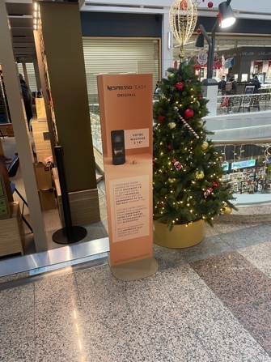
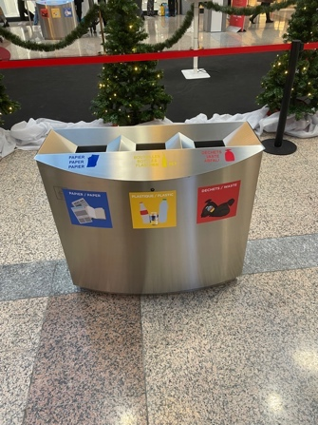
Appendix A – additional photograph prompts shown during the interviews
‘Shopping Centre’
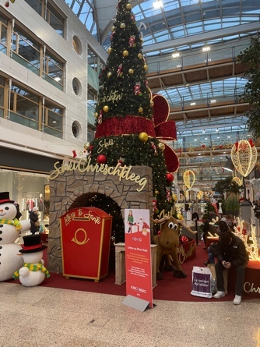
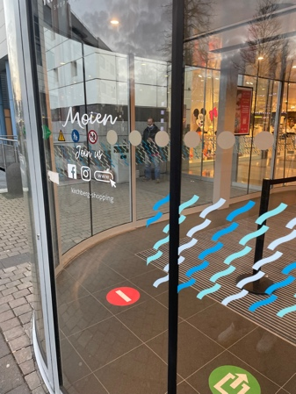
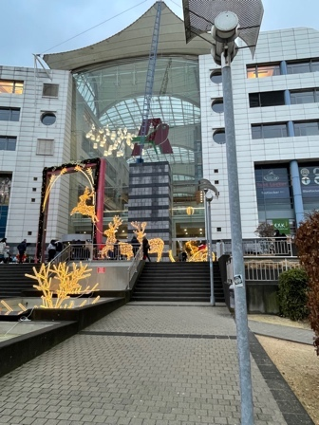
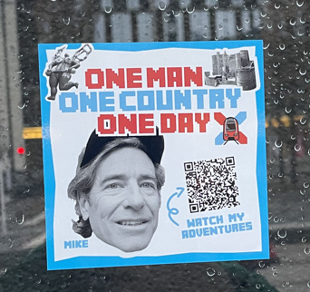

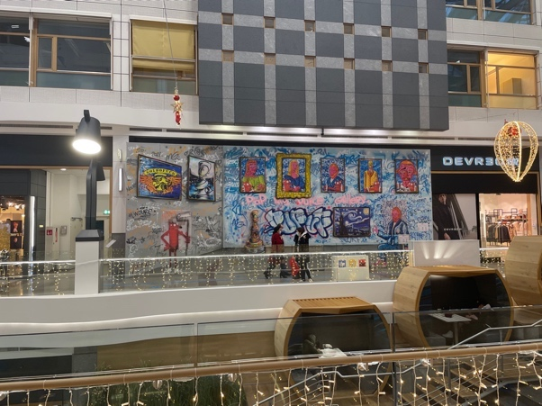
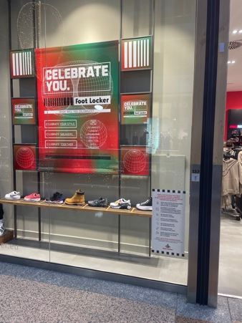

‘Clothes bank’
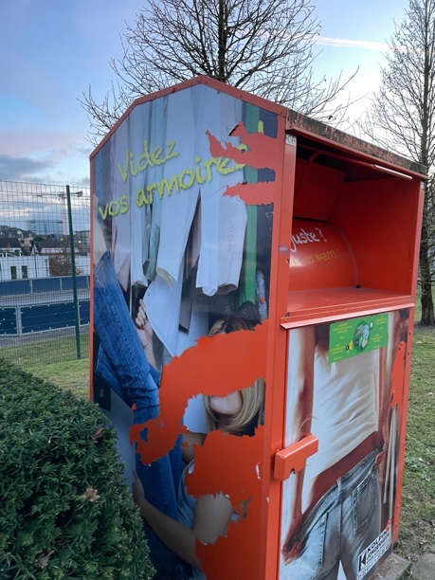
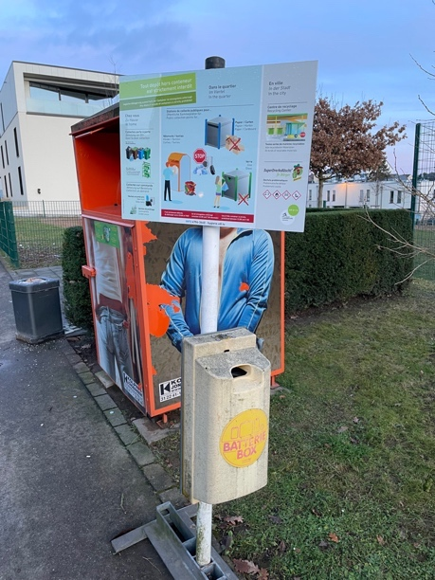

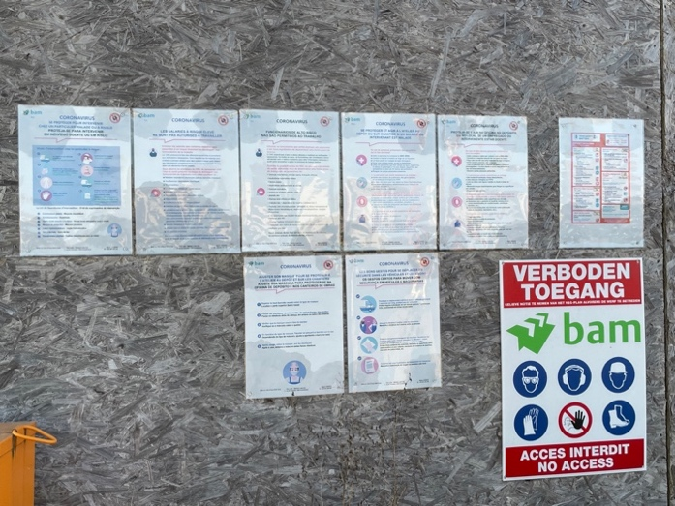
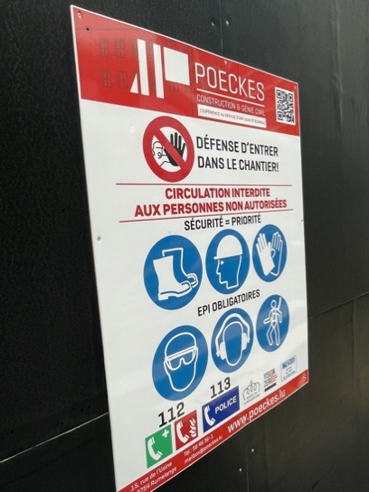
‘Construction sites’

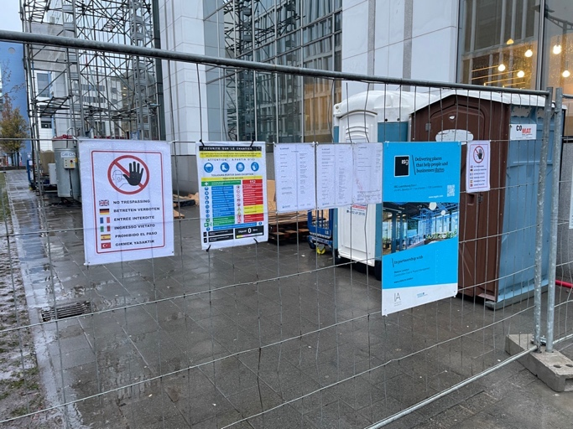
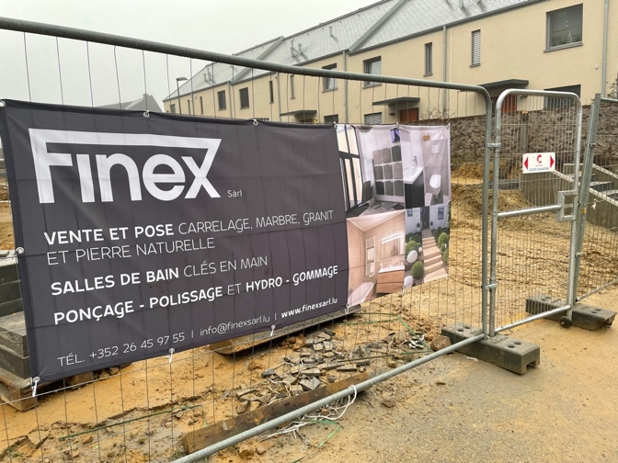
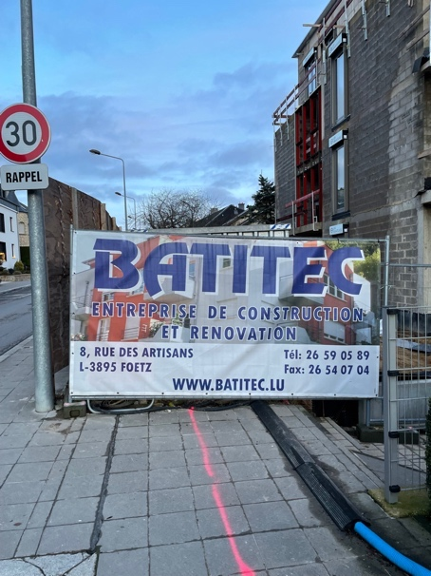
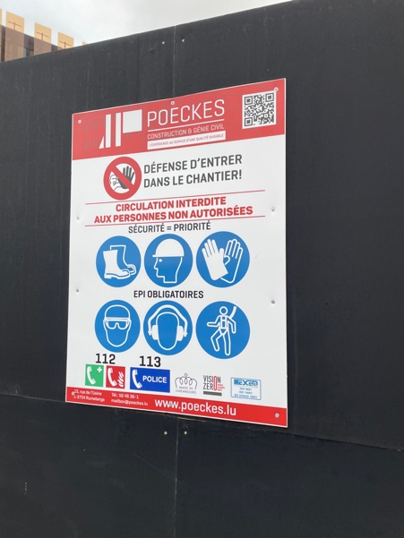
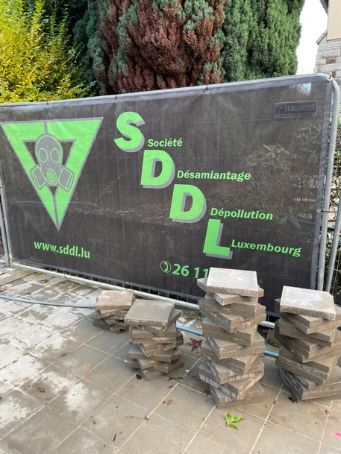
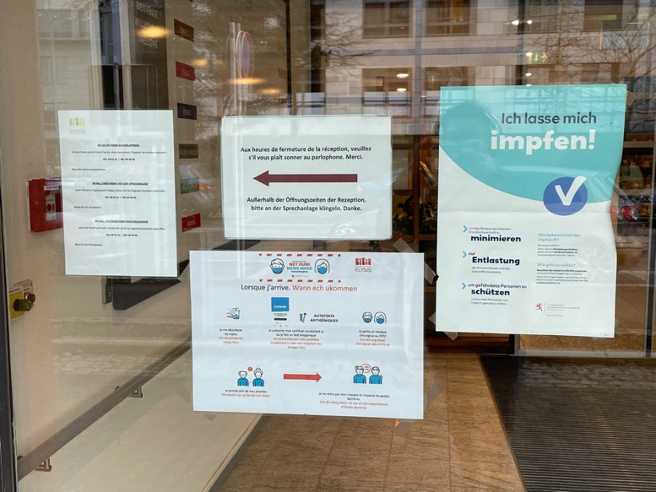
‘COVID signs’

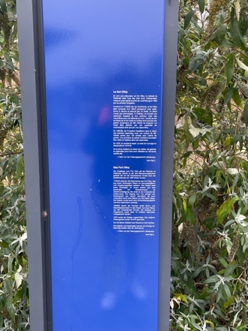
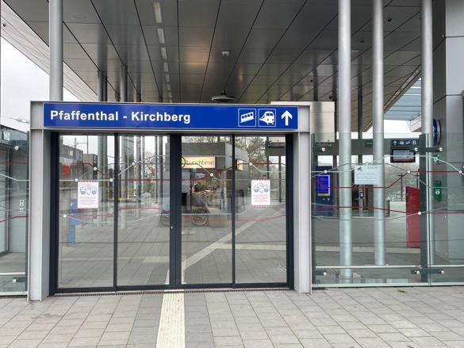
‘Public transport’
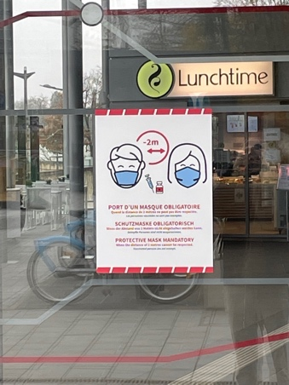
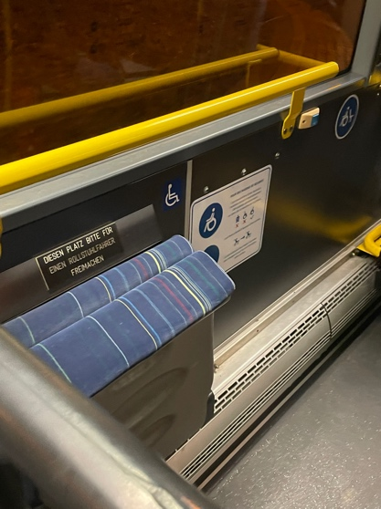
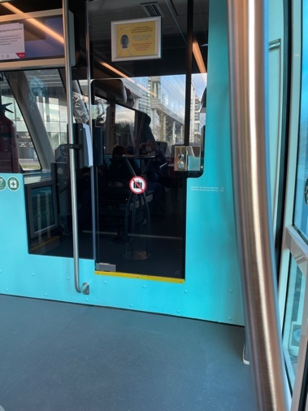
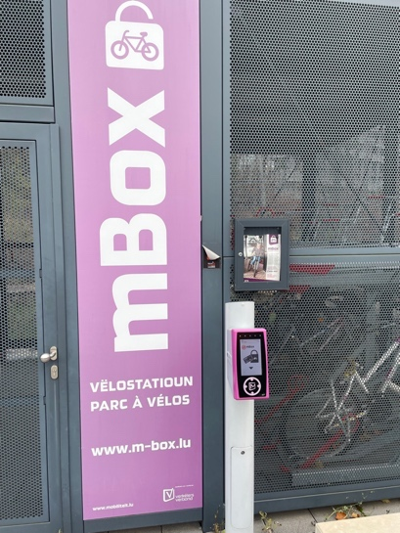

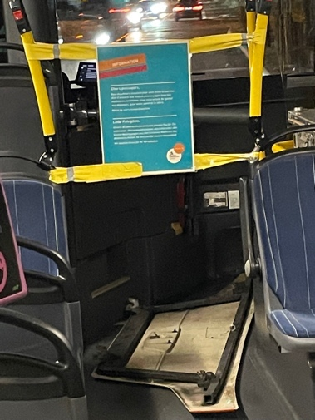
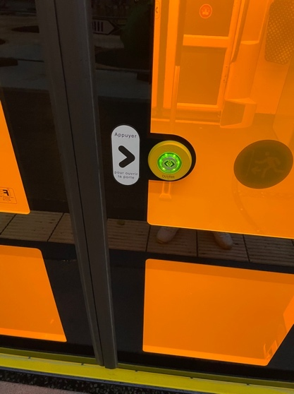

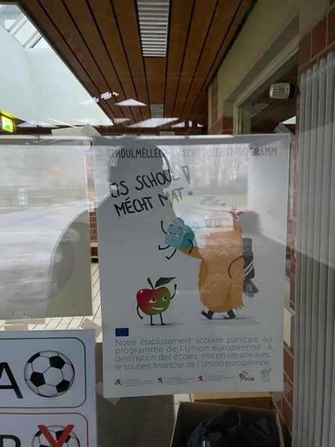
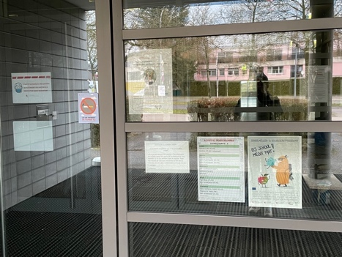
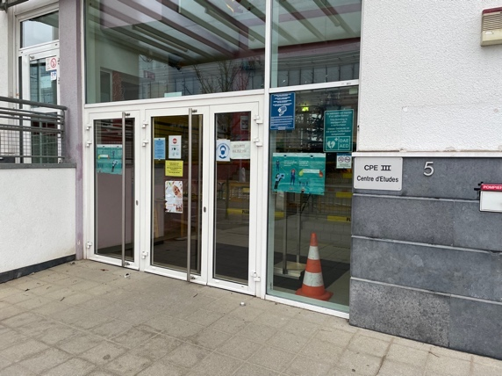
‘Schools in Kirchberg’

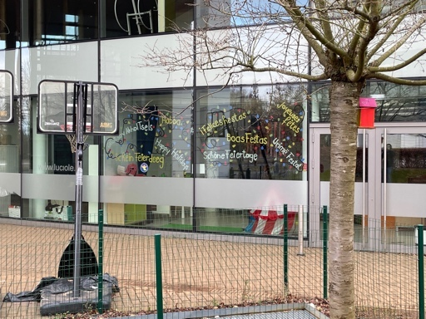
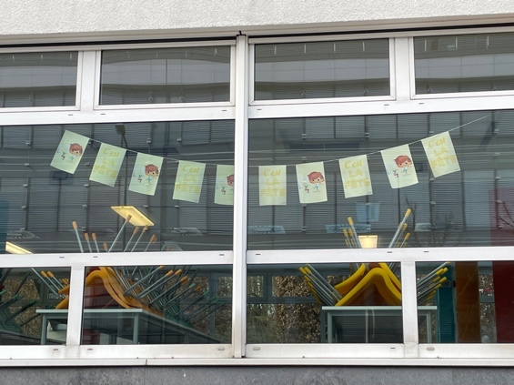
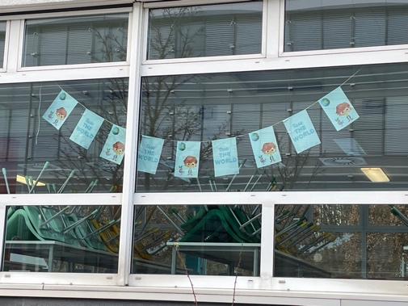
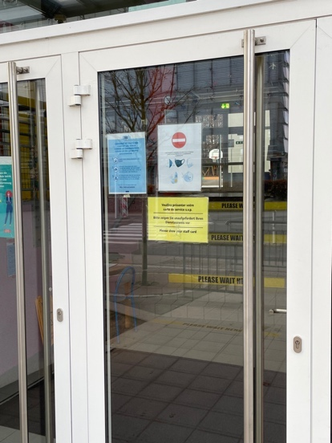
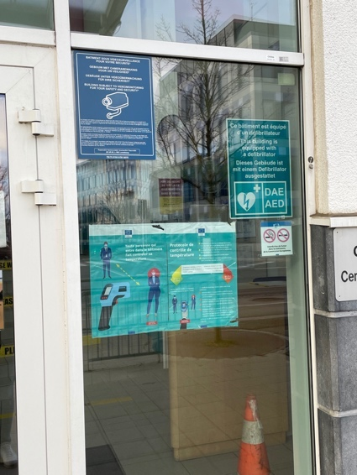
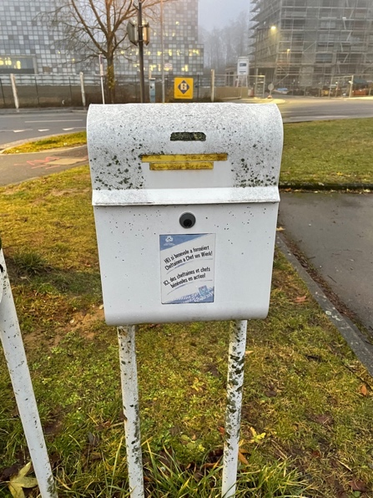
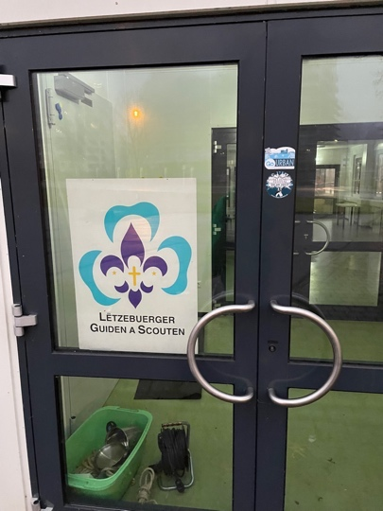
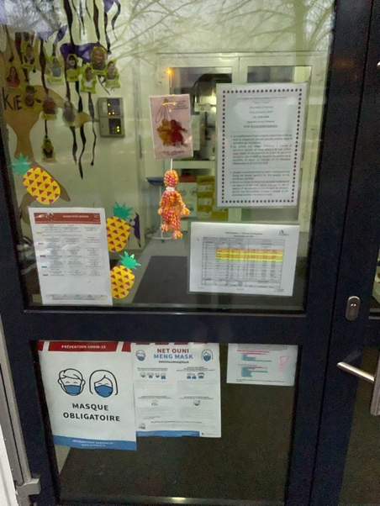
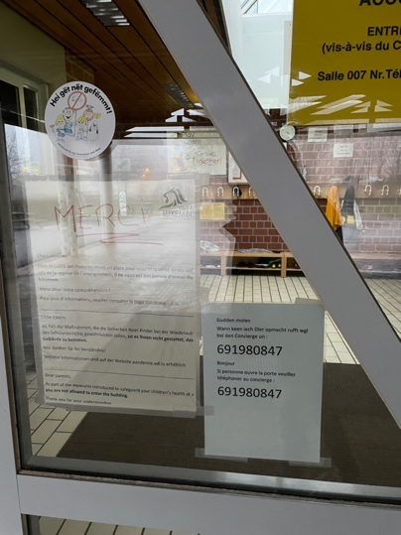
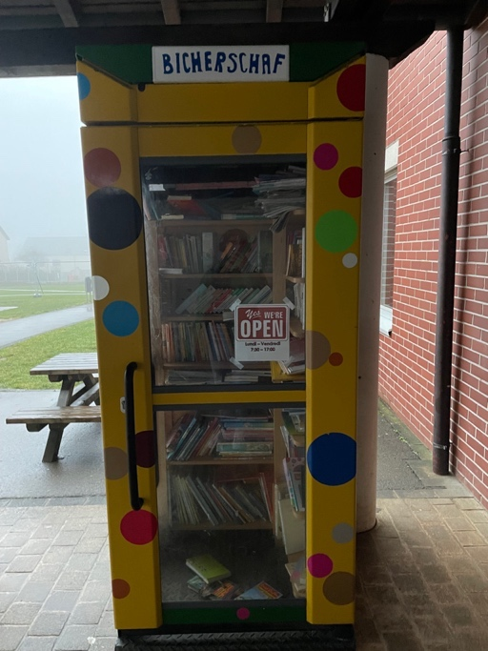
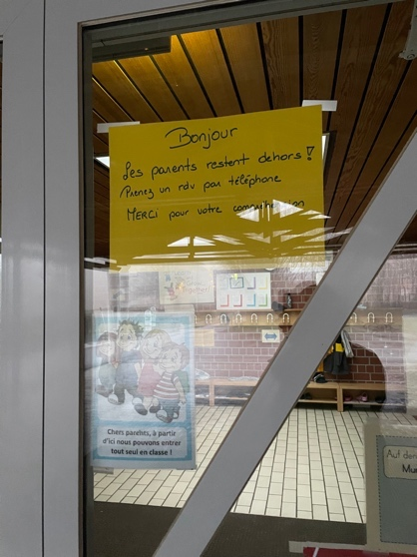

Appendix B – Interview Documents
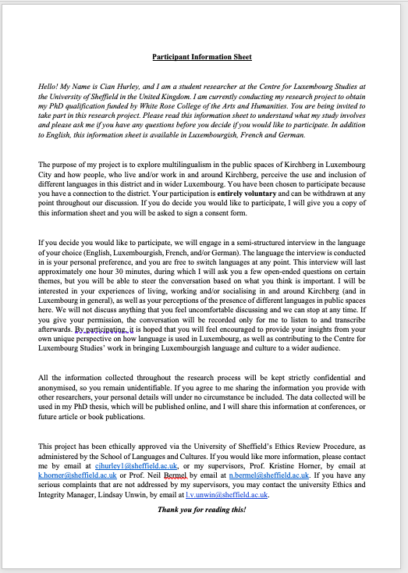
Participant Information Sheet (English)

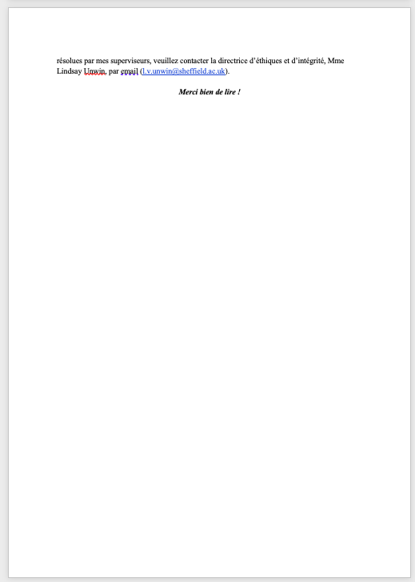
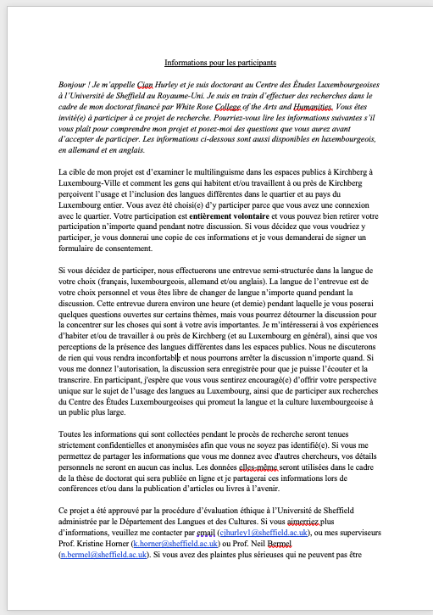
Participant Information Sheet (French)

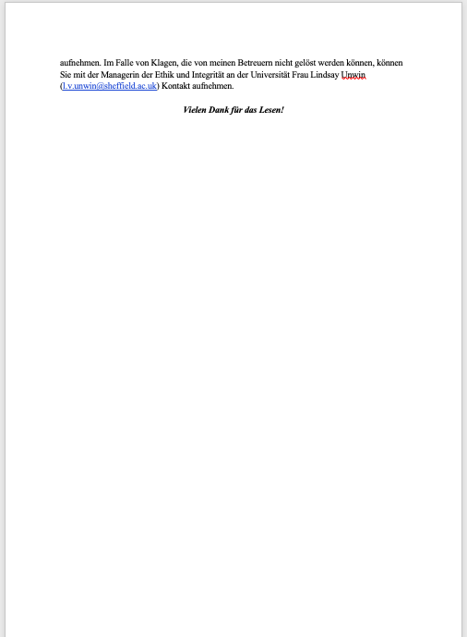
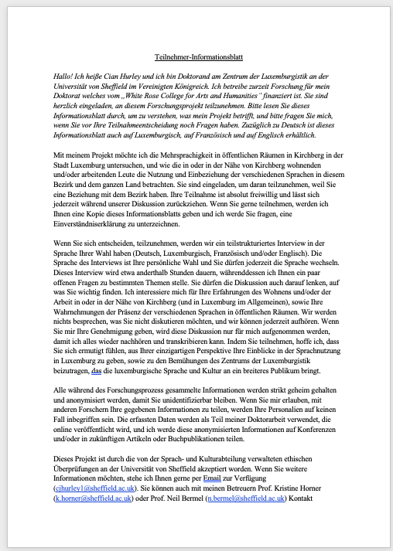
Participant Information Sheet (German)

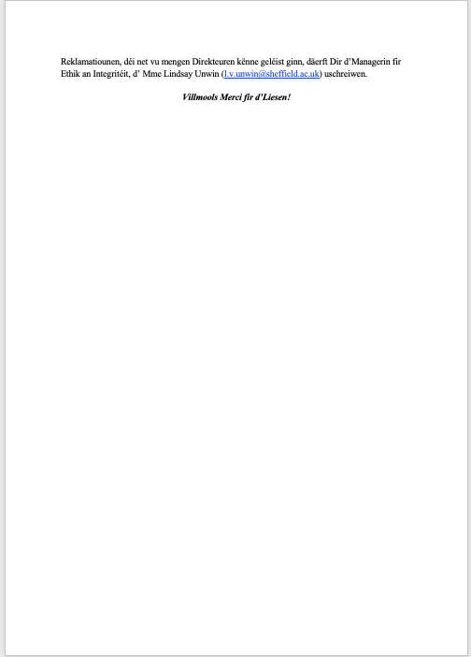
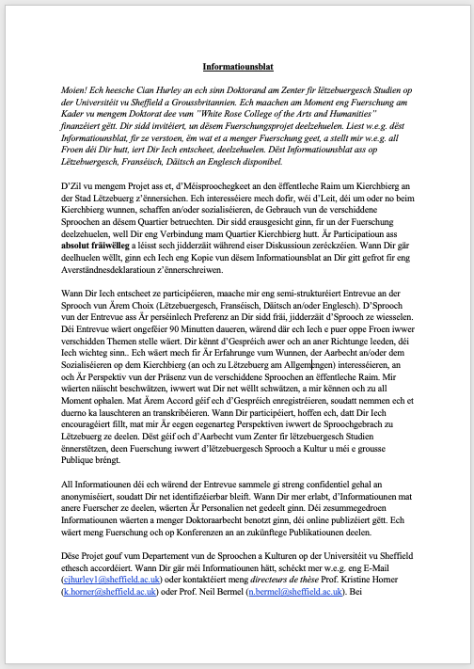
Participant Information Sheet (Luxembourgish)

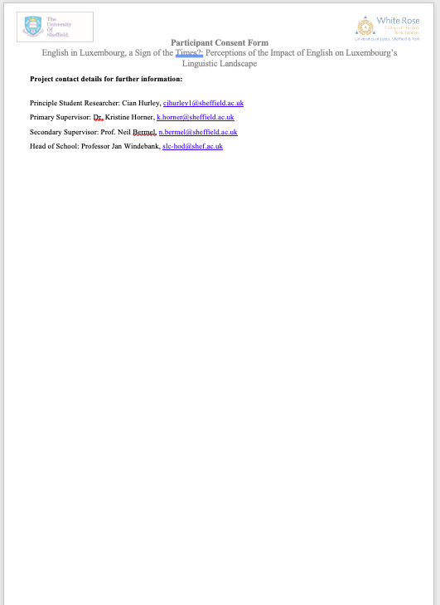
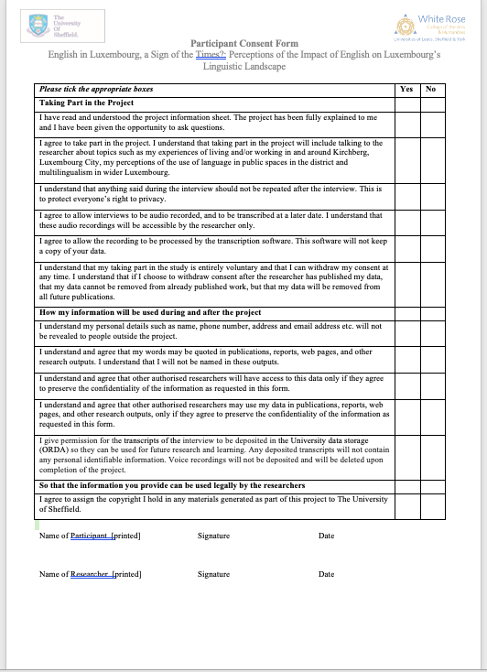
Consent Form (only available in English)

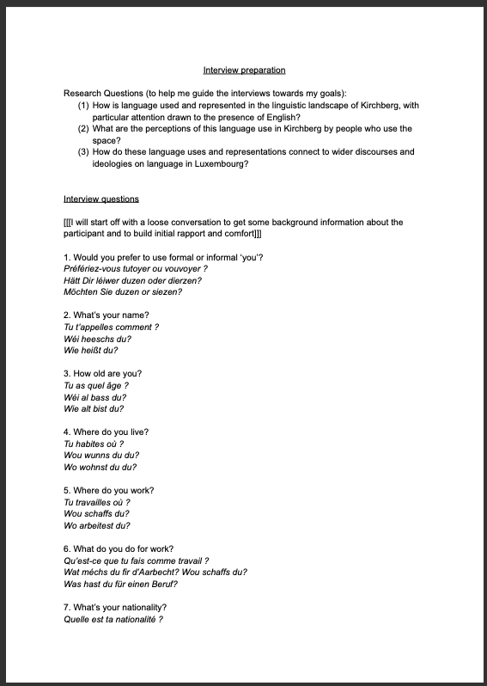
Interview Pre-prepared Questions

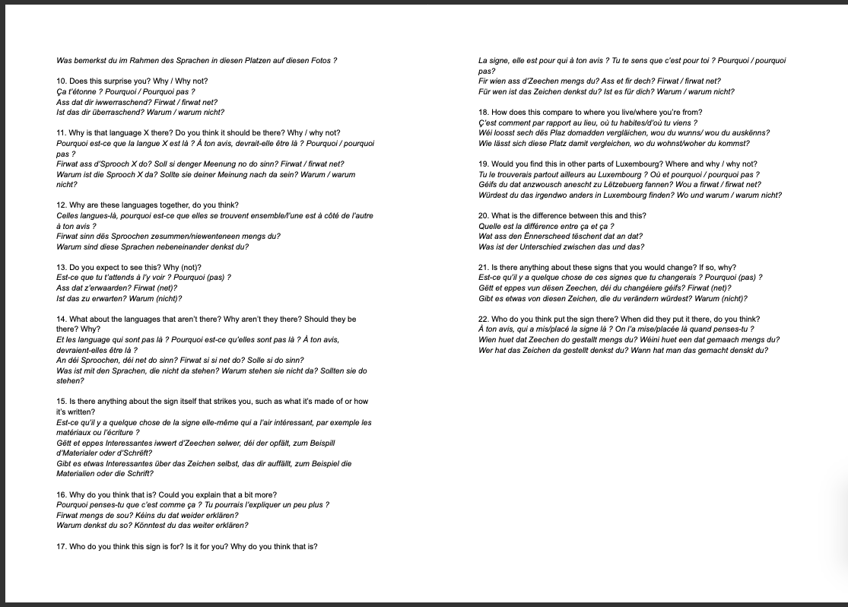
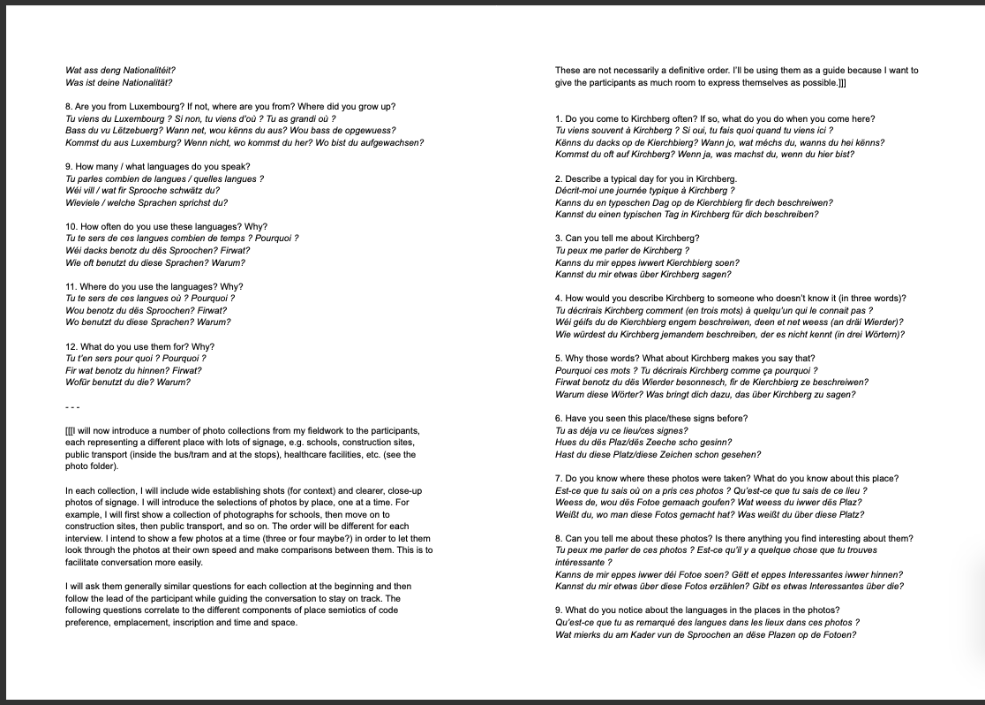

‘geography’ is a term that Soja himself states he uses interchangeably with ‘spatiality’
For further information on Covid-19 LLs, there is an entire series of articles dedicated to the topic in the Linguistic Landscape journal
For further information on the data collection processes, see Chapter 4: Methodology
mother tongue + 2 other languages
See also Flenley & Mannin (2018a) for a look into the concepts of ‘thick’ and ‘thin’ Europeanisation.
An already impressive portfolio of international banking and investment institutions, expected to expand greatly as a result of Brexit and the mass exodus of high-profile corporations from the area (Stafford, 2020).
The tramline is located along the bottom red dashed line in the above Google Map.
The major roads I refer are the prominent grey lines in the above Google Map.
Some of the photographs are discussed and inserted in the body of the thesis, in the analysis chapters. However, refer to Appendix A to see all the photographs used in the interviews but not discussed in the body of the thesis
See Appendix B for interview questions, as well as interview documents, such as information sheet and consent form, all of which were approved via the University Ethics Approval procedure prior to the interviews taking place
This photograph appears later in the analysis section as fig. 7 therefore I have decided to continue that here for sake of continuity and to avoid confusion later on
It is important to note here that Tom’s perception of the tram announcements does not reflect what happens with them. Tram announcements simply say the name of the tram as inscribed at the stop itself. Some signs are only in French, some in Luxembourgish and some a mixture of the two, and the audio reflects this. Some stops have a name in Luxembourgish and French like in Fig.1 so the announcement says this, while some stops have only a name in one language and therefore the announcement says this. The tram stop name is then just repeated.
For further exploration, see section 7.1
See Chapter 6.3 for further information

