

Understanding the Role of Emotional Processing on Outcomes following Psychological Treatment for Depression.

By: Katie Neal

A thesis submitted in partial fulfilment of the requirements for the degree of Doctorate in Clinical Psychology

Clinical Psychology Unit, Department of Psychology
The University of Sheffield

May 2024

Declaration

I, the author, confirm this thesis is my own work and that I am aware of the University of Sheffield guidance on unfair means (www.sheffield.ac.uk/new-students/unfair-means). This thesis is submitted in partial fulfilment of the requirements for the degree of Doctorate in Clinical Psychology. This work has not been submitted for any other degree or to any other institution.

Structure and Word Count

Lay Summary | 400
Section One: Literature Review
Excluding references and tables: |  | 7,192
Including references and tables: |  | 10,574
Section Two: Empirical Study
Excluding references and tables: |  | 6,751
Including references and tables: |  | 9,143
Total
Excluding references and tables: |  | 13,941
Including references and tables: |  | 19,717

Lay Summary
Depression remains one of the leading causes of disability globally, with prevalence rates continuing to rise. Psychological therapy is one of the recommended treatments of depression in adults, with various forms existing such as cognitive behavioural therapy (CBT) and counselling. Whilst there is considerable research showing the effectiveness of psychological therapy, there is a limited understanding of how therapy works and brings about change. Following completion of a psychological therapy, some clients show improvement in their depressive symptoms, whilst others do not, and some even deteriorate. To increase successful treatment rates, researchers are investigating the elements involved in psychological therapy that may impact on outcomes. One of the possible change mechanisms being researched is the role of emotional processing, i.e., the way a person copes with distressing life events. Having a better understanding of the ingredients involved in successful psychological therapy is useful in providing optimal treatments for adults with depression.
The first chapter investigated the relationship between emotional processing and psychological therapy outcomes in the treatment of depression for adults. The existing literature was searched systematically for published studies on this topic which yielded fifteen studies. Nearly all of the studies identified reported that emotional processing impacted on therapy outcome, showing that higher levels of emotional processing were associated with fewer symptoms of depression following a dose of psychological therapy. Only one study showed some potential adverse effects of emotional processing related to psychological therapy outcome. However, findings need to be replicated by future studies before they can be used to inform treatment in clinical practice.
The second chapter explored differences in emotional processing ability in cases of clients who had a successful therapy outcome compared to clients who did not. A successful therapy case refers to improvement in depression symptoms, whereas clients who did not improve showed no change or worsening of symptoms. Differences in the relationship between emotional processing and therapy outcomes were also examined between different stages of therapy by comparing early and middle therapy sessions. Pre-existing data from a trial completed in NHS Talking Therapies services was retrospectively analysed. This analysis found no differences in clients’ ability to process their emotions and therapy outcomes. However, higher levels of emotional processing in earlier therapy sessions predicted better therapeutic outcomes. Findings indicate that clients who showed higher levels of emotional processing in the early stages of therapy were more likely to show improvements in depression symptoms.

Acknowledgements
Firstly, I would like to thank my research supervisors Professor Gillian Hardy and Professor Michael Barkham for your support and guidance with this research project. Also, thank you to Dr Dave Saxon for your patience and support in navigating statistics. An extended thank you to Jack Isgar who partially collaborated on this project.
I would like to thank my clinical tutor, Dr Kate Rayner, who has provided support above and beyond expectations. Thank you for believing in me.
Thank you to everyone who participated in the PRaCTICED trial as without you this project would not have been possible.
To my parents, Julie and Andrew, and my sister, Emily, thank you for never doubting me. Your encouragement to never give up has carried me through this journey. Thank you for always providing humour and a reality check when there have been difficult times.
I would also like to thank my friends, who have shown patience and understanding whilst providing invaluable distractions along the way.
To my partner, Alex, thank you for being alongside me during this time. You gave me the energy and belief in myself in the final stages of this process.
And finally, a big thank you to my fellow trainees for providing a memorable shared experience. With special thanks to Caroline, Emily, and Laura for your honest support, advice, and kindness.

List of Contents
Declaration 2
Structure and Word Count 3
Lay Summary 4
Acknowledgements 6
Part One: Literature Review 8
Abstract 9
Introduction 11
Methods 16
Analysis 21
Results 23
Discussion 37
Conclusion 43
References 44
Appendices 56
Part Two: Empirical Study 73
Abstract 74
Introduction 76
Method 81
Results 91
Discussion 95
Conclusion 102
References 103
Appendices 114

Part One: Literature Review

Does Emotional Processing Facilitate Better Outcomes in the Psychological Treatment of Depression in Adults? A Systematic Review and Meta-Analysis

Abstract
Background:
How individuals process distressing events may be associated with symptoms of depression. Psychological therapy can help individuals learn to process and regulate distressing emotions. Research has demonstrated that emotional processing ability is repeatedly associated with better outcomes in psychological therapy.
Aims:
This systematic review examined data from studies of emotional processing in depressed adults seeking psychological therapy. The main aim of this review was to synthesise the relationship between emotional processing and therapy outcomes. Secondary aims included (1) reviewing differences across therapy modalities, and (2) understanding how emotional processing is captured quantitatively in research.
Method:
A systematic review (PROSPERO CRD42023475724) following PRISMA guidelines was conducted by searching PsycINFO via OVID, PubMed, Scopus, and ProQuest: Dissertations and Theses up to April 15th, 2024. Quantitative studies that included an association between depression and emotional processing were included. Studies were assessed for risk bias using the quality assessment tool for quantitative studies. Meta-analysis and narrative synthesis was used to summarise findings.
Results:
Fifteen studies were included in the review. A significant negative relationship (r = -.03; 95% CI [-.52, -.11]) was found, showing that as emotional processing levels increased, depression symptoms decreased. There was limited evidence suggesting any significant differences between psychological therapy modalities. Several measures were identified as tools to capture emotional processing, again with limited differences between them.
Conclusions:
These results show the important role emotional processing plays across various models of psychological therapy. Findings are limited due to the poor quality of studies included. Future research should continue to replicate findings.

Keywords: emotional processing, emotional arousal, depression, psychological therapy

Practitioner Key Points:
- Emotional processing is associated with better outcomes in psychological therapy, irrespective of therapy modality, used in the treatment of depression in adults
- It may be helpful to consider ways to encourage clients to learn how to process their emotions, not only through observing distressing emotions but also by taking time to reflect and learn from stressful life events
- Having a better understanding of a client’s emotional processing ability may help to predict their treatment outcomes

Introduction
Rachman (1980) is credited with first defining emotional processing as a process for how individuals cope with stressful life events. He emphasised that individuals can usually process adverse experiences over time and tend to develop this skill across the lifespan, improving with experience. Successfully processing painful stimuli can be determined from the individual’s readiness to talk about, see, listen to, or be reminded about the event whilst tolerating the accompanying distressing emotions. Conversely, problems may arise when emotional experiences are not fully processed, resulting in symptoms such as phobias, excessive avoidance, and intrusive thoughts (Rachman 1980, 2001).
The notion of ‘processing’ is well used in psychology and has been widely researched across the field. Psychological research has developed a shared meaning and definition which focuses on the use of a psychological process to convert a stimulus to a more settled mental state, such as absorbing a painful memory. In emotional processing, this definition would refer to the psychological mechanisms by which distressing emotional reactions are converted to non-distressing reactions (Tamayo, 2011). Psychological therapy can often be an effective way for individuals to process and regulate their emotions. Understanding emotions and learning to endure them is an essential component of successful therapy (Pascual-Leone, 2017).
There are several key skills involved in emotional processing which are often replicated in psychological therapy. Firstly, identifying and recognising emotions as they arise. Labelling emotions and feelings can help individuals to create some distance between themselves and their experiences of the emotion, allowing them to feel more in control (Lieberman et al., 2007). Once the emotion has been identified, the next step is to accept and acknowledge it in a non-judgemental way by learning to tolerate its presence rather than trying to fight or avoid the emotion (Ford et al., 2018). The third step involves understanding why emotions may result from certain experiences, memories, or environments (Troy et al., 2018). And finally, developing strategies to manage emotions (Menefee et al., 2022).

Emotional Processing in Depression
Emotional processing can have a significant impact on mood. When emotions are effectively processed, this allows for improved mood regulation and individuals can better negotiate challenging situations. Conversely, individuals who tussle with their emotions often present with mood dysregulation and may even develop mental health conditions. For example, suppressing or avoiding emotions can result in depression (Compare et al., 2014). Furthermore, inadequate processing and management of emotions can lead to the development of physical symptoms such as headaches, muscle tension, and trouble sleeping, which may also impact on mental health (Lumley et al., 2011).
Insufficient ability to attend to and tolerate emotions has been linked with the development of multiple psychological conditions, including depression. Depression, also referred to as major depressive disorder (MDD) or clinical depression, is associated with feelings of sadness and/or hopelessness, sometimes supplemented with physical symptoms lasting at least two weeks and significantly impacts on day-to-day functioning (American Psychiatric Association, 2013). MDD continues to be a leading cause of disability globally, affecting around 322 million people world-wide (Institute for Health Metrics and Evaluation, 2020; World Health Organisation, 2017).
The humanistic experiential approach proposes that depression is the by-product of impaired emotional processing whereby such individuals may struggle to correctly process distressing experiences and memories. Therefore, the enablement of processing emotions is viewed as an essential mechanism for change (Pascual-Leone, 2017). Being attentive to heightened emotional experiences and learning to label them is an important first step in encouraging change. However, this is not adequate on its own. Optimal emotional processing goes beyond recognising emotions and requires the ability to reflect and explore inner experiences creating a new understanding of the problem and encouraging a more adaptive emotional response (Greenberg & Pascual-Leone, 2006; Pascual-Leone, 2018; Whelton, 2004).

Emotional Processing in Psychological Therapy for Depression
Psychological therapy is a process by which clients are encouraged to recollect, explore, understand, and change themselves; there is no doubt that this is fused with emotion (Ehrenreich et al., 2008; Whelton, 2004). A previous scoping review, which has not yet been updated, explored emotional processing research across psychological therapies (humanistic, cognitive, behavioural, and psychodynamic) and concluded that much of the research is biased by the theoretical commitments of the researchers. However, it was emphasised that emotional processing is a fundamental element of therapy in all therapeutic modalities (Whelton, 2004).
Research has shown that emotional processing is often associated with significant improvements in depressive symptoms across different psychological therapy modalities (Auszra et al., 2013; Goldman et al., 2005; Missirlian et al., 2005; Pos et al., 2017; Pascual-Leone, 2018; Pinheiro et al., 2021; Whelton, 2004). Specifically, successful therapeutic outcomes have been linked to higher levels of emotional processing (e.g., De Smet et al., 2020; Fisher et al., 2020; Pos et al., 2017). Pascual and Yeryomenko (2017) systematically examined if “client experiencing” was a predictor of therapy outcome. Unlike the current review, their review only included studies that used the EXP scale to measure emotional processing, and there were differences in the studied population, with the current review focusing only on depression whereas Pascual and Yeryomenko (2017) had a much broader inclusion criteria of a “clinical population”. Likewise, Sonderland and colleagues (2023) conducted a systematic review and meta-analysis of change processes associated with improved outcomes in psychotherapy. Their study was a large-scale review which included multiple variables of change, including emotional processing. Findings showed that experiencing during psychological therapy was one of the most robustly related variables to improvement (r = .44) and reported an overall moderate strong relationship between emotional processing and outcome (r = .31). Like Pascual-Leone & Yeryomenko (2017), Sonderland et al. (2023) also encompassed a broad sample by including studies with a “therapy-seeking” sample. The current review is different to those discussed due to narrowing down the target population to focus just on individuals with depression, whilst broadening the search to include a variety of tools measuring emotional processing.
The first line psychological treatments for new episodes of more severe depression include individual cognitive behavioural therapy (CBT), short-term psychodynamic psychotherapy (STPP), and interpersonal therapy (IPT; NICE, 2022; Kendrick et al., 2022). CBT is a type of psychological therapy for depression that facilitates change by modifying thought patterns and is one of the most evidence-based psychological interventions for the treatment of depression (Beck 1979; for a review see López-López et al., 2019). Limited research suggests that CBT may facilitate emotional processing, despite being designed to elicit cognitive processes (Baker et al., 2012). STPP refers to a time-limited therapy based on psychodynamic psychotherapy focusing on the client’s internal experiences (see Caselli et al., 2023 for review) and is known to elicit emotional processing (Lumely et al., 2021). Similarly, IPT draws on psychodynamic workings and focuses on alleviating symptoms of depression by improving interpersonal functioning (Cuijpers et al., 2011).

Measuring Emotional Processing
In the absence of a unified way to measure emotional processing, it can be challenging to select the most appropriate measure to quantify emotional processing in research studies. The two principles used to evaluate measures of latent concepts are reliability and validity. Reliability assesses the measure’s stability and consistency, whilst validity determines how well a measure captures what it is supposed to (Marcus et al., 2017). Time taken to complete the measure, numerical quality of scores, and minimising missing data are additional important factors taken into consideration when selecting a measure or a tool to capture data (Krosnick & Presser 2010). The psychometric properties of measuring emotional reactions suitable for research is relatively sparse (Marcus et al., 2017). Presently, there is no review of the methods used to capture emotional processing.
The current review focused on quantitative measures of emotional processing, although recognises there are other qualitative methods readily available. A common quantitative measure used for emotional processing is the ‘experiencing scale’ (Klein, 1969), followed by the third version of the client emotional arousal scale (CEAS-III; Warwar & Greenberg, 1999). Other scales include: the Bern Post-Session Reports Short Form (Flückiger et al., 2010), Change and Growth Experiences Scale (CHANGE; Hayes et al., 2007), Affect Experiencing Scale (AES; McCullough et al., 2003), Narrative-Emotion Process Coding System (NEPCS; Boritz et al., 2012), and Assimilation of Problematic Experiences Scale (APES; Stiles et al., 2009).

Clinical Implications
Research attempting to understand the mechanisms facilitating change in psychological therapy aims to establish how therapy works. This helps to improve understanding, as well as increasing therapy effectiveness by highlighting the elements essential in promoting change. Process research aims to expand understanding of the complexity of therapeutic change, as well as aiding theory development and effective therapeutic interventions.
Systematic reviews are widely accepted as essential as they outline the current state of knowledge. They further offer an empirical synthesis of research on a specific issue (Foster & Jewell, 2017), inform future research (Ioannidis, 2016), and help practitioners remain efficiently up to date (Moher et al., 2007; Schlosser et al., 2007; Wormald & Evans, 2018).
Drawing on these points, using systematic methods to understand change processes in psychological therapy may help to provide updates, guidance, and recommendations on optimal processes to help facilitate effective change for adults seeking treatment for depression.
Aims
The relationship between emotional processing and treatment outcome has been widely studied. However, to date, research examining the role of emotional processing specifically in adults with depression across therapeutic modalities has not been systematically synthesised. This review mainly aimed to examine the literature to understand the interaction between emotional processing and psychological therapy outcome for the treatment of depression in adults (aged 18 years old and above). Based on the factors discussed above, the questions explored were as follows:
- Is emotional processing associated with improvement in depression symptoms following a dose of an evidence-based psychological therapy?
  - … irrespective of therapy modality?
  - … irrespective of how emotional processing is measured?

Methods
This meta-analysis was conducted using the Preferred Reporting Items for Systematic Reviews and Meta-Analyses (PRISMA; Page et al., 2021; Appendix A) guidelines.

Study Protocol
Initial scoping searches were conducted on the proposed review in October 2023, with no published or ongoing reviews on the same topic being identified. The review protocol was registered in advance at the international prospective register of systematic reviews (PROSPERO), registration number CRD42023475724.

Search Strategy
The PICO (Population, Intervention, Control and Outcomes) framework was used to develop and refine the search criteria (Richardson et al., 1995). As the studies being sought were measuring associations between variables, a control condition was not required. Consequently, only population, intervention, and outcomes (PIO) formed the search terms (see Table 1).

Table 1
Search Terms
PICO Criteria | Search Terms (Boolean Operators)
Population | depression [MeSH Terms]
(AND)
Intervention | therapy
(AND)
Outcomes | (("emotional processing") OR ("emotional arousal")
Note. Constructs were combined using the Boolean operators OR / AND. Searching using MeSH terms allows for terms to be searched as a Major Concept.
Publications were identified by a search of PsycINFO via OVID, PubMed, Scopus, and ProQuest: Dissertations and Theses using the search terms (("emotional processing") OR ("emotional arousal") AND (depression [MeSH Terms]) AND (therapy). Following on from scoping searches and consultations with the university librarian, these search terms were developed to allow for a broad range of studies to be included in the analysis. Consideration was given to include the term “emotion” rather than “emotional processing” or “emotional arousal” however this frequently resulted in studies exploring emotional regulation which was not within the current scope of this review. Emotional regulation refers to the use of a variety of learnt skills to manage emotions, such as thought challenging in cognitive behavioural therapy, and are often taught explicitly in therapy (Gross, 2015), rather than studies directly exploring emotional processing as defined in the introduction.
Studies had to be published in English and only human studies were included. There were no limits or restrictions on the dates published. The last search was conducted on April 15th, 2024. Forward and backward searching was completed, and experts were consulted to identify missing studies. Papers identified by the systematic search were exported to the online systematic review tool, Rayyan (Ouzzani et al., 2016).

Eligibility Criteria
The Population, Intervention, Comparison, Outcomes (PICO) framework was also used to develop the research question and the resulting inclusion and exclusion criteria (Table 2; Eriksen et al., 2018). PICO frameworks are credited with being beneficial search strategy tools for systematic reviews (Eriksen & Frandsen, 2018).

Table 2
Inclusion and Exclusion Criteria
 | Inclusion Criteria | Exclusion Criteria
Population | Clients (aged ≥ 18 years) with a diagnosis of major depressive disorder (ICD-10 or DSM-V criteria), or diagnosis of major depressive disorder identified via scoring above clinical threshold on a validated screening measure.  Any outpatient setting. | Clients aged < 18 years.  No formal diagnosis of major depressive disorder/ not scoring above clinical threshold on a validated screening measure.  Clients with multiple presenting conditions, presence of organic conditions, or a physical health complaint.  Any inpatient setting.
Intervention | Any psychological intervention for depression. | Intervention is not based on a psychological model.  Pharmacological interventions.
Comparator | Not applicable. | Not applicable.
Outcome | Standardised measures of depression symptoms (e.g., PHQ-9, HRSD, BDI-II), administered at baseline and post-intervention.  Quantitative measures of emotional processing administered at least once, either during therapy or post-intervention.  Association measured between depression and emotional processing | Depression symptoms and/or emotional processing not measured using a standardised measure.  No statistical analysis for associations between emotional processing and depression.
Note. Beck Depression Inventory (BDI-II), Diagnostic and Statistical Manual of Mental Disorders 5th Edition (DSM-V), Hamilton Rating Scale for Depression (HRSD), International Classification of Diseases 10th revision (ICD-10), Patient Health Questionnaire-9 (PHQ-9).

Population. Studies could only include adults (aged 18 years or older) who were seeking psychological treatment for depression. The study sample had to include clients who were either clinically diagnosed with MDD or who were above threshold on a validated screening tool (e.g., the Beck Depression Inventory; Beck et al., 1996). Studies with a mixed sample of multiple presenting conditions (e.g., comorbid anxiety), presence of organic conditions, or a physical health complaint were excluded with the aim of removing possible confounding variables.
Interventions. Multiple evidence-based psychological therapy interventions were accepted, including cognitive behavioural therapy (CBT), emotion focused therapy (EFT), and brief psychodynamic therapy. The treatment had to target symptoms of depression and
was required to be delivered by a trained therapist (e.g., psychiatrists, clinical psychologists, or counsellors). Only individual therapy was included, group and/or dyadic therapy settings were excluded as they could yield confounding effects. Studies were excluded if they only examined pharmacological therapies (i.e., measuring the effectiveness of anti-depressants).
Outcome and Predictor Variables. As a predictor variable, emotional processing had to be measured by a quantitative instrument and needed to be administered during treatment or post-therapy. Studies that only measured emotional processing pre-treatment were excluded. As outcome variables, any quantitative outcome measure of depression was included if it was a well-established, reliable, and validated measure. Studies needed to report an association between the predictor (emotional processing) and the outcome (depression) variables.
Study designs and publications. Empirical studies that reported quantitative statistics were included. Studies could be published as journal articles, books, or dissertations.

Study Selection
A flow diagram of the study selection process is presented in Figure 1 (see results section). Electronic database and citation searches yielded a total of 7,882 records. After duplicate removal, titles and abstracts of 6,319 publications were screened. Next, full texts were inspected. A total of 124 full-text publications were assessed for eligibility. Publications with an unclear inclusion status were discussed between two members of the research team (K.N. & G.H.), and ambiguity was resolved by consensus. If two publications were based on the same data, the study that reported the most comprehensive statistics was selected.
This procedure resulted in 15 unique studies (peer-reviewed journal articles). All 15 studies were included in the systematic review and 10 were entered into the meta-analysis. The five studies that were not included in the meta-analysis did not report the appropriate data or statistics to be extracted or converted into correlational coefficients.

Data Extraction Procedure
A data extraction template was developed in Microsoft Excel according to the preregistered study protocol, tested on three studies, and consequently refined. The lead author (K.N) extracted extrinsic characteristics (e.g., authors, date, publication status, and country), treatment characteristics, methodological characteristics (e.g., random assignment, blindness of raters, and use of control groups), sample characteristics (e.g., sample size, age, and gender), outcome measures, and effect sizes (correlation data). If the study included multiple correlations for different phases of the therapy, the score closest to therapy termination was used (i.e., working phase or post-intervention). For those who reported multiple emotional processing measures the average, often termed the ‘modal’ score, was used.
It was not possible to apply meta-analytic methods to all studies due to under-reporting of statistical information. Therefore, a detailed narrative synthesis of the results across studies is presented to assess the evidence that was not examined through meta-analysis.

Quality Appraisal
The lead author (K.N) independently assessed the quality of each study using the Quality Assessment Tool for Quantitative Studies developed by the Effective Public Health Practice Project (EPHPP). The tool assesses eight factors, which each receives a mark ranging between “strong,” “moderate,” and “weak”: (1) study design, (2) analysis, (3) withdrawals and dropouts, (4) data collection practices, (5) selection bias, (6) intervention integrity, (7) blinding, and (8) confounders. A second independent reviewer (E.K, Trainee Clinical Psychologist, University of Sheffield) quality checked 25% of the articles.

Analysis
The statistical software package Meta-Essentials (version 1.5; Suurmond et al., 2017) was used to conduct a random-effects meta-analysis. Effect sizes were measured as correlation coefficients. All effects were coded such that positive correlations indicated higher levels of emotional processing to be associated with better therapeutic outcomes (i.e., reduced scores on screening tools). Almost all studies reported a Pearson’s r statistic. Where studies reported other effect sizes, these were converted to an r value using an online effect size calculator (Wilson, N.D.). Forest plots operated as graphical representations of the relative strengths of the effect sizes to better understand the statistical information that contributed to the analysis.
A random effects meta-analysis model was selected with the aim of reducing the likelihood of a Type 1 error (Borenstein et al., 2010; Hunter & Schmidt, 2000) as this model assumes variability across and within studies to be the result of sampling error and variability in the population of effects. Meta-Essentials converted the correlation coefficients automatically into Fisher’s z scores (Hedges & Olkin, 2014) to calculate the integrated effect size, before being converted back. In line with Cohen’s (1992) guidelines for the magnitude of effect sizes, r = 0.10 is considered small, r = 0.30 medium, and r = 0.50 large. These guidelines were used to assess the scale of identified effects. Guidance recommends that statistical significance is determined by an alpha value of <0.05 (Bornstein et al., 2010).
Studies were grouped for synthesis in three different ways to answer the research questions. Firstly, studies were grouped into whether they showed an association between emotional processing and psychological therapy outcome. Secondly, they were then re-organised according to which therapy modality was used as the treatment model. And finally, they were grouped by which emotional processing measure was used.
Additionally, a meta-analysis was conducted to explore the relationship between emotional processing and depression outcomes. The meta-analyses calculated a pooled correlation co-efficient for the included studies. Cochrane’s Q and I² statistics (Higgins et al., 2008) were used to assess heterogeneity between studies. Q statistics examine the total variability amongst the pooled effect sizes (Card, 2012). A significant Q statistic indicates that the heterogeneity in the sample is significantly more than can be explained by sampling error (Borenstein et al., 2010). I² statistics assess the proportion of variability that is unaccounted for by sampling error within studies (Higgins & Thompson, 2002). Guidance suggests that an I² value of 25% indicates low variance, 50% moderate variance, and 75% or greater high variance (Higgins et al., 2003).

Publication Bias
Typically, studies reporting smaller effects are less likely to be published compared to studies with larger effect sizes, resulting in an upward bias in the summary effects, referred to as publication bias (Nair, 2019). To assess and remove publication bias, Card (2012) recommends using a multi-method approach, including the use of funnel plots, statistical tests of funnel plot asymmetry, and fail-safe N tests.
Funnel plots combined the effect sizes at the study-level and were assessed for asymmetry as asymmetric funnel plots indicate presence of reporting bias (Card 2012; Peters et al., 2008). Given the potential for subjectivity in visual interpretations, Egger’s Regression test (Egger et al.,1997) examined whether the association between estimated effect size and study size was greater than what would be expected to occur by chance, with a risk of publication bias being indicated by a significant intercept test value. The ‘trim-and-fill’ method (Duval & Tweedie, 2000) assessed asymmetry of the funnel plots by estimating and imputing hypothetically missing studies and provided an adjusted bias-corrected summary effect. Results are deemed to indicate publication bias if they are not comparable to the original values (Card, 2012).
Finally, Rosenthal’s (1979) fail-safe N method estimates the number of additional studies with a minimal effect that would be required to increase the p-value for the pooled meta-analysis effect to be above p < .05, and therefore no longer significant. As a guideline, an adequately high fail-safe N was 5k + 10, where k equates to the number of studies included.

Results
Search Results
The study selection is outlined in Figure 1 using a PRISMA diagram (Page et al., 2021). Following the database searches, studies from all databases were combined (N = 6,754). Duplicates were removed (N = 688) and the remaining articles (N = 6,066) were screened by title and abstract according to the inclusion and exclusion criteria. For the remaining articles (N = 85), full text articles were retrieved and screened against the inclusion criteria. Reasons for excluding studies are summarised in Appendix D. Forward and backward searching yielded an additional three studies. Combined, the database searches yielded a total 15 studies for the systematic review, including 10 for meta-analysis.
Study Characteristics
The characteristics of the included studies are summarised in table three. Of the 15 studies, eight were conducted in the United States of America (USA), six in Europe, and one in Canada. The studies had a mixture of sample sizes ranging from single case to large population-based samples. Most samples recruited middle-aged adults, with an overall age range of 18 - 77 years old, and all studies had a majority female sample. With respect to study design, 10 studies were cohort designs, two observational, one randomised control trial (RCT), one case study, and one longitudinal.
Most studies measured depression using the Beck Depression Inventory 2nd edition (BDI-II; N = 14) whilst one chose the Modified Hamilton Rating Scale for Depression (MHRSD; Hamilton, 1986). For emotional processing, six used the EXP scale, three utilised the Client Emotional Arousal Scale–III (CEAS-III; Warwar & Greenberg, 1999), two opted for the Bern Post-Session Reports Short Form (Flückiger et al., 2010), one chose The Change and Growth Experiences Scale (CHANGE; Hayes et al., 2007), the Assimilation Experience Scale (AES; McCullough et al., 2003) appeared once, as did the Narrative Emotional Processing Code Scale (NEPCS; Boritz et al., 2012), and the Assimilation of Problematic Experiences Scale (APES; Stiles et al., 2009).
Psychological therapy included a range of models. Seven studies referred to the use of Experiential Therapy which combined samples of different models (e.g., client centred therapy and emotional focused therapy). Five studies only included one therapy model and had no comparison groups including: cognitive therapy, Intensive Short-Term Dynamic Psychotherapy (ISTDP), Cognitive Behavioural Therapy (CBT), Exposure-Based Cognitive Therapy (EBCT; N=2). One study compared client centred therapy to emotion focused therapy. Another study compared samples treated with CBT and EBCT. CBT was also compared to EFT in another study.
Figure 1
PRISMA (2009) flow diagram. Adapted from Moher et al., (2009).
Identification of studies via other methods
Identification of studies via databases and registers

Records removed before screening:
Duplicate records removed (n = 203)
Records identified from:
Citation searching (n = 1,128)
Records removed before screening:
Duplicate records removed (n = 688)
Records identified from*:
Databases (n = 6,754)

Identification

Records screened
(n = 6,066)

Reports sought for retrieval
(n = 85)
Reports not retrieved (n = 2)
Reports sought for retrieval
(n = 41)
Reports not retrieved
(n = 0)
Screening

Reports excluded:
No Adequate Measures (n = 14)
Sample not Appropriate (n = 6)
Multiple Publications based on Same Study (n = 2)
No Quantitative Study (n = 12)
Not Available in English (n = 2)

Reports excluded:
No Adequate Measures (n = 34)
Sample not Appropriate (n = 12)
No Association Reported (n = 10)
No Psychological Intervention (n = 6)
Multiple Publications based on Same Study (n = 6)
No Quantitative Study (n = 5)
Reports assessed for eligibility
(n = 39)
Reports assessed for eligibility
(n = 85)

Studies included in review
(n = 15)
Included
Table 3
Characteristics of included studies
Study First Author (Year) | Country | Sample Size | Study Design | Mean Age (SD) [range] | Sex % Female | Therapy Model | Depression Measure | Emotion Processing Measure | Quality Rating Score
Ausra (2013) * | Germany | 74 | RCT | 39.93 (10.96)  [22-63] | 66% | ET | BDI-II | CEAS-III | Strong
Basto (2017) | Portugal | 1 | Case Study | 33 | 100% | CBT | BDI-II | APES | Weak
Boritz (2011) | U.K. | 34 | Cohort | 39.64 (11.97) | 73.5% | CCT/ EFT | BDI-II | NEPCS | Weak
Carryer (2011) * | Canada | 38 | Cohort | 39.5 (9.71)  [22-60] | 85.7% | ET | BDI-II | CEAS-III | Weak
Gómez Penedo (2020) | Germany | 141 | Cohort | 40.77 (11.44) | 52.3% | CBT/ EBCT | BDI-II | PT-EP | Moderate
Holtforth (2012) | Switzerland | 24 | Cohort | 33 (9.7)  [20-52] | 58.3% | EBCT | BDI-II | PT-EP | Weak
Hayes (2007) * | America | 29 | Cohort | 36.69 (11.3)  [18-58] | 66% | EBCT | MHRSD | CHANGE | Weak
Missirlian (2005) * | America | 32 | Cohort | 37 (8.9) | 56.8% | ET | BDI-II | CEAS-III | Weak
Pinheiro (2021) * | Portugal | 50 | Longitudinal | 36.18 (9.7)  [19-77] | 84% | CBT/ EFT | BDI-II | EXP Scale | Moderate
Pos (2003) * | America | 32 | Cohort | 36 (8.9)  [27-63] | 65.6% | ET | BDI-II | EXP Scale | Moderate
Pos (2009) * | America | 74 | Cohort | 39.93 (10.96)  [22 – 63] | 66% | ET | BDI-II | EXP Scale | Moderate
Town (2017) | U.K. | 4 | Case series | 42.25 (14.53)  [40-62] | 100% | ISTDP | BDI-II | AES | Weak
Pos (2017) * | America | 35 | Cohort | 37 (8.0)  [27-63] | 60% | ET | BDI-II | EXP Scale | Weak
Goldman (2005) * | America | 35 | Cohort | 40.74 (1.95)  [28-63] | 71.4% | ET | BDI-II | EXP Scale | Weak
Castonguay (1996) | America | 64 | Cohort | 33.8 | 76.7% | CT | BDI-II | EXP Scale | Moderate

*Included in meta-analysis
RCT – Randomised Control Trial; CCT – Client Centred Therapy, EFT – Emotion Focused Therapy, CBT – Cognitive Behavioural Therapy, CT – Cognitive Therapy, ET – Experiential Therapy, EBCT – Exposure-Based Cognitive Therapy, Intensive Short-Term Dynamic Psychotherapy (ISTDP); BDI – Beck Depression Inventory; MHRSD – Modified Hamilton Rating Scale of Depression; CEAS III – Client Emotion Arousal Scale, NEPCS – Narrative Emotional Processing Code Scale, AES – Assimilation Experience Scale, EXP Scale – Emotional Experiencing Scale, Assimilation of problematic experiences scale (APES)
Methodological Quality
Nine of the 15 studies were rated as having weak quality, five were moderate, and one was strong (Ausara et al., 2013). Most studies (N = 12) were rated at least moderate for selection bias, suggesting the samples were mostly representative of the target population. An area of strength across all studies was data collection methods as all studies used valid and reliable tools (N=15) categorising them as strong. An area of weakness across most studies (N = 8) was addressing confounding variables and reporting any differences between groups prior to the intervention; many of these had to be categorised as weak due to not reporting this information. Similarly, studies were scrutinised for not reporting sufficient details regarding dropouts and withdrawals (N= 6), again requiring a “weak” rating for this category.
A second rater (E.K, trainee clinical psychologist, University of Sheffield) quality rated 25% of the studies. Initial agreement between the first and second rater was 66%. Reasons for discrepancies were due to differences in interpretation of criteria. Following discussions between the two raters and clarification on the quality criteria, 100% agreement was reached.

Narrative Synthesis
Three approaches were used to examine the literature: (1) associations between emotional processing and therapy outcome, (2) differences between therapy models used in process research, and (3) differences in how emotional processing is captured in quantitative outcome measures.

Associations Between Emotional Processing and Therapy Outcome
Fourteen out of the fifteen studies included provided evidence for a relationship between emotional processing and therapy outcomes, with higher levels of emotional processing being associated with reduced severity on a validated depression scale. Nine of these studies (Ausra et al., 2013; Hayes et al., 2007; Missirlian et al., 2005; Goldman et al., 2005; Pinheiro et al., 2021; Pos et al., 2003, 2009, & 2017; Watson et al., 2009) reported a correlation coefficient, finding a significant negative relationship between emotional processing and therapy outcomes (i.e., as emotional processing increases, depression symptoms decrease). One other study (Carryer et al., 2011) also reported a correlation. However, the results of this study, whilst supporting observations that emotional arousal may facilitate therapeutic change, suggested that excessive arousal can have a detrimental impact on therapy outcomes.
A significant and strong negative relationship was reported in a case study (Rho = −0.97, p = .003), showing that as levels of emotional processing increased, there was a significant decrease in depressive symptoms (Basto et al., 2017). However, case studies have significantly weak generalisability, limiting this finding. Similarly, clients who demonstrated clinical and significant levels of improvement post-therapy, showed that peak emotional processing scores were associated with an improvement in self-reported distress levels (Town et al., 2017). Supporting partial correlations showed that emotional processing was associated with improvement in depression symptoms (partial r = –0.45, p < 0.05; Holtforth et al., 2012). Both Boritz et al., (2011) and Castonguay et al., (1996) reported that an increase in levels of emotional processing was associated with a decrease in depression symptoms.

Emotional Processing and Therapy Models
Experiential Therapy for Depression (ET)
Seven studies reported the use of Experiential Therapy for the treatment of depression. Five (Ausra et al., 2013; Carryer et al., 2011; Goldman et al., 2005; Pos et al., 2009 & 2017) samples combined treatment sessions of client centred therapy (CCT) and emotion focused therapy (EFT) as they are assumed to promote the same change processes and were termed ‘experiential therapy for depression’. Two studies (Missirlian et al., 2005; Pos et al., 2003) combined CCT and process–experiential psychotherapy (PET). Treatment modalities were not separated out in the results and therefore cannot be commented on individually. However, as an integrative therapy the majority (N = 6) reported that better therapy outcomes were associated with higher levels of emotional processing. The results the study by Carryer et al. 2011) have been discussed elsewhere within this review.

Cognitive Behavioural Therapy (CBT)
Two studies included CBT as a condition (Gomez Penedo et al., 2020; Pinherio 2021) and compared it with different therapy modalities. The results from one study suggested that CBT was not as effective as being in the exposure-based cognitive therapy (EBCT) condition. EBCT reportedly facilitated greater increases in emotional processing when controlling for baseline BDI (Gomez et al., 2011). Conversely, Pinheiro et al., (2021) reported that a greater increase in emotional processing capability during treatment predicted a greater reduction in depressive symptoms from pre- to post-therapy in both CBT and emotional focused (EFT) cases, with no significant differences between the two modalities. One case study (Basto et al., 2017) included CBT as the only therapy modality of choice and reported that an increase in emotional processing was associated with a significant decrease in depression symptomology (BDI-II).

Exposure-Based Cognitive Therapy for Depression (EBCT)
Two studies (Hayes et al., 2007; Holtforth et al., 2012) used EBCT when investigating the relationship between emotional processing and therapy outcome. As discussed, Holtforth and colleagues (2012) found that EBCT can be used to promote emotional processing and suggested that this was predictive of change in the treatment of depression. Similarly, Hayes et al., (2007) noted the important role of emotional processing when using EBCT in predicting therapeutic change.
As aforementioned, Gomez and colleagues (2011) used a sequential mediation model to test the indirect effect on outcome through emotional processing, showing that being in the EBCT condition (vs. CBT) facilitated greater increases in emotional processing, controlling for baseline BDI. Expressed as a partially standardized effect size, being in EBCT (vs. CBT) resulted in a depression level that was 0.19 SD lower.

Emotion Focused Therapy (EFT)
Two studies included a sample of clients receiving EFT (Bortiz et al., 2011; Pinhero et al., 2021) and compared them with patients receiving client centred therapy (CCT). Both reported that emotional processing was associated with recovery, irrespective of treatment approach.

Client Centred Therapy
One study included a sample of CCT that were not combined with EFT (Boritz et al., 2011). They reported no significance differences between CCT and EFT.

Cognitive Therapy (CT)
One study (Castonguay et al., 1996) looked at emotional processing and therapy outcome in a sample of 30 depressed clients who received cognitive therapy (CT). Results showed that high levels of experiencing predicted decreased symptomatology as measured by the BDI, F change (1,26) = 4.90, p= .036. The results also indicated that a unique aspect of cognitive therapy (i.e., the therapists’ focus on the impact of distorted cognitions in relation to depressive symptoms) correlated negatively with outcome at the end of treatment.

Intensive Short-Term Dynamic Psychotherapy (ISTDP)
One case series study used ISTDP (Town et al., 2017) and reported that affect experiencing was an important treatment process contributing to psychotherapeutic improvement.

Measures of Emotional Processing
The Experiencing Scale (EXP; Klein, 1986)
Six studies (Castonguay et al. 1996; Goldman et al., 2005; Pinherio et al., 2021; Pos et al., 2003, 2009, & 2017) used the EXP scale and all reported a significant relationship with increased levels of emotional processing and decreased symptoms of depression. Of these six studies, the majority (N = 5) used experiential therapy for depression which is often a combination of therapies including client centred therapy, emotion focused, and psychodynamic.

Client Emotional Arousal Scale - Third Version (CEAS-III; Warwar & Greenberg, 1999)
Two studies (Ausra et al., 2013 & Missirlian et al., 2005) used the CEAS-III to measure emotional processing and also reported a significant relationship between emotional processing and therapy outcome. Carryer and colleagues (2011), whose findings did not support the association, also used the CEAS-III. All three studies used a combination of EFT and CCT in their therapy samples.

Bern Post-Session Reports (PT-EP)
Two studies (Gómez Penedo et al., 2020; Holtforth et al., 2012) measured client’s emotional processing by using a brief questionnaire incorporated in the Bern Post-Session Reports, Short Form. Both studies included a sample of EBCT, and one also used a comparative sample of CBT. Both studies reported findings that were supportive of the association between emotional processing and therapy outcome.

Narrative-Emotion Process Coding System (NEPCS)
One study (Borittz et al., 2011) used the NEPCS and reported a significant negative relationship between emotional processing and therapy outcome. Experiential therapies were used in this study.

Assimilation of Problematic Experiences Scale (APES; Stiles et al., 2009)
One study (Basto et al., 2017) used the APES in a CBT case study and reported results consistent with the narrative synthesis.

Change and Growth Experiences Scale (CHANGE; Hayes, Feldman et al., 2007),
Hayes, Feldman, Beevers et al., (2007) used the CHANGE scale (Hayes, Feldman et al., 2007) in a sample receiving EBCT and similarly reported that peak emotional processing was a significant predictor of therapy outcome.

Affect Experiencing Scale (AES; McCullough et al., 2003)
In a series of case studies (N=4) Town and colleagues (2017) used the AES to measure emotional processing in client receiving STPP. The results support the reported association between emotional processing and therapy outcome.

Meta-Analysis
Ten studies reported correlation coefficients for associations between emotional processing and therapy outcome. A meta- analysis was therefore carried out to examine pooled correlation coefficients using a random effects model. Table 4 presents the correlations, study coding, and results for the meta-analyses of levels of emotional processing and change in depression severity (see Fig. 2 for forest plot). The data analysed from 10 studies with 10 effects included a pooled sample of 463 participants. The meta-analysis revealed a significant association between levels of emotional processing and depression severity (r = -.03; 95% CI [-.52, -.11]). The tests of heterogeneity of the effect sizes were significant, Q = 33.74, p < .001; I² = 73.33%. Moderator analyses were not necessary, due to the I² being below the 75% threshold.

Publication Bias
The fail-safe N analysis found that 164 studies with null results would be needed to reduce the significance of the effects to be greater than p < 0.05. This was well above the threshold of 60 studies using methods described by Rosenthal (1979). The funnel plot (see Figure 3) was relatively symmetrical and confirmed this result. Similarly, the trim-and-fill test resulted in zero studies being trimmed, and Egger’s test found a non-significant result (t = -0.72, p = 0.49). Collectively, these tests suggest the absence of publication bias.

Table 4
No. | Study | Correlation | 95% CI |  | Weight
 |  |  | Lower Limit | Upper Limit
1 | Auszra et al., 2013 | -0.23 | -0.44 | 0.00 | 11.47%
2 | Pos et al., 2009 | -0.45 | -0.62 | -0.24 | 11.47%
3 | Watson et al., 2011 | -0.13 | -0.36 | 0.12 | 11.22%
4 | Pinherio et al., 2021 | -0.22 | -0.47 | 0.07 | 10.51%
5 | Carryer et al., 2011 | 0.35 | 0.02 | 0.61 | 9.69%
6 | Goldman et al., 2005 | -0.50 | -0.72 | -0.19 | 9.42%
7 | Pos et al., 2003 | -0.61 | -0.79 | -0.32 | 9.22%
8 | Missirlian et al., 2005 | -0.36 | -0.64 | 0.00 | 9.11%
9 | Pos et al., 2017 | -0.64 | -0.81 | -0.36 | 9.11%
10 | Hayes et al., 2007 | -0.39 | -0.67 | -001 | 8.76%
11 | Overall | -0.33 | -0.52 | -0.11
Meta-analysis correlations

Figure 2
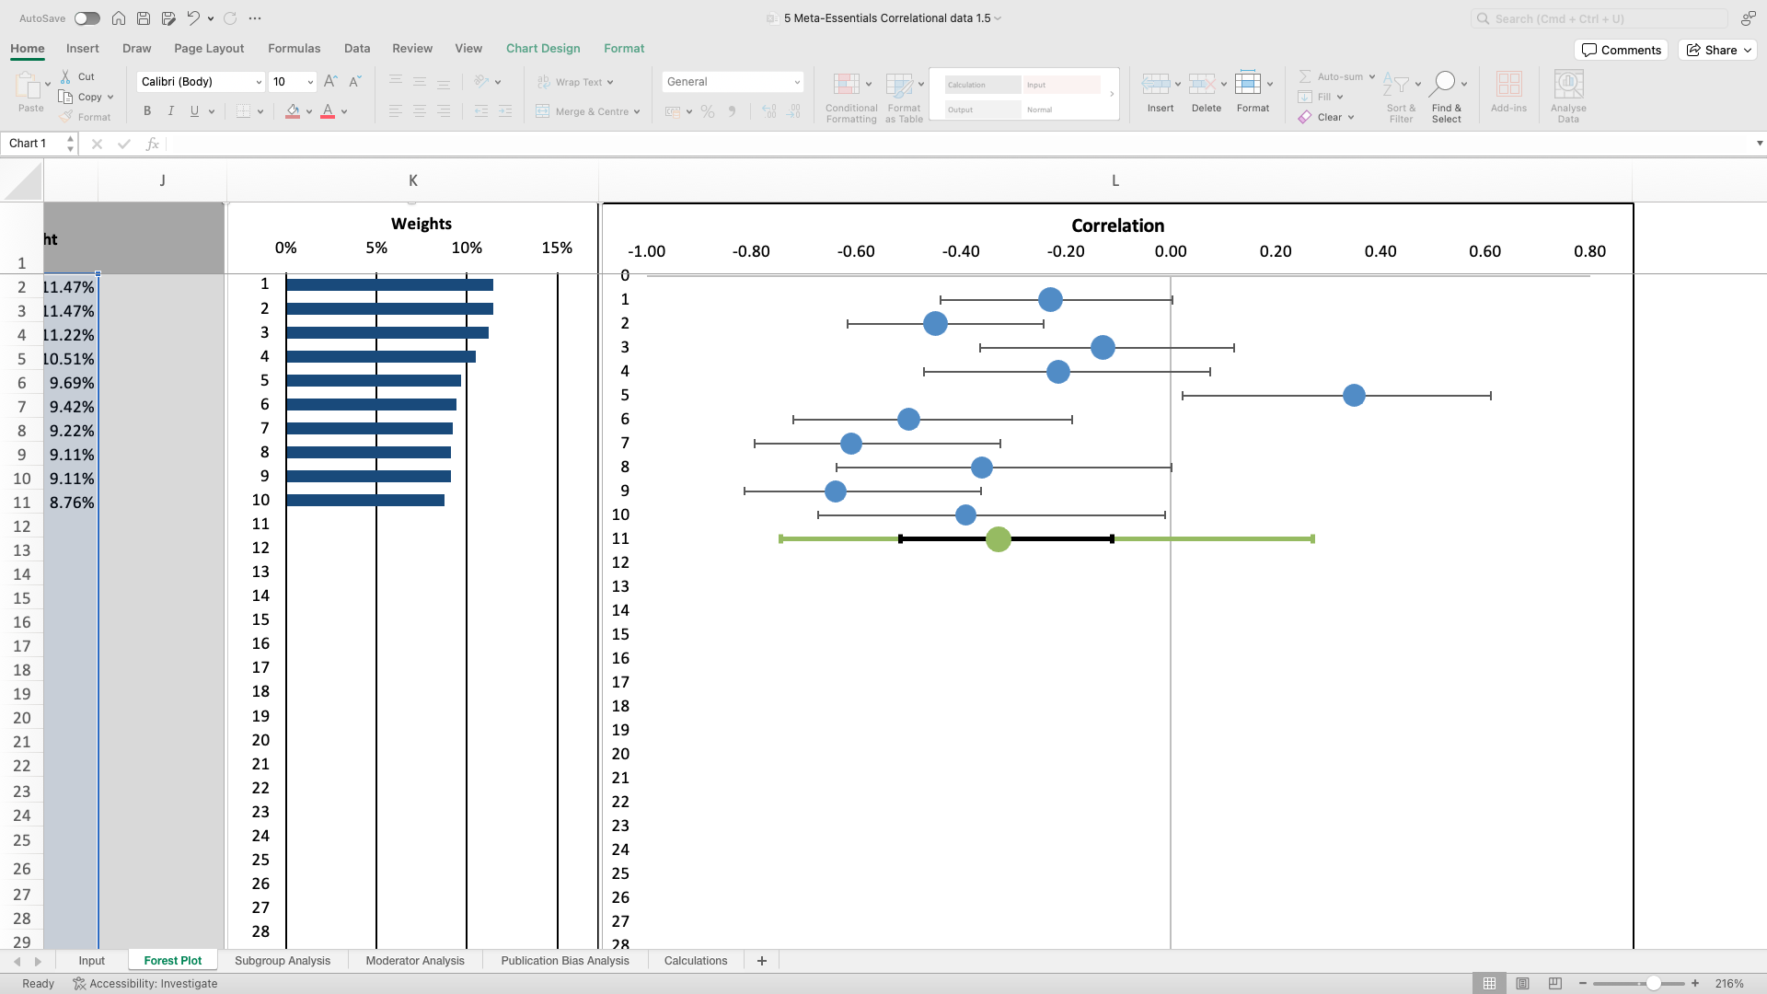
Forest Plot for Meta-Analysis
Blue circles represent each study effect size, number corresponds to study number in table 2
Study 11 is combined effect size showing the meta-analysis result, with black lines representing confidence intervals and green lines showing the predictive intervals.

Figure 3
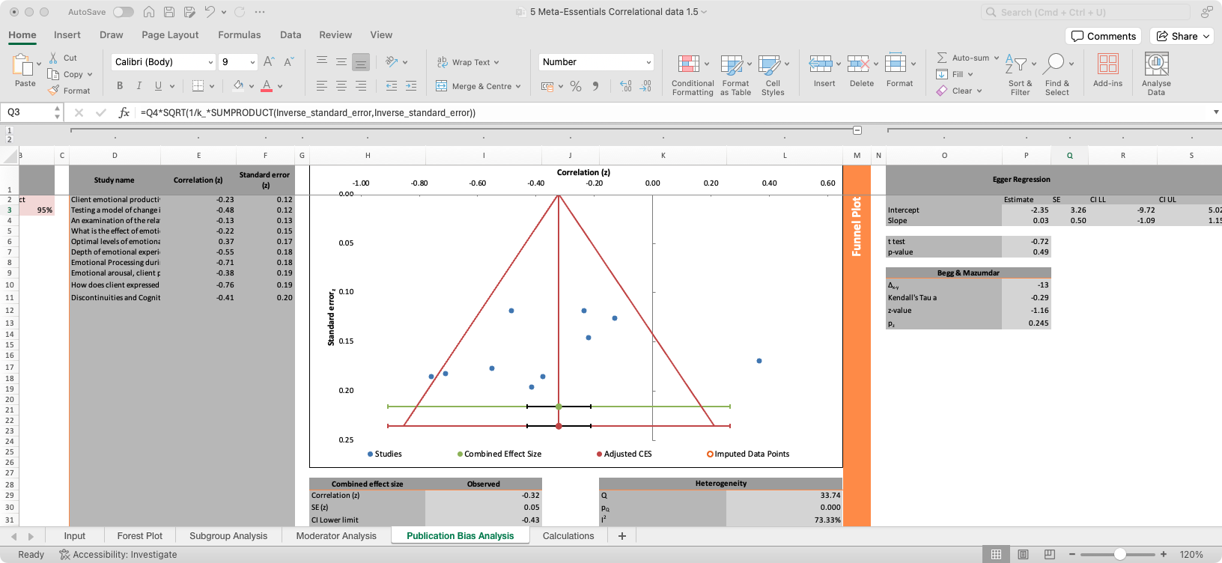
Funnel Plot to Assess Publication Bias

Discussion
This systematic review examined the relationship between emotional processing and psychological therapy outcomes whilst considering different models of therapy and process measures. A total of 15 studies exploring the relationship between emotional processing and therapy outcome were included. The majority (93%) of studies identified reported a significant association between emotional processing and therapy outcome, indicating that higher levels of emotional processing were related to improved symptoms of depression. There was only one study that did not support this finding. No significant differences were identified between therapy models and/or different outcome measures used to quantify emotional processing. Therapy outcome, therapy model, and outcome measures are examined more closely in the discussion. Findings are compared to the wider literature on therapy outcomes, including other reviews.

Therapy Outcomes
The main aim of this review was to synthesise and better understand the relationship between emotional processing and the outcomes of psychological therapy. The results of the meta-analysis revealed a significant and negative moderate correlation; that is, as levels of emotional processing increased following a dose of psychological therapy, symptoms of depression decreased. This finding was further supported by four studies included in the systematic review but that were not imputable to the meta-analysis.
However, a separate study by Carryer et al. (2011) reported adverse effects of emotional processing, suggesting that high levels of experiencing were associated with emotional dysregulation. They suggest that experiencing intense emotion can interfere with cognitive processing resulting in emotional dysregulation. There were no obvious differences between Carryer et al., 2011 and the 14 other studies that could help to explain the disparity in results, other than it being the only study included from Canada. Future research may wish to consider replicating this finding.

Models of Psychological Therapy
The current review also considered if there were any key differences across different modalities of psychological therapy. This could not be analysed with a meta-analysis due to a lack of studies in each modality and instead was understood systematically. Additionally, seven studies (Ausra et al., 2013; Carryer et al., 2011; Goldman et al., 2005; Missirlian et al., 2005; Pos et al., 2003, 2009, & 2017) could not be included in the systematic analysis as they referred to ‘experiential treatments of depression’ and encompassed a variety of psychological therapies that were not separated out in the results.
The remaining studies generally reported no differences between therapy modalities, apart from one finding that EBCT was better than CBT (Gómez Penedo, 2020). Conversely, findings from Basto et al. 2017 lends empirical support to the contention that processing of problematic experiences promotes a good outcome in psychological therapy using CBT. However, the use of case study data limits the generalisability of the CBT result.
Overall, the current review provides evidence that emotional processing can be incorporated across various models of psychological therapy, suggesting that it may not be unique to humanistic approaches. The clinical implication of this is that it may be easier for clinicians to include emotional processing techniques in a model they are already familiar with rather than learning a new model.

Emotional Processing Measures
The final aim of this review was to determine if different measures of emotional processing impacted on the relationship with therapy outcome. Given that 14 (out of 15) studies all showed support for the meta-analysis result using different measures of emotional processing with various psychological therapy models, this result indicates that different measures can be used to replicate findings.

Adding to the Evidence Base
The results of this review are comparable with other reviews exploring similar concepts discussed in the introduction (Pascual & Yeryomenko, 2017; Sonderland et al., 2023). A meta-analysis of 10 studies involving 406 clients resulted in an estimation that levels of emotional processing have a small to medium effect size in predicting outcome (r = -.19; Pascual-Leone & Yeryomenko, 2017). They also reported no differences between therapy approaches. The current review supports the findings of Pascual-Leone and Yeryomenko (2017) and emphasises the specific relationship in a more defined population of depressed adults. Likewise, Sonderland and colleagues (2023) reported an overall moderate strong relationship between emotional processing and outcome (r = .31). The results from the current review support these results by showing a similar effect size.

Methodological Considerations
Several methodological limitations of the reviewed studies should be considered when considering the implications and conclusions of the findings. Firstly, “correlation” refers to a statistical tool which assesses the degree of association between at least two quantitative variables and is expressed as a correlation coefficient. A primary limitation of correlational research is that whilst it can establish associations between processes in psychological therapy and outcomes, it cannot predict causation. A significant linear relationship can be calculated for correlation coefficients, however in medium to large samples such methods can show small correlation coefficients to be highly significant (Aggarwal & Ranganathan, 2016). Therefore, conclusions cannot be drawn about the predictive nature of emotional processing on therapy outcomes given the fairly modest sample size.
Systematic reviews should make every attempt to identify and include all relevant studies. The exclusion of relevant studies can impact the validity of the systematic review (Uttley et al., 2023). The search strategy in the current review may not be deemed comprehensive enough due to several factors including, excluding grey literature, language restrictions, and not using a second rater in the screening process. Future studies may wish to include grey literature and publications not in English to consider a more complete picture (Adams et al., 2016; Uttley et al., 2023). The use of a single reviewer in the screening stage may have impacted on reliability and objectivity of the review as guidance recommends at least two researchers review articles and double-check the processes (Cumptson et al., 2019).

Strengths and Limitations
Systematic reviews use suitable and rigorous methods to ensure it is methodologically sound and, despite the methodological limitations discussed, there are several strengths of the current review. Firstly, the large fail-safe N (165) indicates the relative strength in being confident interpreting the results. Moreover, search terms were purposefully kept broad to increase the likelihood of identifying relevant studies. This included searching reference lists of related articles, which further increases confidence in all relevant studies having been found.
A major limitation concerns the quality of the evidence included. Assessing the quality of evidence is essential in asserting the degree of confidence that can be placed on an estimated effect supporting recommendations. Reviews that include studies with major limitations often result in reduced confidence in the recommendations due to biased estimates. Examples of such limitations include: a lack of blinding, significant levels of drop-out, and not reporting possible confounding variables (Guyatt et al., 2008; Luchini et al., 2021). Given that 60% of the included studies were rated as being of weak quality, the confidence in the results may be deemed as weak.
The search processes were limited to individual therapy for adult clients only, meaning that several studies examining emotional processing and outcomes in children and young people, as well as in other formats such as group and couples therapy, were excluded. Similarly, due to pragmatic issues, qualitative research was also excluded. In process research, qualitative methodologies can help to understand the complex nature of emotional processing.
The decision to include multiple outcome measures of emotional processing can be considered both a strength and a weakness. Client outcomes are frequently measured using scales, which each employ different questions, units, and/or direction to assess similar constructs. Pooling outcomes across studies can be challenging as studies will likely be using different scales. Examining each scale independently is problematic as it can significantly limit the studies included in the analysis, resulting in imprecise estimates and wide confidence intervals (Murad et al., 2019). This supports the inclusion of multiple scales in the current review. However, there is insufficient evidence that the emotional processing scales are all measuring the same construct, which impacts on the validity of the findings.

Future Directions
There is a significant need to improve the quality of studies in process research. This can be done by studies following reporting guidelines, such as the strengthening the reporting of observational studies in epidemiology (STROBE; von Elm et al., 2007) checklist, to ensure there is no missing data and they can be adequately assessed.
Future studies may wish to explore emotional processing and outcomes in populations not studied here (i.e., children and young people), and/or in different therapy formats such as groups. Further, research that synthesises qualitative research on emotional processing and outcomes would be beneficial in improving understanding of complex processes in psychological therapy.

Clinical Implications
When these findings are considered alongside other studies, they describe a mechanism of change that can be influenced and encouraged by therapists. The findings indicate that emotional processing is linked to therapy outcome, across different types of therapy. Understanding such processes is therefore important for therapists, so they may better encourage this mechanism of change. A small caveat by the Carryer et al. (2011) study suggests that too high levels of emotional processing could be harmful. This needs further research. Crucially, when applying the current findings to clinical work, whilst the evidence strongly supports effectiveness for depression, this finding cannot be generalised beyond this specific clinical area.

Conclusion
This review identified a relationship between emotional processing and psychological therapy outcome in the treatment of depression. Findings indicated very little differences between different therapy models implemented in psychological therapy regarding expressed emotional processing. Similarly, there were no differences indicated between measures of emotional processing. These findings show the significant role emotional processing plays in facilitating good outcomes across various models of psychological therapy, indicating its robustness as a concept. Although a variety of psychological therapies were included, it was difficult to differentiate between some models. Future research may wish to consider specific models in greater detail. Therefore, caution should be taken when incorporating emotional processing into models with less evidence for its use.

References
*identifies papers included in the analysis

Adams, J., Hillier-Brown, F. C., Moore, H. J., Lake, A. A., Araujo-Soares, V., White, M., & Summerbell, C. (2016). Searching and synthesising ‘grey literature’ and ‘grey information in public health: critical reflections on three case studies. Systematic Reviews, 5, 1-11. https://doi.org/10.1186/s13643-016-0337-y
Aggarwal, R., & Ranganathan, P. (2016). Common pitfalls in statistical analysis: The use of correlation techniques. Perspectives in Clinical Research, 7(4), 187–190. https://doi.org/10.4103/2229-3485.192046
American Psychiatric Association. (2013). Diagnostic and statistical manual of mental disorders (5th ed.). https://doi.org/10.1176/appi.books.9780890425596
Auszra, L., Greenberg, L. S., & Herrmann, I. (2013). Client emotional productivity—Optimal client in-session emotional processing in experiential therapy. Psychotherapy Research, 23(6), 732-746. https://doi.org/10.1080/10503307.2013.816882 *
Basto, I., Pinheiro, P., Stiles, W. B., Rijo, D., & Salgado, J. (2017). Changes in symptom intensity and emotion valence during the process of assimilation of a problematic experience: A quantitative study of a good outcome case of cognitive-behavioral therapy. Psychotherapy Research, 27(4), 437-449. https://doi.org/10.1080/10503307.2015.1119325
Baker, R., Owens, M., Thomas, S., Whittlesea, A., Abbey, G., Gower, P., … Thomas, P. W. (2012). Does CBT Facilitate Emotional Processing? Behavioural and Cognitive Psychotherapy, 40(1), 19–37. https://doi.org/10.1017/S1352465810000895
Beck, A. T. (Ed.). (1979). Cognitive therapy of depression. Guilford press.
Borenstein, M., Hedges, L. V., Higgins, J. P., & Rothstein, H. R. (2021). Introduction to meta-analysis. John Wiley & Sons.
Boritz, T. Z., Bryntwick, E., Angus, L., Greenberg, L. S., & Constantino, M. J. (2014). Narrative and emotion process in psychotherapy: an empirical test of the Narrative-Emotion Process Coding System (NEPCS). Psychotherapy Research: Journal of the Society for Psychotherapy Research, 24(5), 594–607. https://doi.org/10.1080/10503307.2013.851426
Boritz, T. Z., Angus, L., Monette, G., Hollis-Walker, L., & Warwar, S. (2011). Narrative and emotion integration in psychotherapy: Investigating the relationship between autobiographical memory specificity and expressed emotional arousal in brief emotion-focused and client-centred treatments of depression. Psychotherapy Research, 21(1), 16–26. https://doi.org/10.1080/10503307.2010.504240
Card, N. A. (2012). Applied meta-analysis for social science research. Guilford Press.
Carryer, J. R., & Greenberg, L. S. (2010). Optimal levels of emotional arousal in experiential therapy of depression. Journal of Consulting and Clinical Psychology, 78(2), 190-199. https://psycnet.apa.org/doi/10.1037/a0018401
Caselli, I., Ielmini, M., Bellini, A., Zizolfi, D., & Callegari, C. (2023). Efficacy of short-term psychodynamic psychotherapy (STPP) in depressive disorders: A systematic review and meta-analysis. Journal of Affective Disorders, 325, 169-176. https://doi.org/10.1016/j.jad.2022.12.161
Castonguay, L. G., Goldfried, M. R., Wiser, S., Raue, P. J., & Hayes, A. M. (1996). Predicting the effect of cognitive therapy for depression: A study of unique and common factors. Journal of Consulting and Clinical Psychology, 64(3), 497–504. https://doi.org/10.1037/0022-006X.64.3.497
Cohen, J. (1992). Statistical power analysis. Current Directions in Psychological Science, 1(3), 98-101. https://doi.org/10.1111/1467-8721.ep10768783
Compare, A., Zarbo, C., Shonin, E., Van Gordon, W., & Marconi, C. (2014). Emotional Regulation and Depression: A Potential Mediator between Heart and Mind. Cardiovascular Psychiatry and Neurology, 2014, 324-374. https://doi.org/10.1155/2014/324374
Crits-Christoph, P., Gibbons, M. B. C., & Mukherjee, D. (2013). Psychotherapy process-outcome research. In M. J. Lambert (Ed.), Bergin and Garfield’s handbook of psychotherapy and behavior change (6th ed., pp. 298–340). Wiley.
Cumpston, M., Li, T., Page, M. J., Chandler, J., Welch, V. A., Higgins, J. P., & Thomas, J. (2019). Updated guidance for trusted systematic reviews: a new edition of the Cochrane Handbook for Systematic Reviews of Interventions. The Cochrane Database of Systematic Reviews, 2019(10). https://doi.org/10.1002/14651858.ed000142
Cuijpers, P., Geraedts, A. S., van Oppen, P., Andersson, G., Markowitz, J. C., & van Straten, A. (2011). Interpersonal psychotherapy for depression: a meta-analysis. The American Journal of Psychiatry, 168(6), 581–592. https://doi.org/10.1176/appi.ajp.2010.10101411
Duval, S., & Tweedie, R. (2000). A nonparametric “trim and fill” method of accounting for publication bias in meta-analysis. Journal of the American Statistical Association, 95(449), 89-98. https://doi.org/10.1080/01621459.2000.10473905
Egger, M., Smith, G. D., Schneider, M., & Minder, C. (1997). Bias in meta-analysis detected by a simple, graphical test. BMJ, 315(7109), 629-634. https://doi.org/10.1136/bmj.315.7109.629
Ehrenreich, J. T., Fairholme, C. P., Buzzella, B. A., Ellard, K. K., & Barlow, D. H. (2007). The Role of Emotion in Psychological Therapy. Clinical Psychology, 14(4), 422–428. https://doi.org/10.1111/j.1468-2850.2007.00102.x
Eriksen, M. B., & Frandsen, T. F. (2018). The impact of patient, intervention, comparison, outcome (PICO) as a search strategy tool on literature search quality: a systematic review. Journal of the Medical Library Association: JMLA, 106(4), 420–431. https://doi.org/10.5195/jmla.2018.345
Flückiger, C., Regli, D., Zwahlen, D., Hostettler, S., & Caspar, F. (2010). Der berner patienten- und therapeutenstundenbogen 2000: Ein instrument zur erfassung von therapieprozessen [The Bern Post Session Report 2000, patient and therapist versions: Measuring psychotherapeutic processes]. Zeitschrift für Klinische Psychologie und Psychotherapie: Forschung und Praxis, 39(2), 71–79. https://doi.org/10.1026/1616-3443/a000015
Ford, B. Q., Lam, P., John, O. P., & Mauss, I. B. (2018). The psychological health benefits of accepting negative emotions and thoughts: Laboratory, diary, and longitudinal evidence. Journal of Personality and Social Psychology, 115(6), 1075–1092. https://doi.org/10.1037/pspp0000157
Foster, M., & Jewell, S. (2017). identifying the studies, part 3 [Review of identifying the studies, part 3]. In Assembling the Pieces of a Systematic Review: A Guide for Librarians. Rowman & Littlefield.
Goldman, R. N., Greenberg, L. S., & Pos, A. E. (2005). Depth of emotional experience and outcome. Psychotherapy Research, 15(3), 248-260. https://doi.org/10.1080/10503300512331385188 *
Greenberg, L. S., & Pascual‐Leone, A. (2006). Emotion in psychotherapy: A practice‐friendly research review. Journal of Clinical Psychology, 62(5), 611-630. https://doi.org/10.1002/jclp.20252
Gómez Penedo, J. M., Coyne, A. E., Constantino, M. J., Krieger, T., Hayes, A. M., & Grosse Holtforth, M. (2020). Theory-specific patient change processes and mechanisms in different cognitive therapies for depression. Journal of Consulting and Clinical Psychology, 88(8), 774-785. https://doi.org/10.1037/ccp0000502
Gross, J. J. (2015). Emotion Regulation: Current Status and Future Prospects. Psychological Inquiry, 26(1), 1–26. https://doi.org/10.1080/1047840X.2014.940781
Grosse Holtforth, M., Hayes, A. M., Sutter, M., Wilm, K., Schmied, E., Laurenceau, J. P., & Caspar, F. (2012). Fostering cognitive-emotional processing in the treatment of depression: A preliminary investigation in exposure-based cognitive therapy. Psychotherapy and Psychosomatics, 81(4), 259-260. https://doi.org/10.1159/000336813
Guyatt G. H., Oxman A. D., Kunz R, Vist G. E., Falck-Ytter Y, Schünemann H. J. GRADE Working Group. What is "quality of evidence" and why is it important to clinicians? BMJ 6(7651). https://doi.org/10.1136/bmj.39490.551019.BE
Hamilton, M. (1986). The Hamilton rating scale for depression. In Assessment of depression (pp. 143-152). Springer.
Hayes, A. M., Feldman, G. C., Beevers, C. G., Laurenceau, J. P., Cardaciotto, L., & Lewis-Smith, J. (2007). Discontinuities and cognitive changes in an exposure-based cognitive therapy for depression. Journal of Consulting and Clinical Psychology, 75(3), 409. https://psycnet.apa.org/doi/10.1037/0022-006X.75.3.409 *
Hayes, A. M., Feldman, G. C., & Goldfried, M. R. (2007b). The change and growth experiences scale: a measure of insight and emotional processing. In L. G. Castonguay & C. Hill (Eds.), Insight in psychotherapy (pp. 231–253). American Psychological Association. https://doi.org/10.1037/11532-011
Hedges, L. V., & Olkin, I. (2014). Statistical methods for meta-analysis. Academic press.
Hedges, L. V., & Vevea, J. L. (1998). Fixed-and random-effects models in meta-analysis. Psychological Methods, 3(4), 486. https://doi.org/10.1037/1082-989X.3.4.486
Higgins, J. P. (2008). Commentary: Heterogeneity in meta-analysis should be expected and appropriately quantified. International Journal of Epidemiology, 37(5), 1158-1160. https://doi.org/10.1093/ije/dyn204
Higgins, J. P., & Thompson, S. G. (2002). Quantifying heterogeneity in a meta‐analysis. Statistics in Medicine, 21(11), 1539-1558. https://doi.org/10.1002/sim.1186
Hunter, J. E., & Schmidt, F. L. (2000). Fixed effects vs. random effects meta‐analysis models: Implications for cumulative research knowledge. International Journal of Selection and Assessment, 8(4), 275-292. https://doi.org/10.1111/1468-2389.00156
Institute for Health Metrics and Evaluation. (2015). GBD compare. In: Seattle, WA: IHME, University of Washington [Internet; accessed 14/05/2024]
Ioannidis, J. P. (2016). The mass production of redundant, misleading, and conflicted systematic reviews and meta‐analyses. The Milbank Quarterly, 94(3), 485-514. https://doi.org/10.1111/1468-0009.12210
Kendrick, T., Pilling, S., Mavranezouli, I., Megnin-Viggars, O., Ruane, C., Eadon, H., & Kapur, N. (2022). Management of depression in adults: summary of updated NICE guidance. BMJ, 378. https://doi.org/10.1136/bmj.o1557
Krosnick, J. and Presser, S. (2010). Question and questionnaire design. Handbook of Survey Research, 2, 263-314.
Lieberman, M. D., Eisenberger, N. I., Crockett, M. J., Tom, S. M., Pfeifer, J. H., & Way, B. M. (2007). Putting feelings into words: affect labeling disrupts amygdala activity in response to affective stimuli. Psychological Science, 18(5), 421–428. https://doi.org/10.1111/j.1467-9280.2007.01916.x
López-López, J. A., Davies, S. R., Caldwell, D. M., Churchill, R., Peters, T. J., Tallon, D., … Welton, N. J. (2019). The process and delivery of CBT for depression in adults: a systematic review and network meta-analysis. Psychological Medicine, 49(12), 1937–1947. https://doi.org/10.1017/S003329171900120X
Lumley, M. A., Cohen, J. L., Borszcz, G. S., Cano, A., Radcliffe, A. M., Porter, L. S., Schubiner, H., & Keefe, F. J. (2011). Pain and emotion: a biopsychosocial review of recent research. Journal of Clinical Psychology, 67(9), 942–968. https://doi.org/10.1002/jclp.20816
Lumley, M. A., Krohner, S., Marshall, L. M., Kitts, T. C., Schubiner, H., & Yarns, B. C. (2021). Emotional Awareness and Other Emotional Processes: Implications for the Assessment and Treatment of Chronic Pain. Pain Management, 11(3), 325–332. https://doi.org/10.2217/pmt-2020-0081
Luchini, C., Veronese, N., Nottegar, A., Shin, J. I., Gentile, G., Granziol, U., Soysal, P., Alexinschi, O., Smith, L., & Solmi, M. (2021). Assessing the quality of studies in meta-research: Review/guidelines on the most important quality assessment tools. Pharmaceutical Statistics, 20(1), 185–195. https://doi.org/10.1002/pst.2068
Marcus, G. E., Neuman, W. R., & MacKuen, M. B. (2017). Measuring emotional response: Comparing alternative approaches to measurement. Political Science Research and Methods, 5(4), 733-754. https://doi.org/10.1017/psrm.2015.65
McCullough, L. (Ed.). (2003). Treating affect phobia: A manual for short-term dynamic psychotherapy. Guilford Press.
Missirlian, T. M., Toukmanian, S. G., Warwar, S. H., & Greenberg, L. S. (2005). Emotional arousal, client perceptual processing, and the working alliance in experiential psychotherapy for depression. Journal of Consulting and Clinical Psychology, 73(5), 861-871. https://psycnet.apa.org/doi/10.1037/0022-006X.73.5.861 *
Menefee, D. S., Ledoux, T., & Johnston, C. A. (2022). The Importance of Emotional Regulation in Mental Health. American Journal of Lifestyle Medicine, 16(1), 28–31. https://doi.org/10.1177/15598276211049771
Moher, D., Liberati, A., Tetzlaff, J., Altman, D. G., & PRISMA Group* (2009). Preferred reporting items for systematic reviews and meta-analyses: the PRISMA statement. Annals of Internal Medicine, 151(4), 264-269. https://doi.org/10.7326/0003-4819-151-4-200908180-00135
Moher, D., Tetzlaff, J., Tricco, A. C., Sampson, M., & Altman, D. G. (2007). Epidemiology and reporting characteristics of systematic reviews. PLoS Medicine, 4(3), e78. https://doi.org/10.1371/journal.pmed.0040078
Murad, M. H., Wang, Z., Chu, H., & Lin, L. (2019). When continuous outcomes are measured using different scales: guide for meta-analysis and interpretation. BMJ (Clinical research ed.), 364, k4817. https://doi.org/10.1136/bmj.k4817
Nair, A. S. (2019). Publication bias-Importance of studies with negative results! Indian Journal of Anaesthesia, 63(6), 505-507. https://doi.org/10.4103/ija.IJA_142_19
National Institute for Health and Care Excellence. (2022). Depression in adults: treatment and management [NICE Guideline No. 222]. https://www.nice.org.uk/guidance/ng222
Ouzzani, M., Hammady, H., Fedorowicz, Z., & Elmagarmid, A. (2016). Rayyan—a Web and Mobile App for Systematic Reviews. Systematic Reviews, 5(1). https://doi.org/10.1186/s13643-016-0384-4
Page M. J., McKenzie J. E., Bossuyt P. M., Boutron I., Hoffmann T. C., Mulrow C. D., (2021). The PRISMA 2020 statement: an updated guideline for reporting systematic reviews. BMJ 372(71), 103-112. https://doi.org/10.1136/bmj.n71
Pascual-Leone, A. (2018). How clients “change emotion with emotion”: A programme of research on emotional processing. Psychotherapy Research, 28(2), 165-182. https://doi.org/10.1080/10503307.2017.1349350
Pascual-Leone, A., & Yeryomenko, N. (2017). The client “experiencing” scale as a predictor of treatment outcomes: A meta-analysis on psychotherapy process. Psychotherapy Research, 27(6), 653–665. https://doi.org/10.1080/10503307.2016.1152409
Peters, J. L., Sutton, A. J., Jones, D. R., Abrams, K. R., & Rushton, L. (2008). Contour-enhanced meta-analysis funnel plots help distinguish publication bias from other causes of asymmetry. Journal of Clinical Epidemiology, 61(10), 991-996. https://doi.org/10.1016/j.jclinepi.2007.11.010
Pinheiro, P., Gonçalves, M. M., Sousa, I., & Salgado, J. (2021). What is the effect of emotional processing on depression? A longitudinal study. Psychotherapy Research, 31(4), 507-519. https://doi.org/10.1080/10503307.2020.1781951 *
Pos, A. E., Greenberg, L. S., Goldman, R. N., & Korman, L. M. (2003). Emotional processing during experiential treatment of depression. Journal of Consulting and Clinical Psychology, 71(6), 1007–1016. https://psycnet.apa.org/doi/10.1037/0022-006X.71.6.1007 *
Pos, A. E., Greenberg, L. S., & Warwar, S. H. (2009). Testing a model of change in the experiential treatment of depression. Journal of Consulting and Clinical Psychology, 77(6), 1055–1066. https://psycnet.apa.org/doi/10.1037/a0017059 *
Pos, A. E., Paolone, D. A., Smith, C. E., & Warwar, S. H. (2017). How does client expressed emotional arousal relate to outcome in experiential therapy for depression? Person-Centered & Experiential Psychotherapies, 16(2), 173-190. https://doi.org/10.1080/14779757.2017.1323666
Rachman, S. (1980). Emotional processing. Behaviour Research and Therapy, 18, 51-60. https://psycnet.apa.org/doi/10.1016/0005-7967(80)90069-8
Rachman, S. (2001). Emotional processing, with special reference to post-traumatic stress disorder. International Review of Psychiatry, 13, 164-171. https://psycnet.apa.org/doi/10.1080/09540260120074028
Richardson, W. S., Wilson, M. C., Nishikawa, J., & Hayward, R. S. (1995). The well-built clinical question: a key to evidence-based decisions. ACP Journal Club, 123(3), 12–13. https://doi.org/10.7326/ACPJC-1995-123-3-A12
Rosenthal, R. (1979). The file drawer problem and tolerance for null results. Psychological Bulletin, 86(3), 638–641. https://psycnet.apa.org/doi/10.1037/0033-2909.86.3.638
Schlosser, R. W., Wendt, O., & Sigafoos, J. (2007). Not all systematic reviews are created equal: Considerations for appraisal. Evidence-Based Communication Assessment and Intervention, 1(3), 138-150. https://doi.org/10.1080/17489530701560831
Sønderland, N. M., Solbakken, O. A., Eilertsen, D. E., Nordmo, M., & Monsen, J. T. (2023). Emotional changes and outcomes in psychotherapy: A systematic review and meta-analysis. Journal of Consulting and Clinical Psychology. Advance online publication. https://doi.org/10.1037/ccp0000814
Stiles, W. B., Elliott, R., Llewelyn, S. P., Firth-Cozens, J. A., Margison, F. R., Shapiro, D. A., & Hardy, G. (1990). Assimilation of problematic experiences by clients in psychotherapy. Psychotherapy: Theory, Research, Practice, Training, 27(3), 411-420. https://psycnet.apa.org/doi/10.1037/0033-3204.27.3.411
Suurmond, R., van Rhee, H., & Hak, T. (2017). Introduction, comparison, and validation of Meta‐Essentials: a free and simple tool for meta‐analysis. Research Synthesis Methods, 8(4), 537-553. https://doi.org/10.1002/jrsm.1260
Tamayo, R. (2011). A checklist to define the psychological processes. Revista Colombiana de Psicología, 20(2), 321-327. https://www.redalyc.org/articulo.oa?id=80421265013
Town, J. M., Salvadori, A., Falkenström, F., Bradley, S., & Hardy, G. (2017). Is affect experiencing therapeutic in major depressive disorder? Examining associations between affect experiencing and changes to the alliance and outcome in intensive short-term dynamic psychotherapy. Psychotherapy, 54(2), 148–158. https://psycnet.apa.org/doi/10.1037/pst0000108
Troy, A. S., Shallcross, A. J., Brunner, A., Friedman, R., & Jones, M. C. (2018). Cognitive reappraisal and acceptance: Effects on emotion, physiology, and perceived cognitive costs. Emotion (Washington, D.C.), 18(1), 58–74. https://doi.org/10.1037/emo0000371
Uttley, L., Quintana, D. S., Montgomery, P., Carroll, C., Page, M. J., Falzon, L., ... & Moher, D. (2023). The problems with systematic reviews: a living systematic review. Journal of Clinical Epidemiology, 156, 30-41. https://doi.org/10.1016/j.jclinepi.2023.01.011
von Elm, E., Altman, D. G., Egger, M., Pocock, S. J., Gøtzsche, P. C., Vandenbroucke, J. P., & STROBE Initiative (2007). The Strengthening the Reporting of Observational Studies in Epidemiology (STROBE) statement: guidelines for reporting observational studies. PLoS Medicine, 4(10), e296. https://doi.org/10.1371/journal.pmed.0040296
Warwar, S., & Greenberg, L. S. (1999). Client emotional arousal scale–III. Unpublished manuscript, York University, Toronto, Ontario, Canada.
Watson, J. C., McMullen, E. J., Prosser, M. C., & Bedard, D. L. (2011). An examination of the relationships among clients' affect regulation, in-session emotional processing, the working alliance, and outcome. Psychotherapy Research, 21(1), 86-96. https://doi.org/10.1080/10503307.2010.518637 *
Whelton, W. J. (2004). Emotional processes in psychotherapy: evidence across therapeutic modalities. Clinical Psychology & Psychotherapy, 11(1), 58–71. https://doi.org/10.1002/cpp.392
Wilson, D. B., PH.D. (N.D.). Practical meta-analysis effect size calculator [online calculator]. Retrieved April, 25TH, 2024, from https://www.campbellcollaboration.org/research-resources/effect-size-calculator.html
World Health Organization. (2017). Depression and other common mental disorders: global health estimates (No. WHO/MSD/MER/2017.2). World Health Organization.
Wormald, R., & Evans, J. (2018). What makes systematic reviews systematic and why are they the highest level of evidence? Ophthalmic Epidemiology, 25(1), 27-30. https://doi.org/10.1080/09286586.2017.1337913

Appendices

Appendix | Title | Page
A | PRISMA 2020 Checklist | 51-54
B | Quality Assessment Tool for Quantitative Studies | 55-59
C | Quality Assessment Full Table | 60
D | Reasons for Exclusion of Studies | 61-66

Section and Topic | Item # | Checklist item  Appendix A  The STROBE Checklist (2020) | Location where item is reported
TITLE
Title | 1 | Identify the report as a systematic review. | p.1
ABSTRACT
Abstract | 2 | See the PRISMA 2020 for Abstracts checklist.
INTRODUCTION
Rationale | 3 | Describe the rationale for the review in the context of existing knowledge. | pp. 4-7
Objectives | 4 | Provide an explicit statement of the objective(s) or question(s) the review addresses. | pp. 7-8
METHODS
Eligibility criteria | 5 | Specify the inclusion and exclusion criteria for the review and how studies were grouped for the syntheses. | pp. 8-9  p. 12
Information sources | 6 | Specify all databases, registers, websites, organisations, reference lists and other sources searched or consulted to identify studies. Specify the date when each source was last searched or consulted. | p. 9
Search strategy | 7 | Present the full search strategies for all databases, registers and websites, including any filters and limits used. | pp. 9-10
Selection process | 8 | Specify the methods used to decide whether a study met the inclusion criteria of the review, including how many reviewers screened each record and each report retrieved, whether they worked independently, and if applicable, details of automation tools used in the process. | pp. 9-10
Data collection process | 9 | Specify the methods used to collect data from reports, including how many reviewers collected data from each report, whether they worked independently, any processes for obtaining or confirming data from study investigators, and if applicable, details of automation tools used in the process. | p. 10
Data items | 10a | List and define all outcomes for which data were sought. Specify whether all results that were compatible with each outcome domain in each study were sought (e.g. for all measures, time points, analyses), and if not, the methods used to decide which results to collect. | p. 16
 | 10b | List and define all other variables for which data were sought (e.g. participant and intervention characteristics, funding sources). Describe any assumptions made about any missing or unclear information. | p. 10
Study risk of bias assessment | 11 | Specify the methods used to assess risk of bias in the included studies, including details of the tool(s) used, how many reviewers assessed each study and whether they worked independently, and if applicable, details of automation tools used in the process. | p. 11
Effect measures | 12 | Specify for each outcome the effect measure(s) (e.g. risk ratio, mean difference) used in the synthesis or presentation of results. | p. 20
Synthesis methods | 13a | Describe the processes used to decide which studies were eligible for each synthesis (e.g. tabulating the study intervention characteristics and comparing against the planned groups for each synthesis (item #5)). | Not Applicable
 | 13b | Describe any methods required to prepare the data for presentation or synthesis, such as handling of missing summary statistics, or data conversions. | p. 11
 | 13c | Describe any methods used to tabulate or visually display results of individual studies and syntheses. | pp. 13-14
 | 13d | Describe any methods used to synthesize results and provide a rationale for the choice(s). If meta-analysis was performed, describe the model(s), method(s) to identify the presence and extent of statistical heterogeneity, and software package(s) used. | pp. 11-14
 | 13e | Describe any methods used to explore possible causes of heterogeneity among study results (e.g. subgroup analysis, meta-regression). | Not Applicable
 | 13f | Describe any sensitivity analyses conducted to assess robustness of the synthesized results. | Not Applicable
Reporting bias assessment | 14 | Describe any methods used to assess risk of bias due to missing results in a synthesis (arising from reporting biases). | Not Applicable
Certainty assessment | 15 | Describe any methods used to assess certainty (or confidence) in the body of evidence for an outcome. | Not Applicable
RESULTS
Study selection | 16a | Describe the results of the search and selection process, from the number of records identified in the search to the number of studies included in the review, ideally using a flow diagram. | p. 14 & p.16
 | 16b | Cite studies that might appear to meet the inclusion criteria, but which were excluded, and explain why they were excluded. | Not Applicable
Study characteristics | 17 | Cite each included study and present its characteristics. | pp. 17-18
Risk of bias in studies | 18 | Present assessments of risk of bias for each included study. | pp. 17-18
Results of individual studies | 19 | For all outcomes, present, for each study: (a) summary statistics for each group (where appropriate) and (b) an effect estimate and its precision (e.g. confidence/credible interval), ideally using structured tables or plots. | pp. 20-21
Results of syntheses | 20a | For each synthesis, briefly summarise the characteristics and risk of bias among contributing studies. | pp. 22-27
 | 20b | Present results of all statistical syntheses conducted. If meta-analysis was done, present for each the summary estimate and its precision (e.g. confidence/credible interval) and measures of statistical heterogeneity. If comparing groups, describe the direction of the effect. | pp. 20-21
 | 20c | Present results of all investigations of possible causes of heterogeneity among study results. | p. 19
 | 20d | Present results of all sensitivity analyses conducted to assess the robustness of the synthesized results. | Not applicable
Reporting biases | 21 | Present assessments of risk of bias due to missing results (arising from reporting biases) for each synthesis assessed. | Not applicable
Certainty of evidence | 22 | Present assessments of certainty (or confidence) in the body of evidence for each outcome assessed. | Not applicable
DISCUSSION
Discussion | 23a | Provide a general interpretation of the results in the context of other evidence. | pp. 27-28
 | 23b | Discuss any limitations of the evidence included in the review. | pp. 29-30
 | 23c | Discuss any limitations of the review processes used. | pp. 29-30
 | 23d | Discuss implications of the results for practice, policy, and future research. | pp. 30-31
OTHER INFORMATION
Registration and protocol | 24a | Provide registration information for the review, including register name and registration number, or state that the review was not registered. | p. 8
 | 24b | Indicate where the review protocol can be accessed, or state that a protocol was not prepared. | p. 8
 | 24c | Describe and explain any amendments to information provided at registration or in the protocol. | Not Applicable
Support | 25 | Describe sources of financial or non-financial support for the review, and the role of the funders or sponsors in the review. | Not Applicable
Competing interests | 26 | Declare any competing interests of review authors. | Not Applicable
Availability of data, code and other materials | 27 | Report which of the following are publicly available and where they can be found: template data collection forms; data extracted from included studies; data used for all analyses; analytic code; any other materials used in the review. | Not Applicable

PRISMA Abstract Checklist

Topic | No. | Item | Reported?
TITLE
Title | 1 | Identify the report as a systematic review. | Yes
BACKGROUND
Objectives | 2 | Provide an explicit statement of the main objective(s) or question(s) the review addresses. | Yes
METHODS
Eligibility criteria | 3 | Specify the inclusion and exclusion criteria for the review. | Yes (inclusion only)
Information sources | 4 | Specify the information sources (e.g. databases, registers) used to identify studies and the date when each was last searched. | Yes
Risk of bias | 5 | Specify the methods used to assess risk of bias in the included studies. | Yes
Synthesis of results | 6 | Specify the methods used to present and synthesize results. | Yes
RESULTS
Included studies | 7 | Give the total number of included studies and participants and summarise relevant characteristics of studies. | Yes
Synthesis of results | 8 | Present results for main outcomes, preferably indicating the number of included studies and participants for each. If meta-analysis was done, report the summary estimate and confidence/credible interval. If comparing groups, indicate the direction of the effect (i.e. which group is favoured). | Yes
DISCUSSION
Limitations of evidence | 9 | Provide a brief summary of the limitations of the evidence included in the review (e.g. study risk of bias, inconsistency and imprecision). | Yes
Interpretation | 10 | Provide a general interpretation of the results and important implications. | Yes
OTHER
Funding | 11 | Specify the primary source of funding for the review. | No
Registration | 12 | Provide the register name and registration number. | Yes

Appendix B

Quality Assessment Tool for Quantitative Studies

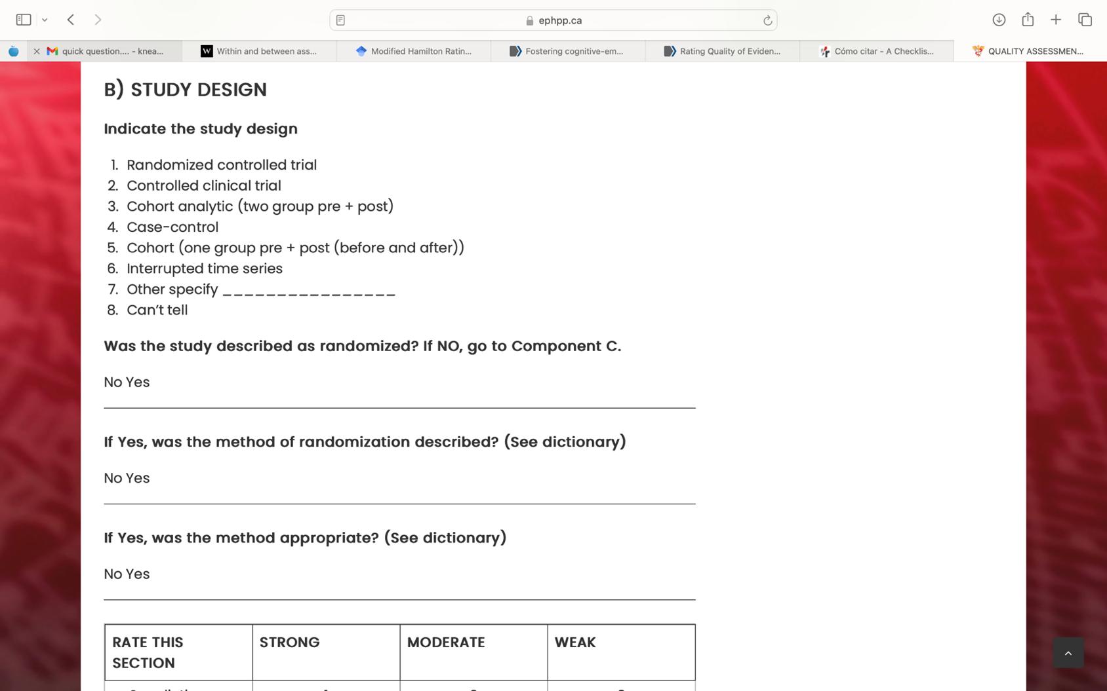

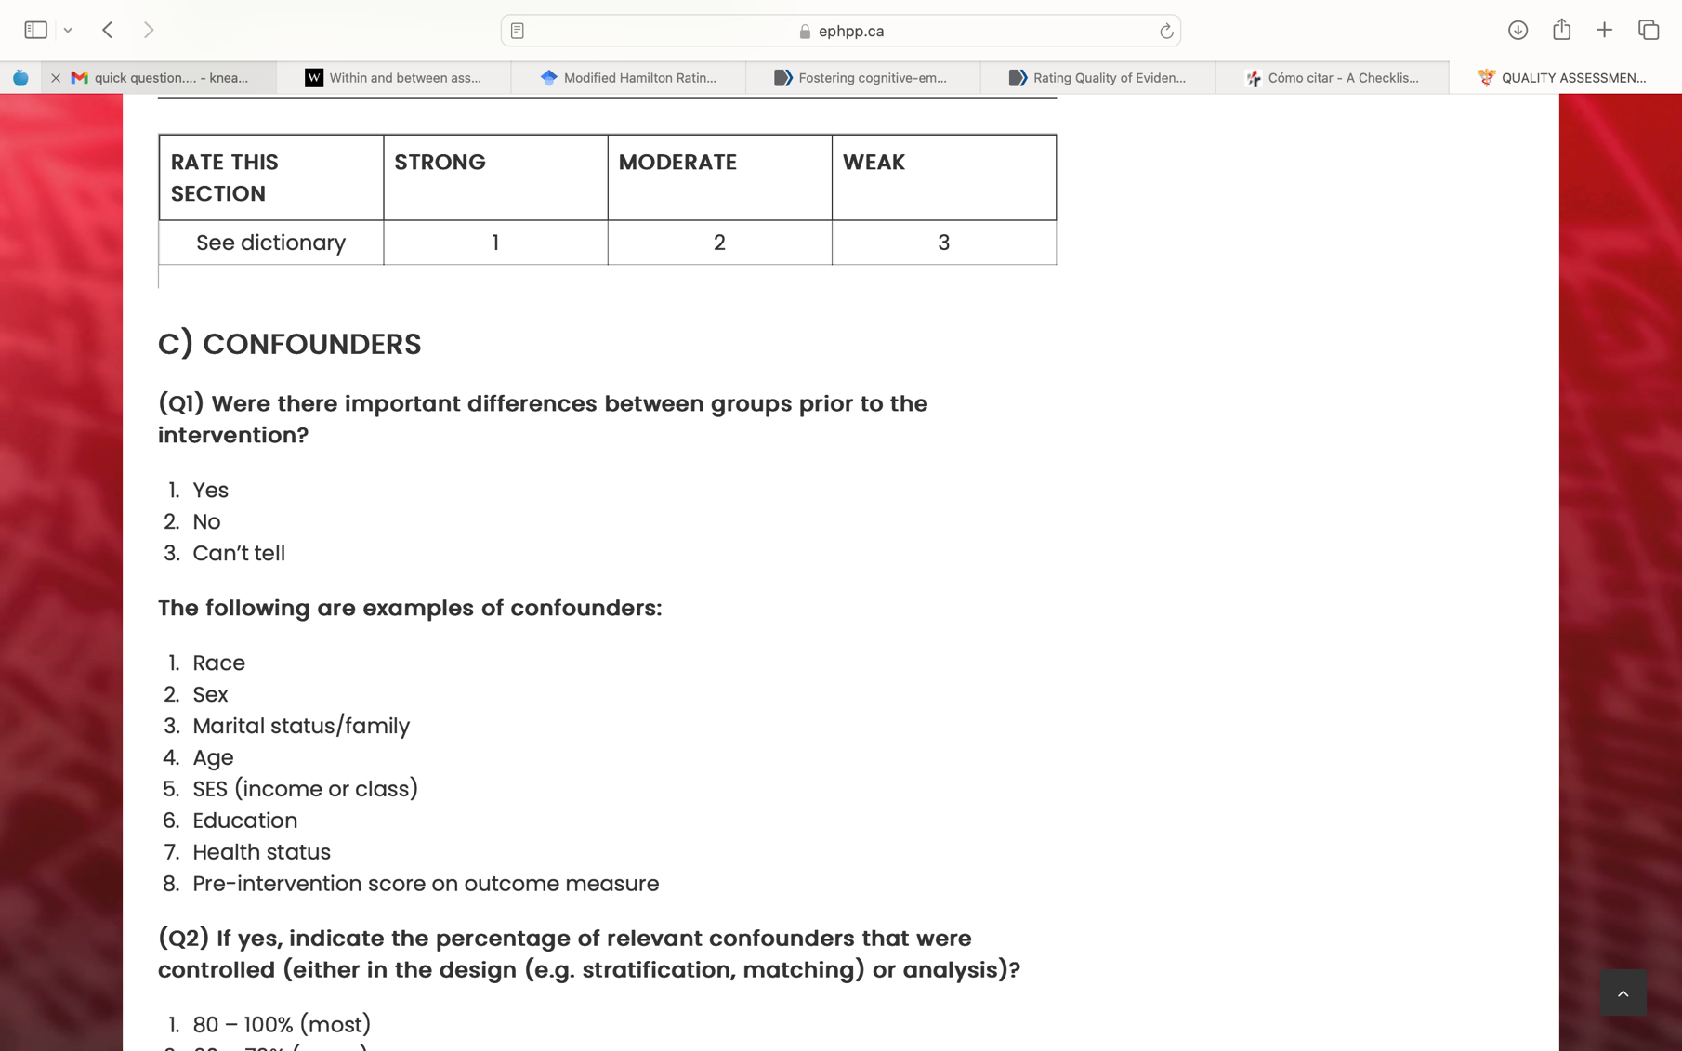

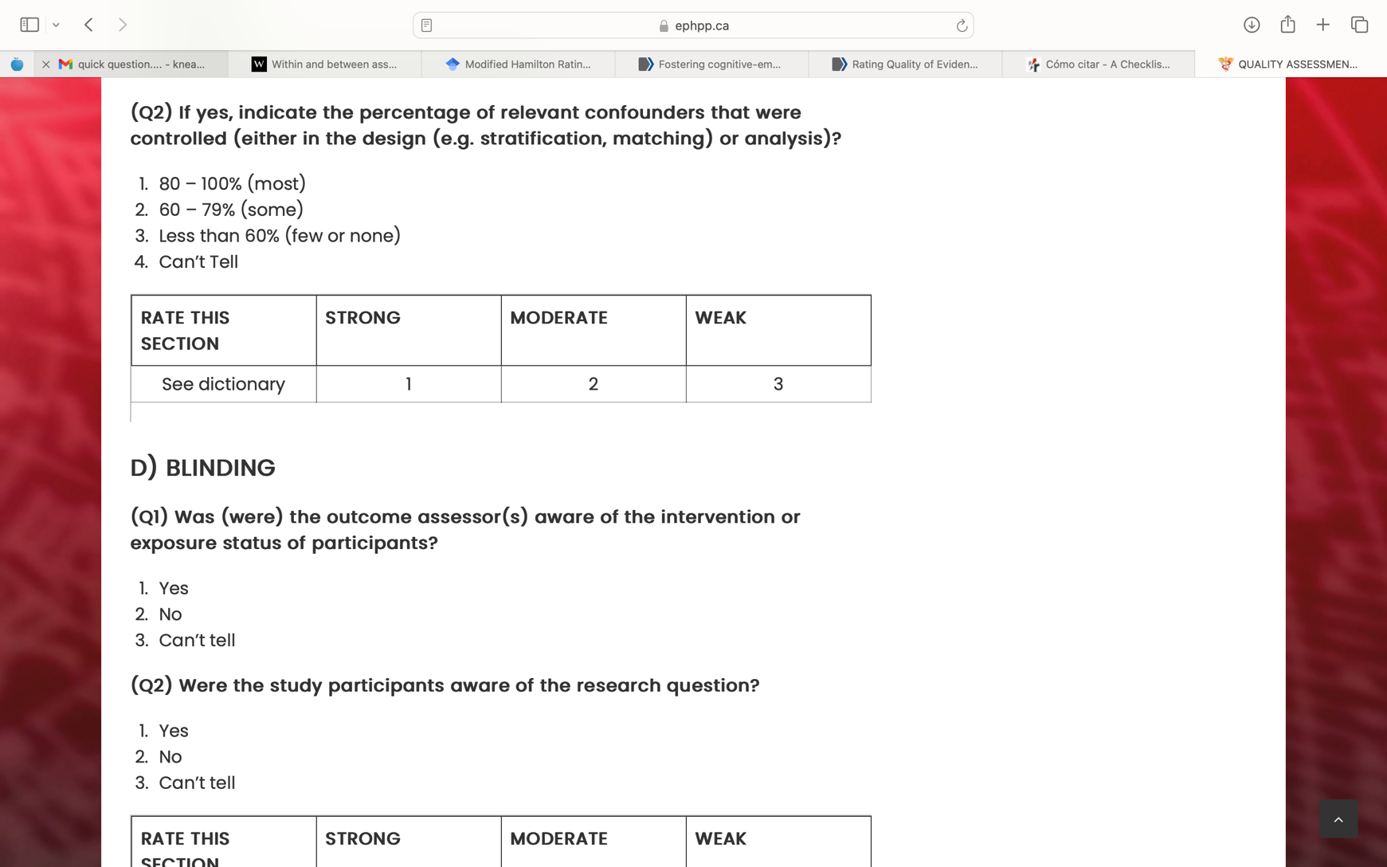

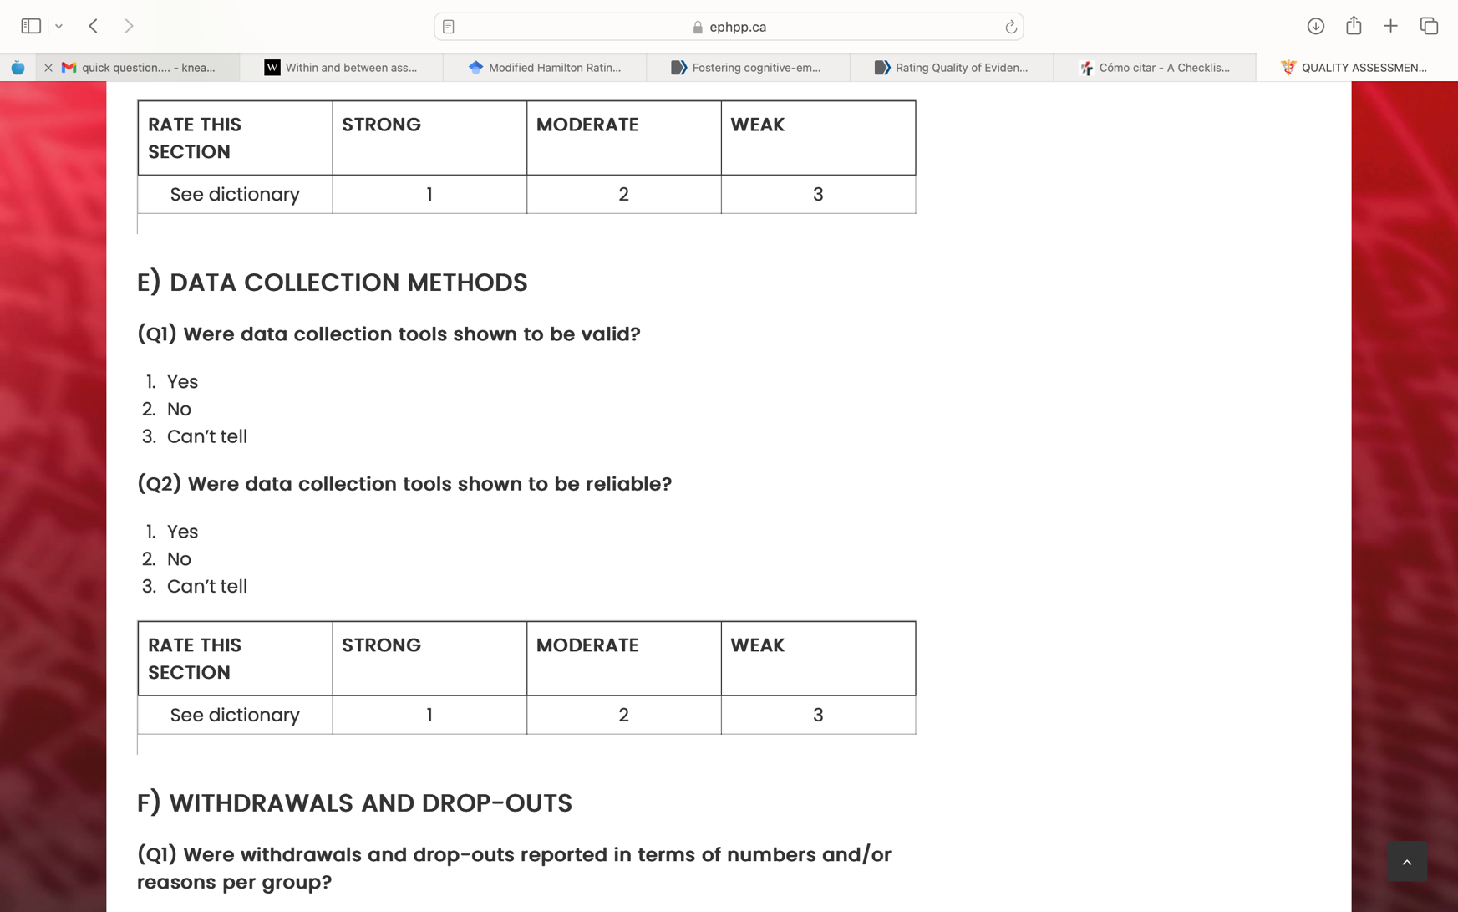

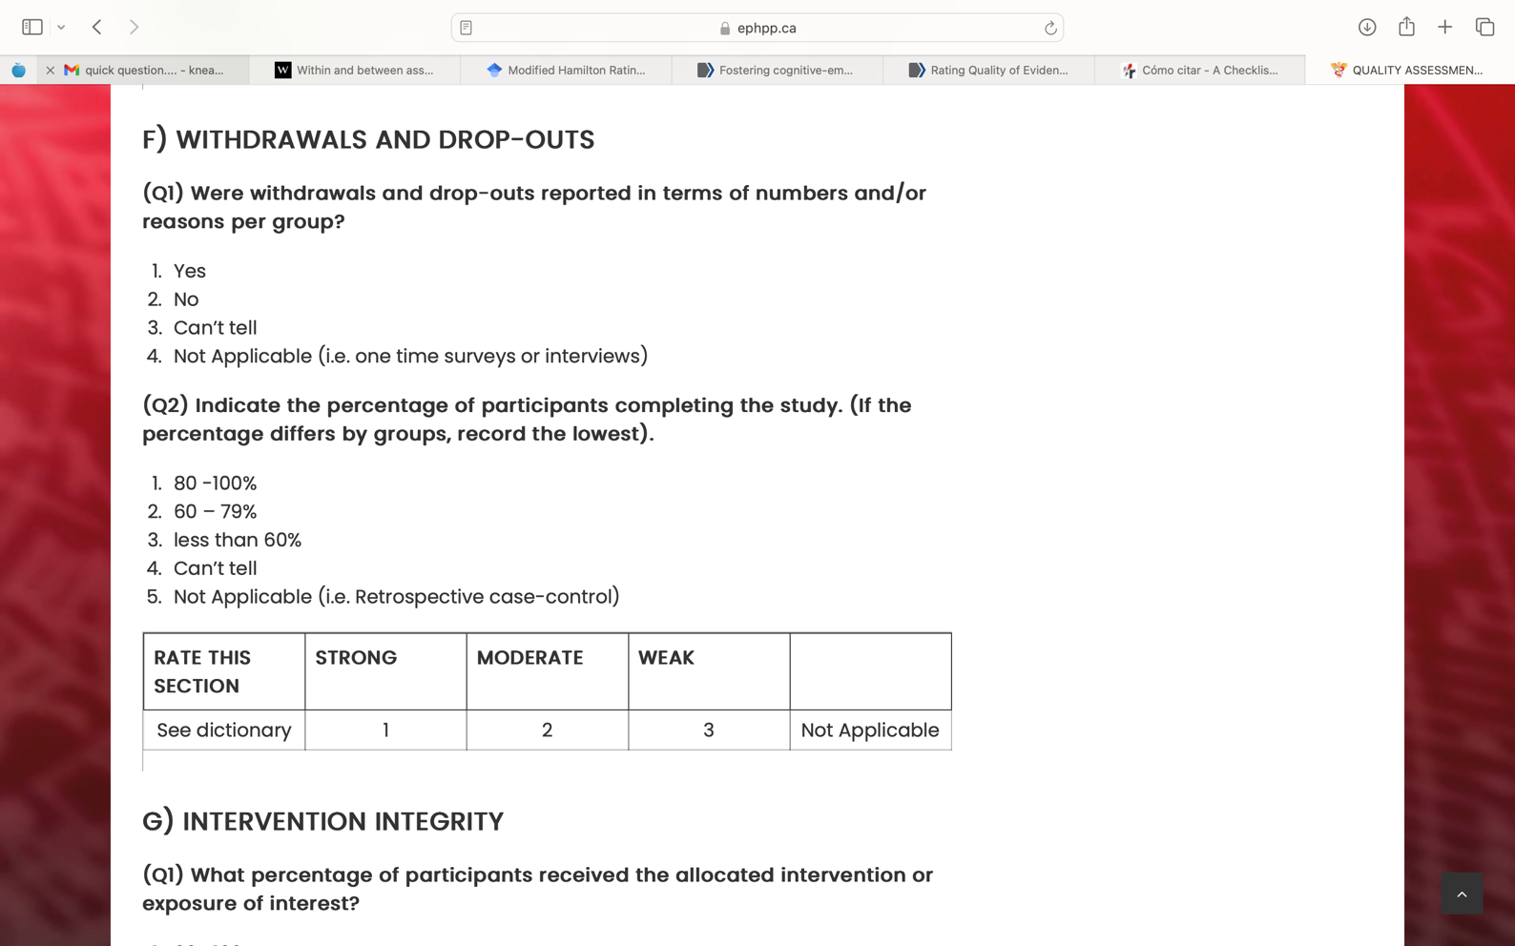

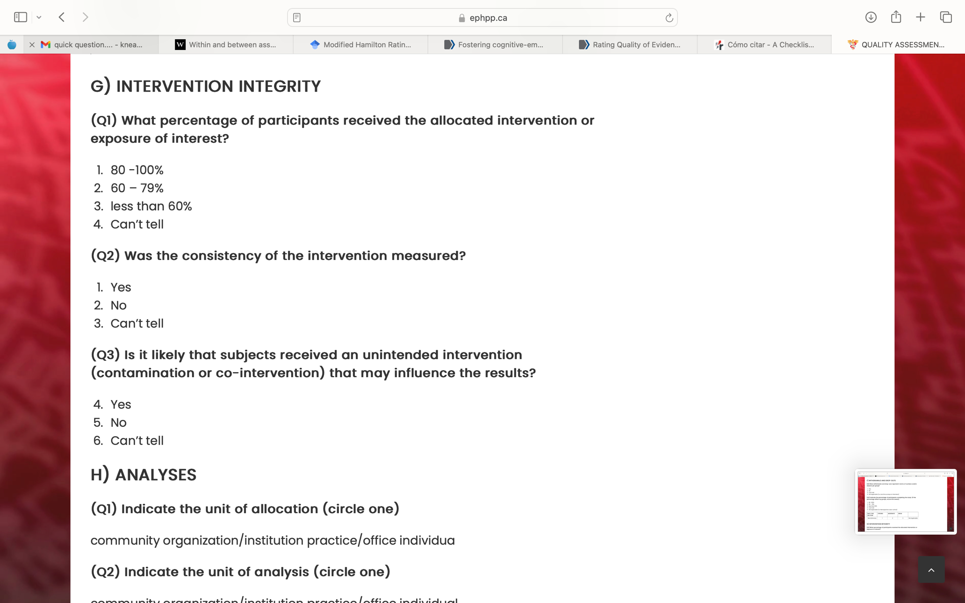

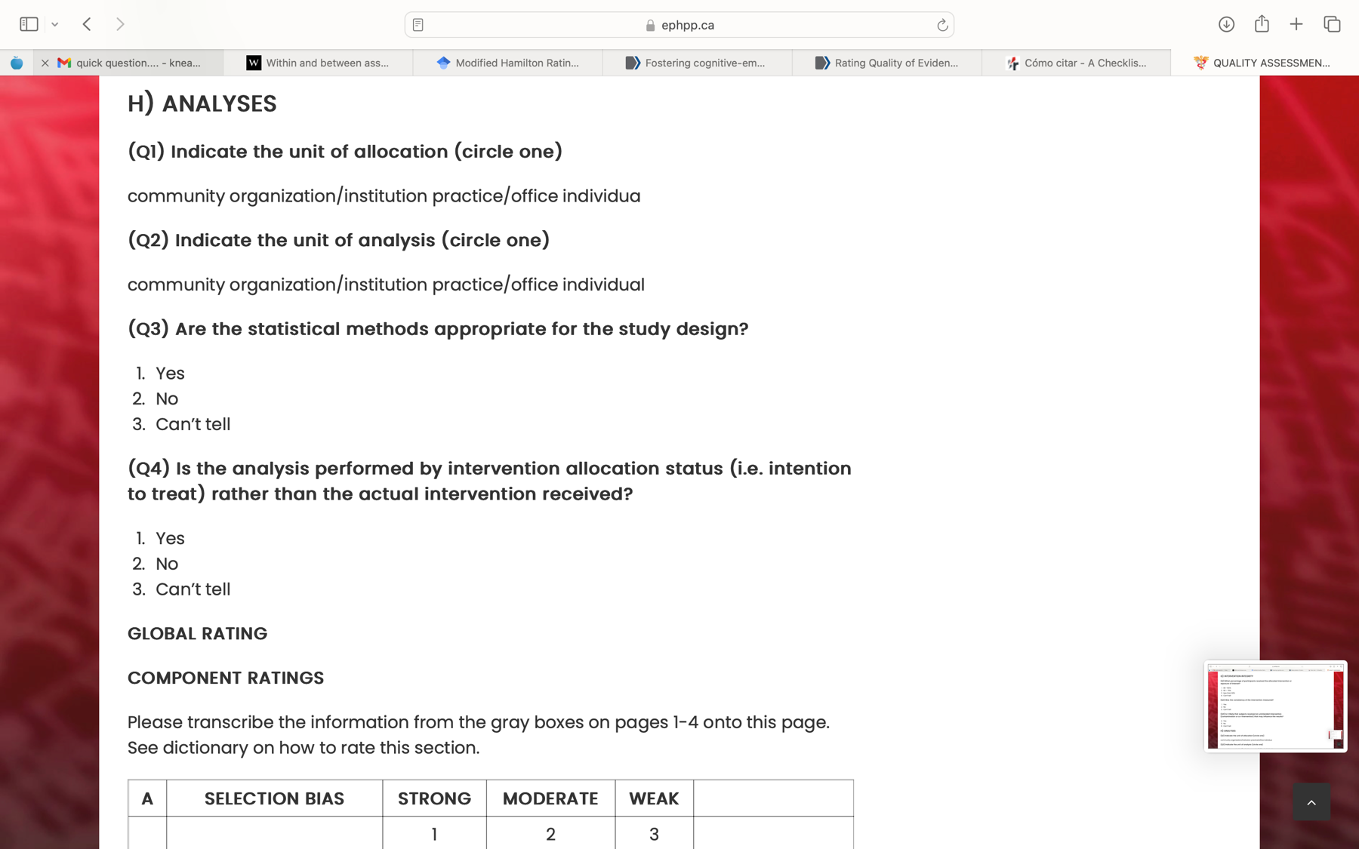

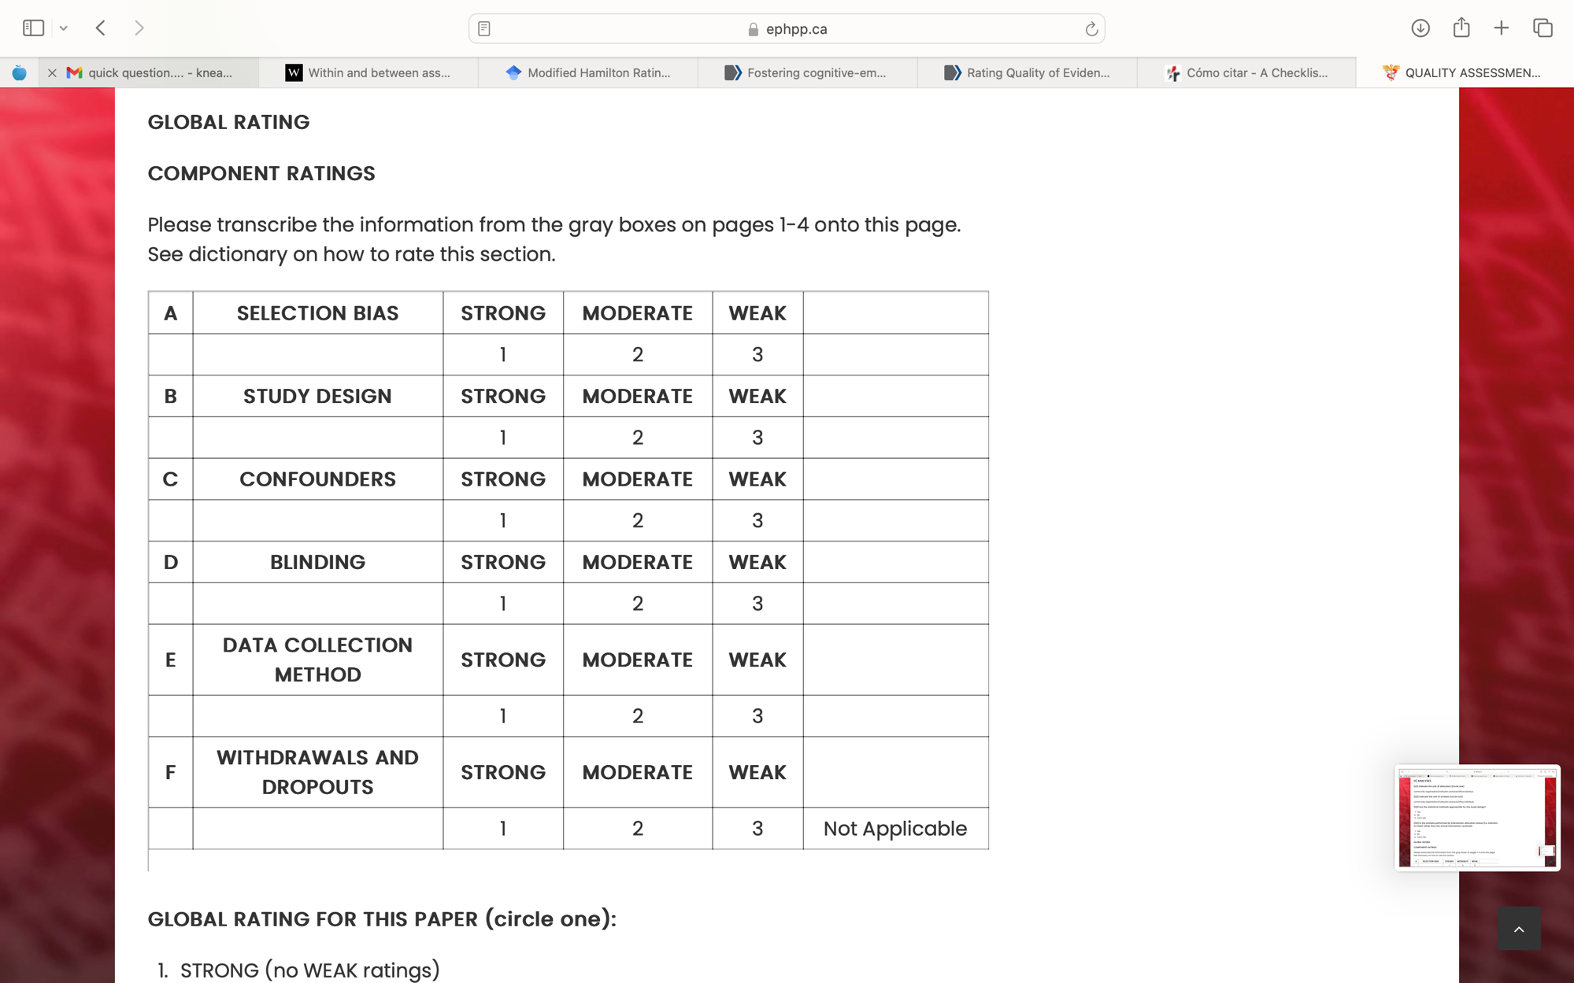

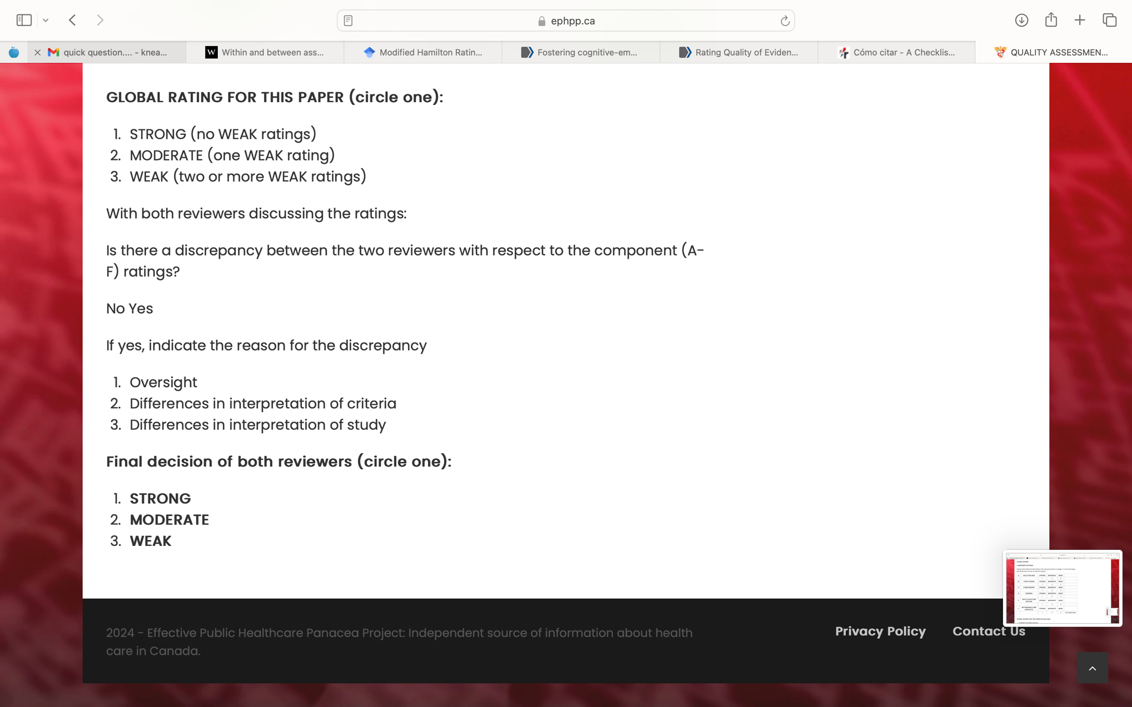

Appendix C
Quality Rating Assessment

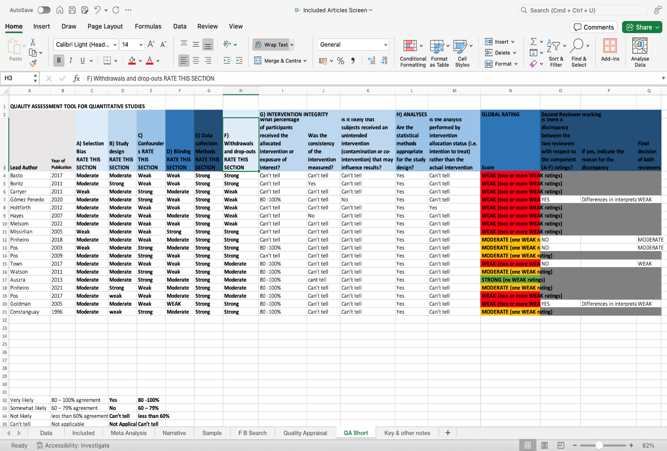

Appendix D
Reasons for Exclusion of Studies
Author(s) | Year | Title | Exclusion Criteria
Abel et al. | 2016 | Sudden gains in cognitive-behavior therapy for treatment-resistant depression: Processes of change | No adequate measure(s)
Adler et al. | 2013 | Narrative meaning making is associated with sudden gains in psychotherapy clients' mental health under routine clinical conditions | No adequate measure(s)
Altenstein et al. | 2013 | Interpersonal microprocesses predict cognitive-emotional processing and the therapeutic alliance in psychotherapy for depression | No adequate measure(s)
Altenstein-Yamanaka et al. | 2017 | Self-reported interpersonal problems and impact messages as perceived by significant others are differentially associated with the process and outcome of depression therapy | Sample not appropriate
Atzil-Slonim et al. | 2018 | Emotional congruence between clients and therapists and its effect on treatment outcome | No adequate measure(s)
Baker et al. | 2008 | The efficacy of problem-focused and emotional approach interventions varies as a function of emotional processing style | Sample not appropriate
Baker et al. | 2011 | Dyadic moderators of the effectiveness of problem-focused and emotional-approach coping interventions | Sample not appropriate
Baker et al. | 2012 | Does CBT facilitate emotional processing? | Sample not appropriate
Barbosa et al. | 2011 | Flexibility between immersion and distancing: A dynamic pattern with effect on depressive symptoms | No adequate measure(s)
Bar-Kalifa et al. | 2020 | Intrapersonal and interpersonal emotional networks and their associations with treatment outcome | No adequate measure(s)
Berking et al. | 2013 | Emotion regulation skills training enhances the efficacy of inpatient cognitive behavioral therapy for major depressive disorder: A randomized controlled trial | No adequate measure(s)
Boritz et al. | 2017 | Narrative flexibility in brief psychotherapy for depression | No association reported
Boritz et al. | 2014 | Narrative and emotion process in psychotherapy: An empirical test of the Narrative-Emotion Process Coding System (NEPCS) | Multiple Publications Based on same study
Brintzinger et al. | 2021 | Patients’ Style of Emotional Processing Moderates the Impact of Common Factors in Psychotherapy | No adequate measure(s)
Browning et al. | 2019 | Predicting treatment response to antidepressant medication using early changes in emotional processing | No psychological intervention
Chhatwal et al. | 2016 | A cognitive-developmental model of emotional awareness and its application to the practice of psychotherapy | No adequate measure(s)
Choi et al. | 2016 | Emotional change process in resolving self-criticism during experiential treatment of depression | Multiple Publications Based on same study
Chu et al. | 2010 | The benefits of meditation vis-à-vis emotional intelligence, perceived stress and negative mental health | No adequate measure(s)
Curtiss et al. | 2014 | Teasing apart low mindfulness: Differentiating deficits in mindfulness and in psychological flexibility in predicting symptoms of generalized anxiety disorder and depression | No adequate measure(s)
Czamanski-Cohen et al. | 2023 | The role of emotion processing in art therapy (REPAT) intervention protocol | No Quantitative Study
de Felice et al. | 2022 | Integration of Cognitive and Emotional Processing Predicts Poor and Good Outcomes of Psychotherapy | No adequate measure(s)
De Smet et al. | 2020 | Change processes underlying “good outcome”: A qualitative study on recovered and improved patients’ experiences in psychotherapy for major depression | No association reported
Dillon et al | 2018 | Transforming core emotional pain in a course of emotion-focused therapy for depression: A case study | No Quantitative Study
Ellison et al. | 2009 | Maintenance of Gains Following Experiential Therapies for Depression | No Quantitative Study
Feldman et al. | 2009 | Change in emotional processing during a dialectical behavior therapy-based skills group for major depressive disorder | Sample not appropriate
Fisher et al. | 2017 | Growth curves of clients’ emotional experience and their association with emotion regulation and symptoms | No adequate measure(s)
Fisher et al. | 2016 | Growth curves of clients’ emotional experience and their association with emotion regulation and symptoms | Sample not appropriate
Fisher et al. | 2020 | Ability to move between self-states and emotional experiencing and processing as predictors of symptomatic change | No adequate measure(s)
Galili-Weinstock et al. | 2020 | Self-compassion among psychotherapy clients is in the details of negative, not positive, emotions | No adequate measure(s)
Gilbert et al. | 2010 | Mindfulness-Based Attention as a Moderator of the Relationship between Depressive Affect and Negative Cognitions | Sample not appropriate
Giles et al. | 2018 | Endurance exercise enhances emotional valence and emotion regulation | No psychological intervention
Goldman et al. | 2006 | The effects of adding emotion-focused interventions to the client-centered relationship conditions in the treatment of depression | No adequate measure(s)
Gonzalez-Escamilla et al. | 2022 | Associating Flexible Regulation of Emotional Expression With Psychopathological Symptoms | Sample not appropriate
Greenberg et al | 2007 | The relationship among emotional productivity, emotional arousal and outcome in experiential theraphy of depression | No adequate measure(s)
Holtforth et al. | 2019 | A randomized-controlled trial of cognitive–behavioral therapy for depression with integrated techniques from emotion-focused and exposure therapies | No association reported
Guastella et al. | 2009 | Sequential growth in cognitive-behavioral emotion-processing: A laboratory study | No psychological intervention
Han et al. | 2020 | A mind-body lifestyle intervention enhances emotional control in patients with major depressive disorder: a randomized, controlled study | No association reported
Heinonen et al. | 2020 | The role of pre-treatment interpersonal problems for in-session emotional processing and long-term outcome in emotion-focused psychotherapy | No adequate measure(s)
Herrmann et al. | 2016 | Emotion categories and patterns of change in experiential therapy for depression | No adequate measure(s)
Hoyt et al. | 2020 | Emotional approach coping in older adults as predictor of physical and mental health | No psychological intervention
Hunt et al. | 1998 | The only way out is through: Emotional processing and recovery after a depressing life event | Sample not appropriate
Hunt et al. | 2007 | Emotional processing versus cognitive restructuring in response to a depressing life event | Sample not appropriate
Katz et al. | 2018 | Psychodynamic technique early in treatment related to outcome for depressed patients | No adequate measure(s)
Kishon et al. | 2020 | Psychological Mindedness and Alexithymia Predict Symptom Reduction in Cognitive Behavior Therapy for Major Depressive Disorder | Sample not appropriate
Kleiven et al. | 2023 | Moments of change: Clients’ immediate experiences when sharing emotions in psychotherapy | No Quantitative Study
Kramer et al. | 2023 | Change in emotional processing in daily life: relationship with in-session self-esteem | No adequate measure(s)
Lynch et al. | 2006 | Mechanisms of change in dialectical behavior therapy: Theoretical and empirical observations | No Quantitative Study
Malik et al. | 2003 | Are all cognitive therapies alike? A comparison of cognitive and noncognitive therapy process and implications for the application of empirically supported treatments | Sample not appropriate
Malin et al. | 2015 | The impact of early empathy on alliance building, emotional processing, and outcome during experiential treatment of depression | No adequate measure(s)
McCarthy et al. | 2017 | Significant change events in psychodynamic psychotherapy: Is cognition or emotion more important? | Sample not appropriate
McNally et al. | 2014 | Transforming emotion schemes in emotion focused therapy: A case study investigation | No association reported
Pascual-Leone et al. | 2009 | Dynamic Emotional Processing in Experiential Therapy: Two Steps Forward, One Step Back | No adequate measure(s)
Pascual-Leone et al. | 2007 | Emotional processing in experiential therapy: why "the only way out is through." | Multiple Publications Based on same study
Piccirilli et al | 2023 | Does emotional processing predict 18-month post-therapy outcomes in the experiential treatment of major depression? | Multiple Publications Based on same study
Pinheiro et al. | 2018 | Emotional processing and therapeutic change in depression: A case study | No adequate measure(s)
Porter et al. | 2016 | No change in neuropsychological dysfunction or emotional processing during treatment of major depression with cognitive-behaviour therapy or schema therapy | No association reported
Rosner et al. | 2000 | Vicarious emotional experience and emotional expression in group psychotherapy | No adequate measure(s)
Røssberg et al. | 2021 | Mechanisms of change and heterogeneous treatment effects in psychodynamic and cognitive behavioural therapy for patients with depressive disorder: a randomizedcontrolled trial | No adequate measure(s)
Rudkin et al. | 2007 | Therapist and client processes affecting assimilation and outcome in brief psychotherapy | No adequate measure(s)
Sindermann et al. | 2022 | Emotion processing in depression with and without comorbid anxiety disorder | No adequate measure(s)
Stiegler et al. | 2018 | Does an emotion-focused two-chair dialogue add to the therapeutic effect of the empathic attunement to affect? | No adequate measure(s)
Town et al. | 2021 | The Anger-Depression Mechanism in Dynamic Therapy: Experiencing Previously Avoided Anger Positively Predicts Reduction in Depression via Working Alliance and Insight | No adequate measure(s)
Town et al. | 2017 | Is affect experiencing therapeutic in major depressive disorder? Examining associations between affect experiencing and changes to the alliance and outcome in intensive short-term dynamic psychotherapy | No association reported
Watson et al. | 2006 | Clients' emotional processing in psychotherapy: A comparison between cognitive-behavioral and process-experiential therapies | No adequate measure(s)
Watson et al. | 1996 | The relationship between vivid description, emotional arousal, and in-session resolution of problematic reactions | No adequate measure(s)
Wiser et al. | 1998 | Therapist interventions and client emotional experiencing in expert psychodynamic-interpersonal and cognitive-behavioral therapies | No adequate measure(s)
Wiser et al. | 1993 | Comparative study of emotional experiencing in psychodynamic-interpersonal and cognitive-behavioral therapies. | No association reported
Wong et al. | 2014 | Interpersonal processes affecting early alliance formation in experiential therapy for depression | No adequate measure(s)
Wright et al. | 2009 | Gender-specific disruptions in emotion processing in younger adults with depression | No psychological intervention
Yasinski et al. | 2020 | Processes of change in cognitive behavioral therapy for treatment-resistant depression: psychological flexibility, rumination, avoidance, and emotional processing | Multiple Publications Based on same study
Zhang et al. | 2016 | Deficits of unconscious emotional processing in patients with major depression: An ERP study | No psychological intervention
Montesano et al. | 2015 | Self-narrative reconstruction after dilemma-focused therapy for depression: A comparison of good and poor outcome cases | No adequate measure(s)
Watson et al. | 2023 | Psychotherapy process research: Identifying productive in-session processes to enhance treatment outcomes and therapist responsiveness. | No Quantitative Study
Harte et al. | 2019 | Processing emotional pain using the expanded Emotion Focused Therapy task of Focusing: A single-session case study | No Quantitative Study
Ernst et al. | 2014 | Emotional awareness and processing in (psychodynamic) psychotherapy | No Quantitative Study
Ince et al. | 2019 | Attachment and depression: The mediating roles of personal life projects and emotional intelligence | Sample not appropriate
Fisher et al. | 2019 | Therapists' interventions as a predictor of clients' emotional experience, self-understanding, and treatment outcomes. | Sample not appropriate
Penedo et al. | 2020 | Theory-specific patient change processes and mechanisms in different cognitive therapies for depression | Multiple Publications Based on same study
Carter et al. | 2021 | Long-term efficacy of metacognitive therapy and cognitive behaviour therapy for depression | No adequate measure(s)
Watson et al. | 2011 | Contrasting Two Clients in Emotion-Focused Therapy for Depression 1: The Case of "Tom," "Trapped in the Tunnel" | No adequate measure(s)
Levenson et al. | 2020 | Enlivening Psychodynamic Brief Therapy with Emotion-Focused Interventions: An Integrative Therapist’s Approach | No Quantitative Study
Lazarus et al. | 2021 | Negative Emotion Differentiation Predicts Psychotherapy Outcome: Preliminary Findings. | Sample not appropriate
McCarthy et al. | 2019 | Process research in psychodynamic psychotherapy: interventions and the therapeutic relationship | No Quantitative Study
Kramer et al. | 2016 | Emotion Measurement - Emotions in clinical practice | No Quantitative Study
Huppert et al. | 2022 | Exposure Therapy when Patients Present with Comorbid Depression | No Quantitative Study
Greenberg et al. | 2024 | Changing emotion with emotion | No Quantitative Study
Toukmanian et al. | 2010 | Change Processes in Clients' Self-Perceptions in Experiental Psychotherapy | No Quantitative Study
Friedlander et al. | 2019 | A close look at therapist contributions to narrative-emotion shifting in a case illustration of brief dynamic therapy | No Quantitative Study
Klug et al. | 2021 | Insight and Outcome in Long-Term Psychotherapies of Depression. | No adequate measure(s)
Probst et al. | 2020 | Patients' interpersonal problems as moderators of depression outcomes in a randomized controlled trial comparing mindfulness-based cognitive therapy and a group version of the cognitive-behavioral analysis system of psychotherapy in chronic depressio | No adequate measure(s)
Sloan et al. | 2006 | The Importance of Emotion in Psychotherapy Approaches | No Quantitative Study
Caspar et al. | 2022 | The impact of integrating emotion focused components into psychological therapy: A randomized controlled trial. | Sample not appropriate
Symington et al. | 2019 | Cognitive and interpersonal predictors and moderators of treatment outcomes in psychological therapy for depression | No adequate measure(s)
Huibers et al. | 2022 | Does psychological process change during psychotherapy predict long-term depression outcome after successful cognitive therapy or interpersonal psychotherapy? Secondary analysis of a randomized trial | No adequate measure(s)
Goldman et al. | 2011 | Contrasting Two Clients in Emotion-Focused Therapy for Depression 2: The Case of "Eloise," "It's Like Opening the Windows and Letting the Fresh Air Come In" | Multiple Publications Based on same study
Høglend et al. | 2019 | Change mechanisms in psychotherapy: Both improved insight and improved affective awareness are necessary. | No adequate measure(s)
Liu et al. | 2018 | Does Sharing Your Emotion Make You Feel Better? An Empirical Investigation on the Association Between Sharing Emotions on a Virtual Mood Wall and the Relief of Patients' Negative Emotions. | Sample not appropriate
Thompson-de Benoit et al. | 2020 | Work with emotions in remote psychotherapy in the time of Covid-19: a clinical experience | No adequate measure(s)
Youngkeun et al. | 2015 | A Theoretical Study About the Roles of Emotional Activation and Repeated Emotional Acceptance in the Counseling Process | Not available in English
Hellerstein et al. | 1998 | A Randomized Prospective Study Comparing Supportive and Dynamic Therapies: Outcome and Alliance | No adequate measure(s)
Wiser et al. | 1993 | Comparative study of emotional experiencing in psychodynamic-interpersonal and cognitive-behavioral therapies. | Sample not appropriate
Hardy et al. | 2001 | Client interpersonal and cognitive styles as predictors of response to time-limited cognitive therapy for depression. | No adequate measure(s)
Watson et al. | 2002 | Comparing the effectiveness of process-experiential with cognitive-behavioral psychotherapy in the treatment of depression. | No adequate measure(s)
Constantino et al. | 2008 | Integrative cognitive therapy for depression: A randomized pilot comparison. | No adequate measure(s)
Kuyken et al. | 2015 | Effectiveness and Cost-Effectiveness of Mindfulness-Based Cognitive Therapy Compared With Maintenance Antidepressant Treatment in the Prevention of Depressive Relapse or Recurrence (PREVENT): A Randomised Controlled Trial | No adequate measure(s)
Watson et al. | 1996 | PATHWAYS TO CHANGE IN THE PSYCHOTHERAPY OF DEPRESSION: RELATING PROCESS TO SESSION CHANGE AND OUTCOME | No adequate measure(s)

Part Two: Empirical Study

A mixed methods design partial replication of clients' emotional processing in psychological therapy for depression: a secondary analysis of the PRaCTICED trial data set.

Abstract
Background:
Understanding the mechanisms accounting for change in psychological therapies for depression remains ambiguous. Considering differences between high and low outcome therapy cases may help to identify factors underpinning effective change. One area of interest is the role of emotional processing.
Objectives:
This study aimed to compare levels of emotional processing, using the Experiencing Scale (EXP; Klein et al., 1969), in depressed clients with high and low change therapeutic outcomes. It was hypothesised that clients with the highest therapeutic change would have higher scores on the EXP scale. A secondary aim of the study focused on differences occurring at different stages of therapy.
Methods:
This study used a mixed methods design. 40 clients were selected from a wider dataset (PRaCTICED Trial) and categorised into high and low change outcome based on pre- and post-intervention scores. A 2x2 ANOVA was used to measure differences in level of emotional processing in high and low therapy outcomes. Logistical regression was used to understand the relationship between emotional processing and high outcomes.
Results:
No differences in the average (modal) levels of emotional processing between high and low outcome cases were observed. Clients with high therapy outcomes demonstrated significantly higher levels of peak emotional processing compared to low change clients. Results further indicated that experiencing higher levels of emotional processing in earlier therapy sessions predicted better therapeutic outcomes.
Conclusions:
This study supports previous research indicating that emotional processing plays a role in achieving psychological outcomes, with a moderate correlation between peak scores and high therapy outcomes.

Key Words: depression, emotional processing, psychological therapies, change mechanisms, EXP scale.

Practitioner Points:
- Emotional processing level (i.e., ability to be aware of and allow the experience of emotions) may account for level of change in psychological therapy.
- Encouraging clients to improve their emotional processing ability at earlier stages of therapy may allow for a deeper understanding of their problem and help to facilitate longer lasting change.
- Psychological therapy should begin to consider strategies and methods that allow for emotional processing to be developed over the course of therapy.
- Emotional processing may not need to occur at advanced levels to achieve good therapy outcomes and is not always required to be present throughout the session.

Introduction
Depression
Depression, also referred to as major depressive disorder (MDD) or clinical depression, is characterised by persistent feelings of sadness and hopelessness, alongside a loss of interest in previously enjoyed activities. The Diagnostic and Statistical Manual of Mental Disorders (5th ed.; DSM–5; American Psychiatric Association, 2013) states that symptoms must persist for a minimum of two weeks to be diagnosed as MDD. Individuals must present with five or more of the following symptoms; (a) depressed mood for most of the day, (b) markedly diminished interest in most activities previously enjoyed, (c) significant changes in appetite (either reduced or increased) , (d) slowing down of thought and/or reduction of physical movement, (e) fatigue, (f) feelings of worthlessness, (g) diminished concentration and, (h) recurrent thoughts of death (APA, 2013).
Depression remains a global primary public health concern. According to the World Health Organisation (WHO; 2023) an estimated 3.8% of the global population have a diagnosis of depression, equating to approximately 280 million people worldwide. A recent review of the global prevalence of depression indicated that rates are continuing to show rise (Moreno-Agostino et al., 2021). Despite being one of the leading courses of disability worldwide (Institute for Health Metrics and Evaluation, 2019), many people with depression lack sufficient treatment (Thornicroft et al., 2017).

Psychological Treatment of Depression
Psychological therapy for the treatment of depression frequently produces positive client outcomes (Cuijpers et al., 2011, 2020; Driessen et al., 2010; Kolovos et al., 2016), suggesting that effective interventions reduces depressive symptomology. Different models of psychological therapy propose that specific mechanisms of change are responsible for effective and successful treatment. For example, the modification of depressive cognitions in cognitive therapy is based on the theory that such cognitions lead to the development and maintenance of depression (Beck, 1979). Alternatively, person-centred therapy derives from Roger’s (1946; 1957) early theories that distress might exist within the client, leading to feelings of vulnerability and anxiety, and therapy should provide a non-judgmental space for honest reflections between the client and therapist.

Measuring Change in Psychological Therapy
Decades of research has been devoted to examining whether psychological therapy produces an effective client change. Several trials and meta-analyses advocate for the efficacy and effectiveness of psychological therapy (e.g., Dragioti et al., 2017). Research is evolving and is now focused on attempting to understand the change mechanisms involved in successful client outcomes (Lemmens et al., 2016). Several theories have attempted to describe why change happens; however, they often make assumptions about mechanisms of change without being scientifically tested, resulting in incomplete knowledge about why change happens in psychological therapy.
A systematic review identified the lack of understanding regarding the psychological mechanisms underlying the various treatment models for depression, and highlighted that limited evidence exists showing that effective mechanisms of change are unique to specific treatment modalities (Lemmens et al., 2017). Therefore, research attempting to understand mechanisms of change is essential (Antichi & Giannini, 2023).

Emotional Processing
One of the proposed mechanisms thought to be accounting for effective change is the emotional processing ability of the client. First defined by Rachman (1980), emotional processing refers to the ability to cope with emotionally distressing experiences and the requirement to process intense emotions in the absence of excessive rumination (Foa & Kozak, 1986). This phenomenon helps to explain the development and maintenance of some common mental health difficulties, including depression. Whilst it is usual to experience fear, sadness, and anxiety, in most circumstances these experiences only result in short-term distress. Difficulties may develop when emotional distress is not appropriately processed (Joormann & Quinn, 2014; Pos et al., 2003).
Some models of psychological therapy, such as experiential therapy, extend the emotional processing definition by viewing emotion as an adaptive form of information gathering, rather than a problematic mechanism (Greenberg & Safran, 1984). In line with the original definition (Rachman, 1980), experiential theorists propose two stages of emotional processing which firstly involves noticing the emotional experience, and secondly learning to tolerate it (Fiedler et al., 2020; Greenberg, 2008; Greenberg & Pascual-Leone, 1995). This approach suggests that depression may be related to incomplete processing of emotional experience (Pinheiro et al., 2021; Pos et al., 2003), indicating that emotional processing is an essential part of psychological therapy needed to achieve successful change outcomes (Pascual-Leone et al., 2018).
Research exploring the role of emotional processing in psychological therapies has shown that emotional processing ability is associated with therapy outcome (Pascual-Leone, 2018; Pinheiro et al., 2021; Sønderland et al., 2023). More successful therapeutic outcomes are associated with higher levels of emotional processing, and overall increased improvement (e.g., De Smet et al., 2020; Fisher et al., 2020; Pos et al., 2017). In different therapeutic approaches, emotional processing has been associated with improvements in depressive symptoms (e.g., Auszra et al., 2013; Baker et al., 2011; Pos et al., 2017).
Improvements in emotional processing in cognitive behavioural therapy (CBT) tend to be viewed as incidental (Baker et al., 2012). Results comparing CBT to other therapeutic models for the presence of emotional processing are mixed, with some reporting no differences between CBT and psychodynamic-interpersonal therapy (Coombs et al., 2002), and others concluding that experiential and psychodynamic therapies facilitate emotional processing more effectively than CBT (Rudkin et al., 2007). Watson and Bedard (2006) compared clients’ emotional processing in “good” and “poor” outcome cases in CBT and process-experiential therapy (PET). They found that clients receiving PET demonstrated higher levels of emotional processing during therapy than those receiving CBT. Given that CBT is one of the recommended treatments for depression (National Institute of Clinical Excellence; NICE, 2022), it is important to better understand the role of emotional processing in this modality.
Despite differences across models, emotional processing is a consistent predictor of outcome in depression, both in emotion focused therapies (e.g., Goldman et al., 2005; Pos et al., 2003, 2009, 2017) and CBT (Castonguay et al., 1996; Watson et al., 2011). Specifically, clients who demonstrated greater emotional processing abilities showed greater improvement in depression symptoms. A meta-analysis of 10 studies and 406 clients resulted in an estimation that levels of emotional processing has a small to medium effect size in predicting outcome (r = -.19; Pascual-Leone & Yeryomenko, 2017).

Limitations of Current Evidence
The rigorous exploration of the psychotherapeutic process spans several decades of research, dating back as early to the work of Carl Rogers in the 1940’s (Barkham, Lutz, et al., 2021; Krause, 2024). Although the field of psychological therapy change process has continued to grow and develop, the cumulative findings only yield a small number of robust and distinct findings. A recent review by Krause (2024) systematically interpreted over a decade’s worth of process research and found that several process variables dominate the field. Therapeutic intervention, i.e. the model of psychological therapy used, was amongst the highest variable investigated and results highlighted the complexity of associating intervention with outcome. This highlights the need for more research into other possible process variables, particularly ones that are less well understood. It also indicated the need to focus less on specific outcomes, and more on the underlying mechanisms.
Regardless of these limitations, psychological therapy process research remains influential in its aim to understand change mechanisms and continues to be widely implemented (Krause, 2024).

Clinical Implications
Beyond testing intervention effectiveness, there is a recognised need to better understand the essential components of psychological treatments. Understanding the mechanisms accounting for change can help to clarify the relationship between treatment and different outcomes, optimise therapeutic change, and improve understanding of human functioning beyond the therapeutic setting. This knowledge is essential in helping clinicians to better tailor their interventions if research informs them about the nature of change in psychological therapies.

Aims & Hypotheses
The main aim of the current study was to compare levels of emotional processing in clients with high and low change therapeutic outcomes using cases from CBT and person-centred experiential therapy (PCET). A secondary aim of the study was to identify if emotional processing increased over the course of therapy between the two groups.
Based on the previous research, it was hypothesised that clients with the highest change outcomes would have higher scores on the emotional processing scale, suggesting that they are better able to process their emotions. A second hypothesis was that change between early and middle therapy sessions should be greater in the high change group.

Method
Design
The current study is a mixed methods partial replication of the Watson and Bedard (2006) study referred to previously. Watson and Bedard (2006) highlighted the importance of replicating their findings to further clarify the role of emotional processing in psychological therapies. The current study replicates the design used by Watson and Bedard (2006) by using the same sample size (N = 40) and selection procedure by using an equal split of high and low therapy cases (i.e., a 50:50 split), as well as an equal amount of different therapy modalities. The current study also replicated the use of the Experiencing Scale (EXP scale; Klein 1969).
The study uses data collected from the PRaCTICED trial, a pragmatic non-inferiority randomised controlled trial of the clinical and cost effectiveness of person-centred experiential therapy (PCET) versus cognitive-behavioural therapy (CBT) (Barkham, Saxon, et al., 2021; Saxon et al., 2017). The current study is also linked to a study using the same data to investigate the role of emotional processing across two different treatments: CBT vs. PCET (JI, Trainee Clinical Psychologist; see Appendix B). This study was registered on AsPredicted (reference number 140892).
The PRaCTICED trial received NHS ethical approval by the Health Research Authority (Research Ethics Committee 14/YH/0001). Participants provided informed consent and the subsequent secondary research carried out in this study was within the remit of the ethics approval. The current project received ethical approved via the University of Sheffield’s Ethics Review Procedure, as administered by the Department of Psychology (Appendix E).

PRaCTICED Trial Overview
The PRaCTICED Trial was a pragmatic, randomised, non-inferiority trial comparing the clinical efficacy and cost-effectiveness of PCET and CBT within the then named Sheffield Improving Access to Psychological Therapy (IAPT) service, now rebranded nationally as the NHS Talking Therapies for Anxiety and Depression service.
The PRaCTICED trial was embedded within the Sheffield Talking Therapies Service which routinely delivers both CBT and PCET, previously known as Counselling for Depression (CfD; Sander & Hill, 2014), and more recently renamed as person-centred experiential-counselling for depression (PCE-CfD; Murphy, 2019). In the original trial it was named person-centred experiential therapy (PCET) but delivered by the profession of counsellors. All therapists and counsellors were appropriately trained in the delivery of their therapy model and received supervision from qualified professionals. Selected tapes of sessions were randomly assessed by external raters for adherence to each model. Clients were offered a maximum of 20 sessions in either intervention and, once randomised, received treatment as standardly delivered within the service.
There were 18 trained PCET counsellors (16 female) with a varied age range (two below 50 years old, nine 50-59, and seven aged 60 and above). The average (mean) number of years’ experience of delivering PCET was 4.6 years, and an average (mean) of 16.6 years of professional practice. The median number of trial participants per counsellor was eight. There were 32 CBT therapists (25 female), with the majority aged below 50 years old (N = 31). They had an average (mean) of eight years of professional practice, and five (median) clients within the trial.
The PRaCTICED trial was based in Sheffield, which has average demographics in comparison to other cities across the UK (Saxon et al., 2017). Participants were assessed for eligibility and consented to participate over two stages. Clients who did not meet the criteria for the trial received treatment as usual within the service. Clients were eligible to be included in the PRaCTICED Trial if they were: (a) aged 18 years or over with a diagnosis of major depression, (b) assessed as requiring stepped up care, and (c) were willing to be randomised to either CBT or PCET. Clients were excluded if there was: (a) a presence of long-term health condition or illness of organic origin (e.g., dementia), (b) presence of other mental health conditions (e.g., psychosis or personality disorder), (c) current alcohol or drug dependency, and (d) a risk of suicide.
During the recruitment period of the trial (November 11th, 2014, to August 3rd, 2018) 9,898 clients were referred for step three treatments in the IAPT service for common mental health problems, of whom 761 (7·7%) were referred to the PRaCTICED trial. Recruitment ceased at 510 participants, accounting for 67% of those referred to the trial. Of these 510, 254 were randomly assigned to receive PCET, and 256 were randomly assigned to receive CBT (figure 1).

Figure 1
Flow diagram for patient selection
10 clients with the highest change scores identified
10 clients with the lowest change scores identified
10 clients with the highest change scores identified
10 clients with the lowest change scores identified
47 clients ranked on clinical changes using the PHQ9 change scores between first and last session
46 clients ranked on clinical changes using the PHQ9 change scores between first and last session
47 clients had audio recordings of session two and six
46 clients had audio recordings of session two and six
121 completed first and last session outcome measures (PHQ9 & GAD7)
98 completed first and last session outcome measures (PHQ9 & GAD7)
256 assigned to CBT
254 assigned to PCET
510 clients randomised within the PRaCTICED trial

Participants
Forty clients were selected from a larger treatment study of depression (PRaCTICED Trial; Barkham, Saxon, et al., 2021). The clients used in current study had an age range between 19 - 65 years old, with an average age of 41 years old. The sample were mostly White British (see Table 1). Severity on the Patient Health Questionnaire (PHQ-9; Spitzer et al., 2009) was not a criterion for acceptance into the PRaCTICED trial, however, is used in the current study as a screen for depression. Before treatment, all clients except one (N=39) met the cut off for clinical threshold (Patient Health Questionnaire 9, or PHQ-9; M: 19.35, SD: 4.74). Severity levels of the sample were as follows: 45% (N=18) were classified as severely depressed, 40% (N=16) were moderately severe, 12.5% (N=5) moderate, and 2.5% (N=1) were mild based on the PHQ-9. Although the PRaCTICED trial used the Clinical Interview Schedule – revised (CIS-R; Lewis et al., 1992), the PHQ-9 was used in the current study as the CIS-R provided a baseline diagnosis but was not used thereafter. The PHQ-9 was used at each session, meaning it was closer to measuring change (but was not used as a threshold for inclusion into the trial).

Table 1:
Demographic information of the study sample
Demographic Category | Frequency | Percentage
Gender
Female | 18 | 45
Male | 22 | 55
Ethnicity
White British | 36 | 90
Asian, or Asian British Pakistani | 1 | 2.5
Black, or Black Caribbean | 1 | 2.5
Asian, Other | 1 | 2.5
White, Other | 1 | 2.5
Treatments
Person Centred Experiential Therapy (PCET).
PCET is drawn from humanistic and experiential approaches (for a review, see Elliott et al., 2021) and is a treatment developed for the management of depression. In the PRaCTICED trial, therapy was standardised using a manual based on the book titled “counselling for depression: a person-centred and experiential approach to practice” (Sanders & Hill, 2014).

Beckian Cognitive Behavioural Therapy (CBT).
The CBT protocol used in the PRaCTICED trial was based on cognitive therapy for the treatment for depression (Beck et al., 1979). The treatment comprised of cognitive therapy with behavioural components, such as daily activity logs and behavioural experiments. The delivery of CBT was standardised by the adoption of the text “cognitive behaviour therapy: basics and beyond” (2nd edition; Beck, 2004).

Measures
Several outcome measures were collected as part of the PRaCTICED trial. However, not all measures, assessments, and information collected at the intake interview were used in the current study.

Patient Health Questionnaire-9 (PHQ-9).
The primary outcome measure was the PHQ-9 (Kroenke et al., 2001; Spitzer et al., 2009), which is a brief (9-item), self-report 4-point Likert scale measure of depression corresponding to each of the nine DSM-5 criteria for depression (see Appendix C). Clients self-rate how often they have been affected by symptoms of depression over a 2-week period. Individual item scores range from 0 (“not at all”) to 3 (“nearly every day”) with total PHQ-9 scores ranging from 0 to 27. Scores of 10 and above are determined as meeting clinical threshold. Scores of 5–9 are classified as mild, 10–14 are moderate, 15–19 are moderately severe, and 20–27 are severe levels of depression. The measure has an internal reliability of 0.89 and a test-retest reliability of 0.84 (Kroenke et al., 2001). The PHQ-9 was administered for each client at screening, at the beginning of each therapy session, and at the end of treatment.

The Experiencing Scale.
The Experiencing Scale (EXP; Klein et al., 1969) describes seven levels of an individual’s emotional and ongoing experiences and measures depth of experiencing (Klein et al., 1986; see Appendix D). The measure allows researchers to code written and/or audio texts passage-by-passage and rate the individual utterances according to the seven levels of defined emotional processing. Lower levels of the scale capture unengaged levels of experiencing, wherein the client describes external events in a removed and neutral manner. At the higher levels, clients demonstrate introspective skills as they begin to process their emerging experience to create new meanings (Klein et al., 1986).
Averaging discrete ratings over therapy, or in segments, produces an overall estimate of the quality of the client’s work, making the scale suitable for measuring change. Interrater reliability coefficients range from .76 to .91, with rating–rerating correlation coefficients around .80 (Klein et al., 1986). Despite originating from the humanistic-experiential tradition, the EXP scale has been used effectively in research examining different psychological models, such as CBT (e.g., Watson & Bedard, 2006). While the content of sessions may vary significantly, the measure continues to capture depth of processing, irrespective of treatment approach (Pascual-Leone & Yeryomenko, 2017).

Procedure
Patient Selection
Clients who had completed a minimum of seven therapy sessions, had available audio recordings for sessions two and six, and provided first and last session data were selected. The clients were then ranked based on their change scores on the PHQ-9 from the start of therapy to their final session. Clients with significant and meaningful change were ranked higher than those with no clinical or significant change. In total, 219 clients had seven or more sessions (121 CBT; 98 PCET), 193 had first & last PHQ9 (105 CBT; 88 PCET), and 93 had recordings of both session two and six (47 CBT, 46 PCET). This was the sample used to rank ‘most and least change’ for both treatments. Please refer to Figure one.
The 20 clients with the highest change in scores (i.e., a decrease in scores) on the PHQ9 within each therapy modality (CBT and PCET) were selected as the “high” therapy outcome cases. The 20 clients with the least amount of change, or those who deteriorated (i.e., increase in scores), as measured on the PHQ9 were classified as the “low” therapy outcome cases. There were no significant differences between the high and low therapy groups at intake. In summary, the total sample included 40 clients grouped in the following way: ten high therapy cases from CBT, 10 high therapy cases from PCET, 10 low therapy cases from CBT, and 10 low therapy cases from PCET. This design is a replication of Watson & Bedard (2006).
Clients meeting the criterion for high therapy outcome cases had an average (mean) pre-therapy score on the PHQ-9 of 21.53, falling within the severe range for symptom severity. All clients, apart from one who was categorised as moderately severe, scored within the severe range. The average post-therapy score was eight, indicating mild symptom severity and falling below the clinical threshold. All clients’ scores, except one, fell to below clinical threshold on the PHQ-9 at post-intervention, meeting the reliable change criteria.
Clients meeting the criterion for a low therapy outcome case had an average (mean) pre-therapy score on the PHQ-9 of 19.9, falling within the moderately severe range for symptom severity. One client scored within the mild symptom severity range, three were moderate, nine were moderately severe, and seven were severe. The average post-therapy score was 16.71, indicating that symptom severity remained within the moderately severe range. All clients’ scores remained above clinical threshold on the PHQ-9 at post-intervention. Within that, two clients showed no change, 10 clients improved (mean: 3.2), and eight clients showed deterioration (mean: -5.75).

Session Selection
Klein et al. (1969) recommended that at least two time points are reviewed in therapy, especially if EXP is being considered in relation to outcome. Sessions were selected from the beginning and middle stages of therapy as Watson and Bedard (2006) found this was where most change in the EXP scale occurred. Therapy sessions two and six were used for the qualitative ratings. The middle 20 minutes (20 minutes following the initial 20 minutes) were selected for rating as it typically represents the “working segment” of a therapy session (Watson & Bedard, 2006). All utterances occurring between the therapist and the client were rated on the EXP scale. The audiotape for one patient was not available, so the next highest rated change sessions were rated in its place.

Ratings.
The rating team consisted of the lead author (KN) and another trainee clinical psychologist working on a linked project using the same sample (JI; see Appendix B). Audio extracts of sessions were analysed and rated using the EXP scale (Klein, 1969). Copies of the original training materials developed by Klein et al., (1969) were obtained and used to calibrate initial training between the two raters. Raters were instructed to give each segment a peak rating (the highest stage reached) and a modal rating (stage for most of the segment) on the EXP scale. Both raters practiced by using transcripts from the training materials, and some randomly selected PRaCTICED trial sessions that were not selected to be used in the study. In line with the training manual, interrater reliability was assessed using a two-way mixed model of intraclass correlations (Shrout & Fleiss, 1979). The correlations for modal and peak ratings, respectively, were significant: r =.94, p <.001; r = .93, p < .001. Intraclass correlation coefficient values greater than 0.90 indicate excellent reliability (Klein et al., 1969).
Following completion of training, each rater rated half of the study audio transcripts (N=40). All utterances (talk-turns) in the selected therapy sessions were rated using the EXP scale, creating a modal and a peak score for each session. After each rater rated 10 transcripts, the two raters rated the same transcript to calibrate agreement and with the aim of reducing drift. To reduce researcher bias, the raters were blind to the identity of the therapy group and outcome status of the patient. However, due to the raters’ background in psychology and training in clinical psychology, it is challenging to be blind to the type of therapy (PCET or CBT) sessions. The clients in the trial were not aware of the aims of this study and were therefore blind to the variables being tested.

Statistical Analysis
Data was analysed using SPSS version 29.0.1.0 (171). A two-way ANOVA was conducted to examine the main effects of the therapy outcome and to address the hypothesis that better outcomes are associated with higher EXP scores. The mean EXP score for both outcomes were calculated. The second hypothesis was addressed by identifying the main effect of session time (early or middle) on EXP scale to identify if EXP was significantly higher in either period. The mean scores of EXP were calculated for early and middle sessions. Interaction effects were reported.
In addition, secondary analyses using multiple logistical regressions were conducted to examine if EXP scores were associated with different therapy outcomes. Depression severity is known to be a significant predictor of therapy outcomes (Antichi & Giannini, 2023; Driessen et al., 2010) therefore this was also entered into the model using PHQ-9 scores at screening. Correlation coefficients are categorised in accordance with Dancey and Reidy (2004) as weak (0.20–0.29), moderate (0.30-0.39), strong (0.40-.069), and very strong (>0.70) relationships.

Results
Mean Modal Ratings
To determine whether there were any differences between clients’ emotional processing and psychological therapy outcome, the mean modal scores of the EXP ratings were subjected to a 2 x 2 ANOVA, with outcome (high or low) as the between-subjects factor, and the stage of therapy (session two or six) as the repeated within-subjects factor. The means and standard deviations for clients’ mode EXP scores are presented in Table Two.
Normality checks and Levene’s test were carried out showing that data distribution was skewed (see Appendix F) and equal variance could not be assumed (Box’s M = 11.76 and F(3, 399135) = 3.7, p = .011). There are no equivalent tests in SPSS, therefore the ANOVA is still reported.

Neither the outcome effect, F(1,38) = 3.003, p = .091, nor the EXP effect, F(3,99) = 2.06, p = .159, were significant, indicating that the mean levels of EXP did not differ across early or middle sessions of therapy (with results averaged across the treatment groups). The interaction between therapy outcome and stage of therapy was also non-significant, F(1, 38) = .181, p = .673.

Table 2
Means and Standard Deviations of the Modal EXP Ratings Across Therapy Stage and Outcome.
 | PHQ-9: Outcome | EXP:  Mean | EXP:  Std. Deviation | N
S2 Mode | Good | 2.05 | .21 | 20
 | Poor | 1.86 | .48 | 20
 | All | 1.95 | .39 | 40
S6 Mode | Good | 2.32 | .67 | 20
 | Poor | 2.00 | .95 | 20
 | All | 2.15 | .83 | 40

Mean Peak Ratings
To determine whether there were any differences between clients’ emotional processing and therapy outcome, the mean peak scores of the EXP ratings were subjected to a 2 x 2 ANOVA, with outcome (high or low) as the between-subjects factor, and the stage of therapy (session 2 or 6) as the repeated within-subjects factor. The means and standard deviations for peak EXP scores are presented in Table Three.
Normality checks and Levene’s test were carried out and assumptions were met (see appendix F). Variances and covariances were homogeneous across the groups, meaning the assumption of homogeneity was satisfied and the ANOVA is valid, Box’s M = 1.64, F(3, 399135) = .515, p = .67.

Therapy outcome significantly differed in their effects, with good therapy outcomes having higher means, F(1,38) = 6.19, p = .017. Peak EXP scores were not found to differ significantly across early or middle sessions of therapy, F(1,38) = 1.799, p = .188. The interaction between therapy outcome and stage of therapy was non-significant, F(1, 38) = .103, p = .750.
Table 3:
Means and Standard Deviations of the Peak EXP Ratings Across Therapy Stage and Outcome.
 | Outcome | Mean | Std. Deviation | N
S2 Peak | Good | 4.00 | 1.00 | 20
 | Poor | 3.33 | .86 | 20
 | All | 3.65 | .98 | 40
S6 Peak | Good | 4.26 | 1.15 | 20
 | Poor | 3.76 | 1.34 | 20
 | All | 2.15 | 1.26 | 40

Logistical Regression
Correlations for the predictor variables were calculated to avoid entering variables into the model that may predict the same thing (see Table 4). Mode scores were not evenly distributed; therefore, Spearman’s rho were used. As this was a replication study, one-tailed analysis was applied.
A logistical regression was conducted to assess the effect of stage of therapy (session 2 and session 6) and level of experiencing (peak and mode scores on EXP scale) on the likelihood of achieving a good therapy outcome. When all variables were entered, the overall model was not statistically significant when compared to the null model, (χ2(4) = 8.87, p = .06).
All variables were also entered individually (see Appendix G), with only one showing significance. Early (session 2) peak scores were found to significantly predict therapy outcomes (p = .037). The overall model was statistically significant when compared to the null model, (χ2(1) = 5.003, p < 0.025), explained 15.7% of the variation of therapy outcome (Nagelkerke R2), and correctly predicted 70% of cases.
When depression severity was added to the model, the overall model remained statistically significant (χ2(1) = 15.361, p <.001), explained 42.6% of the variation (Nagelkerke R2), and correctly predicted 75% of cases. Depression severity (p = .008) and session two peak score (p = .021) were both significant.
Table 4:
Correlations for each predictor variable in the logistical regression model
 |  |  | S2 Mode | S2 Peak | S6 Peak | S6 Mode
Spearman’s rho | S2 Mode | Correlation Coefficient | 1.000 | .312* | .017 | .128
 |  | Sig. (1-tailed) | . | .025 | .458 | .215
 |  | N | 40 | 40 | 40 | 40
 | S2 Peak | Correlation Coefficient | . | 1.000 | -.049 | .249
 |  | Sig. (1-tailed) | . | . | .382 | .060
 |  | N | 40 | 40 | 40 | 40
*. Correlation is significant at 0.05 level (1-tailed)

Odds ratio (OR) showed that for a 1-point increase in S2 peak score, the odds of a good outcome were increased 3-fold (OR 2.9 95% C.I lower 1.177, upper 7.137). However, the 95% Confidence Intervals indicated that OR may be as low as 1.1 times and the odds of a good outcome could be over 7 times more likely. The wide range is due to the small client number.

Discussion
Therapeutic Outcome
The aim of this study was to explore a purported change mechanism in psychological therapy by examining if levels of emotional processing were associated with better therapeutic outcomes. The results indicated that there were no differences in the overall levels of emotional processing as measured by the modal score on the EXP scale between high and low outcome cases. However, there was a difference when considering peak scores on the EXP scale, indicating that clients who had a good therapy outcome were significantly more likely to demonstrate at least one example of higher-level emotional processing compared to those who had low therapy outcomes. Results further indicated that experiencing higher levels of emotional processing in earlier therapy sessions predicted better therapeutic outcomes.
Results partially replicate previous findings (e.g., Auszra et al., 2013; Baker et al., 2011; Pos et al., 2017) and partially support the hypothesis that higher levels of emotional processing are associated with better therapeutic outcomes. Contrary to the hypothesised association, this relationship was not demonstrated across the most common (i.e., modal scores) level of emotional processing, and instead was only found in peak scores. This suggests that clients may not need to demonstrate high levels of emotional processing throughout their therapy sessions to achieve a good outcome.
Clients in both high and low outcomes for the treatment for depression had average modal EXP ratings that lingered around Level 2 at both time points in therapy (i.e. early and middle), indicating that clients were referring to themselves without expressing any emotion. Clients who showed better outcomes demonstrated higher levels on peak EXP scores at an earlier point in therapy (session 2). These clients had average peak EXP scores of 4, which remained throughout therapy, showing that they were focusing directly on emotions and thoughts about themselves. Clients in low outcome cases had an average peak score of 3, indicating that they were recounting events in their life with only minimal reference to their feelings. Interestingly, the low outcome cases achieved average peak scores of 4 by the middle stages of therapy, but this was not sufficient in improving their outcome scores.
EXP Change at the Different Points in Therapy
The current study also investigated if emotional processing increased over the course of therapy. No differences were found across different stages of therapy in either high or low cases, which is incongruent with findings from Watson & Bedard (2006) who reported a significant main effect of stage of therapy as peak and modal EXP ratings in the high outcome group increased from baseline to mid therapy. In the current study, average modal and peak EXP scores largely remained the same across early and middle stages of therapy, except for low outcome cases having higher peak EXP scores at the middle stages of therapy compared to earlier sessions. This finding rejects the hypothesis that change between early and middle therapy sessions would be greater in the high change group.

Replication of Results
Given that the current study was a partial replication of Watson and Bedard‘s (2006) study, it is not surprising that many aspects of the two studies were similar. Both investigated the differences in levels of emotional processing using the EXP scale in high and low therapy outcome cases. The sample numbers, and hence statistical power, were replicated by including the same number of cases and therapy models. The demographics of the studies were comparable, as both had a mean age of 41 years old and were mostly White (90-95%).
The current findings partially replicated Watson and Bedard’s (2006) study, as both studies reported that the mean peak ratings were significantly higher in the high compared to the low outcome group. Differences in modal scores between the groups was not replicated. There are a few reasons that may explain why modal EXP ratings were not associated with good outcomes in the current study.
One explanation for the different finding could be related to gender differences as the current sample had a more even split compared to in Watson & Bedard (2006) whose sample was two-thirds female (67.5%). The effect of gender norms on the quality of the psychological therapy experience remains poorly understood, despite considerable interest in the field. An earlier review by Zlotnick and colleagues (1996), examined the interaction between gender and treatment outcomes, including models of CBT and interpersonal therapy, and reported no significant gender effects. However, some evidence suggests that female clients show better outcomes in supportive therapy compared to interpretive therapy (Ogrodniczuk et al., 2001). This is important to consider when interpreting the different results as CBT and PCET are different types of therapy, with the latter being more interpretive and the former being categorised as supportive. Given the equal split between the genders and the models of therapy, the findings of the current study could support the notion that there are no significant differences between the genders.
Another reason for some of the discrepancies in results may be related to the screening tool used to measure depression severity. Watson and Bedard (2006) used the BDI to categorise clients into high and low therapy outcome cases, whereas the current study used the PHQ-9. Both scales are commonly utilised in research as measures of depression severity. Titov and colleagues (2011) assessed psychometric properties of both measures during treatment for depression and reported differences in how they categorised severity. This may be reflected in the different severity of categories for the two studies, as the sample in the current study were mostly ‘severely depressed’ compared to ‘moderately depressed’ in Watson and Bedard (2006). This may explain why the modal score was not associated with outcome in our study as outcomes will have been categorised differently in the two studies.

Level of Emotional Processing
An interesting finding of both studies is that clients in high/good outcome cases only achieved on average level three (Watson & Bedard, 2006) or level four in the current study on the EXP scale for both modal and peak scores. According to the EXP scale (Klein, 1986), this indicates that clients were in the middle stages of emotional processing ability, rather than towards the top end i.e. levels six and seven. This suggests that clients emotional processing ability, does not need to be at the high end of the scale to achieve good outcomes.

Strengths and Limitations
The study has several strengths. The attributes of the PHQ-9 (i.e., shorter length and based on the diagnostic criteria for depression) may indicate an advantage over the BDI-II (Titov et al., 2011), signifying a relative strength of using a different measure to Watson & Bedard (2006). Another strength is that depression severity, a well-known modifying factor of psychotherapy (e.g., Amati et al., 2017; Gyani al., 2012,) was accounted for within the results indicating robustness and reliability. The biggest strength was the procedures undertaken in training and rating during the emotional processing to ensure validity across the scale between raters was in the exceptional range.
The biggest limitation of the study is that the sample did not meet statistical power requirements of at least 50 clients (Faul et al., 2009 & 2009). Studies that lack sufficient power should be interpreted as having inconclusive findings (Keen et al., 2005). Statistical power is critical for healthcare research when deciding how many patients to enrol in clinical studies, however this was not possible due to using secondary data. Discussions attempted to resolve this by altering the criteria (e.g., lower thresholds on PHQ-9) however this resulted in insufficient parameters between high and low cases.

There are different ways of approaching the sample size of a replication study. Having a sample size of 40 replicated the design of Watson & Bedard (2006) and meant the results would be comparable. Power analysis from the original study was not reported, however it would have been possible to use the effect size reported the original study to guide the subsequent study sample. Watson and Bedard’s (2004) effect size yielded a Cohen’s d of around 0.3 (from mean difference 0.2 and SD at 0.7), and so a replication study should have included a much larger sample (> 100 in each condition) compared to what was gathered in the current study. This also indicates that the original study was likely to be underpowered. Although there is some debate around calculating power for secondary data (Dziak et al., 2020) Bierman and Bubolz (2003) recommended that power analysis is needed for secondary data to avoid Type II errors, just as with new investigations. Therefore, it may have been beneficial to complete a full power analysis as described by Dziak and colleagues (2020).
Power can be deemed adequate with a smaller sample if the effect size is large (Algina & Olejnik, 2005; Shreffler & Huecker, 2023). Many researchers agree upon a power of 80% for smaller samples (Bezeau & Graves, 2001; Shreffler & Huecker, 2023). When this is taken into consideration, the sample size meets the requirement of a minimum of 34 clients (Faul et al., 2009 & 2009; Appendix H).
Ultimately, studies with lower power will find fewer true effects than studies with higher power. Studies with low power may inhibit future work as they lack the ability to detect actual effects with variables; this could lead to potential impacts remaining undiscovered or noted as not effective when they may be (Leon, 2004; Shreffler & Huecker, 2023).
The distribution of the modal data was heavily skewed to the left indicating lower scores on the EXP for most of the sample. The implications of this suggest that the results of the ANOVA may be less reliable, which was further implied by the lack of homogeneity. Given the lack of significant result, it was not necessary to adjust to the p value as is recommended when assumptions are not met (Field, 2009). However, as the total sample size was larger than 20 and the group sizes were equal, ANOVA methods are substantially robust to non-normal skewness (Field, 2009; Glass et al., 1972).
Whilst the EXP scale is an established measure of emotional processing, there are some limitations related to how emotional processing was captured in the current study. The scale relies on explicit statements of clients emotional processing within sessions as rated by external persons which may feel challenging to capture. This was the only measure of emotional processing and is perhaps limiting in nature as it only captures limited time points in the therapy. This may have specifically impacted on CBT sessions as they are typically set according to an agenda and rely on the therapist teaching skills. There were several examples whereby there were very limited utterances due to therapists teaching skills to clients, meaning that overall modal scores had to be scored lower. Given that CBT does not naturally lend itself to emotional processing, there may have been a better way to capture this. However, it is recognised that emotional processing is a difficult measure to capture.
A more general limitation of the study is the reduced generalisability of the findings. The current sample is predominantly white British, which is not representative of the population. A well cited article suggested that samples drawn entirely from Western societies are among the least representative populations (Henrich et al., 2010). As with most of the research in this field, results cannot be applied beyond the sample and thus limit clinical implications.

Clinical Implications
The clinical implications of these findings are that higher levels of emotional processing skills in earlier stages of psychological therapy for depression in adults may facilitate better outcomes. It may be beneficial for practitioners to consider ways to elicit clients to better process their emotions during the initial stages of therapy. Given that emotional processing does not seem to need to be at high levels, this should make it easier for clinicians to implement in daily practice. However, given the limitations of the study further research is required before drawing convincing conclusions.

Future Directions
Replicating these results with a larger sample size would provide stronger evidence for the role of emotional processing in psychological therapy. Designing a study that recruits enough clients in the design process, rather than using secondary data, may help to solve the issue of meeting power whilst maintaining depression thresholds. Research may also wish to consider using an additional scale to measure emotional processing. The Emotional Processing Scale (EPS; Baker et al., 2010) is a self-rated scale and could be helpful to compare alongside an external measure of emotional processing.

Conclusion
Understanding the mechanisms promoting change in psychological therapy is paramount in the treatment of depression, as well as other mental health conditions. By examining the levels of emotional processing in high and low therapy cases, this study supports the theory that emotional processing plays a role in achieving psychological outcomes, with a moderate correlation between high peak scores and high therapy outcomes. However, the strength of this effect relationship was weak and further research with sufficient power is required to replicate these findings. Clients with higher levels of one-off emotional processing occurrences at earlier stages of therapy were more likely to achieve better therapy outcomes. This suggests that whilst emotional processing does impact on therapy outcome, it is important to recognise that it may not need to be embedded in every session, or reach high levels, to achieve optimal outcomes.

References
Algina, J., & Olejnik, S. (2003). Conducting power analyses for ANOVA and ANCOVA in between-subjects designs. Evaluation & The Health Professions, 26(3), 288–314. https://doi.org/10.1177/0163278703255248
Antichi, L., & Giannini, M. (2023). An introduction to change in psychotherapy: Moderators, course of change, and change mechanisms. Journal of Contemporary Psychotherapy, 53(4), 315-323. https://doi.org/10.1007/s10879-023-09590-x
American Psychiatric Association. (2013). Diagnostic and statistical manual of mental disorders (5th ed.). https://doi.org/10.1176/appi.books.9780890425596
Auszra, L., Greenberg, L. S., & Herrmann, I. (2013). Client emotional productivity—Optimal client in-session emotional processing in experiential therapy. Psychotherapy Research, 23(6), 732-746. https://doi.org/10.1080/10503307.2013.816882
Baker, R., Owens, M., Thomas, S., Whittlesea, A., Abbey, G., Gower, P., Tosunlar, L., Corrigan, E., & Thomas, P. W. (2011). Does CBT Facilitate Emotional Processing? Behavioural and Cognitive Psychotherapy, 40(1), 19–37. https://doi.org/10.1017/s1352465810000895
Baker, R., Thomas, S., Thomas, P. W., & Owens, M. (2007). Development of an emotional processing scale. Journal of Psychosomatic Research, 62(2), 167-178. https://doi.org/10.1016/j.jpsychores.2006.09.005
Barkham, M., Lutz, W., & Castonguay, L. (2021). Bergin and Garfield’s handbook of psychotherapy and behavior change. Wiley.
Barkham, M., Mellor-Clark, J., & Stiles, W. B. (2015). A CORE approach to progress monitoring and feedback: Enhancing evidence and improving practice. Psychotherapy, 52(4), 402–411. https://doi.org/10.1037/pst0000030
Barkham, M., Saxon, D., Hardy, G. E., Bradburn, M., Galloway, D., Wickramasekera, N., Keetharuth, A. D., Bower, P., King, M., Elliott, R., Gabriel, L., Kellett, S., Shaw, S., Wilkinson, T., Connell, J., Harrison, P., Ardern, K., Bishop-Edwards, L., Ashley, K., & Ohlsen, S. (2021). Person-centred experiential therapy versus cognitive behavioural therapy delivered in the English Improving Access to Psychological Therapies service for the treatment of moderate or severe depression (PRaCTICED): a pragmatic, randomised, non-inferiority trial. The Lancet Psychiatry, 8(6), 487-499. https://doi.org/10.1016/s2215-0366(21)00083-3
Beck JS. (2011) Cognitive therapy: Basics and beyond. 2nd ed. Guilford press.
Beck, A. T. (Ed.). (1979). Cognitive therapy of depression. Guilford press.
Beck, A. T., Steer, R. A., & Brown, G. (1996). Beck Depression Inventory–II. PsycTESTS Dataset. https://doi.org/10.1037/t00742-000
Bezeau, S., & Graves, R. (2001). Statistical power and effect sizes of clinical neuropsychology research. Journal of Clinical and Experimental Neuropsychology, 23(3), 399–406. https://doi.org/10.1076/jcen.23.3.399.1181
Bromet, E., Andrade, L. H., Hwang, I., Sampson, N. A., Alonso, J., De Girolamo, G., ... & Kessler, R. C. (2011). Cross-national epidemiology of DSM-IV major depressive episode. BMC Medicine, 9, 1-16. https://doi.org/10.1186/1741-7015-9-90
Bierman, A., & Bubolz, T. (2003). Secondary analysis of large survey databases. Symptom research: Methods and Opportunities (interactive textbook).National Institutes of Health.
Castonguay, L. G., Goldfried, M. R., Wiser, S., Raue, P. J., & Hayes, A. M. (1996). Predicting the effect of cognitive therapy for depression: A study of unique and common factors. Journal of Consulting and Clinical Psychology, 64(3), 497–504. https://doi.org/10.1037/0022-006x.64.3.497
Coombs, M. M., Coleman, D., & Jones, E. E. (2002). Working with feelings: The importance of emotion in both cognitive-behavioral and interpersonal therapy in the NIMH Treatment of Depression Collaborative Research Program. Psychotherapy: Theory, Research, Practice, Training, 39(3), 233–244. https://doi.org/10.1037/0033-3204.39.3.233
Cuijpers, P., Geraedts, A. S., van Oppen, P., Andersson, G., Markowitz, J. C., & van Straten, A. (2011). Interpersonal Psychotherapy for Depression: A Meta-Analysis. American Journal of Psychiatry, 168(6), 581–592. https://doi.org/10.1176/appi.ajp.2010.10101411
Cuijpers, P., Karyotaki, E., Eckshtain, D., Ng, M. Y., Corteselli, K. A., Noma, H., Quero, S., & Weisz, J. R. (2020). Psychotherapy for Depression Across Different Age Groups. JAMA Psychiatry, 77(7) 694–702. https://doi.org/10.1001/jamapsychiatry.2020.0164
Dancey, C. P., & Reidy, J. (2007). Statistics without maths for psychology. Pearson education.
De Smet, M. M., Meganck, R., Truijens, F., De Geest, R., Cornelis, S., Norman, U. A., & Desmet, M. (2020). Change processes underlying “good outcome”: A qualitative study on recovered and improved patients’ experiences in psychotherapy for major depression. Psychotherapy Research, 30(7), 948-964. https://doi.org/10.1080/10503307.2020.1722329
Dragioti, E., Karathanos, V., Gerdle, B., & Evangelou, E. (2017). Does psychotherapy work? An umbrella review of meta‐analyses of randomized controlled trials. Acta Psychiatrica Scandinavica, 136(3), 236-246. https://doi.org/10.1111/acps.12713
Driessen, E., Cuijpers, P., de Maat, S. C. M., Abbass, A. A., de Jonghe, F., & Dekker, J. J. M. (2010). The efficacy of short-term psychodynamic psychotherapy for depression: A meta-analysis. Clinical Psychology Review, 30(1), 25–36. https://doi.org/10.1016/j.cpr.2009.08.010
Driessen, E., Cuijpers, P., Hollon, S. D., & Dekker, J. J. M. (2010). Does pretreatment severity moderate the efficacy of psychological treatment of adult outpatient depression? A meta-analysis. Journal of Consulting and Clinical Psychology, 78(5), 668–680. https://doi.org/10.1037/a0020570
Dziak, J.J., Dierker, L.C. & Abar, B. The interpretation of statistical power after the data have been gathered. Curr Psychol 39, 870–877 (2020). https://link.springer.com/article/10.1007/s12144-018-0018-1
Elliott, R., Watson, J. C., Timulak, L., & Sharbanee, J. (2021). Research on humanistic-experiential psychotherapies: Updated review. Bergin and Garfield’s handbook of psychotherapy and behavior change, 421-467. Wiley.
Glass, G. V., Peckham, P. D. and Sanders, J. R. (1972) Consequences of failure to meet assumptions underlying the fixed effects analyses of variance and covariance. Review of Educational Research, 42(3), 237-288. https://doi.org/10.3102/00346543042003237
Faul, F., Erdfelder, E., Lang, A.-G., & Buchner, A. (2007). G*Power 3: A flexible statistical power analysis program for the social, behavioral, and biomedical sciences. Behavior Research Methods, 39, 175-191. https://doi.org/10.3758/bf03193146
Faul, F., Erdfelder, E., Buchner, A., & Lang, A.-G. (2009). Statistical power analyses using G*Power 3.1: Tests for correlation and regression analyses. Behavior Research Methods, 41, 1149-1160. https://doi.org/10.3758/BRM.41.4.1149
Fiedler, K. (2020). On the task, the measures and the mood in research on affect and social cognition. In Emotion and Social Judgements. Garland Science.
Field, A. (2009) Discovering statistics using SPSS (And sex and drugs and rock 'n' roll), 3rd ed. SAGE.
Fisher, H., Hacohen, N., Shimshi, S., Rand‐Lakritz, S., Shapira, K., & Tuval‐Mashiach, R. (2020). Ability to move between self‐states and emotional experiencing and processing as predictors of symptomatic change. Psychology and Psychotherapy: Theory, Research and Practice, 93(4), 723-738. https://doi.org/10.1111/papt.12256
Foa, E. B., & Kozak, M. J. (1986). Emotional processing of fear: Exposure to corrective information. Psychological Bulletin, 99(1), 20–35. https://doi.org/10.1037/0033-2909.99.1.20
Gibbons, M. B. C., Crits-Christoph, P., Barber, J. P., Wiltsey Stirman, S., Gallop, R., Goldstein, L. A., Temes, C. M., & Ring-Kurtz, S. (2009). Unique and common mechanisms of change across cognitive and dynamic psychotherapies. Journal of Consulting and Clinical Psychology, 77(5), 801–813. https://doi.org/10.1037/a0016596
Greenberg, L. (2008). Emotion and cognition in psychotherapy: The transforming power of affect. Canadian Psychology/Psychologie Canadienne, 49(1), 49–59. https://doi.org/10.1037/0708-5591.49.1.49
Greenberg, L. S., Elliott, R. K., & Foerster, F. S. (1990). Experiential processes in the psychotherapeutic treatment of depression. In C. D. McCann & N. S. Endler (Eds.), Depression: New directions in theory, research, and practice (pp. 157–185). Wall & Emerson.
Greenberg, L. S., & Safran, J. D. (1984). Integrating affect and cognition: A perspective on the process of therapeutic change. Cognitive Therapy and Research, 8(6), 559–578. https://doi.org/10.1007/bf01173254
Gyani, A., Pumphrey, N., Parker, H., Shafran, R., & Rose, S. (2012). Investigating the use of NICE guidelines and IAPT services in the treatment of depression. Mental Health in Family Medicine, 9(3), 149–160. https://www.ncbi.nlm.nih.gov/pmc/articles/PMC3622907/pdf/MHFM-09-149.pdf
Hirschfeld, R. M. A., Montgomery, S. A., Keller, M. B., Kasper, S., Schatzberg, A. F., Moller, H.-J., Healy, D., Baldwin, D., Humble, M., Versiani, M., Montenegro, R., & Bourgeois, M. (2000). Social Functioning in Depression. The Journal of Clinical Psychiatry, 61(4), 268–275. https://doi.org/10.4088/jcp.v61n0405
Henrich, J., Heine, S. J., & Norenzayan, A. (2010). The weirdest people in the world?. Behavioral and Brain Sciences, 33(2-3), 61-83. https://doi.org/10.1017/S0140525X0999152X
Faso, B. (2019). Institute for Health Metrics and Evaluation. [accessed online] https://www.healthdata.org/news-events/insights-blog/acting-data/new-global-burden-disease-analyses-show-depression-and ‌
Jacobson, N. S., & Truax, P. (1991). Clinical significance: A statistical approach to defining meaningful change in psychotherapy research. Journal of Consulting and Clinical Psychology, 59(1), 12–19. https://doi.org/10.1037/0022-006x.59.1.12
Joormann, J., & Quinn, M. E. (2014). Cognitive processes and emotion regulation in depression. Depression and Anxiety, 31(4), 308-315. https://doi.org/10.1002/da.22264
Kazdin, A. E. (2003). Clinical significance: Measuring whether interventions make a difference. In A. E. Kazdin (Ed.), Methodological issues & strategies in clinical research (pp. 691–710). American Psychological Association.
Keen, H. I., Pile, K., & Hill, C. L. (2005). The prevalence of underpowered randomized clinical trials in rheumatology. The Journal of Rheumatology, 32(11), 2083–2088. https://www.jrheum.org/content/32/11/2083.long
Klein, M. H., Mathieu-Coughlan, P., & Kiesler, D. J. (1986). The experiencing scales. In L. S. Greenberg & W. M. Pinsof (Eds.), The psychotherapeutic process: A research handbook (pp. 21–71). Guilford Press
Kolovos, S., Kleiboer, A., & Cuijpers, P. (2016). Effect of psychotherapy for depression on quality of life: meta-analysis. British Journal of Psychiatry, 209(6), 460–468. https://doi.org/10.1192/bjp.bp.115.175059
Krause, M. (2024). Lessons from ten years of psychotherapy process research. Psychotherapy Research, 34(3), 261–275. https://doi.org/10.1080/10503307.2023.2200151
Kroenke, K., Spitzer, R. L., & Williams, J. B. W. (2001). The PHQ-9: Validity of a brief depression severity measure. Journal of General Internal Medicine, 16(9), 606–613. https://doi.org/10.1046/j.1525-1497.2001.016009606.x
Lemmens, L. H., Müller, V. N., Arntz, A., & Huibers, M. J. (2016). Mechanisms of change in psychotherapy for depression: An empirical update and evaluation of research aimed at identifying psychological mediators. Clinical Psychology Review, 50, 95-107. https://doi.org/10.1016/j.cpr.2016.09.004
Leon A. C. (2004). Multiplicity-adjusted sample size requirements: a strategy to maintain statistical power with Bonferroni adjustments. The Journal of Clinical Psychiatry, 65(11), 1511–1514. https://pubmed.ncbi.nlm.nih.gov/15554764/
Lewis, G., Pelosi, A.J., Araya, R., & Dunn, G. (1992). Measuring psychiatric disorder in the community: a standardized assessment for use by lay interviewers. Psychological Medicine, 22, 465–486. https://doi.org/10.1017/s0033291700030415
Lutz, W., Lambert, M. J., Barkham, M., & Saxon, D. (2017). Therapist effects, effective therapists and the law of variability. In How and why are some therapists better than others?: understanding therapist effects (pp. 13–36). American Psychological Association.
Moreno-Agostino, D., Wu, Y. T., Daskalopoulou, C., Hasan, M. T., Huisman, M., & Prina, M. (2021). Global trends in the prevalence and incidence of depression: a systematic review and meta-analysis. Journal of Affective Disorders, 281, 235-243. https://doi.org/10.1016/j.jad.2020.12.035
National Institute for Health and Care Excellence. (2022). Depression in adults: treatment and management [NICE Guideline No. 222]. https://www.nice.org.uk/guidance/ng222
Ogrodniczuk, J. S., Piper, W. E., Joyce, A. S., & McCallum, M. (2001). Effect of patient gender on outcome in two forms of short-term individual psychotherapy. The Journal of Psychotherapy Practice and Research, 10(2), 69–78. https://www.ncbi.nlm.nih.gov/pmc/articles/PMC3330641/
Pascual-Leone, A. (2018). How clients “change emotion with emotion”: A programme of research on emotional processing. Psychotherapy Research, 28(2), 165–182. https://doi.org/10.1080/10503307.2017.1349350
Pearce, P., Sewell, R., Hill, A., & Coles, H. (2012). Counselling for depression. The Today, 23, 20-23. https://www.researchgate.net/profile/Peter-Pearce-2/publication/256936041_Counselling_for_depression_TTFeb121/links/0deec52415769e509e000000/Counselling-for-depression-TTFeb121.pdf
Pinheiro, P., Gonçalves, M. M., Sousa, I., & Salgado, J. (2021). What is the effect of emotional processing on depression? A longitudinal study. Psychotherapy Research, 31(4), 1–13. https://doi.org/10.1080/10503307.2020.1781951
Pos, A. E., Greenberg, L. S., Goldman, R. N., & Korman, L. M. (2003). Emotional Processing During Experiential Treatment of Depression. Journal of Consulting and Clinical Psychology, 71(6), 1007–1016. https://doi.org/10.1037/0022-006x.71.6.1007
Pos, A. E., Paolone, D. A., Smith, C. E., & Warwar, S. H. (2017). How does client expressed emotional arousal relate to outcome in experiential therapy for depression?. Person-Centered & Experiential Psychotherapies, 16(2), 173-190. https://doi.org/10.1080/14779757.2017.1323666
Rachman, S. (1980). Emotional processing. Behaviour Research and Therapy, 18(1), 51–60. https://doi.org/10.1016/0005-7967(80)90069-8
Rachman, S. (2001). Emotional processing, with special reference to post-traumatic stress disorder. International Review of Psychiatry, 13(3), 164–171. https://doi.org/10.1080/09540260120074028
Rogers, C. R. (1946). Significant aspects of client-centered therapy. The American Psychologist, 1(10), 415–422. https://doi.org/10.1037/h0060866
Rogers, C. R. (1957). The necessary and sufficient conditions of therapeutic personality change. Journal of Consulting Psychology, 21(2), 95–103. https://doi.org/10.1037/h0045357
Rudkin, A., Llewelyn, S., Hardy, G., Stiles, W. B., & Barkham, M. (2007). Therapist and client processes affecting assimilation and outcome in brief psychotherapy. Psychotherapy Research, 17(5), 613–621. https://doi.org/10.1080/10503300701216298
Samoilov, A., & Goldfried, M. R. (2006). Role of Emotion in Cognitive-Behavior Therapy. Clinical Psychology: Science and Practice, 7(4), 373–385. https://doi.org/10.1093/clipsy.7.4.373
Sanders P, & Hill A. (2014) Counselling for depression: A person-centred and experiential approach to practice. SAGE.
Shreffler, J., & Huecker, M. R. (2023). Type I and Type II Errors and Statistical Power. In StatPearls. StatPearls Publishing.
Shrout, P. E., & Fleiss, J. L. (1979). Intraclass correlations: uses in assessing rater reliability. Psychological Bulletin, 86(2), 420. https://doi.org/10.1037/0033-2909.86.2.420
Spitzer, R. L., Kroenke, K., Williams, J. B. W., & Löwe, B. (2006). A Brief Measure for Assessing Generalized Anxiety Disorder. Archives of Internal Medicine, 166(10), 1092–1097. https://doi.org/10.1001/archinte.166.10.1092
Thornicroft, G., Chatterji, S., Evans-Lacko, S., Gruber, M., Sampson, N., Aguilar-Gaxiola, S., & Kessler, R. C. (2017). Undertreatment of people with major depressive disorder in 21 countries. The British Journal of Psychiatry, 210(2), 119-124. https://doi.org/10.1192/bjp.bp.116.188078
Titov, N., Dear, B. F., McMillan, D., Anderson, T., Zou, J., & Sunderland, M. (2011). Psychometric Comparison of the PHQ-9 and BDI-II for Measuring Response during Treatment of Depression. Cognitive Behaviour Therapy, 40(2), 126–136. https://doi.org/10.1080/16506073.2010.550059
Von Elm, E., Altman, D. G., Egger, M., Pocock, S. J., Gøtzsche, P. C., Vandenbroucke, J. P., & Strobe Initiative. (2014). The Strengthening the Reporting of Observational Studies in Epidemiology (STROBE) Statement: guidelines for reporting observational studies. International Journal of Surgery, 12(12), 1495-1499. https://doi.org/10.1016/j.ijsu.2014.07.013
Wang, Y.-P., & Gorenstein, C. (2013). Psychometric properties of the Beck Depression Inventory-II: A comprehensive review. Revista Brasileira de Psiquiatria, 35(4), 416–431. https://doi.org/10.1590/1516-4446-2012-1048
Watson, J. C., & Bedard, D. L. (2006). Clients’ emotional processing in psychotherapy: A comparison between cognitive-behavioral and process-experiential therapies. Journal of Consulting and Clinical Psychology, 74(1), 152–159. https://doi.org/10.1037/0022-006x.74.1.152
World Health Organization. (2023). Depressive Disorder (depression). World Health Organization. https://www.who.int/news-room/fact-sheets/detail/depression [accessed 05/05/2024]
Zlotnick, C., Shea, M. T., Pilkonis, P. A., Elkin, I., & Ryan, C. (1996). Gender, type of treatment, dysfunctional attitudes, social support, life events, and depressive symptoms over naturalistic follow-up. The American Journal of Psychiatry, 153(8), 1021–1027. https://doi.org/10.1176/ajp.153.8.1021

Appendices

Appendix | Title | Page
A | “Strengthening The Reporting of Observational Studies in Epidemiology” (STROBE) guidelines | 109-111
B | Similar Projects Statement | 112
C | The Patient Health Questionnaire-9 | 113
D | The Experiencing Scale (EXP) | 114
E | Ethical Approval for Research Study | 115
F | Data Distribution Histograms | 116
G | Logistical Regression Individual Models | 117 – 124
H | Power Calculations | 125

Appendix A
STROBE checklist
This study has been written according to the “Strengthening The Reporting of Observational Studies in Epidemiology” (STROBE) guidelines. The STROBE checklist has been completed below where applicable.
 | Item No | Recommendation | Page No.
Title and abstract | 1 | (a) Indicate the study’s design with a commonly used term in the title or the abstract | p. 64
 |  | (b) Provide in the abstract an informative and balanced summary of what was done and what was found | pp. 65-66
Introduction
Background/rationale | 2 | Explain the scientific background and rationale for the investigation being reported | pp. 70-71
Objectives | 3 | State specific objectives, including any prespecified hypotheses | pp. 71-72
Methods
Study design | 4 | Present key elements of study design early in the paper | pp. 72-73
Setting | 5 | Describe the setting, locations, and relevant dates, including periods of recruitment, exposure, follow-up, and data collection | pp. 72-76
Participants | 6 | (a) Cohort study—Give the eligibility criteria, and the sources and methods of selection of participants. Describe methods of follow-up | pp. 72-76
 |  | (b) Cohort study—For matched studies, give matching criteria and number of exposed and unexposed | N/A
Variables | 7 | Clearly define all outcomes, exposures, predictors, potential confounders, and effect modifiers. Give diagnostic criteria, if applicable | pp. 76-78
Data sources/ measurement | 8* | For each variable of interest, give sources of data and details of methods of assessment (measurement). Describe comparability of assessment methods if there is more than one group | pp. 72-78
Bias | 9 | Describe any efforts to address potential sources of bias | p. 81
Study size | 10 | Explain how the study size was arrived at | p. 75
Quantitative variables | 11 | Explain how quantitative variables were handled in the analyses. If applicable, describe which groupings were chosen and why | pp. 81-82
Statistical methods | 12 | (a) Describe all statistical methods, including those used to control for confounding | pp. 81-82
 |  | (b) Describe any methods used to examine subgroups and interactions | N/A
 |  | (c) Explain how missing data were addressed | N/A
 |  | (d) Cohort study—If applicable, explain how loss to follow-up was addressed | N/A
 |  | (e) Describe any sensitivity analyses | N/A
Results
Participants | 13* | (a) Report numbers of individuals at each stage of study—eg numbers potentially eligible, examined for eligibility, confirmed eligible, included in the study, completing follow-up, and analysed | pp. 82-86
 |  | (b) Give reasons for non-participation at each stage | N/A
 |  | (c) Consider use of a flow diagram | N/A
Descriptive data | 14* | (a) Give characteristics of study participants (eg demographic, clinical, social) and information on exposures and potential confounders | p. 77
 |  | (b) Indicate number of participants with missing data for each variable of interest | N/A
 |  | (c) Cohort study—Summarise follow-up time (eg, average and total amount) | N/A
Outcome data | 15* | Cohort study—Report numbers of outcome events or summary measures over time | N/A
Main results | 16 | (a) Give unadjusted estimates and, if applicable, confounder-adjusted estimates and their precision (eg, 95% confidence interval). Make clear which confounders were adjusted for and why they were included | pp. 82-86
 |  | (b) Report category boundaries when continuous variables were categorized | N/A
 |  | (c) If relevant, consider translating estimates of relative risk into absolute risk for a meaningful time period | N/A
Other analyses | 17 | Report other analyses done—eg analyses of subgroups and interactions, and sensitivity analyses | N/A
Discussion
Key results | 18 | Summarise key results with reference to study objectives | pp. 86-87
Limitations | 19 | Discuss limitations of the study, taking into account sources of potential bias or imprecision. Discuss both direction and magnitude of any potential bias | pp. 89-92
Interpretation | 20 | Give a cautious overall interpretation of results considering objectives, limitations, multiplicity of analyses, results from similar studies, and other relevant evidence | pp. 92
Generalisability | 21 | Discuss the generalisability (external validity) of the study results | pp. 91
Other information
Funding | 22 | Give the source of funding and the role of the funders for the present study and, if applicable, for the original study on which the present article is based | N/A
*Give information separately for cases and controls in case-control studies and, if applicable, for exposed and unexposed groups in cohort and cross-sectional studies.

Note: An Explanation and Elaboration article discusses each checklist item and gives methodological background and published examples of transparent reporting. The STROBE checklist is best used in conjunction with this article (freely available on the Web sites of PLoS Medicine at http://www.plosmedicine.org/, Annals of Internal Medicine at http://www.annals.org/, and Epidemiology at http://www.epidem.com/). Information on the STROBE Initiative is available at www.strobe-statement.org.

Appendix B
Similar Projects Statement
This research project was completed partially in collaboration with another trainee clinical psychologist, Jack Isgar. Both studies completed secondary analysis of the PRaCTICED data set. From this data set, both projects selected the “highest” and “lowest” therapy cases across two different therapies (CBT & PCET). This created a sample of 40, which was used in both projects. Both trainees were involved in the same training to use the EXP scale and rated the sample in line with training manual.

Trainees then completed separate analysis to look at different variables, making the projects distinct. The current project was primarily focused on emotional processing and therapy outcomes, whereas Jack’s project was focused on different models of therapy and emotional processing.

Appendix C
The Patient Health Questionnaire-9 (PHQ-9; Kroenke et al., 2001)

Over the last two weeks, how often have you been bothered by any of the following problems?
 | Not at all | Several days | More than half the days | Nearly every day
- Little interest or pleasure in doing things | 0 | 1 | 2 | 3
- Feeling down, depressed, or hopeless | 0 | 1 | 2 | 3
- Trouble falling or taking asleep, or sleeping too much | 0 | 1 | 2 | 3
- Feeling tired or having little energy | 0 | 1 | 2 | 3
- Poor appetite or overeating | 0 | 1 | 2 | 3
- Feeling bad about yourself – or that you are a failure of have let yourself or your family down | 0 | 1 | 2 | 3
- Trouble concentrating on things, such as reading the newspaper or watching television | 0 | 1 | 2 | 3
- Moving or speaking so slowly that other people could have noticed? Or the opposite – being so fidgety or restless that you have been moving around a lot more than usual | 0 | 1 | 2 | 3
- Thoughts that you would be better off dead or of hurting yourself in some way | 0 | 1 | 2 | 3

If you checked off any problems, how difficult have these problems made it for you to do your work, take care of things at home, or get along with other people?

Not difficult at all  … | Somewhat difficult  … | Very difficult  … | Extremely difficult  …

Appendix D
The EXP Scale (Klein et al., 1969)
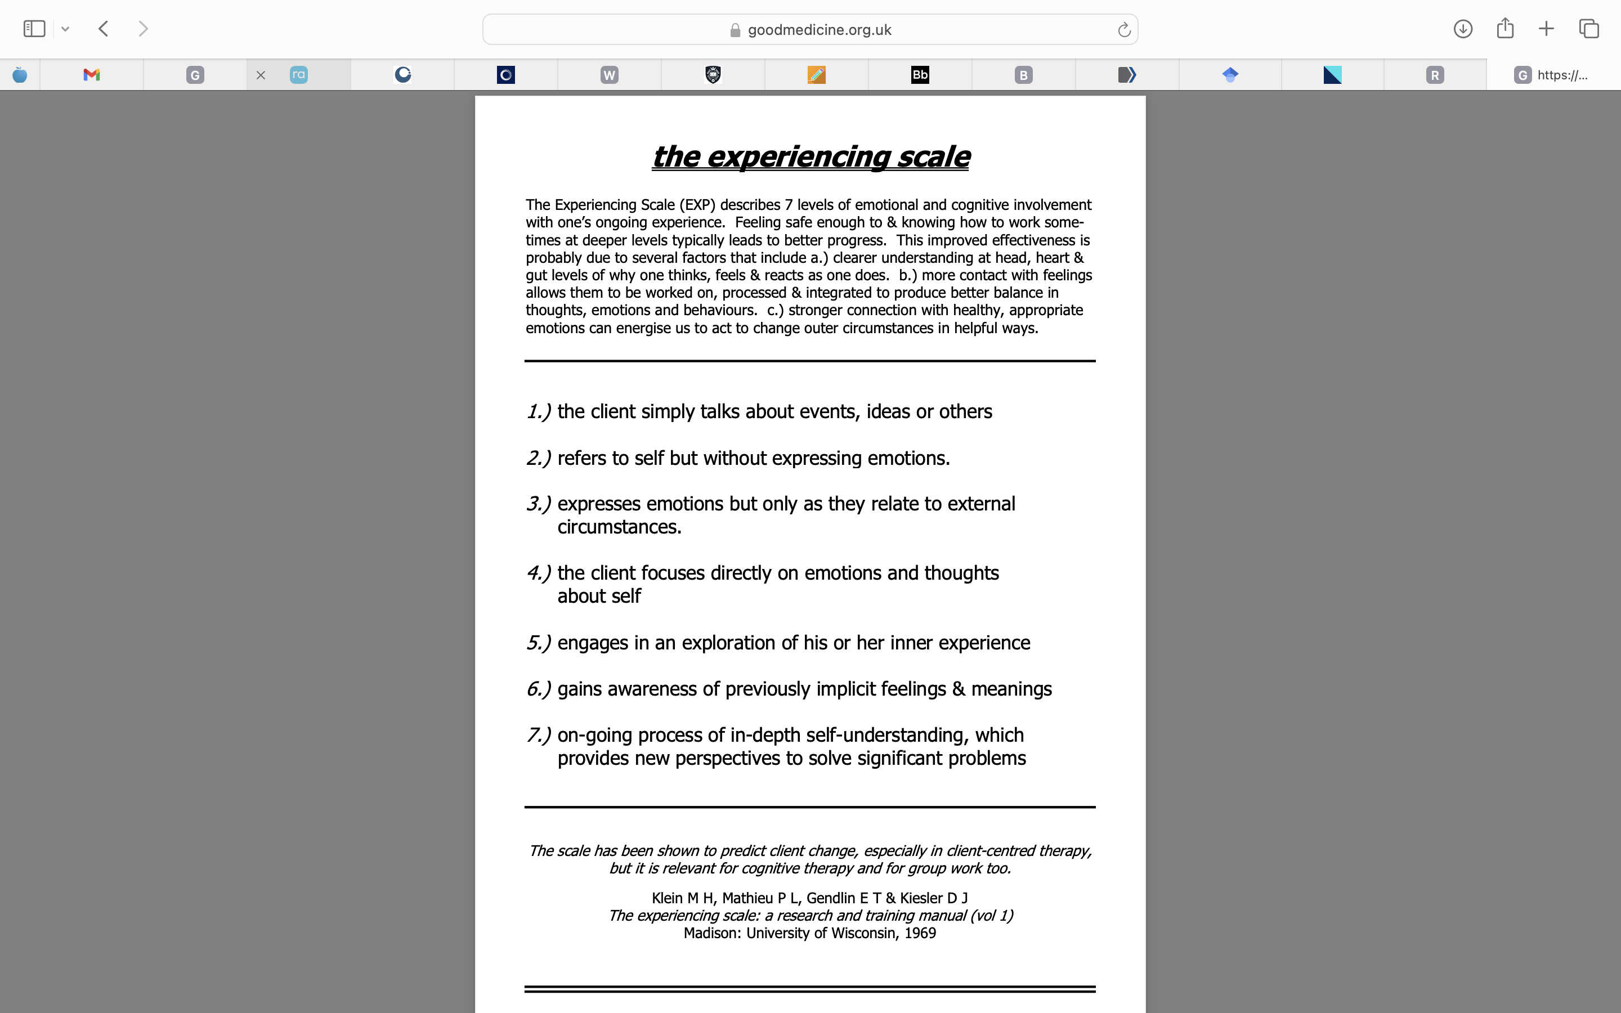

Appendix D
Ethical Approval for Research Study



Appendix E
Data Distribution Histograms

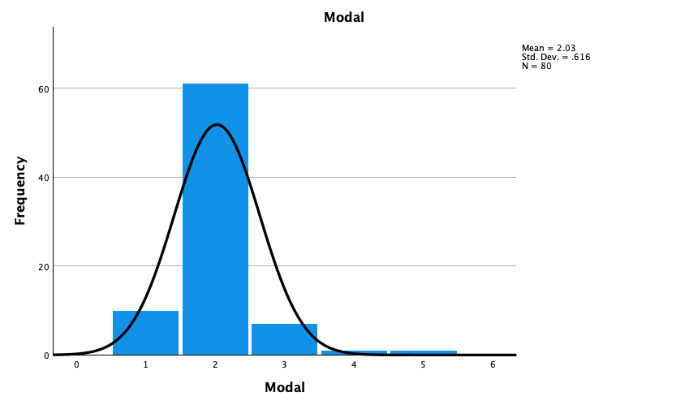

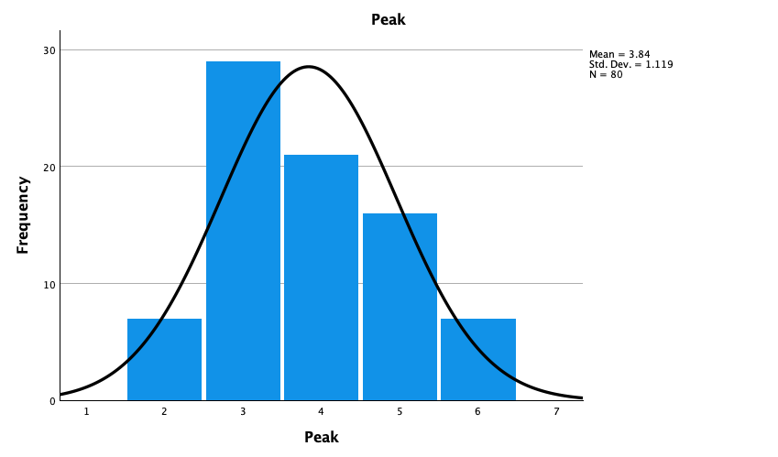

Appendix F
Logistical Regression Individual Models
Logistic Regression – Session 2 Peak Scores

Case Processing Summary
Unweighted Casesª |  | N | Percent
Selected Cases | Included in Analysis | 40 | 100.0
 | Missing Cases | 0 | .0
 | Total | 40 | 100.0
Unselected Cases |  | 0 | .0
Total |  | 40 | 100.0
a. If weight is in effect, see classification table for the total number of cases.

Dependent Variable Encoding
Original Value | Internal Value
Good | 0
Bad | 1
Block 0: Beginning Block
Classification Table^{a,b}
 | Observed |  | Predicted
 |  |  | Outcome |  | Percentage Correct
 |  |  | Good | Bad
Step 0 | Outcome | Good | 0 | 20 | .0
 |  | Bad | 0 | 20 | 100.0
 | Overall Percentage |  |  |  | 52.5
a. Constant is included in the model.
b. The cut value is .500

Variables in the Equation
 |  | B | S.E. | Wald | df | Sig. | Exp(B)
Step 0 | Constant | .100 | .317 | .100 | 1 | .752 | 1.105

Variables not in the Equation
 |  |  | Score | df | Sig.
Step 0 | Variables | S2 Peak | 4.780 | 1 | .029
 | Overall Statistics |  | 4.780 | 1 | .029

Block 1: Method = Enter
Omnibus Tests of Model Coefficients
 |  | Chi-square | df | Sig.
Step 1 | Step | 5.003 | 1 | .025
 | Block | 5.003 | 1 | .025
 | Model | 5.003 | 1 | .025

Model Summary
Step | -2 Log likelihood | Cox & Snell R Square | Nagelkerke R Square
1 | 50.349ª | .118 | .157
a. Estimation terminated at iteration number 4 because parameter estimates changed by less than .001.

Classification Tableª
 | Observed |  | Predicted
 |  |  | Outcome |  | Percentage Correct
 |  |  | Good | Bad
Step 1 | Outcome | Good | 13 | 6 | 68.4
 |  | Bad | 6 | 15 | 71.4
 | Overall Percentage |  |  |  | 70.0
a. The cut value is .500

Variables in the Equation
 |  | B | S.E. | Wald | df | Sig. | Exp(B)
Step 1ª | S2 Peak | -.791 | .380 | 4.332 | 1 | .037 | .454
 | Constant | 2.986 | 1.422 | 4.412 | 1 | .036 | 19.808
a. Variable(s) entered on step 1: S2 Peak.

Logistic Regression: S2 MODE
Case Processing Summary
Unweighted Casesª |  | N | Percent
Selected Cases | Included in Analysis | 40 | 100.0
 | Missing Cases | 0 | .0
 | Total | 40 | 100.0
Unselected Cases |  | 0 | .0
Total |  | 40 | 100.0
a. If weight is in effect, see classification table for the total number of cases.

Dependent Variable Encoding
Original Value | Internal Value
Good | 0
Bad | 1
Block 0: Beginning Block
Classification Table^{a,b}
 | Observed |  | Predicted
 |  |  | Outcome |  | Percentage Correct
 |  |  | Good | Bad
Step 0 | Outcome | Good | 0 | 20 | .0
 |  | Bad | 0 | 20 | 100.0
 | Overall Percentage |  |  |  | 52.5
a. Constant is included in the model.
b. The cut value is .500

Variables in the Equation
 |  | B | S.E. | Wald | df | Sig. | Exp(B)
Step 0 | Constant | .100 | .317 | .100 | 1 | .752 | 1.105

Variables not in the Equation
 |  |  | Score | df | Sig.
Step 0 | Variables | S2 Mode | 2.584 | 1 | .108
 | Overall Statistics |  | 2.584 | 1 | .108
Block 1: Method = Enter
Omnibus Tests of Model Coefficients
 |  | Chi-square | df | Sig.
Step 1 | Step | 2.823 | 1 | .093
 | Block | 2.823 | 1 | .093
 | Model | 2.823 | 1 | .093

Model Summary
Step | -2 Log likelihood | Cox & Snell R Square | Nagelkerke R Square
1 | 52.529ª | .068 | .091
a. Estimation terminated at iteration number 4 because parameter estimates changed by less than .001.

Classification Tableª
 | Observed |  | Predicted
 |  |  | Outcome |  | Percentage Correct
 |  |  | Good | Bad
Step 1 | Outcome | Good | 1 | 18 | 5.3
 |  | Bad | 1 | 20 | 95.2
 | Overall Percentage |  |  |  | 52.5
a. The cut value is .500

Variables in the Equation
 |  | B | S.E. | Wald | df | Sig. | Exp(B)
Step 1ª | S2 Mode | -1.598 | 1.100 | 2.109 | 1 | .146 | .202
 | Constant | 3.232 | 2.195 | 2.168 | 1 | .141 | 25.322
a. Variable(s) entered on step 1: S2 Mode.

Logistic Regression: S6 MODE

Case Processing Summary
Unweighted Casesª |  | N | Percent
Selected Cases | Included in Analysis | 40 | 100.0
 | Missing Cases | 0 | .0
 | Total | 40 | 100.0
Unselected Cases |  | 0 | .0
Total |  | 40 | 100.0
a. If weight is in effect, see classification table for the total number of cases.

Dependent Variable Encoding
Original Value | Internal Value
Good | 0
Bad | 1

Block 0: Beginning Block
Classification Table^{a,b}
 | Observed |  | Predicted
 |  |  | Outcome |  | Percentage Correct
 |  |  | Good | Bad
Step 0 | Outcome | Good | 0 | 20 | .0
 |  | Bad | 0 | 20 | 100.0
 | Overall Percentage |  |  |  | 52.5
a. Constant is included in the model.
b. The cut value is .500

Variables in the Equation
 |  | B | S.E. | Wald | df | Sig. | Exp(B)
Step 0 | Constant | .100 | .317 | .100 | 1 | .752 | 1.105

Variables not in the Equation
 |  |  | Score | df | Sig.
Step 0 | Variables | S6 Mode | 1.468 | 1 | .226
 | Overall Statistics |  | 1.468 | 1 | .226

Block 1: Method = Enter
Omnibus Tests of Model Coefficients
 |  | Chi-square | df | Sig.
Step 1 | Step | 1.508 | 1 | .219
 | Block | 1.508 | 1 | .219
 | Model | 1.508 | 1 | .219

Model Summary
Step | -2 Log likelihood | Cox & Snell R Square | Nagelkerke R Square
1 | 53.844ª | .037 | .049
a. Estimation terminated at iteration number 3 because parameter estimates changed by less than .001.

Classification Tableª
 | Observed |  | Predicted
 |  |  | Outcome |  | Percentage Correct
 |  |  | Good | Bad
Step 1 | Outcome | Good | 6 | 13 | 31.6
 |  | Bad | 2 | 19 | 90.5
 | Overall Percentage |  |  |  | 62.5
a. The cut value is .500

Variables in the Equation
 |  | B | S.E. | Wald | df | Sig. | Exp(B)
Step 1ª | S6 Mode | -.494 | .422 | 1.370 | 1 | .242 | .610
 | Constant | 1.160 | .954 | 1.477 | 1 | .224 | 3.189
a. Variable(s) entered on step 1: S6 Mode.

Logistic Regression: S6 PEAK

Case Processing Summary
Unweighted Casesª |  | N | Percent
Selected Cases | Included in Analysis | 40 | 100.0
 | Missing Cases | 0 | .0
 | Total | 40 | 100.0
Unselected Cases |  | 0 | .0
Total |  | 40 | 100.0
a. If weight is in effect, see classification table for the total number of cases.

Dependent Variable Encoding
Original Value | Internal Value
Good | 0
Bad | 1

Block 0: Beginning Block

Classification Table^{a,b}
 | Observed |  | Predicted
 |  |  | Outcome |  | Percentage Correct
 |  |  | Good | Bad
Step 0 | Outcome | Good | 0 | 20 | .0
 |  | Bad | 0 | 20 | 100.0
 | Overall Percentage |  |  |  | 52.5
a. Constant is included in the model.
b. The cut value is .500

Variables in the Equation
 |  | B | S.E. | Wald | df | Sig. | Exp(B)
Step 0 | Constant | .100 | .317 | .100 | 1 | .752 | 1.105

Variables not in the Equation
 |  |  | Score | df | Sig.
Step 0 | Variables | S6 Peak | 1.617 | 1 | .204
 | Overall Statistics |  | 1.617 | 1 | .204

Block 1: Method = Enter

Omnibus Tests of Model Coefficients
 |  | Chi-square | df | Sig.
Step 1 | Step | 1.639 | 1 | .200
 | Block | 1.639 | 1 | .200
 | Model | 1.639 | 1 | .200

Model Summary
Step | -2 Log likelihood | Cox & Snell R Square | Nagelkerke R Square
1 | 53.713ª | .040 | .054
a. Estimation terminated at iteration number 3 because parameter estimates changed by less than .001.

Classification Tableª
 | Observed |  | Predicted
 |  |  | Outcome |  | Percentage Correct
 |  |  | Good | Bad
Step 1 | Outcome | Good | 8 | 11 | 42.1
 |  | Bad | 6 | 15 | 71.4
 | Overall Percentage |  |  |  | 57.5
a. The cut value is .500

Variables in the Equation
 |  | B | S.E. | Wald | df | Sig. | Exp(B)
Step 1ª | S6 Peak | -.332 | .265 | 1.572 | 1 | .210 | .717
 | Constant | 1.433 | 1.114 | 1.656 | 1 | .198 | 4.192
a. Variable(s) entered on step 1: S6 Peak.

Appendix G
Power Calculations

