
Exploration, Development, and Piloting of Low Intensity Guided Self-help

Rebecca Kelly

A thesis submitted in partial fulfilment of the requirements for the award of Doctor of Clinical Psychology at the University of Sheffield (DClinPsy)

Clinical and Applied Psychology Unit
Department of Psychology
The University of Sheffield

May 2024

Declaration Page
I, the author, declare that this thesis is my own work. It is submitted for the Doctorate in clinical Psychology at the University of Sheffield and has not been submitted to any other University for any other award.

Structure and Word Counts
Abstracts
Lay summary: 476.
Literature review: 224.
Empirical study: 236.

Literature Review
Main body excluding references, tables, and figures: 7993.
Including references, tables, and figures: 10,604.

Empirical Study
Main body excluding references, tables, and figures: 7,990.
Including references, tables, and figures: 12,347.

Total
Excluding references, tables, and figures: 15,983.
Including references, tables, and figures: 22,951.

Lay Summary
This summary is designed for the public who may use mental health services.
Mental health services use different treatments to help people feel less distressed. One of these treatments, commonly used in NHS Talking Therapies, is called guided self-help (GSH). GSH is a structured approach where the patient is guided by a professional to complete a self-help manual. Research has shown GSH can help people with a range of different mental health difficulties. This includes, but is not limited to, helping people feel less depressed and anxious.
The first chapter includes the findings of a research review which explored patients’ and facilitators’ experiences of GSH. This approach, called a systematic review, involved looking at 18 research papers to consider patterns across peoples’ experiences. Five main patterns were developed from this. Most people found GSH helped them to feel better, improved their understanding, and helped them develop new skills. Facilitators also benefitted as partaking helped their professional development. Having good relationships between services, facilitators, and patients was important as it helped patients complete the self-help manuals. The treatment also needed to be relevant, informative, and accessible for it to feel worthwhile. Finally, having choice about how the facilitators guide the therapy could be helpful as some people preferred in-person support, whilst others valued remote feedback.
The second chapter describes the development and testing of a new GSH intervention called Cognitive Analytic Therapy-informed GSH (CAT-GSH) for depression. This therapy was developed by investigating the research and consulting with professionals. CAT-GSH helps people feel better by exploring how the person coped in their past and current relationships. By understanding this, patients can make changes to their coping patterns to help improve their mood. Once the treatment was developed, it was delivered by four Psychological Wellbeing Practitioners (PWPs) who worked for a South Yorkshire NHS Talking Therapy service. It was important to understand if CAT-GSH changed people’s mood and if it was acceptable. Eleven patients were involved in this project. Their mood was recorded at each session and four weeks after the end of their treatment. Patients and PWPs were then asked about their experience of GSH in an interview. Overall, most people’s mood improved by the end of treatment. Participants typically found CAT-GSH to be helpful and acceptable. They also provided information about what they felt could be improved. This included reducing the word-count and adapting some exercises.
Overall, these chapters provided an overview of how people experience GSH alongside outlining the development and testing of a GSH treatment. Both demonstrated that GSH can be a good experience and it can help people feel better. Acceptable treatments tended to mean that patient and facilitators felt supported, that the workbook was informative and accessible, and the delivery approach was flexible. More studies are needed to optimise GSH and to ensure CAT-GSH is beneficial for a larger-group of people.
Acknowledgements
Firstly, a massive thank you to the wonderful Psychological Wellbeing Practitioners, services, participants, and professionals who have supported this project. Your dedication, motivation, and perseverance are unrivalled. I hope our work has an impact and is a step towards helping people.
A special thank you to my thesis supervisors, Dr. Stephen Kellett and Dr. Melanie Simmonds-Buckley. Your support has been immeasurable, and your knowledge and passion has inspired me and kept me going when my motivation falters. Thank you to all my university and placement supervisors. I’ve truly stood on the shoulders of giants and learnt valuable lessons on my journey.
To my family, thank you for believing in me and supporting me through this Doctorate. To my partner, Tom, there has been many times where you have put me and the Doctorate first. You’ve helped me get through this with a smile on my face. To all my friends, you have brought joy, happiness, and love. I couldn’t be where I am without you all. To all the wonderful friends I’ve made on the doctorate. Thank you, a thousand times over. I am so very proud of you all and I’m grateful for sharing the experiences of this Doctorate.

Contents
Preface
Declaration Page ii
Structure and Word Count iii
Lay Summary iv
Acknowledgements vi
Contents vii
Section One: Literature Review
Abstract 2
Introduction 4
Method 9
Results 17
Discussion 46
References 56
Appendices 69
Section Two: Empirical Research Project
Abstract 93
Introduction 96
Method 101
Results 126
Discussion 158
References 166
Appendices 178
Section One: Literature Review
Exploring patient and facilitators reported experiences of guided self-help: A qualitative evidence systematic review

Abstract
Objectives: Guided self-help (GSH) is an effective low-intensity psychological treatment used globally, including within England’s NHS Talking Therapies services. However, there is known variability in outcomes and issues of drop-out from GSH interventions. Understanding how people experience GSH can provide richer data to support quantitative research and guide clinical consideration in care practice. Consequently, this systematic review aims to explore the reported experiences of therapists and patients who have participated in GSH.
Methods: The Enhancing Transparency in Reporting the Synthesis of Qualitative Research checklist informed the development of this research. A one-term search strategy, across four electronic databases, was used to identify eligible papers. A two-step screening process, involving forward and backwards citation chaining, identified 18 papers. Two researchers assessed the papers quality to determine risk to rigour. Thematic Synthesis was used to analyse the data.
Results: Most studies had medium threat to rigour. Thematic synthesis of the included participants quotes led to the creation of five themes: outcomes; collaborative and invested relationships; uncontained and uninvested relationships; technical components are important; and providing facilitation choice.
Conclusions: Overall, GSH can be optimised by nurturing supportive relationships between services, facilitators, and patients; providing relevant, informative, and accessible treatment; alongside providing patients choice about whether GSH is supported in-person or remotely. Services and researchers should consider how to promote these factors within GSH development and implementation.

Practitioner Points
- Evidence suggests that positive experiences are linked to supportive relationships; relevant, informative, and accessible technical components; alongside accommodating to the patient’s preference for in-person or remote support.
- Researchers and services should consider how to optimise these components across the development and implementation of GSH. Legislation, research, and service evaluations are some tools which can support the optimisation of GSH.
- However, due to the medium threat to rigour to most studies, there are precautions about this systematic review’s reliability and validity. As such, this synthesis should be considered within the wider evidence which explores GSH, complex intervention development and evaluation, as well as service delivery.
Keywords
Guided self-help; IAPT; NHS Talking Therapies; Systematic Review; Qualitative.
Introduction
Psychologically-informed guided self-help (GSH) is used worldwide to improve mental health difficulties. For example, its effectiveness in reducing distress has been researched within South Sudanese refugees in Uganda (Tol et al., 2018), university students in India (Kanuri et al., 2015), and people experiencing anxiety in Sweden (Furmark et al., 2009). It is provided in a range of services and can be adapted to be delivered in-person and remotely. Due to the NHS commitment to expand their Talking Therapies services, as outlined in The Five Year Forward View for Mental Health (Independent Mental Health Taskforce, 2016) and The NHS Long Term Plan (NHS England, 2019), GSH is a frontline treatment offered to a large proportion of individuals accessing services. The intervention is commonly offered in England’s NHS Talking Therapies, for anxiety and depression as a low-intensity treatment for those with mild-to-moderate mental health problems. According to the NHS Talking Therapies annual report, between April 2022 – March 2023, 1.22 million people started a low-intensity treatment (NHS England, 2024).
Defining GSH
Despite international recognition, there is no agreed-on definition which outlines essential criteria. As such, there are inconsistencies between GSH interventions such as frequency of facilitator input, session length, and experience of the facilitator (Coull and Morris, 2011). In response, Baguley et al., (2010) aimed to provide good practice guidelines for the use of GSH in NHS Talking Therapies services. The authors argue this approach is more than psychoeducation. It is a structured approach which has core elements. GSH needs to engage the recipient, work towards goals, provide appropriate materials, and be supportive. Completing reviews and outcome measures alongside this work provides the patient and facilitator a chance to consider its effectiveness and review the person’s ongoing needs.
GSH Effectiveness
Various systematic reviews have suggested GSH is as effective in reducing mental health symptoms compared to traditional psychotherapy treatments. For example, Cuijpers et al. (2010) proposed, from synthesising 21 studies, that both GSH and face-to-face psychotherapy reduced anxiety and depression symptoms during the interventions and at one-year after. Furthermore, participant attrition between treatments was not significantly different. A more recent network meta-analysis by Cuijpers et al., (2019), also suggests GSH is as effective as other forms of psychotherapy. The study found GSH, individual, group, and telephone cognitive behavioural therapy (CBT) did not statistically differ from one another with all formats being significantly more effective than waiting lists for the treatment of depression. However, individual and group CBT were more accepted than GSH based on attrition rates. Consequently, GSH appears to be an effective form of treatment which is comparable to other interventions, if not less acceptable.
Whilst these results are promising, both studies have limitations which cast doubts on their findings. Firstly, many of the studies within Cuijper’s et al. (2010) research recruited people via media advertisements rather than from a clinical sample. This raises questions about the generalisability of the findings to clinical populations. Cuijper’s (2019) meta-analysis also has limitations. For example, publication bias and high levels of heterogeneity within the included studies cast doubts on the confidence of the results. Consequently, whilst these two systematic reviews suggest GSH is as effective in treating depression and anxiety as other forms of psychotherapies, caution needs to be given when applying this to clinical findings.
When exploring the effectiveness of GSH in services, the NHS Talking Therapies monthly statistics report (NHS England, February 2024) suggests there is great variability in who benefits from low-intensity therapies. For instance, only 51.2% of patients entering low-intensity treatment moved to ‘recovery’ (fell below clinical cut-off within the appropriate outcome measure) after treatment and 67.4% showed reliable improvement. Overall, 47.9% met both recovery and reliable improvement, and were deemed ‘reliably recovered’. Factors which may influence reliable change with CBT-GSH could include adherence to treatment, patient perception of treatment credibility, clinician’s estimation of positive change, and age of onset (Salomonsson et al., 2019). As such, whilst prior research suggests GSH is an effective treatment in reducing mental health symptoms, there seems to be great variability in outcomes within services delivering the intervention.
Furthermore, whilst drop-out rates are somewhat comparable between GSH and traditionally psychotherapy (Cuijpers et al., 2010; Cuijpers et al., 2019), according to the 2022-2023 annual report for NHS Talking Therapies, approximately 45% of the 1.22 million referrals which started treatment dropped-out (NHS England, 2024). One factor which may influence drop-out from treatment is the lack of patient choice (Windle et al., 2020). Currently, GSH practice and research is largely dominated by CBT-informed modality treatments (Cuijpers et al., 2019) and patients within routine services lack GSH-modality choice (NHS England, n.d.; Kellett et al., 2023). Consequently, high drop-out rates may be improved by expanding GSH research and improving GSH-modality options past the traditional CBT-GSH.
Experiences of GSH
Exploring the experiences of patients and facilitators within GSH provides richer information about the effectiveness and acceptability of the intervention. Furthermore, gathering qualitative data aids with the development and evaluation of complex interventions (such as GSH; Skivington et al., 2021). For example, it provides information from and for stakeholders, contributes to the development of psychological theory and the understanding of change process, alongside contributing to the exploration of the intervention’s acceptability.
Despite the benefits, much of the current literature has not explored the experiences of patients and facilitators. Khan et al., (2007) completed a meta-synthesis to investigate patients’ experiences of receiving treatment for depression in primary care. Patients had mixed feelings about the involvement of a professional guiding them through self-help material. Whilst papers reported the involvement of a professional made people more likely to use self-help materials, other papers reported people found it “hard-work” or felt “ambivalence” regarding their and their therapist’s role. However, there are several limitations in using information from Khan et al. (2007) study to infer any generalisable meaning. For example, these results were only a segment of a larger research aim which provided only a snap-shot of peoples’ experiences and the included studies were not quality reviewed. Overall, the findings suggest people have different experiences of GSH and could help explain the NHS Talking Therapies’ attrition rates (NHS England, 2024).
A recent doctoral thesis by Headley (2021) suggests change from GSH may be due to a combination of modality-specific and shared-GSH factors. The author’s mixed-methods research project explored 17 participants’ experiences of either completing CBT-GSH or Cognitive Analytic Therapy-GSH (CAT-GSH). All participants experienced reliable change by the end of treatment regarding a reduction in their anxiety symptoms. The common GSH-aspects, which were attributed to change in both groups, were having a supportive therapeutic relationship with their PWPs and having some flexibility to the support (i.e. adjusting intervention length). These findings, whilst being mindful of Cuijpers et al., (2010; 2019) reviews, could suggest GSH effectiveness is linked to the therapeutic relationship and whether the participant experiences GSH as being flexible to accommodate their needs.
Clinical Relevance
There have been no reviews, the authors know of, where the aim has been to synthesis the qualitative literature exploring the experience of patients and therapists who facilitate and complete GSH. Exploring individual experiences is crucial to understand factors which influence treatment delivery, engagement, acceptability, change processes, and outcomes. Although clinical trials and quantitative studies provide invaluable quantitative data, a qualitative approach is required to understand in-depth individual experiences not captured by numerical outcomes. Understanding lived experiences can inform efforts to improve and develop GSH intervention to better help patients to make informed choices about the treatments on offer, especially given the value of brief, low-intensity GSH intervention to meet the increasing demands for psychological support (Independent Mental Health Taskforce, 2016; NHS England, 2019).
Aim and Review Questions
The research question for this qualitative synthesis is what are the reported experiences of patients and facilitators who partake and provide GSH? In synthesising the research, the quality of the evidence will be evaluated and its impact on the findings discussed. Clinical implications will be outlined alongside recommendations for the development and facilitation of GSH.
Method
This thematic synthesis was registered on PROSPERO (registration number CRD42022368079; Appendix A). Changes to the original protocol were updated on PROSPERO for transparency and are outlined in Appendix B. Enhancing Transparency in Reporting the Synthesis of Qualitative Research (ENTREQ; Tong et al., 2012) checklist informed the development and reporting of this research.
Search Strategy
A specialist librarian and two Clinical Psychologists were consulted in the development of this systematic review. Once an initial plan was developed the literature was scoped using Google Scholar, SCOPUS, and PsychINFO. This informed key-term development.
Published papers were searched for using four electronic databases: PsycINFO, via Ovid; Web of science; Scopus; and Cumulated Index to Nursing and Allied Health Literature (CINAHL), via EBSCO. These databases were chosen due to their relevancy to clinical practice, GSH, and psychology. A one-component search term strategy was completed with the search terms being variations of ‘guided self-help’ as highlighted in Table 1. These terms were compiled through discussions between the research team and consultations with an academic familiar with GSH literature. The term “OR” was used to find any variation of the term. Other key terms were also considered yet were not specific enough to aid with searching for GSH interventions. For example, “low intensity therapy” was not included because there are various forms of low intensity therapy which include self-help interventions, brief therapies, and poorly categorised high-intensity treatments (Shafran et al., 2021).
A one-term search was used to optimise sensitivity and specificity. From the literature scope, a vast number of terms described the population and outcomes. For example, GSH is used in many different types of services. Limiting the search term to “mental health” may have excluded papers from GP or memory services. Consequently, only variations of GSH were used. These terms were situated in the paper's title, abstract, or key words. Filters limited results to papers written in English dating from 01/01/2000 to 07/11/2022 (present).
Table 1
Key Terms used in Search Strategy
GSH Variations
“Guided Self Help” OR “Guided Self-Help” OR “Assisted Self Help” OR “Assisted Self-Help” OR “Facilitated Self Help” OR “Facilitated Self-Help” OR “Supervised Self Help” OR “Supervised Self-Help” OR “Minimal Contact Therap*” OR “Minimal Contact Intervention*” OR “Supported Self Help” OR “Supported self-help”

Inclusion and Exclusion Criteria
Populations, intervention, comparison, outcomes, and study (PICOS) framework, as outlined in Table 2, helped assess the relevance of each study for this review. This approach was chosen due to its comparable specificity and sensitivity to other methods (Methley et al., 2014). Studies needed to: a) report the views of facilitators and/or adult patients; b) report on GSH (regardless of psychological model, duration, or delivery style); c) use a qualitative or mixed-methods design; d) be written in English; and e) be published.
Influenced by Baguley et al., (2010), GSH was defined as an intervention with a structured psychologically-informed approach, in which the participants worked, either in-person or online, towards alleviating a presenting problem with the support of a facilitator. There was no limit on the time or frequency of facilitation since this varies vastly in the literature. The psychological model of GSH was not a criterion for exclusion (for instance, CBT-informed) because services can use multiple approaches (Cuijpers et al., 2010). Grey literature was not included due to problems with data management, data extraction, risk of bias, and limitations with time and resources (Adams et al., 2016). Quality of the papers were not grounds for exclusion as conclusions can be strengthened when using poor quality papers (Garside, 2013). However, this review will evaluate how bias impacted the findings in the discussion.

Table 2
PICOS Framework of Eligibility Criteria
PICOS Category | Inclusion | Exclusion
Population | Facilitators and/or adult patients | Children and adolescent participants
Intervention | Psychologically-informed GSH | Non-psychological informed GSH, no description of GSH intervention, psychoeducation.
Comparator | N/A | N/A
Outcomes | Experiences of GSH aimed at relieving mental health difficulties | Results not concerning GSH experience, outcomes relating to physical health goals.
Study | Qualitative or mixed method designs, published, English | Quantitative, non-English language, systematic reviews, commentaries, book chapters, letters.

Screening and Selection
The lead author completed the screening and selection process. The literature from the term search was exported into Endnote Software to help manage data. All duplications were removed. Titles and abstracts were reviewed to assess eligibility. The included papers were full-text reviewed. Authors of inaccessible papers were contacted. Forwards and backwards citation chaining was used to identify additional research which may have been missed. Team discussions were used to discuss dilemmas and reach a consensus decision.
Data Extraction and Synthesis
Information on the authors; year of publication; study design; number, gender, and type of participants (facilitator or patient); GSH psychological approach; and the GSH support process was extracted. Appendix C includes the extraction form used in this process.
Thomas and Hardens (2008) Thematic Synthesis (TS) was chosen because of its suitability in synthesising data from studies which have varying methods. Alternative methods of data synthesis were considered such as Textual Narrative Synthesis. However, this was inappropriate for the research aim because, as Lucas et al., (2007) outlines, the approach does not promote transparency and is more useful at describing the literature to find ‘gaps’ for further research.
TS has three stages. Using Nvivo 12 Software, the first stage included reviewing the papers’ result sections and line-by-line semantic coding only direct participant quotes from the findings section. Not coding the main text was done in attempts to separate the participants’ voice from the researchers’ perspective (Sandelowski & Barroso’s, 2002). This was important due to the tendency that patient experiences and needs have been interpretated, developed, and provided, through the lens of the researchers or services (Arumugam et al., 2023). As such, this approach was taken to meet the aim of synthesizing patient and facilitator experiences of GSH and reduce the bias of interpreting interpretations.
Every sentence was assigned at least one code. A note was made on each code about whether the code was from the patient’s perspective (PP) or the therapist’s perspective (TP). For example, the quote “The therapist was amazing.” (Hazell et al., 2020) was coded as ‘amazing therapist (PP)’. This helped the author count how many codes from PP and TP contributed to each theme. This coding process provided a ‘translation of concepts’ across studies. Incomplete, vague lines and authors’ interpretations were not allocated a code.
In stage two, the codes were organised into descriptive themes using a ‘hierarchical tree structure’. This was completed by designing a table on Microsoft Word wherein codes could be moved easily between themes. The codes were repeatedly compared based on similarities and differences to ensure internal homogeneity and external heterogeneity. Both facilitator and patient codes could contribute to the same descriptive theme. However, unique themes could also be generated from purely therapist or patient codes, to recognise some experiences were shared whilst others were unique.
The first two stages produced a synthesis which reflected the aims and findings of the included papers rather than the research aim. Therefore, stage three involved developing analytic themes which considered patients’ and facilitators’ experiences of GSH. The process of developing codes, descriptive themes, and analytical themes was not linear. Names of descriptive themes were changed, and codes were reviewed as part of a quality assurance process. For example, once an analytic theme was completed, each narrative quote, code, and descriptive theme was reviewed. Some codes were found to not accurately describe the quote. These were renamed and moved to a more relevant location.
Quality Assessment
A ‘blind’ quality assessment was completed by the lead author (RK), after the extraction and synthesis of data, using the 11-item Long et al., (2020; Appendix D) adapted Critical Appraisal Skills Programme’s (CASP) qualitative studies checklist (2018). This adapted version aims to evaluate the appropriateness, reliability, and validity of the research to assess the confidence in the findings (or rigour). Long et al., (2020) aimed to address the limitations of the original checklist. For example, the authors included a fourth reply (‘somewhat’) to provide increased nuance to the ‘yes, no, and not sure’ responses. Also, an additional question was included to explore studies theoretical underpinnings, including if the authors outlined their ontological and epistemological positions. This change is supported by the Research Excellence Framework (2018) recommendation wherein authors outline their research’s theoretical underpinnings to increase significance and quality of their paper. ‘Blindness’ to paper’s quality when synthesising intended to reduce bias.
Studies were allocated a number from 1-18. A 20-sided dice was used to randomly select six papers for a research peer to independently appraise. Rolls of 19-20 were rerolled. The Long et al., (2020) checklist was discussed to ensure the raters had the same understanding of the items. Inter-rater reliability was 88%. The largest categorisation difference between the raters occurred when considering question four; whether the research had outlined their theoretical underpinnings. This was largely related to the difference between opinions about if a study could be marked anything higher than ‘no’ (red) if they did not explicitly detail their ontological and epistemological position. This was resolved though discussion, but some difference of opinion remained. This may help explain the inter-rater reliability percentage.
A classification system was used to assess the risk to rigour. This included considering the frequency of items which were awarded a ‘yes’ response. This was then categorised as low (9 or above), medium (6-8), and high (below 6) level of threat to rigour. Whilst other papers have used similar categorisation (Lewis et al., 2018) to ‘score’ the rigour of papers, this practice has largely been discouraged, because the ‘weight’ of individual questions vary in importance depending on researcher perspective, study purpose and methods (Cabinet Office, 2003). Therefore, the intention of the categorisation system is to provide guidance and comparison to other reviews.
Ontological and Epistemological Position
A critical realist (CR) perspective guided the development and analysis of this review. This approach assumes the patients’ and facilitators’ unique realities of GSH experiences were impacted by perspectives alongside broader social framework (Braun & Clarke, 2006). The measurement of this reality, our epistemological position, was subjective; influenced by personal belief, interpretations, and measures. Consequently, these assumptions influenced several decisions about the design and analysis. For example, the design was inductive, focusing on the quotes of participants, which aimed to synthesise their realities, separate from researchers’ interpretations. Furthermore, TS was used as the approach is argued to produce results which correspond to a reality mediated by perspectives, which can be used to directly inform policy and practice (Barnett-Page & Thomas, 2009). Finally, the CR approach influenced the interpretations of the findings, as outlined further within the discussion section.

Reflexivity
A reflexivity statement (Appendix E) acknowledges the lead author’s personal and professional beliefs which influenced this research. A reflexivity diary was kept (Appendix F) to help examine the author’s beliefs and how they impacted the research process. This diary then impacted decisions made as part of a reciprocal procedure. For example, it was recognised that the lead researcher being trained in CBT meant the findings were being interpretated through a CBT-lens, even when other psychological modalities informed the included studies intervention. This was prominent after an extended period of data analysis. The consequence being the researchers bias and assumptions informed the understanding of participant quotes, which was likely different from the participants’ experiences. As such, regular breaks and reflective spaces were incorporated into the data analysis process.
For transparency, it is important to state some of the papers included in this synthesis (Meadows & Kellett, 2017; Wray et al., 2022) have been developed by one of the Clinical Psychologist supervising the lead researcher.
Results
Search Strategy
An initial 3,283 papers were identified: 909 from SCOPUS, 1354 from Web of Science, 383 from CINAHL, and 637 from PsychINFO. Endnote find function was used to remove 1,369 duplicates, with a further 294 being manually removed. This resulted in 1,620 papers titles and abstracts being screened. This process resulted in 1,567 papers being discarded, leaving 53 to be full text reviewed. However, four of these texts were not accessible and the authors did not respond when contacted. Thirty-nine papers were deemed not to meet the inclusion criteria. Reasons for exclusion, along with frequency, are reported in Figure 1. Forward and backwards chaining identified an additional six papers. All were full-text reviewed and their references screened for potential papers. Of the initial six papers, four were included. Overall, 18 papers were included within the systematic review.
Study Characteristics
Table 3 outlines the studies’ characteristics. Extracted information included author and publication year, study design, sample characteristics (including if patients or facilitators were interviewed), GSH delivery professional, target problem of intervention, intervention, and delivery format, and how much support the facilitators provided. Information regarding clinical sampling was also extracted and included in description below.
Figure 1
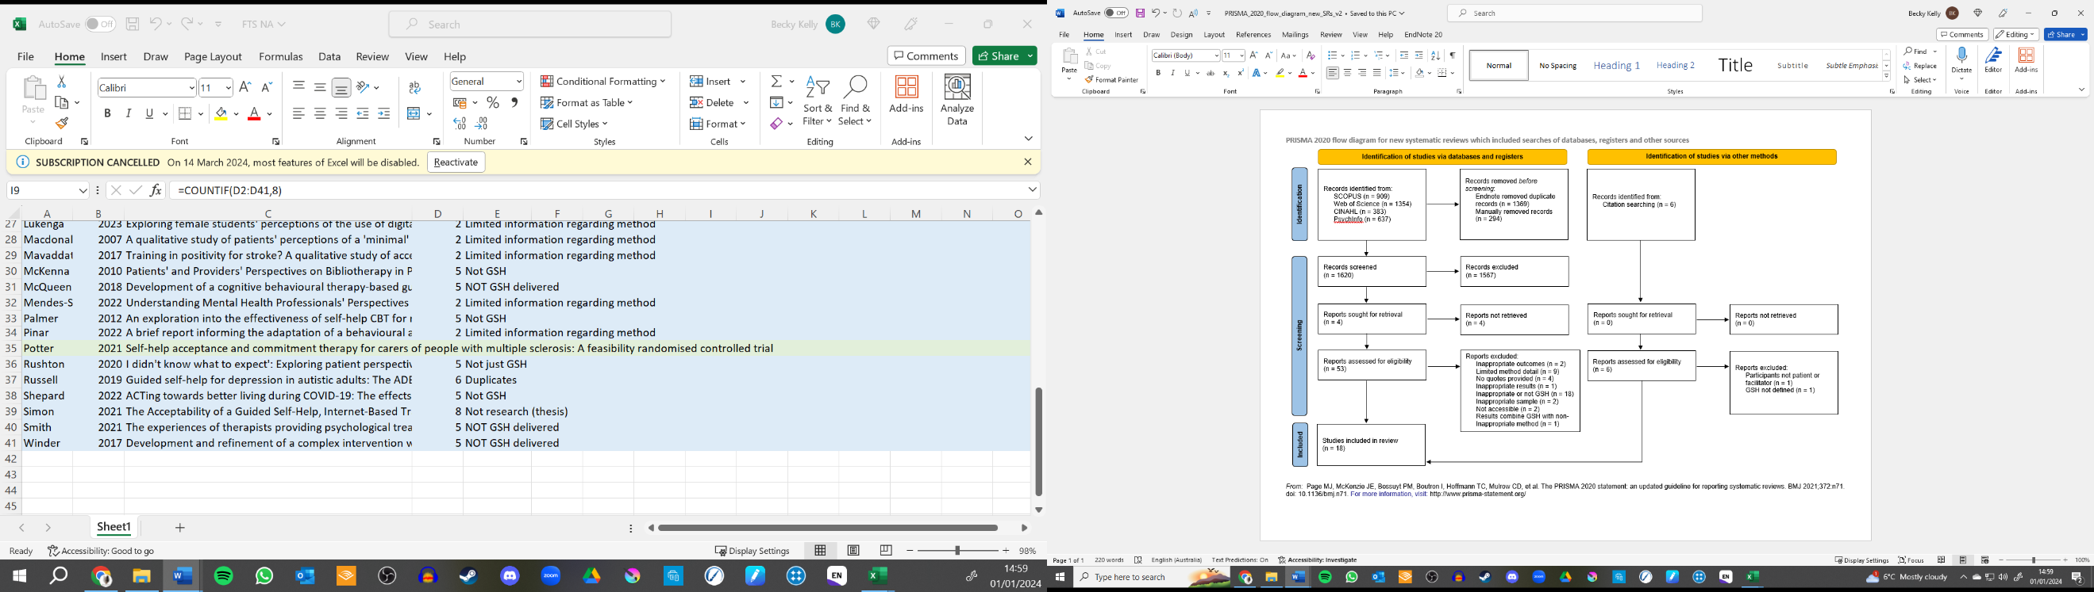
Flowchart of the Search Strategy

Most studies were published after 2016, with four being completed between 2007 – 2016. Interestingly, this reflects when NHS Talking Therapies was introduced in 2008, a service in which GSH is regularly provided as a treatment option facilitated by Psychological Wellbeing Practitioners (PWPs).
A total of 349 participants were included in the studies. However, whilst Horwood et al., (2021) study included 21 patients, only 14 of those had GSH treatment. As such, only quotes from the GSH participants were extracted. Thirteen of the 18 studies included patients, whilst only five studies samples involved facilitators. All papers required participants to meet clinical thresholds of distress however, this was determined differently in each study. For example, Banasiak et al., (2007) required patients to meet a Diagnostic and Statistical Manual of Mental Health (DSM; fourth edition) criteria for Bulimia Nervosa, whilst Wray et al. (2022) recruited participants from NHS Talking Therapies services who met clinical cut-off criteria within routine outcome measures. Facilitators of GSH were titled as GPs, Therapists, Novice Therapists, Clinical Psychologists, Coaches, PWPs, Assistant Psychologists, Supporters, and Trained Guides.
Various mental health problems were treated using the GSH including depression, anxiety, eating disorders, and unshared experiences (including hearing voices). However, Krebber et al., (2017) categorised the target problems as “psychological distress”. Most studies (72%;13/18) used Cognitive Behavioural Therapy (CBT) informed GSH, with one exploring CAT, and three using Acceptance and Commitment Therapy (ACT).
Ten of the studies used a workbook, with eight using either internet-based or software-based manuals (Krebber et al., 2017 provided either workbooks or computer-based manuals). Facilitation styles included in-person (29%) and remote (41%, via email and telephone). Three studies (18%) provided participants a choice between in-person or remote support. However, Lillevoll et al., 2013 and Traviss et al., 2013 facilitation format was unclear.

Table 3
Included Paper’s Characteristics
Author and Publication | Study Design | Sample | Delivery Profession | Target Problem of Intervention | Intervention and Delivery Format | GSH Facilitation
Banasiak et al., 2007 | Qualitative | n = 36, female, patients | GP | Bulimia Nervosa | Bulimia Nervosa and Binge Eating: A Guide to Recovery (CBT); workbook | Face-to-face initial 30–60-minute session; nine face-to-face 20–30-minute structured sessions.
Bortveit et al., 2023 | Qualitative | n = 12, male and female, therapists | Therapists (includes Psychologists, Nurses, and Occupational Therapists) | Depression | eCoping programme (CBT); online | Guidance provided via email after each module, with telephone contact given were needed.
Contreras et al., 2021 | Qualitative | n = 9, male (25%) and female (75%), novice therapists | Novice therapists | Anxiety and Depression | Internet delivered IACT4CARERS (ACT) | Written online feedback provided at end of each completed module; option for patients to attend three peer support groups
Contreras et al., 2022 | Qualitative | n = 23, male (13%) and female (87%), patients | Novice therapists | Anxiety and Depression | Internet delivered IACT4CARERS (ACT) | Written online feedback provided at end of each completed module; option for patients to attend three peer support groups
Hadjustavropoulos et al., 2018 | Qualitative | n = 135, male (30%) and female (70%), mean age = 37.8, patients | Therapist | Anxiety and Depression | Internet delivered CBT | Weekly feedback via email over eight weeks, telephone contacted also provided on request
Hazell et al., 2020 | Mixed-methods | n = 9, male (33.3%) and female (55.6%), White British (88.9%) and White Other (11.1%), patients | Clinical Psychologist | Hearing voices | Guided self-help CBT for voices (GiVE); workbook | Eight face-to-face hour-long sessions
Horwood et al., 2021 | Qualitative | 21, male (n = 17) and female (n = 4), patients with Autism, (14 involved in GSH), and five coaches | Coaches | Depression | Behavioural Activation informed GSH; workbook | Nine face-to-face sessions, 30-45 minutes long, with an initial 90-minute planning session.
Knopp-Hoffer et al., 2016 | Qualitative | n = 36, male (43%) and female (57%), mean age = 44, patients (18 took part in GSH) | PWPs | OCD | Exposure and Response Prevention informed GSH; workbook | Initial 60-minuite session; ten 30-minuite session over 12 weeks; all either face-to-face or via telephone
Krebber et al., 2017 | Qualitative | n = 16, male (50%) and female (50%) mean age = 61.8, patients | Coaches | Psychological Distress | Problem-solving therapy informed GSH for people with head and neck cancer, and lung cancer, who are experiencing psychological distress; delivered via workbook or online | Weekly 10-15-minute-long conversations delivered via email or telephone
Lillevoll et al., 2013 | Qualitative | n = 14, male (36%) and female (64%), patients | Therapist | Depression | MoodGYM (CBT); online | Eight 15-30-minuite-long consultations (delivery unclear)
Ly et al., 2015 | Qualitative | n = 12, male (6) and female (6), age range = 20 – 59, patients | Therapist | Depression | Behavioural Activation | Eight weeks of up to 20 minutes of support delivered via email
Meadows & Kellett, 2017 | Mixed methods | n = 7 PWPs | PWPs | Anxiety | CAT-GSH for Anxiety; workbook | Six 30-35-minuites-long session delivered face-to-face weekly or fortnightly
Perera-Delcourt & Sharkey, 2019 | Qualitative | n = 10, men (2) and women (8), mean age = 33, patients | PWPs | Depression and Anxiety | Guided Computer-based CBT | PWPs provided personalised messages and reviewed progress via online programme.
Plateau et al., 2018 | Qualitative | n = 4, all female, median age = 29, patients | Assistant Psychologist | Eating Disorder | CBT-GSH; workbook | Over 12 weeks of face-to-face individual guidance, delivered weekly for four weeks, and twice a month after.
Potter et al., 2021 | Mixed methods | N = 7 (in GSH group), female (n = 4) and male (n= 5), mean age = 50.23, patients | Clinical Psychology Trainee | Carer Stress | ACT informed GSH; workbook | Weekly, individual, telephone supported calls for 8 sessions: delivery and length of time unclear
Shea et al., 2016 | Qualitative | n = 12, female, mean age = 30.82, patients | Supporter,  Coach | Eating disorders | Culturally adapted CBT-GSH; workbook | Eight 25-minuite support sessions over 12 weeks; delivered either face-to-face or via telephone.
Traviss et al., 2013 | Qualitative | n = 5, female, mean age = 46.6, guides and n = 7, female, mean age = 44.7, patients | Trained Guides | Eating Disorders | CBT-GSH; workbook | Seven one-hour sessions over 12 weeks; delivery unclear
Wray et al., 2022 | Qualitative | n = 12, female, mean age = 30.72, PWPs | PWPs | Anxiety | CAT-GSH for Anxiety; workbook | Six 35-minuite long sessions delivered face-to-face weekly or fortnightly
Note. Intervention delivery describes how the intervention was delivered (for example, workbook, online) whilst GSH facilitation describes how the guidance was provided (for example, face-to-face, telephone)

Quality Assessment
Table 4 outlines the lead researcher’s allocated mark for individual questions as well as an overall verdict. Half the studies had an overall medium threat to rigour (k = 9), with six having low threat, and three having high.
Studies not detailing their theoretical underpinnings was a common area for potential bias. For example, both Contreras et al, (2021) and Contreras et al., (2022) failed to outline the theoretical assumptions which underpinned their method, analysis, and interpretation of results. As such, they received a ‘not sure’ or ‘can’t tell’ categorisation. Alternatively, Lillevoll et al., (2013) provided a description of how a phenomenological-hermeneutical approach underpinned their exploration of participant experiences of GSH. Consequently, this informed the method and analysis of their results. Most papers did not outline this, and as such, were allocated a ‘did not/can’t tell’ mark.
Another common shortcoming was the limited information about the data analysis (question nine). With most papers receiving a ’somewhat’ rating. It was common for papers to report which framework was utilised but then not provide details about the steps they took. This is evident in Krebber et al., (2017) research. The authors outlined they used Thematic Analysis and provided a detailed description for how coding was completed. Yet there was limited justification for this approach, and they provided little information regarding stage 3-6 of Thematic Analysis. As such, most papers received a ‘somewhat’ result.

Table 4
Criteria Allocation to Each Study across each Question
 | Q1. Was there a clear statement of the aims of the research? | Q2. Is a qualitative methodology appropriate? | Q3. Was the research design appropriate to address the aims of the research? | Q4. Are the study’s theoretical underpinnings clear, consistent, and conceptually coherent? | Q5. Was the recruitment strategy appropriate to the aims of the research? | Q6. Was the data collected in a way that addressed the research issue? | Q7. Has the relationship between researcher and participants been adequately considered? | Q8. Have the ethical issues been taken into consideration? | Q9. Was the data analysis sufficiently rigorous? | Q. 10. Is there a clear statement of findings? | Q. 11. How valuable is the research? | Overall
Banasiak et al., 2007 |  |  |  |  |  |  |  |  |  |  |  | H
Bortveit et al., 2023 |  |  |  |  |  |  |  |  |  |  |  | L
Contreras et al., 2021 |  |  |  |  |  |  |  |  |  |  |  | M
Contreras et al., 2022 |  |  |  |  |  |  |  |  |  |  |  | M
Hadjustavropo-lous et al., 2018 |  |  |  |  |  |  |  |  |  |  |  | M
Hazell et al., 2020 |  |  |  |  |  |  |  |  |  |  |  | H
Horwood et al., 2021 |  |  |  |  |  |  |  |  |  |  |  | M
Knopp-Hoffer et al., 2016 |  |  |  |  |  |  |  |  |  |  |  | M
Krebber et al., 2017 |  |  |  |  |  |  |  |  |  |  |  | M
Lillevoll et al., 2013 |  |  |  |  |  |  |  |  |  |  |  | L
Ly et al., 2015 |  |  |  |  |  |  |  |  |  |  |  | M
Meadows & Kellett, 2017 |  |  |  |  |  |  |  |  |  |  |  | H
Perera-Delcourt & Sharkey, 2019 |  |  |  |  |  |  |  |  |  |  |  | L
Plateau et al., 2018 |  |  |  |  |  |  |  |  |  |  |  | L
Potter et al., 2021 |  |  |  |  |  |  |  |  |  |  |  | M
Shea et al., 2016 |  |  |  |  |  |  |  |  |  |  |  | L
Traviss et al., 2013 |  |  |  |  |  |  |  |  |  |  |  | L
Wray et al., 2022 |  |  |  |  |  |  |  |  |  |  |  | M
Note. Red indicates ‘did not’ or ‘can’t tell, orange ‘somewhat’, and green ‘yes’. Vertical lines were included, contrarily to formatting guidelines, for readability. ‘H’ indicates high risk to rigour, ‘M’ medium, and ‘L’ low.
Qualitative Results
Five core themes were inferred from the data: 1) outcomes, 2) collaborative and invested relationships, 3) uncontained and uninvested relationships, 4) technical components are important, and 5) providing facilitation choice. Quotes are identified as either PP or TP. Table 5 provides a summary of the analytic and descriptive themes, alongside supporting participant quotes. Appendix G demonstrates which studies contributed to the sub-themes and themes.

Table 5
Summary of Themes, Subthemes, and Supporting Quotes
Analytic Theme | Descriptive Theme | Quotes
Outcomes | Mostly Improved Symptoms | “I am able to come through that and come back to a place of stability faster than I would have if I hadn’t done this.” (PP; Potter et al., 2020).  “She really seemed to engage in working through the pack… she did say that things were working out the best they ever had in her life and her bulimia was better under control.” (TP; Traviss et al., 2013).  “By the time of the next class you can do the same, really, and then you must indicate whatever has changed. Well, nothing had changed for me.” (PP; Krebber et al., 2017).  “What I recognise is a feeling of demotivation as a therapist when you are unable to select well and you have several patients who do not succeed at all” (TP; Bortveit et al., 2023).
 | Changing Perspectives and Insight | “Well, if someone is for instance… rude to you. Then I always thought, like: oh, I knew it, she doesn’t like me. But then, you can also look at it in another way like: oh, she must be busy.” (PP; Krebber et al., 2017).  What I’m doing is repeating the same pattern as when I was a tiny little child, and things change, I’m not a child anymore… I don’t need to feel rejected and criticised by everyone anymore, I can do things differently. (Facilitator reading an excerpt of a patient’s work; Meadows & Kellett, 2017).
 | Developing Coping Mechanisms | “For me it’s about giving the clients the tool to make the change for themselves”. (TP; Wray et al., 2022).  I got to know her (his partner’s) kids better, for instance. That’s very positive. (Interviewer: How did that happen?) Well, I tried to make the best of it and play with them, not going into a room and hiding away all by myself. (PP; Lillevoll et al., 2013).
 | Professional Development | I really enjoyed the training and learning a bit more about ACT, it’s not something I was very familiar with. So, from my perspective, I definitely viewed it as a good learning development opportunity” (TP; Contreras et al., 2021).
Collaborative and Invested relationships | Supporting Professional Facilitators | “I think (guide is) very patient, non-judgemental, so straight from the beginning, um, yeah, she built a good rapport so, I think that makes a big difference.” (PP, Banasiak et al., 2007)  “I wouldn’t have done as well. I don’t think I would have got the same outcome: “I don’t think I’d be like, as good as I am now if I didn’t have (guide)…” (PP; Plateau et al., 2018).  “You feel like you’re on a bit of a journey with them. People sort of discover themselves by doing all this thinking” (TP).
 | Support Outside of Therapy | “Then I found out one of my work colleagues has exactly the same thing and that just kind of took a bit of weight off me knowing that I could like just talk to her about little things that people without an eating disorder would not understand and so that definitely helped. (PP; Plateau et al., 2018).
 | Supported Facilitators | We had our training and then we had the guide, so yeah, and then there was group supervision too, so yeah it felt enough… I disagree, I really liked the model and I think it fits well at our level. (TP, Meadows & Kellett, 2017).
 | Patient’s Self-motivation | “So the very first chapter I found powerful because it just kind of expressed really clearly everything that was going on in my head. And that then made me go ‘I really want to break this’.” (PP; Potter et al., 2020).  “First and foremost, sort of checking out they were ready to do it, I think that was the key factor that made the difference”.
Uncontained and Uninvested Relationships | Strained Support Outside of Therapy | “And she’s very critical of what I eat. I think it makes me self-conscious and then I feel depressed”. (PP; Shea et al., 2016).  I have supported lots of people that have had caring responsibilities and there is often thoughts and feelings of guilt, feeling overwhelmed and lots going on and, I guess, nobody ever teaches us how to manage our emotions better until things get really bad. (TP; Contreras et al., 2021).
 | Ruptures in Therapy | “Hearing about the doctor’s body image problems and her failed attempts at dieting, whilst being great in friendly situations, was not congruent with a professional treatment” (PP; Banasiak et al., 2007)  “I can’t do it, if I could answer that I wouldn’t be here”, so that was the kind of resistance that was very difficult to talk round, ok “so you feel you can’t do it, why is that?” “Well, if I could answer that question, why would I be sitting here now” it became very confrontational”. (TP; Traviss et al., 2013).
 | Demotivated Patients | “And if you get something similar, you have to open up, open all the boxes, which I don’t want to do”. (PP; Krebber et al., 2017).  It could be challenging to make it (the treatment) work due to the everyday life, and it could be challenging to make it work due to the condition… in regards to how they are coping, the lack of initiative and concentration… energy. And determination. (TP; Bortveit et al., 2023).
Technical Components are Important | Mixed Perspective of Manual Content | “Eh, it’s been huge because like literally every single night, even if we go on holiday, we will take them [book used as part of coping strategy] with us. Or away for one night you know, it’s like that’s become a part of my erm, kind of going to bed routine”. (PP, Hazell et al., (2020)  “I think the structured method offered, having the different booklets and visual tools and things to actually work through questions, answer exercises to do, I think that works really, really well”. (TP, Horwood et al., 2021).  “I found it too much; there was too many activities. It was too … it was too intense for where I was at in my life, so I found I didn’t do quite a few of the exercises (PP; Potter at al., 2020).
 | Mixed Perspective of Flexibility | “People are choosing CAT because they’ve tried CBT and maybe didn’t click with it”. (TP; Wray et al, 2022).  “Flexible appointment times and the treatment setting was comfortable” (PP; Banasiak et al., 2007).  “The place I got offered, it was too far… when we found finally, a place that is not far away, and easy travel for me, there wasn’t an appointment in that centre that was suitable for both of us.” (PP; Knopp-Hoffer et al., 2016).
Providing Facilitation Choice | In-person Personal and Preferred. | “I think the feedback, that’ll be useful to have it face-to-face. It’s just to have some kind of two-way interaction”. (PP; Contreras et al., 2022)
 | Remote Experienced Positively. | “The point I would want to make is that it’s not an inferior substitute for something else, and if you try it, you may actually find it works better than any other type of solution.” (PP; Perera-Delcourt et al., 2019).
 | Limitations of Remote. | “I feel like it was a bit disappointing… it just felt like you were a bit palmed off on this app” (PP; Perera-Delcourt et al., 2019).  “It is too difficult to find what I am looking for… and yeah, we use a lot of time going back and forth and wondering where things are and how to find them… it could be a lot more user-friendly…” (TP; Bortveit et al., 2023).

Theme One: Outcomes
All studies (18/18) contributed towards theme one, which was supported by four subthemes. Treatment was largely reported as effective for most patients especially in increasing their mood, insight, and coping skills. Facilitators also benefitted as they developed their skills. However, sometimes treatments were regarded as ineffective or provided little change.
  - Mostly Improved Symptoms.
Participants described a reduction in their symptoms, across different presenting problems, after GSH. Sometimes improvements were linked to specific goals, sense of stability, or feeling back to normal. Facilitators also recognised patient symptoms improved, which they linked to patient engagement in therapy and early session drop-outs.
However, fewer studies (5/18 papers) reported little or no change in their patients’ presenting problems. Some patients even reported an increase to hearing voices. Disappointment was felt by some whose symptoms did not change. Facilitators also had a similar experience which impacted their motivation as a therapist and made them consider clinical decisions, such as how well they can offer the appropriate treatment to patients.
  - Changing Perspectives and Insight.
Alongside symptom change, GSH also helped increase peoples’ insight into their distress and helped them change perspective. Insight was also described as recognition or awareness of oneself. Specifically, people learnt how to identify triggers and unhelpful patterns of coping. Facilitators also noted an improvement in patients’ perspectives of themselves and what maintained their poor mental health.
  - Developing Coping Mechanisms.
Both patients and therapists reported developing more helpful coping mechanisms was an outcome of GSH. Behavioural changes included writing down thoughts, learning to share their distress, taking care of themselves, and practicing being present in relationships. Facilitators framed these changes using terms linked to the psychological modality, such as behavioural activation within CBT.
  - Professional Development.
Facilitators also benefitted from GSH because they developed a new skill in delivering GSH or they learnt a new psychological modality. This provided variation in their work and different tools to use.
Theme Two: Collaborative and Invested Relationships
Of the included papers, 15/18 contributed to theme two, which was supported by four subthemes. It was inferred that having collaborative and invested relationships was central to GSH. This included patients having support from professionals and family, alongside the facilitators receiving support from their peers and services. It was also recognised that the patients’ supportive relationship with themselves was an important factor, especially when considering treatment effectiveness.
2.1. Supportive Professional Facilitator.
Patients spoke of supportive facilitators who were non-judgemental, compassionate, validating, and installed hope. Some patients reported having professional and knowledgeable practitioners helped them achieve good outcomes because they facilitated improved understanding. Some patients and facilitators explored how the supportive relationship also felt like a joint journey through GSH, where the booklet was shared between them.
2.2. Support Outside of Therapy.
Patients also expressed that they received support from family and friends outside of therapy. This helped with their mood because it provided validation of their struggles as well as helping them implement the GSH manual. Some studies also reported that patients would have liked to have GSH supported by a community who were also completing the programme.
2.3. Supported Facilitators.
Facilitators also spoke about receiving support from their peers, supervisor, and service which helped them deliver GSH. Having in-depth training about GSH and the psychological modality, alongside receiving supervision enabled them to deliver the intervention competently and build their confidence. Facilitators also appreciated less formal support through discussing GSH experiences with their peers.
2.4. Patient’s Self-motivation.
Both patients and therapists expressed that the patients’ relationship with themselves and therapy, specifically their motivation and self-investment, attributed to positive change. Whilst it seemed a common experience for people’s motivation to falter through their journey, part of this self-investment came from wanting to change their lives or wanting to improve their mood. Facilitators also recognised and spoke to patients to ensure they were ready to make a difference.
Theme Three: Uncontained and Uninvested Relationships
Conversely, 11/18 papers reported strained experiences within and between the patients, facilitators, GSH, and the wider system. As such, it was inferred that uncontained relationships negatively impacted people’s experience of receiving and facilitating GSH, and therefore potentially had an impact on the intervention’s effectiveness and accessibility.
3.1. Strained Support Outside of Therapy.
Both patients and facilitators expressed strained relationships in the patients’ lives made GSH difficult. Some patients experienced their loved one’s beliefs or approach as maintaining factors to their distress. One participant described their mother as critical which did not help their low mood, whilst others expressed their family’s attitude to food made it hard to put GSH techniques into practice to help with their eating disorder. Therapists also recognised this struggle for their patients. For example, facilitators who worked with people with caring responsibilities understood how difficult it was to manage distress in a society which failed to teach people how to manage their emotional health.
3.2. Ruptures in Therapy.
Both patients and facilitators spoke of ruptures in their relationships. Some patients experienced their facilitators as detached, disinterested, unsupportive, unknowledgeable, and lacked confidence. Having a professional who lacked confidence and appeared scripted made some patients doubtful of whether the facilitator could support them with their mental health difficulty. Whilst facilitators spoke of their own worries of pushing people away or experiencing their patients as being confrontational. One facilitator expressed that attrition was linked to patient’s lack of investment in their therapeutic relationship.
3.3. Demotivated Patients.
Some papers reported that patients experienced an overly effortful relationship with themselves or therapy because they were either fearful of change or because their mental health difficulties had previously helped them. For some people, therapy was difficult to engage in because it asked them to express their difficult past experiences. The relationship between the patient and GSH was described as unmotivating, intolerable, and ambivalent. Facilitators also recognised that this made it difficult for patients to relate to or invest in treatment.
Theme Four: Technical Components are Important
Theme four was supported by 17/18 paper and comprises of two descriptive themes. Technical components included what the manuals contained (such as psychological-modality, information, and examples) alongside session number, frequency, and length. There were mixed perspectives of the GSH manuals’ content and treatment flexibility regardless of the psychological modality or facilitation style (whether it was in-person or remote). It was inferred from the mixed experiences, that technical components are important as they can impact the accessibility, usability, and acceptability of the intervention.
4.1. Mixed Perspective of Manual Content.
Some papers reported both patients and facilitators found the manual helpful as it focused people’s attention, provided relatable examples, was informative about the psychological-modality and presenting problem, alongside being insightful. As such, the accessible, informative, understandable nature of the manuals helped GSH to become self-sustaining and enabled change. Facilitators also recognised the structured approach in GSH worked well for patients and provided psychological support for differing mental health difficulties.
However, not all patients reported finding the manuals to be useful. Some participants found the manuals to be unrelatable (with their examples and activities) or too overwhelming due to the high content amount and limited time. Other participants reported that the manual was not informative, or did not address, their specific presenting difficulties.
4.2. Mixed Perspective of Flexibility.
The manual was not the only helpful aspect to GSH. Providing flexible treatment, across psychological modality and facilitation style, was useful for some patients. Services which could offer different treatment times and location, alongside other options for treatment, was also beneficial. For example, facilitators recognised having a choice of another GSH psychological modality was useful for patients.
Conversely, some people did not experience GSH as an accommodating or flexible process. Problems included the number of sessions, the length of sessions, and session frequency. This was also related to some patient’s experiences of the manuals being too content heavy.
Theme Five: Providing Facilitation Choice
Theme five, contributed to by 5/18 papers, concerns providing choice for how the GSH is facilitated. It was inferred from the mixed experiences of both in-person and remote facilitation of GSH, that providing choice to facilitation preference was important for the patients. Three subthemes contribute to this.
5.1. In-person Personal and Preferred.
Some papers reported patients felt face-to-face treatment was a personalised support experience which enabled change. It helped build rapport, provided immediate response, and was considered more helpful than other options (such as telephone support).
5.2. Remote Experienced Positively.
However, papers also reported that none-face-to-face facilitation of the manual was also positively received. Facilitation methods included telephone calls and via the internet (by emails or software). People found these facilitation styles were private, accessible, and gave them a sense someone was listening.
5.3. Limitations of Remote.
Finally, some papers reported that a few patients experienced limitations with non-face-to-face facilitation approaches. Other people distrusted the communication method or felt increasingly distant from their facilitator. Facilitators also found these methods could be time consuming and felt disconnected from their patients. This at times were attributed to ruptures within the therapeutic relationship.
Discussion
This systematic review explored the reported experiences of patients and facilitators who participated in GSH across different delivery styles and psychological modalities. The results highlighted five core themes regarding outcomes, relationships, technical components, and providing patients choice of facilitation styles.
All papers reported beneficial outcomes. This included improved symptoms, improved insight, an increase of helpful coping mechanisms, and professional development opportunities for facilitators. Improved symptoms are a common experience of people who partake in GSH (Cuijper et al., 2019). However, five papers (two of high, two of medium, and one of low risk to rigour) also reported participants experienced no symptom change or deterioration. It could be assumed more papers should have reported this when data suggests only 47.9% of patients entering low-intensity treatment ‘reliably recovered’ (NHS England, 2024).
These findings could be an accurate representation of participant experience. However, few people reporting no or deteriorating symptom change could also be due to bias introduced by the studies’ method. One hypothesis is selection bias, in which people who improved were more likely to partake in the qualitative study. Future research would benefit from providing quantitative data about symptom outcomes to enable readers to consider if selection bias contributed to the findings. An alternative explanation is that this synthesis’ method impacted the findings. The aim of this paper is to explore participant’s experience of GSH, not just reported outcomes. As such, some included papers did not specifically explore perceived outcomes (i.e. Krebber et al., 2017) and therefore may be less likely to report them.
Changing perspectives and improved coping strategies were also beneficial outcomes in partaking with GSH. Whilst these sub-themes could have been categorised as ‘enablers of improved mood’, they were considered as outcomes to reflect the reported patient language. This approach aligns with the CR assumption that experiences of GSH are informed by people’s perspectives alongside broader social framework. Regardless, it is likely participants experienced improved insight because in most psychological treatments, a central aim is to help patients increase conscious awareness of themself to help develop new coping mechanisms (Martin, 2023).
The second and third themes aligned and outlined how people valued experiences of supportive relationships and struggled with unsupportive and unprofessional ones. It could be assumed people who experienced a positive relationship with their facilitator, may also have experienced better outcomes (Headley, 2021). The American Psychological Association (APA) Task Force on Evidence-Based Relationships and Responsiveness (2019) argued that, based on meta-analyses, alliance between patient and therapist, collaboration, empathy, and goal consensus are factors which have been ‘demonstrably effective’ on patient outcomes. Furthermore, there is evidence to suggest organisational cultures (a shared sense of values, thinking, and behaviour) is positively correlated with wellbeing outcomes, quality of life, and patient mood (Braithwaite et al., 2017). As such, quality of relationships people experience during GSH is a common theme within wider research and is likely to be related to improved outcomes.
Technical components, outlined in theme four, which were informative and relatable, and were delivered flexibly and accessibly appear very important for both patients and facilitators of GSH. This echo’s other research, such as Lovell et al., (2017), that argues that acceptable forms of low-intensity therapy are accessible, enabling, applicable, relevant, responsive, and motivating. Furthermore, having ‘tailored support’ wherein patients can negotiate the level of support and session length may be one mechanism of change within GSH (Headley, 2021). Consequently, how technical components are developed and delivered appear especially important components in people’s experiences of GSH.
What is not clear from the findings, which based on prior research could have been expected, is the integrative nature of therapist confidence, therapist-adherence to technical components, and outcomes in GSH (Delgadillo et al., 2018). Whilst some studies did report that facilitators who lacked confidence also made some participants doubt the effectiveness of treatment, it is unclear how facilitators delivered, for example, the CBT components of GSH. Furthermore, included studies either did not report or lacked detail about if patients struggled to practice the technical components, if facilitator guidance aligned with the manual, if facilitators found it difficult to understand technical components, or if facilitators made common mistakes. This lack of information may be due to the varying aims of the included papers, limitations to the included studies questionnaires, or how the sole researcher interpretated and synthesised the findings.
Finally, whilst theme five has the fewest study contributions (5/18), it was inferred from the mixed experiences that patients wanted to have preference over if they met the facilitators in-person or remotely. The effectiveness between these facilitation styles is comparable in traditional psychotherapies (Alavi et al., 2023) and within treatments delivered within NHS Talking Therapy services (Nguyen et al., 2022). Furthermore, it could be suggested, based on the argument that accommodating patient treatment choice reduces attrition and improves therapeutic alliance (Windle et al., 2020), providing patients delivery preference could also be beneficial.
Strengths and Limitations
There were several strengths of this review. Firstly, the ENTREQ checklist influenced the development and reporting of this study. The guidance helped avoid common systematic review limitations, such as not clearly reporting the search strategy. It also led to the implementation of other quality assurance techniques such as having two raters assess research quality, the use of PICOS framework to assess eligibility criteria, and the development of a PRISMA screening process flowchart. These safeguards ensured that this systematic review was rigorous and reliable.
Not having stricter GSH inclusion criteria was a drawback of the study. For example, only studies which provided at least 30 minutes of support per week could have been included, as typically provided within NHS Talking Therapies services (NHS England, 2022). This could have increased this studies validity because the experiences of patients who partook in comparable interventions would have been assessed. However, due to varying definitions of GSH, and the vastly different ways GSH is delivered in care settings, not having as restrictive GSH criteria was judged to be more representative. Consequently, to improve the reliability and validity of this systematic review, only papers providing information about the intervention were included. This resulted in studies like Christodoulou et al., (2018) study on Turkish-speaking patients experience of NHS Talking Therapies being excluded because the interventions were not described.
Another limitation included only analysing participants quotes from the included papers. This approach may unintentionally exclude findings described within the papers’ themes but not demonstrated through participant quotes. Furthermore, the use of a sole researcher for study screening, data extraction and coding was another limitation. It is common practice within qualitative studies to have multiple coders to reduce bias and increase the reliability of the findings. However, in the absence of two independent coders, there were several safeguards made to reduce the impact of bias. This included the use of a reflexivity journal, the use of supervision and consultation from expert opinions, alongside the development of a comprehensive search strategy which was transparently uploaded to PROSPERO.
There were also common limitations of the included papers which likely impacted the confidence in this synthesis’ findings. For example, in papers like Meadows and Kellett (2017), their ontological and epistemological positions were not outlined. Unclear ontological and epistemological positions make it difficult to determine whether the researcher’s methods were valid, justifiable, and aligned with their positions (Leung et al., 2015). Consequently, the reliability of this systematic review maybe impacted by how well researchers have validly measured experience of GSH in accordance with their theoretical assumptions.
Furthermore, included studies rarely discussed the relationship between the researcher and participants. For example, 10 papers did not outline their reflections or reflexivity on this matter. It is important to understand how the interviews were approached, if a relationship was established prior the interviews, and how the interviewer’s intra- or inter-personal factors influenced the interview (Roiha & Iikkanen, 2022). As such, the reliability and validity of the findings might be hard to decern due to the risk to rigour within the included papers.
Clinical Implications and Future Directions
Services, professionals, and researchers considering how to optimise GSH experience should deliberate on what outcomes are measured; the relationships between services, patients, and facilitators; how manuals are developed and implemented; alongside providing patients choice about their care.
Firstly, outcomes in the included research were not just about symptom reduction but included changing insight and developing coping mechanisms. Research exploring GSH tends to focus on the reporting of symptom-related measures when exploring the effectiveness of treatment (for example Clark et al., 2018; Saunders et al., 2020). This approach is beneficial and aligns with the aims of the intervention. However, to gain further depth of the impact of GSH, from development to evaluation, professionals could consider incorporating idiosyncratic measures to explore experience and efficiency. This approach has been successfully applied within research and provided data beyond symptom change, to understand recovery, and factors which interplay between therapy, wider systems, and society (Smet & Meganck, 2018).
Having supportive relationships between services, facilitators, and patients was an important experience for those involved with GSH. The APA (2019) suggests therapeutic alliance likely influences outcomes. Factors which enhance therapeutic relationships include good therapeutic listening, facilitators responding to patient emotions and unmet needs, alongside services understanding what ‘patient centeredness’ means for their teams (Kornhaber et al., 2016). However, alliance across services, professionals, and patients is complicated, multifaceted, and can feel psychologically-unsafe to experience and discuss. Consequently, services and therapists are encouraged to carefully consider how to develop supportive relationships within GSH. This could be achieved by gathering information about relationships between the service, professionals, and patients and formulating what factors facilitate and block achieving this. This could include understanding the interplay between organisational, cultural, and individual variables. These formulations, alongside considering the evidence-base, could inform service evaluations, staff training (across bandings and professions), alongside multidisciplinary working to help achieve safe and supportive relationships.
Furthermore, having informative, relatable, and flexible technical components were important. Optimisation of GSH technical components can be achieved across the intervention’s development, implementation, and evaluation. Future research would benefit from developing technical components using the framework for developing and evaluating complex interventions (Skivington et al., 2021). The framework encourages researchers to use both deductive and inductive strategies to develop interventions which will be acceptable and effective for patients. For example, to achieve relatable examples within the GSH development stages, researchers could hold focus groups with people who have lived experiences of the presenting problem. Once the manual’s first draft has been completed, these examples could be reviewed by other experts by experience and those who facilitate GSH. These techniques and other safeguards can also ensure that the technical components adhere to theory and research.
Furthermore, enhancing patient adherence to-, as well as confidence in-, technical components is important. Whilst treatment adherence was not specifically reported in the included studies, the synthesis suggests some patients were not confident in the treatment. Both adherence and therapist confidence are associated with improved outcomes within GSH (Salomonsson et al., 2019) and is therefore important for services to promote. This could be achieved by completing service evaluations, providing professional training, liaising with experts by experience and patient involvement, alongside providing management and clinical supervision.
Providing patients the choice of GSH delivery (in-person or remote) is likely going to improve experience and potentially impact outcomes. Accommodating patient choice could also be extended to decisions regarding psychological modality. Whilst this was not a result of this review, patients are likely to benefit from doing so (Windle et al., 2023). How these options are presented to patients is important as this can determine whether the decision is service-led or patient-centred. Irvine et al., (2020) argued when people are offered choice between different delivery options within NHS Talking Therapies treatments (including GSH), there is a distinction between an ‘accept or rejection’ decision about one treatment option compared to a choice between a range of delivery options. There is risk that more resource-intense delivery approaches are only delivered once the less resource-intense delivery option is rejected. Consequently, services should aim towards not only offering patient choice, but offering it in a way which offers different treatment options. Staff can be supported to have these conversations with patients through staff training and the development of service procedures.
Considering the prior suggestion of increasing patient choice for treatment modality, alongside the evidence that CBT-GSH dominates the literature and clinical practice (Cujipers et al., 2019, Kellett et al., 2023), research and services would benefit from GSH being developed in alternative psychological modalities. This could also be achieved by following the framework for developing and evaluating complex interventions (Skivington et al., 2021). The first step being exploring the development or adaptation of GSH interventions. This could include exploring intervention context (for example, exploring suitability of services), programme theory, stakeholders, intervention refinement, economic considerations, and key uncertainties. Resources and funding would need to be provided for this to be done competently, consistently, and safely.
Conclusion
Overall, participants experience GSH differently. Nevertheless, there were central themes which can help services deliver GSH. This includes ensuring treatment is effective at reducing problem symptoms; that both patients and facilitators have supportive relations when receiving and delivering GSH; that technical components are relatable, informative, and delivered flexibly to patient need; and patients are provided choice about facilitation style. Research would benefit from incorporating idiosyncratic measures; reviewing and evaluating existing technical components; and developing new GSH interventions. Services can also incorporate idiosyncratic measures, formulate their and their patient’s needs, provide staff training, and support patient choice.
References
Adams, J., Hillier-Brown, F., Moore, H., Lake, A., Araújo-Soares, V., White, M., & Summerbell, C. (2016). Searching and synthesising ‘grey literature’ and ‘grey information’ in public health: Critical reflections on three case studies. Systematic Reviews, 5(1). https://doi.org/10.1186/s13643-016-0337-y
Alavi, N., Moghimi, E., Stephenson, C., Gutiérrez, G., Jagayat, J., Kumar, A., Shao, Y., Miller, S., Yee, C., Stefatos, A., Gholamzadehmir, M., Abbaspour, Z., Shirazi, A., Gizzarelli, T., Khan, F., Patel, C., Patel, A., Yang, M., & Omrani, M. (2023). Comparison of online and in-person cognitive behavioural therapy in individuals diagnosed with major depressive disorder: A non-randomized controlled trial. Frontiers in Psychiatry, 14. https://doi.org/10.3389/fpsyt.2023.1113956
American Psychological Association. (2019). What the evidence shows. American Psychological Association. https://www.apa.org/monitor/2019/11/ce-corner- sidebar
Arumugam, A., Phillips, L. R., Moore, A., Kumaran, S. D., Sampath, K. K., Migliorini, F., Maffulli, N., Ranganadhababu, B. N., Hegazy, F., & Botto-van Bemden, A. (2023). Patient and public involvement in research: A review of practical resources for young investigators. BMC Rheumatology, 7(1), 2. https://doi.org/10.1186/s41927-023-00327-w
Banasiak, S. J., Paxton, S. J., & Hay, P. (2007). Perceptions of cognitive behavioural guided self-help treatment for bulimia nervosa in primary care. Eating Disorders, 15(1), 23–40. https://doi.org/10.1080/10640260601044444
Baguley, C., Farrand, P., Hope, R., Leibowitz, J., Lovell, K., Lucock, M., O’Neill,
C., Paxton, R., Pilling, S., Richards, D., Turpin, G., White, J., and
Williams, C. (2010). Good practice guidance on the use of self-help
materials within IAPT services. Technical Report. Increasing Access to
Psychological Therapies. https://www.researchgate.net/publication/277031192_Good_practice_guid ance_on_the_use_of_self-help_materials_within_IAPT_services
Barnett-Page, E., & Thomas, J. (2009). Methods for the synthesis of qualitative research: A critical review. BMC Medical Research Methodology, 9(1). https://doi.org/10.1186/1471-2288-9-59
Børtveit, L., Nordgreen, T., & Nordahl‐Hansen, A. (2023). Therapists’ experiences with providing guided internet-delivered cognitive behavioural therapy for patients with mild to moderate depression: A thematic analysis. Frontiers in Psychology, 14. https://doi.org/10.3389/fpsyg.2023.1236895
Braithwaite, J., Herkes, J., Ludlow, K., Testa, L., & Lamprell, G. (2017). Association between organisational and workplace cultures, and patient outcomes: Systematic review. BMJ Open, 7(11), e017708. https://doi.org/10.1136/bmjopen-2017-017708
Braun, V., & Clarke, V. (2006). Using thematic analysis in psychology. Qualitative Research in Psychology, 3(2), 77-101. DOI: 10.1191/1478088706qp063oa
Cabinet Office. (2003). Quality in Qualitative Evaluation: A framework for assessing research evidence. https://assets.publishing.service.gov.uk/media/5a8179c1ed915d74e33fe69e/ Quality-in-qualitative-evaulation_tcm6-38739.pdf
Christodoulou, V., Fortune, L., Arslan, G., & Koç, C. (2018). Turkish-speaking service-user experience of guided self-help in an Improving Access to Psychological Therapies service: Using discovery interviews to improve services. The Qualitative Report. https://doi.org/10.46743/2160- 3715/2018.2324
Clark, D. M., Canvin, L., Green, J., Layard, R., Pilling, S., & Janecka, M. (2018). Transparency about the outcomes of mental health services (IAPT approach): An analysis of public data. The Lancet, 391(10121), 679–686. https://doi.org/10.1016/s0140-6736(17)32133-5
Contreras, M., Van Hout, E., Farquhar, M., Gould, R. L., McCracken, L. M., Hornberger, M., Richmond, E., & Kishita, N. (2021). Therapists’ perceptions and acceptability of providing internet-delivered guided self- help acceptance and commitment therapy (ACT) for family carers of people with dementia (iACT4CARERS): A qualitative study. The Cognitive Behaviour Therapist, 14. https://doi.org/10.1017/s1754470x21000337
Contreras, M., Van Hout, E., Farquhar, M., McCracken, L. M., Gould, R. L., Hornberger, M., Richmond, E., & Kishita, N. (2022). Internet-delivered guided self-help acceptance and commitment therapy for family carers of people with dementia (iACT4CARERS): A qualitative study of carer views and acceptability. International Journal of Qualitative Studies on Health and Well- being, 17(1). https://doi.org/10.1080/17482631.2022.2066255
Coull, G., & Morris, P. (2011). The clinical effectiveness of CBT-based guided
self-help interventions for anxiety and depressive disorders: A systematic
review. Psychological Medicine, 41(11), 2239-2252.
doi:10.1017/S0033291711000900
Critical Appraisal Skills Programme. (2018). CASP Qualitative Studies Checklist. https://casp-uk.net/casp-tools-checklists/
Cuijpers, P., Donker, T., Van Straten, A., Li, J., & Andersson, G. (2010). Is guided
self-help as effective as face-to-face psychotherapy for depression and
anxiety disorders? A systematic review and meta-analysis of comparative
outcome studies. Psychological Medicine, 40(12), 1943-1957.
doi:10.1017/S0033291710000772
Cuijpers, P., Noma, H., Karyotaki, E., Cipriani, A., & Furukawa, T. A. (2019). Effectiveness and acceptability of cognitive behavior therapy delivery formats in adults with depression: A network meta-analysis. JAMA psychiatry, 76(7), 700-707.
Delgadillo, J. (2018). Guided self-help in a brave new world. British Journal of Psychiatry, 212(2), 65–66. https://doi.org/10.1192/bjp.2017.17
Furmark, T., Carlbring, P., Hedman, E., Sonnenstein, A., Clevberger, P., Bohman, B., Eriksson, A., Hållén, A., Frykman, M., Holmström, A., Sparthan, E., Tillfors, M., Ihrfelt, E. N., María, Eriksson, A., Ekselius, L., & Andersson, G. (2009). Guided and unguided self-help for social anxiety disorder: Randomised controlled trial. British Journal of Psychiatry, 195(5), 440–447. https://doi.org/10.1192/bjp.bp.108.060996
Garside, R. (2013). Should we appraise the quality of qualitative research reports for systematic reviews, and if so, how? Innovation, 27(1), 67–79. https://doi.org/10.1080/13511610.2013.777270
Hadjistavropoulos, H. D., Faller, Y. N., Klatt, A., Nugent, M., Dear, B. F., & Titov, N. (2018). Patient perspectives on strengths and challenges of therapist- assisted internet-delivered cognitive behaviour therapy: Using the patient voice to improve care. Community Mental Health Journal, 54(7), 944–950. https://doi.org/10.1007/s10597-018-0286-0
Hazell, C. M., Kelly, Ó., O’Brien, S., Strauss, C., Cavanagh, K., & Hayward, M. (2020). Patient experience of guided self-help CBT intervention for VoicEs (GiVE) delivered within a pilot randomized controlled trial. The Cognitive Behaviour Therapist, 13. https://doi.org/10.1017/s1754470x20000458
Headley, E. (2021). Low intensity guided self-help interventions: Understanding change. (Identification Number: uk.bl.ethos.852137). [Doctoral Thesis, University of Sheffield]. White Rose eTheses Online.
Horwood, J., Cooper, K., Harvey, H., Davies, L., & Russell, A. (2021). The experience of autistic adults accessing adapted cognitive behaviour therapy: ADEPT (Autism Depression Trial) qualitative evaluation. Research in Autism Spectrum Disorders, 86, 101802. https://doi.org/10.1016/j.rasd.2021.101802
Independent Mental Health Taskforce. (2016). The Five Year Forward View for Mental Health. https://www.england.nhs.uk/wp- content/uploads/2016/02/Mental-Health-Taskforce-FYFV-final.pdf
Irvine, A., Drew, P., Bower, P., Ardern, K., Armitage, C. J., Barkham, M., Brooks, H., Connell, J., Faija, C., Gellatly, J., Rushton, K., Welsh, C., & Bee, P. (2020). ‘So just to go through the options. . .’: Patient choice in the telephone delivery of the NHS Improving Access to Psychological Therapies services. Sociology of Health and Illness, 43(1), 3–19. https://doi.org/10.1111/1467-9566.13182
Kanuri, N., Newman, M. G., Ruzek, J. I., Kuhn, E., Manjula, M., Jones, M., Thomas, N., Abbott, J., Sharma, S., & Taylor, C. (2015). The feasibility, acceptability, and efficacy of delivering internet-based self-help and guided self-help interventions for generalized anxiety disorder to Indian university students: Design of a randomized controlled trial. JMIR Research Protocols, 4(4), e136. https://doi.org/10.2196/resprot.4783
Kellett, S., Bee, C., Smithies, J., Aadahl, V., Simmonds‐Buckley, M., Power, N., Duggan-Williams, C., Fallon, N., & Delgadillo, J. (2023). Cognitive– behavioural versus cognitive–analytic guided self-help for mild-to-moderate anxiety: A pragmatic, randomised patient preference trial. British Journal of Psychiatry, 223(3), 438–445. https://doi.org/10.1192/bjp.2023.78
Khan, N., Bower, P., & Rogers, A. (2007). Guided self-help in primary care mental
health: Meta-synthesis of qualitative studies of patient experience. British
Journal of Psychiatry, 191(3), 206-211. doi:10.1192/bjp.bp.106.032011
Kornhaber, R., Walsh, K., Duff, J., & Walker, K. (2016). Enhancing adult therapeutic interpersonal relationships in the acute health care setting: An integrative review. Journal of Multidisciplinary Healthcare, Volume 9, 537–546. https://doi.org/10.2147/jmdh.s116957
Knopp-Hoffer, J., Knowles, S., Bower, P., Lovell, K., & Bee, P. (2016). ‘One man’s medicine is another man’s poison’: A qualitative study of user perspectives on low intensity interventions for obsessive-compulsive disorder (OCD). BMC Health Services Research, 16(1). https://doi.org/10.1186/s12913-016-1433-3
Krebber, A. M. H., Van Uden–Kraan, C. F., Melissant, H. C., Cuijpers, P., Van Straten, A., Becker-Commissaris, A., Leemans, C. R., & Leeuw, I. M. V. (2017). A guided self-help intervention targeting psychological distress among head and neck cancer and lung cancer patients: Motivation to start, experiences and perceived outcomes. Supportive Care in Cancer, 25(1), 127– 135. https://doi.org/10.1007/s00520-016-3393-x
Leung, L. C. (2015). Validity, reliability, and generalizability in qualitative research. Journal of Family Medicine and Primary Care, 4(3), 324. https://doi.org/10.4103/2249-4863.161306
Lewis, T. L., Furness, H. N., Miller, G. W., Parsons, N., Seers, K., Underwood,
M., & Metcalfe, A. J. (2018). Adoption of a novel surgical innovation
into clinical practice: Protocol for a qualitative systematic review
examining surgeon views. BMJ Open, 8(4), 1-5.
http://dx.doi.org/10.1136/bmjopen-2017-020486
Lillevoll, K., Wilhelmsen, M., Kolstrup, N., Høifødt, R. S., Waterloo, K., Eisemann, M., & Risør, M. B. (2013). Patients’ experiences of helpfulness in guided internet-based treatment for depression: Qualitative study of integrated therapeutic dimensions. Journal of Medical Internet Research, 15(6), e126. https://doi.org/10.2196/jmir.2531
Long, H., French, D. P., & Brooks, J. (2020). Optimising the value of the critical appraisal skills programme (CASP) tool for quality appraisal in qualitative evidence synthesis. Research Methods in Medicine & Health Sciences, 1(1), 31–42. https://doi.org/10.1177/2632084320947559
Lovell, K., Bower, P., Gellatly, J., Byford, S., Bee, P., McMillan, D., Arundel, C., Gilbody, S., Gega, L., Hardy, G. E., Reynolds, S., Barkham, M., Mottram, P., Lidbetter, N., Pedley, R., Molle, J., Peckham, E., Knopp-Hoffer, J., Price, O., & Roberts, C. (2017). Clinical effectiveness, cost-effectiveness, and acceptability of low-intensity interventions in the management of obsessive– compulsive disorder: The obsessive–compulsive treatment efficacy randomised controlled trial (OCTET). Health Technology Assessment, 21(37), 1–132. https://doi.org/10.3310/hta21370
Lucas, P. J., Baird, J., Arai, L., Law, C., & Roberts, H. M. (2007). Worked examples
of alternative methods for the synthesis of qualitative and quantitative
research in systematic reviews. BMC Medical Research Methodology, 7(1),
1-7. https://doi.org/10.1186/1471-2288-7-4
Ly, K. H., Janni, E., Wrede, R., Sedem, M., Donker, T., Carlbring, P., & Andersson, G. (2015). Experiences of a guided smartphone-based behavioral activation therapy for depression: A qualitative study. Internet Interventions, 2(1), 60–68. https://doi.org/10.1016/j.invent.2014.12.002
Martin, S. (2023). Why using “consciousness” in psychotherapy? Insight, metacognition and self-consciousness. New Ideas in Psychology, 70, 101015. https://doi.org/10.1016/j.newideapsych.2023.101015
Meadows, J. A., & Kellett, S. (2017). Development and evaluation of cognitive analytic guided self-help (CAT-SH) for use in IAPT services. Behavioural and Cognitive Psychotherapy, 45(3), 266–284. https://doi.org/10.1017/s1352465816000485
Methley, A. M., Campbell, S., Chew-Graham, C., McNally, R., & Cheraghi-Sohi,
S. (2014). PICO, PICOS and SPIDER: A comparison study of specificity
and sensitivity in three search tools for qualitative systematic reviews.
BMC Health Services Research, 14(1), 1-10.
https://doi.org/10.1186/s12913-014-0579-0
Nguyen, J., McNulty, N., Grant, N., Martland, N., Dowling, D., King, S., Neely, L., Ball, J., & Dom, G. (2022). The effectiveness of remote therapy in two London IAPT services. The Cognitive Behaviour Therapist, 15. https://doi.org/10.1017/s1754470x22000198
NHS England. (n.d.). NHS Talking Therapies, for anxiety and depression. NHS England. https://www.england.nhs.uk/mental-health/adults/nhs-talking- therapies/
NHS England. (2019). NHS Mental Health Implementation Plan 2019/20 – 2023/24. NHS England. https://www.longtermplan.nhs.uk/wp- content/uploads/2019/07/nhs-mental-health-implementation-plan-2019-20- 2023-24.pdf
NHS England. (2022). Types of talking therapy. NHS England. https://www.nhs.uk/mental-health/talking-therapies-medicine- treatments/talking-therapies-and-counselling/types-of-talking- therapies/#:~:text=You%20set%20goals%20with%20your,lasting%2030%20to %2060%20minutes.
NHS England. (2024, January). NHS Talking Therapies, for anxiety and depression, annual reports, 2022-23. NHS England. https://digital.nhs.uk/data-and- information/publications/statistical/nhs-talking-therapies-for-anxiety-and- depression-annual-reports/2022-23
Perera-Delcourt, R., & Sharkey, G. (2019). Patient experience of supported computerized CBT in an inner-city IAPT service: A qualitative study. The Cognitive Behaviour Therapist, 12. https://doi.org/10.1017/s1754470x18000284
Plateau, C. R., Brookes, F. A., & Pugh, M. (2018). Guided recovery: An interpretative phenomenological analysis of service users’ experiences of guided Self-Help for bulimic and binge eating disorders. Cognitive and Behavioral Practice, 25(2), 310–318. https://doi.org/10.1016/j.cbpra.2017.08.004
Potter, K., Moghaddam, N., Evangelou, N., Mhizha-Murira, J. R., & Nair, R. D. (2020). Self-help acceptance and commitment therapy for carers of people with multiple sclerosis: A feasibility randomised controlled trial. Journal of Clinical Psychology in Medical Settings, 28(2), 279–294. https://doi.org/10.1007/s10880-020-09711-x
Research Excellence Framework. (2018). Writing for the research excellence framework 2021: Guidance for qualitative psychologists. British Psychological Society, Qualitative Methods in Psychology Working Group. https://cms.bps.org.uk/sites/default/files/2022- 07/Writing%20for%20the%20REF%202021%20- %20Guidance%20for%20Qualitative%20Psychologists.pdf
Roiha, A., & Iikkanen, P. (2022). The salience of a prior relationship between researcher and participants: Reflecting on acquaintance interviews. Research Methods in Applied Linguistics, 1(1), 100003. https://doi.org/10.1016/j.rmal.2021.100003
Salomonsson, S., Santoft, F., Lindsäter, E., Ejeby, K., Ingvar, M., Öst, L., Lekander, M., Ljótsson, B., & Hedman‐Lagerlöf, E. (2019). Predictors of outcome in guided self-help cognitive behavioural therapy for common mental disorders in primary care. Cognitive Behaviour Therapy, 49(6), 455–474. https://doi.org/10.1080/16506073.2019.1669701
Sandelowski, M., & Barroso, J. (2002). Finding the findings in qualitative studies. Journal of Nursing Scholarship, 34(3), 213-219. https://doi.org/10.1111/j.1547- 5069.2002.00213.x
Saunders, R., Cape, J., Leibowitz, J., Aguirre, E., Jena, R., Cirkovic, M., Wheatley, J., Main, N., Pilling, S., & Buckman, J. E. J. (2020). Improvement in IAPT outcomes over time: Are they driven by changes in clinical practice? The Cognitive Behaviour Therapist, 13. https://doi.org/10.1017/s1754470x20000173
Skivington, K., Matthews, L., Simpson, S. A., Craig, P., Baird, J., Blazeby, J. M., Boyd, K., Craig, N., French, D. P., McIntosh, E., Petticrew, M., Rycroft‐Malone, J., White, M., & Moore, L. (2021). A new framework for developing and evaluating complex interventions: Update of medical research council guidance. The BMJ, n2061. https://doi.org/10.1136/bmj.n2061
Shafran, R., Myles-Hooton, P., Bennett, S., & Öst, L. (2021). The concept and definition of low intensity cognitive behaviour therapy. Behaviour Research and Therapy, 138, 103803. https://doi.org/10.1016/j.brat.2021.103803
Shea, M., Cachelin, F. M., Gutiérrez, G., Wang, S., & Phimphasone, P. (2016). Mexican American women’s perspectives on a culturally adapted cognitive- behavioral therapy guided self-help program for binge eating. Psychological Services, 13(1), 31–41. https://doi.org/10.1037/ser0000055
Smet, M., & Meganck, R. (2018). Understanding long-term outcome from the patients’ perspective: A mixed methods naturalistic study on inpatient psychotherapy. Psychologica Belgica, 58(1), 276. https://doi.org/10.5334/pb.432
Thomas, J., & Harden, A. (2008). Methods for the thematic synthesis of qualitative research in systematic reviews. BMC Medical Research Methodology, 8(1), 1- 10. https://doi.org/10.1186/1471-2288-8-45
Tol, W. A., Augustinavicius, J., Carswell, K., Brown, F. L., Adaku, A., Leku, M. R., García‐Moreno, C., Ventevogel, P., White, R., & Van Ommeren, M. (2018). Translation, adaptation, and pilot of a guided self-help intervention to reduce psychological distress in South Sudanese refugees in Uganda. Global Mental Health, 5. https://doi.org/10.1017/gmh.2018.14
Tong, A., Flemming, K., McInnes, E., Oliver, S., & Craig, J. C. (2012). Enhancing transparency in reporting the synthesis of qualitative research: ENTREQ. BMC Medical Research Methodology, 12(1). https://doi.org/10.1186/1471- 2288-12-181
Traviss, G., Heywood-Everett, S., & Hill, A. J. (2011). Understanding the ‘guide’ in guided self‐help for disordered eating: A qualitative process study. Psychology and Psychotherapy: Theory, Research and Practice, 86(1), 86–104. https://doi.org/10.1111/j.2044-8341.2011.02049.x
Windle, E., Tee, H., Sabitova, A., Jovanović, N., Priebe, S., & Carr, C. (2020). Association of patient treatment preference with dropout and clinical outcomes in adult psychosocial mental health interventions. JAMA Psychiatry, 77(3), 294. https://doi.org/10.1001/jamapsychiatry.2019.3750
Wray, A., Kellett, S., Bee, C., Smithies, J., Aadahl, V., Simmonds‐Buckley, M., & McElhatton, C. (2022). The acceptability of cognitive analytic guided self-help in an Improving Access to Psychological Therapies service. Behavioural and Cognitive Psychotherapy, 50(5), 493–507. https://doi.org/10.1017/s1352465822000194

Appendix A
PROPERSO Information
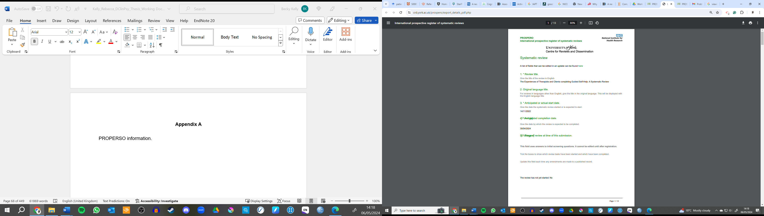
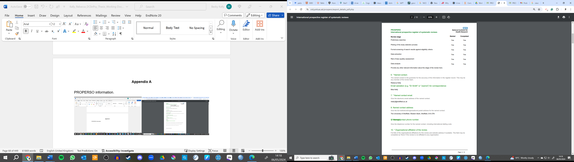

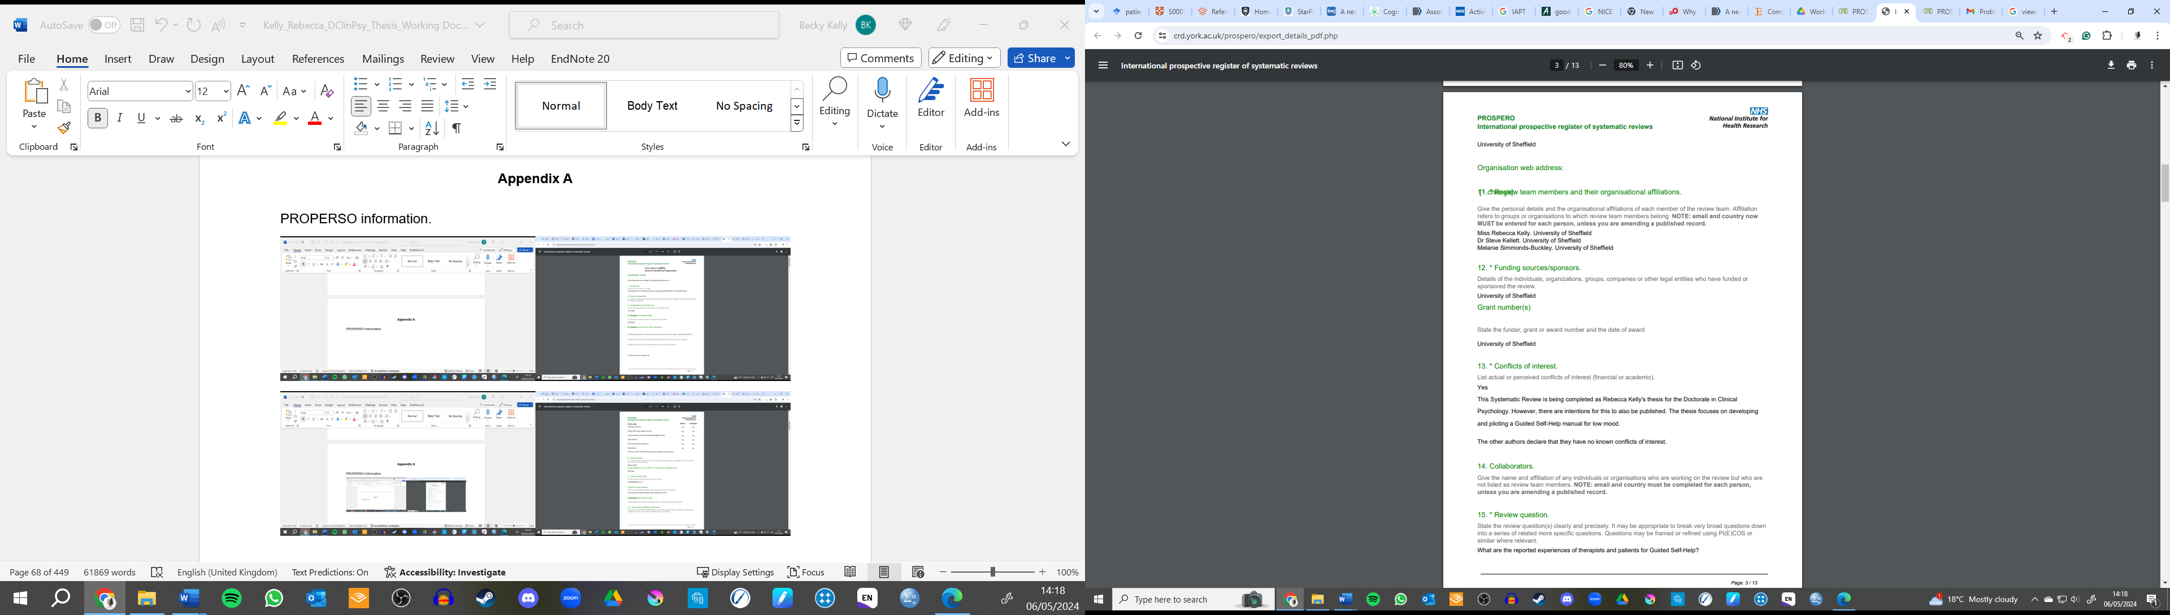

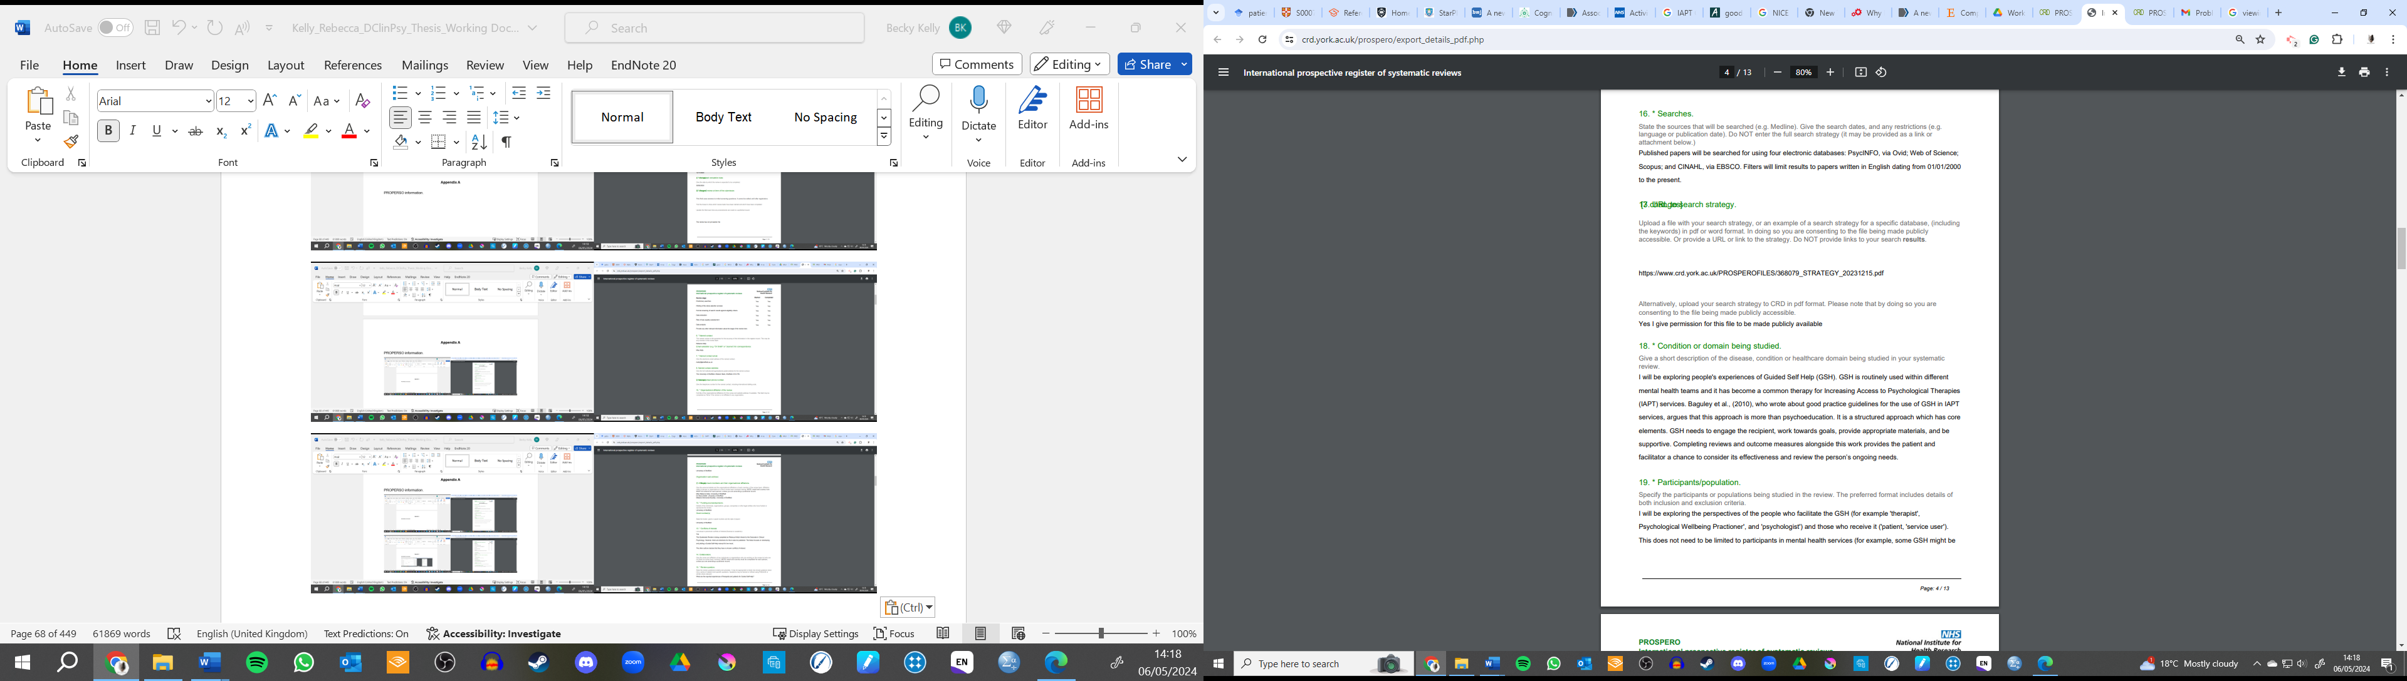

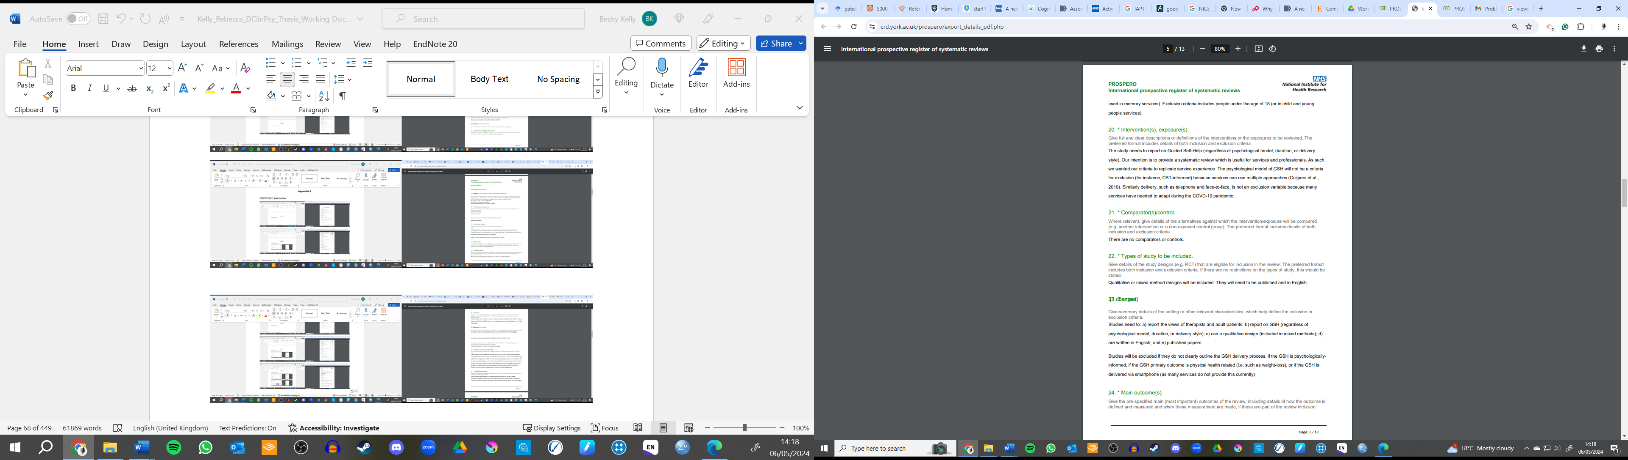
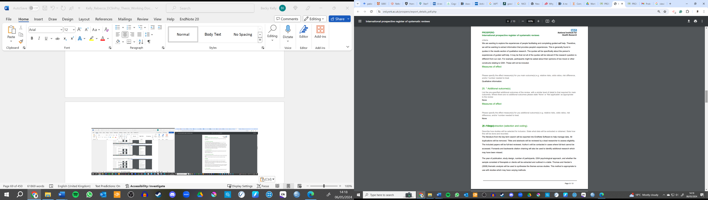
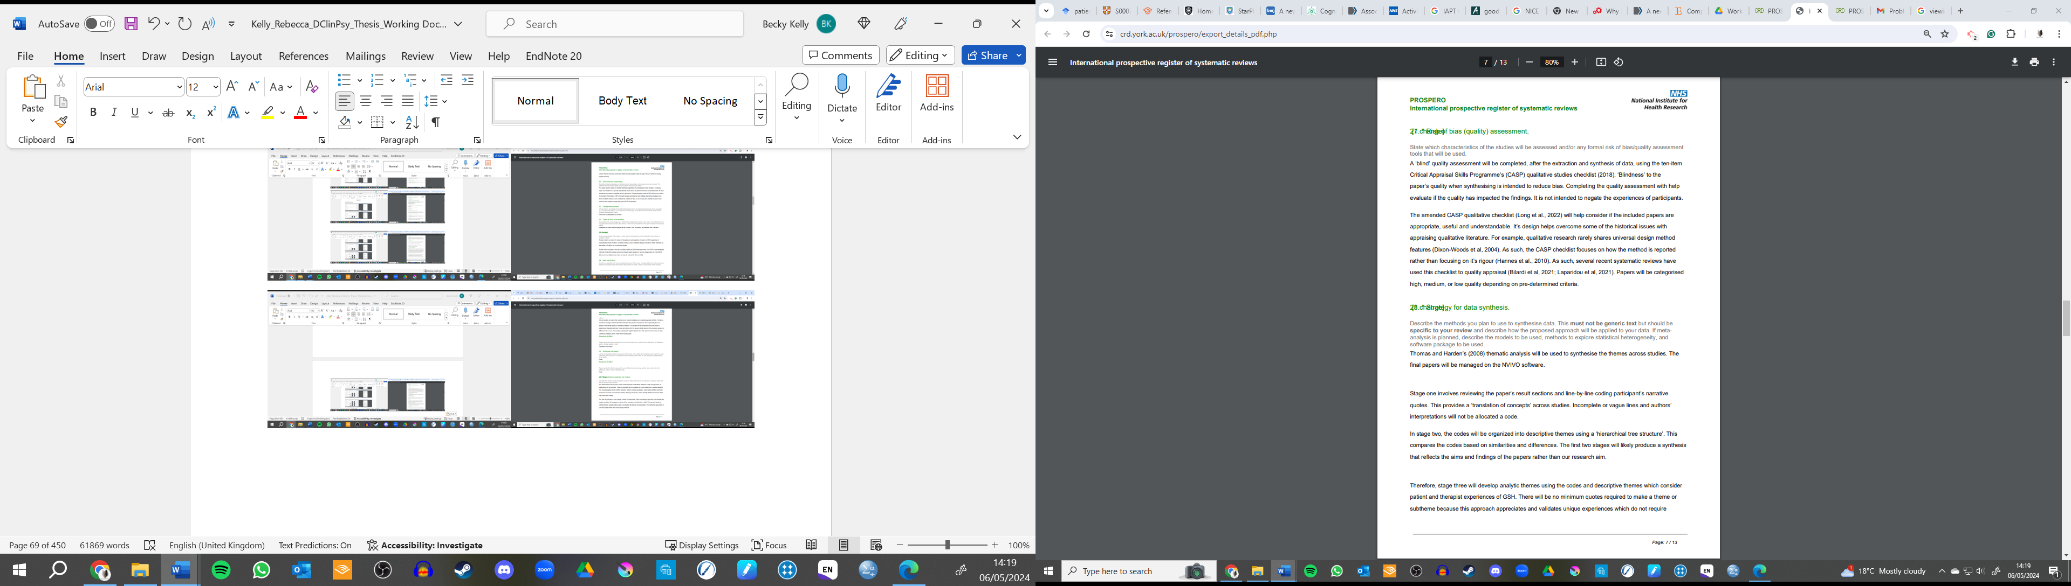
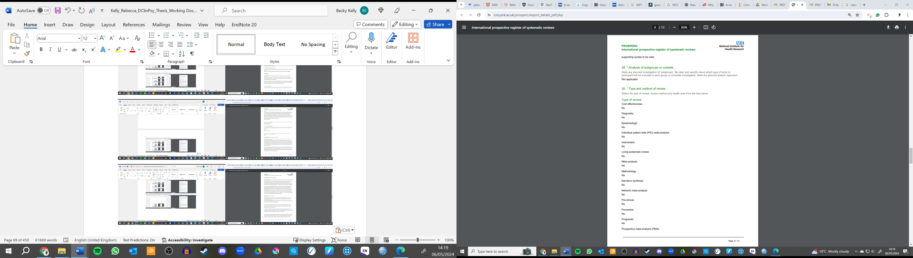
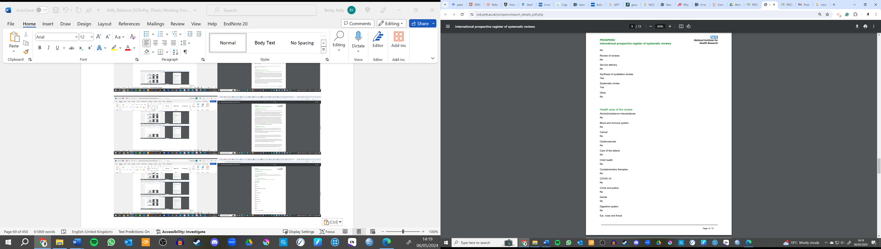
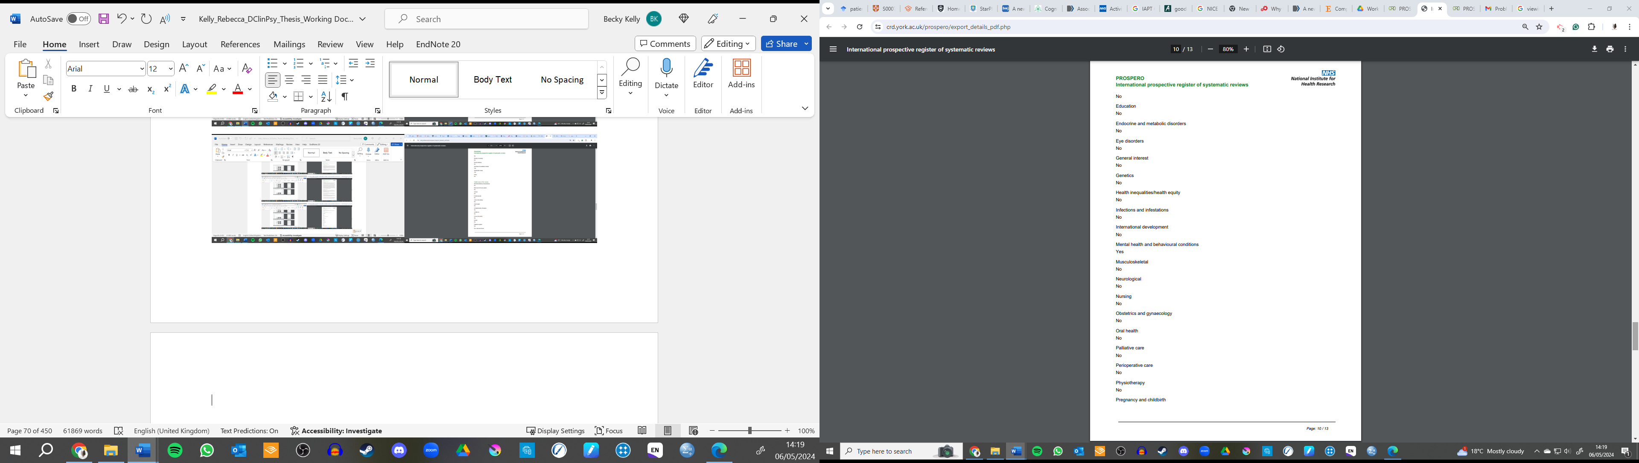
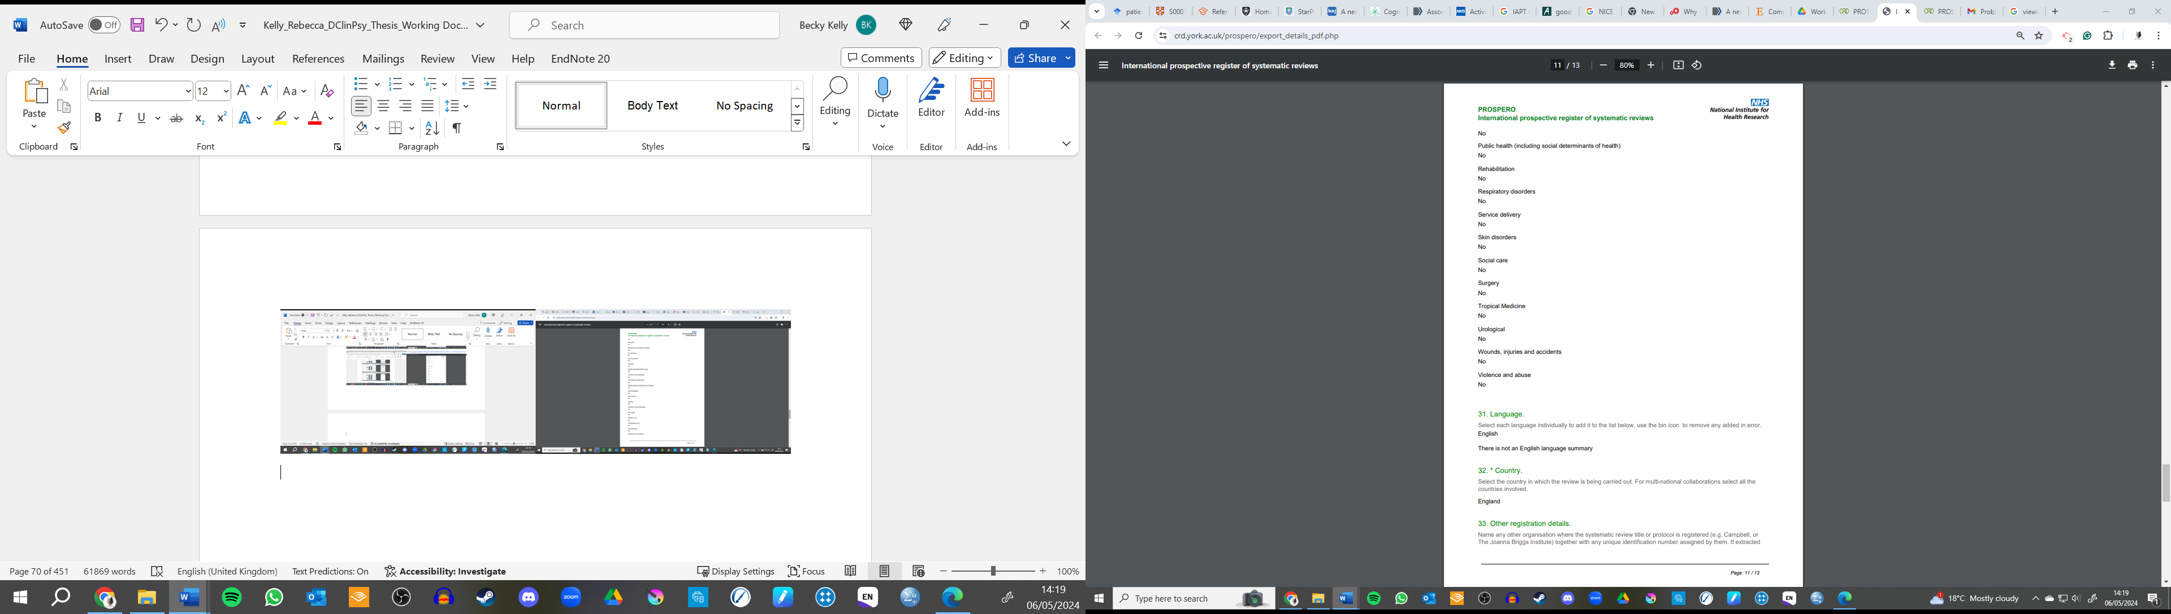
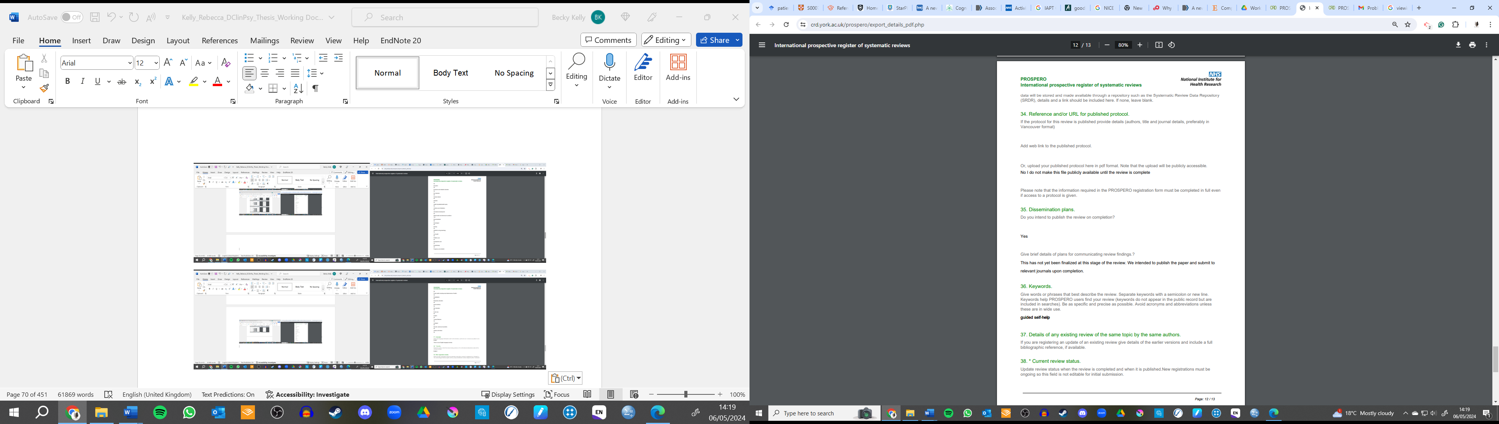
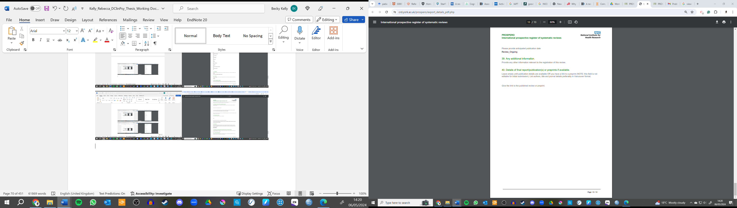
Appendix B
PROSPERO Amendments
Date of change | Amendment | Justification
07.11.2022 | 1) Updated stages of review.  2) Amended error to software name used in data management.  3) Removed GSH from search strategy. | 3) GSH was too broad a term to use within search strategy.
29.11.2022 | 1) Updated stages of review.
16.01.2023 | Changes made prior to quality review.  1) Changed quality appraisal tool from CASP to Long et al., (2022) amended CASP check list.  2) Changed quality appraisal categorisation from frequency, to low, medium, and high. | 1) The adapted checklist addressed limitations for the original CASP checklist (including providing more options for ratings and including additional questions).  2) The CASP checklist was never designed to be weighted and therefore frequency approach was inappropriate.
09.10.2023 | 1) Updated stages of review.  2) Extended the expected completion date.  3) Provided further clarity on what was grounds for exclusion including papers that do not outline GSH delivery process, if GSH was psychologically informed, or if the primary focus was GSH impact on physical health outcomes.  4) Additional researcher added to reflect new supervisor to the project. | 3) Grounds for exclusion was limited, because at the time of planning, it was not expected or recognised GSH was used for physical health difficulties. This error was likely made because the researcher developing the plan was a Trainee Clinical Psychologist and assumed GSH would be psychologically informed, and our aim was for mental health presenting problems.
15.12.2023 | 1) Search strategy and recompleted to include further search terms which we not previously identified. | 1) On the basis of new information and input from other professionals, the search strategy was updated to include more key terms which was not identified previously. This was to improve the inclusion of relevant papers which may have otherwise been missed.
05.04.2023 | 1) Updated stages of review.

Appendix C
Extraction Table
Publication Title:

Study Design and Method
Design Type
Setting
Ontological and Epistemological Position
Data Collection Method
Analysis Approach
Approval/Ethical Consideration

Participants
Number
Age
Gender
Other Demographics
Type (Patient or Facilitator)

GSH Information
Facilitator Title
Target Problem
Delivery Format
GSH Facilitation Information

Results and Conclusions
Themes
Conclusions

Appendix D
Adapted CASP Checklist
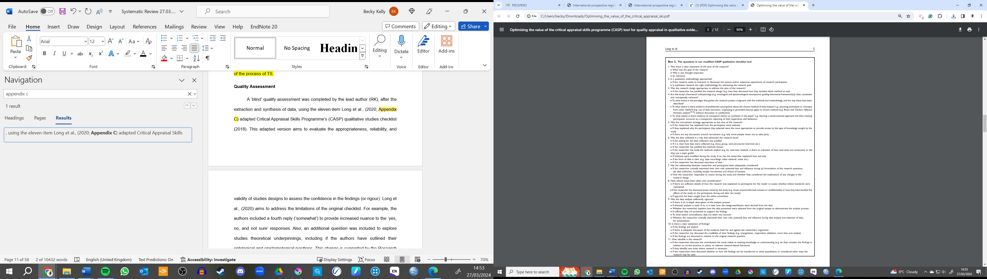
Appendix E
Reflexivity Statement
At the time of writing this, I am a final year Trainee Clinical Psychology student. The conception of this work was generated at the end of my first year. Since this point, my understanding of GSH has changed considerably. At the start of my doctorate, I had only ever experienced GSH as a patient, or from hearing about it through my friends who were PWPs. My access of GSH was impacted by a few factors including the poorly-funded and scarce mental health services in rural northern England. I did not perceive GSH highly, and as such, I could be dismissive about it. From doing this project, I have broadened my understanding and experience of GSH. This experience will have impacted how I analysed the data. There’s an unintentional pull to favour quotes which reflect my own experiences which dismisses other opinions. I acknowledge the impact of this on the analysis, and the reflexivity diary helped me to broaden my perspective.
I also prioritise the voice patients and participants in my clinical and academic work. I acknowledge the history of mental health care, the predominate medical models used in western services, and the power dynamics between professional and patient. Consequently, I favoured using a qualitative approach to understand GSH, and chose to focus on only the participant voices opposed to research authors. This may have been a well-intentioned but a dismissive approach to understanding the research which places participants and researchers into separate categories which does not appreciate the diversity and intertwined nature of qualitative research.

Appendix F
Reflexivity Diary Excerpts
Search Strategy Development
Description | I need to decide the eligibility criteria for how the studies describe GSH.
Initial Thoughts | How flexible can I be with this? From the scoping I know papers might not always describe the GSH approach well. What is the minimum criteria which needs to be included?
Assumptions and Beliefs | I place great value on needing to know if the GSH is psychological based as it is the aim of the review. This is more important than knowing how many sessions were completed or how ethical considerations in the intervention were resolved. As a Trainee Clinical Psychologist, I’ve probably put greater emphasis on this than someone who might value the number of sessions more or how many hours the guided provided support.
Their Impact | What I choose to be included in the criteria will be based on my values and what I think is important.
Decision Made | Get advice from supervisor to then decide knowing that my assumptions and bias will likely impact the eligibility criteria.

Data Analysis
Description | I’m working through the papers; I’ve gotten to number eight.
Initial Thoughts | This is a tedious task and I notice my mind slipping to other thoughts. I’ve started coding using more of my own language, rather than using what the participant has said. For example, “brainwashing” (participant’s narrative) to “changing thoughts”.
Assumptions and Beliefs | I’ve been trained to use Cognitive Behavioural Therapy, and so I’m seeing people’s narratives through this lens. I’m thinking in thoughts, emotions, behaviours, and physical sensations, rather than the person’s understanding and narrative.
Their Impact | I’m using line-by-line descriptive coding. I am trying to keep to the participant’s narrative to reduce the impact of my interpretations at this stage. Continuing using the CBT-lens can have an impact on the validity of the findings.
Decision Made | Continue to try and use the participants words to describe experiences. Take more break to help with fatigue and return when more focused.

Theme Creation
Description | I’ve coded the data and have potential subthemes. I need to consider how they come under a bigger theme.
Initial Thoughts | I have some ideas but there’s a lot of themes and I don’t think some of these subthemes have enough to them. I’m considering merging improved and deterioration mood changes together.
Assumptions and Beliefs | I like GSH and think it can be a very useful intervention. I wonder if I am bias towards more positive outcomes than negative ones.
Their Impact | If I merge the subthemes there is risk I would loose the meaning and side more with the positive outcomes. However, more people report positive outcomes and I think they are similar enough.
Decision Made | Keep working on this with the knowledge of how the assumption could impact my theme development. Hold a consultation meeting with supervisor to get their perspective and highlight my bias in this process.

Appendix G
Contribution to Subthemes and Themes
 | Outcomes |  |  |  |  | Collaborative and Invested Relationships |  |  |  |  | Uncontained and Uninvested Relationships |  |  | Technical Components are Important |  |  | Providing Facilitation Choice
 | 1.1 | 1.2 | 1.3 | 1.4 | 2.1 |  | 2.2 | 2.3 | 2.4 | 3.1 |  | 3.2 | 3.3 | 4.1 | 4.2 | 5.1 |  | 5.2 | 5.3
Banasiak et al., 2007 | X | X | X |  | X |  |  |  |  |  |  | X |  | X | X
Bortveit et al., 2023 | X |  | X |  | X |  |  | X | X |  |  | X | X | X | X |  |  | X | X
Contreras et al., 2021 | X | X | X | X | X |  |  | X |  | X |  |  | X | X | X |  |  |  | X
Contreras et al., 2022 |  | X | X |  | X |  |  |  |  |  |  |  |  | X |  | X |  | X
Hadjistavropo-lous et al., 2018 |  |  | X |  |  |  |  |  | X |  |  |  |  | X | X |  |  |  | X
Hazell et al., 2020 | X | X | X |  | X |  | X |  | X |  |  |  |  | X | X
Horwood et al., 2021 | X |  | X |  |  |  |  |  |  |  |  |  |  | X
Knopp-Hoffer et al., 2016 | X |  |  |  | X |  |  |  |  | X |  | X |  | X | X |  |  | X | X
Krebber et al., 2017 | X | X | X |  |  |  |  |  | X |  |  | X |  | X | X
Lillevoll et al., 2013 | X | X | X |  | X |  |  |  | X |  |  |  |  | X
Ly et al., 2015 | X | X | X |  | X |  |  |  | X |  |  |  |  | X | X |  |  |  | X
Meadows & Kellett, 2017 |  | X |  | X | X |  |  | X |  |  |  |  |  | X | X
Perera-Delcourt & Sharkey, 2019 | X |  |  |  | X |  |  |  | X |  |  |  | X | X |  | X |  | X | X
Plateau et al., 2018 | X | X | X |  | X |  | X |  | X | X |  |  |  | X | X | X
Potter et al., 2021 | X | X |  |  | X |  |  |  | X |  |  |  |  | X | X
Shea et al., 2016 |  | X |  | X | X |  | X |  | X | X |  |  |  | X
Traviss et al., 2013 | X |  |  |  | X |  |  | X | X |  |  | X | X | X
Wray et al., 2022 | X | X |  | X | X |  |  | X |  |  |  |  |  | X | X
Total | 14 | 12 | 11 | 4 | 15 |  | 3 | 5 | 11 | 4 |  | 5 | 4 | 18 | 12 | 3 |  | 4 | 6

Section Two: Empirical Study
Development and piloting of a cognitive analytic therapy guided self-help (CAT-GSH) for depression in NHS Talking Therapies.

Abstract
Objectives: The Medical Research Council’s complex intervention framework (CIF) was used to develop and pilot CAT-GSH for depression in terms of acceptability and effectiveness.
Design: A parallel mixed-methods case series with session-by-session outcome measurement alongside patient and staff interviewing.
Methods: Stage one of the CIF used deductive and inductive strategies to develop the intervention. Stage two of the CIF recruited four Psychological Wellbeing Practitioners (PWPs) and 11 patients to pilot the intervention in an England NHS Talking Therapy service. Acceptability was assessed via uptake rates, dropout, and sessional attendance, plus structured interviews with PWPs and patients that were analysed with framework analysis. Effectiveness was assessed by calculating reliable and clinically significant change rates on sessional clinical outcomes (PHQ-9, GAD-7 and WSAS).
Results: Depression and anxiety significantly reduced between screening and termination, and screening and follow-up. Seven of the 11 patients reliably recovered at follow-up. All patients offered CAT-GSH accepted, and one patient dropped out. Patients found CAT-GSH to be a mostly acceptable experience in which their mood improved, as recognition skills improved, and they were able to implement exits. Facilitators also found CAT-GSH to be an acceptable treatment for NHS Talking Therapies, which provide them with professional development opportunities alongside improving patient’s choice.
Conclusions: CAT-GSH appears acceptable and demonstrates promising preliminary findings for reducing symptoms of depression. Further research is needed to evaluate the intervention in the next stages of the CIF which entails more controlled evaluations.

Practitioner Points
- CAT-GSH for depression appears a viable low intensity treatment for depression in NHS Talking Therapies services.
- Dropout from low intensity therapies is normally high and therefore the acceptability of CAT-GSH for depression is particularly noted.
- Patients and PWPs find the approach acceptable.
- CAT-GSH needs to now be evaluated in larger-scale and more controlled studies.
Keywords
Guided Self-help; NHS Talking Therapies; IAPT; Cognitive Analytic Therapy; Mixed-methods.

Introduction

NHS Talking Therapies and Guided Self Help (GSH)
The aim of the Improving Access to Psychological Therapies (IAPT) programme is to improve the access to, and delivery of, evidence-based psychological therapies for people experiencing anxiety and depression. Now called ‘NHS Talking Therapies for anxiety and depression’, the service is central to ‘The Five Year Forward View for Mental Health’ (Independent Mental Health Taskforce, 2016) and ‘The NHS Long Term Plan’ (NHS England, 2019). NHS Talking Therapies uses a stepped-care approach with the aim of providing the least restrictive recommended psychological treatment first and then increasing treatment intensity appropriately (Bower and Gilbody, 2005). Within step-two of NHS Talking Therapies services, low-intensity (LI) interventions are recommended and offered to people with mild-to-moderate depression (National Institute for Health and Care Excellence; NICE, 2022). These brief LI interventions, typically underpinned by cognitive behavioural therapy (CBT; National Collaborating Centre for Mental Health, 2019), are facilitated by Psychological Wellbeing Practitioners (PWPs) and can be delivered one-to-one, in groups, over the telephone, or via computer packages.
The effectiveness and durability of LI-CBT interventions for depression is open to question. Santoft et al., (2019) suggested CBT-GSH is significantly more effective than control conditions in reducing symptoms of depression in primary care services. However, the effect size was small and most reviewed papers were methodologically flawed. Furthermore, only 47.9% of patient entering LI treatment ‘reliably recovered’ according to NHS Talking Therapies monthly reports (NHS England, 2024). Whilst the report includes other LI treatments alongside GSH, the results suggest there is variability in who benefits from these treatments.
Furthermore, LI therapies within NHS Talking Therapy services typically have high levels of dropout and relapse rates. Firstly, the 2022-2023 annual report for NHS Talking Therapies showed approximately 45% of the 1.22 million referrals which started treatment dropped out (NHS England, 2024). Dropouts within primary care services have been linked to improved mood but also issues with group settings (including preference for one-to-one therapy), poor therapeutic relationships, miscommunication, and impracticalities due to personal life demands (Ghaemian et al., 2020). Regarding relapse rates, approximately 53% of patients who completed LI-CBT relapsed within one year (Ali et al., 2017) and 13.7% of people accessing NHS Talking Therapies services returned for at least one additional treatment between 1-5 years (Lorimer et al., 2024). Consequently, whilst LI interventions within NHS Talking Therapies are beneficial for some patients, there are still high levels of dropout and relapse. One of the ways suggested to improve these outcomes is to improve better choice of treatments for patients (Windle et al., 2020).

Cognitive Analytic Therapy
Cognitive analytic therapy (CAT) is a focussed, integrative psychotherapy (Ryle & Kerr, 2020) which can be delivered across eight, 16, and 24 sessions, according to the level of complexity and context. The intervention has also been adapted for group delivery (Martin et al., 2020) and has a consultation model (Carradice, 2012). CAT uses a transdiagnostic approach and has been delivered to patients with a range of mental health difficulties including those diagnosed with personality disorders, depression, and psychosis (Balmain et al., 2020). CAT is not currently recommended as a treatment within the NICE guidelines for any disorder due to the lack of randomised control trial evidence. This is a common criticism of the approach, highlighted by Calvert and Kellett (2014).
Recently, more clinical trials of CAT have been conducted, more uncontrolled evaluations have been accomplished and two meta-analyses completed. Hallam et al (2021) completed a systematic review and meta-analysis of CAT effectiveness. Depression symptoms significantly reduced, and gains were maintained at follow-up. Simmonds-Buckley et al., (2022) completed a proportional meta-analysis of the acceptability of CAT in 34 studies to show a dropout rate of 18.69%, with CAT generating significantly low dropout compared to other therapies. In terms of the NHS Talking Therapies services, several studies have been recently completed. Wakefield et al. (2021) used propensity score matching to compare 8-sessions CAT protocol to CBT outcomes. Change trajectories for depression were not significantly different between therapies and there was a reduction in the Patient Health Questionnaire-9 scores. Owen et al (2023) retrospectively evaluated 8-16 session CAT and showed a recovery rate of 46.4% with gains being maintained at follow-up.
To address the lack of treatment plurality at step two, CAT-GSH for anxiety was developed and piloted within IAPT services (Meadows & Kellett, 2017). This intervention has six, 35-minuite, PWP-facilitated sessions which follow the reformulation, recognition, and revision CAT approach. The intervention was faithful to the psychoeducational approach, had high completion rates, was acceptable to PWPs, alongside being clinically effective. Wray et al., (2022) explored PWPs experience of the approach to assess acceptability. CAT-GSH provided increased treatment choice, facilitated collaborative therapeutic relationships, increased insight, and “concrete change”. However, at times of high demands, PWPs initially lacked confidence in delivering the intervention. A recent pragmatic patient preference randomised control trial further found that CAT-GSH has comparable outcomes to CBT-GSH, alongside being the preferred treatment when patients are offered a choice between the two interventions (Kellett et al, 2023).
Research Justification
Whilst the development of CAT-GSH for anxiety has been achieved, the development of CAT-GSH for depression has not occurred. Developing a sister CAT-GSH specifically for depression could expand patient choice and provide treatment options to accommodate patient preference. This is important because, accommodating patient preference regarding treatment is associated to lower drop-out rates and higher therapeutic alliance compared to patients who either did not get a choice or were allocated to their nonpreferable treatment (Windle et al., 2020). Furthermore, the CAT-GSH evidence base has also neglected collecting qualitative patient views on acceptability. So far, only a single study (Headley et al, 2021) has gained patients’ experiences of CAT-GSH for anxiety to explore shared and model-specific change mechanisms. This showed that CAT-GSH generated some shared and different change processes to CBT-GSH. Better understanding the patient experience helps adjust the treatment, consider effective clinical practice, and triangulates data (Chenail, 2014).

Aims
Phase One
- Develop a CAT-GSH 6-session workbook specific for the treatment of depression.
Phase Two
- Pilot the CAT-GSH workbook for depression within NHS Talking Therapies setting.
- To assess clinical effectiveness by comparing outcomes at assessment, termination, and follow-up.
- To benchmark CAT-GSH outcomes against CBT-GSH.
- Assess acceptability of CAT-GSH via uptake, drop-out, and attendance rates.
- Qualitatively explore the acceptability of CAT-GSH by interviewing PWPs and patients.
Hypothesis
- Depression symptoms will reliably and clinically significantly reduce between session one and session six.
- There will be a 50% recovery rate at the end of treatment.
- There will be no significant increase in depression over follow-up time.
- There will be no difference in the effectiveness benchmarks between CAT-GSH and CBT-GSH.

Method
Ethical Approval
Approval was obtained from the Health Research Authority (registration number: 310527; Appendix A), NHS Ethics Committee (Appendix B), the University of Sheffield (registration number: 175377). The study was also registered with Clinical Trials.gov (registration number: USheffield 175377).
Ontological and Epistemological Positions
A critical realist-informed perspective helped develop and implement this research. It was assumed that the reality of CAT-GSH was impacted by the researchers, facilitators, and patients’ perspectives alongside broader social narratives and systems (Braun & Clarke, 2006). A subjective epistemological position assumed that the measurement of the reality was impacted by personal beliefs, interpretations, and measurement constructs. For example, Framework Analysis (Ritchie & Spencer, 1994), was used to analyse the data as it aims to understand what occurs behind the descriptions of the phenomena by using both research and data driven processes. Mercier et al., (2023) argues this aligns with a critical realist perspective which holds the “tensions” between perceptions of reality and theoretical descriptions.
Research Phases
The Medical Research Council (MRC, 2008) guidelines for developing and evaluating complex interventions directed the research process (Figure 1). The model proposes a four-stage approach and has been used to develop CAT-GSH (Meadows & Kellett, 2017) and CBT-GSH (Lovell et al, 2008). Phases one and two were completed in this study. The 2008 guidelines were used because they were available at the time of developing this project, however, reflections within the discussion will comment on the updated guidelines (Skivington et al., 2021).

Figure 1
Key Elements of the Development and Evaluation Process
Feasibility
1 Testing procedures
2 Estimating recruitment/retention
3 Determining sample size.

Evaluation
1 Assessing effectiveness.
2 Understanding change process
3 Assessing cost-effectiveness.
Development
1 Identifying the evidence.
2 Identifying/developing theory.
3 Modelling process and outcomes

Implementation
1 Dissemination
2 Surveillance and monitoring
3 Long term follow-ups

Note. Adapted from the Complex Intervention Guide (MRC, 2008)
Phase One: Development
An adapted version of Lovell et al., (2008) and Hardeman et al., (2005) matrix modelling approach was used to develop CAT-GSH for depression. This included a) identifying the evidence-base; b) identifying appropriate theory; and c) creating a model of the intervention. Identifying the evidence-base and appropriate theory was completed by defining depression, identifying key components of GSH, identifying key components of CAT, and identifying our target population and related needs. Table 1 outlines the aims and the exploration methods used. An interview guide (Appendix C), developed during the process of reviewing the literature, guided consultations.
Table 1
Methods Used to Develop CAT-GSH Manual Model
Exploration Aim | Specific Methods Used
Define depression and its importance | Review qualitative and quantitative evidence which defines depression, people’s experiences, and its impact.
Identify key components of GSH | Review evidence about the key components of GSH.  Hold consultation meeting with qualified and trainee CAT practitioners, alongside NHS Talking Therapies PWPs.
Identify key components of CAT | Review evidence regarding the key components of change within CAT.  Consultation meeting with qualified and trainee CAT practitioners, alongside NHS Talking Therapies PWPs.
Identify target population | Review demographics of NHS Talking Therapies services and refer to evidence base.
Note. Adapted table from Lovell et al. (2008) and techniques from Hardeman et al. (2005).
The Matrix Model
Table 2 presents the populated matrix model. Appendix D highlights the process notes made when considering the evidence base and relevant theories.

Table 2
Matrix Guiding the Development of CAT-GSH
 | Experiences of Depression | Barriers to receiving help | Core Components of CAT
Systematic Reviews and Research | Depression experienced as emotional, physical, and interpersonal problems stemming from childhood experiences. | Common barriers include stigma, scepticism about treatment, misfitting treatment and unavailable service. Depression-specific barriers include poor motivation, or fearfulness. | Three core stages of CAT useful: reformulation, recognition, and revision. Patients valued reformulation tools and associated them to change. Idiosyncratic exits strategies useful.
Consultation | Not explored | Potential narrative in society is “just keep going”, which could influence a person’s opinion about seeking help.  Resources within services are limited and patients can feel that pressure (long waiting lists, inconsistent appointments). | Recognition research is underdeveloped yet a useful aspect of CAT. Psychotherapy file may be inaccessible and difficult to translate into GSH. Reformulation letters are difficult to translate into GSH. Considered useful to some clients.
Other Resources | Guidelines outlining low mood, loss of interest, and impact on daily functioning. | No relevant findings | Development of ‘self’ through repeated life experiences. Develops RR and RRP with the aim of coping. Typically, core emotions related to patterns. Understanding procedures as snags, traps, dilemmas. Three stages: reformulation, recognition, and revision.
Included in manual | Emphasis on social functioning and relational expectations alongside low mood and other culturally diverse symptoms. Use of lay language and relevant examples beneficial. Useful to also include in training. | Warm and validating opening to manual, with page dedicated to clear goal setting. It’s importance to outline the predicted research effectiveness. Validating people’s experience of difficulty accessing services. | Follow three core stages of CAT: reformulation, recognition, and revision. Include tools including target problems; traps, dilemmas, and snags; family tree; timeline; mapping; recognition homework tasks; developing and practice exits; identify new roles (strengths and resilience). Exclude letters and psychotherapy file.
 | Client Experience of CAT | Mechanism for Change | CAT and Depression
Systematic Reviews and Research | Mixed opinions. Some appreciated the journey, reformulation tools, and developing exits. But could experience difficult emotions. Positive experiences of CAT-GSH for anxiety. | Suggested mechanisms of change include development of insight, recognition of processes, understanding proximal development. | CAT is transdiagnostic and little exploration specifically for Depression
Consultation | Mapping tools important for clients. Important to promote client language. | Recognition of both conscious and unconscious beliefs. | People with a core emotion linked to depression tend to have patterns relating to withdrawing and disconnecting socially. Common snags are dismissing own achievements. Transdiagnostic model with idiosyncratic aims.
Other Resources | No relevant findings | No relevant findings | No relevant findings
Included in manual | Promote own language using relatable examples. Included mapping of patterns and roles. | Promoting development of insight within core stages of CAT. | Input relatable examples for people who experience depression.
 | Number of Session of GSH | Delivery | Client and PWPs GSH Experience
Systematic Reviews and Research | Eight and six sessions of CAT have promising results. Number of sessions not related to GSH outcome. | GSH have outcome improvements, even with a broad range of delivery (including semi-face-to-face, computer delivered, telephone delivery, internet/emails | GSH should include lay language; promote an appropriate and safe space; clearly outline expectations; acknowledge the stigma; individual is central to change. Positive experience of CAT-GSH for anxiety with patients engaged and motivated. CAT-GSH can invite discussion of past trauma during sessions which can be difficult for clients and PWPs. Past-present discussion, and therapeutic relations, help develop ‘insight’ in the client, and this promoted positive change
Consultation | Typically, fortnightly, and 35-minute sessions in some NHS Talking Therapies services | Typically, face-to-face but could be via telephone/video call depending on COVID related restrictions within NHS Talking Therapies services | Not explored
Other Resources | Needs to be feasible for step two NHS Talking Therapies | NHS Talking Therapies uses PWPs to provide their GSH. | No relevant findings
Included in manual | Six sessions | PWPs delivered sessions. Ideally face-to-face but can be delivered via video link depending on COVID restrictions/service user need. | Readability to be identified with consultations. Some of the information identified here standard part of PWPs training and can be discussed in supervision.
 | Considerations for people with Learning Disabilities | Consideration for working with people from different ethnicities
Systematic Reviews and Research | Helpful techniques include repeating information, checking in with person, using reasonable adjustments. Other suggestions include creating easy-read material, addressing service issues, changing the pace of therapy.
Other Resources |  | Consideration about values and spirituality as part of intervention
Included in Manual | Some of the strategies can be included but it is outside the scope of this research to create an easy-read manual or change the time/formatting of CAT-GSH. | Whilst not directly incorporated into manual, this is included in supervision and training to discuss application to all areas of person’s life impacted by depression

Development of the Manual
The matrix guided the development of the manual. Appendix E outlines the first draft of CAT-GSH for depression. A trainee CAT practitioner, a PWP, and a team manager of an NHS Talking Therapies service reviewed the manual. They provided qualitative feedback alongside rating the manual over five criteria using the ‘Scale for evaluation of self-help guidance for anxiety disorders and depression’ (University College London, n.d.; Appendix F). The scale was chosen as it builds upon IAPT good practice guidelines (Baguley et al., 2010), uses broad areas to evaluate GSH, and was accessible. However, it is not psychometrically tested. Table 3 outlines the range and mean rating for scope, evidence, engagement, implementation, and transparency criteria. The maximum score was 25 for scope, 25 for evidence, 25 for engagement, 20 for implementation, and 5 for transparency. Readability, clarity, and the compassionate approach of the manual was highly rated. However, consultants were concerned about the manual’s transparency and the large amount of content.
Table 3
The Range of Scores of each Core Criteria of the Feedback Questionnaire
 | Scope | Evidence | Engagement | Implementation | Transparency
Range of scores | 20, 24, 25 | 17*, 19, 23 | 23, 24, 25 | 18, 20, 18 | 2, omitted, 3
Note. * one question was omitted.
The manual was adapted to produce the final version (Appendix G). Regarding transparency, an author section at the end of the manual was included. Furthermore, the written content and number of examples was reduced. Table 4 provides an overview of the manual session content and homework.
Table 4
Session Content and Homework of CAT-GSH for Depression
Session | Content | Homework Task
1 | Reformulation - Identification of patterns (dilemma, snag, or trap). | Noticing patterns, family tree, timeline.
2 | Reformulation - identification of roots of depression. Thinking about past relationships. Introduction to relational roles. | Noticing relational roles.
3 | Linking past to present. Recognition - writing problem statement. | Noticing survival patterns.
4 | Revision - creating roadmap and considering exits. | Identifying survival patterns and practicing exits.
5 | Revision - developing healthy identity. Identify strength and resilience. New positive roles. | Identifying survival patterns and practicing exits and/or new positive roles.
6 | Revision - acknowledging endings. Relapse prevention. | None.

Phase Two: Piloting and Feasibility
Phase two explored the acceptability and preliminary outcome change of CAT-GSH to determine the appropriateness of more testing (Bowen et al., 2009; MRC, 2008). This was achieved using a parallel mixed-methods, three-stage (pre-treatment, A; treatment, B; follow-up, C), small-n, case series design. Firstly, a parallel mixed-method approach best fitted the pragmatic needs of conducting this research within mental health services. Secondly, case series have been used by various feasibility studies (Boswell et al., 2019; Hronis et al., 2019; Churchman et al., 2021) to provide rich data exploring each participants’ experiences (Morley, 2017).
Acceptability was defined using the Theoretical Framework of Acceptability (TFA; Sekhon et al. 2017). The framework is divided into several key components (Figure 2). TFA was chosen because, whilst the framework has not been fully evaluated (Sekhon et al., 2017), there is no other known well-defined measure. Furthermore, other studies have deemed the TFA deemed as useful for understanding acceptability of their intervention (Murphy & Gardener, 2019; Pavlova et al; 2020).
Figure 2
The Theoretical Framework of Acceptability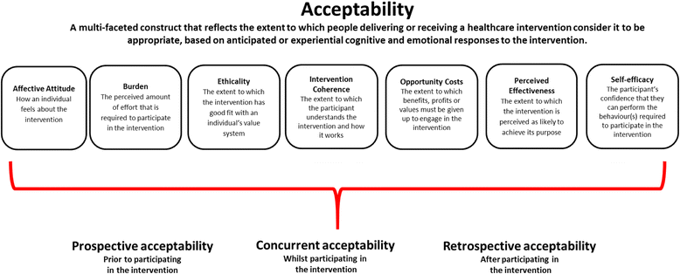
Note. Taken from Sekhon et al. (2017).

Participants
Service managers disseminated the information sheets (Appendix H) and consent forms (Appendix I) within their team. Four PWPs, from a South Yorkshire NHS Talking Therapies service, were recruited using opportunity sampling. All had post-graduate certificates in low-intensity psychological interventions and had experience of CBT-GSH. Recruited PWPs screened the treatment waiting-list and offered CAT-GSH to patients if:
- Depression was the main problem,
- They scored above the clinical cut-off (10-points) on the Patient Health Questionnaire (PHQ-9)
- Aged between 18 – 65,
- Would prefer to use CAT-GSH over other interventions,
- Consented to participate in study,
- Could engage with reading materials.
Exclusion criteria included:
- Patients who needed to be ‘stepped up’ due to complexity and risk,
- Patients receiving other therapies,
- Substance users unable to abstain during sessions.
The exclusion criteria are in line with NHS Talking Therapies step-two treatment guidance. Patients could decide between treatment-as-usual (TAU) or CAT-GSH. TAU typically included one-to-one CBT-GSH. The patients were provided an information sheet (Appendix J), consent form (Appendix K), and the opportunity to speak to the researchers prior to consenting. Based on preference and attrition within Meadows and Kellett’s (2017) study, it was predicted the first 60 people would need to be screened to achieve 10 full-session completers.
Due to human error, one participant partook in CAT-GSH with a score below the PHQ-9 clinical cut-off at screening. The participant’s data was included within the analysis but the potential impact of doing so is explored in the discussion.

Materials
Outcome Measures.
The NHS Talking Therapies minimum dataset measures were employed and included:
- Patient Health Questionnaire-9 (PHQ-9; Appendix L; Kroenke and Spitzer, 2002) is a 9-item self-administered questionnaire designed for detecting depression and is based on the DSM-IV criteria. It has a clinical cut-off of >10 and is widely used within primary care settings. Sensitivity and specificity have been identified at 88% and 85% respectively at the >10 cut-off point (Levis et al, 2019).
- Generalised Anxiety Disorder Assessment (GAD7; Appendix M; Spitzer, et al., 2006) has a clinical cut-off >8, is widely used within primary care settings, and is a self-reported screening tool for generalised anxiety disorder. A systematic review has suggested the GAD-7 has a sensitivity of 83% and specificity of 84% when applying a threshold score of eight (Plummer et al., 2016).
- Work and Social Adjustment Scale (WSAS; Appendix N; Mundt et al., 2002) measures social functioning. It has a clinical cut-off of >10, is sensitive to treatment effects, and has internal reliability (α = 0.82; Zahra et al., 2013).

Procedure
Training and Supervision.
PWPs attended a two-day training course facilitated by the researchers (see Appendix O). The content included specifics of CAT, working with the manual, and collecting/storing data. At the end of the training, the PWPs completed a training satisfaction questionnaire (Appendix P). The questionnaire contained eight questions, seven of which had a Likert rating scale from 1 (not at all) to 10 (extremely). Table 5 outlines the range and median across the 7 items. Table 6 portrays the words used to describe the training. Monthly group clinical supervision, facilitated by the researchers, was provided to the PWPs alongside their regular, individual, weekly case management supervision.
Table 5
The Range and Median of Training Satisfaction Scores
 | Range | Median
1) I feel sufficiently knowledgeable about CAT guided self-help at a theoretical level. | 8 - 10 | 8
2) I feel I sufficiently understand the three components of CAT-GSH. | 8 | 8
3) I feel sufficiently knowledgeable about how CAT-GSH differs from CBT-GSH. | 9 | 9
4) I feel sufficiently confident in implementing CAT-GSH. | 6 – 8 | 7
5) I am generally satisfied with the training provided on CAT-GSH. | 9 | 9
6) The training materials were presented in an engaging and understandable way. | 9 – 10 | 9.5
7) The trainers were encouraging and enthusiastic. | 10 | 10

Table 6
The Words used to Describe Training
 | PWP1 | PWP2 | PWP3 | PWP4
Write five words below to describe the CAT-GSH training | Challenging  Interesting  Informative  Thorough  Educational | Interesting  Mind-opening  Exciting  Thorough  Supportive | Interesting  Engaging  Knowledgeable  Refreshing  Motivating | Enjoyable  Stimulating  Thoughtful  Positive  Educational
Intervention.
CAT-GSH was delivered on a weekly basis and provided face-to-face or via video link. The participants received a copy of the manual.

Data Collection
Quantitative Data.
Demographic, Uptake, and Attrition Information.
Gender and age of patients were documented. Screening data outlined the number of suitable patients, uptake rates, and completion rates. Session attendance and drop-out was recorded to provide an estimation for the recruitment and retention of a full-scale study alongside providing insight into the acceptability of the intervention (Sekhon et al, 2017).
Therapist Competency.
Session three of each CAT-GSH treatment was recorded to assess PWPs competence and treatment fidelity. Two members of the research team scored the PWPs with the validated low-intensity treatment competency scale (LITC; Kellet et al, 2021). Competency categories included focusing the treatment session; establishing and maintaining engagement; interpersonal; information gathering; within session self-help change method; and planning and shared decision making. A total score of 18 or above is defined as GSH competent.
Clinical Outcomes.
Outcome measures were collected at screening, the start of each CAT-GSH session and at one month follow-up. Table 7 outlines this process.

Table 7
Data Collection Points
Outcome Stage | Collection Point
Baseline (A) | Screening Session
 | Session One
CAT-GSH Treatment (B) | Session Two
 | Session Three
 | Session Four
 | Session Five
 | Session Six (Termination)
Follow-up (C) | Follow-up
Qualitative Data.
Individual exit interviews with each patient and PWP were completed by the lead researcher. This was facilitated either in-person or via Microsoft Teams depending on preferences. The sessions were recorded on a Dictaphone and the audio files transferred to a secure server. The interviews were semi-structured and based on an adapted interview guide from a similar study which assessed acceptability of a mental health promotion program (Murphy & Gardener, 2019). The interview guide for the patients (Appendix Q) and PWPs (Appendix R) were grammatically different. A reflexivity log was created pre- and post-interviews (Appendix S). The recordings of the interviews were transcribed by a university-approved transcriber who signed a confidentiality agreement (Appendix T). Exit interviews were not offered to patients who did not finish CAT-GSH because it was not possible to complete at this stage of piloting.

Analysis

Quantitative Analysis
Therapist Competency
Competency is reported by providing each PWPs score, the rate at which competency CAT-GSH was apparent (session scores >18), the total competency score for the sample, and the inter-rater reliability percentage.
Clinical Outcomes – Group Level
The group median, mean and SD for screening, termination, and follow-up scores, across each outcome measure, are reported. Whilst Shapiro-Wilk tests across each outcome were non-significant at screening (PHQ-9, p=.92; GAD-7, p=.61; and WSAS, p=.61), Field (2013) and Ghasemi and Zahediasl (2012) argue this normality test has little power to reject the null hypothesis for small sample sizes. Consequently, non-parametric models (via SPSS, version 26; see Appendix U) analysed the data due to the small sample size not meeting requirements for central limit theorem (>30; Field, 2013) and concerns regarding normality. Friedman’s ANOVA analysed the difference in scores across screening, termination, and follow-up data. Wilcoxon signed-rank tests were subsequently completed to compare screening to termination, screening to follow-up data, and termination to follow-up. Pearson r correlation was calculated.
Treatment characteristics, uptake rates, attrition rates, and outcome pre- and post-treatment means, and SD were benchmarked to established and comparable research.
Clinical Outcomes – Individual Level
Individual participant’s median across the outcome measures for screening, treatment sessions, and follow-up scores are presented visually within graphs.
Reliable Change Index.
Reliable Change Index (RCI; Jacobson & Traux, 1991) calculations for the PHQ-9 and GAD-7 evaluated the likelihood that change between pre-intervention, termination and post-intervention scores reflected real change in the patients’ depression and anxiety symptoms and not due to measurement error. RCI was shown when at follow-up a client’s scores changed by 4 points on the GAD-7 and 6 points on the PHQ-9 (Parry, 2011). This method aligns with NHS Talking Therapies calculations for measuring “reliable improvement”.
Clinically Significant Change.
Clinically Significant Change (CSC; Jacobson & Traux, 1991) calculations assessed whether the change in pre-intervention, termination, and post-intervention PHQ-9 and GAD-7 scores indicated a significant improvement or worsening of patient’s symptoms. CSC was concluded if patient’s who scored above clinical cut-off pre-treatment (PHQ-9 >10; GAD-7 >8) scored below the cut-off post-treatment (Levis et al, 2019). This method aligns with NHS Talking Therapy method of calculating “recovery”.
RCI and CSC for the PHQ-9 and the GAD-7 were calculated for screening session (S) to termination (T) scores, and screening session to follow-up scores (FU; see Appendix V). PHQ-9 RCI and CSC scores were categorised into four groups:
- Uncertain change: no indication of change, or change was determined unreliable,
- Reliable deterioration: change was reliable, and scores worsened,
- Reliable improvement: change was reliable, and scores improved but not below cut-offs,
- Reliable Recovery: change was reliable, and scores improved from above clinical cut-off pre-treatment to below clinical cut-off post-treatment.

Qualitative Analysis
Framework Analysis (FA; Ritchie & Spencer, 1994) analysed the exit interview data. FA is not bound by a specific epistemological position and provides ‘best fit’ for this research (Gale et al., 2013; Richie & Spencer, 1994). Furthermore, FA allows for the incorporation of TFA to guide the exploration of acceptability. Other qualitative analysis approaches were considered however, they did not meet the needs of the research aims. For example, Thematic Analysis (Braun & Clarke, 2006) was considered potentially suitable because it is also not bound to an epistemological position and could provide a pragmatic approach. However, it would not easily allow for the application of TFA to help inform the work.
FA was completed by the lead researcher. Table 8 outlines the five stages and the process in detail. PWPs and patient data were analysed together. This is because the aim of understanding acceptability is from a holistic approach which intends to incorporate the shared experiences of professional and client.

Table 8
Ritchie and Spencer (1994) Framework Analysis
Phase | Description
Familiarisation | This stage includes the repeated and active reading through all the data and listening to audio recordings. This included data files of both patient and PWPs interviews. Appendix W highlights the FA familiarisation notes which reflect the TFA model.
Identifying a Framework | Next, key concepts and categorical themes are identified using a priori framework and patterns from the familiarization stage. The framework is informed by the research question and this stage includes continuous reflection and reforming of the framework.
Indexing | Indexes, reflecting the framework, are systematically applied to the transcripts.
Charting | Then, the indexes are formatted into theme-organised categorises using a chart. This stage enables the data to be manageably formatted into a matrix. This also enables comparison within cases and between themes.
Mapping and Interpretation | Finally, the data’s key characteristics are pulled together to provide an overview by describing the data, identifying patterns, and providing interpretations.

Familiarisation included listening to audio recordings alongside rereading the reflexivity logs and transcripts. From this process an initial framework was created (Appendix X). This framework was tested on two PWPs and three patient transcripts. Revisions to the framework were made (Appendix Y). Once a final framework was outlined, all interviews were indexed using NVIVO software. The indexes were formatted into a theme-organised chart (Appendix Z). This matrix was mapped, and interpretations made to explore the acceptability of CAT-GSH. Auditing was completed at the end of this process (Appendix AA).
Quality Assurance
To ensure quality, the lead researcher utilised supervision to discuss decisions and resolve uncertainties. Hearing second opinions and openly reflecting helped address any bias present. Triangulation of different sources was also used for quality assurance (Korstjens & Moser, 2018). Hence the mixed-methods design with the aim of using multiple approaches to explore acceptability. Long et al., (2020) adapted version of the Critical Appraisal Skills Programme (CASP) qualitative appraisal tool was used to help develop, implement, and report the study.
Reflexivity
A reflexivity diary was kept outlining the lead researcher’s assumptions, preconceptions, and how this affected research decisions (Korstjens & Moser, 2018). The non-linear process included continuously reviewing, adapting, and outcoming. The diary included, but was not limited to, contemplating inter-personal aspects, personal reflections, epistemological considerations, organisational and service implications, ethical dilemmas, and conflicting interests. Appendix BB outlines key excerpts from throughout the research project.
As part of this process, the relationship between the researchers and participants were considered. PWPs had worked for several months with the researchers during training, facilitation, and supervision of the project prior to their interviews. Furthermore, patients were informed that the co-creator of the manual would be interviewing them about their experiences. Arguably, these relationships may have influenced how participants responded during the exit interviews.
A reflexivity statement (Appendix CC) acknowledges the leading conflicting personal and professional beliefs of the main author which influenced the research. For example, the author acknowledges their belief that mental health cannot be neatly defined into depression, anxiety, or other diagnostic criteria. However, GSH has arguably been developed in the social content wherein the main narrative assumes mental health is an illness or fits into diagnostic categories.
Ethical Considerations
As part of the ethical process of developing a novel intervention with an NHS Talking Therapy service, risks and safeguards were considered. For example, there was the risk that without the correct procedures the intervention could be harmful or inefficient. Safeguarding and quality assurance were considered throughout the process to protect against these possibilities. This includes, but is not limited to, following MRC (2008) guidelines, consulting professionals, reviewing evidence base, utilising supervision, upholding NHS values (such as transparency and honesty), consulting professionals, and respecting participants’ rights.
Results
Quantitative Data
Demographic Information
Patient demographics are presented in table 9. Patient age ranged from 18 – 59 years (mean = 42.45).

Table 9
Gender, Age, Session Frequency, and Session Attendance
 | Gender | Age | Session Frequency | Session Attendance
P1 | Female | 55 | Weekly | 6/6
P2 | Female | 39 | Weekly | 6/6
P3 | Female | 53 | Weekly | 6/6
P4 | Female | 40 | Weekly | 6/6
P5 | Female | 18 | Weekly | 3/6
P6 | Male | 59 | Weekly | 6/6
P7 | Male | 29 | Weekly | 6/6
P8 | Female | 29 | Weekly | 6/6
P9 | Female | 49 | Weekly | 6/6
P10 | Male | 41 | Weekly | 6/6
P11 | Female | 55 | Weekly | 6/6
Note. P5 dropped out after session 3.
Uptake and Completion Rates
Figure 3 highlights the patient progress through the screening, treatment, and follow-up process. Of the 98 people screened for suitability, 12 (12.24%) were deemed potentially suitable. Reasons for exclusions are included in Figure 3. Of the people offered CAT-GSH, 11 accepted. Ten of those people completed all six sessions and the follow-up outcome measures (named ‘completer group’). One person dropped out at session three for unknown reasons. None of the completer group missed any sessions and attended full CAT-GSH.

Figure 3
Flowchart of CAT-GSH for Depression Uptake Process
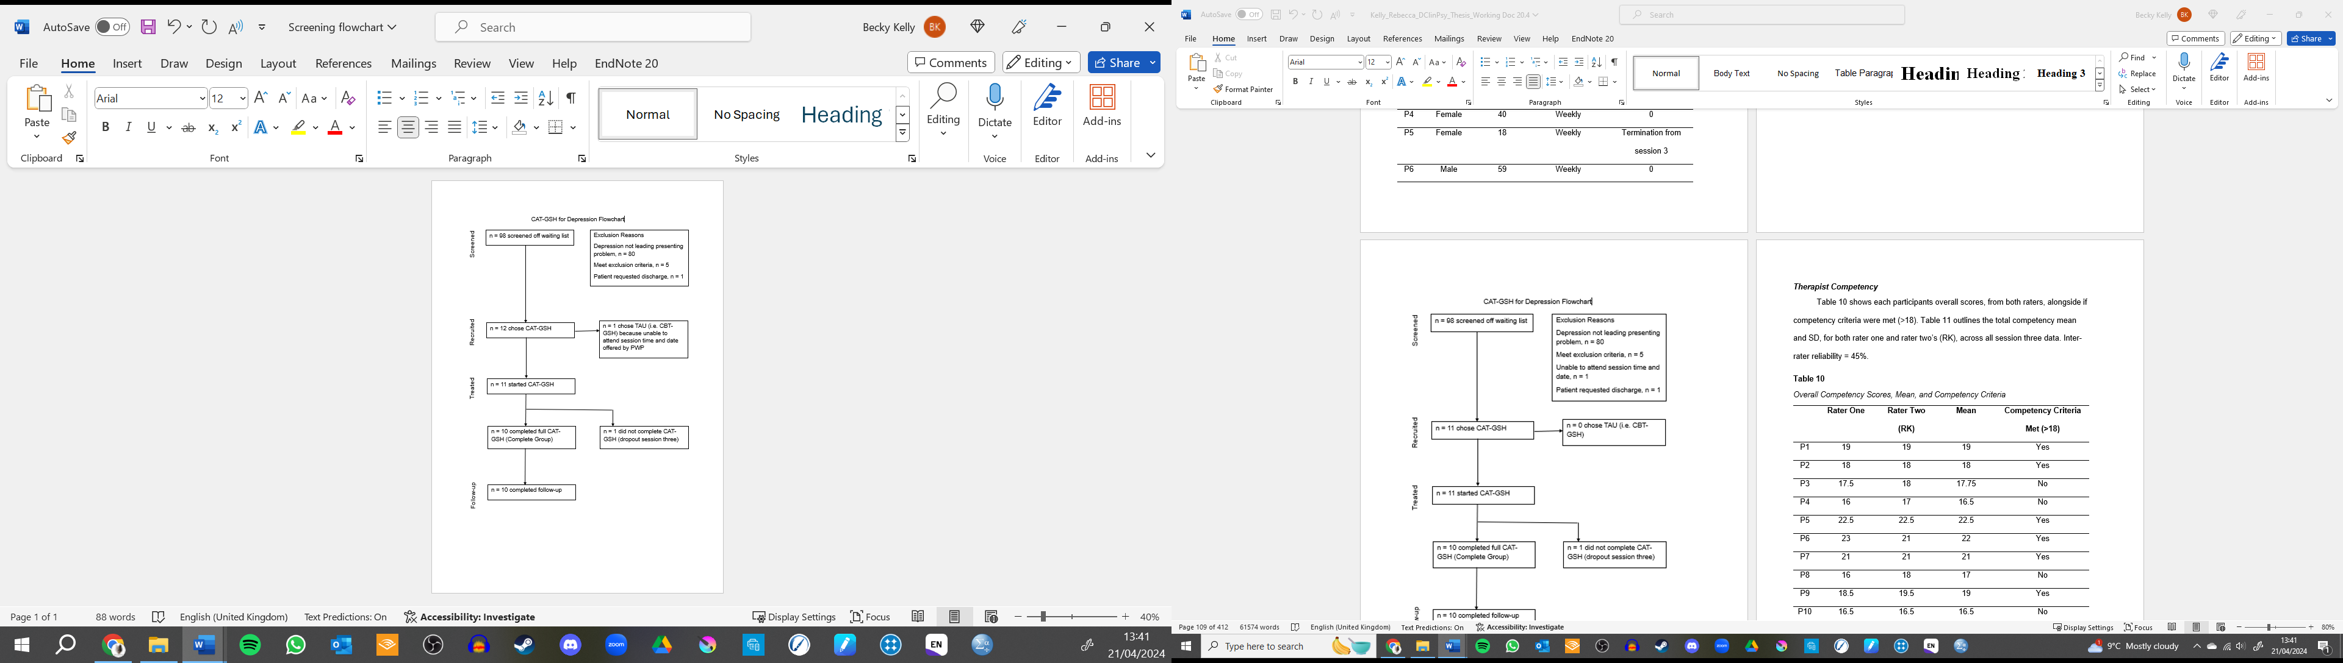
Therapist Competency
Table 10 shows each participant’s overall scores, from both raters, alongside if competency criteria were met (>18). Table 11 outlines the total competency mean and SD, for both raters, across all session three data. Inter-rater reliability calculated using intraclass correction coefficient = 95%.
Table 10
Overall Competency Scores, Mean, and Competency Criteria
 | Rater One | Rater Two (RK) | Mean | Competency Criteria Met (>18)
P1 | 19 | 19 | 19 | Yes
P2 | 18 | 18 | 18 | Yes
P3 | 17.5 | 18 | 17.75 | No
P4 | 16 | 17 | 16.5 | No
P5 | 22.5 | 22.5 | 22.5 | Yes
P6 | 23 | 21 | 22 | Yes
P7 | 21 | 21 | 21 | Yes
P8 | 16 | 18 | 17 | No
P9 | 18.5 | 19.5 | 19 | Yes
P10 | 16.5 | 16.5 | 16.5 | No
P11 | 15 | 16 | 15.5 | No

Table 11
Mean and SD for Therapist Competency
 | Mean (SD) Score for PWPs CAT-GSH Competency
 | Rater One | Rater Two (RK)
Total Competency | 18.45 (2.70) | 18.95 (2.05)
Descriptive Statistics
Table 12 outlines the median, mean, and SD for the PHQ-9, GAD-7, and WSAS across screening, termination, and follow-up. Figure 4 presents median groups scores across screening, treatment sessions, and follow-up for the three outcome measures.
Table 12
Median, Mean, and SD at Screening, Termination, and Follow-up
Measure | Median, Mean, SD | Screening | Termination | Follow-up
PHQ-9 | Median  Mean  (SD) | 16  16.36  (4.84) | 6  8.27  (7.91) | 3.5  6.4  (8.28)
GAD-7 | Median  Mean  (SD) | 11  11.73  (5.41) | 7  8  (6.54) | 3.5  5.8  (6.91)
WSAS | Median  Mean  (SD) | 10  11  (5.6) | 4  9.09  (9.61) | 4.5  7.5  (9.9)
Note. This data includes participant 5 who dropped out at session three.

Figure 4
The median group scores for the PHQ-9, GAD-7, and WSAS.
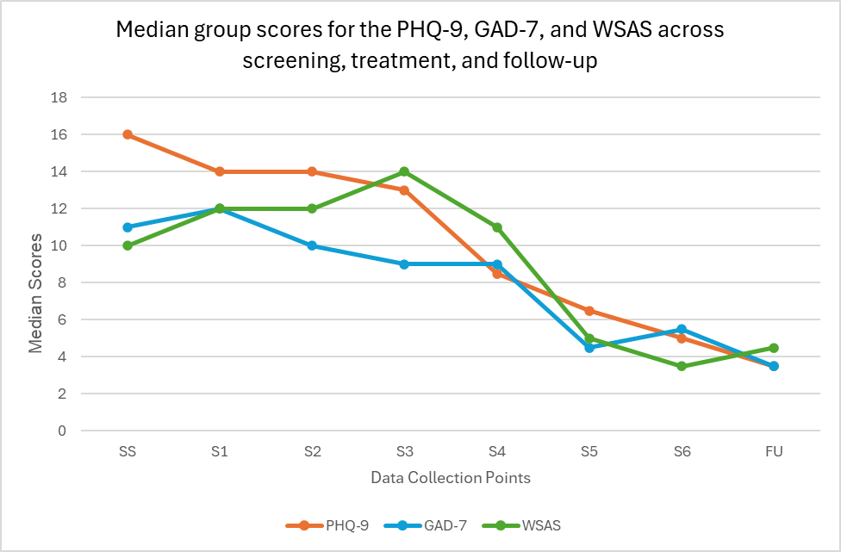
Group Level Analysis
Figure 5 outlines a box and whisker chart demonstrating the distribution of the PHQ-9 scores across each session and includes the screening session and follow-up session.

Figure 5
The Distribution of PHQ-9 scores Across Each Session.
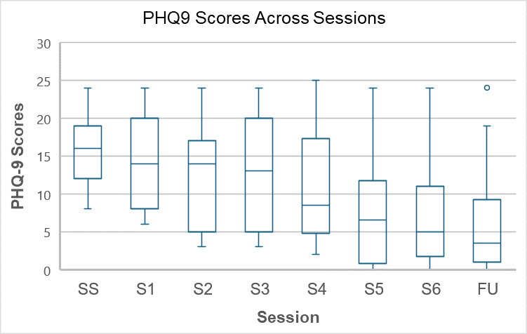
Note. The dashed lines indicate the screening (A), treatment (B), and follow-up (C) stages.
PHQ-9.
Depression symptoms significantly reduced over screening, termination, and follow-up, X²(2) = 13.35, p<.001. From subsequent Wilcoxon tests, it appeared depression was significantly higher at screening (Mdn = 16), than termination (Mdn = 6), z = -2.7, p<.01, r = -0.58; and follow-up (Mdn = 3.5), z = -2.66, p<.01, r = -0.58. There was no significant difference between termination and follow-up, z = -1.42, p = .16.
When excluding the participant who scored below the clinical cut-off at screening, depression symptoms still significantly reduced over screening, termination, and follow-up, X²(2) = 11.71, p<.01. From Wilcoxon tests, depression was significantly higher at screening (Mdn = 17), than termination (Mdn = 8), z = -2.55, p<0.5, r = -0.54; and follow-up (Mdn = 4), z = -2.5, p<.05, r = -0.56. There was no significant difference between termination and follow-up, z = -1.42, p = .16.
GAD7.
Anxiety symptoms significantly reduced over screening, termination, and follow-up, X²(2) = 8.68, p <.05. Wilcoxon tests calculated anxiety was significantly higher at screening (Mdn = 11), than termination (Mdn = 7), z = -2.06, p<.05, r = -0.44; and follow-up (Mdn = 3.5), z = -2.04, p<.05, r = -0.46. There was no significant difference between termination and follow-up, z = -.74, p = .46.
WSAS.
The negative impacts of mental health difficulties did not significantly change across screening, termination, and follow-up, X²(2) = 2.89, p = .24.
Benchmark
Table 13 highlights the present study benchmarked against three other similar studies.

Table 13
Benchmark Outcomes Compared to the Present Study
Author | Presenting Problem (Sample Size) | Treatment | Uptake (%) | Attrition (%) | Outcome  Measure | Outcome
 |  |  |  |  |  | Screening Session Mean (SD) | Termination Mean (SD) | Follow-up Mean (SD) | Change Score  (S–T)
Present Study | Depression (n = 11) | CAT-GSH, screening session, 6x35 minute sessions face-to-face or via Microsoft Teams. | 100 | 9.09 | PHQ-9  GAD-7  WSAS | 16.36 (4.84)  11.73 (5.41)  11 (5.6) | 8.27 (7.91)  8 (6.54)  9.09 (9.61) | 6.4 (8.28)  5.8 (6.91)  7.5 (9.9) | -8.27  -3.73  -1.91
Green et al., (2014) | Depression and/or Anxiety  (n = 1,122) | GSH within NHS Talking Therapies, screening plus 2 – 21 face-to-face sessions | - | - | PHQ-9  GAD-7 | 13.7 (6.43)  12.04 (5.57) | 9.83 (7.15)  8.99 (6.32) | -  - | -3.34 (6.43)  -3.05 (5.82)
Kellett et al., 2023 | Anxiety  (n = 79 partook in CBT-GSH) | CBT-GSH, screening plus 6 – 8 sessions via telephone | - | - | PHQ-9  GAD-7  WSAS | 16.87 (5.01)  16.86 (3.44)  21.35 (7.41) | -  -  - | -  -  - | -4.81 (0.68)  -5.84 (0.62)  -4.67 (1.06)
Meadow & Kellett, 2017 | Anxiety  (n = 17) | CAT-GSH, screening session, 6x35 minute face-to-face sessions | 42 | 9 | PHQ-9  GAD-7  WSAS | 12.4 (3.78)  13.2 (3.43)  15.3 (5.08) | 7.6 (4.81)  7.5 (4.93)  8.8 (3.65) | 5.5 (4.48)  6.3 (4.74)  6.6 (4.77) | -5.7  -4.8  -6.5

Individual Level Analysis
Individual screening, treatment sessions, and follow-up PHQ-9 scores are presented in Figures 6-16. Table 10 highlights the individual level analysis for all participants including the raw scores at screening, termination, and follow-up along with if RCI and CSC has been reached.
Figure 6
Participant 1 PHQ-9 Score across Data Collection Points

Figure 7
Participant 2 PHQ-9 Score across Data Collection Points

Figure 8
Participant 3 PHQ-9 Score across Data Collection Points

Figure 9
Participant 4 PHQ-9 Score across Data Collection Points

Figure 10
Participant 5 PHQ-9 Score across Data Collection Points

Note. Participant dropped out after session three.

Figure 11
Participant 6 PHQ-9 Score across Data Collection Points

Figure 12
Participant 7 PHQ-9 Score across Data Collection Points

Figure 13
Participant 8 PHQ-9 Score across Data Collection Points

Figure 14
Participant 9 PHQ-9 Score across Data Collection Points

Figure 15
Participant 10 PHQ-9 Score across Data Collection Points

Figure 16
Participant 11 PHQ-9 Score across Data Collection Points

Table 14
Raw scores of Screening (S), Termination (T), and Follow-up (FU); the Change in Scores; RCI; CSC; and PHQ-9 Classification.
 | S | T | FU | Change Score (B-T) | RCI | CSC | Chance Score (B-FU) | RC | CSC | Classification for PHQ-9 Scores at FU
Participant 1  PHQ-9  GAD-7 | 23  16 | 0  0 | 0  0 | -23  -23 | Yes  Yes | Yes  Yes | -23  -23 | Yes  Yes | Yes  Yes | Reliable Recovery
Participant 2  PHQ-9  GAD-7 | 12  4 | 2  2 | 1  2 | -10  -2 | Yes  No | Yes  No | -11  -2 | Yes  No | Yes  No | Reliable Recovery
Participant 3  PHQ-9  GAD-7 | 24  24 | 24  16 | 19  16 | 0  -8 | No  Yes | No  No | -5  -8 | No  Yes | No  No | Uncertain Change
Participant 4  PHQ-9  GAD-7 | 8  6 | 1  2 | 1  2 | -7  -4 | Yes  Yes | No  No | -7  -4 | Yes  Yes | No  No | Reliable Improvement
Participant 5  PHQ-9  GAD-7 | 18  16 | 20  20 |  | +2  +4 | No  No | No  No |  |  |  | Uncertain Change (for termination)
Participant 6  PHQ-9  GAD-7 | 16  16 | 10  9 | 6  4 | -6  -7 | Yes  Yes | No  No | -10  -12 | Yes  Yes | Yes  Yes | Reliable Recovery
Participant 7  PHQ-9  GAD-7 | 14  9 | 11  11 | 4  3 | -3  +2 | No  No | No  No | -10  -6 | Yes  Yes | Yes  Yes | Reliable Recovery
Participant 8  PHQ-9  GAD-7 | 19  11 | 11  14 | 24  21 | -8  +3 | Yes  No | No  No | +5  +10 | No  No | No  No | Uncertain Change
Participant 9  PHQ-9  GAD-7 | 19  5 | 4  1 | 3  0 | -15  -4 | Yes  Yes | Yes  No | -16  -5 | Yes  Yes | Yes  No | Reliable Recovery
Participant 10  PHQ-9  GAD-7 | 12  11 | 2  7 | 1  2 | -10  -4 | Yes  Yes | Yes  Yes | -11  -9 | Yes  Yes | Yes  Yes | Reliable Recovery
Participant 11  PHQ-9  GAD-7 | 15  14 | 6  2 | 5  4 | -9  -12 | Yes  Yes | Yes  Yes | -10  -10 | Yes  Yes | Yes  Yes | Reliable Recovery
Note. Participant 5 screening was compared to session three termination.
Qualitative Results
Overall, CAT-GSH was experienced as largely acceptable by the patients and the PWPs. All seven core themes of the TFA (Sekhon et al., 2017) were used and were supported by 16 subthemes (Table 15).

Table 15
Framework highlighting Themes, Subthemes, Number of Contributors, and Quotes
Theme | Sub-theme | Frequency of Contribution | Example Quote
Affective Attitude; Positively Changing Opinions | Mixed Feelings Prior Starting | 12 (9 patients, 3 PWPs) | “Yeah, I think I think from way I were feeling to like actually going in for first session was like ‘argh’ the dread the felt the anxiety of actually I've got to go to that place to go into that place”. (P1)  “I were a little bit sceptical about it to start with.” (PWP1)
 | Largely Positive Feelings | 12 (8 patients, 4 PWPs) | “ Erm, no, just that I really enjoyed it, it really helped.” (P2)  “No (laughs) I wanted to like, you know, give you something but, no, as you can tell I had a good experience with it so I don’t know what I would change to be honest.” (PWP3)
Burden | Emotional Burden | 8 (4 patients, 4 PWPs) | “But then I obviously did me track and did a new one and I managed to find the way to get out of it so but yeah it were a bit doom and gloom like going really root of the problem do you know what I mean?”. (P8)  “I think for some clients, erm, and can be quite I suppose hard hitting, erm, kind of thinking about family and where things might have come from in relationship roles and that making that kind of again that light bulb moment so that can that can be a cost”. (PWP2)
 | PWPs Effort | 3 (0 patients, 3 PWPs) | “Erm, I suppose spinning plates (laughs) erm, again I if I was if I’d just started kind of a obviously everything changed for me personally, er, with job and everything like that which wasn’t massively helpful at the time but I think the, erm, biggest of the spinning plates of like getting trying to get this getting my head into that and then going to maybe low intensity as as usual step two.” (PWP2)
Intervention Coherence | Developing Understanding | 7 (4 patients, 3 PWPs) | “In the grand scheme of things it all makes sense but not until later on so it’s difficult to pinpoint something, you know, that that’s it’s I don’t think there's anything any part of it that’s not particularly helpful.” (P4)  “I think I’d like more time I think to get to grips with it because obviously it’s quite speedy, you know, we were doing that a day of training and that we’re kind of in and doing it.” (PWP4)
 | Different Parts Understood | 14 (10 patients, 4 PWPs) | “I understand that, erm, it were you know to help me, you know, like with relationships and me, you know, to towards people and and why, you know, like why, why I'm a people pleaser and, erm, and I get dismissed and excluded and things but but I learnt that it’s like it is some things from me, erm, you know like me past which weren’t, do you know what I mean, but it’s also to do with me eyesight as well.” (P3)  “So my understanding of that is, erm, for people to have like a new perspective on understanding the root causes of their mental health problems but with a view to having a solution for that and the and having something that they can practice and put into practice but I think in terms of, erm, how they think about things how they view themselves how they value themselves in relation to others”. (PWP1)
 | CAT Language | 9 (5 patients, 4 PWPs) | “Yeah I mean obviously, erm, there was some of the tips regarding the exit strategies, you know, if you start to get into the downward spiral of like thinking and ruminating ‘cos ruminating was one of my biggest problems” (P11)  “Erm, so I think the most helpful again is that relationship role and those middle sections really.” (PWP4)
Cost | No Drawbacks or Costs | 10 (6 patients, 4 PWPs) | “No I think that honestly I cannot everything obviously everything’s been free and every step of the way has been fantastic so I can’t there's no complaints of cost or anything like that, erm…”. (P10)  “No I didn’t I I didn’t have to kind of make any adaptations to be honest really or make any changes it fit exactly as it as it would do with kind of my standardised PWPs work I did weekly sessions like I normally do, they were like 35 minutes long.” (PWP3)
 | Travel and Time | 9 (6 patients, 3 PWPs) | “Just mostly because of travel oh God I could do without driving there today.” (P9)  “I normally I would have had a a guided self-help client in that place so obviously I had to change my treatments around, erm, to do that, erm, but yeah and just have a make time for supervisions and stuff like that but again within service they allowed us to do that” (PWP4)
Perceived Effectiveness | Varied Effectiveness | 14 (10 paitents, 4 PWPs) | ““I feel better now than I did back in October. So I have I do feel calmer, I do have my moments still but like I say I I'm trying to reverse nearly 60 years of behaviour but I do feel I recognise things sooner and I do I have I am calm.” (P6)  “I suppose I'm as a therapist more as looking to get people into recovery but that’s very subjective ‘cos he might not have got into recovery on the questionnaires but he might have read towards progress in terms of his life in terms of what he wants to get out of it.” (PWP2)
 | Helpful and Unhelpful Strategies | 14 (10 patients, 4 PWPs) | “Erm, again I don’t think there was anything really like, from my experience anyway, anything that was the least helpful because I tried to take something out of every session even though it like like the exit strategy.” (P7)  “‘Cos I kind of want to say all of it. Thing is it’s all it’s all relevant, erm, it’s all relevant I think the main thing that sticks out is probably the linking the past to the present.” (PWP3)
 | Provide Patient Choice | 4 (1 patient, 3 PWPs) | “I'm not saying that that would work for everybody …  Interviewer: Yeah.  P:… but it’s good to have an alternative therapy offered”. (P11)  “I think it’s always good to have again like I say just different kind of interventions, erm, at low intensity and just doing IAPT in general as well”. (PWPs2).
Ethicality | Valuing Mental Health | 11 (7 patients, 4 PWPs) | “Interviewer: Yeah, erm, and did the manual align to that importance?  P: Yeah like if I don’t look after myself who’s going to look after my kids if something happened to me?” (P8)  Yeah I suppose I wouldn’t be in the job I do I reckon if I wasn’t (laughs), erm, if I didn’t think it was important to me but yeah as a not just as a therapist but I suppose as a human being (laughs), erm, it’s always good to have, erm, yeah healthy mental wellbeing because it helps you in, you know, in your job friends family every day it helps you so it’s very important to me, erm, not just as a therapist but I think for everyday life for for for everybody really.” (PWP2)
 | Valuing Insight | 11 (8 patients, 3 PWPs) | “Recognition or like recognising that it’s not me that all this that’s happened to me and this experience that I've just gone through in two and a half year is me husband’s trauma is me husband’s childhood trauma that’s fetched into our marriage and it’s not me no matter regardless what I’d have done it were inevitable it were going to come to this point he it’s on him.” (P9)  “Oh, erm, that’s a good one, (pause) probably that kind of realisation for a lot watching that realisation for a lot of clients where they see how they’ve maybe adopted some of those past kind of relationship roles and they're kind of reflecting that towards themselves now”. (PWP3)
Self-Efficacy | Confidence Fluctuate | 12 (9 patients,  3 PWPs) | “So but it so yeah, erm, half and half. Some I found really easy some I found difficult some I thought oh I think I'm doing this right but I'm not sure, you know.” (P4)  “I found that that a lot of the clients found it kind of found it really easy to do the in-between session work to be honest.” (PWP3)
 | Practice, Understanding, and Support | 5 (5 patients, 0 PWPs). | “Er, well me main goal was, er, wanting to like enjoy and spend quality time with me son, erm, erm, a lot of what we focused on were why I were stopping meself, erm, so when once we’d sort of discussed the the blocks I were putting in me own way, erm, it did become quite easy to overcome and every time I come back to that obstacle I have me tools in place now to overcome it.” (P2)

Affective Attitude; Positively Changing Opinions
This theme, supported by 10 patients and 4 PWPs, concerns how individuals felt about the intervention. There is a common pattern that attitudes towards the intervention positively changed over time.
Mixed Feelings Prior Starting.
PWPs and patients spoke of mixed feelings before starting the intervention. Some patients were nervous about starting the intervention, whilst others felt interested in what CAT-GSH could offer. Patients also spoke about how their low mood motivated them to seek help to change. PWPs reported feeling nervous, sceptical, and/or intrigued. They were unsure what to expect and how CAT-GSH could help people, but the possibilities of learning a new modality intrigued them to participate.
Largely Positive Feelings.
PWPs and patients spoke positively about CAT-GSH as they reflected on how they felt during and after the intervention. Patients described CAT-GSH as fantastic, powerful, and enthusiastic. They attributed these feelings to the PWPs support alongside the perceived effectiveness. PWPs shared similar sentiments and felt excited about delivering the sessions. However, some felt strange when delivering the intervention. They attributed this feeling to the novelty of CAT-GSH and how it differed from CBT-GSH. For example, some PWPs were unfamiliar with discussing the relationship between themselves and the patient, as prompted throughout the manual.
Burden
Burden refers to the perceived amount of effort that is required to participate in the intervention. The theme was supported by eight participants including four patients and four PWPs. Common themes included the emotional burden and the effort the PWPs needed to complete the training and preparation.
Emotional Burden.
Four patients described how emotionally taxing it was to complete the manual, with the most difficult aspects being speaking about past relationships and increasing their insight of patterns. However, these aspects were also described as healing and were attributed to the interventions perceived effectiveness. PWPs also agreed some patients found the intervention invoked hard-to-feel emotions because the patients were asked to understand engrained patterns. One PWP also found the manual emotionally burdensome as they felt pressured to deliver the intervention alongside other interventions but tried to hide this stress from their patients.
PWP Efforts.
Two PWPs expressed facilitating CAT-GSH was effortful because of their commitment to other projects. This included them partaking in the long-term conditions pathways and training to become CBT therapists. Part of the effort came from learning about CAT-GSH to ensure its competent delivery and the effort of changing focus between their roles. One PWP felt they exerted no more effort or time for the preparation of sessions compared to other low-intensity therapies.
Intervention Coherence
Coherence is the extent to which the participant understands the intervention and how it works. The theme was supported by all 14 participants. A common pattern between the themes is that no one participant described entirely how CAT-GSH worked. However, participants seemed to understand the aspects which were important to them. Patient and PWPs level of intervention coherence also differentiated, with PWPs seemingly being more knowledge of CAT-GSH.
Understanding Developed.
PWPs and patients explained that the manual was difficult to understand at first, however, this developed with practice. Patients attributed this development of understanding to the PWPs support. Whilst PWPs attributed practice, training, and supervision to the development of understanding.
Different Parts Understood.
PWPs demonstrated a greater depth and breadth of the theoretical understanding of CAT-GSH components. They typically demonstrated understanding of each of the three stages of CAT (reformulation, recognition, and revision) and how different strategies related to this (for example, how the family tree helped patients reformulate their distress). Patients’ comprehension varied and tended to focus on one aspect of CAT-GSH (for example, sole focus on exit strategies). This may have been related to what the patients found most interesting or valuable.
CAT Language.
Both PWPs and patients spoke about their experiences using CAT-informed language. This included using terms such as trap, snag, dilemma, exit strategies and relationship roles. The PWPs used this alongside more traditional CBT-informed language such as thought challenging and behavioural activation.
Opportunity Costs
This included the extent to which benefits, profits, or values were given up for CAT-GSH. The theme was supported by 12 participants (eight patients and four PWPs). Somewhat contradictory, patients and PWPs would explain they sacrificed nothing for CAT-GSH but also provided examples of things they needed to compromise on. This may reflect how people found the ‘costs’ of therapy were worthwhile.
No Drawbacks or Costs.
The patients and PWPs reported they had to give up nothing to be able to engage with CAT-GSH. In fact, patients were happy with the flexibility of the PWPs and service which were accommodating to their choice of time and day.
Travel and Time.
Seven of the nine participants which contributed to this sub-theme also acknowledge there were opportunity costs, but overall, these were worthwhile sacrifice. For patients this usually involved paying for transport or requesting leave from work. For PWPs, they had to make some changes to their work schedules, but this was no more than their standard GSH work. Furthermore, the service accommodated for the extra supervision.
Perceived Effectiveness
Perceived effectiveness (supported by 14 participants) explores the extent to which the intervention is perceived as likely to achieve its purpose. As such, the PWPs and patients provided information about what aspects of CAT-GSH contributed to the perceived effectiveness alongside providing recommendations for changes.
Varied Effectiveness.
Most patients explained CAT-GSH was effective or the first step towards recovery. Treatment helped to improve distress, achieve idiosyncratic goals, improve recognition, and build confidence. Of those who found CAT-GSH to be ineffective, one patient explained they continued to experience depression because of ongoing life events which the manual could not resolve. PWPs believed CAT-GSH was effective at improving their client’s low mood, anxiety, and anger. One PWP also used CAT-GSH teachings to improve their own mood.
Helpful and Unhelpful Components.
The most common helpful components of CAT-GSH included receiving PWPs support, considering the root of their depression, exploring relationship roles and patterns, as well as finding exit strategies. There was a mixture of unhelpful components, including the family tree, the resilience and strength section, and how wordy some of the manual was. However, these factors did not seem to have an impact on the perceived effectiveness of the intervention.
Providing Facilitation Choice.
Four participants, including one patient and three PWPs, spoke about how CAT-GSH should be offered to increase patient choice due to the perceived effectiveness. CAT-GSH was described as a different approach from other GSH and provided and overview of a person’s life story that could be missed from CBT-GSH.
Ethicality
Ethicality is the extent to which the intervention has a good fit with an individual’s values. This theme was supported by 14 participants and included sub-themes: valuing mental health and valuing insight.

Valuing Mental Health.
Both PWPs and patients explained they valued mental health and felt good mental health was important for them and society. Improved mental health enabled them to attend work, look after their children, and improved relationships. CAT-GSH fit with this value because participants perceived the intervention as a therapy which was invested in their wellbeing. PWPs had similar perspectives as the clients, but they also spoke of believing the manual shared their professional and personal value of helping people with mental health difficulties.
Valuing Insight.
Understanding distress was important for participants, regardless of if their mood improved. CAT-GSH aligned with this value because it encouraged people to ‘get to the root’ of their distress and helped them understand their past and current relationships. The PWPs agreed that patients valued improve insight which CAT-GSH facilitated.
Self-efficacy
Self-efficacy described the participants confidence they could perform behaviours require to participate in the intervention. Self-efficacy was supported by 13 participants, 10 patients and three PWPs. Confidence levels to achieve this tended to fluctuate. This depended on the support patients received from the PWPs, their understanding of the task, and practice.
Confidence Fluctuation.
Most patients experienced their confidence to complete tasks fluctuated. This was associated to their motivation, life events, and understanding. One patient did not feel confident in engaging in the tasks due to their poor eyesight. However, PWPs did not report any patients struggling with self-efficacy, with one patient agreeing that they felt confident in engaging in all the strategies, even on tough days. Regarding PWPs self-efficacy for facilitation, two PWPs reported that they either did not feel confident in facilitating CAT-GSH or that their confidence developed with experience.
Practice, Understanding, and Support.
Of the people who experienced their confidence fluctuate, they reported that improving their understanding of the task, PWP support, and practicing the strategies improved their confidence. PWPs supported the patient’s confidence by explaining the intervention and providing emotional support.
Discussion
This study developed and piloted CAT-GSH for depression within an NHS Talking Therapies service. This was achieved over two phases using a mixed-methods case-series design which explored preliminary clinical outcomes of CAT-GSH on outcomes at termination and follow-up alongside the intervention’s acceptability.
CAT-GSH Treatment Outcomes
CAT-GSH appeared to reduce depression symptoms and helped patients meet their idiosyncratic goals. There were significant reductions in depression and anxiety symptoms between screening, termination, and follow-up. Furthermore, seven of the 10 people who completed all six sessions were categorised as ‘reliable recovery’ where change from screening to follow-up was reliable and moved below the clinical cut-off post-treatment. These participants reported they were able to achieve their goals, felt calmer, more in control, and less depressed. These findings are comparable to other studies exploring GSH and CAT-GSH, as demonstrated in the benchmark comparison (Green et al., 2014; Kellett et al., 2023; Meadows & Kellett, 2017).
The findings are also comparable to the wider CAT literature in terms of importance of recognition. For example, the participants spoke about having increased awareness of their depression, relational roles, and patterns. Increased insight of self has been associated with change in depression when using CAT (Raynor et al., 2011) and can be developed with self-recognition and feedback from the therapist (Sandhu et al., 2016). CAT-GSH for depression embodies recognition throughout the sessions with the intention of encouraging the development of self-observation. For example, the manual encourages both the patient and therapist to reflect on how the patient’s ‘survival strategies’ will be present in their therapeutic relationship (page 39 of the manual). This is one of the defining features of the approach that sets it apart from CBT-GSH. Consequently, the reported increased recognition aligns with past papers, and could be one reason why there has been a positive change to the PHQ-9 outcomes. Future studies would benefit from statistically comparing change between the manual’s stages of CAT (reformulation, recognition, and revision).
A surprising result of exploring outcome change was the non-significant relationship between WSAS scores at screening and termination/follow-up. This finding is dissimilar to both Kellett et al., (2023) and Meadows and Kellett (2017) studies. The results suggests that, whilst symptoms of depression and anxiety improved over the course of treatment, their ability to function due to their ‘problem’ did not. The dissimilarity between studies, alongside the assumption that the WSAS has good convergent validity with other depression rating scales (Mundt et al., 2002), raises questions about why this has occurred.
This difference may be an accurate representation of symptom change and ability to function. However, the non-significant findings may reflect a relatively low baseline score with phase A (screening). Consequently, larger studies exploring CAT-GSH for depression should explore the reliability of these preliminary findings and consider what may contribute to this relationship.
Of the participants who reported that CAT-GSH was helpful in reducing their symptoms during the exit interviews (participants 3, 4, and 8), their RCI and CSC categorisation placed them within either ‘uncertain change’ or ‘reliable improvement’. When considering why CAT-GSH was not beneficial, for participant four, their screening scores were below the clinical cut-off. Consequently, they were unable to achieve CSC. Alternatively, poor self-efficacy may also impact outcomes. Participant 3 and 8 reported their confidence in being able to complete intervention-related tasks wavered. High self-efficacy can predict reduced in mood-related symptoms in psychotherapy treatments (Brown et al., 2014) and GSH (Steele et al., 2011). Brown et al., (2014) argues one reason why self-efficacy could impact psychotherapy outcomes is because of the relationship between confidence, outcome expectation, and motivation. As such, CAT-GSH may not have been impactful for these patients’ outcomes due to poor self-efficacy and potentially other patient-related variables.
Alternative explanations could be external factors including uncontrollable life experiences alongside therapist self-confidence and competency. For example, one participant struggled to engage due to their poor eyesight, whilst another reported child-care or unforeseeable circumstances impacted their mood. Furthermore, whilst competency scores on average fell above the cut-off for both raters, some PWPs reported that they did not always feel confident in facilitating CAT-GSH competently. Therapist competence is associated to better psychotherapy outcomes (Power et al., 2022). As such, low therapist competency could have impacted the treatment outcomes.

Acceptability
CAT-GSH for depression appears to be an acceptable intervention for both patients and PWPs because of the high uptake, low attrition rates, and largely positive feedback from the exit interviews. Uptake and attrition rates are comparable to CAT-GSH for anxiety (Meadows & Kellett, 2017) and were better than both group CBT (29.5%) and individual CBT (27.03%) within NHS Talking Therapies (Fanous & Daniels, 2020). The high uptake and low drop-out rates are good indicators for acceptability (Sekhon et al., 2017) but may also be influenced by the novelty of the intervention, the small sample size, as well as impact of social-desirability bias. Future studies would benefit from interviewing people who drop-out of CAT-GSH to get a better understanding of its acceptability alongside completing a quantitative questionnaire to explore acceptability.
When considering aspects of CAT-GSH which were less acceptable, patients tended to suggest changes to the GSH components of the intervention, whilst PWPs suggested changes to the CAT content. For example, patients reported wanting more sessions or less clinical environments, whilst the PWPs reported the family tree (session one) and the strength and resilience sections (session five) could be altered. Wanting more flexibility with frequency, length, or number of sessions is commonly reported in GSH literature (Hazell et al 2020; Krebber et al., 2017; Wray 2022). Moreover, delivery of more sessions at increased intervals are associated with improve outcomes within NHS Talking Therapies (Saunders et al., 2020). As such, providing negotiated additional sessions to help patients understand the current content of CAT-GSH, with flexible intervals, could improve the outcomes of the treatment alongside the acceptability.
Furthermore, the burden of CAT-GSH needs to be considered within the wider context of how low-intensity interventions have negative effects and can be harmful. Some of the patients reported that CAT-GSH was emotionally effortful, especially when discussing past and current relational roles. However, few people spoke about other negative effects of CAT-GSH including mood deterioration, negative intrapersonal experiences, or increased risk to self or others (Ebert et al., 2016). Considering Rozental et al., (2019) reported 50.9% of participants who underwent low-intensity CBT reported negative effects, it is likely that some of these factors were undetected within this study. One explanation could be the participants felt unable to express these concerns because the lead researcher co-developed CAT-GSH and conducted the interviews. As such, a limitation of this study was the lack of direct monitoring of adverse effects. Future studies exploring CAT-GSH should include specific questionnaires exploring negative effects (for example, The Negative Effects Questionnaire; Rozental et al., 2019) alongside using the rational-empirical model of adverse effects (Curran et al., 2019) to consider how to mitigate and reduce risks of CAT-GSH causing harm.
Critical Review
There were various strengths of this research. Firstly, several methodological approaches were completed to strengthen this studies reliability and validity. For example, involving professional consultations during development alongside assessing fidelity to the treatment using two independent raters were steps implemented to ensure the manual was faithful and being delivered in accordance with CAT and GSH principles. Another strength was exploring manual acceptability with both the PWPs and patients. Meadow and Kellett’s (2017) study only explored acceptability of CAT-GSH for anxiety with the PWPs. As such, learning from both patients and PWPs experience of completing CAT-GSH for depression not only strengthens the argument for a larger scale study to be completed, but contributes to the wider CAT and GSH literature.
Despite the strengths, there were also limitations. Firstly, not consulting people with lived experiences during the development of the manual was a limitation as this would have provided unique perspectives and information not obtained within consultations and literature reviews. Furthermore, none of the benchmark studies solely reported on treating depression. This means that comparisons may not accurately represent treatments for depression. Moreover, unlike Meadows and Kellett’s (2017) study, this research did not record the future care of the participants. This information would have been useful to provide further evidence about the benefits and acceptability of CAT-GSH for depression. Another limitation was the exclusion of people who dropped-out of CAT-GSH prior the sixth session. Whilst participants may drop-out early for different reasons, it would have been useful to explore the acceptability of CAT-GSH with people who may have found it too difficult or emotionally demanding to complete. This would have provided richer data into why CAT-GSH is acceptable for some, but not others.
Clinical Implications and Future Directions
This study is the first to develop and pilot a CAT-GSH for depression. This research has preliminarily demonstrated that CAT-GSH has good uptake and low attrition rates, has a positive impact on low mood, and is overall acceptable for both patients and PWPs. This evidence strongly supports the larger-scale evaluation of this intervention, as per the development and evaluation of complex interventions framework (Skivington et al., 2021). Some of the wider benefits being, that if CAT-GSH continues to provide promising results, it will provide further development opportunities of NHS employees and will provide patients treatment choice.
There are several recommendations for evaluating CAT-GSH within the complex Intervention framework. Firstly, as the updated framework suggests (Skivington et al., 2021), CAT-GSH could be refined to align with current literature and suggestions made by the participants. For example, reducing the word-count, providing clearer definitions of CAT terminology, and considering the adaption of certain sections (i.e. family tree). This could be completed with further consultation with experts by experience and PWPs. Secondly, economic modelling should be undertaken to compare the expected benefits of CAT-GSH compared to the cost of completing an evaluation.
When completing the evaluation, there are several avenues to explore including how CAT-GSH reduces depression (mechanisms of change), how it interacts within NHS Talking Therapies frameworks and pathways, alongside considering its effectiveness and usefulness. Stakeholders should be consulted to determine which outcomes would be useful to develop but could include the standard core battery (including the PHQ-9) alongside questionnaires which measure recognition and negative effects of therapy. This can be supported by interviewing people who dropped out. Future evaluations would also benefit from replicating certain aspects of this study which were paramount to reducing risk of harm and increasing reliability and validity. This could include providing training and regular supervision for the PWPs, providing a professional manual which includes all resources needed, measuring therapist competency, and using both quantitative and qualitative methods.

Conclusion
The development and piloting of CAT-GSH for depression has provided evidence that this new GSH intervention creates positive change in depression that appear durable, as well as it being a largely acceptable treatment. These findings, alongside uptake and attrition rates, are comparable to CBT-GSH and CAT-GSH for anxiety. However, caution should be taken when considering the clinical implications of CAT-GSH for depression due to the small sample size, methodological limitations, and potential influence of bias. Furthermore, improvements can be made to ensure that CAT-GSH is an optimised treatment to be used within NHS Talking Therapies services. This includes the refinement of the manual and the completion of a larger-scale and more controlled evaluation. Further research is therefore needed to overcome some of the limitations of this study and to complete the next phase of evaluating this treatment.

References
Ali, S., Rhodes, L., Moreea, O., McMillan, D., Gilbody, S., Leach, C., Lucock, M., Lutz, W., & Delgadillo, J. (2017). How durable is the effect of low intensity CBT for depression and anxiety? Remission and relapse in a longitudinal cohort study. Behaviour Research and Therapy, 94, 1–8. https://doi.org/10.1016/j.brat.2017.04.006
Baguley, C., Farrand, P., Hope, R., Leibowitz, J., Lovell, K., Lucock, M., O’Neill,
C., Paxton, R., Pilling, S., Richards, D., Turpin, G., White, J., and
Williams, C. (2010). Good practice guidance on the use of self-help
materials within IAPT services. Technical Report. Increasing Access to
Psychological Therapies. https://www.researchgate.net/publication/277031192_Good_practice_guid ance_on_the_use_of_self-help_materials_within_IAPT_services
Balmain, N., Melia, Y., Dent, H., & Smith, K. (2020). A systematic review of service user’s experience of cognitive analytic therapy (CAT). Psychology and Psychotherapy: Theory, Research and Practice, 94(1), 36-63. https://doi.org/10.1111/papt.12305
Boswell, J. F., Anderson, L. M., Oswald, J. M., Reilly, E. E., Gorrell, S., & Anderson, D. A. (2019). A preliminary naturalistic clinical case series study of the feasibility and impact of interoceptive exposure for eating disorders. Behaviour Research and Therapy, 117, 54-64. https://doi.org/10.1016/j.brat.2019.02.004
Bowen, D. J., Kreuter, M., Spring, B., Cofta-Woerpel, L., Linnan, L., Weiner, D., Bakken, S., Kaplan, C., Squies, L., Fabrizio, C., & Fernandez, M. (2009). How we design feasibility studies. American Journal of Preventive Medicine, 36(5), 452-457. https://doi.org/10.1016/j.amepre.2009.02.002
Bower, P., & Gilbody, S. (2005). Stepped care in psychological therapies: Access, effectiveness, and efficiency: Narrative literature review. The British Journal of Psychiatry, 186(1), 11-17. doi:10.1192/bjp.186.1.11
Braun, V., & Clarke, V. (2006). Using thematic analysis in psychology. Qualitative Research in Psychology, 3(2), 77-101. DOI: 10.1191/1478088706qp063oa
Brown, L. A., Wiley, J. F., Wolitzky-Taylor, K., Roy‐Byrne, P., Sherbourne, C. D., Stein, M. B., Sullivan, J., Rose, R. D., Bystritsky, A., & Craske, M. G. (2014). Changes in self-efficacy and outcome expectancy as predictors of anxiety outcomes from the calm study. Depression and Anxiety, 31(8), 678–689. https://doi.org/10.1002/da.22256
Calvert, R., & Kellett, S. (2014). Cognitive analytic therapy: A review of the outcome evidence base for treatment. Psychology and Psychotherapy: Theory, Research and Practice, 87(3), 253-277. https://doi.org/10.1111/papt.12020
Carradice, A. (2012). ‘Five‐Session CAT’ consultancy: Using CAT to guide care planning with people diagnosed with personality disorder within community mental health teams. Clinical Psychology & Psychotherapy/Clinical Psychology and Psychotherapy, 20(4), 359–367. https://doi.org/10.1002/cpp.1812
Chenail, R. J. (2014). How to conduct qualitative research on the patient’s experience. The Qualitative Report. https://doi.org/10.46743/2160-3715/2011.1126
Churchman, A., Mansell, W., & Tai, S. (2021). A school-based case series to examine the feasibility and acceptability of a PCT-informed psychological intervention that combines client-led counselling (method of levels) and a parent–child activity (shared goals). British Journal of Guidance & Counselling, 49(4), 587-602. https://doi.org/10.1080/03069885.2020.1757622
Curran, J., Parry, G. D., Hardy, G. E., Darling, J., Mason, A. M., & Chambers, E. (2019). How does therapy harm? A model of adverse process using task analysis in the meta-synthesis of service users' experience. Frontiers in Psychology, 10, 427665. https://doi.org/10.3389/fpsyg.2019.00347
Ebert, D. D., Donkin, L., Andersson, G., Andrews, G., Berger, T., Carlbring, P., Rozenthal, A., Choi, I., Laferton, J. a. C., Johansson, R., Kleiboer, A., Lange, A., Lehr, D., Reins, J. A., Funk, B., Newby, J. M., Perini, S., Riper, H., Ruwaard, J., & Cuijpers, P. (2016). Does Internet-based guided-self-help for depression cause harm? An individual participant data meta-analysis on deterioration rates and its moderators in randomized controlled trials. Psychological Medicine, 46(13), 2679–2693. https://doi.org/10.1017/s0033291716001562
Fanous, M., & Daniels, J. (2020). What are the recovery and attrition outcomes for group CBT and individual CBT for generalised anxiety disorder in an IAPT service? An exploratory study. The Cognitive Behaviour Therapist, 13, e15. doi:10.1017/S1754470X20000045
Field, A. (2013). Discovering statistics using IBM SPSS Statistics. (4th ed.). Sage.
Gale, N. K., Heath, G., Cameron, E., Rashid, S., & Redwood, S. (2013). Using the framework method for the analysis of qualitative data in multi-disciplinary health research. BMC Medical Research Methodology, 13(1), 1-8. https://doi.org/10.1186/1471-2288-13-117
Ghaemian, A., Ghomi, M., Wrightman, M., & Ellis-Nee, C. (2020). Therapy discontinuation in a primary care psychological service: Why patients drop out. The Cognitive Behaviour Therapist, 13. https://doi.org/10.1017/s1754470x20000240
Ghasemi, A., & Zahediasl, S. (2012). Normality tests for statistical analysis: A guide for non-statisticians. International Journal of Endocrinology and Metabolism/International Journal of Endocrinology and Metabolism., 10(2), 486–489. https://doi.org/10.5812/ijem.3505
Green, H., Barkham, M., Kellett, S., & Saxon, D. (2014). Therapist effects and IAPT Psychological Wellbeing Practitioners (PWPs): A multilevel modelling and mixed methods analysis. Behaviour Research and Therapy, 63, 43–54. https://doi.org/10.1016/j.brat.2014.08.009
Hallam, C., Simmonds‐Buckley, M., Kellett, S., Greenhill, B., & Jones, A. (2021). The acceptability, effectiveness, and durability of cognitive analytic therapy: Systematic review and meta‐analysis. Psychology and Psychotherapy: Theory, Research, and Practice, 94(1), 8-35. https://doi.org/10.1111/papt.12286
Hardeman, W., Sutton, S., Griffin, S., Johnston, M., White, A., Wareham, N. J., & Kinmonth, A. L. (2005). A causal modelling approach to the development of theory-based behaviour change programmes for trial evaluation. Health Education Research, 20(6), 676-687. https://doi.org/10.1093/her/cyh022
Hazell, C. M., Kelly, Ó., O’Brien, S., Strauss, C., Cavanagh, K., & Hayward, M. (2020). Patient experience of guided self-help CBT intervention for VoicEs (GiVE) delivered within a pilot randomized controlled trial. The Cognitive Behaviour Therapist, 13. https://doi.org/10.1017/s1754470x20000458
Headley, E. (2021). Low intensity guided self-help interventions: Understanding change. (Identification Number: uk.bl.ethos.852137). [Doctoral Thesis, University of Sheffield]. White Rose eTheses Online.
Hronis, A., Roberts, R., Roberts, L., & Kneebone, I. (2019). Fearless Me!: A feasibility case series of cognitive behavioural therapy for adolescents with intellectual disability. Journal of Clinical Psychology, 75(6), 919-932. https://doi.org/10.1002/jclp.22741
Independent Mental Health Taskforce. (2016). The five years forward view for mental health. NHS England. https://www.england.nhs.uk/wp- content/uploads/2016/02/Mental-Health-Taskforce-FYFV-final.pdf
Jacobson, N. S., & Truax, P. (1991). Clinical significance: A statistical approach to
defining meaningful change in psychotherapy research. Journal of Consulting & Clinical Psychology, 59(1), 12 – 19. https://doi.org/10.1037/0022- 006X.59.1.12
Kellett, S., Bee, C., Smithies, J., Aadahl, V., Simmonds‐Buckley, M., Power, N., Duggan-Williams, C., Fallon, N., & Delgadillo, J. (2023). Cognitive–behavioural versus cognitive–analytic guided self-help for mild-to-moderate anxiety: A pragmatic, randomised patient preference trial. British Journal of Psychiatry, 223(3), 438–445. https://doi.org/10.1192/bjp.2023.78
Kellett, S., Simmonds-Buckley, M., Limon, E., Hague, J., Hughes, L., Stride, C., & Millings, A. (2021). Defining the assessment and treatment competencies to deliver low-intensity cognitive behaviour therapy: A multi-centre validation study. Behaviour Therapy, 52(1), 15–27. https://doi.org/10.1016/j.beth.2020.01.006
Korstjens, I., & Moser, A. (2018). Series: Practical guidance to qualitative research. Part 4: Trustworthiness and publishing. European Journal of General Practice, 24(1), 120-124. https://doi.org/10.1080/13814788.2017.1375090
Krebber, A. M. H., Van Uden–Kraan, C. F., Melissant, H. C., Cuijpers, P., Van Straten, A., Becker-Commissaris, A., Leemans, C. R., & Leeuw, I. M. V. (2017). A guided self-help intervention targeting psychological distress among head and neck cancer and lung cancer patients: Motivation to start, experiences and perceived outcomes. Supportive Care in Cancer, 25(1), 127– 135. https://doi.org/10.1007/s00520-016-3393-x
Kroenke, K., & Spitzer, R. L. (2002). The PHQ-9: A new depression diagnostic and severity measure. Psychiatric Annals, 32(9), 509–515. https://doi.org/10.3928/0048-5713-20020901-06
Levis, B., Benedetti, A., & Thombs, B. D. (2019). Accuracy of Patient Health Questionnaire-9 (PHQ-9) for screening to detect major depression: Individual participant data meta-analysis. BMJ, 365. https://doi.org/10.1136/bmj.l1476
Long, H., French, D. P., & Brooks, J. (2020). Optimising the value of the critical appraisal skills programme (CASP) tool for quality appraisal in qualitative evidence synthesis. Research Methods in Medicine & Health Sciences, 1(1), 31–42. https://doi.org/10.1177/2632084320947559
Lorimer, B., Kellett, S., Giesemann, J., Lutz, W., & Delgadillo, J. (2024). An investigation of treatment returns after psychological therapy for depression and anxiety. Behavioural and Cognitive Psychotherapy, 52(2), 149–162. doi:10.1017/S1352465823000322
Lovell, K., Bower, P., Richards, D., Barkham, M., Sibbald, B., Roberts, C., Davies, L., Rogers, A., Gellatly, J. & Hennessy, S. (2008). Developing guided self-help for depression using the Medical Research Council complex interventions framework: A description of the modelling phase and results of an exploratory randomised controlled trial. BMC Psychiatry, 8(1), 1-19. https://doi.org/10.1186/1471-244X-8-91
Martin, E., Byrne, G., Connon, G., & Power, L. (2020). An exploration of group cognitive analytic therapy for anxiety and depression. Psychology and Psychotherapy: Theory, Research and Practice, 94(S1), 79–95. https://doi.org/10.1111/papt.12299
Meadows, J., & Kellett, S. (2017). Development and evaluation of Cognitive Analytic Guided Self-Help (CAT-SH) for use in IAPT services. Behavioural and Cognitive Psychotherapy, 45(3), 266-284. doi:10.1017/S1352465816000485
Medical Research Council. (2008). Developing and evaluating complex interventions. BMJ. https://mrc.ukri.org/documents/pdf/complex-interventions-guidance/
Mercier, J., Sanders, J., & Munford, R. (2023). Fine companions: Critical realism and framework analysis. International Journal of Qualitative Methods, 22. https://doi.org/10.1177/16094069231220129
Morley, S. (2017). Single case methods in clinical psychology: A practical guide. Routledge.
Mundt, J. C., Marks, I., Shear, M. K., & Greist, J. (2002). The Work and Social Adjustment Scale: A simple measure of impairment in functioning. The British Journal of Psychiatry, 180(5), 461–464. https://doi.org/10.1192/bjp.180.5.461
Murphy, A. L., & Gardner, D. M. (2019). Pilot testing the theoretical framework of acceptability in a process evaluation of a community pharmacy–based men’s mental health promotion program. SAGE Open, 9(4), https://doi.org/10.1177/2158244019885129
National Collaborating Centre for Mental Health. (2019) The improving access to psychological therapies manual. National Collaborating Centre for Mental Health. https://www.rcpsych.ac.uk/docs/default-source/improving- care/nccmh/NHS Talking Therapies/the-NHS Talking Therapies-manual--final- -republished-7-3-18.pdf?sfvrsn=a192d1af_0
NHS England. (2019, July). NHS Mental Health Implementation Plan. NHS England. https://www.longtermplan.nhs.uk/wp-content/uploads/2019/07/nhs-mental- health-implementation-plan-2019-20-2023-24.pdf
NHS England. (2024, January). NHS Talking Therapies, for anxiety and depression, annual reports, 2022-23. NHS England. https://digital.nhs.uk/data-and- information/publications/statistical/nhs-talking-therapies-for-anxiety-and- depression-annual-reports/2022-23#chapter-index
National Institute for Health and Care Excellence. (2022). Depression in adults: Treatment and management. [NICE Guideline No. NG222]. https://www.nice.org.uk/guidance/ng222
Owen, K., Laphan, A., Gee, B., & Lince, K. (2023). Evaluating cognitive analytic therapy within a primary care psychological therapy service. British Journal of Clinical Psychology, 62(3), 663–673. https://doi.org/10.1111/bjc.12430
Parry, G., Barkham, M., Brazier, J., Dent-Brown, K., Hardy, G., Kendrick, T., Rick, J., Chambers, E., Chan, T., Connell, J., Hutten, R., de Lusignan, S., Mukuria, C., Saxon, D., Bower, P., & Lovell, K. (2011). An evaluation of a new service model: Improving access to psychological therapies demonstration sites 2006-2009. (Final report). NIHR Service Delivery and Organisation programme. https://eprints.whiterose.ac.uk/149148/1/3008822-3.pdf
Pavlova, N., Teychenne, M., & Olander, E. K. (2020). The concurrent acceptability of a postnatal walking group: A qualitative study using the theoretical framework of acceptability. International Journal of Environmental Research and Public Health, 17(14), 5027. https://doi.org/10.3390/ijerph17145027
Plummer, F., Manea, L., Trepel, D., & McMillan, D. (2016). Screening for anxiety disorders with the GAD-7 and GAD-2: A systematic review and diagnostic meta-analysis. General Hospital Psychiatry, 39, 24-31. https://doi.org/10.1016/j.genhosppsych.2015.11.005
Power, N., Noble, L. A., Simmonds‐Buckley, M., Kellett, S., Stockton, C., Firth, N., & Delgadillo, J. (2022). Associations between treatment adherence– competence–integrity (ACI) and adult psychotherapy outcomes: A systematic review and meta-analysis. Journal of Consulting and Clinical Psychology, 90(5), 427–445. https://doi.org/10.1037/ccp0000736
Rayner, K., Thompson, A. R., & Walsh, S. (2011). Clients' experience of the process of change in cognitive analytic therapy. Psychology and Psychotherapy, 84(3), 299–313. https://doi.org/10.1348/147608310X531164
Ritchie, J., & Spencer, L. (1994). Qualitative Data Analysis for Applied Policy Research. In: Bryman, A., & Burgess, B. (Eds.), Analyzing Qualitative Data (pp. 173 – 194). Routledge. http://dx.doi.org/10.4324/9780203413081
Rozental, A., Kottorp, A., Forsström, D., Månsson, K., Boettcher, J., Andersson, G., Furmark, T., & Carlbring, P. (2019). The negative effects questionnaire: Psychometric properties of an instrument for assessing negative effects in psychological treatments. Behavioural and Cognitive Psychotherapy, 47(5), 559–572. https://doi.org/10.1017/s1352465819000018
Ryle, A., & Kerr, I. B. (2020). Introducing cognitive analytic therapy: Principles and practice of a relational approach to mental health (2nd ed.). John Wiley & Sons.
Sandhu, S. K., Kellett, S., & Hardy, G. (2017). The development of a change model of “exits” during cognitive analytic therapy for the treatment of depression. Clinical Psychology and Psychotherapy, 24(6), 1263–1272. https://doi.org/10.1002/cpp.2090
Santoft, F., Axelsson, E., Öst, L., Hedman-Lagerlöf, M., Fust, J., & Hedman-Lagerlöf, E. (2019). Cognitive behaviour therapy for depression in primary care: Systematic review and meta-analysis. Psychological Medicine, 49(8), 1266- 1274. doi:10.1017/S0033291718004208
Saunders, R., Cape, J., Leibowitz, J., Aguirre, E., Jena, R., Cirkovic, M., Wheatley, J., Main, N., Pilling, S., & Buckman, J. E. J. (2020). Improvement in IAPT outcomes over time: are they driven by changes in clinical practice? The Cognitive Behaviour Therapist, 13. https://doi.org/10.1017/s1754470x20000173
Sekhon, M., Cartwright, M. & Francis, J.J. (2017). Acceptability of healthcare interventions: An overview of reviews and development of a theoretical framework. BMC Health Services Research 17(1), 1-13. https://doi.org/10.1186/s12913-017-2031-8
Simmonds-Buckley, M., Osivwemu, E., Kellett, S., & Taylor, C. A. (2022). The acceptability of cognitive analytic therapy (CAT): Meta-analysis and benchmarking of treatment refusal and treatment dropout rates. Clinical Psychology Review, 96, 102187. https://doi.org/10.1016/j.cpr.2022.102187
Skivington, K., Matthews, L., Simpson, S. A., Craig, P., Baird, J., Blazeby, J. M., Boyd, K., Craig, N., French, D. P., McIntosh, E., Petticrew, M., Rycroft‐Malone, J., White, M., & Moore, L. (2021). A new framework for developing and evaluating complex interventions: Update of Medical Research Council guidance. The BMJ, n2061. https://doi.org/10.1136/bmj.n2061
Spitzer, R. L., Kroenke, K., Williams, J. B. W., & Löwe, B. (2006). A brief measure for assessing generalized anxiety disorder. Archives of Internal Medicine, 166(10), 1092. https://doi.org/10.1001/archinte.166.10.1092
Steele, A. L., Bergin, J., & Wade, T. D. (2011). Self-efficacy as a robust predictor of outcome in guided self-help treatment for broadly defined bulimia nervosa. The International Journal of Eating Disorders, 44(5), 389–396. https://doi.org/10.1002/eat.20830
University College London. (n.d.). Scale for evaluation of self-help guidance for anxiety disorders and depression. https://www.ucl.ac.uk/pals/sites/pals/files/7_guide_to_evaluating_self- help_materials.pdf
Wakefield, S., Delgadillo, J., Kellett, S., White, S., & Hepple, J. (2021). The effectiveness of brief cognitive analytic therapy for anxiety and depression: A quasi‐experimental case-control study. British Journal of Clinical Psychology, 60(2), 194-211. https://doi.org/10.1111/bjc.12278
Windle, E., Tee, H., Sabitova, A., Jovanović, N., Priebe, S., & Carr, C. (2020). Association of patient treatment preference with dropout and clinical outcomes in adult psychosocial mental health interventions. JAMA Psychiatry, 77(3), 294. https://doi.org/10.1001/jamapsychiatry.2019.3750
Wray, A., Kellett, S., Bee, C., Smithies, J., Aadahl, V., Simmonds-Buckley, M., & McElhatton, C. (2022). The acceptability of cognitive analytic guided self-help in an Improving Access to Psychological Therapies service. Behavioural and Cognitive Psychotherapy, 50(5), 493–507. https://doi.org/10.1017/S1352465822000194
Zahra, D., Qureshi, A., Henley, W., Taylor, R., Quinn, C., Pooler, J., Hardy, G., Newbold, A., & Byng, R. (2014). The work and social adjustment scale: Reliability, sensitivity, and value. International Journal of Psychiatry in Clinical Practice, 18(2), 131-138. https://doi.org/10.3109/13651501.2014.894072

Appendix A
HRA Approval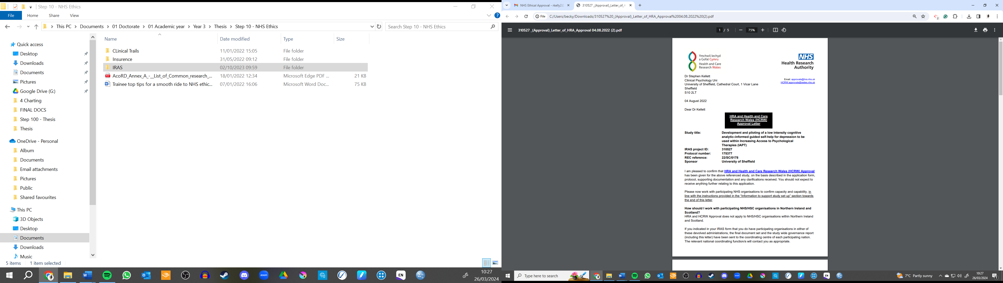
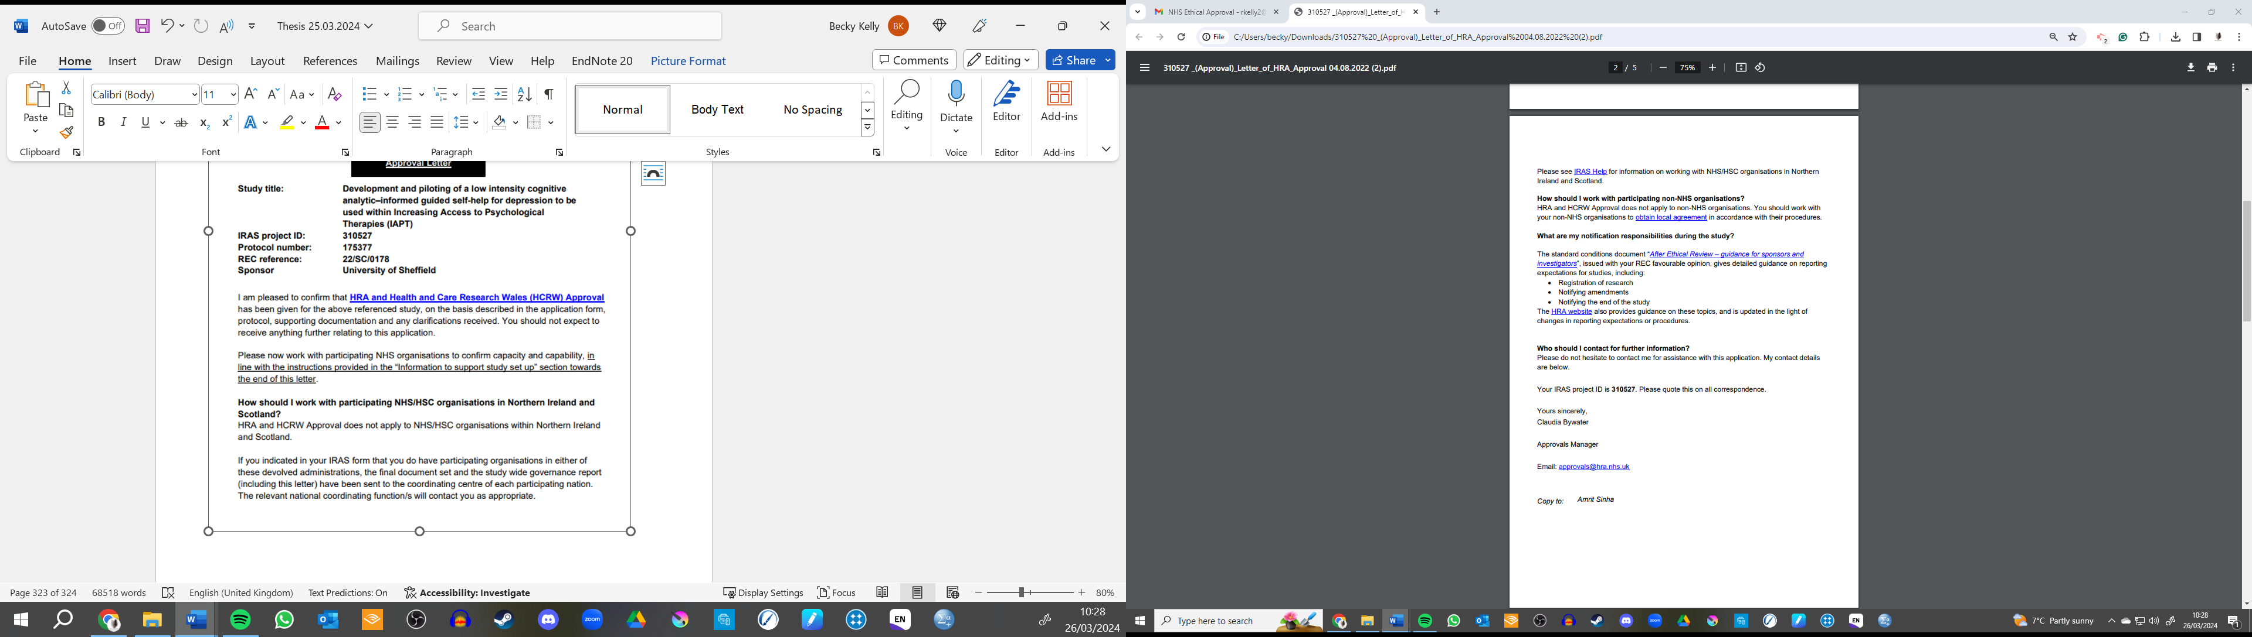

Appendix B
NHS Ethics Board favourable opinion letter. Please note that some of the documents shown in this approval letter have been amended. The amended documents have been approved by the sponsor (University of Sheffield) and resubmitted/approved via IRAS.
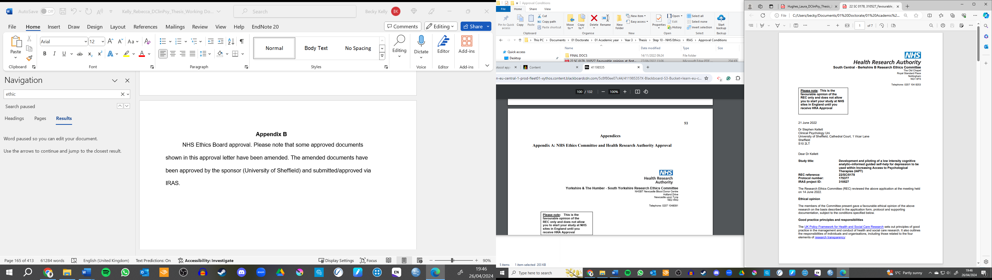
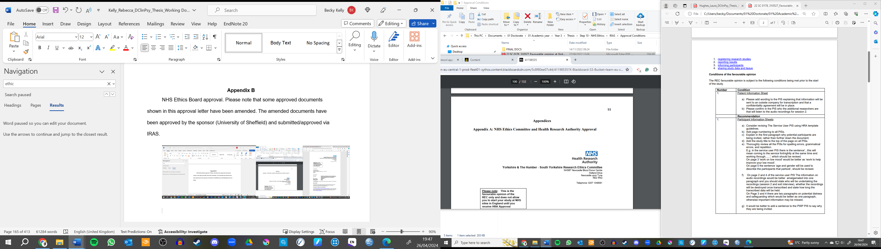
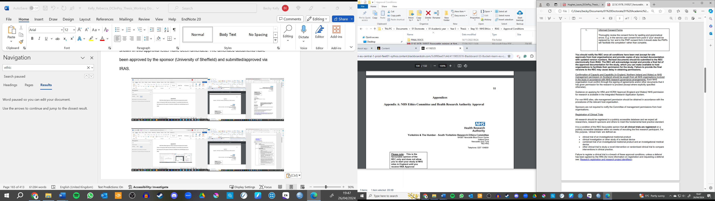
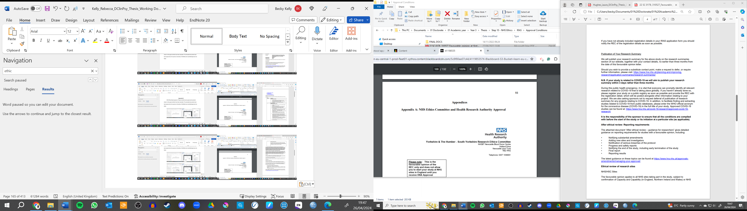
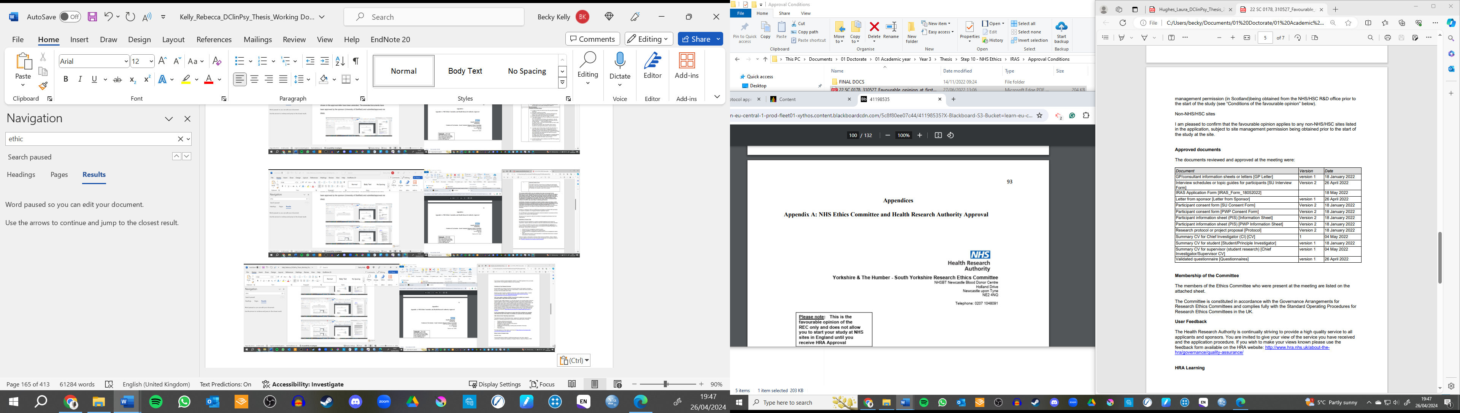

(Page redacted to remove signature)
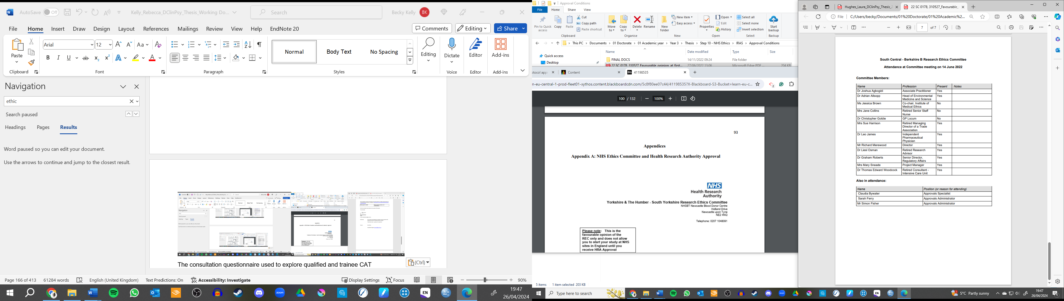
Appendix C
Consultation Questionnaire
Thank you for partaking in the consultation. I am currently creating a matrix to inform the creation and adaption of the CAT guided self-help (GSH) for depression manual. The matrix is broadly concerned with three key research areas: CAT, GSH, and experiences of depression and low mood. However, there are gaps and methodological flaws within the literature. To accommodate, I am asking professional to answer some questions to help inform the development of the manual. You might not have experience within areas and could struggle to answer some of the questions. This is normal and you don’t need to answer all the questions.

- From your clinical experience, how does depression impact relationships?

- What are service-related barriers for people accessing help?

- Are there ways to negate these barriers?

- Research suggests a barrier linked to seeking-help and continuing with therapy is the belief ‘I need to do this (cope) on my own’. Literature suggests a central theme for CAT is ‘doing this together’ (therapeutic relationship/journey). From clinical experience, how have you sensitively promoted ‘doing this together’? Could this translate to GSH?

- Are there common snags, traps, or dilemmas people with Depression tend to experience?

- What are the core components of CAT which are linked to change, especially for those with Depression?

- What have been your client’s experiences of CAT? What parts of CAT were important to them?

Appendix D
Process Notes from Matrix Modelling
Modelling
Depression: Diagnosis, Experiences, Theoretical Understanding
Statistical Prevalence
- Depression prevalence in UK 4.5% (NICE, 2021)
- Depression peaks in older adulthood (55 – 74 years) with more females experiencing depression (7.5%) than males (5.5%).
- Prevalence of depression peaking in COVID-19 at 22.1% (no sex difference; Shevlin et al., 2020).
- Anxiety higher levels than depression in younger people, those who lost income, or people in lower-income brackets.
- Lob et al., (2020) depression great risk for those with lower socio-economic backgrounds, from ‘minority’ backgrounds, or people experiencing health concerns.
NICE Definition (2021)
See NICE (2021) for full description. Key symptoms include low mood and loss of interest. Related symptoms include poor sleep, change in weight, fatigue, appetite changes, poor concentration, agitation, feeling worthless, guilty, or suicidal plans or ideas.
Diagnosis thresholds include mild, moderate, and severe. Meeting thresholds depend on number of related symptoms and impact on function. These guidelines are based on the American Psychiatric Association (APA; 2013 as cited in NICE, 2021) diagnostic and statistical manual of mental disorders, edition 5 (DSM-5).
Experiences of Depression
Issakainen and Hanninen (2014) included:
- exploring people aged between 14 and 34 experiences of depression.
- Depression developed within childhood with difficult experiences contributing to it.
- Within childhood they failed to fulfil expectations others had of them
- Not all the participants contributed an adverse life experience to developing their depression. Single or reoccurring significant life events also exacerbated low mood.
- A smaller amount of people also felt that questioning things too deeply was linked to not being contempt and they saw the future as hopeless.
Haroz et al., (2017) completed a systematic review of qualitative literature exploring the experience of depression from around the world.
- 138 were used within the final analysis.
- 76 different nationalities from around the world were represented.
Table 2 shows the topmost frequent features by region.

Table 2
Topmost Frequent Features of Depression by Region
 | Western  Non-indigenous | Latin American | Middle East | East Asia | South Asia | Southeast Asia | Sub-Saharan Africa
1 | Depressed Mood | Fatigue | Depressed Mood | Fatigue | Sleep | Issues with Heart | Depressed Mood
2 | Social Isolation  Loneliness | Depressed Mood | Social Isolation  Loneliness | Worthlessness  Guilt | Fatigue | Depressed Mood | Sleep
3 | Fatigue | Crying | Fatigue | Sleep | Depressed Mood | Sleep | Weight  Appetite
4 | Sleep | Loss of Interest | Irritability | Loss of Interest | Weight  Appetite | Social Isolation  Loneliness | Fatigue
5 | Loss of Interest | Social Isolation  Loneliness | Sleep  General Pain | Weight  Appetite and Suicide | Issue with heart  Headaches | Thinking too much | Social Isolation  Loneliness
Note. Bold indicates a diagnostic criterion for Major Depression in DSM-5. Taken from Horoz et al. (2017) study.

Figure 1 shows a Venn-diagram created by the authors to represent symptoms relating to depression described within each region (Latin American, Middle East, East Asia, South Asia, Southeast Asia, and Sub-Saharan Africa). The represents the thirty-six symptoms (in frequency order). For the Cognitive Analytic Therapy – Guided Self Help (CAT-GSH) study, it is interesting to note interpersonal problems were mentioned within each region.
Figure 1
Frequency of Depression-related Symptoms across all Regions
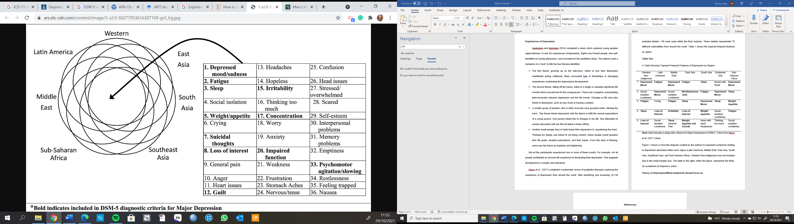
Note: Taken from Horoz et al. (2017) study.

Theory of Depression
Cognitive Behavioural Approaches to Depression
Westbrook (2011) highlights the trade of negative thinking which is centred on:
- Guilt, blame and criticism of oneself.
- Global negativity toward others and the world
- Hopelessness regarding the future
The author further argues:
- unhelpful processing of events (past, present, and future) are also associated with depression.
- Related symptoms of depression (such as loss of energy) can trigger and maintain low mood.
Figure Two highlights the common maintenance process for depression.
Figure 2
Common Maintenance Model for Depression
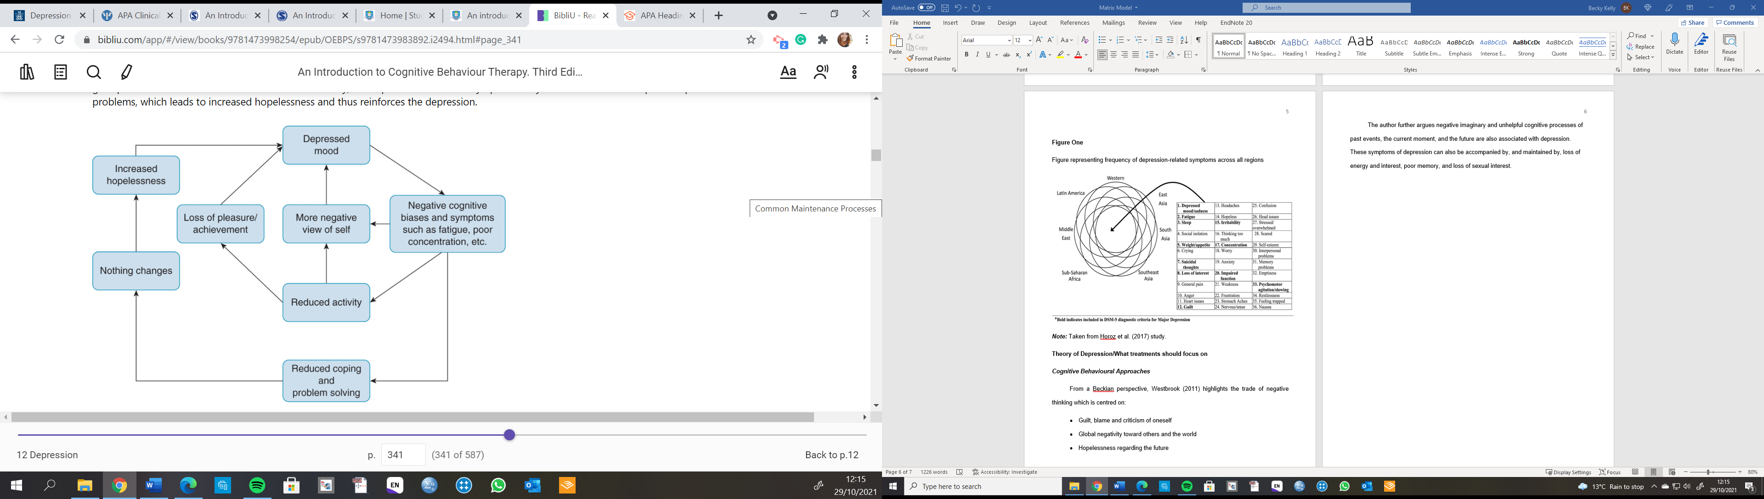
Note. Taken from Westbrook (2011)
Westbrook (2011) suggests treatment should:
- First identify target problems
- Build on a formulation,
- Reduce symptoms using behavioural and cognitive approaches,
- Work towards modifying core beliefs to reduce risk of relapse.
Cognitive Analytic Approaches to Depression
CAT is a transdiagnostic model. As such there is no research which defines a definite CAT model for depression. Some professionals have suggested RRP encapsulate emotions which influence our actions. For example, helplessness might be a common theme or constant core emotion throughout the RR and RRP. However, there is little information found regarding common RR, RRP, Snags, Traps and Dilemmas.
Consultation Questions
Since there is little information regarding CAT approaches to depression, it would be useful to gather this information via consultation meetings. For example:
- What are common (snags, traps, dilemmas) for people who experience ‘depression’.
- Are there common RR or RRP which are played out in people with ‘depression’.

Common Barriers of Treatment for People with Depression and Related Mental Health Problems
Salaheddin and Mason (2016) outlined common barriers for people seeking help include:
- Worries about stigma of seeking help (including feeling embarrassed or ashamed),
- Avoidance of talking about feelings, thoughts, and emotions,
- Viewing help-seeking as weak or pathetic,
- Worry about what other people, including professionals and family, will think if they sought help,
- Minimising their mental health problem,
- And concern about potential negative outcomes of asking for help.
Andrade et al., (2013) explored the World Health Organisations’ (WHO) mental health survey to explore barriers to mental health treatment. This studies limitations included that most included papers were Western.
The most common barriers included:
- People wanting to manage problems on their own,
- Concern they would not be believed,
- People dropped out due to these reasons or because they experienced treatment as being ineffective, or because they had a poor relationship with the service or professional.

Cognitive Analytic Therapy: Core Components, Theory, Mechanisms of Change
Overview
Ryle and Kerr (2020) central principles of CAT include:
- ‘Self’ is developed through repeated relational experiences in early life
- These experiences inform expectations the person has of themselves and others (Relational Roles; RR)
- RR are internal processes (self to self) and interpersonally (self to others, others to self).
- Reciprocal Role Procedures (RRP) are developed with the aim of coping in social experiences.
- RR and RRP can be unconsciously anticipated and enacted to elicit an expected RR which the person has experienced in the past.
- RRP can be categorised as ‘traps’, ‘snags’, or ‘dilemmas’,
- CAT has three distinct stages: Reformulation, Recognition, and Revision.
Clients Experiences of CAT
Balmain et al., (2020) completed a systematic review exploring client’s experiences of CAT. Table 3 highlights the main themes, subthemes, and description.
Table 3
Themes, subthemes, and descriptions of client experience of CAT
Theme | Subtheme | Description
CAT Tools | Diagram | Powerful experience to gain understanding but also included some negative emotions. Some people felt SDR did not impact change
 | Reformulation Letter | Provided focus, gain understand, increased trust, and provided reassurance. Also, could be overwhelming or not considered large component of therapy
 | Goodbye Letter | Useful to share, what could be, withheld thoughts. Important and enjoyable component
 | Letter | Provided structure, felt heard, some would reread but not use. Elicit strong emotions
Experienced change | Learnt to trust | Some learnt to trust – however, not all felt this way
 | Personal changes | Included becoming more self-aware and more compassionate to themselves.
Gaining knowledge and skills | Learnt about patterns | Helpful to learn about unhelpful patterns
 | Learnt to do things differently | Had a model on how to cope different, learnt new strategies and ways of interpersonal relationships
Reflecting on Process | Endings | Worried about therapy coming to an end and not being able to cope after
 | Exits | Exits helped enable change
 | Expectations | Expectations changed over time, and some were surprised at how much they spoke.
 | Therapeutic Relationship | Important to service users, and therapist style was important – especially open whilst providing direction
 | The process | Non-judgemental space key, and how it related to day-to-day life. Being time limited was beneficial.
Strong Emotions | N/A | Some described feelings of scared, tough, painful, and upsetting. Other said it was worthwhile to experience these emotions.
Being in a group | N/A | When in group, it was useful and enjoyable. Some described how one-to-one sessions could have been useful addition.
Note. Taken from Balmain et al., (2020)

Mechanism of Change
Tyler and Masterson’s (2011) article highlight potential mechanisms of change in CAT. This includes the development of insight. Patients felt:
- Reformulation tools contributed to change in insight and distress.
- Insight included increased awareness of patterns and exits.
The authors conclude the tools are important and help with a gradual process of change, which is underpinned by a genuine therapeutic relationship.
Rayner et al., (2010) explored clients experience of receiving CAT and how reformulation and the tools associate to client’s understand of change. Key patterns of experience were linked with:
- A ‘doing with’ with working alliance between the therapist and client,
- Being provided strong encouragement and hope,
- Being able to link CAT theory back to the clients’ problems (being relatable),
CAT tools were important for promoting these key themes. Letters and diagrams contributed to cementing therapeutic alliance. Reformulation in ‘black and white’ was important for ‘keeping it real’. Reformulation tools also helped with facilitating and understanding change as it promoted a non-judgemental narrative to a person’s patterns of coping. However, some said the diagrams annoying and limiting, whilst others preferred the use of diagrams to letters.
Sandhu et al., (2017) explored the revision stage of CAT and how this process contributes to change in those with depression. There were three overarching themes: developing an observing self, change in procedures and roles, and supporting and maintenance of change. The themes and subthemes are highlighted below in table 4.
Table 4
Themes and Subthemes of CAT revision stage
Developing an observing self | Changing in procedures and roles | Support and maintenance of change
Therapist-facilitated recognition | Self-care | Planning exits through scaffolding
Client-facilitated recognition | Being assertive – meeting one’s own needs or wants | Using the SDR
In sessions or out of session | Self-compassion | Attending to the process and feelings of change
 | Motivating and encouraging oneself | Recognition from the therapist
 |  | Maintaining exits via the goodbye letter
Note. Taken from Sandhu et al., (2017)
Figure 3
Model of Exits During the Revision Stage in CAT for Depression
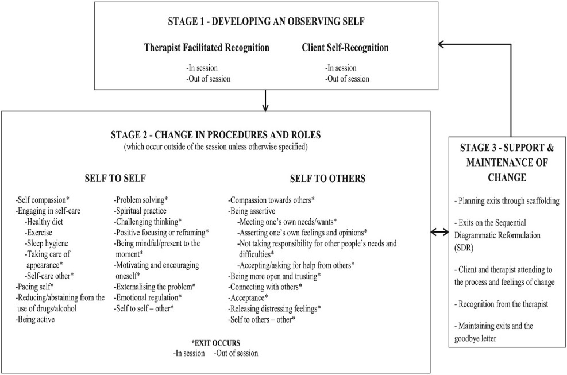
Note. Taken from Sandhu et al., (2017)
Shine and Westacott (2010) found:
- SPQ and working alliance did not significantly change following from the reformulation stage.
- Clients felt the reformulation process helped them feel heard, increase understanding, feel validated and normalised, encouraged joint working, but sometimes left people feeling exposed.
Guided Self Help
NICE guidelines (2009) recommend:
- CBT- GSH should consist of between six to eight sessions.
Meadows and Kellett (2017) completed a six-session CAT-GSH for anxiety. They found there was:
- High treatment completion,
- Most clients who completed treatment met reliable recovery criteria at follow-up.
- Practitioners feedback that 6 sessions were feasible.
Wakefield et al., (2021) found eight-session CAT was not significantly different from CBT in treating depression.
Client Experiences of GSH
Khan et al., (2018) completed a meta-synthesis exploring the experiences of clients who underwent treatment of depression in primary care services. The authors found:
- Depression is linked to internal and external triggers included conflicts and childhood events. People reported feeling “unable to cope” and metaphors included “on edge, churned-up, boxed in”.
- People with depression felt ashamed and worried they did not have a legitimate problem. Primary-care support was sometimes experienced as only service offering help.
- People accessed this support not because they felt low but because they have been a failure in the strategies used to cope. For example, distraction and avoidance was no longer effective.
- People experienced stigma linked to felt sense of loss of control and felt mental health was not a legitimate problem compared to physical health problems.
- Patients understanding of GSH depended on their prior experience. People experienced therapeutic alliance as something which impacted the self-help materials. However, some people were unsure of their role and the therapist role. Self-efficacy could be low.
From this, the authors suggested a framework to apply these concepts to GSH:
- Incorporate personal experience into intervention (i.e. use lay language and normalise),
- Engage patients with therapeutic environment (offer safe place, legitimise help-seeking),
- Promote evidence-based self-help strategies,
- Acknowledge the stigma people can experience when accessing GSH,
- Promote and empower the patient to make change. Reduce misconceptions of GSH.

Delivery
Gellatly et al., (2007) systematically reviewed literature about if the intervention, intervention, population, and study design moderated treatment effect of GSH for depression. They found:
- Delivery of GSH (written or electronic) impacted the effect size of GSH effectiveness,
- No relationship between effect size and professional (paraprofessional/professional), content of guidance (monitoring/supportive), mode of guidance (in-person/remote), or number of sessions.
The authors highlighted ‘monitoring’ facilitators checked patients had used the materials and assisted with queries. But no therapeutic techniques were used. ‘Supportive’ facilitators provided more than monitoring, which included providing advice about specific problems, alongside providing motivation and support.
Cujipers et al, (2010) completed a meta-analysis of randomised control trials to compare face-to-face and GSH psychotherapies for depression and anxiety disorders. They argue in-person therapy and GSH have comparable results in outcome improvement. However, it is unclear what forms of psychotherapy GSH used, and the complete search strategy (including key terms use) is not transparent.
Learning from CAT-GSH for Anxiety
Meadows and Kellett (2017) developed a CAT-GSH for anxiety using a similar approached proposed by the current researchers. They found CAT-GSH for anxiety helped:
- Develop an alliance, aided understanding, and the manual was useful,
- The PWPs experienced a shared ‘journey’ and felt it was a good alternative to CBT.
- However, some PWPs felt time pressure to complete the extra work to prepare for the sessions and found the psychotherapy file unhelpful.
Wray et al (2022) found:
- PWPs attributed positive therapeutic change to the development of insight (especially during the past-present focus of CAT-GSH),
- CAT-GSH offered choice for patients and PWPs compared to treatment-as-usual,
- CAT-GSH was an alternative modality which contributed to professional development,
- PWPs started to use CAT-specific language,
- However, patients shared traumatic experiences more often that CBT-GSH. This was emotional and could be difficult for the PWPs,
- It could also be difficult to complete the manual within 30 minutes at the start of implementation, but this became easier with practice.
IAPT Population
Demographic Considerations
- People from ‘minority’ ethnic background, have disabilities, or identify as LGBT are less likely to recover using IAPT services (in comparison to people who are WHI, non-disabled, and are heterosexual; Bakers, 2018)
- IAPT services can be applicable to people with Learning Disabilities (Dodd et al., 2011). Adaptions could include:
  - Repeating information, checking with understanding, and having carer involvement. This could be incorporated in CAT-GSH for depression pilot.
  - Some adaptation might not be feasible at this stage including providing easy-read manuals, addressing service specific issues, and providing additional sessions.
- Therapies can be adapted to improve outcomes for BAME patients by incorporating values and spiritual perspective (British Association of Behavioural and Cognitive Psychotherapies, 2019).

Matrix Model

Matrix Guiding the Development of CAT-GSH including Contributors in Brackets
 | Experiences of Depression | Barriers to receiving help | Core Components of CAT
Systematic Reviews and Research | Depression experienced as emotional, physical, and interpersonal problems stemming from childhood experiences.  (Haroz et al., Issakainen & Hanninen, 2014) | Common barriers include stigma, scepticism about treatment, misfitting treatment and unavailable service. Depression-specific barriers include poor motivation, or fearfulness.  (Andrade et al., 2013; Mohr et al., 2010; Salaheddin and Mason, 2016) | Three core stages of CAT useful: reformulation, recognition, and revision. Patients valued reformulation tools and associated them to change. Idiosyncratic exits strategies useful.  (Sandhu et al., 2017; Tyler and Masterson’s, 2011; Westacott, 2010)
Consultation | Not explored | Potential narrative in society is “just keep going”, which could influence a person’s opinion about seeking help.  Resources within services are limited and patients can feel that pressure (long waiting lists, inconsistent appointments). | Recognition research is underdeveloped yet a useful aspect of CAT. Psychotherapy file may be inaccessible and difficult to translate into GSH. Reformulation letters are difficult to translate into GSH. Considered useful to some clients.
Other Resources | Guidelines outlining low mood, loss of interest, and impact on daily functioning.  (NICE guidelines) | No relevant findings | Development of ‘self’ through repeated life experiences. Develops RR and RRP with the aim of coping. Typically, core emotions related to patterns. Understanding procedures as snags, traps, dilemmas. Three stages: reformulation, recognition, and revision.  (Ryle and Kerr, 2020)
Included in manual | Emphasis on social functioning and relational expectations alongside low mood and other culturally diverse symptoms. Use of lay language and relevant examples beneficial. Useful to also include in training. | Warm and validating opening to manual, with page dedicated to clear goal setting. It’s importance to outline the predicted research effectiveness. Validating people’s experience of difficulty accessing services. | Follow three core stages of CAT: reformulation, recognition, and revision. Include tools including target problems; traps, dilemmas, and snags; family tree; timeline; mapping; recognition homework tasks; developing and practice exits; identify new roles (strengths and resilience. Exclude letters and psychotherapy file.
 | Client Experience of CAT | Mechanism for Change | CAT and Depression
Systematic Reviews and Research | Mixed opinions. Some appreciated the journey, reformulation tools, and developing exits. But could experience difficult emotions. Positive experiences of CAT-GSH for anxiety.  (Meadows and Kellett; 2017; Rayner et al., 2010; Tyler and Masterson’s, 2011) | Suggested mechanisms of change include development of insight, recognition of processes, understanding proximal development.  (Tyler and Mastersons, 2011) | CAT is transdiagnostic and little exploration specifically for Depression
Consultation | Mapping tools important for clients. Important to promote client language. | Recognition of both conscious and unconscious beliefs. | People with a core emotion linked to depression tend to have patterns relating to withdrawing and disconnecting socially. Common snags are dismissing own achievements. Transdiagnostic model with idiosyncratic aims.
Other Resources | No relevant findings | No relevant findings | No relevant findings
Included in manual | Promote own language using relatable examples. Included mapping of patterns and roles. | Promoting development of insight within core stages of CAT. | Input relatable examples for people who experience depression.
 | Number of Session of GSH | Delivery | Client and PWPs GSH Experience
Systematic Reviews and Research | Eight and six sessions of CAT have promising results. Number of sessions not related to GSH outcome.  (Gellatly, et al., 2007; Meadows and Kellett, 2017; Wakefield et al., 2021) | GSH have outcome improvements, even with a broad range of delivery (including semi-face-to-face, computer delivered, telephone delivery, internet/emails  (Cuijpers et al, 2010; Gellatly et al., 2007) | GSH should include lay language; promote an appropriate and safe space; clearly outline expectations; acknowledge the stigma; individual is central to change. Positive experience of CAT-GSH for anxiety with patients engaged and motivated. CAT-GSH can invite discussion of past trauma during sessions which can be difficult for clients and PWPs. Past-present discussion, and therapeutic relations, help develop ‘insight’ in the client, and this promoted positive change  (Khan et al., 2018; Meadows and Kellett; 2017)
Consultation | Typically, fortnightly, and 35-minute sessions in some NHS Talking Therapies services | Typically, face-to-face but could be via telephone/video call depending on COVID related restrictions within NHS Talking Therapies services | Not explored
Other Resources | Needs to be feasible for step two NHS Talking Therapies.  (NICE, 2009) | NHS Talking Therapies uses PWPs to provide their GSH. | No relevant findings
Included in manual | Six sessions | PWPs delivered sessions. Ideally face-to-face but can be delivered via video link depending on COVID restrictions/service user need. | Readability to be identified with consultations. Some of the information identified here standard part of PWPs training and can be discussed in supervision.
 | Considerations for people with Learning Disabilities | Consideration for working with people from different ethnicities
Systematic Reviews and Research | Helpful techniques include repeating information, checking in with person, using reasonable adjustments. Other suggestions include creating easy-read material, addressing service issues, changing the pace of therapy.  (Dodd et al., 2011)
Other Resources |  | Consideration about values and spirituality as part of intervention.  (BABCP, 2019).
Included in Manual | Some of the strategies can be included but it is outside the scope of this research to create an easy-read manual or change the time/formatting of CAT-GSH. | Whilst not directly incorporated into manual, this is included in supervision and training to discuss application to all areas of person’s life impacted by depression.

References
Please note this reference list is only for the process notes and not for the main project. Please see above for projects reference list.
Andrade, L. H., Alonso, J., Mneimneh, Z., Wells, J. E., Al-Hamzawi, A., Borges, G., Bromat, E., Braffaerts, R., de Girolamo, G., de Graaf, R., Florescu, s., Gureke, O., Hinkov, H., Hu, C., Huang, Y., Hwang, I., Jin, R., Karam, E., Kovess- Masfety, V., Levinson Matschinger, H., O’Neill, S., Posada-Villa, J., Sugar, R., Sampson, N., Sasu, C., Stein, D., Takeshin,a. T., Viana, M., Xavier, M., & Kessler, R. C. (2014). Barriers to mental health treatment: Results from the WHO World Mental Health surveys. Psychological Medicine, 44(6), 1303- 1317. https://doi.org/:10.1017/S0033291713001943
Baker, C. (2018). Are NHS mental health therapies working for everyone? House of Common Library. UK Parliament. https://commonslibrary.parliament.uk/are- nhs-mental-health-therapies-working-for-everyone/
Balmain, N., Melia, Y., Dent, H., & Smith, K. (2021). A systematic review of service user’s experience of cognitive analytic therapy (CAT). Psychology and Psychotherapy: Theory, Research and Practice, 94, 36-63. https://doi.org/10.1111/papt.12305
British Association of Behavioural and Cognitive Psychotherapies. (2019). Improving Access to Psychological Therapies: Black, Asian, and minority ethnic services positive practice guide. https://lewishamtalkingtherapies.nhs.uk/wp- content/uploads/2021/10/IAPT-bame-ppg-2019.pdf
Cuijpers, P., Donker, T., van Straten, A., Li, J., & Andersson, G. (2010). Is guided self-help as effective as face-to-face psychotherapy for depression and anxiety disorders? A systematic review and meta-analysis of comparative outcome studies. Psychological Medicine, 40(12), 1943-1957.
Dodd, K., Joyce, T., Nixon, J., Jennison, J., & Heneage, C. (2011). Improving access to psychological therapies (IAPT): Are they applicable to people with intellectual disabilities? Advances in Mental Health and Intellectual Disabilities. https://doi.org/10.5042/amhid.2011.0110
Foy, A. A., Morris, D., Fernandes, V., & Rimes, K. A. (2019). LGBQ+ adults’ experiences of Improving Access to Psychological Therapies and primary care counselling services: Informing clinical practice and service delivery. The Cognitive Behaviour Therapist, 12, e42. doi:10.1017/S1754470X19000291
Gellatly, J., Bower, P., Hennessy, S., Richards, D., Gilbody, S., & Lovell, K. (2007). What makes self-help interventions effective in the management of depressive symptoms? Meta-analysis and meta-regression. Psychological Medicine, 37(9), 1217-1228. doi:10.1017/S0033291707000062
Haroz, E. E., Ritchey, M., Bass, J. K., Kohrt, B. A., Augustinavicius, J., Michalopoulos, L., & Bolton, P. (2017). How is depression experienced around the world? A systematic review of qualitative literature. Social Science & Medicine, 183, 151-162. https://doi.org/10.1016/j.socscimed.2016.12.030
Issakainen, M., & Hänninen, V. (2016). Young people's narratives of depression. Journal of Youth Studies, 19(2), 237-250. https://doi.org/10.1080/13676261.2015.1059927
Khan, N., Bower, P., & Rogers, A. (2007). Guided self-help in primary care mental health: Meta-synthesis of qualitative studies of patient experience. The British Journal of Psychiatry, 191(3), 206-211. doi:10.1192/bjp.bp.106.032011
Mohr, D. C., Ho, J., Duffecy, J., Baron, K. G., Lehman, K. A., Jin, L., & Reifler, D. (2010). Perceived barriers to psychological treatments and their relationship to depression. Journal of Clinical Psychology, 66(4), 394-409. https://doi.org/10.1002/jclp.20659
National Institute for Health and Care Excellence. (2021). Depression: How common is it? [Clinical Knowledge Summaries]. https://cks.nice.org.uk/topics/depression/background-information/prevalence/
National Institute for Health and Care Excellence. (2021). Depression: How do I diagnose depression? [Clinical Knowledge Summaries]. https://cks.nice.org.uk/topics/depression/diagnosis/diagnosis/
Omylinska‐Thurston, J., McMeekin, A., Walton, P., & Proctor, G. (2019). Clients' perceptions of unhelpful factors in CBT in IAPT serving a deprived area of the UK. Counselling and Psychotherapy Research, 19(4), 455-464. DOI: 10.1002/capr.12249
Rayner, K., Thompson, A. R., & Walsh, S. (2011). Clients' experience of the process of change in cognitive analytic therapy. Psychology and Psychotherapy: Theory, Research and Practice, 84(3), 299-313. https://doi.org/10.1348/147608310X531164
Salaheddin, K., & Mason, B. (2016). Identifying barriers to mental health help- seeking among young adults in the UK: A cross-sectional survey. British Journal of General Practice, 66(651), e686-e692. https://doi.org/10.3399/bjgp16X687313
Sandhu, S. K., Kellett, S., & Hardy, G. (2017). The development of a change model of “exits” during cognitive analytic therapy for the treatment of depression. Clinical Psychology & Psychotherapy, 24(6), 1263-1272. https://doi.org/10.1002/cpp.2090
Shevlin, M., McBride, O., Murphy, J., Miller, J. G., Hartman, T. K., Levita, L., Mason, L., Martines, A., McKay, R., Stocks, T., Bennett, K., Hyland, P., Karatzias, T., & Bentall, R. P. (2020). Anxiety, depression, traumatic stress and COVID-19- related anxiety in the UK general population during the COVID-19 pandemic. BJPsych Open, 6(6). https://doi.org/10.1192/bjo.2020.109
Shine, L., & Westacott, M. (2010). Reformulation in cognitive analytic therapy: Effects on the working alliance and the client's perspective on change. Psychology and Psychotherapy: Theory, Research and Practice, 83(2), 161-177. https://doi.org/10.1348/147608309X471334
Tyrer, R., & Masterson, C. (2019). Clients' experience of change: An exploration of the influence of reformulation tools in cognitive analytic therapy. Clinical psychology & Psychotherapy, 26(2), 167-174. https://doi.org/10.1002/cpp.2339
Westbrook, D., Kennerley, H., & Kirk, J. (2011). An introduction to cognitive behaviour therapy: Skills and applications. (3rd ed.). Sage

Appendix E
First Draft of CAT-GSH for Depression
(Redacted to mitigate from risk of incorrect use)

Appendix F
Scale for Evaluation of Self-Help Guidance for Anxiety Disorders and Depression

(Redacted for copyright reasons)

Appendix G
CAT-GSH for Depression Manual
(Redacted to mitigate from risk of incorrect use)

Appendix H
Information forms for PWPs


Psychological Wellbeing Practitioner Information Sheet
Project Title
Development and piloting of a low intensity cognitive analytic–informed guided self-help for depression to be used within Increasing Access to Psychological Therapies (IAPT)
Project purpose
We are inviting you to take part in this research because are interested in piloting a novel intervention called Cognitive Analytic Therapy Guided Self Help (CAT-GSH) to help people with depression. Before you decide it is important for you to understand why the research is being done and what it will involve. Please take time to read this information sheet and discuss it with others if you wish. Ask us if there is anything that is not clear or if you would like more information. Take time to decide whether you would wish to take part. Thank you for reading this.

Research has found Cognitive Analytic Therapy (CAT) can be an effective treatment for people experiencing mental health difficulties. This includes those who feel low in mood. CAT is currently used in different services. There are some services which use CAT guided self-help manuals to help people with anxiety. However, it has not been adapted or tested as an intervention of people experiencing depression. This study will explore the effectiveness of CAT informed guided self-help with people who experience low mood. The lead researcher, Rebecca Kelly, is currently a Trainee Clinical Psychologist. This research is part of her training and contributes towards her qualifications.
What will this research involve?
We would like you to complete 6 sessions of therapy with service users which aims to help improve their low mood. This therapy is called Cognitive Analytic Therapy-Informed Guided Self Help (CAT-GSH). This will involve service users attending weekly sessions to work jointly through CAT-GSH. You will be asked to complete the standard set of questionnaires each week. You will complete outcome measures at each session. This includes the PHQ9, GAD7 and WSAS. The client will be provided with a CAT-GSH Manual, the Psychological Wellbeing Practitioners (PWPs) will work using the manual session by session to help aid structure. The client will be able to complete in between session work using the manual and bringing it back to the next session to review their in between session work and move on to the next section. Sessions should be 30 minutes for PWPs work. Cognitive analytic self-help uses past and how people grew up, as a way of understanding depression, before moving onto making changes in the present day. You will offer a follow-up appointment to complete the outcome measures and review their needs 4-8 weeks after the last session.

We require session two of all CAT-GSH to be audio recorded on a University of Sheffield’s Dictaphone. This is for quality assurance. We want to explore how PWPs deliver the manual and support people. We want to ensure the manual is being delivered in a similar way by all professionals to uphold reliability and fidelity. An additional researcher, who is not involved in completing the main project, will use a CAT competency form to assess this. This information will be used to explore training requirements, review the manual, and inform the level of support required to help PWPs deliver the intervention. The additional researcher will be asked to sign a confidentiality agreement.
Informing GP’s
With the client’s consent, we would like you to inform their GP’s they are taking part in this study. This can be part of the standard letter sent to the GP which outlines the client is receiving care from IAPT.
Training
We require you to attend a two-day training course facilitated by the researchers (Rebecca Kelly and Steve Kellett). The content of this course includes information about the specifics of CAT, working with the manual, and recording/sharing data collected. Senior PWPs who will provide case management will also attend the training, so they are able to offer support through the process. At the end of the training, you will be invited to share how confident and comfortable you feel delivering the training. If you feel uncertain or any problems arise concerning the delivery of CAT-GSH, further support will be provided by the researchers.

Supervision
Case management will be provided throughout the manual being delivered by Senior PWPs. Additional monthly group clinical supervision will be provided by the researchers to support you.
What information will be collected by you and shared with the researchers?
The researchers are interested in collecting information about the service users’ gender, age, session attendance, and outcome measures. Age and gender will be used to describe the participants who partook. Session attendance information will allow us to compare CAT-GSH to other treatments offered. The outcome measures will allow us to explore if the therapy is effective in improving mood. We are also interested in how many clients chose CAT-GSH and how many dropped out. This information can be collected and compared to other treatments offered.

We request this information is uploaded onto a password protect database by the PWPs and shared with the researchers. This information will not include the names of the participants. All information regarding data collection/storage and confidentiality will be outlined in the training.
Focus Group
We are also interested in exploring how acceptable the intervention is. This includes asking you about your experiences of delivering the manual. A focus group will be organised which will last for two hours. You and your fellow PWPs will be asked to attend and answer questions regarding your experiences. Questions will include ‘what elements of CAT-GSH did you find were the most helpful?’. For this focus group, it would be useful for you to create notes after your sessions outlining what you found worked well and what could be changed. This can be used to prompt your conversation during the interview.
This interview will be audio recorded and then transcribed using an approved University of Sheffield transcriber. They will sign a confidentiality agreement to ensure your information is kept private.

Deciding to take part
You do not have to take part in this study; it is completely voluntary. It is up to you to decide whether you want to take part.
Withdrawing
You can stop being part of the study at any time, without giving a reason, but we will keep information about you that we already have.
Confidentiality and Data Protection
Information regarding how we will store service user information will be provide in the training. All the information we collect about you will be kept safe and secure. This includes password and encrypting data on secure services. People who do not need to know who you are will not be able to see your name or contact details. Your data will have a code number instead. You will not be identifiable in any reports or publications, except under the circumstances where you recognise your own quotes being used.

Session Two Audio Recordings
Audio from session two will be recorded on a University of Sheffield’s Dictaphone. The file name will not include any personal information. This information will be transcribed using an approved University of Sheffield transcriber. Following this it will be analysed using an additional reviewer who has experience of quality assurance. Both they, and the University of Sheffield transcribers, will sign confidentiality agreements before having access to the encrypted and pass-word protected data. The audio records will be destroyed once analysed. The transcribed data will be archived using stored for 10 years on a secure database called Online research Data (ORDA).
Focus Group Information
Audio from the interview will be recorded on a University of Sheffield’s Dictaphone. The files name will not include any personal information. This information will be transcribed using an approved University of Sheffield transcriber. Following this it will be analysed. The audio records will be destroyed once analysed. The transcribed data will be archived using stored for 10 years on a secure database called Online research Data (ORDA).

The only exception to this would be if during the interview the researcher became concerned about a risk of harm to yourself (e.g. suicidal risk), or someone (e.g. a child or another adult) you talk about (e.g. risk of neglect or physical harm). In such a situation the researcher would discuss the need to breach confidentiality with you; the aim of this would always be to support yourself and those you mention and ensure safety. This will involve letting relevant services know about the situation to help provide those involved with support. This will be discussed at the start of the interview, and you can ask questions regarding confidentiality.
What are the limits of confidentiality?
If during the research screening process or any of the follow-up meetings then you disclose an issue that has implications for your own safety (or the safety of others) or make a disclosure concerning criminal activities, then the research team have a duty of care to pass this information onto the relevant authorities. The researcher will inform you of this is this is an outcome from that process.
What happens to my data?
Information collected by the researchers will be collated with other participants information and analysed. The focus group data enables us to learn and revise the manual based on people’s experiences. Shared experiences between participants can inform us what aspects of the manual are working well and what aspects need improving.

The results will be submitted as part of the researcher’s doctoral thesis in May 2023, then prepared for publication in 2023/2024. You can let the researcher know at the start of the study if you would like a copy of this and this can be sent to you. The University of Sheffield is organising and funding this research. This project has been ethically approved via the University of Sheffield Clinical Psychology department, using the University of Sheffield’s Ethics Review Procedure. Once we have finished the study, we will keep some of the data so we can check the results. We will write our reports in a way that no-one can work out that you took part in the study. We need to manage your records in specific ways for the research to be reliable. This means that we won’t be able to let you see or change the data we hold about you.
What are the benefits of taking part?
You will be contributing to improving mental health services. Mental health treatments are based on evidence and research to ensure high-quality treatment. We are hoping this research will contribute to the previous studies and provide alternative to treatments which are currently being offered at Step 2. As such, this will be an opportunity for further professional development.

You will also have space to reflect on your experience during the group interview. This space might not always be available during your regular working routine. This opportunity to inform and shape interventions can be a very rewarding process for people.
What are the potential drawbacks?
CAT-GSH for depression is a new intervention and has not been proven to be effective. A potential result of this study is that it does not show promise for effectively improving people’s mood. However, the intervention is based on research and similar interventions which have been effective and helped people improve their quality of life. The manual has been specially designed and based on evidence. A similar intervention, CAT-GSH for anxiety, has effectively reduced people’s anxiety. Whilst CAT-GSH for depression has not been tested, it is based on research.
What if I wish to complain about the way the study has been carried out?
In the first instance you can contact the lead researcher, Rebecca Kelly on rkelly2@sheffield.ac.uk. Alternatively, you can contact the other researchers involved: Steve Kellett, Lecturer and Researcher on s.kellett@sheffield.ac.uk.

If you feel that your complaint has not been handled to your satisfaction following this, you can contact Professor Elizabeth Milne, Head of Department on psy-hod@sheffield.ac.uk
What if something goes wrong?
This trial is covered by liability insurance by The Sponsor (University of Sheffield) and NHS indemnity.
The University of Sheffield liability insurance covers the overall management of the research. This provides indemnity to:
- the University for its legal liability for injury to persons (other than employees) and damage to material property belonging to other persons arising in connection with the business of the University.
- to staff and students acting on behalf of the University for their legal liability for accident or injury to other parties.
The NHS indemnity will cover any clinical negligence arising from research activities for participants recruited through the NHS. As such:
- NHS bodies are legally liable for negligent acts of their employees.
- This includes whenever the NHS body owes a duty of care to the person harmed including those conducting and receiving novel intervention (such as CAT-GSH).
Contact Information
This research is being conducted by Rebecca Kelly, Trainee Clinical Psychologist. This research will be used to write a thesis which fulfils part of their doctoral training. If you have any questions about the research, you can leave a telephone message with the Research Support Officer on 0114 222 6650 and they will ask Rebecca Kelly to contact you.
Additional Information about your data
The University of Sheffield will act as the sponsor/funder and Data Controller for this study. This means that the University is responsible for looking after your information and using it properly. To collect and use your personal information as part of this research project, we must have a basis in law to do so. The basis that we are using is that the research is ‘a task in the public interest’. Any reference to ‘we’ in the document refers to the research team and the University of Sheffield.

As we will be collecting some data that is defined in the legislation as more sensitive (e.g. information about your health), we also need to let you know that we are applying an additional condition in law: that the use of your data is ‘necessary for scientific or historical research purposes’.

Further information, including details about how and why the University processes your personal information, how we keep your information secure, and your legal rights (including how to complain if you feel that your personal information has not been handled correctly), can be found in the University’s Privacy Notice:
https://www.sheffield.ac.uk/govern/data-protection/privacy/general

Interested in partaking in future research?
The National Institute for Health Research, also known as the NIHR, is keen for members of the public and patients to take part in research. If you are interested in partaking in future research and would like more information, you can access their website: https://bepartofresearch.nihr.ac.uk/

Appendix I
Consent forms for PWPs. Please note, an NHS amendment was made regarding changing the recording of session two to session three. This amendment was approved by the sponsor, research team, and NHS participating services. It was determined the consent forms did not need alteration because consent was sort prior the session.
Development and piloting of a low intensity cognitive analytic–informed guided self-help for depression to be used within Increasing Access to Psychological Therapies (NHS TALKING THERAPIES)
Psychological Wellbeing Practitioner Consent Form
Please note, that none of these statements are optional and will require a ‘yes’ or ‘no’ response.
Please tick the appropriate boxes |  |  | Yes | No
Taking Part in the Project
I have read and understood the project information sheet, or the project has been fully explained to me.
- If you will answer No to this question, please do not proceed with this consent form until you are fully aware of what your participation in the project will mean.
I have been given the opportunity to ask questions about the project.
I agree to take part in the project. I understand that taking part in the project will include completing CAT-GSH and completing the outcome measures (PHQ-9, GAD7, WSAS).
I understand that taking part in the project will include session two of CAT-GSH being audio recorded.
I understand that an additional researcher, who is not involved in completing the main project, will be asked to quality assure session two audio recordings. This person will be asked to sign a confidentiality form.
I understand that taking part in the project will include partaking in follow-up questionnaires and an interview regarding my experiences of completing CAT-GSH.
I understand that the audio data of the interview will be transcribed by a University of Sheffield approved transcriber. They will have signed a confidentiality agreement.
I understand that my taking part is voluntary. I can stop being part of the study at any time, without giving a reason, but you will keep information about me that we already have.
How my information will be used during and after the project
I understand my personal details such as name, phone number, address and email address etc. will not be revealed to people outside the project.
I understand and agree that my words may be quoted in publications, reports, web pages, and other research outputs. I understand that I will not be named in these outputs unless I specifically request this.
I understand and agree that other authorised researchers will have access to this data only if they agree to preserve the confidentiality of the information as requested in this form.
I agree for the data collected from me to be stored anonymously and potentially used in future research.
So that the information you provide can be used legally by the researchers
I agree to assign the copyright I hold in any materials generated as part of this project to The University of Sheffield.
Name of participant [printed] | Signature | Date
Name of Researcher [printed] | Signature | Date
Project contact details for further information:
Below are details of people you can contact regarding the study.
Name: Rebecca Kelly
Role: Lead Researcher/ Trainee Clinical Psychologist
Email Address: rkelly2@sheffield.ac.uk

Name: Stephen Kellett
Role: Researcher/Supervisor
Email Address: s.kellett@sheffield.ac.uk

Below are details of a person you can contact if you wish to raise a complaint. This person is independent to the research project.
Name: Professor Elizabeth Milne
Role: Head of Psychology Department
Email Address: psy-hod@sheffield.ac.uk
University Address: Department of Psychology
Cathedral Court
1 Vicar Lane
Sheffield
S1 2LT

Appendix J
Information Form for Patients

Service User Information Sheet
Project Title
Developing and delivering a psychologically-informed guided self-help manual to help depression.
Project Purpose
We are inviting you to take part in a research study. We are interested in piloting a new intervention called Cognitive Analytic Therapy Guided Self Help (CAT-GSH) to help people with depression. Before you decide it is important for you to understand why the research is being done and what it will involve. Please take time to read this information sheet and discuss it with others if you wish. Ask us if there is anything that is not clear or if you would like more information. Take time to decide whether you would wish to take part. Thank you for reading this.
Research has found Cognitive Analytic Therapy (CAT) can be an effective treatment for people experiencing mental health difficulties. This includes those who feel low in mood. CAT is currently used in different services and is not a new therapy. There are some services which use CAT guided self-help manuals to help people with anxiety. However, it has not been adapted as an intervention of people experiencing depression. This study will explore the effectiveness of CAT informed guided self-help with people who experience low mood. The lead researcher, Rebecca Kelly, is currently a Trainee Clinical Psychologist. This research is part of her training and contributes towards her qualifications.
What will this research involve?
We would like you to complete 6 sessions of therapy to work on improving your low mood. This therapy is called Cognitive Analytic Therapy-Informed Guided Self Help (CAT-GSH). This will involve coming to the service fortnightly and working through a manual with your Psychological Wellbeing Practitioners (PWPs). You will be asked to complete a set of questionnaires each session so that we can monitor your progress. As this intervention is guided self-help you will take the manual home to complete in between work. This will always be discussed during the session to make sure you understand what you need to do. The sessions will be 30 minutes long. Cognitive analytic self-help uses past and how people grew up, as a way of understanding depression, before moving onto making changes in the present day. The PWPs will offer a follow-up appointment to review your mood and needs 4-8 weeks after your last session.

We require session two of all CAT-GSH to be audio recorded on a University of Sheffield’s Dictaphone. This is for quality assurance. We want to explore how PWPs deliver the manual and support people. We want to ensure the manual is being delivered in a similar way by all professionals to uphold reliability and fidelity. An additional researcher, who is not involved in completing the main project, will use a CAT competency form to assess this. This information will be used to explore training requirements, review the manual, and inform the level of support required to help PWPs deliver the intervention. The additional researcher will be asked to sign a confidentiality agreement.
After your follow-up appointment, the researchers would like to contact you by telephone to arrange and complete an exit interview. We would like to ask you questions about your experience of completing the guided self-help manual. We would like to understand how people found the experience so we can review the manual and decide whether we should do further testing. The interview will include questions like ‘what elements of CAT-GSH did you find were the most helpful?’ and ‘what elements of CAT-GSH did you find were unhelpful?’. The interview will be an hour long and take place via telephone. This interview will be audio recorded and then transcribed using an approved University of Sheffield transcriber.
Information GP’s
With your consent, we would like to inform your GP that you are involved with this study. This letter will provide an update about your care and can be discussed with your PWPs.
What information will be collected by the researchers?
PWPs will pass on information about your gender, age, session attendance, and outcome measures. All this information will be anonymised. This means your name and other identifiable information (apart from gender and age) will not be passed on.

For the exit interview, the PWPs will pass on contact details to allow the researchers to arrange and complete the exit interviews. However, the researchers will not know whose information (such as outcome measures) belongs to which person taking part in the exit interview, unless this is explicated stated by yourself. Your responses to the questions will help us understand what is working well with the manual and what needs to be changed.
Deciding to take part
Everyone who has recently been referred to the Barnsley NHS TALKING THERAPIES service for work on low mood has been offered to take part. You do not have to take part in this study; it is completely voluntary. It is up to you to decide whether you want to take part.
Withdrawing
You can stop being part of the study at any time, without giving a reason, but we will keep information about you that we already have.

Confidentiality and Data Protection
All the information we collect about you will be kept safe and secure. People who do not need to know who you are will not be able to see your name or contact details. Your data will have a code number instead. You will not be identifiable in any reports or publications. However, you may be able to identify yourself through any written quotes used.

As with any treatment you receive from the NHS, your therapists will keep notes of what happens during sessions. These notes along with the questionnaires you fill in will be kept secure in the NHS TALKING THERAPIES service you attend and will be subject to the standard NHS policy and procedure regarding note taking and confidentiality. All the information collected by the researchers (gender, age, session attendance, and outcome measures) about you during the research will be kept strictly confidential and will only be accessible to members of the research team. The information will be anonymised and stored on a password protected document on the University of Sheffield’s secure server. You will not be able to be identified in any reports or publications unless you have given your explicit consent for this. The consent forms and questionnaires will be passed to the researcher for the project once you have completed the intervention, with names removed from them.
What are the limits of confidentiality?
If during the research screening process or any of the follow-up meetings then you disclose an issue that has implications for your own safety (or the safety of others) or make a disclosure concerning criminal activities, then the research team have a duty of care to pass this information onto the relevant authorities. In such a situation the researcher would discuss the need to breach confidentiality with you; the aim of this would always be to support yourself and those you mention and ensure safety. For example, it may involve letting relevant services know about the situation to help provide those involved with support. This will be discussed at the start of the interview, and you can ask questions regarding confidentiality.
Session Two Information
Audio from session two will be recorded on a University of Sheffield’s Dictaphone by Rebecca Kelly (Lead Researcher). The files name will not include any personal information. This information will be transcribed using an approved University of Sheffield transcriber. Following this it will be analysed using an external reviewer who has experience of quality assurance. Both they, and the University of Sheffield transcribers, will sign confidentiality agreements before having access to the encrypted and pass-word protected data. The audio records will be destroyed once analysed. The transcribed data will be archived using stored for 10 years on a secure database called Online research Data (ORDA).
Exit Interview Information
Your contact details will be provided, with your consent, to the researchers to arrange and complete the exit interview. The researchers will not know which outcome measures are yours and will not enquire about this specific information. Your personal information will be stored on password protect documents on secure University of Sheffield servers. This information will be deleted once the exit interview has been completed.

Audio from the interview will be recorded on a University of Sheffield’s Dictaphone. The files name will not include any personal information. This information will be transcribed using an approved University of Sheffield transcriber. They will sign a confidentiality agreement to ensure your information is kept private. Following this it will be analysed. The audio records will be destroyed once analysed. The transcribed data will be archived using stored for 10 years on a secure database called Online research Data (ORDA).

What happens to my data?
Information collected by the researchers will be collated with other participants information and analysed. We will describe the age and gender of people who partook in the study. Session attendance information will allow us to compare CAT-GSH to other treatments offered. The outcome measures will allow us to explore if the therapy is effective in improving mood. Finally, the exit interview data enables us to learn and revise the manual based on people’s experiences. Shared experiences between participants can inform us what aspects of the manual are working well and what aspects need improving.

The results will be submitted as part of the researcher’s doctoral thesis in May 2023, then prepared for publication in 2023/2024. You can let the researcher know at the start of the study if you would like a copy of this and this can be sent to you. The University of Sheffield is organising and funding this research. This project has been ethically approved via the University of Sheffield Clinical Psychology department, using the University of Sheffield’s Ethics Review Procedure. Once we have finished the study, we will keep some of the data so we can check the results. We will write our reports in a way that no-one can work out that you took part in the study. We need to manage your records in specific ways for the research to be reliable. This means that we won’t be able to let you see or change the data we hold about you.
What are the benefits of taking part?
One benefit is you’ll be contributing to improving mental health services. Mental health treatments are based on evidence and research to ensure high-quality treatment. We are hoping this research will contribute to the previous studies and provide alternative to treatments which are currently being offered.

You will also have space to reflect on your experience during the exit interview. This reflection space might be difficult to usually have with your therapist. This opportunity to inform and shape interventions can be a very rewarding process for people.

What are the potential drawbacks?
CAT-GSH for depression is a new intervention and has not been proven to be effective. A potential result of this study is that it does not show promise for effectively improving people’s mood. However, the intervention is based on research and similar interventions which have been effective and helped people improve their quality of life. The manual has been specially designed and based on evidence. A similar intervention, CAT-GSH for anxiety, has effectively reduced people’s anxiety. Whilst CAT-GSH for depression has not been tested, it is based on research.
What if I wish to complain about the way the study has been carried out?
In the first instance you can contact the lead researcher, Rebecca Kelly on rkelly2@sheffield.ac.uk. Alternatively, you can contact the other researchers involved: Steve Kellett, Lecturer and Researcher on s.kellett@sheffield.ac.uk.

If you feel that your complaint has not been handled to your satisfaction following this, you can contact Professor Elizabeth Milne, Head of Department on psy-hod@sheffield.ac.uk
What if something goes wrong?
This trial is covered by liability insurance by The Sponsor (University of Sheffield) and NHS indemnity.
The University of Sheffield liability insurance covers the overall management of the research. This provides indemnity to:
- the University for its legal liability for injury to persons (other than employees) and damage to material property belonging to other persons arising in connection with the business of the University.
- to staff and students acting on behalf of the University for their legal liability for accident or injury to other parties.
The NHS indemnity will cover any clinical negligence arising from research activities for participants recruited through the NHS. As such:
- NHS bodies are legally liable for negligent acts of their employees.
- This includes whenever the NHS body owes a duty of care to the person harmed including those conducting and receiving novel intervention (such as CAT-GSH).
Contact Information
This research is being conducted by Rebecca Kelly, Trainee Clinical Psychologist. This research will be used to write a thesis which fulfils part of their doctoral training. If you have any questions about the research, you can leave a telephone message with the Research Support Officer on 0114 222 6650 and they will ask Rebecca Kelly to contact you.
Additional Information about your data
The University of Sheffield will act as the sponsor/funder and Data Controller for this study. This means that the University is responsible for looking after your information and using it properly. To collect and use your personal information as part of this research project, we must have a basis in law to do so. The basis that we are using is that the research is ‘a task in the public interest’. Any reference to ‘we’ in the document in referring to the research team and the University of Sheffield.

As we will be collecting some data that is defined in the legislation as more sensitive (e.g. information about your health), we also need to let you know that we are applying an additional condition in law: that the use of your data is ‘necessary for scientific or historical research purposes’.

Further information, including details about how and why the University processes your personal information, how we keep your information secure, and your legal rights (including how to complain if you feel that your personal information has not been handled correctly), can be found in the University’s Privacy Notice:
https://www.sheffield.ac.uk/govern/data-protection/privacy/general

Interested in partaking in future research?
The National Institute for Health Research, also known as the NIHR, is keen for members of the public and patients to take part in research. If you are interested in partaking in future research and would like more information, you can access their website: https://bepartofresearch.nihr.ac.uk/

Appendix K
Consent forms for PWPs. Please note, an NHS amendment was made regarding changing the recording of session two to session three. This amendment was approved by the sponsor, research team, and NHS participating services. It was determined the consent forms did not need alteration because consent was sort prior the session.
Developing and delivering a psychologically-informed guided self-help manual to help depression
Service User Consent Form
Please note, that none of these statements are optional and will require a ‘yes’ or ‘no’ response.
Please tick the appropriate boxes |  |  | Yes | No
Taking Part in the Project
I have read and understood the project information sheet, or the project has been fully explained to me.
- If you will answer No to this question, please do not proceed with this consent form until you are fully aware of what your participation in the project will mean.
I have been given the opportunity to ask questions about the project.
I agree to take part in the project. I understand that taking part in the project will include completing CAT-GSH and completing questionnaires (PHQ, GAD 7, WSAS).
I understand that taking part in the project will include session two of CAT-GSH being audio recorded.
I understand that an additional researcher, who is not involved in completing the main project, will be asked to quality assure session two audio recordings. This person will be asked to sign a confidentiality form.
I understand that taking part in the project will include partaking in follow-up questionnaires and an interview regarding my experiences of completing CAT-GSH.
I understand that the audio data of the focus group will be transcribed by a University of Sheffield approved transcriber. They will have signed a confidentiality agreement.
I consent for my GP to be informed about my involvement with this study. I can speak to my PWPs about what information will be included.
I understand that my taking part is voluntary. I can stop being part of the study at any time, without giving a reason, but you will keep information about me that we already have.
How my information will be used during and after the project
I understand my personal details such as name, phone number, address and email address etc. will not be revealed to people outside the project.
I understand and agree that my words may be quoted in publications, reports, web pages, and other research outputs. I understand that I will not be named in these outputs unless I specifically request this. However, I may be able to identify my own quotes.
I understand and agree that other authorised researchers will have access to this data only if they agree to preserve the confidentiality of the information as requested in this form.
I agree for the data collected from me to be stored anonymously and potentially used in future research.
So that the information you provide can be used legally by the researchers
I agree to assign the copyright I hold in any materials generated as part of this project to The University of Sheffield.
Name of participant [printed] | Signature | Date
Name of Researcher [printed] | Signature | Date
Project contact details for further information:
Below are details of people you can contact regarding the study.
Name: Rebecca Kelly
Role: Lead Researcher/ Trainee Clinical Psychologist
Email Address: rkelly2@sheffield.ac.uk

Name: Stephen Kellett
Role: Researcher/Supervisor
Email Address: s.kellett@sheffield.ac.uk

Below are details of a person you can contact if you wish to raise a complaint. This person is independent to the research project.
Name: Professor Elizabeth Milne
Role: Head of Psychology Department
Email Address: psy-hod@sheffield.ac.uk
University Address: Department of Psychology
Cathedral Court
1 Vicar Lane
Sheffield
S1 2LT

Appendix L
The PHQ-9
(Redacted for copyright)

Appendix M
The GAD-7
(Redacted for copyright)

Appendix N
The WSAS
(Redacted for copyright)

Appendix O
PowerPoint Slides for Training PWPs
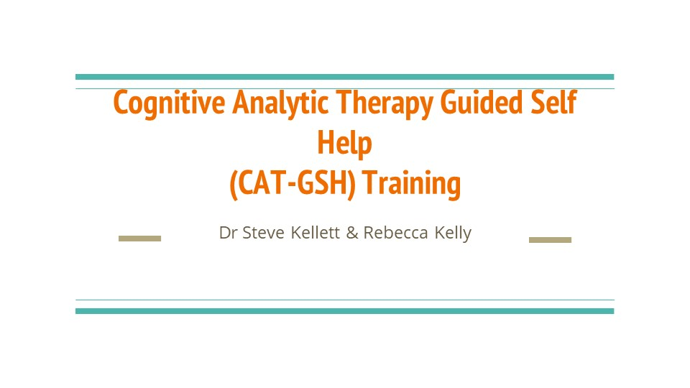
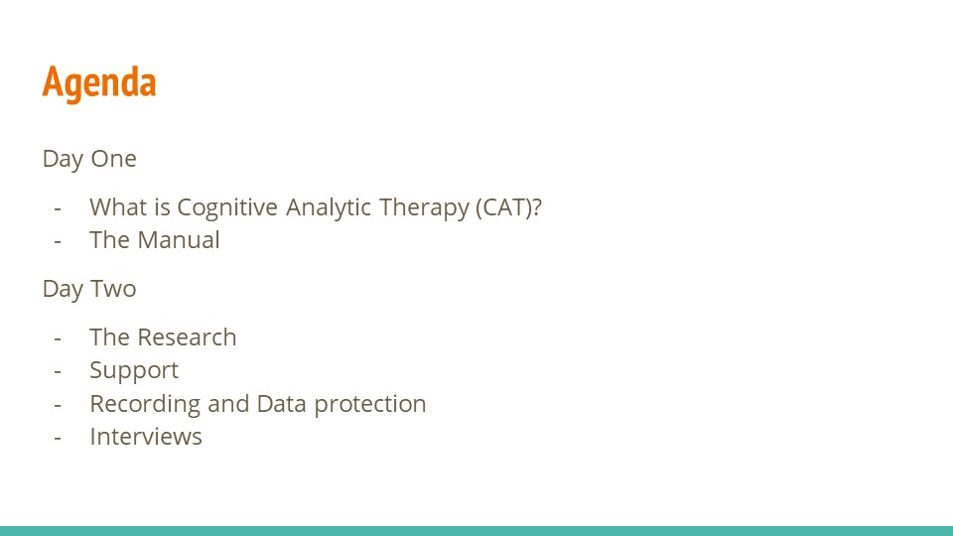
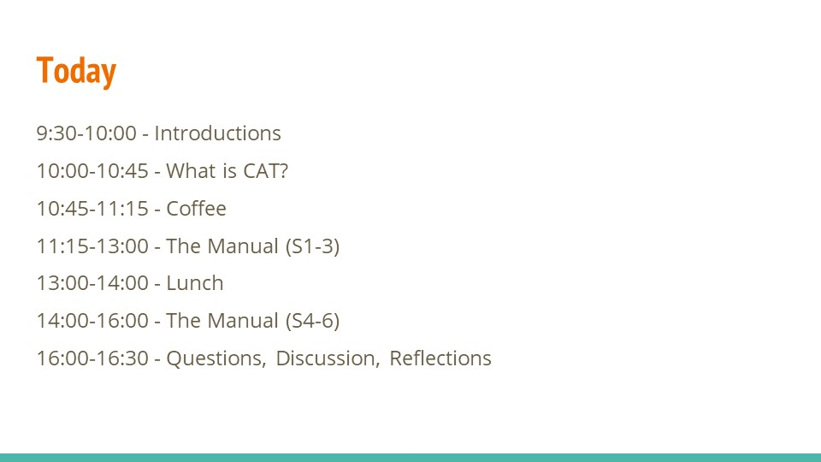
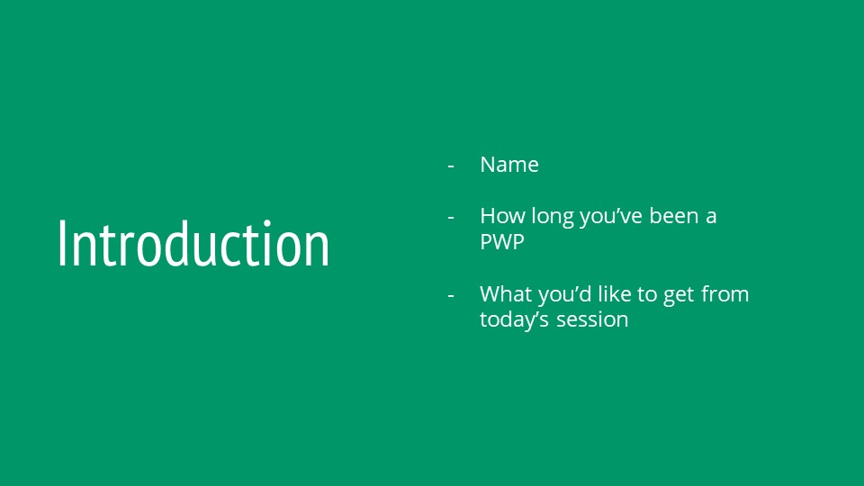
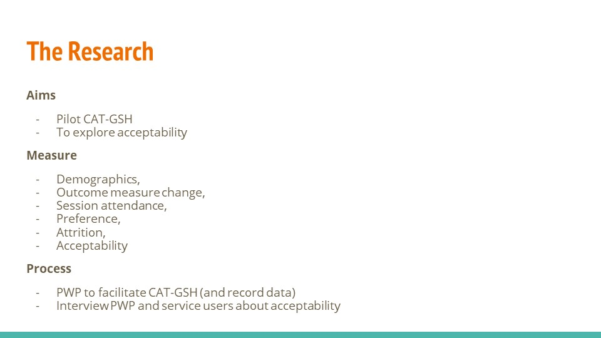
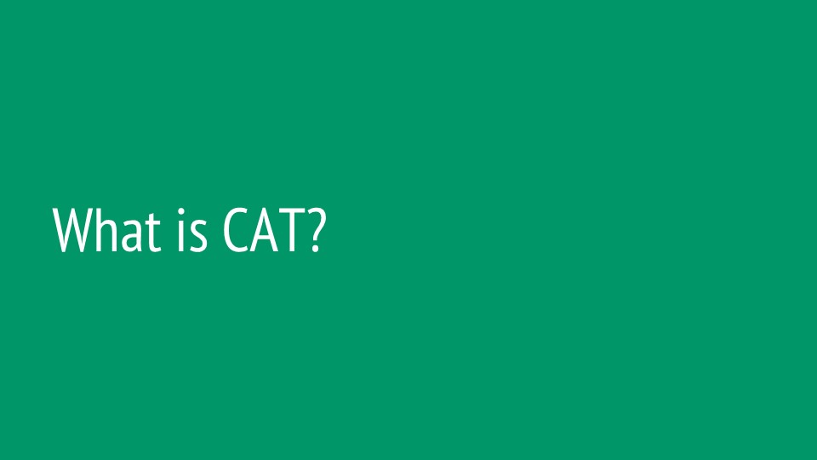
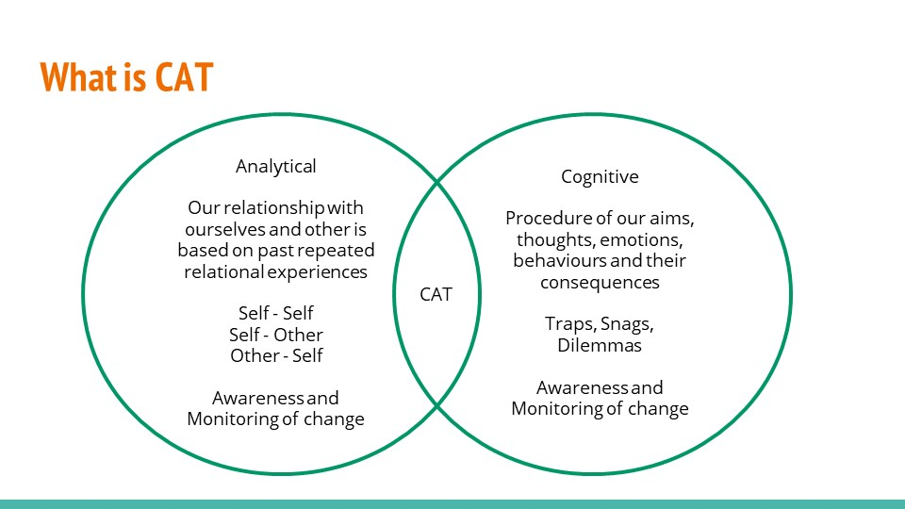
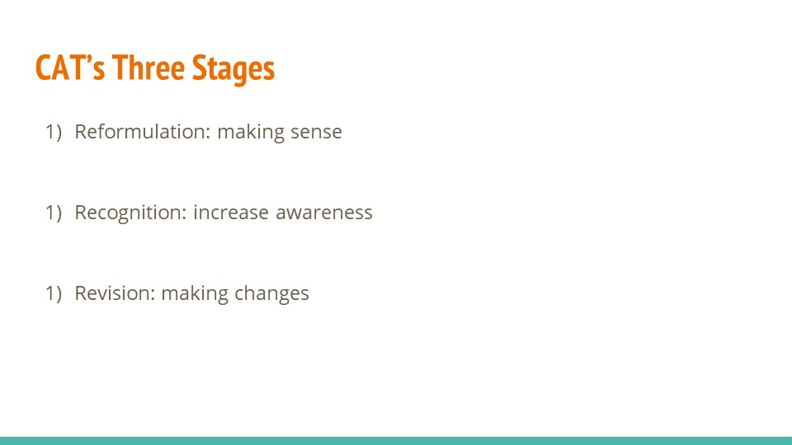

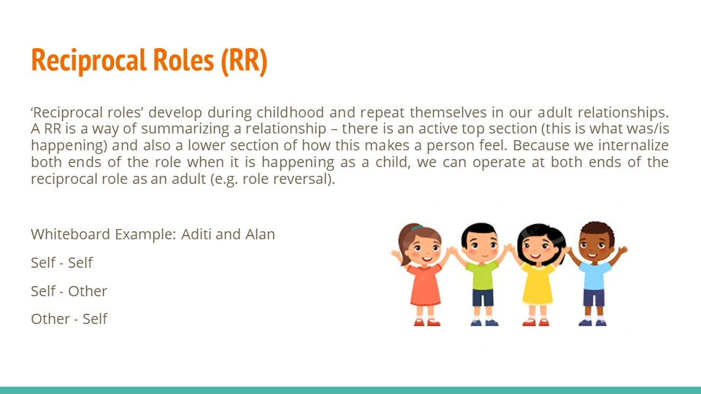
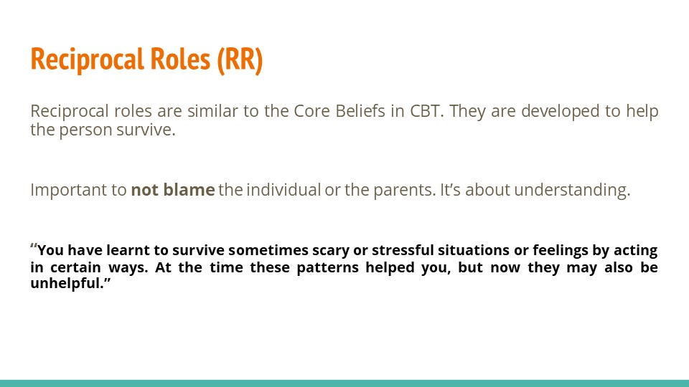
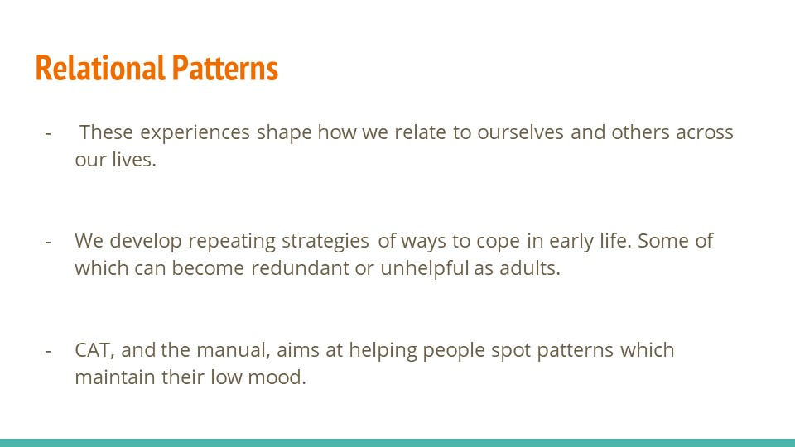
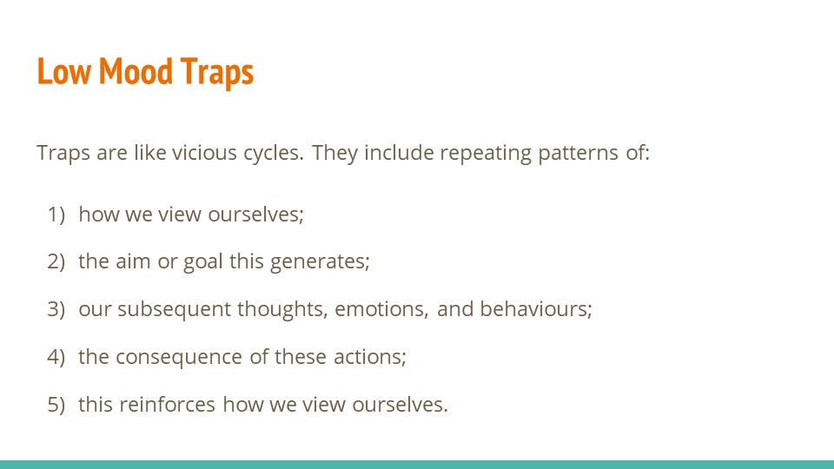
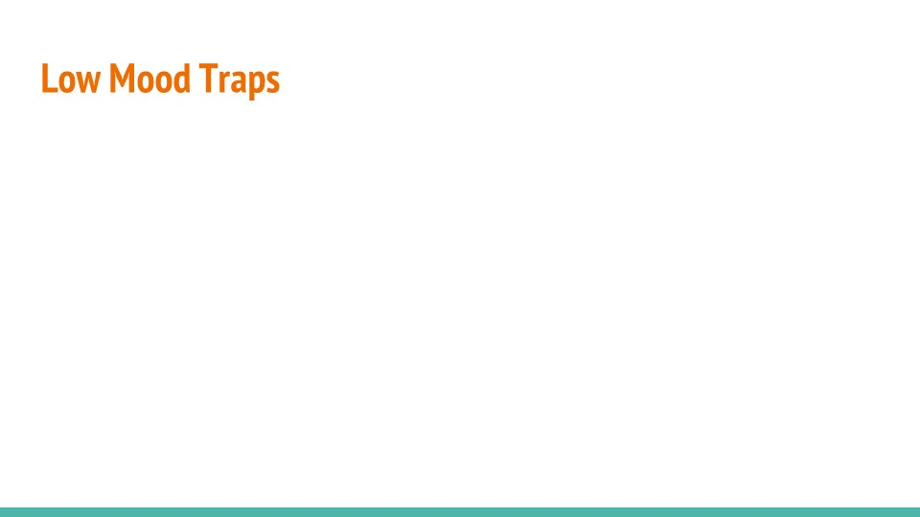
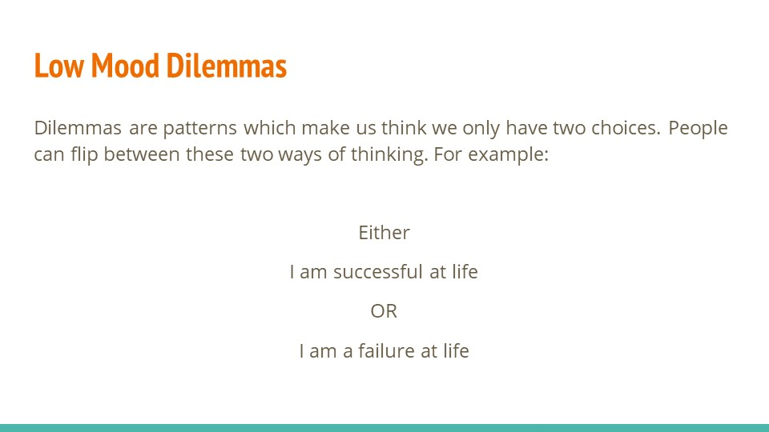
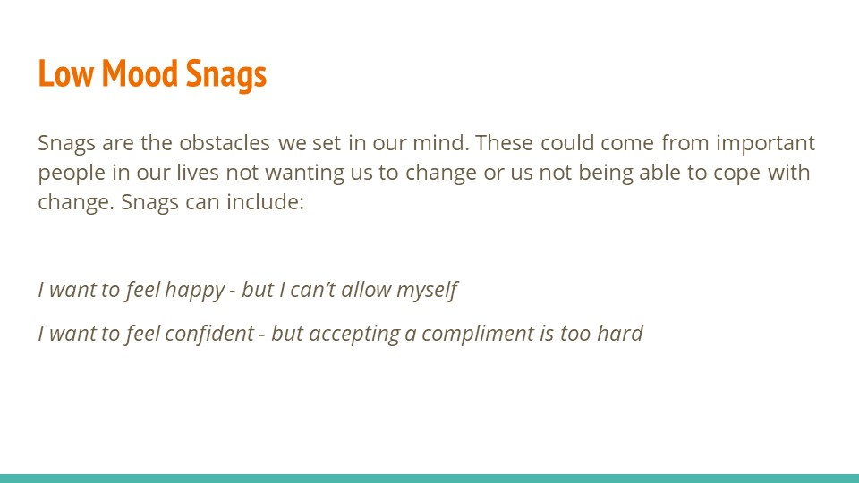
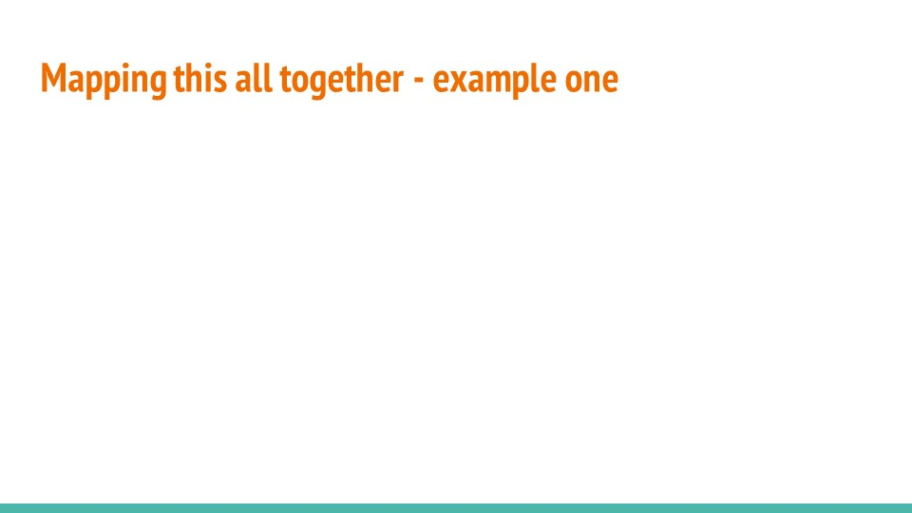
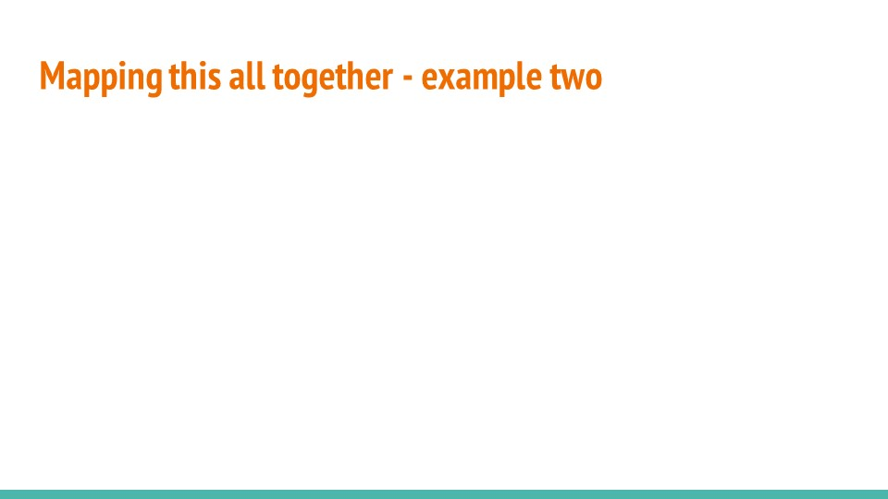

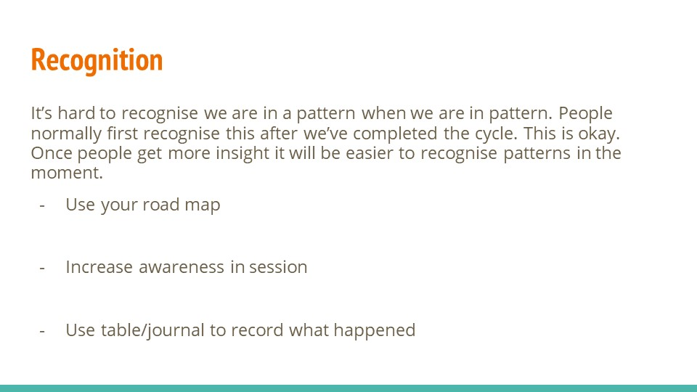

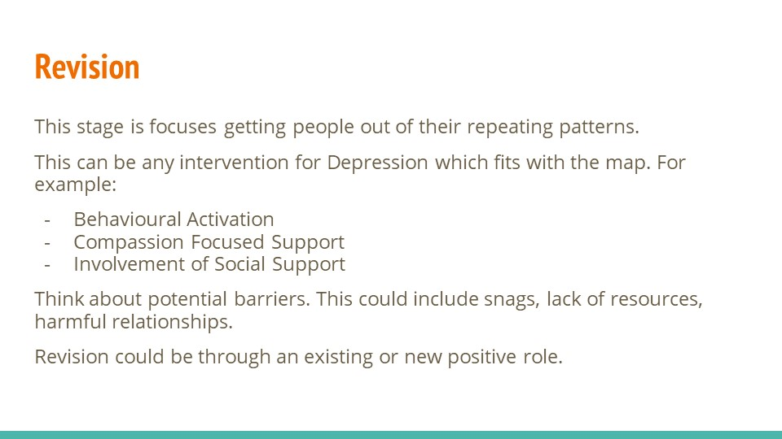
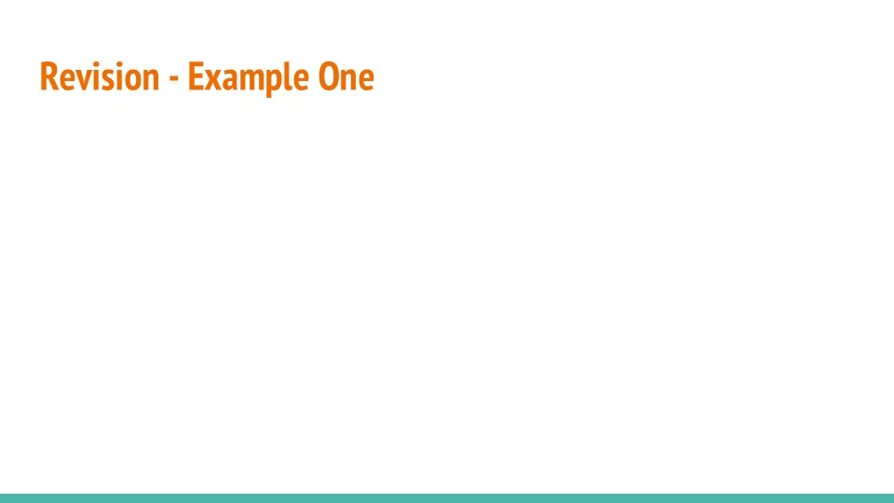
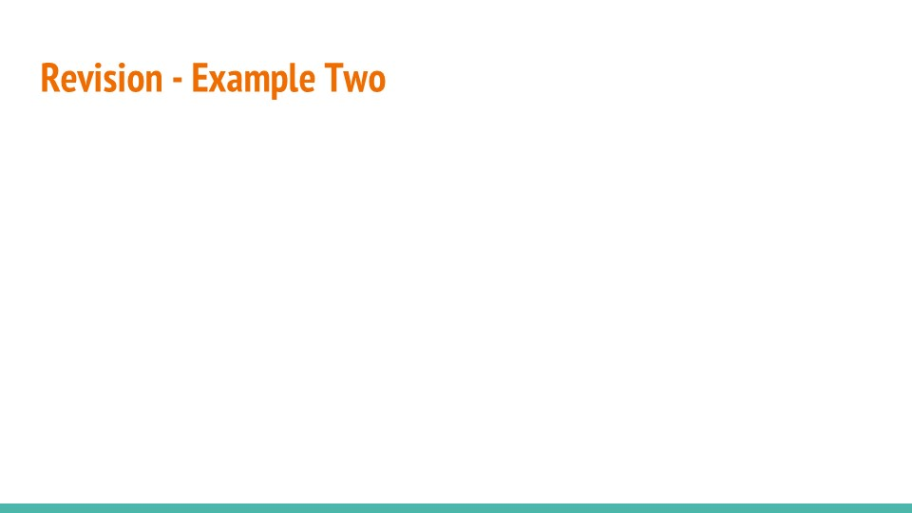

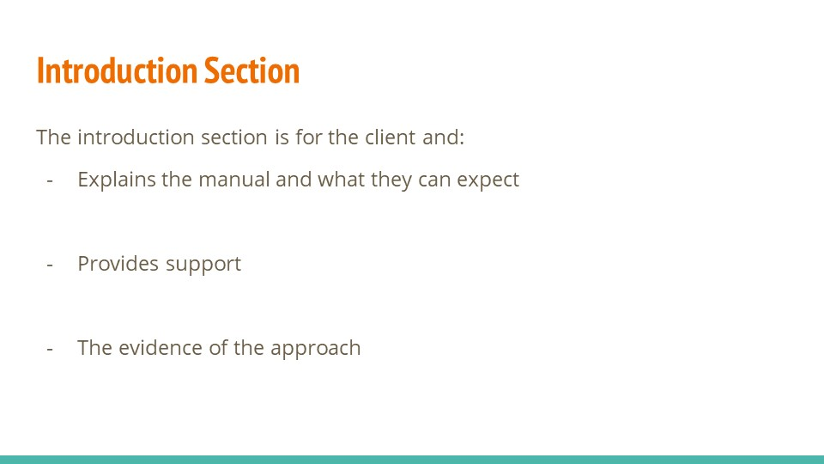
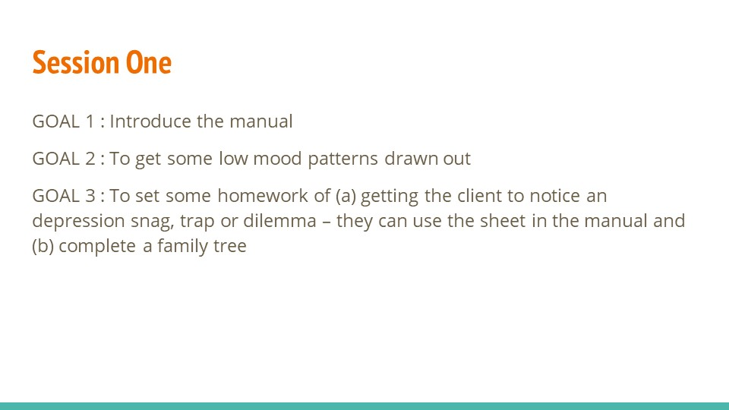
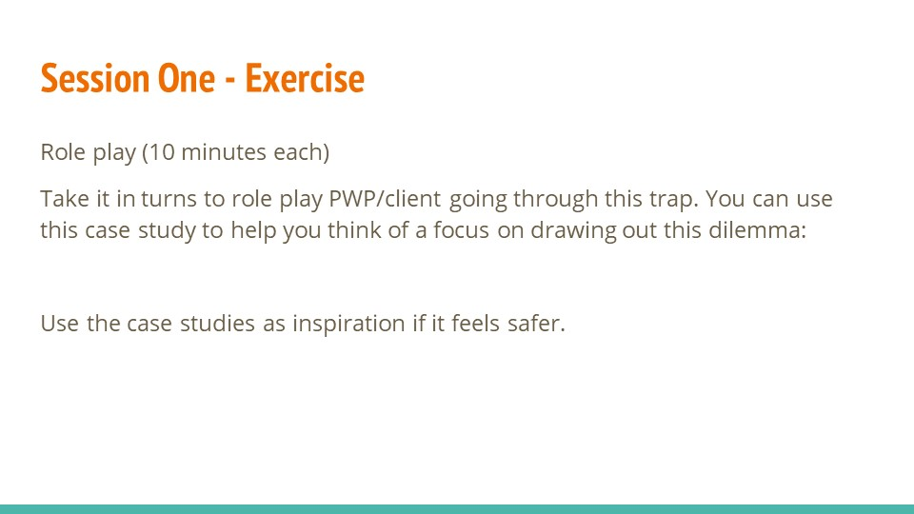
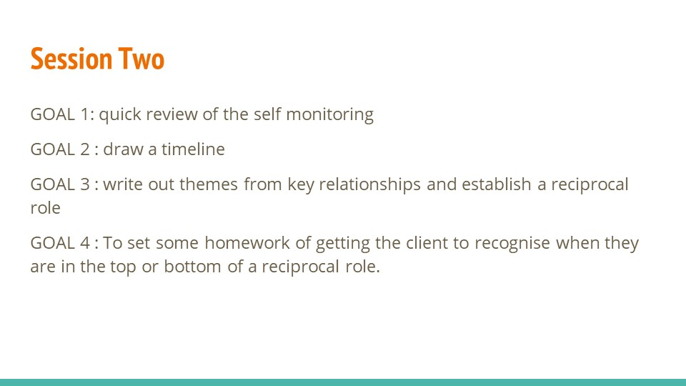
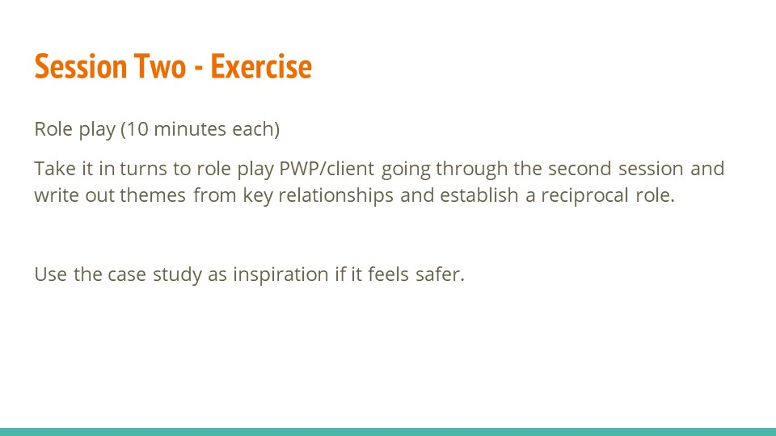
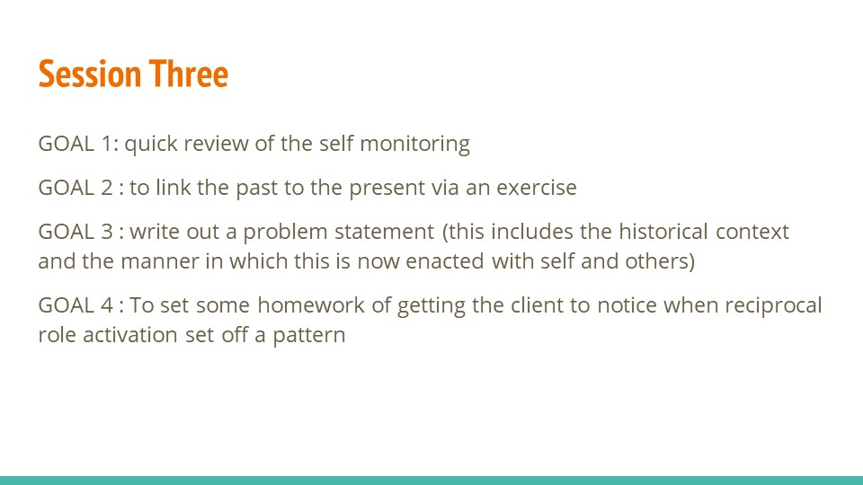
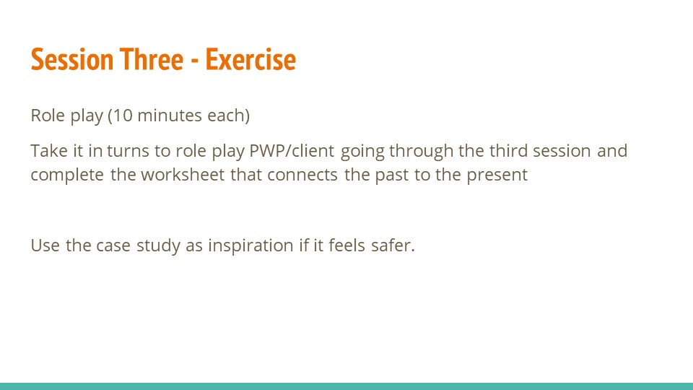
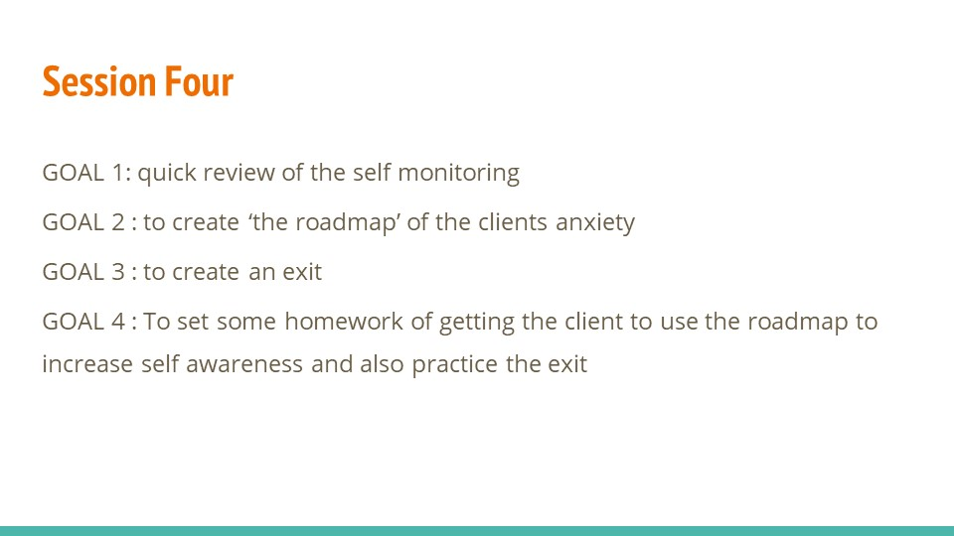
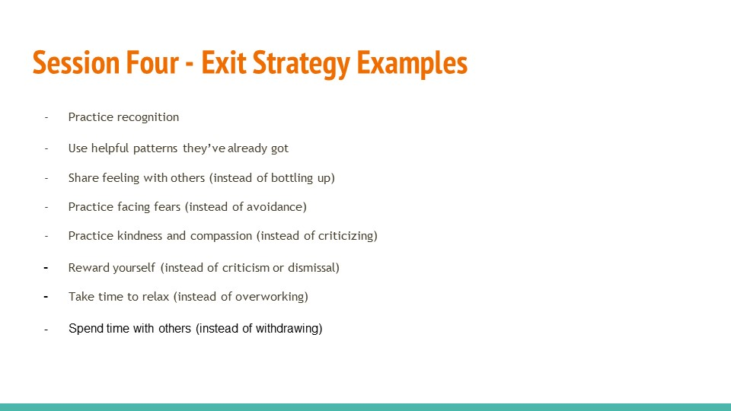
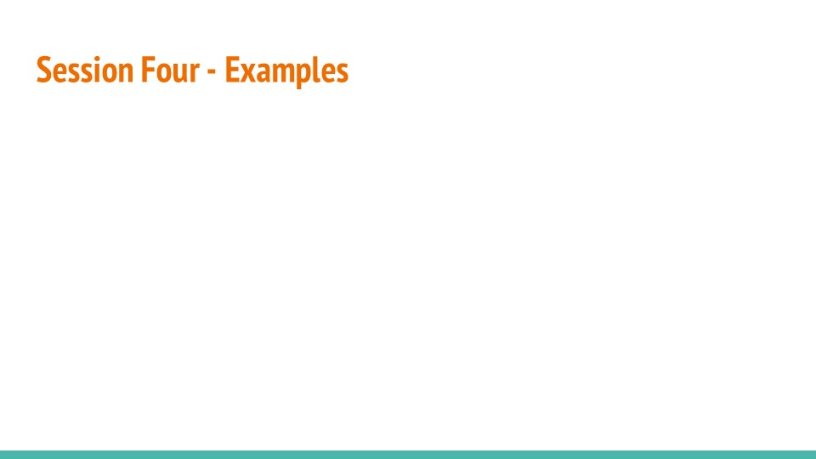
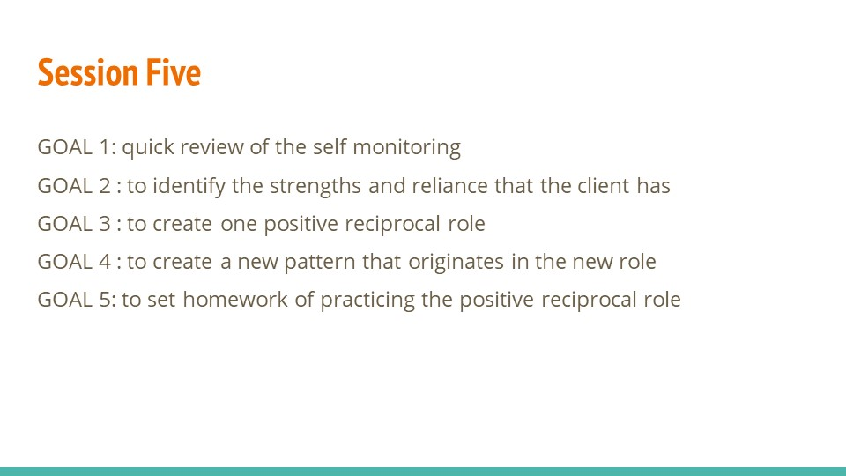
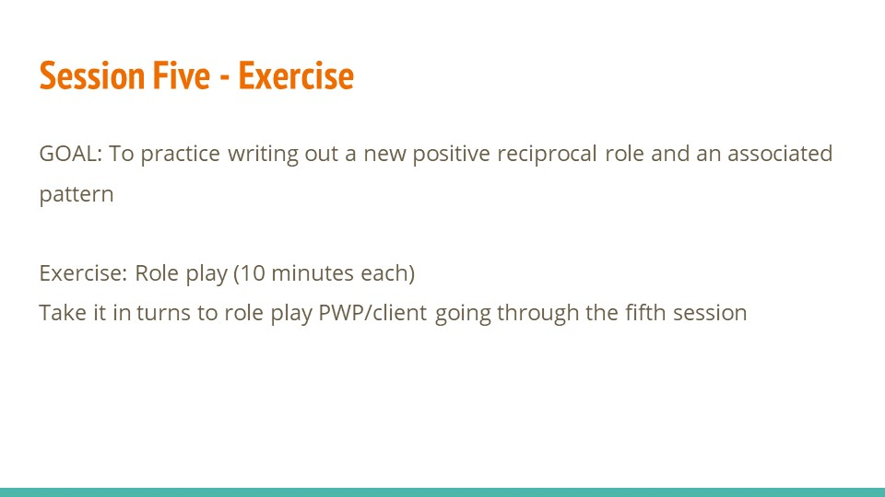
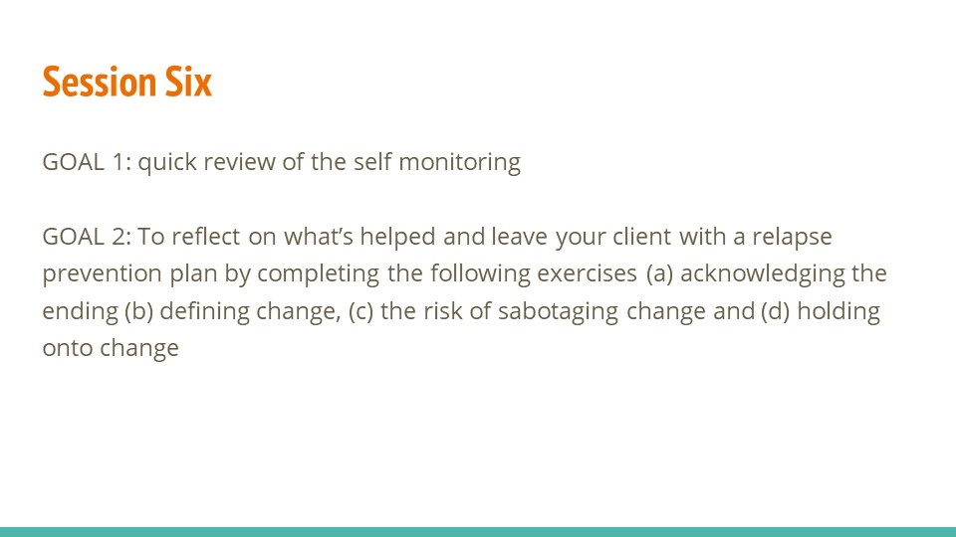
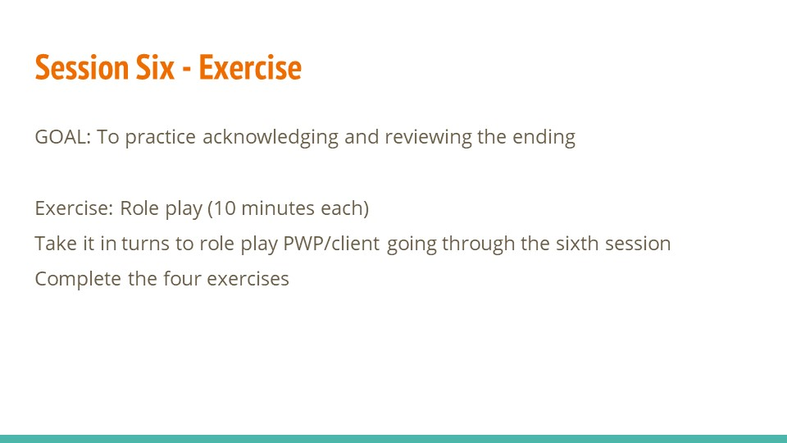

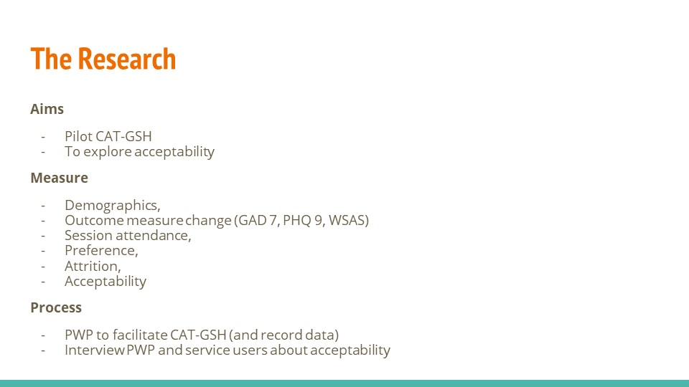
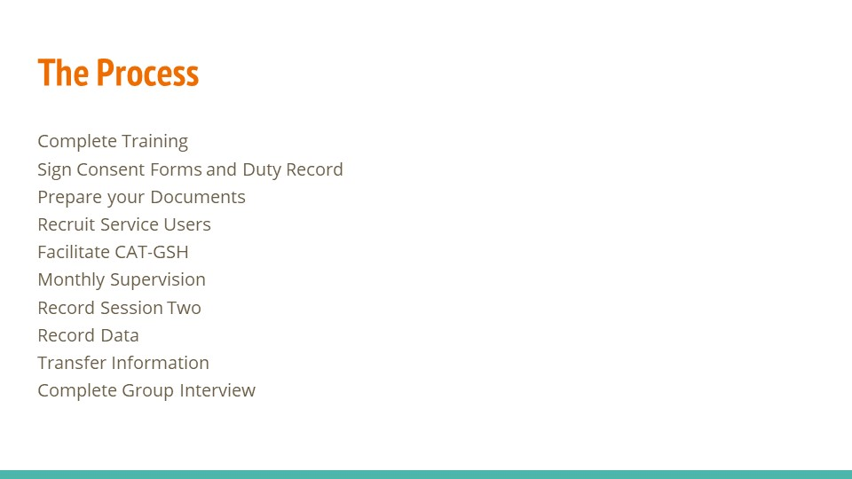
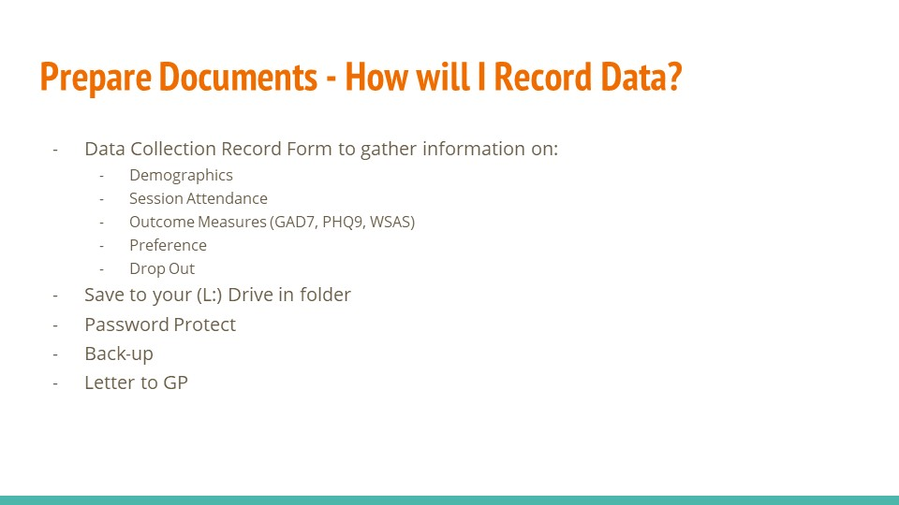
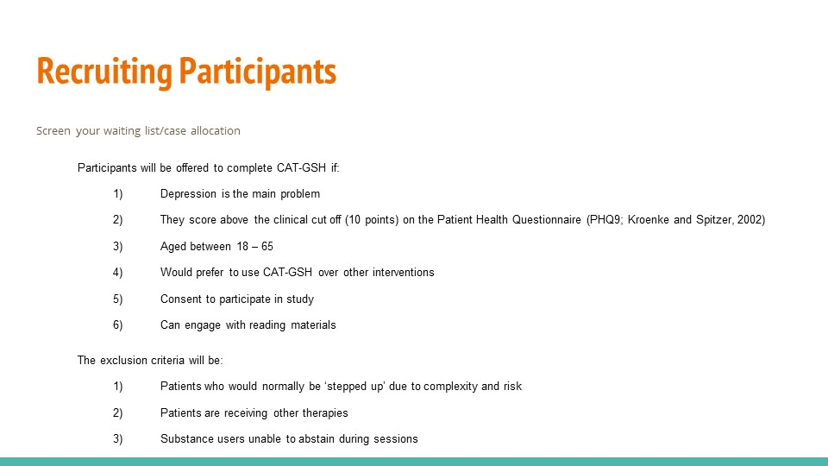
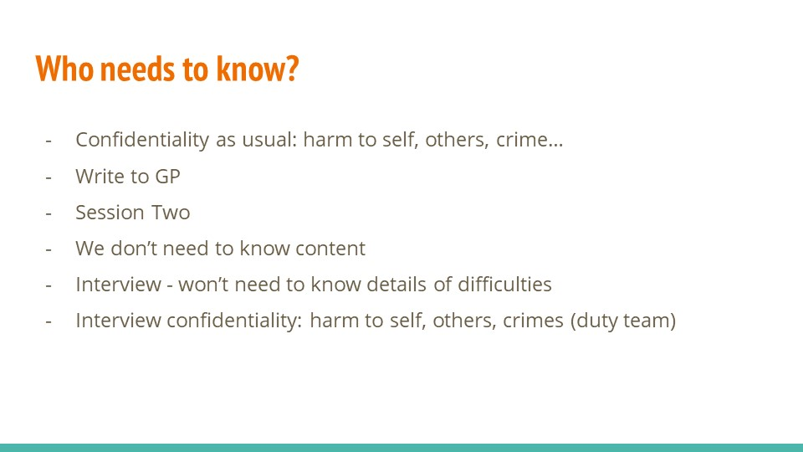
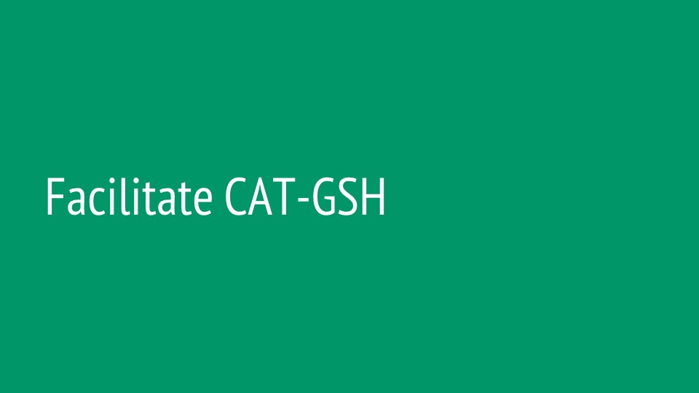
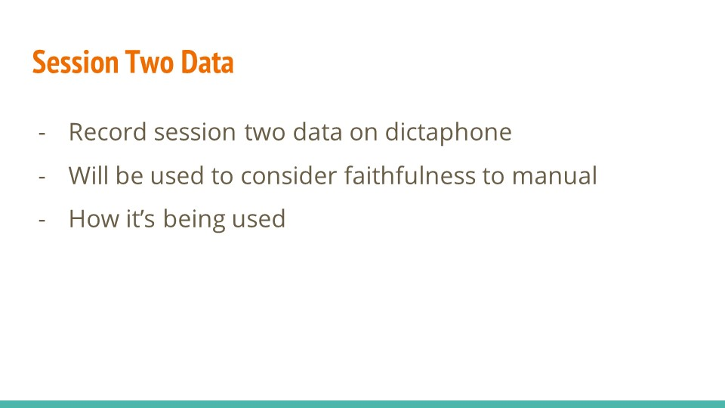
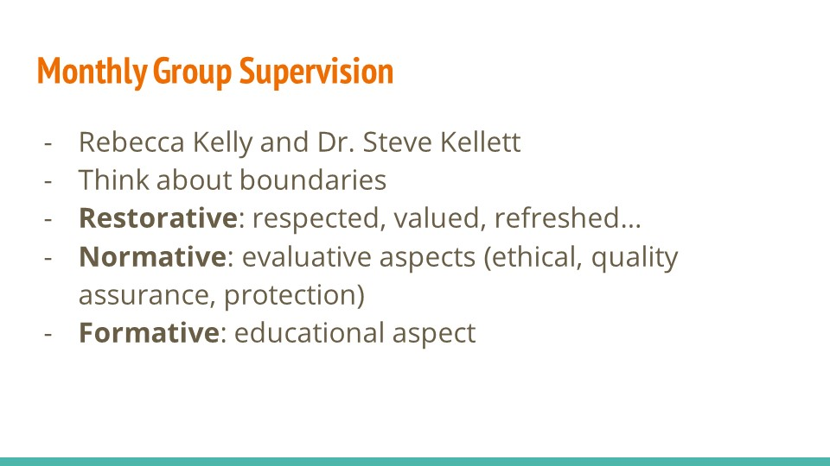
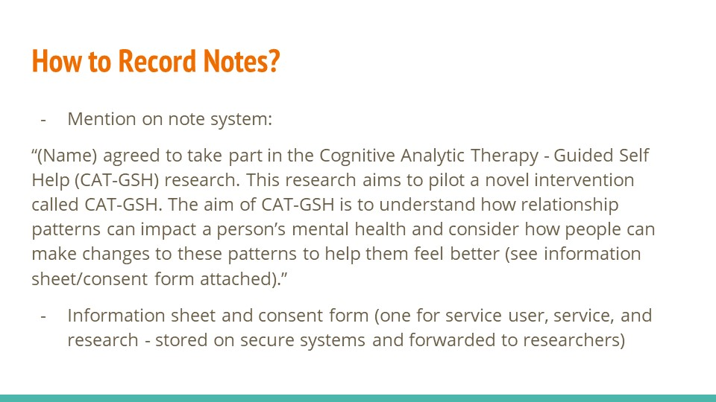
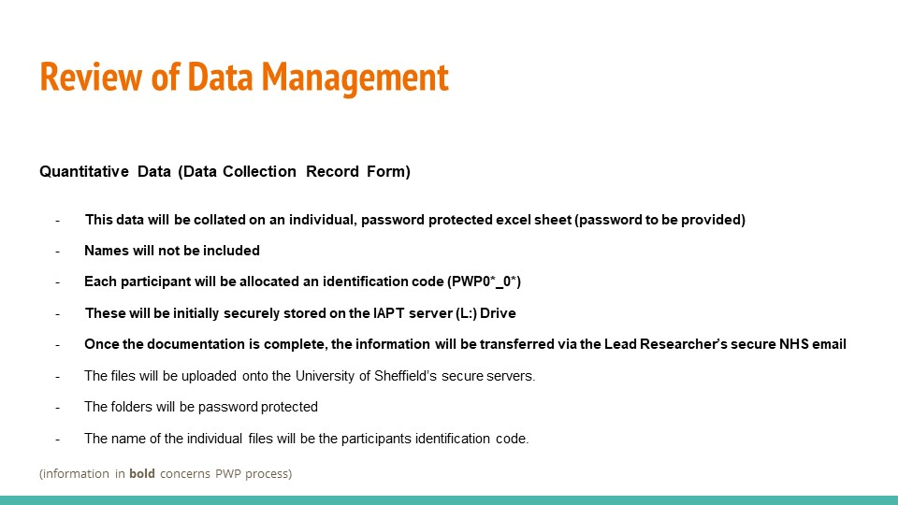
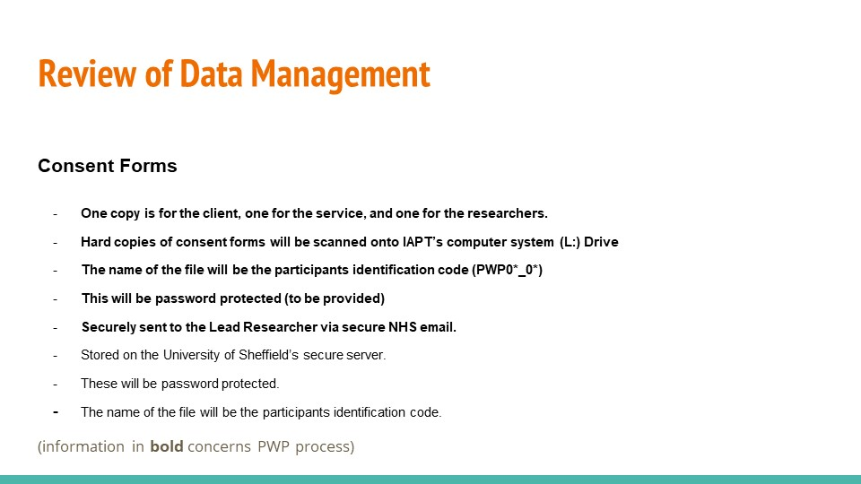
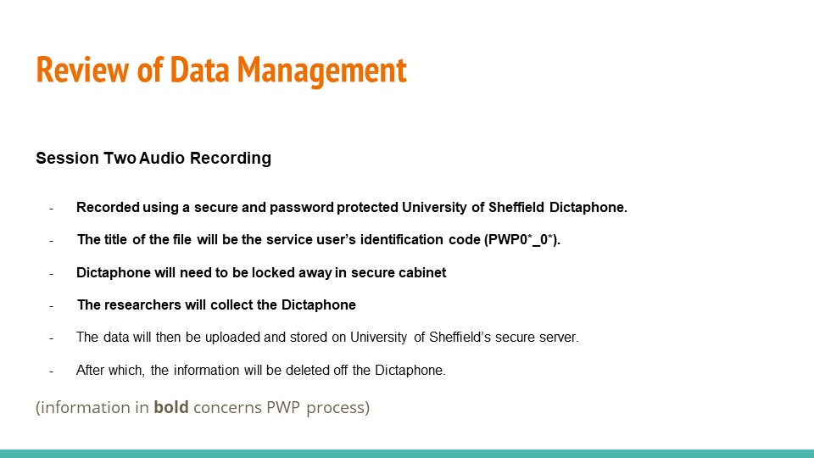
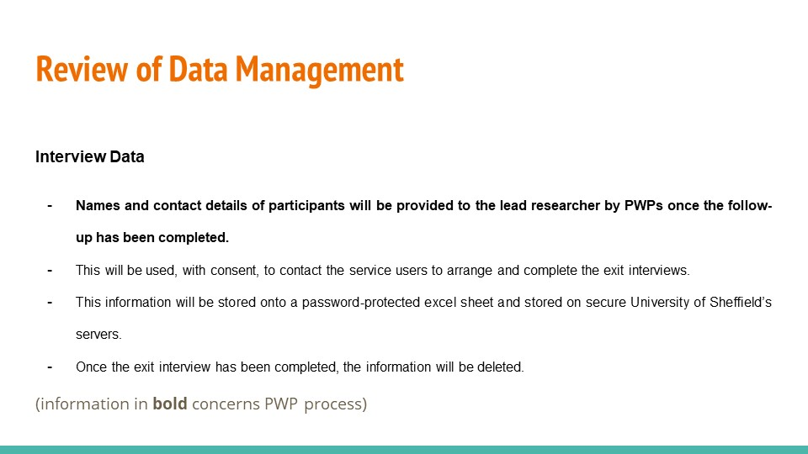
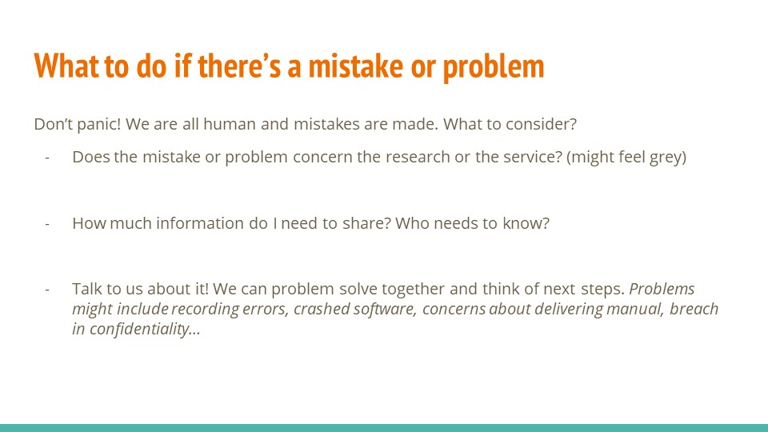
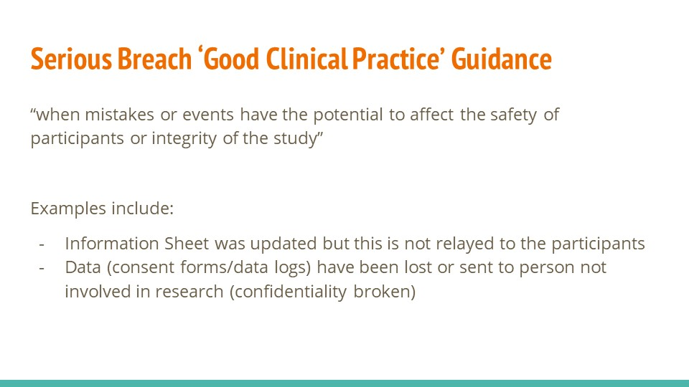
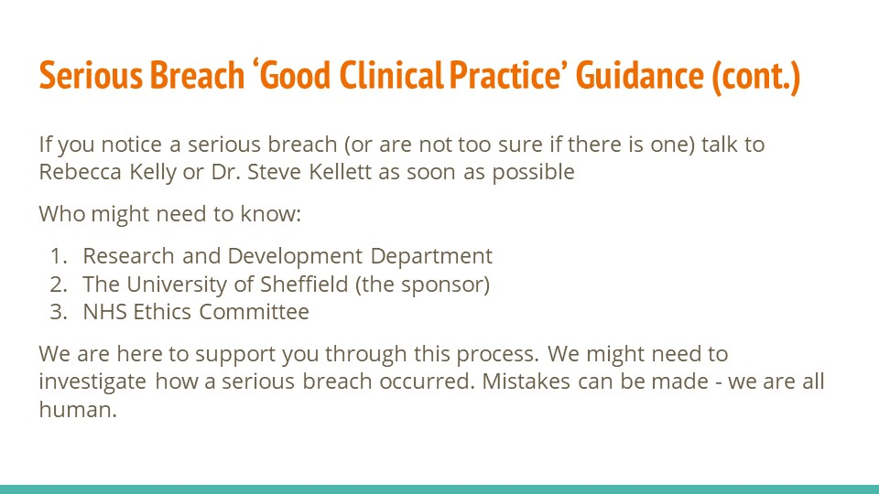
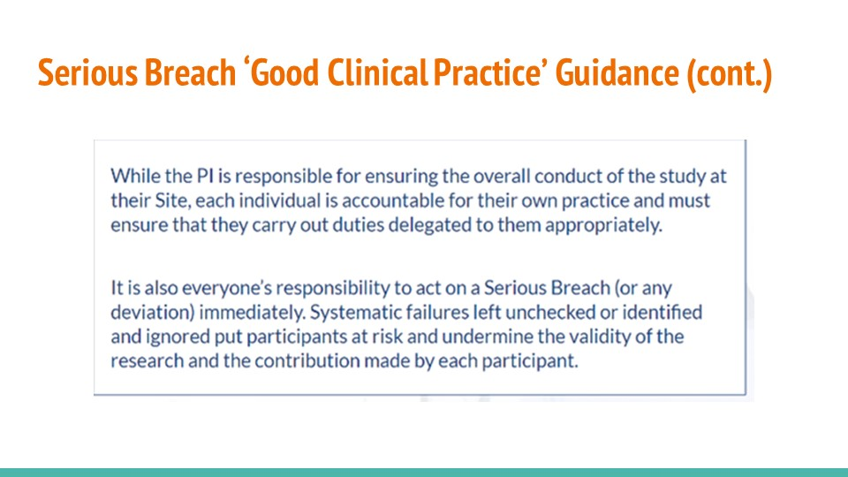
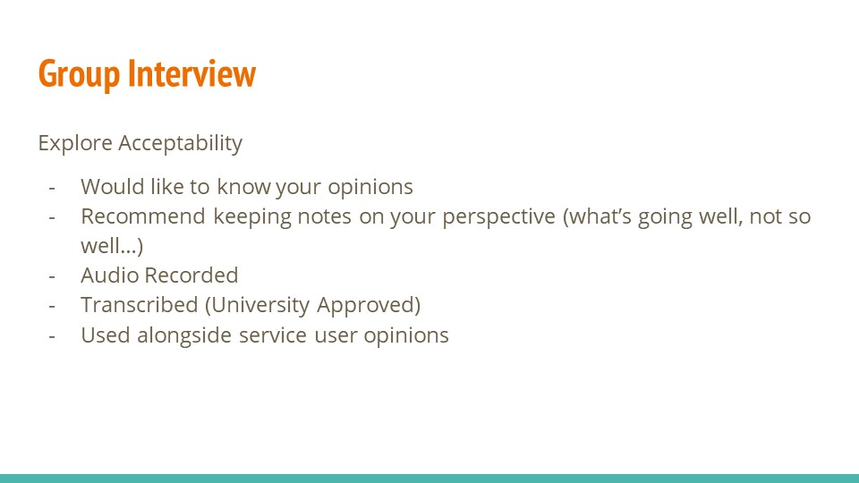

Appendix P

Satisfaction with CAT-GSH Training Form

These questions concern the 2-days training on the theory and the practice of CAT-GSH.

1) I feel sufficiently knowledgeable about CAT guided self-help (CAT-GSH) at a theoretical level.
1 2 3 4 5 6 7 8 9 10
not at all somewhat extremely

2) I feel I sufficiently understand the three components of CAT-GSH (reformulation, recognition and revision).
1 2 3 4 5 6 7 8 9 10
not at all somewhat extremely

3) I feel sufficiently knowledgeable about how CAT-GSH differs from CBT-GSH.
1 2 3 4 5 6 7 8 9 10
not at all somewhat extremely

4) I feel sufficiently confident in implementing CAT-GSH.
1 2 3 4 5 6 7 8 9 10
not at all somewhat extremely
5) I am generally satisfied with the training provided on CAT-GSH.
1 2 3 4 5 6 7 8 9 10
not at all somewhat extremely

6) The training materials were presented in an engaging and understandable way.
1 2 3 4 5 6 7 8 9 10
not at all somewhat extremely

7) The trainers were encouraging and enthusiastic.
1 2 3 4 5 6 7 8 9 10
not at all somewhat extremely

Write five words below to describe the CAT-GSH training:
1.
2.
3.
4.
5.

Appendix Q
Interview Guide for Patients
Introduction
Thank you for taking part in this research. As you will know I’m interested in exploring the experience of completing CAT-GSH. I will be asking you some questions about the manual, the problems you faced, what you enjoyed, and your general experiences. Do you have any questions you would like to ask me?
If at any time you want to stop the interview, or take a break, please let me know. If you have any questions or want me to say the questions in a different way, please let me know.
The things we talk about today are confidential and all your information from the recording will be anonymised, so you cannot be identified. The only exception to this would be if I felt concerned about your safety or someone else’s safety. I would endeavour to inform you of this. However, if needed, this information would need to be passed on to the team involved in your care and potentially people outside this team. Do you have any questions?

Interview Schedule Order | TFA link
How did you feel about CAT-GSH?  Prompt: did your feelings about CAT-GSH change before or after taking part? | Affective Attitude
What motivated you to take part in CAT-GSH?  Prompt: can you tell me some of the reasons why you attended the sessions? | Affective Attitude
How important is your mental health to you?  Follow-up question: did CAT-GSH align with how important mental health is to you? | Ethicality
What aspects of CAT-GSH were important to you? | Ethicality
What elements of CAT-GSH did you find were the most helpful? | Perceived Effectiveness
What elements of CAT-GSH did you find were the least helpful? | Perceived Effectiveness
Were you able to achieve the goals you set at the beginning?  If yes: how did you do this?  If no: what would need to happen to help you reach your goals?  If the answer is yes and no (partial goal achievement) ask both yes/no questions. | Perceived Effectiveness
Have you, or your family and friends around you noticed any changes in your wellbeing?  Yes: what are they?  No: why might this be? | Perceived Effectiveness
Would you recommend CAT-GSH to a friend who was struggling with their mental health?  If yes: why?  If no: why not? | Perceived Effectiveness
Did you have to make any changes, or miss anything to attend the sessions?  If yes: please tell me about what these were. Did you find this OK or  not OK to do? | Opportunity  Costs
How easy or difficult did you find using the manual?  Follow-up question: Did you encounter any problems when completing CAT-GSH? | Burden
Tell me about what you did in between sessions related to CAT-GSH?  Prompt: did you make any changes at home?  If yes: what were those changes?  If no: tell me about why that might have been?  If mixed response about changes, ask both yes/no questions. | Burden
Tell me about how easy or difficult it was to put into practice the homework/activities? | Self-efficacy
How confident did you feel that you could perform the homework/activities required in CAT-GSH?  Prompt: Did your confidence levels change throughout the sessions? | Self-efficacy
What did you understand about the purpose of the CAT-GSH?  Prompt: what did you think the sessions were for? Why are they being done? | Intervention Coherence
What have been the drawbacks or costs of completing this therapy? | Burden
Tell me about what you did in the CAT-GSH?  Prompt: what do you remember doing in the sessions? | Intervention Coherence
Is there anything you would change about CAT-GSH? | Ethicality
What’s important to keep the same about CAT-GSH? | Ethicality

End of Interview
Thank you for taking part in this research today. This research has aimed to explore how acceptable CAT-GSH is for service users and service delivers. I am going to analyse all the interviews I have conducted to look at some of the similarities and differences in people’s experiences. I will then write a report of my findings. We hope that these findings may be helpful for adapting the intervention and making it more effective.

Appendix R
Interview Guide for PWPs
Introduction
Thank you for taking part in this research. As you will know I’m interested in exploring the experience of delivering CAT-GSH. I will be asking you some questions about the manual, the problems you faced, what you enjoyed, and your general experiences. Do you have any questions you would like to ask me?
If at any time you want to stop the interview, or take a break, please let me know. If you have any questions or want me to say the questions in a different way, please let me know.
The things we talk about today are confidential and all your information from the recording will be anonymised, so you cannot be identified. Do you have any questions?
Interview Schedule Order | TFA link
In general, how do you feel about CAT-GSH?  Prompt: did your feelings about CAT-GSH change before or after taking part? | Affective Attitude
What motivated you to volunteer for CAT-GSH?  Prompt: can you tell me some of the reasons why volunteered? | Affective Attitude
What motivated your clients to attend CAT-GSH?  Prompt: can you tell me some of the reasons why the attended? | Affective Attitude
How important is mental health to you?  Follow-up question: did CAT-GSH align with how important mental health is? | Ethicality
What aspects of CAT-GSH were important to you? | Ethicality
What elements of CAT-GSH did you find were the most helpful? | Perceived Effectiveness
What elements of CAT-GSH did you find were the least helpful? | Perceived Effectiveness
Were you and your client able to achieve their goals you set at the beginning?  If yes: how did you do this?  If no: what would need to happen to help you reach your goals?  If the answer is yes and no (partial goal achievement) ask both yes/no questions. | Perceived Effectiveness
Would you recommend CAT-GSH to a friend who was struggling with their mental health?  If yes: why?  If no: why not? | Perceived Effectiveness
Did you have to make any changes, or miss anything to deliver these sessions?  If yes: please tell me about what these were. Did you find this OK or  not OK to do? | Opportunity  Costs
Did your clients have to make any changes, or miss anything to deliver these sessions?  If yes: please tell me about what these were. Did you find this OK or  not OK to do? | Opportunity  Costs
How easy or difficult did you find using the manual?  Follow-up question: Did you encounter any problems when completing CAT-GSH? | Burden
Did you have to complete any work in between sessions related to CAT-GSH?  Prompt: did you make any changes to your work routine?  If yes: what were those changes?  If no: tell me about why that might have been?  If mixed response about changes, ask both yes/no questions. | Burden
Tell me about how easy or difficult you think your clients found putting into practice the homework/activities? | Self-efficacy
What did you understand about the purpose of the CAT-GSH?  Prompt: what did you think the sessions were for? Why are they being done? | Intervention Coherence
What have been the drawbacks or costs, for your clients, of completing this therapy? | Burden
What have been the drawbacks or costs, for your, of facilitating this therapy? | Burden
Tell me about what you did in the CAT-GSH?  Prompt: what do you remember doing in the sessions? | Intervention Coherence
Is there anything you would change about CAT-GSH? | Ethicality
What’s important to keep the same about CAT-GSH? | Ethicality

End of Interview
Thank you for taking part in this research today. This research has aimed to explore how acceptable CAT-GSH is for service users and service delivers. I am going to analyse all the interviews I have conducted to look at some of the similarities and differences in people’s experiences. I will then write a report of my findings. We hope that these findings may be helpful for adapting the intervention and making it more effective.

Appendix S
Excerpts of Interview Reflexivity
Excerpts demonstrating the pre- and post-interview reflections. Common themes include reflecting on interview delivery, impact of researcher’s knowledge on interview questions, and potential impact on interpersonal factors. Excepts have not been linked to participants, or their role as facilitator or patient, to preserve anonymity.
Interview Reflections
Excerpt one, pre-interview: This is my first interview with a participant. I’m nervous about this first interview but also excited. I’ve been considering how these research interviews will be different to a clinical interview as part of my role as a Trainee Clinical Psychologist. I will hope to transfer some of these skills to be welcoming and help the participants to feel at ease, but I’m also aware of my habit to chunk two questions at the same time or potentially ask leading questions. I believe the semi-structured approach will help with this.

Except two, post-interview: I’ve been completing some more reading around GSH as part of my systematic review and can’t help noticing the impact of this on my questions compared to earlier interviews. For example, research has discussed how people’s motivation for change can alter throughout the GSH process. I found myself in the last few interviews asking about if the participants motivation has changed over the course of therapy. Whilst this helps gather more nuanced data it demonstrates the impact of my biases, assumptions, and interests on the research data. For example, I explore motivation (which may be linked to the Acceptability framework via ‘burden’) but I’ve not asked more information regarding the specifics of factors relating to participant understanding.

Except three, post-interview: I’m getting the impression there is a pattern that people are finding the intervention very helpful. However, people seem to be giving me less information regarding what has not been helpful, or what they prefer to change. Whilst this may reflect their truth, or I may be misremembering the information provided and the feedback has been balance, I wonder what factors might be influencing people’s responses and what I can learn from this. I hypothesis that the relationship I have with the PWPs, and patients may influence their responses. I wonder if participants provide positive feedback, as some research suggests, because I am the research, this is “my intervention” and so people may not want to feedback things they find challenging or difficult. Alternatively, some participants seem to get confused about the question “what the drawbacks or costs have been to completing CAT Guided Self-Help?”. Some people have interpretated this as the monetary cost, rather than the physical or emotional costs that I intended to ask about. I wonder if this has skewed the answers. It might be useful in future research to make this more explicit or to pilot the interview before completing it with participants.

Appendix T
Transcriber Confidentiality Form
Doctorate in Clinical Psychology, University of Sheffield
Transcribing Confidentiality Form & Guidance Notes

Type of project: Research thesis
Project title: Development and piloting of a low intensity cognitive analytic–informed guided self-help for depression to be used within Increasing Access to Psychological Therapies (NHS TALKING THERAPIES)
Researcher’s name: Rebecca Kelly
The recording you are transcribing has been collected as part of a research project. Recordings may contain information of a very personal nature, which should be kept confidential and not disclosed to others. Maintaining this confidentiality is of utmost importance to the University.
We would like you to agree:
- Not to disclose any information you may hear on the recording to others,
- If transcribing digital recordings – only to accept files provided via secure email and password protected documents,
- To keep the tapes in a secure locked place when not in use (not applicable),
- When transcribing a recording as far as reasonably practicable ensure it cannot be heard by other people,
- To adhere to the Guidelines for Transcribers (appended to this document) in relation to the use of computers and encrypted digital recorders as far as reasonably practicable,
- To show your transcription only to the relevant individual who is involved in the research project via uploading as requested,
- If you find that anyone speaking on a recording is known to you, we would like you to stop transcription work on that recording immediately and inform the person who has commissioned the work.

Declaration
I have read the above information, as well as the Guidelines for Transcribers, and I understand that:
- I will discuss the content of the recording only with the individual involved in the research project
- If transcribing digital recordings – I will only accept files provided via secure google drive or other secure method as instructed
- I will keep the tapes in a secure place when not in use (not applicable)
- When transcribing a recording as far as reasonably practicable I will ensure it cannot be heard by others
- I will treat the transcription of the recording as confidential information
- I will adhere to the requirements detailed in the Guidelines for transcribers in relation to transcribing recordings onto a computer and transcribing digital audio files as far as reasonably practicable,
- If the person being interviewed on the recordings is known to me I will undertake no further transcription work on the recording

I agree to act according to the above constraints with added amendments
Your name: (name of transcriber)
Signature: (signature)
Date:10.09.2023
- Administration
Several transcriptions will be carried out as part of the role of one or more members of staff working within that team. Many other interviews and focus group discussions will need to be transcribed by a University of Sheffield approved transcriber.

- Data security
To comply with the University's information governance (IG) policies, any Personal Information stored on a portable device or portable media must be protected by an approved encryption system. The recommended procedure for sharing recordings is via the secure University network drive.

- Sharing the recording and transcription:
For those transcribing as part of their normal role: the transcriber should, unless otherwise involved in the work of the project team, only be given access to a folder within the project area which has been set up specifically to hold the recording and subsequent transcripts.
For those transcribing: each transcriber will be provided access to a University of Sheffield email and granted permission to access to the secure google drive. When the transcriber agrees to take a recording a confidentiality agreement will be completed.
Information about how to access the Olympus Software will be provided via email.
Any transcription carried out away from your university workstation MUST be done using headphones and in a position where the recording cannot be overheard or the laptop screen seen by unauthorised people, including family members.
If the recordings are not being accessed via VPN, which should be the default, make sure that you delete the audio and the transcript from the computer that you used, also from the Downloads folder and Recycle bin.
If you use Express Scribe or other transcription software on any computer to transcribe interviews, the software will automatically save a copy of the recording in your computer’s hard drive (usually C:). For data security reasons, it is your responsibility to make sure that all copies of recording are deleted both from Express Scribe software and the computer’s C drive, as follows:
- Open the ‘Express Scribe’ (or equivalent) software.
- Ensure there are no files present in the software, including in the ‘Recover Old Dictation’ window, accessed via ‘File’. If you delete any files (by marking them as ‘Done’) remember to also delete them from the ‘Recover Old Dictation’ window.
- Check C drive (C:\Users\User\AppData\Roaming\NCH Software\Scribe) and delete any files from there.

- Page set up and guidelines
The Allocator will complete the checklist supplied with the Transcription Guidance for Allocators specifying the format required for each transcription. This should include details such as:
- which recommended template should be used (and any local variations such as margins, font, line spacing/numbering)
- whether or not the text should be verbatim (ie include “er”, “mmm”, “you know”, etc) or include laughs, coughs, background noise
- whether or not names of people, places, etc should be entered or anonymised.
Whether to include expressions that help understand the context of what is being said, for example by using exclamation marks, underlining something that is emphasised or noting if something is said in a sarcastic tone.
Whether to use brackets () for the following:
- When someone laughs or coughs: (laughs)
- Noises in background: (doorbell)
- For a significant pause if someone is thinking how to answer a question: (pause)
- When the interviewer replies to say only “yeah”, or “ok” include the response in the preceding paragraph to keep the text flowing, for example: P: When I went into hospital my adherence got much better (mmm) but then it got worse when I got home.
If a word/phrase is unintelligible, or inaudible, use [?] and the timestamp.
If the recording contains unfamiliar technical or medical terms, including drug names, a list of these should be provided by the Allocator. They also may provide you with the list of the questions asked, and/or a participant information sheet.

- Additional information
Ensure you agree a deadline with the Allocator, and do not hesitate to raise any queries with them.
If you have not worked with that particular project team before, the Allocator may ask that you transcribe the first 10-15 minutes of the recording to enable them to do an initial check and so that any issues arising can be discussed and sorted out before you complete the whole recording. This will be a good opportunity to let them know if you estimate that the transcription will take longer than the time initially allocated, or if you need any other information. A rough guideline for completing a transcription of a 1:1 conversation, either face to face or by telephone, is that 1 hour of recording will take 6 hours to complete, including checking time. If you anticipate that it will take longer please discuss this with the Allocator.
However, this may take longer if the following applies:
- the number of participants and whether individual members of a focus group should be identified and recorded separately
- the clarity of the speakers eg a heavy accent, an indistinct telephone line, interrupting each other, speaking at the same time as another person
- the speed at which a person speaks
- excessive background noise (equipment or machinery, children playing or interrupting etc).
Once the transcription is finished, make sure you replay the whole recording to check for errors, missing words, etc.
On completion of the transcription, if you haven’t saved the transcript directly to the secure network folder, upload it and inform the Allocator.
Complete a Claim for fees (Staff) form and hand it over to the Allocator.
The payment rate for transcription is £12.42 per hour (as of August 2018), so approximately £74.52 per straightforward 1 hour recording unless an alternative has been agreed with the Allocator as above.

- Additional guidelines on request
- Indicate long gaps by five eclipses “…..”
- Indicate strong emotion in square brackets [] and the researcher will code the perceived affect

Appendix U
SPSS Analysis

PHQ-9 – Friedman Test Output

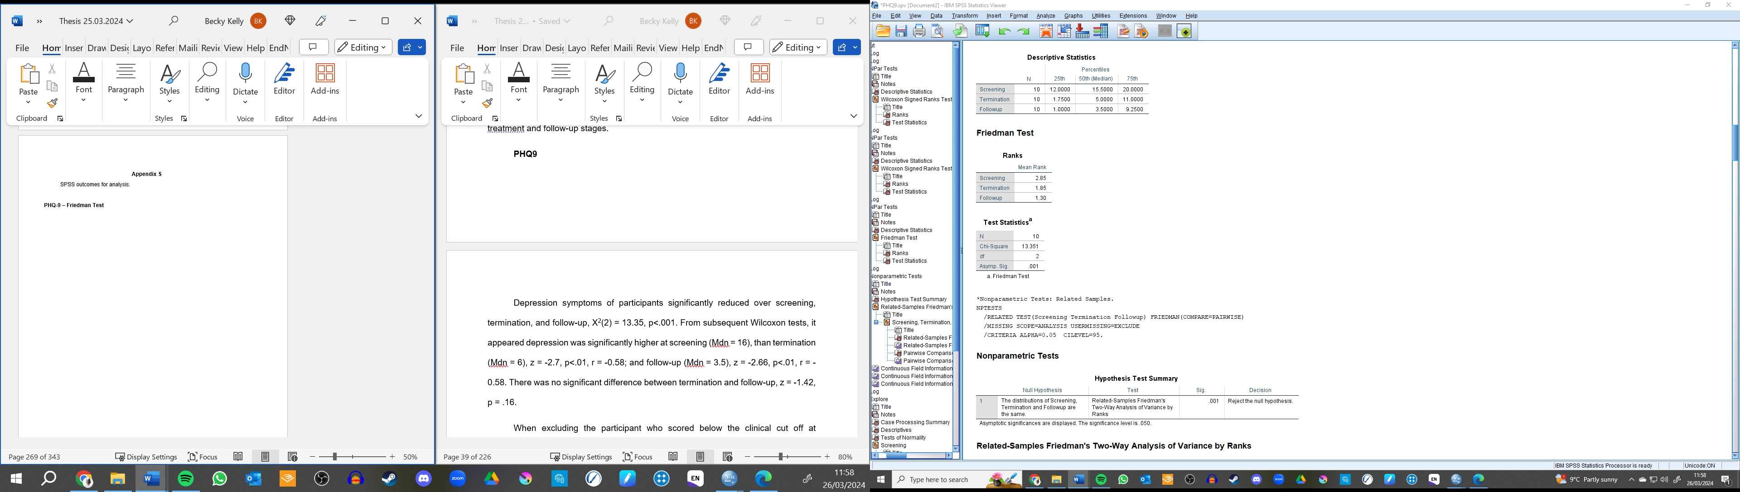
PHQ9 – Screening – Termination Wilcoxon Signed Ranks Test

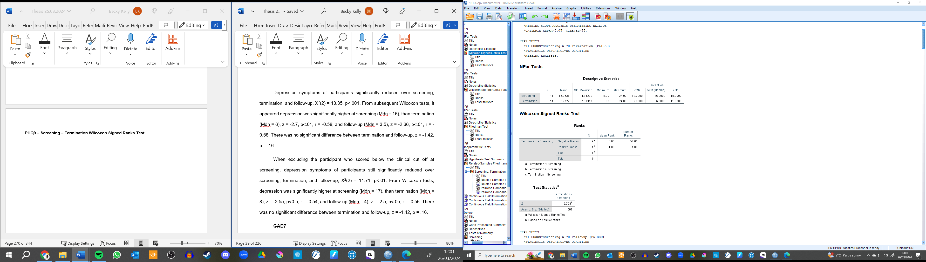

PHQ9 – Screening – Follow-up Wilcoxon Signed Ranks Test
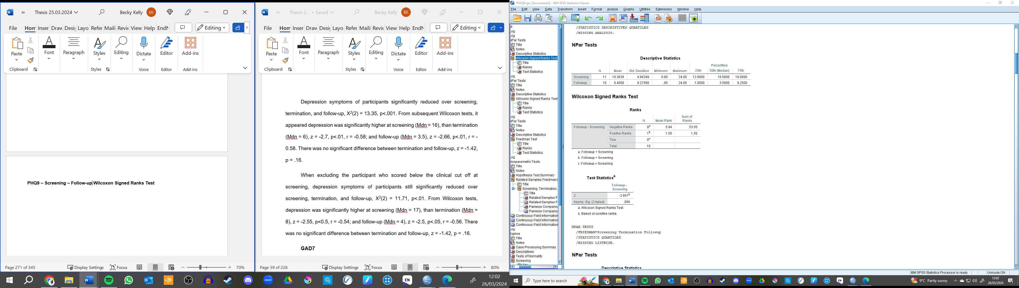

PHQ9 – Termination – Follow-up Wilcoxon Signed Ranks Test
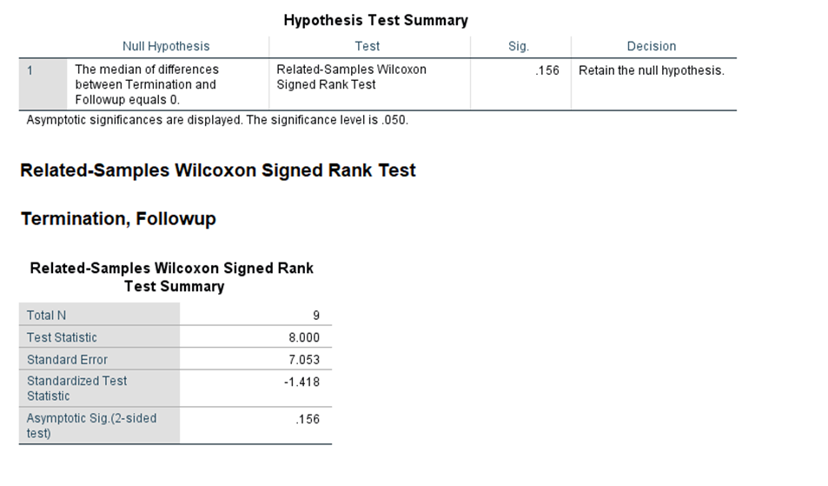
GAD-7 – Friedman Test Output
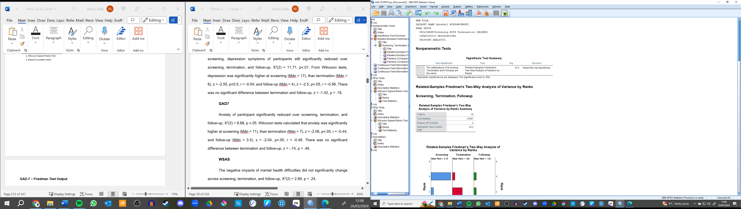
GAD-7 – Screening – Termination Wilcoxon Signed Ranks Test


GAD-7 – Screening – Follow-up Wilcoxon Signed Ranks Test

GAD-7 – Termination – Follow-up Wilcoxon Signed Ranks Test
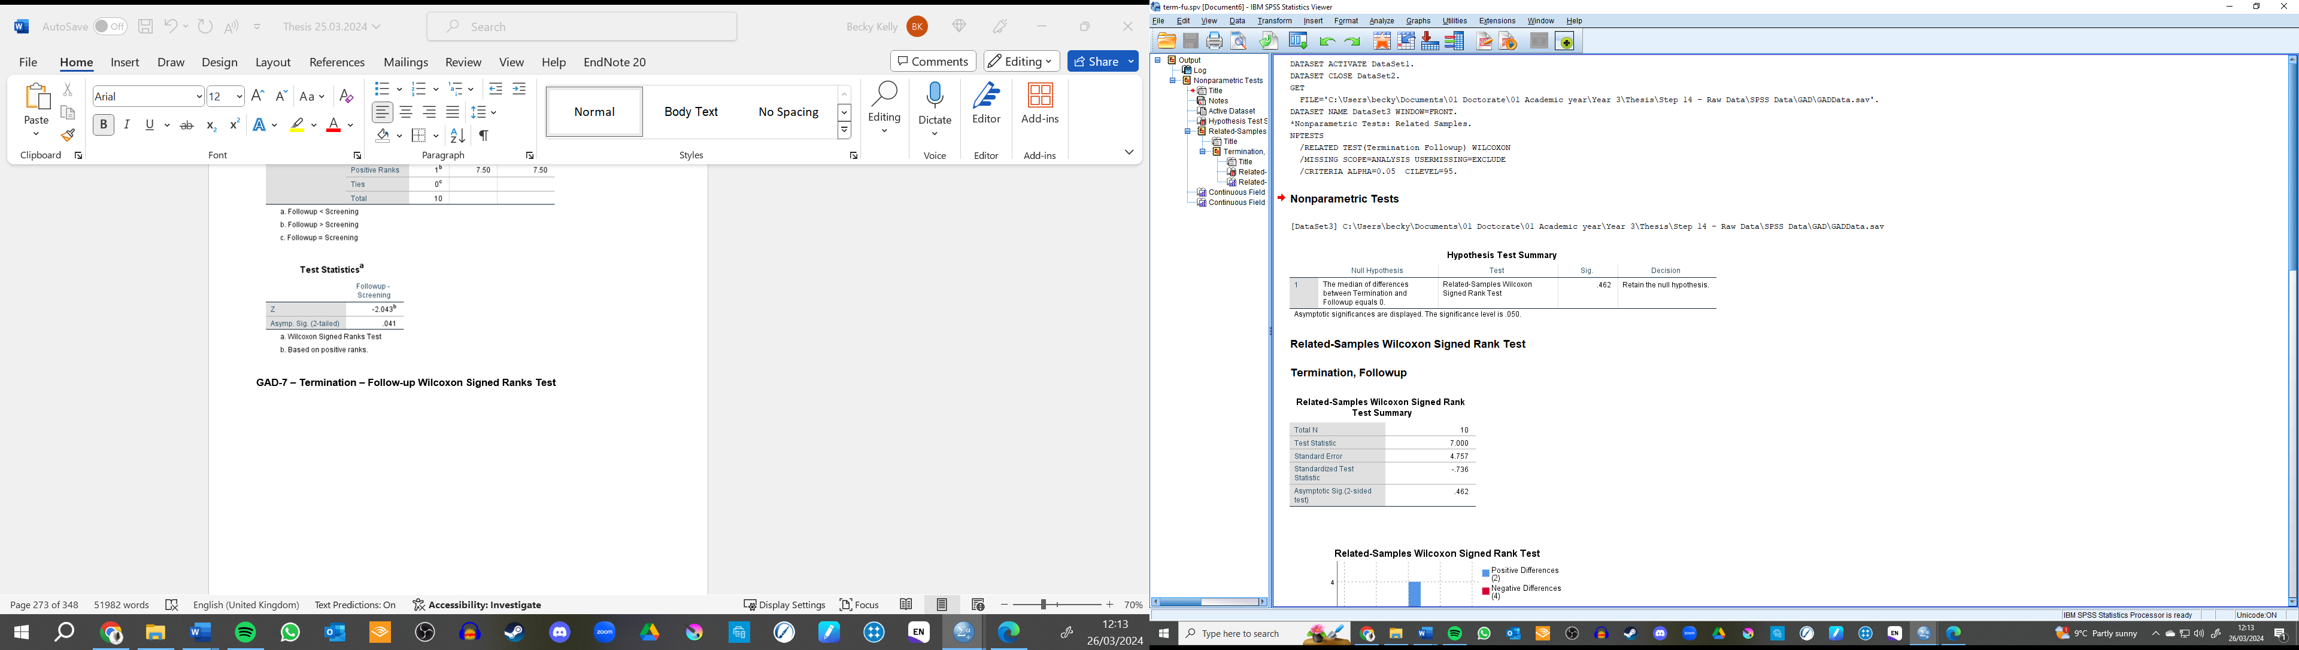
WSAS – Friedman’s Test Output
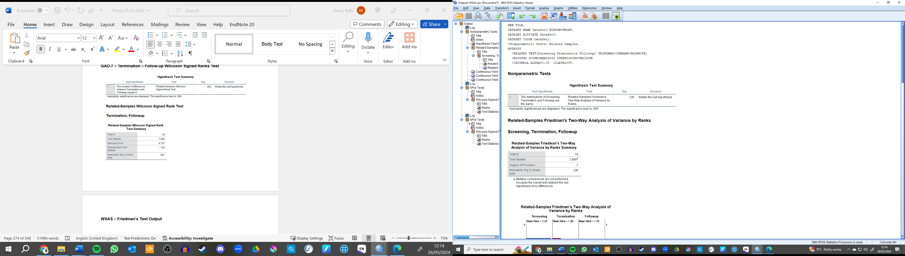
Appendix V
Demonstration of how RCI and CSC were calculated
RCI was calculated using Parry’s (2011) recommendation of a scores 4-point score change on the GAD-7 and 6-points on the PHQ-9. CS was concluded if patient’s who scored above clinical cut-off pre-treatment (PHQ-9 >10; GAD-7 >8) scored below the cut-off post-treatment, as recommended by Levis et al, (2019).
Table Demonstrating the Calculation of RCI and CSC.
 | S | T | FU | Change Score (B-T) | RCI | CSC | Chance Score (B-FU) | RC | CSC
Participant 1  PHQ-9  GAD-7 | 23  16 | 0  0 | 0  0 | -23  -23 | Yes  Yes | Yes  Yes | -23  -23 | Yes  Yes | Yes  Yes
Participant 2  PHQ-9  GAD-7 | 12  4 | 2  2 | 1  2 | -10  -2 | Yes  No | Yes  No | -11  -2 | Yes  No | Yes  No
Participant 3  PHQ-9  GAD-7 | 24  24 | 24  16 | 19  16 | 0  -8 | No  Yes | No  No | -5  -8 | No  Yes | No  No
Participant 4  PHQ-9  GAD-7 | 8  6 | 1  2 | 1  2 | -7  -4 | Yes  Yes | No  No | -7  -4 | Yes  Yes | No  No
Participant 5  PHQ-9  GAD-7 | 18  16 | 20  20 |  | +2  +4 | No  No | No  No
Participant 6  PHQ-9  GAD-7 | 16  16 | 10  9 | 6  4 | -6  -7 | Yes  Yes | No  No | -10  -12 | Yes  Yes | Yes  Yes
Participant 7  PHQ-9  GAD-7 | 14  9 | 11  11 | 4  3 | -3  +2 | No  No | No  No | -10  -6 | Yes  Yes | Yes  Yes
Participant 8  PHQ-9  GAD-7 | 19  11 | 11  14 | 24  21 | -8  +3 | Yes  No | No  No | +5  +10 | No  No | No  No
Participant 9  PHQ-9  GAD-7 | 19  5 | 4  1 | 3  0 | -15  -4 | Yes  Yes | Yes  No | -16  -5 | Yes  Yes | Yes  No
Participant 10  PHQ-9  GAD-7 | 12  11 | 2  7 | 1  2 | -10  -4 | Yes  Yes | Yes  Yes | -11  -9 | Yes  Yes | Yes  Yes
Participant 11  PHQ-9  GAD-7 | 15  14 | 6  2 | 5  4 | -9  -12 | Yes  Yes | Yes  Yes | -10  -10 | Yes  Yes | Yes  Yes

Appendix W
Framework Analysis Familiarization Notes
Affective Attitude
How the individual feels about the intervention. Prior, during, and after the intervention sections are all information collected in the exit interview but references the changing perspective across the intervention.
Patient
Prior Intervention
- Feeling of dread and anxiety linked to having to do the intervention.
- Feeling ‘bad place in life’, hoped the intervention would help.
- Feeling depressed and anxious about starting
- No expectations – had an open mind and feeling towards the intervention.
During intervention
- Feeling calm and reassured (by the PWPs too).
- Once started, looked forward to going.
- Feeling relieved, weight off shoulders
- Some patients spoke of worrying about that they were “wasting the time” of the PWPs and others would benefit from taking their place.
After intervention
- Fantastic manual (easy to read and follow)
- The PWPs support were non-judgemental and supportive.
- Felt easy to use manual – especially because it was a manual and not printed handouts.
- Feeling frightened and scared about the support and intervention ending.
PWPs
Prior intervention
- Some PWPs said they felt unsure what to expect of the intervention, but they were intrigued.
During intervention
- During training, some felt confused or struggled to understand at first, but practice helped.
- PWPs reported enjoying facilitating the sessions. This was link to the perceived effectiveness of the treatment and how easy/simplist the manual was to use.
- One reported that it felt ‘“werid but good” to be discussing the relationship between the patient and PWPs as they have not had to do this before in low intensity work.
Burden
The perceived amount of effort that is required to participate in the intervention.
Patient
- Emotional tole was hard for some people, especially when having to speak about the past and relationships with others. Some people spoke about crying in sessions.
- Participants spoke about completing the homework/between session work each week, which took time. Sometimes homework was not completed due to it being emotionally difficult to cope with, or because it reminded people of bad memories (i.e. related to school).
- Furthermore, not considering the time, but it was also effortful and hard work for some to practice the homework. For example, one spoke of learning to develop a self-talk style, which may be more effortful some days, to talk back to the depression voice.
- Other spoke about the ‘ease’ of engaging in the intervention and manual, and it not being effortful. Especially because the PWPs and manual could be adapted for a person’s “learning style”.
- Ending the intervention was effortful for some people. They reported feeling scared about the future and felt six weeks was too short.
- One person discussed how they would tell other people the intervention (and wider psychological therapy) is not a “quick fix” and effort is needed to see a change.
PWPs
- PWPs had to prep and do work around the intervention to be able to deliver it, especially compared to sessions they are familiar with.
- Preparing a whiteboard or flip chart was effortful but helped map out some cycles in rough.
- Completing training over the two days was also effortful - would potneitally have liked more time.
- Patients might have found the content challenging because they are talking about engrained patterns in their life.
- Difficult for patients to discuss some topics about family relationships and dynamics - people may decide to drop out because it can be difficult to discuss.
- Motivation for some patients could vary - depending on the burden of completing the intervention. For example - child care could flucturate.
- Some patient find it difficult ot do the inbetween work especially if they were struggling with their low mood.
Ethicality
The extent to which the intervention has good fit with an individual’s values.
Patient
- All participants said their mental health was important to them. As such, the intervention which intends to help reduce distress fits with their values of wanting to improve their mental health.
- Also, the intervention helped the participants meet their goals and values. For example, one person spoke of valuing their ability of helping others. When they are low, they could not help others. The interventions effectiveness helped them meet their values.
- Some participants spoke about the importance of developing insight into their difficulties. Recognition of problems (a main component of CAT) therefore aligned with participants value of developing a understanding of the “roots” of their distress. The intervention was described by one person as being “powerful” in this regard.
- People also valued the ability to discuss the difficult events and emotions.
- Some people also discussed how the intervention approach was important because it aligned with their value of being able to make a change to their lives somewhat independently. They spoke of having autonomy over the intervention, which the GSH aspect encouraged.
PWPs
- PWPs spoke of CAT-GSH meeting their values to help others as it provides more options for treatment in NHS TALKING THERAPIES.
- It matches the PWPs values of wanting to help but also their beliefs about mental health. PWPs spoke of believe mental health can be impact by developing coping strategies during childhood.
- Prior experienmce, PWPs saw there were aspects which maintained a persons distress that you did or could not work on- specifically relationship cycles. CAT allowed PWPs to explore this which met their values of helping others but also consider what maintains depression.
Intervention Coherence
The extent to which the participant understands the intervention and how it works.
Patient
- Some people reported the manual being difficult to understand at first, but the PWPs helped with comprehension.
Each participant focused on different aspects of the manual which seemed to link to the sections which they found important. They also discussed this by using a mixture of their own words and CAT terms (such as trap, dilemma, and snag). This includes discussing:
- Setting personal goals to be able to work towards
- Discussing past relationships and links to current ones.
- What meaning people took from these past experiences (i.e. learnt to be critical)
- Understanding traps (all patients chose traps) – the cycle in which people remember about the consequences.
- Recognition – got help from PWPs to achieve recognition of root of depression.
- Finding exit strategies
- Patients used CAT language.
- Complete homework activities
PWPs
- Depression trap and cycle - helped formulate the distress
- Timeline was useful - never used before but helped making link between past and present.
- Recipricol relationships
- problem statements
- exits
- Also reported that patients tended to understand the content and were able to complete the intervention.
- However, sections might be a bit wordy and the text boxes too small in some cased depending on how much the client would like to write.
- Recognition
Opportunity Costs
The extent to which benefits, profits, or values must be given up engaging in the intervention.
Patient
- Some people reported not having to “give up” anything for the intervention. Whilst others reported giving up something but the intervention being “priceless” and worth it.
- The ‘costs’ of the intervention included:
  - Cost of fuel to get to sessions.
  - Cost of person’s time
- Whilst the intervention had costs, some considered how overall the NHS provided care at a better cost compared to affording private sessions.
- People explained that whilst it was easy enough to fit around work and problems with availability were sorted other people who might take part in the future may need to take time off work.

PWPs
- patients may have to rearrange appointments or work to fit with one another. This took up time and some struggled with childcare.
- Patients time - spending time out of the day - but they potentially wanted more time to cover the content too,
- For PWPs, felt like spinning plates and learning how to change hats between the different therapes
- But many people saw these costs as “part of the job”.
Perceived Effectiveness
The extent to which the intervention is perceived as likely to achieve its purpose.
Patient
- Prior starting the intervention, some people reported that they did not believe the intervention was going to work. This was because they had experienced mental health support previously and it had been ineffective. One person felt this support helped, compared to past support, because they spent time linking the past to the present to help with understanding.
- ‘Powerful tool’ because it gets to root of problem (relationships)
- Feeling relieved, weight off shoulders
- All participants perceived the intervention to be effective to varying degrees. This include people reporting they met their goals, mood improved, relationships improved. This was also demonstrated by some participants saying they would recommend the intervention to a friend or family member.
- They attributed the effectiveness to:
  - PWPs helping patients to understand the content.
  - Gaining results from doing homework
  - Gaining tools to help feel better
  - The same consistent PWPs helped improve mood.
- Some participants spoke of being able to meet goals which in turn helped them to feel better and improve relationships.
- Whilst not reporting ineffective treatment, some suggested potential changes. This included:
  - Changing some of the examples to be more relevant. For example, most people wrote traps and not snags. Even then, the patient recognised that these sections might be useful for others (as so effective).
  - Six weeks, with a week between sessions too short – wider gap would help with homework.
- A few patients spoke of mood fluctuating, with some dips during the sessions. Others mentioned that they would still like further help but the GSH helped them on this journey.
PWPs
- Learning about CAT-GSH was intriguing and PWPs spoke about believing it could work before meeting with anyone, then seeing people benefit concreted the effectiveness
- It is effective, but also it add another opportunity to low intensity treatments. Another “string to the bow” of NHS TALKING THERAPIES.
- PWPs also reported they believed their patients benefited and wanted to take part because the intervention helps provide quick changes over six sessions.
- PWPs reporting people met their goals and outcome measure decreased in general.
- If people dfid not meet their goals then it was seen as a step towards recovery.
- Some spects might not be as helpful: family tree, especially one completed the timeline - just spoke of family.
- Help people explore themselves and consider their identity. Good for low level intervention - really clear goals.
- The strengths and resilience section - when people were already making changes and exits - ,moght not be relevant for everyone - might be useful for people on reflection during relapse prevention.
- People patients were or have been improving
- The PWPs would recommend it as a form of treatment to a loved one or a friend. PWPs percieve the manual as helping anyone, even if they don’t struggle with depression - and can also help people with anxiety.
Self-efficacy
The participant’s confidence that they can perform the behaviours required to participate in the intervention.
Patient
- Self-efficacy changed over time for some. Starting the intervention could be difficult and confidence had to be developed. Confidence development was helped by:
  - The PWPs’s support – the guided approach could be adapted to meet different patients learning styles.
  - Having autonomy over the manual
  - The manual ease of use
  - Outside support from loved ones
  - Having experienced past mental health support (i.e. using CBT and/or NHS TALKING THERAPIES before).
- Some reported feeling “Confident enough” and “could work it out” from the start. These people reported that the manual being structured and specific helped.
- Endings were reported as difficult for some people. Some reported feeling worried about being able to maintain the progress, do the work, once the sessions had ended.
PWPs
- The manual helped the PWPs to facilitate because it is laid out clearly and simplistically compared to other guided interventions.
- Sometimes struggled to keep to the allotted time. PWPs put this down to learning the manual and people talking more during the first session because they had been waiting some time for treatment.
Other
- Supportive Relationships: Participants also spoke about the importance of support from their loved ones during this process. Some spoke about their partners encouraging and supporting them. Which helped them access and get most of the intervention. Included in perceived effectiveness?
Reflections
Interesting the PWPs competency is somewhat on threshold limit, but the participants still speak about all the main points of the intervention (coherence). Consider the individual subset of the LITC specifically the CAT specific scores.

Appendix X
First version of the Initial Framework
Initial Framework
Developing an initial framework is step two of Framework Analysis and has been influenced by the familiarisation stage, the Acceptability Framework, and re-reading reflexivity logs. This initial framework incorporates both PWPs and participant responses. Some of the subthemes, which are listed below the seven overarching themes, are population specific. For example, “PWPs’s Confidence” under self-efficacy is specific to PWPs responses. This framework will be tested by indexing two PWPs transcripts and three patients. It will then be reviewed and revised if needed, before the indexing of the whole data set.

Affective Attitude; Positively Changing Opinions
How the individual feels about the intervention. There is a common pattern that attitudes towards the intervention positively changed over time.
Mixed Feelings Prior Starting
PWPs’s and patients spoke of mixed feelings before starting the intervention. For example, some participants felt low and anxious about starting because of their poor mental health and because they had tried therapy before, but it was ineffective. Some of the same participants also felt excited and intrigued and wanted to keep an open mind and motivated to change. PWPs spoke of being unsure and nervous before starting the intervention because they did not know what to expect but also interested by the possibilities of learning a new modality.
Largely Positive Feelings During Intervention
Both PWPs and patients spoke positively about CAT-GSH as they reflected on how they felt during the intervention. Patients described feeling enthusiastic about the intervention (which some described as “fantastic” and “powerful”). They attributed these feelings to the support from the PWPs as well as the perceived effectiveness. However, some patients spoke of being worried they were taking the space of someone else who was more in need of the intervention. PWPs shared similar sentiments and reported feeling excited about delivering the sessions. However, some participants spoke of also feeling confused by the manual and felt the intervention could be “weird”. They attributed this feeling to being new to the model, as well as being unfamiliar with discussing the relationship between the PWPs and patient (as prompted by the manual when considering how the patients relationship patterns may play out during session).
Praise of Manual after Ending
Similar positive sentiments were also attributed to the manual after the end of the intervention. Patients again attributed this to being supported by the PWPs and the easy use of the manual.

Burden
The perceived amount of effort that is required to participate in the intervention. A common patterns across the themes is that whilst aspects of the intervention was effortful, it was worth the burden. This also seemed linked to a perwson’s self-efficacy. Weaving burden and motivation seemed to impact people’s confidence in being able to achieve the tasks.
Emotional Burden
Some patients described how difficult it was to complete the manual at times. This emotional distress was sometimes expressed through crying in sessions. Patients typically expressed the most difficult aspect of the intervention was speaking about past relationships and increasing their insight of patterns. Interestingly, recognition and discussion about relationships has also been attributed to the interventions perceived effectiveness in later themes. The PWPs also agreed that some patients found the intervention emotional taxing because the patients were asked to reflect and understand engrained patterns in their life.
Practicing Strategies is Effortful.
Most patients expressed that practicing the strategies and homework was effortful. This may not be due to the difficulty in understanding the content (as outlined by some patients) but more the effort to implement the strategies (i.e. difficult to implement compassionate self-talk, even if benefits understood). Again, this was agreed by some of the PWPs who commented on how some of their participants found homework effortful, especially when other aspects of their life were demanding.
Training and Preparing for Session was Effortful for PWPs
PWPs’s found preparing for sessions effortful, especially when they used practical tools, such as whiteboards, to support the manual implementation. Session which they were less familiar with were also more effortful than delivering sessions they were more confident with.

Ethicality; Valuing Mental Health and Independence
The extent to which the intervention has good fit with an individual’s values. The main pattern across this theme is how the intervention fits with participants highly valuing their mental health (as does the intervention).
Valuing Mental Health
Both PWPs and patients explained they perceived the intervention as a therapy which was invested in their wellbeing. For example, CAT-GSH helped improve their mood and invested in their mental health. The manual encouraged participants to understand, recognise, and revise these relational roles. PWPs had similar perspectives as the clients, but they also spoke of believing the manual shared their goal of helping people with mental health difficulties (which they value as being important for them personally and professionally).
Valuing Recognition
Recognition was also particularly valued by both participants and PWPs. As such, some PWPs explained exploring past events and improving recognition differentiated CAT-GSH from other modalities (such a CBT-GSH). In particular, patient and PWPs spoke of the importance of recognising past, and current relationships had an impact on a person’s mental health.
Autonomy is Crucial
Some patients also spoke about how autonomy was a crucial aspect of the CAT-GSH which they valued. Being able to do it for themselves was valued.

Intervention Coherence
The extent to which the participant understands the intervention and how it works. A common pattern between the themes is that no one participate accurately described all the reasons for how CAT-GSH worked. However, they seemed to focus on the aspects which were important to them. Of those aspects, some were able to provide descriptions for why this worked for them. In sum though, each key factor of CAT-GSH was discussed by at least one person. It is also important to consider how patient and PWPs level of intervention coherence may be different, with PWPs expected to be more knowledge about the model they are providing. This information has been triangulated with the quantitative assessment of the PWPs competence.
Difficult to Understand at First
Both PWPs and patients explained that the manual was difficult to understand at first, however, the PWPs explained training, supervision, and practice aided their understanding, which the patients attributed the PWPs support as helping them comprehend the therapy.

Different Parts of Manual Understood
Each patient and PWPs comprehended and discussed different parts of the manual and why this was important for their improved wellbeing. It appears that Traps were mostly used and understood by the patients (compared to dilemmas and snags) whilst recognition was mostly discussed (compared to reformulation and revision).
PWPs Language Shifts
PWPs also used a lot of CAT specific language, (such as “relationship roles” and “traps”, alongside more CBT informed language (such as “behavioural activation”).

Opportunity Costs
The extent to which benefits, profits, or values must be given up engaging in the intervention.
Nothing Given Up
Some patients and PWPs spoke of not needing to give up anything to participate in the intervention. Some attributed this to free care provided by the National Health Service.
Worthwhile Costs
Other patients reported that the costs of completing the therapy was linked to the emotional burden highlighted in an earlier theme, whilst others spoke about the cost of fuel and their time to attend sessions. However, all spoke of this being worthwhile. PWPs spoke of the cost of facilitating the GSH was mostly their time. Yet, this was also deemed worthwhile or part of their role.

Perceived Effectiveness
The extent to which the intervention is perceived as likely to achieve its purpose.

Varied Effectiveness
Most patients explained that the treatment was effective or, at least the first step towards recovery journey. However, one patient explained that the treatment did not affect their mood. They attributed this the difficult situational factors in their life which the manual was not designed to help with.
Helpful and Unhelpful Aspects Don’t Impact Effectiveness Perception
Patients attributed the PWPs support, gaining results from completing activity, and gaining tools to help them feel better. As such, the participants believed the intervention was likely to achieve it’s aims. Furthermore, while patients outlined there were some least helpful aspects, such as only having six weeks to complete the sessions, and the short length of sessions, they did not believe this negatively impact the effectiveness of the treatment.

Potentially Provides Patients Choice
Some patients spoke of choosing CAT-GSH over treatment-as-usual (typically CBT-GSH) because it was novel, and they had previously tried CBT.

Self-efficacy
The participant’s confidence that they can perform the behaviours required to participate in the intervention. Like perceived effectiveness and attitude towards the intervention, client’s and PWPs belief in themselves developed over time.
Developing Confidence
Some patients reported feeling confident enough to do the tasks. This confidence built over time and was aided by the PWPs’s support, developing autonomy over the manual, the manuals ease of use, and developing an understanding of CAT.
Confidence Can Waver
Endings were particularly difficult for some patients who were worried about their ability to continue the treatment. One person also struggled with their confidence with implementing treatment as whilst they could engage in the treatment, their sigh-impairment made it difficult.
PWPs’s Confidence
The PWPs confidence in themselves to deliver the manual developed over time. Similarly, to the patients, this was supported by the simplicity of the manual, as well as attending training and supervision. They felt their increased confidence was reflected in their improvement in time keeping where later sessions they delivered were kept to the allotted time.

Appendix Y
Second Version of the Framework
Initial Framework
Version Two – Post-testing
Developing an initial framework is step two of Framework Analysis and has been influenced by the familiarisation stage, the Acceptability Framework, and re-reading reflexivity logs. This initial framework incorporates both PWPs and participant responses. Some of the subthemes, which are listed below the seven overarching themes, are population specific. This framework has been tested by indexing two PWPs transcripts and three patients. It has been revised. Revision Notes are in italics.

Affective Attitude; Positively Changing Opinions
How the individual feels about the intervention. There is a common pattern that attitudes towards the intervention positively changed over time.
Mixed Feelings Prior Starting
PWPs’s and patients spoke of mixed feelings before starting the intervention. For example, some participants felt low and anxious about starting because of their poor mental health and because they had tried therapy before, but it was ineffective. Some of the same participants also felt excited and intrigued and wanted to keep an open mind and motivated to change. PWPs spoke of being unsure and nervous before starting the intervention because they did not know what to expect but also interested by the possibilities of learning a new modality.
Largely Positive Feelings (merged with praise of manual after ending)
Both PWPs and patients spoke positively about CAT-GSH as they reflected on how they felt during the intervention. Patients described feeling enthusiastic about the intervention (which some described as “fantastic” and “powerful”). They attributed these feelings to the support from the PWPs as well as the perceived effectiveness. However, some patients spoke of being worried they were taking the space of someone else who was more in need of the intervention. PWPs shared similar sentiments and reported feeling excited about delivering the sessions. However, some participants spoke of also feeling confused by the manual and felt the intervention could be “weird”. They attributed this feeling to being new to the model, as well as being unfamiliar with discussing the relationship between the PWPs and patient (as prompted by the manual when considering how the patients relationship patterns may play out during session).
This merge occurred because realised how difficult it was to separate how feeling towards the manual were from whilst the patient was in session to whether it was a reflection post session. Both showed that the feeling were largely positive so this felt close enough to merge.

Burden
The perceived amount of effort that is required to participate in the intervention. A common patterns across the themes is that whilst aspects of the intervention was effortful, it was worth the burden. This also seemed linked to a perwson’s self-efficacy. Weaving burden and motivation seemed to impact people’s confidence in being able to achieve the tasks.
Emotional Burden
Some patients described how difficult it was to complete the manual at times. This emotional distress was sometimes expressed through crying in sessions. Patients typically expressed the most difficult aspect of the intervention was speaking about past relationships and increasing their insight of patterns. Interestingly, recognition and discussion about relationships has also been attributed to the interventions perceived effectiveness in later themes. The PWPs also agreed that some patients found the intervention emotional taxing because the patients were asked to reflect and understand engrained patterns in their life.
Practicing Strategies is Effortful (merged with other themes)
Most patients expressed that practicing the strategies and homework was effortful. This may not be due to the difficulty in understanding the content (as outlined by some patients) but more the effort to implement the strategies (i.e. difficult to implement compassionate self-talk, even if benefits understood). Again, this was agreed by some of the PWPs who commented on how some of their participants found homework effortful, especially when other aspects of their life were demanding.
This theme was merged with other themes, including self-efficacy and comprehension. This was because the quotes used to initial create this theme, on reflection, where more about how confident (or unconfident) the patient felt about putting the strategies in practice, or their comprehension of them, rather than the effort it took.
Training and Preparing for Session was Effortful for PWPs
PWPs’s found preparing for sessions effortful, especially when they used practical tools, such as whiteboards, to support the manual implementation. Session which they were less familiar with were also more effortful than delivering sessions they were more confident with.

Ethicality; Valuing Mental Health and Independence
The extent to which the intervention has good fit with an individual’s values. The main pattern across this theme is how the intervention fits with participants highly valuing their mental health (as does the intervention).
Valuing Mental Health
Both PWPs and patients explained they perceived the intervention as a therapy which was invested in their wellbeing. For example, CAT-GSH helped improve their mood and invested in their mental health. The manual encouraged participants to understand, recognise, and revise these relational roles. PWPs had similar perspectives as the clients, but they also spoke of believing the manual shared their goal of helping people with mental health difficulties (which they value as being important for them personally and professionally).
Valuing Insight (name change because it was less about ‘recognition’, which is a specific stage in CAT, and more about “awareness”, “insight” “realisation” and “recognition”)
Recognition was also particularly valued by both participants and PWPs. As such, some PWPs explained exploring past events and improving recognition differentiated CAT-GSH from other modalities (such a CBT-GSH). In particular, patient and PWPs spoke of the importance of recognising past, and current relationships had an impact on a person’s mental health.
Autonomy is Crucial (merged with perceived effectiveness)
Some patients also spoke about how autonomy was a crucial aspect of the CAT-GSH which they valued. Being able to do it for themselves was valued.
This was merged because too few patients commented on this for it to hold weight, and because it was deemed to link closely to what specific about the manual was effective for the patient.

Intervention Coherence
The extent to which the participant understands the intervention and how it works. A common pattern between the themes is that no one participate accurately described all the reasons for how CAT-GSH worked. However, they seemed to focus on the aspects which were important to them. Of those aspects, some were able to provide descriptions for why this worked for them. In sum though, each key factor of CAT-GSH was discussed by at least one person. It is also important to consider how patient and PWPs level of intervention coherence may be different, with PWPs expected to be more knowledge about the model they are providing. This information has been triangulated with the quantitative assessment of the PWPs competence.
Difficult to Understand at First
Both PWPs and patients explained that the manual was difficult to understand at first, however, the PWPs explained training, supervision, and practice aided their understanding, which the patients attributed the PWPs support as helping them comprehend the therapy.
Different Parts of Manual Understood
Each patient and PWPs comprehended and discussed different parts of the manual and why this was important for their improved wellbeing. It appears that Traps were mostly used and understood by the patients (compared to dilemmas and snags) whilst recognition was mostly discussed (compared to reformulation and revision).
PWPs Language Shifts
PWPs also used a lot of CAT specific language, (such as “relationship roles” and “traps”, alongside more CBT informed language (such as “behavioural activation”).

Opportunity Costs
The extent to which benefits, profits, or values must be given up engaging in the intervention.
Things given up
This section was addeded because on the review, some people did not mention that what they gave up was worthwhile. This assumption must have been a bias I had (maybe confirming my expectation that what was given up was useful) when I read the first few transcripts. If the person said this was worthwhile, it was included in this section.
Nothing Given Up
Some patients and PWPs spoke of not needing to give up anything to participate in the intervention. Some attributed this to free care provided by the National Health Service.
Worthwhile Costs (merged with things given up)
Other patients reported that the costs of completing the therapy was linked to the emotional burden highlighted in an earlier theme, whilst others spoke about the cost of fuel and their time to attend sessions. However, all spoke of this being worthwhile. PWPs spoke of the cost of facilitating the GSH was mostly their time. Yet, this was also deemed worthwhile or part of their role.

Perceived Effectiveness
The extent to which the intervention is perceived as likely to achieve its purpose.
Varied Effectiveness
Most patients explained that the treatment was effective or, at least the first step towards recovery journey. However, one patient explained that the treatment did not affect their mood. They attributed this the difficult situational factors in their life which the manual was not designed to help with.
Helpful and Unhelpful Components
Patients attributed the PWPs support, gaining results from completing activity, and gaining tools to help them feel better. As such, the participants believed the intervention was likely to achieve it’s aims. Furthermore, while some patients outlined there were some least helpful aspects, such as only having six weeks to complete the sessions, and the short length of sessions, they did not believe this negatively impact the effectiveness of the treatment.
Provides Patients Choice
Some patients spoke of choosing CAT-GSH over treatment-as-usual (typically CBT-GSH) because it was novel, and they had previously tried CBT.
As a reflectivity note, it felt this sub-theme best fit with effectiveness because the quotes noted that because of the perceived effectiveness, participants suggested that the intervention should be offered to provide patients choice.

Self-efficacy
The participant’s confidence that they can perform the behaviours required to participate in the intervention. Like perceived effectiveness and attitude towards the intervention, client’s and PWPs belief in themselves developed over time.
Developing Confidence (merged with confidence fluctuation)
Some patients reported feeling confident enough to do the tasks. This confidence built over time and was aided by the PWPs’s support, developing autonomy over the manual, the manuals ease of use, and developing an understanding of CAT.
Again, maybe due to my confirmation bias or other assumptions, I did not find much evidence that people developed their confidence. When this theme was tested, it felt that it was better condensed into confidence fluctuation as developing confidence was difficult to distinguish in some participant because their confidence fluctuated.
Confidence Fluctuation
Most patients experienced their confidence fluctuating depending on the task. This could be linked to their motivation, their life events, and situations, and finding it difficult to get into the mindset. PWPs’s did not report any patient difficulties in engaging with the task and one patient agreed and felt confident in engaging in all the strategies and manual, even on tough days. One patient did not feel confident in engaging in the tasks due to her poor eyesight.
Practice, Understanding, and Support (new sub-theme)
Regardless of level of confidence, there were common factors which attributed to the patient’s confidence in being able to complete the intervention. This include practice, understanding, and support from the PWPs.
PWPs’s Confidence (merged with confidence fluctuation)
The PWPs confidence in themselves to deliver the manual developed over time. Similarly, to the patients, this was supported by the simplicity of the manual, as well as attending training and supervision. They felt their increased confidence was reflected in their improvement in time keeping where later sessions they delivered were kept to the allotted time.
This theme was merged because whilst the PWPs developed their own confidence in facilitating the intervention, this was only mentioned by two PWPs, and mirrored the patients confidence in doing the strategies.

Appendix Z
Charting Process
Due to the size of the table, horizontal lines have remained for readability, despite APA 7 guidelines.
Affective Attitude; Positively Changing Opinions

 | Mixed Feelings Prior Starting | Largely Positive Feelings
P1 | Mental health in a dark place. Feeling anxious and dread about starting therapy.  “Yeah, I think I think from way I were feeling to like actually going in for first session was like ‘argh’ the dread the felt the anxiety of actually I've got to go to that place to go into that place”.  “Oh well I were in a bad my life I were in a bad place, erm, at the time, erm, felt in a very very dark place.” | Started to look forward to sessions and shocked at how powerful the book was. Would recommend to a friend.  “I were like actually looking forward to going then on a Wednesday, erm, (laughs) yeah and I just I don’t know I were just shocked at how powerful that is the book the research what’s gone into it”.  “ That’s actually a fantastic manual Becky.”
P2 | Felt unhappy with self-prior starting and nervous about starting the intervention.  “Erm, I were just unhappy with myself and, erm, just happened to be stuck in a bit of a spiral, erm, with depression anxiety and I I’d had enough of feeling that way.”  “Erm, I were a bit nervous to start but once we got into it I really enjoyed it.” | The experience was enjoyable but could be weird at times. This includes when the therapist asks their client about their therapeutic relationship.  “ Erm, no, just that I really enjoyed it, it really helped.”  “I found that like what the hell’s this like really weird to start with”.
P3 | Felt dreadful and wanting the intervention to help change how they were feeling.  “Well, erm, I were just feeling dreadful really”.  “ Erm, I just wanted to, erm, you know like kind you know get it out of me head and and how I feel and and, erm, and to change I am as a person do you do you know what I mean?”. | It was alright and would recommend it to a friend.  “Erm, I thought it were okay, erm, yeah. Yeah I thought it were it were alright.”
P4 | Interested and curious about what CAT-GSH could offer.  “So that’s that’s the way I I sort of felt about it from from the offset really I was really interested in in delving into that that side of things.”
P6 | Felt open minded towards therapy but not sure if it would help.  “I walked in with a very open mind and thought I'm here for help, if I'm not 110% honest it will not work.” | It was okay.  “I thought yeah okay I can I can work that out sound that and it made me think about things on a daily basis.”
P7 | Felt fearful about therapy and did not want to attend.  “Yes (laughs), erm, I was very very stressed and scared first week I was like to my partner I was like ‘I really don’t want to go I really really don’t want to go’ but she basically like pushed me out the door, ‘just try it you just need to try it’”. | Positive and useful intervention which would be recommended it.  “ I wouldn’t have thought so I’d probably say it’s it’s helped a lot more than I thought it would to be honest, erm, I I definitely recommend it if people needed it, 100%.”
P8 | Felt unsure if the treatment would work.  “Yeah yeah yeah I didn’t think it were going to work I didn’t know ‘cos obviously I've had in the past and that didn’t work but obviously I didn’t think it were going to work and then obviously now I've done it it does work.” | Found it to be a good experience which they would recommend to a friend.  “Erm, good to be honest because like I've done therapy in the past but not this sort of one obviously”.
P9 |  | Felt glad and good they did the intervention, and they’d recommend it to a friend. But they also felt uncomfortable due to clinical environment.  “It’s just the way me brain talks to meself and stuff and yeah it I'm glad I've done it I'm glad I've done it”  “I think it’s very clinical it’s uncomfortable you're sat there talk I just think it would have been nice on comfy chairs and maybe something that’s not just all white”.
P10 | Curious, open-minded to give it ago.  “Er, because I was willing to try anything to get myself better and this was offered and I thought yeah why not?”
P11 | Feeling very depressed and anxious. Was opened-minded to see what it could off.  “Me anxiety to me was the biggest issue, erm, with obviously some high depression marks on me questionnaire answers, yeah”.  “I was offered either CBT or CAT therapy, erm, and I don’t know with it being a new therapy I just thought well, you know, new see if it can offer me anything”. | Looked forward to exercise and sessions and found it a positive experience. Would recommend to a friend.  “And and to continue to, in fact I quite looked forward to each exercise in in, you know, because it actually brought something out for me to to deal to help me deal with the issues I was experiencing at that particular time.”  “ I: Okay and would you recommend CAT Guided Self-Help to a friend who’s struggling?  P:Yes 100% yeah I would. I mean obviously I know it’s everyone’s individual (laughs) …”
PWPs1 | Interested and excited to learn and develop but also sceptical.  “I were a little bit sceptical about it to start with.”  “I thought at least it will, might unlock more skills or make me a better practitioner so it mainly interest, erm, in other types of therapy that that’s the main thing” | It was a positive treatment because it was a personal approach which focused on improving awareness of problems.  “Erm, in general I felt, erm, it’s a real positive treatment, erm, I enjoyed doing it I think it’s really worthwhile I think it’s, erm, going to be hopefully something that can be introduced into talking therapy services because I think there's a definite need for it.”
PWPs2 | Unsure about what to expect but intrigued.  “First of all I didn’t, if you want to go right back to the start, I didn’t really know what to expect, erm, about it, erm, and reading about it as well was a bit like oh ‘cos it was it was a bit different to the low intensity PWPs role, erm, as such in terms of the usual intervention as we go through but after doing the training, erm, that was really helpful in terms of, it was kind of like it was intriguing it was like, right this is actually pretty interesting this, in terms of how it could help, erm, clients at low intensity within those kind of six sessions as well”. | Described as a beautiful intervention which the facilitator enjoyed delivering.  “That does it all so that’s why I'm like this is beautiful because it’s got everything there (laughs) it’s, and, erm, and the examples as well so yeah I can’t really fault the manual to be honest with you, thought it was great.”
PWPs3 |  | Delivering the intervention was interesting and enjoyable. Loved the manual and was a good experience.  “No (laughs) I wanted to like, you know, give you something but, no, as you can tell I had a good experience with it so I don’t know what I would change to be honest Becky.”
PWPs4 | Felt sceptical.  “Erm, yeah I think I were a bit sceptical probably at first…” | An enjoyable experience which they would recommend CAT-GSH to a friend.  “No don’t think so I just think overall I think it’s a good, erm, a good treatment, erm, and like I say I think it would be a positive thing if we could introduce that into local talking therapy services as another option for people, erm, because I think there's a need for it, erm, and obviously from doing the trial it seems to be a positive experience for people so and there's that evidence there to suggest it’s something that we could develop”.

Burden
Participant Code | Emotional Burden | PWPs Efforts
P1 | Completing family tree brought back grief and left them feeling down. Yet, the timeline was described as “powerful”.  “I think this is the stage where I said I felt down, erm, it were like a family tree I think that were me session what like it like unearthed, erm, and going through that, erm, ‘cos I felt like I've lost me mum and dad and I felt this grief inside me as well.”
P2
P3
P4
P6
P7
P8 | Looking at root of problem was hard as mood was gloomy.  “But then I obviously did me track and did a new one and I managed to find the way to get out of it so but yeah it were a bit doom and gloom like going really root of the problem do you know what I mean?”.
P9 | Cried during sessions.  “I mean one of the sessions I just sat and cried all session, we didn’t even do workbook at all that day, which I thought that were nice as well but I don’t think I don’t think there were any that I didn’t think were oh that's, do you know.”
P10
P11 | Exercises which asked for patient to reflect on past events and stressful experiences could be hard and “anxiety-provoking”. But this helped them “heal”.  “It’s like we have to be addressed it’s constantly having to look back in your life ‘cos a lot of my issues stemmed from childhood so it’s having to readdress those issues and and they're the hard part of it.”
PWPs1 | Felt pressured to deliver it correctly for the client. Tried to hide this from client.  “P: The only reason it felt like a lot was the pressure on meself to make sure I didn’t deliver it incorrectly or …  Interviewer: Okay.  P: …spoil it or make sure that clients didn’t get I felt real sense of responsibility that these clients have come forward to take part in this and I need to make sure that they get as much out of this as they would any other type of treatment”. | Had to balance a lot of responsibility for other training and had to do a lot of preparation to ensure they felt they understood the content. However, putting in the work was helpful.  “I found difficult but I also think found after the first session of doing that I'm putting that into practice and understanding that that’s what you present with, preparing myself then for the session, knowing that you’ve got to really understand the content in this session what you're trying to get out of it and I think that I think that what I learnt from it was preparing for sessions so, erm, I think that that was something that really helped”.
PWPs2 | Observed talking about past experiences was hard hitting for the patient and made them feel “down”. But this helps in the long run.  “I think for some clients, erm, and can be quite I suppose hard hitting, erm, kind of thinking about family and where things might have come from in relationship roles and that making that kind of again that light bulb moment so that can that can be a cost”. | Had to do some preparation work outside of sessions and this felt like spinning plates due to having to change mindset to meet other responsibilities.  “Erm, I suppose spinning plates (laughs) erm, again I if I was if I’d just started kind of a obviously everything changed for me personally, er, with job and everything like that which wasn’t massively helpful at the time but I think the, erm, biggest of the spinning plates of like getting trying to get this getting my head into that and then going to maybe low intensity as as usual step two.”
PWPs3 | People could become “upset” at looking at past relationships and how they contributed to their current depression.  “I think for a couple of my clients it was potentially more ability than they expected it to be, erm, especially because we were looking at those past relationships and that that’s a big thing for a lot of people how those, you know, major relationships in their lives have affected them and how that could have contributed or how some of those roles could have contributed to their depression.” | Normal amount of effort and time put into preparation.  “So it didn’t add too much really to kind of my normal prep time.”
PWPs4 | Navigating past and current relationships could be difficult and hard for patients.  “I think as well, you know, to continue being empathetic caring role towards mum but also to unpack, you know, what we were kind of looking at in the session as well, erm, so I think that can be a little bit of a difficult thing to navigate for people.”

Coherence
Participant Code | Developing Understanding | Different Parts Understood | CAT Language
P1 | The information was a lot to understand to begin with and the learning continued in-between sessions.  “Er, like I said at beginning, erm, like she’d explain it clear to me, and it’s no fault to (PWPs) this is my learning style that, yeah in session I were listening and there is a lot to take in and like you're dealing with your emotions and you're talking and getting all this out and it’s actually when I came away from session so like I said me cogs as if like like going through all the session.” | The intervention focusing on recognition was important because it helped understand the root of the depression. This helped wellbeing improve especially alongside using the exit strategies.  “Yeah, so that that purpose is like getting to that root cause for that depression, erm, and like purpose of all strategies is to let you understand about that root, erm, and to make your wellbeing your feeling much better in yourself around others. Yeah.” | Used CAT language including snags, road map, exit strategies, and the steps of a trap.  “I found that me interesting part, erm, and then like consequence, aim, action, thoughts, feelings, it it were just it’s a lot to take in lot to take in”.
P2 |  | CAT-GSH aims to make feel better.  “Erm, I knew from what I’d spoken to pe to the person who recommended it that it was going to help me work through me issues.”
P3 |  | CAT-GSH aims to help people understand relationship between themselves and others. This included looking at the past and present relationships.  “I understand that, erm, it were you know to help me, you know, like with relationships and me, you know, to towards people and and why, you know, like why, why I'm a people pleaser and, erm, and I get dismissed and excluded and things but but I learnt that it’s like it is some things from me, erm, you know like me past which weren’t, do you know what I mean, but it’s also to do with me eyesight as well.”
P4 | Further understanding only came later with the aid of the PWPs and repeating lessons.  “In the grand scheme of things it all makes sense but not until later on so it’s difficult to pinpoint something, you know, that that’s it’s I don’t think there's anything any part of it that’s not particularly helpful.” | Being able to understand the root of depression, and the common cycles (patterns), would allow for exit strategies (“off-ramps”) to work.  “Erm, I suppose (sighs) I don’t know whether it’s my understanding or my hope probably a bit of both, (yeah) erm, was to sort of get to the root of, erm, you know, and and a better understanding of myself (yeah) to be able to manage things better going forward (yeah) so, erm, so yeah like I said the the analysis side of things, erm, I was very much interested in because (yeah) I felt that that would, erm, give me a good standing to go forward.” | Discussed CAT-GSH experience using relationship roles, dilemma, trap, and snag.  “it’s not just one or the other it’s not a dilemma to me (yeah) it there's more stages to it (yeah) so (PWPs) said ah so it’s, you know, it’s a cycle it’s a trap.”
P6 | Difficult to understand at first without the help of a PWPs.  “When I first read it it was like reading Swahili some of it. Some of it was a little bit of thought self-explanatory, erm, it did need somebody like (PWPs).” | Changing perspective and viewing personal strengths/resilience help to feel better.  “I thought about things in a different way each session got me to think about things in a slightly different way. Erm, strengths weaknesses aims resilience hates benefits and it sort of developed I thought I can develop the thought process over the over the sessions which again is why I think a lot of the period between will help …”.
P7 |  | CAT-GSH aim is to help people feel better. This can be done with understanding the relationship cycles/patterns. Can decide to do things differently.  “Interviewer: What was your understanding about the purpose of CAT Guided Self-Help?  P: (Laughs) Mainly to feel better is the easiest way to thinking about it”. | Explained exit strategies were important to learn.  “I tried to take something out of every session even though it like like the exit strategy… like going off like massively here but like yeah the session four I'm trying to take something out of every session”.
P8 | Understanding developed with the help of PWPs.  “Like if I didn’t know what question meant or what it meant, erm, she’d like do a scenario so that helped me, you know, think oh right yeah I get what you're saying now. I could put pen to paper then.” | Aim to find the root of the problem and think about things differently.  “Like you look at things in different things than what you would before. I don’t know how to explain it but I know what I mean in me head (laughs).”
P9 |  | CAT-GSH aims to help people push forward and feel better.  “I think it’s a way to push forward and to push you out of that ditch, I well I say ditch, it were a hole that I could have stayed and kept digging it further, erm, it’s to try and get you out of that lift you out of that.”
P10 |  | Learned to find exit strategies to manage things better and feel better.  “Well like I say it helps you navigate, I'm not going to say life, but it helps you navigate things like arguments and letting not letting people make you feel bad you can easily walk away and that’s what the CAT, you know, the sessions taught me”. | Used exiting situations to describe what they could remember of the sessions.  “Er, you know, like the scene and exiting situations that I always remembered and stuff like that.”
P11 |  | Exit strategies are understood as finding more helpful coping approaches. This could include looking at different ways of thinking.  “The purpose of it I think is to, erm, address issues that have probably have led to me having, erm, unhealthy coping strategies.” | Described revisions using the term exit strategies.  “Yeah I mean obviously, erm, there was some of the tips regarding the exit strategies, you know, if you start to get into the downward spiral of like thinking and ruminating ‘cos ruminating was one of my biggest problems”
PWPs1 | CAT-GSH was difficult to understand at first. Understanding traps, dilemmas, and snags were particularly difficult. This led to a lot of effort being put in to ensure this could be explained to patients.  “When I was first on the training just over a year ago and first introduced to the concept, I found it complicated to understand kind of the processes I thought that the, erm, like the three different, erm, things that can be the problem like the snags the traps dilemmas”. | CAT-GSH is about understanding the root of the depression (through family tree), consider their relationship with self and others, think about their unconscious perspectives (i.e. beliefs and values), develop new perspectives and exit strategies.  “So my understanding of that is, erm, for people to have like a new perspective on understanding the root causes of their mental health problems but with a view to having a solution for that and the and having something that they can practice and put into practice but I think in terms of, erm, how they think about things how they view themselves how they value themselves in relation to others”. | Used CAT-GSH terms included dilemma, snag, relationship roles, trap.  “I found it least helpful or most difficult, was the bit about is it a trap a dilemma or a snag”.
PWPs2 | Understanding relationship roles was difficult to understand at first but very important for the patient. Understanding developed with training.  “The learning yeah that was that was slightly confusing at first for me, erm, the the kind of the, erm, way you do it, the that was hard to get my head around at first but it was once you kind of got into the swing of it and the recip the relationship the reciprocal relationship roles”. | Patient also seemed to understand the content of the book. CAT-GSH aims to identify root of depression (with family tree and map), common patterns of this (including traps, dilemmas, and snags), and find exit strategies to this.  “So throughout the sessions we looked at firstly identifying, erm, what was going on and looking at kind of the patterns and the cycles to what was kind of, erm, to their depression and looking at depression traps, nags, dilemmas, erm, again how how they were keeping them stuck in that that cycle of depression”. | Described work using road map, trap, snag, dilemma, exits alongside more tradition CBT language (such as “thought challenging” and “behavioural activation”).  “I think it especially the, erm, with the road mapping and the, erm, the exits it’s the exits that are, erm, that choice there, you know, the choices to be made, erm, we don’t always have to keep doing this same old coping mechanism we've always used”.
PWPs3 |  | CAT-GSH aims to explore and treat a person’s depression by looking at the common patterns that maintain this, think about past relationships, how the patient treats themselves, and consider making new relationship roles/strategies.  “From my understanding of it was that it’s kind of looking particularly from this study we were looking at more depression. The idea is that the clients work through the manual and I'm guiding them through it, erm, which is what we did but it’s predominantly kind of focusing on how, erm, people’s symptoms of depression are kind of are sometimes they're stuck in stuck in that cycle of depression”. | Talked about using road maps and exits.  “I think the thing that’s kind of sticking out to me is the creating, erm, kind of that road map for people”.
PWPs4 | It was difficult to get to grips with at first. Further training would be useful.  “I think I’d like more time I think to get to grips with it because obviously it’s quite speedy, you know, we were doing that a day of training and that we’re kind of in and doing it.” | CAT-GSH about looking at internalised relationship patterns, which have been developed in childhood, and how this impacts their current coping and depression. Creating awareness and exit strategies helps improve mood.  “Erm, so I think it’s obviously to try and reduce repeated patterns of behaviour that, erm, you know, clients have internalised, erm, from childhood so, you know, whether that’s, you know, your care givers or whoever’s been influential, erm, in your childhood or events in your childhood internalise kind of how people react and develop relationships” | Used trap, relationship role, exits to discuss CAT-GSH.  “Erm, so I think the most helpful again is that relationship role and those middle sections really.”

Cost
Participant Code | No Drawbacks or Costs | Travel and Time
P1 | Did not have to make any changes. Time and day was accommodated.  “Er, no no ‘cos on, erm, I'm not working at present anyway, erm, just moved into this house and that, erm, no I, er, set a date and time and that that were me that were my day and time so when sessions come to an end my daughter actually said ‘wow what are you going to do on a Wednesday now?’ (laughs) right and I said ‘don’t worry I’ll do something’ (laughs).” | Had to pay for cost of fuel to attend sessions but that was worthwhile.  “Well well I think it’s priceless do you know what I mean ‘cos I've been given this opportunity to take part in something to support me, erm, I don’t think you could put a price on that. I mean just I travel to centre every Wednesday, erm, I’d say just cost of diesel in this time and age but when you look at how much it’d cost for a private session do you know what I mean?”
P2 | No drawbacks or costs. Time and day fitted to their need and could swap these easily if needed.  “Erm, I didn’t really have any drawbacks to it it was it were pretty easy fitting the appointments around me work so that was easy, erm, there were a couple of swops with appointments where either (PWPs) couldn’t attend or I couldn’t attend but it were just pretty easy to sort out.”
P3 | Don’t recall any drawbacks or costs.  “I don’t think there's any drawbacks or costs, no. | Found it difficult to get someone to transport them to sessions.  “P: So I found that, you know, like difficult…  Interviewer: Yeah.  P:… to keep, you know, getting someone to take me bring me back.”
P4 |  | Had to take time out of work and felt this was a part of getting help.  “Erm, I had to take take a bit of time out of work ‘cos, erm, following me police custody job I, erm, basically packed packed that in and I'm a coroner’s officer now (okay) so, er, I work Monday to Friday seven while three (yeah) so I just had to obviously take some time out of that to, erm, to attend appointments, (yeah) erm, but other than that no that that’s it really.”
P6 |  | Cost patient the time out of their self-employed work but found this easy and financially okay. Another cost was the cost of committing to the treatment.  “I think the cost has got to be the commitment.”
P7
P8
P9 | No drawbacks or costs or things given up.  “Interviewer: Okay and did you have to make any changes or miss anything to attend the sessions?  P: Sorry I've got another phone call. Er, no no.” | One drawback was the travel and putting in the effort to go, but it was worthwhile.  “P: Just mostly because of travel oh God I could do without driving there today.  Interviewer: Yeah.  P: But it didn’t matter didn’t matter.”
P10 | No drawbacks or costs to doing CAT-GSH.  “No I think that honestly I cannot everything obviously everything’s been free and every step of the way has been fantastic so I can’t there's no complaints of cost or anything like that, erm…”. | Sometimes wanted to do things other than CAT-GSH.  “(PWPs), yes she was lovely and everything but so nothing against her or anything it’s just sometimes you want to do your own thing and then there's something in the way.”
P11 | Nothing given up. Time and day of sessions suited the patient well.  “Erm, no, erm, it was quite easy, erm, I'm self-employed so I do manage my own workload but I also, erm, it was an evening session so it was ideal at 7pm after home from work feeding family, you know.”
PWPs1 | Experienced no costs or drawbacks to facilitating and believed clients experiences no drawbacks or costs.  “There's not been anything, erm, negative about it or or no not at all not been any additional costs or anything to me no not at all.” | Had to make some changes to work schedule, such as coming to base, but this was mostly the same as other low-intensity therapy commitments.  “I think in terms of delivering sessions, erm, face to face is still allocate yourself an hour and try and aim for like the session being about 35 to 40 minutes I’d say so in terms of that, not really, pretty much the same.”
PWPs2 | Neither themselves or their patients had any costs for completing the intervention.  “Interviewer: And did you have to make any changes or miss anything to deliver the sessions?  P: No I don’t think I did, no. No.” | Had to make some changes to work schedule including changing clinic days to facilitate face-to-face sessions but this was part of the job.  “Yeah so it was face to face, sometimes I had to change my clinic that day to be face to face but again it was it was fine to be honest with you but for some people maybe it would have been a bit of a drawback that they had to go and do face to face even though it’s part of the job anyway”.
PWPs3 | No drawbacks or costs of facilitating the sessions. Fit within the normal PWPs work schedule.  “No I didn’t I I didn’t have to kind of make any adaptations to be honest really or make any changes it fit exactly as it as it would do with kind of my standardised PWPs work I did weekly sessions like I normally do, they were like 35 minutes long.”
PWPs4 | Was able to be flexible for the patients needs so they wouldn’t experience any drawbacks/costs.  “I think that helped the client, erm, ‘cos obviously and I work later in the evening as well so I were doing it quite late on at 7 o’clock”. | Had to make some minor changes to schedule and fit in extra supervision, but the service accommodated for that.  “I normally I would have had a a guided self-help client in that place so obviously I had to change my treatments around, erm, to do that, erm, but yeah and just have a make time for supervisions and stuff like that but again within service they allowed us to do that”

Perceived Effectiveness
Participant Code | Varied Effectiveness | Helpful and Unhelpful Strategies | Provides Patients Choice
P1 | Able to achieve goals of going out with friends and not letting the depression bully them.  “I've actually done that, for example, like me first one like, erm, write your own goal so me goal was to be able to go out for coffee with me friends ‘cos I just totally shut them off I just wanted to be on me own out the way not go out but I'm actually doing that now I'm meeting me friends and going to have a coffee and shopping so that’s a bonus and like I just wow, (laughs).” | Beneficial to understand root of depression, identifying patterns. However, snags weren’t helpful or relevant for this person but they felt it might work for someone else. Would like extra time in sessions.  “I’ll just, erm, get in, erm, yeah just understanding them snags, erm, in pointing like what is a depression snag, right, erm, and again like looking at them I mean I didn’t like tick every single one of them I went through what what were aimed at me, them them others might be aimed at somebody else but that’s just what I felt I got Becky.”
P2 | Started to feel more confident, achieve their goals, and family noticed improved mood.  “Interviewer: Hmm how did you feel?  P: Er, a lot more confident within meself and like I was actually helping myself not relying on someone else telling me.” | Clear manual, having someone to speak to, focusing on recognition of patterns were the helpful.  “Just how clear it was it it got to the point and helped me understand.”
P3 | Still feel the same way but improved recognition. Family seen no improvements.  “Well, well, honestly I'm still the same it has it has made me, you know, like aware of how how people treat me and how how I am with people, erm, but in all honestly, erm, I still feel… I… I still feel the same it the lady that took it, erm, recommended that I need, erm, counselling.” | Being able to speak to a supportive and approachable PWPs helped. Could think of nothing which was unhelpful.  “She… she were like she were really helpful, you know, she were approachable and everything she she I thought she were a good part in it as well.”
P4 | Felt more in control but unable to achieve goal due to uncontrollable factors. Been able to become more creative. Family not seen any change but felt they’ve increased in recognition.  “Erm, I I don’t I don’t think they’ve (family) noticed anything as such.” | It was useful to be able to link past to the present. It would be useful to have additional sessions they could use in case one session was hard to understand.  “Certainly, linking that past and, you know, how that affected me behaviours going through into, you know, past relationships (yeah) and then, you know, gradually through into the present, erm, yeah yeah definitely, erm, it it sort of made it all make sense really yeah.”
P6 | Starting to feel calmer, less frustrated and angry. Able to recognise quicker. Feels as though they are able “to get a grip”.  “I feel better now than I did back in October. So I have I do feel calmer, I do have my moments still but like I say I I'm trying to reverse nearly 60 years of behaviour but I do feel I recognise things sooner and I do I have I am calm.” | Nothing was unhelpful and speaking to PWPs, discussing childhood relationships, the questioning nature of CAT-GSH, exploring patterns, and having a clear structure was helpful. Would like the option to spread out the sessions over a longer period that six weeks (i.e. one every month).  “I think for people to have benefit, it helped me when there was a a wider gap in between because it gave me more chance to focus on the ‘at home’ tasks, erm, and try and get a better understanding of that so I think a week for me if it would have been one one session a week over six weeks I'm not sure I’d have got the full the full benefit that I felt after, that would be the only thing.”
P7 | Feeling less depressed and able to achieve more (including doing a 10k and going out for meals). Partner seen “massive change” to mood.  “I don’t want to do anything I just want to sit on the sofa and just not do anything and six weeks has kind of like not forced me to like try and do things proper with but it has gone right if you don’t want to go it’s fine but when you feel good go and do stuff go and do things with your partner and all that kind of thing and it’s helped and I have I've done loads, done the Sheffield 10K gone out for meals I'm still feeling the the repercussions of the 10K on Sunday”. | Learning exits from patterns, trying to take something from each session, and understanding the root of the problems was helpful. Nothing unhelpful but would like more than six sessions.  “Erm, again I don’t think there was anything really like, from my experience anyway, anything that was the least helpful because I tried to take something out of every session even though it like like the exit strategy.”
P8 | Was able to achieve their goals including signing up for the gym. Can still have really bad days but will return to the manual.  “Interviewer: Okay, erm, and have you and your family and friends around you noticed any changes in your wellbeing?  P: Er, yeah ‘cos I want to be involved more with them.” | It was helpful to link the past to the present, finding the root of the problem, and help from the PWPs was helpful. No reported unhelpful components.  “The finding the problem like where it all started and putting the past and the present together to realise, I don’t need to dwell on the past when I can look at the future and change my ways where I'm going now.”
P9 | On the road to achieving their goals and not feeling as bad as they used to. Feeling less responsible for other’s problems.  “Erm, so I'm stopping beating meself up all the time about everything that’s out of me control and I just keep saying to meself do you know what, can’t do it it’s not like I'm stopping this is something else that I'm stopping and I said it out loud the other day, I'm stopping making letting other people’s problem be my problem do you know like when they go ‘oh can you just just ‘cos I can’t get’ and I just think no, no, I'm stopping it.” | Being able to do this independently with support from PWPs was most helpful. Would like to change the setting because it felt too “clinical”.  “You see when I first when I first met (PWPs) I just thought oh my God she's only 12 she's got no life experience how is she going to help me she's tiny what what can she possibly do for me, you know, but she were amazing she were so lovely and like that came in and I just started crying and she just went with flow and just so I think how it were delivered, erm, by my by my practitioner person I think she did it brilliant.”
P10 | Achieving goals, going to social events, able to step back from arguments and recognise the  triggers.  “I see I see as well I'm very argumentative person but now since this I'm a step back and think about what you're doing before you pull that trigger and argh! Yeah still get angry at stuff but I suppose everybody does”. | Don’t want to make any changes but found the homework difficult/least helpful. Found being able to write things down in the manual, working out the patterns, and finding exit strategies helpful.  “Er, oh God, there's nothing to change really that’s my honest answer there's nothing to change but I will like I say I will say you've got to want to do it. Other than that it’s it’s fine.”
P11 | Participant experienced reduced self-blame and didn’t feel as down.  “‘Cos I'm not I'm not feeling down and blaming myself too easily and, you know, I'm able to be objective and to use some of the exercises if I start to feel low, to help me get out of that way of thinking”. | Talking to PWPs and working through workbook most helpful aspects. Nothing unhelpful stood out.  “I can’t think of anything I felt that didn’t work for me really.”. | Would like more people to have this choice of treatment.  “Interviewer: Okay and, erm, d-d-d-d is there anything that you would change about CAT Guided Self-Help?  P: Yeah I’d like it to be rolled across to everybody (laughs).”  “I'm not saying that that would work for everybody …  Interviewer: Yeah.  P:… but it’s good to have an alternative therapy offered”.
PWPs1 | Seen a change in their patients moods but also felt they might have benefitted from this if it was available. Felt CAT-GSH helped with their difficulties too.  “I genuinely think had this been around thirty years ago, erm, and somebody delivered it who understood it and cared about my recovery ‘cos I think that’s a an essential part of any treatment is working with somebody who genuinely does want to see you get well and, you know, wants the best for you I think yeah it would have completely changed the direction of my life quite frankly.” | Felt CAT-GSH approach offered something which CBT-GSH can overlook. This includes the life history. Having structure, thinking about relationship roles, and how they develop helpful. PWPs was concerned that their lack in confidence in delivering the manual may have been the least helpful component. Also felt the strength and resilience section was not as helpful because people were already making change.  “Erm, what were important to me about it, I think the I think that with with a lot of CBT techniques we kind of overlook sometimes what people have gone through or listening one because of the time element but we don’t always have that opportunity to listen to people’s life experience and their story and I think that this what's important in this is you're listening to people’s story that’s that’s their story.” | CAT-GSH would help provide more choice for patients.  “Erm, I think that my only sort of I I really believe in short term therapies I think it’s a great thing but I think that the only downside to it is that there isn’t enough on offer in terms of types of therapy I think that, you know, erm, things like mindfulness is now going to be a step three, erm, intervention and it’s not yet as a step two intervention and I just think that, erm, having this as another alternative would be massively beneficial to to clients coming into services because you can’t fit them all into one category”.
PWPs2 | Felt that recovery is subjective and people who weren’t in recovery on outcome measures still found CAT-GSH helped them meet their goals and improve their mood. Felt it effective for low intensity treatment.  “I suppose I'm as a therapist more as looking to get people into recovery but that’s very subjective ‘cos he might not have got into recovery on the questionnaires but he might have read towards progress in terms of his life in terms of what he wants to get out of it.” | Helpful bits of CAT-GSH included having a problem statement; the trap, snag, and dilemma; having exit strategies. The family tree may not be useful for everyone. It would be useful if some of the word count was reduced and “less wordy”. CAT-GSH also helped PWPs to develop professionally but would like more training.  “So I think they were problem statement is always beneficial, erm, people might not think it is but I think it is very a problem statement is always really good because it’s I know it’s really simple and short and sweet but it encapsulates everything in a in a paragraph and it allows not only you to formulate what's going on but the client as well and again it’s quite you can let them stand back and see that and be like ‘oh yeah Christ I've been doing that and it’s impacted upon this’ so I thought that was really good to see”. | It is good to have different kinds of interventions in NHS TALKING THERAPIES.  “I think it’s always good to have again like I say just different kind of interventions, erm, at low intensity and just doing NHS TALKING THERAPIES in general as well”.
PWPs3 | Patients felt it helped them and increased recognition of relationships. One patient did not improve but felt this was due to finding it hard to implement strategies due to life circumstances.  “Erm, one of my clients hasn’t but we explored that in the follow up and it seemed to be just kind of due to lack of time and childcare responsibilities just other factors impacting on on their goals”. | Linking past to current relationships, recognition of patterns, providing tools for change and understanding, and the flow of the manual were all helpful. Felt the strength and resilience part might not help because people already finding exits.  “‘Cos I kind of want to say all of it. Thing is it’s all it’s all relevant, erm, it’s all relevant I think the main thing that sticks out is probably the linking the past to the present.”
PWPs4 | Patients met goals and found it helped with repeating difficulties in relationships which occurred for years.  “Interviewer: And, erm, were you and your clients able to achieve their goals they’d set out at the beginning?  P: Yeah, yeah, definitely.” | CAT-GSH is helpful because it looks at the whole person, observes past and present relationship, provided recognition of patterns, and provides understanding of relationship roles. Least helpful for some patients was PWPs asking about their therapeutic relationship and how it relates to a person’s relational roles.  “Erm, least helpful, erm, I think probably sometimes when I did PWPs relationship, erm, because I know I brought that to supervision a few a couple of times, erm, you know, asking about our dynamic within the session, people tended not to want to go there really and kind of just glossed over that so I don’t know whether that’s again because we didn’t have enough time, you know, to open up and explore it as you would if you were in a full blown CAT provision or something, erm, but yeah probably probably that bit.” | Providing CAT-GSH would provide an alternative approach to help people tackle their depression.  “Erm, I think they also I think they’d had previous treatments, erm, both who I worked with but were still kind of still in the same presentation and these same patterns and I think they also wanted to try something new and again something that they could access, erm, quite quickly that could potentially look at, erm, their depression in a different way I think.”

Ethicality; Valuing Insight and Mental Health
Participant Code | Valuing Mental Health | Valuing Insight
P1 | Had Support Worker role so being able to provide support is important. CAT-GSH fit with that caring ethos and provided behaviour strategies for change.  “Well it’s a a lot me mental health, erm, I mean I don’t know what (PWPs) shared but like I were always like a support worker right supporting other people, erm, and also like quality care assessor, erm, and again supporting people through their training and that and I feel like I've just lost it right, lost it altogether, erm, and I think my mentality I knew I weren’t 100% right and I thought do you know what, if I can’t be 100% I'm not doing this so, erm, that’s how that’s how it’s been so so yeah it is important definitely because that feeling that low is, rock bottom.” | Recognition was important and a powerful tool.  “A bit of both I liked how that one, erm, and then that the roots of depression right, erm, like I said that on its own that roots of depression like I thought wow, (laughs).”
P2 | CAT-GSH aligned with how important their mental health was for them. This is linked to the ability to do things to improve their mood independently in GSH.  “Interviewer: Yeah, erm, what aspects of CAT Guided Self-Help were important to you?  P: Erm, sort of recognising within meself what was happening rather than somebody else pointing it out to me, it were important to me that I picked it meself and worked on it.”
P3 | Mental health was important for the individual and CAT-GSH aligned to this value because it provided realisation of patterns.  “Interviewer: And did CAT Guided Self-Help align with how important that men… your mental health is to you?  P: Yeah it did it, erm, it it yeah and it, you know, like realising things. As well.” | Being able to get insight into people pleasing was an important factor of CAT-GSH.  “P: And just people, you know, people in general just just people pleasing so it it’s learnt it’s learnt me that.  Interviewer: Hmm so it sounds like there was something important about understanding or like, erm, recog or realising there's things that have happened in your past life that are affecting you now.  P: Yeah, yeah I think that yeah.”
P4 | CAT-GSH aligned with how important mental health is to the person because it reinforced that they are in more control that they first thought.  “Erm, yes yeah it it sort of, erm, if if anything it kind of, erm, reinforced it and sort of like (sighs) I want to say empowered but, I don’t know if that’s the right word I. It sort of made me realise that, you know, I was more in control of it than I actually thought (yeah) because, you know, like I said, you know, talking about the off ramps and things like that (yeah) well, erm, it sort of gave me a little bit of control back whereas like I said when I first went into, you know, referred myself into the services, erm, I I didn’t feel in control at all”. | Recognition of problems was part of aim of going to talking therapy and important for the person.  “I did get some like talking therapy, erm, through work and I remember saying, you know, I just if I could pin point why I feel like this why things are so wrong and so bad (yeah) then I might be able to sort of help meself (yeah) but I were just going round and round in circles and, you know, we talk about the, erm, er, you know, the, erm, cycle with the off ramps and things (yeah) in the cap, erm, you know, programme (yeah) and, erm, you know, it very much was like that at the time and I remember that first, you know, seeing that first cycle (yeah) and, you know, the, erm, the relationship roles and everything (yeah) that we spoke about and I remember thinking argh that’s what I were having a problem with (yeah), you know, a big problem with, you know”
P6 |  | Improving both mental health and insight were important factors of CAT-GSH.  “Erm, well it’s very important because I've been angry and frustrated and hot headed and aggressive for nearly 60 years I've had enough, erm, I know a lot of the root causes which is something to do with (PWPs) and (PWPs) got me to think about things like I said that led to a few realisations and that’s that’s really helped.”
P7 |  | Being able to get insight using tracker (trap) was important for them.  “Erm, probably I know it was the first first week I was kind of like, wow, obviously I think we we set out like the depression, er, tracker how I see it.”
P8 | Own mental health, and being able to do CAT-GSH, was important as it helped the patient look after their kids.  “Interviewer: Yeah, erm, and did the manual align to that importance?  P: Yeah like if I don’t look after myself who’s going to look after my kids if something happened to me?” | Being able to realise the link between past and present was very important. It provided hope for future.  “The finding the problem like where it all started and putting the past and the present together to realise, I don’t need to dwell on the past when I can look at the future and change my ways where I'm going now.”
P9 | Being able to do CAT-GSH aligned with the importance of improving their mood and relationships.  “Oh my God it’s it’s important now because honest to God I were ready to end it all I’d lost everything.” | Recognition was important has it provide space from them taking too much personal responsibility for other’s actions.  “Recognition or like recognising that it’s not me that all this that’s happened to me and this experience that I've just gone through in two and a half year is me husband’s trauma is me husband’s childhood trauma that’s fetched into our marriage and it’s not me no matter regardless what I’d have done it were inevitable it were going to come to this point he it’s on him.”
P10 | Mental health and having space to discuss this was important because it provided them space to talk about difference.  “To me oh massively, erm, since being I said this to (PWPs) before but since being a child I've known that I were different (laughs) different in me head type thing like I'm fully aware of everything and not being able to do anything about it. It’s like a blessing and a curse type of thing.” | Getting to the root was very important for the patient and CAT-GSH allowed them to explore this.  “So wanted to to kind of either get to the root of it or just to help me so that that were why I were like willing to try things.”
P11 | CAT-GSH aligns with importance of mental health as it will hopefully make life better for people. It can provide more options.  “Erm, yeah I mean it aligned as in, erm, yeah I mean I'm I'm all for promoting being part of therapies that could actually make life easier for people in society meself yeah (laughs).”
PWPs1 | Facilitating CAT-GSH aligned with their value of helping people improve their mental health. It also allows people to tell their life story and provides a human approach to mental health care.  “I think it I think that the fact that this is something very personal clients experience something that’s very much about them about their story rather than this is a theoretical, you know, approach that we use and if you do x, y and z and this applies to lots of people which is kind of the case with CBT approaches, this is the formula to do to feel better, this is about, tell me about you tell me about everybody significant in your family and tell me your timeline your lifestyle your family, all of that is really personalised” | It was important for patient to realise things about themselves and their mental health.  “I think the fact that they realise more, this is something I'm being offered now want the help now is the immediacy of it I think the curiosity about, you know, partaking in some different type of therapy.”
PWPs2 | Being able to facilitate CAT-GSH aligns with the importance of trying to help people improve their mental wellbeing. Patients also want to improve their mental health and CAT-GSH is an important tool which may help them achieve this.  “Yeah I suppose I wouldn’t be in the job I do I reckon if I wasn’t (laughs), erm, if I didn’t think it was important to me but yeah as a not just as a therapist but I suppose as a human being (laughs), erm, it’s always good to have, erm, yeah healthy mental wellbeing because it helps you in, you know, in your job friends family every day it helps you so it’s very important to me, erm, not just as a therapist but I think for everyday life for for for everybody really.” | Providing recognition between past and present relationships is not just effective but is an important aspect that CAT-GSH can facilitate.  “To be honest with you it was the main again the kind of the identification that it goes a bit deeper in terms of looking at past and family and how it might have picked things up I think that was that was really for me that was really good to do and I think for the clients as well.”
PWPs3 | CAT-GSH helps people to explore mental health and link to relationships, which is important and aligns with PWPs values and the aims of being a therapist.  “I think it also aligned because I saw that change in in kind of some of my clients and even maybe the one client that that wasn’t in recovery she still found it really helpful to explore kind of her depression further and and explore kind of some of the impact that that relationship roles have had on her depression so yeah I definitely think it it kind of does align with kind of my views on mental health.” | It’s important that CAT-GSH facilitates realisation of how past relationship roles impact current.  “Oh, erm, that’s a good one, (pause) probably that kind of realisation for a lot watching that realisation for a lot of clients where they see how they’ve maybe adopted some of those past kind of relationship roles and they're kind of reflecting that towards themselves now”.
PWPs4 | Facilitating CAT-GSH, and being able to learn personally from it, aligns to how mental wellbeing is important to the PWPs.  “Oh very, very important, like I say I've worked in mental health for a long time from coming out of university really, erm, you know, and actually I think what it’s taught me as well as practitioner and personally I think that’s given me the resilience that I needed I think for a lot of the things that have come up and I think for people who haven’t had that and they're not in it every day, erm, I think it’s important that we can provide that for people.”

Self-Efficacy
Participant Code | Confidence Fluctuation | Practice, Understanding, and Support
P1 | Motivation and confidence to put into practice new coping strategies continued through sessions even on tough days.  “I'm down today I'm fed up today right. Well come on do something about and it it’s like that self-talking back to yourself and I still have to do that now even though I'm not having therapy sessions it’s not like, erm, I've done it and that’s it, it’s done with, yeah I feel 100 times better, there's there's still days I don’t feel but, come on, don’t let it win, I get motivated yeah yeah.”
P2 |  | Became more confident to be able to put strategies into practice once got support from PWPs and was able to talk about the blocks which were in the way.  “Er, well me main goal was, er, wanting to like enjoy and spend quality time with me son, erm, erm, a lot of what we focused on were why I were stopping meself, erm, so when once we’d sort of discussed the the blocks I were putting in me own way, erm, it did become quite easy to overcome and every time I come back to that obstacle I have me tools in place now to overcome it.”
P3 | Did not feel confident through the process. This is because their poor eyesight made it difficult to put tasks into practice.  “P: Erm, not very confident.  Interviewer: And was that linked to, from what you’ve said, your eyesight?  P: Yes yeah.”
P4 | Some activities were more difficult than others, so confidence wavered depending on the strategies.  “So but it so yeah, erm, half and half. Some I found really easy some I found difficult some I thought oh I think I'm doing this right but I'm not sure, you know.” | Confidence about individual tasks tended to develop with PWPs support and practice.  “To do the at home tasks. But that's the only thing really that once it had been explained again it did it did make sense (yeah) eventually, you know, and and as I say the more you went through the process it, you know, the the more sense it made towards the end.”
P6 | Felt confident to do most strategies but some were tough.  “I think once I got to a level of understanding I could I felt I could complete that work”. | Practice and development of understanding made participant feel confident to put the strategies into practice.  “P: Having the long longer period in between I know it did help …  Interviewer: Yeah.  P: … and helped create a level of understanding. I'm not going to say I don’t fully understand it but I've got to a level of understanding where I can still work with it.”
P7 | Confidence could fluctuate.  “Erm, some of them I was more confident about, erm, completing them like happy to, erm, perform them really some of them I was like I don’t know how this is going to work, like I say with the the going away for five minutes, ‘cos sometimes I get really like agitated and sometimes I'm like, oh I've just got to get out”. | Once able to understand the strategies and manual, found it quite easy to put this into practice. PWPs helped explain this.  “When I got home and I was doing my the homework kind of thing I was trying to think what what did this mean again but once I remembered what I started writing the session on straight away writing everything down as soon as the session, er, was done I got home and wrote everything down that I needed to and I was going over it for the following week or was maybe the Thursday morning just to remind myself again so on the sixth week the following week I’d like revisit everything just to keep my understanding of what everything meant and again, erm, but like I said the way that (PWPs) explained it helped me understand what it all meant she did take the time to break it down and yeah that that did help.”
P8 | Felt confident to do tasks this was linked to motivation to improve health for their children. Confidence fluctuated depending on if child was having a good or bad day.  “Interviewer: Okay and how confident did you feel that you could perform the homework tasks?  P: Yeah.  Interviewer: Yeah yeah, what do you think helped with that confidence?  P: My kids try and do it for my kids make sure I don’t go back in that dark place.”
P9 | Found putting homework into practice quite easy.  “I think it were quite easy because I was really open to it, erm, and like I say and when we were doing them doing the the the sessions I kept saying to (PWPs) well I've been reading this book read a lot of self-help and things and try and take stuff on board anyway so I think I'm just open to yeah that’s that I’ll have a go at that have a go at that.”
P10 | Was able to put strategies into practice in daily life.  “Yeah that’s what I remembered and I really chuffed with it that I’d done that and like I say I went to this party with people that I used to work with and I’d not seen them for nearly a year and I were obviously worried anxiety, you know, I but it turned out alright it turned into a I'm more in control than I thought.”
P11 | Sometimes struggled to get into mindset to use strategies and may use old strategies.  “Erm, easy to a degree obviously the hardest thing was for me to get into the mindset sometimes.” | Was supported by PWPs and encouraged to recognise how difficult this can be so they can be easier on themselves. PWPs help guide and do in-between tasks.  “To talk it through with (PWPs) and to get guidance and obviously to work through the workbook with (PWPs) was invaluable basically, erm, you know, she guided me and we went through a set structure, erm, I went different like sessions and different parts of the workbook together and yeah she gave me homework to do so she set me tasks, erm, and those tasks helped me to keep my mind like, you know, on redressing these issues still in in-between therapy sessions and yeah so I think on the whole it was a really positive experience for me particularly.”.
PWPs1 | PWPs lacked confidence in facilitating CAT-GSH and wondered if this would develop as they had more experience practicing with patients.  “I do question whether that was my lack of confidence and understanding in that area that could be then passed on to them because it tend to be well I'm a bit confused about it (laughs) and then not sure not that confident”.
PWPs2
PWPs3 | Patients were able to complete the in-between work without difficulty.  “I found that that a lot of the clients found it kind of found it really easy to do the in-between session work to be honest.”
PWPs4 | Patients were able to engage and practice strategies. PWPs confidence in facilitation also developed as they practiced.  “Erm, like I say I think they were both quite switched on clients they did tend to engage in it quite well and were taking notes down in session as well, erm, so they did implement, erm, a lot of kind of the things that were going on so when like looking at survival techniques and kind of how often they're using that and things they were doing that and then reviewing and reporting back to me so that helped the process as well that they were actually engaging into it. Erm, yeah.”

Appendix AA
Auditing Framework Analysis Process
P1
Extract
I: Okay it looks like it’s come up, erm, if the transcription has come down the side of your screen as well you can just close it with the little x, erm, because that might annoy you is that okay? Wicked, okay, so my first question is, how did you feel about CAT Guided Self-Hel
P: The overall of it or at the beginning, me first walking in? Which …
I: Ooh you could, you could tell me about both just the overall feeling and if that how that compared with your first session.
P: Yeah I think I think from way I were feeling to like actually going in for first session was like ‘argh’ the dread the felt the anxiety of actually I've got to go to that place to go into that place, erm, but actually once I was in there and like she just made me feel calm relaxed (laughs), erm, and professional and I think from day one that were a good thing. I'm I'm usually quite quick on body languages and attitudes and that, er, but I didn’t feel anything like unnervy or anything, erm, and I think two or three visits I did feel that, erm, that same kind of feeling but after that I were like actually looking forward to going then on a Wednesday, erm, (laughs) yeah and I just I don’t know I were just shocked at how powerful that is the the book the research what’s gone into it, erm, yeah I were totally I were happy like and engaged in it from beginning and with support from, erm, (PWPs) she were just so easy to talk to in a relaxing atmosphere but at same time, erm, professional and that’s what I liked yeah.
I: And what motivated you to take part in CAT Guided Self-Help?
P: (Sighs) Oh well I were in a bad my life I were in a bad place, erm, at the time, erm, felt in a very very dark place, erm, in fact a couple of times, like I shared with (PWPs), me vision were just walk down to beach and just walk into the sea and them thoughts and feelings were coming but it was as if they were coming faster, erm, on a couple of occasions and I thought do you know what you will need this help, erm, so I mean my doctor I'd gone to the doctor many years ago prescribed me on anti-depressants, erm, and I were on a higher dose then he lowered it and that then in end he just said he weren’t upping me dose but I didn’t actually go to doctor for him to actually up me dose and I remember like like me tone of voice just went ‘I'm not here for more medication just want something I'm tired of it’, erm, and then I got, erm, referred to IAPT and I were waiting then for therapy to come through and then I got a phone call off (PWPs) one day, erm, talking about it and that this is getting introduced and how would I feel like and I thought do you know what, anything. I need that support anything, like I say I had every feeling going (laughs), erm, what it were going to be about and that but no it’s a powerful tool definitely.
I: Powerful, and how important is your mental health to you?
P: Well it’s a a lot me mental health, erm, I mean I don’t know what (PWPs) shared but like I were always like a support worker right supporting other people, erm, and also like quality care assessor, erm, and again supporting people through their training and that and I feel like I've just lost it right, lost it altogether, erm, and I think my mentality I knew I weren’t 100% right and I thought do you know what, if I can’t be 100% I'm not doing this so, erm, that’s how that’s how it’s been so so yeah it is important definitely because that feeling that low is, rock bottom.

Familiarisation Notes
Contributed to yellow highlighted section:
Patient
Prior intervention
- Feeling of dread and anxiety linked to having to do the intervention.
- Feeling ‘bad place in life’, hoped the intervention would help.
- Feeling depressed and anxious about starting
- No expectations – had an open mind and feeling towards the intervention.
During intervention
- Feeling calm and reassured (by the PWPs too).
- Once started, looked forward to going.
- Feeling relieved, weight off shoulders
- Some patients spoke of worrying about that they were “wasting the time” of the PWPs and others would benefit from taking their place.

Identifying Framework Example
Familiarisation | Thoughts | Framework
Prior to intervention person feeling dread (“argh”) and anxiety linked to having to do intervention. | Other people have similar experiences of anxiety towards intervention but not everyone. There’s a mix between people being anxious/dread and interested/curious | Mixed Feelings Prior to Starting
Prior to intervention, they felt depressed and went to GP for help. Did not want medication. | How would this fit into the framework? Early conceptualisation of an intervention, other than medication, could work? Not quite perceived effectiveness but hopeful or interested? | Mixed Feelings Prior to Starting
One began still felt nervous but then this developed into looking forward to going. Felt happy and engaged. | I wonder how this links to other themes. I think it says something about being happy about the GSH aspect of intervention. | Largely Positive Feedback

Indexing
I: Okay it looks like it’s come up, erm, if the transcription has come down the side of your screen as well you can just close it with the little x, erm, because that might annoy you is that okay? Wicked, okay, so my first question is, how did you feel about CAT Guided Self-Hel
P: The overall of it or at the beginning, me first walking in? Which …
I: Ooh you could, you could tell me about both just the overall feeling and if that how that compared with your first session.
P: Yeah I think I think from way I were feeling to like actually going in for first session was like ‘argh’ the dread the felt the anxiety of actually I've got to go to that place to go into that place, erm, but actually once I was in there and like she just made me feel calm relaxed (laughs), erm, and professional and I think from day one that were a good thing. I'm I'm usually quite quick on body languages and attitudes and that, er, but I didn’t feel anything like unnervy or anything, erm, and I think two or three visits I did feel that, erm, that same kind of feeling but after that I were like actually looking forward to going then on a Wednesday, erm, (laughs) yeah and I just I don’t know I were just shocked at how powerful that is the the book the research what’s gone into it, erm, yeah I were totally I were happy like and engaged in it from beginning and with support from, erm, (PWPs) she were just so easy to talk to in a relaxing atmosphere but at same time, erm, professional and that’s what I liked yeah.
I: And what motivated you to take part in CAT Guided Self-Help?
P: (Sighs) Oh well I were in a bad my life I were in a bad place, erm, at the time, erm, felt in a very very dark place, erm, in fact a couple of times, like I shared with (PWPs), me vision were just walk down to beach and just walk into the sea and them thoughts and feelings were coming but it was as if they were coming faster, erm, on a couple of occasions and I thought do you know what you will need this help, erm, so I mean my doctor I'd gone to the doctor many years ago prescribed me on anti-depressants, erm, and I were on a higher dose then he lowered it and that then in end he just said he weren’t upping me dose but I didn’t actually go to doctor for him to actually up me dose and I remember like like me tone of voice just went ‘I'm not here for more medication just want something I'm tired of it’, erm, and then I got, erm, referred to NHS TALKING THERAPIES and I were waiting then for therapy to come through and then I got a phone call off (PWPs) one day, erm, talking about it and that this is getting introduced and how would I feel like and I thought do you know what, anything. I need that support anything, like I say I had every feeling going (laughs), erm, what it were going to be about and that but no it’s a powerful tool definitely.
I: Powerful, and how important is your mental health to you?
P: Well it’s a a lot me mental health, erm, I mean I don’t know what (PWPs) shared but like I were always like a support worker right supporting other people, erm, and also like quality care assessor, erm, and again supporting people through their training and that and I feel like I've just lost it right, lost it altogether, erm, and I think my mentality I knew I weren’t 100% right and I thought do you know what, if I can’t be 100% I'm not doing this so, erm, that’s how that’s how it’s been so so yeah it is important definitely because that feeling that low is, rock bottom.
Yellow highlight – Mixed Feelings Prior Starting
Pink highlight – Largely Positive Feelings
Blue highlighting – Valuing Mental Health
Charting
Participant Code | Mixed Feelings Prior Starting | Largely Positive Feelings
P1 | Mental health in a dark place. Feeling anxious and dread about starting therapy.  “Yeah, I think I think from way I were feeling to like actually going in for first session was like ‘argh’ the dread the felt the anxiety of actually I've got to go to that place to go into that place”.  “Oh well I were in a bad my life I were in a bad place, erm, at the time, erm, felt in a very very dark place.” | Started to look forward to sessions and shocked at how powerful the book was. Would recommend to a friend.  “I were like actually looking forward to going then on a Wednesday, erm, (laughs) yeah and I just I don’t know I were just shocked at how powerful that is the book the research what’s gone into it”.  “ That’s actually a fantastic manual Becky.”

Appendix BB
Excerpts of Reflexivity Log
Choosing the project
Reflexivity Stage | Description
Description of event | Deciding to complete this project – CAT-GSH for depression
Thoughts and feelings | I am excited to have a CAT-GSH project as I’ve enjoyed it in my placement. Although it feels a little weird to working so specifically with depression as I don’t know how much I believe in diagnosis or ‘pure depression’.
Assumptions, values, personal beliefs | I feel at odds with the project as I don’t believe in diagnosis, but the IAPT service deliver tailored interventions to this. I assume others share my opinion but I have no evidence for this yet.
Influence on project | I wonder how this will have an impact on the analysis and interpretation of the findings. If people don’t view mental health the same way I do, with I apply my bias onto their quotes and therefore provide a narrative which does not align with their own?
Re-considerations | None currently as I have not started.
Impact of decision | Decided to accept the project.
Thoughts and feelings | Feeling hopeful and excited.

Deciding on method
Reflexivity Stage | Description
Description of event | Deciding on the design and method of the project. Reading Meadow & Kellett, 2017 paper. Needing to make decisions about how to do stage one (development) of the Complex Intervention Framework.
Thoughts and feelings | From Meadows & Kellett’s paper, I’m not too clear on how the developed the manual. I can’t see a matrix and don’t have access to any supplementary data. As such, there’s little here to influence me. I could use a mix of deductive and inductive approached? i.e. see what the research says and complete consultations?
Assumptions, values, personal beliefs | I value both inductive and deductive approaches and feel this decision to use both aligns with a Critical Realistic perspective as the deductive is grounded in research whilst inductive approaches add and could align with social narratives/shared experiences/how truth is developed.
Influence on project | I think this approach, of using papers and consultation methods will add to the validity and accessibility of CAT-GSH.
Re-considerations | Will need to consider how and who to complete the consultation methods and how much weight they contribute to the CAT-GSH development. What if there is conflicting information? How would we decide this?
Impact of decision | Use both deductive and inductive approaches to developing CAT-GSH. Unsure of specific now.
Thoughts and feelings | Feeling intrigued about how this is going to be achieved. Also wondering if this does align with a Critical Realist perspective well, or will I tip into a further realist/relativist perspective once I have explored the research/consultations.

Deciding the analysis
Reflexivity Stage | Description
Description of event | Research proposal has been reviewed by the university and it was suggested that I could use framework analysis instead of thematic analysis to explore CAT-GSH acceptability.
Thoughts and feelings | I feel unsure about what to do. I’ve never done thematic analysis or framework analysis, so I feel a bit out of my depth.
Assumptions, values, personal beliefs | I’m unsure about how my assumptions and values are impacting me right now. From my understanding of the two approaches both would fit the ontological and epistemological position. However, I think I am siding more with framework analysis because it fits better with a Critical Realist perspective (rather than social constructionist which I tend to fall into)
Influence on project | My perspective on the ‘truth’ could be impact what method I choose to take in this project, when I need to ensure that it falls within CR perspectives.
Re-considerations | There are other reasons why Framework Analysis is better suited but I think from this reflection, it would be a better choice than TA.
Impact of decision | Likely to use FA.
Thoughts and feelings | I feel more confident now I have thought through this process.

Error in data collection
Reflexivity Stage | Description
Description of event | Data has been collected but I’ve now realised one participant started CAT-GSH when they fell below the clinical cut-off (exclusion criteria).
Thoughts and feelings | I feel nervous and annoyed that I did not spot this sooner, but I don’t know what difference that would have made. I now need to think about how to proceed with this.
Assumptions, values, personal beliefs | I think I put greater emphasis on ethics rather than scientific rigour. I value the time and dedication the person put into this and CAT-GSH. It was our mistake so I think they shouldn’t be excluded from the exit interview/quantitative analysis. Especially since this is a pilot study and we can clearly highlight this error, the participant, and why this happened.
Influence on project | Needing to decide whether to keep a participant’s data or exclude it. This could introduce bias, skew the results, and have an impact on the analysis.
Re-considerations | Speak to supervisors for their opinion before making a change, but I think we can include the participant and we can clearly highlight what impact this has made.
Impact of decision | Unknown currently.
Thoughts and feelings | I’m okay with this. I will get some advice about what to do and then make a decision based on my understanding and recommendations.

Appendix CC
Reflexivity Statement
I, the lead author, am a Trainee Clinical Psychologist who worked for Sheffield Health and Social Care (SHSC) NHS Foundation Trust for the first three years of my clinical doctorate training and is currently working for Rotherham, Doncaster, and South Yorkshire (RDaSH) NHS Foundation Trust for the fourth year. I have worked within mental health services for eight years since my first Support Worker role within an eating disorder inpatient service. Since then, my experiences have changed my understanding of mental health. I currently believe mental health can be understood from a bio-psycho-social perspective rather than a largely biological model I once viewed this construct through. I generally do not use diagnosis, such as depression and anxiety, to discuss mental health. As such, it felt weird to develop an intervention directly targeted at ‘depression’. However, I acknowledge NHS Talking Therapy service provide support in a diagnosis-specific way.
I’ve worked professionally alongside the PWPs within this study for about two years. I’ve led the project, provided training, and attended supervision alongside the co-facilitator, Dr. Stephen Kellett. I’ve experienced my relationship with the PWPs to be thought-provoking and enjoyable one. I hope this has helped cultivate a positive, done-with relationship. However, I wonder if this has made it difficult for PWPs to raise concerns about the research and CAT-GSH. Especially if they find it difficult to question the intervention to the project lead. Prior to the exit interviews, I have had no direct contact with the patients, except to book this appointment. I wonder if they too felt comfortable enough to share positive and negative experiences of the intervention with myself as I introduced myself as a co-producer of the intervention and project led.
As for my philosophical stances, I tend to believe there are no universal truth. I tend to align with social constructionist views about reality and how we can measure experiences. However, I can fluctuate and convince myself of some truths, or at least, can take a critical realist standpoint. My personal beliefs have impacted the method chosen as well as the analysis and discussion of results as outlined in the reflexivity logs.

