

Towards Circular Supply Chains: drivers and mechanisms to support the transition

Examining the roles of institutional pressures and of supply chain integration on the adoption of Circular Economy practices in supply chains

Tommaso Calzolari

(UCard No: 001719563)

OMDS Division

Sheffield University Management School

Supervisors:

Prof. Andrea Genovese

Dr. Andrew Brint

1st February 2024

# Research Dissemination

**Journal Articles**

1. Calzolari, T., Genovese, A., & Brint, A. (2021). The adoption of circular economy practices in supply chains–An assessment of European Multi-National Enterprises. *Journal of Cleaner Production*, *312*, 127616.
2. Calzolari, T., Genovese, A., & Brint, A. (2022). Circular Economy indicators for supply chains: A systematic literature review. *Environmental and Sustainability Indicators*, *13*, 100160.
3. Bimpizas-Pinis, M., Calzolari, T., & Genovese, A. (2022). Exploring the transition towards circular supply chains through the arcs of integration. *International Journal of Production Economics*, *250*, 108666.
4. Calzolari, T., Bimpizas-Pinis, M., Genovese, A., & Brint, A. (2023). Understanding the relationship between institutional pressures, supply chain integration and the adoption of circular economy practices. Journal of Cleaner Production, 432, 139686.
5. Calzolari, T., Brint, A., Seuring, S., Genovese, A. (submitted in October 2023) An Investigation into the Relationship among Institutional Pressures, Supply Chain Integration and the Adoption of Circular Economy Practices. *International Journal of Operations and Production Management*

**Conference Presentations and Proceedings**

1. Calzolari, T., Genovese, A., Brint A. (2021). Measuring the effect of institutional pressure and of supply chain integration on the adoption of Circular Economy practices. CERCIS Annual Workshop, Ferrara (Italy)
2. Calzolari, T., Genovese, A., Brint A. (2021). Measuring the effect of institutional pressure and of supply chain integration on the adoption of Circular Economy practices. 20th Roundtable of Sustainable Consumption and Production, Graz (Austria)
3. Mahmoum Gonbadi, A., Calzolari, T., A Genovese (2021). Circular economy practices adoption in the white goods industry in Europe: review of the state-of-the-practice. Proceedings of the International Conference on Resource Sustainability (icRS 2021)
4. Calzolari, T., Genovese, A., Brint A. (2020). The Implementation of Circular Economy practices in European Multi-National Enterprises: A Preliminary Review. Twenty-first International Working Seminar on Production Economics, Innsbruck (Austria)
5. Calzolari, T., Genovese, A., Brint A. (2019). Circular Economy Indicators for Supply Chains: A Systematic Literature Review. 8th International Workshop – Advances in Cleaner Production, Sanya (China).
6. Calzolari, T., Genovese, A., Brint A. (2019). Circular Economy Indicators for Supply Chains: A Systematic Literature Review. OR61 Conference, Canterbury (UK).
7. Calzolari, T., Genovese, A., Brint A. (2019). The Implementation of Circular Economy practices in European Multi-National Enterprises: A Preliminary Review. AiIG 2019 Conference, Turin (Italy)
8. Calzolari, T., Genovese, A., Brint A. (2019). The Implementation of Circular Economy practices in European Multi-National Enterprises: A Preliminary Review. Workshop “Innovation and sustainable growth: is the circular economy a disruptive model?”, Milan (Italy)
9. Calzolari, T., Genovese, A., Brint A. (2021). Measuring the effect of institutional pressure and of supply chain integration on the adoption of Circular Economy practices. 20th Roundtable of Sustainable Consumption and Production, Graz, Austria
10. Calzolari, T., Genovese, A., Brint A. (2021). Measuring the effect of institutional pressure and of supply chain integration on the adoption of Circular Economy practices. CERCIS Annual Workshop, Ferrara, Italy
11. Calzolari, T., Genovese, A., Brint A. (2022). Measuring the effect of institutional pressure and of supply chain integration on the adoption of Circular Economy practices. IPSERA, Jönköping, Sweden
12. Calzolari, T., Genovese, A., Brint A. (2023). An Investigation into the Relationship among Institutional Pressures, Supply Chain Integration and the Adoption of Circular Economy. IPSERA, Barcelona, Spain

**Others**

Blog posts

“Circular Economy and the UK General Election”, 12 December 2019, available at <http://www.retrace-itn.eu/2019/12/09/circular-economy-and-the-uk-general-election/>

“Globalised world: A reality after COVID-19?”, 24 April 2020, available at <http://www.retrace-itn.eu/2020/04/24/globalised-world-a-reality-after-covid-19/>; co-author: Mécia Miguel

“The environment in the Constitution: from principles to formal rules”, 23 February 2022, available at <http://www.retrace-itn.eu/2022/02/23/the-environment-in-the-constitution-from-principles-to-formal-rules/>

Podcast

TiiQu Talks | “Circular Economy: skills and ethics for a new normality”, available at: <https://www.youtube.com/watch?v=d8XcG8dJ_RE&t=3092s>

# Acknowledgements

Most of my praises go to my closest friends, Peppe, Ricca, Juan, Faris, and Mécia. Thanks for making this path exciting and rich of great experiences. Thanks to my family too, my parents, my brothers and sister, my grandma and my grandpa. Your support from far away and love means a lot to me and gave me a lot of stability. Thanks to my supervisors, Andrea and Andrew, for the constant and generous support and knowledge. Thanks to my colleagues – in particular to Azar, Akis, and Ben - for enlightening the daily life in the office. Finally thanks to the

Table of Contents

Research Dissemination ii

Acknowledgements v

Executive Summary xi

CHAPTER 1 Introduction 1

1 Background and motivation of the study 2

2 Research Gaps and research objectives 3

3 Significance of the study and research contribution 5

4 Thesis structure 6

References 8

CHAPTER 2 The adoption of Circular Economy practices in supply chains – A review of European Multi-National Enterprises 11

1 Introduction 12

2 Literature Review 13

2.1 Institutional pressures, Supply Chain Integration on the adoption of CE practices 19

2.2 Research Gaps and Research Questions 21

3 Method 22

3.1 Sample Definition 24

3.2 Content Extraction 24

3.3 Data Coding 25

3.4 Data Analysis 28

4 Results 29

4.1 CE Practices: implementation and measurement 31

4.2 A classification of CE Practices Adoption 34

4.3 Drivers of CE practices implementation 36

4.4 Supply Chain Integration, a possible enabler of CE 39

5 Implications 40

5.1 CE state of the practice – paradigm shift or Greenwashing? 41

5.2 Institutional pressures, SCI and CE practices adoption: a suggested conceptual framework 43

5.3 Limitations 44

6 Conclusions 44

References 46

Appendix 2A 54

Appendix 2B 56

Appendix 2C 63

CHAPTER 3 Review of the literature and formulation of the research hypotheses 65

1 Circular supply chains and production systems: an overview 65

1.1 The origins of the CE discourse in supply chains 66

1.2 Circular Supply Chains: Key definitions 67

1.3 The rationale of the literature review process 69

2 Adoption of CE practices in supply chains: a critical literature review 70

2.1 Overview of the key theories and concepts 70

2.2 Review protocol 74

2.3 Research question formulation 75

2.4 Literature review results 79

2.5 Key findings from the literature review: research questions 84

3 Conceptual Framework and Research Hypotheses 85

4 Chapter’s conclusion 88

References 89

CHAPTER 4 Methodology 100

1 Research philosophy 100

1.1 Ontology and Epistemology 101

1.2 Research Approach 102

2 Research design: Mixed-method research 102

2.1 Exploratory Sequential Mixed-Methods Design 103

2.2 Research Process and Procedures 104

3 Validating the conceptual framework through a Delphi-like study 104

3.1 Translating qualitative findings into the quantitative study 106

4 Testing the hypotheses with quantitative data 107

4.1 Quantitative Data Analysis 110

5 Chapter’s conclusion 111

References 113

CHAPTER 5 Understanding the relationship between institutional pressures, supply chain integration and the adoption of circular economy practices 114

1 Introduction 115

2 Literature Review 116

2.1 Institutional pressures and the adoption of Circular Economy practices 116

2.2 The relationship between SCI and the adoption of CE practices 118

2.3 A look at the state of the practice 119

2.4 Development of research questions 122

3 Method 123

3.1 Design of the Delphi-like study 123

3.2 Interview data analysis 125

3.3 Final validation 126

4 Findings 126

4.1 Preliminary Observations: Round 1 126

4.2 Qualitative exploration: Rounds 2 and 3 127

5 Implications 142

5.1 An emerging qualitative framework: compliance versus proactive trajectories to the transition to a Circular Economy 142

5.2 Contribution to theory and practice 145

5.3 Insights for the operationalisation of constructs 146

6 Conclusions 147

Acknowledgments 148

References 151

Appendix 5A 159

Appendix 5B 162

CHAPTER 6 An Investigation into the Relationship among Institutional Pressures, Supply Chain Integration and the Adoption of Circular Economy Practices 164

1 Introduction 165

2 Literature Review 166

2.1 Theoretical foundations 167

2.2 Hypothesis development 170

2.3 Paper contribution 173

3 Methods 174

3.1 Sampling 176

3.2 Categorisation 176

3.3 Measurement 180

3.4 Statistical analysis 181

4 Results 182

4.1 Sample characteristics 182

5 Discussions and Implications 185

5.1 Discussion of the results 185

5.2 Theoretical Implications 188

5.3 Managerial Implications 189

6 Conclusions 190

6.1 Limitations - Future developments 190

References 192

Appendix 6A 198

CHAPTER 7 Conclusions 200

1 Summary of the research findings 200

1.1 Results from the Delphi-study 200

1.2 Results from the quantitative analysis 202

2 Theoretical and practical contribution 202

3 Research Limitations 204

4 Future research opportunities 204

References 207

Appendix 1 – Doctoral Development Portfolio 208

Appendix 2 – Data Management Plan 210

Appendix 3 – Ethics Approval 213

Appendix 4 – TNA form 213

Appendix 5 – Circular Economy Indicators for Supply Chains: A Systematic Literature Review 219

1 Introduction 220

2 Research background 221

2.1 Measuring sustainability in circular supply chains 223

2.2 Understanding the choices behind DSTs for sustainability 225

2.3 Research gaps and Research questions 226

3 Research method 227

3.1 Systematic review of the literature – CE indicators for supply chains 227

3.2 Review of CE indicators in the industrial practice 233

4 Results 234

4.1 Metrics and Dimensions 237

4.2 CE indicators from industry practitioners 246

4.3 Developing CE indicators for supply chains from the state-of-the-art 246

5 Discussion 250

5.1 Comparing CE indicators in the literature and the practice 251

5.2 Reductionism in Decision Support Tools for Circular Supply Chains 252

5.3 Different paths towards CE measurement in supply chains 253

5.4 Contribution to theory and practice 256

6 Conclusions 257

6.1 Limitations and future directions 258

References 260

# Executive Summary

This thesis identifies and examines the main drivers and mechanisms that support the adoption of circular economy practices in supply chains in the context of European and Asian economies. A literature based conceptual model is developed, challenged, and finally tested, on a representative sample of 150 multinational enterprises included in the Global Fortune 500 list and their supply chains. Using institutional isomorphism theoretical lenses, the adoption of circular economy practices is described in a conceptual model as the outcome of institutional pressures (e.g., coercive, normative, and mimetic) and Supply Chain Integration. Supply Chain Integration is hypothesised to interact with the relationship between institutional pressures and the adoption of circular economy practices. The thesis adopts an exploratory sequential mixed-methods design, with a first qualitative phase aimed at validating the conceptual framework through a Delphi-like study with experts and practitioners; while a second quantitative phase was used to test hypothesised relationships between drivers, mechanisms, and the adoption of circular economy practices. Publicly available secondary data sources are used as a main source: measures of circular economy practices adopted in organisations, along with measures of Supply Chain Integration and institutional pressures, are extracted from Corporate Sustainability reports through a structured coding approach and included in a comprehensive database. Findings shed light on the role of institutional pressures and Supply Chain Integration on the adoption of circular economy practices; identify different types of organisational responses to institutional pressures; investigate the complex role of Supply Chain Integration, which can magnify the adoption of some circular economy practices, while also favouring the preservation of linear supply chains; clarify what are the most prominent institutional pressures and the mechanisms through which they have an impact. The thesis improves the understanding of antecedents of the adoption of circular economy practices by validating and testing a conceptual framework that connects institutional pressures and Supply Chain Integration. Also, it contributes to practice both by engaging with experts involved in the adoption of circular economy practices and by measuring different facets of the antecedents.

# 

# Introduction

Industrial societies have increasingly promoted linear production and consumption patterns based on the extraction, exploitation and unsustainable use of natural resources and on the disposal of end of life products (EMAF, 2015). Also, increasing rates of production and consumption have been historically considered a desirable outcome, because they lead to the creation of wealth and economic growth (Smith, 1776). In the context of globalised supply chains and the increasing global population, the exploitation rate of resources has risen rapidly in the last few decades, causing irreversible ecological damage and climate change (European Commission, 2020). Despite some doubts existing on its compatibility with a growth-oriented economic system (Hickel & Kallis, 2019), recent policy efforts (e.g., in Europe and the People’s Republic of China) aim at achieving ‘green’ growth and sustainable development through the application of the Circular Economy paradigm in their economies.

The Circular Economy concept is seen as a pathway towards more sustainable production and consumption systems in which supply chains are self-sustaining and allow materials to be used over and over again (Webster, 2017). The policy push for a Circular Economy is stimulating companies to create a new economic system where materials and products can be reused and regenerated (Howard et al., 2019), leading to positive environmental, social and economic outcomes and overcoming the weaknesses of the traditional linear production-consumption model (Geissdoerfer et al., 2017). Companies are expected to drive the transition towards the Circular Economy in their supply chains with bottom-up initiatives (Borrello et al., 2020); designing and manufacturing repairable and sustainable goods; adopting solutions aimed at extending product life-time; promoting remanufacturing and recycling in subsequent feedback loops and using renewable energy sources throughout supply chains (Genovese et al., 2017).

In this context, a major contribution is expected from supply chains. The Circular Economy requires a concerted effort by more actors. To realise a shift towards the Circular Economy, it is necessary to increase the capacity of involved companies to share information and knowledge with their partners to reduce uncertainty and resource dependency (Herczeg et al., 2018; Berardi and de Brito, 2021). As such, the supply chains are a very relevant unit of analysis, if not the most important, when studying sustainability transformations and transitions. Looking at this dimension is a promising research opportunity.

## Background and motivation of the study

A supply chain can be defined as (Christopher, 2016):

“A network of connected and interdependent organisations mutually and co-operatively working together to control, manage and improve the flow of materials and information from suppliers to end users”

The supply chain is considered a key unit of action for a systemic transition towards the Circular Economy (EMAF, 2015; Batista et al., 2018; Govindan & Hasanagic, 2018). Networks of organisations in a supply chain should operationalise circular production and consumption systems that are able to use material efficiently and eliminate waste.

The principles of the Circular Economy are a key prerequisite for the evolution of linear supply chains into sustainability-oriented systems, where sustainability is embedded in the properties and functionalities of products and in the value proposition of companies (Batista et al., 2023). Circular Economy principles point to a broader scope of resource use (e.g., products, by-products and waste), direction of material flows and relationships in the supply chain (Figure 1). In order to put the principles of the Circular Economy into practice, it is crucial to establish Circular Supply Chains. Circular Supply Chains go beyond the traditional linear flow of materials from suppliers to manufacturers to customers, and instead involve new actors such as collectors, sorters, re-processors and remanufacturers (Farooque et al., 2019). By expanding the scope of collaboration horizontally across different sectors, Circular Supply Chains help to promote the implementation of Circular Economy principles in practice (De Angelis et al., 2018).

Products and supply chains are transformed in such a way that ecological and economic systems can work together, and human well-being is guaranteed (Murray et al., 2017): waste is eliminated across a product’s life-cycle by designing for a longer life and for the recovery of resources; the dependence on primary materials extraction is also minimised by flowing products and materials back in the economic system. The Circular Economy refers not only to the effective management of resources, but has been linked to the free circulation of knowledge and technologies (Webster, 2017) and more democratic ways of planning socially useful production and consumption (Genovese & Pansera, 2020).

The transition towards circular supply chains requires the involvement of multiple actors which operate across global value chains and production systems. This can happen through incremental improvement of the efficiency of production and logistics processes but also through disruptive changes in the business models (Bocken et al., 2016; Borrello et al., 2020). In this context, a major contribution is expected from Multinational Enterprises, as these organisations dominate our economies and coordinate resource-intensive global supply networks (Calzolari et al., 2021; Bawens et al., 2020; Selwyn, 2019). Activities linked with the Circular Economy – such as, for example enhancing markets of secondary products and materials – constitute a huge green growth opportunity (EMF, 2015), which makes it appealing to businesses by saving costs, and sharing investments, while incorporating a sustainability logic based on circularity in their supply chains.

## Research Gaps and research objectives

While providing interesting perspectives and mentioning important concepts, the current Circular Economy literature exhibits some gaps which have inspired this thesis. Research on the circular economy provides little evidence of the antecedents to the adoption of Circular Economy practices in Multinational Enterprises. Most of the papers are a-theoretical and do not use management theories to better understand the drivers and the obstacles behind circular economy initiatives.

This is even more problematic because the adoption of Circular Economy practices requires the collaboration and the involvement of more companies throughout supply chain networks. Surprisingly, the prevailing literature on Circular Economy often overlooks the critical analysis of the supply chain, and of how practices are spread across supply chain networks. The Sustainable Supply Chain Management literature has already explored the process of the adoption of sustainable and green practices in global supply chains as well as its antecedents (Seuring et al., 2008); however, these aspects are not explicitly discussed in the Circular Economy literature.

Additionally, current research is characterised by ad-hoc case studies and small samples (Kirchherr & van Santen, 2019; Salmenperä et al., 2021). The adoption of Circular Economy practices is usually explored in specific contexts and sectors, rather than through the investigation of large and representative samples. Academic research and business practice seem disconnected (Pagell & Shevchenko, 2014; Korhonen et al., 2018; Stewart & Niero, 2018) especially when dealing with production and consumption systems that are dispersed across continents, energy-intensive, and orchestrated by Multinational Enterprises. In synthesis, Circular Economy literature struggles to assess the real state-of-the practice of the adoption of Circular Economy, as well as of the involvement of global supply chains, within a context that is still dominated by a linear paradigm of production and consumption. This is a significant gap that needs to be investigated.

To summarise this thesis starts from these gaps:

1) Lack of research that investigates why and how companies adopt Circular Economy practices in their supply chains using management theories;

2) Lack of research that identifies the main drivers and supply chain mechanisms that support the adoption of Circular Economy practices in supply chains;

3) Lack of research that explores the transition towards the Circular Economy in a large sample of companies, trying to generalise findings.

The first theme of the thesis is the identification of drivers. In terms of drivers, this thesis explores the predictors of the adoption of Circular Economy practices, in other words it analyses what motivates organisations to take these decisions. Certain requirements behind these initiatives are coming from governments and societies, and others from consumers and the market. Many authors have associated these drivers to Institutional Pressures. Chapter 2, 3, 4, and 6 will contribute to this theme investigating it from different perspectives. In particular the Delphi-Study (Chapter 5) will define a hierarchy of pressures in terms of their importance. Chapter 6 will then recognise through what mechanism different institutional pressures act on supply chains.

The second theme is the identification of supply chain mechanisms of support to the adoption of Circular Economy practices. This thesis explores the most common configurations of supply chains that can facilitate a better transition towards the Circular Economy and the adoption of better and more effective Circular Economy practices. To realise a shift towards Circular Supply Chains, it is necessary to increase the capacity of involved companies to share information and knowledge with their partners to reduce uncertainty and resource dependency (Herczeg et al., 2018; Berardi and de Brito, 2021); fostering collaboration across circular supply chain networks (Elia et al., 2020; Pinto and Diemer, 2020; Di Maria et al., 2022). To do this, the concept of Supply Chain Integration (Frohlich & Westbrook, 2001) will be used. Chapter 5 and 6 are both going to contribute in different ways to this objective, analysing Supply Chain Integration effects on the relationship between institutional pressures and the adoption of circular economy practices both qualitatively (Chapter 5) and quantitatively (Chapter 6).

The third theme is the development of a literature based conceptual model that describes the adoption of Circular Economy practices as the outcome of some drivers and supply chain mechanisms. More than one parts of this thesis will contribute towards this: an initial exploration of companies reports (Chapter 2), the analysis of the academic Literature (Chapter 3), the Delphi-study with practitioners and academics (Chapter 5) and the quantitative study (Chapter 6).

To summarise, the following research objectives of this thesis are to:

1) Investigate the drivers of the adoption of Circular Economy practices looking especially at institutional theory.

2) Investigate the supply chain mechanisms that play a role in facilitating the adoption of Circular Economy practices in supply chains, especially looking at the role of Supply Chain Integration.

3) Define, validate and test a conceptual framework that explores the transition towards the Circular Economy in a large sample of companies, trying to generalise findings.

## Significance of the study and research contribution

Apart from the individual research contribution of each of the papers that are included in the document, this thesis has the following general contributions.

First, the thesis contributes both to theory and practice studying a new phenomenon, the adoption of Circular Economy practices in supply chains, using institutional theory and relevant concepts from the supply chain management literature. The thesis builds a conceptual framework that describes how Multinational Enterprises driven supply chains adopt Circular Economy practices and test it through an empirical analysis, as well as through discussions with experts. By doing so it also connects knowledge and ideas from different research fields. For example, it uses ideas from research in Sustainable Supply Chain Management that has studied drivers, enabling factors, and practices using institutional theory (Kauppi and Luzzini, 2022) in a more recent research field, Circular Supply Chain Management (Farooque et al., 2019; Lahane et al., 2020).

Second, the thesis clarifies the role of Supply Chain Integration and its possible interactions with institutional pressures behind the adoption of Circular Economy practices. Studying transitions towards a Circular Economy requires consideration of how supply chains are currently structured and organised. Supply chains have developed specific capabilities and relationship links, which could provide an advantage, and at the same time, might contribute to creating conditions that foster change, or even be an obstacle it. The role of Supply Chain Integration is explored in this sense, in a Delphi-like study with experts that are participating in changing existing companies in their day-to-day activities, and also through a quantitative empirical study. Such a contribution contributes with additional knowledge to the current debate that is exploring the role of supply chain collaboration in a Circular Economy context.

Last, the thesis contributes to the SCM literature that investigates research questions using secondary data and purpose-built databanks, by using unstructured data from Sustainability reporting. Throughout Chapter 3 and Chapter 6 an advanced coding technique is developed, which evaluates textual content, identifies single units of code, and measures concepts through validated scales from the literature, finally testing a conceptual framework.

## Thesis structure

This thesis comprises a collection of papers, either already published, or submitted and under review. All of them were included in a format suitable for submission for publication in a peer-reviewed journal. All these papers appear alongside traditional thesis chapters. Another part of the thesis comprises of some parts of project deliverables, as part of my research for the ReTraCE project. Realising the Transition to the Circular Economy (ReTraCE) is a research project funded by Horizon 2020 EU’s Marie Skłodowska-Curie Innovative Training Networks that supports the implementation of the European Commission’s Circular Economy strategy. The following paragraphs help understanding the rationale behind the organisation of this document.

*Chapter 1* has briefly presented the background, the motivation, the research gaps, the research objectives and the research contributions of the thesis.

*Chapter 2* is based around a paper, titled “Review of the industrial practice – The adoption of Circular Economy practices in supply chains – A review of European Multi-National Enterprises”, which has been published in 2022 in the *Journal of Cleaner Production*. This paper reviews the industrial practice, scrutinising how the largest Multi-National Enterprises in Europe have approached the Circular Economy. It is part of the literature review because it contributes to frame the research problem and to build the research hypothesis. An extension of this analysis is included in Appendix 5. This second paper, titled “Circular Economy Indicators for Supply Chains: A Systematic Literature Review”, and published in the journal *Environmental and Sustainability Indicators* in 2023, explores how decision-making models in the Supply Chain Management literature and indicators in the industrial practice measure Circular Economy aspects. This second paper was not included as a Chapter in the Thesis, but it is a relevant reflection on what academics and practitioners mean as Circular Economy.

*Chapter 3* formulates the research problem and explores the relevant academic literature. It includes a critical literature review of the main literature streams that are relevant for this research, especially exploring the drivers and the supply chain mechanisms that play a role in the adoption of Circular Economy practices. Part of this Chapter is available online as part of ReTraCE Deliverable 1.1, titled “Measuring the transition towards circular supply chains: Insights from the academic literature and the industry”. In the end of the Chapter the different ideas and contributions found in Chapters 2 and 3 are summarised and a conceptual model is proposed. The conceptual model describes the adoption of Circular Economy practices as the outcome of drivers and supply chain mechanisms. In line with this different research hypotheses are presented, which will be analysed in the empirical chapters.

*Chapter 4* presents the research methodology adopted in this thesis. This chapter draws the connection between the research philosophy, the research approach, and the research design. The main steps of data collection and analysis of the empirical Chapters of the thesis (Chapter 5 and Chapter 6) are presented.

*Chapter 5* is a paper, which has been published in 2023 in the *Journal of Cleaner Production*. The paper, titled “Understanding the relationship between institutional pressures, supply chain integration and the adoption of circular economy practices”, challenges the main ideas behind the conceptual framework through a Delphi-like study.

*Chapter 6* is a paper, which was submitted to the *International Journal of Operations and Production Management*. This last empirical work, titled “An Investigation into the Relationship among Institutional Pressures, Supply Chain Integration and the adoption of Circular Economy Practices” tests the research hypotheses in a sample of 150 European and Asian Multi-National-Enterprises.

Finally, *Chapter 7* summarises the results and implications of this thesis and concludes it, highlighting relevant future research avenues.

Note: I am the first author in all the papers and project deliverables, which are part of this Thesis. My contribution included Conceptualization, Methodology, Data curation, and Writing. The contribution of my supervisors and co-authors is specified in the end of each paper.

## References

Batista, L., Bourlakis, M., Smart, P., & Maull, R. (2018). In search of a circular supply chain archetype–a content-analysis-based literature review. Production Planning and Control, 29(6), 438–451. <https://doi.org/10.1080/09537287.2017.1343502>

Batista, L., Seuring, S., Genovese, A., Sarkis, J., & Sohal, A. (2023). Theorising circular economy and sustainable operations and supply chain management: a sustainability-dominant logic. International Journal of Operations & Production Management, 43(4), 581-594. <https://doi.org/10.1108/IJOPM-12-2022-0765>

Bauwens, T., Hekkert, M., & Kirchherr, J. (2020). Circular futures: what will they look like?. *Ecological Economics*, *175*, 106703. <https://doi.org/10.1016/j.ecolecon.2020.106703>

Berardi, P. C., & de Brito, R. P. (2021). Supply chain collaboration for a circular economy - From transition to continuous improvement. Journal of Cleaner Production, 328, 129511. <https://doi.org/10.1016/j.jclepro.2021.129511>

Bocken, N. M. P., de Pauw, I., Bakker, C., & van der Grinten, B. (2016). Product design and business model strategies for a circular economy. Journal of Industrial and Production Engineering, 33(5), 308–320. <https://doi.org/10.1080/21681015.2016.1172124>

Borrello, M., Pascucci, S., & Cembalo, L. (2020). Three propositions to unify circular economy research: A review. Sustainability, 12(10), 4069. <https://doi.org/10.3390/su12104069>

Calzolari, T., Genovese, A., & Brint, A. (2021). The adoption of circular economy practices in supply chains–An assessment of European Multi-National Enterprises. Journal of Cleaner Production, 312, 127616. <https://doi.org/10.1016/j.jclepro.2021.127616>

Christopher, M. (2016). Logistics & supply chain management. Pearson UK.

De Angelis, R., Howard, M., & Miemczyk, J. (2018). Supply chain management and the circular economy: towards the circular supply chain. Production Planning & Control, 29(6), 425-437. <https://doi.org/10.1080/09537287.2018.1449244>

Di Maria, E., & De Marchi, V. (2022). Industry 4.0 technologies and circular economy: The mediating role of supply chain integration. Business Strategy and the Environment, September 2020, 1-14. <https://doi.org/10.1002/bse.2940>

Elia, V., Gnoni, M. G., & Tornese, F. (2020). Evaluating the adoption of circular economy practices in industrial supply chains: an empirical analysis. Journal of Cleaner Production, 273, 122966. <https://doi.org/10.1016/j.jclepro.2020.122966>

EMAF. (2015). Growth within: a circular economy vision for a competitive europe. *Ellen MacArthur Foundation*, 100. <https://doi.org/Article>

Farooque, M., Zhang, A., Thürer, M., Qu, T., & Huisingh, D., 2019. Circular supply chain management: A definition and structured literature review. Journal of Cleaner Production, 228, 882-900. <https://doi.org/10.1016/j.jclepro.2019.04.303>

Genovese, A., Acquaye, A. A., Figueroa, A., & Koh, S. L. (2017). Sustainable supply chain management and the transition towards a circular economy: Evidence and some applications. Omega, 66, 344-357. <https://doi.org/10.1016/j.omega.2015.05.015>

Genovese, A., & Pansera, M. (2020). The Circular Economy at a Crossroads: Technocratic Eco-Modernism or Convivial Technology for Social Revolution? Capitalism, Nature, Socialism, 0(0), 1–19. <https://doi.org/10.1080/10455752.2020.1763414>

Govindan, K., & Hasanagic, M. (2018). A systematic review on drivers, barriers, and practices towards circular economy: a supply chain perspective. International Journal of Production Research, 56(1–2), 278–311. <https://doi.org/10.1080/00207543.2017.1402141>

Herczeg, G., Akkerman, R., & Hauschild, M. Z. (2018). Supply chain collaboration in industrial symbiosis networks. Journal of Cleaner Production, 171, 1058-1067. <https://doi.org/10.1016/j.jclepro.2017.10.046>

Hickel, J., & Kallis, G. (2019). Is Green Growth Possible? New Political Economy, 3467. <https://doi.org/10.1080/13563467.2019.1598964>

Howard, M., Hopkinson, P., & Miemczyk, J. (2019). The regenerative supply chain: a framework for developing circular economy indicators. International Journal of Production Research, 57(23), 7300-7318. <https://doi.org/10.1080/00207543.2018.1524166>

Kauppi, K., & Luzzini, D. (2022). Measuring institutional pressures in a supply chain context: scale development and testing. Supply Chain Management: An International Journal, 27(7), 79-107. <https://doi.org/10.1108/SCM-04-2021-0169>

Kirchherr, J., Piscicelli, L., Bour, R., Kostense-Smit, E., Muller, J., Huibrechtse-Truijens, A., & Hekkert, M. (2018). Barriers to the circular economy: Evidence from the European Union (EU). Ecological economics, 150, 264-272. <https://doi.org/10.1016/j.ecolecon.2018.04.028>

Korhonen, J., Honkasalo, A., & Seppälä, J. (2018). Circular Economy: The Concept and its Limitations. Ecological Economics, 143(January), 37–46. <https://doi.org/10.1016/j.ecolecon.2017.06.041>

Lahane, S., Kant, R., & Shankar, R. (2020). Circular supply chain management: A state-of-art review and future opportunities. Journal of Cleaner Production, 258, 120859. <https://doi.org/10.1016/j.jclepro.2020.120859>

Murray, A., Skene, K., & Haynes, K. (2017). The Circular Economy: An Interdisciplinary Exploration of the Concept and Application in a Global Context. Journal of Business Ethics, 140(3), 369–380. <https://doi.org/10.1007/s10551-015-2693-2>

Pagell, M., & Shevchenko, A. (2014). Why research in sustainable supply chain management should have no future. Journal of Supply Chain Management, 50(1), 44–55. <https://doi.org/10.1111/jscm.12037>

Pinto, J. T., & Diemer, A. (2020). Supply chain integration strategies and circularity in the European steel industry. Resources, Conservation and Recycling, 153, 104517. <https://doi.org/10.1016/j.resconrec.2019.104517>

Salmenperä, H., Pitkänen, K., Kautto, P., & Saikku, L. (2021). Critical factors for enhancing the circular economy in waste management. Journal of Cleaner Production, 280. <https://doi.org/10.1016/j.jclepro.2020.124339>

Smith, A., & Stewart, D. (1963). An Inquiry into the Nature and Causes of the Wealth of Nations. Homewood, Ill: Irwin, I.

Stewart, R., & Niero, M. (2018). Circular economy in corporate sustainability strategies: A review of corporate sustainability reports in the fast-moving consumer goods sector. Business Strategy and the Environment, 27(7), 1005–1022. <https://doi.org/10.1002/bse.2048>

Webster, K. (2017). The circular economy: A wealth of flows (E. M. F. Publishing (ed.)).

# The adoption of Circular Economy practices in supply chains – A review of European Multi-National Enterprises

**Abstract:**

The European Commission Circular Economy Action Plan aims at fostering a society based on sustainable production and consumption. Within this context, industrial organisations are called to implement a wide set of practices to drive this transition: manufacturing easy-to-repair and sustainable products, adopting solutions aimed at extending product lifetime, and promoting remanufacturing and materials’ recycling. A major contribution is expected from Multi-National Enterprises (MNEs), as these organisations dominate the European economy and coordinate global supply networks, which have been deemed responsible for unsustainable use of natural resources. As such, this study aims at assessing the Circular Economy state-of-the-practice by classifying all the Circular Economy-inspired initiatives promoted by the largest European MNEs. Key findings include the degree of implementation, the level of involvement of supply chain partners, and the drivers behind the implementation of Circular Economy practices. Furthermore, a conceptual framework is proposed, to describe the adoption of Circular Economy practices as a supply chain process. A theoretical discussion explores the role of institutional pressures and supply chain integration to shape the transition towards the adoption of Circular Economy practices in global supply chains.

**Keywords**: Circular Economy, Fortune 500, Sustainability, MNEs, Supply Chain Integration, Institutional Theory

## Introduction

Multi-National Enterprises (MNEs) dominate European free-market economies, coordinating and commanding global supply networks, actively determining what is produced and consumed. As such, they also contribute to the unsustainable use of natural resources which has caused severe environmental degradation. It has been reported that just a hundred MNEs are responsible for 71% of all the GHG emissions since 1988 (Griffin, & Heede, 2017).

The Circular Economy (CE) paradigm focuses on how to revise unsustainable development patterns by transforming production and consumption systems (Fitch-Roy et al., 2020). The end-of-life concept is rethought, as economic activities focus on keeping products and materials in use, so avoiding them becoming waste (Kirchherr et al., 2017). It is claimed that by promoting CE-solutions through their global and multi-tier supply chain networks, MNEs could enact a more efficient use of resources and contribute to the United Nations’ Sustainable Development Goals (SDGs).

Within this context, many MNEs have publicly communicated that they have adopted CE practices (Stewart & Niero, 2018; Hofmann, 2019). Such practices have emphasised the manufacturing of easy to repair and sustainable goods, the adoption of solutions aimed at extending product lifetimes, the promotion of remanufacturing and recycling in subsequent feedback loops, and the use of renewable energy sources throughout supply chains (Genovese et al., 2017).

However, research on the circular economy has mainly been characterised by ad-hoc case studies and small samples (Kirchherr & van Santen, 2019; Salmenperä et al., 2021). The adoption of CE practices is usually explored in specific contexts and sectors, rather than through the investigation of large and representative samples. Academic research and business practice seem disconnected (Pagell & Shevchenko, 2014; Korhonen et al., 2018; Stewart & Niero, 2018) especially when dealing with production and consumption systems that are dispersed across continents, energy-intensive, and orchestrated by MNEs. This is a significant gap that needs to be investigated.

In order to fill this gap, this study seeks to address the following research questions: (RQ1) which CE practices have been adopted by European MNEs in the last years; (RQ2) to what extent CE practices were implemented; (RQ3) what factors could drive or enable MNEs bottom-up initiatives in the context of European free-market economies.

After having determined a representative sample of organisations through the Global Fortune 500 list[1], a comprehensive database of the state-of-the-practice of CE adoption in European MNEs has been created by coding information extracted from sustainability reports; this has allowed performing several analyses aimed at addressing the above-mentioned RQs.

The remainder of this document is arranged as follows. The next section provides a review of current academic work highlighting the gaps and the area that this study contributes to. Section 3 clarifies the method that will be utilised to tackle the research questions generated by the literature review. In Section 4, the results of the analysis are illustrated. Firstly, the sample is characterised; secondly, the most prominent CE practices across four industrial sectors are presented; then, a CE score is calculated for each MNE based on the level of implementation of the CE practices they have adopted and the extent to which supply chain partners are involved; finally, some preliminary evidence of the relationship between institutional pressures, supply chain integration and the adoption of CE practices is shown. In Section 5, two general propositions are proposed, on the possible relationship between institutional pressures, supply chain integration, and the adoption of CE practices in supply chains. Finally, in Section 6, some conclusions are drawn.

## Literature Review

The CE concept has gained traction in academia, policy-making, and business practice; it advocates a deep transformation of the economic system, challenging how modern industrial societies design and produce goods.

Within this context, Circular Supply Chains represent a building block for the transition towards a CE. The penetration of CE-related concepts in the supply chain management literature can be traced back to distinct, but related, streams (Howard et al., 2019).

The Industrial Ecology (IE) literature has focused on the interchange of resources and waste streams within clusters of firms, giving rise to Industrial Symbiosis networks, which are considered an early prototype of closed-loop supply chains (Ghisellini et al., 2016; Korhonen et al., 2018). Sustainable Supply Chain Management (SSCM) has studied how to integrate environmental and social concerns into organisations by reducing unintended negative consequences of production and consumption processes (Liu et al., 2018). Sustainable Supply Chains are an important unit of action towards CE, even if an explicit mention of CE practices was absent in this sub-field in the literature, until recently.

Another relevant literature stream is concerned with reverse logistics (RL) and closed-loop supply chains (CLSCs); RL and CLSCs deal with the practice of taking back products from customers and returning them to the original manufacturer for the recovery of added value by reusing the whole product or part of it (Batista et al., 2018; Lüdeke-Freund et al., 2019). The original objective of the RL and CLSC management literature is strictly related to the economic dimension: to manage the recovery of after-use products (or even, in the case of the fashion industry, the recovery of returned products) to capture additional economic value, which can be obtained by keeping resources in use.

Within this context, the first step of this study consisted of a literature scan aimed at identifying studies that have attempted to characterise the process of adopting CE-inspired practices, along with their drivers and enabling conditions, across large samples of companies, taking the supply chain dimension into account. In order to identify and evaluate the most relevant research, the following procedure was adopted. The literature was firstly screened using the following keywords string:

("circular economy" AND ("practice*" OR "driver*" OR "barrier*") AND ("compan*" OR "supply chain*")).

A first sample of papers was selected; an iterative snowballing phase (looking at papers cited in this first subset) allowed to increase the sample of articles that were finally critically analysed. Two simple selection criteria were applied to abstracts. The first one concerned the unit of analysis: only papers focusing on firms and supply chain as a unit of analysis were included, while those concentrating on the macro level were excluded. The second criterion was related to the sample size: single or multiple case studies were excluded, while empirical papers based on larger samples (with n≥25) were included.

Selected studies (shown in Table 1) constitute the most relevant contributions that describe the process of adoption of CE practices through the analysis of larger samples of companies. Some common findings can be found across the literature: CE principles are finding more and more relevance within organisations sustainability agenda (Stewart & Niero, 2018); companies are setting quantitative targets (Sihvonen & Partanen, 2017), and communicating more and more CE related practices, of different types (Stewart & Niero, 2018; Ghisellini & Ulgiati, 2020). A first aspect that emerges is that available secondary data (e.g., companies’ public Corporate Sustainability reports) have been increasingly employed to review CE adoption in the industrial practice, more frequently than primary data (e.g., surveys and questionnaires, see Table 1).

Independently from considered countries and sectors, the majority of companies seem to have a low level of adoption of CE principles (Masi et al., 2018; Stewart & Niero, 2018); the most common CE practices concern the recycling of end-of-life materials and incremental efficiency improvements in the use of resources (materials, energy) by production and logistics processes. On the other hand, disruptive product innovations linked to product design and new business models are not so common.

These results seem to be confirmed by Gusmerotti et al. (2019), which concluded that most of the CE-related activities at the firm level are related to communications and marketing actions (not linked to the real adoption of CE practices) or to optimisation of logistical processes and value recovery activities. Findings also suggest that the involvement of supply chain partners is often marginal (Masi et al., 2018).

Other than enumerating practices and activities, papers also reflect upon the process of adoption of CE practices, identifying drivers, predictors, and contextual variables which in general could help or hinder the adoption of CE practices. Economic drivers seem to be more important than regulatory ones for companies (Mathews & Tan, 2011; Gusmerotti et al., 2019). The main barriers are related to technological limitations, institutional contexts, consumers’ acceptance of used products, and lack of supply chain visibility (Govindan & Hasanagic, 2018; Masi et al., 2018; Bressanelli et al., 2019).

Some theoretical constructs seem to be relevant when analysing the problem of adoption of CE practices from a supply chain management perspective: predictors of environmental management and green practices (institutional pressures and resource dependence) are being initially tested for CE practices, with institutional environments playing a key role (De Angelis et al., 2018; Ranta et al., 2018; Gusmerotti et al., 2019; Jain et al., 2020).

Other authors are looking at supply chain configurations, which could enable the implementation of CE practices. Key organizational and operational requirements include the coordination and transparency of the supply chain; shared cultural norms; communication and strategic alignment with suppliers and customers (Herczeg et al., 2018; Bressanelli et al., 2019; Howard et al., 2019). Many of these constructs can be associated to the concept of supply chain integration.

Some gaps can also be highlighted: CE practices are commonly characterised for groups of companies that are at the forefront in circular economy innovation (such as the Ellen MacArthur CE100 list[2] or CONAI[3]), or that have explicitly shown at least some formal interest for CE practices (Stewart & Niero, 2018) – e.g. including some keywords in their public reports. The result is thatsamples tend to be *positively biased* and notadequately representative of the general population of companies.

Secondly, some of the mentioned articles from Table 1, as well as a good part of the CE literature have primarily a descriptive purpose. Excluding a few studies from the industrial ecology tradition (Mathews & Tan, 2011; Herczeg et al., 2018), CE publications do not explore the factors behind the transition of supply chains towards the CE from a theoretical point of view. Also, the few studies adopting a theoretical lens to make sense of the adoption of CE practices (Sihvonen & Partanen, 2017; Ranta et al., 2018; Gusmerotti et al., 2019) often lack a supply chain perspective. It is worth mentioning that studies in other research streams in the SCM domain (such as SSCM) have attempted to determine and test antecedents of practices adoption; many authors have started to explore relationships among such research streams in order to derive useful implications (Genovese et al., 2017; Herczeg et al., 2018; Lahane et al., 2020).

Table – Selected publications that attempted to review the adoption of CE in industrial practice. Abbreviations. IT: Institutional Theory; RBV: Resource Based View; DC: Dynamic capabilities; CS report: Corporate Sustainability report; CDP: Carbon Disclosure Program; GRI: Global Reporting Initiative.

|  |  |  |  |  |  |  |  |  |  |
| --- | --- | --- | --- | --- | --- | --- | --- | --- | --- |
| Authors, year | Title | Journal | Sampling technique | Sample size | Geographical context | Variables | Data Source | Unit of analysis | Theoretical lens |
| Ghisellini & Ulgiati, 2020 | Circular economy transition in Italy. Achievements, perspectives and constraints | Journal of Cleaner Production | 3 different Databases | 292 | Italy | CE practices | Secondary sources | Firm | / |
| Jain et al., 2020 | Institutional pressures and circular economy performance: The role of environmental management system and organizational flexibility in oil and gas sector | Business Strategy and the Environment | Indian Ministry National list | 280 | India | CE practices | Questionnaires | Firm | IT |
| Gusmerotti et al., 2019 | Drivers and approaches to the circular economy in manufacturing firms | Journal of Cleaner Production | CONAI consortium list | 821 | Italy | CE practices, drivers | Questionnaires | Firm – supply chain | IT, RBV |
| Masi et al., 2018 | Towards a more circular economy: exploring the awareness, practices, and barriers from a focal firm perspective | Production Planning & Control | LinkedIn groups professionals | 77 | Global | GSCM practices | Questionnaires | Firm – supply chain | / |
| Stewart & Niero, 2019 | Circular economy in corporate sustainability strategies: A review of corporate sustainability reports in the fast-moving consumer goods sector | Business Strategy and the Environment | CE 100 directory | 46 | Global | CE practices | CS reports | Firm | / |
| Sihvonen & Partanen, 2017 | Eco-design practices with a focus on quantitative environmental targets: An exploratory content analysis within ICT sector | Journal of Cleaner Production | quality disclosure requirements CDP, GRI | 43 | Finland | Eco-design practices | CS reports | Firm | DC, IT |

Furthermore, in most cases, the unit of analysis is the single firm. This is problematic as the literature has recognised the involvement of supply networks as fundamental to the design and operation of circular supply chains (EMAF, 2015; Genovese et al., 2017; Batista et al., 2018; Govindan & Hasanagic, 2018) and the support of wider socio-technical systems (Kirchherr et al., 2018; Bauwens et al., 2020). In modern production and consumption systems, a single firm usually controls a limited part of the value creation process. Reuse, remanufacturing, and recycle feedback loops, usually require more actors in the same supply chain to collaborate, share information, and make decisions collaboratively.

For all these reasons, a second round of literature search was performed to explore deeper the relationship between the most prominent concepts that emerged (e.g., institutional pressures and supply chain integration) and the adoption of CE practices.

### Institutional pressures, Supply Chain Integration on the adoption of CE practices

Also during this second literature search process keywords were chosen to select a first sample of articles, which was then enlarged through a snowballing process. The objective of this process was to investigate the possible relationship between institutional pressures, supply chain integration, and the adoption of CE practices.

Research streams that have contributed to the emergence of the CE debate in the Supply Chain Management literature were considered, namely SSCM, IE, and CLSCM. SSCM has already investigated the transition of global supply chains towards less impactful production and consumption paradigms, as well as the requirements at the supply chain level to make this possible; sustainable supply chains have been recently considered a unit of action for implementing CE in supply chains (Liu et al., 2018).

2.1.1 Institutional pressures and the adoption of CE practices

*Institutional theory* and the concept of *isomorphism* (DiMaggio & Powell, 1983) could help understand those pressures that define organisations’ practices and implementation strategies, while also taking into account the supply chain management dimension (Sarkis et al., 2011). *Institutional isomorphism* acts through three mechanisms: coercive, normative, and mimetic pressures (Table 2).

Coercive pressure acts through laws and rules: organisations make decisions based on their fear to avoid sanctions. Normative pressure originates from binding expectations of social norms: organisations are influenced not only by formal rules but also by what is viewed to be appropriate and socially accepted. Mimetic pressure involves shared conceptions and beliefs: organisations follow taken-for-granted dynamics and imitate best practices from other successful social actors, which have established themselves (Scott, 2003).

According to institutional theory theoretical lenses, institutional pressures are one of the main drivers of ‘sustainable’ practices in organisations and their supply chains (Sarkis et al., 2011; Zhu et al., 2013; Touboulic & Walker, 2015; Ranta et al., 2018), and the most important factor behind triple-bottom-line integration in corporations strategy in every industrial sector (Tate et al., 2010). Supply chains adopt sustainable and green practices to gain legitimacy with stakeholders’ groups.

Similarly, the adoption of CE practices could be interpreted as an answer to existing changing rules, norms, and beliefs (Zhu et al., 2010; Mathews & Tan, 2011). Public opinion, legislation, and competing pressures challenge MNEs' reputation (Ranta et al., 2018; Widmer & Prior, 2019) and shape their decision-making process. Furthermore, those pressures affect the whole supply network; within the highly specialised, fragmented, and globalised production systems context, competition dynamics occur at the supply chain level rather than the single firm one (Ketchen & Hult, 2007).

Table ‎2 – Examples of institutional pressures in SCM literature

|  |  |  |
| --- | --- | --- |
| Constructs | Examples of pressures | Authors |
| Coercive Pressure | National/Regional environmental regulations (such as waste emission, cleaner production etc.)  National/ Regional resource-saving and conservation regulations | (Zhu et al., 2013; Zeng et al., 2017; Jain et al., 2020) |
| Normative Pressure | Environmental requirements from customers  Environmental awareness of customers’ organisations  Media scrutiny of the industry  Public environmental awareness (community, NGO etc.) |
| Mimetic Pressure | Competitors’ adoption of ‘green’ practices  Green strategies of direct competitors  Green strategies of substitute products manufacturers |

2.1.2 Supply Chain integration and adoption of CE practices

Once a firm has decided to implement CE-inspired practices, the way its supply chain is organised and configured plays an important role as to how these practices can be spread in the supply chain (Hoejmose et al., 2014).

Supply chain actors can be involved through integration and collaboration, using a cooperative approach in reducing risk, sustaining costs and investments, and sharing information and knowledge. A higher supply chain integration is generally associated with many benefits. The ability to work together with supply chain partners supports the development of inter-organisational resources with supply chain partners, which could bring a competitive advantage (Gold et al., 2010), enable radical and incremental innovation (Soosay et al., 2008), and reduce uncertain outcomes of green product and process innovation (Wong et al., 2020).

Cooperating with first-tier or second-tier suppliers, can mitigate their difficulties in responding to environmental pressures and enable the diffusion of practices throughout the supply chain (Seles et al., 2016; Bressanelli et al., 2019). SCI (Table 3) is considered as an enabling capability in global supply chains. In this context mimetic isomorphism can explain MNEs' adoption of sustainable practices (Escobar & Vredenburg, 2011), while coercive and normative pressures have no effect (Sancha et al., 2015); furthermore, SCI could positively moderate the effect of mimetic pressure on the adoption of sustainable supplier practices (Sancha et al., 2015). No study has been developed to date about the role played by SCI in the adoption process of CE practices, both at the single firm and at the supply chain levels.

Table 3 – Supply chain integration dimensions

|  |  |  |
| --- | --- | --- |
| SCI dimension | Examples | Authors |
| Sharing information with key suppliers/customers | sales forecast  production plans  order tracking and tracing  stock levels | (Frohlich & Westbrook, 2001; Schoenherr & Swink, 2012; Wiengarten & Longoni, 2015; Wiengarten et al., 2019) |
| Developing collaborative approaches with key suppliers/customers | supplier development  risk/ revenue sharing  long-term agreements |
| Joint decision-making with key suppliers/customers | product design/modifications  process design/ modifications  quality improvement  cost control |
| System coupling with key suppliers/customers | vendor-managed inventory  just-in-time systems  Kanban systems  continuous replenishment |

### Research Gaps and Research Questions

While providing interesting perspectives and mentioning important concepts, the current CE literature exhibits some gaps which have inspired this work and shaped the research questions. In synthesis, CE literature struggles to assess the real state-of-the practice of the adoption of CE, as well as of the involvement of global supply chains, within a context that is still dominated by a linear paradigm of production and consumption. Despite MNEs having a key role in promoting more circular and sustainable production and consumption systems in their supply chains, their adoption of CE practices has not been assessed in a systematic way.

Additionally, little evidence is discussed of the antecedents to the adoption of CE practices in MNEs and of how practices are spread across supply chain networks. The literature on the CE topic often neglects the supply chain level of analysis. The SSCM literature has already explored the process of the adoption of sustainable and green practices in global supply chains as well as its antecedents; however, these aspects are not explicitly discussed in the CE literature.

On the basis of the identified gaps, the following research questions will be addressed in this study:

RQ1: Which CE practices have been adopted by European MNEs in the last years?

RQ2: To what extent are CE practices implemented?

RQ3: What factors can drive or enable MNEs bottom-up initiatives in the context of European free-market economies?

The next section details the research method which has been designed in order to address such research questions.

## Method

In order to address the mentioned RQs, this paper seeks to review the adoption of CE practices, and related antecedents and drivers, in a large sample of prominent European MNEs using secondary data from Corporate Sustainability (CS) reports.

Many authors have called for new methods and approaches in the supply chain management discipline (Ellram & Tate, 2016; Roth & Rosenzweig, 2020). Fast-paced changes in paradigms, along with environmental and social pressures require scholars to broaden their research strategies, integrate better analytical and empirical approaches (Roth & Rosenzweig, 2020), and overcome issues related to survey-based research (Ellram & Tate, 2016; Flynn et al., 2018). A greater methodological pluralism might be suitable to answer some research questions, in contexts where surveys have huge problems with data dependability, and with the reliability of data often collected from a single respondent. This is even truer when it comes to asking individuals to auto-evaluate their own companies’ (or supply chain) at higher level of abstraction (e.g., sustainability practices without having complete visibility over the whole supply chain process). Even the most prepared and competent respondents might lack for an overview of a whole process (Ketokivi, 2019) or find cognitive or perceptual difficulties in being accurate (Flynn et al., 2018).

In parallel, companies are demanded to share more and more information with their stakeholders and in general to the public concerning their sustainability practices and their impacts. The amount and the quality of data that organisations make public, regarding their economic social, and environmental impacts and actions, has been enhanced. 80% of the largest 250 global organisations publish a Sustainability report (KPMG, 2020) using increasingly standardised formats. For instance, the Global Reporting Initiative (GRI) framework[4] has provided a standardised format, which has improved the quality of reporting and the comparability of the results among different organisations.

MNEs have the interest to disclose all their sustainability practices, actions, and impacts related to their sustainability strategy, in order to increase customers’ trust, improve brand value, and gain legitimacy from those stakeholders (Hofmann et al., 2019). Even though self-reported information is often presented in a favourable light (Hahn & Kühnen, 2013), using already available and validated information provides a number of advantages in the context of the research objectives of this paper, such as the possibility of pre-defining a sample of relevant MNEs.

Based on this rationale, in order to address the mentioned RQs, the content of CS reports from a representative sample was systematically analysed, using content analysis and a mapping approach (see Figure 1), in a similar way to recent studies (Stewart & Niero, 2018; Mejías et al., 2019). An *abductive* approach was adopted, where multiple waves of coding were preferred to the employment of previously selected keywords. A similar technique has been described by King and Brooks (2018) as *template analysis technique*, where deductive and inductive phases are alternated and initial classification categories are modified and adapted (King & Brooks, 2018).

While most of the constructs of interest (e.g., CE practices, institutional pressures, supply chain integration) were coded with reference to 2018 reports, a longitudinal approach was adopted, in order to highlight how the interpretation of the CE concept has evolved in the 2016, 2017, and 2018 financial years.

The review consisted of four main phases (Figure 1): (i) sample definition, (ii) content extraction, (iii) data coding, and (vi) data analysis. The following sub-sections describe these steps in detail.

### Sample Definition

As discussed in the literature review section, existing studies have limitations in defining samples that can be representative of wider sections of economic systems. This major limitation hinders the ability to generalise results; in particular, existing papers do not clarify to what extent CE initiatives could be applied to major global supply chains. For this reason, a representative sample was defined in advance. The Global Fortune 500 list[5] (2019 edition) was used to select the sample – which includes the Top-50 companies in the list from the European Economic Area[6] (EEA).

Data was extracted from CS reports, which were assumed a suitable reliable source to address the research questions, in line with recent similar papers (Sihvonen & Partanen, 2017; Stewart & Niero, 2018; Mejías et al., 2019).

CS Reports for the 2016, 2017, and 2018 financial years were retrieved for all the companies in the subset. In the absence of a dedicated sustainability report, sustainability information was analysed in annual reports and company websites. Documents – the vast majority of which were in English, with a few notable exceptions in French – have been reviewed regardless of language. A first exploratory search assessed the presence of specific keywords (“circular economy”, “circularity”, “closed-loop”) in all the reports. This phase had purely a quantitative nature, aimed at performing some preliminary analysis prior to the extraction and qualitative analysis of content.

### Content Extraction

During the data extraction phase, each report (2018) was read in its entirety. Text of interest for each of the research questions was identified, extracted, collected through the NVivo software package, and then organised using an Excel spreadsheet. A deductive preliminary template was initially employed to classify content according to macro-themes and their classifications: CE practices, supply chain integration, and institutional pressures.

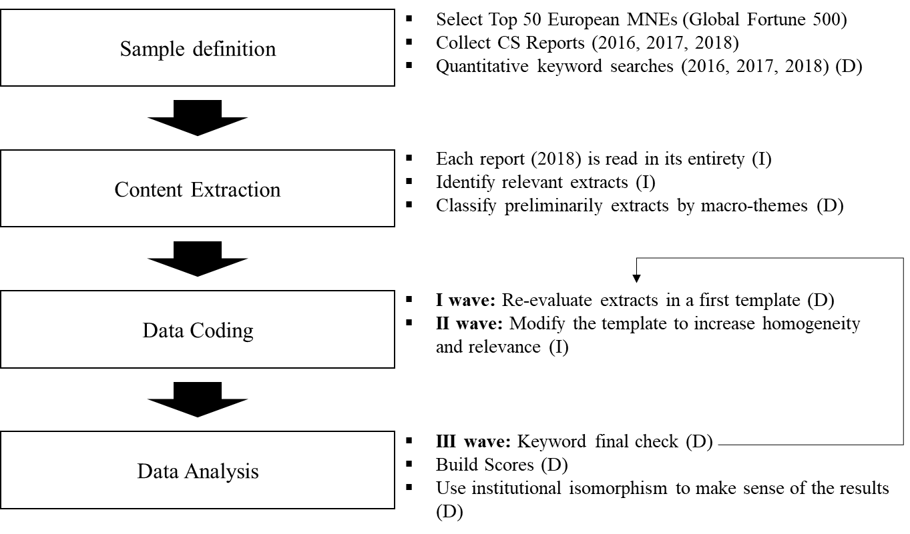

Figure 1 – Method flowchart. The activities for each phase are specified together with their nature: (D) indicates a deductive approach, (I) an inductive one.

### Data Coding

In this phase, the extracted content was interpreted across multiple waves of coding and classified into modified templates. During the first wave of coding,[7] all the collected extracts for each macro-theme were evaluated and the information was further classified into more specific sub-categories. These categories were predefined, such as the type of practice according to the Waste Hierarchy Framework (European Commission, 2008, 2015, 2020), the type of SCI dimension according to the research database International Manufacturing Strategy Survey (Wiengarten & Longoni, 2015), the type of institutional pressure (coercive, normative, mimetic).

It was recognised, however, that organisations sometimes referred to the same CE practice using different terminologies (which could also depend on industrial and geographical contexts) (Ellram & Tate, 2016). Hence, during this phase CE practices were re-classified in *reduce*, *reuse*, *recycle* and *recover* actions, independently of the original classification provided in the surveyed reports. In this new classification phase, sub-category values (for example the different types of “*reduce*” practices) were identified through an iterative process, starting from a critical reading of the collected text; consistent codes were used within the same sectors, to increase the level of homogeneity and comparability between the companies in the sample.

During the *second wave of coding,* CE practices were further characterised, and the template was inductively enriched with some details (Table 4). Firstly, another type of practice was added to the 4-R framework – *renewable energy & resource efficiency*. This category includes incremental improvement of the efficiency in production systems, and the adoption of renewables as a source of energy, both of which are quite commonly mentioned in CS Reports. They were in this way unbundled from *reduce* practices, which in our classification are more linked to radical changes in product design and functionality, which can lead to a substantial reduction in the total use of resources (rather than just an increase in their *productivity*). This distinction had the objective of recognising, to a broader extent, the strength and the weaknesses of the currently implemented approaches. Secondly, the level of implementation of each practice, in each firm, was also evaluated (see Appendix 2B), taking inspiration from similar studies evaluating secondary data (Ancarani et al., 2019b; Mejías et al., 2019). Five incremental implementation stages have been considered based on an objective evaluation of the level of adoption of that specific practice (Table 4). Finally, a third dimension was added to measure the involvement of supply chain partners and distinguish internal CE practices from Circular Supply Chain ones. A complete overview of all the categories can be found in Appendix 2A.

Table 4 – CE practices dimensions of classification

|  |  |  |  |
| --- | --- | --- | --- |
| Dimension of classification | Value | Description | Source |
| Type of CE practice | Reduce | Products are innovated to make more intensive use of resources. Product functions are re-thought and re-defined. | (European Commission, 2008, 2015, 2020);  (Kirchherr et al., 2017) |
| Reuse | Products' life is extended through repairing, preventive maintenance, and refurbishing actions; products and components are reutilised for their original function. |
| Recycle | End-of-life products, parts, components, and materials are reprocessed to make new products, parts, components, and materials. Includes also remanufacturing and recycling. |
| Recover | Energy is recovered from by-products or waste, either directly or through the production of alternative fuels like biofuels. |
| Renewable energy & Resource efficiency | Incremental efficiency improvement of production or logistics processes, or adoption of renewables as a source of energy. Linear flows of materials are not challenged. |
| Level of implementation | No mention of CE practices (0) | Absence of any practice that can be associated to the Circular Economy. | (Mejías et al., 2019); (Ancarani et al., 2019a) |
| Exploratory and conceptual (1) | CE practices are just mentioned as an aspiration; the concept is mentioned symbolically with no clear link with an operational implementation. |
| Testing (2) | Presence of R&D activities, which are being conducted on the implementation of CE practices. It is the case of pilot projects in specific plants, offices, around the world. Strategic acquisitions of start-up companies were considered as being part of this level of implementation. |
| Early Implementation (3) | Evidence of CE practices adoptions can be identified in some product/service lines. Small impacts and plans for future extensions are reported. |
| Company-wide implementation (4) | The CE practice is part of company culture and is widely implemented in different geographical areas. A clear evaluation of the overall impact is provided. |
| Supply chain involvement | Internal CE practice | CE practices are implemented and managed independently by the company. | (Zhu et al., 2013);  (Masi et al., 2018) |
| Circular Supply Chain (CSC) practice | CE practices are implemented with the involvement of at least another supply chain partner. |

In order to supplement information coming from reports, we also used data coming from secondary sources (such as websites of trade magazines and associations, obtained through simple web searches) to integrate further dimensions into the database, the impact on performance (if reported), the presence of government incentives in the given geographical context, the industry of implementation, the type of ownership of the firm, the main drivers of the adoption, the expected results, the type of relationships in the supply chain.

### Data Analysis

A *third wave of coding* was performed, to conduct a keyword-based final check, for making sure that all the relevant text had already been captured from all the reports. We employed both general and specific keywords that resulted from the categorisation in the second wave of coding: the former included Circular Economy, Circular Supply Chain, Closed-Loop Supply Chain, and Waste; while the latter related more specifically to CE practices or to SCI measures which are commonly applied by organisations, such as, for instance, reduce, reuse, recycle, recover, remanufacture, redesign, design for longevity, and supplier integration and customer integration. The retrieved text was further classified according to the specific sub-categories identified in the *first wave of coding*. Such a procedure was aimed at achieving the maximum level of replicability of the analysis.

The final step included a critical analysis of the final database, aiming at summarising the relevant findings and highlighting the key messages, for addressing the research questions. This phase also involved a synthetic representation of the data collected. The described effort to organise the content in a template in the most homogenous possible way has allowed to codify the information and to build synthetic scores for each MNE. Text content was in this way transformed in numerical scores, which included both simple counting indexes (the number of internal CE practices, the number of CSC practices) and more complex ones, such as the “CE score” and the “SCI score”.

“CE score” (0-20 scale) was calculated as the arithmetic sum of the level of implementation (0-4, see Table 4) of each type of practice. SCI score (0-8) was the arithmetic sum of 8 binary variables, corresponding to SCI dimensions (Table 2), derived from the literature (presence of information on a specific item was assigned a 1; its absence a 0). Such scores represent descriptive measures of how each MNE is implementing CE, as well as of its level of supply chain integration. Despite not being an exhaustive evaluation, they genuinely represent the information that has been publicly shared in CS reports.

Institutional isomorphism theoretical lenses were then used to interpret the template and the scores, to identify existing descriptive relations and make sense of the results, and to derive a conceptual framework based on two general propositions.

## Results

The sample (Table 5) includes very well-known MNEs operating at a global level. More than half of all the organisations is established in France and Germany (Table 6). Four categories of industrial sectors are represented: the *service industry* consists of financial institutions like banks and insurance companies; the *manufacturing industry* accounts for automotive companies, Aerospace, Chemical, Pharmaceutical, and FMCG sectors; the *energy industry* involves both energy producers and distributors; the *agri-food industry* covers food producers, and food and drug stores.

Table 5 – The sample of Multi-National Enterprises

|  |  |  |  |
| --- | --- | --- | --- |
| The sample | | | |
| 1. Royal Dutch Shell | 14. Carrefour | 26. Airbus Gr. | 39. Unilever |
| 2. Volkswagen AG | 15. Bosch Gr. | 27. Peugeot | 40. Auchan Holding |
| 3. BP plc | 16. Banco Santander | 28. BASF | 41. Vodafone |
| 4. Daimler | 17. Deutsche Telekom | 29. Royal Ahold Delhaize | 42. Telefonica |
| 5. EXOR Gr. (FCA) | 18. Credit Agricole | 30. Deutsche Post DHL Gr. | 43. Anheuser-Busch InBev |
| 6. AXA | 19. Enel | 31. Munich Re Gr. | 44. ING Gr. |
| 7. Total | 20. Uniper | 32. Societe Generale | 45. Legal & General Gr. |
| 8. Allianz | 21. ENI | 33. ArcelorMittal | 46. Louis Dreyfus |
| 9. BNP Paribas | 22. HSBC Holdings | 34. Renault | 47. Lloyds Banking Gr. |
| 10. Prudential | 23. EDF | 35. Aegon | 48. Bayer |
| 11. BMW Gr. | 24. Tesco | 36. Aviva | 49. Finatis |
| 12. Assicuraz. Generali | 25. Engie | 37. Equinor | 50. CNP Assurances |
| 13. Siemens | 38. BPCE |

Other than the state-owned energy companies Equinor and EDF, all the companies can be classified as private sector organisations; notable cases that include some form of state participation are Enel (23% of its shares are owned by the Italian government), Volkswagen (11% of its shares are owned by the Lower Saxony regional government in Germany) and Deutsche Post DHL Group (21% owned by the Federal Republic of Germany).

The majority of the companies disclosed their sustainability performance information in a dedicated sustainability report (Table 7), following the most commonly used standard for sustainability reporting, the GRI framework. This approach is intended to help businesses to communicate their sustainability results, structuring them in a similar way to financial reports. Despite some exceptions from the Services and Agri-food industries, GRI reporting standards seem to be widely accepted (Figure 2): 35 organisations either comply with these guidelines or make a clear reference to the GRI structure, while only lacking a GRI index.

Table 6 – The sample by country. Table 7 – The Type of Report analysed

|  |  |  |  |  |
| --- | --- | --- | --- | --- |
| Table 6 - able 6 – The sample by country | |  | Table 7 – The Type of Report analysed | |
| Country | Companies |  | Reporting Standards | Companies |
| France | 14 |  | Dedicated Sustainability Report | 37 |
| Germany | 12 |  |  |
| UK | 9 |  |  |
| The Netherlands | 6 |  | Sustainability information in the Annual Report | 13 |
| Italy | 4 |  |  |
| Spain | 2 |  |  |

Figure 2 – Compliance to GRI reporting by sector. Citing GRI means company mention GRI in their reports while only lacking a GRI index.

The interest of organisations towards the CE concept is recent – in 2015 just 3 out of 50 companies were citing it – and it can be interpreted as a direct consequence of the promulgation of the European directives (2015), and the emergence of a public debate about CE (Borrello et al., 2020). The peak was reported in 2018 when 50% of the firms under investigation mentioned the CE concept at least once in their Sustainability reports (Figure 3). However, still in 2018, only 9 organisations included a dedicated section in the report about the CE, which might suggest the lack of a structured approach to reporting CE practices.

Figure 3 – Evolution of the interest in the CE in the Top 50 EU Organisations

### CE Practices: implementation and measurement

The identified CE practices for each MNE have been classified according to their type and level of implementation, as well as for their involvement of supply chain partners (Table 4). Also, CE indicators measuring the impact of practices have been reviewed (Table 9). Each company's CE implementation strategy strongly depends on the focal industry and is subject to sector-specific challenges. In this sub-section, CE practices across the whole sample were aggregated and summarised per industrial sector (Table 8).

Practices linked to *reduction* along with *recycling* are the most popular across the sample, while developments linked to product *reuse* are currently overlooked. In the manufacturing industry (including companies from automotive and related industries), the identified CE practices pertain both to the ability to close the loop for valuable components and key materials, and to the establishment of the first prototypes of Circular Business Models. Remanufacturing projects have resulted in the development of specific product lines of remanufactured parts to support the aftermarket needs of customers (*FCA, Volkswagen, and Renault*). Design for resource recovery practices is playing an important role to operationalise a closed-loop supply chain and to recover materials (e.g., aluminium, steel, plastics, batteries, electrolytes, and graphite). However, only one company (*Bosch*) highlights the necessity of designing products with longer life.

In the Energy sector, the concept of the CE is interpreted as closely related to waste management (with specific reference to plastic waste), as opposed to divestment from fossil fuels and a transition towards renewable energy. *Shell* and *Total* are among the founders of the *Alliance to End Plastic Waste*, committing themselves to invest $1.5 billion over 5 years to develop solutions in this field. At the same time, this problem is being addressed through integration with technological start-ups: Total acquired the French company Synova, a leader in the manufacturing of high-performance recycled polypropylene; *BP* is collaborating with Neste, to increase the supply of sustainable fuel for aviation (the company has already worked as a supplier for Bombardier and Airbus).

The financial sector (and the service sector in general) demonstrates a general lack of clarity when dealing with CE as well as with the potential role that banks and insurance companies could have in supporting the transition towards an economy of services rather than products. Some banks are pioneering the offer of financial instruments to finance the transition of companies – supporting vehicle leasing and renting (*Banco Santander* and *Credit Agricole)* or innovative start-ups (*BNP Paribas*) – but also consumer choices – creating solutions for *Blablacar* carpooling members (*Allianz* and *AXA*). Other common practices adopted by other companies in the financial sector include the divestment from carbon fossil fuels and the investment in sustainable solutions (mainly renewable energy for both households and firms).

The agri-food sector presents a good level of adoption of CE practices that ranges from the implementation of dynamic product pricing policies to reduce food waste, to the rejection of packaging for some product lines and of single-use plastic bags for customers.

Indicators of the economic impact of the adoption of CE practices vary according to the industrial sector and to the type of practice (Table 9). ‘Revenues from remanufactured products’ is a common indicator among the manufacturing companies that have built an infrastructure to recover end of life parts to be sold in the secondary markets (*Renault, FCA, PSA, Volkswagen, Daimler, and BMW*). In the financial sector, economic indicators refer mostly to the ‘green’ investments associated with CE activities or with the promotion of renewable energy or resource efficiency solutions. Most of the environmental KPIs used across sectors and types of practices are efficiency and intensity indicators, comparing a measure of polluting activities (for instance, carbon emissions or energy intensity) to the total production output. Social impacts associated with CE practices are only included by 4 organisations and refer to the employment opportunities provided by the CSC.

Table 8 – CE practices aggregated view per industry across the whole sample (a high level of similarity was registered for companies in the same industry). The detail of the level of implementation in the brackets (0-4), while the involvement of supply chain partners is described by the “*” symbol.

|  |  |  |  |  |
| --- | --- | --- | --- | --- |
|  | Manufacturing | Energy | Financial & Services | Agri-Food |
| Reduce – Prevention | (4) Design for resource recovery *  (2) Modular Design *  (2) Product-as-a-Service * | (1) Commitment to reduce plastic waste | (4) Disinvesting from coal energy sources  (4) Investments in sustainable solutions  (4) Design of "green" products* | (4) Donate unsold food *  (3) Dynamic product pricing to reduce waste  (2) Commitment to reduce plastic waste - Refuse packaging * |
| Reuse | (2) Reuse of parts and components (batteries)* | (0) | (0) | (3) Reuse of packaging |
| Recycle | (4) Closing the loop for some products/materials * | (3) Investments in recycling technologies | (3) Materials recycling (paper) | (4) Recycled materials utilisation |
| Recover | (0) | (3) Energy Recovery from by-products | (0) | (0) |
| Renewable Energy & Resource Efficiency | (4) On-site generation of Renewable Energy  (4) Improve production systems efficiency | (3) Investments in large-scale Renewable Energy generation plants  (4) Improve Energy Efficiency | (3) Investments in Renewable Energy companies  (3) Energy sourcing from Renewable Energy | (4) Prioritise regenerative & less impactful resources |

Just one company, the Italian Energy Utility provider Enel, has developed a measurement system to assess the level of circularity of its solutions and products. Enel X Circular Economy Score is calculated by combining two values. The first represents five CE key dimensions, which are: the commitment of suppliers to CE principles; the presence of reusable elements which can increase the life-cycle of the product; the level of resource efficiency; the level of reuse of materials; and the support offered to suppliers. The second dimension evaluates the implementation of five Circular Business Models (product-as-a-service; sharing platforms; product life cycle extension; sustainability of resources; recovery and recycling). The indicator is subject to third-party verification and then made available to supply chain stakeholders.

Table 9 – Employed KPIs

|  |  |  |  |  |
| --- | --- | --- | --- | --- |
| Dimension | Category | Examples | Description | Adopting Companies |
| Economic | Revenues | Revenues from remanufactured products;  Revenues from ‘green products’. | Revenues associated with CSC activities | 3/50 |
| Investments | Capital invested in sustainable solutions;  Capital dis-invested from carbon intensive assets. | Investments associated with CSC activities | 15/50 |
|  | Overall Circularity | Enel X CE Score;  Parts Collected and Remanufactured. | Indicators of circularity of material flows and of products/services | 3/50 |
| Environmental | Emissions equivalent | CO2 eq. per functional unit;  Absolute CO2 eq. | CO2 eq. emissions associated with the supply chain | 44/50 |
| Energy Usage | Energy intensity;  Cumulative energy use;  Energy from renewable sources. | Energy-based indicators associated with the supply chain | 44/50 |
| Water | Water used;  Wastewater production;  Discharges to water. | Water used or contaminated | 42/50 |
| Waste | Waste sent to landfill;  Waste recovered. | Residual waste produced or recovered by supply chain activities | 36/50 |
| Social | Social impacts associated with CSC | ‘Green’ jobs created | Employment opportunities provided by the CSC | 4/50 |

### A classification of CE Practices Adoption

The 50 MNEs were assigned scores that measure their general level of implementation of CE practices. Table 10 gives an overview of how these 3 scores – the CE score, the number of internal CE (N ICE), and Circular Supply Chain (N CSC) practices – were calculated for Carrefour. The result of such a scoring process was repeated for each MNEs (Table 11). Appendix 2B contains the full detail. Companies with high CE scores can be retrieved across each sector; the majority of the MNEs with a low score belong to the Services sector.

Table 10 – Calculation of the CE score from the CE practices for Carrefour. Max score per type represents the intermediate step of how CE score is calculated. In presence of more than one practice per a chosen type, its value is the maximum level of implementation among all the practices of that type.

|  |  |  |  |  |  |  |
| --- | --- | --- | --- | --- | --- | --- |
| Carrefour | Type of practice | Code | Category score | CE score | N. of ICE practices | N. of CSC practices |
| Reduce | (3) Refusing the use of plastics and the sale of plastic straws by the end of 2018 removing single-use plastic straws from juice boxes* | 4 | 18 | 5 | 5 |
| (4) Rethinking prices to reduce food waste, selling products with short use-by dates at low prices |
| (4) Raise customers awareness: give them access to properly designed information and tips on our product packaging so they know how to use them* |
| (4) Collaborating with local associations donating everything that can be given away: the unsold stock is donated set up to tackle poverty* |
| Renewable Energy & Resource Efficiency | (4) Utilisation of renewable energy (geothermal power, wind power, solar power). The heat generated by stores also has to be recovered and reused – such as the heat generated by refrigeration units | 4 |
| (4) Resource efficiency: reduce per-square-meter electricity consumption in stores by closing the cold storage units – energy savings of up to 18%, or using low-energy light bulbs – up to 50% energy savings |
| Reuse | (2) Promoting the reuse of packaging aiming at 100% reusable, recyclable or compostable packaging* | 2 |
| Recycle | (3) Incorporating 50% of recycled plastic in its juice, soda, and water bottles* | 4 |
| (4) Recycled materials utilisation Since 2017, all cardboard packaging for Carrefour brand food products are printed with vegetal-based ink (over 4,000 products) |
| Recover | (4) Energy production from bio-methane - product wastage that can no longer be consumed (withered flowers, spoilt fruit, and vegetables, etc.) is converted into biogas, and then into bio-methane. | 4 |

Table 11 – An evaluation of the CE scores for each MNE.

|  |  |  |  |  |  |  |  |  |
| --- | --- | --- | --- | --- | --- | --- | --- | --- |
| Organization | CE score | N. of ICE practices | N. of CSC practices |  | Organization | CE score | N. of ICE practices | N. of CSC practices |
| Deutsche Telekom | 19 | 8 | 3 |  | Siemens | 12 | 3 | 2 |
| Unilever | 18 | 5 | 6 |  | HSBC Holdings | 12 | 6 | 1 |
| Carrefour | 18 | 5 | 5 |  | Tesco | 11 | 1 | 3 |
| Auchan Holding | 17 | 6 | 4 |  | Airbus Group | 11 | 2 | 2 |
| Royal Dutch Shell | 17 | 7 | 5 |  | Volkswagen AG | 10 | 1 | 6 |
| FCA | 16 | 5 | 8 |  | Deutsche Post DHL Gr. | 10 | 3 | 1 |
| Renault | 16 | 2 | 6 |  | BASF | 10 | 5 | 1 |
| Telefonica | 16 | 5 | 1 |  | Prudential | 9 | 3 | 0 |
| BNP Paribas | 15 | 3 | 4 |  | Equinor | 8 | 2 | 0 |
| ENI | 15 | 4 | 2 |  | Societe Generale | 8 | 0 | 4 |
| EDF | 15 | 3 | 2 |  | Banco Santander | 8 | 1 | 3 |
| Total | 15 | 6 | 1 |  | Aegon | 8 | 1 | 3 |
| ArcelorMittal | 14 | 2 | 2 |  | BPCE | 8 | 0 | 3 |
| Anheuser-Busch InBev | 13 | 2 | 4 |  | Engie | 8 | 2 | 2 |
| BP plc | 13 | 5 | 1 |  | Allianz | 8 | 3 | 2 |
| Royal Ahold Delhaize | 12 | 4 | 3 |  | Uniper | 8 | 2 | 1 |
| PSA | 12 | 0 | 6 |  | Finatis | 8 | 5 | 1 |
| Bosch Group | 12 | 1 | 5 |  | Bayer | 8 | 2 | 0 |
| Enel | 12 | 2 | 2 |  | CNP Assurances | 7 | 3 | 0 |
| Munich Re Group | 12 | 4 | 2 |  | Aviva | 7 | 4 | 0 |
| BMW Group | 12 | 2 | 3 |  | Louis Dreyfus | 6 | 3 | 0 |
| Vodafone | 12 | 3 | 1 |  | Assicurazioni Generali | 4 | 1 | 2 |
| ING Group | 12 | 0 | 6 |  | Legal & General Group | 4 | 0 | 1 |
| Daimler | 12 | 3 | 5 |  | Lloyds Banking Group | 4 | 0 | 1 |
| Credit Agricole | 12 | 1 | 3 |  | AXA | 4 | 1 | 1 |

### Drivers of CE practices implementation

Companies adopt CE practices motivated by different types of benefits: economic, environmental, and social drivers. The sources behind each of these drivers were also classified using institutional isomorphism theoretical lenses (Table 12).

CE practices can help in reducing waste, the consumption of virgin resources, and emissions thanks to less energy-intensive production processes that can re-use the available parts, components, and by-products. Economic drivers are frequently mentioned in CS reports as well and they are mainly linked with increasing the amount of value that can be extracted from products by keeping resources in use and retaining the value of materials after the end of life of the products. Social drivers are generally overlooked and linked to the more traditional Corporate Social Responsibility agenda, without explicit links to the CE and the social impact of the implementation of these practices.

Sources of drivers can be associated with isomorphic mechanisms. The high level of similarity within the same sector of type practices and levels of implementation and degree of involvement of supply chain partners is a first evidence of isomorphism. *Coercive isomorphism* can be associated with the presence of regulations and legislation imposing fines or bans. For instance, many organisations have taken action to fight waste deriving from the consumption of plastics (*Unilever, Carrefour, ING, BASF, Shell, Total, ENI*) pressured by current regulation (EU Directive 2018/852/EC), as well as by more stringent future ones. The French law on food waste (law 138 of 2016) bans supermarkets from throwing away or destroying unsold food. Accordingly, companies (*Carrefour, Auchan, Finatis*) were forced to act on the root of the problem, to reduce systematically waste streams leveraging on multiple strategies: donating surplus food (to charitable trusts, food banks, and other types of organisations which provide redistribution services), establishing dynamic pricing in their sale points, and also reducing packaging waste.

Changing industry norms are another driver source: new standards have been developed to use materials more efficiently, for example recovering end-of-life products, and closing material loops (e.g., aluminium, steel, plastic). In an industrial context, *normative isomorphism* can be traced back to professional, educational, or trading standards which are adopted as *norms.* Practices are adopted regardless of the presence of an actual legal constraint; however, some external pressures can still be recognised as the main force driving the change. The *Global Battery*, *Aluminium Stewardship,* and *Responsible Steel* initiatives are all powerful examples of current attempts, which are defining norms and standards for a transparent and sustainable supply chain, promoting the adoption of CE practices. In the financial sector, banks are cooperating to create standards to finance the transition to the Circular Economy (*ING* and others) and reach climate goals[8] (*BNP Paribas, ING, Société Générale,* and others).

Even in the absence of coercive or normative pressures, a company could still adopt CE practices, for instance by following the example of industry peers or also by seeking opportunities for competitive advantages – this is described as *mimetic isomorphism.*

Table 12 – Types, sources, and examples of CE drivers.

|  |  |  |  |
| --- | --- | --- | --- |
| Type  Source | Economic | Environmental | Social |
| Coercive pressures | Meet future law requirements for a more circular economy;  Start integrating recycled materials as an input. | follow European Commission Directives:   * 2000/53/EC (end-of-life vehicles); * 2018/852/EC (Packaging Waste);   follow National laws   * French law 2016-138 (against food waste);   Meet customer expectations;  Disclose reparability index. | Avoid sanctions and loss of legitimacy;  Anticipate future regulation on plastics waste. |
| Normative pressures | Reduce uncertainty and risks;  Aluminium Stewardship Initiative;  Global Battery Alliance  Responsible Steel;  Invest for future and green growth;  Milestone pledge for global climate goals. | Reduce products environmental footprint;  Life Cycle Assessments for product lines. | Reduce external costs for the Society  Alliance to end plastic waste;  Become a promoter for a systemic change of the economic paradigm;  The Circular Economy Finance guidelines;  Support the local economy. |
| Mimetic pressures | Opportunity for growth and competitiveness by following best practices;  Invest in renewable energy ;  Invest in recycling technologies capacity;  Identify market gaps, innovate and try to achieve competitive advantage;  Mobility-as-a-service;  Electric mobility. | Use regenerative resources;  disinvest from “carbon-intensive assets”. | Avoid wasting valuable resources;  Repair and reuse IT hardware. |

Companies imitate each other by designing more environmentally friendly and energy-efficient products and showing responsibility when investing in assets. A representative example is an initiative, adopted by many financial institutions, related to the divestment from the coal sector. It is possible to notice, indeed, that all the surveyed companies from this sector report such a practice, while investing in renewable energy solutions and products. Companies that are experimenting Circular Business Models are mostly motivated by identifying market gaps and exploiting market opportunities (*Bosch, Telefonica*).

### Supply Chain Integration, a possible enabler of CE

As mentioned above, the literature recognises that a higher level of collaboration with suppliers and customers is beneficial to deliver superior environmental performance and moderates the effect of institutional pressures on green (Seles et al., 2016; Govindan & Hasanagic, 2018) and sustainable practices (Sancha et al., 2015) adoption. For these reasons, the configuration of the supply chain might play a role also as an enabling mechanism of the adoption of CE practices.

This effect of SCI could be initially assessed in this sample. In order to measure the level of SCI, the relevant code has been extracted from the reports for each SCI measurement item (some examples are shown in Table 13).

The 50 companies were assigned a score from 0 to 8 (see the detail in Appendix 2C), on the basis of the presence in their report of SCI items (Table 3).

Three classes of companies were finally defined, based on the level of supply chain integration. Examples from the reports include: creating stable and long-term relationships with key suppliers and customers, involving suppliers and customers in the design of products and services, and engaging in development programs with suppliers helping them to comply with environmental and human rights standards. Reported collaborations at a supply chain level are mainly focused on suppliers’ auditing and development programmes, involving some life-cycle evaluation of the overall environmental impact of products and services. Highly integrated supply chains seem to have adopted CE practices at a higher level of implementation (higher average CE score) and to adopt a higher number of CSC practices (Table 14). Furthermore, companies with medium integration have a higher number of internal/CSC practices than companies with low integration[9].

Table 13. Examples of Supply Chain Integration from the CS Reports. The dimensions to assess the level of SCI have been derived from the literature (Frohlich & Westbrook, 2001; Wiengarten & Longoni, 2015).

|  |  |  |
| --- | --- | --- |
| SCI dimension | Examples | Company |
| Sharing information | “We minimise food waste in our own operations by preventing it, through optimised store replenishment and on-shelf management, and by re-directing unsold food to feed people.” | Royal Ahold Delhaize |
| Developing collaborative approaches | “We work tirelessly with our suppliers to ensure that our quality standards are met. We run a bespoke due diligence audit programme that offers documented evidence of compliance to our standards and monitors continual improvement.” | Tesco |
| Joint decision-making with key suppliers/customers | “Another aspect of supplier engagement focuses on fostering innovation to improve products, processes and content, often leading to sustainable solutions such as the use of recycled raw materials or weight reduction” | FCA |
| System coupling with key suppliers/customers | As the Company performs a strong platform prime integrator role, managing the supplier base to enable the delivery of on time and on quality product to the final customer. […] The Company’s suppliers provide a large proportion of the value in our products, necessitating a robust supply-chain governance framework. This is supported by processes and tools that foster partnership, risk mitigation and supplier performance development. | Airbus |

## Implications

CE practices, as well as their drivers, were identified for the largest MNEs in Europe. Such a large scale observation of empirical cases of CE adoption is analysed in the following discussion section, in an attempt to understand the dynamics of the transition towards the CE in supply chains.

Some general considerations are drawn, taking inspiration from the recent debate around Circular Economy, and its feasibility in the current economic paradigm. A theoretical discussion is then introduced by looking at how this change is taking place in industrial organisations and their supply chains and where the adoption has been successful and where it has not.

Table 14. The relation between SCI level and the adoption of CE practices; CE score was previously defined, as well as the number of internal CE practices and of CSC practices (Table 11). These values represent the average values of each score, within groups of MNEs with a similar level of supply chain integration.

|  |  |  |  |  |
| --- | --- | --- | --- | --- |
| SCI class | Avg. CE score | Avg. Number of internal CE practices | Avg. Number of CSC practices | Companies |
| High integration  (SCI score ≥4) | 14 | 2.6 | 4.6 | FCA, Telefonica,  Royal Ahold Delhaize, Renault, Shell |
| Medium integration  (2≤SCI score<4) | 13 | 3.4 | 2.8 | Bosch Group, Tesco, PSA, Carrefour, Enel, Deutsche Telekom, Other 5 |
| Low integration  (SCI score<2) | 10 | 2.6 | 2.0 | Auchan Holding, BNP Paribas,  Prudential, BMW Group, Vodafone, Other 30 |

By drawing on institutional theory and on the concept of supply chain integration, and on results from Section 4, the main antecedents (enabling factors) of CE practices adoptions in global supply chains are identified and two general propositions are suggested to inspire future research.

### CE state of the practice – paradigm shift or Greenwashing?

While it is acquiring a growing relevance in corporate sustainability strategies, Circular Economy remains for the moment a peripheral topic. Despite strong societal pressures companies seem to face a linear lock-in re-thinking deeply how value is created. Half of the sample analysed do not even mention the term “circular economy”, even though CS reports had clear evidence of implemented CE practices.

In general, CE does not seem to have a prominent role in the process of value creation of organisations. While the necessity of closing material loops is often recognised, the adoption of CE practices seems linked to a few sporadic initiatives. Their level of implementation is either still at a conceptual stage with no evidence of an implementation, or at an early one. In most cases, the expected results and impacts of CE practices are not disclosed, and when reported, they are negligible and far from affecting the overall business performance. MNEs show a clear preference for recycling practices, where current linear business models are not challenged, rather integrated with value recovery activities. Results confirm that prevalent approaches so far have had a reductionist interpretation of the CE concept where reduce and reuse actions (which are linked to deeper revisions of business models) are still avoided, as they could compromise economic growth through ever-growing outputs or from the launch of new products (e.g., manufacturing easy to repair products might cannibalise future sales).

Furthermore, there is a lack of declared long-term objectives regarding strategic and structural investments in this direction. This is also reflected by the fact that companies seldom employ true circularity indicators for keeping track of their performance; indeed, in most of the cases, companies adopt some environmental measures which are designed as *efficiency* metrics, and thus highly sensitive to productivity improvements (Bimpizas-Pinis et al., 2021). It must be highlighted that the usage of such indicators for measuring the success of CE practices is problematic. Figures could be manipulated to obtain better results, for example just by increasing production volumes (for instance, through productivity improvements), rather than by implementing practices that can promote more efficient usage of resources.

This reductionist approach would increase the risk of a CE Rebound effect[10] (Zink & Geyer, 2017), where an increase of secondary production does not replace primary production at an equivalent level, and as a result environmental impacts are increased, not reduced. In general, there are many doubts that individual actions could be able to reduce the overall impact of entire sectors and contribute to the sustainability objectives that institutions have set, in an economic context that still incentivises growing levels of consumption and pollution, rather than contrasting them.

At the same time, the analysis pointed out factors that might increase MNEs’ propensity to adopt CE practices, as well as their level of implementation, their overall impact, and the extent that supply networks are involved. This constitutes an opportunity to better look at uncovering these possible relationships through quantitative statistical studies and contribute to generalisable results.

### Institutional pressures, SCI and CE practices adoption: a suggested conceptual framework

On the basis of the evidence provided, which found support in the analysed literature, two propositions on the factors (e.g., drivers and mechanisms) that drive or hinder industrial organisations to adopt CE practices can be generated. We propose a conceptual framework (Figure 4), which will be tested in future studies. The three main building blocks of the framework have been identified: CE practices adoption, SCI, and Institutional Pressures.

The first proposition finds foundation in the literature (Mathews & Tan, 2011; Sarkis et al., 2011; Zhu et al., 2013; Masi et al., 2017; De Angelis et al., 2018; Kirchherr et al., 2018; Ranta et al., 2018) according to which the institutional environment is a driver (or inhibitor) of CE practices adoption.

General Proposition 1: Institutional pressures drive the adoption of CE practices in supply chains

The second proposition entails that higher levels of supply chain integration might support the transition towards the CE in the supply chain, in the presence of institutional pressures. This second general proposition finds support in the studies of Wong et al. (2020), Bressanelli et al. (2019), Herczeg et al. (2018), Sancha et al. (2015), and Wu (2013).

General Proposition 2: SCI has a moderating effect on Institutional pressures driving force on the adoption of CE practices in supply chains

Further steps could include the validation of the framework. The need to verify such a potential causal relationship constitutes an interesting research gap that should be further investigated and proved by more articulated inferential studies, similarly to what was done, by using secondary data, by Ancarani et al. (2019a and 2019b).

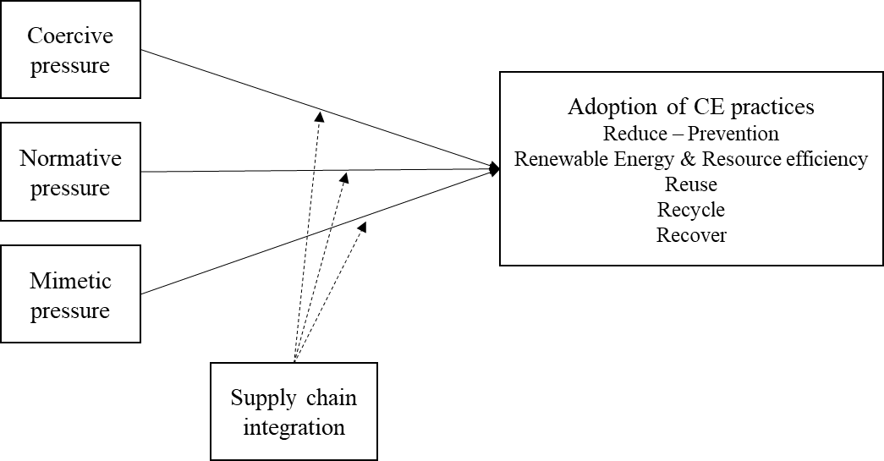

Figure 4 – The conceptual model on the antecedents of CE practices adoption

### Limitations

These results should be interpreted by taking into account the possible limitations of the method. The reliability of secondary data and public information that were found in reports might constitute a challenge. We assumed that it is in the interest of the organisations to report all the virtuous practices that contribute to their overall sustainability performance. However, there is the risk that organisations might over report – to gain more legitimacy from its stakeholders – or under-report – not to disclose information that could be linked to competitive advantage positions (The Guardian, 2019)[11]. Future studies could explore ways to triangulate data from more than one source so as to improve the reliability of the analysis.

The study also discusses the antecedents of CE adoption in supply chains from a theoretical perspective. Many companies in the sample also mention supply chain integration practices and how they are related to sustainability results. This seems to strengthen the hypothesised relationship among two of the constructs (SCI and CE practices adoption).

## Conclusions

This paper aims to investigate which CE practices MNEs have adopted, the extent of the adoption, and the level of involvement of the supply chain, along with the CE drivers behind the adoption. Following empirical observations and referring to the recent literature on the topic, institutional isomorphism and the concept of supply chain integration were employed to investigate the adoption of CE practices in the top 50 European MNEs.

The analysis reveals that the attention devoted to CE practices is generally increasing. Practices associated with *Resource Efficiency* and *Reduction*, along with *Recycling* are the most popular, while developments related to product *Reuse* are currently overlooked. In general, an ambiguous attitude is reported towards the implementation of practices that deal with rethinking product design, product functions, and business models.

The initial evidence also shows that the presence of higher levels of integration in the supply chain usually reflects in a higher propensity of having more CE practices implemented and at a higher level of implementation and with greater involvement of key suppliers and customers.

A framework is developed to explain the factors that drive or hinder industrial organisations to adopt CE practices. It is proposed that the adoption of CE practices is the result of the driving force of institutional pressures moderated by the level of supply chain integration.

Future research will be aimed at: (i) increasing the sample coverage, reviewing reports and other data for the Top-100 European companies in terms of revenues, (ii) validating the framework in a round of interviews, and (iii) testing the causal relationships conceptual framework, on the effect of the level of SCI and the institutional pressures on CE practices adoption. Further steps of this research might also look at extending the study to a broader set of companies or geographical areas.

**Acknowledgments:** This research has received funding from the European Union’s Horizon 2020 research and innovation programme under the Marie Skłodowska-Curie Innovative Training Networks (H2020-MSCA-ITN-2018) scheme, grant agreement number 814247 (ReTraCE project).

## References

Ancarani, A., Di Mauro, C., Legenvre, H., & Cardella, M. S. (2019). Internet of things adoption: a typology of projects. International Journal of Operations and Production Management. https://doi.org/10.1108/IJOPM-01-2019-0095

Ancarani, A., Di Mauro, C., & Mascali, F. (2019). Backshoring strategy and the adoption of Industry 4.0: Evidence from Europe. Journal of World Business. https://doi.org/10.1016/j.jwb.2019.04.003

Batista, L., Bourlakis, M., Smart, P., & Maull, R. (2018). In search of a circular supply chain archetype–a content-analysis-based literature review. Production Planning and Control, 29(6), 438–451. https://doi.org/10.1080/09537287.2017.1343502

Bauwens, T., Hekkert, M., & Kirchherr, J. (2020). Circular futures: What Will They Look Like? Ecological Economics, 175(April), 106703. https://doi.org/10.1016/j.ecolecon.2020.106703

Bimpizas-Pinis, M., Bozhinovska, E., Genovese, A., Lowe, B., Pansera, M., Alberich, J. P., & Ramezankhani, M. J. (2021). Is efficiency enough for circular economy? Resources, Conservation and Recycling, 167(January), 4–5. https://doi.org/10.1016/j.resconrec.2021.105399

Borrello, M., Pascucci, S., & Cembalo, L. (2020). Three Propositions to Unify Circular Economy Research: A Review. 1–24. https://doi.org/10.3390/su12104069

Bressanelli, G., Perona, M., & Saccani, N. (2019). Challenges in supply chain redesign for the Circular Economy: a literature review and a multiple case study. International Journal of Production Research, 57(23), 7395–7422. https://doi.org/10.1080/00207543.2018.1542176

De Angelis, R., Howard, M., & Miemczyk, J. (2018). Supply chain management and the circular economy: towards the circular supply chain. Production Planning & Control, 7287, 1–13. https://doi.org/10.1080/09537287.2018.1449244

DiMaggio, P. J., & Powell, W. W. (1983). The Iron Cage Revisited: Institutional Isomorphism and Collective Rationality in Organizational Fields Author ( s ): Paul J . DiMaggio and Walter W. Powell Published by: American Sociological Association Stable URL : http://www.jstor.org/stable/2095101. American Sociological Review, 48(2), 147–160.

Ellram, L. M., & Tate, W. L. (2016). The use of secondary data in purchasing and supply management (P/SM) research. Journal of Purchasing and Supply Management, 22(4), 250–254. https://doi.org/10.1016/j.pursup.2016.08.005

EMAF. (2015). Growth within a circular economy vision for a competitive europe. Ellen MacArthur Foundation, 100. https://doi.org/Article

Escobar, L. F., & Vredenburg, H. (2011). Multinational Oil Companies and the Adoption of Sustainable Development: A Resource-Based and Institutional Theory Interpretation of Adoption Heterogeneity. Journal of Business Ethics, 98(1), 39–65. https://doi.org/10.1007/s10551-010-0534-x

European Commission. (2008). Directive 2008/98/EC of the European Parliament and of the Council of 19 November 2008 on waste and repealing certain Directives. Available online at: https://eur-lex.europa.eu/legal-con. Last accessed: 11/06/2020.

European Commission. (2015). Closing the loop ‐ An EU action plan for the Circular Economy. Available online at: https://eur-lex.europa.eu/legal-content/EN/TXT/?uri=CELEX%3A52015DC0614. Last accessed: 11/06/2020. https://eur-lex.europa.eu/legal-content/EN/TXT/?uri=CELEX%3A52015DC0614

European Commission. (2020). A new Circular Economy Action Plan For a cleaner and more competitive Europe. Available online at: https://eur-lex.europa.eu/legal-content/EN/TXT/?qid=1583933814386&uri=COM:2020:98:FIN. Last accessed: 11/06/2020.

Fitch-Roy, O., Benson, D., & Monciardini, D. (2020). Going around in circles? Conceptual recycling, patching and policy layering in the EU circular economy package. Environmental Politics, 29(6), 983–1003. https://doi.org/10.1080/09644016.2019.1673996

Flynn, B., Pagell, M., & Fugate, B. (2018). Editorial: Survey Research Design in Supply Chain Management: The Need for Evolution in Our Expectations. Journal of Supply Chain Management, 54(1), 1–15. https://doi.org/10.1111/jscm.12161

Frohlich, M. T., & Westbrook, R. (2001). Arcs of integration: An international study of supply chain strategies. Journal of Operations Management, 19(2), 185–200. https://doi.org/10.1016/S0272-6963(00)00055-3

Genovese, A., Acquaye, A. A., Figueroa, A., & Koh, S. C. L. (2017). Sustainable supply chain management and the transition towards a circular economy: Evidence and some applications. Omega (United Kingdom), 66, 344–357. https://doi.org/10.1016/j.omega.2015.05.015

Ghisellini, P., Cialani, C., & Ulgiati, S. (2016). A review on circular economy: The expected transition to a balanced interplay of environmental and economic systems. Journal of Cleaner Production, 114, 11–32. https://doi.org/10.1016/j.jclepro.2015.09.007

Ghisellini, P., & Ulgiati, S. (2020). Circular economy transition in Italy. Achievements, perspectives and constraints. Journal of Cleaner Production, 243, 118360. https://doi.org/10.1016/j.jclepro.2019.118360

Gold, S., Seuring, S., & Beske, P. (2010). Sustainable supply chain management and inter-organizational resources: A literature review. Corporate Social Responsibility and Environmental Management, 17(4), 230–245. https://doi.org/10.1002/csr.207

Govindan, K., & Hasanagic, M. (2018). A systematic review on drivers, barriers, and practices towards circular economy: a supply chain perspective. International Journal of Production Research, 56(1–2), 278–311. https://doi.org/10.1080/00207543.2017.1402141

Gusmerotti, N. M., Testa, F., Corsini, F., Pretner, G., & Iraldo, F. (2019). Drivers and approaches to the circular economy in manufacturing firms. Journal of Cleaner Production, 230, 314–327. https://doi.org/10.1016/j.jclepro.2019.05.044

Hahn, R., & Kühnen, M. (2013). Determinants of sustainability reporting: A review of results, trends, theory, and opportunities in an expanding field of research. Journal of Cleaner Production, 59, 5–21. https://doi.org/10.1016/j.jclepro.2013.07.005

Herczeg, G., Akkerman, R., & Hauschild, M. Z. (2018). Supply chain collaboration in industrial symbiosis networks. Journal of Cleaner Production, 171, 1058–1067. https://doi.org/10.1016/j.jclepro.2017.10.046

Hoejmose, S. U., Grosvold, J., & Millington, A. (2014). The effect of institutional pressure on cooperative and coercive “green” supply chain practices. Journal of Purchasing and Supply Management, 20(4), 215–224. https://doi.org/10.1016/j.pursup.2014.07.002

Hofmann, F. (2019). Circular business models: Business approach as driver or obstructer of sustainability transitions? Journal of Cleaner Production, 224, 361–374. https://doi.org/10.1016/j.jclepro.2019.03.115

Howard, M., Hopkinson, P., & Miemczyk, J. (2019). The regenerative supply chain: a framework for developing circular economy indicators. 7543. https://doi.org/10.1080/00207543.2018.1524166

Jain, N. K., Panda, A., & Choudhary, P. (2020). Institutional pressures and circular economy performance: The role of environmental management system and organizational flexibility in oil and gas sector. Business Strategy and the Environment, 29(8), 3509–3525. https://doi.org/10.1002/bse.2593

Ketchen, D. J., & Hult, G. T. M. (2007). Bridging organization theory and supply chain management: The case of best value supply chains. Journal of Operations Management, 25(2), 573–580. https://doi.org/10.1016/j.jom.2006.05.010

King, N., & Brooks, J. M. (2018). Doing Template Analysis: A Guide to the Main Components and Procedures. Template Analysis for Business and Management Students, 25–46. https://doi.org/10.4135/9781473983304.n3

Kirchherr, J., Piscicelli, L., Bour, R., Kostense-Smit, E., Muller, J., Huibrechtse-Truijens, A., & Hekkert, M. (2018). Barriers to the Circular Economy: Evidence From the European Union (EU). Ecological Economics, 150(December 2017), 264–272. https://doi.org/10.1016/j.ecolecon.2018.04.028

Kirchherr, J., Reike, D., & Hekkert, M. (2017). Conceptualizing the circular economy: An analysis of 114 definitions. Resources, Conservation and Recycling, 127(April), 221–232. https://doi.org/10.1016/j.resconrec.2017.09.005

Kirchherr, J., & van Santen, R. (2019). Research on the circular economy: A critique of the field. Resources, Conservation and Recycling, 151(September), 4–5. https://doi.org/10.1016/j.resconrec.2019.104480

Korhonen, J., Honkasalo, A., & Seppälä, J. (2018). Circular Economy: The Concept and its Limitations. Ecological Economics, 143(January), 37–46. https://doi.org/10.1016/j.ecolecon.2017.06.041

KPMG. (2020). The KPMG Survey of Sustainability Reporting 2020. Available at (Https://Assets.Kpmg/Content/Dam/Kpmg/Xx/Pdf/2020/11/the-Time-Has-Come.Pdf). https://doi.org/10.6004/jnccn.2019.0020

Lahane, S., Kant, R., & Shankar, R. (2020). Circular supply chain management: A state-of-art review and future opportunities. Journal of Cleaner Production, 258, 120859. https://doi.org/10.1016/j.jclepro.2020.120859

Liu, J., Feng, Y., Zhu, Q., & Sarkis, J. (2018). Green supply chain management and the circular economy: Reviewing theory for advancement of both fields. International Journal of Physical Distribution and Logistics Management, 48(8), 794–817. https://doi.org/10.1108/IJPDLM-01-2017-0049

Lüdeke-Freund, F., Gold, S., & Bocken, N. M. P. (2019). A Review and Typology of Circular Economy Business Model Patterns. Journal of Industrial Ecology, 23(1), 36–61. https://doi.org/10.1111/jiec.12763

Masi, D., Day, S., & Godsell, J. (2017). Supply chain configurations in the circular economy: A systematic literature review. Sustainability (Switzerland), 9(9). https://doi.org/10.3390/su9091602

Masi, D., Kumar, V., Garza-Reyes, J. A., & Godsell, J. (2018). Towards a more circular economy: exploring the awareness, practices, and barriers from a focal firm perspective. Production Planning and Control, 29(6), 539–550. https://doi.org/10.1080/09537287.2018.1449246

Mathews, J. A., & Tan, H. (2011). Progress toward a circular economy in China: The drivers (and inhibitors) of eco-industrial initiative. Journal of Industrial Ecology, 15(3), 435–457. https://doi.org/10.1111/j.1530-9290.2011.00332.x

Mejías, A. M., Bellas, R., Pardo, J. E., & Paz, E. (2019). Traceability management systems and capacity building as new approaches for improving sustainability in the fashion multi-tier supply chain. International Journal of Production Economics, 217(March), 143–158. https://doi.org/10.1016/j.ijpe.2019.03.022

Pagell, M., & Shevchenko, A. (2014). Why research in sustainable supply chain management should have no future. Journal of Supply Chain Management, 50(1), 44–55. https://doi.org/10.1111/jscm.12037

Ranta, V., Aarikka-Stenroos, L., Ritala, P., & Mäkinen, S. J. (2018). Exploring institutional drivers and barriers of the circular economy: A cross-regional comparison of China, the US, and Europe. Resources, Conservation and Recycling, 135(August 2017), 70–82. https://doi.org/10.1016/j.resconrec.2017.08.017

Roth, A., & Rosenzweig, E. (2020). Advancing empirical science in operations management research: A clarion call to action. Manufacturing and Service Operations Management, 22(1), 179–190. https://doi.org/10.1287/msom.2019.0829

Salmenperä, H., Pitkänen, K., Kautto, P., & Saikku, L. (2021). Critical factors for enhancing the circular economy in waste management. Journal of Cleaner Production, 280. https://doi.org/10.1016/j.jclepro.2020.124339

Sancha, C., Longoni, A., & Giménez, C. (2015). Sustainable supplier development practices: Drivers and enablers in a global context. Journal of Purchasing and Supply Management, 21(2), 95–102. https://doi.org/10.1016/j.pursup.2014.12.004

Sarkis, J., Zhu, Q., & Lai, K. H. (2011). An organizational theoretic review of green supply chain management literature. International Journal of Production Economics, 130(1), 1–15. https://doi.org/10.1016/j.ijpe.2010.11.010

Schoenherr, T., & Swink, M. (2012). Revisiting the arcs of integration: Cross-validations and extensions. Journal of Operations Management, 30(1–2), 99–115. https://doi.org/10.1016/j.jom.2011.09.001

Seles, B. M. R. P., de Sousa Jabbour, A. B. L., Jabbour, C. J. C., & Dangelico, R. M. (2016). The green bullwhip effect, the diffusion of green supply chain practices, and institutional pressures: Evidence from the automotive sector. International Journal of Production Economics, 182, 342–355. https://doi.org/10.1016/j.ijpe.2016.08.033

Sihvonen, S., & Partanen, J. (2017). Eco-design practices with a focus on quantitative environmental targets: An exploratory content analysis within ICT sector. Journal of Cleaner Production, 143, 769–783. https://doi.org/10.1016/j.jclepro.2016.12.047

Soosay, C. A., Hyland, P. W., & Ferrer, M. (2008). Supply chain collaboration: Capabilities for continuous innovation. Supply Chain Management, 13(2), 160–169. https://doi.org/10.1108/13598540810860994

Stewart, R., & Niero, M. (2018). Circular economy in corporate sustainability strategies: A review of corporate sustainability reports in the fast-moving consumer goods sector. Business Strategy and the Environment, 27(7), 1005–1022. https://doi.org/10.1002/bse.2048

Tate, W. L., Ellram, L. M., & Kirchoff, J. F. (2010). Corporate social responsibility reports: A thematic analysis related to supply chain management. Journal of Supply Chain Management, 46(1), 19–44. https://doi.org/10.1111/j.1745-493X.2009.03184.x

Touboulic, A., & Walker, H. (2015). Theories in sustainable supply chain management: A structured literature review. In International Journal of Physical Distribution and Logistics Management (Vol. 45, pp. 16–42). Emerald Group Publishing Ltd. https://doi.org/10.1108/IJPDLM-05-2013-0106

Widmer, T., & Prior, D. (2019). Institutional Isomorphism, Institutional Logics and Organisational Fields: An Institutionalist Perspective on Circular Economy. Proceedings of the Spring Servitization Conference 2019, May.

Wiengarten, F., Li, H., Singh, P. J., & Fynes, B. (2019). Re-evaluating supply chain integration and firm performance: linking operations strategy to supply chain strategy. Supply Chain Management, 24(4), 540–559. https://doi.org/10.1108/SCM-05-2018-0189

Wiengarten, F., & Longoni, A. (2015). A nuanced view on supply chain integration: A coordinative and collaborative approach to operational and sustainability performance improvement. Supply Chain Management, 20(2), 139–150. https://doi.org/10.1108/SCM-04-2014-0120

Wong, C. Y., Wong, C. W. Y., & Boon-itt, S. (2020). Effects of green supply chain integration and green innovation on environmental and cost performance. International Journal of Production Research, 0(0), 1–21. https://doi.org/10.1080/00207543.2020.1756510

Zeng, H., Chen, X., Xiao, X., & Zhou, Z. (2017). Institutional pressures, sustainable supply chain management, and circular economy capability: Empirical evidence from Chinese eco-industrial park firms. Journal of Cleaner Production, 155(May 2014), 54–65. https://doi.org/10.1016/j.jclepro.2016.10.093

Zhu, Q., Geng, Y., & Lai, K. hung. (2010). Circular economy practices among Chinese manufacturers varying in environmental-oriented supply chain cooperation and the performance implications. Journal of Environmental Management, 91(6), 1324–1331. https://doi.org/10.1016/j.jenvman.2010.02.013

Zhu, Q., Sarkis, J., & Lai, K. hung. (2013). Institutional-based antecedents and performance outcomes of internal and external green supply chain management practices. Journal of Purchasing and Supply Management, 19(2), 106–117. https://doi.org/10.1016/j.pursup.2012.12.001

Zink, T., & Geyer, R. (2017). Circular Economy Rebound. Journal of Industrial Ecology, 21(3), 593–602. <https://doi.org/10.1111/jiec.12545>

## Appendix 2A

Classification dimensions of a CS Report. LOI: level of implementation (0: no practice; 1: conceptual; 2: testing; 3: early implementation; 4: company implementation) SC: Supply Chain involvement in that CE practice (yes - no)

|  |  |  |  |  |
| --- | --- | --- | --- | --- |
| **Category** | **Sub-category** | **Code** | **LOI** | **SC** |
| **General Information** | **Organisation name** | Company A |  |  |
| **Industry** | Energy Petroleum Refining |  |  |
| **Country of the Headquarter** | The Netherlands |  |  |
| **Report analysed** | Sustainability Report 2018 |  |  |
| **Year of the Report** | 2018 |  |  |
| **Circular Economy practices** | **"Circular Economy" occurrences in the report** | 2 |  |  |
| **Reduce practices** | Redesign packaging for resource recovery | 2 | No |
|  | 4 | Yes |
| **Renewable Energy & Resource Efficiency practices** | Incremental improvement of | 0 |  |
| **Reuse practices** | No practice | 0 |  |
| **Recycle practices** | Investments in recycling technologies | 3 | No |
| Recycle materials (plastic) | 2 | Yes |
| **Recover practices** | Investing in recovery infrastructure | 2 | Yes |
| Energy Recovery from by-products/waste | 3 | Yes |
|  | **CE score** | 10 |  |  |
|  | **N internal CE practices** | 2 |  |  |
|  | **N CSC practices** | 4 |  |  |
| **Circular Economy indicators** | **Economic** | No economic indicator |  |  |
| **Environmental** | CO2 eq. per functional unit; Absolute CO2 eq.; Energy intensity; Energy from renewable sources; Waste sent to landfill. |  |  |
| **Social** | No social indicator |  |  |
| **Supply Chain Integration** | **Suppliers’ integration measures** | Develop collaborative approaches with key suppliers and customers (+1) | | |
| Share information with key suppliers and customers (+1) | | |
|  | Joint decision-making and System coupling are not mentioned | | |
| **Customers integration measures** | Not mentioned at all |  |  |
|  | **SCI score** | 2 |  |  |
| **Institutional pressures** | **Coercive** | Presence of National regulation: A Circular Economy in the Netherlands by 2050 | | |
| **Normative** | Alliance to End Plastic Waste | | |
| **Mimetic** | Not mentioned. However, a high degree of similarity with companies in the same sectors is noticed (type of practice, level of implementation). | | |
| **Further information** | **Expected results** | Not explicitly mentioned |  |  |
| **Registered Impact on performance** | 400,000 tonnes waste for recycling or reuse |  |  |
| **Type of ownership** | Private |  |  |

## Appendix 2B

CE practices adopted by each organisation. The number in brackets indicates a practice level of implementation (0-4). The involvement of supply chain partners is described by the “*” symbol

|  |  |  |  |  |  |
| --- | --- | --- | --- | --- | --- |
| **Company** | **REDUCE** | **RENEWABLE ENERGY &**  **RESOURCE EFFICIENCY** | **REUSE** | **RECYCLE** | **RECOVER** |
| **Deutsche Telekom** | (3) CBM: Leasing model usage for devices (e.g. routers and Media Receiver) * (4)Pursue climate friendly mobility for employees (4) Investments in sustainable solutions (Infrastructure for electric vehicles charging station)* | (4) Promoting resource efficiency in logistics (less packaging waste)  (4) Energy sourcing from renewable energy | (3) Take back program for IT equipment ("Closing the Loop One to one", Netherland) * (3) Reusable cup in canteens (3) Refurbish and resell laptops and desktops  (3) Repair and Refurbish parts for reuse (e.g. routers and Media Receiver) | (4) Copper cable recycling (group wide directive) | (4) Recovery heat from data centres |
| **Carrefour** | (4) Dynamic pricing in supermarkets to reduce waste  (4) Donate unsold food * (4) Raise customer environmental awareness * (4) Refuse single use plastics by 2018 * | (4) Energy sourcing from renewable energy  (4) Improve refrigeration systems efficiency (Substituting refrigeration chemicals with CO2) | (2) Promoting the reuse of packaging * | (3) 50% recycled plastics in its juice, soda and water bottles* (4) Recycled materials utilisation (vegetal based ink) | (4) Energy production from bio-methane |
| **Unilever** | (4) Reduce the use of plastics * (1) Exploring circular business models * | (4) Energy sourcing from renewable energy  (4) Improve production systems efficiency (less waste) (4) New technology to improve material efficiency (plastics) | (2) Reuse packaging (cardboard boxes, in UK) * (4) Reuse products (soap) * | (2) Support investments in recycling infrastructure (pilot plants) * (2) Organic waste composting (projects in India and Argentina) (2) Recycled material utilisation (plastic "Better plastic" product lines) * | (4) Energy recovery from waste (pre-treated and used cement kilns) |
| **Auchan Holding** | (4) Reduce the need of palm oil (3) Reduce (or refuse) packaging* (4) Raise customer environmental awareness (charge customers for bags) * (4) Donate unsold food * | (4) Improve refrigeration systems efficiency | (3) Repair and Refurbish IT equipment for reuse (in China) (1) Commitment to reuse packaging and clothes hangers | (3) Recycle packaging (plastic bottles, France) * (3) Recover waste in stores and logistic centres(Spain, Luxembourg, France) | (3) Energy production from bio-methane (China) |
| **Royal Dutch Shell** | (2) Redesign packaging * (4) Modular Design * (2) Design infrastructure for alternative fuels (3) Design better lubricants (4) Investments in plastic waste prevention* | (4) Digital tools to improve resource efficiency | (3) Reusable bags and cups in Shell Retail | (3) Investments in recycling technologies (software waste management solution) (2) Recycle materials (plastic)  (2) Recycle packaging* | (2) Investing in recovery infrastructure (3) Energy Recovery from byproducts/waste |
| **EXOR Group (FCA)** | (3) Mobility as a service solutions (subscription-based car ownership program, car-sharing service) * (4) Promoting collaborative consumption (P2P car-sharing platform) * (4) Design for resource recovery* | (4) Improve production systems efficiency  (4) Improve logistics efficiency with forecasting tools* (4) Energy sourcing from renewable energy | (2) Refurbish parts for reuse (CarE-Service project) * (2) Refurbish and reuse batteries for non-automotive applications (e.g., motorised wheelchairs) * | (4) Remanufacturing of parts and components* (4) Recycled materials utilisation (aluminium, steel, plastics) * (2) Repurpose end-of-life components into fashion accessories (cooperative, Brazil) (2) Investments in recycling technologies | (2) Energy production from bio-methane (from sewage sludge) |
| **Renault** | (3) Mobility as a service solutions* (4) Design for resource recovery* | (4) Energy sourcing from renewable energy  (4) Improve production systems efficiency | (2) Refurbish parts for reuse (batteries) * (4) Reuse of second hand parts* | (4) Remanufacturing parts and components* (4) Recycled materials utilisation (copper, aluminum, pastics, plastinoids, and textiles for second life in new vehicles) * |  |
| **Telefonica** | (4) Refuse paper invoice | (4) Improve internal resource efficiency  (4) Use of digital data to prevent resource consumption | (4) Refurbish IT equipment for reuse | (4) Recycled materials utilisation (copper, rare earths) * (4) Recycled materials utilisation (paper) |  |
| **BNP Paribas** | (3) Financing businesses transition to CE* (3) Financing CE innovators* (4) Design "green" products for households* (4) Invest in "green" bonds and companies* | (4) Energy sourcing from renewable energy |  | (4) Recycled materials utilisation (paper) | (3) Invest in waste to energy solutions (UK) |
| **Total** | (3) Design better products (Total EcoSolutions Program) * (2) Financing technological innovation (CCUS) (4) Investments in plastic waste prevention | (4) Energy generation from renewable sources |  | (3) Investing in recycling technologies (plastics) (3) Recycle production waste (oil, UK) | (4) Produce biofuel |
| **ENI** | (4) Investing in low carbon and CE research (3) Investing in mobility as a service * | (4) Financing renewable energy/technological innovation (4) Improve production systems efficiency |  | (4) Recycled materials utilisation | (3) Energy recovery from byproducts/waste (bio-oil from municipal waste, Italy) * |
| **Electricite de France** | (4) Divesting from carbon intensive assets | (4) Improve production systems efficiency  (4) Financing renewable energy* |  | (4) Byproduct reutilisation | (3) Recovery of heat from data centres* |
| **ArcelorMittal** | (4) Design for resource recovery (construction industry) * | (4) On site renewable electricity production |  | (4) Recycle operational waste | (2) Energy Recovery from byproducts/waste* |
| **BP plc** | (3) Reduce plastic packaging * | (4) Invest in renewable energy/technological innovation (4) Improve production systems efficiency |  | (2) Invest in recycling technologies | (4) Energy Recovery from byproducts/waste  (4) Produce biofuel |
| **Anheuser-Busch InBev** | (2) Reduce plastic packaging * (2) Refuse paper shipping documents | (4) Energy sourcing from renewable energy | (4) Reuse packaging (returnable bottles and kegs) * | (3) Recycled materials utilisation in bottles* (2) Recover end of life bottles* |  |
| **Royal Ahold Delhaize** | (1) Reduce plastic waste (New Plastics Economy Global Commitment for 2025) (4) Donate unsold food* | (4) On site renewable electricity production (4) Improve local businesses efficiency  (4) Improve refrigeration systems efficiency |  | (4) Recycle food waste* (4) Recycled material utilisation (plastic) * |  |
| **Daimler** | (4) Design for resource recovery* (2) Mobility as a service solutions* (2) Modular design * | (4) Improve production systems efficiency  (2) Energy sourcing from renewable energy |  | (4) Recycled materials utilisation (plastic) * (4) Recycle production waste materials  (1) Build a battery recycling network* |  |
| **BMW Group** | (4) Design for resource recovery* | (4) Improve production systems efficiency  (4) Energy sourcing from renewable energy |  | (4) Recycled materials utilisation (plastics, thermoplastics, aluminium) * (4) Recycle components (batteries)* |  |
| **Bosch Group** | (3) Design for durability (automotive) * (4) Design for environment (energy efficiency and carbon footprint) * (4) Reduce plastic packaging* | (4) Energy sourcing from Renewable Energy |  | (4) Recycled materials utilisation (plastic) * (4) Remanufacturing of parts and components * |  |
| **PSA** | (4) Design for resource recovery* (2) Mobility as a service solutions* |  | (4) Repair and Refurbish parts for reuse (“repair and return” service for automatic gearboxes and complex electronic components.) * | (4) Recycled materials utilisation (plastic, metals) * (4) Recycle components (batteries)* (4) Remanufacturing parts and components* |  |
| **Enel** | (4) Financing CE transition of suppliers and customers (Enel X) * | (4) Renewable energy production | (2) Recycling and re-use of wind turbine blades * | (2) Cooperative recycling (cable reels, pallets, Argentina) |  |
| **Credit Agricole** | (4) Invest in "green" bonds and companies* (3) Financing consumers transition to CE * |  | (4) Refurbish IT equipment for reuse | (4) Materials recycling (plastic, metal of bank cards) * |  |
| **HSBC Holdings** | (4) Disinvesting from carbon intensive assets (3) Redesign infrastructure (Green buildings)  (4) Invest in "green" bonds and companies* (4) Design "green" products for businesses* | (4) Improve internal resource efficiency (paper)  (4) Energy sourcing from renewable energy |  | (4) Recycled materials utilisation (paper) |  |
| **Munich Re Group** | (3) Invest in "green" infrastructure  (3) Promote employee sustainable consumption (4) Design "green" products for businesses* | (4) Improve internal resource efficiency (4) Invest in renewable energy companies* |  | (4) Recycled materials utilisation (paper) |  |
| **Siemens** | (4) Design for resource recovery (electronic components) * (3) Invest in "green" infrastructure  (4) Design for environment (energy efficiency and carbon footprint) * | (4) Energy sourcing from Renewable Energy  (3) On-site generation of Renewable Energy |  | (4) Recycle operational waste |  |
| **ING Group** | (4) Invest against climate change and for a CE* (4) Design "green" products for businesses* (4) Design "green" products for households* (4) Financing CE innovations* | (4) Invest in renewable energy companies* |  | (4) Investing in recycling companies (tyres) * |  |
| **Vodafone** | (4) Invest in "green" projects and companies* | (4) Energy sourcing from renewable energy  (4) On site production of renewable energy |  | (4) Recycle e-waste |  |
| **Airbus Group** | (2) Mobility as a service solutions* (3) Research in clean mobility | (4) Improve production systems efficiency |  | (4) Recycled materials utilisation (carbon fibre materials) * |  |
| **Tesco** | (4) Design to reduce waste (broadening specifications wonky fruit and vegetables) * (2) Refuse packaging* | (4) Energy sourcing from renewable energy |  | (3) Recycle packaging (plastic bottles) * |  |
| **Deutsche Post DHL Gr.** | (4) Design "green" products for customers * | (4) Improve internal resource efficiency (4) Energy sourcing from renewable energy |  |  | (2) Invest in waste to energy solutions (UK) |
| **BASF** |  | (4) Energy sourcing from Renewable Energy  (4) Improve production systems efficiency |  | (3) Recycle operational waste | (2) Energy recovery from byproducts (2) Biofuels utilisation (bio-methane from waste) * (3) Recover heat from production |
| **Volkswagen AG** | (2) Mobility as a service solutions* (2) Research in clean mobility (2) Modular design * | (4) Improve production systems & supply chain resource efficiency * |  | (4) Recycle materials (aluminium) * (4) Recycle components (batteries)* (4) Remanufacturing parts and components* |  |
| **Prudential** | (2) Redesign sustainable headquarter infrastructure | (3) Promoting internal Resource Efficiency (use of water) |  |  | (4) Recycle and incinerate generated waste |
| **Equinor** |  | (4) Renewable energy production |  | (4) Recycle production waste |  |
| **Bayer** |  | (4) Improve production systems efficiency |  | (4) Recycle production waste |  |
| **Uniper** |  | (4) Renewable energy production and sale |  |  | (4) Provide waste heat to industrial partners* (4) Sell power generation by-products to industrial partners |
| **Engie** | (4) Financing "green" technological innovation* (4) Design of "green" products for companies and local authorities* (2) Invest in "green" infrastructure | (4) Renewable energy production and sale |  |  |  |
| **Allianz** | (4) Disinvest from carbon intensive asset (4) Design "green" products for consumers* | (4) Invest in renewable energy companies* | (2) Reusable packaging in gastronomy | (2) Recycle materials (plastic, Ghana) |  |
| **Banco Santander** | (4) Design "green" products*  (3) Financing businesses transition to CE*  (3) Invest in "green" infrastructure | (4) Investments in Renewable Energy companies/technological innovation* |  |  |  |
| **Societe Generale** | (2) Invest in CE infrastructure* (4) Invest in "green" projects and companies* (4) Disinvest from carbon intensive asset | (4) Invest in renewable energy companies* |  |  |  |
| **Aegon** | (4) Disinvesting from carbon intensive assets (4) Design "green" products* for consumers (1) Reduce the use of plastic | (4) Invest in renewable energy companies* |  |  |  |
| **Finatis** |  | (4) Energy sourcing from renewable energy  (4) Improve internal resource efficiency |  | (4) Recycle waste materials (piles, batteries)  (4) Recycle waste materials (packaging)  (4) Recycle waste materials (textile, mattrasses) (2) Recycled materials utilisation (PFC) * |  |
| **BPCE** | (3) Financing businesses "green" transition* (4) Design "green" products for households* | (4) Investments in renewable energy companies* |  |  |  |
| **CNP Assurances** |  | (4) Improve internal resource efficiency (data centres) (4) Improve internal resource efficiency (paper) | (3) Materials recycling (paper) |  |  |
| **Aviva** | (4) Refuse single use plastic (coffee cups) (4) Invest in low carbon infrastructure (3) Promoting employee collaborative consumption | (3) On site production of renewable energy |  |  |  |
| **Louis Dreyfus** |  | (3) Financing renewable energy projects (3) Improve production systems efficiency |  |  | (3) Energy recovery from heat |
| **AXA** | (4) Disinvesting from carbon intensive assets (4) Design "green" products for consumers (annual insurance carpooling) * |  |  |  |  |
| **Assicurazioni Generali** | (3) Disinvesting from carbon intensive assets (4) Design "green" products for consumers* (4) Design "green" products for businesses* |  |  |  |  |
| **Legal & General Group** |  | (4) Investments in renewable energy companies* |  |  |  |
| **Lloyds Banking Group** |  | (4) Investments in renewable energy companies* |  |  |  |

## Appendix 2C

SCI activities reported by each organisation and SCI score. (SIN: sharing information; DCA: Developing Collaborative approaches; JDM: Joint Decision making; SCO: System Coupling)

|  |  |  |  |  |  |  |  |  |  |
| --- | --- | --- | --- | --- | --- | --- | --- | --- | --- |
|  |  | **Suppliers integration** | | | | **Customers integration** | | | |
| **Company name** | **SCI score** | **SIN** | **DCA** | **JDM** | **SCO** | **SIN** | **DCA** | **JDM** | **SCO** |
| **FCA** | **6** | x | x | x | x |  |  | x | x |
| **Telefonica** | **5** | x | x | x | x | x |  |  |  |
| **R. Ahold Delhaize** | **5** |  | x | x | x | x | x |  |  |
| **Renault** | **5** | x | x | x | x | x |  |  |  |
| **Bosch Group** | **4** | x | x | x |  | x |  |  |  |
| **Tesco** | **4** |  | x | x |  | x | x |  |  |
| **PSA** | **4** | x | x | x |  | x |  |  |  |
| **Carrefour** | **3** |  | x | x |  |  | x |  |  |
| **Enel** | **3** |  | x |  |  | x |  | x |  |
| **VWG** | **3** | x | x |  |  | x |  |  |  |
| **Deutsche Telekom** | **3** |  | x | x |  |  |  | x |  |
| **Airbus Group** | **3** | x | x |  |  | x |  |  |  |
| **Munich Re Group** | **3** |  | x |  |  |  | x | x |  |
| **Unilever** | **3** |  | x |  |  | x | x |  |  |
| **Anheuser-Busch I.** | **3** | x | x | x |  |  |  |  |  |
| **Auchan Holding** | **2** |  | x |  |  | x |  |  |  |
| **BNP Paribas** | **2** |  | x |  | x |  |  |  |  |
| **Prudential** | **2** |  | x |  | x |  |  |  |  |
| **BMW Group** | **2** |  | x |  |  | x |  |  |  |
| **Vodafone** | **2** |  | x | x |  |  |  |  |  |
| **Louis Dreyfus** | **2** |  | x |  | x |  |  |  |  |
| **Equinor** | **2** |  | x |  |  |  |  |  | x |
| **Royal Dutch Shell** | **1** |  | x |  |  |  |  |  |  |
| **CNP Assurances** | **1** |  | x |  |  |  |  |  |  |
| **BP plc** | **1** |  | x |  |  |  |  |  |  |
| **Daimler** | **1** |  | x |  |  |  |  |  |  |
| **Total** | **1** |  | x |  |  |  |  |  |  |
| **Allianz** | **1** |  | x |  |  |  |  |  |  |
| **Generali** | **1** |  | x |  |  |  |  |  |  |
| **Siemens** | **1** |  | x |  |  |  |  |  |  |
| **Banco Santander** | **1** |  | x |  |  |  |  |  |  |
| **Credit Agricole** | **1** |  | x |  |  |  |  |  |  |
| **Uniper** | **1** |  | x |  |  |  |  |  |  |
| **ENI** | **1** |  | x |  |  |  |  |  |  |
| **HSBC Holdings** | **1** |  | x |  |  |  |  |  |  |
| **Electricite de France** | **1** |  | x |  |  |  |  |  |  |
| **Engie** | **1** |  | x |  |  |  |  |  |  |
| **BASF** | **1** |  | x |  |  |  |  |  |  |
| **Deutsche Post DHL** | **1** |  | x |  |  |  |  |  |  |
| **Societe Generale** | **1** |  | x |  |  |  |  |  |  |
| **ArcelorMittal** | **1** |  | x |  |  |  |  |  |  |
| **Aegon** | **1** |  | x |  |  |  |  |  |  |
| **Aviva** | **1** |  | x |  |  |  |  |  |  |
| **BPCE** | **1** |  | x |  |  |  |  |  |  |
| **ING Group** | **1** |  | x |  |  |  |  |  |  |
| **Legal & General Gr.** | **1** |  | x |  |  |  |  |  |  |
| **Lloyds Banking Gr.** | **1** |  | x |  |  |  |  |  |  |
| **Bayer** | **1** |  | x |  |  |  |  |  |  |
| **Finatis** | **1** |  | x |  |  |  |  |  |  |
| **AXA** | **0** |  |  |  |  |  |  |  |  |

# Review of the literature and formulation of the research hypotheses

The adoption of Circular Economy practices was defined in the Chapter 2 through an empirical exploration of the industrial practice. Circular Economy practices, as well as their drivers were identified, and two broad propositions were generated: Institutional Pressures and Supply Chain Integration might have a relation with the propensity of firms to adopt Circular Economy practices. This chapter aims at framing the research problem further by reviewing the academic literature. First it gives an overview of the Circular Economy concept and of the Circular Economy discourse in supply chains, and then, through a critical literature review, it explores the role of Institutional Pressures and of Supply Chain Integration in driving or enabling the adoption of Circular Economy (and, more widely, of ‘sustainable’ and ‘green’) practices in firms and in their global supply chains. Finally, the different ideas found in the literature are integrated in a cohesive argument, which describes the hypothesised relationship among the different concepts, in the form of a conceptual model.

## Circular supply chains and production systems: an overview

In the Circular Economy (CE) paradigm every economic activity is designed and planned to maximise ecosystem functioning and human well-being (Murray et al., 2017). As such, the frontiers of environmental sustainability are pushed forward, and products are transformed in such a way that there are workable relationships between ecological systems, economic growth and human well-being. Therefore, CE does not aim only at reducing the negative social and environmental impacts of production and consumption systems (e.g. pollution, creation of waste, resource depletion), but rather to establish self-sustaining production systems where products and resources at the end of their life are not wasted but exchanged, reused and recycled (Genovese et al., 2017). Circular production systems should also take into consideration the environmental and social costs of the externalities associated with the depletion of resources that are used (Andersen, 2007). However, the fact that these costs are not usually incorporated in prices and in market transactions constitutes a significant barrier to implementing circular production systems (Webster, 2017).

Because of the benefits of Circular Supply Chains (CSCs), it is unsurprising that manufacturing industries have recently been placing more emphasis on achieving sustainable production, by shifting from simple mitigation actions to a focus on prevention of environmental damages, based on whole lifecycle assessments and integrated environmental strategies and management systems. This trend has become apparent also in the academic literature focused on supply chain management (Genovese et al., 2017).

### The origins of the CE discourse in supply chains

Several research streams have contributed to the emergence of the CE discourse in the supply chain management literature, namely Industrial Ecology (IE), Green and Sustainable Supply Chain Management (from now on also GSCM and SSCM) and Closed-Loop Supply Chain Management (CLSCM). Many scholars claim that the first elements have arisen in the IE literature (Korhonen et al., 2018). Focusing on the interchange of resources and waste streams within clusters of firms, IE gave rise to Industrial Symbiosis networks (Figure 1), which are considered an early prototype of closed-loop supply chains (Ghisellini et al., 2016).

Also, in the last decades, GSCM and SSCM practices have emerged, trying to integrate environmental and social concerns into organisations by reducing unintended negative consequences of production and consumption processes. GSCM practices include five major elements: green purchasing, eco-design or design for the environment, internal environmental management, customer cooperation for environmental concerns, and investment recovery (Liu et al., 2018). Green Supply Chains are an important building block towards CE, even if an explicit mention of CE practices was absent in this sub-field in the literature, until recently.

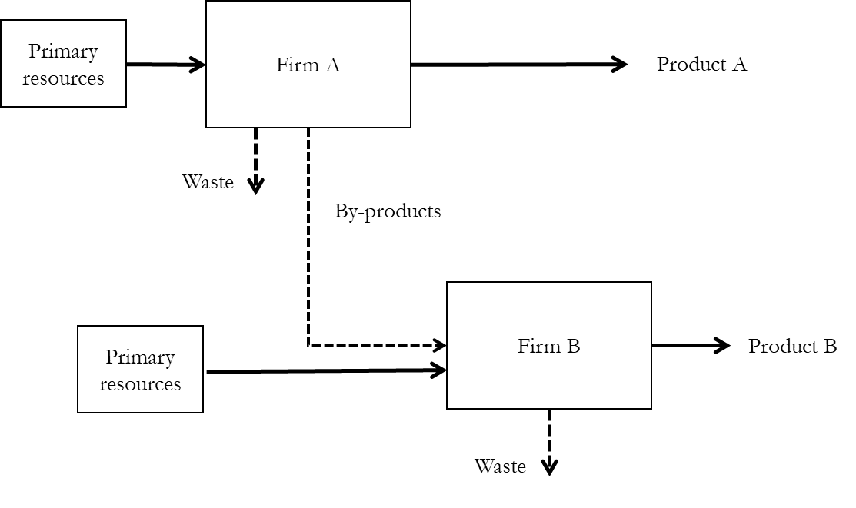

Figure – Industrial symbiosis network diagram

At the micro level of a single organisation, CE interventions support the design of reverse supply chains, recycling, reusing or remanufacturing end-of-life products (Bocken et al., 2016). This has been reflected in another literature stream, concerned with reverse logistics (RL) and closed-loop supply chains (CLSCs). CLSCs deal with the practice of taking back products from customers and returning them to the original manufacturer for the recovery of added value by reusing the whole product or part of it (Batista et al., 2018). The original objective of the RL and CLSC management literature is strictly related to the economic dimension: to manage the recovery of after-use products (or even, in the case of the fashion industry, the recovery of returned products) in order to capture additional economic value, which can be obtained by keeping resources in use.

As such, advanced CSCs should incorporate elements from all the literature streams discussed above, in an attempt to:

* Operationalise production methods that account for the full life cycle cost (including environmental and social dimensions) for goods and services (Andersen, 2007; Webster, 2017);
* Developing a holistic system perspective, enabling full visibility for all actors, processes and materials involved in the manufacturing process, in order to understand hotspots in terms of environmental impacts, resource consumption and waste creation (Genovese et al., 2017);
* Enable regenerative and restorative processes to valorise material flows and waste as a resource according to an Industrial Ecology view. CSCs have the ambition of extending resource exchange and efficiency dynamics even outside the border of localised Industrial Symbiosis networks (EMAF, 2015; Bocken et al., 2016; Webster, 2017; Batista et al., 2018).

### Circular Supply Chains: Key definitions

CSCs, which are illustrated in Figure 2, can activate metabolisms that allow for methods of production that are self-sustaining and in which materials are used multiple times. This is possible by emphasising: product, parts and material reuse; material recycling; the use of renewable energy sources throughout supply chains (Bocken et al., 2016).

According to Batista et al. (2018), CSCs can be viewed as systems based on:

* the minimisation of waste disposal processes through reusing, repairing, remanufacturing and recycling processes;
* the delivery of functionality and experience (value in use), rather than product ownership;
* the promotion of management approaches that build upon a collaborative or shared consumption model.

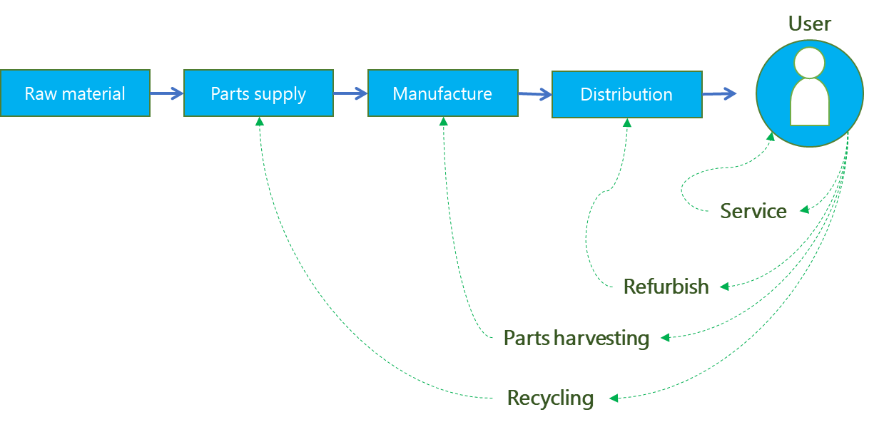

Figure 2 – Forward and reverse activities in a Circular Supply Chain

While the literature recognises many other frameworks to classify CE practices (e.g. 3R, 9R), the 4R framework represents the core of the European Union Waste Framework Directive (European Commission, 2008).

The first *R* identifies r*educe* practices*,* which prevent resource use, either by redefining product functions, or through rethinking and redesigning goods and services. Examples of such practices include: the redesign of products or their packaging; the promotion of modular product design; the redesign of manufacturing infrastructure; the promotion of collaborative consumption practices (e.g., those based on a ‘sharing economy’ paradigm); the move towards a performance-based or service-based business model, rather than one based on simple products.

*Reuse practices* include repairing, preventive maintenance and refurbishing actions and generally aim to reutilise products (or components) in their original function.

*Recycling practices* aim at recycling and reprocessing materials from parts or products. Also, the remanufacturing of parts and components falls into this category. Common practices involve: the reutilisation of by-products; recycling of parts, components and materials; utilisation of recycled materials; packaging recycling; and investments in recycling infrastructure.

*Recover practices* involve energy recovery from by-products or waste, either directly or through the production of alternative fuels like biofuels.

In the European context, over the last few years, several companies (both Small Medium Enterprises and Multinational Enterprises) claim to have made changes in the way they operate, by introducing different CE practices across their supply chains. However, there is limited understanding of what are the practices that have been adopted and also of what are the drivers and mechanisms that are influencing the adoption of CE practices in industrial organisations (Lahane et al., 2020). This is the motivation for the research project and justifies the choices on how to structure the literature review process.

### The rationale of the literature review process

The literature review process is structured to explore both the grey literature and academic literature (Figure 3). The two analyses were conducted in parallel and informed each other. The analysis of the grey literature consisted of an analysis of the state-of-the-practice in terms of adoption of CE practices by the business community. This study is included in Chapter 2 and has partially informed the analysis of the academic literature which is in this Chapter. The academic literature review focused on analysing the drivers and mechanisms behind the adoption of CE practices, and more specifically on examining the role of institutional pressures and supply chain integration. The review led to the formulation of the research questions and of a conceptual framework, which put in relationship the identified variables that are relevant for the research problem.

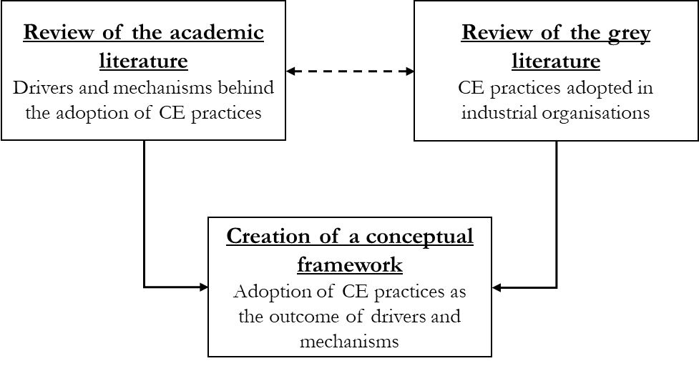

Figure 3 – The rationale of the literature review process (academic and grey literature)

## Adoption of CE practices in supply chains: a critical literature review

Through the introductory study of the state-of-the-practice (Chapter 2), the main types of CE practices, and their drivers are identified, and two broad propositions are generated. In this section of the chapter, a critical literature review explores the role of institutional pressures and of supply chain integration in driving or enabling the adoption of CE (and, more widely, of ‘sustainable’ and ‘green’) practices in firms and in their global supply chains.

### Overview of the key theories and concepts

This section gives a general overview of the key theories and ideas identified in the state-of-the industrial practice: institutional theory and supply chain integration.

2.1.1 Institutional theory

Institutional theory (IT) analyses the role of institutions in society to explain social phenomena. Institutions represent beliefs, rules and social norms, which are established in a defined context and produce stability and order (Scott, 2003). Social actor gives meaning and internalise these factors, which are able to shape their actions and decisions.

Using IT lenses in organisational studies means looking at firms’ decisions as determined by the context within which they act, and by the economic, social, political pressures they deal with. Organisations draw their structures and adopt strategies and practices that are defined as appropriate by the institutional environment, avoiding actions and behaviours that could de-legitimise them. Despite rational choice theory suggesting that firms act mainly to improve their economic efficiency, according to IT they could also strive for other objectives: reducing uncertainty and gaining political power or institutional legitimacy (DiMaggio & Powell, 1983).

This perspective is partially in contrast with the resource based view of the firm – advocating that firms’ individual efforts to achieve competitive advantage are based in the development and orchestration of unique valuable and non-imitable resources, and in differentiation. According to IT, once a set of organisations has established itself as the norm, individual efforts to deal with increased uncertainty tend to produce homogeneity in the organisational structures, culture and output. This process is called *isomorphic change* and acts through three mechanisms, which act on different basis of compliance, order and legitimacy (Table 1):

* *coercive pressure* acts through laws and rules: organisations take decisions on the on the basis of their fear to avoid sanctions;
* *normative pressure* originates from binding expectations of social norms: organisations are influenced not only by formal rules, but also by what is viewed to be appropriate and socially accepted;
* *mimetic pressure* involves shared conceptions and beliefs: organisations follow taken-for-granted dynamics and imitates best practices from other successful social actors, which have established themselves (Scott, 2003).

Table 1 – Institutional pressures and mechanisms of compliance (adapted from Scott, 2003)

|  |  |  |  |
| --- | --- | --- | --- |
|  | Coercive | Normative | Cognitive |
| Logic | Instrumentality: follow rules to avoid sanctions | Appropriateness: follow binding expectations of social norms | Orthodoxy: follow taken-for-granted beliefs |
| Basis of order | Regulative rules | Expectations | Constitutive schema |
| Indicators | Laws/regulations | Standards/certifications/ guidelines | Common belief  Shared logics of action |
| Examples from the review of the grey literature | EU ban on single-use plastic | Alliance to end plastic waste  Global Battery Alliance | Offer ‘green’ products for households and for businesses |

Following the increasing importance of supply chain networks in global competition (Ketchen and Hult, 2007), IT – and some other organizational theories (e.g., CSR, Stakeholder theory) – have increasingly adopted the supply chain as the level of analysis (Sarkis et al., 2011), rather than the single firm. This is because supply chain participants can cooperate and accept a role in the ‘supply chain organisation’ (Ketchen & Giunipero, 2004), performing activities to reach a common goal – in a way that is comparable to what happens at the level of the single organisation. Within the modern globalised production and consumption systems, the largest part of the value creation process lies outside of the single firm’s boundaries and looking at the supply chain level and at inter-firm dynamics, can help explain some outcomes more than any other levels (Ketchen & Giunipero, 2004).

Institutions embrace a set of values and norms that can change over time: IT has been used to understand how organisations adapt their behaviour to these changes. In the last decades, concepts like ‘sustainability’, ‘climate change’ and ‘circular economy’ have gradually been promoted in the public debate and became – to different extents – institutionalised. Some patterns of actions and outcomes in practices and structures became the norm: new laws and regulation have been introduced; more and more businesses have a sustainability, climate or CE strategy and disclose it through their reporting.

For these reasons, and following some suggestions from previous studies (Ranta et al., 2018; Widmer & Prior, 2019), the literature is explored to assess whether institutional theory can be applied in the context of the research questions, to understand CE adoption in supply chains.

2.1.2 Supply Chain Integration

Supply chain management has become a strategic process, and the effective design and operation of the supply chain can explain firms’ performance (Ketchen & Giunipero, 2004; Ketchen & Hult, 2007; MacCarthy et al., 2016). In this context, adopting some rare, valuable and difficult to duplicate practices in the supply chain can provide competitive advantage, since competition itself has shifted from being at the level of the single firm, to the supply chain level (Ketchen & Giunipero, 2004; Ketchen & Hult, 2007).

Part of the organisational science literature has studied supply chains as single entities, where supply chain participants cooperate and use their own and inter-organisational resources to reach shared goals (Gold et al., 2010). The concept of supply chain integration is established in the literature, and it has been measured according to standard dimensions and items (Table 2). Highly integrated supply chains have these characteristics: share information with their partners; create stable and long-term relationships with key suppliers and customers; involve supplier and customers in the design products and services; engage in development programs with suppliers; couple IT systems across the supply chain to improve the overall responsiveness of and to minimise inefficiencies.

An increased level of integration between suppliers and customers can bring significant benefits. The wider the level of integration of internal processes with supplier and customer ones, the greater the performance improvement in terms of delivery, flexibility, quality and cost performance (Frohlich & Westbrook, 2001; Chen et al., 2009; Schoenherr & Swink, 2012), as well as sustainability performance (Wiengarten & Longoni, 2015). Although SCI concept traditionally focuses on forward supply chain activities without explicitly considering reverse supply chain ones, it can play a role in how sustainability practices are adopted by businesses and extended in their supply chains. The effect of SCI was studied also in the context of industrial symbiosis networks, which constitute a prototype of the closed-loop supply chain, where resources and waste are exchanged in a comprehensive view. Also in this context, some SCI constructs (e.g. collaboration with supply chain partners) play an important role in improving the overall environmental and economic performance (Herczeg et al., 2018).

Table – Supply chain integration in the literature

|  |  |  |
| --- | --- | --- |
| SCI dimension | Examples | Authors |
| Sharing information with key suppliers/customers | sales forecast  production plans  order tracking and tracing  delivery status  stock level | (Frohlich & Westbrook, 2001; Schoenherr & Swink, 2012; Wiengarten & Longoni, 2015; Wiengarten et al., 2019) |
| Developing collaborative approaches with key suppliers/customers | supplier development  risk/ revenue sharing  long-term agreements | (Frohlich & Westbrook, 2001; Schoenherr & Swink, 2012; Wiengarten & Longoni, 2015; Wiengarten et al., 2019) |
| Joint decision-making with key suppliers/customers | product design/modifications  process design/ modifications  quality improvement  cost control | (Frohlich & Westbrook, 2001; Schoenherr & Swink, 2012; Wiengarten & Longoni, 2015; Wiengarten et al., 2019) |
| System coupling with key suppliers/customers | vendor-managed inventory  just-in-time  Kanban  continuous replenishment | (Frohlich & Westbrook, 2001; Schoenherr & Swink, 2012; Wiengarten & Longoni, 2015; Wiengarten et al., 2019) |

On the other side, the absence of those mechanisms could make the adoption of CE practices more difficult: for example, it would be very difficult for a supply chain where participants do not share information on material flows to effectively operationalise feedback loops related to reuse, remanufacturing, or recycling. For these reasons, SCI might be an enabling mechanism of CE practices adoption also in the context of transition towards CSCs and support the creation of regenerative and restorative processes. Also the relationship of SCI with the adoption and the extension of CE practices in supply chains will be evaluated in the literature.

### Review protocol

To identify and evaluate the most important research contributions connected with the two ideas of institutional theory and supply chain integration and with the research objective – understanding the transition towards the CE in supply chains – the literature was reviewed. The literature review process was inspired by two guiding questions and by the objective of explaining the relationship among the variables involved: institutional pressures, supply chain integration and adoption of CE practices (see Figure 4). No published literature review has been conducted on this topic.

First the appropriate method to conduct the literature review was chosen, taking into account the purpose of the research project. The most helpful approach was identified as the critical review for two reasons:

* The underlying guiding questions refer to different ideas (e.g., adoption of CE practices, institutional pressures, and supply chain integration), which have been developed independently from each, rather than in a connected way. The critical literature review approach is valuable for combining these different perspectives from the mentioned research areas and creating new theoretical models.
* The objective of the review is to identify the most relevant and established ideas and key findings in the literature, rather than summarising all the material that has been published in a systematic way. For this reason, the idea of conducting a systematic review was excluded. However, a review protocol was developed and followed, and every choice was documented in a systematic way.

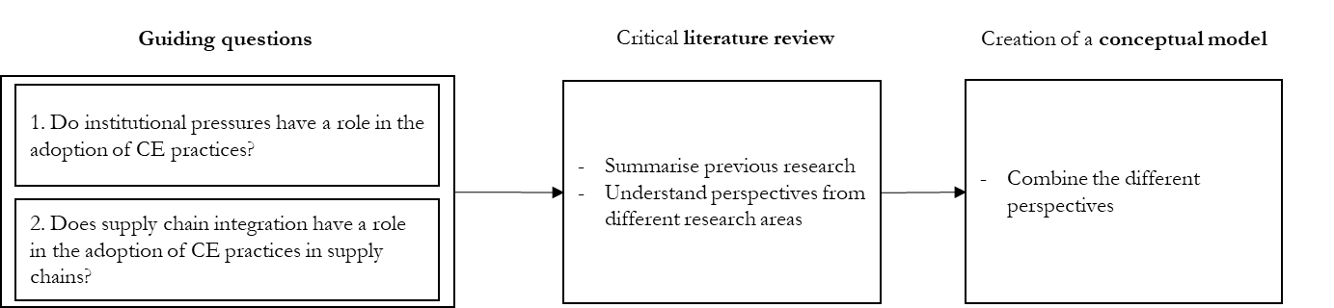

Figure 4 – The rationale of the critical literature review process

The critical review was characterised by 4 steps (Figure 5):

1. research question formulation;
2. keyword-based identification of a first subset of significant research to the topic;
3. snowballing search process and selection of the most relevant and significant research to the topic;
4. analysis and synthesis of findings.

### Research question formulation

The initial guiding questions of the review were investigating the relationship between the variables: institutional pressures and of supply chain integration with the adoption of CE practices:

1. Do institutional pressures have a role in the adoption of CE practices?
2. Does supply chain integration have a role in the adoption of CE practices in supply chains?

Keyword strings were chosen in order to maximise the number of results extracted. The literature was examined using the Scopus database, which is considered one of the most relevant repositories of peer-reviewed papers. A first keyword based search, which was strictly focused on the CE literature stream, did not return a sufficient number of papers (Table 3).

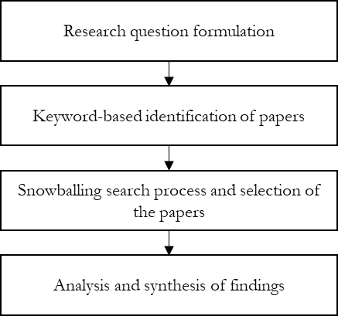

Figure 5 – Flowchart of the research process followed for the critical review

This is not surprising, as the recently developed literature on the CE (Borrello et al., 2020) has mainly focused on micro (e.g. the single firm or product line) and macro (e.g. region, state) levels of analysis and, more rarely, on the meso (e.g. supply chain) one (Ghisellini et al., 2016; Merli et al., 2018). Also, literature on Circular Supply Chain Management has rarely used theories to examine the adoption of CE practices (Lahane et al., 2020).

For these reason, the guiding questions (and accordingly the related keyword strings: see Table 3, II Step) have been widened, in order to include the more traditional Supply Chain Management (SCM) literature, which has already analysed the drivers of ‘sustainable’ and ‘green’ practices and also the role of supply chain configuration in the adoption. Considering similar literature and research areas improves the definition of constructs and enhances the theoretical level and the possibility to generalise findings (Eisenhardt, 1989).

The final guiding questions were (Figure 6):

1. Do institutional pressures have a role in the adoption of CE, ‘green’, ‘sustainable’ practices?
2. Does supply chain integration have a role in the adoption of CE, ‘green’, ‘sustainable’ practices in supply chains?

Table 3 – Strings used in the first keyword based search

|  |  |  |
| --- | --- | --- |
| String name | I Step | Results |
| String I.i | “institutional pressur*” AND "supply chain integration" AND "circular*" | 0 |
| String I.ii | “institutional pressur *” AND "supply chain" AND "circular*" | 24 |
| String I.iii | "supply chain integration" AND "circular*" | 6 |
| String I.iv | "circular economy” AND "supply chain" AND "driver" | 36 |
|  | II Step |  |
| String II.i | (("institutional pressur*" OR "supply chain integration") AND ("circular*" OR "green" OR "sustainable" OR "industrial symbiosis")) | 313 |
| String II.ii | "circular economy" AND "supply chain” AND "driver" | 36 |

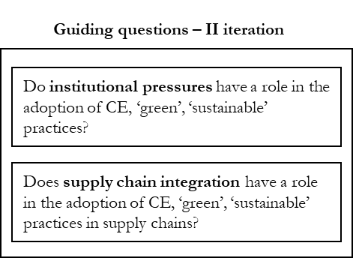

Figure 6 – The final guiding questions

2.3.1 Identification and selection of the most relevant and significant research to the topic

According to the critical review process, the most relevant and significant research on the topic has to be identified. As knowledge related to the research topic is fragmented and relates to different research streams, the identification process should be designed taking into account such complexities. To consider all the relevant research the first keyword-based search was followed by a snowballing process. Guidelines were built, followed and documented carefully.

The 349 papers extracted with String II.i and II.ii (see Figure 7) were firstly analysed and selected. Whether a paper was included or excluded was based on analysing its title and its abstract:

* Papers that described the adoption CE, ‘green’, and ‘sustainable’ practices as being driven by institutional pressures, have been *included*.
* Papers that analysed the effect of the adoption of CE, ‘green’, and ‘sustainable’ practices on firms’ or supply chains’ performance, without focusing on the process of adoption of CE practices, were *excluded;*
* Papers that analysed the role of supply chain integration in the transition towards CE in supply chains, have been *included*.
* Papers which applied institutional theory without a clear focus on supply chains or organisations, were *excluded;*
* Papers that described the adoption CE practices through case studies, as well as the drivers and barriers behind CE adoption in supply chains, were all *included*.

The 20 shortlisted papers include recognised leading experts’ works in the fields of the CE and Supply Chain Management (Table 4). These papers were then read in their entirety and used as the starting point of a snowballing process (Saunders & Rojon, 2011). During the snowballing process, further relevant works were identified by looking at the references of the first subset of papers. For each paper, both citing and cited articles were included. The iterative process continued until there were no new articles.

A total of 21 papers were gathered through the iterative snowballing process (see Figure 7). The resulting 41 papers were considered a good sample and were read in their entirety. These papers are classified in Table 5 into the three classes which highlight their contribution to the following critical review. The first class of papers gathers the most relevant pieces of work on CE practices, drivers and barriers at the supply chain level. This group of papers is foundational to an introduction to the research problem and the theoretical background, to integrate what has already been presented in Chapter 2 with a literature review. The second class collects the key contributions that have focus on the relationship between institutional pressures and the adoption of CE, ‘green’ and ‘sustainable’ practices. The third class centres on the effect of SCI on the adoption of CE, ‘green’ and ‘sustainable’ practices, and also on the effect between SCI on the relationship between institutional pressures and the adoption of CE, ‘green’ and ‘sustainable’ practices.

Table 4 – Examples of the shortlisted papers

|  |  |  |  |
| --- | --- | --- | --- |
| Authors | Title | Year | Source |
| Vachon S., Klassen R.D. | Extending green practices across the supply chain: The impact of upstream and downstream integration | 2006 | International Journal of Operations and Production Management |
| Escobar L.F., Vredenburg H. | Multinational Oil Companies and the Adoption of Sustainable Development: A Resource-Based and Institutional Theory Interpretation of Adoption Heterogeneity | 2011 | Journal of Business Ethics |
| Zhu Q., Sarkis J., Lai K.-H. | Institutional-based antecedents and performance outcomes of internal and external green supply chain management practices | 2013 | Journal of Purchasing and Supply Management |
| Tate W.L., Ellram L.M., Kirchoff J.F. | Corporate social responsibility reports: A thematic analysis related to supply chain management | 2010 | Journal of Supply Chain Management |
| Hoejmose S.U., Grosvold J., Millington A. | The effect of institutional pressure on cooperative and coercive 'green' supply chain practices | 2014 | Journal of Purchasing and Supply Management |
| Herczeg G., Akkerman R., Hauschild M.Z. | Supply chain collaboration in industrial symbiosis networks | 2018 | Journal of Cleaner Production |
| Zeng H., Chen X., Xiao X., Zhou Z. | Institutional pressures, sustainable supply chain management, and circular economy capability: Empirical evidence from Chinese eco-industrial park firms | 2017 | Journal of Cleaner Production |
| Govindan K., Hasanagic M. | A systematic review on drivers, barriers, and practices towards circular economy: a supply chain perspective | 2018 | International Journal of Production Research |
| Masi D., Day S., Godsell J. | Supply chain configurations in the circular economy: A systematic literature review | 2017 | Sustainability (Switzerland) |

Analysis and synthesis

The content of all the papers was analysed. The main objective was to analyse the nature of the relationship among the identified concepts, and the creation of a conceptual model, which could be supported by the existing literature. The results of the content analysis are examined in the Section 2.4.

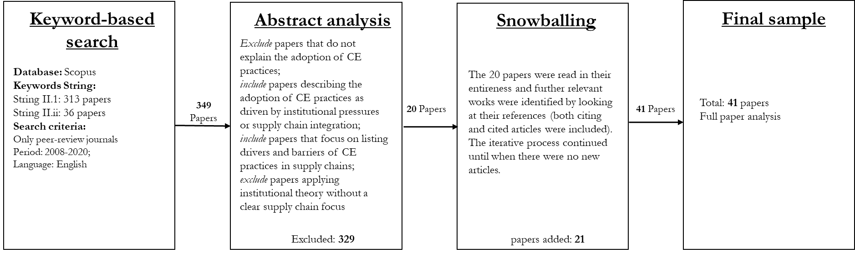

Figure 7 – Flowchart of the critical literature review process

Table 5 – The papers included in the critical review of the literature

|  |  |
| --- | --- |
| CE practices, drivers and barriers | (Genovese et al., 2017; Masi et al., 2017, 2018; Sihvonen & Partanen, 2017; Stewart & Niero, 2018; Govindan & Hasanagic, 2018; Ranta et al., 2018; Bressanelli et al., 2019; Gusmerotti et al., 2019; Mishra et al., 2019; Ruokonen & Temmes, 2019) |
| Institutional pressures & adoption of CE (or ‘green’) practices | (Jennings & Zandbergen, 1995; Darnall et al., 2008; Tate et al., 2010; Zhu et al., 2010, 2013; Arimura et al., 2011; Sarkis et al., 2011; Escobar & Vredenburg, 2011; Lin & Sheu, 2012; Glover et al., 2014; Saldanha et al., 2015; Touboulic & Walker, 2015; Chu et al., 2017; H. Zeng et al., 2017; Saeed et al., 2018; Testa et al., 2018; Liu et al., 2018; Caldera et al., 2019; Widmer & Prior, 2019) |
| Supply chain integration and adoption of CE (or ‘green’) practices | (Vachon & Klassen, 2006; Wu, 2013; Zhu & Geng, 2013; Sancha et al., 2015; Wiengarten & Longoni, 2015; Seles et al., 2016; Herczeg et al., 2018; N. Zeng et al., 2018; Pinto & Diemer, 2020; Wong et al., 2020) |

### Literature review results

The three themes identified in the literature search are discussed one by one in the following sub-sections. The main contribution of the papers is highlighted in the light of the possible contribution to the understanding of the research problem of the underlying research project.

2.4.1 Practices, drivers and barriers towards the CE in supply chain

CE literature has grown exponentially in the last few years (Merli et al., 2018; Borrello et al., 2020). The literature has already focused on reviewing CE practices, drivers and barriers in real world industrial context. Masi et al. (2018) identified green supply chain practices adopted in a sample of firms: companies’ efforts focused on resource and energy utilisation efficiency practices, while investment recovery, green purchasing and customer cooperation practices – which required an active involvement of the suppliers and customers – were rarely considered. An increasing number of scholars involved in sustainability studies, have performed systematic analyses of Corporate Sustainability (CS) reports. Ruokonen and Temmes (2019) concentrated on the mining sector and on the existing gap between commitments and implementation of sustainability actions. CS reports have been used to evaluate the diffusion and the quality of eco-design practices within ICT sector (Sihvonen & Partanen, 2017). Stewart and Niero (2019) assessed the CE practices in the Fast Moving Consumer Goods industry – linked with the reduction and prevention of waste streams, with the reuse of products and with the recycling of end of life materials. Gusmerotti et al. (2019) classified Italian manufacturing companies into clusters according to different levels of adoption of the CE paradigm: the great majority had still a linear business model, or focused only on improving resource efficiency, while a small portion was looked at increasing market competitiveness through a product stewardship strategy or at integrating CE principles in all business functions.

Different authors have expanded the scope of gathering CE applications, by investigating also drivers and barriers behind their implementation (Govindan & Hasanagic, 2018; Masi et al., 2018; Bressanelli et al., 2019; Gusmerotti et al., 2019). Economic drivers seem to be the most important for companies and weak economic incentives or high up-front investments for firms are classified as common CE barriers. Societal barriers referred to an absence of societal concern on resource scarcity and environment. The lack of the disclosure of environmental information by firms was one of the main informational barriers, while institutional ones referred, for example, to low taxes on virgin materials, which could undermine the economic convenience of CE initiatives. The most frequently mentioned barriers in the literature (Govindan & Hasanagic, 2018) are consumers’ perception towards reused components, and technological limitations on the tracking of recycled materials. Other studies mentioned other classes of barriers while confirming the presence of technical challenges (Bressanelli et al., 2019; Masi et al., 2018). By exploring real implementation challenges, other authors conclude that most of the barriers are cultural and institutional: low prices of virgin materials, lack of consumer acceptance, as well as lack of awareness in company culture (Kirchherr et al., 2018). Accordingly, the role of government is highlighted (Genovese et al., 2017; Govindan & Hasanagic, 2018), to build incentives for business initiatives and win market barriers.

Some initial studies have mentioned both institutional pressures and supply chain integration. Ranta et al. (2018) adopted IT lenses to evaluate drivers and barriers in different institutional environments (China, Europe and the USA): recycling was the primary CE action, whereas other CE practices, like reuse appeared not to be supported by the regulatory nor the cultural-cognitive institutional environment (Ranta et al., 2018). Bressanelli et al. (2019) identified the most relevant challenges for CSCs and also the mechanisms organisations could use to address them. Some challenges included market cannibalisation of CE products and the impact of fashion changes, while some of the mechanisms could be linked to the concept of SCI – for example establishing partnerships or sharing information among different supply chain actors (Bressanelli et al., 2019). Collaboration across the whole value chain - sharing knowledge on products and processes, developing collaborative approaches (training for supplier development) investing in systems – is considered an enabler of CE adoption (Mishra et al., 2019). However, most of the mentioned articles had primarily a descriptive purpose and were not aiming at exploring factors behind the transition of supply chains towards the CE from a theoretical point of view.

The literature on the CE at the supply chain level is grounded mainly on single cases and best practices. Factors and variables that drive or inhibit the adoption of CE practices are identified and described, but the discussion looks a-theoretical: there are no large-scale studies, which try to generalise findings or to test relationships among the identified factors. However, the more traditional Supply Chain Management (SCM) literature has already analysed the antecedents of ‘sustainable’ and ‘green’ practices and also supply chain configurations that could best support their adoption, as the next two sub-sections will show.

2.4.2 Institutional theory and CE and ‘green’ practices adoption in firms

The introduction of sustainability agendas in the last decades of the 20th century – together with all the other forces like regulation, the growing sensibility of consumers to environmental protection and labour dignity, the relevance of certification and standards and corporate long-term pledges (*carbon neutrality, zero plastic waste, modern slavery act*) – was able to shape the configuration and the operation mode of supply chains (MacCarthy et al., 2016). Organisations have been focusing on how to integrate environmental and social concerns in their supply chains; how to reduce negative impacts of production and consumption; how to shift from a shareholder centred to a stakeholder centred perspective, which consider both environment and society.

In this context, SSCM and GSCM research investigated the impact of ‘green’ and ‘sustainable’ practices in the reduction of the negative impacts of firms’ operations and of their entire supply chains. Also, GSCM literature has been recently connected with the concept of the CE: Green Supply Chains are considered an important unit of action towards the CE (Liu et al., 2018). GSCM practices work across different stages of the value creation process (e.g., design, sourcing, procurement, production, distribution, end-of-life management) and include five major elements: green purchasing, eco-design or design for the environment, internal environmental management, customer cooperation for environmental concerns, and investment recovery (Liu et al., 2018). The adoption of GSCM practices drives the CE performance (Zhu et al., 2011) and CE Capability of the firm (Zhu et al., 2011; H. Zeng et al., 2017).

Institutional pressures (some examples can be seen in Table 6) are widely considered to be one of the main drivers of ‘green’ and ‘sustainable’ practices in organizations and their supply chains (Sarkis et al., 2011; Zhu et al., 2013; Touboulic & Walker, 2015), and the most important factor behind triple-bottom-line integration in corporations strategy in every industrial sector (Tate et al., 2010). In SSCM and GSCM literature, IT lenses are adopted to explore a variety of aspects: what pressure enables the adoption of which practice; the circumstances of adoption and diffusion; the role of standards and certification; the role of government and of laws; the dynamics inside the supply chains; the challenges that this transition poses in presence of multiple institutional context, like in the case of global network of supply and markets.

Table 6 – Examples of institutional pressures in SCM literature

|  |  |
| --- | --- |
| Constructs | Examples of pressures |
| Coercive Pressure | National/Regional environmental regulations (such as waste emission, cleaner production etc.) (Zhu et al., 2013)  National/ Regional resource saving and conservation regulations (Zhu et al., 2013)  Market – customers (Lin & Sheu, 2012; Glover et al., 2014)  Market – suppliers (Lin & Sheu, 2012; Glover et al., 2014) |
| Normative Pressure | Environmental requirements from customers (Zhu et al., 2013)  Environmental awareness of customers’ (Zhu et al., 2013)  Media attention in the industry (Zhu et al., 2013)  Public environmental awareness (community, NGO etc.) (Zhu et al., 2013) |
| Mimetic Pressure | Competitors’ adoption and ‘green’ practices (Zhu et al., 2013)  Industrial professional group activities (Zhu et al., 2013)  Green strategy of same product producers (Zhu et al., 2013)  Green strategy of substitute product producers (Zhu et al., 2013) |

The transition towards green supply chains follows a clear dynamic (Zhu et al., 2013; Saeed et al., 2018) and to understand it, it is necessary to introduce the distinction between ‘internal’ and ‘external’ GSCM practices: internal GSCM practices (e.g. eco-design and internal environmental management) can be adopted by a single firm in the supply chain independently; external GSCM practices (e.g. customer cooperation, green purchasing, and investment recovery) require the involvement and the cooperation with other actors in the supply chain. Driven by institutional pressures, a first proactive actor in the supply chain takes the initiative and adopts one or more internal GSCM practices across its internal functions. Once the first firm in the supply chain has adopted internal GSCM practices, it tries to extend them to some of its external partners (e.g., suppliers, distributors, customers). For this reason, the adoption of external GSCM practices is driven not only by institutional pressures, but also by the presence of internal GSCM practices (Darnall et al., 2008; Zhu et al., 2013) since it requires the coordination with internal teams and the support of management (Dubey et al., 2019). Institutional pressures drive both ‘internal’ and ‘external’ GSCM practices, and the presence of internal GSCM practices drives the adoption of external GSCM practices. This point will be better articulated in the next subsection, where the role of supply chain integration will be explored.

The literature also widely explored the effect of institutional pressures on global supply chains. MNEs adopt CE or GSCM practices depending on the presence of strong institutions, typical of the Global North (Li et al., 2018), or of the institutional void, in the Global South (Chiappetta Jabbour et al., 2020). Different institutional contexts and distance from suppliers might also cause some challenges: decoupling (Saldanha et al., 2015; Huq & Stevenson, 2020), or higher sustainability risk (Busse et al., 2016). In such a context, coercive and normative pressures might have no effect, and mimetic pressure could be the only pressure driving Multi-National Corporations to adopt sustainable development practices (Escobar & Vredenburg, 2011; Sancha et al., 2015).

2.4.3 Extending green practices in the supply chain – the role of supply chain integration

Once a firm has adopted CE practices, it can use different approaches to involve its supply chain. The way its supply chain is organised and configured plays an important role as to how these practices can be spread in the supply chain. Suppliers and customers could be forced to adopt practices through coercive pressures coming from market, economic and power mechanisms (Hoejmose et al., 2014). Concentrating on the dairy supply chain in the UK, Glover at al. (2014) explained that the dominant position of supermarkets in the network translated in to coercive pressures on suppliers to adopt energy reduction practices (Glover et al., 2014). That same process is named by Seles et al., (2016) ‘green bullwhip’ effect, i.e., the adoption of GSCM practices, which is driven by institutional pressures, exerts institutional pressures itself over on the other supply chain tiers.

Otherwise, supply chain actors can be involved through integration and collaboration, using a cooperative approach in reducing risk, sustaining costs and investments and sharing information and knowledge. A higher supply chain integration is generally associated with many benefits. The ability to work together with supply chain partners supports the development of inter-organisational resources with supply chain partners, which could bring to competitive advantage (Gold et al., 2010); enables radical and incremental innovation (Soosay et al., 2008); reduces uncertain outcomes of green product and process innovation (Wong et al., 2020). Technological integration with primary suppliers and with major customers is positively linked to GSCM adoption in the supply chain (Vachon & Klassen, 2006), which translates in superior economic and environmental performance. Cooperating with first-tier or second-tier suppliers, can mitigate their difficulties in responding to environmental pressures and enable the diffusion of practices throughout the supply chain.

SCI has been considered an enabling factor in the transition of the construction and steel supply chains towards a closed-loop paradigm in the utilisation of resources ( Zeng et al., 2018) (Berlin et al., 2019; Pinto & Diemer, 2020). Also in the context of eco-industrial parks, the presence of supply chain integration supports the adoption of industrial symbiosis practices – where waste streams are exchanged between organisations belonging also to different supply chains and utilised as resources (Herczeg et al., 2018).

Finally, SCI is considered as an enabling firm capability in global supply chains. In this context mimetic isomorphism can explain MNEs adoption of sustainable practices (Escobar & Vredenburg, 2011), while coercive and normative pressures have no effect (Sancha et al., 2015). SCI positively moderates the effect of mimetic pressure on the adoption of sustainable supplier practices (Sancha et al., 2015).

### Key findings from the literature review: research questions

Starting from the general propositions derived from the grey literature (Chapter 2), the critical literature review confirmed that institutional pressures and supply chain integration might have a relationship with the adoption of CE practices in supply chains. The recent literature on the CE did not explore from a theoretical point of view the process of adoption of CE practices in supply chains and did not try to generalise findings (see sub-section 2.4).

However, the exploration of the more traditional Supply Chain Management (SCM) literature gave theoretical relevance to the general propositions. SCM literature has already analysed the antecedents of ‘sustainable’ and ‘green’ practices, and also supply chain configurations that could best support their adoption. In that context, institutional pressures have been considered drivers of the adoption of ‘green’ and ‘sustainable’ practices; supply chain integration have been considered an enabler that in presence of institutional pressures support the adoption of these practices also in suppliers and customers.

As a result of the critical literature review, three research questions (RQs) can be derived: institutional pressures and SCI might have a relationship with the adoption of CE practices: institutional pressures might be an important driver also of the adoption of CE practices in supply chains, while SCI can be an enabling mechanism. These factors might play a role in whether CE practices are adopted or not, in determining which type of CE practices is adopted and at what level of implementation.

Based on these findings, this research project is an attempt to give an answer to the following research questions:

**RQ1:** What relationship do institutional pressures have with the adoption of CE practices?

**RQ2:** What relationship does SCI have with the adoption of CE practices?

**RQ3:** How does SCI interact with the relationship between institutional pressures and the adoption of CE practices?

These three research questions lead to the creation of a conceptual framework that is explained in the following sub-chapter and that will be tested during the research project.

## Conceptual Framework and Research Hypotheses

This section summarises the findings of the review of the industrial practice (Chapter 2) and of the academic literature review (Chapter 3). Also, it offers some hypotheses that will be analysed, discussed, and tested through a coherent methodology in this thesis.

On the basis of the evidence provided, and the support in the analysed literature, we hypothesise that there is a causal link between institutional pressures and the adoption of CE practices: this finds foundation in papers mentioned in sub-sections Chapter 2, Section 2.4 (Sarkis et al., 2011; Lin & Sheu, 2012; Zhu et al., 2013; Genovese et al., 2017; Liu et al., 2018; Kirchherr et al., 2018; Ranta et al., 2018; Bressanelli et al., 2019) according to which the institutional environment is a driver (or inhibitor) of CE practices adoption in firms.

**RQ1:** What relationship do institutional pressures have with the adoption of CE practices?

**Hp1:** Institutional pressures drive the adoption of CE practices in firms;

**Hp1a:** Coercive pressure drives the adoption of CE practices in firms;

**Hp1b:** Normative pressure drives the adoption of CE practices in firms;

**Hp1c:** Mimetic pressure drives the adoption of CE practices in firms;

We hypothesise also that SCI has a relationship with the adoption of CE practices and also that it positively moderates the hypothesised relationship between the institutional pressures and the adoption of CE practices in supply chains: this second proposition finds support in the studies of Wong et al. (2020), Bressanelli et al. (2019), Herczeg et al. (2018), Sancha et al. (2015) and Wu (2013). Once the first organisation has adopted CE practices, having a high level of integration with its supply chain can support to spread those practices, thus enabling the transition towards circular, green and sustainable production and consumption systems.

**RQ2:** What relationship does supply chain integration have with the adoption of CE practices?

**Hp2:** SCI drives the adoption of CE practices in firms;

**Hp2a:** Customer integration drives the adoption of CE practices in firms;

**Hp2b:** Supplier integration drives the adoption of CE practices in firms;

**RQ3:** How does supply chain integration interact with the relationship between institutional pressures and the adoption of CE practices?

**Hp3:** Supply chain integration moderates the relation between institutional pressures and the adoption of CE practices in the supply chain;

**Hp3a:** Supply chain integration moderates the relation between coercive pressure and the adoption of CE practices in the supply chain;

**Hp3b:** Supply chain integration moderates the relation between normative pressure and the adoption of CE practices in the supply chain;

**Hp3c:** Supply chain integration moderates the relation between mimetic pressure and the adoption of CE practices in the supply chain;

We propose a conceptual framework (Figure 8), which will be tested in future studies. The three main building blocks of the framework have been identified: adoption of CE practices, SCI and institutional pressures.

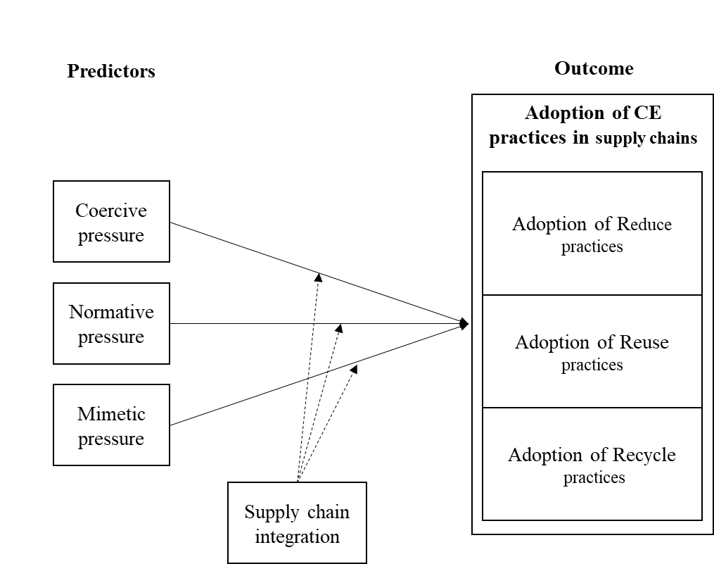

Figure 8 – Hypothesised conceptual model on the relationship among the variables

The same conceptual framework could be explained as a two-step process (Figure 9). The first step represents the adoption of CE practices by the first firm in the supply chain, as driven by institutional pressures. The second step represents the expansion of CE practices in suppliers and customers. SCI is hypothesised to moderate this process (Sancha et al., 2015; Seles et al., 2016).

Further steps include the validation of the framework. The need to verify such potential causal relationship constitutes an interesting research gap that should be further investigated and proved by more articulated inferential studies. This will be discussed in Chapter 5.

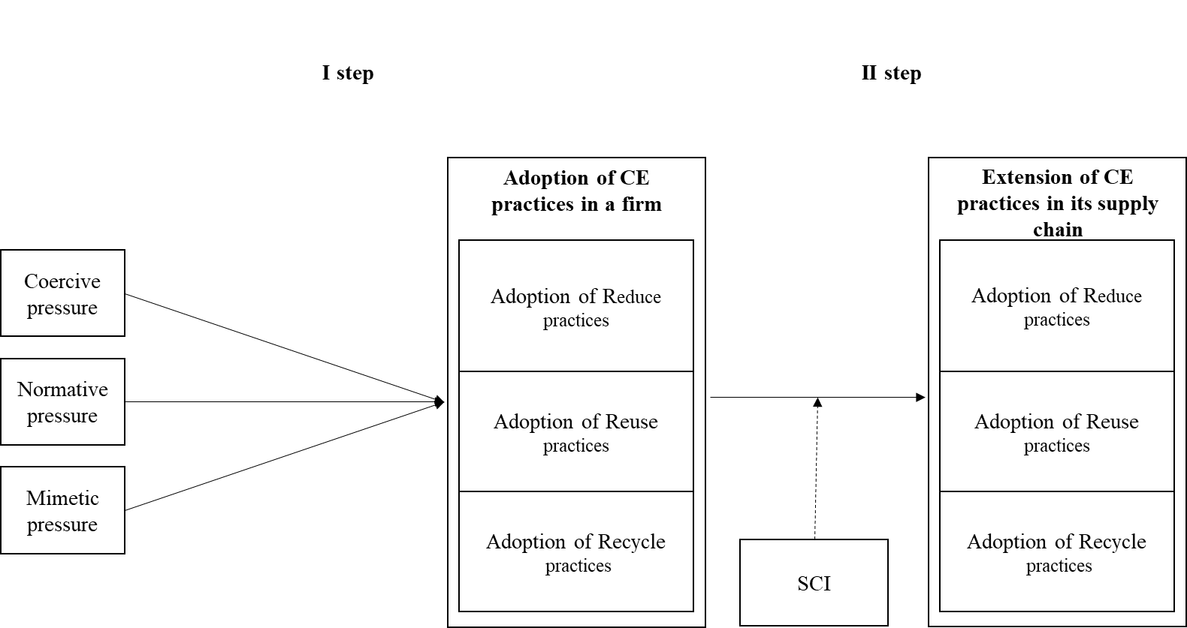

Figure 9 – The two-step conceptual model derived from the literature review

## Chapter’s conclusion

This chapter has focused on the literature review behind the research problem. Two factors were identified through reviewing Multi-National-Enterprises Sustainability reports (Chapter 2), which might play a role in driving and in enabling the transition towards the CE in supply chains. After having presented the key concepts and ideas, the results of the critical literature review were presented. A conceptual model derived from the literature describes the relationship among the variables.

## References

Ancarani, A., Di Mauro, C., Legenvre, H., & Cardella, M. S. (2019). Internet of things adoption: a typology of projects. International Journal of Operations and Production Management. https://doi.org/10.1108/IJOPM-01-2019-0095

Ancarani, A., Di Mauro, C., & Mascali, F. (2019). Backshoring strategy and the adoption of Industry 4.0: Evidence from Europe. Journal of World Business. https://doi.org/10.1016/j.jwb.2019.04.003

Andersen, M. S. (2007). An introductory note on the environmental economics of the circular economy. Sustainability Science, 2(1), 133–140. https://doi.org/10.1007/s11625-006-0013-6

Arimura, T. H., Darnall, N., & Katayama, H. (2011). Is ISO 14001 a gateway to more advanced voluntary action? The case of green supply chain management. Journal of Environmental Economics and Management, 61(2), 170–182. https://doi.org/10.1016/j.jeem.2010.11.003

Batista, L., Bourlakis, M., Smart, P., & Maull, R. (2018). In search of a circular supply chain archetype–a content-analysis-based literature review. Production Planning and Control, 29(6), 438–451. https://doi.org/10.1080/09537287.2017.1343502

Bell, E., Bryman, A., & Harley, B. (2018). Business research methods. Oxford university press.

Berlin, D., Feldmann, A., Nuur, C., & Tilliander, A. (2019). Supply chain collaboration in circular supply chains: The example of Swedish steel recycling. 1657–1666.

Bimpizas-Pinis, M., Calzolari, T., Genovese, A., Lowe, B., de Lima, F. A., MahmoumGonbadi, A., Seuring, S., Sudusinghe, J. I. (2021). ReTraCE Project, Realising the Transition towards the Circular Economy, D1.1, Measuring the transition towards circular supply chains: insights from academic literature and industrial practice. Available online at: http://www.retrace-itn.eu/wp-content/uploads/2020/07/ReTraCE-D1.1.pdf

Bocken, N. M. P., de Pauw, I., Bakker, C., & van der Grinten, B. (2016). Product design and business model strategies for a circular economy. Journal of Industrial and Production Engineering, 33(5), 308–320. https://doi.org/10.1080/21681015.2016.1172124

Borrello, M., Pascucci, S., & Cembalo, L. (2020). Three Propositions to Unify Circular Economy Research: A Review. 1–24. https://doi.org/10.3390/su12104069

Bressanelli, G., Perona, M., & Saccani, N. (2019). Challenges in supply chain redesign for the Circular Economy: a literature review and a multiple case study. International Journal of Production Research, 57(23), 7395–7422. https://doi.org/10.1080/00207543.2018.1542176

Busse, C., Kach, A. P., & Bode, C. (2016). Sustainability and the False Sense of Legitimacy: How Institutional Distance Augments Risk in Global Supply Chains. Journal of Business Logistics, 37(4), 312–328. https://doi.org/10.1111/jbl.12143

Caldera, H. T. S., Desha, C., & Dawes, L. (2019). Evaluating the enablers and barriers for successful implementation of sustainable business practice in ‘lean’ SMEs. Journal of Cleaner Production, 218, 575–590. https://doi.org/10.1016/j.jclepro.2019.01.239

Chen, H., Daugherty, P. J., & Landry, T. D. (2009). Supply chain process integration: a theoretical framework. Journal of business logistics, 30(2), 27-46. <https://doi.org/10.1002/j.2158-1592.2009.tb00110.x>

Chiappetta Jabbour, C. J., Seuring, S., Lopes de Sousa Jabbour, A. B., Jugend, D., De Camargo Fiorini, P., Latan, H., & Izeppi, W. C. (2020). Stakeholders, innovative business models for the circular economy and sustainable performance of firms in an emerging economy facing institutional voids. Journal of Environmental Management, 264(March), 110416. https://doi.org/10.1016/j.jenvman.2020.110416

Christopher, M. (2016). Logistics & supply chain management. Pearson UK.

Chu, S. H., Yang, H., Lee, M., & Park, S. (2017). The impact of institutional pressures on green supply chain management and firm performance: Top management roles and social capital. Sustainability (Switzerland), 9(5). https://doi.org/10.3390/su9050764

Creswell, J. W., & Plano Clark, V. L. (2017). Designing and Conducting Mixed Methods Research. SAGE Publications.

Darnall, N., Jolley, G. J., & Handfield, R. (2008). Environmental management systems and green supply chain management: Complements for sustainability? Business Strategy and the Environment, 17(1), 30–45. https://doi.org/10.1002/bse.557

De Angelis, R., & Ianulardo, G. (2020). Circular Economy as Fictional Expectation to Overcome Societal Addictions. Where Do We Stand? Philosophy of Management, 133–153. https://doi.org/10.1007/s40926-020-00128-y

den Hollander, M. C., Bakker, C. A., & Hultink, E. J. (2017). Product Design in a Circular Economy: Development of a Typology of Key Concepts and Terms. Journal of Industrial Ecology, 21(3), 517–525. https://doi.org/10.1111/jiec.12610

DiMaggio, P. J., & Powell, W. W. (1983). The Iron Cage Revisited: Institutional Isomorphism and Collective Rationality in Organizational Fields Author ( s ): Paul J . DiMaggio and Walter W. Powell Published by: American Sociological Association Stable URL : http://www.jstor.org/stable/2095101. American Sociological Review, 48(2), 147–160.

Dubey, R., Gunasekaran, A., Childe, S. J., Papadopoulos, T., & Helo, P. (2019). Supplier relationship management for circular economy: Influence of external pressures and top management commitment. Management Decision, 57(4), 767–790. https://doi.org/10.1108/MD-04-2018-0396

Eisenhardt, K. M. (1989). Building Theories from Case Study Research. Academy of Management Review, 14(4), 532–550. https://doi.org/10.5465/amr.1989.4308385

Ellram, L. M., & Tate, W. L. (2016). The use of secondary data in purchasing and supply management (P/SM) research. Journal of Purchasing and Supply Management, 22(4), 250–254. https://doi.org/10.1016/j.pursup.2016.08.005

EMAF. (2015). Growth within: a circular economy vision for a competitive europe. Ellen MacArthur Foundation, 100. https://doi.org/Article

Escobar, L. F., & Vredenburg, H. (2011). Multinational Oil Companies and the Adoption of Sustainable Development: A Resource-Based and Institutional Theory Interpretation of Adoption Heterogeneity. Journal of Business Ethics, 98(1), 39–65. https://doi.org/10.1007/s10551-010-0534-x

European Commission. (2008). Directive 2008/98/EC of the European Parliament and of the Council of 19 November 2008 on waste and repealing certain Directives. Available online at: https://eur-lex.europa.eu/legal-con. Last accessed: 11/06/2020.

European Commission. (2015). Closing the loop ‐ An EU action plan for the Circular Economy. Available online at: https://eur-lex.europa.eu/legal-content/EN/TXT/?uri=CELEX%3A52015DC0614. Last accessed: 11/06/2020. https://eur-lex.europa.eu/legal-content/EN/TXT/?uri=CELEX%3A52015DC0614

European Commission. (2020). A new Circular Economy Action Plan For a cleaner and more competitive Europe. Available online at: https://eur-lex.europa.eu/legal-content/EN/TXT/?qid=1583933814386&uri=COM:2020:98:FIN. Last accessed: 11/06/2020.

Flynn, B., Pagell, M., & Fugate, B. (2018). Editorial: Survey Research Design in Supply Chain Management: The Need for Evolution in Our Expectations. Journal of Supply Chain Management, 54(1), 1–15. https://doi.org/10.1111/jscm.12161

Frohlich, M. T., & Westbrook, R. (2001). Arcs of integration: An international study of supply chain strategies. Journal of Operations Management, 19(2), 185–200. https://doi.org/10.1016/S0272-6963(00)00055-3

Genovese, A., Acquaye, A. A., Figueroa, A., & Koh, S. C. L. (2017). Sustainable supply chain management and the transition towards a circular economy: Evidence and some applications. Omega (United Kingdom), 66, 344–357. https://doi.org/10.1016/j.omega.2015.05.015

Genovese, A., & Pansera, M. (2020). The Circular Economy at a Crossroads: Technocratic Eco-Modernism or Convivial Technology for Social Revolution? Capitalism, Nature, Socialism, 0(0), 1–19. https://doi.org/10.1080/10455752.2020.1763414

Ghisellini, P., Cialani, C., & Ulgiati, S. (2016). A review on circular economy: The expected transition to a balanced interplay of environmental and economic systems. Journal of Cleaner Production, 114, 11–32. https://doi.org/10.1016/j.jclepro.2015.09.007

Glover, J. L., Champion, D., Daniels, K. J., & Dainty, A. J. D. (2014). An Institutional Theory perspective on sustainable practices across the dairy supply chain. International Journal of Production Economics, 152, 102–111. https://doi.org/10.1016/j.ijpe.2013.12.027

Gold, S., Seuring, S., & Beske, P. (2010). Sustainable supply chain management and inter-organizational resources: A literature review. Corporate Social Responsibility and Environmental Management, 17(4), 230–245. https://doi.org/10.1002/csr.207

Govindan, K., & Hasanagic, M. (2018). A systematic review on drivers, barriers, and practices towards circular economy: a supply chain perspective. International Journal of Production Research, 56(1–2), 278–311. https://doi.org/10.1080/00207543.2017.1402141

Gusmerotti, N. M., Testa, F., Corsini, F., Pretner, G., & Iraldo, F. (2019). Drivers and approaches to the circular economy in manufacturing firms. Journal of Cleaner Production, 230, 314–327. https://doi.org/10.1016/j.jclepro.2019.05.044

Hahn, R., & Kühnen, M. (2013). Determinants of sustainability reporting: A review of results, trends, theory, and opportunities in an expanding field of research. Journal of Cleaner Production, 59, 5–21. https://doi.org/10.1016/j.jclepro.2013.07.005

Herczeg, G., Akkerman, R., & Hauschild, M. Z. (2018). Supply chain collaboration in industrial symbiosis networks. Journal of Cleaner Production, 171, 1058–1067. https://doi.org/10.1016/j.jclepro.2017.10.046

Hickel, J., & Kallis, G. (2019). Is Green Growth Possible? New Political Economy, 3467. https://doi.org/10.1080/13563467.2019.1598964

Hoejmose, S. U., Grosvold, J., & Millington, A. (2014). The effect of institutional pressure on cooperative and coercive “green” supply chain practices. Journal of Purchasing and Supply Management, 20(4), 215–224. https://doi.org/10.1016/j.pursup.2014.07.002

Huq, F. A., & Stevenson, M. (2020). Implementing Socially Sustainable Practices in Challenging Institutional Contexts: Building Theory from Seven Developing Country Supplier Cases. Journal of Business Ethics, 161(2), 415–442. https://doi.org/10.1007/s10551-018-3951-x

Jennings, P. D., & Zandbergen, P. A. (1995). Ecologically Sustainable Organizations: An Institutional Approach. The Academy of Management Review, 20(4), 1015–1052.

Ketchen, D. J., & Giunipero, L. C. (2004). The intersection of strategic management and supply chain management. Industrial Marketing Management, 33(1), 51–56. https://doi.org/10.1016/j.indmarman.2003.08.010

Ketchen, D. J., & Hult, G. T. M. (2007). Bridging organization theory and supply chain management: The case of best value supply chains. Journal of Operations Management, 25(2), 573–580. https://doi.org/10.1016/j.jom.2006.05.010

Kirchherr, J., Piscicelli, L., Bour, R., Kostense-Smit, E., Muller, J., Huibrechtse-Truijens, A., & Hekkert, M. (2018). Barriers to the Circular Economy: Evidence from the European Union (EU). Ecological Economics, 150(December 2017), 264–272. https://doi.org/10.1016/j.ecolecon.2018.04.028

Kirchherr, J., Reike, D., & Hekkert, M. (2017). Conceptualizing the circular economy: An analysis of 114 definitions. Resources, Conservation and Recycling, 127(April), 221–232. https://doi.org/10.1016/j.resconrec.2017.09.005

Korhonen, J., Nuur, C., Feldmann, A., & Birkie, S. E. (2018). Circular economy as an essentially contested concept. Journal of Cleaner Production, 175, 544–552. https://doi.org/10.1016/j.jclepro.2017.12.111

Lahane, S., Kant, R., & Shankar, R. (2020). Circular supply chain management: A state-of-art review and future opportunities. Journal of Cleaner Production, 258, 120859. https://doi.org/10.1016/j.jclepro.2020.120859

Li, J., Zhang, Y., Hu, Y., Tao, X., Jiang, W., & Qi, L. (2018). Developed market or developing market? A perspective of institutional theory on multinational enterprises’ diversification and sustainable development with environmental protection. Business Strategy and the Environment, 27(7), 858–871. https://doi.org/10.1002/bse.2037

Lin, R., & Sheu, C. (2012). Why Do Firms Adopt/Implement Green Practices? –An Institutional Theory Perspective. Procedia - Social and Behavioral Sciences, 57, 533–540. https://doi.org/10.1016/j.sbspro.2012.09.1221

Liu, J., Feng, Y., Zhu, Q., & Sarkis, J. (2018). Green supply chain management and the circular economy: Reviewing theory for advancement of both fields. International Journal of Physical Distribution and Logistics Management, 48(8), 794–817. https://doi.org/10.1108/IJPDLM-01-2017-0049

MacCarthy, B. L., Blome, C., Olhager, J., Srai, J. S., & Zhao, X. (2016). Supply chain evolution – theory, concepts and science. International Journal of Operations and Production Management, 36(12), 1696–1718. https://doi.org/10.1108/IJOPM-02-2016-0080

Masi, D., Day, S., & Godsell, J. (2017). Supply chain configurations in the circular economy: A systematic literature review. Sustainability (Switzerland), 9(9). https://doi.org/10.3390/su9091602

Masi, D., Kumar, V., Garza-Reyes, J. A., & Godsell, J. (2018). Towards a more circular economy: exploring the awareness, practices, and barriers from a focal firm perspective. Production Planning and Control, 29(6), 539–550. https://doi.org/10.1080/09537287.2018.1449246

Merli, R., Preziosi, M., & Acampora, A. (2018). How do scholars approach the circular economy? A systematic literature review. Journal of Cleaner Production, 178, 703–722. https://doi.org/10.1016/j.jclepro.2017.12.112

Mishra, J. L., Chiwenga, K. D., & Ali, K. (2019). Collaboration as an enabler for circular economy: a case study of a developing country. Management Decision. https://doi.org/10.1108/MD-10-2018-1111

Murray, A., Skene, K., & Haynes, K. (2017). The Circular Economy: An Interdisciplinary Exploration of the Concept and Application in a Global Context. Journal of Business Ethics, 140(3), 369–380. https://doi.org/10.1007/s10551-015-2693-2

Pinto, J. T. M., & Diemer, A. (2020). Supply chain integration strategies and circularity in the European steel industry. Resources, Conservation and Recycling, 153(November 2018), 104517. https://doi.org/10.1016/j.resconrec.2019.104517

Potting, J., Hekkert, M., Worrell, E., & Hanemaaijer, A. (2017). Circular Economy: Measuring innovation in the product chain - Policy report. PBL Netherlands Environmental Assessment Agency, 2544, 42.

Ranta, V., Aarikka-Stenroos, L., Ritala, P., & Mäkinen, S. J. (2018). Exploring institutional drivers and barriers of the circular economy: A cross-regional comparison of China, the US, and Europe. Resources, Conservation and Recycling, 135(August 2017), 70–82. https://doi.org/10.1016/j.resconrec.2017.08.017

Ruokonen, E., & Temmes, A. (2019). The approaches of strategic environmental management used by mining companies in Finland. Journal of Cleaner Production, 210, 466–476. https://doi.org/10.1016/j.jclepro.2018.10.273

Saeed, A., Jun, Y., Nubuor, S. A., RasikaPriyankara, H. P., & Jayasuriya, M. P. F. (2018). Institutional pressures, green supply chain management practices on environmental and economic performance: A two theory view. Sustainability (Switzerland), 10(5), 1–24. https://doi.org/10.3390/su10051517

Saldanha, J. P., Mello, J. E., Knemeyer, A. M., & Vijayaraghavan, T. A. S. (2015). Implementing Supply Chain Technologies in Emerging Markets: An Institutional Theory Perspective. Journal of Supply Chain Management, 51(1), 5–26. https://doi.org/10.1111/jscm.12065

Sancha, C., Longoni, A., & Giménez, C. (2015). Sustainable supplier development practices: Drivers and enablers in a global context. Journal of Purchasing and Supply Management, 21(2), 95–102. https://doi.org/10.1016/j.pursup.2014.12.004

Sarkis, J., Zhu, Q., & Lai, K. H. (2011). An organizational theoretic review of green supply chain management literature. International Journal of Production Economics, 130(1), 1–15. https://doi.org/10.1016/j.ijpe.2010.11.010

Saunders, M. N. K., & Rojon, C. (2011). On the attributes of a critical literature review. Coaching, 4(2), 156–162. https://doi.org/10.1080/17521882.2011.596485

Schoenherr, T., & Swink, M. (2012). Revisiting the arcs of integration: Cross-validations and extensions. Journal of Operations Management, 30(1–2), 99–115. https://doi.org/10.1016/j.jom.2011.09.001

Scott, W. R. (2003). Institutional carriers: reviewing modes of transporting ideas over time and space and considering their consequences. Industrial and Corporate Change, 12(4), 879–894. https://doi.org/10.1093/icc/12.4.879

Seles, B. M. R. P., de Sousa Jabbour, A. B. L., Jabbour, C. J. C., & Dangelico, R. M. (2016). The green bullwhip effect, the diffusion of green supply chain practices, and institutional pressures: Evidence from the automotive sector. International Journal of Production Economics, 182, 342–355. https://doi.org/10.1016/j.ijpe.2016.08.033

Shibin, K. T., Dubey, R., Gunasekaran, A., Hazen, B., Roubaud, D., Gupta, S., & Foropon, C. (2017). Examining sustainable supply chain management of SMEs using resource based view and institutional theory. Annals of Operations Research, 1–26. https://doi.org/10.1007/s10479-017-2706-x

Sihvonen, S., & Partanen, J. (2017). Eco-design practices with a focus on quantitative environmental targets: An exploratory content analysis within ICT sector. Journal of Cleaner Production, 143, 769–783. https://doi.org/10.1016/j.jclepro.2016.12.047

Smith, A., & Stewart, D. (1963). An Inquiry into the Nature and Causes of the Wealth of Nations. Homewood, Ill: Irwin, I.

Soosay, C. A., Hyland, P. W., & Ferrer, M. (2008). Supply chain collaboration: Capabilities for continuous innovation. Supply Chain Management, 13(2), 160–169. https://doi.org/10.1108/13598540810860994

Stewart, R., & Niero, M. (2018). Circular economy in corporate sustainability strategies: A review of corporate sustainability reports in the fast-moving consumer goods sector. Business Strategy and the Environment, 27(7), 1005–1022. https://doi.org/10.1002/bse.2048

Tate, W. L., Ellram, L. M., & Kirchoff, J. F. (2010). Corporate social responsibility reports: A thematic analysis related to supply chain management. Journal of Supply Chain Management, 46(1), 19–44. https://doi.org/10.1111/j.1745-493X.2009.03184.x

Testa, F., Boiral, O., & Iraldo, F. (2018). Internalization of environmental practices and institutional complexity: Can stakeholders pressures encourage greenwashing? Journal of Business Ethics, 147(2), 287–307. https://doi.org/10.1007/s10551-015-2960-2

Touboulic, A., & Walker, H. (2015). Theories in sustainable supply chain management: A structured literature review. In International Journal of Physical Distribution and Logistics Management (Vol. 45, pp. 16–42). Emerald Group Publishing Ltd. https://doi.org/10.1108/IJPDLM-05-2013-0106

Vachon, S., & Klassen, R. D. (2006). Extending green practices across the supply chain: The impact of upstream and downstream integration. International Journal of Operations and Production Management, 26(7), 795–821. https://doi.org/10.1108/01443570610672248

Webster, K. (2017). The circular economy: A wealth of flows (E. M. F. Publishing (ed.)).

Widmer, T., & Prior, D. (2019). Institutional Isomorphism, Institutional Logics and Organisational Fields: An Institutionalist Perspective on Circular Economy. Proceedings of the Spring Servitization Conference 2019, May.

Wiengarten, F., Li, H., Singh, P. J., & Fynes, B. (2019). Re-evaluating supply chain integration and firm performance: linking operations strategy to supply chain strategy. Supply Chain Management, 24(4), 540–559. https://doi.org/10.1108/SCM-05-2018-0189

Wiengarten, F., & Longoni, A. (2015). A nuanced view on supply chain integration: A coordinative and collaborative approach to operational and sustainability performance improvement. Supply Chain Management, 20(2), 139–150. https://doi.org/10.1108/SCM-04-2014-0120

Winterton, J. (2008). Business Research Methods. In Oxford university press (Ed.), Management Learning (Vol. 39, Issue 5). https://doi.org/10.1177/13505076080390050804

Wong, C. Y., Wong, C. W. Y., & Boon-itt, S. (2020). Effects of green supply chain integration and green innovation on environmental and cost performance. International Journal of Production Research, 0(0), 1–21. https://doi.org/10.1080/00207543.2020.1756510

Wright, R. E. (1994). Logistic regression Logistic regression Logistic regression. Reading and Understanding Multivariate Statistics., 346–387.

Wu, G. C. (2013). The influence of green supply chain integration and environmental uncertainty on green innovation in Taiwan’s IT industry. Supply Chain Management, 18(5), 539–552. https://doi.org/10.1108/SCM-06-2012-0201

Zeng, H., Chen, X., Xiao, X., & Zhou, Z. (2017). Institutional pressures, sustainable supply chain management, and circular economy capability: Empirical evidence from Chinese eco-industrial park firms. Journal of Cleaner Production, 155(May 2014), 54–65. https://doi.org/10.1016/j.jclepro.2016.10.093

Zeng, N., Liu, Y., Mao, C., & König, M. (2018). Investigating the relationship between construction supply chain integration and sustainable use of material: Evidence from China. Sustainability (Switzerland), 10(10). https://doi.org/10.3390/su10103581

Zhu, Q., & Geng, Y. (2013). Drivers and barriers of extended supply chain practices for energy saving and emission reduction among Chinese manufacturers. Journal of Cleaner Production, 40, 6–12. https://doi.org/10.1016/j.jclepro.2010.09.017

Zhu, Q., Geng, Y., & Lai, K. hung. (2010). Circular economy practices among Chinese manufacturers varying in environmental-oriented supply chain cooperation and the performance implications. Journal of Environmental Management, 91(6), 1324–1331. https://doi.org/10.1016/j.jenvman.2010.02.013

Zhu, Q., Geng, Y., & Lai, K. hung. (2011). Environmental supply chain cooperation and its effect on the circular economy practice-performance relationship among Chinese manufacturers. Journal of Industrial Ecology, 15(3), 405–419. https://doi.org/10.1111/j.1530-9290.2011.00329.x

Zhu, Q., Sarkis, J., & Lai, K. hung. (2013). Institutional-based antecedents and performance outcomes of internal and external green supply chain management practices. Journal of Purchasing and Supply Management, 19(2), 106–117. https://doi.org/10.1016/j.pursup.2012.12.001

# Methodology

In the previous chapter, a conceptual model was presented, to connect the variables that are relevant to the research problem. This model is the result of the review of the state-of-the-practice in 50 Multinational Enterprises’ managed supply chains (Chapter 2) and of the critical literature review in Chapter 3. As a result of the whole review process a set of hypotheses was proposed. These hypotheses define what possible roles institutional pressures and Supply Chain Integration could have in driving the adoption of Circular Economy practices in supply chains. In this Chapter the research philosophy, the methodology approach and strategy adopted for this thesis are presented (Figure 1). An explanation is provided on the rationale behind the methodological choices made to validate and test the conceptual framework derived from the literature review, and to examine the effect of institutional pressures and Supply Chain Integration on the adoption of Circular Economy practices.

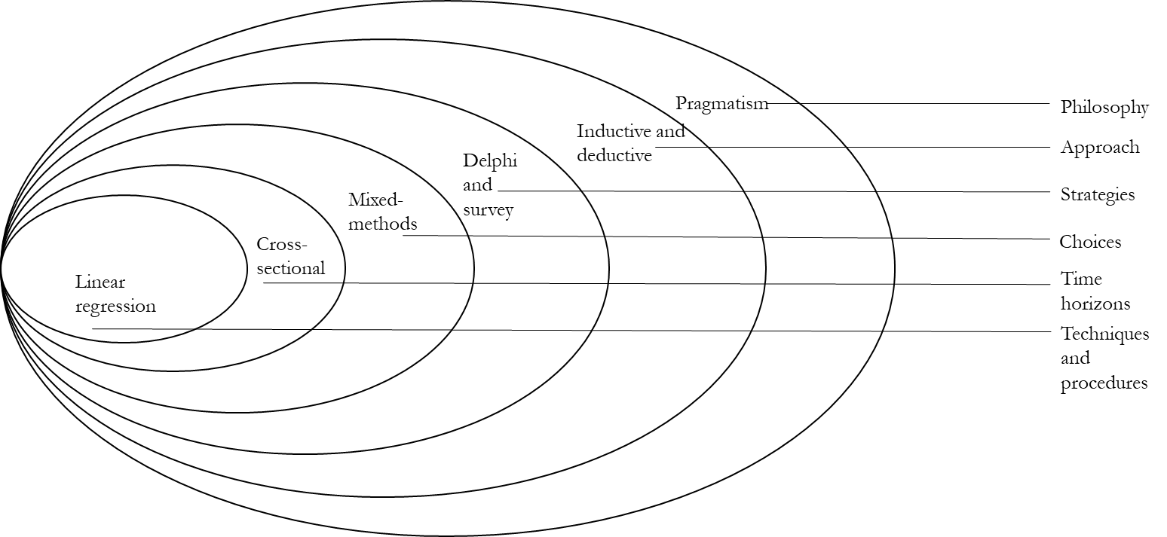

Figure - The representation of the research method (adapted from Saunders et al., 2009)

## Research philosophy

All research has a philosophical foundation and assumptions about possible ways to study certain phenomena to develop knowledge, and these assumptions should be openly stated. The first objective of this chapter is to define philosophical elements and assumption that were incorporated in this thesis and how intertwined they are with, as well as how they have inspired a coherent and effective research approach and subsequent research design. These philosophical elements have to do with ontology and with epistemology.

### Ontology and Epistemology

As a first step,the philosophical assumptions that underpin the research project – in terms of ontology and epistemology – are established. This supports the definition and the design of a suitable research method. Ontology deals with the nature and relationship of the elements that constitute reality, and include answering the question “what kind of things are there in the world?” (Bryman and Bell, 2011).

This research project adopts a mix of *objectivism* and *subjectivism* as ontological approach. This means that the existence of both singular (*objectivism*) and multiple realities (*subjectivism*) is acknowledged. Depending on the phase of the thesis, a more objectivist or subjectivist stance was embraced.

The main objective of the thesis is to verify and test a nexus of hypotheses – the conceptual model, whose three main building blocks – Institutional pressures, Supply Chain Integration and Circular Economy (CE) practices – were identified by looking at the supply chain management literature. Such an objective is mostly grounded in an *objectivist* approach. The adoption of CE practices in an organisation and its supply chain, is seen as a tangible action which can be explained by some social factors, e.g., the presence of institutional pressures and the level of integration of the supply chain network of firms.

However, this thesis acknowledges the importance of a *subjectivist* approach and recognises the existence of multiple perspectives, embedding them into the research: firstly, during the exploratory analysis of the state-of-the-practice (see Chapter 2) the subjective complexity of the research problem (e.g., the adoption of CE practices) in different contexts and industrial sectors is analysed. Then, the subjective opinions and perceptions of practitioners – who face real challenges in operationalising the transition towards the CE in the industry and in facilitating it through policy-making process – was considered in a qualitative study. As it will be discussed in the following sub-chapters, the subjective perspectives of the participants in the Delphi-study were paramount in informing the quantitative phase of the thesis.

Epistemology is concerned with the question “how do we know what we know?” and deals with the approaches in which we can acquire knowledge and subsequently interpret it. This research project takes a *pragmatic* position. This approach puts the research question at the centre to determine epistemological and ontological positions and draws mixed-methods approach as the most appropriate one. The research problem is described through a conceptual model, with the assumption – typical of positivist studies – that patterns of causality among variables can be investigated with a quantitative analysis. At the same time, a strictly positivist approach is considered limited: for this reason, it is supported and strengthened with a qualitative strand to challenge findings from the literature.

### Research Approach

The research approach explains the nature of the relationship between theory and research (Bryman and Bell, 2011). It can be inductive, concerned with building a theory, or deductive, which aims at testing a theory. This study adopts a combination of *inductive* and *deductive* approach. The hypothesis on the causal relationships among the variables in the conceptual framework are deductively drawn from existing theories and literature. However, the theoretical discussion on the CE in supply chains is at an initial stage and the hypothesis have been drawn also from related research fields (SSCM, GSCM, and Industrial Ecology). For this reason, the hypotheses and the conceptual model itself are inductively validated with data collected from experts and researchers in the field, as well as from practitioners and policy makers engaged in the transition towards the CE.

The final phase involves the collection and the analysis of quantitative data, through an extensive activity of coding secondary data sources (as explained in the following Section 4). Data analysis has confirmed some of the hypotheses formulated and rejected some others. In the following Sections, more information is provided on both the qualitative and the quantitative strands of the analysis.

## Research design: Mixed-method research

Research design relates to how to collect and analyse data to answer the research questions and depends on the ontological and epistemological foundations. Adopting a *pragmatic* approach, this research project embeds a mixed-method design.

Mixed-method design is believed to best address complex topics and research problems because it overcomes the dichotomy between qualitative and quantitative approaches, and helps to build more corroborated and complete results (Creswell & Plano Clark, 2017). By combining qualitative and quantitative phases, mixed-methods research allows to answer to the research problem from different perspectives and angles.

In the context of this thesis, a mixed-method research design has meant combining a first qualitative phase with a second quantitative research. This research design has allowed the reduction of the risk of providing an incomplete picture of a phenomena that would require a more articulated interpretation, by involving some stakeholders and experts in an initial part of the study. The large-scale quantitative study was performed only once the conceptual model was corroborated through the involvement of experts’ qualitative observations. In the next sub-chapters, the sequential exploratory mixed-method design is discussed, and both the qualitative and quantitative studies are introduced as well as how they relate to each other.

### Exploratory Sequential Mixed-Methods Design

This thesis adopts an exploratory sequential mixed-methods design. (Figure 2). Sequential mixed methods refer to a research design that collects and analyse data in sequential phases (Creswell and Clark, 2011). The term “exploratory” reflects the need to explore qualitatively the research problem before testing hypotheses. Accordingly, this mixed-method design starts with a qualitative strand (Figure 2, Step I). The qualitative phase was used to refine the hypotheses, to define the adequate measurement scales, and sample of organisations. The rationale of a preparatory qualitative data analysis is also justified by the choice of a research method, which will be based mainly on secondary data collection and coding, and not on questionnaires and interviews. As such, a preliminary pilot study – which is a common practice in the context of primary data collection and research – cannot be part of it.

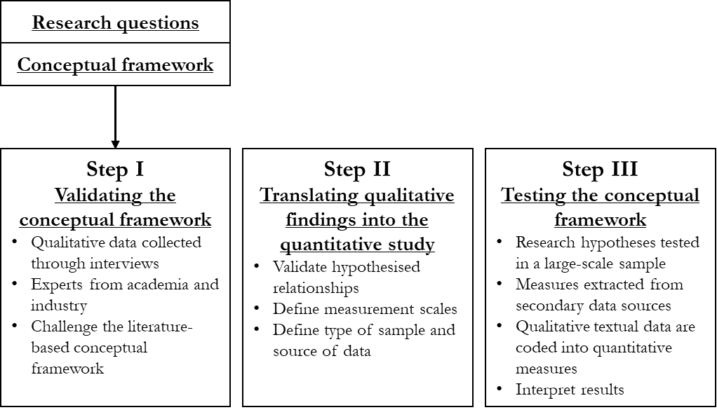

Figure 2 – Steps of the exploratory sequential mixed method study

That phase was followed by a development phase that aimed at translating the findings of the qualitative strand into the quantitative strand (Figure 2, Step II). In other words, the results of the first study supported the development of the quantitative study. The intent was to develop and apply quantitative measures and tools on variables that are grounded in the qualitative study. The first qualitative analysis was necessary to improve the theoretical significance of the conceptual framework and to fine-tune it. Finally, the quantitative strand was also implemented by testing quantitatively research hypotheses (Figure 2, Step III).

### Research Process and Procedures

The process followed to implement exploratory sequential mixed-method in this thesis is represented in Figure 3. In the first phase, the research topic was identified and narrowed down to research objectives (Chapter 1). During this phase the state of industrial practice was analysed (Chapter 2), and the literature was reviewed (Chapter 3). These phases’ output was the formulation of the research hypotheses and the definition of a conceptual framework.

In the second phase the first qualitative data was collected and analysed through a Delphi study (Chapter 5). The objective of this phase was to validate the conceptual framework. The Delphi-study was identified as a suitable research method because of its potential of eliciting knowledge from groups of experts. In this way some qualitative elements were added into the original framework. The results of this phase relate to the following one. The following phase includes the quantitative data collection and analysis (Chapter 6). Data was collected from secondary sources, using a coding procedure and stepwise approach. This phase has involved also adapting and modifying measurement scales to the purpose of the analysis and to the type of data used. The data was analysed by building variables and employing linear regression. The next two Sections are giving more details on the two main strands – defining how data was collected and analysed, introducing the following two thesis chapters.

## Validating the conceptual framework through a Delphi-like study

Before embarking on a huge activity of coding and quantitative data collection a round of semi-structured interviews was executed to fine-tune the theoretical framework. This qualitative phase aimed to challenge the hypothesis on the relation between institutional pressures and CE practices adoption, as well as the role of SCI in that relationship.

A *Delphi-like* approach was employed to elicit knowledge from a panel of qualified experts. Delphi studies allow access to experts’ opinions in a structured manner and enable the ranking and prioritisation of key issues for management action (Okoli and Pawlowski, 2004; Schmidt, 2001). Key characteristics and aspects of a Delphi study include the structured selection of experts, the multi-round nature with multiple interactions, and the final validation stage through a group discussions and workshops.

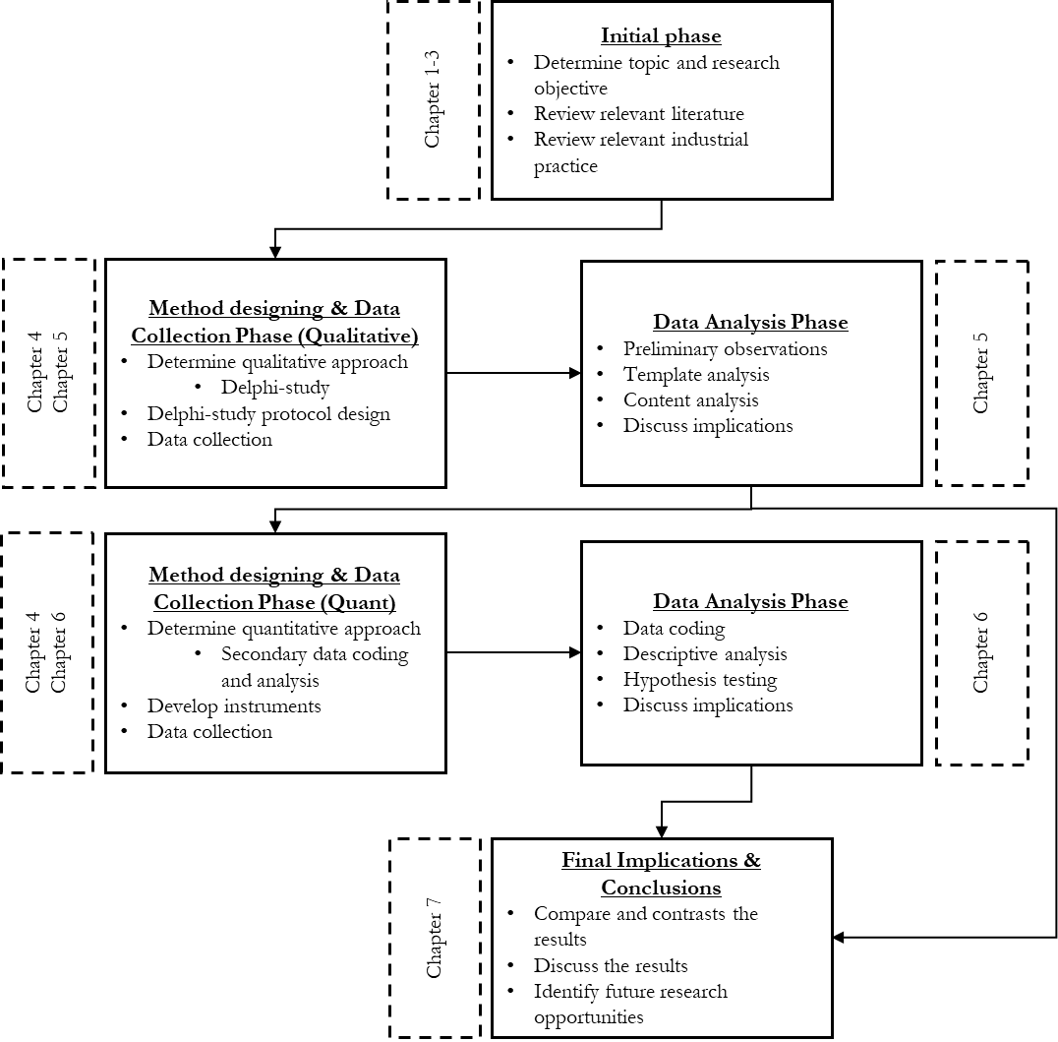

Figure 3 – Research process and procedures

This study has involved both practitioners and academic experts. Participants were selected for their knowledge of the research problem, either theoretical or practical and managerial. Data collection focused on listening to the perception and opinions of experts and academics, which are involved in studying similar research problems. Practitioners, professionals and policy-makers were part of this round of interviews, to understand the practicalities, the challenges that this transitions presents and get feedback on the hypothesis derived from the literature.

The study has involved multiple rounds (Figure 4). In the first round (R1), participants were invited to respond to some general statements regarding the relationships between existing variables using a 3-point Likert scale (support, partially support, reject). This initial phase allowed for the establishment of a first level of agreement on the relationships within the framework and generated a ranked list of the main criticisms. In the second round (R2), the same research problem was explored through semi-structured interviews in a qualitative way. The objective of this phase was to uncover the nature of the relationships in the model. Participants were asked to comment further on their agreement/disagreement points on R1 with anecdotal examples to demonstrate their points. All the raised ideas and points were narrowed down again through content analysis (as explained in detail in Chapter 5, section 3). In the third round (R3), the final categorisation resulting from R2 was improved and validated. A workshop was organised with a total of 8 experts to facilitate group-wide discussion and reach a final agreement. Experts helped evaluate the framework and suggested adding a third level of aggregation of concepts to link the different concepts that emerged to theory. A revised qualitative conceptual framework links the different points that emerged from R1 and R2. The results were also presented at two academic conferences, allowing for further validation. A more detailed description of the method can be found in Chapter 5, Section 3.

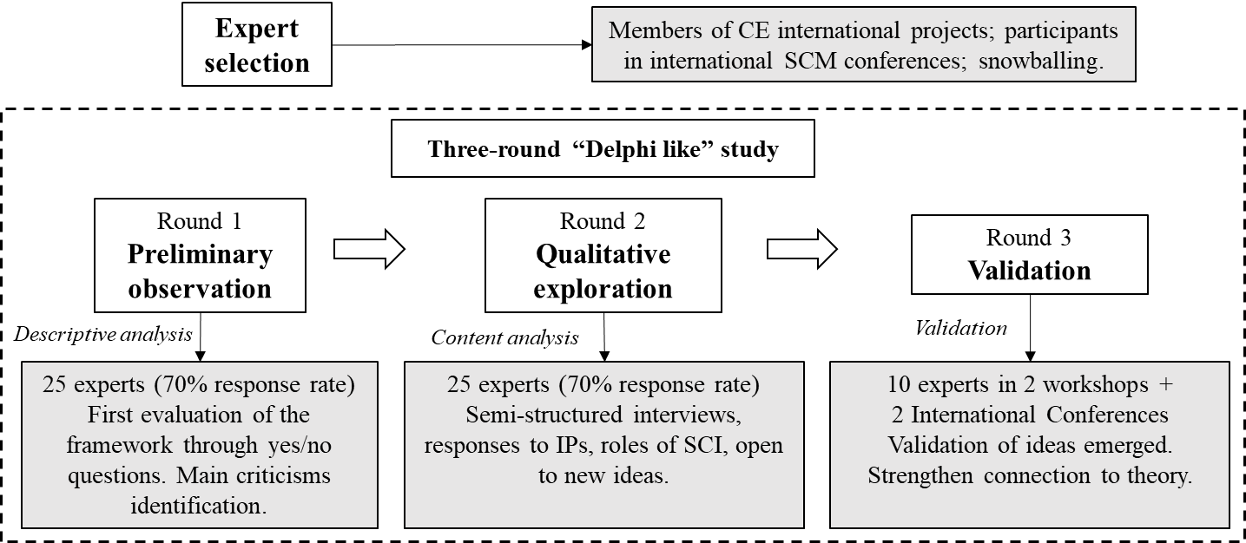

Figure 4 – The Delphi-like study in its three rounds

### Translating qualitative findings into the quantitative study

The Delphi-study has delivered a series of results that will be extensively discussed in chapter 5, Section 4. In synthesis, such a study allowed the identification of potential problem areas in the conceptualisation of the research problem and deficiencies in the research instruments. The analysis confirms the main relationships in the framework and identifies the individual constructs, the most appropriate measurement scales. Missing details in the framework were identified: experts pointed at some control variables to be taken into account for their effect on the outcome variable.

On the role of SCI, the study has revealed some surprising findings. In detail, experts pointed at unexpected effects being more integrated with suppliers and customers in the linear supply chain might carry. Also, some experts, also through qualitative anecdotes, provided examples of how the institutional pressures might have a direct relationship with levels of SCI. As such, the Delphi-study has highlighted the importance to test both moderation and mediation role of SCI.

## Testing the hypotheses with quantitative data

The quantitative phase of the thesis adopted a content analysis approach to collect data and test the hypothesis, by examining publicly available Corporate Sustainability (CS) Reports for a representative sample of MNEs. Relevant information was scrutinised and coded through an advanced procedure to measure the extent concepts of interest are disclosed within the text. The study used a whole sustainability report as a unit of analysis. The concepts are measured through very well established measurement scales in the literature (Table 1).

The final measurement is a cross-sectional sample of 150 MNEs. The measurement process does not focus on keywords searches, but on reading the whole report for each one of the MNEs, identifying the relevant content extracts and evaluating them in order to measure the identified concepts. We decided not to automatise the process, not to have overly strict matching criteria so as to achieve a higher degree of precision. In this way, we could manually identify all the parts of the reports that were relevant for the analysis. This choice also required that we undertook some counteractions to improve the reliability of different phases of data collection.

The following steps were followed to codify content: first sampling and then categorisation (Figure 5), following similar analysis (Piecyk & Björklund, 2014). During the process, unstructured content was firstly assigned to themes in a predefined template, then coded and assigned to specific measurement items that measure those concepts. At the beginning of the analysis a database of MNEs was created based on the Global Fortune 500 list (year 2021); 150 MNEs were chosen by selecting the largest ones headquartered in Asia or Europe. The only inclusion criteria were related to the presence of a public sustainability report, or, at least, of an annual report that included sustainability information. Only reports published in English were considered, and if the report was in another language (2 cases) the company was not considered. After considering these exclusion criteria, the sample was reduced to 150 MNEs. The sample includes MNEs from different industry, which facilitates the generalisability of the results. The entire Sustainability report was used as the unit of analysis in this research. Additional information was collected for each MNE (type of property, headquarter location, industrial sector, type of property, type of sustainability report); annual reports and websites were used in order to gather this information. The full sample is available in Appendix 6A of Chapter 6.

In the categorisation phase, the concepts identified in the literature review were used as pre-defined categories to identify textual content in each report for the purpose of our analysis. After that the extracted content was scrutinised to identify smaller units of code to measure the different aspects of the constructs, following the measurement scales chosen. We started by choosing the most appropriate measurement scales in the literature for the three concepts (Table 1), also considering the limitations highlighted in different papers, especially when measuring institutional pressures (Kauppi & Luzzini, 2022) and SCI (Wiengarten & Longoni, 2015)

Once defined the categories and the individual measurements, we read each MNE report in its entirety to identify all the content that was significant for the analysis, containing evidence on the existence of IPs in the MNE, as well as of SCI aspects and CE practices. The following stages will mostly refer to the text that was extracted in this preliminary phase. In the next stage we worked on the extracted content and categorised it further. We followed multiple waves of coding to make the amount of unstructured content fit for measuring the constructs in the theoretical model. All the text assigned to a macro-theme was scrutinised, to identify single units of code that were in some way giving evidence of more specific aspects of that macro-theme, referring to the level of detail of the measurement items. After this, single units of coding were assigned to measurement items of the three constructs.

Finally, the qualitative content for each measurement item was evaluated and transformed in quantitative binary variables to measure single items and as a consequence the constructs of interest. The two phases are presented, and, in the end, how qualitative content was transformed into quantitative data (measurement) and how quantitative data was analysed (Statistical Analysis, Figure 5).

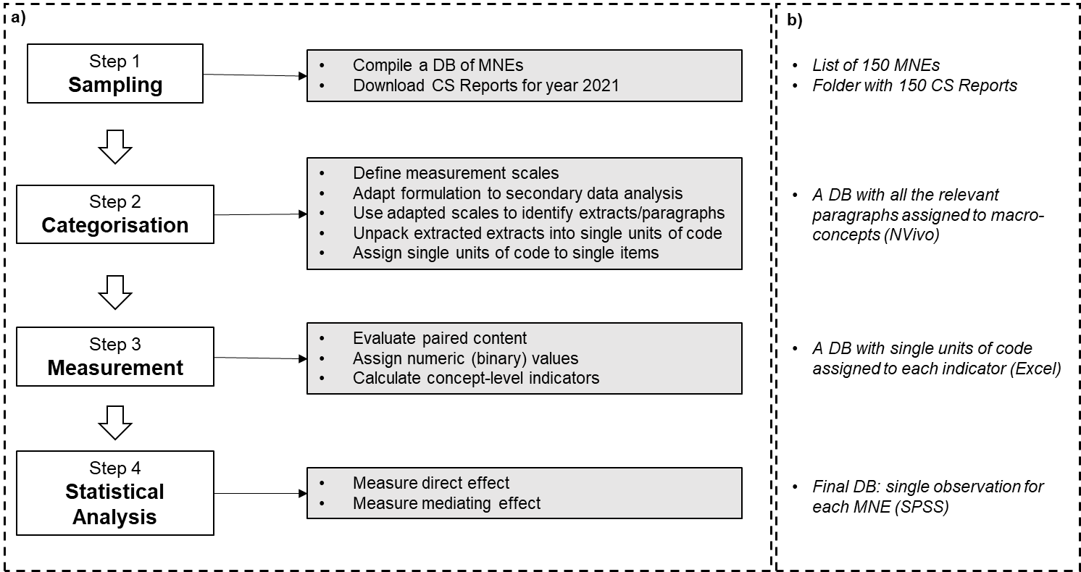

Figure 5 – The quantitative study. Characterisation of the four steps of the Method (5a); Detail of the data produced after each step of the analysis (5b).

Table 1 – Adapting measurement items to the scope of the analysis

|  |  |  |
| --- | --- | --- |
| Construct | Measurement item | Literature |
| Coercive Market Pressure | CMP1. Comments about requests from customers to adopt certain environmental practices (or initiatives) | Kauppi and Luzzini, 2022 |
| CMP2. Comments about major customers withholding their contracts if the firm does not meet their requests to adopt certain environmental practices |
| CMP3. Comments about major suppliers withholding their contracts if the firm does not meet their requests to adopt certain environmental practices |
| Coercive Regulatory Pressure | CRP1. Comments about the presence of a large number of environmental regulations and restrictions imposed on my company’s industry that also impact our procedures/ decision making? |
| CRP2. Comments about government environmental regulation impacting our decision making |
| CRP3. Comments about (frequent) government inspections or audits on our company’s environmental practices to ensure we comply with laws and regulations |
| Normative Pressure | NP1. Comments about paying attention to the environmental practices and tools that appear to benefit our competitors and peers |
| NP2. Comments about actively benchmarking the environmental practices and performance of our main competitors and peers |
| NP3. Comments about paying attention to the environmental practices and tools used and adopted by our key competitors |
| NP4. Comments about employees being influenced by the procedures and tools advocated by industry bodies |
| Mimetic Pressure | MP1. Comments about following academic research on environmental practices (management?) to learn about environmental procedures to implement |
| MP2. Comments about certain environmental procedures becoming a norm within our industry |
| MP3. Comments about opinions of consulting companies and external auditors on the best practices influencing our environmental procedures |
| Suppliers integration | SI1. Comments about sharing information with key suppliers (about sales forecast, production plans, order tracking and tracing, delivery status, stock level) | Frohlich and Westbrook, 2001  IMSS |
| SI2. Comments about developing collaborative approaches with key suppliers (e.g., supplier development, risk/ revenue sharing, long-term agreements) |
| SI3. Comments about joint decision-making with key suppliers (about product design/modifications, process design/modifications, quality improvement and cost control) |
| SI4. Comments about system coupling with key suppliers (e.g., vendor managed inventory, just-in-time, Kanban, continuous replenishment) |
| Customers integration | CI1. Comments about sharing information with key customers (about sales forecast, production plans, order tracking and tracing, delivery status, stock level) |
| CI2. Comments about developing collaborative approaches with key customers (e.g., risk/revenue sharing, long-term agreements) |
| CI3. Comments about joint decision-making with key customers (about product design/modifications, process design/modifications, quality improvement and cost control) |
| CI4. Comments about system coupling with key customers (e.g., vendor managed inventory, just-in-time, Kanban, continuous replenishment) |
| Adoption of CE practices | CE1. Comments on the adoption of “reduce” practices | Calzolari et al., 2021 |
| CE2. Comments on the adoption of “reuse” practices |
| CE3. Comments on the adoption of “recycle” practices |
| CE4. Comments on the adoption of “renewable energy and energy efficiency” practices |
| CE5. Comments on the adoption of “recover” practices |

The detailed description of the method can be found in chapter 6, Section 3. Sampling, categorisation, measurement, and statistical analysis. Next sub-chapter provides some detail of the statistical analysis phase.

### Quantitative Data Analysis

The analysis employs linear regression considering construct level scores. The procedure followed is articulated in Figure 6. The relationship between IP and CE was firstly tested. After this, the direct relationship of SCI on CE. As a last thing the indirect effects of SCI on the relationship between IPs and CE. Indirect effects were measured through a linear regression using the PROCESS macro on SPSS (in order to test mediation)[12]. Regressions included some control variables. The literature and some interactions with experts have identified some factors that are likely to influence the outcome variable. Control variables are both industry-specific and firm-specific. Specifically, industry-specific variables were captured by two dummy variables. The first one isolates manufacturing companies from all the others, as these companies are more frequently involved in CE actions; the second one isolates service companies, which are typically late-adopters. Firm-specific variables include the type of ownership (e.g., state-owned vs privately-owned), the geographical location of the headquarters, and the presence of a Sustainability report. The detailed description of the method can be found in Chapter 6, Section 3.

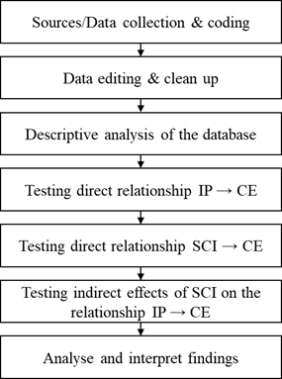

Figure 6 – Data analysis description

Critical issues concerning integrity and ethics issues were analysed. A research ethics application was sent online to the Sheffield University Management School ethics committee (on 25 July 2019) and approved (on the 26th of August 2019, see Appendix 3). In addition, this research project is part of a European Union’s Horizon 2020 research and innovation programme under the Marie Skłodowska-Curie Innovative Training Networks (H2020-MSCA-ITN-2018) scheme (ReTraCE project, grant agreement number 814247). An Ethics application has been approved on behalf of the project to have primary data collection among the partners, which include both universities and industrial organisations.

## Chapter’s conclusion

In this Chapter, the research design to answer the research questions is explained and unpacked, starting from the research philosophy assumptions of the thesis, and then linking this decision with the research design choices. The thesis embeds a prevailing *objectivist* research philosophy, but also strongly acknowledges the importance of *subjective* realities. Epistemologically, the thesis adopts a *pragmatic* position and puts the research question at the centre, draws a mixed-methods approach (exploratory sequential mixed-methods design). Coherently, the research also combines *deductive* and *inductive* approaches. Firstly, the thesis explores qualitatively the research problem before testing hypotheses. A Delphi-like study is used to fine-tune the conceptual framework and the following quantitative phase of the thesis uses a content analysis approach to collect data by examining publicly available Corporate Sustainability Reports for a representative sample of companies. By doing so it measures the constructs of interest and tests the hypothesis.

## References

Bryman, A. & Bell, E. (2015). Business Research Methods. Oxford: Oxford University Press.

Creswell, J. & Clark, V. (2011). Designing and Conducting Mixed-Methods Research. California: Sage Publications Inc.

Okoli, C., & Pawlowski, S. D. (2004). The Delphi method as a research tool: an example, design considerations and applications. Information & management, 42(1), 15-29. <https://doi.org/10.1016/j.im.2003.11.002>

Piecyk, M. I., & Björklund, M. (2015). Logistics service providers and corporate social responsibility: sustainability reporting in the logistics industry. International Journal of Physical Distribution & Logistics Management, 45(5), 459-485.

Schmidt, R., Lyytinen, K., Keil, M., & Cule, P. (2001). Identifying software project risks: An international Delphi study. Journal of management information systems, 17(4), 5-36. <https://doi.org/10.1080/07421222.2001.11045662>

# Understanding the relationship between institutional pressures, supply chain integration and the adoption of circular economy practices

**Abstract:**

This paper explores the role of institutional pressures and supply chain integration in the adoption of Circular Economy practices. Using a Delphi-like approach and leveraging on a panel of 30 experts in the field of Circular Economy, this study aims to gain additional insights into how coercive, normative, and mimetic pressures can drive the implementation of circular supply chains. The findings reveal a hierarchy of institutional pressures, with coercive market and regulatory pressures having a greater impact compared to normative and mimetic pressures. Additionally, the study identifies various responses to these pressures, illustrating different trajectories towards the implementation of Circular Economy practices. Furthermore, the research investigates the role of supply chain integration. Generally, a higher level of supply chain integration can amplify the effect of institutional pressures, promoting the adoption of incremental Circular Economy practices. However, it is noteworthy to mention that supply chain integration may also hinder the adoption of more radical Circular Economy approaches, favouring the retention of linear supply chains.

**Keywords:** Circular Economy, Institutional Theory, Supply Chain Integration, Sustainable Supply Chains

## Introduction

The Circular Economy (CE) paradigm has emerged as an alternative to the linear production-consumption model aiming to provide the stimulus for the development of a new economic system characterised by cyclical and regenerative material and energy flows (Geissdoerfer et al., 2017). Such an industrial model is expected to contribute to positive environmental, social, and economic transformations for achieving sustainable development (Korhonen et al., 2018).

The growing attention that the CE concept has been drawing over the last decade has also generated efforts aimed at exploring the role of factors that could foster this transition. An increasing number of relevant publications in these recent years have been concerned with the identification and classification of existing circular business models (Rosa et al., 2019; Henry et al., 2020; Vegter et al., 2020), the effectiveness of current policies (Domenech and Bahn-Walkowiak, 2019; Vanhamäki et al., 2020; Arsova et al., 2022) as well as potential barriers, including cultural, political, market and technological constraints (de Jesus and Mendonça, 2018; Kirchherr et al., 2018). The implementation of CE principles in practical applications heavily relies on the development of circular supply chains (CSCs), which extend beyond the traditional linear supplier-manufacturer-customer networks to include new actors (e.g., collection and sorting contractors; re-processors; remanufacturers) as well as facilitate horizontal collaboration across different sectors (Genovese et al., 2017; De Angelis et al., 2018).

Also given their general relevance to the transition towards more sustainable futures (Kauppi and Hannibal, 2017; Venkatesh et al., 2020), institutional pressures (in the following, also IPs) have been identified as a key driver to the development of CE approaches (Zeng et al., 2017; Ranta et al., 2018; Calzolari et al., 2021; Do et al., 2022); specifically, coercive, normative, and mimetic pressures can significantly influence the decision of firms to pursue a CE strategy. Nonetheless, in order to realise a shift towards CSCs, it is necessary to increase the capacity of involved companies to share information and knowledge with their partners to reduce uncertainty and resource dependency (Herczeg et al., 2018; Berardi and de Brito, 2021). Given its relevance to the development of such capabilities, the enhancement of supply chain integration (SCI) has been highlighted as a key strategy for fostering collaboration across circular supply chain networks (Elia et al., 2020; Pinto and Diemer, 2020; Di Maria et al., 2022).

In this study, the aim is to challenge and enhance the conceptual framework proposed by Calzolari et al. (2021) which describes the adoption of CE practices as a supply chain process, highlighting the role of institutional pressures and SCI. This framework emerged from a literature review and an analysis of corporate sustainability reports from the top 50 European Multi-National Enterprises (MNEs) of the Global Fortune 500. It is argued that higher integration with suppliers and customers amplifies the effect of IPs on the supply chain adoption of CE practices. Utilising a Delphi-like approach, this paper aims to validate and enhance the framework through interaction with a panel of experts. According to the findings, SCI has a conflicting role in the relationship between IPs and the implementation of CE strategies, as it can facilitate the adoption of some practices, and inhibit others. Additionally, reactions to IPs have been identified.

The remainder of the document is arranged as follows. Section 2 provides a review of the literature focusing on the role of IPs and SCI on the adoption of CE practices. Section 3 provides an overview of the research method employed, while Section 4 illustrates the findings. In Section 5, a revised framework is presented, followed by the study’s conclusions in Section 6.

## Literature Review

Institutional pressures appear to be a factor to consider when examining the adoption of CE practices from a supply chain management (SCM) perspective (De Angelis et al., 2018; Liu et al., 2018). In today’s globalised production systems, these pressures occur at the supply chain level rather than within the boundaries of individual firms (Ketchen and Hult, 2007; Hofstetter et al., 2021). In addition, since the misalignment of supply chain incentives is a key obstacle to CE adoption (Rizos et al., 2016), the way a supply chain is organised can influence the diffusion of CE practices across production networks (Bressanelli et al., 2019). SCI is crucial in achieving a high level of coordinated planning allowing firms to combine the technical knowledge and skills necessary for developing circular capabilities (De Angelis et al., 2018). The following sub-sections critically examine the literature streams looking at the influences of IPs and SCI on the transition towards CSCs.

### Institutional pressures and the adoption of Circular Economy practices

In order to establish and maintain legitimacy with different groups of stakeholders, organisations tend to respond to pressures exerted by other entities operating within the same institutional field (DiMaggio and Powell, 1983). This process is described as institutional isomorphism and operates through three distinct mechanisms, namely coercive, mimetic, and normative pressures. Coercive pressures can stem from regulatory bodies as well as from other organisations upon which the firm is dependent on (such as resource-dominant organisations, suppliers, customers, and investors). Thus, organisations make decisions in accordance with laws and regulations to avoid sanctions (coercive regulatory pressures) and comply with demands and requests imposed by actors in the supply chain (coercive market pressures) (Kauppi and Luzzini, 2022). In the context of the transition towards a CE, such pressures can also be linked to active and passive behaviours on the part of companies, referring to their ability to adopt CE-oriented practices. While in the first scenario a company proactively adopts CE practices and integrates them into its core business practices, a passive behaviour involves merely complying with external pressures without actively seeking additional CE initiatives.

Normative pressures arise from shared values among organisations and employees within an industry or professional association, where organisations are influenced not only by formal rules but also by what is deemed appropriate and socially accepted due to norms and standards.

Finally, mimetic pressures involve the adoption of shared conceptions and beliefs, as organisations mimic successful social actors that have established themselves through taken-for-granted dynamics and best practices (DiMaggio and Powell, 1983; Scott, 2003). For instance, the action of a leading company adopting sustainable practices might prompt other companies in the same supply chain or in the wider industry to embrace similar approaches in order to maintain market competitiveness. The adoption of environmental assessment tools, which have been successfully employed by other enterprises in the same sector, is an example of mimetic isomorphism (Kauppi and Luzzini, 2022).

Institutional theory has been extensively used in SCM research to explain the adoption of practices, organisational structures, or technologies (Zhu and Geng, 2013; Touboulic and Walker, 2015; Kauppi and Luzzini, 2022). Looking at specific types of practices, research has shown that organisations approach sustainability mainly as a means of complying with legislation requirements and improving their brand image, rather than as profit-seekers (Brønn and Vidaver-Cohen, 2009). As such, IPs represent one of the main drivers for the adoption of sustainable practices in organisations and their supply chains, reflecting corporations’ alignment with triple-bottom-line strategies (Ellram and Tate, 2016).

Recent empirical studies have tried to explain why and how supply chains adopt CE practices, looking at which specific pressures are most important in inducing organisations to take action. Initially, stricter environmental regulations were identified as a key factor (Geng et al., 2009; Mathews and Tan, 2011; Herczeg et al., 2018) in steering production and consumption systems towards a cleaner pathway, especially in contexts where economic planning plays a more prominent role.

However, research argues that legislation alone is insufficient to enforce a systemic change within global supply chains (Ranta et al., 2018; Jain et al., 2020). Instead, a combination of institutional pressures is needed to drive the adoption of CE initiatives (Ranta et al., 2018). Along with legislation, normative and mimetic factors play an important role in driving isomorphic actions and the adoption of CE practices. Organisations may use CE approaches in their reporting to legitimise their position, attaching greater importance to standards, certifications, and industry best practices than to legislation (Dagiliene et al., 2020).

In addition to legitimacy reasons, organisations also adopt CE practices to increase their efficiency. The most important pressures depend on the level of market uncertainty and the presence of barriers. In detail, when uncertainty is high, the adoption of CE practices is expected to be driven more by legislative and mimetic factors, whereas when uncertainty is low, companies adopt CE practices to increase their efficiency (Do et al., 2022).

### The relationship between SCI and the adoption of CE practices

In order to explain how supply chains are organised, the SCM literature has widely employed the SCI concept. SCI involves a set of constructs including information exchange, the presence of collaborative activities, and the alignment of strategic interests with key suppliers and customers (Frohlich and Westbrook, 2001; Leuschner et al., 2013).

Considering it as a specific capability of firms, studies have highlighted SCI as an enabling factor in facilitating the adoption of sustainable practices, which can also interact with institutional pressures (Sancha et al., 2015). In the context of the transition towards a CE, the configuration of a supply chain plays a critical role in determining the ease with which CE practices can be diffused across it (Zhu et al., 2011). CE literature indicates that major obstacles to the transition to a CE can arise when companies have little influence over their fragmented and global supply chains (Berardi and de Brito, 2021), due to the misalignment of incentives and limited visibility beyond the first tier (Dou et al., 2018; Mejías et al., 2019). Addressing these barriers and improving ties between companies can support the adoption of CE practices, as in the case of industrial symbiosis networks (Herczeg et al., 2018) or industrial districts (Bressanelli et al., 2022). In these contexts, participating organisations can significantly improve the level of coordinated planning; this can enable them to identify and evaluate innovative ways of utilising their by-products while minimising uncertainty regarding the quality and quantity of waste (de Abreu and Ceglia, 2018; Herczeg et al., 2018).

Consequently, inter-organisational collaboration in the supply chain is expected to facilitate the adoption of CE practices (Cricelli et al., 2021) and lead to a subsequent improvement in sustainability performance (Sudusinghe and Seuring, 2021). SCI can also mediate the impact of Industry 4.0 technologies on the improvement of CE performance (Di Maria and De Marchi, 2022). Recent empirical studies have explored the influence of information sharing and knowledge transfer on the implementation of CE practices in supply chains, highlighting the potential role of establishing long-term oriented relationships and joint decision-making structures (Elia et al., 2020; Calzolari et al., 2021).

### A look at the state of the practice

Empirical research has recently sought to address the gap identified by Kirchherr and van Santen (2019) by investigating the adoption of CE practices in larger samples of companies (Gusmerotti et al., 2019; Dagiliene et al., 2020; Cricelli et al., 2021). Two papers have examined the role of SCI in the adoption of CE practices by analysing large datasets of secondary data to assess the current state of the practice (Elia et al., 2020; Calzolari et al., 2021), reaching similar conclusions.

The first analysis focuses on 98 companies participating in the CE100 program[13] (Elia et al., 2020). These organisations are considered leading first movers in the adoption of CE-driven innovation. The companies are classified based on the CE objectives they pursue (such as reducing inputs and the use of natural resources, and lowering emission levels), the life cycle phases they affect (e.g., material input, design, production, consumption, end-of-life), and the practices they implement (e.g., circular product design and production, business models, cascade/reverse cycle skills, cross-cycle, and cross-sector collaboration). The authors examine the extent to which the level of SCI is correlated to the adoption of CE practices and objectives, defining clusters of organisations characterised by similar levels of integration (single-tier integration, multi-tier integration, full integration). A higher level of SCI is positively associated with the number of CE objectives pursued, the number of product/services life-cycle analysis (LCA) phases impacted, and the impact of the organisations’ actions.

The conceptual framework proposed by Calzolari et al. (2021) (Figure 1) was based on the development and analysis of a database from a sample of 50 European MNEs. The CE practices were categorised according to the level of implementation (identifying five incremental implementation stages), and the involvement of supply chain partners (distinguishing between internal CE practices and Circular Supply Chain practices). Also, CE practices were distinguished according to their types, referring to different R-imperatives, referring to recent classifications introduced by the European Commission (2020):

* Reduce: products are innovated in order to decrease overall resource consumption, also rethinking and redefining their functions
* Reuse: products’ lifecycles are extended through repairing, preventive maintenance, and refurbishing actions; products and components can then be reutilised according to their original functions.
* Recycle: end-of-life products, parts, components, and materials are reprocessed in order to manufacture new products, parts, components, and materials.
* Recover: energy is recovered from by-products or waste, either directly or through the production of alternative fuels.
* Renewable energy & Resource efficiency: incremental efficiency improvements of production or logistics processes are sought, or renewables as a source of energy are adopted. In any case, linear flows of materials are not challenged.

SCI was measured using the International Manufacturing Strategy Survey (IMSS) measurement items (i.e., sharing information with key suppliers/customers, joint decision-making, collaborative approaches, and system coupling) (Wiengarten and Longoni, 2015). According to the findings, the level of adoption of CE practices is aligned with the level of integration with supply chain partners. Thus, supply chains that exhibit higher levels of SCI demonstrate greater adoption of both internal CE practices and Circular Supply Chain practices compared to less integrated supply chains.

To summarise, both existing studies that have examined the relationship between SCI and the adoption of CE practices suggest a more systematic adoption of CE practices in MNEs’ supply chains. High levels of SCI appear to be a key characteristic of organisations that have adopted more practices at higher levels of implementation, as well as companies that have planned to take more actions and have more objectives (Bressanelli et al., 2020; Elia et al., 2020). Considering the need to redesign business operations to accommodate the adoption of CE practices, a higher level of supply chain integration has a direct impact on the number of product life-cycle phases impacted (Elia et al., 2020). This level of integration allows to tackle challenges throughout the entire lifespan of a product as well as to open avenues for identifying opportunities and exploring innovative ways for material recovery and reuse, repair and maintenance services, and developing circular business models.

These analyses also align with the literature that criticises the limitations of incumbent organisations’ CE approach, which often adopts a reductionist interpretation (Ranta et al., 2018; Calzolari et al., 2021). Such a reductionist perspective corresponds to the deliberate oversight of reduce and reuse practices, due to need for deeper re-design of current business models, which could have a direct effect on the sales of new products (e.g., the reduction in future sales due to the manufacturing of products that are easier to repair) and overall growth objectives of organisations (Calzolari et al., 2021). Most of the actions focus on end-of-life material recovery and recycling, with less attention given to product reuse or truly circular business models.

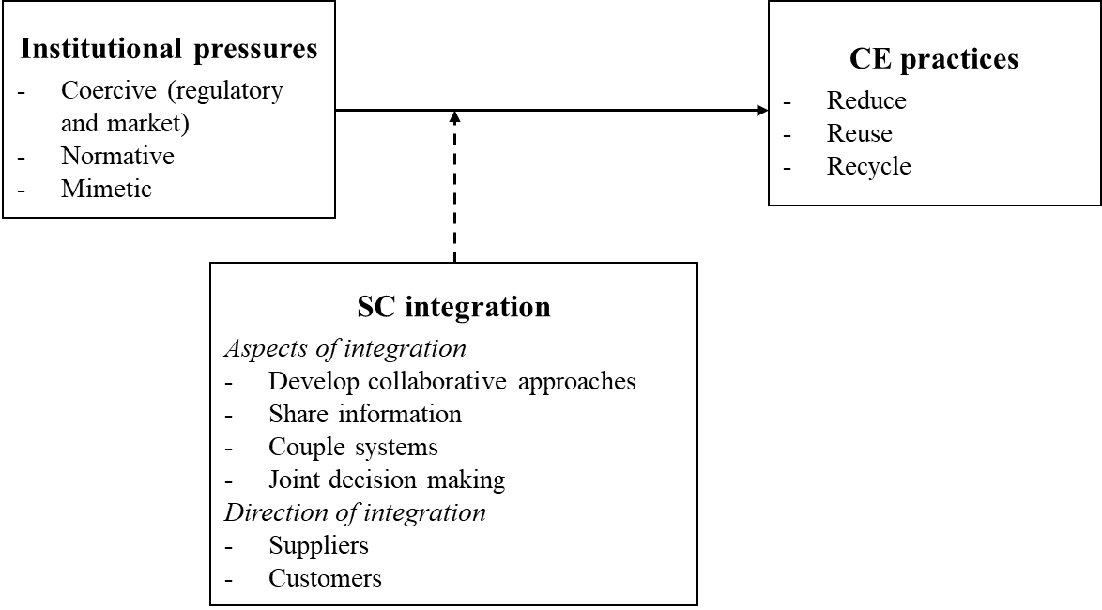

Figure 1 – The initial framework that facilitated discussions in the interviews

### Development of research questions

While some studies are starting to examine the relationship between institutional pressures and the adoption of CE practices, little is known regarding how these pressures are exemplified in the context of firms’ operations (Arranz et al., 2022). While some publications have included Circular Economy (CE) and institutional pressures (IPs) in the same conceptual framework, they have not directly explored their relationship (Bag and Pretorius, 2022; Bag et al., 2022). Other studies have conceptualised CE as a performance construct that does not reflect any intention to implement specific CE practices (Jain et al., 2020). The first research gap this paper aims to address is getting an understanding of how IPs affect the adoption of CE practices by companies, also aiming at clarifying the various roles played by different categories of pressures.

On the other hand, the SCI concept was developed according to the traditional linear thinking of SCM around inputs (suppliers) and outputs (customers), which entails a forward physical flow of deliveries from suppliers to customers and a backward flow of information in the form of orders (Frohlich and Westbrook, 2001). The introduction of new actors such as waste collectors and remanufacturers in circular supply networks has added a layer of complexity as the direction and type of these flows significantly differ (Braz and de Mello, 2022). This controversy highlights the need for further exploratory research, rather than delving immediately into some hypothesis testing. Given also that the link between SCI with performance improvement is becoming unclear (Braz and de Mello, 2022), the initial evidence about the link to CE practices adoption deserves further investigation. In detail, this study will attempt to provide some insights into the ways that SCI can drive the adoption of CE practices, highlighting the need for supply chain visibility and transparency, as well as the important role of key suppliers and customers.

The conceptual framework proposed by Calzolari et al. (2021) was centred around the idea that institutional pressures are driving the adoption of CE practices, while higher levels of integration with suppliers and customers can magnify the effect of IPs on supply chains. However, this framework was developed using a mainly deductive process applied to the analysis of secondary data. Therefore, this paper aims to deepen and enhance the initial work of Calzolari et al. (2021) through the analysis of primary data, in order to address the following research questions:

* RQ1: How can institutional pressures drive the adoption of CE practices, and to what extent? Are certain types of pressures more relevant than others?
* RQ2: What role, if any, does supply chain integration play in the relationship between institutional pressures and the adoption of CE practices?

## Method

In order to address the research questions, a qualitative approach was adopted (Figure 2). This choice was related to the need for direct involvement of stakeholders in the investigation, given that the previous relevant studies have been mainly based on secondary data. Also, a qualitative approach is particularly suitable to the exploratory nature of the research questions as it can provide new knowledge on the relationship among these concepts.

In particular, a *Delphi-like* approach was employed, in order to elicit knowledge from a panel of qualified experts. Delphi studies allow access to experts’ opinions in a structured manner and enable the ranking and prioritisation of key issues for management action (Okoli and Pawlowski, 2004; Schmidt, 2001). This study incorporates the key characteristics and aspects of a Delphi study, such as the structured selection of experts, the multi-round nature with multiple interactions, and the final validation stage through a workshop. Its objective is to gather and prioritise experts’ opinions in order to fine-tune a conceptual framework (Okoli and Pawlowski, 2004). Group-wide discussions were organised where experts could provide feedback on the most common codes and emerging issues.

In the first subsection, we describe how data was collected through the different rounds of the Delphi-like study, and in the second one, the analysis process.

### Design of the Delphi-like study

We selected participants for their knowledge of the research problem, either theoretical or practical/managerial. All rounds of interviews were completed between February 2021 and February 2022. Most of the interviews were held online using the Google Meet platform, with only four taking place in person. The duration ranged from 30 minutes to 1 hour and 30 minutes, with at least one interaction with each interviewee. In total, 30 international experts were interviewed in the study (see Appendix 5A for the full list). Where participants agreed, the interviews were recorded and were subsequently transcribed and analysed. Otherwise, notes were taken during the interview. An executive summary of the transcription was sent to each participant in order to validate our interpretation of the answers (Saunders, 2019).

We used purposive sampling, adding a new interviewee until no new themes were emerging (Saunders, 2019). Participants from different backgrounds were chosen to avoid reaching saturation too early. In total, 12 participants from academia and 18 from industry were interviewed across the rounds in the Delphi-like study; detailed information about the participants’ profiles is provided in Appendix A. As CE is a multi-disciplinary concept, academics had a wide range of expertise, with most having a SCM background, given the clear link of the phenomenon under investigation to CSCs. However, scholars from Strategic Management, Corporate Social Responsibility, Economics and Innovation were also involved. Practitioners came from diverse contexts, with representatives from both MNEs and SMEs invited, across many sectors such as manufacturing, agri-food, logistics, and services; for industrial participants, the level of engagement with CE principles of their organisation is also provided in Appendix 5A.

The research background and the variables involved were introduced to the participants before the interviews began. In the first round (R1), participants were invited to respond to some general statements regarding the relationships between existing variables. Responses to statements were measured using a 3-point Likert scale (support, partially support, reject). Participants were also encouraged to briefly mention any other important aspects missing in the framework, provide criticisms, and suggest improvement points for the model. This initial phase allowed for the establishment of a first level of agreement on the relationships within the framework and generated a ranked list of the main criticisms.

In the second round (R2), the same research problem was explored through semi-structured interviews in a qualitative way. The objective of this phase was to uncover the nature of the relationships in the framework. Participants were asked to comment further on their agreement/disagreement points on R1 with anecdotal examples to demonstrate their points. Questions had a pre-established order and were open-ended, and participants were allowed to offer additional insights, altering the pre-determined flow of the questions (see Appendix 5B). New ideas were welcomed, and practical examples were incentivised. All the raised ideas and points were narrowed down again through content analysis, as explained in sub-section 3.2.

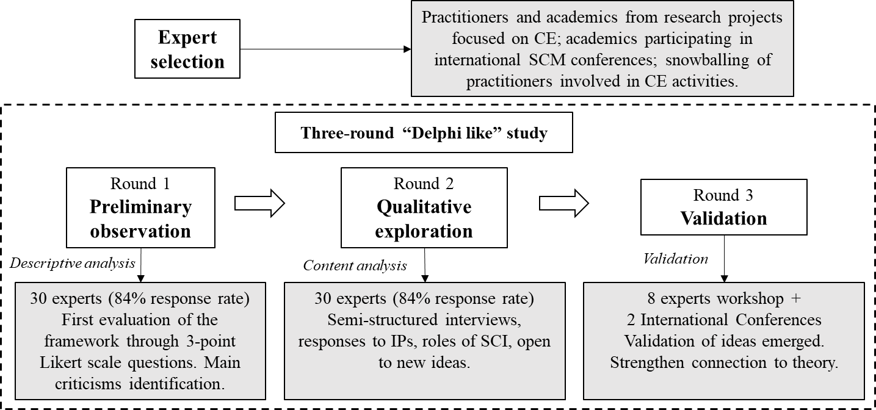

Figure 2 – Research method stages (adapted from De Lima et al., 2022)

In the third round (R3), the final categorisation resulting from R2 was improved and validated. A workshop was organised with a total of 8 experts (3 practitioners and 5 academics, see Appendix 5A) to facilitate group-wide discussion and reach a final agreement. Experts helped evaluate the framework and suggested adding a third level of aggregation of concepts to link the different concepts that emerged to theory. A revised qualitative conceptual framework links the different points that emerged from R1 and R2. The results were also presented at two academic conferences, allowing for further validation.

### Interview data analysis

A template analysis approach was employed (King and Brooks, 2018) to analyse transcribed interview data from the different rounds. A six-step approach (Figure 3) was adopted, in line with previous qualitative studies (Rindova et al., 2011; Bressanelli et al., 2022; Wang et al., 2022). Interviews were first transcribed into textual data, and codes were then developed from such textual data using NVivo. As per template analysis guidelines, the approach was not entirely inductive, as some pre-defined themes were also used. Codes were initially assigned to existing general themes in the initial template (institutional pressures, supply chain integration and Circular Economy practices). This initial template was used as a starting point, with the objective of organising text, better visualising Empirical Observations (EO) associated with each of the general themes, and capturing the complexity of the qualitative information obtained from the interviews.

Through a clustering process, themes were further developed into more complex Conceptual Categories (CC, second-order themes) emerging from the Empirical Observations (EO). Initial themes and associated codes were grouped according to their similarity through an inductive process and assigned to one or more second-order themes. Second-order themes were then refined to avoid repetition. Finally, second-order themes were grouped into Aggregated Dimensions (AD, third-order themes), which highlighted how groups of Conceptual Categories are linked and relevant for the theory.

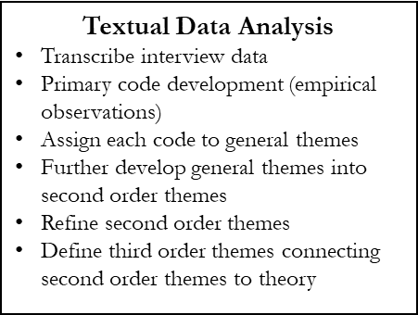

Figure 3 – Content analysis stages

### Final validation

Finally, the results of the content analysis were presented in a workshop in front of a panel of eight experts who provided feedback and helped improve the categorisation process and connect it with theory. In this phase, third-order themes were improved.

## Findings

### Preliminary Observations: Round 1

In the initial phase of the Delphi-like study, experts were asked some preliminary questions concerning the relationship among the identified constructs. The results of this process are reported in Figure 4. In particular, 22 experts supported the idea that IPs are a major driver and include most of the motivations behind the adoption of CE practices. Six of them partially supported this view, stating that there might be some other internal or external drivers to be considered. The remaining two expressed doubts about the assumption that there is a relationship between institutional pressures and CE practices.

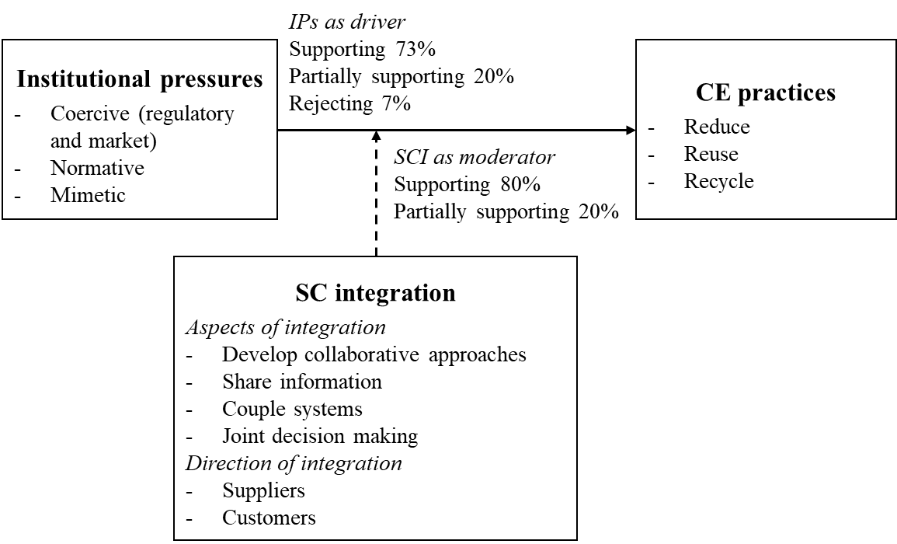

Figure 4 – Overview of the results

24 experts agreed that SCI should be viewed independently from pressures and that it has the capacity to influence the ability of a company to adopt CE practices. Six of them had a different view. Despite agreeing that SCI plays a key role, they claimed that there might be a relationship between IPs and SCI. Experts also identified further important aspects to be considered (Table 1).

Table 1 – Main critiques to the initial framework

|  |  |  |
| --- | --- | --- |
| Proposition | Critique | Frequency |
| IPs drive the adoption of CE practices | There are other internal drivers | 6/30 |
| There are other external drivers | 6/30 |
| There is no influence of institutional pressures on CE adoption | 2/30 |
| SCI is a moderator in that relationship | There is a relationship between IPs and SCI | 2/30 |
| Adoption of CE has a feedback effect on SCI | 2/30 |
| Others | Focus on CE performance rather than adoption | 2/30 |
| Need to distinguish between Disruptive vs Incremental CE | 4/30 |
| Need to be aware of CE practices used for greenwashing | 4/30 |

### Qualitative exploration: Rounds 2 and 3

The results from the content analysis (R2) and of the following validation phase through workshops and conferences (R3) are presented together in this sub-section. R2 identified a hierarchy of pressures and four different ways through which pressures influence firms’ behaviour, also shedding light on the complexities of the role of SCI in the relationship between pressures and adoption of CE practices (Table 2). During R3, group discussions with experts validated the themes that emerged in R2, improving individual experts’ response quality, and identifying further points that will be discussed in the implications section.

Table 2 – Data structure

|  |  |  |  |
| --- | --- | --- | --- |
| Code EO | Empirical observation (code) | Conceptual Categories  (2nd order themes code CC#) | Aggregate dimensions (3rd order themes code AD#) |
| EO1 | - Firms are starting to use environmental assessment tools (like LCA) to evaluate circular business models (CBMs) as a reaction to environmental research and consulting companies’ advice | Re-adjusting existing environmental monitoring systems for the CE (CC1) | Efficiency oriented step-by-step approach to the CE (AD1) |
| EO2 | - Firms are stressing CE principles in their Environmental Management Systems and in their Corporate Sustainability reporting as a reaction to consulting companies’ advice and customers pressures |
| EO3 | - Publicly listed firms are using ESG measures and reporting on SDGs, sometimes including the contribution of CE practices |
| EO4 | - Professional categories are promoting new ideas/concepts/strategies/tools within their organisations (e.g., architects, managers…) |
| EO5 | - Top Management of the most influential organisations have an influence on industry bodies guidelines that become widely accepted |
| EO13 | - CE used as a marketing strategy to reach new markets | Driving opportunistic behaviours and tokenistic action (CC4) |
| EO14 | - CE is used to hide inaction reporting easy CE practices |
| EO15 | - Existing practices are rebranded as CE practices |
| EO16 | - Lobbying activities of leading companies are de-potentiating the CE concept at the policy level |
| EO9 | - New supply chain actors and intermediaries are emerging, which have the interest to disrupt business as usual | Re-organising operations and supply chain management (CC3) | Disruptive first-mover innovators approach to the CE (AD2) |
| EO10 | - CSCs are expected to deliver other purposes (from delivering as fast as you can but closing the loop, create resiliency, depending less on primary resources) |
| EO11 | - European Commission is increasingly considering CE as a tool against resource scarcity - to keep resources in the system, and decrease the dependence from geographically (or geopolitically?) distant countries |
| EO12 | - Social norms influence employment making environmentally engaged organisations more attractive |
| EO6 | - Policies are slowly shifting from recycling to “right-to-repair” | New products development (CC2) |
| EO7 | - Firms are learning from influential think-tanks that work on the CE (WBCSD, EMF) |
| EO8 | - Firm need to balance among different R-imperatives, and between short vs long term strategies through a risk-opportunity approach |
| EO17 | - Brand owners and consumers are setting the CE agenda | Market trends and consumers come first and build the pressure upstream in the supply chain. Regulation usually follows. (CC5) | Hierarchies of pressures and pathways of evolution (AD3) |
| EO18 | - Customers are then asking for certifications upstream in the supply chain |
| EO19 | - Companies adopt CE practices because they want to look good to customers |
| EO20 | - Regulation requires immediate action | In absence of regulation voluntary action is weak or absent. After regulation is implemented, firms learn how to monetise the change in a cost-effective way. (CC6) |
| EO21 | - Policy pressures can be direct or indirect - act on different actors in the supply chain |
| EO22 | - Pressures from within the supply chain - power unbalance |
| EO23 | - Once firms start seeing the value of CE solutions, they share the benefits in the supply chain |
| EO24 | - Higher SCI can increase transparency/traceability/visibility and sharing necessary information | SCI is an amplifier of incremental CE approaches (CC7)  SCI interacts with institutional pressures making it easier to extend pressures across supply chains (CC10) | SCI positively moderates the adoption of incremental CE practices and has both a positive and negative effect towards the adoption of disruptive CE practices (AD4)  SCI might positively mediate the relationship between some institutional pressures and the adoption of CE practices (AD6) |
| EO25 | - Enhancing the level of SCI can increase the strategic alignment of actors in the supply chain and create a shared responsibility |
| EO26 | - Enhancing the level of SCI can align the purpose/priorities of different actors in the supply chain |
| EO27 | - Higher levels of SCI can help overcome structural multi-tier complexity and allows to better recognise pressures |
| EO28 | - Higher levels of SCI can help lower the uncertainties of returns and some operational challenges in circular supply chains |
| EO29 | - Enhancing the level of SCI can help winning the resistance to change of some actors in the supply chain | SCI is a necessary condition of disruptive CE approaches but not sufficient (CC8) |
| EO30 | - Higher levels of SCI can increase collaboration on new products development that integrate CE principles |
| EO31 | - Reusing materials requires visibility at all stages. Tools that are used today does not allow that |
| EO32 | - CE model implies you have to create strong partnerships, even outside traditional key suppliers and customers |
| EO33 | - Less dependency from suppliers is required to experiment with CBMs | SCI is an inhibitor of disruptive CE approaches (CC9) | SCI negatively moderates the adoption of disruptive CE (AD5) |
| EO34 | - Higher levels of SCI can reinforce linear relationships creating a lock-in against CE practices |
| EO35 | - Higher levels of SCI can reinforce incentives and purposes of the linear supply chain |

4.2.1 Institutional pressures – prescriptions, reactivity and the role of Top Management

Experts suggest the existence of a relationship between IPs and the adoption of CE practices (Figure 4). Decisions about the implementation of CE practices strongly depend on prescriptions coming from the external environment, rather than on internal drivers, as highlighted by interviewees.

External pressures from different actors and sources influence firms’ behaviour in many different ways (see Table 2, EOs from 1 to 16); some of the most relevant quotes are also shown according to the isomorphic mechanisms in Table 3, with pressures also clustered based on their effects and resulting behaviours. Four distinct types of responses were found, which describe different ways in which companies usually react to concurrent institutional pressures (Table 2, from CC1 to CC4).

The first set of responses (Table 2, CC1) sees firms being pushed to *re-adjust their existing environmental monitoring systems* to address CE aspects. Firms might already have environmental management systems in place, and they might make use of environmental assessment tools to evaluate environmental impacts of their products, and present related actions and results in their sustainability reports. Pressures from academic research, policies, and consulting firms might drive a *re-adaptation* of these systems to make them fit for the CE. Examples include the definition of new KPIs for the progress towards CE (quote Q12a, Table 3) or the definition of new internal policies to make certain non-strategic processes more efficient and circular (quote Q12b, Table 3).

The second set of responses (Table 2, CC2) is concerned with the impact on firms’ *new product development* processes. Some stakeholders, like NGOs and the civil society, through specific campaigns, might stimulate more radical types of innovations (quote Q22, Table 3) that go beyond simple greenwashing and tokenistic approaches, to support the adoption of more impactful R-imperatives (including attempts to *reduce* production volumes and incentivise *reuse*). At the same time, European legislation is pushing firms to be more ambitious and to conceive solutions for shorter material loops, rather than focusing on recycling of end-of-life products (quote Q20, Table 3).

The third set of responses (Table 2, CC3) is related to pressures that are driving firms to *re-organise their operations and supply chains*. Firms are pushed to create new links and feedback loops in their supply chains to make a better use of materials and reduce waste. The adoption of these practices can also help firms to reduce dependencies and enhance their resilience to external shocks (quote 10, Table 3). Experts include in this category also market pressures linked to the scarcity of some critical materials due, for instance, to geopolitical tensions. Legislators at the European level are aware of risks linked to the way supply chains are organised today and are actively promoting shorter and circular supply chains for critical components to secure future supply of critical materials.

The fourth set of responses (Table 2, CC4) includes resistance to change and the emergence of opportunistic behaviours and tokenistic actions: CE is interpreted as a temporary trend, which should be used to maximise sales and as a marketing strategy, to improve corporate image (quote Q6b, Table 3). Nevertheless, firms in sectors that are expected to be negatively affected by the transition might actively oppose it through lobbying activities (quote Q20, Table 3).

Interviewees explored not only sources and impacts of pressures but also provided insights on their strength and prominence (Table 2, EO 17 to 23). Coercive market and regulatory pressures seem to be the most important ones for two reasons. They are the ones that can modify firms’ behaviour to a wider extent (Figure 5a); also, the presence of these pressures seems to be a necessary condition for other pressures to emerge. In the absence of coercive pressures, experts suggest that firms would rarely engage in CE practices (see Q1b, Q5, Q21 Table 3) and normative and mimetic pressures would be extremely weak (quote Q11 and Q28, Table 3).

In order to support these points, experts shared their views on how different isomorphic pressures are related and influence each other, leading to the emergence of two evolution paths and hierarchies of pressures (AD3 and Figure 5b). The first hierarchy identifies markets, trends, and consumers as the primary drivers for firms to adopt CE practices (CC5). Brand owners, taking into account consumer demand, face the most pressures and take ownership of driving these pressures upstream in the supply chain (quote Q3 Table 3). Within this hierarchy, coercive regulatory pressures typically follow coercive market pressures in terms of importance, followed by normative and mimetic pressures.

A second hierarchy of pressures identifies regulation as the most important and first pressure (CC6), stating that in the absence of regulation, firms’ voluntary action is weak or absent (see quote Q1a in Table 3). Most companies would not consider developing more sustainable and circular products if societal pressures and legislation did not push them (see quotes Q2a in Table 3). After regulation is implemented, firms are forced to learn how to implement changes in a cost-effective way, again through coercive pressures of their suppliers and customers (quote Q2a in Table 3).

In both hierarchies, normative and mimetic pressures are less prominent. Mimetic pressures are still at their initial stage and are expected to become more important once some more firms have established new circularity standards and best practices in each sector (quote Q8 and Q9, Table 3). The emergence of these two alternative hierarchies is coherent to the plurality of views on the transition towards a CE: a first, more planned path relying on legislation (path 1, Figure 5b), and a market-driven one (path 2, Figure 5b).

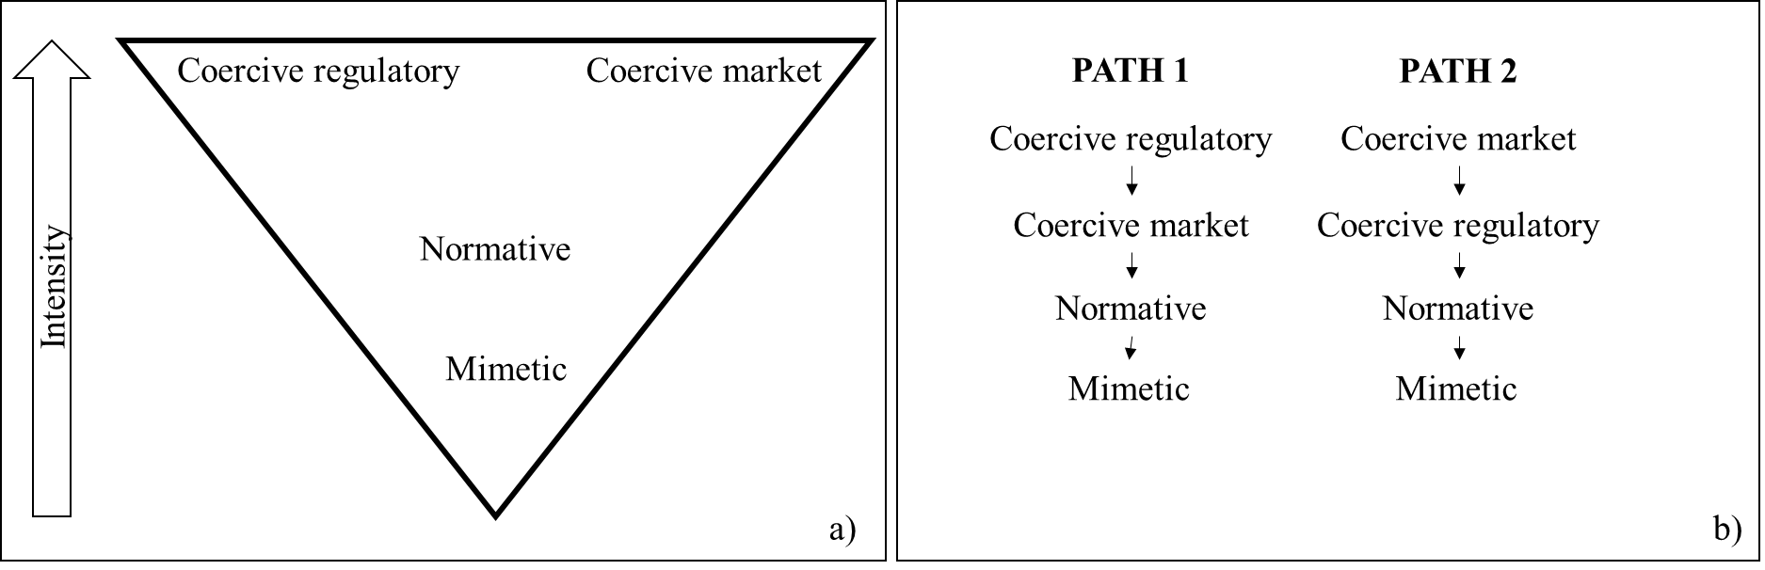

Figure 5 – Hierarchy of pressures (a) and evolution paths (b)

Experts also highlighted the risk of not considering other important drivers of the adoption of CE practices, both internal (such as top/senior management culture and commitment, organisational culture, and leadership) and external (such as national culture and resource scarcity – see quote Q10 in Table 3) to the organisation. Looking at the literature, some of these factors might be connected with IPs (Dubey et al., 2019). For example, experts suggested that there is a relationship between normative pressures and top management commitment (EO5, Table 3). This is because industry standards driving normative pressures are often defined by bodies that are clearly influenced by the top-management of the most important companies in the industry.

In the presence of pressures, organisations can respond in different ways. Some organisations might adapt to institutional requirements, while others might decide to resist them. The timing of action (quote Q11, Table 3) and the decision to be a first mover or follower are crucial elements. Being a first mover may have advantages, such as avoiding some pressures, but it may also require significant investments. Followers could benefit from a mimetic approach, imitating CE practices from peers. This insight may also suggest a link with top management commitment, which plays a role in determining companies’ response to pressures.

It is worth mentioning that only two experts believed there are very weak pressures on companies to adopt CE practices. According to them, the current institutional norms should be analysed more in detail, given that the current dominant pressures are still pushing for supply chains that are designed according to a linear paradigm. Overall, however, the findings seem to validate the relationship between institutional pressures and the adoption of CE practices (Figure 4).

Table 3 – Example of relevant interview quotes – Institutional Pressures

|  |  |  |  |  |
| --- | --- | --- | --- | --- |
| Time | EO (#) | Q (#) | Quotes | Source |
| Coercive  Regulatory Pressures | EO20 | Q1a | “The main reason companies adopt CE practices is to avoid sanctions […]. In absence of coercive pressures companies would not take action. You can see this from how different the actions of North American automotive companies are from the European ones, where presence of emission target reductions is set by law” | Practitioner PH |
| Q1b | “Compliance is the main driver for the Circular Economy. National directives that implement European Union guidelines and packages. But also national directives that provide incentives for green practices. Furthermore, companies want to be ready also for those directives that are not yet out there but might be in the pipeline. “ | Practitioner PE |
| EO16 | Q20 | “European Environmental Bureau calls for extending the right-to-repair directive to more electronic devices and criticised the powerful lobby of personal computers that made it possible to delay the application to that product” | Practitioner PE |
| EO21, EO22 | Q28 | “The main pressures come either from legislation or from others in the supply chain. Usually, it is the focal firm that spreads the pressures of the first tier suppliers and customers. I would expect mimetic pressures becoming stronger as a consequence of more firms having adopted CE practices” | Academic AA |
| Coercive  Market Pressures | EO23 | Q2a | The next step is about learning how to monetise the change in a cost-effective way. And operationalise the change in your supply chain in such a way that it makes business sense. At the moment, there are prejudices against the coercive side of the pressures – where coercive is just seen as an additional cost” | Practitioner PH |
| Q2b | “Focal firms are pressuring others in the supply chain to share their level of inventory real time. Supra national regulation might bring pressures from within the supply chain.” | Academic AA |
| EO17 | Q3 | “You write the supply chain from left to right (extraction – manufacturer - distributor) but you have to read it right to left to understand how the transformation works: Brand owners (in this example manufacturers) and consumers are setting the CE agenda” | Practitioner PA |
| EO02 | Q12a | “To review the performance of our production process we have some KPIs around waste. Looking at the importance directives and our customers are giving to it we want to add KPIs on circularity of inputs” | Practitioner PC |
| Q12b | “We are developing internal policies to make some processes more circular and less wasteful - for example making the use of reusable cups in cafeterias obligatory and making many processes paperless” | Practitioner PI |
| EO17 | Q21 | “In some countries where different perception of social values, final consumers are not accepting fridges because of a yellow ink in a label on the cardboard contains some cadmium. This obliges you to change the design of packaging and also of products at times” | Academic AB |
| Normative Pressures | EO12 | Q4 | “Social norms have an important effect on employment. Aspirations of improve environmental and makes of it a more attractive organisation” | Practitioner PC |
| EO18 | Q5 | “A documentary from an NGO had a major impact on the industry, raising the problem of child labour. After that customers have started to ask for certifications, purify the sources of material” | Practitioner PQ |
| EO4, EO19 | Q6a | “Professional associations are evolving and driving CE (and green) practices. Think about architects that, through *design thinking* design buildings that can be easily recovered; or think about companies that have the knowledge to perform LCA about different product options” | Practitioner PF |
| Q6b | “Our implementation of CE practices is at an initial stage. The primary need is to show our customers we are doing something and improve our corporate image” | Practitioner PM |
| EO7 | Q22 | “NGOs, charities and communities are promoting collaborative and shared consumption models and truly innovative models that are able to overcome the dependence on fossil fuels, the concept of ownership and consumerism” | Academic AE |
| Mimetic Pressures | EO22 | Q7 | “The effect of peers influences the adoption of circular economy innovation; not specifically within supply chains but in general. It is also interesting to understand how different types of peers and firms have a different effect” | Academic AM |
| EO7, EO8 | Q8 | “Companies use a risk and opportunity approach to study what that means for them - how it is it going to impact the business - How it can create value for now and in the long term” | Practitioner PA |
| Q9 | “Companies monitor trends and might decide to follow them” the risk to be “cut out” | Practitioner PE |
| Other drivers | EO11 | Q10 | “Scarcity of resources is also a driver. For example, scarcity of copper, which is a reality. With copper price going up linear business models are at risk. It is a very important driver for companies to explore the feasibility of other business models like circular ones.” | Practitioner PP |
| Timing of action | EO8 | Q11 | “Companies need to decide whether to be a first mover or follower. Both strategies present advantages and risks. First movers could anticipate and avoid some pressures, like mimetic and coercive ones, which generally require an immediate (and maybe sub-optimal) reaction “ | Academic AG |

4.2.2 SCI – in support of the transition to the CE or in defence of linear supply chains?

Regarding the influence of SCI, most of the interviewed experts (24 out of 30) first supported its moderating role; however, SCI represents a multifaceted concept whose implications should be deeply investigated. Qualitative results provide contrasting evidence on the direction (positive-negative), the type of interaction (moderating-mediating[14]) and effect of SCI on the relationship between IPs and the adoption of CE practices, delivering a more uncertain characterisation of its role.

The first idea that emerges from the interviews is that SCI is a necessary condition and a prerequisite for successful CE implementation (CC7, Table 2). In summary, SCI activities describe the degree to which an organisation manages its supply chain to command, control, and manage the whole process. For 13 of the experts, SCI *positively moderates* the adoption of CE practices (see quotes Q13a and b, Q14, Q15b, Q17b in Table 4). In contexts with strong pressures, SCI amplifies their effect and plays a role in determining how deeply CE practices are adopted. On the other hand, the absence of SCI poses serious challenges in activating operational aspects related to material exchanges (quote Q13a Table 4). Also, academic experts mentioned this point and how the lack of adequate information sharing mechanisms and systems is one of the main barriers towards CE practices. A small number of experts expressed contrasting views on the exogenous nature of SCI and argued in favour of a *mediating* role (with IPs also driving SCI – see quote Q19 in Table 4). In line with this, content analysis unveils more evidence that SCI might have a direct relationship with IPs and have a more direct role in driving CE practices itself (CC10, Table 2). Enhancing the level of SCI, as a reaction to IPs, can provide a good platform for starting transformational processes, even in multi-tier and global supply chains (quote Q14 Table 4). Experts cited the cases of companies which are making good progress towards the development of closed-loop supply chains due to their ability to control their production and distribution networks (e.g., Apple and Michelin as notable cases). SCI is about developing key capabilities that are then useful to drive the adoption of CE practices themselves.

A second idea that emerges from the analysis process (CC8, Table 2), confirms the beneficial role of SCI aspects, but simultaneously highlights that being integrated with key suppliers and customers might not be sufficient to enable the adoption of some CE practices. SCI was originally conceptualised for intrinsically linear supply chains; as such, it is biased towards relationships with key suppliers and key customers and towards operational aspects, with no link with reverse and circular flows of materials and associated flows information (Bimpizas-Pinis et al., 2022). To them, SCI *could still positively moderate (or mediate)* the effect of pressures on the adoption of just incremental CE practices (e.g., recycle, recover, renewable energy and resource efficiency). However, the effect of SCI on more radical and disruptive approaches would be uncertain (quote 18a, Table 4).

The third idea that emerged (CC9, Table 2) is that, in some cases, SCI could *negatively moderate (or mediate)* the effect of pressures on the adoption of some more radical CE practices. In other words, more integrated supply chains could provide a form of lock-in into linear supply chains, being a barrier to adopt some approaches and a fully circular logic (see quote Q15a in Table 4). Hence, SCI might strengthen linear supply chains rather than stimulating new relationships with different actors, which have an interest in disrupting business as usual. This idea describes the tension between integration and CE practices in a context of well-consolidated linear supply chains. Established organisations are dealing with CE practices through a stepwise approach; however, lower dependence from suppliers might be required for the most disruptive transformations (Q17a, Table 4).

The need to be receptive to the external context is a key theme (Q9 in Table 3). Companies are aware that CE legislation could revolutionise markets and want to mitigate risks deriving from such potential changes (Q8 in Table 3). For this reason, it is necessary to adopt a learning approach from competitors and suppliers, in order to develop the most strategic partnerships and build the right knowledge. CE solutions can involve heavy initial technological investment; however, in many cases, they involve conceptual and social innovations and a different way to do things, to answer customers’ needs and secure long-term growth within a context of legitimacy. Becoming more adaptable and reactive is considered a key capability in a context of change and might also be connected with the level of SCI.

Table 4 – Example of relevant interview quotes – Supply Chain Integration

|  |  |  |  |  |  |
| --- | --- | --- | --- | --- | --- |
| Supply Chain Integration aspects | EO (#) | Q (#) | Quotes | Role in institutional pressures and CE relationship | Source |
| Sharing information | E24 | Q13a | “Without sharing information, it is impossible to adopt certain emission reduction or circular economy practices. Lack of information sharing is the first barrier.” | Positive | Practitioner PH |
| Q13b | “The complexity in the supply chain is a barrier to the implementation of the policies (e.g.  REACH directive on chemical, ROAS directive on hazardous substances etc.). It is very difficult for firms to comply with them on one side and on the other side to demonstrate and have a clear picture if they are complying with them” | Positive | Academic AM |
| System coupling | E31 | Q18a | “Reusing materials in the supply chain requires visibility at all supply chain stages. Digitalising information can be useful for guaranteeing that the material/products will be recovered” | Positive | Practitioner PN |
| Q18b | “The role of digitalisation and new technologies is extremely important. Blockchain technology for example will bring great advantages to firms that want to implement CE practices in their supply chains” | Positive | Academic AD |
| Joint decision making | E25 | Q14 | “Taking decisions jointly with partners creates a shared responsibility adoption and make it easier to move towards a CE” | Positive | Academic AI |
| E34 | Q15a | “Linear supply chains that take decisions together could build cartels and resist to change” | Negative | Practitioner PD |
| E29 | Q15b | “Greater collaboration on improving processes and developing new products can help winning the resistance to change of some actors in the supply chain” | Positive |  |
| Collaborative approaches | E32 | Q16 | “Developing collaborative approaches is very important - CE model implies you have to create partnerships. Chemical companies are becoming partners with batteries users – to get those batteries back before the end of life with the recycler. Then you start to close the loop” | Positive | Practitioner PA |
| E35 | Q17a | “The more you collaborate and have aligned incentives with existing suppliers and customers mainly focusing on the forward supply chain, the more difficult it will be to activate new processes, adopt CE practices and challenge your linear business model.” | Negative | Practitioner PD |
| Q17b | “Long-term partnership with suppliers supports you in making sure your green practices are spread and bring a tangible improvement to your impact on the environment” | Positive | Academic AA |
| General supply chain integration | E28, 29, 30 | Q19 | “What matters most is that you want to change your level of SCI to get to the CE, you want to see the effect of that change, that comes from pressures on your sustainability performance in a CE” | Positive | Academic AH |

Also, the adoption of CE practices could also have a feedback effect on SCI, favouring further integration; increasing levels of adoption and extension of CE practices might have a retro-active effect on information sharing and suppliers’ involvement. Another notable insight was related to the SCI construct per se; one expert suggested that SCI was originally conceptualised for intrinsically linear supply chains; as such, there is no link with reverse and circular flows of materials and information. Consequently, the SCI concept might be revised in order to make it fully relevant to the transition towards a CE (Bimpizas-Pinis et al., 2022). Also, one expert warned against the dangers deriving from SCI and the potential resistances towards its achievement. More specifically, some companies might not be willing to share information that would be necessary to enable some CE process because of opportunistic behaviours of supply chain partners. A challenge that could be identified is how to share enough information without revealing too sensitive information at the same time.

Institutional pressures do not act with the same intensity for each organisation in a supply chain. Pressures influence primarily a certain organisation or a group of those. Organisations need to formulate a response to those pressures, which include involving their supply chain, transferring responsibilities, and delegating actions, verifying compliance with norms or codes of conduct, or even collaborating on the creation of solutions. SCI might also play a role on this and on how intensively a company is able to put the pressures in its own supply chain.

In synthesis, it is believed SCI could have both a moderating and a mediating role – acting on how intensely the supply chain as a system is able to perceive the pressures but also on extent it can react to them. However, this moderating role might be significantly less relevant, and possibly negative, when considering more radical CE practices.

4.2.3 CE practices in organisations and in their supply chains

Looking at the dependent variable of the framework, experts commented on how companies are approaching and implementing CE principles. They also highlighted some factors to be considered when assessing the process of adoption of CE practices in supply chains. Insights about this, and useful research implications were shared, along with hints on how to measure it, as reported in the following Table 6.

Practitioners pointed out the need to distinguish between very different supply chains and contexts and to analyse them through different approaches (quote Q27, Table 6). They also highlighted the importance of choosing wisely what CE outcomes are to be measured (quote Q23, Table 6), and of quantifying CE practices adoption across the whole company and supply chains (quote Q25, Table 6).

In order to assist with this, experts identified several control variables that can describe the type of market/industry. Companies may have varying behaviours and approaches to the implementation of CE, based on factors such as the intensity of investments in R&D, market concentration, and the type of customers they serve (whether they are businesses or final consumers). Additionally, the position in the supply chain might be a factor that influences the type of CE practices companies choose.

## Implications

This section reflects on the findings that emerged in the results section. It formalises a qualitative framework, which is an evolution of the initial framework (Figure 1). Results are also compared with recent literature, and theoretical and managerial contributions are highlighted.

### An emerging qualitative framework: compliance versus proactive trajectories to the transition to a Circular Economy

Findings confirmed the relevance of the research problem and highlighted the need to investigate further and test the relationships in the initial framework (Figure 1). The process shown in this paper culminated in a revised qualitative framework (Figure 6), which combines the main ideas of the analysis (aggregated dimensions, shown in Table 2, from AD1 to AD6) in a comprehensive graph.

The framework (see Figure 5) brings together the two different evolution paths of institutional pressures, the four specific responses through which IPs are influencing firms’ behaviour, the different ways through which SCI acts on pressures, and the relationship of the drivers with the type of CE practice being adopted. Specifically, the framework distinguishes two possible trajectories that could drive different CE outcomes, and which could be influenced in different ways by the level of SCI.

The first trajectory describes a regulation-driven path (CRP->CMP->NP->MP, see Figure 5), which refers to a context of weak regulation based on voluntary adoption that could be quite representative of the current situation in the European Union. In this scenario, firms decide to passively *comply* with environmental regulations, by re-adjusting their existing environmental monitoring systems, to measure their impact and by taking corrective actions. Firms adopt a step-by-step approach to the CE, focusing only on very incremental CE practices that become institutionalised and create market pressures, normative pressures and mimetic pressures. SCI is expected to have an amplifying role and driving role (Figure 6). Key players, systems, and processes that are expected to drive the transition towards the CE in this case are the same involved in traditional linear supply chains. As such, they can take advantage of the collaborative capabilities of integrated supply chains to implement CE practices that are compatible with established linear value creation processes (e.g., mainly focused on the use of renewable energy, increase resource efficiency and with the integration of recycled flows). SCI could play a similar “amplifying” role also in the presence of tokenistic responses and opportunistic behaviours. Higher SCI could make it possible for key players of the linear supply chain to spread greenwashing actions and irresponsible practices, hiding their inertia (Ferns and Amaeshi, 2021).

The second trajectory describes a market-driven path (CMP->CRP->NP->MP, see Figure 5), with firms *proactively* adopting CE practices pushed primarily by consumer demand and public opinion. This path represents a context with a deeper societal and institutional transformation. New and stricter regulations are expected to emerge as a consequence of a push that comes from consumers, public opinion and societal demands. The most likely responses in this scenario involve reorganising supply chain operations and developing new products. Both these responses require new networks to emerge and disrupt markets by adopting Circular Business Models and more radical CE practices. Firms are also likely to establish new partnerships with new actors (e.g., collection and sorting contractors; re-processors; remanufacturers). SCI in this case has a double role: it provides useful capabilities in terms of coordination and collaboration with key partners in the linear supply chain; however, it also magnifies the risk of lock-ins in linear supply chains. As such, companies with lower levels of SCI could have some advantages to succeed, deriving from a higher possibility to experiment with new solutions and decrease dependence on suppliers.

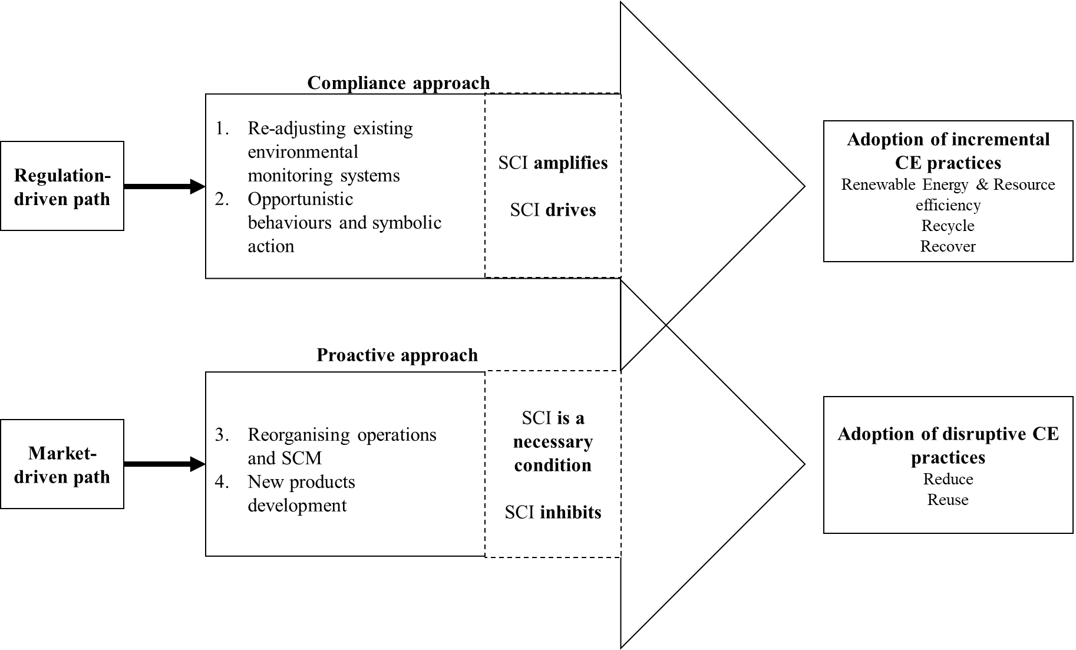Figure 6 – A qualitative version of the framework

In line with previous studies, the framework shows that coercive institutional pressures are the dominant ones (Agyabeng-Mensah et al., 2022) and a necessary condition to activate effective sustainability actions, and for the other pressures to originate (Arranz et al., 2022). Differently from previous literature, this study recognises paths and dynamics that experts are foreseeing. The study also points at the limitations of an institutional change that comes from regulation alone (Ranta et al., 2018). To build the necessary incentives for deeper societal transformation and stronger sustainability, it is necessary to redefine societal values and beliefs and deeply incorporating ecological instances in our institutions (Montabon et al., 2016).

Also, highlighting the double role of SCI is another key contribution of this article. The traditional debate on the collaborative paradigm in supply chain management (Frohlich & Westbrook, 2001) has explored SCI role in sustainability transitions (Wiengarten & Longoni, 2015), and it has started to look at CE transitions very recently (Bimpizas-Pinis et al, 2022). Results enrich the understanding of how SCI might affect the adoption of CE practices, by recognising its advantages and the possible risks. The central issue is how to leverage coordinative and collaborative aspects and capabilities of integrated supply chains without it becoming a constraint against radical innovation.

The responses to institutional pressures that emerge from the qualitative analysis are in line with previous papers on sustainability trajectories (Silvestre et al., 2020). Also in this study, some of the identified initiatives or responses to pressures have an “exploitative” nature of the supply chain capabilities that already exist (e.g., CC1 in Table 2: readjusting their existing environmental monitoring systems) and some others have an “exploratory” nature, adapting completely new capabilities, products, processes, that are different from those used in the past (e.g., CC3 and CC2 in Table 2: re-organising their operations and supply chains and developing new circular products). According to that perspective, SCI could be seen as a factor that provides necessary capabilities and alignment between supply chain actors while also increasing path dependency, pushing for initiatives that exploit existing sustainability process and practices rather than developing new ones. In the context of the transition towards the CE, higher path dependency could be associated to linear lock-in.

### Contribution to theory and practice

This paper extends previous research in sustainable supply chain management that has studied drivers, enabling factors, and practices using institutional theory (Kauppi and Luzzini, 2022). It is also connecting this knowledge and ideas to a more recent research field, circular supply chain management (Farooque et al., 2019; Lahane et al., 2020). This is important as it improves the theoretical understanding of the antecedents of the adoption of CE practices in supply chains by developing a conceptual framework that integrates institutional pressures, supply chain integration, and the adoption of circular economy practices, which can be tested through future quantitative studies. Future empirical studies could then provide clarity on the hierarchy of pressures for the circular economy (e.g., whether mimetic and normative arise where coercive pressures are already present).

Table 5 – Possible measurement scales of CE outcomes

|  |  |
| --- | --- |
| CE practices aspects measured | Literature |
| R-imperatives | (Reike et al., 2018) |
| Supply chain process involved | (Gusmerotti et al., 2019) |
| Level of implementation  Involvement the supply chain | (Calzolari et al., 2021) |
| Sustainability performance (KPIs)* | (Jain et al., 2020) (Chiappetta Jabbour et al., 2020)  (Di Maria & De Marchi, 2022) |
| Incremental vs radical  Symbolic/greenwashing vs challenge linear consumption | (Arekrans et al., 2022)  from the interviews |

A second contribution is related to the concept of SCI. In particular, studying transitions towards a CE requires consideration of how supply chain structures and organisations are evolving. These supply chains might have developed specific capabilities and relationship links, which can provide an advantage, and at the same time, might contribute to creating conditions that foster change. Discussions with experts highlighted that more integrated structures might also have undesired effects. Also, they identified further important aspects and capabilities that might be key in supporting the evolution towards more sustainable production and consumption systems, such as agility and reduced dependence on suppliers and customers. Therefore, future research should consider the complex effect of SCI aspects on the relationship between the pressures a company faces and its behaviour, both a technological and relational point of view.

It is worth mentioning that findings arising from this paper are also very relevant for industrial practice, as they are based on the interaction with a wide range of practitioners (who constituted the majority of the surveyed panel of experts) who are directly participating in changing existing companies in their day-to-day activities and have experience in the CE. Results could offer both practitioners and policymakers a better understanding of how the external environment influences businesses to adopt CE practices. Policymakers can then incorporate these findings into the development process of regulatory guidelines or policy action plans. Companies can benefit from recognising different types of responses to institutional pressures, as well as reflecting on how their level of SCI is going to affect the type of CE practice. The study also warns firms not to rely only on existing supply chain partners for more radical CE practices, but to experiment with others.

### Insights for the operationalisation of constructs

Recent academic debate around institutional pressures at the supply chain level has led to the development of more reliable scales to measure their constructs (Kauppi and Luzzini, 2022), which have overcome the limitations of previous approaches. In the CE literature, IPs have often been measured with proxies or bundled external pressure constructs (Gusmerotti et al., 2019).

The concept of SCI has been conceptualised in different ways. Some authors have distinguished between relational and technological integration constructs (Leuschner et al., 2013), while others have used the concept of arcs of integration to look at different aspects of integration (Frohlich and Westbrook, 2001; Schoenherr and Swink, 2012). These dimensions have been used and validated by the IMSS project in a number of empirical studies (Danese and Bortolotti, 2014; Wiengarten and Longoni, 2015).

Experts’ perspectives were particularly useful in suggesting new dimensions to consider when measuring CE outcomes (see Recommendations R1 to R5, Table 6), in addition to those already used in recent literature (Table 5). CE practices were often classified by distinguishing among different R-imperatives (Reike et al., 2018; Lopes de Sousa Jabbour et al., 2019), the supply chain process involved (Dagiliene et al., 2020), the level of their implementation and the degree of involvement of supply chain partners (Calzolari et al., 2021), and the lifecycle phase involved (Elia et al., 2020). To ensure a critical evaluation of companies’ claims and avoid greenwashing and reductionist approaches to CE (Recommendation R2, Table 6), some other dimensions were suggested. CE practices that enable incremental improvements of linear business models should be distinguished from radical innovations that promote sufficiency and enable the displacement of primary production (Recommendation R4,Table 6), as highlighted in recent literature (Arekrans et al., 2022). Experts also emphasised the importance of choosing wisely which CE outcomes to measure (R1, Table 6), and quantifying CE practices’ adoption across the entire company and supply chain (Recommendations R2 and R3, Table 6).

## Conclusions

This paper sheds some light on the relationship between institutional pressures, supply chain integration and the adoption of Circular Economy practices. An initial framework, derived from academic literature and an analysis of corporate sustainability reports (presented in Calzolari et al., 2021), was challenged and refined through a consultation process with CE experts in a Delphi-like study. The analysis of the data collected through semi-structured interviews confirms that the identified concepts have a relationship; in particular, institutional pressures drive the adoption of Circular Economy practices, with supply chain integration having a complex interaction with this relationship.

The paper suggests different ways in which institutional pressures influence companies’ behaviour when adopting CE practices. Practitioners and academic experts also reflected on the role of supply chain integration. The type of interaction with institutional pressures (moderation or mediation) is contested. Also, some aspects of supply chain integration might reinforce supplier-buyer relationships in a linear perspective and become an obstacle for the most radical Circular Economy practices. The proposed qualitative framework also characterises two trajectories, which differ based on the type of reaction to pressures and the role played by supply chain integration.

The study contributes to the theory by improving the understanding of the process of adoption of Circular Economy practices also from a supply chain management perspective. From a practical standpoint, the evidence from this study could offer policymakers a better understanding of how the external environment influences businesses to adopt CE practices. Policymakers can then incorporate these findings into the development process of regulatory guidelines or policy action plans.

Future research could test the final framework through a large-scale data collection process. Also, another interesting avenue for further investigations is related to the role of institutional pressures and supply chain integration in driving the adoption of more disruptive innovations in the transition towards a CE, along with the degree of circularity of resulting supply chains.

## Acknowledgments

This research has been partially supported by the following European Commission’s research programmes: H2020-MSCA-ITN-2018 scheme, Grant agreement 814247 (ReTraCE project); H2020-MSCA-RISE-2018 scheme, Grant agreement 823967 (ProCEedS project).

Table 6 – Issues to be considered when assessing the process of adoption of CE practices along with experts’ recommendations

|  |  |  |  |
| --- | --- | --- | --- |
| Issue | Source | Recommendation | Detail |
| “The level of CE adoption is currently very low, on average, across industrial sectors. Most industries still work according to a linear logic and there is strong inertia towards change. Despite incumbents having some CE-inspired initiatives in place, they still have a strong reliance on energy-intensive, fossil fuel-based, consumeristic systems.” | Practitioner | Choose wisely what CE outcomes are to be measured (R1) | Should we measure the adoption of some CE practices? Or, is it more important to focus on the sustainability performance in terms of some type of benefits they are expected to bring (e.g., environmental, economic and social)? This aspect is paramount and relates to the type of contribution studies want to achieve, and the debate they want to be part of. There is a dichotomy between the technical CE literature and the SCM literature. In the first case, the categorisation of different approaches could be more valuable; in the second one, the type of supply chain performance and outcome they can help to achieve could be of higher interest. |
| “Companies tend to use the CE label for existing practices, rebranding activities/practices they have already in place. Generally, they do not aim at minimising resource extraction and their reliance on fossil fuels.” | Academic | Beware of greenwashing and symbolic actions (R2) | Researchers need to pay attention to greenwashing attempts: “circular” does not necessarily mean sustainable. For instance, fast fashion companies, while claiming to be *circular* (as they are incentivising recycling and take back schemes) are still relying heavily on fossil fuels and promoting irresponsible consumption patterns. This might be highlight that the CE concept is being hijacked by the business community. |
| “Companies work on two parallel streams. On the one hand, they are experimenting with circular business models (trying them out in the market); on the other, they are still maintaining the linear ones as dominant.” | Practitioner | Quantify CE practices adoption across the whole companies and supply chains (R3) | It is important to take into account to what extent CE practices are being implemented at a whole-company and whole-supply chain level. There should be awareness about tokenistic approaches to CE implementation. |
| “Companies most often focus on recycling, demonstrating a reductionist approach to CE, where higher R-imperatives (such as reduce and reuse) are not considered.” | Practitioner | Distinguish between incremental and transformative (and more disruptive) approaches (R4) | It is important to distinguish between transformative approaches, where business models and ownership paradigms are deeply revisited, from those that have a focus just on increasing recycling, waste management and efficiency. Evidence of this could be found in the CE targets companies set, the type of organisation they collaborate with. Also, investments in R&D could help recognising these differences. |
| “The effect of the adoption of CE practices strongly depends on supply chain stages.” | Practitioner | Differentiate across contexts, sectors and stages in the supply chain (R5) | Higher pressures are often placed on product manufacturers. Organisations operating upstream in the supply chain, might face different challenges. |

## References

Agyabeng-Mensah, Y., Afum, E., Baah, C. and Essel, D. (2022). Exploring the role of external pressure, environmental sustainability commitment, engagement, alliance and circular supply chain capability in circular economy performance. International Journal of Physical Distribution & Logistics Management, 52(5/6), 431-455. <https://doi.org/10.1108/IJPDLM-12-2021-0514>

Arekrans, J., Ritzén, S., & Laurenti, R. (2022). The role of radical innovation in circular strategy deployment. Business Strategy and the Environment, 1-21. <https://doi.org/10.1002/bse.3108>

Arranz, C. F., Sena, V., & Kwong, C. (2022). Institutional pressures as drivers of circular economy in firms: A machine learning approach. Journal of Cleaner Production, 355, 131738. <https://doi.org/10.1016/j.jclepro.2022.131738>

Arsova, S., Genovese, A., & Ketikidis, P. H. (2022). Implementing circular economy in a regional context: A systematic literature review and a research agenda. Journal of Cleaner Production, 133117. <https://doi.org/10.1016/j.jclepro.2022.133117>

Bag, S., Dhamija, P., Bryde, D. J., & Singh, R. K. (2022). Effect of eco-innovation on green supply chain management, circular economy capability, and performance of small and medium enterprises. Journal of Business Research, 141, 60-72. <https://doi.org/10.1016/j.jbusres.2021.12.011>

Bag, S., & Pretorius, J. H. C. (2022). Relationships between industry 4.0, sustainable manufacturing and circular economy: proposal of a research framework. International Journal of Organizational Analysis, 30(4), 864-898. <https://doi.org/10.1108/IJOA-04-2020-2120>

Berardi, P. C., & de Brito, R. P. (2021). Supply chain collaboration for a circular economy - From transition to continuous improvement. Journal of Cleaner Production, 328, 129511. <https://doi.org/10.1016/j.jclepro.2021.129511>

Bimpizas-Pinis, M., Calzolari, T., & Genovese, A. (2022). Exploring the transition towards circular supply chains through the arcs of integration. International Journal of Production Economics, 250, 108666. <https://doi.org/10.1016/j.ijpe.2022.108666>

Braz, A. C., & de Mello, A. M. (2022). Circular economy supply network management: A complex adaptive system. International Journal of Production Economics, 243, 108317. <https://doi.org/10.1016/j.ijpe.2021.108317>

Bressanelli, G., Perona, M., & Saccani, N. (2019). Challenges in supply chain redesign for the Circular Economy: a literature review and a multiple case study. International Journal of Production Research, 57(23), 7395-7422. <https://doi.org/10.1080/00207543.2018.1542176>

Bressanelli, G., Visintin, F., & Saccani, N. (2022). Circular Economy and the evolution of industrial districts: A supply chain perspective. International Journal of Production Economics, 243, 108348. <https://doi.org/10.1016/j.ijpe.2021.108348>

Brønn, P. S., & Vidaver-Cohen, D. (2009). Corporate motives for social initiative: Legitimacy, sustainability, or the bottom line? Journal of Business Ethics, 87(Suppl. 1), 91-109. <https://doi.org/10.1007/s10551-008-9795-z>

Calzolari, T., Genovese, A., & Brint, A. (2021). The adoption of circular economy practices in supply chains–An assessment of European Multi-National Enterprises. Journal of Cleaner Production, 312, 127616. <https://doi.org/10.1016/j.jclepro.2021.127616>

Cricelli, L., Greco, M., & Grimaldi, M. (2021). An investigation on the effect of inter-organizational collaboration on reverse logistics. International Journal of Production Economics, 240, 108216. <https://doi.org/10.1016/j.ijpe.2021.108216>

Dagiliene, L., Frendzel, M., Sutiene, K., & Wnuk-Pel, T. (2020). Wise managers think about circular economy, wiser report and analyze it. Research of environmental reporting practices in EU manufacturing companies. Journal of Cleaner Production, 274, 121968. <https://doi.org/10.1016/j.jclepro.2020.121968>

Danese, P., & Bortolotti, T. (2014). Supply chain integration patterns and operational performance: A plant-level survey-based analysis. International Journal of Production Research, 52(23), 7062-7083. <https://doi.org/10.1080/00207543.2014.935515>

de Abreu, M. C. S., & Ceglia, D. (2018). On the implementation of a circular economy: The role of institutional capacity-building through industrial symbiosis. Resources, Conservation and Recycling, 138, 99-109. <https://doi.org/10.1016/j.resconrec.2018.07.001>

De Angelis, R., Howard, M., & Miemczyk, J. (2018). Supply chain management and the circular economy: towards the circular supply chain. Production Planning & Control, 29(6), 425-437. <https://doi.org/10.1080/09537287.2018.1449244>

de Jesus, A., & Mendonça, S. (2018). Lost in transition? Drivers and barriers in the eco- innovation road to the circular economy. Ecological Economics, 145, 75-89. <https://doi.org/10.1016/j.ecolecon.2017.08.001>

De Lima, F. A., & Seuring, S. (2023). A Delphi study examining risk and uncertainty management in circular supply chains. *International Journal of Production Economics*, *258*, 108810. <https://doi.org/10.1016/j.ijpe.2023.108810>

de Sousa Jabbour, A. B. L., Luiz, J. V. R., Luiz, O. R., Jabbour, C. J. C., Ndubisi, N. O., de Oliveira, J. H. C., & Junior, F. H. (2019). Circular economy business models and operations management. Journal of Cleaner Production, 235, 1525-1539. <https://doi.org/10.1016/j.jclepro.2019.06.349>

Di Maria, E., & De Marchi, V. (2022). Industry 4. 0 technologies and circular economy: The mediating role of supply chain integration. Business Strategy and the Environment, September 2020, 1-14. <https://doi.org/10.1002/bse.2940>

Di Maria, E., De Marchi, V., & Galeazzo, A. (2022). Industry 4.0 technologies and circular economy: The mediating role of supply chain integration. Business Strategy and the Environment, 31(2), 619-632. <https://doi.org/10.1002/bse.2940>

DiMaggio, P. J., & Powell, W. W. (1983). The Iron Cage Revisited: Institutional Isomorphism and Collective Rationality in Organizational Fields. American Sociological Review, 48(2), 147-160. <https://doi.org/10.2307/2095101>

Do, Q., Mishra, N., Colicchia, C., Creazza, A., & Ramudhin, A. (2022). An extended institutional theory perspective on the adoption of circular economy practices: Insights from the seafood industry. International Journal of Production Economics, 247, 108400. <https://doi.org/10.1016/j.ijpe.2021.108400>

Domenech, T., & Bahn-Walkowiak, B. (2019). Transition towards a resource efficient circular economy in Europe: policy lessons from the EU and the member states. Ecological Economics, 155, 7-19. <https://doi.org/10.1016/j.ecolecon.2017.11.001>

Dou, Y., Zhu, Q., & Sarkis, J. (2018). Green multi-tier supply chain management: An enabler investigation. Journal of Purchasing and Supply Management, 24(2), 95-107. <https://doi.org/10.1016/j.pursup.2017.07.001>

Elia, V., Gnoni, M. G., & Tornese, F. (2020). Evaluating the adoption of circular economy practices in industrial supply chains: an empirical analysis. Journal of Cleaner Production, 273, 122966. <https://doi.org/10.1016/j.jclepro.2020.122966>

Ellram, L. M., & Tate, W. L. (2016). The use of secondary data in purchasing and supply management (P/SM) research. Journal of Purchasing and Supply Management, 22(4), 250-254. <https://doi.org/10.1016/j.pursup.2016.08.005>

European Commission. (2020). A new Circular Economy Action Plan For a cleaner and more competitive Europe. Available online at: <https://eur-lex.europa.eu/legal-content/EN/TXT/?qid=1583933814386&uri=COM:2020:98:FIN> Last accessed: 11/06/2020.

Flynn, B. B., Huo, B., & Zhao, X. (2010). The impact of supply chain integration on performance: A contingency and configuration approach. Journal of Operations Management, 28(1), 58-71. <https://doi.org/10.1016/j.jom.2009.06.001>

Frohlich, M. T., & Westbrook, R. (2001). Arcs of integration: An international study of supply chain strategies. Journal of Operations Management, 19(2), 185-200. <https://doi.org/10.1016/S0272-6963(00)00055-3>

Geissdoerfer, M., Savaget, P., Bocken, N. M., & Hultink, E. J. (2017). The Circular Economy-A new sustainability paradigm? Journal of Cleaner Production, 143, 757-768. <https://doi.org/10.1016/j.jclepro.2016.12.048>

Geng, Y., Zhu, Q., Doberstein, B., & Fujita, T. (2009). Implementing China’s circular economy concept at the regional level: A review of progress in Dalian, China. Waste Management, 29(2), 996-1002. <https://doi.org/10.1016/j.wasman.2008.06.036>

Genovese, A., Acquaye, A. A., Figueroa, A., & Koh, S. L. (2017). Sustainable supply chain management and the transition towards a circular economy: Evidence and some applications. Omega, 66, 344-357. <https://doi.org/10.1016/j.omega.2015.05.015>

Gusmerotti, N. M., Testa, F., Corsini, F., Pretner, G., & Iraldo, F. (2019). Drivers and approaches to the circular economy in manufacturing firms. Journal of Cleaner Production, 230, 314–327. <https://doi.org/10.1016/j.jclepro.2019.05.044>

Henry, M., Bauwens, T., Hekkert, M., & Kirchherr, J. (2020). A typology of circular start-ups: An Analysis of 128 circular business models. Journal of Cleaner Production, 245, 118528. <https://doi.org/10.1016/j.jclepro.2019.118528>

Herczeg, G., Akkerman, R., & Hauschild, M. Z. (2018). Supply chain collaboration in industrial symbiosis networks. Journal of Cleaner Production, 171, 1058-1067. <https://doi.org/10.1016/j.jclepro.2017.10.046>

Hofstetter, J. S., De Marchi, V., Sarkis, J., Govindan, K., Klassen, R., Ometto, A. R., Spraul, K. S., Bocken, N., Ashton, W. S., Sharma, S., Jaeger-Erben, M., Jensen, C., Dewick, P., Schröder, P., Sinkovics, N., Ibrahim, S. E., Fiske, L., Goerzen, A., & Vazquez-Brust, D. (2021). From sustainable global value chains to circular economy—different silos, different perspectives, but many opportunities to build bridges. Circular Economy and Sustainability, 1(1), 21-47. <https://doi.org/10.1007/s43615-021-00015-2>

Jabbour, C. J. C., Seuring, S., de Sousa Jabbour, A. B. L., Jugend, D., Fiorini, P. D. C., Latan, H., & Izeppi, W. C. (2020). Stakeholders, innovative business models for the circular economy and sustainable performance of firms in an emerging economy facing institutional voids. Journal of Environmental Management, 264, 110416. <https://doi.org/10.1016/j.jenvman.2020.110416>

Jain, N. K., Panda, A., & Choudhary, P. (2020). Institutional pressures and circular economy performance: The role of environmental management system and organizational flexibility in oil and gas sector. Business Strategy and the Environment, 29(8), 3509-3525. <https://doi.org/10.1002/bse.2593>

Kauppi, K., & Hannibal, C. (2017). Institutional pressures and sustainability assessment in supply chains. Supply Chain Management: An International Journal. 22(5), 458-472. <https://doi.org/10.1108/scm-01-2017-0004>

Kauppi, K., & Luzzini, D. (2022). Measuring institutional pressures in a supply chain context: scale development and testing. Supply Chain Management: An International Journal, 27(7), 79-107. <https://doi.org/10.1108/SCM-04-2021-0169>

Ketchen, D. J., & Hult, G. T. M. (2007). Bridging organization theory and supply chain management: The case of best value supply chains. Journal of Operations Management, 25(2), 573-580. <https://doi.org/10.1016/j.jom.2006.05.010>

Kirchherr, J., Piscicelli, L., Bour, R., Kostense-Smit, E., Muller, J., Huibrechtse-Truijens, A., & Hekkert, M. (2018). Barriers to the circular economy: Evidence from the European Union (EU). Ecological Economics, 150, 264-272. <https://doi.org/10.1016/j.ecolecon.2018.04.028>

Korhonen, J., Honkasalo, A., & Seppälä, J. (2018). Circular economy: The concept and its limitations. Ecological Economics, 143, 37-46. <https://doi.org/10.1016/j.ecolecon.2017.06.041>

Leuschner, R., Rogers, D. S., & Charvet, F. F. (2013). A meta-analysis of supply chain integration and firm performance. Journal of Supply Chain Management, 49(2), 34-57. <https://doi.org/10.1111/jscm.12013>

Liu, J., Feng, Y., Zhu, Q., & Sarkis, J. (2018). Green supply chain management and the circular economy: Reviewing theory for advancement of both fields. International Journal of Physical Distribution and Logistics Management, 48(8), 794-817. <https://doi.org/10.1108/IJPDLM-01-2017-0049>

Mathews, J. A., & Tan, H. (2011). Progress toward a circular economy in China: The drivers (and inhibitors) of eco-industrial initiative. Journal of Industrial Ecology, 15(3), 435-457. <https://doi.org/10.1111/j.1530-9290.2011.00332.x>

Mejías, A. M., Bellas, R., Pardo, J. E., & Paz, E. (2019). Traceability management systems and capacity building as new approaches for improving sustainability in the fashion multi-tier supply chain. International Journal of Production Economics, 217, 143-158. <https://doi.org/10.1016/j.ijpe.2019.03.022>

Okoli, C., & Pawlowski, S. D. (2004). The Delphi method as a research tool: an example, design considerations and applications. *Information & management*, *42*(1), 15-29. <https://doi.org/10.1016/j.im.2003.11.002>

Pinto, J. T., & Diemer, A. (2020). Supply chain integration strategies and circularity in the European steel industry. Resources, Conservation and Recycling, 153, 104517. <https://doi.org/10.1016/j.resconrec.2019.104517>

Ranta, V., Aarikka-Stenroos, L., Ritala, P., & Mäkinen, S. J. (2018). Exploring institutional drivers and barriers of the circular economy: A cross-regional comparison of China, the US, and Europe. Resources, Conservation and Recycling, 135, 70-82. <https://doi.org/10.1016/j.resconrec.2017.08.017>

Reike, D., Vermeulen, W. J., & Witjes, S. (2018). The circular economy: new or refurbished as CE 3.0? —exploring controversies in the conceptualization of the circular economy through a focus on history and resource value retention options. Resources, Conservation and Recycling, 135, 246-264. <https://doi.org/10.1016/j.resconrec.2017.08.027>

Rosa, P., Sassanelli, C., & Terzi, S. (2019). Towards Circular Business Models: A systematic literature review on classification frameworks and archetypes. Journal of Cleaner Production, 236, 117696. <https://doi.org/10.1016/j.jclepro.2019.117696>

Rizos, V., Behrens, A., Gaast, W. Van Der, Hofman, E., Ioannou, A., Hirschnitz-garbers, M., & Topi, C. (2016). Implementation of Circular Economy Business Models by Small and Medium-Sized Enterprises (SMEs): Barriers and Enablers. Sustainability, 8, 1212. <https://doi.org/10.3390/su8111212>

Sancha, C., Longoni, A., & Giménez, C. (2015). Sustainable supplier development practices: Drivers and enablers in a global context. Journal of Purchasing and Supply Management, 21(2), 95-102. <https://doi.org/10.1016/j.pursup.2014.12.004>

Schmidt, R., Lyytinen, K., Keil, M., & Cule, P. (2001). Identifying software project risks: An international Delphi study. *Journal of management information systems*, *17*(4), 5-36. <https://doi.org/10.1080/07421222.2001.11045662>

Scott, W. R. (2003). Institutional carriers: reviewing modes of transporting ideas over time and space and considering their consequences. Industrial and Corporate Change, 12(4), 879-894. <https://doi.org/10.1093/icc/12.4.879>

Sudusinghe, J. I., & Seuring, S. (2021). Supply chain collaboration and sustainability performance in circular economy: A systematic literature review. International Journal of Production Economics, 245, 108402. <https://doi.org/10.1016/j.ijpe.2021.108402>

Touboulic, A., & Walker, H. (2015). Theories in sustainable supply chain management: a structured literature review. International Journal of Physical Distribution & Logistics Management. 45(1/2), 16-42. <https://doi.org/10.1108/IJPDLM-05-2013-0106>

Vanhamäki, S., Virtanen, M., Luste, S., & Manskinen, K. (2020). Transition towards a circular economy at a regional level: A case study on closing biological loops. Resources, Conservation and Recycling, 156, 104716. <https://doi.org/10.1016/j.resconrec.2020.104716>

Vegter, D., van Hillegersberg, J., & Olthaar, M. (2020). Supply chains in circular business models: processes and performance objectives. Resources, Conservation and Recycling, 162, 105046. <https://doi.org/10.1016/j.resconrec.2020.105046>

Venkatesh, V. G., Zhang, A., Deakins, E., & Mani, V. (2020). Drivers of sub-supplier social sustainability compliance: an emerging economy perspective. Supply Chain Management: An International Journal. 25(6), 655-677. <https://doi.org/10.1108/scm-07-2019-0251>

Wiengarten, F., & Longoni, A. (2015). A nuanced view on supply chain integration: A coordinative and collaborative approach to operational and sustainability performance improvement. Supply Chain Management, 20(2), 139–150. <https://doi.org/10.1108/SCM-04-2014-0120>

Zeng, H., Chen, X., Xiao, X., & Zhou, Z. (2017). Institutional pressures, sustainable supply chain management, and circular economy capability: Empirical evidence from Chinese eco-industrial park firms. Journal of Cleaner Production, 155, 54-65. <http://dx.doi.org/10.1016/j.jclepro.2016.10.093>

Zhu, Q., & Geng, Y. (2013). Drivers and barriers of extended supply chain practices for energy saving and emission reduction among Chinese manufacturers. Journal of Cleaner Production, 40, 6-12. <https://doi.org/10.1016/j.jclepro.2010.09.017>

Zhu, Q., Geng, Y., & Lai, K. H. (2011). Environmental supply chain cooperation and its effect on the circular economy practice‐performance relationship among Chinese manufacturers. Journal of Industrial Ecology, 15(3), 405-419. <https://doi.org/10.1111/j.1530-9290.2011.00329.x>

## Appendix 5A

|  |  |  |  |  |  |  |  |
| --- | --- | --- | --- | --- | --- | --- | --- |
| **Type** | **Interviewee code** | **Job Position** | **Industry/Discipline/Sector** | **Involvement with CE activities** | **Mode** | **Recorded** | **Duration** |
| **Round 1 & Round 2 (n=30)** | | | | | | | |
| Practitioner | PA | Sustainability Manager | Chemical | The company is a leader in the CE | Online | No | 1 h |
| Practitioner | PB | Operations Manager | Automotive | The company adopted some initial CE practices | Online | Yes | 45 min |
| Practitioner | PC | Sustainability specialist | Material producer | The company is a leader in the CE | Online | No | 1 h 30 min |
| Practitioner | PD | Sustainability Manager | Motors and Electronics | The company is a leader in the CE | Online | No | 1 h |
| Practitioner | PE | CEO | Sustainability Consulting | The company is a leader in the CE | Online | No | 1 h |
| Practitioner | PF | CEO | Think Tank | The company is a leader in the CE | Online | Yes | 45 min |
| Practitioner | PG | Commercial Manager | Food | The company’s business model is circular | Online | No | 1 h |
| Practitioner | PH | Supply Chain Manager | Material producer | The company adopted some initial CE practices | Online | Yes | 45 min |
| Practitioner | PI | Sustainability Manager | Energy provider | The company is a leader in the CE | Online | Yes | 45 min |
| Practitioner | PL | Supply Chain Manager | IT Software company | The company adopted some initial CE practices | Online | Yes | 45 min |
| Practitioner | PM | Supply Chain Manager | Logistics Provider | The company adopted some initial CE practices | Online | Yes | 45 min |
| Practitioner | PN | Researcher and Consultant | Supply Chain Management | The company is a leader in the CE | Online | Yes | 45 min |
| Practitioner | PO | Supply Chain Manager | Logistics Provider | The company adopted some initial CE practices | Online | No | 45 min |
| Practitioner | PP | Product Manager | Industrial Equipment Components | The company adopted some initial CE practices | Online | No | 45 min |
| Practitioner | PQ | Supply Chain Manager | Food production company | The company adopted some initial CE practices | Online | No | 45 min |
| Practitioner | PR | Researcher | Policy Think-Tank | The company is a leader in the CE | Online | No | 45 min |
| Practitioner | PS | Managing Director | Recovery of cooking oil | The company’s business model is circular | In person | No | 45 min |
| Practitioner | PT | Sales & Marketing Director | Distribution of food | The company adopted some initial CE practices | In person | No | 45 min |
| Academic | AA | Lecturer | Supply Chain Management | CE is part of the research interests | Online | No | 45 min |
| Academic | AB | Professor - Practitioner | Operations Management | CE is part of the research interests | Online | Yes | 1 h |
| Academic | AC | Associate Professor | Strategy and Corporate Responsibility | CE is one of the main research interests | Online | No | 1 h |
| Academic | AD | Professor | Supply Chain Management | CE is one of the main research interests | Online | Yes | 1 h |
| Academic | AE | Professor | Supply Chain Management | CE is one of the main research interests | Online | No | 45 min |
| Academic | AF | Professor | Innovation studies | CE is part of the research interests | In person | Yes | 1 h |
| Academic | AG | Professor | Supply Chain Management | CE is part of the research interests | Online | No | 30 min |
| Academic | AH | Professor | Supply Chain Management | CE is part of the research interests | Online | Yes | 1 h |
| Academic | AI | Professor | Supply Chain Management | CE is part of the research interests | Online | No | 45 min |
| Academic | AL | Conference | Sustainable management | CE was part of the topics of the conference | In person | Yes | 25 minutes |
| Academic | AM | Conference | Economics and Innovation | CE was part of the topics of the conference | Online | Yes | 25 minutes |
| Academic | AN | Professor | Innovation | CE is one of the main research interests | Online | Yes | 30 min |
| **Total** | | | | | | | 24h 20min |
| **Round 3 (N=8)** | | | | | | | |
| Practitioner | PU | Sustainability Specialist | Government Environmental Agency | This agency works on the CE | Workshop  In person | / | 1 hour |
| Practitioner | PV | Sustainability Specialist | Government Environmental Agency | This agency works on the CE |
| Practitioner | PZ | Programme Manager | Non-Governmental Organisation | The NGO is a leader in the CE |
| Academic | AC | Associate Professor | Strategy and Corporate Responsibility | CE is part of the research interests |
| Academic | AN | Professor | Supply Chain Management | CE is part of the research interests |
| Academic | AO | Researcher | Supply Chain Management | CE is one of the main research interests |
| Academic | AP | Professor | Supply Chain Management | CE is part of the research interests |
| Academic | AQ | Researcher | Circular Economy | CE is one of the main research interests |

## Appendix 5B

**Interview questions**

**Round 1 – Preliminary observation**

I. Do you think there is a relationship between institutional pressures and the adoption of circular economy practices? (support, partially support, reject)

II. Do you support/reject the existence of a relationship between supply chain integration and the relationship between institutional pressures and the adoption of circular economy practices? (support, partially support, reject)

III. Do you see any challenge/improvement point? (briefly mention them)

**Round 2 – Qualitative exploration**

I. Details and anecdotes to support/reject the existence of a relationship between institutional pressures and the adoption of circular economy practices:

* How do you think coercive market pressures affect the adoption of circular economy practices?
* How do you think coercive regulatory pressures affect the adoption of circular economy practices?
* How do you think normative pressures affect the adoption of circular economy practices?
* How do you think mimetic pressures affect the adoption of circular economy practices?

II. Details and anecdotes support/reject the existence of a relationship between supply chain integration and the relationship between institutional pressures and the adoption of circular economy practices.

* How do you think sharing information with suppliers and customers can affect the relationship between institutional pressures and the adoption of circular economy practices?
* How do you think coupling systems with suppliers and customers can affect the relationship between institutional pressures and the adoption of circular economy practices?
* How do you think collaborative approaches with suppliers and customers can affect the relationship between institutional pressures and the adoption of circular economy practices?
* How do you think joint decision making with suppliers and customers can affect the relationship between institutional pressures and the adoption of circular economy practices?

III. Can you elaborate on the following challenges/criticisms to the framework emerging from Round 1?

* Existence of other internal drivers to the adoption of circular economy practices
* Existence of other external drivers to the adoption of circular economy practices
* Institutional pressures have no influence on the adoption of circular economy practices
* There is a relationship between Institutional pressures and supply chain integration
* Adoption of circular economy practices has a feedback effect on supply chain integration
* Focus on circular economy performance rather than adoption
* Need to distinguish between Disruptive vs Incremental circular economy practices
* Need to be aware of circular economy practices used for greenwashing

IV. Do you want to add any additional insights?

# An Investigation into the Relationship among Institutional Pressures, Supply Chain Integration and the Adoption of Circular Economy Practices

**Abstract:**

**Purpose –** This paper investigates the role of Institutional Pressures (IPs) and Supply Chain Integration (SCI) in driving the adoption of Circular Economy (CE) practices. Given the acknowledged role of supply chains in the transition to a CE, it is hypothesised that higher IPs might also drive higher levels of SCI in the attempt to implement CE practices.

**Design/methodology/approach –** A conceptual framework is developed and tested in a cross sectional sample of MNEs. Textual content from Corporate Sustainability reports is used to measure the constructs of interest through an advanced coding approach.

**Findings –** Findings show that IPs are driving the adoption of CE practices primarily through the mediation of SCI; the prominent role of coercive and normative pressures is also highlighted. Coercive pressures influence on CE practices is partially mediated by SCI, with normative pressures being fully mediated by it.

**Practical implications –** The study shows that SCI is a key mechanism that lies in between IPs and CE practices. As such managers need to be aware of the pressures and of the capabilities associated with SCI.

**Originality/value –** This empirical study is the first large scale analysis of Multi-National Enterprises (MNEs) that tries to conceptualise how MNEs driven supply chains adopt CE practices in an attempt to generalise theory. The study empirically validates the model and identify research avenues in SCM research to support the adoption of CE practices.

**Keywords:** Circular Economy, Supply Chain Integration, Institutional Theory, Sustainable Supply Chain Management, Multi-National Enterprises

**Paper type** Research paper

## Introduction

The Circular economy (CE) concept is becoming increasingly important for its potential to address grand societal challenges like climate change, waste generation, resource scarcity, and has been incorporated in policy discussion (European Commission, 2020), as well as corporate sustainability plans in the last decade (Sehnem et al., 2019). The political push for a CE is stimulating the development of new production systems where materials and products are reused, remanufactured and recycled, leading to positive environmental, social and economic outcomes (Batista et al., 2023). In order operationalise CE principles, it is crucial to establish Circular Supply Chains (CSCs). CSCs go beyond the traditional linear flow of materials from suppliers to customers, and instead involve new actors such as collectors, sorters, re-processors and remanufacturers (Bimpizas-Pinis et al., 2022). By expanding the scope of collaboration horizontally across different sectors, CSCs help to promote the implementation of CE principles in practice (De Angelis et al., 2018). CSCs can foster the spread of CE-inspired business models – such as, for example enhancing markets of secondary products and materials and promoting servitisation – which constitute a huge green growth opportunity (EMF, 2015).

In this context, a major contribution is expected from Multi-National Enterprises (MNEs), as these organisations coordinate resource-intensive global supply networks (Calzolari et al., 2021). MNEs, both (either private or state-owned), significantly influence resources allocation, investments, materials selection, and product design both in EU and China (Bawens et al., 2020). MNEs are key players to foster upstream-downstream collaborations in CSCs, to support the recovery and sourcing of secondary raw materials, to integrate flows of secondary raw materials with flows of primary raw materials. This means investing in infrastructure for remanufacturing and repair activities, operationalising recycled material and by-product flows, designing product-service systems. As such, it makes sense to start scrutinising them, taking advantage of the vast amount of unstructured data they are already obliged to publish every year, following pressures from governments, which are requesting more detailed disclosure on commitments, targets and indicators .

Institutional pressures (IPs), of a coercive, normative and mimetic nature, have been recognized as a crucial factor in driving the transition towards more sustainable futures (Venkatesh et al., 2020), and as important drivers to adopt CE practices (Ranta et al., 2018). At the same time, in order to achieve a transition towards CSCs, it is crucial to enhance the capacity of companies to share knowledge and information with their partners (Cousins et al., 2019; Herczeg et al., 2018). CE practices cannot be implemented, in isolation, at a single firm level, but require the collaboration of many actors (Chavez et al., 2023). This can help to reduce uncertainty and resource dependency (Silva et al., 2023). In order to develop such capabilities, improving Supply Chain Integration (SCI) has been recognised as a key strategy for promoting collaboration across CSC networks (Calzolari et al., 2021).

This study, based on MNEs in Asian and European countries, examines the impact of external pressures on the adoption of CE-oriented practices. In particular, it examines the direct effect of external pressures on the adoption of CE-oriented practices and the mediating effect of SCI.

This paper argues that SCI plays a key role in influencing responses to IPs for CE. Sustainability is embedded in the circular capabilities of supply chains: the bi-directionality of resource flows across supplier-consumer nodes of a CSC requires alignment with further actors external to the focal supply chain to enable the circular flow of resources (Bimpizas-Pinis et al., 2022). This change cannot come from a single organisation, but rather from a concerted effort of supply chain actors; as such, different aspects of SCI are required to respond to these pressures as a supply chain, which include the implementation of new technologies to couple systems and improve information sharing (De Giovanni, 2022).

Within this study, a conceptual framework derived from the literature will be tested, through a purpose-built databank. Doing this, the study also answers to recent calls for more empirical research, to explore how organisations are approaching the CE with a perspective on supply chain and operations management aspects (Batista et al., 2023). In particular, the study advances the theoretical understanding of CE field from an institutional theory perspective by borrowing the SCI concept used from SCM literature (Batista et al., 2023). It does so by exploring the role of SCI and how it interacts with IPs in the transition towards the CE in (MNEs managed) supply chains.

The remainder of the paper is organised as follows. Section 2 introduces the literature review and the research hypothesis. The research method is described in Section 3. Section 4 reports the results. Section 5 discusses the research findings, and presents the theoretical and practical implications. Section 6 includes the conclusions, the future research avenues, as well as the limitations of the study.

## Literature Review

### Theoretical foundations

The transition towards more sustainable production and consumption systems is primarily a supply chain challenge. The implementation of CE principles could incentivize companies to keep existing resources in the loop; design, produce, and market regenerative products; allow them to slow down their innovation processes; and still enable them to be profitable via the services sold. Supply chains operate within the political economy boundaries and are intertwined with changing social norms. Using management theories and SCM concepts can help analysing how major supply chains are gradually adopting CE practices (Sehnem et al., 2019). To do this, the concepts of institutional theory and SCI are introduced. These two ideas can contribute in different ways to build hypotheses. In essence, institutional theory helps understanding why supply chains take decisions to adopt CE and sustainable practices, while SCI gives an idea of how supply chains are organised. This paper builds and tests a theoretical model based on Institutional theory and SCI that contributes to better understand the process of adoption of CE practices. In doing so the paper contributes to the literature that has studied supply chains as institutional fields and better explain how SCI interacts with IPs in MNEs.

2.1.1 Institutional theory

Institutional theory explains how organisations respond to societal demands and pursue objectives dictated by the external environment in order to gain stability and legitimacy (DiMaggio & Powell, 1983). Organizations tend to adopt similar practices to other entities operating in the same institutional field, driven by coercive, normative, and mimetic pressures (DiMaggio & Powell, 1983). Coercive pressures can arise from regulatory bodies (Coercive Regulatory Pressures, CRPs) or other organizations in the supply chain (Coercive Market Pressures, CMPs), while normative pressures (NPs) stem from shared values within an industry. Mimetic pressures (MPs) involve imitation of best practices from successful social actors.

In today’s globalised production systems, IPs occur at a supply chain level rather than at a firm one (Ketchen & Hult, 2007). The literature has investigated how these pressures work outside the single organisation’s boundaries and create coercive, normative and mimetic isomorphism at the supply chain level (Kauppi, 2013). Supply chains are considered spaces where participating actors influence each other and promote their values (Wu & Jia, 2018). This happens for example in buyer-suppliers’ relationships – when suppliers need to comply with environmental clauses. Some actors have a greater urgency, as well as responsibility and power, to enforce their system of values across the supply chain to reduce risks from upstream stages (Busse et al., 2016). Focal Firms, often MNEs, are believed to play a fundamental role in spreading these pressures in their multi-tier supply chains, also through coercive mechanisms, especially in absence of strong regulatory institutions. This is also the reason why in the recent conceptualisation of IPs for supply chains, CMPs were kept separate from CRPs (Kauppi & Luzzini, 2022).

Some authors have tried to establish the concept of institutional field in a SC context (Wu & Jia, 2018; Kelling et al., 2021). In most cases, however, the whole supply chain cannot be considered a uniform and linear institutional field. In multi-tier supply chains, organisations at different supply chain echelons deal with different institutions, some of which connected with their geographies, or the sector they belong, or with their customers, and all these different institutions might promote contrasting values and compete (Busse et al., 2016). This requires engaging and involving suppliers with different strategies (Sauer & Seuring, 2018).

Institutional pressures are thought to be playing a role when studying the adoption of CE practices from a SCM perspective (De Angelis et al., 2018; Liu et al., 2018). Much research suggests that pressures to adopt sustainable practices, structures, or technologies are intense (Adebanjo et al., 2016) and are associated with stakeholders (e.g., customers, regulators, and NGOs) requiring firms to reduce their environmental impact and enhance their social responsibility. The adoption of these practices in supply chain management (SCM) may be associated with reputation gains, reduced risk, and increased customer loyalty (Paulraj et al., 2017). Looking at specific types of practices, research has shown that organisations approach sustainability mainly as a mean to adhere to legislation requirements and to improve brand image rather than as profit-seekers (Paulraj et al., 2017). As such, IPs are one of the main drivers of sustainable practices in organisations and their supply chains, reflecting the corporations’ alignment with triple-bottom-line strategies (Tate et al., 2010).

2.1.2 Supply Chain Integration

In order to explain how supply chains are organised, SCM literature has widely employed the SCI concept. SCI involves a set of constructs including information exchange, the presence of collaborative activities, and the alignment of strategic interests with key suppliers and customers (Frohlich & Westbrook, 2001).

The “Arcs of integration” framework conceptualised SCI distinguishing between upstream suppliers and downstream customers and across and 4 aspects of integration: sharing information, developing collaborative approaches, taking decisions jointly and coupling systems (Frohlich & Westbrook, 2001). Later conceptualisations leverage on this framework, with the aspects being aggregated into 2 sub-dimensions highlighting the cooperative and collaborative aspects of SCI in a nuanced explanation (Wiengarten & Longoni, 2015). SCI was also reconceptualised differently, distinguishing types of integration: technological, logistical and relational (Leuschner et al., 2013), even though often empirical research on the topic has more often referred to the seminal measurement scales introduced by Frohlich and Westbrook (2001) (see, for instance: Chaudhuri et al., 2018).

The key argument behind collaborative paradigm in SCM is that interdependent relationships and strategic integration can improve supply chain performance and lower transaction costs (Cao & Zhang, 2011). Higher levels of SCI were usually linked with better operational performance (Schoenherr & Swink, 2012). Research also highlighted the importance to develop all the aspects of integration jointly (Danese et al., 2014), as well as the need to develop also internal integration on the side of external one, to achieve improvements in operational performance (Flynn et al., 2010).

Recent literature has identified collaboration and coordination as fundamental components of a systemic transition to a CE (Cricelli et al., 2021). CE requires a collaborative approach that involves all actors in the supply chain, including suppliers, manufacturers, distributors, and customers. SCI is considered as imperative to increase the capacity of companies involved in the supply chain to share information and knowledge in order to reduce uncertainty and resource dependency (Bimpizas et al., 2022). This is in line with the literature that identifies digital technologies and business analytics as key mechanisms to track and trace products and materials, share environmental information, and increase transparency and traceability (Rosca et al. 2023). These key capabilities seem to be key factors in affecting the effectiveness of green or CE practices leading to sustainability performance improvements (Cousins et al., 2019).

SCI is related to better coordination of materials, financial and information flows along the supply chain, and has even an extended scope in the CE because it includes by-products and multiple directional flows (Bimpizas et al., 2022). In this context, downstream and upstream flows are coordinated in such a way primary production is replaced by secondary production (Bimpizas et al., 2022). The ultimate goal of coordination in a CSC could lead to the absence of rebound effects, where CE practices benefits are not offset by increases in overall production (Batista et al., 2023). Recent papers are extending the SCI concept in order to include new actors (such as waste collectors and remanufacturers) and the presence of flows of different direction and type (Bimpizas-Pinis et al., 2022; Braz & de Mello, 2022).

### Hypothesis development

2.2.1 Linking institutional pressures to the adoption of Circular Economy practices

Coercive pressures to adopt CE practices come from environmental regulations and restrictions imposed on companies and from the associated monitoring and inspection activities (Kauppi & Luzzini, 2022). More stringent environmental regulations have been initially identified as a key factor in pushing production systems towards a cleaner pathway, especially in contexts where a more prominent role is played by economic planning (Mathews & Tan, 2011).

In the European Union (EU), CRPs can be associated with regulations imposing fines or bans. EU Directive 2018/852/EC, which tries to address the issue of plastic waste, is a prominent example of this, but also specific national legislations on food waste. French law 138 (2016) for example, bans supermarkets from throwing away or destroying unsold food; this has pushed companies to reduce systematically waste streams leveraging on multiple strategies: donating surplus food (to charitable trusts, food banks, and other types of organisations which provide redistribution services), establishing dynamic pricing in their sale points, reducing packaging waste (Calzolari et al., 2021).

The other source of coercive pressures is the market, in the form of powerful external customers or suppliers making requests to adopt certain environmental practices or initiatives or withholding their contracts if such requests are not met (Kauppi & Luzzini, 2022). CMPs are about private actors making use of their integrated structures to enforce their supply chain partners to comply with certain standards, values or practices (Kelling et al., 2021).

Research argues that a combination of more institutional pillars, rather than legislation alone, favours a more systemic adoption of CE initiatives (Ranta et al., 2018; Jain et al., 2020). Normative factors play an important role in driving isomorphic actions and CE adoption. Organisations might showcase CE approaches in their reporting to legitimise their position, giving more importance to standards, certifications, and the industry's best practices rather than to legislation (Dagiliene et al., 2020).

The work of powerful NGOs, non-profit organisations, consulting companies or external auditors on best environmental management practices and initiatives is part of this (Kauppi & Luzzini, 2022). Employees might be influenced by the procedures and tools advocated by some of these associations. Academic research on environmental management and sustainable supply chain management (SSCM) is also paramount to learn about environmental management practices and initiatives to implement. The consequence is that certain environmental management practices and initiatives become a norm within industries.

New standards have been developed to use materials more efficiently, for example recovering end-of-life products, and closing material loops (e.g., aluminium, steel, plastic). The Global Battery, Aluminium Stewardship, and Responsible Steel initiatives are all powerful examples of current attempts, which are defining norms and standards for a transparent and sustainable supply chain, promoting the adoption of CE practices. The work of Ellen MacArthur Foundation and WBCSD, in developing standard tools to measure the progress towards the CE at the organisational level, like Circulytics and Circular Transition Indicator (CTI), represents another relevant example of NPs.

A company could adopt CE practices to follow the example of industry peers. MPs are about monitoring and benchmarking the environmental management practices and tools that appear to benefit and are adopted by competitors and peers (Kauppi & Luzzini, 2022). The most successful and respected companies are driven by concerns about legitimacy and competitiveness (DiMaggio & Powell 1983). Mimetic isomorphism occurs at all levels of the supply chain and across competitors when companies copy from each other the adoption of innovations and new technology.

For example, financial institutions that are starting to divest from the coal sector or other polluting assets, might be facing MPs from more proactive competitors that have already specific long term targets in place. Similarly, automotive companies launching similar Product-as-a-Service models (like Daimler, Volkswagen, Renault) are likely to be driven by the existence of market opportunities and are facing mimetic isomorphism (Calzolari et al., 2021).

Some studies are starting to test the relationship between IPs and the adoption of CE practices. Although relevant publications have included CE and IPs in the same conceptual framework, they have not explored their direct relationship (Bag & Pretorius, 2022), while others have conceptualised CE as a performance construct devoid of any explicit reference to the implementation of specific industrial practices (Jain et al., 2020).

This paper aims to explore the extent to which the adoption of CE practices by companies is affected by IPs, also clarifying the roles played by different categories of pressures. This leads to the formulation of the first hypothesis:

Hp1 – Coercive market pressures (a), coercive regulatory pressures (b), normative pressures (c), and mimetic pressures (d), have a positive influence on the adoption of CE practices

2.2.2 Linking Supply Chain Integration to the adoption of Circular Economy practices

Several studies have emphasized the significance of SCI or of some of its dimensions, in facilitating the transition towards CSCs leading to a subsequent improvement in sustainability performance (Sudusinghe & Seuring, 2022). Inter-organisational collaboration and trust are an important source of innovation in reverse logistics (Cricelli et al., 2021). Empirical papers have found SCI being associated with higher adoption of CE practices (Elia et al., 2020; Pinto & Diemer, 2020). SCI can mediate the effect of the adoption of Industry 4.0 technologies on the improvement of CE performance (Di Maria & De Marchi, 2022).

In general CE-related literature has placed a strong emphasis on different aspects of SCI (e.g., information sharing among supply chain partners, product design for circularity, and the use of advanced technologies) as strategies to overcome the main risks and uncertainties of CSCs (De Lima, and Seuring, 2023). Information and technological integration, through the use of digital technologies (e.g., blockchain, smart contracts, and digital platforms) might facilitate the coordination of multi-tier supply chains for addressing major societal challenges (Rosca et al., 2022).

Major obstacles to the transition to a CE can arise when companies have little influence on their extremely fragmented and global supply chains (Berardi and de Brito, 2021), due to the misalignment of incentives and limited visibility beyond the first tier (Mejías et al., 2019) or uncertainties concerning the quality of secondary materials (Masi et al., 2018). Reducing these barriers and improving ties between companies can support the adoption of CE practices, similarly to the case of industrial symbiosis networks (Herczeg et al., 2018) or industrial districts (Bressanelli et al., 2022).

Overall, Supplier Integration (SI) and Customer Integration (CI) seem to drive aspects of CE in supply chains. This leads to the formulation of the second hypothesis.

Hp2 – SCI has a positive influence on the adoption of CE practices; SI(Hp2a); CI (Hp2b)

2.2.3 The mediating effect of Supply Chain Integration in the relationship between Institutional pressures and the adoption of Circular Economy practices

The literature does not agree on whether SCI is a prerequisite for the adoption of CE practices, or a driver of them. Despite recognising its importance, literature has not explicitly considered what role SCI plays in the relationship between IPs and the adoption of CE practices. Considering it as a specific capability of firms, studies have highlighted SCI as an enabling factor to the adoption of sustainable supplier development practices, which can also interact with institutional pressures (Sancha et al., 2015). The conceptual framework proposed by Calzolari et al. (2021) was centred around the idea that institutional pressures are drivers of the adoption of CE practices, and that higher integration with suppliers and customers amplifies the effect of IPs on supply chains.

The literature on multi-tier SSCM highlights that SCs constitute a relational space where value systems can be transmitted (Sauer & Seuring, 2018; Wu & Jia, 2018). SCI is increasingly recognized as an important mechanism for overcoming institutional distance and facilitating the coordination of activities across multiple supply chain partners: in the context of MNEs, SCI is considered as a powerful alignment mechanism that can mitigate the effect of sub-national institutional distance (Dong et al., 2016). Also, other research fields (e.g., organisational science) recognise how coordination mechanisms could play a role in influencing institutional pressures (Kostova et al., 2008).

Some authors argued that IPs may influence a company choice about the level of integration with suppliers and customers (Kauppi, 2013; Danese et al., 2020); IPs might be then a driver of SCI (Wong et al., 2008; Turkulainen et al., 2017). It could be then hypothesised that, in the process of driving the implementation of CE practices, IPs also contribute to the implementation of higher degrees of SCI, which, in turn, will be also beneficial to the adoption of CE practices themselves. This leads to the formulation of the third hypothesis:

Hp3 – SCI mediates the relationship between IPs and the adoption of CE practices

### Paper contribution

Testing these research hypothesis has both theoretical and practical relevance. At a theoretical level, the paper aims at establishing whether IPs are acting at a company level, or rather favouring the implementation of higher degrees of SCI, which then acts as a further driver for the implementation of CE practices (Figure 1). Such understanding is also important from a practical point of view, as it can inform policymakers about ways to maximise the effectiveness of their interventions, and managers about the best way to respond to pressures deriving from their institutional environment. In detail, this study will attempt to provide some insights into the ways that SCI can drive the adoption of CE practices, highlighting the need for supply chain visibility and transparency as well as the important role of key suppliers and customers.

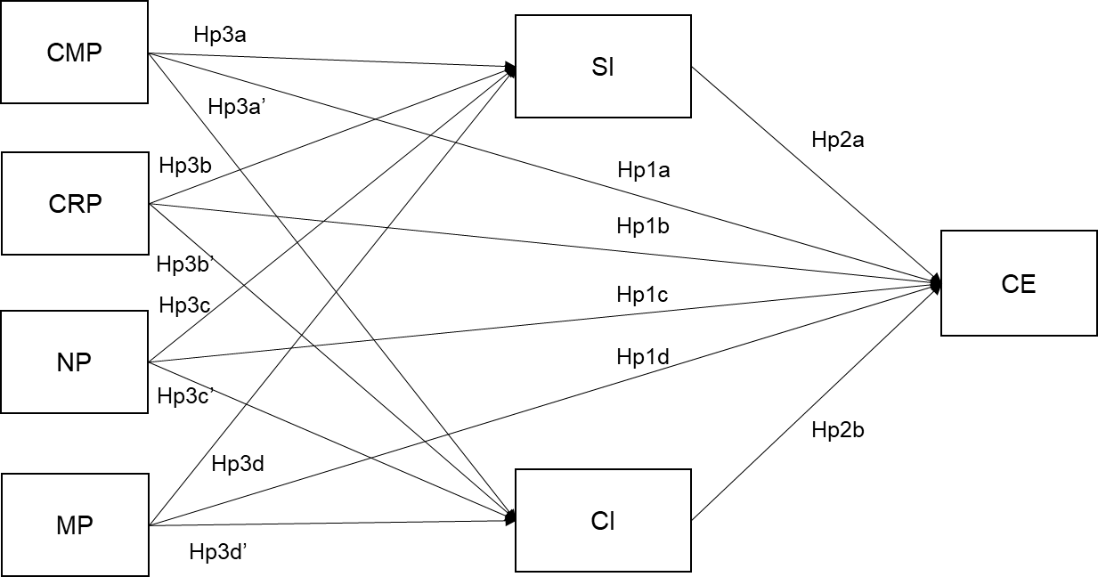

Figure 1- The analytical model. Institutional pressures have a direct effect on the adoption of Circular Economy practices (Hp1); Supply Chain Integration has a direct effect on the adoption of Circular Economy practices (Hp2); Supply Chain Integration mediates the effect of Institutional Pressures on the adoption of Circular Economy practices (Hp3)

## Methods

Considering the purpose of the analysis, we tested the theoretical framework (Figure 1) by examining publicly available Corporate Sustainability (CS) Reports for a representative sample of 150 MNEs for the year 2021. A “directed content analysis” approach was employed, where raw messages (the content of reports) are coded according to a classification scheme that is deductively predefined (Seuring & Gold, 2012). The coding scheme in this case includes both the variables and the hypothesised relationship between them, which is theoretically grounded.

Using CS reports as a data source is becoming common in SCM research (Mejías et al., 2019; Piecyk & Björklund, 2014; Sancha et al., 2022), with different techniques being used, e.g., automated text extraction processes like text mining, or the creation of purpose built quantitative databanks (Sancha et al., 2022).

The reasons behind this choice are multiple: CS reports are validated sources of information, scrutinised by multiple stakeholders; companies with a sustainability orientation aim to signal the practices they have adopted. Governments are increasingly relying on public disclosure to achieve macro-level objectives, as demonstrated by recent regulation on sustainability reporting in the EU. Also, the use of CS reports can help overcoming the limitations of survey research, when it comes to individual responses and self-assessments on both sustainability practices and supply chain concepts (Ketokivi, 2019).

Disadvantages of using these sources are linked to potential discrepancies between information reported and real action (e.g., greenwashing), as the writing of these reports is often contracted to consulting companies, and with the low specificity of available information, especially on SCM aspects. At the least, the use of these data source can give some complementary and unique insights to survey based research in analysing companies’ transition towards more sustainable pathways (Tate et al., 2010).

This study uses a whole CS report as a unit of analysis, to analyse, through a coding procedure, how concepts derived in the literature review are disclosed. The concepts are measured through very well established measurement scales in the literature. The final measurement is applied to a cross-sectional sample of 150 MNEs. The measurement process does not focus on keywords searches, but on reading the whole report for each one of the MNEs, identifying relevant content extracts and evaluating them in order to measure the identified concepts. The process was not automated in order to achieve a higher degree of precision. In this way, the research team could manually identify all the parts of the reports that were relevant for the analysis. This choice also required some actions to improve the reliability of different phases of data collection.

Steps highlighted in Figure 2 were followed to codify content, following approaches employed in similar analyses (Piecyk & Björklund, 2014). The following subsections explain, in detail, the processes adopted in each step.

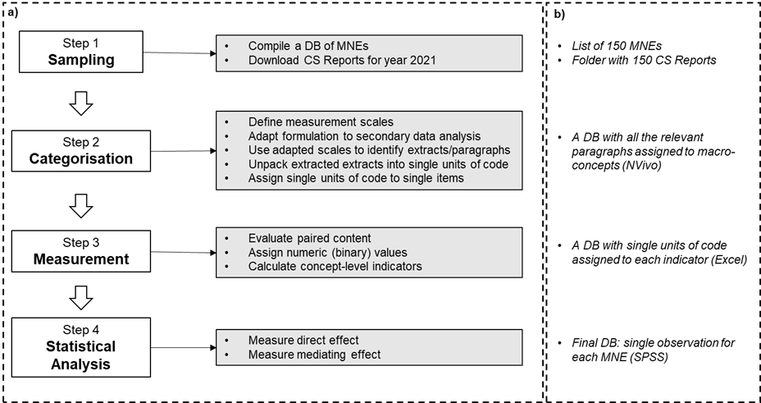

Figure 2 – Characterisation of the four steps of the Method (2a); Detail of the data produced after each step of the analysis (2b).

### Sampling

A database of MNEs was created based on the Global Fortune 500 list (year 2021); 150 MNEs were chosen by selecting the largest ones headquartered in Asia or Europe. The decision to restrict the study to these two macro-areas is related to the fact that the CE agenda has become central to policymaking in many national states and supranational entities within these areas . The only inclusion criteria were related to the presence of a public CS report, or, at least, of an annual report that included sustainability information. For each of the selected companies we checked the presence of a CS report in their company website and on the repository corporateregister.com. Only reports published in English were considered, and if the report was in another language (two cases) the company was not considered. The sample includes MNEs from different industries, which facilitates the generalisability of the results. The entire CS report was used as the unit of analysis in this research. Additional information was collected for each MNE (type of ownership , headquarter location, industrial sector, type of sustainability report); annual reports and websites were used in order to gather this information. The full sample is available in Appendix A.

### Categorisation

In this phase, the concepts identified in the literature review were used as pre-defined categories to identify textual content in each report for the purpose of our analysis. The extracted content was scrutinised to identify smaller units of code to measure the different aspects of the constructs, following the measurement scales chosen. We started by choosing the most appropriate measurement scales in the literature for the three concepts, also considering the limitations highlighted in different papers, especially when measuring institutional pressures (Kauppi & Luzzini, 2022) and SCI (Wiengarten & Longoni, 2015).

*Institutional pressures* – Literature demonstrates that CS reports are the representation themselves of institutional pressures (Tate et al., 2010), as they represent the direct answer to specific institutional pressures that push organisations towards some sustainability direction. As such, it is considered applicable to use CS reports content to measure institutional pressures. To measure institutional pressures, we used the scales from Kauppi and Luzzini, 2022 (Table 1), which provide empirical measures that distinguish the different elements within each pressure and new guidelines on how to measure in a standard and rigorous way institutional pressures in a SCM context. As clarified by authors, such scales “can be adapted to the specific type of supply chain practice”. In practice, measurement items questions were just adapted to the type of measurement and data sources. Basically, each “survey question” was re-phrased to measure the existence/absence in their CS reports of comments about that item. As an example, the first item for Coercive Market Pressure from Kauppi and Luzzini (2022), “Our major external customers frequently make requests for us to adopt certain practices or initiatives in our purchasing procedures”, was adapted as follows, “Comments about requests from customers to adopt certain environmental management practices (or initiatives)”.

*Supply Chain Integration* – MNEs provide in their CS reports information about their supply chain relationships with suppliers and customers. The applicability of this data source comes from the fact that MNEs are expected to be signalling to their stakeholders’ positive supply chain practices. Following previous literature, we measure SCI through Frohlich & Westbrook (2001) seminal conceptualisation. These scales were widely used to measure SCI in manufacturing contexts, especially looking at the plant level. In this case the unit of analysis is different, because we looked at the MNE level, measuring how external SCI four different aspects are disclosed in the context of CS reporting. We disaggregated the SCI construct into upstream SI and downstream CI in line with studies that keep the two directions of integration separate (Blome et al., 2014; Frohlich & Westbrook, 2001). Also, in this case the measurement scales were re-phrased and adapted to the context of this analysis in an analogy to what we did with Kauppi & Luzzini (2022) scales (Table 1).

Adoption of CE practices – Companies provide in their reports descriptive information about their CE actions. The scales to measure the adoption of CE practices were based on previous literature (Calzolari et al., 2021). CE practices are conceptualised according to a 5-Rs framework, which based on the 4-Rs Waste Hierarchy Framework (e.g. reduce, reuse, recycle, recover) from the European Commission. The fifth type of practice (renewable energy & resource efficiency) includes incremental improvements of the efficiency in production systems, and the adoption of renewables sources of energy. The rationale behind this distinction refers to the fact that these are quite commonly mentioned in CS reports. In this way these incremental approaches are distinguished from other types of CE practices.

Table 1 – Adapting measurement items to the scope of the analysis

|  |  |  |
| --- | --- | --- |
| Construct | Measurement item | Literature |
| Coercive Market Pressure | CMP1. Comments about requests from customers to adopt certain environmental practices (or initiatives) | Kauppi and Luzzini, 2022 |
| CMP2. Comments about major customers withholding their contracts if the firm does not meet their requests CMP3. to adopt certain environmental practices |
| CMP3. Comments about major suppliers withholding their contracts if the firm does not meet their requests to adopt certain environmental practices |
| Coercive Regulatory Pressure | CRP1. Comments about the presence of a large number of environmental regulations and restrictions imposed on my company’s industry that also impact our procedures/ decision making? |
| CRP2. Comments about government environmental regulation impacting our decision making |
| CRP3. Comments about (frequent) government inspections or audits on our company’s environmental practices to ensure we comply with laws and regulations |
| Normative Pressure | NP1. Comments about following academic research on environmental practices (management?) to learn about environmental procedures to implement |
| NP2. Comments about certain environmental procedures becoming a norm within our industry |
| NP3. Comments about opinions of consulting companies and external auditors on the best practices influencing our environmental procedures |
| NP4. Comments about employees being influenced by the procedures and tools advocated by industry bodies |
| Mimetic Pressure | MP1. Comments about paying attention to the environmental practices and tools that appear to benefit our competitors and peers |
| MP2. Comments about actively benchmarking the environmental practices and performance of our main competitors and peers |
| MP3. Comments about paying attention to the environmental practices and tools used and adopted by our key competitors |
| Suppliers integration | SI1. Comments about sharing information with key suppliers (about sales forecast, production plans, order tracking and tracing, delivery status, stock level) | Frohlich and Westbrook, 2001  IMSS |
| SI2. Comments about developing collaborative approaches with key suppliers (e.g., supplier development, risk/ revenue sharing, long-term agreements) |
| SI3. Comments about joint decision-making with key suppliers (about product design/modifications, process design/modifications, quality improvement and cost control) |
| SI4. Comments about system coupling with key suppliers (e.g., vendor managed inventory, just-in-time, Kanban, continuous replenishment) |
| Customers integration | CI1. Comments about sharing information with key customers (about sales forecast, production plans, order tracking and tracing, delivery status, stock level) |
| CI2. Comments about developing collaborative approaches with key customers (e.g., risk/revenue sharing, long-term agreements) |
| CI3. Comments about joint decision-making with key customers (about product design/modifications, process design/modifications, quality improvement and cost control) |
| CI4. Comments about system coupling with key customers (e.g., vendor managed inventory, just-in-time, Kanban, continuous replenishment) |
| Adoption of CE practices | CE1. Comments on the adoption of “reduce” practices | Calzolari et al., 2021 |
| CE2. Comments on the adoption of “reuse” practices |
| CE3. Comments on the adoption of “recycle” practices |
| CE4. Comments on the adoption of “renewable energy and energy efficiency” practices |
| CE5. Comments on the adoption of “recover” practices |

Once defined the categories and the individual measurements, we read each MNE report in its entirety to identify all the content that was significant for the analysis, containing evidence on the existence of IPs in the MNE, as well as of SCI aspects and CE practices. We used the adapted formulation of each construct’s item as a guide to understand where in their reports MNEs were giving any evidence of the constructs of we want to measure. All the unstructured content was firstly mapped and then assigned to themes in a predefined template. Each extract was classified by macro-themes (IPs, SCI, and CE) in a preliminary database. At this stage, every possible text extract was included and stored using the NVivo software. The following stages will mostly refer to the text that was extracted in this preliminary phase.

In the next stage, we worked on the extracted content and categorised it further. We followed multiple waves of coding to make the amount of unstructured content fit for measuring the constructs in the theoretical model. All the text assigned to a macro-theme was scrutinised, to identify single units of code that were in some way giving evidence of more specific aspects of that macro-theme, referring to the level of detail of the measurement items. After this, single units of coding were assigned to measurement items of the three constructs. In the supplementary material the steps followed during the coding for one of the extracts that included three unit codes to measure three different items are exemplified.

Subsequently, data was coded using a pre-defined MS Excel template as exemplified in the previous Table 1. This process was repeated for each company in the sample. A third wave of coding was conducted to perform a final keyword check for each report, with the aim of enhancing the homogeneity of the extracted text and codes across companies within the same sector/geographical area. This process involved utilizing specific keywords to identify and capture potentially missing text from reports of companies operating within the same sector, considering the assumption that such companies might share similar vocabulary in their reports. The output of this stage was a MS Excel worksheet containing 150 rows, each representing a MNE, and multiple columns representing the various measurement items. The worksheet was enriched with unit codes specific to each measurement item and MNE (Supplementary materials provide an example of the coding process followed).

To ensure the reliability of the different phases in the coding procedure (Table 2), two main actions were undertaken. The first one was concerned with the mapping of the text in a report. Two authors performed the same process into a subset of reports. After this, we calculated a k-agreement coefficient. The following phase (textual data refinement) consisted in recognising in each text extract single units of code and in assigning each unit of code to a measurement item. Similarly, the same two authors coded the same content; disagreements were measured. In both phases, disagreements occurred in less than 5% of cases. Each disagreement was discussed by the authors in order to reach an agreement.

### Measurement

To measure the three constructs in a quantitative way, a structured coding approach was used to convert textual data into binary variables, assigning a single binary score to each item in the template, rewarding with a 1 the presence of information regarding a specific item, and penalising the absence of them with a 0. We followed similar approaches also in SCM literature that aim to use the unstructured textual content in a quantitative way also to test theoretical models (Ancarani et al., 2019).

Table 2 - Reliability tests taken in different phases and actions taken

|  |  |  |  |
| --- | --- | --- | --- |
| Phase | Description | Actions taken | Reliability measure |
| Text mapping | Recognising in a report the relevant content.  Decide whether to include or exclude text.  Assign text to macro-themes. | 2 authors did the same job into a set of reports.  Discuss on every disagreement. | K-agreement coefficient (disagreements were observed in less than 5% of cases) |
| Textual data refinement | Recognising in each text extract single units of code.  Assign each unit of code to a measurement item. | 2 authors did the same job into a set of extracts.  discuss on every disagreement to reach an agreement. | K-agreement coefficient (disagreements were observed in less than 5% of cases) |

As a last step, aggregated construct level scores are built as the sum of the single binary items they represent. As a result, 7 construct level scores were obtained for each company (CMP, CRP, NP, MP, SI, CI, adoption of CE practices). These are all ordinal variables with a range that varies from 0-3, to 0-5. Additional information (mentioned in the previous sub-sections) was the basis for some control variables. The outcome of the whole analysis is a DB with Company Name, Indicators, binary scores assigned to each indicator, and construct level scores.

### Statistical analysis

The analysis employs linear regression considering construct level scores. We ensured data validity by utilising measurement scales that are widely accepted in the academic community (Table 1). These 7 ordinal variables were considered as continuous with respect the assumptions of linear regression . The procedure followed is articulated in Figure 3.

The relationship between IPs and CE was firstly tested, followed by the direct relationship of SCI on CE. As a last thing the indirect effects of SCI on the relationship between IPs and CE were assessed. Indirect effects were measured through a linear regression using the PROCESS macro on SPSS . Regressions included some control variables. The literature and some interactions with experts have identified some factors that are likely to influence the outcome variable. Control variables are both industry-specific and firm-specific. Specifically, industry-specific variables were captured by two dummy variables. The first one isolates manufacturing companies from all the others, as these companies are more frequently involved in CE actions; the second one isolates service companies, which are typically late-adopters. Firm-specific variables include the type of ownership (e.g., state-owned vs privately-owned), the geographical location of the headquarters, and the presence of a CS report.

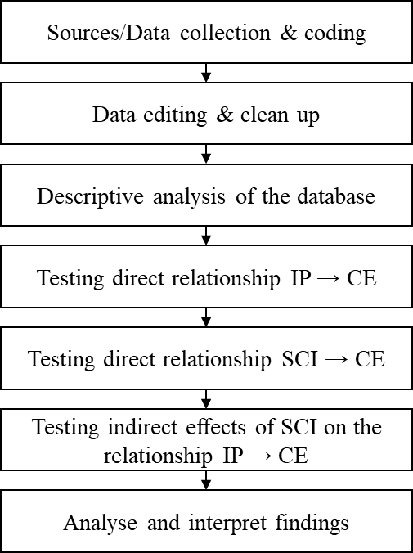

Figure 3 – Data analysis description

## Results

### Sample characteristics

Sectors represented in the sample are shown in Table 3, along with countries of incorporation of the MNEs. Notably, one third of the sample is represented by state-owned companies (including MNEs with some form of State participation). Around half of the MNEs have published a CS report in 2021.

Table 3 – Sample descriptives (n=150)

|  |  |  |
| --- | --- | --- |
| Variable | n | Proportion |
| Industry | | |
| Services | 55 | 37% |
| Manufacturing | 36 | 24% |
| Energy | 28 | 19% |
| Agri-food | 13 | 9% |
| Materials | 7 | 5% |
| Construction | 7 | 5% |
| Conglomerates | 4 | 3% |
| Report type | | |
| Sustainability Report | 75 | 50% |
| ESG report | 25 | 17% |
| CSR report | 20 | 13% |
| Annual report | 13 | 9% |
| Integrated report | 11 | 7% |
| Universal Registration Document | 5 | 3% |
| Climate report | 1 | 1% |
| Property | | |
| Private | 92 | 61% |
| State-owned | 58 | 39% |
| Country | | |
| China | 47 | 31% |
| Japan | 25 | 17% |
| Germany | 14 | 9% |
| France | 11 | 7% |
| Britain | 10 | 7% |
| South Korea | 7 | 5% |
| Switzerland | 6 | 4% |
| Other Asians | 15 | 10% |
| Other European | 15 | 10% |

In the preliminary stage of analysis, the distribution of variables was checked. As in the prerequisites of linear regression, the outcome variable respected normal distribution, and also most of the predictors (see in the Supplementary materials).

Different linear regressions models were used to answer the RQs. Three linear regressions models are reported (Table 4): first, Model 1 measures the direct effects of IPs on the outcome variable Adoption of CE practices (RQ1); Model 2 adds to this regression 5 control variables (presence of a CS report, manufacturing sector, service sector, Headquarter in the EU, type of property). Model 3 includes SI and CI as predictors to start accounting for RQ2.

Table 4 shows that when SI and CI are included in the regression, they account for most of the significant effect on the outcome variable. Finally, the mediated model was tested (Figure 4). The main outcome of the analysis is that IPs are not directly related to the adoption of CE practices, but only indirectly through the effect of SI and CI. SI and CI seem to explain most of the variance of the outcome variable. Also, the effect of CI on the outcome variable is greater than the one of SI.

Looking more specifically at the effect of independent variables on the two mediators, two drivers (NP and CRP) have a significant and positive effect on the two mediators (SI and CI). The other two drivers, CMP and MP, do not have a significant effect on SI and CI. The direction of the relationships is not a surprising one. Higher pressures relate to higher degrees of SCI. Higher levels of SCI are related to a higher adoption of CE practices.

Table 4 –Performing different regressions of the outcome variable “Adoption of CE practices” on the different sets of predictors and control variables. Note *p<0.05; **p<0.01; ***p<0.001

| Dependent variable: Adoption of CE practices | | | | | | |
| --- | --- | --- | --- | --- | --- | --- |
| Model | (1) | | (2) | | (3) | |
| Coercive Market Pressure | 0.344***  (0.087) | 0.138  (0.092) | | 0.086  (0.079) | |
| Coercive Regulatory Pressure | 0.360***  (0.097) | 0.438***  (0.096) | | 0.171  (0.092) | |
| Mimetic Pressure | -0.113  (0.108) | -0.059  (0.107) | | -0.081  (0.092) | |
| Normative Pressure | 0.324***  (0.096) | 0.249**  (0.091) | | 0.095  (0.082) | |
| Sustainability report |  | 0.326*  (0.151) | | 0.287*  (0.130) | |
| Manufacturing |  | 0.706***  (0.199) | | 0.389*  (0.178) | |
| Service |  | 0.148  (0.180) | | -0.030  (0.163) | |
| European Union |  | 0.411*  (0.167) | | 0.158  (0.149) | |
| Property Type |  | -0.237  (0.176) | | -0.248  (0.152) | |
| Supplier Integration |  |  | | 0.197**  (0.071) | |
| Customer Integration |  |  | | 0.437***  (0.075) | |
| Observations | 150 | 150 | | 150 | |
| Fixed-effects | 1.027 | 0.8609 | | 0.5291 | |
| R2 | 0.357 | 0.469 | | 0.612 | |
| Adjusted R2 | 0.339 | 0.435 | | 0.582 | |
| F Statistic | 20.3***  (df=4; 146) | 13.9***  (df=9; 141) | | 20.0***  (df=11;139) | |

Note: Coercive regulatory pressure effect on the outcome variable in the third model is very close to be significant (sig. 0.064)

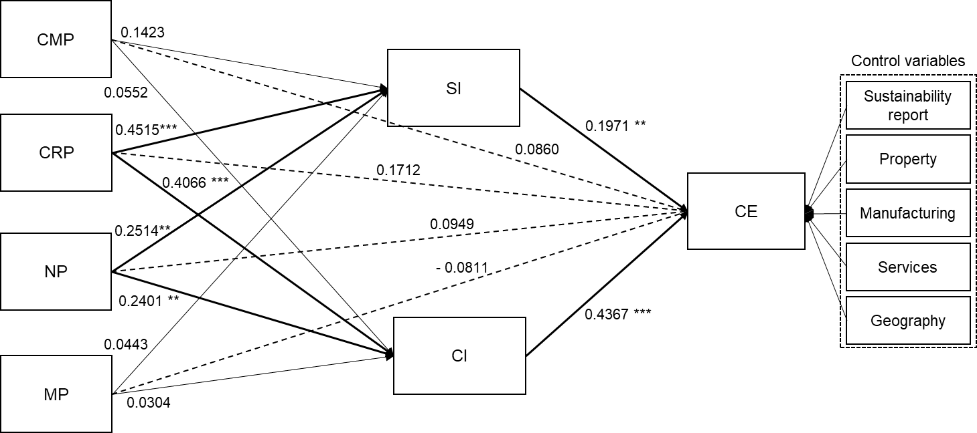

Figure 4 – Mediation model. Note: *p<0.05; **p<0.01; ***p<0.001

## Discussions and Implications

### Discussion of the results

*5.1.1 Institutional Pressures drive the adoption of CE practices via SCI*

The results suggest that SCI should not be considered as a variable that just strengthens or weakens the relationship IPs-adoption of CE practices. Rather, SCI seems to have a much more active role in the complex relationship between IPs and the adoption of CE practices; indeed, SCI mediates the effect of some of the independent variables on the outcome variable, suggesting that IPs might first drive the adoption of higher levels of integration which, in turn, have a positive association with the adoption of CE practices. As such, SCI seems to be a key mechanism that lies in between IPs and the adoption of CE practices, which has the function of carrying the effect of IPs in the context of a company decision-making process. This also suggests that most IPs are not able to influence the outcome variable without affecting first the level of SCI.

To better explain this concept, we refer to the practical case of two French Agri-food companies from the sample (a food distributor, Carrefour, and a food producer, Danone ). These two MNEs operate in an institutional context with high CRPs, e.g., under the French law 138 (2016) that bans food waste. This law affects primarily food distributors, and then, indirectly, other entities in the agri-food supply chain. As a response to high CRPs, both MNEs reacted first by integrating with different suppliers and customers. The following paragraph reports a non-exhaustive list of the main SCI aspects from the final DB: enhancing information sharing mechanisms in the supply chain of environmental, climate data (Carrefour); development of digital tools to facilitate the exchange of information in the supply chain (Danone); provision of financing solution for agricultural transition and regenerative agriculture (both); development of strategic alignment with suppliers and customers on multiple topic among which the CE (Danone); share economic benefits and develop fair pricing policies and relationships with farmers and suppliers (Danone); develop collaborations with suppliers on product or packaging design and technical support for supply lines (Carrefour); develop advanced forms of just-in-time with shared inventory management systems with its leading distributors (Danone); work on customer habits and have campaigns of sustainable consumption campaigns (Carrefour); improve information product traceability and the transparency of the supply chain (Carrefour); co-design solutions with customers (Carrefour); develop key collaboration with TooGood to go to change the labeling of consumption dates on some of its products in France (Danone).

Both the MNEs achieved a medium/high score on SI and CI. The statistical analysis confirms that, frequently, higher scores on SI and CI are associated with higher adoption of CE practices. The development of SI and CI is clearly beneficial to the adoption of CE practices and is seen as a prerequisite to enact a wide range of CE practices they mention in their CS reports.

*5.1.2 The predominant role of regulation and industry standards over market pressures*

Having acknowledged that in the attempt to implement CE practices, IPs are driving higher levels of SCI, results also shed light into the specific mechanisms by which the IPs affect the adoption of CE practices, by discussing their link to SCI. Not all IPs seem to have an appreciable effect on SCI. Certain IPs related to regulation and industry standards are significantly and more strongly associated with SCI if compared to pressures coming from the market (CMPs, MPs, see Figure 4). As such, they may be more relevant in influencing the level of SCI and therefore, indirectly affecting the outcome variable through it. CRP is the only pressure that seems to have an appreciable direct effect on the outcome variable (Table 4 show that its effect is not far from being significant and might become significant if the sample is increased), which is also partially mediated by SI and CI, even though the mediation path has a more significant (and stronger) effect. NP effect is fully mediated by SI and CI. CMP and MP do not show an appreciable direct effect on either of the mediating variables (SI and CI). CMPs and MPs may be less relevant in influencing the mediators or may be indirectly related to the mediators. As a result, in absence of strong industry standards and regulations, they might not be sufficient to push the integration of the supply chain and to drive the adoption of CE practices.

Also this idea is explained through the industrial case mentioned in the previous sub-chapter, which refers to the two agri-food companies headquartered in France. Carrefour and Danone high level of SI and CI seem to be associated with their institutional environment, which is characterised by high CRPs and NPs.

CRP got the maximum (construct level) score for both companies, and NP got a medium score. Looking at qualitative content of the single units of code the high CRPs relate to energy efficiency regulations (Carrefour) and to regulation around plastic waste (for both companies). Danone mention in its report the action planned to achieve the EU target of a 90% target collection rate. Both the companies demonstrate the presence of inspections on environmental protection aspects in their production facilities. NPs relate to trainings and e-learnings modules for employees (Carrefour) and for farmers on environmental best practices (Danone); cooperation initiatives and partnerships with the academic and scientific world (Danone); collaborations with prominent NGOs that work and advocate for the CE (Ellen MacArthur Foundation, Danone); as well as commitments on international agreements aiming at reducing plastic waste, e.g., Global Declaration on Plastics & New Plastics Economy (Carrefour).

Like in many cases in the sample, institutional contexts with such strong pressures are likely to drive higher levels of SCI. This is not necessarily true in different institutional environments, with less prominent CRPs and NPs. The results suggests that MNEs, in absence of strong CRP and NP, in the presence of some MP and CMP, do not show higher levels of SCI. This, in line with the main argument of the previous sub-section on the mediating role of SCI, has a repercussion on the ability of these MNEs to adopt effective and performant CE practices.

High CRPs might drive directly some CE practice, which is understandable. Regulations, with their punitive and coercive nature, represent a direct threat to business continuity and push organisations to quick actions to avoid sanctions. NPs seem not to have a significant direct effect and to be fully mediated by CI and SI. This could be explained looking at the less formalised control systems that is associated with this type of transformation (Scott, 1995). Under NPs, MNEs choose practices that they feel it is appropriate and morally fair to adopt. NPs might be behind more performant and long-term strategies systemic transitions, driving actions only through the mediation of SI and CI. However, this is only a slight difference, considering that most of the effect of both CRP and NP seems to be mediated by the effect of SI and CI. This issue, connected with the previous one, seems to suggest that MNEs might need more than traditional economic and transactional arrangements and market pressures to enact a structural transformation process. They might need primarily stronger pressures from regulations and industry standards. Then, once supply chains are more integrated, it might be easier to put in place enforcement mechanisms also with external suppliers and customers. The adoption of CE practices in other points in the supply chain is usually more strongly associated with IPs derived from MNEs – CRPs mainly, that come from the integrated structures MNEs set.

### Theoretical Implications

This study examines the impact of external pressures on the adoption of CE-oriented practices on MNEs in Asian and European countries. It assesses whether external pressures influence by themselves the adoption of CE practices or whether their impact is mediated by SCI. Effects are explained by the model with sufficient explanatory power (Figure 4). This research findings fill the unexplored gap and has four theoretical contributions.

Firstly, the study complements research that has looked at how SCM collaborative approaches support sustainability. SCI does not help only operational performance but provides key capabilities and better knowledge of how to adopt sustainability practices (Blome et al., 2014; Wiengarten & Longoni, 2015) or to involve suppliers in sustainability activities (Sancha et al., 2015; Vachon & Klassen, 2006). This paper extend these findings to the new CE context, strengthening the idea that collaborative approach to SCM is necessary towards a systemic transition towards the CE in (MNEs managed) supply chains. The CE represents a grand challenge, which requires collective action at multiple levels and also new forms of intermediation (Rosca et al., 2023). SCI can provide better knowledge to operationalise CE principles, can stimulate innovation also outside traditional suppliers and customers (Berardi & de Brito, 2021), and can enable the orchestration of complex systems in a logic of adaptive cycles and quick prototyping and learning (Kristoffersen et al., 2021). The results of this study also highlight CI has a greater effect than SI on the outcome variable. As such, customers have a prominent role in the process of adopting CE practices, which tends to be even more important than the role of suppliers. This aspect requires some reflections. SCI literature claims that there is a popular route that companies usually follow to improve integrative capability. At first enhancing internal effectiveness then streamlining upstream integration with suppliers and then finally enhancing downstream integration with customers (Childerhouse & Towill, 2011). The study poses a question on whether the same route needs to be followed also in the context of CSCs. In this context, downstream-upstream collaborations involving internal and external supply chain actors might be key (Batista et al., 2023).

Secondly, these results contributes to the literature that has studied institutional antecedents of CE and green practices in supply chains (Adebanjo et al., 2016). This paper confirms the very important role of IPs in the transition towards more sustainable supply chains and also reflects on how single IPs affects the adoption of CE practices. The paper also tries to improve the way IPs are measured, adopting newly developed scales from Kauppi and Luzzini (2022). Previous studies have measured IPs with proxies or bundled IPs constructs (Gusmerotti et al., 2019), or have measured IPs as tied to some outcome variable (Zailani et al., 2012). In this study IPs were untied from the outcome variable. We considered how general IPs for environmental management actions drive different types of CE practices. These findings also have implications for the CE-specific literature by filling the research gap highlighted by (Kirchherr et al. 2019) on the need use large samples and to generalise findings.

Finally, these results contributes to the literature that has studied supply chains as institutional fields (Wu & Jia, 2018; Busse et al., 2016; Sauer & Seuring, 2018), which identified integrated supply chain structures as paramount to transmit meaning systems and enforce values and ideas. This paper complements this literature and shows how SCI interacts with IPs in MNEs. First, it confirms the idea that more integrated supply chain structures are necessary to facilitate a shared meaning systems and institutional field in which new sustainability logic (like the CE) can work. Second, it highlights the strong association between CRPs and NPs and SCI, showing MPs and CMPs are not associated with SCI. This might mean that in absence of strong regulation and pressures from industry bodies companies might struggle to implement the necessary level of integration to drive the adoption of CE practices. The same findings also contribute to the literature on antecedents of SCI (Turkulainen, 2017; Wong & Boon-Itt, 2008) which has hypothesised IPs impact themselves the level of SCI.

### Managerial Implications

This study has some implications for practice. Understanding better IPs in their various facets, and multidimensionality, and complexity can help managers to take more informed decisions - as many of their decisions might not be the most efficient ones - especially if they come from NPs and MPs (risk of jumping on the bandwagon) (Kauppi & Luzzini, 2022).

The study suggests practitioners that their level of SCI is an essential mechanism on which they can leverage if they want to adopt CE practices. It also points out how organisations can leverage CRPs and NPs to improve their SCI, which will then improve their circularity. Lastly, it identifies the importance of customers in the transition towards the CE. Because CI mediates more than SI the relationship between. To overcome the challenges faced by single companies to implement CE practices, it is necessary to reach first higher degrees of SCI that will then make it possible to implement CE practices.

## Conclusions

This study examines the impact of external pressures on the adoption of CE-oriented practices on MNEs in Asian and European countries. It tests a theoretical framework by examining publicly available Corporate Sustainability (CS) Reports for a representative sample of 150 MNEs for the year 2021 and using an advanced coding procedure to measure IPs, SCI and CE.

The results identify the role of SCI as a mechanism that lies in between IPs and the adoption of CE practices and reflects on how this is related to key capabilities requested in CSCs. Also, it describes how regulation and industry standards have a predominant role over market pressures being more strongly and significantly associated with higher SI and CI. Lastly, the role of CI is highlighted, being more strongly associated with the outcome variable.

### Limitations - Future developments

While this study has some important contributions, it's important to acknowledge its limitations. The sample size could be expanded to improve the generalizability of the findings. Some control variables could not be considered due to time and resource constraints, like the type of customers (B2C or B2B) or the position of the MNE in the supply chain, which may have influenced our results. The study was conducted over single year, which may have limited our ability to capture changes over a longer period. Future research could conduct longitudinal studies to examine the processes of institutionalisation and deinstitutionalisation of CE practices in supply chains over time. It could also focus on specific sectors. The use of secondary data could also constitute a limitation. Future research should also focus on CE performance and CE indicators rather than on an ordinal outcome variable. Finally, future studies could focus on how the combination of different pressures would lead to a better adoption of CE practices, rather than on the individual effects of single pressures.

The existing study does not adequately consider the impact of Small-Medium Enterprises (SMEs) on MNEs, overlooking the fact that SMEs also play a significant role (Dey et al., 2022). This assumption of MNE dominance leads to an omission of the responsibilities and potential influence that MNEs possess over their partners in global supply chains. Therefore, future studies should address this oversight and take into account the dynamic interplay between MNEs and SMEs in order to gain a comprehensive understanding of supply chain dynamics. By doing so, researchers can better explore the intricate relationships and mutual influence that exist within supply chains, ultimately providing a more accurate depiction of the complex nature of global SCM.

## References

Adebanjo, D., Teh, P. L., & Ahmed, P. K. (2016). The impact of external pressure and sustainable management practices on manufacturing performance and environmental outcomes. International Journal of Operations & Production Management, 36(9), 995-1013.

Ancarani, A., Di Mauro, C., & Mascali, F. (2019). Backshoring strategy and the adoption of Industry 4.0: Evidence from Europe. Journal of World Business, 54(4), 360-371.

Bag, S., & Pretorius, J. H. C. (2022). Relationships between industry 4.0, sustainable manufacturing and circular economy: proposal of a research framework. International Journal of Organizational Analysis, 30(4), 864-898.

Batista, L., Seuring, S., Genovese, A., Sarkis, J., & Sohal, A. (2023). Theorising circular economy and sustainable operations and supply chain management: a sustainability-dominant logic. International Journal of Operations & Production Management, 43(4), 581-594.

Bauwens, T., Hekkert, M., & Kirchherr, J. (2020). Circular futures: what will they look like?. Ecological Economics, 175, 106703.

Berardi, P. C., & de Brito, R. P. (2021). Supply chain collaboration for a circular economy-From transition to continuous improvement. Journal of Cleaner Production, 328, 129511.

Bimpizas-Pinis, M., Calzolari, T., & Genovese, A., 2022. Exploring the transition towards circular supply chains through the arcs of integration. International Journal of Production Economics, 250, 108666.

Blome, C., Paulraj, A., & Schuetz, K. (2014). Supply chain collaboration and sustainability: a profile deviation analysis. International Journal of Operations & Production Management.

Braz, A. C., & de Mello, A. M. (2022). Circular economy supply network management: A complex adaptive system. International Journal of Production Economics, 243, 108317.

Bressanelli, G., Visintin, F., & Saccani, N. (2022). Circular Economy and the evolution of industrial districts: A supply chain perspective. International Journal of Production Economics, 243, 108348..

Busse, C., Kach, A. P., & Bode, C. (2016). Sustainability and the false sense of legitimacy: How institutional distance augments risk in global supply chains. Journal of Business Logistics, 37(4), 312-328.

Calzolari, T., Genovese, A., & Brint, A. (2021). The adoption of circular economy practices in supply chains–An assessment of European Multi-National Enterprises. Journal of Cleaner Production, 312, 127616.

Cao, M., & Zhang, Q. (2011). Supply chain collaboration: Impact on collaborative advantage and firm performance. Journal of operations management, 29(3), 163-180.

Chaudhuri, A., Boer, H., & Taran, Y. (2018). Supply chain integration, risk management and manufacturing flexibility. International Journal of Operations & Production Management, 38(3), 690-712.

Chavez, R., Malik, M., Ghaderi, H., & Yu, W. (2023). Environmental collaboration with suppliers and cost performance: Exploring the contingency role of digital orientation from a circular economy perspective. International Journal of Operations & Production Management, 43(4), 651-675.

Childerhouse, P., & Towill, D. R. (2011). Arcs of supply chain integration. International journal of production research, 49(24), 7441-7468.

Cousins, P. D., Lawson, B., Petersen, K. J., & Fugate, B. (2019). Investigating green supply chain management practices and performance: The moderating roles of supply chain ecocentricity and traceability. International Journal of Operations & Production Management, 39(5), 767-786.

Cricelli, L., Greco, M., & Grimaldi, M., 2021. An investigation on the effect of inter-organizational collaboration on reverse logistics. International Journal of Production Economics, 240, 108216.

Dagiliene, L., Frendzel, M., Sutiene, K., & Wnuk-Pel, T., 2020. Wise managers think about circular economy, wiser report and analyze it. Research of environmental reporting practices in EU manufacturing companies. Journal of Cleaner Production, 274, 121968.

Danese, P., Molinaro, M., & Romano, P. (2020). Investigating fit in supply chain integration: A systematic literature review on context, practices, performance links. Journal of Purchasing and Supply Management, 26(5), 100634.

Danese, P., & Bortolotti, T. (2014). Supply chain integration patterns and operational performance: a plant-level survey-based analysis. International Journal of Production Research, 52(23), 7062-7083.

Dey, P. K., Malesios, C., Chowdhury, S., Saha, K., Budhwar, P., & De, D. (2022). Adoption of circular economy practices in small and medium-sized enterprises: Evidence from Europe. International Journal of Production Economics, 248, 108496.

DiMaggio, P. J., & Powell, W. W. (1983). The iron cage revisited: Institutional isomorphism and collective rationality in organizational fields. American sociological review, 147-160.

Dong, M. C., Ju, M., & Fang, Y., 2016. Role hazard between supply chain partners in an institutionally fragmented market. Journal of Operations Management, 46, 5-18.

De Angelis, R., Howard, M., & Miemczyk, J., 2018. Supply chain management and the circular economy: towards the circular supply chain. Production Planning & Control, 29(6), 425-437.

De Lima, F. A., & Seuring, S., 2023. A Delphi study examining risk and uncertainty management in circular supply chains. International Journal of Production Economics, 108810.

Elia, V., Gnoni, M. G., & Tornese, F., 2020. Evaluating the adoption of circular economy practices in industrial supply chains: An empirical analysis. Journal of Cleaner Production, 273, 122966.

Flynn, B. B., Huo, B., & Zhao, X. (2010). The impact of supply chain integration on performance: A contingency and configuration approach. Journal of Operations Management, 28(1), 58-71.

Frohlich, M. T., & Westbrook, R. (2001). Arcs of integration: an international study of supply chain strategies. Journal of Operations Management, 19(2), 185-200.

Herczeg, G., Akkerman, R., & Hauschild, M. Z., 2018. Supply chain collaboration in industrial symbiosis networks. Journal of Cleaner Production, 171, 1058-1067.

Jain, N. K., Panda, A., & Choudhary, P., 2020. Institutional pressures and circular economy performance: The role of environmental management system and organizational flexibility in oil and gas sector. Business Strategy and the Environment, 29(8), 3509-3525.

Kauppi, K. (2013). Extending the use of institutional theory in operations and supply chain management research: Review and research suggestions. International Journal of Operations & Production Management, 33(10), 1318-1345.

Kauppi, K., & Luzzini, D., 2022. Measuring institutional pressures in a supply chain context: scale development and testing. Supply Chain Management: An International Journal, 27(7), 79-107.

Kelling, N. K., Sauer, P. C., Gold, S., & Seuring, S. (2021). The role of institutional uncertainty for social sustainability of companies and supply chains. Journal of Business Ethics, 173, 813-833.

Ketchen Jr, D. J., & Hult, G. T. M., 2007. Bridging organization theory and supply chain management: The case of best value supply chains. Journal of Operations Management, 25(2), 573-580.

Ketokivi, M. (2019). Avoiding bias and fallacy in survey research: A behavioral multilevel approach. Journal of Operations Management, 65(4), 380-402.

Kristoffersen, E., Mikalef, P., Blomsma, F., & Li, J. (2021). The effects of business analytics capability on circular economy implementation, resource orchestration capability, and firm performance. International Journal of Production Economics, 239, 108205.

Kostova, T., Roth, K., & Dacin, M. T. (2008). Institutional theory in the study of multinational corporations: A critique and new directions. Academy of management review, 33(4), 994-1006.

Leuschner, R., Rogers, D. S., & Charvet, F. F., 2013. A meta‐analysis of supply chain integration and firm performance. Journal of Supply Chain Management, 49(2), 34-57.

Liu, J., Feng, Y., Zhu, Q., & Sarkis, J. (2018). Green supply chain management and the circular economy: Reviewing theory for advancement of both fields. International Journal of Physical Distribution and Logistics Management, 48(8), 794-817.

Masi, D., Kumar, V., Garza-Reyes, J. A., & Godsell, J. (2018). Towards a more circular economy: exploring the awareness, practices, and barriers from a focal firm perspective. Production Planning & Control, 29(6), 539-550.

Mathews, J. A., & Tan, H., 2011. Progress toward a circular economy in China: The drivers (and inhibitors) of eco‐industrial initiative. Journal of industrial ecology, 15(3), 435-457.

Mejías, A. M., Bellas, R., Pardo, J. E., & Paz, E., 2019. Traceability management systems and capacity building as new approaches for improving sustainability in the fashion multi-tier supply chain. International Journal of Production Economics, 217, 143-158.

Paulraj, A., Chen, I. J., & Blome, C. (2017). Motives and performance outcomes of sustainable supply chain management practices: A multi-theoretical perspective. Journal of Business Ethics, 145, 239-258.

Piecyk, M. I., & Björklund, M. (2015). Logistics service providers and corporate social responsibility: sustainability reporting in the logistics industry. International Journal of Physical Distribution & Logistics Management, 45(5), 459-485.

Ranta, V., Aarikka-Stenroos, L., Ritala, P., & Mäkinen, S. J., 2018. Exploring institutional drivers and barriers of the circular economy: A cross-regional comparison of China, the US, and Europe. Resources, Conservation and Recycling, 135, 70-82.

Rosca, E., Tate, W. L., Bals, L., Huang, F., & Ciulli, F. (2022). Coordinating multi-level collective action: how intermediaries and digital governance can help supply chains tackle grand challenges. International Journal of Operations & Production Management, 42(12) 1937-1968.

Sancha, C., Longoni, A., & Giménez, C., 2015. Sustainable supplier development practices: Drivers and enablers in a global context. Journal of Purchasing and Supply Management, 21(2), 95-102.

Sancha, C., Gutierrez-Gutierrez, L., Tamayo-Torres, I., & Gimenez Thomsen, C. (2022). From corporate governance to sustainability outcomes: the key role of operations management. International Journal of Operations & Production Management, 43(13), 27-49.

Sauer, P. C., & Seuring, S. (2018). A three-dimensional framework for multi-tier sustainable supply chain management. Supply Chain Management: An International Journal, 23(6), 560-572.

Schoenherr, T., & Swink, M. (2012). Revisiting the arcs of integration: Cross-validations and extensions. Journal of Operations Management, 30(1-2), 99-115.

Scott Richard, W. (1995). Institutions and organizations. Ideas and Interests, Los Angeles.

Sehnem, S., Vazquez-Brust, D., Pereira, S. C. F., & Campos, L. M. (2019). Circular economy: benefits, impacts and overlapping. Supply Chain Management: An International Journal, 24(6), 784-804.

Seuring, S., & Gold, S. (2012). Conducting content‐analysis based literature reviews in supply chain management. Supply Chain Management: An International Journal, 17(5), 544-555.

Silva, M. E., Pereira, M. M., & Hendry, L. C. (2023). Embracing change in tandem: resilience and sustainability together transforming supply chains. International Journal of Operations & Production Management, 43(1), 166-196.

Sudusinghe, J. I., & Seuring, S. (2022). Supply chain collaboration and sustainability performance in circular economy: A systematic literature review. International Journal of Production Economics, 245, 108402.

Tate, W. L., Ellram, L. M., & Kirchoff, J. F. (2010). Corporate social responsibility reports: a thematic analysis related to supply chain management. Journal of Supply Chain Management, 46(1), 19-44.

Turkulainen, V., Kauppi, K., & Nermes, E. (2017). Institutional explanations: Missing link in operations management? Insights on supplier integration. International Journal of Operations & Production Management, 37(8), 1117-1140.

Vachon, S., & Klassen, R. D. (2006). Extending green practices across the supply chain: the impact of upstream and downstream integration. International Journal of Operations & Production Management, 26(7), 795-821.

Venkatesh, V. G., Zhang, A., Deakins, E., & Mani, V., 2020. Drivers of sub-supplier social sustainability compliance: an emerging economy perspective. Supply Chain Management: An International Journal. 25(6), 655-677.

Wiengarten, F., & Longoni, A. (2015). A nuanced view on supply chain integration: A coordinative and collaborative approach to operational and sustainable performance improvement. Supply Chain Management: An International Journal, 20(2), 139-150.

Wong, C. Y., & Boon-Itt, S. (2008). The influence of institutional norms and environmental uncertainty on supply chain integration in the Thai automotive industry. International Journal of Production Economics, 115(2), 400-410.

Wu, Z., & Jia, F. (2018). Toward a theory of supply chain fields–understanding the institutional process of supply chain localization. Journal of Operations Management, 58, 27-41.

## Appendix 6A

|  |  |  |  |
| --- | --- | --- | --- |
| State Grid | China Minmetals | BASF | Tokio Marine Holdings |
| China National Petroleum | Hengli Group | Bank of Communications | Vodafone Group |
| Sinopec Group | Itochu | Country Garden Holdings | Christian Dior |
| Toyota Motor | China Baowu Steel Group | Roche Group | Wilmar International |
| Volkswagen | Assicurazioni Generali | Xiamen C&D | Indian Oil |
| China State Construction Engineering | China Post Group | Siemens | AIA Group |
| Saudi Aramco | Nestlé | Sinochem | Vinci |
| Samsung Electronics | Hyundai Motor | Engie | Kia |
| Ping An Insurance | Gazprom | Legal & General Group | ENI |
| BP | Dongfeng Motor | Panasonic | KDDI |
| Royal Dutch Shell | Royal Ahold Delhaize | Aviva | Novartis |
| Industrial & Commercial Bank of China | Sony | China Pacific Insurance (Group) | Korea Electric Power |
| Hon Hai Precision Industry (Foxconn) | People's Insurance Co. of China | Lenovo Group | Denso |
| Daimler | China National Offshore Oil | China Vanke | Equinor |
| China Construction Bank | Crédit Agricole | China Merchants Bank | Nippon Steel Corporation |
| Agricultural Bank of China | Hitachi | Marubeni | Sberbank |
| Trafigura Group | Carrefour | ENEOS Holdings | Petronas |
| China Life Insurance | BNP Paribas | Zurich Insurance Group | Intesa Sanpaolo |
| Glencore | Bosch Group | Xiamen ITG Holding Group | ThyssenKrupp |
| China Railway Engineering Group | Tesco | Aegon | Suning.com Group |
| EXOR Group (Stellantis) | AEON | Unilever | Chubb |
| Allianz | HSBC Holdings | Guangzhou Automobile Industry Group | DZ Bank |
| Bank of China | Electricité de France | China National Building Material Group | Poste Italiane |
| China Railway Construction | PowerChina | Airbus | Tata Motors |
| Huawei Investment & Holding | Sinopharm | Mitsubishi UFJ Financial Group | British American Tobacco |
| AXA | Nippon Life Insurance | SoftBank Group | Repsol |
| Honda Motor | COFCO | Prudential | Bharat Petroleum |
| Mitsubishi | Deutsche Post DHL Group | Fortum | SAP |
| TotalEnergies | Nissan Motor | Tokyo Electric Power | Suzuki Motor |
| Deutsche Telekom | Munich Re Group | Seven & I Holdings | Wistron |
| BMW Group | Enel | LG Electronics | Bridgestone |
| Nippon Telegraph and Telephone | Dai-ichi Life Holdings | Rosneft Oil | BT Group |
| China Mobile Communications | Banco Santander | Industrial Bank | SK Hynix |
| Japan Post Holdings | China Evergrande Group | ArcelorMittal | Danone |
| JD.com | Lukoil | Aluminum Corp. of China | Longfor Group Holdings |
| SAIC Motor | SK | Shanghai Pudong Development Bank | Flex |
| China Communications Construction | E. ON | Société Générale |  |
| Alibaba Group Holding | Tencent Holdings | State Bank of India |  |

# Conclusions

The thesis has studied the process of adoption of Circular Economy practices with a supply chain management perspective. The general objective was to describe the adoption of Circular Economy practices as the outcome of some drivers and mechanisms, which were identified in the literature. Particular attention was dedicated to understanding what roles suppliers, customers, and the supply chain configuration play in the adoption of Circular Economy practices. To do so the thesis has first looked at the state of the industrial practice (Chapter 2) and at the relevant academic literature (Chapter 3). This preliminary phase has framed a preliminary conceptual framework, which describes the adoption of Circular Economy practices as the outcome of institutional pressures and supply chain integration. Through a qualitative analysis the framework was challenged and improved (Chapter 5). The Delphi study has allowed to collect perspective from prominent experts from academia and industry, which have validated the framework. The final analysis tested the framework and the research hypotheses (Chapter 6). In this chapter the summary of the research findings of the two analysis is provided. After this, the theoretical and practical contribution of the thesis, as well as the limitations, are discussed. In this last Section, the main implications of the study are connected with other streams of literature and with future research opportunities.

## Summary of the research findings

### Results from the Delphi-study

Chapter 5 reflects on the relationships between the three concepts included in the conceptual framework, e.g., institutional pressures, SCI, and the adoption of CE practices. Findings enrich the framework with some qualitative elements. Institutional pressures (IPs) are widely considered prominent antecedents of the adoption of CE practices, and a critical factor to influence companies’ behaviour and decision making in this direction. Several types of organisational responses to such pressures are identified: companies *re-adjust their existing environmental monitoring systems* to address CE aspects; modify *new product development* processes; *re-organise their operations and supply chains* to make a better use of materials and reduce waste*;* put in place *opportunistic behaviours and tokenistic actions* tobuild resistance to change. Furthermore, results identify a hierarchy of IPs. In detail, coercive market and regulatory pressures are found to have a greater impact on decision making than normative and mimetic ones.

The Chapter also explores the role of SCI. Qualitative results provide contrasting evidence on the direction (positive-negative), the type of interaction (moderating-mediating) and effect of SCI on the relationship between IPs and the adoption of CE practices, delivering a more uncertain characterisation of its role. Generally, a higher level of SCI can magnify the effect of IPs, fostering the adoption of incremental CE practices; nonetheless, SCI may also inhibit the adoption of more radical CE approaches, favouring the preservation of linear supply chains. Despite most of the experts arguing in favour of a *moderating* role, some expressed contrasting views and indicated SCI has a *mediating* role and that IPs drive first higher levels of SCI in the attempt of pushing for the adoption of CE practices. This aspect informed the quantitative phase and advised to consider and test the two possibilities separately.

Finally, the chapter exemplifies two different trajectories towards the implementation of CE practices. The two trajectories could drive different CE outcomes, and be influenced in different ways by the level of SCI. In the first trajectory, firms adopt a stepwise strategy to the CE of passive *compliance* towards weak environmental regulations. The key players, systems, and processes involved are the same involved in traditional linear supply chains, and SCI is expected to have an amplifying and driving role of incremental CE practices that are compatible with established linear value creation processes. Very incremental CE practices become institutionalised and create market pressures, normative pressures and mimetic pressures.

In the second trajectory firms adopt a more *proactive* approach, adopting CE practices pushed primarily by consumer demand and public opinion. In this context, the push from a deeper societal and institutional transformation brings to new and stricter regulations. The most likely responses in this scenario involve *reorganising supply chain operations* and *developing new products*. New networks and partnerships emerge (e.g., collection and sorting contractors; re-processors; remanufacturers) and disrupt Circular Business Models and more radical CE practices. SCI in this case has a double role: it provides useful capabilities in terms of coordination and collaboration with key partners in the linear supply chain; however, it also magnifies the risk of lock-ins in linear supply chains. As such, companies with lower levels of SCI could have some advantages to succeed, deriving from a higher possibility to experiment with new solutions and decrease dependence on suppliers.

In general, the analysis confirms that the identified concepts have a relationship; in particular, IPs drive the adoption of Circular Economy practices, with supply chain integration having a complex interaction with that relationship. By distinguishing between incremental and radical CE practices, the chapter also links SCI with CE outcomes with a different potential of circular rebound effect. SCI seems to favour incremental CE practices that are compatible with established linear value creation processes. Incremental CE practices have lower potential of limiting the risk of circular rebound effect and of making the adoption of CE practices not useful from an environmental perspective. As such the concept of circular rebound effect might be used to explain this complexity.

### Results from the quantitative analysis

In the second analysis (Chapter 7) findings tell something more precise about the relationships among the concepts in the theoretical framework, the role of SCI, and how important mechanism act.

The empirical analysis shows that IPs are driving the adoption of CE practices primarily through the mediation of SCI. IPs do not have a significant direct effect on the outcome variable and SCI seems to have a much more active role in the complex relationship between IPs and the adoption of CE practices. Indeed, SCI mediates the effect of some of the independent variables on the outcome variable, suggesting that IPs might first drive the adoption of higher levels of integration that, in turn, have a positive association with the adoption of CE practices.

Results also shed light into the specific mechanisms by which the IPs affect the adoption of CE practices, by discussing their link to SCI. The prominent role of coercive and normative pressures is highlighted. Coercive pressures influence on CE practices is partially mediated by SCI, with normative pressures being fully mediated by it. This means that regulation and industry standards might have a predominant role over market pressures in driving higher levels of SCI; that in the absence of strong industry standards and regulations, coercive market pressures and mimetic pressures might not be sufficient to push the integration of the supply chain and to drive the adoption of CE practices.

An important aspect should be specified: the statistical analysis has included also testing moderation, even if this analysis was not included in the paper in Chapter 6. All the interaction terms were specified in the linear regression. Results showed that SCI does not moderate any of the effects of IPs on the adoption of CE practices. This result reinforces the hypothesis on SCI having a mediating role on the relationship between IPs and the adoption of CE practices.

## Theoretical and practical contribution

This thesis extends previous research in sustainable supply chain management that has studied drivers, enabling factors, and practices using institutional theory (Kauppi and Luzzini, 2022). It is also connecting this knowledge and ideas to a more recent research field, Circular Supply Chain Management (Farooque, 2019). This is important as it improves the theoretical understanding of the antecedents of CE approaches in supply chains by testing a conceptual framework that integrates IPs, SCI, and the adoption of CE practices. In more detail, the thesis delves deeper into the process of the adoption of CE practices from an institutional theory perspective. At first, it enriches the understanding of how IPs act on organisations, by identifying sets of common responses. Then, it scrutinises IPs in detail for a large sample of Multinational Enterprises. This represents the first attempt to understand institutional drivers behind the adoption of CE practices using validated scales from the literature in an attempt to generalise theory. This analysis contributes to the debate on the transition towards the CE in supply chain, by identifying what are the mechanisms through which IPs drive CE practices. It concludes that in the context of Multinational Enterprises’ driven supply chains regulations and industry standards are the most important drivers of CE practices and that their effect is mediated by SCI. As such, the thesis poses some questions on the effectiveness of market pressures alone to drive any meaningful sustainability transformation of production and consumption systems.

A second theoretical contribution is related to the SCI literature and debate. Studying transitions towards a CE requires consideration of how supply chain structures and organisations are evolving. These supply chains might have developed specific capabilities and relationship links, which can provide an advantage, and at the same time, might contribute to creating conditions that foster change. This thesis partially confirms the argument that a collaborative approach to supply chain management is necessary towards the transition towards CSCs (Sudusinghe & Seuring, 2022). However, it also warns on the undesired effects that might come from more integrated structures, which might reinforce some linear incentives and create inertia. Finally, the thesis contributes to the SCM literature that investigates research questions using secondary data and purpose-built databanks, by using unstructured data from Sustainability reporting, as well as a coding mechanism to measure concepts and test a theoretical framework.

This thesis contributes to practice by engaging with experts to better understand what is driving the CE in organisations and the role of supply chain management aspects. The significance of this contribution lies in the fact that this evidence comes from practitioners who are directly participating in transformation processes of existing companies in their day-to-day activities. Secondly, the thesis improves the understanding IPs in their various facets, and multidimensionality, and complexity. This can help managers to take more informed decisions - as many of their decisions might not be the most efficient ones - especially if they come from normative and mimetic pressures (risk of jumping on the bandwagon) (Kauppi & Luzzini, 2022). Finally, the thesis suggests to practitioners that SCI is an essential mechanism they can leverage to create the necessary conditions to adopt CE practices. It also points out how organisations can leverage regulatory pressures and normative pressures to improve their SCI, which will then improve their circularity. Lastly, it identifies the importance of customers in the transition towards a circular economy because CI mediates more than SI the relationship between IPs and the adoption of CE practices. As such, the study poses a question on whether the popular route to build integrative capabilities (first enhancing internal effectiveness then streamlining upstream integration with suppliers and then finally enhancing downstream integration with customers) needs to be followed also in the context of CSCs. In this context, downstream-upstream collaborations involving internal and external supply chain actors might be key.

## Research Limitations

As already reported, while this study has some important contributions, it is important to acknowledge its limitations. Some control variables could not be considered due to time and resource constraints, like the type of customers (B2C or B2B) or the position of the MNE in the supply chain, which may have influenced our results. The study was conducted over a single year, which may have limited our ability to capture changes over a longer period. Future research could conduct longitudinal studies to examine the processes of institutionalization and deinstitutionalization of CE practices in supply chains over time. It could also focus on specific sectors. The use of secondary data could also constitute a limitation. Future research should also consider defining more accurate measures of CE adoption. This could include either establishing CE performance indicators rather than using ordinal outcome variables. Another possibility could include building different ordinal outcome variables and distinguishing incremental and radical CE practices, and the potential of circular rebound effect. Finally, future studies could focus on how the combination of different pressures would lead to a better adoption of CE practices, rather than on the individual effects of single pressures.

## Future research opportunities

Acknowledging the role of institutional pressures as a driver of Circular Economy and sustainable practices in organisations – Future research could explore different aspects related to how institutional pressures act on firms and how they enact the change in institutional norm. For example, it could provide more clarity on the hierarchy of pressures for the Circular Economy. This thesis has already talked about this, and future studies could investigate whether mimetic and normative pressures arise in contexts of where coercive pressures are already present; how combinations of pressures work together; whether the presence of two or more pressures together create more favourable conditions if compared to institutional fields with only one type of institutional pressures.

Future research could explore how external pressures impact internal factors to bring change into organisations and supply chains. It could test the same hypotheses use other methods like survey – or using other secondary datasets.

Acknowledging the role of Supply Chain Integration, as a key mechanism that lies in between institutional pressures and Circular Economy practices, future studies could further clarify the complex effect (*linear lock-in* vs *enabler*) different Supply Chain Integration aspects could have on the relationship between the pressures a company faces and its behaviour. For example, it could explore the capabilities associated with Supply Chain Integration that are necessary both from a technological and relational point of view to enable different types of Circular Economy practices. At the same time, considering the undesired effects that might come from more integrated supply chain structures, future studies should also investigate the risks associated with Supply Chain Integration, as a factor that might hinder the adoption of more radical Circular Economy practices. This could be clarified through in-depth case studies. The existing dataset from the quantitative study (Chapter 6) could be used to identify some specific industrial cases to further investigate through semi-structured interviews or by using other sources of secondary data, like newspaper’ articles. Emerging literature on Supply Chain Integration, which has started to consider the reverse flows of materials and associated information flows (Bimpizas-Pinis et al., 2023), can help defining and measuring Supply Chain Integration in a Circular Economy context.

To further explore the role of Supply Chain Integration on the adoption of CE practices, research could also investigate the relationship between the regionalisation of supply chain (including reshoring, back-shoring, nearshoring initiatives) with the adoption of Circular Economy practices. Regional supply chains have always integrated circular principles in the way they operate (see for instance the construction sector, the aluminium sector). And reshoring might be seen as a strategy to improve the integration of the supply chain and might also favour the adoption of some CE practices.

Looking at EU Legislation, it can be noted that the Circular Economy is considered at the macro-level as an industrial strategy to secure, in the medium-long term, key resources, especially in a context of great dependence on other countries and geopolitical areas. As such future research could explore this and investigate how Circular Supply Chains could be also seen as a solution to some supply chain risks. Shorter and circular supply chains are seen as a tool to enhance supply chain resilience. Theoretically, minerals and critical raw materials could be secured creating recovery and recycling infrastructure and increasing the use of secondary resources. As such, the Circular Economy has the potential to reduce dependencies from areas with different geopolitical influences, and in the end mitigate shocks in supply chains, through local and highly integrated supply chains.

## References

Ancarani, A., Di Mauro, C., & Mascali, F. (2019). Backshoring strategy and the adoption of Industry 4.0: Evidence from Europe. *Journal of World Business*, *54*(4), 360-371.

Bimpizas-Pinis, M., Calzolari, T., & Genovese, A., 2022. Exploring the transition towards circular supply chains through the arcs of integration. *International Journal of Production Economics*, 250, 108666.

Blome, C., Paulraj, A., & Schuetz, K. (2014). Supply chain collaboration and sustainability: a profile deviation analysis. *International Journal of Operations & Production Management*.

Danese, P., & Bortolotti, T. (2014). Supply chain integration patterns and operational performance: a plant-level survey-based analysis. *International Journal of Production Research*, *52*(23), 7062-7083.

DiMaggio, P. J., & Powell, W. W. (1983). The iron cage revisited: Institutional isomorphism and collective rationality in organizational fields. *American sociological review*, 147-160.

Farooque, M., Zhang, A., Thürer, M., Qu, T., & Huisingh, D. (2019). Circular supply chain management: A definition and structured literature review. *Journal of cleaner production*, *228*, 882-900.

Kauppi, K., & Luzzini, D., 2022. Measuring institutional pressures in a supply chain context: scale development and testing. *Supply Chain Management: An International Journal*, 27(7), 79-107.

Sudusinghe, J. I., & Seuring, S. (2022). Supply chain collaboration and sustainability performance in circular economy: A systematic literature review. *International Journal of Production Economics*, *245*, 108402.

# Appendix 1 – Doctoral Development Portfolio

**SUMS MGT6225 and FCS6100 modules**

|  |  |  |
| --- | --- | --- |
| Code | Module | Status |
| MGT6225 | Unfair means and plagiarism | 29 October 2019 |
| MGT6225 | Finding a research question | 05 February 2020 |
| MGT6225 | Introduction to Social Theory | Cancelled; I reviewed the materials uploaded on Blackboard. |
| MGT6225 | Designing your methodology | Cancelled; I reviewed the materials uploaded on Blackboard. |
| MGT6225 | Preparing for Teaching at SUMS | 7 May 2020 |
| MGT6225 | Preparing for your confirmation review | 12 May 2020 |
| MGT6225 | Social Theory for ODMS | 26 May 2020 |
| FCS6100 | Research Ethics Introductory lecture | 5 February 2020 |
| FCS6100 | Research Ethics and Integrity | Completed on 24 July 2020 |
| MGT6225 | Doing a Literature Review | 28 January 2021 (Part 1); 4 February 2021 (Part 2) |
| MGT6225 | Preparing for Publication | 26 May 2021 |
| MGT6225 | Transitioning out of your PhD | 16 March 2022 |
| MGT6225 | Assessment Information Briefing | 13 May 2022 |
| MGT6225 | Preparing for the VIVA | 9 June 2022 |

**Conferences/other Training activities within UoS/SUMS/OMDS**

|  |  |
| --- | --- |
| Workshop/Training | Date |
| SUMS Doctoral Conference | 18 September 2019 |
| Faculty of Social Sciences – PGR induction session | 16 October 2019 |
| SUMS Statistics Workshop: Basic statistical principles | 08 January 2020 |
| SUMS Statistics Workshop: Introduction to SPSS | 08 January 2020 |
| SUMS Statistics Workshop: Regression and ANOVA | 15 January 2020 |
| SUMS Statistics Workshop: Developing questionnaire scales | 29 January 2020 |
| Social Sciences PGR Training: Mixing methods – why, when and how | 03 February 2020 |
| SUMS Research Development Workshop: 7 Secrets of highly successful research students | 6 May 2020 |
| Looking after your Research Data/Making a DMP | 12 May 2020 |
| SUMS Research Development Workshop: How to plan your PhD | 21 May 2020 |
| SUMS Workshop Communicating research in accessible and visual ways | 8 June 2021 |
| SUMS Statistics Workshop: Generalised Linear Models (discussion) | 26 April |
| SUMS Statistics Workshop: Categorical Data Analysis | 27 May |
| SUMS Statistics Workshop: CFA and SEM using AMOS workshop | 22 July 2022 |

1. Conferences/other Training activities outside UoS

|  |  |  |
| --- | --- | --- |
| Training activities | Location | Date |
| ReTraCE Network Summer School | Sheffield, UK | 03-07 June 2019 |
| OR61 Conference | Canterbury (UK) | 03-05 September 2019 |
| Workshop “Innovation and sustainable growth: is the circular economy a disruptive model?” | Milan (Italy) | 20 September 2019 |
| AiIG 2019 Conference | Turin (Italy) | 15-18 October 2019 |
| 8th International Workshop – Advances in Cleaner Production | Sanya (China) | 13-15 November 2019 |
| Conference on ‘Reducing avoidable plastic waste – incentives, targets, and policy priorities’ | London, UK | 03 December 2019 |
| ReTraCE Network Winter School | Naples, Italy | 09-14 December 2019 |
| ReTraCE ESRs Retreat in Napoli | Naples, Italy | 16-18 December 2019 |
| Twenty-first International Working Seminar on Production Economics | Innsbruck (Austria) | 24-28 February 2020 |
| Academic writing Coursera | Online | February-April 2020 |
| ReTraCE Roundtable Event with Industry and Policy Makers | Online | 11/12 May 2020 |
| ReTraCE ESRs Retreat | Online | 13/14 May 2020 |
| Reuters Events Transform Europe Virtual Series – Transform: Sustainable Procurement & Circularity | Online | 7-8 July 2020 |
| NARTI Course: Writing, Resilience and Balance with Will Medd | Online | 27-30 July 2020 |
| ReTraCE Event Job fair and Meeting with the industry in Brussels | In person | 7 – 10 December 2021 |
| Circular Transition Indicator training - WBCSD | Online | 1-3 February |
| JSCM Webinar Series 2022 – Climate Change | Online | 24 February 2022 |
| Closing the loop or squaring the circle? - A Critical Dialogue on Circular Economy with Dr. Kersty Hobson | Online | 17 March |
| ReTraCE Event Thessaloniki | In person | 26-29 June 2022 |

1. Outreach & Communication activities (see Research Dissemination at the beginning of the thesis)

# Appendix 2 – Data Management Plan

Last modified: 21-07-2020

Created using DMPonline.

**Data summary**

The purpose of data collection is to validate and test a literature-based conceptual model, which describes the adoption of circular economy practices in firms and supply chains, as driven by institutional pressures with the moderating role of the level of integration of the supply chain.

*Relation to the objectives:*

1) validate the hypothesis in the conceptual framework through semi-structured interviews with ReTraCE project experts;

2) test the conceptual framework: measure the effect of a set of predictors (institutional pressures, supply chain integration) on the outcome (circular economy

practices adoption) with empirical data in a sample of large European organisations;

*Types and formats/origins of data generated/collected:*

(1): audio (.mp3), notes (.docx): Data collection from semi-structured interviews with ReTraCE project experts: the interviews are firstly recorded and then translated into writing.

(2) (NVivo, SPSS text, excel): Data collection from publicly available secondary data sources: company annual and sustainability reports, newspaper article sources, press releases are reviewed and codified. All the secondary sources are collected and organised in a google drive folder; the relevant text is firstly extracted from each source and codified in binary terms in spreadsheets (.xlsx, .SPSS). Data mining software with text analytics purpose (NVivo12, SPSS text) will guarantee a certain degree of automation.

*Data analysis:* multivariate statistics regression through SPSS software.

*Data utility:* Collected data will be useful in the data analysis process, to prove the hypothesised relationships derived from the literature with a large sample of empirical data. Data and results will be shared with the ReTraCE project and could be made publicly available.

**FAIR data**

A data collection protocol will be circulated in the research team. Readme.txt files will be kept with the data, containing information on the folder structure, on the methodology used to collect the data, on the variables, on the units of measurement, on the assumptions made, on the format and the file type of the data and on the software used to collect and/or process the data. File names will be concise but meaningful and consistent across versions. A coherent date format will be part of the file name.

*Making data openly accessible*:

Access is restricted only to the researchers directly involved in the project and the supervisory team. As part of the ReTraCE project, part of the research data will be shared with the other researchers in the consortium. Collaboration within the project researchers is encouraged. A confidentiality agreement is included in the Grant and Consortium Agreement signed by the project partners. No external collaborating/partner organisation or service providers are included. All data will be anonymised. As suggested by the European Commission, when possible, research generated data will be made available to the research community: part of the research project deals with the creation of a database of circular economy practices adopted in the most important European enterprises, which will be created by codifying

information that is already publicly available in company reports or other sources. The database has the potential of becoming open-source, being shared with the research community, and updated yearly. The feasibility of such a project will be considered in the final part of the PhD and will be done in accordance with thee EC guidelines.

*Making data interoperable:*

Metadata will be created to facilitate data re-use. The research protocol will be made available and stored with the data. The protocol will include: how the data

collection and analysis process has been conducted, the software used in the analysis, the assumptions made, the variables used.

*Allocation of resources:*

Interview data (recordings, transcriptions, written-form consents) will be anonymised and stored on the password-protected University Google drive. A copy of all collected data will be stored on the University of Sheffield storage area network for a further 60 months after the end of the project, to allow further

analysis and possible publications. Afterward, data will be destroyed.

*Data security*

All data being utilised for research purposes within the project will be anonymised and will not be making any reference to personal characteristics. The consortium will comply with national and EU legislation on the protection of personal data. Following face-to-face interviews aim towards obtaining more insights related to the company operations of each respondent in alignment with the survey

questions. Consequently, it does not involve the collection and/or processing of sensitive personal data (e.g. health, sex, ethnic origin, political opinions, religious or philosophical beliefs). In addition, it neither involves tracking or observation of participants nor processing of genetic information. All transcripts will be in MS Word .doc format.

# Appendix 3 – Ethics Approval

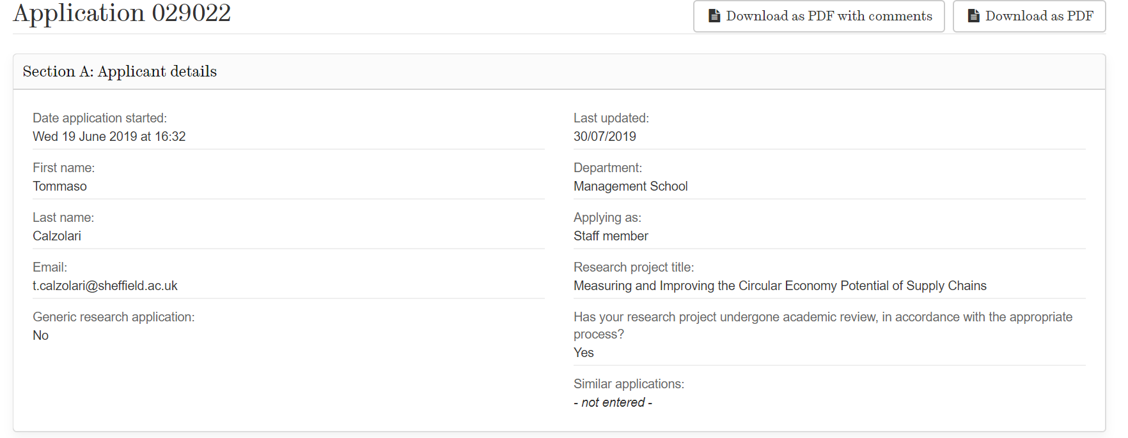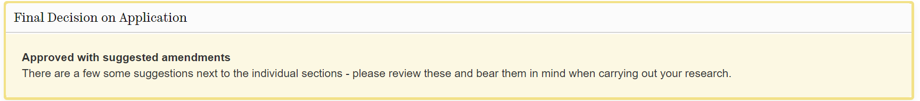

# Appendix 4 – TNA form

|  |
| --- |
| Name of student: Tommaso Calzolari |
| Department or School: Sheffield University Management School |
| Names of all supervisors: Andrea Genovese, Andrew Brint |
| Year of study: 2019/2020 |

|  |  |  |  |  |
| --- | --- | --- | --- | --- |
| **RDF Domain A: Knowledge and Intellectual Abilities**  *the knowledge, intellectual abilities and techniques to do research* | | | | |
|  | **Reflection on your current ability/experience in this area and main priorities for the coming year** | | | **Action to be taken to develop this area (if appropriate), agreed with your supervisor(s).** |
| **Knowledge base (RDF subdomain A1)** *Including:*   * Subject knowledge * Research methods – theoretical knowledge and practical application * Information seeking and information management skills * Academic literacy and numeracy | * I have developed knowledge in the Supply Chain Management (SCM) discipline through my previous study and work experiences. During the past year I have identified the most prominent researchers in the SCM field, with a particular attention to those who concentrate their research on sustainability issues or to SCM issues in a CE context. Keeping up with the emerging research and trend, related with my research problem and discipline is a priority of the next years. Being updated with what is happening in the industrial practice is also a priority; * During the past year I have applied myself in a couple of literature reviews: I spent some months analysing how the transition towards the CE is measured at the supply chain level. For my Confirmation Review documents I critically reviewed the literature on the drivers and the supply chain mechanisms behind the adoption of practices; I want to further develop my understanding of literature review, research design, theory testing and building, case study building and qualitative research methods; * I improved my ability to analyse and codify text from company reports to extract information related to my research problem. A priority is to explore how and to what extent this process could be automathised thanks to text mining softwares; * I have developed my knowledge in the Circular Economy field of study through individual study. In the last year, I had the possibility to open an on-going discussion with the fellow ESR in the ReTraCE project I am improving my knowledge, particularly considering the different level of analuysis, and the different perspectives (e.g. natural capitalism, environmental or ecological economics, degrowth). * I have a good understanding of information seeking and information literacy from previous experiences. I improved my knowledge of reference management softwares; * I am regularly following courses to improve my confidence and productivity in my scientific/technical writing; * During the first semester, I attended Econometric methods module (Module code: ECN6540); I want to improve my knowledge of Multivariate Statistics, and of softwares used to do these analysis; * I started to improve my knowledge of the most important theories that can be used in management studies. A priority is to going into depth with the most relevant ones for my research and apply them. * I do not have a significant experience in qualitative research. I would like to reach proficiency in the use of qualitative analysis packages; | | | * Attend a session text mining software * Attend multivariate statistics session or course * Attend statistics workshops software * Attend writing classes offered by UoS; * Attend SUMS Statistics Workshops in January * Follow online courses on environmental economics (Introduction to Sustainability on Coursera; Valuing Nature University of Exeter on Futurelearn); * Individual study of ecological economics subject (An Introduction on Ecological Economics by Robert Costanza et al.); * Attend ReTraCE Network School events (December 2020); * Attend modules on scientific/technical writing (i.e. ELT 6050 and ELT 6051 offered by UoS); * Attend First Steps with Nvivo * Attend Next steps with Nvivo * Attend Getting data into SPSS * Attend Going Further with SPSS * Attend Beyond the Impact Factor: using metrics to help identify highly-cited and highly-discussed research |
| **Cognitive abilities (A2)** *Including:*   * Analysing * Synthesising knowledge * Critical thinking | * I am regularly participating to events, conferences (inside and outside the ReTraCE network) giving presentations and listening to other researchers presentation; this is helping me to improve my ability of analysing and thinking critically of mine and of their datasets, methods, and results; * I am gradually building up synthesis skills and linking my research problem with existing research, disciplines and ideas. A priority is to synthetise the connection of my research with all the other research fields (e.g. economics, management, environmental economics, ecological economics) * Being at the beginning of my path I could improve my critical thinking, how to develop my own arguments, connect different ideas and looking at the same problem with different theoretical perspectives. | | | * Attend training sessions on qualitative analysis research methods * Build a summary presentation, which synthesises the interlinks with other disciplines, and existing research streams * Attend workshop on Critical thinking and Writing organised by 301 Academic Skills Centre. |
| **Creativity (A3)**  *Including:*   * Intellectual insight * Innovation * Argument Construction | * Being part of the ReTraCE project allows me to get insights, identify potential areas of interest and explore new ideas. I am discussing often with the other 14 ESRs and with my supervisor. * My background and experience is mostly related to Supply Chain Management domain. For this reason I need to explore more in the detail and get in touch with more general economic and environmental perspectives. * I took part to two reading groups (on political ecology in the Political Science School, on Sustainable Development Goals (SDGs) in SUMS). | | | * Read newspapers and blogs on a weekly basis; * Participate to events and conferences organised by ODMS and SUMS (e.g. research presentations, workshops, reading groups); * Continue to engage with ReTraCE ESRs, in particular with WP1 ESRs (i.e. face-to-face meetings, monthly skype meetings); * Keep building contacts in the UoS with both Professors and Researchers and engaging in fruitful discussions around my subject and other stimulating topics; * Participate and present my work in conferences to improve communication and argumentation skills; |
| **RDF Domain B: Personal Effectiveness**  *the personal qualities and approach to be an effective researcher* | | | | |
|  | **Reflection on your current ability/experience in this area and main priorities for the coming year** | | | **Action to be taken to develop this area (if appropriate), agreed with your supervisor(s).** |
| **Personal qualities (B1)** *Including:*   * Resilience * Self-confidence * Integrity * Self-reflection | * In the past I have shown a very good resiliency dealing successfully with very different research and working and cultural environments; * I’m a self-confident person, and I am aware both of areas of strength and of improvement; * I’ve completed trainings on research ethics and integrity, with which I was not very familiar. I am aware that I need to constantly reflect and integrate these principles within my research; * For the ReTraCE project, I am keeping track of all my activities in a diary. During the process of updating this diary I have the occasion to reflect on my progress towards deliverables. | | | * Development of self-confidence:   + Through the process of working on my research (e.g. literature review will help closing my knowledge gap)   + Presenting/discussing my PhD with fellow ESRs, PhD students; * Keep updating ReTraCE diary on a weekly basis; * Keep reflecting and integrating ethics issues in my research. |
| **Self-management (B2)**  *Including:*   * Time management * Responsiveness to change * Work-life balance | * As a full-time PhD student and Early Stage Researcher for the ReTraCE project, I have to prioritise and manage time adequately in order to perform all what is needed in my PhD, and in terms of deliverables for the project. For this reason I benefit from having a structured timetable to plan my time and schedule all the activities. I still can improve the organisation of my working/personal schedule by following courses. * I have a very balanced and thoughtful personality and, as such I feel to be very responsive to change, both in terms of upcoming challenges and opportunities. * I believe work-life balance will keep to be an extremely important point also in these years: I engage in different activities such as reading books, spending time with friends, traveling, playing guitar and watching movies. I also consider a very important aspect doing regular sport activities. | | | * Attend workshop on Managing Your Time and Avoiding Distractions organised by 301 Academic Skills Centre*;* * Enroll in Social Football Group in UoS Goodwin Sport center (as soon as it will be possible and safe playing again). |
| **Professional and career development (B3)**  *Including:*   * Career management * Networking * Reputation and esteem | * In the past, I have managed my career choices independently, striving for my research interests and intellectual curiosity. Nevertheless, it is important for me to continue developing this area and acquiring a structured perspective to manage properly my next career steps; * During my past work experiences, I have engaged on social media with different groups working on my subject area. However I need to improve my online engagement. * In my previous job, I was incentivised to network both inside and outside the company environment. During these months I had the possibility to start building contacts in various conferences I took part to. I wish I will be able to recognise which of these contacts should be fed and kept alive and could help me improving and building my voice. * I want to improve my ability in building social media content to spread the key messages of my research and engage with the scientific and non-scientific communities | | | * Participate in career planning and/or job fairs targeting PhD students; * Attend seminars on social media engagement during ESR ReTraCE retreat in Naples (December 2019); * Make use of conferences to present my work and networking with the scientific community; * Make use of existing events to engage with the existing organisations and citizens communities; * Before the end of my PhD I want to organise at least one event to stimulate a multidisciplinary discussion on the potential of Circular Economy in Sheffield; |
| **RDF Domain C: Research Governance and Organisation**  *the knowledge of the standards, requirements and professionalism to do research* | | | | |
|  | **Reflection on your current ability/experience in this area and main priorities for the coming year** | | **Action to be taken to develop this area (if appropriate), agreed with your supervisor(s).** | |
| **Professional conduct (C1)**  *Including:*   * Ethics * Respect and confidentiality * Attribution and co-authorship | * As part of my initial training at UoS, I have completed an online module on professional conduct (e.g. Ethics, on Confidentiality, on Health and safety on respect and confidentiality); * I am aware of the relevance of my research topic in the context of the research of my division (OMDS) and on SUMS strategic focus. It is important that I will follow up on the future strategic choices of the faculty in terms of research priority and on possible changes to eventually adjust my research focus; | | * Follow SUMS procedures in terms of professional conduct and data confidentiality. | |
| **Research management (C2)**  *Including:*   * Research strategy; * Project planning and delivery; * Risk management. | * I have little experience of research strategy and need to develop more skills; * I am keeping track of the progress and of the research project and activities changes in a Gantt chart; * I developed my knowledge on risk management and become familiar with the procedures at SUMS in terms of plagiarism. | | * Review every 6 months my Gantt chart and reflect on my progress towards milestones/deliverables - *HIGH;* | |
| **Finance, funding and resources (C3)**  *Including*   * Income and funding; * Financial management. | * I am aware of how the ReTraCE budget works; I have created a excel document, which I’ve been updating with the conducted activities and costs covered by the project. | | * Update the budget spreadsheet monthly; | |
| **RDF Domain D: Engagement, Influence and Impact**  *the knowledge and skills to work with others and ensure the wider impact of research* | | | | |
|  | **Reflection on your current ability/experience in this area and main priorities for the coming year** | | **Action to be taken to develop this area (if appropriate), agreed with your supervisor(s).** | |
| **Working with others (D1)**  *Including:*   * Team working; * People Management; * Influence and leadership. | * During my MSc I have taken part to many group projects that were integrative part of the final exam. I am an excellent team player and enjoy working in group; * My current research project is included in the WP1 of ReTraCE (which focus on SCM and the CE) and, in order to work and engage with the other ESRs, we’ve establish monthly online meetings with our supervisors. * I believe I have some influence and leadership skills. In the past I have represented the high school students in the and I would like to further develop them. During the next year I will represent ReTraCE ESR in the Supervisory Board. | | * Attend workshop on leadership; * Responsibly represent Retrace ESRs in the supervisory board. Keep engaging with them in the established communication channels and become the | |
| **Communication and dissemination (D2)**  *Including:*   * Communication Methods; * Publication. * Technical Report Writing * Policy Briefs * Press Releases | * In the past, I’ve presented my research outcomes (both at academic and professional level), where I had to defend the results, methodology applied and proposed solutions. * I’ve not published an article before. Thus, I would like to further develop my skills in this area, gaining awareness of the publishing procedures and requirements. * In my previous work experience, I collaborated in writing some technical reports. I will not have difficulties to write technical reports in my future secondments by companies. * In my first months I have written two blogs that have been published in the ReTraCE website and I am working at other two blogs. * I have little knowledge on writing policy briefs. I hope that the results of my research can be used to support decision-making and perhaps, policy-making at microlevel. Therefore, I would like to further explore this area by having specific training or gain experience through a secondment experience. | | * Attend module on Speaking Skills for Research Purposes (ELT6060); * Attend Writing retreats organised buy UoS; * Individual study on how to write blogs | |
| **Engagement and impact (D3)** *Including:*   * Teaching; * Public Engagement; * Global Citizenship. | * Teaching is not a priority area to me in this moment. However I would like to get some preparation in order to have the possibility to teach in the future; * In my previous work experience, I’ve organised and facilitated a workshop with students and young professionals. However I would like to improve my capacity of talking in public and engaging with a group of people; | | * Attend workshop on Preparing for teaching (part of MGT6225); * How to talk in public session * Attend Conferences engaging with pupils that are doing research in the same topic. | |
| ***Feedback (to be completed after the supervision in which the TNA is discussed)*** | | | | |
| ***Comments from supervisor(s)*** | | ***Any further action agreed by the supervisor and the student [please specify]:*** | | |
|  | |  | | |

|  |  |
| --- | --- |
| **Signature of researcher:** | **Date:** |
| **Signatures of supervisor(s):** | **Date:** |
| **Signature of departmental PGR Director:** | **Date:** |

# Appendix 5 – Circular Economy Indicators for Supply Chains: A Systematic Literature Review

**Abstract:**

Recently, the Circular Economy paradigm has emerged as an alternative to linear and unsustainable production and consumption systems. In order to implement Circular Economy practices and evaluate their effects, organisations need adequate measurement tools. These tools should extend beyond the single firm boundary and consider the complexity of supply chains, material flows, and environmental and social impacts. No established indicator exists to assist the transition of supply chains to a higher degree of circularity; also, most of the literature on Circular Economy indicators has focused on the firm rather than on the supply chain as the level of analysis. Through a Systematic Literature Review method, this paper examines decision support tools, and related indicators, employed for assessing the performance of Circular Supply Chains in the academic literature. In parallel, a content analysis and a template technique are employed to evaluate how Multi National Enterprises measure the effect of the adoption of Circular Economy practices in their reports. Results are synthesised in two composite indicators, which aggregate the most commonly employed measures. Findings show that both academic literature and industrial practice show a scarce consideration of social and circularity metrics, rather focusing on classical environmental impacts and economic measure. In the academic literature, the economic dimension is prevalent, while practitioners seem to evaluate and communicate more often the environmental impacts of already adopted Circular Economy practices. Also, different indicators’ categories (monetary, biophysical, composite indicators) are recognised, according to their choices in terms of selection and aggregation of different metrics and to the contribution they can bring to the transition from linear to circular supply chains.

**Keywords**: Circular Economy, Indicators, Systematic Literature Review, Supply Chains, Performance Measurement, Sustainability Assessment

## 1 Introduction

Since the first industrial revolution, supply chains have operated according to a linear paradigm, based on the extraction and unsustainable use of natural resources. This has caused irreversible ecological damage, as half of the total greenhouse gas emissions and more than 90% of biodiversity and water losses are related to resource extraction and processing (Bressanelli et al., 2019; Kazemi et al., 2019; European Commission, 2020). The Circular Economy (CE) concept was developed to reverse unsustainable patterns of development and create long-term prosperity (Fitch-Roy et al., 2020). In the CE paradigm, every economic activity should maximise ecosystem functions and human well-being (Murray et al., 2017). As such, the frontiers of environmental sustainability are pushed forward, and products are transformed in such a way that there are workable relationships between ecological systems, economic growth and human well-being. A higher circularity in the use of materials is supposed to provide organisations with a wide range of economic benefits. These benefits include reduced materials costs, greater value extraction from resources and greater resilience (Rosa et al., 2019), as well as a positive contribution to environment and society as a whole (Chiappetta Jabbour et al., 2019; WBCSD, 2019).

Because of the benefits of circular supply chains (CSCs), companies have recently been placing more emphasis on achieving sustainable production, by shifting from simple mitigation actions to a focus on prevention of environmental damage, based on whole lifecycle assessment and integrated environmental strategies and management systems (Zhu et al., 2011; Larsen et al., 2018). This trend has also become apparent in the academic literature focused on supply chain management (SCM) where many scholars have analysed how to close the loop of products and materials (Govindan & Bouzon, 2018; Lahane et al., 2020). Within the Industrial Ecology (IE) (Helander et al., 2019), Green and Sustainable Supply Chain Management (GSCM and SSCM) (Genovese, Acquaye, et al., 2017) and Closed-Loop Supply Chain Management (CLSCM) streams of literature (Rezaei et al., 2019), decision support tools (DSTs) for designing and assessing CSCs have been proposed (Bressanelli et al., 2019; Kazemi et al., 2019). These DSTs employ many CE indicators to measure the adoption of CE practices towards desired targets (e.g. economic, environmental and social) (Morseletto, 2020).

Existing reviews of CE indicators show that there is no agreement among researchers and practitioners on what metrics should be selected for the different sustainability pillar and on how to deal with trade-offs (Sassanelli et al., 2019; Saidani et al., 2019; Vinante et al., 2021). There is no consensus on a set of indicators that should measure desirable levels of circularity and establish improvement pathways for production and consumption systems (Vinante et al., 2021). However, these reviews (Saidani et al., 2019; Sassanelli et al., 2019; Vinante et al., 2021) focus on indicators and tools at the firm level rather than including existing knowledge and research gaps at the supply chain level.

To fill this gap, this study reviews CE indicators at a supply chain level developed and employed in the academic literature and in the industrial practice. This will allow the identification of a subset of frequently employed metrics across all the sustainability pillars and the proposal of two prototypes of indicators. These two indicators select and aggregate the most frequently mentioned metrics in the academic literature and in industrial practice. The review also questions the reductionist nature of the different approaches employed for measuring the performance of supply chains from a CE perspective. It then proposes a research agenda aimed at overcoming the limitations of the current literature.

The remainder of this paper is arranged as follows. The next section introduces the research background, defining CSCs and the different approaches that decision support systems can adopt, along with the general sustainability measurement debate. In Section 3, the method utilised to tackle the research questions is illustrated. Firstly, a systematic literature review (SLR) explores DSTs in the context of decision making in CSCs. Secondly, content analysis is used to reveal the CE Indicators in a general sample of Corporate Sustainability (CS) Reports from Multi National Enterprises (MNEs). Section 4 shows the results of both analyses, the most frequent metrics in DSTs for CSCs, the type of decision supported, and the type of sustainability dimension considered. Indicator systems are classified in to three groups on the basis of their underlying assumptions; a taxonomy of CE indicators for MNEs is also presented. In Section 5, results are discussed, and a research agenda is proposed for supporting the development of CE indicators for supply chains.

## 2 Research background

Supply chains and inter-firm relationships have a crucial role in supporting the transition towards a CE (EMAF, 2015; Fischer & Pascucci, 2017; Herczeg et al., 2018). In CSCs (Figure 1), companies cooperate not only to deliver goods and services to customers, but also to provide feedback loops that allow for methods of production to be self-sustaining and for materials to be used multiple times (Bocken et al., 2013; den Hollander et al., 2017; Webster, 2017). Products are designed to last longer and to flow through multiple use phases (Bovea & Pérez-Belis, 2018; Sassanelli et al., 2020); materials are recovered and recycled many times (Go et al., 2015; Wahab et al., 2018). A very important role is played by how products and business models are designed (Bocken et al., 2016, 2017; Pigosso & McAloone, 2017; Lüdeke-Freund et al., 2019; Centobelli et al., 2020; Rocca et al., 2021), with companies selling services rather than just products (Tukker, 2015; Prendeville & Bocken, 2017; Sassanelli, Rossi, et al., 2019). The result is that each product is considered as an asset, whose value is to be preserved for as long as possible in an attempt to displace (at least partially) the demand for new products and primary materials (Zink & Geyer, 2017). This is expected to help keeping consumption levels inside the earth’s boundaries (Rockström et al., 2009). A CSC should be able to:

* Coordinate forward and reverse logistics supporting the creation of value from circular business models and products as a service (Batista et al., 2018; Ebikake et al., 2018);
* Reduce (ideally, to zero) the waste streams it produces by systematically restoring technical materials and regenerating biological materials (Farooque et al., 2019);
* Limit the throughput flow of societal systems to a level that nature tolerates, and utilises ecosystem cycles in economic cycles by respecting their natural reproduction rates (Korhonen et al., 2018).

The Literature is currently exploring enablers of CSCs. Digital technologies (Acerbi & Taisch, 2020; Chiappetta Jabbour et al., 2020; Acerbi et al., 2021) the integration with supply chain partners (Herczeg et al., 2018; Bressanelli et al., 2019; Elia et al., 2020), as well as collaboration with external partners (Cricelli et al., 2021) seem to play a key role in supporting organisations to adopt CE practices.

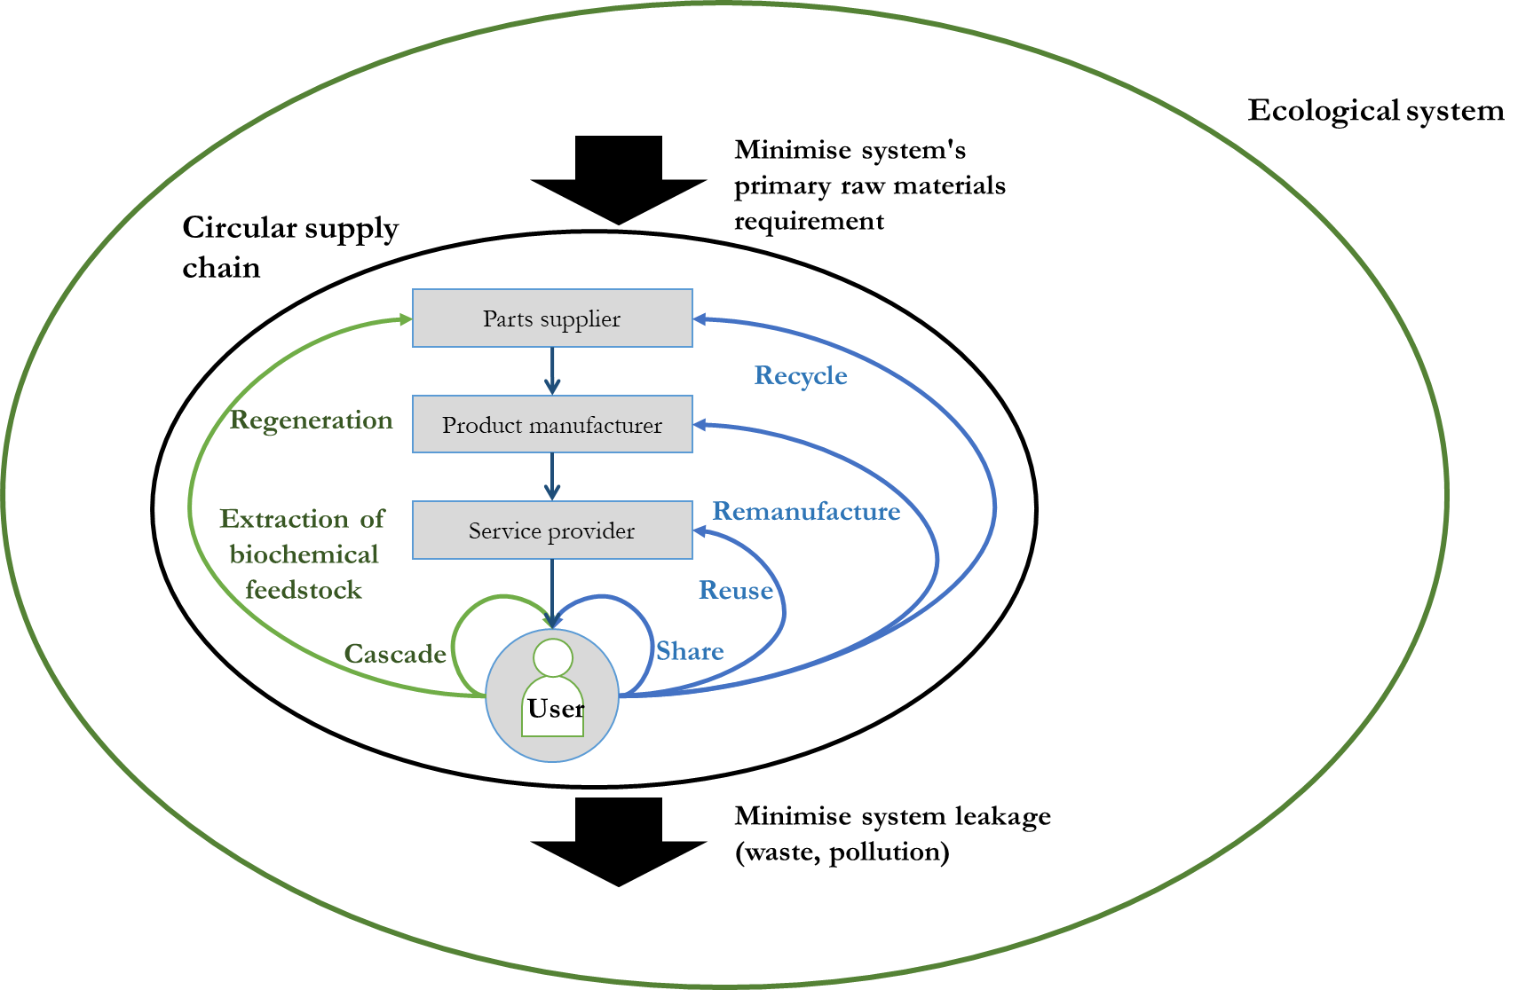

Figure - Circular Supply Chain as part of the Ecological system (adapted from Bloemhof-Ruwaard, 2015)

### 2.1 Measuring sustainability in circular supply chains

Decision-makers need tools to evaluate the adoption of CE practices, and operationalise profitable, efficient, circular and sustainable supply chains. Decision support tools employ many CE indicators to account for a variety of impacts across boundaries between firms (Maestrini et al., 2017), concerning every dimension of sustainability (i.e. economic, environmental and social) (Figure 2). CE indicators are formed by single or multiple metrics, which can be defined as the “finest level of granularity for assessment means” (Vinante et al., 2021).

CE assessment metrics, indicators, methods and methodologies at the firm level have been extensively reviewed (Elia et al., 2017; Saidani et al., 2019; Sassanelli, Rosa, et al., 2019; Vinante et al., 2021). These papers confirm there is a lack of agreement on what needs to be measured, of standard methods of measurement and even of shared terminology and conceptualisation of the CE. For this reason, they try to categorise indicators into frameworks and taxonomies to integrate current performance assessment methods of firms’ functions with CE principles.

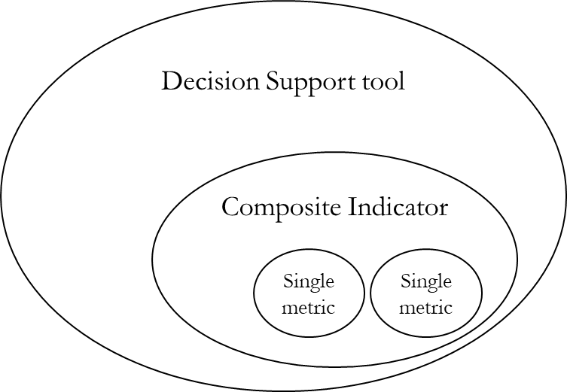

Figure - Decision support tools, Indicators and metrics

In SCM literature, some distinct research streams have developed tools to measure the adoption of CE practices with a supply chains level of analysis. GSCM and SSCM literature (Brandenburg et al., 2014) has been recently considered a crucial unit of action for implementing CE (Liu et al., 2018). Existing decision support tools (DSTs) incorporate a triple bottom line (TBL) approach and life-cycle perspective in the evaluation of impacts for complex and global supply chains (Acquaye et al., 2017; Genovese, et al., 2017a). Indeed, in the GSCM and SSCM literature, the evaluation of environmental impacts makes extensive use of established methods found in environmental science (e.g., *LCA, Life-Cycle Costing*). Some variants of these methods (e.g. *hybrid LCA, Multi Regional I/O Frameworks*) are also able to rigorously assess the environmental performance of complex and global supply chains (Acquaye et al., 2017; Genovese, et al., 2017a). Thanks to these methods, it is possible to determine supply chain *hotspots* (in terms of environmental impacts) using relevant key performance indicators (KPIs), thus identifying areas to be prioritised for action.

At the micro level of a single organisation, CE interventions support the design of reverse supply chains, recycling, reusing or remanufacturing end-of-life products. CLSCs should take back products from customers and return them to the original manufacturer for the recovery of added value by reusing the whole product or part of it (Rubio et al., 2008). RL and CLSCM research streams have firstly concentrated on the evaluation of the economic viability of the adoption of CE practices, and have only recently moved towards integrated multi-dimensional impact assessments (Kazemi et al., 2019). No one had reviewed CE indicators with a supply chain perspective until very recently (Walker et al., 2021).

The literature on CE indicators for supply chains is very fragmented (Figure 3). It is quite clear that a standard way to support decisions and keep track of the transition of supply chains to higher levels of circularity has not been defined. There is no clarity of what should be measured nor of the criteria that should be employed to select metrics, as well as objectives of DSTs. Many CE indicators, metrics or set of metrics have been used. Many DSTs employ economic metrics (e.g., costs, revenues, net present value) or environmental ones (emissions, energy, waste, resources consumed, resources recovered), and even social ones (jobs created by the CSC).

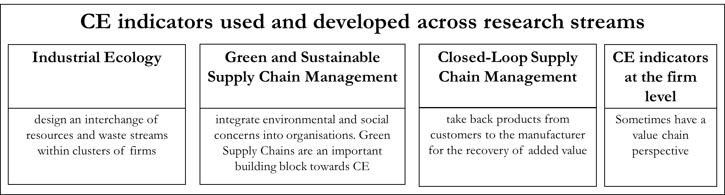

Figure - Decision support tools and CE indicators in the CSCM literature

### 2.2 Understanding the choices behind DSTs for sustainability

DSTs for CSCs can be considered a subset of general sustainability tools (Gasparatos et al., 2008; Gasparatos, 2010; Gasparatos & Scolobig, 2012). When building DSTs, researchers and industrial practitioners have to choose how to systematically select among different metrics (Gasparatos & Scolobig, 2012) and whether to aggregate subsets of metrics into composite indicators. These choices are not just technical ones, but also constitute an important decision, in terms of value perception and worldview assumptions. Analysing general sustainability tools, Gasparatos & Scolobig (2012) recognised three categories of tools (Figure 4), according to their underlying perspectives and conceptions of value:

* *Monetary tools* evaluate sustainability phenomena based on the market evaluation of projects. Environmental impacts are generally transformed into costs. These tools are linked to a *neoclassical* conception of value, which is related to a deeply anthropocentric view. Cost-Benefit Analysis is a classic example of this category (Gasparatos & Scolobig, 2012).
* *Biophysical tools* focus on inflows and outflows of energy, materials and waste within a system. Usually, coefficients and algebraic rules are used to collapse the behaviour of a very complex system into a common unit of measurement, like in the case of EMergy accounting (Odum, 1996; Brown, 2018). This category also includes Life Cycle Assessment (LCA), which explores environmental impacts across a product’s life stages. The type of value consideration of these tools is eco-centric – and highlights the interconnections between economic activities and the environment (Daly & Farley, 2011).
* *Composite indicators* usually formalise identified subsets of variables into measurable indicators. A complex system’s performance is subdivided into measurable pillars and sub-pillars, where more indicators capture different variables. These sub-indicators can be either normalised in a single index or can be presented singularly as part of multi-criteria assessment tools. These tools are more flexible in terms of value considerations, which depend on the specific weighting and normalisation assumptions.

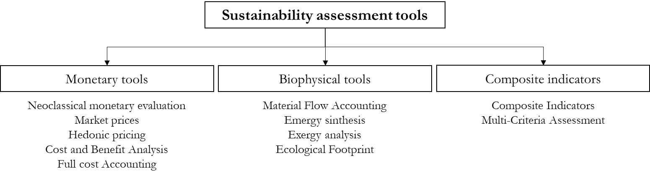

Figure - Three classes of sustainability assessment tools (adapted from Gasparatos, 2012)

No previous review has classified DSTs for CSCs by investigating their underlying assumptions, as per the Gasparatos (2012) framework. In general, the current literature on DSTs for CSCs contributes to knowledge at a very practical stage, investigating specific decisions without questioning world-views and assumptions (Korhonen, et al., 2018; Kirchherr & van Santen, 2019).

### 2.3 Research gaps and Research questions

The CE literature lacks an overview of the standard indicators and DSTs to evaluate the transition towards a CE in supply chains. Available CE assessment metrics, indicators, methods and methodologies in the academic literature were mapped at the firm level (Elia et al., 2017; Saidani et al., 2019; Sassanelli et al., 2019; Vinante et al., 2021) and only recently at the supply chain level (Walker, Vermeulen, et al., 2021). Existing CSC DSTs have employed different methods and used different criteria to select the metrics, and deal with trade-off decisions. On the basis of the identified gaps, the research questions that will be addressed in this study can be summarised as follows:

RQ1: What are the current CE indicators in the context of the CSC literature and in industrial practice?

RQ2: What is a subset of the most commonly employed metrics in both the academic literature and industrial practice?

## 3 Research method

In order to address the research questions, CE indicators were reviewed both in the academic literature and from industrial practice, with two parallel analyses (Figure 5, top part). A Systematic Literature Review was employed in order to identify the key scholarly contributions in the topic of CE indicators at a supply chain level. In parallel, a representative sample of organisations was reviewed to identify how industrial organisations keep track of the impact of the adoption of CE practices. The top-50 European Multi-National-Enterprises from the Global Fortune 500 list were identified as a representative sample. Results of these two analyses were then synthesised to identify subsets of commonly employed indicators, and also build two synthetic composite indicators that are analysed in the discussion section (Figure 5, bottom part).

Academic literature and industrial reports have different nature and scope. DSTs in the literature support decisions on the adoption of new CE practices, adopting most often an *ex-ante* perspective. Corporate Sustainability reports tend to evaluate CE practices that have already been adopted by the company, taking an *ex-post* view. The comparison of the two bodies of knowledge will also allow checking the correspondence between adopted indicators across different contexts and perspectives.

### 3.1 Systematic review of the literature – CE indicators for supply chains

To date, no SLR has been carried out in the topic of CE indicators at a supply chain level. Through a scientific, replicable and transparent process the SLR method identifies the key contributions that are relevant to a particular research question (Denyer & Tranfield, 2009). In this case, the objective was to assess the state of the art of the measurement approaches that have already been developed for assessing the transition towards the CE at the supply chain level. As suggested by Maestrini et al. (2017), the review included four main phases (Maestrini et al., 2017): (i) source identification, (ii) source selection, (iii) source evaluation, and (iv) data analysis (Figure 6). These four phases are illustrated in the following sub-sections.

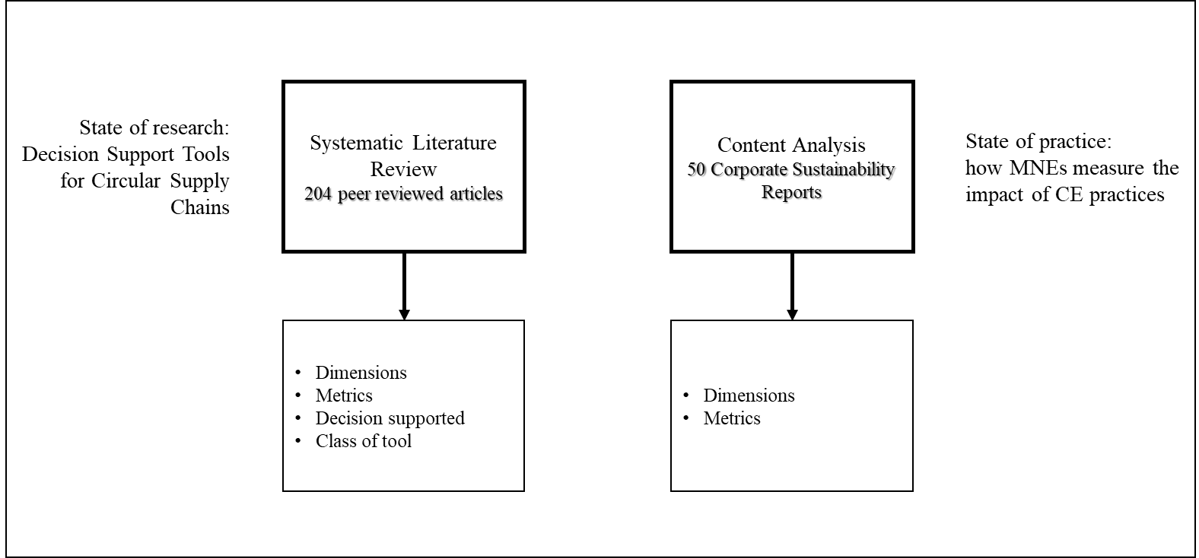

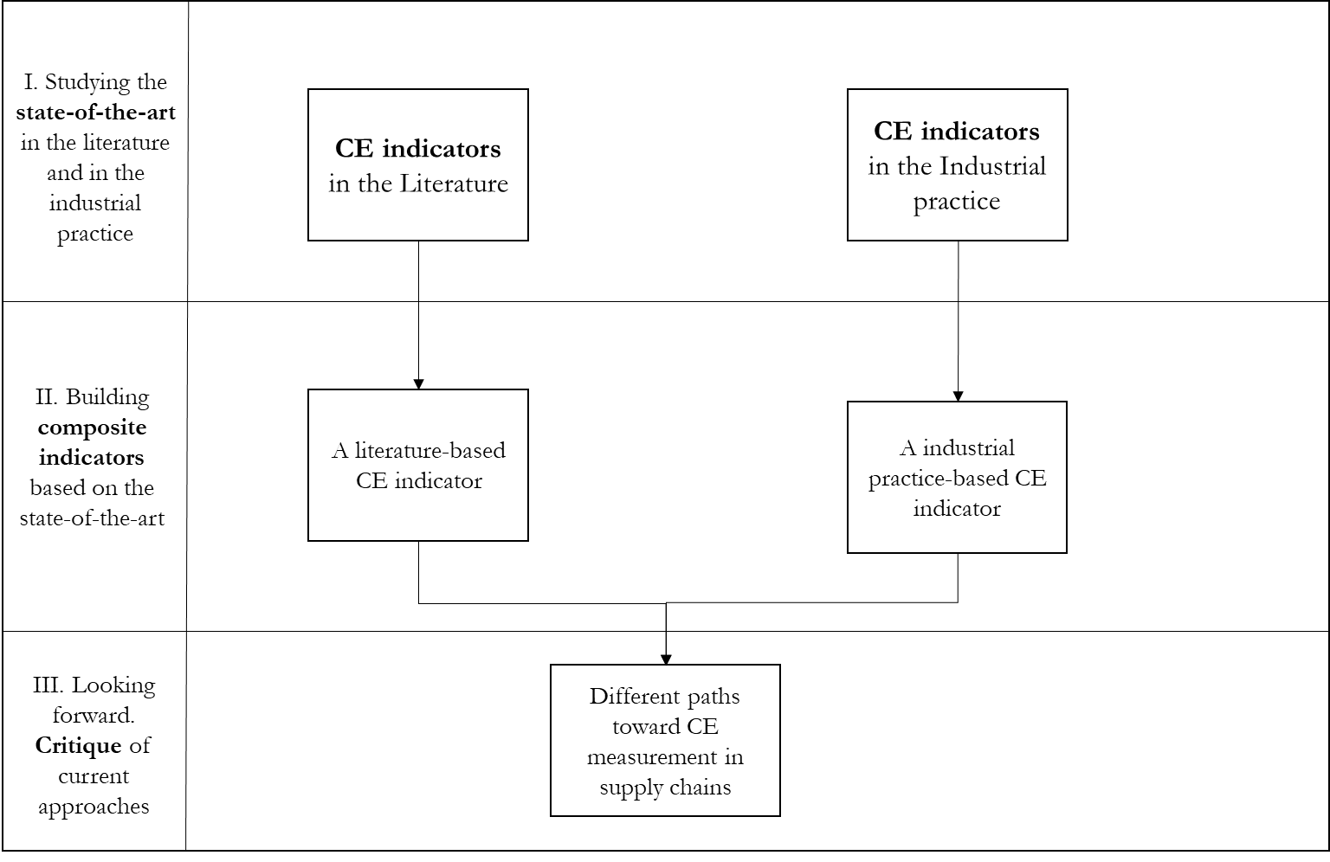

Figure - Research methods diagram. Review of the literature and of the industrial practice protocol (top); approach followed for the derivation of literature and practice-based composite indicators (bottom)

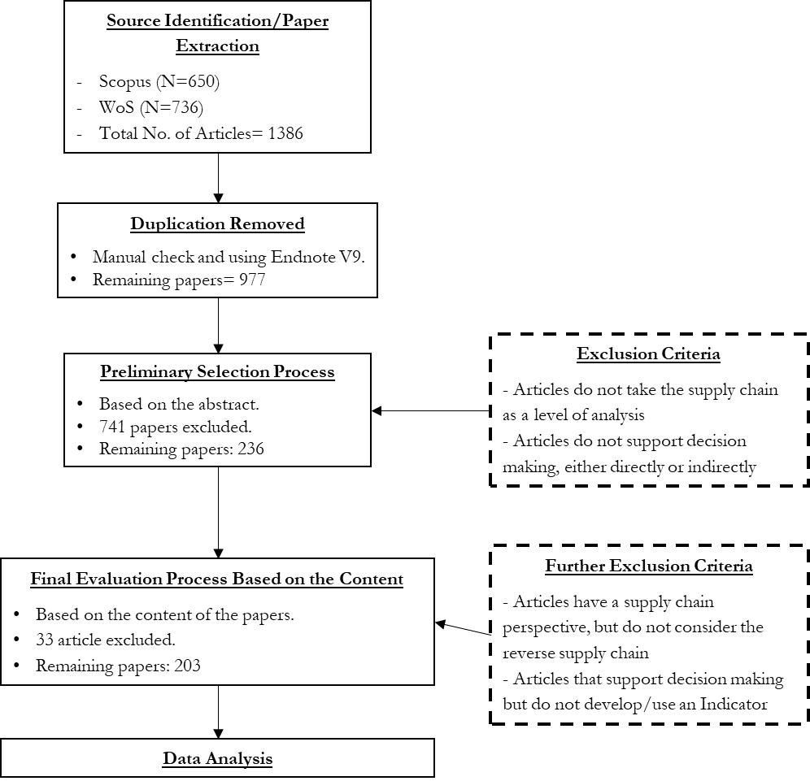

Figure - Papers Search and Evaluation Process

Source Identification

The source identification phase was conducted using the SCOPUS and Web of Science peer-reviewed academic databases. The use of two sources in parallel increased the rigor of the selection process (Denyer & Tranfield, 2009). Keywords were chosen to maximise the number of articles to be included in the analysis. Therefore, the IE, CLSCM and RL literature streams were included, as they have contributed to the origins of a CE discourse in the supply chain management literature (Batista et al., 2018; Sehnem et al., 2019). The following string of keywords was used:

*((‘Circular Economy’ OR ‘Circular’ OR ‘Closed-loop’ OR ‘Reverse’ OR ‘Industrial Ecology’ OR ‘Industrial Symbiosis’) AND ‘Supply Chain*’ AND ( ‘indicator*’ OR ‘measur*’ OR ‘assess*’ OR ‘index*’ OR ‘metric*’ ))*

A manual cross-checking process was conducted in order to eliminate duplicated results. At least two of the research team members executed the overall process in parallel and independently, as suggested by Maestrini et al. (2017). Table 1 provides the results of the search protocols.

Table – Articles Searching Protocols

|  |  |  |  |  |  |  |  |  |
| --- | --- | --- | --- | --- | --- | --- | --- | --- |
| Database | Fields of search | Language | Subject Area | Document Types | Total | Total Both | Duplicate | Remaining |
| Scopus | Article title, Abstract, Keywords  Topic | English | No restrictions | Article; Review | 650 | 1386 | 409 | 977 |
| WOS | 736 |

Source Selection

Once the subset of potentially relevant articles was identified, a first selection process was performed on the abstracts. To delineate the boundaries of the analysis the following inclusion/exclusion criteria were applied:

Only articles in English language have been *included*.

Only peer-reviewed papers were included; book chapters and conference papers have been *excluded*.

Publications which did not develop or employ indicators or measurement systems have been *excluded*.

Publications that considered the circular dimension of SCs (at least as a potential state) were *included*. If the focus was only on the forward element of a supply chain, articles were *excluded*.

Studies were classified on the basis of the specific implementation levels that can be recognised in the CE literature (Ghisellini et al., 2016; Korhonen et al., 2018): the micro level, involving CE strategies at the product and firm level, thus involving an intra-organisational decision-making process; the meso level, including supply chains and, in some contexts, also related to Eco-Industrial Parks and Industrial Symbiosis systems (Masi et al., 2017); the macro level, including CE development in regions and nations (Ghisellini et al., 2016; Kirchherr et al., 2017). Based on this classification:

* + Papers defining indicators to assess CE at the macro level were *excluded* from the analysis.
  + Papers developing indicators and measurement approaches at the meso level were *included* in this SLR. Papers that did not consider the SCs as the level of analysis have been *excluded*.
  + Papers defining specific indicators to measure CE initiatives at the micro perspective of the single organization, were evaluated in detail. A decision was made on the basis of the explicit consideration given to the role played by supply chains (EMAF, 2015; De Angelis et al., 2018). Just studies assuming an inter-organizational perspective for the employed indicators were *included*.

This scanning process resulted in a large reduction in the number of papers (from 977 to 236). Also, this phase was handled separately and autonomously by at least two team members. Regular team meetings were held throughout this phase and the following ones, to compare the choices adopted and to ensure that the process was rigorous. Inter-reliability was satisfied by considering the number of disagreements over the number of papers classified; all the disagreements were examined one by one to come to a collective consensus. Articles that could not easily be excluded with the highest degree of certainty, were included to be further analysed and read in the source evaluation phase.

Source Evaluation

The resulting 236 articles were evaluated and classified from a relevance point of view in relation to the criteria described in Table 2. In particular:

Studies developing an indicator/multiple indicators in order to explicitly evaluate the performance of CSCs were *included*.

Table – Criteria for Selecting Articles

|  |  |  |
| --- | --- | --- |
| Criteria | Number of Studies | Relevance |
| Studies developing an indicator/multiple indicators in order to explicitly evaluate the performance of CSCs | 63 | *Included* |
| Studies employing an indicator/multiple indicators for CSCs in the context of wider Decision-Making models and problems | 140 | *Included* |
| Studies contributing to the CE literature without developing any indicator | 33 | *Excluded* |

Studies employing an indicator/multiple indicators for CSCs in the context of wider Decision-Making models and problems were *included*.

Studies contributing to the CE literature without developing any indicator were *excluded*.

Another 33 articles were excluded, because they did not develop or use any indicator; thus, 203 articles were shortlisted for the purpose of the analysis. Again for this process, at least two team members operated independently, assigning each paper to each category according to the four criteria as suggested by Maestrini et al. (2017).

Data Analysis

Finally, a critical analysis of the 203 shortlisted articles was performed, with the aim of summarising the relevant findings and highlighting the messages. Existing models were surveyed on the basis of the research method employed, the types of decision supported, the sustainability dimension considered and the indicators employed. Single metrics were tracked, in order to understand the most popular ones. DSTs that employed multiple metrics were also classified according to normalisation and/or aggregation approaches. An overview of the classification dimensions is provided in Table 3.

Table – Indicators Classification Dimensions

|  |  |
| --- | --- |
| Classification Dimension | Example |
| Authors | Taskhiri, MS; Jeswani, H; Geldermann, J; Azapagic, A |
| Title | Optimising cascaded utilisation of wood resources considering economic and environmental aspects |
| Year | 2019 |
| Source | Computers & Chemical Engineering |
| Decision type | Strategic |
| Detailed Decision | Circular Supply Chain Network Design - Compare alternative scenario |
| Modelling approach | Mathematical programming method |
| Research Method | Optimisation (& Life Cycle Assessment) |
| Detailed Research Method | Mixed Integers Linear Programming |
| TBL Dimensions considered | Economic & Environmental |
| Economic metrics | Circular Supply Chain Cost |
| Environmental metrics | • Global Warming Potential (GWP); • abiotic depletion potential of resources (ADP); • acidification potential (AP); • eutrophication potential (EP); • freshwater aquatic ecotoxicity potential (FAETP); • human toxicity potential (HTP); • marine aquatic ecotoxicity potential (MAETP); • ozone depletion potential (ODP); • photochemical ozone creation potential (POCP); • terrestrial ecotoxicity potential (TETP) |
| Social metrics | - |
| Single/Multiple/Composite indicator | Multiple indicators |
| Weighting Method | Pareto efficient frontier – indicators are kept separate |
| Class of Sustainability DST | Indicators, Multi-criteria |

### 3.2 Review of CE indicators in the industrial practice

This part of the study identifies the homogenous metrics that are reported by companies when they evaluate the adoption of CE practices. The amount of data that organisations make public has been enhanced because of the greater accountability and transparency demanded for MNEs (Hahn & Kühnen, 2013) by a set of stakeholders (e.g., employee, customers, suppliers, pressure groups, investors, regulators). Also the quality of data, regarding their economic social, and environmental impacts and actions, has been enhanced and follows more and more standardised guidelines (e.g., Global Reporting Initiative[15]). Corporate Sustainability reports represent an ideal platform for evaluating the adoption of CE practices and for identifying KPIs in industry. These reports can be seen as the most direct statement concerning sustainability practices (and, more specifically, CE practices) adopted by a firm (Stewart & Niero, 2018).

This review consisted of four main phases: (i) sample definition, (ii) content extraction, (iii) data coding and (iv) data analysis (see Figure 7). The Global Fortune 500 list[16] (2019 edition) was used to select the sample – which includes the Top-50 companies in the list from the European Economic Area[17] (EEA). A template analysis technique (King & Brooks, 2018) was used to analyse the reports content to identify KPIs related to sustainability and CE practices. During the data extraction phase reports were read in their entirety. The body of text of interest for the research questions was identified, extracted, collected through the NVivo software package, and then organised using an Excel spreadsheet. A keyword-based final check made sure that all the relevant text had been captured from all the reports. Keywords were related to the type of impact category (e.g., emissions, waste, and energy). Such a procedure was aimed at achieving the maximum level of replicability of the analysis.

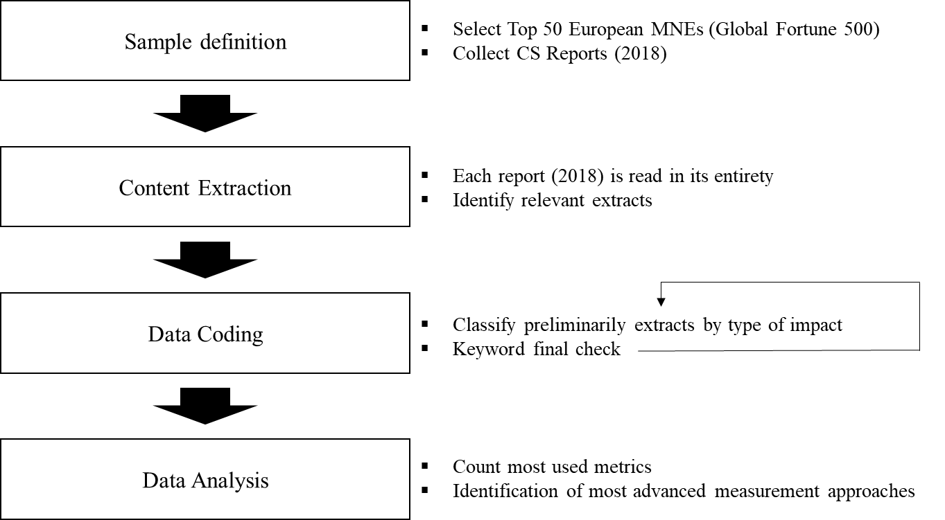

Figure - Content Analysis flowchart. CS reports: Corporate Sustainability Reports.

## 4 Results

In this section, the main results from the analysis of the article sample are reported. The first part focus on the SLR. The following sub-section discusses indicators from the industry and the final sub-section proposes two CE indicators. The sample analysed includes 203 papers from 99 different sources. Journals belong to different research areas, as CE topic has an inter-disciplinary nature. Three out of the four most represented journals belong to the Environmental Science literature (Table 4).

Table - Top 10 Journals that show the highest number of papers

|  |  |
| --- | --- |
| Source | Number of publications |
| Journal of Cleaner Production | 25 |
| International Journal of Production Economics | 16 |
| Sustainability (Switzerland) | 10 |
| Resources, Conservation and Recycling | 9 |
| International Journal of Production Research | 8 |
| Computers and Industrial Engineering | 7 |
| Applied Mathematical Modelling | 6 |
| Science of the Total Environment | 4 |
| European Journal of Operational Research | 4 |

An emerging interest comes from Industrial Engineering literature (e.g., International Journal of Production Economics; International Journal of Production Research) and from Decision Science and Operational Research disciplines. Publications range from 2002 to 2019 and there has been a sustained growth starting from 2015 (Figure 8).

Figure – Increase in annual publications since 2015

Most of the publications support decisions at a strategic level (Figure 9), and more precisely related to the *design of CSCs*. Design decisions include locating and sizing facilities (e.g., industrial plants, distribution centres, collection centres, recycling centres disposal centres), selecting technologies and transportation modes. Capacities need to be allocated among different facilities in the forward and in the reverse supply chain. Some publications support tactical decisions, linked with the *planning of CSCs.* This means deciding how to size the production lots, manage inventory, and coordinate with other supply chain partners. Some papers include elements of both strategic and tactical planning. A significant group of articles does not directly support any specific decision (Unspecified), rather aims at *measuring the performance of CSC Networks*. These papers develop and use indicators to map and evaluate specific CSC processes, or to compare alternatives CSC configurations. Their focus is more on the ex-post measurement rather than on supporting specific decisions directly. For this reason, they were distinguished from tools directly supporting planning decisions.

Figure - Type of decision supported

The majority of the publications employ methods from the Operational Research tradition, namely Mathematical Programming and Simulation (Figure 10). Optimisation models (such as Mixed Integer Linear Programming) can employ either single or multi-objective functions decision variables. Some articles employ analytical models; these tools are either Multi Criteria Decision Making (MCDM) method based or Environmental Science approaches. Among these LCA is the most common, followed by Input/Output and Material Flow Analysis models. Other tools employ a mix of these methods (like LCA and Ecological Network Analysis) or cost-based models (Material Flow Cost Analysis or Life Cycle Costing). The distribution in terms of modelling approaches represents the main difference with previous reviews on CE indicators at the firm level (Sassanelli et al., 2019; Vinante et al., 2021). These reviews have not included CLSCM and RL research streams, which makes a frequent use of Operational Research methods. However, this figure is aligned with the only review that focus on sustainability assessment at the supply chain level (Walker, Vermeulen, et al., 2021).

Figure - Modelling approaches following Seuring classification (2014). ENA: Ecological Network Analysis; I/O: input /output models; LCA: Life Cycle Assessment; MCDM: Multi Criteria Decision Making models; MFA: Material Flow Analysis.

### Metrics and Dimensions

In line with RQ1, the articles reviewed were classified according to the sustainability dimensions they consider and the single metrics they select. The TBL approach is a central concept in sustainability studies, where performance standards need to be achieved across environmental, economic and social dimensions. Following the inclusion of environmental and social issues in the public agenda, SCM scholars have gradually incorporated adequate indicators in their models (Seuring & Mueller, 2008).

Only 15% of the 203 papers integrate the three dimensions simultaneously (Figure 11). The great majority of the papers (82%) do not consider social indicators, favouring the economic and the environmental dimensions. An interesting result is that 34% of the papers do not consider, in an explicit manner, environmental issues. Many of these 34% incorporate reverse logistics considerations, which (as explained in Section 2.1), were at first mainly based on economic aspects. This result highlights some differences in the choices between firm and supply chain level DSTs. Firm level DSTs seem to incorporate more often environmental considerations (Sassanelli et al., 2019).

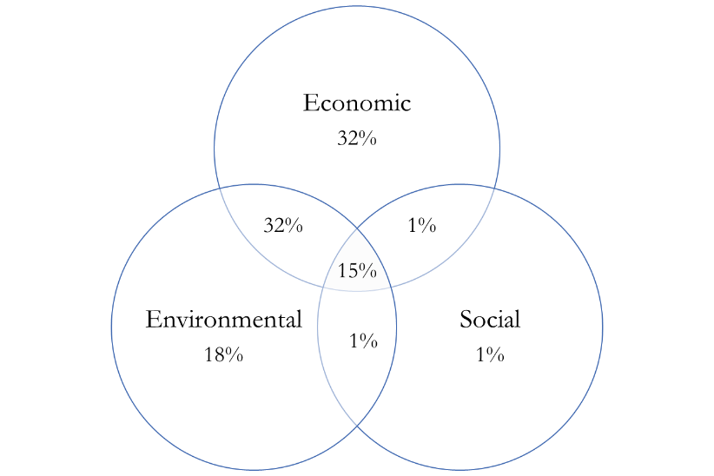

Figure - Dimensions considered by the existing models and tools in the literature

Half of the articles in the sample adopt a single-dimension perspective, mainly favouring the economic (32%) and the environmental (18%) dimensions. Nevertheless, looking at how the consideration of sustainability dimensions has evolved over time, it can be seen that an increasing number of studies account for at least two dimensions (Figure 12). Individual dimensions and employed indicators are discussed in detail in the following subsections (Table 5).

Figure 12 - Interactions between the different methods considering sustainability dimensions and scale of interest.

Table - The most commonly employed metrics

|  |  |  |  |  |  |
| --- | --- | --- | --- | --- | --- |
| TBL Dimension | Category | Metrics | Description | Occurrences | % |
| Economic | Costs | Operational costs  Facility location costs  Transportation cost  Reverse supply chain cost | Cost-based indicators, both at a company and at a supply chain level | 112 | 55% |
| Profits | Total CSC profits  Profits from recovery activities including remanufacturing, recycling and disposal | Profit-based indicators, both at a company and at a supply chain level | 50 | 25% |
| Time | Time responsiveness of the network  Delivery reliability of suppliers | Time responsiveness-based indicators, both at a company and at a supply chain level | 18 | 9% |
| Quality | Reliability of supply  Quality level of the production  Quality of the returns | Quality-based indicators, both at a company and at a supply chain level | 14 | 7% |
| Risk | Financial risk  Value at risk  Conditional value at risk  Variability index  Downside risk | Risk-based indicators associated to uncertainty (e.g., of demand, collection) | 12 | 6% |
| Profitability | Net Present Value  Return on Equity  Return on Assets | Profitability-based indexes, measuring | 9 | 4% |
| Environmental | Emission equivalent | Climate Change  Greenhouse gases  Global Warming Potential | CO2 eq. emissions associated with supply chain | 90 | 44% |
| Waste | Waste Landfilled  Recycled waste  Recovered waste  Recyclability and ease of disassembly | Residual waste produced and landfilled or recovered by supply chain activities | 35 | 17% |
| Energy usage | Energy use  Cumulative energy demand  Renewable energy use  Energy self-sufficiency | Energy-based indicators associated with supply chain | 32 | 16% |
| Virgin resources usage | Abiotic depletion of resource  Mineral, fossil & renewable resource depletion | Virgin resource use associated with supply chain material consumption | 26 | 13% |
| Water | Water depletion  Water emissions  Water use | Water used or contaminated | 26 | 13% |
| Air emissions | Particulate Matter  Respiratory inorganics | Other air emissions associated with supply chain | 22 | 11% |
| Acidification | Terrestrial acidification  Marine acidification | Acidification potential associated with supply chain processes | 19 | 9% |
| Social | CSC jobs created | Number of fixed and variable jobs  Number of drivers hired for transportation | Employment opportunities provided by the CSC | 15 | 7% |
| Organisational H&S compliance | Compliance with the ILO guidelines | Measures of compliance to H&S Guidelines for the jobs created in the CSC | 7 | 4% |
| Quality of work | Work damages  number of accidents, lost  Employee turnover | Measures of quality of the jobs created | 7 | 3% |
| Training | Average hours of training  Training on skills for employability | Indicators of the training provided to workers | 4 | 2% |
| Expenditure on Benefits for employees | Food  Transportation  Pension | Indicators of benefits provided to the workers | 4 | 2% |
| Customer environmental awareness | Enlightening customers to return end of used product  Customer incentives for recovery from discarded product | Indicators of environmental awareness of the customers | 3 | 1% |
| Social cost of waste | Penalty cost of disposal | Social cost of waste produced. Sum of disposal cost and of the cost for the recycler | 2 | 1% |

Economic indicators

80% of the studies employ economic indicators, with a clear prevalence of cost-based measures (Table 5). Notable examples include cost of production, transportation cost, facility location cost (Özceylan & Paksoy, 2013; Shankar et al., 2018; Ponte et al., 2020). These considerations are very common in CSC Network Design Optimisation models. Indicators related to the time responsiveness of the CSC and to the quality of the products are less common (Kazancoglu et al., 2018; Liao et al., 2020). Some CE indicators can be noticed across the different categories of measures. Notable examples are the cost of the reverse supply chain, the profits associated with recovery activities (Baptista et al., 2019; Jin et al., 2019), including remanufacturing (Abdi et al., 2019), recycling and disposal (Li et al., 2019), and the quality of the recovered products after the end of their life (Jeihoonian et al., 2017).

Environmental indicators

Most of the studies that consider the environmental dimension utilise indicators based on Global Warming Potential and Greenhouse Gas Emissions (Tsoulfas et al., 2002; Low et al., 2016; Chavez & Sharma, 2018; Rezaei et al., 2019; Taleizadeh et al., 2019). Emission equivalent (such as CO2-eq) metrics are three times more likely to be employed than any other category of environmental indicators, which seems to confirm that SCM literature has an established carbon-centric point of view (Genovese et al., 2017).

Fewer studies select indicators related to the residual waste that is incinerated or landfilled (17%), or on waste recovered thanks to CSC feedback loops (Rachaniotis et al., 2010; Jayant et al., 2014; Gusmerotti et al., 2019). Other commonly utilised indicators focus on use of energy across supply chains (Genovese et al., 2017). Cumulative energy demand (CED) considers the energy consumed throughout the product lifecycle, including the energy consumed during the extraction, manufacturing and disposal of the raw and auxiliary materials (Govindan et al., 2016; Sgarbossa & Russo, 2017; B. Liu et al., 2018). Only 13% of the articles measure the quantity of virgin resources (e.g. minerals, fossil fuels, renewable resources) that are depleted throughout the supply chain (Rao, 2014; Daaboul et al., 2016; Hazen et al., 2017).

In total, 77 different environmental indicators are employed. This denotes the lack of an agreed standard for measuring the environmental performance of CSCs, or the transition of supply chains towards CSC configurations. Many studies use traditional LCA frameworks, in this way taking into account a wide variety of impacts across the whole product supply chain.

Another relevant gap is the absence of explicit metrics regarding process or material ‘circularity’. Only a very small minority of papers employ specific indicators to measure the proportion of waste and by-products reincorporated in the supply chain (Wei et al., 2014; Gilbert et al., 2017; Jeihoonian et al., 2017; Al-Aomar & Alshraideh, 2019).

Social indicators

Only 18% of the sample consider the social dimension within the definition of the objectives (Darbari et al., 2019; Taleizadeh et al., 2019). It can be observed that there is no agreement on the stakeholders to be involved. Some measurement approaches only consider employees, whilst others consider customers and as well as suppliers, organisations or communities (see Table 5).

The most common indicator (which appears in 7% of the papers included in the sample) is represented by the employment opportunities generated within the supply chain (i.e., the total number of jobs created by the CSC). Whilst not common, some metrics representing the ‘quality’ of the jobs created are also considered: 3% of these indicators mention aspects such as the presence of decent work conditions (Rahimi & Ghezavati, 2018; Hajiaghaei-Keshteli & Fathollahi Fard, 2019), 2% of employee training opportunities (Govindan et al., 2016) and other benefits for workers.

A less common indicator (which appears in just 1% of the papers considered) measures customers’ environmental awareness, related to their willingness to return used products at the end of their life (Govindan et al., 2016; Gusmerotti et al., 2019). Another notable indicator describes the social cost of waste (1%), defined as a penalty cost assigned to companies for disposal of materials throughout the supply chain.

A classification of existing measurement approaches

In this section articles are classified by looking at the work of Gasparatos and Scolobig (2012) on general sustainability assessment tools, characterising existing measurement approaches on the basis of the underlying conceptual assumptions. Three DST classes could be identified (Table 6). Each class of tools shows a good degree of similarity in terms of DST objective, research method adopted, sustainability dimension considered, and metrics selected. Each class also reflects very similar assumptions of value. The three classes of CSC DSTs can be defined as follows:

1. *CSC Monetary tools (88 papers)* support decisions by looking mainly at the economic viability of CSCs. As a consequence, within these tools the economic dimension is prevalent. 63 out of 88 DSTs do not consider at all environmental and social metrics. The other 25 consider multiple dimensions and convert environmental and social impacts in monetary terms to become part of a general cost function. Usually, they employ simplified environmental indicators, mainly based on carbon emissions which are translated into carbon cost. Only 4 out of 88 tools select indicators related to the circularity of material flows or to waste creation at the different stages of the supply chain. 79 out of 88 use mathematical programming or simulation approaches. This class encompasses articles that have an acceptance of *neoclassical* value assumptions.
2. *CSC Biophysical tools (29 papers)*: This class collects mainly tools from the environmental sciences and other tools that analytically represent systems. Articles have the objective of quantifying flows and stocks of materials within the supply chain system and calculating the environmental impacts associated with those flows. The methods employed are mainly LCA, Material Flow Analysis (MFA), hybrid LCA, and I/O methods. The type of decision supported is mainly at the strategic level (e.g., comparing different products, processes and CSCs); chosen metrics are purely environmental. They are usually not aggregated or normalised into composite indicators. The type of value consideration of these tools is *eco-centric*: production and consumption systems are evaluated on how much resources they are consuming, how much waste they produce and how much and how they affect natural systems.
3. *CSC Composite and multicriteria indicators (86 papers)*: these tools consider multiple dimensions at the same time; just 9 over 86 focus on one dimension only. Their objective is to combine performances offered by alternative solutions across different criteria, assisting decision-makers in selecting the best course of action according to their preferences. MCDM and multi-objective mathematical programming approaches are the most common methods. Within these approaches, a first group of papers (38) normalise and combine all the different aspects into a single indicator. These DSTs weight and aggregate more metrics into a *composite indicator*. A second group of studies (48) do not perform normalisation and weighting operations, rather they keep separate aspects that might not be comparable, doing sensitivity analysis and showing alternative solutions (*multicriteria indicators*). Decision-makers are left with a qualitative evaluation of the different profiles of dominant and dominated solution. Also *multicriteria tools* consider simplified environmental indicators and often normalise different environmental metrics into an environmental index, which is considered a proxy of all the environmental impact. Value considerations within these models are complex.

Table 6 - Objectives, methodological approaches, and metrics of different classes of articles in the literature

|  |  |  |  |  |  |  |  |  |
| --- | --- | --- | --- | --- | --- | --- | --- | --- |
| Type of tools | Objective | Methodological approach | Economic metrics | Environmental metrics | Social metrics | Aggregation Technique | Value | Examples |
| CSC Monetary tools | Evaluate the economic viability of CSCs | Mathematical programming;  Simulation | Cost-based | Emission based | CSC jobs created | choose an efficient solution on the Pareto frontier | Neoclassical economics  Utility-based; anthropocentric | (Baptista et al., 2019; Polo et al., 2019) |
| CSC Biophysical tools | Evaluate CSCs impact on Nature | LCA; MFA;  I/O Analysis;  Hybrid I/O LCA | No | mainly standard LCA based metrics / material, waste flows | No | do not aggregate;  aggregate per type of impact (Recipe, Eco-indicator 99) | Eco-centric | (Prosman & Sacchi, 2016; Hoehn et al., 2019) |
| CSC Composite and Multicriteria indicators | Combine multiple performances | MCDM;  Mathematical programming | Cost-based | Emission based | CSC jobs created | normalise all the metrics into one composite indicators;  identify many dominant and dominated solutions on an efficient Pareto frontier | Flexible | (Chavez & Sharma, 2018; Darbari et al., 2019) |

### CE indicators from industry practitioners

Also this section contributes to answering RQ 1, highlighting CE indicators in the industrial practice[18]. Indicators of the economic impact of CE practices adoption vary according to the industrial sector and to the type of practice. ‘Revenues from remanufactured products’ is a common indicator among the manufacturing companies that built an infrastructure to recover end of life parts to be sold in the secondary markets (*Renault, FCA, PSA, Volkswagen, Daimler, and BMW*). In the financial sector, economic indicators refer mostly to the ‘green’ investments associated with CE activities or with the promotion of renewable energy or resource efficiency solutions.

Most of the environmental KPIs which are employed are efficiency indicators (Table 7), comparing a measure of polluting activities (for instance, carbon emissions) to the total production output. It must be highlighted that the usage of such indicators for measuring the success of CE practices is problematic. Figures could be manipulated to obtain better results, for example just by increasing production volumes (for instance, through productivity improvements), rather than by implementing practices which can promote a more efficient usage of resources. Social impacts associated with CE practices are included only in 3 organisations and refer to the employment opportunities provided by the CSC.

Just one company, the Italian Energy Utility provider *Enel*, develops a measurement system to assess the level of circularity of its solutions and products. Enel *X Circular Economy Score[19]* evaluates five CE key dimensions (commitment by suppliers to CE principles; the presence of reusable elements which can increase the life-cycle of the product; the resource efficiency; the reuse of materials; and the support offered to suppliers) and circular business models (inter alia: product as a service; sharing platforms; product life cycle extension).

### Developing CE indicators for supply chains from the state-of-the-art

This final section addresses RQ 2. The results of the reviews of the academic and of industrial practitioners’ literature are used to identify appropriate subsets of KPIs from the three dimensions of sustainability (i.e., economic, environment and social). KPIs are then normalised though MCDM method into two distinct CE composite indicators. These two prototypes could form the basis of DSTs that could be used to keep track of the effectiveness of CE interventions in CSCs; to focus on the trade-offs between different sustainability dimensions; and to account for benefits, impacts and preferences of different decision-makers and stakeholders.

Table - Commonly used economic, environmental and social KPIs for European MNEs

|  |  |  |  |  |
| --- | --- | --- | --- | --- |
| Dimension | Category | Examples | Description | Adopting Companies |
| Economic | Revenues | Revenues from remanufactured products  Revenues from ‘green products’ | Revenues associated with CSC activities | 3/50 |
| Investments | Capital invested in sustainable solutions  Capital dis-invested from carbon intensive assets | Investments associated with CSC activities | 15/50 |
| Environmental | Emissions equivalent | CO2eq per functional unit  Absolute CO2-eq | CO2 eq. emissions associated with the supply chain | 44/50 |
| Energy Usage | Energy intensity  Cumulative energy use  Energy from renewable sources | Energy-based indicators associated with the supply chain | 44/50 |
| Water | Water used  Wastewater production  Discharges to water | Water used or contaminated | 42/50 |
| Waste | Waste sent to landfill  Waste recovered | Residual waste produced or recovered by supply chain activities | 36/50 |
| Social | Social Impacts associated with CSC | ‘Green’ jobs created | Employment opportunities provided by the CSC | 4/50 |
| CE | Overall Circularity | CE Score  Parts Collected and Remanufactured | Indicators of environmental awareness of the customers | 3/50 |

4.3.1 A literature-based CE composite indicator for supply chain

The first multi-objective composite indicator is based on the results of the literature review. This Literature-based CE index (L-CEI) aims to synthesise the models and tools already developed in the literature. The steps for the definition of this indicator are presented below:

* The weights of the three components representing the sustainability dimensions have been determined based on their relative frequencies (as reported in Table 8). For instance, the weight of the economic dimension is 0.49 as this represents the normalised frequency of articles accounting for economic factors (with respect to a normalisation factor that is the sum of the percentage of articles reporting of each dimension).
* The subset of indicators considered for each dimension has been determined by considering the most popular metrics in the subset of papers selected in the review. The three most popular metrics have been selected for each dimension. Weights have been determined in a similar manner to what has been done for dimensions, considering normalised relative frequencies (Table 9).

Table - Calculation of the normalised weights for the dimensions

|  |  |  |
| --- | --- | --- |
|  | Occurrences (%) | Normalised dimension weight |
| Economic | 80% | 0.49 |
| Environmental | 66% | 0.40 |
| Social | 18% | 0.11 |

Table - Calculation of the normalised weights for the economic indicators

|  |  |  |
| --- | --- | --- |
|  | % articles | Normalised indicator weight |
| CSC Cost | 52% | 0.31 |
| CSC Profit | 22% | 0.13 |
| Time Responsiveness | 8% | 0.05 |

Figure 13 shows L-CEI and its components and the weights. The economic dimension dominates, and accounts for around half of the total weight. The metrics are mainly cost-based and profit-based measures. A small portion (0.05) is given by a parameter representing the Time Responsiveness, which measures the time taken by the supply chain to move materials and components in the forward and the reverse supply chain.

Figure - A literature-based CE indicator

Among the environmental metrics prominence is given to the CO2-eq. emissions parameter. The ‘Energy use’ and ‘Virgin Resource use’ metrics have a similar and limited importance (0.08 and 0.07), and account for how intensively the supply chain makes use of energy and of primary resources. The Social component just accounts for 11% of the weight; within this dimension, selected metrics include the employment opportunities of the reverse supply chain ‘CSC Jobs created’ (0.05), and some measures of the quality of jobs, such as compliance to Health & Safety standards and ‘Quality of work’. This last measure usually includes the number of accidents that cause workers’ injuries across supply chain activities.

4.3.2 An industry-based CE composite indicator for supply chain

The second prototype, the Industry-based CE index (I-CEI), is based on the results of the previously presented review of the industrial practice (Section 4.2). The steps for the definition of this indicator are presented below:

* The weights of the three components representing the sustainability dimensions have been determined based on the relative frequencies, in analogy with the calculations shown for L-CEI.
* The subset of indicators considered for each dimension has been determined by considering the most popular metrics in the sample of organisations. The three most popular metrics have been selected for each dimension. The relative weights inside each dimension have been chosen based on the relative frequencies, in analogy with the calculations shown for L-CEI.

The environmental component is dominant (Figure 14), and accounts for more than half of the total weight. The most important metrics are mainly carbon-based and energy-based measures, not differing from the ones which can be found in the sustainable supply chain management literature, with no specific emphasis on circularity issues. A large portion (0.21) is also given by a parameter representing the consumption of water. Among the economic indicators considerable importance is given investments to support the transition towards a more CE, both through sustainable investments (0.15) and through disinvesting from polluting and carbon intensive solutions (CIS) (0.09). Revenues from “green” products refers to the sale of sustainable or remanufactured products and services. The Social dimension has a slightly lower weight than in the L-CEI (0.06) and includes a single indicator (the amount of ‘green jobs’ created).

Figure - An industry-based CE indicator. CIS: Carbon Intensive Solutions.

## Discussion

The objective of the discussion section is to critique what existing DSTs in the context of CSCM are measuring. The first subsection compares the academic and the industrial literature. Then, a critical discussion highlights how DSTs and CE indicators are always affected by reductionism. The advantages and the disadvantages of different approaches to multidimensional decision making are discussed, together with some research avenues and new research ideas that could be looked at to contribute to future research on DSTs for CSCs.

### Comparing CE indicators in the literature and the practice

The first aspect that emerges is that DSTs in the literature and Corporate Sustainability reports place emphasis on different aspects and metrics. L-CEI, which represent the most common metrics selected in DSTs in the literature, seems to over-represent measures that depend on the economic cost. On the other side practitioners measure more often positive environmental effects of CE practices, focusing on the energy consumption of the supply chain, and on its dependence on carbon intensive sources. Also, they integrate more often circularity metrics which make a mass balances between inputs and outputs in the production system (Walker, Vermeulen, et al., 2021).

A possible explanation of these differences might have to do with the different scope of sustainability reporting and DSTs. DSTs most of the times look at the implementation of new CE practices, which require evaluating economic aspects and to define a business case for the organisation and the supply chain. Differently, Corporate Sustainability reports perform a consumptive evaluation of already implemented CE practices (usually referring to the previous financial year). Despite the lack of standard reporting approaches (Opferkuch et al., 2021), CE is considered a framework expected to reduce organisations’ impact on the environment and the stakeholders are requiring this type of evidence in reports (Howard et al., 2019).

Both the indexes (L-CEI and I-CEI) show that existing frameworks and selected metrics struggle to fully capture the adherence of supply chains to the CE paradigm. Materials circularity indicators are included only in rare cases and environmental aspects are often restricted to very simplified indicators, usually based on the cumulative carbon emissions of the supply chain. This choice might derive from knowledge that is consolidated in SSCM discipline: the operationalisation of reverse logistics feedback loops require the activation of facilities (such as processing and disassembling centres, along with remanufacturing plants) and, possibly additional transportation flows (Helander et al., 2019). All these activities employ resources, energy, and cause emissions in the environment and could give rise to rebound effects (promoting, overall, higher resources consumption rates) (Zink & Geyer, 2017). However, in a CE, supply chains should work in a radically different way and try to consider alternative strategies to reduce waste streams.

I-CEI economic metrics are mainly representative of revenue flows related to ‘circular’ products. This can be explained as, at the moment, Industrial Organisations are not adopting CE practices across the whole supply chain, but just in some niches. As such, the current indicators are not designed to measure the performance of a whole CSC, but just some parts of it. Some of the possible metabolisms, where products and materials are used multiple times, are not measured. Rather, DSTs concentrate on a few metabolisms related to recycling, where the products and the waste of linear productions consumption systems are recovered and down-cycled. Measuring multiple feedback loops and metabolisms would tell something more about how much methods of production are self-sustaining and less dependent on primary materials, as well as how much primary production has been displaced with the adoption of CE-related practices.

Both the indexes similarly have a low consideration of social indicators, which confirms previous literature claims (Walker et al., 2021b).

### Reductionism in Decision Support Tools for Circular Supply Chains

The results section 4.3 shows that DSTs systematically select some metrics and ignore others. These choices are not just technical, but also constitute an important decision, in terms of value perception and worldview assumptions.

DSTs in the CSCM domain need to be simple and easy to use, as decision makers need to understand and support the resulting decisions to design and transform existing supply chains. Simplification concerns many aspects that have already been mentioned (selection of metrics, and their aggregation) and some others, like the temporal horizon, considered the type and number of objectives or actors included in the decision. A single indicator is often chosen as a proxy of all environmental (or social) impacts. As a consequence, DSTs have a reductionist interpretation of what to measure to support decisions, and as a consequence of what sustainability is and on what a CSC should be.

A second aspect of reductionism in the academic literature of CE indicators concerns how DSTs deal with trade-offs among different variables. Most of the time, models accept some increase of negative impacts if that allows some type of benefit. This is quite a strong assumption, as variables belonging to different sustainability dimensions have complex relations and dependencies, which cannot be easily described by some linear parameters. *Composite indicators* represent an extreme case aggregating metrics from different dimensions into a single unit-less number. *Monetary tools* transform many variables in to monetary terms, even natural or social ones. Also *Biophysical tools* are not exempt from doing some approximations: CO2-eq., which is the most commonly used indicator, is a linear combination of different greenhouse gases. *Multi-criteria indicators* approaches are emerging and can provide a solution to this. Their main advantage is that by keeping separate more than one profile, they are less affected by reductionism. However, they also make reductionist choices: sometimes a single indicator is used as a proxy of all the possible indicators within one sustainability dimension; in other cases composite indicators are created for each sustainability dimension as linear combinations of some selected metrics[20]. This could lead to the same problems highlighted for composite indicators (e.g., loss of meaning) as the metrics considered might have a complex relationship (e.g., CO2-eq and land use).

### Different paths towards CE measurement in supply chains

DSTs are not always transparent and open on value assumptions behind the models. Both the conceptual choices (e.g., what metric to select and what to ignore) and the methodological ones (whether to aggregate or normalise or not and with what weights) behind each DST are never neutral or objective. They are inspired by embedded worldviews, which are linked to a certain idea of value. These underlying value assumption have an impact on guiding decisions towards different paths of adoption of the CE in supply chains. The recent debate on the CE acknowledges different circular futures are possible (planned circularity, circular modernism, bottom-up sufficiency, peer-to-peer circularity) (Bauwens et al., 2020). The way the transition towards the CE is measured will impact the type of future and the type of supply chains. In fact, indicators act as value-articulating institutions, enforcing a very specific worldview and set of values, which should at least be acknowledged (Gasparatos & Scolobig, 2012).

The classification according to Gasparatos’ framework (Section 4.1.4) groups DSTs according to similar value assumptions. The following paragraphs explore these differences, along with the advantages, the disadvantages of each class of tools (Table 10). Different paths towards CE measurement in supply chains are recognised, according to what desired outcome of change can be measured by the tools.

*Monetary DSTs* for CSCs adopt a neoclassical perspective of value and do not challenge the assumptions and the “rules of the game” in today’s free market economies (even without mentioning it openly). In free market economies actors are driven by economic benefits and companies are profit maximisers (Martinez-Alier et al., 1998). What is right or wrong is decided by subjective preferences and an anthropocentric valuation system that focus on utility functions and consumer preferences in a market setting (Martinez-Alier et al., 1998). Also, Nature or environmental impacts are monetised and included in market transactions. Markets have a key role in guiding the transition towards CSCs.

These DSTs usually provide whole-supply chain visibility of the processes and materials involved in the manufacturing process, as well as different actors’ preferences and utility functions. As such they are able to present the different economic incentives for each CSC actor involved in the value creation process. These models estimate how much it costs to set up reverse channels to recover end of life products and how much additional revenues (or avoided investments) different CE practices can help to generate. Modelling CE benefits and negative impacts across more dimensions and more supply chain stages could show under which condition establishing a CSC is profitable.

As such successful CSCs are systems that use recycling and other CE strategies to increase the efficiency, they have in using materials, are able to create economic value for their customers through the adoption of some CE practice, are able to use reverse logistics to recover “linear” products at the end of their life, and thus consume less resources and produce less waste. As these DSTs come mainly from an engineering background, they consider a CSC as a system that should work efficiently, without considering the socioeconomic context in which they operate (Zink & Geyer, 2017). This view usually implies reductionist views of sustainability and of the CE. These supply chains might use materials more efficiently or not (this is not often measured). The risk of a rebound effect and of market barriers to the operationalisation of CE practices is usually not part of the models. Desirable CSCs do not necessarily produce less products, but more products with less inputs per product.

*Biophysical DSTs* incorporate an *eco-centric* perspective of value. Monetary incentives and supply chain actors’ preferences and utility functions are usually not part of these models. What is right or wrong to produce is decided by the cost and the impact of production. Production and consumption systems are considered in close relationship with Nature, as an active and integrative part of it. They measure the flows between economic systems and natural ones and look at how much resources are consumed, how much waste is created, how much emissions and environmental impacts are caused.

These tools are able to compare different products and configurations of reverse supply chain along with value retention strategies. Alternatives are compared according to the environmental cost of their production and to how heavily they depend on Nature. As such, the amount of primary resources a CSC uses for the production of goods should be minimised. Successful CSCs are systems that are able to decouple production from consumption of resources in absolute terms. Biophysical tools can provide an accurate estimation of environmental impacts thanks to a life-cycle perspective. This can help CSC decision-making processes to move away from the mainstream perspective of accounting just for the economic cost of production of goods and services. But they can also provide insights on how to measure and visualise the CE potential related to regenerative and restorative flows of resources in supply chains, in order to re-use material flows and waste as a resource according to an Industrial Ecology view.

*Composite and multicriteria indicators* have not a pre-defined conception of value. It depends on the weights chosen. It can be more eco-centric or more anthropocentric. Also, in SCM environments, composite indicators are rather common, both among researchers and practitioners. CSCs provide an ideal theoretical and practical context in which these methods could support decision-making. In this complex context, a wide range of stakeholders inside and outside the supply chain may be interested in evaluating the performance of the CSC using an established and standard model. *Composite indicators* approachescan combine strengths from the previous approaches. The main advantage provided by composite indicators is the ability to summarise complex, multi-dimensional realities for supporting decision-makers. Such methods are particularly effective in contexts in which multiple stakeholders are involved. However, normalisation and aggregation might cause loss of details and meaning (Martinez-Alier et al., 1998).

Table - Advantages and Disadvantages of different classes of articles in the literature

|  |  |  |  |
| --- | --- | --- | --- |
| Type of tools | Advantages | Disadvantages | CSC desired evolution |
| CSC Monetary tools | Detailed evaluation of:  flows among SC stages;  actors’ utility functions | Unable to highlight the systemic impacts of CSC on the environment and society | CSC are able to close the loop; focus on efficiency |
| CSC Biophysical tools | can determine with precision the negative environmental impact of the CSC  Can measure the CE potential related to regenerative flows of resources | Unable to measure and visualise the CE potential related to regenerative flows of resources;  Not always able to take into account the environmental impact associated with circular flows | CSC that consume less resources and work in symbiosis with the Nature |
| CSC Composite and multicriteria indicators | useful to consider and integrate multiple stakeholders’ perspective | the outcome of the analysis might depend exclusively on technical decisions (weights) | Flexible; it depends on involved decision-makers, weighting and normalising procedures |

In general, the main worldviews in supply chain management might have a role in influencing the type of transition towards the CE (Nieuwenhuis et al., 2019). Values assumptions affect how the tools are designed and as a consequence also the prescription of the analysis (Saltelli et al., 2020). The majority of the DSTs for CSCs (even without stating it openly) adopt a neoclassical perspective of value and do not challenge the assumptions and the rules of the game in today’s free market economies (Korhonen, Nuur, et al., 2018). By doing so models enforce and promote this worldview. This is a key point: they might be measuring the wrong things and be supporting an evolution of our production and consumption systems that is not the one required by Science and International Agreements. For example, not all the types of CE practice are part of the models, with a clear prevalence of end of life recycling over more innovative supply chain configurations that include radical changes in the use phase, ownership of products. The outcome could be production systems that are circular, make use of a lot of recycled materials flows, but consume a lot of resources and energy to produce the wrong products in the wrong quantities.

For these reasons, it is important to discuss what value there is in a CE. Incorporating other worldviews means making a reflection on consumerism, on the desirability of the growth paradigm and on the effectiveness of free market settings for some goods. This discussion is part of a wider political discussion, which includes the need to update GDP as a measure, integrating it with some other metrics and perspective. It includes a reflection on the role of firms and of other institutions to deliver more sustainable production and consumption systems.

### Contribution to theory and practice

This study contributes to theory by reviewing already developed CE indicators at the supply chain level, which were not reviewed until very recently (Walker et al., 2021). Previously CE indicators and metrics were reviewed only at the single firm level of analysis and no SLR had focused on CE indicators at the supply chain level. This review confirms some of the results and considers many papers that were not included in previous literature reviews (Sassanelli, et al., 2019; Vinante et al., 2021). By identifying indicators and extracting metrics from decision support tools this paper connects streams of literature (or topics) that seems to be disconnected, e.g. SCM literature focusing on CLSCs, and CE literature.

A second theoretical contribution of this paper consists of reflecting critically on the choices behind tools definition and indicators selection. This literature identifies the value assumptions behind the choices that characterise the creation of tools and indicators, as suggested in sustainability science literature (Gasparatos & Scolobig, 2012). DSTs supporting CSC decision making will determine how the transition towards the CE in production and consumption systems will happen and define the type of CE economy our societies will achieve. By recognising the different paths of evolution of supply chains from a linear configuration to a circular one, this paper aims to contribute to this discussion.

This paper contributes to practice by putting together all the CE indicators that have been developed and included in existing DSTs for supply chains. Two first prototypes are proposed to summarise existing knowledge for practitioners.

## Conclusions

This paper aims to investigate CE indicators in the context of CSCM literature as well as those found in company Corporate Sustainability reports and represents a first step towards the development of decision support tools for designing and evaluating CSCs. Two CE indicators prototypes are proposed with the objective of summarising the most frequent choices in current models in the academic and practitioners’ literature.

The analysis reveals that current indicators in the literature focus mostly on measuring the negative environmental impacts of CSCs and not incorporate almost any metrics to evaluate the economic and environmental potential behind the circulation of resources. The most frequently employed metrics are carbon emissions, the use of energy and economic cost. DSTs in the literature evaluate economic aspects more frequently than Corporate Sustainability reports, which measure more often environmental aspects. Both the literature and the industrial practice show a simplified and superficial consideration of social implications in measuring the transition towards the CE in supply chains.

The paper also argues that the approaches in the CSCM literature have a reductionist interpretation of sustainability aspects. Single metrics are selected to represent whole sustainability dimensions, arbitrary weights are chosen, strong assumptions are made, such as that environmental and social impacts can be converted into monetary terms. The 3 different classes of tools identified reflect very different assumptions and worldviews and as such can drive different pathways of evolution of supply chains from a linear configuration to a circular one. CSC Monetary tools focus on improving the economic efficiency of production and consumption networks through the adoption of CE practices; CSC Biophysical tools aims at developing CSC that consume less resources and work in symbiosis with the Nature; CSC composite indicators path is uncertain and depends on involved decision-makers, weighting and normalising procedures.

Future research in SCM should clearly state value assumptions of the models and challenge the prevalent configurations and beliefs to explore how the CE can deeply transform production and consumption systems.

### Limitations and future directions

A first limitation could arise from the different scope of practitioners’ and academic literatures, which might make it problematic the comparison. The former deals with reporting consumptive results for stakeholders; the latter with the creation of tools that most of the times are used both to support decisions in the design phase and to evaluate existing production and consumption networks. For this reason, more research is needed to confirm these findings.

A better CE indicator could be built through a more comprehensive and structured application of MCDM methods and involvement of stakeholders and experts from a variety of backgrounds (academia, industry, NGOs, national and local government). These actors could rigorously choose a subset of representative indicators as well as the relative weights. Selected CE Indicators might also be kept separate in order to avoid the disadvantages of composite indicators. The use of Principal Component Analysis (PCA) could also help to identify a subset of indicators that are independent of one another and develop a more robust and effective index. Secondary datasets could be utilised for this purpose, such as Ecoinvent (2018)[21], a life cycle inventory database that associates detailed environmental impact indicators across all the phases of the life of a product; essentially, such database provides a big repository of Bill of Materials for specific products and processes, along with associated environmental impacts and estimates of resource consumptions.

**Declaration of interests**

The authors declare that they have no known competing financial interests or personal relationships that could have appeared to influence the work reported in this paper.

**Acknowledgments**

This research has received funding from the European Union’s Horizon 2020 research and innovation programme under the Marie Skłodowska-Curie Innovative Training Networks (H2020-MSCA-ITN-2018) scheme, grant agreement number 814247 (ReTraCE project).

## References

Abdi, A., Abdi, A., Fathollahi-Fard, A. M., & Hajiaghaei-Keshteli, M. (2019). A set of calibrated metaheuristics to address a closed-loop supply chain network design problem under uncertainty. *International Journal of Systems Science: Operations and Logistics*. https://doi.org/10.1080/23302674.2019.1610197

Acerbi, F., Sassanelli, C., Terzi, S., & Taisch, M. (2021). A systematic literature review on data and information required for circular manufacturing strategies adoption. *Sustainability (Switzerland)*, *13*(4), 1–27. https://doi.org/10.3390/su13042047

Acerbi, F., & Taisch, M. (2020). A literature review on circular economy adoption in the manufacturing sector. *Journal of Cleaner Production*, *273*, 123086. https://doi.org/10.1016/j.jclepro.2020.123086

Acquaye, A., Feng, K., Oppon, E., Salhi, S., Ibn-Mohammed, T., Genovese, A., & Hubacek, K. (2017). Measuring the environmental sustainability performance of global supply chains: A multi-regional input-output analysis for carbon, sulphur oxide and water footprints. *Journal of Environmental Management*, *187*, 571–585. https://doi.org/10.1016/j.jenvman.2016.10.059

Al-Aomar, R., & Alshraideh, H. (2019). A service-oriented material management model with green options. *Journal of Cleaner Production*, *236*, 117557. https://doi.org/10.1016/j.jclepro.2019.07.032

Baptista, S., Barbosa-Póvoa, A. P., Escudero, L. F., Gomes, M. I., & Pizarro, C. (2019). On risk management of a two-stage stochastic mixed 0–1 model for the closed-loop supply chain design problem. *European Journal of Operational Research*, *274*(1), 91–107. https://doi.org/10.1016/j.ejor.2018.09.041

Batista, L., Bourlakis, M., Smart, P., & Maull, R. (2018). In search of a circular supply chain archetype–a content-analysis-based literature review. *Production Planning and Control*, *29*(6), 438–451. https://doi.org/10.1080/09537287.2017.1343502

Bauwens, T., Hekkert, M., & Kirchherr, J. (2020). Circular futures: What Will They Look Like? *Ecological Economics*, *175*(April), 106703. https://doi.org/10.1016/j.ecolecon.2020.106703

Bloemhof-Ruwaard, J. M. (2015). *Sustainable Logistics Management: from castle on the cloud to cathedral*. *January*.

Bocken, N. M. P., Short, S., Rana, P., & Evans, S. (2013). A value mapping tool for sustainable business modelling. *Corporate Governance*, *13*(5), 482–497. https://doi.org/https://doi.org/10.1108/CG-06-2013-0078

Bocken, Nancy M.P., de Pauw, I., Bakker, C., & van der Grinten, B. (2016). Product design and business model strategies for a circular economy. *Journal of Industrial and Production Engineering*, *33*(5), 308–320. https://doi.org/10.1080/21681015.2016.1172124

Bocken, Nancy M.P., Miller, K., Weissbrod, I., Holgado, M., & Evans, S. (2017). Business model experimentation for circularity: Driving sustainability in a large international clothing retailer. *Economics and Policy of Energy and the Environment*, *2017*(1), 85–122. https://doi.org/10.3280/EFE2017-001006

Bovea, M. D., & Pérez-Belis, V. (2018). Identifying design guidelines to meet the circular economy principles: A case study on electric and electronic equipment. *Journal of Environmental Management*, *228*(August), 483–494. https://doi.org/10.1016/j.jenvman.2018.08.014

Brandenburg, M., Govindan, K., Sarkis, J., & Seuring, S. (2014). Quantitative models for sustainable supply chain management: Developments and directions. *European Journal of Operational Research*, *233*(2), 299–312. https://doi.org/10.1016/j.ejor.2013.09.032

Bressanelli, G., Perona, M., & Saccani, N. (2019). Challenges in supply chain redesign for the Circular Economy: a literature review and a multiple case study. *International Journal of Production Research*, *57*(23), 7395–7422. https://doi.org/10.1080/00207543.2018.1542176

Brown, M. T. (2018). *ICEAM - 9 EMERGY and Environmental Accounting*.

Centobelli, P., Cerchione, R., Chiaroni, D., Del Vecchio, P., & Urbinati, A. (2020). Designing business models in circular economy: A systematic literature review and research agenda. *Business Strategy and the Environment*, *29*(4), 1734–1749. https://doi.org/10.1002/bse.2466

Chavez, R., & Sharma, M. (2018). Profitability and environmental friendliness of a closed-loop supply chain for PET components: A case study of the Mexican automobile market. *Resources, Conservation and Recycling*, *135*(December 2016), 172–189. https://doi.org/10.1016/j.resconrec.2017.10.038

Chiappetta Jabbour, C. J., De Camargo Fiorini, P., Oly Ndubisi, N., Queiroz, M. M., & Luiz Piato, É. (2020). Digitally-enabled sustainable supply chains in the 21st century: A review and a research agenda. *Science of the Total Environment*, *725*, 138177. https://doi.org/10.1016/j.scitotenv.2020.138177

Chiappetta Jabbour, C. J., Sarkis, J., Lopes de Sousa Jabbour, A. B., Scott Renwick, D. W., Singh, S. K., Grebinevych, O., Kruglianskas, I., & Filho, M. G. (2019). Who is in charge? A review and a research agenda on the ‘human side’ of the circular economy. *Journal of Cleaner Production*, *222*, 793–801. https://doi.org/10.1016/j.jclepro.2019.03.038

Cricelli, L., Greco, M., & Grimaldi, M. (2021). An investigation on the effect of inter-organizational collaboration on reverse logistics. *International Journal of Production Economics*, *240*(June), 108216. https://doi.org/10.1016/j.ijpe.2021.108216

Daaboul, J., Le Duigou, J., Penciuc, D., & Eynard, B. (2016). An integrated closed-loop product lifecycle management approach for reverse logistics design. *Production Planning and Control*, *27*(13), 1062–1077. https://doi.org/10.1080/09537287.2016.1177234

Daly, H. E., & Farley, J. (2011). *Ecological economics: principles and applications.* Island press.

Darbari, J. D., Kannan, D., Agarwal, V., & Jha, P. C. (2019). Fuzzy criteria programming approach for optimising the TBL performance of closed loop supply chain network design problem. *Annals of Operations Research*, *273*(1–2), 693–738. https://doi.org/10.1007/s10479-017-2701-2

De Angelis, R., Howard, M., & Miemczyk, J. (2018). Supply chain management and the circular economy: towards the circular supply chain. *Production Planning & Control*, *7287*, 1–13. https://doi.org/10.1080/09537287.2018.1449244

den Hollander, M. C., Bakker, C. A., & Hultink, E. J. (2017). Product Design in a Circular Economy: Development of a Typology of Key Concepts and Terms. *Journal of Industrial Ecology*, *21*(3), 517–525. https://doi.org/10.1111/jiec.12610

Denyer, D., & Tranfield, D. (2009). Producing a systematic review. In *The Sage handbook of organizational research methods* (D. A. Buch). Sage Publications Ltd.

Ebikake, O. E., Sassanelli, C., & Terzi, S. (2018). PSS design through Design for Supply Chain: State of the art review. *Procedia CIRP*, *70*, 198–203. https://doi.org/10.1016/j.procir.2018.03.279

Elia, V., Gnoni, M. G., & Tornese, F. (2017). Measuring circular economy strategies through index methods: A critical analysis. *Journal of Cleaner Production*, *142*, 2741–2751. https://doi.org/10.1016/j.jclepro.2016.10.196

Elia, V., Gnoni, M. G., & Tornese, F. (2020). Evaluating the adoption of circular economy practices in industrial supply chains: An empirical analysis. *Journal of Cleaner Production*, *273*, 122966. https://doi.org/10.1016/j.jclepro.2020.122966

EMAF. (2015). Growth within: a circular economy vision for a competitive europe. *Ellen MacArthur Foundation*, 100. https://doi.org/Article

European Commission. (2020). *A new Circular Economy Action Plan For a cleaner and more competitive Europe. Available online at: https://eur-lex.europa.eu/legal-content/EN/TXT/?qid=1583933814386&uri=COM:2020:98:FIN. Last accessed: 11/06/2020*.

Farooque, M., Zhang, A., Thürer, M., Qu, T., & Huisingh, D. (2019). Circular supply chain management: A definition and structured literature review. *Journal of Cleaner Production*, *228*, 882–900. https://doi.org/10.1016/j.jclepro.2019.04.303

Fischer, A., & Pascucci, S. (2017). Institutional incentives in circular economy transition: The case of material use in the Dutch textile industry. *Journal of Cleaner Production*, *155*, 17–32. https://doi.org/10.1016/j.jclepro.2016.12.038

Fitch-Roy, O., Benson, D., & Monciardini, D. (2020). Going around in circles? Conceptual recycling, patching and policy layering in the EU circular economy package. *Environmental Politics*, *29*(6), 983–1003. https://doi.org/10.1080/09644016.2019.1673996

Gasparatos, A. (2010). Embedded value systems in sustainability assessment tools and their implications. *Journal of Environmental Management*, *91*(8), 1613–1622. https://doi.org/10.1016/j.jenvman.2010.03.014

Gasparatos, A., El-Haram, M., & Horner, M. (2008). A critical review of reductionist approaches for assessing the progress towards sustainability. *Environmental Impact Assessment Review*, *28*(4–5), 286–311. https://doi.org/10.1016/j.eiar.2007.09.002

Gasparatos, A., & Scolobig, A. (2012). Choosing the most appropriate sustainability assessment tool. *Ecological Economics*, *80*, 1–7. https://doi.org/10.1016/j.ecolecon.2012.05.005

Genovese, A., Acquaye, A. A., Figueroa, A., & Koh, S. C. L. (2017). Sustainable supply chain management and the transition towards a circular economy: Evidence and some applications. *Omega (United Kingdom)*, *66*, 344–357. https://doi.org/10.1016/j.omega.2015.05.015

Genovese, A., Morris, J., Piccolo, C., & Koh, S. C. L. (2017). Assessing redundancies in environmental performance measures for supply chains. In *Journal of Cleaner Production* (Vol. 167). https://doi.org/10.1016/j.jclepro.2017.05.186

Ghisellini, P., Cialani, C., & Ulgiati, S. (2016). A review on circular economy: The expected transition to a balanced interplay of environmental and economic systems. *Journal of Cleaner Production*, *114*, 11–32. https://doi.org/10.1016/j.jclepro.2015.09.007

Gilbert, P., Wilson, P., Walsh, C., & Hodgson, P. (2017). The role of material efficiency to reduce CO2 emissions during ship manufacture: A life cycle approach. *Marine Policy*, *75*, 227–237. https://doi.org/10.1016/j.marpol.2016.04.003

Go, T. F., Wahab, D. A., & Hishamuddin, H. (2015). Multiple generation life-cycles for product sustainability: The way forward. *Journal of Cleaner Production*, *95*, 16–29. https://doi.org/10.1016/j.jclepro.2015.02.065

Govindan, K., & Bouzon, M. (2018). From a literature review to a multi-perspective framework for reverse logistics barriers and drivers. *Journal of Cleaner Production*, *187*, 318–337. https://doi.org/10.1016/j.jclepro.2018.03.040

Govindan, K., Garg, K., Gupta, S., & Jha, P. C. (2016). Effect of product recovery and sustainability enhancing indicators on the location selection of manufacturing facility. *Ecological Indicators*, *67*, 517–532. https://doi.org/10.1016/j.ecolind.2016.01.035

Gusmerotti, N. M., Corsini, F., Borghini, A., & Frey, M. (2019). Assessing the role of preparation for reuse in waste-prevention strategies by analytical hierarchical process: suggestions for an optimal implementation in waste management supply chain. *Environment, Development and Sustainability*, *21*(6), 2773–2792. https://doi.org/10.1007/s10668-018-0160-9

Hajiaghaei-Keshteli, M., & Fathollahi Fard, A. M. (2019). Sustainable closed-loop supply chain network design with discount supposition. In *Neural Computing and Applications* (Vol. 31, Issue 9). Springer London. https://doi.org/10.1007/s00521-018-3369-5

Hazen, B. T., Mollenkopf, D. A., & Wang, Y. (2017). Remanufacturing for the Circular Economy: An Examination of Consumer Switching Behavior. *Business Strategy and the Environment*, *26*(4), 451–464. https://doi.org/10.1002/bse.1929

Helander, H., Petit-Boix, A., Leipold, S., & Bringezu, S. (2019). How to monitor environmental pressures of a circular economy: An assessment of indicators. *Journal of Industrial Ecology*, *23*(5), 1278–1291. https://doi.org/10.1111/jiec.12924

Herczeg, G., Akkerman, R., & Hauschild, M. Z. (2018). Supply chain collaboration in industrial symbiosis networks. *Journal of Cleaner Production*, *171*, 1058–1067. https://doi.org/10.1016/j.jclepro.2017.10.046

Hoehn, D., Margallo, M., Laso, J., García-Herrero, I., Bala, A., Fullana-i-Palmer, P., Irabien, A., & Aldaco, R. (2019). Energy embedded in food loss management and in the production of uneaten food: Seeking a sustainable pathway. *Energies*, *12*(4), 1–19. https://doi.org/10.3390/en12040767

Howard, M., Hopkinson, P., & Miemczyk, J. (2019). *The regenerative supply chain: a framework for developing circular economy indicators*. *7543*. https://doi.org/10.1080/00207543.2018.1524166

Jayant, A., Gupta, P., & Garg, S. K. (2014). Reverse logistics network design for spent batteries: A simulation study. *International Journal of Logistics Systems and Management*, *18*(3), 343–365. https://doi.org/10.1504/IJLSM.2014.062820

Jeihoonian, M., Kazemi Zanjani, M., & Gendreau, M. (2017). Closed-loop supply chain network design under uncertain quality status: Case of durable products. *International Journal of Production Economics*, *183*, 470–486. https://doi.org/10.1016/j.ijpe.2016.07.023

Jin, H., Song, B. D., Yih, Y., & Sutherland, J. W. (2019). A bi-objective network design for value recovery of neodymium-iron-boron magnets: A case study of the United States. *Journal of Cleaner Production*, *211*, 257–269. https://doi.org/10.1016/j.jclepro.2018.11.101

Kazancoglu, Y., Kazancoglu, I., & Sagnak, M. (2018). A new holistic conceptual framework for green supply chain management performance assessment based on circular economy. *Journal of Cleaner Production*, *195*, 1282–1299. https://doi.org/10.1016/j.jclepro.2018.06.015

Kazemi, N., Modak, N. M., & Govindan, K. (2019). A review of reverse logistics and closed loop supply chain management studies published in IJPR: a bibliometric and content analysis. *International Journal of Production Research*, *57*(15–16), 4937–4960. https://doi.org/10.1080/00207543.2018.1471244

King, N., & Brooks, J. M. (2018). Doing Template Analysis: A Guide to the Main Components and Procedures. *Template Analysis for Business and Management Students*, 25–46. https://doi.org/10.4135/9781473983304.n3

Kirchherr, J., Reike, D., & Hekkert, M. (2017). Conceptualizing the circular economy: An analysis of 114 definitions. *Resources, Conservation and Recycling*, *127*(April), 221–232. https://doi.org/10.1016/j.resconrec.2017.09.005

Kirchherr, J., & van Santen, R. (2019). Research on the circular economy: A critique of the field. *Resources, Conservation and Recycling*, *151*(September), 4–5. https://doi.org/10.1016/j.resconrec.2019.104480

Korhonen, J., Honkasalo, A., & Seppälä, J. (2018). Circular Economy: The Concept and its Limitations. *Ecological Economics*, *143*(January), 37–46. https://doi.org/10.1016/j.ecolecon.2017.06.041

Korhonen, J., Nuur, C., Feldmann, A., & Birkie, S. E. (2018). Circular economy as an essentially contested concept. *Journal of Cleaner Production*, *175*, 544–552. https://doi.org/10.1016/j.jclepro.2017.12.111

Lahane, S., Kant, R., & Shankar, R. (2020). Circular supply chain management: A state-of-art review and future opportunities. *Journal of Cleaner Production*, *258*, 120859. https://doi.org/10.1016/j.jclepro.2020.120859

Larsen, S. B., Masi, D., Jacobsen, P., & Godsell, J. (2018). How the reverse supply chain contributes to a firm’s competitive strategy: a strategic alignment perspective. *Production Planning and Control*, *29*(6), 452–463. https://doi.org/10.1080/09537287.2017.1390178

Li, Q., Liu, K., & Zhang, Z. H. (2019). Robust design of a strategic network planning for photovoltaic module recycling considering reclaimed resource price uncertainty. *IISE Transactions*, *51*(7), 691–708. https://doi.org/10.1080/24725854.2018.1501169

Liao, H., Shen, N., & Wang, Y. (2020). Design and realisation of an efficient environmental assessment method for 3R systems: a case study on engine remanufacturing. *International Journal of Production Research*, *58*(19), 5980–6003. https://doi.org/10.1080/00207543.2019.1662132

Liu, B., Chen, D., Zhou, W., Nasr, N., Wang, T., Hu, S., & Zhu, B. (2018). The effect of remanufacturing and direct reuse on resource productivity of China’s automotive production. *Journal of Cleaner Production*, *194*, 309–317. https://doi.org/10.1016/j.jclepro.2018.05.119

Liu, J., Feng, Y., Zhu, Q., & Sarkis, J. (2018). Green supply chain management and the circular economy: Reviewing theory for advancement of both fields. *International Journal of Physical Distribution and Logistics Management*, *48*(8), 794–817. https://doi.org/10.1108/IJPDLM-01-2017-0049

Low, J. S. C., Tjandra, T. B., Lu, W. F., & Lee, H. M. (2016). Adaptation of the Product Structure-based Integrated Life cycle Analysis (PSILA) technique for carbon footprint modelling and analysis of closed-loop production systems. *Journal of Cleaner Production*, *120*, 105–123. https://doi.org/10.1016/j.jclepro.2015.09.095

Lüdeke-Freund, F., Gold, S., & Bocken, N. M. P. (2019). A Review and Typology of Circular Economy Business Model Patterns. *Journal of Industrial Ecology*, *23*(1), 36–61. https://doi.org/10.1111/jiec.12763

Maestrini, V., Luzzini, D., Maccarrone, P., & Caniato, F. (2017). Supply chain performance measurement systems: A systematic review and research agenda. *International Journal of Production Economics*, *183*(November 2016), 299–315. https://doi.org/10.1016/j.ijpe.2016.11.005

Martinez-alier, J., Munda, G., & Neill, J. O. (1998). *Weak comparability of values as a foundation for ecological economics*. *26*, 277–286.

Masi, D., Day, S., & Godsell, J. (2017). Supply chain configurations in the circular economy: A systematic literature review. *Sustainability (Switzerland)*, *9*(9). https://doi.org/10.3390/su9091602

Morseletto, P. (2020). Targets for a circular economy. *Resources, Conservation and Recycling*, *153*(October 2019), 104553. https://doi.org/10.1016/j.resconrec.2019.104553

Murray, A., Skene, K., & Haynes, K. (2017). The Circular Economy: An Interdisciplinary Exploration of the Concept and Application in a Global Context. *Journal of Business Ethics*, *140*(3), 369–380. https://doi.org/10.1007/s10551-015-2693-2

Nieuwenhuis, P., Touboulic, A., & Matthews, L. (2019). *Is Sustainable Supply Chain Management Sustainable?* *May* 13–30. https://doi.org/10.1007/978-3-030-15066-2_2

Odum, H. T. (1996). Environmental accounting. Emergy and Environmental Decision Making. *John Wiley & Sons, INC*, 370. https://doi.org/10.1017/CBO9781107415324.004

Opferkuch, K., Caeiro, S., Salomone, R., & Ramos, T. B. (2021). Circular economy in corporate sustainability reporting: A review of organisational approaches. *Business Strategy and the Environment*, *June* 1–22. https://doi.org/10.1002/bse.2854

Özceylan, E., & Paksoy, T. (2013). Reverse supply chain optimisation with disassembly line balancing. *International Journal of Production Research*, *51*(20), 5985–6001. https://doi.org/10.1080/00207543.2013.784405

Pigosso, D., & McAloone, T. (2017). How can design science contribute to a circular economy? *International Conference on Engineering Design, ICED*, *5*(DS87-5), 299–307.

Polo, A., Peña, N., Muñoz, D., Cañón, A., & Escobar, J. W. (2019). Robust design of a closed-loop supply chain under uncertainty conditions integrating financial criteria. *Omega (United Kingdom)*, *88*, 110–132. https://doi.org/10.1016/j.omega.2018.09.003

Ponte, B., Naim, M. M., & Syntetos, A. A. (2020). The effect of returns volume uncertainty on the dynamic performance of closed-loop supply chains. *Journal of Remanufacturing*, *10*(1), 1–14. https://doi.org/10.1007/s13243-019-00070-x

Prendeville, S., & Bocken, N. (2017). Sustainable Business Models through Service Design. *Procedia Manufacturing*, *8*(October 2016), 292–299. https://doi.org/10.1016/j.promfg.2017.02.037

Prosman, E. J., & Sacchi, R. (2016). New environmental supplier selection criteria for circular supply chains: Lessons from a consequential LCA study on waste recovery. *Journal of Cleaner Production*, *172*, 2782–2792. https://doi.org/10.1016/j.jclepro.2017.11.134

Rachaniotis, N. P., Pappis, C. P., Tsoulfas, G. T., & Dasaklis, T. (2010). A multi-objective re-assembling policy model and its implementation in the case of a network of personal computers. *Computers and Mathematics with Applications*, *59*(1), 391–398. https://doi.org/10.1016/j.camwa.2009.07.004

Rahimi, M., & Ghezavati, V. (2018). Sustainable multi-period reverse logistics network design and planning under uncertainty utilizing conditional value at risk (CVaR) for recycling construction and demolition waste. *Journal of Cleaner Production*, *172*, 1567–1581. https://doi.org/10.1016/j.jclepro.2017.10.240

Rao, P. H. (2014). Measuring Environmental Performance across a Green Supply Chain: A Managerial Overview of Environmental Indicators. *Vikalpa*, *39*(1), 57–74. https://doi.org/10.1177/0256090920140104

Rezaei, N., Sierra-Altamiranda, A., Diaz-Elsayed, N., Charkhgard, H., & Zhang, Q. (2019). A multi-objective optimization model for decision support in water reclamation system planning. *Journal of Cleaner Production*, *240*, 118227. https://doi.org/10.1016/j.jclepro.2019.118227

Rocca, R., Sassanelli, C., Rosa, P., & Terzi, S. (2021). *New Business Models for the Reuse of Secondary Resources from WEEEs - The FENIX Project*. Springer International Publishing. https://doi.org/.=https://doi.org/10.1007/978-3-030-74886-9

Rockström, J., Steffen, W., Noone, K., Persson, Å., Chapin, F. S., Lambin, E., Lenton, T. M., Scheffer, M., Folke, C., Schellnhuber, H. J., Nykvist, B., de Wit, C. A., Hughes, T., van der Leeuw, S., Rodhe, H., Sörlin, S., Snyder, P. K., Costanza, R., Svedin, U., … Foley, J. (2009). Planetary boundaries: Exploring the safe operating space for humanity. *Ecology and Society*, *14*(2). https://doi.org/10.5751/ES-03180-140232

Rosa, P., Sassanelli, C., & Terzi, S. (2019). Circular Business Models versus circular benefits: An assessment in the waste from Electrical and Electronic Equipments sector. *Journal of Cleaner Production*, *231*, 940–952. https://doi.org/10.1016/j.jclepro.2019.05.310

Rubio, S., Chamorro, A., & Miranda, F. J. (2008). Characteristics of the research on reverse logistics (1995-2005). *International Journal of Production Research*, *46*(4), 1099–1120. https://doi.org/10.1080/00207540600943977

Saidani, M., Yannou, B., Leroy, Y., Cluzel, F., & Kendall, A. (2019). A taxonomy of circular economy indicators. In *Journal of Cleaner Production*. https://doi.org/10.1016/j.jclepro.2018.10.014

Saltelli, A., Benini, L., Funtowicz, S., Giampietro, M., Kaiser, M., Reinert, E., & van der Sluijs, J. P. (2020). The technique is never neutral. How methodological choices condition the generation of narratives for sustainability. *Environmental Science and Policy*, *106*(January), 87–98. https://doi.org/10.1016/j.envsci.2020.01.008

Sassanelli, C., Rosa, P., Rocca, R., & Terzi, S. (2019). Circular economy performance assessment methods: A systematic literature review. *Journal of Cleaner Production*, *229*, 440–453. https://doi.org/10.1016/j.jclepro.2019.05.019

Sassanelli, C., Rossi, M., Pezzotta, G., Pacheco, D. A. D. J., & Terzi, S. (2019). Defining lean product service systems features and research trends through a systematic literature review. *International Journal of Product Lifecycle Management*, *12*(1), 37–61.

Sassanelli, C., Urbinati, A., Rosa, P., Chiaroni, D., & Terzi, S. (2020). Addressing circular economy through design for X approaches: A systematic literature review. *Computers in Industry*, *120*, 103245. https://doi.org/10.1016/j.compind.2020.103245

Sehnem, S., Vazquez-Brust, D., Pereira, S. C. F., & Campos, L. M. S. (2019). Circular economy: benefits, impacts and overlapping. *Supply Chain Management*, *24*(6), 784–804. https://doi.org/10.1108/SCM-06-2018-0213

Sgarbossa, F., & Russo, I. (2017). A proactive model in sustainable food supply chain: Insight from a case study. *International Journal of Production Economics*, *183*(2017), 596–606. https://doi.org/10.1016/j.ijpe.2016.07.022

Shankar, R., Bhattacharyya, S., & Choudhary, A. (2018). A decision model for a strategic closed-loop supply chain to reclaim End-of-Life Vehicles. *International Journal of Production Economics*, *195*(October 2017), 273–286. https://doi.org/10.1016/j.ijpe.2017.10.005

Stewart, R., & Niero, M. (2018). Circular economy in corporate sustainability strategies: A review of corporate sustainability reports in the fast-moving consumer goods sector. *Business Strategy and the Environment*, *27*(7), 1005–1022. https://doi.org/10.1002/bse.2048

Taleizadeh, A. A., Haghighi, F., & Niaki, S. T. A. (2019). Modeling and solving a sustainable closed loop supply chain problem with pricing decisions and discounts on returned products. *Journal of Cleaner Production*, *207*, 163–181. https://doi.org/10.1016/j.jclepro.2018.09.198

Tsoulfas, G. T., Pappis, C. P., & Minner, S. (2002). An environmental analysis of the reverse supply chain of SLI batteries. *Resources, Conservation and Recycling*, *36*(2), 135–154. https://doi.org/10.1016/S0921-3449(02)00016-2

Tukker, A. (2015). Product services for a resource-efficient and circular economy - A review. *Journal of Cleaner Production*, *97*, 76–91. https://doi.org/10.1016/j.jclepro.2013.11.049

Vinante, C., Sacco, P., Orzes, G., & Borgianni, Y. (2021). Circular economy metrics: Literature review and company-level classification framework. *Journal of Cleaner Production*, *288*, 125090. https://doi.org/10.1016/j.jclepro.2020.125090

Wahab, D. A., Blanco-Davis, E., Ariffin, A. K., & Wang, J. (2018). A review on the applicability of remanufacturing in extending the life cycle of marine or offshore components and structures. *Ocean Engineering*, *169*(March), 125–133. https://doi.org/10.1016/j.oceaneng.2018.08.046

Walker, A. M., Opferkuch, K., Lindgreen, E. R., Simboli, A., Vermeulen, W. J. V., & Raggi, A. (2021). Assessing the social sustainability of circular economy practices: industry perspectives from Italy and the Netherlands. *Sustainable Production and Consumption*, *27*, 831–844. https://doi.org/10.1016/j.spc.2021.01.030

Walker, A. M., Vermeulen, W. J. V., Simboli, A., & Raggi, A. (2021). Sustainability assessment in circular inter-firm networks: An integrated framework of industrial ecology and circular supply chain management approaches. *Journal of Cleaner Production*, *286*, 125457. https://doi.org/10.1016/j.jclepro.2020.125457

WBCSD. (2019). *Circular Transition Indicators*. *July*, 40. https://www.wbcsd.org/Programs/Circular-Economy/Factor-10/Resources/Circular-Transition-Indicators

Webster, K. (2017). *The circular economy: A wealth of flows* (E. M. F. Publishing (ed.)).

Wei, F., Liu, S., Yin, L., Li, W., & Yu, Z. (2014). Research on performance evaluation system for green supply chain management based on the context of recycled economy - Taking Guangxi’s manufacturing industry as example. *Journal of Grey System*, *26*(2), 177–187.

Zhu, Q., Geng, Y., & Lai, K. hung. (2011). Environmental supply chain cooperation and its effect on the circular economy practice-performance relationship among Chinese manufacturers. *Journal of Industrial Ecology*, *15*(3), 405–419. https://doi.org/10.1111/j.1530-9290.2011.00329.x

Zink, T., & Geyer, R. (2017). Circular Economy Rebound. *Journal of Industrial Ecology*, *21*(3), 593–602. https://doi.org/10.1111/jiec.12545

1. The Global Fortune 500 list (2019 edition) collects the Top-500 international corporations in terms of turnover generated during the 2018 year. It is prepared by the American business journal Fortune.
2. Ellen MacArthur CE 100 is a global network of companies that lead the transition towards the systemic change of the circular economy (https://www.ellenmacarthurfoundation.org/our-story/our-network)
3. CONAI is a private consortium of Italian enterprises that either produce or use packaging. The consortium aims at improving Italian waste management systems, supporting alternative strategies to landfilling, in line with policy directives.
4. https://www.globalreporting.org/standards/
5. The Global Fortune 500 list (2019 edition) collects the Top-500 international corporations in terms of turnover generated during the 2018 year. It is prepared by the American business journal Fortune.
6. EEA includes EU countries and Iceland, Liechtenstein, and Norway. The list of companies was compiled on the 1st of January 2019; it reflects, then, EU membership at that date.
7. All the waves of coding were performed independently by all the authors; a kappa-type measure was employed in order to keep track of disagreements. The few cases of disagreements were dealt with through a collective discussion for reaching consensus.
8. https://www.ing.com/Newsroom/News/ING-talks-climate-in-Katowice-at-COP24.htm
9. Companies with medium integration have a higher number of internal CE practices than companies with high integration. This seems to suggest that companies with some supply chain integration adopt more “easier to implement” internal CE practices, and that companies with very high levels of supply chain integration adopt less of those practices and focus on more ambitious CSCs practices.
10. The circular economy rebound effect occurs when the impact of secondary production does not replace primary production in the same proportion, and its environmental impacts are increased, not reduced.
11. https://www.theguardian.com/science/2019/sep/08/producers-keep-sustainable-practices-secret
12. Four different regressions were run to build the full mediation model by specifying one independent variable at the time.
13. CE100 is a programme from the Ellen Macarthur Foundation that involves a large number of large multi-national enterprises with an interest in Circular Economy.
14. Mediating and moderating effects are concepts commonly used in statistical research analysis to understand the connections between variables and the underlying mechanisms that drive those connections (Hayes, 2013). The concept of mediating effect involves how one variable (known as the mediator) explains the relationship between two other variables (the independent variable and the dependent variable). The independent variable has a direct impact on the mediator, which then influences the dependent variable. On the other hand, the moderating effect refers to the influence of a third variable (moderator) on the strength or the direction of the relationship between an independent and a dependent variable.
15. https://www.globalreporting.org/
16. https://fortune.com/global500/
17. EEA includes EU countries and Iceland, Liechtenstein, and Norway. The list of companies was compiled on the 1st of January 2019; it reflects, then, EU membership at that date.
18. The following results refer to the analysis of the Corporate Sustainability reports of the Top-50 companies from the European Economic Area (EEA), according to the Global Fortune 500 list (2019 edition).
19. Enel X Circular Economy Score
20. Pareto-optimality could have a role in reducing some of the problems of CE indicators, but not others. Reductionism affects both technical aspects of selection, weighting and normalisation, but also some epistemological ones. This includes for example political issues (who selects indicators and why).
21. Ecoinvent is one of the world’s leading life cycle inventory database. Available at: https//www.ecoinvent.org/