
PhD Thesis Submitted in Partial Fulfilment of the Requirement of the Degree of Doctor of Philosophy

Title: Climate Change: Impacts and Adaptation in Barotse Flood Plain of the Western Province of Zambia

By: Phillip Banda

Submitted: December 2022

Supervisors: Dr Ankit Kumar (Dept. of Geography University of Sheffield)
Dr Julie M Jones (Dept. of Geography university of Sheffield)

Abstract
The aim of this study/thesis was to explore how climate change is reshaping livelihoods in 3 study areas of the Western Province of Zambia also known as Barotseland. This thesis positions itself at the intersection of Climate change and rural livelihood. Specifically, the main aim of this study was to interrogate the interaction between climate change, rural livelihoods and adaptation strategies in three study sites in the Western Province of Zambia. Research suggests that climate change is the greatest threat to humanity and its impactful effects will be felt in the poorest areas of the world (Hallegate et al., 2017; IPCC, 2014; 2022; Tol, 2018). Climate change will have heterogeneous impacts across different regions of the world (Tol, 2018). This thesis explored rainfall and temperature changes and trends using scientific data in three study areas (Lealui, Nanikelako and Sefula) and compared these with local people’s observations in relation to these changes and trends.
Taking an interdisciplinary approach, through the application of qualitative and quantitative tools, the study analysed local people’s perceptions of changing climatic conditions in their local areas. The study extracts quantitative data to analyse changes and trends in rainfall and temperatures during the study period (1981-2019). The study brings together local people’s perceptions and climatic data to assess whether people’s perceptions fit into the climatic data. Chapter 5 of this study explores local people’s perceptions.
Rainfall onset, duratio and cessation have the greatest impact on rural livelihoods as the land’s productivity is realised when the rains feed crops, fill the rivers with water and nourish pastures for livestock (Mulenga et al., 2016). One of the main physical influences of climate change and variability, is its disruption on rainfall patterns across the world (Sultana and Gaetani, 2016; Serdeczny et al., 2016; IPCC, 2022). This thesis finds that during the study period, rainfall patterns have been shifting towards late onset, early cessation and shorter duration of rainy seasons duration. However, the study revealed that these changes and trends were shifting at insignificant rates as opposed to local people’s observations. Rainfall changes and trends are assessed in chapter 6 of this study.
Global averaged temperatures across the planet point to a more warming trend across the globe than cooling (Lindsey et al., 2020; IPCC, 2022). An upward trend in global temperatures is pushing livelihoods to precarious thresholds (Cullen and Anderson, 2017). This study shows that temperatures have been warming during the study period. However, the study also revealed that local people do not appear to pay much attention to temperature changesand trends as much as they did with rainfall. The lack of concern or attention in relation to temperature changes, in my view are explained by the fact that the effect of rainfall changes or variations are visible and impactful on people’s livelihoods compared to temperatures changes that can be slow and gradual. Temperature changes and trends are assessed in chapter 7 of this study.
In trying to explore the impact of these shifting rainfall and temperatures and how they are reshaping people’s livelihoods in the three study areas, I introduced the Livelihood Strategies Pathways (LSPs). The LSPs, as the main outcome of this study, was conceived during empirical data collection and literature review. The LSPs conceptualises how people negotiate and transition between livelihoods strategies. Employing a multidisciplinary methodology, I draw drew from several conceptual and theoretical lenses including sustainable livelihood frameworks, poverty and assets-based approaches. In doing so, I interrogated the plurality of the ways individuals and households combined their assets to construct livelihoods and respond to climate change within the broader social structures of institutions. In chapter 8, I employed the LSPs to investigate how people were responding or adapting to changing climatic conditions through plurality in asset deployment. I introduce the term ‘adaptation from below’ as way of exploring these adaptation measures that are mainly borne out of local or /traditional knowledge and woven in practices transposed from other parts of the world.

Main Contributions of the thesis
As an orientation to the reader, the main contributions of this research are twofold; that is conceptual and empirical.
Conceptually, I drew from a broad array of knowledge which was integrated into a conceptual framework; the Livelihoods Strategies Pathways (LSPs). Using the LSPs, i conceptualised how people mobilise and combine their assets using rational decision making to construct their livelihoods. People can expand their asset portfolio in different ways to maximise on their well-being and experience forward mobility. However, in times of crisis people may deplete their assets and face a down trajectory of backward mobility. By drawing on and integrating a diverse range of knowledge, the researcher’s conceptual framework provides continuity and expands the body of knowledge on this subject matter (see sections 3.10.1).
Empirically, in chapter 5 I bring people local’s observations in relation to changing climatic conditions into discussion. Focussing on local observations or perceptions, in relation to precipitation changes/trends in the study areas, i interrogated their perceptions and understanding of rainfall changes in their locale areas. In Chapter 6, I extracted climatic data to examine changes and trends in rainfall patterns in the study areas over a period of 39 years. In chapter 7, using scientific climatic data I interrogated temperature changes and trends in the study areas. These are original empirical contributions not done before in the study areas.
In chapter 8, I introduce ‘Adaptation from below’ in chapter 8 as an empirical outcome of this thesis. Borne of ethnographic empirical approaches set out in chapter 4 of this thesis, I explored and interrogated the material used in everyday livelihood constructions using a plurality of asset deployment. In the face of changing climatic conditions local people draw on their old established traditional and culturally embedded strategies of responding and living with change. Adaptation from below fits into new approaches of bottom-up or local adaptation to climatic change.
Contributing at conceptual and empirical levels, not only do I add to existing knowledge and frameworks on the key concepts in this study but also bring out original work that would enhance the spatial understanding of climate and the role of local responses to change.

Forward Statement
The interviewees were informed that photos taken during data collection were going to be used for academic purposes in writing up this thesis. Oral consent was obtained in all cases for these photos to be used for academic purposes only. Due to the nature of the data collection techniques, that included random sampling, it was not practical to obtain written consent.

Table of Contents Page No.
Main Contributions of the thesis …………………………………………………………….…………..…………. iii-iv
Forward Statement ……………………………………………………………………………………………………………. iv
Acknowledgements………………………..…………………………………………………….………….…....….…..…xiv
List Of Figures…………………………………………………………………………………..….…………………..……xv-xvi
List Of Tables………………………………………………………………………………..……………………………………xvii
List of Abbreviations…………………………………………………………………………………..……….…………..xviii
Chapter 1-Introduction ……………………………………………………………………………….....……….………1
1.0.0 Research Background…………………………………………………………………………………………...….1-3
1.1.0 Rationale of the Study …………………………………………………………………………..……..….………3-4
1.2.0 Research Context……………………………………….…………………………………..………….……….……4-5
1.2.1 Livelihood Activities ………………………………………………………………………………..………………..5-7
1.2.2 The Kuomboka Ceremony……………………………………………………………………….………….…….7-8
1.2.3 Governance Systems: The Barotse Royal Establishment (BRE) ………………………...…..….8-9
1.2.4 Forms of Traditional Land Ownership…………………………… ……………………………..…..……...10
1.3.0 The Barotse Agreement………………………………….………………………………….………………….11-12
1.4.0 Agro-Ecological Zones of Zambia………………………………………………… …………..…….…….12-13
1.4.1 Rainfall Characteristics in Zambia ……………………………………………………………………..…….…14
1.5.0 Research Aim and Objectives …………………………………………………………………….……….….....14
1.5.1 Aim ………………………………………………………………………………………………………….…………..……14
1.5.2 Research Objectives …………………………………………………………………………………………..……..15
1.6.0 Thesis Structure ………………………………………………………………………………………….….…….15-17
Chapter 2: Literature Review……………………………………………………………….………………..………. 18
2.1.0 Introduction……………………………………………………………………………………….……………..….….18
2.2.0 Background ……………………………………………………………………………….…….……….………..18-20
2.3.0 Climate Change …………………………………………………………………………………………….….… 20-21
2.4.0 Bio-Physical Impacts of Climate Change …………..……………………………………………..…….21-22
2.4.1 Extreme Temperature and Rainfall Events ………………………………….……………………….23-24
2.4.2 Future Projections ………………………………………………………..…………….……………………….24-25
2.5.0 Climate Change Adaptation …………………………………………………………………….….……….25-28
2.5.1 Adaptation as processes and actions of knowledge acquisition and assimilation ….29-30
2.5.2 Adaptation as a Socio-Cultural Process .....................................................................31-32
2.5.3 Cultural Resilience ……………………………………………………………………………………………....32-33
2.5.4 Place Identity and Attachment ……………………………………………………………………………..33-36
2.6.0 Vulnerability and Adaptive Capacity …………………………………………………………….……..36-37
2.6.1 Exposure and Sensitivity………………………………………………………………………………….…. 37-38
2.7.0 From Adaptation to Transformation …………………………………………………………….……..38-40
2.7.1 The Adaptation Activity Space ……………………………………………………………………….……39-41
2.7.2 Applying the Adaptation Activity Space to the Study Areas ……………….…………………….42
2.7.3 Climate change Adaptation as a contestation of ideas ………………………….……………….42-44
2.8.0 Indigenous Knowledge ………………………………………………………………………………………..44-45
2.9.0 Narratives …………………………………………………………………………………………………..………46-47
2.9.1 Linking Key Concepts with Literature Review……………………………………………………..… 47-49
2.10.0 Conclusion …………………………………………………………………………………………………..……..…..50
Chapter 3: Theoretical & Conceptual Framework …………………………………………………….…….51
3.0.0 Livelihoods Concepts and Frameworks ……………………………………………………………………..51
3.1.0 Introduction ………………………………………………………………………………………………………………51
3.2.0 Background Literature ………………………………………………………………………………………...51-53
3.3.0 Conceptualising Livelihoods ………………………………………………………………………………….54-55
3.4.0 Origins of the Concept of Sustainable Livelihoods ……………………………………………….. 55-56
3.5.0 The Sustainable Livelihoods Framework ……………………………………………………………….56-57
3.6.0 Livelihoods Dynamics ……………………………………………………………………………………………57-58
3.8.0 Trends, Shocks and Seasonality ……………………………………………………………………………58-59
3.9.0 Asset Categories……………………………………………………………………………………………………59-60
3.9.1 Assets Pentagon……………………………………………………………………………………………………61-62
3.9.2 Transforming structures and Processes ………………………………………………………..……………62
3.9.3 Livelihood Strategies……………………………………………………………………………………….…..62-63
3.9.4 Livelihood Outcomes …………………………………………………………………………………………………63
3.9.5 Criticisms of the Sustainable Livelihoods Frameworks …………………………………….…….63-64
3.9.6 Expanding the SLF: The Role of Culture in Livelihoods……………..………………………….…64-66
3.9.7 The Concept of Livelihood Pathways ………………………………………………………………..….66-67
3.9.8 Asset Based Approaches………………………………………………………………………………………..68-71
3.10.0 Conceptual Framing …………………………………………………………………………………………….71
3.10.1 Introduction ………………………………………………………………………………………………………71-71
3.10.2 An Integrated Conceptual and Theoretical Approach ………………………………………….72-73
3.10.3 Livelihoods and Assets ……………………………………………………………………………………………..73
3.10.4 Asset Poor ……………………………………………………………………………………………………………….74
3.10.5 Basic Needs……………………………………………………………………………..…………………..….... 76-77
3.10.6 Concept of Human Well-being…………………………………………………………………….….….76-77
3.11.0 Livelihoods Strategies Pathways (LSPs) ……………………………………………………………….77-78
3.11.2 Forward Mobility ……………………………………………………………………………………………….78-79
3.11.3 Backward Mobility …………………………………………………………………………………………….79-80
3.11.4 Stages of the LSPs …………………………………………………………………………..………….………81-83
3.11.5 Struggling ……………………………………………………………………………………….………….………83-84

3.11.6 Coping ……………………………………………………………………………………………………………..………84

3.11.7 Resilience ………………………………………………………………………………………………….……….84-85

3.11.8 Adaptation ……………………………………………………………………………………………………..….85-86

3.11.9 Transformation ……………………………………………………………………………………………….………86
3.12.0 Interactions between Assets and Livelihoods Strategies Pathways……………….….. 86-88
3.12.1 Climate Change and Asset Dynamics ………………………………………………………………….88-89
3.12.2 Conclusion ……………………………………………………………………………………………………………...89
Chapter 4 -Research Design and Methodology……………………………………………………….…….. 90
4.0.0 Introduction ………………………………………………………………………………………………………………90
4.1.0 Aim …...…………………………………………………………………………………………………….…..………….91
4.1.1 Research Objectives………………………………………………………………………………………………….. 91
4.2.0 Background Literature………………………………………………………………………….……………….91-92
4.3.0 Research Location ……………………………………………………………………………………………………..92
4.3.1 Justification for case study approach ……………………………………………………………….…..92-93
4.4.0 Positionality, Reflexivity and Power Dynamics…………………………………………….……... 93-97
4.5.0 Ethical considerations: Confidentiality and Privacy ……………………………………….………97-98
4.6.0 Methodological Tools: Strategies and Rationality ……………………………………………………..98
4.6.1 Secondary Data Sources ……………………………………………………………………………………….98-99
4.6.2 Sources of Secondary Data and Historical Records ……………………………………………………..99
4.7.0 Mixed Methods: Qualitative and Quantitative tools…….………….………………………….99-100
4.7.1 Quantitative Methods……………………..……………………………………..……………………….100-101
4.7.2 Qualitative Methods ………………………………………………………………………………………………101
4.7.3 Interview Techniques ………………………………………………..…………………………….………101-103
4.7.4 Qualitative Tools …………………………………………………………………………………………………103
4.7.5 Household Semi-Structured Interviews ………………………………………………….……….103-104
4.7.6 Elite and Key Informant Interviews ………………………………………………………………………..…104
4.7.7 Recruitment of Elite & Key Informants ……………………………………………….……….…104-105 4.7.8 Ethnography and Participatory Methods ………………………………………….…….…………105-106
4.7.9 Recruitment of Interview Participants ……………………………………………………….…….106-107
4.8.0 Remote Data Collection Methods ……………………………………………………………….…..107-109
4.8.1 WhatsApp ……………………………………………………………………………………………………………….109
4.8.2 Approach and Conduct of WhatsApp Interviews………………………………………………. 109-110
4.9.0 Document Analysais ……………………………….…………………………………………………….…110-111
4.9.1 Data Analysais……………………………………….…………………………………….………………..….111-112
4.10 .0 Conclusion …………………………………………………………………………………..………….….…112-113
Chapter 5: Indigenous and Cosmological Narratives of changing climatic Regimes …………114
5.0.0 Introduction…………………………………………………………………………………………………….. 114-115
5.1.0 Background Literature …………………………………………………………………………….….……116-117
5.2.0 General Rainfall Characteristics in the study areas……………………………………..….…. 119-121
5.3.0 Narratives and Visual Imageries of Changing Rainfall Patterns………………………..….119-121
5.3.1 Narratives of Late onset of the rains …………………………………………………………….…...119-121
5.3.2 Rainy season onset defined by Month ……………………………………………………………..121-129
5.3.3 Rainy season onset determined by livelihood strategies …………………………….……..129-130
5.3.4 Narratives of Uneven distribution of rains during the rainy season …………….…….131-133
5.3.5 Negative Trends in Rain Season Length (RSL-Duration)……………………………….……133-137
5.3.6 Intensification of Dry Spells……………………………………………………………………………….137-139
5.4.0 Perception by Livelihoods ………………………………………………………………………………..139-140
5.4.1 Conflated Narratives …………………………………….………………………………………………….140-141
5.4.2 Intergenerational perceptions and interpretations …………………………………….….…141-143
5.5.0 Conclusion………………………………………………………………………………………………………………. 143
Chapter 6: An assessment of rainfall characteristics over Mongu Western Zambia ….…….144
6.0.0 Introduction………………………………………………………………………………………………………144-145
6.1.0 Background Literature………………………………………………………………………….…………..145-150
  - Data and Methods………………………………………………………………………………………..………150
    - The study area……………………………………………………………………………………….….……150-152

Sources of data……………………………………………………………………………………….……..152-153
    - Methodological approach …………………………………………………………………………..…153-154
  - Results……………………………………………………………………………………………………..……..……154

Daily rainfall characteristics……………………………………………………………….…….……154-160

Annual rainfall characteristics……………………………………..………………………….….….161-165
    - Characteristics of rainy season onset, cessation, and length……….………………….165-170
    - Summary of Key Trends and Changes……………………………………………………………………171
  - Discussion ……………………………………………………………………….……………………..……..172-174
6.5.1 Merging Science with Local Observations…………………………………………..………..….175-180
6.6.0 Conclusion……………………………………………………………………………………………….……….180-182
Chapter 7: Recent near-surface temperatures trends over Mongu Western Zambia ……..183
7.0.0 Introduction………………………………………………………………………………………………..……183-184
7.1.0 Objectives…………………………………………………………………………………………………..……184-185
7.2.0 Data Sources…………………………………………………………………………………………………………….185
7.3.0 Methods………………………………………………………………………………………….……………….186-188
7.3.1 Mann-Kendall and Modified Mann-Kendall……………………………………………………..185-186
7.4.0 Results…………………………………………………………………………………………………………………...186
7.4.1 Monthly Cycle of Temperatures………………………………………………………………….……186-188
7.4.2 Temperature Distributions for 1981-1999 and 2000-2019………………………………..188-189
7.4.3 Distribution of mean annual temperature…………………………………………………....….189-191
7.4.4 Trends in Mean Annual Temperature ………………………………………………………….…...191-193
7.4.5 Trends in Mean Seasonal Temperature ……………………………………………………….…….194-195
7.4.6 Mean Monthly Temperature trend based on Mann-Kendall and Modified Mann-Kendall Trend Test ………………………………………………………………………………………….….……………….…195-196
7.5.0 Sen’s Slope Estimator and Temperature Trend Magnitude…………………………….…..196-197
7.6.0 Discussion………………………………………………………………………………………………………...199-201
7.7.0 Changes in Mean Temperatures: Local Observations…………………………………………201-202
7.7.1 Narratives of Warming Summers………………………………………………………………………202-204
7.7.2 Narratives of Colder Winters …………………………………….………………………………..……204-205
7.8.0 Merging Science and Local Observations: Convergences and Divergences…………205-208
7.9.0 Conclusion…………………………………………………………………………………………………………208-209
Chapter 8-Climate Change Adaptation in Barotse Flood Plains………………………………………210
8.0.0 Introduction………………………………………………………………………………………………………210-213
8.1.0 Background Literature………………………………………………………………………………..……………213
8.2.0 Adaptation Strategies …………………..……………………………………………………………..…..……..214
8.2.1 Tillage and Land Preparation Techniques……………………………………………………..……214-216
8.2.2 Land Ownership…………………………………………………………………………………………..……216-217
8.2.3 Land Preparing Coinciding with the Lean/Hunger Season and Asset Depletion…..217-218
8.2.4 Forms of Cultivable Land………………………………………………………………………………………….218
8.2.5 Soil Fertility Practices: Chemical Fertilisers and Organic Matter……………………….…219-220
8.2.6 Cow Manure as a Soil Fertility Measure……………………………………………………………..220-223
8.2.7 Cropping Systems: Drought Resistant, Early Maturing Crops and Irrigation………..223-230
8.2.8 Support infrastructure: Seed Banks, Harvesting and Post-harvest Care………….…..230-233
8.3.0 Government Support: Farmer Input Support Programme (FISP)…………………….…..233-235
8.4.0 Farmer Cropping Strategies………………………………………………………………………………...……236
8.5.0 Claiming Land from Land from the Flood Plain: Mazulu…………………………………….236-237
8.6.0 Transhumance: The Seasonal Movement of People and Cattle from the Flood Plain“Kuomboka and Kufuluhela”……………………………………………………………………….……237-241
8.7.0 Linking up Livelihoods Strategies and Adaptation Strategies………………………….…241-242
8.7.1 Struggling Pathways ………………………………………………………………………………………..242-243
8.7.2 Copings Pathways …………………………………………………………………………….……………..243-244
8.7.3 Resilience Pathways………………………………………………………………………………………..244-245
8.7.4 Adaptation Pathways ………………………………………………………………………………………245-246
8.8.0 Conclusion ……………………………..……………………………………………………………………………..247
Chapter 9: Conclusion………………………………………………………………………………………………….248
9.1.0 Introduction ……………………………………………………………………………………………………248-249
9.1.2 Key Findings of the study …………………………………………………………………….…………..249-256
9.1.3 Emerging Trends and Changes : Rainfall and Temperatures……………..………………257-260
9.1.4 Implications for Adaptation ………………………………………………………………………………260-262
9.1.5 Why Adaptation from Below?...............................................................................262-263
9.2.0 Empirical and Theoretical Contributions…………………………………………………………..264-265

9.3.0 Methodological Framework ………………………………………………………………………………266-267

9.4.0 Limitations and Future Directions ……………………………………………………………………………268

9.5.0 Summary……………………………………………………………………………………….……….…………229-274

References …………………………………………………………………………….…………….……………………275-367

Appendices 1a and 1a……………………………………………………………….………………………….……368-370

Appendix 2…………………………………………………………………………………………………………………371-374

Appendix 3…………………………………………………………………………………………………………………375-376

Appendix 4………………………………………………………………………………………………..……………..377-378

Acknowledgments
A great debt and gratitude goes to my first Supervisor, Dr.Deborah Sporton, for the intellectual support and patience at the start of my Doctor of Philosophy (PhD) programme. I pay special tribute to Dr Julie Jones, my second supervisor for her guidance and support in shaping the climatic chapters of my thesis without which my study would not have contributed to knowledge on the subject of climate change particularly in Zambia. I am particularly grateful to Dr Ankit Kumar who kindly accepted to be my first supervisor during the second part of my PhD after Dr Sporton left the University in 2020. I am highly indebted to Dr Jones and Kumar for their kindness and patience during difficult times in personal life. I would also like to pay a special tribute to Drs Francis Cleaver and Miguel Kanai for their valuable feedback during my confirmation review. Dr Cleaver and Kanai gave me constructive and insightful feedback that helped to shape and sharpen the focus of my thesis.
A special thanks to a PhD colleague (UoS) Tavengwa Chitata for the academic and social support we shared during the PhD journey. To many other colleagues in Mongu, Mr Chunga Sitali and Dr Jordan Mukuni Mubita for their support in pointing me into the right direction and creating networks during data collection, I say my thanks. A lot of other people I cannot list individually that provided me material, spiritual and emotional during the writing up of the thesis, I say “zikomo” (thanks).

List Of Figures
Figure 1- Geographical Location of the study sites ………………………………………………………… ……..1
Figure 2-An over of the Barotse Floodplain and location of study sites …………….……… …………5
Figure 3- Main Livelihood Activities ……………………………………………………… ……………………….…..6
Figure4-TheKuomboka Ceremony…………………………………………………………………………………………7
Figure 5- Structure of the BRE……………………………………………… …………………………..……….……….9
Figure 6-- Agro-Ecological Zones of Zambia…………………………………………………………………………13
Figure 7-The Adaptation Activity Space……………………………………………………………………… . ……. 41
Figure 8-Conceptual linkage of key themes………………………………………………………………………….49
Figure 9-Elements of a Livelihood System…………………………………………………………………………… 53
Figure10-The DFID Sustainable Livelihoods Framework ………………………………………………………57
Figure11-AssetPortfolio Dynamics …………………………………………………………….……….………………61
Figure12-LivelihoodOutcomes ……………………………………………………………………………………………63
Figure13-Moser’s Asset Based Model …………………………………………………………………………………69
Figure 14-5 Stages of the LSPs ……………………………………………………………………………….……………81
Figure 15-Asset Dynamics Vs Livelihood Strategies Pathways………………………………………………87
Figure 16- Cattle grazing on the Barotse Flood Plain……………………………………………………..……120
Figure17-Reseracher conducting transect walks and interviews………………………………………..123
Figure 18-Author interviewing a local chief ………………………………………………………………….……128
Figure 19-The Barotse Flood Plain…………………………………………………………………………………..…130
Figure 20-Maize and Rice crops wilting due to a prolonged dry spell………………………………….133
Figure 21-Participants to a workshop reviewing community issues and FISP ……………………..136
Figure22-Woman tending to her crops ………………………………………………………………..……………138
Figure23-Geographical Location of Mongu…………………………………………….…………………….……151
Figure24-Mean Daily Precipitation over Mongu…………………………………………………………………155
Figure 25-Standard Mann-Whitney Test using MAP over Mongu ………………………………………157
Figure 26-Trends of Maximum Daily Precipitation over Mongu …………………………………………158
Figure 27 Total number CWD annually and for the rainy season (November-March) based in each year………………………………………………………………………………………………………………………....159
Figure 28-Annual and rainy season total number of CWD ……………………………………….…..…….160
Figure 29-Rainy season total dry days over Mongu(1981-2019)……………………….…….…….……160
Figure30-Mean Annual Precipitation(mm) over Mongu…………………………………………………….162
Figure31-StandardisedAnomalies …………………………………………………………………………………….164
Figure 32-Abrupt changes in precipitation over Mongu suing Mann-Kendal Test ………………165
Figure 33-Trends in onset and cessation of rainy season over Mongu ……………………………….166
Figure 34-Rainy Season Length over Mongu(1981-2019)……………………………………………………167
Figure35-Rainfall onset and cessation over Mongu……………………………………………………………168
Figure36-Relationship between Mean Annual Precipitation ……………………………….…………….170
Figure37-Annual Cycle of temperatures over Mongu…………………………………………………………188
Figure 38-MAT distribution for 1981-2019,1981-99 and 200-2019 ……………………………………189
Figure 39-MAT analysis over Mongu……………………………………….……………………………………….192
Figure 40 –Linear Trends of MAT over Mongu …………………………………………………………………..192
Figure 41-Temperature Anomalies over Mongu using temporal temperature from 1981-2019 ………………………………………………………………………………………………………………………….…….193
Figure 42-Mean Summer and Winter Temperatures over Mongu …………………………………...194
Figure43-Farmers preparing their fields and planting……………………………..…………………………215
Figure 44-Cooking over on a fire using cow dung and reeds ………………………………………………222
Figure 45-A portion of land fertilised by cow manure Vs one not ferlitised ……………………… 223
Figure46-Vertical(traditional) Vs Horizontal methods of planting cassava ………………….……226
Figure 47-Fields of millet and cassava plants ……………………………………………….…..………………227
Figure 48 –Canal Irrigation system in Sefula……………………………………………………………….….…230
Figure49-Shishete-type of seed bank…………………………………………………………………………………231

List Of Tables
Table 1 Forms of Traditional Land Ownership………………………………………………………………………10
Table 2 Biophysical Impacts of climate change…………………………………………………………………….22
Table 3 Summary of adaptation definitions…………………………………………………………………………28
Table 4 Asset Attributes………………………………………………………………………………………………………70
Table 5 Standard Mann-Whitney U test using Monthly Precipitation over Mongu…………….156
Table 6 The Mann-Kendall trend for the annual number of Consecutive Wet Days and Consecutive Dry Days………………………………………………………………………………….…………………..159
Table 7 Summary of Key Rainfall changes and Trends………………………………………………………..171
Table 8 Summary of agreements and divergences between climatic data and local observations…………………………………………………………………………………………………………………….175
Table 9 Monthly, annual and seasonal statistical analysis of temperature over Mongu…….187
Table 10 Mann-Whitney U Test results for Temperature 1981-2019 and 2000-2019………..191
Table 11 Temperature trend (1981-2019) using Mann-Kendall and Modified Mann-Kendall Trend test……………………………………………………………………………………………………………….………196
Table 12 Summary of the key trends and changes in temperatures…………………………………..197
The table 13-Summary of key difference between science and local observations in relation to temperature trends………………………………………………………………………………………………………198
Table 14 Main type of fields used to cultivate crops on the Barotse Flood Plain ……………….218
Table 15 Illustrative Trends in Maize Harvests Using Local Seed Vs Hybrid Seed ……………….234
Table 16 Famer cropping strategies…………………………………………….………………………………….. 236
Table 17 Summary of the key features of the LSPs…………………………………………………………….246

List of Abbreviations
ABA-Asset Based Approach
AB-Asset Based
BRE-Barotse Royal Establishment
CDD-Consecutive Dry Days
CWD-Consecutive Wet Days
DFID-Department of International Development
FISP-Farmer Input Supply Programme
GHGs-Green House Gases
GRZ-Government of the Republic of Zambia
IK- Indigenous Knowledge
IPCC-Intergovernmental Panel on Climate Change
LSPs-Livelihood Strategies Pathways
MDP-Maximum Daily Precipitation
MAP-Mean Annual Precipitation
MAT-Mean Annual Temperature
NRC-National Research Council
SL-Sustainable Livelihoods
SLF-Sustainable Livelihoods Framework
TEK-Traditional Ecological Knowledge
TLK-Traditional Local Knowledge
UNFCC-United Nations Framework Convention on Climate Change
WG-Working Group
ZMD-Zambia Meteorological Department

Chapter 1-Introduction
1.0.0 Research Background
This thesis centres on the dynamic and interactive linkages between Climate change and rural livelihoods. Specifically, the focus of this research was to interrogate the impact of climate change and variability and how these are shaping or reshaping (transforming) livelihoods in three study sites in the Western Province of Zambia, also as known as Barotseland (see chapter 4-Research Design and Methodology). Research suggests that climate change is the greatest threat to humanity and its impacts will be severely felt/experienced in the poorest regions of the world including Sub-Saharan Africa (Sy, 2016). Climate change will have heterogeneous impacts across parts of the world (Abegunde et al., 2019; IPCC, 2001; 2005; 2014; Tesfaye et al., 2015).

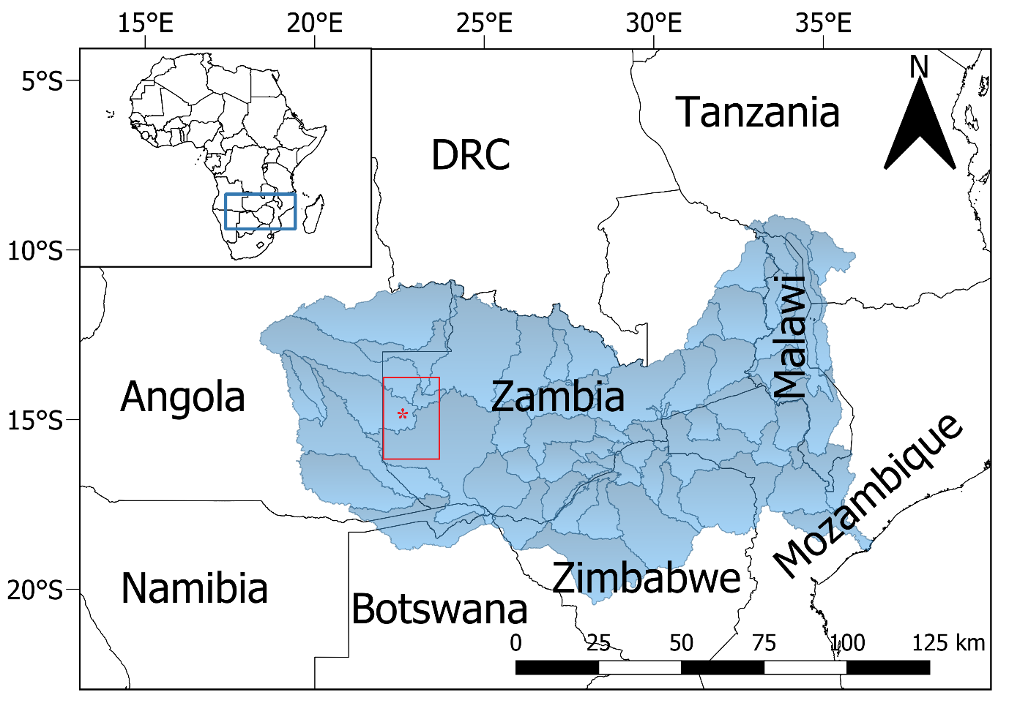
Figure 1- Geographical Location of the study sites

Majority of people in rural areas of the world are reliant on natural resources to construct and sustain their livelihoods (Scoones, 1998: Weston et al., 2015; Pelletier et al., 2016). The International Fund for Agricultural Development [IFAD] attests that those rural livelihoods consist primarily of small-holder family farms, fisheries, forestry and pastoral activities which are often highly sensitive to climate change (IFAD,2011). This over reliance on ecosystems and natural resources entails those rural livelihoods are vulnerable to climate related shocks and stressors (IFAD, 2011; Vermeulen et al., 2012; Thornton, 2012; Schilling et al., 2012). Even the slightest of changes in rainfall or temperature can result in huge disruptions to livelihoods (Connolly-Boutin and Smit, 2016; Somorin, 2010; Seidl et al., 2017). Rainfall is a critical factor to agricultural production; its onset, amount and cessation influences yields and other livelihoods options for rural people; the land’s productivity is realised when the rains feed their crops, fill the rivers with water and nourish pastures for their livestock (Dube and Phiri, 2010). One of the most physical impacts of climate change and enhanced climate variability will be the disruption to precipitation regimes across Africa (IPCC, 2001, 2007; Niang et al, 2014).
Temperatures having been on the upward trend and are predicated to get warmer in Sub-Saharan Africa, will further drive livelihoods to precarious thresholds (Zinke et al., 2004; Bunce et al., 2009; IPCC,2022). In the face of global economic and transboundary forces (multi-exposures/multi scalar), the livelihoods of people in rural places are at a critical point (Leichenko and O’Brien,2008; Kelman et al, 2015). However, people are agents of their own livelihood strategies and devise innovative ways of sustaining their livelihoods that are reffered to as ‘Adaptations from Below’ in this thesis.
In trying to understand how climate change is reshaping people’s lives in the three study areas (see chapter 5-Methods), I conceptualised the Livelihood Strategies Pathways (LSPs) as a way of developing a lense to examine how people negotiate and transition between livelihoods strategies. The LSPs is conceived from chronic Poverty (Hulme, 2003), Assets (Moser, 1998; 2006) and Livelihoods Strategies studies (Scoones, 1998; 2009). Employing an assets-based approach (Moser, 1998), I explored how individuals and households gather their assets to construct livelihoods and respond to climate change within the broader social structures of institutions, power, gender, ethnicity and social status (Scoones,2009: Dijk, 2011; Sakdapolrak, 2014;). While Moser’s assets model is based on an urban context, in this study i drew on the assets model conceptualisations, which I applied to a rural context.
Deploying the LSPs, I conceptualised how people transition between different livelihood strategies (refer to section 3.9.3). The LSPs conceptualises people’s adaptation process as transitions between five livelihood pathways influenced by processes of asset accumulation and depletion or erosion. Therefore, according to the LSPs, mediated by other social-economic, and cultural factors, individuals or households would transition between struggling; coping; resilience; adaptation and transformation. Theselivelihood outcomes are not necessarily an iterative process, but outcomes of asset accumulation or depletion in a dynamic interactive process with the external and internal environment.
Drawing from the livelihoods concept, I expanded and stretched the concept of livelihoods by integrating critical elements such as culture, religion and indigenous knowledge, teasing out intrinsic features integral to the understanding of how these variables shape people’s livelihood strategies. It is my argument that people’s livelihoods cannot be imagined as fitting into the narrow assumptions of the traditional livelihoods framework. Instead, I contest that people face dynamic situations through which they negotiate; however, some traditional livelihoods models negate to consider other critical factors that construct livelihoods. I used the cultural lens to explore how culture is central to livelihood strategies of people in the study areas and how this can inform external adaptation intervention approaches. Cultural ideologies translate into activities and institutions that characterise the political economy of climate change (Tanner et al., 2015) and adaptation is contingent on cultural values; that is what people value as important and how resources can be allocated.
1.1.0 Rationale of the Study
This thesis was motivated and justified on grounds that no study has been undertaken in the study areas that has explored rainfall and temperature characteristics and trends to a greater depth as done in this thesis. Secondly, climate change will have severe, unknown and unpredictable impacts on rural livelihoods and the most at risk are those communities reliant on natural resources such as those in the study areas. Therefore, the findings of this study will not only contribute to the understanding of climatic changes and trends in the study areas but crucially aid response approaches.
1.2.0 Research Context
This research was conducted in the Western Province of Zambia, also referred to as Barotseland (Chomba and Nkata, 2016). The Western province is dominated by the Barotse flood plain. The Barotse floodplain, also referred locally to as Bulozi Plain, is the second largest flood plain in Zambia (Chomba and Nkata, 2016; Cai et al., 2017). The floodplain shares a border with Angola (Cai et al,2017). The Barotse floodplain is a seasonal vast expanse of water, which covers 160 kilometres and at its widest point extends up to 60 kilometres (Flint and Monde,2006; Chomba and Nhkata,2016). The floodplain covers an estimated 550,000 hectares and 1.2 million hectares of wetland (Chomba and Nhkata,2016). The Barotse floodplain is inundated with water from the Zambezi River and its tributaries for about 3-5 months, from late December to end of May (Cai et al.,2017). Inundation of the plains is largely influenced by rainfall characteristics in the upper catchment and stream flows from the uplands (Baidu-Forson, 2014; Cai et al, 2017; Zimba et al.,2018).
The flood characteristics are influenced by upper streams flow from Angola and North-Western Zambia which records mean annual rainfall of above 1000mm (Cai et al., 2017; Zimba, 2017). The peak of the flood season is reached in March or April, which coincides with the annual Kuomboka ceremony (getting out of the water). The water begins to recede from May to July, after which the flood plain is almost clear of surface water (Cai et al.,2016; Chikozho and Mapedza, 2017). Estimates indicate that the main body of the flood plain is 5500km² and the maximum-flooded area is estimated at 10,750km² when other tributaries are considered (Zimba et al., 2018). The Zambezi River is a predominant feature of the lowlands, and its annual flood cycle governs the human and ecological activities of the area (Chomba and Nkata, 2016; Milupi et al., 2019). The higher grounds of the of the flood plain feature forested woodlands suitable for cattle grazing during transhumance period because the annual floods force people and animals to move (Banda et al., 2022).
According to historical meteorological data, the rainy or wet season on the Barotse runs from November until end of March. The annual average annual rainfall is between 600mm to 1400mm considering season variations. Rainfall over the Barotse floodplain is influenced by the annual movement of the Inter-Tropical Convergence Zone (ITCZ). There is considerable rainfall variability over the catchment areas of the flood plain with a very high inter-annual variability (Zimba et al., 2018).
According to local narratives and other anecdote evidence, the Western province has witnessed an increase in droughts in recent years. This narrative is fronted because the Kuomboka ceremony, a powerful symbol of ‘good rains’ did not take place in three consecutive years (2017, 2018 & 2019). A local legend suggests that the only other time the ceremony did not take place due to low water levels was in 1978,1979 and 2005. These local narratives appear to suggest that Western Province’s rapid transition from abundant precipitation to frequent droughts offers a compelling evidence of climate change.
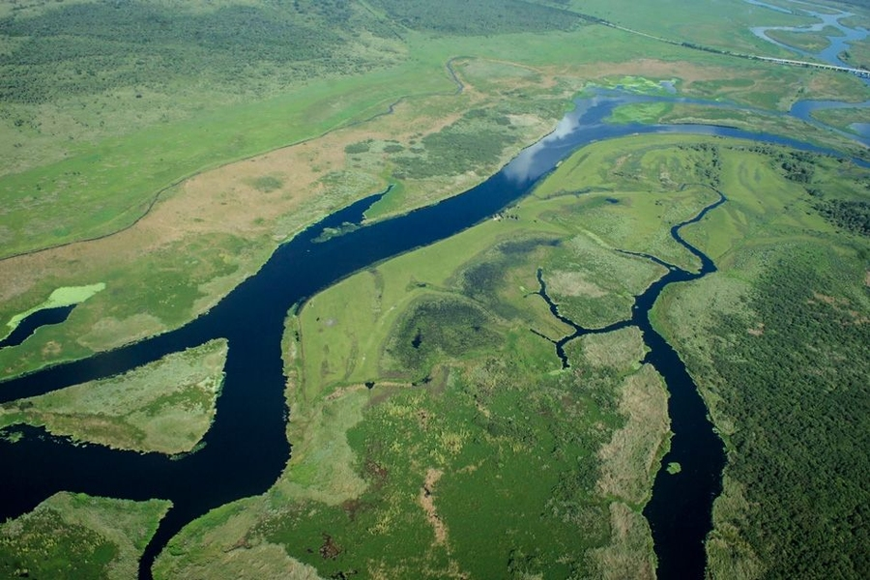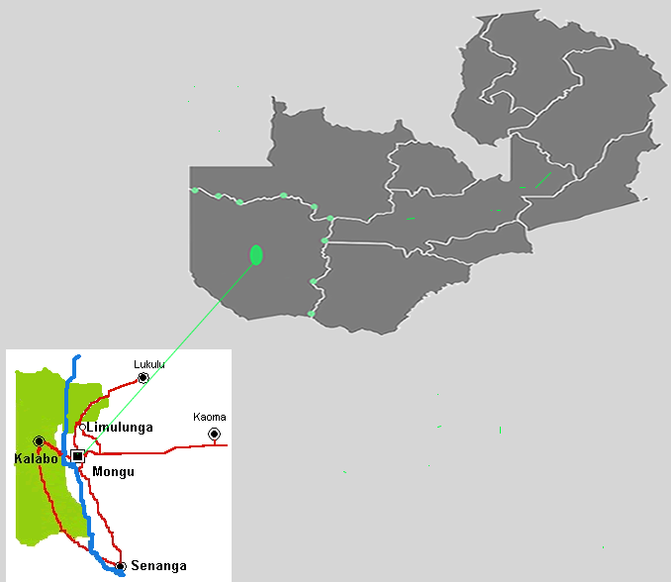
Figure 2- An over of the Barotse Floodplain and location of study sites
1.2.1 Livelihood Activities
The nature, ecosystems of the floodplain and the livelihoods of the people depend largely on the timing and duration of the flooding season (Flint and Monde, 2006; Timberlake, 1997; Milupi et al., 2019). As most of the waters recede, some of it is trapped in swamps, dambos and ox-bow lakes critical to the people and their livestock. According to Kwashimbisa and Puskur, (2014), the Barotse floodplain is one of the most agriculturally productive areas in Zambia. Livelihood activities on the Barotse floodplain are centere on a combination of mixed crop farming, livestock keeping, and exploitation of natural resources with artisanal fishing being the most dominant livelihood activity (Chomba and Nkhata, 2016). People on the flood plain also rely on the rich diversity in the ecosystem services of wetland plants, wild vegetables, and wild animals (Chikozho and Mapedza, 2017). Namafe(2004, P.51) attests that the flood waters of the flood plain determine the Lozi-speaking people’s celebrated annual cyclic socio-cultural characteristics of life, which define their agro-pastoral systems-the ceremony is bond to the core of Barotse culture. The Barotse flood is an area defined by floods; where people revere the flood plain and floods often viewed as disruptive element by many but here are celebrated not just for the socio-economic benefits that are associated with them but also equally as a symbol of cultural identity of the Lozi people.
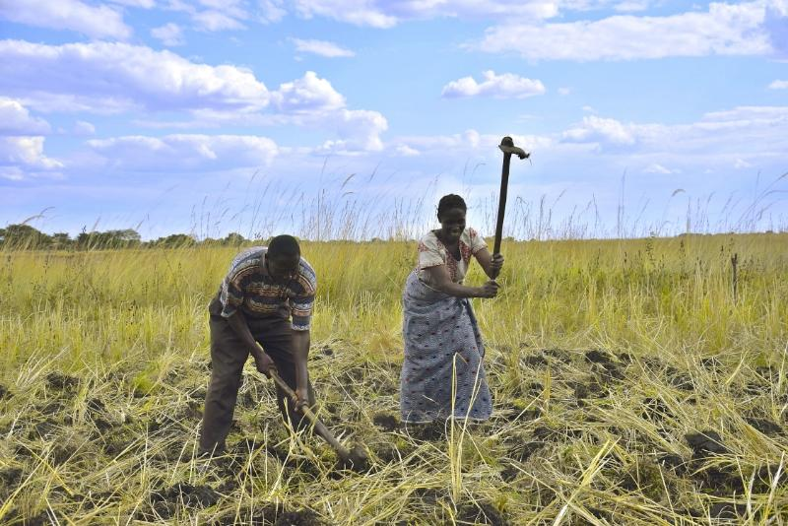
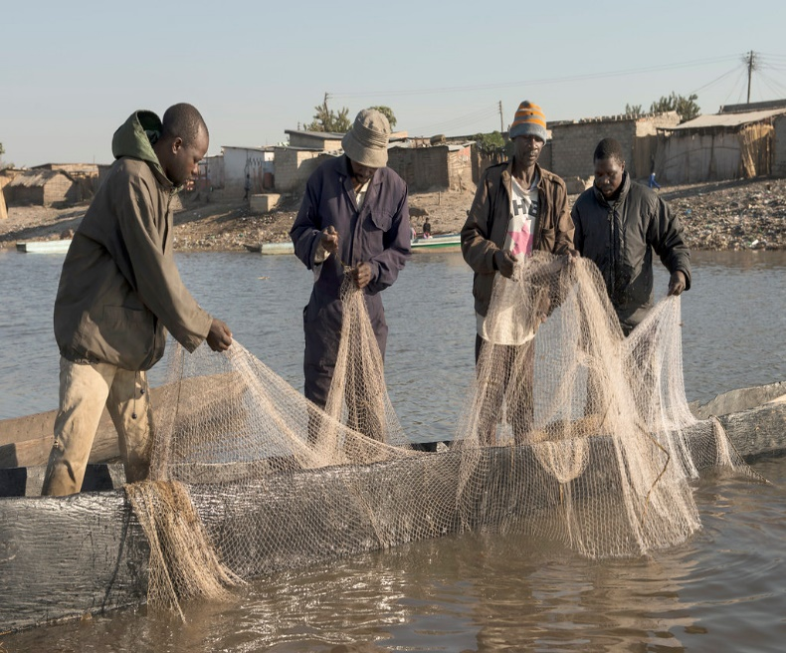

Figure 3-Main Livelihood Activities Source:(www.google.co.uk/search/images)-Subsistence farming and fishing are the main livelihood activities in the study areas.
The Barotse flood plain has about 3000 canals that network between villages and small towns (Cai et al.,2017, 2017). The canals are used mainly for the transportation of people and their goods. However, they are also utilised for irrigation, fishing and domestic use (Cai et al, 2017). While the main river, the Zambezi remains navigable throughout the year, some of the smaller canals are often clogged with plants and silt (Chikozo and Mapedza (2017). People on the flood plain practice transhumance between the flood and dry season which coincides with the period of inundation of the flood plain (Flint, 2006). Most people relocate to the higher ground from the flood plain when the plain is inundated during the rainy season where they cultivate crops and rear their livestock (Chikozho and Mapedza, 2017).
1.2.2 The Kuomboka Ceremony
Nothing perfectly identifies and describes the Lozi people culturally and as a tribal grouping than the Kuomboka (getting out of the water). The Kuomboka is an annual ceremony when the King and people transition from the flood plains to the uplands following inundation of the plains. During the peak of the flood season (April), the King and the people relocate from their summer homes to winter homes together with thousands of their livestock. This transition acts as a livelihood strategy and is the most important cultural fabric, which has been practiced over decades of years. As the flood waters recede from June onwards, the flood plain is transformed into rich green pastures for animals and a variety of wild vegetables for the people. In addition, as the water levels recede, fishermen can go back to their fish enterprises on the Zambezi River, which is now rich in a variety of fish species. In recent years (2017-2020), however, the ceremonial festivities of the Kuomboka have been cancelled primarily due to low water levels in the flood plain following multi-year droughts on record.
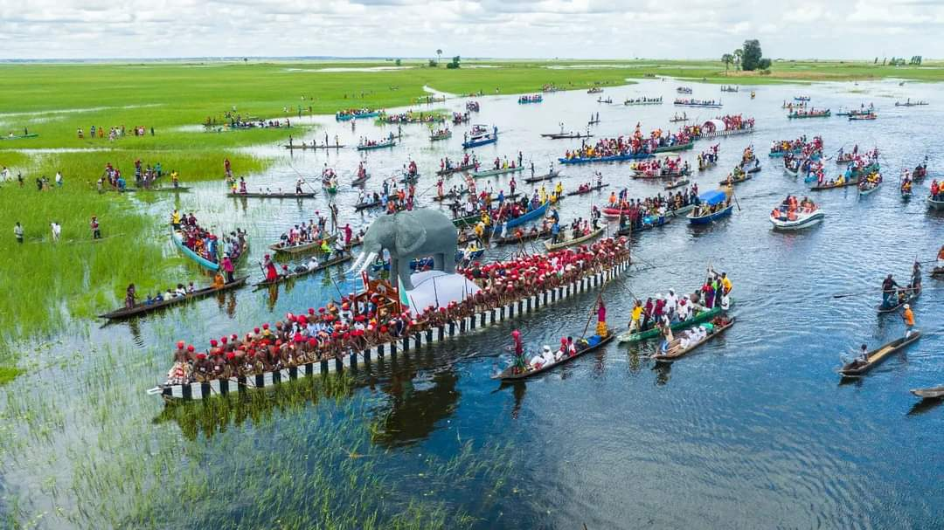
Figure 4-TheKuomboka Ceremony Photo courtesy google image(www.google.co.uk/search)
Figure 4 above, shows the Kings barge (the Nalikwanda) with an elephant on top escorted by smaller canoes in a procession from Lealui to Limulunga during the annual kuomboka ceremony.
1.2.3 Governance Systems: The Barotse Royal Establishment (BRE)
The Western province has 25 different tribes with the Lozi people being the most dominant grouping (Flint, 2006; 2008). Power, governance and administration of the Western Province is centred on the Lozi King, who is referred to as the Litunga (Mufalo, 2011; Sikayile,2015). Traditionally all the land in the Barotse floodplain belongs to the Litunga, who is the traditional leader of the Barotse Royal Establishment (BRE). Customs and traditional tenure determine land access and use. The Litunga is the supreme head of the customary land administration system in Western Province. The Litunga’s supreme status is embodied in his reference as “Minya-Mupu-Na Ngo’mbe”-translated as the owner of land and cattle. The Litunga is also the final authority in relation to all land related matters as encapsulated in the term “Fo Kutabile ngweshi” translated as “where the King had pierced no man can remove”. The BRE administers and presides over land rights (Kwashimbisa and Puskur (2014). Historically, there are two parallel governance systems in the Western Province-the Central Government and the BRE. The BRE represents the traditional systems of governance (Flint, 1986).
Any male family member in the patrilineal line of the first King is eligible for succession to the Kingship.The BRE’s hierarchy is highly centralised and complex for purposes of creating stability and cohesion for historical reasons. The BRE operates through traditional chiefs, who make the Kuta (parliament) which is presided by the Ngambela(Prime Minister). The Ngambela acts as the chief administrator of the BRE. The king can appoint any “commoner” to any office of the BRE. The BRE is a strong symbol of the Lozi people who are the dominant group (Flint, 2006; Mufalo, 2011; Kakanku, 2017).
The King is the supreme leader and is assisted by a team of silalo ndunas (chiefs) whose jurisdiction is governance at district level (Chomba and Nhkata; 2016; Neeta, 2016). The BRE hierarchy system has six levels of governance as shown in the figure 5 below (Mufalo,2011). The Litunga (owner of the land) heads the supreme body of the Barotse National Council. The next level known as the Kuta is the judicial system. The Ngambela is the prime minister, who is followed by the Indunas at a district level. At Sub-district, the BRE is represented by the Silalo Induna and village level matters are handled by Village Headmen (Flint,2003; Chomba and Nhkata,2016).
The functions of the Indunas are to administer land distribution, granting access to natural resources and resolve disputes (Flint, 2008). Rights and access to land are administered by the BRE and the Indunas have powers to restrict access to land at their discretion (Mufalo,2011).
All conflicts and land disputes are presided over by the “kuta”. The “Kuta” is also responsible to assessing and scrutinising all land applications. The “Kuta” is led by a senior chief who presides over matters of conflict and land disputes at provincial level (Western Province). The senior chief does not make unilateral decisions; he is always in consultation with Indunas. At District level, conflicts and disputes and handled by a “saa Kuta” which a Lozi traditional court. Membership of the “kuta” includes the Litunga who only attends when matters of conflict or dispute are of paramount importance (Mufalo,2011).
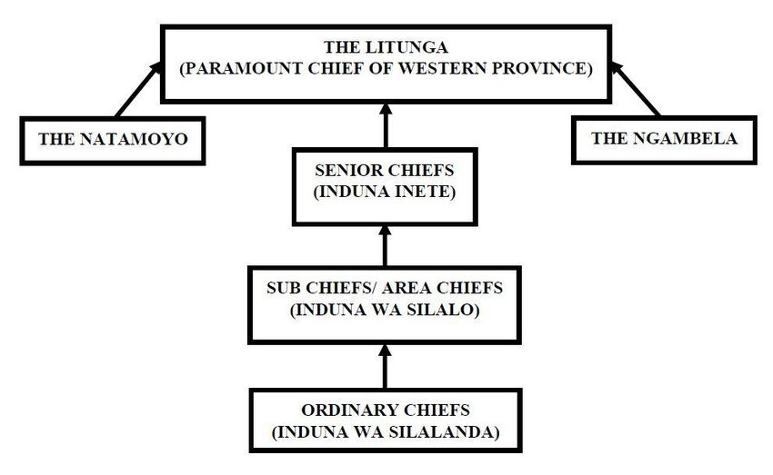
Figure 5- Structure of the BRE. Adapted from Mufalo(2011)

1.2.4 Forms of Traditional Land Ownership
As set out above, the Litunga “owns” all the land in Barotseland-controls 10 ,720Km² in Mongu District. Mongu City Council only holds 30Km² ⁽Mufalo, 2011). The table below shows the five forms of traditional landownership in Barotseland.
Table1: Forms of Traditional Land Ownership. Adopted from Mufalo(2011)
Landownership Form | Description
Mubu-Wa-Ngweshi | This land belongs to the Litunga and is passed on from one Litunga to other. This is the land that the Litunga allocates to people on request or application. This land can be allocated for settling, agriculture or other developments.
Mubu-Wa-Luu | This is land reserved and allocated to custodians of the customary land such as senior chiefs, sub-chiefs and other members of the royal family. Acquisition of this land is attached to the position one holds in the BRE
Mubu-Wa-Bana ba Malena | This is land held in trust by members of the royal family. It is passed on from generation to generation. In cases where there is no one eligible to inherit the land, this land reverts to the Litunga
Mubu-Wa Lusika | This land is ‘owned’ by subjects and is passed on through generations.
Mulalambuwa | This is land that does not belong to anyone, and no one inhabits it. Individuals who are interested in acquiring this land must follow procedures set out by the Silalo of Indunas (court of elders)

1.3.0 The Barotse Agreement
Following Independence of Northern Rhodesia from the British colonial governance in 1964, then Prime Minister of Northern Rhodesia Dr. Kenneth Kaunda, signed an agreement with Sir Mwanawina Lewanika III the then Litunga of the Lozi people. This agreement, which later became known as the Barotse Agreement of 1964 was in recognition of the Litunga of Barotseland as the principal local authority for the governance and administration of Barotseland. The agreement gave powers to the Litunga to make laws in Barotseland in relation to land, natural resources and taxation. The Litunga was accorded the recognition of the Government of the Republic of Zambia under the Customary Law of Barotseland (Bull, 2014).
The purpose of the Barotse agreement was twofold:
- Ensure that Northern Rhodesia proceeded to independence as one country with Barotseland as integral part of Zambia and that all its people were one nation
- To enter arrangements concerning the position of Barotseland as part of the Republic of Zambia to take the place of the treaties and other agreements hitherto subsisting between Her Majesty the Queen and the Litunga of Barotseland.
In 1969, the Barotse Agreement was cancelled by then President of Zambia Dr. Kenneth Kaunda, who even announced that from 1969, Barotseland would be called the Western Province of Zambia. This in effect and practical terms meant that the Barotse Agreement was abrogated and the semi-autonomous rights that were conferred to the Litunga were altogether cancelled. In 1969, The Government of Zambia introduced and passed a Constitutional Amendment Act No 36 of 1969 in parliament to cancel the agreement. The Act stated:
“The agreement shall on and after the commencement of the Constitution Amendment Act No 5 of 1969 cease to have effect, and all rights (whether vested or otherwise), liabilities and obligations there under shall thereafter lapse”. (Bull,2014; Theobald,2017)
To date, there is a sense of tension and uneasiness between the BRE and successive central governments in Zambia. Activists, traditionalists and sympathisers have been agitating for the restoration of the Barotse Agreement. Calls have been made for the recreation of an independent Barotseland and that the Zambia Government must honour the conditions of the Barotse Agreement or alternatively allow Barotseland to secede and become an independent state (Sikayile, 2014).
1.4.0 Agro-Ecological Zones of Zambia
Agro-ecological zones is an internationally accepted framework for land evaluation that enables rational land management options to be set out based on an inventory of land resources and evaluation of biophysical limitations and potentials (Fischer, Velthuizen and Nachtergaele,2000) .
Zambia has been divided into three main ago-ecological zones or regions. These are classed as region I, II (a&b) and III. This is classifications is based on annual rainfall amounts, soils and climatic features (Chabala and Kuntashula, 2013;Makondo et al.,2014).
Region I is characterised by semi-arid conditions and covers Southern areas of Central and Eastern provinces of Zambia. The average annual rainfall is between 400-800mm. Due to low to medium rainfall amounts the growing season lasts between 80 to 120 days. The soil types vary from acidic sandy, acidic loamy and clayey with loamy topsoil. These types of soils can limit crop production.

Region II covers parts of Western, areas of central, Eastern, Southern and Lusaka provinces. Mean annual rainfall is between 800-1000mm with a growing season of 120 days. This zone has some of the most fertile soils in Zambia with good crop yields.

Region III records the highest amounts of rainfall in Zambia with mean annual precipitation of above 1000mm. High rainfall amounts means the growing season ranges from 120 to 150 days. Region III covers the Copperbelt, Northern, Luapula and Northwestern provinces of Zambia. The soils in this zone are characterised by leached acidic soils.
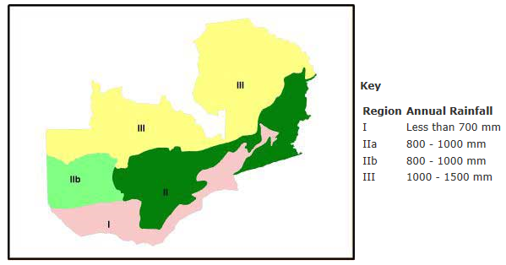
Figure 6- Agro-Ecological Zones of Zambia. Source FAO (2015)
1.4.1 Rainfall Characteristics in Zambia
Precipitation in Zambia follows the shifting position of the Intertropical Convergence Zone (ITCZ) and the El Nino Southern Oscillation (ENSO) (Hu et al, 2017; Wang et al.,2017). ENSO is often associated with strong year-to-year climatic variations in many parts of the world (Meehl et al., 1999;Wang et al.,2017). The ITCZ is positioned north in the dry season and moves southwards in the second half of the year and then repositions northwards in the first half of the year (Cai et al.,2015; Johnson,2017). The ENSO, which acts like a see-saw, influences sea surface temperatures in the Pacific Ocean in two distinct phases (EL Nino and La Nina) (Abdi et al.,2015:Setimela et al.,2018;Nobre et al.,2019) . The behaviour of the two phases can be explained circularly; Variations in sea surface temperatures are both the cause and consequence of wind changes.

Therefore, follows that during the La Nina phase; the intense winds keep warm waters along the equator in the far west, which maintains a zonal temperature gradient that adds to the intensity of the winds (Setimela et al.,2018;Anderson et al.,2022) . A minor disturbance in the form of a burst of westerly winds near the international date line generates currents that transport some of the warm water towards the east, hence lowering/decreasing the zonal temperature gradient (Brainard et al.,2018; Anderson et al.,2022). As a result, the trade winds weaken causing more warm water to flow eastwards, causing further weakening of the winds which culminates into an El Nino (Cheng et al.,2019; Guan and McPhaden,2019) .Therefore, the movement of the ITCZ with the seasons, and start of the rainy season over Mongu is when the ITCZ first encroaches in Zambia on its way south, and ends when it moves north of Zambia on its way north.
1.5.0 Research Aim and Objectives
1.5.1 Aim
The aim of this research was to explore the impact of climate change on livelihoods in the Barotse Flood Plain of Western Zambia. To achieve this objective, the thesis assessed shifts or changes in rainfall and temperature indices in three areas (Lealui, Nanikelako and Sefula). The general aim was to explore the evidence of changes trends in rainfall and temperatures and how these translated into people’s livelihoods.
1.5.2 Research Objectives
- Assess climate variability and change through meta data analysis of rainfall and temperature changes and trends.
- To Compare and contrast local observations against scientific analysis of rainfall and temperatures as set out above.
- To explore the plurality and diversity of rural livelihoods strategies that households/ individuals pursue in response to climate change and variability.
- To examine the types and asset bundles that individuals and households draw on to construct their livelihoods and adaptive measures pursued within and between individuals/ households and how these are shaped by climate change.

1.6.0 Thesis Structure
This thesis has 9 chapters. The sections above set out generic preliminaries of this thesis; that is the research background and rationale for undertaking this study. They also highlighted the research context including the aim and objectives of this study.
Chapter 2 provides literature on which critical analyses and discussions in this study are founded. The interdisciplinary nature of this thesis entails that the literature review is drawn from social and physical sciences. The literature review attempts to explore and link elements of global warming and climate change.The literatureure review highlights climate change detection and attribution. Climate is an the the theme of this thesis, it is analysed in chapter 5 from a local people’s view. Crucially, the literature review attempts to explore the bigger and existential challenge of climate change as linked to the adaptation strategies at different social scales. Chapter 2 also brings together scientific and indigenous knowledge and how these different lenses of inquiry can be integrated to broaden the scope of knowledge and practice of climate change adaptation.
Chapter 3 provides the theoretical and conceptual foundation of this thesis. Focussing on the concept of livelihoods and asset ownership, the theoretical framework explores how individuals and or households combine their assets to construct a livelihood in the face of external and internal shocks and stresses. Theoretical discussions interrogate the traditional livelihood models by bringing into perspective alternative models. I discussion Moser (2006)’s Assets Based Model and De Bruijn and Van Dijk(2005a)’ Livelihood Pathways model. The conceptual framework section introduces the Livelihood Strategies Pathways (LSPs) that I developed as part of the outcome of the thesis.
Chapter 4 focusses on Research Design and Methodology. It explores the research tools employed to meet the objectives of chapter 5, 6 , 7 and 8. It highlights the qualitative methods (semi-structures interview, key informant, participatory observations) and the quantitative methods applied in the analysis of rainfall and temperatures. Issues of ethics and positionality are tackled in chapter 4. Chapter 4 also looks at remote data collection (WhatsApp) used in view of Covid-19 pandemic, that had restricted face-face based research.
Over the next three empirical chapters (5, 6 & 7), I explored and discussed cross cutting issues at the core of the thesis. In the first empirical chapter (chapter 5), I interrogated and reflected on what I had found interesting about how people interpret and understand changing climatic regimes in their locales. Drawing on local narratives and traditional knowledge,I delved into and situated what people considered as forces of environmental change. Chapter 5 is titled indigenous and Cosmological Narratives of changing climatic Regimes. The first theme that emerged during the initial interviews I conducted was how people in the study areas attributed and explained changing climatic patterns to supernatural forces (gods) and superior beings (spirits/dead kings) that they claimed were able to “turn “the rains on or off and controlled other weather variables.
In cosmological narratives, I explored how people were able to vividly narrate what they believed are were the drivers of environmental change through religious and cultural lenses. For example, one of the interesting issues I explored in chapter 5 was how people held concrete and solid beliefs about the dead Kings buried in the flood plains. The belief was that the dead kings could determine ‘if ‘and ‘when’ rains would fall and if for instance people disrespected the traditional royal cenotaphs, the dead Kings can meet out punishment in the form of drought, floods, storms, pest infestations and including death of offending individuals/households or even to entire communities. took keen interest in trying to understand these narratives in turn situate or shape how local people perceive, interpret and respond to environment change in their localities.
In chapter 6, I introduce and analyse rainfall characteristics in the study areas-through exploring rainfall changes and trends over the study period. This chapter explores key rainfall indices of Onset, Cessation and Duration that influence the success or failure of the growing season (Makondo and Thompson, 2020). Within chapter 6, I bring together local narratives and scientific data extracting their common narratives on changing climatic indices to compare the findings. By bringing people’s narratives and their everyday experiences of changing climatic conditions and scientific data, it accords me anopportunity to corroborate or compare between what people observe or experience on everyday basis against scientific data. In my view, indigenous and scientific knowledge in specific reference to climate change articulate the same phenomena but deploy contrasting lenses of inquiry. In this thesis, I find that in the main, local narratives are consistent scientific models whose findings suggest trends towards increasing low precipitation and drying not just in the Western Province but also across many regions of Zambia.
Chapter 7 is continuation of scientific data analysis from chapter 6. It explores and analyses temperature patterns and trends in the study areas. It outlines the seasonal cycle of temperatures in the study areas. Chapter 7 also analyses trends on the monthly, annual and seasonal (winter and summer) temperatures. By linking chapter 5 and 6, it compares local observations against scientific observations to determine whether changes and trends are evident.
Chapter 8 introduces the main outcome of this study “Adaptations from Below”. I Employ ‘Adaptations from below’ as an outcome of the thesis in relation to how people have responded to the impact of shifting rainfall and temperatures in their areas. Adaptations from below conceptualise responses or strategies deployed by local people in the face of changing climatic changes. Therefore, chapter 8 focusses on the processes of adaptation at the micro (individual/household), messo (village level) and macro level in the three study areas.
Chapter 9, the conclusion of this thesis, is a summary and discussion of the key findings. It brings together empirical findings in chapter 5-local narratives; 6 and 7-rainfall and temperature analysis respectively and links these with chapter 8 the main outcome of this study. By extracting the key findings and merging them into a discussion it gives a story of climate change and adaptation both from a local and scientific perspective. Chapter 9 provokes a debate between indigenous or local knowledge and science; how these different lenses of inquiry can be integrated to broaden the scope of knowledge and practice in climate change adaptation.

Chapter 2: Literature Review
2.1.0 Introduction
Chapter 2 is an exploration of the literature that informed this study. It gives a general background to the emergence of climate change as a prominent and contested subject at the global level. It gives a general outlay of the physical characteristics of climate change and the attribution of climate change to the human activities. Climate changes manifests itself in several ways such as extreme temperature, shifts in precipitation patterns, melting snow peak or thawing of permafrost, and sea-level rises among many others (IPCC;2014;2022). Within this chapter, attention is paid to adaptation as a response to climate change. In the context of this study, climate change has had an impact on the livelihoods of the people in the areas in relation to food production and water availability for people and their livestock.
This chapter begins with a background exploration of the broad subject of climate change, its attribution to human activities (anthropogenic) and its impact on the environment. This is then followed by a discussion on the greenhouse effect and its role in maintaining Earth’s habitable conditions. The discussion then transitions to the exploration of climate change, its causes and impacts, and delves into issues of detection and attribution. It then examines the biophysical impacts of climate change. Subsequently, the chapter focuses on extreme temperatures and rainfall events in Africa as highlighted in the IPPC (2022) report. The next sections look at climate change adaptation as a multifaceted strategy that involves several elements. Vulnerability, adaptive capacity and transformation are the subject of discussion towards the closing sections of this chapter. The last two sections of chapter 2 focus on indigenous knowledge and narratives.
2.2.0 Background
Humans are influenced by climate and in turn human activities have been influencing the climate (IPCC; 2007; National Research Council; 2011). There is evidence that the earth is warming primarily from human induced activities through the burning of fossil fuels and other economic activities that release heat-trapping Greenhouses Gases (GHGs) in the earth’s atmosphere (Bryant et al.,1997; Cheng et al.,2016; Kirhmeier-Young et al.,2018; Trenberth,2018). “The changes in the physical climate system, most notably more intensive extreme events, have adversely affected natural and human systems around the world, contributing to a loss and degradation of ecosystems including tropical coral reefs; reduced water and food security; increased damage to infrastructure;additional mortality and morbidity; human migration and displacement; damaged livelihoods ;increased mental health issues; and increased inequality” (IPCC,2022, P.8: Chapter 1 WWGII). The burning of fossil fuels such as oil, natural gas and coal contribute the largest percentage to Carbon Dioxide (CO₂) emissions (Dong et al., 2017a; Pamarati et al.,2017b; Dong et al.,2018). Human economic activities have over the years increased the concentration of carbon dioxide, methane and nitrous oxide in the atmosphere making it harmful (Schlesinger,2007; Kirhmeier-Young et al.,2018; Kweku et al., 2018). Natural drivers of increased concentrations of greenhouses gases are permafrost, oceans forest fires, wetlands, earthquakes, volcanos among others (Yue and Gao,2018;Krissansen-Totton and Davies,2013).The greenhouse effect is a consequent of the temperature of the lower layers of the Earth increasing due to the heating and cumulative impact of greenhouses gases(GHGs) (Andrady et al.,2015; Anderson et al.,2016;Hertberg et al.,2017). According to Latake et al. (2015), the concentration of greenhouses in the atmosphere is determined by the summation of natural systems and human activities and the removal (sinks) from the atmosphere through complex chemical processes.
According to the IPCC 6th Assessment Report (2022), global warming reaching 1.5⁰C in the near-term would inevitably result in unavoidable increases in multiple climatic hazards and risks consequently presenting several adverse impacts on the eco and human systems. The IPCC (2022) reports that human induced temperature increases have been detected across Africa and many regions of Africa have warmed rapidly than the global average-this indicates an increase in the frequency of heatwaves. The IPCC (2022) reports that with increased greenhouse gas emissions, average temperatures across Africa are projected to increase and some of these temperatures will be unprecedented in the history of these regions. Populations in low latitude regions of Africa are projected to experience large increases in the frequency of daily temperature extremes (Harrington et al.,2016; Arias et al.,2021).
In many areas of South, East and North Africa, precipitation and temperature trends since the 1950s are attributable to human induced (anthropogenic) climate change. Research has also demonstrated that climate change impacts on human and natural systems are projected to have negative impacts across several sectors in Africa (Munday and Washington, 2019; IPCC, 2022).
The following sections are interrogations in the broad subject of climate change, its features, and impacts.
2.3.0 Climate Change
Neelin (2011), describes climate as the average condition of the atmosphere, ocean, land surfaces and the ecosystems of a region. Neelin (2011) forwards that the climate of a region includes the mean wind direction and strength, mean cloud cover, the temperature of the sea surface of the surrounding area and ocean currents that influence the sea surface temperature among other factors. On the contrary, weather is the state of the atmosphere and ocean at a defined period (Neelin,2011).
As the air temperature increases in the lower layers of the earth, it results into an irreversible phenomenon of climate change and global warming (Sinnot-Armstrong and Howarth; Bayer et al., 2015; Mikhaylov et al., 2020). Global warming narrowly refers to an increase in global temperatures (Chapman;2015; Schuldt,2016). Climate change, however, on the other hand refers to the broad scale changes in climatic patterns that are attributed in part to the greenhouse effect and global warming (Schuldt, 2016). Greenhouse’s gases are a key factor in accelerating climate change by altering the composition of the atmosphere (Ramanathan and Feng, 2008; Latake et al., 2015; Kweku et al., 2018; Qiao et al., 2019). Global warming and climate change are often used interchangeably in everyday use (Whitmarsh,2009; Chapman,2015).
The IPCC AR5 (IPCC, 2014, P.120) defines climate change as “a change in the state of the climate that can be identified (e.g., using statistical tests) by changes in the mean and/or the variability of its properties, and that persists for an extended period, typically decades or longer. It refers to any changes in climate over time, whether due to natural variability or as the result of human activity”.
According to the (IPCC,2014, P.119-Chapter1), “climate is the average weather or more rigorously, as the statistical description in terms of the mean and variability of relevant quantities over a period of time ranging from months to thousands of years or millions of years”. The NRC (2001) argues that climatic statistics maybe calculated in form of long-term measures such as daily minimum temperatures, frequency of floods or length of the growing season. The IPCC (2014) adds that the classical period for averaging these variables is 30 years a standard set by the World Meteorological Organisation. The variables considered are among many other include surface temperatures, precipitation and wind. The National Research Council (NRC, 2001) adds that the climate of a region includes humidity, cloudiness, soil moisture, thickness, and the concentration of the sea. The NRC (2001) asserts that to the extent that climate and climate change are often presented in global averages, large variations may exist at local and regional levels which may depart from the global averages. These variations may lower or amplify the impact of climate change across different parts of the world. The climate system is composed of the oceans, land, atmosphere and cryosphere with the atmosphere being the most fragile or /volatile. The oceans and atmosphere are fluidic in nature and interact in unique ways to produce variability patterns in weather (Rahmstorf and Coumou;2011; Trenberth,2018).
Climate change as opposed to climate variability, based on the foregoing, refers to significant and statistical variations in either the average state of the climate or variability that lasts for an extended time frame, typically decades or longer. Therefore, average climate indices of a region are in many instances used as a metric of overall change (Swain et al.,2020). Arising from the fact that the climate of a region is an aggregate of weather conditions over a period; it means that multi-decadal climate can be seen as a process of quantifying changes in the overall aggregate probability distributions from day-to day weather conditions (Swain et al.,2020).
2.4.0 Bio-Physical Impacts of Climate Change
The impacts of climate change will manifest in the areas of ecosystems, water sources, food security and safety, health, and human security (conflict) (Cramer et al.,2018).

Space left to fit table 2 below.

Table 2: Biophysical Impacts of climate change. Adapted Moser & Satterthwaite (2008)

Physical Signs | Impact on natural systems | Impact on human health
Increased frequency of warm spells and heat waves over most land areas | Decreased crop yields in warmer regions, increased risk of wildfires, and range for disease vectors | Increased risk of heat-related diseases and deaths, increase in vector-borne disease, increased respiratory diseases due to air pollution
Increased frequency of heavy rainfall events | Damage to crops, soil erosion, waterlogging, water quality, river level rises | Increase in floods and landslides disrupting livelihoods
Increased in intense tropical cyclones and storm activity | Damage to crops, forests, and coral reefs; interference with water supply | Damage to housing infrastructure, disruption to businesses, transport, and infrastructure; loss of income and assets; large scale displacements of people-erosion of social networks and assets
Increased droughts and dry spells | Land degradation, reduced crop yields, livestock deaths, wildﬁre risks, water stress | Water problems, migration into urban areas, hydro-energy deficits, food insecurity, spike in food prices, conflict
Increased cold snaps | Damage to crops | Illness or death due to exposure to extremely cold temperatures

“Human induced climate change has led to an increase in the frequency and increase of daily temperatures and contributed to a widespread intensification of precipitation extremes” (Stott, 2016, P.1). In the following sections, I examined extreme temperature and rainfall events associated with climate change purposely as it fits in with the empirical analysis of this study.
2.4.1 Extreme Temperature and Rainfall Events
According to the IPCC (2022-Chapters 1- WGs I&II), there is proven evidence that human -induced climate change has led to an increased frequency and intensity in some of the weather and climate extremes events since the pre-industrial era, especially in temperature extremes. This evidence of observable changes has been attributed to GHGs, aerosol emission and land-use activities. Observable extremes in precipitation, droughts, tropical storms, hot or /dry and fire events have intensified since AR5 (IPCC, 2014). The IPCC AR6 (2022) forwards that these extreme weather events would not likely occur without the influence of human activities. In 2021, soaring temperatures across Northwest USA described as the “heat dome” was described as an extreme event and more of such events will occur often in future(www.nationalgeographical.com). A village in British Columbia was “incinerated “and destroyed by wildfires due to extreme heat (www.nationalgeographic.com).
The IPCC AR6(2022, Chapters 1-WGs I & II) reports that human induced climate change is the main driver of the observed frequency and intensity in hot and cold extremes across the globe and at continental level. The frequency and intensity of hot events have increased, and cold extremes have decreased at global and continental scale. This trend will continue even if global warming is stabilised as 1.5⁰C. The AR6 adds that the number of hot days and hot nights and the frequency, and/or intensity of warm spells or heat waves have increased across the globe. The largest increase in the hottest days has been experienced in the mid-latitude and semi-arid regions at the rate of 1.5 to 2 times the rate of global warming.
According to IPCC (2022, WGI Section 22.2.1.1), the observed climatic trends across Africa indicate that near surface temperatures have increased by 0.5⁰C or more over a time of 50-100 years. Minimum temperatures have warmed at a high rate than maximum temperatures. Near surface air temperature anomalies have significantly been higher during the period 1955-2010 compared to the period 1979-1994. IPCC (2022) further adds that it is more likely that mean annual temperatures have also increased over the last century across many parts of Africa. The IPCC (2022) concludes that there is strong empirical evidence that there is a strong anthropogenic signal in relation to temperature increases in Africa during the 20th century.
The IPCC (2022, WGI Section 22.2.2.1), reports that most regions of Southern Africa (Botswana, Zimbabwe and Western South Africa) have experienced a downward trend in total mean summer rainfall and other indices of intra-seasonal characteristics seasonal rainfall such as onset, duration, rainfall intensity have changed. Southern Africa has also experienced a reduction in late austral precipitation during the second half of the 20th century. Rainfall over North Africa (Algeria, Tunisia) has experienced a strong reduction in the amount recorded in winter and early spring. These trends indicate a greater than 330 dry days per year over the period 1997-2008. However, other regions of North Africa (northern Algeria and Morocco) have experienced positive trends in precipitation in autumn.
The IPCC (2022, WGI Section 22.2.2.1) also indicates that over Eastern Africa, during the last three (3) decades rainfall has decreased in the months of March, May and June. This has been attributed to the rapid warming in the Indian Ocean, which drives an increase in convection and precipitation over the tropical Indian Ocean and drives an increased subsidence over many areas of East Africa and results in decreased rainfall from March to May or June. The report also indicates that East Africa has experienced a decline in monsoonal precipitation over a period of 60 years (1948-2009).
2.4.2 Future Projections
Global warming is projected to intensify the Earth’s hydrological cycle and increase the frequency and intensity of flood and drought risk (Arnell, 2004; IPCC, 2014; Asadieh and Krakauer, 2017; Grillakis;2019). The IPCC AR6 (2022) also forwards explains that the frequency and intensity of heavy precipitation events have likely increase since AR5. Heavy precipitation events will become more frequent and intense (Coumou and Rahstort, 2012; Pereira; 2019; Tabari,2020). AR6(2022) projects that the increase in the frequency of heavy precipitation events will accelerate with more global warming, likely to double and triple in frequency of 10- year and 50- year events (IPCC,2022). Tabari (2020), forwards that extreme precipitation events will intensify across many parts of the world due to the concentration of atmospheric water vapour exceeding the saturation concentration at the rate of 6-7% for each degree rise in global temperature. Heavy precipitation events will result into an increase in the frequency of pluvial and river floods as the capacity of natural and artificial drainage infrastructure is exceeded (IPCC, 2022). One of the significant precipitation events of 2019, was when Southern Africa was devastated by cyclone Ida such that it became the most powerful event recorded in Southern Africa (UNFCC, 2020). Over a thousand of people were reported dead and infrastructure costing millions of dollars was damaged (UNFCC,2020). In 2021, hundreds of homes were engulfed and swallowed in Germany and Belgium due to unprecedented amounts of rainfall that feel in a period of 24 hours (www.nationalgeographic.com).Droughts and dry events will increase in frequency and severity with increasing global warming (IPCC, 2022). Many regions of the world will be impacted by severe agricultural and ecological droughts even if the global rate of warming is stabilised in the range of 1.5⁰C to 2⁰C.
According to the IPCC (2022, P.13-Chapter 1), adaptation to climate change is critical as it plays a role in reducing climate related risks. The IPCC (2022, P.13-Chapter 1), indicates that adaptation fosters development, which can be dislocated by impacts and risks associated with climate change. The IPCC (2022), forwards that a multitude of climate related impacts have caused severe damage in many regions of the world and these impacts will significantly increase in the future. In view of the foregoing, the motivation for adapting to climate change is animated by the empirical reality of the current and projected impacts of climate change (Di Falco and Sharma, 2018; Tol, 2020). The following sections explore the concept of adaptation.
2.5.0 Climate Change Adaptation
Adaptation to climate change gained prominence as a global policy agenda with the Paris Agreement of 2015, which had a global goal on adaptation (P Agreement, 2015; Savaresi,2016). The goal was in response for calls to strengthen global governance of adaptation (Farmer; 2015; Vignola et al.2017).
“Adaptation to the unavoidable consequence of climate change has become a necessity globally (Klein et al.2014, P.1). According to Moser and Boykoff (2013) and Holdren (2008), adaptation to climate change has not been fully integrated in scientific literature as a necessity and complementary to the efforts targeted at mitigating its impacts. The physical occurrence of extreme climatic and weather events had accelerated the placing of adaptation to the front of the climate change agenda (IPCC,2012; Baker et al.,2012).Berrang-Ford et al.(2011) ,however, contest that climate change is not the sole driver of adaptation but one of the many contributing forces. Kelman (2015), stresses that climate change is one element of the many other risks with the potential to contribute to disasters particularly where vulnerability and exposure exists. Although adaptation to anthropogenic climate change may reflect an existential threat to humanity; it presents and opens new opportunities that would mitigate the adverse impacts of climate change (Smithers and Smit, 1997).
The term adaptation as applied in modern literature was first applied in natural sciences, specifically in evolutionary biology (Skelly et al., 2007; Hoberg and Brooks,2015). According to evolutionary biology, adaptation refers to the development of generic or behavioural characteristics, which enable organisms or species or systems to respond to environmental change in order to survive and reproduce (Winterhalder 1980, Kitano, 2002). Kitano (2002), states that individual species develop individual adaptive features to ensure survival. Drawing from plant physiology, Edwards et al. (2010) and Sage et al. (2012) demonstrated how long term-changes in the environment through millions of years have shaped plant physiology pathways that are visible today. Becklin et al. (2016), argue that it is these pathways shape the possible range of physiological tolerance for plant responses to emerging environmental threats. Smit and Wandel (2006), argue that adaptation was first applied in human systems by cultural ecologist and anthropologist Julian Steward, who described cultural adaptation as “as the adjustment of culture cores (regional societies) to the natural environment through subsistence activities. According to Smit and Wandel(2006, P.283), the application of adaptation to human dimensions of global environment change often refers to “a processprocesses, actions or outcomes in a system (household, community, group, sector , region , country) in order for the system to better cope/respond, manage or adapt to some changing condition, stress, hazard, risk or opportunity.”
There are many definitions of climate change adaptation are as many as the authors on adaptation literature (see table below). However, what is common among all the many definitions and approaches is that they refer to adaptation as changes or adjustments in a system in the face of a climatic stimuli. The differences in definitions also reference variations in scope, application and interpretation of the broad topic of adaptation (Smit et al.,2000; Schipper,2007). Smit et al. (2000) also argues that the differences in definitions also reflect the question: “adaptation to what?”. Smit et al. (2000), forward the answer to the question can refer to responses to change and variability or to climate or a response to negative effects including vulnerabilities. Responses are also taken to capture opportunities presented by change (Smit et al., 2000). Smit et al.(2000), attest that the different definitions also capture the question “who or what adapts?” . Smit et al.(2000) postulate that people, social and economic systems, ecological systems, activities, processes or structures of systems adapt. The nature of adaptation and its impact is shaped not only by the nature or social economic nature of the object (small /large, single sector or complex species) but also on the properties that characterise its adaptation propensity; that is adaptability, vulnerability, viability, sensitivity, susceptibility, resilience and flexibility.
As authorities on climate change research, the Intergovernmental Panel on Climate Change (IPCC), define climate change adaptation as “adjustment in natural or human systems in response to actual or expected climatic stimuli or their effects, which moderates harm or exploits beneficial opportunities” (IPCC, 2007b, P.118). Based on the IPCC (2007) definition, processes and actions of adaptation includes actions made in anticipation of climate change; actions that are based on deliberate policy measures influenced by current or future changes. These actions include intra and extra individual autonomous or unconscious responses reflecting those unplanned response strategies triggered by changes in natural systems and other global forces (Reser and Swim, 2011).

Space left to fit table 3

Table 3: Summary of adaptation definitions. Adapted from Schipper (2007)
Source | Definition
IPCC (2022, WGII) | The process of adjustment to actual or expected climate and its effects. In human systems, adaptation seeks to moderate or avoid harm or exploit beneficial opportunities. In some natural systems, human intervention may facilitate adjustment to expected climate and its effects
Moser et al(2010) | Adaptation involves changes in social-ecological systems in response to actual and expected impacts of climate change in the context of interacting non- climatic changes. Adaptation strategies and actions can range from short-term coping to longer-term, deeper transformations, aim to meet more than climate change goals alone, and may or may not succeed in moderating harm or exploiting beneficial opportunities.
Downing et al. (1997) | Adaptation is synonymous with “downstream coping”
Füssel & Klein (2002) | All changes in a system, compared to a reference case, that reduce the adverse effects of climate change.
Rennie & Singh (1996) | Adaptive strategies are ways in which local individuals, households and communities have changed their mix of productive activities, and modified their community rules and institutions in response to vulnerabilities, in order to meet their livelihood needs
Smit (1993 | Involves adjustments to enhance the viability of social and economic activities and to reduce their vulnerability to climate, including its current variability and extreme events as well as longer term climate change.

According to Smit et al. (2000), the many definitions and approaches to adaptation depict the ways in which type, or form of adaptation can be distinguished; put differently “how does adaptation occur?”. The following section examines the ways in which adaptation can occur both as a process and an outcome or condition.

2.5.1 Adaptation as processes and actions of knowledge acquisition and assimilation
According to Reser and Swim (2011) adaptation can also refer to those intra and extra individual processes and activities that involve the accommodating, assimilating and responding to various contexts and new life. The processes and activities of knowledge acquisition and assimilation might involve trial and error (Cleaver,2001; Angell;2011; Abu,2017), improvisation, hybridisation, contestation and negotiations of practices to create new kinds of adaptive arrangements (Cleaver, 2012; 2015; Abu and Reed, 2018). The processes and actions described above draw from the concept bricolage (Cleaver 2012; 2017). According to Cleaver and de Koning (2015, P.4),“ institutional bricolage is a process through which people, consciously and non-consciously, assemble or reshape institutional arrangements, drawing on from whatever materials and resources are available, regardless of their original purpose. Through this process, old arrangements are modified, and new ones are invented. Institutional components from different origins are consciously reused, reworked or refashioned to perform new functions. Adapted configurations of new rules, practices, norms and relationships are attributed meaning and authority. These refurbished arrangements are necessary responses to everyday challenges and are embedded in daily practice”.
According to Abu and Reed (2018) a key feature of the process of bricolage is the idea of making do-making do with whatever resources available at hand for new purposes. Cleaver (2012) argues that people make do by borrowing from already existing institutions, ways of thinking, established social norms and relationships to create new institutions to fit into new purposes. Wang (2021) argues that bricolage encompasses flexibility and crafting together of different livelihood options and in many ways resembles the concept of livelihood diversification (Ellis, 2000). Agency is a key ingredient of making do, the bricoleur creatively negotiates between different choices and makes decisions shaped by parameters of resource constraints. Linked to agency is improvisation, is another critical feature of bricolage is improvisation as postulated by Lévis-Strauss (1962 in Singer et al.,2016). Lévis-Strauss (1962), quoted in Singer et al. (2016), posits that the bricoleur is adept at performing a number of diverse tasks and always makes do with whatever is at hand. By gathering with whatever resources available, the bricoleur unleashes innovation through improvisation by turning anything into something (Abu and Reed, 2018). The bricoleur reuses resources for purposes different from those for which they were originally conceived (Cleaver, 2012). In trying to explain the process of making do within resource constraints Cleaver (2012), stresses that bricolage is a process of hybridisation-a blending of new and old resources/materials to make something different or integrating elements of the modern and customary by combing them in new forms to represent new meanings. Research has demonstrated how individuals and communities bring together old practices and established norms into new practices in forms that the new practice is neither completely new nor completely customary (Reser and Swim, 2011,Faggin and Behagel, 2018;Munro and Bartlett, 2019) . Cleaver and De Koning (2015), demonstrated how local people reshaped newly introduced institutions to respond to their needs through a process they described as “alteration”. “Alterations” is a process whereby some elements of newly introduced package of institutions are combined with existing ones to create a hybrid version that answers to people’s interests.
Arts et al. (2012) argued that the concepts of livelihood and bricolage can be applied to inform how people construct their livelihoods. Dressler et al. (2016), adopted the term “livelihood bricolage” to describe how people gather their assets and available options to construct their livelihood activities. Arts et al. (2012), described livelihood bricolage as “the flexible and dynamic crafting together of various livelihoods options and its associated impacts on the landscape.
According to Abu (2018), bricolage is often linked to locally developed responses and adaptive responses to change. Turner and Clifton (2009), argue that indigenous/local people must always accommodate and respond to changes in their environments. Turner and Spalding (2013b), state that indigenous/local people draw on their past by “going back to the past to draw on their previous practices to secure their livelihoods”. Leonard et al. ((2013), suggest that local people hold alternative knowledge about climate change and variability based on their locally developed knowledge and practices. Adger et al. (2013), stress that understanding the cultural values and norms of people will inform adaptation decision making and planning on adaptation.
Research shows that the construction and the sustenance of livelihoods is shaped not only by economic and political conditions by also cultural traditions of a community (Daskon, 2010; Clarke and Mayer,2016). Adaption, as a socio-cultural process, is the subject of the next section.
2.5.2 Adaptation as a Socio-Cultural Process
Society’s response to change is mediated by many factors (Casanova-Pérez et al., 2016). Culture plays a critical role in framing perceptions of climatic risk (Adger et al.,2013; Abu, 2018). Culture generally refers to a set of values, beliefs, norms, traditions, and ways of life shared by a group of people (Adger et al, 2013; Landauer et al., 2013). Noll et al. (2020. P.2), refer to culture as “the collective programming of the human mind that distinguishes the members of a group from another”. Therefore,it goes that culture is a system of collective held views; collectives views can play a key role in shaping individual actions. Daskon (2010) and Adger et al.(2013) assert that culture intersects with other characteristics of individuals and collective identities in complex ways to shape the development , uptake and effectiveness of adaptation activities. According to (Casanova-Pérez et al., 2016), there is gap in research that examines socio-cultural processes that shape perceptions of limits and opportunities for societal adaptation to climate change. This research gap prevents a holistic approach for the identification and understanding of socio-cultural processes that determine the process of adaptation (Daskon,2010;Antwi-Agyei,2015). Nielsen and Reenberg (2010), argue that understanding of cultural dimensions of climate adaptation informs how communities within the same locality or environment with similar experiences adopt different adaptation strategies. Nielsen and Reenberg (2010) stress that these differentiated adaptation strategies could be attributed to constructions of contextual cultural values and social relations embedded within those societies.
Culture is manifested in people’s livelihoods and social processes that are embedded in how the risk is perceived, understood, responses, and the decision making (Hall, 2008; Adger et al., 2013). Leonard et al. (2013), argue that adaptation strategies and decisions about institutional arrangements and the governance for adaptation is shaped by a set of values linked to worldviews. Xue et al. (2016), forward that people’s perceptions in relation to environmental risk varies as do their beliefs. Xue et al. (2016), drawing from Douglas and Wildavsky (1982)’s cultural theory, argue that people’s risk perception reflects or reinforces their preference on how society is organised. Xue et al. (2016), states that this preference is known as cultural worldviews.
Hedlund-de Witt (2013b, P.156), described worldviews as “inescapable, overarching systems of meaning and meaning-making that to a substantial extent inform how humans interpret, enact, and co-create reality”. Hedlund-de Witt (2015), argues that worldviews consist of elementary assumptions and perceptions in relation to the underlying nature of reality, ‘proper’ social relations or guidelines for living, or the existence or non-existence of important entities. Researchers have argued that worldviews shape or inform how people perceive environmental matters such as climate change, what are imagined as useful response strategies and defines what is thought to be individual responsibility (Hulme,2009; O’Brien et al.,2010).
Worldviews including religious beliefs inform what new knowledge can be legitimate and how it can be absorbed into resource management (Adger et al. 2011). Worldviews are embedded in socio-cultural process that determine what adaptation measures are deemed possible and what people perceive to be barriers to adaptation (Adger et al., 2009a;Landauer et al., 2013). Studies have demonstrated that cultural worldviews play a key role in environment risk perception and therefore of climate change adaptation (Hornsey et al.,2016). Sanganyando et al. (2017), posit that a cultural worldview is a lens through which individuals view, interpret and engage with the world around them. Sanganyando et al. (2018) attest that a cultural worldview is a product of the individual’s beliefs, values and background mediating by media consumption and education. Murphy et al. (2015), forward explain that culture is a vehicle through which a group of people transform/change everyday materials into significant symbols through which they draw meaning and value is placed. Armitage et al. (2008), assert that worldviews shape a society’s environmental relationship and constructs responses to environmental change.
2.5.3 Cultural Resilience
Embedded within cultural lenses of adaptation is the concept of Cultural Resilience (Crane,2010; Daskon,2010). Crane (2010, P.), defines cultural resilience as “the ability to maintain livelihoods that satisfy both material and moral (normative) needs in the face of major stresses and shocks; environmental, political, economic, or otherwise”. Crane (2010), argues that this definition of cultural resilience reflects the role of subjective normative experience, acknowledging that people’s lives mean something to them at the same time recognising changes in behaviours, values and social institutions that are deeply seated in cultural fabric of a people. Daskon (2010, P.15) refers to cultural resilience as “an active resistance to unforeseen changes through the protection of a people’s traditional practices.” Daskon (2010), further forwards that people demonstrated cultural resilience through long-standing socio-cultural practices systems that include traditional knowledge, experiences, skills, values, customs and motivations to survival. Daskon(2010, P.16) in his study in Bangladesh demonstrated how individuals and households rejected programmes promoted by the government in favour of local traditional practices. Villagers rejected new techniques after testing them declaring after that “better the things we know already than the new things than the new things we don’t know.” Daskon (2010), asserts that by collectively or consciously resisting change during vulnerable times, by deploying multiple livelihood strategies through experience and knowledge maintained through generations, people are able to sustain their livelihood and ultimately their well-being. Crane (2010), states that when cultural resilience is absent, crises/threats will be interpreted as a disruption; conversely the presence of cultural resilience enables people to transition through disruption smoothly.
From this study’s perspective, understanding culture and other lenses of cultural worldviews is critical due to the nature of the study areas. The study rural areas have very strong traditional values and beliefs that shape many aspects of livelihoods. Therefore, to understand and appreciate local people’s perceptions, interpretations and responses strategies to changes requires an immersion into these values, beliefs, and metaphysical views.
As discussed above, culture can be referred to as collective programming of a group of people that distinguishes them from another group (Noll et al., 2020). Using this lens, culture can be mirrored in place identity and attachment. Place identity and attachment broadly refer to the emotional, physical and social connections people develop with places that are constructed through an interactive process of meaning making (Scannell and Gifford,2010; Sherry et al.,2018).
2.5.4 Place Identity and Attachment
A novel way that culture has been applied in understanding of its role in climate change adaptation is place identity and attachment (Groulx et al, 2014). Adger (2003), referred to place identity and attachment as native culture and sense of identity ties that people have to the places they have lived for generations. As Cresswell (2003, P.11) observed, “place is not a thing in the world, place is also a way of seeing, knowing and understanding the world .“ Groulx et al. (2014, P.3) described place identity as “the use of physical environment to maintain a person’s self-concept through the promotion of self-efficacy, the exploration of the past memories, and the expression of preference and place attachment at the emotional bond between a person and a place.” Smith (2018) quoting Wright (1947), states that place is a location where human activity unfolds. According to Fresque-Baxter and Armitage (2012), place is an integral part of place identity; places are part of self-reference if they remain to be consistent with how individuals understand and define themselves (Twigger -Ross et al. 1996).
Place identity is a socially constructed product/outcome that is internalised and often reproduced through everyday experience of people and places (Steele, 1981; Stedman, 2002; Inalhan and Finch, 2004). Place identity situates knowledge and behaviour and is often shaped by socio-cultural processes (Watson et al., 2001). Meanings and values of a people shape their attitudes, behaviours and their interactions, which then define their worldview (O’Brien and Hochochka,2010). Meanings and values are a dynamic process that evolve with time as new experiences are assimilated into the existing cognitive structures (Nielsen and Reenberg, 2010). When places are threatened by real or perceived changes, the long-term continuity of a place maybe disrupted and therefore potentially affecting place identity (Watson et al., 2001). Consequently, people will engage in coping measures directed at mitigating the threats (Fresque-Baxter and Armitage,2012). The long-term impacts of the changes may result into changing perceptions of the place, its meanings and values, a sense of loss or experience of grief (Herrich, 2018). Groulx et al. (2014) posit that place identity and attachment can foster individual and collective sensitivities to local climate impacts; these sensitivities are strongly associated with the connections of individuals and groups in the social meaning that is embedded in the natural landscape.
Scannell and Gifford (2010), posit that place attachment can be conceptualised as a physical aspect through the provision of resources -the supplier of necessities of food, water, shelter and other resources key to survival. Place can also be deployed cognitively as knowledge and familiarity of how local resources can be extracted or utilised within the place to maintain livelihoods. Viewed from this lens,I posit that immersion into the dynamics of place identity and attachment develops into two-way interactive process. The environment acts as the source and provider of livelihood resources, whereas the individual creates conditions vital for the sustaining the environment. The cognitive expression of place for survival typically takes place at the individual level (Scannell and Gifford,2010).
Agnew (2005) conceptualises a place as a combination of three interpretative elements: the physical location, the everyday activities at the locale and the sense of place. These three elements can be incorporated into the concept of place attachment (Amundsen, 2015). Amundsen (2015) uses the concept of place attachment to describe how people or individuals relate to place through social networks, belonging to a community and its physical space. Research shows how people’s “subjective” aspects of value, culture and place are essential ingredients to the designing and implementation of adaptation to climate change (Adger, 2013; O’Brien, 2009). Paying attention to place identity and place attachment identifies ways places and people may experience their identity (Adger and Barnett, 2009). What is seen as positive adaptation to one community maybe be perceived to be maladaptive in another community (Adger and Barnett, 2009).
In reference to climate change adaptation, place identity and attachment are critical to understanding how individuals and entire communities respond to climatic threats and to policy interventions directed at responding to change. Fresque-Baxter and Armitage (2012), posit that research on place identity has demonstrated how it can contribute to the understanding of how individuals and communities perceive change. Fresque-Baxter and Armitage (2012), citing case studies, demonstrated how identities embedded in place attachment and identity played a role in climate risk perception, motivation and adaptation.
However, research shows that place identity and attachment can be an obstacle to effective adaptation to climatic threats. Barnett et al. (2021) in their study in Gippsland East (UK), demonstrated that when adaptation strategies are not calibrated with local people’s values, they may not be successful. Barnett et al. (2021), argue that a strong desire for continuity and damage to self-esteem may result in denial of the risks posed by climate change. Local people may project “false sense” of resilience (Barnett et al., 2021). This sense of “resilience” will portray local people as being in control, which inevitably masks the true nature of climatic threats which the communities face (Barnett et al., 2021).Tschakert et al. (2017), assert that people who value culture and identity, community cohesion, and a sense of place are more likely to perceive themselves as less at risk from climate change.
These cultural elements interrogated above are central to this study on many fronts. These cultural resources interact with the political- economy and ecological system in shaping how people in the study areas perceive, interpret, accept or reject change and ultimately shape every life. Adaptation from Below as a process and outcome of this study, is a theorisation of the capacity of individuals or households in the study areas to mobilise not just tangible but also intangible cultural resources in response to emerging threats. Through practices and values such as trust in local seed banks and post-harvest care; adaptations from below demonstrates that individuals or /households draw on their traditional-cultural resources in responding to change. The strong sense of place attachment and identity that local people hold of the Barotse flood plain must a starting point in trying to design any future interventions to climate change threats. Central to that is culture and tradition, which are very strong in the fabric of the Lozi people as symbolised in the Kuomboka ceremony and the pride Lozi people exude in the ‘nation’ of Barotseland.
Adaptation is often linked to concepts of vulnerability and adaptive capacity. The section below is a discussion on vulnerability and adaptive capacity.
2.6.0 Vulnerability and Adaptive Capacity
The concept of vulnerability in global environment change studies has been widely applied (Smit et al., 2000; Smit and Wandel, 2006; Adger, 2006; Dilling et al., 2015; Balica et al.,2015). According to Smit and Wandel(2006), the vulnerability of a system at a given scale reflects or is a combination of its exposure and sensitivity to external or internal stimuli (hazard ), and its ability or capacity or it resilience to cope or adapt or recover from the effects of the stimuli or disturbance. Sensitivity refers to the extent or degree to which a system is affected by a perturbation (Gallopin, 2006). A system or exposure maybe a household, population, a group of people, a settlement, a country an economic sector, an ecosystem. External and or internal stimuli invoke interactive environmental and socio-economic forces that disrupt the normal function of the system (Barreteau et al., 2020). Forces that shape exposure and sensitivity can often be interdependent and overlapping (Smit et al., 2000; Smit and Wandel, 2006).
Vulnerability can be conceptualised as a function of exposure (‘conditions of the natural and built environment that position a system to be affected by climate stressors’), sensitivity (‘the degree to which a system is affected ‘by climate stressors), and adaptive capacity (‘the ability of a system to modify its features and behaviours to better manage). Therefore, addressing vulnerability requires that at least one or all the elements are addressed (Jurgilevich et al.,2017; Thomas et al 2019). Vulnerability is a dynamic process of single or co-interactive forces, meaning that vulnerability changes over time and the risk factors associated with vulnerability can shift in unknown ways (McDowell, 2012). Vulnerability can shift over time in relation to shifting “risk landscape” in unpredictable ways such as changes in current and future stresses, and the cumulative effects of increased frequent extreme events (Dilling et al., 2015). Pelling (2011), argued that contemporary modes of definitions of adaptation are aimed at accommodatig change rather than contesting it. Pelling (2010), forwards that current systems and paradigms are taken at their face value and in some cases changed but not often questioned or challenged. Consequently, the spatial-temporal dynamic nature of vulnerability entails that adaptive strategies to counter climate change may be ineffective (Dilling et al,2015) .
2.6.1 Exposure and Sensitivity
Exposure and sensitivity are often co-interactive and linked (Smit et al., 2000) and can sometimes be difficult to pull-part. According to Adger(2003) , the exposure and sensitivity of a system to an external or internal stimuli is the likelihood of the system experiencing that specific condition and the occupance, and the likelihood characteristics of the system which shape its sensitivity to the exposure. Therefore, the occupance characteristics (e.g., Settlement-location and livelihood types, land and others) are a function of the broader social, economic, cultural, political and environmental conditions. These elements or features are sometimes referred to as “drivers, sources or determinants” of exposure and sensitivity. Adger(2003), posits that many forces that shape exposure and sensitivity are like those that influence adaptive capacity.
It is often argued that to reduce vulnerability, addressing the susceptibility of the poor in relation to extreme events and disasters will in the long run mitigate against climate change (Dilling et al., 2015). It is argued that climate change is disproportionately impactful on the existing poor people’s vulnerabilities that in turn worsens existing conditions of inequality and creates a chronic cycle of vulnerability. Therefore, it is argued that addressing existing vulnerabilities to disasters and other extreme events will prevent people falling into poverty traps shaped by exposure to extreme events (Dilling et al., 2015).
According to Adger et al. (2009a) and Barnett et al. 2015), even under the modest conditions of global warming, adaptation may not effectively deal with harm to social and ecological systems. According to Dow et al. (2013), climate change vulnerabilities research at the global scale suggests that “tipping points” and “key vulnerabilities “in biophysical systems if exceeded would pose severe threats to human life and ecosystems. Dow et al. (2013), assert that adaptation limits or thresholds have been identified particularly in ecological systems evidenced through species extinction. Dow et al. (2013), further stress that breaching adaptation thresholds will result in severe consequences that would require transformation to remedy or mitigate. There is an implicit assumption that there is a critical threshold at which the linear capacity to deliberately adapt to climate change diminishes (O’Brien, 2012; Pelling, 2010). O’Brien (2012) argues that questions arise as to whether humans have the capacity to adapt to complex non-linear and irreversible environmental shift.
This thesis took cognisance of the role of intersectionality because it is important in the identification and recognition of community subgroups particularly gender dynamics. Gender dynamics is critical to processes of adaptation; however, this was not the focus of this study.
Transformation has increasingly been promoted by researchers and practitioners as the solution to the unpredictable nature of environmental change and sustainability. The section below focusses on transformation as a supplementary and complementary response strategy in dealing with the complex and unpredictable nature of environmental change.
2.7.0 From Adaptation to Transformation
“Transformation as an adaptive response to climate change risk opens a range of novel policy options and positions as a component of development policy and practice” (Pelling et al., 2013.p.4). Pelling et al. (2013), describe transformation as responses that produce non-linear changes in systems or their host social and ecological environments. O’Brien (2012.P.4), defined transformation as “physical and or qualitative changes in form, structure or meaning making.” Sharma (2007), described transformation as a psychosocial process that involves the deployment of human potential to commit, care and create change for better life. The latter two definitions above take divergent approaches: O’Brien’s (2012), definition is biased towards technological innovation and social structural processes towards transformation. Sharma’s (2007) approach, on the other hand, integrates individual characteristics, beliefs, values, norms, identity and behaviours critical to the transformation process. The above mode of transformation recognises that transformation requires deep realigning/reorientation of a wide range of society’s values, beliefs, structures, institutions and technology. Sharma (2007) draws back to the ideas submitted above that examining a people’s deeply ingrained values, culture and worldviews is a necessity to developing adaptation strategies.
This thesis draws from Park et al. (2012.P.119)’s definition of transformation adaptation; “a process that fundamentally (but not necessarily irreversible) results in change in the biophysical, social or economic components of a system from one form, function or location (state) to another, thereby enhancing the capacity for desired values to be achieved given or real changes in the present of future environment.“ This definition differs significantly from the two above in its materiality and function as it pay attention to the biophysical, social and economic aspects of a system.
Pelling (2011), posits that transformation involves fundamental changes to the functioning of systems- for instance new social contracts, and new relationships of power in terms of gender, class or ethnicity that unleash alternative development choices and pathways. Pelling (2011), states that transformation opens new areas of policy measures beyond existing systemic barriers. It allows for deeply embedded risk and vulnerability causes to be reconfigured as part of the reengineering of the development trajectories towards sustainability and social justice (Pelling ,2011).
A few conceptual frameworks on transformation focus on climate change adaptation (O’Brien, 2012; Pelling, 2010; Park et al., 2011; Huang et al., 2012; Pelling et al., 2015). The following section focuses on the adaptation activity space as conceptualised by Pelling et al. (2015). The focus on the adaptation activity space is constructed on its applicability to many aspects of the livelihoods, socio-cultural and economic-political orientation of the study areas.
2.7.1 The Adaptation Activity Space
Pelling et al. (2015)’s model attempts to illustrate the importance of transformation to the reconfiguration of adaptation. It attempts to sketch out the origins and breadth of the transformative activities that capture the plurality of elements of co-evolving social-ecological systems. The framework helps to deconstruct the space in which transformation, including other adaptive actions, can be observed and the inter-relationships through which multiple non-linear transformations maybe possible or deployed (Pelling et al., 2015). Pelling et al. (2015), attest that their framework was inspired by David Harvey (2010)’s Methodology of Moments that was conceived by Mark in his Economic and Philosophical Manuscripts of 1844.
Reformulating Harvey (2010)’s activity spheres framework, Pelling et al. (2015) focus on the adaptation activity space by shifting from a political-economy approach to political-ecology epistemology. Political ecology expands political economy’s hegemonic power asymmetries that shape the distribution of risk and opportunities. It also examines nature and other environmental forces including mediating sites of power. The individual sphere interrogates the values and identity elements of social relations and links with nature. The activity spheres also mobilise other expressions of social relations including social capital and other social relations that identifies individuals with their communities through shared norms and values.
The discourse space examines Harvey’s mental imageries of worldviews conceived and reproduced that are situated beyond the individual, for example political and popular discourses. The behaviour activity space captures all activities of everyday interactions and routines, the unconscious acts that embody and recreate the naturalisation of the other co-evolving activity spheres. The institutions expand on Harvey’s work on formal arrangements by including informal cultural institutions and explore into the number of ways these interact as forces to constrain adaptation activities. Technology activity space was Harvey’s conception of material and organisational objects.

The Adaptation Activity Space
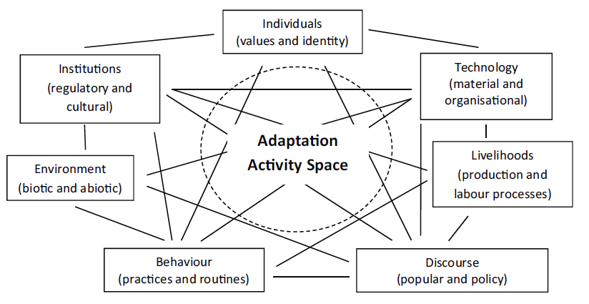
Figure 7-The Adaptation Activity Space –Adapted from Pelling et al. (2015).
The value of the adaptation activity space in this study lies in its recognition of the complex and fluid nature of elements and processes that mediate between in a social system. Embedded within societal layers are the individual, environment, behaviour (individual group), technology, institutions and livelihoods. The interactive nature of the activity spaces entails that, for example to transform the Barotse flood plain from a subsistence agriculture zone to a tourism zone will require the other activity spaces shift in sync. It means that individuals with deep seated cultural value and a strong sense of place identity will need to be persuaded in the proposed changes (re-socialised). The institutional (formal and informal) framework that governs the plains will need to be reorganised to fit in with the proposed changes and new technologies introduced. This transformation process will reshape the landscape (environment) and the livelihoods of the people in complex ways. However, the uncertain nature of the outcomes may result into what Juhola et al. (2016) referred to as maladaptation particularly if local people are not won over with new changes. Juhola et al. (2016) describes maladaptation as the unintended outcome/result on intentional adaptation that acerbates the vulnerability of the target or outside population.

2.7.2 Applying the Adaptation Activity Space to the Study Areas
The relevance and applicability of the concept of transformation is discussed in empirical findings on the proposed Barotse Cultural Landscape. While in the broad conceptualisation of transformation of the Barotse Flood Plain have good intentions, the biggest concern to local people and other stakeholders is that the intended transformative measures may disrupt and contract livelihood spaces for the indigenous people. Chung Tiam Fook (2017) argues that resource-based communities maybe reluctant to accept fundamental/radical changes to their landscape due to a strong sense of place and cultural identity. The prospect of large scale social and economic transformation, whose outcomes are unpredictable, can be seen as a threat to livelihoods and well-being (Chung Tiam Fook,2017). Attachment to place and cultural identity could coalesce as resistance and contestation of space; a means through which local people will seek redress and recognition through claims of belonging (Geschiere and Jackson, 2006). Geschiere and Jackson (2006) use the term “autochthony” translated as “origin of soil itself” a direct claim to a territory. Pelican (2009, P.1), suggests that “autochthony” manifests itself in narratives as “indigenous rights to self-determination, to lands, territories and natural resources, and to free, prior and informed consent. “These sentiments still play out in Barotse land; the question of the sensitive Barotse Agreement, the right to self-determination; the right to land and resource is always a source of contestation. If the Barotse cultural landscape transformation is to be realised, a careful negotiation of these sensitivities and thorny complexities will be required.
The foregoing unpredictable nature of outcomes adaptation/transformation cultivates perfect grounds for contestation. In the next section I examine climate change adaptation as a contestation of ideas.
2.7.3 Climate change Adaptation as a contestation of ideas
According to Eriksen et al. (2015), climate change adaptation is a contested social-political process that mediates how groups and individuals deal with a myriad of co-evolving environmental and social changes. Sovacool et al. (2015) argue that social and political contestations are closely linked in the process of climate change adaptation. Sovacool et al. (2015), states that regardless of the good intentions of the planners or how well the adaptive measures are designed, adaptation projects have always been characterised by underlying power distribution and contestations of ideas. Ford et al. (2011), argue that deeply entrenched institutions and other social forces may influence which actors will have powerful voices and naturally shape adaptation agendas. Biermann et al. (2005), illustrated how adaptation measures can be shaped to promote specific actors, from state agencies, donors, NGOs and private institutions. Sovacool et al. (2015), stress adaptation projects are always focal points of competing interests that often result in winners and losers. “Adaptation is part of the socio-political involving relations, contestations, negotiations and cooperation of at multiple scales, from the individual to that of international negotiations” (Eriksen et al., 2015, P.14).
Climate change adaptation is not a unitary decision or strategy but a social process in which social and political relations intersect to shape the dynamic processes of changes, some of which are driven by other socio-economic factors not necessarily by climate change. Pelling (2010) argues that climate change adaptation must be seen as an integral aspect of social change rather than just an adjustment to the biophysical processes of change that require technical measures to address. Eriksen et al. (2015) assert that framing climate change adaptation in this way recognises the role of inequality and social justice in shaping debate on adaptation and transformation. “There is a risk that present adaptation strategies may reinforce vulnerability, if not properly conceived and legitimately implemented (Kjéllén 2006, P.9). Adger (2006), suggested that vulnerability to environmental change is directly or indirectly human driven that reinforces the interests of the powerful actors and concentrates power in the hands of the powerful. Wise et al. (2014) demonstrated how adaptation options are considered an outcome of contested decisions in relation to resource allocation, investment options and social activities. Dominant actors with power and presence in public or private arenas can wield their influence to help sway the parameters of decision making to their advantage (Ribot, 2013). It is my argument that the conflict and contestations of ideologies and interests can be reconciled through knowledge co-production and collaborative partnership between stakeholders.
According to Klenk et al. (2017) research shows that crafting effective adaptation strategies requires co-production of knowledge that cuts across scientific, local communities and other stakeholders. Indigenous knowledge sometimes referred to as local knowledge manifests itself differently across time and place (Latulippe and Klenk et al., 2017). Adger et al. (2014), argue that knowledge systems and practices of indigenous people are projected as a key resource for climate change adaptation. The next section explores the role of indigenous knowledge in climate change adaptation.
2.8.0 Indigenous Knowledge
“Indigenous knowledge is generally employed to mean knowledge, innovations and practices of indigenous and local communities embodying traditional lifestyles; the wisdom that is developed over many generations of holistic traditional scientific utilisation of lands, natural and environment. This is generally passed down from generation to generation, for most part is undocumented (Egeru, 2012, P.1). Indigenous knowledge (IK) is sometimes referred to as local or traditional knowledge (Kelman et al., 2012). Indigenous knowledge includes Traditional Ecological Knowledge (TEK) of the local landscape, methods of coping with environmental change, knowledge on weather patterns and seasons, knowledge of conservation, cropping patterns and local seeds among others (Cameron, 2012).” It is a vast system of knowledge that includes local technical knowledge, traditional environmental knowledge and ‘science of the local people” (IIoka, 2016, P.12). IK and TEK focus on local knowledge and contextual forces/factors that bear upon the ability of communities to respond to change (Cameron, 2012). Drawing from their experience, experimentation, and tinkering(bricolage), local people have often adapt to local environmental change through the deployment of techniques and methods utilising knowledge passed on both by oral means and practice (McDonell, 2016; Makondo and Thomas, 2020; Chitata et al., 2021). According to Makondo and Thomas (2020), this process of knowledge creation and transmission enables local people to develop and maintain a wide tool of coping strategies. Fairhead et al. (2017), attest that local knowledge and practices can provide an important platform for dealing with future climate change challenges.
According to Petzold et al. (2020), although indigenous knowledge systems have been recognised as a major resource for climate change adaptation; they have not been applied consistently in adaptation activities and often have been neglected in research and policy (Egeru, 2012; Adger et al., 2014). Adger et al. (2014) advance that the greater the diversity of adaptation strategies the greater the chance of crafting effective adaptation strategies. The IPCC AR5 (2014) argued for a “two-eye” approach through the integration of many different forms of knowledge.
The “two-eyed” or pluralist way of knowing and understanding the world is important as it accords for both science and traditional or indigenous knowledge to examine, question and reflect on their own deep-seated frames of knowledge and enrich their worldviews learnt from others (Hatcher,2009; Martin,2012). Incorporating different worldviews into climate change adaptation strategies can foster community–level management of climate change effects by integrating scientific interventions into local practices (Stevenson et al., 2014; Hornsey,2021). “Two-eye” approaches to climate change adaptation recognise and integrate worldviews that are value-based and place-based (Adger, 2016). Adger’s(2016) placed-based approach recognises the role of institutions, structural and procedures and local people’s experiences that enable or limit people’s motivation to adapt to climate change. Value-placed approach by O’Brien and Wolf (2010) direct attention to people’s subjective experiences of climate change. O’Brien and Wolf (2010)’s approaches to adaptation planning bring into focus conceptual frameworks that integrate culture, contexts and science as key considerations in planning climate change adaptation (Lyons et al., 2019). The centrality of infusing/merging indigenous knowledge with science arises from the fact that local people’s identities are connected to their environments and their relationships to culture, traditions, rituals and ways of sharing knowledge and worldviews and in the indigenous observations of local environmental change (Berkes, 2009; Lyons et al., 2019). Local people’s cultural heritage and cosmology are important because they shape their worldviews and perceptions of climate change. The two-eye view of climate change ensures that local meanings and understanding of climate change remain relevant and situate climate change within local contexts that include people’s lives, their cultures and values (Abu et al.,2019; MacFarlane et al.,2022).
Naess (2013) argues that there is often an overlap between local observations of climate change (local knowledge) and meteorological observations. Citing research conducted in Clyde River in the Canadian Artic, Naess (2013) demonstrated how local narratives and scientific observations were neither wrong. Gearheard et al. (2010) account for divergences between local people and meteorological data in the methods the data is presented. Orlove et al.2002) in their research in the Andes demonstrated how local people’s visual observations of stars used to predict ‘El Niṅo’ can be scientifically validated.

2.9.0 Narratives
“Narratives, storytelling and communication are vital to how we live our lives. The world is constructed and reconstructed by stories, or narratives that social actors construct about it” (Bushell et al., P.3). Narratives are shaped by people, shape people and communities in which they live (Wood, 1991; Archetti, 2013). Archetti(2013) forward that narratives connect and give meaning to events and actions that would otherwise not have had any connections between them. Humans experience their world as a narrative and therefore, communicating through narratives can be powerful in shaping people’s views. Therefore, a collectively unifying narrative could give meaning to events, actions and understanding truths (Taleb,2008).
Elliot (2005) describes a narrative as a storyline-that is a set of events including their causal connections within a narrative. According to Moezzi et al. (2017), narratives are often used pretheoretically and imprecisely to refer to various kinds of language representations of some length.
According to Bushell et al. (2017), there is no agreed definition of a narrative. Bushell et al. (2017. P.3), posit that loosely used, a narrative can “explain a situation, define a problem that disrupts the order of the initial situation and then provide a resolution to that problem, which re-establishes order.” Krauss et al. (2020, p.7), advance that “narratives tell a story that make space meaningful and turn geological, architectural and meteorological features or events into makers of memory, of identity and belonging.” In relation to climate change narratives can be framed to explain why climate change is important and people must act to respond to its impacts (Bushell et al., 2017).
Somers (1994) advanced that narratives turn single events into episodes through the assembly of a series of historical events into a narrative plot(emplotment). Somers (1994) argues that emplotment gives prominence to interdependent events over time as opposed to through their chronological order. Bushell et al. (2017), stress that through emplotment people make sense of future events that can be “tested” against others’ narrative understanding of the present and past. Narratives have a temporal element, which makes them applicable in climate change communication (Bushell et al., 2017). Through narratives, individuals or communities can tell different stories about climate change and which in turn are subject to different interpretations by different actors. This differentiated interpretation can be a source of confusion or conflation because even minor differences in the storyline can change the meaning of events. However, narratives can provide a lens for shared meaning of events (ibid).
Reflecting on narratives in the study areas; similarities and variations in narratives in relation to rainfall indices such as onset, duration and withdraw; rainfall is not just perceived as a meteorological event, but of livelihoods, of agriculture; of floods; fishing, wild vegetables and medicinal herbs. Over generations and generations, seasons are reflected on and compared to each other in narratives such as “we had very good rains in 1973”; “last year the rains delayed, and our harvest was affected. “ Krauss et al. (2020) further posit that those local narratives give key insight into material-semiotic evolution of specific regions, their environmental histories, trends and variabilities.
Drawing from Moezzi et al. (2017), I conceive narratives as symbols projected in written and spoken language that shape how people conceive, communicate and comprehend their world. I argue so based on interviews with study participants. For instance, when interrogating study participants’ conception of the onset of the rainy season; in their view onset of the rainy season was perceived as a powerful symbol of start of the agricultural season and all the activities that surround it. Therefore, any actual or perceived late onset of rain season drives people into a state of weary. This state of weary was reflected in the use of phrases such as “it looks like we are going to die this year as happened last year; God has looked down on us this year”. Therefore, late onset of rainy season symbolised “imminent hunger” and invoked the need to reconcile with “God” for perceived wrongs done.
2.9.1 Linking key concepts with literature review.
At the core of this literature review is the centring of livelihoods at the core of the conceptual framework as demonstrated in figure 8. As indicated in the preceding chapters of this thesis, the focus of this study was to examine the impact of climate on livelihoods in the study areas. In formulating the linkages between the diverse literature interrogated in this chapter, I place the vulnerability context on the outer core of the conceptual framework with climate change being the core of the threats to rural livelihoods (IPCC, 2014; 2022). Rural livelihoods are highly sensitive to climate changes and variability because they are reliant on the extraction/exploration of natural resources and other eco-system services (Heltberg,2009). This conceptual framework conceives assets as a key ingredient in the construction of people’s livelihoods. From a rural perspective, the assets include labour; natural resources; land; social capital, finance and culture among others critical to their survival (see sections 3.9.0-3.9.1). Taken into perspective, for illustration purposes, out of the five traditional livelihoods assets only one (finance) is fluid, robust and flexible to be converted to other assets in times of stress or shock. The other four assets lack the plasticity or robustness of easy conversion and are highly vulnerable even to slightest changes in climatic indices. Livelihood assets shape how people respond/adapt to climate change and is a key element of the livelihood strategies pathways as discussed in section 3.10.1. Adaptation from below in chapter 8 zeros in on the role of assets in local adaptation to climatic changes.
Drawing from Marschὔtz et al. (2020, P.), the main themes of this literature review can be summed by in the following statement: “narratives link identities with place (culture) and can show how actors perceive their agency (motivations to adapt); narratives can connect factual events (climate change) in a place with their values and these values shape how people respond to perceived changes.”
Culture plays out throughout the discussions of this thesis. Culture shapes how people perceive, interpret and understand change (Adger, 2006; Daskon, 2010). It is interwoven in socio-economic forces to formulate narrative building and worldviews (Brondizio et al., 2016; Roncoli et al., 2016). Narrative and worldviews are reflected by people’s decision-making process and behaviour as they engage into livelihood activities (Singh et al., 2016). The literature review and the key concepts outlined in this chapter are integrated and are applied in the empirical chapters 5 and 8.

Linking Main theoretical concepts
External context
Internal context
External context
Internal context
Adaptation
Livelihoods
Assets
Culture
Well-being
Pathways
Norms
values
External Interventions
Adaptation from Below
Narrative building & Worldviews
Traditional wisdom & practices
Physical Assets
Land, farm-equipment
Livestock-cattle/pigs
Immaterial Assets

Figure 8-Conceptual linkage of key themes
2.10.0 Conclusion
This chapter has examined and explored the wider concept of climate change. It has discussed climate change manifestations, effects and impacts across different sectors. The chapter also interrogated the concepts of adaptation as a response strategy in the face of the unpredictable effects of climate change. Within the wide context of adaptation, the chapter delved into how adaptation can be a process of knowledge transfer and assimilation. Adaptation can also be influenced by people’s culture, which then shapes how people perceive and respond to environmental change. Adaptation is linked to two concepts of vulnerability and adaptive capacity and this chapter demonstrated how vulnerability and adaptive capacity can co-interact. As the future impacts of climate change remain unknown and unpredictable, scholars have argued that adaptation has limits and transformation has been promoted as the alternative. Climate change adaptation is more than just technical strategies, it includes the deployment of various forms of knowledge; indigenous/local knowledge is a key element of climate change adaptation. People’s perception of the world can be influenced on emotional and personal beliefs and to some extent by measurable/physical data. Narratives and storylines have become central to local observations and interpretations of climate change. This literature review is central in the discussions and analyses of this study to explore, question, contest and understand findings of the empirical chapters.

Chapter 3: Theoretical & Conceptual Framework
3.0.0 Livelihoods Concepts and Frameworks
3.1.0 Introduction
Chapter 3 takes an integrative approach; it brings together the theoretic and conceptual frameworks. The theoretical framework is focused on the concept of livelihoods and assets portfolio on which people from a rural perspective construct livelihoods. The conceptual framework born out of the empirical work of this study conceptualises how people combine assets to meet their daily needs and achieve well-being. The Livelihood Strategies Pathways brings assets, pathways, and well-being to model how people transition through different livelihood pathways mediated by broad social-political-economic and environmental processes.
This chapter begins with a broad scan of background literature on livelihoods in plurality and diversity. The next two sections that follow focus on elements that compose a livelihood system and introduces the concept of livelihoods. The chapter then transitions to explore origins of the Sustainable Livelihoods followed by an interrogation of the DFID Framework. In doing this, the section looks at types of assets and how they fit in the asset pentagon.The next section introduces the concept of livelihood pathways as conceptualised by De Haan and Zommers(2005). The theoretical framework section concludes with a discussion on Asset Based Approaches(ABAs). The original idea of the livelihoods was criticised on many fronts and ABAs were fronted as alternatives.
Section 4.0 begins with an introduction of the conceptual framework. It then briefly explores concepts of basic needs and poverty key concepts in this study. This section then discusses well-being and links this to the LSPs. The last two sections focus on interactions between assets and livelihoods strategies pathways. The section is then contextualised on climate change and asset dynamics in the study areas.
3.2.0 Background Literature
The livelihoods broadly refer to the multiplicity and diversity in the ways that people construct and sustain a living over time through the utilisation of a mix of economic, social, cultural and environmental resources (Pain and Lautze, 2002; Scoones, 1998). Solesbury (2003), traces the prominence of livelihood studies to an intersection of scientific scholarship and development policy. However, Sakdapolrak (2014) contests that livelihoods research, as understood in modern times, came to prominence in the 1980s through Ian Scoones’ (2009) works that described livelihoods research as “an integrative, locally embedded, cross sectoral and informed by deep field engagement and a commitment to action”.
De Haan and Zoomers (2005) quoting Long (1997), describe a livelihood as the idea of individuals or groups striving to make a living, attempting to meet their various consumption and economic necessities, coping with uncertainties, responding to new opportunities and choosing between different value positions .
Chambers (1989, P.7), defined a livelihood as “adequate stocks of food and cash to meet basic needs.” Chambers stresses that these flows of food and cash/incomes are a result of the process of livelihood generation. Niehof and Price (2001), argue that a livelihood generation refers to a bundle of activities that people engage into to provide for their daily basic needs. Niehof and Price (2001), posit that a livelihood generation consists of activities, resources and assets required to undertake these activities. Niehof and Price (2001), further stress that a livelihood generation is a multifaceted and dynamic process. Assets and resources are critical ingredients to a livelihood system. The figure below conceptualises some of the elements that compose a livelihoods system.
The figure below conceptualises elements that compose a livelihood system. It is based on the readings above and the author’s own imagination of a livelihood system.

Resources
Assets
Tangible/Physical Assets
Intangible Assets
Livelihood strategy

Land, livestock, and housing. Public-goods –roads, bridges, electricity
Material-crafts, historical sites etc. Non-material-Social networks, rules, norms, cultural practices

Figure 9- Elements of in a Livelihood System. Adapted from Moser (1998)
The diagram above is a simple illustration of the elements linking the bundles of assets and resources that characterise a livelihood system. A combination of assets and resources determines livelihood outcomes and well-being. At the centre of the diagram is the livelihood strategy –a multifaceted and complex process of activities that shape how households deploy their assets and resources.
The earlier definitions of a livelihood, as demonstrated above, have been criticised because they fail to make distinctions between the multifaceted nature of processes, activities, assets or resources, and outcomes that characterise a livelihood.
Scoones (1998, P.5), modified the definition of a livelihood as “a livelihood comprises the capabilities, assets (material and social resources and activities required as means of living. A livelihood is sustainable when it can cope with and recover from stresses and shocks and maintain or enhance its capabilities and assets while not undermining the natural resources base”.
Ellis (2000, P.10), added more grit to the definition of a livelihood, which he defined as “a livelihood comprises the assets (natural, physical, financial, human and social capita, these activities and the access to these (mediated by institutions and social relations that together determine the living gained by the individual or household.”
The integration of these definitions into the concept of livelihoods recognises that a livelihood is a complex and multifaceted concept (Niehof, 2004).
3.3.0 Conceptualising Livelihoods
The concept of livelihoods was framed on the recognition and understanding of the plurality and diversity of activities that shape poor people’s livelihoods to ensure survival and improve their well-being (Gordon et al., 2000). The epistemological and practical strength of the livelihood approach lies in the focus on diversity within complex local realities, their attempt to apply a holistic and people centred view of specific combinations of livelihood activities, and their commitment to action and ‘development thinking” (Mὕller-Mahn et al., 2010). The livelihood approach is anchored on two concepts of “household” and “strategy” (Rakodi and Lloyds-Jones, eds., 2002, P.30). Rakodi and Lloyd-Jones (eds.2002, P.30) define household as “a person or co-resident group of people who contribute to and or/ benefit from a joint economy in either cash or domestic labour”. Niehof (2001), asserts that the concept of livelihood can only be concretised and applied when it is linked to an individual or household. Niehof (2001), posits that a household is a basic unit of social organisation, and it is the household that acts as an arena of everyday life for many people in the world. Niehof (2001), argues that it is within the context of a household that activities intended to meet people’s basic need are undertaken. Based on the foregoing, Niehof (2001) suggests that a livelihood is generated from an arena of a household.
According to Fischer and Chhatre (2015), rural livelihoods approaches conceptualise a dynamic relationship between assets and activities, as they interact with each other to form the basis on which individuals or households draw resources essential for their survival. The plurality and diversity of activities that constitute a livelihood strategy are realised by combining assets and capabilities that individuals or households have access to or control (Fischer and Chhatre (2015). Rakodi and Lloyds-Jones (2002), posit that a livelihood strategy encompasses all those activities that households engage in as they mobilise their resources and opportunities, which they combine to earn a living. These activities include on-farm and off-farm livelihood strategies; engagement in labour market activities, utilisation of savings, asset accumulation through investments, and borrowing from social networks among other activities (Grown and Sebstad, 1989). Individuals and households recreate or negotiate their livelihoods considering their circumstances and according to contextual factors prevailing in their localities (Ellis, 2000). The relationship between assets and productive assets is mediated several factors at various scales of society (Fischer and Chhatre, 2015). Livelihoods are constructed within specific institutions and social arrangements of markets, laws, rules, gender, culture, and power that limit choices (De Haan and Zoomer, 2005. Prowse, 2010; Adger et al., 2014, Sakdapolrak, 2014).
According to Shen et al. (2008), there were contestations in the notion of rural development in developing countries. Shen et al. (2008), argue that questions were posed about the success of ‘small-scale enterprises. The contention was that while it was acknowledged that small-scale farm agricultural activities had improved agricultural productivity, this did not shift or transform poverty levels, social inequality. Furthermore, asymmetricity in income distribution was on the increase. There were calls for new approaches to the analysis of livelihoods (World Bank, 1990). The concept of sustainable livelihoods emerged out of this new thinking in the late 1980s (Shen et al., 2008).
3.4.0 Origins of the Concept of Sustainable Livelihoods
Chambers and Conway (1992) have been credited with coining the term ‘sustainable livelihoods’ in their seminal work entitled Sustainable Rural Livelihoods: Practical Concepts for the 21st Century. Conway and Chambers (1992), argued that the concept of livelihood was based on the ideas of capability, equity, and sustainability. All of which they claimed were end and means. Conway and Chambers’ work was influenced by Sen’s work on capabilities (1985). Chambers and Conway (1992, P.7), described the concept of sustainable livelihoods as:
“a livelihood comprises the capabilities, assets (stores, resources, claims and access) and activities required for a means of living; livelihood is sustainable which can cope with and recover from stress and shocks, maintain or enhance its capabilities and assets, and provide sustainable livelihood opportunities for the next generation; which contributes net benefits to other livelihoods at the local and global levels and in the short and long term”.
According to Levine (2014), there is a core of sustainable livelihoods body of thinking that is widely recognised and accepted by researchers and practitioners (Levine, 2014; Scoones, 2015; Serrat, 2017). It is from this thinking that various sustainable livelihoods frameworks were conceptualised and developed (Scoones, 2015; Serrat, 2017). The following section examines the concept of sustainable livelihood framework and pays focus on the DFID framework, which is widely held as most conceptualised sophisticated and applied framework” (Pain and Lautz,2002; Solesbury,2003; Scoones,1998;2015).
3.5.0 The Sustainable Livelihoods Framework
The Sustainable Livelihoods Approach (SLA) gained traction in the 1990s when research demonstrated that there is complexity and multiplicity in the ways people construct their living (Moser, 1998; Patnan and Prasad (2014). Moser (2000), argues that there were concerted calls during the 1990s that development agendas should be people centred and an on-going process. The SLA enhances understanding of how the livelihoods of poor people are constructed (Scoones, 1998; DFID, 1998; Serrat, 2017). The SLA recognises assets or capital an individual or household needs to sustain a livelihood (Scoones, 1998). It assumes that every household needs a bundle of assets to craft a living (Scoones, 1998; DFID, 1998). Moser (1998), adds that the SLA aims to give an insight of people’s assets or endowments and how these can be transformed into positive livelihood strategies or livelihood outcomes. Moser (1998), attests that there is no single asset bundle that can exclusively sustain positive livelihood outcomes sufficient to yield diversity and multiplicity in livelihood outcomes as defined in the DFID framework of 2000.
The Sustainable Livelihoods Framework (SLF) is not a theoretical approach because it explains complex subjects such as poverty, inequality, vulnerabilities, constraining structures and well-being (Wiggins,2002). It is a broad normative framework that had been widely applied in poverty reduction and development studies (Wiggins, 2002). Consequently, it needs to be immersed into other theories and concepts to explain such phenomena (Wiggins, 2002). However, it has been applied as a tool to analyse people’s well-being, poverty, inequality and other factors that constrain people’s livelihood (Scoones, 1998; Solesbury, 2003; Serrat, 2017). However, De Haan (2012) contests that Polanyi (1977) attempted to bring theoretical grit to livelihoods by arguing that the economy is socially, culturally, and historically embedded rather than the individual maximisation behaviour. Polanyi (1977), argued that people need a material base to meet their needs and wants.
There have been several livelihoods frameworks that were developed based on the concept of the sustainable livelihoods approach (Levine, 2014). The DFID (2000)’s sustainable livelihoods framework remains the most common and conceptually strong, in modern times, and still enjoys worldwide application (Pain and Lautz, 2002; Levine, 2014). The DFID SLF as depicted below, conceptualises that the basic components of livelihoods can be broken into livelihood resources that people have, the livelihood strategies that people pursue, and the livelihood outcomes that they can achieve (Pain, 2002).

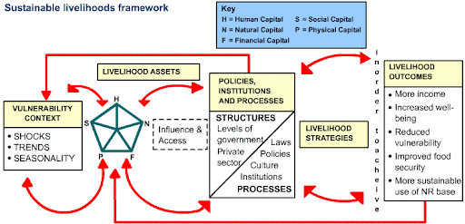

Figure 10- The DFID Sustainable Livelihoods Framework.DFID (2000)
3.6.0 Livelihoods Dynamics
Livelihoods and assets are always in a mutually dynamic and influential process (Lloyd-Jones and Rakodi, 2002; Levine, 2014). Stresses and shocks may affect how asset bundles can produce new environments to which livelihoods must respond or adjust (Scoones, 2009). Vulnerability analysis has been an integral component of the livelihood approaches. McDowell and Hess (2012), posit that small-scale farmers in rural areas confront a wide variety of social and environmental stressors that force changes in livelihood strategies to prevent livelihood collapse, while at the same time taking advantage of new opportunities brought by these changes.
DFID’s SLFs starts with the analysis of the vulnerability context. The argument here is that to explore livelihoods the initial starting point is to interrogate the context that shapes them (Levine, 2014).
“Vulnerability is taken to refer to “the propensity of exposed elements such as physical or capital assets, as well as human beings and their livelihoods, to experience harm and suffer damage or loss when impacted by a single of compound hazard or events” (Birkmann et al., 2013, P.3). According to Rakodi and Lloyds-Jones (eds., 2002), vulnerability is characterised by a combination of exposure, sensitivity and adaptive capacity of a system (Bohle, 2007; Wisner et al., 2004). According to Birkmann (2011), vulnerability is composed of conditions and processes that shape exposure and susceptibility of a system and includes capacities to positively respond to those conditions and processes. Birkmann (2011) adds that vulnerability is not only situated in threats posed by environmental change but in the political, economic and social processes that shape governance. Leichenko and Silva (2014) posit that vulnerability has two critical elements of ‘exposure’ and ‘social’-the ‘exposure’ element reflects an area which is subject to climatic hazards and the ‘social’ element consists of individual, community, cultural, economic, political factors that may exacerbate susceptibility to harm and constrain the capacity to mitigate climatic shocks. McDowell and Hess (2012), argue that while physical events act as an external stressor, the consequent risk that the hazard presents is a factor that is socially differentiated and reproduced by processes, events, and other systems internal to society. Research attributes some of the social factors to education, health, infrastructure, culture and poverty (Adger et al., 2004; Vincent, 2004; Hinkel, 2011). All these factors intersect in complex and multiple ways to shape access, and control assets (Blaikie et al, 1994).
3.8.0 Trends, Shocks and Seasonality
According to the DFID framework, vulnerability is characterised by conditions of trends, seasonality, and shocks. The vulnerability context, it is argued, with reference to climate change includes extreme climatic events such as floods, storms, wildfires, pests and droughts (climatic shocks and stresses) all of which erode and degrade the livelihoods of individuals and communities.The researcher adds that trends also include shifts in rainfall and temperature indices of a region. This study explored shifts in rainfall indices of the onset of the rains; rainy season duration; rainfall intensity and rainy season withdraw over a 40-year period (see Climatic Chapter). As these shifts become “the new normal” and become normalised within the communities, it is plausible to argue that rather than being seen as seasonal variabilities, these shifts can be described as trends. For instance, rainfall data examined in this study shows a steady shift of the onset of the rainy season from November to December throughout the entire study period (1980-2019).I argue that this steady and consistent shift over a 40-year period can be described as a trend rather than a seasonal variability.
For example, non-climatic shocks or stresses include sudden spikes in the price of food prices or farming inputs that reduces the buying of a currency. Additionally, some assets are very volatile and susceptible to economic fluctuations; while others such as land and buildings might remain stable for a long time. Trends include population growth, technological changes, national macroeconomic policies, and global economic trends (Morse and McNamara, 2013). Seasonality refers to variations in the market prices of goods and services and to the availability of products and other opportunities essential for daily life. Seasonality also applies to agricultural supply and output services. Trading is very cyclical based on seasonal lines and for some crops with annual harvest, trading short (Devereux et al., 2012; Blackmore et al., 2021). For example, the price and availability of fertiliser in the rural areas of Zambia can be unpredictable during the planting season. Price speculators hold stocks to create an artificial shortage resulting in price increases (Sitko et al., 2012; Mofya et al., 2013). All these factors can shape and influence how people deploy their assets and capabilities as they construct their livelihood.
Livelihood frameworks frame that there is a close link between an individual or household asset portfolio and well-being; assets shape well-being (Lloyd-Jones and Rakodi, 2002).
3.9.0 Asset Categories
The SLA organises assets into five core categories as set out below.
- Human Capital –Human capital is represented by the quality and quantity of human capital within the household. This is influenced by many factors such as the health status of the members of the household, age of family members, and levels of education/skills of family members. Lack of some of these factors may have consequences on the ability of a household to secure a livelihood. Human capital also includes embodied capital acquired and imparted by home upbringing and caring in which parents play a role.
- Natural resources-The International Institute for Sustainable Development (in Pain and Lautze, 2002, P.11) defines natural capital as an “extension of the economic notion of capital to environmental ‘goods and services. It also describes it as a stock which produces a flow of goods and services. Natural capital includes land, water resources (rivers, lakes), forests and a wide range of ecosystems and the services that flow from them that sustain people’s livelihoods. Pain and Lautze (2002), suggest that natural capital can also be renewable and non-renewable.
- Social Capital-Social capital largely attributed to the scholarship of Robert Putnam (1994). The World Bank (in Fox and Gersham, 2000) describes Social capital as “the institutions, relationships, and norms that shape the quality and quantity of a society’s social interactions –it is the glue that holds people together”. Social capital includes social rules, norms, networks of social obligations, and reciprocity embedded in communities. Social capital includes structures and institutions that enables individuals, households and communities to achieve joint objectives.
- Financial Capital-financial capital has mainly been defined in economic terms. DFID (2000), defines financial capital as the financial resources that people use to achieve their livelihood objectives. It Includes cash, savings, investments, remittances, pensions and other liquid assets that can be converted to other assets
- Physical Capital-Refers to stock of infrastructure and equipment utilised for production assets such as housing, transport and communications (public goods) facilities available to individuals, households or communities essential for everyday activities (www.worldbank.org).Collective/public).
Based on Carney (1998. P.7)

3.9.1 Assets Pentagon
Most SLFs map assets into a pentagon (Kim and Sumberg, 2015; Scoones; 1998). Carney (1998) converged livelihood assets into a pentagon as embedded in the DFID (2000) model. According to Chen et al. (2013), the structure or shape of the pentagon is dynamic and is largely influenced by contextual factors such as natural events, political, economics, culture, and others. Carney (1998), conceptualised that access by an individual, household or community to each type of asset can be mapped or plotted along the axes. Carney (1998), posits that plotting the assets provides a starting point for imagining how and what combination of assets could achieve positive livelihood outcomes. The pentagon gives insight into household’s livelihood, its resources, endowments and sustainability (Chen et al., 2013).
The illustrative asset pentagon below depicts various asset combinations. The shapes of the pentagon captures the dynamic nature of the access to assets. The symmetricity of the pentagon shows evenness in access to all assets while asymmetrical shows a lack of access to assets.

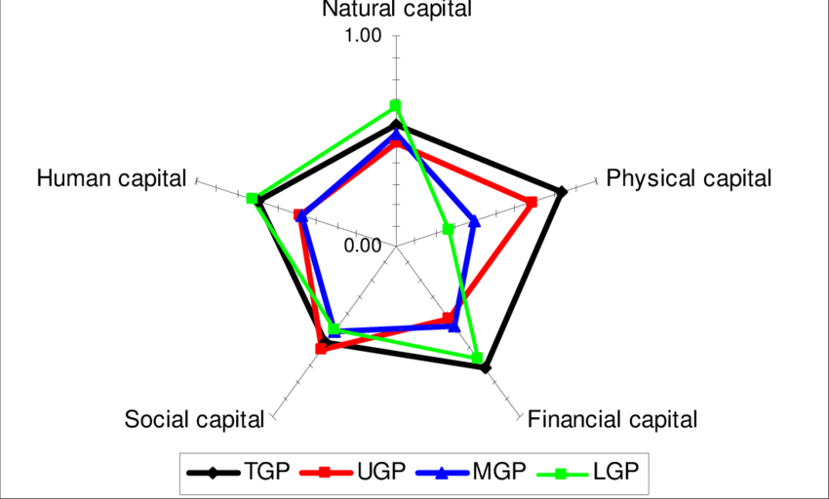
Figure 11- Asset Portfolio Dynamics. Adapted from Erenstein et al.(2007).
According to Shivakoti and Shrestha (2005), various factors determine what mix of assets will yield or result in a desirable livelihood outcome. In the pentagon, livelihood assets can be scaled from 0 to 1 for illustrative purposes. The core or centre of the pentagon represents zero or poor access to livelihood assets and assumes 0 on the scale. The peripheral or points on the outer perimeter depict full or maximum access to livelihood assets. Full access to livelihood assets or an optimal combination of assets yields or achieves 1 on the scale. Therefore, it goes that a higher degree in the robustness of the structure of the pentagon depicts a higher degree of performance of a livelihood strategy and its robustness to cope with and recover from shocks and stresses, maintain or improve it assets, and capabilities (Rakodi and Lloyd-Jones, 2002; Erenstein et al, 2010).
3.9.2 Transforming structures and Processes.
“Livelihoods are never neutral: they both shape and are shaped by processes of inclusion and exclusion, and are embedded in contested and conflicting arenas” (de Haan and Zoomers, 2005, P.34). The DFID SLF recognises that people negotiate through structures (government, private) and processes (law enforcement such police, laws, rules) that shape their livelihood strategies. Levine (2014), refers to these structures and processes as “political economy analysis “-that is how people’s potentials or possibilities are shaped by the broad structures of society in which they construct their livelihoods. Structures and processes shape who gains access to what types of assets (de Haan and Zoomers, 2005). Markets and legal processes, for instance, determine how assets can transferred or exchanged from one type to another (DFID, 1998; Moser, 1998). Assets, access, rights and institutions taken together and are viewed as a critical component of livelihoods that intersect in complex ways to provide opportunities and constraints for households, individuals, and communities (King, 2011). According the Oughton and Wheelock (2003), the ability of a household to organise and deploy their endowments is influenced by institutions of regulation, power, norms and values. Oughton and Wheelock (2003) drawing from Sen (1999), argue that these institutions also determine a household’s entitlements. Folbre (1999), referred to these institutions as structures of constraints of power, gender relations, interest groups and others that mediate access to endowments and entitlements.
3.9.3 Livelihood Strategies
Individuals or households combine their assets and resources within the vulnerability context that then shape their livelihood strategies. The choice of a livelihood strategy is influenced by a complex intersection of factors. The livelihood strategy is largely influenced by the household asset bundle and decisions made about how these assets are deployed or allocated to different livelihood activities (DFID, 2000). Deverux et al.(2012), argue that a livelihood strategy is not merely a pattern of an individual or household behaviour but a set of guiding principles through which people try to organise themselves to fulfil their goals.
3.9.4 Livelihood Outcomes
The DFID framework divides livelihood outcomes into five categories as set out in the table below. Outcomes vary according to access, rights and control of assets, and other resources.
More income and more economically sustainable livelihoods
Increased well-being-nonmaterial goods e.g., self-esteem, sense of control, political participation, access to health & education
Reduced vulnerability to external shocks, trends and seasonality
Improved food security
More sustainable use of natural resources
Figure 12- Livelihood Outcomes. Adapted from DFID (2000)
3.9.5 Criticisms of the Sustainable Livelihoods Frameworks
The DFID framework and other SLFs have been criticised for not being “people centred” enough (Sakdapolrak, 2014). It argued that is in their construct, most SLFs ‘hide’ away people within the framework (Levine, 2014). Scholars argue that people are lost within the framework that inevitably relegates people to the equivalent of other assets when in effect people should have been at the core of the analysis (Prowse, 2010; Levine, 2014). Levine (2014), contests that the linkages between the various elements (vulnerabilities, assets, structures & processes) of the framework are weak when they are critically essential to the operationalisation of the framework. Lautze and Raven-Roberts (2003), cite the perceived lack of cohesion in the arrows and boxes. They argue that the construct of the DFID SLF is based an artificial combination of different and delinked forces that shape livelihoods. Lautze and Raven-Roberts (2003), argue that great emphasis should have been directed at understanding how these forces shape livelihoods. Sakdaplorak (2014), argues that the framework disregards the critical role of power and politics by failing to broaden insight into how these structural factors influence livelihoods.
Critics of the livelihood concepts have argued that the concept is simplistic and overly materialistic in its approach (King, 2011). King (2011), contests that livelihoods operate at spatiotemporal scales; livelihood are characterised by a collection of resources, collaboration with social networks, and the movement of labour, which inevitably makes livelihoods spatial. King (2011), contends that livelihood approaches have overlooked symbolic and cultural norms and practices that shape how livelihood assets can be accessed. Daskon (2010), on the other hand, argues that the concept of livelihoods needs to expand to integrate not only economic factors but also cultural, historical and spatial forces of change that enhance or constrain livelihoods. Sakdapolrak(2014), critics the DFID framework on the grounds that it fails to incorporate non-economic or intangible structures from a cultural context and other social structures of dominance that shape people’s lives. The following section examines the role of culture in shaping livelihood.
3.9.6 Expanding the Sustainable Livelihoods Framework: The Role of Culture in Livelihoods
One of the criticisms of the SLFs has been their lack of inclusion of culture in analysing livelihoods (De Haan, 2012; Scoones, 2015). Culture plays a critical role in how communities respond to climate change and several studies have demonstrated the socio-cultural role in shaping livelihoods (Nagel, 2012; Fresque-Baxter, 2012; Adger et al. 2013, Brown et al., 2019). “An inadequate consideration of the cultural perspective oversimplifies not only people, but also their resourcefulness and capacities” (Daskon, 2015, P.3). Verhelst(1990, P.5), refers to culture as “ every aspect of life, know-how, technical knowledge , customs of food and dress, religion, mentality, values, language symbols, socio-political and economic behaviours , ingenious methods of taking decisions and exercising power , methods of production and economic relations, and so on”. The centrality of culture in livelihoods has been demonstrated in research that shows that tradition and culture are resources or assets critical for the survival and sustainability of rural livelihoods (Daskon, 2010; Rao and Walton, 2004). Ma et al. (2021), posit that diverse customs and traditions which make up a culture of a people are conduits through which local farmers in rural areas acquire and transfer knowledge, and skills, and accumulate livelihood assets.
De Bruijn et al. (2005, P.16), describe culture as “the sum of the cultural understandings of the environment and the cultural means people employ to counter insecurities of every sort”. They argue that cultural understandings shape and influence people’s coping strategies and their changing interpretations of what constitutes work and resources. De Haan and Zoomers (2005a), employ the term ‘style’ as a way of informing habitus-shaped understating of livelihoods. Through style, de Haan and Zoomers (2005) assert that livelihoods consist of groups sharing specific social positions, cultural repertoire, knowledge, interests, and prospects. Bourdieu’s (2002) habitus theory employs social practices to describe actors as a system of deeply ingrained dispositions: an embodied manner of being, seeing, acting, and thinking, a schema of perception, conception, and action”. Bourdieu (2002), refers to habitus as an actor’s dispositions internalised through social structures-a process through which rules and values of social space become internalised through interactions and observations. Sakdapolrak (2014, P.4), argues that these “embodied dispositions and specific ways of perceiving and valuing the world explain why some opportunities are not even considered by some people”.
Ma et al. (2021), assert that the traditional and cultural beliefs of a people can release the potential of people to be agents of change, enhance their adaptation to external shocks or stresses, and improve their livelihood outcomes. Su et al. (2019), demonstrated how traditional culture played a vital role in transforming household livelihood strategies in China’s tourism sector. Daskon (2010), argues that many rural people or communities instinctively situate their beliefs, norms, religion, traditional knowledge, and other socio-cultural elements to construct and sustain their livelihoods. Daskon (2010), adds that as a dynamic process, culture and traditional values or norms help to reinforce livelihood resilience during times of crisis. “Cultural values enhance people’s ability to be agents of change and their ability to question, challenge and propose, and ultimately bring new ways of doing things” (Daskon,2010, P.2).
Adger et al. (2012), posit that cultural lenses help to explain differences in response across people when exposed to the same environmental risk. Adger et al. (2012), posit that climate change narratives interact with other cultural beliefs to animate responses that appear to be “irrational” and inconsistent with responses advocated by institutions promoting adaptation policies. They argue that information about climate does not necessarily resonate or connect with all cultures and worldviews in the same way. Research also shows how communities with the same shared beliefs and values produce their unique view of the natural environment which in turn shapes the way they respond to changes (Amundsen, 2015; Change, 2016). Neef et al. (2018), suggest that Western literature conceives that successful adaptation of climate change is reflected in dealing with immediate risks to the physical well-being and livelihood security of a people. However, they contend that this approach is faulty as it fails to account or address the socio-cultural risks that people or communities may face in the process of adaptation. They argue further that this perspective ignores the subjective dimensions of climate change that shape how people perceive and respond to change.
The researcher argues by adopting Creswell’s (2007, P.8) writing “that culture is not just a thing in the world, culture is also a way of seeing, knowing and understanding the world.” The researcher stresses that culture has epistemological and ontological importance because it informs the understanding of its culture that shapes people’s livelihoods.
Sustainable livelihoods frameworks have been instrumental in developmental work in trying to find answers and solutions to issues of poverty at the global level (Scoones, 1998). However, in the consideration of the criticism of the SLF, it is reasonable to consider alternative concepts that add to their applicability and utility. De Bruijn and Van Dijk (2005; 2006) Livelihood Strategies Pathways adds another dimension to the study of livelihoods by exploring how individual and or group experience shape how people perceive and respond to events. The following section examines De Bruijn and Van Dijk (2005)’s contribution to the study of livelihoods.
3.9.7 The Concept of Livelihood Pathways
De Bruijn and Van Dijk (2005a), make a distinction between a livelihood strategy and pathway. De Bruijn and Van Dijk (2005a), refer to a strategy as a pre-set goal that is established after a process of rational and conscious negotiation choices by actors. De Bruijn and Van Dijk (2005a; 2005b), conceptualise a strategy as a stage rather than structured category. They argue that rather than classifying people in terms of that they own, individuals should be classified in relation to their objectives and priorities. Therefore, it goes that at different times, a particular individual may deploy different strategies. De Bruijn and Van Dijk (2005), refer to a pathway as a step-by-step iterative process in which procedure goals, preferences, resources and means are constantly renegotiated in view of emerging unstable conditions with which the actor or decision maker is faced. Through this iterative process individuals make choices based on a range of past experiences rather than on the future. De Bruijn and Van Dijk (2006), argue that recollections of the past are informed to a greater extent by an individual’s intellectual concerns of the current. Knowledge about past unstable conditions and how to cope with them is gained through an incremental learning process. Arising from this, actors’ have differentiated experiences of conditions over time. Their knowledge, experiences, and understanding of their environment varies systematically among them. Therefore, when challenged with a similar set of conditions, they are likely to follow different pathways. Drawing from this, they argue that individuals who have experienced a disruptive event such a drought are more likely to respond in a different way in a good year compared to individuals who have just experienced several good years (De Bruijn et al., 2005). De Bruijn and Van Dijk (2005a; 2000b), argue that pathways are linked to the decision-making process in uncertain conditions.
In their study of pastoralists in Mali, De Bruijn and Van Dijk (2005b) show that under unpredictable environmental conditions the pastoralists were unable to make long-term strategic decisions in relation to their livelihoods. De Bruijn and Van Dijk (2005a; 2005b), suggest that, therefore, these pastoralists relied on a trial-and-error type of everyday interactions with the local environments from which pathways emerged. “In reality people combine different activities in a complex bricolage or portfolio of activities” (Scoones, 2009). The concept of “trial-and-error” was corroborated by the empirical findings of this study, which found that individuals and households were applying response strategies that were based on elements of bricolage (see Adaptation from Below chapter).
In their studies of the Sahelian ecosystems, De Bruijn et al. (2005, P.14) argue that the Sahelian ecosystems were not “just neatly organised and equilibrated set of production space for farmers and herdsmen but a volatile, highly dynamic and extremely varied environment both in time and space.” De Bruijn et al. (2005), posit that risk events produce a different array of responses at individual, household, and community level (collective decision-making units). These risk events and subsequent responses by individuals intersect with a myriad of psychological, institutional and cultural processes in ways that attenuate the perception of risk and shape risk response behaviours. De Bruijn et al. (2005), posit that these response strategies prompt further response at a socio-cultural scale and trigger additional responses at the institutional level that might foster positive or negative responses.
It has been contended that a better approach to an analytical discussion of livelihoods is an asset-based approach (Moser, 2008; May et al., 2009; Walelign et al., 2017). The point of contention here is that livelihood approaches do not make critical inquiry in distinctive assets and how asset variations influence livelihood strategies pursued by individuals or households (Walelign et al., 2017). The following section in based on Moser’s asset-based approach to livelihood analysis.
3.9.8 Asset Based Approaches
Asset Based approaches (AB) and SLFs have similar conceptual foundations because they both focus on assets and capabilities, livelihoods, and institutions that shape people’s livelihoods (Moser, 1998). However, there is a bifurcation between them. AB models pay particular emphasis on assets, how these assets are deployed, and the role of asset accumulation strategies. On the other hand, SLFs approaches focus on livelihoods strategies linked to well-being. Asset based approaches are influenced by Sen Entitlements and Bebbington’s Capitals and Capabilities approaches (Moser, 1998). Bebbington (1999), posited that assets are not just resources that people utilise to construct their livelihoods but that assets give people the ability to be and act. Sen’s (1976), entitlement approach is framed around three concepts of endowments, entitlement and entailment mapping (Osmani, 1993; 1995; Sohlberg, 2006). Sen (1976), describes endowments as a bundle of resources that can be legally owned by an individual. According to Sen (1976), entitlement is a combination of all possible ways goods and services that an individual can legally obtain by utilising resources of his endowment set. Entitlement mapping is the relationship between the endowment set and the entitlement set. It depicts the rate at which resources from the endowment bundle can be transformed into good and services (Sen, 1976). Bebbington (1999, P.2), argues, therefore, that assets are the basis of “agent’s power to reproduce, to challenge, or change the rules that govern the control, use, and transform resources”. Moser (1998) adds that assets create agency; agency energises people to mobilise resources that will satisfy their daily needs.
Moser’s (1998) AB model illustrates how vulnerability and asset ownership are linked. The model identifies the risks or threats and resilience in resisting; resilience enhances recovery from negative effects of environmental change (Morecroft et al., 2012; Satterthwaite et al., 2020). Using her model, Moser (1998) demonstrates that assets and endowments are the means through which individuals, households, and communities can mobilise when faced with a crisis. Moser’s (1998) approach strives to stress that vulnerability is linked to asset ownership. Therefore, the more assets individuals or households have, conversely the less vulnerable they are. Therefore, it goes that the greater the erosion of people’s assets, the greater their vulnerability and the insecurity that is associated to it (Moser, 1998). Moser (1996), argues that poor surmount a complex bundle of assets that contribute to their well-being and positive outcomes while deploying their agency to manage assets to cushion and limit the impact of shocks.
Assets
Individual, household and collective
- Endowment
- Asset Accumulation
.

Strategies
Determined by individual
and collective
agency
Institutions
- Laws
- Regulatory Frameworks
- Norms
Opportunities
- Lifecycle
- Macropolitics
- Macroeconomics

Figure 13- Moser’s Asset Based Model. Adapted from Moser (1986)
Kim and Sumberg (2015), criticise asset based approaches on the grounds that they aggregate different types of assets into one group negating that fact that assets are heterogenous. Kim and Sumberg (2015), contest that different types of assets have different values and attributes, which they refer to as asset-ness. They further argue asset-based approaches do not acknowledge the individuality of lives and motivations in the deployment of assets. Drawing from Dorward et al.’s (2001) work, Kim and Sumberg (2015) pursue an argument that an interaction and integration of an asset’s attributes determines its value, experience and implications of owning. Kim and Sumberg (2015), stress that the experience or implications of owning or using a particular asset transcends its individual attributes; it is the integrated quality that gives an asset its asset-ness .Dorward et al. (2001), categorised the attributes of livelihood assets as set out in the table below.
Table 4: Asset Attributes. Adapted from Dorward et al. (2001).
Attribute | Description
Productivity | production or income activities and processes associated with employing an asset to generate resources for consumption and social reproduction
Utility | the individual, social and demographic well-being (health, nutrition, shelter, clothing, …) derived from the use of an asset
Security | Risk of theft, loss of control or access, susceptibility to pathogens or other risks
Holding costs | costs associated with holding or maintaining an asset
Life | costs associated with acquiring or disposing off an asset; expected period over which the asset is held; seasonal and lifecycle effects on an asset’s value
Convertibly | costs involved in converting or exchanging an asset
Complementarity | Effects on and of other assets (e.g. plough with a bullock will be little vale)
Ownership/control | Private(individual/household); communal; public, gendered rights and responsibilities for disposal, acquisition, costs and returns

Drawing from Kim and Sumberg (2015) argument above, the value of an asset is subjective, context specific, and contingent. The value of a specific asset, as perceived by the asset owner, reflects an individual’s objectives, preferences, skills, interests and access to other assets, and the specific context within which the individual constructs their livelihood and the strategies they deploy their assets. The researcher argues that Kim and Sumberg (2015) hypothesis fits into the narrative of this study; value, desirability and the actual usefulness of assets is subjective, and contingent on the circumstances of the asset owner. Take for instance cattle; from the Lozi people’s perspective in which the cultural value of cattle is important than the income it can generate when sold. Therefore, a cattle owner will only consider selling his cattle as a last contingent option. Seen from this lens, the economic value of cattle is secondary to its cultural value. Binsbergen and Geschiere (2005) argue that assets are more than economic, rather their value is embedded in social relations and increases social power.
The theoretical framework discussed above feeds into the conceptual framework set out in the next section. At the centre of the theoretical and conceptual frameworks is a hypothesis that individuals or households generate a livelihood out of a rational mix of assets and incomes (Ellis, 2000; Davis et al., 2010). Well-being is shaped by socio-economic characteristics and asset endowment of an individual or household (Wavelign et al., 2017). Livelihood strategies are mediated by various forces and seasonal variations-both economic and climatic seasonal variations (Wavelign et al., 2017). Seasons are characterised by shocks and stresses that drive some individuals or households into poverty (Adger, 2006; Leichenko and Silva, 2014). Individuals or households negotiate through these perturbations by deploying asset smoothing and asset accumulation strategies (Moser, 1986; 1998). This conceptual framing is borne out of an understanding that asset endowment mediated by “political economy” influences Livelihoods Strategies Pathways.
The Livelihoods Strategies Pathways (LSPs), as a conceptual tool, gives insight into the relationship between asset ownership (endowment) and well-being. By bringing together concepts of livelihoods, livelihoods strategies, asset erosion, and asset accumulation, the LSPs acts as a tool for appraising how people rationally or reactively respond to climatic and non-climatic events through deployment or redeployment of their assets portfolio. Empirical insights derived from the study sites feed into the conception of the LSPs and Adaptation from below (see chapter on Adaptation from Below).
3.10.0 Conceptual Framing
3.10.1 Introduction
This thesis employed the Livelihood Strategies Pathways (LSPs) as a way of conceptualising how people’s livelihoods in rural areas are shaped and or being reshaped by climate change and other co-interactive socio-cultural and economic-political factors. The LSPs employs an integrated conceptual and theoretical approach informed by livelihoods (Scoones, 1998; De Haan and Zoomers), poverty (Hulme and Shepherd, 2003; Carter and Barrett, 2006), assets (Moser, 1998) and capitals and capabilities (Bebbingtion, 1999). It explores how individuals or households mobilise and combine their asset bundles and other resources to construct their livelihoods in the presence of shocks or stresses and mediating social structures (institutions of exchange) of institutions, power, gender, ethnicity and social status (Scoones, 1998; de Haan and Zoomer, 2005). The LSPs were empirically conceived and refined through engagement with other conceptual and theoretical foundations indicated above.

3.10.2 An Integrated Conceptual and Theoretical Approach
This thesis applies an integrated conceptual and theoretical approach. The application of an integrated conceptual and theoretical approach was informed by the fact that no single concept or theory can sufficiently explain how individuals or households construct their livelihoods. This is drawn from the understanding that the study of livelihoods is not situated in any one discipline (Pain and Lautze, 2002). An integrated approach transcends beyond a narrow focus on livelihoods to examining the characteristics of those livelihoods. It examines what assets and resources people need to construct a livelihood and the functions of those assets (Carter and Barret, 2006). As an integrated approach, it explores the strategies and pathways people take to convert their asset; and in what ways these assets enable individuals or households to achieve well-being (de Bruijn and Van Dijk, 2005a; de Haan and Zoomers, 2006). By employing an integrated approach this thesis explores the role of agency, socio-cultural (norms, values), perceptions and worldviews, and how these intersect with constraining structures in shaping livelihoods strategies pathways. It is from the rationale above that this thesis conceives that an integrated conceptual and theoretical approach is an ideal entry for this study.

As set above, the LSPs is conceived from 3 keys concepts: assets, pathways and well-being. It attempts to highlight how rural livelihoods involve the deployment of assets to produce daily living outputs. These outputs both material and non-material are intended to meet people’s well-being and aspirations. These livelihood activities are played out in an unpredictable external context as set out in figure 13.

As demonstrated by Dorward et al. (2009), for many rural people the construction of livelihood activities is characterised by uncertain seasonal cycles that shape the production of food crops, livestock, labour hiring and the sale of agricultural produce. This uncertain and unpredictable external context affects people’s consumption and accumulation motivations. However, in seasons of good fortune people can produce more crops and livestock and be able to store and sell the surplus. With extra savings, people can accumulate more assets, which they can convert into liquid or consumed in times of crisis. Research shows that lack of access to financial markets for insurance and other financial support in times of crisis (Hansen et al., 2007; Hazwell et al., 2010;Xu et al.,2018), makes people craft livelihood strategies intended to meet their daily needs and ultimately satisfy their well-being.

3.10.3 Livelihoods and Assets
Scoones (1998, P.5), defines a livelihood as “a livelihood comprises the capabilities, assets, material, and social resources, and activities required as a means of living. A livelihood is sustainable when it can cope with and recover from stresses and shocks and maintain or enhance its capabilities and assets while not undermining the natural resources base”. The capacity of a livelihood to cope with and respond to disturbances is what Speranza et al. (2014. P.5) refer to as livelihood resilience, which they describe as “the capacity of a livelihood to cushion stresses and disturbances while maintaining or improve essential properties and functions.”
This thesis describes a livelihood as being composed of activities that individuals or households engage in on an everyday basis to meet their essential basic needs. These activities involve individuals or households gathering and converting different kinds of assets to sustain their livelihoods. Assets can act as a ’safety nindividual’s dividuals or households’ livelihoods are disrupted (Carter and Barret, 2006). From a rural perspective, assets are measured in units such as the number and diversity of livestock; the productivity of land; the size and health status of the family, and socio-cultural networks; access and rights to common pool resources (Adato et al., 2006). Adato et al. (2006), posit that the household well-being is a function of household characteristics and its asset holding. Brandolini et al. (2010. P.2), suggest that “the possession of tangible and intangible assets is a major determinant of the longer-term prospects of a household and individuals”.
3.10.4 Asset Poor
Following on from the foregoing, this thesis applied the term “asset poor” to refer to households or individuals whose command, access and rights to assets and other resources critical for their livelihoods is not sufficient to meet or sustain their daily basic needs for extended periods of time. This is framed on the assumption that individuals or households need access to and command over a portfolio of assets and resources to construct a livelihood that meets their basic needs. It is from this command and diversity of assets that generates flows of products or incomes that ultimately determines whether an individual or household is poor and the extent to which they can be described as asset poor (Reardon and Vosit, 1995). The description of ‘asset poor’ is influenced by Sen’s capability approach that postulates: “Capability failure of an individual is the inability to achieve basic capabilities to adequately fulfil certain crucial functions at a minimal level” (Sameti et al., 2012). The capability approach takes in account the role of monetary and other resources (tangible and intangible) to achieve well-being (Sameti et al., 2012).
3.10.5 Basic Needs
The definition of basic needs is contentious and there is no agreed standard for measuring these basic needs (Haveman and wolff, 2004). Basic needs refer to those goals essential for basic human survival and the avoidance of harm (Abubakar, 2021). Basic needs are natural (innate) to every individual; they must be achieved if an individual is to go on to achieve any other needs (Abubakar, 2021). Cardoso et al. (2021), add that basic needs are a bundle of requirements; that is personal, social, political and economic that result into a satisfactory life and the participation in societal development. The methods and measurements of the multiple theoretical and conceptual frameworks of human basic needs is beyond the scope of this thesis, however, this thesis will refer to basic needs as access to food, clean water, accommodation(housing), healthcare, education, safety, and self-expression. The adoption of the basic needs approach in this study is motivated by the fact for an individual to survive or “get by”, these basic needs must be met (Max-Neef, 2017). It is impossible to envisage survival in the absence of these basic needs (Doyal and Gought, 1984 ;). Contextualising the basic needs approach to socio-economic status of the study areas, is grounded on the fact that the study areas are highly deprived areas and the everyday lives of the people are centred on meeting basic everyday needs (Moono ,2015: Rajratnam et al.,2015). By common everyday use, poverty exists when one or more people fall short of a level of economic welfare determined to constitute a reasonable minimum, either in some absolute sense or by standards of a specific society.
“The concept of reasonable minimum is then defined by pre-determined basic consumption needs such as food consumption” (Lipton and Ravallion, 1994. P.1). Bourguignon and Chakravarty (2019), argue that poverty is a multidimensional concept that describes a shortfall from a predefined threshold on each element of individual well-being. Chambers (1995), refers to poverty as a state of deprivation or lacking what is required for well-being. Chambers (1995), stresses this lacking manifests as in the form of physical, economic, political, and psychological or spiritual deprivation. Well-being and basic needs are important concepts in this study. Drawing from empirical evidence of this study, the most critical goal of the individuals or households in the study areas is to satisfy their daily basic needs and enhance well-being. The satisfaction of these basic needs is constrained by multiple deprivations in the spheres including those suggested by Chambers (1995).
The definitions and measurements of poverty are relative depending on different interest groups and individuals’ experiences (Laderchi et al., 2003; Kotler et al., 2006). There are two main approaches applied in the measurement of poverty-the use of income and consumption approaches (Hulme and Shepherd,2003; Chen and Ravallion,2011;2019; Smeeding,2016). From an income perspective, an individual is considered poor if his or her income falls below a pre-determined income level (Hulme and Shepherd,2003; Chaudry and Wimer,2016; Bourguignon and Chakravarty, 2019). Consumption measures of poverty aggregate food and non-food essential items into a ’consumption basket’ that determines whether people are poor or not (Backiny-Yetna, 2017. Both approaches are error prone and restrictive in their appraisal and analysis of poverty (Bourguignon and Chakravarty, 2019).To draw reliable and valid conclusions , it is recommended to employ multidimensional measures of poverty that transcend incomes and consumption measures of poverty (Ravallion,2016;Smeeding ,2016;Bourguignon and Chakravarty, 2019).Researchers have made calls for the application of other measures and analyses of poverty using livelihoods and assets models (May and Carter, 1999;Moser,2008; Erenstein and Chandna,2010; Hua and Zhang,2017).
Hulme and Shepherd (2003), describe chronic poverty as a condition of intergenerational poverty where households experience significant capability deprivations for an extended period. The distinctive feature of chronic poverty is the extended duration that households are exposed to conditions of poverty (Ravallion, 1998; Yaqub, 2002).
3.10.6 Concept of Human Well-being
There is plurality in conceptions and theorising of human well-being (La Placa et al., 2013). This thesis adopted McNaught (2011)’s concept of well-being in its discussions. Applying a definitional framework of well-being, McNaught (2011) argues that well-being is wider than individual subjectivities; well-being constitutes a range of environmental, geographical, political and socio-economic factors. McNaught’s (2011) framework has four domains of well-being; that is individual well-being; family well-being; community well-being and societal well-being. The framework conceives, that well-being is dynamically constructed by actors through an intersection of their circumstances, locality, activities, and psychological resources.
Therefore, individuals change circumstances of their lives in reference to the four domains. For instance, when an individual or household is faced with a shock (idiosyncratic shock), they take measures that will resolve or cushion the impact of the shock to satisfy unmet needs. This could involve for example, drawing on their socio-cultural networks, migrating or disposing off stocks of assets. Such measures open economic opportunities and psychological energies different from those that the individual or household had previously enjoyed (McNaught, 2011).
McNaught (2011), argues that individual well-being is an important element of the framework. He locates the individual as an active agent who possesses the power and conscious to interpret and design well-being. La Placa et al. (2013), however, contest that while individuals are active agents that create and interpret well-being, they are subject to influence by socially defined concepts of well-being and other standard scales of well-being. La Placa et al. (2013), stress that individual well-being, therefore, is a multi-dimensional concept that incorporates subjective experiences of, for example, career and financial well-being, physical, psychological, spiritual, and moral values, and experiences. La Placa et al. (2013), add that all these elements of well-being are shaped by the broader structural factors and standard objective definitions of an individual’s life, which can be externally observed and measured.
McNaught’s (2011) concept of well-being renders itself applicable in this study at the individual or household level. McNaught’s (2011) conception of well-being can be linked to livelihoods; particularly that most SLFs were originally conceptualised at an individual and household level (Schreckenberg et al., 2010). Drawing from McGregor (2007), well-being is linked to the resources that an individual or household can command and what goals they are able to achieve from those resources. Therefore, well-being has a critical place in this study; this study explores how individuals or households desire to achieve well-being arising from the different combinations of asset deployment that is played out within the broader socio-cultural context. Socio-cultural and political-economic forces constantly evolve and so does well-being (McGregor, 2007). Asset accumulation and loss resulting from exogenous and endogenous forces precipitate reconfigurations of livelihoods. It is from these livelihood reconfigurations that Livelihoods Strategies Pathways emerge. Livelihoods Strategies Pathways is the subject of discussion in the following section.
3.11.0 Livelihoods Strategies Pathways (LSPs)
The Livelihoods Strategies Pathways (LSPs) contributes as a model for conceptualising how individuals and households negotiate or transition between different livelihood strategies based on their access to resources. The LSPs integrates De Bruijn and Van Dijk’s (2005a; 2005b) distinct concepts of livelihood strategies and livelihood pathways into a single unitary concept. The LSPs conceives livelihoods strategies pathways as a step-by-step process composed of reactive and or rational conscious pre-determined negotiation of choices by individuals or households. Therefore, LSPs is an outcome of everyday livelihood activities actively navigated by individuals and households; a process where individuals and households consider their assets and resources and evaluate realistic choices for achieving livelihood outcomes .The LSPs recognises the role of human agency (Giddens , 1984; Tanner et al., 2015; Colding et al., 2020), in that individuals and households construct livelihood strategies through a combination of survival strategies and devise conditions that make their livelihoods possible (Giddens, 2008). The ability to engage in a type of livelihood pathway is shaped by the type of assets and resources individuals or households have access to and surmount amidst constraining structures (Scoones, 1998; Moser, 1998; De Haan and Zoomer, 2005). For purposes of discussion, the term livelihood strategy will refer to activities and decision-making processes that individuals or households engage in as they allocate and combine their assets to activities that meet their daily needs.
At the centre of the Livelihoods Strategies Pathways are livelihood activities that individuals or households engage in on an everyday basis to meet their basic needs. Therefore, Livelihoods Strategies Pathways are influenced by individuals or households’ asset portfolio (labour, land, socio-cultural capital, education etc.) mediated by endogenous and exogenous forces prevailing in their locales. The allocation and combinations of assets and other resources result in several outcomes. The outcome of each livelihood strategy (Struggling, Coping, Resilience …) is shaped by the socio-characteristics of an individual or household and asset portfolio that in turn influences the livelihood strategy pathway that individuals or households will follow. The LSPs conceives that individuals or households make rational decisions that will enhance or sustain their well-being. However, the LSPs takes cognisance that in times of crisis individuals or households take reactive actions designed to satisfy their needs.

This thesis argues that a livelihood strategy pathway is a livelihood activity borne out or constructed from everyday negotiation of alternatives by individuals and households. This negotiation is influenced by a repertoire of socio-cultural and economic-political institutions and processes that subsequently inform decision making. Drawing from De Haan and Zoomers (2005), the LPCs conceptualises that individuals and households do not construct livelihoods under conditions of their making rather that livelihoods emerge from past and current actions and decisions mediated by environmental factors that are constantly evolving.
3.11.1 Forward Mobility
The graphic representation of the LSPs conceives that when an individual or household improves its well-being forward mobility is observed; that is a positive forward movement from coping to resilience or from adaptation. A forward mobility or transition can be achieved through asset accumulation and diversified asset deployment. Drawing from the empirical data of this study, this was achieved through improved land management practices, planting of drought resistant crops, livestock diversity (cows, goats, chickens), and engagement in non-farm activities. Forward mobility can also be realised through redeployment of labour from activities with low returns to those with better returns (Ellis, 2000). Conversely, individuals or households who were once poor can climb out of conditions of poverty through asset accumulation and improved asset utilisation (Moser, 1998).
While climate change maybe the biggest threat to livelihood through its disruption of farming activities in rural areas of the global South, people have been devising ways of living with climate change. Farmers have been redeploying the use of their land through cropping changes. Evidence shows shifting from crop farming to other lucrative income generating activities, for example shifting from water based agro-based agriculture to pastoral systems. In East Africa and the Ethiopian highlands where rainfall has been on a decline during the last decade, farmers have been increasingly diversifying into other activities such as transient pastoralism and cultivation of commercial crops such as coffee (Carr et al., 2013; Liao et al., 2020; Kariuki et al., 2021). Ogada et al. (2020), document that farmers in Kenya adopted multiple stress-tolerant crops that boosted not just staple food production but also food security. Ogada (2020), document how these farmers were able to yield surpluses that they resold on commercial basis thereby enhancing their incomes. The extra incomes were then invested on other asset accumulation activities.
In relation to the LSPs, these positive adaptation strategies enhance people’s ability to flexibly adjust to change and enjoy high well-being in comparison to those that have a poor asset bundle. This high adaptive capacity acts a buffer against rapid or slow onset events.
3.11.2 Backward Mobility
Backward mobility is observed when an individual or household is pushed backwards to a position of poor or low well-being when faced with a crisis. Based on the empirical data of this study, backward mobility was observed during periods of low yields or harvests due to poor rains (drought) and lean periods between the seasons. Backward mobility was also observed when households experienced loss of the family head (particularly male heads). An individual or a household can experience a shock that can result in a negative transition from coping to struggling or from adaptation to resilience. Individuals or households can be driven into a negative pathway due to climate-related events such as floods or storms (livelihood shocks) that destroy their crops, livestock, housing and infrastructure such as roads or bridges leading to asset erosion at household and or at community level (Scoones, 2009; Sayers et al, 2015). Economic factors such as prices of farming inputs, inflation, low prices for agricultural products and more recently trans-global diseases such as COVID-19, can have serious repercussions for people’s livelihoods (Pittman et al. 2011; Boughton et al., 2020; Morton, 2020). Conversely, individuals or households who were once non-poor can fall into poverty when faced with a crisis that erodes their assets (Moser, 1998).
Climate change and variability impact on the livelihoods of millions of people, particularly rural areas of the global south (Douglas et al.,2008; Olsson et al., 2014). Even the slightest changes in rainfall, in terms of onset, duration and cessation can have devasting impacts on the agricultural activities on which many rural people rely (Olsson et al.,2014; IPCC;2022). Climate change has been the main driver behind the disappearance of farming land and soil fertility in many regions of the world (Reed et al.,2012; Bayu,2020; Mondal,2021). The erosion of farming land disrupts food production activities and compromises food security not just at the household level but equally at the national level (Nguyen,2002; Dawson et al.,2016; Leisner,2020).
Research demonstrates that for many rural poor, natural resources on which they depend such as forests, rivers, lakes, fish stocks and others have been impacted by climate change (Osbahr et al.,2010; IPCC,2022). Climate change erodes these critical resources by disrupting and exacerbates human suffering as more and more people are pushed into conditions of poverty.
At an individual or household level, which is the focus of this study, climate change in tandem with other socio-economic forces affect livelihood pathways through the disruption of their livelihood activities and consequently pushing people into conditions of hardship and low well-being. This is illustrated in the LSPs as asset erosion and low well-being. Due to a low adaptive capacity, people with a poor asset bundle are highly vulnerable to rapid and slow onset events. A mix of low adaptive capacity and high vulnerability translates into irrational and reactive desperate responses that results in maladaptation.

3.11.3 Stages of the LSPs

Shocks/Stresses

Asset erosion Asset accumulation
a
Resilience
Flexible asset movement-ability to bounce back and transform.
Adaptation
Coping
Chronic poverty / transgenerational poverty
Robust and complex asset redeployment -flexibility in asset liquidity
Medium asset diversity -a mix of farm and non-farm activities
High asset diversity -complex mix of farm and non-farm activities
Struggling

High Adaptive Capacity
High vulnerability
Low-asset diversity. Reliance on labour exchanges & ecosystems

Poor well-being High well-being

Figure 14-4 Stages of the LSPs. Author’s own work
The LSPs was drawn from different approaches that had interrogated how subsistence farmers in rural areas responded to change through the process of decision-making and adaptive behaviour. Decision making is shaped by social-economic processes (Slegers, 2008; Singh et al., 2016). Operating within contexts of internal and external pressures of which climate change is a big factor, individuals or households make decisions based on plurality of factors that are mainly shaped by asset availability, cost constraints, financial costs, risk perception, and experience. Singh et al. (2016), stress that agency or motivation to act or respond is a critical element in livelihood construction. Singh et al. (2016), further argue that responses to external and internal pressures are driven by subjective perceptions of risk and vulnerability.
The conception of the LSPs is framed on a continuum; starting from a state of struggling on the extreme left of the LSPs, that is living in a cyclic of perpetual survival strategies directed at meeting the barest of everyday needs. The continuum transitions to full adaptation on the extreme right, which in this case situates as a state where an individual or household has an assets portfolio that supports a robust and flexible response to changes.
As indicated above, having borrowed from other studies, the LSPs situates that individuals or households may be driven by desperate/reactive short-term motivations for survival. These individuals or households respond to crisis to satisfy their immediate needs and in the long term maladapt (Jones et al., 2010). When conditions are favourable individuals or households can make incremental asset accumulation and transition to adaptation. On the opposite end, you have individuals or households that have a positive response strategy and deploy agency to deal dynamic changes both in the external and internal environment (Park et al., 2012). However, even fully adapted individuals or households maybe be pushed backwards into a state of struggling or coping, and eventually into poverty when they facemultiple challenges.
The LSPs can be linked to Doward et al. (2009)’s three broad categories of livelihood strategies or three activities that contribute to livelihoods:
I.Hanging in-conditions where assets are held, and activities are directed at maintaining livelihood activities in the face of extreme socio-economic conditions. In the LSPs, this can relate to the Struggling Stage.
II.Stepping up-whereby activities are engaged into planned investments and asset accumulation as the primary motivation-these activities are intended to expand the productivity of existing assets and income to improve livelihoods. This is the resilience stage in the LSPs.
III.Stepping out-whereby current activities are directed at asset accumulation where time assets deployed as a base to expand and diversify existing livelihood activities leading to a higher or more returns. In the LSPs this is the adaptation stage where individuals or households have a combination of liquid assets, land, livestock (cattle, goats, pigs), and mobile farm equipment.
3.11.4 Struggling
According to Warner (2000), to be in a state of struggle is to have few assets or resources from which to create and sustain a livelihood. As conceptualised in the LSPs, people in a state of struggle often rely on a mix of natural resources, social networks, and outside assistance. Most rural poor people are heavily reliant on eco-systems (hidden harvest) and services that flow from them as embodied in common pool resources such as rivers, land, pasturelands and forests (Campbell and Luckert, 2002; Ryan et al., 2016; Wisely et al., 2018). Extraction of natural resources is very common in poor people’s livelihhods strategies because they are often deemed as ‘free’. Environmental incomes can provide a pathway for asset accumulation and a strategy out of poverty (Anglesen and Wunder, 2003; Hallegate et al., 2018). Apart from their labour, in many cases, natural resources are the only asset which struggling individuals or households can surmount (Anglesen and Wunder, 2003). Inevitably, as common pool resources are susceptible to over exploitation and widespread degradation it exacerbates climate change (Heltbeg, 2004; Turner and Grieco, 2000). However, natural resources are prone to over exploitation as in Hardin’s ‘Tragedy of the Commons’ (Hardin, 1968; World Bank, 2016b).
Outside assistance normally comes in the form food aid and other forms of support such as farming input supplies. Individuals in a state of struggle will also draw on the resources of their social networks through which their assets can be shared, traded and transformed to create livelihoods (Ellis, 2000). When faced with a crisis, struggling people make trade-offs between survival and longer-term sustainability (Geest, 2004). These livelihood strategies pathways are often precarious and climate-sensitive making them highly vulnerable to internal and external shocks (Shackleton et al., 2012). According to the LPCs struggling individuals and households live precarious livelihoods and subsist in conditions of intergenerational and chronic poverty traps. Poverty traps are self-perpetuating and reinforcing conditions of deprivation lasting from one generation to another (Carter and Barrett, 2006; Bird, 2007). According to the LPCs, an in individual or household in the struggling state can improve its well-being through a combination of asset smoothing and external support to cope during times of crisis. Being in a state of struggle is not necessarily a static position; through a careful mix of asset accumulation, deployment, and outside assistance poor people in a state of struggle can migrate into less worse position of coping.

3.11.5 Coping
Coping involves livelihoods strategies that are reactive and short term intended to deal with day-to-day perturbations, problems and opportunities. Rugalema(2007) suggests that coping measures are taken in response to a shock/stresses that results in declining availability of daily needs. The main objective of coping is to ensure that an individual or household can sustain economic and social viability after the crisis has passed. Coping strategies do not deal with the underlying causes of vulnerabilities; and should the same event or hazard occur in future, individuals and households will more than likely experience similar effects (Twyman et al., 2010). The distinction between coping and struggling, is that a struggling individuals or household have poor assets or resources or have its assets or resources depleted the household will often rely on support from their socio-cultural networks, remittances and or external agencies to sustain their daily needs. This support or assistance can energise people to mobilise and sustain their daily needs for a period, beyond which those resources will soon be depleted if the crisis is not resolved.
Assets diversification and improved asset utilisation by households can result in forward mobility above the poverty line, which can be transitional or permanent. Households can create new livelihood opportunities and enhance their well-being through the expansion of cultivated land, better crop mix, livestock diversity, building food stores to withstand future shocks and stresses (Ellis, 1999; Moser, 1998; Adger, 2005). Where there are no feasible opportunities for diversification, remittances from social networks and migration can sustain livelihoods (World Bank, 2007). Accumulation or diversity in the assets stock improves a household’s resilience against future shocks (Adger, 2007). However, a household can also be pushed back to a state of struggle when faced with a shock that reduces its capacity to mobilise its daily needs.

3.11.6 Resilience
Speranza et al. (2014. P.9), describe livelihood resilience as “the capacity of a livelihood to cushion stress and disturbances while maintaining or improving essential properties.” An individual or a household’s resilience to endogenous and exogenous disturbances is influenced by the capacity to sustain a livelihood above a poverty threshold (Adger et al, 2011). When the household asset bundle falls below a pre-determined threshold, there is a probability of being pushed into the path of a poverty trap (Barrett and Constas, 2014). Faced with downward mobility, individuals or households try to shield themselves against the effects of perturbations to survive. Through different deployment and conversion strategies, they negotiate their way up. Asset diversification is widely recognised as a strategy for asset flexibility, stability and increasing well-being (Ellis and Allison, 2005; Sallu, Twyman, and Stringer, 2010). Diversification is enhanced by drawing more effort and time into a series of unrelated livelihood activities as an asset accumulation strategy; through waged labour or self-employment, accumulation of physical assets such as land or herds of livestock, and investment in a range of seed types, and mixed cropping (Ellis, 2000). The accumulation of assets may go a long way in supporting individuals or households’ ability to respond to shocks with greater diversity in alternatives (Tanner et al., 2015). However, the accumulation of assets does not permanently shield an individual or household from slipping back in poverty and subsist in coping conditions (Quandt, 2018). The difference between coping and resilient livelihoods strategies pathways is that resilient livelihoods strategies pathways can respond or /cope with disturbances in a robust manner by ensuring that the functional capability of people’s assets is permanently not dislocated. Therefore, according to the LSPs sustainability and continuity of livelihoods in the face of shocks and stresses is the key feature of this state.

3.11.7 Adaptation
Adaptation generally refers to the activities and adjustments that people make in response to current or future predicted changes (Kelso and Vogel, 2015). Human and environmental systems are in constant interactive process of change; therefore, adaptation is not a destination but rather a constant process of adjustments is response to other changes. The capacity to adapt to change is based on access to assets and is opportunity driven (Sallu, Twyman and Stringer, 2010). According to Heltberg et al. (2009) adaptation is a risk management strategy based on a household’s access to assets which enable it to cope or mitigate risks associated with changes. Jakobsen (2012) argues that a household asset bundle is a key factor in reducing risk and tackling with change.
Adaptation takes place when individuals or households with a diversified assets portfolio engage in a combination of high-return farm and off-farm activities with the objective of asset accumulation; increasing their household income streams and maximising return from their asset bundle (Adger, 2005, 2009). Individuals or households diversify and seize opportunities created by technological advances, new markets, favourable labour returns, and improved infrastructure (Reardon et al., 2006). In this way these households accumulate high endowments of assets such as land, livestock, machinery and buildings; the combination of farm and non-farm activities accumulates more assets which protects them from future impacts of climate change and other socio-economic stressors (Ellis and Freeman, 2004; Barrett et al., 2001).
3.12.0 Interactions between Assets and Livelihoods Strategies Pathways
The behaviour of the Livelihoods Strategies Pathways corroborates with several studies on livelihood strategies and asset dynamics in rural areas challenged by extreme weather events including climate change and other socio-economic forces (de Haan and Zommers, 2005;2006; Kazianga and Dry,2006; Ogada et al., 2020). Barret et al. (2001b) in their studies in the Ethiopian Highlands and the Mali Sahelian region found that individuals or households with poor asset endowments were unable to experience positive livelihood mobility and were less able to respond to climate related events such as droughts, floods, livestock disease or soil degradation (struggling people). Individuals or households with high assets endowments were able to access superior livelihood strategies and utilised opportunities emerging from climate change (resilience, adaptation and transformation).

Space left to fit in figure 15.
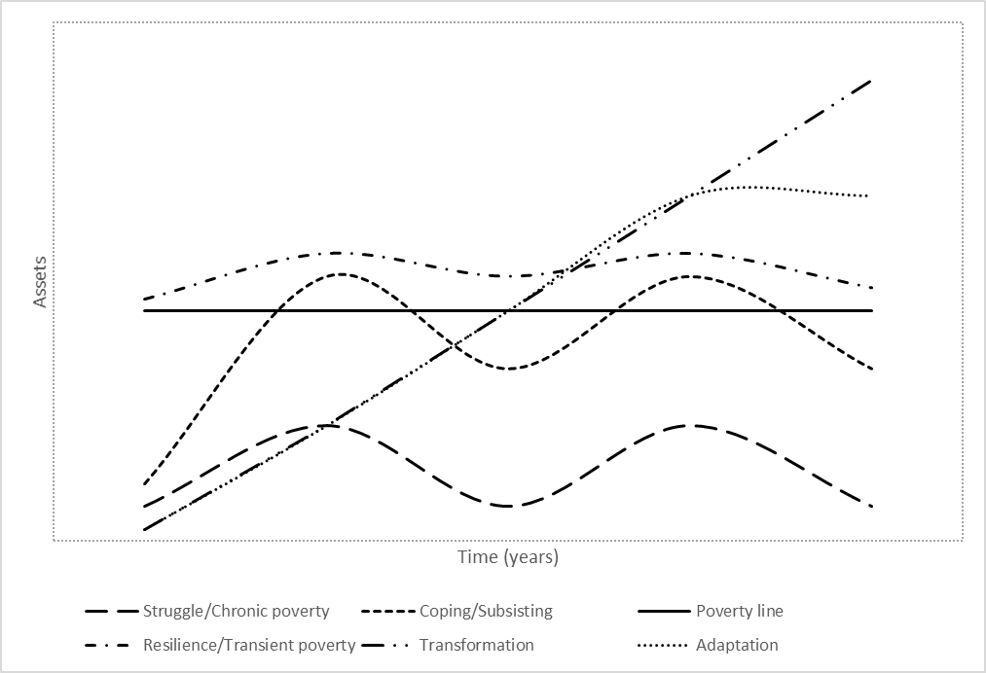
Figure 15- Asset Dynamics Vs Livelihoods Strategies Pathways. Author’s own Work
Figure 15 above provides a basic illustration of asset portfolio over time and how this shapes livelihoods strategies pathways. In the presence of an imaginary level of poverty that meets the essential everyday needs- individuals or households are imagined as subsisting below, oscillating between or subsisting above the imaginary level of well-being. This illustration does not ignore or obfuscate the fact that poverty and well-being are broad concepts beyond meeting basic daily needs (beyond the material needs of people). Taking the description of poverty at its basic level, poverty is described as the inability to access or obtain basic goods and services in relation to income and consumption parameters (Coudouel et al.,2002: Gentle and Maraseni,2012).
An initial asset mix or portfolio suggests that an individual or households can accumulate assets and face upward mobility to an improved livelihood strategy as illustrated in the LSPs above (Fig 15). At a given time period, considering an asset mix or portfolio, prevailing contextual issues and in the presence of shocks/stresses, an individual or household will construct a livelihood through a careful allocation of its assets. Assets vary across time mediated by constraining structures and intersected with shocks/stresses. Over time, the individual or household will negotiate between choices to achieve optimal utility from their asset portfolio. Shocks/stresses have the negative consequence of pushing people below the poverty line downward towards chronic or intergenerational poverty. Favourable conditions promote asset accumulation and push people above the poverty line towards higher well-being. The livelihood strategy pursued by an individual or household will have pathways of asset accumulation and well-being. The figure above also illustrates a critical point at which adaptation reaches a threshold and its marginal returns flatten out and only through transformation will asset accumulation improve.
3.12.1 Climate Change and Asset Dynamics
Climate variability and climate change have increasingly been affecting rural livelihoods (Olsson et al., 2014; IPCC, 2014; Hallegate and Rozenberg, 2017; Turner et al., 2020). Extreme climatic events disrupt lives and livelihoods of millions of people across the world (IPCC, 2014; Hoegh-Guldberg et al., 2018). Changes in rainfall patterns (onset, duration, withdrew) and extreme temperatures erode natural resources such as land, rivers, and forests on which the poor people subsist their livelihoods (Douglas et al., 2008, Bryan et al., 2013; Fahad and Wang, 2018).
Situating climate change in the context of this study, analysis of the climate data (see climactic analysis chapter) demonstrates that the biggest risk of climate change is its impact on rainfall patterns; its onset, duration and withdraw, which have been shifting during period analysed. This shift will translate into poor or low crop yields, loss of livestock, damage to fishing grounds and loss of forest resources. The loss of these common pool assets has an impact on livelihood strategies and well-being as depicted in the LSPs above. Transitions/movements between different livelihood strategies of the LSPs is shaped by seasonal variabilities (rainfall) and asset command. For instance, seasonal deprivation during the lean season is a factor of food reserves from the last season. Inevitably, the ability to recover from seasonal deprivation largely depends on an individual or household’s ability to command assets to construct a livelihood that will in the long term enhance its well-being and transition through the different livelihood strategies of the LSPs. The ability or capacity to recover is also influenced by asset diversity within the household and therefore individuals/households in a state of struggle will face challenges to experience mobility across the LSPs. And thereforeTherefore, those in a resilience livelihood strategy can recover from shocks as a consequent of an asset diversity in their command. Pursuing this line of argument and drawing from Moser (1998) work, climate will change exacerbate poor people’s vulnerabilities; vulnerability is closely linked to asset ownership. “The greater the erosion of people’s assets, the greater the vulnerability. The greater the command and asset mix, the greater the capacity of people to buffer against shocks” (Moser, 1998; 16).
3.12.2 Conclusion
This chapter explored the theoretical and conceptual frameworks applied in this study. It brought together these two frameworks to explore how livelihoods from a rural perspective are constructed. The theoretical framework introduced the concept of livelihoods and sustainable livelihoods; explored the DFID SLF and assets type/asset pentagon. Scholars and practitioners have criticised the livelihoods approach and alternatives frameworks have been promoted Moser (1998; 2006). Asset Based Approach gained traction in development work in view of these criticisms. Section 4.0 of this chapter introduced the Livelihood Strategies Pathways that was conceived out of empirical work of this study. The LSPs integrates assets, livelihood strategies and well-being. The LSPs models how asset portfolios shape livelihood strategies and meets individual/household well-being. Critically, this chapter contextualised the LSPs to the study areas and demonstrated a dynamic relationship between climatic change and livelihoods.

Chapter 4 -Research Design and Methodology
4.0.0 Introduction
Chapter 4 introduces the research design and methods that were applied in this thesis during data collection. The research design and methodology was an integrative conceptual approach situated in the “lived experiences” of the people in the study areas. The “lived experienced” coined by Sale and Thielke(Thielke (2018, P.2), describe qualitative research as “an ongoing process focussing on interpretation and meaning that explores human problems”. Abbot and Wilson (2015) argue that “the lived experience “is the premise within which climate change is understood and interpreted by lay (local) people.
The first section of this chapter introduces the objectives of this study,followed by the study area location. The Study location gives a general overview of each of the three (3) sites. This is then followed by an overview of the research methods applied to answer the research questions. The methods used in this study were informed by an understanding that to delve a deeper and insightful into meanings of people’s worldviews, a researcher has to apply an integrated interdisciplinary approach that incorporates a wide range of data collection tools, which are critically important for purposes of triangulation (Denzin ; 1985; Gilbert,2008 ;Bryman,2012; Cresswell; Silva,2017).
The primary data collection tools used in this research consisted of:
- Semi-structured interviews.
- Elite and key informant interviews.
- Ethnographic and participatory observations and
- Remote Data Collection
This chapter also reflects on issues of positionality, reflexivity, and power dynamics during the entire data collection process. Ethical issues that guided the process of data collection are tackled before examining the methods. The chapter concludes by appraising the document and data analysis.

4.1.0 Aim
The aim of this research was to explore the impact of climate change on livelihoods in the Barotse Flood Plain of Western Zambia. In order to achieve this objective, the thesis assesses shifts/changes and trends in rainfall and temperature in three areas (Lealui, Nanikelako and Sefula). The goal is to explore the evidence of change and trends in rainfall and temperatures, and how these translate into people’s livelihoods in the study areas.
4.1.1 Research Objectives
- Assess climate variability and change through Meta data analysis of rainfall and temperature changes/trends.
- To Compare and contrast local observations against scientific analysis of rainfall and temperatures as set out above.
- To explore the plurality and diversity of rural livelihoods strategies that households or individuals pursue in response to climate change and variability.
iv. To examine the types of assets bundles that individuals and households draw on to construct their livelihoods, the adaptive measures pursued within and between individuals or households, and how these are shaped by climate change.

4.2.0 Background Literature
This chapter consolidates this thesis’ earlier discussions by building on the theoretical and conceptual frameworks on which the thesis is anchored. Chapter 4 was bridged to meet the empirical objectives of this thesis. This chapter was the pathway to the investigation of “the lived experience“of people in the study areas and to draw meaningful inferences in subsequent discussions. From the foregoing, this study adopted a mixed methods research (quantitative & qualitative) because it accorded for an adequate exploration of the scientific climatic data and local people’s interpretations of their livesexperiences of these perceived changes (Collins et al., 2007; Teddie ,22009; Silva2017). Silva (2017) adds that research cannot mirror or replicate the image of the social world; however, it opens access to meanings people draw or place on their experiences and social world. Therefore, to fully understand/grasp the effects of shifting climatic conditions in the study areas, it was imperative to integrate the two approaches: merge numerical data and people’s narratives using a two-lens perspective. Central to two lens perspective is that people’s perceptions of climatic changes can be “tested or modelled“for correlations through numerical analysis (Shao and Goidel, 2016). Studies have demonstrated that people’s perceptions of shifting climatic conditions often correlate with scientific climatic trends (Savo et al., 2016; Rapinsk et al., 2018; Reyes- Garcia et al., 2019). Other studies, however, have also demonstrated differences in trends between climatic trends and people’s perceptions (Abu et al., 2019). Quantitative and qualitative methods have limitations when applied in isolation; therefore, these limitations in scientific measurements and people’s perceptions can be integrated through a “two-eye” approach (Bartlett et al., 2012). The “two-eye” approach offers an intelligent way of narrowing gaps between scientific data and people’s perceptions (Bartlett et al, 2012; Haag et al., 2021).
4.3.0 Research Location
The Barotse floodplain,14°19'~16°32'S and 23°15'~23°33'E(see study area map) also referred to locally as Bulozi Plain, is the second largest flood plain in Zambia (Chomba and Nhata,2016; Cai et al.,2017). The floodplain is in the Western province of Zambia sharing a border with Angola (Cai et al., 2017). The Barotse floodplain is a seasonal vast expanse of water which is 160 kilometres long and at its widest point extends up to 60 kilometres (Flint and Monde,2006; Chomba and Nhkata,2016). The floodplain covers an estimated areas of 5,500KM² and 1.2 million hectares of wetland (Chomba and Nhkata,2016; Cai et al,2017). The Barotse floodplain is inundated with water from the Zambezi River and its tributaries for about 3-5 months, from late December to end of May (Cai et al., 2017; Zimba et al., 2018). Inundation of the plains is largely influenced by rainfall characteristics in the upper catchment and stream flows from the uplands (Baidu-Forson, 2014)-refer to figure 1 and section 1.2.0.
4.3.1 Justification for case study approach
The motivation for this study was anchored on the need to explore the impacts of climate change and how this is reshaping livelihoods in the Western province of Zambia. Case studies are most appropriate when exploring one or multiple cases, each case is studied as if it is singular and then compared to others (Starman 2013; Clark et al, 2021). The areas offer a special case for investigation each offering unique, contrasting features and contextual problems. Through a case approach, this study undertook an in-depth exploration of the diversity and uniqueness of each study area, exposures same climatic events, natural resources endowment, access to infrastructure, markets and livelihood dynamics. As indicated in the earlier discussions in this thesis, the main livelihoods in the study areas are subsistence farming, fishing, livestock herding, harvesting and collection of Non-Timber Forest Products (NTFPs) which are all vulnerable to the impacts of climate change (Olssen et al.,2014). NTFPs include wild vegetables and fruits, medicinal plants, wild meat, reeds, tubers and others. The three study sites were selected for the following reasons:
- Lealui, the main residence of the Litunga King of the Lozi People is a powerful cultural symbol of the Lozi people and the “nation” of Barotseland. Lying slightly on an elevated position in the flood plain, it overlooks the vast expanse of the Barotse Flood Plain. Most of the land is normally flooded during the flood season. Lealui has good road access to the urban areas of Mongu and Kalabo further west. With land use restrictions and grazing pastures preserved for the King’s livestock, agricultural activities are limited to small land portions mainly that surrounding people’s homes.
- Nanikelako is a remote area that lies further in the interior of the flood plain. During the flood season the entire area is flooded. Villages are sited on man-made hills (Mazulu) and navigation during the flood season is by canoes. There are no schools or health facilities in Nanikelako. The soils in Nanikelako are sandy and not suitable for agricultural activities. Livestock keeping is the main occupation in Nanikelako,with the vast expanse of the flood plain providing good grazing lands particularly during the dry season.
- Sefula-Lies South-west of Mongu along the tarred Mongu-Sesheke road. Sefula lies on the upland overlooking the low-lying flood plain. Sefula has schools both primary and secondary and health facilities. Sefula is one of the biggest rice growing areas of the Western province. With access to irrigation systems farming activities including growing of vegetables are done throughout te year.
Having given the background of the study areas, the next section considers ethical issues of positionality, reflexivity and power dynamics.
4.4.0 Positionality, Reflexivity and Power Dynamics
According to Bourke (2014) research is shared space that is influenced by both the researcher and the research participants. Therefore, it goes that the researcher and the participant have the potential to shape the research process. Bourke (2014) argues that both parties will identitify into play through perceptions. Bourke (2014) further adds that people’s biases shape the research process, and it is through the recognition of these biases that insight can be gained into how to approach a research setting, interaction with communities and how to engage with them. Kezar(2002, P.96) posits that “within the positionality theory, it is acknowledged that people have multiple overlapping identities.” Therefore, people make meaning from various aspects of their identity (Bourke, 2014).
Wolfe (1996) posited that a researcher’s positionality is situated within a social hierarchy vis-à-vis other social groups and individuals in relation to class, gender, race, ethnicity and culture each of which has the potential to limit or broaden a researcher understanding of others. Wolfe (1996) and Hertfeld (2020), argue that “embodied subjectivity “and positioned knowledge shapes how completely a researcher can understand and carefully interpret local phenomena. Positionality plays an important role in research when engaging with participants in the field (Hall, 1990; Bourke, 2014). Anthias (2002, p.501), defined positionality as “placement within a set of relations and practices that implicate identification and ‘performativity’ or actions”. Anthias (2002) adds that individual researchers enact (through performativity) and experience (through social positioning by others) positionality in pathways that transition within the multitudes of social contexts and structures. Holmes (2020) refers to the term positionality as an individual’s world view and the subsequent position they take or /adopt in pursuance of his or /her research objective(s). A researcher’s worldview is influenced by several factors including their ontological and epistemological orientations and to greater extent the way they interact with the environment. According to Roberts (2001), the most important consideration in qualitative research is the question whether the researcher operates as either an “insider” or “outsider” in the context of research. The most dominant assumption argued about this dualism has been that the researcher adopts a neutral position (Roberts, 2001).
While conducting this study and through the everyday interactions with the communities in the study area, I was acutely reminded and constantly mindful of my position of privileged as a researcher. As an “outsider”, this status accorded me an easy access to the communities because my local contacts and guides had already “spread word” beforehand. Paechter (2012) advances that traditionally, researchers employing ethnographic studies have been taken as “outsiders” who journey into another culture and attempt to understand its important features through participation. Being a Zambian and able to speak the local language was advantageous for the creation of rapport and building of trust. Being an “outsider” had its own challenges some of which were the suspicions and mistrust of “outsiders” and the intentions of this research. This suspicion meant that I was not able to record the interviews to allay notions of suspicion as a way of gaining people’s trust. I was in a transitory mode-shifting and negotiating between a myriad of vantages of being a “foreigner” and “Zambian”, which Wolfe (1996) referred to as “mobile subjectivities “.
However, Scheyvens and Stoney (2003) contest that the debate about “insider-outsider” is redundant and emphasised that researchers pay particular attention to the understanding of historical or cultural specificities as well, thereby creating openness and honesty while undertaking their research. Scheyness and Stoney (2003) posit that it is far more beneficial to cultivate such capacities than preoccupation with the insider-outsider status. They stress that even experienced insider researchers encounter obstacles due to differences in class, education, social status, and race and gender while undertaking their research. “Where outsiders have the advantage of being detached from the field, an insider must learn to manage the influence of being the researcher and the researched” (Bettez, 2012). Paechter (2012), argues that even researchers who start as “insiders” can find the research process challenging. “Insider” and “outsider” positioning require self-introspection in relation to the entire research process (Ellis, 2011; Paechter,2012)
Reflexivity, according to Fook (1999, p.11), refers to a process of reflective practice to examine the research process-“it’s an ability to locate oneself in a picture”. Turner (2010) refers to reflexivity as “self-critical introspection “. What can be inferred from Fook and Turner’s (1999) definitions is that a researcher should be attentive to his or her own background experiences, knowledge, and social status that might interfere with aspects of their research process. Conducting research in areas where poverty, deprivation and marginalisation are endemic as is the case in this study area, I was reminded of my privileged position. The urge to help these people living in conditions of chronic poverty was overpowering, which would have been in conflict as a researcher. My desire to be detached was acutely challenged within myself-conscious as a development worker who is opposed to all kinds of suffering, inequality and injustice perpetuated by political and traditional leaders.
Navigating and negotiating through this complex and conflicting web of positionality, ethical tensions and dilemmas came into sharp focus when the researcher went to visit a local chief as part of his data collection. It took him a few weeks to fix an appointment with the chief. When the appointment day was finally fixed, it made the researcher and his local guide to make a journey of 3 hours each way. They took public transport to get a roadside junction, where they then had to walk to get to the chief’s palace. From the road junction, it took them an hour, walking through narrow forest paths, in temperatures of nearly 35⁰C. As they walked through the forests, the only sounds they could hear were their own footsteps as they stepped on dead plant leaves and the chirping of birds. It was an extremely hot day and the researcher recalled thinking, “when are we going to get there?” and for a moment he thought it was not a wise idea to walk for such a long distance in such a dense forest. When they finally got there, the researcher’s thoughts were hesitant of walking through the forest again.
They met the chief and were welcomed and served with glasses of a local drink (munkoyo-a drink made of fermented corn meal and then mixed with roots of local trees). The chief walked us through his village, showed us his herd of cattle and his fields of rice, maize and cassava. Most of the crops were withering due to a prolonged dry spell (see narratives chapter 5). We discussed a broad range of issues focussing mainly on changing rainfall patterns and impacts on livelihoods in the study areas. The Chief made the following notable remark:
“This year has been very challenging, we had some rains at the start of the rainy season and people planted. From end of November, we have not had many rains and the crops are drying. If the rains do not come any time soon these crops, we completely die out. We are not sure how will survive as they we do not get much support from the government “.
Then came the decisive moment; the researcher was filled with tension and apprehension. We were served with some plates of food that had been prepared by the chief’s wife. The ambiguity and personal challenges were “should I be eating the food as a researcher?” – “how do I maintain distance and at the same time appreciate the culture of the research context?” As the researcher and his guide were sitting in the glass-thatched dining room, the guide looked at the researcher and said, “Please we have to eat this food or else we will spoil everything we have done today.” He said, “The most disrespectful thing you can ever do is refusing to eat food prepared for you as a guest”. With a sense of conflicted emotions, I reluctantly agreed to eat the food.
Several qualitative researchers have documented and theorised about the complexities of situations of strife and confusion (Bettez, 2012; Olukotu et al.,2021; Secules set al.,2021). Other scholars have reflected on personal encounters of challenging situations they had to navigate through while conducting their qualitative research (Subreenduth and Rhee; 2010; Nazneen and Sultana, 2013).
The next section examines the ethics that guided the entire research process. The ethical application was two pronged; one from the University of Sheffield and the other from the University of Zambia’s Ethics Committee, which approves international applications. In the first instance, the researcher got ethical approval from the University of Sheffield as the home institution. The ethical approval was “amended “to incorporate other data collection tools due to the face-face interviews restrictions that were imposed due to the Covid-19 pandemic.
4.5.0 Ethical Considerations: Confidentiality and Privacy
The nature of qualitative research through the everyday personal interaction between the researcher and the participants poses challenging ethical concerns for both the researcher and the participants (Guillemin and Gillan, 2004; Sanjari et al., 2012). Sanjari et al. (2012), stress that the researcher must always be aware of the potential negative impact of their research on the participants through the questioning and other interactive activities in the research context. It is critical that the entire research process does not cause participants any form of harm to the participants. Guillemin and Gillan (2004), posit that whenever research is designed and conducted, human beings must be at the centre of the process. Caution is placed on kinds of repeat and long-term interviews where the researcher and participants could easily build a relationship and intimacy.
The researcher took cognisance of the importance of maintaining respect and privacy in all his conversations. He also ensured the discussions were truthful. Every effort and care was taken to ensure questions asked were non-intrusive and did not trigger any feelings of disrespect towards the interviewees. The researcher avoided giving any room for misrepresentations and misunderstandings; the two research assistants, who were competent in native language and were familiar with the local culture, were locally recruited. Informed consent was sought through the provision of the consent forms and study information leaflet as were approved during the ethical application stage (see appendices). The participants were assured of confidentiality and made aware of the purpose of the study; how the information will be collected and used. All the data collected was secured and anonymously coded. I took cognisance that I was talking to elderly people and that I was taking their time; therefore, interviews were conducted on agreed time limits.
This section discusses the methodological tools that were employed during the research process including the strategies and the justification for this approach. It details how the research participants were drawn-up and accessed. It also details how each method was deployed to address the research questions.
4.6.0 Methodological Tools: Strategies and Rationality
4.6.1 Secondary Data Sources
The use of secondary data sources, sometimes also referred to as documentary analysis, involves the examination of documents that contain or may contain information about phenomena one wished to study or is already studying (Bailey, 1994: Daas and Beukenhurst, 2008). This is essential to the supplementary of data or information that is collected from primary sources such as focus groups and in-depth interviews (Scott, 1990; Mogalakwe, 2009). Creswell (2009) and Johnston (2014), describe secondary data analysis as a systematic and methodological procedure designed to apply theoretical knowledge and conceptual frameworks through the utilisation of existing data to address the research question.
According to Hinde (2020), the examination of current and historical records and documents is of particular importance to qualitative research exploring social-political and economic phenomena. Hinde (2020) contends that to fully understand temporal contextual historical and emerging issues, it is essential that a researcher benefits from a broad range of sources to identify facts and have a clear understanding of key issues. Secondary data provides a researcher with another lens to for the understanding, extraction, and the interpretation of the connected or unconnected issues at the core their study (GHR and Aithal,2022) b.
During this process, I gathered and analysed a wide of published and unpublished literature cutting across a wide area of disciplines. These disciplines covered subjects that touched on climatic trends in Zambia, Poverty trends in the Western province of Zambia, Livelihoods, the History of the Barotseland among others. The justification or rationale of the application of secondary sources for this was based on the understanding that rural livelihoods are shaped by a complex interaction of culture and traditional norms, economic and political processes that are bound in historical roots that cannot be fully and or solely interpreted from empirical research alone.
4.6.2 Sources of Secondary Data and Historical Records
The documentary sources accessed consisted of those from public institutions and private sources. The secondary data sources used in this study consisted of Government Policy Statements and Reviews, Civil Society (NGO) Strategy Papers, Project Reviews, and Annual Reviews.
A systematic and thorough examination of documents shaped the background data that helped to me to appreciate the socio-cultural, socio-political, and economic context, which influenced people’s livelihoods. Documentary sources were useful for grounding the research in the context of climate change and other factors key to the research question. Aside from drawing richness into the research process, documents were particularly crucial for exploring discourse divergences between Government publications, Civil Society and International Aid Agencies. Information generated from documents was applied in formatting interview questions, follow-up questions and pre and post interviews including providing pointers to activities or events that needed to be observed in the field.
4.7.0 Mixed Methods: Qualitative and Quantitative tools
This study employed a mixed methods approach that is quantitative and qualitative methods to meet the objectives of this study. Mixed methods involve the collection, analysis, integration of findings, and drawing conclusions using both quantitative and qualitative tools (Cresswell.2003; Brewer and Hunter, 2006). Quantitative methods were applied in the exploration of rainfall and temperature trends during the study time (1981-2019); this was to assess whether there have been any changes in rainfall and temperature in the study areas. The qualitative methods were employed in drawing people’s understanding of these climatic trends, their impacts, and response strategies. Qualitative research recognises that the socially constructed nature of reality , which is embedded intimately in the context of a study (Yates and Leggit, 2016). Mixed methods are appropriate when no one single method can adequately answer a research question (Tobi and Kampen, 2018). The application of mixed methods accords the researcher a chance to deeply and accurately understand and draw valid conclusions of the nature of the phenomena under study (Lisle, 2011; Almeda, 2018).
4.7.1 Quantitative Methods
The quantitative methods applied in this study are discussed in the chapter that analyses rainfall and temperatures. The methods involved analysing large number of data sets; carefully checking the degree to which the analysed data and observations are consistent. This process also included exploring the degree to which there is correlation between the different data sets using different tools. Using different software packages, Advanced Excel and L- Programming, numerical data was manipulated using formulas and coding to assess climatic trends and answer the question if these trends point to climate change or seasonal variabilities. The most important methods used to calculate trends and rate of change, in both rainfall and temperatures in the study areas, were Mann Kendal and Modified Mann Kendal Tests and Sen’s Slope Estimator.
In this study, trend analysis for both rainfall and temperatures were conducted by using non-parametric Mann-Kendall test. The purpose of analysis is to investigate whether values of the data sets are trendless, increasing or decreasing (Da Silva et al., 2015). Non-parametric trends require that data sets be independent and give tolerance for outliers in the data. Parametric tests on the other hand require that the data be independent and normally distributed and for this case are not suitable for the analysis climatic data that is highly variable data (Hamed and Rao, 1998). MK trend detection was originally conceived by Mann-Kendall as a non-parametric test for trend detection (Mondal et al., 2012; Sa’adi et al.,2019).MK is widely applied in meteorological analysis as a statistical approach to assess for spatial and temporal trends of hydrological a temperature series. Non-parametric tests are preferred because they eliminate the problem of skewing data (Hamed and Rao; Mondal et al., 2012).
Sen’s Slope estimator was conceptualised by Sen (1968). Sen’s Slope Estimator (SSE) is also a non-parametric statistical tool for estimating the slope (steepness) of a trend in a sample of data set. The estimator asseses the magnitude of the trend and its variance (Da Silva et al., 2019). A positive slope of the value SSE indicates an upward trend or an increasing trend in the time series. A negative slope of the value of the SSE on the other hand suggests a downward or decreasing trend in the time series (Pohlet, 2016; Panda and Sahu, 2019).
The use of the statistical tools above is aligned with the aim of this study; that is to determine if there trends or changes in the climatic data (MK/MMK) and determine the magnitude/size including the trajectory (SSE). Detailed and comprehensive analysis of the climatic data is in chapters 6 focussing on rainfall and 7 on temperatures.
4.7.2 Qualitative Methods
The singular application of numerical data cannot capture the lived experience of people (Collins et al., 2007). Driven by the desire to understand the everyday lived experience of the research subjects, this study adopted qualitative interviewing techniques as an instrument for data collection. The lived experience of people and their reality under relativism can be shared meanings through individual lenses and perception (Walsham, 2006). Social constructivism argues that individuals and or collective groups seek understanding of their world and develop subjective interpretations and thereof meanings of their experiences towards certain phenomena (Borman et al., 1985; Argent, 2019). Drawing from this epistemological vantage, I investigated the complexity of views and multiple interpretations of climate change and its impact of livelihoods from the real world of the research subjects rather than from the scientific biophysical viewpoint.
I took cognisance of the fact that often-qualitative research has been charged with being not able to avoid the infusion of personal impressions or descriptive accounts of the researcher thereby, preventing the avoidance of biases from data collection and analysis (LeCompte and Borman et al., 1986; Lune and Berg, 2017). To close in on their ‘story’, there is always a lingering temptation by qualitative researchers to lose objectivity altogether and fall prey to “going native” (Bergman, 2008). However, I argue that the use of quantitative analysis alone cannot sufficiently explain people’s understanding, perceptions and interpretation of events that surround them.
4.7.3 Interview Techniques
Kvale (1983, p.174), defines a qualitative research interview as “an interview whose purpose is to gather descriptions of the lifeworld of the interviewee with respect to the interpretation of the meaning of the described phenomena.” The purpose of research is to extract relevant information from the research participants that is centred on the evidence to be generated for achieving the research objectives of describing, predicting, and interpreting the phenomena” (Cohen and Manion, 2007, P.12). Therefore, qualitative interviews serve as a rich source for the exploration of people’s inner- feelings and attitudes (Hitchings and Latham,2020). Fraenkel and Wallen (2003) and Taylor (2005) posit that interview techniques play a critical role in social research because they facilitate for an in depth and holistic descriptions of an activity or situation.
Interview techniques can be structured and sometimes they are also be referred to as standardised or unstructured (open) (Schimdt, 2004; Kallio et al., 2016). The goal of a structured interview is to generate data that is amenable to quantitative analysis (Murphy and Dingwall, 2003). The relationship between a structured or standardised and unstructured interview can be visualised as a continuum along which a researcher seeks to be in control to greater or less extent of the interview process (Murphy and Dingwall,2003; Brinkman,2014). An unstructured or informal interviews on the other hand most often used in ethnographic research, are the opposite of the continuum, where the researcher and the interviewee are engaged in an interactive two-way exchange as conversing partners (Geertz,1973; Bryman,2016). Data generated from unstructured interviews is a product of an open process that pays particular attention to reflexivity and subjectivity. Not only is this data “thick” and “deeper” but most important is a result of an interactive accomplishment in which researcher and interviewee are collaborators in the “story making” (Geertz, 2012).
A balance had to be stuck between facilitating a natural and open interaction between myself as a researcher and the research subject, and the need for cross comparison in the three case studies. Therefore, it was necessary to maintain consistency in the structure of the interview techniques hence the use of semi-structured interviews. Semi-structured interviews accord reciprocity between the interviewer and participant. The most critical thing about it is that it enables the interviewer to improvise and make follow-up questions that are shaped by the respondent’s response (Polit and Berk, 2010; Galletta, 2012).
The following section gives insight into the core data collection methods that were used in this study. More details are integrated in the discussions of the irrelevant chapters and are also included in the appendices. Collection of data was initially envisioned to be conducted in two stages to capture how seasonality (wet and dry season) shape livelihoods in the study areas and to capture how livelihood strategies transition between the two seasons. The two-stage period was also envisaged to reflect seasonal variation in livelihoods and asset/resources use. The first stage of data collection was conducted between October 2019 and February 2020. The second stage was initially postponed and cancelled altogether due to the global disruption caused by the outbreak of the Covid-19 pandemic.
The data collection methods used during this stage were semi-structured interviews, elite/ key informant interviews. They were conducted sequentially and concurrently with ethnography and participatory methods through everyday interactions with study participants and members of the community in the study areas.
4.7.4 Qualitative Tools
4.7.5 Household Semi-Structured Interviews
A test semi-structured interview guide was employed to 5 people prior to it being administered in the study areas. The feedback from the responses of the test interviews was used to revise and refine the final interview guide. The interview guide integrated the core questions of the study, thereby providing a structure for the discussions during the interviews (Taylor, 2005). The questions in the interview guide were not strictly followed allowing for variation and flexibility in the order of questions (Mason, 2004). One similar interview guide was used in all three study areas to explore the study areas by gathering similar types of information, while at the same time taking in account spatial contextual factors (Wheeler, 2010). The final semi-structured interview guide consisted of twenty questions which were supplemented by follow-up questions during the interview process.
The core questions of the interview guide focussed on knowledge and attribution of changing climatic regimes; the core livelihood strategies in the study areas; how the changing climatic regimes were impinging on the people; and the coping and response strategies that were deployed. The interview guide also composed of questions related to external interventions such as government support and NGO programmes designed to mitigate the impact changing climatic patterns. The questions were asked in Lozi language. However, during interviews, some of the participants switched between Lozi and English languages. 20 household or individual semi-structured interviews were conducted out of the 30 planned.
Acknowledging that information generated during household interviews can be influenced by recall and people’s reconstruction of past events, it was essential to complement this view through elite or key informant interviews (Willis, 2006) and as a method of triangulation (Denzin, 1995).
4.7.6 Elite and Key Informant Interviews
In-depth elite and key informant interviews were utilised to capture information that could not have been captured using semi-structured interviews (Arthur & Hilhorst, 2011). The researcher engaged with actors at a macro and micro levels with knowledge and experience of the issues of critical importance about the people in the study areas and the surrounding localities. Elite interviews are critical for generating crucial detailed data from individuals and groups who have knowledge and experience in their professional fields and local issues (Denscombe, 2012; McKenna and Main, 2013). Key informants are important for gaining understanding into livelihood activities, local traditions and culture McKenna and Main, 2013). Key informant are very helpful in trying to understand why people do certain things and why they do not; they are excellent avenue for exploring people’s behaviours and response to certain events (Marshall, 1996; Rapport & Overing,2003) . Traditional leaders were very insightful in using oral historical testimonies that traced changing rainfall and temperature trends, local traditions and culture that shape livelihoods, common pool resource use and access, cropping systems, and other socio-economic trends. Oral testimonies were invaluable for the understanding of socially differentiated perceptions and understanding and knowledge about changes in livelihoods and aspects of the physical environment within each study locale. Oral historical testimonies are an important ingredient to indigenous knowledge (Agrawal, 2003; Green & Raygorodetsky, 2010). A combined total of twelve elite and key informant interviews were conducted- Seven elite interviews (experts) and five a selected number of communities leaders.
4.7.7 Recruitment of Elite & Key Informants
Key informants act as instruments of access to people and information; they act as ‘local experts’ and local guides explaining contextual issues to an outsider (Bernard, 1995a). During this study, the identification and recruitment was conducted through recommendations from the Mongu City Council officials and everyday interactions with people including snowballing. The selection of these key informants was then narrowed down to people who held formal or informal positions in their communities or groups and most significant those with knowledge about themes centred on the research objectives (Kun et a.,2013;Lokot,2021). A distinction was made between expert and local key informants. Payne and Payne (2004), state that expert key informants are those who hold specialist knowledge in their professional fields and hold formal positions in the research context. Payne and Payne (2010), describe local key informants, whose social positioning in a research context accords them to possess specialist knowledge about other local people, happenings and activities that is more detailed and extensive that ordinary people. Precaution was exercised based on the premise that key informants represent a sub-stratum of a specific community or group. However, their views maybe subjective, not always representative and reflective of the groups they represent (Morris, 2009; McKenna, 2012). Morris (2009), adds further that “seeking the truth” is best done through everyday observations and interactions with participants in the field rather than reliance on the subjective interpretations of key informants.
4.7.8 Ethnography and Participatory Methods
Along aside engaging in semi-structured and eliten or key informant interviews, the researcher took part in participatory observations activities that included community meetings and civil society workshops or seminars hosted by local Non-Governmental Organisations. The researcher attended a Constituency Delimitation Consultative meeting intended to generate views of stakeholders at the Provincial, District, and Constituency level in Western province. The main stakeholders present at the meeting were local communities, government officials, technical experts and members of the Barotse Royal Establishment (BRE). The process of boundary delimitation and demarcation has always proved to be a contentious issue not just in this region but also across the country because it is centred on land issues. The researcher was very much interested in listening to the views of the stakeholders in relation to the boundary making practices and understanding the dynamics among the various actors involved in the process. The researcher was also interested in gaining insight into how they negotiated their conflicting visions of the outcomes of the exercise. The researcher attended two other workshops that were hosted by Action-Aid Zambia and Civil Society for Poverty Reduction. The thematic discussions at these two forums were centred on issues of governance at national and local levels. It was through the engagement with NGOs that the researher got wind of the contentious Farmer Input Support Programme (FISP), a farmer support programme by the Government. FISP was a recurrent theme in most of the workshops the researcher had attended; littered with allegations of mismanagement, corruption and as an instrument of political patronage. As highlighted in the following, FISP and other similar poverty reduction programmes by the Government are characterised by poor funding and lack of transparency.
Participant observations were central to the contextual appreciation of the local environment and developmental issues. The researcher took transect walks, with his local guide, of landmarks of special interest such as the Mongu harbour, the Zambezi River, and local markets.
4.7.9 Recruitment of Interview Participants
There is a wide variation in the ways of sampling procedures strategies and goals in qualitative research (Coyne, 1997; Abrams, 2010; Vogt, 2011). Qualitative scholars have argued that ‘purposive sampling also sometimes referred to as ‘judgemental sampling’ and ‘theoretical sampling ‘are the common categories of sampling strategies in qualitative research (Curtis et al., 2000; Marshall, 1996). According to Abrams (2010), purposive sampling is a strategy where the researcher exercises judgement and flexibility in determining who is best suited to giving perspective on the phenomena of the research interest and in eliciting data that answers the research question. Based on that judgement, the research then draws up a frame for capturing the target participants (Abrams; 2010; Tongco, 2007). In theoretical sampling, which is anchored on grounded theory, sampling procedures are developed based on the characteristics and categories of issues that emerge during the activities of data collection and analysis (Strauss and Corbin, 1998). It has been argued that the two approaches are different. However, one would argue that the differences between them are difficult to pull apart. The theoretical foundations of theoretical sampling to a greater degree involves the application of judgement by the researcher during the process of sample selection (Curtis et al., 2000). In the same token, purposive sampling strategies are often well pre-planned during the framing of the research just like theoretical sampling (ibid).
Based on the foreground, it was necessary to decide on the sampling strategy to use in the study. The researcher faced the challenge of how-to best benefit from different sampling strategies and elicit comparative data sets from the three study sites. The decision was further complicated by the fact that one of the study sites, Nanikelako, could be described as “hard to reach” (Abrams, 2010) due to its remote location and inaccessibility by vehicles. As Patton (2002), commended that to benefit from the use of broader methodological genres researchers can use several techniques to achieve their overall sampling goals.
Using a contact at Mongu City Council, the researcher was given a list of Councillors from the Council who acted as gatekeepers to the study sites. Initially the researcher was able to enlist five participants from Lealui who, in his judgement, were engaged in similar livelihood strategies and shared experience of local issues in Lealui. In small and close-knit communities cultures tend to be collectivist and homogenous (Hall, 1976; Lavoie and Lavoie, 2016). Everyday interactions and livelihoods are shaped by social rules and expectations that are embedded in the social fabric (Hall, 1976). The researcher’s goal at this stage was to gather detailed pattern of livelihoods and contextual interpretations of changing climatic regimes. From then on, the researcher was able to use other techniques such as snowballing to access and recruit other participants into my data collection. The researcher replicated the same pattern of accessing and recruiting research participants in the other two study sites.
4.8.0 Remote Data Collection Methods
The entire data collection for this study had been planned as a two-phased approach. This was intended to capture the wet or rainy and dry season. The aim of this two-phased approach was to explore and contrast the different livelihoods strategies between the two seasons. The wet season was specifically designed to explore the processes and factors that shaped livelihoods during the wet season; household decision making in relation to asset deployment during preparation of the rainy seasons; types of local and external support available or accessed by households (weather information, family networks, seed or fertiliser support); assets redeployment in face of shifting climatic patterns.
The dry season and its post-harvest season data collection phase was intended to explore how and what factors shape households’ decisions regarding the harvest; asset accumulation or re-investment after the harvest; and in times of crisis or poor yields, households’ response strategies, asset smoothing during the lean season.
However, due to the outbreak of the Covid-19 global health pandemic, the second stage of data collection could not be conducted. The University of Sheffield in line with UK Government’s Covid-19 guidelines stopped all data collection methods that required face-to face interaction. In order to change from face-to-face to remote data collection an ethics “amendment “was applied for (see appendix). Rodham and Gavin (2006) assert that when conducting online research, major ethical issues are no different from those applied in traditional data collection approaches. However, Khalil et al. (2021) contest that telephone interviews present with a different set of ethical challenges including issues of consent, confidentiality, and data quality among others.
“Qualitative researchers face unique opportunities and challenges as a result of the disruption caused by the outbreak of Covid-19. Although the pandemic represents a unique opportunity to study the crisis itself, social distancing mandates are restricting traditional face-to face-investigations of all kinds” (Lobe et al., 2020, P.1; Teti, 2020). Teti et al. (2020), argue that the Covid-Pandemic is a social event, which is disrupting social order. Teti et al. (2020), stress that there is need for researchers to investigate the “lived experience” of people while at the same time public health mandates and social distancing measures are limiting the ability of researchers to explore their research interests. Researchers pursuing research requiring face-to-face data collection methods were forced to transition or adopt other forms of data collection methods- internet based or phone-based applications (Kobakhidze et al.,2021).
In view of the foregoing, to continue with the study and capture more data. The researcher adopted remote-based methods and used the telephone and internet-based techniques. Fogel et al. (2018), posit that in remote based interviews the researcher and the research participants do not need to deal with issues of travel, distance and safety. However, research demonstrates that remote based data collection techniques can face technological challenges. Technological challenges include reliable internet connection, telephone signal and access to computers or mobile phone (Deakin and Wakefield, 2013; Fielding et al; 2016; Lobe et al., 2020). Remote data collection methods suffer from impersonality of the interview process; it can be difficult to create rapport with the interviewee(s) and the lack of body language can pose challenges (Weller, 2016; Khalil et al., 2021). Torrentira (2020), argues that the nature of qualitative interviews requires a high level interaction between the researcher and interviewee; whereby the interviewee opens up to a free two-way conversation and the researcher engages into exploring the research questions. Weller (2016), adds that rapport is often regarded as an ingredient for the minimising of social distance and the cultivation of trust critical to the candid disclosure and thereof the richness of the stories narrated by participants. This study used largely used WhatsApp mobile and video to conduct the refined second stage data collection.
4.8.1 WhatsApp
WhatsApp messenger is an internationally available American freeware cross-platform instant messaging and voice –IP secure service by Meta platforms. Meta Platform report that their freeware is encrypted end-to-end; meaning it is a very secure tool to use in research (www.whatsapp.com/features). Some its features such as text messaging, image and video sharing are attractive to researchers conducting remote interviews (Dar et al., 2017). The free availability of WhatsApp and the simplicity of its user provided an alternative to face-to-face. However, the researcher was cognisant of the potential challenges of using it due to the rural nature of the study areas with unreliable internet and mobile signals in the study areas. Equally challenging were the cost factors of ensuring that interviewees had mobile phone credit. Another consideration was access to power for interviewees to have their mobile phones charged considering that there was power rationing in Zambia.
4.8.2 Approach and Conduct of WhatsApp Interviews
The reasearcher set out to make follow up interviewees with twenty study participants covering all the three study areas. However, due to several challenges including internet signals and access to mobile phones, the researcher only managed to interview eight. The researcher made monetary contributions towards the cost of mobile credit to ensure that interviews were conducted.
Re-connecting and re-establishing rapport with the interviewees was easy because the researcher had prior interaction with them during the first stage of data collection. Speaking the local language was equally handy in trying to break the ice after a few months of no contact. There was an uneasy and uncomfortable question as to why the researcher had not been able to travel back to the study sites as promised during my first field trip. It was uncomfortable to justify why the researcher was unable to travel to Zambia particularly that in the case of Zambia, lockdown measures were not in place when the UK was in a total lockdown. These issues were challenging to address because the interviewees referenced the idea “the researchers only collect data and then abandon the study after data has been collected” (Clark, 2008; Neal, 2015). However, with an honest and respectful conversation the interviewees were accommodating all my explanations.
The scheduling of interviews took in account time differences between Zambia and the UK (2 hrs difference in UK Wintertime and 1hr difference in UK summertime). The researcher took cognisant that he was taking the interviewees’ time that they could use to engage into livelihood activities. Therefore, the researcher made a compensation for this time. For purposes of confidentiality and privacy, a careful consideration for the presence of other people in the house/place when the call was made was noted. To comply with research ethics and maintain privacy, an interviewee had the liberty to proceed or refuse to proceed with the interview. However, on all occasions the interviewees chose to proceed with the interview at times even in the presence of other people who were not necessarily part to the interview. On such occasions, great effort was made in ensuring that no personal questions were asked. The interviews focussed on broad themes of livelihoods and climatic changes. However, it was possible that the presence of other people might have influenced how the interviewees responded to the questions. On one occasion, the researcher could hear a voice in the background attempting to answer a question that he had posed to an interviewee. In this case, the researcher had asked an interviewee if they had accessed farming inputs from the government during the last farming season. The answer from the background was “no, they never brought anything here as always”. This reflects one of the challenges of remote interviews; that invisible people in the background can potentially influence an interview (Dar et al., 2017). According to Hensen et al .(2020) , remote interviews shift responsibility to the interviewee to establish privacy which can be difficult when study participants share a living space and have limited space or time.
4.9.0 Document Analysis
Document analysis is a key process in qualitative research that is often applied in combination with other techniques as a means of enhancing triangulation (Denzin, 1970; 1985). Eisner (1991, p.291), argues that by triangulating data a researcher “attempts to provide a confluence of evidence that breeds credibility. “ Yin (1994), adds that a qualitative researcher adds rigour and reliability to the research findings by drawing upon multiple sources of data to converge and corroborate evidence.
Document analysis was essential in this study as a way of engaging the temporal and spatial contextual issues in each one of the study areas (Bowen, 2009). Skimming and reading through a broad range of documents provided an opportunity to gaining an understanding of the social milieu within the study areas and (Bowen, 2009). Examining and paying particular attention to literature centred on rural livelihoods, poverty, climate change, adaptation and other wider issues of development I was able to iteratively engage in processes of content and thematic analysis. Through content and thematic analysis, the researcher was able to “listen” to themes and critical issues of public policy and development as embedded in the political, economic, and social life of the people in the study areas. Document analysis was very insightful in drawing an in-depth understanding of what other researchers have done and how these feed or fit into my research .The strength of document analysis lies in its facilitation of monitoring and tracking of dynamic societal trends that impact on people’s livelihood such price trends in good or services, population growth and shifts in cultural norms, among the many and therefore of the response by people as a consequence of endogenous and exogenous pressures (Gitz et al.,2012;Tesso et al.,2012). Insights and information derived from document analysis was used to generate new research questions and rephrase the original questions.
4.9.1 Data Analysis
Data must be read and read multiple times to understand the socio-economic and historical context of events to develop macro-propositions or topics about the phenomena under study (Kent, 2020; Khoa et al.,2023). The tentative macro-propositions can be further refined and narrowed to specifics in the process of grounded theory analysis (Strauss, 1987).
The first stage of data analysis involved a meticulous reading of notes and research diaries several times, by paying particular attention to the socio-political context of the livelihood strategies, changing climatic regimes, and responses strategies. These three themes formed the foundational basis on which this study was conceived, and it was critical to situate the key narratives from the onset. The second stage of the data analysis was characterised by breaking down the narratives in smaller texts, words, phrases, and sentences, and analysing these through an open mind. Initial coding using constructionist grounded theory was applied to generate exemplars for basis of comparisons and refinement of the macro-propositions (Charmz and Thornberg, 2021). Initial coding was done line-by-line of participant narratives including of those key informants picking out key words, phrases, sentences from field notes and diaries. Repeatedly re-reading the notes for purposes of understanding commonality and differences in responses between households or individuals and across the three study sites. Line-by-line coding allowed the researcher to create a deeper and fuller understanding of the contextual issues across sites that were frequently brought up in interviews.
Using Glaser and Strauss (1967), as a guide, 0an inductive approach to coding aimed at identifying patterns and discovering theoretical characteristics in the data, line-by-line coded the data to create and progressively create higher themes or theories that were grounded in the data rather having pre-conceptualised theories drawn from elsewhere (Corbin and Strauss,2008). The researcher inductively kept an open mind with the understanding that social phenomenon is not constructed by human laws of constant, the researcher wanted the data to ‘speak to him’ rather than the opposite. Danermark and Morgan (2023), argue that social reality is constructed through open interaction in which events or variables that often overlap and in which individuals or groups learn and respond to change.
Note: Full list of the composition of interviewees is attached in appendix (4)
4.10 .0 Conclusion
This chapter has been a discussion on the quantitative and qualitative used during the data collection stage of this study. It gave a rational for adopting a mixed approach; no one method is sufficient to facilitate for reliable and valid inferences from a study (Bartlett et al., 2012; Haag et al., 2021). By adopting a mixed approach, this study incorporated epistemological and ontological rigour in the data collected (Rolfe, 2006; Johnston, 2014). This chapter links up with the theoretical and conceptual framework to provide a structure for data collection, analysis, and interpretation of the findings (Swanson, 2013). This chapter reflected on the key issues of ethics and ethical conduct during the research process.
It also discussed issues of positionality, reflexivity, and power relations critical in social research because they can affect the position of the researcher; these factors can influence how the researcher approaches the entire research process (Sultana, 2007; Liong, 2015; Schiffer, 2020). Following up with the above issues, the question of “insider and outsider” were explored-how the researcher views him/herself in relation to the research context. A researcher is referred to as an “insider” by virtue of their indigenous, race, culture or nationality; an “outsider” is stranger to the research area (Ergun and Erdemir, 2010). In this chapter the data collection instruments used were assessed; that is household or individual, semi-structured interviews, key informant, and elite interviews, and ethnographic participatory methods. Due to the outbreak of the Covid-19 pandemic and subsequent field research restrictions by the University of Sheffield, the researcher incorporated the use of remote data collection using WhatsApp as the instrument for this purpose.

Chapter 5: Indigenous and Cosmological Narratives of changing climatic Patterns.
5.0.0 Introduction
“In the old days, we could tell if the rains are coming and when to go to the fields by looking at the position of the moon. Our forefathers told us they could smell the rains months ahead” (Mushabati: 55-Male-Lealui).
The foregoing statement depicts an indigenous or traditional understanding of the local environment and an intergenerational knowledge transfer. From the context of this study, the statement shows a concern or an observation or perception of changing rainfall patterns in the study areas. Issues explored in this chapter arose from interviewes with local people and the literature review in chapter 3 with specific reference to local or indigenous knowledge and narratives.
The thrust of chapter 5 is to interrogate local people’s observations, perceptions and interpretations of changing climatic conditions in the 3 study areas. Secondly, to analyse local people’s narratives and storylines to determine whether trends or changes in rainfall are evident in the scientific data. The third objective of the chapter is to examine convergences and divergences in people’s narratives and scientific data in reference to climatic indices in the study regions. In trying to achieve these objectives, the chapter also attempts to interrogate the extent to which these changes articulate themselves into people’s livelihoods and the entire landscape in the study areas. Assembling local people’s observations can provide an important insight in documenting multiple grainy-local scale environmental responses to climate change (Savo et al., 2016).
During interviews and participatory observations, study participants expressed judgements and interpretations of local environmental changes in relation to rainfall and temperatures. These narratives generally centred on religious, spiritual and cultural paradigms of change. In relation to rainfall changes, this study probed into aspects of the onset, distribution, intensity, rain season length (duration), and cessation as linked to scientific climatic data analysed in chapter 6. These indices of rainfall reflect communities’ concerns over observed rainfall changes. This chapter of the study also interrogated the various ways these climatic changes articulate themselves in people’s livelihoods and the entire landscape.
The four main indices that emerged during data collection as based on the semi-structured interview guide in appendix 3 are set out:
- Late onset of the rainy season.
- Uneven distribution (spread) of the rains.
- Receding or negative trends in the length season length/duration.
- Intensification of dry spells and droughts.
These themes are in turn explored in the following sections.
In order to explore what people, perceive to be shifts in climatic conditions in their local environments, i examined people’s interpretations and inferences of changing climatic patterns in their everyday lives. Drawing on people’s narratives or storylines, and local knowledge, i investigated their everyday use of language, spoken words and symbolic imaginaries that situate what people consider as drivers of environmental change. Corollary to the preceding, the study investigated how these perceived local observations of environmental change feed into the socio-cultural-economical fabric of the people.
Chapter 5 begins by exploring some background literature on indigenous and cosmological narratives of climatic changes. This is followed by a discussion based on local people’s observations, conceptions and interpretations of the perceived changes based on the indices highlighted above and the impact of these changes on their livelihoods. It examines these rainfall indices in all the three study areas of Sefula, Nanikelako and Lealui (see chapter 4). This is thematically developed as an exploration of people’s judgements in relation to these rainfall changes as described in commonly used phrases such as “the rains are not coming on time these days”, “we do not receive enough rainfall” and “the rainy season stops early these days”. The discussion then goes to examine narratives of uneven distribution of the rains during the rainy season.The length or duration of the rainy season was one of the strongest narratives that emerged, particularly that most of the crops grown in the study areas have a growing period of 3 to 4 months (90-120 days).

5.1.0 Background Literature
One of the dominant narratives that emerged during interviews was people’s attributions and construing of shifting climatic patterns to supernatural forces (gods) and superior beings (spirits/dead kings); which they believed were able to “turn “the rains on or off and controlled other weather variables. The belief or narrative was the view that forces beyond humans or planetary forces were responsible for environmental changes. In all the three study areas there was a belief that local climatic conditions were changing –that is rainfall was becoming more variable and temperatures were becoming extreme (hotter summers and colder winters). It is important to highlight from the outset that people in the study areas did not appear to place greater attention to changes in temperature during the interviews. From the local people’s perspective, the most pressing concern in the study areas were perceived changes in rainfall patterns. This was reflected in the fact that rainfall shapes livelihood activities in the study area. Temperatures changes are discussed separately in chapter 7.
Science Historian Spencer Weart postulated that, “at the start of the 20th Century and for years to follow then on, deeply ingrained in human cultural systems is the belief God or nature would rescue humanity from environmental change” (quoted in Taylor, 2014, p.12). Religious and cosmological narratives are important as they influence “the adherents’ attitudes and behaviours as well as being powerful social actors” (Haluza-Delay, 2014, P.1). Alison (2015) argues that dominant discourses of climate change focus on its materialistic interpretation that obscures deep cultural anchors; subjective interpretations of emotional, psychological and spiritual beliefs that people ascribe to changing climatic conditions. Drawing from the foregoing, the study areas have very strong cultural and religious beliefs that often shape their interpretations of social and natural events. For example, there are beliefs that God can “bless” people with good rains or “punish “them with droughts. In other parts of the world, similar beliefs are held where victims of natural catastrophic events are held responsible for their situation by virtue of having engaged in worldly chastisement (Ahamd,2019).
Narratives play a critical role in the way people perceive, interpret and understand things around them in any setting (Bravo, 2009; Bremer et al., 2019b-see also in section 2.9.0 literature review). As Bravo (2009) observed, the grand-global narratives of climate change are not sufficiently sensitive because they are premised on a language of physical scientific causations. Bravo(2009) asserts that these global scale narratives are not responsive to non-scientific social contexts. Bremer et al. (2019b), argue that science-based narratives of the changing global environment often negate the cultural specificity of place; that is the diverse ways of living with the climate that is only meaningful to local people. “Whilst the complex science of measuring and modelling climate change may escape the majority, climate change is present in people’ understanding of themselves in relation to place” (Geoghegan and Leyson, 2012). Yeh (2015), asserted that the ‘experience of local people’ is non-negotiable knowledge as a starting point for interdisciplinary ‘human dimensions’ of global climate research. Bourdieu (1993), using the concept of habitus and social practices, postulated that social practices are pre-reflective, habitual, and routinised actions shaped by practical knowledge. Bourdieu (1993, P.137), further argues that “social practices are enacted through actor’s habitus, which is a system of deeply inscribed dispositions: an embodied manner of being, seeing, acting and thinking, a schema of perception, conception and action”. De Haan and Zoomers (2005), argue that people’s decisions and livelihood strategies are embedded in in their experiences, learning processes, and personal and collective history. Despite its globality, climate change is experienced and interpreted through contextual frames of reference; frames that often reflect religious and cultural ideas of ways of existence in the world.
Before exploring the main emergent themes from the study areas, the next section will first explore the general features of the rainfall patterns in the study areas.
5.2.0 General Rainfall Characteristics in the Study Areas
“The effects of climate change will be experienced in various ways both in human and natural systems” (Serdeczny et al., 2016 P.1). Research suggests that there has been a steady decline in rainfall received in the regions of Southern, Western and Eastern Sahel in North Africa and an increase of rainfall in parts of Eastern Africa since the 1980s (Cook and Vizy, 2016; Nicholson et al., 2018; Serdeczny et al.,2016). Precipitation in Africa indicates trends towards a drier Sub-Saharan Africa tropics and wetter regions in parts of Western and East Africa. Juana et al. (2013), contend that since the 1970s rainfall patterns in Africa have declined by 25 per cent over a period of 40 years. Most of the African continent is characterised by semi-arid conditions and consequently vulnerable to extreme variabilities in rainfall from year to year (Niang et al., 2014; Nicholson et al., 2018). Rainfall is highly seasonal in most parts of Africa dominated by unimodal distributions in extra-tropical and sub-tropical regions whereas the low latitudes experience bi-modal distributions (Nicholson, 2018).
According to Chabala et al. (2013), more than 90 per cent of the total annual rainfall is received during the main rainy season between November and April. According to Libanda et al. (2019; 2020) and Kaluba et al. (2017), since the 1980s rainfall in Zambia has been on a negative trend. Specifically notable has been the frequency of drier years in the 1990s and 2000s.Libanda et al. (2019), argue that of great concern has been the increased rainfall variability during the November-December-January –February (NDJF) rainfall. Libanda et al. (2019), further demonstrate a significant decrease in precipitation at an annual scale during the DJF months. Similar research demonstrates a downward trend in rainfall patterns in Zambia (Thurlow et al., 2009; 2012; Mulenga et al., 2017).
According to Hachigonta et al. (2007), during a typical or normal rainy season the onset of the rains in Zambia has historically occurred between October and November with variability on the actual start dates between different regions of the country. The rainy season in Zambia is unimodal (Zimmer et al., 2019). Rainfall cessation or retreat has historically been in March or April (Zimmer et al., 2019). Historically the onset and cessation of the rains in Zambia have centred on maize growing and other crops such as millet, sorghum, sweet potatoes and groundnuts (Hachigonta et al., 2007). Maize is the main staple food in Zambia and is predominant in terms of production and consumption. Maize is normally planted in late October or early November (Mukanga et al., 2010; Mather et al., 2013). It requires a four-month period from planting to maturity. December is a key point in the growing season with anything grown beyond this point having very little prospect of resulting into a good yield (Manda et al., 2016; Mubanga and Ferguson, 2017). The onset and cessation of rains is critical to the planning of agricultural activities in relation to land preparation, crop mix and selection, the planting, and final harvest of the crops (Sutcliffe et al., 2015; Makondo and Thompson, 2019).” The inter-annual and seasonal rainfall variability are key factors in the success of agriculture production. This is particularly true for Zambia where more than 60% of the staple food crop maize is grown by small-scale farmers under rain fed conditions” (Chabala et al., 2013 P.1).
Having set out the general rainfall characteristics in the study areas, in the sections that follow, the researcher explored dominant themes or narratives concerning observed or perceived changes in rainfall patterns.
5.3.0 Narratives and Visual Imageries of Changing Rainfall Patterns
5.3.1 Narratives of Late onset of the rains
Wilson et al. (2012, P.1), defined rainfall onset as “occurring when daily precipitation consistently exceeds the local annual daily average and ends when precipitation systematically drops below that value”. Stern and Copper (2011) defined the onset of the rainy season based on a three-criterion scale:
- The first date of the year on which a total of at least 25 mm of rainfall is recorded within 5 days.
- The starting day and at least two other days in these 5 days (at least 0.1 mm of rainfall observed/recorded)
- No dry period of seven or more consecutive days occurring in the following 30 days.
According to Stern and Cooper (2011), reliable determination of the onset of the rainy season and the start of the growing season is critical in regions of the world where rainfall is limited to only a few months of the year. Ati et al. (2002), argue that in cases where most of the agricultural production activities depend on rainfall, water available to crops is strongly influenced by the onset of the rainy season, its duration, and cessation. Ati et al. (2002), posit that it is critically important that the onset of the rainy season is predictable because it coincides with the growing season (agricultural season).
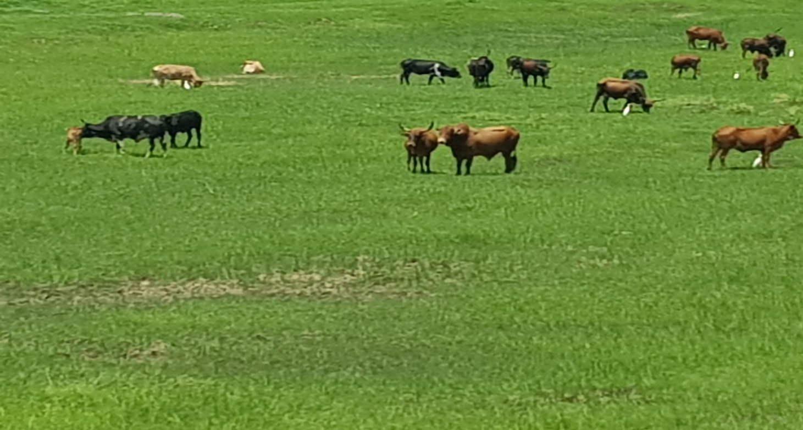
Figure 16-Cattle grazing on the floodplain.
A beautiful picture that tells a different story. This photo, which was taken in early December 2019 in Lealui, shows cattle feeding on the lower flood plains. However, local people indicated that due to the late onset of the rains, cattle were still grazing on the lower flood plain in December. In a “normal” rainy season, this area of the flood plain would have been flooded and cattle transferred to higher land. “Normal” rainy is used here loosely to refer to previous predicted rainy season onset and cessation (November-April).
There were differences in the understanding or definition of the onset of the rainy season across generations and localities. This might have been influenced by livelihoods activities dominant in a particular locality. However, the most established definition in all the study areas referred to the onset of the rainy season as the first week of continuous rainy days- of 3 or more days of rain in a week. Other study participants used the first month of consecutive rainy days, which appeared to suggest the types of crops grown. There was no agreeable definition of the onset of the rainy season and narratives surrounding this were not uniform. A loose logic based on observations of ‘tell-tell’ signs of the local environment was used to establish onset. These ‘tell-tell’ signs consisted of observations of the wind direction, position of the moon, position of the sun at sunrise or sunset, visibility or availability of the certain insects such as caterpillars, availability of certain wild vegetables such as wild mushrooms among other signs.
5.3.2 Rainy Season Onset Defined by Month
As maize is the main crop grown in Lealui and Nanikelako, the reference point of the onset was the first week of continuous rainy days when people began to prepare their fields for maize growing. Maize has been cultivated on monoculture basis for generations mainly for consumption and customary reasons (Amukena-Mongu Small-Scale Farmer). In Sefula, rice is cultivated on a subsistence and cash crop basis. Rice is mainly grown on seasonal basis structured around the annual floods but also throughout the year for those with access to irrigation systems. In Nanikelako an area which lies deep in the flood plain, pastoralism was the dominant activity mainly because of access to the vast expanse of the flood plain and pastures; secondly, the presence of Kalahari sands in Nanikelako does not favour farming as a viable livelihood activity.
Narratives in relation to the onset or start of the rainy season were centred on the months of November and mid to late December. Late onset of the rains referred to when the rains did not fully set until early December or then after. However, the rule of the thumb was that the first few days or the first two weeks of the rains were not considered as the “actual start of the rains”. The “actual start of the rains” was based on several tell-tell signs based on traditional knowledge and experience. Some of the tell-tell signs included “dark clouds in the afternoon”, “thunder”, “hot nights”, presence of certain insects such as caterpillars, abundant mushrooms and other wild vegetables. Participants were weary about “being misled by the false onset of the rains”. People made recollections of previous “false starts” where they experienced heavy rains in October that gave them an impression of an early onset. They narrated, however, that this onset was soon characterised by long dry spells lasting up to 3 weeks. Intertwined within other narratives of late onset of the rainy season was a general concern with the length and frequency of intra-season dry spells. While the study participant’s acounted for a “normal dry spell” within the rainy season; however, their main concern was the length of the dry spells that replicated drought conditions (linanga) that ravaged their crops in previous years.
The end of November was the yardstick against which the onset of the rainy season and the agricultural season was measured or judged. By end of December, the expectation was that the agricultural season would have been in ‘full swing’ with crops such as maize that were planted in November had grown past the ‘knee height’ (a reference point but commonly used in the study areas-it translates into 20-25mm above growing surface).
In Nanikelako, an interviewee put changes in rainfall onset into perspective; “in 1993 the rains were very good as I can recall and since then the rains have been a problem. I remember also that in 1977 the rains were so heavy that we had a big harvest and got a lot of fish, it’s never been the same since” (Masiye -65: Male-Nanikelako). As the preceding quote cites, it appears to suggest the forward shifting of the onset has been a slow process with significant impacts on the livelihoods of the people who are dependent on the rains. The older generations of interviewees were able to historically recount that the first rains or the onset of rains was normally in October. An elderly woman in interviewed Lealui reflected, “We used to have rains every Independence Day (24th October), which we believed was a blessing from God for our liberation. Over time the rains have behaved in ways we do not know, we receive most of the rains in December or even January sometimes” (Bo Sitenge-78: Female-Lealui). A similar observation was made by a study participant in Sefula who said, “Years back we used to have green maize fields by December and by January most of maize crops had cobs because the rains were coming early. Nowadays, even getting a full bag of maize is a miracle. In the last two rainy seasons (2017-2018, 2018-2019 rainy seasons) we waited for the rains which never came and last year (2019-2020) the rains did not fall until late December” (Namangolwa- 65: Male-Sefula).
The quotes above depict variations in perceptions in the changes in the rainy season onset. Various reference points were made in observations and perceptions. Some of these references were based on religious imageries of change with “God” at the centre of perceptions of rainfall patterns. The older generations appeared to have made historical connections of the previous onset to the independence of Zambia as a country. Many people in Zambia often have rain on 24th October as a “blessing from God” and an indication of a good rain season ahead. As indicated in the literature background, maize growing is often applied as the yardstick against which the rainy season is measured. In the researcher’s views there was some over exaggeration in the onset of rainy season, it was not factual or possible to have fully grown maize by December grown under rain conditions. Scientifically maize requires at least 120 days to fully mature and suggestions that people used to have maize by December in previous years flies over simple truth.
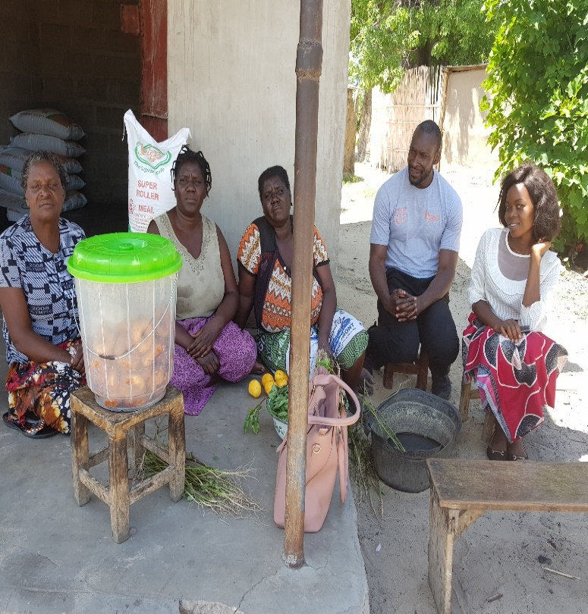
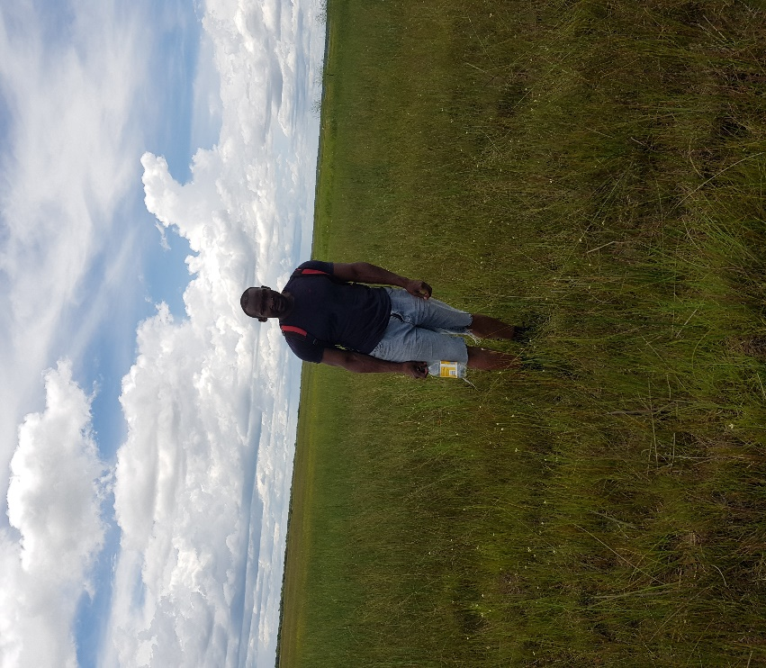
Figure 17- Author during data collection in Sefula deep in the Barotse Flood plain in photo on the left. Photo on the right author interacting with interviewees after interviews in Lealui.
A local key informant in Sefula suggested that one of the consequences of the delayed onset of the rains was the shrinking of the growing season by 3 to 4 weeks. He argued that the 3-4 weeks delay was because in the last few years the rainy season did not fully start until later in December; meaning there were no rains for the entire month of November. Further, he stressed the shift of the onset of rains from November to December and decline in the rainfall amount means shortening of the growing season. The key informant added, “these changes in the rainfall patterns means that people have had to shift their land preparation, planting from November to December and in some extreme years to January “. A cassava grower in Nanikelako made similar corroborative sentiments; suggesting that due to the delayed onset of the rainy season and early retreat of the rains has inevitably resulted poor yields/harvest. Mr Linyama (61: Male-Nanikelako) asserted that it was critical to have good rains from the onset to allow the newly planted cassava stems to germinate; after that the rains must be consistent for about 3 months to allow the cassava tubers to be fully germinate. Another local farmer made the following observation, “early rains are not normally a sign of a coming good rainy season or a good harvest. Years ago, we had early rains from October, we planted our crops hoping for a bumper harvest. Later in the season we were faced with a late drought and a lot of people were left without food” (Namakando: 55-Male-Lealui). Similar sentiments were made by other interviewees who suggested the first rains can “mislead” people into believing that the rainy season has commenced. Based on the traditional knowledge people have learnt to understand and interpret the season onset based on the observation of their local environment with reference to “tell-tell signs as indicated above. For example, the visibility of caterpillars and wild mushrooms that blossom during the first rains were often taken as the “true” onset of the rainy season by some interviewees.
Another key informant David Mwanamambo, the Regional Manager for Action Aid Zambia, an organisation that works with different communities in the study areas on Climate Smart Projects observed , “there is an observation that most of the rainfall is concentrated between December and February rather than being spread out from November, December, January and February. This is a significant shift in rainfall patterns with unmitigated repercussions for thousands of people and their livelihoods. Most of the people in the plains depend on the rains and disruptions to the rains affects the growing season and fishing activities”. These observations fit into climatic data analysed in chapter 6 that indicates late onset and rainfall intensification -rainfall concentration in short space of time.
One of the visible signs of the shifting rainfall patterns particularly in relation to the onset of the rains in the study areas; evidently during participatory observations was large tracts of land that were untilled in November. “In previous rainy seasons, the month of November was at the peak of the field management activities; the landscape would be heaving with households and individuals spending entire days in their fields” (Lillian Makata-Women for Change). Men, women and their children would wake up at 4am to prepare for a busy day on their fields. Lillian continued, “as you can see people are still not sure if the rains are coming hence why people are still in the villages and not in their libala(woodland with sparse and short tress which are cut down to grow plants” (Lillian Matakala-ibid). However, it was interesting to observe that while other farmers were reluctant to start land preparations during the first rains; other farmers took advantage of the first rains to prepare their land. These differences in the timing of land preparations could also account for in my view for in differences in crop yields. I observed that, even though marginally, farmers who prepared their land and planted during the first rains recorded better yields compared to those who planted later in the rainy season. On the other hand, in case of a “false start”, the late planters would perceive themselves as more in tune with their environment.
Being patriarch communities, men’s fields are normally cultivated and planted first before women. This also applies to harvest time; men’s crops are gathered first before women. The gender roles and responsibilities are clearly defined and embedded in the cultural fabric of the Lozi people (Flint, 2006). The strong patriarchal orientation of the communities is deeply ingrained in the everyday livelihood activities. “During harvest, the men’s harvest is gathered first then our brothers and it is the women and their sisters” (Mubanga-51: Male-Sefula). All farming activities from planting, weeding or applying fertilisers fits into these customary and gender roles (Kajoba, 2008). Equally in relation to the yield, men made the decisions as to how much will be used for household consumption or sold to meet other household needs (Kajoba, 2008; Rajaratnan, 2016).
Ms Sitongi a Project Officer at Save the Children contends that the conspicuous lack of agricultural activities during the time of “urgency” in the farming season was telling; “in that either people were responding to the shifting of onset of rains or did not anticipate good rains in the 2019-2020 season as was the case during the previous two years”. A sweet potato grower in Sefula made the following comments which appeared to affirm the lack of urgency in November during data collection, “if look everywhere around here, the fields still have a lot of dry grass and other vegetation because we have no rains. I can assure you that if the rains had come early, all these fields would have been tilled and crops starting to grow” (Sibusiso:53-Male-Sefula). Some interviewees emphasised on reading the “tell-tell- signs” so as not be deceived by the changing climate; suggesting that people should not misinterpret weather signs and be caught out by the “false onset of the rains”. However, in my observations, there was no uniformity in the what was described as “tell-tell signs”. What could be described as “tell-tell signs “In Lealui maybe not the case in Sefula. For example, caterpillars are abundant in Sefula due its woodlands and forests making suitable conditions for caterpillars to thrive. On the hand, the vast expanse of the flood, low lying land and fertile soils is favourable for wild mushrooms in Lealui with the first rains. These differences in perception in “tell-tell signs “have some breath of scientific grounding. During the dry season, female caterpillars nest their eggs in the on-forest trees and other secondary under growth. The first rains trigger the eggs to transform into larvae. The health, size and the availability of the caterpillars is alleged to be influenced by a particular pattern of rain-often this is days of heavy rains that is followed by a few days of sunny days (Dufour,1987; Janzen, 1988; Muvatsi,2021). And based on these observations, farmers were motivated to begin their land preparations and other agricultural activities.
Below is an extract of an interview with a local chief in relation to perceived changes in the onset of the rainfall in the study areas. Some of the responses referenced broader issues of economic, political, social, environmental and cultural aspects. It was apparent from the conversation that there was a complex mix of socio-economic and climatic issues of concern to local people. This demonstrates that socio-economic, environmental and cultural issues can be intractably linked (Reyes-Garcia et al., 2023).
Interviewer: “Could you tell me when the rains normally start in this area?”
Chief: “We have a problem here as you can see. This is December, all these people here should be in the fields but as you can see, the women are brewing Kachasu (local brew) instead of tending the fields. The men would have been up by 5am going to their fields and as the schools are closed, the children would be on the fields helping their parents. Everywhere you look it is very dry, nothing is growing and on some fields the maize we planted in November has been eaten by worms “.
Interviewer: “so in previous years, when have the rains started to fall if you can recall?”
Chief: “We Lozi people are very much connected to our land, for as long as I have lived and remember we have had a good start of rains in November sometimes but not very often in October. I recall when I was still in primary school years ago, when we closed schools, our roles changed to helping our parents on the fields. By December, all crop types from maize, cassava, millet, cowpeas, groundnuts and others would be grounded in the soil. Downstream over there, our rice would be in floodwaters. This year all our cattle are still on the flood plain and we are in December. In previous, everybody’s animals would have been moved to the upper land. Inspite of all the problems we have here, the Government does not seem to care about us. We last saw our Member of Parliament during the elections time and he has never been since”.
Interviewer: “Could you tell me in what ways are the changes to the onset of rains affecting livelihood activities in this area?”
Chief: “As I mentioned to you earlier, all the people in the villages and the entire flood plain including their animals depend on the rains. Life here is based on land and the rains, there would be no people or animals here if we could not grow food or look after our animals. Nothing is ever so important than knowing when we can go to the field and then we take down our hoes and prepare our seed. The Government never gives us seeds or fertilisers over here. We are told that in other areas people get seeds and fertiliser, not here we are never thought of. I hope you understand what I am saying”.
Interviewer:” why is the onset of the rains important to the people here?”
Chief: “when the rains come on time then we prepare our fields, get the seed ready and most important we plan when to move our animals from the plains to the upper lands. The type of crops we grow here mainly maize, cassava, millet and sorghum require enough rains from start until they mature. Any long pose in the rains our harvest is in trouble. It is common here that people have two homes, one here in the lower flood plain and one in the upland. During the off-season people go the town to sell their produce or do other businesses. Therefore, when people know when the rains are coming, they prepare to relocate back here for farming activities. Sometimes we must sell a few cows or goats to get the seed or other things we need in the fields, you cannot do that if you are not sure when the rains are coming. We must use our knowledge to tell if the rains are real or not, if we plant too early the crops will not survive and again, we plant late we get nothing”.
Interviewer:” Are you able to cite in specific years when you noticed that the rains were getting delayed on starting?”
Chief: “It is not easy to put exact years to this. However, I think in the last 5 years we have not had the Kuomboka due to poor rains. The last 5 years we did not have to relocate from the flood plains as the flood waters did not come. Our animals were grazing on the plains through the entire rainy season during those years”.
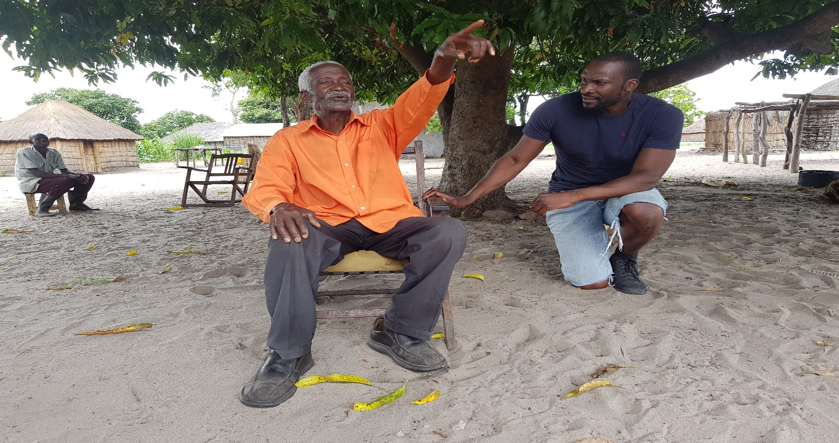
Figure 18- The author interviewing a local chief.
Fig. 18, the chief emphasising a point in relation to the impact of delayed rains. Seated in the background is the chief’s son. Photo by author.
Climate change has direct and indirect socio-economic-material consequences for people under the threats of its most sever impacts such a declining or shifting rainfall patterns . In the main, a key takeaway from this interview with the chief was that environmental change was a genuine concerns and local people have observed these changes that have material consequences. The chief recites how local people apply traditional knowledge to determine rainfall patterns. Material consequences are reflected in declining crop outputs or low yields as a direct consequence of changing rainfall patterns.
Some of the responses were woven in the longstanding issues of poverty and marginalisation in the study areas. The chief narrates how local people have not had any support from the government in terms of the FISP programmes (Farmer Input Support Programmes). This narrative appeared to be embedded in not only local people’s attitudes to the central government but generally in the Western province of Zambia. Empirical and anecdote evidence has long argued that the Western Province of Zambia is the poorest out of the nine provinces of Zambia (Mufalo,2011; Noyoo and Campus,2014). For example, a CSO survey of 2012, the latest which could be retrieved cited the Western Province as the province with the highest incidence of poverty in Zambia (CSO,2012). As Mufalo(2011) argued, the integration of Barotse land into Zambia was designed to undermine and curtail development prospects in Barotse land. Madudeni et al., (2015) forward the resultant merging of Zambia and Barotse was the suppression of autonomy and skewing of resource distribution towards other regions of Zambia.
5.3.3 Rainy season onset perceived by livelihood strategies.
It was evident in my view that narratives surrounding the onset of the rainy season appeared to be constructed largely on livelihood strategies between and within the study areas. From the perspective of pastoralists particularly in Nanikelako, the onset of the rainy season was premised on “green pastures” around and nearer the villages. Normally, during the dry season between July and October, cattle are moved further afar into the inner flood plain in search of pasture and water on an annual transhumance practice. The inner flood plain called the Bulozi Meander has clayey, loamy water channels and other seasonal water sources (Mulapo) fertile for forage that cattle survive on during the dry season. When the first rains begin to fall, cattle are moved back nearer the villages as the pastures flourish again. This transhumance, the seasonal movement of cattle and people coincide with the formal ceremony of the Kuomboka (getting out the water). The Kuomboka is a core cultural identity of the Lozi people (Flint, 1985;2006; Knight-Jones et al.,2016)). Based on these transhumance practices, perceptions and narratives on the onset of the rainy season were shaped by the re-appearance of new green grass pastures near to the villages.
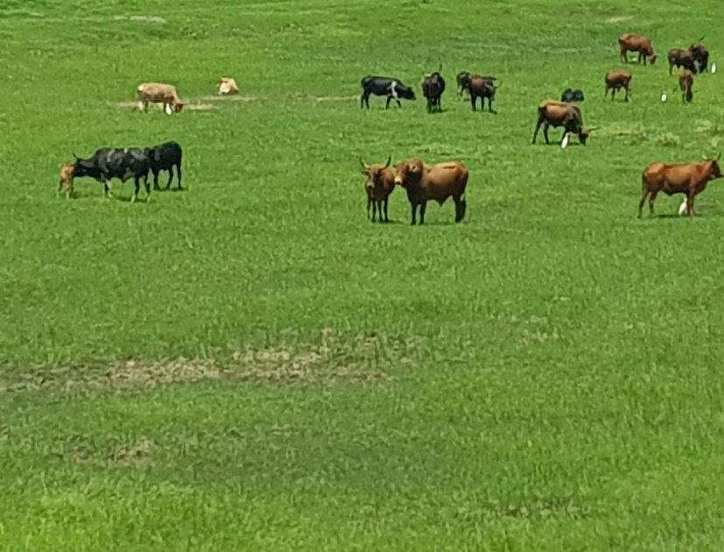
This is also reflected by remarks made by elderly male pastoralists, “when we see the rains coming early it gives a sign on how the entire rainy season will be but what is important to us is that we know will have new pastures for our animals. If the rains delay falling or sometimes not even fall at all then the animals will be stuck in the plains for the entire year. With good rains we can move the animals closer to our villages allowing us to attend to our crops as well” (Sepiso:76-Male-Nanikelako). Another elderly man made the following observations echoing similar sentiments. “In the old days we used to move the animals back to the villages from the plains with the growth of the new pastures from November onwards; but if I recall in the last 15 years, we have not moved the animals until sometimes at the start of January. If you are still in the plains by December, you have no time to attend to the fields (libala)” (Mushabati:65-Male-Nanikelako). The preceding remarks emanating from elderly “statesmen” with years of living and experience in the study area emboldened the general narrative of much of the people in Nanikelako.
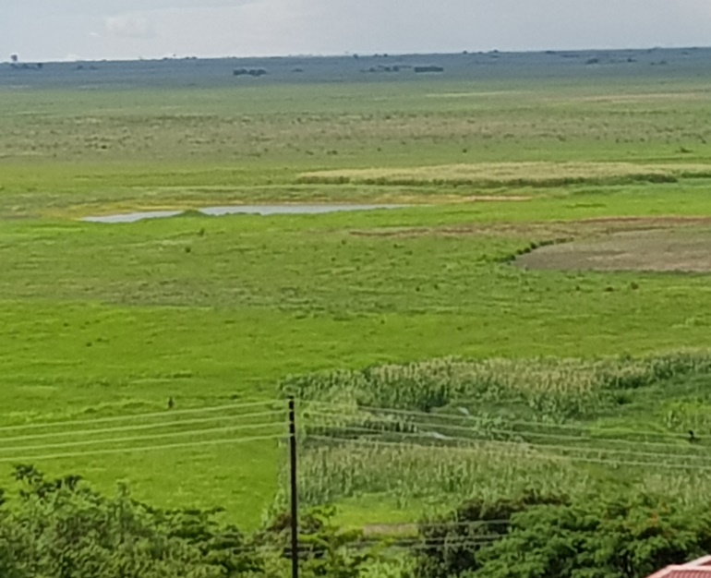
Figure 19- The Barotse Flood.
In figure 19, the vast expanse of the Barotse flood plain flourishing with green pastures. Photos taken early December 2019. In previous years by this time of the year, the flood plain would have been inundated with floodwaters with most of the cattle moved to the uplands.

5.3.4 Narratives of Uneven distribution of rains during the rainy season
As well as concerns regarding the late onset of rains, concerns were abounded of perceived uneven distribution of the rains during the rainy season. Broadly, there were homogeneous narratives that depicted a scenario that rainy seasons have become increasingly become unevenly distributed or not evenly spread. The consensus was that the seasonal rains were concentrating between Decembers and February rather than being spread out through the entire normal rainy season of 5 months (NDJFM). Interviewees made some accounts of the lack of rains during the month of November and December. According to interviewees, during a ‘normal’ rainy season rainfall progressively intensifies from November spreading through to December, January, and February and slowly ceding/ceasing from March to April. According to local accounts, the wettest period of the rainy season was in the months of December, January and February. One study participant in Nanikelako made the following observation, “the rainy seasons have become unusually unpredictable. We are in December and for weeks since November; the skies have not opened even showers in sight. We are worried because when the rains start falling without a break, we have no time to prepare our fields later alone get to the fields. The worst concern is that we will never be able to grow any food here” (Innonge: 62-Female: Sefula). The above sentiment corroborates with finding of the rainfall analysis in chapter 6 that shows the rainfall intensity has been on the upward trend in the study areas.
A District Agricultural Coordinator (DACO) in Mongu Central corroborating with people’s accounts suggested that the uneven distribution of rainfall results into “highs” of intense rainfall and “lows” of dry spells. These highs” and “lows” translated into the differentiated crops and fields. The DACO added that an even spread or distribution of the rains through the entire season is important for proper crop growth. A skewed distribution could result into floods or drought conditions with negative consequences on people’s livelihoods.
The DACO added, “When we had intense rains that peaked in January, some fields were inundated with water that saturated the ground thereby submerging some crops. Flooding stresses plants by off cutting the sources of oxygen supply to the roots. Small maize crops completely die out when submerged in water for more than 5 days concurrently. The only people who benefited this season were those who planted late and those were able replant their fields in December”.
The DACO further reflected on shifting rainfall and food security, “the last 3 years have been challenging for the people, poor rains for 3 consecutive years have had a negative impact on food security. The conditions are dire in the remote areas of the province where people are lacking in food supplies and water. If these dry conditions persist for any longer in the future, then the living conditions of the people can only get worse”.
Broadly, all the communities reported a shift in the peaking and the spread of the rains through the rainy season months of November, December, January, February and Marc (NDJFM). Most of the people interviewed suggested that most of the rains were concentrating between December, January and February. This sudden peaking and intensification of rainfall may explain communities’ concerns about “no break in the rains” that sometimes prevents them from tending to their fields at time when they need to apply fertiliser to crops and carry out weeding. Some interviewees expressed that the concentration of the rains within a few months results in daily rainfall intensity that destroys their crops.
Research shows that rainfall intensity can have detrimental effects on the socio-economic activties of people through disruption of their livelihood activities of agriculture and livestock keeping through flooding (Gulati et al.,2009). Extreme rainfall events can lead to reduced crop yields and food insecurity (Gulati et al.,2009; Shahid,2011). These accounts of rainfall intensity are corroborated with flooding events that characterised the rainy seasons of 1999-2000, 2005-2006-2007 during which lives were lost and livelihoods affected (Tauya,2010). Tauya(2010) observes that while annual flooding on the Barotse flood plain is regular feature that sustains livelihoods through the provision water and enhancing soil fertility, what is concerning has been the frequency , intensity , timing and duration of the flooding events.
Apart from trends in the general wetting and drying shifts, changes over time in the characteristics of wetting and drying are critical to the assessment of climatic hazards (Funk and Brown,2006; Batisan and Yarnal,2010; Greve et al.,2014; Jensen et al.,2019). Batisan and Yarnal(2010) and Saeed et al.(2018) respectively posit that this is true in the case of semi-arid areas where rainfall occurs during the wet season. In these regions, they add, changes in the onset and length have substantial repercussions for people and their livelihoods. The rainy season length (RSL) or duration was of great concerns to people and their livelihoods in all the three study areas. Variability in rainy season length threatens food security and livelihoods (Thornton et al., 2011; Amekudzi et al.2015).
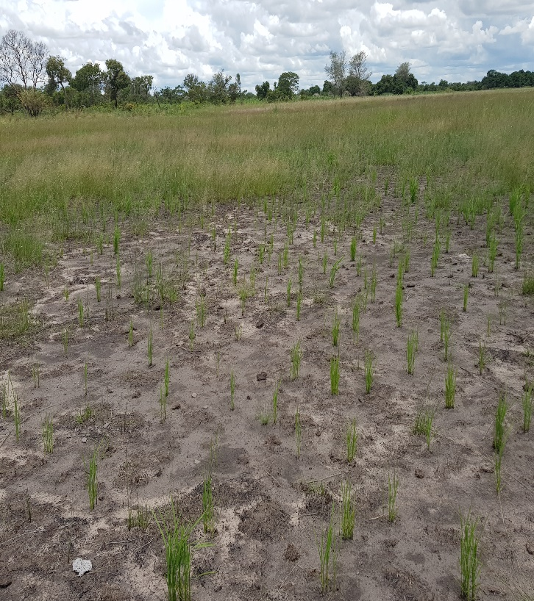
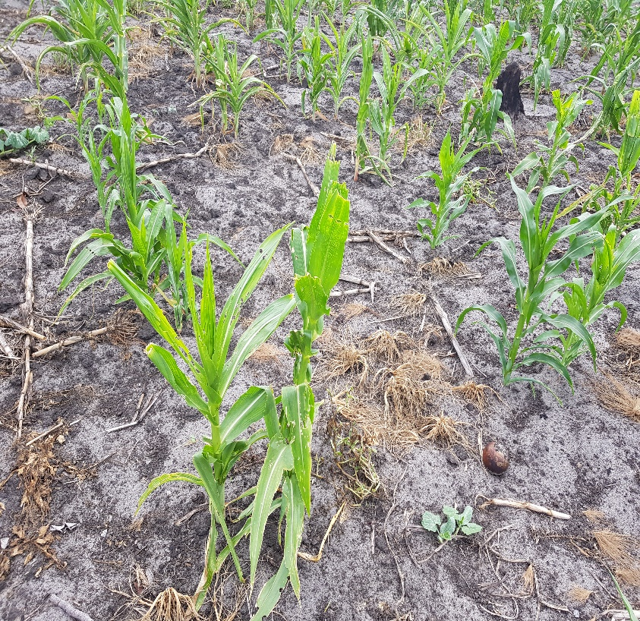

Figure 20-Left a maize filed in Sefula wilting and attacked by armyworms due to a prolonged dry spell. Right a field of rice wilting due to late arrival of flood waters-photos taken by author (Mid December,2019).
5.3.5 Negative Trends in Rain Season Length (RSL-Duration): “we used to have good rains and harvests in the old days. These days the rains are never enough “.
According to Amekudzi et al. (2015), the duration of a rainy season is influenced by the onset and cessation of the rainfall. Amekudzi et al. (2015) assert that in semi-arid regions problems related to poor agriculture practices, food security and human health are linked to generally high variabilities in the onset and cessation of the rainy season. Broadly, in all the three study areas the length of the rainy season was loosely defined based on the onset of the rainy season that historically was the month of November and cessation of March. Based on this period the rainy season length consists of 5 months (NDJFM).
Research suggests that there is a relationship between the onset, cessation and rainy season length that very is critical for agricultural activities (Sivakumar, 1988; Mugalavai et al., 2008). Omotosho et al. (2000) and Oguntude et al. (2014) in their research in Northern Nigeria demonstrated how the onset, cessation and length of the growing season were significantly linked and illustrated how the length of growing season was sensitive to the onset and cessation of the rains.
During an interview with a female study participant in Lealui, I inquired if she had noticed any changes in the rainy season duration specifically during the last twenty years. In response she made the following remarks, “I do not know a lot about the total annual rainfall amounts, but we can judge this from the time we grow our crops to harvest that the rains are enough. If our crops do not mature or we have a poor harvest, then we know the rains were not enough. What is clear to us here is that the rains have changed when they start and how they are spread over the entire season”. Probing further, I asked her what she implied by “enough”. She indicated “the amount of rainfall available for our crops from planting to harvest”. She added, “the kind of crops grown here such as maize, millet, sorghum and maize need consistent rainfall from sowing to maturity lack of which significantly reduces the chances of a good yield” (In’gutu: 54-Female-Lealui).
These remarks above fit in with similar narratives above where patterns of rainfall are determined by for example, by how much people harvest or gather at the end of the growing season. Interviewees appeared to ignore or discount other factors that influence crop harvest such as early land preparation or the use of fertiliser. On the hand, it goes to demonstrate that how people define or describe reality may not always fit into measurable data, however, their descriptions help to understand how their perceive reality and how they re-strategies to sustain their livelihoods.
As part of the data collection, I participated in an NGO Forum organised by the Civil Society for Poverty Reduction (CSPR) that was reviewing among other issues the Farmer Input Support Programme (FISP). What local farmers repeatedly brought up was the issue of “not enough rains to grow maize, cassava, beans, millet and sorghum”. I had an opportunity to interview a representative of the Mongu Small-Scale Farmers’ Cooperative to gain insight into the issue of “enough rain”. The discussion is representative of the general narrative of farmers’ perspectives in relation to the rainy season duration. The narratives cannot be wholly reproduced here; however, the interview script is representative of the concerns:
Interviewer: During the workshop the issue of “enough rains” was brought up several times, what does that mean?
Farmers’ Representative: “the type of crops we grow especially maize need enough rains from about November until end of February for us to have a good harvest. If the rains pose or stop in between it should not be for a long time otherwise the crops die. Equally you do not expect the rains to fall non-stop as crops will suffocate due to too much water”.
Interviewer:” in your understanding or experience how long should the rains fall for your crops to mature up to harvest”?
Farmers’ Representative: “many of our farmers and people in the villages grow maize mainly but also millet, sorghum and groundnuts. Maize needs consistent rains for about 4 months. Millet and sorghum can survive even with poor rains in my experience”.
Interviewer: “what have you and your members noticed in the past years in relation length of the rain season in this region?”
Farmers’ Representative: “it is not something we can count going back in years, but we face poor rains more these days than before. Sometimes the rains do not come till late December and will end early February. When this happens, then we have no time to prepare our fields and the crops has no time to mature. If we had better seed varieties that mature early, then maybe we can have a harvest. The FISP programmes only benefits people with connections in the ruling party connections. The District Agricultural Co-ordinators have no control over the programme. The whole system of FISP has been taken over by politics and is not helping poor people who need it”.

Space left blank to fit in figure 12 below

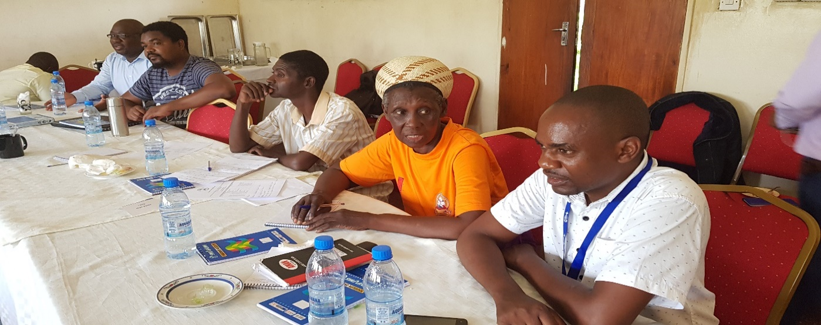
Figure 21- Participants to a workshop/seminar reviewing community projects and FISP. Photo by author.
At the household and individual level, there was sentiments that the probable cause of the perceived shortening of the rain season was the late onset and early cessation of the rains. In all the study areas, there was broad agreement that a forward shift in the onset of the rains from November to December and cessation of around later February has cut short the normal duration of the season. Rice growers in Sefula were particularly concerned with the shifting and shortening of the growing season because rice demands a longer growing period and requires a lot of water compared to maize. “I used to harvest about 80 bags of rice every year from this field going back maybe ten years ago. I have not had more than 30 bags since 2016 and the main reason is the rains come late and finish early. When that happens, the floods never arrive here for rice to grow” (Situla: 58-Male-Sefula).
This interview extract above draws back to the main concerns of local people with changing rainfall patterns and the impacts these have on their livelihoods. Responses in this extract centre or reference back to the main themes already established in this chapter-rainy season duration and the growing season. To some extent an intertwining of issues such as rainy season duration and growing season appeared to be conflated -for example the growing days of a hybrid maize seeds are different from traditional maize seeds. Traditional maize seeds require a growing season of 120 days whereas hybrid seeds often require 80-90 days. However, this difference did appear to be taken into consideration by local farmers in trying to assess “enough” rain. In trying to justify a correlation between season duration and crop yields, interviewees ignored factors such planting dates, seed variety and the application of fertilisers. Equally, there was a bundling of storylines or narratives in relation changing rainfall and crop growing that local people appeared to conflate. For example, maize requires different growing conditions and compared to rice or cassava. Compared to cassava, maize is water intensive and very sensitive to rainfall variation and so constructing changing rainfall indices based on maize solely may obfuscate the true picture.
5.3.6 Intensification of Dry Spells
During field participatory observations, I interacted with a range of people (general public and interviewees-see appendix 4) in the study areas. It was evident not only from people’s (public & interviewees) views but also from the physical landscape that the region was experiencing a dry spell at the start of the December (2019) lasting until the end of December. An interviewee passively commented, “It rains every Christmas day but this year it never did “(Pelekelo: 55-Male-Lealui). Zambia Meteorological Department (ZMD, 2012) defines a dry spell as a period of continuous and consecutive dry days of less than 5mm or no amount of rainfall recorded. According to the ZMD’s categorisation, this was a long-term dry spell as it lasted more than 18 days.
During one of my participant observation activities in Lealui in December 2019, I spent some time with a 65-year widow who was weeding in a small maize field. It was evident from the dry landscape and vast tracts of fields of wilting crops almost abandoned by their owners that there was a dry spell in the study areas (linanga). As I conversed with the woman she remarked, “I have four grandchildren, we rely on this field for our survival but the little rains that came in November have stopped”. In relation to drying trends, some interviewees particularly the older generation were able to cite years of drought in 1992-3, 2004-5, 2012-14 and 2017-18. These dry years fit into the climatic data analysed in section 6.3.2 that point to more drought(drying) conditions particularly in those years cited. 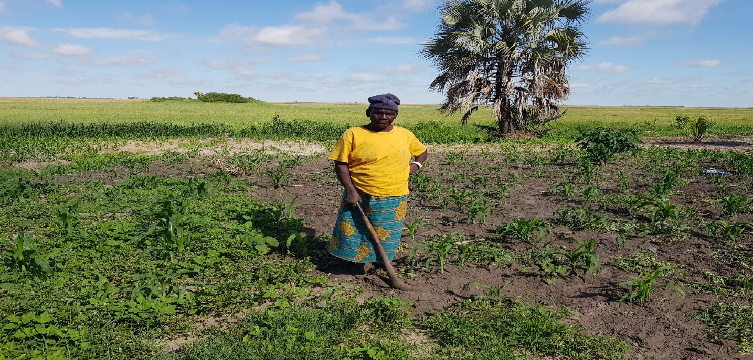
Figure 22: A woman in Lealui tending to her mixed field of maize, cassava and local vegetables. Photo taken early December 2019 –after a prolonged dry spell crops not performing well for this time into the growing season.
These conditions of a dry spell were replicated across all the three study areas. A man in Sefula observed, “We had a few rains at the start of November, but for almost three weeks nothing at all not even a single drop of rain has fallen” (Lubasi:65-Male-Sefula). In Nanikelako, one interviewee put things into a historical context that she contrasted with recent years without citing precise years. She observed, “In the years back we never had to think about the rains, we knew when the rains would come and then we get hoes out and seeds ready. These days we live at mercy of God not knowing if the rains will ever come and if they did come how long they will last” (Seshekamon:61-Female- Lealui).
What I adduce from the foregoing, was that the rainfall patterns that have become unpredictable and erratic in their onset, duration and cessation. This generally corroborates with rainfall analysis in chapter 6 of this study. The erratic nature of the rains was clear to elucidate from majority of the interviews as in the discussions above. The interviews established that these shifts in the rainfall were the main attributable factors of poor crop yields. I argue that these visual-narrative schemas evoked by study participants (see to methods) interviewed provides compelling evidence of how changing climatic changes in the study areas are impacting on local’s livelihood strategies.
My argument corroborates with Reyes-Garcia et al. (2016) who forward that local people with a long history with of their environment hold intricate and valuable knowledge not only of weather variability but also climate change. Reyes-Garcia et al. (2016, P.2) apply “local indicator of climate change” to refer to “local observations of climate change reported by people with long histories of interaction with their environment and observed impacts on the biophysical and the social systems attributed to climate change “. Savo et al. (2016) argue that places that have few or lack instruments for collecting scientific data, local observations provide valuable first-hand descriptions of complex interactions between the biological and the physical elements of the environment under climate change pressures.
Analysis of the meteorological data during the period 1981-2019 indicates that Mongu experienced 17 years wet years and 22 dry years; these defined as years above or below the 1981-2019 average. However, both trends appear to be statically insignificant as demonstrated in chapter 6. Similar studies (Libanda et al., 2019; Musonda et al., 2020) suggest an increase in dry/drought conditions in the Southern/Western regions of Zambia. According to Musonda et al. (2020), the biggest magnitude of drying has been recorded in some districts of the Western Province (Barotse Land). Local perceptions appear to suggest strongly concerns with drying trends, with people citing catastrophic drought years of 1991-92, 2004-2005 and more recently 2018-2019 as a source of worry.
5.4.0 Perception by livelihoods
A common theme that emerged from local narratives and climatic data indicates that rainfall patterns are shifting in all the study areas However, the point of departure or contestation lies in the nature and the magnitude of these changes. As well as striking differences in the perception and interpretation of the changes between local observations and scientific data, there was distinctions between and within the study areas in the weight or importance of these changes. The spatial differences placed on the magnitude of these differences reflect dominant livelihood dynamics and contextual issues. In Sefula for instance, the presence of irrigation systems cushioned the impact of the changes in the rainfall patterns that partly explained that while farmers acknowledged these changes in rainfall, they appeared not to elevate or have strong views in relation to these rainfall changes. The farmers who owned “premium land” (irrigated fields) did not rely on the rains to engage in their farming activities; their ability and capacity to cultivate different crops year-round on rotation and mixed cropping basis amelioarated the impact of rainfall changes. Aside from growing rice as the main crop, the farmers grew vegetables such as tomatoes, green vegetables and sunflower post flooding or dry season. Their ability and capacity to redeploy the use of land as an asset for the cultivation different crops fostered their adaptive capacity and resilience to changing climatic conditions.
Conversely, for other farmers without access to irrigation systems the impact of the changing rainfall patterns was a big concern. “Some people here are well connected to the indunas (village headmen) and their land is watered year-round but for many of us, without the rains and the flooding season we cannot grow anything “(Akende-Farmer: 68-Male-Sefula). In Lealui and Nanikelako, the importance of rainfall changes was strongly expressed mainly not just due to the absence of irrigation systems also but also in relation to the types of crops. In Lealui and Nanikelako, maize dominant crop grown is extremely sensitive to changes in rainfall and any disruptions to the rains will have impact on yields. Maize yields are affected by late onset, cessation and prolonged dry spells (Hachingonta , 2005). As earlier discussed in the paper, in Nanikelako most of the people were engaged in mono- cropping of maize while others engaged in agro-pastoralism. Pastoralists’ views were strongest regarding access to pastures for their animals as opposed to agricultural activities. One cattle owner indicated, “the soils here are sandy you must work twice as hard to grow maize, I rely on my cattle and if we do not have the rains then we are in great difficulties. We must move our animals further afar in the flood plains for pasture and water” (Muka: 56-Male-Nanikelako).
5.4.1 Conflated narratives
During interviews and discussion with the participants, it was evident that they made a direct causal link between crop yield and total rainfall. Participants did not appear to disentangle other critical factors that influence crop yield, such as early planting, seed type and access to vital farming inputs such as fertilisers. This conflation of issues was present in some of narratives. In some cases, people who accessed improved seed varieties and fertilisers reported good yields during the same rainy/agricultural season whereas other farmers reported poor yields. Often, those that had poor yields linked this to either the late onset or shortening of the rainy season but ignored factors such early planting and other land management practices that influence crop yields. Research argues that one of the prominent causes of poor yields by subsistence farmers in Zambia is poor agricultural practices such as poor seed choices, and management and government policies that are not supportive of rural farmers (World Bank, 2010; Mulenga et al., 2014). “In spite of the generally argued correlations between rainfall and crop yields, there are clear discrepancies with poor yields during some years of near annual rainfall (Black et al., 2015). Sentiments of the lack of agricultural extension services were common which Office District Agricultural Co-ordinator citing the lack of funding from the Provincial Office. Further, the Western Province is characterised by Kalahari sands with strong acidity, poor nutrients and low water retention properties (Rajaratnan et al., 2015). These differences in perceptions and interpretations can collectively be termed as boundary objects; that object shared by several communities but perceived or used differently to each other (Baggio et al.,2015).
Added to this complex picture is the nature of the land tenure system in the entire study area. All the land belongs to Litunga (King). People are allocated a portion of land that they are allowed to occupy for settlement and livelihood activities. However, they do not own that land but enjoy its usufruct (Kajoba, 2008; Jayne et al., 2008). Lack of title to land creates perceptions of future loss rights to use of the land thereby contributing to low crop productivity (Baidu-Forson et al., 2014).
5.4.2 Intergenerational perceptions (Age related Interpretations)
Intergenerational or age-related perceptions appeared to generally be influenced in my view by educational attainment on one hand and experience on the other. Younger people in general had some level of education and had more livelihood options including getting into the formal economy. Younger people were more abreast with modern scientific terminology in relation to climate change. Younger people were able cite cite climate change as the main factor behind late onset, early withdraw and shortening rainy season. In the general, younger people were able to demonstrate scientific understanding of climate change. I can arge that, exposure to media and access to education by younger people can be said to the source of their knowledge on climate change.
The older generation attributed these changing climatic condistions mainly to religious or planetary forces. Guo et al. (2022) argue that the age of a farmer had a negative perception of environmental change -suggesting that the older the person, the more likely they dismiss environmental change or attribute it to other factors.
Narratives in the study areas espoused by the old generation attributed rainfall changes to long established cyclical rainfall patterns and placed “faith” in the traditional agricultural methods. Older generations “placed trust” in the use of indigenous seeds and natural fertilisers such as cow dung as opposed to modern farming techniques including the use of chemical fertilisers. Older people showed a lack of interest in the use of artificial fertilisers arguing that these were not good for the long-term fertility of the soils and water sources. By implication the older generation’s explanations for poor yields were changes in the onset and cessation of the rainy season. Going by this narrative, the interpretation is that the older generation attributed poor yields singularly to changes in rainfall rather the none-adoption of new farming methods and discounting the possibility the critical role of soil degeneration. Zimmer al. (2019) document intergenerational perception of climatic changes shaped during formative years and experience. Byg and Salick (2009) demonstrated that the link between climatic change and age maybe not be very strong .Yaro et al. (2015) , however, argue that socio-demographic characteristics including age played a significant role in how people perceived and responded to climatic changes. They assert that even within the same locality/village socio-demographic factors including age played a role in how people perceived climatic changes. Another interesting narrative espoused mainly by the older generation was the depiction of the rainfall changes to normal seasonal variabilities. “We have always experienced cycles in the in rainfall, in some years we have good rains and in some we face poor rains. This is not really something we have not seen, the only problem we have is that we have lost our memories “(Lizazi-72-Sefula). Berkes and Boillat (2009;2013) made similar observations where local people perceived rainfall changes not as unprecedented rather possibly cyclic.
From the foregoing observations, I argue that the volatility and unpredictable nature of the shifting precipitation regimes are pushing people’s livelihoods to precarious limits. People’s narratives and climatic observations suggest that people are increasingly facing challenges to their livelihoods driven in part by changes in the rainfall. This variability and or trend in the seasonal rains is currently the most critical stressor faced by most people interviewed. The dependence on agriculture and other ecosystem services in the rural areas makes them vulnerable to multiple stressors including political, institutional, economic and biophysical (Panthi, et al., 2015; Qaisrani et al., 2018; Thorpe and Figge, 2018). Poor or lack of access to markets, farming inputs and poor infrastructure add to existing risks to worsen the living conditions of the people in rural settings (Thorpe and Figge, 2018).
The above sections based on interviews from people from the study areas tell a story of environment change -observed or perceived but is a lived reality in their livelihoods. Based on interrogations of rainfall indices critical to their agriculture activities, local narrated a story living with change. People’s understanding of their lived reality or world is often constructed several factors including culture, perceptions, beliefs among others. However, these individual factors often contradict measurable or physical data. Moezzi et al. (2017) stress that natural phenomena and theoretical models about the world have always been described in narratives and storylines. This chapter focuses on people’s narratives and storylines to visualise these changes which are then compared measurable data in chapters 6 and 7.
5.5.0 Conclusion
Chapter 5 explored local people’s observations, perceptions/interpretations of changing rainfall patterns in their areas. Summed up as narratives or storylines –local observations built on long term and intergenerational transfer and sharing observations, experiences and knowledge. Local observations can be a source of first-hand detailed descriptive visual images of the complex interaction between the physical and biological elements of climate change. As highlighted above some of the narratives of changing rainfall patterns were influenced by religions and cultural paradigms. The general narrative, however, was that rainfall patterns have been changing significantly; onset of the wet season has shifted towards December from November and that cessation has come early than in previous years. Other significant narratives centred on shortening rainy season length (RSL) and intensification in dry spells. Some of the narratives appeared to be shaped by livelihoods and contextual issues in each study areas such as place vulnerability and exposure. Chapter 5 contrasts with chapter 6 that applies scientific measures to assess for evidence of local people’s observations. The next chapter (6) in an assessment of rainfall characteristics over Mongu western Zambia in which the study areas lie.

Chapter 6: An assessment of rainfall characteristics over Mongu Western Zambia

6.0.0 Introduction

This chapter follows on and draws on the discussions in chapter 5: Indigenous and cosmological narratives of changing climatic regimes. Whereas chapter 5 is based on local people’s observations of changing rainfall patterns, chapter 6 is framed on the scientific analysis of rainfall characteristics during the study period. Chapter 6 seeks to determine whether people’s observations are evident in climatic data and to assess whether the scientific analysis of rainfall data in the study areas corroborates with local observations. Local observations and scientific data apply different lenses of inquiry and have unique advantages and disadvantages (Roncoli, Crane and Orlove,2016; Reyes-Garcia et al.,2015; Kothari and Arnall,2019).It is often argued that integrating these two lenses of inquiry can sharpen the scope of available climate data and effective adaptation strategies (Rudiak-Gould, 2014; Kothari and Arnall, 2019). These contrasting frames of inquiry enrich, expand knowledge application in climate change adaptation and drive motivations for the integration of indigenous/local and scientific knowledge (Chanza and De Wit; Nalau, 2018; 2016). At the heart of these two worldviews is the complexity of how people know the world (epistemology) and the multiple ways of understanding what the world is (ontology); reality is perceived using different perspectives (Goldman, 2018; Owen, 2020-see also section 7.8.0).

Chapter 6 starts by providing some background literature in relation to the role of rainfall characteristics in rural livelihoods. It then proceeds to highlight the methods and data sources applied in this study. This is followed by the methodological approach-analysis of rainfall trends using the Mann Kendall and Modified Mann Kendall tests. Within this section, the chapter explores daily rainfall characteristics and onset of the wet season. It also considers trends in Consecutive Wet Days (CWD) and Consecutive Dry Days (CDD) as these are key variables in determining the agricultural season. The discussion then proceeds to examine characteristics of the rainy season onset, cessation and length, key factors that are important for agricultural activity.
The last section of this chapter is an analysis and discussion that converges science and local observations. In this analysis and discussion, I attempt to abstract points of convergence and divergence between the findings from scientific analysis of rainfall and local people views. In doing so, I concur with (Yeh, 2015) who argued that scientific epistemological and ontological representations of climate change through measurements, abstraction and long-term averages, should not dissolve/dismiss alternative ways of knowing and interpretations of climate change. Berkes et al. (2021) forwards that regardless of the realities that some elements of local people’s observations, perceptions and interpretations of climate change may challenge and question long established and deep-seated theories of scientific knowledge production, local knowledge is not always incompatible with science. Berry et al. (2016, P.3) made the following observations, “climate change should not be understood as a decisive break from the past nor a unique outcome of modernity-but as the latest stage in the cultural evolution of the climate idea; an idea which enables humans to live with their weather through a widening and changing range of cultural resources, practices, artefacts and rituals”.
6.1.0 Background Literature
Precipitation is one of the significant climate components (Sun et al., 2018). Sub-Saharan African subsistence farmers primarily depend on rain-fed agricultural production as the main economic activity, especially within the rural settings (Connolly-Boutini and Smit, 2016). Therefore, seasonal rainfall, the number of rainy days, and the amount of total rainfall received significantly affect the agricultural production. A large part of the Sub-Saharan African population (about 80%) live in rural areas depends on rain-fed farming as their primary source of income (Huho, 2017). Additionally, of the urban population, between 10% – 25% rely on agriculture as their source of livelihood (Ngetich et al., 2014). However, rainfall variability is a common occurrence with different periods experiencing different rainfall characteristics, which leads to average, below average, and above normal rainfall amounts (Gorman,2015; Huho, 2017).

Taking 2013 for illustrative purposes to demonstrate spatio-temporal changes in rainfall across Africa, the World Meteorological Organization (2019) forwards the year 2013 experienced below normal precipitation based on the long-term rainfall average of 1033 mm between 1961 to 1990. Within the same year (2013), East African region experienced above-normal rainfall between March and April, leading to significant flooding (Dunning et al., 2016). As well as variability, there are trends towards extreme rainfall events both in terms of frequency and magnitude across Africa (Akumaga & Tarhule, 2018; IPCC,2022).
Zambia has experienced an increase in the frequency and intensity of extreme events such as droughts and floods in the last 30 years (Chabala et al, 2013; Bopape et al., 2021). Many regions of Zambia experienced drought in 1991/92, 1994/95, 1997/98, 2002/2003 and 2003/2004 (Thurlow et al., 2012). In 2007-2008, 2010-11, 2016-17, Luangwa district in the Eastern Province of Zambia experienced unprecedented flooding (Mseteka, 2017). In 1989 large areas of Lusaka experienced heavy flooding with an estimated 50,000 people left homeless (Mulwanda, 1983). These extreme events have been described as normal climate variability; however, climate change has been aggravating the frequency (Thurlow et al., 2012) Many regions in Africa have experienced precipitation changes (IPCC, 2014; IPCC, 2022). Rainfall variability has also been witnessed within the Horn of Africa region (Tierney et al., 2015; Degefu et al., 2017). There has been notably a significant decline in the long rainfall season (March to May) within the last three decades (Tierney et al., 2015). The spatial rainfall characteristics distribution within the Horn of African has had a significant impact on food security and agriculture within the region (Degefu,2017; Lewis; Ogenga et al.,2018). Also, a study carried in Kenya within the central region revealed a significant decrease in rainy days and a significant increase in rainfall intensity (Huho, 2012;Kisaka et al.,2015;Wakachala et al.,2015). Understanding the changing precipitation characteristics is fundamental, especially in relation to planning of the growing season as it can impact livelihoods (Dzimbo and Mashizha, 2017).

According to Dube et al. (2016), the climate of a region is a critical factor that shapes development and livelihoods. Dube et al. (2016), argues that all human activities linked to livelihoods are responsive to the climate in various ways. Weather and climatic patterns are central to human survival as they support agriculture and socio-economic development, thereby sustaining human life and ecosystems (Olsson et al., 2014). However, extreme weather events like floods and droughts are known to exert negative effects on societies (Rahman et al., 2021) and to dictate economic rhythms in poor regions of the world where economies and other livelihood activities are driven by rain-fed agriculture (Eldon et al., 2020) and other ecosystems services (Ryan et al., 2016).

Research shows that extreme precipitation events are on the increase across Southern Africa, and with climate change, this is expected to worsen (IPCC 2022; New et al. 2006; Ongoma et al., 2018). For example, in 2017, cyclone Idah killed an estimated over 1000 people in Mozambique, Zimbabwe, and Malawi (ReliefWeb, 2017; UNICEF, 2018). During the same rainy season, over 79 000 people were left homeless in Mozambique (ReliefWeb 2017). ACT Alliance (2017) also documented that during the same 2017 rainy season, over 35000 people were affected by severe flooding in neighbouring Malawi. During the same period, Zimbabwe experienced severe floods in 37 districts causing extensive damage to infrastructure (ACAPS 2017; Libanda and Ngonga, 2018).
In Southern Africa, Zambia is one of the most severely affected regions by extreme precipitation events (Musonda et al., 2020). Studies in Zambia demonstrate that economic losses and livelihoods due to extreme precipitation have increased, especially since 1990s (Kaluba et al., 2017). A study that used a hydro-crop model together with a dynamic general equilibrium model to evaluate the impacts of climate change on economic variations in Zambia found that the country lost US$4.3 billion from 1998 to 2008 to climate-related events that results an increase in poverty rate (Thurlow et al., 2008). A study conducted in Kabwe and Livingstone, Zambia, concluded reduction in annual rain and number of rainy days (Makondo & Thomas, 2020). The study further revealed delay in rainy season about 7 weeks in Kabwe and 3 to 4 weeks in Livingstone. That also concluded that the frequency and duration of dry spells within rainy season showed increasing trend (Makondo & Thomas, 2020).
All these events and trends demonstrate the need for mechanisms that can effectively respond to them. In sub-Saharan Africa, responses to climate shocks such as drought and floods have mainly focused on post-disaster response rather than anticipating these events and ensuring that mechanisms to absorb them are put in place (WFP 2019). Evidence suggests that anticipating climatic events and installing mechanisms to cushion them reduces the cost of emergency response required by ~50% (WFP 2016). The studies on climate change impact assessment should be inclusive of vulnerability assessment where to identify the exposure, sensitivity and adaptive capacity to climate change. As the South African region poses significant threat due to climatic variability to their water resources, food, health, infrastructure, biodiversity, and environment (Ziervogel et al., 2014). It follows then that climate studies provide the foundation on which anticipatory actions can be framed. Despite of the high-level poverty and inequality, the climate change is further exacerbating the challenges for national development.

Research suggests that in future climate change will present unknown and unpredictable challenges for humanity and eco-systems (Fankhauser, 2017; IPCC, 2022). The challenge for humanity will be to innovate new models or strategies that will deal with gradual processes of climate change (Fankhauser, 2017; Perera et al.,2020). Research points to increasing trends and effects of slow (gradual) climate change related events such as droughts, rainfall scarcity, rising temperatures and heatwaves (Vogt et al., 2018; IPCC, 2022). Tosun and Howlett (2021) argue that gradual (slow onset) receive less attention compared to rapid onset climatic events, however, the impacts of gradual climatic events are cumulative and increase over time culminating into large scale impacts that disrupt livelihoods. In view of the foregoing, addressing future impacts of climate change will require addressing the limits of current soft and hard adaptation strategies. To overcome future gradual (slow) and rapid on-set climatic events will require concerted efforts directed at addressing finance, governance and information impediments to effective adaptation (IPCC, 2022).

Rainfall is the single most essential factor that influences livelihood activities in many rural areas (Niles et al., 2016; Biggie and Mubanga, 2022). The onset and cessation of rainfall timing strongly influence the agricultural sector in a variety of ways (Amekudzi et al., 2015). Mubanga and Ferguson (2017) forward that in rain-fed agricultural systems, the amount and distribution of rainfall has a huge influence on crop choices (varieties) and other agronomics activities. According to Gummadi et al. (2017), the rain-fed agricultural systems' performance and productivity are influenced by the onset and cessation of the rainy season. Gummadi et al. (2017) attest that other variables, including the amount and distribution of rainfall, the length of the rainy season, and the frequency of dry and wet spells also impact the growing season. Froidant and Dredihou (2017) argue that the combination of dry and wet days is critical to rain-fed growing season. Increase in annual dry days can decrease the soil moisture and can cause the droughts, thereby negatively affecting crop yields (Sahid et al., 2011). Conversely, an increase in wet days can also have a negative impact on crop productivity through soil erosion, flooding, and leaching (Barry et al., 2018). An increase in dry days and a decrease in wet days can effectively shorten the growing season, if these dry days occur at either end or start of the season. Considering that in a normal season, the rainy season in the study areas lasts between 4-5 months, an increase in dry-days and decrease in wet-days will have a significant impact on the growing of maize, the leading staple food in the region (Mulenga et al., 2017). Delayed onset and an early cessation of rainfall affect planting time and the potential to grow crops (Mubanda and Umar, 2014; Gummadi et al., 2017).

Several studies on rainfall season length, onset, and cessation have been conducted in the Sub-Saharan Africa. Other studies that have expounded on rainfall cessation and onset include; (Hachigonta et al., 2008; Ngetich et al., 2014). Bopape et al. (2021) forward that many cultural and economic activities in Zambia are dominated by the onset, cessation and total rainfall associated with the rainy season. The onset and cessation behave differently for different zones and parts of African region. In West Africa, the rainfall onset and its cessation progress in a regional manner (Oguntunde et al., 2014-see section 5.3.1). Besides, the onset and cessation of rainfall are different in southern Africa. According to Tadross et al. (2005), rainfall onset extends towards the northeast and southeast concurrently while the cessation increases from the borders of Mozambique, Zimbabwe, and South Africa.

A study was carried out by Hachigonta et al. (2008) to determine rainfall season duration and onset dates in Zambia using historical data from 1979 to 2002. Results from this study suggest that the western and northern parts of Zambia experienced early onset dates while the eastern and southern areas experienced late-onset. The onset dates suggested inter-annual variability of the rainy seasons all over the country. The study identified gaps in understanding onset and cessation variability and how farmers interact with rainfall characteristics such as; dry and wet spell intensity and frequencies (Hachigonta et al., 2008).

This study aims to assess long-term (1981 – 2019) patterns of onset, cessation, rainy season length (RSL), and mean annual precipitation over Mongu in western Zambia (over a 38-year period). It also considers the wet spell and dry spell length as indicators of extreme events relevant to agriculture (Nyirenda & Sachikumba, 2019). The frequency of both floods and droughts added to the sandy, poor soil nutrient nature of Mongu makes it an interesting study area. As far literature indicates there is no known published works that have attempted to focus on rainfall trends in this region. This study aims to fill this research gap. Most studies have focussed on other regions of Zambia (Alfani et al., 2019; Arndt et al., 2019; Hachigonta et al., 2008; Makondo & Thomas, 2020; Mulungu Kelvin, Gelson Tembo, 2019).

The studies highlighted above across Zambia suggest a downward trend in heavy rainfall events and an upward trend in the frequency of dry events (Makondo & Thomas, 2020). Further, there is overwhelming scientific evidence that rural livelihoods mainly depend on rain-driven agriculture, especially in developing countries where access to irrigation facilities is limited (Dube et al., 2010; Makondo and Thompson, 2020; Salemo et al., 2019). The dependence on rainfall necessitates the need to understand RSL determined by the onset and cessation of the rainy season (Makondo and Thompson, 2020). Reliable information on the changes in onset, cessation, and RSL can optimize agricultural productivities, especially in rural regions like Mongu (Ngetichi et al., 2014; Simelon et al., 2013; Wainright et al., 2019).

Data and Methods

The study area
Mongu is the provincial capital of the Western Province in Zambia (Section 1.2.0). It is located on the Barotse floodplain within the confines of the Zambezi riparian region bounded by latitude 11⁰S and 19⁰S and longitude 18⁰E to 34⁰E (Figures 1&2 ; Nyambe et al., 2018). The floodplain is estimated to cover 1.2 million hectares (Turpie et al., 1999 as cited in Nyambe et al., 2018). Being on a floodplain, much of Mongu is usually waterlogged in the rainy season. These conditions encourage the flourishing of vegetation after the rainy season. The vegetative regeneration is estimated to support ~250,000 pastoralists, with the overall wetland itself is of high economic value despite the ever-increasing pressures from extreme climate events and population growth (LUCN, 2003; Estrada-Carmona et al., 2020)-See also sections 1.0.0-1.2.1.

Space intentionally left blank to fit figure 23 on next page

Figure 23: Geographical location of Mongu (red asterisk) in Zambia. The red square shows the extent of the floodplains. The blue shading indicates the geographical spread of the Zambezi Riparian Region (ZRR), whereas the insert shows the location of the ZRR on the map of Africa.
Like much of Zambia, precipitation over Mongu mainly driven by mechanisms such as the Intertropical Convergence Zone (ITCZ) and the effects of El Nino Southern Oscillation (ENSO) are directly felt in the area (insert ref). The seasonal precipitation cycle is strongly driven by the seasonal movement of the ITCZ, whereas ENSO influences and is responsible for rainfall variability in the study area. In general, during La Niña, Zambia experiences higher than average precipitation, this is reversed in El Niño years where the region experience dryness (Hachigonta et al., 2008). These factors are explained in more detail below.

The ITCZ is a zone located between the tropics in the region of the equator. The ITCZ zone is characterized by low pressure where the heat and moisture-loaded surface trade winds join, leading to enhanced mean convention, precipitation, and cloud formation (Waliser & Jiang, 2015). The ITCZ and its associated cloud and precipitation moves with the seasonal movement of the zone of maximum insolation of the sun. It is the seasonal movements of this zone of precipitation associated with the ITCZ that determines the seasonal cycle of precipitation in Mongu, with the rainy season from November to April as the ITCZ moves toward the southern tropics and then north again during austral Autumn. During the convergence of the trade winds, latent heat is released that acts as a fundamental element of the atmospheric energy balance and improved cloud formation. According to Waliser & Jiang (2015), heat, momentum, moisture, and radiation fluxes differ significantly between the surface and the atmosphere in the ITCZ regions and those outside the ITCZ region. Therefore, the ITCZ zone's structure, position, and migration are fundamental for determining the land, ocean, and atmosphere interaction characteristics locally, tropical ocean circulations, and the earth's climate features, and importantly for this thesis the precipitation regime in the study area.

On the other hand, the El Nino Southern Oscillation (ENSO) is a mode of climate variability in the tropics that causes significant climate variability in many regions of the globe, and that affect the amount of rainfall which leads to affect the condition of vegetation (Moeletsi et al., 2011). The ENSO is amongst the most significant occurrence within the Earth Climate systems and is due to the sea surface temperature variation in the tropical Pacific Ocean (Hansen et al., 2004). ENSO is described using three distinct phases; El Nino, Neutral, and La Nina. During the El Nino phase, sea surface temperatures (SST) are warmer than average and more relaxed during the La Nina phase in the Eastern and Central Pacific (Hachigonta et al., 2008). The neutral phase refers to the condition whereby neither El Nino nor La Nina occurs, and the SST is average within the equatorial pacific. During El Nino, high SST heat the atmosphere, leading to increased convection and rainfall within Eastern Africa (Hawinkel et al., 2016), whereas during La Nina rainfall is reduced due to enhanced subsidence in this region (see also section 1.4.1) .

Sources of data
In this study, the daily Climate Hazards Group Infrared Precipitation with Station data version 2 dataset (CHIRPSv2.0: Funk et al., 2015) were used. The University of California, Santa Barbara (https://www.chc.ucsb.edu/data/chirps/) and the United States Geological Survey (USGS) developed CHIRPSv2.0 by merging observed rain-gauge data with satellite images from the Globally Gridded Satellite dataset of the National Climate Centre of NOAA (National Oceanic and Atmospheric Administration). The dataset has a high spatial resolution of 0.05⁰ and a daily temporal resolution; it is of high quality and has been widely used in climate-related studies worldwide (Katsanos et al., 2016; Cavalcante et al., 2020; Libanda et al., 2020). The grid boxes used in this study are those within the confines of longitude 22.8° E –23.9° E and latitudes 14.8° S and 15.9° S for the period 1981 – 2019. In the absence of long-term station observation data in Mongu, this dataset was chosen due to its high spatial and temporal resolution resolution and its development for agricultural drought monitoring (Funk et al., 2015).

6.2.3 Methodological approach
Trend detection was done using the improved version of the non-parametric Mann-Kendall test (Hamed and Rao, 1998) using the ‘modifiedmk’ Package in R programming language (R Core Team, 2013). This test was modified from its original version developed by Mann (1945) and Kendall (1975). It follows the hypothesis:
- no monotonic trend detected.
- monotonic trend present
The modified Mann-Kendall test is mathematically expressed as follows:
for [1]
R_{i} is the rank of the de-trended series, n is the time series’ length, and ϕ⁻¹ is the inverse standard normal distribution function with 0 mean and a standard deviation of 1.
To quantify the magnitude of the trends, Sen’s slope estimator was employed (Sen 1968). The Sen’s slope estimator is also a non-parametric method and is mathematically expressed as:
[2]
Where: Q is a slope estimate. $Y_{I}$’ are $Y_{I}$ the values at times I’ and I, where I’ is more significant than I, N’ is all data pairs for which I’ is more significant than i. After calculating trends, the ‘pheno’ package (Schaber, 2003) was used to run the sequential Mann-Kendall test (Sneyers, 1990) to detect approximate potential turning points in the trend of the time series. R Programming Language was again used to calculate rainy season length (RSL). To do this, each year was sectioned into an agro meteorological year beginning in September and ending in August, the year that follows. The onset was then considered the first day of the agro meteorological year when 8% of total annual rainfall normally between October and November and the cessation when 90% of precipitation was reported. The length of the rainy season was then taken as the difference between cessation and onset. Many researchers (e.g., Ilesanmi, 1972; Laux et al., 2008; Ndomba et al., 2010; Guenang and Kamga, 2012; Amekudzi et al., 2015) have utilized a similar approach in studies around the world.

Wet and dry years were also studied. Data were expressed as standardized anomalies due to seasonal variations in the time series. These were calculated by dividing anomalies by their climatological standard deviation for the study period. Two of the 27 core climate change indices of Karl et al. (1999) were also studied, i.e., Consecutive dry and wet days (CDD and CWD respectively), to understand the evolution of wet and dry spells. The two indices CDD and CWD, are key indices since they can indicate inadequate and adequate water for agriculture. Consecutive dry days, for example, are an indicator of inadequate agricultural water. The consecutive dry days (CDD) were defined as the maximum number of consecutive days with < 1mm precipitation, while the consecutive wet days (CWD) as the number of days with ≥ 1mm precipitation (Karl et al., 1999). The Climate Data Operators package was used in the computation (Miao et al., 2016; Alexander and Arblaster, 2017).
  - Results

6.3.1 Daily rainfall characteristics
This section of the study focuses on the daily rainfall characteristics in the study area. Mongu receives a daily rainfall average of 2.5 mm every year. The wet season extends from November to April, the wettest months are December – February (DJF) when a mean daily precipitation of 6.5 mm is received (Figure 24). With a mean daily rainfall of generally < 1 mm, the June – August (JJA) months are the driest over the region. The usual rainfall cycle of Mongu is, therefore, clearly defined as uni-modal, with precipitation associated with the passage of the ITCZ.
Figure 24: Mean daily precipitation (mm) over Mongu, averaged over longitude 22.8° E –23.9° E and latitudes 14.8° S and 15.9° S for the period 1981 – 1999 (red curve) and 2000 – 2019 (blue curve).
Firstly, I explored whether the seasonal cycle of mean annual precipitation has changed between the first 20 years of data (1981-1999) and the most recent 20 years (2000-2019). To do this the Mann-Whitney U-test was used. Figure 24 above shows the seasonal cycle of mean annual precipitation for these two periods. The independent samples Mann-Whitney U test indicates that differences between the mean annual precipitation for the periods 1981 to 1999 and 2000 – 2019 was statistically significant at p<0.05. The assessment depicted a significant difference (U = 278, p-value = 0.013) between the periods 1981 – 1999 and 2000 – 2019. Hence the mean daily precipitation has increased during the second half of 20 years compared to the previous 19 years. Specifically, during the core of the rainy season (DJF), 6.9 mm of mean daily precipitation was observed during the period the last 20 years (2000-2019) compared to 6.5 mm over the period 1981–1999. This translates into a ~6.1% increase in precipitation from the period 1981-1999 compared to 2000-2019.

The rainfall data was further analysed monthly using Mann-Whitney U test for each month during the study period. The mean value of each month in the first period was found to be lower (1981-1999) while that for the second half was higher (2000-2019) except in the months July and October. The highest increase was observed in December, February and March. The results of the Mann-Whitney U test for the monthly precipitation are shown in Table 5, which shows that although the amount of precipitation has increased in latter half of the study period, but the only individual month in which the means are significantly different is December.
Table 5: standard Mann-Whitney U test using Monthly Precipitation over Mongu
Month | Mann-Whitney U | P-Value | Interpretation
Jan | 193.5 | 0.922 | Retain the null hypothesis
Feb | 235.5 | 0.201 | Retain the null hypothesis
Mar | 240 | 0.16 | Retain the null hypothesis
Apr | 217.5 | 0.439 | Retain the null hypothesis
May | 197 | 0.809 | Retain the null hypothesis
Jun | 199.5 | 0.33 | Retain the null hypothesis
Jul | 190 | 1 | Retain the null hypothesis
Aug | 199.5 | 0.33 | Retain the null hypothesis
Sep | 224.5 | 0.169 | Retain the null hypothesis
Oct | 171 | 0.593 | Retain the null hypothesis
Nov | 249 | 0.097 | Retain the null hypothesis
Dec | 263 | 0.04 | Reject the null hypothesis

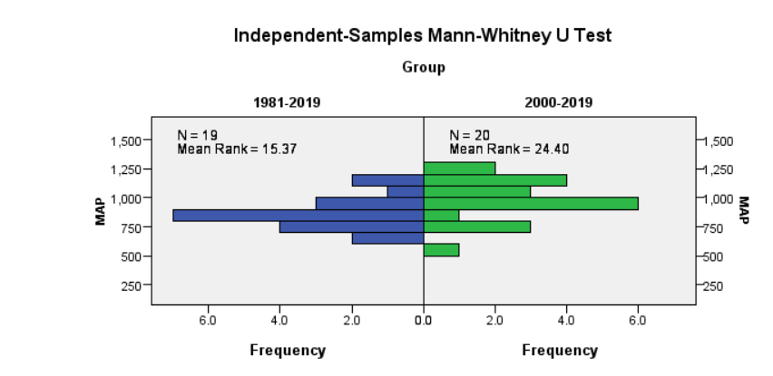
Figure 25: standard Mann-Whitney U test using Mean Annual Precipitation over Mongu. The blue bar represents the precipitation for the period 1981-1999 and the green bar shows the precipitation for the period 2000-2019
Based on the analysed data that there is an increase in mean daily precipitation over Mongu (Figure 25). This was explored further by considering trends of the maximum daily precipitation amount (MDP, i.e., maximum daily precipitation recorded in one day within a given year). Results show that MDP is increasing at a rate of 0.06 mm per year. However, this trend was statistically insignificant (P-Value = 0.45) at α 0.95. During the study period, the highest MDP observed is 63.9 mm recorded in 1986, whereas the lowest is 19.9 mm reported in 1997. On average, Mongu experienced a MDP of 33.2 mm for the period 1981 – 2019.

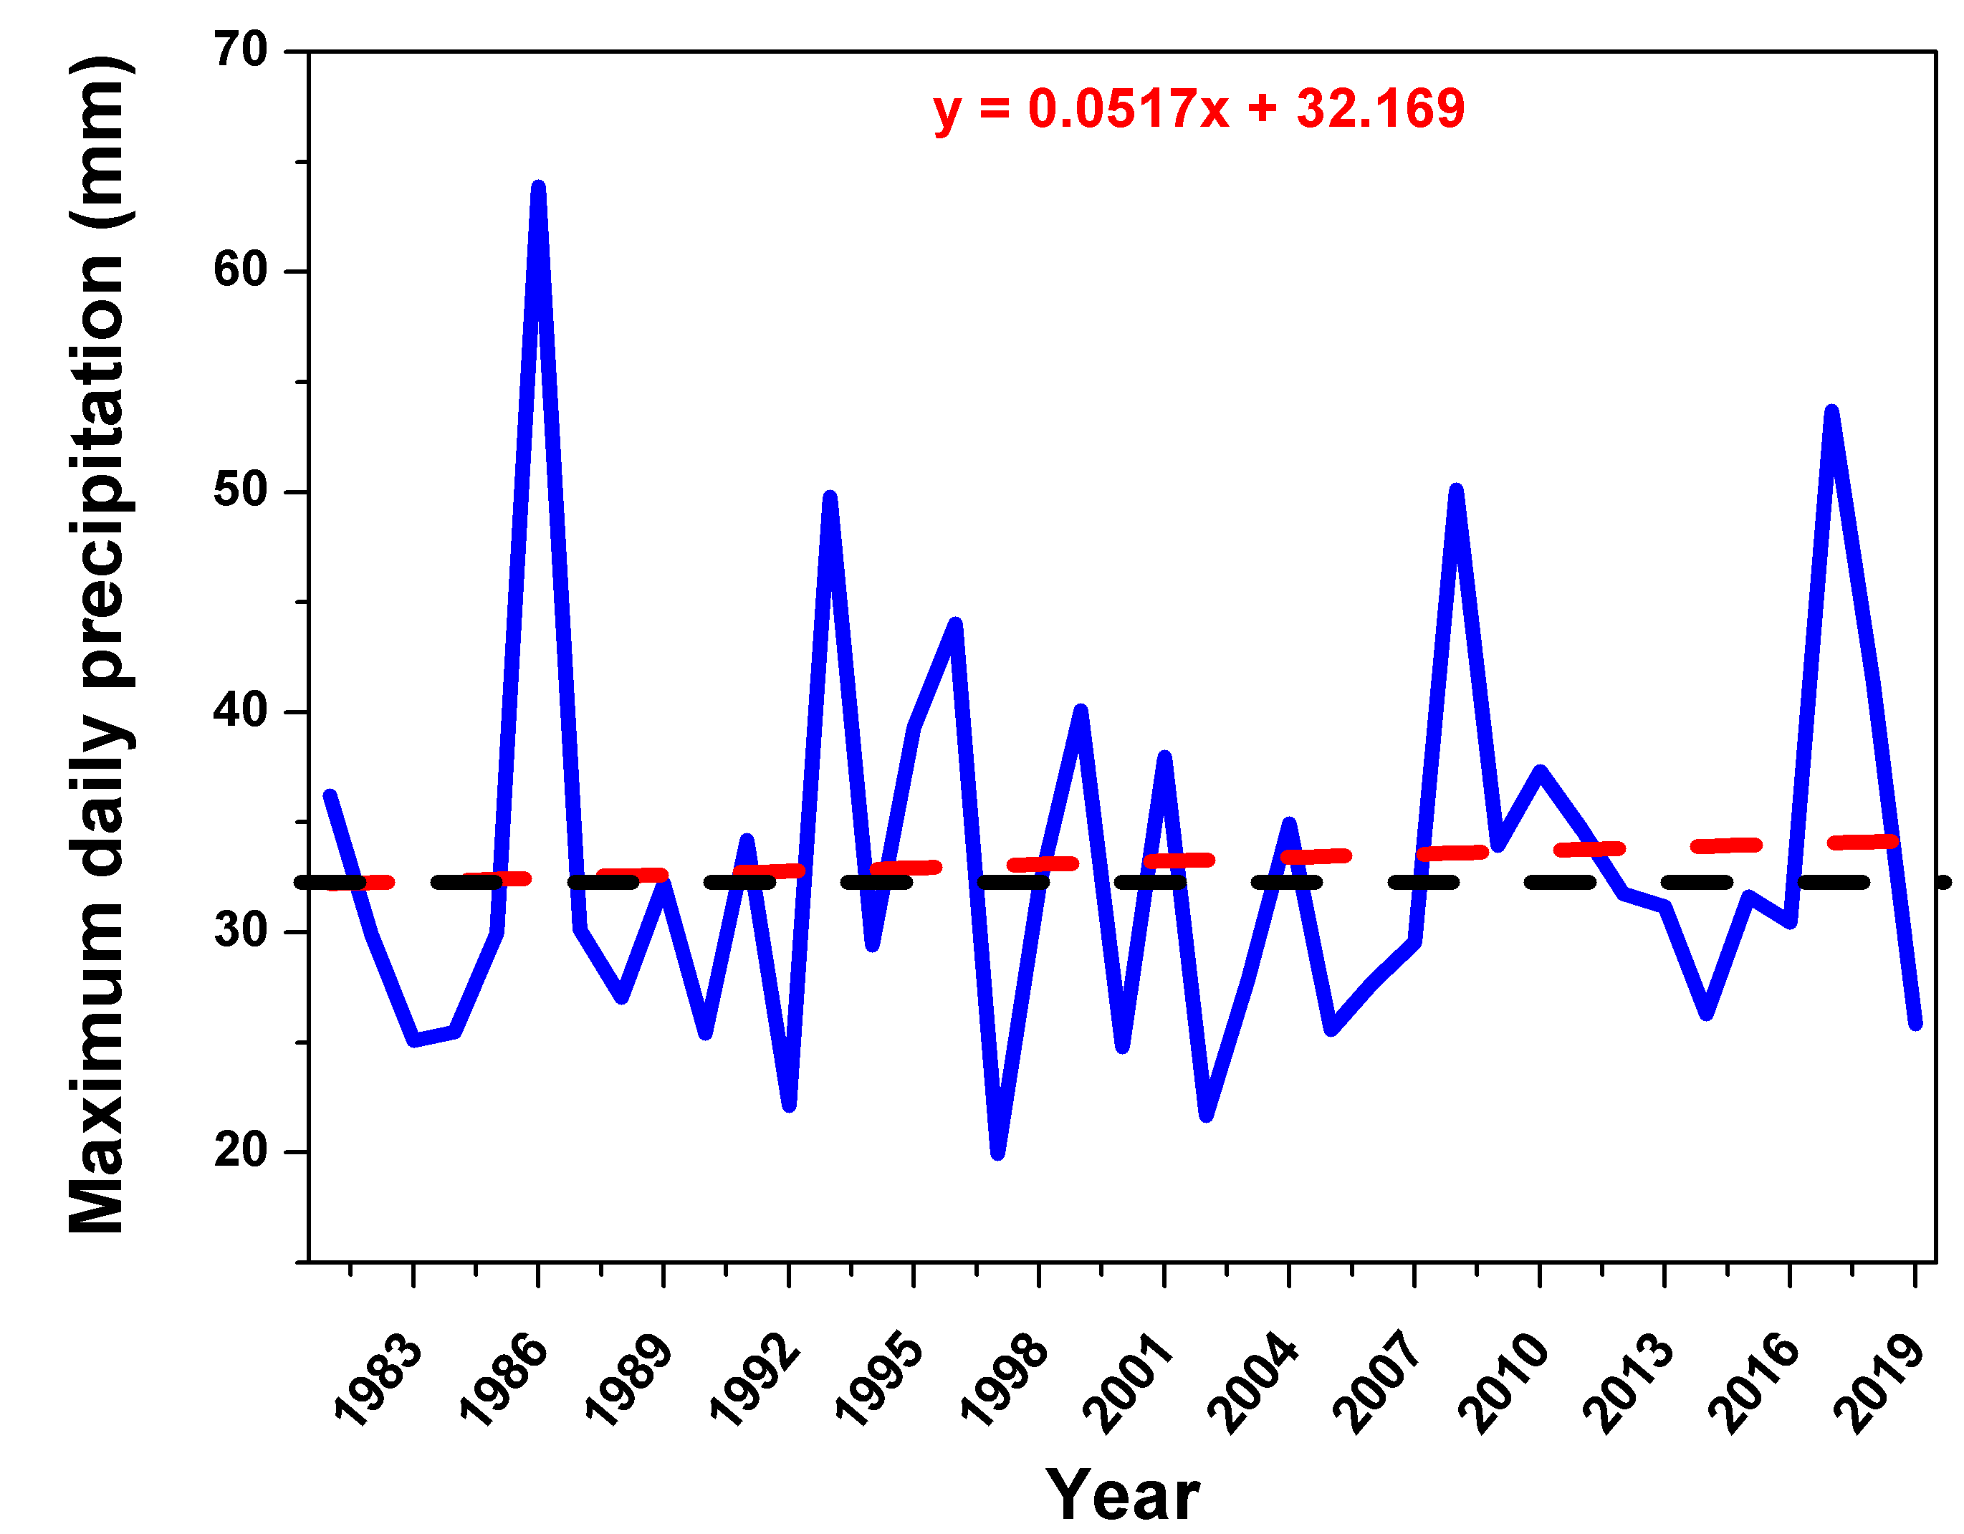
Figure 26: Trend of Maximum daily precipitation (mm) over Mongu, averaged over longitude 22.8° E –23.9° E and latitudes 14.8° S and 15.9° S for the period 1981 – 2019. The red dashed line is the regression fitted using the Sen’s slope estimator, and the dashed black line is the mean maximum daily precipitation.
Occurrences of CDDs and CWDs were also explored during the rainy season (November – March). The results indicate that the average mean monthly consecutive wet days are more that consecutive dry days during the rainy season. The number of mean monthly CWD was 17 days while the number of mean monthly CDD were 14 days over Mongu (Table 6). The minimum CDD was 9 days while minimum CWD was 11 days in the study period. Similarly, the maximum CDD was 19 days while the maximum CWD was found 21 days in Mongu during the study period. The data was further analysed for assessing standard deviation and coefficient of variation in the study period. From the analysis it was found that standard deviation for both CDD and CWD was 2 days while the coefficient of variation for CDD was 14.7% whereas it was 12.1% for CWD. Drawing from the foregoing, while annual total rainfall has increased, the number of wet days has decreased and an increase in dry days. The increase in annual total rainfall is attributed to rainfall intensity –that is a lot of rainfall falling over a short period.

Metric | Consecutive dry days (CDD) | Consecutive wet days (CWD)
Mean (days) | 14 | 17
Min (days) | 9 | 11
Max (days) | 19 | 21
SD (days) | 2 | 2
CV (%) | 14.7 | 12.1

Figure 27 above and table 6 below show the total number CWD annually and for the rainy season (November-MaFigure 27 below shows the summary statistics of mean monthly consecutive dry and wet days during the rainy season (November – March) over Mongu, averaged over longitude 22.8° E –23.9° E and latitudes 14.8° S and 15.9° S for the period 1981 – 2019. SD, standard deviation; CV, coefficient of wet daysrch) based in each year.
It can be seen that the number of rainy days are increasing which were further evaluated to determine if the trend is significant or not. For that the Mann-Kendall trend test was applied and it indicates that the increase in wet days is significant with 95% significance level (Table 6). The year 2011 was the wettest year where the total number of rainy days in annual analysis was 119 while 105 days were observed wet during the rainy season (November to March-see also figure 27 and 28). The lowest number of rainy days were observed during 1981 where the total annual rainy days were 58 in which 52 rainy days were found during the rainy season.
Table 6: The Mann-Kendall trend for the annual number of Consecutive Wet Days and Consecutive Dry Days over Mongu in the period 1981-2019
 | Kendall's tau | S | Var(S) | p-value (Two-tailed)
CWD | 0.2254 | 165.00 | 6809.00 | 0.0469
CDD | -0.2230 | -163.00 | 6805.67 | 0.0496

Figure 28: Annual and rainy Season (November to March) total number of CWD over longitude 22.8° E –23.9° E and latitudes 14.8° S and 15.9° S for the period 1981 – 2019.Figure 28 shows the total number of dry days during the rainy season which often starts from November and lasts till the end of March over Mongu, Zambia. The results indicate a decrease in the number of dry days during the rainy seasons and the same was evaluated for trend significance using Mann-Kendall trend test. The results of Mann-Kendall trend test showed significant decrease in the number of CDD.

Figure 29: Rainy Season (November to March) total number of dry days over longitude 22.8° E –23.9° E and latitudes 14.8° S and 15.9° S for the period 1981 – 2019.
6.3.2 Annual rainfall characteristics
Mean annual rainfall was assessed over the past 20 years (2000 – 2019) and compared to the long-term mean (1981 – 2019) to assess if there are any noticeable recent climate change and variability. The results revealed that during the entire study period (1981 – 2019), precipitation has been increasing at the rate of ~5 mm/year (P-Value = 0.01) as shown in Figure 30. However, during the last two decades (2000 – 2019), a negative trend at the rate of 2.7 mm/year is observed albeit statistically insignificant (P-Value = 0.97). Although a negative trend was observed, mean annual precipitation (MAP) was found higher (982.2 mm) during the period 2000 – 2019 compared to 1981 – 2019 (924.1 mm), thus reflecting the insignificance of the trend (P-Value = 0.97), and that this negative trend follows a period of positive trends. The higher mean annual precipitation value during the last two decades indicates the occurrence of higher intensity precipitation in lesser time. This high rainfall intensity is linked to the increase in the number of rainy days, with a shorter rainy season, however, observable more rainy days. The foregoing analysis corroborates with Biggie and Mubanga (2022) who found the trends in the rainy season length decreasing over AERII over which the study areas are located (see Section 1.4.0) . Biggie and Mubanga(2022)’s study cover the period 1983-2019, which is almost the same period that this study covers. The range of MAP during the 1981 – 2019 period ranges from 598.9 mm – 1286.9 mm with an 18% coefficient of variation (CV). This is because, in both periods, the maximum rainfall was reported in 2010 while the minimum was observed in 2018.

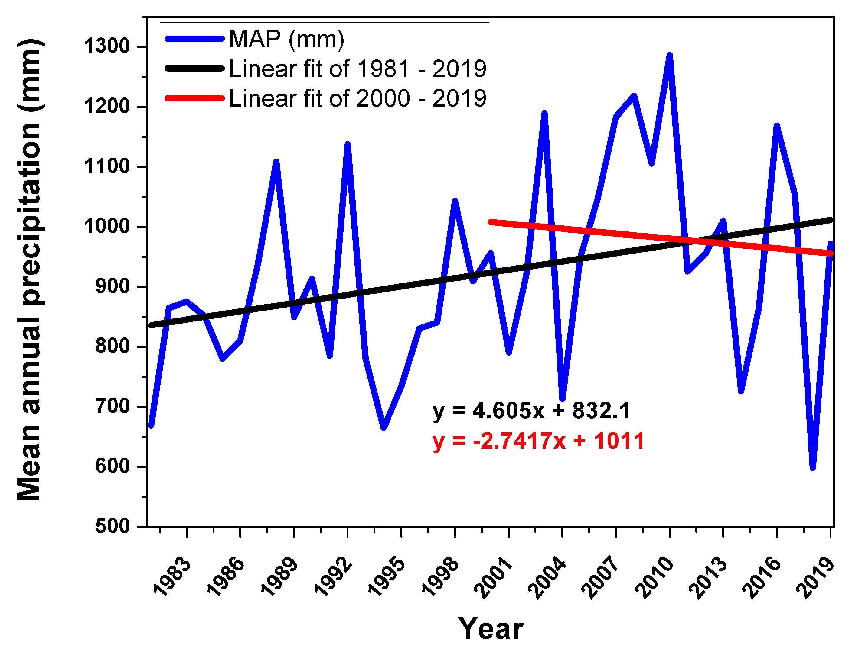
Figure 30: Mean annual precipitation (mm) over Mongu, averaged over longitude 22.8° E –23.9° E and latitudes 14.8° S and 15.9° S for 39 years (1981 – 2019). Red line in the figure above represents the regression for the period 2000 – 2019 while black line shows the regression for the period 1981 – 2019. Regression fitting was done using the Sen’s slope estimator in this study.
Figure 31 below presents standardized anomalies of mean annual rainfall over Mongu. Standardized anomalies are a widely used for measuring the magnitude of precipitation distribution because their computation removes any influences of dispersion from the data. These results show that during the study period (1981 – 2019), Mongu experienced 17 wet years and 22 dry years (defined as a year above or below 1981-2019 mean). A statistically insignificant near-zero positive trend in wet years was also found (Sen’s slope = 0.002 ; P-Value = 0.96) while dry years exhibited an insignificant negative trend (Sen’s slope = -0.01 ; P-Value = 0.29). The years 1981-1986 were consecutive dry years where the precipitation was found below the long term (1981-2019) average precipitation while 1987 and 1988 was recorded wet years after the consecutive dryness over Mongu. The years 1989-1991 were again the dry period over Mongu which was dissipated with high precipitation in 1992. Again, there was a dry period recorded in 1993-1997 over Mongu while 1998 was again a wet year. The years 2001 and 2004 were again found with precipitation below average. After 2004 the Mongu experienced consecutive wet spell from 2005-2013 whereas the years 2014-2015 were again dry. The precipitation was found above the long-term average in the years 2016 and 2017 whereas 2018 was driest year during the study period (Figure 29).

To the extent that there no previous scientific findings to rely on or cite, the dry years in the cited above corroborate with local people’s observations of significant drought years in 1992/3, 2004/2005, 2012-2014 and recently 2017/2018 (refer to section 5.3.5). Table 8 below summaries areas of agreement and disagreement between local observation and climatic data analysis . Biggie and Mubanga (2022) report drought years in 1992/3, 1995 and 2011 in the in western Zambia where the study areas lie also. Biggie and Mubanga’s findings are not significantly different from local observations as explored in this study.

Space left blank to fit figure 31 on next page
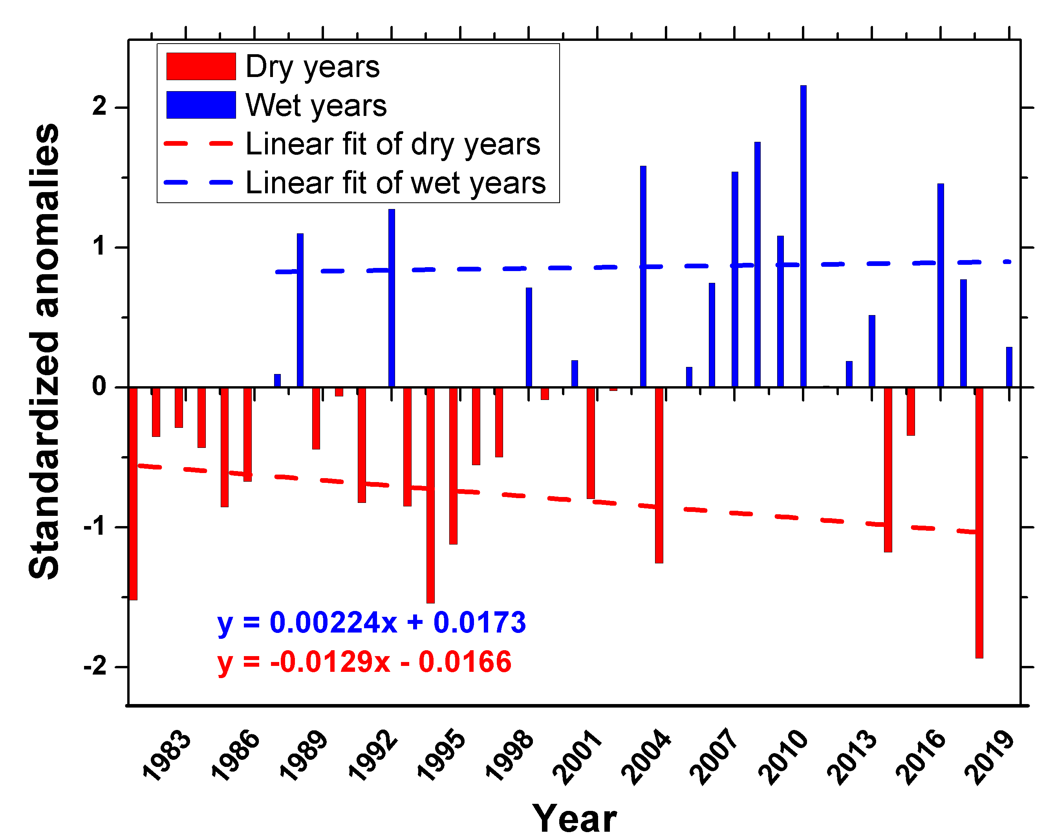
Figure 31: Standardized anomalies of precipitation over Mongu, averaged over longitude 22.8° E –23.9° E and latitudes 14.8° S and 15.9° S for a 39-year period (1981 – 2019)

The sequential Mann-Kendall statistical test revealed that Mongu experienced two statistically significant sudden changes in the trend of mean annual precipitation during the period 1981 – 2019 (Figure 32), in 2005 and 2008. The change point is determined at the intersection between the progressive and retrograde curves. If the intersection occurs, α = 0.05, within the confidence interval of +/-1.96 shown by dashed horizontal lines, indicates a change point. Although the progressive and retrograde series of Kendall normalized Tau’s are seen to be in contact during the 1997/1998 season (Figure 32), the two lines did not cross, and thus, this was not considered a potential trend turning point. As demonstrated in figure 32 below, the red (dry) and blue (wet) lines cross in 2005 and 2008 indicating a new trend. Where a crossing point is present it indicates the start of a new trend (Gerstengarbe and Werner, 1999; Bisai, 2019). Figure 32 demonstrates that 2005 was a transition point from a wet trend to a dry trend that subsequently reverses in 2008. These turning points in general corroborate with Musonda et al.(2020)study that found that 2005-6 as a dry period and the period 2008-14 as the wettest period in Zambia.

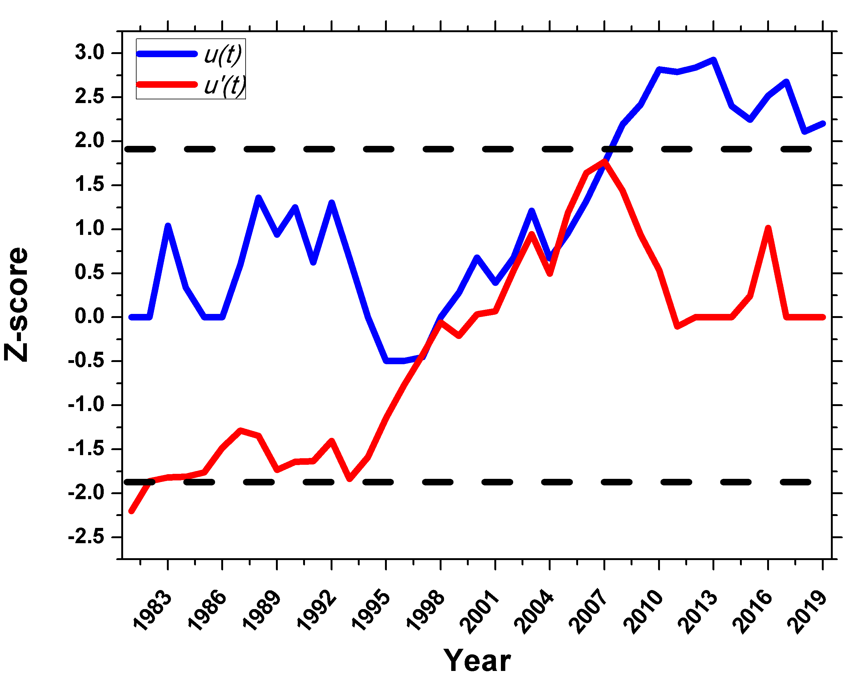
Figure 32: Abrupt changes in precipitation over Mongu based on Sequential Mann-Kendall test statistic. The dashed black dashed lines indicate limits of statistical significance at the α 0.95. The period covered is 1981 – 2019, and the data is averaged over longitude 22.8° E –23.9° E and latitudes 14.8° S and 15.9° S.
6.3.3 Characteristics of rainy season onset, cessation, and length
Rainy season onset and cessation are hypothesized to have defined effects on agricultural yields (Amekudzi et al., 2015). During the 1981 – 2019 period, an analysis of onset, cessation, and length of the rainy season revealed that the mean start of the season is on the 14th of November each year while the end is on March 20th (Figure 33). A positive trend of onset dates was also found (Sen’s slope = 0.19; P-Value = 0.1), suggesting that rainy seasons over Mongu generally start later. On the other hand, cessation dates were found to exhibit a negative trend (Sen’s slope = -0.06; P-Value = 0.5), inferring that rainy season are ending earlier. It was hypothesized that this would ordinarily translate into shorter rainy seasons. Figure 33 confirms the hypothesis that due to late onset and early cessation of rains, rainy seasons are getting shorter, although the trend is insignificant (Sen’s slope = -0.25; P-Value = 0.1).
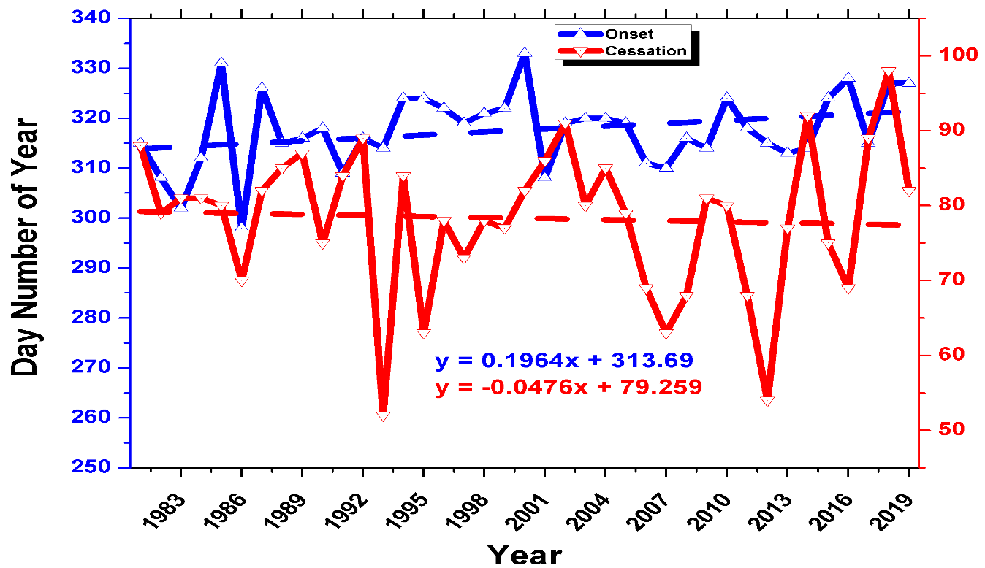
Figure 33: Trends in onset and cessation of the rainy season over Mongu. The period covered is 1981 – 2019, and the data is averaged over longitude 22.8° E –23.9° E and latitudes 14.8° S and 15.9° S

Space intentionally left blank to fit figure 33 on the next page
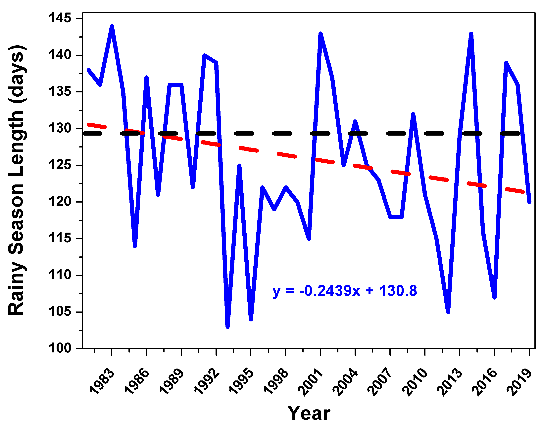
Figure 34: Rainy season length (days) over Mongu, averaged over longitude 22.8° E –23.9° E and latitudes 14.8° S and 15.9° S for a 39-year period (1981 – 2019)
Red dashed line is the regression line fitted using the Sen’s slope estimator, and the dashed black line is the mean RSL (days) over the period.
Figure 34 shows the rainfall onset and cessation trend analysis for the Mongu region. The results indicate an increasing trend (day 315, 1981 to day 327, 2019) within the rainfall onset based on years. The trend translates to delayed rainfall start, and this might have a significant impact on farmers and agricultural activities in the study area. Besides, the trend analysis reveals a decreasing cessation date depicting an early withdrawal (day 88, 1981 to day 82, 2019). The results analysis suggests a significant inter-annual onset and cessation rainfall variability within the study region. Based on the observed data's onset and cessation grouping, many of the years fell under the normal category. Both the onset and cessation were classified into three categories (normal, late and early).

Figure 35: Rainfall Onset and Cessation Classification
Cessation and onset period was categorized under normal and extreme conditions (below normal). Rainy season onset classification was adopted from Amekudzi et al. (2015)-the average daily rainfall amounts/rainy days from the period 1982-2019 for Mongu using satellite data was calculated. The next step involved the computation of the mean monthly totals. Mean monthly totals were summed into mean annual rainfall or rainy days that were recorded at each 5-day interval throughout the year. The next step involved the computation of percentages of mean annual rainfall and rainy days and their cumulative percentages. Subsequently, the temporal variation of the cumulative percentages for the entire year were determined. Following this method, the average onset date of rainfall was described/determined as the first point of the maximum positive curvature of the graph. Cessation on the other hand was defined as the maximum negative curvature. Based on the foregoing, the rainy season length (RSL) is defined described as the difference of the onset and cessation dates of rainfall. The most notable years with late withdrawals are; 2000, 1985, 2016, 2019, and 2018 while the years with the most notable late onset are; 1989,1981, 2001, 1992, 2002, 2014, 2017, 2018. Based on classification above for both onset and cessation of rainfall, two years were grouped under below normal category (onset: 1993 and 2012, cessation: 1983 and 1986
Generally, Mongu region is characterised by increasing (later) onset dates and decreasing (earlier) cessation dates. Therefore, the result suggests a significant growing season reduction. The trends signify a decrease in the rainy season duration. Correlations between MAP and rainy season length (RSL) have previously been identified (Dunning et al., 2016; Byakatonda et al., 2018). However, in this study, a weaker insignificant negative relationship (correlation coefficient of -0.18) was found. The key finding here is that there is an increase in rainy season days despite a decrease in the rainy season length. The turning point is observed in 2009/10, which is present/observed in the analysis of mean annual precipitation and in the number of wet days. The forward trend in rainy season onset fits into Biggie and Mubanga (2022) findings over AERII over which the study areas lie. However, Biggie and Mubanga (2022)’s study finds insignificant trends in cessation. Biggie and Mubanga (2022) attest that despite the seasonal rainfall amounts in all three AERs of Zambia remaining the same, the rainy season and therefore the growing season is getting shorter. Other previous studies have drawn similar conclusions in relation to the shortening rainy season across Zambia (Hachigonta et al.,2008; Mulenga et al,2017). The shortening growing season is a call for policy makers and other stakeholders to proactively empower farmers with skills in improved farm management practices in relation to crop choices and varieties that maximize yields and minimize losses.

Figures 31 and 32 show that in the first part of the study period, until around 2009/10 the trend in the number of rainy days in a rainy season was positive coinciding with the period of positive trend in mean annual precipitation. These trends reversed from 2009/10 to 2019 (figure 32). The second decade results shows that the number of rainy days decreased compared to 1981-1990 and similarly the mean annual rainfall was also comparatively lower. The decrease in rainy days suggests that it is becoming dry over Mongu because of the decrease in the mean precipitation and rainy days (Figure 34). The last two decades 2001-2019 shows a decrease in rain days with fluctuations in some years and similarly the mean annual rainfall was found higher in years 2006, 2007 and 2010 which then decreased to 2014 and again was observed to be higher in 2016. Overall, the lowest amount of mean annual precipitation was in 2018 while the least rainy days were observed in the years 1993 and 2012 (Figures 35 and 36).
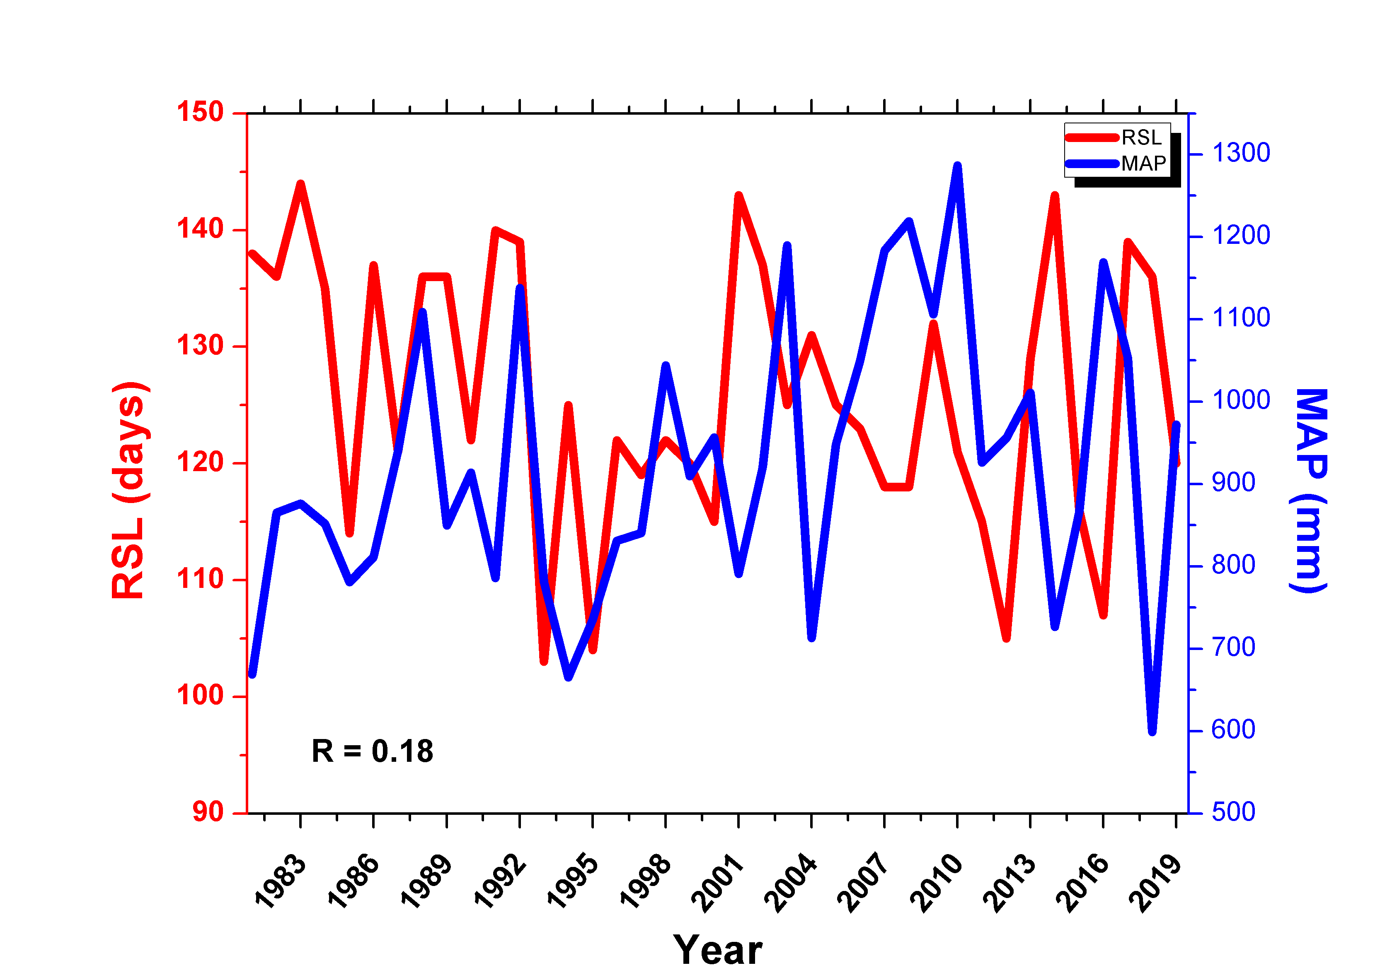
Figure 36: The relationship between mean annual precipitation and rainy season length, averaged over longitude 22.8° E –23.9° E and latitudes 14.8° S and 15.9° S for 39 years (1981 – 2019)
Having analysed the key changes and trends in rainfall during the period under study, the table below is a summary of these changes and trends.

Space intentionally left blank

6.3.4 Summary of Key Changes and Trends
Table 7 Summary of Key Changes and Trends 6.3.4
Rainfall Indices | Climatic data | Description
Rainy season onset | Forward trends towards late onset: Sen’s Slope=0.19 P-Value=0.1. | Rainfall starts shifting towards December from November
Rainfall distribution | Climatic data points to increased rainfall intensity-increase in CWD. Study period experienced an increase of maximum daily rainfall of 6.6mm. Highest increase during the last 20 years (2000-2019). However, these changes were insignificant-Value=0.45. | Rainfall season concentration between 3 months opposed to being spread through the normal 5. A shift from 180 days season to 120 days
Rainy season duration | Climatic data points to an insignificant trend towards a shortening RSL: Sen’s slope=-0.25 P-Value=0.1. Combination of late onset and early withdrew translates into a shorter RSL. Majority of years during study period indicate normal RSL. | Minor changes towards a narrowing rainy season compounded with more intense rains. By implication the growing season has decreased in line with late onset and early withdraw
Consecutive Wet Days | Climatic data points to an increase in wet days-Mann Kendall trend test shows 95% increase in wet days. Mann Kendall shows decrease in dry days. Increased wet days coincide with an increasing rainfall intensity during the study period | Consecutive wet days have been an increase-that is rainy days with rainfall amounts more than 1mm have been on the increase
Total Annual Rainfall | During the study period (1981-2019) rainfall increased at an annual rate of ~5 mm/year (P-Value = 0.01. The last decade (2000-19) experienced a negative trend at an annual rate of ~2.7mm/year abet insignificant P-Value=0.97. | Total annual rainfall has remained the same during the study period with insignificant changes of a receding trend during the period 2000-2019
Rain season Cessation | Negative trends towards early withdraw: Sen’s Slope=-0.06 P-Value 0.5 | The rains have been withdrawing early from the previous of April to March and late February

6.5.0 Discussion
The main objective of this chapter was to investigate rainfall characteristics over Mongu in Western Zambia to assess for changes and trends in rainfall over the study period. The findings indicate that there is a positive trend in long-term annual rainfall. However, this study finds out a negative (albeit insignificant) trend in last two decades 2000-2019. Similarly, a study by Makondo and Thomas (2020) in AERII concluded reduction in number of wet days and concluded a shortening of the rainy season. The current study also finds a shortening of the rainy season, and a positive trend in the number of wet days within the rainy season over the entire period, but with some evidence of a reversal of the trend in the final decade (from 2009/10 onwards). This study points to an early cessation as also observed by Makondo and Thomas (2020). This study reveals a decadal-scale variability in the annual mean precipitation, with positive trends to a period of increased mean precipitation in the period 2000-2010, and negative trends after that agreeing with the findings of Linbanda et al. (2020) and Biggie and Mubanga (2022). This period of increased mean annual precipitation was also reported by Libanda et al. (2020) and revealed by Makondo and Thomas. The finding of this study, however, are inconsistent with the results by Libanda et al. (2020) which concluded a decrease in the amount of rainfall based on satellite based daily data which were compared with data from 35 meteorological stations between 1960-2016. This study on the contrary reveals an increase in the amount of annual rainfall compared to assertions by Libanda et al., (2020).

The key findings of this study suggest that while long-term mean annual rainfall was observed to have a positive trend (fig 30), RSL exhibited a negative trend (fig 34). Although this trend is insignificant, it is a result of significant trends in start date (later) and end date (earlier) of the rainy season. The same shortening in the rainy season length was also observed in Makonda and Thomas (2020) and in the study conducted by Libanda et al. (2020). Interestingly, this study also finds an increase in the total number of wet days within a rainy season. This suggests that despite the shortening of the rainy season, within each rainy season there are a greater number of rain days. The result also suggests that more rainfall is now being received within a short period hence with higher intensity that is also corroborates with results of the maximum daily precipitation that showed positive trend although the results were insignificant. However, the impact of intense rainfall over a short period can have serious consequences for people and their livelihoods (Levy et al., 2016).

When this was explored further, it was observed that there is a general increase in annual maximum daily precipitation, especially in the last 20 years, although this increase was statistically insignificant (Figure 25). Therefore, the increase in annual precipitation is likely a combination of more rain days, with a potential contribution from more intense rainfall, i.e., more frequent and intense rainfall (IPCC, 2022). The findings of this study are consistent with global outlook that concludes that there had been an increase in the number of heavy precipitation events (95 percentile) across many regions of the world (Lehmann et al., 2016; Mukherjee et al., 2018; IPCC, 2022). Research argues that the observed increase in extreme precipitation events is associated with climate change at the global scale (Fischer and Knutt, 2016; Sun et al., 2021). Extreme rainfall events damage/erode topsoil structure and highly reduces soil permeability, translating into poor agricultural yields for the rural majority who depend on rain-fed agriculture for their livelihoods (Burt et al., 2016; Han et al., 2020).

According to the IPPC (2022-Chapter11; Section 11.4.2), evidence indicates that there has been an increase in daily precipitation during the latter half of the 20th Century dependent on data availability. The IPCC (2022) forwards that several gauge stations show significant increases in extreme daily precipitation than decreases. Fowler et al. (2021) forward that rainfall intensification can cause severe disruptions to livelihoods and damage communities. Wainright et al. (2020) report that for example, during October to December rainy 2019, the rainy season over East Africa was the wettest on record with many locations experiencing widespread flooding. Wainright et al. (2020) forward the rainfall amount received were double the climatological rainfall. Similarly, Kruger et al. (2019) indicate that Southern Africa has experienced an increase in extreme precipitation events. According to Mungambiwa et al. (2021) and Balgah et al. (2023), flash floods are due to extreme intense rainfall that results in hundreds of millimetres within few hours or days.

The impact of flash floods on human life and, economic terms, can be devastating (Velasco et al., 2013). This is especially concerning considering that Mongu features several floodplains such as the Barotse and Zambezi. These floodplains are considered among Africa’s most significant wetlands (LUCN, 2003). Therefore, the increase in precipitation intensity and rain days within a rainy season over Mongu is a threat to agriculture and a threat to lives. For instance, in 2009, 1000 households were displaced in Mongu due to floods that also caused significant agricultural and infrastructural damage, with 65% of upland and 80% of floodplain crops lost to extreme precipitation events (DREF, 2009). In 2011, it was reported that 78,000 people were affected by floods in Mongu, with 60% being women and children (LT, 2011). Therefore, the observed increase in precipitation intensity must require monitoring with a particular focus placed on bettering forecasting facilities, establishing early warning systems and overall disaster preparedness.

The following section brings together local observations and scientific data to highlight areas of agreement and disagreement in relation to rainfall patterns and trends.

Space left to fit in next section -6.5.1

    - Merging Science with Local Observations
Table below is a descriptive comparison of the rainfall indices explored from local people versus climatological data.
Table 8 Summary of agreements and divergences between climatic data and local observations.
Rainfall Indices | Climatic data | Local observations | Description
Rainy season onset | Forward trends towards late onset: Sen’s Slope=0.19 P-Value=0.1. Section 6.3.3 | Narratives of late onset towards late November/Early December. Sections 5.3.1-5.3.3 | Climatic data and local observations agreement-insignificant differences in relation to actual start dates
Rainfall Intensity | Climatic data points to increased rainfall intensity-increase in CWD. Study period experienced an increase of maximum daily rainfall of 6.6mm. Highest increase during the last 20 years (2000-2019). However, these changes were insignificant P-Value=0.45. Section 6.3.1 | Local observations suggested “a lot of rainy falling within a few days- not giving a chance to tend to our fields”. Narratives suggested that due to late onset most of the rainfall concentrate between December to end of February/early March. Sections 5.3.1-5.3.4 | General agreement between local observations and scientific observations in relation to rainfall intensity. Scientific data points to rainfall intensity also observed by local people
Rainy season Length | Climatic data points to an insignificant trend towards a shortening RSL: Sen’s slope=-0.25 P-Value=0.1. Combination of late onset and early withdrew translates into a shorter RSL. Majority of years during study period indicate normal RSL. Section 6.3.3 | Local observations point to a shorter RSL. Narratives of late onset and early withdrew combine to reinforce local observations. Section 5.3.4 | Broad agreement in relation to RSL between the science and local observations. However, divergence to the extent of the changes/trends. Science points to insignificant changes as evidenced that majority of years fell under normal RSL. Local narratives suggest a significant trends towards a shorter RSL.
Consecutive Wet and Dry Days | Climatic data points to an increase in wet days-Mann Kendall trend test shows 95% increase in wet days. Mann Kendall shows decrease in dry days. Increased wet days coincide with an increasing rainfall intensity during the study period. Section 6.3.1 | Local observations point to more dry days /prolonged and frequent dry spells. Section 5.3.5 | Clear and obvious differences between science and local observations. The differences in opinion maybe situated in the way local people perceive/ referenced “dry spells or drought”.
Total Annual Rainfall | During the study period (1981-2019) rainfall increased at an annual rate of ~5 mm/year (P-Value = 0.01. The last decade (2000-19) experienced a negative trend at an annual rate of ~2.7mm/year abet insignificant P-Value=0.97. Section 6.3.2 | Sweeping narratives of decreasing total annual rainfall enveloped in the term “not enough rainfall to grow our crops”. Section 5.3.1-5.3.4 | Divergences between the two findings-local observations interwoven with conflated themes of late onset, early withdrew and RSL. Differences situated in measures of assessing total rainfall
Rain season Cessation | Negative trends towards early withdraw: Sen’s Slope=-0.06 P-Value 0.5  Section 6.3.3 | Local observations of early withdraw of the rains coinciding with late onset-resulting into short rainy seasons. Sections 5.3.1-5.3.4 | Scientific analysis and local observations corroborate in relation to rainy season cessation
The rainfall data analysed in this study to points divergences and convergences with local people’s observations. Convergence or agreement is observed in the onset, cessation and rainy season length as shown Sen’s slope. Sen’s slope =0.19 and P value -0.1 points to a positive trend in the onset of rains (i.e. later onset). In relation to cessation of the rainy season Sen’s slope (=0.06, P-Value=0.5) suggests a negative trend which ordinarily mean that the rainy season stops early. The combined effect of late onset and early cessation of the rainy season translates in a shorter rainy season (Amekudzi et al., 2015). Drawing from the foregoing, the scientific climatic data used in this study affirms people’s observations that the rainy seasons during the study period have been starting late and withdrawing early. As demonstrated in section 6.3.3 of this chapter, rainy season onset showed a positive trend-that is a forward shift of start of the rainy season with climatic data pointing November (Sen’s slope =0.19 and P-value=0.1) and a negative trend with Sen’s Slope =-0.06 and P-Value=0.5. Chapter 5 under sections 5.3.1-5.3.4 demonstrated from the local perspective narratives of late onset and early withdraw of the rains. Local observations appeared to suggest that onset of the rainy season shifted towards late November/early December. Whereas scientific data points to precise starts of between 14-21 Novembers as start dates, interviewees were unable to cite precise starts.
These insignificant grainy differences in start dates, in my view lie in the fact that scientific approaches apply precise and objective approaches that measure actual start dates. Scientific approaches often has set standards and homogenous instruments that can be applied at a global scale and largely replicate similar observations (Panini, 2005). On the hand, people make subjective and broad judgements based on historical observations of their local environment. This can be seen in remarks/narratives such as such, “In the old days, we could tell if the rains are coming and when to go to the fields by looking at the position of the moon. Our forefathers told us they could smell the rains months ahead”. This statements symbolises the subject nature and the framing of rainfall patterns based on historical narratives passed on through generations. Subjective and historical narratives can suffer from uncertainty due the none existence of standards of measure that reproduce similar results when applied in different part of the world (Panini,2005) .Another interesting observation drawn from this study, descriptions of onset varied between and within study site and while others were based on livelihood activity. For instance, subsistence farmers in Nanikelako defined onset as “when green pastures appeared on the flood plain” (section 5.3.2).
Seen from this angle, it is my view the description of onset reflected pastoralism as the dominant activity in the area. Pastoralism is closely linked to the seasonal flood season-flood bring water and green pastures for people and their animals. This seasonality also influences the annual migration of people and their livestock from the flood plain to the higher ground. It goes therefore that the presence of flood water and emergence of green pastures maybe seen by pastoralists as a sign of the rainy season onset. In Lealui and Sefula on the other hand, onset appeared to be largely framed around the appearance of wild vegetables and wildlife in the local forests. For example, the presence of seasonal mushroom, fruits and wildlife such as caterpillars were symbolic of rainy season onset. Similar studies have demonstrated how local people have used their traditional knowledge in terms such as “signs of weather” to predict the rainy season (Bolliat and Berkes, 2013). Roncoli et al. (2002) in their study demonstrated how local people relied on the fruit production of certain trees to assess rainy season onset. Radney et al. (2019) document in their studies in East Africa (Uganda, Kenya & Ethiopia) how local people applied a mix of meteorological, astrological and biological indicators to describe and predict their local weather.
Citing Goldman (2018) and Owen (2020), these fine grainy differences lie in the lenses of inquiry and the complex interrelations between science and local observations both from an epistemological and ontology level-the perception, interpretation and understanding of a same phenomenon using different approaches. Savo et al. (2016) in their large-scale meta-analysis climate change observed by subsistence farmers in 137 countries between 1955-2005, found that climatic ensembles were unable to capture local observations.
The rainy season length or duration is influenced by the onset and cessation of the rains; however, the RSL is not essential for the assessment of climatic change but critical for the determining the growing season (HarvestChoice; Makondo and Thompson, 2019). The data analysis in this study points to an insignificant negative trend in rainy season length (Sen’s slope=-0.25, p-Value-0.1-Section 6.3.3). However, people’s narratives contrasts with scientific data with local narratives portraying a picture of an impactful shortening rainy season length (section 5.3.4). Local people suggested an onset that has shifted towards late November/early December and a withdraw of end of February/early March. However, scientific data indicates during the study period that abet insignificant forward shifts of onset, most of the years fell under normal withdrew. In the broader context, however, the data points an increasing trend of late onset and a decreasing (early) cessation that can attributed to people’s perception of a shortening RSL and thereof of the growing season. Based on the foregoing, I argue that it is plausible that people will report significant changes in rainy season length when data indicates the opposite because changes in RSL impact the growing season and crucially people’s harvest. It is possible the local people may conflate RSL with other factors that affect their harvest and thereof of their perception of RSL.
Savo et al. (2016) forward that soil moisture can simulate and acerbate conditions of drying observed by local people. Changes in temperatures can also affect crop yields in the similar ways that shifts in rainfall can (Savo et al., 2016). The analysed data in this study points to an upward trend in winter and summer temperature (section 7.4.6 & 7.6.0), both MM and MMK tests affirm this trend. It’s this combination of shifting rainfall patterns and up trends in my view combine reinforce people’s perceptions of significant changes in RSL. Although shifts in the RSL do not always often translate into proportional changes in MAP, correlations between the two have previously to be found strong (Laux et al., 2008; Amekudzi et al.,2010). No association was found in this study, which may relate to the increase in the number of rain days within the rainy season identified.
Other divergences or overlaps between rainfall data and people’s observations are related to perceived decline in the total annual rainfall received. Based on the analysed data as demonstrated in figure 24, Mongu recorded an increase in daily precipitation intensity of 0.06mm per year. However, this positive trend appears to reverse in the 2009/10. Even though this increase is insignificant, it contradicts people’s perceptions of decline in observed MAP (Section 6.3.2). The turning of 2009/10 corroborates with the finding of Maidment et al. (2015). Maidment et al. (2015) observed that rainfall trends in Southern Africa where Zambia is located experiencing an increasing trend from 1983 to 2008. However, the contradictions in findings between local observations and climatic data can attributed to differences in perception between the two lenses of inquiry as observed in discussions above. Climatic trends indicate the period 2000-2019 recorded MAP of 982.2mm compared the longer term of 924.1mm during the 1981-2019. This inconsistence or divergence can partly be explained by the fact that most of the study participants were unable to recall long rainfall historical events. Indeed, there were ambiguities and at sometimes conflation in the narratives as to whether some people referred to historical climatic events as normal seasonal variabilities or trends. As observed in sections 5.3.1-5.3.4, local people were unable to make differences between a dry spell and a drought. Their use of the term “linanga” (drought) was collectively used to refer to “the lack of rain”. The rainfall data of this study relates to period between 1980 and 2019 (39 years), however, some of the people’s observations or memory of recall of climatic events were related to a much longer periods and in some cases shorter periods (5.3.5). It also is equally plausible that people’s observations at the local scale were not captured in this data as studies in different parts of the world have proved (Savo et al, 2016).
Research shows that there are often strong and significant overlaps between local narratives on ecological changes and climatic data generated using complex scientific methods (Bolliat and Berkes, 2013; Alexander et al., 2011; Klein et al., 2014; Bremer and Meisch, 2017). Local knowledge can provide great insights into the extent, impacts of shifting local climatic conditions and contextualise these on the human landscape (Alexander et al., 2011). Klein et al. (2014) demonstrated how local knowledge of climate change and ecological change supported perceptions of delayed summer on the Tibetan Plateau. Engaging with herders herding livestock at higher attitudes daily they revealed changes in seasonality that indicated warming trends in the region. Krauss and Bremer (2020) posit that local narratives of change are critical to giving insight into material –semiotic evolution of specific regions and their environmental histories.
Local narratives and scientific modelling of change with specific reference to the empirical findings of this study, I argue articulate the same phenomena but employ contrasting lenses of inquiry. I further argue that the two contrasting lenses are complementary to the narration of the same story about climate change and its interactions with rural livelihoods. Drawing from people’s narratives about changing climatic conditions in the three study areas, I am compelled to conclude that local narratives, perceptions and observations are broadly consistent with scientific findings in relation to seasonal variabilities and trends towards decreasing precipitation in the Western Province of Zambia particularly in the study areas. The language used by local people to describe certain climatic phenomena may have some ambiguities when directly applied into scientific models. However, “narratives situate events in a certain place and time, thus shifting attention from the scientific abstraction of climate to the changes of weather and seasons as the materialisation of climate change in a discrete episode” (Krauss and Bremer, 2020 P.3). Similar differences in observation, perception and interpretation of climatic events are explored and discussed in section 7.8.0(temperature analysis).
The changes and trends in rainfall based on the both climatological data analysed and empirical findings from interviewees of this study are broadly consistent with similar other studies in different parts of Zambia have found shifting rainfall patterns but crucially for the Western province of Zambia (Gannon et al., 2014; Met-Office Zambia, 2018; Mulenga et al, 2017; Makondo and Thompson e al., 2020; Musonda et al., 2020). Similar studies across Zambia offer evidence of shorter rainy seasons and increasingly less predictable rainfall patterns (Kaluba et al., 2017; Libanda and Ngonga, 2018; Libanda et al., 2020). These studies suggest indicators of climate change in Zambia; pointing to variable rainfall seasons that are increasingly getting shorter, erratic, uneven, and less predictable over the last 30 years (GRZ et al., 2007; (Mubaya et al., 2012; Mulenga et al.,2018). Ngoma et al. (2019). Nyirenda and Sachikumba add that between 1976 and 2016, Zambia had recorded a rainfall declined of 1.9mm per decade. Several other studies have predicted decreasing rainfall patterns across most parts of Zambia (Lekprichakul, 2008; Libanda et al., 2020).
6.6.0 Conclusion
This study has demonstrated a general increase in long-term mean annual precipitation over Mongu, although, in the recent 20 years (2000 – 2019) a decrease has been observed, RSL has exhibited a negative trend, with rainy seasons generally starting late and withdrawing earlier. Daily precipitation intensity was generally increasing during the study period. The findings also indicate that the number of wet days increased although at an insignificant rate. The increase in wet days links with increased rainfall intensity despite a decrease in the rainy season duration (RSL). The study areas are characterised by high seasonal rainfall variability that directly affects agricultural crop yield and production. The rainfall was an upward trend while the number of rainy days declined with a turning point in 2009/10 as indicated above. Rainfall changes and trends in the study areas are influenced by larger scale changes beyond the scope of this study.

The study reveals that rainfall onset occurs at around 14th November while cessation happens at around 20th March. Generally, the study results reveal an increasing rain season onset trend and a decreasing cessation trend that means a decrease in the rainy season (and the growing season). These changes can be linked to the changing climate in the study region which is also observed in other areas of Zambia (Mulenga et al., 2017; Biggie and Mubanga, 2022). Therefore, there is a need to educate and empower farmers on these changes and trends-particularity in relation types of crops to grow based on the future rainfall characteristics. The findings of this study argue for a realignment of climate monitoring and forecasting systems not just at the national but also at local scales. Critically there is a need for enhanced and locally conceived adaptation strategies in rural settings where majority of people subsist on rain-driven agriculture for their livelihoods.

This study in general and this chapter brings together or coalesces into a two epistemological and ontological investigation of climate change. Yeh(2016) argues that local/traditional knowledge does not exist to be disproved or confirmed by science but rather its place in knowledge co-production is situated in its contribution to climate change debates. The experience of local people framed as narratives in this study (chapter 5) “should be taken as a non-negotiable starting point for the understanding from a multi-perspective of ‘human dimension of global climate change ‘(Yeh, 2016. P.3). As demonstrated chapter 5, local people gave valuable insight into their everyday interactions with the physical environment and how with time it has been changing. Their epistemological and ontological lenses may be different from a scientific lens, however, the rainfall changes described or narrated by local people in many ways fits into the climatic data analysed in chapter 6.

Berkes et al. (2021) forwards that local people’s knowledge is a combination of valid observations and beliefs with no basis of reality. However, they possess valuable understanding of the working of their environment or natural world acquired/transmitted through generations. Some of the knowledge is acquired through their day-to-day pursuit of their livelihoods. Chapter 5 demonstrated how local people understood for example onset of the rainy season through the observations of appearance of the wildlife and were able to predict a ‘false start’ of the rainy season. These observations were to a large extent valid and affirmed through generations which then shaped the planning of their agricultural activities. With marginal or insignificant differences, this chapter has demonstrated that local observations and scientific methods are complementary. In many regions of the world, climate change will be experienced through shifts in rainfall and temperatures. The next chapter (7) explores temperatures changes and trends over Mongu.

Chapter 7: Recent near-surface temperature trends over Mongu Western Zambia
7.0.0 Introduction
Current and projected increases in global temperatures will have significant and adverse impacts on both human and natural systems (IPCC, 2014; 2022-Chapters 1; Munday and Washington, 2019). Since the IPCC 5th Assessment Report multiple, consistent, concurrent changes in the physical systems have become more visible; rising sea levels, loss of sea ice volume, increasing global temperatures and shifts in precipitation patterns (IPCC, 2022). Under global warming, the spatial-temporal distribution of temperature is projected to change (IPCC; 2014; 2022; Neukom et al., 2019) with impacts on human activities and ecosystems (Jacob et al., 2018; IPCC, 2022). From the observations and projections, many regions of Africa will experience increasing temperatures; temperatures will become hotter and longer heat waves more than 300 days per year (reference needed). The projections point to frequent hot days and nights with decreasing cold days (Shukla et al., 2019; Kraemer et al., 2021; IPCC, 2022). Increasing temperatures also increase the probability of droughts as increase in temperature rise the rate of evapotranspiration (Spinoni et al 2015; Nauman et al., 2018). In this study, the temperature trends over Mongu in western Zambia are assessed based on the European Centre for Medium Range Weather Forecasting (ECMWF) ERA5 products using the temporal temperature data records from 1981 to 2019. This study focusses on monthly and seasonal mean temperatures because mean temperatures can exert stress on human life and livelihoods (Lin, 2011). This analysis of monthly and seasonal temperatures is continuation of the precipitation analysis as set out in earlier in this paper. This is critical as climate change has a direct influence on two ingredients of agricultural production, that is rainfall and temperature (Phillips et al.,2014). Any changes in these rainfall and temperature can translate into severe repercussions for rural livelihoods due to the reliance on agricultural production (IPPC,2007b).
The aim of the chapter is to analyse the temperature trends in Mongu in Western Zambia (Barotseland) using Mann-Kendall and Modified Mann-Kendall trend test. In order to quantify the magnitude of trend over Zambia, the Sen’s Slope estimator is applied. The temperatures are assessed over the long-term period of 1981-2019 (40 years) against the short-term period of 2000-2019(20 years) to determine if these trends are indicative of climate change or climatic variabilities. Within this analysis, the study aims at identifying whether there are convergences or divergences between local narratives and scientific observations.
7.1.0 Objectives:
1) To outline the seasonal cycle of temperatures in Mongu and to determine whether temperature increases are evident in the seasonal cycle over the analysed period.
2) To analyse trends in monthly, annual mean and seasonal (winter and summer) temperatures.
3) Building on objectives 1 and 2, to compare local people’s observations to determine whether trends and changes are evident.
The three objectives above align with the aim and objectives of this study as set out in chapter 4. Temperature indices are central to the determination of climate change; and therefore, seasonal cycles and long-term temperature changes have an impact on people’s livelihoods.
This chapter consists of two sections. The first section focusses on empirical quantitative analysis of temperature as set in the objectives above. The first section starts by citing the source of the data that employed to analyse temperature in the study areas. This followed by a discussion of the methods (Mann Kendal and Modified Mann Kendal Tests) used in analysing the trends. Subsequently, the section goes on to present the results of the analysis by exploring monthly temperature cycles and temperature distributions for the study period. In presenting the results, the section highlights the distribution of annual temperature and assess trends in mean annual temperatures. Following the presentation of the results, the section then examines the annual rate of change of temperatures using Sen’s Slope Estimator. This section concludes with a discussion of the results and findings of the temperature analysis.
The second section builds from the above through the exploration of local people’s views in relation to temperature trends. Here I explore local people’s observations, perceptions and interpretations of temperature in the study areas during the study period. In this section, I also assess local people’s view in relation to summer and winter temperatures. The section then coalesces/merges science with people’s views by bringing together areas on convergence; that is areas where scientific data agrees with local observations in relation to temperature trends. The section also brings to discussion areas of divergence; that is where scientific data and local observations ran parallel or disagree in relation to temperature trends. The preceding discussion leads to epistemological and ontological dualism; science versus indigenous/local knowledge. Working from fundamental different “worldviews”, science and indigenous/local knowledge will often arrive at different conclusions to the same question. However, in my view, this does not suggest that science or indigenous knowledge is superior to the other. In view of the foregoing, this section also explores how indigenous/local knowledge and science can be integrated.
7.2.0 Data Sources
The temperature data used in this study was retrieved from the Physical Sciences Laboratory of the European Centre for Medium Range Weather Forecasting (ECMWF) (ERA5; https://www.ecmwf.int/en/forecasts/datasets/reanalysis-datasets/era5.). It is available from the period 1979 onward and gridded at a resolution of 31km by 31km (Hersbach et al., 2020). Lealui is 22Kms from Mongu; Sefula is 16Kms and Nanikelako is 17Kms. This dataset is of high quality and is widely used in climate studies around the globe (Muñoz-Sabater et al., 2021; Yao et al., 2021; Zhu et al., 2021). For downloading the data, a grid box on Mongu was overlaid and data for the selected area was downloaded. Reanalysis data was chosen for this analysis, as the data is publicly available. This temperature data variable was at 2-meter deep measurement. The mapping of temperature at 2 meter deep below the earth’s surface constitutes a valid geothermal exploration tool (Coolbaugh et al ,2007). Coolbaugh et al (2007), argue that at depths of more than 1 meter, temperature variations influenced by the 24-hour solar radiation cycle are almost eliminated. From research, it appeared Mongu has not had regular local station data available before 2006. Therefore, in this study the above-mentioned grid data was used for the period of 1981-2019. This period was picked to fit with the available precipitation data analysed in this chapter.
7.3.0 Methods
7.3.1 Mann-Kendall and Modified Mann-Kendall
To calculate the trend Mann-Kendall and Modified Mann-Kendall trend tests were applied in this study. The MK trend test was first applied and proposed by Mann (1945). The Modified Mann-Kendall trend test introduced by Hamed and Rao (1998) is also used in this study in order to determine the significant trend in the time series data. Both MK and MMK trend tests are based on two predefined hypotheses i.e., if the p value is greater than 0.05 at 95% significance level this means that no significant trend exists in time series data and if the p value is less than the significant 0.05 at 95% significance level this means that there is a significant trend in the time series data. The value of Kendall's Tau determines whether the temperature trend is upward or downward. The positive Kendall’s Tau indicates upward temperature trend while the negative Kendall's Tau value indicates downward temperature trend. The Sen’s Slope value determine the trend magnitude in ℃/annum.
7.4.0 Results
7.4.1 Monthly Cycle of Temperatures
One of the most significant current discussions relates to the impacts of anthropogenic (human-induced) on temperature change and studies pertaining to temperature variations are at the centre of these dialogues (IPCC,2014;2022; Tabari,2020). To address the objective one, the annual cycle of temperatures in the gridbox overlying Mongu were calculated (Figure 37; Table 9). This section focuses on monthly temperature variation in Mongu in Western Zambia. The temperature varies over months and seasonally in line with seasonal climatic conditions of Zambia (Libanda et al., 2020). Similarly, the variation in temperature is also not the same over months and seasons therefore, monthly as well as seasonal temperature data is analysed.
Table 9 shows the minimum, maximum, mean, standard deviation and variation coefficient of temperature at monthly, annual and seasonal interval. The highest monthly temperature occurs in October (with annual mean 27.20 ℃) and the lowest occurs in month of July (with annual mean temperature 18.95 ℃). Similarly, the highest variation in monthly temperature during the study period 1981-2019 was observed in October in both standard deviation and variation coefficient results while the lowest variation was observed in January.
Figure 37 shows that during October, a month of maximum insolation receives, where the highest temperature of 27.7°C recorded and the lowest of 19.9°C is recorded in in July. An ‘S’ like shape in mean monthly temperature is observed as shown in figure 37 and same is reported in earlier studies over Zambia (Libanda et al., 2020), was also found over Mongu. Specifically, Mongu was found to be characterised by total annual average temperature ~21.8°C (average temperature 1981-2019), which is lowest 19.9 °C in month of July, gradually beginning to rise at the beginning of August, reaching their peak of 27.7°C in month of October before steadily dropping to medium temperatures of ~22°C in December.
Table 9: Monthly, annual and seasonal statistical analysis of temperature over Mongu
Period | Minimum | Maximum | Mean | Standard deviation | Variation coefficient (%)
Jan | 22.16 | 24.46 | 23.04 | 0.52 | 2.25
Feb | 21.85 | 24.58 | 23.09 | 0.69 | 2.99
Mar | 22.16 | 25.11 | 23.30 | 0.70 | 2.99
Apr | 21.94 | 24.36 | 23.22 | 0.62 | 2.67
May | 19.72 | 22.95 | 21.58 | 0.70 | 3.22
Jun | 17.49 | 20.47 | 19.18 | 0.79 | 4.14
Jul | 17.62 | 20.84 | 18.95 | 0.67 | 3.56
Aug | 20.48 | 24.00 | 22.21 | 0.83 | 3.74
Sep | 23.81 | 27.34 | 26.09 | 0.80 | 3.05
Oct | 24.12 | 29.97 | 27.20 | 1.21 | 4.46
Nov | 22.91 | 27.41 | 24.94 | 1.03 | 4.14
Dec | 22.12 | 25.08 | 23.37 | 0.69 | 2.97
Annual | 22.14 | 23.77 | 23.01 | 0.42 | 1.83
Winter | 17.56 | 20.13 | 19.06 | 0.64 | 3.33
Summer | 24.44 | 27.69 | 26.08 | 0.75 | 2.87
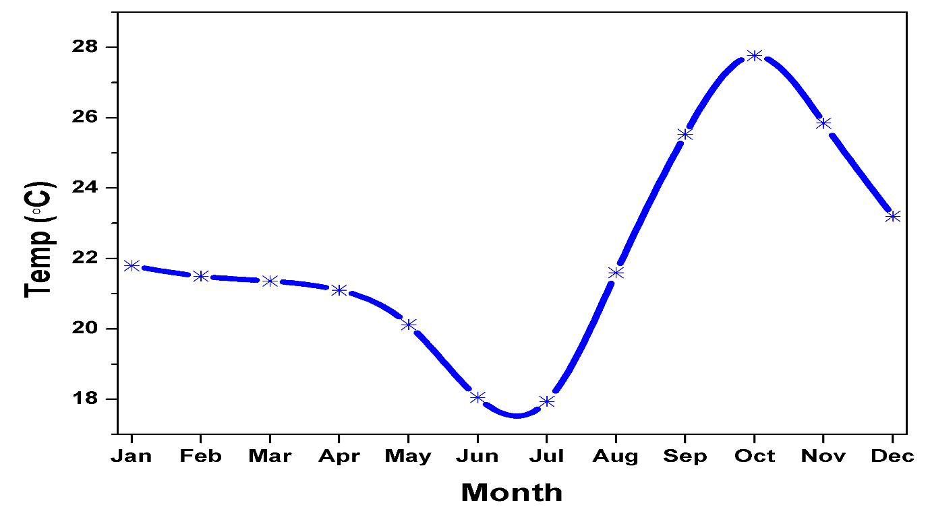
Figure 37: The annual cycle of mean monthly temperature (°C) over Mongu, averaged over longitude 22.8° E –23.9° E and latitudes 14.8° S and 15.9° S for a 20-year period (2000 – 2019)
7.4.2 Temperature Distributions for 1981-1999 and 2000-2019
To determine whether changes to the seasonal temperature cycle are evident, the seasonal cycle for first and second 20 years of the overall data period are calculated (Figure 38). The blue line shows the monthly average temperature over the period 1981-2019 while the green line represents the monthly average temperature of the period 1981-1999 whereas the orange line represents the mean monthly temperature during 2000-2019. It is evident from the results of figure 38 that the temperature is comparatively higher during the last two decades (2000-2019) compared to the first two decades (1981-1999) and to overall average temperature during the study period (1981-2019). The highest variation is observed in October where the 2000-2019 temperature is almost 0.08 ℃ higher than the 1981-2019 period average temperature, and it is 1.4 ℃ higher than the October average temperature of the 1981-1999 period.

Figure 38: Mean Monthly Temperature distribution for 1981-2019, 1981-1999 and for 2000-2019.
It is evident from the figure 38 that there have been temperature increases over Mongu. The of months January, April, May, November and December showed in change in average temperature of the three temporal period as shown in figure 38. The 1981-1999 and 1981-2019 average temperature of March was higher as compared to the average temperature of the period 2000-2019. It showed that the temperature in March is comparatively lower than the previous two decades temperature (1981-1999). This temperature rise is observed in the June, July, September and October months where the last two decades average temperature (2000-2019) is much higher than the average temperature of 1981-1999. These findings corroborate with similar findings that average temperature are increasing in Zambia (Mulenga et al.2017). Libanda et al. (2020) in their study demonstrated that summer temperatures have been increasing at a rate of 0.01⁰C per year which fits into the evidence of this analysis as analysed above. Mulenga et al. (2017) in their study evidenced decadal temperature increases from 0.056⁰ C to 0.60⁰C between 2000-2009 in agro-ecological zone IIb on which the study areas lie. A similar study by Chabala et al. (2013) agro- area IIb found an increasing trend in both maximum and minimum temperatures. Chabala et al. (2013) used a large data and covering a large area. However, the results of their study fit in the finds of this study. Chabala et al. (2013) analysed data from 1940 to 2010 with their study finding that the most significant temperature was from the 2000s.
7.4.3 Distribution of mean annual temperatures.
To determine whether the median annual temperatures between the 1981-and second half of the record are significant, the Mann-Whitney U-test is applied and the results indicates that this change is not statistically significant (Mann-Whitney U test: U = 289, Test statistic = 289, p-value = 0.039; Reject the Null hypothesis of equal distributions). The Mann-Whitney U-test results are table 10 below. This observation agrees with several studies that have documented that temperature is generally increasing over Zambia and across the southern African region (see for example Jury, 2013; Conway et al., 2004; Chabala et al.,2013; Libanda et al., 2020).
In this study, the Mann-Whitney U test was applied to each month, annual, and seasonal scale to compare the temperature distribution from 1981-1999 and 2000 to 2019. The results showed that temperature in January and February months are increasing but the results were insignificant. Similarly, the months March and April showed a decrease in temperature with insignificant results. The Mann-Whitney U test results for the months May, June, July and August showed insignificant increase in temperature while the months September and October recorded significant increase in temperature where the p-value was less than the threshold 0.05. November showed insignificant increase while December month recorded an insignificant decrease in the amount of temperature.
The Mann Whitney U test was also applied on annual, winter and summer season average temperature. The annual average temperature for the time period 1981-1999 was 17.24 ℃ while the average annual temperature recorded during 2000-2019 was 24.95. The annual temperature showed significant results where the p-value was recorded 0.039 which was less than the threshold p-value of 0.05 (Table 9). Similarly, the Mann-Whitney U test was also applied to the winter season temperature where the average temperature during 1981-1999 was 16.42 ℃ while this was 23.4 ℃ average temperature during 2000-2019. The winter season temperature showed an increase but according to Mann Whitney U test results this increase was insignificant, and the p-value was close to 0.05 threshold level. The Mann Whitney U test results for the summer season showed that during 1981-1999 the average temperature was 19.79 ℃ which was 24.95 ℃ in 2000-2019. The results showed a significant increase in summer season.
Table 10: Mann-Whitney U Test results for Temperature 1981-2019 and 2000-2019
Time Interval | 1981-1999 Mean | 2000-2019 Mean | Mann-Whitney U Test | Standardized Test Statistic | 2-tailed p-value | Remarks
Jan | 18.3 | 21.4 | 218 | 0.787 | 0.431 | Not Significant
Feb | 17.53 | 22.35 | 237 | 1.321 | 0.187 | Not Significant
Mar | 22.84 | 17.3 | 136 | -1.517 | 0.129 | Not Significant
Apr | 20.79 | 19.25 | 175 | -0.421 | 0.630 | Not Significant
May | 19.89 | 20.1 | 192 | 0.056 | 0.955 | Not Significant
Jun | 17.84 | 22.05 | 231 | 1.152 | 0.249 | Not Significant
Jul | 18.42 | 21.5 | 220 | 0.843 | 0.399 | Not Significant
Aug | 16.58 | 23.25 | 255 | 1.826 | 0.068 | Not Significant
Sep | 16.16 | 23.65 | 263 | 2.051 | 0.040 | Significant
Oct | 23.21 | 26.45 | 319 | 3.625 | 0.000 | Significant
Nov | 19.68 | 20.3 | 196 | 0.169 | 0.866 | Not Significant
Dec | 22.21 | 17.9 | 148 | -1.18 | 0.238 | Not Significant
Annual | 17.24 | 24.95 | 289 | 1.742 | 0.039 | Significant
Winter | 16.42 | 23.4 | 258 | 1.911 | 0.056 | Not Significant
Summer | 19.79 | 24.95 | 289 | 2.782 | 0.005 | Significant

7.4.4 Trends in Mean Annual Temperature
Having considered the seasonal cyclone, to address objective 2, temperature trends are now considered.
Results (Figure 39) of the mean annual temperature (MAT) analysis indicate that during the 40-year study period (1981 - 2019), Mongu experienced a MAT of 23.01°C. Overall, MAT was found to range between 21.14 and 23.77°C. The lowest MAT i.e., 21.14 °C was recorded in 1986 while the highest (i.e., 23.77 °C) was observed in 1995. Figure 39 further indicates that based on the linear regression analysis, the trend of MAT is positive at an annual rate of 0.0166 °C which is not significant as evident from R² value.
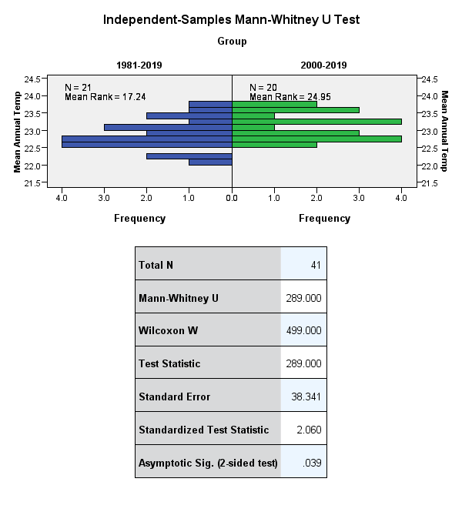
Figure 39: Mean annual temperature over Mongu. The blue bar represents the temperature for the period 1981-2019 and the green bar shows the temperature for the period 2000-2019

Figure 40: Mean annual temperature (MAT; °C) over Mongu (blue line), averaged over longitude 22.8° E –23.9° E and latitudes 14.8° S and 15.9° S for a 38-year period (1981 – 2019). The dashed blue line is the linear trend.
The figure 40 indicates fluctuations in temperature over the study period. The years 1987, 1995, 2005, 2015, 2016, 2018 and 2019 is observed warm years where the average annual temperature was recorded above 23.5 ℃. Whereas the years 1981 and 1986 was the cold years where the temperature remained below 22.5 ℃ during the study period. The linear trend results showed rising temperature trend with insignificant R² value. Similar rising temperature trend over Zambia with 0.01 ℃ annual increase was observed by Libanda et al. (2020).
Figure 41 below presents the temperature anomalies of mean annual temperature of the period 1981-2019 over Mongu, relative to the mean of that period. Anomalies are a widely used measure of the temperature variation from its temporal mean. The positive anomalies show a high temperature in that particular from its long-term mean temperature while negative anomalies indicate low temperature from long term mean. These results show that during the study period (1981 – 2019), Mongu experienced 19 warm years and 20 cold years (defined as a year above or below 1981-2019 mean). The warm years than mean is presented in red colour while the cold years than mean is presented in blue colour in figure 41. Furthermore, it is evident from the anomalies results that all years onward from 2013 experienced higher temperature than 1981-2019 mean temperature.
20

Figure 41: Temperature anomalies over Mongu using the temporal temperature data from 1981-2019

7.4.5 Trends in Mean Seasonal Temperature
Figure 42 shows the seasonal temperatures over the period 1981-2019. The seasons analysed in this study are summer and winter temperature. The mean temperature for months of June, July and August are taken as winter season over Mongu while for summer season the mean temperature of September, October and November months are analysed. The latter are the months showing the greatest changes in Figure 37. Months of September, October and November are deemed as summer because during this period the highest temperatures are recorded as demonstrated in figures 37 and 38 above.

Figure 42: Mean Summer and Winter Temperature

Both winter and summer seasons shows fluctuations in during the study period 1981-2019. The orange line shows the summer temperature trend while the orange dash line shows the summer temperature linear trend. Similarly, the blue line shows winter temperature distribution and blue dash line shows the winter temperature linear trend. Both seasons show a positive trend. The trend in summer is higher than the winter temperature trend, which fits with the results of the seasonal cycle in Figure 37 which showed the greatest difference in October. The summer temperature observed an increase with an annual rate 0.0383℃ but the R² shows insignificant results. This fits into Libanda et al. (2020)’s observations of summer temperatures across of 5% significance level. Similarly, the winter temperature observed an increase at an annual rate of 0.0219℃, however the increase was insignificant as the R² is low. These trends appear to be insignificant as opposed to those analysed by MKT and MMT because of autocorrelations in time series data resulting into false trends (Hansen and Lunde,2014; Gao et al., 2019).

7.4.6 Mean Monthly Temperature trend based on Mann-Kendall and Modified Mann-Kendall Trend Test
To address objective 2, temperature trends are now analysed. The trend in temperature was assessed using the non-parametric Mann-Kendal (MK) and Modified Mann-Kendall (MMK) trend tests technique. Both MK and MMK have been extensively used in research studies to detect the presence or absence of trend in time series data (Phuong et al., 2020; Tunde et al., 2022). The bold value in table 11 represents the existence of significant trend in the monthly, annual and seasonal temperature. The MMK results detected the significant upward trend in in the month of February that is found insignificant in the MK trend test results. Similarly, June also detected significant upward trend in MMK trend test while the same month observed insignificant trend in the MK test results (Table 11).
The seasonal, annual and monthly temperature trends, calculated over the period 1981-2019 are shown in Table 11. Considering firstly the monthly temperature trends, the months July, August, September, and October recorded significant upward trends. The results of both MK and MMK trend tests showed upward temperature trends in all most in all months except March and December where insignificant downward trends are evident. The annual trend is significant and upward, and as are the trends in winter and summer.

Table 11: shows the temperature trend (1981-2019) using Mann-Kendall and Modified Mann-Kendall Trend test
 | Kendall's Tau | MK P Value | MMK P Value | Sen's Slope
January | 0.092 | 0.398 | 0.398 | 0.006
February | 0.171 | 0.114 | 0.019 | 0.012
March | -0.008 | 0.948 | 0.948 | -0.001
April | 0.064 | 0.558 | 0.558 | 0.006
May | 0.182 | 0.091 | 0.091 | 0.017
June | 0.201 | 0.062 | 0.004 | 0.024
July | 0.238 | 0.027 | 0.040 | 0.020
August | 0.257 | 0.017 | 0.001 | 0.023
September | 0.271 | 0.012 | 0.001 | 0.024
October | 0.538 | 0.000 | 0.000 | 0.069
November | 0.164 | 0.129 | 0.129 | 0.023
December | -0.087 | 0.423 | 0.423 | -0.008
Annual | 0.391 | 0.000 | 0.000 | 0.020
Winter | 0.257 | 0.017 | 0.000 | 0.023
Summer | 0.475 | 0.000 | 0.000 | 0.040
Note: The bold MKT, MMKT P values and Spearman’s Rho Z value indicates the existence of significant trend
7.5.0 Sen’s Slope Estimator and Temperature Trend Magnitude
The Sen’s Slope gives the magnitude of the temperature trend, and the unit is ℃/year. Analysing the monthly Sen’s Slope (SS) results, the highest trend magnitude was observed in October (0.069℃/year) followed by September and June with SS value 0.040℃/year which means that the temperature in these months is getting higher with this observed slope magnitude. The negative trend magnitude was in March (-0.001℃/year) and December (-0.008℃/year) which means that in these two months the temperature is decreasing, although as stated above these trends are insignificant.
The annual and seasonal temperature trend magnitude was also assessed using the SS approach. The results revealed that the annual temperature is rising at the rate of 0.020℃/year slope magnitude. Similarly, the seasonal temperature shows that the temperature trend magnitude is higher in summer (0.040℃/year) than winter (0.023℃/year). This means that the warming is much higher in summer than winter over Mongu.
Summary of Key Temperature Trends and Changes
The table 12- is summary of the key trends in temperatures during the study period. The table indicates both summer and winter temperatures point warming.
Temperature Indices | Trends
Temperature Distribution | Highest temperature increases during the period 2000-2019. Highest increases during the months of January, April, May, November and December
Summer and Winter Temperatures | Both summer and winter temperature on a positive trend with the month of September and October showing significant trends. Summer trends indicate an increase of 0.0383⁰C. Winter temperatures show an insignificant upward trend of p-value=0.05-with an annual increase of 0.0219⁰C
All the years from 2013 indicate trends of an upward trend with mean temperature of 0.166⁰C

Summary of Key Temperature Trends and Changes
The table 13-below provides a Summary of key difference between science and local observations in relation to temperature trends. The temperature indices have been summarised as summer and winter temperature as the key questions in this analysis were based on seasonal basis rather broken to specific indexes such as daytime temperature, night temperature, hottest time of the day and so on.

Temperature Indices | Climatic Data | Local Observations | Description
Summer temperatures | Climatic data points to warming trend. Both MK and MMK indicated warming. Highest warming trends observed during the summer months of August-November. October had the highest warming trend(0.069℃/year) followed by September.  Day and night-time temperature not analysed in this study | Observations of warming trends particularly during the months of October and November. Differences in observations with some interviewees in perception between daytime and night temperature. Some interviewees suggesting too hot during the day while others suggested extremely hot nights | Agreement between science and local observation in relation to warming trends. Only difference lies in precision in terms of months with greatest warming trends. Science citing 4 months between August and November- local between people citing between October and November
Winter temperatures | Science to a decrease in cold days. Both MK and MMK point to warming winters. Science points June with the warmest trend in winter.  March(-0.001℃/year)and December(-0.008℃/year) temperature indicated a decreasing trend even though these trends are insignificant | Reports of colder winters in “recent years”. Reports of extended winter months from May to August as opposed to June to July | Differences in perceptions between science and local observations that be attributed to several factors; grind box used in this study may have introduced errors when being downscaled. It is possible local observations may not have been captured by science

7.6.0 Discussion
The main objective of this study was to explore the mean monthly, mean annual and mean seasonal temperature and trend over Zambia using the temporal gridded temperature data of 1981-2019. The monthly cycle of temperature results was consistent to that of Libanda et al. (2020) having S like shape and the highest temperature in October (figure 37). The rate of annual increase in temperature 0.0166℃/year of linear trend was higher than that of Libanda et al. (2020). Libanda et al. (2020) used a longer time period between 1950-2016 and covered a larger area. However, the period of this study as in Libanda et al. (2020)’s shows the strongest increase in temperatures. Results of linear trend 0.0154℃/year while this increment in temperature was lower than that reported by Ongoma et al. (2017) in equatorial East Africa where the temperature increase was 0.05℃/year. Ongoma et al. (2017) analysed temperature data from 1950 to 2010 that demonstrated strongest increase in temperature from 1980 onwards fitting into finds of this study.
The increase in temperatures might be the result of global climate change (Wills et al. 2018) but some local factors can also contribute to temperature increase. These factors include geographical location, topographical features, wind direction (sea-surface interaction) and vegetation cover among others (Benth et al.,2007; Yang et al.,2019). Similarly, the increasing trend in temperatures was observed in Lake Chad basin Africa. (Mahmood et al., 2019) analysed data from 1950-2013 which was consistent with results of this study. The rate of increase in annual temperature was 0.022℃/year calculated through Sen’s Slope (Mahmood et al. 2019) which was near to the results of the current study as calculated 0.020℃/year using Sen’s Slope. Similarly, the increasing trend in minimum and maximum temperature at annual, summer, and winter scale was observed by Byakatonda et al. (2018) who analysed climatic trends and variability over Botswana using different geo-statistical techniques like Mann-Kendall. The study analysed data from 14 meteorological station across different regions of Botswana during the period 2000-2016.
The results of this study are largely consistent with the recent findings of the IPCC 6th Assessment Report(2022). The IPCC 6th Assessment Report (2022) reports that temperatures across many regions of Africa are expected to rise in line with increasing global warming trends. Since the IPCC 5th Assessment Report (2014), studies have shown that many parts of Africa have frequent hot days and hot nights and heatwaves have also become frequent and longer (Kramer et al., 2021). West and South-Western Africa are projected to become extremely hot and dry (Shulka et al.,2019; IPCC,2022). According to the IPCC (2022), the observed annual temperatures over Southern Africa have increased between 1.04⁰C and 1.44⁰C during the period 1961-2015. The annual number of hot days have increased over Southern Africa on a decadal scale. The IPPC (2022) also projects that the number of hot and very hot days will increase under 1.5⁰C and 2⁰C of global warming. The number of cold days and extremely cold days are projected to decrease under any projected scenarios of emissions. Kruger and Nxumalo(2017b) report that the occurrence of cold extremes decreased over Southern Africa.
The section above of this chapter above focussed on the quantitative empirical assessment of seasonal cycles, monthly and annual mean trends. The section aimed to assess the monthly, seasonal and annual temperature trend and seasonal cycle over Mongu, western Zambia. The linear trend, Mann-Whitney U-Test, Mann-Kendall and Modified Mann-Kendall was applied to assess the trend in temperature time series data downloaded from the European Centre for Medium Range Weather Forecasting (ECMWF) ERA5 website. This data was used as the Mongu area does not have any long-term climatic data. Applying basic statistics such mean, standard deviation and coefficient variation it is concludes that there is high monthly, seasonal and annual temperature variability over the study regions during the study period 1981-2019. The key findings of this study indicate that there is an upward trend in the months of July, August, September and October. The monthly temperature analysis concluded that the highest variation was observed in October. During the study period, months of March and December on the other hand experienced a down trend. Furthermore, the trend results concluded significant upward trend in temperature in seasonal and annual data records. In monthly data records of the Mann-Kendall trend results it is concluded that an upward trend is observed in the months July, August, September and October while there was a little variation in the Modified Mann-Kendall trend test results as the significant upward trend was in the months February, June, July, August, September, and October. Furthermore, the trend magnitude calculated using Sen’s Slope concluded the highest trend in temperature in October with 0.069 ℃/year while this trend magnitude was 0.020 ℃/year in annual results whereas in winter this was 0.023 ℃/year and in summer the trend magnitude was 0.040 ℃/year. Overall, the study concluded an increasing trend in temperature on both summer and winter temperatures.
The following section interrogates interviewees’ perceptions in relation to temperature trends in the study areas during the study period. I submit here that the question of temperature trends was not explored to greater depth with interviewees on two grounds. Firstly, the most critical factor that shapes livelihoods in the study areas is rainfall and therefore changes in rainfall patterns are visual, impactful and relatable with people in the study areas. Rain-fed agriculture is the main stay of most of the people in the study areas-changes in rainfall affects crops yields and water availability with resulting severe consequences for people and their livestock. It goes therefore, that local people are likely to pay more attention to shifts in rainfall than changes in temperatures. Secondly, situated in a low-lying area the study areas generally experience warmer temperatures during most times of the year and therefore people may not notice small changes in temperatures over the years.
7.7.0 Changes in Mean Temperatures: Local Observations, Perceptions and Interpretations
Spatial-temporal changes in mean temperatures have been widely used as indicators of climate change among other factors such as precipitation patterns and wind velocity (Yang et al., 2009; IPCC, 2014; Niang et al., 2014). Communities reliant on natural resources for their livelihoods are often keenly Intune and watchful of their environment and quickly observe climatic anomalies and their effects on their livelihoods. These anomalies can be experienced collectively which then draw a narrative picture of change (Roncolli et al.,2016).
Interviewees were asked semi-structured questions in relation to their perceptions or observed temperatures based on the questionnaire as attached in the appendix 3. The key questions were based on summer and winter temperatures during the study period 1980-2019. The responses varied based on location and age. The quote below gives an indication of the responses.
“It is very strange that during August (2019) it was still very cold which is not normally the case but then temperatures just shoot up unbearably within days in September. In previous years, the cold weather used to end latest by July. It is strange that we are in August it is still cold” (Lillian Matakala:female-67-Sefula).
These intergenerational perceptions can be attributed to life experiences. The older generations might have experienced significant climatic events that register in long term in their memories. Equally, older people have traditionally worked on the land and more sensitive to changes in both rainfall and temperature particularly so if this impacted on their crop yields. On the other hand, the younger generations may not have experienced such events and not relate with what the older generations might have experienced. As earlier discussed, De Bruijn and van Dijk (2006) argued that recollection of the past unstable events to a greater extent is influenced by an individual’s knowledge of the past through an incremental learning process.
7.7.1 Narratives of Warming Summers
Participants across all the three study areas offered consistent but sometimes conflicting views of rising summer temperatures and colder temperatures in winter. Broadly, most interviewees suggested that summer temperatures have been on an upward trend in recent years. “Recent years” is often used in the study areas mainly to refer to events that they can recall and are unable to cite precise years when those events occurred. However, there was inconsistencies in the warming trend –particularly whether the warming trends referred to daytime or night-time temperatures. Interviewees offered different times scales in years of their observations of these changes. The time scales of 1980s, 1990s and 2000 cited by interviewees as the warmest years appeared to reflect an inter-generational theme and experience of extreme climatic events. Older interviewees were able to cite years when they experienced either extreme hot summers or cold winters while the younger ones were unable to cite precise years other than referencing those temperatures have been on the increase in “recent years”.
For example, one male interviewee (72yr) in Nanikelako was able to cite 1993 and 2005 as particularly hot years. These years corroborate with Musonda et al. (2020)’s findings that 1992/3 and 2005 were dry years characterised by drought conditions across most regions of Zambia. On the other hand, a 30-year male farmer in the same area was unable to cite any specific years apart from putting across a general statement on summer temperature as in the statement below:
“We know that in summer it is normally hot in the plains. We can say that in recent years, of course it is unbearable during the dry season but sometimes you cannot remember the different years” (Shambango:30-Male-Nanikelako).
In Lealui and Nanikelako, the general narrative was that both day- time and night summer temperatures have increased in recent years. Both in Lealui and Nanikelako, interviewees did not appear to make distinctions between summer daytime temperatures and night-time temperatures. Interviewees in these two areas appeared to suggest that summer daytime and night-time temperatures were the same as summed up by an interviewee below:
“It is very hot in the plains in summer; one cannot make the difference between day and night. During the day you are hot and at night you are sweating; the difference is the absence of sun at night” (Namakando:65-Female-Nanikelako).
In Sefula, while most interviewees reported rising summer day-time temperatures, other interviewees indicated that summer night-time temperatures were getting extremely hot. In all the three study areas there was an agreement that summer night-time temperatures were increasingly getting hotter and winter night-time temperatures getting colder. However, there was a narrative that the temperatures in Sefula were not warming or not hot as much as in Lealui and Nanikelako. This narrative was forwarded by some interviewees who have homes in both in Sefula and Nanikelako. It is common for people in the study areas to have two residences, one in the plains and another in the plains. These household/individuals transition between the flood plain and the uplands following the seasonal flooding (see Kuomboka-getting out of the water). These differences in perceptions between Lealui and Nanikelako in comparison with Sefula can be explained by several factors. Sefula lies on an upland with areas of woodland cover. Lealui and Nanikelako, on the other hand are located on an open low-lying flood plain with very little vegetative cover. Factors including topography, vegetation cover, slope and solar radiation can influence these spatial microclimate variations; areas with wooded cover often generally have lower daytime temperatures compared to open areas Tougeron et al., (2016; Zellweger et al.,2019). Zellweger et al. (2019) posit that seasonal maximum/minimum temperatures can be regulated by landscape and topography features of an area. Summer maximum temperatures can be moderated by the cooling effect of trees (Zellwger et al.,2019).
During field data collection in pursuance of temperature question, I made provision for an expert interview. An Official from the Water Resources Management Authority (WARMA) made the following observation in relation to the dry/drought conditions during the 2016, 2017 and 2018, “a combination of unusually high temperatures and droughts impacts on wells and boreholes in the villages as the ground water retreats deeper into the ground. We have faced a few long dry conditions culminating into critical waters problems due to a reduction in the ground water recharge in this area. And on the flood plains the consequence has been a reduction of water bodies” (Provincial Hydrologist-Western Province).
7.7.2 Narratives of Colder Winters
There were other narratives of winters becoming colder in the “recent years” with many interviewees citing the presence of frost in the winter morning and the non-availability certain wild winter fruits due to cold temperature. It was alleged that when minimum temperatures exceed certain optimal levels fruits would not mature. There were inconsistencies in accounts as to whether these cold temperatures referred to daytime or night-time temperatures. In Nanikelako interviewees were of the view that it was getting extremely cold during winter nights. It is logical to imagine that when the temperatures fall during the night that it would feel colder in vast open spaces such as Lealui and Nanikelako. The lack of vegetation, in particular trees and hedges in both Lealui and Nanikelako prevents the windbreak and antifreeze role of vegetation making it feel colder than the actual temperature (Tougeron et al., 2016).
One participant in Nanikelako appeared to infuse traditional and scientific explanations to perceived changes in the following statement:
“in early August, the cold migrates from the upland to the plains and normally winds from the South are bitterly cold, this year (2019) the winds came from the east this is why in the plains it is has been warm this year” (Imwiko: 64-Male- Lealui).
Imwiko stressed that according to the Lozi traditional narrative, winds from the East are normally warm and in previous years, the winds from the South have influenced winter temperatures in the plains. Imwiko claimed that it was highly unusual to have Easterly winds during the winter months. Imwiko was able to support his view by illustrating how in the last two years (2018 and 2019), the wind velocity has been noticeably slow in July compared to previous years when the wind velocity in the plains tends to increase; with dusty conditions characterising the plains at this the time of the year. Kanno et al., (2013), made an observation that during the dry season, Zambia experiences easterly winds which bring with them warmer temperatures and when winds shift westerly, colder temperatures are experienced across the county. Possible explanations for the perceived warmer temperatures in the lower lands of the plains maybe linked to this directional shift in the winds; the uplands will experience colder temperatures resulting from the general wind regimes transitions (ibid). People in the lower lands experience warmer temperatures than those in the uplands even though the temperature differences may be marginal. Local topography can influence wind speed and direction; the spatial gradient between the uplands and low lowlands may shift the wind speed and direction due to the resulting block effect (Yang et al.,2016).
7.8.0 Merging Science and Local Observations: Convergences and Divergences
In general, the scientific empirical data employed in this study is consistent with interviewees’ narratives in relation to an upward trend in summer temperatures. According to the temperature analysis above, the summer months of July, August, September and October have been on an upward trend during the study period. Both MK and MMK tests point to an increase in hotter summers, which fits into interviewees’ narratives. These findings corroborate with similar studies that report frequent hot days, hot nights and longer heatwaves across Africa (Shukla et al., 2019; Kraemer et al., 2021; IPCC, 2022).
However, there is a divergence between scientific data analysed and interviewees’ narratives in relation to winter temperatures. Whereas interviewees appeared to suggest that winters have become colder, the empirical data does not support these observations. It is also possible that daytime winter temperatures have got warmer and night-time temperatures got colder but the daily mean have remained the same. However, both MK and MMK tests point to an upward trend in winter temperatures; suggesting that cold winters are on the decrease. In addition, between and within study sites interviewees gave different accounts of summer and winter temperatures; none of which these accounts are reflected in the data analysed. Equally, these differences between scientific and local observations can be attributed to the fact that models used to capture scientific data may conflate and conceal differences between temperatures (James and Washingston,2013). Studies have shown that some differences between scientific climatic data and local observations maybe rooted in original datasets that might miss some variables when downscaling them to the village level (Llamazares et al.,2017;Haag et al.,2021).It is plausible, therefore, that in this study the ERA5 gridbox used in this analysis might have limited accuracy attributed to scale mismatch to the village level which might have influenced the spatial accuracy of the downscaled temperature variables.
Whereas the differences between climatic data and local observations are apparent in this case, I argue that both worldviews are critical to understanding local climatic changes. Haag et al.(2021) argue local observations may lack empirical objectivity but they are rooted in daily observations and practices. Haag et al. (2021) further forward those local observations help to erase uncertainties by acting as a conduit of evidence gathering for local changes in temperatures in the shape of biophysical signs and indicators.
The differences in findings between scientific data and people’s narratives maybe also attributed to the embedded multiple and diverse worldviews/contexts of understanding how climate change is experienced and interpreted (Pettinger, 2007; Callison, 2014; Fielding and Hornseyl.,2016). Researchers working in different regions and cultures of the world argue that epistemologies of environmental knowledge are often centred on understanding a complex interaction of environment forces occurring within a particular geographical area (Lorenzoni and Pidgeon ,2006). Equally other epistemologies of environmental knowledge are based on personal experience, that is knowledge that is first-hand (Congretel and Pinton,2020;Lam et al.,2020). This first-hand experience is often far removed from climate modelling (Marino and Schweitzer,2016). Reyes-Garcia et al. (2016) argue that local people’s perceptions of climate change can be influenced by personal experiences of recent increases in temperatures including actual outdoor temperatures at the point interview(elicitation) or other short-term changes in rather long-term global climate change trends. Reyes-Garcia et al. (2016) forward further that “visibility” researchers posit that the effects of climate change are visible and can be tracked based on personal experiences.
Drawing from the foregoing, I argue that as scientific term ‘climate change’ may not be a term familiar in certain communities. I contend that climate change is a ‘relative’ term subject to multiple interpretations that are often integrated into ongoing societal narratives. While at the global scale debate rages on climate change, it causes and effects; at the local (micro) level localised perspectives of environmental change contest for space for recognition. At micro scale local people may not reference local environmental change as “climate change”. However, their reference point maybe constructed from a social, material, religious/spiritual even livelihood perspective or much more broadly from a cultural lens (Egeru,2013; File,2021). These diverse frames of reference are situated in local values, beliefs cultural paradigms and embedded in indigenous knowledge systems (Hornsey, 2016). Therefore, it is my assertion that the understanding that local people draw from local environmental change is a core element of their worldview that does not necessarily resonate with scientific terms. That said, local people’s observations, perceptions and their interpretative lens may not necessarily conflict with the scientific phenomenon that is generally recognised/referred to as climate change.
Marino and Schweitzer (2009) argue that the global climate change debate did not emerge on the global scale through local experiences but through global scientific and political discourses. Drawing from Marino and Schweitzer (2009), it is plausible to argue that if ‘climate change’ did not emerge at the local scale then it is not a term that will be synonymous (familiar) with local people. Hulme (2017) argues that “climate change” emerged from western scientific research which was applied as term to embrace all forms of climatic inconstancies on 10-year time scale. Hulme (2017) forwards the “climate change” was adopted as a descriptive term to refer to these climatic inconstancies as distinguished from economic or political changes. Bushell et al. (2017) argue that “climate change” emerged and evolved through western scientific research.
It is not my argument that local people in the study areas are sceptical or in denial of climate change but rather express these climate changes in local frames of reference. As Farbotko and Lazrus(2012, P.3), “the abstractions of time, space and belonging which dominant climate change narratives assume are not often universally shared”. Farbotko and Lazrus(2012) argue cultural values and everyday practices of a people are important in understanding the meanings and repercussions of environmental change. According to Nash et al. (2019. P.4) “everyday” constructs a key concept cultural study, broadly referred to as “the site of tacit and ongoing mundane practices shared by ordinary people”. Research has demonstrated (Savo et al.,2016) local people do not demonstrate the idea of climate change, however, local people identify moments of environmental change not through the scientific lens of climate change. Local knowledge can reflect greater depth of understanding local ecological systems; this is true on many fronts whether this links causality of local environmental change to climate change (Savo et al.,2016. These localised approaches to knowing reveal alternative ways of knowing climate change at the site of everyday life (Nash et al.,2019).
Mistry and Berardi (2016) argue that rather than attempting to make local knowledge “scientific “, it is important that its uniqueness and epistemology be harnessed. Mistry and Berardi (2016) stress instead of seeking scientific knowledge to validate local knowledge, research must be directed at expanding its range of alternatives for action. It is from this background that there is a strong argument for the integration of scientific and indigenous knowledge in order to understand and respond to environmental change (Latulippe and Klenk,2019). Latulippe and Klenk(2019) forward that in order to value indigenous ways of knowing , being and doing requires the cultivation of culturally appropriate spaces for indigenous scientific research to flourish within the existing infrastructure of knowledge production. This approach to global knowledge assemblage can foster knowledge co-production that can contribute to the creation a global resource of understanding of climate change and response strategies (Reyes-Gracia et al.,2016-see also literature section 2.8.0). The challenge posed to science as the dominant lens to understanding climate is not driven by the desire to privilege other forms of knowledge over science bur rather to a recognition that climate change can be comprehended in plurality of ways (Hulme, 2016; Leyson, 2014).
7.9.0 Conclusion
In the sections above, this chapter analysed and explored temperatures in the study areas over the study period. The first section of this study focussed on the quantitative empirical analysis of the monthly temperature cycle and temperature distribution for the entire study period. It also highlighted the distribution of the mean annual temperature and the trends in the mean annual temperature. Using Sen’s Slope the study estimated the annual magnitude of trend. The key findings of the quantitative analysis of temperatures during the study period are summarised in 7.6.0. The second section of this study explored local people’s observations, perceptions and interpretations of the changing temperatures in the study areas. It explored narratives in summer and winter temperatures by local people and what they attribute these changes to. The chapter brought together science and indigenous knowledge in trying to find areas of agreement and disagreement in relation to the subject of study. Drawing from different epistemological and ontological lens, it often the case that science and indigenous knowledge will have areas of contention. However, I argue in this chapter that neither science of indigenous/local is supreme over the other. The dominance of science over indigenous/local knowledge in climate change adaptation illuminates how most response strategies are oriented towards technical strategies. However, tackling the multiplicity of climate change impacts demands the advancement of science and indigenous/local knowledge through a non-hierarchical lens and the creation of knowledge co-production platforms.
Having explored local people’s perception/observations in relation to shifting climatic conditions in chapter 5 and explore rainfall changes and trends in chapter 6 and temperatures in chapter 7, chapter 8 that follows is based on the process and activities of adaptation at the local level.

Space intentionally left blank

Chapter 8-Climate Change Adaptation in Barotse Flood Plains
8.0.0 Introduction
Chapter 8 focusses on the processes of adaptation at the micro (individual/household), Messo (village level) and macro level in the three study areas. Micro levels adaptation refers to unconscious everyday autonomous responses that individuals and households engage into as responses to climatic and non-climatic shocks and stressors (Ndamani and Watanabe, 2015; Kumar et al., 2020; Singh, 2020). Autonomous adaptation includes all those unplanned responses to climatic and non-climatic stimuli-triggered by environmental change and or economic changes (IPCC, 2001; Bonzanigo et al., 2015). I employ the term Adaptations From Below as a lens to examine the ways into which people in the study areas exercise agency to mobilise their assets to respond to changing climatic and non-climatic conditions. Adaptations from Below was conceived during and after field data collection through observing, interpreting and trying to understand how local people learn, modify and pass on knowledge from one generation to another. These adaptive strategies are constructed at a local level, influenced by indigenous knowledge systems and blended with other knowledge systems including scientific knowledge.
Adaptation from below is drawn from the concept of local adaptation, which is that due to geo-spatial, socio-economic, socio-cultural and institutional differences adaptation practices need to be embedded into local contextual ways of life of the people (Funfgeld,2015; Nordgren at al.,2016). Local adaptation, I argue is a collective or assemblage of indigenous knowledge, traditional ecological knowledge and local environmental knowledge. This assemblage enhances resilience and adaptation to climate change at the local level (Berkes,2009; Parsons et al.,2021; Rarai et al., 2022). As illustrated in the literature review above, local adaptation in often embedded in the cultural fabric of people and how they interact with human and non-human actors. It includes how people create and refine knowledge over generations; it this knowledge that acts a powerful force in how people perceive, understand and interpret change. And in this study, local adaptation enveloped as adaptation from below is at the centre of adaptation considering that for people in the study areas, people there is little or no external interventions. People often rely on their agency in using locally available resources.
Chapter 8 links up with the previous empirical chapters (5, 6 and 7) and focusses on local response strategies to shifting rainfall patterns and temperatures. The three empirical chapters coalesce here into what I refer to as “science meets local observations” and summarised into a quote from Krauß and Bremer (2020. P.2), “we interpret what we see, select the most workable of multiple choices”. Research shows that narratives as opposed to scientific facts influence people’s understanding of climate change (Böhm et al.,2019; Petrescu et al.,2022). Böhm et al. (2019) forward key elements of narratives in relation to climate change include the casual relations and how the impacts of climate change can be mitigated. Seen from this lens, therefore narratives are a reference point for reality as people know it by making sense of observations, enables people to draw inferences and create models for future pathways (Veland et al.,2017).
I employ the concept of adaptation from below to refer to livelihood strategies influenced by culture, values, place attachment and identity. These and among other factors shape and constitute the indigenous knowledge systems. By implication, evidence of environmental change will be dismissed if it threatens local people’s cultural norms or accepted if it affirms the cultural values of the people (Kahan et al., 2011; Kuehne, 2014). Culture and traditional knowledge systems can interact in several ways in shaping livelihoods and fostering or hindering adaptation (Davies et al., 2019; Few et al., 2021).
In chapter 8, I consider how local subsistence farmers, pastoralists and fishermen in the study areas have use local practices that are intertwined with other knowledge systems to sustain their livelihoods in the face of climate change and other everyday stressors (see also section 2.5.2 and 2.8.0). Indigenous (local) knowledge systems interact with socio-economic forces in dynamic ways that results into socio-cultural modification (farbotko and Lazrus,2012; Curry et al., 2015; Makondo and Thomas,2018). Socio-cultural modification refers to people’s every day decision making directed at responding to or modifying livelihood strategies which is “once-off” but a dynamic process of “trial –by error” (Curry et al., 2015, P.12). Trial-by error includes activities of improvisation, hybridisation, contestation and negotiation of practices to create different kinds of adaptation arrangements (Cleaver, 2012; 2015; Abu and Reed, 2018 on institutions). I forward that the processes highlighted above centre on practices of knowledge production intended to find solutions to everyday challenges. Trial by error, improvisation and hybridisation involves processes of inclusions and or exclusions and the assemblage of activities that in the long term become established in the fabric of a society (Abu and Reed, 2018; Ellen, 2018).
Traditional societies across the world have long established systems, practices and norms that have sustained them; vast ‘banks’ of knowledge of planting, reading weather and climate, environmental conditions, healthcare and medicines (Whyte,2017; Tume et al.,2019). It is these banks of knowledge and practices borne out everyday trial by error, improvisation, hybridisation, contestation and negotiation that in my view compose ‘Adaptation from Below”. In ‘Adaptation from Below’, I derive elements of trial by error, improvisation and hybridisation to conceptualise adaptation activities that are based on local co-production of local knowledge systems. People create and hybridise different elements of local and scientific knowledge to sustain their livelihoods and adapt to change (Abu and Reed, 2018). Drawing from this, it implies that what is referred to as local knowledge can be a form of hybridisation or infusion of different understanding and interpretation of events that are practised in a particular locality but may not necessarily originate from that place. Therefore, adapting from below is plurality and diversity of livelihood activities that are characterised by a blending of different knowledge systems and practices directed at responding to present threats and as contingency measures for the future security.
Indigenous knowledge (IK) is often interchanged with local knowledge (LK) and traditional ecological knowledge (TEK) (Berkes, 2012; 2015). This discussion will employ local knowledge and practices as these adaptive measures are not purely indigenous but rather reflect a process of knowledge acquisition, transplant, blending replicated over time and space.
In the following sections, I demonstrate and discuss the practices of adaptations from below. While great emphasis is placed on interrogating Adaptation from Below as the main outcome of this study in relation to local responses to climate change and other socio-economic changes; at macro level adaption interventions, I explore the role of the government and Non-Governmental Organisations (NGOs) in responding to climate change impacts and towards promoting alternative livelihoods. I examine the Farmer Input Support Programme (FISP) introduced in 2002 by the government of Zambia under the Ministry of Agriculture Food and Fisheries (MAFF). FISP was designed to support smallholder farmers with agricultural inputs such as seeds, fertilisers, small farm equipment among others (Mofya et al., 2013). Within the subject of macro level adaptation, I interrogate the proposed Barotse Cultural Landscape propagated by UNESCO, WWF and the Government of Zambia.
8.1.0 Background Literature
According to Von der Porten et al. (2016), the term indigenous knowledge system describes a collective held understanding of a particular area/region that has been developed by indigenous people living on that landscape for many generations and has been passed or transferred often through oral means that consists of knowledge of the local environment and ecology (refer to section 2.8.0). Local knowledge is a critical element of indigenous knowledge system (TIKS) (Harrison, 2008; Byg and Salick, 2010). Local knowledge includes rainfall patterns, cultural knowledge, knowledge that is embedded in the spiritual, cultural lore, everyday interactions and language of a people. Amin et al. (2021, P.2) refer to indigenous adaptation techniques and knowledge practices as, “those structural or non-structural measures adopted by the local community irrespective of ethnicity as long as those long-term practices are perceived to be effective for adaptation practices “. Structural measures include intercropping, crop rotation, use of improved seed varieties and irrigation systems. These strategies are not necessarily local indigeneity but products of interactions between traditional practices and scientific knowledge. Non -structural measures include use of local seed varieties, transhumance practices, local farming practices among other measures (Amin et al., 2021). As indicated above these practices are developed and passed on over generations and therefore are often unique to a people or community (Byg and Salick, 2010; Adger at al., 2013; Alessa et al., 2015).
Faced with shifting climatic conditions in their areas, individuals and households have developed and refined their adaptation strategies over generations. These adaptive measures include changes in farming practices (on-farm) and engagement in non-farm livelihoods. In the flowing sections, I examine the main response strategies used by local subsistence farmers. These response strategies were shaped around access and ownership to asset bundles such as land, labour, natural resources, social capital, government support and finance.

8.2.0 Adaptation Strategies
The following were the main local adaptation measures common in all the three study areas- these are interrogated in turn.
- Tillage and land preparation techniques/choice of cultivable land
- Soil fertility practices-chemical fertilisers and organic matter including use of cow manure.
- Cropping systems-Drought resistant crops, early maturing crops and irrigation
- Support Infrastructure-Local Seed Banks, Harvest and Post-Harvest Care
- Government Support-Farmer Input Support Programme (FISP)
- Farm cropping strategies
- Land reclamations
- Transhumance practices-seasonal movement of people and livestock
Each one of these practices gives agency to a set of socio-cultural driven strategies that function effectively within the socio-economic-political-environmental constraints of everyday life.
Field preparation and planting timing are critical to crop yields as any delay in the timing of these activities could have significant consequences to the farmer. In the following section, I examine tillage systems and soil management strategies employed by farmers in the study areas.
8.2.1 Tillage and Land Preparation Techniques
Data collection for this thesis was designed to coincide with the rainy season and the growing season. The month of November is a critical period when people in the study areas begin to prepare for the coming agricultural season. In a ‘normal’ rainy season and based on historical meteorological data, the growing season is influenced by the on onset of the rainy season. As evidenced in the meteorological and temperature analysis chapter of this thesis, the first rains of late October and early November signify the rainy season onset and thereof of the growing/agricultural season. According to Thierfelder et al. (2013) the productivity of crops is sensitive to the time of planting that then is also influenced by time of land preparation. Thierfelder et al. (2013) argue that undertaking land preparations before the onset of the rainy season well before the agricultural season starts can significantly increase yields by facilitating timely planting while utilising the minimal agricultural inputs.
The growing season is characterised by land preparation using different tillage systems, planting (seeding) and application of mature or chemical fertilisers. Land as a form of physical capital is critical as a means of productive assets (Carter and Barrett, 2006). For majority of farmers in all the study areas, land preparing commences in the second week of consistent rains. Most of the interviewees suggested that the first rains made the soil much softer as they used hand hoes to prepare their fields. The use of hand hoes was the most common and prevalent method of land tilling as hoes were cheap and affordable costing about ZMK 150. Local crafts men locally made most of the hoes while some were sold in the urban markets of Mongu. However, interviewees indicated using hand hoes was labour intensive and “backbreaking”. Many study participants indicated using hand hoes constrained the size of land they were able to cultivate. According to interviewees, land preparation using hand hoes did not start until the first or second week of rains that made the soil much softer. Consequently, this resulted in late planting in comparison to ox-drawn land preparation that could be undertaken in the dry season.
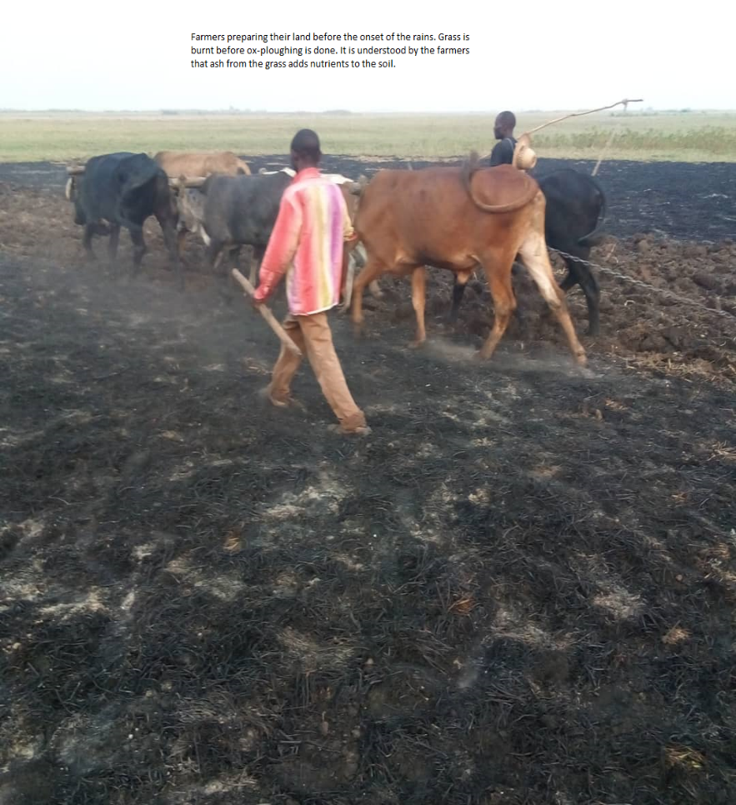
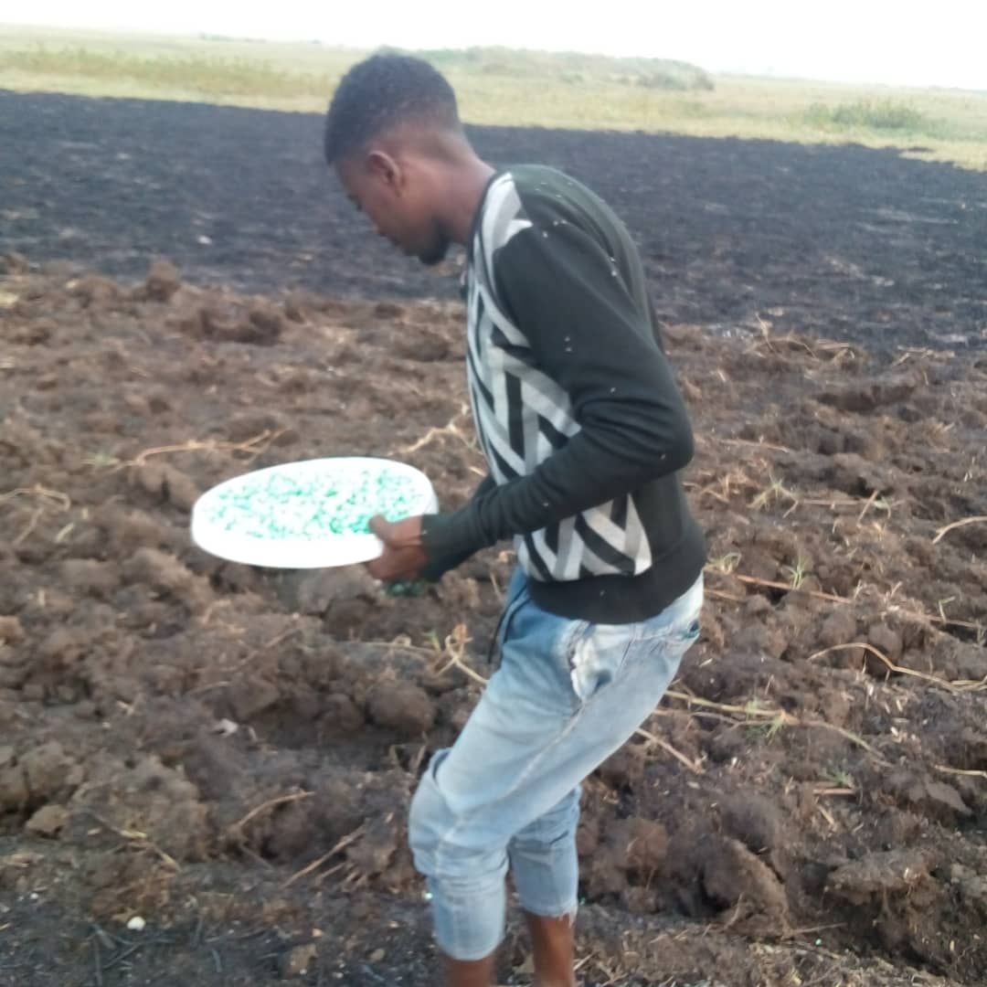
Figure 43: Farmers preparing land-here it shows burnt grass before ox-drawn ploughing is done. Farmers suggest that burning grass before cultivation enhances soil fertility. On the right a farmer planting mixed local, and hybrids seed of maize. Photo by author.
Other study participants indicated that livestock ownership was an expensive venture hence hand hoe cultivation was the only option. For those who were able to borrow or rent oxen from their social networks to increase their cultivated land, they had to wait until the livestock owners had prepared their land. Livestock owners had to prepare their own land before assisting others, which gave them an advantage of planting early than other farmers.
For the farmers who owned cattle, land preparation commenced a few months before the onset of the rainy season employing drying-season ripping with the aid of ox-drawn ploughs. Livestock owners indicated that apart from the rains that was the determining factor of the growing season, they felt there were more in control in terms of when to start land preparations, planting and the size-cultivated land. It plausible to argue that ox-drawn ploughing had advantages as it enables for dry-season land preparation, early planting and the potential for good yields if other factors hold; that the onset of the rain including the distribution of the rainfall during the agricultural season. One cattle owner in Sefula made the following observations.
“We can start preparing the land as soon as we have harvested. We start in early October so that when the rains come in November when start planting. We get more from our land than people using hoes” (Amwiko-Sefula, 69-Male).
8.2.2 Land Ownership
The size of land ‘held ‘varied widely between study areas, between and within individuals/households largely due to the nature of land tenure system in Barotseland. In principle, every Lozi person is deemed to be entitled to a piece of traditional land whether male or female (Jain et al., 2016). Between households, those who acquired land through inheritance or a family gift and others with close connections to the Indunas held more land in size and variety. Within a household, men tended to have more in land size, variety. The narrative was that access to, and ownership of land is weave in a complex web of social-cultural power of relationships. Significantly, the King owns all the land in the Barotseland and access to land is at his discretion through leaders of the BRE and Indunas (village leaders). Seen from this angle, access and not ownership to land is critical to livelihood strategies pathways particularly that the study sites are agriculturally based. However, it was evident the distribution of land was highly inequitable, and its allocation was largely influenced by connections to village leaders (Indunas) and leaders of the BRE. As discussed in this thesis, the land tenure system in Barotseland is customary; is managed and administered by Indunas on behalf of the King. The Indunas on behalf pf the King allocate land for settling, agriculture or other developments but not ownership is passed (Jain et al., 2016). See also sections 1.2.3-1.2.4.
8.2.3 Land Preparing Coinciding with the Lean/Hunger Season and Asset Depletion
However, the month of November falls/coincides with the period referred to as the lean/ hunger season-that is the period when food stores from the previous season have been depleted (Ellis and Manda;2012; Anderson et al.,2017. Most households would have exhausted or run down their grain stores from the previous harvests. The lean/ hunger season is characterised widespread hunger and food prices spikes that expose and push households into a state of struggle (Khander et al.,2012). Ironically, the start of the growing season demands a lot of labour as most subsistence farmers lack access to mechanised farming equipment for land preparations for the coming growing season. Manual land preparation is “backbreaking” work that requires a lot of energy and good physical health. Labour as a form of physical capital is a key at this stage of the seasonal cycle and is a key driver of resilience and adaptation (Brooks et al., 2005). Faced with a predicament individuals/households engage into desperate measures such selling off their livestock or personal items in order to cope during this season. This was evident in households with poor asset bundles; these desperate measures of disposing off assets meant that households were stuck in perpetuate states of struggle and only those who were able to surmount external support were able to cope during the lean season/hunger. Seasonal transitions in and out of poverty particularly during the lean season co-interact with others to worsen people’s well-being. The net impact is that household further deplete their assets eroding the possibilities of asset accumulation. These findings/observations corroborate with similar studies which demonstrated asset depletion during the lean/hunger season in agriculturally based livelihoods (Khander et al.,2012; Ellis and Manda,2012; Anderson et al., 2017). This analysis fit into the initial state of the LSPs framework-a state of poor assets and welling-being characterised by transgenerational poverty.
8.2.4 Forms of Cultivable Land
The cultivable land types of the Barotse Flood Plain are classified according to soil type, proximate to water sources, risk of flooding, vulnerability to drought and remoteness to local communities. Most of the farmers have gardens or fields situated on these different land types on which they carry out their agricultural activities. Having gardens or fields on different land types is critical as productivity depends on the location of the plot. The most productive gardens or fields are located the Zambezi River and tend have good soil fertility. The productivity of these gardens/fields are largely influenced by rainfall and the groundwater availability.
Table 14- Main type of fields used to cultivate crops on the Barotse Flood Plain. Adapted from Sililo(2017) and Del Rio (2015).

Land Type(singular & Plural) | Description | Crops grown
Sitapa/Litapa | Located in low-lying areas (lagoons/depressions) often close to water sources in the dry season. Prone to flooding during the wet season. Sitapa/Litapa soil fertility is good due to alluvium deposits left after floods -only short growing period crops are cultivated on them due to early flooding. | Maize, Green Vegetables, Cassava, Potatoes, Okra, Cowpeas, Watermelons, beans.
Sishanjo/Lishanjo | Located at the edge of the flood plain. Soil fertility is good but are often waterlogged and can be prone to flooding. Only short period crops can be grown on them | Rice, Green vegetables, Tomatoes. Maize, Sweet potatoes, Cowpeas
Litongo/Matongo | Situated at slightly higher ground than Shishanjo. The soils are sandy with low organic matter. These are village rain-fed garderns/fields. | Maize, cassava, Cowpeas, Watermelons, Cabbage, Cassava, Onions, Eggplants(aubergines)
Litema/Matema | These are forest gardens-forest fields. The soils are sandy with low organic matter. Farmers use biomass to improve their fertility. | Millet, Cassava, Sweet Potatoes, Maize
Saana | These are plains in the upland with natural grass. Gets flooded during the wet season. Soil fertility is good. | Rice, potatoes and groundnuts.
Lizulu/Mazulu | Man-made or natural small hills or moulds raised above the surrounding low-lying ground. Difficult to access during the flooding season. | Maize, Sweet potatoes, pumpkins, Green vegetables, Okra, Groundnuts
8.2.5 Soil Fertility Practices: Chemical Fertilisers and Organic Matter
In terms of soil management practices, there was differentiation in measures the used between and within households. The differentiation was based on a mix asset ownership, ownership of livestock and crops grown. Households and individuals who owned cattle tended to have other assets which enabled them to purchase chemical fertilisers while at the time using animal manure and crop residue as soil management measures. Households and individuals without livestock and access to animal manure used organic material such as crop residue as a soil enrichment strategy. There were unverified narratives that the farmers who applied chemical fertilisers reported better yields/output. Research on the other hand indicates that plant organic matter apart being critical to the process of soil nitrogen fixation helps to improve soil chemical composition and improve yields (Ajayi et al., 2009; Furey and Tilman,2021, Hafez et al.,2021; Voltr et al.,2021 ). The overall, the general narrative was that many subsistence farmers were able to transform the productive of their land and reported increase in their yields with chemical fertilisers. The farmers sold surplus harvests from which they were able to diversify their asset portfolios. Some interviewees reported how they were able to expand their cultivable land over the years through the hiring of extra labour from savings made from the sale of surplus grains.
Additionally, some reported accumulating substantial savings that they then invested in the purchase of more stocks farming inputs and high value livestock such as cattle. Several other farmers reported using their saving to buy bicycles, which they used to transport inputs and produce to markets. Based on the preceding observations, it is plausible to suggest that those individuals /households who expanded their cultivable land saw an increase in their non-farm incomes. Expansion in non-farm activities was characterised by an increased in the number of grocery stores and bars. The pursuance of non-farm livelihood strategies reflected not only the recognition of the vulnerability of on-farming activities by individuals/households but the desire to improve their well-being. This forward mobility along LSPs fits into similar studies that demonstrated that rural subsistence farmers in the developing countries experienced improved well-being through asset accumulation driven by expansion in agricultural productivity and non-farm activities (Hurni et al., 2015).
Abede et al. (2022) reported differences in yields between chemical fertilisers and organic matter are marginal. Abede et al. (2022) in their study that explored the output differences between chemical fertilisers and organic matter found that there no were significant differences in yields between the two approaches. Abede et al. (2022) contend that marginal differences between the two approaches were attributed to other factors rather than inputs application. They attributed the yield differences to individual farmer circumstances, tillage methods employed, rainfall distribution and planting time.
Given the high cost of chemical fertilisers on the other hand, meant that in most cases only farmers with a diverse asset bundle and cash reserves could afford to apply chemical fertilisers on their fields. The cost of a 50kg of fertiliser was costing ZMK400 as 2019 prices as recommended by the Ministry of Agriculture Food and Fisheries (MAFF, 2019 bulletin-ZMK1=£16). However, I witnessed 50Kg bags of fertilisers being sold at ZMK600 in the markets by other traders. There were allegations by interviewees that Officials from the District Agriculture Office were diverting farming inputs from FISP beneficiaries to their networks of traders and who then resell these inputs at inflated prices.
8.2.6 Cow Manure as a Soil Fertility Measure
“Cow Manure is a great asset and if well managed could serve as an organic soil fertiliser amendment that could restore degraded soil” (Ndambi et al., 2019). In the uplands of Sefula and Nanikelako, farmers practised a kind of kraal rotation. Using this system, the farmers will shift or move the location of kraal every month or two depending on its size and the number of cattle it houses. Cattle are headed out at dawn into the plains or in local forests (mishutu) to graze during the day freely. At dusk, the cattle are brought back and housed in the kraals not just for safety and for soil conservation. As the cattle defecate while housed in the kraal, their droppings in deposited on the soil and in the process provide vital soil nutrients. Every one month or two the location of the kraal is moved to different portion of the land and the same process is repeated over again. Some of the cow droppings were collected to be used on different land portions or even sold to other people. Some of the cow dung is used as a source of cooking energy and it was claimed that is burns for a long time compared to wood fuel. Anecdote narratives suggested that portions of land that housed a kraal and were fertilised in this way remained nutrient rich and productive for five years. It is contestable how long a piece of land will stay fertile from hosting a sedentary kraal; however, research demonstrates sedentary kraaling through rotation of kraal siting has the potential to improve yields and enhancing soil nutrient (Kizza and Areola, 2010). Kizza and Areola (2010) stress that the concentration and localisation of nutrients on a kraal site restores the entire ecosystem and creates spatial productivity at the micro level. Kizza and Areola (2010) argue that sustainable agriculture in semi-arid environments can be fostered using animal manure from a kraal as soil and crop management strategy by redistributing soil nutrients back to degraded soils. A farmer involved in mixed cropping and livestock keeping said made the flowing observations:
“we have used this method of improving our soils for a very long time. My father left me the land and a few cows. Every month we move the kraal to fertiliser different parts of the land and our crops do well compared to others.”(Sishekomo-Male-54:Nanikelako).
An interviewee In Nanikelako made the following remarks:
” Cattle manure is better than those fertilisers people use in the city. For many years we have used this, our crops do very well and apart from that we use dung for cooking as we do not have wood fuel here” (Sepiso-Nanikelako). Sepiso added, “Without cow manure there would have been difficulties growing food here. We can grow maize, cassava, millet and maybe sorghum without the need for chemical fertilisers”.
As well using cow dung for agricultural purpose, it long been used as an alternative source of household energy for cooking particularly in Nanikelako and Lealui where wood fuel is scarce. As Milupi et al. (2017) observed, the use of cow dung as a source of fuel is a sustainable use of natural resources as it stops people from degrading the existing forests for wood fuel purposes. There were some anecdote sentiments that cow dung when used as energy burnt slowly thereby and hence lasting longer than wood fuel. Other benefits of cow dung as cited by interviewees included less smoke and reusability of ashes for cooking indigenous vegetables as libowa and delele (okra like) compared to wood. The multiple use of cow dung fits into the concept of adaptation from below and the process of bricolage. It demonstrates how local people make do and construct their livelihoods with the available resources through improvisation and hybridisation. By making do within the parameters of resource constraints and by deploying their agency people mobilise available resources to sustain their livelihoods.

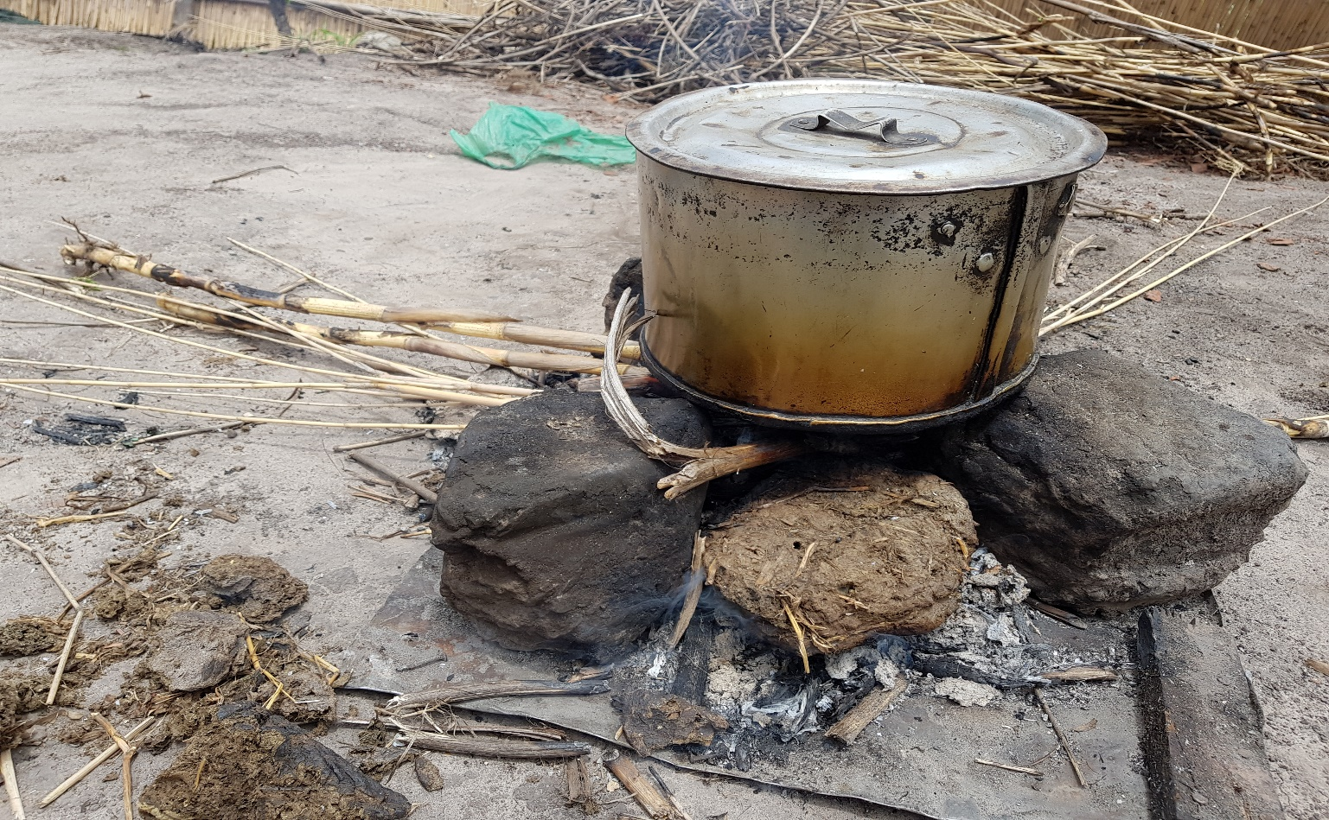
Figure 44: Cooking on a fire using cow dung and reeds.
“We could not survive here if we did not have cow dung which we use for farming and cooking. As you can see here we have not trees aside from linjefu (aquatic weeds) and mashela(lily family). However, cow dung gives more in terms cooking time, and we use the ash as an ingredient for cooking (as caustic soda) our traditional foods. In even in winter as it gets very cold we make fire in the house in the night using cow dung as it gives less smoke compared wood fuel. Thinking of it in a bigger picture, we rely on cow dung for cooking as the other fuel sources (linjefu and mashela) as are seasonal” (Mwanamwambwa-Nanikelako).
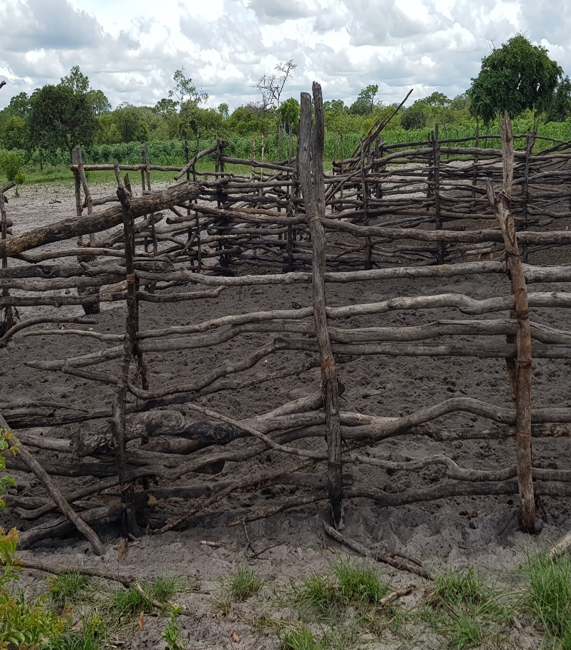
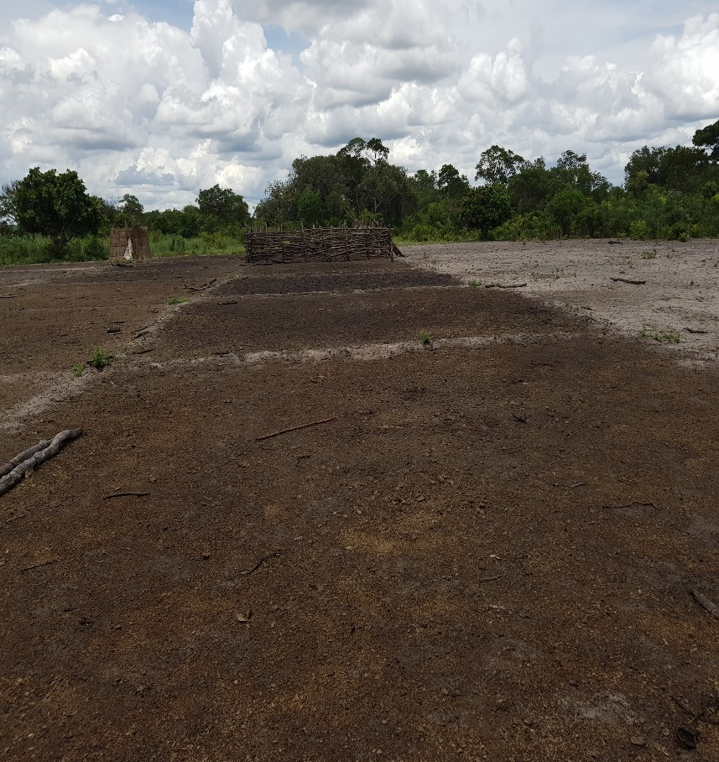

Figure 45: Differences between a portion of land fertilised by cow manure on the near left and one not on the far right.
Photo on the left shows a kraal where cattle are kept over for a certain number of months. Cows dung enriches the soils as the adjacent photo on the right shows. The next photo shows a contrast between fertilised portions of land (dark) against the unfertilised land on the far side of the photo of the right.
8.2.7 Cropping Systems: Drought Resistant, Early Maturing Crops and Irrigation
According to Chikoti et al. (2013), cassava is one of the main major staple crops grown in Zambia. It accounts for 95% of the crops in Western, Northern, Northwestern and Luapula provinces of Zambia. Chikoti et al. (2016) stress that 30% of the population in Zambia is directly or indirectly dependent on cassava for their household food consumption and for sell.
Facing changing rainfall and temperatures changes as discussed earlier in this thesis (i.e. late onset, early withdraw of rains, rainfall intensity, warming trends), people in the study area have been trying to spread or reduce the risk of crop failure by growing drought resistant and early maturing crops. Drought resistant crops demand less water and can withstand long periods of drought conditions (Fischer et al.,2016; Padakandla, 2016). According to Gano et al. (2021), crop/plant adaptation is critical to ensure that climate change does not affect food production. According to Westengen and Brysting (2014) crop adaptation includes the use of more drought resistant crop species/varieties and improved crop varieties.
Cassava (manihot esculenta) is an important source of household staple food in many parts of Africa that is very resilient to drought conditions (Abegunde et al., 2019; Ndjouenkeu et al., 2020). According to FAO (2013), cassava is highly resilient to prolonged drought, heat and poor soils. Therefore, cassava is an ideal crop for cultivation in regions of low rainfall.
To the extent that it was not cultivated on a large scale in Lealui and Nanikelako due to poor soils and land use restrictions, it was dominate crop grown in the upper lands fields of Sefula. Cassava was primarily grown for household food consumption. From field observations, most of the cassava fields were intercropped with seasonal crops such as maize, beans, pumpkins and groundnuts. Intercropping cassava with season crops assured food security at household level particularly that cassava tubers require 2-3 years to fully mature. However, some farmers with excess capacity or in instances of a good harvest, some of the Cassava was sold to traders from urban city of Mongu because its high market value. In comparison to maize meal, cassava meal was cheaper and affordable to many city dwellers. During participant observations in the markets of Mongu, I observed a meda (5kg bucket) of maize meal costing between ZMK15 to ZMK20 (Zambia currency - Kwacha). The same meda of Cassava meal was costing between ZMK5 to ZMK8. There were indications that the sky rocketing prices of maize meal was making Cassava meal an economically preferred choice for urban dwellers. There were indications that farmers were increasingly getting motivated to intensify its cultivation as a way of increasing their income streams.
Two varieties locally known as nalumino and lipuuim are common. According to an interviewee, nalumino and lipuuim are resistant to drought and pests such as mealybug. Lipuuim is an early maturing variety mainly grown on the uplands areas called matongo- upper lands where flood waters cannot reach. Another interviewee suggested that the preference for Cassava growing was based on the easy availability of stems/cuttings and its utility as the leaves can be used as vegetables.
“Cassava gives you a lot. We make flour for buhobe (local porridge) and the leafs we use as vegetables and the dry stems are as wood fuel” (Madulo-65, male-Farmer: Sefula).
According to Lillian Mataka the Provincial Co-ordinator for Women for Change (WFC), local people have used igneous traditional ways to improve yields from cassava stems. She narrated that the traditional way of growing cassava was to insert/plant the cutting/cultivars vertically/upright in the soil. According to interviewees, the yields from this way of growing were reported to be low with interviewees reporting harvesting 2 to 3 cassava tubers from a single plant. In recent years, the farmers have been planting the cuttings horizontally in the soil as shown in the figure below. Using this method, not only do the farmers increase the surface area of germination for the cultivars but as well as the number of tubers from one cassava plant. Cassava growers highlighted the big size or bulkiness of the tubers as the biggest advantage of this method of growing cassava. Most interviewees could not recite the precise years when this way of growing was introduced. This might suggest this developed through a process of trial by error or knowledge acquisition/transfer from other places. However, according to Lillian Mataka this ‘indigeneity” or “tinkering” has been has become the norm for cassava growing in the study areas. Lillian stresses that this method has since gained widespread traction in the study areas for improving yields and enhancing food security at household and national level. There was anecdotal narratives that this way of cassava growing enhances its quality, made it more resistant to pests and tubers lasted long in storage.
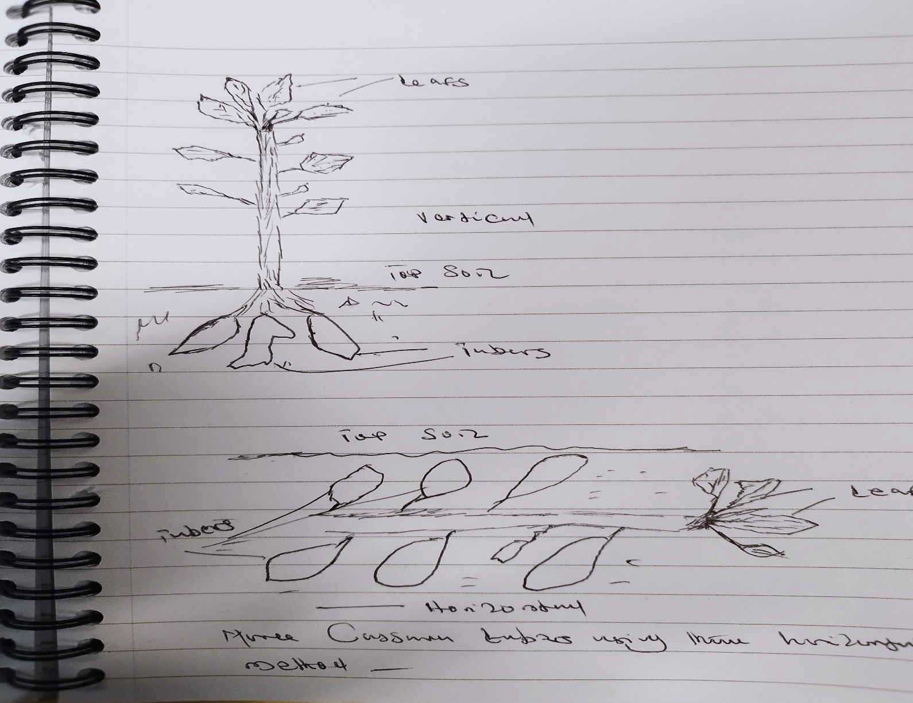
Figure 46: Vertical(traditional) Vs Horizontal methods of planting cassava
Drawing by an interviewee showing the traditional (vertical-top) and the horizontal methods. The horizontal method appears to show more tubers on one crop compared to the vertical method. Drawing by Situtu(Sefula).
Most of cultivars were gathered from the farmers who own fields or bought from other local farmers. There was a belief that the local cultivars were resistant to pests and more productive. The re-planting or recycling of the same varieties of cultivars transferred from generation to generation had the potential of preventing the importation of pests or diseases from other regions. The counter argument is that the continuous recycling of the same varieties over many generations could result into low productivity.
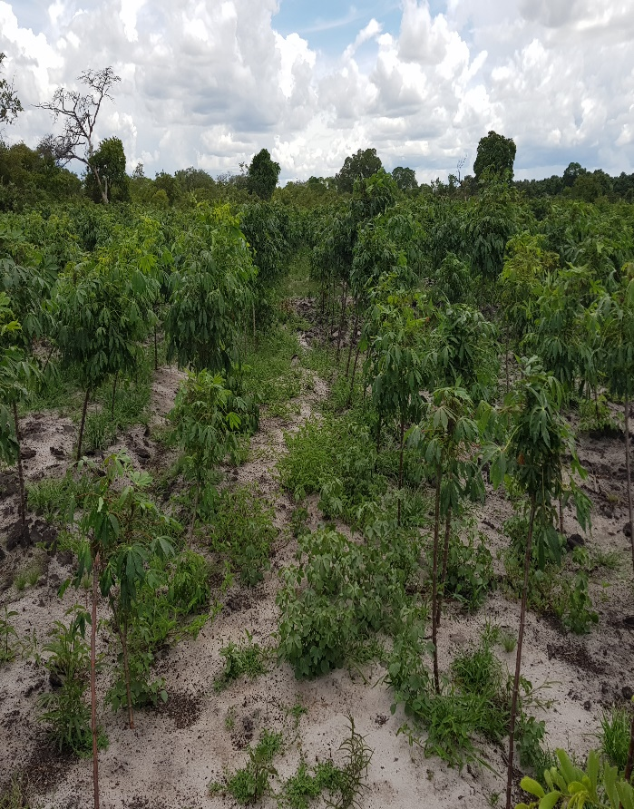
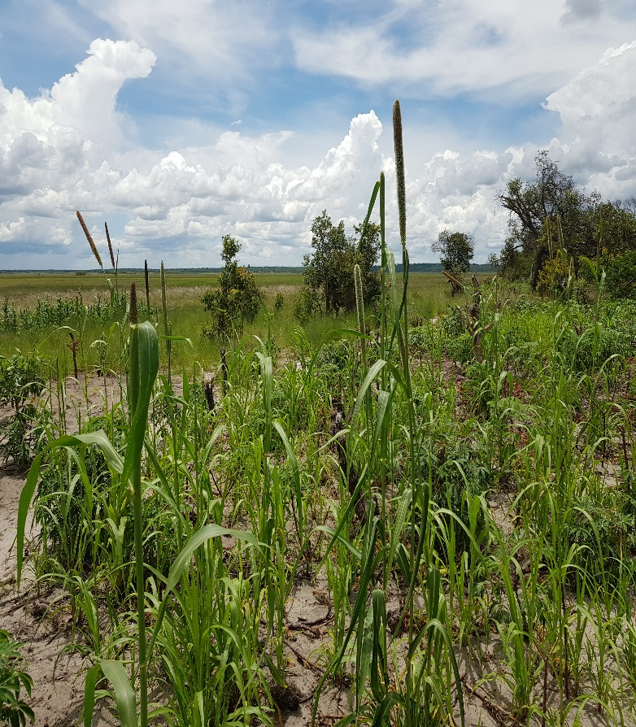
Once harvested the fresh cassava tubers are peeled are processed in two ways. The fresh tubers are sun dried for a number of days and milled into some flour. Another method of processing cassava is by peeling the fresh tubers, cutting then into small chips and then soaking them in water for up to 7 days and placed in the sun to dry. The chips are then placed in water for another 2-3 days before dried in the sun. Once fully dried the chips are then milled into a flour that is used to cook a local porridge called buhobe. It was suggested by interviewees that these two methods of processing cassava enhanced longevity in storage and quality. According to Oghenechavwuko et al.(2013), the drying of cassava under the sun improves its shelf life and reduces on the postharvest losses.

Figure 47: Fields of millet and cassava plants
On the left is a mixed field of millet and sorghum and on the right is a cassava field. These crops are drought resistant. Photo by author.
Rice growing is a very popular, highly important and profitable activity in many parts of the Western Province of Zambia (Milupi et al., 2020). Rice growing in the study areas, particularly Sefula was restricted to the lower flood plains and in the dambos(litapa and shishanjo). Litapa and shishanjo are low lying depressions that are subject to wetness and flooding in different proportions of length during the year. The distinction between litapa and shishanjo , is that litapa lies further deep in the flood plain and most of it water comes from the annual flooding and groundwater table. Shishanjo on the other hand lies slightly away from the flood plain; its water comes from rainfall and gets flooded in later period of the rainy season. In the case of poor rainfall, shishanjo are vulnerable to droughts and crop lose compared to litapa .Litapa and shishanjo have a poor drainage and have high water retention making them suitable and favourable for rice growing. According to Styger(2014) rice is the crop grown during the flooding season as it tolerates prolonged flooding .Rice growing is undertaken under two systems, under rain fed and an irrigation system. With changing rainfall patterns due to climate change, the use of the irrigation system reduces the risk of dependence on the rains to produce rice and other crops. On the other hand, due its high demand for water rice growing is highly vulnerable to droughts.
Land preparation for rice growing commences as soon the harvest has been taken off the fields and the water levels have recedded from the flood plain beginning from the months of May/June. Interviwees empahised the timing of planting as being critical as it determines how the crop will develop and the eventual final yield/harvest. They indicated that late planting means that the plants will be flooded before they tiller resulting in poor yields . From obserevations and interviews most of the land preparation was done by hand hoes . Some farmers with extra incomes could afford to cultivate more land by hiring extra labour or ox-ploughs. Rice growers interviweed indicated that they would start planting rice following the first rains in November. Interviwees expressed concern that greatest challenge to commemmencement of planting was the unpredictablity of the onset of the rainy season-that is when to predict exactly when the rains will start. Other interviwees expressed concerns at uncertainities when the floods will come and the extent to which the flood plains will be innudated . These Interviwees’ concerns colloborate with the climatic analysis of this thesis that points to late onset of the rainy season, increased frequency of droughts and rainfall intensity leading to flash floods (refer to rainfall analysis chapter).
One way rice growers have adapted rice growing particularly in Sefula in the use of the local variety commonly known as Mongu rice – named after the capital city of the Western Province- but also referred to as ‘super rice’. It is referred to as Mongu rice because it is cultivated on the flood plains around the District of Mongu and surrounding areas. The rice seeds are selected from the local traditional “seed banks” or those that were picked from the farmers’ previous good harvests. Most of the rice farmers interviewed suggested that seeds from the local “seed banks” were of superior quality compared to those bought from agro dealers (scientific/hybrid seeds).
They argued that Mongu rice was more resistant to both excessive floods and drought conditions. This variety of rice is not prone to attacks by ricebird(s) and small fish that come with the floodwaters. Farmers explained that Mongu rice tended to mature early and requires less water and has a higher tolerance for too much water compared to the commercial rice varieties on the market. Rice growing is very attractive to many people for its high value in the Mongu City markets. The location of Sefula benefits from location capital, which facilities accessibility to large markets giving individuals/households opportunities to engage in diversified livelihoods influenced by access to markets (Jakobsen, 2012). However, the biggest challenge for farmers who are growing Mongu rice is access to capital for expanding their production capacity (Harvest-Survey of 2014/2015).
Since the 2000s, the Government and donors have accelerating trends towards rice growing in Sefula. The government and the Japanese government set up a gravity –fed surface irrigation system for rice growing in Sefula. The Sefula Canal Rice Project was constructed at a cost of USA $8 million as a joint venture project to create employment opportunities and promote food security.
“The Western Province has vast potential to feed the country with rice; however, the biggest obstacle is access to services and to fair markets. Rice growing would change a lot of people’s lives here, reduce poverty levels and diversify people’s livelihoods” (Induna-Sefula).
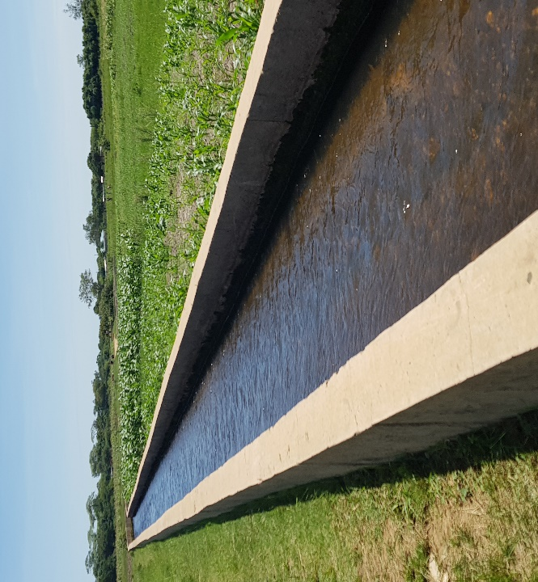
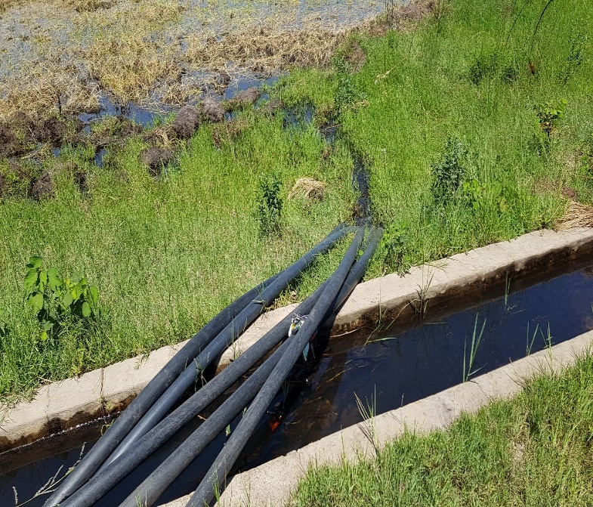
The narratives above corroborate with those of a Harvest-Survey of 2014/2015 of Zambia that revealed that the Western Province of Zambia is the largest producer of rice with Sefula contributing significantly to the annual total harvest (Zamstats, 2017). However, lack of government support directed at small-scale farmers has been a barrier to understanding market dynamics, thus, making the sector less profitable (CSPR, 2018). With good support from government, the farmers would be abreast with the dynamics of prices and their pricing would respond to the market behaviours of supply and demand.
Figure 48: Canal Irrigation system in Sefula
Canal Irrigation infrastructure in Sefula used by rice and vegetables farmers. On the left one of the canals running through fields and on the right farmers diverting water onto their fields using hosepipes.
8.2.8 Support infrastructure: Seed Banks, Harvesting and Post-harvest Care
The crops which constitute ‘adaptation from below’ are not a solution by themselves, they also have supporting infrastructure adapted and developed in the locally. Seed banks are one of the important aspects of the adaptation from below as they form the foundation and progression of genetic superiority.
Typical ‘Seed banks’ were wood and mud thatched huts that were also used as kitchens locally known as situngu. In all the study areas, these ‘seed banks ‘were owned at an individual or household level. After each harvest, the farmer selects the best grain of maize, rice, millet, sorghum, groundnuts, beans and others from the ‘seed bank’. The process of seed preservations starts with suspending unshelled grains or hanging them on the roof of the hut. It was alleged that when the seeds are left unshelled, they lasted long in storage than when shelled. A slow burning wood fuel fire is lit underneath them in a process known locally as ku kunyeka (translated to as to smoke). Smoke and heat from the fire penetrate the grains to make them dry and the smoke keeps free from pests and other grain microorganisms. The thatched roof of the ‘seed bank’ provides adequate ventilation of the grains and maintains a good moisture content for as long the grain are in storage. This open fire seed preservation blends locale practices and applies scientific principles of ‘curing’ to have antimicrobial effects. Beans, pumpkins and watermelon seeds were preserved in a different way. These are sun dried for up to 7 days till fully dry. The seeds/grains then dipped in a bitter plant ash for several days to ensure they are moisture and pest free before storing them in clay pots ready to be used during the next growing season.
Farmers with bigger land sizes and good harvest construct structures known as sishete. These are elevated on wooden poles to house the grain stores. These traditional granaries are sprinkled with traditional pesticide made of bitter plants, ash and cow dung that stops pests from invading the seeds while in storage. The size and capacity of the granary (sishete) symbolises how successful and hardworking farmer is. Farmers with bigger sishete that are filled to full capacity are looked upon with admiration and well respected in the villages.
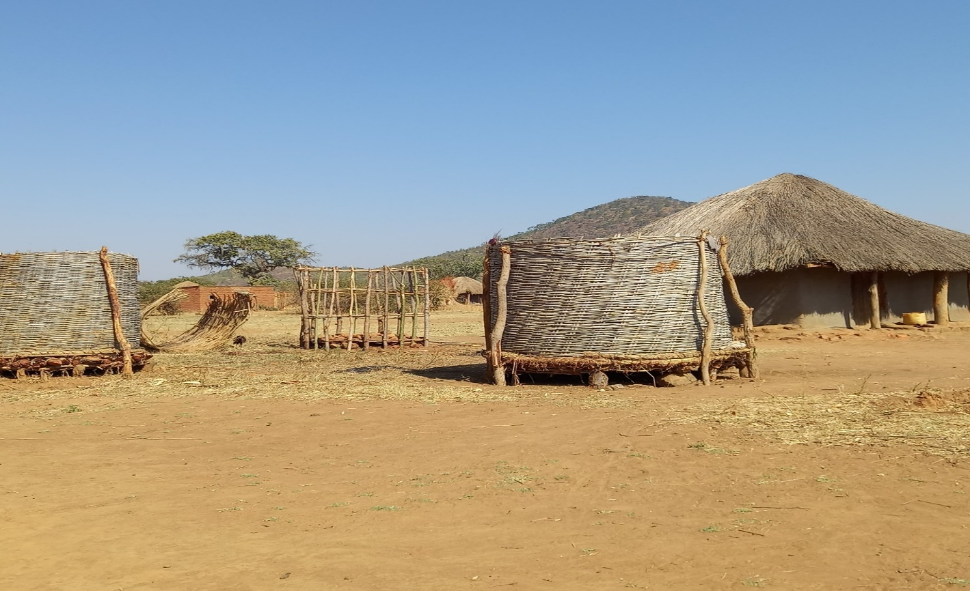
Figure 49: Shishete-type of seed bank
A typical sishete made of grass/reeds and wooden poles raised above the ground in which different types of harvested crops are stored. Photo courtesy of Mwanja Mwale(PhD Scholar UoS).
Traditional seed saving or preservation have been used for a long time and passed on through generations with marginal or not modification (Adhikari et al., 2021; Dasgupta et al.,2023). This method of seed preservation is widely practiced in many parts of rural areas of the world (Semenya and Mokgoebe,2020; Chhetry and Belbahir, 2009; Dasguta et al.,2023). Tumule et al. (2020) stressed ‘smoking’ or curing can stimulate the germination process of seeds by initiating physical and or physiological processes required to break seed dormancy leading to enhanced seed germination and better yields. Adhikari et al. (2021) and Dasgupta et al. (2023) demonstrated how seeds that were preserved through the process of smoking and heat have a higher germination rate and vigour than those that were not. These traditional grain/seed preservations have been practised and evolved over many generations and have proved to be robust enough to cope with change (Mobolade et al., 2019). Many interviewees appeared to suggest that they preferred to plant local seeds from the “seed banks” as it gave them better yields and was more resistant to local crop pests.
In summing discussion of section 8.2.1-8.2.8 response strategies in changing climatic conditions in the study areas, which I referred to “adaptation from below”. There is a debate that can be constructed here, there could be an argument or contest that these adaptation strategies are not necessarily or borne out of local/indigenous knowledge or practices. The counter argument is that these practices were “transported” by people who moved from different areas into the study areas. Others might argue that these practices drive from interactions with agricultural extension officers. However, local people argue to the contrary that these practices were long established in the study areas through generations observing that, “we do not have any agricultural extension officers here. Who does not know that mukapa yandongo (groundnut shells) fertilise the soil? Who is this area does not know that beans is good for the soil? We have known how to grow our own food here using local seeds that were more resistant to bad rains or pests. Whoever wants to tell us that we borrowed our way of life needs to read our history as Lozi people” (Mbumwaye:71-Male-Sefula).
I argue that largely these adaptation strategies were borne out of a complex process of blending of “transported” and long-established practices in the local communities. However, some of the practices such intercropping were an outcome of interactions between social cultural factors and land scarcity (refer to section 1.2.3-1.2.4). Land is “centrally” controlled by the BRE and therefore local people will utilise every portion of their land to produce food. This drives a process of ‘intensification of production’ through intercropping and crop rotation influenced following seasonal cycles.
The Government of Zambia introduced farmer input subsidies in the 2002/2003 farming season through the Fertiliser Support Program (FSP). The primary focus of the FSP was to increase maize production through the provision of farming inputs such as fertiliser and seeds (Mason et al., 2013). The Farmer Input Support Program (FISP) replaced FSP in the 2009/2010 farming season. The following section is a discussion on FISP. FISP is not necessarily an element of adaptation from below but is discussed here as part of the broad range of government strategies for adaptation across Zambia.
8.3.0 Government Support: Farmer Input Support Programme (FISP)
Field observations and interviews with study participants revealed that individuals and households were adopting improved seed varieties in combination with local crop varieties. However, many improved seed varieties were mainly accessible through the government Farmer Input Supply Programme (FISP) and agro traders. A few individuals and households with cash savings were able to purchase these seed varieties particularly maize from agro dealers. The Government of Zambia introduced FISP in 2002 to improve small-scale farmers’ access to agricultural inputs (World Bank, 2010). During the farming seasons 2002/03 to 2008/09 each eligible farmer was to receive one FISP pack consisting of the 4 50Kgs of basal fertiliser, 4 50Kgs of top dressing and 20Kg of seed (Mofya et al., 2013). It was also envisaged that the programme would improve access to modern farming inputs and support crop diversification (Sitko et al., 2012; Mason and Tembo). During the agricultural season of 2015/2016 and 2016/2017 the Government transformed FISP to FISP e-voucher (electronic version) (Mason et al., 2020). A notable addition to the programme was the encouragement to farmers to diversify away from traditional maize cultivation. FISP e-voucher introduced flexibility in the system by allowing farmers to acquire a broad range of farming inputs not limited to fertilisers (Kuntashula, 2021). Access to physical agricultural inputs/assets such as fertilisers is key to in enhancing in fostering productivity, livelihood sustainability, food security and well-being (ibid).
From interviews with beneficiaries of FISP, the outcomes/benefits of the programme were mixed and, in most cases, marginal. The FISP Pack encouraged some farmers to expand their cultivable land and recorded improved harvests in comparison to previous years when the programme when they had not benefited from the programme. One farmer in Sefula, reported harvesting 15 more bags of maize in the 2017/18 season after accessing the FISP pack compared to the 2016/2017 season when he did not have access to the pack. Some farmers introduced a dual system of production; one for home consumption using local seeds and the other one meant for cash sells using hybrid seeds. Based on this dual system of production, some farmers were able to hire more labour and ox-drawn power.
To this extent, FISP enabled farmers to diversify their cropping systems through mixed cropping; farmers ventured into growing commercial crops such as sunflower and to the less extent tobacco. Indeed, from the beneficiaries of FISP, the programme enabled access to cheap farming inputs, increased their capital and improved their food security. It is therefore, that these farmers that have experienced forward mobility on the LSPs. By drawing incomes from a non-farm activity, they ability to bounce back in times of crisis had been enhanced.
The table below tracks a farmer’s maize production using a dual production system over a 3-year period. The data used to draw from the farmer’s production notebook. The size of the hectares has been rounded off to the nearest whole number.
Table 15- Illustrative Trends in Maize Harvests Using Local Seed Vs Hybrid Seed
Season | Cultivated Land Size(hectares ) | Local Seeds | Hybrid Seeds
2015/16 | 3 | 45 of 50Kgs | 65 of 50Kgs
2016/17 | 5 | 65 of 50Kgs | 90 of 50Kgs
2017/2018 | 8 | 95 of 50Kgs | 120 of 50Kgs
The table above suggests that the farmer recorded more harvest using hybrid seeds as opposed to local seeds. However, as discussed earlier improved harvests cannot be singularly attributed to the use hybrid seeds. Factors such as the application of fertilisers, labour proportions/times spent on land, extension services, early planting and rainfall patterns can influence harvests.
However, FISP has been characterised by reports of corruption, political patronage, nepotism and as a result most farming inputs were inaccessible to subsistence farmers (Mason et al., 2013, 2020; Kuntashula, 2021). The criteria used to enrol farmers favours large-scale farmers at the expense of poor subsistence farmers. Among the other requirements was that the farmer must register with a local cooperative and subscribe to one membership share. The farmer must demonstrate that they cultivate 5 hectares of land. For those farmers are eligible to get farming inputs, they are required to pay ZMK400 which is aside from the cooperative membership fee. However, membership of a cooperative is not a guarantee that the farmer will be eligible for subsidised inputs (Mason and Jayne, 2013; Simale et al., 2015). Inputs are often delayed due to financial and logistical challenges (World Bank, 2010; Mason et al., 2020). In comparison to original FISP, the FISP e-voucher has not had any significant impact on yields and crop diversification (Siame and Siame, 2017; Mason et al., 2020). From the interviewees’ perspective, particularly subsistence farmers in the study areas, FISP and FISP e-voucher’s intended benefits have not been realised as summed up in the extract below:
“Only people with connections get seeds and fertiliser from the depots. Most of the people who need the inputs never get them. If you do not belong to the ruling party, you get nothing and sometimes you must give someone money to be enrolled. The inputs never come on time and sometimes you do not receive what you applied for.”(Chairperson-Mongu, Small Scale farmers’ Cooperative).

Space intentionally left blank to fit in next section

8.4.0 Farmer Cropping Strategies
Table16- Famer cropping strategies.
Local adaptation to changes in rainfall and temperatures
Changes to planting dates | Due to late onset of rains planting dates have shifting towards mid-November and early December. This fits with indications from climatic data of a forward shift pf the onset of the rains
Changes in crops grown | Evidence of farmers moving from growing traditional crops such as maize to millet, sorghum, cowpea, cassava. These crops respond well to a short growing seasons and rainfall variabilities
Growing more drought resistant crops | In Sefula and Nanikelako, people rely more on cassava as opposed to maize that is vulnerable to rainfall changes. Sorghum and millet have increasingly been promoted as alternatives to maize.
Crop mix and crop rotation | Farmers growing a mix of crops on the same piece of land as risk protector. In Sefula for example, farmers growing rice, vegetables and wheat on the same field. In Nanikelako famers growing millet, cowpeas and watermelons during the same growing season. Crop mix improves food security and better income returns. Mixed cropping also acts a risk spreader. Crop rotation is improves and enhances soil fertility
Use of local seeds | Evidence of more trust in the use of local seed varieties of maize, rice, sweet potatoes, sorghum, millet, African aubergine

8.5.0 Claiming Land from Land from the Flood Plain: Mazulu
The Lozi people have always used traditional ways to adapt to living with floods. Due to the low-lying nature of the flood plain, people have used land reclamations called lizulu(mazulu-plural) to build their houses and carry out agricultural activities. A lizulu is made by collecting soils and heaping it in a low-lying area to make a hill or mould structure that is elevated from other areas. In some villages particularly in Nanikelako ever year, soils are collected to heap of the existing mazulu make them higher and broader allowing for more spaces for living and cultivation of food. In Lealui and Nanikelako, there is a significant number of the moulds. Several of them are dedicated to annual agricultural activities during the flooding season. At the peak of the floods, the mazulu used for agriculture can only be accessible by canoe, particularly those that are located deep into the flood plains of Nanikelako and Lealui. However, due to their location and susceptibility to flooding yields from mazulu tend to be low. The low yields are also as due to the small size of the mazulu; as they are human made and demand a lot of manual labour to construct.
8.6.0 Transhumance: The Seasonal Movement of People and Cattle from the Flood Plain“Kuomboka and Kufuluhela”
Aryal et al (2018) describe transhumance as a form of livestock production in which livestock are moved between fixed points to use the seasonal availability of grazing pastures. Rajamajhi and Manandjhi(2020) describe transhumance as a type of pastoralism in which animals are moved on a season basis between different agro-ecological zones to utilise the seasonal availability of grazing pastures. What the two descriptions of transhumance above underline is that this movement is driven by the need to find new pastures for live livestock. Aryal et al.(2018) stress that the movement usually happens between winter and summer and varies in type; from nomadic ways to settled communities who combine arable farming with livestock keeping. In both cases of nomadic and sedentary settled communities practice transhumance if form of livelihood strategy taken to adjust to certain environmental changes.
Transhumance practised by communities with fixed settlement is historical and traditionally a responsive strategy to climate variability, low agricultural productivity and remote location as well for its socio-economic and cultural importance (Chetri et al., 2011).”The knowledge of pastoral communities and their lifestyle are rooted in the historical evolution of their experiences in their environments, which is largely been part of their social adaptation strategy to environment variability Easdale and Aquiar (2018.P1)”. Hulme (2008b) contended that climate change is both a physical transformation as much as it is a cultural object and therefore cultural objects of adaptation play a critical role in fostering change. Transhumance has been cited as an adaptation strategy against the negative effects of climate change (Agrawal, 2010; Aryal et al., 2018)
The Lozi people have always practised transhumance for hundreds of years that has always coincided with the annual flooding season (Munan’andu et al., 2012; Mwamulowe, 2017). In the Western Province of Zambia (also known as Barotse Land), the movement of people and their livestock from the flood to the upper lands as a result of annual flooding is locally known as Kuomboka (getting out of the water) (Moonga and Milupi, 2015). The opposite movement –that is the movement of people and their animals back to the flood plain post floods is known as Kufuluhela(Moonga and Milupi,2015). Kufuluhela occurs during the dry season when the floodwaters recede, and the flood is rich with green pastures. Each village or clusters of villages have grazing lands called mafulelo(plural). Mafulelo is derived from the term kufula-translated as grazing. Each lifulelo(singular) has boundaries and access to these grazing is restricted to individuals and households of that village or villages. In certain circumstances, access is granted to people from nearby villages to graze their animals. This transhumance is necessitated by climatic conditions such low or poor rainfall and the annual flooding that occurs from January to June each year which is largely influenced by patterns of the annual rainfall. Anecdotal narratives appeared to suggest that during the flooding season as the cattle are moved uplands, the cattle tend lose a lot of weight due to poor pastures which are mainly consist of small shrubs.
The significance of the transhumance practices in the Barotse Flood plains were highlighted in an evaluation report on the nomination of the Barotse Land Cultural Landscape which was undertaken by the International Council on Monuments and Sites (ICOMOS).
“A transhumance system that goes beyond the grandiose of the annual Kuomboka ceremony and the site specific royal graves, settlement moulds and canal-it is the social, cultural and economic force that binds communities together around migration between the flood plain and higher ground and the value of the very specific type of agriculture practiced on the fertile plans that in effect provide the impetus for this system”)ICOMOS, 2009, P.71)
Interviewees reported that in the last 15-20 years pronounced seasonal rainfall variabilities have affected the quality and size of pasturelands. Interviewees cited the late onset and early retreat of the rains as having had a huge impact on their livestock keeping as text extract below indicates.
“In the old days we never used to travel far in search of fresh pastures, even at the peak of the dry season we used to have nutritious pastures near the villages. In the old days the most we would go was about 5 kilometres and our wives would bring us food as we looked after our animals. In recent years, looking after animals has become hard because we must have to move up to 80 kilometres on the flood plain and be away from home for months. The water points dry up quickly as well. How long we can live like this, no one knows but God. The rains never come on time and if they did come the finish after 2 months” (Manyando-Herdsman-Nanikelako).
Transhumant practices extend as far as up to 50-100 kilometres from the village deep in the inner flood plain during the dry season as the pastures near the villages become scare. Topographic features of the areas influence transhumance practices. The landscape in Nanikelako is composed of with low-lying vast expanses of plain land, dambos, disused canals, swamps and ox-bow lakes many of which are seasonal water bodies.
In Nanikelako, transhumance was undertaken on a horizontal bases-which is the back-and-forth movement of people and cattle across different areas of the low-lying flood plain. Therefore, in Nanikelako the movement of cattle covered a wide area following established routes of water sources and pastures influenced by timing of rainfall and vegetation growth. Whereas Nanikelako appeared to hold the potential for cattle production due to vast expanse of the grazing lands, it is challenged in the sense of location capital. Its remote location hinders access to markets and extension services. The lack of location capital; that is infrastructure in the form of roads, bridges, electricity and others narrows options or alternative livelihoods for individuals/households to engage in. Consequently, in the case of Nanikelako individuals/households the vulnerability of individuals/households’ shocks is amplified due to limited livelihood options. The foregoing observations fit into the general observation of the poverty incidence in the Western Province of Zambia (CSPR,2013;2015).
In Sefula, transhumance was undertaken on a vertical basis-which is people and cattle ascending and descending from the low-lying flood to the upper land. Sefula is characterised by a wide upper land that overlooks the low-lying flood plain. In Sefula, the transhumance is mainly undertaken by moving herds from the low-lying flood plain to the adjacent upper lands during the flood season and back down when the flooding has receded.
On the other hand, Lealui, which is he King’s Winter Palace lies an on slightly high ground surrounded with vast expanses of low-lying flood plain. However, the land and its pastures in are the preserve of the King; no one is permitted to keep cattle or graze their livestock on the proximate areas of Lealui. Therefore, the movement of cattle and people in Lealui coincided with the Kuomboka; the transition of the King and his herd from Lealui to Limulunga which is the King’s summer palace (refer to the Kuomboka ceremony).
During the flood season, the herds are kept in kraals made of wooden structures. At night, the cattle are locked in the kraals to protect them from cattle rustlers and wild animals. The cow dung deposited in the kraal fertiliser the land and some of it is collected then dried as an energy source. During the day, the cattle is moved to the edges of the flooded plain or nearby forests and dambos to graze.
“most of the people on the flood plain have two homes, one on the flood plain and another on the upper lands. When we are blessed with good rains and the plains flood, we move with our animals. If the there is too much water on the plains, we live on the upper land for up to end of June before we move back. When we move back the plains are rich with forage and our animals are happy just as we are. In the last few years, we have faced poor rains, we have no water or food for us or our animals. We do not get any kind of help and it is sad to see our animals die due to starvation” (Induna-Nanikelako).
Livestock keeping was found to play a significant role in how people have responded to the impacts of shifts in the rainfall in Sefula and Nanikelako. At household and individual level selling livestock provided cash that was invested in other livelihood activities (e.g grocery stores) and purchase durable assets such as bicycles. Interviewees indicated they were able to pay school fees for their children and pay for medical expenses from cash incomes from cattle sells. Sale of Milk and cowhide created employment opportunities across the communities. Cowhides are used to make traditional mats and others sold to traders from the urban areas. Cash incomes and investment in other livelihoods contributed to livelihood and asset diversification. The findings of this study corroborate with similar studies (Moonga and Milupi, 2015; Milupi et al, 2019) that found communities on the Barotse Flood plain have long used transhumance as way of responding to environmental state. Similar studies in other regions of the world have suggested that transhumance practices have deployed in order to deal with challenges of environmental change in precipitation and snowfalls in Nepal and Himalayas ( Rajamajhi and Manadhar, 2020; Aryal, 2016; Gentle and Thwaites , 2016). Easdale and Aguiar (2018) add transhumant is a critical socio-productive measure adapted so spatial and temporal environmental variabilities. Some of these measures are necessarily, indications of how people have increasingly diversified their livelihoods in order to broaden their incomes streams and spread risk. As agriculture is increasingly becoming vulnerable to climate related perturbations (Lawson et al., 2020), the centrality of livelihoods and asset diversification becomes critical as it acts a risk spreader. Livelihood diversification acts as buffer in case people’s main livelihood is disrupted by climatic or non-climatic shocks or stressors (Ellis, 1998; Mohammed et al, 2021).
Transhumant livelihoods depend on natural resources and therefore highly vulnerable to climate variabilities. Questions arise at how these livelihoods will remain viable in the face of the unpredictable nature of climate change; that is drying of water sources due to drought and the increasing erosion of commons across many rural areas of the world. The spread/distribution of water sources and grazing pastures is to a greater extent shaped by rainfall and temperatures of a locality and therefore as some of the impacts of climate change remain unknown, it entails that the livelihoods people involved in livestock keeping is at risk (Dong et al., 2010; Onah et al., 2013; Tiwari et al., 2020).
The responses strategies set out above are often woven into knowledges, ideas, logics, values, norms and understandings of local people, in my view can be classified into 4 livelihood pathways; Struggling; Coping; Resilience and Adaptation.
8.7.0 Linking up Livelihoods Strategies and Adaptation Strategies.
In the following sections I illustrate how I developed the LSPs based on empirical observations and the application of other theoretical lenses of inquiry. As argued earlier in this study (refer to sections 3.9.1-3.9.1 & 3.9.7-3.10.1), key to the conceptual development of the LSPs is the deployment of assets in livelihood construction in the face of internal and external forces (push & pull). Internal and external forces shape how individuals distribute their assets to satisfy their well-being (Scoones, 1998; Moser,1998). In stable times/seasons individuals or households make rational and purposeful decisions which then situate/shape their livelihood pathways. However, in times of crisis people make reactive or desperate decisions to ensure survival. In the following sections, I track through the conceptualisation of the LSPs through an ethnographic analysis of asset deployment.
8.7.1 Struggling Pathways
The concept of struggling pathways is based on the everyday survival instincts of individuals or households who lack in asset diversity or those who subsist on “hand to mouth” basis. From this study’s perspective, these were individuals or households that were lacking in access/ownership of land, liquid and physical assets that could easily be redeployment on the everyday basis and critically in times of crisis.
Based on empirical engagements, I observe that these individuals or households relied on their own labour as the most important asset in their portfolio. They subsisted through labour exchanges with households in their local areas. The defining feature of these individuals/households was the lack of access to land. These landless people were disadvantaged from the onset because as already established in this study, agriculture is the dominant livelihood activity. During data collection, I interacted with an old lady who lived by herself and due to illness was unable to engage in piece work. She survived by accessing or tapping into her immediate social network (neighbours) and community cooperation that very strong in the study areas. There were other similar stories of people in the study areas who were relying on their labour for survival; either by working on other people’s land or other labour-intensive jobs. Many young people looked after other people’s cattle which they grazed on pastures in the vast expanse of the flood. The returns/incomes from these kinds of jobs were paid either in food portions or small amounts of money.
There was a narrative of strong community cooperation and propensity to share available resources particularly food in times of crisis. Based on the concept of care-the innate behaviour of humans to care for one other, people rallied together to satisfy their daily needs and thereof their well-being. Motivations or agency for asset accumulation in this case is almost nearly impossible as people’s preoccupation is to get the next meal.
In times of widespread crisis particularly during droughts, resources were scarce in terms of food that could be shared around. For example, during the drought years of 2017-2019, interviewees cited widespread hunger that devastated all the study areas. Competition for grazing land led to hostilities between and within villages prompting some people to convert their livestock to daily needs of food. While people were able to surmount their agency during desperate times, they lived in the reality that they will face the same hardships in the next season. While they were sentiments of plenty food during the rainy season due to the abundance of natural resources such as wild vegetables, non-timber forest products and fish in the flood plain, many people in this category lived in a cyclical reality of recurrent or worse conditions in the following year.
From all the three study areas, two concepts come into play in relation to livelihood struggle in this category of classification: unequal power distribution and fragmented geography. In Nanikelako, location capital and place vulnerability narrowed the range of alternative livelihoods options and critically during times of crisis. The conditions particularly in Nanikelako were desperate, the lack of social infrastructure such as schools and hospitals mean that social mobility in relation to health and education opportunities exacerbated intergenerational poverty. Based ethnographic interactions with study participants, evidence indicated high levels of illiteracy and poor health outcomes Nanikelako. In Lealui, unequal access to land ;the most critical asset is highly skewed in favour of the King therefore limiting livelihood options for people. In Sefula, while land and other support infrastructure such as irrigation is available, many people subsisted on sub-letting their labour because only a few individuals or households owned land and had access to the irrigation infrastructure.
In categorising this group of people, I draw on three (3) key points; lack of asset diversity; limited range of livelihood options and intergenerational cycle of struggle.
8.7.2 Coping Pathways
The basic characteristics of the Coping Pathways are like that of the Struggling. Individuals or households in this category relied prominently on the extraction of natural resources and labour exchanges due to being asset poor (see section 3.10.4) and a limited range of livelihood options.
In this pathway I assemble individuals or households that apart from engaging into activities above were also involved in brewing local alcohol(kachasu/kachipembe) and making local crafts. Kachasu brewing is common in Sefula and Nanikelako but restricted in Lealui.
The most distinctive feature between struggling and coping pathways was access to remittances. Remittances play a critical role in times of crisis as buffer for vulnerable people (Musah-Surugu et al.,2018). Some individuals/households with social networks beyond their locale areas relied on remittances from their family members in the urban areas. Interviewees narrated how remittances supported them to meet their basic needs in times of drought or other social pressures. Remittances were used to buy food, pay for school requirements and other essential needs. Other individuals/households indicated how their children from urban areas sent them monthly allowances for food and other needs. Without these remittances, these families were vulnerable to external and internal shocks.
However, these individuals or households heavily rely on labour exchanges and the extraction of natural resources. They are at a higher risk of falling back into the state of struggle.
A common thread in Struggling and Coping Pathways is that these are short-term strategies to ensure everyday survival. These strategies do not deal with the underlying causes of vulnerabilities; should the same event or hazard occur in future, people or communities will more than likely experience similar effects.
Case Reference: Ms Namunji in Lealui relies on the remittances from her brother who lives in Lusaka. Ms Namunji is unemployed and owns no productive assets apart from a mud thatched house. She looks after 3 orphans, and one is disabled. She cannot engage in farming due to land use restrictions in Lealui. During the flood season, Ms Namunji will engage in artisanal fishing using fishing baskets in cooperation with other women. In times of crisis Ms Namunji like many other families in Lealui are in danger of starvation without support from her brother. The possibility of Ms Namunji escaping these conditions are nearly impossible without deliberate/target interventions from external agencies.
8.7.3 Resilience Pathways
Resilience pathways situate in a delicate balance -any extreme mixture of external and internal pressure can easily push these livelihoods to Coping or Struggling.
Whereas, in my conception I imagine that livelihoods in this category are characterised with a moderate asset diversity (liquid cash, livestock-cattle, pigs and goats). These livelihood pathways are characterised by a high proportion of farming activities that are highly sensitive to seasonal cycles and climatic shifts. For example, in Sefula there is a dominance of rice growing and livestock keeping. These farming activities are highly profitable in good agricultural seasons because of the huge demand and high prices of rice. Many of the farmers in this category experienced good levels of well-being, access to health facilities and schools.
However, based on the fact these livelihood pathways are anchored on farming activities means that changes in climatic conditions can have devastating impacts. Anecdote evidence indicates that droughts of 2017-2018-2019 eroded farming activities in the study areas. Water shortages and livestock disease wiped out hundreds of cattle. Farmers made huge losses in terms of crops and animals. However, resilience pathways were able to bounce back and transform into better pathways. Interviewees in this category narrated how they sold off their livestock and some of their stores of rice stocks which they reinvested in their farming activities. Other farmers in this category diversified their farming portfolios into growing vegetables such as cabbages and tomatoes that had good returns.
Case Reference: Mr Mubaanga a farmer in Sefula held his wealth in livestock and grain stores. He kept his livestock as a symbol of wealth and for cultural reasons. Over the years he accumulated a big head of cattle. He claims to have lost hundreds of heads of cattle due to a devasting epidemic of anthrax in 2016. Mr Mubaanga reports that he had to sell the rest of the cattle to avoid a total lose. He narrates that he had to start over again by restocking from his father and selling off his grain stores. Mr Mubaanga has been investing heavily into cassava and millet growing as these are drought resistant.
8.7.4 Adaptation Pathways
Individuals or households in this pathway were engaged in a diversity of on farm and non-farm activities. These individuals/households can be imagined as having achieved high levels of well-being. Their highly diversified assets in terms of social networks, financial capital and other assets cemented their robust and flexible response to shocks through rational asset redeployment.
In my conception, the feature of this pathway was anchored on a good mix of liquid cash, physical assets such land, lorries, bicycles and livestock diversity (a mix of cattle, pigs and goats). This fluidity and diversity in their assets accelerated further asset accumulation not possible in the other pathways.
In terms of on farm production, these individuals were involved in growing different crops-maize, cassava, rice and green vegetables with ready markets in the urban markets of Mongu. Crops of were grown for dual purposes-that is for household food consuption and commercial purposes. These farmers were able to purchase hybrid seeds and fertilisers to maximise their returns and further accumulate assets.
Case Reference: Mr Mwendalubi, a farmer in Sefula with a stock of roughly 200 cattle, 130 goats and 15 pigs. He collects livestock manure for his agricultural activities and resells the surplus. He is engaged in mixed farming-rice, vegetables, maize and cassava. He owns a lorry that transports his farm produce and hires it out to other farmers. He managed to send two (2) of his children to university.
Table 17- Summary of the key features of the LSPs
Pathways | Features | Asset Diversity | Well-being
Struggling | Labour-exchanges, natural-resources and social networks | Poor/low asset bundles | Transgenerational poverty
Coping | Labour-exchanges, natural-resources, social networks & Remittances | Poor/low | Transgenerational poverty. Can escapee poverty in the right conditions
Resilience | Anchored on-farm activities/moderate activities in non-farm | Moderate asset diversity -mix of liquid cash, livestock, land and grain stores | Moderate well-being  Flexibility in asset redeployment/bounce back from perturbations
Adaptation | High mix of on farm and non-farm activities | Complex/careful mix of liquid, physical assets | High well-being. Greater opportunities to apply assets
Transformation | No empirical evidence to indicate has been achieved or can achieved without external support

8.8.0 Conclusion
Chapter 8 explored the main outcome of this research ‘Adaptation from below’. Chapter 8 focused on the processes and activities of adaptation to shifting climatic conditions in the three study areas. Adaptation from Below was conceived during and after data collection; it is situated in local knowledge and practices developed and refined over main generations. Adaptation from Below is a blending/hybridisation of local knowledge and practices infused with knowledge from different parts of the world. This was demonstrated into how local people engaged in their farming activities from the choice of seeds, tillage systems, soil fertilisation and post-harvest care of their harvests. Through all these many farming activities, evidently processes of trial and error, blending and bricolage were intertwined with local practices. This chapter explored the plurality and diversity of adaptation practices in the study areas including tillage, land preparations and soils fertility management. It also examined the main cropping systems and the use of drought resistant crops in the face of increasing drying conditions in the study areas. Local support infrastructure is key in the study areas; the use of local banks plays as central role in the local practices and knowledge retention/transfer between generations. This chapter explored transhumance practices in the study areas. Transhumance practices coincide with the annual flooding season that is also celebrated through the Kuomboka ceremony. Hundreds of people and their livestock move from the lower flood plain to the uplands every year between March/April to escape the flood water.

Chapter 9: Conclusion
9.1.0 Introduction
This thesis set out to investigate the impacts of climate change and explore into the plurality of adaptation strategies in the Barotse flood plain of the Western Province of Zambia. Taking an interdisciplinary approach, the thesis explored rainfall and temperature changes and trends between 1981 and 2019 in three study areas (refer to methodology-Chapter4). Employing qualitative and quantitative methods, the thesis assessed local people’s observations (qualitative-chapter 5) and applied scientific data analysis (quantitative-chapters 6&7) to evidence for change and trends. The thesis demonstrated in chapter 5 that local people’s observations pointed to rainfall and temperatures shifts. Local people’s biggest concern was perceived to be changes in the onset, duration, and cessation in rainfall. In chapters 6 and 7, this thesis analysed rainfall and temperatures indices to establish whether people’s observations match with climatic data. Through discussions and analyses, this thesis established that people’s observations and scientific data were generally in broad agreement; in that some of the indices of rainfall and temperatures have been shifting. Local observations and scientific data point to a forward trend towards late onset, shortening of the rainy season (duration) and an early withdraw. In relation to temperatures, both local observations and scientific data point towards warming summers. However, there were divergences between local observation and scientific data in relation to winters. Whereas local observations appeared to indicate a trend towards colder winters, these observations were not supported by scientific data. However, remarkably local people did not appear to emphasise changes in temperatures as much as they did for that of rainfall. In my view this can be attributed to the fact that changes rainfall patterns were more visible and impactful on people’s livelihoods.
The thesis introduced the Livelihoods Strategies Pathways (LSPs)-as a way of conceptualising how local people respond to change through the deployment of their assets in order to satisfy their well-being. The main adaptation outcome of the thesis, which I referred to as “Adaptation from Below”, was conceived during and after field data collection through observing, interpreting and trying to understand how local people learn, modify and pass on knowledge from one generation to another. These adaptive strategies are constructed at a local level, influenced by indigenous knowledge systems and blended with other knowledge systems including scientific knowledge. This thesis was motivated by the grounds that no similar studies has been conducted in the study areas that have explored rainfall and temperature changes to greater depth as in this study has. In undertaking this study, this thesis has contributed empirical knowledge that will be valuable to policy makers and other researchers as the world seeks to find solutions to climate change. In conducting this research, I deployed a place-based three case study (see chapter 4-methods).
In order to meet the aim of the thesis and answer the research question, the thesis set out to meet the follow objectives.
- Assess climate variability and change through meta data analysis of rainfall and temperature changes/trends.
- To Compare and contrast local observations against scientific analysis of rainfall and temperatures as set out above.
- To explore the plurality and diversity of rural livelihoods strategies that households/ individuals pursue in response to climate change and variability.
- To examine the types and asset bundles that individuals and households draw on to construct their livelihoods and adaptive measures pursued within and between individuals/ households and how these are shaped by climate.
The following sections present the key findings of this thesis as set out in Chapters 5, 6, 7 and 8. The key findings are highlighted under each objective and main themes that were explored.
    - Key Findings of the study
Objective I. Assess climate variability and change through meta data analysis of rainfall and temperature changes/trends.
From the scientific analysis of data, the key findings of this study suggest that while long-term mean annual rainfall was observed to have a positive trend, the rainy season length or duration was on a negative trend (decreasing). Although this trend is insignificant (p<0.05), it is a result of significant trends in onset (later) and cessation (earlier) of the rainy season that are driving changes in rainfall patterns. The findings above corroborate with similar studies in Zambia (Libanda et al.,2020; Makonda and Thomas,2020; Biggie and Mubanga,2022). Interestingly, this study also finds an increase in the total number of wet days within a rainy season. This suggests that despite the shortening of the rainy season, within each rainy season there are a greater number of rain days. This suggests that more rainfall is received within a short period resulting into higher rainfall intensity and floods.
In relation to temperatures, local people’s observations were that summer temperatures were warming. Interviewees suggested that the month of October was the warmest. Interviewees also reported experiencing unusually hot nights. However, this study did not assess daytime or night-time temperature in order to establish evidence for these views. The exploration of daytime and nighttime is beyond the scope of this study. It is possible that the night temperatures have remained stable during the study period, however, it is also arguable that people will report feeling hot in the night as they were not as active in the night compared to the day when they engaged in their livelihood activities. The findings also revealed that local people appeared to suggest that winters were getting cold compared to previous years; however, these assertions do not fit with climatic data analysis. Here too, it is plausible that people will report experiencing feeling cold when the actual temperatures are warm. The possible explanation for this is that winter-time (cold season) in the study areas coincides with the dry season-it is the lean season with most people not engaging very productive livelihoods activities and being less active may make people feel cold when infact the temperatures have remained stable over time.
The key findings from the climatic analysis of this study point to an upward trend (positive) in temperatures in the months of July, August, September and October. The monthly temperature analysis concluded that the highest variation was observed in October corroborating with local observations. During the study period, months of March and December on the other hand experienced a downward trend (decreasing temperatures). Furthermore, the trend results concluded a significant upward trend in temperature in seasonal and annual data records. In monthly data analysis using Mann-Kendall trend the results indicate an upward trend in the months of July, August, September and October. There was a little variation in the Modified Mann-Kendall trend test results as the significant upward trend was in the months February, June, July, August, September, and October. The trend magnitude calculated using Sen’s Slope concluded the highest trend in temperature in October with 0.069 ℃/year while this trend magnitude was 0.020 ℃/year in annual results whereas in winter this was 0.023 ℃/year and in summer the trend magnitude was 0.040 ℃/year. Overall, the study concluded an increasing trend in temperature on both summer and winter temperatures. These results corroborate with the findings of the IPCC (2022, Chapter 1)-that point towards warming trends both in summer and winter. According to IPCC (2022, WGI Section 22.2.1.1), across Africa the observed climatic trends indicate that near surface temperatures have increased by 0.5⁰C or more over a time of 50-100 years. Minimum temperatures have warmed at a high rate than maximum temperatures. Near surface air temperature anomalies have significantly been higher during the period 1955-2010 compared to the period 1979-1994. The IPCC (2022) further adds that it is more likely that mean annual temperatures have also increased over the last century across many parts of Africa.
Objective II. To Compare and contrast local observations against scientific analysis of rainfall and temperatures as set out above.
a. Narratives of Late onset of the rainy season-Chapter 5 established that the general narrative(views) from all the three study areas was that the rainy season has been shifting forwards (late onset). The narrative was that rainy season was starting in early December as opposed to late October to early November as was the case in previous years. The rainy season onset appeared to be defined by two frames of reference, by month and livelihood activities within and between the study areas. However, in the main it was agreeable that the rainy onset was historically referenced to the month of November. In Lealui and Sefula, rainy season onset was broadly defined by month. In Nanikelako this appeared to be defined by the availability of green pastures for cattle in the vicinity of the villages depicting a livelihood frame of reference. During data collection, I observed large tracts of land left uncultivated during the month of November that interviewees attributed to late onset of the rainy season. These local observations agree with climatic data analysed in chapter 6(Sen’s Slope=0.19, P-Value=0.1). This is consistent with other research that indicates that wet seasons will get delayed across many regions of Africa with the largest shifts of an average of 12 days over much of Southern Africa (Dunning et al., 2019; IPCC,2022).
b. Narratives of uneven distribution of rainfall and intensification of dry spells-broadly the views from interviewees were that the rains have been unevenly distributed during the rainy season and often characterised by long and frequent dry spells. Most interviewees were of the view that the rainy season is concentrated within three months (DJF) as opposed to being spread evenly during rainy season compared to previous ‘normal’ rainy season of five months (NDJFM). During the study period, a maximum of 21 consecutive wet days was recorded. Interviewees also suggested that dry spells have become frequent and intense. This corroborates with the climatic data analysis that revealed rainfall intensification in 2000-2009 with 982.2mm against 924.1mm in 1981-2000. During the study period, 19 consecutive dry days were recorded (see section 6.3.1). The findings of this study indicate an increase in wet days that coincides with rainfall intensity during a shorter rainy season. Rainfall concentration or intensity can play a critical role in the total rainfall amounts (Quenum et al., 2019). These indices can influence the flooding or drought events including the frequency of dry spells (Quenum et al.,2019). Kumar et al. (2019) argue that the distribution of rainfall through an entire season rather than its total deficiency during the season can significantly influence crop productivity. Kumar et al. (2019) forward that any high variability or any prolonged uneven distribution of rainfall can result into severe impacts on crop productivity not just in rain fed but equally irrigated cases.
c. Narratives of negative trends in rainy season length (duration) and early cessation – sentiments by interviewees in all the three study areas indicated the rainy season length has become shorter and the rains withdraw early(stoppage). The argument was that due to the late onset of the rainy season and early withdraw; the rainy season length has become shorter. The anecdotal view was the rainy season onset has shifted forward towards late November and early December and cessation has shifted backwards from April to March. Following this line of narrative, the rainy season has reduced by a month. The above observations translate into a shorter rainy season and growing season. These local observations fit in with the scientific data analysed that depicted a negative Sen’s Slope (=-0.6 and P-Value=0.5) as analysed in section 6.3.3. Using six member ensemble, Cook and Vizy(2016) found shortening growing seasons over Southern Africa and western parts of the Sahel.Biggie and Mubanga(2022) in their study across the entire three Agro Ecological Areas(AERIIb) of Zambia found shortening/decreasing rainy season and early cessation of the rains this is despite rainfall amounts remaining relatively stable. All the above findings are consistent with the IPCC (2022, WGI Section 22.2.2.1) - most regions of Southern Africa (Botswana. Zimbabwe and Western South Africa) have experienced a downward trend in total mean summer rainfall and other indices of intra-seasonal characteristics seasonal rainfall such as onset, duration, rainfall intensity has changed.
Objective III and IV as discussed here together - asset bundle influence the response strategies (Moser, 1998). As argued in the theoretical and conceptual framework, asset characteristics influence how individuals or households deploy or deploy their assets in the face of threats in order to satisfy their well-being (Moser, 1996; Scoones, 1998; Chen et al., 2013). From the perspective of this study, access to labour and critical natural resources such as land shaped response strategies as most of the livelihoods are agriculturally based (see chapter 8). And well-being outcomes in the form of livelihood security, empowerment and sustainable use of natural resources is a result of a rational deployment of assets and negotiation of constraining forces within the vulnerability context (Armitage et al.,2012; Breslow et al.,2016).
As discussed in Chapter 8; ‘Adaptation from below’, climate change adaptation at the individual or household level were shaped by local practices embedded in long-term cultural practices and values of the people. These practices and values reflected strong place attachment and identity of the Lozi people who inhabit the Barotse flood plain. These practices and values among others constitute indigenous or local knowledge systems. As demonstrated in chapter 8, research shows that people’s understanding and perceptions of environmental change is affirmed if it fits in with cultural values (Kahan et al.,2011; Kuehne,2014). This corroborates with Daskon(2010), who describes cultural resilience as a strategy of responding to change characterised by the protection of long standing traditional practices .The Barotse flood plain typifies a place where culture, traditional, place identity, attachment , livelihood and politics coalesce. The annual celebration of the flood season symbolised by the transition of the King from the flood plain to higher ground in a form of agro-pastoral transhumance system, has often been seen by Lozi people as a symbol of the state of the Lozi nation (Flint, 2007). The entire ceremony articulates the Lozi nation and the future aspiration of a separate state of Barotseland (Flint,2007) (see section 1.2.2).
From the foregoing, this complex sociocultural and socioecological relationship between the flood plain and local people forms a rich environment for people to construct livelihoods and while safeguarding the flood plain (Shishekanu, 2022).
The key findings of objectives III and IV are summarised below under broad adaptation measures discussed in chapter 8.
a. Tillage and land preparation techniques/choice of cultivable land: land preparation under ripping and minimal tillage systems was undertaken mainly from the month of November. Land preparation was undertaken by hand hoes and ox-drawn for those who owned cattle or could afford to pay for their land be tilled using ox-drawn plough. Land size and labour within the household determined the size of cultivated land and influenced the harvest in the presence of adequate rains-these are explored in Sections 8.2.1, 8.2.2 and 8.2.4
b. Soil fertility practices-chemical fertilisers and organic matter including use of cow manure: Soil management practices consisted of reduced tillage, delayed tillage and minimal tillage recommended for its less disturbance to soil. The application of chemical fertiliser was highly sort after but least in use due to the cost factors. Application of cow manure and organic matter were the most practised due to the ready availability of manure and plant organic matter left over from previous harvest. Farmers using chemical fertilisers reported the marginally better outcomes in terms of harvests. However, studies suggest that the application of chemical fertilisers by themselves does not necessary result in improved harvests, rather other farm management practices contribute to improved yields. See sections 8.2.5 and 8.2.6

c. Cropping systems-The main cropping systems are mono-cropping, mixed cropping and rotational cropping. Crops grown consisted of drought resistant crops, and early maturing crops. In order to reduce the risk of crop failure and harvests, most subsistence farmers adopted drought resistant and early maturing crops. Cassava was the most popular drought resistant crop grown in the study areas. Local varieties nalumino and lipuuim were most common. The availability of cassava cuttings locally encouraged the growing of local varieties apart anecdotal sentiments that local varieties gave better yields per plant.
Rice growing the most popular in Sefula due to its access to fertile plains of the flood plains and irrigation infrastructure. Rice is grown throughout the year; however, most of the rice growing was undertaken to fit in with the annual flood season. During the dry season rice is grown using irrigation canals that were constructed by the Government and donors. In the face of changing rainfall characteristics irrigation will reduce reliance in rainfall. Rice growing is a highly profitable livelihood activity grown on both subsistence and commercial basis. Farmers engaged in rice grown on commercial basis were relatively well- off than those did not due to high incomes earned from sales of rice. Sefula produces a highly valued rice known as “mongu-rice” which is packaged and sold commercially. Other drought resistant crops such as sorghum and millet were grown on scale basis alongside other crops such as maize, groundnuts, sweet potatoes and beans (see section 8.2.7).

d. Support Infrastructure-Local Seed Banks, Harvest and Post-Harvest Care: As part of ‘adaptation from below’ local people had support infrastructure such as ‘seed banks’ that stored local seeds for generations. ‘Seed banks’ made of wood and mud thatched huts stored local seeds of maize, cassava cuttings(stems), rice, millet, groundnuts and other crops. The preservation of local seeds consisted of “smoking” locally referred to as ku kunyeka under a slow burning fire. The heat and smoke removed moisture from the seeds and stops pests and other microorganisms from attacking the seeds. Better-off farmers constructed bigger ‘seed banks’ known as shishete-some kind of granary that was elevated from the ground and treated with local herbs to stop pests from invading seeds. Local people purchase these seeds in the next farming season earning the seed bank farmer extra incomes that they invested into other activities (refer to section 8.2.8).
e. Government Support-Farmer Input Support Programme (FISP): First introduced in 2002 the Farmer Input Support Programme (FISP) has undergone several reforms. It aims to support small-scale farmers with farming inputs such as improved seed varieties and farm equipment. Access to agricultural inputs and farm equipment is central to improving productivity, food security and well-being (Mal, 2014). A recent change to the programme was to encourage farmers to diversify away from traditional crops such as maize in the face of changing rainfall patterns. The outcomes of FISP are mixed due to late or non-delivery of farming inputs. The eligibility criteria also acts as a barrier to the smaller subsistence farmers that cannot meet the requirement such subscription fees. In all the study areas, none of the interviewees have been able to access inputs under FISP due to a complex mix of factors and allegations of corruption in the administration of the programme.
f.Farm cropping strategies: In response to changeing rainfall patterns, evidence from the study areas suggests farmers changing their cropping systems. In particular, due to late onset of the rains farmers have shifted their planting season to fit in with late onset. Most farmers have shifted their planting from November to December. As well as shifting their planting in relation to late onset, late planting is strategy used a precaution in case of a “false onset” of the rainy season.
Other changes in cropping systems consist of shifting from growing traditional crops such as maize that is highly sensitive to changes in rainfall to growing drought resistant crops such as millet, sorghum and cassava. Not only are these crops drought resistant but are suitable for a shorter growing season and rainfall variability. In order to buffer themselves against the risk of crop failure and maximise harvests from the same piece of land, mixed cropping and crop rotation have been another strategy farmers have increasing been adopting particularly in Sefula where crops can be grown year-round using irrigation infrastructure –refer to sections 6.3.3 and 6.4.0. Transhumance practices: Floods are often viewed as a disruption and detrimental to people and their livelihoods (Sultana,2010; Call,2017). From local people’s perspective, a good rainy season is one that inundates the entire flood plain. In the Barotse flood plain floods sustain the livelihoods of people and their livestock. The annual transhumance of people and their livestock from the flood plain to uplands locally referred to as the Kuomboka is the Lozi people’s annual cyclic sociocultural way of life which characterises their agro-pastoral livelihoods (Namafe, 2004; Sishekanu). The king like many of his subjects reside on the flood plain during the dry season and relocates to Limulanga that sits on the edge of the flood plain when the flood plain is inundated around March/ April.

From around June when the flood waters begin to recede, the reverse movement takes place and people move back to the flood plain to continue with their livelihoods and graze their cattle in the now nutrient rich flood plain. For thousands of people who subsist on the flood plain, their livelihoods are hugely dependent on the rich ecosystems nourished by the seasonal hydrological cycle of the Zambezi River. This annual movement not only demonstrates how local people live with floods but also is at the core of Barotse culture. However, with climate change comes the unknowns and unpredictable variables and as the frequency and intensity of extreme weather events intensify, the future of the people on the Barotse flood plain is threatened (see section 8.7.0).

    - Emerging Trends: Rainfall and Temperatures
Chapters 6 and 7 of this thesis analysed rainfall and temperatures during the study period. Based on this analysis, I conclude that these changes can be attributed either long term climate change and or climatic variability. Climate change and variability disrupt or alter hydrological and temperature patterns (IPCC.,2014;2022). Evidence suggests that rainfall and temperature will be two of the most critical variables that will have a significant impact of the livelihoods on the people in the global south (IPCC.,2014;2022).
As demonstrated and analysed in chapter 6, all the key indices of the rainfall patterns in the study areas point to a forward shift and negative shift for cessation or withdraw. Late onset of the rainy (Sen’s Slope 0.19, P-Value=0.1), receding rainy season duration (Sen’s Slope -0.25, P-Value=-0.1) and early cessation (Sen’s Slope 0.06, P-Value=0.5) implies that the normal growing season of 180 days has been decreasing to 120 days. This reduction in the growing season has not been compensated or not reflected in adaptation measures. Most farmers are still reliant on growing traditional crops such as maize that are water thirst and sensitive to temperature shifts (Connolly-Boutin and Smit,2016; Dube et al.,2016). Poor rains and high temperatures will worsen drought conditions and water stress making people even more vulnerable to conditions of poverty. Droughts and a short rainy season will compound pre-existing food security issues in the study areas as was the case during the 2017-2019 droughts.
The data analysed reveals two others critical indices relevant to agriculture, that is rain intensity and consecutive wet days. An increase in rainfall intensity and consecutive rainy days maybe result in saturation overflow or flooding and erosivity (Nearing et al., 2017; Dunkerley,2021). Considering that the Barotse flood plain is dominated or characterised by sandy soils with low productivity; increased rainfall intensity will further degrade these soils. Conversely, the most fertile soils that lie in inner flood plain that are often exposed to flooding. Rainfall intensity increases the power of rainfall to cause erosion and loss of fertile lands essential for agricultural purposes (Dunkerley,2021). As the analysis indicates, extreme flooding events impact not only agricultural activities but critically access to education and health facilities. Mroz et al. (2023), in their study document how flooding events increased the risk for maternal neonatal morbidities and mortalities in the Barotse Flood Plain.
These changes and trends in these rainfall and temperatures will have significant implications for agriculture-based livelihoods.
Taking the case of Nanikelako, locational poverty, marginalisation compounded by changes in rainfall and temperatures will culminate into severe food insecurity not just for humans but for livestock as grazing ranges on which livestock thrive will virtually disappear. Seasonal water points dependent on the annual flooding will dry up due to drought and high temperatures. According to Leal Filho et al. (2021), extreme dry events such as droughts and heatwaves impact on food production due to rainfall scarcity and soil moisture. Droughts are often characterised by below normal rainfall or precipitation and extreme heat over several months or years which often results in agricultural droughts (Zhao and Dai,2022): As analysed in chapter 5, Nanikelako is a highly depraved area, and the outlook appears desperate without concerted efforts to confront these rainfall and temperature changes. Future projections not just for the study areas but for Zambia indicate frequent and prolonged droughts and increased water stress (Libanda et al.,2020).
The Barotseland flood produces 60-70% or locally grown rice in Zambia (Blom,1984; Milupi et al., 2020). Another significant impact of the receding rainfall and warming trends will be disruption of the irrigation systems in the rice and vegetable growing areas of Sefula. The major economic activities in Sefula are centred on rice growing and livestock keeping particularly cattle. Rice growing is water intensive; it demands a lot of water to have a successful yield of rice (Yao et al.,2017; Singh et al.,2021). Receding rainfall and warming trends will have a damaging impact on rice and vegetable growing. As demonstrated in chapter 8, irrigation is one of the effective ways people in rice have adapted against poor rainfall and higher temperatures. Research shows that decreasing rainfall compounded with warming trends will be deleterious in sub-Saharan African especially among the poorest who depend on rainfall for their livelihoods (Kurukulasuriya and Mendelsohn,2007; Ahmed,2020).
Movement and transportation of goods services in the vast expanse of the Barotse flood plain in anchored on the vast network of 300 canals dotted across the flood plain (Cai et al.,2017). This transverse system of man-made canals are the nerve of the transport and communication system of people on the flood plain (Chaiwa,2023). The villages in the expanse of the flood plain are connected by this network of canals. Between June and December, when waters in the flood plain recede navigation between the villages is reliant on this network of canals not just for the transportation of people but also for goods that are traded between the villages. Diminishing water levels in the canals will disrupt this vital network of communication and further worsen their living conditions.
The impacts of climate change are well documented in research from different regions of the world (Ahmad and Afzal,2021; Ndiritu and Maricho,2021; Foster et al.,2023;Kikstra et al.,2022). This study has demonstrated how livestock keeping is a critical element of the livelihood dynamics in the study areas. The impacts of decreasing rainfall patterns and warming trends will impact livestock keeping through the spread of livestock diseases and diminishing grazing lands. Hotter and drier conditions will result in water stress and exert pressure on grazing systems. Higher temperatures will cause heat stress in livestock and favour the spread of pathogens such as anthrax which is endemic in the study areas. Grazing lands will be impacted through herbage growth, changes in the composition and herbage quality (Herrero et al.,2016; Godde et al.,2021).
The greatest threats that climate change and variability pose is on humanity (Rocque et al.,2021; IPCC,2022). Abbass et al. (2022) forward that climate change accelerates the transmission of waterborne and vector born disease. Warming temperatures, extreme precipitation events (floods, droughts etc.), wildfires and other are impacting human life. According to Rocque et al. (2021), climate change will have multiple impacts on humans including but not restricted to the following: increased respiratory infections, heat related morbidity/mortality, malnutrition to increased food insecurity and increased conflict for resources (IPCC,2014;2022). These multiple impacts of climate change cannot be wholly reproduced here. However, one of the prevalent diseases that is synonymous with extreme rainfall events and warming temperatures relevant to the study areas is malaria. Malaria is endemic in many semi-arid regions of the world (Ototo et al.,2022). To the extent that this study did not investigate the impact of climate change on human health, it is plausible to extrapolate from research conducted in similar climatic regions of the world that the impact of climate change and the prevalence of vector borne diseases in the study areas.
Research has showed that in conditions of extreme rainfall events and warmer temperatures mosquito populations thrive (Tompkins and Ermert, 2013; Diouf et al.,2021; IPCC,2022; Ototo et al.,2022). Increased malaria transmissions has been recorded in West Africa, Central Africa, Southern Africa and Indian Sub-Continent (ibid). Widespread malaria transmissions have been attributed to when atmospheric conditions (rainfall and temperature) are favourable for breeding and transmission (Ayanlade et al.,2020; IPCC,2022).
Broadly research shows that the malaria incidence has recorded a higher transmission with high endemicity in the Southern and South-Western regions. These trends suggest or coincide with shifts in observed rainfall and temperature trends in Zambia (Lubinda, 2020; Lubinda et al, 2021). Taking current and future perspectives based other studies and the empirical results of this study in relation to rainfall and temperature, it is plausible to conclude that people, livestock and the entire eco-systems will be severely impacted (Lubinda et al.,2021; IPCC.,2014;2022).
    - Implications for Adaptation
The evidence of this study fits into the broad picture of the current and future climatic changes in semi-arid zones across Africa. Drawing back on the results of chapters 6 and 7, evidence pointing to receding rainfall patterns and warming temperatures; adapting to these changes will require more than just local adaptation and external interventions but also finding other novel ways of dealing with unexpected effects of climate change. Chapter 8 analysed local people’s strategies responses which I refer to as adaptation from below. Farmers have been realigning their planting dates to strategies such as late planting to counter late onset of the rainy season. In this context farmers must be encouraged to re-examine their farming activities including their agricultural calendars (from land, preparation, seed selection, planting, weeding and harvest). These strategies should be complemented by other responses strategies such the introduction of modern hybrid seeds than reliance on local seeds. Evidence drawn for this study indicates that local farmers preferred local seeds for many reasons including cultural and the trust that they held in local seeds.
Local seeds are readily available and anecdotally were more resilient to pests and drought conditions. However, these local seeds require a longer growing season of more than 120-days growth cycle (Mulenga et al.,2017). However, there are cost concerns associated with hybrid seeds; hybrid seeds cost more to buy and often require the application fertilisers for good yields to be realised. This cost burden can be absorbed by reforming the operations of FISP to ensure its benefits are targeted to the most vulnerable and poorest farmers.
With a shrinking rainy season duration and early cessation, introducing early maturing crops with a shorter growing season will ensure farmers yields are maintained. In tandem with the measures above, drought resistant crops must be given priority. Drought resistant crops do not just improve yields but are also resistant to pests (Fisher et al. 2015; Hadebe and Mabhaudi,2017). As well as introducing drought resistant crops, farmers should be supported in crop diversity through the cropping systems, crop rotation, intercropping and the promotion of farmer education programmes. These measures will increase crop productivity, resilience and sustainability of the local agricultural systems (Tirado and Cotter,2010; Peng et al.,2023; Sloat et al.,2023).
Researchers have been agitating for doubling on efforts to accelerate climate-smart agricultural measures or practices in semi-raid regions. Climate-smart measures include the creation of awareness for emerging technologies for sustainable crop yields, mixed-crop-livestock systems, rainwater harvesting and micro-irrigation, improved soil management practices through ecological farming. The Barotse flood is rich is in rainwater catchment systems such as ox-bow lakes, canals and numerous tributaries of the Zambezi River. Research shows that rainwater harvesting be channelled towards the expansion for irrigatable land and can be an important buffer during periods of poor rainfall such as droughts (Anderson et al.,2020;Munyasya et al.,2022). Recha et al. (2014) forward that rainwater harvesting is a cost-effective strategy in semi-arid regions as it has been proven to improve crop yields and enhances people’s resilience through the reduction of vulnerability to droughts.
it is important that strategies and resources are pulled together to ensure the sustainability of livelihoods in the study areas. However, the central question revolves around how these activities would be financed. Without addressing this critical question, the outlook for livelihoods in the study areas and many other regions in the global south is bleak. COP26(Glasgow-2021) and COP27(Sharma El Sheikh-2022) agreed to upscale larger climate finance by 2025 through “Loss and Damage”. However, often these pledges have never been fully realised in the past and it remains to be seen how this can be achieved in the future.
The key point of the LSPs is the emphasis on diversification-that is a planned shift from on-farm to non-farm livelihood activities. Diversification can also be said to be plurality and multiplicity in livelihood activities as continuum of the adaptation process to sustain well-being. One of the critical ways that diversification could be achieved in the study areas in my view, from a household perspective is through the creation of micro-financing. Micro-financing would involve the provision of small loans explicitly directed at enhancing livelihood resilience and fostering adaptation. As discussed earlier in this paper, livelihood diversification energises individuals or households to invest in climate resilient livelihood activities, however, the biggest constraint to these endeavours is the lack of finance. Similar micro-financing projects have been undertaken by international organisations such as the International Monetary Fund (IMF) in drought prone regions. In Cambodia, for example, the IMF piloted a micro-finance project in drought prone area in which rice was a dominant crop grown. The project successfully expanded rice cultivation through the introduction of irrigation infrastructure in small farmer holder allotments. The main outcome of the project was the enhancement in livelihood resilience and adaptation and individual/household and community level (Forcella,2013; Guermond et al.,2022).
    - Why Adaptation from Below?
Studies have demonstrated that previously attested or mainstream climate change strategies have not necessarily materialised envisaged or expected outcomes (Pelling,2010; Shackleton et al., 2015). Top-down approaches to dealing with spatial, socio-economic, cultural and other contextual differences have failed to yield positive outcomes (Pelling,2010). Overt or under-acknowledged socio-cultural motivations for adaptation have rarely been interrogated or promoted as a necessity to dealing with place specific environmental change (Shackleton et al., 2015). In agitating for adaptation from below, I try to bring to the fore the need to examine the materiality of culture as a critical ingredient or starting point in trying to investigate how local people perceive and deal with environment change.
As cited early in this paper, culture stands throughout discussions because of its centrality in all the entire livelihoods cycles in the study areas-the image of the Lozi people, how they describe or perceive themselves, their daily interactions and most important how they mobilise their resources are embedded in their cultural fabric. Therefore, I argue here that the motivations or energies of the Lozi people and how they conceptualise adaptation strategies fits into the ways of their lives-cultural values, norms and other socially acceptable ways of living.
Throwing this curved ball into perspective, researchers and policy makers have been agitated for intersectionality to be central to climate change adaptation with gender dynamics being one central element (Kaijer and Kronsell,2014; Osborne,2015). Extracting and applying gender equality, land ownership or distribution in male or patriarchy dominated area needs to be carefully thought through. To bring a gender equality discussion in relation to land for example, is a taboo and will be met with fierce resistance. The study areas are strongly patriarch-men own land and women are not allowed to own land. On the flip side, it is suggested or acknowledged that one of the ways of empowering women is through land ownership particularly in rural areas of the global south (Mishra and Sam, 2015; Grabe et al.,2016). Therefore, care must be taken to examine cultural limits and other aspects of culture that are deemed intolerable by local people. Studies in place identity and attachment have demonstrated how culture is central - why some individuals or groups refuse to adapt to climate change using certain strategies (Devine-Wright,2013; Tschakert et al.,2017). Adams (2015) illustrated how people deemed “trapped” in flood prone areas refused to be relocated because it would interfere with their “ways of life”. Devine-Wright and Sabel (2017) in their research in place attachment and identity show cased how local people refused to have wind farms and nuclear energy plants set up in their local areas because they were deemed out of place-were argued to ‘industrialise ‘a rural place regarded as ‘natural’.
In trying to conceptualise adaptation from below, here I’m trying to refocus efforts from the traditional “drafting” of complex technical adaptation strategies from failed top-down strategies to local -micro-grainy strategies. These local-micro-grainy strategies long practised by local people have not been paid attention by external interventionists -interventions that have been imposed or transposed from other regions of the world as “one-size-fits-all”. Adaptation from below reaffirms two cardinal principles drawn from Conway et al. (2019): consult about the problem, investigate people’s most pressuring problem and secondly integrate people’s own ways of living into interventions. Therefore, I strongly argue that nesting culture into locally developed adaptation strategies will help to naturalise complex scientific data or models into strategies that reflect local concerns and determine adaptation in practice.

9.2.0 Empirical and Theoretical Contributions
This thesis assessed the impact of climate change on rural livelihoods. Applying a multidisciplinary approach and drawing largely from empirical observations, it demonstrated how shifting rainfall and temperature changes and trends in the study areas are affecting livelihoods. The empirical contributions of this thesis are grounded on the basis that this study has explored rainfall and temperature indices to greater depth not done before. In so doing, this thesis has contributed to a growing resource on climate change and rural livelihoods no just in Zambia (Arslan et al.,2015; Wineman,2016; Mulenga et al.,2017, Nawrotzki and DeWaard,2018; Biggie and Mubanga,2022) but across the world (IPCC,2014; Connolly-Boutini et al.,2016; Serdeczny et al.,2017; Araro et al.,2020).

By introducing the conceptual framework Livelihood Strategies Pathways (LSPs) this thesis has contributed to the understanding of asset ownership, livelihood strategies and well-being from a rural perspective (Carney, 1998; Moser, 1998; Scoones, 2000; De Bruijn et al., 2005; De Haan and Zoomers). The LSPs employs an integrative approach (poverty, livelihoods, assets, and well-being), it conceptualises how asset accumulation or depletion determines how people respond to change to satisfy their well-being. The LSPs brings well-being into focus as it is often ignored in my view. This theoretical deficit in the integration of well-being into livelihoods studies obscures the role of agency that individuals or households summon in pursuance of their livelihoods. By bringing agency into discussion, this study has demonstrated how people in the study areas as active agents are engaged in everyday trial/and error and bricolage to satisfy their everyday and future needs in the face shifting climatic conditions. My argument here is that the goal of individuals or households is well-being and therefore when faced with risks/threats to their well-being they summon their agency to maintain their current well-being or transition to the next level of well-being. Based on the argument advanced above, I argue that the LSPs brings agency, asset accumulation and well-being into discussion. I argue that people with the rational application of their assets, people pursure well-being in their everyday activities. Even in times of stress or shocks, people will summount their energies to meet their everday needs. Even in the most dire times , people will exploit opportunities using their last resources/ assets which often is their labour and their social networks.Through the conceptualisation of ‘adaptation from this below’ as way of exploring how local people adapt to climate change, this study enriches existing literature on local/indigenous knowledge as essential element of climate change adaptation (Daskon ,2010; Reser and Swim,2011; Kelman et al.,2012; Adger et al.,2012; Makondo and Thomas,2020).
Another important contribution of this thesis is the reaffirming of key concepts of local adaptation, local indigenous / traditional ecological knowledge through the conceptualisation of adaptation from below. Adaptation from below draws back from the idea that people are masters of their destiny -people know and understand their own problems and often have ideas on how to create pathways out of these problems. People’s daily lived reality is often far removed from external interventionists. Based on traditional knowledge also referred to as indigenous knowledge acquired through everyday engagements in their livelihood activities, people devise and recreate ways, strategies and tools of living with change. Its these practices, logics, wisdoms alternative lenses that adaptation from below brings to the fore.

9.3.0 Methodological Framework This study employed empirical data collection tools to assess rainfall and temperatures from a two-lens perspective and applied secondary data in subsequent discussions. Blending local/indigenous and scientific lenses of inquiry this thesis appraised shifting climatic conditions in the study areas. This multi-disciplinary approach contributes to methodological and philosophical rigour to data collection tools (Byg and Salick,2009; Makondo, 2018: Reyes-Garcia et al.,2019). No one method or approach can explore the ‘lived experience’ of people and to understand how people in the study areas perceive and interpret environmental change. Boylorn(2008, P.480), describes the ‘lived experience’ as “representation and understanding of a researcher or research subjects’ human experiences, choices, and options and how those factors influence ones perception of knowledge…”. In social sciences, the lived experience has been applied to investigate subjective experiences in empirical research (McIntosh and Wright, 2019). Seen from this view, a multi-disciplinary approach was suitable for this study. Kothari and Arnall(2019) refer to ‘everyday’ as a space in which the subject of climate change constitutes and constituted by tacit everyday realities , identities and practices in cyclic relationship. What I draw from McIntosh and Wright (2019) and Kothari and Arnall (2019)’s description of ‘everyday’, is that people’s experiences of climate change can be influenced by embedded cultural constructions of reality. From the foregoing, it was necessary to integrate semi-structured, key informant interviews and observation participatory data collection to fully understand people’s perceptions of rainfall and temperature changes. For example, in order to assess the rainy season onset from interviewees, I conducted individual/household interviews first and crossed checked this with key informant and participatory interviewees within and between the studies areas. As shown in chapter 5, the responses were varied depending on the location and livelihood strategy. Using participatory observations, I analysed interview scripts to determine if people’s narratives match with what I had observed in the field. Using secondary data, local narratives were analysed to gain insight into how these narratives fit into the bigger theme such as poverty, religion, culture and other cross cutting issues at the local level. As Reyes-Garcia et al. (2019) argue to gain insight from local observations into mainstream climate change science requires interactions with local people with historical knowledge of their environment and locally developed “instruments” of detecting local changes. Crate and Fedorov (2013) refer to local people as place-based people who have an immediate daily dependence and interaction with the local environment. Reyes-Garcia et al. (2019) attest that a cross–scale and interdisciplinary mix of interactive and structured tools/techniques that captures local communities’ views bridges the gap between local knowledge and science.

On the reverse argument, no qualitative methods can scientifically assess rainfall and temperature changes/trends. Scientific data analysis is based on validity and predictability achieved through detailed scientific methods independent of subjective human inferences (Crate and Fedorov, 2013). To evidence for changes and trends advanced by local people in chapter 5 required the application of scientific data analysis tools in chapter 6 and 7. This required an analysis of large amounts of data over many years in order to rigorously evidence for changes and trends. The multidiscipline approach applied in this study aids scalability and transferability of local observation into mainstream science while at the same time valuing the role of “local instruments “of assessing change (Reyes-Garcia et al.,2019). Savo et al. (2016) attest that in circumstances where local observations and scientific modelling are divergent, scientific models may not have captured local observations. Pearce (2014) attests that framing climate change as a scientific problem contributes to the narrative that climatic change is a scientific problem at the global scale-this narrative underplays the plurality and diversity of contexts that construct people perspectives. Based on the foregoing, it plausible to conclude that local/indigenous and scientific knowledge are not mutually exclusive but complementary.

9.4.0 Limitations and Future Directions

The empirical findings both from the local people and scientific perceptive of this thesis offer insight into a unique region of Zambia; where nature, people and culture intersect. The reality, however, is that the physical impacts of climate change are being experienced while the future impacts are still unknown. This study was initially designed to consist of two study periods: the wet and the dry seasons. The aim was to assess and compare change and trends between the two seasons and explore into the different livelihood pathways people transition between the two seasons. However, due to the global COVID-19 pandemic and subsequent restrictions imposed on face-to-face research, I was only able to assess the wet season. Future research can be directed at assessing the dry season. In the same vein, I would have liked to explore to greater depth some of the adaptation strategies particularly tillage and cropping systems.

I am convinced these are important themes to be explored as the impacts of climate change take hold. Research shows with rising temperatures and unpredictable rainfall, traditional crops such as maize that are sensitive to heat stress and changes in rainfall will become uncultivable (IPCC,2022; Li et al.,2022). Other studies forward that soil characteristics will be compromised under rising temperatures and extreme rainfall events (Zhang, 2012; Servadio et al.,2016). Informed, by the foregoing, investigating tillage systems such as reduced, delayed and no tillage can help to improve yields. In addition, as rainfall patterns shift, researching into how cropping systems such as monoculture, mixed and rotation would improve yields will help support local farmers respond to these changes.

9.5.0 Summary
Over four empirical chapters, this thesis interrogated climate change, impacts and response strategies in the Barotse flood plain of Western Province of Zambia. Applying the sustainable livelihoods framework and livelihood strategies pathways as main lens of conceptualising rural livelihoods, it demonstrated how individuals or households cope/respond to changing climatic conditions in their locales. Through analysis and discussions, this thesis has demonstrated that assets play a critical role into the plurality and diversity of ways people respond to change. The LSPs as a conceptual lens conceptualises that asset bundles fluctuate over time; people accumulate assets in favourable conditions and transition out of poverty. However, in times of crisis people experience shocks that erode their assets and are drawn into conditions of poverty. Climate change maybe not a subject that people in the study areas may relate with in their everyday use of language; however, they understand environmental change through tacit intergenerational knowledge. This is knowledge gained not from formalised and structured processes but rather through in-depth observations and understanding of their local climate. The power of local knowledge lies its everyday long-term observations of change by local people (Huntington et al., 2011; Klein et al., 2014; Reyes-Garcia et al., 2015).
Based on empirical analysis, this thesis draws the following inferences:
Based on semi-structured interviews, participatory observations and key informant interviews, there is a general narrative of the changing rainfall patterns in the study areas. The main themes in rainfall changes are late onset, early withdraw and shorter growing seasons. These themes fit/corroborate into climatic data analysed with marginal differences in total rainfall.
A general agreement in relation to summer temperatures of a positive trend (warming up). Differences in relation to winter temperatures –science points to warming winters while local people suggest colder winters-this is attributed to differences in frames of references as discussed in chapter 7.
Chapter 8 demonstrated how people are responding to changes in indices of rainfall –adaptation from below explored local adaptive strategies main of which were independent of scientific reasoning but crafted from long periods a relationship between people and their environment and often blended with ideas learnt from different parts of the world. There is little input from the central or local government in supporting people in responding to change.
It was evident that adaptive capacity and livelihood diversity was high in Sefula in part due to easy access to the urban markets of Mongu and opportunities opened by irrigation infrastructure. The remoteness and isolation of Nanikelako placed people in position that is more vulnerable mainly due to lack of alternative livelihood opportunities outside of farming.

As the physical and material impacts of climate change take hold, at the sharp end of these impacts are poor people living in rural areas such as in the study areas. In as much as the changes in rainfall and temperature maybe appear insignificant as analysed in this study, their resultant impacts can have significant and damaging effects on people’s livelihoods. The cumulative impacts of these shifts in co-interactive with other socio-economic-political forces can be erosive. Drawing back to the context of this study, most of the people in the study areas subsist on crop-livestock, fishing and non-timber forest products livelihoods. Over the years, pastures overgrazing on the flood plain, forest and soil degradation have been steadily increasing. Climate change will not only accelerate these changes but also act a risk multiplier. To illustrate and elaborate this point, the rainfall data in chapter 6 indicate insignificant shifts in rainy season onset and cessation.
However, the unimodal characteristic of the rainy season in the study areas precedes the “lean season”-when food stocks and wild vegetables/fruits became scare. It goes therefore, any delay in the onset of the rainy season can have a damaging impact on local communities as the first rains not only bring relief in relation to food and water availability for the people but also for their livestock on which they depend heavily as high value assets. Central to this argument is that the amount of rainfall available to crops is greatly influenced on the rainy season onset, duration, distribution (spread) and cessation (Ngetich et al., 2013). On the other hand, even though the data points to insignificant warming trends-this in combination with changes in rainfall patterns can result crop failure and water shortages due to declining or reduction in ground water recharge as this study discussed in section5.3.4.
Acknowledging that fact that some of the perceptions/observations of changing rainfall and temperatures by local people might have gaps and conflations, the lived experience of the people in the face of these changes are reflected in the multiple and diversity of the strategies they have devised to respond to these perceived changes as discussed in chapter 8. I argue that these perceived/observable changes by local in their local communities are rooted in local knowledge-their observations may not necessarily be reflected in the climate data. As these changes are observed through individual everyday experiences and verified through collective observations, even marginal changes in rainfall or temperatures are magnified particularly when this disrupts their everyday life. As Roncolli et al. (2016) argued, communities that rely on natural resources such as rainfall for their livelihoods people will keenly pay attention and be watchful of the landscape and quickly notice changes and their impacts. Often these changes can be experienced collectively thereby giving a homogenous picture of change (Roncolli et al.,2016).
The works of Leichenko and O’Brien (2008) Double Exposure illustrated the role of climate change as a risk multiplier. In the near recent times, the concept of double exposure was further highlighted by the impact of the global Covid-19 pandemic. To the extent that the data collection of this study was interrupted, I subsequently had remote interactions with study participants (refer to section 4.8.0) revealed the devastating climate of Covid-19 on their livelihoods. Even though this narrative was not explored or probed deeply due to time limitation, a picture emerged of the negative impacts on their agricultural activities. Due to lockdowns, the local agriculture value chains in the sense of access markets were disrupted. Interviewees cited lockdown measures that shut of markets resulting into their fresh produce going to waste. At the global scale, similar sentiments of the impact of Covid-19 on rural livelihoods have been documented (Gatto and Islam, 2021; Leach et al., 2020).
Going back to the context of this study, the socio-cultural value of a “good rainy season” and the resultant floods plays a pivotal role in the local economy. The seasonal flooding acts as an economical booster in the local communities of the study areas. The annual celebration of the Kuomboka ceremony draws in large number of people from across the world who boost the local economy (section 1.2.2). Local and international tourists spend substantial sums of money on lodging, food, local crafts, hire of speedboats and taxis pouring in money into local circulation. Anecdotal reports indicate that the droughts of 2016-2017-2018 that saw the cancelling of the ceremony suggested a reduction of money in circulation in Mongu. To the extent that most of the study participants lamented the lack of social safety nets and other support mechanisms in the study areas, the future appears desperate when the future impacts of climate change as suggested by the IPCC (2022) taken in context.
This study demonstrated how assets play a critical role in rural livelihoods. However, the over dependence on natural resources that are extremely sensitive to climate change entails that poor people are extremely vulnerable to minor changes in climatic conditions (Gupta,2014; Hallegatte et al.,2016). Research shows that the direct and indirect effects of climate change shape dynamics of how people fall into poverty (IPCC; 2014; Halegatte et al., 2015; 2017). The link between poverty and environmental change has been a subject of debate in sustainable livelihoods literature (Reardon and Vosti, 1995; Vemer, 2010; Olsson et al., 2014). Similar sentiments were observed in the study areas where seasons of poor rainfall deplete people’s food stocks and livestock. Interviewees narrated that during seasons of poor rainfall they had to convert some of their assets into cash in order buy food and other daily essentials.
The contribution of poor people to the damaging impacts of climate change arises out of the necessity to make a living out of natural resources, which are the most asset and readily available to them. As often is the case, the voices/views of the poor and marginalised are not represented at the country or global level when climate change adaptation and mitigation strategies are conceived. At global stage, global assemblages such the recent United Nations Climate Change Conference (COP26) where global powers assembled to set climate change mitigation targets, the real victims of the damaging impacts of climate change were unrepresented (Ogden et al.,2013;Nel,2017). Global assemblages frame climate change as a collective problem with collective answers, however, only the powerful shape the agenda at the expense of the voiceless (Dubash, 2019). Policy makers push for these global targets to be adapted at the local scales often with mixed results (Myers et al., 2018).
One of the key topics of the COP26 was to accelerate climate finance both public and private flows from the developed to developing countries targeted at mitigation targets- that is low emissions and decarbonising economies and adaptation envisaged to build resilience towards impacts of climate change (Mountford et al.,2021). In my view and other researchers is that the finance flows are unlikely to be realised or fulfilled, if they did, may not reach the real victims of climate change who are often pushed into further deprivation through low emissions and decarbonising projects such as REDD+ (McAfee, 2016; Nel, 2017). I concur with Chirisa et al. (2021), who forward that there is need to promote climate adaptation strategies that engage with local people- both autonomous and planned adaptation strategies that pay attention to local values and ways of living with nature. Chirisa et al. (2021) argue that these locally crafted adaptation strategies can be blended with other practices from other parts of the world and financed by a local financing mechanism to reduce political rigidities.
Global pronouncements and targets towards low emissions and decarbonisation contrasts with an increasing global demand for natural resources and commodities (Fankhauser and Joytzo, 2017; Voigt et al., 2019; Sovacool et al.,2020). Questions arise in relation to the availability and access to natural resources within local communities (Green,2015; Chatterton and Pusey,2020). Power relations and dynamics between the local people and central government are always a source of contestation and conflict (Mdhlovu, 2018; Diprose and Azca, 2020). Asymmetrical access to resources and conflicting visions of local needs and development agendas between local and central government often ensue over the control of land/space, governance (Kelly,2013).
The scope of my thesis is beyond climate change ‘detection’ and attribution (DA); that is evidencing that the climate the study areas has significantly changed and attributing this to anthropogenically induced forcings. The science of ‘detection and attribution is complex and rigorous that is conducted by scientists who specialise in detection and attribution but often do not agree on detection and attribution (Scott et al, 2010;2016).Sippel et al.(2020) argue that the science of detection and attribution (DA) focuses on identifying externally forced signals in the observed climatic data (seas surface temperature, humidity or seasonal cycle of temperature ). Lahsen et al. (2020) forward while scientific approaches to detect and attribute weather events to climate change have improved, there is still a lot of uncertainty and contestation. Lahsen et al. (2020) argue that even the most advanced models are characterised with diversity in interpretations/meanings often filtered with socio-cultural and political frames of reference. To detect and attribute climate change for a given region, needs long term climatic data which often a problem in Africa (IPCC, 2022), as well as the relevant climate model simulations and applying the correct statistics (Han, Cook & Vizy, 2019; Lahsen et al.,2020). Climate change scientists are still grappling with the question of attempting to make definitive distinction between climate change and weather change/variability (Ghil and Lucarini, 2020). I argue that the rainfall and temperatures analysed in this study point to climate change rather than season changes. The time covered in this study of 40 year is significant to indicate climate change.
What is projected and agreeable is that the impacts of climate change will increase variability, the frequency and severity of extreme climatic events and in the variability of weather patterns which will have significant impacts for natural systems and most important on livelihoods (Thornton et al.,2014; IPCC,2022).

References
Abbass, K., Qasim, M.Z., Song, H., Murshed, M., Mahmood, H. and Younis, I., 2022. A review of the global climate change impacts, adaptation, and sustainable mitigation measures. Environmental Science and Pollution Research, 29(28), pp.42539-42559.
Abbott, D. and Wilson, G. (2014) ‘Climate change: lived experience, policy and public action’, International journal of climate change strategies and management, 6(1), pp. 5–18. doi: 10.1108/IJCCSM-04-2013-0040.
Abdi, A.M., Vrieling, A., Yengoh, G.T., Anyamba, A., Seaquist, J.W., Ummenhofer, C.C. and Ardö, J., 2016. The El Niño–La Niña cycle and recent trends in supply and demand of net primary productivity in African drylands. Climatic Change, 138(1), pp.111-125.
Abebe, T.G., Tamtam, M.R., Abebe, A.A., Abtemariam, K.A., Shigut, T.G., Dejen, Y.A. and Haile, E.G., 2022. Growing use and impacts of chemical fertilizers and assessing alternative organic fertilizer sources in Ethiopia. Applied and Environmental Soil Science, 2022, pp.1-14.
Abegunde, V.O., Sibanda, M. and Obi, A., 2019. The dynamics of climate change adaptation in Sub-Saharan Africa: A review of climate-smart agriculture among small-scale farmers. Climate, 7(11), p.132.
Abrams, L.S., 2010. Sampling ‘hard to reach’populations in qualitative research: The case of incarcerated youth. Qualitative social work, 9(4), pp.536-550.
Abu, R. and Reed, M.G., 2018. Adaptation through bricolage: Indigenous responses to long‐term social‐ecological change in the Saskatchewan River Delta, Canada. The Canadian Geographer/Le Géographe Canadien, 62(4), pp.437-451.
Abu, R., 2018. Knowledge, use, and change in the Saskatchewan River Delta: assessing the changing livelihoods of Cumberland House Métis and Cree Nation (Doctoral dissertation, University of Saskatchewan).
Abu, R., Reed, M.G. and Jardine, T.D., 2019. Using two-eyed seeing to bridge Western science and Indigenous knowledge systems and understand long-term change in the Saskatchewan River Delta, Canada. International Journal of Water Resources Development.
Abubakar, A., 2021. Towards a human-centred approach for enhancing place prosperity: defining and operating within the basic human needs. Open House International.
Act Alliance, E.U., 2017. Joint CSO letter to Stefano Manservisi, Director General for International Cooperation and Development. Disponible en ligne [en anglais]: https://bit. ly/36kZ94q.
Adato, M., Carter, M. R., & May, J. (2006). Exploring poverty traps and social exclusion in South Africa using qualitative and quantitative data. Journal of Development Studies, 42(2), 226–247.
Adger W N, Pulhin J M, Barnett J, Dabelko G D, Hovelsrud G K, Levy M, Oswald Spring U, Vogel C H ´ et al 2014 Human security Climate Change 2014: Impacts, Adaptation, and Vulnerability. Part A: Global and Sectoral Aspects. Contribution of Working Group II to the Fifth Assessment Report of the Intergovernmental Panel on Climate Change, ed C B Field et al (Cambridge: Cambridge University Press) pp 755–91
Adger WN (2006) Vulnerability. Glob Environ Change 16(3):268–281
Adger, N., 2003. Social Capital, collective Action, and Adaptation to Climate Change. Thyndall Centre for Climate Change Research and CSERGE. School of Environmental Sciences, University of East Anglia, Norwich, NR4 7TJ, United Kingdom.
Adger, W.N., Barnett, J., Brown, K., Marshall, N. and O'brien, K., 2013. Cultural dimensions of climate change impacts and adaptation. Nature climate change, 3(2), pp.112-117.
Adger, W.N., Barnett, J., Chapin III, F.S. and Ellemor, H., 2011. This must be the place: underrepresentation of identity and meaning in climate change decision-making. Global Environmental Politics, 11(2), pp.1-25.
Adger, W.N., Brooks, N., Bentham, G., Agnew, M., Eriksen, S., Adger, W.N., Brooks, N., Kelly, M. and Bentham, G., 2004: New indicators of vulnerability and adaptive capacity.
Adhikari, A., Bist, P., Kunwar, S. and Adhikari, A., 2021. Exploring the indigenous knowledge of Gurung community: a case study from Syangja, Nepal. Socio Economy and Policy Studies (SEPS), 1(2), pp.79-83.
Adler PS, Kwon SW (2002) Social capital: prospects for a new concept. Acad Manag Rev 27(1):17–40.
Agnew, J., 2005. Space: place. Spaces of geographical thought, pp.81-96.
Agrawal A. Local institutions and adaptation to climate change. In Mearns R, Norton A, eds. Social Dimensions of Climate Change Equity and Vulnerability in a Warming World. Washington, DC: World Bank; 2010:173-198
Agrawal, A. and Perrin, N., 2009. Climate adaptation, local institutions and rural livelihoods. Adapting to climate change: thresholds, values, governance, and pp.350-367.
Agrawal, A., 1995. Dismantling the divide between indigenous and scientific knowledge. Development and change, 26(3), pp.413-439.
Agreement, P., 2015, December. Paris agreement. In Report of the Conference of the Parties to the United Nations Framework Convention on Climate Change (21st Session, 2015: Paris). Retrived December (Vol. 4, p. 2017). HeinOnline.
Ahmad, A.N., 2019. Disaster cosmologies in comparative perspective: Islam, climate change and the 2010 floods in Pakistan's Southern Punjab. Journal of Historical Sociology, 32(3), pp.311-330.
Ajayi, A.E., Dias Junior, M.D.S., Curi, N., Araujo Junior, C.F., Aladenola, O.O., Teixeira Souza, T.T. and Inda Junior, A.V., 2009. Comparison of estimation methods of soil strength in five soils. Revista Basileira de Ciência do Solo, 33, pp.487-495.
Akumaga, U., & Tarhule, A. (2018). Projected Changes in Intra-Season Rainfall Characteristics in the Niger River Basin, West Africa. MDPI Atmosphere, 9(497), 1983–1985. https://doi.org/10.3390/atmos9120497
Aldrich, D.P., Page-Tan, C.M. and Paul, C.J., 2016. Social capital and climate change adaptation. In Oxford Research Encyclopedia of Climate Science.
Alessa, L., Kliskey, A., Gamble, J., Fidel, M., Beaujean, G. and Gosz, J., 2016. The role of Indigenous science and local knowledge in integrated observing systems: moving toward adaptive capacity indices and early warning systems. Sustainability Science, 11(1), pp.91-102.
Alexander, L.V. and Arblaster, J.M., 2017. Historical and projected trends in temperature and precipitation extremes in Australia in observations and CMIP5. Weather and Climate Extremes, 15, pp.34-56.
Alfani, F., Arslan, A., McCarthy, N., Cavatassi, R., & Sitko, N. (2019). Climate-change vulnerability in rural Zambia: the impact of an El Niño-induced shock on income and productivity (Issue February).
Allison, E.A., 2015. The spiritual significance of glaciers in an age of climate change. Wiley Interdisciplinary Reviews: Climate Change, 6(5), pp.493-508.
Almeida, F., 2018. Strategies to perform a mixed methods study. European Journal of Education Studies.
Amekudzi, L. K., Yamba, E. I., Preko, K., & Asare, E. O. (2015). Variabilities in Rainfall Onset, Cessation and Length of Rainy Season for the Various Agro-Ecological Zones of Ghana, 416–434. https://doi.org/10.3390/cli3020416
Amin, M.N., Asaduzzaman, M., Kabir, A., Snigdha, S.S. and Hossain, M.S., 2021. Lessons from local indigenous climate adaptation practices: perceptions and evidence from coastal Bangladesh. Local Environment, pp.1-18.
Anderson, R., Bayer, P.E. and Edwards, D., 2020. Climate change and the need for agricultural adaptation. Current opinion in plant biology, 56, pp.197-202.
Anderson, T.R., Hawkins, E. and Jones, P.D., 2016. CO2, the greenhouse effect and global warming: from the pioneering work of Arrhenius and Callendar to today's Earth System Models. Endeavour, 40(3), pp.178-187.
Anderson, W., Cook, B.I., Slinski, K., Schwarzwald, K., McNally, A. and Funk, C., 2022. Multi-year La Niña events and multi-season drought in the Horn of Africa. Journal of Hydrometeorology.
Andrady, A.L., Aucamp, P.J., Austin, A.T., Bais, A.F., Ballare, C.L., Barnes, P.W., Bernhard, G.H., Bornman, J.F., Caldwell, M.M., de Gruijl, F.R. and Erickson, D.J., 2015. Environmental effects of ozone depletion and its interactions with climate change: 2014 assessment Executive summary.
Angell, A.C. and Parkins, J.R., 2011. Resource development and aboriginal culture in the Canadian north. Polar Record, 47(1), pp.67-79.
Angelsen, A. and Wunder, S., 2003. Exploring the forest-poverty link. CIFOR occasional paper, 40, pp.1-20.
Anita D. Bayer, Thomas A.M. Pugh, Andreas Krause, Almut Arneth. Historical and future quantification of terrestrial carbon sequestration from a Greenhouse-Gas-Value perspective,Global Environmental Change,Volume 32,
Anthias, F., 2002. Where do I belong? Narrating collective identity and translocational positionality. Ethnicities, 2(4), pp.491-514.
Antwi-Agyei, P., Dougill, A.J. and Stringer, L.C., 2015. Barriers to climate change adaptation: evidence from northeast Ghana in the context of a systematic literature review. Climate and Development, 7(4), pp.297-309.
Araro, K., Legesse, S.A. and Meshesha, D.T., 2020. Climate change and variability impacts on rural livelihoods and adaptation strategies in Southern Ethiopia. Earth Systems and Environment, 4(1), pp.15-26.
Archetti, C., 2012. Understanding terrorism in the age of global media: A communication approach. Springer.
Arias, P., Bellouin, N., Coppola, E., Jones, R., Krinner, G., Marotzke, J., Naik, V., Palmer, M., Plattner, G.K., Rogelj, J. and Rojas, M., 2021. Climate Change 2021: The Physical Science Basis. Contribution of Working Group14 I to the Sixth Assessment Report of the Intergovernmental Panel on Climate Change; Technical Summary.
Armitage DR, Plummer R, Berkes F, Arthur RI, Charles AT, Davidson-Hunt IJ, Diduck AP, Doubleday NC, Johnson DS, Marschke M, McConney P, Pinkerton EW, Wollenberg EK (2008) Adaptive co-management for social-ecological complexity. Front Ecol Environ 7(2):95–102
Armitage, D., Béné, C., Charles, A.T., Johnson, D. and Allison, E.H., 2012. The interplay of well-being and resilience in applying a social-ecological perspective. Ecology and Society, 17(4).
Arndt, C., Chinowsky, P., Fant, C., Paltsev, S., Schlosser, C. A., Strzepek, K., Tarp, F., & Thurlow, J. (2019). Climate change and developing country growth: the cases of Malawi, Mozambique, and Zambia. Climatic Change, 154(3–4), 335–349. https://doi.org/10.1007/s10584-019-02428-3
Arnell, N. W.: Climate change and global water resources: SRES emissions and socio-economic scenarios,Glob.Environ.Chang., 14, 31–52, https://doi.org/10.1016/j.gloenvcha.2003.10.006, 2004.
Arslan, A., McCarthy, N., Lipper, L., Asfaw, S., Cattaneo, A. and Kokwe, M., 2015. Climate smart agriculture? Assessing the adaptation implications in Zambia. Journal of Agricultural Economics, 66(3), pp.753-780.
Arts, B., van Bommel, S., Ros-Tonen, M. and Verschoor, G. eds., 2012. Forest People Interfaces: understanding community forestry and biocultural diversity. Springer Science & Business Media.
Aryal, S., Cockfield, G. and Maraseni, T.N., 2016. Perceived changes in climatic variables and impacts on the transhumance system in the Himalayas. Climate and Development, 8(5), pp.435-446.
Aryal, S., Maraseni, T., Cockfield, G. and de Bruyn, L.L., 2018. Transhumance, livestock mobility and mutual benefits between crop and livestock production. Sustainable Agriculture Reviews 31: Biocontrol, pp.25-39.
Asadieh, B. and Krakauer, N.Y., 2017. Global change in streamflow extremes under climate change over the 21st century. Hydrology and Earth System Sciences, 21(11), pp.5863-5874.
Asanzi, P., Putzel, L., Gumbo, D. and Mupeta, M., 2014. Rural livelihoods and the Chinese timber trade in Zambia's Western Province. International Forestry Review, 16(4), pp.447-458.
Ati, O.F., Stigter, C.J. and Oladipo, E.O., 2002. A comparison of methods to determine the onset of the growing season in northern Nigeria. International Journal of Climatology: A Journal of the Royal Meteorological Society, 22(6), pp.731-742.
Aubin, I., Boisvert‐Marsh, L., Kebli, H., McKenney, D., Pedlar, J., Lawrence, K., Hogg, E.H., Boulanger, Y., Gauthier, S. and Ste‐Marie, C., 2018. Tree vulnerability to climate change: improving exposure‐based assessments using traits as indicators of sensitivity. Ecosphere, 9(2), p.e02108.
Ayanlade, A., Nwayor, I.J., Sergi, C., Ayanlade, O.S., Di Carlo, P., Jeje, O.D. and Jegede, M.O., 2020. Early warning climate indices for malaria and meningitis in tropical ecological zones. Scientific Reports, 10(1), p.14303.
Backiny-Yetna, P., Steele, D. and Djima, I.Y., 2017. The impact of household food consumption data collection methods on poverty and inequality measures in Niger. Food Policy, 72, pp.7-19.
Baggio, J.A., Brown, K. and Hellebrandt, D., 2015. Boundary object or bridging concept? A citation network analysis of resilience. Ecology and Society, 20(2).
Baidu-Forson, J.J., Phiri, N., Ngu’ni, D., Mulele, S., Simainga, S., Situmo, J., Ndiyoi, M., Wahl, C., Gambone, F., Mulanda, A. and Syatwinda, G., 2014. Assessment of agrobiodiversity resources in the Borotse flood plain, Zambia. WorldFish.
Baker, I., Peterson, A., Brown, G. and McAlpine, C., 2012. Local government response to the impacts of climate change: An evaluation of local climate adaptation plans. Landscape and urban planning, 107(2), pp.127-136.
Balgah, R.A., Ngwa, K.A., Buchenrieder, G.R. and Kimengsi, J.N., 2023. Impacts of Floods on Agriculture-Dependent Livelihoods in Sub-Saharan Africa: An Assessment from Multiple Geo-Ecological Zones. Land, 12(2), p.334.
Balica, S.F., Dinh, Q. and Popescu, I., 2015. Vulnerability and exposure in developed and developing countries: Large-scale assessments. In Hydro-meteorological hazards, risks and disasters (pp. 125-162). Elsevier.
Banda, A.M., Banda, K., Sakala, E., Chomba, M. and Nyambe, I.A., 2022. Assessment of land use change in the wetland of Barotse Floodplain, Zambezi River Sub-Basin, Zambia. Natural Hazards, pp.1-19.
Banda, S., Namafe, C.M. and Chakanika, W.W., 2015. Traditional Environmental Knowledge among Lozi Adults in Mitigating Climate Change in the Barotse Plains of Western Zambia. International Journal of Humanities Social.
Barnett, J., Graham, S., Quinn, T., Adger, W.N. and Butler, C., 2021. Three ways social identity shapes climate change adaptation. Environmental Research Letters, 16(12), p.124029.
Barreteau, O., Anderies, J.M., Guerbois, C., Quinn, T., Therville, C., Mathevet, R. and Bousquet, F., 2020. Transfers of vulnerability through adaptation plan implementation: an analysis based on networks of feedback control loops.
Barrett C, Bezuneh M, Abdillahi A (2001b). Income diversification, poverty traps and policy shocks in Cote d‟Ivoire and Kenya. Food. Policy. 26, 4: 367–384.
Barrett, C.B., Reardon, T. and Webb, P., 2001. Nonfarm income diversification and household livelihood strategies in rural Africa: concepts, dynamics, and policy implications. Food policy, 26(4), pp.315-331.
Barry, A.A., Caesar, J., Klein Tank, A.M.G., Aguilar, E., McSweeney, C., Cyrille, A.M., Nikiema, M.P., Narcisse, K.B., Sima, F., Stafford, G. and Touray, L.M., 2018. West Africa climate extremes and climate change indices. International Journal of Climatology, 38, pp.e921-e938.
Bartlett, C., Marshall, M. and Marshall, A., 2012. Two-eyed seeing and other lessons learned within a co-learning journey of bringing together indigenous and mainstream knowledge and ways of knowing. Journal of Environmental Studies and Sciences, 2(4), pp.331-340.
Bassett, T.J. and Fogelman, C., 2013. Déjà vu or something new? The adaptation concept in the climate change literature. Geoforum, 48, pp.42-53.
Batisani, N. and Yarnal, B., 2010. Rainfall variability and trends in semi-arid Botswana: implications for climate change adaptation policy. Applied Geography, 30(4), pp.483-489.
Bayu, T., 2020. Review on contribution of integrated soil fertility management for climate change mitigation and agricultural sustainability. Cogent Environmental Science, 6(1), p.1823631.
Bebbington, A. (1999) Capitals and capabilities: A framework for analysing peasant viability, rural livelihoods, and poverty, World Development, 20 (4), 2021-44
Bebbington, A., 1997. Social capital and rural intensification: local organizations and islands of sustainability in the rural Andes. Geographical Journal, pp.189-197.
Becklin, K.M., Anderson, J.T., Gerhart, L.M., Wadgymar, S.M., Wessinger, C.A. and Ward, J.K., 2016. Examining plant physiological responses to climate change through an evolutionary lens. Plant physiology, 172(2), pp.635-649.
Bello, N. J. (1997). Investigating the spatial pattern of the characteristics of the onset and cessation of the rains in Nigeria. GeoJournal, 43(2), 113–123. https://doi.org/10.1023/A:1006846702405
Benjaminsen, T.A. and Bryceson, I., 2012. Conservation, green/blue grabbing and accumulation by dispossession in Tanzania. Journal of Peasant Studies, 39(2), pp.335-355.
Benth, J.Š., Benth, F.E. and Jalinskas, P., 2007. A spatial-temporal model for temperature with seasonal variance. Journal of Applied Statistics, 34(7), pp.823-841.
Berdegué, J.A., Rosada, T. and Bebbington, A.J., 2013. Rural transformation.
Berkes, F., 2009. Evolution of co-management: role of knowledge generation, bridging organizations and social learning. Journal of environmental management, 90(5), pp.1692-1702.
Bernard, V.L., 1995. The Feltham-Ohlson framework: implications for empiricists.
Berrang-Ford, L., Ford, J.D. and Paterson, J., 2011. Are we adapting to climate change?. Global environmental change, 21(1), pp.25-33.
Berry, B.J., Bihari, J. and Elliott, E., 2016. The limits of knowledge and the climate change debate. Cato J., 36, p.589.
Bettez, S.C., 2012. Resisting Theoretical Disembodiment: Claiming Space in the Research and Theories Conversations: Sociology, Hybridity, and Mixed Race Studies. In But Don't Call Me White (pp. 23-43). Brill.
Biggie, K.L. and Mubanga, K.H., Temporal characterization of daily rainfall trends in Zambia from 1983 to 2019: A crop growing season perspective.
Bird, K., 2010. Isolation and poverty: The relationship between spatially differentiated access to goods and services and poverty.
Bisai, D., 2019. Analysis of Temporal Trends of Rainfall Time Series (1901-2002) of Purulia Weather Observatory by Sequential Mann-Kendall Test, West Bengal, India. West Bengal, India, 12(2), pp.076-080.
Black, E., Tarnavsky, E., Maidment, R., Greatrex, H., Mookerjee, A., Quaife, T. and Brown, M., 2016. The use of remotely sensed rainfall for managing drought risk: A case study of weather index insurance in Zambia. Remote Sensing, 8(4), p.342.
Blackmore, I., Rivera, C., Waters, W.F., Iannotti, L. and Lesorogol, C., 2021. The impact of seasonality and climate variability on livelihood security in the Ecuadorian Andes. Climate Risk Management, 32, p.100279.
Blaikie, P., Cannon, T., Davis, I., & Wisner, B. (1994). At risk: Natural hazards, people’s vulnerability and disasters. London: Routledge.
Blöschl, G., Hall, J., Viglione, A., Perdigão, R. A. P., Parajka, J., Merz, B., Lun, D., Arheimer, B., Aronica, G. T., Bilibashi, A., Boháč, M., Bonacci, O., Borga, M., Čanjevac, I., Castellarin, A., Chirico, G. B., Claps, P., Frolova, N., Ganora, D., Gorbachova, L., Gül, A., Hannaford, J., Harrigan, S., Kireeva, M., Kiss, A., Kjeldsen, T. R., Kohnová, S., Koskela, J. J., Ledvinka, O., Macdonald, N., Mavrova-Guirguinova, M., Mediero, L., Merz, R., Molnar, P., Montanari, A., Murphy, C., Osuch, M., Ovcharuk, V., Radevski, I., Salinas, J. L., Sauquet, E., Šraj, M., Szolgay, J., Volpi, E., Wilson, D., Zaimi, K., & Živković, N. (2019). Changing climate both increases and decreases European river floods. Nature, 573(7772), 108-111. doi: 10.1038/s41586-019-1495-6.
Bocchiola, D. and Diolaiuti, G., 2010. Evidence of climate change within the Adamello Glacier of Italy. Theoretical and applied climatology, 100(3), pp.351-369.
Bohle, H.G., 2007. Living with vulnerability: livelihoods and human security in risky environments. UNU-EHS.
Böhm, G., Pfister, H.R., Salway, A. and Fløttum, K., 2020. Remembering and Communicating Climate Change Narratives–The Influence of World Views on Selective Recollection. Frontiers in psychology, 10, p.1026.
Boillat, S. and Berkes, F., 2013. Perception and interpretation of climate change among Quechua farmers of Bolivia: indigenous knowledge as a resource for adaptive capacity. Ecology and society, 18(4).
Bopape, M.J.M., Waitolo, D., Plant, R.S., Phaduli, E., Nkonde, E., Simfukwe, H., Mkandawire, S., Rakate, E. and Maisha, R., 2021. Sensitivity of Simulations of Zambian Heavy Rainfall Events to the Atmospheric Boundary Layer Schemes. Climate, 9(2), p.38.
BORMAN, K. M., LeCOMPTE, M. D., & GOETZ, J. P. (1986). Ethnographic and Qualitative Research Design and Why It Doesn’t Work. American Behavioral Scientist, 30(1), 42-57. https://doi.org/10.1177/000276486030001006
Boughton, D., Thawnghmung, A.M., San, C.C., Aung, N. and Okamoto, I., Agriculture and Rural Livelihoods: Incipient Progress Aborted. In Myanmar (pp. 124-138). Routledge.
Bourdier, M., 1993. LE MYTHE ET L'INDUSTRIE: OU LA PROTECTION DU PATRIMOINE CULTUREL AU JAPON. Genèses, (11), pp.82-110.
Bourdieu P (1986) The forms of capital. In: Richardson JG (ed) Handbook of theory and research for the sociology of education. Greenwood Press, Westport, pp 241–258
Bourdieu, P.: Habitus, in: Habitus: A Sense of Place, edited by: Hillier, J. and Rooksby, E., Ashgate, Burlington, 43–49, 2002.
Bourguignon, F. and Chakravarty, S.R., 2019. The measurement of multidimensional poverty. In Poverty, social exclusion and stochastic dominance (pp. 83-107). Springer, Singapore.
Bourguignon, F. and Chakravarty, S.R., 2019. The measurement of multidimensional poverty. In Poverty, social exclusion and stochastic dominance (pp. 83-107). Springer, Singapore.
Bourke, B., 2014. Positionality: Reflecting on the research process. The qualitative report, 19(33), pp.1-9.
Boyard-Micheau, J., P. Camberlin, N. Philippon, and V. Moron, 2013: Regional-scale rainy season onset detection: A new approach based on multivariate analysis. J. Climate, 26, 8916– 8928, https://doi.org/10.1175/JCLI-D-12-00730.1
Boylorn, R. M. (2008), ‘Lived Experience’, in Given, L. M. (ed.) The Sage encyclopedia of qualitative research methods, Vol. 2, Thousand Oaks: Sage.
Brainard, R.E., Oliver, T., McPhaden, M.J., Cohen, A., Venegas, R., Heenan, A., Vargas-Ángel, B., Rotjan, R., Mangubhai, S., Flint, E. and Hunter, S.A., 2018. Ecological impacts of the 2015/16 El Niño in the central equatorial Pacific. Bulletin of the American Meteorological Society, 99(1), pp.S21-S26.
Brandolini, A., Magri, S. and Smeeding, T. M. (2010) ‘Asset-based measurement of poverty’, Journal of policy analysis and management, 29(2), pp. 267–284. doi: 10.1002/pam.20491.
Bravo, M.T., 2009. Voices from the sea ice: The reception of climate impact narratives. Journal of Historical Geography, 35(2), pp.256-278.
Bremer, S. and Meisch, S., 2017. Co‐production in climate change research: reviewing different perspectives. Wiley Interdisciplinary Reviews: Climate Change, 8(6), p.e482.
Bremer, S., Haque, M.M., Aziz, S.B. and Kvamme, S., 2019. ‘My new routine’: Assessing the impact of citizen science on climate adaptation in Bangladesh. Environmental Science & Policy, 94, pp.245-257.
Bremer, S., Johnson, E., Fløttum, K., Kverndokk, K., Wardekker, A. and Krauß, W., 2020. Portrait of a climate city: How climate change is emerging as a risk in Bergen, Norway. Climate Risk Management, 29, p.100236.
Breslow, S.J., Sojka, B., Barnea, R., Basurto, X., Carothers, C., Charnley, S., Coulthard, S., Dolšak, N., Donatuto, J., García-Quijano, C. and Hicks, C.C., 2016. Conceptualizing and operationalizing human wellbeing for ecosystem assessment and management. Environmental Science & Policy, 66, pp.250-259.
Brewer, J., & Hunter, A. (2006). Foundations of multimethod research: Synthesizing styles (2nd ed.). Thousand Oaks, CA: Sage. Creswell, J. W. (2003). Research design: Qualitative, quantitative, and mixed methods approaches (2nd ed.). Thousand Oaks, CA: Sage.
Brinkmann, S., 2014. Unstructured and semi-structured interviewing. The Oxford handbook of qualitative research, pp.277-299.
Brondizio, E.S. and Tourneau, F.M.L., 2016. Environmental governance for all. Science, 352(6291), pp.1272-1273.
Brooks N, Adger WN, Kelly PM (2005) The determinants of vulnerability and adaptive capacity at the national level and the implications for adaptation. Global Environ Chang 15:151–163.
Brottem, L., Turner, M.D., Butt, B. and Singh, A., 2014. Biophysical variability and pastoral
Bruijn, M. E. de, Kaag, M. M. A., Til, A. van, & Dijk, J. W. M. van. (2005). Sahelian pathways: climate and society in Central and South Mali. Leiden: African Studies Centre. Retrieved from https://hdl.handle.net/1887/3018
Bryan, E., C. Ringler, B. Okoba, C. Roncoli, S. Silvestri, and M. Herrero, 2013:Adapting agriculture to climate change in Kenya: household strategies and determinants. Journal of Environmental Management, 114, 26-35.
Bryant, E., Bryant, E.A. and Edward, B., 1997. Climate process and change. Cambridge University Press.
Bryman, A. (2012). Social Research Methods (4th ed.) New York: Oxford University Press.
Bryman, A., 2016. Social research methods. Oxford university press.
Bull, M.M., 2014. Reserved area: Barotseland of the 1964 agreement. Zambia Social Science Journal, 5(1), p.4.
Bunce, M., Rosendo, S. and Brown, K., 2010. Perceptions of climate change, multiple stressors and livelihoods on marginal African coasts. Environment, Development and Sustainability, 12(3), pp.407-440.
Burt, T., Boardman, J., Foster, I. and Howden, N., 2016. More rain, less soil: long‐term changes in rainfall intensity with climate change. Earth Surface Processes and Landforms, 41(4), pp.563-566.
Bushell, S., Buisson, G.S., Workman, M. and Colley, T., 2017. Strategic narratives in climate change: Towards a unifying narrative to address the action gap on climate change. Energy Research & Social Science, 28, pp.39-49.
Bushell, S., Buisson, G.S., Workman, M. and Colley, T., 2017. Strategic narratives in climate change: Towards a unifying narrative to address the action gap on climate change. Energy Research & Social Science, 28, pp.39-49.
Bushell, S., Colley, T. and Workman, M., 2015. A unified narrative for climate change. Nature Climate Change, 5(11), pp.971-973.
Byakatonda, J., Parida, B. P., Kenabatho, P. K., & Moalafhi, D. B. (2018). Analysis of rainfall and temperature time series to detect long-term climatic trends and variability over semi-arid Botswana. Journal of Earth System Science, 127(2), 25.
Byakatonda, J., Parida, B.P., Kenabatho, P.K. and Moalafhi, D.B., 2019. Prediction of onset and cessation of austral summer rainfall and dry spell frequency analysis in semiarid Botswana. Theoretical and Applied Climatology, 135(1), pp.101-117.
Byg, A. and Salick, J., 2009. Local perspectives on a global phenomenon—climate change in Eastern Tibetan villages. Global environmental change, 19(2), pp.156-166.
C. Leigh Anderson , Travis Reynolds , Joshua D. Merfeld & Pierre Biscaye (2018) Relating Seasonal Hunger and Prevention and Coping Strategies: A Panel Analysis of Malawian Farm Households, The Journal of Development Studies, 54:10, 1737-1755, DOI: 10.1080/00220388.2017.1371296
C. Alexander, N. Bynum, E. Johnson, U. King, T. Mustonen, P. Neofotis, N. Oettle, C. Rosenzweig, C. Sakakibara, V. Shadrin, M. Vicarelli, J. Waterhouse, B. Weeks
Cai, W., Wang, G., Santoso, A., McPhaden, M.J., Wu, L., Jin, F.F., Timmermann, A., Collins, M., Vecchi, G., Lengaigne, M. and England, M.H., 2015. Increased frequency of extreme La Niña events under greenhouse warming. Nature Climate Change, 5(2), pp.132-137.
Cai, Yanjun. "Bonding, Bridging, and Linking: Photovoice for Resilience through Social Capital." Natural Hazards (Dordrecht) 88.2 (2017): 1169-195. Web.
Call, M.A., Gray, C., Yunus, M. and Emch, M., 2017. Disruption, not displacement: Environmental variability and temporary migration in Bangladesh. Global environmental change, 46, pp.157-165.
Callison, C., 2014. How climate change comes to matter: The communal life of facts. Duke University Press.
Cameron, E.S., 2012. Securing Indigenous politics: A critique of the vulnerability and adaptation approach to the human dimensions of climate change in the Canadian Arctic. Global environmental change, 22(1), pp.103-114.
Campbell, B.M., Jeffrey, S., Kozanayi, W., Luckert, M., Mutamba, M. and Zindi, C., 2002. Household livelihoods in semi-arid regions: options and constraints. CIFOR.
Caney, S., 2015. Climate change. In The Routledge handbook of global ethics (pp. 384-398). Routledge.
Cao, J., Yeh, E.T., Holden, N.M., Qin, Y. and Ren, Z., 2013. The roles of overgrazing, climate change and policy as drivers of degradation of China's grasslands. Nomadic Peoples, 17(2), pp.82-101.
Cardoso Pereira, S., Marta‐Almeida, M., Carvalho, A.C. and Rocha, A., 2020. Extreme precipitation events under climate change in the Iberian Peninsula. International Journal of Climatology, 40(2), pp.1255-1278.
Cardoso, R., Sobhani, A. and Meijers, E., 2021. The cities we need: Towards an urbanism guided by human needs satisfaction. Urban Studies, p.00420980211045571.
Carney, D. (1998) Sustainable livelihoods. What differences can we make? Papers pre- sented at the Department for International Development's Natural Resources Advisers Conference, July 1998, DFID, London
Carter, M.R. and Barrett, C.B., 2006. The economics of poverty traps and persistent poverty: An asset-based approach. The Journal of Development Studies, 42(2), pp.178-199.
Carter, M.R. and May, J., 1999. Poverty, livelihood and class in rural South Africa. World development, 27(1), pp.1-20.
Casanova-Pérez, L., Martínez-Dávila, J.P., López-Ortiz, S., Landeros-Sánchez, C. and López-Romero, G., 2016. Sociocultural dimension in agriculture adaptation to climate change. Agroecology and Sustainable Food Systems, 40(8), pp.848-862.
Cavalcante R., Ferreira D., Pontes P., (2020). Evaluation of extreme rainfall indices from CHIRPS precipitation estimates over the Brazilian Amazonia, Atmospheric Research, 238, https://doi.org/10.1016/j.atmosres.2020.104879
Chabala, L.M., Kuntashula, E. and Kaluba, P., 2013. Characterization of temporal changes in rainfall, temperature, flooding hazard and dry spells over Zambia. Universal Journal of Agricultural Research, 1(4), pp.134-144.
Chaiwa, C., 2023. Placemaking of the Barotse Cultural Landscape, Zambia. In Placemaking and Cultural Landscapes (pp. 209-226). Singapore: Springer Nature Singapore.
Chambers, Robert, and Gordon Conway. Sustainable rural livelihoods: practical concepts for the 21st century. Institute of Development Studies (UK), 1992.
Chambers, R., 1995. Poverty and livelihoods: whose reality counts?. Environment and urbanization, 7(1), pp.173-204.
Chandima Daskon, Tony Binns, Culture, tradition and sustainable rural livelihoods: exploring the culture–development interface in Kandy, Sri Lanka, Community Development Journal, Volume 45, Issue 4, October 2010, Pages 494–517, https://doi.org/10.1093/cdj/bsp019
Change, G.E., 2016. Place, well-being, and fairness shape priorities for adaptation to climate change. Global Environmental Change, 38, pp.A1-A3.
Change, I.P.O.C., 2007. Climate change 2007: the physical science basis. Agenda, 6(07), p.333.
Chanza, N. and De Wit, A. (2016) ‘Enhancing climate governance through indigenous knowledge: Case in sustainability science’, South African Journal of Science, 112(3-4), pp. 35–41. doi:10.17159/sajs.2016/20140286.
Chapman, M. W. (2015, March 15). Gallup: Concern about environment down—Americans worry least about global warming. CBS News. Retrieved from http://www.cnsnews.com/news/article/ michael-w-chapman/gallup-concern-about-environment-down-americans-worry-leastabout .
Charmaz, K. and Thornberg, R., 2021. The pursuit of quality in grounded theory. Qualitative research in psychology, 18(3), pp.305-327.
Chatterton, P. and Pusey, A., 2020. Beyond capitalist enclosure, commodification and alienation: Postcapitalist praxis as commons, social production and useful doing. Progress in Human Geography, 44(1), pp.27-48.
Chaudry, A. and Wimer, C., 2016. Poverty is not just an indicator: the relationship between income, poverty, and child well-being. Academic pediatrics, 16(3), pp.S23-S29.
Chen, H., Zhu, T., Krott, M., Calvo, F., Ganesh, P., & Makoto, I. (2013). Measurement of evaluation of livelihood asset in sustainable forest common governance. Land Use Policy, 30, 908–914. doi:10.1016/j.landusepol.2012.06.009
Cheng, L., Hoerling, M., AghaKouchak, A., Livneh, B., Quan, X.W. and Eischeid, J., 2016. How has human-induced climate change affected California drought risk?. Journal of Climate, 29(1), pp.111-120.
Cheng, L., Trenberth, K.E., Fasullo, J.T., Mayer, M., Balmaseda, M. and Zhu, J., 2019. Evolution of ocean heat content related to ENSO. Journal of Climate, 32(12), pp.3529-3556.
Chetri DK, Karki DBN, Sah R, et al. (2011) Transhumance effect on husbandry practices and physiological attributes of chauri (yak-catle) in Rasuwa district. Our Nature 9: 128-137. DOI: 10.3126/on.v9i1.5747
Chhetry, G. and Belbahri, L. (2009). Indigenous pest and disease management practices in traditional farming systems in north east India. A review. Journal of Plant Breeding and Crop Science, 1(3): 28-38.
Chibbompa, C.C., 2018. Impact of e-voucher farmer input support programme (FISP) on crop productivity and income diversification among small-scale farmers of Lukanda agricultural camp in Kapiri Mposhi district in Zambia (Doctoral dissertation, Mulungushi University).
Chikoti, P.C., Ndunguru, J., Melis, R., Tairo, F., Shanahan, P. and Sseruwagi, P., 2013. Cassava mosaic disease and associated viruses in Zambia: occurrence and distribution. International Journal of Pest Management, 59(1), pp.63-72.
Chikozho, C. and Mapedza, E., 2017. In search of socio-ecological resilience and adaptive capacity: articulating the governance imperatives for improved canal management on the Barotse floodplain, Zambia. International Journal of the Commons, 11(1).
Chirisa, I., Gumbo, T., Gundu-Jakarasi, V.N., Zhakata, W., Karakadzai, T., Dipura, R. and Moyo, T., 2021. Interrogating climate adaptation financing in Zimbabwe: proposed direction. Sustainability, 13(12), p.6517.
Chitata, T., Zwarteveen, M., Kuper, M., Olmos-Herrera, C., Dajani, M., Kemerink-Seyoum, J., Frances, C., Beckett, L., Lu, F., Kulkarni, S., Kulkarni, H. and Aslekar, U., 2021. Transformations to groundwater sustainability: from individuals and pumps to communities and aquifers. Current Opinion in Environmental Sustainability, 49, pp.88-97.
Chomba, M. and Nkhata, B., 2016. Property rights and benefit sharing: a case study of the Barotse floodplain of Zambia. International Journal of the Commons, 10(1).
Chown, S.L., Hoffmann, A.A., Kristensen, T.N., Angilletta Jr, M.J., Stenseth, N.C. and Pertoldi, C., 2010. Adapting to climate change: a perspective from evolutionary physiology. Climate research, 43(1-2), pp.3-15.
Chreckenberg, K., I. Camargo, K. Withnall, C. Corrigan, P. Franks, D. Roe, L. M. Scherl, et al. 2010. Social assessment of conservation initiatives: a review of rapid methodologies. London: IIED.
Christensen, J. H., K. Krishna Kumar, E. Aldrian, S.-I. An, I. F. A. Cavalcanti, M. de Castro, W. Dong, P. Goswami, A. Hall, J. K. Kanyanga, A. Kitoh, J. Kossin, N.-C. Lau, J. Renwick, D. B. Stephenson, S.-P. Xie, and T. Zhou. Climate Phenomena and their Relevance for Future Regional Climate Change Supplementary Material. In: T. F. Stocker, D. Qin, G.-K. Plattner, et al. (editors). Climate Change 2013: The Physical Science Basis. Contribution of Working Group I to the Fifth Assessment Report of the Intergovernmental Panel on Climate Change. Cambridge, United Kingdom and New York, NY, USA, 2013.
Christmann, G.B. and Ibert, O., 2012. Vulnerability and resilience in a socio-spatial perspective. Raumforschung und Raumordnung, 70(4), pp.259-272.
Chung Tiam Fook, T., 2017. Transformational processes for community-focused adaptation and social change: a synthesis. Climate and Development, 9(1), pp.5-21.
Clark, T., 2008. We're Over-Researched Here!' Exploring Accounts of Research Fatigue within Qualitative Research Engagements. Sociology, 42(5), pp.953-970.
Clark, T., Foster, L., Bryman, A. and Sloan, L., 2021. Bryman's social research methods. Oxford university press.
Clarke, H.E. and Mayer, B., 2017. Community recovery following the Deepwater Horizon oil spill: toward a theory of cultural resilience. Society & natural resources, 30(2), pp.129-144.
Cleaver, F. 2012. Development through bricolage: Rethinking institutions for natural resource management. Abingdon, Oxon, New York, NY: Routledge
Cleaver, F., 2017. Development through bricolage: rethinking institutions for natural resource management. Routledge.
Climate change science [electronic resource] : an analysis of some key questions (2001). Washington, D.C.: National Academy Press.
Colding, J., Barthel, S. and Samuelsson, K., 2020. Supporting bottom-up human agency for adapting to climate change. One Earth, 3(4), pp.392-395.
Collins, K.M.T., Onwuegbuzie, A.J. and Jiao, Q.G. (2007) ‘A Mixed Methods Investigation of Mixed Methods Sampling Designs in Social and Health Science Research’, Journal of mixed methods research, 1(3), pp. 267–294. doi:10.1177/1558689807299526.
Congretel, M. and Pinton, F., 2020. Local knowledge, know‐how and knowledge mobilized in a globalized world: A new approach of indigenous local ecological knowledge. People and Nature, 2(3), pp.527-543.
Connolly-Boutin, L. and Smit, B., 2016. Climate change, food security, and livelihoods in sub-Saharan Africa. Regional Environmental Change, 16(2), pp.385-399.
Connor, L.H. and Higginbotham, N., 2013. “Natural cycles” in lay understandings of climate change. Global environmental change, 23(6), pp.1852-1861.
Conway et al., (2004). Over one century of rainfall and temperature observations in Addis Ababa, Ethiopia. Int. J. Climatol. 24 (1), 77–91. https://doi. org/10.1002/joc.989.
Coolbaugh, M.F., Sladek, C., Faulds, J.E., Zehner, R.E. and Oppliger, G.L., 2007, January. Use of rapid temperature measurements at a 2-meter depth to augment deeper temperature gradient drilling. In Thirty-second workshop on geothermal reservoir engineering.
Corbin, J. and Strauss, A., 2008. Qualitative research. Techniques and procedures for developing grounded theory, 3.
Coyne, I.T., 1997. Sampling in qualitative research. Purposeful and theoretical sampling; merging or clear boundaries?. Journal of advanced nursing, 26(3), pp.623-630.
Cramer, W., Guiot, J., Fader, M., Garrabou, J., Gattuso, J.P., Iglesias, A., Lange, M.A., Lionello, P., Llasat, M.C., Paz, S. and Peñuelas, J., 2018. Climate change and interconnected risks to sustainable development in the Mediterranean. Nature Climate Change, 8(11), pp.972-980.
Crane, T.A., 2010. Of models and meanings: Cultural resilience in social–ecological. Ecology and Society, 15(4).
Crate, S.A. and Fedorov, A.N., 2013. A methodological model for exchanging local and scientific climate change knowledge in northeastern Siberia. Arctic, pp.338-350.
Cresswell, T., 2003. Place: A Short Introduction. Routledge, London.
Creswell, J. W. (2007). Qualitative Inquiry and Research Design: Choosing Among Five Approaches. Sage Publications
Creswell JW. Research Design: Qualitative, Quantitative and Mixed Methods Approaches. 3rd ed. Thousand Oaks, CA: Sage; 2009
CSPR (2018). Zambia: Poverty Reduction Strategy Paper. Assessment of Poverty Trends in Western Province of Zambia. CSPR. Lusaka.
Curry, G.N., Koczberski, G., Lummani, J., Nailina, R., Peter, E., McNally, G. and Kuaimba, O., 2015. A bridge too far? The influence of socio-cultural values on the adaptation responses of smallholders to a devastating pest outbreak in cocoa. Global Environmental Change, 35, pp.1-
Curtis, S., Gesler, W., Smith, G. and Washburn, S., 2000. Approaches to sampling and case selection in qualitative research: examples in the geography of health. Social science & medicine, 50(7-8), pp.1001-1014.
Da Silva, R.M., Santos, C.A., Moreira, M., Corte-Real, J., Silva, V.C. and Medeiros, I.C., 2015. Rainfall and river flow trends using Mann–Kendall and Sen’s slope estimator statistical tests in the Cobres River basin. Natural Hazards, 77, pp.1205-1221.
Daas, P. and Arends-Tóth, J., 2012. Secondary data collection. Statistics Netherlands, The Hague/Heerlen.
Danemark, B., Ekstrom, M., Jakobsen, L., and Karlsson, J. 2002. Explaining Society : Critical Realism in the Social Sciences , London: Routledge
Danermark, B. and Morgan, J., 2023. Applying critical realism in an interdisciplinary context: an interview with Berth Danermark. Journal of Critical Realism, pp.1-37.
Daniels, S. and Endfield, G.H., 2009. Narratives of climate change: introduction. Journal of Historical Geography, 35(2), pp.215-222.
Dar, Q.A., Ahmad, F., Ramzan, M., Khan, S.H., Ramzan, K., Ahmed, W. and Kamal, Z., 2017. Use of social media tool “Whatsapp” in medical education. Annals of King Edward Medical University, 23(1).
Darnhofer, I.; Bellon, S.; Dedieu, P.; Milestad, R. Adaptiveness to enhance the sustainability of farming systems. A review. Agron. Sustain. Dev. 2010, 30, 545–555.
Dasgupta, R., Dhyani, S., Basu, M., Kadaverugu, R., Hashimoto, S., Kumar, P., Johnson, B.A., Takahashi, Y., Mitra, B.K., Avtar, R. and Mitra, P., 2023. Exploring indigenous and local knowledge and practices (ILKPs) in traditional jhum cultivation for localizing sustainable development goals (SDGs): a case study from Zunheboto district of Nagaland, India. Environmental Management, 72(1), pp.147-159.
Daskon, C.D., 2010. Cultural resilience—the roles of cultural traditions in sustaining rural livelihoods: a case study from rural Kandyan villages in Central Sri Lanka. Sustainability, 2(4), pp.1080-1100.
Daskon, C.D., 2015. Significance of cultural values in securing asset portfolios of rural communities. Sri Lanka Journal of Social Sciences, 38(1), pp.31-50.
Davies, S.R., Halpern, M., Horst, M., Kirby, D.A. and Lewenstein, B., 2019. Science stories as culture: experience, identity, narrative and emotion in public communication of science. Journal of Science Communication, 18(5).
De Bruijn, M. and van Dijk, H.: Introduction: Climate and society in Central and South Mali, in: Sahelian pathways. Climate and society in Central and South Mali, edited by: De Bruijn, M., van Dijk, H., Kaag, M., and van Til, K., African Studies Centre, Leiden, 2005a
De Haan, L. and Zoomers, A., 2005. Exploring the frontier of livelihoods research. Development and change, 36(1), pp.27-47.
De Haan, L.J., 2012. The livelihood approach: A critical exploration. Erdkunde, pp.345-357.
De Pinto, A., Smith, V.H. and Robertson, R.D., 2019. The role of risk in the context of climate change, land use choices and crop production: evidence from Zambia. Climate Research, 79(1), pp.39-53.
De Witt, A. (2015) ‘CLIMATE CHANGE AND THE CLASH OF WORLDVIEWS: AN EXPLORATION OF HOW TO MOVE FORWARD IN A POLARIZED DEBATE’, Zygon, 50(4), pp. 906–921. doi:10.1111/zygo.12226.
DEAKIN, H., & Wakefield, K. (2013). SKYPE interviewing: reflections of two PhD researchers.Qualitative Research, 14/5: p. 1-14. DOI: 10.1177/1468794113488126 [doi:10.1177/1468794113488126]
Degefu, M.A., Rowell, D.P. and Bewket, W., 2017. Teleconnections between Ethiopian rainfall variability and global SSTs: observations and methods for model evaluation. Meteorology and Atmospheric Physics, 129(2), pp.173-186.
DeHaan, L. and Zoomers, A., 2005. Exploring the frontier of livelihoods research. Development and change, 36(1), pp.27-47.
Del Rio, T., Groot, J.C., DeClerck, F. and Estrada-Carmona, N., 2018. Integrating local knowledge and remote sensing for eco-type classification map in the Barotse Floodplain, Zambia. Data in brief, 19, pp.2297-2304.
Denscombe, M., 2012. Research proposals: A practical guide: A practical guide. McGraw-Hill Education (UK).
Denzin, N.K. (1970). The research act: A theoretical introduction to sociological methods. Chicago: Aldine.
Denzin, N.K. (1989) The Research Act: A Theoretical Introduction to Sociological Methods, 3rd edn, Prentice Hall, Englewood Cliffs, NJ.
Denzin, N.K., 1985. Emotion as lived experience. Symbolic Interaction, 8(2), pp.223-240.
Deressa T, Hassan M, Ringler C (2011) Perception of and adaptation to climate change by farmers in the Nile basin of Ethiopia. J Agric Sci 149:23–31, doi: 10.1017/S0021859610000687Return to ref 2011 in article
Devereux, S., Sabates-Wheeler, R. and Longhurst, R. eds., 2012. Seasonality, rural livelihoods and development. New York, NY, USA:: Earthscan.
DFID, U.K., 1999. Sustainable livelihoods guidance sheets. London: DFID, 445.
Di Falco, S. and Sharma, S. (2018) ‘Investing in Climate Change Adaptation: Motivations and Green Incentives in the Fiji Islands’, Ecological economics, 154, pp. 394–408. doi:10.1016/j.ecolecon.2018.08.015.
Diem, J.E., Hartter, J., Ryan, S.J. and Palace, M.W., 2014. Validation of satellite rainfall products for western Uganda. Journal of Hydrometeorology, 15(5), pp.2030-2038.
Dijk, T.V., 2011. Livelihoods, capitals and livelihood trajectories: a more sociological conceptualisation. Progress in development studies, 11(2), pp.101-117.
Dilling, L., Daly, M.E., Travis, W.R., Wilhelmi, O.V. and Klein, R.A., 2015. The dynamics of vulnerability: why adapting to climate variability will not always prepare us for climate change. Wiley Interdisciplinary Reviews: Climate Change, 6(4), pp.413-425.
Diprose, R. and Azca, M.N. (2020) ‘Conflict management in Indonesia's post-authoritarian democracy: resource contestation, power dynamics and brokerage’, Conflict, security & development, 20(1), pp. 191–221. doi:10.1080/14678802.2019.1705074.
Dong, K., Dong, X., Jiang, Q. and Zhao, J., 2021. Valuing the greenhouse effect of political risks: the global case. Applied Economics, 53(31), pp.3604-3618.
Dong, K., Sun, R. and Hochman, G., 2017. Do natural gas and renewable energy consumption lead to less CO2 emission? Empirical evidence from a panel of BRICS countries. Energy, 141, pp.1466-1478.
Dong, S., Wen, L., Zhu, L. et al. Implication of coupled natural and human systems in sustainable rangeland ecosystem management in HKH region. Front. Earth Sci. China 4, 42–50 (2010). https://doi.org/10.1007/s11707-010-0010-z
Dorward, A., Anderson, S., Bernal, Y.N., Vera, E.S., Rushton, J., Pattison, J. and Paz, R., 2009. Hanging in, stepping up and stepping out: livelihood aspirations and strategies of the poor. Development in practice, 19(2), pp.240-247.
Dorward, A.; Anderson, S.; Clark, S.; Keane, B. and Moguel, J. (2001) ‘Asset Functions and Livelihood Strategies: A Framework for Propoor Analysis’, contributed paper to EAAE Seminar on Livelihoods and Rural Poverty, September 2001, Ashford, Kent
Douglas, I., K.Alam, M.A. Maghenda,Y. Mcdonnell, L. McLean, and J. Campbell, 2008: Unjust waters:climate change,flooding and the urban poor inAfrica. Environment and Urbanization, 20(1), 187-205.
Douglas, M. and Wildavsky, A., 1982. Risk and culture: An essay on the selection of environmental and technological dangers. Berkeley: University of California Press, p12.
Dow, K., Berkhout, F., Preston, B.L., Klein, R.J., Midgley, G. and Shaw, M.R., 2013. Limits to adaptation. Nature Climate Change, 3(4), pp.305-307.
Downing, T.E., Ringius, L., Hulme, M. and Waughray, D., 1997. Adapting to climate change in Africa. Mitigation and adaptation strategies for global change, 2, pp.19-44.
Doyal, L. and Gough, I., 1984. A theory of human needs. Critical Social Policy, 4(10), pp.6-38.DREF(2009).Zambiafloods. Available at: https://www.ifrc.org/docs/Appeals/09/MDRZM006.pdf. [Accessed on 25th January 2021]
DREF(2010). Annual Report. Avaibalabe at: MAA0001009ar.pdf (Accessed 2/12/2021).
Du, H., Alexander, L.V., Donat, M.G., Lippmann, T., Srivastava, A., Salinger, J., Kruger, A., Choi, G., He, H.S., Fujibe, F. and Rusticucci, M., 2019. Precipitation from persistent extremes is increasing in most regions and globally. Geophysical Research Letters, 46(11), pp.6041-6049.
Dubash, N.K., 2019. An Introduction to India’s Evolving Climate Change Debate. India in a warming world: Integrating climate change and development, pp.1-28.
Dube, K. and Nhamo, G.: Climate variability, change and potential impacts on tourism: Evidence from the Zambian side of the Victoria Falls, Environ. Sci. Pol., 84, 113–123, 2018.
Dube, T., Moyo, P., Ncube, M. and Nyathi, D., 2016. The impact of climate change on agro-ecological based livelihoods in Africa: A review. Dube T, Moyo P, Mpofu M, Nyathi D (2016), The impact of climate change on agro-ecological based livelihoods in Africa: A review, Journal of Sustainable Development, 9(1), pp.256-267.
Dufour, D.L., 1987. Insects as food: a case study from the northwest Amazon. American anthropologist, 89(2), pp.383-397.
Duncombe, R., 2006. Using the livelihoods framework to analyze ICT applications for poverty reduction through microenterprise. Information Technologies & International Development, 3(3), pp.pp-81.
Dunkerley, D., 2021. The importance of incorporating rain intensity profiles in rainfall simulation studies of infiltration, runoff production, soil erosion, and related landsurface processes. Journal of Hydrology, 603, p.126834.
Dunning, C. M., E. C. L. Black, and R. P. Allan (2016), The onset and cessation of seasonal rainfall over Africa, J. Geophys. Res. Atmos., 121, 11,405–11,424, doi:10.1002/2016JD025428.
Easdale, M.H. and Aguiar, M.R., 2018. From traditional knowledge to novel adaptations of transhumant pastoralists the in face of new challenges in North Patagonia. Journal of Rural Studies, 63, pp.65-73.
Ebi, K.L. and Bowen, K., 2016. Extreme events as sources of health vulnerability: Drought as an example. Weather and climate extremes, 11, pp.95-102.
Edwards EJ, Osborne CP, Strömberg CAE, Smith SA, Bond WJ, Christin PA, Cousins AB, Duvall MR, Fox DL, Freckleton RP, et al (2010) The origins of C4 grasslands: integrating evolutionary and ecosystem science. Science 328: 587–591.
Egeru, Anthony (2012), Role of Indigenous Knowledge in Climate Change Adaptation: A Case Study of Teso Sub-Region, Eastern Uganda. Indian Journal of Traditional Knowledge, 11(2), 217-22
Eldon, J., Baird, G., Sidibeh, S., Dobasin, D., Rapaport, P., Cheng, W., & Shennan, C. (2020). On-farm trials identify adaptive management options for rainfed agriculture in West Africa. Agricultural Systems, 182, 102819. doi: 10.1016/j.agsy.2020.102819
Ellen, R., 2018. Cultural adaptation. The international encyclopedia of anthropology, pp.1-7.
Elliot, A.J., 2005. A conceptual history of the achievement goal construct. Handbook of competence and motivation, 16(2005), pp.52-72.
Elliott, Jane (2005) Using narrative in social research: qualitative and quantitative approaches London: Sage, 2005
Ellis C (2011) Autoethnography: an overview. Forum: Qualitative Social Research 12(1): Article 10.
Ellis, F. and Manda, E., 2012. Seasonal food crises and policy responses: A narrative account of three food security crises in Malawi. World Development, 40(7), pp.1407-1417.
Ellis, F., 2000. The determinants of rural livelihood diversification in developing countries. Journal of agricultural economics, 51(2), pp.289-302.
Erenstein, O., Hellin, J., & Chandna, P. (2010). Poverty mapping based on livelihood assets: A meso-level application in the Indo-Gangetic Plains, India. Applied Geography, 30, 112–125.
Ergun, A. and Erdemir, A., 2010. Negotiating insider and outsider identities in the field:“Insider” in a foreign land;“outsider” in one’s own land. Field methods, 22(1), pp.16-38.
Estrada-Carmona, N., Attwood, S., Cole, S., Remans, R., & DeClerck, F. (2020). A gendered ecosystem services approach to identify novel and locally-relevant strategies for jointly improving food security, nutrition, and conservation in the Barotse Floodplain. International Journal Of Agricultural Sustainability, 18(4), 351-375. doi: 10.1080/14735903.2020.1787618
Faggin, J. and Behagel, J., 2018. Institutional bricolage of Sustainable Forest Management implementation in rural settlements in Caatinga biome, Brazil. International Journal of the Commons, 12(2).
Fahad, S. and Wang, J., 2018. Farmers’ risk perception, vulnerability, and adaptation to climate change in rural Pakistan. Land use policy, 79, pp.301-309.
Fahad, S. and Wang, J., 2018. Farmers’ risk perception, vulnerability, and adaptation to climate change in rural Pakistan. Land use policy, 79, pp.301-309.
Fahey, D., Doherty, S., Hibbard, K.A., Romanou, A. and Taylor, P., 2017. Physical drivers of climate change.
Fankhauser, S. and Jotzo, F., 2018. Economic growth and development with low‐carbon energy. Wiley Interdisciplinary Reviews: Climate Change, 9(1), p.e495.
Fankhauser, S., 2016. Adaptation to climate change. S. Fankhauser, Adaptation to Climate Change, Annual Reviews of Resource Economics, doi10, 1146.
FAO (Food and Agriculture Organization) (2013) Dietary protein quality evaluation in human nutrition: report of an FAO Expert Consultation. Food and nutrition paper; 92. FAO: Rome.
Farbotko, C. and Lazrus, H., 2012. The first climate refugees? Contesting global narratives of climate change in Tuvalu. Global Environmental Change, 22(2), pp.382-390.
Farmer, G.T., 2015. Overview of Climate Change Science. In Modern Climate Change Science (pp. 1-42). Springer, Cham.
Feinberg, M., & Willer, R. (2011). Apocalypse soon?: Dire messages reduce belief in global warming by contradicting just-world beliefs. Psychological Science, 22, 34–38
Fernández-Llamazares Á, Garcia RA, Díaz-Reviriego I, Cabeza M, Pyhälä A, Reyes-García V (2017) An empirically tested overlap between indigenous and scientific knowledge of a changing climate in Bolivian Amazonia. Reg Environ Change 17:1673–1685. https://doi.org/10.1007/s10113-017-1125-5
Field, C.B., Barros, V.R., Mastrandrea, M.D., Mach, K.J., Abdrabo, M.K., Adger, N., Anokhin, Y.A., Anisimov, O.A., Arent, D.J., Barnett, J. and Burkett, V.R., 2014. Summary for policymakers. In Climate change 2014: impacts, adaptation, and vulnerability. Part A: global and sectoral aspects. Contribution of Working Group II to the Fifth Assessment Report of the Intergovernmental Panel on Climate Change (pp. 1-32). Cambridge University Press.
Fielding, K.S. and Hornsey, M.J., 2016. A social identity analysis of climate change and environmental attitudes and behaviors: Insights and opportunities. Frontiers in psychology, 7, p.121.
File, D.J.M.B., Domapielle, M.K. and Derbile, E.K., 2021. Local Perspectives on the Causes of Climate Change in Rural Ghana: Implications for Development Planning. Ghana Journal of Geography, 13(2).
Fischer, E.M. and R. Knutti, 2014: Detection of spatially aggregated changes in temperature and precipitation extremes. Geophysical Research Letters, 41(2), 547–554, doi:10.1002/2013gl058499.
Fischer, G., Van Velthuizen, H.T., Shah, M.M. and Nachtergaele, F.O., 2002. Global agro-ecological assessment for agriculture in the 21st century: methodology and results.
Fischer, H.W. and Chhatre, A., 2016. Assets, livelihoods, and the ‘profile approach’for analysis of differentiated social vulnerability in the context of climate change. Environment and Planning A: Economy and Space, 48(4), pp.789-807.
Fischer, H.W., Reddy, N.N. and Rao, M.S., 2016. Can more drought resistant crops promote more climate secure agriculture? Prospects and challenges of millet cultivation in Ananthapur, Andhra Pradesh. World Development Perspectives, 2, pp.5-10.
Flint, L., 2006. Contradictions and challenges in representing the past: The Kuomboka Festival of Western Zambia. Journal of Southern African Studies, 32(4), pp.701-717.
Fogel, H.A., Liskutin, T.E., Wu, K., Nystrom, L., Martin, B. and Schiff, A., 2018. The economic burden of residency interviews on applicants. The Iowa orthopaedic journal, 38, p.9.
Folbre, N. (1994) Who Pays for the Kids? Gender and the structures of constraint, London: Routledge.
Forcella, D., 2013. Microfinance and adaptation to climate change. UMM Thematic Paper, 35.
Forster, P.M., Smith, C.J., Walsh, T., Lamb, W.F., Lamboll, R., Hauser, M., Ribes, A., Rosen, D., Gillett, N., Palmer, M.D. and Rogelj, J., 2023. Indicators of Global Climate Change 2022: annual update of large-scale indicators of the state of the climate system and human influence. Earth System Science Data, 15(6), pp.2295-2327.
Fowler, H.J., Lenderink, G., Prein, A.F., Westra, S., Allan, R.P., Ban, N., Barbero, R., Berg, P., Blenkinsop, S., Do, H.X. and Guerreiro, S., 2021. Anthropogenic intensification of short-duration rainfall extremes. Nature Reviews Earth & Environment, 2(2), pp.107-122.
Fox, J. and Gershman, J., 2000. The World Bank and social capital: Lessons from ten rural development projects in the Philippines and Mexico. Policy sciences, 33(3), pp.399-419.
Fraenkel, J. R. & Wallen, N. E. (2003). How to design and evaluate research in education. Fifth ed. New York: McGraw-Hill.
Fresque-Baxter, Jennifer A, and Armitage, Derek. "Place Identity and Climate Change Adaptation: A Synthesis and Framework for Understanding." Wiley Interdisciplinary Reviews. Climate Change 3.3 (2012): 251-66. Web.
Frick-Trzebitzky, F., 2017. Crafting Adaptive Capacity: Institutional Bricolage in Adaptation to Urban Flooding in Greater Accra. Water Alternatives, 10(2).
Froidurot, S. and Diedhiou, A., 2017. Characteristics of wet and dry spells in the West African monsoon system. Atmospheric Science Letters, 18(3), pp.125-131.
Fünfgeld, H., 2015. Facilitating local climate change adaptation through transnational municipal networks. Current Opinion in Environmental Sustainability, 12, pp.67-73.
Funk, C.C. and Brown, M.E., 2006. Intra-seasonal NDVI change projections in semi-arid Africa. Remote Sensing of Environment, 101(2), pp.249-256.hel
Furey, G.N. and Tilman, D., 2021. Plant biodiversity and the regeneration of soil fertility. Proceedings of the National Academy of Sciences, 118(49), p.e2111321118.
Füssel, H. (2007). Vulnerability: A generally applicable conceptual framework for climate change research. Global Environmental Change, 17, 155–167.
Füssel, H.M., 2007. Adaptation planning for climate change: concepts, assessment approaches, and key lessons. Sustainability science, 2(2), pp.265-275.
Gadgil, M., Berkes, F. and Folke, C., 2021. Indigenous knowledge: From local to global. Ambio, 50(5), pp.967-969.
Galletta, A., 2013. Mastering the semi-structured interview and beyond: From research design to analysis and publication (Vol. 18). NYU press.
Gallopin, G. (2006), “Linkages between vulnerability, resilience and adaptive capacity”, Global Environmental Change, Vol. 16 No. 3, pp. 293-303.
Galvin, K.A., 2008. Responses of pastoralists to land fragmentation: social capital, connectivity and resilience. In Fragmentation in semi-arid and arid landscapes (pp. 369-389). Springer, Dordrecht.
Gannon, C., Kandy, D., Turner, J., Kumar, I., Pilli-Sihvola, K. and Chanda, F.S., 2014. Near-term climate change in Zambia. Red Cross/Red Crescent Climate Centre, The Hague.
Gano, B., Dembele, J.S.B., Tovignan, T.K., Sine, B., Vadez, V., Diouf, D. and Audebert, A., 2021. Adaptation Responses to Early Drought Stress of West Africa Sorghum Varieties. Agronomy, 11(3), p.443.
Gao, Y., Cheng, J., Meng, H. and Liu, Y., 2019. Measuring spatio-temporal autocorrelation in time series data of collective human mobility. Geo-spatial Information Science, 22(3), pp.166-173.
Gatto, M. and Islam, A.H.M.S., 2021. Impacts of COVID-19 on rural livelihoods in Bangladesh: Evidence using panel data. PloS one, 16(11), p.e0259264.
Gearheard, S., Pocernich, M., Stewart, R., Sanguya, J. and Huntington, H.P., 2010. Linking Inuit knowledge and meteorological station observations to understand changing wind patterns at Clyde River, Nunavut. Climatic Change, 100(2), pp.267-294.
Gedefaw, M., Yan, D., Wang, H., Qin, T. and Wang, K., 2019. Analysis of the recent trends of two climate parameters over two eco-regions of Ethiopia. Water, 11(1), p.161.
Geertz, C., 1973. The interpretation of cultures (Vol. 5019). Basic books.
Geneve. Hamed, K.H., Rao, A.R., 1998. A modified Mann-Kendall trend test for autocorrelated data. J. Hydrol. 204 (1–4), 182–196. https://doi:10.1016/S0022-1694(97)00125-X.
Gentle, P. and Thwaites, R., 2016. Transhumant pastoralism in the context of socioeconomic and climate change in the mountains of Nepal. Mountain Research and Development, 36(2), pp.173-182.
Geoghegan, H. and Leyson, C., 2012. On climate change and cultural geography: farming on the Lizard Peninsula, Cornwall, UK. Climatic Change, 113(1), pp.55-66.
Geschiere, P. and Jackson, S., 2006. Autochthony and the crisis of citizenship: Democratization, decentralization, and the politics of belonging. African studies review, 49(2), pp.1-8.
Gerstengarbe, F.W. and Werner, P.C. (1999) Estimation of the Beginning and End of Recurrent Events Within A Climate Regime. Climate Research, v.11(2), pp.97-107
Ghil, M. and Lucarini, V., 2020. The physics of climate variability and climate change. Reviews of Modern Physics, 92(3), p.035002.
GHR, G. and Aithal, P.S., 2022. How to Choose an Appropriate Research Data Collection Method and Method Choice Among Various Research Data Collection Methods and Method Choices During Ph. D. Program in India?. International Journal of Management, Technology, and Social Sciences (IJMTS), 7(2), pp.455-489.
Giddens, A., 1984. The constitution of society. Berkeley.
Gilbert, N., 2008. Research, theory and method. Researching social life, 2.
Gill GJ. But how does it compare with the real data? RRA Notes 1991, 14:5–13
Gitz, V. and Meybeck, A., 2012. Risks, vulnerabilities and resilience in a context of climate change. Building resilience for adaptation to climate change in the agriculture sector, 23, p.19.
Glaser, B.G., Strauss, A.L. and Strutzel, E., 1968. The discovery of grounded theory; strategies for qualitative research. Nursing research, 17(4), p.364.
Glick, P., B. Stein, and N. Edelson. 2011. Scanning the conservation horizon: a guide to climate change vulnerability assessment. National Wildlife Federation, Washington, D.C., USA
Godde, C.M., Mason-D’Croz, D., Mayberry, D.E., Thornton, P.K. and Herrero, M., 2021. Impacts of climate change on the livestock food supply chain; a review of the evidence. Global food security, 28, p.100488.
Goldman, M.J., Turner, M.D. and Daly, M., 2018. A critical political ecology of human dimensions of climate change: Epistemology, ontology, and ethics. Wiley Interdisciplinary Reviews: Climate Change, 9(4), p.e526.
Gordon, A., Davis, J., Long, A. and Meadows, K., 2000. The role of natural resources in the livelihoods of the urban poor. Natural Resources Institute.
Gore, C. (1993) “Entitlement Relations and ‘Unruly’ Social Practices: A Comment on the Work of Amartya Sen,” Journal of Development Studies 29(3): 429–460
Goulden, M.C., Adger, W.N., Allison, E.H. and Conway, D., 2013. Limits to resilience from livelihood diversification and social capital in lake social–ecological systems. Annals of the Association of American Geographers, 103(4), pp.906-924.
Granderson, A.A., 2014. Making sense of climate change risks and responses at the community level: A cultural-political lens. Climate Risk Management, 3, pp.55-64.
Grassini P, Yang H and Cassman K G 2009 Limits to maize productivity in Western corn-belt: a simulation analysis for fully irrigated and rainfed conditions Agric. Forest Meteorol. 149 1254–65
Green, M., 2015. Making Africa middle class: From poverty reduction to the production of inequality in Tanzania. Economic Anthropology, 2(2), pp.295-309.
Greve, P., Orlowsky, B., Mueller, B., Sheffield, J., Reichstein, M. and Seneviratne, S.I., 2014. Global assessment of trends in wetting and drying over land. Nature geoscience, 7(10), pp.716-721.
Groulx, M., Lewis, J., Lemieux, C. and Dawson, J., 2014. Place-based climate change adaptation: A critical case study of climate change messaging and collective action in Churchill, Manitoba. Landscape and Urban Planning, 132, pp.136-147.
Grown, C.A. and Sebstad, J., 1989. Introduction: Toward a wider perspective on women's employment. World Development, 17(7), pp.937-952.
Guan, C., McPhaden, M.J., Wang, F. and Hu, S., 2019. Quantifying the role of oceanic feedbacks on ENSO asymmetry. Geophysical Research Letters, 46(4), pp.2140-2148.
Guenang, G. M., & Mkankam Kamga, F. (2012). Onset, retreat and length of the rainy season over Cameroon. Atmospheric Science Letters, 13(2), 120–127.
Guermond, V., Parsons, L., Vouch, L.L., Brikell, K., Michiels, S., Fay, G., Bateman, M., Zanello, G., Natarajan, N., Iskander, D. and Picchioni, F., 2022. Microfinance, over-indebtedness and climate adaptation: new evidence from rural Cambodia.
Guido, Z., Zimmer, A., Lopus, S., Hannah, C., Gower, D., Waldman, K., Krell, N., Sheffield, J., Caylor, K. and Evans, T., 2020. Farmer forecasts: Impacts of seasonal rainfall expectations on agricultural decision-making in Sub-Saharan Africa. Climate Risk Management, 30, p.100247.
Guillemin, M. and Gillam, L., 2004. Ethics, reflexivity, and “ethically important moments” in research. Qualitative inquiry, 10(2), pp.261-280.
Gulati, A., Gupta, P., Jha, M., Parth Sarthi, P. and Vishal, K., 2009. Impact of climate change, variability, and extreme rainfall events on agricultural production and food insecurity in Orissa. ISPRS Archives, 38(8), p.W3.
Gummadi, S., Rao, K.P.C., Seid, J., Legesse, G., Kadiyala, M.D.M., Takele, R., Amede, T. and Whitbread, A., 2018. Spatio-temporal variability and trends of precipitation and extreme rainfall events in Ethiopia in 1980–2010. Theoretical and Applied Climatology, 134, pp.1315-1328.
Haag, I., Kassam, K.A., Senftl, T., Zandler, H. and Samimi, C., 2021. Measurements meet human observations: integrating distinctive ways of knowing in the Pamir Mountains of Tajikistan to assess local climate change. Climatic Change, 165(1), pp.1-22.
Hachigonta, S. and Reason, C.J.C., 2006. Interannual variability in dry and wet spell characteristics over Zambia. Climate Research, 32(1), pp.49-62.
Hachigonta, S., Reason, C. J. C., & Tadross, M. (2008). An analysis of onset date and rainy season duration over Zambia. Theoretical and Applied Climatology, 91(1–4), 229–243. https://doi.org/10.1007/s00704-007-0306-4
Hafez, M., Popov, A.I. and Rashad, M., 2021. Integrated use of bio-organic fertilizers for enhancing soil fertility–plant nutrition, germination status and initial growth of corn (Zea mays L.). Environmental Technology & Innovation, 21, p.101329.
Hall, S. (1990). Cultural identity and diaspora. In J. Rutherford (Ed.), Identity: ommunity, culture, difference (pp., 2-27). London, England: Lawrence & Wishart.
Hallegatte S, Bangalore M, Bonzanigo L, Fay M, Kane T, Narloch U, Rozenberg J, Treguer D and VogtSchilb A (2016) Shock Waves: Managing the Impacts of Climate Change on Poverty. Climate Change and Development Series. Washington, DC: World Bank.
Hallegatte S, Rozenberg J (2017) Climate change through a poverty lens. Nature Climate Change 7:250–256. https://doi.org/10.1038/ nclimate3253
Hallegatte S, Vogt-Schilb A, Bangalore M and Rozenberg J (2017) Unbreakable: Building the Resilience of the Poor in the Face of Natural Disasters. Washington, DC: World Bank
Hallegatte, S., Fay, M. and Barbier, E.B., 2018. Poverty and climate change: Introduction. Environment and Development Economics, 23(3), pp.217-233.
Haller, T. and Merten, S., 2008. “We are Zambians—don’t tell us how to fish!” institutional change, power relations and conflicts in the Kafue flats fisheries in Zambia. Human Ecology, 36(5), pp.699-715.
Haluza‐DeLay, R., 2014. Religion and climate change: varieties in viewpoints and practices. Wiley Interdisciplinary Reviews: Climate Change, 5(2), pp.261-279.
Hamed, K.H. and Rao, A.R., 1998. A modified Mann-Kendall trend test for autocorrelated data. Journal of hydrology, 204(1-4), pp.182-196.
Hamed, K.H., Rao, A.R., (1998). A modified Mann-Kendall trend test for autocorrelated data. J. Hydrol. 204 (1–4), 182–196. https://doi:10.1016/S0022-1694(97)00125-X.
Hamilton-Peach, J. and Townsley, P., 2004. An IFAD sustainable livelihoods framework. International Foundation for Agricultural Development (IFAD).
Hansen, J. W., Potgieter, A., & Tippett, M. K. (2004). Using a general circulation model to forecast regional wheat yields in northeast Australia. Agricultural and Forest Meteorology, 127(1–2), 77–92. https://doi.org/10.1016/j.agrformet.2004.07.005
Hansen, J.W., Baethgen, W.E., Osgood, D.E., Ceccato, P.N. and Ngugi, R.K., 2007. Innovations in climate risk management: protecting and building rural livelihoods in a variable and changing climate.
Hansen, P.R. and Lunde, A., 2014. Estimating the persistence and the autocorrelation function of a time series that is measured with error. Econometric Theory, 30(1), pp.60-93.
Hardin, G. 1968. The tragedy of the commons. Science 162, 1243–8.
Harrington, L. J. et al., 2016: Poorest countries experience earlier anthropogenic emergence of daily temperature 59 extremes. Environmental Research Letters, 11(5), 055007, doi:10.1088/1748-9326/11/5/055007
Harrison G (2008) When languages die: the extinction of the world’s languages and the erosion of human knowledge. Oxford University Press, New York
Hartmann DL. Global physical climatology. Elsevier Science, USA; 2015.
Harvest Survey(2014). Various Years. Crop Forecast Survey (CFS) Dataset. Lusaka, Zambia: Harvest Survey Briefs.
Harvey, D., 2010. Social justice and the city (Vol. 1). University of Georgia press.
Hatcher, A., Bartlett, C., Marshall, M. and Marshall, A., 2009. Two-Eyed Seeing: A cross-cultural science journey. Green Teacher, (86), p.3.
Hawinkel, P., Thiery, W., Lhermitte, S., Swinnen, E., Verbist, B., Van Orshoven, J., & Muys, B. (2016). Vegetation response to precipitation variability in East Africa controlled by biogeographical factors. Journal of Geophysical Research: Biogeosciences, 121(9), 2422–2444. https://doi.org/10.1002/2016JG003436
Hay R. A rooted sense of place in cross-cultural perspective. Can Geogr 1998, 42:245–266
Hazell, P., Anderson, J., Balzer, N., Hastrup Clemmensen, A., Hess, U. and Rispoli, F., 2010. The potential for scale and sustainability in weather index insurance for agriculture and rural livelihoods. World Food Programme (WFP).
Hedlund-de Witt (2013b) “Worldviews and Their Significance for the Global Sustainable Development Debate.” Environmental Ethics 35 (2): 133–62.
Heltberg, R., Jorgensen, S.L. and Siegel, P.B., 2009, February. Climate change: Challenges for social protection in Africa. In IOP Conference Series. Earth and Environmental Science (Vol. 6, No. 41). IOP Publishing.
Hensen, B., Mackworth-Young, C.R.S., Simwinga, M., Abdelmagid, N., Banda, J., Mavodza, C., Doyle, A.M., Bonell, C. and Weiss, H.A., 2021. Remote data collection for public health research in a COVID-19 era: ethical implications, challenges and opportunities. Health Policy and Planning, 36(3), pp.360-368.
Herrero, M., Henderson, B., Havlík, P., Thornton, P.K., Conant, R.T., Smith, P., Wirsenius, S., Hristov, A.N., Gerber, P., Gill, M. and Butterbach-Bahl, K., 2016. Greenhouse gas mitigation potentials in the livestock sector. Nature Climate Change, 6(5), pp.452-461.
Herrick, C.N., 2018. Self-identity and sense of place: Some thoughts regarding climate change adaptation policy formulation. Environmental Values, 27(1), pp.81-102.
Hersbach, H., Bell, B., Berrisford, P., Hirahara, S., Horányi, A., Muñoz‐Sabater, J., Nicolas, J., Peubey, C., Radu, R., & Schepers, D. (2020). The ERA5 global reanalysis. Quarterly Journal of the Royal Meteorological Society, 146(730), 1999-2049.
Hertzberg, M., Siddons, A. and Schreuder, H., 2017. Role of greenhouse gases in climate change. Energy & Environment, 28(4), pp.530-539.
Herzfeld, M., 2020. Transformations of cultural intimacy: An afterword. Cultural Dynamics, 32(3), pp.230-237.
Hinde, A., 2020. Secondary analysis. In Handbook for research students in the social sciences (pp. 248-257). Routledge.
Hinkel, J., 2011. “Indicators of vulnerability and adaptive capacity”: towards a clarification of the science–policy interface. Global environmental change, 21(1), pp.198-208.
Hitchings, R. and Latham, A., 2020. Qualitative methods II: On the presentation of ‘geographical ethnography’. Progress in Human Geography, 44(5), pp.972-980.
Hoberg, E.P. and Brooks, D.R., 2015. Evolution in action: climate change, biodiversity dynamics and emerging infectious disease. Philosophical Transactions of the Royal Society B: Biological Sciences, 370(1665), p.20130553.
Hoegh-Guldberg, O., Jacob, D., Bindi, M., Brown, S., Camilloni, I., Diedhiou, A., Djalante, R., Ebi, K., Engelbrecht, F., Guiot, J. and Hijioka, Y., 2018. Impacts of 1.5 C global warming on natural and human systems. Global warming of 1.5 C. An IPCC Special Report.
Hoffman, A.J., 2020. How culture shapes the climate change debate. In How Culture Shapes the Climate Change Debate. Stanford University Press.
Holdren, J.P., 2008. Meeting the climate-change challenge. Washington, DC: National Council for Science and the Environment.
Holmes, G., 2014. What is a land grab? Exploring green grabs, conservation, and private protected areas in southern Chile. Journal of Peasant Studies, 41(4), pp.547-567.
Holtorf, C., 2018. Embracing change: how cultural resilience is increased through cultural heritage. World archaeology, 50(4), pp.639-650.
Hornsey, M.J., 2021. The role of worldviews in shaping how people appraise climate change. Current Opinion in Behavioral Sciences, 42, pp.36-41.
Hornsey, M.J., Harris, E.A., Bain, P.G. and Fielding, K.S., 2016. Meta-analyses of the determinants and outcomes of belief in climate change. Nature climate change, 6(6), pp.622-626.
Hosonuma, N., M. Herold, V. De Sy, R. S. De Fries, M. Brockhaus, L. Verchot, A. Angelsen, & E. Romijin. (2012). An assessment of deforestation and degradation drivers in developing countries. Environmental Research Letters 7:1-12.
Howe, P. D., M. Mildenberger, J. R. Marlon, and A. Leiserowitz, 2015: Geographic variation in opinions on climate change at state and local scales in the USA. Nat. Climate Change, 5, 596–603, https://doi.org/10.1038/nclimate2583.
Hsiang, S., and Coauthors, 2017: Estimating economic damage from climate change in the United States. Science, 356, 1362–1369, https://doi.org/10.1126/science.aal4369.
https://library.wmo.int/index.php?lvl=notice_display&id=21700#.YDffvHVKjQc
https://www.google.co.uk/search?q=the+barotse+flood+plain
https://www.google.co.uk/search?sca_esv=594192123&q=kuomboka+ceremony&tbm
Hu, Z.Z., Kumar, A., Zhu, J., Huang, B., Tseng, Y.H. and Wang, X., 2017. On the shortening of the lead time of ocean warm water volume to ENSO SST since 2000. Scientific reports, 7(1), pp.1-7.
Hua, X., Yan, J. and Zhang, Y., 2017. Evaluating the role of livelihood assets in suitable livelihood strategies: Protocol for anti-poverty policy in the Eastern Tibetan Plateau, China. Ecological Indicators, 78, pp.62-74.
Huang J., Wu P., Zhao X. (2013). Effects of rainfall intensity, underlying surface and slope gradient on soil infiltration under simulated rainfall experiments, 104, 93-102, https://doi.org/10.1016/j.catena.2012.10.013.
Huho, J. M. (2017). An Analysis of Rainfall Characteristics in Machakos County, Kenya. IOSR Journal of Environmental Science, Toxicology and Food Technology, 11(04), 64–72. https://doi.org/10.9790/2402-1104026472
Hulme M (2015) Climate and its changes: a cultural appraisal. Geo: Geography and Environment 2(1):1–11. https://doi.org/10.1002/geo2.5
Hulme, M., 2008b. Geographical work at the boundaries of climate change. Transactions of the Institute of British Geographers, 33 (1), 5 –11.
Hulme, Mike. 2009. Why We Disagree about Climate Change: Understanding Controversy, Inaction and Opportunity. Cambridge: Cambridge University Press.
Huntington HP (2011) Arctic science: The local perspective. Nature 478:182-183. doi: 10.1038/478182a
Hurni, H., Giger, M., Liniger, H., Studer, R.M., Messerli, P., Portner, B., Schwilch, G., Wolfgramm, B. and Breu, T., 2015. Soils, agriculture and food security: the interplay between ecosystem functioning and human well-being. Current Opinion in Environmental Sustainability, 15, pp.25-34.
ICOMOS (International Council for Monuments and Sites). (2009). Barotse Cultural Landscape (Zambia): Microsoft Word - Zambia_SD03_EN.doc (cbd.int). Accessed 12/05/2022
IFAD (2011): The Rural Poverty Report: 2011 New realities, new challenges: new opportunities for tomorrow’s generation.
Ilesanmi, O. (1972). An empirical formulation of the onset, advance, and retreat of rainfall in Nigeria. Journal of Tropical Geography. 34(1), 17-34.
Iloka, N.G., 2016. Indigenous knowledge for disaster risk reduction: An African perspective. Jàmbá: Journal of Disaster Risk Studies, 8(1), pp.1-7.
Inalhan, G. and Finch, E., 2004. Place attachment and sense of belonging. Facilities.
IPCC (2007) Synthesis Report. Contribution of Working Group I, II and III to the Fourth Assessment Report of the Intergovernmental Panel on climate change Core writing team. In: Pachauri RK, Reisinger A (eds) IPCC, Geneva, Switzerland, p 104
IPCC (2014) Climate change 2014: impacts, adaptation, and vulnerability. Part A: global and sectoral aspects. In: Field CB, Barros VR, Dokken DJ, Mach KJ, Mastrandrea MD, Bilir TE, Chatterjee M, Ebi KL, Estrada YO, Genova RC, Girma B, Kissel ES, Levy AN, Maccracken S, Mastrandrea PR, White LL (eds) Contribution of working group II to the fifth assessment report of the Intergovernmental Panel on Climate Change. Cambridge University Press, Cambridge 1132 pp
IPCC, 2012: Managing the Risks of Extreme Events and Disasters to Advance Climate Change Adaptation. A Special Report of Working Groups I and II of the Intergovernmental Panel on Climate Change [Field, C.B., V. Barros, T.F. Stocker, D. Qin, D.J. Dokken, K.L. Ebi, M.D. Mastrandrea, K.J. Mach, G.-K. Plattner, S.K. Allen, M. Tignor, and P.M. Midgley (eds.)]. Cambridge University Press, Cambridge, UK, and New York, NY, USA, 582 pp.
IPCC, 2014: Climate Change 2014: Synthesis Report. Contribution of Working Groups I, II and III to the Fifth Assessment Report of the Intergovernmental Panel on Climate Change [Core Writing Team, R.K. Pachauri and L.A. Meyer (eds.)]. IPCC, Geneva, Switzerland, 151 pp
IPCC, 2014: Climate Change 2014: Synthesis Report. Contribution of Working Groups I, II and III to the Fifth Assessment Report of the Intergovernmental Panel on Climate Change [Core Writing Team, R.K. Pachauri and L.A. Meyer (eds.)]. IPCC, Geneva, Switzerland
IPCC, 2022: Climate Change 2022: Impacts, Adaptation and Vulnerability. Contribution of Working Group II to the Sixth Assessment Report of the Intergovernmental Panel on Climate Change [H.-O. Pörtner, D.C. Roberts, M. Tignor, E.S. Poloczanska, K. Mintenbeck, A. Alegría, M. Craig, S. Langsdorf, S. Löschke, V. Möller, A. Okem, B. Rama (eds.)]. Cambridge University Press. Cambridge University Press, Cambridge, UK and New York, NY, USA, 3056 pp., doi:10.1017/9781009325844.
IPCC, C.W.T., 2007. Climate change 2007: synthesis report (p. 104). Geneva, Switzerland: IPCC.
IPCC. The Physical Science Basis, Chapter 1.5, Working Group I Contribution to the IPCC Fourth Assessment Report of the Intergovernmental Panel on Climate Change. Cambridge University Press, Cambridge; 2007
IPCC. The Physical Science Basis, Chapter 8.1. Working Group I Contribution to the IPCC Fourth Assessment Report. Cambridge University Press, Cambridge; 2011.
Jacob, D., Kotova, L., Teichmann, C., Sobolowski, S. P., Vautard, R., Donnelly, C., Koutroulis, A. G., Grillakis, M. G., Tsanis, I. K., & Damm, A. (2018). Climate impacts in Europe under+ 1.5 C global warming. Earth's Future, 6(2), 264-285.
Jain, N., Chileshe, R., Muwowo, F. and Lupiya, M., 2016. Perceptions of customary land tenure security in western province of Zambia. Int'l J. Soc. Sci. Stud., 4, p.78.
Jakobsen, K., 2013. Livelihood asset maps: a multidimensional approach to measuring risk-management capacity and adaptation policy targeting—a case study in Bhutan. Regional Environmental Change, 13(2), pp.219-233.
Jayne, T.S., Mather, D., Mason, N. and Ricker‐Gilbert, J., 2013. How do fertilizer subsidy programs affect total fertilizer use in sub‐Saharan Africa? Crowding out, diversion, and benefit/cost assessments. Agricultural economics, 44(6), pp.687-703.
Jayne, T.S., Zulu, B., Kajoba, G. and Weber, M.T., 2008. Access to land, and poverty reduction in rural Zambia: Connecting the policy issues (No. 1093-2016-88067).
Jensen, L., Eicker, A., Dobslaw, H., Stacke, T. and Humphrey, V., 2019. Long‐term wetting and drying trends in land water storage derived from GRACE and CMIP5 models. Journal of Geophysical Research: Atmospheres, 124(17-18), pp.9808-9823.
Johnson, T.C., 2017. Quaternary climate variation in eastern Africa. In Oxford Research Encyclopedia of Climate Science.
Johnston, A., 2014. Rigour in research: theory in the research approach. European Business Review.
Juana, J.S., Kahaka, Z. and Okurut, F.N., 2013. Farmers' perceptions and adaptations to climate change in sub-Sahara Africa: A synthesis of empirical studies and implications for public policy in African agriculture. Journal of Agricultural Science, 5(4), p.121.
Juhola, S., Glaas, E., Linnér, B.O. and Neset, T.S., 2016. Redefining maladaptation. Environmental Science & Policy, 55, pp.135-140.
Julius M. Huho. (2012). The changing rainfall pattern and the associated impacts on subsistence agriculture in Laikipia East District, Kenya. Journal of Geography and Regional Planning, 5(7), 198–206. https://doi.org/10.5897/jgrp12.018
Jurgilevich, A., Räsänen, A., Groundstroem, F. and Juhola, S., 2017. A systematic review of dynamics in climate risk and vulnerability assessments. Environmental Research Letters, 12(1), p.013002.
Jurt, C., Häberli, I. and Rossier, R., 2015. Transhumance farming in Swiss Mountains: adaptation to a changing environment. Mountain Research and Development, 35(1), pp.57-65.
Jury, M., (2013). Climate trends in southern Africa. South Afr. J. Sci. 109 (1), 1–11. https://doi.org/10.1590/sajs.2013/980.
Kahan, D.M., Jenkins‐Smith, H. and Braman, D., 2011. Cultural cognition of scientific consensus. Journal of risk research, 14(2), pp.147-174.
Kahan, D.M., Jenkins‐Smith, H. and Braman, D., 2011. Cultural cognition of scientific consensus. Journal of risk research, 14(2), pp.147-174.
Kaijser, A. and Kronsell, A., 2014. Climate change through the lens of intersectionality. Environmental politics, 23(3), pp.417-433.
Kajoba, G.M., 2008. Vulnerability and resilience of rural society in Zambia: From the viewpoint of land tenure and food security (Vol. 4). Working Paper on Social-Ecological Resilience Series.
Kakanku, K., 2017. The 1964 Zambia Barotseland agreement conflict.
Kallio, H., Pietilä, A.M., Johnson, M. and Kangasniemi, M., 2016. Systematic methodological review: developing a framework for a qualitative semi‐structured interview guide. Journal of advanced nursing, 72(12), pp.2954-2965.
Kalnay et al., (1996). The NCEP/NCAR 40-year reanalysis project, Bull. Amer. Meteor. Soc., 77, 437-470.
Kaluba, P., Verbist, K.M.J., Cornelis, W.M. and Van Ranst, E., 2017. Spatial mapping of drought in Zambia using regional frequency analysis. Hydrological sciences journal, 62(11), pp.1825-1839.
Kanno, H., Sakurai, T., Shinjo, H., Miyazaki, H., Ishimoto, Y., Saeki, T., Umetsu, C., Sokotela, S. and Chiboola, M., 2013. Indigenous climate information and modern meteorological records in Sinazongwe District, Southern Province, Zambia. Japan Agricultural Research Quarterly: JARQ, 47(2), pp.191-201.
Kariuki, R.W., Western, D., Willcock, S. and Marchant, R., 2021. Assessing interactions between agriculture, livestock grazing and wildlife conservation land uses: A historical example from East Africa. Land, 10(1), p.46.
Karl, T.R., N. Nicholls, and A. Ghazi, 1999: CLIVAR/GCOS/WMO workshop on indices and indicators for climate extremes: Workshop summary. Climatic Change, 42, 3-7.
Kasali, G., 2011. Integrating Indigenous and scientific knowledge systems for climate change adaptation in Zambia. In Experiences of climate change adaptation in Africa (pp. 281-295). Springer, Berlin, Heidelberg.
Katsanos D., Retalis A., Michaelides S. (2016). Validation of a high-resolution precipitation database (CHIRPS) over Cyprus for a 30-year period, Atmospheric Research, 169, 459-464, https://doi.org/10.1016/j.atmosres.2015.05.015.
Kazianga, H. and Udry, C., 2006. Consumption smoothing? Livestock, insurance and drought in rural Burkina Faso. Journal of Development economics, 79(2), pp.413-446.
Kelly, A.B., 2013. Conservation practice as primitive accumulation. In New Frontiers of Land Control (pp. 23-42). Routledge.
Kelman, I., 2012. Climate change and the Sendai framework for disaster risk reduction. International Journal of Disaster Risk Science, 6(2), pp.117-127.
Kelman, I., 2015. Climate change and the Sendai framework for disaster risk reduction. International Journal of Disaster Risk Science, 6, pp.117-127.
Kelso, C. and Vogel, C., 2015. Diversity to decline-livelihood adaptations of the Namaqua Khoikhoi (1800–1900). Global Environmental Change, 35, pp.254-268.
Kendall, M. G. (1975). Rank correlation methods (4th edn. G). London.
Kent, R., 2020. Data construction and data analysis for survey research. Bloomsbury Publishing.
Kezar, A. (2002). Reconstructing static images of leadership: An application of positionality theory. Journal of Leadership Studies, 8(3), 94-109.
Khalil, K., Das, P., Kammowanee, R., Saluja, D., Mitra, P., Das, S., Gharai, D., Bhatt, D., Kumar, N. and Franzen, S., 2021. Ethical considerations of phone-based interviews from three studies of COVID-19 impact in Bihar, India. BMJ Global Health, 6(Suppl 5), p.e005981.
Khandker, S.R., Khalily, M.B. and Samad, H.A., 2012. Seasonal hunger and its mitigation in North-West Bangladesh. The Journal of Development Studies, 48(12), pp.1750-1764.
Khoa, B.T., Hung, B.P. and Hejsalem-Brahmi, M., 2023. Qualitative research in social sciences: data collection, data analysis and report writing. International Journal of Public Sector Performance Management, 12(1-2), pp.187-209.
Kikstra, J.S., Nicholls, Z.R., Smith, C.J., Lewis, J., Lamboll, R.D., Byers, E., Sandstad, M., Meinshausen, M., Gidden, M.J., Rogelj, J. and Kriegler, E., 2022. The IPCC Sixth Assessment Report WGIII climate assessment of mitigation pathways: from emissions to global temperatures. Geoscientific Model Development, 15(24), pp.9075-9109.
Kilroy, G., 2015. A review of the biophysical impacts of climate change in three hotspot regions in Africa and Asia. Regional Environmental Change, 15(5), pp.771-782.
King, B., 2011. Spatialising livelihoods: Resource access and livelihood spaces in South Africa. Transactions of the Institute of British Geographers, 36(2), pp.297-313.
Kim, S.K. and Sumberg, J., 2015. Assets,‘Asset‐ness’ and Graduation. IDS Bulletin, 46(2), pp.124-133.
Kirchmeier‐Young, M.C., Gillett, N.P., Zwiers, F.W., Cannon, A.J. and Anslow, F.S., 2019. Attribution of the influence of human‐induced climate change on an extreme fire season. Earth's Future, 7(1), pp.2-10.
Kisaka, O., Mucheru-Muna, M., Ngetich, F.K., Mugwe, J., Mugendi, D. and Mairura, F., 2013. Seasonal rainfall variability and aptness of Geographical-Information-Systems (GIS) interpolation techniques in the arid regions of Embu county, Kenya. In African Crop Science Conference Proceedings (Vol. 11, pp. 883-893).
Kitano, H., 2002. Systems biology: a brief overview. science, 295(5560), pp.1662-1664.
Kizza, S. and Areola, O., 2010. Analysis of the effects of kraal manure accumulation on soil nutrient status through time.
Kjellén, M., 2006. From public pipes to private hands: Water access and distribution in Dar es Salaam, Tanzania (Doctoral dissertation, Acta Universitatis Stockholmiensis).
Klein, J.A., Hopping, K.A., Yeh, E.T., Nyima, Y., Boone, R.B. and Galvin, K.A., 2014. Unexpected climate impacts on the Tibetan Plateau: local and scientific knowledge in findings of delayed summer. Global Environmental Change, 28, pp.141-152.
Klenk, N., Fiume, A., Meehan, K. and Gibbes, C., 2017. Local knowledge in climate adaptation research: moving knowledge frameworks from extraction to co‐production. Wiley Interdisciplinary Reviews: Climate Change, 8(5), p.e475.
Knight-Jones, T.J., Hang’ombe, M.B., Songe, M.M., Sinkala, Y. and Grace, D., 2016. Microbial contamination and hygiene of fresh cow’s milk produced by smallholders in Western Zambia. International journal of environmental research and public health, 13(7), p.737.
Knutson T. 2017. Detection and attribution methodologies overview. In: Climate Science Special Report: Fourth National Climate Assessment, Volume I. Wuebbles DJ, Fahey DW, Hibbard KA et al. (eds). U.S. Global Change Research Program: Washington, DC, pp 443–451. https://science2017.globalchange. gov/downloads/CSSR_AppC.pdf [accessed 16 June 2021].
Kobakhidze, M.N., Hui, J., Chui, J. and González, A., 2021. Research Disruptions, New Opportunities: Re-Imagining Qualitative Interview Study During the COVID-19 Pandemic. International Journal of Qualitative Methods, 20, p.16094069211051576.
Koning, J.D. and Cleaver, F., 2012. Institutional bricolage in community forestry: An agenda for future research. In Forest-people interfaces (pp. 277-290). Wageningen Academic Publishers, Wageningen.
Kothari, U. and Arnall, A., 2019. Everyday life and environmental change. The Geographical Journal, 185(2), pp.130-141.
Kotler, P., Roberto, N., & Leisner, T. (2006). Alleviating poverty: A macro/micro marketing perspective. Journal of Macromarketing, 26(3), 233–238.
Kpadonou, R.A., Adegbola, P.Y. and Tovignan, S.D., 2012. Local knowledge and adaptation to climate change in Ouémé Valley, Benin. African Crop Science Journal, 20, pp.181-192.
Krauß, W. and Bremer, S., 2020. The role of place-based narratives of change in climate risk governance. Climate Risk Management, 28, p.100221.
Krissansen‐Totton, J. and Davies, R., 2013. Investigation of cosmic ray–cloud connections using MISR. Geophysical Research Letters, 40(19), pp.5240-5245.
Kruger, A. C. and M. Nxumalo, 2017b: Surface temperature trends from homogenized time series in South Africa: 53 1931-2015. International Journal of Climatology, 37(5), 2364-2377, doi:10.1002/joc.4
Krüger, F.; Bankoff, G.; Cannon, T.; Orlowski, B. and Schipper, L. (Eds). 2015. Cultures and disasters: Understanding cultural framings in disaster risk reduction. Abingdon, Oxon, New York, NY: Routledge
Kuehne, G., 2014. How do farmers’ climate change beliefs affect adaptation to climate change?. Society & Natural Resources, 27(5), pp.492-506.
Kumar, P.V., Sandeep, V.M., Bal, S.K., Rao, A.S. and Pramod, V.P., 2019. Spatial and temporal variability of dry spells over India. ICAR–Central Research Institute for Dryland Agriculture, Santoshnagar, Hyderabad-500, 59.
KUMAR, S., 1980. Interaction of lower level westerly waves with Intertropical Convergence Zone over central Africa during summer season. Mausam, 31(3), pp.421-430.
Kun, K.E., Kassim, A., Howze, E. and MacDonald, G., 2013. Interviewing Key Informants: Strategic Planning for a Global Public Health Management Program. Qualitative Report, 18, p.18.
Kuntashula, E., 2021. Impact of the Farmer Input Support Policy on Agricultural Production Diversity and Dietary Diversity in Zambia.
Kvale, S., 1994. Ten standard objections to qualitative research interviews. Journal of phenomenological psychology, 25(2), pp.147-173.
Kwashimbisa, M. and Puskur, R., 2014. Gender situational analysis of the Barotse Floodplain. WorldFish.
Kweku, D.W., Bismark, O., Maxwell, A., Desmond, K.A., Danso, K.B., Oti-Mensah, E.A., Quachie, A.T. and Adormaa, B., 2018. Greenhouse effect: Greenhouse gases and their impact on global warming. Journal of Scientific research and reports, 17(6), pp.1-9.
La Placa, V., McNaught, A. and Knight, A., 2013. Discourse on wellbeing in research and practice. International Journal of Wellbeing, 3(1).
Lacroix, K. and Gifford, R., 2018. Psychological barriers to energy conservation behavior: The role of worldviews and climate change risk perception. Environment and Behavior, 50(7), pp.749-780.
Laderchi, C., Saith, R., & Stewart, F. (2003). Does it matter that we do not agree on the definition of poverty: A comparison of four approaches. Oxford Development Studies, 31(3), 233–274.
Lahsen, M., Couto, G.D.A. and Lorenzoni, I., 2020. When climate change is not blamed: the politics of disaster attribution in international perspective. Climatic Change, 158(2), pp.213-233.
Lam, D.P., Hinz, E., Lang, D.J., Tengö, M., von Wehrden, H. and Martín-López, B., 2020. Indigenous and local knowledge in sustainability transformations research: a literature review. Ecology & Society, 25(1).
Landauer, M., Haider, W. and Pröbstl-Haider, U., 2014. The influence of culture on climate change adaptation strategies: preferences of cross-country skiers in Austria and Finland. Journal of Travel Research, 53(1), pp.96-110.
Latake, P.T., Pawar, P. and Ranveer, A.C., 2015. The greenhouse effect and its impacts on environment. Int. J. Innov. Res. Creat. Technol, 1(3).
Latulippe, N. and Klenk, N., 2020. Making room and moving over: knowledge co-production, Indigenous knowledge sovereignty and the politics of global environmental change decision-making. Current Opinion in Environmental Sustainability, 42, pp.7-14.
Lautze, S. and Raven-Roberts, A. (2003) ‘The vulnerability context: Is there something wrong with this picture?’ Paper for the FAO International Workshop on Food Security in Complex Emergencies: Building policy frameworks to address longer-term programming challenges, Tivoli, 23-25 September. www.alnap.org/resource/8138
Laux, P.; Kunstmann, H.; Bardossy, A. (2008). Predicting the regional onset of the rainy season in West Africa. Int. J. Climatol., 28, 329–342.
Lavoie, M. and Lavoie, M., 2016. Land Regime Choice in Close-Knit Communities: The Case of the First Nations Land Management Act. Osgoode Hall LJ, 54, p.559.
Leach, M., MacGregor, H., Scoones, I. and Wilkinson, A., 2021. Post-pandemic transformations: How and why COVID-19 requires us to rethink development. World Development, 138, p.105233.
Leal Filho, W., Ayal, D.Y., Matandirotya, N., Ogendi, G.M., Kateka, A., Emiru, N., Mbih, R.A. and Adane, G.B., 2023. Living under extreme conditions: How African communities are coping with a changing climate. Environmental Development, p.100821.
Leclerc, C., Mwongera, C., Camberlin, P. and Boyard-Micheau, J., 2013. Indigenous past climate knowledge as cultural built-in object and its accuracy. Ecology and Society, 18(4).
Lehmann, E. L. (1975). Nonparametrics: statistical methods based on ranks. Holden-Day, Inc., California, 457 pp.
Lehmann, J., Coumou, D. and Frieler, K., 2015. Increased record-breaking precipitation events under global warming. Climatic Change, 132(4), pp.501-515.
Leichenko, R. and Silva, J.A., 2014. Climate change and poverty: vulnerability, impacts, and alleviation strategies. Wiley Interdisciplinary Reviews: Climate Change, 5(4), pp.539-556.
Lekprichakul, T., 2007. Impact of 2004/2005 Drought on Zambia’s Agricultural Production: Preliminary Results (No. 2008-003). Working Paper.
Leonard, S., Parsons, M., Olawsky, K. and Kofod, F., 2013. The role of culture and traditional knowledge in climate change adaptation: Insights from East Kimberley, Australia. Global Environmental Change, 23(3), pp.623-632.
Levine, S., 2014. How to study livelihoods: Bringing a sustainable livelihoods framework to life. Researching livelihoods and services affected by conflict, pp.1-18.
Levy, K., Woster, A.P., Goldstein, R.S. and Carlton, E.J., 2016. Untangling the impacts of climate change on waterborne diseases: a systematic review of relationships between diarrheal diseases and temperature, rainfall, flooding, and drought. Environmental science & technology, 50(10), pp.4905-4922.
Lewis, K., 2017. Understanding climate as a driver of food insecurity in Ethiopia. Climatic Change, 144(2), pp.317-328.
Leyshon C (2014) Critical issues in social science climate change research. Contemp Soc Sci 9(4):359–373. https://doi.org/10.1080/21582041.2014.974890.
Li, C., Sun, Y., Zwiers, F., Wang, D., Zhang, X., Chen, G. and Wu, H., 2020. Rapid warming in summer wet bulb globe temperature in China with human-induced climate change. Journal of Climate, 33(13), pp.5697-5711.
Li, Y., Hou, R., Liu, X., Chen, Y. and Tao, F., 2022. Changes in wheat traits under future climate change and their contributions to yield changes in conventional vs. conservational tillage systems. Science of The Total Environment, 815, p.152947.
Liao, C., Agrawal, A., Clark, P.E., Levin, S.A. and Rubenstein, D.I., 2020. Landscape sustainability science in the drylands: mobility, rangelands and livelihoods. Landscape Ecology, 35, pp.2433-2447.
Libanda B, Ngonga C. 2018. Projection of frequency and intensity of extreme precipitation in Zambia: a CMIP5 study. Climate Research, 76(1): 59–72.
Libanda, B., Bwalya, K., Nkolola, N.B. and Chilekana, N., 2020. Quantifying long-term variability of precipitation and temperature over Zambia. Journal of Atmospheric and Solar-Terrestrial Physics, 198, p.105201.
Libanda, B., Mie, Z., Nyasa, L. (2020). Deciphering the performance of satellite-based daily rainfall products over Zambia. Acta Geophys. 68, 903–919. https://doi.org/10.1007/s11600-020-00429-w
Libanda, Brigadier. "Multi-model Synthesis of Future Extreme Temperature Indices over Zambia." Modeling Earth Systems and Environment 6.2 (2020): 743-57. Web.
Lima, M.G.B., Kissinger, G., Visseren-Hamakers, I.J., Brana-Varela, J. and Gupta, A., 2017. The Sustainable Development Goals and REDD+: assessing institutional interactions and the pursuit of synergies. International Environmental Agreements: Politics, Law and Economics, 17(4), pp.589-606.
Lindsey, R. and Dahlman, L., 2020. Climate change: Global temperature. Climate. gov, 16.
Liong, M., 2015. In the shadow of deception: Ethical dilemma, positionality, and reflexivity in ethnographic fieldwork. Qualitative Research Journal.
Lipton, M. and Ravallion, M., 1995. Poverty and policy. Handbook of development economics, 3, pp.2551-2657.
Lisle, J. (2011). The benefits and challenges of mixing methods and methodologies: lessons learnt from implementing qualitatively led mixed methods research designs in Trinidad and Tobago. Caribbean Curriculum, 18, 87- 120.
LIU Xiaoqian WANG Yanglin PENGJian Ademola K BRAIMOH YIN He. "Assessing Vulnerability to Drought Based on Exposure, Sensitivity and Adaptive Capacity： A Case Study in Middle Inner Mongolia of China." Chinese Geographical Science 23.1 (2013): 13-25. Web.
Lloyd-Jones, T. and Rakodi, C., 2014. Urban livelihoods: A people-centred approach to reducing poverty. Routledge.
Lloyd-Jones, T., & Rakodi, C. (2002). Urban Livelihoods: A People-centred Approach to Reducing Poverty (1st ed.). Routledge. https://doi.org/10.4324/9781849773805
Lobe, B., Morgan, D. and Hoffman, K.A., 2020. Qualitative data collection in an era of social distancing. International Journal of Qualitative Methods, 19, p.1609406920937875.
Lokot, M., 2021. Whose voices? Whose knowledge? A feminist analysis of the value of key informant interviews. International Journal of Qualitative Methods, 20, p.1609406920948775.
Lorenzoni, I. and Pidgeon, N.F., 2006. Public views on climate change: European and USA perspectives. Climatic change, 77(1), pp.73-95.
LT (2011). Floods threaten 78, 000 people in Mongu. Available at: https://www.lusakatimes.com/2011/01/10/floods-threaten-78-000-people-mongu/. [Accessed on 24th January, 2021]
Lubinda, J., Haque, U., Bi, Y., Hamainza, B. and Moore, A.J., 2021. Near-term climate change impacts on sub-national malaria transmission. Scientific reports, 11(1), p.751.
Lubinda, J., 2020. The Spatio-Temporal Impact of Climate Change on Malaria Transmission, Control and Elimination in Southern Africa: The Case of Zambia (Doctoral dissertation, Ulster University).
Lubinda, J., Haque, U., Bi, Y., Hamainza, B. and Moore, A.J., 2021. Near-term climate change impacts on sub-national malaria transmission. Scientific reports, 11(1), p.751.

LUCN (2003). Barotse floodplain, Zambia: local economic dependence on wetland resources. Available at: https://www.cbd.int/doc/case-studies/inc/cs-inc-iucn-12-en.pdf. [Accessed on 24th January 2021]
Luers, A.L., 2006. The surface of vulnerability: an analytical framework for examining environmental change. Global Environmental Change, 15(3), pp.214-223.
Lune, H. and Berg, B.L., 2017. Qualitative research methods for the social sciences. Pearson.
Lyons, I., Hill, R., Deshong, S., Mooney, G. & Turpin, G. 2019a. Putting uncertainty under the cultural lens of Traditional Owners from the Great Barrier Reef Catchments. Regional Environmental Change, 9, 1597-1610.
Ma, X., Wang, R., Dai, M. and Ou, Y., 2021. The influence of culture on the sustainable livelihoods of households in rural tourism destinations. Journal of Sustainable Tourism, 29(8), pp.1235-1252.
Macdonald, P., Harper, S. L., Willox, A. C. & Edge, V. L. A necessary voice: climate change and lived experiences of youth in Rigolet, Nunatsiavut, Canada. Glob. Environ. Chang. 23, 360–371 (2013).
Macfarlane, R., Charles-Norris, K.A., Warren, S.K., Mahendra, A., Butler, A.J., Hayes, K., Mitchell, R. and Armstrong, B., 2022. Two-Eyed Seeing: Seeking Indigenous Knowledge to strengthen climate change adaptation planning in public health. Environmental Health Review, 65(3), pp.77-82.
MACO. Implementation Manual for the 2006/2007 Agricultural Season Fertilizer Support Programme. ( Lusaka, Zambia: MACO, 2006).
Maddison, D., 2007. The perception of and adaptation to climate change in Africa (Vol. 4308). World Bank Publications.
MAFF(2019). Investment Opportunities in the Agricultural Sector. MA
Maher, N., Lehner, F. and Marotzke, J., 2020. Quantifying the role of internal variability in the temperature we expect to observe in the coming decades. Environmental Research Letters, 15(5), p.054014.
Mahmood, R., Jia, S., & Zhu, W. (2019). Analysis of climate variability, trends, and prediction in the most active parts of the Lake Chad basin, Africa. Scientific reports, 9(1), 6317. doi: 10.1038/s41598-019-42811-9
Makondo, C.C. and Thomas, D.S., 2018. Climate change adaptation: Linking indigenous knowledge with western science for effective adaptation. Environmental science & policy, 88, pp.83-91.
Makondo, C.C., Chola, K. and Moonga, B., 2014. Climate change adaptation and vulnerability: A case of rain dependent small-holder farmers in selected districts in Zambia. American Journal of Climate Change, 3(04), p.388.
Makondo, C.C., Thomas, D.S.G. (2020). Seasonal and intra-seasonal rainfall and drought characteristics as indicators of climate change and variability in Southern Africa: a focus on Kabwe and Livingstone in Zambia. Theor Appl Climatol 140, 271–284. https://doi.org/10.1007/s00704-019-03029-x
Makunka, Cynthia. 2011. Performance of the Food and Agriculture Organization’s Input Voucher Schemes in Zambia: A Case Study of Chongwe and Mazabuka Districts. M.A. thesis, University of Zambia.
Malherbe, W., Sauer, W. and Aswani, S., 2020. Social capital reduces vulnerability in rural coastal communities of Solomon Islands. Ocean & Coastal Management, 191, p.105186.
Manda, J., Alene, A.D., Gardebroek, C., Kassie, M. and Tembo, G., 2016. Adoption and impacts of sustainable agricultural practices on maize yields and incomes: Evidence from rural Zambia. Journal of Agricultural Economics, 67(1), pp.130-153.
Mann, H. B. (1945). Nonparametric tests against trend. Econometrica: Journal of the econometric society, 245-259.
Marengo, J. A., Liebmann, B., Grimm, A. M., Misra, V., Silva Dias, P. L., Cavalcanti, I. F. A., Carvalho, L. M. V., Berbery, E. H., Ambrizzi, T., Vera, C. S., Saulo, A. C., Nogues-Paegle, J., Zipser, E., Seth, A., & Alves, L. M. (2012). Recent developments on the South American monsoon system. International Journal of Climatology, 32(1), 1–21. https://doi.org/10.1002/joc.2254
Marengo, Jose A., Tomasella, J., Alves, L. M., Soares, W. R., & Rodriguez, D. A. (2011). The drought of 2010 in the context of historical droughts in the Amazon region. Geophysical Research Letters, 38(12), 1–5. https://doi.org/10.1029/2011GL047436
Marin, A., 2010. Riders under storms: contributions of nomadic herders’ observations to analysing climate change in Mongolia. Global Environmental Change, 20(1), pp.162-176. Crétat, J., Vizy, E.K. and Cook, K.H., 2014. How well are daily intense rainfall events captured by current climate models over Africa?. Climate dynamics, 42(9-10), pp.2691-2711.
Marino, E. and Schweitzer, P., 2016. Speaking again of climate change: an analysis of climate change discourses in North-Western Alaska. Anthropology and climate change: From actions to transformations, pp.200-209.
Marschütz, B., Bremer, S., Runhaar, H., Hegger, D., Mees, H., Vervoort, J. and Wardekker, A., 2020. Local narratives of change as an entry point for building urban climate resilience. Climate Risk Management, 28, p.100223.
Martin, D.H., 2012. Two-eyed seeing: a framework for understanding indigenous and non-indigenous approaches to indigenous health research. Canadian Journal of Nursing Research Archive, pp.20-43.
Mashizha, T.M., Ncube, C., Dzvimbo, M.A. and Monga, M., 2017. EXAMINING THE IMPACT OF CLIMATE CHANGE ON RURAL LIVELIHOODS AND FOOD SECURITY: EVIDENCE FROM SANYATI DISTRICT IN MASHONALAND WEST, ZIMBABWE. Journal of Asian and African Social Science and Humanities, 3(2), pp.56-68.
Mason, N.M., Jayne, T.S. and Mofya‐Mukuka, R., 2013. Zambia's input subsidy programs. Agricultural Economics, 44(6), pp.613-628.
Mason, N.M., Kuteya, A., Ngoma, H., Tossou, D.A. and Baylis, K.R., 2020. Did the e-voucher approach to Zambia's Farmer Input Support Programme (FISP) outperform the traditional FISP? Evidence from the Crop Forecast (No. 1878-2020-536).
Max-Neef, M., 2017. Development and human needs. In Development Ethics (pp. 169-186). Routledge.
Maxwell, J.A., 2021. Why qualitative methods are necessary for generalization. Qualitative Psychology, 8(1), p.111.
May, C., Brown, G., Cooper, N. and Brill, L., 2009. The Sustainable Livelihoods Handbook: An asset based approach to poverty.
May, C., Brown, G., Cooper, N. and Brill, L., 2009. The Sustainable Livelihoods Handbook: An asset based approach to poverty.
Mbugua, M. et al. (2020) ‘Social networks and household food consumption smoothing in the presence of idiosyncratic shocks: insights from rural Kenya’, Development in practice, 30(3), pp. 383–393. doi: 10.1080/09614524.2020.1715344.
McAfee, K., 2016. Green economy and carbon markets for conservation and development: a critical view. International Environmental Agreements: Politics, Law and Economics, 16(3), pp.333-353.
McCord, P.F., Cox, M., Schmitt-Harsh, M. and Evans, T., 2015. Crop diversification as a smallholder livelihood strategy within semi-arid agricultural systems near Mount Kenya. Land Use Policy, 42, pp.738-750.
McCubin TS, Smit B, Pearce T (2015) Where does climate fit? Vulnerability to climate change in the context of multiple stressors in Funafuti. Global Environ Change 30:43–55
McGregor, J.A. 2007. Researching wellbeing: from concepts to methodology. In: Wellbeing in developing countries. (eds. Gough, I. and J.A. McGregor). New York, NY: Cambridge University Press
McIntosh, I. and Wright, S., 2019. Exploring what the notion of ‘lived experience’offers for social policy analysis. Journal of Social Policy, 48(3), pp.449-467.
McKenna, S.A. and Main, D.S., 2013. The role and influence of key informants in community-engaged research: A critical perspective. Action Research, 11(2), pp.113-124.
McNaught, A., 2011. Defining wellbeing. Understanding wellbeing: An introduction for students and practitioners of health and social care, pp.7-23.
Mdhlovu, P., 2018. Water Governance, Power Relations and Water Conflicts: Exploring the Dynamics of Water Conflict and its Resolutions between the Mining and Irrigation Sectors in the Olifants Water Management Area (South Africa) (Doctoral dissertation, University of Pretoria).
Meehl, G.A., Karl, T., Easterling, D.R., Changnon, S., Pielke Jr, R., Changnon, D., Evans, J., Groisman, P.Y., Knutson, T.R., Kunkel, K.E. and Mearns, L.O., 2000. An introduction to trends in extreme weather and climate events: observations, socioeconomic impacts, terrestrial ecological impacts, and model projections. Bulletin of the American Meteorological Society, 81(3), pp.413-416.
Meehl, G.A., Richter, J.H., Teng, H., Capotondi, A., Cobb, K., Doblas-Reyes, F., Donat, M.G., England, M.H., Fyfe, J.C., Han, W. and Kim, H., 2021. Initialized Earth System prediction from subseasonal to decadal timescales. Nature Reviews Earth & Environment, 2(5), pp.340-357.
Melo Zurita, M.D.L. et al. (2018) ‘Living with disasters: social capital for disaster governance’. Disasters. 42(3). pp. 571–589.
Meynard, JM., Charrier, F., Fares, M. et al. Socio-technical lock-in hinders crop diversification in France. Agron. Sustain. Dev. 38, 54 (2018). https://doi.org/10.1007/s13593-018-0535-1
Miao, C., Sun, Q., Duan, Q. and Wang, Y., 2016. Joint analysis of changes in temperature and precipitation on the Loess Plateau during the period 1961–2011. Climate Dynamics, 47(9), pp.3221-3234.
Mikhaylov, A., Moiseev, N., Aleshin, K. and Burkhardt, T., 2020. Global climate change and greenhouse effect. Entrepreneurship and Sustainability Issues, 7(4), p.2897.
Milupi, I.D., Moonga, M.S. and Chileshe, B., 2020. Traditional Ecological Knowledge and Sustainable Practices among the Lozi-speaking people of Zambia. Multidisciplinary Journal of Language and Social Sciences Education (2664-083X, Online ISSN: Print ISSN: 2616-4736), 3(1), pp.24-42.
Ministry of Agriculture and Livestock (MAL, 2014) Report on the assessment of small-scale farmers’ perception on the farmer input support programme (FISP) reforms. A case study of Chibombo, Kaoma and Sinazongwe districts. Lusaka, Zambia.
Mirriam Sampa, M., Namafe, C., Milupi, I.D., Njungu, M., Monde, P.N., Simooya, S.M. and NJungu, M., 2019. Climate Change Impacts, Vulnerability and Adaptation Options among the; Lozi Speaking People in Barotse Floodplain of Zambia.
Mishra, Ashok K, and Pede, Valerian O. "Perception of Climate Change and Adaptation Strategies in Vietnam: Are There Intra-household Gender Differences?" International Journal of Climate Change Strategies and Management 9.4 (2017): 501-16. Web.
Mistry, J. and Berardi, A., 2016. Bridging indigenous and scientific knowledge. Science, 352(6291), pp.1274-1275.
Mobolade, A.J., Bunindro, N., Sahoo, D. and Rajashekar, Y., 2019. Traditional methods of food grains preservation and storage in Nigeria and India. Annals of Agricultural Sciences, 64(2), pp.196-205.
Moeletsi, M. E., Walker, S., & Landman, W. A. (2011). ENSO and implications on rainfall characteristics with reference to maize production in the Free State Province of South Africa. Physics and Chemistry of the Earth, 36(14–15), 715–726. https://doi.org/10.1016/j.pce.2011.07.043
Moezzi, M., Janda, K.B. and Rotmann, S., 2017. Using stories, narratives, and storytelling in energy and climate change research. Energy Research & Social Science, 31, pp.1-10.
Mofya-Mukuka, R., Kabwe, S., Kuteya, A.N. and Mason, N.M., 2013. How Can the Zambian Government Improve the Targeting of the Farmer Input Support Program? (No. 1092-2016-87532).
Mogalakwe, M., 2009. The documentary research method–using documentary sources in social research. Eastern Africa Social Science Research Review, 25(1), pp.43-58.
Moises Jr, C., 2020. Online data collection as adaptation in conducting quantitative and qualitative research during the COVID-19 pandemic. European Journal of Education Studies, 7(11).
Mondal, A., Kundu, S. and Mukhopadhyay, A., 2012. Rainfall trend analysis by Mann-Kendall test: A case study of north-eastern part of Cuttack district, Orissa. International Journal of Geology, Earth and Environmental Sciences, 2(1), pp.70-78.
Moono, L., 2015. An analysis of factors influencing market participation among smallholder rice farmers in Western Province, Zambia (No. 634-2016-41469).
Morecroft, M.D., Crick, H.Q., Duffield, S.J. and Macgregor, N.A., 2012. Resilience to climate change: translating principles into practice. Journal of Applied Ecology, 49(3), pp.547-551.
Morris Z. (2009) The truth about interviewing elites. Politics. 29(3): 209–217.
Mosase, E., & Ahiablame, L. (2018). Rainfall and temperature in the Limpopo river basin, Southern Africa: means, variations, and trends from 1979 to 2013. Water, 10(4), 364.
Moser, C. and Satterthwaite, D., 2010. Toward pro-poor adaptation to climate change in the urban centers of low-and middle-income countries. Social dimensions of climate change: Equity and vulnerability in a warming world, pp.231-258.
Moser, C.O., 1998. The asset vulnerability framework: reassessing urban poverty reduction strategies. World development, 26(1), pp.1-19.
Moser, S.C. and Boykoff, M.T., 2013. Climate change and adaptation success. Successful adaptation to climate change: Linking science and policy in a rapidly changing world, pp.1-33.
Mountford, H., Waskow, D., Gonzalez, L., Gajjar, C., Cogswell, N., Holt, M., Fransen, T., Bergen, M. and Gerholdt, R., 2021. COP26: Key Outcomes from the UN Climate Talks in Glasgow.
Mroz, E.J., Willis, T., Thomas, C., Janes, C., Singini, D., Njungu, M. and Smith, M., 2023. Impacts of seasonal flooding on geographical access to maternal healthcare in the Barotse Floodplain, Zambia. International Journal of Health Geographics, 22(1), p.17.
Mseteka, H., 2017. Investigating the Impacts of Climate Change Vulnerability on Livelihoods and the Environment.
Mubanga, K.H and Ferguson, W. (2017). Threats to Food Sufficiency among smallholder farmers in Choma, Zambia. Food Security. 9. 10. 1007/s12571-017-0700-4.
Mubanga, K.H and Umar, B.B. (2014). Smallholder Farmers’ Responses to Rainfall Variability and Soil Fertility Problems by the Use of Indigenous Knowledge in Chipepo, Southern Zambia. Journal of Agricultural Science. 6.10.5539.v6n6p75.
Mubaya, C.P., Njuki, J., Mutsvangwa, E.P., Mugabe, F.T. and Nanja, D., 2012. Climate variability and change or multiple stressors? Farmer perceptions regarding threats to livelihoods in Zimbabwe and Zambia. Journal of environnemental management, 102, pp.9-17.
Mufalo, M., 2011, February. Re-Examining the argument for the restoration of the Barotseland Agreement. In A paper presentation to the CPD National Conference on Traditional Authorities, Decentralisation and Rural Development. Lusaka: Zambia.
Mugalavai, E. M., Kipkorir, E. C., Raes, D., & Rao, M. S. (2008). Analysis of rainfall onset, cessation and length of growing season for western Kenya. Agricultural and Forest Meteorology, 148(6–7), 1123–1135. https://doi.org/10.1016/j.agrformet.2008.02.013
Mugambiwa, S.S. and Makhubele, J.C., 2021. Anthropogenic flash floods and climate change in rural Zimbabwe: Impacts and options for adaptation. Technium Soc. Sci. J., 21, p.809.
Mukanga, M., Derera, J., Tongoona, P. and Laing, M.D., 2010. A survey of pre-harvest ear rot diseases of maize and associated mycotoxins in south and central Zambia. International journal of food microbiology, 141(3), pp.213-221.
Mukherjee, S., Aadhar, S., Stone, D. and Mishra, V., 2018. Increase in extreme precipitation events under anthropogenic warming in India. Weather and climate extremes, 20, pp.45-53.
Mulenga, B.P., Wineman, A. and Sitko, N.J., 2017. Climate trends and farmers’ perceptions of climate change in Zambia. Environmental management, 59(2), pp.291-306.
Mulungu Kelvin, Gelson Tembo, H. B. and H. N. (2019). Climate change and crop yields in Zambia: correlative historical impacts and future projections Kelvin Mulungu 1, Gelson Tembo 2 , Hilary Bett 3 , Hambulo Ngoma 4. November, 1–27.
Mulwanda, M., 1993. The need for new approaches to disaster management; the floods in Lusaka, Zambia. Environment and urbanization, 5(2), pp.67-77.
Munang'andu, H.M., Banda, F., Siamudaala, V.M., Munyeme, M., Kasanga, C.J. and Hamududu, B., 2012. The effect of seasonal variation on anthrax epidemiology in the upper Zambezi floodplain of western Zambia. Journal of veterinary science, 13(3), p.293.
Munday, C. and Washington, R., 2018. Systematic climate model rainfall biases over southern Africa: Links to moisture circulation and topography. Journal of Climate, 31(18), pp.7533-7548.
Muñoz-Sabater, J., Dutra, E., Agustí-Panareda, A., Albergel, C., Arduini, G., Balsamo, G., Boussetta, S., Choulga, M., Harrigan, S., & Hersbach, H. (2021). ERA5-Land: A state-of-the-art global reanalysis dataset for land applications. Earth System Science Data, 13(9), 4349-4383.
Munro, P.G. and Bartlett, A., 2019. Energy bricolage in Northern Uganda: rethinking energy geographies in Sub-Saharan Africa. Energy Research & Social Science, 55, pp.71-81.
Munyasya, A.N., Koskei, K., Zhou, R., Liu, S.T., Indoshi, S.N., Wang, W., Zhang, X.C., Cheruiyot, W.K., Mburu, D.M., Nyende, A.B. and Xiong, Y.C., 2022. Integrated on-site & off-site rainwater-harvesting system boosts rainfed maize production for better adaptation to climate change. Agricultural Water Management, 269, p.107672.
Murombedzi, J.C., 2016. Inequality and natural resources in Africa. World Social Science Report, pp.59-62.
Murphy, C., Tembo, M., Phiri, A., Yerokun, O. and Grummell, B., 2015. Adapting to climate change in shifting landscapes of belief. Climatic change, 134(1), pp.101-114.
Murthy, C.S, Laxman, B, Sai, M. V. R. Sesha, and Diwakar, P.G. "Analysing Agricultural Drought Vulnerability at Sub-district Level through Exposure, Sensitivity and Adaptive Capacity Based Composite Index." International Archives of the Photogrammetry, Remote Sensing and Spatial Information Sciences - ISPRS Archives 40.8 (2014): 65-70. Web.
Musah-Surugu, I.J., Ahenkan, A., Bawole, J.N. and Darkwah, S.A., 2017. Migrants’ remittances: A complementary source of financing adaptation to climate change at the local level in Ghana. International Journal of Climate Change Strategies and Management, 10(1), pp.178-196.
Musonda, B., Jing, Y., Iyakaremye, V., & Ojara, M. (2020). Analysis of Long-Term Variations of Drought Characteristics Using Standardized Precipitation Index over Zambia. Atmosphere, 11(12), 1268. doi: 10.3390/atmos11121268
Muvatsi, P., Snook, L.K., Morgan, G. and Kahindo, J.M., 2021. The yield of edible caterpillars Imbrasia oyemensis and Cirina forda from timber trees logged on concessions in the Democratic Republic of the Congo: A contribution to managing tropical forests for multiple resources. Trees, Forests and People, 4, p.100079.
Mwamulowe, K., 2017. The Dilemma of Zambia’s Barotse Plains Cultural Landscape Nomination: Implications for Sustainable Development. In Going Beyond (pp. 189-200). Springer, Cham.
Myers, R., Larson, A.M., Ravikumar, A., Kowler, L.F., Yang, A. and Trench, T., 2018. Messiness of forest governance: How technical approaches suppress politics in REDD+ and conservation projects. Global Environmental Change, 50, pp.314-324.
Myers, T., Maibach, E., Roser-Renouf, C. et al. The relationship between personal experience and belief in the reality of global warming. Nature Clim Change 3, 343–347 (2013). https://doi.org/10.1038/nclimate1754
Naess, L.O., 2013. The role of local knowledge in adaptation to climate change. Wiley Interdisciplinary Reviews: Climate Change, 4(2), pp.99-106.
Nagel, T., 2012. Mortal questions. Cambridge university press.
Nakashima, D. J., Galloway McLean, K., Thulstrup, H. D., Ramos Castillo, A. & Rubis, J. T. Weathering Uncertainty: Traditional Knowledge for Climate Change Assessment and Adaptation (United Nations University, 2012). A comprehensive analysis of implications of climate change for indigenous and marginalized communities.
Nalau, J. et al. (2018) ‘The Role of Indigenous and Traditional Knowledge in Ecosystem-Based Adaptation’, Weather, climate, and society, 10(4), pp. 851–865. doi:10.1175/WCAS-D-18-0032.1.
Namafe, C.M., 2004. Flooding in the context of the Barotse people of the upper Zambezi wetlands. Southern African Journal of Environmental Education, 21, pp.50-60.
Narisma, G.T., Foley, J.A., Licker, R., Ramankutty, N., (2007). Abrupt changes in rainfall during the twentieth century. Geophys. Res. Lett. 34, 6710. https://doi.org/10.1029/2006GL028628.
Nasilele, L., 2019. The socio-economic benefits and challenges of inland water transport in Zambia: a case study of the Barotse sub basin (Doctoral dissertation, The University of Zambia).
National geographic (2021). This summer could change our understanding of extreme heat. Available at: http://.nationalgeographic.com/ This summer could change our understanding of extreme heat (nationalgeographic.com). Accessed 17/02/2022
National Research Council, 2011. Advancing the science of climate change. National Academies Press.
Naumann, G., Alfieri, L., Wyser, K., Mentaschi, L., Betts, R.A., Carrao, H., Spinoni, J., Vogt, J. and Feyen, L., 2018. Global changes in drought conditions under different levels of warming. Geophysical Research Letters, 45(7), pp.3285-3296.
Nawrotzki, R.J. and DeWaard, J., 2018. Putting trapped populations into place: climate change and inter-district migration flows in Zambia. Regional environmental change, 18(2), pp.533-546.
Ndamani, F. and Watanabe, T., 2015. Farmers’ perceptions about adaptation practices to climate change and barriers to adaptation: A micro-level study in Ghana. Water, 7(9), pp.4593-4604.
Ndambi, O.A., Pelster, D.E., Owino, J.O., De Buisonje, F. and Vellinga, T., 2019. Manure management practices and policies in sub-Saharan Africa: implications on manure quality as a fertilizer. Frontiers in Sustainable Food Systems, 3, p.29.
Ndiritu, S.W. and Muricho, G., 2021. Impact of climate change adaptation on food security: evidence from semi-arid lands, Kenya. Climatic Change, 167(1-2), p.24.
Ndjouenkeu, R., Ngoualem Kegah, F., Teeken, B., Okoye, B., Madu, T., Olaosebikan, O.D., Chijioke, U., Bello, A., Oluwaseun Osunbade, A., Owoade, D. and Takam‐Tchuente, N.H., 2020. From cassava to gari: mapping of quality characteristics and end‐user preferences in Cameroon and Nigeria. International Journal of Food Science & Technology.
Ndomba, P. (2010). Development of rainfall curves for crops planting dates: A case study of Pangani River Basin in Tanzania. Nile Basin Water Sci. Eng. J., 3, 13–27.
Neal, S., Mohan, G., Cochrane, A. and Bennett, K., 2016. ‘You can’t move in Hackney without bumping into an anthropologist’: why certain places attract research attention. Qualitative Research, 16(5), pp.491-507.
Nearing, M.A., Yin, S.Q., Borrelli, P. and Polyakov, V.O., 2017. Rainfall erosivity: An historical review. Catena, 157, pp.357-362.
Neef, A., Benge, L., Boruff, B., Pauli, N., Weber, E. and Varea, R., 2018. Climate adaptation strategies in Fiji: The role of social norms and cultural values. World Development, 107, pp.125-137.
Neelin, J.D. (2011) Climate change and climate modeling. Cambridge ; New York: Cambridge University Press.
Neeta, N., 2016. Indigenous knowledge practices as mechanism for flood management and disaster risk reduction: the case of the Lozi people of Zambia. Indilinga African Journal of Indigenous Knowledge Systems, 15(2), pp.140-150.
Nel, A., 2017. Contested carbon: Carbon forestry as a speculatively virtual, falteringly material and disputed territorial assemblage. Geoforum, 81, pp.144-152.
Neukom, R., Barboza, L. A., Erb, M. P., Shi, F., Emile-Geay, J., Evans, M. N., Franke, J., Kaufman, D. S., Lücke, L., & Rehfeld, K. (2019). Consistent multi-decadal variability in global temperature reconstructions and simulations over the Common Era. Nature Geoscience, 12(8), 643.
Ngetich, K.F., Mucheru-Muna, M., Mugwe, J.N., Shisanya, C.A., Diels, J. and Mugendi, D.N., 2014. Length of growing season, rainfall temporal distribution, onset and cessation dates in the Kenyan highlands. Agricultural and Forest Meteorology, 188, pp.24-32.
Ngetichi et al. ( IPCC),2014): Climate Change 2014: Impacts, Adaptation, and Vulnerability. Part A: Global and Sectoral Aspects. Contribution of Working Group II to the Fifth Assessment Report of the Intergovernmental Panel on Climate Change [Field, C.B., V.R. Barros, D.J. Dokken, K.J. Mach, M.D. Mastrandrea, T.E. Bilir, M. Chatterjee, K.L. Ebi, Y.O. Estrada, R.C. Genova, B. Girma, E.S. Kissel, A.N. Levy, S. MacCracken, P.R. Mastrandrea, and L.L.White (eds.)]. Cambridge University Press, Cambridge, United Kingdom and New York, NY, USA, 1132 pp
Ngoma, J., Moors, E., Kruijt, B., Speer, J. H., Vinya, R., Chidumayo, E. N., and Leemans, R.: Below and above-ground carbon distribution along a rainfall gradient. A case of the Zambezi teak forests, Zambia Acta Oecologica, 87, 45–57, 2018a
Nguyen, N.V., 2002. Global climate changes and rice food security. Rome: FAO.
Niang I., Ruppel O.C., Abdrabo M.A., Essel A., Lennard C., Padgham J. and Urquhart P. (2014). Africa. In: Climate Change 2014: Impacts, Adaptation, and Vulnerability. Part B: Regional Aspects. Contribution of Working Group II to the Fifth Assessment Report of the Intergovernmental Panel on Climate Change [Barros, V.R., C.B. Field, D.J. Dokken, M.D. Mastrandrea, K.J. Mach, T.E. Bilir, M. Chatterjee, K.L. Ebi, Y.O. Estrada, R.C. Genova, B. Girma, E.S. Kissel, A.N. Levy, S. MacCracken, P.R. Mastrandrea, and L.L. White (eds.)]. Cambridge University Press, Cambridge, United Kingdom and New York, NY, USA, 1199-1265.
Niang, I., Ruppel, O., Abdrabo, M., Essel, A., Lennard, C., Padgham, J. and Urquhart, P. (2014) ‘Africa’, in Field, C.B., Barros, V.R., Dokken, D.J., Mach, K.J., Mastrandrea, M.D., Bilir, T.E., Chatterjee, M., Ebi, K.L., Estrada, Y.O., Genova, R.C., Girma, B., Kissel, E.S., Levy, A.N., MacCracken, S., Mastrandrea, P.R. and White, L.L. (eds.) Climate Change 2014: Impacts, Adaptation, and Vulnerability. Part B: Regional Aspects. Contribution of Working Group II to the Fifth Assessment Report of the Intergovernmental Panel on Climate Change, Cambridge and New York: Cambridge University Press
Niehof, A., 2001. Rural livelihood systems: Conceptual framework (No. 5). International Potato Center.
Niehof, A., 2004. The significance of diversification for rural livelihood systems. Food policy, 29(4), pp.321-338.
Nielsen JO, D’haen SAL, Reenberg A (2012) Adaptation to climate change as a development project: a case study from Northern Burkina Faso. Clim Dev 4(1):16–25. doi:10.1080/17565529. 2012.660357
Niles, M.T. and Mueller, N.D., 2016. Farmer perceptions of climate change: Associations with observed temperature and precipitation trends, irrigation, and climate beliefs. Global Environmental Change, 39, pp.133-142.
Niles, M.T. and Mueller, N.D., 2016. Farmer perceptions of climate change: Associations with observed temperature and precipitation trends, irrigation, and climate beliefs. Global Environmental Change, 39, pp.133-142.
Nobre, G.G., Muis, S., Veldkamp, T.I. and Ward, P.J., 2019. Achieving the reduction of disaster risk by better predicting impacts of El Niño and La Niña. Progress in Disaster Science, 2, p.100022.
Noll, B., Filatova, T. and Need, A., 2020. How does private adaptation motivation to climate change vary across cultures? Evidence from a meta-analysis. International journal of disaster risk reduction, 46, p.101615.
Nordgren, J., Stults, M. and Meerow, S., 2016. Supporting local climate change adaptation: Where we are and where we need to go. Environmental Science & Policy, 66, pp.344-352.
Norris, F.H., Stevens, S.P., Pfefferbaum, B., Wyche, K.F. and Pfefferbaum, R.L., 2008. Community resilience as a metaphor, theory, set of capacities, and strategy for disaster readiness. American journal of community psychology, 41(1), pp.127-150.
Noyoo, N. and Campus, K., 2014, May. Indigenous systems of governance and post-colonial Africa: The case of Barotseland. In Conference on African Indigenous Knowledge Systems, Indaba Hotel, Fourways, Johannesburg, May (pp. 8-9).
Nyambe I., Chabala A., Banda K., Zimbas H., Phiri W. (2018). Determinants of spatio-temporal variability of water quality in the Barotse Floodplain, western Zambia In: Climate change and adaptive land management in southern Africa – assessments, changes, challenges, and solutions (ed. by Revermann, R., Krewenka, K.M., Schmiedel, U., Olwoch, J.M., Helmschrot, J. & Jürgens, N.), pp. 14–21, Biodiversity & Ecology, 6, Klaus Hess Publishers, Göttingen & Windhoek.
Nyirenda, K. and Sachikumba, E., 2019. Trend Analysis of Extreme Rainfall in Zambia and Its Potential Implication on Water Resources Availability and Agricultural Productivity. change, 3, p.17.
Nyong, A., Adesina, F. and Osman Elasha, B., 2007. The value of indigenous knowledge in climate change mitigation and adaptation strategies in the African Sahel. Mitigation and Adaptation strategies for global Change, 12(5), pp.787-797.
O’Brien, K. and Hochachka, G., 2010. Integral adaptation to climate change. Journal of Integral Theory and Practice, 5(1), pp.89-102.
O’Gorman, P.A., 2015. Precipitation extremes under climate change. Current climate change reports, 1(2), pp.49-59.
O'Brien, K.L. and Wolf, J., 2010. A values‐based approach to vulnerability and adaptation to climate change. Wiley Interdisciplinary Reviews: Climate Change, 1(2), pp.232-242.
Ogada, M.J., Rao, E.J., Radeny, M., Recha, J.W. and Solomon, D., 2020. Climate-smart agriculture, household income and asset accumulation among smallholder farmers in the Nyando basin of Kenya. World Development Perspectives, 18, p.100203.
Ogden, L., Heynen, N., Oslender, U., West, P., Kassam, K.A. and Robbins, P., 2013. Global assemblages, resilience, and Earth Stewardship in the Anthropocene. Frontiers in Ecology and the Environment, 11(7), pp.341-347.
Ogenga, J.O., Mugalavai, E.M. and Nyandiko, N.O., 2018. Impact of rainfall variability on food production under rainfed agriculture in Homa Bay County, Kenya. Int. J. Sci. Res. Publ, 8(8), pp.857-870.
Oghenechavwuko, U.E., Saka, G.O., Adekunbi, T.K. and Taiwo, A.C., 2013. Effect of processing on the physico-chemical properties and yield of gari from dried chips. Journal of Food Processing and Technology, 4(8), pp.01-06.
Oguntunde, P.G., Lischeid, G., Abiodun, B.J. and Dietrich, O., 2014. Analysis of spatial and temporal patterns in onset, cessation and length of growing season in Nigeria. Agricultural and forest meteorology, 194, pp.77-87.
Ollila A. Challenging the greenhouse effect specification and the climate sensitivity of the IPCC. Phys Sci Int J. 2019;22(2):1-19.
Olsson, L., Opondo, M., Tschakert, P., Agrawal, A., Eriksen, S.H., Ma, S., Perch, L.N., and Zakieldeen, S.A. (2014) ‘Livelihoods and poverty’, in Field, C.B., Barros, V.R., Dokken, D.J., Mach, K.J., Mastrandrea, M.D., Bilir, T.E., Chatterjee, M., Ebi, K.L., Estrada, Y.O., Genova, R.C., Girma, B., Kissel, E.S., Levy, A.N., MacCracken, S., Mastrandrea, P.R. and White, L.L. (eds.) Climate Change 2014: Impacts, Adaptation, and Vulnerability. Part A: Global and Sectoral Aspects. Contribution of Working Group II to the Fifth Assessment Report of the Intergovernmental Panel on Climate Change, Cambridge and New York: Cambridge University Press.
Olukotun, O., Mkandawire, E., Antilla, J., Alfaifa, F., Weitzel, J., Scheer, V., Olukotun, M. and Mkandawire-Valhmu, L., 2021. An analysis of reflections on researcher positionality.
Omerkhil, N., Kumar, P., Mallick, M., Meru, L.B., Chand, T., Rawat, P.S. and Pandey, R., 2020. Micro-level adaptation strategies by smallholders to adapt climate change in the least developed countries (LDCs): Insights from Afghanistan. Ecological Indicators, 118, p.106781.
Omotosho, J.B., Balogun, A.A. and Ogunjobi, K., 2000. Predicting monthly and seasonal rainfall, onset and cessation of the rainy season in West Africa using only surface data. International Journal of Climatology: A Journal of the Royal Meteorological Society, 20(8), pp.865-880.
Onah, O., Akarugwo, A.E., Okeke, N.A. and Nwakile, T.C., 2020. Climate change and transhumance pastoralism in North-Central Nigeria. International Journal of Multidisciplinary and Current Research, 8, pp.409-414.
Ongoma, V., & Chen, H. (2017). Temporal and spatial variability of temperature and precipitation over East Africa from 1951 to 2010. Meteorology and Atmospheric Physics, 129(2), 131-144.
Onorato, P., Mascheretti, P. and DeAmbrosis, A. (2011) ‘'Home made' model to study the greenhouse effect and global warming’, European journal of physics, 32(2), pp. 363–376. doi:10.1088/0143-0807/32/2/009.
Oppenheimer, M., Campos, M., Warren, R., Birkmann, J., Luber, G., O’Neill, B., Takahashi, K., Brklacich, M., Semenov, S., Licker, R. and Hsiang, S., 2015. Emergent risks and key vulnerabilities. In Climate Change 2014 Impacts, Adaptation and Vulnerability: Part A: Global and Sectoral Aspects (pp. 1039-1100). Cambridge University Press.
Orlove BS, Chiang JCH, Cane MA. Ethnoclimatology in the Andes. Am Sci 2002, 90:428–435.
Osbahr, H., Twyman, C., Adger, W.N. and Thomas, D.S., 2010. Evaluating successful livelihood adaptation to climate variability and change in southern Africa. Ecology and Society, 15(2).
Oscar Kisaka, M., Mucheru-Muna, M., Ngetich, F., Mugwe, J., Mugendi, D. and Mairura, F., 2015. Seasonal rainfall variability and drought characterization: Case of eastern arid region, Kenya. In Adapting African agriculture to climate change (pp. 53-71). Springer, Cham.
Osman, A.K., 2015. Vulnerability and Potential Adaptation Options of Agricultural Sector to Climate Change in Sudan. Sudan Academy of Sciences Journal Special Issue (Climate Change), p.32.
Osmani, S. 1995. ‘The entitlement approach to famine: an assessment’, in: K. Basu, P. Pattanaik and K. Suzumura (Eds) Choice, Welfare and Development. Oxford; Oxford University Press
Osmani, S., 1993. The entitlement approach to famine: an assessment. Choice, Welfare and Development. Oxford University Press, Oxford.
Ototo, E.N., Ogutu, J.O., Githeko, A., Said, M.Y., Kamau, L., Namanya, D., Simiyu, S. and Mutimba, S., 2022. Forecasting the Potential Effects of Climate Change on Malaria in the Lake Victoria Basin Using Regionalized Climate Projections. Acta Parasitologica, 67(4), pp.1535-1563.
Owen, G., 2020. What makes climate change adaptation effective? A systematic review of the literature. Global Environmental Change, 62, p.102071.
Padakandla, S.R. Climate sensitivity of crop yields in the former state of Andhra Pradesh, India Ecological Indicators, 70 (2016), pp. 431-438
Paechter, C., 2013. Researching sensitive issues online: Implications of a hybrid insider/outsider position in a retrospective ethnographic study. Qualitative Research, 13(1), pp.71-86.
Paechter, Carrie. "Researching sensitive issues online: implications of a hybrid insider/outsider position in a retrospective ethnographic study." Qualitative Research 13, no. 1 (2013): 71-86.
Page, G.G., Wise, R.M., Lindenfeld, L., Moug, P., Hodgson, A., Wyborn, C. and Fazey, I., 2016. Co-designing transformation research: lessons learned from research on deliberate practices for transformation. Current Opinion in Environmental Sustainability, 20, pp.86-92.
Pain, A. and Lautze, S., 2002. Addressing livelihoods in Afghanistan (No. 299-2016-4744).
Painter, J., Osaka, S., Ettinger, J. and Walton, P., 2020. Blaming climate change? How Indian mainstream media covered two extreme weather events in 2015. Global Environmental Change, 63, p.102119.
Panda, A. and Sahu, N., 2019. Trend analysis of seasonal rainfall and temperature pattern in Kalahandi, Bolangir and Koraput districts of Odisha, India. Atmospheric Science Letters, 20(10), p.e932.
Pandey, R. and Bardsley, D.K., 2015. Social-ecological vulnerability to climate change in the Nepali Himalaya. Applied Geography, 64, pp.74-86.
Panthi J, Aryal S, Dahal P, Bhandari P, Krakauer NY, Pandey VP (2015) Livelihood vulnerability approach to assessing climate change impacts on mixed agro-livestock smallholders around the Gandaki River Basin in Nepal. Reg Environ Change 16(4):1121–1132
Panthi, J., Dahal, P., Shrestha, M.L., Aryal, S., Krakauer, N.Y., Pradhanang, S.M., Lakhankar, T., Jha, A.K., Sharma, M. and Karki, R., 2015. Spatial and temporal variability of rainfall in the Gandaki River Basin of Nepal Himalaya. Climate, 3(1), pp.210-226.
Paramati, S.R., Mo, D. and Gupta, R., 2017. The effects of stock market growth and renewable energy use on CO2 emissions: evidence from G20 countries. Energy economics, 66, pp.360-371.
Park, S.E., Marshall, N.A., Jakku, E., Dowd, A.M., Howden, S.M., Mendham, E. and Fleming, A., 2012. Informing adaptation responses to climate change through theories of transformation. Global Environmental Change, 22(1), pp.115-126.
Parry, M.L., Canziani, O., Palutikof, J., Van der Linden, P. and Hanson, C. eds., 2007. Climate change 2007-impacts, adaptation and vulnerability: Working group II contribution to the fourth assessment report of the IPCC (Vol. 4). Cambridge University Press.
Pasini, A. (2005) From observations to simulations [electronic resource] : a conceptual introduction to weather and climate modelling. Hackensack, New Jersey: ill.
Payne, J. and Payne, G., 2004. Key concepts in social research. Key concepts in social research, pp.1-248.
Pearce, W., 2014. Scientific data and its limits: rethinking the use of evidence in local climate change policy. Evidence & Policy, 10(2), pp.187-203.
Pelican, M., 2009. Complexities of indigeneity and autochthony: An African example. American Ethnologist, 36(1), pp.52-65.
Pelletier, B., Hickey, G.M., Bothi, K.L. and Mude, A., 2016. Linking rural livelihood resilience and food security: an international challenge. Food Security, 8(3), pp.469-476.
Pelletier, J.D. and Turcotte, D.L., 1999. Self-affine time series: II. Applications and models. In Advances in Geophysics (Vol. 40, pp. 91-166). Elsevier.
Pelling, M. and High, C., 2005. Understanding adaptation: what can social capital offer assessments of adaptive capacity?. Global environmental change, 15(4), pp.308-319.
Pelling, M., 2010. Adaptation to climate change: from resilience to transformation. Routledge.
Pelling, M., O’Brien, K. and Matyas, D., 2013. Adaptation and transformation. Climatic change, 133, pp.113-127.
Pelling, M., O’Brien, K. and Matyas, D., 2015. Adaptation and transformation. Climatic change, 133, pp.113-127.
Peng, B., Guan, K., Tang, J., Ainsworth, E.A., Asseng, S., Bernacchi, C.J., Cooper, M., Delucia, E.H., Elliott, J.W., Ewert, F. and Grant, R.F., 2020. Towards a multiscale crop modelling framework for climate change adaptation assessment. Nature plants, 6(4), pp.338-348.
Perera, A.T.D., Nik, V.M., Chen, D., Scartezzini, J.L. and Hong, T., 2020. Quantifying the impacts of climate change and extreme climate events on energy systems. Nature Energy, 5(2), pp.150-159.
Petrescu-Mag, R.M.; Burny, P.; Banatean-Dunea, I.; Petrescu, D.C. How Climate Change Science Is Reflected in People’s Minds. A Cross-Country Study on People’s Perceptions of Climate Change. Int. J. Environ. Res. Public Health 2022, 19, 4280. https://doi.org/10.3390/ ijerph19074280.
Pettenger, M (2007). The Social Construction of Climate Change: Power, Knowledge, Norms, Discourses. Routledge. London.
Petzold, J. et al. (2020) ‘Indigenous knowledge on climate change adaptation: a global evidence map of academic literature’.
Philip A, Augistine Y, Abindaw B (2014) Impact of climate variability on smallholder households and indigenous coping strategies in Bonga district. Int J Develop Res 4(3):693–699
Phiri, J.S., Moonga, E., Mwangase, O. and Chipeta, G., 2013. Adaptation of Zambian agriculture to climate change a comprehensive review of the utilisation of the agro-ecological regions. A Review for the Policy Makers. Zambia Academy of Sciences (ZaAS), pp.1-41.
Phuong, D. N. D., Tram, V. N. Q., Nhat, T. T., Ly, T. D., & Loi, N. K. (2020). Hydro-meteorological trend analysis using the Mann-Kendall and innovative-Şen methodologies: a case study. International Journal of Global Warming, 20(2), 145-164.
Pittman, J., Wittrock, V., Kulshreshtha, S. and Wheaton, E., 2011. Vulnerability to climate change in rural Saskatchewan: Case study of the Rural Municipality of Rudy No. 284. Journal of Rural Studies, 27(1), pp.83-94.
Platteau, J.P. and Peccoud, R. eds., 2010. Culture, institutions, and development. Routledge.
Pohl, B., Macron, C. and Monerie, P.A., 2017. Fewer rainy days and more extreme rainfall by the end of the century in Southern Africa. Scientific Reports, 7(1), pp.1-7.
Pohlert, T., 2016. Non-parametric trend tests and change-point detection. CC BY-ND, 4, pp.1-18.
Polanyi, K. (1977): The livelihood of man. (Ed. by H. Pear- son) New York.
Proag, V., 2014. The concept of vulnerability and resilience. Procedia Economics and Finance, 18, pp.3
Prowse, M.: Integrating reflexivity into livelihoods research, Progress in Development Studies, 10, 211–231, 2010.
Prowse, M.: Integrating reflexivity into livelihoods research, Progress in Development Studies, 10, 211–231, 2010.
Putnam RD (2000) Bowling alone: the collapse and revival of American democracy. JSTOR 108
Qaisrani, A., Umar, M.A., Siyal, G.E.A. and Salik, K.M., 2018. What defines livelihood vulnerability in rural semi-arid areas? Evidence from Pakistan. Earth Systems and Environment, 2(3), pp.455-475.
Qaisrani, Ayesha, Umar, Muhammad Awais, Siyal, Ghamz E Ali, and Salik, Kashif Majeed. "What Defines Livelihood Vulnerability in Rural Semi-Arid Areas? Evidence from Pakistan." Earth Systems and Environment 2.3 (2018): 455-75. Web.
Qiao, H., Zheng, F., Jiang, H. and Dong, K., 2019. The greenhouse effect of the agriculture-economic growth-renewable energy nexus: evidence from G20 countries. Science of the Total Environment, 671, pp.722-731.
Quandt, A., 2018. Measuring livelihood resilience: the household livelihood resilience approach (HLRA). World Development, 107, pp.253-263.
Quenum, G.M.L., Klutse, N.A., Dieng, D., Laux, P., Arnault, J., Kodja, J. and Oguntunde, P.G., 2019. Identification of potential drought areas in West Africa under climate change and variability. Earth Systems and Environment, 3(3), pp.429-444.
Radeny, M., Desalegn, A., Mubiru, D., Kyazze, F., Mahoo, H., Recha, J., Kimeli, P. and Solomon, D., 2019. Indigenous knowledge for seasonal weather and climate forecasting across East Africa. Climatic Change, 156(4), pp.509-526.
Rajaratnam, S., Cole, S. M., Fox, K. M., Dierksmeier, B., Ranjitha, P., Zulu, F., Shwu Jiau, T., & Situmo, J. (2015). Social and gender analysis report: Barotse floodplain, Western Province, Zambia (No. AAS-2015-18). CGIAR Research Program on Aquatic Agricultural Systems. doi:AAS-2015-18.
Rajaratnam, S., Cole, S.M., Fox, K.M., Dierksmeirer, B., Puskur, R., Zulu, F., Jiau, T.S. and Situmo, J., 2015. Social and gender analysis report: barotse floodplain, western province, zambia.
Rakodi, C., 1999. A capital assets framework for analysing household livelihood strategies: Implications for policy. Development policy review, 17(3), pp.315-342.
Ramanathan, V. and Feng, Y. (2009) ‘Air pollution, greenhouse gases and climate change: Global and regional perspectives’, Atmospheric environment (1994), 43(1), pp. 37–50. doi:10.1016/j.atmosenv.2008.09.063.
Rao KPC, Ndegwa WG, Kizito K, Oyoo A (2011) Climate variability and change: farmer perceptions and understanding of intra-seasonal variability in rainfall and associated risk in semi-arid Kenya. Exp Agric 47:267–291
Rao, V. ed., 2004. Culture and public action. Orient Blackswan.
Rapinski M, Payette F, Sonnentag O, Herrmann TM, Royer M-JS, Cuerrier A, Siegwart Collier L, Hermanutz L, Guanish G (2018) Listening to Inuit and Naskapi peoples in the eastern Canadian Subarctic: a quantitative comparison of local observations with gridded climate data. Reg Environ Change 18:189–203. https://doi. org/10.1007/s10113-017-1188-3.
Rapport, N. and Overing, J., 2002. Social and cultural anthropology: The key concepts. Routledge.
Rarai, A., Parsons, M., Nursey-Bray, M. and Crease, R., 2022. Situating climate change adaptation within plural worlds: The role of Indigenous and local knowledge in Pentecost Island, Vanuatu. Environment and Planning E: Nature and Space, 5(4), pp.2240-2282.
Rau, B., Rugalema, G., Mathieson, K. and Stloukal, L., 2008. The evolving contexts of AIDS and the challenges for food security and rural livelihoods. FAO, Rome, Italy.
Ravallion, M. and Chen, S., 2011. Weakly relative poverty. Review of economics and statistics, 93(4), pp.1251-1261.
Ravallion, M. and Chen, S., 2019. Global poverty measurement when relative income matters. Journal of public economics, 177, p.104046.
Ravallion, M., 2016. Toward better global poverty measures. The Journal of Economic Inequality, 14(2), pp.227-248.
Ray, D.K.; Gerber, J.S.; MacDonald, G.K.; West, P.C. Climate variation explains a third of global crop yield variability. Nat. Commun. 2015, 6, 5989.
Rayamajhi, N. and Manandhar, B., 2020. Impact of climate change and adaptation measures on transhumance herding system in Gatlang, Rasuwa. Air, Soil and Water Research, 13, p.1178622120951173.
Raymond CM, Fazey I, Reed MS, Lindsay CS, Robinsong GM, Evelyh AC (2010) Integrating local and scientific knowledge for environmental management. J Environ Manag 91:1766–1777
Reardon, T. and Vosti, S.A. (1995) ‘Links between rural poverty and the environment in developing countries: Asset categories and investment poverty’, World development, 23(9), pp. 1495–1506. doi:10.1016/0305-750X(95)00061-G.
Reardon, T., Pingali, P.L. and Stamoulis, K.G., 2006. Impacts of Agrifood Market Transformation during Globalization on the Poor's Rural Nonfarm Employment: Lessons for Rural Business Development Programs (No. 1099-2016-88892).
Relph E. Place and Placelessness. London: Pion; 1976.
Reser, J.P. and Swim, J.K., 2011. Adapting to and coping with the threat and impacts of climate change. American Psychologist, 66(4), p.277.
Reyes-García V, Fernández-Llamazares Á, Guèze M, Garcés A, Mallo M, Vila-Gómez M, Vilaseca M (2015) Local indicators of climate change: the potential contribution of local knowledge to climate research. WIREs Clim Change 7:109-124. doi: 10.1002/wcc.374
Reyes-García, V., Álvarez-Fernández, S., Benyei, P., García-del-Amo, D., Junqueira, A.B., Labeyrie, V., Li, X., Porcher, V., Porcuna-Ferrer, A., Schlingmann, A. and Soleymani, R., 2023. Local indicators of climate change impacts described by indigenous peoples and local communities: Study protocol. PloS one, 18(1), p.e0279847.
Reyes-García, V., Fernández-Llamazares, Á., Guèze, M., Garcés, A., Mallo, M., Vila-Gómez, M., & Vilaseca, M. (2016). Local Indicators of Climate Change: The Potential Contribution of Local Knowledge to Climate Research. WIREs Climate Change, 7(1), 109–124. https://doi.org/10.1002/wcc.37
Reyes-García, V., García-del-Amo, D., Benyei, P., Fernández-Llamazares, Á., Gravani, K., Junqueira, A.B., Labeyrie, V., Li, X., Matias, D.M., McAlvay, A. and Mortyn, P.G., 2019. A collaborative approach to bring insights from local observations of climate change impacts into global climate change research. Current opinion in environmental sustainability, 39, pp.1-8.
Ribot, J., 2013. Vulnerability does not just fall from the sky: Toward multi-scale pro-poor climate policy. In Handbook on climate change and human security (pp. 164-199). Edward Elgar Publishing.
Ricker‐Gilbert, J., Mason, N.M., Darko, F.A. and Tembo, S.T., 2013. What are the effects of input subsidy programs on maize prices? Evidence from Malawi and Zambia. Agricultural Economics, 44(6), pp.671-686.
Rocque, R.J., Beaudoin, C., Ndjaboue, R., Cameron, L., Poirier-Bergeron, L., Poulin-Rheault, R.A., Fallon, C., Tricco, A.C. and Witteman, H.O., 2021. Health effects of climate change: an overview of systematic reviews. BMJ open, 11(6), p.e046333.
Rodham, K. and Gavin, J., 2006. The ethics of using the internet to collect qualitative research data. Research Ethics, 2(3), pp.92-97.
Rolfe, G., 2006. Validity, trustworthiness and rigour: quality and the idea of qualitative research. Journal of advanced nursing, 53(3), pp.304-310.
Roncoli, C., Crane, T. and Orlove, B., 2016. Fielding climate change in cultural anthropology. In Anthropology and climate change (pp. 87-115). Routledge.
Roncoli, C., Ingram, K. and Kirshen, P., 2002. Reading the rains: Local knowledge and rainfall forecasting in Burkina Faso. Society & Natural Resources, 15(5), pp.409-427.
Rosenzweig, M. R. (1988). Risk, implicit contracts and the family in rural areas of low-income countries. The Economic Journal, 393, 1148–1170.
Ros-Tonen, M., 2012. Non-timber forest product extraction as a productive bricolage process. In Forest-people interfaces (pp. 29-48). Wageningen Academic Publishers, Wageningen.
ROWLEY, J. (2012). Conducting research interviews. Management Research Review, 35/3/4: p. 260-71. DOI: 10.1108/01409171211210154 [doi:10.1108/01409171211210154]
Rudiak-Gould, P., 2014. The influence of science communication on indigenous climate change perception: theoretical and practical implications. Human Ecology, 42, pp.75-86.
Rühlemann, A. and Jordan, J.C., 2021. Risk perception and culture: implications for vulnerability and adaptation to climate change. Disasters, 45(2), pp.424-452.
Russell, J.M. and Johnson, T.C., 2007. Little Ice Age drought in equatorial Africa: intertropical convergence zone migrations and El Niño–Southern Oscillation variability. Geology, 35(1), pp.21-24.
Ryan, C., Pritchard, R., McNicol, I., Owen, M., Fisher, J., & Lehmann, C. (2016). Ecosystem services from southern African woodlands and their future under global change. Philosophical Transactions Of The Royal Society B: Biological Sciences, 371(1703), 20150312. doi: 10.1098/rstb.2015.0312
Sa’adi, Z., Shahid, S., Ismail, T., Chung, E.S. and Wang, X.J., 2019. Trends analysis of rainfall and rainfall extremes in Sarawak, Malaysia using modified Mann–Kendall test. Meteorology and Atmospheric Physics, 131, pp.263-277.
Saeed, F., Bethke, I., Fischer, E., Legutke, S., Shiogama, H., Stone, D.A. and Schleussner, C.F., 2018. Robust changes in tropical rainy season length at 1.5 C and 2 C. Environmental Research Letters, 13(6), p.064024.
Sage RF, Sage TL, Kocacinar F (2012) Photorespiration and the evolution of C4 photosynthesis. Annu Rev Plant Biol 63: 19–47.
Sakdapolrak, P., 2014. Livelihoods as social practices–re-energising livelihoods research with Bourdieu's theory of practice. Geographica Helvetica, 69(1), pp.19-28.
Sale, J.E. and Thielke, S., 2018. Qualitative research is a fundamental scientific process. Journal of clinical epidemiology, 102, pp.129-133.
Salerno, J., Diem, J.E., Konecky, B.L. and Hartter, J., 2019. Recent intensification of the seasonal rainfall cycle in equatorial Africa revealed by farmer perceptions, satellite-based estimates, and ground-based station measurements. Climatic Change, 153(1-2), pp.123-139.
Salick, J., Byg, A. and Bauer, K., 2012. Contemporary Tibetan Cosmology of Climate Change. Journal for the Study of Religion, Nature & Culture, 6(4).
Sameti, M., Esfahani, R.D. and Haghighi, H.K., 2012. Theories of poverty: A comparative analysis. Kuwait chapter of Arabian journal of business and management review, 1(6), pp.45-56.
Sanganyado, E., Teta, C. and Masiri, B. (2018) ‘Impact of African traditional worldviews on climate change adaptation’, Integrated environmental assessment and management, 14(2), pp. 189–193. doi:10.1002/ieam.2010.
Sanganyando, E., 2017. This Is Why African Men Should Pay Lobola.
Satterthwaite, D., Archer, D., Colenbrander, S., Dodman, D., Hardoy, J., Mitlin, D. and Patel, S., 2020. Building resilience to climate change in informal settlements. One Earth, 2(2), pp.143-156.
Savaresi, A., 2016. The Paris Agreement: a new beginning?. Journal of Energy & Natural Resources Law, 34(1), pp.16-26.
Savo, V., Lepofsky, D., Benner, J.P., Kohfeld, K.E., Bailey, J. and Lertzman, K., 2016. Observations of climate change among subsistence-oriented communities around the world. Nature Climate Change, 6(5), pp.462-473.
Sayers, P., Walsh, C. and Dawson, R., 2015. Climate impacts on flood and coastal erosion infrastructure. Infrastructure Asset Management, 2(2), pp.69-83.
Scannell, L. and Gifford, R., 2010. Defining place attachment: A tripartite organizing framework. Journal of environmental psychology, 30(1), pp.1-10.
Schaber J (2003) 'Phenology in German in the 20th Century: Methods, analyses and models. Ph.D. Thesis. University of Potsdam. Germany. http://pub.ub.uni-potsdam.de/2002meta/0022/door.htm
Scheyvens, R and Storey, D(2003). Development Fieldwork: SAGE Publications. London.
Schiffer, A., 2020. Issues of power and representation: Adapting positionality and reflexivity in community‐based design. International Journal of Art & Design Education, 39(2), pp.418-429.
Schilling, J., Opiyo, F.E. and Scheffran, J., 2012. Raiding pastoral livelihoods: motives and effects of violent conflict in north-western Kenya. Pastoralism: Research, Policy and Practice, 2(1), pp.1-16.
Schipper, E.L.F. (2015) ‘Religion and belief systems: drivers of vulnerability, entry points for resilience building?’. In F. Krüger et al. (eds.) Cultures and Disasters: Understanding Cultural Framings in Disaster Risk Reduction. Routledge, London. pp. 145–154.
Schipper, E.L.F. and Burton, I., 2009. Understanding adaptation: origins, concepts, practice and policy. The Earthscan reader on adaptation to climate change, 19, p.19.
Schlesinger, M.E. (2007) Human-induced climate change [electronic resource] : an interdisciplinary assessment. Cambridge: Cambridge University Press.
Schmidt J. (2010). Effects of soil slaking and sealing on infiltration-experiments and model approach Proceedings of the 19th World Congress of Soil Science: Soil solutions for a changing world, Brisbane, Australia, 1–6 the physics of soil pore structure dynamics, 9-32
Schmidt, C., 2004. The analysis of semi-structured interviews. A companion to qualitative research, 253(41), p.258.
Schmuck, H. (2000) ‘An act of Allah: religious explanations for floods in Bangladesh as survival strategy’. International Journal of Mass Emergencies and Disasters. 18(1). pp. 85–95
Schreckenberg, K., Camargo, I., Withnall, K., Corrigan, C., Franks, P., Roe, D., Scherl, L.M. and Richardson, V., 2010. Social assessment of conservation initiatives. A review of rapid methodologies IIED.
Schuldt, J.P., 2016. “Global warming” versus “climate change” and the influence of labeling on public perceptions. In Oxford Research Encyclopedia of Climate Science.
Schulte-Herbrüggen, B. et al. (2013) ‘The Importance of Bushmeat in the Livelihoods of West African Cash-Crop Farmers Living in a Faunally-Depleted Landscape’, PloS one, 8(8), pp. e72807–e72807. doi:10.1371/journal.pone.0072807.
Schwartz, S.E., 2018. Resource Letter GECC-1: The Greenhouse Effect and Climate Change: Earth's Natural Greenhouse Effect. American Journal of Physics, 86(8), pp.565-576.
Scoones I (1998) Sustainable rural livelihoods and rural development. https://www.staff.ncl.ac.uk/david.harvey/AEF806/Sconnes1998. pdf. Accessed 12 January 2020 Seneviratne SI, Nicholls N, Easte
Scoones, I., 2015. Sustainable livelihoods and rural development. Practical Action Publishing.
Scott, J. 1990. A Matter of Record: Documentary Sources in Social Research. Cambridge, UK: Polity Press.
Secules, S., McCall, C., Mejia, J.A., Beebe, C., Masters, A.S., L. Sánchez‐Peña, M. and Svyantek, M., 2021. Positionality practices and dimensions of impact on equity research: A collaborative inquiry and call to the community. Journal of Engineering Education, 110(1), pp.19-43.
Sedano, F., Silva, J.A., Machoco, R., Meque, C.H., Sitoe, A., Ribeiro, N., Anderson, K., Ombe, Z.A., Baule, S.H. and Tucker, C.J., 2016. The impact of charcoal production on forest degradation: a case study in Tete, Mozambique. Environmental Research Letters, 11(9), p.094020
Seidl, R., Thom, D., Kautz, M., Martin-Benito, D., Peltoniemi, M., Vacchiano, G., Wild, J., Ascoli, D., Petr, M., Honkaniemi, J. and Lexer, M.J., 2017. Forest disturbances under climate change. Nature climate change, 7(6), pp.395-402.
Semenya, S.S. and Mokgoebo, M.J., 2020. The Utilization and Conservation of Indigenous Wild Plant Resources in the Limpopo Province, South Africa. Natural Resources Management and Biological Sciences, p.317.
Sen, A., 1976. Famines as failures of exchange entitlements. Economic and Political Weekly, pp.1273-1280.
Sengupta, S., 2018. Hotter, Drier, Hungrier: How Global Warming Punishes the Worlds Poorest. The New York Times, 12.
Serdeczny, O., Adams, S., Baarsch, F., Coumou, D., Robinson, A., Hare, W., Schaeffer, M., Perrette, M. and Reinhardt, J., 2017. Climate change impacts in Sub-Saharan Africa: from physical changes to their social repercussions. Regional Environmental Change, 17(6), pp.1585-1600.
Servadio, P., Bergonzoli, S. and Beni, C., 2016. Soil tillage systems and wheat yield under climate change scenarios. Agronomy, 6(3), p.43.
Setimela, P., Gasura, E., Thierfelder, C., Zaman-Allah, M., Cairns, J.E. and Boddupalli, P.M., 2018. When the going gets tough: Performance of stress tolerant maize during the 2015/16 (El Niño) and 2016/17 (La Niña) season in southern Africa. Agriculture, ecosystems & environment, 268, pp.79-89.
Shackleton, S., Ziervogel, G., Sallu, S., Gill, T. and Tschakert, P., 2015. Why is socially‐just climate change adaptation in sub‐Saharan Africa so challenging? A review of barriers identified from empirical cases. Wiley Interdisciplinary Reviews: Climate Change, 6(3), pp.321-344.
Shackleton, S.E. and Shackleton, C.M., 2012. Linking poverty, HIV/AIDS and climate change to human and ecosystem vulnerability in southern Africa: consequences for livelihoods and sustainable ecosystem management. International Journal of Sustainable Development & World Ecology, 19(3), pp.275-286.
Shahid, S., 2011. Trends in extreme rainfall events of Bangladesh. Theoretical and applied climatology, 104(3), pp.489-499.
Shameem, M.I.M., Momtaz, S. and Rauscher, R., 2014. Vulnerability of rural livelihoods to multiple stressors: A case study from the southwest coastal region of Bangladesh. Ocean & Coastal Management, 102, pp.79-87.
Shao, W., and K. Goidel, 2016: Seeing is believing? An examination of perceptions of local weather conditions and climate change among residents in the U.S. Gulf Coast. Risk Anal., 36, 2136–2157, https://doi.org/10.1111/risa.12571.
Shen, F., Hughey, K.F. and Simmons, D.G., 2008. Connecting the sustainable livelihoods approach and tourism: A review of the literature. Journal of Hospitality and Tourism Management, 15(1), pp.19-31.
Sherry, J., Curtis, A., Mendham, E. and Toman, E., 2018. Cultural landscapes at risk: Exploring the meaning of place in a sacred valley of Nepal. Global Environmental Change, 52, pp.190-200.
Shivakoti, G. and Shrestha, S. (2005) ‘Analysis of Livelihood Asset Pentagon to Assess the Performance of Irrigation Systems’, Water international, 30(3), pp. 356–362
Shukla, P.R., Skeg, J., Buendia, E.C., Masson-Delmotte, V., Pörtner, H.O., Roberts, D.C., Zhai, P., Slade, R., Connors, S., van Diemen, S. and Ferrat, M., 2019. Climate Change and Land: an IPCC special report on climate change, desertification, land degradation, sustainable land management, food security, and greenhouse gas fluxes in terrestrial ecosystems.
Siame, M., Lichilo, I. and Siame, N., 2017. An Assessment of FISP e-voucher Performance. International Journal of Innovative Research and Development, 6(7), pp.188-212.
Sikayile, A., 2015. The puzzle of state sovereignty; discourses of contested statehood-" The case of Barotseland in Zambia" (Master's thesis, Norwegian University of Life Sciences, Ås).
Sililo, N., 2017. From agriculture to technology: science policy in Zambia since independence (Doctoral dissertation, Stellenbosch: Stellenbosch University).
Silva, C., 2017. Research design-the new perspective of research methodology.
Silvestri, Silvia, Bryan, Elizabeth, Ringler, Claudia, Herrero, Mario, and Okoba, Barrack. "Climate Change Perception and Adaptation of Agro-pastoral Communities in Kenya." Regional Environmental Change 12.4 (2012): 791-802. Web.
Simelton, E., Quinn, C.H., Batisani, N., Dougill, A.J., Dyer, J.C., Fraser, E.D., Mkwambisi, D., Sallu, S. and Stringer, L.C., 2013. Is rainfall really changing? Farmers’ perceptions, meteorological data, and policy implications. Climate and development, 5(2), pp.123-138.
Singer, M.K., Dressler, W., George, S., Baquet, C.R., Bell, R.A., Burhansstipanov, L., Burke, N.J., Dibble, S., Elwood, W., Garro, L. and Gravlee, C.C., 2016. Culture: The missing link in health research. Social science & medicine, 170, pp.237-246.
Singh, C., Iyer, S., New, M.G., Few, R., Kuchimanchi, B., Segnon, A.C. and Morchain, D., 2021. Interrogating ‘effectiveness’ in climate change adaptation: 11 guiding principles for adaptation research and practice. Climate and Development, pp.1-15.
Singh, S., 2020. Farmers’ perception of climate change and adaptation decisions: a micro-level evidence from Bundelkhand Region, India. Ecological Indicators, 116, p.106475.
Sinnott-Armstrong, W. and Howarth, Richard B (2005) Perspectives on climate change [electronic resource] : science, economics, politics, ethics. Bingley, U.K.: Emerald.
Sippel, S., Meinshausen, N., Fischer, E.M., Székely, E. and Knutti, R., 2020. Climate change now detectable from any single day of weather at global scale. Nature climate change, 10(1), pp.35-41.
Sishekanu, M., Unesco Heritage Nomination of the Barotse Floodplain Cultural Landscape in Western Zambia.
Sitali, D.C., Twambo, M.C., Chisoni, M., Bwalya, M.J. and Munyeme, M., 2018. Lay perceptions, beliefs and practices linked to the persistence of anthrax outbreaks in cattle in the Western Province of Zambia. Onderstepoort Journal of Veterinary Research, 85(1), pp.1-8.
Sivakumar, M.V.K., 1990. Exploiting rainy season potential from the onset of rains in the Sahelian zone of West Africa. Agricultural and forest Meteorology, 51(3-4), pp.321-332.
Skelly, D.K., Joseph, L.N., Possingham, H.P., Freidenburg, L.K., Farrugia, T.J., Kinnison, M.T. and Hendry, A.P., 2007. Evolutionary responses to climate change. Conservation biology, pp.1353-1355.
Sledgers, M.F.W. (2008). “If only it would rain again”. Farmers’ perception of rainfall and drought in semi-arid Central Tanzania. Journal of Arid Environments, 72: 2106-2123.
Sloat, L.L., Davis, S.J., Gerber, J.S., Moore, F.C., Ray, D.K., West, P.C. and Mueller, N.D., 2020. Climate adaptation by crop migration. Nature communications, 11(1), p.1243.
Smeeding, T., 2016. Poverty measurement. The Oxford handbook of the social science of poverty, 1.
Smit, B. and Wandel, J., 2006. Adaptation, adaptive capacity and vulnerability. Global environmental change, 16(3), pp.282-292.
Smit, B., Burton, I., Klein, R.J. and Wandel, J., 2000. An anatomy of adaptation to climate change and variability. In Societal adaptation to climate variability and change (pp. 223-251). Springer, Dordrecht.
Smith, J.S. (2018) Explorations in place attachment. London, [England] ; New York, New York: Routledge.
Smithers, J., Smit, B., 1997. Human adaptation to climatic variability and change. Global Environmental Change 7, 129–146.
Sneyers, R. (1990). On the statistical analysis of series of observations. WMO Tech. Note No. 143, Geneve. Genève: Secretariat of the World Meteorological Organization. Technical Note No 143. Geneva. Switzerland
Sohlberg, P., 2006. Amartya Sen's entitlement approach: empirical statement or conceptual framework?. International Journal of Social Welfare, 15(4), pp.357-362.
Solesbury, W., 2003. Sustainable livelihoods: A case study of the evolution of DFID policy. London: Overseas Development Institute.
Somers, M.R., 1994. The narrative constitution of identity: A relational and network approach. Theory and society, pp.605-649.
Somorin, O.A., 2010. Climate impacts, forest-dependent rural livelihoods and adaptation strategies in Africa: A review. African Journal of Environmental Science and Technology, 4(13), pp.903-912.
Sookun, A., Boojhawon, R. and Rughooputh, S.D.D.. (2014) ‘Mapping drivers of climate change: Carbon budget index for Mauritius’, Ecological indicators, 46, pp. 340–350. doi:10.1016/j.ecolind.2014.06.034.
Sovacool, B.K., Linnér, B.O. and Goodsite, M.E., 2015. The political economy of climate adaptation. Nature Climate Change, 5(7), pp.616-618.
Speranza, C.I., Wiesmann, U. and Rist, S., 2014. An indicator framework for assessing livelihood resilience in the context of social–ecological dynamics. Global Environmental Change, 28, pp.109-119.
Spinoni, J., Naumann, G. and Vogt, J., 2015. Spatial patterns of European droughts under a moderate emission scenario. Advances in Science and Research, 12(1), pp.179-186.
Starman, A.B., 2013. The case study as a type of qualitative research. Journal of Contemporary Educational Studies/Sodobna Pedagogika, 64(1).
Stedman, R.C., 2002. Toward a social psychology of place: Predicting behavior from place-based cognitions, attitude, and identity. Environment and behavior, 34(5), pp.561-581.
Steele, F., 1981. The sense of place. CBI publishing company.
Stefan Rahmstorf and Dim Coumou, ‘Increase of Extreme Events in a Warming World’ (2011) 108 PNAS 17905.
Stern, R.D. and Cooper, P.J.M., 2011. Assessing climate risk and climate change using rainfall data–a case study from Zambia. Experimental Agriculture, 47(2), pp.241-266.
Stevenson, K.T., Peterson, M.N., Bondell, H.D., Moore, S.E. and Carrier, S.J., 2014. Overcoming skepticism with education: interacting influences of worldview and climate change knowledge on perceived climate change risk among adolescents. Climatic change, 126(3), pp.293-304.
Stott, P. et al. (2016a) Attribution of Extreme Weather Events in the Context of Climate Change, Wiley interdisciplinary reviews. Climate change. Wiley, pp. 23–41. doi:10.17226/21852.
Stott, P., 2016. How climate change affects extreme weather events. Science, 352(6293), pp.1517-1518.
Stott, P.A. and Mitchell, J.F.B. (2021) ‘Detection and attribution of climate change’, Weather, 76(10), pp. 324–324. doi:10.1002/wea.4027.
Stott, P.A. et al. (2010) ‘Detection and attribution of climate change: a regional perspective’, Wiley interdisciplinary reviews. Climate change, 1(2), pp. 192–211. doi:10.1002/wcc.34.
Strauss, A. and Corbin, J., 1998. Basics of qualitative research techniques.
Strauss, A.L., 1987. Qualitative analysis for social scientists. Cambridge university press.
Strauss, C.L., 1962. The science of the concrete. The savage mind, 17, pp.157-174.
Stringer LC, Quinn CH, Kumar A, Singh D. Perceived Climate Variability and Compounding Stressors: Implications for Risks to Livelihoods of Smallholder Indian Farmers. Environ Manage. 2020 Nov;66(5):826-844. doi: 10.1007/s00267-020-01345-x. Epub 2020 Aug 13. PMID: 32789595.
Styger E, Abraham, B., Araya, H., Berhe, T., Edwards, S., Gujja, B., Khadka, R.B., Koma, Y.S., Sen, D., Sharif, A. and Uphoff, N., 2014. The system of crop intensification: reports from the field on improving agricultural production, food security, and resilience to climate change for multiple crops. Agriculture & Food Security, 3(1), pp.1-12.
Su, M. M., Wall, G., Wang, Y., & Jin, M. (2019). Livelihood sustainability in a rural tourism destination - Hetu Town, Anhui Province, China. Tourism Management, 71(4), 272–281. https://doi.org/10.1016/j.tourman.2018.10.019
Su, M. M., Wall, G., Wang, Y., & Jin, M. (2019). Livelihood sustainability in a rural tourism destination - Hetu Town, Anhui Province, China. Tourism Management, 71(4), 272–281. https://doi.org/10.1016/j.tourman.2018.10.019
Sultana, F., 2010. Living in hazardous waterscapes: Gendered vulnerabilities and experiences of floods and disasters. Environmental Hazards, 9(1), pp.43-53.
Sun, Q., Miao, C., Duan, Q., Ashouri, H., Sorooshian, S. and Hsu, K.L., 2018. A review of global precipitation data sets: Data sources, estimation, and intercomparisons. Reviews of Geophysics, 56(1), pp.79-107.
Sun, Q., X. Zhang, F. Zwiers, S.Westra, and L. Alexander, 2021: A Global, Continental, and Regional Analysis of Changes in Extreme Precipitation. Journal of Climate, 34(1), 243–258, doi:10.1175/jcli-d-19-0892.1.
Sunstein, C. R. (2006). Misfearing: A reply. Harvard Law Review, 119(4), 1110-1125.
Swain, S., Mishra, S.K. and Pandey, A., 2021. Assessing contributions of intensity-based rainfall classes to annual rainfall and wet days over Tehri Catchment, India. In Advances in Water Resources and Transportation Engineering: Select Proceedings of TRACE 2020 (pp. 113-121). Springer Singapore.
Swanson, R. A. (2013). Theory building in applied disciplines. San Francisco, CA: Berrett-Koehler.
Sy, Amadou(2016). Africa: Financing Adaptation and Mitigation in the World’s Most Vulnerable Region. Brookings Institution. Available at: global_20160818_cop21_africa.pdf (brookings.edu). Accessed 14/06/2022.
Tabari, H., 2020. Climate change impact on flood and extreme precipitation increases with water availability. Scientific reports, 10(1), pp.1-10.
Tadross, M. A., Hewitson, B. C., & Usman, M. T. (2005). The interannual variability on the onset of the maize growing season over South Africa and Zimbabwe. Journal of Climate, 18(16), 3356–3372. https://doi.org/10.1175/JCLI3423.1
Tadross, M., Suarez, P., Lotsch, A., Hachigonta, S., Mdoka, M., Unganai, L., Lucio, F., Kamdonyo, D. and Muchinda, M., 2007, June. Changes in growing-season rainfall characteristics and downscaled scenarios of change over southern Africa: implications for growing maize. In IPCC regional Expert Meeting on Regional Impacts, Adaptation, Vulnerability, and Mitigation, Nadi, Fiji (pp. 193-204).
Taleb, N.N., 2007. The black swan: The impact of the highly improbable (Vol. 2). Random house.
Tanner, T., Lewis, D., Wrathall, D., Bronen, R., Cradock-Henry, N., Huq, S., Lawless, C., Nawrotzki, R., Prasad, V., Rahman, M.A. and Alaniz, R., 2015. Livelihood resilience in the face of climate change. Nature Climate Change, 5(1), pp.23-26.
Tauya, E., 2010. Responding to climate change impacts: adaptation and mitigation strategies as practised in the Zambezi River Basin.
Taylor, A., de Bruin, W.B. and Dessai, S., 2014. Climate change beliefs and perceptions of weather‐related changes in the United Kingdom. Risk Analysis, 34(11), pp.1995-2004.
Teddlie, C. and Tashakkori, A. (2009) Foundations of mixed methods research : integrating quantitative and qualitative approaches in the social and behavioral sciences. Los Angeles: SAGE.
Teka O, Houessou GL, Oumorou M, Vogt J, Sinsin B (2013) An assessment of climate variation risks on agricultural production: perceptions and adaptation options in Benin. International Journal of Climate Change Strategies and Management 5:166–180
Tesfaye, K., Gbegbelegbe, S., Cairns, J.E., Shiferaw, B., Prasanna, B.M., Sonder, K., Boote, K., Makumbi, D. and Robertson, R., 2015. Maize systems under climate change in sub-Saharan Africa: potential impacts on production and food security. International Journal of Climate Change Strategies and Management.
Tesso, G., Emana, B. and Ketema, M., 2012. Analysis of vulnerability and resilience to climate change induced shocks in North Shewa, Ethiopia. Agricultural Sciences, 3(06), p.871.
Teti, M., Schatz, E. and Liebenberg, L., 2020. Methods in the time of COVID-19: the vital role of qualitative inquiries. International Journal of Qualitative Methods, 19, p.1609406920920962.
Thapa, B. J. "Climate Change Perception and Adaptation among Indigenous Farmers : A Study on Thamis of Dolkha." Banko Janakari : A Journal of Forestry Information for Nepal = Banako Jānakāri 29.2 (2019): 42-48. Web.
Thomas, K., Hardy, R.D., Lazrus, H., Mendez, M., Orlove, B., Rivera‐Collazo, I., Roberts, J.T., Rockman, M., Warner, B.P. and Winthrop, R., 2019. Explaining differential vulnerability to climate change: A social science review. Wiley Interdisciplinary Reviews: Climate Change, 10(2), p.e565.
Thompson, H.E., Berrang-Ford, L. and Ford, J.D., 2010. Climate change and food security in sub-Saharan Africa: a systematic literature review. Sustainability, 2(8), pp.2719-2733.
Thornton, P.K., Jones, P.G., Ericksen, P.J. and Challinor, A.J., 2011. Agriculture and food systems in sub-Saharan Africa in a 4 C+ world. Philosophical Transactions of the Royal Society A: Mathematical, Physical and Engineering Sciences, 369(1934), pp.117-136.
Thurlow, J., Zhu, T., & Diao, X. (2009). The impact of climate variability and change on economic growth and poverty in Zambia: In IFPRI discussion papers (No. 890; IFPRI Discussion Papers). International Food Policy Research Institute (IFPRI).
Thurlow, J., Zhu, T., & Diao, X. (2012). Current climate variability and future climate change: Estimated growth and poverty impacts for Zambia. Review of Development Economics, 16(3), 394–411. https://doi.org/10.1111/j.1467-9361.2012.00670.x
Tierney, J. E., Ummenhofer, C. C., & DeMenocal, P. B. (2015). Past and future rainfall in the Horn of Africa. Science Advances, 1(9), 1–9. https://doi.org/10.1126/sciadv.1500682
Timberlake J (1997) Biodiversity of the Zambezi Basin Wetlands: a review of available information. Zambezi Society and Biodiversity Foundation for Africa Report to IUCN—The World Conservation Union Regional Ofce for Southern Africa, Harare, pp 1–45
Tiwari, K.R., Sitaula, B.K., Bajracharya, R.M., Raut, N., Bhusal, P. and Sengel, M., 2020. Vulnerability of Pastoralism: A Case Study from the High Mountainsof Nepal. Sustainability, 12(7), p.2737.
Tobi, H. and Kampen, J.K., 2018. Research design: the methodology for interdisciplinary research framework. Quality & quantity, 52(3), pp.1209-1225.
Tol, R.S., 2020. The economic impacts of climate change. Review of Environmental Economics and Policy.
Tompkins, A.M. and Ermert, V., 2013. A regional-scale, high resolution dynamical malaria model that accounts for population density, climate and surface hydrology. Malaria journal, 12, pp.1-24.
Tongco, M.D.C. (2007) ‘Purposive sampling as a tool for informant Selection’, Ethnobotany research and applications, 5, pp. 147–158. doi:10.17348/era.5.0.147-158.
Tosun, J. and Howlett, M., 2021. Managing slow onset events related to climate change: The role of public bureaucracy. Current Opinion in Environmental Sustainability, 50, pp.43-53.
Tougeron, K., Van Baaren, J., Burel, F. and Alford, L., 2016. Comparing thermal tolerance across contrasting landscapes: first steps towards understanding how landscape management could modify ectotherm thermal tolerance. Insect Conservation and Diversity, 9(3), pp.171-180.
Trenberth K E, Fasullo J T. 2009. Global warming due to increasing absorbed solar radiation. Geophysical Re Jain, S. (2007). An empirical economic assessment of Impacts of climate change on agriculture in Zambia. Policy Research, 4291, 1 - 31. search Letters, 36(7): L07706, https://doi.org/10.1029/2009GL037527.
Trenberth, K.E. and Zhang, Y., 2018. How often does it really rain?. Bulletin of the American Meteorological Society, 99(2), pp.289-298.
Trenberth, K.E., 2018. Climate change caused by human activities is happening and it already has major consequences. Journal of energy & natural resources law, 36(4), pp.463-481.
Tschakert, P., Barnett, J., Ellis, N., Lawrence, C., Tuana, N., New, M., Elrick‐Barr, C., Pandit, R. and Pannell, D., 2017. Climate change and loss, as if people mattered: values, places, and experiences. Wiley Interdisciplinary Reviews: Climate Change, 8(5), p.e476.
Tume, S.J.P., Kimengsi, J.N. and Fogwe, Z.N., 2019. Indigenous knowledge and farmer perceptions of climate and ecological changes in the bamenda highlands of Cameroon: insights from the Bui Plateau. Climate, 7(12), p.138.
Tumuhe, C.L., Ategeka, K., Sunday, C., Tibaijuka, D. and Muhindo, C.B., 2020. The utilization of traditional and indigenous foods and seeds in Uganda. Journal of Food Security, 8(1), pp.11-21.
Tunde, O. L., Adewole, O. O., Alobid, M., Szűcs, I., & Kassouri, Y. (2022). Sources and Sectoral Trend Analysis of CO2 Emissions Data in Nigeria Using a Modified Mann-Kendall and Change Point Detection Approaches. Energies, 15(3), 766.
Turner, M.G., Calder, W.J., Cumming, G.S., Hughes, T.P., Jentsch, A., LaDeau, S.L., Lenton, T.M., Shuman, B.N., Turetsky, M.R., Ratajczak, Z. and Williams, J.W., 2020. Climate change, ecosystems and abrupt change: science priorities. Philosophical Transactions of the Royal Society B, 375(1794), p.20190105.
Turner, N. and Spalding, P.R., 2013. “We might go back to this”; drawing on the past to meet the future in northwestern North American Indigenous communities. Ecology and Society, 18(4).
Turner, N.J. and Clifton, H., 2009. “It's so different today”: Climate change and indigenous lifeways in British Columbia, Canada. Global Environmental Change, 19(2), pp.180-190.
Turpie, J., Smith, B., Emerton, L. & Barnes, J. (1999). Economic value of the Zambezi basin wetlands. Zambezi Basin Wetlands Conservation and Resource Utilization Project, IUCN Regional Offi ce for Southern Africa, The Canadian International Development Agency (CIDA), University of Cape Town, Cape Town, South Africa.
Twigger, R.C. and Uzzell, D., 1996. Place and Identify Process. Journal of Environmental Psychology, 16, pp.205-220.
Twyman, C., CM Sallu and Stringer, L.C., 2010. Resilient or vulnerable livelihoods? Assessing livelihood dynamics and trajectories in rural Botswana. Ecology and Society, 15(4).
UNFCC(2020). Climate Change is an Increasing Threat to Africa. Available at: https://unfccc.int/news/climate-change-is-an-increasing-threat-to-africa. Accessed 17/02/2022.
Van Der Geest, K., 2004. " We're managing!": climate change and livelihood vulnerability in Northwest Ghana (Vol. 74). Leiden: African Studies Centre.
Veland, S., Scoville-Simonds, M., Gram-Hanssen, I., Schorre, A.K., El Khoury, A., Nordbø, M.J., Lynch, A.H., Hochachka, G. and Bjørkan, M., 2018. Narrative matters for sustainability: the transformative role of storytelling in realizing 1.5 C futures. Current Opinion in Environmental Sustainability, 31, pp.41-47.
Velasco, M., Versini, P.A., Cabello, A. and Barrera-Escoda, A., 2013. Assessment of flash floods taking into account climate change scenarios in the Llobregat River basin. Natural Hazards and Earth System Sciences, 13(12), pp.3145-3156.
Verhelst, T.G. No Life without Roots: Culture and Development; Zed Press: London, UK, 1990.
Vermeulen, S.J., Aggarwal, P.K., Ainslie, A., Angelone, C., Campbell, B.M., Challinor, A.J., Hansen, J.W., Ingram, J.S., Jarvis, A., Kristjanson, P. and Lau, C., 2012. Options for support to agriculture and food security under climate change. Environmental Science & Policy, 15(1), pp.136-144.
Verner, D. ed., 2010. Reducing poverty, protecting livelihoods, and building assets in a changing climate: Social implications of climate change for Latin America and the Caribbean. World Bank Publications.
Vignola, R., Leclerc, G., Morales, M. and Gonzalez, J., 2017. Leadership for moving the climate change adaptation agenda from planning to action. Current Opinion in Environmental Sustainability, 26, pp.84-89.
Vincent, K., 2004. Creating an index of social vulnerability to climate change for Africa. Tyndall Center for Climate Change Research. Working Paper, 56(41), pp.1-50.
Vindel, J.M., Valenzuela, R.X., Navarro, A.A. and Polo, J., 2020. Temporal and spatial variability analysis of the solar radiation in a region affected by the intertropical convergence zone. Meteorological Applications, 27(1), p.e1824.
Vogt, J. et al., 2018: Drought Risk Assessment and Management: A conceptual Framework. Publications Office of the 16 European Union, Luxembourg, 68 pp. Available at: file:///C:/Users/IREUS17~1/AppData/Local/Temp/vogt_etal_2018_drought_risk_assessment_final-online_1.pdf (accessed [21/07/2022]
Vogt, W.P. (2011) SAGE quantitative research methods [electronic resource]. Los Angeles, [Calif.]: SAGE.
Voigt, M., Wich, S.A., Ancrenaz, M., Meijaard, E., Abram, N., Banes, G.L., Campbell-Smith, G., d’Arcy, L.J., Delgado, R.A., Erman, A. and Gaveau, D., 2018. Global demand for natural resources eliminated more than 100,000 Bornean orangutans. Current Biology, 28(5), pp.761-769.
Voltr, V., Menšík, L., Hlisnikovský, L., Hruška, M., Pokorný, E. and Pospíšilová, L., 2021. The soil organic matter in connection with soil properties and soil inputs. Agronomy, 11(4), p.779.
Von der Porten, S., De Loë, R.C. and McGregor, D., 2016. Incorporating indigenous knowledge systems into collaborative governance for water: challenges and opportunities. Journal of Canadian Studies, 50(1), pp.214-243.
Wainwright, C. M., Marsham, J. H., Keane, R. J., Rowell, D. P., Finney, D. L., Black, E., and Allan, R. P. (2020). ‘Eastern African Paradox’ rainfall decline due to shorter not less intense Long Rains. npj Climate and Atmospheric Science, 2(1):1–9.
Wainwright, C.M., Finney, D.L., Kilavi, M., Black, E. and Marsham, J.H., 2021. Extreme rainfall in East Africa, October 2019–January 2020 and context under future climate change. Weather, 76(1), pp.26-31.
Wainwright, C.M., Marsham, J.H., Keane, R.J., Rowell, D.P., Finney, D.L., Black, E. and Allan, R.P., 2019. ‘Eastern African Paradox ’rainfall decline due to shorter not less intense Long Rains. npj Climate and Atmospheric Science, 2(1), pp.1-9.
Wakachala, F.M., Shilenje, Z.W., Nguyo, J., Shaka, S. and Apondo, W., 2015. Statistical patterns of rainfall variability in the Great Rift Valley of Kenya. J. Environ. Agric. Sci, 5, pp.17-26.
Waldman, K.B., Vergopolan, N., Attari, S.Z., Sheffield, J., Estes, L.D., Caylor, K.K. and Evans, T.P., 2019. Cognitive biases about climate variability in smallholder farming systems in Zambia. Weather, Climate, and Society, 11(2), pp.369-383.
Walelign, S.Z. and Jiao, X., 2017. Dynamics of rural livelihoods and environmental reliance: Empirical evidence from Nepal. Forest Policy and Economics, 83, pp.199-209.
Waliser, D. E., & Jiang, X. (2015). Tropical Meteorology and Climate: Intertropical Convergence Zone. In Encyclopedia of Atmospheric Sciences: Second Edition (Second Edi, Vol. 6). Elsevier. https://doi.org/10.1016/B978-0-12-382225-3.00417-5
Walsham, G., 2006. Doing interpretive research. European journal of information systems, 15(3), pp.320-330.
Wang, C., Deser, C., Yu, J.Y., DiNezio, P. and Clement, A., 2017. El Niño and southern oscillation (ENSO): a review. Coral reefs of the eastern tropical Pacific, pp.85-106.
Wang, R.Y., Chen, T. and Wang, O.B., 2021. Institutional bricolage in irrigation governance in Rural Northwest China: Diversity, legitimacy, and persistence. Water Alternatives, 14(2), pp.350-370.
Wasko, C. et al. (2021) ‘Evidence of shorter more extreme rainfalls and increased flood variability under climate change’, Journal of hydrology (Amsterdam), 603, p. 126994. doi:10.1016/j.jhydrol.2021.126994.
Watson, A, Alessa, L, Sproull, J, comps. Wilderness in the Circumpolar North: Searching for Compatibility in Ecological, Traditional, and Ecotourism Values; 2001 May 15–16; Anchorage, AK. Proceedings RMRS-P-26. Ogden, UT: U.S. Department of Agriculture, Forest Service, Rocky Mountain Research Station; 2002. Available at: http://www.fs.fed.us/rm/pubs/rmrs_p026.pdf (Accessed September 8, 2011).
Watson, Alan E.; Alessa, Lilian; Sproull, Janet, comps. Wilderness in the Circumpolar North: searching for compatibility in ecological, traditional, and ecotourism values; 2001 May 15-16; Anchorage, AK. Proceedings RMRS-P-26. Ogden, UT: US Department of Agriculture, Forest Service, Rocky Mountain Research Station. p. 120-132., 26, pp.120-132.
Weber, E.U., 2010. What shapes perceptions of climate change?. Wiley Interdisciplinary Reviews: Climate Change, 1(3), pp.332-342.
Websites
Weller, S., 2017. Using internet video calls in qualitative (longitudinal) interviews: Some implications for rapport. International Journal of Social Research Methodology, 20(6), pp.613-625.
Westengen, Ola T, and Brysting, Anne K. "Crop Adaptation to Climate Change in the Semi-arid Zone in Tanzania: The Role of Genetic Resources and Seed Systems." Agriculture & Food Security 3.1 (2014): 3.
Weston, P., Hong, R., Kaboré, C. and Kull, C.A., 2015. Farmer-managed natural regeneration enhances rural livelihoods in dryland West Africa. Environmental management, 55(6), pp.1402-1417.
Wheelock, J., Oughton, E. and Baines, S., 2003. Getting by with a little help from your family: Toward a policy-relevant model of the household. Feminist Economics, 9(1), pp.19-45.
Whitmarsh, L., 2009. What's in a name? Commonalities and differences in public understanding of “climate change” and “global warming”. Public understanding of science, 18(4), pp.401-420.
Whyte, K., 2017. What do indigenous knowledges do for indigenous peoples?. Forthcoming in Keepers of the Green World: Traditional Ecological Knowledge and Sustainability, Edited by Melissa K. Nelson and Dan Shilling.
Wiggins, Steve. 2002. Sustainable Rural Livelihoods: A Way Forward for the Micro-Economics of Development? Paper presented at the Development Economics Study Group Annual Conference, Nottingham, UK, 18-20 April.
Willis, J., 2007. Foundations of qualitative research: Interpretive and critical approaches. sage.
Wills, R. C., Schneider, T., Wallace, J. M., Battisti, D. S., & Hartmann, D. L. (2018). Disentangling global warming, multidecadal variability, and El Niño in Pacific temperatures. Geophysical Research Letters, 45(5), 2487-2496.
Wilson, D.M., Heaton, E.A., Liebman, M. and Moore, K.J., 2013. Intraseasonal changes in switchgrass nitrogen distribution compared with corn. Agronomy Journal, 105(2), pp.285-294.
Wineman, A., 2016. Multidimensional household food security measurement in rural Zambia. Agrekon, 55(3), pp.278-301.
Winterhalder, B., 1980. Environmental analysis in human evolution and adaptation research. Human Ecology, 8(2), pp.135-170.
Wisely, S.M., Alexander, K. and Cassidy, L., 2018. Linking ecosystem services to livelihoods in southern Africa. Ecosystem Services, 30, pp.339-341.
Wisner, B., Blaikie, P., Cannon, T., & Davis, I. (2004). At risk: Natural hazards, people’s vulnerability and disasters (2nd ed.). London: Routledge.
Wolfe, P., 1997. Should the subaltern dream? Australian Aborigines and the problem of ethnographic ventriloquism. Cultures of scholarship, pp.57-96.
Wood, D., 1991. On Paul Ricoeur. Narrative and interpretation.
Woolway, R.I., Kraemer, B.M., Zscheischler, J. and Albergel, C., 2021. Compound hot temperature and high chlorophyll extreme events in global lakes. Environmental Research Letters, 16(12), p.124066.
World Bank (2010) World development report 2010:development and climate change.
World Bank, Washington, DC. https: //openknowledge.worldbank.org/handle/ 10986/4387
World Bank. (1990). World development 1990: Poverty. Washington, DC: World Bank.
World Bank. 2010. Impact Assessment of the Fertilizer Support Programme, Analysis of Effectiveness and Efficiency: Zambia. World Bank Sustainable Development Department Report No. 54864ZM. Washington, D.C.: The World Bank. Agricultural and Rural Development, Africa Region.
World Meteorological Organization. (2019). WMO Statement on the State of the Global Climate in 2019 (Issue WMO Statement on the state of the Global Climate).
Wossen, T., Di Falco, S., Berger, T. and McClain, W., 2016. You are not alone: social capital and risk exposure in rural Ethiopia. Food security, 8(4), pp.799-813.
Wuepper, David, Yesigat Ayenew, Habtamu, and Sauer, Johannes. "Social Capital, Income Diversification and Climate Change Adaptation: Panel Data Evidence from Rural Ethiopia." Journal of Agricultural Economics 69.2 (2018): 458-75. Web.
www.nationalgeographicc.co.uk: As climate disasters grow more costly, who should pay the bill? | National Geographic
www.publications.wfp.org: WFP - Year in review 2019 (accessed 19/5/2022)
www.reliefweb.org: Tropical Cyclone Idai - Mar 2019 | ReliefWeb (Accessed 23/09/2022)
www.unicef.org: Cyclone Idai and Kenneth | UNICEF (Accessed 8/12/2021)
www.wfp.org/publications: WFP Year in Review 2016 | World Food Programme(accessed 7/10/2020)
Xu, D., Liu, E., Wang, X., Tang, H. and Liu, S., 2018. Rural households’ livelihood capital, risk perception, and willingness to purchase earthquake disaster insurance: Evidence from southwestern China. International journal of environmental research and public health, 15(7), p.1319.
Xue, W., Hine, D.W., Marks, A.D., Phillips, W.J. and Zhao, S., 2016. Cultural worldviews and climate change: A view from China. Asian Journal of Social Psychology, 19(2), pp.134-144.
Y.S. Mohammed, A.S. Mokhtar, N. Bashir, U.U. Abdullahi, S.J. Kaku, U. Umar (10, October 2012), “A Synopsis on the Effects of Anthropogenic Greenhouse Gases Emissions from Power Generation and Energy Consumption” , International Journal of Scientific and Research Publications, ISSN 2250-3153,1-7 [4].
Yang, K., Yu, Z., Luo, Y., Zhou, X., & Shang, C. (2019). Spatial‐temporal variation of lake surface water temperature and its driving factors in Yunnan‐Guizhou Plateau. Water Resources Research, 55, 4688–4703. https://doi.org/10.1029/2019WR025316
Yang, W., Guo, X. and Wang, Y. (2018) ‘Observational evidence of the combined influence of atmospheric circulations and local factors on near‐surface meteorology in Dagze Co basin, inner Tibetan Plateau’, International journal of climatology, 38(4), pp. 2056–2066. doi:10.1002/joc.5316
Yao, L., Lu, J., Xia, X., Jing, W., & Liu, Y. (2021). Evaluation of the ERA5 sea surface temperature around the Pacific and the Atlantic. IEEE Access, 9, 12067-12073.
Yaqub, S., 2002. Chronic poverty: scrutinizing estimates, patterns, correlates and explanations.
Yaro, J.A., Teye, J. and Bawakyillenuo, S., 2015. Local institutions and adaptive capacity to climate change/variability in the northern savannah of Ghana. Climate and Development, 7(3), pp.235-245.
Yates, J. and Leggett, T., 2016. Qualitative research: An introduction. Radiologic technology, 88(2), pp.225-231.
Yeh, E.T., 2016. ‘How can experience of local residents be “knowledge”?’Challenges in interdisciplinary climate change research. Area, 48(1), pp.34-40.
Yin, J., Gentine, P., Zhou, S., Sullivan, S. C., Wang, R., Zhang, Y., & Guo, S. (2018). Large increase in global storm runoff extremes driven by climate and anthropogenic changes. Nature communications, 9(1), 1-10.
Yohannis, M.A., Waema, T.M. and Hutchinson, M., 2017, May. Linking climate information to livelihood strategies through ICTs: The role of integrated sustainable livelihoods framework. In 2017 IST-Africa Week Conference (IST-Africa) (pp. 1-8). IEEE.
Yue, X.L. and Gao, Q.X., 2018. Contributions of natural systems and human activity to greenhouse gas emissions. Adv Clim Change Res 9: 243–252.
ZamSats(2017): Zambia Demographic and Health Survey 2018. Zambia Statistics Agency. ZamStats. Lusaka.
Zellweger, F., Coomes, D., Lenoir, J., Depauw, L., Maes, S.L., Wulf, M., Kirby, K.J., Brunet, J., Kopecký, M., Máliš, F. and Schmidt, W., 2019. Seasonal drivers of understorey temperature buffering in temperate deciduous forests across Europe. Global Ecology and Biogeography, 28(12), pp.1774-1786.
Zhang, X.C., 2012. Cropping and tillage systems effects on soil erosion under climate change in Oklahoma. Soil Science Society of America Journal, 76(5), pp.1789-1797.
Zhu, J., Xie, A., Qin, X., Wang, Y., Xu, B., & Wang, Y. (2021). An assessment of ERA5 reanalysis for antarctic near-surface air temperature. Atmosphere, 12(2), 217.
Ziervogel, G. and Calder, R., 2003. Climate variability and rural livelihoods: assessing the impact of seasonal climate forecasts in Lesotho. Area, 35(4), pp.403-417.
Ziervogel, G., New, M., Archer van Garderen, E., Midgley, G., Taylor, A., Hamann, R., Stuart‐Hill, S., Myers, J. and Warburton, M., 2014. Climate change impacts and adaptation in South Africa. Wiley Interdisciplinary Reviews: Climate Change, 5(5), pp.605-620.
Zimba, H., Kawawa, B., Chabala, A., Phiri, W., Selsam, P., Meinhardt, M. and Nyambe, I., 2018. Assessment of trends in inundation extent in the Barotse Floodplain, upper Zambezi River Basin: A remote sensing-based approach. Journal of Hydrology: Regional Studies, 15, pp.149-170.
Zimba, M.H., 2017. Earth Observatory-based Assessment of Spatial and Temporal trends in Inundation Extent in the Barotse Wetland, Western Zambia (Doctoral dissertation, University of Zambia).
Zinke, J., Dullo, W.C., Heiss, G.A. and Eisenhauer, A., 2004. ENSO and Indian Ocean subtropical dipole variability is recorded in a coral record off southwest Madagascar for the period 1659 to 1995. Earth and Planetary Science Letters, 228(1-2), pp.177-194.

Appendices
Appendix 1a
Semi-Structured Interviews Guide
Questions not necessarily posed in this order- prompts used depending on responses and issues brought up by interviewees.
- What is your marital status (married, divorced or single-determine household unit)?
- Do you have any children?
- Do you have formal education?
- What are the most common livelihoods in this area?
- What changes have you noticed in weather patterns in your lifetime?
- What changes have you observed during the rainy season in this area? If so, what are these changes? (examples rainy onset, droughts, floods)
- What changes have observed/noticed during the summer and winter months? (Assess changes in temperatures).
- Do you think there has been any changes in summer temperatures? If yes, can you describe these changes?
- Do you think there has been any changes in winter temperatures / If yes, can you describe these changes?
- Has been any impact on your livelihoods due these changes in summer and winter temperatures?
- If there are any changes, what are these changes?
- What do you think is the cause of these changes? (Assess attribution)
- In terms of years, when did you notice these changes? (Assess timeline of climatic events)
- Have these changes affected you as an individual or household? If so, how? (Assess livelihood strategies)
- Can you describe what your main livelihood?
- Have these changes affected your livelihood in any way? If so in what ways has your livelihood been affected?
- Do you have other sources of livelihoods aside your main livelihood?
- Are there any activities (livelihoods) you were involved in previous years that you are not able to do now? If so, which ones and what do you think is the cause?
- Are there any activities (livelihoods) that you are currently engaged in that you were not engaged in previous years?
- What measures you have taken in order to respond to these changes? [Assess resilience and adaptation strategies]
- What types of assets/resources do you have as an individual or household? (Land, farm equipment, cattle etc.)
- Who owns these assets within the household? [determine decision maker in relation to asset deployment]
- How do you decide on what to use(consumption) and what to save (investment/accumulate) as a household?
- Do you have any access to any assets/resources outside your household? [common pool resources-forests, rivers, grazing lands]
- Are there any rules on to have access and or/rights to these resources? If so, what are the rules [family networks, club membership, community belonging]
- Do you have access to external support in order to respond to changes above? [Support from Government, NGOS, Family networks]

Appendix 1b
Key Informant Interview Guide
Description | Key Informant Type
To gain general insight into livelihoods and other social issues in the study areas | Community and religious leaders, chiefs and other informal networks
To assess changes/trends in weather patterns during the study period | Community and religious leaders, local chiefs and informal networks and NGOs
To assess local strategies for managing climatic changes -vulnerability, resilience and adaption | Government Officers, NGOs and community leaders
Assess government farmer support programmes (FISP) and other external support | Farmer Cooperatives leaders, NGOS and Government Officers
Explore cross -cutting socio-cultural issues-culture, tradition and land ownership | Local chiefs and community leaders

Appendix 2

Participant Information Sheet
Climate Change: Impacts and Adaptation in Western Zambia
Please take some time to read this information and ask questions if anything is unclear.
Contact details can be found at the end of this document.
What is the purpose of this study?
This study aims to assess the impact of climate change on rural livelihoods in the Western Province of Zambia (Barotseland)
Who is organising this research?
The research for this study is being undertaken by Phillip Banda who is PhD student in the Dept. of Geography at the University of Sheffield.
University of Sheffield Research Ethics Committee has reviewed and approved this research.
Why have I been chosen?
By using the interviews and group discussions this project intends to gather views of individuals and households on the impacts of climate change and how people are responding to these changes in order to construct a livelihood. It also intends to assess what resources people utilise in order to construct a livelihood.
I to interview 60 participants and conduct 6 group discussions in two different seasons of the year (dry and wet season).
Do I have to take part?
Participation in this study is voluntary and you may ask the researcher questions before agreeing to participate. However, I believe that your contribution will assist in help me to fulfil the main objectives of this study and help shape policy formulation at National level.
If you agree to participate, you will be asked to sign a consent form. However, at any time, you are free to withdraw from the study and if you choose to withdraw, I will not ask you to give any reasons.
What will happen to me if I take part?
If you agree to take part in this study, I will audio record the individual interviews and group discussions for record purposes to be analysed at a later stage of the research.
I may ask you to participate in a follow-up interview, though participation in this is optional.
What are the possible benefits of participating?
While the study may not benefit you as individual, the benefits of the study will help to understand how policy makers and other organisations can target their poverty reductions interventions and shape future interventions as the impacts of climate change take hold.
What are the possible risks of taking part?
While I hope that your experience will be pleasant, by asking questions about how you earn a living as an individual or household may make you uncomfortable. At any time during the interview, you can choose to withdraw.
How will my interview be used?
The interviews and group discussions will used for academic research purpose only, in writing up my PhD thesis.
On the consent form I will ask you to confirm that you are happy to assign your (or where relevant, your child or vulnerable adult in your legal charge) copyright for the interview to us, which means that you consent to the researcher using and quoting from your interview.
What will happen to the results of the project?
All the information that I collect about you during the research will be kept strictly confidential. You (or where relevant, your child or vulnerable adult in your legal charge) will not be identified in any reports or publications and your name and other personal information will be anonymised.
What happens to the interviews collected during the study?
Interviews and group discussions will be transcribed and stored digitally, managed by the researcher for the duration of the project. Only the researcher and supervisor will have access to the interviews.
What happens at the end of the project?
If you agree to participate in this project, the research will be written up as a thesis you may request a summary of the research findings by contacting the researcher. On successful submission of the thesis, it will be deposited both in print and online at University of Sheffield, to facilitate its use in further research. The digital online copy of the thesis will be deposited with the University of Sheffield Library and will be published with open access meaning that it will be available to all internet users. At the end of this project, the audio and digital data collected from interviews with participants will be deposited at the UK Data Service for use by future researchers.
What about use of the data in future research?
If you agree to participate in this project, the research may be used by other researchers and regulatory authorities for future research.
Who is funding the research?
This research is self-funded as well as a study loan from the UK Government
What should I do if I have any concerns or complaints?
If you have any concerns about the project, please speak to the researcher, who should acknowledge your concerns within ten (10) working days and give you an indication of how your concern will be addressed. If you remain unhappy or wish to make a formal complaint, please contact [please insert details, name, address and email].
Fair Processing Statement
This information which you supply and that which may be collected a part of the project will be entered into a filing system or database and will only be accessed by the researcher and supervisor involved in the project. The information will be retained by University of Sheffield and will only be used for the purpose of research, statistical and audit and possibly commercial purposes. By supplying this information, you are consenting to us storing your information for the purposes above. The information will be processed by use in accordance with the provisions of the Data Protection Act 1998. No identifiable data will be published.
For Further information or queries you may contact my supervisor
Dr Julie Jones
Dept. of Geography
Email:J.Jones@Sheffield.ac.uk
University of Sheffield
Western Bank, Sheffield S10 2TN
UK.

Or Department of Geography
The University of Sheffield
SHEFFIELD S10 2TN
United Kingdom
Email: geography@sheffield.ac.uk

Appendix 3
PhD Research Project-Climate Change: Impacts & Adaptation in Western Zambia

Please tick the appropriate boxes |  |  | Yes | No
Taking Part in the Project
I have read and understood the project information sheet dated …/…/…. or the project has been fully explained to me. (If you will answer No to this question, please do not proceed with this consent form until you are fully aware of what your participation in the project will mean.)
I have been given the opportunity to ask questions about the project.
I agree to take part in the project. I understand that taking part in the project will include… ( completing a questionnaire, being interviewed, being recorded (audio and / or video, participating in a focus group)
I understand that my taking part is voluntary and that I can withdraw from the study at any time/before [ ]; I do not have to give any reasons for why I no longer want to take part and there will be no adverse consequences if I choose to withdraw.
How my information will be used during and after the project
I understand my personal details such as name, phone number, address and email address etc. will not be revealed to people outside the project.
I understand and agree that my words may be quoted in publications, reports, web pages, and other research outputs. I understand that I will not be named in these outputs unless I specifically request this.
I understand and agree that other authorised researchers will have access to this data only if they agree to preserve the confidentiality of the information as requested in this form.
I understand and agree that other authorised researchers may use my data in publications, reports, web pages, and other research outputs, only if they agree to preserve the confidentiality of the information as requested in this form.
I give permission for the [ ] that I provide to be deposited in [……………….] so it can be used for future research and learning
So that the information you provide can be used legally by the researchers
I agree to assign the copyright I hold in any materials generated as part of this project to The University of Sheffield.
Name of participant [ ] | Signature | Date
Name of Researcher [ ] | Signature | Date
Project contact details for further information:
If further details contact:
Dr Julie Jones
Dept. of Geography

Appendix 4
List of Interviewees
Location | Interviewees Mix | Age Group | Characteristics/Livelihoods
Sefula | Males-6  Females-4 | 30-71 | A mix of farmers, pastoralists, traders and timber extractors
Lealui | Males-5  Females-3 | 40-70 | Mix mainly subsistence farmers due to land use restrictions
Nanikelako | Males-5  Females-6 | 25-65 | Mainly pastoralists and subsistence farmers (due to poor soils)
List of Key Informants
Location | Description | Age | Expertise
Nanikelako | Local chief(male) | 74 | Presides over a village/s of over 50 households. Vast knowledge of local issues.
Nanikelako | Charcoal trader and farmer (male) | 65 | Assistant to the local chief. Understands local issues and markets trends in relation to local produce and urban markets of Mongu
Lealui | Grocery store own and informal women’s leader(female) | 55 | Interacts with a wide range of local people, picks on local issues. Involved in organising local people for community work
Mongu | Mongu Farmers Union President (male) | 52 | Represents farmers at local level. Wide knowledge on farming activities, farm produce markets/pricing
Mongu | Local businessman | 49 | Interacts with a wide of local people and understands local issues and business trends
List Of Expert Informants
Organisation | Position | Expertise
Provincial vet Office | Vet Officer | Expert animal disease prevalence and prevention
Auditor General Office | Senior Auditor | Expertise on FISP-Implementation and evaluation
Women for Change | Programs Officer
Provincial Forest Office | Provincial Forest Officer | Expertise forestry management & climate change
Mongu City Council | Community Engagements | Expertise land issues and other public issues
Action Aid | Programs Officer | Engagement local adaptation and poverty alleviation issues

