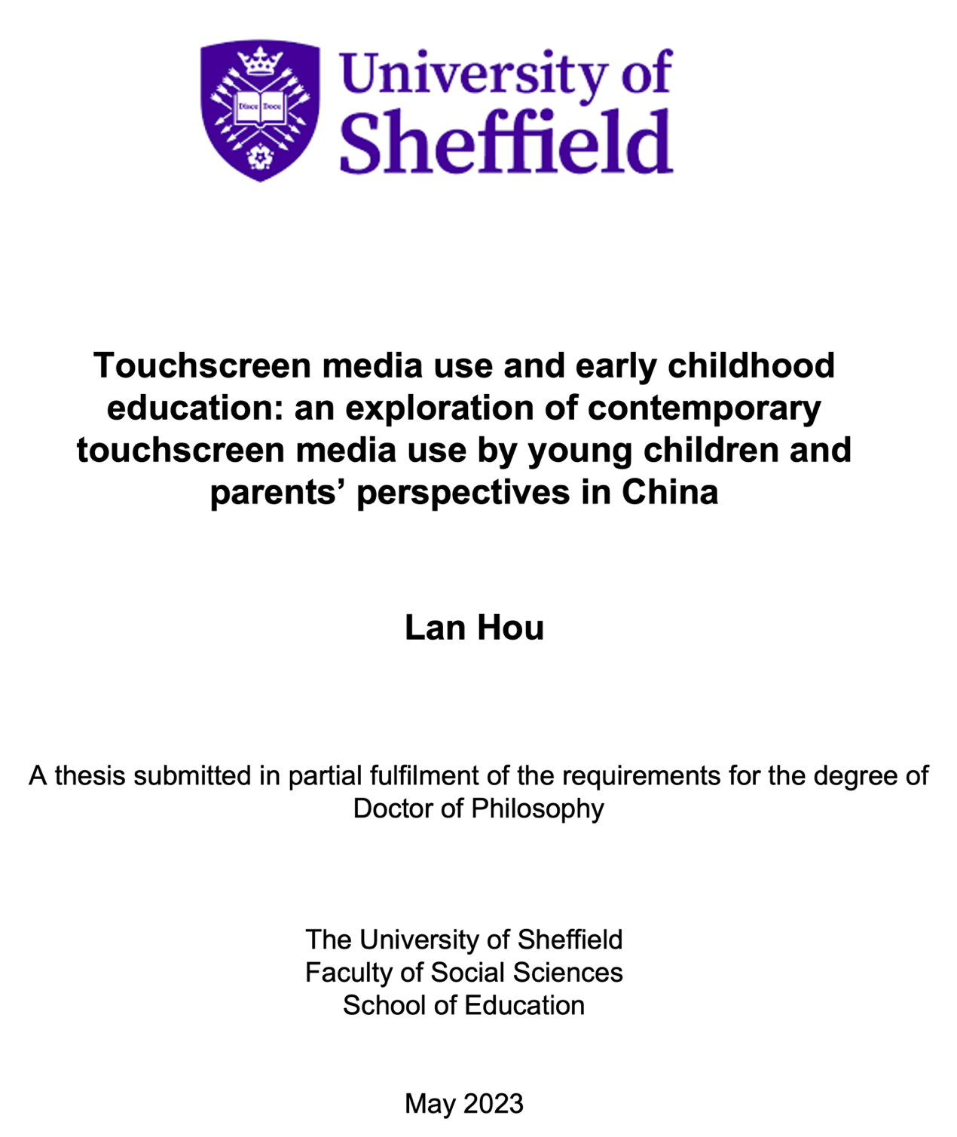

Abstract
In the digital era, touchscreen media has become an integral part of children's lives. To gain a deeper understanding of children's use of this technology, it is necessary to investigate their everyday engagement with touchscreen media. This thesis aims to provide valuable insights by investigating the use of touchscreen media by Chinese children aged three to six, including their app preferences, places, duration of use and other aspects of their engagement with this technology. Additionally, this thesis explores the potential influence of parents on their children's everyday use of touchscreen media. Specifically, the study examines the attitudes, beliefs, and perceptions of parents towards their children's use of touchscreen media, including their perceived risks, advantages and parental mediation strategies. To achieve these objectives, the study adopts the ‘Day in the Life’ methodology (Gillen, 2018). Three families with children from an urban area of China were selected to participate in the research.
This thesis makes several significant contributions to the field of research on children's engagement with touchscreen media. From methodological perspective, it demonstrates the adaptability of the ‘Day in the Life' methodology (Gillen, 2018) for remote data collection during the COVID-19 pandemic. The research phases were redesigned to fit the study's context, while the internet and a social media app were used for remote research. Specifically, parents from three families acted as recorders to facilitate their children's behaviour recording for the video component of the methodology. This remote approach provides a viable alternative to traditional research methods, especially when in-person data collection is not feasible or poses risks to participants. Furthermore, it presents a unique opportunity for researchers to collect data from participants in their natural settings, allowing for a more accurate representation of their everyday use of touchscreen media.
From a theoretical perspective, the thesis indicates that iPads are the preferred devices for children's touchscreen media use. Furthermore, due to kindergartens being closed and children spending more time at home during the pandemic, children have been introduced to online courses and learning through using touchscreen media. They engage in a variety of activities such as painting, math, and English learning.
Additionally, the thesis highlights the significant role that parents' attitudes and beliefs play in shaping their children's use of touchscreen media. Parents who perceive iPads as a source of entertainment tend to adopt a more permissive approach to supervising their children's use. Conversely, those who view the devices as tools to improve their children's skills are more likely to encourage exploration with learning apps and set stricter limits on app use and duration.

Acknowledgement
The completion of this thesis would not have been possible without the support and guidance of a number of individuals to whom I am deeply grateful. First and foremost, I would like to express my sincere appreciation to my supervisors, Dr. Jessica Bradley, Dr. Becky Parry, and Dr. Fiona Scott, for their unwavering support, constructive feedback, and invaluable guidance throughout the research process. Their intellectual insights, enthusiasm, and mentorship have inspired and motivated me to undertake this study and to strive for excellence in every aspect of my work. As an international student, their support has been particularly meaningful and I am grateful for the opportunities they have provided me to grow both as a scholar and a person.
I am also deeply grateful to my family for their unwavering love, encouragement, and support. They have been a constant source of inspiration and motivation throughout this journey, and I am honored to have such a loving and supportive family. Additionally, I would like to express my gratitude to my husband, Keqian Nan, for his unyielding support, patience, and understanding. His unwavering belief in me and my abilities has been pivotal in the completion of this work.
Moreover, I am especially proud of myself for giving birth to my daughter, Cecilia, in the last year before submitting my thesis, and I am grateful for the unyielding support of my family during this transformative time. Cecilia has brought immense joy and inspiration to my life and has provided a renewed sense of purpose and determination in my work.
Furthermore, I would like to extend my heartfelt appreciation to the three families who generously participated in my research, particularly during the unprecedentedCOVID-19 pandemic. Their cooperation, generosity, and willingness to share their personal experiences have been critical to the success of my work, and I am deeply grateful for their contributions.
In conclusion, I would like to express my sincere gratitude to all those who have supported me in the completion of this thesis. Your guidance, support, and encouragement have been invaluable, and I am honored to have had the opportunity to work with and learn from such inspiring individuals.

The table of contents
1. Introduction 9
1.1 Global perspective 9
1.2 Touchscreen media use in China 11
1.3 Introducing the present study 12
1.4 Research objectives and questions 15
1.5 Thesis structure 16
2. Literature review 18
2.1 Introduction 18
2.2 Touchscreen media use in different settings by children 19
2.2.1 Home setting 20
2.2.2 Educational settings 22
2.2.3 In other settings 24
2.3 The benefits of touchscreen media use by children 27
2.3.1 Drawing skills development 27
2.3.2 Musical skills development 28
2.3.3 Digital literacy in touchscreen media use 29
2.4 Parental Perspectives and Involvement 33
2.4.1 Parental attitudes and beliefs 34
2.4.2 Parental mediation in children’s touchscreen media use 37
2.4.3 Mediation strategies for supporting children's touchscreen media use 38
2.5 Touchscreen media use among children in China 41
2.5.1 The development of touchscreen media use in China 41
2.5.2 Challenges and issues specific to children's touchscreen media use in China 42
2.5.3 Impact of the COVID-19 pandemic on touchscreen media use in families of China 48
2.6 Summary 50
3. Methodology 52
3.1 Introduction 52
3.2 Design and overview 52
3.3 Research questions 53
3.4 The ‘Day in the Life’ methodology in my research 54
3.5 Research stages 61
3.6 Research participants and recruitment 92
3.7 The COVID-19 pandemic context 94
3.8 Ethical issues in the research 96
3.9 summary 101
4. Data analysis 103
4.1 Data analysis of Family One (F1) of Sara 103
4.1.1 An introduction of Sara and her family 104
4.1.2 Sara’s touchscreen media use 104
4.1.3 Parents’ perspectives and attitude toward children’s touchscreen media use 109
4.2 Data analysis of Family Two (F2) of Sherry 111
4.2.1 An introduction of Sherry and her family 111
4.2.2 Sherry’s touchscreen media use 112
4.2.3 Parents’ perspectives and attitude toward children’s touchscreen media use 116
4.3 Data analysis of Family Three (F3) of Rob 118
4.3.1 An introduction of Rob and his family 118
4.3.2 Rob’s touchscreen media use 119
4.3.3 Parents’ perspectives and attitude toward children’s touchscreen media use 124
4.4 summary 129
5. Findings and discussion 131
5.1 The COVID-19 pandemic affected the way children used touchscreen media during the study 131
5.1.1 COVID-19 impact on children's touchscreen time and duration 131
5.1.2 The COVID-19 pandemic had an impact on the types of app children used 133
5.1.3 The COVID-19 pandemic had an impact on settings involvement in children’s touchscreen media use 134
5.2 iPads Dominate children’s touchscreen media use 135
5.3 Parents expressed a range of perceived risks and advantages of their children’s touchscreen media use 136
5.4 Parents’ attitudes appear to influence children’s behaviour in terms of their touchscreen media use 138
5.4.1 Parents’ attitudes can affect the types of app children use 139
5.4.2 Parents’ attitudes and belief affect their supervision strategies for children 141
6. Conclusions and recommendations 143
6.1 Implications and recommendations 144
6.2 Limitations of the research 146
Bibliography 148
Appendices 170
Appendix 1: Approval Letter 170
Appendix 2: Child information sheet in English version 171
Appendix 3: Child information sheet in Chinese version 172
Appendix 4: Consent form for adults in English 174
Appendix 5: Consent form for adults in Chinese 176
Appendix 6: Information sheet for adult in English 178
Appendix 7: Information sheet for adult in Chinese 182
Appendix 8: Ongoing assent – Decision card for children 185
Appendix 9: video recording and field notes 186
Appendix 10: A guidance of phone recording for parents 216
Appendix 11: University of Sheffield's policy for research requiring face-to-face contact with participants 217

List of tables

Table 1. The sample of field notes (Name is pseudonyms) 54
Table 2. The research time scale and related tasks of the research 57
Table 3. The phases of the ‘Day in the Life’ data collection and generation 59
Table 4. A guidance of phone recording for parents 61
Table 5. Quantity and Duration of Videos Collected from Three Families 63
Table 6. Quantity and Duration of Videos Collected from Three Families 64
Table 7. Coding framework 66
Table 8. A sample of transcript: VID-006 Transcript 68
Table 9. Questions for an interview with parents 74
Table 10. Video data quantity from WeChat interviews with three families 77
Table 11. The coding framework of WeChat reflective interview 77
Table 12. Transcript sample of WeChat interview with Family One (F1) 79
Table 13. Details of three families in my research 83
Table 14. Transcript of WeChat interview with F1 95
Table 15. Transcript of WeChat interview with F1 96
Table 16. Transcript of WeChat interview with F1 97
Table 17. Transcript of WeChat interview with F1 103
Table 18. Transcript of WeChat interview with F1 104
Table 19. Transcript of WeChat interview with F2 106
Table 20. Transcript of WeChat interview with F3 109
Table 21. Transcript of WeChat interview with F3 110
Table 22. Transcript of WeChat interview with F3 110

List of figures
Figure 1. A sample of coding in ELAN from Family One (VID 006, 18.05.2021) 67
Figure 2. A sample of transcription in ELAN from Family One (VID30, 22.09.2021) 71
Figure 3. An example of multimodal transcripts from family of Sara (VID030, 22.09.2021) 72
Figure 4. Screen recording of WeChat interviews with parents 77
Figure 5. Participant recruitment poster 81
Figure 6. Decision cards 90

Introduction
The prevalence of touchscreen media in the lives of children is undeniable, leading to the emergence of a generation referred to as ‘Digital Children’ or ‘Digital Natives’ (Prensky, 2001). These terms highlight that children are growing up in a digital environment where technology plays a crucial role in shaping their experiences and engagement. Touchscreen media, including smartphones, tablets, and touch-enabled devices, has become ubiquitous and accessible, providing children with various opportunities to engage with games, apps, and websites(Marsh, 2019; Soni et al., 2019). The user-friendliness of touchscreen media is largely attributed to the portability and accessibility of these devices, enabling children to easily access digital content and enjoy an immersive experience instantly(Rokhsaritalemi, Sadeghi-Niaraki and Choi, 2020; Schmidt et al., 2021). Furthermore, research suggests that children tend to use touchscreen devices more proficiently and rapidly than adults, owing to their early exposure to technology(Danovitch, 2019)
Considering the prevalence of touchscreen media in children's lives, this thesis aims to explore children's use of touchscreen media in the context of China specifically. This section outlines some broad trends in children's touchscreen media use globally and in China before introducing the empirical study.

1.1 Global perspective
Numerous studies conducted in different countries have shown a growing popularity of touchscreen media among children. In the United States, a research study has shed light on notable changes in media use patterns, revealing a significant increase in the prevalence of touchscreen media use among American children aged 0-8 over time. Specifically, the data indicates that in 2011, 41% of households with children had access to touchscreen media, whereas in 2020, this percentage had risen to 95% (Hadders-Algra, 2020). Similarly, a report by Ofcom (2019) found that 69% of UK children aged two to four preferred touchscreen media devices, with 19% of them owning their own devices, such as smartphones and iPads. Furthermore, Konca (2022)) revealed that the duration of children's touchscreen media use had increased dramatically to 80 minutes per day and was continuing to trend upwards in the UK. Halpin et al. (2021) found similar results in a study of children's use of touchscreen media in Australia, indicating that the use of touchscreen media had become popular among children aged zero to four. These children could easily access it at home, spending an average of 20 minutes per day using touchscreen-based devices.
The rising popularity of touchscreen media among children has led to a wide variety of content and apps being made available. Among these, educational apps have gained significant traction in the market, addressing the learning requirements of children (Thai, Bang and Li, 2022). This trend demonstrated a growing interest in incorporating touchscreen media into early childhood education and highlights its potential as both an entertainment and a learning tool (Blumberg et al., 2019). However, concerns have been raised regarding the quality and appropriateness of certain apps, as not all of them are suitable for meeting the developmental needs of children (Papadakis, 2020).
As the global prevalence of touchscreen media use among children continues to rise, researchers have explored the potential implications of this phenomenon on child development. Numerous studies have examined the cognitive, social, and emotional impact associated with the use of touchscreen media among children (Neophytou, Manwell and Eikelboom, 2021; Werling et al., 2021). While some research has reported positive outcomes, such as knowledge acquisition and skill development, others have highlighted potential risks linked to excessive use of touchscreen media, including distracted attention, exposure to inappropriate content, and reduced physical activity (Naslund et al., 2020; Pandya and Lodha, 2021).
Despite varying perspectives on the effects of touchscreen media use on children, it is clear that touchscreen media has become an integral part of children’s everyday lives in recent years (Dardanou et al., 2020; Haddon, 2020a). Therefore, it is crucial for researchers, educators, and parents to understand children's engagement with touchscreen media and to develop strategies to facilitate a positive experience for children. Moreover, the COVID-19 pandemic has further emphasised the importance of understanding the implications of digital media for children's development (Haddon, 2020a). With school closures and the shift to remote learning, many children have heavily relied on touchscreen-based devices for both educational and entertainment purposes (Dorouka, Papadakis and Kalogiannakis, 2020; Yadav and Chakraborty, 2021). This unprecedented situation has resulted in an increase in screen time for children and raised concerns among parents, highlighting the need to explore the potential effects of this heightened exposure to touchscreen media(Guerrero et al., 2019).
China, a rapidly developing country with a large population, has experienced a significant increase in the adoption of digital technology among children, particularly in the use of touchscreen media devices (Livingstone et al., 2019). This growing prevalence of touchscreen media use raises questions regarding its potential impact on the development and well-being of Chinese children, as well as the role of parents in supporting and guiding their children's media consumption. By contextualising the Chinese situation within the broader global landscape of children's touchscreen media use, this study aims to make a valuable contribution to enhancing a comprehensive understanding of the complex dynamics surrounding children’s engagement with touchscreen media in their everyday lives.

1.2 Touchscreen media use in China
The phenomenon of children's use of touchscreen media is not limited to Western countries but is also prevalent in China. In 2019, the China Internet Network Information Center (CNNIC) reported that nearly 30 million children under the age of ten, accounting for approximately 4% of the total 7.59 billion Chinese internet users, used digital technology, including touchscreen media. Furthermore, Gou and Dezuanni (2018) found that over half of the Chinese parents surveyed reported that their children had their own touchscreen media devices and used them frequently in their everyday lives. On the other hand, some studies suggested that although touchscreen media has popular amount children, watching television still dominate children's media consumption (Kostyrka-Allchorne, Cooper and Simpson, 2017).
Recent research has indicated that there is a growing prevalence of children in China using touchscreen media devices, which has become the dominant source of their screen time. Wang, Zhao and Shadbolt (2019) conducted a study indicated that children in China utilise touchscreen media devices more frequently than other forms of media, such as television. This trend is particularly noticeable among children aged three to seven, who tend to allocate more time to using touchscreen devices compared to other media options, especially when screen-based tablets are accessible (Gou and Dezuanni, 2018). Moreover, the COVID-19 pandemic has further amplified the utilisation of touchscreen media among Chinese children. Due to reduced opportunities for outdoor activities, children have increasingly turned to touchscreen-based device use, dedicating more time to exploring various apps and digital content (Dong, Cao and Li, 2020).
The popularity of touchscreen media among children in China can be attributed to the numerous learning and play opportunities offered by various apps on these devices. According to Gou and Dezuanni (2018), parents in China consider touchscreen media as the preferred method of digital interaction for their children and some apps have been introduced for children. Various apps, such as, 'Jiliguala' and 'Wukong Shizi' focus on language learning, while 'My Numbers' is designed for improving numeracy skills. Additionally, there are apps such as 'Baby Bus' and 'Xiao Banlong' that integrate cartoons, games and singing to provide early education experiences (Gou and Dezuanni, 2018).
With the increasing availability of touchscreen media in Chinese households, research on digital technology and screen-based device use by children in China has seen a significant rise in recent decades. In April 2014, the Children's Media Literacy Education Research Centre of the China National Youth Palace Association was established in Guangzhou (Lee, 2020). This research center has undertaken a range of comprehensive and longitudinal studies with a specific focus on the use of digital media, particularly touchscreen devices, by children in China. One such research study was conducted with a sample size of over 20,000 children from cities across China. The primary objective of this study was to comprehend children's engagement with digital technology and to facilitate a positive experience for them. The findings of this research revealed that children are accessing the internet and touchscreen media at increasingly younger ages (Zhang, 2016). At the same time, the study emphasised the necessity for further investigations into the effects of touchscreen media on children, particularly those of preschool age, in China (Zhang, 2016). The need for research is not only due to a lack of studies but also because touchscreen media as an emerging technology should be continuously investigated to track its evolution (McNeill et al., 2019; Bus, Neuman and Roskos, 2020).

1.3 Introducing the present study
The present study focuses on touchscreen media use by children, specifically children in pre-school age on three to six years in China. Their use of touchscreen media, including their use of mobile phones and other touchscreen-based devices, is explored in this research.
My research involved the participation of three families from urban areas in China, specifically from three Tier 1 cities: Beijing, Shanghai and Guangzhou. As urbanisation continues to expand in China, the number of cities in the country is increasing. According to the latest official data from the China City Statistical Yearbook in 2022, there were 691 cities in China (China Statistical Yearbook 2022, 2022). These cities are classified into three tiers based on factors in terms of GDP (gross domestic product), regional family income levels and population size (Rogoff and Yang, 2022).
Beijing, Shanghai, Guangzhou and Shenzhen are categorised as Tier 1 cities. In addition to these four Tier 1 cities, thirty-five large and medium-sized cities fall under the Tier 2 classification, while the rest are categorised as Tier 3 (China Statistical, 2022). Except for the four Tier 1 cities, the status of Tier 2 and Tier 3 cities changes slightly based on developments in their financial and population sectors (Rogoff and Yang, 2022). The selection of three families from Tier 1 cities in my research is driven by the research aims and objectives. This research aims to address two central questions: the examination of children's behaviour in the use of touchscreen media and the exploration of parental mediation. Detailed explanations and relevant sub-questions are discussed in the following section '1.4 Research Objectives and Questions.
Research conducted across urban and rural areas of China has shown that families in urban areas have greater access to digital technology, including touchscreen media (Gou and Dezuanni, 2018; He et al., 2022). This is primarily due to the extensive exposure that urban families have, which not only reduce parents' concerns but also enhances children's use and proficiency. Literature from Western countries has also addressed the fact that families residing in developed areas possess significant experience with touchscreen media, both for parents and children. They are familiar with touchscreen media and related devices, enabling early exposure for children and a rich experience in their use. For instance, children in urban areas typically have greater access to touchscreen-based devices and apps compared to children in rural areas (Nikken, 2019).
In my research, children from three families residing in urban and Tier 1 cities have demonstrated a high level of exposure to touchscreen media. They also exhibit a rich experience and proficiency in using touchscreen-based devices. This wealth of data has greatly contributed to the research aim of conducting a comprehensive exploration of children's use and behaviours of the engagement with touchscreen media. Building on this initial exploration, the research can further investigate parental mediation and strategies. As Livingstone et al. (2019) and Gou and Dezuanni (2018) have revealed, parents in more developed areas of China often possess well-informed perspectives and a better understanding of new technologies based on their experiences. Specifically, by analysing children's touchscreen media use and behavior, this research aims to further explore and understand how parental mediation influences the strategies employed by parents and shapes children's behaviour.
Specifically, through interviews with parents who possess informed and valuable insights into their children's engagement, the thesis extensively examines parents' perceptions regarding the potential risks, concerns and benefits associated with their children's use of these devices. Furthermore, it investigates in the parental mediation approach, which entails parents actively engaging with, participating in and supervising their children's interaction with touchscreen media.
Parents' attitudes toward their children's use of touchscreen media are often multifaceted, with a particular focus on parental perspectives (Sandberg, Sjöberg and Sundin, 2021). On one hand, parents recognise that touchscreen media provides an enjoyable experience for their children and enhances their everyday lives, offering them greater opportunities to explore the world (Huber, Highfield and Kaufman, 2018). On the other hand, recent studies have indicated that parents are increasingly expressing concerns regarding potential negative effects, such as exposure to inappropriate content, privacy issues and excessive use ( Fox, Alexa and Marieao, 2019). In the context of China, most parents emphasise concerns and potential risks related to their children's health and development when using touchscreen media (Shin and Lwin, 2022a). Specifically, parents expressed worries about potential eyesight problems and issues of distraction (Zhao et al., 2020). Additionally, Wang, Guo and Shadbolt (2019) found that Chinese parents primarily concerned about the ‘content’ and ‘screen time’ aspects of their children's engagement with touchscreen media. Specifically, 67.6% of the parents surveyed were worried that their children might be spending too much time with digital devices, while 66.7% expressed concerns about the potential exposure to inappropriate content through online platforms and apps.
Based on these concerns, parents believe that children should be carefully protected, especially when they are young and vulnerable (Li, Luo and He, 2022). However, some studies argue that parents' excessive worry is unnecessary because touchscreen media use does not dominate the majority of children's time in their everyday lives (Dardanou et al., 2020). These studies indicated that children often spend their time engaging in activities such as playing with toys, participating in outdoor activities, and reading books, with only a small portion of their time dedicated to touchscreen media. Similarly, Gou and Dezuanni (2018) also demonstrated that preschool children in China still engage in significant physical activities. However, research indicates that the COVID-19 pandemic has significantly impacted children's utilisation of touchscreen media, resulting in an increased amount of time spent engaging with it (Eales et al., 2021). Therefore, it is imperative to investigate how children incorporate touchscreen media into their daily routines, especially considering the transformative effects brought about by the pandemic.
As a researcher from China, I am deeply interested in studying how Chinese children use touchscreen devices and understanding the perspectives of Chinese parents on this topic. Touchscreen-based devices have become widely popular among Chinese families, and considering the unique cultural context of China, there is an excellent opportunity to explore this subject from a distinct standpoint. By examining the experiences and viewpoints of Chinese parents and their children, my goal is to gain valuable insights into the potential risks, concerns and benefits associated with touchscreen media use. This thesis aims to provide a comprehensive understanding of how Chinese children actively interact with touchscreen devices, as well as how parents mediate and supervise their use. By doing so, it contributes to the existing knowledge on children's touchscreen media use and parental perspectives, specifically within the Chinese context. Furthermore, the findings of this thesis can serve as a basis for developing effective guidelines and interventions that promote healthy and responsible use of touchscreen media among Chinese children.

1.4 Research objectives and questions
My research focuses on two central questions. The first question aims to investigate how children between the ages of three and six from three families in urban areas of China use touchscreen media in their everyday lives. The second question focuses on exploring the attitudes, beliefs and perspectives of the parents in these three families regarding their children's touchscreen media use. These two central questions are further broken down into specific sub-questions, which are listed in this section.
First, three sub-questions which aim to understand how children from three families used touchscreen media in everyday lives are involved in my research:
- What kind of screen-based devices of touchscreen media and related apps are mainly involved in children’s everyday lives?
- What are the preferences and digital practices of children when using touchscreen media?
- How frequently and for what duration do children use touchscreen media?
At the same time, in order to have an insight into parents’ considerations and explore how parents’ perspectives shaped the environment and behaviour of children’s touchscreen media use, three specific sub-questions are designed and listed below.
- What are parents’ attitudes towards children’s use of touchscreen media in current everyday lives (e.g., what positive attitude and concerns do parents have towards children’s touchscreen media use?)
- What parental mediation strategies do parents employ to facilitate and supervise their children's use of touchscreen media?
- What are the purposes and motivations of parents involved in their supervision and participation in children's use of touchscreen media?

1.5 Thesis structure
The thesis starts with a thorough review of existing and current literature on the use of touchscreen media by children in Chapter 2. The primary objective of this chapter is to establish a comprehensive understanding of the present landscape of children's interaction with touchscreen-based devices. To gain a detailed understanding of children's use of touchscreen media, this chapter initially explores various aspects of their engagement, such as different settings in which they use touchscreen media, the benefits associated with it, parental perspectives, parental involvement and mediation. Lastly, the review focuses specifically on the context of children's engagement with touchscreen media in China, encompassing the use patterns among Chinese children, as well as the opportunities, challenges, and issues related to their use of touchscreen media.
After reviewing the literature on children's use of touchscreen media and examining the Chinese context, Chapter 3 introduces the research methodology adopted for this study. Specifically, the ‘Day in the Life" methodology developed by Gillen (2018) is introduced, alongside qualitative approaches. This chapter provides a design and overview in section 3.2, following an introduction in section 3.1, to provide a comprehensive understanding of how this methodology applies to the research. Subsequently, the research focus and questions are presented in section 3.3, with particular emphasis on exploring children's behaviour and parental perspectives. Each main research question is accompanied by specific sub-questions. By exploring these two aspects, this thesis aims to further investigate the complex relationship between children's behaviour in using touchscreen media and their parents' perceptions. Sections 3.4 and 3.5 provide a detailed introduction to the ‘Day in the Life" methodology (Gillen, 2018) and outline the specific stages of the research. In section 3.6, the process of participant recruitment is discussed. Considering the impact of COVID-19, section 3.7 addresses the adjustments made to the methodological approaches. Ethical considerations related to the research are explained in the final section, 3.8, of this chapter.
Chapter 4 focuses on the data analysis, providing separate descriptive analyses for three participating families. Each analysis for each family comprises three components: an introduction to the family, the child's use and behaviour with touchscreen media, and the parents' perspectives and attitudes. Based on the research focus and questions, the analysis delves specifically into children's use of touchscreen media and behaviour, considering factors such as device type, locations, duration of use, app preferences, and digital practices. Additionally, the parents' perspectives and attitudes towards their children's use of touchscreen media are analysed, taking into account perceived risks, challenges, advantages, parental involvement and mediation.
Building upon the comprehensive analysis conducted in the previous chapter, Chapter 5 delves into a detailed discussion and elaboration of the findings. The main findings of the study are presented and explained in this chapter.
Chapter 6 presents the conclusions and recommendations. The conclusions drawn from the study are outlined, along with an exploration of the research limitations. Furthermore, recommendations are provided for parents, families, and further research.
Following Chapter 6, a comprehensive bibliography is included to provide readers with a complete reference list of all the sources utilised in this research. Finally, the appendices are presented, which offer supplementary information and detailed data supporting the findings presented throughout the thesis.

Literature review

2.1 Introduction
Given the growing prevalence of touchscreen media use among children, it is crucial to investigate how children engage with touchscreen media in their everyday lives (Haddon, 2020a). Additionally, understanding children’s everyday use of touchscreen media need to consider parental perspectives and involvement. That is mainly because parents often play a pivotal role in shaping their children's media use, influencing factors such as children’s preference, screen time, duration and actions (Hammer, Scheiter and Stürmer, 2021). By examining existing literature, this literature review aims to provide a comprehensive understanding of the current context of children’s use of touchscreen media and parental perspective and inform future research in this area.
Specifically, in section 2.2, the literature review begins by discussing touchscreen media use in various early childhood educational settings, specifically encompassing homes, educational institutions and other external environments. This section aims to explore different way of touchscreen use by children into various settings. This section seeks to explore the diverse ways in which children engage with touchscreen media in different settings. It encompasses variations in environments, devices, usage patterns and levels of participation when children are exposed to touchscreen media in different contexts. In addition, this section discusses how the evolution of touchscreen media has not only increased accessibility but also profoundly transformed children's lives.
Section 2.3 is dedicated to exploring the benefits of children's touchscreen media use, emphasising the unique features of this emerging technology. Compared to other tools and technologies, touchscreen media, with its incorporation of sound and image features, has made significant contributions to enhancing children's skills, particularly in areas such as drawing and music (Huovinen and Rautanen, 2020; Yadav, Chakraborty and Mittal, 2022). However, it is challenging to limit the focus of touchscreen media use to just one or two specific skill developments. Therefore, Section 2.3 goes beyond the discussion of specific skill development to address a crucial aspect of touchscreen media use, which is the development of language and literacy skills. It not only emphasises the importance of digital literacy skill development but also discusses the impact of touchscreen media use on children.
While touchscreen media use by children offers substantial benefits for learning and skill development, parents often present their concerns. These parental perspectives and beliefs not only influence their own involvement in children's engagement but also shape children’s behaviour in touchscreen media use. Section 2.4 delves into the examination of parental perspectives and involvement, specifically addressing concerns and disadvantages associated with touchscreen media usage. Furthermore, this section explores parental attitudes, beliefs, and mediation strategies.
In line with a comprehensive exploration of children's use of touchscreen media, the literature review proceeds to offer a specific focus on the current landscape in China regarding touchscreen media use among children in Section 2.5. In this section, it first provides insights into the social and cultural context in China, which are essential for a deeper understanding of the development of touchscreen media use among children in the country. Within this specific social and cultural context, unique challenges and issues emerge, encompassing government regulations, parental concerns and the requirements surrounding children's touchscreen media use. Furthermore, in the latter part of Section 2.5, it specifically explains how the COVID-19 pandemic has influenced touchscreen media use in Chinese families. This is particularly pertinent as my research was conducted during the COVID-19 pandemic, which offers valuable background information on the evolving trends in children's touchscreen media use. I also discuss emerging trends and novel patterns in children's use during this period.

2.2 Touchscreen media use in different settings by children
In recent years, touchscreen devices such as smartphones and tablets have become increasingly common in everyday lives of children (Dardanou et al., 2020; Macias and Choi, 2021). These devices offer a wide range of child-friendly apps, including games, videos and e-books, which have made them an essential part of children's everyday experiences (Courage, 2019; Eisen and Lillard, 2020). Furthermore, the app of touchscreen media has transcended its initial use in homes and has extended its presence to various other settings, including classrooms, shops, restaurants, libraries and museums (Lauricella, Herdzina and Robb, 2020; Ely et al., 2021). In order to develop a comprehensive understanding of the various settings in which touchscreen media is utilised in children's everyday lives, this chapter delves into the discussion of different settings, including home, educational and other relevant contexts.

2.2.1 Home setting
In recent years, there has been a significant increase in the prevalence of touchscreen media use among children in home settings (Dardanou et al., 2020; Carr and Dempster, 2021). Research has identified the home environment as the primary location where children access touchscreen media more frequently compared to other environments (Konca, 2022). It has been noted that children first experience touchscreen media at home (Papadakis, Alexandraki and Zaranis, 2022). This trend can be attributed to the increasing affordability of touchscreen media devices, which has made it easier for families with children to own and utilise them, thereby granting children greater access to this technology (Nikken, 2019; Quinn and Bliss, 2021). Moreover, the home environment provides a comfortable and familiar setting for children to explore and interact with various forms of touchscreen media (Strouse et al., 2021). The COVID-19 pandemic has further underscored the significance of touchscreen media in providing entertainment and education to children at home (Alabdulaziz, 2021; Egan and Beatty, 2021). Given this context, it is crucial to focus on and explore children's use of touchscreen media primarily within the home environment in order to gain insight into their interaction and practice with this technology.
Papadakis, Alexandraki and Zaranis (2022) observed that touchscreen devices are primarily used by children in their home environment for entertainment purposes, such as playing games and watching videos. A wide range of games, such as Minecraft, Roblox, Among Us, Fortnite and Animal Crossing, offers children unique entertainment experiences (Du et al., 2021). Designed specifically for children, these games feature engaging characters, bright colours, and simple game mechanics to capture their attention (Berg, 2021). Additionally, children's engagement with touchscreen devices in home settings often involves watching videos, which has become increasingly popular (Dardanou et al., 2020). Streaming services like Netflix and YouTube Kids offer a variety of age-appropriate content, including cartoons, movies, and educational videos (Radesky et al., 2020). These videos not only entertain children but also offer learning opportunities and help them acquire knowledge in various areas such as science, history, and geography (Behnamnia et al., 2020).
Similarly, touchscreen devices are commonly used by children for entertainment purposes in home settings in China (Fan, Antle and Lu, 2022; Liu and Hwang, 2023). However, the manner in which Chinese children use these devices differs from their peers in other countries. Fan et al. (2022) conducted a study revealing that Chinese children aged two to six spend an average of 30 minutes per day using touchscreen devices for playing games and watching videos. This duration is significantly lower than the global average of 1-2 hours per day reported by some recent studies (Jusienė et al., 2020; Ribner and McHarg, 2021). Furthermore, the Chinese government has implemented guidelines aimed at providing parents with an approach to managing their children's screen time at home. These guidelines include limiting the use of digital technology, including touchscreen devices, to a maximum of 15 minutes at a time and not exceeding 1 hour per day (State Administration of Press and Publication, Radio, Film and Television, 2018). The guidelines reflect a growing concern among policymakers and parents about the negative effects of excessive screen time on children's development.
To minimise the potential harm associated with touchscreen media, Chinese parents have implemented measures to restrict screen time and promote a balance between entertainment and education for their children (Gong et al., 2022). In the Chinese context, the use of touchscreen media by children is closely associated with educational and skill development objectives, reflecting the country's social and cultural values and the strong desire of parents to enhance their children's abilities (Dong, Cao and Li, 2020). Education holds significant importance in Chinese culture, and the pursuit of academic excellence begins early in a child's life (Liu, Peng and Luo, 2020). Therefore, Chinese parents are highly motivated to provide their children with every opportunity to foster skill development.
In China, children have access to a broad range of games and videos that are specifically designed for their age group, with a greater proportion of these offerings catering to their developmental needs (Dong, Cao and Li, 2020). Apps, such as 'Baby Bus', 'Happy Valley' and 'Panda's Home', not only aim to provide an entertaining experience, but also focus on developing children's social, language, creativity, problem-solving and memory skills (Gou and Dezuanni, 2018). Moreover, popular video apps, such as Tencent Video and iQiyi, offer a broad range of educational content for children in addition to cartoons and movies (Wang and Lobato, 2019). These educational videos cover a variety of subjects, including language, mathematics, and science, enabling children to learn and acquire knowledge while enjoying their screen time (Dong, Cao and Li, 2020).
With the COVID-19 pandemic, there has been a noticeable shift in how children engage with touchscreen media within their homes (Egan and Beatty, 2021). The implementation of social distancing measures has resulted in children spending more time indoors, leading to an increase in their overall screen time (Toombs et al., 2022). Consequently, there has been a greater reliance on touchscreen devices, as they serve as a means for children to fulfill their need for social interaction during periods of physical separation (Toombs et al., 2022). Notably, various social media apps, such as Instagram, TikTok, and YouTube, have been observed as platforms employed by children to communicate and connect with their peers and friends (Neumann et al., 2022). As such, touchscreen media has become a valuable tool in maintaining social connections and mitigating the detrimental effects of social isolation on children during the pandemic (Bozzola et al., 2022).
During the COVID-19 pandemic, Chinese children have shown a similar preference of increased engagement with social media app on touchscreen devices (Luo, Berson and Berson, 2023). According to a study by Ma et al. (2021), children aged 7 to 15 in China have been observed to frequently use the social media app WeChat, which is widely popular among the Chinese population due to its multifunctional nature, offering messaging and social media features. Moreover, the pandemic make children have time and chances to explore various apps through touchscreen media, especially involved remote learning and skills development (Dong, Cao and Li, 2020). With the closure of schools, touchscreen devices have become essential tools for facilitating online learning (Yang and Gunn, 2020). Online learning has seen as to be an effective method for delivering educational materials and enabling children to interact with their teachers and peers, thereby allowing them to continue their education while minimising the risk of the pandemic (Kruszewska, Nazaruk and Szewczyk, 2022). A current research revealed that Chinese parents actively encouraged their children to use touchscreen media for knowledge acquisition, skill development, and remote learning during the pandemic (Siu and Ng, 2022). They have been observed to encourage their children to spend time on learning and skills development while engaging with touchscreen media during pandemic.

2.2.2 Educational settings
In recent years, touchscreen media has become increasingly prevalent in educational settings, including schools, nurseries and other learning environments. Hull, Cavanagh and Lombardozzi (2018) conducted a study that revealed children in these settings actively participated in a variety of educational activities, such as drawing, reading, and language learning, through the utilisation of touchscreen-based devices. Furthermore, the use of such technology has been found to enhance children's interest and engagement in learning, resulting in improved concentration and focus.
Research indicates that touchscreen devices are increasingly being utilised as supplementary tools in traditional classrooms. For example, Vu et al. (2022) and Chuang and Jamiat (2023) have demonstrated that touchscreen-based devices are employed to provide students with interactive and multimedia learning materials, including videos, animations and simulations. These resources serve as valuable support in elucidating complex concepts and facilitating interactive learning experiences that complement traditional teaching methods. For example, Sepp et al. (2023) elucidated that touchscreen media can effectively visually represent and explicate fundamental mathematical concepts for children, thereby fostering their interest in mathematics and enhancing their comprehension of complex concepts. Additionally, recent studies have also demonstrated that visual aids, including the use of touchscreen media, play a significant role in enhancing children's comprehension of complex concepts and improving their ability to retain information (Haleem et al., 2022).
Notably, incorporating touchscreen-based devices into educational settings provides a unique multisensory learning experience that surpasses the limitations of traditional textbooks (Goundar et al., 2023). By enabling children to physically interact with the screen through touch and swipe gestures, they can actively engage with educational content in innovative and captivating ways. This heightened level of engagement and enjoyment during the learning process can consequently stimulate a greater desire to acquire knowledge (Berrezueta-Guzman et al., 2020).
Moreover, touchscreen media serves as a valuable tool for promoting collaboration and communication among students. In recent years, this technology has been increasingly employed in educational settings to enhance the learning experience of children. Durgungoz and Durgungoz (2022) conducted a study that revealed how touchscreen devices were utilised by children in a classroom environment to engage in collaborative projects, exchange ideas, and communicate with their peers during and after the learning process. These interactions fostered a sense of community and increased engagement within the classroom.
In addition, the integration of touchscreen media in educational settings promotes personalised learning experiences, allowing learners to progress at their own pace and level, resulting in increased engagement and optimal learning outcomes. Taherian Kalati and Kim (2022) as well as Zhang et al. (2023) have discussed the utilisation of touchscreen-based devices for monitoring the advancement of young learners and delivering immediate feedback to educators. This instant assessment and evaluation of learning outcomes allow for prompt intervention and the adaptation of instructional strategies.
Some studies have highlighted the significant benefits of using touchscreen media to support curriculum objectives in early childhood education. However, it is important to note that touchscreen media cannot fully replace traditional teaching methods (Zhang and Huang, 2022). Therefore, striking a balance between utilising traditional teaching methods and incorporating touchscreen media support becomes crucial. It is essential for children to interact with teachers to ensure a meaningful and productive experience with digital activities (Alabdulaziz, 2021). Research has shown that children often get distracted by the visual and auditory features, such as videos, images, and music, when using touchscreen media in the classroom (Courage, 2019). To address this, some research emphasises the importance of teachers' involvement when children engage with touchscreen media (Samuelsson, Price and Jewitt, 2022). Children require guidance, interactions, and support from teachers while using touchscreen-based devices in an educational setting, as this facilitates positive outcomes and a better digital learning experience. Furthermore, teachers can effectively monitor and supervise children's progress during these activities (Gonzales, 2022). Therefore, several studies have emphasised the need for practitioners to acquire the necessary knowledge and practical skills to effectively incorporate touchscreen media into educational practices (M. M. Neumann et al., 2019; Vidal-Hall, Flewitt and Wyse, 2020).

2.2.3 In other settings
Children primarily use touchscreen media in both home and educational environments. However, due to the portable nature of these devices, children are also observed using them in other settings (Papadakis, Alexandraki and Zaranis, 2022). The extensive utilisation of touchscreen-based devices outside the home is significantly influenced by the portable nature. Their compact size and lightweight nature make them highly portable, allowing parents or caregivers to conveniently carry them for children. This accessibility feature ensures that touchscreen media is readily available whenever the need arises, thereby enabling children to engage with the devices in various contexts (Koran, Berkmen and Adalıer, 2022). Research has shown that touchscreen-based devices are frequently given to children in public places, such as shops and restaurants, with the intention of calming or distracting them (Garg, 2021). A study conducted by Elias and Lemish (2021) specifically highlighted that children under five years old frequently utilise touchscreen media when outside of their homes. This observation emphasised the role of touchscreen-based devices as a ‘pacifier’, offering soothing or calming effects on young children in unfamiliar or stimulating surroundings.
The prevalence of children using touchscreen media is not limited to the use of their own devices as a means to calm them down. There is a growing trend of incorporating touchscreen media in public areas to provide children with enjoyable and meaningful experiences. In recent years, various public spaces have implemented touchscreen media, offering interactive and engaging activities for children. For instance, museums have embraced touchscreen media to enhance exhibits and provide interactive learning experiences for children (Shawcroft et al., 2022). Research has indicated that new technology with touchscreen media use has been introduced to facilitate children's experiences (Taherian Kalati and Kim, 2022a). For instance, the Children's Museum of Indianapolis has utilised touchscreen-based devices to introduce dinosaurs and their habitats (Barbieri, Bruno, & Muzzupappa, 2018). This research suggests that children can develop a strong understanding of complex information and knowledge about history, science, and other subjects through immersive and interactive experiences in museums.
In certain shopping centers, it has been observed that children also utilise touchscreen media. Harper et al. (2019) conducted a study that discovered children's ability to easily navigate kiosk systems on touchscreen devices in shopping centers, aiding them in finding their way. Additionally, the introduction of touchscreen-based interactive displays in select shopping centers in the UK has the potential to offer children a unique experience (Floegel and Lemish, 2021). Through the utilisation of touchscreen media, children can actively interact with various features to acquire information about specific brands or companies, the materials used in products, or even gain an understanding of how particular services operate. By providing such content, children have the opportunity to learn about the world around them in an enjoyable and captivating manner (Levin-Semir and Bertschi 2018).
Summary
This section reviews the literature related to the different settings involved in children's everyday use of touchscreen media. Three main settings are primarily discussed: home, early childhood educational institutes and other external settings. Children access touchscreen media more frequently at home, where they first experience its use (Papadakis, Alexandraki and Zaranis, 2022). The home setting not only provides easy access to contemporary touchscreen media but also offers a comfortable and familiar environment for children to explore (Nikken, 2019; Strouse et al., 2021). Moreover, the COVID-19 pandemic has amplified the use of touchscreen media at home, introducing new trends in children's use patterns.
Many studies indicate that children mainly use entertainment and video apps while at home, which often include popular games and video apps (Radesky et al., 2020; Berg, 2021). Due to social distancing measures, children have started to explore the use of social media apps and online learning apps. Particularly in China, children have been found to use touchscreen media for skill development and learning purposes. This is influenced by the specific social and cultural context, where parents prioritise their children's skill development and academic outcomes (Fan, Antle and Lu, 2022; Liu and Hwang, 2023). This trend has further prompted app designers in China to incorporate educational elements into their apps. With the onset of the COVID-19 pandemic, children in China have increasingly turned to remote learning and playing at home compared to before. As a result, the home has become a key location for the use of touchscreen media.
Children's use of touchscreen media is not limited to the home environment, it is also prevalent in various educational settings such as schools, nurseries and after-school clubs. In this section, I review the incorporation of touchscreen media into different educational contexts, examining its significance, impact and potential issues. Firstly, touchscreen media serves as a valuable supplementary tool in traditional educational settings, offering interactive and multimedia learning materials that provide children with a multisensory learning experience (Goundar et al., 2023; Sepp et al., 2023). Additionally, it facilitates the sharing of learning experiences among children, teachers, and peers, making the learning process enjoyable. Teachers can also monitor children's progress and involve parents in this journey, fostering collaboration and enhancing the overall learning and play experience. However, certain issues have emerged as well. Finding the right balance between integrating new technology and maintaining in-person interactions with caregivers and teachers is a challenge associated with the use of touchscreen media (Alabdulaziz, 2021). This issue has prompted further research into understanding children's behaviour in using touchscreen media.
Touchscreen media, with its portable benefits, has extended children's access beyond home and educational settings. Children can be observed using touchscreen media in various places, including shops and restaurants. Some parents also provide their children with touchscreen-based devices such as iPads, ensuring flexible entertainment options. In addition to personal devices, touchscreen media technology has been incorporated into public spaces, offering an enjoyable and supportive experience for children. Examples include its use in museums and shopping centers in some studies (Harper et al., 2019; Shawcroft et al., 2022).
With the widespread use of touchscreen media, its benefits need to be explored further and critically examined. In the next section, the literature review focuses on the advantages and benefits of touchscreen media use in children's everyday lives.

2.3 The benefits of touchscreen media use by children
Incorporating multimedia elements such as video, images, and sound in touchscreen media provides an engaging and pleasurable learning experience for children (Taherian Kalati and Kim, 2022a). These advantages have been recognised by both parents and teachers, leading to their increased use in various settings for children, as discussed in the previous chapter. Furthermore, research has indicated that early-year children can benefit from the use of touchscreen media in terms of enhanced learning outcomes and skill acquisition (Dorouka, Papadakis and Kalogiannakis, 2020; Papadakis, Alexandraki and Zaranis, 2022).
This chapter aims to introduce three primary learning aspects that have received considerable attention in current research regarding skill acquisition and development. Specifically, this chapter will explore the role of touchscreen media in drawing, music, and literacy and language learning.

2.3.1 Drawing skills development
The use of drawing apps on touchscreen devices has gained popularity as a means of children's skill development and interest. Studies have shown that drawing apps provide an array of tools and colours for children to create digital drawings and paintings using their fingers or a stylus (Kirkorian et al., 2020; Meyer et al., 2021). This process has been observed to enhance children's fine motor skills, as they practice hand-eye coordination and finger movements on the screen (Fernández-Sotos, Fernández-Caballero and Rodriguez-Jimenez, 2020).
Furthermore, using drawing apps can positively impact children's colour cognition, allowing them to recognise, understand, and use colours effectively (Yadav, Chakraborty and Mittal, 2022). This is particularly important for children who are still learning about different colours and how to combine them to form relationships while drawing different objects and scenes. Drawing apps can assist in this learning process, as children can experiment with different colours and explore how they interact with each other, helping them to develop a comprehensive understanding of colour theory (Yadav, Chakraborty and Mittal, 2022).
In addition to enhancing children's artistic skills, drawing apps can also promote language and literacy development. Children can use drawing apps to create pictures that convey a message or tell a story, fostering creativity, imagination, language, and literacy development (Dashti and Habeeb, 2020). Drawing apps have been found to be particularly beneficial in enhancing children's ability to express themselves through verbal and written communication. By adding text or captions to their drawings, children can improve their vocabulary and practice their writing skills, strengthening their cognitive and linguistic abilities (Fernandez-Sotos et al., 2020).
Drawing apps provide an interactive and engaging platform for children to explore their creativity, enhance their motor and cognitive skills, and promote language and literacy development. They offer a variety of features that allow children to experiment with different colours, shapes, and patterns, helping them to develop their artistic and creative abilities. Drawing apps can also assist in teaching children about colour theory and encourage them to express themselves through verbal and written communication. Thus, the use of drawing apps on touchscreen devices has the potential to be an effective tool for promoting children's overall development (Yadav, Chakraborty and Mittal, 2022).

2.3.2 Musical skills development
Recent research has demonstrated that the use of touchscreen media in combination with music apps can have a profound impact on children's musical experiences and learning abilities(Maba, 2020). Unlike traditional music teaching methods, touchscreen media offers a more intuitive and natural way for children to interact with music (Wang and Chen, 2019). This technology enables children to explore music in novel and imaginative ways, allowing them to experiment with different sounds, instruments, and compositions (Young and Wu, 2019; Behnamnia et al., 2020). By touching and manipulating various elements within the music app, children can develop their creativity and ingenuity while creating unique musical arrangements.
Moreover, incorporating music knowledge into these apps can also greatly benefit children's sensory experiences (Hood et al., 2021). By exposing children to the sounds of various instruments, they can learn to differentiate between them and develop their musical ear (Trainor et al., 2017). The term ‘musical ear’ refers to a person's ability to perceive and comprehend the subtle nuances and complexities of music (Goncharova and Gorbunova, 2020). For children, the process of developing a musical ear involves recognising and distinguishing between various musical elements, such as melody, rhythm, and harmony. By integrating these elements into music apps, children can develop their sensory perception and understanding of music in a fun and interactive way.
Furthermore, touchscreen media provides children with greater control and flexibility over the music they create (Maba, 2020). With just a swipe or tap, children can adjust the tempo, pitch, and volume of different instruments or sounds, enabling them to create their own distinct musical compositions. This interactive and engaging learning experience can help children develop their musical skills and confidence while having fun at the same time. The ability to create music in this way encourages children to be creative and explore their musical talents, which can have a positive impact on their overall well-being and development (Rickard et al., 2018; Schellenberg, 2011).
However, it is important to note that the use of touchscreen media and music apps should not replace traditional music education methods entirely. Rather, it should be used as a complementary tool to enhance children's musical experiences and learning. Traditional music education methods such as instrument lessons and singing should still be incorporated to provide children with a well-rounded musical education.
According to research, the advantages of music apps are not limited to enhancing the musical aptitude and experience of children (Ma, Zhang and Wang, 2020). In fact, incorporating music elements into these apps can yield benefits that extend far beyond the scope of traditional music education. The integration of music and sound elements into various educational apps has been shown to support children's learning and development in a multitude of ways.
For example, storytelling apps that incorporate music have been observed to not only enhance children's musical ability but also promote the development of their language and communication skills (Rideout and Hamel, 2006). By offering an immersive and engaging learning environment, these apps foster imagination and creativity, leading to better learning outcomes. In this way, the incorporation of music elements into apps can facilitate the acquisition of a range of important skills, providing a holistic approach to early childhood education.

2.3.3 Digital literacy in touchscreen media use

The role of touchscreen media in the development of children’s language and literacy skills is particularly remarkable (Dore et al., 2020; Read et al., 2022; Booton, Hodgkiss and Murphy, 2023). Research has demonstrated that the use of touchscreen media can have a positive impact on language and literacy development in children. Apps have been found to support vocabulary acquisition, reading comprehension, and writing, establishing a crucial foundation for future learning (Blumberg et al., 2019). In particular, literacy-focused apps, such as interactive e-books and storytelling apps, have been found to promote children's engagement with reading and literacy learning (Yusuf, 2021).
These apps incorporate digital materials in touchscreen media, utilising audio, images, and music to create immersive experiences that foster children's interest in reading (O’Brien, Seward and Zhang, 2022). Touchscreen devices equipped with multimodal features, such as sounds, animations, and text, effectively engage the visual and auditory senses. Furthermore, touchscreen media possessing these features have been recognised as potentially beneficial educational tools for promoting literacy development, as they enhance interactivity and enable children to engage in meaningful communication through icons, text, pictures, audio, and even create digital creation (Eroğlu et al., 2022). The presence of such multimodal features and interactions observed during children's utilisation of touchscreen devices facilitates cross-modal learning and advances their literacy skills, including letter-sound knowledge, phonemic awareness, and print recognition (Noothidawati et al., 2015).
Neumann (2014) identified a lack of empirical and in-depth research in the field of early childhood education regarding the use of touchscreen media and its impact on emergent literacy development. However, recent qualitative studies have started shedding light on the potential benefits and providing detailed insights into the use of touchscreen-based devices for literacy learning (Marsh, 2016; Silva et al., 2021; Stougaard Pedersen et al., 2021). Research indicated that touchscreen media offers children a unique and creative avenue for interacting with text and reflecting on their understanding through engagement with screen-based devices (Marsh et al., 2019).
In a study conducted by Marsh et al. (2019), the impact of touchscreen media on children's reading and language development was examined. The researchers discovered that the utilisation of touchscreen devices can enhance children's skills and competences in various areas, including reading comprehension, phonological awareness, and word recognition. These findings were further supported by a study conducted by O’Brien, Seward and Zhang (2022), where children independently used app activities to drag letters, match words, and trace letter shapes with their fingers, thereby demonstrating the potential effectiveness of touchscreen media in facilitating literacy learning.
Additionally, the incorporation of touchscreen devices and literacy apps has shown positive outcomes in children's letter and sound recognition, primarily due to the presence of entertaining elements such as interactive games, colourful animations, and engaging sounds (Neumann, Worrall and Neumann, 2019). This indicates that the use of touchscreen devices and apps not only effectively engages children but also promotes their literacy skills in a fun and interactive manner.
Various apps that promote literacy skills and development are being introduced into children's everyday lives. Neumann (2010) conducted research with two to five-year-old children (N=48) who were introduced to literacy apps. In the study, 48 children between the ages of two and five were introduced to several literacy apps on an iPad, including 'Magnetic ABCs', 'Story kit app', and 'Doodle Buddy'. The children were given free access to the apps and were observed as they used the device independently. The researcher found that the children used their fingers to draw and move letters on the screen, which can help to develop letter recognition and letter-sound associations. Additionally, children were also observed using the apps to create their own stories and messages, which support emergent writing skills such as understanding the purpose of writing and learning to form letters and words. Further research conducted by Neumann (2020) improved that the use of iPads and literacy apps had a significant positive impact on children's emergent writing skills. The study showed improvements in children’s ability to write letters and their own names, as well as their use of symbols and typing skills. Moreover, a study conducted by Edwards, Straker and Oakey (2018) also indicated that children gained the opportunity to engage in authentic writing experiences through the use of touchscreen media. By constructing emails and messages to family members, touchscreen media has become a valuable tool in promoting children's writing skills and providing them with meaningful writing experiences.
Digital touchscreen media use has also been found to promote the development of second language skills in children. For example, a study by Smith et al. (2022) found that story-telling activities using touchscreen media improved the English listening comprehension of Spanish preschool children. The researchers observed that the use of touchscreen devices and digital storybooks allowed the children to interact with the story and its language in a more engaging and interactive way, which led to improved language skills.
Similarly, in research conducted in China, touchscreen devices have been found to be effective in promoting preschool children's second language skills (M. Neumann et al., 2019) . Zhang, He and Lin (2021) found that the English learning app 'Ji Li Gua La' has been frequently downloaded and used at home for children. The app focuses on teaching fundamental English knowledge to children up to eight years old. Through utilising elements such as English songs, picture books, cartoons and daily speaking videos, it can help to maintain children's interest and motivation to learn. More studies further supported the benefits of touchscreen media in promoting second language skills in children. For instance, a study by (Sun et al., 2022) found that the use of touchscreen media in early childhood education improved the English language skills of Korean preschoolers. The researchers observed that the children who participated in English language activities using touchscreen devices showed significant improvements in their English vocabulary and sentence comprehension skills compared to those who participated in traditional paper-based activities. Similarly, a study by Lee et al. (2021) examined the effects of a language learning program using touchscreen devices on the language development of children in Korea. The study found that the children who participated in the program showed significant improvements in their English language skills, particularly in their listening and speaking skills.
Some studies found that touchscreen media can introduce children to abstract concepts and activities that were considered too complicated for young age groups to understand and undertake, such as concepts in mathematics and dynamics systems (Behnamnia, Kamsin and Ismail, 2020; Papadakis, Kalogiannakis and Zaranis, 2021). Moreover, Papadakis, Kalogiannakis and Zaranis (2021) specifically explained that touchscreen media can provide a way to visually display and explain fundamental mathematical concepts for children, which encourages children to consider and solve problems and helps them to understand complicated concepts better.
Currently, children’s engagement with touchscreen media has gone beyond learning with single educational purposes and specific skills. Some studies have found that children’s activities with screen-based devices can often support multi-purpose learning and multi-discipline knowledge acquisition. For example, Hoel and Tønnessen (2019) indicated that when children undertake story-creating with apps, their drawing, reading and speaking competencies were also being practised simultaneously. Marsh et al. (2019) also found that some story creating apps have been embedded into purposes of facilitating children’s mathematics learning in terms of enumeration, arithmetic problem-solving, spatial reasoning and geometric knowledge.
Summary
The use of touchscreen media, with its significant and unique features such as sound and image integration, involves finger actions and audio-visual elements. Contemporary research has shown that these features are utilised in activities and skill development related to drawing and music. However, studies indicate that touchscreen media use extends beyond specific skill development and encompasses language and digital literacy (Li, Brar and Roihan, 2021).
Digital literacy encompasses the various ways in which young children engage with literacy through technology and various forms of media (Kumpulainen, Sairanen and Nordström, 2020). This includes activities related to reading, writing and communication through different modes, often in playful and creative digital environments. Digital literacy involves a diverse set of skills that go beyond the traditional definition of ‘reading’ and ‘writing’. It includes the ability to access, utilise and analyse digital texts, as well as the capacity to create and share them (Marsh, 2019).
Within the scope of literacy, children's touchscreen media use has been investigated with regards to vocabulary acquisition, reading comprehension, writing and communication skills. Children have been observed using apps that encompass a wide range of language and digital literacy skill development. These apps not only include language learning and storytelling applications but also extend to online learning and social media apps. Furthermore, some research has suggested that identifying specific skill developments can be challenging due to the interactive nature of children's digital literacy skills, where they often interact and influence each other.
In the previous section, the literature review explored children's touchscreen media use in various settings and its associated benefits. Within the discussion, the significance of parental involvement and family participation in children's use of touchscreen media became apparent. Given the focus of my research, it is imperative to examine how parental perspectives and beliefs not only influence the environments in which children engage with touchscreen media but also have a substantial influence on shaping children's behaviours. Consequently, the following section will specifically concentrate on parental perspectives and their active roles in children's touchscreen media use.

2.4 Parental Perspectives and Involvement
As previously explained in the thesis, the utilisation of touchscreen media has experienced considerable popularity in diverse contexts, including homes, education, and other settings. Consequently, it has had a profound influence on the lives of children. However, this widespread phenomenon has also led to concerns and apprehensions among parents regarding its potential effects on their children (Eales et al., 2021). While parents generally acknowledge the significant advantages of touchscreen media for their children, they also express concerns about potential adverse effects on their overall development (Macias and Choi, 2021). Consequently, parents' perspectives play a vital role in shaping their children's behaviour when using touchscreen media and influencing the approach to parental mediation. Therefore, it is crucial to explore parents' attitudes, beliefs and perspectives concerning their children's use of touchscreen media. This section aims to examine parental viewpoints on various aspects of touchscreen media use and investigate parental mediation strategies, thereby facilitating a comprehensive understanding of the topic.

2.4.1 Parental attitudes and beliefs
- Positive attitudes towards touchscreen media use
As touchscreen media becomes increasingly prevalent among children, parents hold diverse opinions regarding its use. This section examines the positive attitudes of parents toward their children's utilisation of touchscreen media.
Research conducted by (Kucirkova, 2018) highlights that a significant number of parents perceive touchscreen media as a valuable tool that supports their children's learning and entertainment. This positive outlook was reinforced by a study conducted by(Huber, Highfield and Kaufman, 2018), which demonstrated that parents recognise the potential of touchscreen media in exposing their children to a wealth of information, thereby expanding their knowledge and understanding of the world. The accessibility of multimedia content through touchscreen devices can support children to acquire diverse information and knowledge from various sources. Parents hold the belief that touchscreen media, in conjunction with its multisensory nature, provides an enjoyable and interactive means for their children to engage in a wide range of activities (Tatar and Gerde, 2023). Through the utilisation of apps such as games, videos and educational apps, touchscreen media offers children an immersive experience that not only entertains but also enhances their skills (Araiza-Alba et al., 2020).
Through the provision of diverse interactive features, touchscreen media can facilitate children's involvement in activities tailored to their unique interests and learning preferences. The utilisation of educational apps, which effectively engage children in interactive learning experiences that correspond to their developmental requirements while fostering critical thinking and problem-solving skills (Blumberg et al., 2019). The integration of touchscreen media, coupled with a multisensory approach, is believed by parents to offer an enjoyable and interactive avenue for their children to actively participate in a range of activities (Tatar and Gerde, 2023).
Moreover, research suggests that parents hold the belief that touchscreen media can enhance children's social communication and interaction skills (Dardanou et al., 2020). In a study conducted by (Thomas et al., 2021), it was demonstrated that the use of touchscreen media can facilitate communication between children and their friends and family members. The findings of the study also revealed that children can utilise touchscreen devices to engage in joint media activities and communicate with one another. Furthermore, touchscreen media enables parents to connect with their children even when they are not physically present, fostering a sense of connectedness and support (Carr and Dempster, 2021).
Numerous studies have demonstrated the positive impact of touchscreen media on children's social relationships. The use of touchscreen media allows children to interact with distant friends and family members, which has become particularly significant during the pandemic (Eales et al., 2021). Social media apps, in particular, have gained widespread popularity among children as they offer an ideal platform for sharing experiences, thoughts, and emotions with others, regardless of geographical location (Oliemat, Ihmeideh and Alkhawaldeh, 2018a). Through the utilisation of messaging apps, photos, and videos, children can effectively share updates about their everyday lives with their loved ones, leading to the development of strong interpersonal connections (Huber, Highfield and Kaufman, 2018).
- Concerns and negative attitudes towards touchscreen media use
While acknowledging the advantages of touchscreen media, parents have expressed concerns regarding the potential exposure of their children to unsuitable content, cyberbullying, and privacy issues (Muir and Joinson, 2020; Abraham and Selvan, 2022)(Muir and Joinson, 2020; Abraham and Selvan, 2022). One significant worry raised by parents is the possibility of their children encountering inappropriate content while using touchscreen devices (Ochoa and Reich, 2020). Inappropriate content, which may include violent or sexual material, can have detrimental effects on the emotional and psychological well-being of children (Neumann, Merchant and Burnett, 2020). Moreover, such content can have lasting impacts on their development and behaviour, making it challenging to address these issues in the future (Anderson et al., 2003). Consequently, parents are apprehensive about the necessity of monitoring their children's use of touchscreen media to ensure that they are not exposed to inappropriate content.
Furthermore, concerns raised by parents regarding the potential threats children face when using touchscreen media have become increasingly prevalent. Specifically, cyberbullying and privacy issues have been identified as significant areas of concern (Crepax et al., 2022). Cyberbullying refers to the pervasive problem of using digital communication to harass or intimidate individuals. Recent studies have indicated that children who actively participate in social media platforms, such as YouTube Kids and TikTok, are increasingly susceptible to this issue (Spies, 2022). Parents have emphasised that the ease of anonymity and accessibility provided by touchscreen media creates an environment in which bullies can target vulnerable children, leading to emotional distress and potentially causing long-term psychological consequences for the children involved (Patchin and Hinduja, 2018).
At the same time, the privacy concerns associated with children's use of touchscreen media have become a significant issue, causing considerable apprehension among parents (Guerrero et al., 2019). The disclosure of personal information in this context can have severe implications for the safety and well-being of children (Livingstone, Mascheroni and Staksrud, 2018). A critical aspect of this problem is that children often share sensitive details, such as their full names and addresses, without fully comprehending the potential risks involved (Livingstone, Stoilova and Nandagiri, 2019). Consequently, they unwittingly expose themselves to potential dangers. Furthermore, recent research has indicated that parents also share their child's information on social media, which further compounds the issue of information security (Hoy, Fox and Deitz, 2023).
In addition, parents frequently express concerns about their children's excessive use of touchscreen media. Several studies have provided compelling and specific evidence that supports these parental concerns regarding the addictive nature of touchscreen media use among children (Dardanou et al., 2020; Papadakis, 2020; Hood et al., 2021). These studies have revealed that excessive engagement with touchscreen media can lead to addiction, which, in turn, has detrimental effects on various aspects of children's learning, memory, and mental development (McNeill et al., 2019).
Furthermore, prolonged use of touchscreen media can result in overstimulation (Neophytou, Manwell and Eikelboom, 2021). Research has indicated that the overuse of touchscreen media can cause sleep issues for children aged two to five years old, subsequently leading to health problems (Lin et al., 2020). Additionally, excessive use of touchscreen media is often associated with other health concerns raised by parents, such as vision problems and reduced physical activity (Christakis et al., 2018; Anderson, 2020). Excessive screen time has been shown to decrease physical activity, which is strongly linked to several problems, most notably obesity (James J. Ashton and Beattie, 2019). The COVID-19 pandemic has further exacerbated this issue, as children's outdoor activities have been reduced and the use of touchscreen devices has increased (Pardhan et al., 2022). As a result, parents have become increasingly concerned about the potential long-term effects of extended touchscreen media use on their children's physical health (Puzio, Makowska and Rymarczyk, 2022).
In addition to the aforementioned concerns, parents also express apprehension regarding the potential negative effects of touchscreen media use on the emotional, behavioural, and speech development of their children (Fontenelle-Tereshchuk, 2021). Several studies have provided evidence that excessive use of touchscreens during early childhood is associated with cognitive delays, language development issues, and difficulties in social and emotional skills (Young and Wu, 2019; Lawrence and Choe, 2021). Research indicates that children who become strongly attracted to the visual and auditory stimulation provided by touchscreen devices have difficulties focusing on activities that do not offer similar levels of stimulation. Consequently, when these devices are taken away, children often experience unfavorable moods (Lin et al., 2020). Some parents provide touchscreen media for their children as a way to manage their children's moods (Griffith et al., 2022; Stockdale et al., 2023). Research has even suggested that touchscreen media is sometimes used as an ‘electric babysitter’ for children (Eales et al., 2021). However, excessive exposure to touchscreen media can limit children's chances to express their thoughts and ideas (Lin et al., 2020). Specifically, when children have limited opportunities for parent-child interactions due to excessive media use, they may struggle to develop self-regulation skills, leading to negative consequences (Ribner and McHarg, 2021).

2.4.2 Parental mediation in children’s touchscreen media use
In recent years, the increasing prevalence of touchscreen devices among children has raised concerns among parents, as discussed in previous sections of this thesis. These concerns highlight the potential risks of touchscreen media use among children and emphasise the importance of monitoring and managing children's exposure to such media. Thus, it is crucial for parents to actively participate in managing and facilitating their children's use of touchscreen media (Scott, 2022a).
Parental mediation is an essential factor in determining children's interaction with touchscreen devices, as it empowers parents to regulate children’s use effectively and foster overall development (Gözüm and Kandır, 2021; Scott, 2022a). The concept of parental mediation encompasses the active participation of parents in guiding and supervising their children's media consumption (Shin and Lwin, 2022a). It encompasses a range of strategies and behaviours employed by parents to guide and monitor their children's interactions with digital content. By engaging in effective parental mediation, parents can play a crucial role in shaping their children's experiences with touchscreen devices (Benedetto and Ingrassia, 2021).
Engaging in active parental mediation empowers parents to exercise control over their children's exposure to potentially harmful content, while also providing guidance and instruction on the safe and responsible use of touchscreen-based devices (Shin and Lwin, 2022b). Given that children are exposed to touchscreen media from a young age and readily embrace their use, parents bear a substantial responsibility in determining the appropriate level of exposure, access, and use practices (Abraham and Selvan, 2022). Consequently, parents assume a vital role as the primary mediators in shaping young children's interaction with digital media.
In recent years, there has been a significant focus on researching the behaviours of young children in relation to touchscreen media (Carr and Dempster, 2021, 2021; Taherian Kalati and Kim, 2022a). The objective of these research is to gain a deeper understanding of family dynamics and parental mediation in this context. Additionally, researchers aim to deliberate on strategies that maximise the opportunities presented by touchscreen media, while effectively addressing and mitigating the associated risks (Oliemat, Ihmeideh and Alkhawaldeh, 2018a).
Several studies have indicated that parents encounter considerable challenges when attempting to manage their children's screen time and touchscreen activities (Garg, 2021; Abraham and Selvan, 2022). These challenges arise due to parents' recognition of both the advantages and potential risks associated with touchscreen media. In order to navigate these challenges, parents must undertake various responsibilities, including safeguarding their children from online hazards, facilitating their active participation in the online world, and equipping them with the knowledge and skills necessary to make informed and responsible decisions regarding their digital practices (Huber, Highfield and Kaufman, 2018; James J Ashton and Beattie, 2019).
In practice, parents frequently encounter a dilemma when it comes to choosing between restrictive and enabling mediation approaches, leaving them uncertain about determining the appropriate screen time and suitable content for their children. The complexities inherent in parental decision-making in this context stem from acknowledging the advantages and potential risks associated with the use of digital media by young children.

2.4.3 Mediation strategies for supporting children's touchscreen media use
Research on parental mediation highlights that a significant number of parents acknowledge the potential advantages of touchscreen media in facilitating children's development, particularly in terms of learning, knowledge acquisition and skill development (Hood et al., 2021). Nevertheless, parents have also expressed apprehensions regarding the potential risks associated with online activities and potential adverse effects on their children's health and development (James J Ashton and Beattie, 2019). As previously discussed in this thesis, these concerns encompass various mental and physical issues, including addiction, social and cognitive development, sleep disturbances, and obesity-related problems.
In the given context, parents primarily adopt parental mediation strategies to manage their young children's screen time and digital practices. Recent research indicates an increase in the use of restrictive strategies as children's touchscreen media use has grown (Oliemat, Ihmeideh and Alkhawaldeh, 2018b). For instance, some studies have observed parents implementing strict limitations on their children's touchscreen media use, allowing no more than 30 minutes per day (Sivrikova et al., 2020). Furthermore, parents recognise that children in young age are unable to independently download apps on touchscreen-based devices (Livingstone et al., 2018). As a result, parents take the responsibility of choosing which apps to download and actively monitor their children's digital activities. This involves regularly checking the apps installed on their devices and promptly removing any that contain inappropriate content (Abraham and Selvan, 2022). Moreover, the increasing prevalence of video apps, such as YouTube and TikTok, among children has led parents to employ filtering mechanisms to limit access to age-inappropriate content on these platforms (Scott, 2022a).
Although parents have been observed employing a restrictive approach to mediation, they also actively engage in actions to facilitate their children's positive experiences with touchscreen media. Research suggests that parents actively participate in their children's engagement with touchscreen media to support their use of touchscreen-based devices and facilitated their experience (Yadav and Chakraborty, 2022). Recognising the significance of parental involvement, parents are inclined to explore digital content through touchscreen media alongside their children. For example, they have been observed jointly watching videos on YouTube and playing games on touchscreen-based devices. This co-use of touchscreen media not only fosters positive interaction and strengthens the parent-child relationship but also helps mitigate potential risks associated with exposure to inappropriate content (Gözüm and Kandır, 2021).
Parental mediation acts as a safeguarding mechanism that assists children in navigating the digital environment and maximising the advantages of their interactions with touchscreen devices. Through the implementation of effective mediation strategies, parents can encourage positive and educational experiences for their children while reducing the potential risks associated with excessive or unsuitable media use (Scott, 2022b).
Parents employ a range of strategies and adapt their mediation approaches when they identify potential risks or concerns for their children (Shin and Lwin, 2022b). This adaptability is apparent in their willingness to experiment with different actions based on specific circumstances. For instance, parents established clear rules for their children or modified existing ones in response to their children's outcomes. More specifically, when a child has negative academic performance, parents imposed stricter limits and reduced their screen time or use of touchscreen media. Conversely, if a child showed progress and achieved positive academic outcomes, parents provided additional screen time for the use of touchscreen-based devices (Swider-Cios, Vermeij and Sitskoorn, 2023). This flexibility in parental mediation demonstrates their ongoing efforts to address potential hazards and cultivate wholesome digital experiences for their children.
Summary
Section 2.4 focuses on parental attitudes and mediation strategies regarding touchscreen media use by children. It is evident that parents recognise the significant advantages of touchscreen media in enriching children's everyday lives. They identify it as a valuable tool for expanding children's knowledge and fostering critical understanding of the world (Kucirkova, 2018). Additionally, touchscreen media has become a means for children to stay connected with others, especially during the COVID-19 pandemic, enabling them to connect with friends and family effortlessly.
However, alongside these undeniable benefits, parents also express concerns and worries. These concerns include exposure to unsuitable content, cyberbullying, and privacy risks. Moreover, parents are apprehensive about excessive screen time, which lead to health and psychological issues. Some parents also reflect on their own actions, recognising their use of touchscreen media as a form of electronic babysitter.
Given the complexity of parental attitudes toward touchscreen media, parental mediation strategies vary within children's families. Parental mediation, characterised by active participation in guiding and supervising children's media consumption, presents in three primary ways: active, restrictive, and co-use strategies (Psalti, Zafiropoulos, 2022). These three approaches have a significant impact on children's screen time, the types of apps they use and their behavioral patterns. Through reviewing literature, this section provides a comprehensive understanding of the interactive impact of parental mediation on children's behaviour, emphasising the importance of exploring the intricacies of children's touchscreen media use in contemporary environments within the scope of my research.
Building upon this broader discussion of the current context of children's touchscreen media use, the following section will focus on the contemporary context of touchscreen media use in China. This contextual exploration will provide a better understanding of the research context, which specifically focuses on children and their families in China.

2.5 Touchscreen media use among children in China
The objective of my research was to investigate the utilisation of touchscreen media by children in the Chinese context. Therefore, it was crucial to gain insights into the current circumstances surrounding this topic in order to identify research gaps and limitations, and to establish my research aims and questions. This section examined the literature on the prevalence and characteristics of touchscreen media use among children in China, as well as the unique challenges and issues that arise within this cultural context.
To begin, this section provides a comprehensive overview of the existing literature on touchscreen media use among children in China, encompassing prevalence rates, use patterns, and characteristics. Furthermore, it explores the potential effects of this use on children's development, specifically in terms of cognitive, social, and emotional outcomes. Additionally, an analysis is conducted to examine the challenges and issues that have emerged within the Chinese cultural context, such as the influence of traditional values, social norms, and parental attitudes on children's media use. By examining these factors, the objective of the thesis is to identify gaps in the existing literature and formulate research questions that contribute to a deeper understanding of the role of touchscreen media use in children's everyday lives in China.

2.5.1 The development of touchscreen media use in China
In recent years, touchscreen media has become a popular form of technology in China, especially among children. Its widespread availability and affordability have made it an essential aspect of everyday life. However, the impact of touchscreen media on children's development in China is a subject of concern that requires examination.
Several factors have contributed to the popularity of touchscreen media in China. Firstly, the increasing availability of mobile devices with advanced features and low prices has made it more accessible to the general public, including children (Cai et al., 2020). Secondly, the Chinese government's investment in the technology sector has resulted in the creation of more apps, including those designed specifically for children (Xu and Chen, 2018). Thirdly, the COVID-19 pandemic has accelerated the shift towards online learning and entertainment, making touchscreen media an even more important aspect of everyday life for many children (Zhang et al., 2020).
As a result of the increased availability of touchscreen media, children in China have adopted new and different ways of using technology. In the past, children primarily used touchscreen media for entertainment purposes such as playing games or watching videos. However, the rise of online learning has led many children to use it for educational purposes as well (Wu et al., 2021). Additionally, the increased availability of social media platforms has facilitated the use of touchscreen media for social interaction, communication, and self-expression (Zhang et al., 2019). Given the widespread adoption of touchscreen media by children in China, it is crucial to examine its impact on their development. By understanding the changes in children's use of technology, we can identify potential benefits and drawbacks, as well as develop appropriate interventions to promote healthy use (Wu et al., 2021).
Despite the potential benefits of touchscreen media for children, there are concerns about its negative impact on their development (Radesky et al., 2018). Research has found that excessive use of touchscreen media can lead to physical health problems such as eye strain and obesity, as well as social and emotional issues such as social isolation and cyberbullying (Christakis et al., 2020; Kabali et al., 2018; Radesky et al., 2018). Moreover, overuse of touchscreen media can result in a lack of engagement in real-world activities such as playing outside or reading books, which can hinder children's cognitive and social development (Chassiakos et al., 2019; Radesky et al., 2018).
In conclusion, the increasing availability and popularity of touchscreen media in China has had a significant impact on the development of children. While it has provided new opportunities for entertainment, education, and social interaction, it is important to consider the potential negative effects that excessive use of touchscreen media can have on children's physical and mental health, as well as their cognitive and social development. Therefore, it is crucial for parents, educators and researchers to collaborate and ensure that children use touchscreen media in a responsible and balanced manner, taking into account the risks associated with overuse.

2.5.2 Challenges and issues specific to children's touchscreen media use in China
In recent years, there has been a significant increase in the use of touchscreen media devices among children in China (Li and Wang, 2021). These digital devices, including smartphones, tablets, and other similar technologies, have become prevalent in the lives of Chinese children (Yang and Zheng, 2018). However, this widespread use of technology has led to a range of challenges and issues that are influenced by social cultural perspectives and government policies. Therefore, this section aims to provide a comprehensive understanding of the current social and cultural context surrounding children's use of touchscreen media devices in their everyday lives.
The use of touchscreen media devices among children in China has been a topic of discussion in recent research, particularly when compared to Western countries (Chen, Li and Chen, 2020). This issue is shaped by various perspectives, including social and cultural factors, health and developmental concerns, and educational values (Jiang, Li and Li, 2020). One significant factor shaping attitudes towards touchscreen media devices is traditional Chinese culture. The Chinese have a long-standing tradition of placing a high value on education and academic achievement (Chen and Lee, 2019). This cultural emphasis has influenced Chinese parents' attitudes towards touchscreen media devices as they are viewed as potential distractions that could interfere with their children's academic performance (Li and Wang, 2021).
In many Chinese households, parents prioritise academic success over recreational activities and therefore tend to discourage the use of these devices among their children (Chen and Lee, 2019). This is in contrast to some Western countries, where parents tend to encourage the use of technology for educational and recreational purposes (Katz and Crotty, 2018). However, the impact of government policies cannot be overlooked. The Chinese government has implemented various regulations on the use of touchscreen media devices in schools, such as limiting screen time and banning the use of mobile phones in classrooms (Chen, Li and Chen, 2020).
However, recent research suggests that attitudes towards touchscreen media devices are changing among Chinese parents (Zhang et al., 2018). As these devices become more widespread and accessible, parents are becoming more accepting of their use and even incorporating them into their children's educational experiences. For instance, there has been a growing trend of educational apps and games being developed specifically for touchscreen devices, which can help children to learn and develop new skills (Huang et al., 2020).
Despite this shift, there are still concerns among some Chinese parents about the potential health risks associated with excessive touchscreen device use among children. These concerns are rooted in the belief that prolonged exposure to screens could lead to eye strain, sleep disturbances, and other health problems (Radesky et al., 2020; Huang et al., 2020). As a result, some studies found that some parents continue to limit their children's use of touchscreen devices and encourage them to engage in other activities, such as arranging reading and outdoor activities for children (Huang et al., 2020).
The COVID-19 pandemic has had a profound impact on the general attitudes of children towards touchscreen media devices in China. The pandemic has led to the adoption of remote learning and the consequent rise in the use of touchscreen media devices for educational purposes. With lockdowns and school closures becoming more common, children in China have become more reliant on touchscreen media devices for educational purposes (Zhang, Xu and Zhao, 2021). The researchers indicated that the pandemic has led to the adoption of remote learning, and touchscreen media devices have become a crucial tool for students to attend online classes and complete their homework. This shift has led to an increase in the time that children spend on touchscreen media devices, which has affected parents’ attitudes towards these devices.
Before the pandemic, touchscreen media devices were primarily seen as a form of entertainment for children. However, the pandemic has changed this perception, with touchscreen media devices being viewed as essential tools for education (Zhang, Xu and Zhao, 2021). Children now see these devices as a means to continue their studies and stay connected with their teachers and classmates, rather than just for entertainment purposes.
The increased reliance on touchscreen media devices for education has also had an impact on children's learning. Research has shown that touchscreen media devices can enhance learning, particularly for children, by promoting engagement and interactivity (Marsh et al., 2018). However, there are concerns that excessive screen time can lead to negative effects on learning and development, including poor attention span and sleep disruption (Hermawati et al., 2018). The pandemic has led to an increase in screen time for many children, and this have long-term consequences on their learning and development.
In recent years, the Chinese government has become increasingly concerned about the use of touchscreen media devices among children, particularly with regards to video game addiction. The government has implemented policies and regulations aimed at restricting excessive use of video games and promoting educational technology, with a focus on balancing the potential benefits and risks of digital media. One significant development in this area has been the government's introduction of regulations that restrict the amount of time children can spend playing video games.
The negative effects of prolonged video game exposure on children's physical and mental health, as well as academic performance, have been well-documented in previous studies (Gentile et al., 2011; King et al., 2018). To address these concerns, the Chinese government has implemented strict limits on gaming time for children under the age of 18. Since 2018, gaming companies in China have been required to limit children's gaming time to 90 minutes per day on weekdays and three hours per day on weekends and public holidays (National Press and Publication Administration, 2019).
To ensure compliance with these regulations, gaming companies have also been required to use real-name registration systems to monitor and enforce the gaming time limits. This system prevents children from using multiple accounts to extend their gaming time and allows parents and guardians to monitor their child's gaming activity (Chen et al., 2020).
The promotion of educational technology was another essential aspect of the Chinese government's policies. The Ministry of Education's initiatives aimed to use technology to improve the quality of education in China and prepared students for a ‘digital future’ (Swanson and Valdois, 2022). Furthermore, the government's allocation of funds for the procurement of touchscreen media devices and educational software demonstrates its acknowledgement of the potential of digital media in enhancing academic performance. Specifically, such governmental actions based on the consensus that integrating touchscreen media devices in classrooms can enable teachers to use interactive and captivating teaching techniques, provide customised learning experiences, and grant students access to a plethora of educational resources (Xie et al., 2018).
These regulations not only have an impact on the use of video games but also have broader implications for the use of digital media in the country. The implementation of the real-name registration policy is one example of how the government is trying to regulate the use of digital media. The real-name registration policy required users to provide their real names and identification information when using online platforms (Li, 2017). This policy has improved accountability for online behaviour and has enhanced the safety of children's online experiences. Moreover, by requiring users to provide their real names, it becomes more difficult for individuals to engage in harmful or illegal activities online (Xie et al., 2018).
The government's efforts to regulate the use of digital media can have a significant impact on shaping social norms regarding appropriate child use of touchscreen media technology. In addition to enhancing accountability and safety, the establishment of rules and guidelines for the use of digital media can promote healthy digital habits and discourage excessive or harmful use by children. This can lead to a positive impact on society by reducing the adverse effects of technology addiction and encouraging more responsible use of digital media.
To elaborate, the government's role in regulating digital media can effectively establish a framework for the appropriate use of touchscreen media technology among children. By setting clear expectations and boundaries for digital media use, parents and educators can better guide children towards healthy digital habits. The government's initiatives can also help mitigate the risks associated with excessive or harmful use of digital media among children, such as decreased physical activity and mental health issues.
Furthermore, the promotion of responsible digital media use through government regulation can have long-term benefits for society. By encouraging healthy digital habits at an early age, individuals are more likely to carry these habits into adulthood, leading to reduced technology addiction and improved overall well-being. This can also lead to a more productive and responsible workforce, as individuals who have developed healthy digital habits are less likely to experience burnout or decreased work performance due to excessive digital media use.
The increasing use of touchscreen media devices among children in China has raised several concerns regarding their potential impact on physical and mental health, as well as the risk of addiction and dependency. Firstly, the excessive use of these devices has been linked to various physical health problems such as poor posture, eye strain, and obesity, as children sit for extended periods of time and reduce physical activities (Gopnik, 2019; Hutton et al., 2013). Additionally, the blue light emitted by these devices has been found to disrupt sleep patterns, leading to fatigue and other health issues (Chang et al., 2015; Falck-Ytter et al., 2016).
Secondly, the use of touchscreen media devices among children has been associated with negative implications for mental health. Excessive screen time has been linked to a range of psychological disorders, including depression, anxiety, and attention-deficit/hyperactivity disorder (ADHD) (Anderson et al., 2017; Kim et al., 2018; Radesky et al., 2018). According to Twenge (2017), the excessive use of touchscreen media can result in adverse effects on the development of social skills, leading to social isolation and difficulties in interacting with others. These negative effects can cause challenges for children in building healthy relationships, regulating their emotions, and forming connections with others. Some studies suggested that the intensive use of touchscreen media technology can hinder the process of children’s socialisation, which is crucial for the healthy psychological development of children (Anderson et al., 2017; Lillard and Peterson, 2018).
Therefore, some researchers recommend limiting children's use of touchscreen media technology and encouraging them to engage in social activities that foster healthy socialisation (Radesky et al., 2016)). These researchers thought children can develop social skills, enhance their communication abilities and establish meaningful relationships with others through reducing time of using touchscreen media.
Moreover, the intensive use of touchscreen media by children also resulted in addiction and dependency, which can be attributed to the intense stimulation provided by these devices (Kuss et al., 2014; Lin et al., 2015). Consequently, children reduce other crucial activities, such as physical exercise, reading, and face-to-face interaction, which ultimately lead to social isolation, reduced creativity and poor academic performance.
The cultural perspective on parental attitudes towards children's use of touchscreen media in China reveals a strong emphasis on academic achievement, parental authority, and discipline. Chinese parents prioritise their children's education and future success, which leads them to place strict control on child-rearing practices. This cultural focus on academic achievement and discipline influences parents' views on technology use and their involvement in monitoring their children's use of touchscreen media.
Research conducted by Wu et al. (2019) and Lin, Lin and Huang (2020) found that Chinese parents viewed touchscreen media as a potential hindrance to their children's academic pursuits. As a result, parents implemented measures to limit and restrict their children's use of touchscreen media. The prioritisation of academic achievement in Chinese culture reinforces parents' control over their children's behaviour and development.
The emphasis on parental authority and control in Chinese culture also affect parents' monitoring and involvement in their children's use of touchscreen media. Li et al. (2019) found that Chinese parents tend to download more educational apps for their children and impose stricter restrictions on their children's use of touchscreen media within the home environment. This behaviour is consistent with the cultural values of discipline and academic success in China.
Moreover, Chinese parents view touchscreen media as a tool to enhance their children's academic performance. The cultural emphasis on educational attainment led Chinese parents to download educational apps and games that are designed to support learning and development. This tendency is reflected in the higher proportion of educational apps downloaded by Chinese parents compared to parents from Western cultures (Li et al., 2019).
Finally, the stricter restrictions on children's use of touchscreen media in the Chinese home environment reflect a desire to maintain discipline and control over children's behaviour. Chinese parents view excessive use of touchscreen media as a form of indulgence that detracts from children's academic pursuits and overall development (Chen and Stevenson, 2019; Li et al., 2019). Therefore, parents limit the amount of time children are allowed to spend on touchscreen devices and monitor the content they access.
In summary, the cultural perspective on parental attitudes towards children's use of touchscreen media in China reveals a strong emphasis on academic achievement, parental authority, and discipline. Chinese parents prioritise their children's education and future success, which leads them to place strict control on child-rearing practices. This cultural focus on academic achievement and discipline influences parents' views on technology use and their involvement in monitoring their children's use of touchscreen media.

2.5.3 Impact of the COVID-19 pandemic on touchscreen media use in families of China
The COVID-19 pandemic has dramatically changed the way that Chinese families engage with touchscreen media devices. Due to remote learning and increased time spent at home, children are spending more time using these devices for entertainment and educational purposes. This shift in media use has important implications for the cognitive and social development of children, as well as for parental involvement in the use of technology.
According to a study by (Lin et al., 2020), the pandemic has led to a significant increase in touchscreen media use among children in China. This research indicated that children were using touchscreen media devices for longer periods of time, with some children using them for more than five hours per day during pandemic. This increase in media use has been driven by the need for remote learning, as well as the closure of schools and limited access to outdoor activities.
While touchscreen media devices can provide children with educational and entertainment opportunities, there were also potential risks associated with excessive use. As discussed in the previous section, research has linked excessive media use to negative outcomes such as obesity, poor academic performance, and impaired social skills (Christakis et al., 2018). Moreover, prolonged screen time can lead to eye strain, headaches, and sleep disturbances, which can negatively impact children's physical and mental health.
The pandemic has also highlighted the importance of parental involvement and supervision in promoting responsible and positive use of touchscreen media devices by children. Parents play a crucial role in setting limits on media use and ensuring that children engage in a balanced range of activities that promote physical, social, and emotional well-being. Studies have shown that parental involvement and monitoring can help mitigate the negative effects of media use on children (Anderson, 2020).
In conclusion, the COVID-19 pandemic has had a significant impact on touchscreen media use in Chinese families, leading to an increase in media use among children. While touchscreen media devices offer many benefits, excessive use can have negative consequences for children's physical and mental health. It is therefore important for parents to be involved and monitor their children's media use, ensuring that it is balanced and promotes their overall well-being.
Summary
Touchscreen media has become widespread in China and children have become proficient users, which similar with the trend seen in Western countries. Moreover, several socio-cultural factors have been reviewed within this context. With the rapid development of touchscreen media, Chinese children encounter a variety of devices, apps and technologies. Parents and caregivers are actively seeking ways to maximise the benefits of touchscreen media while mitigating potential risks.
Research has indicated that parents, caregivers and app designers continually adapt their strategies to enhance children's experiences with touchscreen media (Gou and Dezuanni, 2018; Liu, Peng and Luo, 2020; Fan, Antle and Lu, 2022). These adjustments gradually integrate touchscreen media into various aspects of children's lives, including play, learning and other engagements. However, this process also raises challenges and issues, leading to discussions about the educational value, health concerns and the role of parents in children's touchscreen media use.
From a socio-cultural perspective, there is an expectation that children should align with academic requirements in using with touchscreen media (He et al., 2022). Therefore, skill development and knowledge acquisition often take precedence in children's use of touchscreen media in the current context. Although video and game apps have become prevalent in the lives of Chinese children, parents are keen on supervising the quality of these digital materials to ensure they have a positive educational impact (Gong et al., 2022). This attitude also influences children's behaviour and parental mediation of touchscreen media use.
Furthermore, this section sheds light on the impact of the COVID-19 pandemic. A review of the literature reveals a shift in children's touchscreen media use in China during this period. Children in China have been observed using online learning apps to explore new ways of studying various subjects, such as English and mathematics. This discovery warrants further exploration and discussion.

2.6 Summary
This chapter has reviewed existing literature relevant to my research questions and focus, highlighting areas where gaps in knowledge remain. It has particularly emphasised the need to focus on children's touchscreen media use and their behaviour in touchscreen media use, both within the present thesis and in future research. Through a thorough review, the current context in terms of the social and cultural background has been examined. Children’s touchscreen media use was assessed in different settings, including home, educational institutes and other external settings. The review confirmed that children's touchscreen media is widely accessible in their everyday lives across various settings. The way children interact with touchscreen media and their behaviour is changeable and needs continuous tracking and research, especially with the impact of COVID-19, which has brought changes in the social and living environment. Some new trends need to be explored further.
Through examining children's touchscreen media use in different settings, it was found that the home, as the child's very first place experiencing touchscreen media use, plays a crucial role in shaping children’s cognition and behaviour. Based on such considerations, the literature review stressed the importance of examining parental perspectives and attitudes. This is because parents’ beliefs and perspectives determine the level of their participation and actions, which ultimately shape the internal and external environment and have a significant impact on children’s behaviour. Moreover, the literature review examined how parental perspectives impact mediation and parental strategies in children's use of touchscreen media. This led my research to explore the interactive influence of children’s behaviour, parental perspective and mediation strategies.
Specifically, my thesis aims to better understand how children engage with touchscreen media in their everyday lives within the social context of their families and communities in China. The research focuses on children's actions and social practices with touchscreen media in various settings and seeks to comprehend the significance of parental perspectives, their supervision, participation, and how these factors impact on children's behaviour in everyday practices.
Aligned with the identified knowledge gaps and the theoretical resources discussed in this chapter, the research questions for the present study are as follows:
First, three sub-questions which aim to understand how children from three families used touchscreen media in everyday lives are involved in my research:
  - What kind of screen-based devices of touchscreen media and related apps are mainly involved in children’s everyday lives?
  - What are the preferences and digital practices of children when using touchscreen media?
  - How frequently and for what duration do children use touchscreen media?
At the same time, in order to have an insight into parents’ considerations and explore how parents’ perspectives shaped the environment and behaviour of children’s touchscreen media use, three specific sub-questions are designed and listed below.
  - What are parents’ attitudes towards children’s use of touchscreen media in current everyday lives (e.g., what positive attitude and concerns do parents have towards children’s touchscreen media use?)
  - What parental mediation strategies do parents employ to facilitate and supervise their children's use of touchscreen media?
  - What are the purposes and motivations of parents involved in their supervision and participation in children's use of touchscreen media?

Methodology

3.1 Introduction
In this chapter, I present the methodology and research processes of my research. The chapter is divided into seven sections, each of which presents a key aspect of the methodology.
To provide a general overview of the methodology, the chapter starts with 3.1 Design and Overview. In section 3.2, I present the two main research questions and their subsequent questions. This section clarifies how the COVID-19 pandemic impacted my research and what adjustments were made.
Section 3.3 discusses the research design in the context of the COVID-19 pandemic, providing a detailed explanation of the adjustments made to accommodate the unique circumstances of the pandemic. Section 3.4 introduces the research participants and the recruitment process, including the criteria used for recruitment and the reasons for selecting certain participants.
The crucial part of this chapter is Section 3.5, which introduces the methodology from a theoretical perspective. Here, I present the ‘Day in the Life' methodology (Gillen et al., 2018) and discuss the adjustments made to ensure it was appropriate for the pandemic context. Section 3.6 provides an overview of the entire research process, emphasising the data collection phases based on the research design. The analysis process is also included in this section. In the last section 3.7, ethical issues involved in my research are discussed.

3.2 Design and overview
This study was designed to comprehensively explore and gain a deep understanding of children's engagement with touchscreen media in their everyday lives in China. Given the complex and nuanced nature of the research topic, it was necessary to conduct a comprehensive data collection process and an in-depth analysis to capture and interpret the intricate details of children's behaviour and interaction with touchscreen media. To ensure the feasibility and practicality of the research, a small-scale study was conducted with three families from urban areas in China using the ‘Day in the Life' methodology developed by (Gillen, 2018).
To achieve the research aims, a target of selecting 3 families was set. This targeted approach allowed for a more thorough investigation of the research topic and ensured that data collected could be analysed in-depth. Conducting small-scale research not only made the data collection and analysis stages more feasible but also allowed for a more nuanced and detailed investigation to be conducted. As McGeown et al. (2020) noted, small-scale research can provide a more comprehensive and thorough understanding of a research topic, particularly when dealing with complex and nuanced subjects such as children's behaviour and interaction with touchscreen media.
To align with the specific research context and objectives, the research approaches and phases were reconsidered and adjusted accordingly. Specifically, this methodology uses video as a visual tool and is complemented by a reflective interview (Gillen et al., 2018). In my research, it conducted video recordings of children's engagement with touchscreen media and interviews with parents from the three families. Due to the COVID-19 pandemic, the research was conducted remotely using the internet and Chinese social media app, WeChat.
Based on the systematic research phases of the ‘Day in the Life' methodology (Gillen et al., 2018), children's everyday use of touchscreen media was recorded through parents acting as recorders. Videos from each family were compiled into 10-minute compilations, which were then used in reflective interviews with parents. Through a systematically designed research approach and stages, this study aimed to investigate children's behaviour and parents' perspectives in-depth towards children's use of touchscreen media in their everyday lives. Furthermore, this research explored the complex relationship between parents' perspectives and their children's behaviour in the use of touchscreen media.

3.3 Research questions
In order to provide a clear and concise focus for the study, guide the research process, and ensure that the research objectives are met. My research focuses on two central questions. The first question aims to investigate how children between the ages of three and six from three families in urban areas of China use touchscreen media in their everyday lives. The second question focuses on exploring the attitudes, beliefs and perspectives of the parents in these three families regarding their children's touchscreen media use. These two central questions are further broken down into specific sub-questions, which are listed in this section.
First, three sub-questions which aim to understand how children from three families used touchscreen media in everyday lives are involved in my research:
    - What kind of screen-based devices of touchscreen media and related apps are mainly involved in children’s everyday lives?
    - What are the preferences and digital practices of children when using touchscreen media?
    - How frequently and for what duration do children use touchscreen media?
At the same time, in order to have an insight into parents’ considerations and explore how parents’ perspectives shaped the environment and behaviour of children’s touchscreen media use, three specific sub-questions are designed and listed below.
    - What are parents’ attitudes towards children’s use of touchscreen media in current everyday lives (e.g., what positive attitude and concerns do parents have towards children’s touchscreen media use?)
    - What parental mediation strategies do parents employ to facilitate and supervise their children's use of touchscreen media?
    - What are the purposes and motivations of parents involved in their supervision and participation in children's use of touchscreen media?

3.4 The ‘Day in the Life’ methodology in my research
In my research, I employed the ‘Day in the Life' methodology (Gillen et al., 2007; Gillen and Cameron, 2010) to establish a thoughtful and systematic framework for collecting and analysing data on children's behaviour in their everyday use of touchscreen media. Through an examination of the 'DITL' methodology, I have evolved and advanced my research approach and methods, making them more applicable within the context of my study.
The ‘Day in the Life' methodology is a qualitative research approach employed in social science research to obtain a comprehensive understanding of participants' experiences in everyday contexts (Cameron and Hunt, 2018). This methodology involves qualitative methods that observe and document participants' activities over a single day (Cameron et al., 2020; Kirkorian et al., 2020; Kumpulainen, Sairanen and Nordström, 2020). The methods and approaches aim to capture participants’ practices and experiences in a natural environment where they reside (Matera and Wang, 2014). The approach is particularly useful in revealing the subtle nuances of participants' lives and how their daily experiences are influenced by the complex interplay of social and cultural perspectives (Gillen et al., 2007, 2019; Cameron et al., 2020)
When used in research involving children, the ‘DITL' methodology holds the potential to offer valuable insights into their daily experiences, routines and interactions with both their environment and the people around them. The aim of this methodology, which is employed with children, is to ultimately provide a holistic and comprehensive understanding of their daily transactions (Gillen et al., 2007; Gillen et al., 2018).
The 'DITL' methodology was initially employed as part of an international program aimed at developing new methods for studying early childhood and exploring the lives of children from five different counties (Cameron, Tapanya and Gillen, 2006). In the process, methods and designs were developed to gain insights into children's experiences from various perspectives. Diverse viewpoints were explored and examined through the involvement of outsiders, including parents, teachers, researchers and other caregivers based on the methodology. Critical insights from these outsiders, who are integral to children's lives and communities, have greatly supported research endeavors to further explore various aspects of children's lives and behaviour. This exploration has spanned topics such as music, eating events and digital literacy in subsequent years (Gillen and Hancock, 2006; Young and Gillen, 2007; Gillen et al., 2019). In contemporary research, this methodology has been applied widely and recognised as an effective approach for studying children's everyday life and behaviour within the context of early childhood education (Theron et al., 2011; Cameron et al., 2020).
Based on the ‘DITL’ methodology, several important principles must be considered. This particular qualitative methodology is commonly identified as a ‘cultural’ approach and involves the meticulous observation of the intricacies and complexities inherent in interactive processes in action (Gillen, 2007). In particular, the key focus of this methodology is to identify and understand the underlying cultural meanings and values that shape and inform these interactions. (Gillen et al., 2007; Cameron et al., 2020). Employing the methodology grounded in this principle proved to be advantageous in my research, as it enabled me to investigate the cultural context and practices of children's use of touchscreen media. Through this approach, I identified the factors that affect children’s engagement and interaction with touchscreen media devices. Ultimately, my study can generate valuable insights into the intricate relationship between children and touchscreen media, thereby providing a more comprehensive understanding of this rapidly evolving phenomenon.
The use of visual methods, specifically through the use of videos, has also been identified as a crucial principle of this methodology. the ‘Day in the Life’ methodology in research with children is a visual method that mainly employs video to investigate subtle details of children's behaviour and gain an insight into the meaning behind actions (Gillen et al., 2007; Cameron et al., 2020). From a methodological perspective, the use of video as an observational approach has become increasingly popular in contemporary qualitative research (Flewitt and Cowan, 2019; Montag and Elhai, 2020). Moreover, this method has gained further traction in recent times due to the pandemic, as it presents an alternative option to capture children's behaviour and actions remotely (Cuevas-Parra, 2020). Moreover, when video is used as a visual method in the ‘Day in the Life' methodology, it provides a particularly advantageous means of gaining a comprehensive understanding of participants' everyday engagement and environment (Huot and Laliberte Rudman, 2015).
The research also indicated that video approaches can also support in the research phases by facilitating a ‘reflective process’. In particular, the research design includes a reflective interview that accesses parental feedback on the video compilation, enabling parents to offer valuable insights into their perspectives on their children's behaviour (Gillen et al., 2007). During the reflective process, researchers and caregivers from diverse cultural and contextual backgrounds review the video data, providing critical and reflective perspectives. The use of visual methods, specifically video, and reflective procedures are considered to be essential components of the ‘Day in the Life' methodology. These components not only facilitate data collection, but also support a further reflective data analysis. (Cameron et al., 2020).
Given the current pandemic context and the need to conduct research remotely, the video approach used in the ‘Day in the Life’ methodology accommodated my research design. It provided a possibility to observe children's behaviour remotely by using video devices. Furthermore, parents' perspectives on children's use of touchscreen media were an essential aspect of investigation in my research. the ‘Day in the Life’ methodology and research approaches supported me in conducting reflective interviews with parents. In particular, this approach not only presented parents' role as recorders but also as participants who contributed valuable reflective thoughts on their children's behaviour and engagement with touchscreen media (Gillen et al., 2007; Cameron et al., 2020).
Although the ‘Day in the Life' methodology can be particularly useful in investigating children's touchscreen media use in their everyday lives, certain modifications were necessary to align it with my specific research aims and contextual factors. As (Gillen, 2016) noted, the ‘Day in the Life' methodology is still developing and needs to be adapted according to the complexities of the research context. In my study, to ensure the applicability and suitability of the ‘Day in the Life' methodology (Gillen et al., 2018) for my research goals and context, the video recording approach of over six hours recording throughout a day was modified. Instead, a six-week recording was conducted to capture children's everyday engagement with touchscreen media. Additionally, the approach of continuously recording all activities throughout the day was revised to focus specifically on collecting children's engagement and behaviour in their use of touchscreen media.
Gillen et al. (2007) and Gillen (2010) have emphasised the significance of the core concept of the ‘Day' in their methodology, as it enables a comprehensive understanding of children's lives and activities. The the ‘Day' recording technique is based on the consideration of sufficient data collection and naturalism. According to the original methodology, continuous recording over an entire day, focusing on children's activities and routines across various settings, supports sufficient data collection involving different cultural factors (Gillen et al., 2007). Typically, this involves spending more than six hours observing and recording children's behaviour to gather adequate data for analysis.
For example, Gillen's (2010) the ‘Day in the life' program continuously recorded six hours of a single day at a child's home to investigate both the explicit and implicit meanings behind children's social behaviour. Similarly, Cameron et al. (2020) spent thirteen hours for capturing children's drawing activities across different settings, such as school and home, to study the dynamic nature of children's behaviour in changing environments. Additionally, the researchers believed that an extended and continuous period of recording within a day would facilitate the children's adaptation to the camera's presence and encourage them to display their natural behaviour in everyday settings. This would enable the researchers to observe and analyse even the subtlest details of children's behaviour (Gillen et al., 2007; Gillen, 2010).
Considering the ongoing COVID-19 pandemic, I re-considered the approach to recording data in my research, particularly when it comes to the involvement of parents as recorders. As I have previously discussed in the thesis, it is not feasible to expect families to undertake continuous and lengthy recordings of over six hours, particularly given the challenges presented by the pandemic. In response to these limitations, I have adjusted my research methodology to align with my research aims. Specifically, parents act as recorders and to capture their children's behaviour over a period of six weeks, rather than recording continuously for a single day. This modification acknowledged the impracticality of expecting a single parent to record their child's behaviour continuously for an extended period and allowed for greater flexibility and convenience. By observing and recording children's behaviour over an extended period, sufficient data was collected. Moreover, I gained a more comprehensive understanding of their behaviour patterns and potential changes over time. This approach also allowed for greater opportunities to identify any environmental or situational factors that influenced children's behaviour.
The involvement of parents as recorders also facilitated my adjustment to recording children over a period of six weeks rather than for the entire day. As previously mentioned, continuous recording is often implemented to ensure children's comfort during video observation. Specifically, when parents serve as recorders, the natural setting is maintained and the children feel at ease with the recording process (Hackett, 2017). Moreover, it allows for a more authentic representation of the child's behaviour and can help mitigate any nervousness that arise in the presence of a researcher (Rhodes et al., 2020). While involving parents as recorders to implement the ‘Day in the Life' approach has certain advantages, there were also challenges that needed to be considered in my research. For example, parents cannot record their child's behaviour for the entire day when using the ‘Day in the Life' methodology. Another significant challenge was that parents have limited technical skills, which could affect the quality of the recordings and potentially limit the scope of the study. Therefore, involving parents as recorders required training and support to ensure that they understood the recording process and could capture the relevant data accurately and consistently.
To address these challenges, the research made adjustments to the way parents recorded their children's engagement with touchscreen media. As explained earlier in the thesis, the ‘Day in the Life' approach was modified to allow parents to focus on recording their children's engagement with touchscreen media in specific moments, rather than continuously recording throughout the entire day. Moreover, to ensure the collection of valid and reliable video data on children's behaviour, parents were invited to participate in a half-hour filming practice session prior to the actual data collection. A table entitled 'A Guidance of Phone Recording for Parents' was provided in the practice, which included detailed filming instructions. This guidance provided specific support for parents to observe and record their child's behaviour in both verbal and non-verbal actions. In this table, parents can gain an understanding of their children's behaviour through multimodal features, which enable the collection of their child's behaviour across various modes.
My study focused on the use of touchscreen media by children, with an emphasis on their everyday engagement and settings. In order to achieve my research objectives, it was necessary to modify the recording focus while employing "a day in the Life" methodology. As research conducted by Cameron et al. (2020), the researcher selected footage specifically related to children's drawing activities from a 13-hour recording to align with the research objectives. In my research, I have discussed previously how a day-long recording is adjusted. Once this adjustment is made, the recording focus was then redesigned to align with the research aim and directly focus on children's touchscreen media use. Parents were instructed to focus on and record their children's interactions with touchscreen media rather than aimlessly recording their activities. This modification not only aligns with the research aims, but it also provided parents with a clear and specific recording task, making it easier for them to understand their role as recorders in the study.
As the methodology approach developed by Gillen (2007), it is common practice to involve two researchers during the observation stage: one for recording day-long activities, and the other for generating field notes. However, in my research, I encountered a situation where parents were independently recording their children, which resulted in the absence of field notes. To address this issue, a remote approach was adopted in order to support me to gather information from recorded videos and generated field notes.
Specifically, I quickly reviewed the videos at each instance when the parents sent them to me. Using WeChat to have a quick conversation with parents, I collected and noted basic information from the video, such as the location, time, duration, participants, and the name of the app that could not be directly obtained from the video image. This information was then compiled into a field note, which was used as a supplementary document to facilitate further video analysis. An example of the field notes, which involved all three children from the families in my research, is presented in the table below.
Table 1. The sample of field notes (Name is pseudonyms)
Video code | Family number | Field notes
VID001 | Family 1 | Date: 30.04.21  Time: around 7 p.m.  Location: Living room  Description: Sara is sitting at the table in the living room using an iPad. She is using the iQiyi video app to watch PAW Patrol. The recording took place in the evening after dinner.  Observations: Sara seems engaged with the content she is watching, occasionally smiling and nodding her head. She is sitting upright and appears comfortable. The volume of the iPad is at a moderate level. The lighting in the room is dim, with a lamp on the side table providing most of the light. There are no other individuals present in the living room.
VID048 | Family 2 | Date: 22.08.21  Time: around 7:30 p.m.  Location: Sherry's bedroom  Description: Sherry is attending a 25-minute, one-on-one online drawing session using the Meishubao app. Her mother is recording the video while they have a conversation.  Observations: Sherry is focused on her drawing throughout the session, occasionally looking up at the screen to follow her instructor's guidance. Her mother is engaged in conversation with Sherry, offering words of encouragement and asking about her progress. The learning table is well-lit, and the room is quiet except for occasional background noise from outside. Overall, the session appears to be going smoothly and both Sherry and her mother seem to be enjoying themselves.
VID055 | Family 3 | Date: 17.09.21  Time: around 10 a.m.  Location: N/A (Not specified in information)  Description: A recording was made of Rob using the Huohuasiwei app to complete a math and logic learning task. Rob's mother recorded the video, and there were no other individuals present during the engagement.  Observations: The video recording shows Rob using the Huohuasiwei app with focus and concentration. Rob's body language suggests that he is actively engaged with the learning task. The absence of any other individuals indicates that Rob is capable of completing the task independently. It is not possible to observe any interactions between Rob and his mother as the video only captures Rob using the app.
In order to obtain a comprehensive comprehension of the research process and establish a well-defined structure for the data collection phases, the subsequent section will introduce each step of the research and outline the data collection phases with specific tasks.

3.5 Research stages
This chapter aims to provide a clear structure of the research stages and specific phases conducted within each family with children. An overview of the research stages is presented, followed by a detailed explanation of the data collection and generation stage using the the ‘Day in the Life' methodology. Table 2 provides a comprehensive understanding of the research procedures, time scale, and tasks in a straightforward manner.
To emphasise the significance of the data collection stage as a fundamental component of the overall research process, Table 3 is introduced to specifically explain the third stage in my research procedure, which involved data generation and collection using the the ‘Day in the Life' methodology (Gillen et al., 2018). This stage was crucial and involved complex work in the research. Therefore, Table 3 first outlines the key tasks involved in each phase of the data collection stage, providing a clear structure of how the research was conducted following the framework and principles of the the ‘Day in the Life' methodology. A detailed explanation of each phase in the table is provided, which explain the contents and tasks involved in each phase. Following such structure, this chapter provides a clear and comprehensive understanding of the methodology used in my research and how the data was systematically collected within the three families.
Table 2. The research time scale and tasks of the research
Stages | Tittle | Period | Time | Research tasks
1 | Ethical approval application | 8 weeks | Jan 2021-March 2021 | - Prepare the paperwork for ethical application.  - Submit and advance the application.  - Complete the ethical approval application.
2 | Participant recruitment | 4 weeks | April 2021-May 2021 | - Post recruitment information of my research on various social media platforms in China by using WeChat.
3 | ‘DITL’ data collection and generation | 12 weeks with each family | June 2021-September 2021 | - Phase One: initial participant meeting and informed consent process  - Phase Two: formal filming preparation and practice  - Phase Three: formal filming and field notes  - Phase Four: footage selection and compilation creation  - Phase Five: reflective interview preparation and scheduling  - Phase Six: 1-hour reflective interview and analysis
4 | Data analysis with each family | 12 weeks | September 2021-Decemebr 2021 | - Transcription and Analysis of Data:  In this task, the data was transcribed and analysed by using ELAN.  This included analysing the children's verbal and non-verbal behaviour and actions in the video compilation from three families, as well as the recording of the interview with parents.
The table provides a detailed overview of the tasks involved in conducting a research study, along with the corresponding durations required to complete each task. The research study consists of four stages, namely ethical approval application, participant recruitment, ‘DITL’ data generation, and data analysis with each family.
During the first stage, the researcher submitted and completed the ethics application, which took a total of six weeks. This stage was crucial as it ensured that the study followed ethical guidelines and principles, protecting the participants from any harm and maintaining their privacy throughout the research process.
The second stage involved participant recruitment, which took four weeks to complete. In this stage, social media mobile app, WeChat, was used to disseminate recruitment information and attract participants for the study.
The third stage of this research, the ‘Day in the Life' data collection and generation, involved working with each of the three families for a period of twelve weeks. This stage was divided into six phases based on the framework of the the ‘Day in the Life' methodology (Gillen et al., 2018). These phases included the initial participant meeting and informed consent process, formal filming preparation and practice, formal filming and field notes, footage selection and compilation creation, reflective interview preparation and scheduling and reflective interview and analysis. This stage was crucial in the research as it involved the main work and complex tasks associated with using the ‘Day in the Life' methodology (Gillen et al., 2018). To provide a clear structure and detailed explanation of how the data was collected and generated from the three families, I outline Table 3 below and provides a comprehensive explanation of each phase involved third stage of my research.
The final stage of the study, data analysis with each family, involved four sub-tasks. The first subtask was translating the data, which included the video compilation and the 1-hour interview with a parent. The second subtask involved transcribing and analysing the data using ELAN, including the analysis of the children's verbal and non-verbal behaviour and actions in the video compilation, as well as the recording of the interview with parents. The third subtask required creating a first draft of data analysis, which involved analysing the data from one family and creating a chapter based on this analysis. Finally, the researcher created a second draft of the data chapter, which included the analysis of all data from all three families and created the final chapter of data analysis.
Table 3. The phases of the ‘Day in the Life’ data collection and generation
Phases | Approaches | 12-week arrangement | Contents and tasks
1 | Online meeting  (with no recording in this phase) | One week | Initial Participant Meeting and Informed Consent Process  - Conduct initial open-ended online meeting with potential participants in at least 30 minutes.  - Provide informed consent from adult participants and assent from children in child-friendly language (allow at least a week for consideration and consultation before participation).  - Explain ethics in my research.  - Explain my research in detail to potential participants, including research design, research aims, multiple methods and crucial information.
2 | Formal online meeting | One week | Formal Filming Preparation and Practice  - Conduct 30-minute online meeting to obtain signed consent from adult participants and assent form children.  - Conduct half-hour 'practice' filming session.  - Provide the guidance table for parents to support their recording.  - Negotiate a specific day and start-up time for formal filming
3 | Remote video recording | Six weeks | Formal Filming and Field notes  - Parents as recorders start actual Day's filming.  - Produce field notes.
4 | N/A | Three weeks | Footage Selection and Compilation Creation  - Step one: develop a coding framework.  - Step two: transcribe and code the videos.  - Step three: Review the coded videos.  - Step four: Select segments for the compilation
5 | N/A | One week | Reflective Interview Preparation and Scheduling  - Negotiate and confirm the date and time of the reflective interview with parents.
6 | Online reflective interview | One week | An online interview is conducted with each parent in 1 hour.  - Conduct 1 hour online reflective interview with parents.  - View the compilation of their children’s engagement with touchscreen media and discuss with me.  - Start with a general discuss and basic questions and then with open-ended questions.  - Video-record discussions for subsequent transcription and analysis

Above, Table 3 provides an outline of the specific phases involved in data collection and generation within the research procedure. The six phases of data collection conducted with the three families in my research followed the framework of the ‘Day in the life' data collection phases by Gillen (2018). Each phase of data collection in my study was associated with distinct tasks and contents.
Phase One:
Phase one of the research project did not involve data collection. It consisted of an initial open-ended online meeting with potential participants through the mobile social media app WeChat. The meeting was conducted for a minimum of 30 minutes, during which adult informed consent (see appendix 5) was obtained from parent participants and child information sheet (see appendix 2) was obtained from children using child-friendly language.
To ensure that all potential participants and their families were adequately informed, a comprehensive explanation of the research project was provided during the initial meeting. This included a detailed description of the research aims, methods, procedures, and expected contributions. Furthermore, certain key aspects were specifically highlighted during the meeting with parents, including their role as recorders, the data generation process, and the ethical issues involved in the research.
Participants were given assurance that all necessary measures would be taken to safeguard their privacy and confidentiality. Parents were also informed that both parents’ and their children had the option to withdraw from the study at any point without any penalty or consequences. The detailed process of obtaining agreement and maintaining ethical considerations throughout the research are explained in the 'Ethical Issues' section in the thesis. To facilitate a thorough understanding of the study, all participants were encouraged to ask questions about the research.
Parents were invited to contact the researcher if they were interested in participating in the study. After the meeting, each participant was given one week to consider and discuss the study with other family members before making a decision on whether or not to participate.
Phase Two:
Within one week after the initial meeting in phase one, three families expressed their interest in participating in my research. Upon their agreement to take part, I proceeded to 'phase two'. During this phase, I scheduled a half-hour online meeting with each family, which included both a parent and their child. The main purpose of these meetings was to obtain the signed consent from the parents and the final decision from the children regarding their participation. Additionally, a practice filming session was arranged during these meetings to prepare parents for the formal recording phase. Towards the end of each meeting, I negotiated a start time for the formal recording phase with parents.
During the meeting, I completed preliminary preparations for the upcoming formal filming stage. Specifically, I organised a week-long practice filming session in which supported parents acted as recorders for my research in the following data recording phase. In order to facilitate this practice session, I provided a guidance table to each family prior to the commencement of filming. The guidance table served to provide parents with direction and structure for their recording duties.
Table 4. A guidance of phone recording for parents
Children’s behaviour | Actions involved | Suggestions for recording
Verbal behaviour | Children's conversation, speaking, and other oral expressions | - Ensure that the voices of children are clearly recorded, without any distortion or background noise.  - Position the phone at an appropriate distance from the child to ensure that their speech is captured with clarity.  - Avoid interrupting children while they are speaking or responding during the recording process, allowing them to express themselves fully. It is important to make them feel comfortable and listened to.
Non-verbal behaviour | Finger movement on a screen; facial expression and body movement, such as gestures and postures | - Adjust the recording distance based on movement.  - If children interact with a touchscreen intensively, record at a close distance to capture both the screen and their finger movements.  - If children have fewer interactions and move slowly, such as when watching videos, record from a greater distance to capture their body movements clearly.
About this table of guidance for recording, I introduced it with a focus on its design objectives, the components contained within it, and its use as a tool for guiding recording. During our discussion in the meeting, we discussed both verbal and non-verbal behaviour and actions that children exhibit when using touchscreen media while being recorded. Additionally, we talked about recording skills that can be used when utilising a mobile phone to capture children's behaviour, including both verbal and non-verbal actions in terms of different modes, such as language, facial expressions, gestures and hand and body movement.
Each parent from three families was given one week after the phase two meeting to practice and record their children's behaviour in the use of touchscreen media. During this process, parents were required to record three to five videos using their own mobile phones within a span of five minutes. The process was supported by using WeChat to maintain communication with each other and discuss any potential issues that arose in recording. Specifically, parents sent me videos after each recording and we discussed how to adjust and improve the recording skills to ensure different modes in children's behaviour were clearly captured. Parents were also informed that all videos generated during the practice stage would not be saved and used in analysis of the research. Ultimately, all three parents actively and effectively completed the practice in one week.
Phase Three:
In the third phase of the study, the formal filming phase was initiated. During this phase, each participating family was allocated a period of six weeks to record videos of their children engaging with touchscreen media in their everyday lives. This phase was supported by using WeChat for messaging and document sharing.
Parents were instructed to focus on their children’s engagement and behaviour while using touchscreen media, such as mobile phones and other touchscreen-based devices. There were no limitations on the places where the recordings could be made. A list of the data generated from the recordings and field notes is provided in Appendix 9. Due to the pandemic, the majority of the collected videos showed children's engagement at home in three families. Specifically, only five out of seventeen videos from family two (F2) involved using a mobile phone at a restaurant. Moreover, parents were encouraged to send the videos each time they recorded them on WeChat, and then I quickly reviewed each video. Some basic information that could not be shown in the video was requested each time by communicating on WeChat, including the app name and content, time, duration, place, and participants. Based on the video content and a brief conversation with parents using WeChat, field notes were created as described previously in section 3.5.
Moreover, parents were required to record each video for at least three minutes, and to finally record a total of ten videos, with at least thirteen minutes of recording time over the course of six weeks. Ultimately, as illustrated in the table below, parents from three families recorded a total of 61 videos, with each video ranging from five to ten minutes in duration. The collection of approximately 250 minutes in total was primarily focused on capturing children's interactions with touchscreen media.
Table 5. Quantity and Duration of Videos Collected from Three Families
Family code | Quantity of videos | The number of minutes
F1 | 31 | 88.68
F2 | 17 | 106.6
F3 | 13 | 40.14
Total | 61 | 234.82
During the video recording, I informed parents I would be happy to provide continuous support in order to facilitate the process of data generated. Through keeping contact on WeChat, parents from three families actively complete the recording task and they also show a high enthusiasm in recording. Each of the three families ultimately submit over ten videos in six weeks.
After completing the parent recording phase, a more detailed video log table (see Appendix 9) was created based on the previously provided field notes table. The detailed video log form contained more comprehensive information, such as the video code, date of recording, device type, participants, location, and detailed field notes. An example of the video log form Family One (F1) is provided below.
Table 6. Quantity and Duration of Videos Collected from Three Families
Family code | Video code | Date | Device type | Participants | Location | Summary/note
F 1 | VID001 | 30.04.21 | iPad | Sara | Home:  Livingroom | Sara's father placed an iPad on the living room table and left. Sara then appeared in the video and proceeded to select the iQiyi video app by tapping on the screen independently. She proficiently navigated through the app and selected an episode from her viewing history. Finally, she started watching "PAW Patrol," which was recorded in its entirety.
 | VID002 | 30.04.2021 | iPad | Sara | Home:  Livingroom | The video recording began with Sara watching cartoons on her iPad. Throughout the duration of the recording, Sara remained seated in a chair with her hands resting on her legs while watching the show "PAW Patrol" on the iQiyi video app.
 | VID003 | 30.04.2021 | iPad | Sara | Home:  Livingroom | During the observation, Sara maintained a consistent posture of sitting in a chair with her hands resting on her legs while viewing the cartoon "PAW Patrol" on iQiyi. Her mother was engaged in household tasks while Sara was watching. Sara exhibited minimal body movement and hand gestures, and all of her actions appeared slow in the video.
 | VID004 | 10.05.2021 | iPad | Sara | Home:  Livingroom | Sara was observed engaging in two activities simultaneously - watching cartoons on the iQiyi app and playing with paper stickers on the table. She sang along with the song at the end of the episode. When a new episode began, she briefly paused her play action with the stickers and focused on the screen for a few minutes. Towards the end of the video recording, she stopped playing with the stickers in her hand and turned her attention to the screen.
The primary objective of the video log form was to provide clear direction for each video, thereby making it easier to categorise the vast amount of data. Unlike the basic field notes I generated, which focused solely on information not seen on the video image, the video log table provided a more comprehensive description, including not only basic information but also a brief summary of the features of each video. Moreover, this table served as a valuable resource during the subsequent analysis phase, facilitating a more thorough review and examination of the collected data. The complete video log and regarding field notes are included in the appendices for reference.
Phase Four:
Phase 4 involved the generation of a video compilation, which was then used in the reflective interview with parents in the next phase. In general, a 10-minute video data compilation was created for each family, involving four stages of compilation generation.
- Step one: develop a coding framework
The first step in creating a compilation involved developing a coding framework. To aid the analysis process, a comprehensive coding framework was designed, as shown in Table 7 below. This framework encompassed relevant aspects related to the research questions and focus of the study. Each code was carefully defined to ensure its specificity, clarity, and comprehensiveness. Both inductive and deductive coding approaches were used to establish the coding framework.
Deductive coding is a method that utilises pre-established codes derived from the research questions and objectives. This approach ensures that the analysis remains closely aligned with the specific aims of the study and enables the identification of patterns and trends that directly address the research questions (Saunders et al., 2018). By employing deductive coding, the focus is maintained on the intended objectives of the research, thereby enhancing the accuracy and relevance of the findings (Morse et al., 2002).
In the context of my research, the primary focus was to investigate children's behaviour and actions when using touchscreen media in various settings. To achieve this, I developed a coding framework that encompassed several key aspects, including the location of device use, multimodal behaviours, types of devices and apps, and the level of parental involvement. Specifically, the codes used in this deductive coding approach were home setting, outside settings, verbal and non-verbal actions, iPad use, and smartphone use.
Furthermore, inductive coding is a data analysis method characterised by the examination of data without any preconceived notions or expectations (Cypress, 2019). It facilitates the spontaneous emergence of codes from raw data, thereby enabling the identification of new themes and patterns that were not initially anticipated in the research questions or objectives (Bonello and Meehan, 2019)(Bonello and Meehan, 2019). This approach enables a comprehensive exploration of the data and enhances the potential for discovering insightful findings (Skjott Linneberg and Korsgaard, 2019). In the analysis of video data capturing children's behaviour while using touchscreen media, certain codes were identified deductively. These codes encompassed aspects such as parental involvement, parent mediation, multitasking, social interaction, playfulness, learning outcomes, and emotional responses.
Through the integration of both inductive and deductive coding methods, the coding framework successfully encompassed both expected and unexpected aspects of children's behaviour and actions while engaging with touchscreen media (Pearse, 2019). This comprehensive approach yielded a more profound comprehension of the data and enhanced the analysis of the research questions (Xu and Zammit, 2020). The coding framework presented in the table below provides a systematic approach for analysing the video data collected during the study. This framework plays a crucial role in identifying patterns and trends in children's behaviour and actions when using touchscreen media. By employing this framework during the analysis phase, it becomes possible to create video compilations and thoroughly explore the data. The codes used in this stage not only support the creation of video compilations but also facilitate a comprehensive examination of the data.
Table 7. Coding framework
Code | Description
Home setting | The child is using touchscreen media in their home setting, such as their own room or living room.
Outside setting | The child is using touchscreen media in an outside setting, such as a park, playground and public places.
Verbal actions | Verbal communication by the child while using touchscreen media. For example, a child is explaining how to use an app or describing their thought process while playing a game.
Non-verbal actions | Non-verbal actions or behaviour by the child while using touchscreen media. This includes gestures, facial expressions and body movement in use of touchscreen media.
iPad use | The child is using an iPad in touchscreen media use.
Mobile phones use | The child is using a mobile phone in touchscreen media use.
Learning app use | The child is using a touchscreen learning app, such as an English learning app.
Entertaining app use | The child is using a touchscreen app for entertainment purposes, such as a game or video app.
Attention span | Codes related to the duration of time children spend using touchscreen devices, indicating their ability to sustain attention and focus on the media.
Peer participation | The child is using touchscreen media with other children or siblings, such as playing a game or watching a video together.
Parent participation | The child is using touchscreen media with a parent or caregiver present, such as a parent helping the child to use an app or setting time limits for device use.
Parental mediation | Codes related to the strategies and approaches parents employ to mediate their children's touchscreen media use, such as setting limits, monitoring content, engaging in joint media activities, or providing guidance on responsible device use.
Content preference | Codes related to specific types of media content children show a preference for, such as educational apps, games, videos, or interactive stories.
Multitasking | Codes related to instances where children engage in multiple activities simultaneously while using touchscreen devices, such as playing a game while watching a video.
Social interaction | Codes related to instances where children engage in social interaction while using touchscreen devices, such as playing multiplayer games or sharing content with others.
Playfulness | Codes related to children's engagement in playful activities on touchscreen devices, such as tapping, swiping, or interacting with virtual elements.
Learning outcomes | Codes related to observed educational or cognitive benefits resulting from touchscreen media use, such as improved problem-solving skills or language development.
Emotional responses | Codes related to children's emotional reactions while using touchscreen devices, such as joy, frustration, or excitement.
- Step two: transcribe and code the videos
Transcribing the video data involved creating a written record of the dialogue and actions that occurred in each video. For this research, ELAN software was used to transcribe and code the videos simultaneously based on a coding framework. ELAN is a software program developed by the Max Planck Institute for Psycholinguistics and commonly used in linguistics and language-related research. In my study, ELAN was used to transcribe, annotate, and code the videos. Specifically, this step involved manually transcribing the video data while using ELAN software to annotate and code the video in real-time. As I transcribed the video, I used ELAN software to add annotations and codes to the data in real-time, which helped to ensure accuracy and consistency in the coding process. In order to provide a clear explanation, I give an example below to demonstrate how to transcribe and code videos in this step.
Figure 1. A sample of coding in ELAN from Family One (VID 006, 18.05.2021)
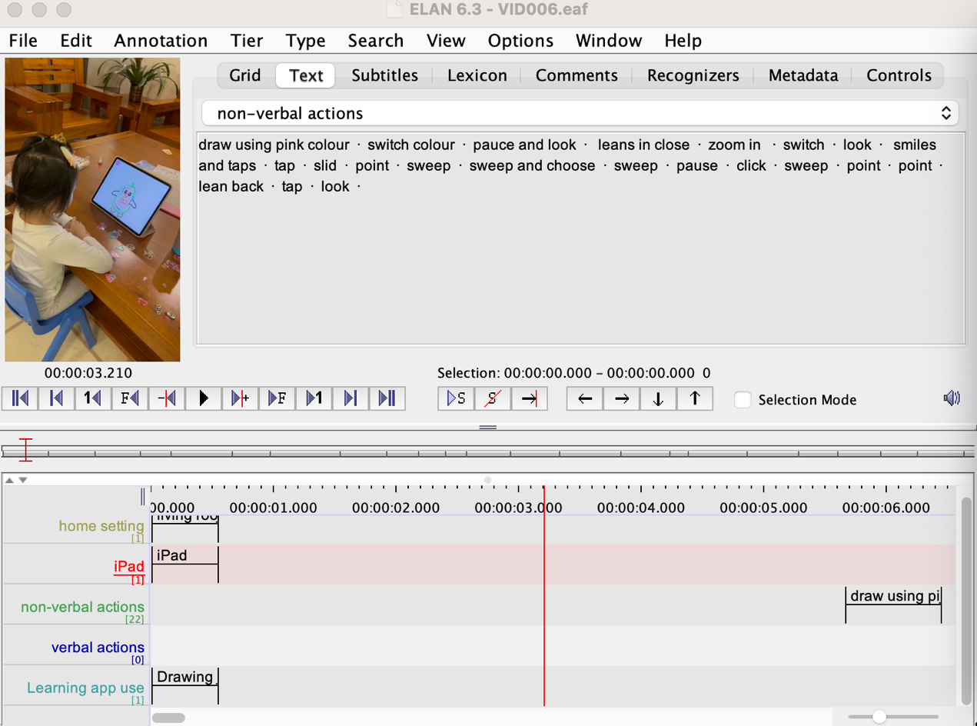
Table 8. A sample of transcript: VID-006 Transcript
[00:01] Sara is sitting at the table in the living room, using an iPad to draw in the "Drawing for Girls" app. She is using in close to the screen.
[00:06] Sara moves her hand rapidly back and forth to fill in a large area with pink colour.
[00:12] Sara switches to a different colour and starts filling in another area of the drawing.
[00:18] Sara takes a brief pause and looks at the drawing.
[00:22] Sara leans in close to the screen again and starts adding more detail to the drawing.
[00:30] Sara uses her finger to zoom in on a specific area of the drawing.
[00:35] Sara switches to a different tool in the app and starts adding text to the drawing.
[00:44] Sara finishes adding the text and takes a step back to look at the drawing as a whole.
[00:50] Sara smiles and taps the "Save" button to save her completed drawing.
I used the ELAN software to generate a transcript of the video data. Using a manual transcription approach, I transcribed both the audio and visual elements of the video. In order to accurately generate the transcript. As there was no dialogue in VID-006, I did not transcribe any dialogue in this particular sample of the transcript. During the transcription process, I applied codes to the video data in order to capture key aspects of Sara's behaviour and actions. Specifically, I observed Sara using an iPad to draw in the 'Drawing for Girls' app. To indicate both the device and app being used, I added codes for 'iPad' and 'Learning app use' respectively. In addition, I used the 'Non-verbal actions' code to capture Sara's physical movements, such as leaning in close to the screen.
By coding the video data in this way, I was able to systematically capture and analyse Sara's behaviour and actions while using the iPad and the 'Drawing for Girls' app. This coding approach, in combination with the transcript generated by the ELAN software, provided a comprehensive and detailed data analysis.
- Step three: Review the coded videos
After I had transcribed and coded the videos using the coding framework, I moved on to the next step, which was to review the coded videos. During this step, I checked the accuracy and consistency of the coding to ensure that it reflected the data accurately.
As I reviewed the coded videos, I identified areas where the coding was unclear or ambiguous, or where codes had been applied inconsistently. As I reviewed the coded videos, I noticed that some segments had been coded for 'Verbal actions' but did not include any codes for 'Non-verbal actions'. Upon further examination, I realised that these segments did in fact include non-verbal actions, such as gestures or facial expressions, that were not captured by the original coding. To address these issues, I went back to the original video data and re-examined the segments in question.
In addition to checking the accuracy of the coding, I also used the coded videos to identify patterns and trends in the data. For example, I used the ‘Learning app use’ code to compare the frequency of educational app use and entertainment app use, and the "Home setting" code to compare behaviour and actions when using touchscreen media in different settings.
- Step four: Select segments for the compilation
After I coded and reviewed the videos of children's touchscreen media use, I began step four, which involved selecting segments for the compilation. My goal was to create a 10-minute video for each family that represented the data collected and highlighted interesting and relevant segments.
To begin the selection process, I reviewed the coded segments and ranked them based on their relevance, interest, and quality. For instance, since my research question focused on how children use touchscreen media for learning and entertainment purposes, I prioritised segments that showcased these activities. I also looked for segments that provided clear evidence of learning or skill development, such as children engaging in problem-solving or critical thinking while using educational apps.
In addition to considering relevance and quality, I also looked for segments that highlighted the differences in touchscreen media use in different settings. For example, I viewed segments that occurred in different locations, such as at home and at a public place, to identify any differences in behaviour or actions. I also had a look for segments that demonstrated how children interacted with others while using touchscreen media, including sibling and parent participation. After selecting the segments, I compiled them into a 10-minute video by editing the segments together. This involved trimming segments to the desired length, adding transitions or effects, or overlaying text or narration to provide context.
After 10-minutes compilation generation, the compilation of each family was further analysed from multimodal perspective by using ELAN. Children's behaviour is complex and dynamic and can be influenced by a wide range of factors (Crescenzi-Lanna, 2020). Although verbal communication is one important aspect of behaviour, a multimodal perspective takes into account the many different modes of communication that children use, such as non-verbal cues, facial expressions, and body language. In the ‘Day in the life’ developed by Gillen (2007), using a multimodal perspective can also be useful when conducting reflective interviews with parents. By analysing children’s behaviour from a range of different modes, researchers can gain a more complete understanding of children’s behaviour and how it is perceived by parents and caregivers. In my research, taking a multimodal perspective when analysing children's behaviour provided valuable insights into how children engage with touchscreen media and identified social and cultural factors that influenced children’s behaviour.
In this research, ELAN supported me to gain an in-depth analysis of compilation. This is because ELAN enabled me to track and focus on individual semiotic resources present in children's actions. As illustrated in the sample transcription tiers below, different semiotic resources, including talk, body position, and hand movement, were annotated in separate tiers in ELAN. This allowed me to analyse each aspect of children's behaviour in depth.
Figure 2. A sample of transcription in ELAN from Family One (VID30, 22.09.2021)
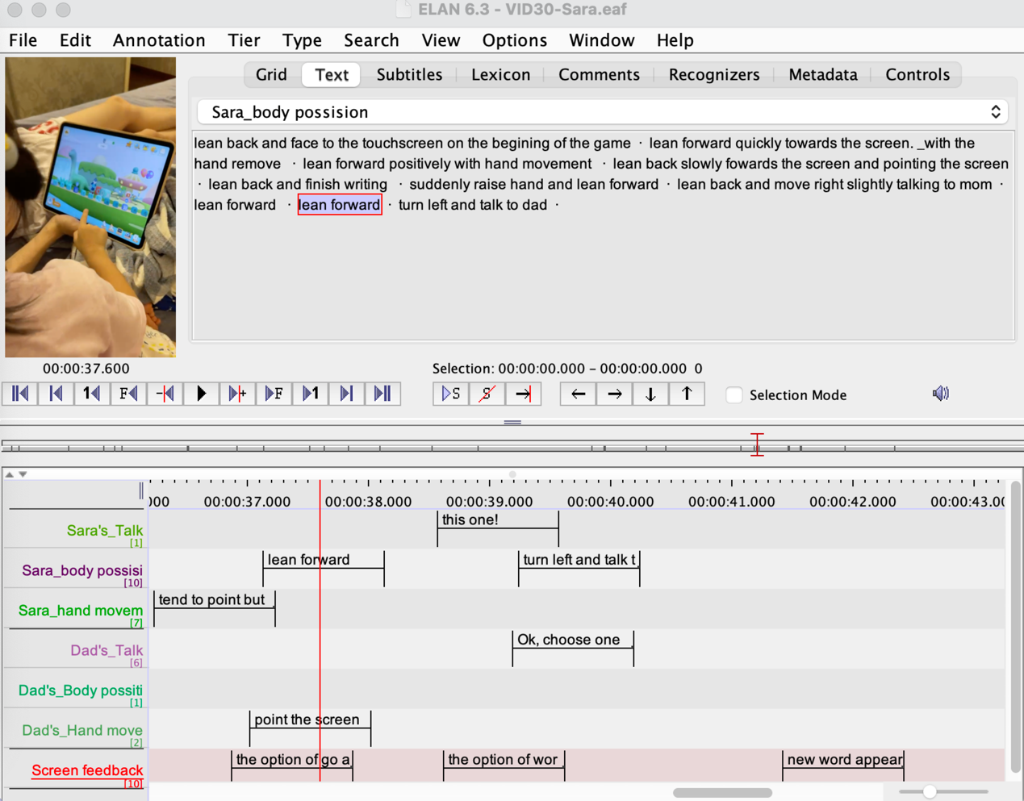
ELAN is a versatile tool that offers a range of functions to facilitate transcription and analysis of video recordings from multimodal perspectives in my research. To ensure that all modes of children's behaviour were accurately captured and identified, the compilation from each of the three families was viewed in various ways. These included viewing with and without sound, as well as in slow motion and at an accelerated pace. By applying different viewing methods repeatedly, I was able to focus on participants' behaviour separately in terms of verbal and non-verbal actions in recordings (Flewitt and Cowan, 2019).
Viewing without sound proved particularly useful in avoiding distraction by the children's speech and ensuring that their subtle movements were precisely captured during analysis. During this phase, I paid particular attention to the children's gestures of manipulation on the touchscreen, which included finger and body movements such as pressing and dragging. Ultimately, a descriptive multimodal transcription was produced and noted based on the children's sequential actions in the compilation. An example of such a multimodal transcript is provided below.
Figure 3. An example of multimodal transcripts from family of Sara (VID030, 22.09.2021)
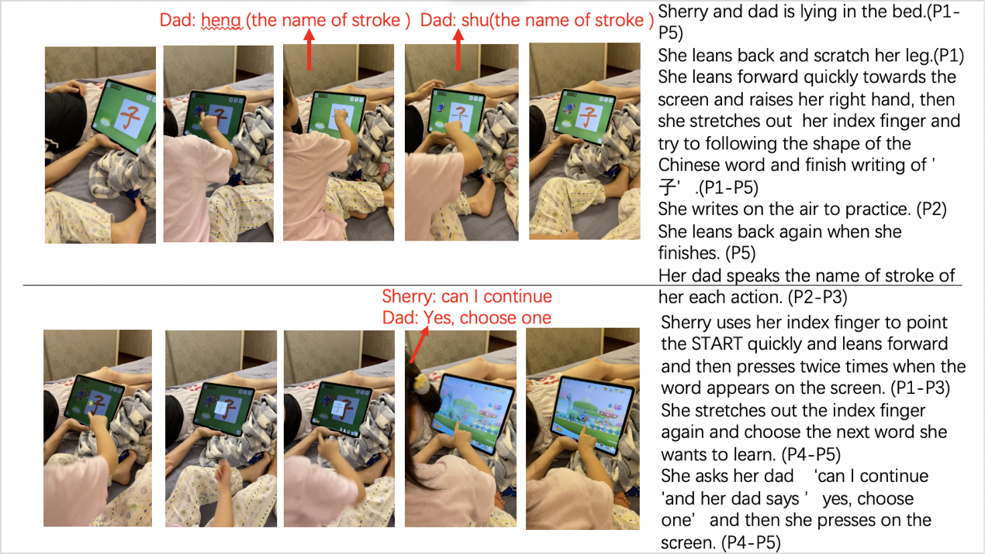
After multimodal transcription of three families were completed, ‘phase five’ that involved a preparation of interview with parents’ from three families started.
Phase five:
After completing the multimodal transcription of compilation, the research project moved on to phase five, which aimed to prepare for reflective interviews with the parents. Specifically, I contacted parents on WeChat to negotiate and confirm the date and time of a reflective interview.
Phase six:
During the final phase of my research, I conducted reflective interviews with parents, which involved a 1-hour discussion with each parent from three families. In this phase, the interview started with a discussion of a 10-minute video compilation of their children's behaviour in use of touchscreen media, without any accompanying notes or transcripts from the previous phase. The interviews aimed to explore the complex relationship between children's behaviour and parents' attitudes, specifically investigating how parents' beliefs, attitudes and perspectives have an impact on their children's experiences of using touchscreen media.
Reflective interviews with parents are recognised as an essential stage in investigating children's everyday activities using the the ‘Day in the Life' methodology. According to Gillen et al. (2018) and Gillen and Cameron (2010), the methodology acknowledges the importance of involving parents in the research process, as they offer valuable context and insights into their children's behaviour.
Generally, interviews allow researchers to collect in-depth, nuanced information directly from participants, providing insights that cannot be obtained through other forms of data collection. When interviews are used in studies that focus on family dynamics and the relationships between parents and their children, it is a valuable tool for collecting qualitative data in social research (Neumann, Merchant and Burnett, 2020). As (Adler, Salanterä and Zumstein-Shaha, 2019) indicated, interviews with parents are an effective method for exploring the experiences and behaviour of children, because parents are often intimately involved in their children's lives and have a wealth of knowledge about their children's routines, preferences, and interactions with others.
In phase six, a combination of discussion prompted by the video compilation and reflective interviews, which allowed parents to offer unique perspectives. such perspectives are essential to understand the complex relationship between children’s behaviour and parents’ attitudes.
The interview involved two parts based on the ‘Day in the life’ methodology used in my research. The first part was a discussion focused on children's behaviour and actions in their use of touchscreen media in 10-minute compilation, while the second part was an open-ended conversation expended based on their children's behaviour and actions with touchscreen media in the compilation. Through the combination of interviews with parents, researchers can gain a comprehensive understanding of the social context behind participants' behaviour and action in video recordings.
During the initial phase of the interview, parents were shown a 10-minute compilation and encouraged to share any information about their children's behaviour of using touchscreen media, such as interests, preferences, and problems related to the use. The pre-designed interview questions, as outlined in the table below, were asked in this process.

Table 9. Questions for an interview with parents
- The basic questions involve:
1. What kind of screen-based devices are used by your child in his/her everyday life?
2. What kind of apps are used in his/her use with touchscreen media, could you please give some examples?
3. What is the duration, frequency and relative places involved in his/her current engagement with these apps and screen-based devices?
4. How did the epidemic affect the way and duration of using touchscreen media by children in your family?
- After these basic questions, some open-ended questions will be asked, including:
1. What do you think about touchscreen media affecting children’s lives?
2. Would you like to encourage your child to use touchscreen media, how and why? Any advantages of child use of touchscreen devices are involved in your family in your opinion?
3. Do you have any worries and concerns toward your child using touchscreen media in his/her everyday life?
4. Do you think any risk has been involved in using touchscreen media in children’s lives, what aspects are involved?
4. Do you have any strategies and family rules in your family in children’s use of touchscreen media?
5. What do you think of parent supervision and assistance in children’s touchscreen media use, how and why? (Is there any moment your children ask for help from you?)
6. Who downloads apps for children in the family (parents or children themselves)?
- If parents choose and download apps:
- How do you choose an app for your children?
- What are the aspects considered when you choose apps for children, such as purposes, aims or any other aspects?
- Where do you know the apps you are going to download?
Is there any paid app in your children’s use with touchscreen media?
- If children download or choose apps for themselves:
- Would you like to help them to choose, or they can choose any one they like?
- Where did they know the apps?
7. For the apps that your children prefer to use in current days, how did you find out?
8. Would you like to use these apps first or have a quick check in advance before your children start to use them?
- (3-5 extra questions extended from the previous questions and conversation have been included into the interview with individual family)
These questions addressed various aspects of the research aims and questions. Moreover, these aspects were incorporated into eight basic and open-ended questions, including device types, app categories, places of use, time duration of use, family strategies and rules, perceived risks, and parental supervision and assistance. To gain a deeper understanding of the unique characteristics of each child's touchscreen use, I asked three to five additional questions after the initial viewing compilation review and the responses to the initial questions during the viewing session. These additional questions were tailored to the individual characteristics of each child's touchscreen use, as identified by the participating families. This method allowed for a comprehensive exploration of the specific issues and challenges related to children's touchscreen use in each family, while also facilitating a comparison of similarities and differences across families.
To ensure a thorough investigation of the complex issues surrounding children's touchscreen use, this approach provided a rich and nuanced exploration of the various factors involved in children's touchscreen use. Specifically, by incorporating both pre-designed and customised questions, I was able to gather a comprehensive understanding of the unique patterns and characteristics of each child's touchscreen use. Following the reflective interview with parents, the conversations by using WeChat were screen recorded (see the screen picture below) for subsequent transcription and analysis. Ultimately, 136.52 minute in total was collected with parent interviews from three families as table shows after the image below.

Figure 4. Screen recording of WeChat interviews with parents
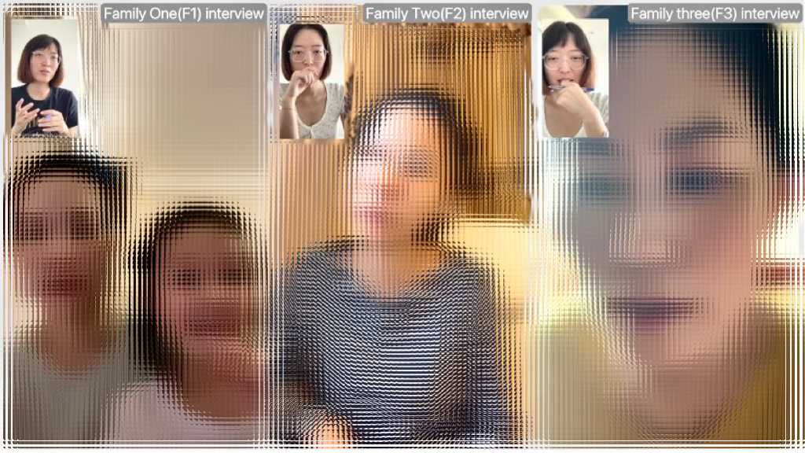
Table 10. Video data quantity from WeChat interviews with three families
Family code | Quantity of videos | The number of minutes
F1 | 1 | 41.14
F2 | 1 | 49.18
F3 | 1 | 46.20
Total | 3 | 136.52
The screen recording of the WeChat interview provided me with the opportunity to create a detailed and accurate transcription of the discussions. To accomplish this, I used ELAN to transcribe and analyse. ELAN proved to be an efficient tool for transcribing and coding the data based on the coding framework, which facilitated the identification of recurring themes and patterns within the conversations.
The coding framework utilised in this study was developed with careful consideration of both the research questions and insights gained from interviews with parents from three families. In order to ensure a comprehensive analysis of WeChat interviews, a combination of inductive and deductive coding approaches was employed. The derived codes primarily focused on investigating children's behaviour of touchscreen media use in relation to various factors. Thus, the conversation in the interviews was coded in terms of the spaces utilised, device types employed, the frequency and duration of engagement, and the timing of children's behaviour and interactions. Furthermore, the study aimed to explore parents' attitudes, beliefs, and perspectives regarding their children's use of WeChat. To address this objective, the coding process involved capturing codes related to parental concerns, perceived benefits and positive outcomes, parents' attitudes and beliefs, as well as their mediation strategies.
Table 11. The coding framework of WeChat reflective interview
Code | Description
Home setting | This code refers to the child's use of touchscreen media while at home.
Outside setting | This code refers to the child's use of touchscreen media outside of home. It includes use in outdoor activities, or other situations outside of the home.
Educational app use | This code refers to the use of apps that have an educational focus, such as those designed to teach literacy, numeracy, or other academic skills.
Entertaining app use | This code refers to the use of apps that are purely for entertainment purposes, such as games, videos, or social media apps.
iPad use | This code refers to the child's use of an iPad. It includes use of various apps on the iPad.
Mobile phone use | This code refers to the child's use of a mobile phone. It includes use of various apps on a mobile phone.
Benefits | This code refers to the benefits that parents perceive as being associated with their child's touchscreen media use. Benefits may include educational benefits, entertainment benefits and skill development.
Concerns and challenges | This code refers to the concerns and challenges that parents perceive as being associated with their child's touchscreen media use. Concerns include issues related to screen time, exposure to inappropriate content or addiction to technology. Challenges may include difficulty in managing the child's use of technology or balancing such media use with other activities.
Mediation strategies | This code refers to the strategies used by parents to manage their child's use of touchscreen media. Strategies include setting limits on screen time, monitoring the child's use of technology or providing guidance on appropriate use of technology.
Parental supervision | This code refers to the level of parental supervision of the child's touchscreen media use. It includes direct supervision of the child's use of touchscreen media or potential supervision through the use of monitoring setting in apps for example.
Parent-child interactions | Codes related to the nature and quality of parent-child interactions during touchscreen media use, including joint engagement, communication about content, or opportunities for shared learning.
Supports and participation | This code refers to the level of support provided to the child by the parents for the use of touchscreen media, including app downloading, problem-solving or participation in activities with the child that involve the use of touchscreen media.
This approach allowed me to identify recurring patterns and themes across the data, which provided insights into the ways that children were using touchscreen media and how parents perceived and responded to their children's use. Furthermore, the use of ELAN and the coding framework helped to ensure that the analysis was systematic and rigorous, which is important in producing reliable and valid research findings.
Specifically, I transcribed the WeChat interview data with three families by listening to the audio or watching the video of the interviews and manually transcribing the dialogue on ELAN. This involved capturing not only the words spoken by parents but also their tone of voice and any non-verbal cues present. Communication is a complex process that involves more than just words (Barrett and Twycross, 2018). Tone of voice, facial expressions, and body language are essential aspects of communication that provide important context and insights into the attitudes, beliefs, and perspectives of the parents being studied. By using ELAN as a tool to identify non-verbal cues, I was able to gain a more thorough understanding of the parents' responses, which ensured that the findings accurately reflected their true thoughts and feelings. Using ELAN and the coding framework, I generated a transcript that ultimately supported the data analysis. An example of a detailed transcript based on Family One (F1), WeChat interview with Sara's mother, is presented below.
Table 12. Transcript sample of WeChat interview with Family One (F1)
Timestamp | Transcription | Codes
0:00 | Interviewer (I): Thank you for speaking with me today. I'd like to start by asking you about your child's use of screen-based devices and expand questions as well. What kind of devices does she use on a daily basis? | N/A
0:10 | Sara's Mum (SM): Well, she primarily uses her iPad for playing games and watching videos. | iPad use, Entertaining app use
0:25 | I: I see. And does she ever use a mobile phone? | N/A
0:30 | SM: Yes, she has access to my old phone sometimes. But she doesn't use it very often because she prefers the larger screen on the iPad. | Mobile phone use
0:45 | I: That makes sense. How do you feel about your child's use of technology? Do you think it has any benefits or drawbacks? | N/A
0:55 | SM: Well, I worry about her eyesight and posture, so we encourage her to take breaks and stretch. I also think there are some inappropriate content on touchscreen media in some apps. But overall, we think it can be a valuable learning tool for her. | Parental attitudes and beliefs, Benefits, Concerns and challenges
1:20 | I: That's great. Do you have any specific strategies for managing your child's screen time? | N/A
1:25 | SM: Yes, we have a set time limit each day, and we try to enforce it as much as possible. We also use parental controls to restrict access to certain apps and websites. And we encourage her to engage in other activities, like playing blocks, drawing or reading a book. | Parental strategies, Parental supervision
1:50 | I: Those are some great strategies. Have you noticed any changes in your child's behaviour or skills since she started using touchscreen devices? | N/A
2:00 | SM: Yes, definitely. She's become much more proficient with touchscreen media technology, which I think will be useful for her in the future. And she's also developed some problem-solving and critical thinking skills through using educational apps. But we do worry sometimes that she's spending too much time on the iPad and not enough time playing with other kids or doing other activities. | Skill development, Concerns and challenges
2:30 | I: Do you feel like you have enough support and resources to manage your child's use of technology? | N/A
2:40 | SM: Yes, I think we do. We try to stay informed about new apps and trends, and we talk with other parents to see what strategies have worked for them. And we also have a good relationship with our child's school, which provides some guidance on using technology in an educational setting. | Supports and participation
During the analysis process, a thorough review and analysis of the transcripts was conducted to identify common themes and patterns related to children's touchscreen use. The focus was on identifying the nuances of the conversations, including both verbal and non-verbal cues, to gain a deeper understanding of the children's behaviour and the ways in which parents managed their use of touchscreen devices.
Based on the data collected from the 10-minute compilation of children's behaviour of using touchscreen devices, as well as reflective interviews with parents, a detailed descriptive analysis chapter was created in the next chapter in chapter 4.

3.6 Research participants and recruitment
The process of participant recruitment for my study was conducted remotely using the Chinese social media app, WeChat, due to the challenges posed by the COVID-19 pandemic. As outlined in Table 2, which presents the research stages and timeline, the recruitment process spanned four weeks. Ultimately, three families from advanced urban areas with children aged three to six years old participated in my research.
To begin the recruitment process, I created a recruitment poster that contained the necessary information and criteria, as shown below. This poster was then posted on WeChat, a widely used social media platform in China, to attract potential participants.
Figure 5. Participant recruitment poster
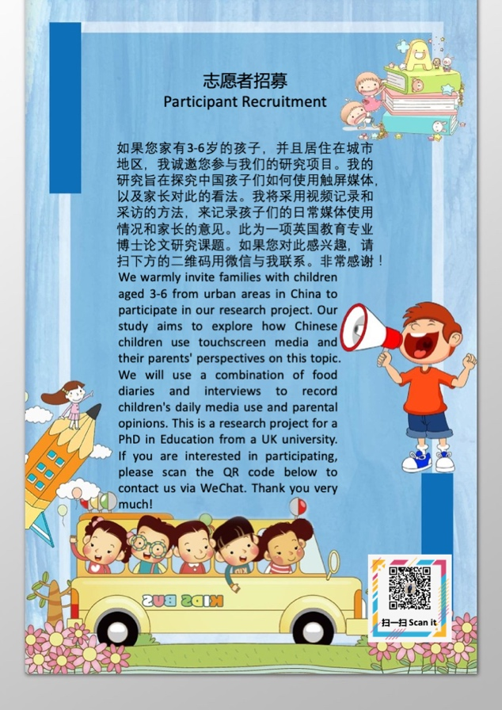
The poster presented a summary of the research study, encompassing the title, aims and objectives, contributions, and recruitment criteria. The two primary criteria featured in the poster during the recruitment phase were: (1) prospective participants needed to be residing in urban areas, and (2) children were required to be aged between three to six years. The poster also incorporated a QR code of my WeChat account to facilitate easy communication for interested individuals.
In four weeks, I received responses from five families who met the recruitment criteria. I then conducted informal video interviews with each of the five families who met the recruitment criteria. Due to the COVID-19 pandemic, these interviews were conducted remotely via WeChat video call without any data recording or collection. During the interviews, I introduced my research methodology, aim and objectives, procedures, and the roles of parents and children in the research. I answered all questions carefully to ensure understanding. Additionally, I explained the parents' role as recorders in the research and the predicted 12-week duration of data collection for each family, allowing parents to consider their availability and make appropriate arrangements.

Following the informal interviews, parents were given a week to consider their participation and ask any further questions through WeChat messaging. Ultimately, three families from urban areas in China with children aged three to six agreed to participate in my research. The table below provides details on the participating families.
Table 13. Details of three families in my research
Family code | Name of child | Gender | Age | Ethnicity | City of living
Family 1 | Sara | Female | 3 years and 7 months | Chinese | Guangzhou
Family 2 | Sherry | Female | 5 years old | Chinese | Beijing
Family 3 | Rob | Male | 4 years and 9months | Chinese | Shanghai

3.7 The COVID-19 pandemic context
In this section, I thoroughly explore how the COVID-19 pandemic has affected research approaches and methods in my study. The COVID-19 pandemic has had a profound impact on research involving children and their families (Weeland, Keijsers and Branje, 20211122). One of the main challenges that researchers have faced is how to access children as research participants while maintaining social distancing measures (Burton et al., 2023). As a result, there has been a shift towards alternative methods of data collection that do not require face-to-face contact (Saarijärvi and Bratt, 2021). Some research indicated that the COVID-19 pandemic has caused significant disruptions and delays in various studies involving children (Dong, Cao and Li, 2020; Quinones and Adams, 2021). Furthermore, starting studies has become more challenging due to safety concerns and logistical difficulties arising from the pandemic (Krause et al., 2021). Moreover, researchers have highlighted the complex ethical considerations that researchers must take into account when conducting research with children during a pandemic, including the potential risks of exposure to the virus during in-person visits (Banks et al., 2020; Konken and Howlett, 2022).
To address the pressing concerns raised by the pandemic, (Quinones and Adams, 2021) advocated for researchers to prioritise the safety and well-being of study participants by adapting research protocols to the current circumstances. One such adaptation involves utilising alternative virtual methods for data generation and implementing additional safety measures.
The consideration of ethical issues is crucial when developing research methods and approaches， as they safeguard the rights and well-being of participant. The COVID-19 pandemic has highlighted the need for ethical considerations in research involving children. Based on University of Sheffield's policy for research requiring face-to-face contact with participants in 2020 (see Appendix 11), It is imperative that researchers ensure that their research does not harm children or put them at risk of contracting the virus. Moreover, researchers needed to consider the potential risks of exposing children to the virus during in-person visits, as well as the potential risks of conducting research remotely (Banks et al., 2020; Stifel et al., 2020).
In light of the COVID-19 pandemic, I have given thorough consideration to the protection of children, their families, and myself. In order to achieve this goal, I implemented a series of initial changes that were primarily focused on ensuring their safety. I closely followed the guidelines and recommendations provided by the University of Sheffield's policy for research requiring face-to-face contact with participants (see Appendix 11). This policy suggested that in most cases, qualitative research involving human participants should be conducted remotely.
Therefore, I adapted observation and interview methods to be conducted remotely using the internet and social media mobile app WeChat. It offers features such as messaging, voice and video calls, and file sharing, making it a versatile tool for conducting remote research. By using social media app and the internet, I was able to conduct research without the need for in-person interactions, which significantly reduced the risk of exposing children to the virus and ensure the research in a safe and ethical manner (Babvey et al., 2021). Specifically, these changes allowed me to continue with my research while minimising the risk of exposure to the virus and maintaining social distancing measures. Based on this consideration, the changes that were made were divided into two main research approaches, including observation and interview. Specifically, parents were invited to act as recorders and participate in my research in order to support my remote observation and data collection. Moreover, parents’ interviews were also conducted online by using WeChat. When considering the ethical implications of using social media apps to collect data remotely, it is essential to ensure that all data is stored in accordance with data security and privacy requirements (Keshta and Odeh, 2021). In this study, all collected data were securely stored, aligning with the ethical guidelines of University of Sheffield, utilising the university's Google Drive. The subsequent chapter provides a more comprehensive discussion of the ethical issues relevant to my research.

3.8 Ethical issues in the research
This research involved the participation of children and their families; therefore, ethical issues needed to be carefully considered before the research began (Coady, 2010). In my research, ethics were based on considering three families with children as important participants who were vulnerable and needed protection. Additionally, the complex context of the pandemic was also taken into account in regard to ethics. Specifically, ethical issues regarding the consent and assent process, confidentiality and disclosure, and protection from harm were thoughtfully considered and addressed separately within the context of the research.
Informed consent is a fundamental principle of research ethics (Arnott et al., 2020). It involves researchers explaining their research work clearly and appropriately to ensure that participants can make an informed decision about their involvement (Alderson and Morrow, 2020). Informed consent gives attention to the rights of children and their meaningful involvement in research (Arnott et al., 2020). Obtaining informed consent from young participants should consider their legal status, particularly in relation to their age. For instance, in the UK, parental consent is required for children under sixteen to be approached for participation in a research study (Huser, Dockett and Perry, 2022). The British Educational Research Association's (BERA) ethical guidelines for educational research address the importance of obtaining consent from both children and their parents (or legal guardians) before conducting research with children. This ensures that the research is ethical and responsible.
In the context of the pandemic, issues related to consent and assent should be carefully considered, especially with more parents feeling hesitant to allow their children to participate in research involving observation and interviews. Many parents are concerned about the health risks their children face during the COVID-19 pandemic.
Furthermore, in research involving children and video data, it is crucial for researchers to explain to both parents and children what will happen during the study before it begins. Studies conducted by (Marsh et al., 2018; Livingstone and Blum-Ross, 2020) that focus on children's behaviour and the use of video recording approaches also emphasise the importance of gaining consent from both the young participant and one of their parents. This is because such studies require the active participation of children, including their engagement in various activities that will be observed and recorded.
Children's willingness to participate in a study is contingent on their understanding of the research and the information provided to them. Therefore, researchers must be transparent about the study's purpose, methods, and potential risks, ensuring that both parents and children fully comprehend and provide informed consent before participation. By addressing these ethical considerations, researchers can conduct studies involving children in a safe and respectful manner.
Based on these considerations and ethical guidelines, children between the ages of three and six participated in my research. It was a legal requirement that a parent or guardian act as adult gatekeepers and provide consent before their child's involvement. In the decision-making process, parents were provided with sufficient information, including the research topic, focus and aims, questions, methods, plan, and timetable, to facilitate informed decision-making. An information sheet with a consent form was provided to parents to ensure that they understood the research and agreed to their children's participation.
As discussed in research regarding children and reviewing guidance from the UK, obtaining adult gatekeepers' permission for their children's involvement does not fully meet the requirements of informed consent in research involving children's participation. If a research study involves the participation of children, their agreement should also be fully obtained and respected. It is crucial that researchers ensure that all children are involved in decision-making processes on matters concerning them (Coady, 2010).
Considering that early year children in my research had difficulties with reading and understanding a formal printed document, I have prepared a form of child information sheet (see Appendix 3) and ongoing assent (see Appendix 8) for young participants to gain their agreement. This approach ensures that the children are fully informed about their participation in the research and can express their willingness to take part in an appropriate manner.
In early childhood literature, the terms 'consent' and 'assent' are often used interchangeably because children below the legal age cannot provide fully independent consent (Coady, 2010). Assent is based on the same principles as consent and represents children's participation decision (Dockett and Perry, 2011). However, some researchers are concerned that using assent for children diminish the importance of children's agreement compared to parents' permission, which can be shown on a printed document (Mayne, Howitt and Rennie, 2018). Moreover, children are not considered competent or contributing factors when verbal assent is used in research that involves them (Coady., 2010).
In my research, parental consent and child assent were equally important. The method of obtaining agreement from parents and children was based on a consideration of children's age and capacity to read and write. Child participants in my research were fully respected, particularly in their decision to participate. Every child and parent were informed that their participation was voluntary, and they were free to withdraw at any time and for any reason.
To encourage and support children's decision to participate, a child's verbal assent is obtained based on providing sufficient and appropriate information about the research. If young participants do not know and understand the research information and what is required of them, their assent is of less value (Mayne, Howitt and Rennie, 2018). To ensure young participants can easily access and understand the information and their involvement, all research information was provided in different forms, including appropriate language and visual images based on the specific ethical guidance from the University of Sheffield.
Moreover, the issue of researcher/child power imbalance should be carefully considered during the decision-making process by children (Mayne, Howitt and Rennie, 2018). Studies indicated that researchers' role and their voice, facial expressions, encouragement, or descriptive language can place pressure on a child's decision-making (Mayne, Howitt and Rennie, 2018; Quaye et al., 2019). Therefore, I provided time for children to make their own choices without pressure imposed by others. Participants were informed that their decision would not upset anybody, and they could make any choice without worries.
To enhance children's understanding of their ability to make choices, decision cards (Figure 1) featuring three facial expressions were provided to each child. According to (Rockett et al., 2020)Dockett et al. (2013), visual representations combined with images can facilitate children's comprehension, encourage discussions between researchers and children, and provide young participants with opportunities to practice decision-making. Mayne, Howitt, and Rennie (2018) further suggested that using images when seeking agreement from children can increase positive engagement.
In my research, decision cards with the images shown below were used to inform children that they can make decisions by choosing any one of three facial pictures to indicate their decision about participation.
Figure 6. Decision cards

In my research, the use of decision cards was not limited to the beginning stage. Children were encouraged to use the cards to express their attitudes towards involvement at any time during the study. To facilitate remote data collection, I stayed in contact with parents through WeChat, a Chinese social media app, where I received videos and messages. Before the research began, parents and their children were provided with decision cards, and were informed about the aim and how to use them. Every week during the six weeks of video data collection in each family, I reminded parents to have their children use the decision cards and inquired about their willingness to continue participating in the research via WeChat. Three families' children expressed their willingness by using the smiley face card and continued to participate in the study until the end.
This design was based on the principle of ongoing assent, which recognises that children's participation is open for renegotiation at any point (Kyritsi, 2019). By regularly checking in with the children and giving them the opportunity to express their willingness to participate, I ensured that their ongoing consent was respected throughout the study.
Several studies have indicated that an ongoing assent provided children with the opportunity to choose which activities to participate in, particularly as they gradually develop an understanding of the research study and its approaches (Pyle and Danniels, 2016; Dockett et al., 2017). Furthermore, ethical guidelines from the University of Sheffield suggested that ongoing assent can help reduce the issue of power imbalance between children and researchers, as children feel less obligated to participate once they become more familiar with the research (University Research Ethics Policy, Version 8).
To respect children's rights and track their willingness to participate in my research, obtaining a child's verbal assent using a decision card was viewed as an ongoing process. At every stage of the research, children were asked to confirm their agreement to participate. This approach allowed for the ongoing evaluation of children's interest and willingness to participate, which was essential for ensuring that their rights and well-being were respected throughout the study (Barley, 2021).
To ensure ongoing assent from children in my research, I relied on the assistance of their parents. This is because children's behaviour and actions involve non-verbal cues and subtle signs that may not be accurately identified by a researcher (Ericsson and Boyd, 2017). Parents were informed that if they notice their children's actions, emotions, or other non-verbal behaviour suggesting discomfort, they can inform me. Based on this feedback, I can adjust the timetable, duration, and frequency of research methods to ensure that young participants can positively engage in the research.
During the data collection phase, I fully respected the family routine and parents' arrangements. Parents acted as recorders and could flexibly record their children's behaviour and activities of using touchscreen media during the six-week video data collection period. Through ongoing communication with each family, parents and I were able to adjust the plan for data collection as needed throughout the process. For example, during the first week of data collection, the mother of Rob in Family Three and I adjusted the recording arrangement due to her increased workload from working at home during the pandemic.
During the consent and assent process, I explained to parents and children the issue of confidentiality and disclosure in terms of the limitations of confidentiality and child protection. As the ethical guidelines from the University of Sheffield, if the researcher finds that a young participant is living with significant risks and in unacceptable circumstances, such as experiencing or witnessing violent abuse, they are obliged to pass on this information to the relevant authorities. Therefore, I provided statements to parents at the outset of the research that I need to break the principle of confidentiality if child protection issues are raised during my research. For instance, if I discover that a young child is living with family violence and abuse, I have the responsibility to keep and pass on the evidence to the appropriate authorities.
Furthermore, the principle of child protection in regard to confidentiality should be explained to children, and researchers should define abusive behaviour to help children understand the meaning of 'harm' in the context of confidentiality (Jackson-Hollis, 2019). As my research involved children and their families being observed remotely, I conducted a preliminary online meeting to explain all ethical issues pertaining to the research to both parents and children prior to the start of the study.
As Williamson et al. (2009) have argued, speaking directly to young participants is a better approach than using a document to describe the issue of confidentiality. Using appropriate language and some variation in wording can help children effectively accept and understand the concept of confidentiality (Jackson-Hollis, 2019). In particular, for my research, children's verbal assent was combined with an explanation of confidentiality in the early stage of the research. I used simple language to help children understand that it was important to keep them safe in the research and to help them easily access information about confidentiality. During the preliminary online meeting, each child was given the opportunity to have a 5–10-minute private online conversation with me, with their parents' agreement. This provided a space for children to ask questions and clarify any concerns they have had about the research process. By taking these steps, I ensured that the principle of child protection was maintained, and all participants understood the importance of confidentiality in the research. During my research, I reassured children in online conversations that nobody they knew would have access to the content of the recording of what they said. Additionally, I encouraged them to ask any questions they had about my research. Additionally, I highlighted and explained situations that cause me concern and result in a breach of confidentiality, such as abuse, bullying, or neglect. As the children in my research were not involved in formal interviews like their parents, I engaged in weekly conversations with each child and parent through WeChat, especially when I gained ongoing assent from the children. Each child was also given the opportunity to speak with me privately, with their parents' agreement. Throughout this process, I paid close attention to each child's feelings and situation, ensuring their willingness and protection throughout the research.

3.9 summary
This chapter aims to provide a detailed description of the research methodology employed. The chapter begins with a detailed introduction to the 'Day In The Life' (DITL) methodology developed by Gillen (Gillen et al., 2007; Gillen and Cameron, 2010). It discusses the evolution, origins, disciplinary context, specific methods and research stages associated with this methodology. My research follows principles of the 'DITL' approach, which guides me to identify and understand children's behaviour and parents' perspectives, exploring how the environment and parents' perspective interact with children's engagement with touchscreen media. At the same time, the research also incorporates adaptations and modifications to suit the specific research focus, questions and the specific context. Considering the COVID-19 pandemic, which prevents me accessing children's families directly, a parent was invited to record children's activities in their everyday lives. In the recording stage, instead of continuously filming at least 6 hours of day-long activity as the original design from Gillen’s (2007) research, the focus shifted to recording children's behaviour with touchscreen media. Furthermore, a single day's recording has evolved into a flexible record spanning 6 weeks by parents. Through such development, parents and I collaborated well during the data collection phase and collected 61 videos totaling 234.82 minutes.
Within this chapter, the research stages are introduced, with specific tasks assigned to each stage and an overall timeline provided. The chapter goes into detailed explanations of the data collection and generation phases. In the 'DITL' data collection phases, data need to be initially organised and summarised to facilitate reflective data generation and subsequent analysis. Therefore, this chapter provides a detailed description of how the data were initially collected and subsequently analysed through coding, transcribing and regeneration.
This approach aligns with the aim of gaining reflective insights from outsiders based on the ‘DITL’ methodology. Collecting viewpoints from such outsiders requires initial data processing. In my research, this chapter introduces the process of familiarising, coding, categorising and ultimately compiling video data of children into a 10-minute compilation. This compilation is designed for parents to view, enabling them to provide their primary reflections and further perspectives in an interview.
Additionally, this chapter addresses other crucial aspects of research methodology, including participant recruitment, ethical considerations and the impact of the COVID-19 pandemic on the methodology. With this detailed introduction, the subsequent chapter will focus on how the data are analysed within each of the three families based on the research focuses and questions.

Data analysis
This chapter presents a descriptive analysis based on the previously discussed of research methodology, which focuses on three separate families. Each family is analysed in different sections, with each analysis section following a specific structure consisting of three sections: (1) an introduction of the family, (2) the child's touchscreen media use, and (3) parents' perspectives and attitudes toward touchscreen media use by their children. Within this structure, specific features within children’s touchscreen media use from each family are analysed in detail. The purpose of this chapter is to provide a comprehensive description of the conditions of the three families regarding their children's behaviour in use with touchscreen media. The analysis involves observing the children's behaviour in recording videos and complementing this information with interviews with parents about how their children use touchscreen media in everyday lives.
Such investigation starts with an analysis in aspects of device type, settings involvement, time and duration, and app preferences for children's touchscreen media use. Furthermore, parents' perspectives in terms of benefits, risks, strategies and their participation are explored. Through this analysis process, I aim to examine how children's current engagement with touchscreen media use affected parents' perspectives, as well as how parental strategies and attitudes shaped and influenced their children's behaviour in using touchscreen media in different settings in my research.

4.1 Data analysis of Family One (F1) of Sara
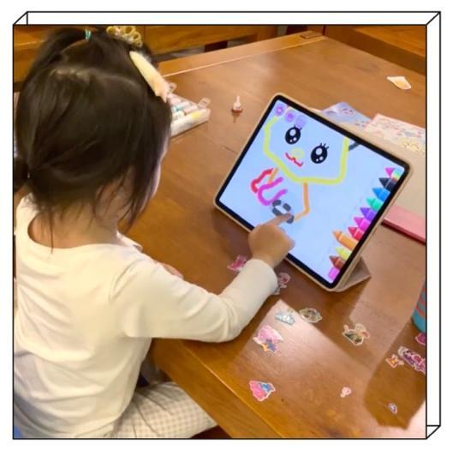

4.1.1 An introduction of Sara and her family
Sara, a three-year-old Chinese girl, was the subject of study for the research project beginning in September 2019, when she was 3 years and 7 months old. She is the only child in the family and has been living with her parents in Guangzhou city since birth. Guangzhou is the capital and largest city of Guangdong province in southern China and is ranked as one of the first-tier cities in the latest Chinese city tier system (2017) due to its significant economic, cultural, and political influence.
Both of Sara's parents have full-time jobs. Her mother is employed by a media company, while her father is a doctor. At the time of recruitment, Sara had just started attending kindergarten five days a week. However, due to the government's coronavirus lockdown in China in 2019, Sara and her mother stayed at home for the duration of the data collection phase. Sara's mother worked from home while taking care of Sara, and Sara stopped attending kindergarten during this period. As a result, all 31 videos with 88.68 minutes (see the table ‘Quantity and Duration of Videos Collected from Three Families’) collected for the project were recorded by Sara's mother at home.

4.1.2 Sara’s touchscreen media use
- Devices:
Devices: Sara’s family had a rich and varied touchscreen media environment. She had exposure to various touchscreen media devices in everyday life, including mobile phones and iPads. However, she had a distinct preference for touchscreen devices, and iPad was her favorite device, which she used more frequently than any other device. Specifically, Sara had her own iPad, which made it easy for her to access and use it at home and in her everyday life.
Table 14. Transcript of WeChat interview with F1
Timestamp | Transcript
15:02 | Lan: So, she used her own iPad in all collected videos?
15:08 | Sara’s mum: yes, she did. As you see in the video, that iPad is her personal one.
15:20 | Lan: Did you buy it specifically for her?
15:41 | Sara’s mom: Not really. It belonged to me before (smile), but she used it more frequently than me from this year and more apps are needed to download for her. So, I just deleted apps I used on it and gave it to her.
Although Sara's parents never prevented her from using a mobile phone, Sara was observed to spend more time on an iPad in the 33 videos collected. None of the videos involved the use of a mobile phone. However, Sara's mother shared some situations where Sara used a mobile phone.
Table 15. Transcript of WeChat interview with F1
Timestamp | Transcript
11:15 | Lan: What kind of screen-based devices are used by your child in her everyday life?
11:21 | Sara’s mum: mum. I think she just only uses iPads and iPhones so far.
12:14 | Lan: So, does she also have her own iPhone?
12:20 | Sara’s mum: Nope. She hasn’t. She often uses mine or her dad’s phone if she wants.
12:32 | Lan: I just saw she only used an iPad in the recorded videos.
12:40 | Sara’s mum: Oh yes. She rarely uses a phone at home and outside of home as well. So, as you see I didn’t collect any behaviour from her about using mobile phones. I mean she used before and just sometimes in some cases.
Sara's mother explained that Sara had less experience using a mobile phone, especially after she got her own iPad. Her mother believed that the bigger screen of the iPad provided a better experience, including for watching and operating on a touchscreen. Although Sara rarely used a mobile phone at home or outside, she did use her parents' mobile phones in some situations, such as when they were eating outside and waiting for dishes to arrive. Sara rarely requested to use her parents' phones, but her parents sometimes lead her to watch videos or use apps on a phone to keep her quiet and seated. On her parents' phones, only one or two apps were downloaded and prepared for Sara, including a video app and one of the other apps that Sara had used recently.
Sara's mother explained that Sara preferred operating on her own iPad rather than on a mobile phone because the apps on her iPad could record data and support future use, providing her with a better experience. For example, painting apps can record the level of the game that Sara has achieved, allowing her to access the next new level when she returns to the app. This same experience also occurred when using video apps on her own iPad. Moreover, Sara's mother indicated that the setting and design of apps on an iPad and iPhone often had minor differences, causing Sara to sometimes need her help when using an app on a mobile phone. However, this was not the case with Sara's use of an iPad.
In conclusion, Sara's preference for using an iPad rather than a mobile phone is supported by her experiences with both devices. The detailed analysis of her behaviour
- Places:
As observed in the collected videos, Sara primarily used touchscreen media at home, with the living room and her bedroom being the main areas of engagement. Out of the 33 videos collected, 24 were recorded in the living room, while 9 were recorded in her bedroom. It was noted that Sara had different levels of engagement in different places at home. For instance, her use of touchscreen media in the living room involved a diverse range of apps, with entertainment apps such as video and painting apps being the most commonly used. She was able to navigate different apps and operate them proficiently using her fingers on the touchscreen. Her mother rarely participated in her engagement unless Sara had difficulties using the apps, although Sara sometimes shared her screen achievements with her mom.
On the other hand, Sara's engagement with touchscreen media in her bedroom was mainly for learning purposes. Her parents often joined in with specific apps, such as the literacy learning app called Hongenshizi, as observed in the 9 videos recorded during the study. It was at bedtime that Sara often used her iPad, and her parents were usually available and would like to join in her engagement. The use of touchscreen media provided them with opportunities to engage in various activities while also helping Sara to improve her skills.
During the videos, Sara's parent's participation was noted to have helped her in various ways. For instance, Sara's father could explain how the Chinese character that she was learning on the screen could be used in everyday life, while also providing extended knowledge about the content. Such interactions helped Sara to understand the meaning and learn content through the app. Additionally, her parent's participation improved her concentration when using the literacy learning app in the bedroom. According to the multimodal data transcript, Sara's concentration was easily distracted when using the literacy app in the bedroom.
Sara’s mother in the interview reviewed the video clips with me and we discussed this issue that Sara’s concentration is easily distracted in using some apps with learning features.
Table 16. Transcript of WeChat interview with F1
Timestamp | Transcript
11:13 | Lan: Sara doesn't seem to completely focus on using the literacy app on the bed.
11:19 | Sara’s mum: Yeah, she didn’t. The learning of Chinese characters is difficult, you know, although it can be learned through the iPad. She usually needs to learn one character through completing three or four episodes on the screen. Of course, these episodes look entertaining but still boring and spend much time compared with using other apps. She always wants to skip over certain stages and give up some difficult parts.
12:07 | Lan: Yeah, I can see she found it is not possible to achieve a reward if she cannot complete the stages.
12:13 | Sara’s mum: Yes, so she starts to hit the screen frequently and see what happened.
12:17 | Lan: Does that mean she's impatient and wants to finish?
12:21 | Sara’s mum: Yes, but her father and I would like to try to get her attention back to the screen again and finish the tasks.

- Time and duration:
According to the video records collected from Sara's family, she frequently used an iPad at home. On average, she was observed using it three to four times a day. However, calculating the exact duration of her touchscreen media use is difficult since the video recording was done in non-consecutive segments. During the interview with Sara's mother, she insisted that Sara used touchscreen media for no more than two hours a day. However, the actual duration of her use of touchscreen media sometimes longer than two hours per day, depending on the frequency and habits of use.
Sara's preference for using apps contributes to this finding. Out of the 33 videos collected, 13 videos recorded her use of a video app to watch children's cartoons. During these recordings, Sara was rarely interrupted and was completely immersed in the experience. Her movements and actions were reduced, including touching the screen, talking, and body movement. She typically watched four to five cartoon episodes continuously, with each video lasting 10-15 minutes. Thus, she could use video apps for up to an hour at a time. Given this, it is challenging to limit Sara's touchscreen media use to only two hours per day. Furthermore, there were no specific rules or limitations in place to regulate Sara's use of touchscreen media, making it challenging to determine the specific duration and time of her daily use of touchscreen media.
- App preference and digital practices:
There are three types of apps that Sara uses in her everyday life: video apps, painting apps, and literacy learning apps. Among these, Sara is proficient in using the iQiyi app, which is one of the largest Chinese online video platforms in China. The app contains a specific kid channel that specialises in graphic videos, cartoons, and nursery rhymes and songs for children. In the data collection, 19 videos recorded that Sara used this app to watch cartoons, such as PAW Patrol.
Sara has developed a high level of proficiency in using the video app independently on her iPad. She can navigate the app proficiently, including opening the app, choosing episodes, fast forwarding or slowing down videos, and adjusting the volume through touching the screen. Sara rarely needed her mother's help except in cases of technical issues, such as network disconnection. Moreover, Sara can accurately find the episodes she wants to see based on the function of watching history.
Sara spent more time watching videos using her touchscreen media than using other apps. Additionally, she showed great enthusiasm in using the video app. As the multimodal transcript shows, the interactions between Sara and her parents decreased when she focused on the screen content of episodes. Compared with her behaviour and actions when using other apps, Sara's body movements and communication occurred just a few times when she was focused on the screen content of episodes.
However, a completely different situation was observed when Sara was using the video app. In one video clip (VID004), the iPad played PAW Patrol while Sara was also painting on papers at the same time. She occasionally glanced at the screen for a few seconds and then went back to her work on papers. During such engagement, she showed more body and facial movement and communicated with her parents about the plots and characters. In the recording, Sara left for a while and prevented her mother from closing the video app. Such multitasking engagement often persisted for a few hours. Even if Sara stopped to draw and change to do other things, the video app still worked and played.
Sara's engagement with painting apps on her iPad was a significant aspect of her touchscreen media use. Specifically, Sara frequently used three drawing games for children aged 3 to 8: Drawing for Girls, Drawing Academy, and Bini Mini. These apps offered step-by-step instructions to draw characters using contour tracing, with the support of app functions that allowed the drawn characters to move on the screen with music. Sara enjoyed using these painting apps and was observed using them immersivity multiple times a day. Nine of the 33 videos collected during the data collection period showed Sara using painting apps on her iPad.
Through observation, it was clear that Sara had a specific preference for drawing a particular character repeatedly. As her frequency of drawing increased, Sara started to experiment with creative works on the painting apps. The multimodal transcript revealed that after finishing the line drawing, Sara usually did not follow the audio indications to choose colours for coloring. Instead, she would take a few seconds to think and choose colours that were often different from the indications. Sara demonstrated her own distinct preference for colour matching during the painting process on a touchscreen. Sometimes, she would stop to think for a while to choose or change a colour. Furthermore, she tried to draw some patterns in the blank space on the screen to make the picture look more colourful after drawing the characters. All such creative explorations were led by Sara herself and were based on her long-term use of painting apps.
The last type of app that Sara used frequently is a literacy learning app called Hongenshizi, which is a Chinese learning app designed for children to learn common Chinese characters. The app uses various entertaining ways, including animations, children's songs, interactive activities, and stories to help children explore Chinese character learning. Sara often used this app with her parents at bedtime in her bedroom. Unlike the other two types of apps, this app was not chosen and downloaded based on Sara's interests. As a learning app, the time and duration of using the app were specific. Sara's parents often used this app together with her at 8 pm before she slept and learned on the app for up to 30 minutes each time every day. Sara needed to learn two Chinese characters, including four to five stages of each.
Based on a multimodal transcript, Sara often engaged in intensive conversations with her parents, and these conversations sometimes strayed from the learning topics. Additionally, Sara engaged in some unrelated actions while using the app, such as playing with her feet, hitting herself, and grabbing her mother's pajamas. At the same time, the amount of time that her eyes were fixed on the screen was usually short, especially after about ten minutes of learning.
Sara's distracted attention while learning impacted her learning efficiency. Her parents sometimes had to pull her attention back by raising the iPad and guiding her in practicing writing Chinese characters on the screen. According to her mother's interview, it is still quite challenging for Sara to remember all the Chinese characters she learned on the app. Her mother tried to point out some Chinese characters that appeared in everyday situations, such as on food packaging and signboards on the road, but Sara often had no idea about them. Sara's mother believed that the design of learning apps mainly focuses on attracting children's attention by utilising various entertaining features. However, such a design can distract children's attention, especially when different elements appear simultaneously. Sara's mother indicated that Sara was always attracted by the animations and music in the app, rather than the learning content. As a result, the learning outcome for Sara was unsatisfactory.

4.1.3 Parents’ perspectives and attitude toward children’s touchscreen media use
In Sara's family, entertainment use and related apps dominated her everyday use of touchscreen media. Furthermore, there were no specific limitations or family rules set up regarding her use of touchscreen media.
Sara's habits of using touchscreen media were ultimately influenced by her parents' perspectives and attitudes. Firstly, her parents created a rich and varied touchscreen media environment for her at home, and Sara was able to easily access and use touchscreen devices in her everyday life, especially with her own iPad. As a result, the frequent use of the iPad made it her favorited device, and she was able to explore different apps based on her interests. During the interview, Sara's mother also mentioned that Sara still had difficulties downloading apps independently. Therefore, all apps that Sara used on her iPad were downloaded by her mother, who rarely chose apps with specific educational purposes. Most of the apps on Sara's iPad were based on her interests, such as painting and video watching. Although Sara's mother did try an educational app that was downloaded based on her own will during the data collection period, the atmosphere and environment of Sara's family allowed Sara to freely explore touchscreen media in her everyday life.
Sara was also able to freely explore her use of touchscreen media based on her parents' perceptions and thoughts. Sara's mother had not set up any specific rules or strategies regarding the type of devices, time duration, frequency, or the types of apps used by children in their use of touchscreen media. As a media employee, Sara's mother considered touchscreen media as a tool that everyone uses almost every day, and she accepted that touchscreen media was a part of Sara's life, even though she was still quite young. However, the lack of rules and limitations in Sara's use of touchscreen media did not mean that her mother did not have any concerns about her use of technology.
Parents’ participation and guidance are essential in ensuring safe and responsible use of touchscreen devices by children. Sara's mother shared her perspective on the importance of parental supervision and guidance in preventing potential damage from the use of touchscreen media. She specifically highlighted two concerns: inappropriate content and in-app advertisements.
Sara's mother expressed concerns about age-inappropriate content, including violence and sexual content, which could make children feel uncomfortable. She cited examples of violent content in some child cartoon episodes that Sara had encountered. In-app advertisements were another concern. She explained that almost every app has this problem, and they can be particularly tricky for kids, often leading them to pay for fees they did not intend to purchase.
Sara's mother shared an instance where some inappropriate advertisements occasionally popped up while Sara was using painting apps on her iPad. Moreover, Sara sometimes mistakenly accessed pages with video introductions, such as TikTok, which contained age-inappropriate content. Such issues not only disrupt a child's attention and experience but also pose risks to their safety while using touchscreen media.
Summary
This section analyses the data from Family 1, focusing on Sara's use of touchscreen media and her parents' perspectives toward children touchscreen media use. The analysis reveals that Sara is exposed to an open and unrestricted environment of touchscreen media in her daily life. She has experience using both iPads and mobile phones, but she predominantly uses the iPad, especially when it is available. Sara has been observed freely using her own iPad at home, typically four or five times, and she selects apps based on her own preferences. Three types of preferred app using were observed, including video apps, painting apps, and literacy learning apps.
Sara's mother employs an active parental mediation approach while also maintaining a relaxed attitude toward Sara's touchscreen media use. Sara's parents view touchscreen media as valuable entertainment tools that offer children an enjoyable experience of play and learning. However, they also express concerns regarding inappropriate content and in-app advertisements.

4.2 Data analysis of Family Two (F2) of Sherry
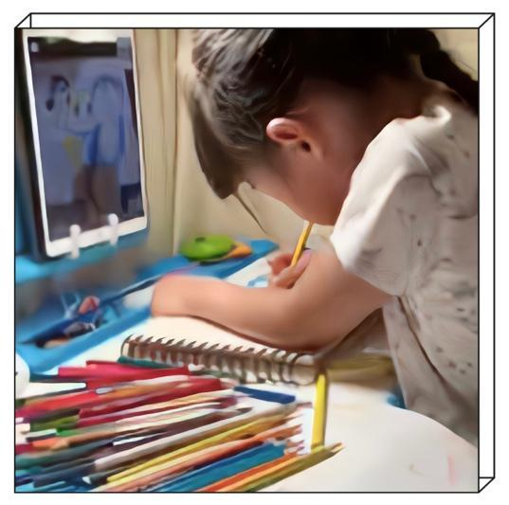

4.2.1 An introduction of Sherry and her family
Sherry, a five-year-old girl, lived in Beijing with her family, including her parents and her three-year-older brother, Nathan. Beijing is a megacity and the capital city of China, which is globally recognised as a leading center for culture, politics, finance, business, and economics. In the latest Chinese city tier system (2017), Beijing is classified as one of the four first-tier cities, and is considered a developed region in China.
Sherry's mother was a full-time homemaker who spent much time taking care of her and her brother, in terms of their studies and everyday lives. Sherry's father was engaged in foreign trade. During my research, Sherry was in kindergarten and preparing for elementary school. However, due to the COVID-19 pandemic, the study and activities arrangement in her kindergarten were affected. Consequently, Sherry had to adjust her original schedule of attending kindergarten every working day from 8 am to 5 pm before the pandemic. During my data collection at her family, Sherry had an irregular schedule based on specific notices from her kindergarten.
Over 16 recorded videos of Sherry's use of touchscreen media, more than half of them (10 videos) were collected at home, and only a few (4 videos) were collected outside of home, considering health and safety. This approach provided a rich understanding of the nuances of Sherry's touchscreen media use, and the ways in which her parents managed her use of technology, as detailed in the following section.

4.2.2 Sherry’s touchscreen media use
- Devices:
Based on Sherry's experience of using touchscreen media, she has access to several devices, including iPads and mobile phones, which are the main devices she uses for touchscreen media. Both Sherry and her brother have their own iPads, which they use regularly.
Table 17. Transcript of WeChat interview with F1
Timestamp | Transcript
11:13 | Lan: What devices are involved in Sherry’s use with touchscreen media in everyday life?
11:19 | Sherry’s mum: For her, she uses her iPad almost everyday. She sometimes uses a mobile phone but not too much, probably one or two times a week.
12:01 | Lan: Does she have her own iPad and phone?
12:05 | Sherry’s mum: Yes, she has her own iPad like her brother, because she has some studying and learning sessions that need to be taken on an iPad from a few years before, but she doesn’t have her own phone. She is still too young as a five-year-old girl to have a phone. Also, her kindergarten has a very strict rule that children cannot be allowed to carry a mobile phone into the classroom.
In the video data collection phase, Sherry was observed using an iPad in 10 videos, whereas only 4 videos involved the use of a mobile phone. She rarely used a mobile phone at home, except when she went outside a few times with her family. The four recorded videos captured Sherry and her brother playing a mobile game on her father's phone in a restaurant during the time of ordering and waiting. There were no specific apps downloaded for Sherry and her brother on her parents' phone, but they were always excited to pick and play adult games on their parents' phone. One of the games they frequently played was Hole.io, which is an action and competitive game where the player starts as a 'small black hole' and expands by absorbing more objects through controlling the direction of movement on the screen.
Based on the multimodal transcript, the game was complicated for Sherry, and she often had difficulties controlling and operating it on the screen. However, she quickly learned strategies by watching her brother play and operate the game. Moreover, the time Sherry spent playing mobile games increased significantly after watching her brother play every time. Such learning and interaction in using touchscreen media between siblings often created concerns for her parents. These related concerns and worries are explained in detail below.
Compared to her limited experience with mobile phones, Sherry used an iPad almost every day.
- Places:
In Sherry's touchscreen media use, it was observed that her engagement with touchscreen media devices was mainly recorded at home, especially in her bedroom. Upon reviewing the video records, it was found that all 10 videos that were recorded at home involved her use of an iPad on a leaning table in her bedroom. Sherry's iPad use typically persisted for a long time, up to 20 minutes each time, and she almost never walked or left from the iPad during its use. She was often seen sitting in front of the leaning table in a stationary posture and didn't engage in much physical activity or movement. This was mainly because her use of touchscreen media often involved online learning and studying.
- Time and duration:
Sherry's use of touchscreen media was specifically arranged for learning and studying. She had scheduled online sessions lasting between 15 to 25 minutes, 2 to 3 times per week for language, art, and music studies. In addition to these sessions, some assignments required completion on an iPad. Furthermore, due to the temporary closure of kindergartens, Sherry's kindergarten also had some online activities and tasks that needed to be completed. As a result, Sherry spent an average of 2 to 3 hours per day using an iPad.
- App preference and digital practices:
Upon reviewing Sherry's touchscreen media use, it was found that she primarily used it for learning and studying purposes, with a focus on English learning and art studying. Sherry's parents emphasised the importance of using an iPad as a complete learning tool to cultivate their daughter's interests and develop her skills. Consequently, Sherry's use of touchscreen media was not mainly for entertainment purposes, such as watching videos or playing games.
Table 18. Transcript of WeChat interview with F1
Timestamp | Transcript
14:02 | Lan: I realised that Sherry never plays games on her iPad. Are there any games she often plays on an iPad?
14:09 | Sherry’s mum: Not really. There are not any games on her iPad I am afraid. I didn’t download any games for her on her iPad.
14:16 | Lan: So, she never uses an iPad to play or watch some children’s programs for example?
14:22 | Sherry’s mum: No, she doesn’t. There are not any video apps on her iPad as well. I don’t want her to spend much more time watching videos on the iPad. She can watch any children’s program on TV if she wants.
15:03 | Lan: Did she request or try to download any entertainment app on her iPad?
15:43 | Sherry’s mum: She is too young and cannot download apps from the app store independently so far. She rarely requests to download a specific game app. Her iPad is only used for taking some online courses since she started using the iPad. Her brother sometimes would like to show her some video apps and game apps on his iPad. She is really excited about those and would like to borrow her brother’s iPad to play, but she never asks me to download on her iPad.
During the data collection for my research in Sherry's family, it was observed that she used two apps for English learning: Gogokid and Qkids. Gogokid is an online English teaching app designed for children aged 4 to 12. It offers children a 25-minute session with a native English-speaking teacher and a customised learning plan that includes session arrangements, learning assignments, and other practices based on an English level test. Sherry had been using this app for a year at the start of the data collection.
In terms of Sherry's use of touchscreen media at home during data collection, she was observed using the Gogokid app in two different ways: for online courses and in-app practice. The duration of her use for each was between 20-30 minutes. She participated in online courses and completed after-class practice independently on her iPad. Sherry's behaviour showed a slight difference between online courses and practice when using the app.
Based on multimodal transcripts, Sherry's behaviour and actions were more multimodal during after-class practice while using the app. Specifically, she displayed more verbal behaviour during online courses, which mainly included conversations with the teacher. At the same time, there were some non-verbal cues such as head turns, facial expressions, and changes in sitting position that appeared during the conversations.
During the English learning practice on the app, Sherry's interaction with the touchscreen involved various aspects, including verbal and non-verbal actions. Her finger movements on the iPad screen, such as tapping, dragging, and sliding, were especially noteworthy. Through these interactions, Sherry demonstrated her understanding and outcomes in English learning on the app. However, during online learning sessions, touchscreen media was only used as a communication tool. The advantages of using touchscreen media, such as animation, pictures, and music, could not be utilised in the app. To compensate for this, teachers showed physical cards prepared by themselves through video, but Sherry was not attracted to them and had difficulty keeping her focus on the screen during the entire online session.
Moreover, in online courses, the frequency of interactions between Sherry and teachers significantly decreased in the last 5 to 10 minutes of the course. As a result, Sherry's physical behaviour indicated a decrease in communication and patience. In particular, Sherry was observed checking the time on the touchscreen three times in one minute during the last stage of the course. Additionally, her head turned more frequently, and her eyes were away from the touchscreen many times, indicating that her attention was not focused on the learning content at the end of the course.
In terms of Sherry's English learning through touchscreen media, she found that the Qkids app provided her with a better online course learning experience than the Gogokid app. While the two apps have similar functions and designs, Qkids stood out for Sherry due to the positive interaction she had with her teachers on the touchscreen. The app's interactive interface and gamified course design encouraged her active participation, allowing her to focus on the learning content more effectively than in Gogokid. During her online courses with Qkids, Sherry could positively interact with her teacher by responding to instructions on the touchscreen and completing small tasks. The inclusion of animation characters and pictures further engaged her attention, enabling her to absorb knowledge effectively.
In addition to her English learning, Sherry also spent significant time using touchscreen media for art learning. Meishubao, an online drawing tutorial app for children over four years old, was frequently used by Sherry on her iPad. The app's specific course design and interactive games aim to cultivate children's interest, inspire their imagination and creativity in drawing. During the online course, teachers use an external camera that hangs above the iPad to provide detailed instructions on sketching and colouring, enabling Sherry to develop her skills in a fun and engaging way.
During my data analysis, I noticed that Sherry often had a course on a drawing app once or twice a week. In these courses, Sherry and her teacher would decide on a topic for her drawing and the teacher would guide her in conceiving her art creation. Sherry would then adjust her ideas and consider how to complete her creation based on the teacher's instructions regarding different aspects. Sherry seemed to enjoy these courses on the app and would often sit in front of the screen eagerly waiting for the class to begin.
In the collected videos, Sherry's mother participated in two of her online drawing courses. During the interview, Sherry's mother reviewed the video clips and shared her thoughts on Sherry's online drawing courses.
Table 19. Transcript of WeChat interview with F2
Timestamp | Transcript
20:45 | Lan: I saw you join Sara’s drawing course two times in video recordings.
20:51 | Sherry’s mum: (smile) Yes, I basically join in her drawing courses every time if I have time.
21:03 | Lan: I didn’t see your participation in other online courses in video recording, such as English courses.
21:14 | Sherry’s mum: Yes, this is because Sherry has a greater enthusiasm and interest in drawing than other courses. I hope I can help her more on such learning and I have also studied arts for many years. I hope to know her current level in drawing. I can then arrange for further off-line learning if she needs.
In the case of Meishubao, Sara's mother's participation had a positive impact on her learning. Specifically, her mother provided support for Sara to understand the teacher's instructions, particularly when the teacher introduced abstract concepts. In a multimodal transcript, it was observed that Sara often had a long pause after the teacher's specific instructions in the drawing course. She frequently needed her mother's explanation to continue the drawing process. Additionally, Sara liked to interact with both the teacher and her mother simultaneously. For instance, she sometimes asked for her mother's suggestions on layout and colour details. After discussing these aspects, Sara would present an efficient drawing work.

4.2.3 Parents’ perspectives and attitude toward children’s touchscreen media use
In Sherry's family, touchscreen media plays an important role in her learning and skill acquisition across different aspects of life. However, Sherry's mother holds a conservative attitude towards children's touchscreen media use and has strict rules in terms of time duration and app selection. Sherry's iPad did not have any entertainment apps, such as games and videos, as her mother believed that these apps could be harmful to her eyesight and could cause eye fatigue due to long periods of screen time.
Sherry's mother's concerns about age-inappropriate content on her brother's iPad also led her to prevent Sherry from using it or strictly controlling the duration of use. Furthermore, Sherry's mother is cautious when downloading apps and considers factors such as the company that launched and developed the app, as well as feedback from other parents whose children have used the app. In particular, for apps that provide online interactive learning, Sherry's mother often confirms that the teachers from the app hold a certificate of teaching. Sherry's mother tries out each app before downloading it for Sherry, ensuring that the content and design are suitable for use.
Sherry's mother's conservative attitude towards touchscreen media and strict rules on app selection and time duration shaped Sherry's habits and behaviour in using touchscreen media. As a result, Sherry's touchscreen media use was limited to educational apps that aligned with her mother's perspective on learning and skill acquisition.
The detailed analysis of Sherry's behaviour using touchscreen devices, as well as her mother's perspective and attitude, provided a rich understanding of the complexities and nuances of children's behaviour using touchscreen devices and the ways in which parents manage their use of technology. This analysis can serve as a valuable resource for future research and can inform policies and practices related to children's use of touchscreen devices.
Summary
In this section, I have analysed the data from Family 2, Sherry's family, focusing on Sherry's behaviour and her parents' perspectives regarding touchscreen media use. Sherry's use of touchscreen media presented clear boundaries and a restrictive mediation and environment. She primarily uses her own iPad, which dominates her screen time, and her parents' mobile phones are also observed to use in the context.
The iPad is viewed as an educational tool in Sherry's touchscreen media use. This perspective of Sherry’s family influences how Sherry utilises touchscreen media in terms of location, time, duration, app selection and digital practices. It also shapes her parents' mediation strategies. Sherry was observed using her iPad mostly at home, engaging with learning apps, including online live streaming courses and skill-based learning apps. These learning activities primarily revolve around English language learning and art studies. She has set times for participating in online courses every weekend and uses her iPad to complete assignments following these courses.
Sherry's parents actively support her touchscreen media use, reflecting their view of touchscreen media as a valuable tool. Through a restrictive parental mediation approach, Sherry's touchscreen media use has a significant impact. Sherry's mother checks apps before downloading and encourages Sherry to use apps with educational purposes, discouraging the download of entertainment apps such as video streaming and gaming apps. By following this approach, her parents encourage Sherry to use her iPad as a means to explore different ways of learning knowledge and skills while engaging in alternative forms of entertainment, such as physical activities and occasional game app use on their parents' mobile phones. Sherry and her parents actively explore various learning methods through touchscreen media, providing Sherry with a unique and enriching learning experience and knowledge acquisition.

4.3 Data analysis of Family Three (F3) of Rob
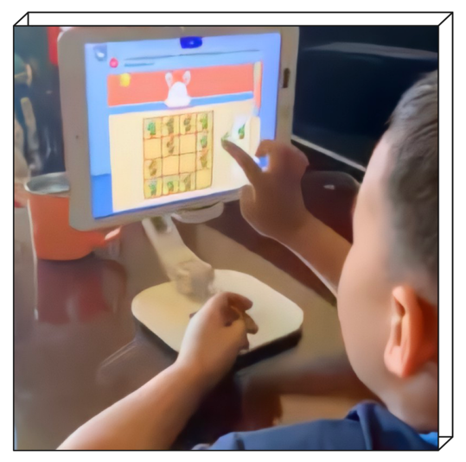

4.3.1 An introduction of Rob and his family
Rob was a 4-year and 9-month-old boy when I collected data from his family in August 2020. He lived with his parents in Shanghai, one of the most developed cities in China, known for its financial, business, and economic activities. Rob's mother was a full-time homemaker and was primarily responsible for organizing his activities and taking care of his everyday life. On the other hand, Rob's father spent more time on his business, often going on business trips during my data collection. Consequently, Rob's father did not participate in any of the video recordings of Rob's activities with touchscreen media in his family.
Moreover, due to the significant impact of COVID-19, Rob's activities mainly took place at home. As a result, I ultimately collected 13 videos, and home was the primary location where Rob used touchscreen media in his everyday life.

4.3.2 Rob’s touchscreen media use
Rob's touchscreen media use played a significant role in his everyday life, with the iPad and educational apps being his preferred devices and apps. Through the analysis of his behaviour with touchscreen devices, it was observed that he engaged in various activities such as playing educational games, drawing, and watching videos. These activities often involved using learning apps that allowed him to develop his skills in areas such as language, math, and problem-solving.
- Devices:
The collected data from 13 videos at Rob's home showed that the only touchscreen media device used by him was an iPad. During the interview with Rob's mother, she confirmed that the iPad had become the primary device for touchscreen media use in Rob's life. This finding highlights the importance of considering individual preferences and habits when studying children's use of technology, as it varies depending on the child's experiences and exposure to different devices. This information can also inform the development of effective interventions or policies aimed at promoting safe and healthy use of touchscreen devices among children.
Table 20. Transcript of WeChat interview with F3
Timestamp | Transcript
12:12 | Lan: Has the iPad already become the main device in Rob’s touchscreen media use?
12:16 | Rob's mum: Yes, I think so. He almost needs to use it everyday for playing, learning and watching videos.
12:29 | Lan: There are so many aspects involved in his use.
12:34 | Rob's mum: Exactly. There are so many apps on his iPad. (Laughs) He is an expert on using it! [...] This is the second iPad of his own, because the old version device is too old.
12:47 | Lan: Oh, really? Does that mean he has been using the iPad from a young age?
12:52 | Rob's mum: Yes. He started to use an iPad from probably when he was two.
During the interview with Rob's mother, it was revealed that Rob was able to proficiently use his iPad in the collected videos. He demonstrated the ability to operate the touchscreen independently without any support. Specifically, he was able to accomplish simple tasks such as opening the iPad by typing in the password, selecting apps, and tapping the screen to follow instructions. In addition, he was able to handle more complex tasks such as closing pop-up advertisements and browsing apps in the Appstore.
While Rob demonstrated a high level of proficiency with the iPad, his mother did mention that there were some instances where he required her assistance when using touchscreen media.

Table 21. Transcript of WeChat interview with F3
Timestamp | Transcript
17:12 | Rob’s mum: He needs me to download apps in App Store every time. He needs my help sometimes if the app needs to register an account to start. […] He needs me to re-connect Wi-Fi if the internet connection has problems.
Although Rob has only been observed using an iPad in collected videos, he also has experience of using mobile phones in his everyday life based on his mother’s comments.
Table 22. Transcript of WeChat interview with F3
Timestamp | Transcript
12:03 | Lan: Does Rob use any other touchscreen media devices, such as mobile phones, in his everyday life?
12:08 | Rob’s mum: He used my mobile phone sometimes.
12:13 | Lan: I didn’t see any activities with mobile phones in videos.
12:19 | Rob’s mum: Yes, he almost never used mobile phones during recording. Mobile phone use for him happens randomly and not commonly.
Based on the interview with Rob’s mother, it was revealed that Rob rarely uses mobile phones at home, especially when his iPad is available for him to use. Additionally, he does not have a specific preference for app selection and spaces when using mobile phones. Irregular use of mobile phones usually happens at specific times when his mother uses her mobile phone, such as when having a video call on a social media app with her friends and family or when using a navigation app during driving.
Rob’s mum: Apps on my phone basically are not downloaded for him. He sometimes picks and tries apps and functions, such as opening the camera. He may find out one or two apps he is interested in, but he doesn’t use it frequently, only once or twice.
Rob's behaviour in using mobile phones was found to be different from his behaviour in using iPads. Based on the collected videos and interviews with his mother, Rob's exploration of his mother's mobile phone was usually shorter than his use of an iPad. His mother's use of the phone could stimulate his interest, especially when she used apps that he had never seen or used on his own iPad. However, Rob rarely requested to use a mobile phone at home or outside, as confirmed by his mother in the interview. This was the reason why there were no specific apps for Rob on his mother's phone.
- Spaces:
Rob primarily used his iPad at home in the living room during the video recordings. Although his parents did not impose any specific requirements on space selection for his touchscreen media use at home, Rob was most often observed using his iPad on a side table in the living room. Out of the 13 videos recorded, 12 captured his engagement with the iPad in the living room, and the remaining video showed him using it in the dining room.
During the interview, Rob's mother revealed that although his touchscreen media use was only observed at home during the video collection phase, he also had experience using the iPad outside the home. Due to the lockdown restrictions, they did not go out frequently, but when they did, his mother often took the iPad with her in case they needed it. Rob's mother's comments highlighted the role of the iPad in managing children's behaviour in public spaces. She explained that the iPad provided a means of distraction for Rob, which helped him to sit quietly by her side without becoming restless or disruptive.
During this section of the interview, Rob's mother also discussed Rob's frequent use of a video app with pre-downloaded children's videos during outdoor touchscreen media use. She explained that this was due to the issue of internet connectivity and speed in outdoor environments. By preparing in advance with pre-downloaded content, Rob's mother could ensure that Rob had a positive and engaging touchscreen media experience even in settings where internet connectivity may be limited.
More details about Rob's app use and preferences are explained in the "app preference" section below. Overall, the analysis of Rob's touchscreen media use and his mother's interview provided valuable insights into the ways in which parents manage their children's touchscreen media use in public spaces and the importance of pre-downloaded content for a positive user experience.
- Times and duration:
Rob's weekly touchscreen media use is divided into two main categories: using the iPad for online courses related to math and English learning and other uses for entertainment and class assignments. Rob has a weekly time arrangement for 20 to 30 minutes during weekends for the former. During other times when there are no online courses, Rob uses touchscreen media almost every day. In the video recording phase, Rob's iPad use was observed during the daytime, which mainly involved online class assignments and entertainment app use.
Rob's mother also indicated during the interview that Rob has more opportunities to use touchscreen media during the daytime due to lockdown. Before lockdown, Rob needed to spend almost the whole day in kindergarten from 8am to 4:30pm, limiting his daily use of touchscreen media. However, during lockdown, Rob had more flexibility in using touchscreen media during the daytime, leading to a difference in frequency and duration of use. Despite this change, Rob's total daily touchscreen media use remains about one and a half hours on average.
During the video recording phase, it was observed that Rob spent an average of 10-15 minutes on a single touchscreen media session at home. In the interview with Rob's mother, she indicated that Rob's touchscreen media use at home is relatively unrestricted, in terms of app selection and timing. Since Rob's touchscreen media use generally occurs in the living room, it allows for greater parental supervision, especially during household chores. Although Rob's mother stated that she does not actively participate or monitor Rob's touchscreen media use, she generally limits his iPad use to 15 minutes per session, as she believes that prolonged use cause eye strain and fatigue.
- App preference and digital practices:
Huohuasiwei is an app designed for children aged 3 to 12, with a primary focus on cultivating mathematical thinking through online courses. According to Rob's mother, he participated in a 30-minute online class offered by this app every Saturday and Sunday from 10:00-10:30 in the morning. During these online classes, Rob, along with 4 or 5 other children, followed the guidance of a teacher to complete various tasks on the screen, which involved counting, classifying items, and arithmetic operations. In my video recordings, I captured Rob's use of this app in 4 out of 13 videos. The app's teaching and learning approach is primarily focused on the development of basic mathematical knowledge and logical thinking.
Furthermore, Guagualong English, an app designed for children between the ages of 2 to 8, was also frequently used by Rob during the data collection. In my video recordings, I observed Rob using this app in 6 out of 13 videos. The app features daily updated learning topics and themes, allowing children to learn new words and pronunciation through cartoon scenes and dialogues, where new words and related pictures are shown on the screen. Rob learned by watching these scenes and repeating the words out loud, and the app would then provide a score based on his pronunciation. Each learning theme takes approximately 20 minutes to complete, and the contents can be watched and learned repeatedly. According to Rob's mother, he utilised this app almost every day, at least once.
The multimodal analysis of Rob's use of these apps showed that his behaviour was primarily focused on learning, especially in the area of mathematics and language. The apps provide Rob with a structured and interactive learning environment, allowing him to develop his basic knowledge and skills in these areas. The detailed analysis of Rob's use of these apps provides valuable insights into children's learning behaviour on touchscreen devices and can inform future research and policy in this area.
In Rob's use of entertainment apps, three apps were observed to be used by him: Tencent Video, Diamond Painting Art Book, and Cute Sudoku. Tencent Video is a popular video streaming app in China that is operated by Tencent, one of the country's largest technology companies. The platform offers a diverse range of high-quality video content, encompassing genres such as movies, TV dramas, variety shows, documentaries, and sports events. In addition to catering to adult viewers, Tencent Video has developed a dedicated section for children's videos, featuring age-appropriate content such as educational videos, cartoons, and animated films.
During the observation period, one video captured Rob using Tencent Video to watch a children's show called ‘Deer Squad’ during dinner time on his iPad. In an interview with Rob's mother, it was revealed that Tencent Video is the most commonly used entertainment app by Rob, and he watches videos on it almost every day. Specifically, he enjoys watching popular children's shows such as ‘Paw Patrol’, ‘Deer Squad’, and ‘Peppa Pig’. As previously discussed in the section on ‘Spaces’, Rob not only uses the app at home but also outside the home with his parents. Rob's mother has expressed that Rob utilises the Tencent Video app extensively both within the home environment and outside of it. During the interview, Rob’s mother elaborated that she has also installed the Tencent Video app on her mobile phone, thereby enabling Rob to access video content at any time without the need to carry his iPad with him.
During the interview, Rob's mother also mentioned the ‘youth mode’ setting of Tencent Video, which is designed to provide a secure viewing experience for young viewers. This feature allows parents to create a password-protected mode that restricts access to certain types of content, such as those that contain violence or explicit sexual content, thus ensuring that their children are protected from potentially harmful material. Rob's mother primarily utilised the ‘youth mode’ setting to monitor Rob's use of the video app in terms of duration and timing.
The ‘youth mode’ setting reflects Rob's mother's attitude towards parental supervision and her concerns about children's exposure to potentially harmful material. It also highlights her efforts in establishing guidelines for Rob's use of touchscreen media. These aspects are discussed further in the next section on ‘Parents' Perspectives and Attitudes Towards Children's Touchscreen Media Use’.
During the video capture phase of the study, Rob's use of two gaming apps, Diamond Painting Art Book and Cute Sudoku, were observed on his iPad. The detailed analysis of Rob's language and non-verbal behaviour during the use of these apps highlighted the improvements he made in his skills.
Diamond Painting Art Book is a drawing app designed for children aged four and above. Rob demonstrated a high level of focus and concentration while using this app. He paused at various points in the app to carefully examine the numerical cues and gem placements in the picture. His fingers moved with precision and accuracy as he placed the gems in their corresponding positions. Rob's eyes were fixated on the screen, and he leaned in closer to the iPad screen to get a better view of the picture. His facial expression was serious, indicating his complete engagement in the task at hand.
In the Cute Sudoku app, Rob demonstrated his problem-solving and logical reasoning abilities. He frequently paused to examine the numbers in the puzzle and consider his next move. His fingers moved swiftly across the screen as he inputted his answers. Rob's eyes frequently shifted between the numbers on the screen and the possible locations for his next answer. He often furrowed his brow in concentration, indicating his intense focus on the game. Rob's use of this app allowed him to develop his critical thinking and reasoning skills.

4.3.3 Parents’ perspectives and attitude toward children’s touchscreen media use
This section examines Rob's mother's viewpoints on children's use of touchscreen media, based mainly on data from the interview. In general, Rob's mother was not overly strict about the amount of time Rob spent on his iPad or the specific apps he used in his everyday life. During the video data collection, Rob's behaviour demonstrated that he could choose his preferred apps to use without any interruptions from his parents.
In the interview, Rob's mother regarded the iPad primarily as an entertainment device for Rob's use, even when some learning purposes, such as math and English learning, were observed in the video data collection. Rob’s mother thought that educational apps Rob used in the video collection did not dominate his time using touchscreen media in everyday life. Moreover, her focus on downloading these apps was not centered on the acquisition and improvement of certain skills. Rather, she placed emphasis on Rob's interests and ensured that the selected learning apps integrated entertainment features with educational aims, allowing Rob to acquire skills while engaging in play.
Despite maintaining a relaxed attitude towards Rob's use of touchscreen media, Rob's mother still held concerns and anxieties towards his engagement with such media. This is in line with other parents' views and concerns about their children's engagement with touchscreen media. Concerns regarding the potential adverse effects of touchscreen media on children's health and development are often reported in the literature, and Rob's mother expressed her worries about the same issues. She was concerned about Rob's posture while using the iPad and the potential effects of screen time on his eyesight and physical development.
Initially, Rob's mother expressed concern regarding the potential detrimental effects on eye health resulting from extended use of touchscreen media. During the interview, Rob's mother mentioned that Rob rarely watched TV at home, but instead watched videos on his iPad every day. Furthermore, his video app consumption dominated his everyday touchscreen media use. Rob's mother believed that video app use posed a significant risk to children's eye health. During the interview, she mentioned that when Rob was two years old, he had to see a doctor due to excessive use of the video app and watching videos for several hours. This experience made Rob's mother realise the importance of parental supervision and she began regulating Rob's screen time to ensure that he used touchscreen media appropriately.
To address her concerns about eyesight issues, Rob's mother initially limited Rob's time spent using the iPad. She activated the "youth mode" setting within the video app, which restricted Rob's viewing time to no more than 15 minutes per session. If Rob wanted to watch videos on the iPad for longer, he needed his mother's password. This feature also prevented Rob from encountering inappropriate content, such as violent or sexual material. The issue of inappropriate content is another concern of Rob's mother, which is explained later.
Rob's mother played an important role in protecting his eyesight by helping him establish healthy habits for using touchscreen media. This involved maintaining a safe viewing distance and ensuring adequate illumination in the environment. To achieve this, Rob's mother provided a supportive stand for the iPad and a desk lamp on a side table in the living room. This stand helped Rob maintain the appropriate distance and sitting posture while using the iPad, while the lamp ensured that the screen was visible in adequately lit environments, even at night.
By encouraging Rob to use the iPad only in the living room, Rob's mother could more easily monitor his screen time and ensure that he was not using the device in bed or other inappropriate places. In fact, all 13 videos of Rob using the touchscreen media showed that he was operating the iPad at the side table in the living room with proper posture and viewing distance, as encouraged by his mother.
Rob's mother's efforts to promote healthy touchscreen media use reflect her belief in the importance of proper habits and supervision to protect children's eyesight and overall health. By establishing these habits early on, Rob will be more likely to maintain healthy habits in the future.
During Rob's use of touchscreen media, his mother expressed concerns about the potential risks associated with the appearance of inappropriate content. Specifically, Rob's mother was worried about the presence of inappropriate content in pop-up ads. She noted that such ads could contain images or videos that were not age-appropriate and could be distressing for children and parents. For example, Rob accidentally clicked on a TikTok ad that redirected him to the download page when he was using a game app. Although Rob cannot independently download apps on the iPad, his mother was worried that such pop-up ads could mislead children into accessing apps that were not age appropriate.
Moreover, Rob's mother was also concerned about the presence of inappropriate content, including violent and inappropriate language, in video apps. To address this concern, she set the 'youth mode' setting on the video app, which controlled the time and restricted Rob from accessing age-inappropriate content while using the video app. However, during the interview, Rob's mother acknowledged that some of the animated movies and children’s episodes that Rob watched contained some inappropriate scenes and images. Therefore, she believed that parental supervision and guidance were critical in mitigating the risks associated with inappropriate content in videos.
During the interview, Rob's mother emphasised the importance of establishing effective measures to safeguard children's media consumption. She suggested that stricter censorship and regulation are necessary to ensure that children's videos are suitable for their age and do not have any negative effects on their physical and mental health. Rob's mother expressed concern about the potential harm that inappropriate content can cause to children's development, and stressed the need for parents, media companies, and regulatory authorities to work together to promote age-appropriate content and protect children's well-being. Moreover, she believed that it is crucial to strike a balance between providing children with an enriching media experience and ensuring their safety and health. Rob's mother mentioned that parents have a responsibility to monitor and guide their children's media consumption, but also acknowledged the need for media companies and regulatory authorities to take responsibility for the content they produce and distribute.
To minimise the risks associated with inappropriate content exposure, Rob's mother utilised several measures. For example, she would check the age suitability of apps when downloading them for Rob and carefully review the content included in the app to ensure that the materials and design were appropriate for his age. Rob's mother's emphasis on parental supervision and guidance highlighted the need for parents to take an active role in their children's media use. Through daily checks on apps and content, parents can ensure that their children are using touchscreen media safely and responsibly. This proactive approach to media management and active monitoring can promote safe and healthy touchscreen media use, while also creating a relaxed and enjoyable media experience for children. This is why Rob's mother adopted a relaxed attitude and Rob has been observed to freely choose apps on his iPad at home.
Rob's mother expressed concerns about the potential risks of touchscreen media, but she also highlighted several advantages of these devices, including their portability and convenience, the potential to motivate and reward children, and the educational benefits during the pandemic.
During the interview, Rob's mother explained that the compact and lightweight nature of touchscreen-based devices, such as iPads, has made a significant impact on their everyday lives. She illustrated that Rob used his iPad to stay entertained in various contexts, such as watching videos and playing games while waiting at a store. Additionally, touchscreen media use can also provide Rob with a wide range of entertainment options, including educational apps and interactive games during long rides, making the journey more enjoyable.
Furthermore, Rob's mother explained how touchscreen media can play a crucial role in motivating her son. She strategically used the prospect of extra screen time as a reward for Rob's diligent efforts in various activities, such as practicing the piano. This approach not only reinforced positive behaviour but also ensured that Rob had an enjoyable and engaging experience during his learning process. At the same time, Rob's mother highlighted that Rob often displayed increased focus and dedication in his piano practice, driven by the desire to earn more screen time. By using this approach, Rob made notable progress in his musical skills while enjoying the benefits of touchscreen media in a controlled and responsible way.
Rob's mother also highlighted how touchscreen media can sometimes feel like a ‘nanny’ which helped her to manage the pressure of parental supervision. By allowing Rob to use his iPad during outdoor activities, she was able to take a break and engage in other tasks, such as chatting with friends or enjoying a meal. Similarly, when she needed to focus on her own tasks, such as work or attend meetings at home during the pandemic, she would let Rob play with his iPad for a while. However, she acknowledged the risk of exceeding the time limits she set for Rob's iPad use, and thus, she was conscious of monitoring his screen time to ensure that he did not exceed appropriate limits, especially when she used the iPad as a ‘nanny’.
Furthermore, Rob's mother viewed the iPad as a tool to cultivate her son's interests and provide him with diverse learning opportunities, rather than a conventional educational tool. She believed that using touchscreen media could help children learn and acquire skills in a fun and interactive way, particularly through educational apps that incorporated pictures, animations, and audio. During the pandemic, when Rob's kindergarten had no online activities for play and learning, she and Rob began exploring various educational apps. She aimed to stimulate Rob's curiosity and provide him with a foundation in various subjects, such as art, music, math and English, through his engagement with touchscreen media.
However, Rob's mother acknowledged that the entertainment-driven nature of educational apps made it difficult for children to engage in serious and in-depth learning. Therefore, she did not believe that educational apps could help Rob make significant progress in a particular skill. Instead, she encouraged Rob to use educational apps to help him discover his interests and as a supplementary tool for offline learning. She indicated that she would reduce the use of online course apps and focus on offline learning, such as music and art, which require more focus, interaction and guidance for deeper learning. She believed that offline courses would provide a more in-depth and immersive learning experience for Rob.
Although Rob's mother did not believe that educational apps prioritised education, I noticed during the video data collection of Rob's iPads use that the educational apps he used were paid apps, such as Huohuasiwei and Guagualong, whereas most of the game and entertainment apps were free. His mother believed that paying for educational apps was worthwhile, because they provided Rob with more learning opportunities and the potential to acquire skills.
Summary
This section analyses of Rob's behaviour and his mother's perspective on touchscreen media use in children's everyday lives. Rob has a rich experience with touchscreen media in his everyday life, with the iPad being his primary device whenever it is available. He proficiently uses his iPad for various activities, such as gaming, drawing and video apps. Rob's use extends to different settings, including restaurants, travel and outdoor environments, although due to the COVID-19 pandemic, his use was primarily observed at home.
Rob's touchscreen media use with various apps primarily involved into English, mathematics and games. His English and math learning involve online live courses scheduled each weekend. Due to the pandemic, his screen time increased to 2-3 hours a day. In Rob's family, his parents adopt a co-use mediation strategy, creating a relaxed and open environment where Rob can choose and explore touchscreen media based on his preferences and interests. However, some limitations are in place to ensure safe and valuable use. Specifically, Rob's mother does not restrict use time, frequency or app types but limits individual durations. Rob needs to have a break after around 30 minute use. Rob’s parents have also implemented 'youth mode' to restrict the time spent on video apps to protect his eye health. Additionally, his parents ensure that Rob uses the iPad with proper posture and in well-lit surroundings. At the same time, Rob's parents also monitor and filter inappropriate content, such as offensive language and violent material within apps.
In Rob's family, touchscreen media is seen as a valuable tool for cultivating interests and providing an enjoyable interactive experience. App downloads and use are driven by Rob's own preferences and interests. Despite the COVID-19 situation prompting exploration of numerous learning apps, Rob's mother emphasises that offline courses offer a formal and rigorous learning environment, which can lead to more meaningful progress. Touchscreen media and learning apps continue to serve as supplementary tools to support offline learning. The family plans to return to offline classes once the pandemic subsides.

4.4 summary
This chapter conducts an analysis of touchscreen media use among three different families, focusing on children's behaviour, parents' perspectives and mediation strategies. The analysis specifically examines children's behaviour regarding settings, devices, time duration, app preferences and digital practices. Additionally, it explores parents' attitudes, perspectives, concerns and mediation strategies regarding their children's touchscreen media use.
Across the three families, while children's touchscreen media use differs in some aspects, the iPad emerges as the primary device when accessible. Due to the COVID-19 pandemic, children's touchscreen media use predominantly occurred at home, leading to an increase in screen time. Parents have taken care to limit overall touchscreen media use to 2-3 hours per day, especially when physical activities have been reduced during the pandemic. The analysis reveals the involvement of various apps in children's touchscreen media use, with a focus on video apps, entertainment apps and the emergence of online live course apps to support remote learning during the pandemic. Children and parents have explored English, math, drawing and other educational activities using touchscreen media.
Parents' attitudes and perspectives vary among the families. They acknowledge that touchscreen media brings enjoyable experiences to children's play, learning and exploration activities. However, they recognise the need for limitations to maximise benefits and minimise harm in such use. Concerns primarily revolve around excessive screen time, which can lead to discomfort and visual issues, as well as exposure to inappropriate content, including in-app advertisements, aggressive language, violence and sexual content.
Furthermore, parents' differing definitions of touchscreen media devices, which reflect their perspectives. Two families view touchscreen media as a tool to provide entertainment experiences and cultivate interests for young children. It serves as an entertaining way but still requires formal offline courses to gain meaningful advancement. These two families create a relaxed and open environment that allows children to explore touchscreen media based on their preferences and choices, emphasising child-led use. In contrast, another family use touchscreen media as an educational tool to facilitate skill development. In this family, parents aim to shape their children's habits to use the iPad without entertainment apps, such as video and game apps, occasionally uses entertainment apps on mobile phones.
These three families employ various parental mediation strategies, including active, restrictive and co-use strategies, aligning with their unique perspectives. The next chapter will provide a more in-depth exploration of the findings, offering a robust discussion regarding children's behaviour, parents' perspectives and the employed parental mediation strategies. Furthermore, it will examine the interactive impact of these three essential components.

Findings and discussion

5.1 The COVID-19 pandemic affected the way children used touchscreen media during the study
I conducted research on the impact of the COVID-19 pandemic on children's touchscreen media use in China. The study involved the investigation of the media use patterns of children from three families. The results of the study indicated that the pandemic had a significant impact on children's behaviour in three key areas: time spent on media consumption, the types of apps used, and the settings in which media was consumed.
Specifically, the findings revealed that children's media use increased significantly during the pandemic. Furthermore, the types of apps they used shifted, with more emphasis on educational and entertainment apps. The study also showed that parents had to adjust the settings for media consumption due to the pandemic, such as setting limits on screen time or monitoring content more closely.
The implications of these findings are significant for families, educators, and policymakers. For example, parents may need to establish more structured routines and guidelines for their children's media use during pandemics. Educators could provide guidance to parents on how to optimise media use for educational purposes. Policymakers may also need to develop regulations and guidelines to support safe and healthy media use for children during pandemics.

5.1.1 COVID-19 impact on children's touchscreen time and duration
The COVID-19 pandemic has had a profound impact on the everyday lives of families worldwide. In particular, the increased amount of time children have spent at home has led to a significant shift in their media use habits (Sonnenschein, Grossman and Grossman, 2021). In this study, I investigated the effect of the COVID-19 pandemic on the time and duration of using touchscreen media among children from three families.
Prior to the pandemic, parents in my study reported that their children used iPads during the evening, night, and on weekends after returning from nursery. However, due to the pandemic, children began staying at home for most of the day and subsequently increased their use of touchscreen media during daytime hours. This finding is consistent with previous studies that have shown that children's screen time increases when they have extended periods of free time and decreased physical activity due to restrictions on outdoor activities and school closures (Banks et al., 2020; Weeland, Keijsers and Branje, 20211122).
As a result of the increased frequency of use, I investigated the amount of time children were spending on touchscreen media. Initially, three of the participating families believed that they were controlling their children's time on touchscreen media, as they had done prior to the pandemic, limiting it to 2 hours per day. However, during our interviews, these parents indicated that the time their children were spending on touchscreen media was likely exceeding 2 hours per day during the pandemic. They found it challenging to accurately track the time their children were spending because they were controlling the use at various times throughout the day. This finding is consistent with previous studies that have shown that parents have difficulty accurately monitoring and reporting their children's screen time (Dardanou et al., 2020).
Interestingly, parents from family 1 and family 3 acknowledged that they were unable to control their children's time spent on touchscreen media for 2 hours each day. Similarly, parents from family 2 reported that they lost control of their children's time on a few occasions. Therefore, the pandemic has shifted the pattern of touchscreen media use, making it challenging for parents to track their children's time spent on it. These findings highlight the importance of parents adopting new strategies to monitor their children's screen time and ensure that they are not exceeding the recommended time limit.
In light of these findings, it is necessary for parents to adjust their supervision strategies. Parents could, for instance, use software apps or parental control tools to limit the amount of time their children spend on touchscreen media (Houghton et al., 2020). Alternatively, parents could encourage their children to engage in physical activities or other non-screen-based activities to reduce their overall screen time (Lauricella et al., 2021). Finally, it is essential to educate parents on the potential negative impacts of excessive screen time on children's health and development and provide guidance on best practices for screen time management (AAP Council on Communications and Media, 2016).
In conclusion, the COVID-19 pandemic has led to a significant shift in children's media use habits, particularly in terms of the time and duration of touchscreen media use. Parents' ability to monitor and limit their children's screen time has been challenged, and new strategies must be adopted to ensure that children's overall screen time is within the recommended limits. The findings of this study provide critical insights into the impact of the pandemic on children's media use habits and highlight the need for continued research and intervention in this area.

5.1.2 The COVID-19 pandemic had an impact on the types of app children used
Through my research, I found that the COVID-19 pandemic has led to a significant increase in the use of touchscreen media among children, particularly in the form of app use (Banks et al., 2020). In response to the pandemic-induced lockdowns and school closures, children have turned to technology for entertainment and education (Koran, Berkmen and Adalıer, 2022). As a result, children have tried more apps than before and have shown a greater interest in exploring different types of apps, such as game apps, for entertainment purposes. Parents have also downloaded various apps to enhance their children's experiences in different aspects, such as education.
Specifically, my research found that many parents have downloaded online course apps to support their children's learning during the pandemic. With schools closed or functioning remotely, online course apps have provided access to a range of subjects, including language, music, painting and math. My research found that children from three families were using or had used online course apps for educational purposes.
Moreover, my research found that touchscreen media not only supports traditional learning but also fosters interests and helps children acquire new skills during the pandemic. A parent from family two reported that her daughter started learning drawing using an online course app from the start of the pandemic, and the results were impressive. In this way, online course apps have provided children with opportunities to explore new interests and develop new skills despite the challenging circumstances of the pandemic.
However, it is important to note that not all types of apps are created equal. While educational apps have provided children with valuable learning opportunities during the pandemic, some app types have raised concerns about their impact on children's wellbeing. For instance, excessive screen time and the use of social media apps have been associated with a range of negative outcomes, including poorer mental health, sleep disturbances, and reduced physical activity (Orben and Przybylski, 2019; Twenge and Campbell, 2019).
Furthermore, my research found that despite the availability of various app types, children still prefer to spend most of their time watching videos on their iPads. Children from two families in my research indicated that they spend most of their time on video apps. This finding is consistent with previous research, which has found that watching videos is one of the most popular activities among children using touchscreen devices (Ofcom, 2019).
In summary, the COVID-19 pandemic has led to an increased use of touchscreen media among children, with a greater interest in exploring various app types for entertainment and education. Parents have also adapted to this trend by exploring new ways of using touchscreen media to support their children's learning and interests. However, it is crucial to consider the potential risks associated with excessive screen time and certain app types, as well as the importance of maintaining a balance between online and offline activities in children's lives.

5.1.3 The COVID-19 pandemic had an impact on settings involvement in children’s touchscreen media use
The use of touchscreen media has become increasingly popular among children, especially during the COVID-19 pandemic when outdoor activities have been limited. In my research, I found that home settings were the primary environment for children's touchscreen media use among three families. Although some studies have shown that children's touchscreen use has extended beyond the home, including in educational settings like schools and nurseries, and in public areas like museums, libraries, and restaurants (Kucirkova, 2019), my research only recorded touchscreen use by a child from family 2 at a restaurant.
During the interviews, parents from the three families indicated that the pandemic had limited their children's opportunities to use touchscreen media outside the home. However, they also mentioned that even before the pandemic, the home was the main place for their children's touchscreen media use. They further indicated that their children's use of touchscreen media outside the home was mainly for entertainment purposes rather than academic or learning tasks. In line with my research, Kucirkova (2019) also reported that children's touchscreen use is mainly for entertainment purposes.
Although some studies have suggested that touchscreen media can be used for educational purposes, particularly in early years settings (Marsh, 2019; Taherian Kalati and Kim, 2022a), my research showed that the use of touchscreen media for educational purposes was not common among the families. The parents in my research believed that children were not capable of using touchscreen media independently and accessing its various features, which limited its use for educational purposes. Therefore, nurseries and teachers have not yet introduced touchscreen media into the classroom for educational purposes, such as supporting academic assignments, coursework, and e-learning.
However, the limited use of touchscreen media in educational settings among the families in my research suggests that more needs to be done to support the integration of touchscreen media into educational settings. This may involve providing guidance for parents and teachers on appropriate touchscreen media use and incorporating touchscreen media into classroom activities that support academic and learning tasks.
Moreover, while my research only recorded touchscreen uses by a child from family 2 at a restaurant, other studies have reported that touchscreen use is becoming increasingly common in public spaces like restaurants and cafes (Lumsden et al., 2016). This highlights the need for further research on the use of touchscreen media in different settings and its impact on children's development.
In conclusion, while touchscreen media use has become increasingly popular among children, its use for educational purposes remains limited. The COVID-19 pandemic has led to increased reliance on touchscreen media for entertainment and educational purposes, but more needs to be done to support its integration into educational settings. Further research is needed to better understand the impact of touchscreen media use in different settings and to provide guidance for parents and caregivers on appropriate use.

5.2 iPads Dominate children’s touchscreen media use
Through the analysis of children's touchscreen media use within three Chinese families, this research has uncovered several key findings. Despite being exposed to various touchscreen media and having extensive experience with touchscreen-based devices, iPads emerged as the preferred device across different settings. Another device commonly involved in touchscreen media use was the mobile phone; however, parents generally believed that children at a young age did not need to use mobile phones to communicate with others. Across the three families, children had their own iPads, and they incorporated them into various aspects of their everyday lives. This finding aligns with prior research indicating that children tend to prefer iPads over other devices due to their portability, ease of operation, and the favorable screen size for touch interactions (Marsh et al., 2018; Dashti and Habeeb, 2020).
Research has shown that children are increasingly becoming proficient and independent users of touchscreen media at a young age (James J. Ashton and Beattie, 2019; Bus, Neuman and Roskos, 2020). In this study, children from the three families demonstrated the ability to use iPads proficiently without parental support for navigation on the touchscreen. In some instances, one child was observed typing words on the screen while using social media apps to chat with family members. However, they still required parental assistance for some tasks, such as downloading apps and navigating through complex settings, including system configurations, internet connections and network switching.
This research primarily focused on observing children's iPad usage within their homes, and this focus was significantly influenced by the COVID-19 pandemic. Consequently, observations were limited primarily to home settings, with fewer conducted outside the home environment. Parents confirmed that their children predominantly used iPads within the confines of their homes, rather than in other locations. While some previous research suggests that children engage with touchscreen media across various settings, including homes, nurseries, schools and outdoor environments (Dardanou et al., 2020; Yang and Gunn, 2020), this study revealed that nursery activities rarely incorporated iPads or other electronic devices. Instead, physical play and traditional instructional methods remained the central focus of nursery activities. It is important to note that this research was conducted in developed areas where touchscreen media had not yet become a standard feature in early childhood education settings.
In cases where iPads were unavailable, children in my research occasionally used their parents' mobile phones. However, parents indicated that their mobile phones did not have specific apps tailored for children, and mobile phones were not the preferred choice for children's media consumption. Children occasionally expressed short-lived interest when parents used certain apps, such as map apps, game apps and video apps, on their mobile phones. Nevertheless, children did not engage in prolonged or frequent use of these apps. Parents mentioned that children sometimes watched videos on mobile phones when they were outside and iPads were not brought along. However, compared to their iPad usage, such occasional and sporadic mobile phone use was brief and random.

5.3 Parents expressed a range of perceived risks and advantages of their children’s touchscreen media use
The perceived risks and advantages of using touchscreen media were explored through the perspectives of parents from three families, who shared a consensus on certain concerns while also expressing different viewpoints. One major concern shared by all parents was the potential harm to their children's eye health due to prolonged use of touchscreen media. One major concern shared by parents regarding the use of touchscreen media is the potential harm to their children's eye health. As some studies indicated that prolonged exposure to screens has been linked to a range of eye problems, including eyestrain, dry eye, and myopia (short-sightedness) (Sheppard and Wolffsohn, 2018). This is especially concerning for children, who have developing eyes and are more vulnerable to the negative effects of screen time.
According to previous research, inappropriate content is the central question about children’s use with touchscreen media (Neumann, 2018). Parents in my study did not express significant concerns about this issue. This is because parents had taken measures to prevent their children from accessing such content, such as setting up ‘youth mode’ and monitoring the apps their children used. They believed that such measures could help reduce the risk of children being exposed to age-inappropriate content. Moreover, since the children in our study were aged between three and six, they were unable to download apps independently, giving parents greater control over what apps they could use.
Interestingly, the parents in my study held an open attitude towards using iPads and other touchscreen media. Moreover, they were more concerned with how their children used it and for what purposes, rather than whether they should use it or not. This is consistent with previous research that has highlighted the importance of considering the quality of children's screen time, rather than just the quantity (Neumann, Merchant and Burnett, 2020). Parents in my study believed that touchscreen media could offer various benefits for their children's learning and development, such as improving their fine motor skills, creativity, and cognitive abilities. However, they also expressed concerns about the impact of touchscreen media on their children's attention and focus, as well as the design of educational apps.
Some parents in my study were worried that educational apps on touchscreen media could be distracting for children and might not produce good results. They believed that the design of such apps, which incorporates sound, image, and music, could be more attractive to children than the actual content, and that some apps require parents to take more actions on the screen, further reducing children's attention and focus on the content. Similarly, some parents in my study preferred offline courses to online course apps, as they believed that the former offered higher quality instruction.
In conclusion, while parents in this study acknowledged the potential risks associated with touchscreen media use, they adopted measures to mitigate these risks and focused more on how their children used it, rather than whether they used it or not. This study sheds light on the complexities of parental attitudes towards touchscreen media use and the factors that influence their perceptions of the risks and benefits of such media.
Although parents have expressed concerns about the risks involved in using touchscreen media, they also acknowledge its apparent benefits for their children. One of the most significant benefits of using touchscreen media is its ability to integrate entertaining elements into learning. Parents in the study noted that their children enjoyed using the iPad to learn, particularly when the learning process was designed to resemble games. This finding is consistent with previous research, which has shown that gamification can enhance motivation and engagement in learning.
Another advantage of using touchscreen media is its portability, which allows parents to take it with them when they go outside. This feature has been observed to reduce children's nervousness and unsettledness in public places. Parents can use the device to distract their children and keep them engaged, particularly when they are waiting for food in restaurants or traveling in a car. This finding is consistent with previous research, which has shown that touchscreen-based devices can be useful in managing children's behaviour in public places (Dardanou et al., 2020).
However, some parents have expressed concerns about the potential risks associated with the use of touchscreen media. These risks include the impact on children's cognitive and social development, particularly their language and communication skills. Some parents also worry that the excessive use of touchscreen media could lead to addiction and affect their children's sleep patterns. Furthermore, there is limited research on the long-term effects of using touchscreen media on children's development.
In conclusion, while touchscreen media offers several advantages for children's learning and development, parents should be aware of the potential risks associated with its use. It is essential to use the device in moderation and to ensure that it does not interfere with children's language and social development. Future research should investigate the long-term effects of touchscreen media on children's cognitive and social development to provide more comprehensive guidelines for parents and educators.

5.4 Parents’ attitudes appear to influence children’s behaviour in terms of their touchscreen media use
Based on current research, it has been suggested that parents' attitudes towards the use of touchscreen media can significantly impact their children's behaviour (Barrett and Twycross, 2018; Dong, Cao and Li, 2020). Thus, parents have a crucial role in shaping their children's attitudes and behaviour towards touchscreen media. In this section, the attitudes of parents and children from three families are discussed individually. Specifically, this section examines the diverse attitudes of these families in terms of their purpose, beliefs, participation, and strategies towards touchscreen media use. Furthermore, this section further analyses how these attitudes and actions from parents have shaped their children's behaviour while using touchscreen media devices. Through this investigation, this section aims to explore the close relationship between children's behaviour and their parents' attitudes towards touchscreen media.

5.4.1 Parents’ attitudes can affect the types of app children use
In a study on the impact of parental attitudes on the types of apps children use, it was found that parents’ attitudes can potentially influence their children's choice of apps (Dardanou et al., 2020). The study examined the attitudes of parents from three different families towards their children's use of touchscreen media.
Parent from family 1 who mainly viewed the iPad as an entertainment tool for children. As a result, this parent tended to download more game and entertainment apps for their child. The parent focused solely on their child's interest in touchscreen use, rather than considering any potential learning purposes that some apps may have. For example, when the child was observed using a drawing app, the parent stated that they only thought of their child's enjoyment of drawing and not of improving their skills. While the child appeared to enjoy using the drawing app in the video and demonstrated high concentration during use, it is uncertain how much the app actually benefited their drawing skills.
On the other hand, parents from the other two families had different attitudes towards their children's use of touchscreen media. Family 2's parents emphasised educational apps and limited their children's access to entertainment apps. Family 3's parents balanced both entertainment and educational apps for their children, giving their children the freedom to choose which apps they wanted to use.
While Family 1's child did not take any online courses, they were observed using a literacy learning app a few times. The mother explained that she downloaded the app for her children at the start of the pandemic when other parents had recommended it to her. Although she did not force her child to use the app or have a strong purpose to encourage their use, the child still used it a few times. This highlights the role of social influence in app use. The mother's decision to download the app was influenced by other parents' recommendations, and her child's use of the app was also influenced by the mother's actions.
Family Two's parent holds a different perspective towards their children's use of touchscreen media compared to the other two families. This parent considers the iPad as a valuable learning tool and has a strong purpose for their child's use of touchscreen media. As a result, they have a strict attitude towards its use. Unlike the children in the other families, the child in Family Two does not play games or watch videos on the iPad. Instead, their iPad is exclusively for learning and educational purposes.
Furthermore, the child from Family Two uses the iPad differently than the children from the other families. Instead of using various types of apps, they only have educational apps on their iPad. While video apps are the most frequently used apps for the other two families' children, the child in Family Two was not allowed to watch videos on the iPad, and there are no video apps on their device.
The parents in Family Two have set strict guidelines for their child's iPad use, mainly for learning purposes. They only download educational apps on the device, and the child engages in various forms of learning, such as English, drawing, music, and literacy learning. Compared to the other two families, the child in Family Two used the iPad more seriously, like being in a real class. They even have a specific learning table in their room where they use the iPad with apps. The mother also participates in online courses on the iPad with the child. She insisted that parental participation supported their children’s learning on an iPad. As the research indicated, parents' participation in their children's media use can have positive effects, including promoting their language and literacy skills (Papadakis, Alexandraki and Zaranis, 2022).
Research has shown that parents' attitudes towards touchscreen media play a significant role in shaping their children's app use (Neumann, Merchant and Burnett, 2020). This strict attitude towards iPad use and the associated actions have led to the child in Family Two using only learning apps on their device. The mother rarely downloads game or entertainment apps on the iPad, reinforcing its role as a learning tool.
Similar to family one, the mother in family three viewed touchscreen media as having both entertaining and educational features. According to a study by Dardanou et al.(2020), parents often provide their children with touchscreen devices as a tool for learning and entertainment in most family household. Moreover, the mother in family three allowed her son to use various apps for different purposes, such as video watching, math and English learning, and game playing. Like family one, the mother provided a relaxed environment where the child could freely choose which apps to use, empowering the child to make independent decisions. Because of such attitude, the child has been observed use various apps involved in different feature in my research.
The mother in family three did not limit the types of apps the child could use, allowing him to explore various apps independently. This approach aligns with the concept of child autonomy, where parents provide opportunities for children to learn, discover, and make decisions on their own (Domoff et al., 2019). Based on such attitude from the parent, her son’s choice of apps in using was based on his own interest. Video apps were used more often than other types of apps in the child use with iPad.
In addition, the child in family three used some apps to participate in online courses through online learning platforms. These online courses provided opportunities for group communication and activities, which is particularly important during the pandemic when social distancing measures are in place. This approach aligns with the view that touchscreen media can provide new opportunities for children to learn and interact with others (Haddon, 2020b)
Furthermore, unlike family two, the parents in family three did not place a strong emphasis on formal education. Instead, they utilised learning apps as a means to cultivate their child's interests and facilitate group communication and activities. This approach aligns with the notion that children's learning experiences should be guided by their individual interests and passions (Taherian Kalati and Kim, 2022b). By creating avenues for children to delve into their interests and engage in group activities, parents in family three are actively fostering the growth of vital social and emotional skills.

5.4.2 Parents’ attitudes and belief affect their supervision strategies for children
In the study conducted on the touchscreen media use of children in three families, it was observed that parents' attitudes and beliefs determined the type of supervision strategies they employed. Family 1 and Family 3 displayed an open attitude towards their children's media use, granting them autonomy to choose their preferred apps. These parents' strategies were based on respecting their children's interests and preferences. They downloaded apps based on their children's interests and encouraged them to explore touchscreen media use. Although they did not strictly limit their children's choice of apps, they were mindful of the potential risks and took measures to mitigate them. For instance, Family 3 set the ‘youth mode’ to limit the time their children spent using video apps and provided an iPad stand to ensure their children used the device in good posture and at a safe distance. Additionally, they ensured that their children used the iPad in sufficient light to avoid any eye health issues.
On the other hand, Family 2 adopted a strict attitude towards their children's media use. This attitude influenced the parent to establish a rigid home guideline on the child's media use. The parent limited the time their child spent on the device and supervised their app use, ensuring that the content was appropriate and had educational value. The parent frequently checked the app content after downloading to guarantee that the apps used were beneficial for the child's development. Moreover, the parent supervised the online course content and even participated in the course due to their strong purpose.
The finding revealed that parents' attitudes and beliefs significantly affect the supervision strategies they employ towards their children's media use. The findings suggest that parents who adopt an open attitude towards their children's media use grant them autonomy to explore the device, download apps based on their interests and preferences, and encourage them to explore touchscreen media use. On the other hand, parents who adopt a strict attitude towards their children's media use establish rigid home guidelines, limit the time their children spend on the device, and supervise their app sue to ensure that the content is appropriate and has educational value.
The study's findings are consistent with previous research on parental mediation approach, which suggest that parents' attitudes and beliefs are crucial determinants of their mediation approach (Dardanou et al., 2020; Papadakis, Alexandraki and Zaranis, 2022). Moreover, the study highlights the importance of considering parents' attitudes and beliefs when developing effective media use guidelines for children.
The American Academy of Pediatrics (AAP) recommends that parents establish a Family Media Use Plan to help manage their children's media use. The plan should be tailored to the child's age, development, and needs, and should reflect the family's values and priorities (AAP, 2021). The AAP also recommends that parents supervise their children's media use, establish time limits, and monitor the content for age-appropriateness and educational value (AAP, 2016).
However, the study's findings suggest that the one-size-fits-all approach may not be effective in all cases. Parents' attitudes and beliefs may vary depending on cultural, social, and economic factors. Therefore, it is crucial to consider the context in which parents and children live and develop media use guidelines that reflect their unique needs and circumstances.
In conclusion, the study's findings suggest that parents' attitudes and beliefs significantly affect the supervision strategies they employ towards their children's media use. Effective media use guidelines should consider parents' attitudes and beliefs, as well as the child's age, development, and needs, and should reflect the family's values and priorities. The study's findings have important implications for researchers and practitioners in the field of child development and media use.

Conclusions and recommendations
This thesis aims to investigate the use of touchscreen media among children residing in urban areas in China, while also examining the attitudes, beliefs, and perspectives of their parents. The findings of this research were significant, as they shed light on the complex relationship between children’s behaviour and parental perspectives, all of which have an impact on children's behaviour of touchscreen media use.
This thesis examines children's device preferences, specifically their preference for iPads over other touchscreen-based devices such as smartphones. It reveals that iPads dominate children's use of touchscreen media. A significant factor contributing to this trend is the COVID-19 pandemic, an unprecedented global event that has had a substantial impact on children's screen time habits. The sudden shift to remote learning and the implementation of social isolation measures have resulted in a notable increase in the duration of touchscreen media use among children.
Moreover, the pandemic has brought about changes in the types of apps children use on their devices. Educational and online course apps have gained prominence as remote learning has become more prevalent. These apps are increasingly being utilised and explored in various learning activities. Consequently, the pandemic has influenced children's touchscreen media use, leading to shifts in their media consumption patterns. Moreover, as outdoor activities have been reduced due to the pandemic, the domestic environment has become the primary space for children to engage with various forms of media. However, the increased reliance on touchscreen media has raised concerns regarding excessive exposure. Consequently, parental supervision and mediation strategies have become essential to mitigate potential risks associated with prolonged touchscreen media use among children.
The study examined the various perceptions held by parents regarding their children's use of touchscreen media and found a wide range of opinions. These perceptions encompassed both concerns about potential risks and recognition of the benefits associated with touchscreen media. Parents expressed worries about their children's exposure to inappropriate content, the possibility of addiction and the potential negative impacts on their mental and physical development. Conversely, they also acknowledged the advantages of touchscreen media, such as its educational benefits, ability to foster skill development.
One particularly significant finding of this study is the substantial influence of parental attitudes on children's touchscreen media use. The study observed that parents' attitudes not only affected children’s behaviour in terms of the types of apps their children used but also influenced their own mediation strategies. Parents who held a more positive attitude towards touchscreen media were inclined to encourage their children to explore its use and adopt a less strict supervision approach. Conversely, parents with a more negative attitude limited the time and types of apps their children could use.
Furthermore, the definition of touchscreen media as a tool, as perceived by parents, had a significant impact on children’s media use behaviour. Parents who viewed touchscreen media as a beneficial educational tool were more likely to encourage their children to explore various educational content and apps in order to achieve educational goals. These parents also employed mediation strategies to limit the time and app use. They prioritised the use of apps with educational purposes over those designed for entertainment. In contrast, parents who considered touchscreen media primarily as an entertainment tool tended to have a more relaxed attitude towards their children’s use of it. They also expressed the belief that touchscreen media did not support in-depth learning.

6.1 Implications and recommendations
The findings of this study on Chinese children's touchscreen media use and their parents' perspectives hold several implications and recommendations for parents, families and researchers. These are critical to understanding and navigating the digital landscape in a constructive and beneficial way.
The study highlights the crucial role of parents and families in guiding their children's use of touchscreen media. Parents' attitudes, perceptions of risks and benefits, and their mediation strategies significantly influence the types of apps children use, their preferences, and the duration of their screen time. Therefore, it is recommended that parents adopt a balanced approach, recognising the entertaining, educational, and developmental advantages of touchscreen media, while also mitigating potential risks such as excessive screen time and exposure to inappropriate content. Parents should establish reasonable screen time limits, encourage children to explore diverse content, and avoid solely promoting educational apps while disregarding the entertainment aspect of touchscreen media. Furthermore, to facilitate children's experience with touchscreen media, parents should actively engage with their children, participating in their media consumption. This can be achieved through co-viewing and discussing media content together. Additionally, the development of parenting workshops and resources could provide valuable guidance on effective strategies for managing children's media use.
The findings of this study have significant implications for researchers in the field, emphasising the importance of considering various potential aspects that shape children's behaviour regarding touchscreen media use. By acknowledging the multifaceted influences that impact children's engagement with touchscreen media, researchers can enhance the validity and comprehensiveness of their research designs. Specifically, one implication is the necessity to incorporate a more diverse range of participants in future studies. By including children from different socioeconomic backgrounds and geographic locations, researchers can capture a broader spectrum of experiences and contexts in which touchscreen media are utilised. This approach would provide a more comprehensive understanding of how children's media use varies across different settings and cultural contexts. Additionally, considering the potential influence of socioeconomic factors on media access, use patterns and digital literacy, incorporating diverse participants would contribute to more inclusive and representative research practices.
This study emphasises the need for long-term investigations into the consequences of increased touchscreen media use on children's development. While the current study provides valuable insights into touchscreen media use and relevant digital practices, a comprehensive understanding of its potential impact on cognitive, social, and emotional development necessitates longitudinal research. By examining the sustained effects of touchscreen media use over time, researchers can gain valuable insights into its implications for children's well-being and learning outcomes.
In addition, it is crucial to consider the influence of the circumstance of COVID-19 on children's touchscreen media use patterns. The COVID-19 pandemic, in particular, has caused significant disruptions in the everyday routines and activities of children, leading to a heightened reliance on touchscreen-based devices for educational and entertainment purposes. Given the exceptional nature of these circumstances, it is essential for researchers to recognise and investigate the potential effects of these factors on children's habits and behaviour of touchscreen media use in the future.
Furthermore, considering the predominant use of iPads among the participants in this study, it is imperative for future research to investigate children's utilisation of a wider variety of devices. In light of the ongoing technological advancements, touchscreen devices have become increasingly diverse in children’s lives, encompassing not only tablets but also smartphones and other touchscreen-based tablets. By delving into children's interactions with various types of devices, researchers can gain a more comprehensive understanding of their media preferences and use patterns, as well as identify potential differences in the experiences and outcomes associated with each device.

6.2 Limitations of the research
The present study has provided valuable insights into touchscreen media use among Chinese children and their parents' perspectives. However, it is crucial to acknowledge several limitations. This chapter addresses these limitations, which are based on a reconsideration of the research questions, focus, methodology, design and findings. Additionally, the chapter offers suggestions for further research.
This research explores children's behaviours in the contemporary context of China. Three families from developed urban areas were invited to participate to support an in-depth exploration of children's touchscreen media use. Due to time constraints, the research has a limited scope, focusing on a small case study within this specific group. The primary aim of this research is to explore children's behaviour, with less emphasis on the influence of complex social and cultural contexts. Consequently, there is no comparative sample from rural environment or a broader spectrum of Chinese families. This limitation excludes an essential segment of the population and the unique social and cultural factors that influence touchscreen media use among children.
Furthermore, this research places a strong focus on the interactive impact of children's behaviour and parental perspectives. From a critical perspective, it explores how parents' viewpoints shape children's behaviour and how these behaviors, in turn, affect the application of parental mediation. Throughout the research, three children of different ages and genders were observed. Some observations indicate that older children use touchscreen media involve more educational purposes, which related to concerns about entrance examinations for primary school. Additionally, gender differences in preferences were observed, with girls showing more interest in painting apps and painting learning, while the boy tended to prefer competitive gaming apps. However, based on the research focus and questions, this research cannot have a further exploration on these aspects. For future research, it is worthwhile to explore in greater depth the behaviours and impact of touchscreen media use on children of different genders and age groups. Moreover, it is essential to recognise that families in urban and developed areas have different exposure levels to touchscreen media use and engage in various settings compared to families in rural areas. Future research should consider broader sampling strategies that encompass a more extensive range of Chinese families, regions, and socio-economic backgrounds, thus enriching our understanding of this multifaceted phenomenon.
In addition to the limitations base on research focus and design considerations, it is essential to acknowledge the specific and unique social context in which this study was conducted. The research took place under the exceptional circumstances of the COVID-19 pandemic. This context facilitated a novel approach to studying children and their families, allowing for the collection of intensive data due to increased screen time. It also enabled the exploration of new trends and diverse uses, including various apps, settings and forms of engagement. This unique context has introduced changes in children's behaviour regarding touchscreen media and has prompted children and families to discover new possibilities for its use. For instance, it was observed that children in China began to frequently use online live course apps, engaging in various learning activities through touchscreen media due to the reduction in in-person activities. This represents a new avenue for remote learning exploration. However, there remains a need for longitudinal and further research to comprehensively understand the long-term impact of COVID-19 on children's touchscreen media use.
Furthermore, it is essential to consider conducting research on children's behaviour and parental perspectives in the post-pandemic era. This will enable the investigation of the potential impacts and implications of this exceptional period and provide valuable insights into the lasting effects of this unique social context.

Bibliography

Abraham, B.K. and Selvan, D.A. (2022) ‘Exploring Parents’ Perceptions And Approaches To Parenting In The Digital Age’, Journal of Pharmaceutical Negative Results, pp. 3992–3998. Available at: https://doi.org/10.47750/pnr.2022.13.S10.486.
Adler, K., Salanterä, S. and Zumstein-Shaha, M. (2019) ‘Focus Group Interviews in Child, Youth, and Parent Research: An Integrative Literature Review’, International Journal of Qualitative Methods, 18, p. 1609406919887274. Available at: https://doi.org/10.1177/1609406919887274.
Alabdulaziz, M.S. (2021) ‘COVID-19 and the use of digital technology in mathematics education’, Education and Information Technologies, 26(6), pp. 7609–7633. Available at: https://doi.org/10.1007/s10639-021-10602-3.
Alderson, P. and Morrow, V. (2020) The Ethics of Research with Children and Young People: A Practical Handbook. SAGE.
Anderson, R. (2020) Security Engineering: A Guide to Building Dependable Distributed Systems. John Wiley & Sons.
Araiza-Alba, P. et al. (2020) ‘Children’s memory of a story experienced with virtual reality versus traditional media technology’, International Journal of Virtual Reality, 20(2), pp. 55–69. Available at: https://doi.org/10.20870/IJVR.2020.20.2.3151.
Arnott, L. et al. (2020) ‘Reflecting on three creative approaches to informed consent with children under six’, British Educational Research Journal, 46(4), pp. 786–810. Available at: https://doi.org/10.1002/berj.3619.
Ashton, James J. and Beattie, R.M. (2019) ‘Screen time in children and adolescents: is there evidence to guide parents and policy?’, The Lancet Child & Adolescent Health, 3(5), pp. 292–294. Available at: https://doi.org/10.1016/S2352-4642(19)30062-8.
Ashton, James J and Beattie, R.M. (2019) ‘Screen time in children and adolescents: is there evidence to guide parents and policy?’, The Lancet Child & Adolescent Health, 3(5), pp. 292–294. Available at: https://doi.org/10.1016/S2352-4642(19)30062-8.
Babvey, P. et al. (2021) ‘Using social media data for assessing children’s exposure to violence during the COVID-19 pandemic’, Child Abuse & Neglect, 116, p. 104747. Available at: https://doi.org/10.1016/j.chiabu.2020.104747.
Banks, S. et al. (2020) ‘Practising ethically during COVID-19: Social work challenges and responses’, International Social Work, 63(5), pp. 569–583. Available at: https://doi.org/10.1177/0020872820949614.
Barley, R. (2021) ‘Assent or Consent? Engaging Children in Ethnographic Study’, in G. Spencer (ed.) Ethics and Integrity in Research with Children and Young People. Emerald Publishing Limited (Advances in Research Ethics and Integrity), pp. 29–41. Available at: https://doi.org/10.1108/S2398-601820210000007007.
Barrett, D. and Twycross, A. (2018) ‘Data collection in qualitative research’, Evidence-Based Nursing, 21(3), pp. 63–64. Available at: https://doi.org/10.1136/eb-2018-102939.
Behnamnia, N. et al. (2020) ‘The effective components of creativity in digital game-based learning among young children: A case study’, Children and Youth Services Review, 116, p. 105227. Available at: https://doi.org/10.1016/j.childyouth.2020.105227.
Behnamnia, N., Kamsin, A. and Ismail, M.A.B. (2020) ‘The landscape of research on the use of digital game-based learning apps to nurture creativity among young children: A review’, Thinking Skills and Creativity, 37, p. 100666. Available at: https://doi.org/10.1016/j.tsc.2020.100666.
Benedetto, L. and Ingrassia, M. (2021) Parenting: Studies by an Ecocultural and Transactional Perspective. BoD – Books on Demand.
Berg, V. (2021) ‘A Game-Based Online Tool to Measure Cognitive Functions in Students’, International Journal of Serious Games, 8(1), pp. 71–87. Available at: https://doi.org/10.17083/ijsg.v8i1.410.
Berrezueta-Guzman, J. et al. (2020) ‘Smart-Home Environment to Support Homework Activities for Children’, IEEE Access, 8, pp. 160251–160267. Available at: https://doi.org/10.1109/ACCESS.2020.3020734.
Blumberg, F.C. et al. (2019) ‘Digital Games as a Context for Children’s Cognitive Development: Research Recommendations and Policy Considerations’, Social Policy Report, 32(1), pp. 1–33. Available at: https://doi.org/10.1002/sop2.3.
Bonello, M. and Meehan, B. (2019) ‘Transparency and Coherence in a Doctoral Study Case Analysis: Reflecting on the Use of NVivo within a “Framework” Approach’, The Qualitative Report [Preprint]. Available at: https://doi.org/10.46743/2160-3715/2019.3823.
Booton, S.A., Hodgkiss, A. and Murphy, V.A. (2023) ‘The impact of mobile application features on children’s language and literacy learning: a systematic review’, Computer Assisted Language Learning, 36(3), pp. 400–429. Available at: https://doi.org/10.1080/09588221.2021.1930057.
Bozzola, E. et al. (2022) ‘The Use of Social Media in Children and Adolescents: Scoping Review on the Potential Risks’, International Journal of Environmental Research and Public Health, 19(16), p. 9960. Available at: https://doi.org/10.3390/ijerph19169960.
Bus, A.G., Neuman, S.B. and Roskos, K. (2020) ‘Screens, Apps, and Digital Books for Young Children: The Promise of Multimedia’, AERA Open, 6(1), p. 2332858420901494. Available at: https://doi.org/10.1177/2332858420901494.
Cai, H. et al. (2020) ‘Once-for-All: Train One Network and Specialize it for Efficient Deployment’. arXiv. Available at: https://doi.org/10.48550/arXiv.1908.09791.
Cameron, C.A. et al. (2020) ‘A Day in the Life of young children drawing at home and at school’, International Journal of Early Years Education, 28(1), pp. 97–113. Available at: https://doi.org/10.1080/09669760.2019.1605887.
Cameron, C.A., Tapanya, S. and Gillen, J. (2006) ‘Swings, Hammocks, and Rocking Chairs as Secure Bases During A Day in the Life in Diverse Cultures’, Child and Youth Care Forum, 35(3), pp. 231–247. Available at: https://doi.org/10.1007/s10566-006-9011-1.
Carr, A. and Dempster, T. (2021) ‘Parent-child interactions during joint engagement with touchscreen technology: A comparison of younger versus older toddlers’, Infant Behavior and Development, 64, p. 101587. Available at: https://doi.org/10.1016/j.infbeh.2021.101587.
‘Children and parents: media use and attitudes report 2019’ (no date).
‘China Statistical Yearbook 2022 | China YearBooks’ (2022), 16 November. Available at: https://www.chinayearbooks.com/china-statistical-yearbook-2022.html (Accessed: 7 November 2023).
Christakis, D.A. et al. (2018) ‘How early media exposure may affect cognitive function: A review of results from observations in humans and experiments in mice’, Proceedings of the National Academy of Sciences, 115(40), pp. 9851–9858. Available at: https://doi.org/10.1073/pnas.1711548115.
Chuang, C. and Jamiat, N. (2023) ‘A systematic review on the effectiveness of children’s interactive reading applications for promoting their emergent literacy in the multimedia context’, Contemporary Educational Technology, 15(2), p. ep412. Available at: https://doi.org/10.30935/cedtech/12941.
Coady, M. (2010) ‘Ethics in early childhood research’, in Doing Early Childhood Research. 2nd edn. Routledge.
Courage, M.L. (2019) ‘From Print to Digital: The Medium Is Only Part of the Message’, in J.E. Kim and B. Hassinger-Das (eds) Reading in the Digital Age: Young Children’s Experiences with E-books: International Studies with E-books in Diverse Contexts. Cham: Springer International Publishing (Literacy Studies), pp. 23–43. Available at: https://doi.org/10.1007/978-3-030-20077-0_3.
Crepax, T. et al. (2022) ‘Information technologies exposing children to privacy risks: Domains and children-specific technical controls’, Computer Standards & Interfaces, 82, p. 103624. Available at: https://doi.org/10.1016/j.csi.2022.103624.
Crescenzi-Lanna, L. (2020) ‘Multimodal Learning Analytics research with young children: A systematic review’, British Journal of Educational Technology, 51(5), pp. 1485–1504. Available at: https://doi.org/10.1111/bjet.12959.
Cuevas-Parra, P. (2020) ‘Co-Researching With Children in the Time of COVID-19: Shifting the Narrative on Methodologies to Generate Knowledge’, International Journal of Qualitative Methods, 19, p. 1609406920982135. Available at: https://doi.org/10.1177/1609406920982135.
Cypress, B.S. (2019) ‘Data Analysis Software in Qualitative Research: Preconceptions, Expectations, and Adoption’, Dimensions of Critical Care Nursing, 38(4), p. 213. Available at: https://doi.org/10.1097/DCC.0000000000000363.
Dardanou, M. et al. (2020) ‘Use of touchscreen technology by 0–3-year-old children: Parents’ practices and perspectives in Norway, Portugal and Japan’, Journal of Early Childhood Literacy, 20(3), pp. 551–573. Available at: https://doi.org/10.1177/1468798420938445.
Dashti, F.A. and Habeeb, K.M. (2020) ‘Impact of Shared iPads on Kindergarten Students’ Collaboration and Engagement in Visual Storytelling Activities’, Early Childhood Education Journal, 48(4), pp. 521–531. Available at: https://doi.org/10.1007/s10643-020-01018-8.
Domoff, S.E. et al. (2019) ‘Development and validation of the Problematic Media Use Measure: A parent report measure of screen media “addiction” in children’, Psychology of Popular Media Culture, 8, pp. 2–11. Available at: https://doi.org/10.1037/ppm0000163.
Dong, C., Cao, S. and Li, H. (2020) ‘Young children’s online learning during COVID-19 pandemic: Chinese parents’ beliefs and attitudes’, Children and Youth Services Review, 118, p. 105440. Available at: https://doi.org/10.1016/j.childyouth.2020.105440.
Dore, R.A. et al. (2020) ‘Characteristics of Children’s Media Use and Gains in Language and Literacy Skills’, Frontiers in Psychology, 11. Available at: https://www.frontiersin.org/articles/10.3389/fpsyg.2020.02224 (Accessed: 15 May 2023).
Dorouka, P., Papadakis, S. and Kalogiannakis, M. (2020) ‘Tablets and apps for promoting robotics, mathematics, STEM education and literacy in early childhood education’, International Journal of Mobile Learning and Organisation, 14(2), pp. 255–274. Available at: https://doi.org/10.1504/IJMLO.2020.106179.
Du, Y. et al. (2021) ‘Connected Play in Virtual Worlds: Communication and Control Mechanisms in Virtual Worlds for Children and Adolescents’, Multimodal Technologies and Interaction, 5(5), p. 27. Available at: https://doi.org/10.3390/mti5050027.
Durgungoz, A. and Durgungoz, F.C. (2022) ‘“We are much closer here”: exploring the use of WhatsApp as a learning environment in a secondary school mathematics class’, Learning Environments Research, 25(2), pp. 423–444. Available at: https://doi.org/10.1007/s10984-021-09371-0.
Eales, L. et al. (2021) ‘Children’s screen and problematic media use in the United States before and during the COVID-19 pandemic’, Child Development, 92(5), pp. e866–e882. Available at: https://doi.org/10.1111/cdev.13652.
Egan, S.M. and Beatty, C. (2021) ‘To school through the screens: the use of screen devices to support young children’s education and learning during the COVID-19 pandemic’, Irish Educational Studies, 40(2), pp. 275–283. Available at: https://doi.org/10.1080/03323315.2021.1932551.
Eisen, S. and Lillard, A.S. (2020) ‘Learning from Apps and Objects: The Human Touch’, Mind, Brain, and Education, 14(1), pp. 16–23. Available at: https://doi.org/10.1111/mbe.12224.
Elias, N. and Lemish, D. (2021) ‘Parents’ Social Uses of Mobile Phones in Public Places: The Case of Eateries in Two National Contexts’, International Journal of Communication, 15(0), p. 19.
Ely, E. et al. (2021) ‘Navigating Children’s Use of Screen Media: An Analysis of Guidance Information Provided on Public Library Websites’, The Library Quarterly, 91(1), pp. 32–51. Available at: https://doi.org/10.1086/711633.
Eroğlu, G. et al. (2022) ‘A mobile app that uses neurofeedback and multi-sensory learning methods improves reading abilities in dyslexia: A pilot study’, Applied Neuropsychology: Child, 11(3), pp. 518–528. Available at: https://doi.org/10.1080/21622965.2021.1908897.
Fan, M., Antle, A.N. and Lu, Z. (2022) ‘The Use of Short-Video Mobile Apps in Early Childhood: a Case Study of Parental Perspectives in China’, Early Years, 0(0), pp. 1–15. Available at: https://doi.org/10.1080/09575146.2022.2038088.
Fernández-Sotos, P., Fernández-Caballero, A. and Rodriguez-Jimenez, R. (2020) ‘Virtual reality for psychosocial remediation in schizophrenia: a systematic review’, The European Journal of Psychiatry, 34(1), pp. 1–10. Available at: https://doi.org/10.1016/j.ejpsy.2019.12.003.
Flewitt, R. and Cowan, K. (2019) Valuing Young Children’s Signs of Learning: Observation and Digital Documentation of Play in Early Years Classrooms, The Froebel Trust: London, UK. Report. London, UK: The Froebel Trust, pp. 1–46. Available at: https://www.froebel.org.uk/research/observation-and-digital-documentation/ (Accessed: 15 May 2023).
Fontenelle-Tereshchuk, D. (2021) ‘“Homeschooling” and the COVID-19 Crisis: The Insights of Parents on Curriculum and Remote Learning’, Interchange, 52(2), pp. 167–191. Available at: https://doi.org/10.1007/s10780-021-09420-w.
Garg, R. (2021) ‘“Its Changes so Often”: Parental Non-/Use of Mobile Devices While Caring for Infants and Toddlers at Home’, Proceedings of the ACM on Human-Computer Interaction, 5(CSCW2), p. 369:1-369:26. Available at: https://doi.org/10.1145/3479513.
Gillen, J. et al. (2007) ‘“A day in the life”: advancing a methodology for the cultural study of development and learning in early childhood’, Early Child Development and Care, 177(2), pp. 207–218. Available at: https://doi.org/10.1080/03004430500393763.
Gillen, J. et al. (2019) A Day in the Digital Lives of Children Aged 0-3. Full report. : DigiLitEY ISCH COST Action 1410 Working Group 1: Digital Literacy in Homes and Communities. Report. Available at: https://eprints.lancs.ac.uk/id/eprint/134173/ (Accessed: 25 January 2024).
Gillen, J. (no date) ‘“A Day in the Life” – a still developing methodology’.
Gillen, J. and Cameron, C. (2010) International Perspectives on Early Childhood Research: A Day in the Life. Springer.
Gillen, J. and Hancock, R. (2006) ‘“A Day in the Life”: Exploring Eating Events Involving Two-Year-Old Girls and their Families in Diverse Communities’, Australasian Journal of Early Childhood, 31(4), pp. 23–29. Available at: https://doi.org/10.1177/183693910603100405.
Goncharova, M.S. and Gorbunova, I.B. (2020) ‘Mobile Technologies in the Process of Teaching Music Theory’, Propósitos y Representaciones, pp. e705–e705. Available at: https://doi.org/10.20511/pyr2020.v8nSPE3.705.
Gong, N. et al. (2022) ‘Barriers to family intervention to promote child and adolescent vision health: A qualitative study based on community practice in China’, Journal of Pediatric Nursing, 66, pp. e76–e81. Available at: https://doi.org/10.1016/j.pedn.2022.05.007.
Gonzales, G. (2022) ‘Mapping Pupil’s Learning Progression Using Hand Manipulatives and Touch Screen Applications: Implications to Post-COVID-19 New Normal’, Education Research International, 2022, p. e9976083. Available at: https://doi.org/10.1155/2022/9976083.
Gou, H. and Dezuanni, M. (2018) ‘Towards understanding young children’s digital lives in China and Australia’, 26(2). Available at: https://doi.org/10.3916/C57-2018-08.
Goundar, M.S. et al. (2023) ‘Mobile learning for preschoolers: a systematic literature review’, International Journal of Mobile Learning and Organisation, 17(1–2), pp. 303–320. Available at: https://doi.org/10.1504/IJMLO.2023.128347.
Gözüm, A.İ.C. and Kandır, A. (2021) ‘Digital games pre-schoolers play: parental mediation and examination of educational content’, Education and Information Technologies, 26(3), pp. 3293–3326. Available at: https://doi.org/10.1007/s10639-020-10382-2.
Griffith, S.F. et al. (2022) ‘Making the best of app use: The impact of parent-child co-use of interactive media on children’s learning in the U.S’, Journal of Children and Media, 16(2), pp. 271–287. Available at: https://doi.org/10.1080/17482798.2021.1970599.
Growing up with Google: How children’s understanding and use of internet‐based devices relates to cognitive development - Danovitch - 2019 - Human Behavior and Emerging Technologies - Wiley Online Library (no date). Available at: https://onlinelibrary-wiley-com.sheffield.idm.oclc.org/doi/full/10.1002/hbe2.142 (Accessed: 14 May 2023).
Guerrero, M.D. et al. (2019) ‘Screen time and problem behaviors in children: exploring the mediating role of sleep duration’, International Journal of Behavioral Nutrition and Physical Activity, 16(1), p. 105. Available at: https://doi.org/10.1186/s12966-019-0862-x.
Hackett, A. (2017) ‘Parents as researchers: collaborative ethnography with parents’, Qualitative Research, 17(5), pp. 481–497. Available at: https://doi.org/10.1177/1468794116672913.
Hadders-Algra, M. (2020) ‘Interactive media use and early childhood development,’ Jornal de Pediatria, 96, pp. 273–275. Available at: https://doi.org/10.1016/j.jped.2019.05.001.
Haddon, L. (2020a) ‘The Domestication of Touchscreen Technologies in Families with Young Children’, in The Routledge Companion to Digital Media and Children. Routledge.
Haddon, L. (2020b) ‘The Domestication of Touchscreen Technologies in Families with Young Children’, in The Routledge Companion to Digital Media and Children. Routledge.
Haleem, A. et al. (2022) ‘Understanding the role of digital technologies in education: A review’, Sustainable Operations and Computers, 3, pp. 275–285. Available at: https://doi.org/10.1016/j.susoc.2022.05.004.
Halpin, S.J. et al. (2021) ‘Postdischarge symptoms and rehabilitation needs in survivors of COVID-19 infection: A cross-sectional evaluation’, Journal of Medical Virology, 93(2), pp. 1013–1022. Available at: https://doi.org/10.1002/jmv.26368.
Hammer, M., Scheiter, K. and Stürmer, K. (2021) ‘New technology, new role of parents: How parents’ beliefs and behavior affect students’ digital media self-efficacy’, Computers in Human Behavior, 116, p. 106642. Available at: https://doi.org/10.1016/j.chb.2020.106642.
Harper, C. et al. (2019) ‘Exploring Hospital Wayfinding Systems: Touchscreen Kiosks, Apps and Environmental Cues’, Proceedings of the International Symposium on Human Factors and Ergonomics in Health Care, 8(1), pp. 172–175. Available at: https://doi.org/10.1177/2327857919081042.
He, A.-Q. et al. (2022) ‘Investigation of children’s habits of smartphone usage and parental awareness of myopia control in underdeveloped areas of China’, International Journal of Ophthalmology, 15(10), pp. 1691–1698. Available at: https://doi.org/10.18240/ijo.2022.10.19.
Hoel, T. and Tønnessen, E.S. (2019) ‘Organizing Shared Digital Reading in Groups: Optimizing the Affordances of Text and Medium’, AERA Open, 5(4), p. 2332858419883822. Available at: https://doi.org/10.1177/2332858419883822.
Hood, R. et al. (2021) ‘The association of mobile touch screen device use with parent-child attachment: a systematic review’, Ergonomics, 64(12), pp. 1606–1622. Available at: https://doi.org/10.1080/00140139.2021.1948617.
Hoy, M.G., Fox, A.K. and Deitz, G.D. (2023) ‘Parents’ perceptions of the sensitivity of their children’s personal information and willingness to share with social media marketers: Implications for sharenting’, Journal of Consumer Affairs, 57(1), pp. 346–356. Available at: https://doi.org/10.1111/joca.12502.
Huber, B., Highfield, K. and Kaufman, J. (2018) ‘Detailing the digital experience: Parent reports of children’s media use in the home learning environment’, British Journal of Educational Technology, 49(5), pp. 821–833. Available at: https://doi.org/10.1111/bjet.12667.
Huot, S. and Laliberte Rudman, D. (2015) ‘Extending Beyond Qualitative Interviewing to Illuminate the Tacit Nature of Everyday Occupation: Occupational Mapping and Participatory Occupation Methods’, OTJR: Occupational Therapy Journal of Research, 35(3), pp. 142–150. Available at: https://doi.org/10.1177/1539449215576488.
Huovinen, E. and Rautanen, H. (2020) ‘Interaction affordances in traditional instruments and tablet computers: A study of children’s musical group creativity’, Research Studies in Music Education, 42(1), pp. 94–112. Available at: https://doi.org/10.1177/1321103X18809510.
Huser, C., Dockett, S. and Perry, B. (2022) ‘Young children’s assent and dissent in research: agency, privacy and relationships within ethical research spaces’, European Early Childhood Education Research Journal, 30(1), pp. 48–62. Available at: https://doi.org/10.1080/1350293X.2022.2026432.
Jackson-Hollis, V. (2019) ‘Qualitative research with primary school-aged children: ethical and practical considerations of evaluating a safeguarding programme in schools’, Journal of Children’s Services, 14(3), pp. 194–204. Available at: https://doi.org/10.1108/JCS-01-2019-0005.
Jusienė, R. et al. (2020) ‘Executive function and screen-based media use in preschool children’, Infant and Child Development, 29(1), p. e2173. Available at: https://doi.org/10.1002/icd.2173.
Keshta, I. and Odeh, A. (2021) ‘Security and privacy of electronic health records: Concerns and challenges’, Egyptian Informatics Journal, 22(2), pp. 177–183. Available at: https://doi.org/10.1016/j.eij.2020.07.003.
Kirkorian, H.L. et al. (2020) ‘Drawing across media: A cross-sectional experiment on preschoolers’ drawings produced using traditional versus electronic mediums’, Developmental Psychology, 56, pp. 28–39. Available at: https://doi.org/10.1037/dev0000825.
Konca, A.S. (2022) ‘Digital Technology Usage of Young Children: Screen Time and Families’, Early Childhood Education Journal, 50(7), pp. 1097–1108. Available at: https://doi.org/10.1007/s10643-021-01245-7.
Konken, L.C. and Howlett, M. (2022) ‘When “Home” Becomes the “Field”: Ethical Considerations in Digital and Remote Fieldwork’, Perspectives on Politics, pp. 1–14. Available at: https://doi.org/10.1017/S1537592722002572.
Koran, N., Berkmen, B. and Adalıer, A. (2022) ‘Mobile technology usage in early childhood: Pre-COVID-19 and the national lockdown period in North Cyprus’, Education and Information Technologies, 27(1), pp. 321–346. Available at: https://doi.org/10.1007/s10639-021-10658-1.
Kostyrka-Allchorne, K., Cooper, N.R. and Simpson, A. (2017) ‘The relationship between television exposure and children’s cognition and behaviour: A systematic review’, Developmental Review, 44, pp. 19–58. Available at: https://doi.org/10.1016/j.dr.2016.12.002.
Krause, P. et al. (2021) ‘COVID-19 and Fieldwork: Challenges and Solutions’, PS: Political Science & Politics, 54(2), pp. 264–269. Available at: https://doi.org/10.1017/S1049096520001754.
Kruszewska, A., Nazaruk, S. and Szewczyk, K. (2022) ‘Polish teachers of early education in the face of distance learning during the COVID-19 pandemic – the difficulties experienced and suggestions for the future’, Education 3-13, 50(3), pp. 304–315. Available at: https://doi.org/10.1080/03004279.2020.1849346.
Kucirkova, N. (2018) ‘Personalised Learning with Digital Technologies at Home and School: Where is Children’s Agency?’, in G. Oakley (ed.) Mobile Technologies in Children’s Language and Literacy. Emerald Publishing Limited, pp. 133–153. Available at: https://doi.org/10.1108/978-1-78714-879-620181009.
Kucirkova, N. (2019) ‘Children’s Reading With Digital Books: Past Moving Quickly to the Future’, Child Development Perspectives, 13(4), pp. 208–214. Available at: https://doi.org/10.1111/cdep.12339.
Kumpulainen, K., Sairanen, H. and Nordström, A. (2020) ‘Young children’s digital literacy practices in the sociocultural contexts of their homes’, Journal of Early Childhood Literacy, 20(3), pp. 472–499. Available at: https://doi.org/10.1177/1468798420925116.
Kyritsi, K. (2019) ‘Doing Research With Children: Making Choices on Ethics and Methodology That Encourage Children’s Participation’, Journal of Childhood Studies, pp. 39–50. Available at: https://doi.org/10.18357/jcs442201919059.
Lauricella, A.R., Herdzina, J. and Robb, M. (2020) ‘Early childhood educators’ teaching of digital citizenship competencies’, Computers & Education, 158, p. 103989. Available at: https://doi.org/10.1016/j.compedu.2020.103989.
Lawrence, A. and Choe, D.E. (2021) ‘Mobile Media and Young Children’s Cognitive Skills: A Review’, Academic Pediatrics, 21(6), pp. 996–1000. Available at: https://doi.org/10.1016/j.acap.2021.01.007.
Lee, A.Y.L. (2020) ‘The Development of Media Literacy in Chinese Societies’, in The Handbook of Media Education Research. John Wiley & Sons, Ltd, pp. 309–325. Available at: https://doi.org/10.1002/9781119166900.ch29.
Li, H., Luo, W. and He, H. (2022) ‘Association of Parental Screen Addiction with Young Children’s Screen Addiction: A Chain-Mediating Model’, International Journal of Environmental Research and Public Health, 19(19), p. 12788. Available at: https://doi.org/10.3390/ijerph191912788.
Li, J., Brar, A. and Roihan, N. (2021) ‘The use of digital technology to enhance language and literacy skills for Indigenous people: A systematic literature review’, Computers and Education Open, 2, p. 100035. Available at: https://doi.org/10.1016/j.caeo.2021.100035.
Lin, H.-P. et al. (2020) ‘Prolonged touch screen device usage is associated with emotional and behavioral problems, but not language delay, in toddlers’, Infant Behavior and Development, 58, p. 101424. Available at: https://doi.org/10.1016/j.infbeh.2020.101424.
Liu, C. and Hwang, G.-J. (2023) ‘Roles and research trends of touchscreen mobile devices in early childhood education: review of journal publications from 2010 to 2019 based on the technology-enhanced learning model’, Interactive Learning Environments, 31(3), pp. 1683–1702. Available at: https://doi.org/10.1080/10494820.2020.1855210.
Liu, J., Peng, P. and Luo, L. (2020) ‘The Relation Between Family Socioeconomic Status and Academic Achievement in China: A Meta-analysis’, Educational Psychology Review, 32(1), pp. 49–76. Available at: https://doi.org/10.1007/s10648-019-09494-0.
Livingstone, S. et al. (2018) In the digital home, how do parents support their children and who supports them? London, UK: Department of Media and Communications, The London School of Economics and Political Science. Available at: http://blogs.lse.ac.uk/parenting4digitalfuture/ (Accessed: 15 May 2023).
Livingstone, S. et al. (2019) ‘Comparative global knowledge about the use of digital technologies for learning among young children’, in The Routledge Handbook of Digital Literacies in Early Childhood. Routledge.
Livingstone, S. and Blum-Ross, A. (2020) Parenting for a Digital Future: How Hopes and Fears about Technology Shape Children’s Lives. Oxford University Press.
Livingstone, S., Mascheroni, G. and Staksrud, E. (2018) ‘European research on children’s internet use: Assessing the past and anticipating the future’, New Media & Society, 20(3), pp. 1103–1122. Available at: https://doi.org/10.1177/1461444816685930.
Livingstone, S., Stoilova, M. and Nandagiri, R. (2019) Children’s data and privacy online: growing up in a digital age: an evidence review. London, UK: London School of Economics and Political Science, Department of Media and Communications. Available at: http://www.lse.ac.uk/my-privacy-uk (Accessed: 15 May 2023).
Luo, W., Berson, I.R. and Berson, M.J. (2023) ‘A Social Media Analysis of the Experiences of Chinese Early Childhood Educators and Families with Young Children during COVID-19’, Sustainability, 15(3), p. 2560. Available at: https://doi.org/10.3390/su15032560.
Ma, Z. et al. (2021) ‘The impact of COVID-19 pandemic outbreak on education and mental health of Chinese children aged 7–15 years: an online survey’, BMC Pediatrics, 21(1), p. 95. Available at: https://doi.org/10.1186/s12887-021-02550-1.
Maba, A. (2020) ‘Computer-aided music education and musical creativity’, Journal of Human Sciences, 17(3), pp. 822–830. Available at: https://doi.org/10.14687/jhs.v17i3.5908.
Macias, C. and Choi, K. (2021) ‘Preschoolers’ beliefs about media technologies: The role of family income’, Human Behavior and Emerging Technologies, 3(4), pp. 572–584. Available at: https://doi.org/10.1002/hbe2.278.
Marsh, J. (2016) ‘THE DIGITAL LITERACY SKILLS AND COMPETENCES OF CHILDREN OF PRE-SCHOOL AGE’, Media Education, 7(2), pp. 178–195.
Marsh, J. et al. (2018) ‘Play and creativity in young children’s use of apps’, British Journal of Educational Technology, 49(5), pp. 870–882. Available at: https://doi.org/10.1111/bjet.12622.
Marsh, J. (2019) ‘Researching the digital literacy and multimodal practices of young children: A European agenda for change’, in The Routledge Handbook of Digital Literacies in Early Childhood. Routledge.
Matera, A.G. and Wang, Z. (2014) ‘A day in the life of the spliceosome’, Nature Reviews Molecular Cell Biology, 15(2), pp. 108–121. Available at: https://doi.org/10.1038/nrm3742.
Mayne, F., Howitt, C. and Rennie, L.J. (2018) ‘A hierarchical model of children’s research participation rights based on information, understanding, voice, and influence’, European Early Childhood Education Research Journal, 26(5), pp. 644–656. Available at: https://doi.org/10.1080/1350293X.2018.1522480.
McGeown, S. et al. (2020) ‘Understanding reading motivation across different text types: qualitative insights from children’, Journal of Research in Reading, 43(4), pp. 597–608. Available at: https://doi.org/10.1111/1467-9817.12320.
McNeill, J. et al. (2019) ‘Longitudinal Associations of Electronic Application Use and Media Program Viewing with Cognitive and Psychosocial Development in Preschoolers’, Academic Pediatrics, 19(5), pp. 520–528. Available at: https://doi.org/10.1016/j.acap.2019.02.010.
Meyer, M. et al. (2021) ‘How educational are “educational” apps for young children? App store content analysis using the Four Pillars of Learning framework’, Journal of Children and Media, 15(4), pp. 526–548. Available at: https://doi.org/10.1080/17482798.2021.1882516.
Montag, C. and Elhai, J.D. (2020) ‘Discussing digital technology overuse in children and adolescents during the COVID-19 pandemic and beyond: On the importance of considering Affective Neuroscience Theory’, Addictive Behaviors Reports, 12, p. 100313. Available at: https://doi.org/10.1016/j.abrep.2020.100313.
Morse, J.M. et al. (2002) ‘Verification Strategies for Establishing Reliability and Validity in Qualitative Research’, International Journal of Qualitative Methods, 1(2), pp. 13–22. Available at: https://doi.org/10.1177/160940690200100202.
Moving beyond tracing: The nature, availability and quality of digital apps to support children’s writing - Margaret Quinn, Marie Bliss, 2021 (no date). Available at: https://journals.sagepub.com/doi/abs/10.1177/1468798419838598?journalCode=ecla (Accessed: 14 May 2023).
Muir, K. and Joinson, A. (2020) ‘An Exploratory Study Into the Negotiation of Cyber-Security Within the Family Home’, Frontiers in Psychology, 11. Available at: https://www.frontiersin.org/articles/10.3389/fpsyg.2020.00424 (Accessed: 15 May 2023).
Naslund, J.A. et al. (2020) ‘Social Media and Mental Health: Benefits, Risks, and Opportunities for Research and Practice’, Journal of Technology in Behavioral Science, 5(3), pp. 245–257. Available at: https://doi.org/10.1007/s41347-020-00134-x.
Neophytou, E., Manwell, L.A. and Eikelboom, R. (2021) ‘Effects of Excessive Screen Time on Neurodevelopment, Learning, Memory, Mental Health, and Neurodegeneration: a Scoping Review’, International Journal of Mental Health and Addiction, 19(3), pp. 724–744. Available at: https://doi.org/10.1007/s11469-019-00182-2.
Neumann, M. et al. (2019) ‘An Evaluation of Mandarin Learning Apps Designed for English Speaking Pre-schoolers’, Journal of Interactive Learning Research, 30(2), pp. 167–193.
Neumann, M.M. (2014) ‘An examination of touch screen tablets and emergent literacy in Australian pre-school children’, Australian Journal of Education, 58(2), pp. 109–122. Available at: https://doi.org/10.1177/0004944114523368.
Neumann, M.M. (2018) ‘Using tablets and apps to enhance emergent literacy skills in young children’, Early Childhood Research Quarterly, 42, pp. 239–246. Available at: https://doi.org/10.1016/j.ecresq.2017.10.006.
Neumann, M.M. et al. (2019) ‘Assessment and Technology: Mapping Future Directions in the Early Childhood Classroom’, Frontiers in Education, 4. Available at: https://www.frontiersin.org/articles/10.3389/feduc.2019.00116 (Accessed: 15 May 2023).
Neumann, M.M. (2020) ‘Social Robots and Young Children’s Early Language and Literacy Learning’, Early Childhood Education Journal, 48(2), pp. 157–170. Available at: https://doi.org/10.1007/s10643-019-00997-7.
Neumann, M.M. et al. (2022) ‘Exploring the social media networks of primary school children’, Education 3-13, 0(0), pp. 1–15. Available at: https://doi.org/10.1080/03004279.2022.2144404.
Neumann, M.M., Merchant, G. and Burnett, C. (2020) ‘Young children and tablets: the views of parents and teachers’, Early Child Development and Care, 190(11), pp. 1750–1761. Available at: https://doi.org/10.1080/03004430.2018.1550083.
Neumann, M.M., Worrall, S. and Neumann, D.L. (2019) ‘Validation of an Expressive and Receptive Tablet Assessment of Early Literacy’, Journal of Research on Technology in Education, 51(4), pp. 326–341. Available at: https://doi.org/10.1080/15391523.2019.1637800.
Nikken, P. (2019) ‘Parents’ Instrumental use of Media in Childrearing: Relationships with Confidence in Parenting, and Health and Conduct Problems in Children’, Journal of Child and Family Studies, 28(2), pp. 531–546. Available at: https://doi.org/10.1007/s10826-018-1281-3.
O’Brien, B.A., Seward, R. and Zhang, D. (2022) ‘Multisensory Interactive Digital Text for English Phonics Instruction with Bilingual Beginning Readers’, Education Sciences, 12(11), p. 750. Available at: https://doi.org/10.3390/educsci12110750.
Ochoa, W. and Reich, S.M. (2020) ‘Parents’ Beliefs About the Benefits and Detriments of Mobile Screen Technologies for Their Young Children’s Learning: A Focus on Diverse Latine Mothers and Fathers’, Frontiers in Psychology, 11. Available at: https://www.frontiersin.org/articles/10.3389/fpsyg.2020.570712 (Accessed: 15 May 2023).
Oliemat, E., Ihmeideh, F. and Alkhawaldeh, M. (2018a) ‘The use of touch-screen tablets in early childhood: Children’s knowledge, skills, and attitudes towards tablet technology’, Children and Youth Services Review, 88, pp. 591–597. Available at: https://doi.org/10.1016/j.childyouth.2018.03.028.
Oliemat, E., Ihmeideh, F. and Alkhawaldeh, M. (2018b) ‘The use of touch-screen tablets in early childhood: Children’s knowledge, skills, and attitudes towards tablet technology’, Children and Youth Services Review, 88, pp. 591–597. Available at: https://doi.org/10.1016/j.childyouth.2018.03.028.
Orben, A. and Przybylski, A.K. (2019) ‘Screens, Teens, and Psychological Well-Being: Evidence From Three Time-Use-Diary Studies’, Psychological Science, 30(5), pp. 682–696. Available at: https://doi.org/10.1177/0956797619830329.
Pandya, A. and Lodha, P. (2021) ‘Social Connectedness, Excessive Screen Time During COVID-19 and Mental Health: A Review of Current Evidence’, Frontiers in Human Dynamics, 3. Available at: https://www.frontiersin.org/articles/10.3389/fhumd.2021.684137 (Accessed: 14 May 2023).
Papadakis, S. (2020) ‘Tools for evaluating educational apps for young children: a systematic review of the literature’, Interactive Technology and Smart Education, 18(1), pp. 18–49. Available at: https://doi.org/10.1108/ITSE-08-2020-0127.
Papadakis, S., Alexandraki, F. and Zaranis, N. (2022) ‘Mobile device use among preschool-aged children in Greece’, Education and Information Technologies, 27(2), pp. 2717–2750. Available at: https://doi.org/10.1007/s10639-021-10718-6.
Papadakis, S., Kalogiannakis, M. and Zaranis, N. (2021) ‘Teaching mathematics with mobile devices and the Realistic Mathematical Education (RME) approach in kindergarten’, Advances in Mobile Learning Educational Research, 1(1), pp. 5–18. Available at: https://doi.org/10.25082/AMLER.2021.01.002.
Pardhan, S. et al. (2022) ‘Risks of Digital Screen Time and Recommendations for Mitigating Adverse Outcomes in Children and Adolescents’, Journal of School Health, 92(8), pp. 765–773. Available at: https://doi.org/10.1111/josh.13170.
Patchin, J.W. and Hinduja, S. (2018) ‘Deterring Teen Bullying: Assessing the Impact of Perceived Punishment From Police, Schools, and Parents’, Youth Violence and Juvenile Justice, 16(2), pp. 190–207. Available at: https://doi.org/10.1177/1541204016681057.
Pearse, N. (2019) ‘An Illustration of a Deductive Pattern Matching Procedure in Qualitative Leadership Research’, Electronic Journal of Business Research Methods, 17(3), p. pp143‑154-pp143‑154. Available at: https://doi.org/10.34190/JBRM.17.3.004.
Prensky, M. (2001) ‘Digital Natives, Digital Immigrants Part 2: Do They Really Think Differently?’, On the Horizon, 9(6), pp. 1–6. Available at: https://doi.org/10.1108/10748120110424843.
Puzio, D., Makowska, I. and Rymarczyk, K. (2022) ‘Screen device use and common health problems in children and adolescents Używanie urządzeń cyfrowych a powszechne problemy zdrowotne u dzieci i młodzieży’, Psychiatria i Psychologia Kliniczna, 22, pp. 55–61. Available at: https://doi.org/10.15557/PiPK.2022.0007.
Quaye, A.A. et al. (2019) ‘Children’s active participation in decision-making processes during hospitalisation: An observational study’, Journal of Clinical Nursing, 28(23–24), pp. 4525–4537. Available at: https://doi.org/10.1111/jocn.15042.
Quinones, G. and Adams, M. (2021) ‘Children’s Virtual Worlds and Friendships during the covid-19 Pandemic: Visual Technologies as a Panacea for Social Isolation’, Video Journal of Education and Pedagogy, 5(1), pp. 1–18. Available at: https://doi.org/10.1163/23644583-bja10015.
Radesky, J.S. et al. (2020) ‘Young Children’s Use of Smartphones and Tablets’, Pediatrics, 146(1), p. e20193518. Available at: https://doi.org/10.1542/peds.2019-3518.
Read, K. et al. (2022) ‘The Impact of COVID-19 on Families’ Home Literacy Practices with Young Children’, Early Childhood Education Journal, 50(8), pp. 1429–1438. Available at: https://doi.org/10.1007/s10643-021-01270-6.
Rhodes, M. et al. (2020) ‘Advancing Developmental Science via Unmoderated Remote Research with Children’, Journal of Cognition and Development, 21(4), pp. 477–493. Available at: https://doi.org/10.1080/15248372.2020.1797751.
Ribner, A.D. and McHarg, G. (2021) ‘Screens across the pond: Findings from longitudinal screen time research in the US and UK’, Infant Behavior and Development, 63, p. 101551. Available at: https://doi.org/10.1016/j.infbeh.2021.101551.
Rockett, R.J. et al. (2020) ‘Revealing COVID-19 transmission in Australia by SARS-CoV-2 genome sequencing and agent-based modeling’, Nature Medicine, 26(9), pp. 1398–1404. Available at: https://doi.org/10.1038/s41591-020-1000-7.
Rogoff, K.S. and Yang, Y. (2022) ‘A Tale of Tier 3 Cities’. National Bureau of Economic Research (Working Paper Series). Available at: https://doi.org/10.3386/w30519.
Rokhsaritalemi, S., Sadeghi-Niaraki, A. and Choi, S.-M. (2020) ‘A Review on Mixed Reality: Current Trends, Challenges and Prospects’, Applied Sciences, 10(2), p. 636. Available at: https://doi.org/10.3390/app10020636.
Saarijärvi, M. and Bratt, E.-L. (2021) ‘When face-to-face interviews are not possible: tips and tricks for video, telephone, online chat, and email interviews in qualitative research’, European Journal of Cardiovascular Nursing, 20(4), pp. 392–396. Available at: https://doi.org/10.1093/eurjcn/zvab038.
Samuelsson, R., Price, S. and Jewitt, C. (2022) ‘How pedagogical relations in early years settings are reconfigured by interactive touchscreens’, British Journal of Educational Technology, 53(1), pp. 58–76. Available at: https://doi.org/10.1111/bjet.13152.
Saunders, B. et al. (2018) ‘Saturation in qualitative research: exploring its conceptualization and operationalization’, Quality & Quantity, 52(4), pp. 1893–1907. Available at: https://doi.org/10.1007/s11135-017-0574-8.
Schmidt, M. et al. (2021) ‘Evaluation of a spherical video-based virtual reality intervention designed to teach adaptive skills for adults with autism: a preliminary report’, Interactive Learning Environments, 29(3), pp. 345–364. Available at: https://doi.org/10.1080/10494820.2019.1579236.
Scott, F.L. (2022a) ‘Family mediation of preschool children’s digital media practices at home’, Learning, Media and Technology, 47(2), pp. 235–250. Available at: https://doi.org/10.1080/17439884.2021.1960859.
Scott, F.L. (2022b) ‘Family mediation of preschool children’s digital media practices at home’, Learning, Media and Technology, 47(2), pp. 235–250. Available at: https://doi.org/10.1080/17439884.2021.1960859.
Sepp, S. et al. (2023) ‘Capturing Movement: A Tablet App, Geometry Touch, for Recording Onscreen Finger-based Gesture Data’, IEEE Transactions on Learning Technologies, pp. 1–11. Available at: https://doi.org/10.1109/TLT.2023.3246507.
Shawcroft, J.E. et al. (2022) ‘Screen-play: An observational study of the effect of screen media on Children’s play in a museum setting’, Computers in Human Behavior, 132, p. 107254. Available at: https://doi.org/10.1016/j.chb.2022.107254.
Sheppard, A.L. and Wolffsohn, J.S. (2018) ‘Digital eye strain: prevalence, measurement and amelioration’, BMJ Open Ophthalmology, 3(1), p. e000146. Available at: https://doi.org/10.1136/bmjophth-2018-000146.
Shin, W. and Lwin, M.O. (2022a) ‘Parental mediation of children’s digital media use in high digital penetration countries: perspectives from Singapore and Australia’, Asian Journal of Communication, 32(4), pp. 309–326. Available at: https://doi.org/10.1080/01292986.2022.2026992.
Shin, W. and Lwin, M.O. (2022b) ‘Parental mediation of children’s digital media use in high digital penetration countries: perspectives from Singapore and Australia’, Asian Journal of Communication, 32(4), pp. 309–326. Available at: https://doi.org/10.1080/01292986.2022.2026992.
Silva, E.P. et al. (2021) ‘The influence of multisensory media on learning children with reading disorder’, Revista Psicopedagogia, 38(115), pp. 104–120. Available at: https://doi.org/10.51207/2179-4057.20210009.
Siu, A.F.Y. and Ng, C.K.Y. (2022) ‘Child-Centered home learning for preschool children during the pandemic: views from school practitioners and parents’, Asia Pacific Journal of Education, 0(0), pp. 1–16. Available at: https://doi.org/10.1080/02188791.2022.2118668.
Sivrikova, N.V. et al. (2020) ‘Parental reports on digital devices use in infancy and early childhood’, Education and Information Technologies, 25(5), pp. 3957–3973. Available at: https://doi.org/10.1007/s10639-020-10145-z.
Skjott Linneberg, M. and Korsgaard, S. (2019) ‘Coding qualitative data: a synthesis guiding the novice’, Qualitative Research Journal, 19(3), pp. 259–270. Available at: https://doi.org/10.1108/QRJ-12-2018-0012.
Smart Devices, Smart Decisions? Implications of Parents’ Sharenting for Children’s Online Privacy: An Investigation of Mothers - Alexa K. Fox, Mariea Grubbs Hoy, 2019 (no date). Available at: https://journals.sagepub.com/doi/abs/10.1177/0743915619858290?journalCode=ppoa (Accessed: 14 May 2023).
Smith, S.A. et al. (2022) ‘Phonetic discrimination, phonological awareness, and pre-literacy skills in Spanish–English dual language preschoolers’, Journal of Child Language, 49(1), pp. 80–113. Available at: https://doi.org/10.1017/S0305000920000768.
Soni, N. et al. (2019) ‘A Framework of Touchscreen Interaction Design Recommendations for Children (TIDRC): Characterizing the Gap between Research Evidence and Design Practice’, in Proceedings of the 18th ACM International Conference on Interaction Design and Children. New York, NY, USA: Association for Computing Machinery (IDC ’19), pp. 419–431. Available at: https://doi.org/10.1145/3311927.3323149.
Sonnenschein, S., Grossman, E.R. and Grossman, J.A. (2021) ‘U.S. Parents’ Reports of Assisting Their Children with Distance Learning during COVID-19’, Education Sciences, 11(9), p. 501. Available at: https://doi.org/10.3390/educsci11090501.
Spies, C. (2022) The Impact of Embedded Influencer Advertising on YouTube and TikTok on Preteen Children: Investigating Parental Awareness. Thesis. The IIE. Available at: http://iiespace.iie.ac.za/handle/11622/688 (Accessed: 15 May 2023).
Stifel, S.W.F. et al. (2020) ‘Assessment During the COVID-19 Pandemic: Ethical, Legal, and Safety Considerations Moving Forward’, School Psychology Review, 49(4), pp. 438–452. Available at: https://doi.org/10.1080/2372966X.2020.1844549.
Stockdale, L.A. et al. (2023) ‘Infants’ physiological responses to emotionally salient media with links to parent and child, empathy, prosocial behaviors and media use’, Computers in Human Behavior, 139, p. 107497. Available at: https://doi.org/10.1016/j.chb.2022.107497.
Stougaard Pedersen, B. et al. (2021) ‘To Move, to Touch, to Listen: Multisensory Aspects of the Digital Reading Condition’, Poetics Today, 42(2), pp. 281–300. Available at: https://doi.org/10.1215/03335372-8883262.
Strouse, G.A. et al. (2021) ‘Zooming through development: Using video chat to support family connections’, Human Behavior and Emerging Technologies, 3(4), pp. 552–571. Available at: https://doi.org/10.1002/hbe2.268.
Sun, H. et al. (2022) ‘The Development of a Parental Questionnaire (QQ-MediaSEED) on Bilingual Children’s Quantity and Quality of Digital Media Use at Home’, Acta Psychologica, 229, p. 103668. Available at: https://doi.org/10.1016/j.actpsy.2022.103668.
Swider-Cios, E., Vermeij, A. and Sitskoorn, M.M. (2023) ‘Young children and screen-based media: The impact on cognitive and socioemotional development and the importance of parental mediation’, Cognitive Development, 66, p. 101319. Available at: https://doi.org/10.1016/j.cogdev.2023.101319.
Taherian Kalati, A. and Kim, M.S. (2022a) ‘What is the effect of touchscreen technology on young children’s learning?: A systematic review’, Education and Information Technologies, 27(5), pp. 6893–6911. Available at: https://doi.org/10.1007/s10639-021-10816-5.
Taherian Kalati, A. and Kim, M.S. (2022b) ‘What is the effect of touchscreen technology on young children’s learning?: A systematic review’, Education and Information Technologies, 27(5), pp. 6893–6911. Available at: https://doi.org/10.1007/s10639-021-10816-5.
Tatar, B.H. and Gerde, H.K. (2023) ‘Partnering with Families to Use Screen Time for Supporting Early Language and Literacy’, The Reading Teacher, 76(4), pp. 439–450. Available at: https://doi.org/10.1002/trtr.2150.
Thai, K.-P., Bang, H.J. and Li, L. (2022) ‘Accelerating Early Math Learning with Research-Based Personalized Learning Games: A Cluster Randomized Controlled Trial’, Journal of Research on Educational Effectiveness, 15(1), pp. 28–51. Available at: https://doi.org/10.1080/19345747.2021.1969710.
Theron, L. et al. (2011) ‘A “Day in the Lives” of Four Resilient Youths: Cultural Roots of Resilience’, Youth & Society, 43(3), pp. 799–818. Available at: https://doi.org/10.1177/0044118X11402853.
Thomas, G. et al. (2021) ‘Exploring contemporary screen time in Australian adolescents: A qualitative study’, Health Promotion Journal of Australia, 32(S2), pp. 238–247. Available at: https://doi.org/10.1002/hpja.440.
Toddlers’ digital media practices and everyday parental struggles: Interactions and meaning-making as digital media are domesticated (no date). Available at: https://sciendo.com/article/10.2478/nor-2021-0041 (Accessed: 14 May 2023).
Toombs, E. et al. (2022) Increased Screen Time for Children and Youth During the COVID-19 Pandemic. Ontario COVID-19 Science Advisory Table. Available at: https://doi.org/10.47326/ocsat.2022.03.59.1.0.
Towards understanding young children’s digital lives in China and Australia - Gou Dezuanni 2018a - Scipedia (no date). Available at: https://www.scipedia.com/public/Gou_Dezuanni_2018a (Accessed: 14 May 2023).
Twenge, J.M. and Campbell, W.K. (2019) ‘Media Use Is Linked to Lower Psychological Well-Being: Evidence from Three Datasets’, Psychiatric Quarterly, 90(2), pp. 311–331. Available at: https://doi.org/10.1007/s11126-019-09630-7.
Vidal-Hall, C., Flewitt, R. and Wyse, D. (2020) ‘Early childhood practitioner beliefs about digital media: integrating technology into a child-centred classroom environment’, European Early Childhood Education Research Journal, 28(2), pp. 167–181. Available at: https://doi.org/10.1080/1350293X.2020.1735727.
Wang, G., Zhao, J. and Shadbolt, N. (2019) ‘What concerns do Chinese parents have about their children’s digital adoption and how to better support them?’ arXiv. Available at: https://doi.org/10.48550/arXiv.1906.11123.
Wang, W.Y. and Lobato, R. (2019) ‘Chinese video streaming services in the context of global platform studies’, Chinese Journal of Communication, 12(3), pp. 356–371. Available at: https://doi.org/10.1080/17544750.2019.1584119.
Weeland, J., Keijsers, L. and Branje, S. (20211122) ‘Introduction to the special issue: Parenting and family dynamics in times of the COVID-19 pandemic.’, Developmental Psychology, 57(10), p. 1559. Available at: https://doi.org/10.1037/dev0001252.
Werling, A.M. et al. (2021) ‘Media use before, during and after COVID-19 lockdown according to parents in a clinically referred sample in child and adolescent psychiatry: Results of an online survey in Switzerland’, Comprehensive Psychiatry, 109, p. 152260. Available at: https://doi.org/10.1016/j.comppsych.2021.152260.
Xu, W. and Zammit, K. (2020) ‘Applying Thematic Analysis to Education: A Hybrid Approach to Interpreting Data in Practitioner Research’, International Journal of Qualitative Methods, 19, p. 1609406920918810. Available at: https://doi.org/10.1177/1609406920918810.
Yadav, S. and Chakraborty, P. (2021) ‘Designing Digital Content for Children: Understanding children’s capabilities’, Childhood Education, 97(1), pp. 75–78. Available at: https://doi.org/10.1080/00094056.2021.1873699.
Yadav, S. and Chakraborty, P. (2022) ‘Child–smartphone interaction: relevance and positive and negative implications’, Universal Access in the Information Society, 21(3), pp. 573–586. Available at: https://doi.org/10.1007/s10209-021-00807-1.
Yadav, S., Chakraborty, P. and Mittal, P. (2022) ‘Designing Drawing Apps for Children: Artistic and Technological Factors’, International Journal of Human–Computer Interaction, 38(2), pp. 103–117. Available at: https://doi.org/10.1080/10447318.2021.1926113.
Yang, T. and Gunn, C. (2020) ‘Understanding kindergarten teachers’ perceptions of the use of touchscreen technologies: An exploratory study in mainland China’, E-Learning and Digital Media, p. 2042753020980120. Available at: https://doi.org/10.1177/2042753020980120.
Young, S. and Gillen, J. (2007) ‘Toward a Revised Understanding of Young Children’s Musical Activities: Reflections from the “Day in the Life” Project’, 84, pp. 79–99. Available at: https://doi.org/10.7916/D81N7ZR0.
Young, S. and Wu, Y.-T. (2019) ‘Music at Their Finger-Tips: Musical Experiences via Touchscreen Technologies in the Everyday Home Lives of Young Children’, in S. Young and B. Ilari (eds) Music in Early Childhood: Multi-disciplinary Perspectives and Inter-disciplinary Exchanges. Cham: Springer International Publishing (International Perspectives on Early Childhood Education and Development), pp. 235–251. Available at: https://doi.org/10.1007/978-3-030-17791-1_15.
Yusuf, N. (2021) ‘The Effect of Online Tutoring Applications on Student Learning Outcomes during the COVID-19 Pandemic’, I T A L I E N I S C H, 11(2), pp. 81–88.
Zhang, N., He, J. and Lin, J. (2021) ‘Research on the Design of Juicy Feedback in Educational Applications for Children’, in Knowledge Innovation on Design and Culture. WORLD SCIENTIFIC, pp. 283–287. Available at: https://doi.org/10.1142/9789811238727_0065.
Zhang, Y. and Huang, X. (2022) The application of multimedia teaching in early childhood education. Available at: http://www.theseus.fi/handle/10024/753258 (Accessed: 15 May 2023).
Zhao, Y. et al. (2020) ‘The Effects of Online Homeschooling on Children, Parents, and Teachers of Grades 1–9 During the COVID-19 Pandemic’, Medical Science Monitor : International Medical Journal of Experimental and Clinical Research, 26, pp. e925591-1-e925591-10. Available at: https://doi.org/10.12659/MSM.925591.

Appendices

Appendix 1: Approval Letter

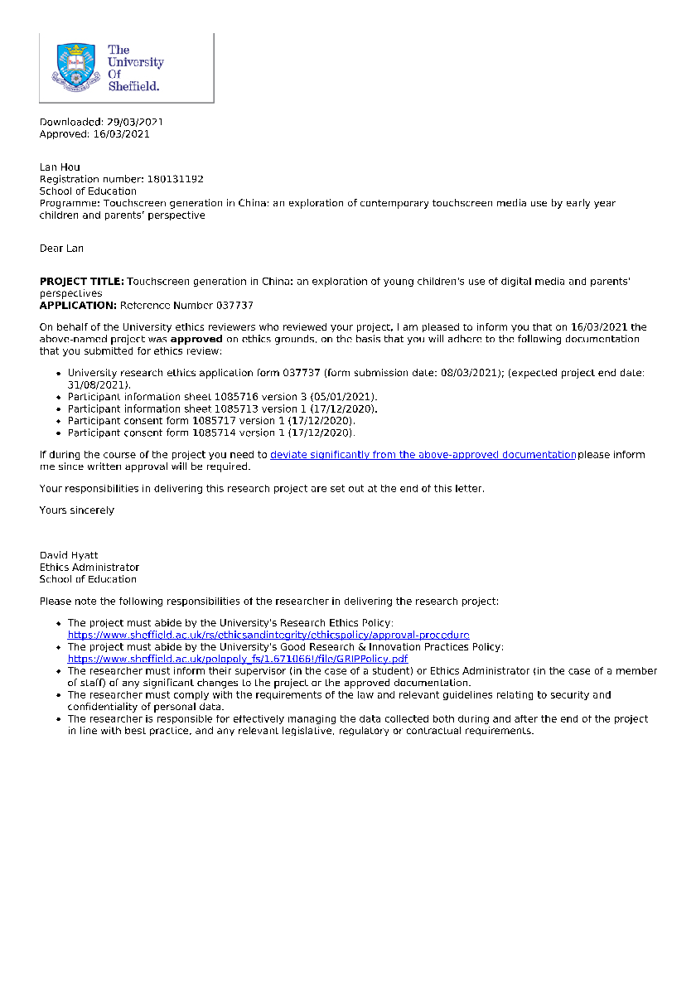

Appendix 2: Child information sheet in English version
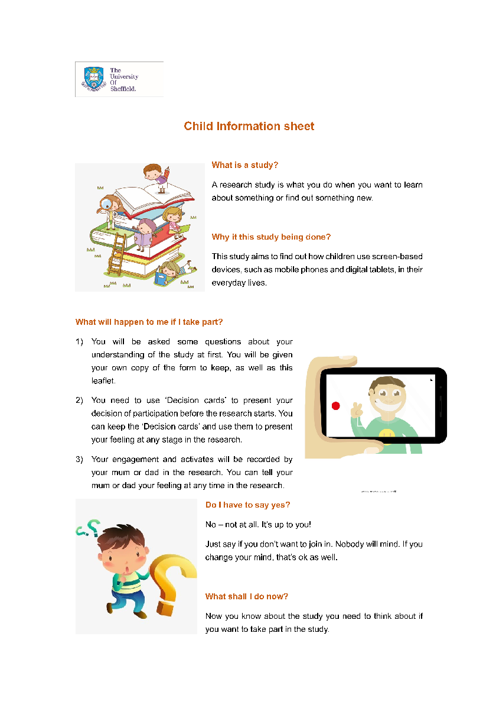

Appendix 3: Child information sheet in Chinese version
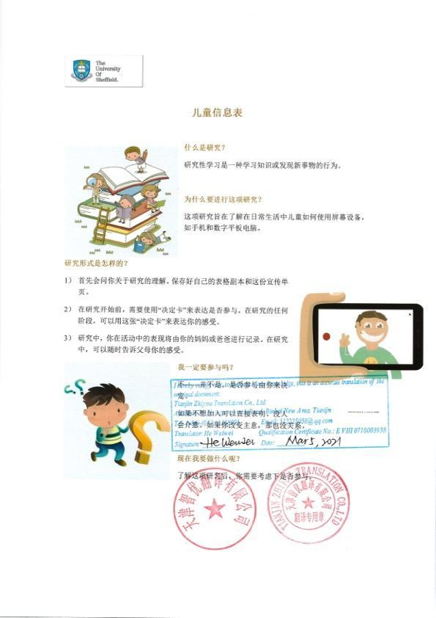

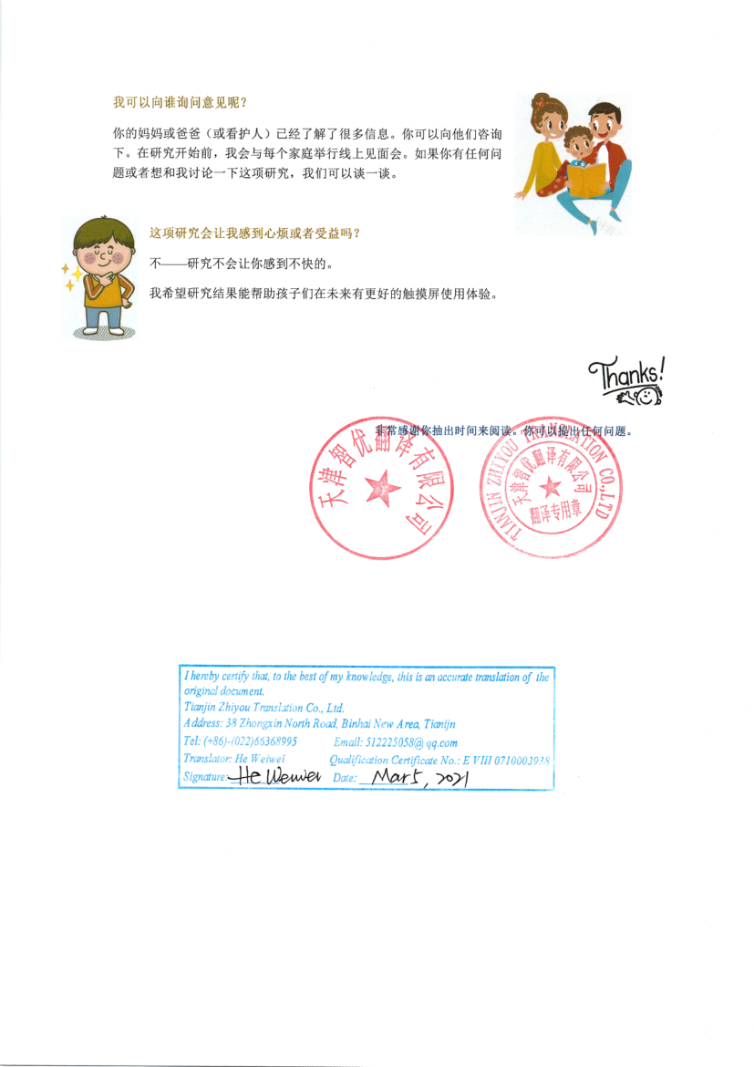

Appendix 4: Consent form for adults in English
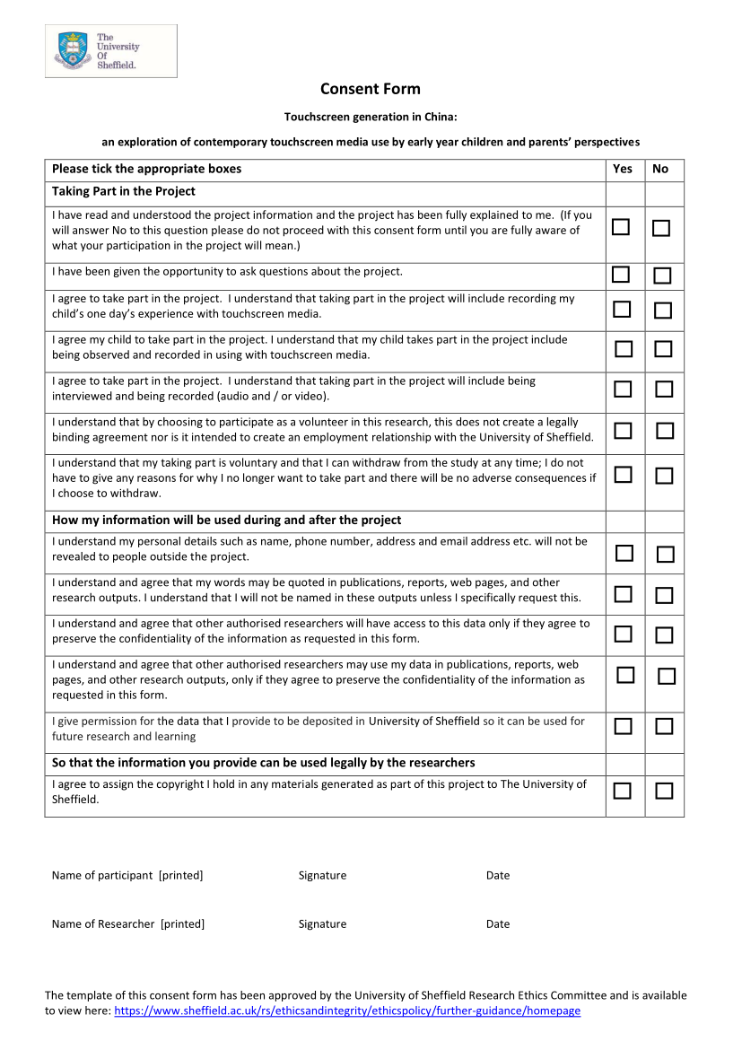



Appendix 5: Consent form for adults in Chinese
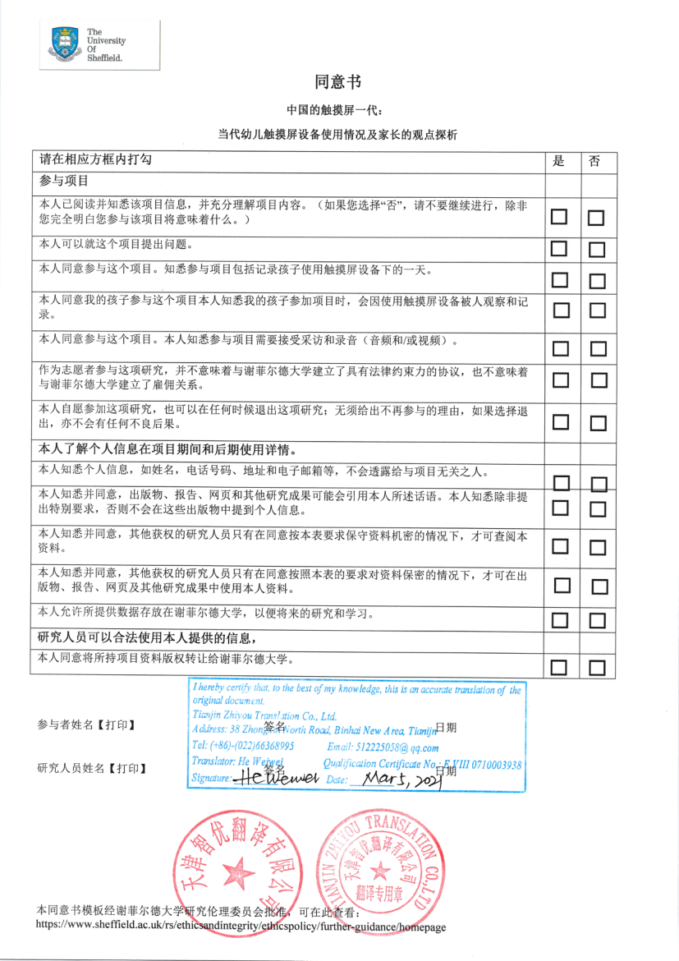

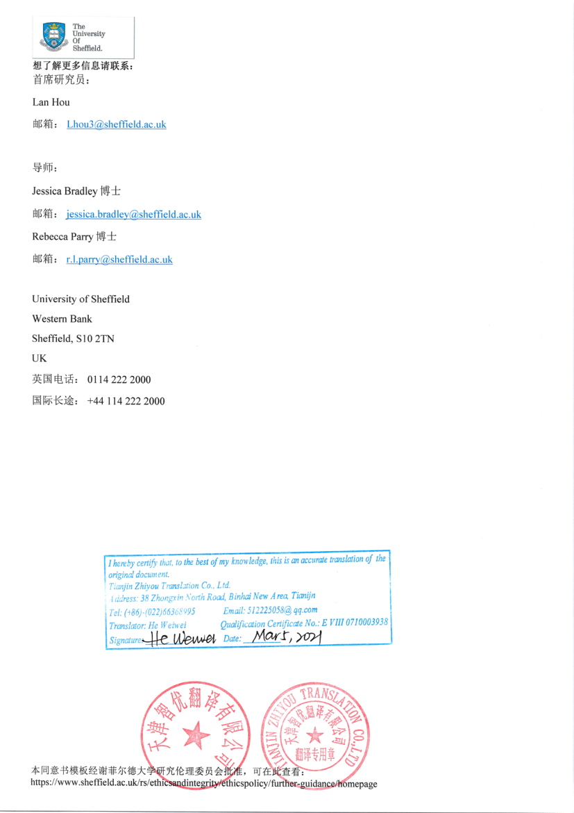

Appendix 6: Information sheet for adult in English
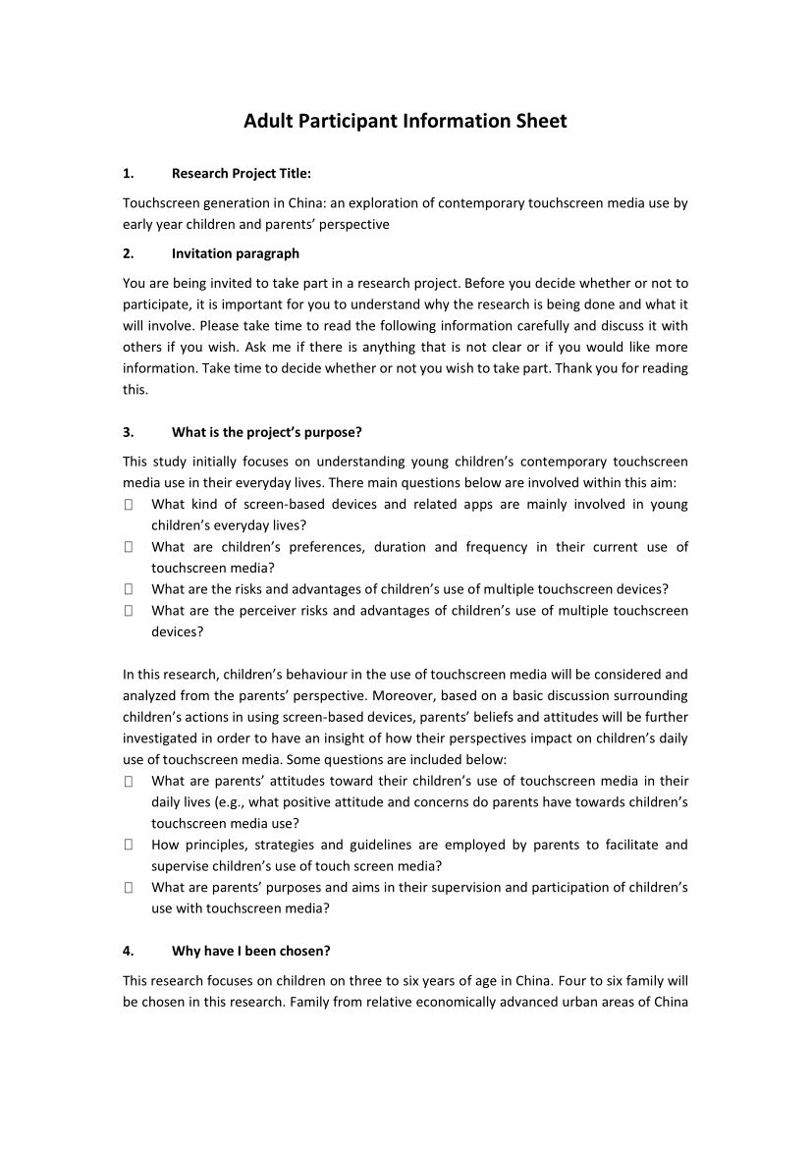

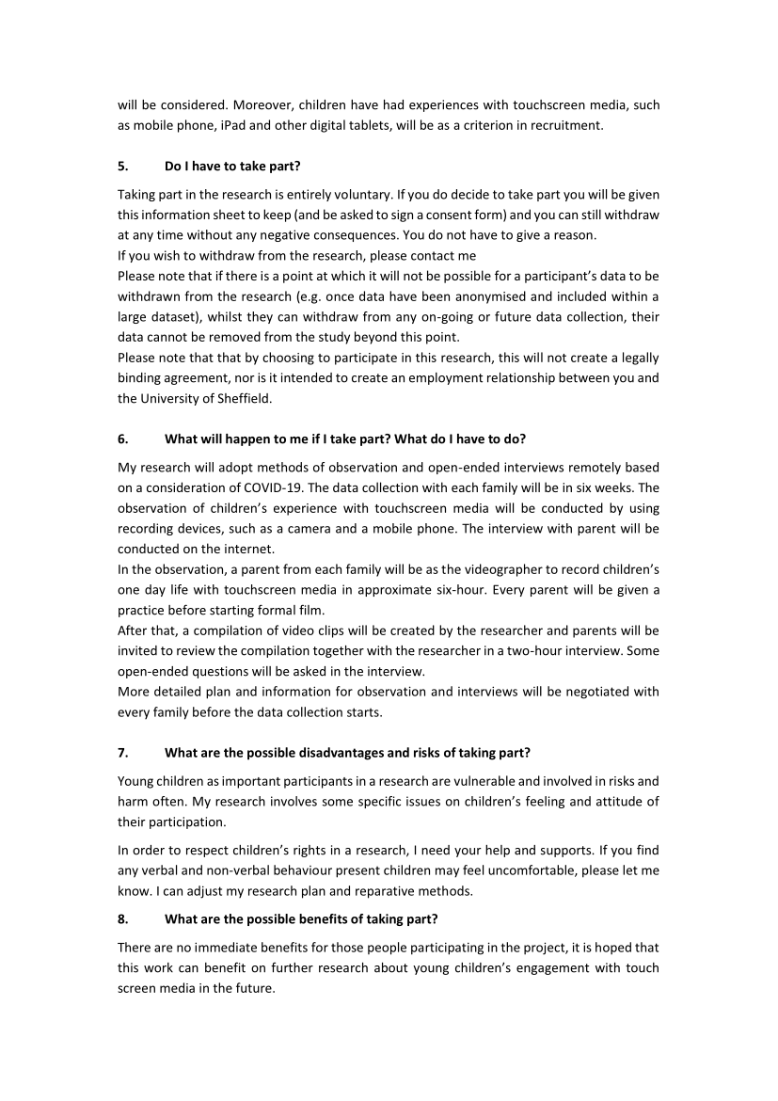

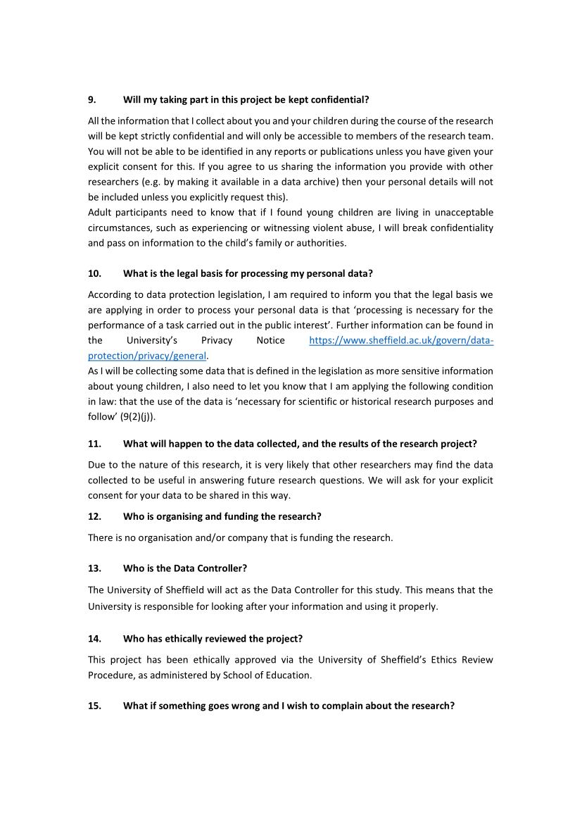

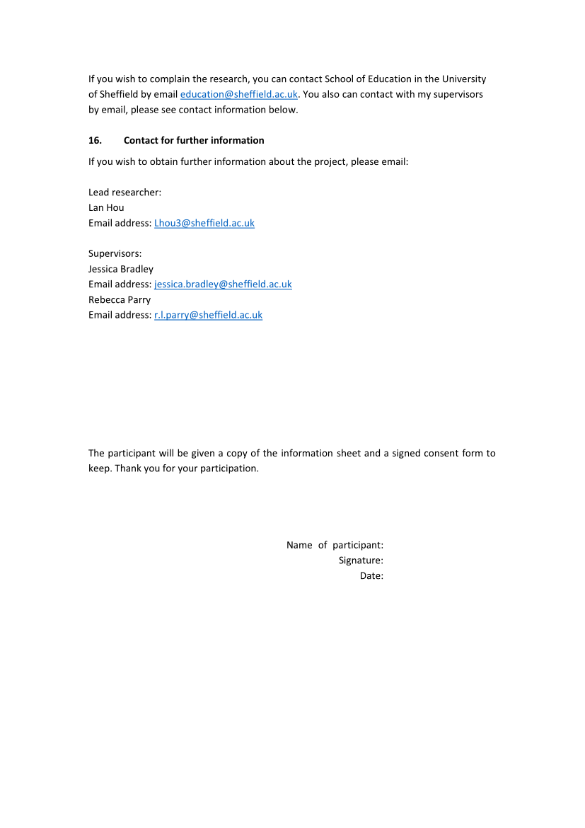

Appendix 7: Information sheet for adult in Chinese
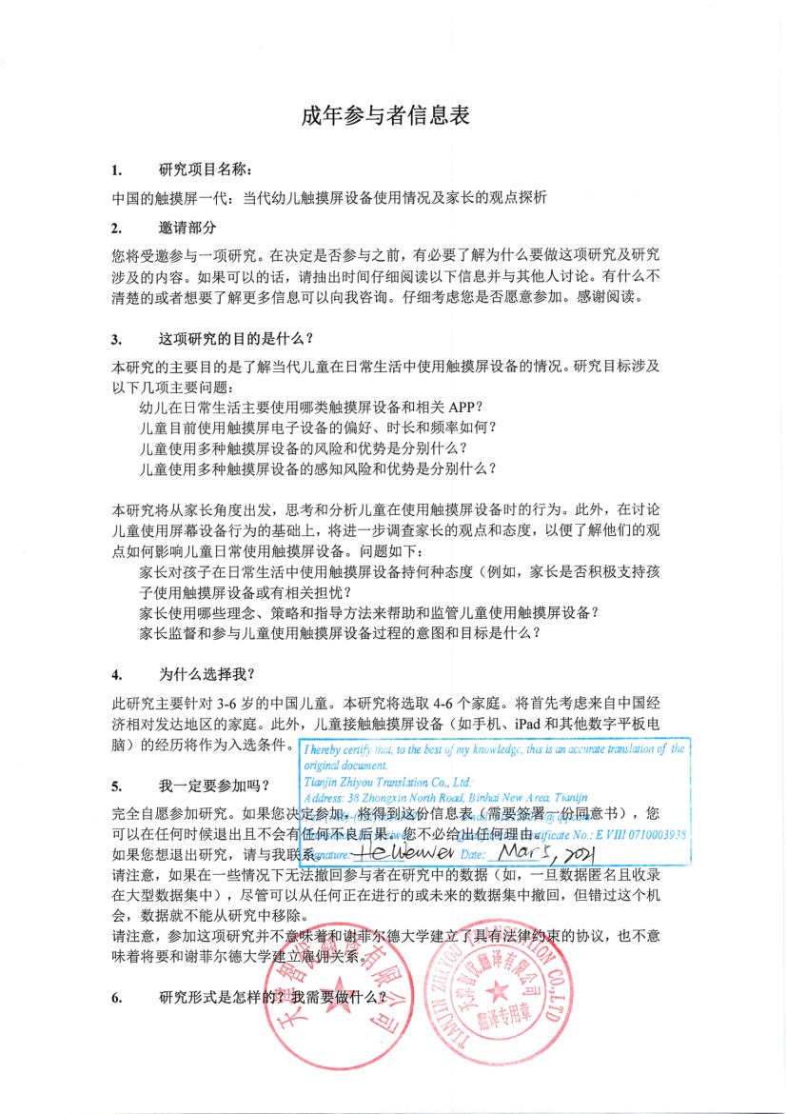

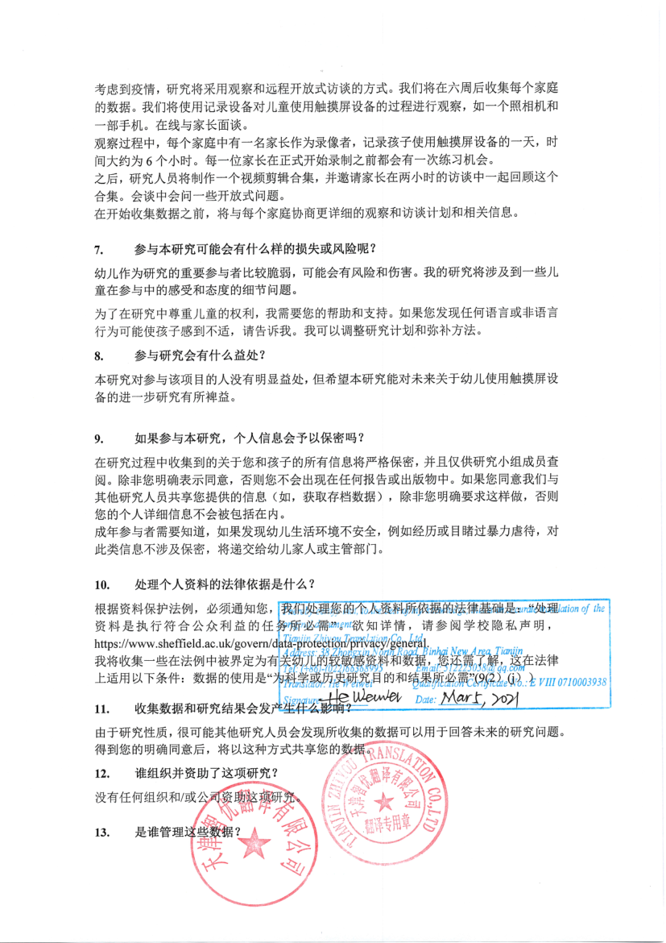

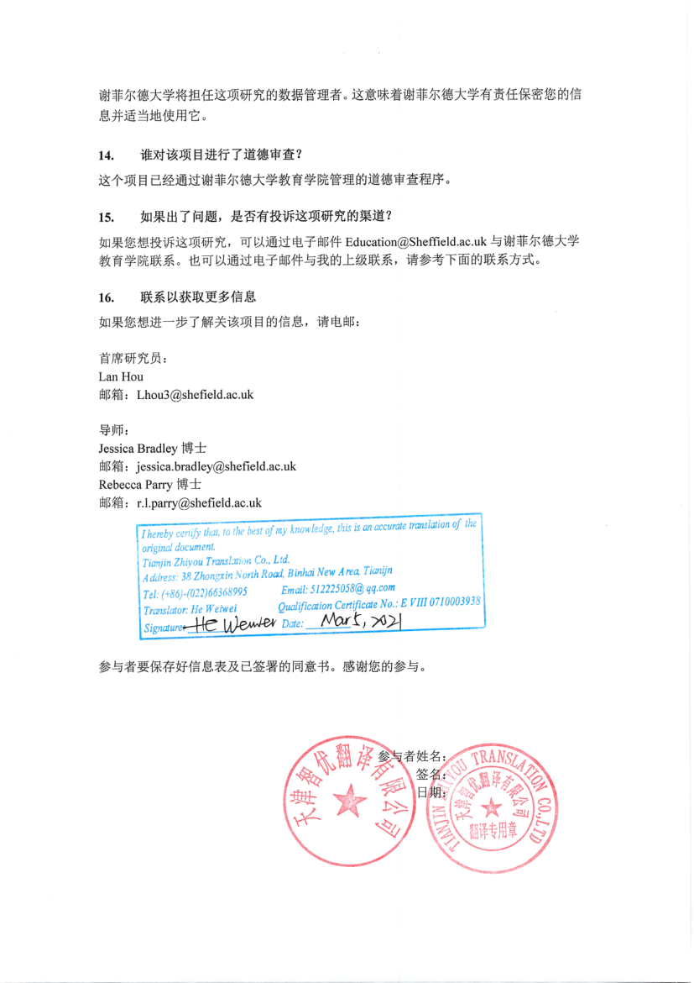

Appendix 8: Ongoing assent – Decision card for children
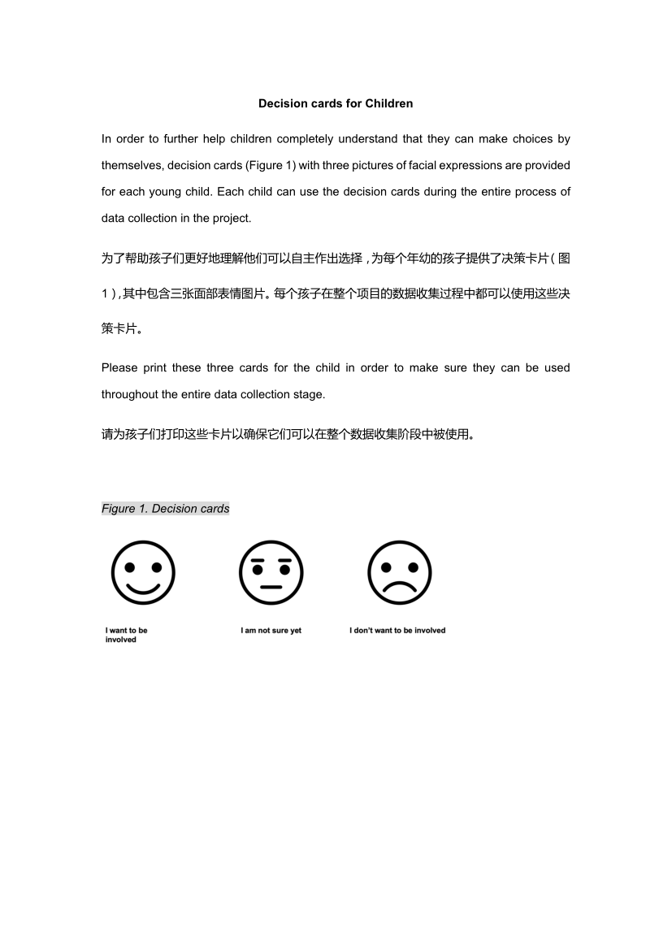

Appendix 9: video recording and field notes
Name | Date | Duration（min:sec） | Device used | Participants | Location | Summary/note
VID001 | 30.04.2021 | 00:27 | iPad | Sara | Home:  Livingroom | Sara’s dad put iPad on the table in the living room when Sara is drawing.  Sara choose the iQiyi video app and open independent and then choose one from the history viewing.  She is viewing PAW Patrol
VID002 | 30.04.2021 | 01:09 | iPad | Sara | Home:  Livingroom | Sara is keeping the same position (sit on the chair and put her hand on legs) in viewing the cartoon- PAW Patrol on iQiyi.  Not any other actions show in this clip.
VID003 | 30.04.2021 | 05:26 | iPad | Sara | Home:  Livingroom | Sara is keeping the same position (sit on the chair and put her hand on legs) in viewing the cartoon- PAW Patrol on iQiyi.  Her mother is making housework and Sara is keeping in watching。  She didn’t change the position during the whole 5 minutes.
VID004 | 10.05.2021 | 04:32 | iPad | Sara | Home:  Livingroom | Sara is watching cartoon on the iQiyi app and at the same time she is paly the blocks on the table.  She is singing with the song when the episode ends.  When the episode stats she stops to play on hand and focus on few minutes then paly on hand with bocks.  In the last half of video, she finishes the block game and focuses more on the episode.
VID005 | 17.05.2021 | 00:56 | iPad | Sara | Home:  Livingroom | Mom give the iPad and then ask Sara how to start but she answers mom ’I don’t know where the start is’  Her mom says ‘`let me teach you’  Sara is trying to press on the screen randomly。  Mom teaches Sara to swipe the screen and ask what the next.  Mom: What it the next? Try to find out an app in green.  S: What kind green?  Mom: this one (point)  Sara pushes away of mom’s hand and presses the correct one- iQiyi (a video app)  The episode directly starts and mom askes some questions, but Sara does not answer.  Mom leaves and the video ends here
VID006 | 18.05.2021 | 02:06 | iPad | Sara | Home:  Livingroom | Painting on the app.  Sara is manipulating independently.  The painting image starts to dance with a song.  Sara is press and control the role on the screen.  She can smoothly access to the next level using her index finger  She swipes on the screen right and left to choose and painting follows on the audio guidance.
VID007 | 22.05.2021 | 04:16 | iPad | Sara | Home:  Livingroom | The situation same with the VID1-3, iQiyi is used for watching PAW Patrol.  No one participant in and Sara keep a single posture.
VID008 | 31.05.2021 | 01:59 | iPad | Sara | Home:  Livingroom | Painting on the app.  Grandma accompanies with Sara.  This activity is interrupted by dinner.  Sara follows the audio guidance, such as ‘yellow’ to choose a pencil on the right side of the screen.  She use the index finger to follow the lines on the screen to complete a figure.  Sara then does not follow the audio guidance and choose different colours to paint and tries to draw some extra decoration on the figure.  When she finished the figure becomes a moved image.
VID009 | 31.05.2021 | 04:02 | iPad | Sara with dad | Home:  Livingroom | Literacy learning-writing an Chinese word’儿’  Having a talk with dad.  It is on Sara’s bedtime and this learning as a game before sleep.  Sara almost can manipulate independently, but when she pause her hand behind the screen, her dad would like to choose for her and tell her what should she does in the next stage.
VID010 | 31.05.2021 | 02:03 | iPad | Sara with dad | Home:  Livingroom | Literacy learning-儿  There are some chines words randomly appear on the screen and Sara needs to put and combine them in a correct order to create a write sentence.  Sara wants to see the answer when she cannot recognise some of words, but her dad covers the answer by hands and encourages her to finish.
VID011 | 10.06.2021 | 03:19 | iPad | Sara with dad | Home:  Livingroom | Literacy learning-儿  Sara can easily recognise this word, dad sometimes try to point a wrong option, but Sara can tell him it is not a correct one and recognise the correct Chinese word.  More communication here. Dad would like to speak the stroke name of Chines word.  Sara says ‘I don’t like you to point, let me do it by myself please’ , then dad stope to point and press beyond and on the screen.  Sara wants to continue but it’s time to bed so dad take the iPad away.
VID012 | 16.06.2021 | 07:49 | iPad | Sara with dad | Home:  Livingroom | Literacy leaning  A baby appears on the screen, and she needs to drag the baby to find out the gifts.  Sara don’t know how to do at the beginning and no action. Dad gives a clear guidance and does not press on the screen.  He encourages Sara, like ‘You got it’ ‘yes, this is the gift’ ‘go ahead’ ‘one more need to be found’
VID013 | 17.06.2021 | 03:20 | iPad | Sara with mom | Home:  Livingroom | Sara wants to play iPad, but her mom disagrees. The process of communication is recording in this video clip.
VID014 | 25.06.2021 | 02:15 | iPad | Sara with dad | Home:  Bedroom | This video is recording after the engagement of Sara use touchscreen media.
VID015 | 30.06.2021 | 03:16 | iPad | Sara | Home:  Bedroom | This clip is same with the VID014.  Mom requests her to have a break and take the iPad away from her.  Sara asks when the break ends, and she wants to watch the cartoon before dinner.
VID016 | 8.07.2021 | 01:36 | iPad | Sara | Home:  Bedroom | Sara is wating PAW Patrol on iQiyi app. She holds the blocks on her hand and didn’t change action in a while.  She expressions become serious when the roles in some dangers in the episode.  Sara’s action follows with the plot of the story in episode.
VID017 | 10.07.2021 | 08:23 | iPad | Sara | Home:  Livingroom | Same with the VID016  She is watching PAW Patrol on iQiyi app.
VID018 | 10.07.2021 | 01:09 | iPad | Sara with dad | Home:  Bedroom | Reading activity with dad.  Sara needs to recognise the items according to the audio guidance.  The audio guidance includes ‘Where is horse’.  Dad participate in the activities and say ‘here’  But the activity is interrupted as Sara need to pee.
VID019 | 10.07.2021 | 05:26 | iPad | Sara with dad | Home:  Bedroom | Reading activity  Sara and dad participate in the activities.  This part is about recognise the careers, such as ‘teacher’ ’dancer’ ‘firemen’ ‘astronaut’  Dad introduces more details about each career’s work content and have an interaction with Sara.  Sara is active when joining the activity and more excited.  She shared Marshall is a ‘fireman’ and he is a role in PAW Patrol.
VID020 | 25.07.2021 | 00:53 | iPad | Sara | Home:  Livingroom | Sara is watching PAW Patrol in iQiyi app.  Her mom interrupts her and let her show how she manipulates on the iPad to find out what she would watch in this app.  Sara chooses from the history recording and then press to full screen.
VID021 | 05.08.2021 | 04:32 | iPad | Sara | Home:  Livingroom | Sara is watching PAW Patrol in iQiyi app.  No hand movement and body gestures.
VID022 | 08.08.2021 | 04:16 | iPad | Sara | Home:  Livingroom | Sara is watching PAW Patrol in iQiyi app.  No hand movement and body gestures.
VID023 | 10.08.2021 | 00:56 | iPad | Sara with grandma | Home:  Livingroom | Grandma accompany with Sara in the engagement of drawing.  Grandma says ‘this colour is amazing’ and then Sara turn her head to the right and gaze grandma, but the activity is interrupted by the dinner.
VID024 | 17.08.2021 | 01:59 | iPad | Sara | Home:  Livingroom | This video is similar with VID004.  Sara is watching cartoon on the iQiyi app and at the same time she is paly the blocks on the table.  She is singing with the song when the episode ends.  When the episode stats she stops to play on hand and focus on few minutes then paly on hand with bocks.  In the last half of video, she finishes the block game and focuses more on the episode.
VID025 | 20.08.2021 | 10:46 | iPad | Sara | Home:  Livingroom | This video is similar with the last one.  Sara is watching cartoon on the iQiyi app and at the same time she is paly the blocks on the table.  She is singing with the song when the episode ends.  When the episode stats she stops to play on hand and focus on few minutes then paly on hand with bocks.  In the last half of video, she finishes the block game and focuses more on the episode.
VID026 | 25.08.2021 | 03:05 | iPad | Sara with mom | Home:  Livingroom | Sara cleans up the table and mom holds the iPad. Then mom passed the iPad to Sara and Sara start to manipulate by herself.
VID027 | 07.09.2021 | 03:50 | iPad | Sara | Home:  Livingroom | Painting game on the screen but is interrupted by the dinner.
VID028 | 11.09.2021 | 02:06 | iPad | Sara | Home:  Livingroom | Watching on iQiyi app, but it is interrupted by her mom.
VID029 | 17.09.2021 | 03:48 | iPad | Sara | Home:  Livingroom | Painting game. Painting app for girls.  When Sara press on the different colour pencil present on the right side of the screen, it plays the name of colour.  Sara presses many times to choose a colour to draw a cat.
VID030 | 22.09.2021 | 00:50 | iPad | Sara | Home:  Bedroom | Painting game. Painting app for girls.  There is some audio guidance to tell Sara what the next stage of the panting, such as ‘now let us stat to draw a penguin’ ‘drawing a small mouth for the cute penguin’  Sara chooses the correct colour according to the audio guidance and finish the picture. Then the penguin is dancing on the screen.
VID031 | 22.09.2021 | 01:22 | iPad | Sara | Home:  Bedroom | Painting game. Painting app for girls.  Sara swipes on the screen and choose animal she wants to draw. This animals with the specific sound. When she swipes to the option the sound plays.  Sara takes her left foot and use the toe to touch the option and success.
VID032 | 22.09.2021 | 01:22 | iPad | Sara | Home:  Bedroom | Painting game on the screen but is interrupted by the dinner.
VID033 | 22.09.2021 | 01:22 | iPad | Sara | Home:  Bedroom | Panting on the screen.  Sara needs to paint and follows the line and according to the audio guidance, such as ‘yellow’ ‘green’ ’black’ to complete the figure shows on the screen.  In the last, Sara would like to choose the colour she likes, and she doesn’t follow the audio guidance.  When she finishes, she immediately tell dad (recorder) this is the flower.  She gives some extra decorations on the figures.

The table of family two (Sherry is a 5-year-old girl):
Videos and relative fieldnotes
Name | Date | Duration（min:sec） | Device used | Participants | Location | Summary/note
VID034 | 14.06.2021 | 11:33 | iPad | Sherry | Home:  Bedroom | Sherry has a personal painting course on iPad.  The teacher tries to guide her.  When teacher gives some suggestions about correcting some lines, her mom join in and sit beside on Sherry.  Mom helps sherry to correct the line.  Sherry follows the teacher’s guidance and not many talks with the teacher.  Mom would like to give an extra guide and some detailed explanation when Sherry is painting.
VID035 | 17.06.2021 | 05:04 | iPad | Sherry | Home:  Bedroom | Personal painting courses on iPad.
VID036 | 22.06.2021 | 05:04 | iPad | Sherry | Home:  Bedroom | Personal painting courses on iPad.
VID037 | 01.07.2021 | 05:58 | Mobile phone | Sherry and her brother | Outside of home:  Restaurant | Sherry’s mom is helping to choose ‘Peppa Pig’ for Sherry and her brother. They are quiet in watching. Less body movement.  Sherry’s brother is holding the mobile phone and dependently operating the video app and find out video they want to see.  There is no recording about what episode details on the screen.  Sherry’s mom and dad tends to take the mobile back and push them to order dishes but failed.
VID038 | 03.07.2021 | 08:56 | Mobile phone | Sherry and her brother | Outside of home:  Restaurant | It is similar with the content with the last one.  Dad is ordering.  Sherry and her brother are focusing on watching the screen of mobile phone.  There is no more detailed recording on the screen’s game.  Sherry is playing at first and then her brother wants to tech her and grab the mobile phone. Then he gives the mobile phone back to Sherry.  More interaction between Sherry and her brother about how to play to gain the rewards.
VID039 | 07.07.2021 | 06:32 | Mobile phone | Sherry and her brother | Outside of home:  Restaurant | It is similar with the content with the last one, but dad is stopping the play with mobile phone as there is a call comes in.
VID040 | 12.07.2021 | 07:46 | iPad | Sherry and mom | Home:  Bedroom | English learning on iPad.  Mom would like to guide Sherry. Sherry makes some mistakes on some words and mom let her again and again till every word is correct.  Mom is correcting some grammar mistakes for each sentence that Sherry says. When sherry says ‘go’, mom tells her it should be ‘goes’  After a long paragraph, sherry need to finish some relative questions. Mom would like to give some guidance. Mom explains the meaning of ‘always’ and help Sherry to complete the question on the screen.  Sherry manipulates on the screen independently.  Sherry wants to stoop learning but mom thinks she needs more learning and agree have a break after 15 minutes.
VID041 | 20.07.2021 | 13:04 | Mobile phone | Sherry and her brother | Outside of home:  Restaurant | Sherry with her brother play mobile phone but cannot see details on the screen.
VID042 | 22.07.2021 | 09:24 | iPad | Sherry and mom | Home:  Bedroom | English leaning on the screen.  Mom mentions sherry again if she makes some mistakes.  Sherry needs to read the sentences on the screen and explains the meaning of sentences.  Sherry is emotional.
VID043 | 02.08.2021 | 12:01 | iPad | Sherry | Home:  Bedroom | Personal painting courses on the iPad.
VID044 | 8.08.2021 | 06:56 | Mobile phone | Sherry and her brother | Outside of home:  Restaurant | Sherry and her brother paly dad’s mobile phone, but it interrupted when the dishes come.
VID045 | 10.08.2021 | 04:22 | iPad | Sherry | Home:  Bedroom | Personal painting courses on the iPad.  More details of screen are recorded. Sherry learns to draw Doraemon.  Mom would like to give an oral guide during painting.
VID046 | 13.08.2021 | 03:27 | Mobile phone | Sherry and her brother | Outside of home:  Restaurant | Sherry plays a game on dad’s mobile phone with her brother.
VID047 | 17.08.2021 | 02:05 | Mobile phone | Sherry and her brother | Outside of home:  Restaurant | Sherry wants to play mobile phone, but her dad takes the phone back. He says Sherry give more focus on mobile phone than eating.
VID048 | 22.08.2021 | 04:50 | iPad | Sherry and mom | Home:  Bedroom | Personal painting course on iPad.  Many pencils on the table and sherry needs to fill colour for Doraemon.  Mom corrects the sitting gesture for Sherry.  Mom help Sherry to choose a colour and mentions sherry fill all the blank.
VID049 | 26.08.2021 | 02:08 | iPad | Sherry | Home:  Bedroom | Paly entertainment game on iPad.
VID050 | 30.08.2021 | 04:42 | iPad | Sherry | Home:  Bedroom | Literacy learning  Sherry need to follow the names of stroke to learn how to write different words.

The table of family three (Rob is 4 years 9 months): Videos and relative fieldnotes
Name | Date | Duration（min:sec） | Device used | Participants | Location | Summary/note
VID051 | 17.08.2021 | 02:16 | iPad | Rob and dad | Home:  Bedroom | Games about Maths.  Rob needs to finish the questions according to the explanation.  Dad joins in the activity and would like to ask some extra questions to make sure Rob understand the answer.
VID052 | 20.08.2021 | 02:52 | iPad | Rob | Home:  Bedroom | Rob play with Diamond painting.  Rob is swiping on the screen to fill the colour.  Mom(recorder) asks what it the app and how to play. Rob explains for her and share the experience with the game.  He plays on independently.
VID053 | 27.08.2021 | 03:00 | iPad | Rob | Home:  Bedroom | English leaning.  Rob is watching English cartoon and learn how to speak some English words.  he is distracting by yogurt on the table and mom pats him.  He is speaking with the video according to the guidance in episode.
VID054 | 10.09.2021 | 03:51 | iPad | Rob | Home:  Bedroom | Maths leaning  Rob learns how to account on the iPad.
VID055 | 17.09.2021 | 05:14 | iPad | Rob | Home:  Bedroom | Coding skills learning.  Robe drags the ‘apple’ on the correct place and make sure the arrangement meets the requirements.
VID056 | 22.09.2021 | 04:08 | iPad | Rob | Home:  Bedroom | Rob is playing on the iPad, but it is interrupted by an advertisement twice times. He gives up.
VID057 | 08.10.2021 | 03:16 | iPad | Rob | Home:  Bedroom | English learning  Rob is learning some items’ name. He is speaking with the audio, such as ‘table’ ‘desk’ ‘chair’.  Some English song is play between each episode. Rob can have a quick break.  The word learning by watching dialogues.
VID058 | 11.10.2021 | 03:09 | iPad | Rob | Home:  Bedroom | English learning.  Each dialogue based on a theme, such as living room. Some words about living room are introduced. Rob speaks follow the pronunciation in video.
VID059 | 16.10.2021 | 04:57 | iPad | Rob | Home:  Bedroom | Coding and maths game.
VID060 | 19.10.2021 | 00:39 | iPad | Rob | Home:  Dining room | Rob is watching videos when he is having dinner. The connection is not stable and the recording is interrupted.
VID061 | 22.10.2021 | 03:11 | iPad | Rob | Home:  Bedroom | English learning  The topic name is the dog and flowers.  Rob is listening to the story and then learn some English words.  He is using the index finger to press the right side to flip.  He can manipulate independently and doesn’t need any help from mom.
VID062 | 27.10.2021 | 03:13 | iPad | Rob | Home:  Bedroom | English learning  After the story, Rob needs to finish some questions about the story.  Some words need to be selected, such as ‘butterfly’ and then the word needs to be chosen and drag to the picture of butterfly.  Rob wants to stop the learning; his mom encourages him to finish this part and then can gave a break.
VID063 | 31.10.2021 | 02:28 | iPad | Rob | Home:  Bedroom | English learning.  Rob needs to speak follow the audio on an iPad.  Two pictures appear on the screen and Rob needs to recognise and choose which one is the correct one according to the audio.  Rob can quickly pick the correct one and then turn to his mom.  Mom agrees have a break then.

Appendix 10: A guidance of phone recording for parents
Children’s behaviour | Actions involved | Suggestions for recording
Verbal behaviour | Children's conversation, speaking, and other oral expressions | - Ensure that the voices of children are clearly recorded, without any distortion or background noise.  - Position the phone at an appropriate distance from the child to ensure that their speech is captured with clarity.  - Avoid interrupting children while they are speaking or responding during the recording process, allowing them to express themselves fully. It is important to make them feel comfortable and listened to.
Non-verbal behaviour | Finger movement on a screen; facial expression and body movement, such as gestures and postures | - Adjust the recording distance based on movement.  - If children interact with a touchscreen intensively, record at a close distance to capture both the screen and their finger movements.  - If children have fewer interactions and move slowly, such as when watching videos, record from a greater distance to capture their body movements clearly.

Appendix 11: University of Sheffield's policy for research requiring face-to-face contact with participants

