

Investigating Multiscale Sample Entropy in Resting State EEG and fMRI Signals in Autism Spectrum Condition and Neurotypical Controls

Wenyi Xiao

Submitted in accordance with the requirements for the degree of Doctor of Philosophy

Department of Psychology, University of Sheffield

September 2023

Abstract

This thesis aimed to enhance the comprehension of the multiscale sample entropy profiles in resting-state EEG and fMRI signals. Specifically, it sought to explore the neurophysiological characteristics of individuals with Autism Spectrum Condition (ASC) compared to neurotypical controls (CON). The study also considered potential confounding factors like eye conditions (eyes-open and eyes-closed) and age, which might influence observed differences. Utilising multimodal techniques, temporal-based measurements of multiscale sample entropy were obtained from simultaneous EEG and fMRI signals, providing both high temporal and spatial resolution. The analysis involved two extensive existing datasets comprising 300 participants from the National Institute of Mental Health (NIMH) EEG project and 500 participants from the Autism Brain Imaging Data Exchange (ABIDE) I fMRI project. In Chapter 2, multiscale sample entropy and relative power spectrum were compared between ASC and CON groups in both eyes-open and eyes-closed conditions. The findings revealed generally small diagnosis group differences, with slightly larger effects during eyes-closed conditions, suggesting the potential importance of considering brain state in future research. Chapters 3 and 4 focused on identifying brain regions contributing to ASC and CON classification. Analysis was conducted separately for eyes-open and eyes-closed conditions due to data source differences. Diagnosis group differences were observed within the default mode network (DMN), and machine learning classification demonstrated modest accuracy. Chapter 5 examined the effect of age on multiscale sample entropy, finding a significant correlation with age in both ASC and CON groups, with a stronger correlation in CON. The previously observed changes in MSE within the ASC group were subsequently confirmed to be associated with age.
Keywords: Multiscale Sample Entropy, default mode network (DMN), machine learning classification, resting-state EEG, resting-state fMRI, Autism Spectrum Condition (ASC)

Declaration of Contribution
I, Wenyi Xiao, the author of this thesis, hereby declare my contributions and responsibilities regarding the research, data processing, and analyses conducted within this study. The following details outline the roles and contributions of individuals involved in this research:
Data Sources and Pre-processing
All data used in this research was obtained from secondary datasets. In Chapter 2, the dataset retrieved from the NDA had undergone pre-processing steps, including high-pass filtering at 0.1 Hz, low-pass filtering at 100 Hz, and notch filtering at 60 Hz. Furthermore, any channels recorded from electrodes with impedances exceeding 200 kOhm were already removed, and the data had been partitioned into 2.048-second epochs by the initial data collection team.
Specifically, I wish to acknowledge the valuable contribution of Dr. Adam Dede, a postdoctoral research associate, who played a significant role in pre-processing the EEG data utilized in this study. Dr. Adam Dede's pre-processing procedures adhered to standard protocols, encompassing artifact removal, and interpolation. Comprehensive details regarding Dr. Adam Dede's pre-processing methodologies can be accessed at https://github.com/adede1988/SheffieldAutismBiomarkers. However, I independently wrote the code and implemented all the subsequent analyses.
The fMRI data were obtained from publicly accessible secondary datasets. Specifically, the fMRI data from the Autism Brain Imaging Data Exchange (ABIDE) dataset was utilised. Pre-processing of the fMRI data involved standard steps such as motion correction, spatial normalisation, and signal intensity normalisation. Specific tools and software used in the fMRI pre-processing, such as the Statistical Parametric Mapping (SPM) toolbox and the Data Processing Assistant for Resting-State fMRI (DPARSF), were referenced in the corresponding sections of this thesis. However, I independently wrote the code and implemented all the subsequent analyses.

Project Design and Statistical Analyses
I devised the overall project to investigate the multiscale sample entropy profiles in resting-state EEG and fMRI signals, specifically focusing on individuals with Autism Spectrum Condition (ASC) compared to neurotypical controls (CON). The project also considered potential confounding factors such as eye conditions (eyes-open and eyes-closed) and age.
Furthermore, I designed and conducted all subsequent statistical analyses throughout the study, ensuring the appropriate methodologies and statistical tests were employed to address the research questions and objectives. The details of these statistical analyses can be found in their respective chapters within this thesis.
GitHub Repositories and Additional Resources
To facilitate transparency and reproducibility, I have provided links to relevant GitHub repositories and additional resources where applicable: https://github.com/wenyixiao0058/eegstudy.git; https://github.com/wenyixiao0058/fmristudy.git and https://github.com/wenyixiao0058/MSE_effectiveness.git. I understand the importance of providing clarity in this regard. I will work to rectify this issue by updating the GitHub repository to include comprehensive documentation. This will ensure that future researchers can access and understand the procedures used in this study.
I affirm that the above declaration accurately reflects the contributions and responsibilities of individuals involved in this research, and I am committed to maintaining the highest standards of academic integrity and transparency in my work.

Wenyi Xiao
PhD researcher
02/09/2023

Acknowledgement
I am deeply honoured to acknowledge the individuals and sources of support that have played a pivotal role in completing my thesis. This academic journey would not have been possible without their unwavering support. First and foremost, I extend my heartfelt gratitude to my thesis supervisors, Dr. Myles Jones and Professor Milne Elizabeth. Their mentorship, dedication, and expertise have been the cornerstone of this endeavour. Their valuable insights and constructive feedback have been instrumental in shaping the quality of this work. I would like to extend a special and heartfelt thanks to Dr. Dede Adam. Dr. Adam's invaluable contributions and support have significantly impacted this thesis project.
I would also like to express my sincere appreciation to my parents. Their unwavering belief in my abilities, constant encouragement, and sacrifices made this academic pursuit possible. Your unwavering support has been my driving force.
To my friends, Huluobo, Bixuan, Qianhe, Shenzhi, Xiaoqiu, Shuangke and Anton, your encouragement and camaraderie have motivated me during this thesis's challenging phases.
I must also acknowledge the unique form of support from my adorable pets: Chouchou, jojo, yoyo, xiaokui and dengdeng. Their wagging tails and soothing purrs were a constant reminder to take breaks and appreciate the simpler joys in life.
In closing, I extend my deepest gratitude to Dr. Myles Jones, Professor Milne Elizabeth, my parents, friends, and my cherished pets. Your support has been indispensable, and I am profoundly thankful for your presence in my academic and personal journey.

With heartfelt thanks,
Wenyi Xiao

Contents
Chapter 1 General Introduction 8
Aims and Contents of Thesis 43

Chapter 2 Investigating Spontaneous EEG Biomarkers and the Influence of Eye Conditions in ASC 75
Introduction 75
Method 78
Results 82
Discussion 90
Conclusion 96

Chapter 3 Unravelling Eyes-Open Resting-State Brain Complexity in Autistic Spectrum Condition: Insights from Multiscale Sample Entropy Analysis Using fMRI Data 110
Introduction 111
Method 116
Results 135
Discussion 151
Conclusion 155

Chapter 4 Unravelling Eyes-Closed Resting-State Brain Complexity in Autistic Spectrum Condition: Insights from Multiscale Sample Entropy Analysis Using fMRI Data 171
Method 172
Results 174
Discussion 188
Conclusion 191

Chapter 5 Investigating Developmental Trajectories from childhood to young adult in Individuals with Autistic Spectrum Condition and neurotypical controls: Reflected in resting state EEG and fMRI Signal Complexity 195
Introduction 195
Method 197
Results 199
Discussion 219
Limitation 227

Chapter 6 General Discussion 241
Summary of the Conducted Studies 241
Contributions of the Present Programs of Research 246
Limitations and Future Research 250

Chapter 1

General Introduction

The Need for Biomarkers in Autistic Spectrum Condition (ASC)
To date, there still has not been an agreement on consistency of the classification of ASC. The debate mainly lies in the diagnosis of PDD-NOS, as The DSM-IV criteria seems to be more sensitive than DSM-V, some studies indicated that patients diagnosed as having PDD-NOS by DSM-IV would not meet criteria for ASC under DSM-V (Kulage et al. 2014; Yaylaci and Miral 2017). Prior to 2013, in the fourth edition of the American Psychiatric Association's Diagnostic and Statistical Manual of Mental Disorders (DSM-IV) (Bell, 1994), Autistic Spectrum Condition (ASC) was identified as a subgroup under the umbrella of Pervasive Developmental Disorders (PDDs). Individuals diagnosed with these disorders typically show delays or deficits in social interaction and communication and display repetitive/restricted behaviours (Vahia, 2013). A patient diagnosed with autistic disorder would have demonstrated at least six of twelve symptoms, including marked impairment in nonverbal behaviours in social interaction, delay in the development of spoken language and stereotyped repetitive behaviours (Bell, 1994). Therefore, the ability to effectively distinguish one disease from another is complicated by the wide variability in symptom severity within and between a group of diseases. To minimise this variability and make criteria more accurate, the 5th edition of the Diagnostic and Statistical Manual of Mental Disorders (Sharma et al., 2015) consolidated these distinct diagnoses under the umbrella of PDDs into a singular dimensional diagnostic spectrum as Autism Spectrum Condition (ASC). The symptoms now represent a continuum of severity of impairments in only two domains (social communication and restricted repetitive behaviour). Concerns about the new diagnosis of ASC absorbing all separate disorders into one might omit some patients who would have been diagnosed with priorly distinct autistic disorders, such as Asperger's syndrome and PDD-NOS (Carbone & Dell'Aquila, 2023; Walker et al., 2004). DSM-V suggested specifying these priorly distinct disorders as a progression under the same underlying disorder with sorted symptom severity using specifiers based on different individuals' clinical manifestations, such as language level or intellectual impairment.
Although there are many potential future discoveries regarding the developmental neurobiology of Autistic Spectrum Condition (ASC), the current diagnosis of ASC relies on behavioural criteria, which involves direct observation of behaviour and gathering historical information (Risi et al., 2006). Multiple sources of information are necessary to generate a valid and reliable diagnosis, including clinician’s observations, caregiver interviews, and, if possible, self-report. The standard diagnostic assessments for an ASC diagnosis are the Autism Diagnostic Observation Schedule (ADOS) (Gotham et al., 2007) and the Autism Diagnostic Interview, Revised (ADI-R) (Lord et al., 1994) because of their detailed evaluation of behavioural and developmental characterization, and high reliability when administered by trained assessors (Brentani et al. 2013). Manifestations of ASC also vary greatly depending on the severity of the autistic condition, cognitive ability, level of language function (Howlin et al., 2014), developmental trajectories (Moore & Goodson, 2003) and a wide range of IQ suggesting the core feature of ASC – heterogeneity. The profiles of strengths, weaknesses, and symptom characteristics can vary widely (Bal et al., 2019; Hoang et al., 2018), as can changes over time and co-occurrence with other common psychiatric conditions (Lai et al., 2019; McCormick et al., 2020; McVey, 2019), such as anxiety, mood, and attentional disorders (Khachadourian et al., 2023). Indeed, ASC is associated with long-term impairment (Rydzewska et al., 2018) and frequently co-occurs with other conditions (e.g., intellectual disabilities [∼30%], attention deficit hyperactivity disorder (ADHD) [~ 30%]) and learning disability [~ 20%] (Khachadourian et al., 2023); the majority of individuals with ASC have at least one co-occurring mental health conditions or other neurodevelopmental diagnoses (Rydzewska et al., 2018; Khachadourian et al., 2023).
Indeed, the challenge of classifying and diagnosing ASC inherently originates from the heterogeneity of ASC itself. Due to the intricate heterogeneity of ASC, there has been significant interest and investment in finding biological markers, commonly known as biomarkers, which is to identify more homogenous groups for biological research, improve the process of autism diagnosis, including early detection before symptoms become evident, and predict the likelihood of co-occurring symptoms. According to Lord et al. 2018, a diagnosis of ASC can be identified as early as 18 to 24 months of age. Specific symptoms can be distinguished from typical development and other developmental conditions or delays at this stage. Additionally, the goal is to develop more dependable and sensitive markers to tailor personalised treatments and evaluate treatment responses effectively (Frye et al. 2019; Loth et al. 2016; McPartland 2017; Ruggeri et al. 2014). This endeavour is not unique to ASC, as similar efforts are being made in other neuropsychiatric conditions (Clementz et al. 2016). There is a growing consensus that relying solely on clinical symptoms and phenomenology for classifying individuals into diagnostic categories may not fully capture biologically meaningful distinctions among different cases (Stein et al. 2022). Therefore, the search for biomarkers is crucial for understanding the underlying neurobiological mechanisms and improving the precision of diagnosis and treatment across various neuropsychiatric conditions.
Although ASC has a strong genetic basis (Li et al., 2012; Krishnan et al., 2016), it is essential to recognize that biomarkers do not necessarily have to be genetically based, familial, or dependent on specific traits (attributes often associated with "developmental endophenotype" biomarker) (Ruggeri et al., 2014). Additionally, it is unlikely that a genetic test will ever be precise enough to predict whether a person will develop autistic traits. As in most autistic individuals, the condition typically arises from the combined effects of numerous common genetic variations, with this genetic predisposition further interacting with environmental factors (Mandy & Lai, 2016; Masi et al., 2017). Only approximately 5% of individuals with ASC possess a small number of rare ASC-related genetic variations or mutations (Carter & Scherer, 2013). A potential biomarker can be considered as such if it represents a biological variable associated with the "disease" condition and can be directly measured in individuals or their biomaterials using reliable and sensitive quantitative methods (Mayeux, 2004; Strimbu & Tavel, 2010). These candidate biomarkers are the measurements obtained from biosample analysis (e.g., urine, blood) and measurements of behaviour, neuropsychological performance, or a pattern of brain activity. There is substantial progress in ASC research across multiple domains, such as genetics and gene expression, metabolism, multimodal neuroimaging, and sophisticated behavioural experiments employing advanced technologies and paradigms (Vargason et al., 2020). For example, a pronounced achievement in the electroencephalogram (EEG) biomarker for ASC diagnosis is that N170 latency has become the first autism biomarker to gain approval from the US Food and Drug Administration (FDA) for inclusion in its biomarker qualification program. Furthermore, the European Medicines Agency (EMA) has also supported using N170 latency as an autism biomarker (Letter of support for N170 ERP as a prognostic biomarker for adaptive social functioning and its potential to stratify study populations). Research has demonstrated the prognostic validity of N170 latency by showing its association with brain responses to human faces and autism polygenic scores - the weighted sum of the variants tied to ASC (Mason et al., 2022). Moreover, N170 latency can predict changes in social adaptive behaviour approximately 18 months into the future (Mason et al., 2022; Oakley et al., 2022).
Why resting-state EEG for studying brain dysfunction in ASC
From a theoretical and practical standpoint, EEG is an ideal biomarker for characterising neurodevelopmental conditions. In event-related potential (ERP) studies, EEG measurements can detect abnormalities in brain activities evoked by sensory stimuli in ASC (Bomba & Pang, 2004; Belmonte, 2000). Interpreting task-dependent changes in brain function without a fundamental understanding of the functional differences in individuals with ASC during a resting state can be challenging. In this sense, resting state electrophysiological signals can serve as a baseline in task-evoked studies and are easier to apply to clinical assessment. Task-based evoked potential studies focus exclusively on examining neural responses synchronised with specific events of interest while disregarding all other resting-state brain activity as a controlling session, which is also generally regarded as background noise. Numerous studies have proposed that the brain functions intrinsically as a system, characterised by intrinsic integration during rest periods (Boly et al., 2008; Raichle 2015).
Event-related potentials have been employed in research settings for many years; however, their practical implementation in clinical contexts remains to be determined (Woodman, 2010). Nonetheless, there has been a rising interest in utilising resting-state EEG signals for the development of biomarkers that can assist in the diagnosis of neurodevelopmental disorders (Wang et al., 2013), predicting developmental trajectories (Takarae et al., 2022) and monitoring treatment outcomes (Pineda et al., 2012). This renewed interest has gained particular prominence in the field of ASC (Heunis et al., 2016). The resting-state EEG, also called spontaneous EEG, is recorded without specific tasks or stimuli to capture the baseline neural activity. These spontaneous fluctuations have revealed the presence of large-scale intrinsic networks consisting of brain regions with similar functionality and synchronised activity (Liu et al., 2010). Therefore, spontaneous EEG can also provide valuable insights into the neurophysiological characteristics underlying neurodevelopmental conditions like ASC (Jeste et al., 2015), as it can reflect the altered brain activities (Li et al., 2022; Itahashi et al., 2015).
Novel analysis methods in EEG biomarker in ASC
Conventional methods to characterise spontaneous EEG signals is by following a linear method and breaking down different neural oscillations with Fourier analysis to transform EEG data into the frequency domain that share physiological activities. This allows the decomposition of the data into various frequency bands (delta, theta, alpha, beta and gamma). The EEG signals are then quantified using measures like absolute power, relative power, and coherence. Absolute power indicates the amount of EEG activity within a specific frequency band. On the other hand, relative power represents the proportion of EEG activity in a specific frequency band relative to the overall activity across all frequency bands, essentially creating a "ratio". Coherence measures the level of synchronisation between two EEG signals on a frequency basis (Baumgratz et al. 2014). These traditional analysis methods rely on assumptions that EEG signals are inherently stochastic (or randomly distributed) and stationary. Also, the frequency-based decomposition methods ignore temporal information present in EEG signals. It is important to note that brain activity consists of aggregated neural activities over time (Nayak and Anilkumar 2020), and the extracellular currents captured by EEG can offer insights into diverse cellular activities at persistent temporal scales (Nunez and Harth 1982).
Neurobiological studies reveal that brain electrical activity arises from the combined postsynaptic potentials of many neurons in the brain cortex (Nunez, 1974). This fundamental neurobiological basis categorizes the human brain as a complex system (Natarajan et al., 2004) that exhibits intricate fluctuations even during rest periods (Zuo et al., 2010). This complexity arises due to the intricate interplay of numerous neuronal circuits operating across diverse temporal and spatial scales (Pedersen et al., 2017). The EEG signal represents a time-varying and nonstationary signal (Lo et al., 2009; Palus, 1996), with its frequency characteristics changing over time. As aforementioned, traditional time-domain or frequency-domain measures can only analyze the waveform and frequency-domain characteristics of the entire time series or frequency but cannot reveal the frequency component composition of the signal and the energy distribution of the relevant frequency component at a specific time scale. As such, apart from the traditional qualitative EEG methods, it is imperative to account for the nonstationary, nonlinear, and complex nature of holistically understanding brain activities.
In recent decades, when studying the diagnosis of ASC using comparison techniques with spontaneous EEG (Hashemian & Pourghassem, 2014), researchers typically compare the EEG signals of individuals without ASC to those with ASC. These novel resting-state EEG methods require automated signal processing (Heunis et al., 2016). Automated EEG signal processing occurs across data acquisition, preprocessing, feature extraction and classification. In the feature extraction step, specific characteristics of the EEG signals will be determined and further examined. These signals contain valuable spontaneous EEG information that needs to be extracted and compared, and these extracted pieces of information are referred to as "features." Various signal processing methods and different scenarios are employed to obtain these features. In the final step (classification), researchers must decide on an appropriate statistical method or use the machine learning classifiers to measure the pattern recognized between the EEG signals of individuals with ASC and those without ASC, based on the identified 'features'. EEG biomarker studies encompass time series analysis methods that should account for the nonstationary, nonlinear, and complex properties of EEG signals. These studies also incorporate machine learning and data-driven strategies to enhance the accuracy and effectiveness of the classification process (Bosl et al., 2011; Duffy & Als, 2012; Pistorius et al., 2013). In this thesis, we will also stick with the comparison techniques and novel EEG study pipeline by extracting mainly nonlinear features of spontaneous EEG and fMRI.

Clinical confounding factors in development of resting-state EEG biomarkers for ASC
Ongoing advancements in signal processing and analytical methods for diagnosing ASC can benefit from the incorporating multivariate variables, which could aid in identifying clinically relevant subgroups and novel biomarkers for treatment monitoring. Specifically, there is a notable gap in exploring clinical confounding factors related to biomarker development for ASC. The existing literature provides clear evidence that traditional qualitative EEG methods influenced by various sociodemographic, technical, and clinical factors (Billeci et al. 2013). These factors include age, gender, socioeconomic status (SES), comorbidity, medication usage, the condition of eyes open versus closed, the number and placement of electrodes, and the reliability of test-retest measurements. The effects of these factors on EEG have primarily studied in healthy individuals, but there is limited research on their impact specifically in individuals with ASC. The following sections will briefly review the current evidence regarding these clinical and demographic confounders, with a particular emphasis on age and the condition of eyes open versus closed. It is essential to conduct empirical studies to determine whether a similar range of factors in individuals with ASC will also influence novel resting-state EEG biomarkers.
Confounding factor: Age
Age-Related Changes in EEG Biomarkers: Impact on power spectra and entropy. Age-related changes in EEG power spectra have consistently been observed in healthy individuals. These changes typically involve decreases in delta (Babiloni et al., 2006; Gaál et al., 2010; Rossini et al., 2007) and theta power (Cummins & Finnigan, 2007; Sleimen-Malkoun et al., 2015; van Noordt & Willoughby, 2021; Vysata et al., 2012). On the other hand, the findings regarding alpha power have been more varied, with some studies reporting increases with age (Clarke et al., 2001; Cragg et al., 2011) and others reporting decreases with age (Barry et al., 2007; Fan et al., 2014). Similar inconsistencies have been observed in the higher frequency beta band, with reports of both increases with age (Fan et al., 2014; Wang et al., 2016) and decreases with age (van Noordt & Willoughby, 2021; Vysata et al., 2012). Furthermore, ageing is characterised by significant alterations in brain oscillatory activity, as indicated by studies conducted by (Fernández et al., 2012; Ishii et al., 2017; Vlahou et al., 2014). The observed variations in EEG power spectra can be attributed to underlying physiological processes related to maturation, including changes in synaptic density, myelination, and skull thickness. These processes are associated with age-related changes in brain structure and function.
Additionally, ageing is generally associated with increased entropy (Hershey & Lee, 1987; Yao et al., 2013). However, scrutiny of age-related studies reveals the presence of Simpson's paradox in correlations (Davy et al., 2003). Simpson's paradox occurs when the direction of correlation between two variables appears to be positive or negative, but this direction reverses when the variables are analysed within different subgroups. In the context of entropy and ageing, although there seems to be a positive correlation overall, the correlation may differ within specific age subgroups. For instance, there is a consistent increase in sample entropy in young adults (Takahashi et al., 2009), especially at the fine scales (van Noordt & Willoughby, 2021). This increase aligns with the maturation process of functional brain networks, which involves the reinforcement of distributed long-distance connections (Casey et al., 2015; Hwang et al., 2013). Sample entropy at the fine scale reflects long-range connections (Heisz & McIntosh, 2013), thereby providing an explanation for the observed increase in sample entropy. Conversely, older adults tend to exhibit a decrease in entropy as they age (Takahashi et al., 2009). However, the presence of positive age-related correlations in multiscale sample entropy appears to be lacking in individuals with ASC (Milne et al., 2019).
Given these alterations in EEG biomarkers that are associated with age, and considering that age has been demonstrated as a highly strong predictor of spontaneous EEG metrics according to the study by (Dede et al., 2023), it is of utmost importance to consider the impact of age when examining EEG patterns in individuals with ASC. By comprehending the normative age-related shifts in EEG, researchers can more effectively differentiate the specific EEG features linked to ASC from typical age-related fluctuations.
Confounding factor: Eye Conditions (Eyes open & eyes closed)
The Impact of Eye Conditions on spontaneous EEG in ASC. Changes in brain states, such as variations in eye conditions (e.g., eyes open versus eyes closed), can potentially introduce confounding factors when analysing spontaneous EEG. This is because spontaneous EEG is capable of accurately capturing the impact of external sensory or visual stimuli and detecting differences between resting states under different eye conditions (Boytsova & Danko, 2010; Wei et al., 2018). Studies have suggested that eye conditions can affect the brain signal; when healthy individuals are seated and in a relaxed state with their eyes closed, the increased brain activity in the low-frequency delta and theta ranges, along with the prominent alpha range, is predominantly observed throughout a widespread region (Geller et al., 2014); and their brain complexity is decreased (Vecchio et al., 2021). In a study conducted by La Rocca et al., 2014, connectivity metrics of the frontal and parietal lobes were employed to accurately classify individuals into eyes open, and eyes closed states with a high level of accuracy. Additionally, a study reported that the abrupt transition between eye states, from eyes closed to eyes open and vice versa, can have an impact on brain signals. The change in eye state was effectively detected in less than two seconds by machine learning classifiers (Saghafi et al., 2017). However, in practical settings, the heterogeneity in collecting data on subjects' eye states under specific and consistent criteria is often overlooked across studies. Indeed, it has been suggested that brain state may be an important factor to consider and control when searching for biomarkers of autism (Newson & Thiagarajan, 2018).
The Impact of Eye Conditions on power spectrum in ASC. During a seated and relaxed state with closed eyes, healthy individuals exhibit heightened brain activity primarily in the low-frequency delta and theta ranges and in the dominant alpha range, which is observed across a widespread region(Barry et al., 2007). Additionally, there is a decrease in EEG power at higher frequencies (Geller et al., 2014; Isler et al., 2023).
In the case of ASC, several studies have indicated that individuals with ASC exhibit divergent EEG patterns compared to neurotypical controls when examining the differences between eyes-open and eyes-closed conditions. A comprehensive review investigated the resting-state EEG power spectrum across various psychiatric conditions, suggesting that individuals with ASC display reduced delta and beta power compared to neurotypical controls during eyes-closed conditions and decreased alpha power during eyes-open conditions and the eye-closed condition resting-state may be a more reliable approach for identifying abnormal alpha oscillations in individuals with neurodevelopmental disorder (Newson & Thiagarajan, 2018). Furthermore, a specific study has even shown that children with ASC exhibit a notable reduction in absolute alpha power, regardless of the eye conditions (Bellato et al., 2020). Due to conflicting research findings on the precise power differences between eye conditions in ASC compared to control groups and the potential diagnostic value of resting-state eye closed condition, a clear understanding of these distinctions should be established.
Resting state EEG abnormalities in Relative Power in ASC
A systematic study (Wang et al., 2013) suggested a potential "U-shaped" pattern of EEG power changes across various brain regions. Specifically, there was an increase in power in the low (i.e., delta, theta) and high-frequency bands (i.e., beta and gamma bands) and a decrease in power in the mid-frequency band (alpha band) in comparison to typically developing individuals (Murias et al., 2007; Coben et al., 2008). These studies support the notion that disruptions in neural oscillations occur in ASC and that EEG power can capture some of the associated dynamics of this disruption.
Early investigations into resting-state EEG in individuals with ASC did not uncover consistent patterns of abnormal neural activity (Afifi et al., 2015; Cantor et al., 1986; Chan et al., 2007; Coben et al., 2008; Cornew et al., 2012; Murias et al., 2007). The reported incidence of EEG irregularities in ASC subjects exhibited significant variations across studies, potentially due to the absence of standardised diagnostic methods during that period or limitations stemming from EEG recording technology (e.g., different eye conditions, fewer electrodes, or small sample size) and analysis techniques (e.g., qualitative assessments, diverse quantification approaches). EEG spectral power discussed in this thesis was assessed in relative form to mitigate the impact of overall power fluctuations and enhance comparability across different diagnosis groups and eye conditions. This approach offers the advantages of reducing the influence of overall power variations and facilitating comparisons between groups. This table includes EEG studies that employ relative power spectral analysis to examine activity in different power bands and eye conditions (i.e., eyes open or closed) between brain regions. Not surprisingly, relative power differences are inconsistent across studies due to the wide range of ages under investigation. Nevertheless, regardless of the different eye states, a similar 'U-shaped' pattern of relative power spectrum has been observed in individuals with ASC, as reported by (Wang et al., 2013), which is characterised by enhanced relative power at low frequencies, followed by a decrease in relative power within the alpha band, and a subsequent enhancement at higher frequencies.

Table 1
Exploring Brain Region Activity Across Various Power Bands and Eye Conditions in EEG Studies Utilizing Relative Power Spectral Analysis
Frequency  band | Brain region(s) | Effect | Eye Condition | Sample Size | Age Group | Ref(s)
All |  | No effect | Eyes open in dark | 222 ASC  210 CON | 3-36  months | (Huberty et al. 2021)
Delta | All region | Enhanced | Eyes open | 11 ASC  13 CON | 4-12 years | (Cantor et al. 1986)
 | All region | Enhanced | Eyes gently closed | 27 ASC  23 CON | 6-15 years | (Cornew et al. 2012)
 | Frontal | Enhanced | Eyes gently closed | 27 ASC  23 CON | 6-15 years | (Cornew et al. 2012)
 | Frontal | Decreased | Eyes closed | 20 ASC  20 CON | 6-11 years | (Coben et al. 2008)
 | Central/  Parietal | Enhanced | Eyes open | 66 ASC  90 CON | 5-18 years | (Chan et al. 2007)
Theta | Frontal/  Temporal | Enhanced | Eyes closed | 18 ASC  18 CON | Adult | (Murias et al. 2007)
 | Posterior | Enhanced | Eyes closed | 20 ASC  20 CON | 6-11 years | (Coben et al. 2008)
Alpha |  | No effect | Eyes closed | 20 ASC  20 CON | 6-11 years | (Coben et al. 2008)
 | All region | Decreased | Eyes open | 66 ASC  90 CON | 5-18 years | (Chan et al. 2007)
 | All region | Decreased | Eyes open | 11ASC  13 CON | 4-12 years | (Cantor et al. 1986)
 | All region | Decreased | Eyes open | 21 ASC  21 CON | 4-12 years | (Afifi et al. 2015)
 | Frontal/  Parietal/  Occipital | Decreased | Eyes closed | 18 ASC  18 CON | Adult | (Murias et al. 2007)
 | Temporal/Parietal | Enhanced | Eyes gently closed | 27 ASC  23 CON | 6-15 years | (Cornew et al. 2012)
Beta | All region | Decreased | Eyes open | 21 ASC  21 CON | 4-12 years | (Afifi et al. 2015)
 | Parietal/  Occipital | Enhanced | Eyes closed | 18 ASC  18 CON | Adult | (Murias et al. 2007)
Gamma | Frontal, Parietal /Temporal | Enhanced | Eyes closed | 19 ASC  19 CON | children | (van Diessen et al. 2015)

Complexity Measures and Entropy Methods
Brain function can be analysed using methods beyond traditional linear approaches commonly seen in deterministic systems. EEG signals are segmented into sections with comparable traits that are particularly meaningful to evaluate. The signals are statistically stationary within each segment and analysed in the time or frequency domains. Nevertheless, EEG signal results from an overlap of various spatial structures (some fundamental oscillations) embedded in spectrum noise at multiple temporal scales (Nayak & Anilkumar, 2020). Also, EEG signals originate from a deterministic chaotic dynamical system (Pijn et al., 1991; Röschke & Aldenhoff, 1992). Based on the feature of EEG signals, nonlinear dynamical parameters provide a more accurate depiction of dynamic properties than those based on power spectrum analysis (Fell et al., 1996). The complexity of a time series can be characterised by its symbolisation (coarseness) and the quantity in the nonlinear dynamic domain, such as the correlation dimension (Eke et al., 2002).
To quantify spontaneous EEG signals, Shannon (Shannon, 1948) introduced entropy from purely physical interpretation into information theory to describe the distribution of possibilities of signal components. Sample entropy refines from the approximate entropy family of statistics introduced by Pincus (Pincus, 1991). It is frequently prescribed as a measure of the probability of similar patterns within a time series in terms of its regularity (or, inversely, irregularity) or its predictability over time by identifying repetitive patterns. Generally, a higher sample entropy value indicates less predictability or is commonly referred to as more complexity. Additionally, it demonstrates stability and accuracy even when dealing with short and fragmented data segments (McCamley et al., 2018; Yentes et al., 2013).
Entropy-based methods have been widely used to identify many neurological disorders (Delgado-Bonal & Marshak, 2019), such as Alzheimer’s disease (Azami et al., 2017; Simons et al., 2018), epileptic seizure (Yang et al., 2018) and schizophrenia (Tan et al., 2016). Several studies have identified the presence of atypical sample entropy in electrobiological signals for ASC (Catarino et al., 2011; Hadoush et al., 2019). A recent application of sample entropy in fNIRS data (Xu et al., 2020) and fMRI signals (Maximo et al., 2021), respectively, demonstrated accurate discrimination of ASC and further identified specific aberrant brain complexity associated with the symptoms (Zhang et al., 2020).
Illustration of Sample Entropy Calculation
Figure 1
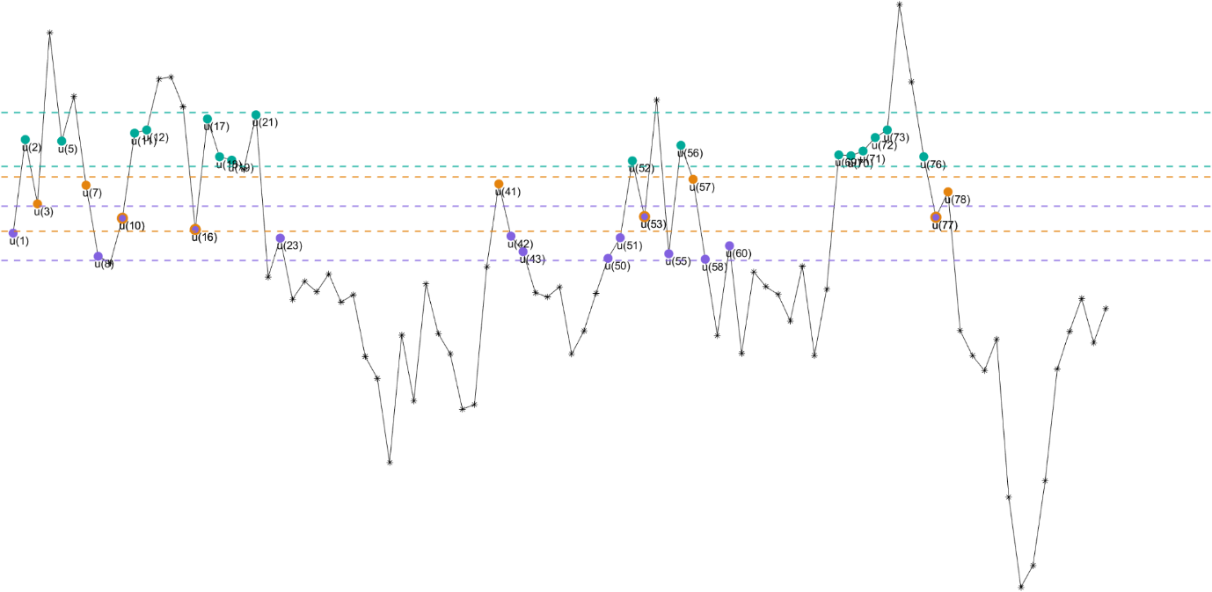
Illustration of Sample Entropy Calculation

Here is a piece of real EEG data extracted from a real EEG signal. This time series u(1), . . . , u(n) is shown to illustrate the procedure for Sample Entropy calculation in which the pattern length, m, is 2, and the similarity threshold, r, is 25. (r is a given positive real value that is typically chosen to be between 10% and 20% of the standard deviation of the time series.) We started with u(1), u(2) and u(3), which are represented by purple, green and orange dots and dotted horizontal lines around them represent u(1,2,3) ± r * std(time series) respectively with corresponding colours. If any pairwise distance between u(1) and other data points within this finite time series is under similarity criterion r * std(time series), they will be labelled as indistinguishable and marked as the same colour with u(1) (e.g., u(8),u(23),u(42),u(43) ... u(60)). Similarly, we’ve obtained other matching points as u(2) and u(3) and they are marked as green for u(2) and orange for u(3).
Given the 2-component (purple-green template pattern [u(1), u(2)])and the 3-component (purple-green-orange template pattern [u(1), u(2),u(3)]), there are two purple-green sequences,[u(10), u(11)] and [u(16), u(17)], except the self-matching sequences, that match the template sequence, and also two purple-green-orange sequence [u(51), u(52),u(53)] and[u(55), u(56),u(57)], that matches the template sequence [u(1), u(2),u(3)]. Therefore, in this case, the number of sequences matching the 2-component template pattern is two, and the number of sequences matching the 3-component template pattern is 2. These calculations are repeated for the next 2-component and 3-component template pattern, which are ([u(2), u(3)]) and ([u(2), u(3), u(4)]), respectively. Sequences that match each of the 2- and 3-component template patterns are again detected and added to the amounts. This procedure is then repeated for all other possible template sequences to determine the ratio between the total number of m component template matches and the total number of m+1 component template matches. SampEn is the natural logarithm of this ratio and reflects the probability that sequences that match each other for the first m data points will also match for the next point.
Why Multiscale Sample Entropy?
Despite the effectiveness and efficiency of single-scale sample entropy in assessing complexity based on signal regularity at the original time scale, there have been criticisms regarding its ability to fully capture the intricate nature of biological systems. In the study of brain complexity in neurological disorders, there exist contradictory findings where most studies indicate a reduction in complexity (Kang et al., 2018; Xu et al., 2020; Zhang et al., 2020), while others propose an increase in complexity (Bosl et al., 2018; Zhang et al., 2021). In addition to considering the influence of different brain regions (Maximo et al., 2021; Kang et al., 2018; Xu et al., 2020) and age groups (Bosl et al., 2018; Kang et al., 2018), this inconsistency can be attributed to inherent limitations of single-scale sample entropy as a measurement tool for complexity.
The human brain is regulated by an evolving interacting mechanism (Barrett, 2012), ensuring consistency in the time domain during ongoing processes (Bassett & Gazzaniga, 2011). Considering that signals from the brain hold different meanings across various spatial and temporal scales (Busa & van Emmerik, 2016; Yakovleva et al., 2020), it is crucial to accurately assess the multiscale spatiotemporal complexity of physiological signals composed of interrelated information (Costa et al., 2005). Intuitively, complexity is associated with “meaningful structural richness” (Grassberger, 1991), thus revealing correlations over multiple spatiotemporal scales in a time series. However, in some cases, others observed that an increase in single-scale sample entropy does not necessarily indicate a corresponding increase in physiological complexity (Delgado-Bonal & Marshak, 2019; Goldberger et al., 2000; Vaillancourt & Newell, 2002). Minimum entropy is not present in signals that are entirely predictable (e.g., periodic signals), and signals that are entirely unpredictable (e.g., uncorrelated random signals) do not display the expected maximum entropy. This leads to a challenge in distinguishing between regularity and complexity as it assigns high entropy values to both random and complex signals.
To illustrate this, Newell, 2002 extracted a sequence of data points representing the interval time series of a healthy heartbeat, which has been found to exhibit one of the most complex (i.e., multifractal) processes in nature (Ivanov et al., 1999). Then, the order of these data points was shuffled to create a randomised surrogate data; the sample entropy value of the surrogate data increases because traditional entropy treats the randomly randomised surrogate data as more irregular and unpredictable than the original heartbeat data. However, this randomised signal lacks the fractal correlation properties and nonlinear interactions present in the original data, as the process of randomly shuffling the original data points completely destroys the original internal correlations (Lancaster et al., 2018). As a result, despite the higher sample entropy value, the randomised dataset is considered to be less physiologically complex according to the definition provided above. This single time scale, along the gradient from regularity to randomness, leads to the perplexing conclusion that randomness is complex in some circumstances. For example, traditional entropy-based algorithms always assign the highest value to uncorrelated random signals (i.e. white noise), which can be confusing with the expected value of structurally complex signals (Costa et al., 2003). Therefore, it is important to recognise that increased irregularity or entropy does not necessarily imply an increase in physiological complexity. In such cases, assessing the physiological complexity is better achieved using scaling techniques that can detect and quantify the presence of long-range correlations in nonstationary time series, that is, the multiscale sample entropy (Costa et al., 2002).
Multiscale entropy (MSE) is an extension of sample entropy that includes an additional coarse-graining procedure (Costa et al., 2002). Integrating the temporal coarse-graining procedure within MSE progressively downsizes the original signal by applying a moving average filter with non-overlapping windows to average the adjacent data points into several subsets with increasing time scales (Courtiol et al., 2016). With the increasing temporal scales, the power spectral density of frequency after coarse graining shrank. In this case, the coarse-graining procedure acts like the low-pass filter in the frequency domain and downsamples the data points (Govindan et al., 2007; Kaffashi et al., 2008). Recent research proved that coarse-graining is mathematically identical to wavelet decomposition (Bosl et al., 2018), especially Haar wavelet approximations at power-of-two scales (Bosl et al., 2022). This extension to multiple time scales allows the determination of the irregularity in long-range temporal dynamics, that is, evoked neural dynamics that associate current brain activity with previously activated connectivity that has been generated by recurrent dynamics through multiple hierarchic levels of cortical networks (Garrido et al., 2007). Specifically, higher values of multiscale entropy (MSE), particularly at coarse time scales, are indicative of higher frequency, nonlinearities, and heightened stochasticity (Azami et al., 2017; Courtiol et al., 2016; van Noordt & Willoughby, 2021) or more transients in signals (School of Chemical Engineering and Technology, Xi'an Jiaotong University, Xi'an 710049; China & Wu, 2017), while conventional entropy-based measurements overlook these aspects.
Additionally, multiscale entropy performs differently in different types of time series; unlike the confusion in single-scale sample entropy, multiscale entropy instead shows an increased trend on EEG signals, while a decreased trend on surrogate one with the same pattern showing in white noise (Costa et al., 2003). MSE can reveal the dependence of entropy measures over multiple time scales. MSE performs differently in a random noise because its information only concentrates on the short time scales; as the signal being coarse-grained, its average remained unchanged and standard deviation monotonically reduced due to the absence of new structure (Costa et al., 2005). Therefore, MSE managed to present different patterns on different time series.
Here, the aim was to compare the performance of MSE on noise to demonstrate their performance of capturing features of different types of data as the foundation of the interpretation of multiscale entropy-based methods.
- MSE of noise: The dependency between the above-mentioned multiscale entropy-based methods and 1/f noise (i.e., PN) and white noise (WN).
- MSE of Phase-shuffled surrogate time series: To further test whether MSE is sensitive to nonlinear temporal dependencies in EEG and fMRI signal irregularities and to confirm its validity in the studies (Kosciessa et al., 2020), the MSE was applied to the corresponding phase-shuffled surrogate time series of the original time series.
Evaluation of Multiscale Entropy-based method on Noises
White Noise and 1/f Noise Generation. White noise (WN) has a constant power spectral density, whose samples are randomly drawn from the Gaussian distribution and uncorrelated (Diebold 1998). WN generated by $stretch * X_{n }+ shift$, where $X_{n }$ is a random scalar drawn from the standard normal distribution. $stretch$ is a parameter to adjust the width of the Gasussian distribution and $shift$ parameter works to shift the distribution.
1/f noise is defined by $\frac{1}{f^{c}}$. The key difference with 1/f noise is that it has a power spectrum that decreases with increasing frequency (Baxandall 1968). To generate it, we define its frequency description and then transform inversely to reveal it at the time domain. To generate it, we define its frequency description and transform it inversely to reveal it at the time domain. The frequency description is defined to generate the 1/f noise, and then the inverse transformation is applied to reveal it in the time domain. Firstly, an exponential decay parameter is set to define the steepness of the frequency distribution slope. Uniformly distributed random numbers with half the length of the noise are generated and multiplied by a negative exponential to create a $\frac{1}{f}$ amplitude spectrum. Now, this amplitude spectrum moves towards zero, and it is mirrored using some additional random factors to obtain the coefficients for the inverse Fourier transform.
Evaluating Multiscale Sample Entropy Performance on White Noise and 1/f Noise with Various Exponential Decay Parameters. Figure 2 illustrates the time and frequency domain description of the normally distributed white noise and 1/f noise and their multiscale entropy curves. Panel A and B are for WN and PN, respectively. Subplots(i) are the time domain signal while subplots(ii) are the frequency domain signal, and subplots (iii) are the MSE pattern for noises.
The signal distribution of WN and PN is similar, and they are all close to the Gaussian distribution. Values alone are not what distinguish 1/f noise from white noise. In the white noise, entropy values go down over time as the coarse-grained WN standard deviation decreases monotonously due to the absence of a new structure (School of Chemical Engineering and Technology, Xi’an Jiaotong University, Xi’an 710049; China & Wu, 2017).
To emphasise this statement, the occurrence of zeros in sample entropy for regular time series (i.e., periodic data) can also be observed, given their high predictability associated with the same repetitive data points (Delgado-Bonal & Marshak, 2019). Unlike the findings reported in other studies, where the multiscale sample entropy profile of 1/f noise remains flat from the time scale 1 to 20 (Wu et al., 2013; Pham, 2017), this test demonstrates that the varying exponential decay parameter also influences the performance of multiscale sample entropy for 1/f noise. When the exponential decay parameter (ed) falls within the range of 50 and 200, this moderate ed has the potential to generate a noise signal resembling EEG characteristic. This is because EEG signals frequently encompass a wide spectrum ranging from slow-wave activity to higher-frequency components. The presence of the 1/f-like amplitude spectrum is why it looks more like a biological signal. The multiscale entropy-based approach also detects this characteristic. In the context of 1/f noise, the low-frequency components confirm the progressive rise in entropy at finer scales. The inherent fractal structure of 1/f noise prevents this entropy increase at coarser scales, maintaining a relatively consistent level. Moreover, it is evident that multiscale sample entropy is strongly influenced by frequency but may not depend on the amplitude of the examined signals.
As the exponential decay parameter (ed) increases to over 300 in this case, the generated 1/f noise will tend to exhibit characteristics more similar to white noise. This is because higher values of exponential decay parameters lead to faster decay of the amplitude spectrum in the frequency domain. 1/f noise typically has a 1/f power spectrum, which means that as frequency increases, the amplitude decreases. When ed increases, the amplitudes of high-frequency components decrease more rapidly, making the noise signal resemble white noise, where all frequencies have similar amplitudes. This reduced distinction in amplitudes results in the noise signal having a more uniform distribution of frequencies, which is characteristic of white noise. This feature is also captured by the multiscale entropy-based method, as reflected by the declining pattern observed at coarser time scales, coinciding with the reduction of high-frequency components.

Figure 2
Analysis of White Noise Signals in Time and Frequency Domains, Multiscale Sample Entropy Profile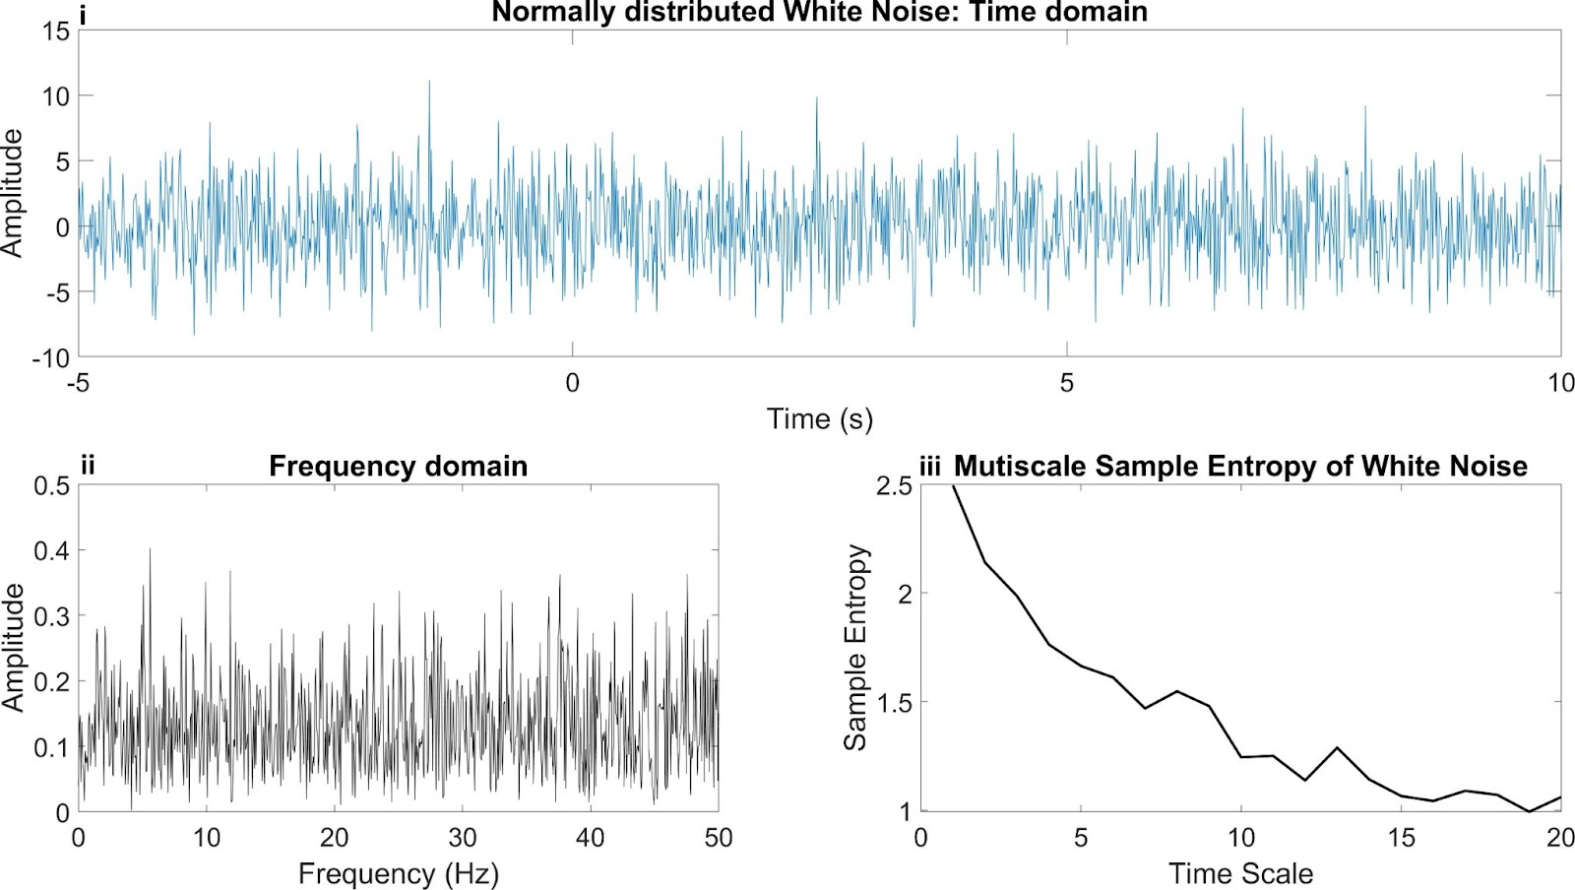
Figure 2 illustrates the time and frequency domain description of the normally distributed white noise and its multiscale entropy curve. Subplots(i) are the time domain signal while subplots (ii) are the frequency domain signal, and subplots (iii) are the MSE pattern for white noise.
Figure 3
Analysis of 1/f Noise Signals in Time and Frequency Domains, Multiscale Sample Entropy Profile, and the impact of varied exponential decay parameter
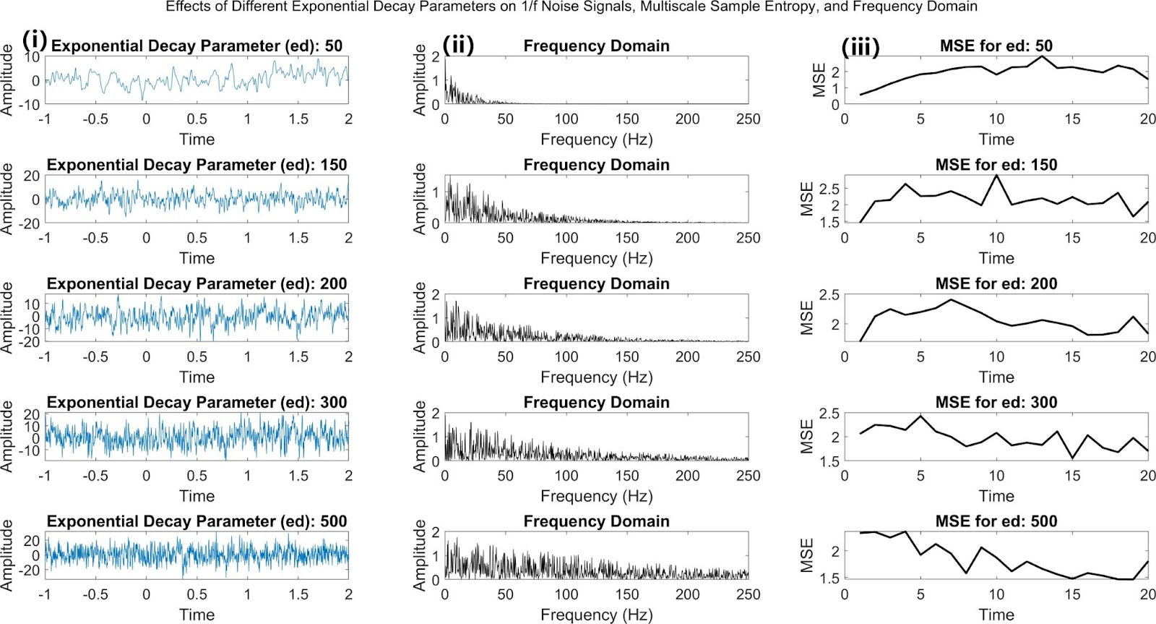
Figure 3 illustrates the time and frequency domain description of the 1/f noise and its multiscale entropy curve. Subplots(i) are the time domain signal while subplots (ii) are the frequency domain signal, and subplots (iii) are the MSE pattern for 1/f noise.

Evaluating Multiscale Sample Entropy Performance on Phase-shuffled Surrogate time series. To further examine the sensitivity of MSE to nonlinear temporal dependencies in resting-state EEG and fMRI signal irregularities and verify its validity, phase-shuffled surrogate time series were introduced. These surrogate time series were generated by subjecting the original EEG and fMRI signals to a Fourier transform (FFT), uniformly randomly shuffling the phase of the Fourier components, and then applying the inverse Fourier transform to reconstruct the time domain. To enhance reliability in identifying nonlinearity, the iterated amplitude-adjusted Fourier transform (IAAFT) technique was employed to shift the nonlinear correlation structure (multifractality) while keeping the degree of linear correlation (persistence) and the amplitude distribution (Theiler et al., 1992; Schreiber & Schmitz, 1996). This procedure includes the following steps:
- Perform FFT on the original time series.
- Initialise the surrogate time series and Perform FFT on the surrogate time series.
- Match the amplitude of the original FFT and surrogate FFT.
- Generate random phase shifts.
- Apply the phase shifts to the amplitude-matched FFT.
- Apply inverse FFT to obtain the phase-shuffled surrogate time series.
The phase-shuffled surrogate time series were obtained through a maximum of 100 iterations. The entire execution was carried out using a custom MATLAB script available on GitHub at the following link: https://github.com/wenyixiao0058/MSE_effectiveness.git, specifically referring to the "phase_suffled_surrogate.m" file, which employs built-in functions like fft for extracting FFT characteristics and ifft for reversing the data to its original time domain representation. Refer to Figure 3 for an example comparing the original EEG signals with the surrogate time series. Notably, the power spectrum of both the original EEG and phase-shuffled time series is identical. As the power spectrum reflects a linear process but lacks phase information, the phase-shuffled time series is expected to exhibit higher entropy than the original EEG or fMRI time series due to its increased irregularity.

Figure 4
Multiscale Sample Entropy of original EEG signal and surrogate time series
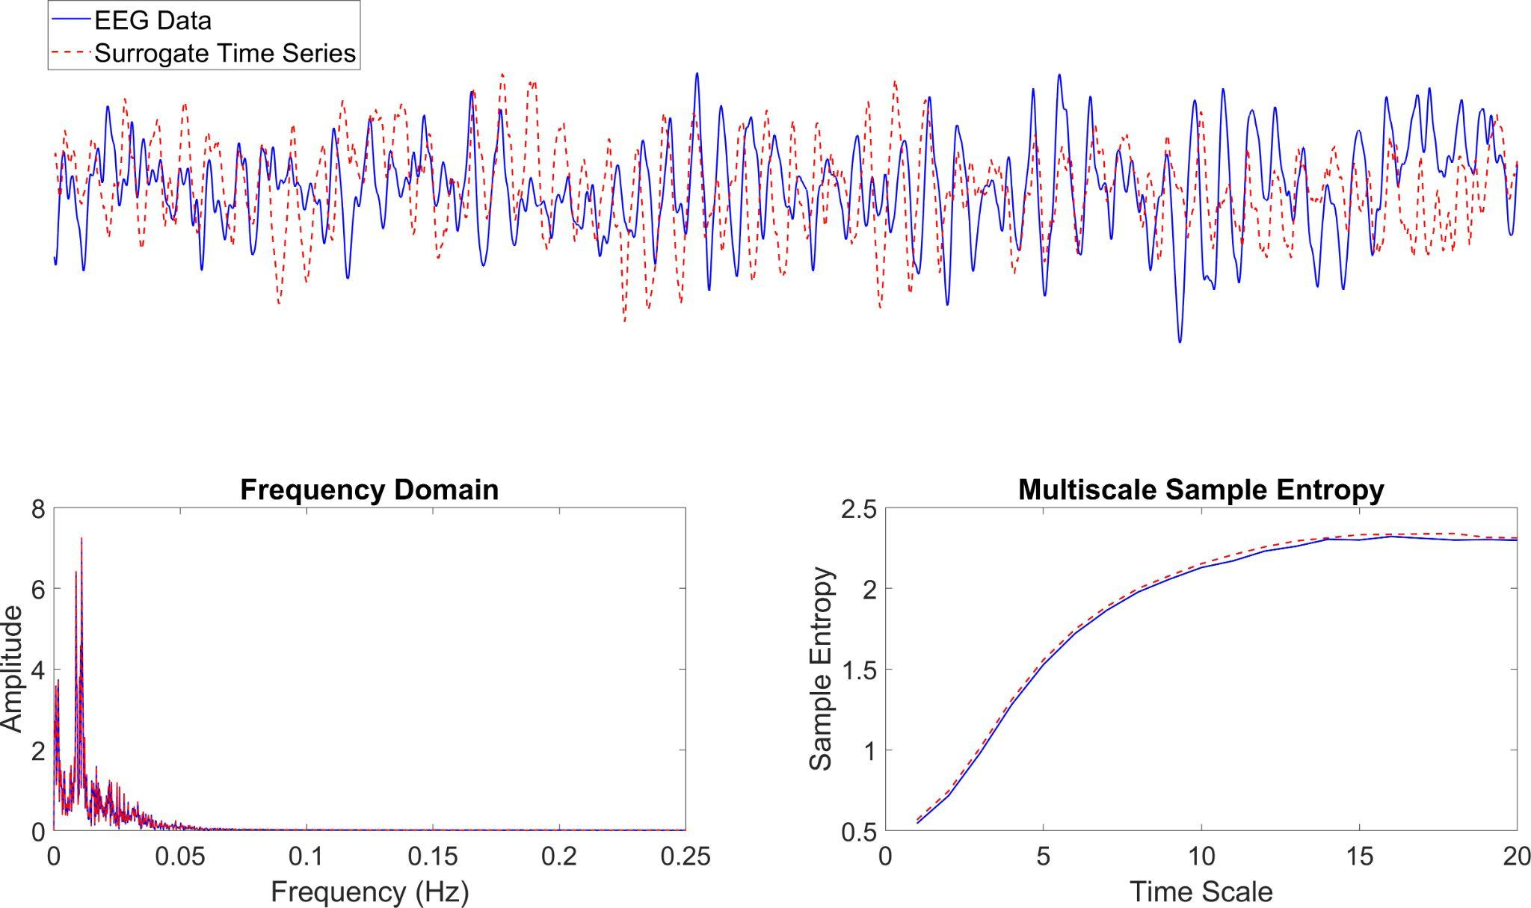

The upper panel depicts a section of continuous EEG time series (represented by the solid blue line) alongside phase-shuffled surrogate time series (depicted by the dashed red line). Notably, the power spectrum of both the original EEG and phase-shuffled time series is identical. MSE assigns greater entropy to the phase-shuffled surrogate time series compared to the original time series due to its increased irregularity.
Again, the phase-shuffled surrogate time series for a signal from each intracerebral voxel was produced using the previously described method that was applied to the EEG signal. Here, the multiscale sample entropy was only employed on the grey matter signal using the same parameters in the following study (Chapter 3). The standardised multiscale sample entropy was computed by subtracting the global mean and subsequently dividing by the global standard deviation, resulting in a regenerated standardised multiscale sample entropy. As anticipated, the raw and standardised multiscale sample entropy of the phase-shuffled surrogate time series exceeded that of the original fMRI signal (Figure 4).

Figure 5
Raw and Standardrised Multiscale Sample Entropy of original fMRI signal and surrogate time series
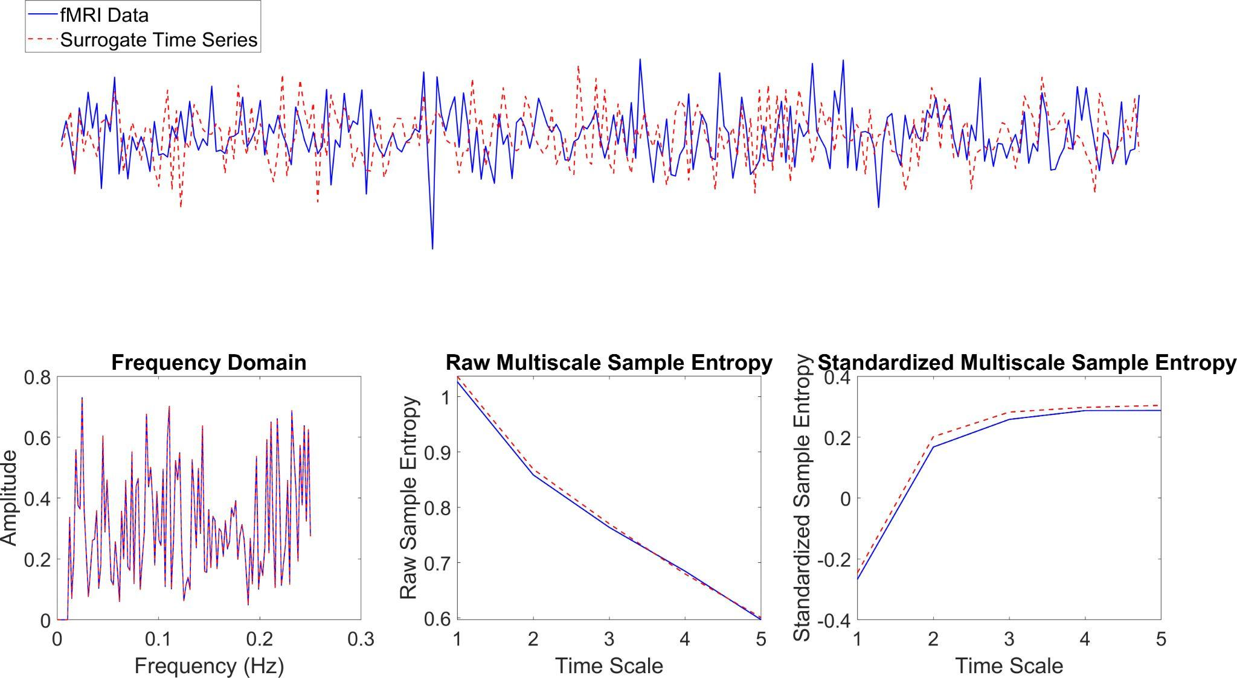

The upper panel depicts a fMRI time series from a random grey matter voxel (represented by the solid blue line) alongside a phase-shuffled surrogate time series (depicted by the dashed red line). Notably, the power spectrum of both the original fMRI and phase-shuffled time series is identical. MSE assigns greater entropy to the phase-shuffled surrogate time series than the original time series due to its increased irregularity. In this case, the decreasing trend in MSE for the fMRI signal needs to be clarified; it could be attributed to the insufficient data points, remaining noise artefacts, or limitations in capturing frequency components of different filtering methods employed within this investigation. Nevertheless, an in-depth exploration of these factors exceeds the bounds of this thesis and could be a novel direction for future research. The analysis will rely on standardised multiscale sample entropy for interpretation in the current study. Standardised multiscale sample entropy can capture enhanced nonlinear features of the phase-shuffled surrogate fMRI time series, as evidenced in this test. Furthermore, it effectively reproduces key MSE findings, including age-related variations and identifying the eyes-closed condition in the following studies (i.e., Chapters 3 and 4).

Multiscale Sample Entropy as a biomarker for ASC
To date, several studies have analysed the neural correlates of ASC based on multiscale entropy calculation, which has shown an atypical neuronal pattern. In contrast to the inconclusive outcomes observed with single-scale sample entropy, evidence from studies conducted under resting-state conditions suggests a consistent reduction in multiscale entropy among individuals with ASC. This reduction is primarily observed at coarse time scales (i.e., larger time scales) (Catarino et al., 2011), with some effects also observed at fine time scales (i.e., smaller time scales) (Milne et al., 2019). Given the high heterogeneity of ASC, some studies parallelly explore the MSE pattern at subgroups based on the severity of ASC. (Hadoush et al. 2019) have suggested that children with severe ASC exhibit a lower MSE in the parietal and right frontal region. An overall decreased MSE among high-risk ASC groups was also found in another study (Anon, n.d.). Although there is an indirect association between MSE and other linear features (Courtiol et al., 2016; van Noordt & Willoughby, 2021), such as power content and functional connectivity, it remains uncertain whether the observed decrease in multiscale sample entropy in individuals with ASC stems from dysfunctional neuronal connectivity.
Brain complexity in rs-fMRI BOLD signals in ASC
To comprehensively understand the brain complexity in ASC populations, multimodal imaging datasets will be analysed from the perspective of the atypical neurophysiological dynamics would be guided by a direct measure rich in information in both spatial (i.e., localisation of atypical brain complexity) and temporal (i.e., time series of the BOLD signal) context. The high spatial resolution of resting-state fMRI can effectively detect this richness in atypical brain complexity information and underlying cortical neuronal generators.
Neurons do not store glucose or oxygen as internal energy reserves (Falkowska et al., 2015). When a specific brain area becomes up-regulated, the increased neural activity and heightened signalling processes lead to an augmented demand for energy through the hemodynamic response in that particular brain region. This mechanism boosts regional cerebral blood flow and provides more oxygen than the neurons typically require (Ogawa et al., 1993). As a result, there is a detectable change in the relative levels of oxyhaemoglobin and deoxyhaemoglobin (Sheng et al. 2022), discernible through MR imaging due to their distinct magnetic susceptibilities (Schenck, 1996). This imaging technique is known as the blood oxygen level-dependent (BOLD) contrast imaging.
Biswal et al. first described the biological significance of neural activity fluctuations (Biswal et al., 1995). Since then, fMRI has been extensively utilised to investigate spontaneous fluctuations of various resting-state brain regions in neurotypical individuals and individuals with neurological and psychiatric disorders (Lee et al., 2013; Zhan & Yu, 2015). Like the EEG signal, the fMRI time series exhibits linear properties and nonlinearity (Friston et al., 1998; Gultepe & He, 2013). This nonlinearity in fMRI holds the potential to offer a more comprehensive understanding of the underlying neuronal mechanisms. Entropy measure has been commonly used to analyse spontaneous electrophysiological signals (Chenxi et al., 2016; De Wel et al., 2017) and to detect brain alterations in neurodevelopmental disorders.
Clinical Relevance of Default Mode Network (DMN) in ASC
Successful social interactions rely on understanding the concept of "self" about others (Steinbeis, 2016). It is theorised that individuals with ASC face challenges in reciprocal social interaction because they struggle with self-referential cognitive processing and inferring the mental states of others (Lombardo et al., 2007). These difficulties contribute to the difficulties experienced by individuals with ASC in engaging effectively in social interactions. Given the importance of understanding the concepts of "self" and "other" in social interactions, it is not unexpected that the DMN, a fundamental brain system involved in processing information related to the self and others (Andrews-Hanna et al., 2010; Buckner & DiNicola, 2019; Dixon et al., 2021; Li et al., 2014; Molnar-Szakacs & Uddin, 2013), has been identified as a critical network implicated in social dysfunction in ASC (Feng et al., 2022; Lombardo et al., 2019; Yerys et al., 2015).
In general, fMRI time series studies commonly utilise linear-based methods to analyse time-varying linear correlations among regions of interest. Regarding ASC, the literature predominantly indicates a mixture of under- and over-connectivity patterns. These patterns vary depending on whether one examines local or global networks. Whole-brain connectivity approaches have presented evidence indicating that individuals with ASC exhibit the lowest levels of whole-brain functional connectivity, while controls demonstrated the highest levels (Moseley et al., 2015). The seed region-of-interest (ROI) approach and data-driven ICA approaches indicate specific altered connections and corresponding relations to the deficits in ASC. In a ground-breaking study by Monk et al., they examined connectivity within the DMN in adults with ASC when their eyes open. Using the Posterior Cingulate Cortex (PCC) as a seed, they observed under-connectivity between the PCC and Superior Frontal Gyrus (SFG) in individuals with ASC. However, they also discovered over-connectivity between the PCC and bilateral temporal lobes and the right Posterior Hippocampal Gyrus (PHG).
Additionally, they found that social functioning was linked to the strength of connectivity between the PCC and temporal lobes. Weaker connectivity between the PCC and SFG was associated with poorer social functioning. In comparison, stronger connectivity between the PCC and right PHG was related to more severe restricted and repetitive behaviours (Monk et al., 2009).
Another study, focused on children rather than adults, also identified changes in functional connectivity within the DMN during the eyes open condition (Paakki et al., 2010). They used regional homogeneity (ReHo), which measures the local synchronisation of spontaneous fMRI (BOLD) signal activity within specific clusters. ReHo analysis examines local connectivity but does not capture global or long-range FC. The study revealed significant alterations in the resting-state brain activity of children with ASC, particularly within regions of the right hemisphere closely associated with the DMN. Specifically, a decrease in ReHo, indicating under-connectivity, was found in the right superior temporal sulcus and right insula. However, it is worth noting that contradictory findings are reported in the literature on the eyes closed condition. For instance, an increase in ReHo has been reported in the right precuneus and inferior parietal gyrus by (Li et al., 2018).
On the other hand, individuals with ASC exhibit under-connectivity within the sub-components of the DMN, as highlighted by the research (Bathelt & Geurts, 2021; Washington et al., 2014; Yerys et al., 2015). Specifically, under-connectivity is observed in the medial prefrontal cortex (mPFC) and PCC of the DMN. Notably, the severity of social deficits in ASC individuals is correlated with the extent of this under-connectivity. However, there are still contradictory findings. The findings suggest that there are both under- (Assaf et al., 2010; Bathelt & Geurts, 2021; Lynch et al., 2013)and over-connections between the DMN and other brain regions(Glerean et al., 2016; Washington et al., 2014), particularly at the long-distance junction. This discrepancy is attributed to the distinct functioning of different sub-components of the DMN in individuals with ASC (Bathelt & Geurts, 2021). Specifically, the precuneus in ASC exhibits hypoconnectivity, while the posterior cingulate cortex demonstrates hyperconnectivity in ASC (Lynch et al., 2013; Assaf et al., 2010). It is important to note that these variations may also be influenced by the heterogeneity of the ASC endophenotype itself (Moseley et al., 2015). Moreover, these intra- and inter-DMN-associated connections are negatively correlated with the symptoms of ASC (Assaf et al., 2010; Feng et al., 2023).
Age-related variations in Default Mode Network (DMN)
The disparity in functional connectivity within and across the Default Mode Network (DMN) is also influenced by age. Age-related variations have been proposed to contribute to the modular structure of the DMN between childhood and early adulthood in healthy controls. The proposal suggests that during early development, there may exist a less specialised and more widely distributed proto-organisation of the DMN (Buckner & DiNicola, 2019). It has been demonstrated that the growth of internodal functional connectivity within the DMN in typically developing children follows a quadratic trajectory about age, similar to the process of synaptogenesis. This growth of connectivity reaches its maximum point between the ages of 11 and 13. However, in children with ASC, these long-distance connections do not develop during adolescence (Washington et al., 2014).
In summary, multiple studies consistently reveal a notable trend: Intrinsic functional connectivity is typically diminished in adolescents and adults with autism compared to their age-matched counterparts, whereas in younger children with the condition, functional connectivity seems to be heightened (Fan et al., 2021). During the transition from childhood to adolescence in individuals with ASC, a shift was observed from overall hyperconnectivity to hypoconnectivity (Bathelt & Geurts, 2021; Uddin et al., 2013). It is important to note that these alterations in connectivity also have the potential to be influenced by the modular organisation of the DMN. Consistent with this finding, several studies have shown increased connectivity within subnetworks of DMN during childhood in individuals with ASC. However, as individuals with ASC transition into adolescence, there is a notable shift towards decreased connectivity and greater modularity within the DMN (Bathelt & Geurts, 2021; Glerean et al., 2016; Lynch et al., 2013). Insufficient evidence supported the expectation of hypoconnectivity within the DMN during adolescence. Instead, the strength of DMN subnetwork connections appeared similar between individuals with ASC and neurotypical individuals towards the end of the age range (18 years). As proposed by Uddin and colleagues, hypoconnectivity may emerge in later stages of development beyond 18 years (Uddin et al., 2013). On the other hand, the decrease in hyperconnectivity observed in the ASC group could indicate a delayed developmental pattern. According to a recent comprehensive review of the DMN (Buckner & DiNicola, 2019), the modularisation of DMN subsystems is a developmental process that relies on activity and experience.
Assessing Entropy Measures in ASC Research Using Resting-State fMRI
Nonlinear signal processing methods, such as approximate entropy (ApEn) (Pincus, 1991; Pincus, 1995) and sample entropy (SampEn) (Richman & Moorman, 2000), have been recently applied to investigate the complexity of brain fMRI dynamics. Entropy indicates the frequency of pattern repetition within a signal, measuring both the randomness and predictability of a stochastic process. In general, entropy assigns a higher value to greater randomness. Conversely, lower entropy indicates a simpler signal or system with lower levels of complexity. According to the Goldberger/Lipsitz model (Goldberger, 1996; Goldberger et al., 2002), it is generally expected that healthier and more robust systems will exhibit greater complexity in their physiological output, whereas more predictable behaviours would be associated with pathological states (Pool 1989).
Except for the functional connectivity (FC) measures (Biswal et al., 1995), the temporally synchronised activity between segregated brain regions can also be assessed during unconstrained intrinsic activity with nonlinear methods. Using resting-state fMRI data, sample entropy was successfully employed to characterise the resting-state brain activity of many neurotypical participants from the 1000 functional connectome project (FCP) database. The resulting whole-brain entropy pattern was further verified to be parcelled into seven hierarchical regional networks (Wang et al., 2014). Entropy can also be applied to differentiate between the brain states of resting periods and working memory tasks among normal subjects (Nezafati et al., 2020). Despite concerns about the reliability and accuracy of using sample entropy to analyse fMRI data with shorter data points compared to EEG data, it has been shown that sample entropy is not dependent on data length and can effectively differentiate between regions in younger and elderly adults even with very few data points (Sokunbi, 2014). Additionally, brain entropy has been proposed as a potential differentiator for various psychiatric and neurophysiological disorders, such as schizophrenia (Sokunbi et al., 2014), Alzheimer's disease (Wang and Alzheimer's Disease Neuroimaging Initiative 2020), and ADHD (Sato et al., 2013; Sokunbi et al., 2013). These findings demonstrate the potential of entropy as a tool for evaluating brain activity through rs-fMRI data.
Entropy research in the ASC population is considerably limited and mostly relies on EEG-based quantitative analysis. Generally, ASC subjects exhibited a reduced entropy in the prefrontal cortex, such as the left orbitofrontal cortex (Zhang et al., 2020) and superior frontal gyrus (Maximo et al., 2021), as identified in resting-state functional magnetic resonance imaging (rs-fMRI) studies. Despite observing reduced entropy in the frontal cortex among ASC subjects, several resting-state fMRI studies have reported inconsistent results. For example, a study conducted by (Zhang et al., 2020) revealed that sample entropy values were notably decreased in individuals with ASC compared to neurotypical individuals across multiple brain regions responsible for processing visual and sensory information, indicating reduced complexity in the adult ASC brain. Another study found decreased entropy in the frontal cortex and increased entropy in the left angular, superior parietal lobule, and right inferior temporal gyrus in ASC children (Maximo et al., 2021).
Nevertheless, another study investigated the complexity of resting-state BOLD signals using sample entropy in children and adolescents and found no significant differences between the ASC and neurotypical groups (Easson & McIntosh, 2019). These inconsistent studies might be attributed to the heterogeneity of ASC, as severe ASC children have relatively lower entropy across brain regions than mild ASC children (Hadoush et al., 2019). Furthermore, entropy is significantly negatively related to Autism Diagnostic Observation Schedule total scores (ADOS) in some specific brain regions, such as the left postcentral gyrus and the right lingual gyrus (Zhang et al., 2020) and also SRS scores (Easson & McIntosh, 2019).
These findings point to the potential diagnostic utility of entropy measured by methods like sample entropy for understanding the dynamics of the ASC brain, as well as the need for further examination of underlying ASC symptomatology. Nevertheless, there needs to be more rs-fMRI studies that have utilised multiscale sample entropy, primarily due to the limited temporal resolution of the fMRI technique and the inadequate number of time points available for robust analysis. The limited number of time points available for analysis can increase the data's noise levels (Courtiol et al., 2016; Sokunbi, 2014). However, it is essential to emphasise that no study has yet directly proved the lack of validity or usefulness of Multiscale Sample Entropy (MSE) in the context of rs-fMRI analysis. Typically, BOLD (Blood Oxygen Level Dependent) time series data are relatively short, consisting of approximately 100-200 time points. When applying the coarse-grained procedure in MSE with a significant scale factor (greater than scale 5), the short length of the data may lead to unreliable estimations of sample entropy. Researchers have proposed estimating the appropriate parameters for MSE calculations from relatively short BOLD signals to address this issue. In the study (Yang & Tsai, 2013), they utilised a time scale factor of up to 5 to mitigate this concern. In another study, entropy was successfully employed to partition seven distinct brain networks at a resting state. To accommodate the limited number of time points in the rs-fMRI study, the researchers utilised parameters of m = 2 and r = 0.6 (Nezafati et al., 2020; Wang et al., 2014). This adjustment was made to ensure the suitability of entropy analysis in the context of rs-fMRI studies with relatively few time points available (Yang et al., 2018).
The change in the BOLD signal is crucial in rs-fMRI imaging, which is commonly used to generate maps that reveal specialised brain regions engaged during the resting state, focusing on low-frequency fluctuations typically ranging from 0.01 to 0.1 Hz. The primary interest in resting-state fMRI is studying these low-frequency fluctuations (Lee et al., 2013). However, using low-pass filtering in rs-fMRI continues to be a subject of debate and disagreement in the field. Evidence suggests that low-pass filtering can reduce detection sensitivity without significantly improving specificity (Della-Maggiore et al., 2002; Skudlarski et al., 1999). Furthermore, low-pass filtering might impose a high level of autocorrelation on the signal, violates the assumption of temporal independence (Christova et al., 2011; Friston et al., 2000), which is essential for statistical testing and could potentially have adverse and unpredictable effects on the calculation of multiscale sample entropy (Kaffashi et al., 2008). In the context of rs-fMRI, arguments state that band-pass filtering can introduce spurious correlations. Thus, it is crucial to correct temporal filtering to account for this effect (Davey et al., 2013). As a result, unlike most rs-fMRI studies that employ a low-pass filter, our approach involves the implementation of a high-pass filter to eliminate low-frequency drifts originating from common physiological noise (Boubela et al., 2013).
Age-related Complexity in ASC and neurotypical controls
Numerous variables associated with brain activity are recognised to affect entropy detection. A notable fMRI study demonstrated that global entropy exhibited an inverted U-shaped trajectory, peaking around the age of 40 (Niu et al., 2022). Consistent with findings from EEG studies on brain entropy, brain complexity tends to increase with age among healthy young adults (Wang, 2021), with a particular emphasis on a progressive increase from childhood to adulthood (McIntosh et al., 2008). The increased complexity with age could be attributed to the idea that higher entropy levels are associated with improved cognitive performance (Sokunbi et al., 2011) and intellectual capacity (Saxe et al., 2018) associated with brain development. However, this age-related increase in complexity reverses when considering the older population. Younger individuals tend to exhibit greater brain activity complexity than older individuals, as demonstrated by (Smith et al., 2014; Sokunbi, 2014; Yang et al. 2013; Yao et al., 2013). This finding aligns with the "loss of complexity" theory, wherein the ageing brain experiences a decline in integrating intricate networks (Lipsitz, 2004). Lipsitz and Goldberger proposed that the average human ageing process is associated with a reduced complexity observed across various fractal-like anatomical structures and physiological processes (Lipsitz, 1992).
Furthermore, the age-related rise in brain complexity among healthy young adults is particularly prominent in specific regions, including the default mode network (DMN) and executive control network (ECN), as highlighted by (Wang, 2021). Additionally, in a recent study utilising data from a population of healthy elderly individuals, a negative correlation between brain entropy and spontaneous brain activity within the DMN has been observed (Yang et al., 2013). The region-specific rise in brain complexity with age might be due to the postulated heightened variability in cortical dynamics resulting from improved functional integration (Ballard et al., 2023). During the maturing process, the most significant proportion of integrated nodes was identified within the DMN (Niu et al., 2022), potentially explaining this age-related observation.
DMN is the simultaneous activation of specific cortical regions within a distributed network while the brain is at rest (Raichle & Snyder, 2007). Additionally, it is recognised as a task-negative network, as it becomes suppressed during goal-directed cognitive tasks (Raichle et al., 2001) and in passively controlled conditions (Shulman et al., 1997; Mazoyer et al., 2001). Nevertheless, the precise role of DMN activity in the decline of cognitive function is still not fully understood (Mevel et al., 2011). While BOLD activity in the DMN attenuated during cognitively demanding tasks (Raichle & Snyder, 2007), previous studies based on task-based approaches have indicated a close association between DMN activity and essential cognitive functions (Mevel et al., 2011). However, activities involving internally constructed representations (Spreng & Grady, 2010), such as remembering, envisioning the future, theory-of-mind reasoning and making social inferences, have elicited increased activation in regions of the DMN beyond that during passively controlled conditions. The core ASC symptoms, social-cognitive functions, rely on a closely interconnected network of brain structures within the DMN. For instance, activity in the posterior cingulate cortex has been observed during tasks involving autobiographical episodic memory and self-referential processes (Buckner & Carroll, 2007; Maddock et al., 2001; Sheline et al., 2009), the medial frontal cortex is linked to social cognitive processes (Amodio & Frith, 2006), and the medial temporal lobe primarily contributes to episodic memory (Milner, 2005).
Moreover, the socio-cognitive processes within individuals with ASC are also subject to age-related changes linked to the diverse developmental trajectories observed in different functional circuits (Padmanabhan et al., 2013; Wiggins et al., 2011). Specifically, the observed age-related modifications in the intrinsic functional connectivity of the posterior superior temporal sulcus suggest that ASC does not adhere to a single developmental pattern (Alaerts et al., 2015). This paper aims to establish a whole brain entropy map using a large dataset from ABIDE I to investigate the group differences of SEN between ASC and neurotypical controls.
Complexity related to eye conditions in ASC and Neurotypical Controls
Another relevant confounding factor in clinical studies that should be acknowledged is the state of the eyes, whether they are open or closed. The transition from a state of eyes closed to eyes open during rest leads to alterations in the intricate patterns of interaction between brain networks.
Specifically, there is an increased connectivity between most brain networks and stronger spontaneous BOLD oscillations when the eyes are closed compared to when they are open (Han et al., 2023; McAvoy et al., 2008). Graph theory analyses further revealed that during the eyes-closed state, there is a reduction in cliquishness and local efficiency of networks. In contrast, global efficiency is heightened in comparison to the eyes-open state, thereby suggesting an enhanced level of integration during eyes-closed, while the eyes-open state may exhibit greater modularity or specialisation within the networks (Xu et al., 2014; Yan et al., 2009).
The functional networks of the human brain demonstrate distinct topological properties when the eyes are open compared to when they are closed, categorisable as "exteroceptive" and "interoceptive" networks reflecting different modes of information processing (Marx et al., 2003; Xu et al., 2014). These two networks consist of widespread topological brain regions. Specifically, the exteroceptive network encompasses attentional and oculomotor systems, such as the superior parietal gyrus and frontal eye fields, which exhibit activation during the eyes-open state. On the other hand, the interoceptive network involves sensory systems, including visual, auditory, and somatosensory regions, which demonstrate activation during the eyes-closed state (Hüfner et al., 2008; Marx et al., 2003). Furthermore, as observed during the transition from eyes open to eyes-closed, there is an increased connectivity between the salience network and the DMN. At the same time, there is a decrease in connectivity between the salience network and the Visual Network (Han et al., 2023). Moreover, it is worth mentioning that the primary visual cortices exhibit low correlations with other regions, particularly during the eyes-closed condition, as noted in a study by (McAvoy et al., 2008). This reduction in correlations aligns with a decrease in visual activity, as reported by (Yang et al., 2007).In addition to the suppression of visual information processing during the eyes-closed condition, the eyes-open state involves increased attentional load (Hüfner et al., 2009) and multisensory activity (Koba et al., 2021; Marx et al., 2004; Qian et al., 2019). However, there is decreased intra-network FC in the DMN at eyes-closed conditions (Agcaoglu et al., 2019; Koba et al., 2021).
Links between MSE and Functional Connectivity in ASC
The intricacy of the dynamic fluctuations in neural activity is associated with both the probability of single neurons firing and the likelihood of synchronisation among various brain regions. Signals that are more predictable, indicating lower neural complexity, facilitate phase relationships between different brain regions, thereby increasing the chances of synchrony and information processing across distributed brain regions (McDonnell and Ward 2011; Ghanbari et al. 2015).
Multiscale sample entropy (MSE) captures high frequency temporal complexity (i.e., fine scales) and low-frequency temporal complexity (i.e., coarse scales) (Costa et al. 2002). It has been suggested that coarse time scales reflect long-range interactions across distributed neural populations, while fine time scales signify interconnectivity among local neural populations (McIntosh et al. 2014). ASC has been consistently associated with atypical brain connectivity patterns (Doyle-Thomas et al. 2015; O’Reilly et al. 2017; Müller and Fishman 2018) and atypical MSE pattern. Some studies propose the hypothesis that the diminished complexity of electrical brain activity observed in individuals with ASC may be linked to a potential reduction in long-range temporal correlations in brain activity (Takahashi et al. 2009). Additionally, a study reveals a trend indicating decreased complexity in the EEG signals of infants at high risk of ASC during the early stages of brain development. This suggests that the variations in EEG signal complexity at these early stages may reflect the rapid changes in local neural connectivity (Bosl et al. 2011). However, the underlying neurophysiological mechanisms governing the complexity of electrophysiological and fMRI signals in ASC, as well as their relationships with functional connectivity (FC), remain uncertain.

Links between MSE and E/I in ASC
Local signal fluctuations have been suggested to be responsive to the synchronised firing of groups of neurons, that is, when neuronal clusters are highly excitable, it tends to produce more irregular and complex activity, while greater inhibition leads to more regular and predictable patterns (Haider and McCormick 2009). In healthy neural circuits, there is a delicate balance between excitatory and inhibitory inputs, contributing to the complex and dynamic patterns of neural activity (Dehghani-Habibabadi et al. 2023). In cases where there is an imbalance in E/I ratios, such as in neurological disorders like ASC or epilepsy, it has been proposed that this imbalance may influence the temporal structure of neural signals. For example, an altered E/I balance could potentially affect the temporal structure of neural oscillations, leading to changes in the nonlinear temporal dependence reflected in the MSE. Specifically, there is an assumption that the regulation of neural activity by GABA may contribute to the reduced complexity of neural activity (Ghanbari et al. 2015), specifically leading to a reduction in complexity at the coarse time scale associated with an elevated E/I ratio (Park et al. 2023). Additionally, specifically leading to a reduction in the complexity of brain activity in a brain region of ASC might potentially be triggered by the excessive synaptic input from other brain regions. These incoming interconnections could have been reinforced through interactions with the brain region exhibiting an imbalanced E/I ratio (Park et al. 2023).
Data Sources and Pre-processing
All data used in this research was obtained from secondary datasets. In Chapter 2, the dataset retrieved from the NDA had undergone pre-processing steps, including high-pass filtering at 0.1 Hz, low-pass filtering at 100 Hz, and notch filtering at 60 Hz. Furthermore, any channels recorded from electrodes with impedances exceeding 200 kOhm were already removed, and the data had been partitioned into 2.048-second epochs by the initial data collection team.
Specifically, I wish to acknowledge the valuable contribution of Dr. Adam Dede, a postdoctoral research associate, who played a significant role in pre-processing the EEG data utilised in this study. Dr. Adam Dede's pre-processing procedures adhered to standard protocols, encompassing artefact removal, and interpolation. Comprehensive details regarding Dr. Adam Dede's pre-processing methodologies can be accessed at https://github.com/adede1988/SheffieldAutismBiomarkers. However, I independently wrote the code and implemented all the subsequent analyses.
The fMRI data were obtained from publicly accessible secondary datasets. Specifically, the fMRI data from the Autism Brain Imaging Data Exchange (ABIDE) dataset was utilised. Pre-processing of the fMRI data involved standard steps such as motion correction, spatial normalisation, and signal intensity normalisation. Specific tools and software used in the fMRI pre-processing, such as the Statistical Parametric Mapping (SPM) toolbox and the Data Processing Assistant for Resting-State fMRI (DPARSF), were referenced in the corresponding sections of this thesis. However, I independently wrote the code and implemented all the subsequent analyses.
EEG Data Pre-processing in Study 1. The data used for analysis were already filtered and pre-cleaned by the original collection team. Specifically, the data were high passed at .1 Hz, low passed at 100Hz, and notch filtered at 60 Hz to remove line noise. Additionally, channels with high impedances were removed, and the data were divided into 2.048-second epochs.
Furthermore, this pre-cleaned dataset was pre-processed following the pre-processing steps provided by Dr.Adam Dede. Specifically, for each channel and epoch, the voltage difference within an 80 ms moving window, measuring the gap between the highest and lowest values was calculated. Epochs in which were detected at least one 100 𝜇V deflection were identified as potentially containing noise and were marked. A channel was considered if it exceeded the 100 𝜇V threshold in half of the trials, leading to the removal of these channels. Furthermore, if 25% of the remaining channels exhibited threshold crossings in a trial, that trial was consequently excluded. The specific details regarding the number of removed trials and channels can be found in Table 1. All data were referenced to an average reference and then interpolated onto a standardised 32-channel montage. Lastly, a Laplacian transformation was applied to estimate the current source density of the data, and this Laplacian-transformed data were employed for calculating intersite phase clustering. For more detailed information about the data import and cleaning steps, refer to the functions: readEEGdat.m, removeNoiseChansVolt.m, convertCoordinates.m, interpolate_perrinX.m, and laplacian_perrinX.m from https://github.com/adede1988/SheffieldAutismBiomarkers.
Data Pre-processing in Study 2 and 3 (rs-fMRI study). To ensure reproducibility and replicability, the pre-processed resting-state fMRI data was used from ABIDE I with publicly available access via the Pre-processed Connectomes Project (http://preprocessed-connectomes-project.org/). The pre-processing pipeline applied in this study was generated using the Data Processing Assistant for Resting-State fMRI (DPARSF) (Chao-Gan & Yu-Feng, 2010). All fMRI data were acquired and released with approval from each contributor’s ethics committee.
Aims and Contents of Thesis
This thesis aims to contribute to understanding the multiscale sample entropy profile of the resting state EEG and fMRI signal. Specifically, the study aims to investigate the neurophysiological characteristics of individuals with autistic spectrum condition (ASC) compared to neurotypical controls (CON). The investigation also considers potential confounding factors such as eye conditions (i.e., eyes-open and eyes-closed condition) and age, which may influence the observed differences. This study will utilise multimodal techniques to obtain temporal-based measurements of multiscale sample entropy in simultaneous EEG and fMRI signals. The EEG measurements provide high temporal resolution, while the fMRI measurements offer high spatial resolution. The analyses used two large existing datasets, with 300 participants in the EEG project from the National Institute of Mental Health (NIMH) and 500 participants in the fMRI project from Autism Brain Imaging Data Exchange (ABIDE) I. It is important to note that this study refers to secondary data analysis.
Chapter 2 directly compared multiscale sample entropy and relative power spectrum at both eyes-open and eyes-closed conditions for both ASC and CON groups. The findings indicated that 1) diagnosis group differences between ASC and CON are generally small and 2) diagnosis group differences seem more prominent during the eyes closed condition, so this is a fruitful direction for future research to consider brain state more carefully. Chapters 3 and 4 of the thesis focuses on identifying brain regions that contribute to classifying individuals with ASC and neurotypical controls CON using a larger database. The analysis conducted the dataset separately from eyes-open and eyes-closed conditions because the data collected from different subjects. This examination reveals that the primary group differences lie within the default mode network (DMN).
Furthermore, the study evaluates the classification performance using a machine learning classifier, demonstrating modest accuracy. The research sheds light on the calculation of multiscale sample entropy, contrasting with the prevalent utilisation of single-scale sample entropy in most rs-fMRI studies. This emphasises the significance of applying multiscale sample entropy to achieve a more precise measurement of brain complexity.
In Chapter 5, the study further examined the effect of age on multiscale sample entropy in both the ASC and CON groups, suggesting that brain complexity exhibits a positive relationship with age in both groups. However, the magnitude of this positive correlation is notably stronger in the CON group than the ASC group. It is important to note that the age range of the datasets used in this study encompasses childhood to early adulthood.
Additionally, the study examines the clinical traits associated with ASC and their relationship with multiscale sample entropy. The findings propose a negative correlation between the clinical traits of ASC and altered brain complexity. This implies that variations in brain complexity can reflect the underlying neurophysiological mechanisms of ASC.
In summary, this thesis aims to enhance our comprehension of the variations in multiscale sample entropy observed in individuals with ASC, exploring the influence of age and the clinical characteristics associated with altered brain complexity. The study employed multimodal neuroimaging techniques and analysed data from large existing databases to achieve this. The primary goal of this thesis is to offer valuable insights into the neurophysiological aspects of ASC by exploring the nonlinear temporal characteristics of neuroimaging signals. The study also investigates the association between altered brain complexity and clinical features, contributing to a broader understanding of ASC.

Chapter 2
Investigating Spontaneous EEG Biomarkers and the Influence of Eye Conditions in ASC

Introduction
Heterogeneity in Autism Spectrum Condition and the Potential of Spontaneous EEG as a Biomarker. Autism Spectrum Condition (ASC) is heterogeneous, encompassing various clinical features and developmental trajectories influenced by various causes and concurrent genetic and environmental factors (Abrahams & Geschwind, 2008; Masi et al., 2017). This heterogeneity is also evident in the varied phenotypic expressions and symptoms presented, including atypical behaviours like difficulties in social communication and interaction and repetitive patterns in behaviour, interests, or activities (Grzadzinski et al., 2013). Numerous research studies have shown promising findings, revealing atypical neurobiological processes linked to ASC (Jeste et al., 2015). From a theoretical and practical standpoint, spontaneous EEG is an excellent potential ideal biomarker for characterising neurodevelopmental conditions (Leiser et al., 2011).
Spontaneous EEG, also called resting-state EEG, is recorded without specific tasks or stimuli to capture the baseline neural activity. These spontaneous fluctuations have revealed the presence of large-scale intrinsic networks consisting of brain regions with similar functionality and synchronised activity (Liu et al., 2010). Therefore, spontaneous EEG can also provide valuable insights into the neurophysiological characteristics underlying neurodevelopmental conditions like ASC (Jeste et al., 2015), as it can reflect altered brain activities (Li et al., 2022; Itahashi et al., 2015). An increasing body of research has been dedicated to exploring brain signal complexity as a potential biomarker for ASC. Multiscale entropy (MSE) has been introduced as a method for analysing physiological signals that are typically non-stationary, and it has demonstrated potential in capturing the complexity of various biological processes. MSE measures the degree of signal similarity across a time series and assesses the predictability of the signal over progressively longer temporal scales, assigning low values to fully periodic or random fluctuations. Biological signals often exhibit non-linear activity with structures or patterns spanning frequencies and temporal scales (Costa et al., 2002; Costa et al., 2005). Several studies have identified the presence of atypical sample entropy in electrobiological signals for ASC (Bosl et al., 2011; Catarino et al., 2011; Hadoush et al., 2019). Furthermore, this atypical sample entropy has been linked to characteristics associated with ASC symptom severity and clinical traits (Liu et al., 2017).
The Impact of Eye Condition Variability on EEG Analysis in Autism Spectrum Condition Research. However, in addition to reflecting the intrinsic neuronal activity (Raichle, 2015), spontaneous EEG also incorporates variations induced by the interaction between neurons and the shifts in functional states of the brain, which have implications for the processing of sensory information (Laumann & Snyder, 2021; Liu et al., 2020). Changes in brain states, such as variations in eye condition (e.g., eyes-open versus eyes-closed), can potentially introduce confounding factors when analysing spontaneous EEG. This is because spontaneous EEG can accurately capture the impact of external sensory or visual stimuli and detect differences between resting states under different eye conditions (Boytsova & Danko, 2010; Wei et al., 2018). Studies have suggested that eye conditions can affect the brain signal when healthy individuals are seated and in a relaxed state with their eyes closed; the increased brain activity in the low-frequency delta and theta ranges, along with the prominent alpha range, is predominantly observed throughout a widespread region (Geller et al., 2014); and their brain complexity is decreased (Vecchio et al., 2021). In a study conducted by La Rocca et al. 2014, connectivity metrics of the frontal and parietal lobes were employed to classify individuals into eyes-open and eyes-closed states with high accuracy.
Moreover, Saghafi et al. 2017 discovered that unexpected shifts in eye states can be effectively detected within seconds using brain signals. In the case of ASC, several studies have indicated that individuals with ASC exhibit divergent EEG patterns compared to neurotypical controls when examining the differences between eyes-open and eyes-closed conditions. A comprehensive review investigated the resting-state EEG power spectrum across various psychiatric conditions, suggesting that individuals with ASC display reduced delta and beta power compared to neurotypical controls during the eyes-closed condition and decreased alpha power during the eyes-open condition and the eyes-closed condition resting-state may be a more reliable approach for identifying abnormal alpha oscillations in individuals with neurodevelopmental disorder (Newson & Thiagarajan, 2018). Furthermore, a specific study has shown that children with ASC exhibit a notable reduction in absolute alpha power, regardless of the eye condition (Bellato et al., 2020). Due to conflicting research findings on the precise power differences between eye conditions in ASC compared to control groups and the potential diagnostic value of eyes-closed condition resting-state, a clear understanding of these distinctions should have been established.
While the contrasting results regarding eye condition between individuals with ASC and controls are intriguing, the practical aspect of data collection concerning subjects' eye states is frequently neglected in various studies, leading to a lack of consistency in the criteria applied. While specific biomarkers for ASC have been identified, their current utility in clinical settings is limited. This is due to their variability across development, uncertain correlation with behaviour, and significant variability among individuals with ASC (Vettori et al., 2019), which is influenced by the heterogeneity of the condition. Moreover, certain confounding factors, such as eye condition, further confuse the investigations. Researchers have also emphasised the significance of giving due consideration to eye states as a pivotal factor in the creation of dependable and clinically significant new biomarkers for autism, as proposed by (Newson & Thiagarajan., 2018). This indicates the need for more methodologically robust approaches that account for the diversity of eye-related factors when studying autism and its potential biomarkers.
In this research, the analysis involved a specific group of participants with data collected for both eyes-open and closed conditions, comprising 126 individuals with ASC and 174 neurotypical controls aged between 8 and 18 years. The study aimed to investigate the relative power spectrum and multiscale sample entropy across these conditions to classify individuals with ASC and neurotypical controls. By comparing brain activity between these two conditions, the researchers sought to explore how changes in brain state might interact with ASC diagnosis.
Method
Participants and Data
No new data were collected for this project. To directly compare EEG measurements between eyes-open and closed conditions, the dataset from the project Multimodal Developmental Neurogenetics of Females with ASD was selected for whom both eyes-open and eyes-closed data were available (Table 1). It is crucial to note that the distinction between eyes-open and eyes-closed conditions is regarded as a within-participant factor. It implies that each participant contributed data for both conditions, facilitating a direct comparison within the same individuals. This experimental design enhances the validity, as any observed differences can be more confidently attributed to the experimental manipulation rather than individual variability. All raw data was obtained from the National Institute of Mental Health (NIMH) data archive (NDA) with the identifier 10.15154/1528590 (Xiao & Dede, 2023). All autistic participants were assessed using the ADOS module appropriate to their age and language ability. In contrast, neurotypical participants were evaluated using either the ADOS or the professional judgement of qualified clinicians from the data collection team. In cases where a participant received multiple ADOS modules, we only considered the score from the module designed for lower language ability. For participants whose EEG had been collected multiple times, only their first EEG dataset was considered. Based on their ADOS scores and the standardised cut-offs provided by the ADOS, all participants were categorised into one of two groups: Autism Spectrum Condition (ASC) or control (CON). After applying the inclusion and exclusion criteria mentioned above across the datasets, the total number of participants was 300 (126 ASC participants). The age distribution of each diagnosis group is displayed in Figure 1.
Table 1.
Phenotypic information of the dataset and relevant EEG parameters
Group | IQ | IQ.  metrics | Age  in Year | N.total (female) | Orig.  channels | Final.  channels | Orig.  epochs | Final.  epochs
ASC | 107(21) | DAS GCA | 12.75(2.75) | 126(53) | 125(0) | 125(1) | 65(28) | 59(28)
CON | 113(15) | DAS GCA | 13(2.92) | 174(89) | 125(0) | 125(1) | 69(26) | 69(26)
Note. DAS GCA = Differential Ability Scales General Conceptual Ability
Numeric values indicate mean and (standard deviation)
Figure 1
Distribution of Age for individuals with ASC and neurotypical controls
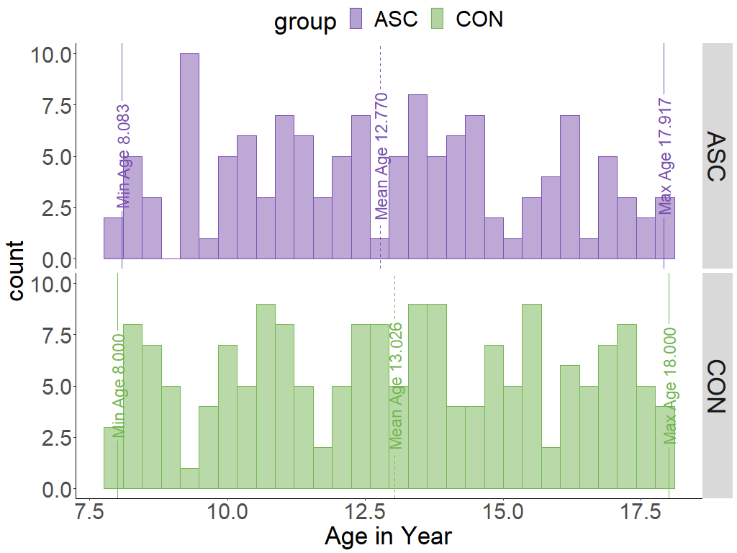
Note. The age range, represented from left to right, includes the minimum, mean, and maximum values. The x-axis corresponds to age, while the y-axis represents the count of individuals.
EEG Data Pre-processing
The data used for analysis were already filtered and pre-cleaned by the original collection team. Specifically, the data were high passed at .1 Hz, low passed at 100Hz, and notch filtered at 60 Hz to remove line noise. Additionally, channels with high impedances were removed, and the data were divided into 2.048-second epochs.
Furthermore, this pre-cleaned dataset was pre-processed followed the pre-processing steps provided by Dr.Adam Dede. Specifically, for each channel and epoch, the voltage difference within an 80 ms moving window, measuring the gap between the highest and lowest values was calculated. Epochs in which were detected at least one 100 𝜇V deflection were identified as potentially containing noise and were marked. A channel was considered if it exceeded the 100 𝜇V threshold in half of the trials, leading to the removal of these channels. Furthermore, if 25% of the remaining channels exhibited threshold crossings in a trial, that trial was consequently excluded. The specific details regarding the number of removed trials and channels can be found in Table 1. All data were referenced to an average reference and then interpolated onto a standardized 32-channel montage. Lastly, a Laplacian transformation was applied to estimate the current source density of the data, and this Laplacian-transformed data were employed for calculating intersite phase clustering. For more detailed information about the data import and cleaning steps, refer to the functions: readEEGdat.m, removeNoiseChansVolt.m, convertCoordinates.m, interpolate_perrinX.m, and laplacian_perrinX.m from https://github.com/adede1988/SheffieldAutismBiomarkers.
Relative Power Spectra Extraction
Power spectra were calculated independently in each epoch. EEG spectral power was assessed in relative form to mitigate the impact of overall power fluctuations and enhance comparability across different diagnosis groups and eye conditions. This approach offers the advantages of reducing the influence of overall power variations and facilitating comparisons between groups. By utilising relative power in EEG analysis, researchers gain the benefits of improved interpretability, enhanced comparability, and a focus on relative changes within specific frequency bands. To avoid edge artefacts, each epoch was mirrored forwards and backwards, and narrowband filtering using a Gaussian filter in the frequency domain wavelet convolution was utilised for 100 logarithmically spaced frequencies ranging from 2 to 80 Hz, as outlined by (Cohen., 2014). The mean was calculated across the epoch after converting the filtered complex time series into a power time series and discarding the mirrored copies. The relative power spectra were obtained by dividing the raw power by the sum of power across the entire frequency range.

Multiscale Sample Entropy (MSE) Extraction
MSE analysis involved two procedures for each epoch and electrode. Firstly, the original signal was downsampled to create a coarse-grained time series at different scales. The downsampling factor was determined by averaging consecutive data points. Secondly, the sample entropy was computed for each coarse-grained time series. Sample entropy measures the regularity or complexity of the time series. The calculation involved comparing sequences of data points and counting the occurrences that met a similarity threshold. The similarity factor was set based on the standard deviation of the time series. The sample entropy was computed for each coarse-grained time series to assess the complexity at different scales.
Statistical Analysis
To test the channel-wise MSE and relative power spectrum differences between diagnosis groups and eye conditions, a series of two samples and independent samples, two-tailed t-tests were conducted with threshold-free cluster enhancement (TFCE) (Mensen & Khatami, 2013; Smith & Nichols, 2009). This method builds on other cluster-based approaches (e.g., cluster mass and cluster height; (Friston et al., 1996; Maris & Oostenveld, 2007)) but is sensitive to both strong-narrow and weak-broad effects, taking into account the temporal and spatial dependencies in EEG data. This alleviates the issue of setting arbitrary cut-offs when defining cluster thresholds and inference, a common problem in other cluster-based methods. TFCE has been shown as a helpful method in combination with permutation tests to maintain family-wise alpha at 0.05 effectively and control Type I error rates for multiple comparisons across all EEG electrodes. The main objective of TFCE is to enhance weaker signals that belong to large clusters to a level comparable to strong signals in smaller clusters by utilising both the intensity of the data point and information from neighbouring channels. The computational process involves setting multiple thresholds on the initial statistics, then calculating the number of points above each specific threshold along with their neighbours and multiplying this value by the current threshold height. The final TFCE value is the summation of each score at the many thresholds. Using this analysis requires setting two parameters: Signal intensity (height: H) and spatial distribution (extent: E).
Optimising Stability and Significance: TFCE Parameter Considerations. The advantage of TFCE over traditional hard-thresholding-based cluster formation aims for greater stability, minimising significant output changes with small input variations. The goal is to eliminate dependence on the arbitrary selection of the cluster-forming threshold in traditional methods, where setting the threshold lacks a principled approach (Smith and Nichols 2009). However, in TFCE there is still a need to choose parameters E and H. The E parameter controls how large clusters must be to be considered significant. A higher E is more conservative, demanding larger clusters for significance, while a lower E increases sensitivity, allowing smaller clusters to be deemed significant. On the other hand, the H parameter regulates the intensity required within a cluster for significance. A higher H is more conservative, requiring higher intensity values, while a lower H increases sensitivity, permitting clusters with lower intensity values to be considered significant. The optimal choice of E and H depends on the desired balance between minimising false positives and detecting true activations.
The potential combination of E and H parameters. In an empirical study, the researchers explored the effects of different E and H parameters, spanning the range of 0.1, 0.5, 1, 2, and 3. Subsequently, they selected specific values, E=0.5 and H=2, for further analysis. This choice revealed significant group differences, as highlighted in the preceding summary, showcasing the sensitivity and interpretability achieved with these specific parameter settings. Additionally, by applying Random Field Theory (RFT), the researchers estimated uncorrected P-values for a TFCE statistic with H = 2 and E = 2/3, closely mirroring empirically determined values of H = 2 and E = 0.5.
To calculate the FWERs of different optimal combinations of E and H for the TFCE, I performed permutation tests (1,000 permutations in this study). For this permutation test, I first selected 174 neurotypical control subjects from eyes-open condition to maximise sample homogeneity. Then, 40 subjects were randomly picked from the set of 174 subjects and randomly assigned to two equal groups (20 per group). Because assignment was fully random, no significant results should have emerged when these two groups’ rs-EEG metrics were compared. The identification of a significant difference following multiple comparison correction signifies the occurrence of a family-wise error. Consequently, FWER was computed as the proportion of such false positives among all comparisons within the permutation tests. Here, I chose the combination of E/H as 0.66 / 2; 0.5 / 2; 0.66 / 3; all FWER values are under the nominal 5% level. Additionally, based on the results from (Mensen Khatami, 2013), I finally set E = .66 and H = 2 for TFCE. This also involved conducting 5,000 random permutations between or within participants to construct an empirical distribution that closely resembles the null hypothesis of no discernible variations in either group or eye conditions. This was done separately at each time scale (MSE) and frequency band (relative power). These analyses used the ept_TFCE function from the TFCE toolbox (https://github.com/Mensen/ept_TFCE-matlab). The complete procedure is carried out within the context of the following GitHub repository: https://github.com/wenyixiao0058/eegstudy.git, specifically focusing on the "tfce_scripts.m" file.
Results
Descriptive plots for MSE and Relative PSD
Graphical representations of Individual Sample Entropy and Relative Power Spectrum across three distinct brain regions for both the ASC and CON diagnosis groups and under different eye conditions (eyes open and closed) are illustrated in Figure 2. Green dots represent data from the individuals with ASC, while orange dots represent data from the CON group. The left panel (Panel A) is for multiscale sample entropy, while the right (Panel B) is for relative power spectra. Within each set of plots, the upper plot shows data for the eyes-open condition, while the lower plot shows data for the eyes-closed condition. Figures A(a) and B(a) are for the central region, which includes all electrodes averaged across the central region, while Figures A(b) and B(c), as well as A(c) and B(c) are for the frontal and parietal-occipital regions, respectively. The y-axis represents the raw sample entropy or relative frequency across the time scales or frequency. While the x-axis shows the time scale factor divided into fine, mid, and coarse or frequency bands (delta, theta, alpha, beta and gamma), which are displayed in different shadowed areas. In Panel A, each plot includes an additional coloured line representing the averaged entropy values curve across subjects in both groups.
Figure 2
Descriptive visualisation of Multiscale sample entropy and Relative Power Spectra
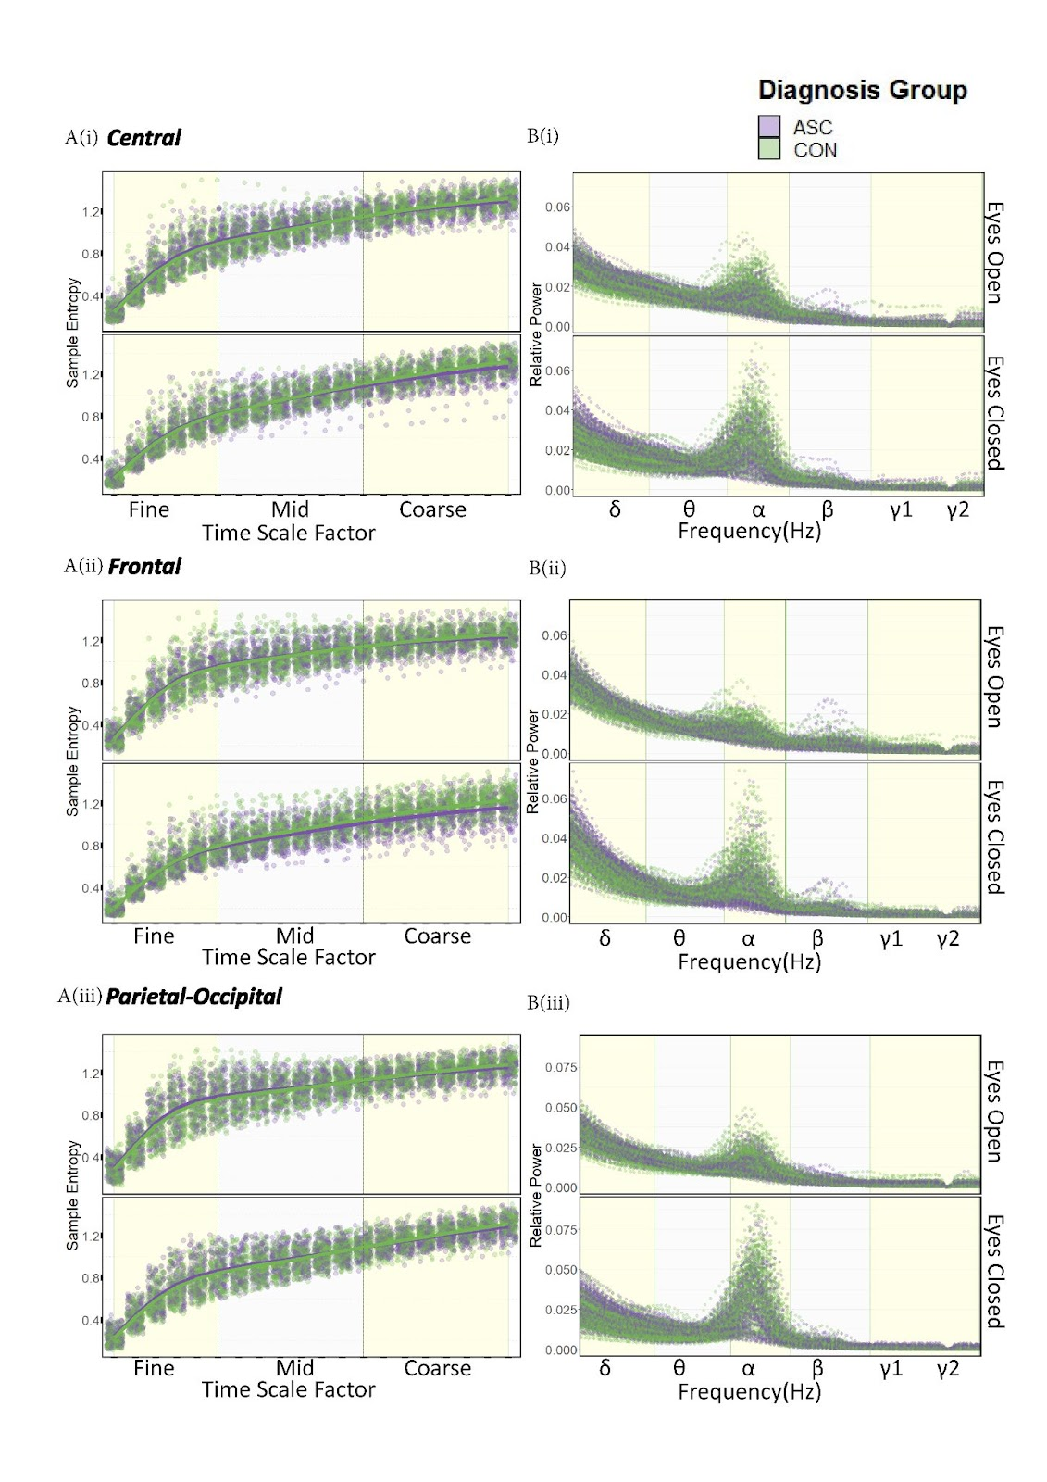
Note. δ = delta; θ = theta; α = alpha; β = beta; γ1 = low gamma; γ2 = high gamma.
Multiscale Sample Entropy Result
Channel-wise differences were presented in the direction and magnitude of diagnosis group distinctions under both eyes-open and closed conditions, as well as the contrasts between eyes-open and closed conditions. The averaged multiscale sample entropy was visualised for different across the time scales (fine, mid, and coarse) and averaged across all electrodes and participants (regardless of diagnostic group) brain regions (frontal, central and parietal-occipital), resulting in a significantly greater brain complexity during the eyes-open condition compared to eyes-closed condition regardless of the diagnosis groups (Figure 3, A). These findings were further supported by the channel-wise comparisons shown in Figure 3, C(i) and C(ii).
To examine group differences, the averaged MSE across time scales and brain regions were visualised separately for the eyes-open (left side Figure 3B panel) and closed (right side Figure 3B Panel) condition, as depicted in Figure 3, B(i). The TFCE-based method revealed a significant group difference during only the eyes-closed condition after correction. Specifically, individuals with ASC exhibited reduced sample entropy compared to neurotypical counterparts, particularly at the coarse scale across the entire brain (Figure 3, D(i) and D(ii)). The TFCE-based method only revealed a significant group difference at the eyes-closed condition after correction. Specifically, individuals with ASC exhibited reduced sample entropy compared to neurotypical counterparts, particularly at the coarse scale across the entire brain (Figure 3, D(i) and D(ii)).
To investigate group differences between eyes-open and eyes-closed conditions, the averaged MSE was calculated and visualised as the difference score (eyes-open minus eyes-closed) across brain regions at each time scale factor, as illustrated in Figure 3, B(ii). Overall, the entropy during the eyes-open condition was considerably higher than during the eyes-closed condition, as evidenced by all difference scores above the zero baseline (where eyes-open equals eyes-closed). This discrepancy was particularly prominent in the frontal region, with individuals diagnosed with ASC, exhibiting a more significant disparity than the control group. After applying correction techniques, these findings were further corroborated by the channel-wise comparisons in Figure 3, D(iii).

Figure 3
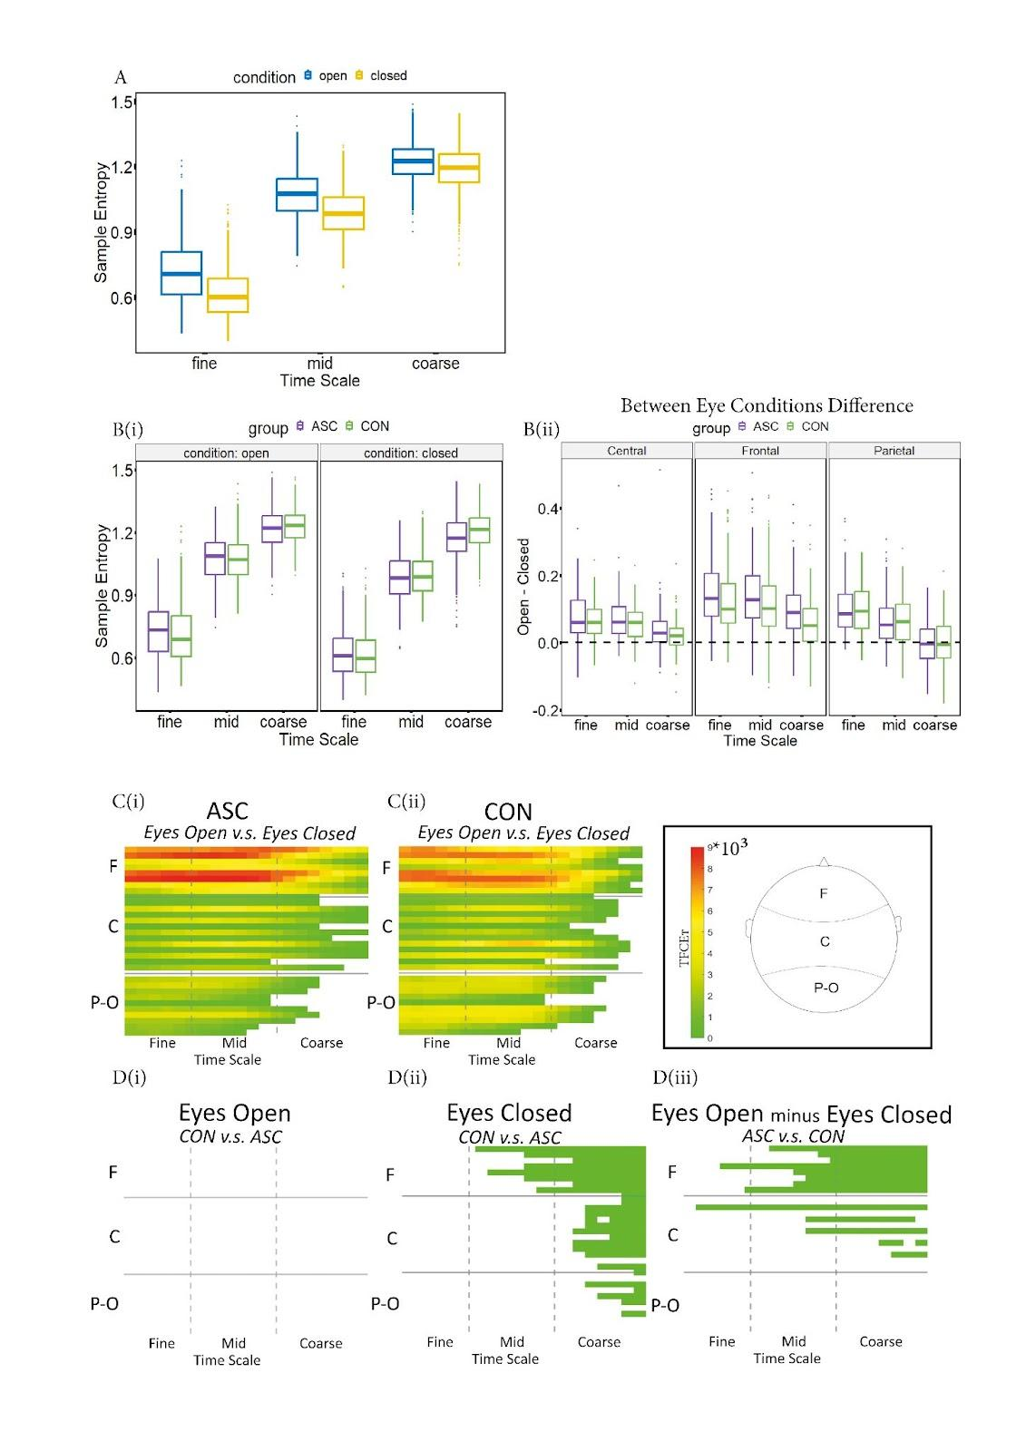
Comparative Analysis of MSE in ASC and CON Groups
This figure shows boxplots in three panels, each presenting different comparisons between eye condition (eyes open and closed) and diagnosis groups (ASC and control). The figures in Panel A show a boxplot depicting the entropy differences across eyes-open and eyes-closed condition and diagnosis groups. Blue boxes represent the eyes-open condition, while yellow represents the eyes-closed condition. Overall, the multiscale sample entropy at the eyes-open condition is greater than those at the eyes-closed condition across brain regions and diagnosis groups at each time scale.
Panel B consists of boxplots comparing the ASC (green) and control (orange) groups (Green represents the ASC group, while orange represents the neurotypical group). Figure B (1) displays the entropy differences between ASC and neurotypical groups across eye conditions (eyes-open and closed condition) and time scales (fine, mid, and coarse).
The y-axis shows sample entropy, and the x-axis shows fine, mid, and coarse time scales. Figure B (2) shows the contrasts in entropy between eyes-open and closed conditions and the difference between diagnosis groups in central, frontal, and parietal-occipital regions from left to right. The additional horizontal dashed black line at zero means that the entropy values for eyes-open and eyes-closed conditions are equal.
Panel C-D shows the TFCE value of pairwise eye condition, and group contrasts for each electrode and time scale factor. As can be seen from the contrast in Figure C, there is a consistent increase in brain signal complexity at the eyes-open condition compared to the eyes-closed condition in both ASC and neurotypical control groups (depicted in C (1) and C (2), respectively). There is no significant diagnostic group difference in the eyes-open condition. However, the group difference is primarily located in the frontal region at the coarse scale during the eyes-closed condition and the contrast between the two eye conditions (eyes-open minus eyes-closed condition).
Relative Power Spectrum Result
Considering power spectra extracted from all channels and both groups, there was an increase in relative alpha power and a decrease in relative delta power during the eyes-closed condition compared to the eyes-open condition regardless of the diagnosis groups (Figure 4, A). These findings were further supported by the channel-wise comparisons at the single channel level (Figure 4C) shown in Figure 4, C(i) and C(ii) after correction.
To examine group differences, the averaged relative power across frequency bands and brain regions was visualised separately for the eyes-open (left side Figure 4 Panel) and closed (right side Figure 4 Panel) condition, as depicted in Figure 4, B(i). There were differences between groups in the eyes-open, eyes-closed, and contrast between eyes-open and closed conditions.
The TFCE-based method detected a significant group difference in the eyes-open and eyes-closed conditions after correction. Specifically, individuals with ASC exhibited reduced relative alpha power compared to neurotypical individuals in both the eyes-open and eyes-closed condition. Additionally, enhanced relative ASC individuals exhibited higher delta power than the neurotypical individuals during the eyes-closed condition (Figure 4 D(ii)). It was predominantly observed during the eyes-closed condition across the entire brain. In contrast, a slight disparity was only observed in the central region during the eyes-open condition after correction (Figure 4, D(i) and D(ii)).
To investigate group differences between eyes-open and eyes-closed conditions, the averaged relative power spectrum was calculated and visualised as the difference score (eyes-open minus eyes-closed) across brain regions at each frequency band, as illustrated in Figure 4, B(ii). Overall, the relative delta power during the eyes-open condition was considerably higher than during the eyes-closed condition. Conversely, the relative alpha power in the eyes-open condition was considerably lower than during the eyes-closed condition, as evidenced by all difference scores above the zero baseline (where eyes-open equals eyes-closed). This discrepancy was particularly prominent in the parietal region, with individuals diagnosed with ASC exhibiting a smaller disparity than the control group. These findings were further corroborated by the channel-wise comparisons in Figure 4, D(iii) after applying TFCE correction.

Figure 4
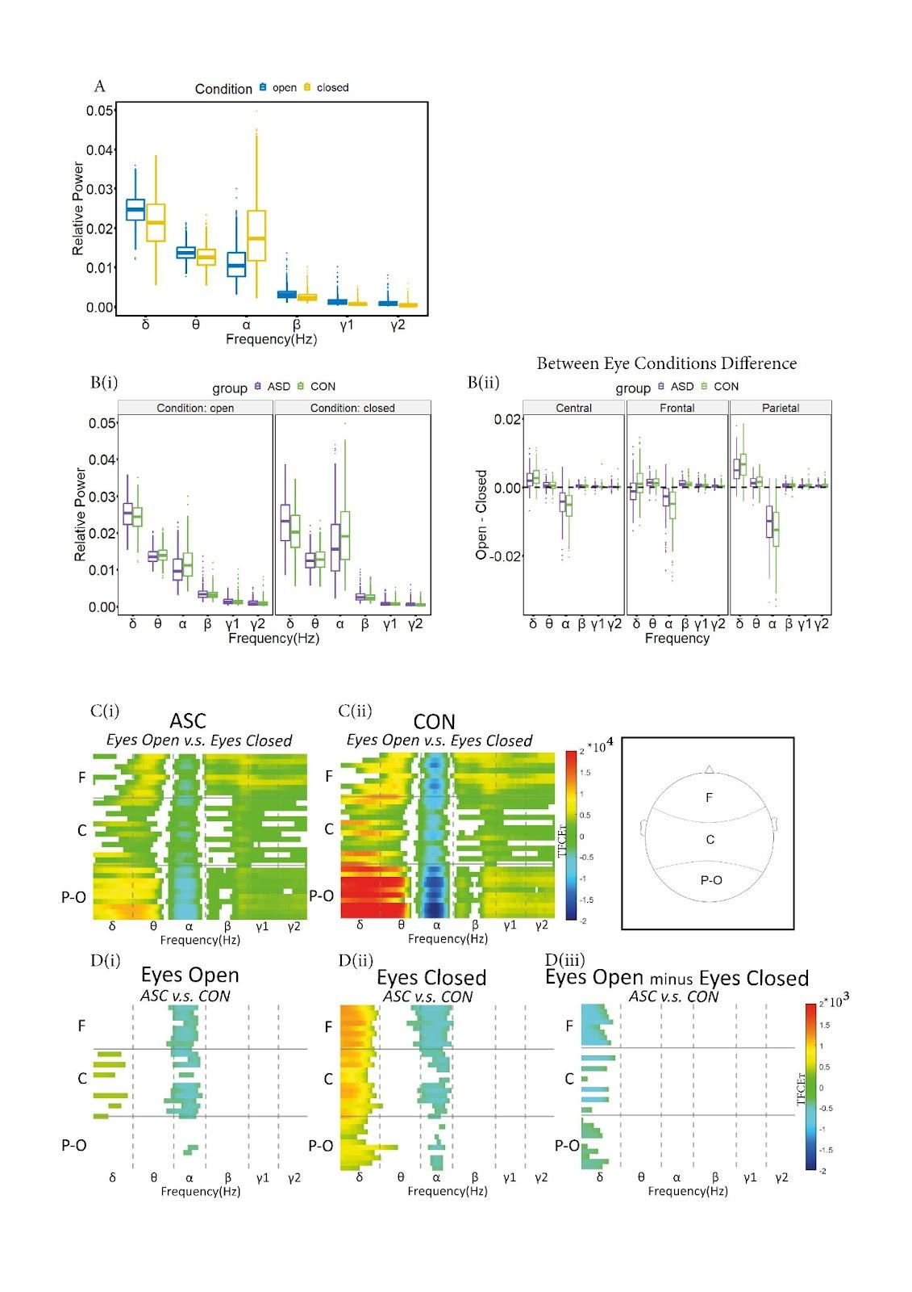
Comparative Analysis of Relative Power Spectrum in ASC and CON Groups

Note. Similarly, Panel A shows a boxplot that depicts the entropy differences across eyes-open and eyes-closed condition and diagnosis groups.
Generally, relative power increases in the alpha band and decreases in the delta band at the eyes-closed condition across diagnosis groups throughout the brain. Boxplots in Panel B compare the ASC and control groups across eye conditions and contrasts between them. ASC individuals exhibited increased delta power and decreased alpha power compared to the control group, particularly during the eyes-closed condition. However, the contrasts between brain states among ASC individuals are smaller than those in controls.
The statistical TFCE method produced consistent results, as in Panel C-D, where the TFCE statistics represent pairwise contrasts between eye conditions and groups for each electrode and time scale factor. As can be seen from the contrast in Plot C, there is a consistent increase in alpha power and decrease in delta power at the eyes-closed condition compared to the eyes-open condition in both ASC and neurotypical control groups (depicted in C (1) and C (2), respectively). Diagnostic group differences in delta power were significant only during the eyes-closed condition but not during the eyes-open condition. Moreover, distinct changes in power across groups in the delta and alpha bands were primarily observed during the eyes-closed condition across the entire brain. As seen in Figures C (1)-(2) and D (3), individuals with ASC exhibit a smaller difference between the eyes-open and closed condition compared to the control group.

Relation between mean MSE and relative delta and alpha power in diagnosis groups and eye conditions
Pearson's correlation analysis involved assessing the relationships between averaged Multiscale Sample Entropy (MSE) matrices at fine, mid and coarse time scale factors and averaged Relative Delta and Alpha Power (RelPow) matrices across the subjects. The analysis was conducted at each diagnosis group (i.e., ASC and CON), eye conditions (i.e., eyes-open and eyes-closed condition) and brain regions (i.e., global, frontal, central and parietal-occipital regions) respectively.
Figure 5
Correlation between MSE at fine, mid and coarse scales and Relative Delta and Alpha Power across subjects at ASC group at the eyes-closed condition

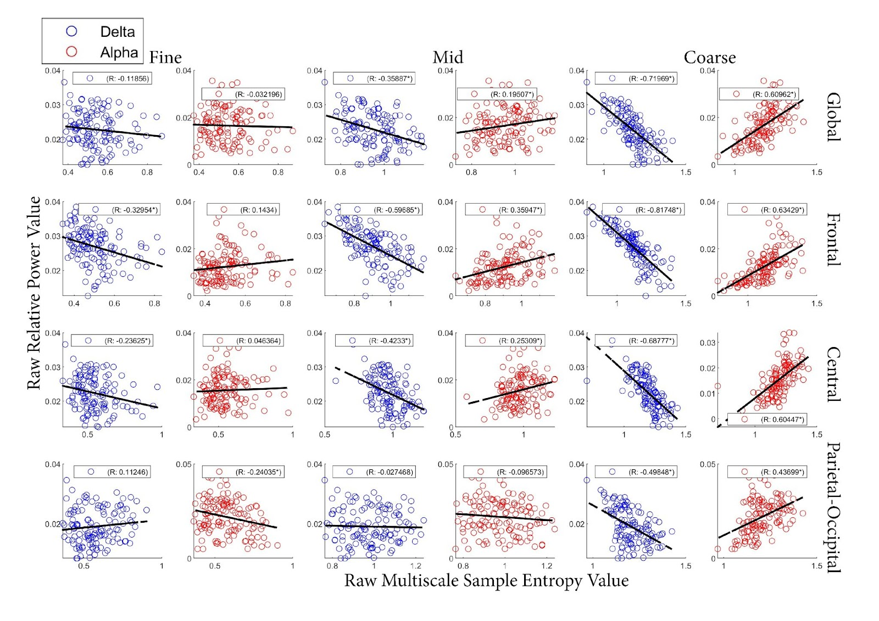
Note. Scatterplots of Pearson’s correlation of Relative Delta and Alpha Power and MSE at fine (left), mid (middle) and coarse (right) time scale factors for each brain regions (global, frontal, central and parietal-occipital regions) at ASC group at the eyes-closed condition.

Figure 6
Correlation between MSE at fine, mid and coarse scales and Relative Delta and Alpha Power across subjects at ASC group at the eyes-open condition
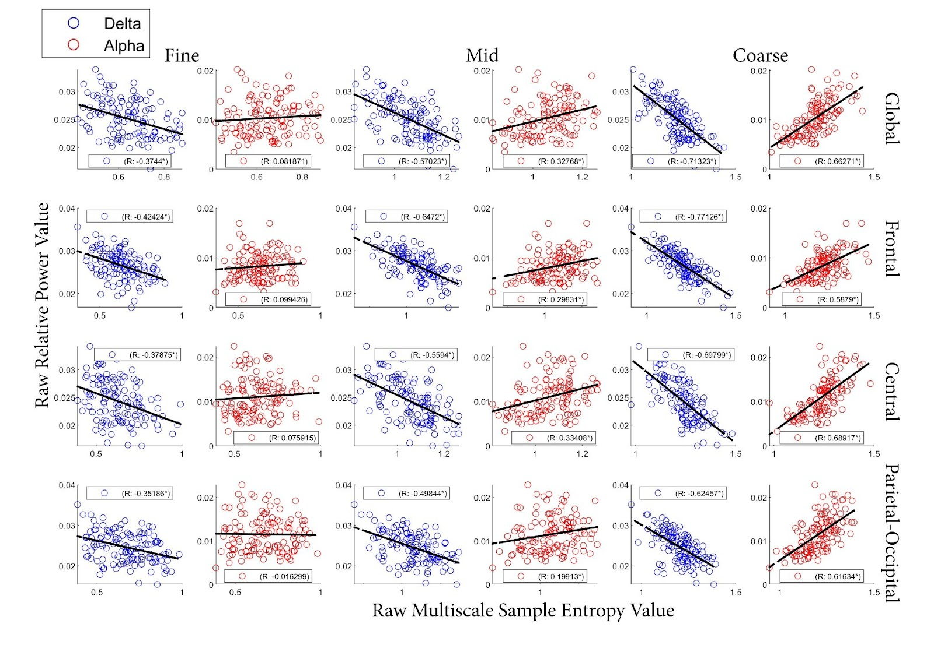
Note. Scatter plots same as the Figure 5 at the ASC group at the eyes-open condition.

Figure 7
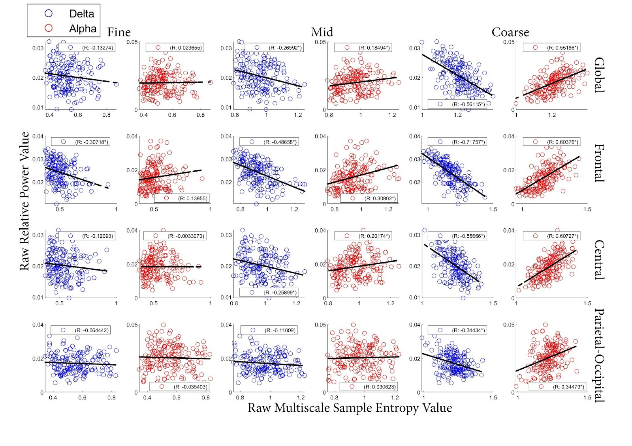
Correlation between MSE at fine, mid and coarse scales and Relative Delta and Alpha Power across subjects at CON group at the eyes-closed condition

Note. Scatter plots same as the Figure 5 at the CON group at the eyes-closed condition.

Figure 8
Correlation between MSE at fine, mid and coarse scales and Relative Delta and Alpha Power across subjects at CON group at the eyes-open condition
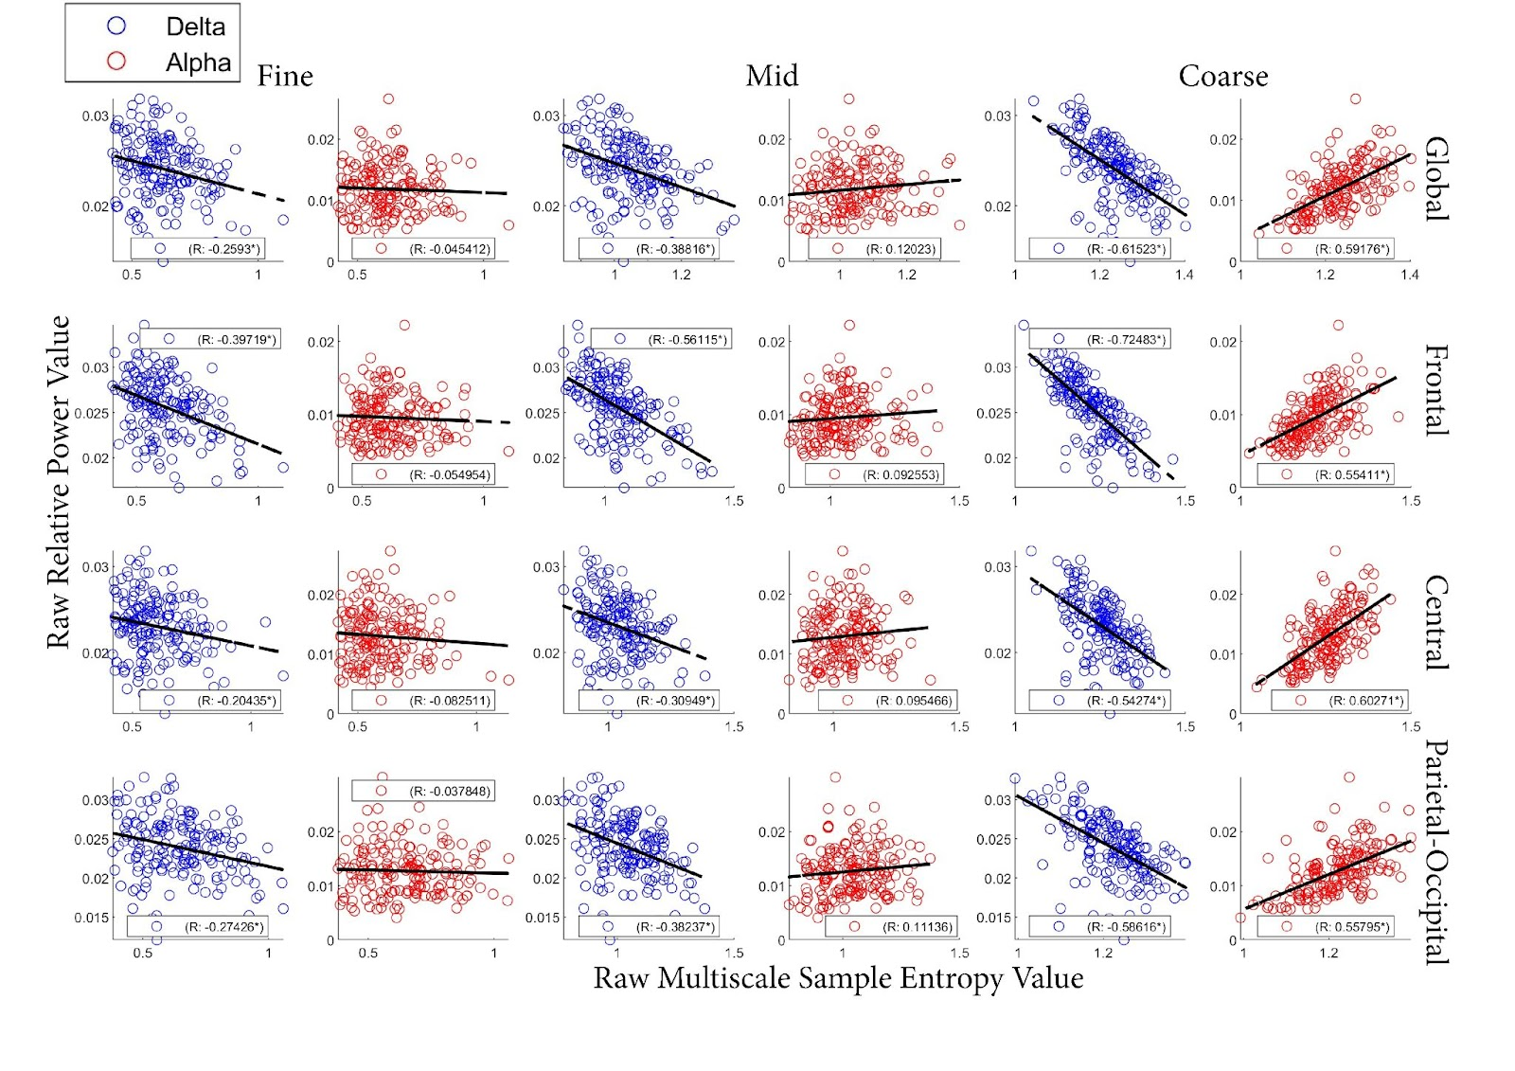

Note. Scatter plots same as the Figure 5 at the CON group at the eyes-open condition.

Linking Relative Delta and Alpha Power to MSE

Furthermore, a series of robust regression analyses explored associations between Multiscale Entropy (MSE) in each time scale and Relative Power in delta and alpha frequency bands across brain regions. The study investigated the association in individuals with ASC and a control group under both eyes-closed and eyes-open conditions respectively, with corresponding statistical details available in Table 1. Specifically, the coefficient β signifies the alteration in the dependent variable (i.e., Multiscale Entropy) for a one-unit change in the independent variable (i.e., Relative Power in delta or alpha frequency bands), holding other variables constant. The R-squared (R²) serves as a statistical metric representing the proportion of the variance in the dependent variable (i.e., Multiscale Entropy) elucidated by the independent variable(s) (i.e., Relative Power in delta or alpha frequency bands) within the model.

Table 1
Statistical Significance Assessment of Coefficients (β) via Robust Regression and R-squared Values in Frontal, Central, and Parietal-Occipital Regions During Eyes-Open and Closed Conditions Across Various Scaling Factors in ASC and CON Groups
Group | Condition | Scale | Frequency | Brain Region | Coefficient (β) | R-Squared  (R²)
ASC | Eyes-Closed | 1 | Delta | Frontal | -0.0173 | 0.1086
 |  |  | Delta | Central | -0.0098 | 0.0558
 |  |  | Alpha | Parietal-Occipital | -0.0181 | 0.0578
 |  | 2 | Delta | Frontal | -0.0272 | 0.3562
 |  |  | Delta | Central | -0.0188 | 0.1792
 |  |  | Alpha | Frontal | 0.0202 | 0.1292
 |  |  | Alpha | Central | 0.0156 | 0.0641
 |  | 3 | Delta | Frontal | -0.0343 | 0.6683
 |  |  | Delta | Central | -0.0382 | 0.4730
 |  |  | Delta | Parietal-Occipital | -0.0358 | 0.2485
 |  |  | Alpha | Frontal | 0.0311 | 0.4023
 |  |  | Alpha | Central | 0.0430 | 0.3654
 |  |  | Alpha | Parietal-Occipital | 0.0499 | 0.1910
 | Eyes Open | 1 | Delta | Frontal | -0.0125 | 0.1800
 |  |  | Delta | Central | -0.0113 | 0.1435
 |  |  | Delta | Parietal-Occipital | -0.0094 | 0.1238
 |  | 2 | Delta | Frontal | -0.0193 | 0.4189
 |  |  | Delta | Central | -0.0203 | 0.3129
 |  |  | Delta | Parietal-Occipital | -0.0169 | 0.2484
 |  |  | Alpha | Frontal | 0.0080 | 0.0890
 |  |  | Alpha | Central | 0.0143 | 0.1116
 |  |  | Alpha | Parietal-Occipital | 0.0082 | 0.0397
 |  | 3 | Delta | Frontal | -0.0265 | 0.5948
 |  |  | Delta | Central | -0.0304 | 0.4872
 |  |  | Delta | Parietal-Occipital | -0.0292 | 0.3901
 |  |  | Alpha | Frontal | 0.0166 | 0.3456
 |  |  | Alpha | Central | 0.0331 | 0.4750
 |  |  | Alpha | Parietal-Occipital | 0.0290 | 0.3799
CON | Eyes Closed | 1 | Delta | Frontal | -0.0164 | 0.0944
 |  | 2 | Delta | Frontal | -0.0240 | 0.2368
 |  |  | Delta | Central | -0.0110 | 0.0671
 |  |  | Alpha | Frontal | 0.0209 | 0.0955
 |  |  | Alpha | Central | 0.0130 | 0.0407
 |  | 3 | Delta | Frontal | -0.0333 | 0.5149
 |  |  | Delta | Central | -0.0295 | 0.3099
 |  |  | Delta | Parietal-Occipital | -0.0319 | 0.1186
 |  |  | Alpha | Frontal | 0.0389 | 0.3645
 |  |  | Alpha | Central | 0.0524 | 0.3688
 |  |  | Alpha | Parietal-Occipital | 0.0330 | 0.1188
 | Eyes-Open | 1 | Delta | Frontal | -0.0110 | 0.1578
 |  |  | Delta | Central | -0.0059 | 0.0418
 |  |  | Delta | Parietal-Occipital | -0.0075 | 0.0752
 |  | 2 | Delta | Frontal | -0.0169 | 0.3149
 |  |  | Delta | Central | -0.0117 | 0.0958
 |  |  | Delta | Parietal-Occipital | -0.0130 | 0.1462
 |  | 3 | Delta | Frontal | -0.0265 | 0.5254
 |  |  | Delta | Central | -0.0304 | 0.2946
 |  |  | Delta | Parietal-Occipital | 0.0292 | 0.3436
 |  |  | Alpha | Frontal | 0.0166 | 0.3070
 |  |  | Alpha | Central | 0.0331 | 0.3633
 |  |  | Alpha | Parietal-Occipital | 0.0290 | 0.3113

Note. Higher R-squared values indicate a better fit, implying that a larger proportion of the variance in the dependent variable (i.e., Multiscale Entropy) is accounted for by the independent variable(s) (i.e., Relative Power in delta or alpha frequency bands) in the model.
Overall, MSE accounted for most of the variability in Relative Delta and Alpha Power, particularly at the coarse time scale factor across all eye conditions and diagnosis groups, as indicated by the R-squared values presented in Table 1. Regarding the specific associations between MSE and Relative Delta and Alpha Power, in the ASC group during eyes-closed conditions, fine-scale delta frequency exhibited significant negative associations with frontal and central regions, while alpha frequency showed a negative association with the parietal-occipital region. At the mid and coarse scales, similar patterns of negative associations were observed for delta frequency with various brain regions, whereas alpha frequency displayed positive associations. Under eyes-open conditions, the ASC group showed consistent negative associations between delta frequency and multiple regions across all scales, while alpha frequency exhibited positive associations. The control group demonstrated different patterns, with delta frequency showing negative associations under both eyes-closed and eyes-open conditions, while alpha frequency displayed positive associations, particularly at the mid and coarse scales. These findings highlight distinct neurophysiological patterns associated with ASC in different conditions and scales, while the diagnosis group differences are less obvious.
Linking MSE to ADOS Score
117 of 126 ASC participants have an available ADOS Score (i.e., overall score that combining Social Affect and Restricted and Repetitive Behaviors domains). The mean ADOS Score is 11.92 with a standard deviation of 3.98. To illustrate the relationship between averaged MSE and ADOS score, a series of Pearson’s correlation were conducted across each time scale factor (i.e., fine, mid and coarse), brain regions (i.e., frontal, central and parietal-occipital) and eye conditions (i.e., eyes-open and eyes-closed condition). Overall, there is no significant correlation between MSE and ADOS score at each condition.
Figure 9
Pearson’s correlation between MSE and ADOS score at eyes-closed condition.
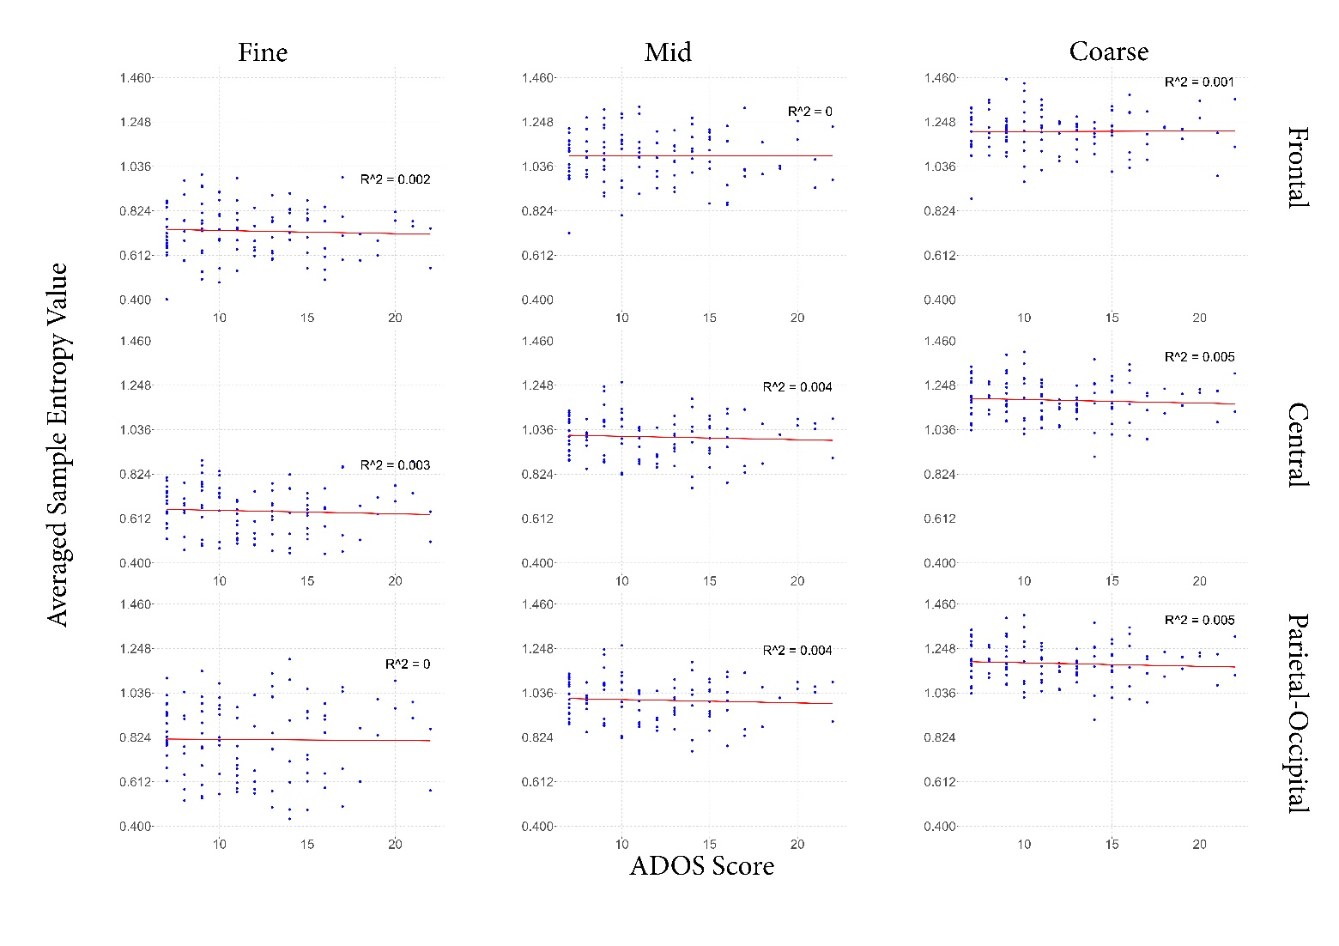
Note. Red line indicates the correlation regression line. R^2 indicates the correlation coefficient.

Figure 10
Pearson’s correlation between MSE and ADOS score at eyes-open condition.
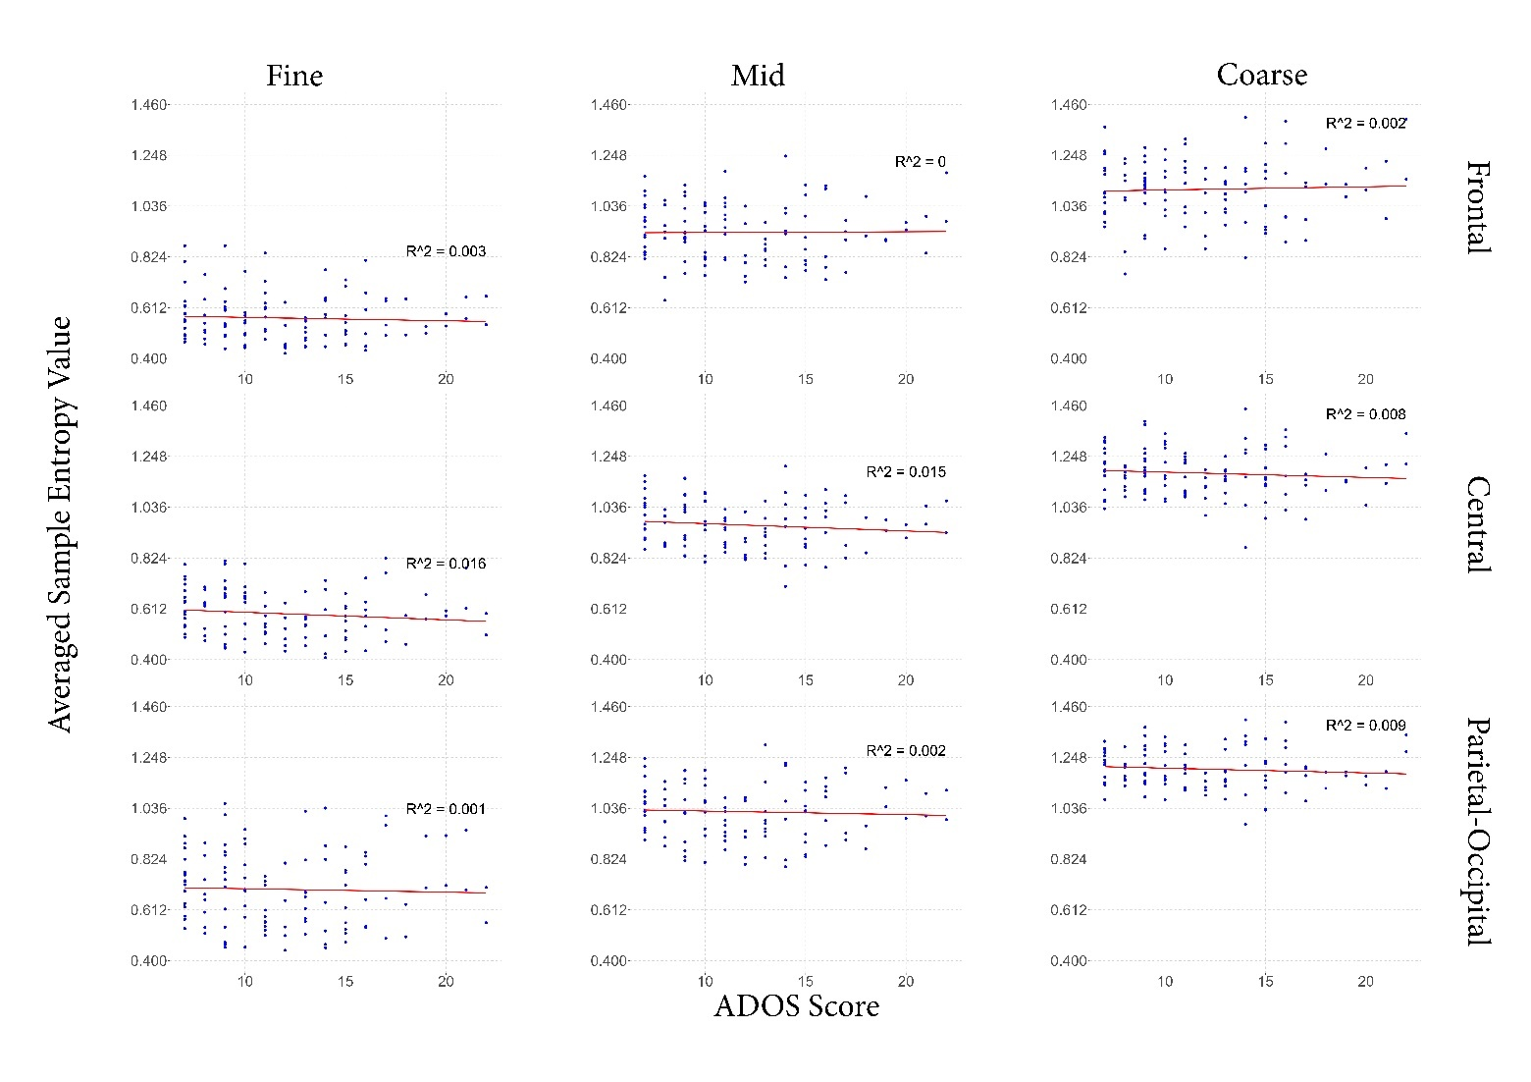
Note. Red line indicates the correlation regression line. R^2 indicates the correlation coefficient.

Discussion
Enhanced Alpha relative power at the eyes-open condition. The present study aimed to investigate electrophysiological profiles of individuals with and without ASC by comparing multiple rs-EEG metrics, primarily focusing on relative power spectrum and multiscale sample entropy during eyes-open and eyes-closed resting states.
It has been observed that there was a higher level of alpha power at the eyes-closed compared to eyes-open condition, especially in the parietal-occipital areas in both groups. Alpha oscillations, serving as the dominant rhythm in the human electroencephalographic signal (Angelakis et al., 2004; Buzsáki, 2006), exhibit enhanced power during the eyes-closed condition, known as "alpha reactivity," which indicates adjustments in brain activity during different rest states. The classical view suggested the suppression of alpha-band activity is a typical event-related alpha response, given that the increased alpha power observed during the eyes-closed condition primarily manifests in the parietal-occipital regions, indicating a state of relative inactivity in the visual cortex (Pfurtscheller, 1992; Pfurtscheller et al., 1996) or reduced processing of external visual information (Barry et al., 2007; Hohaia et al., 2022;Lange et al., 2013; Johnson et al., 2011). Furthermore, further evidence supports the idea that the absence of visual stimulation or light solely causes this type of alpha suppression. This phenomenon has been observed not only in completely darkened rooms during the eyes-open condition (Chapman et al., 1970) but also in a recent study that successfully replicated and expanded the finding to include children with ASC (Edgar et al., 2023).
Conversely, the relative power in the other frequency bands (i.e., delta, theta, beta, and gamma) increased during the eyes open relative to the eyes-closed condition. Specifically, only the differences in delta and alpha power were mainly concentrated in the parietal-occipital areas, which is aligned with earlier EEG studies (Barry & De Blasio, 2017; Travis et al., 1974; Kan et al., 2017; Petro et al., 2022), while the differences in the other frequency bands were more widespread across the brain. Delta enhancement in posterior regions has been associated with detecting motivational salient information (Knyazev, 2007; Zhang et al., 2013). Likewise, the elevation in theta activity has been associated with attentional processes and visual perception, such as periodic sampling of visual attention (Busch & VanRullen, 2010; Kawashima et al., 2022). Similarly, the increased beta and gamma power in the occipital region during the eyes-open condition, indicating heightened cortical processing, supports the notion of enhanced visual cortical activity during the eyes-open condition since beta and gamma power has also been associated with top-down prediction signals involved in the visual perception of causal events (van Pelt et al., 2016).
Considering the findings in this study, these observed relative power changes during the eyes-open condition are likely associated with the presence of visual information and heightened vigilance (Boksem et al., 2005), suggesting that the eyes-open resting state more actively engages brain processes associated with the processing of visual and sensory information (Brodoehl et al., 2015; Mathe & Sminchisescu, 2015; Wang & Wang, 2021; Wei et al., 2018; Zhang et al., 2020). Based on the assumption that the magnitude of EEG oscillations reflects information processing, the smaller changes in EEG power between eyes-open and closed conditions in individuals with ASC compared to neurotypical individuals suggest that individuals with ASC exhibit reduced adaptivity in response to eye condition.
Elevated relative Delta to Alpha ratio among individuals with ASC. Additionally, our research demonstrated that individuals with ASC exhibit an elevated delta-to-alpha ratio compared to neurotypical controls (i.e., a greater proportion of delta power and a reduced proportion of alpha power). This finding is highly consistent with an analysis by (Wang et al., 2013) consolidated data from 14 EEG studies on ASC. The findings suggested a potential "U-shaped" pattern of EEG power changes across various brain regions. Specifically, there was an increase in power in the low and high-frequency bands (delta, theta, beta, and gamma bands) and a decrease in power in the mid-frequency band (alpha band) in comparison to typically developing individuals (Coben et al., 2008; Murias et al., 2007).
Given that slower oscillations are typically associated with long-range connections (Amzica & Steriade, 1995), suggesting a possible failure of top-down synchronisation and weaker inhibitory regulation. The elevated delta might indicate overall hyperconnectivity within the frontal region in individuals with ASC (Orekhova et al., 2014). However, this increased delta has been commonly observed in children with learning disabilities (Fonseca et al., 2006) and several neurodevelopmental disorders (Clarke et al., 2002; Ostrowski et al., 2021). The delta frequency band also involves various functions such as sustained attention, decision-making, and motivation (Harmony, 2013; Nácher et al., 2013). Therefore, it has been suggested that elevated resting delta relative power could be a general indicator of neurological dysfunction rather than specific to ASC. Furthermore, the significant absence of the anticipated rise in delta relative power among individuals with ASC during the eyes-open condition indicates that the state of the eyes strongly influences the heightened relative power of delta frequencies.
It is worth noting that, unlike the inconsistent observation of a rise in delta power, we consistently observed a decrease in alpha power in individuals with ASC compared to neurotypical controls when both their eyes were open and closed. This finding is highly consistent with other resting state EEG studies conducted on individuals with ASC at various developmental stages (Chan & Leung, 2006; Coben et al., 2008; Levin et al., 2017; Murias et al., 2007; Orekhova et al., 2007; Stroganova et al., 2007) across various brain regions (Chan et al., 2007; Pop-Jordanova et al., 2010), similar to this present study. Alpha oscillation undergoes significant amplitude modulation in response to internal or external events (Pfurtscheller et al., 1996; Pfurtscheller, 1997), which reflects changes in the rhythmic activity of a substantial population of neurons (Lopes da Silva et al., 1974). The decrease in alpha power is usually associated with a clearly-defined developmental trajectory linked to cognitive ability and elevated sensitivity to sensory or attentional stimuli (Clements et al., 2022; Foxe & Snyder, 2011), as observed in clinical assessments (Loo et al., 2009; Kamida et al., 2016; Kaushik & Jena, 2022; Wang et al., 2017). Moreover, recent studies have suggested that reduced alpha power during resting states could be a potential biomarker for cognitive conditions in children with ASC (Dickinson et al., 2018; Keehn et al., 2017; Shephard et al., 2018). The consistent finding of decreased alpha power among individuals with ASC regardless of eye condition (Bellato et al., 2020) suggests that this decrease in alpha power represents an inherent neuronal alteration among individuals with ASC rather than a response to external visual stimuli. Although there may be some conflicting findings regarding increased or decreased alpha power in individuals with ASC (Cornew et al., 2012; Mathewson et al., 2012; Shephard et al., 2018), that could be attributed to medication usage (Blume, 2006) nor the co-occurring situation of anxiety among the participants (Knyazev et al., 2004) in different studies.
Enhanced Brain Complexity at Resting eyes-open condition. It is acknowledged that the state of the eyes influences brain activity (Petro et al., 2022). The observed alterations in the distribution of relative rs-EEG power across different regions provide evidence of intrinsic brain activity changes switched between eyes-open and eyes-closed states during rest, a well-known EEG difference (Barry et al., 2007). It is noteworthy that in this study, the brain complexity is also modulated by the condition of the eyes, which is reflected by an increased MSE at the eyes-open condition.
Given that spontaneous brain activity when eyes are closed, equipped with a mean frequency of spikes lower than evoked activity, operates with reduced energy consumption (Attwell & Laughlin, 2001; Tozzi et al., 2016), it is not surprising that the dynamics of the eyes-open condition exhibit greater complexity when compared to those of eyes-closed condition in both ASC and neurotypical control groups. This finding aligns with the previous studies, as they have demonstrated that the complexity of the dynamics observed during the eyes-open condition surpasses that of the eyes-closed condition (Hussain et al., 2017). During the resting state, the brain displays various oscillatory patterns, with the alpha rhythm being particularly prominent. As the visual processing centre, the occipital cortex exhibits a marked increase in relative alpha power during periods of closed eyes, denoting a noteworthy accumulation of alpha oscillatory activity in this particular brain region (Petro et al., 2022). The heightened visual system activity observed during the eyes-open condition is likely due to visual stimulation and may be mediated by the reticular activating system. The increased visual activity may engage additional structural components, leading to enhanced coupling between functional components and more intricate dynamics. External visual stimuli, such as photic stimulation, can evoke an increased cortical response and higher complexity in the broader brain in young adults, but only at the coarse scale (Takahashi et al., 2009), which is more sensitive to the nonlinear properties in signals (Courtiol et al., 2016).
Individuals with ASC have a reduced Multiscale Sample Entropy, mainly at the frontal coarse time scale. Multiple studies have examined the neural correlates of ASC using multiscale entropy (MSE) calculation. These studies consistently demonstrate an abnormal neuronal pattern, indicating a statistically significant trend towards decreased MSE in ASC during both the eyes-closed condition (Milne et al., 2019) and the eyes-open condition(Angulo-Ruiz et al., 2023; Catarino et al., 2011), as well as in dimly lit rooms (Bosl et al., 2011).To account for the high heterogeneity of ASC, some studies parallelly explore the MSE pattern within subgroups categorised by the severity of ASC. A study by (Hadoush et al., 2019) revealed that children diagnosed with severe ASC manifest lower MSE in the parietal and right frontal regions than their counterparts with milder ASC. These findings align with the results of the current study, which found significantly lower MSE values in individuals with ASC compared to neurotypical subjects, specifically in the frontal region. The lower complexity of the ASC reflects the lower probability of occurrence of a new pattern of EEG signal. The disruption of the normal functioning of the overall system may occur due to the loss of structural components or diminished functional capability of its subsystem. The increase in uniformity of patterns, resulting from the dominance of specific patterns or the absence of new patterns, is reflected in low MSE values. Therefore, the reduction in MSE values observed in ASC subjects indicates a loss of complexity (Lipsitz, 1992). This supports the hypothesis that "neurodevelopmental disorders will degrade a system complexity since they represent a less adapted system."
In general, smaller and more localised neuronal populations give rise to higher frequency oscillations, whereas larger populations or long-range coordination are involved in low-frequency oscillations (Schnitzler & Gross, 2005; von Stein & Sarnthein, 2000). This means complexity at fine scales (i.e., smaller scales and higher frequencies) indicates a short-range neural network. In comparison, complexity at coarse scales (i.e., bigger scales and lower frequencies) suggests long-range neural network properties (Takahashi, 2013). Our observation of lower EEG complexity in ASC subjects was evident only at coarse scales. This indicates that the loss of complexity in ASC subjects may be associated with long-range neural networks, but only at the eye-closed condition without any external visual simulation.
Eye condition operates as a ‘task’. Spontaneous brain activity exhibits distinct patterns between the eyes-open and eyes-closed conditions. Specifically, spontaneous brain activity in the resting-state eyes-open condition would be higher in the occipital regions, particularly in the attentional system regions, but lower in the sensorimotor regions compared to the resting-state eyes-closed condition (Wei et al. 2018). Relative to the eyes-closed state, the eyes-open condition imposes heightened demands on the brain due to increased external stimuli. Consequently, this gives rise to a functional state characterised by involuntary information processing and mental activity, even though the brain is still at rest (Marx et al. 2003; Wei et al. 2018). This is also referred to as the "exteroceptive" and "interoceptive" mental states hypothesis (Marx et al. 2003; Marx et al. 2004).
As entropy measures signal predictability, the greater irregularity observed across channels during the eyes-open condition, even when examined independently, may suggest a decrease in the synchronisation of oscillatory activity (Stam et al. 1993). The desynchronization corresponds to the electrophysiological correlation indicative of increased cortical excitability and generalised brain arousal (Daly et al. 2018). An investigation using transfer entropy on resting EEG recordings demonstrated that more information flows into the brain during the eyes-closed condition compared to the eyes-open condition, particularly from the posterior to the frontal lobe (Olejarczyk et al. 2020). This supports the hypothesis that, with eyes closed, the brain is primarily engaged in internal processes rather than responding to external stimuli, leading to an increase in cerebral synchronisation.
Given findings suggest that the eyes-open condition induces a higher level of brain desynchronization and information processing. The increased entropy values in the eyes-open condition reflect a state of greater unpredictability and randomness in the EEG signal, highlighting the relevance of entropy in capturing the distinctive resting state conditions.
Eyes-closed condition is more fruitful. In addition to the observed evident group differences during the eyes-closed condition in the study of ASC, a comprehensive review investigated the resting-state EEG power spectrum across various psychiatric conditions (Newson & Thiagarajan, 2018), also suggesting that the classification results with the highest reliability and consistency across all disorders and frequency bands were achieved when analysing relative power during the eyes-closed condition.
However, the reason behind the divergence observed in diagnostic group disparities, primarily during the eyes-closed condition, remains unclear. Indeed, the eyes' condition modulated the underlying brain regions responsible for discerning ASC from neurotypical controls. The default mode network(DMN) is a predominant brain network that exhibits alterations in brain activity associated with variations in the state of the eyes (Costumero et al., 2020; Liu et al., 2020; Wang et al., 2022). DMN is also a highly clinically relevant brain network to ASC (Buckner et al., 2008), particularly in social cognition processing and self-related information processing (Glerean et al., 2016; Jung et al., 2014; Yerys et al., 2015). It is assumed that individuals with ASC exhibit variations in brain oscillations, specifically during the eyes-closed condition, which could potentially be linked to DMN. This hypothesis will be further investigated in the upcoming chapter, utilising an rs-fMRI dataset known for its higher spatial resolution.
Conclusion
In general, when it comes to classifying individuals with or without ASC, relying solely on single features such as decreased alpha, increased delta, or reduced sample entropy may be less accurate than using a combination of multiple features, as stated in a study using the machine learning classifier (Kang et al., 2021). This statement is also supported by the overall low effect size observed when classifying the individuals with ASC from neurotypical controls using a univariate feature (Dede et al., 2023). Nonetheless, the result provides evidence that the predictive performance of the diagnosis group (i.e., ASC and Control groups) for EEG variables varies across different eye conditions, highlighting the importance of considering the experimental context in collecting rs-EEG data. The primary finding of this study suggests that collecting data under the eye-closed condition may yield more informative insights into a prediction of diagnosis groups with EEG variables. Further research is necessary to examine the reliability of this finding.

Chapter 3

Unravelling Eyes-Open Resting-State Brain Complexity in Autistic Spectrum Condition: Insights from Multiscale Sample Entropy Analysis Using fMRI Data

Abstract
The previous chapter delved into the multiscale sample entropy profiles observed in individuals with Autism Spectrum Condition (ASC) and neurotypical controls during the resting state EEG signal at eyes-open and eyes-closed conditions. The study specifically focused on comparing the profiles of multiscale sample entropy between the eyes open and eyes closed conditions, aiming to identify any divergences in these two states of eyes at both diagnosis groups. The findings shed light on the intricacies of brain complexity during rest, revealing that the eyes-open condition exhibited higher levels of multiscale sample entropy than the eyes-closed condition, regardless of diagnosis groups. Furthermore, the study highlighted that the differences between the ASC and neurotypical control groups (CON) were more pronounced in the eyes-closed condition, emphasising the significance of this eyes’ state in understanding group distinctions. The conclusion indicates that: 1) group differences in MSE between ASC and CON are generally very small; 2) group differences in MSE seem somewhat more prominent during the eyes-closed condition, so this might be a fruitful direction for future research to consider brain state more carefully. Undoubtedly, the condition of the eyes influenced the underlying brain regions that differentiate ASC from neurotypical controls. Building upon these discoveries, the current chapter takes a step further by employing the resting state functional magnetic resonance imaging (rs-fMRI) technique and extending the investigation of multiscale sample entropy to a larger dataset (e.g., ABIDE I). By harnessing the power of rs-fMRI, this study aimed to delve deeper into the brain complexity and underlying brain regions involved, unravelling its role in classifying individuals with and without ASC. This chapter seeked to provide a more comprehensive investigation into the brain complexity exhibited by individuals with and without ASC during rest at the eyes-open and eyes-closed condition separately, along with a focus on the underlying brain location.
Introduction
Based on EEG data, the preceding section provided evidence supporting the effectiveness of multiscale sample entropy in distinguishing individuals with Autism Spectrum Condition (ASC) from neurotypical individuals. This finding is consistent with previous EEG studies (Catarino et al., 2011; Hadoush et al., 2019; Takahashi et al., 2016), which also demonstrated the ability of multiscale sample entropy to effectively differentiate between ASC and neurotypical individuals, especially at the coarse scale in MSE at the frontal region.
Additionally, the eyes-closed condition tends to be more effective in highlighting differences among diagnosis groups than the eyes-open condition. However, the exact reason for this has yet to be apparent. Indeed, the underlying brain regions responsible for discerning ASC from neurotypical controls were modulated by the eyes’ condition. It is worth noting that EEG data has a high temporal resolution (Bosl et al., 2017; Lau et al., 2022), allowing for an accurate understanding of the chaotic behaviour of biological processes (Pradhan & Dutt, 1993). Hence, when studying the neurophysiological profile of ASC, entropy-based investigations rely heavily on quantitative analysis using EEG signals.
On the other hand, the spatial resolution of EEG signals is limited, which can pose challenges in precisely localising specific spatial alterations. Therefore, pinpointing the exact location of detailed spatial alterations still needs to be discovered. To address this limitation, applying the resting state functional magnetic resonance imaging (rs-fMRI) technique was considered to gain insights into the precise localisation of the intricate spatial alterations related to brain complexity.
Resting-State fMRI Insights into Atypical Brain Activity in ASC. Resting-state fMRI is widely acknowledged as a robust method for studying spontaneous brain activity, capturing regional alterations in cerebral blood flow and oxygen consumption through the blood oxygen level-dependent (BOLD) contrast (Lv et al., 2018). Resting-state fMRI data provide valuable insights into the atypical functional connectivity in brain networks and the altered temporal dynamics of the brain activity fluctuations in individuals with ASC. For example, amplitude of low-frequency fluctuations (ALFF), which measures the magnitude of spontaneous low-frequency oscillations in fMRI signals, displayed reduced values in the DMN brain networks among children with ASC (Achuthan et al., 2023) but increased ALFF in right middle temporal gyrus, angular gyrus, inferior parietal gyrus (Li et al., 2018) and the dorsal striatum (Mei et al., 2022). Additionally, Li et al. 2018 reported an elevation in regional homogeneity (ReHo) in the right precuneus and inferior parietal gyrus in individuals with ASC, suggesting a more substantial alignment between the time series of voxels in these particular brain regions and their neighbouring voxels in fMRI data.
Exploring Complexity of Brain Dynamics in ASC through Entropy-Based Methods. In addition to these functional connectivity measures, the temporally synchronised activity between segregated brain regions can also be assessed on unconstrained intrinsic activity with nonlinear methods due to the intrinsic nonlinearity of the rs-fMRI signal (Friston et al., 1998; Gultepe & He, 2013). Sample entropy was successfully employed to characterise the resting-state brain activity of a substantial number of neurotypical participants from a 1000 functional connectome project (FCP) database (Wang et al., 2014) with the rs-fMRI dataset. The resulting whole-brain entropy pattern was further verified to be parcelled into seven hierarchical regional networks. Entropy can also be applied to differentiate between the brain states of resting periods and working memory tasks among normal subjects (Nezafati et al., 2020). These findings demonstrate the potential of entropy as a tool for evaluating brain activity through rs-fMRI signals.
Nonlinear signal processing methods, such as approximate entropy (Pincus, 1991; Pincus, 1995) and sample entropy (Richman & Moorman, 2000), have been recently applied to investigate the complexity of rs-fMRI dynamics (Sokunbi, 2014). These entropy-based methods measure the frequency of pattern repetition within a signal, indicating both the randomness and predictability of a stochastic process (Delgado-Bonal & Marshak, 2019). According to the Goldberger/Lipsitz model (Goldberger, 1996; Goldberger et al., 2002; Ho et al., 1997), it is generally expected that a less healthy system exhibits lower complexity in its physiological signal, as more predictable behaviours would be associated with pathological states (Pool 1989). Generally, individuals with ASC exhibit a reduced entropy in the prefrontal cortex, such as the left orbitofrontal cortex (Zhang et al., 2020) and superior frontal gyrus (Maximo et al., 2021). Despite observing reduced entropy in the frontal cortex among ASC subjects, several resting-state fMRI studies have reported inconsistent results concerning specific brain regions. For example, a study by Zhang et al. 2020 revealed that sample entropy values were notably decreased in individuals with ASC compared to neurotypical individuals across multiple brain regions responsible for processing visual and sensory information, indicating reduced complexity in the adult ASC brain. Another study found both decreased entropy in the frontal cortex and increased entropy in the left angular gyrus, superior parietal lobule, and right inferior temporal gyrus in ASC children (Maximo et al., 2021). Furthermore, decreased entropy has always been seen in the severe ASC children's brain regions (Hadoush et al., 2019) and also significantly negatively related to Autism Diagnostic Observation Schedule total scores (ADOS) in some specific brain regions, such as the left postcentral gyrus and the right lingual gyrus (Zhang et al., 2020) and also SRS scores (Easson & McIntosh, 2019). These findings point to the potential diagnostic utility of entropy-based measures for understanding brain dynamics among the ASC population and its association with ASC symptomatology.
However, it is noteworthy that another study investigated the complexity of resting-state BOLD signals using sample entropy in children and adolescents and found no significant differences between the ASC and neurotypical groups (Easson & McIntosh, 2019). The inconsistent findings observed in rs-fMRI studies investigating the neurophysiological profile of ASC may also be attributed to the scarce utilisation of multiscale sample entropy (Okazaki et al., 2015). Multiscale sample entropy has provided more comprehensive insights into the system by considering the complexity of different signal series derived from the original data. It enables the comparison of series, aiding in identifying and quantifying regularity patterns (Costa et al., 2005). This model suggests that optimally functioning biological systems are characterised by multiple hierarchical mechanisms interacting over time, generating complex signals containing interconnected information. In contrast, single-scale sample entropy tends to misinterpret uncorrelated random signals, such as white noise, and actual complex signals, as it assigns high values to both (Vaillancourt & Newell, 2002).
Challenges and Solutions in Applying Multiscale Sample Entropy to rs-fMRI Studies. However, the limited utilisation of multiscale sample entropy in rs-fMRI studies is because of the constraints imposed by the temporal resolution of the fMRI technique and the insufficient number of available time points for robust analysis. Typically, BOLD signals are relatively short, consisting of approximately 100-200 successive time points (TR = 2 sec). The limited number of time points available for analysis could increase the noise in the coarse-grained signal (Courtiol et al., 2016; Sokunbi, 2014). However, it is essential to emphasise that no study has yet directly proved the lack of validity or usefulness of MSE in the context of rs-fMRI analysis. In practice, coarse graining involves a downsampling procedure that gradually eliminates rapid oscillatory patterns from the signal. As the time scale increases, the evaluation primarily focuses on the entropy of the slower activity (i.e., the lower frequencies). Such a coarse-graining procedure alleviates the signal from linear effects between consecutive samples, like those associated with observational noise at short time scales; MSE can evaluate the remaining correlations of possibly nonlinear deterministic nature (Govindan et al., 2007; Vakorin et al., 2011).
Researchers have also suggested appropriate parameters for MSE calculations from relatively short BOLD signals. The study (Yang & Tsai, 2013) utilised a time scale factor of up to 5 to mitigate this concern. In another study, entropy successfully partitioned seven distinct brain networks in the resting state. To accommodate the limited number of time points in the rs-fMRI study, the researchers utilised parameters of m = 2 and r = 0.6 (Nezafati et al., 2020; Wang et al., 2014). This adjustment ensures the suitability of entropy analysis in the context of rs-fMRI studies with relatively few available time points (Yang et al., 2018). As demonstrated during the initial introduction (Chapter 1), the validity of these parameters in the measurement of MSE was verified by assigning greater entropy to the phase-shuffled surrogate time series compared to the original fMRI time series, owing to the increased irregularity present in the phase-shuffled surrogate time series.
Exploring Resting-State fMRI Differences across Eye Conditions: Insights and Considerations. Previous studies have examined differences in rs-fMRI matrices, i.e., functional connectivity across eye-open and eye-closed resting conditions in neurotypical controls. For instance, studies uncovered that the average BOLD activity in the visual processing regions was more substantial in eyes-open (EO) compared to eyes-closed (EC) conditions (Costumero et al., 2020), while increased connections in auditory and sensorimotor networks to other networks found at EC conditions. The increase in functional connectivity of visual processing is also positively associated with alpha reactivity(i.e., the degree of EC-to-EO alpha-blocking) (Wan et al., 2019) with regional heterogeneity (ReHo) in DMN (Bowman et al., 2017). Furthermore, increased parietal-occipital BOLD signal intensity in the somatosensory and secondary visual processing areas is observed at eye-closed conditions with disconnections between the visual and somatosensory areas (Götz et al., 2017; McAvoy et al., 2012).
According to Yan et al. 2019, although the functional connectivity maps of the default mode network (DMN) exhibit similarities across different resting eye conditions, the connectivity strength was lower during eyes closed compared to eyes open. However, Jao et al. 2013 argued that the connectivity strength of the bilateral posterior cingulate cortex (PCC) significantly decreased during the eyes open state, despite no observable differences in the PCC-as-seed functional connectivity map between eye conditions (Weng et al., 2020). Several studies have also reported that the amplitude of low-frequency fluctuation is higher during eyes-closed compared to eyes-open (Jao et al., 2013) and that the power of the blood-oxygen-level dependent (BOLD) signal is greater during eyes-closed (McAvoy et al., 2008; Yan et al., 2009).
Considering the substantial evidence suggesting that the state of the eyes during rest exerts a significant influence on fMRI signals, it becomes crucial to acknowledge the potential variations in brain activity associated with eye conditions. Although no direct rs-fMRI study has yet offered empirical evidence of distinct disparities in brain complexity between different eye conditions, it remains essential to recognize and account for the possible fluctuations in brain activity that could arise between eye conditions to construct a comprehensive whole-brain entropy map. While this study will cover a considerable dataset sourced from ABIDE I, enabling exploration of alteration in brain sample entropy between individuals with ASC and neurotypical controls, both in the context of eyes-open and eyes-closed conditions separately, it is important to note that no suitable dataset exists to directly facilitate a comparative analysis of brain complexity across eye conditions.

Method
Data
To ensure reproducibility and replicability, the pre-processed resting-state fMRI data was used from ABIDE I with publicly available access via the Pre-processed Connectomes Project (http://preprocessed-connectomes-project.org/). The pre-processing pipeline applied in this study was generated using the Data Processing Assistant for Resting-State fMRI (DPARSF) (Chao-Gan & Yu-Feng, 2010). All fMRI data were acquired and released with approval from each contributor’s ethics committee.
Procedure for Filtering the Dataset
The procedure of the dataset filtering is illustrated in Figure 1. The complete dataset of the Abide Autism I is 1112 in total, including 539 participants with ASC and 573 neurotypical controls. First, we chose those sites with the same sampling rate as the entropy is sensitive to the frequency. Most sites have a 0.5 Hz sampling rate, so we selected 611 data in total, including 291 ASC and 320 CON. Available pre-processed data after the automated functional quality assessment with the PCP Quality Assessment Protocol includes 506 participants (231 ASC and 275 CON). As this is a voxel-wise rs-fMRI study, to control the head motion better, we further exclude that dataset with excessive mean FD (mean FD > mean group FD +2SD), resulting in 500 data in total (226 ASC and 274 CON). This dataset is further separated into two based on the eye condition during the data collection. Only the sub-dataset at the eye open condition was included in this study. The overall step-by-step dataset chosen flowchart is depicted in Figure 1. The phenotypic information is shown in Table 3. The age range for individuals with ASC falls between 7.00 and 50.22 years (M = 16.43, SD = 7.17), while neurotypical controls exhibit an age range of 6.47 to 39.39 years (M = 15.75, SD = 5.67). The graphical representation of the age distribution is depicted in Figure 2. Notably, there is no statistically significant disparity in age between the diagnostic groups (t = 1.0407, p = 0.2988).

Figure 1
Flowchart of step-by-step dataset filtering.

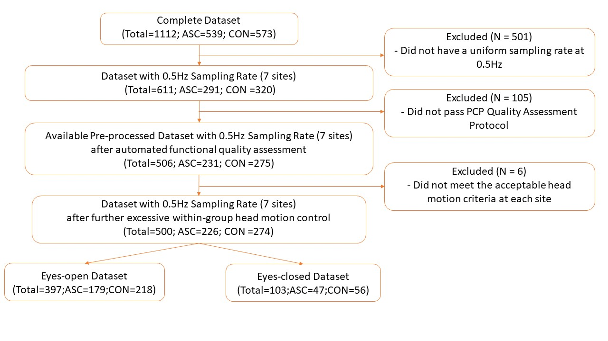Automated Functional Quality Assessment
In this investigation, the quality of functional MRI (fMRI) images was evaluated using various metrics in both the spatial and temporal domains. It is noteworthy that these quality assessments were executed using the PCP Quality Assessment Protocol (http://preprocessed-connectomes-project.org/quality-assessment-protocol/index.html#installing-the-qap-package), a standardized procedure available through the publicly accessible database ABIDEI. Importantly, this protocol ensures transparency, reproducibility, and adherence to established guidelines in the analysis of neuroimaging data.
The spatial domain assessment, employing the mean functional image, included metrics such as Ghost to Signal Ratio assessed the mean signal in the 'ghost' image, representing signal outside the brain due to acquisition in the phase encoding direction, relative to the mean signal within the brain, indicating lower values are preferable (Giannelli et al. 2010).
While in the temporal domain, relying on voxel-wise time-series functional data, metrics like the Entropy Focus Criterion, which employed Shannon's entropy to evaluate the uniformity and energy distribution within the brain, with lower values signifying less noisy data (Atkinson et al. 1997). Foreground to Background Energy Ratio measured the mean energy within the head relative to outside, and Smoothness of Voxels evaluated the full-width half maximum of the spatial distribution , both with lower values considered better(Friedman et al. 2006). Standardized DVARS calculated the spatial standard deviation of temporal derivatives (Nichols 2012),indicating lower values for better data quality. Other metrics, such as Fraction of Outlier Voxel and Mean Distance to Median Volume, utilized functional time-series data to assess the mean fraction of outliers and the distance between time-point volumes and the median volume, respectively (Cox 1996). Mean Framewise Displacement measured subject head motion, and metrics like Number FD greater than 0.2mm and Percent FD greater than 0.2mm quantified frames or volumes with displacement greater than 0.2mm, all reflecting lower values for better data quality (Jenkinson et al. 2002; Yan et al. 2013). Additional details are available at http://preprocessed-connectomes-project.org/abide/quality_assessment.html.
Table 1 displays the outcomes of the automated functional quality assessment for site-wise data with a 0.5Hz sampling rate from 7 sites (N = 611) for each spatial and temporal variable. The comparison of various quality metrics across distinct imaging sites reveals noteworthy differences in the characteristics of fMRI data. Entropy Focus Criterion (EFC) values consistently demonstrated positive uniformity across all sites, indicating a consistent distribution of voxel intensities and favourable data quality. Foreground to Background Energy Ratio exhibited higher values uniformly, reflecting increased energy within brain regions across all sites. Notably, the assessment of spatial smoothness, measured by Full-Width Half Maximum (FWHM), revealed variations, with SDSU displaying the highest FWHM, suggesting distinct spatial smoothness characteristics at this site. Metrics associated with outlier detection, distance to median volume, ghost to signal ratio (GSR) and mean framewise displacement consistently indicated low values across all sites, indicative of robust data quality and minimal head motion.
Following preprocessing, including automated functional quality assessment and the subsequent exclusion of data with excessive mean Framewise Displacement (FD) within each site group (defined as mean FD_Jenkinson > mean FD_Jenkinson(group) + 2 * SD), as illustrated in Table 2, there is a marginal enhancement in most quality metrics. However, variations persist across sites, underscoring the diverse data quality characteristics within each group. The exclusions made to mitigate excessive mean FD within each site group significantly contribute to a more nuanced evaluation of data quality (N = 500). This underscores the critical importance of acknowledging and addressing the impact of head motion in neuroimaging analyses.

Table 1
Site-Wise Data with 0.5Hz Sampling Rate before automated functional quality assessment (N=611)
Site | N | Ghost to Signal Ratio | Entropy Focus Criterion | Foreground to Background Energy Ratio | Smoothness of Voxels | Fraction of Outlier Voxel | Mean Distance to Median Volume | Mean Framewise Displacement
NYU | 184 | -0.0052  (0.0040) | 0.5024 (0.0243) | 115.1792 (25.6358) | 1.9065 (0.1484) | 0.0069 (0.0017) | 0.0149 (0.0052) | 0.0691 (0.0500)
SDSU | 36 | 0.0226  (0.0128) | 0.4411 (0.0215) | 135.5550 (27.4048) | 2.8631 (0.3334) | 0.0049 (0.0080) | 0.0050 (0.0040) | 0.0944 (0.1234)
STANFORD | 40 | 0.0445  (0.0135) | 0.5498 (0.0256) | 61.7417 (10.0542) | 2.4181 (0.2118) | 0.0066 (0.0053) | 0.0122 (0.0110) | 0.1092 (0.0785)
TRINITY | 49 | 0.0155  (0.0066) | 0.4124 (0.0182) | 155.4983 (31.8079) | 2.0194 (0.1268) | 0.0027 (0.0025) | 0.0087 (0.0053) | 0.1096 (0.1108)
UM_1 | 110 | 0.0335  (0.0097) | 0.5341 (0.0232) | 72.5291 (13.1818) | 2.4071 (0.1714) | 0.0075 (0.0109) | 0.0209 (0.0204) | 0.1921 (0.2806)
UM_2 | 35 | 0.0402  (0.0107) | 0.5459 (0.0194) | 60.0860 (9.0388) | 2.3836 (0.1387) | 0.0032 (0.0037) | 0.0140 (0.0106) | 0.0924 (0.0951)
USM | 101 | 0.0396 (0.0104) | 0.5332 (0.0177) | 77.3840 (15.9648) | 1.8368 (0.0906) | 0.0025 (0.0031) | 0.0177 (0.0103) | 0.1358 (0.1479)
YALE | 56 | 0.0487 (0.0149) | 0.4897 (0.0250) | 92.7550 (30.4840) | 2.6400 (0.3185) | 0.0149 (0.0064) | 0.0053 (0.0034) | 0.1094 (0.0790)
Note. Numeric values indicate mean and (standard deviation)
NYU = NYU Langone Medical Center. SDSU = San Diego State University.
STANFORD = Stanford University. TRINITY = Trinity Centre for Health Sciences. UM = University of Michigan. USM = University of Utah School of Medicine. YALE = Yale Child Study Center.

Table 2
Site-Wise Pre-processed Data with 0.5Hz Sampling Rate after automated functional quality assessment and further exclusion with excessive mean FD within each group of sites (N=500)
Site | N | Ghost to Signal Ratio | Entropy Focus Criterion | Foreground to Background Energy Ratio | Smoothness of Voxels | Fraction of Outlier Voxel | Mean Distance to Median Volume | Mean Framewise Displacement
NYU | 166 | -0.0052 (0.0040) | 0.5018 (0.0247) | 115.1409 (26.0799) | 1.9071 (0.1526) | 0.0066 (0.0011) | 0.0144 (0.0047) | 0.0607 (0.0322)
SDSU | 33 | 0.0217 (0.0112) | 0.4411 (0.0224) | 134.8110 (27.9385) | 2.8578 (0.3405) | 0.0034 (0.0051) | 0.0041 (0.0022) | 0.0632 (0.0416)
STANFORD | 36 | 0.0456 (0.0135) | 0.5498 (0.0251) | 61.8329 (10.3597) | 2.4124 (0.2042) | 0.0059 (0.0048) | 0.0100 (0.0055) | 0.0879 (0.0424)
TRINITY | 44 | 0.0155 (0.0063) | 0.4125 (0.0166) | 153.4534 (27.3054) | 2.0199 (0.1301) | 0.0024 (0.0024) | 0.0077 (0.0037) | 0.0833 (0.0352)
UM_1 | 82 | 0.0335 (0.0102) | 0.5332 (0.0237) | 71.0993 (12.6420) | 2.3651 (0.1574) | 0.0032 (0.0031) | 0.0124 (0.0060) | 0.0735 (0.0448)
UM_2 | 31 | 0.0400 (0.0112) | 0.5450 (0.0195) | 59.5212 (9.2120) | 2.3761 (0.1320) | 0.0026 (0.0032) | 0.0112 (0.0057) | 0.0652 (0.0367)
USM | 60 | 0.0393 (0.0101) | 0.5314 (0.0158) | 77.9893 (15.6400) | 1.8392 (0.0915) | 0.0018 (0.0022) | 0.0153 (0.0063) | 0.0957 (0.0464)
YALE | 48 | 0.0494 (0.0152) | 0.4898 (0.0253) | 91.2792 (31.4471) | 2.6560 (0.3075) | 0.0138 (0.0054) | 0.0044 (0.0020) | 0.0855 (0.0434)
Note. Numeric values indicate mean and (standard deviation)
NYU = NYU Langone Medical Center. SDSU = San Diego State University.
STANFORD = Stanford University. TRINITY = Trinity Centre for Health Sciences. UM = University of Michigan. USM = University of Utah School of Medicine. YALE = Yale Child Study Center.

Table 3
Phenotypic information of the dataset with 0.5 Hz Sampling Rate after quality control at Eyes-Open condition
Group | Age | Gender  (M/F) | FIQ | VIQ | PIQ
ASC | 16.43(7.17) | 157/22 | 104.16(18.22) | 103.30(20.17) | 104.40 (18.92)
CON | 15.75(5.67) | 165/53 | 110.87(13.49) | 112.11 (13.77) | 107.53 (13.84)
Note. ASC = Autistic Spectrum Conditions. CON = neurotypical controls.
FIQ = IQ test administered for Full Scale IQ standard score.
VIQ = IQ test administered for Verbal IQ standard score.
PIQ = IQ test administered for Performance IQ standard score.
Numeric values indicate mean (standard deviation).

Figure 2
Distribution of Age among ASC and Control groups at the final dataset under eyes-open condition. 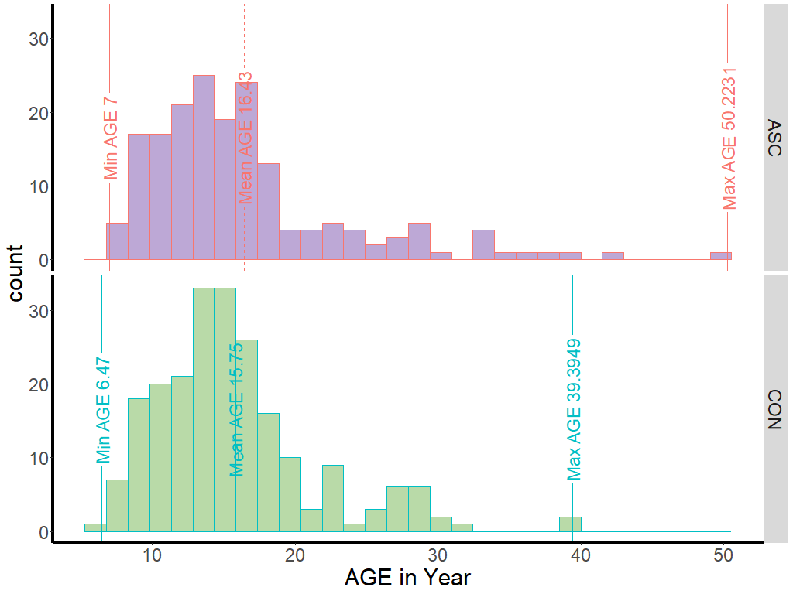
Note. Vertical lines indicate minimum, averaged, and maximum age within each group from left to right at each panel.

Multi-Site fMRI Data Acquisition Parameters
Data from 7 sites (n=611) were analysed with the same original Sample Resolution (SR) in 0.5Hz. Voxel size: 3.0~4.0 mm within plane; slice thickness: 3.0~4.0mm. TR:1500ms~3000ms; TE:15ms~30ms. The analysis encompassed datasets gathered from the sites listed below. The subsequent table furnishes a comprehensive depiction of the acquisition parameters employed across diverse sites within the study. Notably, multiple sites were included in this study, each characterised by distinct acquisition specifications.

Table 4
A comprehensive overview of the acquisition parameters used across different sites in the study
Site | Voxel size | Slice thickness | TR | TE | Time points
NYU | 3.0*3.0*4.0 mm | 4.0 mm | 2000 ms | 15ms | 180
SDSU | - | 3.4 mm | 2000 ms | 30 ms | 180
STANFORD | 3.125*3.125 *4.500 mm |  | 2000 ms | 30 ms | 180
TRINITY | 3.0*3.0*3.0 mm | 3.5 mm | 2000 ms | 28 ms | 150
UM | 3.438*3.438*3.0mm | 3.0 mm | 2000 ms | 30 ms | 300
USM | 3.4*3.4*4.0mm | 3.0 mm | 2000ms | 28ms | 240
YALE | 3.4*3.4*4.0mm | 4.0 mm | 2000ms | 25ms | 200
Note. TR = repetition time. TE = echo time.
NYU = NYU Langone Medical Center. SDSU = San Diego State University.
STANFORD = Stanford University. TRINITY = Trinity Centre for Health Sciences. UM = University of Michigan. USM = University of Utah School of Medicine. YALE = Yale Child Study Center.

rs-fMRI data pre-processing
The image pre-processing was performed using the Data Processing Assistant for Resting-State fMRI (DPARSF) (Chao-Gan & Yu-Feng, 2010), a tool based on Statistical Parametric Mapping (SPM) (Flandin & Friston, 2008) and the Data Processing & Analysis of Brain Imaging (DPABI) toolbox (Yan et al., 2016). The standard pre-processing steps from the ABIDE project were as follows. These steps included slice timing correction, head motion correction, normalisation, and spatial smoothing.
Specifically, the pre-processing involved correcting the acquisition duration differences between volume slices, realigning the time series using a six-parameter rigid body linear transformation, registering the images to the MNI standard space with 3x3x3 mm voxels, and applying a 6mm smoothing kernel. A Friston 24-parameter model was also used to regress out head motion effects from the realigned data.
The initial ten volumes were discarded during the pre-processing, and the slice-timing correction was performed to account for different signal acquisition times. Each subject's time series of images were then realigned using a two-pass procedure, with registration to the first image followed by registration to the mean functional image. Co-registration between individual T1-weighted MPRAGE images and the mean functional image was performed without resampling. The individual T1 images were segmented into grey matter, white matter, and cerebrospinal fluid using the DARTEL tool. No global normalisation was performed. High-pass filtering at 0.01 Hz was also applied to the time series signal, as the low-pass filtering could be controversial. Low-pass filtering has reduced detection sensitivity without significantly improving specificity (Della-Maggiore et al., 2002). This filtering method introduces a significant level of autocorrelation in the signal, thereby violating the assumptions of temporal independence necessary for sample entropy estimation. Additionally, other research demonstrated the presence of significant fMRI frequencies exceeding 0.15 Hz (Chen & Glover, 2015; Kundu et al., 2012). After filtering the signals, transformations from the individual native space to the MNI space were computed finally.
To summarise, the image pre-processing was performed using DPARSF, following the standard pre-processing steps from the ABIDE project. This involved correcting for slice timing differences, realigning the images, registering to the MNI standard space, high pass filtering and smoothing the data. Head motion effects were regressed using a Friston 24-parameter model.

Quality control for head motion
Pre-processed rs-fMRI data downloaded were priorly excluded if the scans showed excessive head motion, indexed by mean framewise displacement (FD) (Jenkinson et al., 2002) exceeding 0.2 mm. Raw resting-state functional data and T1-weighted magnetization-prepared gradient echo images (MPRAGE) obtained for further quality examination. Those with an excessive mean FD (i.e., mean FD_Jenkinson > mean FD_Jenkinson(group)+2*SD) were further excluded. This framewise displacement (FD) (Jenkinson) was defined to evaluate the volume-to-volume superimposed head position discrepancy. After excluding subjects with excessive head motion, independent sample t-tests determined that the ASC and control group from most sites were not significantly different in head motion. The individual mean FD_Jenkinson was calculated after performing the realignment between functional data and T1 image in DPARSF with the application of pre-generated matrices (https://www.rfmri.org/DownloadedReorientMats) to reorient the origin of functional data and T1 image to the anterior commissure first.

Table 5
Site-Wise Pre-processed Data Exclusion Criteria Using Head Motion Parameter (FD_Jenkinson)
(FD_Jenkinson)
Site | Original  Sample size | Head Motion Criteria  (M += 2SD) | Independent Sample t-tests between Group in Head Motion Parameter | Final Sample Size
NYU | 184 | 0.085+=0.033  0.068+=0.025 | t=3.471, p<0.01 | 166 (69 in autism;97 in control)
SDSU | 36 | 0.070+=0.051  0.072+=0.036 | t=-0.084, p=0.934 | 33 (12 in autism;21 in control)
STANFORD | 40 | 0.117+=0.032  0.124+=0.062 | t=-0.395, p=0.696 | 36 (17 in autism;19 in control)
TRINITY | 49 | 0.114+=0.046  0.082+=0.019 | t=2.918, p<0.01 | 44 (21 in autism;23 in control)
UM_1 | 110 | 0.104+=0.048  0.075+=0.033 | t=3.123, p<0.01 | 82 (36 in autism;46 in control)
UM_2 | 35 | 0.101+=0.066  0.092+=0.093 | t=0.300, p=0.766 | 31(12 in autism;19 in control)
USM | 101 | 0.107+=0.050  0.107+=0.046 | t=-0.006, p=0.995 | 60 (37 in autism;23 in control)
YALE | 56 | 0.104+=0.050  0.088+=0.043 | t=1.189, p=0.241 | 48 (22 in autism;26 in control)
Note. NYU = NYU Langone Medical Center. SDSU = San Diego State University.
STANFORD = Stanford University. TRINITY = Trinity Centre for Health Sciences. UM = University of Michigan. USM = University of Utah School of Medicine. YALE = Yale Child Study Center.

Statistical analysis: Data-driven Exploration followed by Machine Learning Classifier
In this study, the novel neurophysiological biomarker study pipeline (as illustrated in Figure 3) will be employed by extracting nonlinear features of spontaneous fMRI (i.e., multiscale sample entropy) and comparing group differences between individuals with and without ASC. More specifically, this novel resting-state neurophysiological biomarker pipeline includes data acquisition, preprocessing, feature extraction and classification (Heunis et al., 2016). In the feature extraction step, specific characteristics of the rs-fMRI signals will be extracted and compared, and these extracted pieces of information are referred to as "features." In the final step (classification), the machine learning strategies are incorporated to enhance the accuracy and effectiveness of the classification process (Bosl et al., 2011; Duffy & Als, 2012; Pistorius et al., 2013).

Figure 3
Full analysis procedure based on rs-fMRI data with multiscale sample entropy calculation.
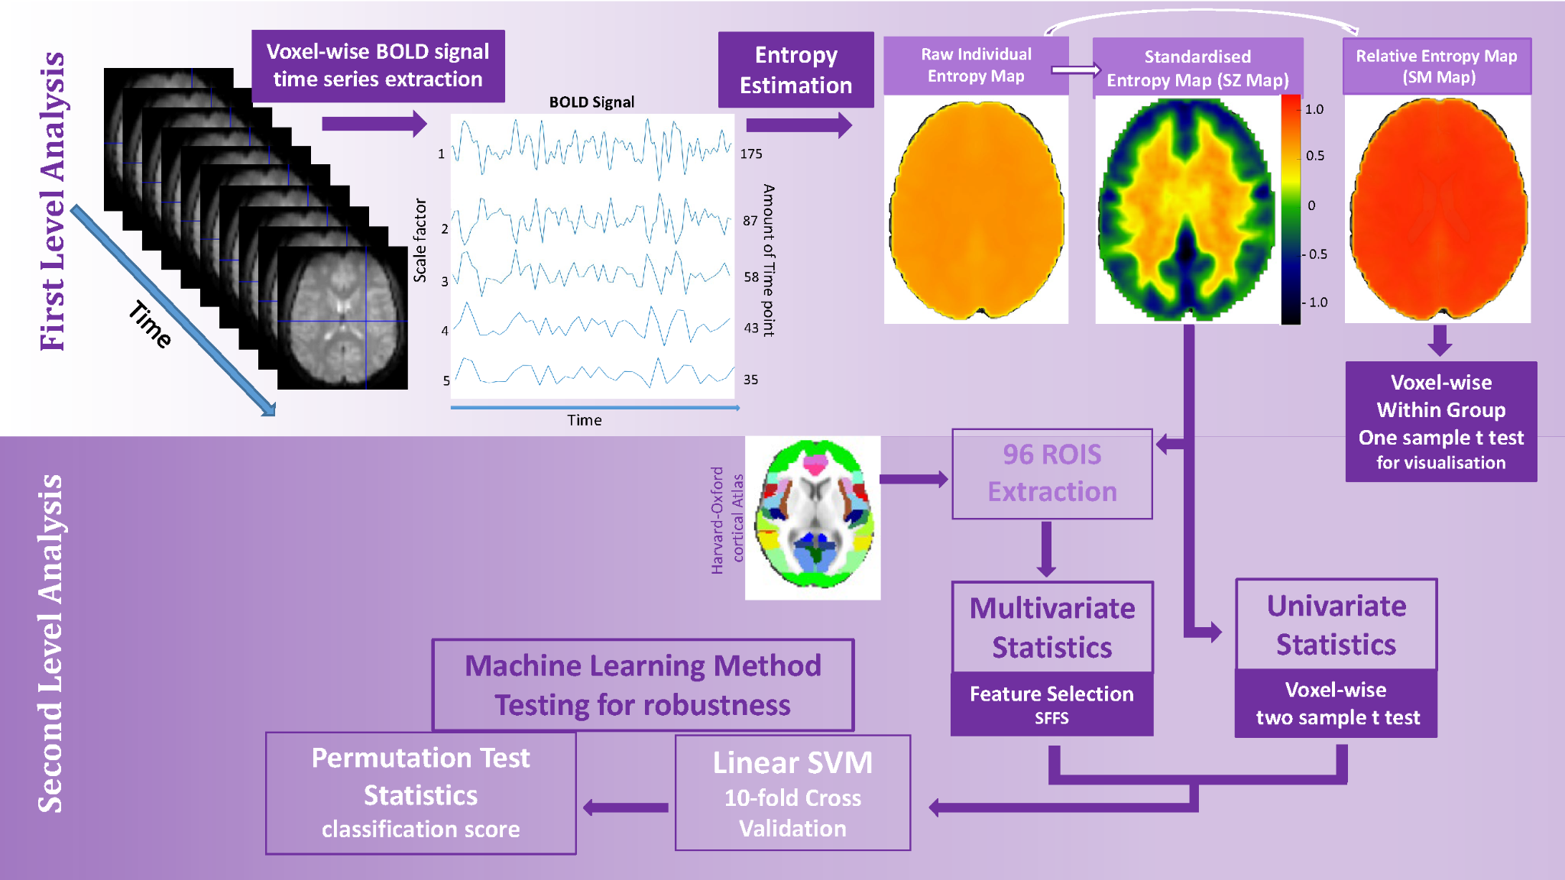
Instead of employing a specific hypothesis-driven method for testing specific hypotheses, we opted for a hypothesis-free statistical analysis. This choice was influenced by the conflicting findings in the current literature regarding the resting state fMRI signal group differences between individuals with and without ASC. Varied effects have been observed across different brain rhythms and regions (Maximo et al., 2021), and there have also been no significant differences between groups (Easson & McIntosh, 2019).
Furthermore, the limited availability of adequate sample sizes across several studies may have contributed to a constrained exploration of the generalizability and robustness of findings. This, in turn, has led to the emergence of conflicting findings, as previously highlighted. Thus, it becomes imperative to rigorously assess the external validity of our results when scrutinising the intricate neural patterns within the ASC population. In light of this, the present study capitalised on a substantial, pre-existing dataset, specifically the Autism Brain Imaging Data Exchange (ABIDE), to enhance the empirical basis of the investigation (https://fcon_1000.projects.nitrc.org/indi/abide/).
To strike a balance between statistical flexibility and robustness, the machine learning approach was adopted with two main components: feature selection and an objective function to assess all possible feature subsets. First, the feature selection process conducted in two directions (as illustrated in Figure 3): The first approach employed the univariate method, where features were selected based on the significant clusters identified through a massive univariate voxel-wise two-sample t-test and corrected using a cluster-based method. In contrast, the second approach, referred to as the multivariate method, employed Sequential Forward Floating Selection (SFFS) to select features. Second, the objective function was a 10-fold cross-validation method utilising a linear Support Vector Machine (SVM) as the machine learning classifier. This procedure entailed the division of data into training and test sets. A linear SVM model was trained using the training samples throughout each cross-validation procedure iteration. Subsequently, the resultant model was employed on the corresponding test sample to evaluate the efficacy of the selected features.
Feature selection: Significant clusters obtained from massive univariate voxel-wise two sample t tests (Univariate Method)
Like most rs-fMRI studies, the voxel-wise two-sample t-test was initially conducted to explore group differences. The Threshold-free cluster enhancement was adopted as a cluster-based technique to address the multiple comparison problem (Nichols, 2012), resulting in significant clusters that indicated group differences. These clusters would be considered the selected features for further investigation in subsequent evaluations.
The voxel-wise two-sample t-test, known as mass-univariate model-based analysis, is a commonly used classical statistical method where statistical inference is conducted individually at each voxel. Brain regions exhibiting significant statistical effects between groups are identified based on BOLD responses using iterative statistical analysis of all voxels. However, a noteworthy limitation of this strategy lies in the presumption that the covariance between adjacent voxels needs to offer pertinent insights into the cognitive function under investigation. This covariance is often viewed as uncorrelated noise and is typically mitigated by applying spatial filters, which smooth BOLD signals across neighbouring voxels (Mahmoudi et al., 2012). Additionally, such mass univariate is inevitable to meet the multiple comparison problem.
Feature selection: Contributing cortical atlas obtained from the Sequential Forward Floating Selection (SFFS)
This study utilised the Harvard-Oxford cortical atlas to address this limitation and assign predefined meaning to the selected features. This atlas was employed to aggregate multiple voxels within predefined functionally related regions (Stelzer et al., 2013). This methodology enables the simultaneous analysis of multiple voxels, facilitating dimension reduction and integrating cognitive information linked to the importance of these regions. The subsequent sections explain the univariate and multivariate statistical analyses in detail.
In the context of the classical classification problem, feature selection aims to automatically search for and choose the optimal subset of features for classification purposes. This is primarily motivated by the curse of dimensionality. In many instances, fMRI data contain a limited number of samples but a more significant number of features. This discrepancy often leads to overfitting in classification, resulting in misleading diagnostic outcomes and insufficient generalisation performance.
To reduce the chances of overfitting, one can employ feature-selection algorithms to eliminate redundant data. This study employed a specific feature-selection algorithm, Sequential Forward Floating Selection (SFFS) (Pudil et al., 1994). The SFFS algorithm begins by identifying the initial feature with the highest classification rate and adding it to an empty candidate set. Subsequently, other features are chosen individually and combined with either the first feature or the existing subset of features in the candidate set. The algorithm tests each new feature combination to determine if it improves the classification rate. This process continues until no additional features contribute to improving the objective function.
The Final Classification Step
After successfully choosing the feature candidates using the abovementioned steps, we assessed these selected features. The 10-fold cross-validation method with a linear Support Vector Machine (SVM) was utilised as the machine learning classifier to accomplish this. This involved splitting the data into training and test samples. In each iteration of the cross-validation process, a linear SVM model was trained using the training samples, and the resulting model was applied to the test sample to assess the feature subset. This combination of SFFS and linear SVM has demonstrated notable accuracy in distinguishing between various resting brain states (Al-Zubaidi et al., 2019).
The classification accuracy (CA) was derived using a 10-fold cross-validation strategy with confusion matrix (CM) and accuracy calculation. The CM provided information on the predicted and actual classifications produced by the linear SVM. The SVM classifier (ASC or CON) results were compared with the reference data, and the CM outcomes were documented.
Table 6
Example of the Confusion Matrix
 |  | Referenced Data
 |  | ASC | CON
Classified Data | ASC | $$\left[TP FP\right]$$  $\left[FN TN\right]$
 | CON
Note. TP = True Positives. FP = False Positives. FN = False Negatives. TN = True Negatives.
$Sensitivity (True Positive Rate)=\frac{True Positives}{True Positives+False Negatives}$ (Equation 1)

$Specificity\left(True Positive Rate\right)=\frac{True Negatives}{True Negatives+False Positives}$(Equation 2)

To conduct significance testing, we employed a method described by (Pereira et al., 2009). We estimated the null distribution by calculating the accuracy score of the classifier on 1000 permutations of the dataset. These permutations preserved the features but shuffled the labels. This null distribution represented the hypothesis that there is no relationship between the features and labels. An empirical p-value was then computed as the percentage of permutations where the score obtained was greater than that obtained using the original data. P < 0.05 indicates a significant difference in classification results than random chance.
First level Statistics – BOLD time series extraction and Entropy calculation
The primary objective of this study is to thoroughly examine the effectiveness of entropy as a measure for distinguishing individuals with ASC from neurotypical control subjects. The time series data was extracted from individual rs-fMRI intracranial signals and voxel-wise calculations of multiscale sample entropy for both the ASC and control groups.
To compare the voxel-wise entropy across different research sites, we selected seven sites (NYU, SDSU, Stanford, Trinity, UM1&2, USM, and Yale) with a typical sampling frequency of 0.5Hz. However, it is essential to note that the amplitude range of the preprocessed rs-fMRI data varied significantly among these sites. To mitigate the impact of this amplitude range and enable further voxel-wise analysis, a normalisation process was performed on the voxel-wise rs-fMRI signals prior to entropy calculation. Subsequently, multiscale sample entropy calculation was conducted on each voxel, generating raw sample entropy maps.
Multiscale sample entropy map of each subject from different sites obtained from the pre-processed data in template space and spatially smoothed with a 6-mm FWHM Gaussian kernel within each brain mask, which was also warped and smoothed. Pre-processed rs-fMRI data and the individual anatomical brain mask are read in by functions that come with the SPM toolbox in Matlab, including spm_vol and spm_read_vols. After extracting the time series from each voxel within the mask, the multiscale sample entropy was computed, yielding five indices for each time scale factor. These indices were then transformed into a brain map format with the built-in function of spm_write_vol in the SPM toolbox in Matlab. Second-level statistical analysis was conducted with modified Matlab scripts sourced from the DPABI toolbox (Yan et al., 2016), publicly accessible through GitHub https://github.com/Chaogan-Yan/DPABI.
The complete data analysis process, encompassing tasks such as data input, time series extraction, multiscale sample entropy computation, generation of resultant entropy brain maps, and storage of outcomes for individual participants, was executed using the High-Performance Computing resources provided by the University of Sheffield's ShARC (Sheffield Advanced Research Computer) infrastructure. My authored code employed in this study was available on GitHub: https://github.com/wenyixiao0058/fmristudy. Specifically, for data input, extracting voxel-wise time series, and organizing output storage, check out the "getfmriDat.m" and "setfmriAggregate.m" files. To perform multiscale sample entropy computations, the relevant code is available in the "multiscale_entropy4fmri.m" file.
Entropy Calculation
In this study, the calculation of Sample Entropy was conducted using the Matlab script provided in the work of (Azami et al., 2017), which is also employed in the Chapter 2 EEG study.
Multi-Scale Entropy
Multi-Scale sample entropy (MSE) computes the sample entropy on the original signal and on coarse-grained time series that are derived from the original signal. MSE calculation incorporates two procedures in each epoch and for each electrode independently. Firstly, the algorithm generates coarse-grained time series by progressively downsampling the time series$\left\{χ₁,χ₂,…χɴ\right\}$. As for time scale factor 𝜏, each element $\left(i\right)$ from the coarse-grained time series $\left\{Yτ\left(i\right)\right\}$is obtained by averaging 𝜏 consecutive data points, resulting in a time series with a length of exactly divisible by 𝜏 into the original length. Specifically, the time series associated with scale factor 1 is the original data and scale factor 2 is the average of consecutive pairs of data points and so forth for increasing scales. As such, the element of a coarse-grained time series $i$ is calculated according to:
$\left\{Yτ\left(i\right)\right\}=\frac{1}{τ}\sum_{i=1}^{\frac{N}{τ}}{}\left(χ{}_{((i-1)*τ +1)}: χ{}_{(i*τ)}\right)$ (Equation 3)
where $N$ is the length of the original signal. Second, the algorithm computes the sample entropy for each coarse-grained time series. Sample entropy is defined by the negative natural logarithm of the conditional probability that a time series of length $\frac{N}{τ}$, having repeated itself within a tolerance $γ$(similarity threshold) for $m$ points (the length of sequences to be compared), will also repeat itself for $m+1$ points, without allowing self-matches. The pattern length $m$ was fixed to 2 and the similarity factor $γ$ was set to 0.60 * standard deviation of the time series in this study; that is, data points were indistinguishable if the absolute amplitude difference between them was ≤ 60% of the standard deviation of the time series.
Before the SE calculation, all time series were centred and normalised to standard deviation 1 to avoid the bias of varying range of amplitude across channels and datasets. SE is proposed to calculate the distance between any pairwise elements and count the number of times when this distance is under the threshold $γ$. To do this, for a time series with $N$ elements, forms a $(N- m+1)$ vectors $U_{m} (i)$ $\left|1<i<N- m+1\right|$,where $U_{m} (i)=χ(i+(m-1))$ is the vector $m$ points from $χ_{(i)}$to $χ_{(i +(m-1))}$. Then the built-in matlab function pdist is used to determine the pairwise Chebyshev distance $d\left[U_{m} (i) -U_{m} (j)\right]\left(i≠j\right)=max\left\{{|U}_{m} (i)-U_{m} (j)|\right\}$, then it is extended to the$m+1$. The number of thresholded pairwise distances are counted respectively. The quantity is:
$A_{i}^{m}(γ)=\sum_{i=1\left(i≠j\right)}^{N-m}{}(d\left[U_{m} (i) -U_{m} (j)\right]<γ)$ and${ B}_{i}^{m+1}(γ)=\sum_{i=1\left(i≠j\right)}^{N-m+1}{}(d\left[U_{m+1} (i) -U_{m+1} (j)\right]<γ)$
(Equation 4)

and sample entropy equation is:
$Sample Entropy(m, γ, N) = -\frac{N-m+1}{N-m-1}*log(\frac{A(m, τ)}{B(m+1, τ)})$ (Equation 5)
Second level Statistics (Group level Analysis)
Univariate Statistics
At the second level of statistical analysis, the two-sample t-test was applied among the autism and control groups, resulting in a T-statistics map demonstrating voxel-wise t values. The null hypothesis is that there is no difference in the Sample Entropy value obtained in each voxel between groups. When inferring the fMRI spatial content, hundreds of thousands of t-tests were conducted for each voxel simultaneously, which inflates the false positives.
Bonferroni correction is too harsh as it considers these t-tests independent, which is different for fMRI inference as these t-tests are related to their neighbouring test. To better correct the multiple comparison problems raised by a mass of t-tests conducted in this voxel-wise study, a permutation test with Threshold-Free Cluster Enhancement (TFCE) was applied to achieve a balance between test-retest reliability and family-wise error rate (under 5%) as well as cluster-based inference which assesses the surprising spatial extent (i.e., the size of cluster connected by voxels). This step was achieved by the DPARSF toolbox integrating PALM(Permutation Analysis of Linear Models) (Winkler et al., 2016). The number of permutations was set at 5000 with the acceleration method of no acceleration (few permutations), which is recommended for spatial statistics.
The investigation also revealed that inconsistent individual masks used for calculating brain entropy maps could lead to false positive findings from the voxel-wise two-sample t-test. This is due to the situation where one mask contains a value while another does not. The voxel-wise t-test combines all brain entropy maps based on various individual masks and then contrasts these values with the empty voxels in the differences between masks. Consequently, this procedure can yield false positive results in these specific voxels, usually at the edge of the cortex. To counter this issue, it is advisable to employ a uniform mask that remains identical across participants, groups, and sites.
One sample voxel-wise t-test within each diagnosis group
To reduce the global effects of variability across participants, as done in many other temporal analyses in rs-fMRI study (Li et al. 2021), the entropy of each voxel was divided by the global mean entropy value for each subject, resulting in a relative entropy. The global mean entropy value was calculated for each participant within a group mask obtained by selecting a threshold of 90% on the mean map of all subjects. The relative entropy value in each voxel reflects the degree of its raw entropy value relative to the average entropy value of the whole brain. Here we used ‘smentropy’ to denote this relative entropy for the further one-sample t test, which compares these voxel-wise relative entropy with 1 to see how the entropy varies about the whole-brain mean.
In the present work, voxel-wise one-sample t test was applied to examine the relative sample entropy throughout the brain with the function y_TTest1_Image (https://github.com/Chaogan-Yan/DPABI) at each time scale (1-5) respectively. The input files are the individual relative entropy maps compared to the value 1 to examine its relative global entropy at both ASC and Control group respectively. The Figure 4 is the Z statistical maps transformed from the original t statistical maps (TFCE-corrected) with the function y_TFRtoZ (https://github.com/Chaogan-Yan/DPABI) and displayed using the MRIcroGL (Rorden and Brett 2000). The reference coordinates of the visualisation are (0.196167 * 2.06932 *26.3201 mm). The yellow-to-red area represents the significant greater relative magnitude to the global mean, which relates to the relatively higher entropy through the whole brain; while the green-to-blue area represents the significant smaller relative magnitude to the global mean, which relates to the relatively lower entropy through the whole brain. The two-sample t test on the global mean between groups show that there is no significant difference on raw sample entropy for each scale (Scale 1: t =-1.111, p =0.267; Scale 2: t =-2.532, p =0.0117; Scale 3: t =-1.691, p =0.092; Scale 4: t =-0.925, p =0.355; Scale 5: t =-0.748, p =0.455). This facilitates a comparative assessment of the relative entropy map across the diagnosis groups under investigation.
Two-sample voxel-wise t test across diagnosis groups
The input files were the individual entropy maps standardised by subtracting the overall average and dividing by the standard deviation. This method provides two key advantages: 1) it helps alleviate the influence of overall variability within the brain when conducting voxel-wise group-level analysis; 2) it restores the multiscale sample entropy profile of the fMRI signal, and its validity was confirmed in the pilot test in the general introduction (Chapter 1). Furthermore, it effectively discriminates between grey and white matter by capturing their distinct nonlinear characteristics through standardised multiscale sample entropy.
Voxel-wise mixed-effect analysis and voxel-wise two-sample t-tests were conducted to perform the univariate group-level analysis. These analyses utilised the functions y_MixedEffectsAnalysis_Image and y_TTest2_Image from the DPABI toolbox (Yan et al., 2016) and are publicly accessible at (https://github.com/Chaogan-Yan/DPABI). The voxel-wise mixed effect analysis was performed to understand better the changing pattern in brain complexity across the multiple time scale factors at ASC and neurotypical control groups. The voxel-wise two-sample t-test was performed to examine the group difference at each scale. Statistical analysis was all corrected for the multiple comparisons problem by the permutation test with Threshold-Free Cluster Enhancement (TFCE) (Smith & Nichols, 2009).
Multivariate Statistics
Feature Selection for ASC/CON Classification
After generating standardised sample entropy maps from rs-fMRI data for each subject per time scale (i.e., 1-5), the Harvard-oxford cortical atlas was used to define the ROIs. The Harvard-oxford cortical atlas is a well-established anatomical parcellation of the brain into 48 ROIs per hemisphere, excluding the cerebellar lobules. Mean values of standardised sample entropy were calculated for each ROI and used to create a feature (ROI) vector, i.e., R[1, …, 96], for each time scale factor. Those features are listed in Table. The total number of features is 480 (i.e., 96*5). The SFFS strategy used the sequential floating feature selection toolbox(http://splab.cz/en/download/software/software-pro-sekvencni-selekci-priznaku). The linear SVM was performed using the Scikit-learn in Python (Pedregosa et al., 2011). This entire procedure was executed using a custom script available at the following GitHub repository: https://github.com/wenyixiao0058/fmristudy.git, specifically referring to the "svm_fmri.py" script.

Results
Voxel-wise one sample t test result
The one-sample test output from a sub-dataset with 0.5Hz sampling rate at eye open condition is depicted in Figure 4. Voxel-wise, one sample t-test was performed without any covariates. Based on visual inspection of the descriptive entropy map, different brain tissues gain different ranges of entropy value. The relative higher entropy mainly lies in the white matter, while the grey matter shows a relatively lower entropy. Entropy reversal occurs since scale 2, where grey matter exhibits lower entropy while white matter demonstrates a higher entropy.

Figure 4
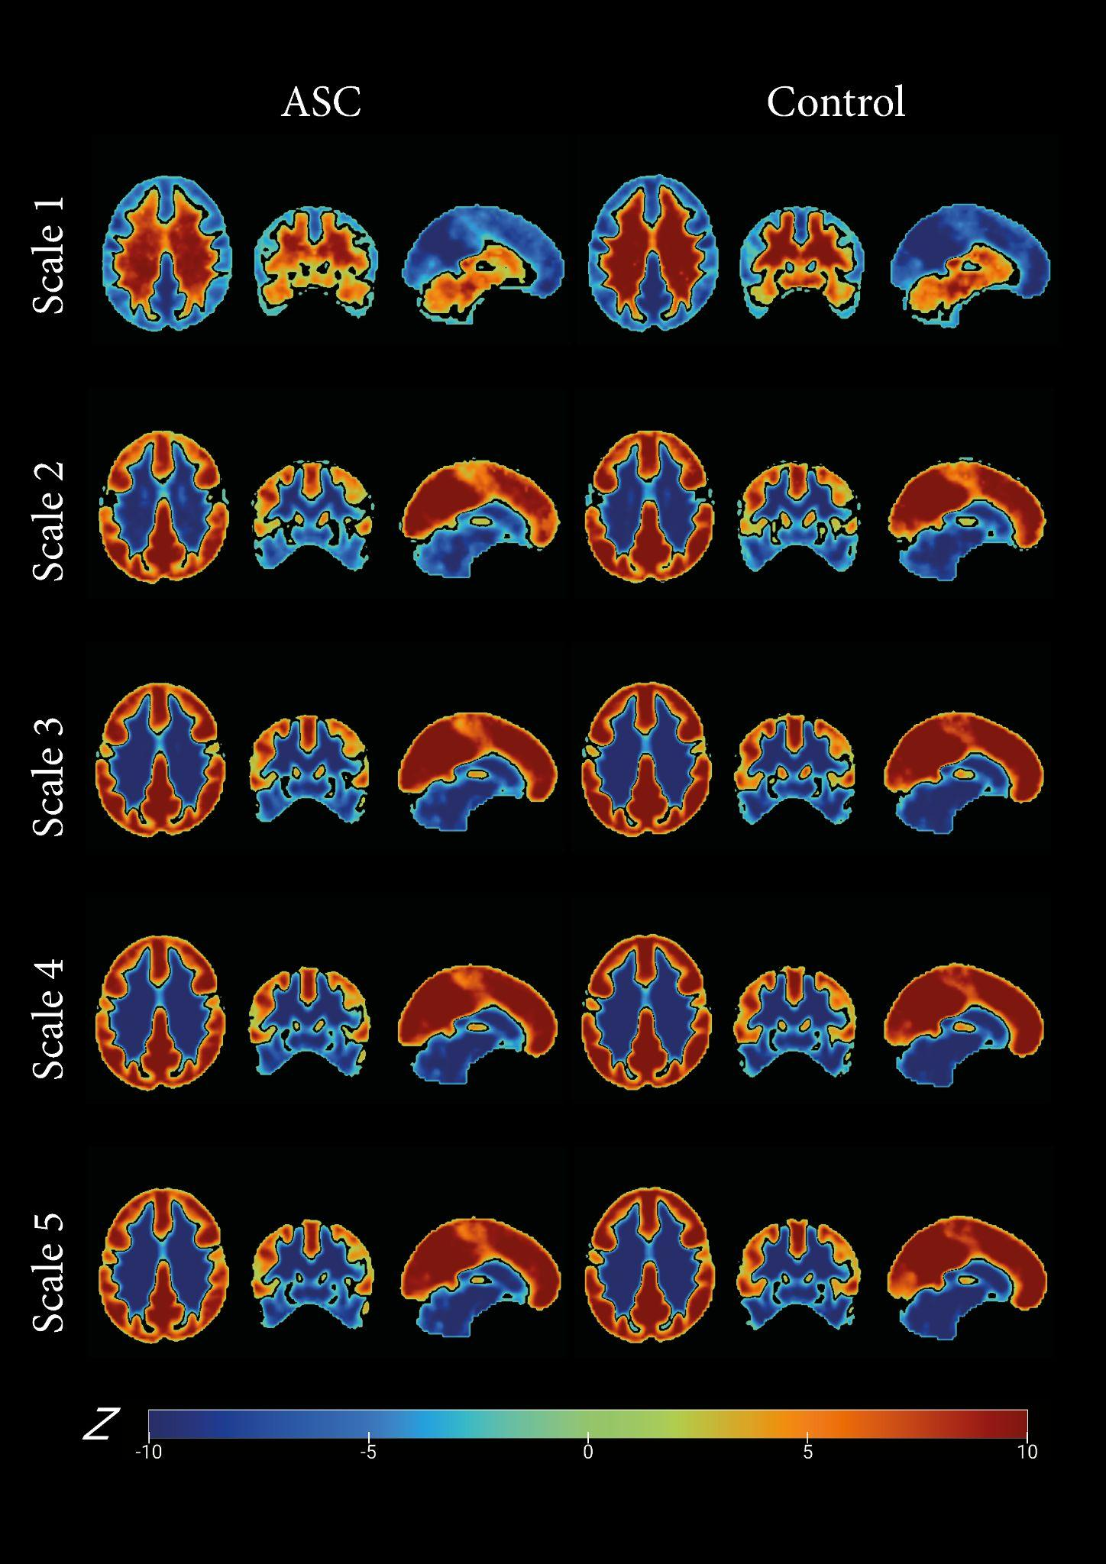
Within the brain variability in sample entropy for each voxel, time scale factor and diagnosis group.
Note. Hot colours indicate greater-than-average sample entropy value of a given contrast (i.e., relative sample entropy value v.s. 1), corrected by permutation test with threshold-free cluster enhancement, with voxel level: p < .05.
Entropy was extracted across seven cortical networks to visualise the time scale changes in brain complexity. The 7 cortical network identified by (Yeo et al. 2011) consisting of 1)Visual network: This network includes areas of the occipital and parietal lobes involved in processing visual information.2)Somatomotor network: This network includes areas of the frontal and parietal lobes involved in controlling movement and sensation.3)Dorsal attention network: This network includes areas of the parietal and frontal lobes involved in the control of spatial attention.4)Ventral attention network: This network includes areas of the frontal and parietal lobes involved in the control of non-spatial attention.5)Limbic network: This network includes areas of the medial temporal lobe, cingulate cortex, and insula involved in emotional processing and memory.6)Frontoparietal network: This network includes areas of the frontal and parietal lobes involved in cognitive control and decision making.7)Default mode network: This network includes areas of the medial prefrontal cortex and posterior cingulate cortex involved in self-referential thinking and mind-wandering. Mask downloaded from https://surfer.nmr.mgh.harvard.edu/fswiki/CorticalParcellation_Yeo2011 projected into MNI152 space and resliced into 3mm isotropic space and extracted the overlap between the network masks and group mask. Then, these seven cortical network masks and the white matter mask were applied to extract the relative sample entropy from each participant in both ASC and neurotypical control groups. Relative sample entropy for each cortical network and white matter visualised in the box plot (Figure 5).

Figure 5
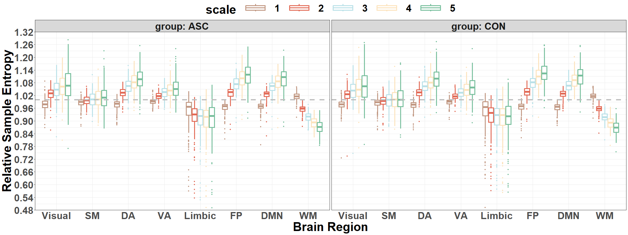
Averaged relative sample entropy for the eyes-open dataset.

Note. Visual = Visual Network; SM = Somatomotor Network; DA = Dorsal Attention Network; VA = Ventral Attention Network; Limbic = Limbic Network; FP = Frontoparietal Network; DMN = Default Mode Network; WM = White Matter.
Voxel-wise two sample t test result: Group Level Statistical Analysis
A normalisation process was applied to standardise the sample entropy values and mitigate the impact of individual differences. Precisely, the sample entropy of each voxel was adjusted by subtracting the global mean and dividing it by the standard deviation. This adjustment was performed within the individual brain mask, excluding background and non-brain tissue signals. Consequently, a standardised whole-brain sample entropy map was generated and utilised in subsequent group-level analysis.

Figure 6
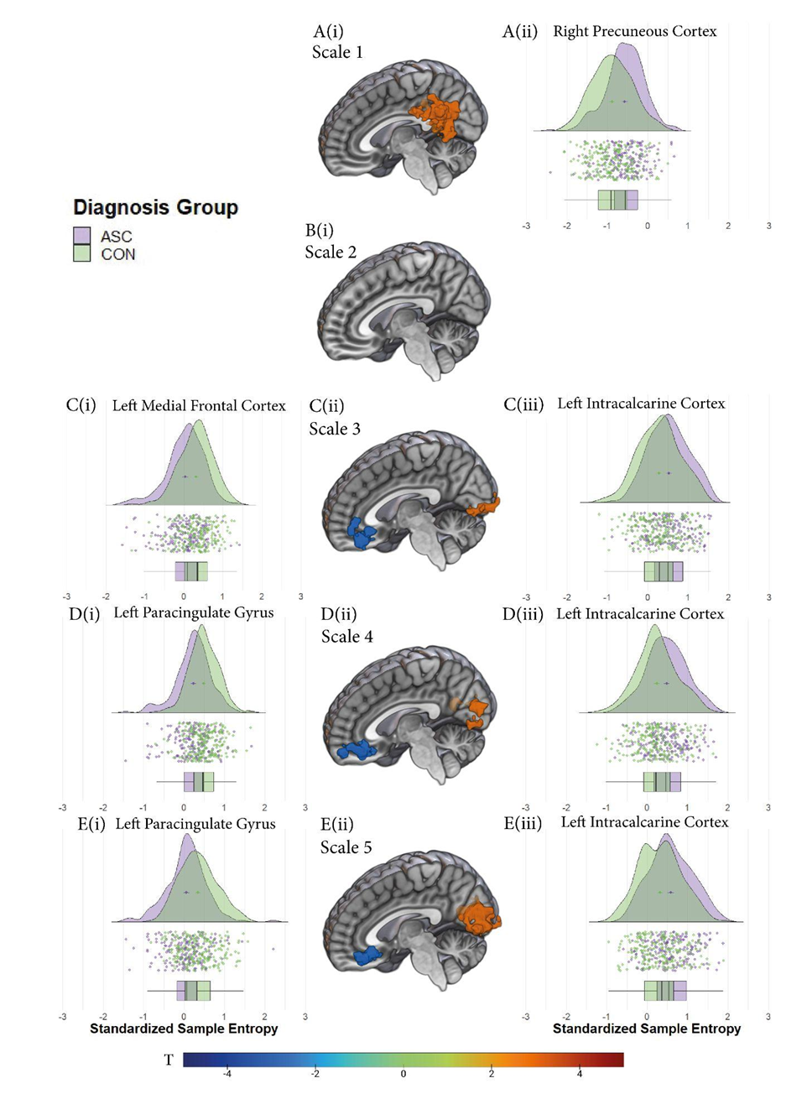
Diagnosis group contrasts for each voxel and time scale factor, corrected by permutation test with threshold-free cluster enhancement, with voxel level: p < .05.
Note. Hot colours indicate greater sample entropy value in the ASC group of a given contrast (i.e., ASC v.s. CON), corrected by permutation test with threshold-free cluster enhancement, with voxel level: p < .05. Additionally, corresponding descriptive data plots display bilaterally. Purple represents individuals with ASC, while green represents CON. T value indicates t statistics obtained from the voxel-wise two sample t test.
In Figure 6, the middle panel (A-E(ii)) displays a sagittal slice extracted from the standardised MNI brain template. The details of the significant clusters at each scale factor are illustrated in Table 5. All the significant cluster reports are provided by CUI Xu's xjview (http://www.alivelearn.net/xjview/).
Table 7
Information of the significant cluster obtained from voxel-wise two-sample t test at each time scale factor (p < .05, corrected by TFCE with permutation test)
Scale | Brain Region | MNI Coordinates | Peak Intensity t-value | Volume (Voxels)
1 | Right Precuneus Cortex (PCUN) | 9, -54, 18 | 5.29038 | 429
2 | - | - | - | -
3 | Left Medial Frontal Cortex (mLFC) | -9, 33, -3 | -4.7452 | 131
3 | Left Intracalcarine Cortex (L-ICC) | -9, -84, 0 | 3.795 | 66
4 | Left Paracingulate Gyrus (L-PCG) | -12, 48, -3 | -4.1392 | 112
4 | Left Intracalcarine Cortex (L-ICC) | -15, -75, 3 | 3.5987 | 100
5 | Left Paracingulate Gyrus (L-PCG) | -12, 45, -6 | -4.3071 | 112
5 | Left Intracalcarine Cortex (L-ICC) | -9, -72, 3 | 4.3867 | 346

Significant group difference at scale 1 was observed in the right precuneus cortex (PCUN, MNI coordinates: 9, -54, 18), which revealed a peak intensity (t =5.29038, p<0.05, TFCE corrected). The PCUN cluster encompassed a volume of 216 cubic millimetres and comprised 429 voxels. There was no significant group difference found after correction at the scale 2.
At scale 3, a significant group difference was observed in the left medial frontal cortex (mLFC, MNI coordinates: -9, 33, -3) with a peak intensity t-value of -4.7452 (p < 0.05, TFCE corrected). The mLFC cluster comprised 131 voxels. Additionally, in the left intra-calcarine cortex (L-ICC; MNI coordinates: -9, -84, 0), a significant group difference was observed with a peak intensity t-value of 3.795 (p < 0.05, TFCE corrected). This cluster encompassed 66 voxels.
Similarly, at scale 4, a significant group difference was found in the left paracingulate gyrus (MNI coordinates: -12, 48, -3) with a peak intensity t-value of -4.1392 (p < 0.05, TFCE corrected). The left paracingulate gyrus cluster consisted of 112 voxels. Additionally, in the left intra-calcarine cortex (L-ICC; MNI coordinates: -15, -75, 3), a significant group difference was observed with a peak intensity t-value of 3.5987 (p < 0.05, TFCE corrected). This cluster encompassed 100 voxels.
Likewise, at scale 5, a significant group difference was observed in both the left paracingulate gyrus (MNI coordinates: -12, 45, -6) and the left intra-calcarine cortex (MNI coordinates: -9, -72, 3). The left paracingulate gyrus cluster exhibited a peak intensity t-value of -4.3071 (p < 0.05, TFCE corrected) and encompassed 112 voxels. The left intra-calcarine cortex cluster had a peak intensity t-value of 4.3867 (p < 0.05, TFCE corrected) and consisted of 346 voxels. These overlapping results across scales 3 to 5 suggest consistent and robust group differences in these specific brain regions, indicating a potential disparity in brain complexity.

Results from Voxel-wise Mixed Effect Analysis
Figure 7
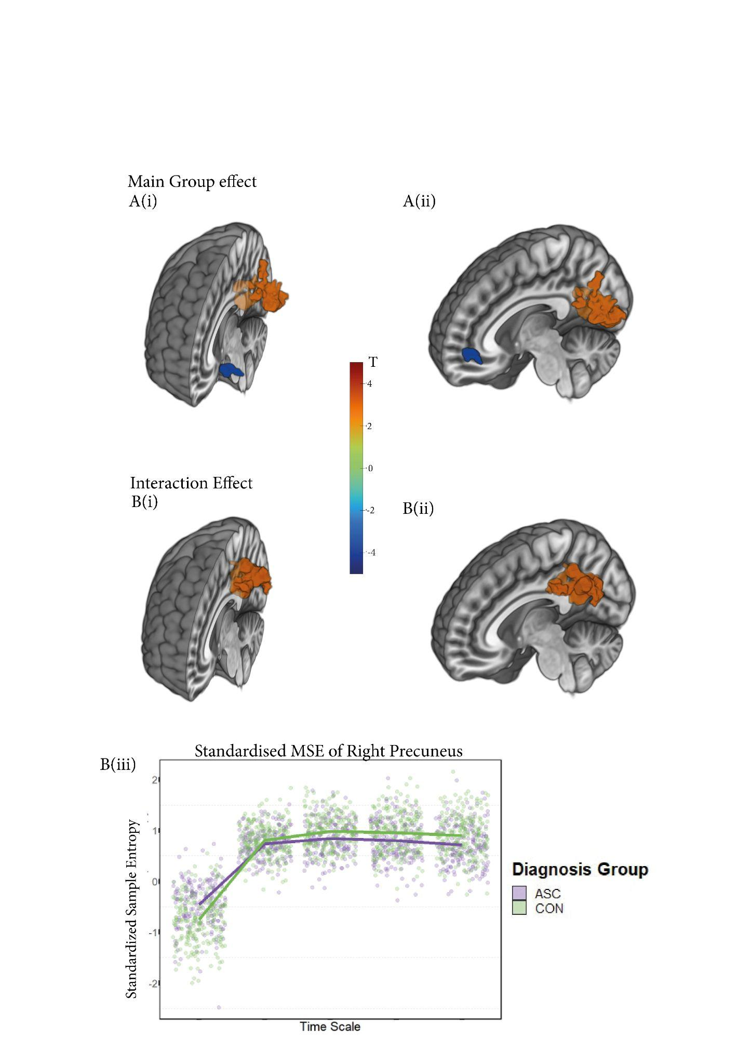
Significant clusters resulting from voxel-wise mixed effect analysis, corrected by permutation test with threshold-free cluster enhancement, with voxel level: p < .05.
Note. Main group effect represents the contrast of the diagnosis group (i.e., ASC v.s. CON) and displays at A(i) and A(ii) at two sagittal views. Hot colours indicate greater MSE across time scales in ASC compared to the CON. The interaction effect investigated is the diagnosis group X time scale and displays at B(i) and B(ii) at two sagittal views. Hot colours indicate greater MSE in ASC of a given contrast (i.e., Contrast = (ASC at scale 5 - ASC at scale 1) - (CON at scale 5 - CON at scale 1)). Additionally, B(iii) demonstrates that the multiscale sample entropy within the significant cluster across time scales. Purple represents ASC while green represents CON. T value indicates t statistics.
In the voxel-wise mixed effect analysis, a significant main effect of the group was observed in three brain regions. First, in the left middle frontal gyrus (MNI coordinates: -24, 60, 12), a peak intensity t-value of -4.5012 (p<0.05, TFCE corrected) was found, with 27 voxels showing a significant difference between the groups. Second, in the left cuneus (MNI coordinates: -9, -72, 3), a peak intensity t-value of 4.5197 (p<0.05, TFCE corrected) was observed, with 245 voxels. Last, in the right posterior cingulate (MNI coordinates: 6, -54, 24), a peak intensity t-value of 3.5441 (p<0.05, TFCE corrected) was found, with 22 voxels.
Furthermore, a significant interaction effect between the group and time scale was detected at the right precuneus (MNI coordinates: 9, -54,18), a peak intensity t-value of 5.4419 (p<0.05, TFCE corrected), indicating that the impact of the group differs depending on the levels of the scale variable.
Multivariate statistics
Specific ROI selected by SFFS
The ROI (i.e., features) selected by SFFS were listed and plotted using the ggsegHO package in R (Makris et al., 2006; Mowinckel & Vidal-Piñeiro, 2020), as depicted in Figure 8. In our SFFS results, the features are left cingulate gyrus posterior part and left temporal fusiform cortex anterior part at scale 1; left superior temporal gyrus anterior part; right supramarginal gyrus posterior part and left frontal orbital cortex at scale 2; right inferior temporal gyrus posterior part at scale 3; right inferior frontal gyrus parstriangularis at scale 4 and right middle frontal gyrus at scale 5.
Figure 8
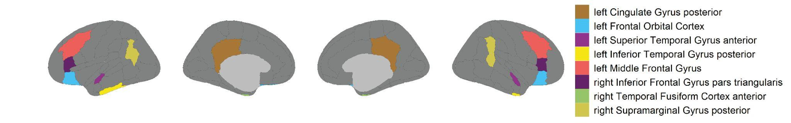
Specific Harvard-oxford cortical atlas that were selected from SFFS to distinguish between individuals with and without ASC

Note. The performance of these regions was further evaluated by the linear SVM classifier. Brain positions were organised from left to right as follows: left lateral, left medial, right medial, and right lateral.
Machine learning Classification of different models
This study aimed to determine if features extracted using multiscale sample entropy, selected from univariate and multivariate models, could effectively distinguish individuals with ASC from control subjects using machine learning techniques. Specifically, a linear Support Vector Machine (SVM) classifier with significant clusters and Sequential Forward Floating Selection (SFFS) feature selection was used.
Through this analysis, it has been found that the multivariate model, which consisted of a subset of brain regions selected by SFFS, achieved the highest classification accuracy of 68% in identifying individuals with ASC. This model also demonstrated a well-balanced overall performance. The brain regions identified by SFFS as the most distinguishing between ASC and non-ASC individuals in terms of rs-fMRI MSE are displayed in Figure 8.

Table 8
Classification Performance of MSE in Different Sets
Rs-fMRI features | All Regions |  |  |  |  | Region sets by SFFS
 | CA | CM | Sen | Spe |  | CA | CM | Sen | Spe
MSE | 56% | $$\left[157 22\right] \\ \left[23 195\right]$$ | 88% | 89% |  | 68% | $$\left[125 54\right] \\ \left[54 164\right]$$ | 70% | 75%
Note. MSE = Multiscale Sample Entropy. CA = Classification Accuracy. CM = Confusion Matrix. Sen = Sensitivity. Spen = Specificity. All Regions = This model includes all brain atlas as features. Region sets by SFFS = This model examines the features selected by Sequential Forward Floating Selection.
In this study, I used cross-validation with the ShuffleSplit method to evaluate the accuracy of a Support Vector Machine (SVM) model. The accuracy is calculated using the cross_val_score method from scikit-learn. The formula for accuracy is straightforward: $Accuracy=\frac{Number of Correct Predictions}{Total Number of Predictions}$. In the context of cross-validation, this formula is applied to each fold, and the cross_val_score method from scikit-learn returns an array of accuracy scores for each fold. The mean and standard deviation of these accuracy scores is often calculated to provide an estimate of the average accuracy and its variability across different folds.
Additionally, it has been assessed the stability of the multivariate model using a permutation test and found it to be the most stable (classification accuracy = 0.68, p < 0.0001), followed closely by the univariate model (classification accuracy = 0.63, p < 0.0001), and the original model (classification accuracy = 0.56, p = 0.027) (See in Figure 9). These scores significantly outperformed those obtained using permuted data, indicating a low likelihood of achieving such good results by chance. This provides evidence that the model with MSE feature candidates contains real feature dependency compared to the random data model (classification accuracy = 0.51, p = 0.435), and both the univariate and multivariate models effectively utilised this information to achieve good outcomes.

Figure 9
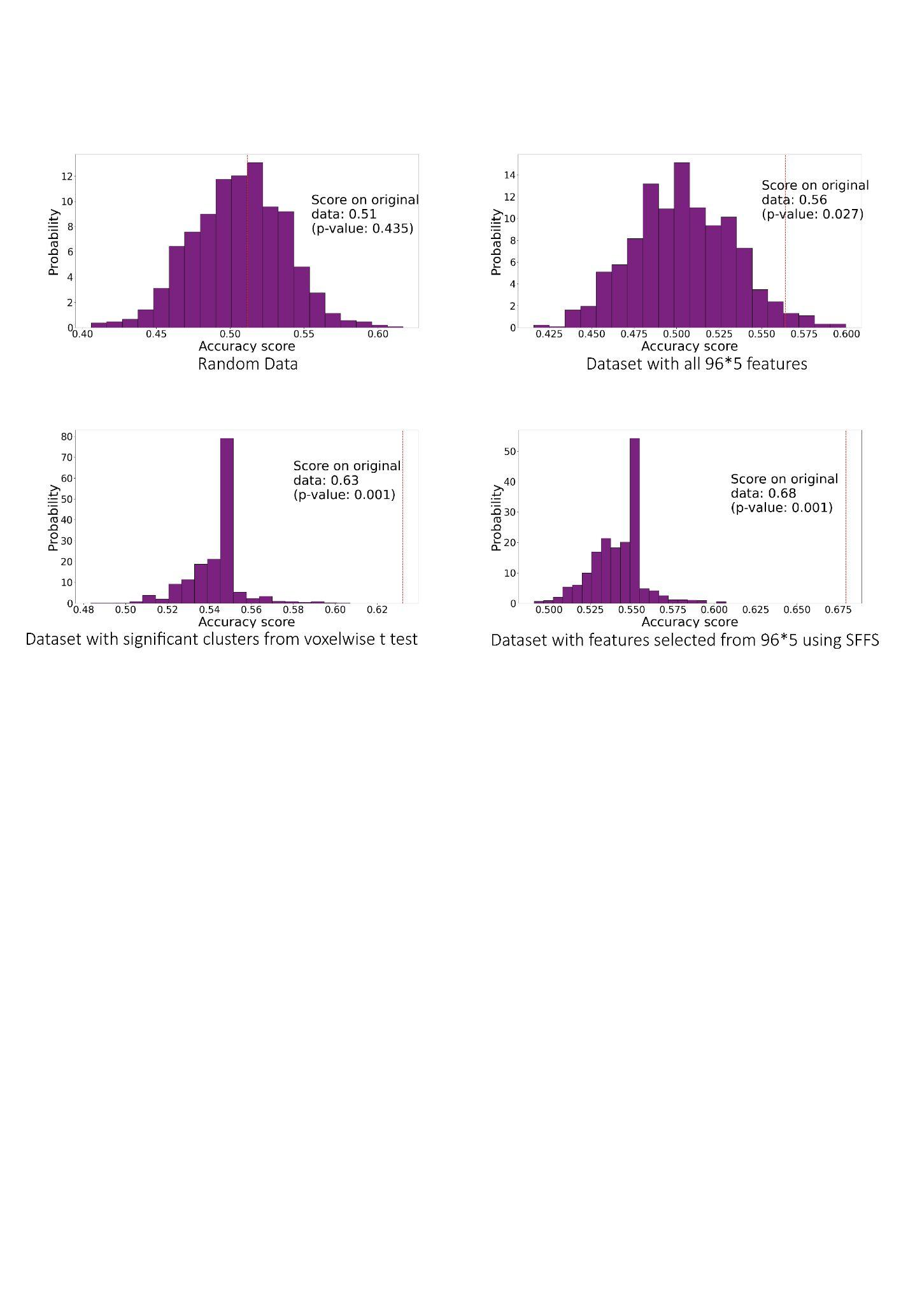
Empirical distributions of accuracy of the classifier generated via 1000 times of random label permutations for different models.
Note. Random data represents random surrogate data with the same number of samples and features as the original dataset, original region sets containing all features and region sets selected by significant clusters (i.e., the Univariate Model) and SFFS (i.e., the Multivariate Model). The red line shows the actual classification accuracy.
Correlation between the significant clusters (obtained from the voxel-wise two sample t test) / features selected by the SFFS and ADOS score of individuals with ASC
To investigate the potential relationship between the selected neurophysiological biomarkers and the clinical traits of individuals with ASC, a subsequent correlation analysis was performed. This analysis aimed to explore how these identified features may be associated with the ADOS score in the ASC population. The study included 108 ASC participants from three sites (i.e., the NYU, SDSU and USM sites), for whom ADOS total scores were available (Table 7). The sample entropy of each significant cluster and the features selected using the SFFS method were extracted for the correlation test with the ADOS score using Pearson's correlation coefficient. However, the results indicated no significant correlation between the sample entropy and the ADOS score in this cohort (Table 8).
Table 7
Available Samples with ADOS Scores across Different Sites
Site | Sample Size | ADOS
NYU | 60 | 11.433(4.323)
SDSU | 11 | 10.545(4.321)
USM | 37 | 12.838(3.023)
Note. NYU = NYU Langone Medical Center.
SDSU = San Diego State University.
USM = University of Utah School of Medicine.
Numeric values indicate mean and (standard deviation)

Table 8
Correlation Analysis of ADOS Scores with Brain Regions Using Univariate and Multivariate Methods
Method |  |  | Time scale | Correlation coefficient with ADOS | P value
Univariate Method | Specific positions selected from the voxel-wise two sample t test | right precuneus cortex | 1 | 0.061 | 0.533
 |  | left medial frontal cortex | 3 | 0.0621 | 0.523
 |  | left intra-calcarine cortex | 3 | -0.118 | 0.226
 |  | left paracingulate gyrus | 4 | 0.0621 | 0.523
 |  | left intra-calcarine cortex | 4 | -0.127 | 0.190
 |  | left paracingulate gyrus | 5 | 0.002 | 0.987
 |  | left intra-calcarine cortex | 5 | -0.101 | 0.296
Multivariate Method | Specific Atlas selected from the SFFS | CingulateGyrusposterior_L | 1 | -0.151 | 0.118
 |  | TemporalFusiformCortexanterior_L | 1 | -0.128 | 0.186
 |  | FrontalOrbitalCortex_L | 2 | -0.075 | 0.440
 |  | SuperiorTemporalGyrusanterior_L | 2 | 0.176 | 0.067
 |  | SupramarginalGyrusposterior_R | 2 | -0.039 | 0.694
 |  | InferiorTemporalGyrusposterior_R | 3 | 0.0434 | 0.656
 |  | InferiorFrontalGyrusparstriangularis_R | 4 | 0.100 | 0.302
 |  | MiddleFrontalGyrus_L | 5 | 0.147 | 0.126

Discussion

At Different Time Scales: Multiscale Sample Entropy Pattern and Distinct Attributes of White Matter
Regarding the voxel-wise one sample t-test results, at fine time scales (i.e., scale 1), both diagnostic groups demonstrate significantly lower sample entropy in the cortical structure than the average sample entropy (i.e., significantly less than 1). Conversely, the white matter exhibits higher sample entropy than the global average. As the time scale increases, the relative sample entropy of cortical networks increases. The increase in entropy with increasing time scale is consistent with the multiscale entropy curve of complex signals, indicating the presence of new irregular patterns in the BOLD signal of the cortical structure. Conversely, the white matter exhibits a pattern opposite to that of cortical networks, precisely the grey matter. At scale 1, representing the original BOLD signal, an increased volume of white matter led to a higher standard deviation of the BOLD signal, as noted by (Wang et al., 2021). This might lead to a greater level of brain complexity in the white matter region compared to the overall brain average, as depicted in Figure 4 at scale 1.
Unlike neurons in the cortical network, which participate in computational processing, the white matter primarily comprises myelinated axons facilitating communication between brain regions (Blumenfeld, 2010). Resting-state BOLD signal from the white matter has been considered dominated by noise (Murphy et al., 2013). As the time scale increases, the relative entropy of the white matter decreases rapidly, exhibiting a performance similar to that of white noise due to the absence of a new pattern of BOLD signal. This finding also supports the validity of the standardised multiscale sample entropy as it successfully distinguishes white matter and grey matter.
Discussion about the Univariate and Multivariate Statistics
The current analyses show that individuals with ASC exhibit a different resting-state fMRI complexity compared with neurotypical subjects, primarily at the default mode network. Additionally, the MSE profiles across various time scales reveal two ways of diminishing BOLD complexity towards either a regular or random pattern, in contrast to other standard entropy analysis, which measures single-time-scale regularity. Reduced BOLD complexity toward the regular pattern is observed in the anterior part of DMN (i.e., the medial frontal regions (mPFC), and the posterior part of the DMN, which contains the posterior cingulate cortex (PCC) and precuneus (PCUN), exhibits reduced BOLD complexity towards the random process. And this collective model exhibits a moderate level of classification accuracy.
Distinguishing ASC through DMN Sub-components: Beyond Single Region Analysis. Throughout the investigation, it has been consistently observed that the brain regions exhibiting the most pronounced distinction between individuals with ASC and those without ASC, as revealed by both univariate and multivariate statistical analyses, were primarily located within the default mode network (DMN). The DMN comprises interconnected brain structures such as the posterior cingulate cortex (PCC), precuneus (PCUN), and medial prefrontal cortex (mPFC) (Fox et al., 2005).
Numerous linear-based studies consistently reported relatively conflicting results regarding the intra-regional activity of the default mode network (Bathelt & Geurts, 2021; Cole et al., 2018; Lynch et al., 2013; Washington et al., 2014; Yao et al., 2016; Yerys et al., 2015), indicating that the subcomponents of the DMN may function differently despite their interconnectedness. This study aligns with previous research on rs-fMRI functional connectivity by demonstrating varying performance and group differences in sample entropy within different components of the DMN across different time scales. This emphasises the significance of investigating sub-components within the DMN when differentiating individuals with and without ASC. It also encourages moving beyond the limited approach of studying individual brain regions (Maximo et al., 2021) to a more comprehensive network-level investigation.
Different Types of Complexity Alterations in the DMN in ASC. This research is unique in recognising variations in brain complexity within the DMN among individuals with and without ASC. While numerous studies have focused on linear-based variations in functional connectivity (Doyle-Thomas et al., 2015; Hull et al., 2016), and other rs-fMRI temporal metrics: amplitude of low-frequency fluctuations (ALFF) and regional homogeneity (ReHo) (Lian & Northoff, 2021) in the DMN, this study sheds light on the disparities in brain complexity in this context.
It has been known that DMN deactivated with explicit task demands (Fox et al., 2005; Buckner et al., 2008) and is active during periods of introspective mental activities at rest; therefore, DMN can also be considered as a ‘resting state network’ (Greicius et al., 2003; Korgaonkar et al., 2014). The demonstration of DMN complexity in classifying ASC during the resting state also supports the idea that the resting state is not a task-free condition; rather, it can also be perceived as a form of task (Biswal, 2012; Buckner et al., 2013). Since the effectiveness of entropy in identifying task-related brain activity has been validated (Lin et al., 2022; Nezafati et al., 2020), the importance of exploring complexity in brain activity during resting states is also being highlighted.
Specifically, the multiscale sample entropy (MSE) pattern demonstrated that individuals with ASC displayed reduced entropy in the prefrontal cortex at the coarse scale compared to neurotypical individuals. This suggests that the prefrontal cortex exhibits a typical form of complexity deduction in individuals with ASC (Yang et al., 2015). Here again, the definition of physiologic complexity is based entirely on an increase in unpredictability or irregularity and fails to incorporate other essential features, such as the presence of long-range fractal correlations (Goldberger, 1997). This finding supports the theory of “loss of complexity” due to the pathological state, indicating the destruction of nonlinear structures in brain dynamics (Goldberger, 1997).
Indeed, when one examines the fractal complexity of interval fluctuations in health and disease, a breakdown of long-range correlation properties will be observed, aligning with the general complexity-loss hypothesis presented above (Courtiol et al., 2016; van Noordt & Willoughby, 2021). A decrease in system complexity generally indicates either a loss or impairment of functional components or altered nonlinear coupling between these components (Lipsitz, 1992). In other words, the decreased brain complexity at coarse time scales within the prefrontal cortex can be interpreted as a manifestation of the breakdown or loss of nonlinear characteristics in ASC. This finding strongly also aligns with the results obtained from our previous EEG study (Chapter 2).
Conversely, when observing individuals with ASC at scale 1, it is evident that they display noticeably higher sample entropy in the posterior cingulate cortex (PCC) and precuneus (PCUN) compared to neurotypical controls. However, within the ASC cohort, there is a gradual decline in the trend of sample entropy within the PCC and PCUN from scale 2 onwards, demonstrating relative stability across various time scale factors, as shown in the voxel-wise mixed-effect analysis (Figure 7). This intriguing pattern of initially increasing and subsequently decreasing entropy implies a reduction in complexity within the PCC and PCUN signal in ASC compared to neurotypical controls, suggesting that the signal in ASC exhibits uncorrelated randomness (characterised by heightened entropy at shorter time scales followed by a decayed entropy at longer time scales) (Yang et al., 2015). In addition, the decreased frontal MSE at the fine time scale and increased occipital MSE at the coarse time scale were also observed in an individual with ASC during and after electroconvulsive therapy (Okazaki et al., 2015). Additionally, these changes were linked to a clinical improvement index, suggesting that this could serve as a neurophysiological indicator of ASC.
Furthermore, these findings emphasise the importance of investigating multiscale sample entropy (MSE) patterns rather than solely focusing on a single scale. In traditional single-scale entropy studies, there have been reports of both increases and decreases in the complexity of brain signals (Maximo et al., 2021; Zhang et al., 2020). This contradiction is likely caused by sample entropy being initially designed to evaluate the predictability or regularity of a series of data points (Delgado-Bonal & Marshak, 2019) rather than serving as a direct indicator of physiological complexity. Single-scale entropy does not explicitly explore the nonlinear properties of the signal or quantify fractal scaling behaviour, as an increase in sample entropy does not necessarily indicate a corresponding increase in physiological complexity (Vaillancourt & Newell, 2002).
DMN Complexity: Concerns for ASC Clinical Assessment. Numerous studies have explored the clinical relevance of DMN in the ASC population (Harikumar et al., 2021; Jung et al., 2014). Furthermore, the DMN is known to be involved in various social cognitive processes associated with impairments in ASC, such as emotional perception (Luo et al., 2015), self-referential and autobiographical processing, theory of mind, mentalizing, and affective decision-making (Andrews-Hanna et al., 2010; Molnar-Szakacs & Uddin, 2013; Spreng & Grady, 2010; Whitfield-Gabrieli & Ford, 2012).
However, alterations in brain complexity within the DMN have also been observed in other neurological disorders, including schizophrenia, Attention Deficit Hyperactivity Disorder (ADHD) and Bipolar Disorder (BP) (Guan et al., 2022). This suggests that the measure of brain complexity may not be unique to ASC and instead reflects broader neurological conditions. Furthermore, considering the relatively modest classification performance and the need for clearer association between these alterations and behavioural scores in ASC, it is insufficient to conclude that this index is suitable for robust clinical assessment purposes. Further research and validation are needed to establish its clinical utility and specificity in the context of ASC. For instance, one study can use transdiagnostic designs to achieve specificity, where multiple disorders are studied simultaneously, allowing for a direct evaluation of differential diagnostic sensitivity (Li et al., 2020; Parkes et al., 2020). Furthermore, aside from the limited group-level estimation of brain abnormalities in case-control designs, the consideration of age-related variations enables researchers to measure how individuals with ASC deviate from the typical age-related trajectory (Bathelt et al. 2020; Parkes et al. 2020).

Conclusion
This study has expanded the understanding of brain complexity in ASC, revealing atypical intricate dynamics within the DMN and the influence of different time scales on regional complexities. Multiscale sample entropy has provided a new perspective, demonstrating the importance of considering multiple time scale factors in assessing brain complexity. Furthermore, research investigated on the confounding factor - age, is required to fully elucidate the clinical significance of these altered complexities and their specificity to ASC. Ultimately, this study contributes to the ongoing progress of the neurophysiological underpinnings of ASC.

Chapter 4

Unravelling Eyes-Closed Resting-State Brain Complexity in Autistic Spectrum Condition: Insights from Multiscale Sample Entropy Analysis Using fMRI Data

Abstract
In the previous chapters, based on EEG data (Chapter 2), the study investigated the multiscale sample entropy (MSE) between individuals with and without autism spectrum condition (ASC) at both the eyes' open and closed conditions. The findings revealed that the eyes-closed condition yields more promising outcomes in classifying individuals with ASC from neurotypical controls. While the exact reason remains unclear, it is assumed that the enhanced engagement of the default mode network (DMN) during the eyes-closed condition may contribute to these results. However, EEG data, which was previously used, has limited spatial resolution. Therefore, this study aims to examine the specific brain regions exhibiting group differences by extending the investigation of multiscale sample entropy to a larger resting-state functional magnetic resonance imaging (rs-fMRI) database known as ABIDE.
In the initial phase of the study, only the dataset from the eyes-open condition was used, as most participants were in this state. Voxel-wise two-sample t-tests and multivariate pattern analysis (MVPA) were applied to identify significant clusters or brain atlases demonstrating group differences. The primary group differences were found to be localised within the DMN. The remaining eyes-closed condition dataset was utilised in this subsequent phase, following the same statistical analysis. However, this dataset comprised only a relatively limited number of participants for each group.
Additionally, due to the lack of data from the same participants in both eyes open and closed conditions, direct comparisons between the two conditions for each group were impossible. Instead, brain complexity was extracted from cortical networks, and MSE profiles within each network were obtained for both eyes-open and eyes-closed conditions. The inter-network correlation was also examined.
Overall, this study aims to enhance our understanding of ASC-related differences in brain complexity by analysing the specific brain regions and inter-network correlations using rs-fMRI data from ABIDE.
Method
Data
The dataset used in this chapter followed the same selection process as in the previous chapter. However, for this chapter, the chosen dataset was collected under the eyes-closed condition instead of the eyes-open condition used in the previous rs-fMRI chapter. This dataset comprises 47 individuals with ASC and 56 neurotypical controls, all of whom were age-matched (t = -0.030, p = 0.976) and IQ-matched (FIQ: t = -0.532, p = 0.596; VIQ: t = -0.692, p = 0.491; PIQ: t = -0.327, p = 0.745). The accompanying figure illustrates the age distribution, with the y-axis denoting the number of individuals and the x-axis representing age in the year (Figure 1). The upper segment of the chart corresponds to individuals with ASC, while the lower segment pertains to the neurotypical controls. The following table presents phenotypic information, encompassing the counts of female and male participants and the average and standard deviation of IQ scores (Table 1).

Figure 1
Distribution of Age for individuals with ASC and neurotypical controls
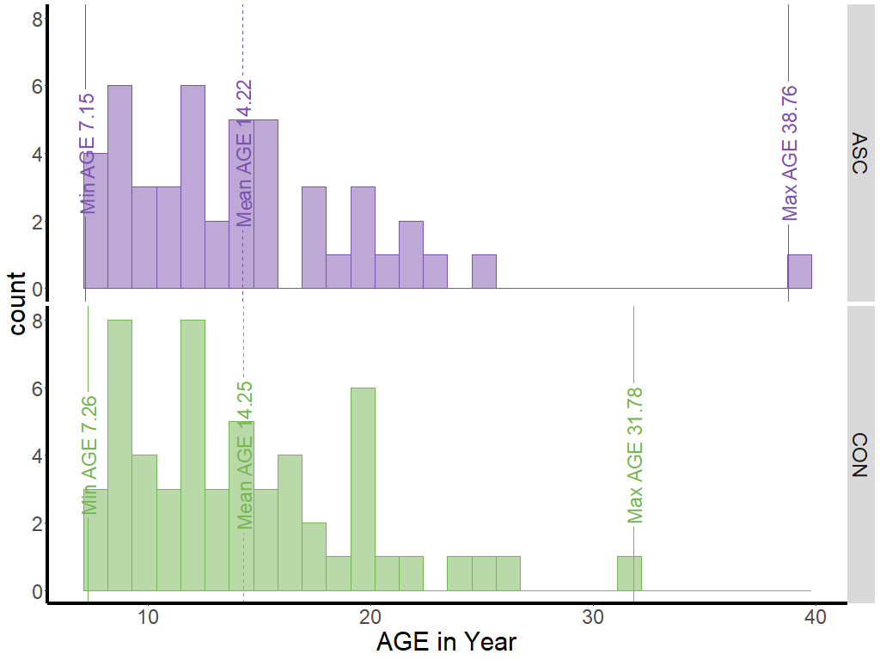
Note. The age range, represented from left to right, includes the minimum, mean, and maximum values. The x-axis corresponds to age, while the y-axis represents the count of individuals.

Table 1
Phenotypic information of the dataset with 0.5 Hz Sampling Rate after quality control at eyes-closed condition
Group | Age | Sex  (M/F) | FIQ | VIQ | PIQ
ASC | 14.22(5.81) | 40/7 | 110.09(16.34) | 108.74(16.84) | 109.17(15.72)
CON | 14.25(5.23) | 50/6 | 111.66(13.17) | 110.95(15.13) | 110.14(13.84)
Note. ASC = Autistic Spectrum Conditions. CON = neurotypical controls.
FIQ = IQ test administered for Full Scale IQ standard score.
VIQ = IQ test administered for Verbal IQ standard score.
PIQ = IQ test administered for Performance IQ standard score.
Numeric values indicate mean and (standard deviation)

Results
Voxel-wise one-sample t-test to visualise the relative sample entropy brain map for each time scale and diagnosis group
The statistical analysis conducted in this phase of the fMRI chapter replicated the same procedure as the previous phase of the fMRI project. The average of raw sample entropy between ASC and neurotypical controls shows no significant difference (Scale 1: t =-0.902, p =0.369; Scale 2: t =0.070, p =0.9443; Scale 3: t =0.275, p =0.784; Scale 4: t =0.679, p =0.499 Scale 5: t =0.413, p =0.680). This allows for comparing relative sample entropy between the different diagnosis groups. The initial step involved performing a voxel-wise one-sample t-test using the relative sample entropy obtained by dividing the raw entropy by the individual global mean. The purpose was to compare the relative sample entropy with 1. If the t-statistics were significantly greater than zero, the voxel exhibited a sample entropy greater than the global average. In comparison, a negative t-statistic indicated a sample entropy smaller than the global average. The outcome is illustrated in Figure 2, depicting the results for each time scale (i.e., scale 1-5) for both individuals with ASC and the neurotypical control groups. The processing pipeline in this study is worth mentioning that the entropy measure is calculated in the MNI space rather than the native space. Transformation into standard space rather than native space in volume-based analyses could lead to disparate group difference determinations (Hutchison et al., 2014).
Generally, the voxel-wise one-sample t-test results for the eyes-closed dataset exhibited similarities with those of the eyes-open dataset. However, the eyes-closed dataset had fewer significant voxels that deviated from the global average compared to the eyes-open dataset. This observation suggests that at finer time scales, most voxels tend to be closer to the global mean. Moreover, the difference in sample entropy between the grey and white matter was relatively small. Conversely, as the time scale increased, the situation reversed since the scale 3. More significant voxels emerged, indicating a growing disparity in sample entropy between the grey and white matter.

Figure 2
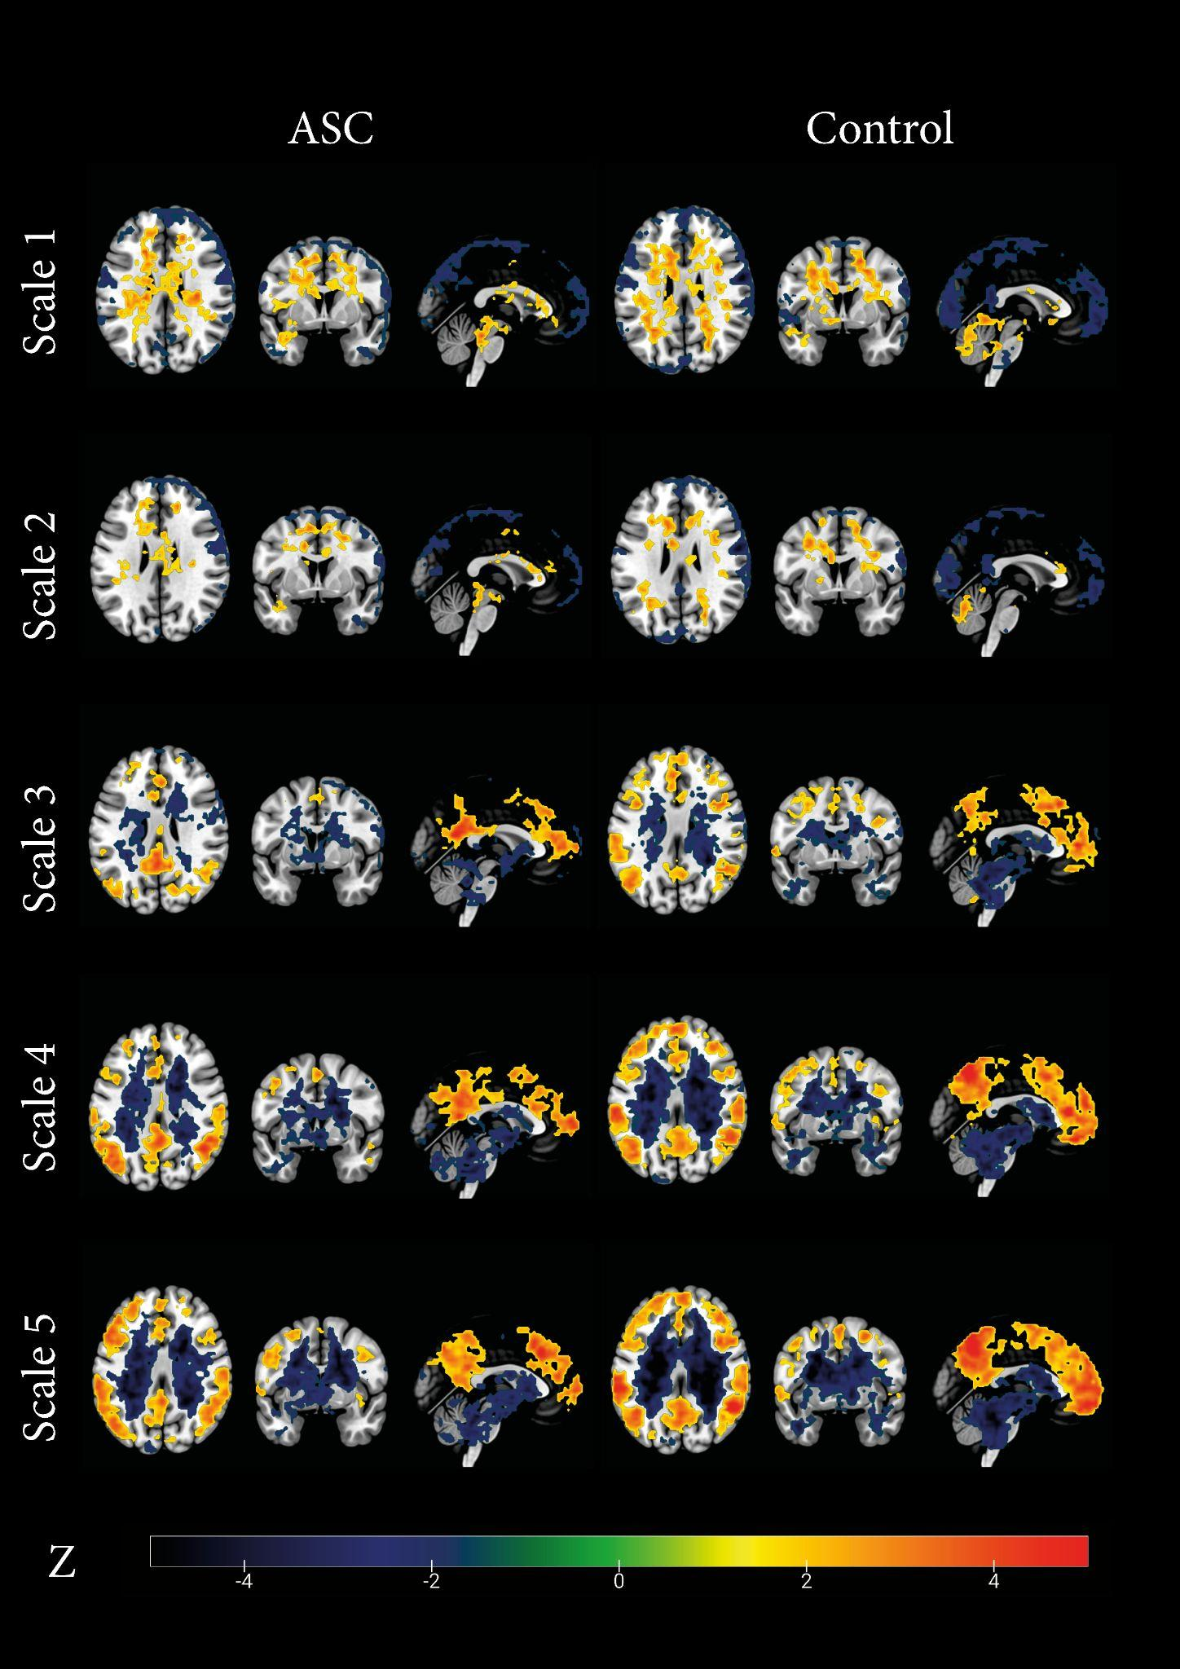
Significant Voxel-wise one sample t test result comparing relative sample entropy at each voxel with 1 for each time scale (i.e., 1-5) among the ASC and control groups.

To better visualise the relative sample entropy patterns of the seven cortical networks and white matter, the averaged relative sample entropy for each region of interest in both the eyes-open and eyes-closed datasets was plotted, as shown in Figure 3 for the eyes-open dataset and Figure 4 for the eyes-closed dataset. In both the ASC and control groups, and regardless of whether participants had their eyes open or closed, the majority of cortical networks in the grey matter demonstrated relative sample entropy that was either lower than or close to the global average (i.e., the relative sample entropy is 1) at scale 1. On the other hand, the white matter exhibited sample entropy that was higher than the global average in both conditions.
Regarding multiscale sample entropy performance, particularly from scale 2 onwards, five of seven cortical networks exhibited higher relative sample entropy than the global average. These networks, which include the visual network, dorsal attention network, ventral attention network, frontal-parietal network, and default mode network, displayed increasing relative sample entropy as the time scales were raised. This pattern of multiscale sample entropy signifies typical neurophysiological signals commonly observed. In contrast, the multiscale sample entropy profile of the white matter consistently declines, resembling white noise characteristics. These findings are consistent with the results of the voxel-wise one-sample t-test and provide more specific information about the precise brain networks involved. Furthermore, the relative multiscale sample entropy profiles of these cortical networks and the white matter demonstrate remarkably similar performance in both the eyes-open and eyes-closed conditions.
It is worth noting that the somatomotor network and limbic network exhibited distinct behaviour compared to the other cortical networks. Specifically, the somatomotor network remained close to the global average (i.e., 1) throughout scales 1 to 5 in the eyes-open condition, exhibiting a subtle upward trend. However, in the eyes-closed condition, this upward trend becomes more pronounced. In contrast, the relative multiscale sample entropy of the limbic network decreased since scale 2. It remained steady, consistently below the global average in both diagnostic groups during both eyes-open and eyes-closed conditions. This could be attributed to the overlap between the limbic network and cortical brain structures.
It is essential to highlight that during the eyes-closed condition, the relative multiscale sample entropy of the visual network remains stable across different time scales, closely approaching a value of 1 (equivalent to the global average) from scale 1 to 5. This multiscale sample entropy pattern suggests a self-similar or fractal structure, where the signals within these networks display consistent patterns or structures at various magnification levels, resulting in a consistent level of complexity regardless of the scales. The key finding is that the visual network's constant multiscale sample entropy value is evident only when the eyes are closed and not during the eyes-open condition in both diagnostic groups.

Figure 3
Averaged relative sample entropy for the eyes-open dataset
Note. Visual = Visual Network; SM = Somatomotor Network; DA = Dorsal Attention Network; VA = Ventral Attention Network; Limbic = Limbic Network; FP = Frontoparietal Network; DMN = Default Mode Network; WM = White Matter.

Figure 4
Averaged relative sample entropy for the eyes-closed dataset
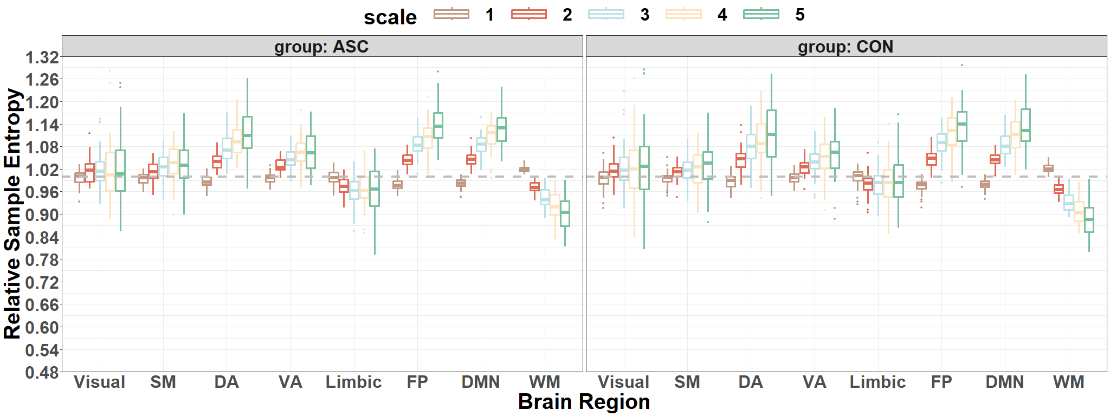
Note. Visual = Visual Network; SM = Somatomotor Network; DA = Dorsal Attention Network; VA = Ventral Attention Network; Limbic = Limbic Network; FP = Frontoparietal Network; DMN = Default Mode Network; WM = White Matter.
It shows the average relative sample entropy for both ASC and neurotypical control groups across seven cortical networks and white matter. In the graph, the horizontal line at the middle represents the value of 1, indicating the global average relative sample entropy. Each different colour on the graph represents a specific time scale (ranging from 1 to 5), which together forms a multiscale entropy profile for each region of interest.
Correlation between the entropy of the networks across subjects in both groups at eyes-open condition
To delve deeper into the connections between different cortical networks, Pearson's correlation was employed to analyse the relationships between the seven cortical networks. This analysis was performed on the raw sample entropy separately for each time scale and under two conditions: eyes-open and eyes-closed conditions. The eyes-open was evaluated first and then compared to the eyes-closed condition. The findings demonstrated that all the internetwork pairwise correlations were remarkably positive, with each value exceeding 0.55. The correlation between networks describes how the entropy in various cortex regions varies across subjects in different diagnosis groups within the eyes-open and eyes-closed condition datasets (Figure 5 and Figure 6, respectively).

Figure 5
Inter-network pairwise correlation heatmap represents how the entropy of different cortical networks co-varies across subjects in different diagnosis groups for the eyes-open dataset
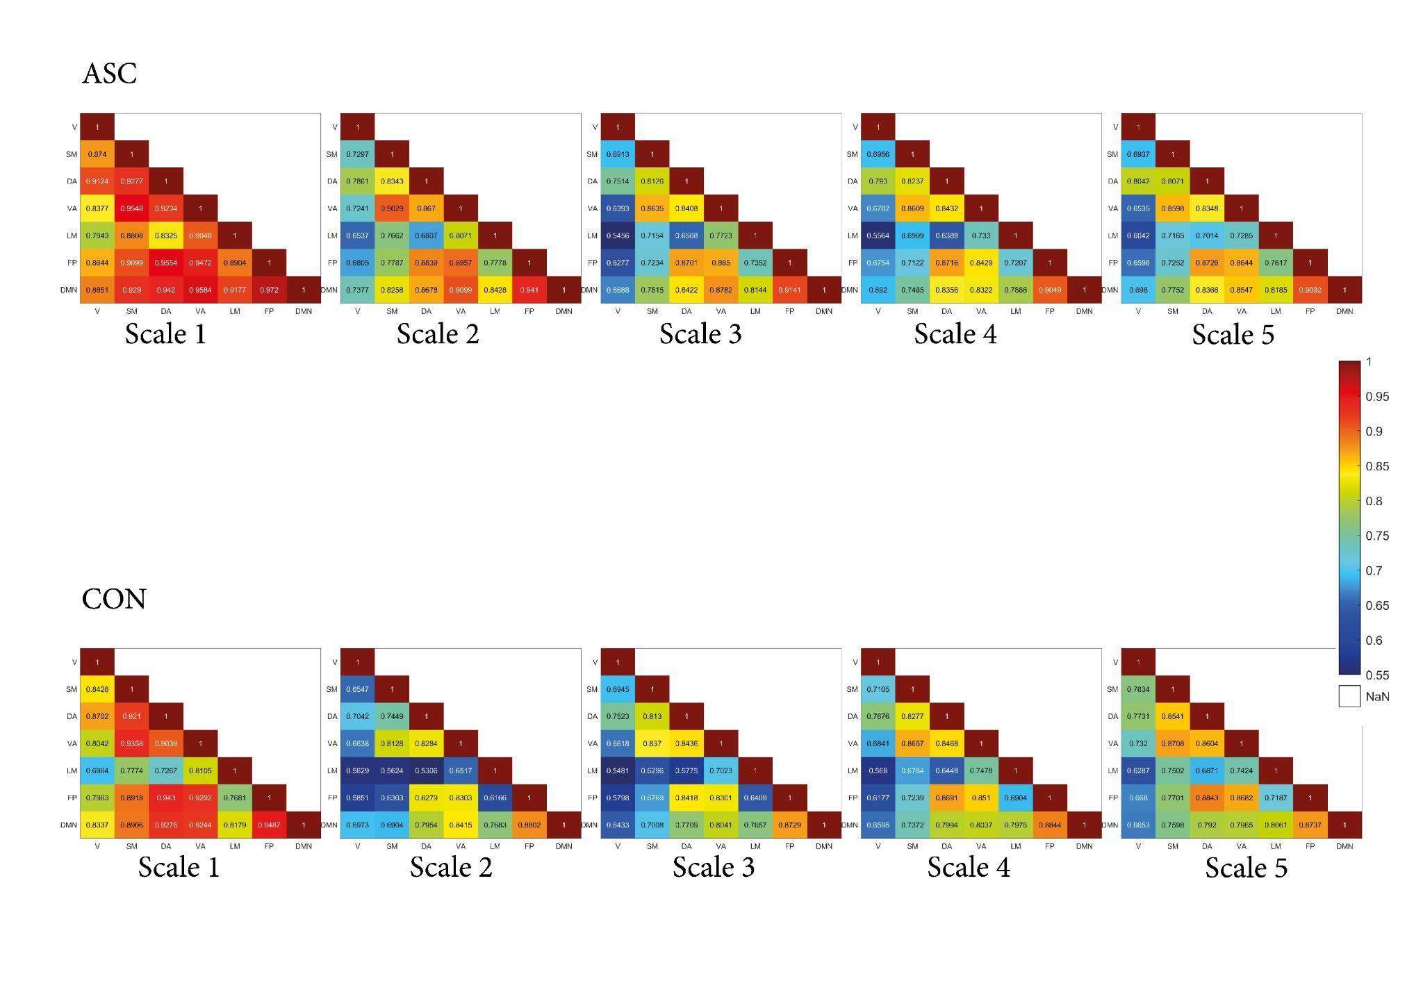
Note. Visual = Visual Network; SM = Somatomotor Network; DA = Dorsal Attention Network; VA = Ventral Attention Network; Limbic = Limbic Network; FP = Frontoparietal Network; DMN = Default Mode Network.

Figure 6
Inter-network pairwise correlation heatmap represents how the entropy of different cortical networks co-varies across subjects in different diagnosis groups for the eyes-closed dataset
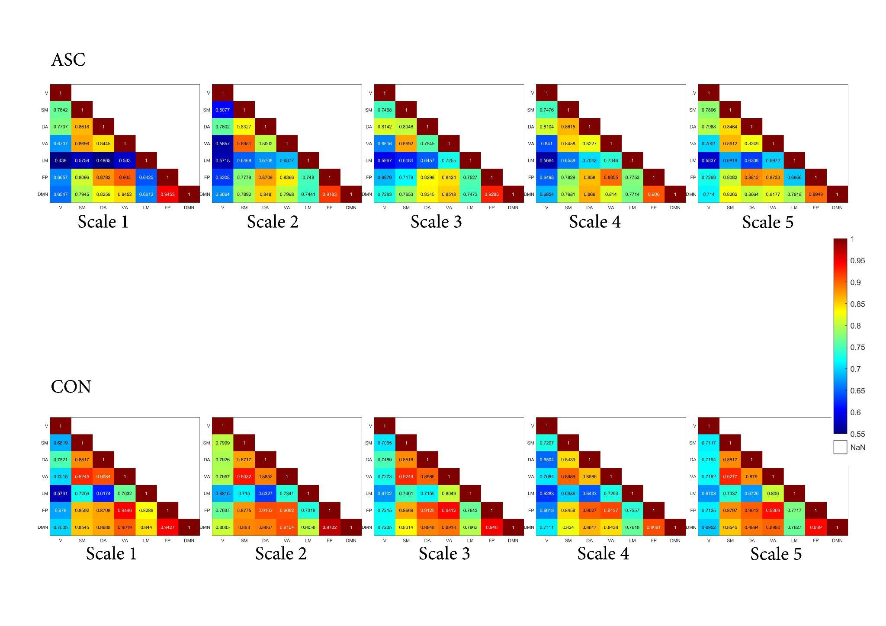
Note. Visual = Visual Network; SM = Somatomotor Network; DA = Dorsal Attention Network; VA = Ventral Attention Network; Limbic = Limbic Network; FP = Frontoparietal Network; DMN = Default Mode Network.
In summary, there are three main findings to highlight:
1)The correlation between the visual network and other networks is relatively low in both ASC and neurotypical control groups, especially during the eyes-closed condition.
2)The correlation between the limbic network and other networks is also relatively low in both ASC and neurotypical control groups, particularly during the eyes-closed condition.
3)The inter-network correlation is notably high at scale 1 during the eyes-open condition but decreases from scale 2 onwards. In contrast, the inter-network correlation remains stable from scale 1 to scale 2 during the eyes-closed condition. Overall, the correlation patterns within both diagnosis groups exhibit relative stability across various time scales, as demonstrated in the figures.
Group level Analysis: Voxel-wise two sample t test
It is not feasible to directly infer the group difference of the multiscale sample entropy from the voxel-wise one-sample t-test. Consequently, the voxel-wise two-sample t-tests were conducted between the ASC and CON groups on each time scale. The threshold-free cluster enhancement (TFCE) correction method was analysed to account for multiple comparisons.

Figure 7
Significant clusters resulting from voxel-wise two-sample t-tests between ASC and control groups for each time scale, corrected by permutation test with threshold-free cluster enhancement, with voxel level: p < .05.
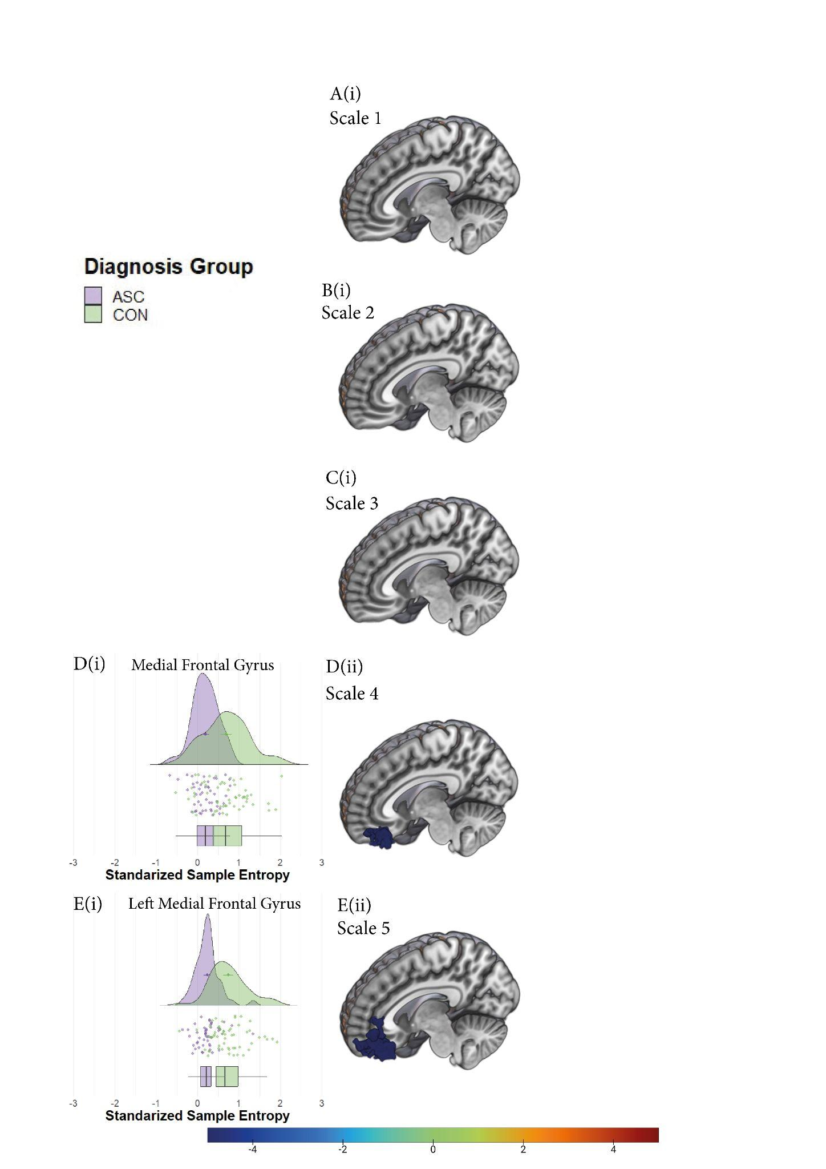
T
Note. Plots A(i), B(i), C(i), D(ii), and E(ii) represent significant clusters resulting from voxel-wise two-sample t-tests between ASC and control groups for each time scale. The D(ii) and E(ii) plots display the distribution of standardised sample entropy within this significant cluster for the ASC group (in purple) and the control group (in green) for scales 4 and 5, respectively. Additionally, corresponding scatter plots and a box plot were also included. Each row of the figure represents the result for each respective time scale, and the bilateral plots provide a detailed presentation of the distribution, scatter, and box-plot forms of the standardised sample entropy within the significant cluster for each group.
Table 2
Voxel-Wise Two Sample t-Test Results: Scale, Brain Regions, MNI Coordinates, Peak Intensity t-values, and Volume (p < .05, corrected by TFCE with permutation test)
Scale | Brain Region | MNI Coordinates | Peak Intensity t-value | Volume (Voxels)
1 | - | - | - | -
2 | - | - | - | -
3 | - | - | - | -
4 | Left Medial Frontal Gyrus | -12 36 -18 | -4.3977 | 90
4 | Right Medial Frontal Gyrus | 9 42 -21 | -3.683 | 37
5 | Left Medial Frontal Gyrus | -12 48 3 | -4.8015 | 254

Specific ROI selected by SFFS
The ROI (i.e., features) selected by SFFS were listed and plotted using the ggsegHO package in R (Makris et al., 2006; Mowinckel & Vidal-Piñeiro, 2020), as depicted in Figure 8. In our SFFS results, the features are Left lingual gyrus, left heschls gyrus, and left lateral superior occipital cortex at scale 1; left inferior posterior temporal gyrus, left anterior temporal fusiform cortex, right intracalcarine cortex and right frontal pole at scale 2; left superior frontal gyrus, right medial frontal cortex and right posterior cingulate gyrus at scale 3; right heschls gyrus at scale 4 as well as left orbital frontal cortex and right inferior lateral occipital cortex at scale 5.

Figure 8
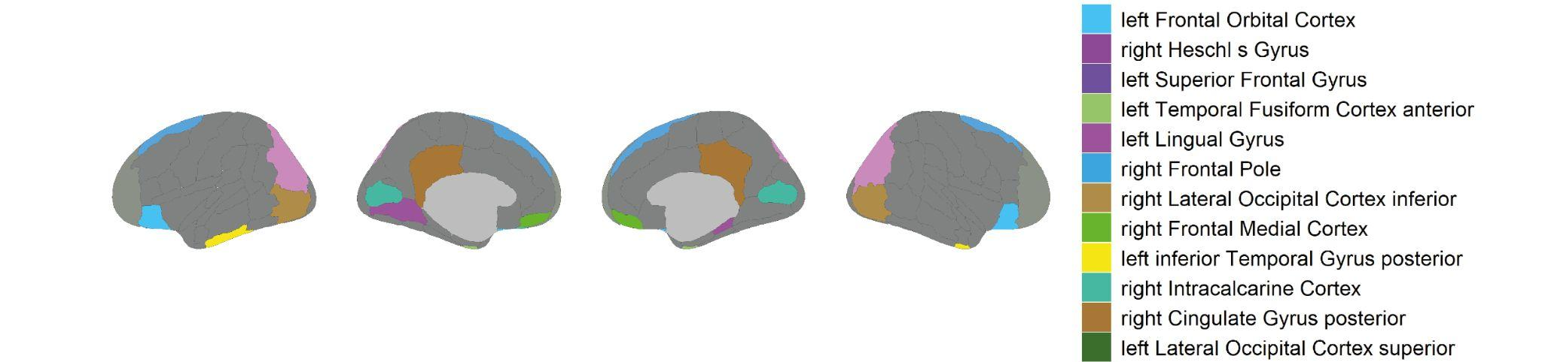
Specific Harvard-oxford cortical atlas that were selected from SFFS to distinguish between individuals with and without ASC

Note. The performance of these regions was further evaluated by the linear SVM classifier. Brain positions were organised from left to right as follows: left lateral, left medial, right medial, and right lateral.

Machine learning Classification of different models
This study aimed to determine if features extracted using multiscale sample entropy, selected from univariate and multivariate models, could effectively distinguish individuals with ASC from control subjects using machine learning techniques. Specifically, a linear Support Vector Machine (SVM) classifier with significant clusters and Sequential Forward Floating Selection (SFFS) feature selection was used.
Through this analysis, it has been found that the multivariate model, which consisted of a subset of brain regions selected by SFFS, achieved the highest classification accuracy of 87% in identifying individuals with ASC. This model also demonstrated a well-balanced overall performance. The brain regions identified by SFFS as the most distinguishing between ASC and non-ASC individuals in terms of rs-fMRI MSE are displayed in Figure 9.

Figure 9
Empirical distributions of accuracy of the classifier generated via 1000 times of random label permutations for different models
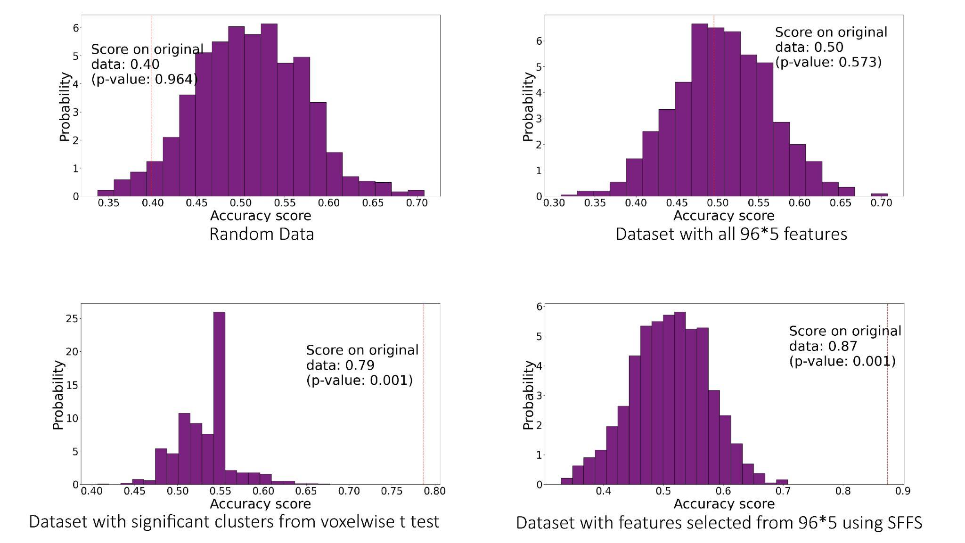
Note. Random data represents random surrogate data with the same number of samples and features as the original dataset, original region sets containing all features and region sets selected by significant clusters (i.e., the Univariate Model) and SFFS (i.e., the Multivariate Model). The red line shows the actual classification accuracy.

Table 6
Classification Performance of MSE in Different Sets
Rs-fMRI feature | Region sets by significant clusters |  |  |  |  |  |  | Region sets by SFFS
 | CA | CM |  | Sen |  | Spe |  | CA | CM | Sen | Spe
MSE | 79% |  | $$\left[39 8\right] \\ \left[8 48\right]$$ |  | 83% | 86% |  | 87% | $$\left[39 8\right] \\ \left[8 48\right]$$ | 83% | 86%
Note. MSE = Multiscale Sample Entropy. CA = Classification Accuracy. CM = Confusion Matrix. Sen = Sensitivity. Spen = Specificity. All Regions = This model includes all brain atlas as features. Region sets by SFFS = This model examines the features selected by Sequential Forward Floating Selection.
In this study, I used cross-validation with the ShuffleSplit method to evaluate the accuracy of a Support Vector Machine (SVM) model. The accuracy is calculated using the cross_val_score method from scikit-learn. The formula for accuracy is straightforward: $Accuracy=\frac{Number of Correct Predictions}{Total Number of Predictions}$. In the context of cross-validation, this formula is applied to each fold, and the cross_val_score method from scikit-learn returns an array of accuracy scores for each fold. The mean and standard deviation of these accuracy scores is often calculated to provide an estimate of the average accuracy and its variability across different folds.
Discussion
The main goal of this session is to investigate the multiscale sample entropy on the resting-state fMRI data collected from both the ASC group and the neurotypical control group under the eyes-closed condition. The objective is to compare these new findings with the previously obtained results from the eyes-open condition.
Multiscale sample entropy proves to be a valuable indicator of resting state fMRI signals. The connectivity between the visual network and other brain networks is notably weaker, particularly when the eyes are closed. Moreover, the multiscale sample entropy of the visual network indicates a self-similar or fractal structure (Goldberger, 1997; Honjo & Sano, 1995), wherein the signals within these networks demonstrate power-law behaviour or configurations across different time scales, leading to a uniform complexity level regardless of the scales involved. This multiscale sample entropy pattern is also typical in 1/f noise or signals with less transient (School of Chemical Engineering and Technology, Xi'an Jiaotong University, Xi'an 710049; China & Wu, 2017). However, the specific reason behind the atypical multiscale sample entropy behaviour in the visual network during the eyes-closed condition remains to be determined, and exploring this reason falls beyond the scope of the current study.
The key finding is that the visual network's constant multiscale sample entropy value is specifically evident during closed-eye periods and not during eyes-open conditions. Additionally, a relatively weak relationship exists in raw multiscale sample entropy between the visual network and other brain networks during the eyes-closed condition, observed in both diagnostic groups. Considering the inhibition of visual information processing during eyes-closed conditions, this provides evidence that the abnormal complexity observed in the visual network is not simply a result of low-frequency noise (Tong et al., 2019) or the 1/f-like characteristic in vivo neurophysiological signals (Buzsáki, 2006). Consequently, multiscale sample entropy is a valuable indicator of resting state fMRI signals by reflecting variations in the underlying brain activity. However, it still should be cautious when drawing conclusions based on coarse scale multiscale sample entropy (MSE) results, as they can potentially lead to biassed interpretations with false positives. Due to its sensitivity to differences in higher frequency power and noise within the signal (Courtiol et al., 2016; Kosciessa et al., 2020). Therefore, rather than being constrained by drawing any scale-specific group differences, the emphasis on identifying spatial atypical complexity becomes more crucial in this study.
Consistent Reduction in Prefrontal Cortex Entropy from Eyes-Open to Eyes-Closed Condition. First, the observed reduction in the prefrontal cortex among individuals with ASC is consistent across both eyes-open and eyes-closed datasets, particularly at the coarse scale of multiscale sample entropy. However, there is a distinction between the two datasets: in the eyes-open dataset, the decrease is evident in the paracingulate gyrus, while in the eyes-closed dataset, the reduction is observed in the medial frontal gyrus.
In this study, multiscale sample entropy (MSE) revealed that individuals with ASC demonstrate reduced entropy at coarse scales in the prefrontal lobe compared to neurotypical controls, regardless of whether the eyes were open or closed. This suggests that the prefrontal cortex undergoes complex alterations in ASC. Consequently, the decreased brain complexity observed at coarse time scales within the prefrontal lobe can indicate the breakdown or loss of nonlinear characteristics in individuals with ASC. These findings align with the results obtained from our previous EEG study (Chapter 2) and align with findings from other EEG studies investigating MSE in ASC. This finding is also consistent with other EEG and fMRI studies (Hadoush et al., 2019; Maximo et al., 2021). This atypical brain region generates considerable interest in the investigation of ASC. (Courchesne and Pierce 2005) believed that abnormalities in the frontal lobe must play a crucial role in underpinning the fundamental characteristics of autism. They presented evidence from macroscopic and microscopic perspectives, indicating that excessive growth of grey and white matter in the frontal lobes disrupts the typical advancement of the prefrontal lobe, leading to atypical behaviour controlled by the frontal region. Another study also verified changes in brain metabolites within the white matter of the frontal lobe in children with ASC, further affirming the significance of this brain area in the clinical manifestations of the disorder, including its contribution to cognitive impairment (Margari et al., 2018).
Eyes-closed condition seems to enhance the Classification Accuracy. In general, the classification accuracy is higher when compared to the eyes-open condition. The classification accuracy of the multiscale sample entropy, when using a heterogeneous sample with all genders and an unrestricted severity range to classify ASC during the eyes-open condition, typically hovers around 60%, which is a common performance level observed in most resting-state fMRI studies (Nielsen et al., 2013; Reiter et al., 2021).
This classification accuracy was demonstrated to be influenced by various factors, such as the use of single or multi-site datasets, the heterogeneity or homogeneity of the sample, symptom severity, social function, daily living skills, and verbal IQ (Nielsen et al., 2013; Reiter et al., 2021). Additionally, the eye condition impacts the classification accuracy, as indicated in the findings of this present study.
However, it is essential to acknowledge the limitations present in various studies, primarily arising from the constraints of the secondary datasets utilised. For example, in the eyes-closed condition dataset, the achieved classification accuracy is relatively high (87%). This suggests the potential for building high-performance diagnostic models using only a few rs-fMRI features in a small, well-matched dataset. However, this higher accuracy might come at the cost of overfitting (Ying, 2019), as the small sample size and the feature selection process contribute to poor generalizability of the diagnostic model. In contrast, the current study, using a larger and more diverse dataset of autism but at the eyes-open condition, reported a classification accuracy of 68%. Hence, it is crucial to recognise that the claim about the eyes-closed condition being more effective in classifying ASC with the resting-state fMRI signal is based on the dataset used in this study. Future research should consider eye states during data collection and use datasets that include both eyes-open and eyes-closed conditions to draw a more accurate and robust conclusion. This approach would provide a more comprehensive understanding of the role of eye states in classifying ASC with resting-state fMRI signals.

Conclusion
This study investigated multiscale sample entropy (MSE) on resting-state fMRI data collected from individuals with ASC and neurotypical controls under eyes-closed conditions. The aim was to compare these findings with previous results from eyes-open conditions. The significance of multiscale sample entropy as an indicator of resting state fMRI signals was highlighted, particularly in revealing the complexity of brain networks, like the visual network, during eyes-closed periods.
A consistent reduction in prefrontal cortex entropy and alterations in DMN entropy in individuals with ASC was observed across eyes-open and eyes-closed datasets. This reduced entropy at coarse scales in the prefrontal lobe implies complexity alterations in ASC, possibly reflecting a breakdown of nonlinear characteristics. This finding aligns with other EEG and fMRI studies, supporting the role of the prefrontal cortex in ASC characteristics.
Furthermore, the discussion noted that the eyes-closed condition enhanced classification accuracy, achieving higher accuracy rates than the eyes-open condition. However, caution was advised due to potential overfitting and generalizability issues from dataset limitations. The assertion about the effectiveness of eyes-closed conditions for classifying ASC should be considered within the context of the specific dataset used. Future research should encompass diverse datasets, including both eyes-open and eyes-closed conditions, to comprehensively evaluate the role of eye states in classifying ASC using resting-state fMRI signals.

Chapter 5

Investigating Developmental Trajectories from childhood to young adult in Individuals with Autistic Spectrum Condition and neurotypical controls: Reflected in resting state EEG and fMRI Signal Complexity

Abstract
Previous studies have demonstrated the alterations in multiscale sample entropy in individuals with ASC and also highlight the importance of considering eye conditions (i.e., eyes-open and closed condition). Additionally, age has been shown to have an impact on brain entropy (Sokunbi, 2014; Wang et al., 2017; Yao et al., 2013), and numerous studies have highlighted age-related alterations in both EEG and fMRI findings in the ASC population (Dickstein et al., 2013; Han et al., 2017; Orekhova et al., 2008; Haghighat et al., 2021). The current study will explore the developmental trajectory of brain entropy in both individuals with ASC and neurotypical control groups. Furthermore, the earlier findings will be subject to re-analysis within distinct age subgroups to assess the influence of age more comprehensively.
Introduction
The Relationship Between Age and Entropy: Age-Related Changes in EEG and fMRI
Ageing is generally associated with increased entropy (Hershey & Lee, 1987; Yao et al., 2013). However, scrutiny of age-related studies reveals the potential presence of Simpson's paradox in correlations (Davy et al., 2003). Simpson's paradox occurs when the direction of correlation between two variables appears positive or negative, but this direction reverses when the variables are analysed within different subgroups. In the context of entropy and ageing, although there is a positive correlation overall, the correlation may differ within specific age subgroups.
For instance, there is a consistent increase in sample entropy in young adults (Takahashi et al., 2009), especially at the fine scales (van Noordt & Willoughby, 2021). This increase aligns with functional brain networks' maturation process, which involves reinforcing distributed long-distance connections (Casey et al., 2015; Hwang et al., 2013). Sample entropy at the fine scale reflects long-range connections (Heisz & McIntosh, 2013), explaining the observed increase in sample entropy. Conversely, older adults tend to exhibit a decrease in entropy as they age (Takahashi et al., 2009). However, positive age-related correlations in multiscale sample entropy appear lacking in individuals with ASC (Milne et al., 2019).
Similarly, in fMRI studies, entropy has been suggested to increase with age in young, healthy individuals due to brain maturation and improving information processing capacity (Easson & McIntosh, 2019) by approximately 0.1 bits (Yao et al., 2013). In contrast, it might decrease with age among older adults (Sokunbi et al., 2015) due to the loss of complexity in the brain system (Dickstein et al., 2007; Lipsitz, 1992). The classic complexity loss theory attributes the reduction in complexity to ageing and pathological states, suggesting that these factors could be the leading causes of a less healthy brain system. Several studies have reported differences in the impact of age on entropy, indicating that the correlation between age and entropy observed in neurotypical individuals may not be present in those with neurological disorders such as Alzheimer's disease (Wang and Alzheimer's Disease Neuroimaging Initiative 2020) and ADHD (Angulo-Ruiz et al., 2022).

Implications for Studying ASC
Considering these age-related effects in EEG and fMRI biomarkers and the age has been proven to be a robust single predictor of spontaneous EEG metrics (Dede et al., 2023), it is crucial to account for the influence of age when investigating electrophysiological patterns in individuals with ASC. By understanding the normative age-related changes in brain activities, researchers can better discern the specific electrophysiological characteristics associated with ASC and distinguish them from typical age-related variations.
This research aims to explore the developmental trajectory of brain entropy in both individuals with ASC and neurotypical control groups using EEG and fMRI data. The study will use the data from the previous investigation. It will further partition the dataset into specific age categories to better understand how age impacts the identified alteration of brain entropy in the ASC population.

Methods
Data from the EEG project (Chapter 2)
Participants included children and adolescents aged 8.08-17.91 in ASC and neurotypical control groups. To gain a deeper understanding of the correlations between multiscale sample entropy and age, the study conducted a more detailed investigation using more specific age groups. Participants were categorised into three distinct age groups based on their quantiles: The first group included individuals whose quantiles ranged from 0 to 0.3333 (i.e., age ranged from 8.08 to 11.25 years). The second group ranged from 0.3333 to 0.6666 (i.e., age ranged from 11.25 to 14.17 years), while the third and final group comprised individuals with quantiles between 0.6666 and 1 (i.e., age ranged from 14.17 to 17.91 years) (see in Table 1).

Table 1
Age Ranges in Age Subgroups in ASC and CON Participants
Group | Age group | Age in Year  M(SD) | Age Range (min-max) | Sample size
ASC | Age group 1 | 9.77 (0.92) | 8.08-11.25 | 40
 | Age group 2 | 12.70 (0.90) | 11.25-14.17 | 40
 | Age group 3 | 15.86 (1.15) | 14.17-17.91 | 41
CON | Age group 1 | 9.75 (1.00) | 8.08-11.25 | 54
 | Age group 2 | 12.86 (0.79) | 11.25-14.17 | 52
 | Age group 3 | 16.04 (1.02) | 14.17-17.91 | 60

Numeric values indicate mean (standard deviation), minimum-maximum.

Multiscale Sample Entropy Analysis and Statistical Assessment across Age Subgroups
Multiscale sample entropy extraction
No additional multiscale sample entropy computations were performed; the same MSE values as those in the preceding study (Chapter 2) were utilised. Multiscale sample entropy was previously computed for each channel and time scale (ranging from 1 to 20). This resulted in a matrix of participants multiplied by 32 (representing the number of channels) multiplied by 20 (representing the time scale) multiplied by the number of epochs. This analysis was conducted separately for each diagnostic group and both the eyes open and closed conditions.

Correlation between age and multiscale sample entropy in different regions, diagnosis groups and eye conditions
Multiscale sample entropy was averaged across three time scale subgroups (i.e., fine, mid, and coarse) and brain regions (i.e., frontal, central and parietal-occipital) in both ASC and neurotypical control groups during both eyes open and eyes closed conditions. This resulted in a matrix of participants multiplied by three (representing the time scale) and three (representing the brain region). The correlation between age and sample entropy across participants in each condition mentioned above was examined using Pearson’s correlation with the built-in function cor.test in R. Only the correlation coefficients of this analysis are illustrated in Figure 1.

Statistical analysis across Age subgroups within and between diagnosis groups
Like the previous chapter (Chapter 2), the present study employed a rigorous statistical evaluation involving channel-wise analyses. These analyses encompassed two-sample t-tests across time scales, diagnostic groups, and eye conditions. To effectively maintain family-wise alpha at 0.05 and control Type I error rates for multiple comparisons across all cephalic channels and entropy time scale factors, threshold-free cluster enhancement (TFCE) with permutation was applied. This was executed using the ept_TFCE function sourced from the TFCE toolbox (https://github.com/Mensen/ept_TFCE-matlab).

Results
Result of Correlation between MSE and age for rs-EEG dataset
Based on the correlation heatmap presented in Figure 1, it is evident that the correlation between sample entropy and age demonstrates similarities across diagnosis groups and eye conditions in the central and parietal-occipital regions. However, in the frontal region, a notable difference is observed. Specifically, at the eyes-open condition, regardless of the diagnosis group, the correlation becomes weaker with increasing time scales (represented on the x-axis) from fine to coarse. Conversely, the correlation remains consistent with increasing time scales in the control group at the eyes closed condition. However, in the ASC group at the eyes-closed condition, this correlation weakens.
Figure 1
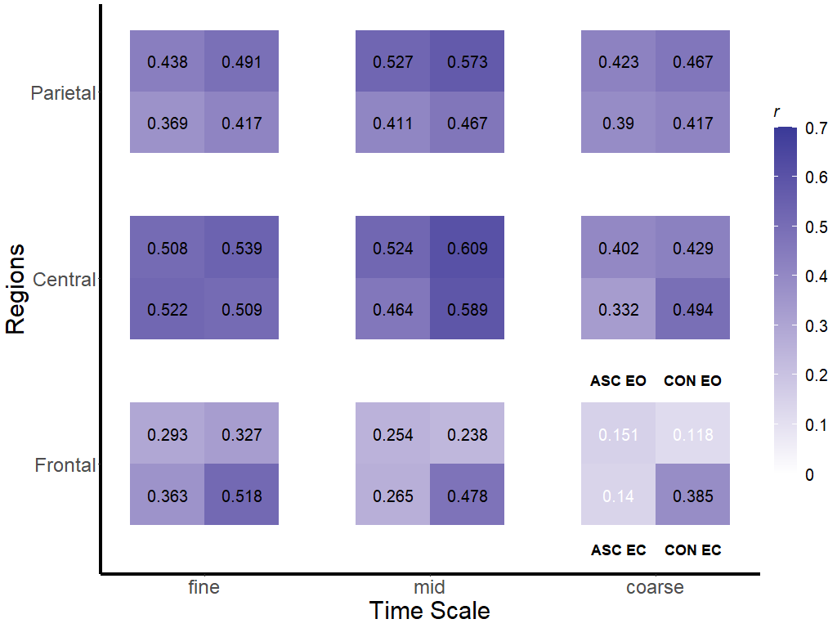
Correlation heatmap reporting Pearson’s correlation coefficients for each comparison across subjects.

Note. These comparisons are conducted across various brain regions (i.e., frontal, central and parietal-occipital), displayed in panels from bottom to top. Additionally, correlations are assessed on each time scale (i.e., fine, mid, and coarse), shown in panels from left to right. In each square cell, the correlations are computed for the ASC group during eyes-open conditions (ASC EO), the CON group during eyes-open conditions (CON EO), the ASC group during eyes-closed conditions (ASC EC), and the CON group during eyes-closed conditions (CON EC). The bar on the right side of the map indicates the colour legend of Pearson’s correlation coefficients (r). Deeper colours indicate stronger correlations. Correlation coefficient values are displayed on each cell, with black denoting a significant correlation (p <0.05, uncorrected), while white signifies an insignificant correlation.
Channel-wise Results obtained from the TFCE method
Upon further analysis of age subgroups, the relationship between age and sample entropy is observed in terms of the quantity and intensity of each electrode, as indicated by the TFCE index obtained through the threshold-free cluster enhancement (TFCE) method.
Firstly, a set of comparisons were executed among three different age subgroups (Age 1, Age 2, and Age 3 groups) within the ASC group and the neurotypical control group separately. The outcomes of these comparisons are depicted in Figure 2. A notable finding emerges a considerably larger increase in multiscale sample entropy among the older age group (Age 3 group) compared to the younger age group (Age 1 group) in the control group, in contrast to the ASC group. This observation is depicted in the left bottom plot of the heatmaps for each group. This consistent pattern persists across the contingent age subgroups (i.e., Age 1 and Age 2 and Age 2 and Age 3 subgroups), even though the age gaps between these subgroups are relatively narrower. This indicates a positive correlation between age and multiscale sample entropy among neurotypical controls. However, this age-related positive trend in multiscale sample entropy is noticeably less prominent in the ASC groups.
Furthermore, the distinctions between the eyes-open and closed conditions are not observable within the control group, except for the frontal region. Nonetheless, these differences are slightly more evident in the ASC group. Specifically, the number of electrodes and the associated magnitude exhibiting age-differentiated sample entropy is greater in the eyes-open condition compared to the eyes-closed condition within the ASC group.

Figure 2
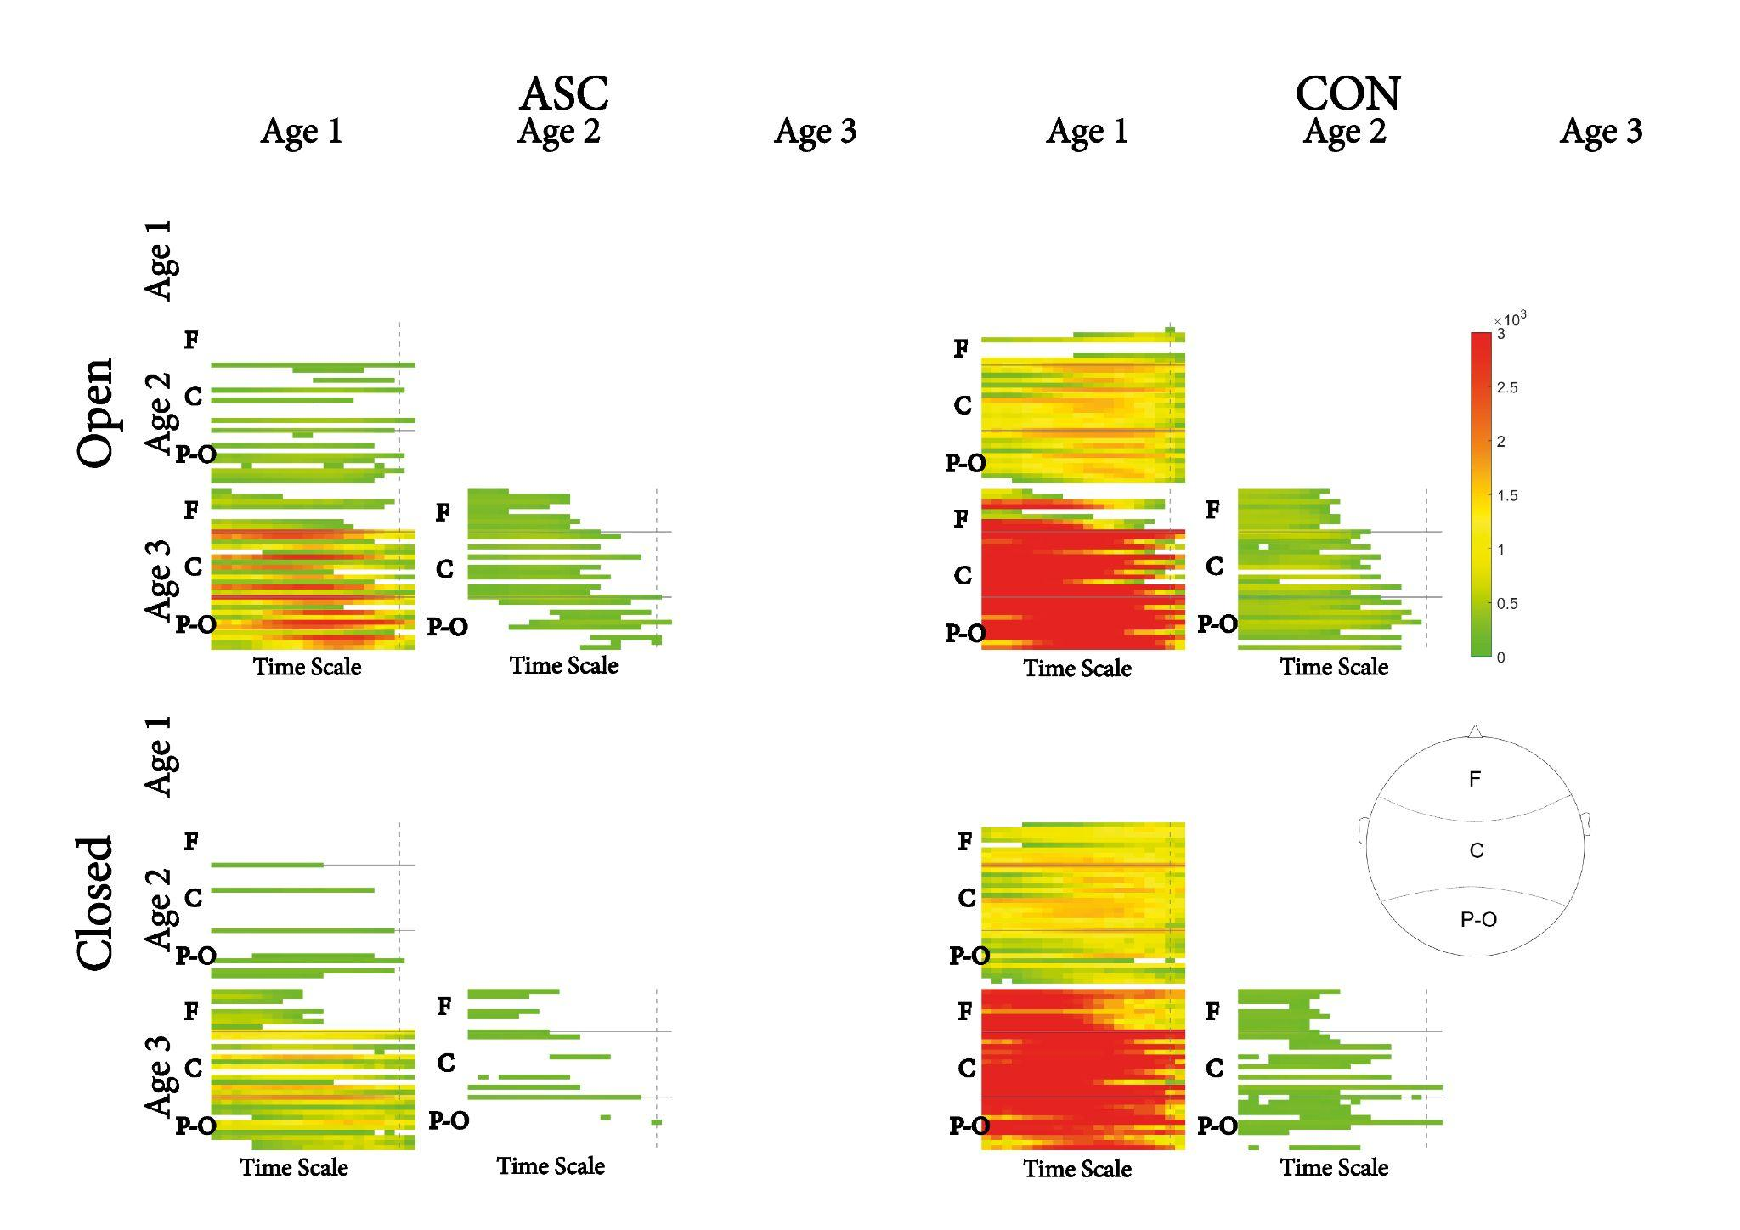
Pairwise age group contrasts for each scalp electrode and time scale factor for different diagnosis groups (i.e., ASC and CON groups) and eye conditions (i.e., eyes-open, and eyes-closed condition) respectively.
Note. Hot colours indicate higher levels of multiscale sample entropy in the older group when considering a specific contrast (such as Age 1 vs. Age 2). These comparisons have been masked for significance using the Threshold Free Cluster Enhancement with 2,500 random permutations between subjects.
Note: F = frontal; C = central; P-O = parietal-occipital.
Secondly, comparisons were performed between diagnostic groups (ASC and CON groups) within three age subgroups and under different eye conditions. The results of these comparisons are presented in Figure 3. It is worth noting that the group differences in multiscale sample entropy are only seen at the eyes-closed condition and within the Age 2 subgroup.

Figure 3
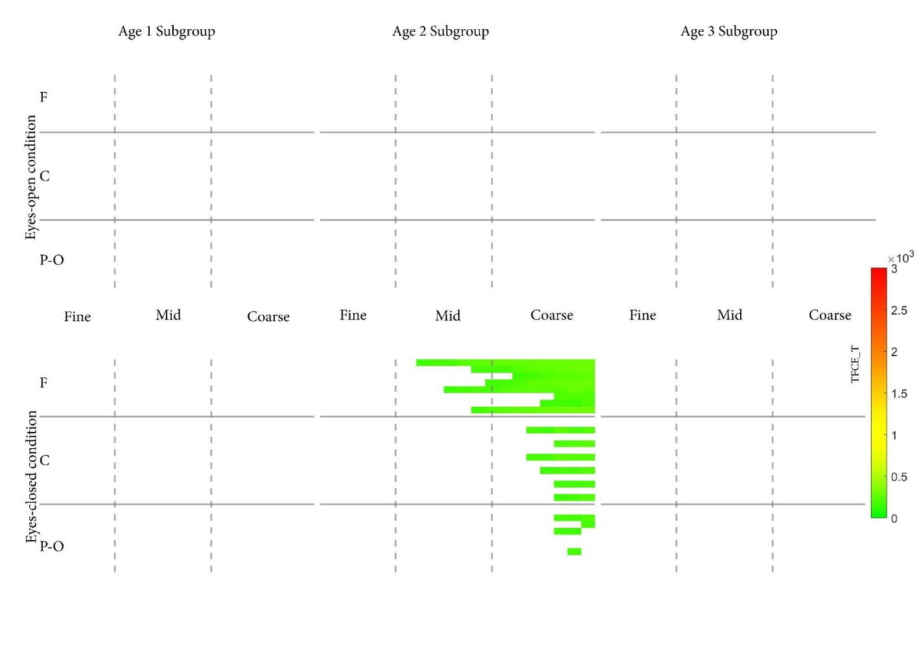
Pairwise diagnosis group contrasts for each scalp electrode and time scale factor for different age subgroups and eye conditions respectively.
Note. Cold colours indicate lower levels of multiscale sample entropy in the ASC group compared to the CON group. These comparisons have been masked for significance using the Threshold Free Cluster Enhancement with 2500 random between-subjects permutations. F = frontal; C = central; P-O = parietal-occipital.
Data from the fMRI project (Chapter 3)
No new data was collected, and the fMRI data utilised in this Chapter was the same as those used in the prior study (Chapter 3). Only the dataset collected under the eyes-open condition was included in this phase due to the restricted sample size available for the dataset under the eyes-closed condition. Participants included children and adolescents aged 7.13-42.33 in ASC and 7.19-39.39 in neurotypical control groups. The entire dataset was divided into three distinct age categories to understand how age influences multiscale sample entropy in distinguishing individuals with and without ASC. The first category consisted of individuals whose quantiles fell within the range of 0 to 0.3333. The second category encompassed individuals with quantiles ranging from 0.3333 to 0.6666. Lastly, the third category comprised individuals with quantiles between 0.6666 and 1, as shown in Table 2.
Table 2
Age Ranges in Age Subgroups in ASC and CON Participants for the fMRI study
Group | Age group | Age in Year  M(SD) | Age Range (min-max) | Sample size
ASC | Age group 1 | 10.62 (7.13) | 7.13 - 12.8 | 59
 | Age group 2 | 14.76 (12.90) | 12.9-16.61 | 59
 | Age group 3 | 23.51 (16.64) | 16.64-42.33 | 59
CON | Age group 1 | 10.42 (7.19) | 7.19-12.8 | 66
 | Age group 2 | 14.68 (12.9) | 12.9-16.6 | 79
 | Age group 3 | 21.93 (16.66) | 16.66-39.39 | 72
Numeric values indicate mean (standard deviation), minimum - maximum.

Multiscale Sample Entropy Analysis and Statistical Assessment across Age Subgroups
No additional multiscale sample entropy computations were performed; the same MSE values as those in the preceding study (Chapter 3) were utilised. Each participant has a standardised multiscale sample entropy brain map for each time scale factor (i.e., 1-5). These maps served as input files for correlating age and MSE.
Voxel-wise Pearson's correlation between age and multiscale sample entropy
To investigate the relationship between multiscale sample entropy and chronological age, a series of the voxel-wise Pearson's correlation between age and standardised sample entropy was conducted for each time scale factor using the function y_Correlation_Image at each time scale (1-5) respectively. A permutation test with Threshold-Free Cluster Enhancement (TFCE) was applied to achieve a balance between test-retest reliability and family-wise error rate (under 5%) (Chen et al., 2018). This written Matlab script is sourced from the DPABI toolbox (Yan et al., 2016) integrating PALM(Permutation Analysis of Linear Models) (Winkler et al., 2016), which is publicly accessible through GitHub (https://github.com/Chaogan-Yan/DPABI). This statistical process was run using the High-Performance Computing resources provided by the University of Sheffield's ShARC (Sheffield Advanced Research Computer) infrastructure. The outcomes of this analysis are illustrated in Figure 4.

Figure 4
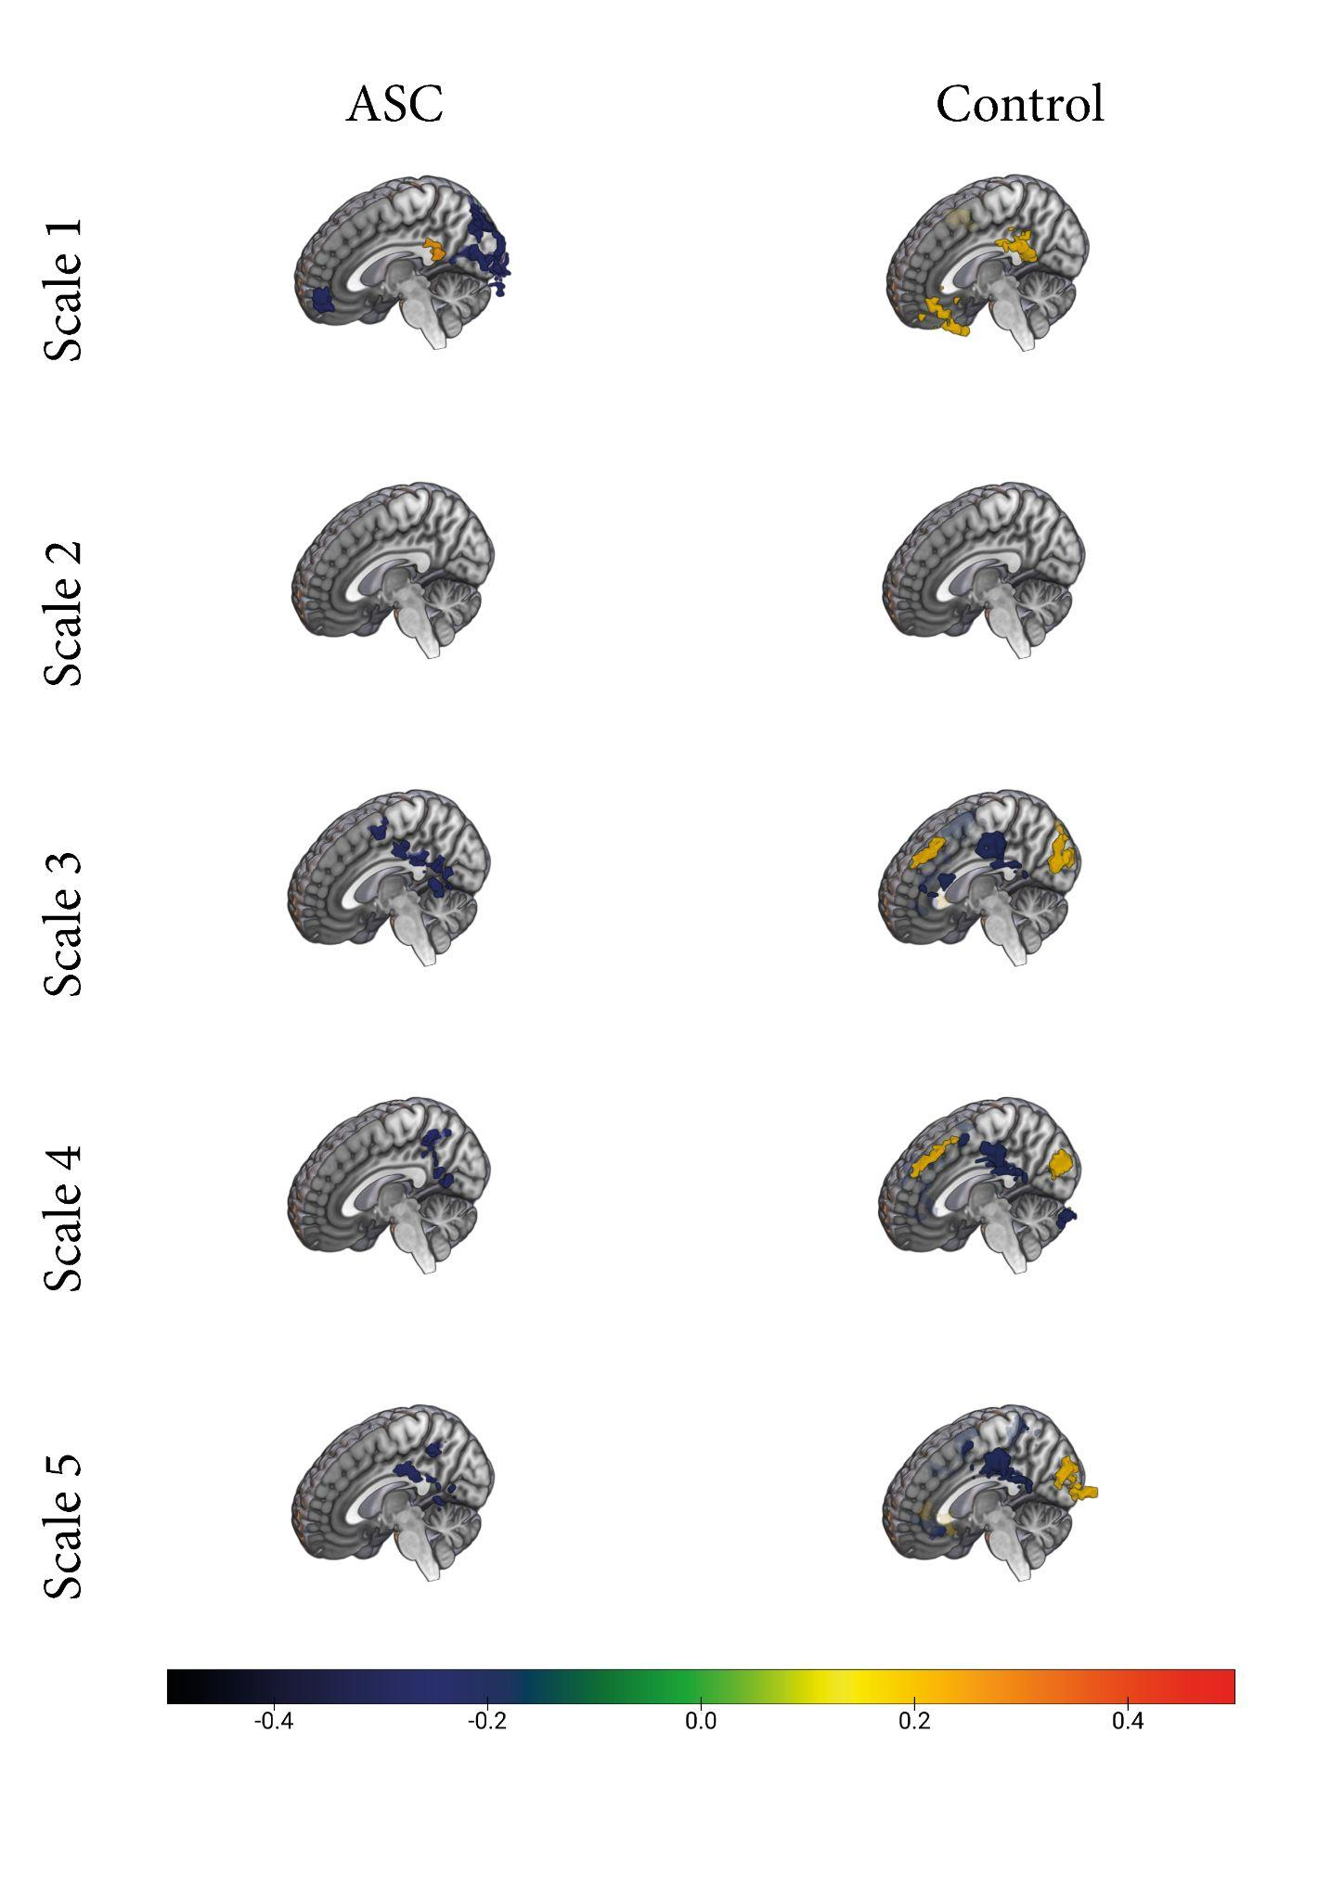
Brain maps of Pearson's correlation coefficients between age and standardised sample entropy, corrected by permutation test with threshold-free cluster enhancement, with voxel level: p < .05.
R
Note. This analysis was conducted separately for each time scale factor within the ASC and CON groups. The results were masked using the Threshold-Free Cluster Enhancement (TFCE) method with permutation tests. Hot colour indicates positive correlations.
At scale 1, a positive correlation exists between age and sample entropy within neurotypical participants. In contrast, individuals with ASC exhibit a negative correlation between age and sample entropy in the frontal and occipital regions. Among individuals with ASC, age is only positively correlated with sample entropy in the posterior cingulate cortex. Notably, this positive correlation shifts to a negative trend as the scale increases, a pattern also observable in the posterior cingulate cortex of neurotypical participants. Additionally, neurotypical controls display a positive correlation between age and sample entropy in the superior frontal cortex and occipital regions across most time scale factors. Details of the clusters show significant correlations with age in each time scale illustrated in Table 3, including the located brain region, MNI coordinates, peak intensity in correlation coefficient within the significant cluster and voxel size.
Table 3
Correlations of Multiscale Sample Entropy with Age in ASC and CON Groups at Different Time Scale Factors (p < .05, corrected by TFCE with permutation test)
Scale | Group | Brain Region | MNI Coordinates | Peak Intensity R-value | Volume (Voxels)
1 | ASC | Right Precuneus | 9 -81 42 | -0.43 | 315
 |  | Left Medial Frontal Gyrus | 0 57 0 | -0.40 | 76
 |  | Left Posterior Cingulate | -3 -42 21 | 0.37 | 39
 | CON | Left Middle Frontal Gyrus | -30 51 6 | 0.28 | 75
 |  | Left Posterior Cingulate | -3 -45 18 | 0.32 | 86
 |  | Right Precentral Gyrus | 57 -6 36 | 0.36 | 80
2 | ASC | - | - | - | -
 | CON | - | - | - | -
3 | ASC | Left Postcentral Gyrus | -54 -21 33 | -0.36 | 67
 |  | Left Middle Frontal Gyrus | -21 -6 48 | -0.32 | 24
 |  | Left Medial Frontal Gyrus | 6 -3 54 | -0.37 | 29
 | CON | Right Precuneus | 0 -78 33 | 0.29 | 118
 |  | Right Precentral Gyrus | 54 -3 12 | -0.31 | 69
 |  | Right Postcentral Gyrus | 54 -18 30 | -0.34 | 45
 |  | Right Medial Frontal Gyrus | 3 42 48 | 0.40 | 55
 |  | Left Precentral Gyrus | -30 -12 57 | -0.43 | 107
 |  | Right Middle Frontal Gyrus | 30 -6 57 | -0.31 | 48
4 | ASC | Right Precuneus | 9 -51 48 | -0.37 | 61
 |  | Left Inferior Parietal Lobule | -51 -33 39 | -0.35 | 33
 | CON | Right Inferior Frontal Gyrus | 27 18 -12 | -0.35 | 55
 |  | Right Cuneus | 3 -87 21 | 0.28 | 76
 |  | Left Cingulate Gyrus | -6 -21 30 | -0.33 | 33
 |  | Right Middle Frontal Gyrus | 33 39 30 | -0.33 | 38
 |  | Left Middle Frontal Gyrus | -24 -9 54 | -0.40 | 72
 |  | Right Medial Frontal Gyrus | 3 42 48 | 0.38 | 53
5 | ASC | Left Cingulate Gyrus | -6 -24 30 | -0.38 | 44
 |  | Right Cingulate Gyrus | 9 -45 42 | -0.35 | 41
 | CON | Right Superior Temporal Gyrus | 30 6 -27 | 0.31 | 34
 |  | Left Cuneus | -9 -102 0 | 0.27 | 71
 |  | Right Cuneus | 3 -87 21 | 0.30 | 73
 |  | Right Precentral Gyrus | 57 0 12 | -0.29 | 40
 |  | Right Postcentral Gyrus | 57 -18 27 | -0.35 | 35
 |  | Left Posterior Cingulate | -6 -45 18 | -0.34 | 71
 |  | Left Middle Frontal Gyrus | -24 -12 54 | -0.37 | 86
 |  | Right Superior Frontal Gyrus | 21 6 60 | -0.29 | 41

Voxel-Level Two-Sample t-Test Comparing ASC and CON within Different Age Subgroups
A series of comparisons were performed between diagnostic groups (ASC and CON groups) within three different age subgroups. The results of these comparisons are presented in Figures 5 and 6, as well as Tables 4 and 5. The voxel-wise two-sample t-test between diagnosis groups was conducted for each time scale factor using the function y_TTest2_Image at each time scale (1-5), respectively. A permutation test with Threshold-Free Cluster Enhancement (TFCE) was applied to balance test-retest reliability and maintain a family-wise error rate below 5% (Chen et al., 2018). This written Matlab script is sourced from the DPABI toolbox (Yan et al., 2016) integrating PALM(Permutation Analysis of Linear Models) (Winkler et al., 2016), which is publicly accessible through GitHub (https://github.com/Chaogan-Yan/DPABI). This statistical process was run using the High-Performance Computing resources provided by the University of Sheffield's ShARC (Sheffield Advanced Research Computer) infrastructure.
In the previous section (Chapter 3), a decline in MSE is observed at the coarse scale within the medial frontal gyrus among individuals with ASC. Additionally, it has been revealed that this disparity between groups is discernible solely within the youngest age subgroup (i.e., the Age1 group), encompassing individuals aged 7.13 to 12.8 in the ASC group and 7.19 to 12.8 in the CON group. These findings are visually presented in Figure 5 and outlined in Table 4.
Furthermore, a distinctive pattern of MSE is noted within the precuneus and posterior cingulate among individuals with ASC in the preceding section (Chapter 3), is characterised by an initial increase followed by a subsequent decline. Notably, this divergence between groups is exclusively observed within the adult subgroup (i.e., the Age 3 group), encompassing individuals aged 16.64 to 42.33 in the ASC group and 16.66 to 39.39 in the CON group. These outcomes are visually depicted in Figure 6 and detailed in Table 5.
It is essential to highlight that no differences between groups were detected in the middle age range (i.e., the Age 2 group), encompassing individuals aged 12.9 to 16.61 in both the ASC and CON groups. Therefore, no figure or table shows any group differences within the Age 2 group.

Figure 5
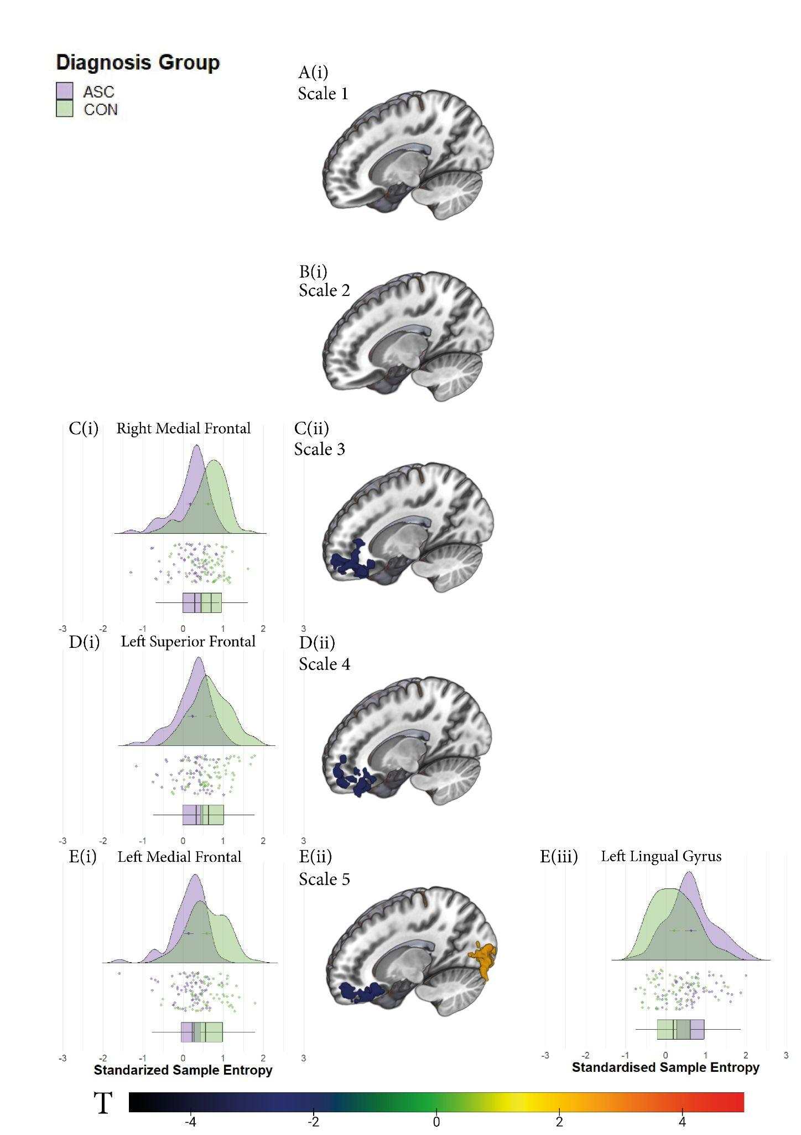
Diagnosis group differences in MSE in each time scale factor within Age 1 subgroup, corrected by permutation test with threshold-free cluster enhancement, with voxel level: p < .05.

Note. Hot colours at the middle panel indicate greater MSE in the ASC group of a given contrast (i.e., ASC v.s. CON), masked by TFCE with a permutation test. Detailed descriptive graphs in the left and right panels depict individual sample entropy values acquired from participants in both ASC and CON groups, distinguished by purple and green respectively. T value indicates t statistics obtained from the voxel-wise two sample t test.
Table 4
Significant cluster indicate diagnosis group differences at each time scale factor within Age 1 subgroup (p < .05, corrected by TFCE with permutation test)
Scale | Brain Region | MNI Coordinates | Peak Intensity t-value | Volume (Voxels)
1 | - | - | - | -
2 | - | - | - | -
3 | Right Medial Frontal Gyrus | 6 60 0 | -3.8068 | 140
4 | Left Superior Frontal Gyrus | -12 66 12 | -3.6135 | 117
5 | Left Medial Frontal Gyrus | -3 36 -12 | -3.805 | 112
5 | Left Lingual Gyrus | 0 -87 0 | 3.6135 | 164

Figure 6
Diagnosis group differences in MSE in each time scale factor within the Age 3 subgroup,
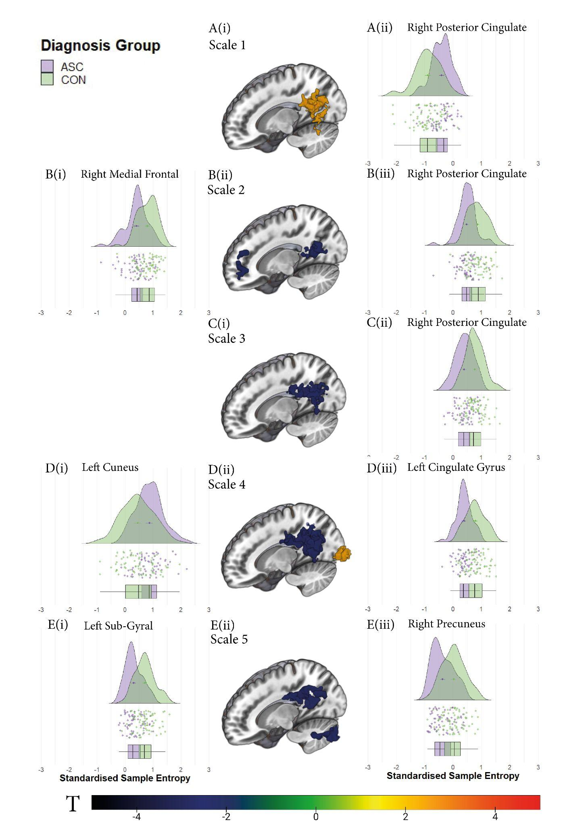
, corrected by permutation test with threshold-free cluster enhancement, with voxel level: p < .05.

Note. Hot colours at the middle panel indicate greater MSE in the ASC group of a given contrast (i.e., ASC v.s. CON), masked by TFCE with a permutation test. Detailed descriptive graphs in the left and right panels depict individual sample entropy values acquired from participants in both ASC and CON groups, distinguished by purple and green respectively. T value indicates t statistics obtained from the voxel-wise two sample t test.
Table 4.
Significant cluster indicate diagnosis group differences at each time scale factor within Age 3 subgroup (p < .05, corrected by TFCE with permutation test)
Scale | Brain Region | MNI Coordinates | Peak Intensity t-value | Volume (Voxels)
1 | Right Posterior Cingulate | 9 -54 15 | 5.2724 | 277
2 | Right Medial Frontal Gyrus | 6 45 30 | -3.6646 | 70
2 | Right Posterior Cingulate | 3 -48 18 | -3.9215 | 93
3 | Right Posterior Cingulate | 9 -57 24 | -4.1017 | 247
4 | Left Cuneus | -3 -96 6 | 3.9981 | 100
4 | Left Cingulate Gyrus | -6 -30 33 | -4.8101 | 541
5 | Left Sub-Gyral | -33 -57 -9 | -4.1198 | 115
5 | Right Precuneus | 6 -60 30 | -4.4665 | 227

Discussion
The main focus of this chapter was to conduct a comprehensive investigation into the potential relationship between age and the previously identified neurophysiological biomarkers. Additionally, this chapter aimed to analyse the impact of age on multiscale sample entropy in both the ASC and control groups, utilising the resting-state EEG and fMRI data previously examined. The primary discovery of the study is a significant correlation between age and multiscale sample entropy in the neurotypical control group, which was observed consistently in both EEG and fMRI signals across distributed brain regions. This finding implies that the growth in neural complexity reflects a maturational transformation in the underlying brain networks. However, it is essential to note that the correlation observed is confined to the age range covered by the dataset, which spans from childhood to young adulthood. However, it also covers the whole human brain development, which is ongoing from childhood to at least 30 years of age (Kundu et al., 2018).
Enhanced Age-Related Influence on Neurotypical Controls in Comparison to Individuals with ASC. Significant changes were observed within childhood (i.e., disparities between Age 1 and Age 2 subgroups, aged 7.13 - 16.61 in the ASC group; aged 7.19 - 16.66 in the CON group) and within the teenage years (i.e., distinctions between Age 2 and Age 3 groups, aged 16.61 - 42.33 in the ASC group; aged 16.66 - 39.39 in the CON group) were narrowed both spatially and temporally. In contrast, the contrasts between childhood and young adulthood became pronounced (refer to Fig. 2). The observation of a positive relationship between brain complexity and age from childhood to young adulthood among healthy controls in this study is in line with previous research utilising EEG (Anokhin et al., 1996; Easson & McIntosh, 2019; van Noordt & Willoughby, 2021).
Research has indicated that the raised entropy of EEG signals from childhood to adulthood is associated with enhanced accuracy and reduced variability in reaction times during task performance ( McIntosh et al., 2008; Misić et al., 2010; Lippé et al., 2009). This rise in entropy is further believed to manifest the growing cognitive capacity during development (McIntosh et al., 2008). Previous research has proposed that this enhanced information processing capacity throughout adolescence arises from a greater number of possible configurations of functional networks (McIntosh et al., 2010), which is postulated to stem from improved functional segregation and integration processes within hierarchically organised networks (Ballard et al., 2023; Garrett et al., 2013; Johnson, 2001; Luna et al., 2010; Niu et al., 2022). During adolescence, there is a reduction in grey matter and an increase in white matter volume (Pfefferbaum et al., 1994), which is associated with a transformation from primarily local connections to reinforced distributed long-distance connections, possibly due to the age-dependent systematic pruning of short-range functional connectivity (Supekar et al., 2009). As long-distance connections that facilitate integration and distributed processing become more developed, neural and cognitive specialisation also progresses accordingly (Luna et al. 2020), leading to extensive changes in the neurological, behavioural, and social domains during adolescence (Jaworska & MacQueen, 2015).
However, individuals with ASC exhibit a reduced age-dependent increase in entropy, suggesting a potentially delayed developmental pattern and indicating that their central nervous system processes information with reduced flexibility and efficiency despite following a similar developmental trajectory of brain complexity as their neurotypical counterparts. This reduced age-related rise in brain complexity observed in ASC may be attributed to an elevated ratio of excitatory to inhibitory coupling in the brain (Easson and McIntosh 2019; Rubenstein & Merzenich, 2003), which could be associated with atypical neurodevelopmental trajectories in the ASC population, such as abnormal myelination and synaptic development (Rubenstein & Merzenich, 2003), as well as disparities in grey matter thinning (van Rooij et al., 2018) and a lack of typical maturational increases in cortical GABA level (Port et al., 2019). Inhibitory signalling is vital in enhancing the precision of excitatory brain signals. Thus, an increase in excitatory signalling and a decrease in inhibitory signalling could cause more chaotic and less stable signalling, decreased functional specialisation, and less efficient information processing (Nelson & Valakh, 2015), resulting in imprecise brain activity and this reduced age-dependent increase in brain complexity.
In the behaviour context, as neurotypical individuals progress from childhood to young adulthood, an increase in entropy values indicates a higher information processing capacity and functional brain development. A vital characteristic of this specialisation during adolescence is the capacity to regulate behaviour adaptively (McCormick & Telzer, 2017), which becomes most evident when the demands of self-regulation coincide with heightened arousal, emotional saliency, and social pressures (Spear, 2013). However, individuals with ASC do not exhibit developments in many aspects observed into adulthood, as seen in neurotypical individuals. Current research indicates that individuals with ASC may not exhibit the expected developmental progress during adolescence in skills necessary for adulthood. These critical skills encompass executive function, social cognition and communication, emotional recognition and self-awareness(Andersen et al., 2015; Bal et al., 2013; Huggins et al., 2020). Specifically, young adults with ASC demonstrated thicker grey matter in frontal regions responsible for executive function and higher-order cognition. However, they experienced thinner grey matter in temporal and nearby parietal regions, such as the supramarginal gyrus, associated with social cognition and interaction, compared to their typically developing peers(van Rooij et al., 2018).
Age-Related Brain Complexity: The medial posterior cortex. Age is broadly positively associated with the multiscale sample entropy among neurotypical controls in the EEG signal, covering the entire brain, as depicted in Figure 2. This finding aligns with established results in the ageing literature concerning the differences in EEG variability between younger and older individuals (McIntosh et al., 2014; McIntosh, 2018). As shown in Figure 4, the fMRI signals reveal specific brain regions contributing to age-related complexity. Generally, the grey matter demonstrates substantial age-related effects on brain complexity, whereas the white matter exhibits no age-related effects. This finding aligns with previous fMRI studies on functional property changes from childhood to adulthood (McIlvain et al., 2022).
Specifically, in the neurotypical control group, the prominent age-related brain regions are the medial posterior cortical areas, recognised as pivotal "network hubs" within the brain (Hagmann et al., 2008). This observation is highly consistent with another study on age-related brain complexity, which also identified that the contributing age-related clusters were predominantly located within the default mode network and somatosensory network among healthy controls (Niu et al., 2022). Additionally, it is also in line with another MEG study on age-related brain complexity, which highlighted the medial parietal regions, including the precuneus and posterior cingulate cortex, as the most notable age-related brain regions (Dosenbach et al., 2010; Misić et al., 2010). These regions are distinguished by their strategic position within the structural hierarchy of the cerebral cortex (Al-Ramadhani et al., 2021). The medial posterior cortex, encompassing the precuneus and posterior cingulate, has been recognised as a potential structural core because of its distinctive topological characteristics, including dense connectivity (degree), efficient communication with other regions (efficiency), and its active involvement in a significant proportion of short paths between various brain regions (elevated betweenness centrality), playing a central role in a central role in integrating information across functionally segregated brain regions (Achard et al., 2006; Hagmann et al., 2008; Iturria-Medina et al., 2008; Leech et al., 2012; Kundu et al., 2018; Tomasi & Volkow, 2010). These areas also play prominent roles in the default mode (Leech et al., 2012; Raichle et al., 2001; Utevsky et al., 2014) or task-negative networks (Fox et al., 2005), as they display distinctive connectivity patterns compared to the more extensive network during both task-related activities and resting state: with increasing task difficulty, the ventral and dorsal posterior cingulate/precuneus demonstrate contrasting integration patterns with the default mode network; moreover, during rest, the dorsal posterior cingulate/precuneus exhibits connectivity with both the default mode network and task-positive networks (Leech et al., 2011).
Furthermore, the neurotypical control group displays additional more substantial age-related brain regions, specifically the inferior frontal gyrus, postcentral gyrus, and prefrontal gyrus, which predominantly fall within the somatomotor network. Another study (Rosenberg et al., 2020) also reported notable age-related effects on static resting state functional connectivity within a circuit involving the dorsolateral prefrontal cortex, postcentral gyrus, and precentral gyrus.
Remarkably, these regions do not simply demonstrate a straightforward positive correlation with age; a crossing point emerges since scale 3. This distinctive pattern of initially increasing and subsequently decreasing MSE has also emerged in analysing large time-scale EEG signals (Courtiol et al., 2016; McIntosh et al., 2014). The MSE in the older age group is higher than in the younger age group from scale 1 to 20, followed by an opposite pattern after scale 20. This phenomenon can be attributed to the broader bandwidth of EEG activity in older individuals, where faster oscillations drive the dynamics, resulting in increased complexity at finer scales (Courtiol et al., 2016). The reason for this distinctive trend solely observed in fMRI data analysis is probably due to the relatively narrow bandwidth of the fMRI signal and faster frequency decay as the time scale increases, and there could exist a correlation between time scales in fMRI and EEG signal analyses.
Age-Related Group Differences in Multiscale Sample Entropy: Unravelling Developmental Inconsistencies within the Default Mode Network. Another pivotal discovery in this project is that the group differences observed between the ASC and control group in the previous chapter were further identified as age-related in this subsequent study. Specifically, the reduced multiscale sample entropy observed in the medial prefrontal cortex of the ASC group, indicating a typical decrease in brain complexity, was predominantly evident in the younger age group (between 7.13 and 12.8 in the ASC group; 7.19 and 12.8 in the control group). On the other hand, the atypical multiscale sample entropy identified in the posterior cingulate/precuneus was predominantly observed in the older age group (between 16.64 and 42.34 in the ASC group and between 16.66 and 39.39 in the control group).
Notably, no significant group differences were found in the middle age group (between 12.9 and 16.61 in both groups). Other rs-fMRI studies investigating alterations in functional connectivity in individuals with ASC have similarly observed the lack of significant group differences in the middle age group (Long et al., 2016). While the exact mechanisms driving these developmental disparities remain uncertain, these age-related group differences could account for the discrepancies in brain complexity group differences observed in other studies. The absence of significant group differences in the middle-aged group was also observed in other fMRI studies on the functional connectivity alteration of individuals with ASC (Long et al., 2016), particularly concerning the default mode network (Marsh & Hamilton, 2011). Although potential mechanisms underlying these developmental disparities are still unclear, these age-related group differences may explain the inconsistencies in brain complexity group differences observed in other studies with different age compositions of samples.
Moreover, the age-specific group differences in brain complexity observed in the medial prefrontal cortex and posterior cingulate/precuneus suggest that developmental dysfunction might be implicated in the pathology of ASC. Consistent research findings indicate that short-distance connectivity declines while long-distance connectivity increases as individuals age (Bagarinao et al., 2020). This age-related process also reduces the integration of functional organisation, as networks that are more regionally specific during younger ages integrate into anatomically distributed and functionally distinct networks throughout neurodevelopment (Fair et al., 2009; Kundu et al., 2018). However, research findings suggest that individuals with ASC may experience atypical neurodevelopment concerning the integration and segregation of brain networks (Long et al., 2016; Wass, 2011). This could manifest as an excess of disorganised and insufficiently selective local connectivity and poorly synchronised, weakly responsive, and information-limited long-distance connectivity (Courchesne & Pierce, 2005). For instance, during typical development, there is a noticeable increase in intrinsic functional connectivity between nodes of the default mode network (DMN) from childhood to adulthood (Supekar et al., 2010). However, there is no consistent evidence in individuals with ASC that such connectivity increases with age within the DMN (Doyle-Thomas et al., 2015; Wiggins et al., 2012).
Moreover, in neurotypical individuals, inter-network connectivity also tends to increase with age (Power et al., 2010). However, this pattern is also absent in ASC (Cheng et al., 2015), indicating altered development of critical intra- and inter-network connections in ASC. Given this distinct neurodevelopmental pattern observed in healthy controls and individuals with ASC, where the posterior cingulate and precuneus are also recognised as notable age-related brain areas (Dosenbach et al., 2010), it is not surprising that the atypical multiscale sample entropy observed in the posterior cingulate/precuneus would predominantly appear in the young adult group in this study.
On the other hand, the specific atypical brain complexity observed in the prefrontal cortex, particularly in the children groups, is likely attributed to aberrant brain growth in individuals with ASC during early ages, which has been shown to mainly affect the frontal lobe (Amaral et al., 2008; Carper et al., 2002; Carper & Courchesne, 2005; Courchesne & Pierce, 2005) presented both macroscopic and microscopic evidence of frontal maldevelopment, indicating that atypical overgrowth of grey and white matter in the frontal lobes hinders the usual progression of the prefrontal lobe, resulting in abnormal frontal-mediated behaviour. Numerous neuroimaging studies have demonstrated the critical role of the prefrontal cortex in various functions, including mentalising (Ibrahim et al., 2021), basic emotional processing (Ibrahim et al., 2021; Wang et al., 2007), irony comprehension (Ibrahim et al., 2021), social judgement (Li et al., 2021; Watanabe et al., 2012), and self-referencing (Leshikar & Duarte, 2012), which represent core features of ASC. For early diagnosis of autism, certain clinical features have shown consistent reliability. These include reduced interaction and attention towards others, diminished focus on others' eyes, lack of response to one's name being called, and an inability to engage in imitative games and reciprocal vocalisations (Klin et al., 2015; Wetherby et al., 2004). These indicators signify difficulties in achieving normative social interaction and communication skills that are crucial developmental milestones. Such challenges can contribute to atypical developmental trajectories and the manifestation of more severe symptoms (Klin et al., 2003).
In summary, the variations seen in the DMN among different age groups suggested the neurodevelopmental role of DMN in the neurophysiological characteristics of ASC, viewed from a nonlinear perspective. Furthermore, this discovery also gives rise to a concern regarding the identification of classification biomarkers for ASC. That is, the biomarker only applies to a limited subgroup exhibiting a homogeneous characteristic, such as age, in this study, which could potentially limit its generalizability to a broader population and applicability to the clinical setting. Additionally, given the acknowledged characterisation of ASC as a neurodevelopmental condition with high heterogeneity, a single universal classification biomarker might be unlikely. As highlighted by Lombardo, if autism is a broad description encompassing various distinct genetic and neurological conditions, then particular biomarkers may only reflect specific subsets of autistic individuals. However, they might not consistently differentiate all individuals diagnosed with ASC from a neurotypical sample (Lombardo et al., 2019). This could also explain why the use of a uniform sample dataset is more effective in accurately classifying ASC compared to employing a varied sample dataset with diverse characteristics (Reiter et al., 2021), as well as the generally limited reliability of the biomarker observed in the majority of studies (Dede et al., 2023).
Limitation
Methodological concern
The age-induced alterations in MSE profiles of the fMRI signals showed a temporally dependent inverted U-shaped trend. This trend implies that, compared to their younger counterparts, fast oscillations could lead the dynamics and yield greater complexity at finer scales (e.g., scale 1 in fMRI signal and scale <20 in EEG signal). Additional investigation into MSE at a larger time scale (>20) within the context of EEG signal analysis is required to validate the potential existence of such a pattern, but it has already been confirmed in numerous studies (Courtiol et al., 2016; McIntosh et al., 2014; McIntosh, 2018).
Considering that the fast oscillation is determined by local neural connections due to the anti-correlations between spectral and spatial frequencies in neurophysiological signals (Nunez, 1989). This temporally dependent inverted U-shaped trend in MSE could have been anticipated based on changes in spectral power during normal ageing. Typically, lower frequencies experience a decline in power, while higher frequencies tend to exhibit an increase (Dustman et al., 1993; Gasser et al., 1988). It becomes evident that the ageing brain is marked by a heightened emphasis on localised, segregated information processing (He and Evans 2010), and this trend is less pronounced in individuals with ASC and can also be attributed to their atypical neurodevelopmental trajectories (Lawrence et al., 2019). However, the inclusion of additional evidence is essential to support such strong arguments, such as establishing correlations of local effects of MSE at fine or coarse scales with functional connectivity at fast or slow frequencies (Wang et al., 2018) as well as with local or distributed entropy (McIntosh et al., 2014) in EEG and fMRI signal analysis.
This study primarily established the age-related MSE in the ASC population and neurotypical controls. Machine learning techniques can be integrated into future studies to identify neurodevelopmental abnormalities by employing normative modelling (Marquand et al., 2016). This approach entails creating brain development growth charts to monitor how an individual's biology deviates from the expected trajectory based on age. In psychiatry research, normative models have previously demonstrated the considerable variability in brain structure observed within ASC conditions (Zabihi et al., 2019).

Chapter 6
General Discussion

This PhD thesis aimed to contribute to understanding the multiscale sample entropy profile of the resting state EEG and fMRI signal. Specifically, the study aimed to investigate this nonlinear neurophysiological characteristic of individuals with autistic spectrum conditions (ASC) compared to neurotypical controls (CON). Additionally, the investigation also considered potential confounding factors such as eye conditions (i.e., eyes-open and eyes-closed condition) (Chapter 2 and Chapter 3, Studies 1 and 2) and age (Chapter 4), which may have influenced the observed group differences. This study utilised multimodal techniques to obtain temporal-based measurements of multiscale sample entropy in simultaneous EEG (Chapter 2) and fMRI signals (Chapter 3). The EEG measurements provided high temporal resolution, while the fMRI measurements offered high spatial resolution. The analyses were conducted on two large existing datasets, with 300 participants in the EEG project from the National Institute of Mental Health (NIMH) (Sayers et al. 2022) and 500 participants in the fMRI project from the Autism Brain Imaging Data Exchange (ABIDE) I (Di Martino et al., 2014). It is important to note that this study referred to secondary data analysis.
This concluding chapter will discuss the critical contributions of this research to understanding the multiscale sample entropy profile of resting-state EEG and fMRI signals in individuals with ASC. The first section will summarise the key findings from Chapters 2, 3, and 4 of the four studies. The second section will focus on the key contributions and implications of the research. The third section will outline the limitations of the work and propose directions for future research. Finally, the fourth section will conclude, emphasising the validity of using multiscale sample entropy as a classification measure for ASC and neurotypical controls.

Summary of the Conducted Studies
Study 1:
Complexity of resting state EEG signals in Neurotypical and Autistic Spectrum Conditions (ASC) collected during eyes open and eyes closed (Chapter 2)
The primary objective of Study 1 (Chapter 2) was to investigate the resting state EEG measurements, particularly the multiscale sample entropy profile and relative power spectrum, in individuals with ASC and neurotypical controls under both eyes-open and eyes-closed conditions. The study aimed to identify potential group differences related to the eye condition. In this study, the overall diagnosis group differences of the resting state EEG measures in predicting the diagnosis groups were relatively modest. However, these resting state EEG measures in predicting the diagnosis groups were significantly more pronounced during the eyes-closed condition compared to the eyes-open condition. Specifically, the ASC group exhibited a reduction in multiscale sample entropy at the coarse time scale across all brain regions.
Furthermore, the differences between the eyes-open and eyes-closed conditions were more pronounced in the ASC group than in controls, particularly in the frontal region. Consequently, there was a specific reduction in multiscale sample entropy at the coarse scale in the frontal region, explicitly concerning the differences between the eyes-open and eyes-closed conditions (i.e., eyes-open minus eyes-closed data). These results not only indicate that group differences seem to be more prominent during the eyes closed condition, which offers a promising avenue for future research in exploring differences between ASC and neurotypical controls, but also suggest that the consistent findings of reduced frontal multiscale sample entropy in ASC may be linked to the differences between the eyes-open and eyes-closed conditions at the frontal region in ASC. This highlights the significance for researchers to meticulously consider the eye conditions during resting state in future investigations.
Moreover, individuals with ASC showed elevated relative delta power and reduced relative alpha power compared to neurotypical controls. Again, this altered relative delta/alpha power ratio was particularly noticeable during the eyes-closed condition and is in line with findings from other studies, providing strong consistency in the results.
Study 1 advanced the multiscale sample entropy literature by first evaluating and comparing the eye conditions (i.e., eyes-open and eyes-closed condition) differences between individuals with and without ASC. Findings indicate that the eyes-closed condition provided more valuable insights in exploring group differences between ASC and neurotypical controls. Nevertheless, the exact reason why the eyes-closed condition offers more fruitful results in exploring these group differences remains uncertain. One potential hypothesis is that the DMN (DMN) is more engaged during the eyes-closed condition, and the DMN is a highly clinically relevant brain network for ASC individuals. Thus, when individuals with ASC close their eyes, it may lead to more atypical brain activity, particularly within the DMN. To investigate this assumption, it is evident that the low spatial resolution EEG technique is insufficient. Therefore, in the subsequent study (Chapter 3), the resting state fMRI technique with relatively high spatial resolution was employed to examine further the multiscale sample entropy profile of individuals with ASC and neurotypical controls.
Studies 2a and 2b:
Mapping Multiscale Entropy of Resting State fMRI Signals in Neurotypical Individuals and Autistic Spectrum Conditions (ASC) (Chapters 3 and 4):
The primary objectives of Studies 2a and 2b (Chapters 3 and 4) were to construct and compare the multiscale sample entropy profile of the brain mapping in individuals with ASC and neurotypical controls, using resting state fMRI signals from an extensive database (i.e., ABIDE I). This study divided the dataset into two subsets based on the eyes-open and eyes-closed conditions, resulting in Study 2a and Study 2b, respectively. However, both subsets followed the same data-driven statistical procedure. Here, the voxel-wise two-sample t-test with the threshold-free cluster enhancement correction and multivoxel pattern analyses were utilised separately to identify the most contributing brain regions in classifying the individuals with and without ASC.
The results suggest that individuals with ASC display abnormal brain complexity in the DMN at both eyes-open and eyes-closed conditions, explicitly showing a significant normal-form decrease in multiscale sample entropy, particularly at the coarse time scale, predominantly in the medial frontal cortex. Additionally, there is an uncorrelated random pattern of reduced multiscale sample entropy, mainly observed at the precuneus in individuals with ASC. Only the reduction of brain complexity in the medial frontal cortex was replicated in the eyes-closed condition. Subsequently, these identified brain regions were further assessed using a linear Support Vector Machine (SVM) in machine learning with a 10-fold cross-validation to evaluate accuracy.
The multivoxel pattern analysis with the feature selection method (Sequential et al. - SFFS) identified more brain regions within the DMN, resulting in slightly higher accuracy compared to the fewer significant clusters obtained from the voxel-wise two-sample t-test in both eyes-open and eyes-closed conditions. However, the voxel-wise two-sample t-test provides more detailed information about the magnitude and direction of the atypical brain complexity in the ASC group. Generally, the classification accuracy of the DMN is relatively low in the eyes-open condition dataset. However, it is higher in the eyes-closed condition dataset (i.e., the highest accuracy is 87%), which aligns with the findings from the previous EEG study (Chapter 2). However, it is essential to note that the datasets used in this study did not collect both eyes-open and eyes-closed condition data from the same participant, unlike the previous EEG study. As a result, it is not feasible to directly compare the multiscale sample entropy profile between the eyes-open and eyes-closed conditions and draw definitive conclusions. However, these results suggest that the eyes-closed condition provides more valuable insights in classifying individuals with and without ASC, as it exhibits more significant diagnosis group differences (Chapter 2) and higher accuracy (Chapter 3) than the eyes-open condition. Therefore, this research underscores the significance of carefully considering the eye condition when investigating the group differences between ASC and neurotypical controls, an aspect that was previously overlooked in most studies. Moreover, the fMRI study 2a and 2b (Chapters 3 and 4) validates the role of the DMN in classifying individuals with ASC, thereby expanding on the previous findings limited to the frontal lobe only.
Considering that ASC is a neurodevelopmental condition (Tuchman & Cuccaro, 2011) and age is a significant factor affecting resting-state brain activity (Dede et al., 2023), the subsequent studies in Chapter 5 aimed to explore how cortical maturation from childhood to young adulthood is manifested in the multiscale sample entropy of resting state EEG and fMRI signals analysed in the previous studies (Chapter 2 and 3).
Study 3:
Decreased Cortical Maturation from Childhood to Young Adulthood Manifests in Complexity of Resting State EEG and fMRI Signals (Chapter 5)
In Study 3, the dataset used in the previous studies (Chapters 2 and 3) was partitioned into three equal sections to examine multiscale sample entropy variations between and within age subgroups of the diagnosis groups. The dataset utilised in these previous studies only covered the age range from childhood to young adulthood, ranging from approximately 7 to 30 years old.
This study successfully replicated the positive correlation between age and multiscale sample entropy in neurotypical controls (Polizzotto et al., 2015), thereby validating the data integrity and the analysis approach employed in all the studies within this thesis. The most prominent and consistent findings from the EEG and fMRI datasets revealed that the age-related positive association in multiscale sample entropy is less pronounced in individuals with ASC when compared to neurotypical controls. These findings suggest that cortical maturation from childhood to young adulthood, as reflected in increasing brain complexity, may be delayed or impaired in individuals with ASC, resulting in a diminished magnitude of the positive age-related association in brain complexity.
Furthermore, the previously identified group differences in Chapters 2 and 3 in multiscale sample entropy were found to be highly dependent on age. Specifically, the reduction in multiscale sample entropy at the frontal region was observed and replicated only at the young age group, which included participants aged from 11.25 to 14.17 in the EEG study (Chapter 2) and aged from 7.13 to 12.8 in the fMRI study (Study 2a in Chapter 3).
The additional presence of atypical multiscale sample entropy in the precuneus was only replicated in the young adult group in the fMRI study, comprising participants aged from 16.64 to 42.33 in the ASC group and 16.66 to 39.39 in the neurotypical control group. This observation may be attributed to the fact that the precuneus is a highly age-related brain region (Li et al., 2019; Dosenbach et al., 2010), and the pronounced group difference in this region may be more evident due to atypical integration and segregation of functional organisation during development in ASC (Long et al., 2016; Wass, 2011), as observed in the adult group.

Contributions of the Present Programs of Research
This thesis contributes to the literature on ASC's multiscale sample entropy profile in four keyways. Firstly, it highlights the importance of considering the eye condition while collecting resting state EEG and fMRI data. Secondly, it underscores the DMN in distinguishing individuals with and without ASC. Thirdly, it investigates multimodal neuroimaging signals using large sample size, thereby expanding the knowledge of multiscale sample entropy in fMRI signal analysis. MSE might be the potential indicator for this multimodality approach. Lastly, it emphasises the influence of age on resting state brain complexity in multimodal neuroimaging signals, thus providing further insights into the heterogeneity of ASC.
Importance of considering the eyes condition. A large body of literature shows that resting-state paradigms using eyes-open versus closed produce distinct results (Agcaoglu et al., 2019; Petro et al., 2022). In a comprehensive review of studies combining eyes-open and eyes-closed conditions, it revealed a U-shaped pattern of atypical power spectrum in individuals with ASC, characterised by increased power in low-frequency bands, decreased alpha power, and increased power in high-frequency bands (Wang et al., 2013). However, another review that separately considered eyes-open and eyes-closed conditions failed to replicate this finding and reported highly inconsistent results for ASC (Newson & Thiagarajan, 2018).
On the other hand, a specific study focusing on children with ASC demonstrated a distinct reduction in absolute alpha power, irrespective of the eye condition (Bellato et al., 2020). The divergent findings for ASC may be attributed to the variability in the usage of different eye conditions during data collection, which motivated the focus of this study. The study in Chapter 2 was the first to directly assess and compare the eye conditions (i.e., eyes-open and eyes-closed condition) differences in both the relative power spectrum and brain complexity between individuals with and without ASC.
Further emphasising the finding from Chapter 3, the study revealed a higher accuracy in distinguishing individuals with ASC from neurotypical controls using the multiscale sample entropy in the eyes-closed condition (87%) compared to the eyes-open condition (68%). The findings indicated that the state where participants had their eyes closed yielded more valuable outcomes in distinguishing individuals with ASC. This was achieved by studying the relative power spectrum obtained from resting-state EEG signals and the multiscale sample entropy derived from resting-state EEG and fMRI signals. This observation not only confirms the significance of accounting for eye conditions when studying neuropsychological conditions (Newson & Thiagarajan, 2018) but also expands the scope from solely focusing on ADHD (Bellato et al., 2020) to encompass ASC as well.
Unveiling the DMN in Distinguishing Individuals with and without ASC. To illustrate the reasons behind the eyes-closed condition yielding more significant outcomes in distinguishing individuals with ASC, a larger dataset (ABIDE I) acquired through the resting state fMRI technique was applied in Chapters 3 and 4. The primary brain regions for distinguishing individuals with ASC were within the DMN (DMN). The DMN has been recognized as a crucial brain system involved in processing self and others (Davey et al., 2016; Mars et al., 2012), and it is associated with social dysfunction in ASC (Lynch et al., 2013; Nair et al., 2020). However, the atypical brain complexity observed within the components of the DMN in this study does not correlate with the available ADOS scores in the dataset. This lack of correlation could be attributed to atypical brain complexity in the DMN, which may not be specific to ASC, as similar atypical findings have been reported in the DMN of individuals with other psychiatric disorders (Hu et al., 2021). As a result, this finding does not directly support the Theory-of-Mind hypothesis of ASC (Lombardo et al., 2010; Tager-Flusberg, 2007).
However, the potential significance of the DMN in classifying individuals with ASC must be considered. The atypical brain complexity consistently observed in the DMN is evident in the dataset under the eyes-closed condition, which has a small sample size but extends to the larger dataset under the eyes-open condition.
MSE could be a potential indicator for the multimodal neuroimaging signals. MSE has the potential to serve as an indicator for both EEG and fMRI signals, as evidenced by the consistent results across these two multimodal neuroimaging signals. First, in these research investigations, MSE efficiently identified heightened irregularity within phase-shuffled surrogate time series derived from EEG and fMRI data (Chapter 1). Specifically, when the temporal structure of the EEG and fMRI phase-shuffled surrogate time series was disrupted while keeping their spectral properties unchanged, the resulting surrogate time series lost some of their inherent regularity and predictability. This enhanced irregularity was effectively identified by the MSE, which appropriately assigned a greater value to the surrogate time series.
Second, MSE accurately distinguished variations between states of eyes being open and closed in both EEG and fMRI signals (Chapter 2 and Chapters 3 and 4). Importantly, all these alterations between eye conditions remain consistent across both ASC and neurotypical control groups. Regarding the resting state EEG signal, the multiscale sample entropy during the eyes-open condition surpasses that observed during the eyes-closed condition. This distinction is established using resting state EEG data obtained from the same participant under both eyes-open and eyes-closed conditions.
While lacking an accessible fMRI dataset that would enable a direct comparison of multiscale sample entropy variations between different eye conditions, consistent disparities in multiscale sample entropy across eye conditions have also been identified within fMRI signals. Precisely, the multiscale sample entropy pattern within the visual network during the eyes-closed condition displays fractal-like attributes, while the eyes-open condition exhibits a typical behaviour. Furthermore, the correlation between MSE within the visual network and other brain networks is diminished during the eyes-closed condition compared to the eyes-open condition. It is worth noting that these correlations related to the visual networks are relatively low in both scenarios, as expected with resting state signals. These phenomena might arise from inhibiting visual information processing during the eyes-closed condition. Further investigation is required to understand why the fMRI signal becomes more self-similar and demonstrates an increased fractal structure under these circumstances.
Third, MSE effectively identified age-related alterations in EEG and fMRI signals (Chapter 4). Specifically, age significantly correlates with multiscale sample entropy, as shown in resting state EEG signals among neurotypical controls. Concerning the resting state fMRI data, MSE effectively identified age-related changes in numerous cortical regions that were associated with ageing, including the posterior cingulate, prefrontal gyrus, postcentral gyrus and precentral gyrus (Dosenbach et al., 2010; Misić et al., 2010). These age-related alterations in specific brain regions could be due to the cortical maturation from childhood to young adulthood (van Noordt & Willoughby, 2021) and the engagement of stimulus-independent thoughts at the resting state (Maillet et al., 2019).
Emphasising The Impact of Age on Resting State Brain Complexity: Unravelling Developmental Inconsistencies within the DMN. Furthermore, the subsequent study (Chapter 4) revealed that this atypical brain complexity within the default mode network (DMN) in individuals with ASC highly depends on age. In particular, the uncorrelated random alteration in multiscale sample entropy (MSE) in individuals with ASC at the precuneus and posterior cingulate cortex was predominantly observed in the adult group. In contrast, during childhood, the typical decrease in MSE in ASC at the medial prefrontal cortex was mainly found in the youngest age group.
These results suggest that the altered brain complexity of the DMN and its atypical developmental trajectory are prominent neurobiological characteristics of ASC. The atypical developmental trajectory is also observed in the intrinsic functional connectivity within the nodes of the DMN in individuals with ASC. Studies focusing on intrinsic functional connectivity in children with ASC mostly report increased intra-network connectivity between core DMN nodes (Assaf et al., 2010; Lynch et al., 2013), whereas studies in adolescents and adults tend to report decreased connectivity (Jung et al., 2014; Kennedy & Courchesne, 2008; Monk et al., 2009; Wiggins et al., 2011). In mixed age groups, findings are varied, showing both increases and decreases in connectivity (Fishman et al., 2014; Funakoshi et al., 2016; Supekar et al., 2013; Uddin et al., 2013). Even though there is no apparent correlation between multiscale sample entropy and functional connectivity (Courtiol et al., 2016), these variations in connectivity and multiscale sample entropy profiles across different nodes of the DMN reflect underlying developmental changes in ASC (Funakoshi et al., 2016).
Similar atypical age-related structural changes in DMN subcomponents have also been reported in other developmental studies on individuals with ASC. For instance, there was an accelerated thinning in the bilateral posterior cingulate cortex (PCC) between childhood and adulthood, which was found to be correlated with social deficits (Doyle-Thomas et al., 2013). Additionally, there was a decelerated volume reduction with age (ages 7–29) in the ventromedial prefrontal cortex (mPFC) and the temporal, parietal junction (TPJ) (Lin et al., 2015). Moreover, in children with ASC, the internodal DMN functional connectivity fails to develop during adolescence. These results suggest that the atypical brain complexity may be attributed to the underlying atypical structural basis. To gain a comprehensive understanding, future research should focus on reconciling the disparities between atypical brain complexity and the rates of change in volumetric and cortical thickness.
Limitations and Future Research
Beyond the limitations specific to each of the four studies discussed in their respective chapters, there are limitations across studies that are important to acknowledge.
Limited Classification Performance with Multiscale Sample Entropy. In general, the classification performance using the univariate potential biomarker, multiscale sample entropy, in ASC is relatively low in these studies. However, it is worth noting that an increasing number of studies have reported high levels of classification accuracy using multivariate, machine-learning approaches to classify neurophysiological data obtained from autistic and neurotypical samples (Bi et al., 2018; Vargason et al., 2020). This points towards a potential future direction, where a combination of multivariate biomarkers could be utilised instead of relying solely on univariate biomarkers for improved classification accuracy. However, it is crucial to take into account the issue of overfitting. This risk is particularly elevated for approaches based on support vector machines, especially when the number of features significantly surpasses the number of participants. This is a common scenario in machine-learning approaches to autism diagnostic classification. In the future, machine learning studies will likely gain advantages from the availability of larger datasets that are now publicly accessible.
The unsatisfactory classification performance could also be attributed to the challenge of identifying developmentally invariant biomarkers for ASC due to the unfolding of phenotypic manifestations over time, especially during early childhood, which involves dynamic interactions among multiple risk factors (Goldman et al., 2011; Ruggeri et al., 2014). As indicated by previous entropy-based studies, the classification of Autism Spectrum Disorder (ASC) is consistently dependent on age (Kang et al., 2019). Consequently, in this study, the ASC population was further divided into age subgroups to investigate and account for age-related variations. Nonetheless, this presence of phenotypic heterogeneity presents challenges in achieving replicability and generalizability of findings (Reiter et al., 2021), a common issue in many ASC studies, particularly those with small sample sizes or convenience samples.
Challenges and Limitations in Identifying Biomarkers for ASC Diagnosis. Furthermore, it is essential to acknowledge that the common challenges in identifying reproducible biomarkers for ASC were also inherent in the conducted studies. Several biomarkers are associated with neuropsychiatric conditions other than ASC, compromising their specificity. An illustrative example is the elevated whole blood serotonin, the first biomarker identified for ASC (Schain & Freedman, 1961). It is associated with various neuropsychiatric and nonpsychiatric medical conditions (Lin et al., 2014). The connection is likely due to shared genetic mutations implicated in both autism and other conditions.
Furthermore, this association extends to children with obsessive-compulsive disorder (OCD) who exhibit symptoms similar to ASD, such as repetitive behaviours, but only among those with a family history of OCD and not those without such a family history (Hanna et al., 1991). In this thesis, although atypical brain complexity was observed through EEG and fMRI techniques, it did not show any significant association with the atypical behavioural symptoms of ASC traits. Specifically, although the findings in these studies reveal the importance of considering the conditions of eyes and the role of DMN when classifying ASC from the neurotypical controls at rest, the underlying theory has not yet been established because of the lack of association with the symptoms' severity or traits in ASC. One possible solution is to expand the dataset and separate the ASC group into severe ASC group and mild ASC group based on the ADOS score or other diagnosis tools. Therefore, the further association between alteration in EEG and fMRI brain complexity and severity in ASC will be established.
Another concern is the sensitivity. Like many other proposed biomarkers, from gene expression profiles to brain structure and connectivity measures, they show limited sensitivity and fail to consistently identify most samples studied (Bosl et al., 2011; Ecker et al., 2010; Scherer & Dawson, 2011). The alteration in brain complexity identified in ASC in studies in this thesis is also limited to specific age subgroups.
Altogether, applying a biomarker for diagnosing ASC in the clinical setting is challenging. For example, a significant achievement in EEG biomarkers for diagnosing ASC is that N170 latency has become the first autism biomarker to gain approval from the US Food and Drug Administration (FDA) for inclusion in its biomarker qualification program. Furthermore, the European Medicines Agency (EMA) has also supported using N170 latency as an autism biomarker. Letter of support for N170 ERP as a prognostic biomarker for adaptive social functioning and its potential to stratify study populations. However, considering the variability of N170 across development, its uncertain correlation with behaviour, and its high individual variability (Vettori et al., 2019), the N170 may not be a dependable biomarker. This is because the effect size of the group difference between individuals with autism and neurotypical participants falls within a range where the current analysis indicates that the information gained will be insufficient. The risk of false positives will be too high to make a clinically significant impact on real-world diagnosis. A recent study from the same group proposing the N170 as a biomarker reported a Partial Eta Squared of .084 for a diagnosis X task condition interaction (Parker et al., 2021). In this thesis, the alteration in brain complexity in ASC also exhibits variations across development and lacks a clear association with ASC traits. These are the main limitations of this finding and the common difficulties encountered in the realm of biomarkers for ASC diagnosis.

References
Abrahams, B. S., & Geschwind, D. H. (2008). Advances in autism genetics: on the threshold of a new neurobiology. Nature Reviews. Genetics, 9(5), 341–355. https://doi.org/10.1038/nrg2346
Achard, S., Salvador, R., Whitcher, B., Suckling, J., & Bullmore, E. (2006). A resilient, low-frequency, small-world human brain functional network with highly connected association cortical hubs. The Journal of Neuroscience, 26(1), 63–72. https://doi.org/10.1523/JNEUROSCI.3874-05.2006
Achuthan, S. K., Coburn, K. L., Beckerson, M. E., & Kana, R. K. (2023). Amplitude of low frequency fluctuations during resting state fMRI in autistic children. Autism Research, 16(1), 84–98.
Afifi, L., Raafat, H., Abdullah, K., Elhabashy, H., & Raafat, O. (2015). Quantitative EEG in autistic children. The Egyptian Journal of Neurology, Psychiatry and Neurosurgery, 52(3), 176. https://doi.org/10.4103/1110-1083.162031
Agcaoglu, O., Wilson, T. W., Wang, Y.-P., Stephen, J., & Calhoun, V. D. (2019). Resting state connectivity differences in eyes open versus eyes closed conditions. Human Brain Mapping, 40(8), 2488–2498. https://doi.org/10.1002/hbm.24539
Agcaoglu, O., Wilson, T. W., Wang, Y.-P., Stephen, J., & Calhoun, V. D. (2019). Resting state connectivity differences in eyes open versus eyes closed conditions. Human Brain Mapping, 40(8), 2488–2498. https://doi.org/10.1002/hbm.24539
Alaerts, K., Nayar, K., Kelly, C., Raithel, J., Milham, M. P., & Di Martino, A. (2015). Age-related changes in intrinsic function of the superior temporal sulcus in autism spectrum disorders. Social Cognitive and Affective Neuroscience, 10(10), 1413–1423. https://doi.org/10.1093/scan/nsv029
Al-Ramadhani, R. R., Shivamurthy, V. K. N., Elkins, K., Gedela, S., Pedersen, N. P., & Kheder, A. (2021). The precuneal cortex: anatomy and seizure semiology. Epileptic Disorders : International Epilepsy Journal with Videotape, 23(2), 218–227. https://doi.org/10.1684/epd.2021.1257
Al-Zubaidi, A., Mertins, A., Heldmann, M., Jauch-Chara, K., & Münte, T. F. (2019). Machine Learning Based Classification of Resting-State fMRI Features Exemplified by Metabolic State (Hunger/Satiety). Frontiers in Human Neuroscience, 13, 164. https://doi.org/10.3389/fnhum.2019.00164
Amaral, D. G., Schumann, C. M., & Nordahl, C. W. (2008). Neuroanatomy of autism. Trends in Neurosciences, 31(3), 137–145. https://doi.org/10.1016/j.tins.2007.12.005
Amodio, D. M., & Frith, C. D. (2006). Meeting of minds: the medial frontal cortex and social cognition. Nature Reviews. Neuroscience, 7(4), 268–277. https://doi.org/10.1038/nrn1884
Amzica, F., & Steriade, M. (1995). Short- and long-range neuronal synchronization of the slow (< 1 Hz) cortical oscillation. Journal of Neurophysiology, 73(1), 20–38. https://doi.org/10.1152/jn.1995.73.1.20
Andersen, P. N., Skogli, E. W., Hovik, K. T., Geurts, H., Egeland, J., & Øie, M. (2015). Working memory arrest in children with high-functioning autism compared to children with attention-deficit/hyperactivity disorder: results from a 2-year longitudinal study. Autism: The International Journal of Research and Practice, 19(4), 443–450. https://doi.org/10.1177/1362361314524844
Andrews-Hanna, J. R., Reidler, J. S., Sepulcre, J., Poulin, R., & Buckner, R. L. (2010). Functional-anatomic fractionation of the brain’s default network. Neuron, 65(4), 550–562. https://doi.org/10.1016/j.neuron.2010.02.005
Andrews-Hanna, J. R., Reidler, J. S., Sepulcre, J., Poulin, R., & Buckner, R. L. (2010). Functional-anatomic fractionation of the brain’s default network. Neuron, 65(4), 550–562. https://doi.org/10.1016/j.neuron.2010.02.005
Angelakis, E., Lubar, J. F., & Stathopoulou, S. (2004). Electroencephalographic peak alpha frequency correlates of cognitive traits. Neuroscience Letters, 371(1), 60–63. https://doi.org/10.1016/j.neulet.2004.08.041
Angulo-Ruiz, B. Y., Muñoz, V., Rodríguez-Martínez, E. I., Cabello-Navarro, C., & Gómez, C. M. (2023). Multiscale entropy of ADHD children during resting state condition. Cognitive Neurodynamics, 17(4), 869–891. https://doi.org/10.1007/s11571-022-09869-0
Angulo-Ruiz, B. Y., Ruiz-Martínez, F. J., Rodríguez-Martínez, E. I., Ionescu, A., Saldaña, D., & Gómez, C. M. (2023). Linear and Non-linear Analyses of EEG in a Group of ASD Children During Resting State Condition. Brain Topography. https://doi.org/10.1007/s10548-023-00976-7
Anokhin, A. P., Birbaumer, N., Lutzenberger, W., Nikolaev, A., & Vogel, F. (1996). Age increases brain complexity. Electroencephalography and Clinical Neurophysiology, 99(1), 63–68. https://doi.org/10.1016/0921-884x(96)95573-3
Assaf, M., Jagannathan, K., Calhoun, V. D., Miller, L., Stevens, M. C., Sahl, R., O’Boyle, J. G., Schultz, R. T., & Pearlson, G. D. (2010). Abnormal functional connectivity of default mode sub-networks in autism spectrum disorder patients. Neuroimage, 53(1), 247–256. https://doi.org/10.1016/j.neuroimage.2010.05.067
Assaf, M., Jagannathan, K., Calhoun, V. D., Miller, L., Stevens, M. C., Sahl, R., O’Boyle, J. G., Schultz, R. T., & Pearlson, G. D. (2010). Abnormal functional connectivity of default mode sub-networks in autism spectrum disorder patients. Neuroimage, 53(1), 247–256. https://doi.org/10.1016/j.neuroimage.2010.05.067
Atkinson, D., Hill, D. L., Stoyle, P. N., Summers, P. E., & Keevil, S. F. (1997). Automatic correction of motion artifacts in magnetic resonance images using an entropy focus criterion. IEEE Transactions on Medical Imaging, 16(6), 903–910. https://doi.org/10.1109/42.650886
Attwell, D., & Laughlin, S. B. (2001). An energy budget for signaling in the grey matter of the brain. Journal of Cerebral Blood Flow and Metabolism, 21(10), 1133–1145. https://doi.org/10.1097/00004647-200110000-00001
Azami, H., Abásolo, D., Simons, S., & Escudero, J. (2017). Univariate and multivariate generalized multiscale entropy to characterise EEG signals in alzheimer’s disease. Entropy, 19(1), 31. https://doi.org/10.3390/e19010031
Azami, H., Fernández, A., & Escudero, J. (2017). Refined multiscale fuzzy entropy based on standard deviation for biomedical signal analysis. Medical & Biological Engineering & Computing, 55(11), 2037–2052. https://doi.org/10.1007/s11517-017-1647-5
Azami, H., Fernández, A., & Escudero, J. (2017). Refined multiscale fuzzy entropy based on standard deviation for biomedical signal analysis. Medical & Biological Engineering & Computing, 55(11), 2037–2052. https://doi.org/10.1007/s11517-017-1647-5
Babiloni, C., Binetti, G., Cassarino, A., Dal Forno, G., Del Percio, C., Ferreri, F., Ferri, R., Frisoni, G., Galderisi, S., Hirata, K., Lanuzza, B., Miniussi, C., Mucci, A., Nobili, F., Rodriguez, G., Luca Romani, G., & Rossini, P. M. (2006). Sources of cortical rhythms in adults during physiological aging: a multicentric EEG study. Human Brain Mapping, 27(2), 162–172. https://doi.org/10.1002/hbm.20175
Bagarinao, E., Watanabe, H., Maesawa, S., Mori, D., Hara, K., Kawabata, K., Yoneyama, N., Ohdake, R., Imai, K., Masuda, M., Yokoi, T., Ogura, A., Taoka, T., Koyama, S., Tanabe, H. C., Katsuno, M., Wakabayashi, T., Kuzuya, M., Hoshiyama, M., … Sobue, G. (2020). Aging impacts the overall connectivity strength of regions critical for information transfer among brain networks. Frontiers in Aging Neuroscience, 12, 592469. https://doi.org/10.3389/fnagi.2020.592469
Bal, E., Yerys, B. E., Sokoloff, J. L., Celano, M. J., Kenworthy, L., Giedd, J. N., & Wallace, G. L. (2013). Do Social Attribution Skills Improve with Age in Children with High Functioning Autism Spectrum Disorders? Research in Autism Spectrum Disorders, 7(1), 9–16. https://doi.org/10.1016/j.rasd.2012.07.004
Bal, V. H., Kim, S.-H., Fok, M., & Lord, C. (2019). Autism spectrum disorder symptoms from ages 2 to 19 years: Implications for diagnosing adolescents and young adults. Autism Research : Official Journal of the International Society for Autism Research, 12(1), 89–99. https://doi.org/10.1002/aur.2004
Ballard, H. K., Jackson, T. B., Symm, A. C., Hicks, T. H., & Bernard, J. A. (2023). Age-related differences in functional network segregation in the context of sex and reproductive stage. Human Brain Mapping, 44(5), 1949–1963. https://doi.org/10.1002/hbm.26184
Ballard, H. K., Jackson, T. B., Symm, A. C., Hicks, T. H., & Bernard, J. A. (2023). Age-related differences in functional network segregation in the context of sex and reproductive stage. Human Brain Mapping, 44(5), 1949–1963. https://doi.org/10.1002/hbm.26184
Barrett, H. C. (2012). A hierarchical model of the evolution of human brain specializations. Proceedings of the National Academy of Sciences of the United States of America, 109 Suppl 1(Suppl 1), 10733–10740. https://doi.org/10.1073/pnas.1201898109
Barry, R. J., & De Blasio, F. M. (2017). EEG differences between eyes-closed and eyes-open resting remain in healthy ageing. Biological Psychology, 129, 293–304. https://doi.org/10.1016/j.biopsycho.2017.09.010
Barry, R. J., Clarke, A. R., Johnstone, S. J., Magee, C. A., & Rushby, J. A. (2007). EEG differences between eyes-closed and eyes-open resting conditions. Clinical Neurophysiology, 118(12), 2765–2773. https://doi.org/10.1016/j.clinph.2007.07.028
Barry, R. J., Clarke, A. R., Johnstone, S. J., Magee, C. A., & Rushby, J. A. (2007). EEG differences between eyes-closed and eyes-open resting conditions. Clinical Neurophysiology, 118(12), 2765–2773. https://doi.org/10.1016/j.clinph.2007.07.028
Bassett, D. S., & Gazzaniga, M. S. (2011). Understanding complexity in the human brain. Trends in Cognitive Sciences, 15(5), 200–209. https://doi.org/10.1016/j.tics.2011.03.006
Bathelt, J., & Geurts, H. M. (2021). Difference in default mode network subsystems in autism across childhood and adolescence. Autism: The International Journal of Research and Practice, 25(2), 556–565. https://doi.org/10.1177/1362361320969258
Bathelt, J., & Geurts, H. M. (2021). Difference in default mode network subsystems in autism across childhood and adolescence. Autism: The International Journal of Research and Practice, 25(2), 556–565. https://doi.org/10.1177/1362361320969258
Bathelt, J., & Geurts, H. M. (2021). Difference in default mode network subsystems in autism across childhood and adolescence. Autism: The International Journal of Research and Practice, 25(2), 556–565. https://doi.org/10.1177/1362361320969258
Bathelt, J., Koolschijn, P. C., & Geurts, H. M. (2020). Age-variant and age-invariant features of functional brain organization in middle-aged and older autistic adults. Molecular Autism, 11(1), 9. https://doi.org/10.1186/s13229-020-0316-y
Baumgratz, T., Cramer, M., & Plenio, M. B. (2014). Quantifying coherence. Physical Review Letters, 113(14), 140401. https://doi.org/10.1103/PhysRevLett.113.140401
Baxandall, P. J. (1968). Noise in transistor circuits. Wireless World, 74, 388–392.
Bell, C. C. (1994). DSM-IV: Diagnostic and Statistical Manual of Mental Disorders. The Journal of the American Medical Association, 272(10), 828. https://doi.org/10.1001/jama.1994.03520100096046
Bellato, A., Arora, I., Kochhar, P., Hollis, C., & Groom, M. J. (2020). Atypical Electrophysiological Indices of Eyes-Open and Eyes-Closed Resting-State in Children and Adolescents with ADHD and Autism. Brain Sciences, 10(5). https://doi.org/10.3390/brainsci10050272
Bellato, A., Arora, I., Kochhar, P., Hollis, C., & Groom, M. J. (2020). Atypical Electrophysiological Indices of Eyes-Open and Eyes-Closed Resting-State in Children and Adolescents with ADHD and Autism. Brain Sciences, 10(5). https://doi.org/10.3390/brainsci10050272
Bellato, A., Arora, I., Kochhar, P., Hollis, C., & Groom, M. J. (2020). Atypical Electrophysiological Indices of Eyes-Open and Eyes-Closed Resting-State in Children and Adolescents with ADHD and Autism. Brain Sciences, 10(5). https://doi.org/10.3390/brainsci10050272
Belmonte, M. (2000). Abnormal Attention in Autism Shown by Steady-State Visual Evoked Potentials. Autism: The International Journal of Research and Practice, 4(3), 269–285. https://doi.org/10.1177/1362361300004003004
Bi, X.-A., Wang, Y., Shu, Q., Sun, Q., & Xu, Q. (2018). Classification of autism spectrum disorder using random support vector machine cluster. Frontiers in Genetics, 9, 18. https://doi.org/10.3389/fgene.2018.00018
Billeci, L., Sicca, F., Maharatna, K., Apicella, F., Narzisi, A., Campatelli, G., Calderoni, S., Pioggia, G., & Muratori, F. (2013). On the application of quantitative EEG for characterizing autistic brain: a systematic review. Frontiers in Human Neuroscience, 7, 442. https://doi.org/10.3389/fnhum.2013.00442
Biswal, B. B. (2012). Resting state fMRI: a personal history. Neuroimage, 62(2), 938–944. https://doi.org/10.1016/j.neuroimage.2012.01.090
Biswal, B., Yetkin, F. Z., Haughton, V. M., & Hyde, J. S. (1995). Functional connectivity in the motor cortex of resting human brain using echo-planar MRI. Magnetic Resonance in Medicine, 34(4), 537–541. https://doi.org/10.1002/mrm.1910340409
Blume, W. T. (2006). Drug effects on EEG. Journal of Clinical Neurophysiology, 23(4), 306–311. https://doi.org/10.1097/01.wnp.0000229137.94384.fa
Blumenfeld, H. (2010). Areas of the CNS made up mainly of myelinated axons are called white matter. De Neuroanatomy through Clinical Cases (2nd Ed.), Sunderland, Sinauer Associates Inc.
Boksem, M. A. S., Meijman, T. F., & Lorist, M. M. (2005). Effects of mental fatigue on attention: an ERP study. Brain Research. Cognitive Brain Research, 25(1), 107–116. https://doi.org/10.1016/j.cogbrainres.2005.04.011
Boly, M., Phillips, C., Tshibanda, L., Vanhaudenhuyse, A., Schabus, M., Dang-Vu, T. T., Moonen, G., Hustinx, R., Maquet, P., & Laureys, S. (2008). Intrinsic brain activity in altered states of consciousness: how conscious is the default mode of brain function? Annals of the New York Academy of Sciences, 1129, 119–129. https://doi.org/10.1196/annals.1417.015
Bomba, M. D., & Pang, E. W. (2004). Cortical auditory evoked potentials in autism: a review. International Journal of Psychophysiology, 53(3), 161–169. https://doi.org/10.1016/j.ijpsycho.2004.04.001
Bosl, W. J., Loddenkemper, T., & Nelson, C. A. (2017). Nonlinear EEG biomarker profiles for autism and absence epilepsy. Neuropsychiatric Electrophysiology, 3(1). https://doi.org/10.1186/s40810-017-0023-x
Bosl, W. J., Loddenkemper, T., & Vieluf, S. (2022). Coarse-graining and the Haar wavelet transform for multiscale analysis. Bioelectronic Medicine, 8(1), 3. https://doi.org/10.1186/s42234-022-00085-z
Bosl, W. J., Tager-Flusberg, H., & Nelson, C. A. (2018). EEG Analytics for Early Detection of Autism Spectrum Disorder: A data-driven approach. Scientific Reports, 8(1), 6828. https://doi.org/10.1038/s41598-018-24318-x
Bosl, W., Tierney, A., Tager-Flusberg, H., & Nelson, C. (2011). EEG complexity as a biomarker for autism spectrum disorder risk. BMC Medicine, 9, 18. https://doi.org/10.1186/1741-7015-9-18
Bosl, W., Tierney, A., Tager-Flusberg, H., & Nelson, C. (2011). EEG complexity as a biomarker for autism spectrum disorder risk. BMC Medicine, 9, 18. https://doi.org/10.1186/1741-7015-9-18
Bosl, W., Tierney, A., Tager-Flusberg, H., & Nelson, C. (2011). EEG complexity as a biomarker for autism spectrum disorder risk. BMC Medicine, 9, 18. https://doi.org/10.1186/1741-7015-9-18
Bosl, W., Tierney, A., Tager-Flusberg, H., & Nelson, C. (2011). EEG complexity as a biomarker for autism spectrum disorder risk. BMC Medicine, 9, 18. https://doi.org/10.1186/1741-7015-9-18
Bosl, W., Tierney, A., Tager-Flusberg, H., & Nelson, C. (2011). EEG complexity as a biomarker for autism spectrum disorder risk. BMC Medicine, 9, 18. https://doi.org/10.1186/1741-7015-9-18
Boubela, R. N., Kalcher, K., Huf, W., Kronnerwetter, C., Filzmoser, P., & Moser, E. (2013). Beyond Noise: Using Temporal ICA to Extract Meaningful Information from High-Frequency fMRI Signal Fluctuations during Rest. Frontiers in Human Neuroscience, 7, 168. https://doi.org/10.3389/fnhum.2013.00168
Bowman, A. D., Griffis, J. C., Visscher, K. M., Dobbins, A. C., Gawne, T. J., DiFrancesco, M. W., & Szaflarski, J. P. (2017). Relationship Between Alpha Rhythm and the Default Mode Network: An EEG-fMRI Study. Journal of Clinical Neurophysiology, 34(6), 527–533. https://doi.org/10.1097/WNP.0000000000000411
Boytsova, Yu. A., & Danko, S. G. (2010). EEG differences between resting states with eyes open and closed in darkness. Human Physiology, 36(3), 367–369. https://doi.org/10.1134/S0362119710030199
Brentani, H., Paula, C. S. de, Bordini, D., Rolim, D., Sato, F., Portolese, J., Pacifico, M. C., & McCracken, J. T. (2013). Autism spectrum disorders: an overview on diagnosis and treatment. Revista Brasileira de Psiquiatria (Sao Paulo, Brazil : 1999), 35 Suppl 1, S62-72. https://doi.org/10.1590/1516-4446-2013-S104
Brodoehl, S., Klingner, C. M., & Witte, O. W. (2015). Eye closure enhances dark night perceptions. Scientific Reports, 5, 10515. https://doi.org/10.1038/srep10515
Buckner, R. L., & Carroll, D. C. (2007). Self-projection and the brain. Trends in Cognitive Sciences, 11(2), 49–57. https://doi.org/10.1016/j.tics.2006.11.004
Buckner, R. L., & DiNicola, L. M. (2019). The brain’s default network: updated anatomy, physiology and evolving insights. Nature Reviews. Neuroscience, 20(10), 593–608. https://doi.org/10.1038/s41583-019-0212-7
Buckner, R. L., Andrews-Hanna, J. R., & Schacter, D. L. (2008). The brain’s default network: anatomy, function, and relevance to disease. Annals of the New York Academy of Sciences, 1124, 1–38. https://doi.org/10.1196/annals.1440.011
Buckner, R. L., Andrews-Hanna, J. R., & Schacter, D. L. (2008). The brain’s default network: anatomy, function, and relevance to disease. Annals of the New York Academy of Sciences, 1124, 1–38. https://doi.org/10.1196/annals.1440.011
Buckner, R. L., Krienen, F. M., & Yeo, B. T. T. (2013). Opportunities and limitations of intrinsic functional connectivity MRI. Nature Neuroscience, 16(7), 832–837. https://doi.org/10.1038/nn.3423
Busa, M. A., & van Emmerik, R. E. A. (2016). Multiscale entropy: A tool for understanding the complexity of postural control. Journal of Sport and Health Science, 5(1), 44–51. https://doi.org/10.1016/j.jshs.2016.01.018
Busch, N. A., & VanRullen, R. (2010). Spontaneous EEG oscillations reveal periodic sampling of visual attention. Proceedings of the National Academy of Sciences of the United States of America, 107(37), 16048–16053. https://doi.org/10.1073/pnas.1004801107
Buzsáki, G. (2006). Rhythms of the Brain. Oxford University Press. https://doi.org/10.1093/acprof:oso/9780195301069.001.0001
Buzsáki, G. (2006). Rhythms of the Brain. Oxford University Press. https://doi.org/10.1093/acprof:oso/9780195301069.001.0001
Cantor, D. S., Thatcher, R. W., Hrybyk, M., & Kaye, H. (1986). Computerized EEG analyses of autistic children. Journal of Autism and Developmental Disorders, 16(2), 169–187. https://doi.org/10.1007/BF01531728
Carbone, A., & Dell’Aquila, A. (2023). The diagnosis of “pervasive developmental disorder not otherwise specified”: A systematic literature review. Children (Basel, Switzerland), 10(5). https://doi.org/10.3390/children10050844
Carper, R. A., & Courchesne, E. (2005). Localized enlargement of the frontal cortex in early autism. Biological Psychiatry, 57(2), 126–133. https://doi.org/10.1016/j.biopsych.2004.11.005
Carper, R. A., Moses, P., Tigue, Z. D., & Courchesne, E. (2002). Cerebral lobes in autism: early hyperplasia and abnormal age effects. Neuroimage, 16(4), 1038–1051. https://doi.org/10.1006/nimg.2002.1099
Carter, M. T., & Scherer, S. W. (2013). Autism spectrum disorder in the genetics clinic: a review. Clinical Genetics, 83(5), 399–407. https://doi.org/10.1111/cge.12101
Casey, B. J., Galván, A., & Somerville, L. H. (2016). Beyond simple models of adolescence to an integrated circuit-based account: A commentary. Developmental Cognitive Neuroscience, 17, 128–130. https://doi.org/10.1016/j.dcn.2015.12.006
Casey, B. J., Glatt, C. E., & Lee, F. S. (2015). Treating the Developing versus Developed Brain: Translating Preclinical Mouse and Human Studies. Neuron, 86(6), 1358–1368. https://doi.org/10.1016/j.neuron.2015.05.020
Catarino, A., Churches, O., Baron-Cohen, S., Andrade, A., & Ring, H. (2011). Atypical EEG complexity in autism spectrum conditions: a multiscale entropy analysis. Clinical Neurophysiology, 122(12), 2375–2383. https://doi.org/10.1016/j.clinph.2011.05.004
Catarino, A., Churches, O., Baron-Cohen, S., Andrade, A., & Ring, H. (2011). Atypical EEG complexity in autism spectrum conditions: a multiscale entropy analysis. Clinical Neurophysiology, 122(12), 2375–2383. https://doi.org/10.1016/j.clinph.2011.05.004
Catarino, A., Churches, O., Baron-Cohen, S., Andrade, A., & Ring, H. (2011). Atypical EEG complexity in autism spectrum conditions: a multiscale entropy analysis. Clinical Neurophysiology, 122(12), 2375–2383. https://doi.org/10.1016/j.clinph.2011.05.004
Chan, A. S., & Leung, W. W. M. (2006). Differentiating Autistic Children With Quantitative Encephalography: A 3-Month Longitudinal Study. Journal of Child Neurology, 21(5), 392–399.
Chan, A. S., Sze, S. L., & Cheung, M.-C. (2007). Quantitative electroencephalographic profiles for children with autistic spectrum disorder. Neuropsychology, 21(1), 74–81. https://doi.org/10.1037/0894-4105.21.1.74
Chan, A. S., Sze, S. L., & Cheung, M.-C. (2007). Quantitative electroencephalographic profiles for children with autistic spectrum disorder. Neuropsychology, 21(1), 74–81. https://doi.org/10.1037/0894-4105.21.1.74
Chao-Gan, Y., & Yu-Feng, Z. (2010). DPARSF: A MATLAB Toolbox for “Pipeline” Data Analysis of Resting-State fMRI. Frontiers in Systems Neuroscience, 4, 13. https://doi.org/10.3389/fnsys.2010.00013
Chao-Gan, Y., & Yu-Feng, Z. (2010). DPARSF: A MATLAB Toolbox for “Pipeline” Data Analysis of Resting-State fMRI. Frontiers in Systems Neuroscience, 4, 13. https://doi.org/10.3389/fnsys.2010.00013
Chapman, R. M., Shelburne, S. A., & Bragdon, H. R. (1970). EEG alpha activity influenced by visual input and not by eye position. Electroencephalography and Clinical Neurophysiology, 28(2), 183–189. https://doi.org/10.1016/0013-4694(70)90186-0
Chen, J. E., & Glover, G. H. (2015). BOLD fractional contribution to resting-state functional connectivity above 0.1 Hz. Neuroimage, 107, 207–218. https://doi.org/10.1016/j.neuroimage.2014.12.012
Chen, X., Lu, B., & Yan, C.-G. (2018). Reproducibility of R-fMRI metrics on the impact of different strategies for multiple comparison correction and sample sizes. Human Brain Mapping, 39(1), 300–318. https://doi.org/10.1002/hbm.23843
Cheng, W., Rolls, E. T., Gu, H., Zhang, J., & Feng, J. (2015). Autism: reduced connectivity between cortical areas involved in face expression, theory of mind, and the sense of self. Brain: A Journal of Neurology, 138(Pt 5), 1382–1393. https://doi.org/10.1093/brain/awv051
Chenxi, L., Chen, Y., Li, Y., Wang, J., & Liu, T. (2016). Complexity analysis of brain activity in attention-deficit/hyperactivity disorder: A multiscale entropy analysis. Brain Research Bulletin, 124, 12–20. https://doi.org/10.1016/j.brainresbull.2016.03.007
Christova, P., Lewis, S. M., Jerde, T. A., Lynch, J. K., & Georgopoulos, A. P. (2011). True associations between resting fMRI time series based on innovations. Journal of Neural Engineering, 8(4), 046025. https://doi.org/10.1088/1741-2560/8/4/046025
Clarke, A. R., Barry, R. J., McCarthy, R., & Selikowitz, M. (2001). Age and sex effects in the EEG: development of the normal child. Clinical Neurophysiology, 112(5), 806–814. https://doi.org/10.1016/S1388-2457(01)00488-6
Clarke, A. R., Barry, R. J., McCarthy, R., & Selikowitz, M. (2002). EEG analysis of children with attention-deficit/hyperactivity disorder and comorbid reading disabilities. Journal of Learning Disabilities, 35(3), 276–285. https://doi.org/10.1177/002221940203500309
Clements, G. M., Gyurkovics, M., Low, K. A., Beck, D. M., Fabiani, M., & Gratton, G. (2022). Dynamics of alpha suppression and enhancement may be related to resource competition in cross-modal cortical regions. Neuroimage, 252, 119048. https://doi.org/10.1016/j.neuroimage.2022.119048
Clementz, B. A., Sweeney, J. A., Hamm, J. P., Ivleva, E. I., Ethridge, L. E., Pearlson, G. D., Keshavan, M. S., & Tamminga, C. A. (2016). Identification of Distinct Psychosis Biotypes Using Brain-Based Biomarkers. The American Journal of Psychiatry, 173(4), 373–384. https://doi.org/10.1176/appi.ajp.2015.14091200
Coben, R., Clarke, A. R., Hudspeth, W., & Barry, R. J. (2008). EEG power and coherence in autistic spectrum disorder. Clinical Neurophysiology, 119(5), 1002–1009. https://doi.org/10.1016/j.clinph.2008.01.013
Coben, R., Clarke, A. R., Hudspeth, W., & Barry, R. J. (2008). EEG power and coherence in autistic spectrum disorder. Clinical Neurophysiology, 119(5), 1002–1009. https://doi.org/10.1016/j.clinph.2008.01.013
Cole, E. J., Barraclough, N. E., & Andrews, T. J. (2019). Reduced connectivity between mentalizing and mirror systems in autism spectrum condition. Neuropsychologia, 122, 88–97. https://doi.org/10.1016/j.neuropsychologia.2018.11.008
Cornew, L., Roberts, T. P. L., Blaskey, L., & Edgar, J. C. (2012). Resting-state oscillatory activity in autism spectrum disorders. Journal of Autism and Developmental Disorders, 42(9), 1884–1894. https://doi.org/10.1007/s10803-011-1431-6
Cornew, L., Roberts, T. P. L., Blaskey, L., & Edgar, J. C. (2012). Resting-state oscillatory activity in autism spectrum disorders. Journal of Autism and Developmental Disorders, 42(9), 1884–1894. https://doi.org/10.1007/s10803-011-1431-6
Costa, M, Peng, C. K., Goldberger, A. L., & Hausdorff, J. M. (2003). Multiscale entropy analysis of human gait dynamics. Physica A, 330(1–2), 53–60. https://doi.org/10.1016/j.physa.2003.08.022
Costa, M., Goldberger, A. L., & Peng, C. K. (2002). Multiscale entropy analysis of complex physiologic time series. Physical Review Letters, 89(6), 068102. https://doi.org/10.1103/PhysRevLett.89.068102
Costa, M., Goldberger, A. L., & Peng, C. K. (2005). Multiscale entropy analysis of biological signals. Physical Review E, 71(2). https://doi.org/10.1103/PhysRevE.71.021906
Costa, Madalena, Goldberger, A. L., & Peng, C. K. (2002). Multiscale entropy analysis of complex physiologic time series. Physical Review Letters, 89(6), 068102. https://doi.org/10.1103/PhysRevLett.89.068102
Costa, Madalena, Goldberger, A. L., & Peng, C. K. (2005). Multiscale entropy analysis of biological signals. Physical Review E, 71(2). https://doi.org/10.1103/PhysRevE.71.021906
Costumero, V., Bueichekú, E., Adrián-Ventura, J., & Ávila, C. (2020). Opening or closing eyes at rest modulates the functional connectivity of V1 with default and salience networks. Scientific Reports, 10(1), 9137. https://doi.org/10.1038/s41598-020-66100-y
Costumero, V., Bueichekú, E., Adrián-Ventura, J., & Ávila, C. (2020). Opening or closing eyes at rest modulates the functional connectivity of V1 with default and salience networks. Scientific Reports, 10(1), 9137. https://doi.org/10.1038/s41598-020-66100-y
Courchesne, E., & Pierce, K. (2005). Why the frontal cortex in autism might be talking only to itself: local over-connectivity but long-distance disconnection. Current Opinion in Neurobiology, 15(2), 225–230. https://doi.org/10.1016/j.conb.2005.03.001
Courchesne, E., & Pierce, K. (2005). Why the frontal cortex in autism might be talking only to itself: local over-connectivity but long-distance disconnection. Current Opinion in Neurobiology, 15(2), 225–230. https://doi.org/10.1016/j.conb.2005.03.001
Courtiol, J., Perdikis, D., Petkoski, S., Müller, V., Huys, R., Sleimen-Malkoun, R., & Jirsa, V. K. (2016). The multiscale entropy: Guidelines for use and interpretation in brain signal analysis. Journal of Neuroscience Methods, 273, 175–190. https://doi.org/10.1016/j.jneumeth.2016.09.004
Courtiol, J., Perdikis, D., Petkoski, S., Müller, V., Huys, R., Sleimen-Malkoun, R., & Jirsa, V. K. (2016). The multiscale entropy: Guidelines for use and interpretation in brain signal analysis. Journal of Neuroscience Methods, 273, 175–190. https://doi.org/10.1016/j.jneumeth.2016.09.004
Courtiol, J., Perdikis, D., Petkoski, S., Müller, V., Huys, R., Sleimen-Malkoun, R., & Jirsa, V. K. (2016). The multiscale entropy: Guidelines for use and interpretation in brain signal analysis. Journal of Neuroscience Methods, 273, 175–190. https://doi.org/10.1016/j.jneumeth.2016.09.004
Courtiol, J., Perdikis, D., Petkoski, S., Müller, V., Huys, R., Sleimen-Malkoun, R., & Jirsa, V. K. (2016). The multiscale entropy: Guidelines for use and interpretation in brain signal analysis. Journal of Neuroscience Methods, 273, 175–190. https://doi.org/10.1016/j.jneumeth.2016.09.004
Courtiol, J., Perdikis, D., Petkoski, S., Müller, V., Huys, R., Sleimen-Malkoun, R., & Jirsa, V. K. (2016). The multiscale entropy: Guidelines for use and interpretation in brain signal analysis. Journal of Neuroscience Methods, 273, 175–190. https://doi.org/10.1016/j.jneumeth.2016.09.004
Courtiol, J., Perdikis, D., Petkoski, S., Müller, V., Huys, R., Sleimen-Malkoun, R., & Jirsa, V. K. (2016). The multiscale entropy: Guidelines for use and interpretation in brain signal analysis. Journal of Neuroscience Methods, 273, 175–190. https://doi.org/10.1016/j.jneumeth.2016.09.004
Cox, R. W. (1996). AFNI: software for analysis and visualization of functional magnetic resonance neuroimages. Computers and Biomedical Research, an International Journal, 29(3), 162–173. https://doi.org/10.1006/cbmr.1996.0014
Cragg, L., Kovacevic, N., McIntosh, A. R., Poulsen, C., Martinu, K., Leonard, G., & Paus, T. (2011). Maturation of EEG power spectra in early adolescence: a longitudinal study. Developmental Science, 14(5), 935–943. https://doi.org/10.1111/j.1467-7687.2010.01031.x
Cummins, T. D. R., & Finnigan, S. (2007). Theta power is reduced in healthy cognitive aging. International Journal of Psychophysiology, 66(1), 10–17. https://doi.org/10.1016/j.ijpsycho.2007.05.008
Davey, C. E., Grayden, D. B., Egan, G. F., & Johnston, L. A. (2013). Filtering induces correlation in fMRI resting state data. Neuroimage, 64, 728–740. https://doi.org/10.1016/j.neuroimage.2012.08.022
Davey, C. G., Pujol, J., & Harrison, B. J. (2016). Mapping the self in the brain’s default mode network. Neuroimage, 132, 390–397. https://doi.org/10.1016/j.neuroimage.2016.02.022
Davy, P. J., Rayner, J. C., Beh, E. J., Pemajayantha, V., Mellor, R., Peiris, M. S., & Rajasekera, J. R. (2003). Generalised correlations and Simpson’s paradox. Current Research in Modelling, Data Mining & Quantitative Techniques.
De Wel, O., Lavanga, M., Dorado, A., Jansen, K., Dereymaeker, A., Naulaers, G., & Van Huffel, S. (2017). Complexity analysis of neonatal EEG using multiscale entropy: applications in brain maturation and sleep stage classification. Entropy, 19(10), 516. https://doi.org/10.3390/e19100516
Dede, A. J. O., Xiao, W., Vaci, N., Cohen, M. X., & Milne, E. (2023). Lack of univariate, clinically-relevant biomarkers of autism in resting state EEG: a study of 776 participants. MedRxiv. https://doi.org/10.1101/2023.05.21.23290300
Dede, A. J. O., Xiao, W., Vaci, N., Cohen, M. X., & Milne, E. (2023). Lack of univariate, clinically-relevant biomarkers of autism in resting state EEG: a study of 776 participants. MedRxiv. https://doi.org/10.1101/2023.05.21.23290300
Dehghani-Habibabadi, M., & Pawelzik, K. (2023). Synaptic self-organization of spatio-temporal pattern selectivity. PLoS Computational Biology, 19(2), e1010876. https://doi.org/10.1371/journal.pcbi.1010876
Delgado-Bonal, A., & Marshak, A. (2019). Approximate entropy and sample entropy: A comprehensive tutorial. Entropy (Basel, Switzerland), 21(6). https://doi.org/10.3390/e21060541
Delgado-Bonal, A., & Marshak, A. (2019). Approximate entropy and sample entropy: A comprehensive tutorial. Entropy (Basel, Switzerland), 21(6). https://doi.org/10.3390/e21060541
Delgado-Bonal, A., & Marshak, A. (2019). Approximate entropy and sample entropy: A comprehensive tutorial. Entropy (Basel, Switzerland), 21(6). https://doi.org/10.3390/e21060541
Della-Maggiore, V., Chau, W., Peres-Neto, P. R., & McIntosh, A. R. (2002). An empirical comparison of SPM preprocessing parameters to the analysis of fMRI data. Neuroimage, 17(1), 19–28. https://doi.org/10.1006/nimg.2002.1113
Della-Maggiore, V., Chau, W., Peres-Neto, P. R., & McIntosh, A. R. (2002). An empirical comparison of SPM preprocessing parameters to the analysis of fMRI data. Neuroimage, 17(1), 19–28. https://doi.org/10.1006/nimg.2002.1113
Di Martino, A., Yan, C. G., Li, Q., Denio, E., Castellanos, F. X., Alaerts, K., Anderson, J. S., Assaf, M., Bookheimer, S. Y., Dapretto, M., Deen, B., Delmonte, S., Dinstein, I., Ertl-Wagner, B., Fair, D. A., Gallagher, L., Kennedy, D. P., Keown, C. L., Keysers, C., … Milham, M. P. (2014). The autism brain imaging data exchange: towards a large-scale evaluation of the intrinsic brain architecture in autism. Molecular Psychiatry, 19(6), 659–667. https://doi.org/10.1038/mp.2013.78
Dickinson, A., DiStefano, C., Senturk, D., & Jeste, S. S. (2018). Peak alpha frequency is a neural marker of cognitive function across the autism spectrum. The European Journal of Neuroscience, 47(6), 643–651. https://doi.org/10.1111/ejn.13645
Dickstein, D. L., Kabaso, D., Rocher, A. B., Luebke, J. I., Wearne, S. L., & Hof, P. R. (2007). Changes in the structural complexity of the aged brain. Aging Cell, 6(3), 275–284. https://doi.org/10.1111/j.1474-9726.2007.00289.x
Dickstein, D. P., Pescosolido, M. F., Reidy, B. L., Galvan, T., Kim, K. L., Seymour, K. E., Laird, A. R., Di Martino, A., & Barrett, R. P. (2013). Developmental meta-analysis of the functional neural correlates of autism spectrum disorders. Journal of the American Academy of Child and Adolescent Psychiatry, 52(3), 279-289.e16. https://doi.org/10.1016/j.jaac.2012.12.012
Diebold, F. X. (1998). Elements of forecasting. Cincinnati, OH, USA: South-Western College Pub.
Dixon, M. L., Moodie, C. A., Goldin, P. R., Farb, N., Heimberg, R. G., Zhang, J., & Gross, J. J. (2022). Frontoparietal and Default Mode Network Contributions to Self-Referential Processing in Social Anxiety Disorder. Cognitive, Affective & Behavioral Neuroscience, 22(1), 187–198. https://doi.org/10.3758/s13415-021-00933-6
Dosenbach, N. U. F., Nardos, B., Cohen, A. L., Fair, D. A., Power, J. D., Church, J. A., Nelson, S. M., Wig, G. S., Vogel, A. C., Lessov-Schlaggar, C. N., Barnes, K. A., Dubis, J. W., Feczko, E., Coalson, R. S., Pruett, J. R., Barch, D. M., Petersen, S. E., & Schlaggar, B. L. (2010). Prediction of individual brain maturity using fMRI. Science, 329(5997), 1358–1361. https://doi.org/10.1126/science.1194144
Dosenbach, N. U. F., Nardos, B., Cohen, A. L., Fair, D. A., Power, J. D., Church, J. A., Nelson, S. M., Wig, G. S., Vogel, A. C., Lessov-Schlaggar, C. N., Barnes, K. A., Dubis, J. W., Feczko, E., Coalson, R. S., Pruett, J. R., Barch, D. M., Petersen, S. E., & Schlaggar, B. L. (2010). Prediction of individual brain maturity using fMRI. Science, 329(5997), 1358–1361. https://doi.org/10.1126/science.1194144
Doyle-Thomas, K. A. R., Duerden, E. G., Taylor, M. J., Lerch, J. P., Soorya, L. V., Wang, A. T., Fan, J., Hollander, E., & Anagnostou, E. (2013). Effects of age and symptomatology on cortical thickness in autism spectrum disorders. Research in Autism Spectrum Disorders, 7(1), 141–150. https://doi.org/10.1016/j.rasd.2012.08.004
Doyle-Thomas, K. A. R., Lee, W., Foster, N. E. V., Tryfon, A., Ouimet, T., Hyde, K. L., Evans, A. C., Lewis, J., Zwaigenbaum, L., Anagnostou, E., & NeuroDevNet ASD Imaging Group. (2015). Atypical functional brain connectivity during rest in autism spectrum disorders. Annals of Neurology, 77(5), 866–876. https://doi.org/10.1002/ana.24391
Doyle-Thomas, K. A. R., Lee, W., Foster, N. E. V., Tryfon, A., Ouimet, T., Hyde, K. L., Evans, A. C., Lewis, J., Zwaigenbaum, L., Anagnostou, E., & NeuroDevNet ASD Imaging Group. (2015). Atypical functional brain connectivity during rest in autism spectrum disorders. Annals of Neurology, 77(5), 866–876. https://doi.org/10.1002/ana.24391
Duffy, F. H., & Als, H. (2012). A stable pattern of EEG spectral coherence distinguishes children with autism from neuro-typical controls - a large case control study. BMC Medicine, 10, 64. https://doi.org/10.1186/1741-7015-10-64
Duffy, F. H., & Als, H. (2012). A stable pattern of EEG spectral coherence distinguishes children with autism from neuro-typical controls - a large case control study. BMC Medicine, 10, 64. https://doi.org/10.1186/1741-7015-10-64
Dustman, R. E., Shearer, D. E., & Emmerson, R. Y. (1993). EEG and event-related potentials in normal aging. Progress in Neurobiology, 41(3), 369–401. https://doi.org/10.1016/0301-0082(93)90005-D
Easson, A. K., & McIntosh, A. R. (2019). BOLD signal variability and complexity in children and adolescents with and without autism spectrum disorder. Developmental Cognitive Neuroscience, 36, 100630. https://doi.org/10.1016/j.dcn.2019.100630
Easson, A. K., & McIntosh, A. R. (2019). BOLD signal variability and complexity in children and adolescents with and without autism spectrum disorder. Developmental Cognitive Neuroscience, 36, 100630. https://doi.org/10.1016/j.dcn.2019.100630
Easson, A. K., & McIntosh, A. R. (2019). BOLD signal variability and complexity in children and adolescents with and without autism spectrum disorder. Developmental Cognitive Neuroscience, 36, 100630. https://doi.org/10.1016/j.dcn.2019.100630
Ecker, C., Marquand, A., Mourão-Miranda, J., Johnston, P., Daly, E. M., Brammer, M. J., Maltezos, S., Murphy, C. M., Robertson, D., Williams, S. C., & Murphy, D. G. M. (2010). Describing the brain in autism in five dimensions--magnetic resonance imaging-assisted diagnosis of autism spectrum disorder using a multiparameter classification approach. The Journal of Neuroscience, 30(32), 10612–10623. https://doi.org/10.1523/JNEUROSCI.5413-09.2010
Edgar, J. C., Franzen, R. E., McNamee, M., Green, H. L., Shen, G., DiPiero, M., Liu, S., Airey, M., Goldin, S., Blaskey, L., Kuschner, E. S., Kim, M., Konka, K., Roberts, T. P. L., & Chen, Y. (2023). A comparison of resting-state eyes-closed and dark-room alpha-band activity in children. Psychophysiology, 60(6), e14285. https://doi.org/10.1111/psyp.14285
Eke, A., Herman, P., Kocsis, L., & Kozak, L. R. (2002). Fractal characterization of complexity in temporal physiological signals. Physiological Measurement, 23(1), R1-38. https://doi.org/10.1088/0967-3334/23/1/201
Fair, D. A., Cohen, A. L., Power, J. D., Dosenbach, N. U. F., Church, J. A., Miezin, F. M., Schlaggar, B. L., & Petersen, S. E. (2009). Functional brain networks develop from a “local to distributed” organization. PLoS Computational Biology, 5(5), e1000381. https://doi.org/10.1371/journal.pcbi.1000381
Falkowska, A., Gutowska, I., Goschorska, M., Nowacki, P., Chlubek, D., & Baranowska-Bosiacka, I. (2015). Energy Metabolism of the Brain, Including the Cooperation between Astrocytes and Neurons, Especially in the Context of Glycogen Metabolism. International Journal of Molecular Sciences, 16(11), 25959–25981. https://doi.org/10.3390/ijms161125939
Fan, F., Liao, X., Lei, T., Zhao, T., Xia, M., Men, W., Wang, Y., Hu, M., Liu, J., Qin, S., Tan, S., Gao, J.-H., Dong, Q., Tao, S., & He, Y. (2021). Development of the default-mode network during childhood and adolescence: A longitudinal resting-state fMRI study. Neuroimage, 226, 117581. https://doi.org/10.1016/j.neuroimage.2020.117581
Fan, J. C., Cheung, R. T., Chu, L. W., Fung, P. C. W., Chang, C. Q., Sik, H. H., Zhang, M. M., Xie, B. J., Hung, Y. S., & Gao, J. L. (2014). Age-related changes of EEG and its source in resting state. 2014 19th International Conference on Digital Signal Processing, 797–800. https://doi.org/10.1109/ICDSP.2014.6900774
Fell, J., Röschke, J., Mann, K., & Schäffner, C. (1996). Discrimination of sleep stages: a comparison between spectral and nonlinear EEG measures. Electroencephalography and Clinical Neurophysiology, 98(5), 401–410.
Feng, Y., Kang, X., Wang, H., Cong, J., Zhuang, W., Xue, K., Li, F., Yao, D., Xu, P., & Zhang, T. (2023). The relationships between dynamic resting-state networks and social behavior in autism spectrum disorder revealed by fuzzy entropy-based temporal variability analysis of large-scale network. Cerebral Cortex, 33(3), 764–776. https://doi.org/10.1093/cercor/bhac100
Fernández, A., Zuluaga, P., Abásolo, D., Gómez, C., Serra, A., Méndez, M. A., & Hornero, R. (2012). Brain oscillatory complexity across the life span. Clinical Neurophysiology, 123(11), 2154–2162. https://doi.org/10.1016/j.clinph.2012.04.025
Fishman, I., Keown, C. L., Lincoln, A. J., Pineda, J. A., & Müller, R.-A. (2014). Atypical cross talk between mentalizing and mirror neuron networks in autism spectrum disorder. JAMA Psychiatry, 71(7), 751–760. https://doi.org/10.1001/jamapsychiatry.2014.83
Flandin, G., & Friston, K. (2008). Statistical parametric mapping (SPM). Scholarpedia, 3(4), 6232. https://doi.org/10.4249/scholarpedia.6232
Fonseca, L. C., Tedrus, G. M. A. S., Chiodi, M. G., Cerqueira, J. N., & Tonelotto, J. M. F. (2006). Quantitative EEG in children with learning disabilities: analysis of band power. Arquivos de Neuro-Psiquiatria, 64(2B), 376–381.
Fox, M. D., Snyder, A. Z., Vincent, J. L., Corbetta, M., Van Essen, D. C., & Raichle, M. E. (2005). The human brain is intrinsically organized into dynamic, anticorrelated functional networks. Proceedings of the National Academy of Sciences of the United States of America, 102(27), 9673–9678. https://doi.org/10.1073/pnas.0504136102
Fox, M. D., Snyder, A. Z., Vincent, J. L., Corbetta, M., Van Essen, D. C., & Raichle, M. E. (2005). The human brain is intrinsically organized into dynamic, anticorrelated functional networks. Proceedings of the National Academy of Sciences of the United States of America, 102(27), 9673–9678. https://doi.org/10.1073/pnas.0504136102
Fox, M. D., Snyder, A. Z., Vincent, J. L., Corbetta, M., Van Essen, D. C., & Raichle, M. E. (2005). The human brain is intrinsically organized into dynamic, anticorrelated functional networks. Proceedings of the National Academy of Sciences of the United States of America, 102(27), 9673–9678. https://doi.org/10.1073/pnas.0504136102
Foxe, J. J., & Snyder, A. C. (2011). The Role of Alpha-Band Brain Oscillations as a Sensory Suppression Mechanism during Selective Attention. Frontiers in Psychology, 2, 154. https://doi.org/10.3389/fpsyg.2011.00154
Friedman, L., Glover, G. H., Krenz, D., Magnotta, V., & FIRST BIRN. (2006). Reducing inter-scanner variability of activation in a multicenter fMRI study: role of smoothness equalization. Neuroimage, 32(4), 1656–1668. https://doi.org/10.1016/j.neuroimage.2006.03.062
Friston, K. J., Josephs, O., Rees, G., & Turner, R. (1998). Nonlinear event-related responses in fMRI. Magnetic Resonance in Medicine, 39(1), 41–52. https://doi.org/10.1002/mrm.1910390109
Friston, K. J., Josephs, O., Rees, G., & Turner, R. (1998). Nonlinear event-related responses in fMRI. Magnetic Resonance in Medicine, 39(1), 41–52. https://doi.org/10.1002/mrm.1910390109
Friston, K. J., Josephs, O., Zarahn, E., Holmes, A. P., Rouquette, S., & Poline, J. (2000). To smooth or not to smooth? Bias and efficiency in fMRI time-series analysis. Neuroimage, 12(2), 196–208. https://doi.org/10.1006/nimg.2000.0609
Frye, R. E., Vassall, S., Kaur, G., Lewis, C., Karim, M., & Rossignol, D. (2019). Emerging biomarkers in autism spectrum disorder: a systematic review. Annals of Translational Medicine, 7(23), 792. https://doi.org/10.21037/atm.2019.11.53
Funakoshi, Y., Harada, M., Otsuka, H., Mori, K., Ito, H., & Iwanaga, T. (2016). Default mode network abnormalities in children with autism spectrum disorder detected by resting-state functional magnetic resonance imaging. The Journal of Medical Investigation, 63(3–4), 204–208. https://doi.org/10.2152/jmi.63.204
Gaál, Z. A., Boha, R., Stam, C. J., & Molnár, M. (2010). Age-dependent features of EEG-reactivity-Spectral, complexity, and network characteristics. Neuroscience Letters. https://doi.org/10.1016/j.neulet.2010.05.037
Garrett, D. D., Samanez-Larkin, G. R., MacDonald, S. W. S., Lindenberger, U., McIntosh, A. R., & Grady, C. L. (2013). Moment-to-moment brain signal variability: a next frontier in human brain mapping? Neuroscience and Biobehavioral Reviews, 37(4), 610–624. https://doi.org/10.1016/j.neubiorev.2013.02.015
Garrido, M. I., Kilner, J. M., Kiebel, S. J., & Friston, K. J. (2007). Evoked brain responses are generated by feedback loops. Proceedings of the National Academy of Sciences of the United States of America, 104(52), 20961–20966. https://doi.org/10.1073/pnas.0706274105
Gasser, T., Verleger, R., Bächer, P., & Sroka, L. (1988). Development of the EEG of school-age children and adolescents. I. Analysis of band power. Electroencephalography and Clinical Neurophysiology, 69(2), 91–99. https://doi.org/10.1016/0013-4694(88)90204-0
Geller, A. S., Burke, J. F., Sperling, M. R., Sharan, A. D., Litt, B., Baltuch, G. H., Lucas, T. H., & Kahana, M. J. (2014). Eye closure causes widespread low-frequency power increase and focal gamma attenuation in the human electrocorticogram. Clinical Neurophysiology, 125(9), 1764–1773. https://doi.org/10.1016/j.clinph.2014.01.021
Ghanbari, Y., Bloy, L., Christopher Edgar, J., Blaskey, L., Verma, R., & Roberts, T. P. L. (2015). Joint analysis of band-specific functional connectivity and signal complexity in autism. Journal of Autism and Developmental Disorders, 45(2), 444–460. https://doi.org/10.1007/s10803-013-1915-7
Ghanbari, Z., & Moradi, M. H. (2020). FSIFT-PLV: An emerging phase synchrony index. Biomedical Signal Processing and Control, 57, 101764. https://doi.org/10.1016/j.bspc.2019.101764
Giannelli, M., Diciotti, S., Tessa, C., & Mascalchi, M. (2010). Characterization of Nyquist ghost in EPI-fMRI acquisition sequences implemented on two clinical 1.5 T MR scanner systems: effect of readout bandwidth and echo spacing. Journal of Applied Clinical Medical Physics / American College of Medical Physics, 11(4), 3237. https://doi.org/10.1120/jacmp.v11i4.3237
Glerean, E., Pan, R. K., Salmi, J., Kujala, R., Lahnakoski, J. M., Roine, U., Nummenmaa, L., Leppämäki, S., Nieminen-von Wendt, T., Tani, P., Saramäki, J., Sams, M., & Jääskeläinen, I. P. (2016). Reorganization of functionally connected brain subnetworks in high-functioning autism. Human Brain Mapping, 37(3), 1066–1079. https://doi.org/10.1002/hbm.23084
Glerean, E., Pan, R. K., Salmi, J., Kujala, R., Lahnakoski, J. M., Roine, U., Nummenmaa, L., Leppämäki, S., Nieminen-von Wendt, T., Tani, P., Saramäki, J., Sams, M., & Jääskeläinen, I. P. (2016). Reorganization of functionally connected brain subnetworks in high-functioning autism. Human Brain Mapping, 37(3), 1066–1079. https://doi.org/10.1002/hbm.23084
Golberger, A. L. (1996). Non-linear dynamics for clinicians: chaos theory, fractals, and complexity at the bedside. The Lancet, 347(9011), 1312–1314.
Golberger, A. L. (1996). Non-linear dynamics for clinicians: chaos theory, fractals, and complexity at the bedside. The Lancet, 347(9011), 1312–1314.
Goldberger, A L, Amaral, L. A., Glass, L., Hausdorff, J. M., Ivanov, P. C., Mark, R. G., Mietus, J. E., Moody, G. B., Peng, C. K., & Stanley, H. E. (2000). PhysioBank, PhysioToolkit, and PhysioNet: components of a new research resource for complex physiologic signals. Circulation, 101(23), E215-20. https://doi.org/10.1161/01.cir.101.23.e215
Goldberger, A L. (1997). Fractal variability versus pathologic periodicity: complexity loss and stereotypy in disease. Perspectives in Biology and Medicine, 40(4), 543–561. https://doi.org/10.1353/pbm.1997.0063
Goldberger, A. L. (1997). Fractal variability versus pathologic periodicity: complexity loss and stereotypy in disease. Perspectives in Biology and Medicine, 40(4), 543–561. https://doi.org/10.1353/pbm.1997.0063
Goldberger, Ary L, Amaral, L. A. N., Hausdorff, J. M., Ivanov, P. C., Peng, C. K., & Stanley, H. E. (2002). Fractal dynamics in physiology: alterations with disease and aging. Proceedings of the National Academy of Sciences of the United States of America, 99 Suppl 1(Suppl 1), 2466–2472. https://doi.org/10.1073/pnas.012579499
Goldberger, Ary L, Amaral, L. A. N., Hausdorff, J. M., Ivanov, P. C., Peng, C. K., & Stanley, H. E. (2002). Fractal dynamics in physiology: alterations with disease and aging. Proceedings of the National Academy of Sciences of the United States of America, 99 Suppl 1(Suppl 1), 2466–2472. https://doi.org/10.1073/pnas.012579499
Goldman, J., Becker, M. L., Jones, B., Clements, M., & Leeder, J. S. (2011). Development of biomarkers to optimize pediatric patient management: what makes children different? Biomarkers in Medicine, 5(6), 781–794. https://doi.org/10.2217/bmm.11.96
Gotham, K., Risi, S., Pickles, A., & Lord, C. (2007). The Autism Diagnostic Observation Schedule: revised algorithms for improved diagnostic validity. Journal of Autism and Developmental Disorders, 37(4), 613–627. https://doi.org/10.1007/s10803-006-0280-1
Götz, T., Hanke, D., Huonker, R., Weiss, T., Klingner, C., Brodoehl, S., Baumbach, P., & Witte, O. W. (2017). The Influence of Eye Closure on Somatosensory Discrimination: A Trade-off Between Simple Perception and Discrimination. Cerebral Cortex, 27(6), 3231–3239. https://doi.org/10.1093/cercor/bhx089
Govindan, R. B., Wilson, J. D., Eswaran, H., Lowery, C. L., & Preißl, H. (2007). Revisiting sample entropy analysis. Physica A: Statistical Mechanics and Its Applications, 376, 158–164. https://doi.org/10.1016/j.physa.2006.10.077
Govindan, R. B., Wilson, J. D., Eswaran, H., Lowery, C. L., & Preißl, H. (2007). Revisiting sample entropy analysis. Physica A: Statistical Mechanics and Its Applications, 376, 158–164. https://doi.org/10.1016/j.physa.2006.10.077
Grassberger, P. (1991). Information and complexity measures in dynamical systems. In H. Atmanspacher & H. Scheingraber (Eds.), Information Dynamics (Vol. 256, pp. 15–33). Springer US. https://doi.org/10.1007/978-1-4899-2305-9_2
Greicius, M. D., Krasnow, B., Reiss, A. L., & Menon, V. (2003). Functional connectivity in the resting brain: a network analysis of the default mode hypothesis. Proceedings of the National Academy of Sciences of the United States of America, 100(1), 253–258. https://doi.org/10.1073/pnas.0135058100
Guan, S., Wan, D., Zhao, R., Canario, E., Meng, C., & Biswal, B. B. (2023). The complexity of spontaneous brain activity changes in schizophrenia, bipolar disorder, and ADHD was examined using different variations of entropy. Human Brain Mapping, 44(1), 94–118. https://doi.org/10.1002/hbm.26129
Gultepe, E., & He, B. (2013). A linear/nonlinear characterization of resting state brain networks in FMRI time series. Brain Topography, 26(1), 39–49. https://doi.org/10.1007/s10548-012-0249-7
Gultepe, E., & He, B. (2013). A linear/nonlinear characterization of resting state brain networks in FMRI time series. Brain Topography, 26(1), 39–49. https://doi.org/10.1007/s10548-012-0249-7
Hadoush, H., Alafeef, M., & Abdulhay, E. (2019). Brain Complexity in Children with Mild and Severe Autism Spectrum Disorders: Analysis of Multiscale Entropy in EEG. Brain Topography, 32(5), 914–921. https://doi.org/10.1007/s10548-019-00711-1
Hadoush, H., Alafeef, M., & Abdulhay, E. (2019). Brain Complexity in Children with Mild and Severe Autism Spectrum Disorders: Analysis of Multiscale Entropy in EEG. Brain Topography, 32(5), 914–921. https://doi.org/10.1007/s10548-019-00711-1
Hadoush, H., Alafeef, M., & Abdulhay, E. (2019). Brain Complexity in Children with Mild and Severe Autism Spectrum Disorders: Analysis of Multiscale Entropy in EEG. Brain Topography, 32(5), 914–921. https://doi.org/10.1007/s10548-019-00711-1
Hadoush, H., Alafeef, M., & Abdulhay, E. (2019). Brain Complexity in Children with Mild and Severe Autism Spectrum Disorders: Analysis of Multiscale Entropy in EEG. Brain Topography, 32(5), 914–921. https://doi.org/10.1007/s10548-019-00711-1
Haghighat, H., Mirzarezaee, M., Araabi, B. N., & Khadem, A. (2021). Functional Networks Abnormalities in Autism Spectrum Disorder: Age-Related Hypo and Hyper Connectivity. Brain Topography, 34(3), 306–322. https://doi.org/10.1007/s10548-021-00831-7
Hagmann, P., Cammoun, L., Gigandet, X., Meuli, R., Honey, C. J., Wedeen, V. J., & Sporns, O. (2008). Mapping the structural core of human cerebral cortex. PLoS Biology, 6(7), e159. https://doi.org/10.1371/journal.pbio.0060159
Haider, B., & McCormick, D. A. (2009). Rapid neocortical dynamics: cellular and network mechanisms. Neuron, 62(2), 171–189. https://doi.org/10.1016/j.neuron.2009.04.008
Han, J., Zeng, K., Kang, J., Tong, Z., Cai, E., Chen, H., Ding, M., Gu, Y., Ouyang, G., & Li, X. (2017). Development of Brain Network in Children with Autism from Early Childhood to Late Childhood. Neuroscience, 367, 134–146. https://doi.org/10.1016/j.neuroscience.2017.10.015
Han, J., Zhou, L., Wu, H., Huang, Y., Qiu, M., Huang, L., Lee, C., Lane, T. J., & Qin, P. (2023). Eyes-Open and Eyes-Closed Resting State Network Connectivity Differences. Brain Sciences, 13(1). https://doi.org/10.3390/brainsci13010122
Hanna, G. L., Yuwiler, A., & Cantwell, D. P. (1991). Whole blood serotonin in juvenile obsessive-compulsive disorder. Biological Psychiatry, 29(8), 738–744. https://doi.org/10.1016/0006-3223(91)90193-p
Harikumar, A., Evans, D. W., Dougherty, C. C., Carpenter, K. L. H., & Michael, A. M. (2021). A review of the default mode network in autism spectrum disorders and attention deficit hyperactivity disorder. Brain Connectivity, 11(4), 253–263. https://doi.org/10.1089/brain.2020.0865
Harmony, T. (2013). The functional significance of delta oscillations in cognitive processing. Frontiers in Integrative Neuroscience, 7, 83. https://doi.org/10.3389/fnint.2013.00083
Hashemian, M., & Pourghassem, H. (2014). Diagnosing autism spectrum disorders based on EEG analysis: a survey. Neurophysiology, 46(2), 183–195. https://doi.org/10.1007/s11062-014-9427-4
He, Y., & Evans, A. (2010). Graph theoretical modeling of brain connectivity. Current Opinion in Neurology, 23(4), 341–350. https://doi.org/10.1097/WCO.0b013e32833aa567
Heisz, J. J., & McIntosh, A. R. (2013). Applications of EEG neuroimaging data: event-related potentials, spectral power, and multiscale entropy. Journal of Visualized Experiments, 76. https://doi.org/10.3791/50131
Hershey, D., & Lee, W. E. (1987). Entropy, aging and death. Systems Research, 4(4), 269–281. https://doi.org/10.1002/sres.3850040406
Heunis, T.-M., Aldrich, C., & de Vries, P. J. (2016). Recent Advances in Resting-State Electroencephalography Biomarkers for Autism Spectrum Disorder-A Review of Methodological and Clinical Challenges. Pediatric Neurology, 61, 28–37. https://doi.org/10.1016/j.pediatrneurol.2016.03.010
Heunis, T.-M., Aldrich, C., & de Vries, P. J. (2016). Recent Advances in Resting-State Electroencephalography Biomarkers for Autism Spectrum Disorder-A Review of Methodological and Clinical Challenges. Pediatric Neurology, 61, 28–37. https://doi.org/10.1016/j.pediatrneurol.2016.03.010
Ho, K. K., Moody, G. B., Peng, C. K., Mietus, J. E., Larson, M. G., Levy, D., & Goldberger, A. L. (1997). Predicting survival in heart failure case and control subjects by use of fully automated methods for deriving nonlinear and conventional indices of heart rate dynamics. Circulation, 96(3), 842–848. https://doi.org/10.1161/01.cir.96.3.842
Hoang, N., Buchanan, J. A., & Scherer, S. W. (2018). Heterogeneity in clinical sequencing tests marketed for autism spectrum disorders. NPJ Genomic Medicine, 3, 27. https://doi.org/10.1038/s41525-018-0066-3
Hohaia, W., Saurels, B. W., Johnston, A., Yarrow, K., & Arnold, D. H. (2022). Occipital alpha-band brain waves when the eyes are closed are shaped by ongoing visual processes. Scientific Reports, 12(1), 1194. https://doi.org/10.1038/s41598-022-05289-6
Honjo, H., & Sano, M. (1995). Entropy Spectrum of Self-Similar Fractal Patterns. Progress of Theoretical Physics, 94(5), 737–744. https://doi.org/10.1143/PTP.94.737
Howlin, P., Savage, S., Moss, P., Tempier, A., & Rutter, M. (2014). Cognitive and language skills in adults with autism: a 40-year follow-up. Journal of Child Psychology and Psychiatry, and Allied Disciplines, 55(1), 49–58. https://doi.org/10.1111/jcpp.12115
Hu, Z., Liu, L., Wang, M., Jia, G., Li, H., Si, F., Dong, M., Qian, Q., & Niu, H. (2021). Disrupted signal variability of spontaneous neural activity in children with attention-deficit/hyperactivity disorder. Biomedical Optics Express, 12(5), 3037–3049. https://doi.org/10.1364/BOE.418921
Huberty, S., Carter Leno, V., van Noordt, S. J. R., Bedford, R., Pickles, A., Desjardins, J. A., Webb, S. J., BASIS Team, & Elsabbagh, M. (2021). Association between spectral electroencephalography power and autism risk and diagnosis in early development. Autism Research : Official Journal of the International Society for Autism Research, 14(7), 1390–1403. https://doi.org/10.1002/aur.2518
Hüfner, K., Stephan, T., Flanagin, V. L., Deutschländer, A., Stein, A., Kalla, R., Dera, T., Fesl, G., Jahn, K., Strupp, M., & Brandt, T. (2009). Differential effects of eyes open or closed in darkness on brain activation patterns in blind subjects. Neuroscience Letters, 466(1), 30–34. https://doi.org/10.1016/j.neulet.2009.09.010
Hüfner, K., Stephan, T., Glasauer, S., Kalla, R., Riedel, E., Deutschländer, A., Dera, T., Wiesmann, M., Strupp, M., & Brandt, T. (2008). Differences in saccade-evoked brain activation patterns with eyes open or eyes closed in complete darkness. Experimental Brain Research, 186(3), 419–430. https://doi.org/10.1007/s00221-007-1247-y
Huggins, C. F., Donnan, G., Cameron, I. M., & Williams, J. H. (2021). Emotional self-awareness in autism: A meta-analysis of group differences and developmental effects. Autism: The International Journal of Research and Practice, 25(2), 307–321. https://doi.org/10.1177/1362361320964306
Hull, J. V., Jacokes, Z. J., Torgerson, C. M., Irimia, A., & Van Horn, J. D. (2016). Resting-State Functional Connectivity in Autism Spectrum Disorders: A Review. Frontiers in Psychiatry, 7, 205. https://doi.org/10.3389/fpsyt.2016.00205
Humeau-Heurtier, A. (2015). The multiscale entropy algorithm and its variants: A review. Entropy, 17(5), 3110–3123. https://doi.org/10.3390/e17053110
Hussain, L., Aziz, W., Saeed, S., Shah, S. A., Nadeem, M. S., Awan, I. A., Abbas, A., Majid, A., & Kazmi, S. Z. (2017). Complexity analysis of EEG motor movement with eye open and close subjects using multiscale permutation entropy (MPE) technique. Biomedical Research (0970-938X), 28(16).
Hutchison, J. L., Hubbard, N. A., Brigante, R. M., Turner, M., Sandoval, T. I., Hillis, G. A. J., Weaver, T., & Rypma, B. (2014). The efficiency of fMRI region of interest analysis methods for detecting group differences. Journal of Neuroscience Methods, 226, 57–65. https://doi.org/10.1016/j.jneumeth.2014.01.012
Hwang, K., Hallquist, M. N., & Luna, B. (2013). The development of hub architecture in the human functional brain network. Cerebral Cortex, 23(10), 2380–2393. https://doi.org/10.1093/cercor/bhs227
Ibrahim, K., Soorya, L. V., Halpern, D. B., Gorenstein, M., Siper, P. M., & Wang, A. T. (2021). Social cognitive skills groups increase medial prefrontal cortex activity in children with autism spectrum disorder. Autism Research : Official Journal of the International Society for Autism Research, 14(12), 2495–2511. https://doi.org/10.1002/aur.2603
Ishii, R., Canuet, L., Aoki, Y., Hata, M., Iwase, M., Ikeda, S., Nishida, K., & Ikeda, M. (2017). Healthy and pathological brain aging: from the perspective of oscillations, functional connectivity, and signal complexity. Neuropsychobiology, 75(4), 151–161. https://doi.org/10.1159/000486870
Isler, J. R., Pini, N., Lucchini, M., Shuffrey, L. C., Morales, S., Bowers, M. E., Leach, S. C., Sania, A., Wang, L., Condon, C., Nugent, J. D., Elliott, A. J., Friedrich, C., Andrew, R., Fox, N. A., Myers, M. M., & Fifer, W. P. (2023). Longitudinal characterization of EEG power spectra during eyes open and eyes closed conditions in children. Psychophysiology, 60(1), e14158. https://doi.org/10.1111/psyp.14158
Itahashi, T., Yamada, T., Watanabe, H., Nakamura, M., Ohta, H., Kanai, C., Iwanami, A., Kato, N., & Hashimoto, R.-I. (2015). Alterations of local spontaneous brain activity and connectivity in adults with high-functioning autism spectrum disorder. Molecular Autism, 6, 30. https://doi.org/10.1186/s13229-015-0026-z
Iturria-Medina, Y., Sotero, R. C., Canales-Rodríguez, E. J., Alemán-Gómez, Y., & Melie-García, L. (2008). Studying the human brain anatomical network via diffusion-weighted MRI and Graph Theory. Neuroimage, 40(3), 1064–1076. https://doi.org/10.1016/j.neuroimage.2007.10.060
Ivanov, P. C., Amaral, L. A., Goldberger, A. L., Havlin, S., Rosenblum, M. G., Struzik, Z. R., & Stanley, H. E. (1999). Multifractality in human heartbeat dynamics. Nature, 399(6735), 461–465. https://doi.org/10.1038/20924
Jänig, W., & McLachlan, E. M. (2013). Neurobiology of the autonomic nervous system. In C. J. Mathias & S. R. Bannister (Eds.), Autonomic failure: A textbook of clinical disorders of the autonomic nervous system (pp. 20–34). Oxford University Press. https://doi.org/10.1093/med/9780198566342.003.0003
Jao, T., Vértes, P. E., Alexander-Bloch, A. F., Tang, I.-N., Yu, Y.-C., Chen, J.-H., & Bullmore, E. T. (2013). Volitional eyes opening perturbs brain dynamics and functional connectivity regardless of light input. Neuroimage, 69, 21–34. https://doi.org/10.1016/j.neuroimage.2012.12.007
Jaworska, N., & MacQueen, G. (2015). Adolescence as a unique developmental period. Journal of Psychiatry & Neuroscience, 40(5), 291–293. https://doi.org/10.1503/jpn.150268
Jenkinson, M., Bannister, P., Brady, M., & Smith, S. (2002). Improved optimization for the robust and accurate linear registration and motion correction of brain images. Neuroimage, 17(2), 825–841. https://doi.org/10.1016/s1053-8119(02)91132-8
Jenkinson, M., Bannister, P., Brady, M., & Smith, S. (2002). Improved optimization for the robust and accurate linear registration and motion correction of brain images. Neuroimage, 17(2), 825–841. https://doi.org/10.1016/s1053-8119(02)91132-8
Jeste, S. S., Frohlich, J., & Loo, S. K. (2015). Electrophysiological biomarkers of diagnosis and outcome in neurodevelopmental disorders. Current Opinion in Neurology, 28(2), 110–116. https://doi.org/10.1097/WCO.0000000000000181
Johnson, J. S., Sutterer, D. W., Acheson, D. J., Lewis-Peacock, J. A., & Postle, B. R. (2011). Increased Alpha-Band Power during the Retention of Shapes and Shape-Location Associations in Visual Short-Term Memory. Frontiers in Psychology, 2, 128. https://doi.org/10.3389/fpsyg.2011.00128
Johnson, M. H. (2001). Functional brain development in humans. Nature Reviews. Neuroscience, 2(7), 475–483. https://doi.org/10.1038/35081509
Jung, M., Kosaka, H., Saito, D. N., Ishitobi, M., Morita, T., Inohara, K., Asano, M., Arai, S., Munesue, T., Tomoda, A., Wada, Y., Sadato, N., Okazawa, H., & Iidaka, T. (2014). Default mode network in young male adults with autism spectrum disorder: relationship with autism spectrum traits. Molecular Autism, 5, 35. https://doi.org/10.1186/2040-2392-5-35
Jung, M., Kosaka, H., Saito, D. N., Ishitobi, M., Morita, T., Inohara, K., Asano, M., Arai, S., Munesue, T., Tomoda, A., Wada, Y., Sadato, N., Okazawa, H., & Iidaka, T. (2014). Default mode network in young male adults with autism spectrum disorder: relationship with autism spectrum traits. Molecular Autism, 5, 35. https://doi.org/10.1186/2040-2392-5-35
Jung, M., Kosaka, H., Saito, D. N., Ishitobi, M., Morita, T., Inohara, K., Asano, M., Arai, S., Munesue, T., Tomoda, A., Wada, Y., Sadato, N., Okazawa, H., & Iidaka, T. (2014). Default mode network in young male adults with autism spectrum disorder: relationship with autism spectrum traits. Molecular Autism, 5, 35. https://doi.org/10.1186/2040-2392-5-35
Kaffashi, F., Foglyano, R., Wilson, C. G., & Loparo, K. A. (2008). The effect of time delay on Approximate & Sample Entropy calculations. Physica D: Nonlinear Phenomena, 237(23), 3069–3074. https://doi.org/10.1016/j.physd.2008.06.005
Kamida, A., Shimabayashi, K., Oguri, M., Takamori, T., Ueda, N., Koyanagi, Y., Sannomiya, N., Nagira, H., Ikunishi, S., Hattori, Y., Sato, K., Fukuda, C., Hirooka, Y., & Maegaki, Y. (2016). EEG Power Spectrum Analysis in Children with ADHD. Yonago Acta Medica, 59(2), 169–173.
Kan, D. P. X., Croarkin, P. E., Phang, C. K., & Lee, P. F. (2017). EEG Differences Between Eyes-Closed and Eyes-Open Conditions at the Resting Stage for Euthymic Participants. Neurophysiology, 49(6), 432–440. https://doi.org/10.1007/s11062-018-9706-6
Kang, J., Chen, H., Li, X., & Li, X. (2019). EEG entropy analysis in autistic children. Journal of Clinical Neuroscience, 62, 199–206. https://doi.org/10.1016/j.jocn.2018.11.027
Kang, J., Chen, H., Li, X., & Li, X. (2019). EEG entropy analysis in autistic children. Journal of Clinical Neuroscience, 62, 199–206. https://doi.org/10.1016/j.jocn.2018.11.027
Kang, J., Jin, Y., Liang, G., & Li, X. (2021). Accurate assessment of low-function autistic children based on EEG feature fusion. Journal of Clinical Neuroscience, 90, 351–358. https://doi.org/10.1016/j.jocn.2021.06.022
Kaushik, P., & Jena, S. P. K. (2022). Effect of cognitive behavioral intervention on electroencephalographic band powers of children with learning difficulty under eyes-closed and eyes-open conditions. Arquivos de Neuro-Psiquiatria, 80(3), 224–232. https://doi.org/10.1590/0004-282X-ANP-2020-0503
Kawashima, T., Hayashi, M. J., & Amano, K. (2022). Attentional rhythmic blink: Theta/Alpha balance in neural oscillations determines the rhythmicity in visual sampling. BioRxiv. https://doi.org/10.1101/2022.04.15.488436
Keehn, B., Westerfield, M., Müller, R.-A., & Townsend, J. (2017). Autism, attention, and alpha oscillations: an electrophysiological study of attentional capture. Biological Psychiatry: Cognitive Neuroscience and Neuroimaging, 2(6), 528–536. https://doi.org/10.1016/j.bpsc.2017.06.006
Kennedy, D. P., & Courchesne, E. (2008). The intrinsic functional organization of the brain is altered in autism. Neuroimage, 39(4), 1877–1885. https://doi.org/10.1016/j.neuroimage.2007.10.052
Khachadourian, V., Mahjani, B., Sandin, S., Kolevzon, A., Buxbaum, J. D., Reichenberg, A., & Janecka, M. (2023). Comorbidities in autism spectrum disorder and their etiologies. Translational Psychiatry, 13(1), 71. https://doi.org/10.1038/s41398-023-02374-w
Klin, A., Jones, W., Schultz, R., & Volkmar, F. (2003). The enactive mind, or from actions to cognition: lessons from autism. Philosophical Transactions of the Royal Society of London. Series B, Biological Sciences, 358(1430), 345–360. https://doi.org/10.1098/rstb.2002.1202
Klin, A., Shultz, S., & Jones, W. (2015). Social visual engagement in infants and toddlers with autism: early developmental transitions and a model of pathogenesis. Neuroscience and Biobehavioral Reviews, 50, 189–203. https://doi.org/10.1016/j.neubiorev.2014.10.006
Knyazev, Gennadij G, Savostyanov, A. N., & Levin, E. A. (2004). Alpha oscillations as a correlate of trait anxiety. International Journal of Psychophysiology, 53(2), 147–160. https://doi.org/10.1016/j.ijpsycho.2004.03.001
Knyazev, Gennady G. (2007). Motivation, emotion, and their inhibitory control mirrored in brain oscillations. Neuroscience and Biobehavioral Reviews, 31(3), 377–395. https://doi.org/10.1016/j.neubiorev.2006.10.004
Koba, C., Notaro, G., Tamm, S., Nilsonne, G., & Hasson, U. (2021). Spontaneous eye movements during eyes-open rest reduce resting-state-network modularity by increasing visual-sensorimotor connectivity. Network Neuroscience (Cambridge, Mass.), 5(2), 451–476. https://doi.org/10.1162/netn_a_00186
Korgaonkar, M. S., Ram, K., Williams, L. M., Gatt, J. M., & Grieve, S. M. (2014). Establishing the resting state default mode network derived from functional magnetic resonance imaging tasks as an endophenotype: A twins study. Human Brain Mapping, 35(8), 3893–3902. https://doi.org/10.1002/hbm.22446
Kosciessa, J. Q., Kloosterman, N. A., & Garrett, D. D. (2020). Standard multiscale entropy reflects neural dynamics at mismatched temporal scales: What’s signal irregularity got to do with it? PLoS Computational Biology, 16(5), e1007885. https://doi.org/10.1371/journal.pcbi.1007885
Kosciessa, J. Q., Kloosterman, N. A., & Garrett, D. D. (2020). Standard multiscale entropy reflects neural dynamics at mismatched temporal scales: What’s signal irregularity got to do with it? PLoS Computational Biology, 16(5), e1007885. https://doi.org/10.1371/journal.pcbi.1007885
Kosciessa, J. Q., Kloosterman, N. A., & Garrett, D. D. (2020). Standard multiscale entropy reflects neural dynamics at mismatched temporal scales: What’s signal irregularity got to do with it? PLoS Computational Biology, 16(5), e1007885. https://doi.org/10.1371/journal.pcbi.1007885
Krishnan, A., Zhang, R., Yao, V., Theesfeld, C. L., Wong, A. K., Tadych, A., Volfovsky, N., Packer, A., Lash, A., & Troyanskaya, O. G. (2016). Genome-wide prediction and functional characterization of the genetic basis of autism spectrum disorder. Nature Neuroscience, 19(11), 1454–1462. https://doi.org/10.1038/nn.4353
Kulage, K. M., Smaldone, A. M., & Cohn, E. G. (2014). How will DSM-5 affect autism diagnosis? A systematic literature review and meta-analysis. Journal of Autism and Developmental Disorders, 44(8), 1918–1932. https://doi.org/10.1007/s10803-014-2065-2
Kundu, P., Benson, B. E., Rosen, D., Frangou, S., Leibenluft, E., Luh, W.-M., Bandettini, P. A., Pine, D. S., & Ernst, M. (2018). The Integration of Functional Brain Activity from Adolescence to Adulthood. The Journal of Neuroscience, 38(14), 3559–3570. https://doi.org/10.1523/JNEUROSCI.1864-17.2018
Kundu, P., Inati, S. J., Evans, J. W., Luh, W.-M., & Bandettini, P. A. (2012). Differentiating BOLD and non-BOLD signals in fMRI time series using multi-echo EPI. Neuroimage, 60(3), 1759–1770. https://doi.org/10.1016/j.neuroimage.2011.12.028
La Buissonnière-Ariza, V., Wood, J. J., Kendall, P. C., McBride, N. M., Cepeda, S. L., Small, B. J., Lewin, A. B., Kerns, C., & Storch, E. A. (2018). Presentation and Correlates of Hoarding Behaviors in Children with Autism Spectrum Disorders and Comorbid Anxiety or Obsessive-Compulsive Symptoms. Journal of Autism and Developmental Disorders, 48(12), 4167–4178. https://doi.org/10.1007/s10803-018-3645-3
La Rocca, D., Campisi, P., Vegso, B., Cserti, P., Kozmann, G., Babiloni, F., & De Vico Fallani, F. (2014). Human brain distinctiveness based on EEG spectral coherence connectivity. IEEE Transactions on Bio-Medical Engineering, 61(9), 2406–2412. https://doi.org/10.1109/TBME.2014.2317881
Lai, M.-C., Kassee, C., Besney, R., Bonato, S., Hull, L., Mandy, W., Szatmari, P., & Ameis, S. H. (2019). Prevalence of co-occurring mental health diagnoses in the autism population: a systematic review and meta-analysis. The Lancet. Psychiatry, 6(10), 819–829. https://doi.org/10.1016/S2215-0366(19)30289-5
Lancaster, G., Iatsenko, D., Pidde, A., Ticcinelli, V., & Stefanovska, A. (2018). Surrogate data for hypothesis testing of physical systems. Physics Reports, 748, 1–60. https://doi.org/10.1016/j.physrep.2018.06.001
Lange, J., Oostenveld, R., & Fries, P. (2013). Reduced occipital alpha power indexes enhanced excitability rather than improved visual perception. The Journal of Neuroscience, 33(7), 3212–3220. https://doi.org/10.1523/JNEUROSCI.3755-12.2013
Lau, Z. J., Pham, T., Chen, S. H. A., & Makowski, D. (2022). Brain entropy, fractal dimensions and predictability: A review of complexity measures for EEG in healthy and neuropsychiatric populations. The European Journal of Neuroscience, 56(7), 5047–5069. https://doi.org/10.1111/ejn.15800
Lawrence, K. E., Hernandez, L. M., Bookheimer, S. Y., & Dapretto, M. (2019). Atypical longitudinal development of functional connectivity in adolescents with autism spectrum disorder. Autism Research : Official Journal of the International Society for Autism Research, 12(1), 53–65. https://doi.org/10.1002/aur.1971
Lee, M. H., Smyser, C. D., & Shimony, J. S. (2013). Resting-state fMRI: a review of methods and clinical applications. American Journal of Neuroradiology, 34(10), 1866–1872. https://doi.org/10.3174/ajnr.A3263
Leech, R., Braga, R., & Sharp, D. J. (2012). Echoes of the brain within the posterior cingulate cortex. The Journal of Neuroscience, 32(1), 215–222. https://doi.org/10.1523/JNEUROSCI.3689-11.2012
Leech, R., Kamourieh, S., Beckmann, C. F., & Sharp, D. J. (2011). Fractionating the default mode network: distinct contributions of the ventral and dorsal posterior cingulate cortex to cognitive control. The Journal of Neuroscience, 31(9), 3217–3224. https://doi.org/10.1523/JNEUROSCI.5626-10.2011
Lei, M., Meng, G., Zhang, W. M., & Sarkar, N. (2016). Sample entropy of electroencephalogram for children with autism based on virtual driving game. Acta Phys. Sin, 65(108701), 10–7498.
Leiser, S. C., Dunlop, J., Bowlby, M. R., & Devilbiss, D. M. (2011). Aligning strategies for using EEG as a surrogate biomarker: a review of preclinical and clinical research. Biochemical Pharmacology, 81(12), 1408–1421. https://doi.org/10.1016/j.bcp.2010.10.002
Leshikar, E. D., & Duarte, A. (2012). Medial prefrontal cortex supports source memory accuracy for self-referenced items. Social Neuroscience, 7(2), 126–145. https://doi.org/10.1080/17470919.2011.585242
Levin, A. R., Varcin, K. J., O’Leary, H. M., Tager-Flusberg, H., & Nelson, C. A. (2017). EEG power at 3 months in infants at high familial risk for autism. Journal of Neurodevelopmental Disorders, 9(1), 34. https://doi.org/10.1186/s11689-017-9214-9
Li, A., Zalesky, A., Yue, W., Howes, O., Yan, H., Liu, Y., Fan, L., Whitaker, K. J., Xu, K., Rao, G., Li, J., Liu, S., Wang, M., Sun, Y., Song, M., Li, P., Chen, J., Chen, Y., Wang, H., … Liu, B. (2020). A neuroimaging biomarker for striatal dysfunction in schizophrenia. Nature Medicine, 26(4), 558–565. https://doi.org/10.1038/s41591-020-0793-8
Li, G., Rossbach, K., Jiang, W., & Du, Y. (2018). Resting-state brain activity in Chinese boys with low functioning autism spectrum disorder. Annals of General Psychiatry, 17, 47. https://doi.org/10.1186/s12991-018-0217-z
Li, G., Rossbach, K., Jiang, W., & Du, Y. (2018). Resting-state brain activity in Chinese boys with low functioning autism spectrum disorder. Annals of General Psychiatry, 17, 47. https://doi.org/10.1186/s12991-018-0217-z
Li, J., Chen, X., Zheng, R., Chen, A., Zhou, Y., & Ruan, J. (2022). Altered Cerebellum Spontaneous Activity in Juvenile Autism Spectrum Disorders Associated with Clinical Traits. Journal of Autism and Developmental Disorders, 52(6), 2497–2504. https://doi.org/10.1007/s10803-021-05167-6
Li, L., He, C., Jian, T., Guo, X., Xiao, J., Li, Y., Chen, H., Kang, X., Chen, H., & Duan, X. (2021). Attenuated link between the medial prefrontal cortex and the amygdala in children with autism spectrum disorder: Evidence from effective connectivity within the “social brain”. Progress in Neuro-Psychopharmacology & Biological Psychiatry, 111, 110147. https://doi.org/10.1016/j.pnpbp.2020.110147
Li, M.-T., Zhang, S.-X., Li, X., Antwi, C. O., Sun, J.-W., Wang, C., Sun, X.-H., Jia, X.-Z., & Ren, J. (2021). Amplitude of Low-Frequency Fluctuation in Multiple Frequency Bands in Tension-Type Headache Patients: A Resting-State Functional Magnetic Resonance Imaging Study. Frontiers in Neuroscience, 15, 742973. https://doi.org/10.3389/fnins.2021.742973
Li, R., Utevsky, A. V., Huettel, S. A., Braams, B. R., Peters, S., Crone, E. A., & van Duijvenvoorde, A. C. K. (2019). Developmental maturation of the precuneus as a functional core of the default mode network. Journal of Cognitive Neuroscience, 31(10), 1506–1519. https://doi.org/10.1162/jocn_a_01426
Li, W., Mai, X., & Liu, C. (2014). The default mode network and social understanding of others: what do brain connectivity studies tell us. Frontiers in Human Neuroscience, 8, 74. https://doi.org/10.3389/fnhum.2014.00074
Li, X., Zou, H., & Brown, W. T. (2012). Genes associated with autism spectrum disorder. Brain Research Bulletin, 88(6), 543–552. https://doi.org/10.1016/j.brainresbull.2012.05.017
Lian, F., & Northoff, G. (2021). The Lost Neural Hierarchy of the Autistic Self-Locked-Out of the Mental Self and Its Default-Mode Network. Brain Sciences, 11(5). https://doi.org/10.3390/brainsci11050574
Lin, H.-Y., Ni, H.-C., Lai, M.-C., Tseng, W.-Y. I., & Gau, S. S.-F. (2015). Regional brain volume differences between males with and without autism spectrum disorder are highly age-dependent. Molecular Autism, 6, 29. https://doi.org/10.1186/s13229-015-0022-3
Lin, L., Chang, D., Song, D., Li, Y., & Wang, Z. (2022). Lower resting brain entropy is associated with stronger task activation and deactivation. Neuroimage, 249, 118875. https://doi.org/10.1016/j.neuroimage.2022.118875
Lin, S.-H., Lee, L.-T., & Yang, Y. K. (2014). Serotonin and mental disorders: a concise review on molecular neuroimaging evidence. Clinical Psychopharmacology and Neuroscience : The Official Scientific Journal of the Korean College of Neuropsychopharmacology, 12(3), 196–202. https://doi.org/10.9758/cpn.2014.12.3.196
Lippé, S., Kovacevic, N., & McIntosh, A. R. (2009). Differential maturation of brain signal complexity in the human auditory and visual system. Frontiers in Human Neuroscience, 3, 48. https://doi.org/10.3389/neuro.09.048.2009
Lippé, S., Kovacevic, N., & McIntosh, A. R. (2009). Differential maturation of brain signal complexity in the human auditory and visual system. Frontiers in Human Neuroscience, 3, 48. https://doi.org/10.3389/neuro.09.048.2009
Lipsitz, L. A. (1992). Loss of “complexity” and aging. JAMA, 267(13), 1806. https://doi.org/10.1001/jama.1992.03480130122036
Lipsitz, L. A. (1992). Loss of “complexity” and aging. JAMA, 267(13), 1806. https://doi.org/10.1001/jama.1992.03480130122036
Lipsitz, L. A. (1992). Loss of “complexity” and aging. JAMA, 267(13), 1806. https://doi.org/10.1001/jama.1992.03480130122036
Lipsitz, L. A. (1992). Loss of “complexity” and aging. JAMA, 267(13), 1806. https://doi.org/10.1001/jama.1992.03480130122036
Lipsitz, L. A. (2004). Physiological complexity, aging, and the path to frailty. Science of Aging Knowledge Environment : SAGE KE, 2004(16), pe16. https://doi.org/10.1126/sageke.2004.16.pe16
Liu, X., Wu, X., Zhong, M., Huang, H., Weng, Y., Niu, M., Zhao, L., & Huang, R. (2020). Dynamic Properties of Human Default Mode Network in Eyes-Closed and Eyes-Open. Brain Topography, 33(6), 720–732. https://doi.org/10.1007/s10548-020-00792-3
Liu, Z., Fukunaga, M., de Zwart, J. A., & Duyn, J. H. (2010). Large-scale spontaneous fluctuations and correlations in brain electrical activity observed with magnetoencephalography. Neuroimage, 51(1), 102–111. https://doi.org/10.1016/j.neuroimage.2010.01.092
Lo, M.-T., Tsai, P.-H., Lin, P.-F., Lin, C., & Hsin, Y. L. (2009). The nonlinear and nonstationary properties in eeg signals: probing the complex fluctuations by hilbert–huang transform. Advances in Adaptive Data Analysis, 01(03), 461–482. https://doi.org/10.1142/S1793536909000199
Lombardo, M. V., Barnes, J. L., Wheelwright, S. J., & Baron-Cohen, S. (2007). Self-referential cognition and empathy in autism. Plos One, 2(9), e883. https://doi.org/10.1371/journal.pone.0000883
Lombardo, M. V., Chakrabarti, B., Bullmore, E. T., Wheelwright, S. J., Sadek, S. A., Suckling, J., MRC AIMS Consortium, & Baron-Cohen, S. (2010). Shared neural circuits for mentalizing about the self and others. Journal of Cognitive Neuroscience, 22(7), 1623–1635. https://doi.org/10.1162/jocn.2009.21287
Lombardo, M. V., Eyler, L., Moore, A., Datko, M., Carter Barnes, C., Cha, D., Courchesne, E., & Pierce, K. (2019). Default mode-visual network hypoconnectivity in an autism subtype with pronounced social visual engagement difficulties. ELife, 8. https://doi.org/10.7554/eLife.47427
Lombardo, M. V., Lai, M.-C., & Baron-Cohen, S. (2019). Big data approaches to decomposing heterogeneity across the autism spectrum. Molecular Psychiatry, 24(10), 1435–1450. https://doi.org/10.1038/s41380-018-0321-0
Long, Z., Duan, X., Mantini, D., & Chen, H. (2016). Alteration of functional connectivity in autism spectrum disorder: effect of age and anatomical distance. Scientific Reports, 6, 26527. https://doi.org/10.1038/srep26527
Long, Z., Duan, X., Mantini, D., & Chen, H. (2016). Alteration of functional connectivity in autism spectrum disorder: effect of age and anatomical distance. Scientific Reports, 6, 26527. https://doi.org/10.1038/srep26527
Loo, S. K., Hale, T. S., Macion, J., Hanada, G., McGough, J. J., McCracken, J. T., & Smalley, S. L. (2009). Cortical activity patterns in ADHD during arousal, activation and sustained attention. Neuropsychologia, 47(10), 2114–2119. https://doi.org/10.1016/j.neuropsychologia.2009.04.013
Lopes da Silva, F. H., Hoeks, A., Smits, H., & Zetterberg, L. H. (1974). Model of brain rhythmic activity. The alpha-rhythm of the thalamus. Kybernetik, 15(1), 27–37.
Lord, C, Rutter, M., & Le Couteur, A. (1994). Autism Diagnostic Interview-Revised: a revised version of a diagnostic interview for caregivers of individuals with possible pervasive developmental disorders. Journal of Autism and Developmental Disorders, 24(5), 659–685. https://doi.org/10.1007/BF02172145
Lord, Catherine, Elsabbagh, M., Baird, G., & Veenstra-Vanderweele, J. (2018). Autism spectrum disorder. The Lancet, 392(10146), 508–520. https://doi.org/10.1016/S0140-6736(18)31129-2
Loth, E., Spooren, W., Ham, L. M., Isaac, M. B., Auriche-Benichou, C., Banaschewski, T., Baron-Cohen, S., Broich, K., Bölte, S., Bourgeron, T., Charman, T., Collier, D., de Andres-Trelles, F., Durston, S., Ecker, C., Elferink, A., Haberkamp, M., Hemmings, R., Johnson, M. H., … Murphy, D. G. M. (2016). Identification and validation of biomarkers for autism spectrum disorders. Nature Reviews. Drug Discovery, 15(1), 70–73. https://doi.org/10.1038/nrd.2015.7
Luna, B., Padmanabhan, A., & O’Hearn, K. (2010). What has fMRI told us about the development of cognitive control through adolescence? Brain and Cognition, 72(1), 101–113. https://doi.org/10.1016/j.bandc.2009.08.005
Luna, B., Tervo-Clemmens, B., & Calabro, F. J. (2021). Considerations when characterizing adolescent neurocognitive development. Biological Psychiatry, 89(2), 96–98. https://doi.org/10.1016/j.biopsych.2020.04.026
Luo, Y., Kong, F., Qi, S., You, X., & Huang, X. (2016). Resting-state functional connectivity of the default mode network associated with happiness. Social Cognitive and Affective Neuroscience, 11(3), 516–524. https://doi.org/10.1093/scan/nsv132
Lv, H., Wang, Z., Tong, E., Williams, L. M., Zaharchuk, G., Zeineh, M., Goldstein-Piekarski, A. N., Ball, T. M., Liao, C., & Wintermark, M. (2018). Resting-State Functional MRI: Everything That Nonexperts Have Always Wanted to Know. American Journal of Neuroradiology, 39(8), 1390–1399. https://doi.org/10.3174/ajnr.A5527
Lynch, C. J., Uddin, L. Q., Supekar, K., Khouzam, A., Phillips, J., & Menon, V. (2013). Default mode network in childhood autism: posteromedial cortex heterogeneity and relationship with social deficits. Biological Psychiatry, 74(3), 212–219. https://doi.org/10.1016/j.biopsych.2012.12.013
Lynch, C. J., Uddin, L. Q., Supekar, K., Khouzam, A., Phillips, J., & Menon, V. (2013). Default mode network in childhood autism: posteromedial cortex heterogeneity and relationship with social deficits. Biological Psychiatry, 74(3), 212–219. https://doi.org/10.1016/j.biopsych.2012.12.013
Lynch, C. J., Uddin, L. Q., Supekar, K., Khouzam, A., Phillips, J., & Menon, V. (2013). Default mode network in childhood autism: posteromedial cortex heterogeneity and relationship with social deficits. Biological Psychiatry, 74(3), 212–219. https://doi.org/10.1016/j.biopsych.2012.12.013
Ma, F. (2022). Diagnostic and statistical manual of mental disorders-5 (DSM-5). Encyclopedia of Gerontology and Population Aging, 1414–1425.
Maddock, R. J., Garrett, A. S., & Buonocore, M. H. (2001). Remembering familiar people: the posterior cingulate cortex and autobiographical memory retrieval. Neuroscience, 104(3), 667–676. https://doi.org/10.1016/s0306-4522(01)00108-7
Mahmoudi, A., Takerkart, S., Regragui, F., Boussaoud, D., & Brovelli, A. (2012). Multivoxel pattern analysis for FMRI data: a review. Computational and Mathematical Methods in Medicine, 2012, 961257. https://doi.org/10.1155/2012/961257
Maillet, D., Beaty, R. E., Adnan, A., Fox, K. C. R., Turner, G. R., & Spreng, R. N. (2019). Aging and the wandering brain: Age-related differences in the neural correlates of stimulus-independent thoughts. Plos One, 14(10), e0223981. https://doi.org/10.1371/journal.pone.0223981
Makris, N., Goldstein, J. M., Kennedy, D., Hodge, S. M., Caviness, V. S., Faraone, S. V., Tsuang, M. T., & Seidman, L. J. (2006). Decreased volume of left and total anterior insular lobule in schizophrenia. Schizophrenia Research, 83(2–3), 155–171. https://doi.org/10.1016/j.schres.2005.11.020
Mandy, W., & Lai, M.-C. (2016). Annual Research Review: The role of the environment in the developmental psychopathology of autism spectrum condition. Journal of Child Psychology and Psychiatry, and Allied Disciplines, 57(3), 271–292. https://doi.org/10.1111/jcpp.12501
Margari, L., De Giacomo, A., Craig, F., Palumbi, R., Peschechera, A., Margari, M., Picardi, F., Caldarola, M., Maghenzani, M. A., & Dicuonzo, F. (2018). Frontal lobe metabolic alterations in autism spectrum disorder: a 1H-magnetic resonance spectroscopy study. Neuropsychiatric Disease and Treatment, 14, 1871–1876. https://doi.org/10.2147/NDT.S165375
Marquand, A. F., Rezek, I., Buitelaar, J., & Beckmann, C. F. (2016). Understanding Heterogeneity in Clinical Cohorts Using Normative Models: Beyond Case-Control Studies. Biological Psychiatry, 80(7), 552–561. https://doi.org/10.1016/j.biopsych.2015.12.023
Mars, R. B., Neubert, F.-X., Noonan, M. P., Sallet, J., Toni, I., & Rushworth, M. F. S. (2012). On the relationship between the “default mode network” and the “social brain”. Frontiers in Human Neuroscience, 6, 189. https://doi.org/10.3389/fnhum.2012.00189
Marsh, L. E., & Hamilton, A. F. de C. (2011). Dissociation of mirroring and mentalising systems in autism. Neuroimage, 56(3), 1511–1519. https://doi.org/10.1016/j.neuroimage.2011.02.003
Marx, E., Deutschländer, A., Stephan, T., Dieterich, M., Wiesmann, M., & Brandt, T. (2004). Eyes open and eyes closed as rest conditions: impact on brain activation patterns. Neuroimage, 21(4), 1818–1824. https://doi.org/10.1016/j.neuroimage.2003.12.026
Marx, E., Deutschländer, A., Stephan, T., Dieterich, M., Wiesmann, M., & Brandt, T. (2004). Eyes open and eyes closed as rest conditions: impact on brain activation patterns. Neuroimage, 21(4), 1818–1824. https://doi.org/10.1016/j.neuroimage.2003.12.026
Marx, E., Stephan, T., Nolte, A., Deutschländer, A., Seelos, K. C., Dieterich, M., & Brandt, T. (2003). Eye closure in darkness animates sensory systems. Neuroimage, 19(3), 924–934. https://doi.org/10.1016/s1053-8119(03)00150-2
Marx, E., Stephan, T., Nolte, A., Deutschländer, A., Seelos, K. C., Dieterich, M., & Brandt, T. (2003). Eye closure in darkness animates sensory systems. Neuroimage, 19(3), 924–934. https://doi.org/10.1016/s1053-8119(03)00150-2
Masi, A., DeMayo, M. M., Glozier, N., & Guastella, A. J. (2017). An overview of autism spectrum disorder, heterogeneity and treatment options. Neuroscience Bulletin, 33(2), 183–193. https://doi.org/10.1007/s12264-017-0100-y
Mason, L., Moessnang, C., Chatham, C., Ham, L., Tillmann, J., Dumas, G., Ellis, C., Leblond, C. S., Cliquet, F., Bourgeron, T., Beckmann, C., Charman, T., Oakley, B., Banaschewski, T., Meyer-Lindenberg, A., Baron-Cohen, S., Bölte, S., Buitelaar, J. K., Durston, S., … Jones, E. J. H. (2022). Stratifying the autistic phenotype using electrophysiological indices of social perception. Science Translational Medicine, 14(658), eabf8987. https://doi.org/10.1126/scitranslmed.abf8987
Mathe, S., & Sminchisescu, C. (2015). Actions in the eye: dynamic gaze datasets and learnt saliency models for visual recognition. IEEE Transactions on Pattern Analysis and Machine Intelligence, 37(7), 1408–1424. https://doi.org/10.1109/TPAMI.2014.2366154
Mathewson, K. J., Jetha, M. K., Drmic, I. E., Bryson, S. E., Goldberg, J. O., & Schmidt, L. A. (2012). Regional EEG alpha power, coherence, and behavioral symptomatology in autism spectrum disorder. Clinical Neurophysiology, 123(9), 1798–1809. https://doi.org/10.1016/j.clinph.2012.02.061
Maximo, J. O., Nelson, C. M., & Kana, R. K. (2021). “Unrest while Resting”? Brain entropy in autism spectrum disorder. Brain Research, 1762, 147435. https://doi.org/10.1016/j.brainres.2021.147435
Maximo, J. O., Nelson, C. M., & Kana, R. K. (2021). “Unrest while Resting”? Brain entropy in autism spectrum disorder. Brain Research, 1762, 147435. https://doi.org/10.1016/j.brainres.2021.147435
Maximo, J. O., Nelson, C. M., & Kana, R. K. (2021). “Unrest while Resting”? Brain entropy in autism spectrum disorder. Brain Research, 1762, 147435. https://doi.org/10.1016/j.brainres.2021.147435
Maximo, J. O., Nelson, C. M., & Kana, R. K. (2021). “Unrest while Resting”? Brain entropy in autism spectrum disorder. Brain Research, 1762, 147435. https://doi.org/10.1016/j.brainres.2021.147435
Maximo, J. O., Nelson, C. M., & Kana, R. K. (2021). “Unrest while Resting”? Brain entropy in autism spectrum disorder. Brain Research, 1762, 147435. https://doi.org/10.1016/j.brainres.2021.147435
Mayeux, R. (2004). Biomarkers: potential uses and limitations. NeuroRx : The Journal of the American Society for Experimental NeuroTherapeutics, 1(2), 182–188. https://doi.org/10.1602/neurorx.1.2.182
Mazoyer, B., Zago, L., Mellet, E., Bricogne, S., Etard, O., Houdé, O., Crivello, F., Joliot, M., Petit, L., & Tzourio-Mazoyer, N. (2001). Cortical networks for working memory and executive functions sustain the conscious resting state in man. Brain Research Bulletin, 54(3), 287–298. https://doi.org/10.1016/S0361-9230(00)00437-8
McAvoy, M., Larson-Prior, L., Ludwikow, M., Zhang, D., Snyder, A. Z., Gusnard, D. L., Raichle, M. E., & d’Avossa, G. (2012). Dissociated mean and functional connectivity BOLD signals in visual cortex during eyes closed and fixation. Journal of Neurophysiology, 108(9), 2363–2372. https://doi.org/10.1152/jn.00900.2011
McAvoy, M., Larson-Prior, L., Nolan, T. S., Vaishnavi, S. N., Raichle, M. E., & d’Avossa, G. (2008). Resting states affect spontaneous BOLD oscillations in sensory and paralimbic cortex. Journal of Neurophysiology, 100(2), 922–931. https://doi.org/10.1152/jn.90426.2008
McAvoy, M., Larson-Prior, L., Nolan, T. S., Vaishnavi, S. N., Raichle, M. E., & d’Avossa, G. (2008). Resting states affect spontaneous BOLD oscillations in sensory and paralimbic cortex. Journal of Neurophysiology, 100(2), 922–931. https://doi.org/10.1152/jn.90426.2008
McCamley, J. D., Denton, W., Arnold, A., Raffalt, P. C., & Yentes, J. M. (2018). On the calculation of sample entropy using continuous and discrete human gait data. Entropy (Basel, Switzerland), 20(10). https://doi.org/10.3390/e20100764
McCormick, C. E. B., Kavanaugh, B. C., Sipsock, D., Righi, G., Oberman, L. M., Moreno De Luca, D., Gamsiz Uzun, E. D., Best, C. R., Jerskey, B. A., Quinn, J. G., Jewel, S. B., Wu, P.-C., McLean, R. L., Levine, T. P., Tokadjian, H., Perkins, K. A., Clarke, E. B., Dunn, B., Gerber, A. H., … Morrow, E. M. (2020). Autism Heterogeneity in a Densely Sampled U.S. Population: Results From the First 1,000 Participants in the RI-CART Study. Autism Research : Official Journal of the International Society for Autism Research, 13(3), 474–488. https://doi.org/10.1002/aur.2261
McCormick, E. M., & Telzer, E. H. (2017). Adaptive Adolescent Flexibility: Neurodevelopment of Decision-making and Learning in a Risky Context. Journal of Cognitive Neuroscience, 29(3), 413–423. https://doi.org/10.1162/jocn_a_01061
McDonnell, M. D., & Ward, L. M. (2011). The benefits of noise in neural systems: bridging theory and experiment. Nature Reviews. Neuroscience, 12(7), 415–426. https://doi.org/10.1038/nrn3061
McDonough, I. M., & Nashiro, K. (2014). Network complexity as a measure of information processing across resting-state networks: evidence from the Human Connectome Project. Frontiers in Human Neuroscience, 8, 409. https://doi.org/10.3389/fnhum.2014.00409
McDonough, I. M., & Nashiro, K. (2014). Network complexity as a measure of information processing across resting-state networks: evidence from the Human Connectome Project. Frontiers in Human Neuroscience, 8, 409. https://doi.org/10.3389/fnhum.2014.00409
McIlvain, G., Schneider, J. M., Matyi, M. A., McGarry, M. D., Qi, Z., Spielberg, J. M., & Johnson, C. L. (2022). Mapping brain mechanical property maturation from childhood to adulthood. Neuroimage, 263, 119590. https://doi.org/10.1016/j.neuroimage.2022.119590
McIntosh, A R, Kovacevic, N., Lippe, S., Garrett, D., Grady, C., & Jirsa, V. (2010). The development of a noisy brain. Archives Italiennes de Biologie, 148(3), 323–337.
McIntosh, A R, Vakorin, V., Kovacevic, N., Wang, H., Diaconescu, A., & Protzner, A. B. (2014). Spatiotemporal dependency of age-related changes in brain signal variability. Cerebral Cortex, 24(7), 1806–1817. https://doi.org/10.1093/cercor/bht030
McIntosh, A. (2018). Neurocognitive aging and brain signal complexity. BioRxiv. https://doi.org/10.1101/259713
McIntosh, A. R., Kovacevic, N., & Itier, R. J. (2008). Increased brain signal variability accompanies lower behavioral variability in development. PLoS Computational Biology, 4(7), e1000106. https://doi.org/10.1371/journal.pcbi.1000106
McIntosh, Anthony Randal, Kovacevic, N., & Itier, R. J. (2008). Increased brain signal variability accompanies lower behavioral variability in development. PLoS Computational Biology, 4(7), e1000106. https://doi.org/10.1371/journal.pcbi.1000106
McPartland, J. C. (2017). Developing clinically practicable biomarkers for autism spectrum disorder. Journal of Autism and Developmental Disorders, 47(9), 2935–2937. https://doi.org/10.1007/s10803-017-3237-7
McPartland, J., Brady, L. & FNIH Biomarkers Consortium, Neuroscience Steering Committee, ABC-CT Project Team. DDT Qualification Submission: N170 to upright human faces. (2018). . (n.d.).
McVey, A. J. (2019). The neurobiological presentation of anxiety in autism spectrum disorder: A systematic review. Autism Research : Official Journal of the International Society for Autism Research, 12(3), 346–369. https://doi.org/10.1002/aur.2063
Mei, T., Ma, Z.-H., Guo, Y.-Q., Lu, B., Cao, Q.-J., Chen, X., Yang, L., Wang, H., Tang, X.-Z., Ji, Z.-Z., Liu, J.-R., Xu, L.-Z., Wang, L.-Q., Yang, Y.-L., Li, X., Yan, C.-G., & Liu, J. (2022). Frequency-specific age-related changes in the amplitude of spontaneous fluctuations in autism. Translational Pediatrics, 11(3), 349–358. https://doi.org/10.21037/tp-21-412
Mensen, A., & Khatami, R. (2013). Advanced EEG analysis using threshold-free cluster-enhancement and non-parametric statistics. Neuroimage, 67, 111–118. https://doi.org/10.1016/j.neuroimage.2012.10.027
Mevel, K., Chételat, G., Eustache, F., & Desgranges, B. (2011). The default mode network in healthy aging and Alzheimer’s disease. International Journal of Alzheimer’s Disease, 2011, 535816. https://doi.org/10.4061/2011/535816
Milne, E., Gomez, R., Giannadou, A., & Jones, M. (2019). Atypical EEG in autism spectrum disorder: Comparing a dimensional and a categorical approach. Journal of Abnormal Psychology, 128(5), 442–452. https://doi.org/10.1037/abn0000436
Milne, E., Gomez, R., Giannadou, A., & Jones, M. (2019). Atypical EEG in autism spectrum disorder: Comparing a dimensional and a categorical approach. Journal of Abnormal Psychology, 128(5), 442–452. https://doi.org/10.1037/abn0000436
Milne, E., Gomez, R., Giannadou, A., & Jones, M. (2019). Atypical EEG in autism spectrum disorder: Comparing a dimensional and a categorical approach. Journal of Abnormal Psychology, 128(5), 442–452. https://doi.org/10.1037/abn0000436
Milner, B. (2005). The medial temporal-lobe amnesic syndrome. The Psychiatric Clinics of North America, 28(3), 599–611, 609. https://doi.org/10.1016/j.psc.2005.06.002
Misić, B., Mills, T., Taylor, M. J., & McIntosh, A. R. (2010). Brain noise is task dependent and region specific. Journal of Neurophysiology, 104(5), 2667–2676. https://doi.org/10.1152/jn.00648.2010
Misić, B., Mills, T., Taylor, M. J., & McIntosh, A. R. (2010). Brain noise is task dependent and region specific. Journal of Neurophysiology, 104(5), 2667–2676. https://doi.org/10.1152/jn.00648.2010
Misić, B., Mills, T., Taylor, M. J., & McIntosh, A. R. (2010). Brain noise is task dependent and region specific. Journal of Neurophysiology, 104(5), 2667–2676. https://doi.org/10.1152/jn.00648.2010
Molnar-Szakacs, I., & Uddin, L. Q. (2013). Self-processing and the default mode network: interactions with the mirror neuron system. Frontiers in Human Neuroscience, 7, 571. https://doi.org/10.3389/fnhum.2013.00571
Molnar-Szakacs, I., & Uddin, L. Q. (2013). Self-processing and the default mode network: interactions with the mirror neuron system. Frontiers in Human Neuroscience, 7, 571. https://doi.org/10.3389/fnhum.2013.00571
Monk, C. S., Peltier, S. J., Wiggins, J. L., Weng, S.-J., Carrasco, M., Risi, S., & Lord, C. (2009). Abnormalities of intrinsic functional connectivity in autism spectrum disorders. Neuroimage, 47(2), 764–772. https://doi.org/10.1016/j.neuroimage.2009.04.069
Monk, C. S., Peltier, S. J., Wiggins, J. L., Weng, S.-J., Carrasco, M., Risi, S., & Lord, C. (2009). Abnormalities of intrinsic functional connectivity in autism spectrum disorders. Neuroimage, 47(2), 764–772. https://doi.org/10.1016/j.neuroimage.2009.04.069
Moore, V., & Goodson, S. (2003). How well does early diagnosis of autism stand the test of time? Follow-up study of children assessed for autism at age 2 and development of an early diagnostic service. Autism: The International Journal of Research and Practice, 7(1), 47–63. https://doi.org/10.1177/1362361303007001005
Moseley, R. L., Ypma, R. J. F., Holt, R. J., Floris, D., Chura, L. R., Spencer, M. D., Baron-Cohen, S., Suckling, J., Bullmore, E., & Rubinov, M. (2015). Whole-brain functional hypoconnectivity as an endophenotype of autism in adolescents. NeuroImage. Clinical, 9, 140–152. https://doi.org/10.1016/j.nicl.2015.07.015
Mowinckel, A. M., & Vidal-Piñeiro, D. (2020). Visualization of brain statistics with R packages ggseg and ggseg3d. Advances in Methods and Practices in Psychological Science, 3(4), 466–483. https://doi.org/10.1177/2515245920928009
Muller, C. L., Anacker, A. M. J., & Veenstra-VanderWeele, J. (2016). The serotonin system in autism spectrum disorder: From biomarker to animal models. Neuroscience, 321, 24–41. https://doi.org/10.1016/j.neuroscience.2015.11.010
Murias, M., Webb, S. J., Greenson, J., & Dawson, G. (2007). Resting state cortical connectivity reflected in EEG coherence in individuals with autism. Biological Psychiatry, 62(3), 270–273. https://doi.org/10.1016/j.biopsych.2006.11.012
Murias, M., Webb, S. J., Greenson, J., & Dawson, G. (2007). Resting state cortical connectivity reflected in EEG coherence in individuals with autism. Biological Psychiatry, 62(3), 270–273. https://doi.org/10.1016/j.biopsych.2006.11.012
Murphy, K., Birn, R. M., & Bandettini, P. A. (2013). Resting-state fMRI confounds and cleanup. Neuroimage, 80, 349–359. https://doi.org/10.1016/j.neuroimage.2013.04.001
Nácher, V., Ledberg, A., Deco, G., & Romo, R. (2013). Coherent delta-band oscillations between cortical areas correlate with decision making. Proceedings of the National Academy of Sciences of the United States of America, 110(37), 15085–15090. https://doi.org/10.1073/pnas.1314681110
Nair, A., Jolliffe, M., Lograsso, Y. S. S., & Bearden, C. E. (2020). A Review of Default Mode Network Connectivity and Its Association With Social Cognition in Adolescents With Autism Spectrum Disorder and Early-Onset Psychosis. Frontiers in Psychiatry, 11, 614. https://doi.org/10.3389/fpsyt.2020.00614
Natarajan, K., Acharya U, R., Alias, F., Tiboleng, T., & Puthusserypady, S. K. (2004). Nonlinear analysis of EEG signals at different mental states. Biomedical Engineering Online, 3(1), 7. https://doi.org/10.1186/1475-925X-3-7
Nayak, C. S., & Anilkumar, A. C. (2020). EEG Normal Waveforms. StatPearls.
Nelson, S. B., & Valakh, V. (2015). Excitatory/inhibitory balance and circuit homeostasis in autism spectrum disorders. Neuron, 87(4), 684–698. https://doi.org/10.1016/j.neuron.2015.07.033
Newson, J. J., & Thiagarajan, T. C. (2018). EEG frequency bands in psychiatric disorders: A review of resting state studies. Frontiers in Human Neuroscience, 12, 521. https://doi.org/10.3389/fnhum.2018.00521
Newson, J. J., & Thiagarajan, T. C. (2018). EEG frequency bands in psychiatric disorders: A review of resting state studies. Frontiers in Human Neuroscience, 12, 521. https://doi.org/10.3389/fnhum.2018.00521
Newson, J. J., & Thiagarajan, T. C. (2018). EEG frequency bands in psychiatric disorders: A review of resting state studies. Frontiers in Human Neuroscience, 12, 521. https://doi.org/10.3389/fnhum.2018.00521
Nezafati, M., Temmar, H., & Keilholz, S. D. (2020). Functional MRI signal complexity analysis using sample entropy. Frontiers in Neuroscience, 14, 700. https://doi.org/10.3389/fnins.2020.00700
Nezafati, M., Temmar, H., & Keilholz, S. D. (2020). Functional MRI signal complexity analysis using sample entropy. Frontiers in Neuroscience, 14, 700. https://doi.org/10.3389/fnins.2020.00700
Nichols, T. E. (2012). Multiple testing corrections, nonparametric methods, and random field theory. Neuroimage, 62(2), 811–815. https://doi.org/10.1016/j.neuroimage.2012.04.014
Nichols, T. E. (2017). Notes on creating a standardized version of DVARS. ArXiv Preprint ArXiv:1704.01469.
Nielsen, J. A., Zielinski, B. A., Fletcher, P. T., Alexander, A. L., Lange, N., Bigler, E. D., Lainhart, J. E., & Anderson, J. S. (2013). Multisite functional connectivity MRI classification of autism: ABIDE results. Frontiers in Human Neuroscience, 7, 599. https://doi.org/10.3389/fnhum.2013.00599
Niu, Y., Sun, J., Wang, B., Yang, Y., Wen, X., & Xiang, J. (2022). Trajectories of brain entropy across lifetime estimated by resting state functional magnetic resonance imaging. Human Brain Mapping, 43(14), 4359–4369. https://doi.org/10.1002/hbm.25959
Niu, Y., Sun, J., Wang, B., Yang, Y., Wen, X., & Xiang, J. (2022). Trajectories of brain entropy across lifetime estimated by resting state functional magnetic resonance imaging. Human Brain Mapping, 43(14), 4359–4369. https://doi.org/10.1002/hbm.25959
Nunez, P L, & Harth, E. (1982). electric fields of the brain: the neurophysics of eeg. Physics Today, 35(6), 59–59. https://doi.org/10.1063/1.2915137
Nunez, P. L. (1989). Generation of human EEG by a combination of long and short range neocortical interactions. Brain Topography, 1(3), 199–215. https://doi.org/10.1007/BF01129583
Nunez, Paul L. (1974). The brain wave equation: a model for the EEG. Mathematical Biosciences, 21(3–4), 279–297. https://doi.org/10.1016/0025-5564(74)90020-0
Oakley, B. F. M., Loth, E., Jones, E. J. H., Chatham, C. H., & Murphy, D. G. (2022). Advances in the identification and validation of autism biomarkers. Nature Reviews. Drug Discovery, 21(10), 697–698. https://doi.org/10.1038/d41573-022-00141-y
Oakley, B. F. M., Loth, E., Jones, E. J. H., Chatham, C. H., & Murphy, D. G. (2022). Advances in the identification and validation of autism biomarkers. Nature Reviews. Drug Discovery, 21(10), 697–698. https://doi.org/10.1038/d41573-022-00141-y
Ogawa, S., Menon, R. S., Tank, D. W., Kim, S. G., Merkle, H., Ellermann, J. M., & Ugurbil, K. (1993). Functional brain mapping by blood oxygenation level-dependent contrast magnetic resonance imaging. A comparison of signal characteristics with a biophysical model. Biophysical Journal, 64(3), 803–812. https://doi.org/10.1016/S0006-3495(93)81441-3
Okazaki, R., Takahashi, T., Ueno, K., Takahashi, K., Ishitobi, M., Kikuchi, M., Higashima, M., & Wada, Y. (2015). Changes in EEG complexity with electroconvulsive therapy in a patient with autism spectrum disorders: a multiscale entropy approach. Frontiers in Human Neuroscience, 9, 106. https://doi.org/10.3389/fnhum.2015.00106
Okazaki, R., Takahashi, T., Ueno, K., Takahashi, K., Ishitobi, M., Kikuchi, M., Higashima, M., & Wada, Y. (2015). Changes in EEG complexity with electroconvulsive therapy in a patient with autism spectrum disorders: a multiscale entropy approach. Frontiers in Human Neuroscience, 9, 106. https://doi.org/10.3389/fnhum.2015.00106
Orekhova, E. V., Elsabbagh, M., Jones, E. J., Dawson, G., Charman, T., Johnson, M. H., & BASIS Team. (2014). EEG hyper-connectivity in high-risk infants is associated with later autism. Journal of Neurodevelopmental Disorders, 6(1), 40. https://doi.org/10.1186/1866-1955-6-40
Orekhova, E. V., Stroganova, T. A., Nygren, G., Tsetlin, M. M., Posikera, I. N., Gillberg, C., & Elam, M. (2007). Excess of high frequency electroencephalogram oscillations in boys with autism. Biological Psychiatry, 62(9), 1022–1029. https://doi.org/10.1016/j.biopsych.2006.12.029
Orekhova, E. V., Stroganova, T. A., Prokofyev, A. O., Nygren, G., Gillberg, C., & Elam, M. (2008). Sensory gating in young children with autism: relation to age, IQ, and EEG gamma oscillations. Neuroscience Letters, 434(2), 218–223. https://doi.org/10.1016/j.neulet.2008.01.066
Ostrowski, L. M., Spencer, E. R., Bird, L. M., Thibert, R., Komorowski, R. W., Kramer, M. A., & Chu, C. J. (2021). Delta power robustly predicts cognitive function in Angelman syndrome. Annals of Clinical and Translational Neurology, 8(7), 1433–1445. https://doi.org/10.1002/acn3.51385
Paakki, J.-J., Rahko, J., Long, X., Moilanen, I., Tervonen, O., Nikkinen, J., Starck, T., Remes, J., Hurtig, T., Haapsamo, H., Jussila, K., Kuusikko-Gauffin, S., Mattila, M.-L., Zang, Y., & Kiviniemi, V. (2010). Alterations in regional homogeneity of resting-state brain activity in autism spectrum disorders. Brain Research, 1321, 169–179. https://doi.org/10.1016/j.brainres.2009.12.081
Padmanabhan, A., Lynn, A., Foran, W., Luna, B., & O’Hearn, K. (2013). Age related changes in striatal resting state functional connectivity in autism. Frontiers in Human Neuroscience, 7, 814. https://doi.org/10.3389/fnhum.2013.00814
Palus, M. (1996). Nonlinearity in normal human EEG: cycles, temporal asymmetry, nonstationarity and randomness, not chaos. Biological Cybernetics, 75(5), 389–396. https://doi.org/10.1007/s004220050304
Park, J., Kawai, Y., & Asada, M. (2023). Spike timing-dependent plasticity under imbalanced excitation and inhibition reduces the complexity of neural activity. Frontiers in Computational Neuroscience, 17, 1169288. https://doi.org/10.3389/fncom.2023.1169288
Parker, T. C., Crowley, M. J., Naples, A. J., Rolison, M. J., Wu, J., Trapani, J. A., & McPartland, J. C. (2021). The N170 event-related potential reflects delayed neural response to faces when visual attention is directed to the eyes in youths with ASD. Autism Research : Official Journal of the International Society for Autism Research, 14(7), 1347–1356. https://doi.org/10.1002/aur.2505
Parkes, L., Satterthwaite, T. D., & Bassett, D. S. (2020). Towards precise resting-state fMRI biomarkers in psychiatry: synthesizing developments in transdiagnostic research, dimensional models of psychopathology, and normative neurodevelopment. Current Opinion in Neurobiology, 65, 120–128. https://doi.org/10.1016/j.conb.2020.10.016
Pedersen, M., Omidvarnia, A., Walz, J. M., Zalesky, A., & Jackson, G. D. (2017). Spontaneous brain network activity: Analysis of its temporal complexity. Network Neuroscience (Cambridge, Mass.), 1(2), 100–115. https://doi.org/10.1162/NETN_a_00006
Pedregosa, F., Varoquaux, G., Gramfort, A., Michel, V., Thirion, B., Grisel, O., Blondel, M., Prettenhofer, P., Weiss, R., Dubourg, V., & Vanderplas, J. (2011). Scikit-learn: Machine learning in Python. The Journal of Machine Learning Research, 12, 2825–2830.
Pereira, F., Mitchell, T., & Botvinick, M. (2009). Machine learning classifiers and fMRI: a tutorial overview. Neuroimage, 45(1 Suppl), S199-209. https://doi.org/10.1016/j.neuroimage.2008.11.007
Petro, N. M., Ott, L. R., Penhale, S. H., Rempe, M. P., Embury, C. M., Picci, G., Wang, Y.-P., Stephen, J. M., Calhoun, V. D., & Wilson, T. W. (2022). Eyes-closed versus eyes-open differences in spontaneous neural dynamics during development. Neuroimage, 258, 119337. https://doi.org/10.1016/j.neuroimage.2022.119337
Petro, N. M., Ott, L. R., Penhale, S. H., Rempe, M. P., Embury, C. M., Picci, G., Wang, Y.-P., Stephen, J. M., Calhoun, V. D., & Wilson, T. W. (2022). Eyes-closed versus eyes-open differences in spontaneous neural dynamics during development. Neuroimage, 258, 119337. https://doi.org/10.1016/j.neuroimage.2022.119337
Pfefferbaum, A., Mathalon, D. H., Sullivan, E. V., Rawles, J. M., Zipursky, R. B., & Lim, K. O. (1994). A quantitative magnetic resonance imaging study of changes in brain morphology from infancy to late adulthood. Archives of Neurology, 51(9), 874–887. https://doi.org/10.1001/archneur.1994.00540210046012
Pfurtscheller, G. (1992). Event-related synchronization (ERS): an electrophysiological correlate of cortical areas at rest. Electroencephalography and Clinical Neurophysiology, 83(1), 62–69. https://doi.org/10.1016/0013-4694(92)90133-3
Pfurtscheller, G. (1997). EEG event-related desynchronization (ERD) and synchronization (ERS). Electroencephalography and Clinical Neurophysiology, 103(1), 26. https://doi.org/10.1016/S0013-4694(97)88021-6
Pfurtscheller, G., Stancák, A., & Neuper, C. (1996). Event-related synchronization (ERS) in the alpha band--an electrophysiological correlate of cortical idling: A review. International Journal of Psychophysiology, 24(1–2), 39–46. https://doi.org/10.1016/S0167-8760(96)00066-9
Pham, T. D. (2017). Time-Shift Multiscale Entropy Analysis of Physiological Signals. Entropy, 19(6), 257. https://doi.org/10.3390/e19060257
Pijn, J. P., Van Neerven, J., Noest, A., & Lopes da Silva, F. H. (1991). Chaos or noise in EEG signals; dependence on state and brain site. Electroencephalography and Clinical Neurophysiology, 79(5), 371–381. https://doi.org/10.1016/0013-4694(91)90202-F
Pincus, S. (1995). Approximate entropy (ApEn) as a complexity measure. Chaos, 5(1), 110–117. https://doi.org/10.1063/1.166092
Pincus, S. (1995). Approximate entropy (ApEn) as a complexity measure. Chaos, 5(1), 110–117. https://doi.org/10.1063/1.166092
Pincus, S. M. (1991). Approximate entropy as a measure of system complexity. Proceedings of the National Academy of Sciences of the United States of America, 88(6), 2297–2301. https://doi.org/10.1073/pnas.88.6.2297
Pincus, S. M. (1991). Approximate entropy as a measure of system complexity. Proceedings of the National Academy of Sciences of the United States of America, 88(6), 2297–2301. https://doi.org/10.1073/pnas.88.6.2297
Pineda, J. A., Juavinett, A., & Datko, M. (2012). Self-regulation of brain oscillations as a treatment for aberrant brain connections in children with autism. Medical Hypotheses, 79(6), 790–798. https://doi.org/10.1016/j.mehy.2012.08.031
Pistorius, T., Aldrich, C., Auret, L., & Pineda, J. (2013). Early Detection of risk of autism spectrum disorder based on recurrence quantification analysis of electroencephalographic signals. 2013 6th International IEEE/EMBS Conference on Neural Engineering (NER), 198–201. https://doi.org/10.1109/NER.2013.6695906
Pistorius, T., Aldrich, C., Auret, L., & Pineda, J. (2013). Early Detection of risk of autism spectrum disorder based on recurrence quantification analysis of electroencephalographic signals. 2013 6th International IEEE/EMBS Conference on Neural Engineering (NER), 198–201. https://doi.org/10.1109/NER.2013.6695906
Polizzotto, N., Takahashi, T., Walker, C., & Cho, R. (2015). Wide Range Multiscale Entropy Changes through Development. Entropy, 18(1), 12. https://doi.org/10.3390/e18010012
Pool, R. (1989). Is It Healthy to Be Chaotic? Chaos may provide a healthy flexibility to the heart, brain, and other parts of the body. Conversely, many ailments may be associated with a loss of this chaoticflexibility. Science, 243(4891), 604–607.
Pool, R. (1989). Is It Healthy to Be Chaotic? Chaos may provide a healthy flexibility to the heart, brain, and other parts of the body. Conversely, many ailments may be associated with a loss of this chaoticflexibility. Science, 243(4891), 604–607.
Pop-Jordanova, N., Zorcec, T., Demerdzieva, A., & Gucev, Z. (2010). QEEG characteristics and spectrum weighted frequency for children diagnosed as autistic spectrum disorder. Nonlinear Biomedical Physics, 4(1), 4. https://doi.org/10.1186/1753-4631-4-4
Port, R. G., Oberman, L. M., & Roberts, T. P. (2019). Revisiting the excitation/inhibition imbalance hypothesis of ASD through a clinical lens. The British Journal of Radiology, 92(1101), 20180944. https://doi.org/10.1259/bjr.20180944
Power, J. D., Fair, D. A., Schlaggar, B. L., & Petersen, S. E. (2010). The development of human functional brain networks. Neuron, 67(5), 735–748. https://doi.org/10.1016/j.neuron.2010.08.017
Pradhan, N., & Dutt, D. N. (1993). A nonlinear perspective in understanding the neurodynamics of EEG. Computers in Biology and Medicine, 23(6), 425–442. https://doi.org/10.1016/0010-4825(93)90091-e
Psychiatric, A. A. (2000). Diagnostic and Statistical Manual of Mental Disorders 4th Ed text revision. (No Title).
Pudil, P., Novovičová, J., & Kittler, J. (1994). Floating search methods in feature selection. Pattern Recognition Letters, 15(11), 1119–1125. https://doi.org/10.1016/0167-8655(94)90127-9
Qian, S., Wang, X., Qu, X., Zhang, P., Li, Q., Wang, R., & Liu, D.-Q. (2019). Links Between the Amplitude Modulation of Low-Frequency Spontaneous Fluctuation Across Resting State Conditions and Thalamic Functional Connectivity. Frontiers in Human Neuroscience, 13, 199. https://doi.org/10.3389/fnhum.2019.00199
Raichle, M E, MacLeod, A. M., Snyder, A. Z., Powers, W. J., Gusnard, D. A., & Shulman, G. L. (2001). A default mode of brain function. Proceedings of the National Academy of Sciences of the United States of America, 98(2), 676–682. https://doi.org/10.1073/pnas.98.2.676
Raichle, M. E. (2015). The restless brain: how intrinsic activity organizes brain function. Philosophical Transactions of the Royal Society of London. Series B, Biological Sciences, 370(1668). https://doi.org/10.1098/rstb.2014.0172
Raichle, M. E., MacLeod, A. M., Snyder, A. Z., Powers, W. J., Gusnard, D. A., & Shulman, G. L. (2001). A default mode of brain function. Proceedings of the National Academy of Sciences of the United States of America, 98(2), 676–682. https://doi.org/10.1073/pnas.98.2.676
Raichle, M. E., MacLeod, A. M., Snyder, A. Z., Powers, W. J., Gusnard, D. A., & Shulman, G. L. (2001). A default mode of brain function. Proceedings of the National Academy of Sciences of the United States of America, 98(2), 676–682. https://doi.org/10.1073/pnas.98.2.676
Raichle, Marcus E, & Snyder, A. Z. (2007). A default mode of brain function: a brief history of an evolving idea. Neuroimage, 37(4), 1083–1090; discussion 1097. https://doi.org/10.1016/j.neuroimage.2007.02.041
References
Reiter, M. A., Jahedi, A., Jac Fredo, A. R., Fishman, I., Bailey, B., & Müller, R.-A. (2021). Performance of machine learning classification models of autism using resting-state fMRI is contingent on sample heterogeneity. Neural Computing & Applications, 33(8), 3299–3310. https://doi.org/10.1007/s00521-020-05193-y
Reiter, M. A., Jahedi, A., Jac Fredo, A. R., Fishman, I., Bailey, B., & Müller, R.-A. (2021). Performance of machine learning classification models of autism using resting-state fMRI is contingent on sample heterogeneity. Neural Computing & Applications, 33(8), 3299–3310. https://doi.org/10.1007/s00521-020-05193-y
Reiter, M. A., Jahedi, A., Jac Fredo, A. R., Fishman, I., Bailey, B., & Müller, R.-A. (2021). Performance of machine learning classification models of autism using resting-state fMRI is contingent on sample heterogeneity. Neural Computing & Applications, 33(8), 3299–3310. https://doi.org/10.1007/s00521-020-05193-y
Reiter, M. A., Jahedi, A., Jac Fredo, A. R., Fishman, I., Bailey, B., & Müller, R.-A. (2021). Performance of machine learning classification models of autism using resting-state fMRI is contingent on sample heterogeneity. Neural Computing & Applications, 33(8), 3299–3310. https://doi.org/10.1007/s00521-020-05193-y
Richman, J. S., & Moorman, J. R. (2000). Physiological time-series analysis using approximate entropy and sample entropy. American Journal of Physiology. Heart and Circulatory Physiology, 278(6), H2039-49. https://doi.org/10.1152/ajpheart.2000.278.6.H2039
Richman, J. S., & Moorman, J. R. (2000). Physiological time-series analysis using approximate entropy and sample entropy. American Journal of Physiology. Heart and Circulatory Physiology, 278(6), H2039-49. https://doi.org/10.1152/ajpheart.2000.278.6.H2039
Risi, S., Lord, C., Gotham, K., Corsello, C., Chrysler, C., Szatmari, P., Cook, E. H., Leventhal, B. L., & Pickles, A. (2006). Combining information from multiple sources in the diagnosis of autism spectrum disorders. Journal of the American Academy of Child and Adolescent Psychiatry, 45(9), 1094–1103. https://doi.org/10.1097/01.chi.0000227880.42780.0e
Rorden, C., & Brett, M. (2000). Stereotaxic display of brain lesions. Behavioural Neurology, 12(4), 191–200. https://doi.org/10.1155/2000/421719
Röschke, J., & Aldenhoff, J. B. (1992). A nonlinear approach to brain function: deterministic chaos and sleep EEG. Sleep, 15(2), 95–101. https://doi.org/10.1093/sleep/15.2.95
Rosenberg, B. M., Mennigen, E., Monti, M. M., & Kaiser, R. H. (2020). Functional Segregation of Human Brain Networks Across the Lifespan: An Exploratory Analysis of Static and Dynamic Resting-State Functional Connectivity. Frontiers in Neuroscience, 14, 561594. https://doi.org/10.3389/fnins.2020.561594
Rossini, P. M., Rossi, S., Babiloni, C., & Polich, J. (2007). Clinical neurophysiology of aging brain: from normal aging to neurodegeneration. Progress in Neurobiology, 83(6), 375–400. https://doi.org/10.1016/j.pneurobio.2007.07.010
Rosso, O. A., Martin, M. T., & Plastino, A. (2002). Brain electrical activity analysis using wavelet-based informational tools. Physica A: Statistical Mechanics and Its Applications, 313(3–4), 587–608. https://doi.org/10.1016/S0378-4371(02)00958-5
Rubenstein, J. L. R., & Merzenich, M. M. (2003). Model of autism: increased ratio of excitation/inhibition in key neural systems. Genes, Brain, and Behavior, 2(5), 255–267. https://doi.org/10.1034/j.1601-183X.2003.00037.x
Ruggeri, B., Sarkans, U., Schumann, G., & Persico, A. M. (2014). Biomarkers in autism spectrum disorder: the old and the new. Psychopharmacology, 231(6), 1201–1216. https://doi.org/10.1007/s00213-013-3290-7
Ruggeri, B., Sarkans, U., Schumann, G., & Persico, A. M. (2014). Biomarkers in autism spectrum disorder: the old and the new. Psychopharmacology, 231(6), 1201–1216. https://doi.org/10.1007/s00213-013-3290-7
Ruggeri, B., Sarkans, U., Schumann, G., & Persico, A. M. (2014). Biomarkers in autism spectrum disorder: the old and the new. Psychopharmacology, 231(6), 1201–1216. https://doi.org/10.1007/s00213-013-3290-7
Rydzewska, E., Hughes-McCormack, L. A., Gillberg, C., Henderson, A., MacIntyre, C., Rintoul, J., & Cooper, S.-A. (2018). Prevalence of long-term health conditions in adults with autism: observational study of a whole country population. BMJ Open, 8(8), e023945. https://doi.org/10.1136/bmjopen-2018-023945
Saghafi, A., Tsokos, C. P., Goudarzi, M., & Farhidzadeh, H. (2017). Random eye state change detection in real-time using EEG signals. Expert Systems with Applications, 72, 42–48. https://doi.org/10.1016/j.eswa.2016.12.010
Sato, J. R., Takahashi, D. Y., Hoexter, M. Q., Massirer, K. B., & Fujita, A. (2013). Measuring network’s entropy in ADHD: a new approach to investigate neuropsychiatric disorders. Neuroimage, 77, 44–51. https://doi.org/10.1016/j.neuroimage.2013.03.035
Saxe, G. N., Calderone, D., & Morales, L. J. (2018). Brain entropy and human intelligence: A resting-state fMRI study. Plos One, 13(2), e0191582. https://doi.org/10.1371/journal.pone.0191582
Sayers, E. W., Bolton, E. E., Brister, J. R., Canese, K., Chan, J., Comeau, D. C., Connor, R., Funk, K., Kelly, C., Kim, S., Madej, T., Marchler-Bauer, A., Lanczycki, C., Lathrop, S., Lu, Z., Thibaud-Nissen, F., Murphy, T., Phan, L., Skripchenko, Y., … Sherry, S. T. (2022). Database resources of the national center for biotechnology information. Nucleic Acids Research, 50(D1), D20–D26. https://doi.org/10.1093/nar/gkab1112
Schain, R. J., & Freedman, D. X. (1961). Studies on 5-hydroxyindole metabolism in autistic and other mentally retarded children. The Journal of Pediatrics, 58, 315–320. https://doi.org/10.1016/s0022-3476(61)80261-8
Schenck, J. F. (1996). The role of magnetic susceptibility in magnetic resonance imaging: MRI magnetic compatibility of the first and second kinds. Medical Physics, 23(6), 815–850. https://doi.org/10.1118/1.597854
Scherer, S. W., & Dawson, G. (2011). Risk factors for autism: translating genomic discoveries into diagnostics. Human Genetics, 130(1), 123–148. https://doi.org/10.1007/s00439-011-1037-2
Schnitzler, A., & Gross, J. (2005). Normal and pathological oscillatory communication in the brain. Nature Reviews. Neuroscience, 6(4), 285–296. https://doi.org/10.1038/nrn1650
School of Chemical Engineering and Technology, Xi’an Jiaotong University, Xi’an 710049, China, & Wu, W. (2017). Multiscale entropy analysis of electrochemical noise. International Journal of Electrochemical Science, 11602–11615. https://doi.org/10.20964/2017.12.06
School of Chemical Engineering and Technology, Xi’an Jiaotong University, Xi’an 710049, China, & Wu, W. (2017). Multiscale entropy analysis of electrochemical noise. International Journal of Electrochemical Science, 11602–11615. https://doi.org/10.20964/2017.12.06
Schreiber, T., & Schmitz, A. (1996). Improved surrogate data for nonlinearity tests. Physical Review Letters, 77(4), 635–638. https://doi.org/10.1103/PhysRevLett.77.635
Schreiber, T., & Schmitz, A. (1996). Improved surrogate data for nonlinearity tests. Physical Review Letters, 77(4), 635–638. https://doi.org/10.1103/PhysRevLett.77.635
Shannon, C. E. (1948). A mathematical theory of communication. Bell System Technical Journal, 27(3), 379–423. https://doi.org/10.1002/j.1538-7305.1948.tb01338.x
Sharma, N., Mishra, R., & Mishra, D. (2015). The fifth edition of Diagnostic and Statistical Manual of Mental Disorders (DSM-5): what is new for the pediatrician? Indian Pediatrics, 52(2), 141–143. https://doi.org/10.1007/s13312-015-0589-y
Sheline, Y. I., Barch, D. M., Price, J. L., Rundle, M. M., Vaishnavi, S. N., Snyder, A. Z., Mintun, M. A., Wang, S., Coalson, R. S., & Raichle, M. E. (2009). The default mode network and self-referential processes in depression. Proceedings of the National Academy of Sciences of the United States of America, 106(6), 1942–1947. https://doi.org/10.1073/pnas.0812686106
Sheng, J., Li, Q., Liu, T., & Wang, X. (2022). Cerebrospinal fluid dynamics along the optic nerve. Frontiers in Neurology, 13, 931523. https://doi.org/10.3389/fneur.2022.931523
Shephard, E., Tye, C., Ashwood, K. L., Azadi, B., Asherson, P., Bolton, P. F., & McLoughlin, G. (2018). Resting-State Neurophysiological Activity Patterns in Young People with ASD, ADHD, and ASD + ADHD. Journal of Autism and Developmental Disorders, 48(1), 110–122. https://doi.org/10.1007/s10803-017-3300-4
Shulman, G. L., Corbetta, M., Buckner, R. L., Fiez, J. A., Miezin, F. M., Raichle, M. E., & Petersen, S. E. (1997). Common Blood Flow Changes across Visual Tasks: I. Increases in Subcortical Structures and Cerebellum but Not in Nonvisual Cortex. Journal of Cognitive Neuroscience, 9(5), 624–647. https://doi.org/10.1162/jocn.1997.9.5.624
Simons, S., Espino, P., & Abásolo, D. (2018). Fuzzy Entropy Analysis of the Electroencephalogram in Patients with Alzheimer’s Disease: Is the Method Superior to Sample Entropy? Entropy, 20(1), 21. https://doi.org/10.3390/e20010021
Skudlarski, P., Constable, R. T., & Gore, J. C. (1999). ROC analysis of statistical methods used in functional MRI: individual subjects. Neuroimage, 9(3), 311–329. https://doi.org/10.1006/nimg.1999.0402
Sleimen-Malkoun, R., Perdikis, D., Müller, V., Blanc, J.-L., Huys, R., Temprado, J.-J., & Jirsa, V. K. (2015). Brain Dynamics of Aging: Multiscale Variability of EEG Signals at Rest and during an Auditory Oddball Task. ENeuro, 2(3). https://doi.org/10.1523/ENEURO.0067-14.2015
Smith, R. X., Yan, L., & Wang, D. J. J. (2014). Multiple time scale complexity analysis of resting state FMRI. Brain Imaging and Behavior, 8(2), 284–291. https://doi.org/10.1007/s11682-013-9276-6
Smith, R. X., Yan, L., & Wang, D. J. J. (2014). Multiple time scale complexity analysis of resting state FMRI. Brain Imaging and Behavior, 8(2), 284–291. https://doi.org/10.1007/s11682-013-9276-6
Smith, S. M., & Nichols, T. E. (2009). Threshold-free cluster enhancement: addressing problems of smoothing, threshold dependence and localisation in cluster inference. Neuroimage, 44(1), 83–98. https://doi.org/10.1016/j.neuroimage.2008.03.061
Smith, S. M., & Nichols, T. E. (2009). Threshold-free cluster enhancement: addressing problems of smoothing, threshold dependence and localisation in cluster inference. Neuroimage, 44(1), 83–98. https://doi.org/10.1016/j.neuroimage.2008.03.061
Sokunbi, M. O. (2014). Sample entropy reveals high discriminative power between young and elderly adults in short fMRI data sets. Frontiers in Neuroinformatics, 8, 69. https://doi.org/10.3389/fninf.2014.00069
Sokunbi, M. O. (2014). Sample entropy reveals high discriminative power between young and elderly adults in short fMRI data sets. Frontiers in Neuroinformatics, 8, 69. https://doi.org/10.3389/fninf.2014.00069
Sokunbi, M. O. (2014). Sample entropy reveals high discriminative power between young and elderly adults in short fMRI data sets. Frontiers in Neuroinformatics, 8, 69. https://doi.org/10.3389/fninf.2014.00069
Sokunbi, M. O., Cameron, G. G., Ahearn, T. S., Murray, A. D., & Staff, R. T. (2015). Fuzzy approximate entropy analysis of resting state fMRI signal complexity across the adult life span. Medical Engineering & Physics, 37(11), 1082–1090. https://doi.org/10.1016/j.medengphy.2015.09.001
Sokunbi, M. O., Fung, W., Sawlani, V., Choppin, S., Linden, D. E. J., & Thome, J. (2013). Resting state fMRI entropy probes complexity of brain activity in adults with ADHD. Psychiatry Research, 214(3), 341–348. https://doi.org/10.1016/j.pscychresns.2013.10.001
Sokunbi, M. O., Gradin, V. B., Waiter, G. D., Cameron, G. G., Ahearn, T. S., Murray, A. D., Steele, D. J., & Staff, R. T. (2014). Nonlinear complexity analysis of brain FMRI signals in schizophrenia. Plos One, 9(5), e95146. https://doi.org/10.1371/journal.pone.0095146
Sokunbi, M. O., Staff, R. T., Waiter, G. D., Ahearn, T. S., Fox, H. C., Deary, I. J., Starr, J. M., Whalley, L. J., & Murray, A. D. (2011). Inter-individual differences in fMRI entropy measurements in old age. IEEE Transactions on Bio-Medical Engineering, 58(11), 3206–3214. https://doi.org/10.1109/TBME.2011.2164793
Spear, L. P. (2013). Adolescent neurodevelopment. The Journal of Adolescent Health, 52(2 Suppl 2), S7-13. https://doi.org/10.1016/j.jadohealth.2012.05.006
Spreng, R. N., & Grady, C. L. (2010). Patterns of brain activity supporting autobiographical memory, prospection, and theory of mind, and their relationship to the default mode network. Journal of Cognitive Neuroscience, 22(6), 1112–1123. https://doi.org/10.1162/jocn.2009.21282
Spreng, R. N., & Grady, C. L. (2010). Patterns of brain activity supporting autobiographical memory, prospection, and theory of mind, and their relationship to the default mode network. Journal of Cognitive Neuroscience, 22(6), 1112–1123. https://doi.org/10.1162/jocn.2009.21282
Stein, D. J., Shoptaw, S. J., Vigo, D. V., Lund, C., Cuijpers, P., Bantjes, J., Sartorius, N., & Maj, M. (2022). Psychiatric diagnosis and treatment in the 21st century: paradigm shifts versus incremental integration. World Psychiatry : Official Journal of the World Psychiatric Association (WPA), 21(3), 393–414. https://doi.org/10.1002/wps.20998
Steinbeis, N. (2016). The role of self-other distinction in understanding others’ mental and emotional states: neurocognitive mechanisms in children and adults. Philosophical Transactions of the Royal Society of London. Series B, Biological Sciences, 371(1686), 20150074. https://doi.org/10.1098/rstb.2015.0074
Stelzer, J., Chen, Y., & Turner, R. (2013). Statistical inference and multiple testing correction in classification-based multi-voxel pattern analysis (MVPA): random permutations and cluster size control. Neuroimage, 65, 69–82. https://doi.org/10.1016/j.neuroimage.2012.09.063
Strimbu, K., & Tavel, J. A. (2010). What are biomarkers? Current Opinion in HIV and AIDS, 5(6), 463–466. https://doi.org/10.1097/COH.0b013e32833ed177
Stroganova, T. A., Nygren, G., Tsetlin, M. M., Posikera, I. N., Gillberg, C., Elam, M., & Orekhova, E. V. (2007). Abnormal EEG lateralization in boys with autism. Clinical Neurophysiology, 118(8), 1842–1854. https://doi.org/10.1016/j.clinph.2007.05.005
Supekar, K., Musen, M., & Menon, V. (2009). Development of large-scale functional brain networks in children. PLoS Biology, 7(7), e1000157. https://doi.org/10.1371/journal.pbio.1000157
Supekar, K., Uddin, L. Q., Khouzam, A., Phillips, J., Gaillard, W. D., Kenworthy, L. E., Yerys, B. E., Vaidya, C. J., & Menon, V. (2013). Brain hyperconnectivity in children with autism and its links to social deficits. Cell Reports, 5(3), 738–747. https://doi.org/10.1016/j.celrep.2013.10.001
Supekar, K., Uddin, L. Q., Prater, K., Amin, H., Greicius, M. D., & Menon, V. (2010). Development of functional and structural connectivity within the default mode network in young children. Neuroimage, 52(1), 290–301. https://doi.org/10.1016/j.neuroimage.2010.04.009
Tager-Flusberg, H. (2007). Evaluating the Theory-of-Mind Hypothesis of Autism. Current Directions in Psychological Science, 16(6), 311–315. https://doi.org/10.1111/j.1467-8721.2007.00527.x
Takahashi, T. (2013). Complexity of spontaneous brain activity in mental disorders. Progress in Neuro-Psychopharmacology & Biological Psychiatry, 45, 258–266. https://doi.org/10.1016/j.pnpbp.2012.05.001
Takahashi, T. (2013). Complexity of spontaneous brain activity in mental disorders. Progress in Neuro-Psychopharmacology & Biological Psychiatry, 45, 258–266. https://doi.org/10.1016/j.pnpbp.2012.05.001
Takahashi, T., Cho, R. Y., Murata, T., Mizuno, T., Kikuchi, M., Mizukami, K., Kosaka, H., Takahashi, K., & Wada, Y. (2009). Age-related variation in EEG complexity to photic stimulation: a multiscale entropy analysis. Clinical Neurophysiology, 120(3), 476–483. https://doi.org/10.1016/j.clinph.2008.12.043
Takahashi, T., Cho, R. Y., Murata, T., Mizuno, T., Kikuchi, M., Mizukami, K., Kosaka, H., Takahashi, K., & Wada, Y. (2009). Age-related variation in EEG complexity to photic stimulation: a multiscale entropy analysis. Clinical Neurophysiology, 120(3), 476–483. https://doi.org/10.1016/j.clinph.2008.12.043
Takahashi, T., Cho, R. Y., Murata, T., Mizuno, T., Kikuchi, M., Mizukami, K., Kosaka, H., Takahashi, K., & Wada, Y. (2009). Age-related variation in EEG complexity to photic stimulation: a multiscale entropy analysis. Clinical Neurophysiology, 120(3), 476–483. https://doi.org/10.1016/j.clinph.2008.12.043
Takahashi, T., Yoshimura, Y., Hiraishi, H., Hasegawa, C., Munesue, T., Higashida, H., Minabe, Y., & Kikuchi, M. (2016). Enhanced brain signal variability in children with autism spectrum disorder during early childhood. Human Brain Mapping, 37(3), 1038–1050. https://doi.org/10.1002/hbm.23089
Takarae, Y., Zanesco, A., Keehn, B., Chukoskie, L., Müller, R.-A., & Townsend, J. (2022). EEG microstates suggest atypical resting-state network activity in high-functioning children and adolescents with autism spectrum development. Developmental Science, 25(4), e13231. https://doi.org/10.1111/desc.13231
Tan, O., Aydin, S., Sayar, G., & Gursoy, D. (2016). EEG complexity and frequency in chronic residual schizophrenia. Anadolu Psikiyatri Dergisi, 17(5), 385. https://doi.org/10.5455/apd.205512
Theiler, J., Eubank, S., Longtin, A., Galdrikian, B., & Doyne Farmer, J. (1992). Testing for nonlinearity in time series: the method of surrogate data. Physica D: Nonlinear Phenomena, 58(1–4), 77–94. https://doi.org/10.1016/0167-2789(92)90102-S
Theiler, J., Eubank, S., Longtin, A., Galdrikian, B., & Doyne Farmer, J. (1992). Testing for nonlinearity in time series: the method of surrogate data. Physica D: Nonlinear Phenomena, 58(1–4), 77–94. https://doi.org/10.1016/0167-2789(92)90102-S
Tomasi, D., & Volkow, N. D. (2010). Functional connectivity density mapping. Proceedings of the National Academy of Sciences of the United States of America, 107(21), 9885–9890. https://doi.org/10.1073/pnas.1001414107
Tong, Y., Hocke, L. M., & Frederick, B. B. (2019). Low Frequency Systemic Hemodynamic “Noise” in Resting State BOLD fMRI: Characteristics, Causes, Implications, Mitigation Strategies, and Applications. Frontiers in Neuroscience, 13, 787. https://doi.org/10.3389/fnins.2019.00787
Tozzi, A., Zare, M., & Benasich, A. A. (2016). New perspectives on spontaneous brain activity: dynamic networks and energy matter. Frontiers in Human Neuroscience, 10, 247. https://doi.org/10.3389/fnhum.2016.00247
Travis, T. A., Kondo, C. Y., & Knott, J. R. (1974). Parameters of eyes-closed alpha enhancement. Psychophysiology, 11(6), 674–681. https://doi.org/10.1111/j.1469-8986.1974.tb01136.x
Tuchman, R., & Cuccaro, M. (2011). Epilepsy and autism: neurodevelopmental perspective. Current Neurology and Neuroscience Reports, 11(4), 428–434. https://doi.org/10.1007/s11910-011-0195-x
Uddin, L. Q., Supekar, K., & Menon, V. (2013). Reconceptualizing functional brain connectivity in autism from a developmental perspective. Frontiers in Human Neuroscience, 7, 458. https://doi.org/10.3389/fnhum.2013.00458
Uddin, L. Q., Supekar, K., & Menon, V. (2013). Reconceptualizing functional brain connectivity in autism from a developmental perspective. Frontiers in Human Neuroscience, 7, 458. https://doi.org/10.3389/fnhum.2013.00458
Uddin, L. Q., Supekar, K., Lynch, C. J., Khouzam, A., Phillips, J., Feinstein, C., Ryali, S., & Menon, V. (2013). Salience network-based classification and prediction of symptom severity in children with autism. JAMA Psychiatry, 70(8), 869–879. https://doi.org/10.1001/jamapsychiatry.2013.104
Utevsky, A. V., Smith, D. V., & Huettel, S. A. (2014). Precuneus is a functional core of the default-mode network. The Journal of Neuroscience, 34(3), 932–940. https://doi.org/10.1523/JNEUROSCI.4227-13.2014
Vahia, V. N. (2013). Diagnostic and statistical manual of mental disorders 5: A quick glance. Indian Journal of Psychiatry, 55(3), 220–223. https://doi.org/10.4103/0019-5545.117131
Vaillancourt, D. E., & Newell, K. M. (2002). Changing complexity in human behavior and physiology through aging and disease. Neurobiology of Aging, 23(1), 1–11. https://doi.org/10.1016/s0197-4580(01)00247-0
Vaillancourt, D. E., & Newell, K. M. (2002). Changing complexity in human behavior and physiology through aging and disease. Neurobiology of Aging, 23(1), 1–11. https://doi.org/10.1016/s0197-4580(01)00247-0
Vakorin, V. A., Lippé, S., & McIntosh, A. R. (2011). Variability of brain signals processed locally transforms into higher connectivity with brain development. The Journal of Neuroscience, 31(17), 6405–6413. https://doi.org/10.1523/JNEUROSCI.3153-10.2011
Vakorin, V. A., Mišić, B., Krakovska, O., & McIntosh, A. R. (2011). Empirical and theoretical aspects of generation and transfer of information in a neuromagnetic source network. Frontiers in Systems Neuroscience, 5, 96. https://doi.org/10.3389/fnsys.2011.00096
van Diessen, E., Senders, J., Jansen, F. E., Boersma, M., & Bruining, H. (2015). Increased power of resting-state gamma oscillations in autism spectrum disorder detected by routine electroencephalography. European Archives of Psychiatry and Clinical Neuroscience, 265(6), 537–540. https://doi.org/10.1007/s00406-014-0527-3
van Noordt, S., & Willoughby, T. (2021). Cortical maturation from childhood to adolescence is reflected in resting state EEG signal complexity. Developmental Cognitive Neuroscience, 48, 100945. https://doi.org/10.1016/j.dcn.2021.100945
van Noordt, S., & Willoughby, T. (2021). Cortical maturation from childhood to adolescence is reflected in resting state EEG signal complexity. Developmental Cognitive Neuroscience, 48, 100945. https://doi.org/10.1016/j.dcn.2021.100945
van Noordt, S., & Willoughby, T. (2021). Cortical maturation from childhood to adolescence is reflected in resting state EEG signal complexity. Developmental Cognitive Neuroscience, 48, 100945. https://doi.org/10.1016/j.dcn.2021.100945
van Pelt, S., Heil, L., Kwisthout, J., Ondobaka, S., van Rooij, I., & Bekkering, H. (2016). Beta- and gamma-band activity reflect predictive coding in the processing of causal events. Social Cognitive and Affective Neuroscience, 11(6), 973–980. https://doi.org/10.1093/scan/nsw017
van Rooij, D., Anagnostou, E., Arango, C., Auzias, G., Behrmann, M., Busatto, G. F., Calderoni, S., Daly, E., Deruelle, C., Di Martino, A., Dinstein, I., Duran, F. L. S., Durston, S., Ecker, C., Fair, D., Fedor, J., Fitzgerald, J., Freitag, C. M., Gallagher, L., … Buitelaar, J. K. (2018). Cortical and subcortical brain morphometry differences between patients with autism spectrum disorder and healthy individuals across the lifespan: results from the ENIGMA ASD working group. The American Journal of Psychiatry, 175(4), 359–369. https://doi.org/10.1176/appi.ajp.2017.17010100
Vargason, T., Grivas, G., Hollowood-Jones, K. L., & Hahn, J. (2020). Towards a Multivariate Biomarker-Based Diagnosis of Autism Spectrum Disorder: Review and Discussion of Recent Advancements. Seminars in Pediatric Neurology, 34, 100803. https://doi.org/10.1016/j.spen.2020.100803
Vargason, T., Grivas, G., Hollowood-Jones, K. L., & Hahn, J. (2020). Towards a Multivariate Biomarker-Based Diagnosis of Autism Spectrum Disorder: Review and Discussion of Recent Advancements. Seminars in Pediatric Neurology, 34, 100803. https://doi.org/10.1016/j.spen.2020.100803
Vecchio, F., Miraglia, F., Pappalettera, C., Orticoni, A., Alù, F., Judica, E., Cotelli, M., & Rossini, P. M. (2021). Entropy as measure of brain networks’ complexity in eyes open and closed conditions. Symmetry: Culture and Science, 13(11), 2178. https://doi.org/10.3390/sym13112178
Vettori, S., Jacques, C., Boets, B., & Rossion, B. (2019). Can the N170 be used as an electrophysiological biomarker indexing face processing difficulties in autism spectrum disorder? Biological Psychiatry: Cognitive Neuroscience and Neuroimaging, 4(3), 321–323. https://doi.org/10.1016/j.bpsc.2018.07.015
Vlahou, E. L., Thurm, F., Kolassa, I.-T., & Schlee, W. (2014). Resting-state slow wave power, healthy aging and cognitive performance. Scientific Reports, 4, 5101. https://doi.org/10.1038/srep05101
von Stein, A., & Sarnthein, J. (2000). Different frequencies for different scales of cortical integration: from local gamma to long range alpha/theta synchronization. International Journal of Psychophysiology, 38(3), 301–313. https://doi.org/10.1016/S0167-8760(00)00172-0
Vysata, O., Kukal, J., Prochazka, A., Pazdera, L., & Valis, M. (2012). Age-Related Changes in the Energy and Spectral Composition of EEG. Neurophysiology, 44(1), 63–67. https://doi.org/10.1007/s11062-012-9268-y
Walker, D. R., Thompson, A., Zwaigenbaum, L., Goldberg, J., Bryson, S. E., Mahoney, W. J., Strawbridge, C. P., & Szatmari, P. (2004). Specifying PDD-NOS: a comparison of PDD-NOS, Asperger syndrome, and autism. Journal of the American Academy of Child and Adolescent Psychiatry, 43(2), 172–180. https://doi.org/10.1097/00004583-200402000-00012
Wan, L., Huang, H., Schwab, N., Tanner, J., Rajan, A., Lam, N. B., Zaborszky, L., Li, C.-S. R., Price, C. C., & Ding, M. (2019). From eyes-closed to eyes-open: Role of cholinergic projections in EC-to-EO alpha reactivity revealed by combining EEG and MRI. Human Brain Mapping, 40(2), 566–577. https://doi.org/10.1002/hbm.24395
Wang, A. T., Lee, S. S., Sigman, M., & Dapretto, M. (2007). Reading affect in the face and voice: neural correlates of interpreting communicative intent in children and adolescents with autism spectrum disorders. Archives of General Psychiatry, 64(6), 698–708. https://doi.org/10.1001/archpsyc.64.6.698
Wang, B., Niu, Y., Miao, L., Cao, R., Yan, P., Guo, H., Li, D., Guo, Y., Yan, T., Wu, J., Xiang, J., & Zhang, H. (2017). Decreased Complexity in Alzheimer’s Disease: Resting-State fMRI Evidence of Brain Entropy Mapping. Frontiers in Aging Neuroscience, 9, 378. https://doi.org/10.3389/fnagi.2017.00378
Wang, D. J. J., Jann, K., Fan, C., Qiao, Y., Zang, Y.-F., Lu, H., & Yang, Y. (2018). Neurophysiological Basis of Multi-Scale Entropy of Brain Complexity and Its Relationship With Functional Connectivity. Frontiers in Neuroscience, 12, 352. https://doi.org/10.3389/fnins.2018.00352
Wang, H., Ghaderi, A., Long, X., Reynolds, J. E., Lebel, C., & Protzner, A. B. (2021). The longitudinal relationship between BOLD signal variability changes and white matter maturation during early childhood. Neuroimage, 242, 118448. https://doi.org/10.1016/j.neuroimage.2021.118448
Wang, H., McIntosh, A. R., Kovacevic, N., Karachalios, M., & Protzner, A. B. (2016). Age-related Multiscale Changes in Brain Signal Variability in Pre-task versus Post-task Resting-state EEG. Journal of Cognitive Neuroscience, 28(7), 971–984. https://doi.org/10.1162/jocn_a_00947
Wang, J., Barstein, J., Ethridge, L. E., Mosconi, M. W., Takarae, Y., & Sweeney, J. A. (2013). Resting state EEG abnormalities in autism spectrum disorders. Journal of Neurodevelopmental Disorders, 5(1), 24. https://doi.org/10.1186/1866-1955-5-24
Wang, J., Barstein, J., Ethridge, L. E., Mosconi, M. W., Takarae, Y., & Sweeney, J. A. (2013). Resting state EEG abnormalities in autism spectrum disorders. Journal of Neurodevelopmental Disorders, 5(1), 24. https://doi.org/10.1186/1866-1955-5-24
Wang, Jiang, & Wang, M. (2021). Review of the emotional feature extraction and classification using EEG signals. Cognitive Robotics, 1, 29–40. https://doi.org/10.1016/j.cogr.2021.04.001
Wang, Jun, Barstein, J., Ethridge, L. E., Mosconi, M. W., Takarae, Y., & Sweeney, J. A. (2013). Resting state EEG abnormalities in autism spectrum disorders. Journal of Neurodevelopmental Disorders, 5(1), 24. https://doi.org/10.1186/1866-1955-5-24
Wang, Jun, Ethridge, L. E., Mosconi, M. W., White, S. P., Binder, D. K., Pedapati, E. V., Erickson, C. A., Byerly, M. J., & Sweeney, J. A. (2017). A resting EEG study of neocortical hyperexcitability and altered functional connectivity in fragile X syndrome. Journal of Neurodevelopmental Disorders, 9, 11. https://doi.org/10.1186/s11689-017-9191-z
Wang, Y., Li, J., Zeng, L., Wang, H., Yang, T., Shao, Y., & Weng, X. (2022). Open Eyes Increase Neural Oscillation and Enhance Effective Brain Connectivity of the Default Mode Network: Resting-State Electroencephalogram Research. Frontiers in Neuroscience, 16, 861247. https://doi.org/10.3389/fnins.2022.861247
Wang, Z. (2021). The neurocognitive correlates of brain entropy estimated by resting state fMRI. Neuroimage, 232, 117893. https://doi.org/10.1016/j.neuroimage.2021.117893
Wang, Z., & Alzheimer’s Disease Neuroimaging Initiative. (2020). Brain entropy mapping in healthy aging and alzheimer’s disease. Frontiers in Aging Neuroscience, 12, 596122. https://doi.org/10.3389/fnagi.2020.596122
Wang, Z., & Alzheimer’s Disease Neuroimaging Initiative. (2020). Brain entropy mapping in healthy aging and alzheimer’s disease. Frontiers in Aging Neuroscience, 12, 596122. https://doi.org/10.3389/fnagi.2020.596122
Wang, Z., Li, Y., Childress, A. R., & Detre, J. A. (2014). Brain entropy mapping using fMRI. Plos One, 9(3), e89948. https://doi.org/10.1371/journal.pone.0089948
Wang, Z., Li, Y., Childress, A. R., & Detre, J. A. (2014). Brain entropy mapping using fMRI. Plos One, 9(3), e89948. https://doi.org/10.1371/journal.pone.0089948
Washington, S. D., Gordon, E. M., Brar, J., Warburton, S., Sawyer, A. T., Wolfe, A., Mease-Ference, E. R., Girton, L., Hailu, A., Mbwana, J., Gaillard, W. D., Kalbfleisch, M. L., & VanMeter, J. W. (2014). Dysmaturation of the default mode network in autism. Human Brain Mapping, 35(4), 1284–1296. https://doi.org/10.1002/hbm.22252
Washington, S. D., Gordon, E. M., Brar, J., Warburton, S., Sawyer, A. T., Wolfe, A., Mease-Ference, E. R., Girton, L., Hailu, A., Mbwana, J., Gaillard, W. D., Kalbfleisch, M. L., & VanMeter, J. W. (2014). Dysmaturation of the default mode network in autism. Human Brain Mapping, 35(4), 1284–1296. https://doi.org/10.1002/hbm.22252
Washington, S. D., Gordon, E. M., Brar, J., Warburton, S., Sawyer, A. T., Wolfe, A., Mease-Ference, E. R., Girton, L., Hailu, A., Mbwana, J., Gaillard, W. D., Kalbfleisch, M. L., & VanMeter, J. W. (2014). Dysmaturation of the default mode network in autism. Human Brain Mapping, 35(4), 1284–1296. https://doi.org/10.1002/hbm.22252
Wass, S. (2011). Distortions and disconnections: disrupted brain connectivity in autism. Brain and Cognition, 75(1), 18–28. https://doi.org/10.1016/j.bandc.2010.10.005
Wass, S. (2011). Distortions and disconnections: disrupted brain connectivity in autism. Brain and Cognition, 75(1), 18–28. https://doi.org/10.1016/j.bandc.2010.10.005
Watanabe, T., Yahata, N., Abe, O., Kuwabara, H., Inoue, H., Takano, Y., Iwashiro, N., Natsubori, T., Aoki, Y., Takao, H., Sasaki, H., Gonoi, W., Murakami, M., Katsura, M., Kunimatsu, A., Kawakubo, Y., Matsuzaki, H., Tsuchiya, K. J., Kato, N., … Yamasue, H. (2012). Diminished medial prefrontal activity behind autistic social judgments of incongruent information. Plos One, 7(6), e39561. https://doi.org/10.1371/journal.pone.0039561
Wei, J., Chen, T., Li, C., Liu, G., Qiu, J., & Wei, D. (2018). Eyes-Open and Eyes-Closed Resting States With Opposite Brain Activity in Sensorimotor and Occipital Regions: Multidimensional Evidences From Machine Learning Perspective. Frontiers in Human Neuroscience, 12, 422. https://doi.org/10.3389/fnhum.2018.00422
Wei, J., Chen, T., Li, C., Liu, G., Qiu, J., & Wei, D. (2018). Eyes-Open and Eyes-Closed Resting States With Opposite Brain Activity in Sensorimotor and Occipital Regions: Multidimensional Evidences From Machine Learning Perspective. Frontiers in Human Neuroscience, 12, 422. https://doi.org/10.3389/fnhum.2018.00422
Wei, J., Chen, T., Li, C., Liu, G., Qiu, J., & Wei, D. (2018). Eyes-Open and Eyes-Closed Resting States With Opposite Brain Activity in Sensorimotor and Occipital Regions: Multidimensional Evidences From Machine Learning Perspective. Frontiers in Human Neuroscience, 12, 422. https://doi.org/10.3389/fnhum.2018.00422
Wei, J., Chen, T., Li, C., Liu, G., Qiu, J., & Wei, D. (2018). Eyes-Open and Eyes-Closed Resting States With Opposite Brain Activity in Sensorimotor and Occipital Regions: Multidimensional Evidences From Machine Learning Perspective. Frontiers in Human Neuroscience, 12, 422. https://doi.org/10.3389/fnhum.2018.00422
Weng, Y., Liu, X., Hu, H., Huang, H., Zheng, S., Chen, Q., Song, J., Cao, B., Wang, J., Wang, S., & Huang, R. (2020). Open eyes and closed eyes elicit different temporal properties of brain functional networks. Neuroimage, 222, 117230. https://doi.org/10.1016/j.neuroimage.2020.117230
Wetherby, A. M., Woods, J., Allen, L., Cleary, J., Dickinson, H., & Lord, C. (2004). Early indicators of autism spectrum disorders in the second year of life. Journal of Autism and Developmental Disorders, 34(5), 473–493.
Whitfield-Gabrieli, S., & Ford, J. M. (2012). Default mode network activity and connectivity in psychopathology. Annual Review of Clinical Psychology, 8, 49–76. https://doi.org/10.1146/annurev-clinpsy-032511-143049
Wiggins, J. L., Peltier, S. J., Ashinoff, S., Weng, S.-J., Carrasco, M., Welsh, R. C., Lord, C., & Monk, C. S. (2011). Using a self-organizing map algorithm to detect age-related changes in functional connectivity during rest in autism spectrum disorders. Brain Research, 1380, 187–197. https://doi.org/10.1016/j.brainres.2010.10.102
Wiggins, J. L., Peltier, S. J., Ashinoff, S., Weng, S.-J., Carrasco, M., Welsh, R. C., Lord, C., & Monk, C. S. (2011). Using a self-organizing map algorithm to detect age-related changes in functional connectivity during rest in autism spectrum disorders. Brain Research, 1380, 187–197. https://doi.org/10.1016/j.brainres.2010.10.102
Wiggins, J. L., Peltier, S. J., Bedoyan, J. K., Carrasco, M., Welsh, R. C., Martin, D. M., Lord, C., & Monk, C. S. (2012). The impact of serotonin transporter genotype on default network connectivity in children and adolescents with autism spectrum disorders. NeuroImage. Clinical, 2, 17–24. https://doi.org/10.1016/j.nicl.2012.10.008
Wiggins, L. D., Tian, L. H., Levy, S. E., Rice, C., Lee, L.-C., Schieve, L., Pandey, J., Daniels, J., Blaskey, L., Hepburn, S., Landa, R., Edmondson-Pretzel, R., & Thompson, W. (2017). Homogeneous Subgroups of Young Children with Autism Improve Phenotypic Characterization in the Study to Explore Early Development. Journal of Autism and Developmental Disorders, 47(11), 3634–3645. https://doi.org/10.1007/s10803-017-3280-4
Winkler, A. M., Ridgway, G. R., Douaud, G., Nichols, T. E., & Smith, S. M. (2016). Faster permutation inference in brain imaging. Neuroimage, 141, 502–516. https://doi.org/10.1016/j.neuroimage.2016.05.068
Winkler, A. M., Ridgway, G. R., Douaud, G., Nichols, T. E., & Smith, S. M. (2016). Faster permutation inference in brain imaging. Neuroimage, 141, 502–516. https://doi.org/10.1016/j.neuroimage.2016.05.068
Woodman, G. F. (2010). A brief introduction to the use of event-related potentials in studies of perception and attention. Attention, Perception & Psychophysics, 72(8), 2031–2046. https://doi.org/10.3758/APP.72.8.2031
Wu, S.-D., Wu, C.-W., Lin, S.-G., Lee, K.-Y., & Peng, C.-K. (2014). Analysis of complex time series using refined composite multiscale entropy. Physics Letters A, 378(20), 1369–1374. https://doi.org/10.1016/j.physleta.2014.03.034
Wu, S.-D., Wu, C.-W., Lin, S.-G., Wang, C.-C., & Lee, K.-Y. (2013). Time series analysis using composite multiscale entropy. Entropy, 15(3), 1069–1084. https://doi.org/10.3390/e15031069
Xiao, W., & Dede, A. (2023). Comparing eyes closed and eyes open resting states in Autism. Open Science Framework. https://doi.org/10.17605/osf.io/36dy9
Xu, L., Hua, Q., Yu, J., & Li, J. (2020). Classification of autism spectrum disorder based on sample entropy of spontaneous functional near infra-red spectroscopy signal. Clinical Neurophysiology, 131(6), 1365–1374. https://doi.org/10.1016/j.clinph.2019.12.400
Xu, L., Hua, Q., Yu, J., & Li, J. (2020). Classification of autism spectrum disorder based on sample entropy of spontaneous functional near infra-red spectroscopy signal. Clinical Neurophysiology, 131(6), 1365–1374. https://doi.org/10.1016/j.clinph.2019.12.400
Xu, P., Huang, R., Wang, J., Van Dam, N. T., Xie, T., Dong, Z., Chen, C., Gu, R., Zang, Y.-F., He, Y., Fan, J., & Luo, Y. (2014). Different topological organization of human brain functional networks with eyes open versus eyes closed. Neuroimage, 90, 246–255. https://doi.org/10.1016/j.neuroimage.2013.12.060
Yakovleva, T. V., Kutepov, I. E., Karas, A. Y., Yakovlev, N. M., Dobriyan, V. V., Papkova, I. V., Zhigalov, M. V., Saltykova, O. A., Krysko, A. V., Yaroshenko, T. Y., Erofeev, N. P., & Krysko, V. A. (2020). EEG Analysis in Structural Focal Epilepsy Using the Methods of Nonlinear Dynamics (Lyapunov Exponents, Lempel-Ziv Complexity, and Multiscale Entropy). Thescientificworldjournal, 2020, 8407872. https://doi.org/10.1155/2020/8407872
Yan, C., Liu, D., He, Y., Zou, Q., Zhu, C., Zuo, X., Long, X., & Zang, Y. (2009). Spontaneous brain activity in the default mode network is sensitive to different resting-state conditions with limited cognitive load. Plos One, 4(5), e5743. https://doi.org/10.1371/journal.pone.0005743
Yan, C., Liu, D., He, Y., Zou, Q., Zhu, C., Zuo, X., Long, X., & Zang, Y. (2009). Spontaneous brain activity in the default mode network is sensitive to different resting-state conditions with limited cognitive load. Plos One, 4(5), e5743. https://doi.org/10.1371/journal.pone.0005743
Yan, C.-G., Chen, X., Li, L., Castellanos, F. X., Bai, T.-J., Bo, Q.-J., Cao, J., Chen, G.-M., Chen, N.-X., Chen, W., Cheng, C., Cheng, Y.-Q., Cui, X.-L., Duan, J., Fang, Y.-R., Gong, Q.-Y., Guo, W.-B., Hou, Z.-H., Hu, L., … Zang, Y.-F. (2019). Reduced default mode network functional connectivity in patients with recurrent major depressive disorder. Proceedings of the National Academy of Sciences of the United States of America, 116(18), 9078–9083. https://doi.org/10.1073/pnas.1900390116
Yan, C.-G., Cheung, B., Kelly, C., Colcombe, S., Craddock, R. C., Di Martino, A., Li, Q., Zuo, X.-N., Castellanos, F. X., & Milham, M. P. (2013). A comprehensive assessment of regional variation in the impact of head micromovements on functional connectomics. Neuroimage, 76, 183–201. https://doi.org/10.1016/j.neuroimage.2013.03.004
Yan, C.-G., Wang, X.-D., Zuo, X.-N., & Zang, Y.-F. (2016). DPABI: Data Processing & Analysis for (Resting-State) Brain Imaging. Neuroinformatics, 14(3), 339–351. https://doi.org/10.1007/s12021-016-9299-4
Yan, C.-G., Wang, X.-D., Zuo, X.-N., & Zang, Y.-F. (2016). DPABI: Data Processing & Analysis for (Resting-State) Brain Imaging. Neuroinformatics, 14(3), 339–351. https://doi.org/10.1007/s12021-016-9299-4
Yang, A. C., & Tsai, S.-J. (2013). Complexity of mental illness: A new research dimension. Progress in Neuro-Psychopharmacology and Biological Psychiatry, 45, 251–252. https://doi.org/10.1016/j.pnpbp.2013.01.018
Yang, A. C., Hong, C.-J., Liou, Y.-J., Huang, K.-L., Huang, C.-C., Liu, M.-E., Lo, M.-T., Huang, N. E., Peng, C.-K., Lin, C.-P., & Tsai, S.-J. (2015). Decreased resting-state brain activity complexity in schizophrenia characterized by both increased regularity and randomness. Human Brain Mapping, 36(6), 2174–2186. https://doi.org/10.1002/hbm.22763
Yang, A. C., Huang, C.-C., Yeh, H.-L., Liu, M.-E., Hong, C.-J., Tu, P.-C., Chen, J.-F., Huang, N. E., Peng, C.-K., Lin, C.-P., & Tsai, S.-J. (2013). Complexity of spontaneous BOLD activity in default mode network is correlated with cognitive function in normal male elderly: a multiscale entropy analysis. Neurobiology of Aging, 34(2), 428–438. https://doi.org/10.1016/j.neurobiolaging.2012.05.004
Yang, A. C., Tsai, S.-J., Lin, C.-P., & Peng, C.-K. (2018). A Strategy to Reduce Bias of Entropy Estimates in Resting-State fMRI Signals. Frontiers in Neuroscience, 12, 398. https://doi.org/10.3389/fnins.2018.00398
Yang, H., Long, X.-Y., Yang, Y., Yan, H., Zhu, C.-Z., Zhou, X.-P., Zang, Y.-F., & Gong, Q.-Y. (2007). Amplitude of low frequency fluctuation within visual areas revealed by resting-state functional MRI. Neuroimage, 36(1), 144–152. https://doi.org/10.1016/j.neuroimage.2007.01.054
Yang, Y., Zhou, M., Niu, Y., Li, C., Cao, R., Wang, B., Yan, P., Ma, Y., & Xiang, J. (2018). Epileptic seizure prediction based on permutation entropy. Frontiers in Computational Neuroscience, 12, 55. https://doi.org/10.3389/fncom.2018.00055
Yao, Y., Lu, W. L., Xu, B., Li, C. B., Lin, C. P., Waxman, D., & Feng, J. F. (2013). The increase of the functional entropy of the human brain with age. Scientific Reports, 3, 2853. https://doi.org/10.1038/srep02853
Yao, Y., Lu, W. L., Xu, B., Li, C. B., Lin, C. P., Waxman, D., & Feng, J. F. (2013). The increase of the functional entropy of the human brain with age. Scientific Reports, 3, 2853. https://doi.org/10.1038/srep02853
Yao, Z., Hu, B., Xie, Y., Zheng, F., Liu, G., Chen, X., & Zheng, W. (2016). Resting-State Time-Varying Analysis Reveals Aberrant Variations of Functional Connectivity in Autism. Frontiers in Human Neuroscience, 10, 463. https://doi.org/10.3389/fnhum.2016.00463
Yaylaci, F., & Miral, S. (2017). A Comparison of DSM-IV-TR and DSM-5 Diagnostic Classifications in the Clinical Diagnosis of Autistic Spectrum Disorder. Journal of Autism and Developmental Disorders, 47(1), 101–109. https://doi.org/10.1007/s10803-016-2937-8
Yentes, J. M., Hunt, N., Schmid, K. K., Kaipust, J. P., McGrath, D., & Stergiou, N. (2013). The appropriate use of approximate entropy and sample entropy with short data sets. Annals of Biomedical Engineering, 41(2), 349–365. https://doi.org/10.1007/s10439-012-0668-3
Yeo, B. T. T., Krienen, F. M., Sepulcre, J., Sabuncu, M. R., Lashkari, D., Hollinshead, M., Roffman, J. L., Smoller, J. W., Zöllei, L., Polimeni, J. R., Fischl, B., Liu, H., & Buckner, R. L. (2011). The organization of the human cerebral cortex estimated by intrinsic functional connectivity. Journal of Neurophysiology, 106(3), 1125–1165. https://doi.org/10.1152/jn.00338.2011
Yerys, B. E., Gordon, E. M., Abrams, D. N., Satterthwaite, T. D., Weinblatt, R., Jankowski, K. F., Strang, J., Kenworthy, L., Gaillard, W. D., & Vaidya, C. J. (2015). Default mode network segregation and social deficits in autism spectrum disorder: Evidence from non-medicated children. NeuroImage. Clinical, 9, 223–232. https://doi.org/10.1016/j.nicl.2015.07.018
Yerys, B. E., Gordon, E. M., Abrams, D. N., Satterthwaite, T. D., Weinblatt, R., Jankowski, K. F., Strang, J., Kenworthy, L., Gaillard, W. D., & Vaidya, C. J. (2015). Default mode network segregation and social deficits in autism spectrum disorder: Evidence from non-medicated children. NeuroImage. Clinical, 9, 223–232. https://doi.org/10.1016/j.nicl.2015.07.018
Yerys, B. E., Gordon, E. M., Abrams, D. N., Satterthwaite, T. D., Weinblatt, R., Jankowski, K. F., Strang, J., Kenworthy, L., Gaillard, W. D., & Vaidya, C. J. (2015). Default mode network segregation and social deficits in autism spectrum disorder: Evidence from non-medicated children. NeuroImage. Clinical, 9, 223–232. https://doi.org/10.1016/j.nicl.2015.07.018
Ying, X. (2019). An overview of overfitting and its solutions. Journal of Physics: Conference Series, 1168, 022022. https://doi.org/10.1088/1742-6596/1168/2/022022
Zabihi, M., Oldehinkel, M., Wolfers, T., Frouin, V., Goyard, D., Loth, E., Charman, T., Tillmann, J., Banaschewski, T., Dumas, G., Holt, R., Baron-Cohen, S., Durston, S., Bölte, S., Murphy, D., Ecker, C., Buitelaar, J. K., Beckmann, C. F., & Marquand, A. F. (2019). Dissecting the heterogeneous cortical anatomy of autism spectrum disorder using normative models. Biological Psychiatry: Cognitive Neuroscience and Neuroimaging, 4(6), 567–578. https://doi.org/10.1016/j.bpsc.2018.11.013
Zhan, X., & Yu, R. (2015). A Window into the Brain: Advances in Psychiatric fMRI. BioMed Research International, 2015, 542467. https://doi.org/10.1155/2015/542467
Zhang, D., Yao, L., Chen, K., Wang, S., Chang, X., & Liu, Y. (2020). Making Sense of Spatio-Temporal Preserving Representations for EEG-Based Human Intention Recognition. IEEE Transactions on Cybernetics, 50(7), 3033–3044. https://doi.org/10.1109/TCYB.2019.2905157
Zhang, L., Wang, X.-H., & Li, L. (2020). Diagnosing autism spectrum disorder using brain entropy: A fast entropy method. Computer Methods and Programs in Biomedicine, 190, 105240. https://doi.org/10.1016/j.cmpb.2019.105240
Zhang, L., Wang, X.-H., & Li, L. (2020). Diagnosing autism spectrum disorder using brain entropy: A fast entropy method. Computer Methods and Programs in Biomedicine, 190, 105240. https://doi.org/10.1016/j.cmpb.2019.105240
Zhang, T., Huang, W., Wu, X., Sun, W., Lin, F., Sun, H., & Li, J. (2021). Altered complexity in resting-state fNIRS signal in autism: a multiscale entropy approach. Physiological Measurement, 42(8). https://doi.org/10.1088/1361-6579/ac184d
Zhang, W., Lu, J., Liu, X., Fang, H., Li, H., Wang, D., & Shen, J. (2013). Event-related synchronization of delta and beta oscillations reflects developmental changes in the processing of affective pictures during adolescence. International Journal of Psychophysiology, 90(3), 334–340. https://doi.org/10.1016/j.ijpsycho.2013.10.005
Zuo, X.-N., Di Martino, A., Kelly, C., Shehzad, Z. E., Gee, D. G., Klein, D. F., Castellanos, F. X., Biswal, B. B., & Milham, M. P. (2010). The oscillating brain: complex and reliable. Neuroimage, 49(2), 1432–1445. https://doi.org/10.1016/j.neuroimage.2009.09.037

