Characterisation of peroxisomes in the fission Yeast Schizosaccharomyces pombe and slime mold Dictyostelium discoideum

Yousef Mohammed A ALhammad

This thesis is submitted to the University of Sheffield for the degree of Doctor of Philosophy



Department of Molecular Biology and Biotechnology University of Sheffield
September 2023

Abstract
Peroxisome is a compartment that is found in most eukaryotic organisms' cells. It has several crucial roles, such as fatty acid beta (β) oxidation and hydrogen peroxide (H2O2) detoxification. It contains many essential enzymes, including oxidase and catalase, and has several metabolic and non-metabolic pathways, depending on the environment and the organisms within its cells. This study investigates the role of peroxisomes in two organisms, S. pombe and D. discoideum.

Although S. pombe is a well-studied yeast, there is only one study of this yeast that has focused on peroxisomes. This study offers a few crucial observations, including that S. pombe contains peroxisomes, that GFP containing a well-characterized PTS1 (SKL) is efficiently imported, and that peroxisome numbers increase in cells grown on a fatty acid as the sole carbon source, suggesting a role for peroxisomes in fatty acid degradation.

The starting point in my research was initially a bioinformatics screen. This screening recognized the enzymes imported into peroxisomes based on the presence of a potential peroxisomal targeting signal. A few proteins were found. However, the low number of proteins with a classical PTS might be the result of different targeting signals that are not recognized by our bioinformatics parameters. Indeed, in other organisms, there are proteins without PTS1 that still use Pex5 for import. The first example is S. cerevisiae Acyl-CoA oxidase. In a global yeast two-hybrid screen, S. pombe Pex5 was found to bind S. pombe Str3 and Lys3. Consequently, we think that there is conserved targeting of a peroxisomal protein lacking a PTS1 and PTS2 imported into the peroxisome by Pex5. One of these is the Str3 case. Interestingly, proteins involved in peroxisomal fatty acid β -oxidation are absent from the S. pombe genome, casting doubt on the conclusions from the previous study and explaining the low number of potential peroxisomal enzymes.

In D. discoideum, this study investigates the dynamic regulation of peroxisome numbers in response to growth conditions and identifies peroxisomal import and contents through a proximity labeling approach (BioID). Overall, this study sheds light on the roles and regulation of peroxisomes in these two organisms.

Acknowledgement
In the name of Allah, the Most Gracious, the Most Merciful, I dedicate this thesis to the loving memory of my dear father Mohammed Alhammad. Although he is no longer with us, his unwavering support, encouragement, and belief in my abilities continue to inspire me every day. I am eternally grateful for his guidance, wisdom, and the values he instilled in me. His resilience, determination, and unwavering faith in my academic pursuits will forever remain a source of inspiration.

I would also like to express my deepest gratitude to my beloved mother Fatimah Alnasser. Her unconditional love, constant encouragement, and sacrifices have been the cornerstone of my academic journey. Her unwavering support, both emotionally and intellectually, has been invaluable. I am truly blessed to have her as my guiding light, and I am grateful for her unwavering belief in my potential.

I would like to extend my heartfelt appreciation to my beloved wife, Fatimah Alrashed. Throughout my rigorous PhD journey, she has been a pillar of strength, unwavering in her support and understanding. While I immersed myself in the demanding work at the university lab, she selflessly took on the responsibility of taking care of our children and managing our household. Her boundless love, patience, and sacrifice have allowed me to focus on my studies without worry, and for that, I am eternally grateful. Her unwavering belief in my abilities and her constant encouragement propelled me forward during moments of doubt and exhaustion. Her understanding and willingness to make personal sacrifices for my academic pursuits have been immeasurable. I am truly blessed to have such an incredible partner by my side, who not only supports my ambitions but also enriches my life in countless ways. Thank you, Fatimah, for your unwavering love, support, and for being the rock in my life.

I would like to express my heartfelt gratitude to my esteemed supervisors, Ewald Hettema, Jason King, and Donald Watts. Their unwavering patience, guidance, and support have been instrumental in the successful completion of my experiments and research. Throughout my PhD journey, they have generously dedicated their valuable time and expertise to mentor me, providing invaluable insights and constructive feedback that have shaped my work. Their commitment to excellence, professionalism, and willingness to go above and beyond in assisting me at every step

of the way is deeply appreciated. The weekly lab meetings served as a forum for intellectual discussions, where their mentorship and encouragement challenged me to broaden my horizons and strive for academic excellence. I am truly fortunate to have had the opportunity to work under their supervision and learn from their wealth of knowledge and experience. Additionally, I would like to express my sincere thanks to the Saudi Arabian Cultural Bureau in the UK and the Saudi Arabia Ministry of Environment Water and Agriculture for their generous support, which has been instrumental in making my academic journey possible.

I would like to extend my heartfelt gratitude to my colleagues in both Ewald Hettema's group and Jason King's group. Their unwavering support, collaborative spirit, and willingness to share their expertise have been invaluable throughout my research journey. Their contributions, whether through fruitful discussions, troubleshooting experiments, or lending a helping hand, have significantly enriched my work and made it a collaborative success. I am grateful for the time we spent together in the lab, working side by side, sharing ideas, and supporting each other. The camaraderie and friendly atmosphere fostered by my colleagues have made the research process both enjoyable and fulfilling. I truly appreciate their dedication and teamwork, which have undoubtedly played a crucial role in my progress.

I would like to express my heartfelt gratitude to Nicholas J Van, the Light Sheet Microscope Manager at the Wolfson Light Microscopy Facility & Whitfield Lab in the School of Biosciences department, and Dr Khoa Pham, the Mass Spectrometry Senior Technical Specialist in the School of Biosciences department. I am truly fortunate to have had the opportunity to collaborate with such talented individuals and to have received their invaluable support and assistance. Their contributions have greatly enhanced the quality of my work and expanded my understanding in the field.

Contents

Chapter 1. Introduction 17
  - Peroxisomes 17
  - Selected metabolic pathways 18
Peroxisomal oxidation and respiration 18
Fatty acid β oxidation 19
Sterol metabolism 23
Ether lipid synthesis 25
Glyoxylate metabolism 28
  - Peroxisomal disorders 29
  - Peroxins biosynthesis and peroxisome biogenesis 32
  - Peroxisome fission 34
  - Peroxisomal protein import pathway 36
Peroxisomal matrix protein import pathway 36
Peroxisomal membrane proteins 37
  - Organisms used in this study 39
Yeasts as Ideal Organisms for Biotechnology Research 39
Slime mold D.discoideum 42
  - Aim and objectives of the overall thesis 44
Chapter 2. Material and methods 46
  - Chemicals and enzymes 46
  - Strains and plasmids 46
Strains 46
Plasmids 48
  - DNA procedures 50
Polymerase chain reaction (PCR) 50
Annealing oligos 51
Plasmid miniprep 51
Plasmid maxiprep 52
DNA purification 52
Ethanol precipitation of DNA 52
Agarose gel electrophoresis 52
DNA digestion and gel extraction 53
DNA ligation by T4 ligase 53
Homologous recombination 54
DNA sequencing 57
  - Growth Media 57
  - Yeasts protocols 59
Yeasts growth maintenance 59
One step transformation 59
High efficiency transformation 60
Yeasts genomic DNA isolation 62
FM4-64 staining 63
Mitotracker 63
  - D. discoideum protocols 63
Growing and maintaining D. discoideum cells 63
Electroporation of D. discoideum cells 66
  - E. coli protocols 66
Growth and looking after E. coli 66
Preparation of chemical competent E. coli DH5α cells 66
Preparation of electrocompetent E. coli cells 67
Transformation of chemically competent E. coli 68
Transformation of electrocompetent E. coli 68
  - Protein procedures 68
Modified alkaline protein extraction method for fission yeast. 68
Trichloroacetic acid (TCA) protein precipitate method 69
Sodium dodecyl sulphate polyacrylamide gel electrophoresis (SDS- PAGE) 69
BioID Streptavidin pull down 70
Western blot analysis 71
  - Microscopy 72
Microscopy for Yeasts 72
Microscopy for D. discoideum 72
  - Arivis Software analysis 74
  - Bioinformatics analysis 78
Chapter 3. Characterisation of peroxisomes in S. pombe 80
  - Introduction 80
  - Bioinformatics of S. pombe 81
  - Lack of fatty acid β-oxidation in S. pombe 93
  - Conserved targeting of a peroxisomal matrix protein lacking a consensus peroxisomal targeting signal in S. pombe 102
Cystathionine beta-lyase Str3 102
Saccharopine dehydrogenase Lys3 107
  - The transsulfuration pathway in yeast requires the peroxisomal protein str3 but not peroxisomes 111
  - Peroxisomes fission and peroxisomes inheritance in S. pombe 115
Tagging affects Pex11 function not a Pex11 paralog 115
The role of dynamin superfamily in S. pombe peroxisomes fission . 119
  - Peroxisome knock-out phenotype study 128
  - Discussion 128
Chapter 4. Dynamic regulation of peroxisomes in D. discoideum 136
  - Introduction 136
  - Peroxisomes dynamics in D. discoideum 137
Analysis of peroxisome numbers 141
Analysis of peroxisome volume 142
  - Role of dynamin role in D. discoideum peroxisome fission 144
  - Discussion 145
Chapter 5. Identification and characterization of peroxisomal proteins in D. discoideum using BioID 149
  - Introduction 149
  - Bioinformatics of D. discoideum 149
  - Proximity labelling approach (BioID) in D. discoideum 166
Confirmation of peroxisomal biotinylation by Immunoblotting 168
Confirmation of peroxisomal biotinylation by fluorescence microscopy 169
BioID Streptavidin pull-down 170
Mass spectrometry analysis 171
  - Discussion 192
Fatty acid β-oxidation 192
Ether lipid biosynthesis 194
Mevalonate pathway and Sterol biosynthesis 195
Glyoxylate pathway 198
Reactive oxygen species (ROS) metabolism 199
The Metabolism of amino acids 200
Nucleic acids synthesis 201
Chapter 6. General discussion 203
  - Introduction 203
  - Bioinformatics search 204
  - BioID in peroxisomes of D. discoideum 205
Putative peroxisomal metabolic pathways in D. discoideum 206
Peroxisomal protein import pathway in D. discoideum 209
  - Conserved targeting of a peroxisomal matrix protein lacking a consensus peroxisomal targeting signal in S. pombe 212
  - Peroxisomes fission 212
  - Dynamics of Peroxisomes in D. discoideum 215

List of figures

Figure 1. 1 Schematic representation of peroxisomal fatty acid β oxidation pathway.
................................................................................................................................. 21
Figure 1. 2 The eukaryotic sterol biosynthesis pathways, which consist of two distinct routes. 25
Figure 1. 3 Schematic representation of ether lipid biosynthesis starts in the peroxisome and finishes in ER. 26
Figure 1. 4 Schematic representation of biosynthesis pathways. 34
Figure 1. 5 Schematic representation of the role of the dynamin protein family in vacuoles fission, and with regard to Pex11 in peroxisomes fission 35
Figure 1. 6 Schematic representation of peroxisomal protein import pathways in yeast cells. 39
Figure 1. 7 The position of D. discoideum on phylogenetic tree of eukaryotes, edited from (Eichinger et al., 2005). D. discoideum is positioned between plants on one side and fungi and yeasts on the other side 42
Figure 1. 8 Composite electron micrograph of the developmental stages of D. discoideum during starvation. © M.J. Grimson & R.L. Blanton 44
Figure 2. 1 The proposed model for plasmids construction by homologous recombination in S. cerevisiae 55
Figure 2. 2 Construction of knockout by homologous recombination in S. cerevisiae
and S. pombe 56
Figure 2. 3 Schematic representations of the methods used method for the C-terminal genome tagging in S. pombe 57
Figure 3. 1 S. pombe has lost the capacity to degrade certain carbon sources, including fatty acids (B) and glycerol (C).94
Figure 3. 2 Microscopic confirmation revealed that S. pombe can’t survive under oleate-tween40 conditions. 95
Figure 3. 3 Visualization of peroxisomes in S. pombe cells using various 96
Figure 3. 4 S. cerevisiae strains spotted onto plates as controls. 97
Figure 3. 5 The inability of S. pombe to grow on various lipids including tweens. 98
Figure 3. 6 The inability of S. pombe to grow in oleic acid 99
Figure 3. 7 The growth capability of S. pombe in heat-degraded oleic acid. 99

Figure 3. 8 The impact of different lipid sources on the mitochondria of S. pombe.100 Figure 3. 9 Impact of different tweens conditions (Tween40 and 80) on vacuoles in S. pombe 101
Figure 3. 10 S. pombe Str3 displays dual subcellular localization 103
Figure 3. 11 Both SpStr3 and ScStr3 are peroxisomal enzymes, but they seem to utilize distinct peroxisomal import pathways via the pex5 receptor 106
Figure 3. 12 S. pombe Lys3 displays a peroxisomal punctate pattern and does not depend on its PTS1 signal for subcellular localization 109
Figure 3. 13 S. cerevisiae Pex5 does not recognize the PTS1 signal carried by S. pombe Lys3 (SpLys3) 110
Figure 3. 14 Tagging of S. pombe Fat2 and Pmp20 in the C-terminus suggests that these proteins might have distinct peroxisomal import pathways compared to Str3 and Lys3 111
Figure 3. 15 Variability in sulfur metabolism among S. cerevisiae and S. pombe…112 Figure 3. 16Schematic shows the role of homocysteine in the transsulfuration pathway, where it is converted to cysteine via a series of enzymatic reactions 113
Figure 3. 17 The Str3 mutant strain in MAT A (Met15-deficient) S. cerevisiae does not exhibit growth when cysteine is provided as the sole source of sulfur in the media.
............................................................................................................................... 113
Figure 3. 18 S. pombe Str3 complements the function of S. cerevisiae Str3 in the transsulfuration pathway and peroxisomes are not essential for this metabolic pathway in yeast 114
Figure 3. 19 The C-terminal tag affects the function of Pex11, rather than that of a Pex11 paralog 118
Figure 3. 20 The phenotype of dnm1Δ cells in S. pombe differs from that of the wild- type strain and exhibits heterogeneous patterns of peroxisomes. 120
Figure 3. 21 The subcellular pattern of peroxisomes in a S. pombe vps1∆ mutant strain closely resembles that of the wild-type strain 121
Figure 3. 22 Microscopy confirmation of the dnm1∆ mutant strain through the staining of vacuoles with the lipophilic dye FM4-64 122
Figure 3. 23 In vivo, the compound Dynasore inhibits the processes of peroxisomal fission and fusion, while its effectiveness in inhibiting S. pombe Dnm1 function remains uncertain 123

Figure 3. 24 The phenotype of mdv1∆ cells resemble that of the S. pombe wild-type strain 125
Figure 3. 25 Deletion of the S. pombe Inp2 results in the observation of an empty zone in the middle of cells, distinguishing it from the wild-type strain 126
Figure 3. 26 The mean number of peroxisomes in the middle zone of S. pombe inp2∆
and wild type cells. 126
Figure 3. 27 S. pombe Inp2 does not localize to S. cerevisiae peroxisomes and does not complement the function of S. cerevisiae Inp2 in the inheritance of peroxisomes in S. cerevisiae 127
Figure 4. 1 Peroxisomal expression in D. discoideum utilizing an extrachromosomal plasmid that contains RFP fused with SKL 137
Figure 4. 2 Peroxisomally targeted RFP allows live cell imaging of peroxisomes in D. discoideum using spinning disk microscopy 138
Figure 4. 3 Different growth conditions used to assess their impact on the size and number of peroxisomes in D. discoideum 140
Figure 4. 4 D. discoideum peroxisomes captured using Arivis Vision 4D 3.4.0 141
Figure 4. 5 The peroxisome numbers in each respective growth condition medium..
............................................................................................................................... 142
Figure 4. 6 The peroxisome volumes in each respective growth condition medium..
............................................................................................................................... 143
Figure 4. 7 Peroxisomes in both dymA∆ and AX2 strains. 145
Figure 5. 1 The immunoblot confirmation of cells expressing both peroxisomally targeted and cytosolic plasmids 167
Figure 5. 2 The confirmation of biotinylated proteins in cells expressing peroxisomally targeted BirA, cytosolic BirA, and Ax2 strains. 169
Figure 5. 3 A spinning disk microscopy was used to detect biotinylated proteins in cytosolic and peroxisomally targeted BirA 170
Figure 5. 4 Immunoblots of biotinylated proteins isolated from peroxisomally targeted BirA and cytosolic BirA, both before and after affinity purification via magnetic streptavidin beads. 171
Figure 5. 5 The volcano plot displays a total of 121 proteins from our proteomic analysis. 172

Figure 5. 6 The categorization of identified proteins based on gene ontology annotations in the UniProt database and the Dictyostelium database into 12 functional categories 175
Figure 5. 7 The classification of identified peroxisomal proteins into two criteria 176
Figure 5. 8 A Venn diagram illustrating the utilization of two criteria to identify peroxisomal proteins among the 63 statistically significant proteins in the mass spectrometry analysis. 176
Figure 5. 9 A pie chart illustrating the peroxisomal targeting sequence (PTS) ratio of the putative peroxisomal proteins identified in the mass spectrometry list. 181
Figure 5. 10 The number of putative D. discoideum PTS1 tripeptides found in this study 182
Figure 5. 11 A schematic cartoon illustrating the peroxisomal isoforms of inorganic pyrophosphatase (ppa1) sequences in different Dictyostelium species, indicating their import to peroxisomes via the ribosomal readthrough mechanism 183
Figure 5. 12 The number of putative D. discoideum PTS2 sequences found in this study 186
Figure 5. 13 A comparison is shown between peroxisomal proteins found in different organisms and the 54 putative biotinylated peroxisomal proteins identified in D. discoideum through mass spectrometry 192
Figure 5. 14 The β-oxidation pathway and auxiliary enzymes involved in the degradation of polyunsaturated fatty acids are illustrated 193
Figure 5. 15 The differences and similarities between ether lipid biosynthesis in humans and D. discoideum, specifically in the peroxisome 195
Figure 5. 16 The mevalonate and sterol biosynthesis pathways in D. discoideum, with biotinylated peroxisomal mevalonate and sterol biosynthesis enzymes labelled in bold.
............................................................................................................................... 198
Figure 5. 17 The glyoxylate pathway in D. discoideum, along with the biotinylated peroxisomal enzymes that are labelled in bold 199

List of Tables
Table 1. 1 Table 1.1 Main microbody processes. (Modified from van den Bosch et al., (1992) 29
Table 2. 1 The strains used in this study 46
Table 2. 2 Escherichia. coli strains used in this study 47
Table 2. 3 The plasmids used in this study 48
Table 2. 4 The PCR reagents used in this study 50
Table 2. 5 PCR conditions. 51
Table 2. 6 Growth media used in this study 58
Table 2. 7 Components of the solutions required for high efficiency S. cerevisiae
transformation 60
Table 2. 8 Components of the solutions required for high efficiency S. pombe
transformation 62
Table 2. 9 The composition of individual SDS-PAGE gels. Volumes of each reagent used to make a 10% gel are shown 70
Table 2. 10 The constituents for BioID Streptavidin pull down 71
Table 2. 11 Buffers used in Western blot analysis. 72

Table 3. 1 A bioinformatic list of putative peroxisomal proteins of S. pombe that potentially have both PTS1 and PTS2 has been generated 81
Table 3. 2 The peroxisomal patterns observed in different mutant strains compared to the wild-type S. pombe strain 128
Table 3. 3 The core machinery for peroxisome biogenesis in S. pombe (modified from Kiel et al., 2006) 130

Table 4. 1 Holm-Šídák's multiple comparisons test. 143
Table 5. 1 A compilation of putative peroxisomal proteins involved in lipid metabolism across various organisms, namely H. sapiens, U. maydis, S. cerevisiae, S. pombe, and D. discoideum 151
Table 5. 2 Putative peroxisomal proteins involved in diverse metabolic pathways across multiple organisms, including H. sapiens, U. maydis, S. cerevisiae, S. pombe, and D. discoideum 154

Table 5. 3 Peroxisomal proteins involved in metabolic pathways, peroxisome fission and organisation, in multiple organisms, including H. sapiens, U. maydis, S. cerevisiae, S. pombe, and D. discoideum 159
Table 5. 4 Other putative peroxisomal proteins multiple organisms, including H. sapiens, U. maydis, S. cerevisiae, S. pombe, and D. discoideum 162
Table 5. 5 The identified proteins according to gene ontology annotations in the UniProt database 173
Table 5. 6 The putative peroxisomal proteins identified by mass spectrometry analysis that were experimentally confirmed to localize to peroxisomes in D. discoideum or other organisms. 177
Table 5. 7 Partially or exclusively peroxisomal pathways in various organisms, including D. discodium 187
Table 5. 8 Comparison of the putative biotinylated peroxisomal proteins identified in D. discoideum through mass spectrometry with proteins from other organisms. 189
Table 6. 1 The shared peroxisomal proteins identified in both proteomic analyses of D. discoideum and A. thaliana 208

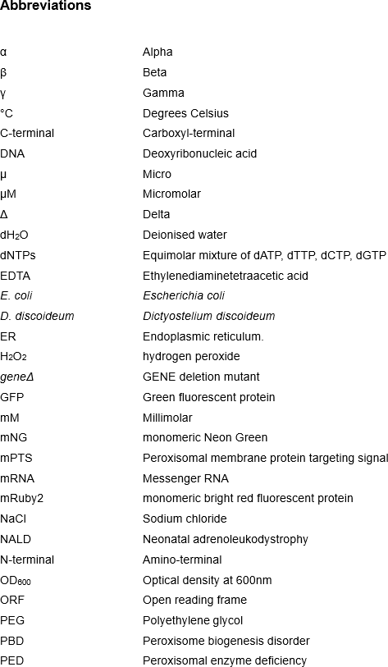

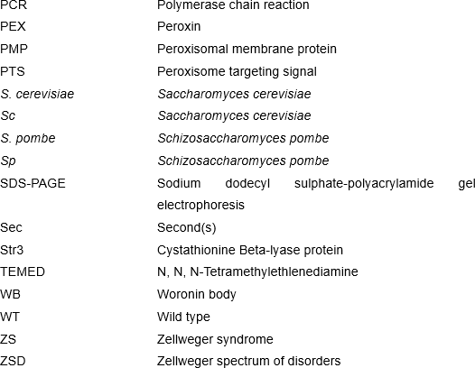

Chapter 1. Introduction

Peroxisomes

Peroxisomes, identified in the early 1950s through biochemical means in mouse kidney cells (Baudhuin et al., 1965), are essential organelles present in most eukaryotic cells (Akşit & van der Klei, 2018; Sibirny, 2016). Typically, peroxisomes exhibit a round shape enveloped by a single lipid layer, with a diameter ranging from 0.1μm to 0.2μm (Kim & Hettema, 2015; Sibirny, 2016; Yuan et al., 2016). These organelles play crucial roles in cellular processes, including β-oxidation of fatty acids and detoxification of hydroxy peroxide (H₂O₂) (Sibirny, 2016; Yuan et al., 2016), housing various enzymes such as oxidases and catalase. Peroxisomes also engage in diverse metabolic and non-metabolic functions depending on their environment (Akşit & van der Klei, 2018; Kim & Hettema, 2015; Yuan et al., 2016).

While peroxisomes universally share functions like fatty acid β-oxidation and H₂O₂ detoxification across eukaryotes, specific functions can vary between species or change in response to environmental conditions (Fidaleo, 2010; Camões et al., 2015). In humans, for instance, peroxisomes perform unique functions such as alpha (α) oxidation of fatty acids, D-amino acid and purine degradation, biosynthesis of ether lipids, polyunsaturated fatty acids, and bile acids (Camões et al., 2015; Subramani, 1993). Mammalian peroxisomes also facilitate essential metabolic processes, including lysine, oxygen, and polyamine metabolism (Wanders & Waterham, 2006). In plants, peroxisomes are involved in processes like photorespiration (Kao et al., 2018), and in yeasts, they play a crucial role in the glyoxylate cycle in addition to fatty acid β-oxidation (van den Bosch et al., 1992). Filamentous fungi utilize peroxisomes for the final stage of β-lactam antibiotics synthesis (Klei et al., 2006), while in S. cerevisiae, lysine biosynthesis concludes within peroxisomes, mediated by enzymes like Lys1, peroxisomal malate dehydrogenase (Mdh3), and glycerol-3-phosphate dehydrogenase (Gpd1) (Al-Saryi et al., 2017).

Woronin bodies (WBs) represent a distinct type of peroxisome found in over 50 species of filamentous fungi, playing a crucial role in repairing damaged hyphae by quickly filling septal pores (Kiel et al., 2006; Tenney et al., 2000). Glycosomes, another type of peroxisome, are present in certain parasitic protists like kinetoplastida, including trypanosomatids, and house enzymes for glycolysis (Lorenz et al., 1998; Moyersoen et al., 2004; Sibirny, 2016).

Notably, peroxisomes lack their own genome, and peroxisomal proteins are encoded by the nuclear genome. Synthesized in the cytoplasm by free polyribosomes, these proteins are post-translationally targeted to the peroxisomal membrane and imported into the organelle (Baker & Sparkes, 2005; Rucktäschel et al., 2011).

Selected metabolic pathways

Peroxisomal oxidation and respiration

Peroxisomal respiratory pathway was the first function identified in rat kidney peroxisomes. The peroxisomes were originally described as compartments containing at least one flavinoxidase producing H2O2 and catalase (De Duve & Baudhuin, 1966). This pathway is based upon the formation of H2O2 by a group of oxidases and the breakdown of the H2O2 by catalase. Among the oxidases discovered are: urate oxidase, D-aminoacid oxidase, L-a-hydroxyacid oxidase A and B (De Duve & Baudhuin, 1966), acyl•CoA oxidase (Osumi & Hashimoto, 1978), glutaryl-CoA oxidase (Vamecq & Van Hoof, 1984), polyamine oxidase (Holtta, 1956), pipecolic acid oxidase (Mihalik & Rhead, 1989; Wandersl et al., 1989), oxalate oxidase (Beard et al., 1985), trihydroxycholestanoyl•CoA oxidase (Schepers et al., 1990), and pristanoyl-CoA oxidase (Wanders et al., 1990). Catalase is known as one of the most essential antioxidant enzymes, that catalyses the decomposition of H2O2 to H2O and O2 and is

mostly located in peroxisomes. Therefore, it is considered as a reliable marker enzyme of these organelles not only in animals but also in plants cells. Interrelationship between uric acid metabolism and reactive oxygen species (ROS) in plants (Corpas et al., 2019). The pathway is classified amongst cytosol, peroxisomes, and ER but some of the key enzymes, such as the ROS-generating xanthine oxidoreductase and urate oxidase, together with the xanthine metabolites, uric acid and allantoin, have been established to be present in plants peroxisomes (Corpas et al., 2019). However, in contrast to most mammals, human peroxisomes are lack of urate oxidase (Rao et al., 1988).

Fatty acid β oxidation

β oxidation of fatty acids occurs in mitochondria and peroxisomes in many organisms such as animals and some fungi whereas it takes place only in peroxisome in others such as yeast and plants cells (Camões et al., 2015). In mammalian cells, medium and long chain fatty acids are processed in mitochondria, while very long chain and branched chain fatty acids undergo initial β-oxidation in the peroxisome (Fidaleo, 2010; Lazarow and Fujiki, 1985; van den Bosch et al., 1992). As a result, studies by
Camões et al. (2009) and Schrader et al. (2013) have reported a direct relationship between these two organelles, which is commonly referred to as the peroxisome- mitochondrion connection (Camões et al., 2015).

Fatty acid β oxidation was first identified in glyoxysomes, specialized peroxisomes found in plant cells, particularly in the cotyledons of germinating seeds (Cooper & Beevers, 1969) and subsequently in rat liver peroxisomes (De Duve & Baudhuin, 1966). The β oxidation pathway in mitochondria and peroxisomes are the same except for that in peroxisomes, the first reaction is an oxidation reaction by an acyl-CoA oxidase (ACOX) enzyme while in mitochondria is this equivalent step is mediated by acyl-CoA dehydrogenases (Camões et al., 2015; Fidaleo, 2010). Both oxidases and dehydrogenases are involved in oxidation reactions. However, the products of their reactions can vary depending on the specific substrates and electron acceptors involved. Oxidases catalyse oxidation-reduction reactions using dioxygen as the electron acceptor, resulting in the formation of either H2O or H2O2 as a by-product (van den Heuvel et al., 2001). In contrast, dehydrogenases transfer electrons from a substrate to an electron carrier molecule, such as NAD⁺ or FAD. The products of

dehydrogenase reactions can vary depending on the specific substrate being oxidized. For example, alcohol dehydrogenase catalyses the oxidation of alcohols to aldehydes or ketones, with the transfer of electrons to NAD⁺ to form NADH (Pelmont et al., 1989).

Before β -oxidation can start, a fatty acid needs to be activated and imported into peroxisomes. In this step a fatty acid is activated to acyl-CoA by acyl-CoA synthetase. This step occurs outside peroxisomes in mammalian cells, but it could also occur inside peroxisomes e.g., MCFAs in yeast. The acyl-CoA ester is translocated across the peroxisomal membrane via the peroxisomal ABC transporters ABCD1-3. The enzymes directly involved in peroxisomal fatty acid  oxidation is well-known, and oxidation occurs in 4 enzymatic steps to yield acetyl-CoA (figure 1.1). 1) Acyl-CoA oxidase oxidizes acyl-CoA to 2-trans-enoyl-CoA during which hydrogen peroxide is formed. 2) Hydration by 2-enoyl-CoA hydratase results in the formation of 3- hydroxylacyl-CoA. 3) Dehydrogenation of 3-hydroxylacyl-CoA creates 3-keto acyl- CoA, using NAD⁺ as electron acceptor. In addition, redox shuttles deoxidize NADH to NAD⁺ (Al-Saryi et al., 2017; van Roermund et al., 2003). 4) Finally, thiolytic cleavage of 3-ketoacyl-CoA results in the formation of acetyl-CoA, and an acyl-CoA which is now 2 carbon atoms shorter than the original fatty acid substrate (van Roermund et al., 2003). This mechanism repeats until the fatty acid has been totally degraded in for instance yeast, with the final round of degradation yielding two acetyl-CoA species. In mammals, VLCFAs shortened by peroxisomal β oxidation leave peroxisomes as MCFAs or LCFAs and are further oxidized by mitochondrial β oxidation.

In cells, the generation of energy by β oxidation is necessary for metabolic processes (Reddy & Hashimoto, 2001). In conclusion, this process involves four reactions which are accomplished by Oxidase, Hydratase, Dehydrogenase, and Thiolase enzymes (Sibirny, 2016).

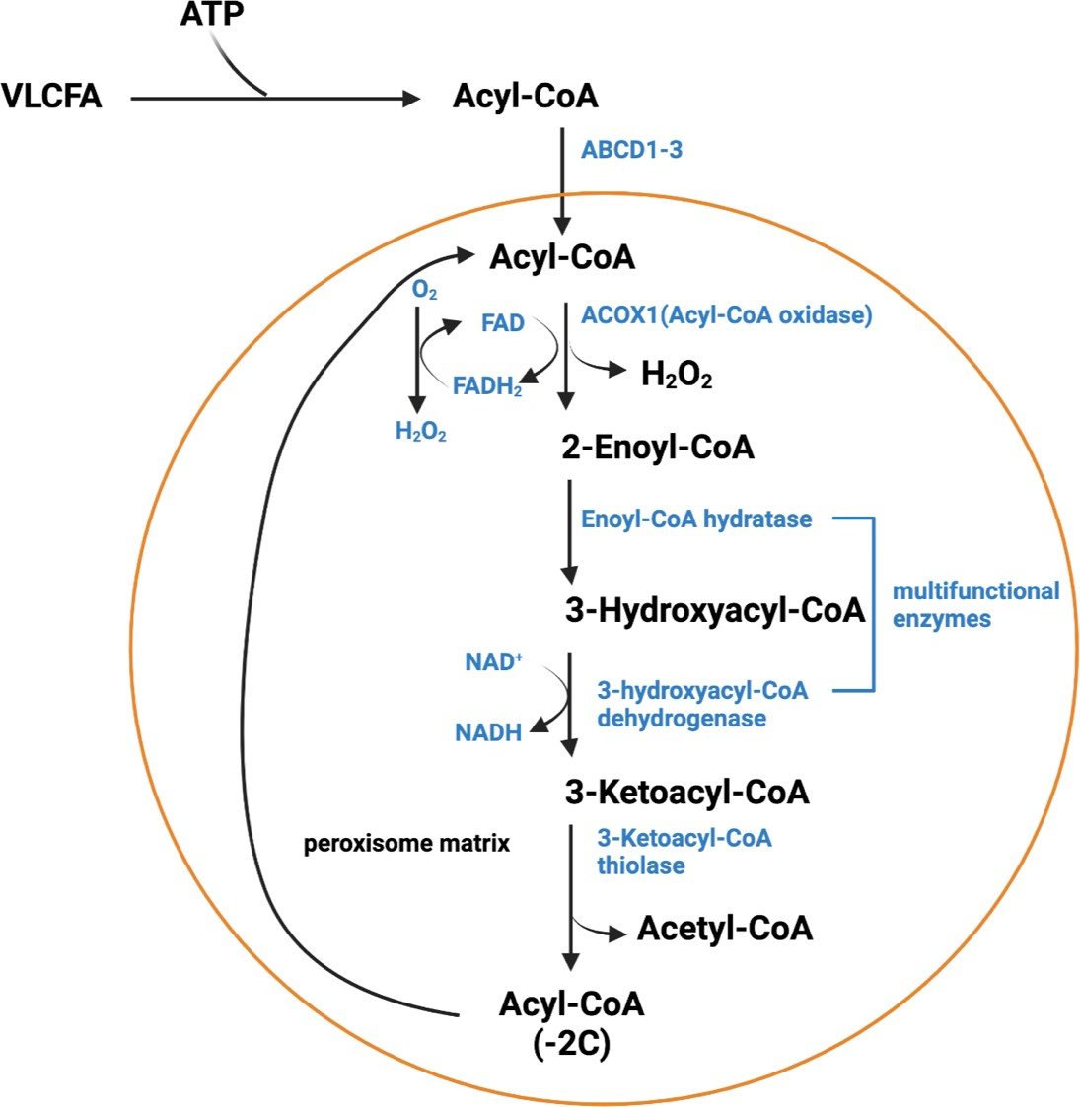

Figure 1. 1 Schematic representation of peroxisomal fatty acid β oxidation pathway. There are four subsequent reactions in peroxisomes to accomplish β oxidation of fatty acids in addition to an activation step, whereby coenzyme A is conjugated onto form an acyl-CoA ester. This step occurs outside the peroxisome which includes membrane-bound (very-) long-chain acyl-CoA synthetases because (very-) long-chain fatty acids cannot cross the peroxisome membranes by diffusion. Import of the activated long-chain fatty acids into the peroxisome is achieved by specific ABC transporter of subfamily D.

The four enzymatic activities of peroxisomal fatty acids β-oxidation enable the degradation of saturated fatty acids through sequential steps of dehydrogenation, hydration, a second dehydrogenation and thiolytic cleavage. However, the degradation of mono- and polyunsaturated fatty acids, which contain double bonds, requires the presence of auxiliary enzymes such as the NADPH-dependent 2,4- dienoyl-CoA reductase, the ∆3, ∆2-enoyl-CoA isomerase, and NADP-dependent isocitrate dehydrogenase isoenzymes to remove the double bonds (Goepfert et al., 2005; Schulz & Kunau, 1987; van Roermund et al., 2003). Studies have shown that Δ3-cis-Δ2-trans- enoyl-CoA isomerase is involved in the removal of double bonds at odd-numbered positions, whereas an NADPH- dependent 2,4-dienoyl-CoA reductase

is required to remove double bonds at even-numbered positions (Goepfert et al., 2005; Schulz & Kunau, 1987). In eukaryotes, either 2-trans,4-cis-dienoyl or 2-trans,4- trans- dienoyl-CoA is converted to 3-trans-enoyl-CoA via the catalytic action of the enzyme 2,4-dienoyl-CoA reductase. In mammals, the β-oxidation of unsaturated fatty acids requires the presence of 2,4-dienoyl-CoA reductase (encoded by the Decr gene) in both mitochondria and peroxisomes (Schulz & Kunau, 1987). The subcellular localization of NADPH- dependent 2,4-dienoyl-CoA reductase in S. cerevisiae was also found in peroxisomes (van Roermund et al., 1998). The ∆3, ∆2-enoyl-CoA isomerase enzyme converts a 3-cis- or 3-trans-enoyl-CoA molecule into 2-trans-enoyl- CoA. In many organisms, ∆3, ∆2-enoyl-CoA isomerase activity has been found in both multifunctional and monofunctional enzymes involved in the core β-oxidation cycle. In the yeast S. cerevisiae, both ∆3, ∆2-enoyl-CoA isomerase and 2,4-dienoyl-CoA reductase are essential for the metabolism of fatty acids containing cis-double bonds on even-chain carbons, such as petroselinic acid (6-cis-octadecenoic acid). In plants, both enzyme activities have been identified, but their corresponding genes have not yet been characterized (Behrends et al., 1988; Engeland & Kindl, 1991). This enzyme has been extensively studied in S. cerevisiae and mammals, but its function in plants is not yet well understood. In animal cells, the enzyme is thought to play a role in the degradation of conjugated fatty acids, such as 9-cis-11-trans-octadecadienoic acid (Ren & Schulz, 2003). It has also been implicated in one of the complementary pathways for the degradation of fatty acids with uneven double bonds (Gurvitz et al., 1999; Shoukry & Schulz, 1998). The third enzyme involved in the degradation of unsaturated fatty acids is NADP-dependent isocitrate dehydrogenase, IDP3, which is localized exclusively to peroxisomes in S. cerevisiae. As for all enzymes and transporters and main peroxisomal redox shuttle enzymes, expression of this enzyme is induced during growth on fatty acids as sole carbon source. Cells lacking IDP3 are unable to oxidize mono- and polyunsaturated fatty acids with double bonds at even positions (van Roermund et al., 1998).

Sterol metabolism

In 1865, bisphosphonate drugs (BPs) were first produced in Germany (Fleisch, 1998). BPs prevent excessive osteoclast-mediated bone resorption (osteoporosis). This medication is classified into two different ways. There is the non-nitrogen containing group (N- NBPs) such as etidronate and clodronate which induces osteoclast apoptosis, while alendronate is an example of a drug in the other group (a nitrogen- containing group “NBPs”) which is more effective than the N-NBPs group drugs in treating osteoclasts and prevents farnesyl diphosphate synthase enzyme (FDPS)- the essential enzyme for activating the final two steps of the mevalonate pathway (Green, 2004). Moreover, NBPs also stop the growth of D. discoideum by targeting FDPS (Nuttall et al., 2012). This enzyme is fascinating because it serves as the focal point for remedies known as nitrogen-containing bisphosphonates NBPs (Grove et al., 2000).

In 1958, the mevalonate pathway (MVA) in animals was first identified by Conrad Bloch, while in the same year, this pathway was first noted in yeasts by Feodor Lynen (Yang et al., 2021). The mevalonate pathway is found in mammals, plants, fungi, archaebacteria and algae, excluding chlorophytes, and in some protozoa such as Trypanosoma and Leishmania. It was firstly thought to be cytosolic.

It has been suggested that the mevalonate pathway takes place in different cellular compartments such as the ER and peroxisomes (Kovacs et al., 2007). It was proposed that two enzymes of the mevalonate pathway, mevalonate kinase and farnesyl diphosphate synthase, are both located in rat liver peroxisomes (Biardis et al., 1994). Moreover, due to the reduction in the activity of the mevalonate pathway enzymes in Zellweger’s syndrome patients, it was suggested that the peroxisomes are a subcellular location for all enzymes in the pathway (Biardis et al., 1994) although this has later been disputed (Wanders & Waterham, 2006). However, farnesyl diphosphate synthase is found in D. discoideum peroxisomes (Nuttall et al., 2012).

In eukaryotic cells, enzymes involved in the mevalonate pathway also play a crucial role in providing precursors for other pathways. The mevalonate pathway supplies precursors for the synthesis of dolichol, the isoprenoid side chain of ubiquinone, the

sidechain of haem A and for prenylation of the tRNA species (Sapir-Mir et al., 2008; Tholl, 2006). The mevalonate pathway allows eukaryotic cells to convert acetyl-CoA into farnesyl diphosphate (FDP). In plants, the methylerythritol phosphate (MEP) pathway (also known as the non-mevalonate pathway) is generally responsible for supplying prenyl diphosphates used in secondary metabolism. The MEP pathway synthesizes monoterpenes, diterpenes, and tetraterpenes. On the other hand, MVA pathway serves as an alternative source for the same diphosphates involved in the synthesis of monoterpenes, diterpenes, and tetraterpenes. However, the MVA pathway primarily provides the universal precursors needed for synthesizing sesquiterpenes, sterols, triterpenes, and related compounds. (Bergman et al., 2019; Bouvier et al., 2005; Sapir-Mir et al., 2008). FDP may also be needed for protein prenylation. However, the role common to most organisms is the provision of FDP for sterol biosynthesis (Goldstein & Brown, 1990).

Sterol synthesis stands as a pivotal metabolic process prevalent in diverse forms across most eukaryotic cells. Notably, in mammals, cholesterol takes center stage as the major sterol, serving as the precursor for essential cellular components such as vitamin D, steroid hormones, and bile acids. Meanwhile, in the plant kingdom, sterols like campesterol, stigmasterol, and sitosterol play key roles in generating cellular growth hormones, triterpenoids, and brassinosteroids. Fungi, on the other hand, predominantly feature ergosterol as their major sterol, while Dictyostelium primarily contains Dictysterol. It is worth highlighting that Dictyostelium demonstrates versatility by producing stigmostenol and sterol ester as well, expanding the spectrum of sterols within its metabolic repertoire (Rodriguez-Paris et al., 1993).

As a type of lipid, sterols are involved in many cellular processes in eukaryotes. They are essential for cell viability because they regulate membrane permeability, the fluidity of the plasma membrane, and plasma lipoproteins. They also interact with other membrane constituents such as proteins and lipids. Moreover, sterols serve as precursors for steroid hormone biosynthesis, and all sterols are synthesized from squalene (Figure 1.2). In terms of squalene synthase, squalene is made from two molecules of farnesyl diphosphate. Squalene epoxidase converts squalene to squalene epoxide. Subsequently, and dependent on the organism, there are two different pathways. Plants produce cycloartenol from squalene epoxide whereas animals and fungi form lanosterol (Figure 1.2). It has been demonstrated that in the

case of D. discoideum, squalene epoxide is converted to cycloartenol (David Nes et al., 1990) thereby suggesting that the sterol biosynthesis pathway in D. discoideum is analogous to the plant’s pathway (Figure 1.2).

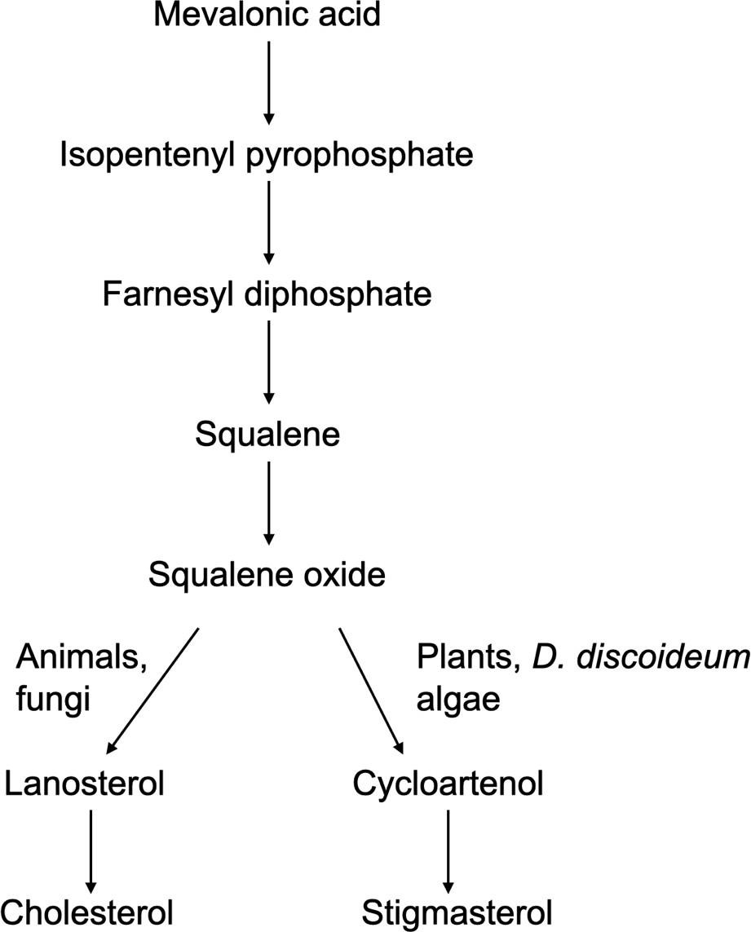
Figure 1. 2 The eukaryotic sterol biosynthesis pathways, which consist of two distinct routes. Lanosterol is produced by animals and fungi, while cycloartenol is synthesized by plants. Furthermore, it has been demonstrated in D. discoideum that cycloartenol originates from squalene epoxide.

Ether lipid synthesis

Lipids can be classified into eight groups: fatty acyls, glycerolipids, glycerophospholipids, sphingolipids, sterol lipids, prenol lipids, saccharolipids, and polyketides. These categories are further divided into groups and subgroups based on different characteristics, such as the presence of ether or ester bonds. In mammals, ether lipids constitute around 20% of the total phospholipid content. Ether phospholipids are essential components of eukaryotic cell membranes. One notable

glycerophospholipid is plasmalogens, which represents a distinct group containing a vinyl-ether bond and is found within cell membranes (Braverman & Moser, 2012).

The biosynthesis of ether phospholipids begins with dihydroxyacetone phosphate (DHAP) within peroxisomes (Kappelt et al., 2020; Rangholia et al., 2021). DHAP is acylated by Dihydroxyacetone phosphate acyltransferase (DHAP-AT/GNPAT) to produce an acyl-DHAP. Acyl-DHAP is then replaced by Alkyldihydroxyacetone phosphate synthase (AGPS) to form alkyl-DHAP (ether bond), which is the product of fatty acyl-CoA reductase 1 and 2 (FAR1/2). In human cells, Far1 is a peroxisomal tail- anchored protein that binds to the peroxisomal Pex19 receptor via the C-terminus (Honsho et al., 2010).

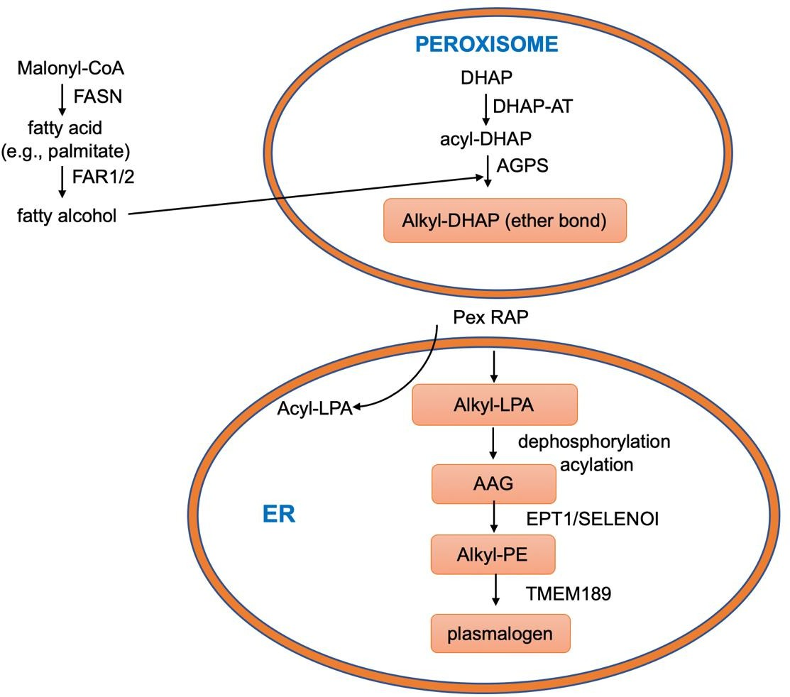
Figure 1. 3 Schematic representation of ether lipid biosynthesis starts in the peroxisome and finishes in ER. (Modified from Rangholia et al., 2021).

In higher plants and their seeds, ether-linked phospholipids make up less than 1% of the overall phospholipids (van den Bosch et al., 1992). The three enzymes essential

for the synthesis of ether phospholipids in mammalian peroxisomes (acyl-CoA: DHAP- AT, alkyl-DHAP synthase, and NADPH alkyl-DHAP oxidoreductase) are absent from plant peroxisomes (van den Bosch et al., 1992). Apart from Pullularia pullulans, most common yeasts such as S. cerevisiae and Hansenula polymorpha have only tiny amounts of plasmalogens (Veenhuis & Harder, 1987). Furthermore, the peroxisomal DHAP-AT involved in ether lipid biosynthesis in mammalian tissues cannot be found in yeast. Mutants of S. cerevisiae defective in sn-glycerol-3-phosphate AT also show loss of DHAP-AT activity, indicating a common structural gene for both activities (Common et al., 1986). In T. brucei glycosomes, a protein similar to DHAP-AT has been discovered. However, it does not participate in ether-phospholipid biosynthesis but rather in the formation of long-chain alcohols (Opperdoes, 1990). The Dictyostelium enzyme FARAT is most closely related to human DHAP-AT and contains a fatty acyl-reductase (FAR) and an acyltransferase (AT) domain in its sequence (Kappelt et al., 2020). Interestingly, the only crystal structure of alkyldihydroxyacetone phosphate synthase eapA (= Human AGPS) from the Dictyostelium enzyme allows for the determination of the exact reaction mechanism in humans (Razeto et al., 2007). By contrast, the aerobic protozoa Tetrahymena pyriformis strains do not contain plasmalogens yet are very abundant in alkyl-acyl glycerophospholipids (Fukushima et al., 1976). The mechanism and localization of the responsible enzymes have not been determined.

Chondrodysplasia punctata (CDP) is a genetically heterogeneous group of bone dysplasias in humans, characterized by stippling of the epiphyses in infancy. It is divided into two types: the Conradi-Hunermann type with autosomal dominant inheritance, and the rhizomelic type with an autosomal recessive mode of inheritance (Spranger et al., 1971). The rhizomelic type has different clinical signs, including extremely short stature affecting mostly the proximal sides of the extremities, a typical facial appearance, genetic contractures, characteristic visual involvement, severe mental and growth retardation, and several radiological deformities, such as shortening, ossification of humeri and/or femora with calcification (Spranger et al., 1971).

RCDP has been recognized as belonging to the group of peroxisomal disorders, including a deficiency of peroxisomal thiolase, phytanic acid alpha oxidation, and two

enzymes that initiate the synthesis of ether-phospholipids in peroxisomes: dihydroxyacetone phosphate acyltransferase (DHAP-AT) and alkyl-dihydroxyacetone phosphate synthase (alkyl-DHAP synthase) (Moser et al., 1995; Wanders et al., 1988). These enzymes are imported via PTS2 pathway and mutations in pex7 lead to RCDP (Motley et al., 1997).

Glyoxylate metabolism

In glyoxylate metabolism, acetyl units are converted to carbohydrates by malate synthase and isocitrate lyase, along with enzymes from the citric acid cycle, in microorganisms and germinating fat-bearing seeds (Tolbert, 1981). This cycle was first identified in the 1950s by Kornberg and Krebs (Ensign, 2006). In germinating castor beans, a compartment consisting of the five enzymes of the glyoxylate cycle is referred to as a "glyoxysome" (Breidenbach & Beevers, 1967). In addition to the glyoxylate cycle, it contains oxidases, catalase, and a β-oxidation system, and based on these features, glyoxysomes are considered to be the plant kingdom variant of mammalian peroxisomes (De Duve, 1983; Rry Beevers, 1979; Tolbert, 1981). In higher plants, during the transition from germinating seeds to seedlings with green leaves, glyoxysomes develop the capacity for photorespiration, in which glyoxylate is formed from glycolate and then converted to glycine by a transaminase (De Duve, 1983; Tolbert, 1981). Additionally, glyoxysomes are transformed into peroxisomes, which are characteristic of green leaves, through sequential changes (Nishimura et al., 1986; Sautter, 1987). T. pyriformis played a significant role in the origin of the phylogenetic relationship between peroxisomes and glyoxysomes (De Duve, 1983). The peroxisomes of T. pyriformis contain two glyoxylate cycle enzymes, isocitrate lyase and malate synthase (Fukushima et al., 1976). Similar to T. pyriformis, the two glyoxylate cycle enzymes, isocitrate lyase and malate synthase, are present in yeast cells grown on C2 compounds such as acetate, ethanol or on compounds that are degraded to C2 compounds such as alkanes and fatty acids (Veenhuis & Harder, 1987). While yeast isocitrate lyase is the only eukaryotic member of this family that is present in the cytosol instead of being targeted to the peroxisome or the glyoxysome (Chaves et al., 1997), Malate synthase Mls1 (Effelsberg et al., 2016; Kunze et al., 2002; Mccammon et al.,1990), Malate dehydrogenase Mdh3 (Elgersma et al., 1996;

van Roermund et al., 1995) and Citrate synthase Cit2 (Lee et al., 2006; Nakatsukasa et al., 2015) have been found in S. cerevisiae peroxisomes.

The glyoxylate cycle is mostly absent from mammalian cells. However, it has been reported that isocitrate lyase and malate synthase are present in several vertebrate tissues, such as the adipose tissue of hibernating bears and the hepatic tissue of rats (Davis et al., 1990).

Table 1. 1 Table 1.1 Main microbody processes. (Modified from van den Bosch et al., (1992).

Nomenclature | Mammals | Plants |  | Yeast | Protozoa
 |  | Seeds | Leaves |  | Tetrahymena | Trypanosoma
Enzyme system | Peroxisomes | Glyoxysomes | Peroxisomes | Peroxisomes | Peroxisomes | Glyoxysomes
Oxidases (H2O2) | + | + | + | + | + | -*
Catalase | + | + | + | + | + | +  -
β oxidation | + | + | + | + | + | +
Glyoxylate cycle | - | + | - | + | + | -*
Ether lipid  synthesis | + |  |  |  |  | +
Photorespiration | - | - | + | - | - | -
Glycolysis | - | - | - | + | - | +
Symbols: +, present; -, absent; ±, present in some but not all species; blank, not yet reported; * present in some species but apparently not located in the microbodies.

Peroxisomal disorders

Since cells depend on peroxisomes for various crucial metabolic processes (Wanders, 2018), any malfunctions in peroxisomal functions lead to inherited diseases (Akşit & van der Klei, 2018; Kim & Hettema, 2015). Peroxisomal diseases can be classified into two categories. The first category is composed of peroxisome biosynthesis disorders (PBDs), while the second category consists of single peroxisomal enzyme deficiencies (PEDs).

The PBDs are a diverse group of inherited disorders characterized by various genetic variations, including the cerebro-hepato-renal or Zellweger spectrum disorders (ZS) (Jo & Cho, 2019; Schutgens et al., 1986). Additionally, there is another condition called rhizomelic chondrodysplasia punctata (RCDP). More recently, a smaller group of

patients has been identified with mutations in genes related to the maintenance of peroxisomes, particularly in genes involved in fission (Waterham et al., 2016). These disorders share a common issue: a general dysfunction in peroxisome functioning caused by a specific defect in one of several processes. The primary cause of most PBDs is attributed to mutations in any of the 13 different PEX genes (Ebberink et al., 2012; Waterham et al., 2016). These genes encode peroxins, which play a critical role in importing proteins into the peroxisomal membrane and/or matrix (Waterham et al., 2016).

Zellweger syndrome is the most severe and prevalent subtype of PBDs, characterized by renal and hepatic dysfunction, brain deformity, and a high mortality rate within the first year of life (Fidaleo, 2010; Klouwer et al., 2015; Wanders, 2018). Other milder forms within the Zellweger spectrum disorders include neonatal adrenoleukodystrophy (NALD), infantile Refsum disease (IRD), and a newly recognized disorder, Heimler syndrome (Fidaleo, 2010; Klouwer et al., 2015; Wanders, 2018).

The lack of peroxisomes in the Zellweger syndrome is associated with a few biochemical defects (Schutgens et al., 1986; Wanders’ et al., 1990; Wanders et al., 1988). First, ether phospholipids biosynthesis is affected leading to a lack of plasmalogens in all tissues. Second, Fatty acids β oxidation is affected because of a lack of β oxidation enzyme proteins. Consequently, an accumulation is observed of very long-chain fatty acids in tissues and blood, and of intermediates in the biosynthesis of bile acids in blood. It has been shown that in Zellweger fibroblasts, the peroxisomal β oxidation enzyme proteins are synthesised normally, but are rapidly degraded (Schram et al., 1986). Third, because of a low level of phytanic acid  oxidation activity and pipecolic acid oxidase, there are defective degradation of phytanic acid and pipecolic acid, respectively (Wandersl et al., 1989). Fourth, many peroxisomal matrix enzymes such catalase, D-amino acid oxidase and L- hydroxy acid oxidase are mislocalized to the cytoplasm (Fujiki et al., 2012). Unusual empty membrane structures peroxisomes called peroxisomal "ghosts" were identified in fibroblasts from Zellweger patients (Carson et al., 1986; Gartner et al., 1991). Clinically milder forms of the Zellweger spectrum disorder, neonatal type of adrenoleukodystrophy (NALD), infantile type of Refsum disease (IRD) and Heimler disease have milder defects in peroxisomes formation and peroxisomal protein import

(Arias et al., 1985; Black & Cornacchia,1986). Heimler syndrome, a condition resulting from mutations with reduced impact on the peroxisome-biogenesis genes Pex1 and Pex6, is a rare genetic disorder. It is characterized by various symptoms such as sensorineural hearing loss, imperfect development of tooth enamel (amelogenesis imperfecta), abnormal nails, and, in some cases, pigmentation issues in the retina that may appear later in life (Ratbi et al., 2015; Varela et al., 2020).

One special group of PBDs are caused by mutations in Pex7, the PTS2 receptor. However, mutations in the PTS2 containing protein alkyl dihydroxyacetone phosphate synthase or alkyl-DHAP-synthase results in the same autosomal recessive disease called rhizomelic chondrodysplasia punctata (RCDP) because of lack of ether lipid synthesis (Motley et al., 1997). The clinical symptoms of this disease include an extremely short stature mainly affecting the proximal parts of the extremities, abnormal facial appearance, severe growth and mental retardation and inherited contractures (Heikoop et al.,1990; Hoefler et al., 1988; Motley et al., 1997).

Peroxisomal fission defects constitute the third group of PBDs. The identification of genetic defects specifically linked to peroxisome division has occurred relatively recently. The delay in recognizing these defects may be explained by the limited presence of biochemical abnormalities associated with peroxisomes in cells derived from these patients (Waterham et al., 2016). There have been only a small number of documented cases where mutations in dynamin-like protein 1 gene (Dlp1), mitochondrial fission factor (Mff), ganglioside-induced differentiation-associated protein 1 (Gdap1), and peroxisomal membrane protein 11B (Pex11β) have been observed (Ebberink et al., 2012; Huber et al., 2013; Shamseldin et al., 2012; Waterham et al., 2007). Despite conducting microscopic examinations of fibroblasts from patients with Dlp1 and Pex11β defects, which revealed evident impairment in peroxisome division, all conventional biochemical indicators of peroxisomes in plasma, erythrocytes, and fibroblasts appeared to be largely unaffected or normal (Waterham et al., 2016).

The other type of defect in peroxisomal function is referred to as single peroxisomal enzyme deficiencies (PEDs) (Fidaleo, 2010; Klouwer et al., 2015; Steinberg et al., 2006; Subramani, 1993). This category encompasses impairments in both peroxisomal matrix enzymes and peroxisomal membrane proteins responsible for

metabolite transport. Examples of disorders within this category include X-linked adrenoleukodystrophy (X-ALD), Acyl-CoA oxidase deficiency, and D-bifunctional protein deficiency, which are associated with peroxisomal fatty acid β-oxidation. Refsum disease is a disorder linked to peroxisomal fatty acid α oxidation. Primary hyperoxaluria type 1 affects peroxisomal glyoxylate metabolism. Disorders related to peroxisomal ether phospholipid biosynthesis include GPAT (DHAPAT) deficiency- RCDP type 2, AGPS deficiency-RCDP type 3, and FAR1 deficiency-RCDP type 4. ABCD3 (PMP70) deficiency and BAAT deficiency are disorders affecting peroxisomal bile acid synthesis. Lastly, Acatalasemia is a disorder associated with peroxisomal H2O2 metabolism (Waterham et al., 2016).

Peroxins biosynthesis and peroxisome biogenesis

PEX genes encode the essential proteins entitled peroxins for the formation or multiplication of peroxisomes (Distel et al.,1966). More than 36 peroxins that have been identified by studying budding yeast and other organisms using genetic screens, DNA microarray techniques for oleic-induced yeast genes, and proteomic assays (Akşit & van der Klei, 2018; Kiel et al., 2006).

The above-mentioned disorders are fatal autosomal recessive diseases caused by impaired peroxisome biogenesis. While ZS patients display the most severe clinical and biochemical defects, patients with neonatal adrenoleukodystrophy (NALD) show a lower level of severity compared to ZS. Meanwhile, individuals with infantile Refsum disease (IRD) and Heimler syndrome exhibit milder features. Cell fusion studies using fibroblast from patients was used in the study of the genetic basis of peroxisome biogenesis disorders (PBDs; MIM 601539) at institutions such as the Academic Medical Centre (AMC) in the Netherlands (Brul et al., 1988), Kennedy Krieger Institute (KKI) in the USA (Roscher et al., 1989), and Gifu University in Japan (Yajima et al., 1992). These studies led to the identification of 15 complementation groups (CGs) in mammals, determined using fibroblasts from patients with PBDs, peroxisome-deficient Chinese hamster ovary (CHO) cell mutants, and yeasts (Wiemer et al., 1996; Ghaedi et al., 2000; Shimozawa et al., 1998).

In human cells, Pex19 binds and stabilizes newly synthesized peroxisomal membrane proteins (PMPs) in the cytoplasm (Shibata et al., 2004). Pex19 also interacts with the peroxisomal targeting signals (mPTSs) of several PMPs, and a portion of cellular Pex19 is associated with the surface of peroxisomes (Halbach et al., 2006; Matsuzono et al., 1999; Schliebs et al., 2010). Loss of Pex19 in vivo results in the degradation and/or mislocalization of PMPs in human cells (Matsuzono et al., 2006; Sacksteder & Gould, 2000), which is further supported by studies in S. cerevisiae showing that both

Pex3 and Pex19 are required for proper PMP localization and stability (Hettema et al.,2000). Importantly, two distinct PMP import mechanisms have been identified: one that is Pex19-dependent, where mPTSs bind to Pex19, and another that is Pex19- independent, where mPTSs do not bind to Pex19 (Nuttall et al., 2011).

This observation with regard to S. cerevisiae led to the identification of the essential genes for peroxisome biosynthesis. This was followed by another which showed that when the budding yeast grows on a medium that has an oleic acid as the sole carbon source, the number of peroxisomes increases, it means that these organelles have an essential role for lipid degradation in S. cerevisiae (Erdmann et al., 1989; Veenhuis & Harder, 1987). Based on these observations, the genetic screening of peroxisome biosynthesis has been undertaken. Therefore, strains which are deficient in peroxisome biosynthesis can’t grow in a medium that contains oleate. Peroxisomes are also important for plasmalogen synthesis, and a genetic screen based on plasmalogen biosynthesis identified peroxisome biosynthesis mutants in Chinese hamster ovary (CHO) cells (Tsukamoto et al., 1988). Subsequently, complementation of the mutants (S. cerevisiae and CHO) led to the identification of some important peroxisomal genes for peroxisome biosynthesis. This was followed by a number of different studies with regard to different yeast such as Hansenula polymorpha, Pichia pastoris and Yarrowia lipolytica (Erdmann et al., 1989; Tsukamoto et al., 1988).

There are two ways in which peroxisomes are formed (Sibirny, 2016). The first is by growth and fission of a previous peroxisome into two (Figure_1.4 A) (Motley & Hettema, 2007). The second is the formation of peroxisomes from other organelles, such as the ER (Hoepfner et al., 2005); this is called de novo formation (Figure_1.4 B). These peroxisome formation methods, particularly the latter, are still the subject of some contention (Aksit et al., 2018).

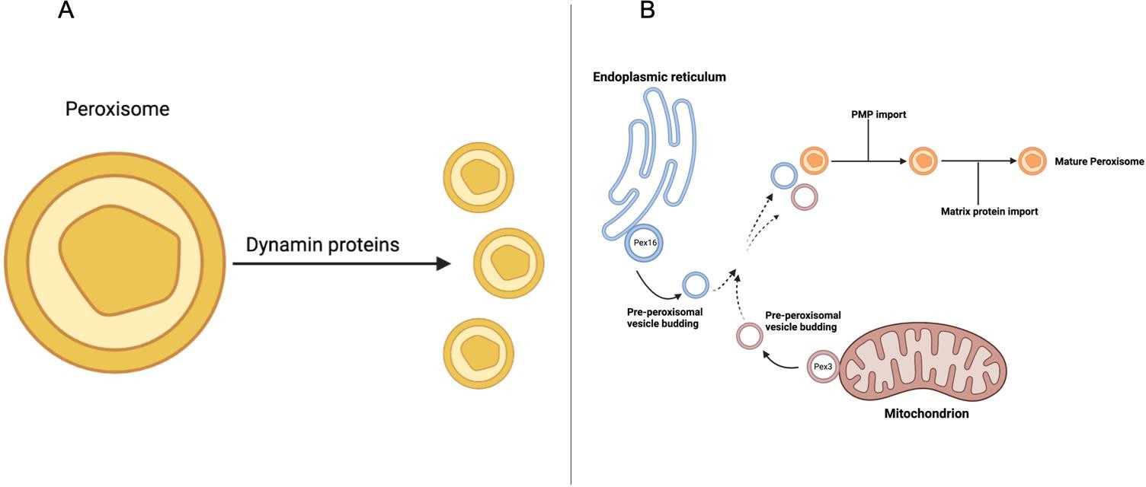

Figure 1. 4 Schematic representation of biosynthesis pathways. A. The growth and fission of a previous peroxisome into a new one. B. The requirement regarding the de novo formation of peroxisomes is a pre-peroxisomal vesicle coming from the ER, together with a vesicle from the mitochondria. This is followed by the import of membrane and peroxisomal matrix proteins.

Peroxisome fission

Peroxisomes are dynamic organelles that can modulate their proliferation, morphology, and movement within cells. By PEX genes and other peroxisomal membrane proteins, peroxisomes can change their number and size (Smith & Aitchison, 2013; Tam et al., 2003; Yuan et al., 2016). In S. cerevisiae, the Pex11 family (Pex11, Pex25 and Pex27) have been well characterized in terms of their role in peroxisome fission, and the overexpression of these genes result in peroxisome proliferation. In mammals there are three isoforms of Pex11-α, β and γ- the same as in filamentous fungi which contain three Pex11p isoforms. These are designated Pex11p, Pex11Bp and the less similar Pex11Cp (Kiel et al., 2006). While S. cerevisiae has a single Pex11 protein, S. pombe Pex11 has a paralog (SPAC1F12.04c). In the case of S. cerevisiae, Pex25p has been shown to interact with Pex27p. However, both proteins are absent in S. pombe.

The dynamin superfamily is a large GTPase family that is responsible for several cellular processes such as endocytosis, cytokinesis and organelles fission including mitochondria, chloroplasts, and peroxisomes (Fujimoto et al., 2019). Mammals have

3 classical dynamins and several dynamin-like proteins. In the case of D. discoideum, there are 5 dynamin-like proteins- dymA, dymB, dlpA, dlpB, and dlpC. The first two are most similar to the yeast proteins Vps1p and Dnm1p, and the mammalian protein DRP1. This group plays a role in peroxisomal and mitochondrial division, vesicle trafficking, and cytokinesis. In S. pombe the DRPs are similar to S. cerevisiae DRPs and it has been found that peroxisome numbers and size in S. pombe cells lacking Dnm1 or Vps1 similar to that in wild type cells. However, the double mutant dnm1∆ vps1∆ contained either no peroxisomes at all, or a small number of morphologically aberrant organelles (Jourdain et al., 2008). Moreover, in S. pombe, vacuole tubulation by Vps1 was more extensive in the absence of a second DRP, Dnm1. Both dnm1∆ and the double mutant vps1∆ dnm1∆ showed vacuole fission defects similar to that of vps1∆ (Figure 1.5 A) (Röthlisberger et al., 2009).

To complete peroxisome fission, there are three steps, peroxisome elongation, in the case of yeasts, Pex11 is responsible for this step (Gandre-Babbe & Van Der Bliek, 2008; Li & Gould, 2003). Following constriction, which is the second step, Dnm1 and Dlp1 (Drp1) are targeted to the peroxisomal membranes by Fis1 (Fission 1), whereas recently it has been shown that Vps1 is targeted by Pex27 in S. cerevisiae (Ekal et al., 2023). Pex11 attaches to Fis1 which employs the yeast peripheral membrane receptors Caf4 or Mdv1 or the mitochondrial fission factor Mff1 in mammalian cells (Figure 1.5 B) (Gandre-Babbe & Van Der Bliek, 2008; Motley et al., 2008).

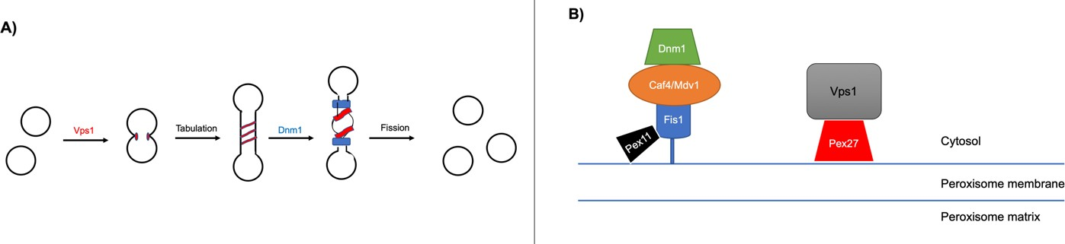

Figure 1. 5 Schematic representation of the role of the dynamin protein family in vacuoles fission, and with regard to Pex11 in peroxisomes fission. (A) Vps1 attaches to the vertices of docked vacuoles (modified from Röthlisberger et al., 2009). From this middle step, vacuoles can engage in either fusion or fission. In the fission pathway, Vps1 acts as a ‘‘tubulase,” which provides a vacuole of appropriate diameter for fission by Dnm1, which is a ‘‘pinchase”. In the absence of Dnm1, tubulated, un-fragmented, vacuoles accumulate; in the absence of Vps1, tubules do not form and Dnm1 cannot cleave. GTPase-dead alleles of Vps1 do not cause membrane tubulation. Consequently, the pitch of the Vps1 helix could reflect the GTP-bound form of the protein (Röthlisberger et al., 2009). (B) The proposed model for the recruitment of fission machinery. Peroxisomal Dnm1 depends upon a number

of factors for its recruitment and activity, including Pex11, Fis1 and Mdv1/Caf4. Recently it has been identified that Pex27 a factor for Vps1-dependent peroxisome fission in S. cerevisiae (Ekal et al., 2023).

Peroxisomal protein import pathway

Peroxisomal matrix protein import pathway

Peroxisomal matrix proteins require specific signals entitled peroxisomal targeting sequence (PTS) to gain access to peroxisomes. Most matrix proteins are targeted via a PTS1 recognized by the soluble receptor Pex5, with a small subset being targeted via a PTS2 recognized by the soluble receptor Pex7 (Rucktäschel et al., 2011; Sibirny, 2016). The PTS1 is located at the extreme C-terminus of the proteins, while the PTS2 is located near the N-terminus (Sibirny, 2016). The conserved tripeptide consensus sequence of PTS1 is (S/A/C)-(K/R/H)-(L/M), while the conserved nonapeptide with the consensus sequence of PTS2 is (R/K)-(L/V/I)-X5-(H/Q)-(L/A), where X refers to any amino acid (Sibirny, 2016). Different organisms exhibit variations in the utilization of these two peroxisomal sequences. For example, Caenorhabditis elegans exclusively relies on the PTS1 pathway. In contrast, plants possess a greater number of peroxisomal proteins that utilize the PTS2 pathway compared to yeast and mammals (Motley et al., 2000; Reumann et al., 2009).

The PTS1 is recognised by Pex5 in the cytosol and this targeting complex docks on the peroxisomal membrane through interactions with the docking complex which comprise Pex13 and Pex14, and in S. cerevisiae also Pex17 (Wróblewska et al., 2017).
In the case of S. cerevisiae, a second condition specific PTS1 receptor is encoded by Pex9, that import a small subset of PTS1 proteins when peroxisomes are proliferating during growth on oleate (Effelsberg et al., 2016; Yifrach et al., 2016). The RING-finger complex, consisting of Pex2, Pex10, and Pex12 and connected to the docking complex through Pex8 (Agne et al., 2003), interacts with Pex5 at a downstream step of the receptor docking process in the import cascade (Chang 1999). The process of Pex5 ubiquitination involves the RING-finger peroxins Pex2, Pex10, and Pex12, which function as ubiquitin ligases. These peroxins add ubiquitin molecules to Pex5, resulting in its ubiquitination (Kiel et al., 2005). Monoubiquitinated Pex5 is then recycled back into the cytosol by the exportomer complex Pex1, Pex6 and Pex26 (Pex15 in yeast) (Figure 1.5 A. In most organisms, Pex5 acts as co-receptor role for Pex7, while Pex20 is the co-receptor for Pex7 in fungi and Pex18/21 in S. cerevisiae (Lanyon-Hogg et al., 2014). The docking of the PTS2 protein-Pex7/Pex20 complex also occurs at the level of Pex13 and Pex14 (Figure 1.6 A).

However, some peroxisomal proteins such as Cu/Zn superoxide dismutase 1 and Pnc1 lack of both PTS1 and PTS2. They are imported into peroxisomes by a non- classical import mechanism called a piggyback which is a protein lacking a PTS is piggyback imported into peroxisomes through its direct interaction with the PTS containing one (Kim & Hettema, 2015; Wanders, 2018). Furthermore, in the case of
S. cerevisiae, acyl-CoA oxidase (Pox1) protein has neither a PTS1 nor a PTS2 and is recognised by the N-terminal domain of Pex5 (Kempiński et al., 2020; Kim & Hettema, 2015; Rymer et al., 2018).It has been shown, using random mutagenesis combined with a two-hybrid screen in S. cerevisiae, that acyl-CoA oxidase has single amino acid residues that are important for Pex5 interaction and for the peroxisomal import of this protein. These amino acids come close to each other within two domains of the folded acyl-CoA oxidase, which do not follow a linear sequence but rather form a signal patch that acts as the PTS3, guiding the protein into the peroxisomal matrix (Kempiński et al., 2020).

Peroxisomal membrane proteins

Peroxisomes in the cells of most Zellweger Spectrum disorder patients are devoid of matrix proteins but contain their membrane proteins. These peroxisomes are known
as peroxisomal ghosts. This indicates that the peroxisomal membrane proteins follow a different import pathway than the matrix proteins (Carson et al., 1986). In some of the rare complementation groups, where Pex3, 16 or 19 are mutated, peroxisomal membrane structures are altogether absent and PMPs are either degraded or mislocalised to ER or mitochondria (Fang et al., 2004; Hettema et al,.1999; Wanders, 2018). It seems that a clear Pex16 ortholog appears to be absent from most yeast genomes (Kiel et al., 2006).

There are two different known pathways for targeting peroxisomal membrane proteins. The first one is via the recognition of a membrane peroxisomal targeting signal (mPTS) by Pex19. This peroxin is found mainly in the cytosol, with small amounts found on the peroxisomal membrane (Götte et al., 1998; Sacksteder & Gould, 2000). Pex19 acts as a chaperon and as a cytosolic receptor and the PMP is then released into the peroxisome membrane (Figure 1.6 B) (Fujiki et al., 2006; Fang et al., 2004). Most PMPs are inserted into the peroxisomal membrane via this pathway and are referred to as Class I PMPs. The other mechanism is known as the Class II PMPs import pathway via ER. In this class Pex19 is not required and only a few PMPs are imported into peroxisomes via this mechanism (Hua et al., 2015; Tam et al., 2005).

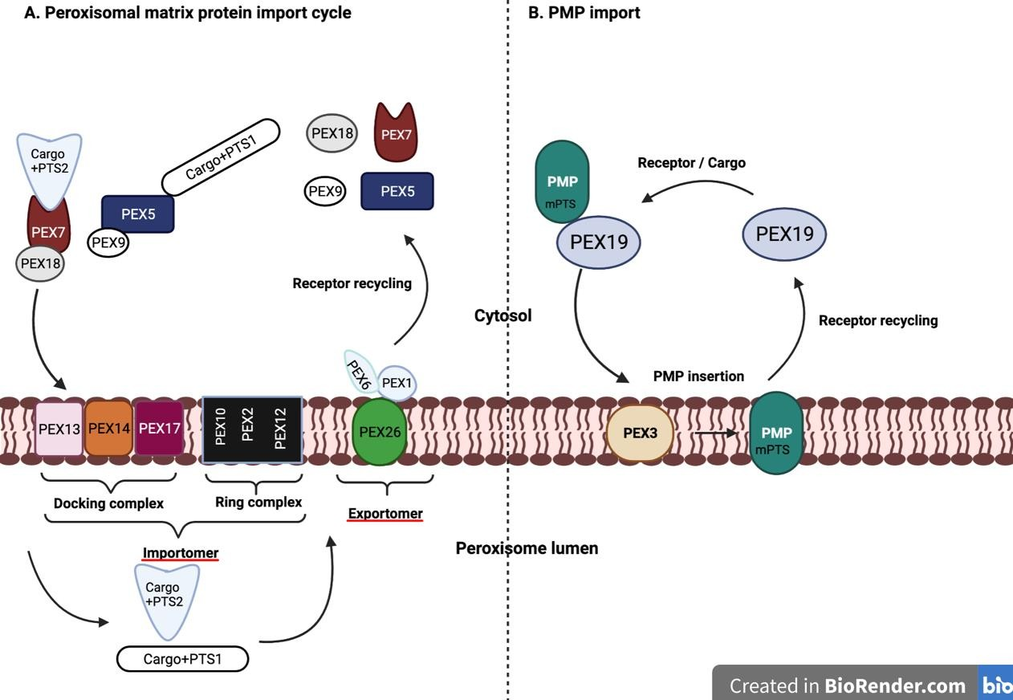

Figure 1. 6 Schematic representation of peroxisomal protein import pathways in yeast cells. Peroxisomal matrix proteins require specific signals PTS1 or PTS2 “A” and the import of peroxisomal membrane proteins “B”. peroxisomal membrane proteins “PMPs” (right) are recognized in the cytosol by Pex19 which docks at the peroxisomal membrane mediated by Pex3.

Organisms used in this study

Yeasts as Ideal Organisms for Biotechnology Research

Budding yeasts, such as S. cerevisiae, and fission yeasts, such as S. pombe, are ideal organisms for biotechnology research for several reasons. First, they are eukaryotic unicellular living organisms with membrane-bound organelles, making them ideal for some new pathways. Second, these yeasts have powerful genetic tools and can live as either diploids (cells with two sets of chromosomes each) or haploids (cells with one set of chromosomes each). Desired phenotypes produced from mutant alleles that lead to the reduction or loss of function are detected in haploid cells, not in diploid ones. Diploid cells are used to determine the number of genes identified in a genetic screen, and to assess whether a mutant allele is dominant or recessive to a wild-type allele. Third, these yeasts have homologous recombination systems that can be used

to change genes or introduce new genes. Fourth, autonomously replicating plasmids are available for these yeasts. Because of all these genetic tools, it is possible to construct strains designed to optimally perform in biotechnology processes. Finally, these yeasts can grow under various conditions, such as oxygen limitation, low pH, and temperature changes, making them ideal biotechnology hosts (Duina et al., 2014; Hoffman et al., 2015).

S. cerevisiae

Since the invention of bread, the budding yeast S. cerevisiae has been extensively studied for its metabolic regulation in order to improve bread manufacturing processes (Hoffman et al., 2015). During the process of budding in yeast, cell division occurs in asymmetrical division, resulting in the formation of two cells: an older cell (the parent cell) and a younger cell (the daughter cell) (Lord & Wheals, 1980). Additionally, studies have shown that under certain conditions, S. cerevisiae can switch between haploid and diploid states (Hoffman et al., 2015; Duina et al., 2014).

The publication of the complete genome sequence of S. cerevisiae in 1996 led to the development of biotechnology approaches and many technologies (Botstein & Fink, 2011). A deletion library for nearly all open reading frames (ORFs) of the budding yeast has been created, followed by a similar one for the fission yeast S. pombe (Botstein & Fink, 2011; Kim et al., 2010) Each yeast gene has been mutated by replacing it with a drug-resistant one, and marked with a synthetic sequence, allowing for the biological role of many of the genes to become well-known (Botstein & Fink, 2011).

Another type of gene mutation is the introduction of green fluorescent protein (GFP) fusion technology, which allows for the visualization of most proteins or gene interactions and localizations (Botstein & Fink, 2011). This has led to the creation of the Saccharomyces Genome Database (SGD), which provides information about any Saccharomyces gene. Almost 1000 yeast genes are members of orthologous gene families related to human disease (Botstein & Fink, 2011). Studies of S. cerevisiae and
S. pombe have greatly contributed to clarifying the cellular role of genes and proteins in the scientific community (Botstein & Fink, 2011).

S. cerevisiae has been used in groundbreaking research leading to Nobel Prizes in Physiology or Medicine. Yoshinori Ohsumi, the 2016 Nobel Prize winner, studied S. cerevisiae for his discoveries of mechanisms for autophagy, while in 2013, Randy W. Wexler, James E. Rothman, and Thomas C. Südhof won the Nobel Prize for their discoveries of key regulators of the cell cycle, using S. cerevisiae in their research (Hohmann, 2016). In 2001, Leland Hartwell, Paul Nurse, and Tim Hunt won the Nobel Prize for their discoveries of key regulators of the cell cycle, with Hartwell working with
S. cerevisiae and Nurse with S. pombe (www.nobelprize.org) (Hohmann, 2016).

S. pombe

Fission yeast has risen in popularity as a model organism for more than half a century (Hoffman et al., 2015). As aforementioned, S. pombe is one such yeast; it has a constant diameter and grows by increasing in length (Forsburg & Rhind, 2006). Furthermore, its cells are rod-shaped and have four cycle stages: G1 (10%), S (10%), G2 (70%), and M (10%) (Forsburg & Rhind, 2006).

S. pombe and S. cerevisiae probably separated 700 million years ago (Forsburg & Rhind, 2006; Hoffman et al., 2015). This discovery noted that S. pombe was more conserved in regard to genes than S. cerevisiae because the latter lost about 338 conservative genes since the separation (Forsburg & Rhind, 2006; Hoffman et al., 2015). Furthermore, S. pombe is sometimes called a micro-mammal yeast because, in contrast to budding yeast, the genome of fission yeast is haploid and the similarity between this type of yeast and mammalian cells is closer than other yeasts (Forsburg & Rhind, 2006; Hoffman et al., 2015). Therefore, S. pombe has been considered an ideal host for expressing human proteins with therapeutic and drug applications (Verma et al., 2014). However, S. pombe has had limited use in biotechnology so far. Good expression systems amenable to industrial use have not yet been developed for
S. pombe, even though there are expression vectors available for research aims (Giga-Hama et al., 2007).

Although S. pombe is a different type of yeast than S. cerevisiae, the instruments and procedures used to study the two yeasts are similar (Forsburg & Rhind, 2006). Using these procedures, significant insights have been obtained in biology by employing S.

pombe (Forsburg & Rhind, 2006). However, medial fission is the way of division of S. pombe, and it is used to study its length, which indicates which cell cycle stage the yeast is in (Forsburg & Rhind, 2006).

Slime mold D.discoideum

D. discoideum, a slime mold amoeba, is a valuable eukaryotic cell model organism for understanding various signaling and developmental mechanisms in higher eukaryotes. For example, conserved processes such as cellular communication, intracellular signalling, and cytoskeletal dynamics have been discovered in various eukaryotic forms (Escalante & Vicente, 2000; Parent & Devreotes, 1996). D. discoideum was first discovered by Raper in 1935. It is evolutionarily situated between plants and fungi on the eukaryotic phylogenetic tree (Eichinger et al., 2005) (Figure 1.7). However, D. discoideum seems to be more closely related to plants and animals than fungi and yeasts because fungi and yeast have a faster rate of divergence compared to plants and animals (Insall, 2005).

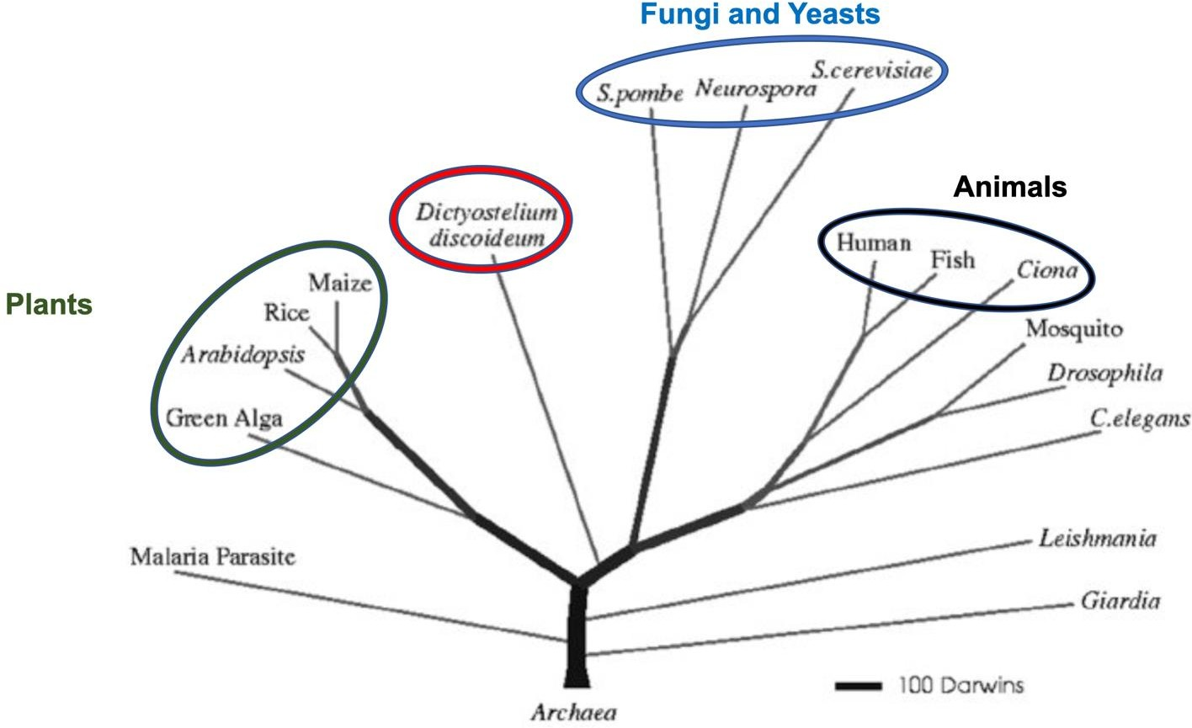
Figure 1. 7 The position of D. discoideum on phylogenetic tree of eukaryotes, edited from (Eichinger et al., 2005). D. discoideum is positioned between plants on one side and fungi and yeasts on the other side.

The genome of D. discoideum was fully sequenced and published in 2005, and its complete genome sequence is available in the D. discoideum database (dictybase.org) (Eichinger et al., 2005). D. discoideum has six chromosomes with a haploid genome that is rich in adenine (A) and thymine (T) nucleotides (77.57%). Additionally, it has a higher number of simple sequence repeats (SSRs) than any other known sequenced genomes (Eichinger et al., 2005).

The life cycle of D. discoideum is unique in that it contains two separate stages - a motile unicellular stage and a multicellular stage and multiple cell type (Annesley & Fisher, 2009). In the vegetative (growth) form, the amoeba exists as motile unicellular amoebae using bacteria as its main food source. However, when nutrients become depleted, D. discoideum can aggregate and progress through a developmental production process, producing a multicellular fruiting body that contains a stalk and spore cells. When D. discoideum begins to starve, cells accumulate to form loose and tight hills of cells (stages 1 and 2). A migrating slug then forms (stage 3), or they grow into a "finger" (stage 4). Afterward, a Mexican hat appears (stage 5) leading to the final form of the fruiting body (stage 6) (Figure 1.8) (Escalante & Vicente, 2000). Based on this process, the term "social amoeba" was suggested.

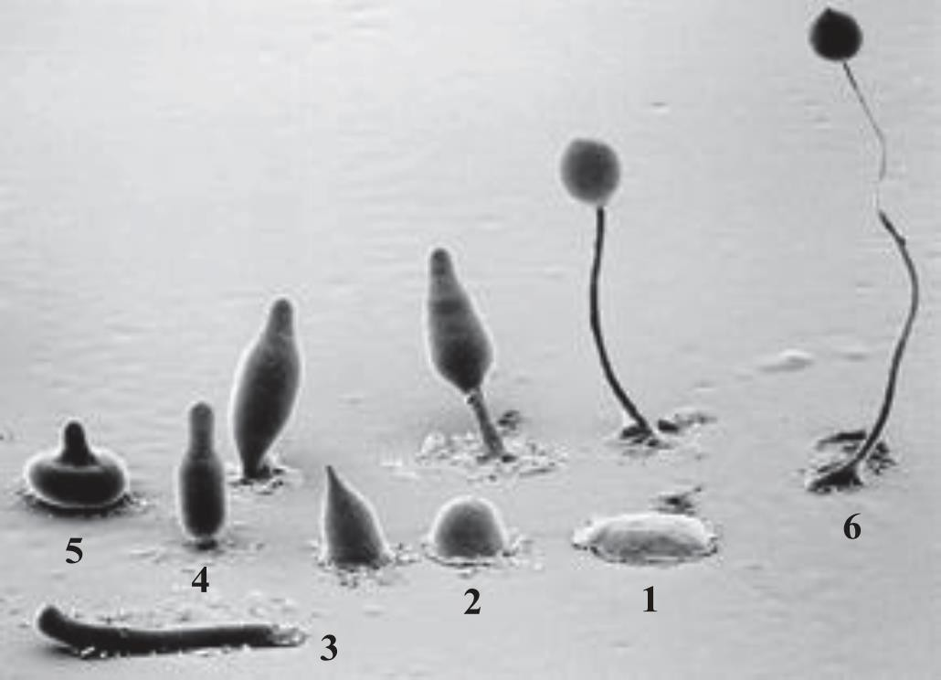
Figure 1. 8 Composite electron micrograph of the developmental stages of D. discoideum during starvation. © M.J. Grimson & R.L. Blanton.

Bacteria are the natural source of food for the free-living wild type D. discoideum, which feeds on bacteria through a process called phagocytosis. However, D. discoideum can also obtain nutrients from a liquid medium through micropinocytosis. Various mutations have been created to allow the amoebae to grow in a semi-defined liquid medium without a bacterial food source (axenic culture) (Watts & Ashworth, 1970). This enables researchers to conduct biochemical experiments and visualize live cells.

Aim and objectives of the overall thesis

The study aimed to elucidate peroxisome function in S. pombe and D. discoideum through a comprehensive investigation employing various methodologies. The specific objectives were:

- Identification of peroxisomal proteins by comparing them to known proteins in other organisms and analyzing conserved potential peroxisomal targeting sequences (PTS).
- Application of bioinformatics analysis to tag specific proteins in the S. pombe genome, with subsequent expression of these proteins in S. cerevisiae to study the metabolic role of peroxisomes in S. pombe. Additionally, investigating the function of certain genes responsible for peroxisomal fission and inheritance in S. pombe through knockout experiments and labeling with peroxisomal markers (Chapter 3).
- Examination of the regulation of peroxisome number under different growth conditions in D. discoideum and exploration of the role of the dymA gene, the first gene of dynamins, in peroxisome fission in D. discoideum (Chapter 4).
- Utilization of a proximity labelling approach known as BioID to identify components involved in peroxisomal import and contents (Chapter 5).

Chapter 2. Material and methods

Chemicals and enzymes

The majority of substances, primers, and materials employed in this research were provided by MERCK (formerly Sigma-Aldrich). Restriction enzymes and their associated solutuions were provided by New England Biolabs (NEB). Solutions for polymerase chain reaction (PCR), deoxyribonucleotide triphosphates (dNTPs), DNA polymerases, and kits for Miniprep were given by Bioline UK. Gel extraction kits were provided by Qiagen. Ingredients comprising growth media were provided by Difco Laboratories and ForMedium. D-Glucose was made by Fisher Scientific UK. Apparatus employed for handling DNA and protein work was procured from BioRad. Solutions essential for protein-related procedures were contributed by Geneflow.

Strains and plasmids

Strains

Table 2.1 shows the strains used in this study, with gene deletions or modifications performed as described in (Longtine et al., 1998). The strains include Sc: Saccharomyces cerevisiae Sp: Schizosaccharomyces pombe, Dh: D hansenii, Dd: Dictyostelium discoideum.
Table 2. 1 The strains used in this study.

Strain | Genotype | Source | Organism
BY4741 WT | MATA his3-1 leu2-0 met15-0 ura3-0 | Euroscarf | Sc
BY4742 WT | MATα his3-1 leu2-0 lys2-0 ura3-0 | Euroscarf | Sc
pex3∆ | BY4741 pex3∆::KanMX4 | Euroscarf | Sc
pex3∆ | BY4742 pex3∆::kanMX4 | Euroscarf | Sc
NCYC102 D  hansenii | D hansenii NCYC 102 (national collection  of yeast culture) | NCYC | Dh
YEH117 WT | Ura4,leu1, 32 h- | Van Ian Hagan | Sp
pex3∆ | pex3∆:: kanMX4 ade6-M216 ura4-D18  leu1-32 | Bioneer | Sp

pex5∆ | YEH117 pex5∆:: KanMX4 | This study | Sp
pex5∆ | YEH117 pex5∆:: HphMX6 | This study | Sp
str3∆ | BY4741str3∆:: HisMX6 | This study | Sc
pex5∆ str3∆ | BY4741 pex5∆::Leu2 str3∆:: HisMX6 | This study | Sc
WT Lys3-mNG | YEH117 Lys3:: Lys3-mNG-hphMX6 | This study | Sp
WT Lys3-GFP | YEH117 Lys3:: Lys3-GFP- KanMX4 | This study | Sp
WT Lys3-mRuby2 | YEH117 Lys3:: Lys3-mRuby2-KanMX4 | This study | Sp
pex3∆ Lys3-mNG | Pex3∆:: kanMX4 Lys3::Lys3-mNG-hphMX6 | This study | Sp
pex5∆ Lys3- mNG | pex5∆ :: KanMX4 Lys3:: Lys3-mNG-  hphMX6 | This study | Sp
WT Str3-mNG | YEH117 Str3:: Str3-mNG-HphMX6 | This study | Sp
WT Str3-GFP | YEH117 Str3:: Str3-GFP- KanMX4 | This study | Sp
pex3∆ Str3-mNG | Pex3∆:: kanMX4 Str3::Str3-mNG-HphMX6 | This study | Sp
pex5∆ Str3- mNG | pex5∆ :: KanMX4 Str3:: Str3-mNG-  HphMX6 | This study | Sp
WT Pex3-mNG | YEH117 Pex3:: pex3-mNG-HphMX6 | This study | Sp
WT Pex11-mNG | YEH117 Pex11:: pex11-mNG-HphMX6 | This study | Sp
WT Pex11 paralog-  mNG | YEH117 Pex11:: pex11 paralog-mNG-  HphMX6 | This study | Sp
inp2∆ Lys3-mNG | inp2∆:: kanMX4 Lys3::Lys3-mNG-hphMX6 | This study | Sp
vps12∆ Lys3-mNG | vps1∆:: kanMX4 Lys3::Lys3-mNG-hphMX6 | This study | Sp
dnm1∆ Lys3-mNG | dnm1∆:: kanMX4 Lys3::Lys3-mNG-  hphMX6 | This study | Sp
mdv1∆ Lys3-mNG | mdv1∆:: kanMX4 Lys3::Lys3-mNG-  hphMX6 | This study | Sp
WT Pmp20-mNG | YEH117 Pmp20:: Pmp20-mNG-HphMX6 | This study | Sp
WT Fat2-mNG | YEH117 Fat2:: Fat2-mNG-HphMX6 | This study | Sp
Ax2 | axeA2, axeB2, axeC2 | Robert Kay | Dd
dnmA- | DymA∆, abp1∆, myoB∆::blasticidinS  (Merck). | (Gopaldass et  al., 2012) | Dd

Table 2. 2 Escherichia. coli strains used in this study.

Strains | Genotype | purpose | source
Electroporation  competent DH5α | supE44 ΔlacU169 (Φ80 lacZ ΔM15)  hsdR17 recA1 endA1gyrA96 thi-1 relA1 | Amplification of  plasmid and recovery of plasmid DNA from S. cerevisiae subsequent to vivo homologous  recombination. | (Hanahan, 1983)

Chemically competent  DH5α | supE44∆lacU19 6 (Φ 80 lacZ (Φ  80M15)  hsdR17 recA1 endA1  gyrA96 thi-1 relA1 | Creation of cloning  structures and the process of expressing plasmid DNA | (Hanahan, 1983)

Plasmids

In S. cerevisiae, plasmids were constructed using a homologous recombination-based method or through restriction digest and ligation, followed by transformation into E. coli. Ycplac33 and Ycplac111 were used as backbone vectors (Daniel Cietz & Sugino, 1988). N-terminal tags were introduced between SacI and BamHI sites, while C- terminal tags were introduced between PstI and HindIII sites. Promoters between EcoRI and SacI. Open reading frames were inserted into the remaining restriction sites in the multiple cloning sites.

The integrated cassettes (tags with selection markers) in the S. pombe genome were from Longtine plasmids (Longtine et al., 1998). Meanwhile, for random tag knock-in of the D. discoideum genome, the pDM1514 plasmid was utilized (Paschke et al., 2018). The backbone BirA-R118G vector in D. discoideum was pIS77 with a G418 selective marker (Batsios et al., 2016). A list of plasmids used in this study (Table 2.3).

Table 2. 3 The plasmids used in this study.

Extrachromosomal vector plasmids
Plasmid name | insert | Primers | Backbone  vector | Organism
pYM08 | SpStr3p | Vip4472F  Vip4473R | pEH116 | Sc
pYM19 | SpStr3 | Vip4310F  Vip4311R | pAA28 | Sc
pYM04 | SpLys3 | Vip4308F  Vip4309R | pYM02 | Sc
pYM19 | ScStr3 | Vip4652F  Vip4653R | pYM04 | Sc
pYM23 | Spinp2 | Vip4892F  Vip4893R | pYM5 | Sc
pYM21 | SKL | p1514SKLfw | p1514 | Dd

 |  | p1514SKLrv
pYM22 | SKL | pPB87SKLfw  pPB87SKLrv | pPB87 | Dd
Gene knock-in plasmids
Gene + marker | Selective  marker | Primers | Plasmid | Organism
SpLys3+ mNG | HphMX6 | vip4417F  vip4418R | pGH59 | Sp
SpLys3+ GFP | kanMx6 | vip4417F  vip4418R | pFA6a-kanMX6-  PGAL1-GFP | Sp
SpLys3+ mRuby2 | kanMx6 | vip4417F  vip4418R | pGH60 | Sp
SpPex3+ mNG | HphMX6 | vip4764F  vip4765R | pGH59 | Sp
SpStr3+ mNG | HphMX6 | vip4595F  vip4596R | pGH59 | Sp
SpStr3+ GFP | kanMx6 | vip4595F  vip4596R | pFA6a-kanMX6-  PGAL1-GFP | Sp
SpPex11+ mNG | HphMX6 | Vip3748F  Vip3749R | pGH59 | Sp
SpPex11paralog  + mNG | HphMX6 | Vip4906F  Vip4907R | pGH59 | Sp
SpPmp20+ mNG | HphMX6 | Vip4873F  Vip4874R | pGH59 | Sp
SpFat2+ mNG | HphMX6 | Vip4875F  Vip4876R | pGH59 | Sp
mRFP+SKL | HphMX6 | SKLbglspe_fw  SKLbglspe_rv | pYM21 | Dd
Gene knock-out plasmids
knocked-out  gene | Selective  marker | Primers | Plasmid | Organism
Scstr3∆ | HIS3 | Vip4541F  Vip4542R | pUG27 | Sc
Scpex5∆ | Leu2 | Vip4610F  Vip4611R | pUG73 | Sc
Sppex5∆ | kanMx6 | Vip4740F  Vip4741R | pUG6 | Sp
Sppex5∆ | HphMX6 | Vip4740F  Vip4741R | pAG32 | Sp

Spinp2∆ | kanMx6 | Vip4899F  Vip48900R | pUG6 | Sp
Spvps1∆ | kanMx6 | Vip4987F  Vip4988R | pUG6 | Sp
Spvps1∆ | HphMX6 | Vip4987F  Vip4988R | pAG32 | Sp
Spdnm1∆ | kanMx6 | Vip4989F  Vip4990R | pUG6 | Sp
Spdnm1∆ | HphMX6 | Vip4989F  Vip4990R | pAG32 | Sp
Spmdv1∆ | kanMx6 | Vip5001F  Vip5002R | pUG6 | Sp
Spmdv1∆ | HphMX6 | Vip5001F  Vip5002R | pAG32 | Sp

DNA procedures

Polymerase chain reaction (PCR)

PCR is commonly used to amplify regions of genomic DNA or plasmids. Velocity™ DNA polymerase was used for proofreading PCR to ensure high-fidelity amplification, while MyTaq™ DNA polymerase was used for PCR knock-out and colony PCR. Components were introduced to the PCR reaction on ice, with the DNA polymerase added in the final step. For colony PCR, a sterile pipette tip was used to pick a single colony from a plate and inoculate it into the PCR reaction mix. The PCR reagents used in this study are listed in Table 2.4.

Table 2. 4 The PCR reagents used in this study.

Component | MyTaqTMDNA polymerase | VELOCITYTMDNA  polymerase
Template | 1μl of 1/50 diluted plasmid  DNA (5-10ng) or 1μl gDNA | 1μl of 1/50 diluted plasmid DNA  (5-10ng) or 1μl gDNA
Reaction buffer | 10µl 5x MyTaq buffer | 5μl 5x Hi-Fi buffer
Forward primer | 5µl (5µM) | 5μl (5μM)
Reverse primer | 5µl (5µM) | 5µl (5µM)
dNTPs | _ | 5μl dNTP’s (0.5 mM)

DNA polymerase | 0.2µl of 5U/µl | 0.25μl (2.25 unit)
dH20 | 27.8µl | 28.75μl
Total volume | 50µl | 50µl

PCR conditions were set up as the table 2.5. PCR conditions.

Table 2. 5 PCR conditions.

Steps | MyTaqTM DNA  polymerase | VELOCITYTM  DNA polymerase
Initial denaturation | 95°C 2min | 98°C 3 min
Denaturation | 95°C 30sec | 98°C 30sec
Annealing | 50-65°C 30sec | 50-65°C 1min
Elongation | 72°C 30sec/kb | 72°C 15sec/kb
Final elongation | 72°C 10min | 72°C 10 min
Termination | 10°C | 10°C

The annealing temperature for each individual primer was dependent upon its nucleotide composition and was calculated as follows: 4x (number of G + number of C) + 2x (number of A + number of T). The melting temperature was then subtracted by 5°C to give us the approximate annealing temperature.

Annealing oligos

The primers were annealed generating the following mixture: 0.5µl 100 µM forward primer
0.5µl 100 µM reverse primer 8µl of dH2O
1µl 10 X annealing buffer: 400mM Tris-Hcl PH=8.0
200mM mgCl2 500mM NaCl
The annealing mixture was heated to 95°C for 5 minutes and then cooled slowly to room temperature.

Plasmid miniprep
Plasmids were isolated from 5mL of E. coli DH5α cells grown overnight in 2TY medium with a selective antibiotic, using the Qiagen miniprep kit. The miniprep was performed according to the manufacturer’s protocol, followed by measuring the concentration of plasmids using a Nanodrop.

Plasmid maxiprep

For the maxiprep, plasmids were isolated from 250 mL of E. coli DH5α cells grown overnight in LB medium with a selective antibiotic, using the Qiagen maxiprep kit, followed by measuring the concentration of plasmids using a Nanodrop.

DNA purification

PCR products for tagging the S. pombe genome were purified using the PCR purification kit from Qiagen, and the protocol was followed.

Ethanol precipitation of DNA

The purified DNA products were precipitated with ethanol before integration into the
S. pombe genome. For each sample, 1/10 volume of 3M Na Acetate pH 5.5 was added to the PCR products and mixed with 2.5 volumes of ice-cold 100% ethanol. The mixtures were kept at -20°C for a few hours or overnight. The tubes were then spun at maximum speed in a cold centrifuge for 30 minutes. The ethanol was carefully pipetted off, leaving behind the DNA pellets. To wash the pellets, 400µL of ice-cold 70% ethanol was added without mixing and spun for 3 minutes. This step was repeated before the ethanol was removed and the pellets were left to air dry. Finally, the pellets were resuspended in the required amount of H2O.

Agarose gel electrophoresis

PCR items, plasmids, plasmids that have been cleaved, and DNA that have been removed from gel were analyzed by agarose gel electrophoresis and examined using an ultraviolet transilluminator imaging system (Gene Genius). An appropriate quantity

of agarose was dissolved in TBE buffer (1mM Tris-base, 0.1M Boric acid, 1mM EDTA, pH 8.0) to establish gels of 0.5% to 1% (weight/volume) concentration, contingent upon the size of the DNA fragments. Ethidium bromide was supplemented until a final concentration of 0.5µg/mL was reached. Before loading the samples onto the agarose gel, DNA loading buffer (5x loading buffer, NEB) was added to achieve a final 1x concentration. DNA size was estimated by comparison to the 1 kb DNA ladder from Bioline. The gel was run in 1x TBE running buffer at a constant voltage of 90-95V for 35 minutes.

DNA digestion and gel extraction

The DNA cleavge was conducted using restriction enzymes within a compelete volume of 25μl. 1μg of DNA was digested with 1μl of the appropriate restriction enzyme and 2.5μl of 10x NEB CutSmartTM buffer, and the final volume was made up by adding ddH2O. The digestion mixtures were incubated at 37°C for 4 hours to overnight. The digested DNA was then separated by agarose gel electrophoresis.

To extract DNA from the gel, the gel was observed using a UV transilluminator emmitting long-wavelength light, and the specific DNA section was carefully removed from the gel using a sterile scalpel. Subsequntly, the DNA fragments were purified utilizing the QIAquick Gel Extraction Kit (Qiagen), adhering to the instructions provided by the manfacture.

DNA ligation by T4 ligase

The components were added together in a total volume of 20μl, containing 2μl of 10x ligation buffer, 1μl T4 ligase (NEB), and varying ratios of double-digested PCR product/linearized vector (~50 ng), and the reactions were made up to 20μl with dH2O. The identical procedure was simultaneously executed, with the exception that the PCR product was omitted as a negative control. The mixtures were allowed to incubate at room temperature throughout the night and subsequntly introduced into chemically competent E. coli cells the following day.

Homologous recombination

The homologous recombination-based DNA editing technique was applied for clone genes, insert tags or genes, either within a vector or into the yeast genome. This technique is also employed for gene deletion in yeasts.

Plasmids construction in S. cerevisiae

To construct the desired plasmids, PCR was used to amplify the inserts. The primers were constructed to guarantee that the PCR output was flanked by roughly 18 nucleotides, which were homologous to the insertion sites in the plasmid. The vectors were then digested at the insertion site using restriction enzymes. The linearized vector and PCR products were co-transformed into S. cerevisiae using a high- efficiency transformation protocol. The co-transformation of the vector and the PCR product enabled homologous recombination between the ends of the vector and the PCR product, closing the gap in the plasmid (gap-repair), and allowing for the plasmid to replicate in S. cerevisiae cells (Figure 2.1).

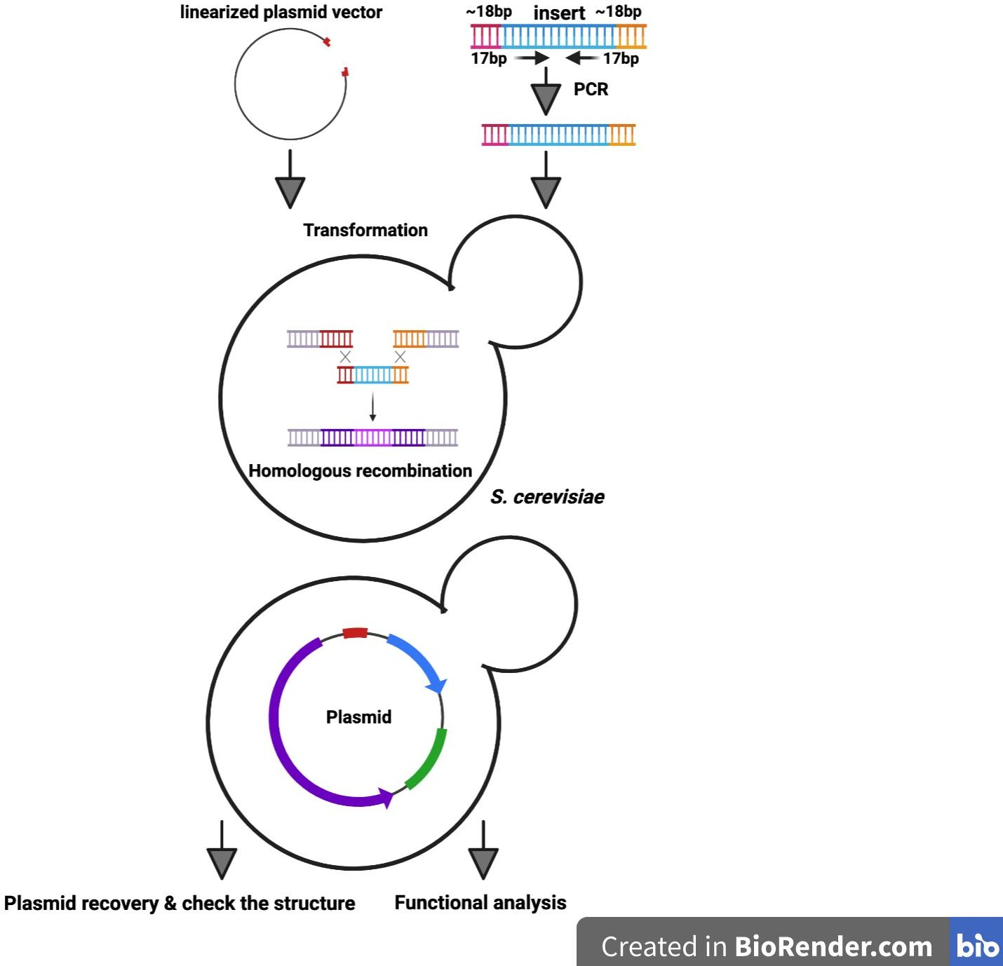
Figure 2. 1 The proposed model for plasmids construction by homologous recombination in S. cerevisiae.

Knockout or gene deletion in S. cerevisiae and S. pombe

PCR was used to amplify the knockout cassette selection marker. The forward primer contains 50 nucleotides identical to the region upstream of the ORF start codon in S. cerevisiae and at least 80 nucleotides identical to the same region in S. pombe (Red) (Gregan et al., 2006). The reverse primer contains 50 nucleotides identical to the sequence downstream of the ORF stop codon in S. cerevisiae and at least 80 nucleotides identical to the same region in S. pombe (Blue) (Figure 2.2). Subsequntly, the PCR fragment was introduced into yeast cells and cultured on the apprporiate

selective medium. Accurate clones were discerened throghuh PCR to validate the alteration in the genome.

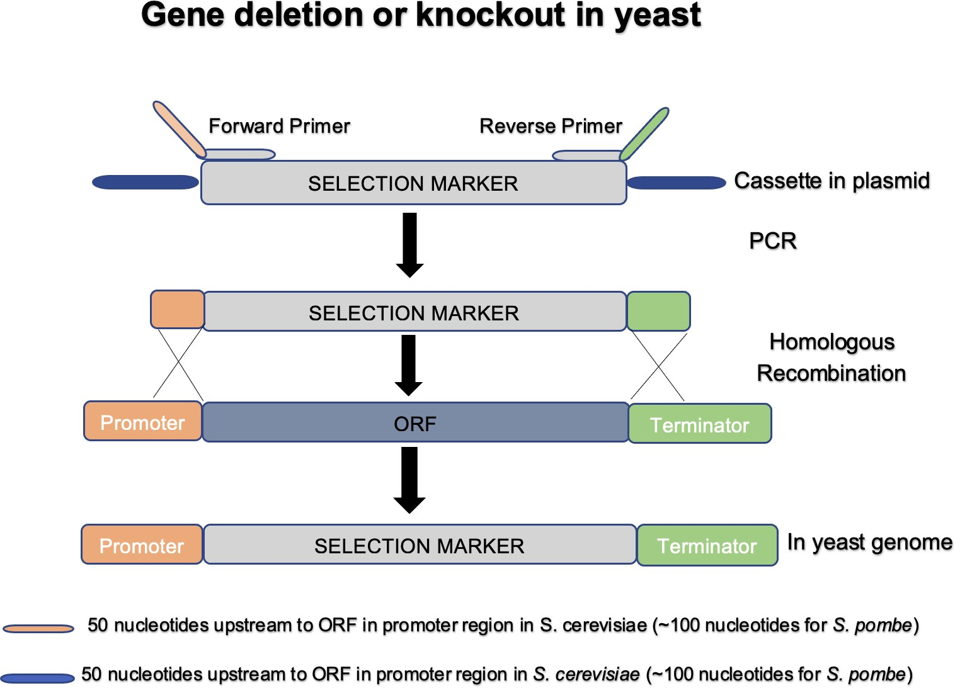

Figure 2. 2 Construction of knockout by homologous recombination in S. cerevisiae and S. pombe.

C- terminal genome tagging in S. pombe

PCR was used to amplify the tags with selection marker. Forward primers were conceived to encompass no less 80 nucleotides that matched to the region directly preceding the stop codon, whereas the reverse primer integrated a minimum of 80 nucleotides following the stop codon. The PCR outcomes were introduced into S. pombe cells through a high efficiency transformation and grown on appropriate selective medium. The precision of the clones was verified by PCR (Figure 2.3).

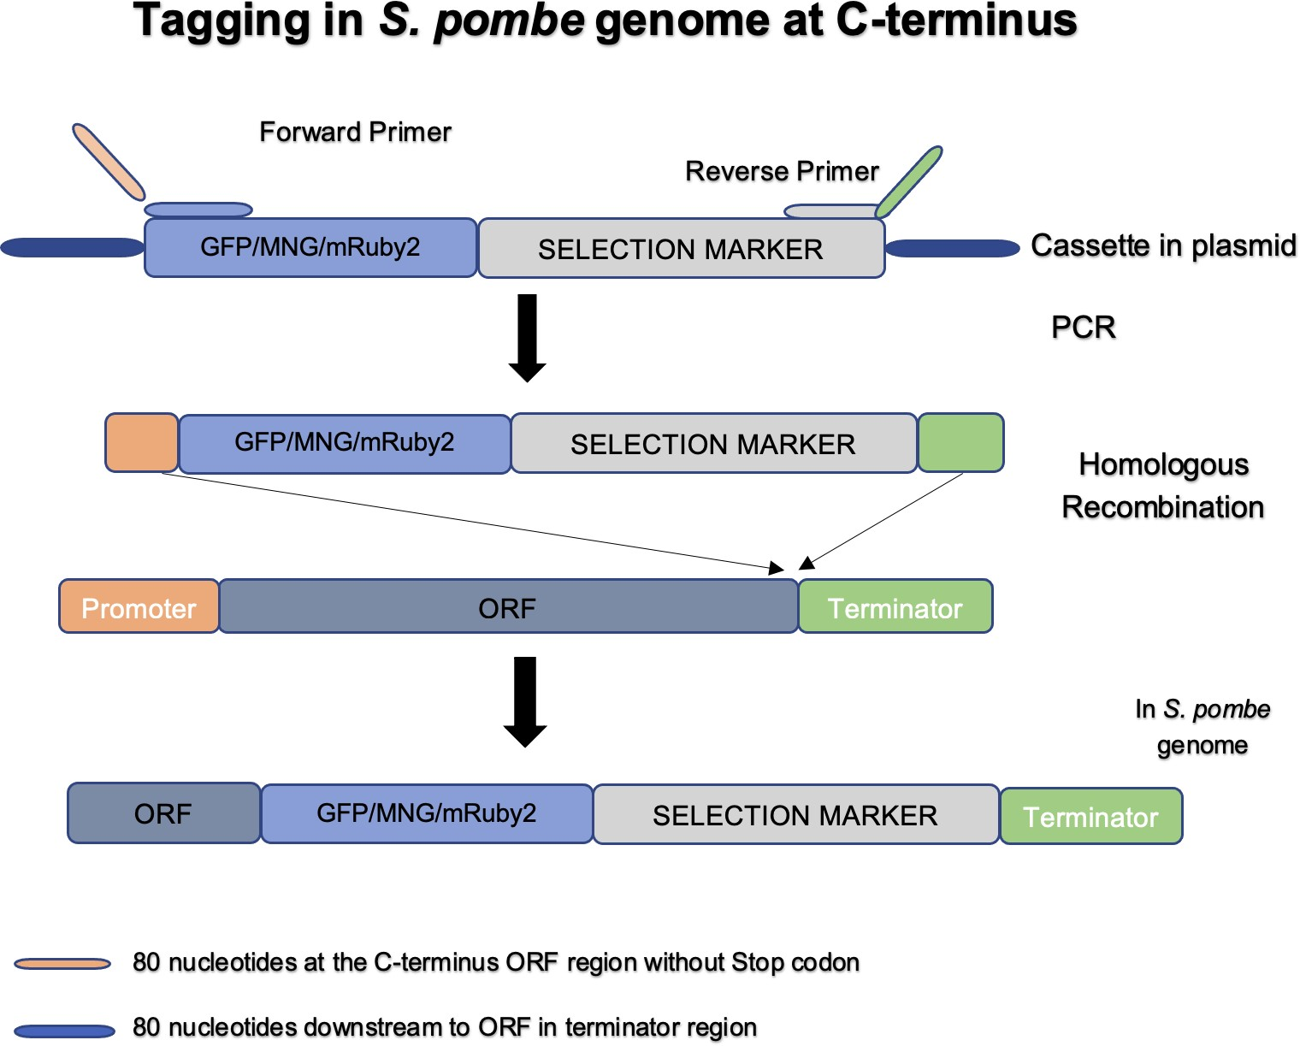

Figure 2. 3 Schematic representations of the methods used method for the C-terminal genome tagging in S. pombe.

DNA sequencing
The C-terminal genome tagging in S. pombe and the plasmid clones in S. cerevisiae and D. discoideum were sequenced by Source Bioscience, and the sequence data were analyzed using SnapGene and the online multiple sequence alignment tool ClustalW.

Growth Media

Millipore water was used to dissolve all of the ingredients for the cell growth media. The media were sterilized using different methods: autoclaving at 121°C for yeasts and filtration for D. discoideum. Finally, appropriate antibiotics were added to the

media to achieve their final concentration if antibiotic resistance selection was required.

Table 2. 6 Growth media used in this study.

Culture media | Organism | Description
2TY | E. coli | 1.6%Bacto tryptone, 1%yeast extract,  0.5%NaCl. Ifantibiotic-resistance  selection was required, Ampicillin(75μg/ml) were added.
LB | E. coli | 10 g Peptone 140.  5 g Yeast Extract.  5 g Sodium Chloride.
YPD | S. cerevisiae | Yeast extract (1%), peptone (1%), D-glucose  (2%).
Yeast extract + supplements (YES) | S. pombe | 0.5% (w/v) yeast extract. 3.0% (w/v) glucose. 225mg/l adenine, histidine, leucine, uracil and lysine.  YES + lipid sources:  For oleate Tween40 mix (1:4): 625µl in 100 total media.  For 1%Tweens media: 1ml of tweens in 100ml total media.  For 1% Oleic acid medium: 1ml of oleic acid in 100ml total media.  Lipid sources were filtered and then added after  the medium autoclaved.
HL5 | D. discoideum | HL5 (Formedium, HL60102) 35.5g/liter in water. Substance name:  Peptone Yeast Extract  Potassium dihydrogen phosphate Disodium hydrogen phosphate  Glucose
SIH | D. discoideum | L-Arginine L-Asparagine L-Aspartic Acid L- Cysteine Ammonium chloride KH2PO4 L-Glutamic Acid Glycine L-Histidine L-Isoleucine Calcium chloride Glucose L-Leucine L-Lysine L-Methionine L-Phenylalanine FECl3 Vitamins L-Proline L- Threonine L-Tryptophane Valine  Magnesium Chloride Micro Elements
Bacterial growth | D. discoideum | K. pneumoniae laboratory strain
Ice-cold freezing medium | D. discoideum | 45%HL-5, 45% horse serum, 10% DMSO
Yeast minimal  media 1(YM1) | S. cerevisiae | 0.5%Ammonium sulphate, 0.17% yeast nitrogen  base, 2%glucose. Adjusted to pH 6.5.
Yeast Minimal  Media 2(YM2) | S. cerevisiae | 0.5% Ammonium sulphate, 0.17% yeast  nitrogen base, 2% glucose, 1%casamino acids. Adjusted to pH 6.5.

Amino acid and  nucleic acidbase | S. cerevisiae | The essential amino acids weresupplemented  to YM1 and YM2 media as needed; in the form of 100x stocks (0.2% histidine, 0.3% leucine, 0.3% lysine, 0.2% methionine, 0.2%  tryptophan, 0.2% uracil)
Dropout supplements | S. cerevisiae | YM1 dropout media were formulated using -Leu- Ura-His, -Ura-His dropout supplements from ForMedium, negating the necessity individually  incorporting amino acids at times.
Solid Media | All | A 2% agar concentration was introduced into the liquid cultivation solution, which was subsequntly sterilizied through autoclaving. Once autoclaved, the solution was cooled dwon and dispensed into sterile Sterilin petri dishes, where it solidified at  ambient temperature, Ultimately, the plates were kept in cold storage.

Yeasts protocols

Yeasts growth maintenance

Both S. cerevisiae and S. pombe strains were cultivated at 30°C on either liquid or solid media. Amino acids and uracil were added to the plates as required for auxotrophic strains. Antibiotics were used to select for cassettes conferring resistance. For long-term storage, yeasts were grown overnight, and 15% (v/v) glycerol stocks were prepared and stored at -80°C.

One step transformation

S. cerevisiae strains were grown in 3mL of YPD liquid media at 30°C overnight on a shaker set at 200 rpm. 200μl of the overnight culture was then centrifuged for 60 seconds at 12,000 rpm in an Eppendorf tube and the supernatant was carefully removed. Next, 5μl (50μg) of single-stranded DNA (ssDNA) from Salmon sperm was added and vortexed, followed by the addition of ~1µl of plasmid DNA (100ng-500 ng) and another round of vortexing. Finally, 50μl of one-step buffer (0.2M LiAc pH 5.0, 40% (w/v) PEG 4000 (polyethylene glycol), 0.1M DTT) was added and mixed well before the incubation period. The mixture was then incubated for approximately 6 hours at room temperature with occasional vortexing. Afterward, the mixture was heat-shocked

at 42°C for 30 minutes, and the resulting cell suspension was plated onto appropriate selective media. The plates were then incubated at 30°C for 3 days.

High efficiency transformation

High efficiency transformation in S. cerevisiae

For creating S. cerevisiae plasmids and knockout strains, the high-efficiency yeast transformations protocol using the lithium acetate procedure was followed, as reported by (Zhang & Reese, 2006). The S. cerevisiae strains were incubated overnight in 5ml of YPD liquid medium at 30°C with shaking at 200 rpm. The following morning, the optical density (OD600) of the culture was measured, and the appropriate amount of overnight culture was added to a new YPD culture (5ml per transformation) starting with an OD of 0.1, which was allowed to grow to mid-log phase (~0.3-0.8 OD). The cells were then harvested by centrifugation at 3000 rpm for 3 minutes, and the supernatant was discarded. The pellet was washed twice with 1 ml of freshly prepared 1X TE/LiAc solution, and then resuspended in 50µL of 1X TE/LiAc solution. Next, 5µL (50µg) of single-stranded DNA (ssDNA) were added and vortexed. Then, 5µl of digested vector (0.2-0.5µg) and 5µl of PCR product (50µg) were added and vortexed again, before leaving the mixture for 10 minutes at room temperature. After that, 300µL of sterile, filtered 40% PEG solution was added to the mixture and further mixed by vortexing. The reaction was left at room temperature for 30 minutes and then incubated at 30°C for another 30 minutes, followed by heat shock in a hot water bath at 42°C for 15 minutes. The cells were then spun down at 5000rpm for 1 minute, and the supernatant was completely discarded. The pellet was resuspended in 50 µL of 1X TE, and the cells were plated on selective media and incubated at 30°C for 3 days. In instances where antibiotic resistance markers such as G418 and Hygromycin B were used, cells were first recovered for 3-4 hours in liquid YPD medium before being spread onto YPD plates containing the appropriate antibiotic.

Table 2. 7 Components of the solutions required for high efficiency S. cerevisiae transformation.

Reagents | Stock

1xTE/Lithium Acetate solution | 1ml 10xTE (0.1M Tris-HCl and 0.01M EDTA) (pH  7.4) 1ml 1M Lithium Acetate solution (pH 7.5) 8ml dH2O
40% Polyethylene Glycol solution | 3.2ml 50% (w/v) PEG 4000 dissolved in Millipore  water 0.4ml 10x TE (0.1M Tris-HCl and 0.01M  EDTA) (pH 7.4) 0.4ml 1M Lithium Acetate (pH 7.5)
1xTE | 1ml 10xTE (0.1M Tris-HCl and 0.01M EDTA) (pH  7.4) 9ml dH20

High efficiency transformation in S. pombe

For C-terminal genome tagging in S. pombe and the creation of knockout strains, the high-efficiency yeast transformation protocol by the lithium acetate procedure was used, as reported by Kumar Rai et al. (2018). A starter culture was set up during the day by inoculating ~25 or 50 µl into ~ 50ml of YES media, and the culture was incubated at 30 °C with shaking at 200 rpm overnight. The following morning, when the OD600 reached around 0.7 (~1x107 cells/ml), which is mid-exponential phase, the cells were harvested by centrifugation at 3,000rpm for 3 min. The pellet was washed with sterile water and spun again at 3,000rpm for 3 min. The cells were washed twice with 5ml of LiAc/TE and spun at 3,000rpm for 3 min. Then, the pellet was resuspended in 1ml of LiAc/TE, transferred to an Eppendorf tube, and centrifuged at 5,000rpm for 1 min. The supernatant was discarded, and the pellet was resuspended in ~250 µl of LiAc/TE (the pellet should reach the 150µl line on the Eppendorf tube. If the pellet is higher, more LiAc/TE should be added, and vice versa). Next, 2µl of sonicated salmon sperm DNA (10mg/ml) was added to 100µl of cells (for each transformation), followed by vortexing. Then, ~10µg of purified DNA linear cassettes was transformed to integrate into the chromosome of S. pombe. The mixture was incubated at room temperature for 10 min before adding 260µl of 40% PEG and incubating at 30°C for
~3-4 hrs. After incubation, 43µl of DMSO (di-methyl sulfoxide) was added, then the mixture was transferred to a water bath at 42°C for 5 min for heat shock. The mixture was spun at 5000 rpm, and the supernatant was removed. The pellet was washed with sterile water to remove DMSO before being resuspended in 100µl of sterile water or YES liquid medium. Then, the cells were plated on YES plates (YES plates without selection) and incubated at 30°C for two days. After 48 hours, replica

plating onto selective plates was accomplished for antibiotic markers (for Hygromycin B concentration is 200µg/ml and G418 concentration is 100µg/ml).

Table 2. 8 Components of the solutions required for high efficiency S. pombe transformation.

Reagents | Stock
LiAc/TE [10ml] | 1ml 1M LiAc pH7.5, 1ml 10x TE pH7.5 (0.1M Tris,  0.01M EDTA) 8ml sterile MilliQ water
40% PEG [10ml] | 4g PEG (polyethylene glycole) MW 3,350, 1ml  1M LiAc, pH7.5, 1ml 10x TE (0.1M Tris, 0.01M  EDTA), 3ml sterile MilliQ water. Dissolve PEG  completely (incubate at 50°C), make up to 10ml and filter sterilise
1M LiAc pH7.5 [100ml] | 20.4g Lithium acetate, adjust pH to 7.5 with  acetic acid
10x TE pH7.5 (200ml) | 0.746g EDTA (final concentration 0.01M), 2.422g  Tris (final concentration 0.1M) adjust pH to 7.5 with HCl

Yeasts genomic DNA isolation

A single colony from yeast strains grown on selective plates was inoculated into 3ml of liquid media (YPD for S. cerevisiae and YES for S. pombe) and incubated overnight. The next morning, cells were harvested at 12,000 rpm for 1 min in a 2ml screw cap tube and washed with 1ml of sterile water. The supernatant was then removed, and cells were resuspended in the remaining water. 200 µl of TENS solution (20mM Tris/HCl pH 8.0, 1mM EDTA, 100mM NaCl, 2% Triton X-100, 1% SDS), 200µl of glass beads, and 200µl of phenol/chloroform were added. The tubes were then settled in a bead beater at full speed for 45 seconds, and the mixture was centrifuged at 12,000 rpm for 1 min before adding another 200µl of TENS solution followed by vortexing. The samples were then centrifuged at 12,000 rpm for ~5 min, and ~350µl of supernatant was transferred to a fresh Eppendorf tube. 200µl of phenol/chloroform was added, and the samples were vortexed and centrifuged as before. 300µl of the supernatant was transferred to another fresh Eppendorf tube. Then, 30µl of 3M Sodium acetate pH 5.2 (1/10 volume) and 750µl of ice-cold 100% ethanol (2.5X volume) were added, and the mixture was put on ice for 30 min to precipitate the

genomic DNA. The samples were then centrifuged at 12,000 rpm for 30 min in a cold centrifuge and washed with 300-500µl of ice-cold 70% ethanol. After centrifugation again for 10 min at maximum speed, the supernatant was removed, and the pellet was resuspended in 200µl of 1X TE + 2µl RNase (100µl Rnase/TE). The mixture was incubated at room temperature on the bench for 10 min. The DNA precipitation step was repeated as previously mentioned, and the pellet was washed again with 70% ice-cold ethanol. Centrifugation at maximum speed was then carried out, and the pellet was dried at 56°C and resuspended in 50 µl of 1X TE.

FM4-64 staining.

To stain the vacuolar membrane, the lipophilic dye FM4-64 (Invitrogen) was used, as described by Vida and Emr (1995). Cells were grown to the log phase, pelleted down (2ml), and resuspended in 200μl of YES medium containing FM4-64 (1ng/μl final concentration). The resuspended cells were then incubated at 30°C for 60 minutes before being pelleted down. The supernatant was removed, and the cells were washed three times with YES medium. Next, the cells were resuspended in 200μl of medium and added to 3-4ml of fresh medium before being incubated at 30°C for 4 hours. Finally, the cells were imaged using a fluorescence microscope.

Mitotracker

Staining was performed by adding 10µl of MTGreen stock solution (10µM in DMSO) to 1ml of cell culture and incubating it at 30 °C with shaking for 20 minutes. Stained cells were then washed once with YES and resuspended in approximately 10µl of YES prior to preparing samples for microscopy (Chiu et al., 2010).

  - D. discoideum protocols

Growing and maintaining D. discoideum cells

D. discoideum laboratory strains could obtain nutrients from either liquid medium or by consuming bacteria. Typically, cells were cultured in petri dishes or shaking flasks with growth medium, similar to mammalian cell culture.

Growth
D. discoideum were routinely cultured at 22°C in HL5 medium in 10cm petri dishes. Densities above 3 x 10⁶ cells/ml and temperature above 25°C were avoided as they disrupt cell function.

To optimize growth conditions in the SIH-defined medium, cells were initially cultured in HL5 rich medium. Subsequently, the cells were washed three times with the SIH medium without splitting them from the plate to remove any residual HL5 medium. Finally, the SIH medium was added to the cells.

To prevent destruction of D. discoideum cells caused by KK2, which induces a hydrophobic effect, special plates were used for the bacterial growth medium. The cells were initially cultured in the HL5 rich medium in these special plates, and they were incubated in HL5 for 30 minutes to allow them to settle down. Then, the cells were washed by KK2 twice without splitting them from the plate to remove any residual HL5 medium, and 100µl of bacteria was added to 10ml of KK2 in the plates.

Resuspending cells
D. discoideum adhered to the bottom of the dish with much less strength compared to mammalian cells. Therefore, trypsinization was not necessary. Cells were easily resuspended by using a 10ml pipette and controller (Integra Biosciences – other brands may not have been powerful enough) to blast them off the bottom. All the medium was drawn into the 10ml pipette, and then the dish was tilted to expose the bottom surface where the cells appeared as a cloudy layer. The medium was then sprayed back into the top half of the dish, causing the cells to detach from the surface. The pipette was moved around, and the dish was rotated to ensure complete resuspension of cells across the entire surface.

Splitting cells

Cells were typically split 1:5 to maintain a consistent density the following day. To do this, 2ml of cells were added to 8ml of fresh medium in a new dish.

Freezing cells
Over time (more than a month), mutant phenotypes could be suppressed or there might have been a loss of fluorescent protein expression. To prevent this, 250µl aliquots of a dense cell suspension were frozen at -80°C (“starters”) and defrosted as needed. To set up the required number of dishes (~4 starters from each dish), each dish with a density of ~3 x 10⁶ cells/ml was resuspended, and the cells were transferred to a Falcon (50ml centrifuge) tube. The cells were collected at 2,000 RPM in a tissue culture centrifuge for 2 minutes, and the medium was aspirated off. The pellet was resuspended in 1ml of ice-cold freezing medium per initial confluent dish. Then, 250µl of cells were aliquoted into autoclaved 500µl Eppendorf (microfuge) tubes and transferred directly into a cell freezer (similar to those used for mammalian cells), which cooled at a rate of -1°C/min (“Mr. Frosty” or similar). The tubes were placed in the -80°C freezer overnight. The next day, cells were transferred to the freezer box and stored at -80°C, where they would remain viable for 1-2 years.

Medium and buffers
Each medium was thoroughly mixed on a stirrer for at least 15 minutes, then filtered using 0.2µm filters (either bottle-top or syringe for smaller volumes). Media was stored in the fridge or cold room for longer periods. To supplement the medium, 5ml of 100X concentrated Pen/Strep stock from Fisher (10266912) was added when a new bottle/aliquot was opened. For selection purposes, either 20µg/ml G418 or 50µg/ml hygromycin from 1000X concentrated aliquots in water (i.e., 10µl per 10ml of D. discoideum culture) could be used. Aliquots were stored at -20°C long term, and the ones in use were kept in the fridge.

Seeding cells for live imaging
Cells were seeded into glass-bottomed 35mm dishes (MatTek P35G-1.5-12-C). Simply, cells were added to the dish at least 15 minutes prior to imaging. Ideally, 1 x 10⁶ cells per dishes in 2mL medium were used.

Electroporation of D. discoideum cells

The transformation of DNA into D. discoideum amoebae was accomplished by electroporation according to the method of Pang et al., (1999). This method was performed under sterile conditions, so most steps were carried out inside a hood. Amoebae (log phase cells, i.e., <3x10⁶/ml) were harvested by centrifugation (about 1/3 of a confluent dish) in a sterile, pre-cooled 15ml Falcon tube for 2 minutes at 2000rpm. All the medium was carefully aspirated off using a yellow tip on the end of the aspirator before the cells were resuspended in 0.4ml of ice-cold E-Buffer per zap (10mM potassium phosphate pH 6.1, also known as KK2, and 50mM sucrose). DNA (0.5µg DNA for extrachromosomal vectors, while 10µg DNA for integrating vectors) was added to the cells, which were then transferred to a 2mm sterile, chilled electroporation cuvette. The cells were pulsed with an electric current using an electroporator set at 1.2kV and a time constant of approximately 0.3ms. After the cuvette had been placed on ice, cells were immediately transferred to a 10cm petri dish containing 10ml of HL5 supplemented with 10µg/ml doxycycline to prevent any infections and incubated overnight at 22˚C. Twenty-four hours later, antibiotic selection was added (10µg/ml G418 or 50µg/ml hygromycin) and incubated at 22˚C for approximately two weeks for colonies to appear.

  - E. coli protocols
Growth and looking after E. coli

E. coli was usually grown on 2TY (or LB) agar plates or in the 2TY (or LB) medium for overnight growth at 37°C. Strains that had been transformed with plasmids containing an ampicillin resistance gene were cultured on 2TY or LB containing 75μg/ml ampicillin. Each plate was kept at 4°C for a maximum of 2 weeks. For long-term storage, 800μl of E. coli was mixed with 800µl of sterile 30% (v/v) glycerol in a 2ml cryo-tube and stored at -80°C.

Preparation of chemical competent E. coli DH5α cells

A single colony of DH5α was inoculated into 5ml of 2TY medium and cultured overnight at 37°C with shaking at 200 rpm. The next day, 200ml of the overnight culture was inoculated into a 1L conical flask to create a secondary culture at a starting OD600 of
0.05 and grown at 37°C with shaking until it reached exponential phase (~0.5 OD600). The culture was then cooled on ice for 15 minutes, divided into four 50ml sterile Falcon tubes, and centrifuged at 3000rpm (Sigma 4-16K) for 10 minutes at 4°C. The supernatant was discarded, and the pellets were resuspended in 75ml of ice-cold solution I (100mM rubidium chloride, 50mM manganese chloride, 10mM calcium chloride, 30mM potassium acetate, 15% w/v glycerol, pH 5.8), put on ice for 20 minutes, and centrifuged as before. After removing the supernatant, the pellet was resuspended in 16ml of ice-cold solution II (10mM MOPS, 10mM rubidium chloride, 75mM calcium chloride, 15% w/v glycerol, pH 6.8). Then, 200μl aliquots were taken and placed in pre-cooled Eppendorf tubes, and all the Eppendorf tubes were rapidly frozen in liquid nitrogen. Finally, the frozen cells were stored at -80ºC. These cells were prepared using the rubidium chloride method (Hanahan, 1983).

Preparation of electrocompetent E. coli cells

DH5α cells were streaked onto a 2TY agar plate and incubated overnight at 37°C. A single colony was inoculated into 5ml of 2TY broth and grown overnight at 37°C with shaking at 200 rpm. The following day, 1L of 2TY broth was inoculated with the overnight culture to start a secondary culture with an initial OD600 of 0.05. The culture was grown at 37°C with shaking until it reached the exponential phase at an OD600 of
0.5. The culture was then chilled on ice for 15 minutes, and the cells were harvested by centrifugation at 3,000 rpm for 15 minutes. The supernatant was discarded, and the pellet was resuspended in 500ml of ice-cold 10% (v/v) glycerol. The cells were centrifuged again, resuspended in 250 ml of ice-cold 10% (v/v) glycerol, and then in 50ml of ice-cold 10% (v/v) glycerol. The cells were then centrifuged again at 3,000 rpm for 15 minutes at 4°C, and the supernatant was removed. The cell pellet was resuspended in 750μl of ice-cold 10% (v/v) glycerol. The cells were aliquoted into pre- cooled 1.5ml Eppendorf tubes (40μl in each tube), flash-frozen in liquid nitrogen, and stored at -80°C.

Transformation of chemically competent E. coli

50μl of E. coli DH5α chemically competent cells were thawed on ice, and 1µl of plasmid or 10µl of ligation mixture was added to the cells. The mixture was then left on ice for 20 minutes (30 minutes for ligation mixture). The cells were heat shocked in a 42°C water bath for 2 minutes and then immediately transferred back on ice for 5 minutes. After that, 900μl of 2TY medium was added, and the cells were incubated at 37°C for 30 minutes (45 minutes for ligation mixture). The tube was then centrifuged at 8,000 rpm for 1 minute, and the supernatant was removed (~900µl). The cell pellet was resuspended in the remaining medium and plated onto 2TY agar media with the appropriate antibiotic. The plate was incubated overnight at 37°C before being stored at 4°C.

Transformation of electrocompetent E. coli

40μl of E. coli DH5α electrocompetent cells were thawed on ice and transferred to a pre-chilled 2 mm electroporation cuvette. Then, 1μl of yeast genomic DNA was added and mixed thoroughly by pipetting. The cuvette was inserted into the Bio-Rad MicroPulser and given a pulse using setting EC2 (V=2.5 kV). After electroporation, 600μl of 2TY medium was immediately added to the cells and transferred to a fresh 1.5ml Eppendorf tube and incubated at 37°C for 45 minutes. Then, the cells were spun down by centrifugation at 5000 rpm for 3 minutes. The supernatant was discarded, and the pellet was resuspended in 200μl of 2TY medium before plating onto a 2TY agar plate containing the appropriate selective antibiotic. The plate was then incubated overnight at 37°C.

Protein procedures

Modified alkaline protein extraction method for fission yeast.

A rapid method for protein extraction from fission yeasts using a modified alkaline protein extraction protocol was performed as described by Matsuo et al., (2006). Once the cells had reached an OD600 of 0.5 (5 ODs for each cell culture), the cell pellet was

washed with 1ml of dH2O and harvested by centrifugation at 3,000 rpm for 5 minutes. After harvesting, the supernatant was removed, and the pellet was resuspended in 300 µl of dH2O. Then, 300µl of 0.6M NaOH was added to the tube to make a final concentration of 0.3M NaOH. The mixture was kept at room temperature for 10 minutes before being centrifuged and the supernatant was carefully removed. Next, 90µl of loading buffer was added to the pellet, and the samples were boiled at 95˚C for 15 minutes before loading.

Trichloroacetic acid (TCA) protein precipitate method

Overnight cultures of S. cerevisiae and D. discoideum were grown, and 10 OD600 units of cells were harvested. The pellets were resuspended in 500μl of freshly prepared TCA lysis buffer (0.2M NaOH and 0.2% β-mercaptoethanol) and incubated for 10 minutes on ice. Subsequently, 71μl of 40% (w/v) TCA (trichloroacetic acid) solution was added to the sample. After centrifugation in a cold micro-centrifuge at maximum speed for 5 minutes, the supernatants were totally removed. The pellets were resuspended in 10μl of 1M Tris base, pH 9.4. Subsequently, 90μl of 1X SDS protein loading dye (62.5mM Tris-Cl, pH 6.8, 10% (v/v) glycerol, 2.3% (w/v) SDS, 0.05% (w/v) bromophenol blue, and 0.025M DTT) was added to each sample. Finally, samples were boiled at 95°C for 15 minutes before loading onto an SDS-PAGE gel.

Sodium dodecyl sulphate polyacrylamide gel electrophoresis (SDS-PAGE)

SDS-PAGE was performed following the protocol outlined in (Sambrook & Russell, 2006). The resolving gels (10% polyacrylamide) and stacking gels were prepared by mixing stock solutions as shown in the table below. Protein loading dye was added to protein samples at a final concentration of 1X before loading onto the gel. Gels were then run at a constant voltage of 150V for approximately 120 minutes.

Protein running buffer (10X): 30.28g Tris Base, 144.13g Glycine, 10g SDS, dH2O up to 1L.

Protein loading dye (4X): 250mM Tris pH 6.8, 9.2% (w/v) SDS, 40% (v/v) Glycerol, 0.2% (w/v) Bromophenol Blue, 100mM DTT.

Table 2. 9 The composition of individual SDS-PAGE gels. Volumes of each reagent used to make a 10% gel are shown

Components | Resolving gel (10%) | Stacking Gel (4%)
Protogel (Acrylamide, Bis-  acrylamide mix) 30% stock | 3.3ml | 650µl
Resolving buffer 4X stock | 2.6ml | -
Stacking buffer 4X stock | - | 1.25ml
APS 10% (w/v) stock | 100μl | 50μl
TEMED 1000X stock | 10μl | 5μl
ddH2O | 4.1ml | 3.05ml
Total Volume | 10ml | 5ml

BioID Streptavidin pull down.

The protocol was based on Batsios et al., (2016). Three to four dishes of both peroxisomally targeted BirA and cytosolic BirA control cells were set up to reach 100% confluency on the day of the experiment. The next day, after counting the cells (totaling 5 to10 x 10⁷ cells), they were harvested by centrifugation into a 50ml falcon tube. The cells were then resuspended in KK2 at 1 x 108/ml, and the appropriate volume of the higher cell count was discarded so that both samples were equal. Cells were transferred to a 1.5ml Eppendorf tube and washed twice in 1ml KK2 before being spun down at room temperature for 1 minute at 10,000 rpm. The pellet was then resuspended in 1ml TNE lysis buffer with 2X protease inhibitors (HALT) and left on ice for 30 minutes to lyse. At 4˚C, the lysate was spun down at maximum speed for 20 minutes to pellet debris. During the centrifugation time, beads were prepared. 40µl of bead suspension per sample was equilibrated in an Eppendorf tube. The beads were then washed three times in TNE, harvested at 2500g for 1 minute, and resuspended in 100µl TNE per sample. After the centrifugation finished, the supernatant was transferred into a clean, cold Eppendorf, and a 30µl sample was taken to analyze protein binding efficiency (pre). 100µl of equilibrated beads were added per sample, and tubes were rotated at 4˚C for 3-4 hours before being centrifuged at 4˚C for 3 minutes at 3000rpm. A 30µl supernatant was taken as an unbound fraction. Beads were washed twice in 500µl buffer I, and the supernatant was removed as much as

possible after rotating for 5 minutes. Then, beads were washed twice in 500µl buffer II, and the supernatant was completely discarded as much as possible. A 40µl 2X SDS- PAGE sample buffer was added directly to the beads, followed by a further 40µl 1X SDS-PAGE sample buffer. Finally, tubes were boiled at 100˚C for 3 minutes, tapped each minute to resuspend, and kept at a -20˚C freezer for western blot analysis.

Table 2. 10 The constituents for BioID Streptavidin pull down.

Reagents | Components
Beads | Thermo High-capacity Streptavidin agarose resin (No.20359)
TNE lysis buffer | 0.5% (v/v) NP-40, 50mM Tris-HCl 8.0, 150mM NaCl, 5mM MgCl2 and  complete protease inhibitor cocktail
Wash buffer I | 150mM NaCl, 1%NP-40, 0.5% sodium deoxycholate, 0.1% SDS,  50mM Tris-HCl, pH 8.0.
Wash buffer II | 20mM Tris-HCl (pH 7.5)

Western blot analysis

After protein samples were separated by SDS-PAGE, the nitrocellulose membrane was blotted by transferring samples at a constant 200mA current for 150 minutes in the transfer buffer. Blots were blocked overnight at 4°C or for one hour at room temperature using 5% (w/v) skimmed milk in the TBST buffer. Following the blocking step, the membrane was subjected to a one-hour incubation at room temperature with primary and secondary antibodies, with washing done three times for 5 minutes each between incubations using TBS-tween20. The specified antibody dilutions were employed: anti-GFP (1:3000) as the primary antibody, and HRP-linked anti-mouse polyclonal (1:10000) as the secondary antibody. Enhanced Chemi-Luminescence (ECL) substrates were utilized to visualize the blots, and the identified proteins were captured and recorded through a Syngene GBox imaging system along with Genesys software.

Regarding BioID Streptavidin pull-down immunoblotting confirmation, after blocking, the membrane was washed three times for 5 minutes using TBS-tween20. Then, the membrane was stained with 0.5µl streptavidin S/a680 in 10ml PBS in a covered 50ml

falcon tube and left on a rotor for 30 minutes before being washed three times and imaged.

Table 2. 11 Buffers used in Western blot analysis.

Reagents | Components
Running Buffer 10X | 30.28g Tris Base, 144.13g Glycine, 1% (w/v) SDS. Top up to 1Litre
Transfer buffer | 15.13g Tris Base, 56.25g Glycine, 4Litre dH2O, 1Litre Methanol
TBS 10X | 24.23g Tris HCl, 80.06 g NaCl. Mix in 800ml ddH2O. Adjust pH to 7.6  with HCl. Top up to 1Litre
TBST | For 1Litre; 100ml of 10X-TBS + 900ml ddH2O + 1ml tween20.

Microscopy

Microscopy for Yeasts

Yeast cells were examined using an Axiovert 200M microscope (manufactured by Carl Zeiss) equipped with an Exfo X-cite 120 excitation light source, band pass filters from both Carl Zeiss and Chroma Technology Corp., objective lenses including α Plan-Fluar 100× 1.45 NA, Plan-Apochromat 63× 1.4 NA, or a-Plan 40× 0.65 NA Ph2 (from Carl Zeiss), and a digital camera (Orca ER; produced by Hamamatsu Photonics). The software used for image capturing was Volocity (by PerkinElmer). Fluorescence images were acquired as 0.5-μm Z stacks with exposure times up to 300ms, combined into a single plane using Openlab (PerkinElmer), and further edited using Photoshop (by Adobe). For manual analysis of the microscopy images, the Fiji-ImageJ software was employed.

Microscopy for D. discoideum

Fixing and staining cells (4% PFA)

After cell counting (1x10⁶ cells per well), the cells were seeded in a final volume of 3ml. Acid-washed coverslips were placed. In each well of a 6-well plate, and 3ml of medium containing 1X10⁶ seeded cells were added to the coverslips. The plate was then incubated for more than an hour. For fixation, a sheet of parafilm was taped onto

the bench and 100 µl drops of 4% paraformaldehyde (PFA) in SSB buffer were added onto each coverslip. Using reverse forceps, the coverslips were carefully picked out and washed by dunking in a small beaker of SSB. Excess liquid was then removed with a tissue, and the coverslips were inverted onto a drop of fixative. This process was repeated for each coverslip, and they were left for about 10 minutes to fix. To quench the fixative, each coverslip was washed three times by dunking it in a beaker of SSB and then inverted onto drops of PBS+0.1M glycine. To enhance the permeability of the cells, each coverslip was then inverted onto drops of PBS+0.1% Triton X100. For streptavidin staining, each coverslip was inverted onto 50 µl of PBS+1:1000 streptavidin 549 and left for about 30 minutes. The slides were then labelled, and a small drop of ProlongGold mounting medium+DAPI was added before mounting. The coverslips were washed three times by dunking them in a beaker of SSB as described above, and then given a final dunk in water. Excess water was removed with a tissue, and the coverslips were then inverted onto the slide. Finally, the slides were placed in a flat, dark place at room temperature overnight to set. The next day, the slides were checked under the microscope, and biotinylated proteins were stained with streptavidin.

Spinning disk microscopy

Live cell imaging of D. discoideum was conducted within microscopy dishes with glass bottoms (provided by MatTek). The cells were seeded in filtered HL-5 medium on the day prior, unless otherwise specified. Images were captured using a PerkinElmer Ultraview VoX spinning disk microscope fitted with an UPlanSApo 100x oil immersion objective (with a numerical aperture of 1.4) and a Hamamatsu C9100-50-EM0CCD camera. Laser scanning confocal images were acquired using a Zeiss LSM880 Airyscan confocal microscope, featuring a Fastscan detector and a 100x 1.4 NA objective. All images were captured using the same set-up each time. A 50µm red channel was used with an NIDAQ Piezo Z device to acquire Z-stack images after selecting the bottom and top positions in 0.2µm increments. D. discoideum peroxisomal numbers, volumes, and other features were then analysed automatically using Arivis Vision 4Dx64 software.

Arivis Software analysis

The Arivis Software, a powerful tool for data analysis and visualization, was utilized for the analysis conducted in this study. A wide range of features and functionalities are provided by the Arivis Software to assist in the analysis process. The analysis was performed using the Arivis Vision 4DX64 program, and the files were saved in Sils format. The standard 2D view with Z plane controls on the side panel allowed for the manipulation of the Z plane in an up and down direction. Furthermore, Brightness and Contrast buttons were located on the side of the screen. While the option to change colors exists, a grey color was deemed satisfactory. Moreover, the presence of a histogram button on the side of the screen facilitated the adjustment of the display.

The analysis can be performed using two available options in the analysis panel. The first option is to have the “Analysis” button clicked, which opens the analysis interface. Alternatively, the second option can be selected by clicking on the flask-shaped button, which also opens the analysis interface on the side of the screen.

After the analysis interface was opened, an analysis pipeline was created. The pipeline allowed for the definition of a sequence of steps or operations to be executed on the data. These steps encompassed various tasks, such as pre-processing, feature extraction, or statistical analysis, based on the specific analysis requirements.

An analysis pipeline was created, allowing for the automation, and streamlining of the analysis process, which saved time and ensured consistency in the results. The Arivis software provided a user-friendly interface for designing and modifying analysis pipelines, making it easy to customize the analysis workflow according to specific needs.

In the first step, the region of interest (ROI) was defined, and the entire Z plane was utilized as the current plane. For the current time point, the entire stack of data was used. The scaling was set to 100% to represent the full size of the images. By clicking on the “Add Operation” button, access was gained to the image processing options,

which included functions such as background removal. However, for this analysis, background removal was deemed unnecessary.

It is crucial to ensure that the current time point was selected and checked because if only the current plane was selected, the analysis would be limited to a single slice, resulting in the exclusion of structures present throughout the entire dataset.

The shape selection tool was utilized to choose shapes with a spherical appearance. The segmentation section served the purpose of identifying the objects or features of interest within the background. To achieve this, an intensity thresholding method was applied by setting a specific value, whereby any object above that threshold was considered of interest, while objects below that value were considered background.

However, for the detection of objects like touch peroxisomes, the traditional segmentation methods were replaced by the utilization of a more advanced algorithm known as Blob Finder. The Blob Finder algorithm was employed to identify and extract connected regions or blobs in an image based on criteria such as size, shape, and intensity. This algorithm was found to be more effective in accurately detecting the desired structures, such as touch peroxisomes, within the dataset.

The Blob Finder algorithm is primarily designed to identify structures by examining the surrounding regions. While it is mainly intended for nuclei detection, it can also be effectively used for peroxisomes. Blob Finder can be accessed by simply double- clicking on it, which will lead to the next step.

In Blob Finder, the option was available to rename it, such as “Peroxisomes Finder,” in order to better reflect its purpose. Additionally, the algorithm allowed for the selection of a specific channel to apply it to, offering three different numerical values for customization. This enabled the specification of the desired size of the structures to be analysed using a measurement tool, such as 1.1µm.

A preview was provided in Blob Finder, displaying each detected object in a different color, which facilitated visual assessment of the results. The probability threshold was adjustable to control the required intensity level for an object to be considered a valid

detection. Furthermore, the split sensitivity parameter determined how the algorithm separated connected structures, preventing the misinterpretation of two attached objects as a single structure.

In theory, the percentage challenge can be adjusted to evaluate the accuracy of the algorithm. For instance, a value of 65% may be deemed satisfactory, but there was the opportunity to aim for a more precise percentage, such as 72.5%. The visibility of the objects under examination could be toggled using the eye button.

Once the settings were finalized and deemed satisfactory, all the inputs were stored, and the algorithm was executed. The results were presented in an object table and were also stored within the image itself for future reference and analysis.

Clicking on the “Features Columns” tool allowed access to a list of various measurements that could be performed on the detected segments. These measurements encompassed parameters such as shape side length, long side length, and the position of the first and last planes.

To add an operation, the “Segment Feature” option was selected. One important feature to consider was the intensity of each segment. By choosing this feature and clicking “OK,” the mean intensity was obtained, allowing for the calculation of the average intensity across all segments.

To arrange the segments based on intensity, a list was created with sorting based on intensity. The weakest signal (lowest intensity) appeared at the top of the list, while the brightest intensity was positioned at the bottom. Similarly, a list based on volume could be generated, with the largest volume at the top and the smallest volume at the bottom.

If there was any presence of background noise, segmentation filtering could be applied by double-clicking on the “Segment Filter” tool. For instance, a filter condition such as “<0.03µm” could be set to eliminate segments below a certain size.

To further refine the segmentation based on shape, a range was added to the “Sphericity” feature by right-clicking on it and accessing the segment filter. This

allowed for the specification of desired characteristics within a specific range, enabling the filtering of segments based on their spheroid shape.

For the analysis of a single D. discoideum cell, the process was initiated by utilizing the “Draw Object” button located at the top. With this tool, a region around the cell was manually drawn, ensuring that no holes were created. The objective was to encompass the entire cell and fill in the middle.

Upon completing the drawing of the cell, clicking on the “New” button assigned a specific color to the labelled cell. This process was repeated for each individual cell in the dataset. The labelled cells could be visualized by selecting the “Show Objects Table” option.

Before adding further analysis steps, it was important to ensure that the drawing encompassed the entire Z stack. If it did not, adjustments were made to include the complete stack, thereby ensuring the capture of all peroxisomes within the cell. By navigating up and down within the Z stack, a comprehensive visualization of all peroxisomes was achieved.

Once the drawing was completed, covering the entire Z stack, the peroxisome finder algorithm was executed to detect and analyse the peroxisomes present within the cell.

To incorporate an operation within the segment section, the “Compartments” option was double-clicked, followed by its addition using the plus (+) button. The parameter “Number of Children” indicated the count of peroxisomes within each cell.

To generate a summary of the analysis, the “Summary” button was clicked. If the information was deemed satisfactory and exporting it to an Excel file was desired, the “Master Detail Report” option was selected. The features to be included in the report could then be chosen. In this instance, six features were selected: number of children (peroxisomes), name, mean intensity, sphericity, surface area, and volume. The feature column was enabled, and the Excel file could be exported by clicking on “Export.”

This approach offered a means to extract the data. An alternative option was to utilize the “Export Object Feature” button, situated at the conclusion of the process. By adding the operation and specifying the desired save location, the export process was initiated. Subsequently, a file containing the extracted data was generated in the designated folder.

The data in a 3D representation could be viewed by applying colors to the objects (peroxisomes) based on a specific feature. In the “Features” section, a feature such as “Sphericity” could be selected to assign colours to the peroxisomes according to their sphericity values.

Once the coloring was implemented, the colored objects were visualized by activating the “4D Viewer” button. This action opened the viewer, enabling the peroxisomes to be explored and examined in a 3D space interactively. The colors assigned based on sphericity provided additional visual information regarding the shape characteristics of the peroxisomes.

By utilizing the 4D Viewer, a better understanding of the spatial distribution and arrangement of the peroxisomes within the cellular environment was obtained, enhancing the analysis and interpretation of the data.

The analysis of the exported files was conducted using the Light Sheet Analysis computer situated in the LMF department at the University of Sheffield. The analysis was carried out using the specific model of features that had been previously created. GraphPad Prism 9 (version 9.1.0), a graphing software, was employed to evaluate the statistical variance.

Bioinformatics analysis

The peroxisomal proteome was identified using various approaches. Firstly, a pattern search was performed using the Prosite database (https://prosite.expasy.org/scanprosite/) to identify proteins in both S. pombe and D. discoideum protein databases (Pombase and dictybase) that contain a potential PTS1

[SAPCNQE]-[KRHSQN]-[LFMI]->. In addition, proteins known to be localized to peroxisomes in other organisms, such as H. sapiens, U. maydis, and S. cerevisiae, were used as references to identify homologous proteins in Pombase and Dictybase via BLAST searches. Bioinformatics searches were also conducted using scientific resources such as Uniprot, Pombase, SGD, NCBI, and Dictybase.

Chapter 3. Characterisation of peroxisomes in S. pombe

Introduction

In recent years, biotechnology has gained popularity in various fields (Jullesson et al., 2015; Papagianni, 2012; Schmidt-Dannert, 2017). Yeasts such as S. cerevisiae and
S. pombe are ideal organisms for biotechnology research for several reasons. They exhibit considerable resistance against harsh industrial conditions and are well understood in terms of genetics and synthetic biology. Moreover, they are considered non-pathogenic and useful for a wide variety of applications (Chen et al., 2018; Deparis et al., 2017; Kavšček et al., 2015; Lian et al., 2018).

Although S. pombe is a well-studied yeast, only one study has focused on peroxisomes in this yeast (Jourdain et al., 2008). This study made several important observations, including the presence of peroxisomes in S. pombe, efficient import of GFP containing a well-characterized PTS1 (SKL), and an increase in peroxisome numbers in cells grown on fatty acids as the sole carbon source, suggesting a role for peroxisomes in fatty acid degradation.

My research began with a bioinformatics screen that identified enzymes potentially imported into peroxisomes based on the presence of a potential peroxisomal targeting signal. Interestingly, the absence of proteins involved in peroxisomal fatty acid β- oxidation in the S. pombe genome raises questions about the conclusions from the previous study and may explain the low number of potential peroxisomal enzymes. Therefore, we grew different strains of S. pombe in media containing lipids as a carbon source, along with other different media, to investigate whether S. pombe does indeed contain a peroxisomal fatty acid β-oxidation pathway.

Although some organisms have proteins that use Pex5 for import despite the absence of a classical PTS1, such as the S. cerevisiae Acyl-CoA oxidase, S. pombe Pex5 binds to S. pombe Str3 and Lys3 in a global yeast two-hybrid screen (Das et al.,2013; Vo et

al., 2016). This suggests that there may be conserved targeting of peroxisomal proteins lacking both PTS1 and PTS2 but imported by Pex5. To explore this further, these genes were tagged along with some other genes in the S. pombe genome.

In addition, genes responsible for peroxisomal fission and inheritance were knocked out in S. pombe strains that were labelled with peroxisomal markers to investigate their role in S. pombe. Our initial analysis suggests a limited metabolic role for peroxisomes in fission yeast.

  - Bioinformatics of S. pombe

Firstly, a pattern search was conducted using the Prosite database (https://prosite.expasy.org/scanprosite/) to identify proteins in the S. pombe protein database (PomBase) that contain a potential PTS1 motif [SAPCNQE]-[KRHSQN]- [LFMI]-> and a potential PTS2 motif R-[LVIQ]-X-X-[LVIH]-[LSGA]-X-[HQ]-[LA]->. The
code Gchw4xAhCc was utilized for searching our S. pombe proteome database. A list of potential S. pombe peroxisomal proteins containing both PTS1 and PTS2 motifs is presented in Table 3.1. It is worth mentioning that our search yielded only two PTS2- carrying proteins in S. pombe.

Additionally, a bioinformatics search was conducted for peroxisomal proteins in S. pombe by comparing it with other organisms such as human, S. cerevisiae, and U. maydis and D. discoideum to find homologous proteins in PomBase through BLAST searches. Various websites for bioinformatics searches were used including UniProt (https://www.uniprot.org/), the scientific resource of S. pombe PomBase (https://www.pombase.org/), the Saccharomyces Genome Database SGD (https://www.yeastgenome.org/), the scientific resource of slime mold D. discoideum DictyBase (http://dictybase.org/), and the National Centre for Biotechnology Information NCBI (https://www.ncbi.nlm.nih.gov/). Putative S. pombe peroxisomal proteins with different organisms including H. sapiens, U. maydis, S. cerevisiae, and
D. discoideum, were listed in Table 5.1 of Chapter 5.

Table 3. 1 A bioinformatic list of putative peroxisomal proteins of S. pombe that potentially have both PTS1 and PTS2 has been generated. This includes proteins with known peroxisomal targeting

signals as well as those with structural features that suggest they may localize to peroxisomes. Further studies are needed to confirm the peroxisomal localization and function of these proteins.

uniprot ID | Protein name | PTS  sequence | function | conserved? | Other  Schizosaccharomyces  homologs and last 3 amino acids
Q12702 (2ABA_SCHPO) | Protein phosphatase PP2A regulatory subunit B | SKL | Phosphatase 2A  influences diverse cellular functions like transcription, cell cycle advancement, and morphological changes, initiating the recognition of pivotal targets for this enzyme. The regulatory component might guide the catalytic element toward specific sets of substrates, which, though overlapping,  display distinct  characteristics. | Yes | S9VU64  (S9VU64_SCHCR)  S. cryophilus (SKL)  S9Q139 (S9Q139_SCHOY)  S. octosporus (SKL)
O74173 (EF1B_SCHPO) | Elongation factor 1-beta | SKL | EF-1-beta and EF-1-  delta promote the conversion of GDP that is bound to EF-1-alpha  into GTP. | Yes | B6K2M6  (B6K2M6_SCHJY)  S. japonicus (AKL)
O74976 (FAT2_SCHPO) | Putative peroxisomal- coenzyme A synthetase | AKL | Acid-thiol ligase activity | Yes | S9PRD6  (S9PRD6_SCHOY)  Acetyl-CoA ligase  S. octosporus (AKM)  S9WZE3 (S9WZE3_SCHCR)  Acetyl-CoA ligase  S. cryophilus  (AKM)
O74338 (BLT1_SCHPO) | Mitosis inducer protein blt1 | SKM | During the initiation of  mitosis, it establishes a central ring structure prior to the organization of the medial actin ring. It plays a crucial role in positioning the division septum at the center before the cell  undergoes division. | No

P40370 (ENO11_SCHPO) | Enolase 1-1 | AKF | Catalytic Activity:  (2R)-2-  phosphoglycerate + H2O  → phosphoenolpyruvate  This protein is a homolog of human  phosphopyruvate hydratase ENO1  (UniProt ID:  A0A2R8Y6G6) which in human is involved in carbohydrate degradation, specifically glycolysis, where it converts pyruvate from D-glyceraldehyde 3-  phosphate. | Yes | S9RG75  (S9RG75_SCHOY)  S. octosporus  (EKL)  S9W323 (S9W323_SCHCR)  S. cryophilus  (EKL)
O13782 (FNTB_SCHPO) | Protein farnesyltransferase subunit beta | SKF | Facilitates the transfer of  a farnesyl group from farnesyl diphosphate to a cysteine located at the fourth position from the C-terminus of various proteins. The beta subunit plays a role in binding peptides. | Yes | S9RF00  (S9RF00_SCHOY)  S. octosporus  (KDI)  B6K0M5 (B6K0M5_SCHJY)  S. japonicus  (LQC)  S9X6R1 (S9X6R1_SCHCR)  S. cryophilus  (KSI)
Q09694 (LYS1_SCHPO) | Saccharopine dehydrogenase [NAD(+), L-lysine- forming] | QKL | Mediates the NAD+-  dependent breakdown of saccharopine into L- lysine and 2-  oxoglutarate, constituting the concluding phase in the alpha-aminoadipate (AAA) pathway responsible for lysine  synthesis. | Yes | S9RKI4  (S9RKI4_SCHOY)  S. octosporus  (KKL)  S9W8G1 (S9W8G1_SCHCR)  S. cryophilus (KKL)
Q10292 (MEK1_SCHPO) | Meiosis-specific serine/threonine- protein kinase mek1 | SRL | Likely protein kinase necessary for the process of meiotic recombination. | Yes | B6K485  (B6K485_SCHJY)  S. japonicus  (CCI)  S9Q0S1 (S9Q0S1_SCHOY)

S. octosporus
(PSS)

S9X8P2 (S9X8P2_SCHCR)
S. cryophilus
(YPL)
P87311 (MUB1_SCHPO) | MYND-type zinc finger protein C31F10.10c | SRL | Establishment or  maintainance of cell polarity.  Ubiquitin-dependent protein catabolic processs. | Yes | S9RAK4  (S9RAK4_SCHOY)  S. octosporus (SNT)  S9X8Z1 (S9X8Z1_SCHCR)  S. cryophilus  (SNI)  B6JWY5 (B6JWY5_SCHJY)  S. japonicus  (ATV)
O74839 (MSY1_SCHPO) | Mechanosensitive ion channel protein Msy1 | ARL | Controls the levels of  intracellular calcium and cellular volume to ensure survival when confronted with hypo-osmotic shock. Functions as a calcium channel responsive to mechanical stimuli due to membrane stretching. Its conductance measures approximately  0.25 nanosiemens. Plays a role in upholding vacuole integrity and safeguarding the nuclear envelope during hypo-  osmotic shock. | Yes | S9VUR0  (S9VUR0_SCHCR)  S. cryophilus  (AHI)  B6K2R6 (B6K2R6_SCHJY)  S. japonicus  (TAR)  S9PWU0 (S9PWU0_SCHOY)  S. octosporus  (AHL)
Q10156 (LKH1_SCHPO) | Dual specificity protein kinase lkh1 | SNL | A protein kinase that  potentially functions as a suppressor of filamentous growth and flocculation. It seems to play a part in the proper construction of the cell wall and septum, as well as in the process of cell separation. There is a  suggestion that it might | Yes | S9R892  (S9R892_SCHOY)  S. octosporus  (SNF)  B6JX68 (B6JX68_SCHJY)  S. japonicus (SPL)

 |  |  | counteract the regulation  of beta-glucan distribution, which is relevant for both cell wall and septum assembly  sites. |  | S9W8I5  (S9W8I5_SCHCR)  S. cryophilus  (VNF)
Q10326 (MUG8_SCHPO) | Meiotically up- regulated gene 8 protein | NKL | Has a role in meiosis and  septation. | Yes | S9PNA3  (S9PNA3_SCHOY)  S. octosporus  (SRA)  S9VW92 (S9VW92_SCHCR)  S. cryophilus  (TRA)
O14121 (NDH1_SCHPO) | Probable NADH- ubiquinone oxidoreductase C3A11.07,  mitochondrial | SSL | Catalyses the oxidation of NADH | Yes | S9PU92  (S9PU92_SCHOY)  S. octosporus  (SSI)  B6JY80 (B6JY80_SCHJY)  S. japonicus  (SSL)  S9W431 (S9W431_SCHCR)  S. cryophilus  (SSL)
P36597 (NMT1_SCHPO) | 4-amino-5- hydroxymethyl-2- methylpyrimidine phosphate synthase | ANL | In charge of generating  the pyrimidine heterocycle within the thiamine biosynthesis route. Facilitates the creation of  hydroxymethylpyrimidine phosphate (HMP-P) through the interaction of histidine and pyridoxal phosphate (PLP). The enzyme utilizes both PLP and a histidine within its active site to produce HMP-P, leading to the deactivation of the enzyme. This enzyme is capable of undergoing only one catalytic cycle, indicating it functions as  a suicide enzyme. | Yes | S9W292  (S9W292_SCHCR)  S. cryophilus  (ANL)  S9PSA2 (S9PSA2_SCHOY)  S. octosporus (ANV)  B6K7Z3 (B6K7Z3_SCHJY)  S. japonicus  (EDL)

Q9P780 (NPL4_SCHPO) | Nuclear protein localization protein 4 | SSL | Participates in the  transportation of proteins destined for the nucleus from the cytoplasm and facilitates the export of poly(A) RNA from the nucleus. Plays a function in the process of endoplasmic reticulum- associated degradation (ERAD). | Yes | B6JZU4  (B6JZU4_SCHJY)  S. japonicus  (SSL)  S9Q1G1 (S9Q1G1_SCHOY)  S. octosporus  (SSL)  S9VTY0 (S9VTY0_SCHCR)  S. cryophilus  (SSM)
Q10220 (PCC1_SCHPO) | EKC/KEOPS  complex subunit SPAC4H3.13 | SSL | A constituent of the  EKC/KEOPS complex, essential for the creation of a threonylcarbamoyl group on adenosine at position 37 (t6A37) in tRNAs that recognize codons commencing with adenine. This complex likely facilitates the transfer of the threonylcarbamoyl segment from threonylcarbamoyl-AMP (TC-AMP) to the N6 group of A37. SPAC4H3.13/PCC1 acts  as a unit for dimerization within the complex. Moreover, the EKC/KEOPS complex contributes to both the deprotection and elongation of telomeres. It is also necessary for efficient recruitment of transcriptional  coactivators. | Yes | S9X361  (S9X361_SCHCR)  S. cryophilus  (CSL)  B6K1D7 (B6K1D7_SCHJY)  S. japonicus  (SSL)  S9R6F6 (S9R6F6_SCHOY)  S. octosporus (SSL)
Q9Y7N6 (PLB5_SCHPO) | Putative lysophospholipase C1450.09c | AKI | Catalyses the release of  fatty acids from lysophospholipids | Yes | S9Q046  (S9Q046_SCHOY)  S. octosporus  (MIA)  B6JZP9 (B6JZP9_SCHJY)  S. japonicus

(TIF)

S9VXW2 (S9VXW2_SCHCR)
S. cryophilus
(LIA)
Q12705 (PP2B_SCHPO) | Serine/threonine- protein phosphatase | SSL | A protein phosphatase  activated by calcium and stimulated by  calmodulin. This particular subunit likely contributes to the calmodulin-triggered activation of calcineurin. It seems to play a part in various cellular  processes including  cytokinesis, mating, transportation, positioning of the nucleus and spindle pole body, as well as  determining cell shape. | Yes | S9W1G2  (S9W1G2_SCHCR)  S. cryophilus  (KKS)  B6K4R9 (B6K4R9_SCHJY)  S. japonicus  (LSM)
O74445 (PRS10_SCHPO) | Probable 26S proteasome subunit rpt4 | QKL | The 26S proteasome  participates in the energy-driven breakdown of proteins tagged with ubiquitin. The regulatory (or ATPase) component  imparts both the requirement for ATP and the specificity for substrates to the 26S  complex. | Yes | S9VPV7  (S9VPV7_SCHCR)  S. cryophilus  (QKL)  S9RCK7 (S9RCK7_SCHOY)  S. octosporus  (QKL)
P30776 (RAD21_SCHPO) | Cohesin subunit rad21 | SSL | A segment of the cohesin  complex that can be cleaved, playing a role in maintaining the cohesion of chromosomes throughout the cell cycle. The cohesin complex is vital for keeping sister chromatids together post DNA replication. It seems that the cohesin complex shapes a substantial protein ring that ensnares sister  chromatids. Upon | Yes | S9RDI6  (S9RDI6_SCHOY)  S. octosporus  (NSL)  S9W0X5 (S9W0X5_SCHCR)  S. cryophilus  (NSL)

transitioning from
metaphase to anaphase, this protein gets cleaved by cut1, detaching from chromatin and enabling the separation of sister chromatids. Additionally, it participates in the DNA double-strand-break (DSB) repair
mechanism.
Q10205 (RRP43_SCHPO) | Exosome complex component rrp43 | SKF | A non-catalytic  constituent within the RNA exosome complex, which exhibits 3'->5' exoribonuclease activity and is involved in numerous cellular processes related to RNA processing and degradation. Within the nucleus, the RNA exosome complex contributes to the proper maturation of stable RNA species like rRNA, snRNA, and snoRNA. It also aids in eliminating by-products of RNA processing, non-coding 'pervasive' transcripts, such as antisense RNA species and cryptic unstable transcripts (CUTs), as well as mRNAs with processing irregularities. This action restricts or prevents their export to the cytoplasm. In the cytoplasm, the RNA exosome complex plays a role in the general degradation of mRNA and in RNA surveillance pathways, thus impeding the translation of faulty mRNAs. The catalytically inactive RNA exosome  core complex consisting | Yes | B6K5V8  (B6K5V8_SCHJY)  S. japonicus  (LTA)  S9VWP3 (S9VWP3_SCHCR)  S. cryophilus  (HIK)  S9PT53 (S9PT53_SCHOY)  S. octosporus  (HIK)

of 9 subunits (Exo-9) is
suggested to be crucial in capturing and presenting RNA for degradation. It serves as a framework for the connection of catalytic subunits, auxiliary proteins, or complexes. ski6 is a component of the hexameric ring formed by RNase PH domain-containing subunits, which potentially creates a central channel for threading RNA
substrates for
degradation.
Q10099 (SEH1_SCHPO) | Nucleoporin seh1 | EKL | Serves as a constituent of the nuclear pore complex (NPC). Nucleoporins (NUPs), which make up the NPC components, can have dual roles as structural elements of the NPC and as partners for docking or interacting with temporarily linked nuclear transport factors. Effective directional transport is maintained through two  mechanisms: an affinity gradient of Phe-Gly (FG) repeats for these transport factors across the NPC and a concentration gradient of transport cofactors across the nuclear  envelope. | Yes | S9W0E5 (S9W0E5_SCHCR)  S. cryophilus  (RST)  S9PT81 (S9PT81_SCHOY)  S. octosporus  (RAV)  B6K2F5 (B6K2F5_SCHJY)  S. japonicus  (SSN)
G2TRQ6(TAM11_SCHPO) | Uncharacterized protein tam11 | AKM | Elongated cellular morphology at division | No | B6K5V2 (B6K5V2_SCHJY)  S. japonicus  (PVA)  S9VWY2 (S9VWY2_SCHCR)

S. cryophilus
(KFQ)
G2TRJ4 (TAM1_SCHPO) | Uncharacterized protein tam1 | SQL | Protein localization to  vacuolar membrane. Regulation of TOR signalling. | Yes | S9RL25  (S9RL25_SCHOY)  S. octosporus  (SQL)  S9VS46 (S9VS46_SCHCR)  S. cryophilus  (SQL)  B6JWB4 (B6JWB4_SCHJY)  S. japonicus  (SQL)
O14313 (PMP20_SCHPO) | Peroxisomal membrane associated protein 20 | SSL | Might function more as a  chaperone than as a peroxidase. Displays no peroxidase activity  dependent on  thioredoxin. Exhibits  modest chaperone activity. | Yes | S9XCK8  (S9XCK8_SCHCR)  S. cryophilus  (KSL)
O14463 (TRX1_SCHPO) | Thioredoxin-1 | ANL | Engages in diverse  redox processes by undergoing reversible oxidation of its active center dithiol into a disulfide, thereby  facilitating dithiol-  disulfide exchange reactions. | Yes | S9PZU1  (S9PZU1_SCHOY)  S. octosporus  (ENL)  S9W3A9 (S9W3A9_SCHCR)  S. cryophilus  (ENL)
O94464 (YBR6_SCHPO) -  ->Nucleus-vacuole junction protein 2 | Uncharacterized protein C23G7.06c | PKL | In the event of  endoplasmic reticulum (ER) stress or elevated cellular ceramide levels, triggers connections between the ER and the middle-Golgi complex. This facilitates the transfer of ceramides from the ER to the Golgi complex through means other than vesicles. Within the Golgi  complex, these  ceramides are  transformed into complex sphingolipids, | No | S9X754  (S9X754_SCHCR)  S. cryophilus  (NSK)  B6JZS7 (B6JZS7_SCHJY)  S. japonicus  (KVE)

thus averting the buildup
of harmful ceramide.
A6X970 (YF64_SCHPO) | Putative uncharacterized protein C23C4.04c | EKL |  | No | S9W0J8  (S9W0J8_SCHCR)  S. cryophilus  (PKD)  B6K7K1 (B6K7K1_SCHJY)  S. japonicus  (QES)
Q9Y7M1 (YGK4_SCHPO) | Putative 2-  hydroxyacyl-CoA lyase | PKL | Facilitates a carbon-  carbon cleavage reaction, breaking down a 2-hydroxy-3- methylacyl-CoA molecule into formyl-CoA and a 2-methyl-branched fatty aldehyde. | Yes | S9VTG9  (S9VTG9_SCHCR)  S. cryophilus  (AKL)  B6JWD2 (B6JWD2_SCHJY)  S. japonicus  (VKL)
O60153 (YHY4_SCHPO) | Uncharacterized protein C19C7.04c | SRL |  | Yes | S9R7B9  (S9R7B9_SCHOY)  S. octosporus  (SRL)  S9XJH0 (S9XJH0_SCHCR)  S. cryophilus  (SRL)
Q9UTC5 (YIDE_SCHPO) | Putative uridine kinase C227.14 | SSL | Catalytic activity | Yes | S9RM13  (S9RM13_SCHOY)  S. octosporus  (VDL)  S9X791 (S9X791_SCHCR)  S. cryophilus  (VDL)
Q9URW9 (YLX7_SCHPO) | Putative aldehyde dehydrogenase- like protein C922.07c | NKL | 3-chloroallyl aldehyde  dehydrogenase activity | Yes | S9XBB8  (S9XBB8_SCHCR)  S. cryophilus  (NKL)  S9PWD9 (S9PWD9_SCHOY)  S. octosporus  (NKL)
P38937 (CUT8_SCHPO) | Tethering factor for  nuclear proteasome cut8 | RQLPVGEQL | Engaged in protein  degradation through the ubiquitin pathway. | Yes | B6JUT1  (B6JUT1_SCHJY)  S. japonicus

 |  |  | Functions as a  regulatory element in the ubiquitin/proteasome pathway, governing the degradation rate of substrates within the proteasome. Directs proteasomes towards the nucleus, aiding in the breakdown of nuclear proteins such as mitotic cyclin and cut2. Essential for the typical advancement of  anaphase. |  | (RQLPVGNHL)  S9W1L9 (S9W1L9_SCHCR)  S. cryophilus  S9PTB1 (S9PTB1_SCHOY)  S. octosporus
P78875 (TPP1_SCHPO) | Trehalose- phosphatase | RIIYVLRHL | Catalytic activity | Yes | B6JZ38  (B6JZ38_SCHJY)  S. japonicus  S9PXJ2 (S9PXJ2_SCHOY)  S. octosporus  S9XCA4 (S9XCA4_SCHCR)  S. cryophilus  (RIIYVLRHL)

The initial bioinformatics screen identified a few potential peroxisomal proteins in S. pombe. Interestingly, none of these proteins included the typical enzymes involved in peroxisomal β-oxidation. Although Acyl-CoA oxidase (ACOX, POX), peroxisomal multifunctional enzyme MFE2, and Acetyl-CoA C-Acetyltransferase (POT1, or 3- Ketoacyl-CoA thiolase), which are enzymes involved in the β-oxidation pathway within the peroxisomes, have been found in other yeasts such as S. cerevisiae and D. hansenii, no matches were found in S. pombe. Furthermore, when mitochondrial β- oxidation proteins such as Acyl-CoA dehydrogenases (ACAD) and Enoyl-CoA hydratase were searched against the S. pombe protein database, no matches were found. These results suggest that S. pombe may have lost the ability to degrade fatty acids.

It appears that some proteins identified have a potential PTS1 in other fission yeasts (Schizosaccharomyces cryophilus, Schizosaccharomyces octosporus, and

Schizosaccharomyces japonicus) including Protein phosphatase PP2A regulatory subunit B, Elongation factor 1-beta, and Enolase 1-1.

However, certain proteins with potential PTS1, such as Probable NADH-ubiquinone oxidoreductase C3A11.07 (mitochondrial) and nuclear protein localization protein 4, do not appear to be peroxisomal (Table 5). Interestingly, our bioinformatic search revealed that the S. pombe genome has the lowest number of peroxisomal proteins compared to the other organisms (see Chapter 5).

Lack of fatty acid β-oxidation in S. pombe

Based on our findings in the bioinformatics search, the questions arose: Does S. pombe has the ability to breakdown fatty acids and use them as sole carbon source? In order to investigate the yeast's capacity for fatty acid degradation, it was cultivated with other yeasts other yeasts including S. cerevisiae and D. hansenii in YES medium supplemented with various carbon sources. PEX3 gene deletion mutants of S. cerevisiae and S. pombe were taken as control for cells lacking peroxisomes. Serial dilutions of cells were then spotted on YES medium containing different carbon sources (glucose, glycerol, and oleate-tween40), as well as on medium with no carbon source. After five days, the plates were imaged (Figure 3.1).

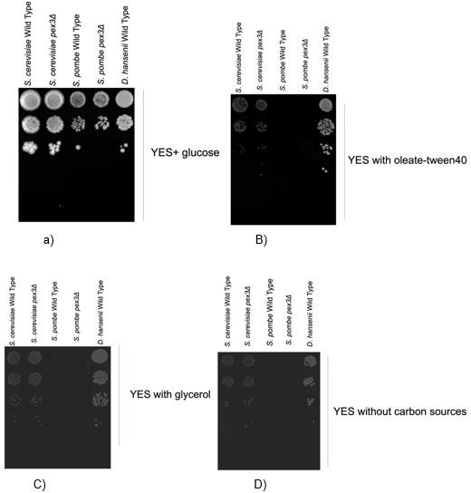

Figure 3. 1 S. pombe has lost the capacity to degrade certain carbon sources, including fatty acids
(B) and glycerol (C). The cells were cultured until they reached the logarithmic growth phase and were subsequently spotted onto different plates containing various carbon sources and incubated at 30˚C for 5 days. These findings suggest that the metabolic pathways of S. pombe differ from other yeast.
While S. cerevisiae and D. hansenii have the ability to degrade fatty acids, it was found that S. pombe cannot use fatty acids or glycerol as the sole carbon source (Figure 3.1).

In the earlier study conducted by Jourdain et al. (2008), the involvement of peroxisomes in fatty acid breakdown was proposed, as an increase in peroxisome numbers was observed in response to growth on oleate. Additionally, the presence of around 11 small peroxisomes, each approximately 0.5 mm in diameter, distributed throughout the cytosol was revealed. To further investigate peroxisome formation, S. pombe cells were cultivated with oleic acid, a known inducer of peroxisomes. Within

about 4 hours of introducing oleic acid—a period roughly equivalent to one cell cycle— a noticeable increase in both peroxisome quantity and size was observed. Furthermore, a remarkable 43% increase in peroxisome number and a 17% increase in peroxisome size were exhibited by S. pombe cells cultured in oleic acid for 24 hours.

However, contrasting findings are presented by this study (Figure 3.1), suggesting that
S. pombe cells are unable to grow on an oleate medium, indicating a potential absence of fatty acid degradation in these cells.

To further investigate the capability of S. pombe to induce peroxisome proliferation in response to oleate, additional experiments were conducted. Specifically, a green peroxisomal marker (mNG) was integrated at the C-terminus of the Saccharopine dehydrogenase 'Lys3' gene in the S. pombe genome, confirming its localization to peroxisomes (as demonstrated in Figure 3.12). Subsequently, the strain was cultured in YES medium supplemented with oleate-tween40 as the sole carbon source, and the resulting cells were observed under a microscope (as shown in Figure 3.2).

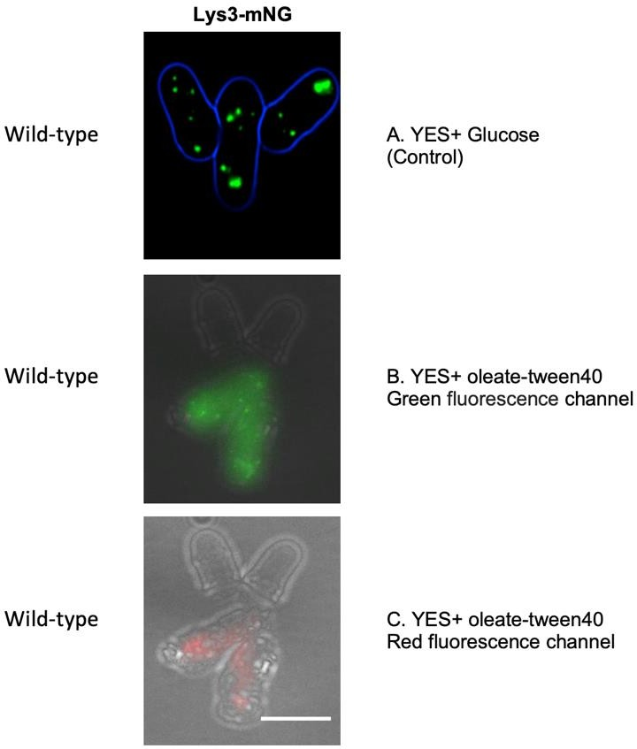
Figure 3. 2 Microscopic confirmation revealed that S. pombe can’t survive under oleate-tween40 conditions. Cells expressing a green peroxisomal marker (lys3-mNG) were cultured in YES medium with two different carbon sources. A) shows cells grown in normal YES medium with glucose as a control, while B) shows cells grown in a medium containing an oleate Tween mixture as the sole carbon source. C) shows the same cells as in B, imaged using the red fluorescence channel. The fluorescence

images were obtained as 0.5μm Z-stacks. After selecting the in-focus planes, they were merged as maximum intensity projection into a single plane for further processing in Adobe Photoshop. A brightfield image from a single plane was added to the blue channel in Photoshop and processed to emphasize only the cell's perimeter (A). It is important to note that Lys3-mNG is expressed in S. pombe as a green peroxisomal marker in this study. Unless otherwise specified in the figure legend, all subsequent microscopy images were processed using a similar approach. Scale bar is 5μm.

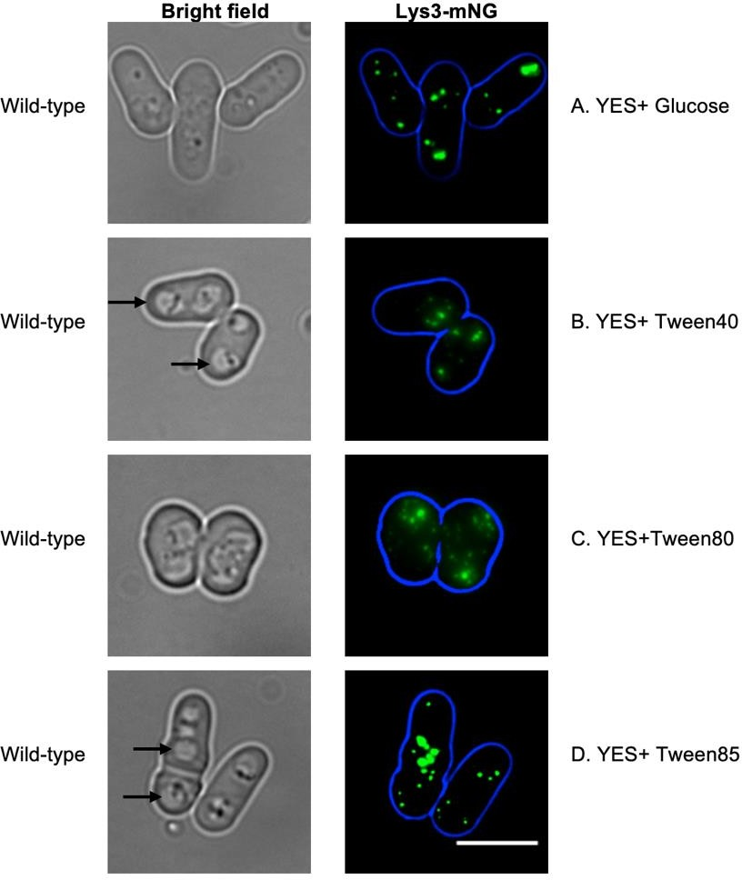
The cells displayed an inability to survive in a medium containing the oleate-tween40 mixture, while they exhibited viability in a glucose-supplemented medium. They appeared strongly affected, and the high level of red autofluorescence strongly suggests that these cells are dead or dying. Consequently, a subsequent experiment was conducted to examine the ability of S. pombe to utilize and survive on specific Tweens (Tween40, 80 and 85). These Tweens were added to the YES medium as chemical sources of fatty acids and served as the sole carbon source (Figure 3.3).
Figure 3. 3 Visualization of peroxisomes in S. pombe cells using various Tween containing media (Tween40, 80 and 85). The peroxisomes in S. pombe cells were labelled with the green peroxisomal marker (Lys3-mNG. Cells examined using epifluorescence microscopy. The enlargement of the compartment in the bright field images (indicated by black arrows) was investigated in the next section. Scale bar: 5μm

In contrast to the oleate-tween mixture, S. pombe demonstrated the ability to survive in the Tween medium. However, it should be noted that no visible growth was observed

under these conditions as the OD600 did not change after shifting to any of the Tween medium over a period 24h.

Based on the findings from previous experiments (Figure 3.2 and 3.3), a subsequent experiment was conducted to examine the potential toxicity of oleic acid on S. pombe cells. To do so, S. pombe strains were spotted onto plates containing various lipid sources, with glucose included as a control (Figure 3.5). Additionally, S. cerevisiae strains were employed as further control samples in the experiment.

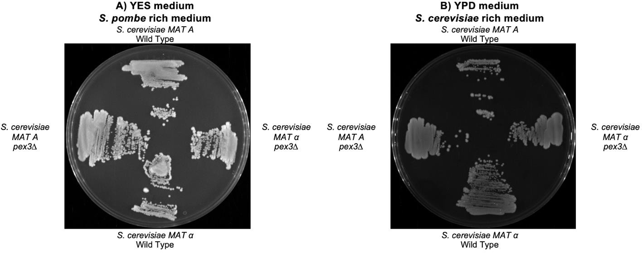
Figure 3. 4 S. cerevisiae strains spotted onto plates as controls. A) Cells grown in YES medium, while B) shows cells grown in YPD medium.

Similar to the previous experiment, S. pombe cells were cultured and subsequently spotted onto various YES medium plates containing different lipid sources, including the oleate-tween mixture, oleic acid alone, and Tweens (Tween40,80 and85).

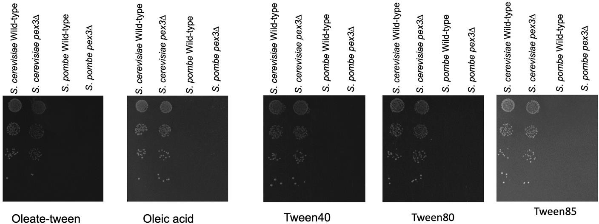
Figure 3. 5The inability of S. pombe to grow on various lipids including tweens. The cells were cultured until they reached the logarithmic growth phase. Serial dilutions of S. cerevisiae and S. pombe cell strains were then spotted onto plates containing different lipid sources in YES media and incubated at 30˚C for 5 days. S. cerevisiae strains were used as the control.

Figure 3.5 illustrates that S. pombe cells fail to grow on any of the lipid types tested.

Typically, in the experimental process, lipid sources are sterilized separately by filtering and then added to autoclaved YES media. However, in this particular experiment, the lipid sources were autoclaved together with the medium, resulting in distinct outcomes in an oleic acid + glucose medium (as shown in Figure 3.6 and 3.7).

As a control, glucose was included in the lipid medium. Interestingly, when the lipid sources, including oleic acid, were sterilized by filtering and added after autoclaving the YES media, S. pombe exhibited growth in the presence of oleate-tween with glucose, while the presence of oleic acid inhibited the growth of S. pombe cells (Figure 3.6).

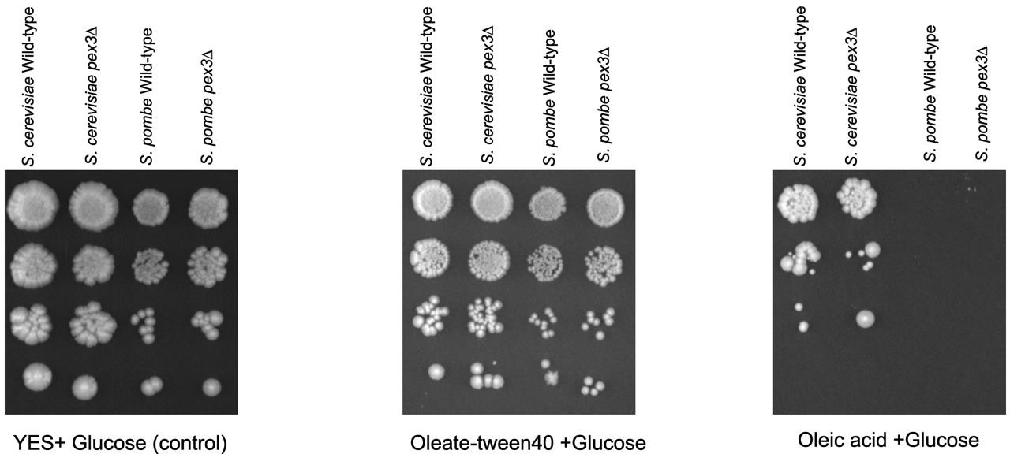
Figure 3. 6 The inability of S. pombe to grow in oleic acid. Serial dilutions of S. cerevisiae and S. pombe cell strains that were spotted on YES media containing glucose with lipids and incubated at 30˚C for 5 days. In this experiment, the lipid sources were sterilized by filtering and added after autoclaving the YES media. Interestingly, in the presence of oleate-tween with glucose, S. pombe was able to grow, while oleic acid prevented S. pombe cells from growing.

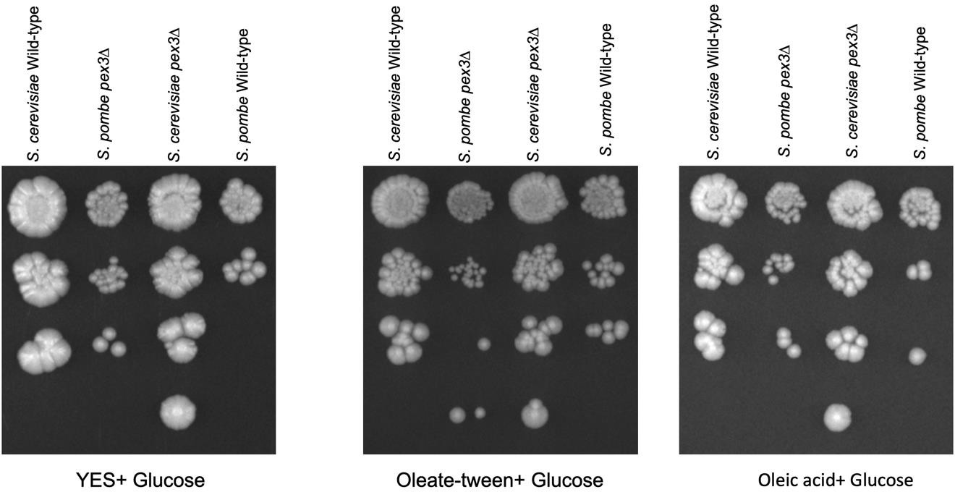
Moreover, when the lipid sources, including oleic acid, were autoclaved together with the media, S. pombe displayed growth in the YES medium containing glucose as the carbon source after the autoclaving process involving oleic acid (Figure 3.7).
Figure 3. 7 The growth capability of S. pombe in heat-degraded oleic acid. Serial dilutions of S. cerevisiae and S. pombe cell strains that were spotted on YES media containing glucose with lipids and incubated at 30˚C for 5 days. In this experiment, the lipid sources were autoclaved with the media. S. pombe was able to grow in YES medium containing glucose as a carbon source even after autoclaving the lipid sources with the media, which was in contrast to the results seen in Figure 3.6.

The results revealed that the degradation of oleic acid may have been influenced by the autoclave temperature (Ayton et al., 2012), resulting in the growth of S. pombe cells.

Nonetheless, it can be concluded that cells cannot use oleate/tween as carbon source and S. pombe cannot survive in a medium without carbon source (Figure 3.1D), not because it is toxic but because they lack the ability to degrade fatty acids via β- oxidation. Indeed, when an additional carbon source is present (glucose) S. pombe can grow in the presence of oleate-tween.

The mitochondria of S. pombe cells were visualized by employing a MitoTracker Green FM (MTGreen) (Invitrogen) to investigate the potential impact of lipid sources on the mitochondria. The experimental protocol described by Chiu et al., (2010) was followed.
S. pombe cells were cultivated in both YES medium supplemented with a lipid source and YES medium with glucose as a control. Subsequently, the cells were examined under a microscope (Figure 3.8).

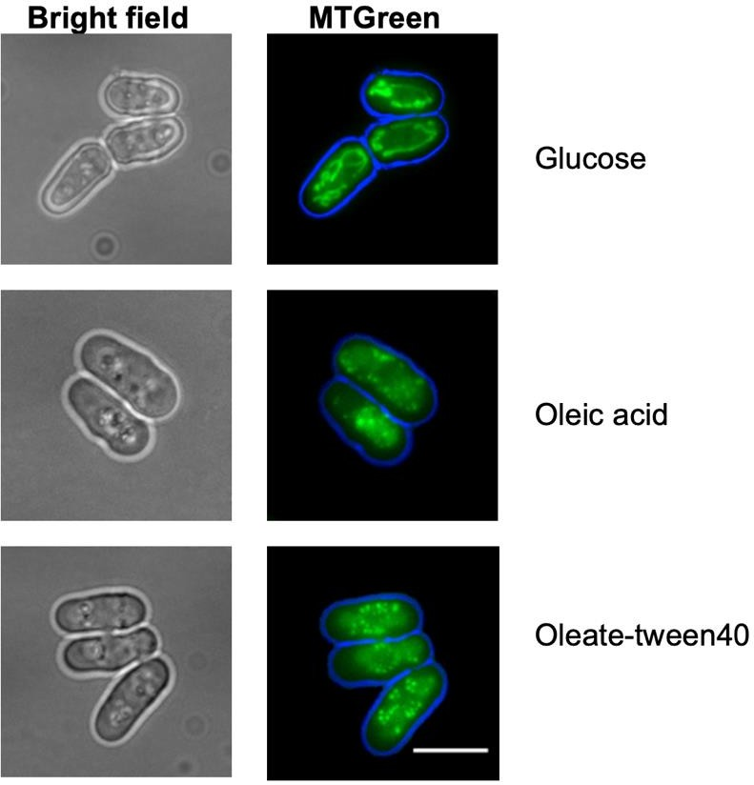
Figure 3. 8The impact of different lipid sources on the mitochondria of S. pombe. The visualization of S. pombe cell mitochondria were achieved by utilizing MitoTracker Green FM (MTGreen) from Invitrogen. The peroxisomes examined using epifluorescence microscopy. While the mitochondria of
S. pombe cells appear intact in the glucose medium, they appear to be degraded in media with oleic acids and oleate-tween40 containing media. Scale bar is 5μm

While the mitochondria of S. pombe appeared to be intact in the control medium (YES medium containing glucose), they exhibited signs of fragmentation and degradation when exposed to the medium containing the lipid source (Figure 3.8). This observation further indicates that S. pombe is unable to utilize lipids as a carbon source.

The yeast vacuoles are organelles known for their dynamic behavior, which involves undergoing fission and fusion processes in response to changes in the environment and throughout the cell cycle (Wickner, 2002). In order to investigate the response of
S. pombe vacuoles to lipid growth, the vacuolar membrane in S. pombe cells was stained with the lipophilic dye FM4-64 after the cells were cultured in YES medium containing tweens (Tween40 and 80) (Figure 3.9).

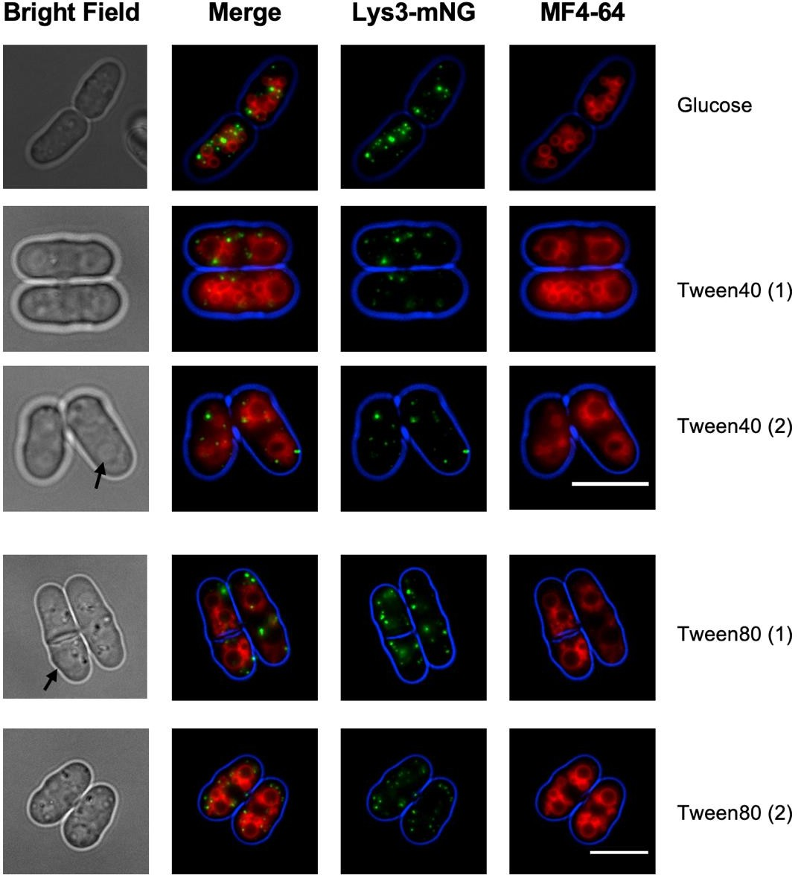
Figure 3. 9 Impact of different tweens conditions (Tween40 and 80) on vacuoles in S. pombe. S. pombe cells stained with the lipophilic dye FM4-64 in YES media containing two different tweens (40 and 80). The black arrows indicate the vacuole enlargement in the tweens media. The merge channel

reveals peroxisomes with a green marker (lys3-mNG) and vacuoles with the FM4-64 red dye. The peroxisomes examined using epifluorescence microscopy. Vacuole enlargement in media containing tweens may be due to either a shift from glucose to lipid media or pressure on the cells resulting from a lack of carbon sources (Rothlisberger et al., 2009). Scale bar is 5μm.

Notably, vacuole enlargement was observed in media containing tweens, and this could be attributed to the transition from glucose to lipid in the medium or the cellular stress resulting from the lack of carbon sources (Röthlisberger et al., 2009).

Contrary to the findings of the previous study conducted by Jourdain et al., (2008), which suggested a role for S. pombe peroxisomes in fatty acid degradation, the present study demonstrates that S. pombe is unable to degrade fatty acids when they are the sole carbon source. This observation challenges our current understanding that peroxisomes are essential organelles for hosting lipid degradation mechanisms in most yeasts in general. Consequently, it raises the question of what functions S. pombe peroxisomes serve if they have lost the ability to degrade fatty acids.

Conserved targeting of a peroxisomal matrix protein lacking a consensus peroxisomal targeting signal in S. pombe.

Cystathionine beta-lyase Str3

Through a global yeast two-hybrid screen, it was uncovered that S. pombe Pex5, the peroxisomal receptor for PTS1, interacts with S. pombe Str3 (Das et al.,2013.; Vo et al., 2016). In S. cerevisiae, Str3 harbours a PTS1 (SKL) and localizes within the peroxisome (Barreto et al., 2006; Giard et al., 2001). Surprisingly, S. pombe Str3 does not contain a putative PTS1, suggesting it interacts differently to Pex5 as has been described for only a few other proteins including S. cerevisiae Acyl-CoA oxidase (Klein et al., 2002). Based on this finding, the hypothesis was proposed that there might be a conserved mechanism for targeting peroxisomal proteins lacking a PTS1, wherein they are imported into the peroxisome through Pex5. S. pombe Str3 could serve as an example of such a protein with conserved targeting mechanisms.

To investigate this, Str3 was tagged at its C-terminus in the genome using either GFP or mNG. This was achieved by purifying the PCR product containing GFP or mNG, a selectable marker, and the gene's upstream at the C-terminus of the ORF without a stop codon, along with downstream flanks to the ORF in the terminator region (Figure 2.3). Subsequently, the purified product was integrated into the yeast genome. While GFP was easily detectable with western blotting, monomeric NeonGreen (mNG) was much brighter than GFP under the microscope. (Figure 3.10A, B).
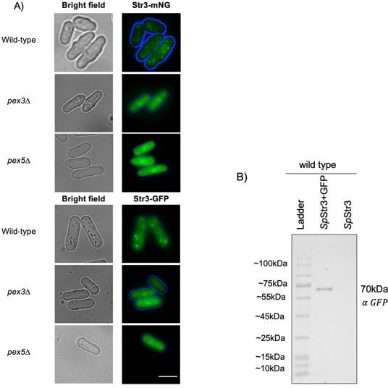

Figure 3. 10 S. pombe Str3 displays dual subcellular localization. SpStr3 tagged with green reporter proteins (mNG and GFP) at the C-terminus in different S. pombe strains. Cells were cultured until reaching the logarithmic growth phase and the peroxisomes then examined using epifluorescence microscopy. A) dual localisation pattern of punctate peroxisomes and cytosolic diffuse labelling are observed in the wild-type strain, suggesting that this protein might have two distinct cellular localizations. Str3-GFP and Str3-mNG localisation in S. pombe pex3∆ and pex5∆ provides additional evidence that the puncta are indeed peroxisomes. B) Analysis of the GFP-tagged Str3 in the wild-type strain using anti-GFP antibody via western blot. Scale bar is 5μm.

Str3 exhibits both a punctate labelling reminiscent of peroxisomes and diffuse labelling representing the cytosol in the wild-type strain, suggesting that this protein may have two distinct cellular locations. To confirm the peroxisomal localization of Str3, the mutant S. pombe strain pex3∆ was employed, which showed cytosolic expression of the gene (Figure 3.10A). In the pex5∆ strain, the localisation also appeared cytosolic, providing further evidence that the punctate structures observed in WT cells are indeed peroxisomes and that the peroxisomal import pathway of this protein occurs through the PTS1 receptor Pex5 (Figure 3.10A). In this study, the pex5∆ strain was generated, and its confirmation was carried out using PCR analysis (Figure 3.1 in the Appendix for the PCR confirmation results). Furthermore, the presence of GFP-tagged Str3 in the wild-type strain was confirmed by conducting a western blot analysis using an anti-GFP antibody (Figure 3.10B). Due to the difficulty of detecting mNG using an anti-mNG antibody in western blot analysis, PCR and sequencing methods were employed to confirm the presence of Str3-mNG. (Figure 3.2 in the Appendix).

Two plasmids were constructed to investigate whether the S. cerevisiae Pex5 receptor (ScPex5) recognizes the S. pombe STR3 protein (SpStr3) and to explore the potential for shared peroxisomal import pathways between SpStr3 and its homolog in S. cerevisiae (ScStr3). The plasmids contained GFP-tagged versions of SpStr3 at both the C- and N-termini. For plasmid construction, the Ycplac plasmid series was utilized, following the methodology described by Daniel Cietz & Sugino, (1988).

To generate the GFP N-terminal tag SpStr3 plasmid, a plasmid was constructed containing a TpI1 promoter, PGK1 terminator, and SpSTR3. The newly created plasmids were validated through test digestion and sequencing to ensure their integrity. After confirming the plasmids, they were expressed in a wild-type S. cerevisiae strain. Notably, both plasmids exhibited cytosolic expression, indicating that ScPex5 was unable to recognize SpStr3 (Figure 3.11A and B).

To investigate the potential differences in peroxisomal import pathways between S. cerevisiae and S. pombe, the STR3 and PEX5 genes were deleted from the S. cerevisiae genome. Subsequently, an untagged plasmid containing the S. pombe PEX5 gene (SpPex5) was constructed. Both the untagged SpPex5 plasmid and the N-terminal GFP-tagged SpStr3 were then expressed in the str3∆ pex5∆ double

knockout strain of S. cerevisiae. Microscopic examination of the resulting strain revealed cytosolic expression, suggesting the possibility of SpPex5 is unable to function together with S. cerevisiae peroxisomal docking or import machinery (Figure
3.11 C).

To investigate the recognition of peroxisomal S. cerevisiae Str3 (ScStr3) by SpPex5, a plasmid containing N-terminal GFP-tagged ScStr3 (since S. cerevisiae Str3 possesses a PTS1) was generated. The plasmid was then expressed in both the S. cerevisiae wild-type and str3∆ strains. In both strains, the gene exhibited a punctate peroxisomal patterns (Figure 3.11 D and E). Subsequently, the same plasmid was expressed in the S. cerevisiae str3∆ pex5∆ double knockout strain also expressing untagged SpPex5. The resulting expression showed cytosolic localization, indicating that SpPex5 is unable to recognize peroxisomal S. cerevisiae Str3 within the same organism (Figure 3.11 F).

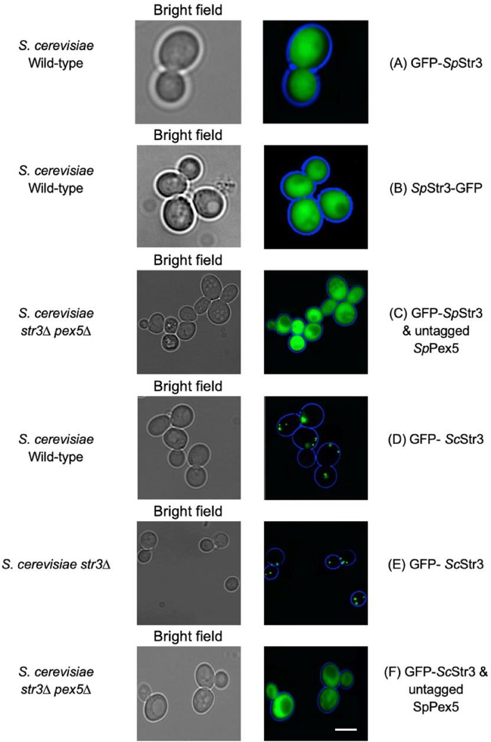

Figure 3. 11Both SpStr3 and ScStr3 are peroxisomal enzymes, but they seem to utilize distinct peroxisomal import pathways via the pex5 receptor. Cells were cultured until reaching the logarithmic growth phase and then examined using epifluorescence microscopy. The microscopy expression of SpStr3 and ScStr3 in different S. cerevisiae strains. A) and B) display N- and C-terminal GFP-tagged SpStr3 expressed in a S. cerevisiae str3∆ strain, respectively, and both show cytosolic expression. C) shows N-terminal GFP-tagged SpStr3 expressed with untagged SpPex5 in a S. cerevisiae str3∆ pex5∆ double knockout, which also shows cytosolic expression. D) and E) show ScStr3 expressed in both S. cerevisiae wild-type and str3∆ strains, respectively, and both display the puncta patterns of peroxisomes. Finally, F) shows ScStr3 expressed with untagged SpPex5 in a S. cerevisiae str3∆ pex5∆ double knockout, but it shows cytosolic expression. The observed pattern suggests that SpPex5 might not be able to efficiently interact with S. cerevisiae peroxisomal docking or import machinery, potentially explaining the differential import pathways for these enzymes. Scale bar is 5μm.

Based on our results, it was observed that both Str3 proteins in S. pombe and S. cerevisiae localize to the peroxisome and depend on Pex5 for their import. However, the patterns observed indicate that there could be an inefficient interaction between SpPex5 and the peroxisomal docking or import machinery in S. cerevisiae. This

inefficiency might be a possible explanation for the distinct import pathways utilized by these enzymes.

Saccharopine dehydrogenase Lys3

In addition to SpStr3, the yeast two-hybrid system reveals the binding of S. pombe Pex5 to Lys3, which shares homology with S. cerevisiae Lys1. Lys1 is a peroxisomal protein with an SKL targeting sequence. This enzyme plays a crucial role in the conversion of saccharopine to lysine, where the final step in the lysine biosynthesis pathway occurs within peroxisomes (Al-Saryi et al., 2017; David et al., 2022).

Apart from the incorporation of green markers (GFP and mNG) at the C-terminus of Lys3, a red marker mRuby2 was also inserted at the C-terminus of the S. pombe Lys3 gene (SpLys3). Furthermore, the S. pombe peroxisomal biogenesis factor 3 Pex3 gene (C29A4.14c) was tagged with mNG at the C-terminus, serving as a marker for peroxisomes (Figure 3.12).

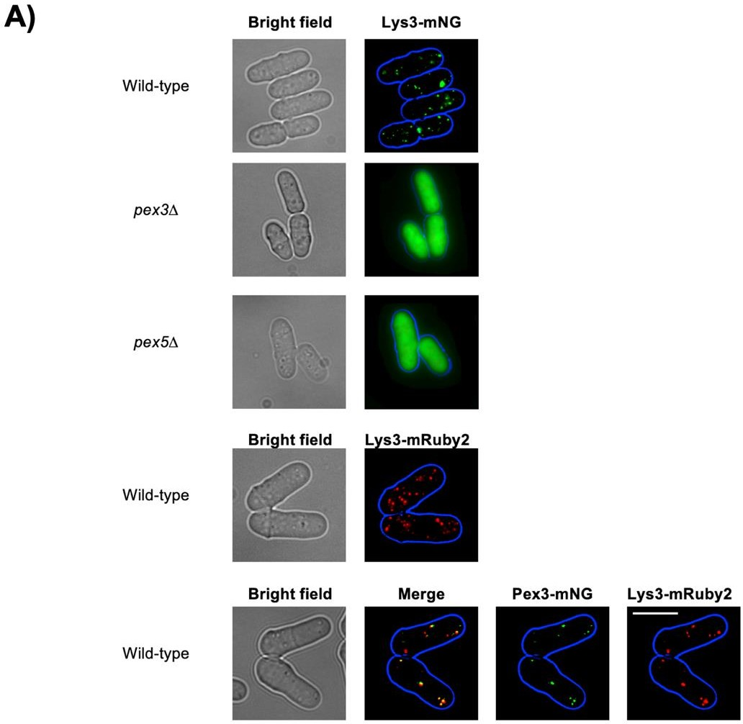

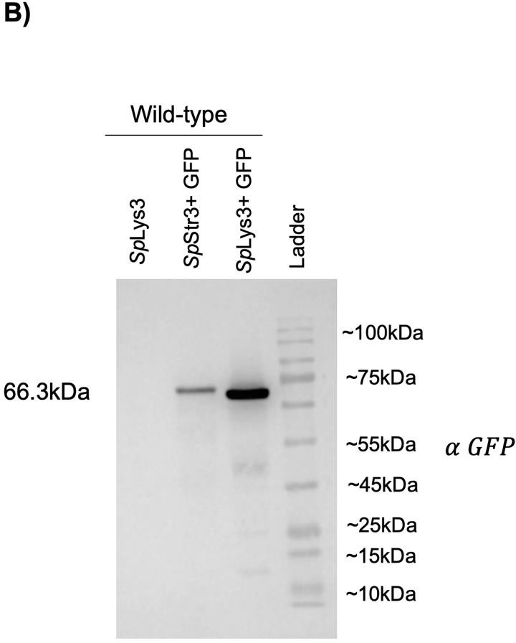

Figure 3. 12 S. pombe Lys3 displays a peroxisomal punctate pattern and does not depend on its PTS1 signal for subcellular localization. The SpLys3 (SpLys3) tagged at the C-terminus with different reporter genes (mNG, GFP, and mRuby2) in various S. pombe strains. Cells were cultured until reaching the logarithmic growth phase and then examined using epifluorescence microscopy. A) The wild-type S. pombe strain exhibits a punctate pattern representing peroxisomes with SpLys3. The presence of the C-terminal tag on Lys3 in pex3Δ and pex5Δ provides further confirmation of these puncta as peroxisomes. Additionally, the colocalization of red Lys3-mRuby2 with the green peroxisomal marker Pex3-mNG clearly demonstrates that this gene functions as a peroxisomal protein in S. pombe.
B) The results of western blot analysis using an anti-GFP antibody on the GFP-tagged Lys3 and GFP- tagged Str3 in the wild-type strain. Scale bar is 5μm.

Interestingly, it is observed that SpLys3 does not solely rely on its peroxisomal targeting sequence (QKL). This is evident as SpLys3, when tagged at the C-terminus in the S. pombe genome, is successfully imported into peroxisomes. The wild-type S. pombe strain displays a punctate pattern of peroxisomes and shows colocalization of the red Lys3-mRuby2 with the green peroxisomal marker Pex3-mNG. In contrast, pex3Δ and pex5Δ cells displayed cytosolic expression (Figure 3.12 A). This confirms the puncta are indeed peroxisomes.

The GFP-tagged strains were confirmed through western blot analysis (Figure 3.12 B), while the mNG and mRuby2-tagged LYS3 gene fusions were validated by PCR and subsequent sequencing (Appendix Figure 3.5).

To investigate the recognition of SpLys3 by ScPex5, a plasmid containing GFP N- terminal tagged SpLys3, which carries a peroxisomal targeting signal 1 (PTS1) sequence (QKL), was expressed in the wild-type S. cerevisiae strain (Figure 3.13).

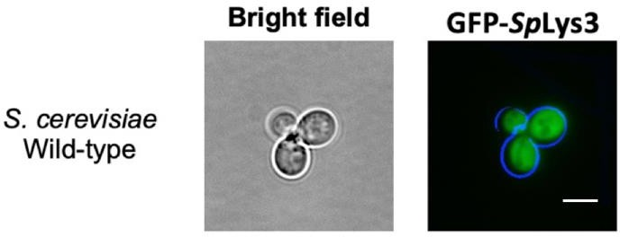
Figure 3. 13S. cerevisiae Pex5 does not recognize the PTS1 signal carried by S. pombe Lys3 (SpLys3). The S. pombe Lys3 protein, tagged with GFP at the N-terminus, was expressed in the wild- type strain of S. cerevisiae. The cells were cultured until they reached the logarithmic growth phase and were subsequently examined using epifluorescence microscopy, revealing cytosolic expression of the protein. While SpLys3 was found to localize to peroxisomes in its native organism S. pombe, the expression of the N-terminal GFP-tagged SpLys3 in S. cerevisiae resulted in cytosolic expression, suggesting differences in the recognition of this peroxisomal protein between the two yeasts. Scale bar is 5μm

The gene displayed a cytosolic expression pattern. This observation suggests variations in the recognition of this peroxisomal protein between S. cerevisiae and S. pombe yeast species (Figure 3.13).

Our bioinformatic search revealed that the S. pombe genome contains two genes harboring a PTS1 sequence. The first gene corresponds to a peroxisomal coenzyme A synthetase (FAT2) with the PTS1 AKL. In S. cerevisiae, its homologous protein, FAT1, is also a peroxisomal protein but possesses the PTS1 SKL (Watkins et al., 1998). The second gene encodes a peroxisomal membrane- associated protein 20 (PMP20) with the PTS1 SSL. PMP20 is a homolog of the human peroxisomal Peroxiredoxin 5 PRDX5 (P30044) with the PTS1 SQL (Knoops et al., 1999), the U. maydis Thioredoxin domain-containing protein (A0A0D1C4Q6), and the S. cerevisiae Peroxiredoxin AHP1 (P38013) (with the PTS1 AHL).

Subsequently, these genes were tagged with mNG at their C-terminus (Figure 3.14).

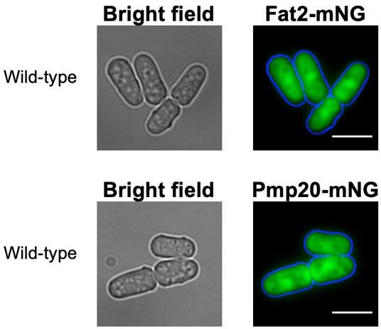
Figure 3. 14Tagging of S. pombe Fat2 and Pmp20 in the C-terminus suggests that these proteins might have distinct peroxisomal import pathways compared to Str3 and Lys3. Cells were cultured until reaching the logarithmic growth phase and then examined using epifluorescence microscopy. Interestingly, both proteins exhibited cytosolic expression. Scale bar is 5μm

Both Fat2 and Pmp20 displayed cytosolic expression. Further investigations are needed to verify the peroxisomal subcellular localization of both Fat2 and Pmp20 in S. pombe as C-terminal fusions will have inactivated the PTS1. Nonetheless, these findings indicate that Fat2 and Pmp20 may employ a distinct peroxisomal import pathway different from that of Str3 and Lys3.

The current study has shown that the peroxisomal proteins Str3 and Lys3 in S. pombe are imported into peroxisomes through Pex5, independent of the peroxisomal targeting signal (PTS1). It is likely that they employ a peroxisomal pathway referred to as PTS3, which involves the utilization of Pex5 for their import into the peroxisomal matrix (Rymer et al., 2018).

The transsulfuration pathway in yeast requires the peroxisomal protein str3 but not peroxisomes

Sulfur metabolism is a well-known pathway that involves the absorption of inorganic sulphate and the synthesis of sulfur amino acids via the transsulfuration pathway (cysteine) and the methyl cycle (methionine). In most yeasts, there are two pathways for producing cysteine. The first one is the transsulfuration pathway, which occurs in
S. cerevisiae but not in S. pombe. This pathway leads to the production of cysteine from homocysteine and the reverse reaction. The second pathway is the O-acetyl- serine (OAS) pathway, which is an irreversible pathway in S. pombe due to the lack of

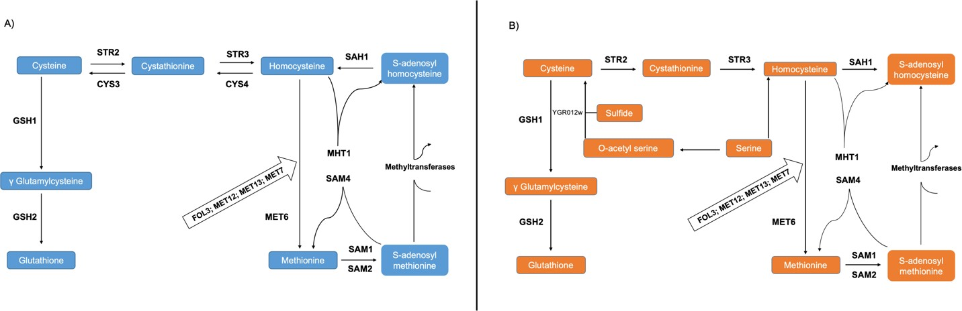
two enzymes, cystathionine beta-synthase (encoded by CYS4) and cystathionine gamma-lyase (encoded by CYS3). This pathway is absent in S. cerevisiae (Figure 3.15) (Hébert et al., 2011).

Figure 3. 15 Variability in sulfur metabolism among S. cerevisiae and S. pombe. A) The transsulfuration pathway which occurs in S. cerevisiae (blue colour). B) The O-acetyl-serine (OAS) pathway which occurs in S. pombe (orange colour). (Modified from Hébert et al., 2011)

Homocysteine, which holds a pivotal role in the transsulfuration pathway (Figure 3.16), involves the participation of the cystathionine beta-lyase protein (Str3), responsible for converting cysteine into homocysteine. This process occurs in microorganisms and plants but not in animals. When Str3 is absent, the ability of S. cerevisiae Mat A cells (methionine auxotroph) to grow on cysteine or cystathionine as the sole sulfur source is compromised (Barreto et al., 2006). BY4741 Mat A cells are deficient in MET15, also called MET17, encoding homocysteine synthase.

The growth of the str3∆ yeast cell strain on media with cysteine or cystathionine as the sole sulfur source is rendered impossible in S. cerevisiae (Barreto et al., 2006; Sohn et al., 2014). To confirm these observations, spotting experiments were conducted using our mutant MAT A str3∆ strain alongside different strains on various media (Figure 3.17). Additionally, further experiments were performed to assess the functionality of our mutant S. cerevisiae str3∆ Mat A strain (methionine auxotroph). Spotting assays were carried out, placing the mutant strain alongside different strains on media containing cysteine as the sole sulfur source, with S. cerevisiae MAT α strains (Methionine autotroph) employed as controls. Moreover, PCR confirmation (Figure 3.3 in the Appendix) was carried out in addition to these experiments.

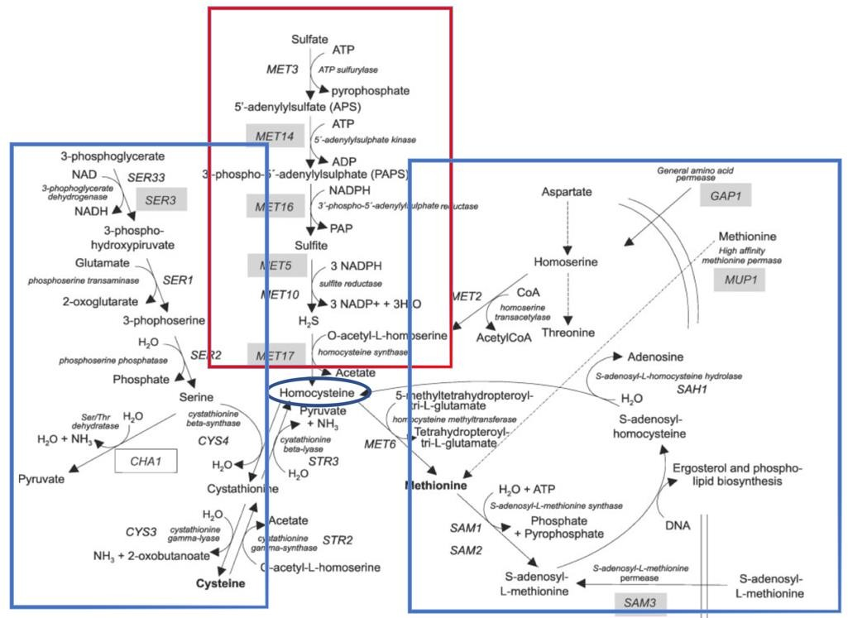
Figure 3. 16Schematic shows the role of homocysteine in the transsulfuration pathway, where it is converted to cysteine via a series of enzymatic reactions. Cystathionine beta-lyase (Str3) plays a critical role in this pathway by catalyzing the conversion of cystathionine to homocysteine. This reaction is a key step in the biosynthesis of cysteine and other sulfur-containing amino acids in many organisms, including yeasts and plants. The absence of Str3 can lead to metabolic disorders and growth defects, highlighting its importance in sulfur metabolism. Therefore, the study of Str3 and its role in the transsulfuration pathway is essential for understanding the regulation of sulfur metabolism in different organisms.

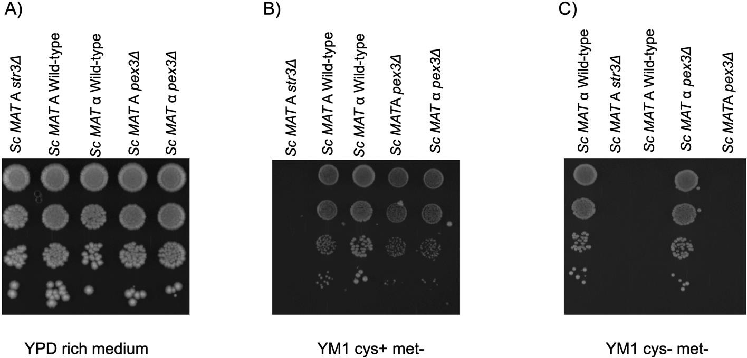

Figure 3. 17 The Str3 mutant strain in MAT A (Met15-deficient) S. cerevisiae does not exhibit growth when cysteine is provided as the sole source of sulfur in the media. The cells were cultured until they reached the logarithmic growth phase. Then, serial dilutions of S. cerevisiae strains spotted on various media and incubated at 30˚C for 5 days. The strains featured in the figure are S. cerevisiae MAT A str3Δ, S. cerevisiae MAT A Wild-type, S. cerevisiae MAT α Wild-type, S. cerevisiae MAT A pex3Δ, and S. cerevisiae MAT α pex3Δ. Among these strains, S. cerevisiae MAT A is Met15 deficient, while S. cerevisiae MAT α is Met15 autotroph, Met15 is also known as Met17. A) demonstrates the results on YPD rich medium. B) showcases the results on Yeast minimal medium 1 (YM1) without

methionine but with cysteine added as a sulfur-containing amino acid. C) presents the results on Yeast minimal medium 1 (YM1) devoid of any sulfur-containing amino acids (methionine and cysteine minus medium).

Consistent with previous findings (Barreto et al., 2006; Sohn et al., 2014), the S. cerevisiae Scstr3Δ (Mat A) strain displayed an inability to grow under these conditions (Figure 3.17).

After expressing plasmids containing SpStr3 and ScStr3 in our Scstr3∆ mutant cells, spotting assays were conducted on two different media to investigate whether SpStr3 exhibits a complementary function to ScStr3 in the trans-sulphuration pathway (Figure 3.18).

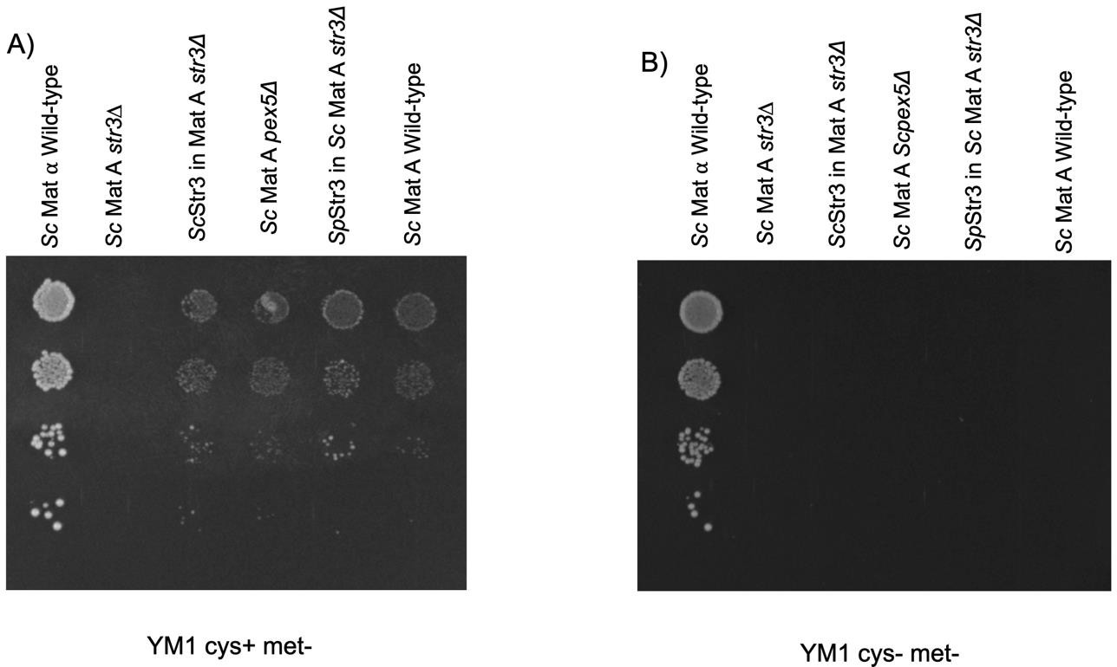
Figure 3. 18 S. pombe Str3 complements the function of S. cerevisiae Str3 in the transsulfuration pathway and peroxisomes are not essential for this metabolic pathway in yeast. The cells were cultured until they reached the logarithmic growth phase. Then, serial dilutions of different S. cerevisiae strains spotted on yeast minimal medium 1 (YM1) media and incubated at 30˚C for 5 days. A) Growth on YM1 without methionine, but with cysteine as the sole sulfur source, is depicted. The S. cerevisiae MAT α wild type “a Met15 autotroph” demonstrates robust growth in this medium, while the Scstr3Δ Mat A mutant strain does not, due to the lack of ScStr3—an essential enzyme in the transsulfuration pathway. However, when SpStr3 is expressed in the mutant strain, it exhibits similar growth to the ScStr3 in the str3Δ Mat A strain, indicating that SpStr3 complements ScStr3 in the transsulfuration pathway. Furthermore, the Scpex5Δ Mat A strain, which lacks the peroxisomal str3 pathway, exhibits vigorous growth in this medium, providing confirmation that Str3 does not need to be localised to peroxisomes for its role in the transsulfuration pathway. B) Growth on YM1 without any sulfur-containing amino acids (methionine and cysteine minus medium) is illustrated. Only the Mat 𝘢 wild type, the Met15 autotroph, is capable of growing in this medium, while the Mat A wild type, which is Met15 deficient, fails to grow.

The results indicate that SpStr3 possesses a complementary function to ScStr3 in the trans-sulfuration pathway. Furthermore, it was observed that the Scpex5Δ Mat A strain, lacking the peroxisomal Str3 pathway, exhibited robust growth in this medium, confirming that Str3 does not necessarily need to localise to peroxisomes for its role in the trans-sulphuration pathway (Figure 3.18).

Peroxisomes fission and peroxisomes inheritance in S. pombe

Tagging affects Pex11 function not a Pex11 paralog

Orthologous of Pex11p are found almost in all eukaryotic organisms. In humans, there are three related proteins known as Pex11α, β, and γ. Pex11α seems to be accountable for peroxisome proliferation when stimulated by external factors, while Pex11β is necessary for constant peroxisome proliferation. When compared to mammalian isoforms α and β, filamentous fungi's Pex11p exhibits the highest similarity, whereas Pex11Bp is significantly less similar. Similarly, mammalian Pex11γ, analogous to fungal Pex11Cp, shows the least similarity to the other two mammalian isoforms. The specific role of fungal Pex11C and mammalian Pex11γ in peroxisome proliferation has yet to be determined (Kiel et al., 2006).

Overproduction of Pex11p has been observed to cause a substantial increase in peroxisome numbers in all studied organisms, involving humans (Kiel, van der Klei, et al., 2005; Marshall et al.,1995; Schrader et al., 1998). The deletion of Pex11 in S. cerevisiae has been shown to significantly decrease organelle numbers. While the genome of S. cerevisiae encodes only one Pex11 protein, filamentous fungi have three isoforms: Pex11p, Pex11Bp, and the less similar Pex11Cp. Other species such as C. albicans, D. hansenii, H. polymorpha, and Y. lipolytica also possess the previously unidentified Pex11Cp, which is absent in S. cerevisiae and its close relatives. Notably, Gibberella zeae appears to possess not only Pex11, Pex11B, and Pex11C but also paralogs of Pex11p and Pex11Cp. The situation in filamentous fungi is similar to that observed in higher eukaryotes, which also have multiple forms of Pex11p (Kiel et al., 2006). The presence of a paralog of Pex11 in S. pombe was uncovered through our

bioinformatics search, which was identified as SPAC1F12.04c. It appears that it is conserved in Schizosaccharomyces (S9XCI1 SPOG_02731 S. cryophilus, and B6K164 SJAG_02788 S. japonicus). Furthermore, it shows homology with Pex11 from Tuber borchii (white truffle) (A0A2T6ZZ94) and Morchella conica (A0A3N4LD04), both of which are filamentous fungi.

Due to the inadequate brightness of the previous peroxisomal membrane marker (Pex3), a decision was made to select Pex11 as a replacement marker. However, upon tagging Pex11, a significant impact on the number of peroxisomes was observed (Figure 3.17A). This is attributed to the involvement of Pex11, along with its family members Pex25 and Pex27 (which are absent from the S. pombe genome) (Kiel et al., 2006), as well as the Dynamin superfamily, in peroxisomal fission (Ekal et al., 2023; Gandre-Babbe & van der Bliek, 2008; Li & Gould, 2003). Interestingly, when the Pex11 paralog was also tagged, no noticeable effects were observed (Figure 3.19B). The red mRuby2 marker was utilized to tag Lys3 as a peroxisomal marker.

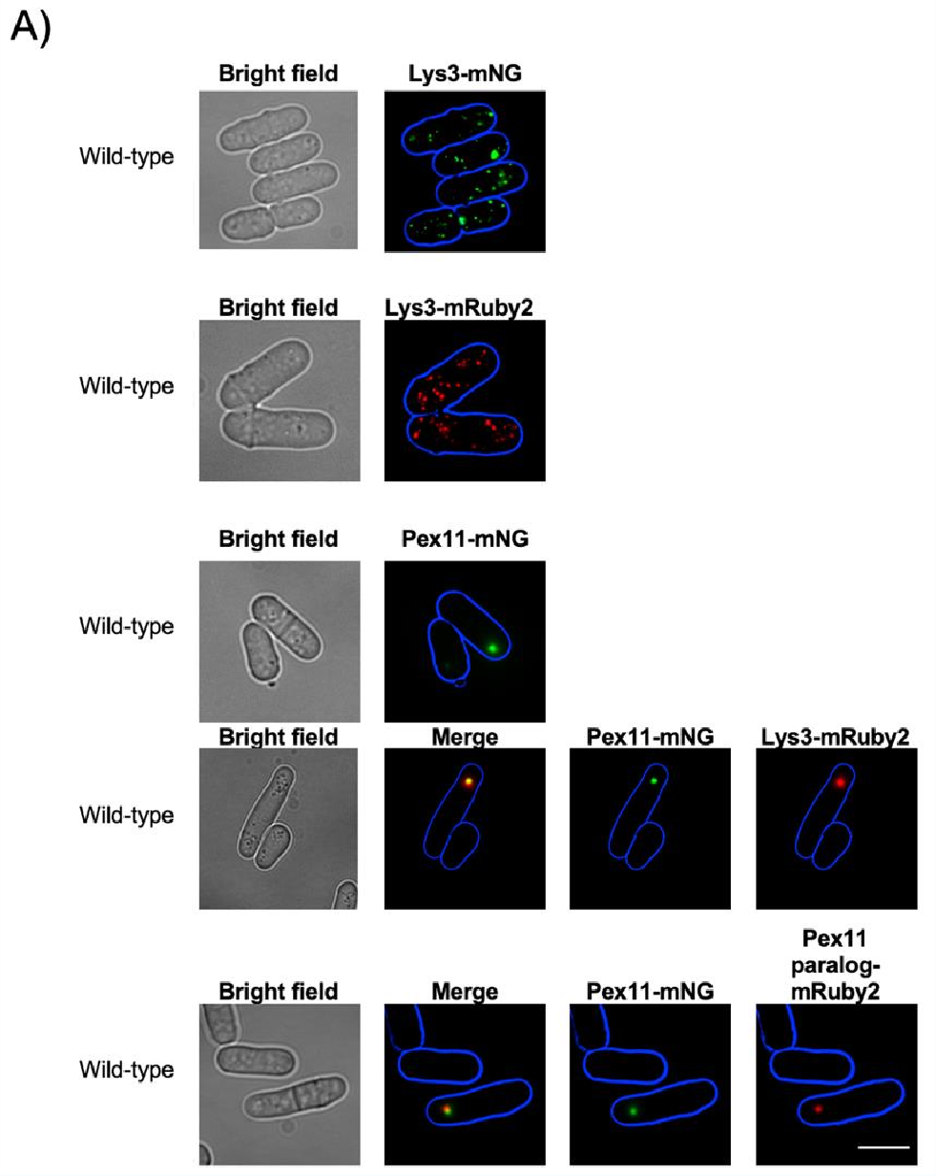

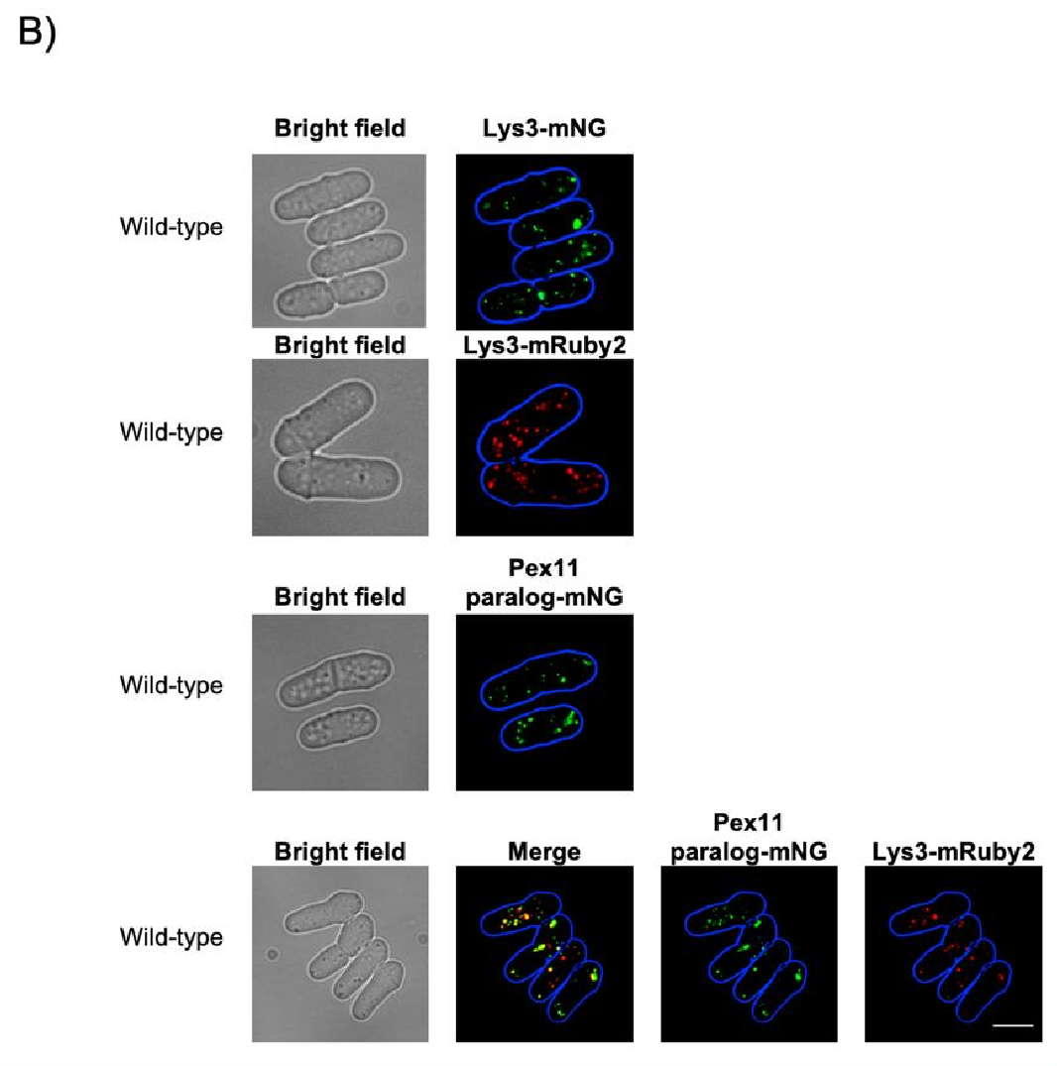
Figure 3. 19 The C-terminal tag affects the function of Pex11, rather than that of a Pex11 paralog.
A) The tagging affected Pex11 function, resulting in a reduced number of peroxisomes or no peroxisomes at all. Pex11-mNG and Lys3-mRuby2 localization in S. pombe wild-type cells is shown. B) In contrast, tagging the Pex11 paralog did not affect peroxisomes. The localization of Pex11 paralog- mNG and Lys3-mRuby2 in S. pombe wild-type cells is shown. Cells were cultured until reaching the logarithmic growth phase and were then examined using epifluorescence microscopy. Scale bar is 5μm.

It has been observed that in the genome of S. cerevisiae, when Pex11 is tagged with GFP at the C-terminus, peroxisomes tend to exhibit a tendency to cluster or aggregate to some extent (Motley et al., 2012). While one of the functions of Pex11 is peroxisome proliferation and maintenance (Koch et al., 2010), which suggests that tagging this gene would affect peroxisome numbers, tagging the paralog does not. A question is raised about the role of the Pex11 paralog in peroxisome fission in S. pombe. The answers can be obtained by visualizing peroxisomes in the Pex11 paralog mutant strain.

The role of dynamin superfamily in S. pombe peroxisomes fission

The dynamin superfamily, a large GTPase family, plays a crucial role in various cellular processes, including the fission of organelles such as peroxisomes (Fujimoto et al., 2019).
Previous studies have shown that S. pombe strains lacking either dnm1∆ or vps1∆ exhibited a peroxisomal profile similar to that of the wild-type strain. However, in contrast, cells of the double mutant dnm1∆ vps1∆ strain either lacked peroxisomes completely or had a limited number of structurally abnormal organelles (Jourdain et al., 2008). In light of these findings, this study aims to investigate the specific roles of both genes in peroxisome fission in S. pombe, while also exploring the involvement of the accessory protein Mdv1.

The role of dynamin-related protein (Dnm1) in peroxisome fission in S. pombe

In S. cerevisiae, it has been demonstrated that cells lacking DNM1 exhibit a reduction in the number of peroxisomes, particularly noticeable when the cells are grown in the presence of oleate (Kuravi et al., 2006). Therefore, in order to demonstrate the role of the major dynamin protein in S. pombe (dnm1), a knockout of this gene has been performed in the S. pombe genome, along with the utilization of a peroxisomal marker (Figure 3.20).

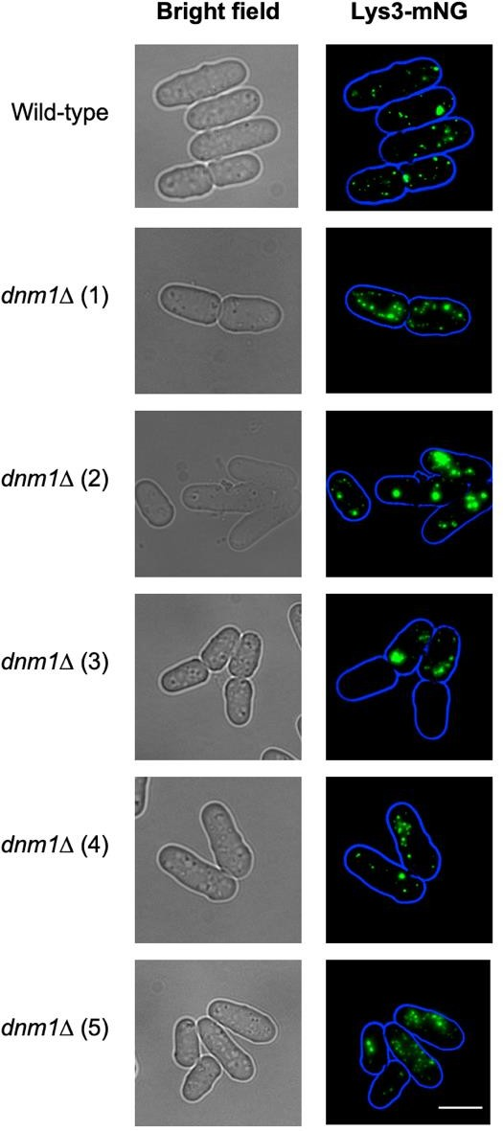
Figure 3. 20 The phenotype of dnm1Δ cells in S. pombe differs from that of the wild-type strain and exhibits heterogeneous patterns of peroxisomes. Peroxisomes in both strains were labelled with the green peroxisomal marker (Lys3-mNG). Cells were cultured until reaching the logarithmic growth phase and were then examined using epifluorescence microscopy. In image (1) peroxisomes align with the plasma membrane, while in image (2) some cells exhibit the same pattern as in the wild- type strain, while others show a reduced number of peroxisomes. Image (3) shows some cells with no peroxisomes at all, whereas images (4) and (5) show the same pattern as in the wild-type strain. Scale bar is 5μm.

A heterogeneous pattern of peroxisomes was observed in the S. pombe dnm1∆ strain, where some peroxisomes aligned with the plasma membrane, while in other images, certain cells exhibited the same pattern as in the wild-type strain, whereas others showed a reduced number of peroxisomes (See Table 3.2). Notably, some cells were found without any detectable peroxisomes, suggesting that Dnm1 likely plays a significant role in regulating peroxisome fission (Figure 3.20). These observations indicate the importance of further investigations to gain a comprehensive

understanding of the precise mechanisms and functions of the dynamin superfamily in peroxisome dynamics in S. pombe.

The role of vacuolar protein sorting-associated protein 1 (Vps1) in peroxisome fission in S. pombe

Peroxisome fission in S. cerevisiae is associated with the dynamin-like protein Vps1p (vacuolar protein sorting protein 1). A decrease in the number and an increase in size of peroxisomes is observed when the Vps1 gene is deleted in S. cerevisiae cells (Hoepfner et al., 2001; Motley et al., 2008; Vizeacoumar et al., 2006). To investigate the role of Vps1 in peroxisome fission in S. pombe, the generation of the S. pombe vps1∆ mutant strain was successfully achieved. Peroxisomes were visualized using the peroxisomal mNG-tagged Lys3 marker (Figure 3.21).

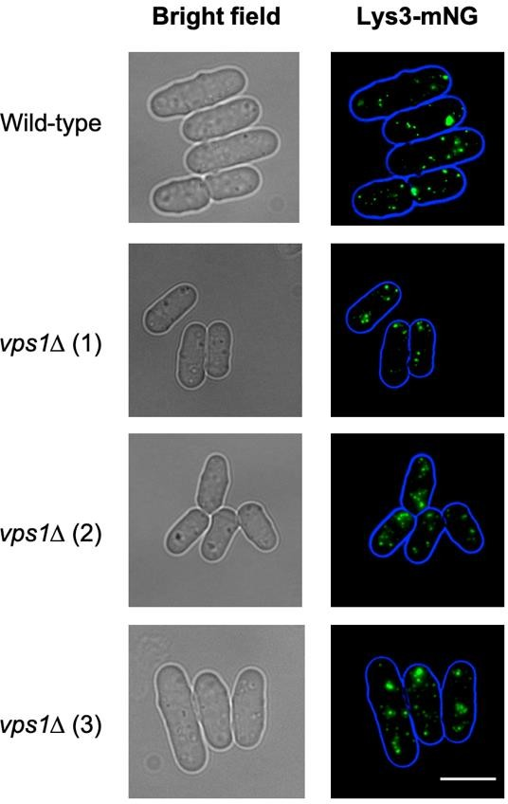
Figure 3. 21 The subcellular pattern of peroxisomes in a S. pombe vps1∆ mutant strain closely resembles that of the wild-type strain. Peroxisomes in both strains were labelled with the green peroxisomal marker (Lys3-mNG). Cells were cultured until reaching the logarithmic growth phase and were then examined using epifluorescence microscopy. Scale bar is 5μm.

The pattern of peroxisomes in the vps1∆ strain closely resembles that of the wild-type
S. pombe strain, which is in agreement with Jourdain et al., (2008).

Furthermore, the involvement of S. pombe Dnm1 and Vps1 in vacuole fission was investigated alongside peroxisome fission. Vacuoles were stained with FM4-64 in both mutant strains, dnm1∆ and vps1∆, for visual analysis (Figure 3.22).

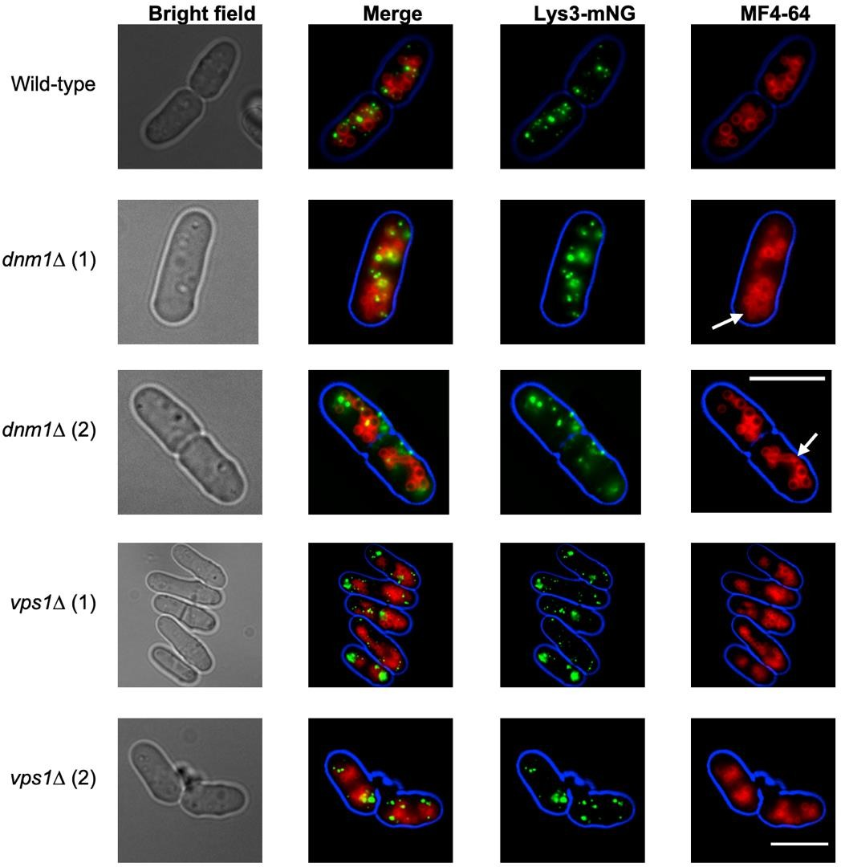
Figure 3. 22 Microscopy confirmation of the dnm1∆ mutant strain through the staining of vacuoles with the lipophilic dye FM4-64. The dnm1∆ strain exhibited tubulated and un-fragmented vacuoles (dumbbell-shaped), while the vps1∆ strain showed a lack of tubule formation (Röthlisberger et al., 2009). Peroxisomes in both strains were labelled with the green peroxisomal marker (Lys3-mNG). Cells were cultured until reaching the logarithmic growth phase and were then examined using epifluorescence microscopy. Scale bar is 5μm.

Unlike the vps1∆ strain, the dnm1∆ strain occasionally exhibited vacuoles with a dumbbell shape, as shown in Figure 3.22 (Röthlisberger et al., 2009). This observation further corroborated our identification of the mutant strain dnm1∆, in addition to the confirmation through PCR (Röthlisberger et al., 2009).

Considering the previous observations and the challenges associated with generating a double knockout mutant strain (dnm1∆ and vps1∆) with labelled peroxisomes, an alternative approach was chosen for exploration. To mimic a similar protocol used in
S. cerevisiae cells (Alpadi et al., 2013), S. pombe vps1∆ cells were subjected to a treatment with 100µM of Dynasore (a dnm1 inhibitor drug) for one hour, followed by an increase in drug concentration to 200µM. The incubation period was extended to approximately 4 hours. Subsequently, the effect of dynamin inhibition on peroxisome localization was assessed by imaging the cells. A transporter (DMSO) was used as a control (Figure 3.23).

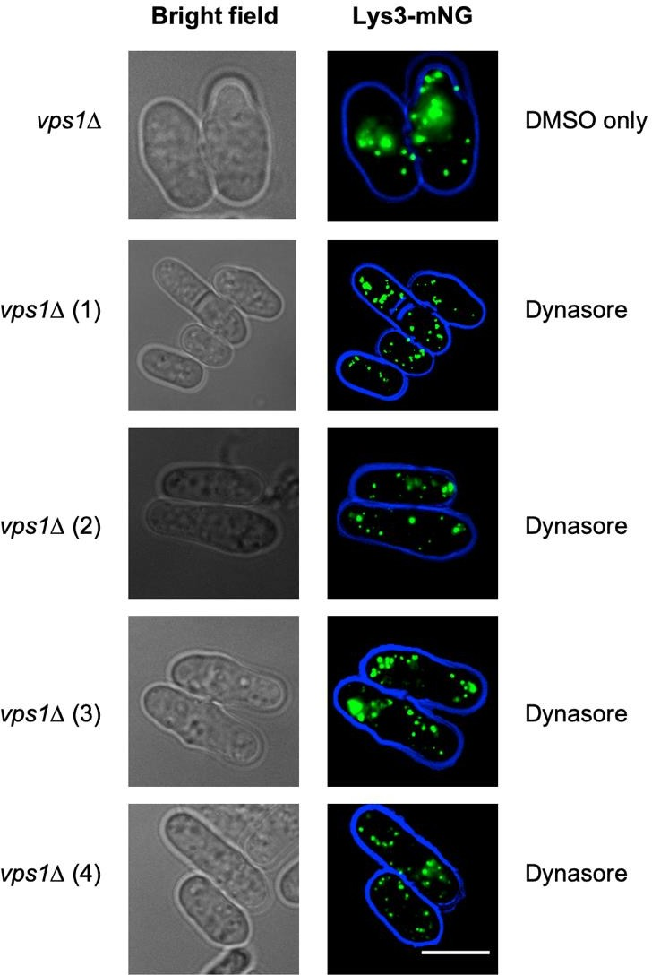
Figure 3. 23 In vivo, the compound Dynasore inhibits the processes of peroxisomal fission and fusion, while its effectiveness in inhibiting S. pombe Dnm1 function remains uncertain. The peroxisomes in S. pombe vps1∆ mutant cells were labelled with the green peroxisomal marker (Lys3- mNG), with a transporter (DMSO) used as a control. Cells were cultured until reaching the logarithmic growth phase and were then examined using epifluorescence microscopy. Scale bar: 5μm.

However, there are several considerations that need to be taken into account. The effectiveness of dynasore in inhibiting S. pombe Dnm1 function has not been

established, and the mechanism by which dynasore enters S. pombe cells remains unclear. Additionally, the potential impacts of dynasore on peroxisomes are still uncertain. These aspects present significant complexities that cannot be fully resolved in a single experiment. Furthermore, it would be highly useful to include a positive control alongside the test strain, such as S. cerevisiae cells. Therefore, further investigations are necessary to address these inquiries and acquire a more comprehensive understanding of the consequences associated with blocking fission in S. pombe peroxisomes.

The role of Mitochondrial division protein (mdv1) in peroxisome fission in S. pombe

In S. cerevisiae, both Caf4p and Mdv1p were discovered to have the ability to bind Dnm1p. In an mdv1Δ and caf4Δ double mutant, a significant portion of Dnm1p becomes detached from mitochondria (Schauss et al., 2006). Mdv1p plays a more prominent role in fission compared to Caf4p, as mdv1Δ cells display a noticeable fission defect, while caf4Δ cells do not (Griffin et al., 2005).

Furthermore, it was found that both Caf4p and Mdv1p are necessary for Dnm1p- dependent peroxisome fission, similar to their roles in mitochondrial fission. However, unlike mitochondrial fission, these proteins have redundant functions in peroxisome fission. Additionally, Vps1p-dependent fission of peroxisomes was shown to be independent of the presence of Fis1p, Caf4p, or Mdv1p (Motley et al., 2008). However, a recent study demonstrated that Vps1p relies on pex27 (Ekal et al., 2023). In this study, the accessory protein Mdv1 gene was also knocked out from the S. pombe genome to investigate its involvement in peroxisome fission (Figure 3.24).

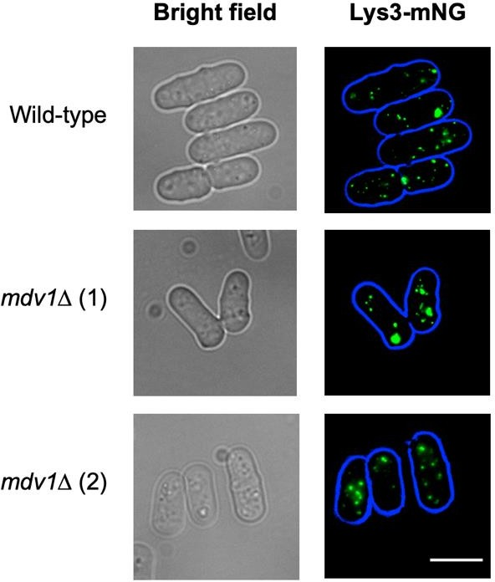
Figure 3. 24 The phenotype of mdv1∆ cells resemble that of the S. pombe wild-type strain. Cells were cultured until reaching the logarithmic growth phase and the peroxisomes in S. pombe mdv1∆ mutant cells were labelled with the green peroxisomal marker (Lys3-mNG) then examined using epifluorescence microscopy. Scale bar: 5μm.

Similar to the vps1∆ strain, the peroxisome pattern in the mdv1∆ mutant closely resembles that of the wild-type S. pombe strain, as depicted in Figure 3.24. It is worth noting here that, unlike S. cerevisiae cells, the S. pombe genome lacks CCR4- associated factor 4 (caf4).

Inheritance of peroxisomes protein 2 knockout (inp2∆)

During the bioinformatics search, the gene "Inheritance of peroxisomes protein 2" (Inp2/SPBC21B10.06c) was identified in the S. pombe genome. In the budding yeast
S. cerevisiae, the ortholog Inp2p is a peroxisomal membrane protein known for its role as the peroxisome-specific receptor for the myosin V motor Myo2p and its crucial involvement in peroxisome inheritance (Fagarasanu et al., 2006). However, in S. pombe, which is a fission yeast, the function of this protein remains unclear. To investigate the role of S. pombe Inp2, a knockout of this gene was successfully generated in the S. pombe genome. Similar to previous mutant strains, Lys3-mNG was utilized as a peroxisomal marker to visualize peroxisomes (Figure 3.25).

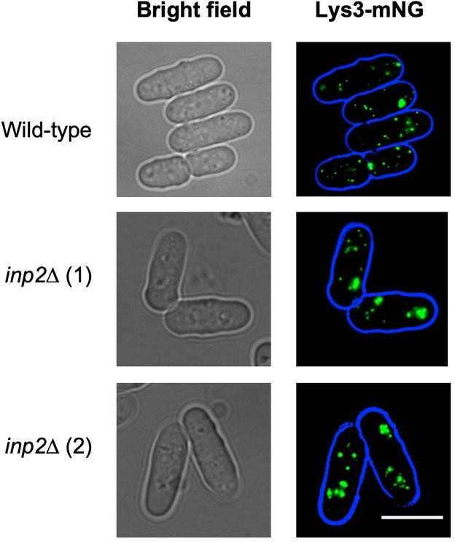
Figure 3. 25 Deletion of the S. pombe Inp2 results in the observation of an empty zone in the middle of cells, distinguishing it from the wild-type strain. Cells were cultured until reaching the logarithmic growth phase and the peroxisomes in S. pombe inp2∆ mutant cells were labelled with the green peroxisomal marker (Lys3-mNG) then examined using epifluorescence microscopy. Scale bar is 5μm.

An empty zone was observed in the centre of cells in the inp2∆ mutant strain, which contrasted with the wild-type strain. In order to quantify the difference, the number of peroxisomes in the middle zone of 100 cells was counted for both strains.

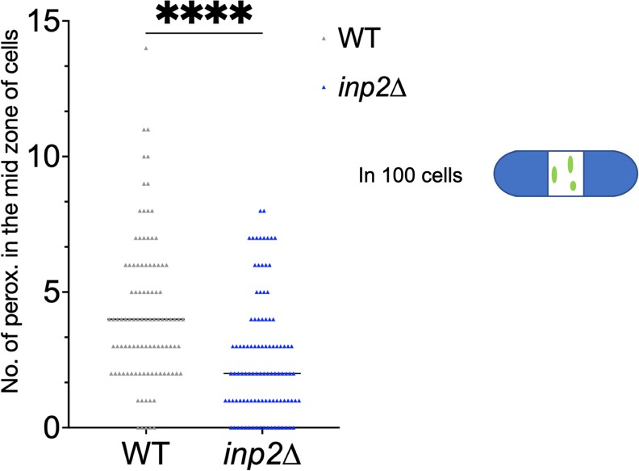
Figure 3. 26 The mean number of peroxisomes in the middle zone of S. pombe inp2∆ and wild type cells. In the wild type cells (grey), the mean number of peroxisomes in the middle zone is approximately 4.2, whereas in the inp2∆ cells (blue), the mean number of peroxisomes in the middle zone is around 2.5. Bars in the graph indicate median with 95% confidence interval for mean. Statistical significance analysis was performed using Wilcoxon test where, p values are for * <0.05, ** <0.01, ***
<0.001, **** <0.0001, ns stands for not significant.

The results, presented in Figure 3.26, indicate a reduction in peroxisome abundance in the middle zones of cells in the inp2∆ mutant strain compared to the wild-type strain. The mean number of peroxisomes in the middle zone of the inp2∆ strain is approximately 2.5, whereas it is around 4.5 in the wild-type strain (Figure 3.26). Nevertheless, peroxisome motility in fission yeast appears to be closely connected to mitochondria and could potentially be an indirect consequence of alterations in mitochondrial activity (Jourdain et al., 2008). It is possible that a specific stage in the cell cycle is delayed, and the cell cycle might vary between different cells. Additionally, defective mitochondria could be associated with peroxisomes, although it doesn't necessarily imply a lack of phenotype.

To investigate the potential complementary function of S. pombe Inp2 (SpInp2) with S. cerevisiae Inp2 (ScInp2), a plasmid carrying N-terminal GFP-tagged SpInp2 was introduced into both the S. cerevisiae wild-type strain and the inp2∆ strain, along with a plasmid carrying a red peroxisomal marker (pAul28).

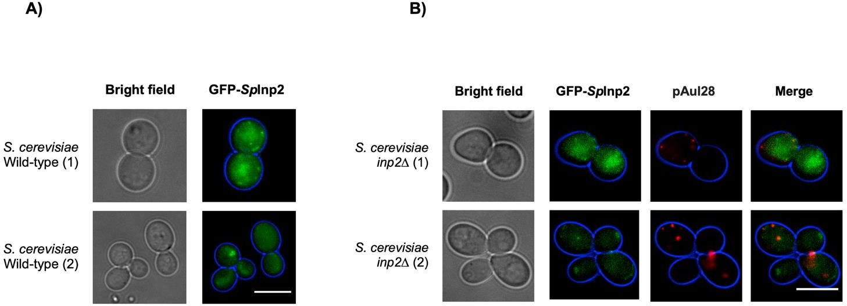
Figure 3. 27 S. pombe Inp2 does not localize to S. cerevisiae peroxisomes and does not complement the function of S. cerevisiae Inp2 in the inheritance of peroxisomes in S. cerevisiae.
S. pombe inp2 was N-terminally tagged with GFP and expressed along with a red peroxisomal marker in (A) the S. cerevisiae wild-type strain and (B) the S. cerevisiae inp2∆ strain. Scale bar is 5μm.

Microscopic imaging analysis revealed that SpInp2 did not exhibit peroxisomal punctate structures in the S. cerevisiae wild-type strain (Figure 3.27A), and it also did not colocalize with the red peroxisomal marker in the inp2∆ strain (Figure 3.27B). Furthermore, the red peroxisomal marker remained localized to the mother cells in the mutant strain, indicating that SpInp2 does not possess a complementary function like

S. cerevisiae Inp2. However, further investigations are required, including tagging the gene from the C-terminus, as well as conducting experiments without any tag, to confirm this conclusion and exclude other possibilities.

Peroxisome knock-out phenotype study

The subcellular patterns of peroxisomes in 100 cells from various mutant strains generated in this study were analysed and compared to the wild-type S. pombe strain (Table 3.2).

Table 3. 2 The peroxisomal patterns observed in different mutant strains compared to the wild- type S. pombe strain.

Strain
S. pombe WT | 73 | 27 | - | - | - | - | -
inp2∆ | 57 | 43 | - | - | - | - | -
pex11-MNG | - | - | 19 | 1 | - | 80 | -
pex11paralog-MNG | 71 | 29 | - | - | - | - | -
vps1∆ | 68 | 13 | - | - | - | - | -
dnm1∆ | 63 | 19 | - | - | - | 4 | 14
mdv1∆ | 67 | 33 | - | - | - | - | -

The dnm1∆ mutant strain exhibited distinct peroxisome patterns, while the vps1∆ and mdv1∆ mutant strains displayed peroxisome patterns similar to the wild-type strain. Tagging the Pex11 protein affected its function and resulted in a reduced number of peroxisomes or complete absence of peroxisomes. In contrast, tagging the Pex11 paralog did not impact peroxisome patterns. Furthermore, in the inp2∆ mutant strain, an empty zone was observed in the centre of cells compared to the wild-type strain (Table 3.2).

Discussion

S. pombe, the second most well-developed yeast model system after S. cerevisiae, has mainly been used to study cell cycle-related processes, although its potential as

a biotechnological production host is increasing. However, metabolic pathways in S. pombe are still poorly characterized (Jourdain et al., 2008). Peroxisomes have multifunctional roles in different organisms, but fatty acid β-oxidation and hydrogen peroxidase detoxification are the most commonly found peroxisomal processes in most eukaryotic cells (Akşit & van der Klei, 2018; Sibirny, 2016). Peroxisome number is often responsive to metabolic requirements in many organisms. For example, when
S. cerevisiae is grown on oleate (C18:1 fatty acid), peroxisomes proliferate, and β- oxidation enzyme expression is greatly increased (Chen et al., 2014; van Roermund et al., 2003). In yeast and plants, fatty acid β-oxidation occurs only in peroxisomes, whereas in mammalian cells and some groups of fungi, fatty acids β-oxidation occurs in both peroxisomes and mitochondria (Camões et al., 2015; van Roermund et al., 2003). Yeasts are, therefore, an ideal organism for understanding this pathway inside peroxisomes. The β-oxidation of fatty acid pathway is well characterised, and the enzymes are evolutionarily conserved. The genes encoding these enzymes are readily detectable using bioinformatic methods. So far, bioinformatics, frequently combined with experimental data, has revealed the presence of peroxisomal β-oxidation systems in all fungi and in basidiomycetes and certain clades of ascomycetes, an additional mitochondrial β-oxidation system is present (Trotter, 2001). However, in the case of S. pombe, the pathway of fatty acid β-oxidation has not been studied extensively. Only one study in this yeast focused on peroxisomes, in particular, the process of peroxisome fission by dynamin-related proteins (DRPs). In this study, peroxisomes were labelled with a fluorescent peroxisomal reporter and were shown to proliferate in the presence of oleate, suggesting a role in fatty acid degradation (Jourdain et al., 2008).

Our screening indeed identified that the core machinery for peroxisome biogenesis is present in S. pombe, and this agrees with a previous bioinformatic study (Kiel et al., 2006) (Table3.3). However, our screening did not identify any hits for enzymes involved in fatty acid β-oxidation in S. pombe, even though peroxisomes have been suggested to play a role in fatty acid degradation by Jourdain et al., (2008). Additionally, while enzymes involved in peroxisomal β-oxidation pathway, such as Acyl-CoA oxidase (ACOX, POX), peroxisomal multifunctional enzyme MFE2, and POT1-Acetyl CoA C Acetyltransferase (3-Ketoacyl-CoA thiolase), are present in other yeasts like S. cerevisiae and D. hansenii, no matches were found in S. pombe.

Furthermore, a search for mitochondrial β-oxidation proteins, including Acyl-CoA dehydrogenases (ACAD) and Enoyl-CoA hydratase, against S. pombe yielded no results.

Table 3. 3 The core machinery for peroxisome biogenesis in S. pombe (modified from Kiel et al., 2006).

Peroxin | Functional categories | Uniprot accession Number
Targeting of matrix proteins
PEX7 | PTS2 cargo, shuttling receptor | P78798
PEX5 | PTS1 and PTS2 cargo, shuttling  receptor | O94325
Matrix protein import machinery
PEX5 | Cargo-translocating channel | O94325
PEX14 | Cargo-translocating channel  Receptor docking complex | O60065
PEX13 | Receptor docking complex | O14136
PEX8 | Docking and export complex  conjugation, importomer assembly | Q9UT96
PEX4 | Receptor export (ubiquitylation),  ubiquitin conjugating enzyme | Q9P6I1
PEX2 | Receptor export (ubiquitylation), form the  RING finger complex | O42845
PEX10 | Receptor export (ubiquitylation), form the  RING finger complex | Q9UUF0
PEX12 | Receptor export (ubiquitylation), form the  RING finger complex | Q8TFH8
PEX1 | Receptor export (recycling), AAA-type  ATPase | O74941
PEX6 | Receptor export (recycling), AAA-type  ATPase | O13764
Direct targeting of PMPs
PEX3 | Receptor docking | O14017
PEX19 | Soluble chaperone and receptor | Q10485
Formation of peroxisomal membrane from the
ER
PEX3 | Form a complex required for the de novo  generation of peroxisomes | O14017
PEX19 | Form a complex required for the de novo  generation of peroxisomes | Q10485
Fission
PEX11 | Membrane elongation, recruits the  fission machinery | Q10333  Q10346
Regulation of peroxisome biogenesis

PEX28 | Form a complex with reticulon homology  domain- containing proteins and establish peroxisome contact sites at ER subdomains, contain dysferlin domains | O13679
PEX29 | Form a complex with reticulon homology  domain- containing proteins and establish peroxisome contact sites at ER subdomains, contain dysferlin domains | O13679
PEX32 | Form a complex with reticulon homology  domain- containing proteins and establish peroxisome contact sites at ER  subdomains, contain dysferlin domains | O59807

Although some proteins were identified as being conserved in peroxisomes and having potential PTS1 sequences in other fission yeasts, such as S. cryophilus, S. octosporus, and S. japonicus, the number of peroxisomal proteins in S. pombe appeared to be relatively low compared to other organisms such as human and S. cerevisiae. Additionally, certain proteins like Probable NADH-ubiquinone oxidoreductase C3A11.07 and mitochondrial and nuclear protein localization protein 4, which possess potential PTS1 sequences, do not seem to be peroxisomal (Table 3.1; Supplementary file). These results suggest that the peroxisome in S. pombe may be a derived form that has lost many of its functions. However, this also makes it an excellent compartment for use in synthetic biology and biotechnology, as it could potentially serve as a platform for the development of novel enzymatic processes.

Moreover, in this study it was observed that S. pombe cells cannot utilize fatty acids as the sole carbon source, as evidenced by their inability to survive in media containing oleic acid or an oleate tween mixture as the exclusive carbon source (Figure 3.1, 3.2, and 3.5). Although S. pombe cells can survive in media containing tweens as chemical sources of lipids, they exhibit impaired growth (Figure 3.3 and Figure 3.5). The mitochondria of S. pombe cells remain intact in glucose medium but undergo fragmentation and potential degradation in media containing lipid sources (Figure 3.8). The observed enlargement of the vacuole in tweens medium in S. pombe is likely attributed to the change in media or the absence of carbon sources rather than the presence of tweens. This may explain the relatively increased numbers of

peroxisomes in tweens medium without a corresponding growth change (Figure 3.9) (Röthlisberger et al., 2009). To provide a control, glucose was added to the lipid medium, and it was demonstrated that S. pombe can grow in the presence of an oleate tween mixture and glucose (Figure 3.6 and 3.7). Notably, in the YES medium with oleic acid + glucose, S. pombe cells can only grow when the oleic acid is autoclaved. This could be attributed to the autoclaving process, which degrades the oleic acid, making it more accessible to S. pombe for growth (Ayton et al., 2012).

Due to the lack of growth and inconclusive imaging, it was not possible to determine conclusively whether there was an increase in peroxisomes. Thus, it is possible that many functions of the S. pombe peroxisome have been lost, and it may be a derived form. Nevertheless, S. pombe peroxisomes constitute a promising compartment to be utilized in synthetic biology applications for the development of new enzymatic processes.

Most peroxisomal proteins are imported via a consensus of PTS1 and PTS2 by Pex5 and Pex7, respectively. However, there are proteins that lack PTS1 but still utilize Pex5 for import. For example, acyl-CoA oxidase (Pox1, Aox) and carnitine acetyltransferase (Cat2p) in S. cerevisiae are imported via Pex5 even though they lack PTS1(Kempiński et al., 2020; Rymer et al., 2018). Some proteins, such as Cu/Zn superoxide dismutase 1 and Pnc1, are peroxisomal and have no targeting signals, yet they are still imported into peroxisomes by a non-classical import mechanism (Kim & Hettema, 2015; Wanders, 2018).

According to bioinformatics analysis, only a few proteins are predicted to be imported into S. pombe peroxisomes. In a global yeast two-hybrid screen, S. pombe Pex5 was found to interact with S. pombe Str3. Although Str3 in S. cerevisiae has a PTS1 (SKL) and localizes to the peroxisomes (Barreto et al., 2006; Giard et al., 2001), we think that there may be a conserved targeting mechanism for peroxisomal proteins lacking both PTS1 and PTS2 that involves Pex5 import in S. pombe. SpStr3 was tagged at the C-terminus with green fluorescent protein (GFP) reporter genes in the genome of various S. pombe strains, as shown in Figure 3.10.

In addition to SpStr3, S. pombe Pex5 was found to interact with Lys3 in a yeast two- hybrid system. Lys3 is the homologue of peroxisomal protein Lys1 in S. cerevisiae (David et al., 2022; Al-Saryi et al., 2017). Although SpLys3 has a PTS1 motif (QKL), our data suggests that it does not rely solely on this peroxisomal targeting sequence for import. This is supported by our observation that when SpLys3 was tagged with reporter genes at the C-terminus and integrated into the S. pombe genome, it still localized to peroxisomes (Figure 3.12).

Two additional proteins were identified as putative peroxisomal proteins in S. pombe through bioinformatic searches (Table 3.1 and 5.1). The first one is Oxalate--CoA ligase pcs60 (Fat2), which has an AKL as PTS1 and is homologous to S. cerevisiae peroxisomal peripheral membrane protein FAT2 Oxalate--CoA ligase FAT2 (which has an SKL) (Blobel, 1996; Watkins et al., 1998). It is also homologous to the peroxisomal 4-coumarate--CoA ligase 1 in D. discoideum (which has a PKL) and was identified in the mass spectrometry list (See chapter 5). Second one is a peroxisomal membrane associated protein Pmp20 (has an SSL) and it is the homologue of human peroxisomal Peroxiredoxin 5 PRDX5 (P30044) which carries an PTS1 (SQL) (Knoops et al., 1999) (Table 3.1 and 5.1). Both genes were tagged with a C-terminal mNG reporter gene in the S. pombe genome (Figure 3.14), but they showed cytosolic expression, indicating that they may utilize a different peroxisomal import pathway than Str3 and Lys3. Indeed, tagging of PTS1 protein with a C-terminal tag inactivates the PTS1. To confirm peroxisomal location, N-terminal tagging experiment could be performed.

Plasmids containing both SpStr3 and SpLys3 tagged with GFP and were expressed in different S. cerevisiae strains to investigate whether ScPex5 recognizes them (Figure 3.11 and 3.13). However, our data suggests that they may utilize a different peroxisomal import pathway than in S. cerevisiae. The import pathway of SpStr3 and SpLys3 in S. pombe may be similar to the peroxisomal pathway observed in S. cerevisiae for acyl-CoA oxidase (Pox1) protein, which lacks both PTS1 and PTS2. Pox1 is recognized by the N-terminal domain of Pex5 known as PTS3, leading to its import into the peroxisomal matrix (Kempiński et al., 2020; Rymer et al., 2018). Consequently, further investigations are necessary to enhance our understanding of the peroxisomal import pathway for SpStr3 and SpLys3 in S. pombe, particularly to confirm which domain of the Pex5 receptor interacts with these peroxisomal proteins.

Yeast Str3 is involved in the transsulfuration pathway, which converts cysteine to homocysteine. Specifically, Str3 catalyses the conversion of cystathionine into homocysteine. Previous studies in S. cerevisiae have shown that cells lacking the str3Δ gene are unable to grow when cysteine or cystathionine is the sole sulfur source in the media (Barreto et al., 2006; Sohn et al., 2014).

While Barreto et al. (2006) suggested a potential role for peroxisomes in the transsulfuration pathway in S. cerevisiae, this study provides evidence that peroxisomes may not be required. Specifically, pex3 mutant strains (S. cerevisiae MAT A pex3Δ "a Met15deficient" and S. cerevisiae MAT α pex3Δ "aMet15 autotroph") were capable of growing in minimal medium without methionine and medium without sulfur- containing amino acids (Figure 3.17 B and C).

To investigate whether SpStr3 has a complementary function to ScStr3 in the trans- sulphuration pathway, SpStr3 and ScStr3 were expressed in our Scstr3∆ mutant cells, and spot assays were performed in different media (Figure 3.18). The results demonstrate that SpStr3 indeed complements the function of ScStr3 in the trans- sulfuration pathway (Figure 3.18).

In order to examine the role of various peroxisomal genes in fission and inheritance of
S. pombe peroxisomes, some of these genes were tagged and others were knocked out. The presence of a tagged Pex11 protein had an impact on the number of peroxisomes, which aligns with findings observed in S. cerevisiae. In S. cerevisiae, the Pex11 protein has been linked to peroxisome proliferation, as evidenced by morphological studies involving PEX11 mutant cells. Cells lacking Pex11 demonstrated an inability to increase the number of peroxisomes when exposed to fatty acids, leading to the accumulation of a small number of enlarged peroxisomes (Erdmann & Blobel, 1995). While the S. cerevisiae genome contains only one PEX11 gene (Kiel et al., 2006), an additional Pex11 paralog is present in the S. pombe genome, which was unaffected by the tagging process (Figure 3.19B). This result raises questions about the role of this gene (SPAC1F12.04c) in peroxisome fission in S. pombe compared to the PEX11 gene (Q10333).

To study peroxisome fission in S. pombe, peroxisomes were labelled by reporter genes and a number of genes were knocked out. While vps1∆ and mdv1∆ strains showed the same patterns of peroxisomes as the wild-type strain, the dnm1∆ strain showed a variety of peroxisome patterns (Figure 3.20).

An empty zone in the middle of S. pombe inp2∆ cells, compared to the wild-type strain, was observed (Figure 3.25). Subsequently, the number of peroxisomes in both strains was counted (Figures 3.26). Additionally, N-terminal GFP-tagged SpInp2 was expressed in both the S. cerevisiae wild-type strain and the inp2∆ strain, along with a plasmid carrying a red peroxisomal marker (pAul28), to examine the potential complementary function of S. pombe Inp2 with S. cerevisiae Inp2. However, further investigations are needed to fully understand this finding.

In conclusion, additional investigations are required to gain a better understanding of these findings concerning dynamics peroxisome in S. pombe.

Chapter 4. Dynamic regulation of peroxisomes in D. discoideum

Introduction

Peroxisomes are vital organelles found in most eukaryotic cells, measuring about 0.1- 1μm in diameter and spherical in shape (Kim & Hettema, 2015; Yuan et al., 2016). The peroxisomes have several metabolic and non-metabolic functions that vary depending on the environment and organism. As dynamic organelles, peroxisomes can modulate their proliferation, morphology, and movement within cells, and engage in crosstalk with other organelles in response to external cues.

Despite their importance, peroxisomes have been largely overlooked in studies of D. discoideum. To address this gap, a cassette containing mRFP fused to the classical peroxisomal targeting sequence (PTS1) SKL was first integrated into the Dictyostelium genome. This approach allowed us to create stable cell lines with reduced variability among cells and enabled more accurate visualization of peroxisomes. Using spinning disk microscopy and live-cell imaging, we visualized peroxisomes in D. discoideum cells grown under different conditions.

In addition to investigating the dynamic regulation of peroxisomes, the role of the major gene of dynamins (dymA) was also explored in peroxisome fission in D. discoideum. Previous studies have suggested that dynamin-related proteins may be involved in peroxisome division, but the role of DymA in this process in D. discoideum has not been characterized. To address this, a knockout DymA mutant strain was obtained from our laboratory, and subsequently, a plasmid carrying a red peroxisomal marker was expressed to investigate the effect of this gene on peroxisome fission in D. discoideum using live-cell imaging.

Overall, this study provides new insights into the dynamic regulation of peroxisomes in D. discoideum and sheds light on the role of DymA in peroxisome fission. The

findings presented here may have important implications for understanding peroxisome biology and its role in cellular function.

  - Peroxisomes dynamics in D. discoideum

Peroxisomes perform common functions, such as fatty acids β-oxidation and detoxification of H2O2, which are present in most organisms. Additionally, they exhibit specific functions that are limited to certain species or may vary based on environmental factors (Camões et al., 2015; Fidaleo, 2010). In yeast, the quantity of peroxisomes expands - i.e. peroxisomal biogenesis is increased when fatty acids are carbon source (Smith & Aitchison, 2013). To investigate whether the regulation of peroxisome numbers responds dynamically to varying growth conditions in D. discoideum, an extrachromosomal vector containing a red fluorescent protein (RFP) with a peroxisomal targeting sequence (SKL) was transfected into the wild-type AX2 strain to demonstrate peroxisomal expression. As a control, a plasmid with solely RFP, expressing it in the cytosol, was utilized (Figure 4.1).

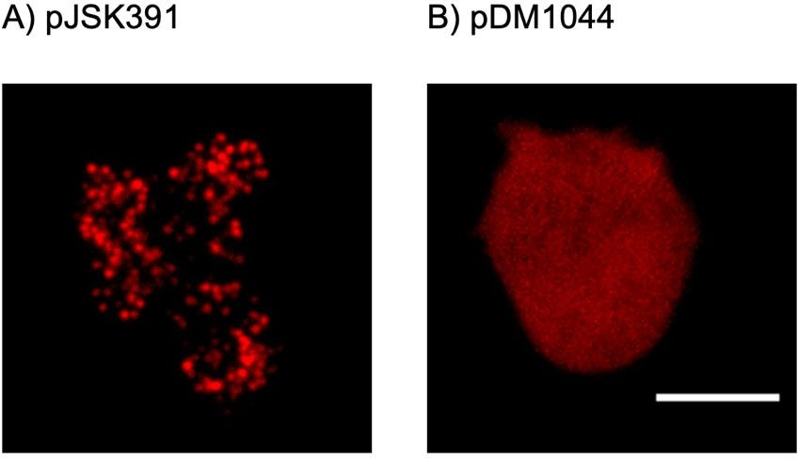
Figure 4. 1 Peroxisomal expression in D. discoideum utilizing an extrachromosomal plasmid that contains RFP fused with SKL. The visualization was conducted through spinning disk microscopy. A) peroxisomal expression is compared using pJSK391, displaying peroxisomal puncta. On the other hand, B) demonstrates cytosolic expression utilizing the pDM1044 plasmid. Scale bar is 10μm.

To achieve stable and reliable visualization of peroxisomes, an integration plasmid was employed instead of an extrachromosomal plasmid, which exhibited varying levels of expression across the cell population. Specifically, the pDM1514 integrating

expression plasmid (Paschke et al., 2018), containing RFP fused with a peroxisomal targeting sequence (SKL), was utilized. The backbone plasmid (pDM1514) was subjected to BglII and SpeII restriction enzyme digestion, followed by purification. Subsequently, the purified backbone plasmid was ligated with the SKL fragment (created by annealing oligos) within E. coli cells (DH5α) at 37°C. The next day, a single colony was inoculated in LB broth supplemented with ampicillin and incubated overnight for maxiprep and miniprep of the newly generated plasmid. Verification of the new plasmid was accomplished through test digestion and sequencing. After confirmation, the cassette containing mRFP with SKL was randomly integrated into the Dictyostelium genome, facilitating the creation of stable cell lines with reduced variability among cells and enabling more precise visualization of peroxisomes (Figure 4.2).

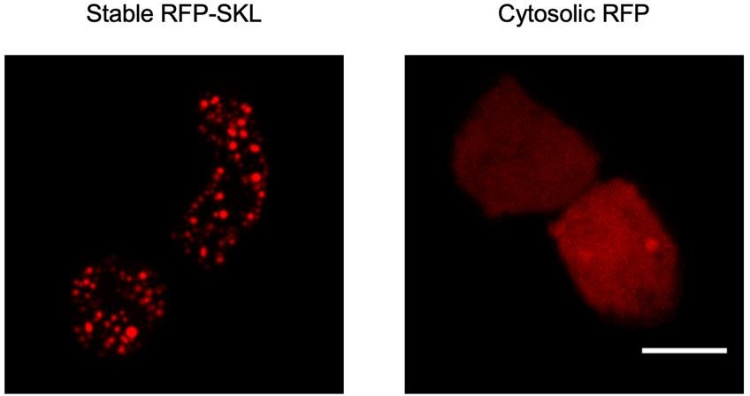
Figure 4. 2 Peroxisomally targeted RFP allows live cell imaging of peroxisomes in D. discoideum using spinning disk microscopy. The pDM1514 plasmid contains fused RFP with peroxisomal targeting sequence (SKL) and is integrated into the Dictyostelium genome. Scale bar is 10μm.

The new strain, which contained stably expressed peroxisomally targeted RFP, was then cultured under various growth conditions. D. discoideum has the ability to grow either axenically in liquid medium, such as HL5, or by phagocytosis of bacteria. This study aimed to investigate whether the presence of bacteria, which are likely to contain more lipids, influences the number of peroxisomes in D. discoideum. HL5 medium consists of peptone, yeast extract, potassium dihydrogen phosphate, disodium

hydrogen phosphate, and glucose, while the SIH-defined medium contains glucose, a variation of amino acids, vitamins, and micro elements, but does not include any fatty acids. Initially, various concentrations of oleic acid (100µM, 50µM, 20µM, 10µM, 5µM, 2µM, 1µM, and 0.5µM) were added to HL5 medium as a chemically sourced fatty acid. However, it was discovered that the strain could not tolerate oleic acid, and even the lowest concentration resulted in cell death. Consequently, it was replaced with an oleate-tweens40 mixture (0.1% oleate, 0.25% tween40) (Hettema et al., 1996), along with various types of tweens (Tween 40, 80, and 85). It was further observed that the oleate-tweens40 mixture and Tween 85 were lethal to Dictyostelium cells, while the other Tweens were deemed suitable. The concentration of tweens utilized was approximately 0.25%, consistent with that used in yeast medium (Hettema et al., 1996). Dictyostelium cells were cultured under different growth conditions for approximately 24 hours, with three independent replicates, and compared to growth in HL5 medium as the control.

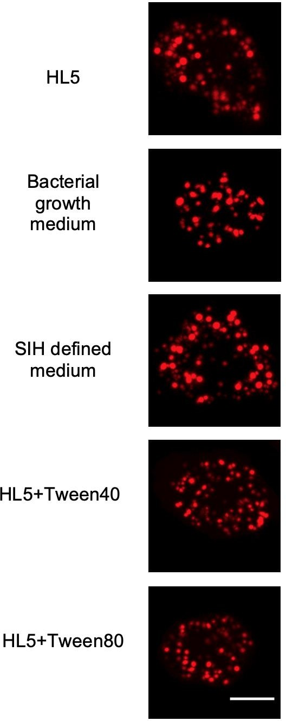
Figure 4. 3 Different growth conditions used to assess their impact on the size and number of peroxisomes in D. discoideum. It is worth noting that growth on bacteria likely contains higher levels of fatty acids compared to HL5 medium, whereas SIH defined medium completely lacks fatty acids. In HL5 medium, tweens40 and 80 were included as chemical sources of fatty acids. Scale bar is 10μm.

The growth on bacteria likely harbors elevated levels of fatty acids in comparison to HL5 medium, while SIH defined medium is devoid of fatty acids altogether. In HL5 medium, tweens40 and 80 serve as chemical sources of fatty acids (Figure 4.3). The numbers and volumes of peroxisomes, along with additional features like mean intensity, sphericity, and surface area, were automatically analyzed using Arivis software. This comprehensive analysis followed the live visualization of peroxisomes through spinning disk microscopy (Figures 4.3 and 4.4). Arivis Vision 4D 3.4.0, a 3D/4D imaging software, facilitates the visualization and analysis of extensive and intricate microscopy data. Tailored for use across various fields, including life sciences, biomedical research, and material sciences, Arivis Vision 4D empowers researchers to execute diverse image processing and analysis tasks, such as quantification and visualization. The software proves particularly invaluable for scrutinizing substantial datasets arising from time-lapse imaging experiments or high-throughput screening assays.
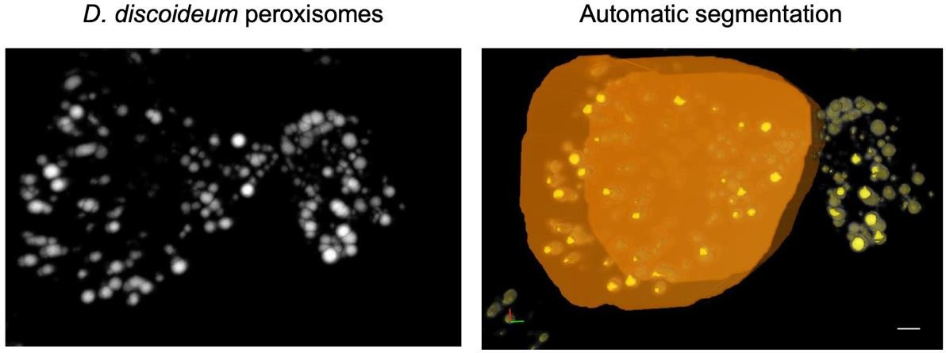
Figure 4. 4 D. discoideum peroxisomes captured using Arivis Vision 4D 3.4.0, a powerful 3D/4D imaging software commonly used for visualizing and analysing large and complex microscopy data. The peroxisomes' numbers and sizes were automatically analysed by the Arivis software, which offers various tools for image processing, segmentation, tracking, quantification, and visualization.

All graphs, calculations, and statistical analyses were conducted using GraphPad Prism software version 9.0 for Mac (GraphPad Software, San Diego, CA, USA). To investigate the numbers and volumes of peroxisomes, peroxisome numbers and volumes were quantified for 50 cells in each replicate or each experimental condition. The graphs (Figure 4.5 and 4.6) display bars representing the median with a 95% confidence interval for the mean. Statistical significance was assessed using ordinary one-way ANOVA test, where p-values are denoted as * <0.05. Each replicate was assigned a distinct colour, and the mean values for peroxisome numbers and volumes were computed. Figures 4.5 and 4.6 illustrate these findings.

Analysis of peroxisome numbers

Based on our findings, no significant differences were observed among the different growth conditions used when compared to our control (HL5 medium), which had a mean peroxisome number of approximately 52.1. The mean peroxisome number during growth on bacteria was approximately 39.1. In SIH media, the mean

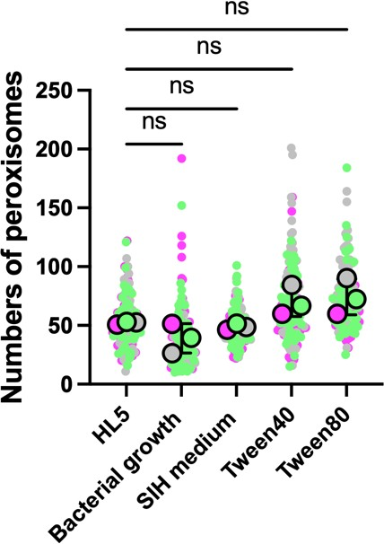
peroxisome number was approximately 48.8. In HL5 media containing tween40, the mean peroxisome number was approximately 70.3 peroxisomes. The highest mean peroxisome number was observed in HL5 media containing tween 80, with approximately 74.2 peroxisomes (Table 4.1 and Figure 4.5).
Figure 4. 5 The peroxisome numbers in each respective growth condition medium. Statistical variance was assessed using GraphPad Prism 9 (version 9.1.0), a graphing software. Bars in the graph indicate the median with 95% confidence intervals for mean. ns stands for not significant. Each replica in the figure is labelled with a different colour, namely magenta, magnesium, and flora colours. The mean value of each replica is represented by a large circle, while the line represents the SD of all the replicates.

There is no significant difference in the number of peroxisomes between HL5 medium and other media possibly due to the insufficient concentration of tweens used in the media to stimulate peroxisomes effectively.

Analysis of peroxisome volume

The Arivis software was used to calculate the volume of each individual peroxisome. Subsequently, the average volume of peroxisomes in each cell was determined. The analysis of peroxisome volume was performed using GraphPad Prism 9.

According to the findings, no significant differences were observed among the different media used when compared to the volume of peroxisomes in HL5 medium, which measured approximately 0.53µm³. The peroxisome volume during bacterial growth media was approximately 0.40µm³. In SIH media, the peroxisome volume was approximately 0.51µm³. In HL5 media containing tween40, the average peroxisome

volume was approximately 0.43µm³. On the other hand, in HL5 media containing tween80, the peroxisome volume was approximately 0.45µm³ (Table 4.1 and Figure 4.6).

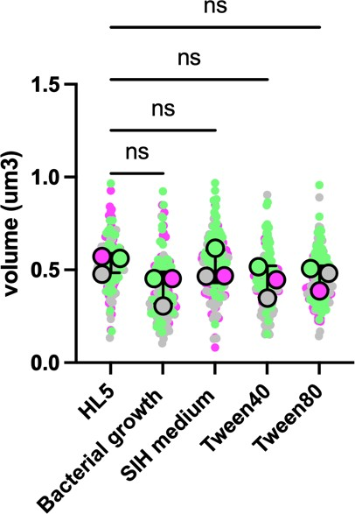
Figure 4. 6 The peroxisome volumes in each respective growth condition medium. Statistical variance was assessed using GraphPad Prism 9 (version 9.1.0), a graphing software. Bars in the graph indicate the median with 95% confidence intervals for mean. ns stands for not significant. Each replica in the figure is labelled with a different colour, namely magenta, magnesium, and flora colours. The mean value of each replica is represented by a large circle, while the line represents the SD of all the replicates.

There is no significant difference in the volume of peroxisomes between HL5 medium and other media.

Table 4. 1 Holm-Šídák's multiple comparisons test. The adjusted P value represents the differences in peroxisome values between different media when compared with the HL5 medium.

 | Peroxisomes numbers |  |  | Peroxisomes volumes
media | Mean | Adjusted P  value | P value  summary | Mean | Adjusted P  value | P value  summary
HL5 | 52.13 | - | - | 0.53µm³ | - | -
Bacterial  growth | 39.11 | 0. 2971 | ns | 0.40µm³ | 0. 2098 | ns
SIH medium | 48.81 | 0.7084 | ns | 0.51µm³ | 0.7547 | ns
Tween40 | 70.34 | 0.1707 | ns | 0.43µm³ | 0.3652 | ns
Tween80 | 74.21 | 0.1078 | ns | 0.45µm³ | 0.4122 | ns

  - Role of dynamin role in D. discoideum peroxisome fission

The dynamin superfamily is a large family of GTPases that play a role in various cellular processes, such as endocytosis, cytokinesis, and the division of organelles, including mitochondria and peroxisomes. Completing peroxisome fission requires three sequential steps. The first step is peroxisome elongation, which is regulated by the Pex11 family. Following elongation, the second step involves constriction, in which members of the dynamin superfamily are involved (Carmichael et al., 2022).

In D. discoideum, there are five dynamin-like proteins, including dymA and dymB, which are similar to the yeast proteins Vps1p and Dnm1p, respectively, and three other proteins, dlpA, dlpB, and dlpC (Fujimoto et al., 2019). In D. discoideum, the absence of DymA, dlpA, or dlpB in cells resulted in deficiencies in cytokinesis, suggesting the potential involvement of cooperative action between dlpA and dlpB hetero oligomers with dymA in cytokinesis (Fujimoto et al., 2019). Furthermore, Wienke et al., (1999) reported that cells with a disrupted dymA gene exhibited changes in the morphology of mitochondria, nuclei, and endosomes, as well as a dysfunction in fluid-phase uptake.

In yeast, specifically S. cerevisiae, it has been established that yeast Dnm1, analogous to DymA of D. discoideum, plays a role in peroxisome fission alongside the Pex11 family (including Pex11, Pex25, and Pex27). The functions of the dynamin superfamily in peroxisome fission have been extensively investigated and comprehended. The process of peroxisome fission involves three essential steps, as discussed in Chapter
1. In yeasts, the initial step is peroxisome elongation, primarily regulated by Pex11 (Carmichael et al., 2022). The second step is constriction, where Dnm1 and Dlp1 (Drp1) are recruited to the peroxisomal membranes by Fis1 (Fission 1). However, recent research suggests that in S. cerevisiae, Pex27 targets Vps1 to peroxisomal membranes, contributing to this step (Ekal et al., 2023).

Nevertheless, no study to date has investigated the impact of the dymA gene on peroxisome fission in D. discoideum. Therefore, to explore the role of the primary dynamins gene (dymA) in peroxisome fission in D. discoideum, an extrachromosomal

vector named pJSK391 was utilized. This vector contained a red fluorescent protein (RFP) fused with a peroxisomal targeting sequence (SKL). Both the D. discoideum dymA∆ mutant (Gopaldass et al., 2012) and the wild-type AX2 strain were transfected with this vector. Subsequently, the labelled peroxisomes in both strains were visualized using spinning disk microscopy (Figure 4.7).

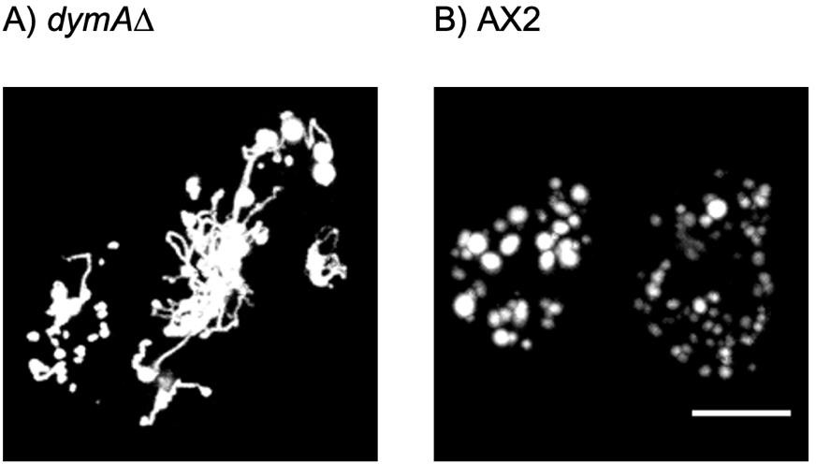
Figure 4. 7 Peroxisomes in both dymA∆ and AX2 strains. A) Peroxisomes in the dymA∆ strain appeared round but connected by thin bridges, while in B) the wild-type strain, peroxisomes were observed to be more rounded. Scale bar is 10μm.

In the dymA∆ strain, peroxisomes appeared to be still round but connected by thin bridges, whereas in the wild-type strain, peroxisomes were observed to be more rounded, as depicted in Figure 4.7.

Discussion

In this chapter, our study sheds light on the dynamic regulation of peroxisomes in D. discoideum and explores the role of the major gene of dynamins (dymA) in peroxisome fission. Peroxisomes are essential organelles in eukaryotic cells that perform metabolic and non-metabolic functions. However, despite their importance, peroxisomes have not been well-characterized in D. discoideum.

The study utilized an integration plasmid containing mRFP with SKL, which was integrated into the Dictyostelium genome, allowing for stable and reliable visualization of peroxisomes. The study investigated whether the number of peroxisomes is

dynamically regulated in response to different growth conditions in D. discoideum. This study demonstrates that peroxisomes in D. discoideum are not as responsive to growth conditions as previously reported in both mammals and yeasts (Smith & Aitchison, 2013). Moreover, no reduction in peroxisomes is observed in conditions lacking lipids, such as SIH medium. These findings raise questions about the reasons behind the limited responsiveness of D. discoideum peroxisomes.

In yeast, the number of peroxisomes is typically limited to a small count, usually fewer than twelve, whereas mammalian cells generally have hundreds of peroxisomes (Lazarow, 2003). Our study on D. discoideum reveals that the average number of peroxisomes in this organism ranges from 50 to 70, which is comparable to mammalian cells. This large abundance of peroxisomes in D. discoideum suggests that controlling their numbers under different growth conditions may not be necessary, as there is always a substantial quantity of peroxisomes present.

If peroxisomes in D. discoideum are abundant but display minimal responsiveness in the absence of dietary lipids, it suggests that their primary function may not be associated with β-oxidation. One possible explanation could be that the concentration of Tweens used in our experiments might not be sufficient to stimulate peroxisomes. Another explanation could be the existence of an alternative pathway for fatty acid β- oxidation within the mitochondria of D. discoideum cells. Our bioinformatics search provided evidence supporting this pathway, as we identified mitochondrial fatty acid β- oxidation enzymes, including Acyl-CoA dehydrogenases (acad8, acadsb), Enoyl-CoA hydratase (echs1, auh), Hydroxyacyl-CoA dehydrogenases (DDB0205217, DDB0168688), and ketoacyl-CoA thiolases (DDB_G0271544, DDB0190384).

While a crucial role is played by peroxisomes in mammalian cells, particularly human cells, as their dysfunction can lead to severe health impairments and even death (Chapter 1), yeast peroxisome mutant cells can still exhibit growth. This understanding gives rise to a compelling question: Is the knockout of peroxisomes fatal for D. discoideum? The importance of specific peroxisomal enzymes, such as Citrate synthase (Huang et al., 2004), in the growth of D. discoideum is duly recognized. Furthermore, it's noteworthy that D. discoideum peroxisomes house significant metabolic pathways like plasmalogen synthesis and sterol biosynthesis (chapter 5).

The enigmatic and thought-provoking question revolves around the fundamental vitality of peroxisomes for its development and the potential for survival in their absence. This question fuels a deeper investigation into unravelling the intricate interplay between peroxisomes and the survival mechanisms of D. discoideum.

To gain further insights, conducting experiments with a mutant strain of D. discoideum lacking the essential PEX3 gene, which plays a role in peroxisome biogenesis, and subsequently comparing the growth rate of this mutant strain with that of the wild-type strain would yield valuable information. Such an approach would facilitate an assessment of the contribution of peroxisomes to D. discoideum growth.

There are notable differences in D. discoideum compared to other organisms, such as yeast, in terms of its carbon source dependency, as evidenced by our tests focused on carbon sources. However, further research is needed to explore the role of peroxisomes in β-oxidation in D. discoideum. It is important to determine if sterols are capable of inducing peroxisome division in D. discoideum and how D. discoideum peroxisomes respond to different sterol conditions. Additionally, it is uncertain whether their response is temperature-dependent or if they exhibit limited responsiveness altogether.

To address these questions, conducting experiments with this mutant strain and incubating it under various conditions, including those with deferent lipid sources, would help evaluate the significance of peroxisomes not only in β-oxidation but also in other metabolic pathways, such as sterol biosynthesis (See chapter 5).

Moreover, the investigation in our study centred around the role of DymA in peroxisome fission, a vital process for peroxisome proliferation. Through the utilization of dymA∆ strain and subsequent examination of peroxisome fission via live-cell imaging, the involvement of DymA in peroxisome fission within D. discoideum was investigated. The outcomes of this study provide insights into the dynamic regulation of peroxisomes in D. discoideum and hold implications for comprehending peroxisome biology and its contributions to cellular functionality. Notably, the results demonstrated the participation of DymA in peroxisome fission in D. discoideum, thereby suggesting

its essential role in peroxisome biology within D. discoideum and the dymA experiment gives the first clear evidence that peroxisomes actually divide at all in D. discoideum.

Overall, the study contributes to our understanding of peroxisome dynamics in D. discoideum and may have important implications for understanding peroxisome biology in other eukaryotic cells. Further research is needed to explore the regulatory mechanisms underlying peroxisome dynamics in D. discoideum and to investigate the role of peroxisomes in cellular function. The findings presented in this study provide a foundation for future research on peroxisome biology and its role in eukaryotic cells.

Chapter 5. Identification and characterization of peroxisomal proteins in D. discoideum using BioID

Introduction

Peroxisomes are essential organelles in eukaryotic cells that play critical roles in metabolic pathways, such as fatty acid β-oxidation and H2O2 detoxification and contain crucial enzymes like oxidases and catalase. Despite their importance, our understanding of peroxisomes in D. discoideum is limited. In this study, we utilized a bioinformatics search and a proximity-dependent labelling method called BioID, which employs a mutant form of the biotin ligase BirA from E. coli to identify the components and import pathways of peroxisomes in D. discoideum. Strains expressing BirA fused with the peroxisomal targeting sequence (SKL) were generated and their localization was confirmed by fluorescence microscopy. The immunoblotting results showed multiple bands of biotinylated proteins, indicating their peroxisomal nature, in contrast to the control sample, where cytosolic BirA only produced a single band of endogenously biotinylated protein (MCCC1) in D. discoideum (See next section). Then BioID Streptavidin pull-down was performed, and the samples were sent off for mass spectrometry for analysis. By identifying the components of peroxisomes and their import pathways in D. discoideum, this study aims to provide a better understanding of the functional significance of peroxisomes in this organism. Additionally, the findings could have implications for understanding the importance of peroxisomes in other eukaryotic systems and shed light on the evolution of peroxisomal biology.

  - Bioinformatics of D. discoideum

Similar to what was done in S. pombe (See chapter 3), a pattern search was first performed using the Prosite database (https://prosite.expasy.org/scanprosite/) to identify proteins in the D. discoideum protein database (dictybase) that contain a potential PTS1 [SAPCNQE]-[KRHSQN]-[LFMI]->. A code for our D. discoideum proteome database (Q6GCg9OsFF) was used to perform the search.

In addition, peroxisomal proteins known to be localized in other organisms, such as human, S. cerevisiae, and U. maydis was used as a reference to find homologous proteins in Dictyostelium through BLAST searches. Bioinformatics searches were carried out using websites such as Uniprot (https://www.uniprot.org/), the scientific resource of slime mold Dictyostelium (http://dictybase.org/), the Saccharomyces Genome Database SGD (https://www.yeastgenome.org/), and the National Center for Biotechnology Information NCBI (https://www.ncbi.nlm.nih.gov/).

A list of potential Dictyostelium peroxisomal proteins was generated and classified as to whether they had predicted PTS1 or 2. Those proteins experimentally confirmed as peroxisomal by mass spectrometry (see following section) are also indicated (Table 5.1, 5.2, 5.3 and 5.4).

Table 5. 1 A compilation of putative peroxisomal proteins involved in lipid metabolism across various organisms, namely H. sapiens, U. maydis, S. cerevisiae, S. pombe, and D. discoideum. The initial three columns were compiled by Camões et al., (2015), whereas the information pertaining to S. pombe and D. discoideum was added in this study.

Function/ Pathway |  |  | Protein |  | H.  sapiens | U. maydis | S.  cerevisia e | S. pombe | D. discoideum
Fatty acid activation |  |  | Long-chain-fatty-acid-CoA  ligases (ACSL-like) |  | ●  SLC27A 2 | ● UMAG_025 83 | ● FAT1 | ● lcf2 | ● DDB0190808
 |  |  | PCS60-like Fatty acid-CoA  ligase (FACL) |  | ● ACSF3 | ●  UMAG_116 59 | ● PCS60 | ● pcs60 | ● DDB0205849  4cl1
 |  |  | FACL-like2 Long-chain fatty  acid coA ligase |  | ○ | ● | ○ | ○
 |  |  | Very long-chain acyl CoA  synthase (VLACS, FAT1) |  | ●  VLACS  SLC27A 2 | ●  UMAG_025 83 | ●  FAT1 | ●  SPAC1B2.0  3c  pcs60 | ● eloA  DDB0205849
 |  |  | Acetyl-CoA synthetase |  | ● ACSS2 | ●  UMAG_030 69 (DKK) | ● ACS1(VK L)  ACS2 | ●  SPCC191.0  2c | ● acsA
Other acyl- activating  enzymes |  |  | 4-Coumarate-CoA ligase  subfamily |  | ○ | ●  UMAG_061 53 | ○ | ○ | ●●  4cl1
FA-CoA  transport |  |  | ABC transporter class D |  | ● ABCD1 | ● UMAG_039 45 | ● PXA1 | ○ | ● abcD1
Lipid metabolism | Coenzymes (Accessory enzymes) | Faβ –  oxidation | Acyl-CoA oxidases (ACOX) |  | ●  ACOX1 ACOX2 ACOX3  ACOXL | ●  UMAG_022 08 UMAG_043  24 | ●  POX1 | ○ | ●●  acox1 DDB_G0286669 DDB0216722
 |  |  | Acyl-CoA dehydrogenase  (ACAD) |  | ● ACAD 11 | ● UMAG_014 66 | ○ | ○ | ●●  DDB0167901  DDB0190990
 |  |  | Bifunction al enzymes | Enoly-CoA  hydratase, hydroxyacyl- CoA Dehydrogenas e (EHHADH)  (PBE) | ●  EHHAD H | ●  UMAG_017 47 | ●  FOX2 | ○ | ●●  mfeB DDB0231502
 |  |  |  | Hydroxysteroid  (17-bets) | ●  HSD17B 4 | ●  UMAG_017 47 | ●  FOX2 | ○ | ●●  mfeA

 |  |  |  | dehydrogenas  e 4 (HSD17B4) (MFE-2) |  |  |  |  | DICPUDRAFT_48 962
 |  |  | Thiolases | 3-Ketoacyl-  CoA thiolase/ Acetyl-CoA 152 odecanoyl  152 rase  (ACAA) | ● HSD17B 4 | ●  MAC1 | ●  POT1 | ○ | ●●  DDB0167887 DDB0190384
 |  |  |  | Sterol carrier  protein x (SCPx) | ●  SCP2 | ●  UMAG_019 86 | ○ | ○ | ●●  DDB0190384
 |  | a- oxidation | Alpha-methylacyl-CoA  racemase (AMACR) |  | ●  AMACR | ●  UMAG_059 61 | ○ | ○ | ○
 |  |  | Phytanoyl-CoA 2-  hydroxylase (PHYH) |  | ●  PHYH | ○ | ○ | ○ | ●  DDB_G0349042
 |  |  | 2-Hydroxyhytanoyl-CoA  lyase (HPCL2) |  | ●  HACL1 | ○ | ●  PXP1 | ●  SPBC725.0 4 | ●●  hacl1 ilvB
 |  |  | Fatty aldehyde  dehydrogenase (ALDH3A2) |  | ●  ALDH3 A2 | ●  UMAG_036 65 | ● ALD4  K7_ALD2 | ●  SPAC922.0  7c | ● comG  DDB_G0276821
 |  | Saturation  PUFAS | 2,4-dionoyl-CoA reductase  (DECR2) |  | ●  DECR2 | ●  UMAG_101 83 | ●  SPS19 | ●  etr1 | ●●  mecr
 |  |  | 3,2-enoyl-CoA isomerase  (PECI) |  | ●  ECI2 | ●  UMAG_015 99 | ●  ECI1 | ○ | ●●  ech1 DDB_G0271866
 |  | FA-CoA  deactivati on  / export | Acyl-CoA thioesterase  (ACOT1) |  | ●  ACOT1 | ●  UMAG_001 30 | ○ | ○ | ●  DDB_G0282005
 |  |  | Peroxisomal acyl-CoA  thioesterase (ACOT8) |  | ●  ACOT8 | ●  UMAG_001 46 | ●  TES1 | ○ | ●  DDB_G0282005 DDB_G0268064
 |  |  | Ectomycorrhiza-regulated  esterase |  | ○ | ●  UMAG_042 47 | ○ | ○ | ○
 |  |  | Peroxisomal carnitine O-  octanoyltransferase (CROT) |  | ●  CROT | ○ | ○ | ○ | ○
 |  |  | Carnitine O-  acetyltransferase (CRAT) |  | ●  CRAT | ●  UMAG_007 89 | ●  CAT2 | ○ | ○
ꙍ-oxidation |  |  | Long chain fatty alcohol oxidase |  | ○ | ●  UMAG_020 23 | ○ | ○ | ●  DDB0184181
- — Absent/homologue not identified.
- — Protein homologue present, peroxisomal and/or with a predicted PTS1/PTS2.
- — Protein homologues present without a confirmed PTS or peroxisomal localisation.

●*— PTS containing proteins unique to S. pombe.
- x_ PTS containing proteins unique to D. discoideum.
- Found in mass spectrometry list

In our analysis, it was observed that the peroxisomal β-oxidation protein set was present in D. discoideum along with other proteins, but this pathway was found to be absent in the genome of S. pombe. A notable peroxisomal protein identified in D. discoideum is the Thiamine pyrophosphate-binding enzyme family protein ilvB (B0G117), which is involved in α-oxidation. Despite lacking a peroxisomal targeting signal (PTS), the protein identified through bioinformatics and experimentally confirmed by mass spectrometry is listed in the table. The BioID analysis will be discussed in detail later.

Additionally, our bioinformatics search and proteomic analysis revealed two auxiliary peroxisomal proteins associated with polyunsaturated fatty acid (PUFA) metabolism. The first protein, 2,4-dienoyl-CoA reductase (DECR2), also lacks a PTS signal. The second protein, 3,2-enoyl-CoA isomerase (PECI), carries a PTS1 signal (CNL).

Although it did not show high significance (P value = 0.186679) in the mass spectrometry analysis, 4-Coumarate-CoA ligase 4cl1 (Q54P77) is considered a peroxisomal protein in D. discoideum. It possesses a PTS1 signal (PKL). This protein, classified as an acyl-activating enzyme involved in fatty acid activation, shares homology with U. maydis (A0A0D1BUI7) and A. thaliana peroxisomal OPC-8:0-CoA ligase 1 4CLL5 (Q54P77). Its role includes contributing to jasmonic acid biosynthesis by initiating the β-oxidative chain shortening of precursor molecules (Kienow et al., 2008). In A. thaliana, Arabidopsis 4-coumaroyl-coa ligase 8 participates in the biosynthesis of the benzenoid ring of coenzyme Q in peroxisomes and contributes to the β-oxidation of p-coumarate for ubiquinone biosynthesis (Soubeyrand et al., 2019).

Table 5. 2 Putative peroxisomal proteins involved in diverse metabolic pathways across multiple organisms, including H. sapiens, U. maydis, S. cerevisiae, S. pombe, and D. discoideum. The first three columns of the table were originally compiled by Camões et al., (2015), while the information related to S. pombe and D. discoideum was added in the present study.

Function/ Pathway | Protein | H.  sapien s | U. maydis | S. cerevisiae | S. pombe | D. discoideum
Ether lipid synthesis | Glyceronephospha  te O-  acyltransferase (GNPAT) | ●  GNPAT | ●  UMAG_116 32 | ○ | ○ | ●●  DDB0188248
 | Alkyldihydroxyacet  one phosphate synthase (AGPS) | ● AGPS | ●  UMAG_112 75 | ○  PACBIOSEQ_LOCU S771 | ○  SPBC713.03 | ●●  eapA
 | Acyl/alkyl DHAP  reductase | ● DHRS1  1 | ● UMAG_058  93 | ● AYR1 | ● ayr1 | ● DDB0188337
 | Fatty acyl-CoA  reductase (FAR1/2) | ●  FAR1 | ●  UMAG_116 32 | ○ | ○ | ●●  DDB0188248
 | Glycerol-3-  phosphate  dehydrogenase (GPD1) | ●  GPD1 | ●  UMAG_005 55 | ●  GPD1 | ●  gpd1 gpd2 | ●  GPD1
Oxygen metabolism/ oxidation redox equivalents | Epoxide hydrolase  2 (EPHX2) | ●  EPHX2 | ●  UMAG_018 52 | ●  YNR064C | ●  SPAC6G10.0  3c | ○
 | Epoxide hydrolase  1 (EPHX1) | ●  EPHX1 | ●  UMAG_019 38 | ○ | ○ | ○
 | Glutathione S-  transferase kappa (GSTK1) | ●  GSTK1 | ●  UMAG_056 78 | ○ | ○ | ○
 | Omega-class  glutathione  transferase (GTO1) | ●  GTO1 | ○ | ●  GTO1 | ●  gto2 | ● DDB0231435
 | Catalase (CAT) | ●  CAT | ●  katG UMAG_062 11  ●  CCP2 | ●  CTA1 | ●  cta1 | ●●  catA
 | Peroxiredoxin 1  (PRDX1) | ●  PRDX1 | ●  UMAG_031 77 | ●  GPX1 | ●  gpx1 | ●  DICPUDRAFT_93 234
 | Peroxiredoxin 5  (PRDX5) | ●  PRDX5 | ●  UMAG_103 31 | ●  AHP1 | ●  Pmp20 | ●  prdx5

 | Nitric oxide  synthase 2 (NOS2) | ●  NOS2 | ○ | ●  YHB1 | ●  SPAC869.02  c | ●  nosip
 | Superoxide  dismutase 1  (SOD1) | ●  SOD1 | ●  UMAG_024 53 | ●  SOD1 | ●  sod1 | ●  sodA
 | Copper chaperone  of SOD1 (CCS) | ●  CCS | ○ | ●  CCS1 | ●  ccs1 | ●  ccs
 | Cytochrome c  peroxidase | ○ | ●  CCP2 | ●  CCP1 (QGL) | ○ | ○
Amino acid metabolism | Cystathionine  beta-lyase (STR3) | ○ | ●  UMAG_054 96 | ●  STR3 | ●  str3 | ●  cysA
 | 3-hydroxy-3-  methylglutaryi CoA lyase (HMGCL) | ●  HMGC L | ●  UMAG_020 01 | ○ | ○ | ●  hmgL
 | D-amino acid  oxidase (DAO) | ●  DAO | ●  DAO1 | ○ | ●  dao1 | ●●  ddo-1; ddo-2
 | Alanine-glyoxylate  aminotransferase (AGXT) | ●  AGXT | ○ | ●  AGX1 | ○ | ●  agxt
 | D-aspartate  oxidase (DDO) | ●  DDO | ○ | ○ | ○ | ●●  DDB0189713
 | Cytosolic aspartate  aminotransferase (AAT2) | ●  GOT1 | ●  UMAG_005 95 | ●  AAT2 | ●  aat2 | ●  aatB
 | Acetolactate  synthase | ○  ILVBL | ●  UMAG_032 39 | ●  ILV2 | ●  ilv1 | ●  ilvB hacl1
 | Methylcrotonyl-  CoA carboxylase beta chain | ●  MCCC2 | ●  UMAG_052 47 | ○ | ○ | ●  mccA mccb
 | Rel. to  Fumarylacetotacet ate hydrolase | ○ | ● | ○ | ○ | ○
Mannosylerythr  itol lipid synthesis | MAC1 | ○ | ●  MAC1 | ○ | ○ | ○
 | MAC2 | ○ | ●  MAC2 | ○ | ○ | ○
 | Hydroxy acid  oxidase | ●  HAO2 | ●  UMAG_050 61 | ○ | ○ | ●  haox

Glycolate/  Glyoxylate metabolism | Isocitrate  dehydrogenase (IDH) | ●  IDH1 | ●  UMAG_061 11 | ●  IDP3 (CKL) | ●  idh1 (ESL) | ●  idhC
 | Citrate synthase  (CS) | ●  CS | ●  UMAG_016 27 | ●  CIT2 | ●  cit1 | ●●  cshA
 | Malate synthase  (MLS) | ○ | ●  UMAG_150 04 | ●  MLS1 | ○ | ●●  156ode masB
 | Peroxisomal  malate dehydrogenase  (MDH) | ○ | ●  UMAG_111 61 | ●  MDH3 | ●  MDH1 | ●  (PTS2)  mdhA
Purines and  pyrimidines | Xanthine  dehydrogenase (XDH) | ●  XDH | ●  UMAG_032 64 | ○ | ○ | ●  xdh
 | Urate oxidase  (Uricase) | ○ | ●  UMAG_006 72 | ○ | ●  SPCC1223.0 9 | ●●  uox
Lysine  metabolism | Homoaconitase  (LYS4) | ○ | ●  LYS4 | ●  LYS4 | ●  lys2 | ●  aco2
 | Saccharopine dehydrogenase  (LYS1) | ●  SCCPD H | ●  UMAG_042 68 | ●  LYS1 | ●  lys3 | ●  DDB0218638
 | Pipecolic acid  oxidase (PIPOX), sarcosine ox, fam | ●  PIPOX | ●  UMAG_039 35 | ○ | ●  fap1 | ●  DDB0215209
- — Absent/homologue not identified.
- — Protein homologue present, peroxisomal and/or with a predicted PTS1/PTS2.
- — Protein homologues present without a confirmed PTS or peroxisomal localisation.
●*— PTS containing proteins unique to S. pombe.
- x_ PTS containing proteins unique to D. discoideum.
- Found in mass spectrometry list

In human cells, the biosynthesis of ether phospholipids commences within peroxisomes, starting with Dihydroxyacetone phosphate (DHAP) as the initial compound (Kappelt et al., 2020; Rangholia et al., 2021). DHAP undergoes acylation by Dihydroxyacetone phosphate acyltransferase (DHAPAT/GNPAT), leading to the formation of an Acyl-DHAP. Following this, Alkyldihydroxyacetone phosphate synthase (AGPS) replaces the acyl group with an alkyl group through an ether bond formation, resulting in the production of Alkyl-DHAP. This process involves the enzymatic activity

of Fatty acyl-CoA reductase 1 and 2 (FAR1/2), which are responsible for the final product.

In contrast to other organisms mentioned in the table, the genome of D. discoideum contains peroxisomal proteins that exhibit similarity with human peroxisomal ether lipid proteins. One of these proteins is characterized by the PlsC domain, known as FARAT in D. discoideum (Q54I12) (=Human DHAPAT/GNPAT). FARAT shares a close resemblance to human DHAPAT/GNPAT and contains both a Fatty acyl-reductase (FAR) domain and an Acyltransferase (AT) domain, playing a vital role in ether lipid synthesis, specifically glycerol phosphate acyltransferase (Kappelt et al., 2020).

Additionally, another enzyme identified through mass spectrometry is Alkyl dihydroxyacetone phosphate synthase (eapA) (O96759), a homolog of human peroxisomal Alkyl dihydroxyacetone phosphate synthase AGPS, which also contributes to the synthesis of ether lipids.

Catalase is an enzyme found in most organisms that undergo aerobic respiration. Its function is to safeguard cells against the detrimental effects of hydrogen peroxide. This enzyme is also found in our proteomic analysis (O77229) and has a PTS1 (SNL).

D. discoideum Peroxiredoxin5 prdx5 (Q54N76) shares homology with human peroxisomal Peroxiredoxin 5 PRDX5 (P30044), with the PTS1 (SQL) (Knoops et al., 1999). Additionally, it is a homolog of U. maydis Redoxin domain-containing protein (A0A0D1C5N8) with the PTS1 (AKL), S. cerevisiae Peroxiredoxin AHP1 (P38013) which carries a PTS1 (AHL), and S. pombe Peroxisomal membrane associated protein 20 Pmp20 (O14313) which carries a PTS1 (SSL).

In terms of amino acid metabolism, Cystathionine beta-lyase (Str3) has been found to be localized in yeast peroxisomes. This localization has been confirmed in S. pombe (which lacks a peroxisomal targeting signal) through this study and in S. cerevisiae by Barreto et al., (2006), where it possesses an PTS1 (SKL). However, in other organisms such as D. discoideum, the homologous protein Cystathionine gamma-lyase (cysA) does not possess a peroxisomal targeting sequence (PTS) and appears to be located

in the cytoplasm. Similarly, Saccharopine dehydrogenase Lys1 is also found to be localized in yeast peroxisomes. The subcellular location of Lys1 in S. cerevisiae has been confirmed by Al-Saryi et al., (2017), and the subcellular location of Lys3 in S. pombe has been confirmed through this study. However, the D. discoideum homolog (DDB0218638) does not possess a peroxisomal targeting sequence (PTS) and also appears to be located in the cytoplasm.

D. discoideum stands out as the only organism in the table that possesses a homolog of human peroxisomal D-aspartate oxidase DDO (F2Z2E0), which is a FAD-dependent oxidoreductase domain-containing protein (Q55FP7). Another protein, D-aspartate oxidase (Q556W1), plays a role in the D-amino acid metabolic process, and both proteins were identified in our proteomic analysis.

Similar to S. cerevisiae, D. discoideum possesses peroxisomal enzymes involved in glyoxylate metabolism, including Citrate synthase, Malate synthase, and Malate dehydrogenase. These enzymes were identified in our mass spectrometry analysis.

Table 5. 3 Peroxisomal proteins involved in metabolic pathways, peroxisome fission and organisation, in multiple organisms, including H. sapiens, U. maydis, S. cerevisiae, S. pombe, and D. discoideum. The initial three columns of the table were initially compiled by Camões et al., (2015), and the information concerning S. pombe and D. discoideum was included in the current study.

Function/  Pathway | Protein | H.  sapien s | U. maydis | S. cerevisiae | S. pombe | D.  discoideum
Cleavage of  cofactors | Coenzyme A  diphosphatase NUDT7 | ●  NUDT7 | ●  UMAG_013 32 | ●  PCD1 | ●  SPAC6G9.05 | ●  DDB0169414
 | Coenzyme A diphosphatase NUDT19 | ● NUDT1 9 | ● UMAG_039 79 | ○ | ○ | ●  DDB0188803
 | NADH  pyrophosphatase NUDT12 | ●  NUDT1 2 | ●  UMAG_061 94 | ●  NPY1 | ●  SPBC1778.03  c | ●  DDB0191700
Retinoid  metabolism | Short-chain alcohol  dehydrogenase / Dehydrogenase/reduct ase SDR family  member 4 | ●  DHRS4 | ●  UMAG_021 82 | ●  SPS19 | ●  SPAC4H3.08 SPCC736.13 | ●  DDB0186029
Proteases | Insulin-degrading  enzyme (IDE) | ●  IDE | ●  UMAG_119 53 | ●  STE23 | ●  mug138 | ●  mppB  ●  DDB_G02878 51
 | Serine hydrolase-like  protein 2 (SERHL) | ●  SERHL 2 | ○ | ○ | ●  SPAC22A12.0  6c | ●  DDB_G02862 39
 | Peroxisomal LON  protease-like (LONP) | ●  LONP2 | ● PIM1  ●  UMAG_055 58 | ●  PIM1 | ●  pim1 | ●  DDB_G02780 63
Phosphatases | 2C protein  phosphatase (PP2C family) | ●  PPM1K | ●  UMAG_048 19 UMAG_043 20 UMAG_013  91 | ●  PTC1 | ●  ptc4 | ●  DDB_G02839 19
 | Histidine phosphatase  domain containing protein | ○ | ● | ● | ●
L-Ascorbate  synthesis | L-gluconolactone  oxidase | ○ | ● | ○ | ●

Biotin synthesis | 8-amino-7-  oxononanoate synthase | ○ | ●  UMAG_029 15  (AGM) | ●  SCP684_0016008 100 | ○ | ○
Amine  metabolism | Peroxisomal  (poly)amine oxidase (PAOX) | ●  PAOX | ●  UMAG_058 50 | ●  FMS1 | ●  lsd1 | ●●  DDB0188339
Carboxyiesteras  es | Similar to Para-  nitrobenzyl esterase | ● | ● | ○ | ●
Carbohydrate  metabolism | Glucose 6-phosphate  dehydrogenase | ●  G6PD | ●  UMAG_049 30  (GKM) | ●  ZWF1 | ●  zwf1 | ●  g6pd-1 (SKK)
 | Fructose-bisphosphate  aldolase | ●  ALDO A | ●  UMAG_006 74 | ●  FBA1 | ●  fba1 | ●●  fba
 | Glyceraldehyde 3-  phosphate dehydrogenase (Gapd) | ●  GAPD/ GAPD H (SKE) | ●  GAPD | ●  TDH3(GPD3)/ TDH2/ TDH1 (AKA) | ●  gpd3 | ●●  gpdA
Alkyl nitronates  oxidation | 2-Nitropropane  dioxygenase/  Nitronate monooxygenase | ○ | ●  UMAG_113 82 | ●  YJR149W | ○ | ●  DDB0167318
Peroxisome division | Fis1 | ●  FIS1 | ●  FIS1 (GRR) | ●  FIS1 | ●  fis1 | ●  DDB0218220
 | Dnm/Dlp1 | ●  DNM1L | ●  UMAG_053 78 | ●  DNM1 | ●  dnm1 | ●  dymA
 | Caf4 | ○ | ●  MDV1 | ●  CAF4 | ●  mdv1/  SPAC25D11.0  1/  SPAC664.15/ SPACUNK12.  01 | ●  DDB0184583
 | Vps1 | ○ | ●  UMAG_150 47 | ●  VPS1/ PEX19? | ●  vps1/  SPAC767.01c/ SPAC9G1.14c | ○
Peroxisome  organization | Djp1 | ● | ●  UMAG_027 19 | ●  DJP1 ICS1,  PAS22, YIR004W, YIB4W | ●  SPBC3E7.11c | ○

 | Rho1 | ● | ●  UMAG_103 36  ●  UMAG_057 34 | ●  RHO1 | ●  SPAC1F7.04,  rho1 | ●  racC
Peroxisome  inheritance/motil ity | Inp1 | ○ | ○ | ●  INP1 YMR204C, YM8325.05C | ○ | ● DDB0205791
 | Inp2 | ○ | ○ | ● INP2 | ● inp2/  SPBC21B10.0  6c | ○
 | Myo2 | ● MYO5  B | ● UMAG_045 55 | ● MYO2 | ● myo2  ●  myo51 | ● myoJ
- — Absent/homologue not identified.
- — Protein homologue present, peroxisomal and/or with a predicted PTS1/PTS2.
- — Protein homologues present without a confirmed PTS or peroxisomal localisation.
●*— PTS containing proteins unique to S. pombe.
- x_ PTS containing proteins unique to D. discoideum.
- Found in mass spectrometry list

Some proteins were identified in the peroxisomes of D. discoideum that are not found in yeast peroxisomes, but they show homology to human peroxisomal enzymes. One of these proteins is Nudix hydrolase domain-containing protein DDB0188803 (Q54GC2), which is the homolog of human peroxisomal coenzyme A diphosphatase NUDT19. Another protein is serine hydrolase-like protein DDB_G0286239 (Q54M29), which is the homolog of human peroxisomal protein Serine hydrolase-like protein 2 (SERHL). Additionally, the Amino oxidase domain-containing protein (Q54HR9), which is the homolog of human peroxisomal (poly)amine oxidase (PAOX) and A. thaliana Q9LYT1 (Kamada-Nobusada et al., 2008), was also found in the mass spectrometry list and is the ortholog of U. maydis UMAG_05850.

Fructose-bisphosphate aldolase fba (Q86A67) and glyceraldehyde 3-phosphate dehydrogenase gpdA (Q94469) are peroxisomal proteins involved in carbohydrate metabolism, and they were identified in our proteomic search.

.

Table 5. 4 Other putative peroxisomal proteins multiple organisms, including H. sapiens, U. maydis, S. cerevisiae, S. pombe, and D. discoideum. The first three columns of the table were originally compiled by Camões et al., (2015), while the information related to S. pombe and D. discoideum was added in the present study.

Function/  Pathway | Protein | H.  sapiens | U. maydis | S. cerevisiae | S. pombe | D. discoideum
Other proteins with PTS1 in Um or Hs | Acetoacetyl-CoA  synthetase | ●  AACS | ●  fer3  ● UMAG_05131 | ● ACS1 | ●  SPCC191.02c | ● DDB0168111  ●  DDB0229916
 | gmc type oxidoreductase | ●  CHDH | ●  UMAG_01872 | ○ | ○ | ●  chdh
 | Betaine aldehyde  dehydrogenase (ALD4) | ● ALDH1A2 | ● UMAG_05407 | ● ALD4 | ● meu8 | ● DDB0231474
 | Soluble quinone  reductase | ● | ● | ● | ●
 | Uncharacterized short  chain reductase (SDR) | ●  DECR2 | ●  UMAG_10183 | ●  SPS19 | ●  SPAC922.06 | ●  DDB0185652
 | 2-Dehydropantoate-2  reductase | ○ | ● UMAG_00740 | ● PAN5 | ●  SPBPB2B2.09c | ○
 | Histidine triad protein | ●  HINT1 | ●  UMAG_11567 | ●  HNT1 | ●  hnt1 | ●  fhit
 | Cytochrome b5 | ●  CYB5B | ●  UMAG_11368 | ● | ●  SPCC1281.06c | ●  cyb5B
 | Phenol 2-monooxygenase | ○ | ● | ○ | ●
 | Zinc-binding alcohol  dehydrogenase (ZADH2) | ●  ZADH2 | ○ | ○ | ●  SPAPB24D3.08c | ●  DDB0186919
 | β-Lactamase-like protein  2 | ●  LACTB2 | ●  UMAG_11901 | ○ | ○ | ●  DDB0205321
 | Ribonuclease UK114 | ●  RIDA | ●  UMAG_10014 | ●  HMF1 | ●  mmf2 | ●  DDB0169400
 | Translation elongation  factor eEF1β | ●  EEF1B2 | ●  UMAG_01189 | ●  EFB1 | ●  tef5 | ●●  efa1B
 | Hydroxysteroid  dehydrogenase-like 2 | ●  HSDL2 | ●  UMAG_02990 | ○ | ○ | ●●  DDB0184238
Misc. peroxisomal membrane proteins | ABCD family | ●  ABCD1 | ●  UMAG_03945 | ●  PXA1 | ○ | ●  abcD1
 | PXMP2 | ●  PXMP2 | ○ | ○ | ●  SPAC4G9.14 | ●  DDB_G0290631
 | PXMP4 | ●  PXMP4 | ●  UMAG_05390 | ○ | ○ | ●  DDB0216578
 | MPV17-like 2 | ●  MPV17L | ○ | ○ | ○ | ○
 | PMP47/PMP34 | ●  SLC25A17 | ●  UMAG_01782 | ○ | ○ | ○
 | ANT1p | ○ | ● | ● | ○ | ○
 | PMP52 (TMEM135) | ● | ○ | ○ | ○ | ●

 |  | TMEM135 |  |  |  | DDB0218846
 | ACBD5 | ●  ACBD5 | ●  UMAG_02959 UMAG_11226 | ●  ACB1 | ●  SPBC1539.06 | ●  acbd6 acbA
 | MOSC2/mARC | ● MTARC2 | ●  UMAG_00984 UMAG_00362 | ○ | ○ | ○
Misc. peroxisomal proteins | Protein phosphatase  PP2A regulatory subunit B | ●  PPP2R2D | ●  UMAG_05365 | ●  CDC55 | ●  pab1 | ●  phr2aB
 | Mitosis inducer protein  blt1 | ○ | ○ | ●  FAR3 | ●*  blt1 | ○
 | Enolase 1-1 | ●  ENO2 | ●  UMAG_03356 | ●  ENO1 | ●  eno101 | ●  enoA
 | Protein  farnesyltransferase subunit beta | ●  FNTB | ●  UMAG_05348 | ●  RAM1 | ●*  cpp1 | ●  fntB
 | Meiosis-specific  serine/threonine-protein kinase mek1 | ●  CHEK2 | ●  UMAG_11296 | ●  RAD53 | ●  mek1 | ●  fhkC
 | MYND-type zinc finger  protein | ●  ZMYND19 | ●  UMAG_02587 | ●  MUB1 | ●*  SPBC31F10.10c | ●  DDB_G0277331
 | Mechanosensitive ion  channel protein Msy1 | ○ | ●  UMAG_02237 | ○ | ●*  msy1 | ○
 | Dual specificity protein  kinase lkh1 | ●  CLK2 | ●  UMAG_04543 | ●  KNS1 | ●*  lkh1 | ●  clkA
 | Meiotically up-regulated  gene 8 protein | ○ | ○ | ○ | ●*  mug8 | ○
 | Probable NADH-  ubiquinone oxidoreductase | ○ | ●  UMAG_02164 | ●  NDI1 | ●  SPAC3A11.07 | ●  DDB0168392  ● DDB_G0270104
 | 4-amino-5- hydroxymethyl-2 methylpyrimidine  phosphate synthase | ○ | ●  UMAG_00816 | ●  THI5 | ●*  nmt1 | ○
 | Nuclear protein  localization protein 4 | ●  NPLOC4 | ●  UMAG_00714 | ●  NPL4 | ●*  npl4 | ○
 | EKC/KEOPS complex  subunit | ○ | ○ | ●  PCC1 | ●*  SPAC4H3.13 | ○
 | Putative  lysophospholipase | ●  PLA2G4F | ●  UMAG_11266 | ●  PLB3 | ●*  SPCC1450.09c | ○
 | Serine/threonine-protein | ●  PPP3CA | ●  UMAG_00936 | ●  CMP2 | ●*  ppb1 | ●  canA
 | Probable 26S proteasome  subunit rpt4 | ●  PSMC6 | ●  UMAG_11291 | ●  RPT4 | ●  rpt4 | ●  psmC6 (QKV)
 | Cohesin subunit rad21 | ●  RAD21 | ●  UMAG_02591 | ●  MCD1 | ●*  rad21 | ●  DDB0202625

 | Exosome complex  component rrp43 | ●  EXOSC8 | ●  UMAG_10747 | ●  RRP43 | ●*  rrp43 | ●  DDB0184528
 | Nucleoporin she1 | ●  SHE1L | ●  SEC13 | ●  SHE1 | ●*  she1 | ●  DDB0169145
 | Uncharacterized protein  tam11 | ○ | ○ | ○ | ●*  tam11 | ○
 | Uncharacterized protein  tam1 | ○ | ○ | ○ | ●*  tam1 | ○
 | Thioredoxin-1 | ●  PRDX1 | ●  UMAG_10953 | ●  TRX1 | ●  trx1 | ●  trxC
 | Nucleus-vacuole junction  protein 2 | ●  MST069 | ●  UMAG_00757 | ●  NVJ2 | ●  nvj2 | ●  DDB0168100
 | Putative uncharacterized  protein | ○ | ○ | ○ | ●*  SPAC23C4.04c | ○
 | Uncharacterized protein | ○ | ○ | ●  YGR273C | ●*  SPBC19C7.04c | ○
 | Putative uridine kinase | ●  UCK1 | ●  UMAG_11388 | ●  YFH7 | ●*  SPAC227.14 | ●  udkA
 | Putative aldehyde  dehydrogenase-like protein | ●  ALDH2 | ●  UMAG_02508 | ●  ALD4 | ●*  SPAC922.07c | ●  DDB0231474
 | Probable electron transfer  flavoprotein subunit alpha, mitochondrial | ●  ETFA | ●  UMAG_05754 |  | ●  SPAC27D7.06  etf1 | ●  etfa
 | malonyl-CoA  decarboxylase | ●  MLYCD | ○ | ○ | ○ | ●  DDB0188724
 | Thioesterase superfamily  protein | ●  ACOT13 | ●  UMAG_04666 | ○ | ●  SPBC31F10.02 | ●  DDB_G0295733
 | Small glutamine-rich  tetratricopeptide repeat- containing protein | ●  SGTB | ●  UMAG_10205 | ●  PPT1 | ●  sgt2 | ●x  DDB0219750
 | Uncharacterized protein | ○ | ○ | ○ | ○ | ●x  DDB0184178
 | Squalene synthase | ●  FDFT1 | ●  ERG9 | ●  ERG9 | ●  erg9 | ●x  fdfT
 | Uncharacterized protein | ○ | ○ | ○ | ○ | ●x  DDB0188617
 | flavin-containing  monoamine oxidase A | ●  MAOA | ●  UMAG_05423 | ●  GUT2 | ●  gut2 | ●●  maoA
 | Glutathione transferase | ●  GSTT2 | ○ | ○ | ○ | ●  DDB0187641
 | acyltransferase domain-  containing protein | ○ | ○ | ○ | ○ | ●x  DDB0186727
 | SUN domain-containing  protein 2 | ●  SUCO | ●  UMAG_04407 | ○ | ●  SPBC3E7.09 | ●  sun2
 |  | ○ | ○ | ○ | ○ | ●x  DDB0186498
 | histone deacetylase  binding | ○ | ○ | ●  PSE1 | ○ | ●  DDB0186662

 | Sterol carrier protein  “SCP2 domain-containing protein” | ●  SCP2 | ●  UMAG_11938 | ○ | ○ | ●●  DDB_G0284681
 | Glucose-6-phosphate  isomerase | ●  GPI | ●  UMAG_15008 | ●  PGI1 | ●  pgi1 | ●x  gpi g6pi, pgi
 | Uncharacterized protein | ○ | ○ | ○ | ○ | ●x  DDB0185545
 | Uridine-cytidine kinase C | ○ | ●  UMAG_02015 | ●  URK1 | ●  urk1 | ●●  udkC udkD
 | Isochorismatase family  protein 1A | ●  ISOC2 | ●  UMAG_12021 | ○ | ○ | ●  DDB_G0285041
 | Short-chain  dehydrogenase/reductase family protein | ●  DHRS7 | ●  UMAG_03108 | ●  IFA38 | ●  SPBC30D10.05c | ●x DDB_G0282765
 | 165 odecanoyl-CoA delta-  isomerase | ●  ECI1 | ●  UMAG_03220 | ○ | ○ | ●x  DDB0204191
 | AB hydrolase-1 domain-  containing protein | ○ | ○ | ○ | ○ | ●x  DDB0204294
- — Absent/homologue not identified.
- — Protein homologue present, peroxisomal and/or with a predicted PTS1/PTS2.
- — Protein homologues present without a confirmed PTS or peroxisomal localisation.
●*— PTS containing proteins unique to S. pombe.
- x_ PTS containing proteins unique to D. discoideum.
- Found in mass spectrometry list

The Translation elongation factor eEF1β protein appears to be a conserved peroxisomal protein in all organisms. In D. discoideum, the Elongation factor 1-beta efa1B (Q9GRF8) with a PTS1 (NKI) was identified in a mass spectrometry list. This protein is homologous to the human Elongation factor 1-beta EEF1B2 (PTS1=NKI), which is involved in the accelerated synthesis of thiol-containing proteins in response to oxidative stress induced by homocysteine (Chacko et al., 1998). It is also homologous to U. maydis Putative translation elongation factor 1 subunit beta UMAG_01189 (PTS1=AKI), S. cerevisiae Elongation factor 1-beta EFB1 (PTS1=QKL), S. pombe Elongation factor 1-beta tef5 (PTS1=SKL), and A. thaliana A0A5S9Y4A5 (PTS1=NKI).

There are proteins that appear to be peroxisomal only in S. pombe, such as the putative uridine kinase SPAC922.07c with PTS1 (SSL), which exhibits catalytic activity in S. pombe (Table 3.1). On the other hand, there are proteins that are exclusively found in the peroxisomes of D. discoideum, in comparison to the organisms listed in

the table. However, it has been observed that these proteins are also present in plant peroxisomes, such as Flavin-containing monoamine oxidase A (maoA) (Q54IT3). This protein possesses a strong PTS1 signal (SKL) and has been identified in the mass spectrometry analysis. Interestingly, it shares homology with the peroxisomal Polyamine oxidase PAO2 in the plant A. thaliana (Kamada-Nobusada et al., 2008).

Further research is required to confirm the peroxisomal localization and function of these proteins, although some have already been experimentally validated.

  - Proximity labelling approach (BioID) in D. discoideum

An experimental approach was used to identify and confirm peroxisomal proteins in the D. discoideum genome. This approach involved proximity labelling (BioID) specifically targeting the peroxisomes of D. discoideum. Proximity labelling is an alternative technique for studying proteins in complex cellular pathways, replacing immunoprecipitation and biochemical fractionation methods (Branon et al., 2017). Enzymes are employed to generate reactive molecules that can bind to nearby proteins (Kim & Roux, 2016). Various variants of this method exist, including binary- candidate methods, horseradish peroxidase (HRP), ascorbate peroxidase (APEX), and biotin identification (BioID) methods, with the latter two being commonly used (Branon et al., 2017; Branon et al., 2018; Kim & Roux, 2016). Roux et al., (2012) introduced the BioID technique, which involves fusing a mutated form of E. coli BirA (R118G) with a protein of interest inside cells. This modified enzyme generates biotinoyl-5′-AMP, leading to the production of activated biotin molecules that react with nearby proteins’ free primary amines, such as lysine residues (Kim et al., 2016; Larochelle et al., 2019). Biotinylated proteins are subsequently captured using streptavidin-based affinity purification and analysed using mass spectrometry (Larochelle et al., 2019; Mehus et al., 2016). Unlike other methods, BioID offers a straightforward and safe approach to proximity labelling (Branon et al., 2017; Branon et al., 2018). To achieve that, strains were created expressing BirA fused with the peroxisomal targeting sequence (SKL), while a control strain expressing BirA without SKL was used for comparison between biotinylated peroxisomal proteins and biotinylated cytosolic proteins.
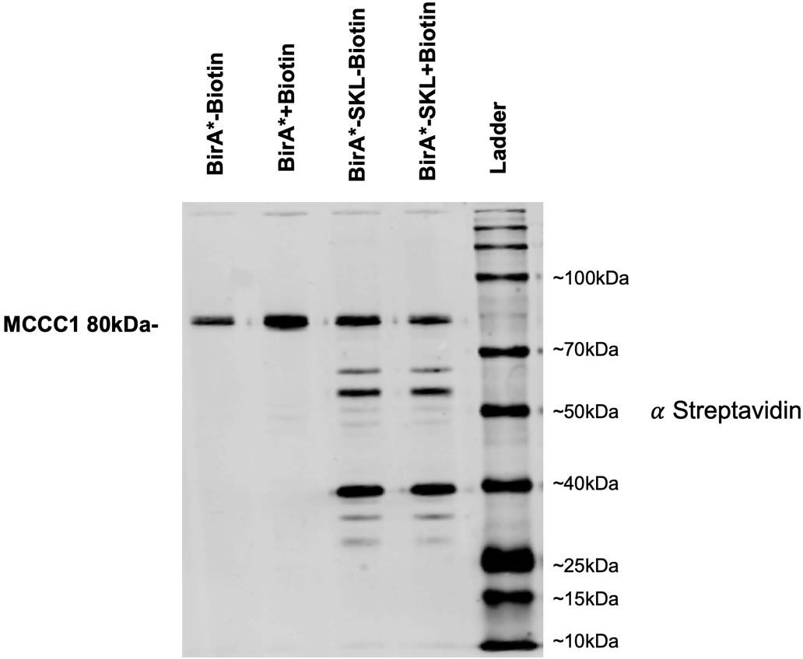
The cells were lysed and subsequently subjected to western blot analysis (Figure 5.1).

Figure 5. 1 The immunoblot confirmation of cells expressing both peroxisomally targeted and cytosolic plasmids. These cells were incubated overnight in two separate flasks, each containing 10ml of HL5 medium with and without biotin. Notably, the HL5 medium already contains biotin, which resulted in the biotinylation of peroxisomal proteins. Hence, there was no need to add additional biotin to the HL5 medium.

Cells expressing both plasmids were incubated overnight. Initially, before realizing that HL5 medium already contains a sufficient amount of biotin for biotinylation, 50mM of biotin was added to the HL5 medium. The DMSO solvent was used as a control (Figure 5.1).

Confirmation of peroxisomal biotinylation by Immunoblotting

For confirmation by western blot, the total number of cells. In addition to cells expressing cytosolic and peroxisomally targeted BirA, the AX2 wild-type strain was included as a control.
During the immunoblotting procedure, both the AX2 and cytosolic BirA cells showed a band for MCCC1 (approximately 80kDa), which was used as a loading control as the only significantly endogenously biotinylated protein in D. discoideum (Davidson et al., 2013). In contrast, cells expressing peroxisomally targeted BirA showed multiple bands of biotinylated proteins (Figure 5.2).

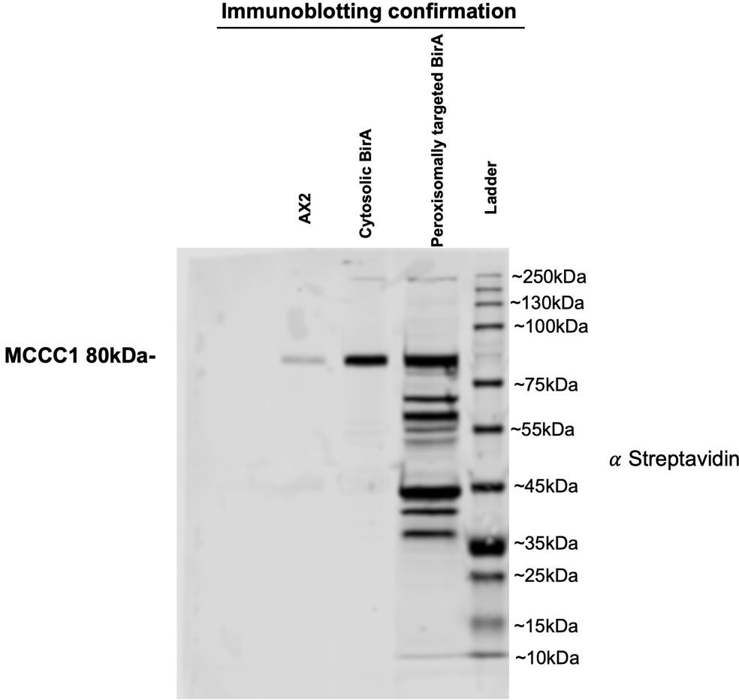
Figure 5. 2 The confirmation of biotinylated proteins in cells expressing peroxisomally targeted BirA, cytosolic BirA, and Ax2 strains. Immunoblotting was employed for this confirmation, and MCCC1, a biotinylated mitochondrial 3-methylcrotonyl-CoA carboxylase α, served as a loading control during the immunoblotting procedure (Davidson et al., 2013). It is worth noting that the loading for Ax2 is comparatively lower in the analysis.

Confirmation of peroxisomal biotinylation by fluorescence microscopy

Fixation involves treating the cells with a paraformaldehyde fixative to preserve their structure and biomolecules for subsequent microscopy.

Cells expressing cytosolic BirA showed a bean-shaped mitochondrial expression (Perry et al., 2020), which was due to the endogenous biotinylation of mitochondrial 3-methylcrotonyl-CoA carboxylase α (MCCC1) (Davidson et al., 2013). In contrast, cells expressing peroxisomally targeted BirA showed a peroxisomal round-shaped expression (Figure 5.3).

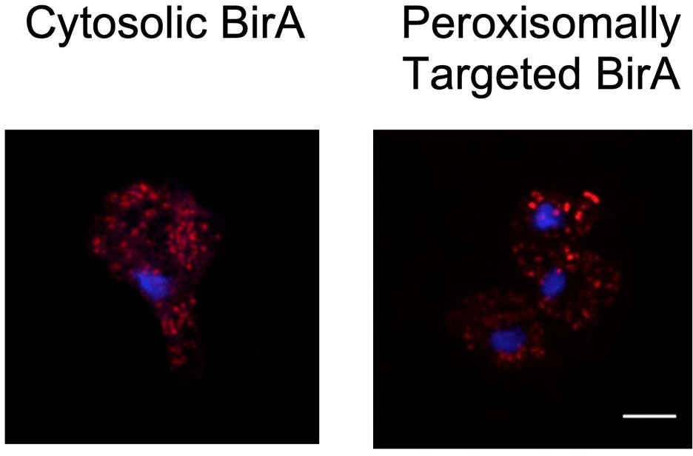
Figure 5. 3 A spinning disk microscopy was used to detect biotinylated proteins in cytosolic and peroxisomally targeted BirA. Streptavidin staining was employed for this purpose. The cytosolic BirA exhibited a bean-shaped mitochondrial expression due to the endogenous biotinylation of mitochondrial 3-methylcrotonyl-CoA carboxylase α (MCCC1). On the other hand, the peroxisomally targeted BirA displayed a round shaped peroxisomal expression. Additionally, the nucleus was visualized using a blue DAPI stain.

BioID Streptavidin pull-down

After confirming the expression of peroxisomally targeted BirA and cytosolic BirA by fluorescence microscopy and immunoblotting, three to four dishes of each cell line were set up to reach 100% confluency on the day of the experiment. The cells, amounting to 5 to 10 x 10⁷ cells, were collected through centrifugation into a 50ml Falcon tube.

Three replicates of both peroxisomally targeted BirA and cytosolic BirA were performed. The pull-down samples were tested and subsequently subjected to western blot analysis (Figure 5.4) before being sent for mass spectrometry analysis. The input sample from the peroxisomally targeted BirA showed multiple bands, indicating that the lysis was efficient. However, the input sample from the cytosolic BirA only showed a band for the endogenous biotinylated MCCC1. The unbound fraction from the cytosolic BirA samples displayed only one band corresponding to the endogenous biotinylated MCCC1, whereas the peroxisomally targeted BirA sample exhibited significantly fewer bands when compared to the beads sample, suggesting that the beads efficiently pulled down proteins. The beads sample from the peroxisomally targeted BirA showed multiple bands of peroxisomal proteins, indicating

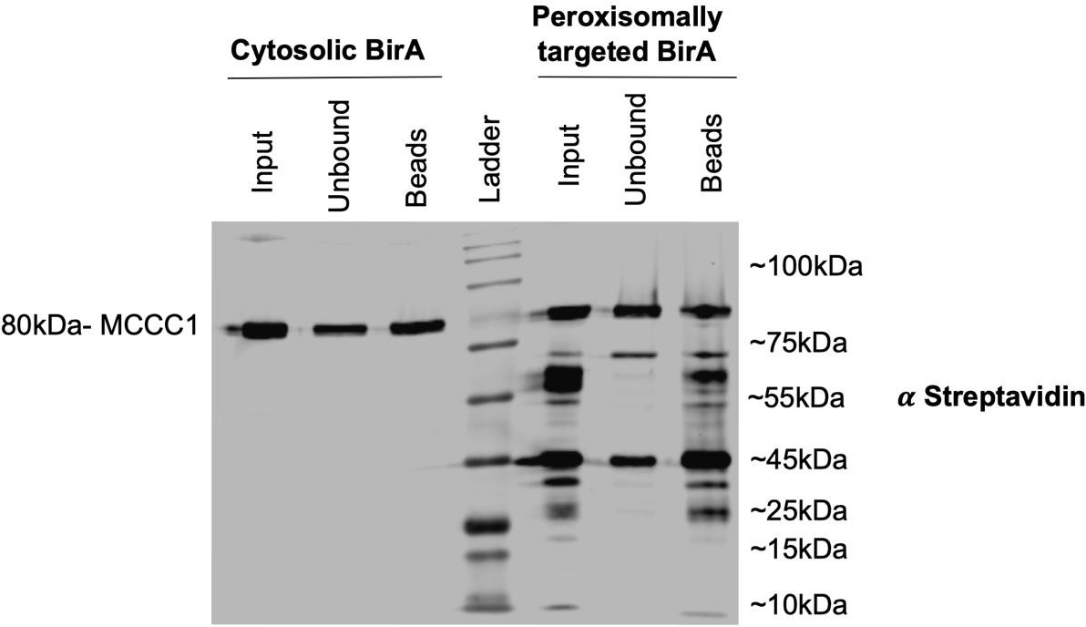
efficient protein pull-down. In the control sample, only a band for the endogenous biotinylated MCCC1 was observed (Figure 5.4).

Figure 5. 4 Immunoblots of biotinylated proteins isolated from peroxisomally targeted BirA and cytosolic BirA, both before and after affinity purification via magnetic streptavidin beads. The input sample from the peroxisomally targeted BirA showed multiple bands, indicating that the lysis was efficient. However, the input sample from the cytosolic BirA only showed a band for the endogenous biotinylated MCCC1. The unbound fraction from both samples only showed a band for the endogenous biotinylated MCCC1, indicating that the beads pulled down proteins efficiently. The beads sample from the peroxisomally targeted BirA showed multiple bands of peroxisomal proteins, indicating efficient protein pull-down. In the control sample, only a band for the endogenous biotinylated MCCC1 was observed.

Mass spectrometry analysis

The results of the mass spectrometry analysis have been obtained and can be accessed in the Supplementary files. The samples were cut using trypsin, which cleaves lysine and arginine amino acid residues. The list comprises a total of 121 proteins, out of which 63 were identified as statistically significantly increased in the BirA-SKL samples compared to cytosolic BirA controls. Among these 63 enriched proteins, 49 proteins were exclusively found in peroxisomally targeted BirA* samples when compared to the control group (Figure 5.5). The list includes two endogenous biotinylated MCCC proteins. MCCA exhibited intensities of 7.010, 9.325, and 9.766 in the control replicates, while in the peroxisomally targeted samples, the intensities were 8.226, 8.005, and 7.623, respectively. The fold change (peroxisomally targeted samples vs the control samples) for the MCCA is 0.59, with a corresponding P-value

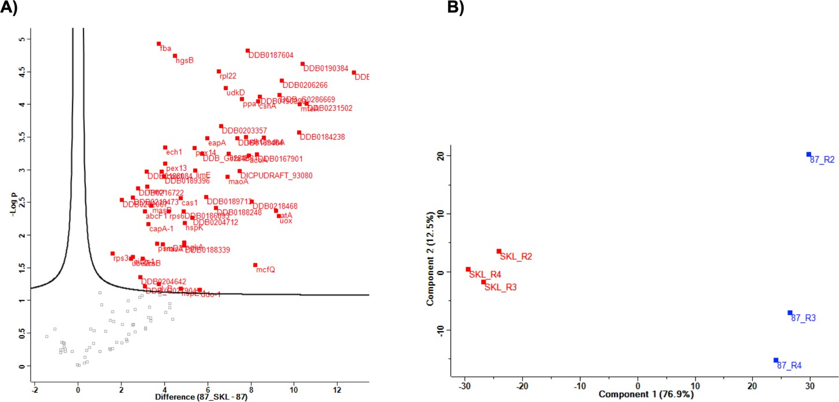
of 0.43. Similarly, MCCB showed intensities of 5.730, 8.188, and 8.694 in the control replicates, and 7.308, 6.984, and 6.557 in the peroxisomally targeted samples. The fold change (peroxisomally targeted samples vs the control samples) for the MCCB is 0.66, with a corresponding P-value of 0.55. The principal component analysis (PCA) revealed clustering that demonstrates the consistency of the samples across repeats (Figure 5.5B).
Figure 5. 5 Figure 5.5 A) The volcano plot displays a total of 121 proteins from our proteomic analysis. Grey dots represent proteins with statically low values, while red-labelled proteins indicate the most statistically significant enrichment compared to the control. B) The graph illustrates the principal component Analysis (PCA) of the three replicates for both peroxisomally targeted samples (shown in red) and cytosolic samples (shown in blue).

These proteins were then classified into different categories as shown in Table 5.5.

Table 5. 5 The identified proteins according to gene ontology annotations in the UniProt database.

Pathway |  |  |  | Name |  | Fold  change (SKL vs 87) | p-Value  (SKL vs 87)
A) Carbohydrate metabolism (7) |  |  |  | 9. Succinate--CoA ligase [GDP-forming] subunit  beta scsB |  | 7.874642 | 0.022909
 |  |  |  | 15. malate synthase masB |  | 10.43405 | 0.003561
 |  |  |  | 18. Fructose-bisphosphate aldolase Fba |  | 13.2632 | 1.18E-05
 |  |  |  | 20. malate synthase masA |  | 15.25739 | 0.013858
 |  |  |  | 30. Phosphoglycerate kinase, calmodulin binding  PgkA |  | 30.16666 | 0.012943
 |  |  |  | 54. Citrate synthase cshA |  | 323.4843 | 8.98E-05
 |  |  |  | 56. Probable malate dehydrogenase mdhA |  | 386.92 | 0.000326
B) lipid metabolism (20) |  |  |  | 7. Acyl-coenzyme A oxidase DDB0216722 |  | 6.789941 | 0.0
 |  |  |  | 11. Peptidase S1 PA clan DDB_G0279049 |  | 8.592866 | 0.060635
 |  |  |  | 12. Acyl-coenzyme A oxidase DDB0188084 |  | 8.993963 | 0.001825
 |  |  |  | 19. Peroxisomal acyl-coenzyme A oxidase acox1 |  | 14.70942 | 0.0013858
 |  |  |  | 23. Delta(3,5)-Delta(2,4)-dienoyl-CoA isomerase  ech1 |  | 16.39201 | 0.000459
 |  |  |  | 25. Hydroxy methyl glutaryl-CoA synthase B hgsB |  | 22.15381 | 1.81E-05
 |  |  |  | 26. Cycloartenol synthase cas1 |  | 26.76219 | 0.002738
 |  |  |  | 36. Sterol carrier protein DDB_G0284681 |  | 53.06944 | 0.000576
 |  |  |  | 38. Alkyl dihydroxy acetone phosphate synthase  eapA |  | 62.7193 | 0.000328
 |  |  |  | 39. Glyceronephosphate  DDB0188248 | O-acyltransferase | 82.89622 | 0.003875
 |  |  |  | 45. Acyl-coenzyme A oxidase DDB0169464 |  | 166.7884 | 0.000332
 |  |  |  | 50. Acyl-coenzyme A oxidase acoA |  | 237.811 | 0.000603
 |  |  |  | 52. Mitochondrial substrate carrier family protein  mcfQ. |  | 292.6891 | 0.028577
 |  |  |  | 53. Acyl-CoA dehydrogenase DDB0167901 |  | 308.3394 | 0.00058
 |  |  |  | 55. Acyl-CoA dehydrogenase DDB0190990 |  | 341.9809 | 7.61E-05
 |  |  |  | 59. Acyl-coenzyme A oxidase DDB_G0286669 |  | 628.1304 | 0.005109
 |  |  |  | 62. Peroxisomal multifunctional enzyme A mfeA |  | 1217.075 | 9.91E-05
 |  |  |  | 63. Thiolase family protein DDB0190384 |  | 1337.826 | 2.4E-05
 |  |  |  | 64. Enoyl-CoA hydratase DDB0231502 |  | 1527.447 | 9.79E-05
 |  |  |  | 65.SMT domain-containing protein (Sterol Methyl  transferase) DDB0202574 |  | 7014.859 | 3.27E-05
C) Amino  catabolism (4) | acid | biosynthesis | and | 17. Thiamine pyrophosphate-binding enzyme  family protein ilvB |  | 13.19776 | 0.056066
 |  |  |  | 21. 3-hydroxyisobutyryl-CoA hydrolase  DDB0189396 |  | 15.62642 | 0.001265
 |  |  |  | 35. D-aspartate oxidase ddo-1 |  | 49.36697 | 0.06894
 |  |  |  | 49. 3-hydroxyisobutyryl-CoA hydrolase  DDB0187604 |  | 230.2951 | 1.51E-05
(D)Purines and pyrimidines (3) |  |  |  | 42. Uridine-cytidine kinase D udkD |  | 114.7873 | 5.62E-05
 |  |  |  | 48. Uridine-cytidine kinase C udkC |  | 217.5286 | 0.000318
 |  |  |  | 58. Uricase uox |  | 628.1304 | 0.005109

E) Protein biosynthesis (7)  Ribosome and elongation factors | 2. 40S ribosomal protein S3a Rps3 | 3.052747 | 0.019156
 | 24. 40S ribosomal protein S6 rps6 | 18.33497 | 0.004369
 | 40. 60S ribosomal protein rpl22 | 90.77112 | 3.1E-05
 | 44. Elongation factor 1 beta efa1B | 124.7455 | 0.000576
TRNA synthetase | 5. Eukaryotic translation initiation factor 2 eif2s1 | 5.742608 | 0.021721
Proteasome & proteases | 16. 26S proteasome non-ATPase regulatory  psmD3 | 12.60431 | 0.013723
Protein modification | 4. NEDD8-conjugating enzyme Ubc12 | 5.489911 | 0.023055
E) Oxidoreductase activity (6) | 13. Enoyl-[acyl-carrier-protein] reductase mecr | 9.210999 | 0.001825
 | 29. Amino_oxidase domain-containing protein  DDB0188339 | 30.16153 | 0.014412
 | 37. DAO domain-containing protein DDB0189713 | 60.89629 | 0.002634
 | 43. Probable flavin-containing monoamine oxidase  A maoA | 120.9114 | 0.001301
 | 57. Catalase CatA | 575.0772 | 0.004263
 | 60. Sulfite oxidase DDB0206266 | 693.9061 | 4.3E-05
G. Cytoskeleton and signal transduction  (3) | 3. Period circadian protein | 4.041421 | 0.002898
 | 32. Fibronectin type-III domain-containing protein  DDB0204712 | 39.07197 | 0.005422
 | 34. LIM domain-containing protein E lime | 42.7509 | 0.001026
H) Stress response (2) | 27. Heat shock cognate protein Hsc70-2 HspE-1 | 26.90654 | 0.066726
 | 31. Small heat shock protein hspK | 30.38133 | 0.006512
I) cell surface (1) | 14. cAMP-binding protein 1capA-1; capA-2 | 9.487801 | 0.006878
K) Intracellular protein transport (3) | 10. Non-transporter ABC protein abcF1 | 8.504169 | 0.0004392
 | 22. Peroxisomal membrane protein PEX13 | 16.23602 | 0.000814
 | 33. Peroxisomal membrane protein PEX14 | 42.13116 | 0.00047
L) Vitamins, co-enzymes, and hormones  (2) | 28. Calcium-transporting ATPase DDB0186093 | 29.29759 | 0.004395
 | 61. Hydroxysteroid dehydrogenase-like 2 DDB02 | 1190.675 | 0.000271
M) Unknown or unclassified function (5) | 6. W2 domain-containing protein DDB0218473 | 5.776817 | 0.002653
 | 8. RPAP1_C domain-containing protein  Q54TH7_DICDI | 7.408219 | 0.044659
 | 41. DUF829 domain-containing protein  “Transmembrane nuclear protein 53” | 98.67703 | 0.000215
 | 47. Inorganic pyrophosphatase ppa1 | 190.3372 | 8.23E-05
 | 51. DUF1446 domain-containing protein  DDB0218468 | 264.0589 | 0.003062

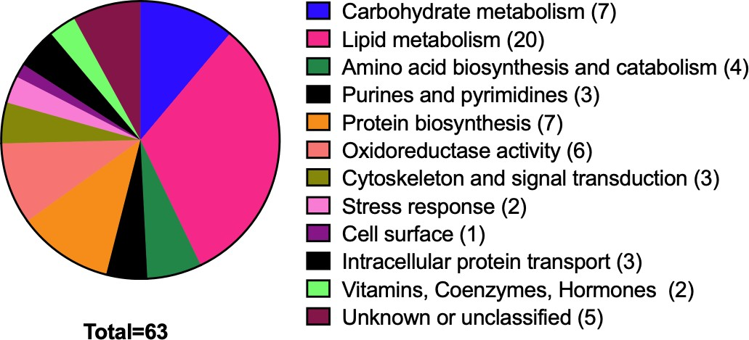

Figure 5. 6 The categorization of identified proteins based on gene ontology annotations in the UniProt database and the Dictyostelium database) into 12 functional categories. The figure also provides the number of proteins detected for each category.

Table 5.5 displays a list of statistically significant proteins identified in the mass spectrometry analysis, organized into 12 functional categories. The table includes the proteins detected for each category, with the protein names listed in accordance with their respective order of P-value in the mass spectrometry list.

Peroxisomal proteins were identified based on two different criteria. Firstly, proteins experimentally confirmed as peroxisomal in either D. discoideum or other organisms were considered peroxisomal, accounting for approximately 45 proteins (Figure 5.7A and Table 5.6). Secondly, proteins were identified based on the presence of a PTS, resulting in around 40 proteins (Figure 5.7B). Among the 63 statistically significant proteins, 53 of them fulfilled at least one of the criteria, suggesting their association with peroxisomes. However, there might be some overlap between the two different criteria, particularly between experimentally confirmed proteins and those identified as peroxisomal targeting signal (PTS) proteins (Figure 5.8). This overlap accounts for approximately 85% of the proteins, indicating that the experiment yielded successful results. The peptides identified in these proteins, as well as their abundance, can be found in the Supplementary files. Additionally, the coverage area of the detected peptides in the sequence of peroxisomal proteins in the mass spectrometry list is highlighted in Table 5.1 in the Appendix.

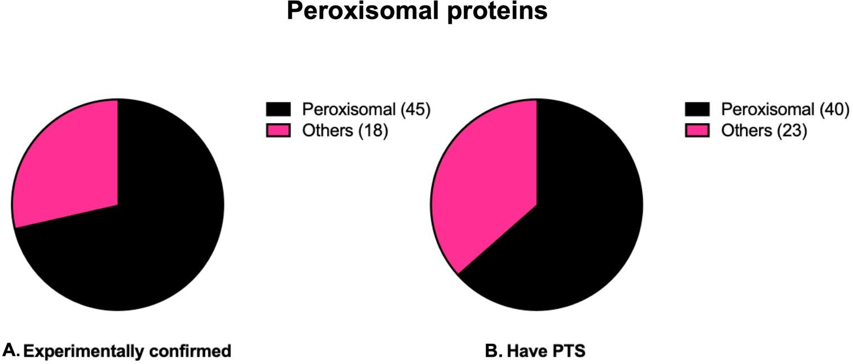

Figure 5. 7 The classification of identified peroxisomal proteins into two criteria. A) Peroxisomal proteins that have been experimentally confirmed in different organisms. B) Peroxisomal proteins that possess a peroxisomal targeting sequence (PTS1 or PTS2). This study identified a total of 54 statistically abundant peroxisomal proteins.

.

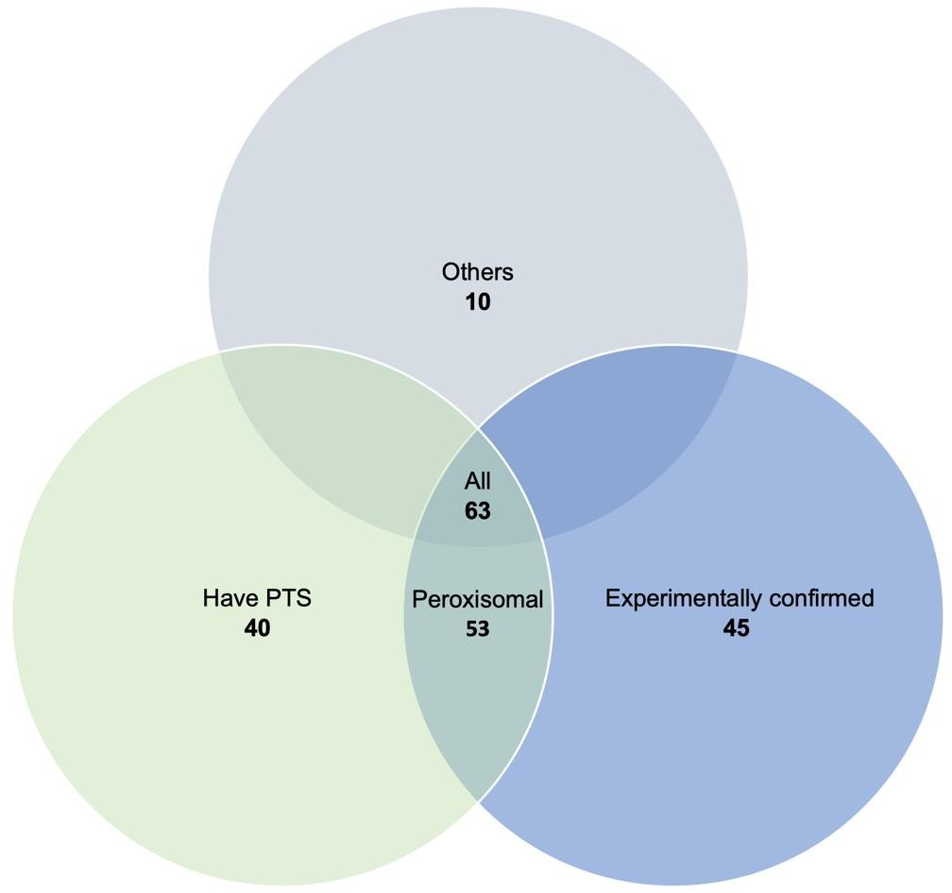
Figure 5. 8 A Venn diagram illustrating the utilization of two criteria to identify peroxisomal proteins among the 63 statistically significant proteins in the mass spectrometry analysis.

Approximately 15% of the proteins fall outside these criteria, while the remaining 85% exhibit overlapping characteristics within the three different criteria.

Table 5. 6 The putative peroxisomal proteins identified by mass spectrometry analysis that were experimentally confirmed to localize to peroxisomes in D. discoideum or other organisms. The table includes the name of each protein, accession number in Uniprot (AC), gene code, and the serial number in the mass spectrometry list. The type of peroxisomal targeting sequence (PTS) for each protein is also provided. Studies showing the localization of these proteins in peroxisomes of D. discoideum and examples of homologues or orthologues proteins in other organisms are included.

No.* | AC | Name |  |  | Gene code | PTS in  Dictyostelium discoideum | Experimental confirmation of  localization in Peroxisomes |  | subcellular
 |  |  |  |  |  |  | References | organism
25 | Q86HL5 | Hydroxy  synthase B | methyl | glutaryl-CoA | HGSB | PTS1  SKL | (Alkuwayti, 2014) | Dictyostelium  discoideum
26 | Q55D85 | Cycloartenol synthase |  |  | CAS1 | PTS1  SKI | (Alkuwayti, 2014) | Dictyostelium  discoideum
 |  |  |  |  |  |  | (Chowdhary et al., 2012) | Arabidopsis  (plant) | thaliana
65 | Q553T0 | SMT domain-containing protein  (Sterol Methyl transferase) |  |  | DDB0202574 | PTS1  AKL | (Alkuwayti, 2014) | Dictyostelium  discoideum
54 | Q8MQU6 | Citrate synthase |  |  | cshA | PTS2  RINILANHL | (Huang et al., 2004a) | Dictyostelium  discoideum
 |  |  |  |  |  |  | (Pracharoenwattana et al.,  2005) | Arabidopsis thaliana
57 | O77229 | Catalase-A |  |  | catA | PTS1  SNL | (Xenia et al., 2000) | Dictyostelium  discoideum

 |  |  |  |  | (Hayashi & Suga, 1978) | Dictyostelium  discoideum
39 | Q54I12 | PlsC domain-containing protein  (Glyceronephosphate O- acyltransferase) | DDB0188248 | PTS1  SKL | (Kappelt et al., 2020) | Dictyostelium  discoideum
 |  |  |  |  | (Uyama et al., 2017) | Homo sapiens
 |  |  |  |  | (Uyama et al., 2015) | Mammalian cells
62 | Q9NKW1 | Peroxisomal multifunctional  enzyme A | mfeA | PTS1  SKL | (Matsuoka, Kuwayama,  Daisuke Ikeno, et al., 2004) | Dictyostelium  discoideum
 |  |  |  |  | (Matsuoka et al., 2003) | Dictyostelium  discoideum
58 | Q54LT2 | Uricase | uox | PTS1 SRL | (Parish, 1975) | Dictyostelium  discoideum
 |  |  |  |  | (Hayashi & Suga, 1978) | Dictyostelium  discoideum
 |  |  |  |  | (Damsz et al., 1994) | Soybean Cotyledons  (plant)
18 | Q86A67 | Fructose-bisphosphate aldolase | fba | No PTS | (F. Zhang et al., 2016) | Rice (plant)
 |  |  |  |  | (Freitag et al., 2012) | Thermoproteus tenax
 |  |  |  |  | (Fukuoka et al., 2019) | methylotrophic yeast  Pichia pastoris
61 | Q54DN0 | Hydroxysteroid dehydrogenase-  like 2 | DDB0184238 | PTS1  PKL | (Kowalik et al., 2009) | Homo sapiens
42 | Q9GNF0 | Uridine-cytidine kinase D | udkD | PTS2  RIETISSHL | (Kim et al., 2021) | Plants (Pseudouridine-  5'-phosphate glycosidase At1g50510)
48 | Q54R62 | Uridine-cytidine kinase C | udkC | PTS1  SKL
7 | Q55CT6 | Acyl-coenzyme A oxidase | DDB0216722 | No PTS | (Klein et al., 2002) | Saccharomyces cerevisiae
19 | Q54GQ6 | Peroxisomal acyl-coenzyme A  oxidase 1 | acox1 | PTS1  SKL
59 | Q54LF1 | Acyl-coenzyme A oxidase | DDB_G0286669 | PTS1  SKL
12 | Q54II1 | Acyl-coenzyme A oxidase | DDB0188084 | PTS2  RVRNIVNHL
45 | Q75JL8 | Acyl-coenzyme A oxidase | DDB0169464 | PTS2  RIEIIKKHL
50 | Q54RB0 | Acyl-coenzyme A oxidase | acoA | PTS2  RIDNTLKHL
63 | Q55DN6 | Sterol carrier protein (Thiolase  family protein) | DDB0190384 | PTS1  SKL | (Edqvist et al., 2004) | plants
35 | Q556W1 | D-aspartate oxidase | ddo-1; ddo-2 | PTS1  SKL | (Amery et al., 1998) | Homo sapiens
37 | Q55FP7 | DAO domain-containing protein  “D-aspartate oxidase” | DDB0189713 | PTS1  SKL | (Sacchi et al., 2011) | Homo sapiens
56 | Q54GE6 | Probable malate dehydrogenase 1 | mdhA | PTS2  RINNISSQL | (Elgersma et al., 1996) | Saccharomyces  cerevisiae
 |  |  |  |  | (Pracharoenwattana et al.,  2007) | Arabidopsis thaliana

29 | Q54HR9 | Amino oxidase domain-containing  protein | DDB0188339 | PTS1  PKM | (Kamada-Nobusada et al.,  2008) | Arabidopsis thaliana  (plant)
43 | Q54IT3 | Probable flavin-containing  monoamine oxidase A | maoA | PTS1  SKL | (Holtta, 1956) | Mammalian cells  (Rat liver)
 |  |  |  |  | (Kamada-Nobusada et al.,  2008) | A. thaliana
36 | Q54PA2 | Sterol carrier protein | DDB_G0284681 | PTS1  AKL | (Williams et al., 2011) | Homo sapiens
 |  |  |  |  | (Edqvist et al., 2004) | A. thaliana
64 | Q54BX7 | Enoyl-CoA hydratase | DDB0231502 | PTS2  RINIISNQI | (Espeel & Van Limbergen,  1995) | Homo sapiens
116 | Q54SN3 | Enoyl-CoA hydratase/isomerase  family | DDB0204191 | PTS1  SKL
38 | O96759 | Alkyl dihydroxy acetone phosphate  synthase | eapA | PTS1  PKL | (Biermann & Van Den  Bosch, 1999) | Homo sapiens
33 | Q54C55 | Peroxisomal membrane protein  PEX14 | pex14 | No PTS | (Bharti et al., 2011) | Homo sapiens
47 | Q54PV8 | Inorganic pyrophosphatase | PPA1 | *…. PTS1*  (TGA…. SKL) | (Stiebler et al., 2014) | Homo sapiens  C. elegans Ustilago maydis
 |  |  |  |  | (Shimizu & Ohkuma2, 1993) | Mammalian cells  (Rat liver)
30 | Q9GPM4 | Phosphoglycerate kinase | pgkA | *…. PTS1*  (TGA…. NKL) | (Freitag et al., 2012) | Ustilago maydis
15 | Q54RR4 | Malate synthase B | masB | PTS1  SNL | (Murai et al., 1996) | Candida tropicalis
 |  |  |  |  | (Kunze et al., 2002) | Saccharomyces  cerevisiae
 |  |  |  |  | (Hayashi & Nishimura,  2006) | Arabidopsis thaliana
20 | Q8T2K9 | Malate synthase A | masA | PTS1  PKL | (Murai et al., 1996) | Candida tropicalis
 |  |  |  |  | (Kunze et al., 2002) | Saccharomyces  cerevisiae
17 | B0G117 | Thiamine pyrophosphate-binding  enzyme family protein | ilvB | No PTS | (Fraccascia et al., 2011) | Homo sapiens
 |  |  |  |  | (Nötzel et al., 2016) | Saccharomyces cerevisiae
21 | Q55GN0 | ECH_2 domain-containing protein  (3-hydroxyisobutyryl-CoA hydrolase) | DDB0189396 | PTS2  RIEIIKNHL | (Reumann et al., 2004) | Arabidopsis thaliana  (Mouse-ear cress) (plant)
49 | Q54JY1 | ECH_2 domain-containing protein  (3-hydroxyisobutyryl-CoA hydrolase) | DDB0187604 | PTS2  RINTIGNHI
22 | Q54CL3 | Probable peroxisomal membrane  protein PEX13 | pex13 | No PTS | (Elgersma et al., 1996) | Saccharomyces  cerevisiae
23 | Q54SS0 | Delta(3,5)-Delta(2,4)-dienoyl-CoA  isomerase, mitochondrial | ech1 | PTS1  CNL | (Goepfert et al., 2005) | Plant
52 | Q76P23 | Mitochondrial substrate carrier  family protein (If you blast this protein against human, you will find | mcfQ | No PTS | (Nakagawa et al., 2000;  Wylin et al., 1998) | Homo sapiens Yeasts

peroxisomal membrane protein
PMP34 isoform 1)
53 | Q86A74 | Acyl-CoA dehydrogenase | DDB0167901 | PTS2  RIQIISNHL | (Zolman et al., 2007) | Arabidopsis (plant)
55 | Q55BV1 | Acyl-CoA dehydrogenase | DDB0190990 | PTS1  SKY
60 | Q54XJ8 | Sulfite oxidase | DDB0206266 | PTS1  NKL | (Nowak et al., 2004) | Arabidopsis thaliana  (plant)
11 | Q54XC3 | Peptidase S1 PA clan | DDB_G0279049 | PTS1  SKL | (Majsec et al., 2017) | Arabidopsis thaliana  Arabidopsis suecica  (plant)
51 | Q54RD7 | DUF1446 domain-containing  protein (Propionyl-CoA carboxylase) | DDB0218468 | PTS1  SNL | (Biacs et al., 1989) | Higher plant  (rnunq-bean”Vigna radial”)
13 | Q54YT4 | Enoyl-[acyl-carrier-protein]  reductase, | mecr | No PTS | (De Nys et al.,2001; Mäkelä  et al., 2019) | Homo sapiens  Mouse
- No.* Serial numbers of proteins in the mass spectrometry list.

The cellular metabolic and non-metabolic roles of these putative biotinylated peroxisomal proteins are listed in Table 5.2 of the Appendix based on information from the UniProt database.

Peroxisomal protein import pathways in D. discoideum

The import of a subset of peroxisomal matrix proteins is mediated by either the PTS1 or PTS2 pathway, and this varies between organisms. For instance, in C. elegans, only the PTS1 pathway is employed (Motley et al., 2000), whereas in humans, only a limited number of proteins carrying the PTS2 signal are recognized (Kunze, 2020). Notably, it has been observed that in plants, the PTS2 pathway is more commonly utilized by numerous peroxisomal proteins compared to other organisms (Reumann et al., 2009). Out of the 53 peroxisomal proteins identified in our proteomic study, 30 contain a PTS1, 10 contain a PTS2, and the remaining 13 include 4 membrane proteins that require an alternative pathway (Figure 5.9).

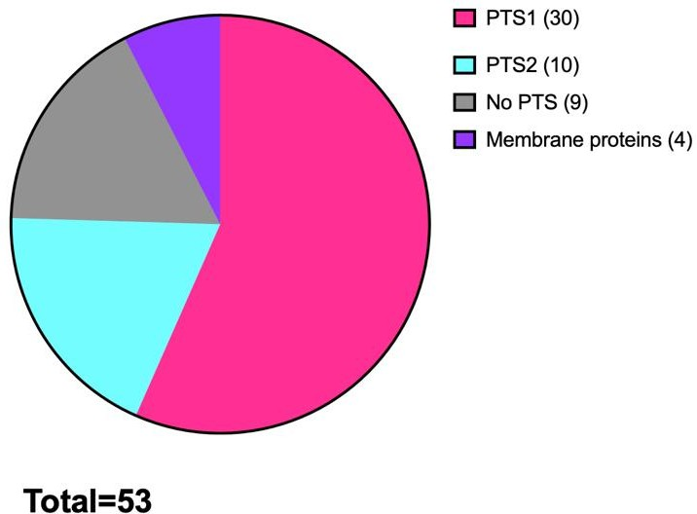
Figure 5. 9 A pie chart illustrating the peroxisomal targeting sequence (PTS) ratio of the putative peroxisomal proteins identified in the mass spectrometry list. The proteomic analysis revealed that out of the total 53 putative peroxisomal proteins, 30 carry the PTS1 signal sequence, while 10 carry the PTS2 signal sequence. Additionally, there were 4 peroxisomal membrane proteins that utilize a different import pathway, such as PEX13 (Q54CL3) and PEX14(Q54C55). Furthermore, 9 peroxisomal matrix proteins were identified that lack a consensus peroxisomal targeting signal.

        - Putative PTS1 in D. discoideum

The majority of peroxisomal matrix proteins are imported via the PTS1-dependent pathway, and the consensus sequence for this motif is [S/A/C][K/R/H][L/M/I] (Petriv et al., 2002). Although the SKL tripeptide sequence has been described as the strongest PTS1 in many organisms, there are other PTS1 tripeptides recognized by the PEX5 receptor. For instance, in plants, 9 major PTS1 tripeptides [SA][RK][LM] are considered good indicators for peroxisomal localization if they are present in unknown proteins (Reumann, 2004).
In this study, 30 out of the 53 peroxisomal proteins examined were found to possess the PTS1 signal sequence. This includes two proteins, inorganic pyrophosphatase ppa1 and Phosphoglycerate kinase pgkA, which utilize the ribosomal readthrough process (See below).

The majority of the 30 PTS1-carrying proteins had the strongest PTS1 SKL tripeptide, with 14 proteins containing this motif. The PKL tripeptide was found in four peroxisomal matrix proteins, while the SNL motif was found in three proteins. NKL motif was found twice, whereas other motifs were found only once (Figure 5.10).

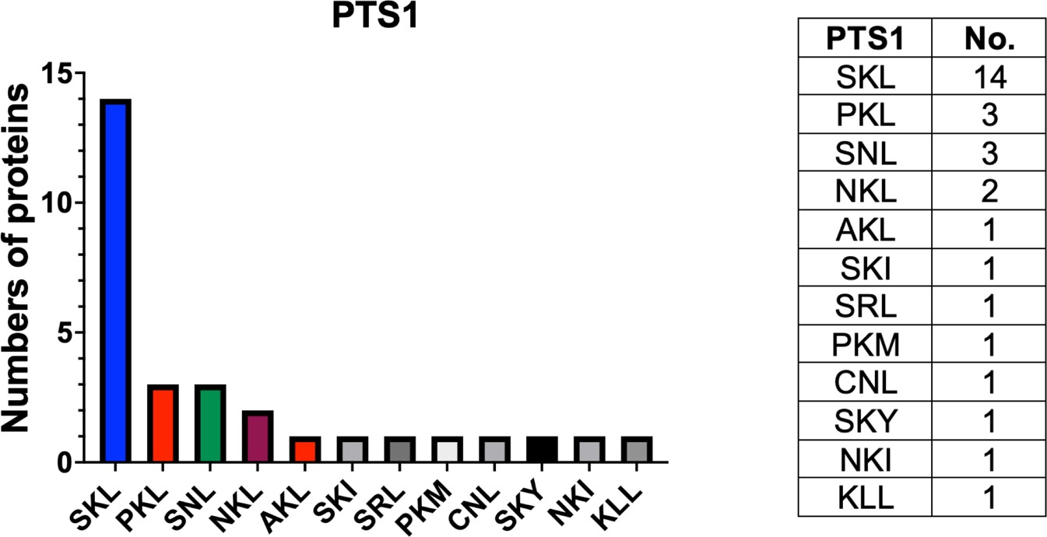
Figure 5. 10 The number of putative D. discoideum PTS1 tripeptides found in this study. The majority of PTS1-carrying proteins have the strongest PTS1 tripeptide SKL, with 14 proteins containing this motif. The PKL tripeptide is found in four proteins, while SNL is found in three proteins. NKL motifs was found twice, whereas other motifs were found only once.

Similar to other organisms, this study reveals that the commonly observed putative PTS1 tripeptide in D. discoideum is SKL, followed by other PTS1 sequences that vary across different organisms.

        - Ribosomal read through mechanism found in D. discoideum

Eukaryotes use different evolutionary mechanisms to generate peroxisomal matrix protein isoforms with dual intracellular localization or roles from a single gene (Bersch et al., 2018; Reumann et al., 2016). The most common mechanisms are alternative splicing, point mutations, and translational readthrough of stop codons, which result in C-terminally PTS1-extended peroxisomal proteins. In contrast, longer N-terminal PTS2 sequences are thought to mainly arise from exon shuffling (Reumann et al., 2016).

In 1971, ribosomal readthrough of individual genes for viral replicases in bacteriophage QB was first discovered (Weiner & Weber, 1973). Both eukaryotic and prokaryotic viruses utilize leaky termination of translation to optimize their coding

capacity (Stiebler et al., 2014). Translational readthrough of stop codons offers an alternative method for generating protein modifications with extensions of the C- terminus. This process allows for the extension of proteins with an additional in-frame targeting sequence, such as a PTS1. It has been shown that mammals and fungi use both alternative splicing and translational readthrough to generate peroxisomal isoforms of glycolytic enzymes (Freitag et al., 2012; Stiebler et al., 2014). Different methods leading to the formation of peroxisomal isoforms of inorganic pyrophosphatase in various organisms have been described (Stiebler et al., 2014). For instance, in U. maydis ipp1, an alternative methionine start codon is used, while in humans (PPA1 and PPA2) and the nematode Caenorhabditis elegans (C. elegans), readthrough is utilized for Pyp-1.

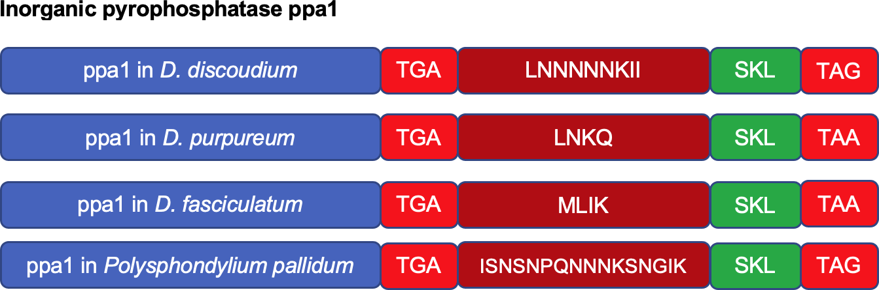
In this study, the D. discoideum inorganic pyrophosphatase ppa1 (Q54PV8) was identified as a biotinylated peroxisomal protein in the mass spectrometry list. It appears to be targeted to peroxisomes through ribosomal readthrough. This protein is conserved among all Dictyostelium species and has the same PTS1 "SKL." It is worth noting that TGA stop codons, especially those followed by CT, are more susceptible to readthrough than TAA and TAG stop codons (Stiebler et al., 2014), as shown in Figure 5.11.

Figure 5. 11 A schematic cartoon illustrating the peroxisomal isoforms of inorganic pyrophosphatase (ppa1) sequences in different Dictyostelium species, indicating their import to peroxisomes via the ribosomal readthrough mechanism. In all species, ppa1 is followed by a leaky TGA stop codon, followed by a few amino acids before the PTS1 and second stop codons. The sequences were obtained from the Dictyostelium database (http://www.dictybase.org).

Peroxisomal targeting of the glycolytic enzyme Phosphoglycerate kinase pgkA (Q9GPM4) is another potential example of readthrough in D. discoideum, and it has

been identified in mass spectrometry analysis. This enzyme is considered to be present in both peroxisomes and cytosol and its peroxisomal localization is regulated by this post-transcriptional mechanism, not only in in U. maydis (Freitag et al., 2012) but also in D. discoideum.
The results of this study indicate that the evolutionary mechanism of generating peroxisomal matrix protein isoforms with dual intracellular localization or roles from a single gene, the ribosomal read-through mechanism, is not limited to higher eukaryotes. This mechanism extends to simple eukaryotic cells like D. discoideum and therefore existed early in evolution.

        - Peroxisomal membrane proteins

Two distinct pathways are known for the targeting of peroxisomal membrane proteins. The first pathway involves the recognition of a membrane peroxisomal targeting signal (mPTS) by PEX19 (Götte et al., 1998; Sacksteder & Gould, 2000). However, most peroxisomal membrane proteins (PMPs) are inserted into the peroxisomal membrane through the second pathway, known as the PMPs pathway (Hua et al., 2015; Tam et al., 2005). Membrane proteins such as Pex13 (Q54CL3) and Pex14 (Q54C55), which are components of the docking complex, a translocon channel that specifically mediates the import of peroxisomal cargo proteins bound to a Pex5 receptor and utilize a peroxisomal membrane proteins pathway (Feng et al., 2022). The proteomic analysis revealed the presence of mitochondrial substrate carrier family protein (Q76P23). This protein is a homolog of human peroxisomal membrane protein Pmp34 isoform 1 (Wylin et al., 1998) and U. maydis A0A0D1CBN0. It is also homologous to the plant peroxisomal nicotinamide adenine dinucleotide carrier PXN O04200 from A. thaliana. In plants, a peroxisomal carrier transports NAD and plays a role in optimal fatty acid degradation during storage oil mobilization (Bernhardt et al., 2012). The Yeast homolog of Pmp34, (Pmp47) is essential for the metabolism of middle-chain fatty acids in yeast peroxisomes (Candida boidinii) and is associated with peroxisome proliferation (Nakagawa et al., 2000).

In the mass spectrometry analysis, Sterol Methyltransferase (Q553T0), a membrane protein with an SMT domain, was also identified. This protein differs from other

membrane proteins as it possesses a distinct targeting signal, PTS1 (AKL), suggesting that it is likely targeted to the peroxisome through a separate pathway.

        - Putative PTS2 in D. discoideum

The consensus sequence for the N-terminus PTS2 is [R/K][L/V/I]X5[H/Q][L/A] (Subramani, 1993; Titorenko & Rachubinski, 2001). PTS2 usually starts with R and almost always followed by Leucine (L) or Valine (V), however, in D. discoideum, it can also be followed by Alanine (A) (Nuttall et al., 2012). It has been found that the number of PTS2-carrying proteins in plants is higher than in mammals and yeasts (Reumann et al., 2009). In this study, approximately 10 putative peroxisomal proteins carrying PTS2 were found out of 53 (Table 5.6). Most of these PTS2-carrying proteins have the RI-X5-HL sequence, which is also found in human and plant peroxisomal proteins (Kunze et al., 2011; Pracharoenwattana et al., 2007; Schliebs et al., 2010). The other PTS2 sequences are RI-X5-QL, which is also found in humans (Kunze et al., 2011), RV-X5-HL, RI-X5-HI, and RI-X5-QI (Figure 5.12).

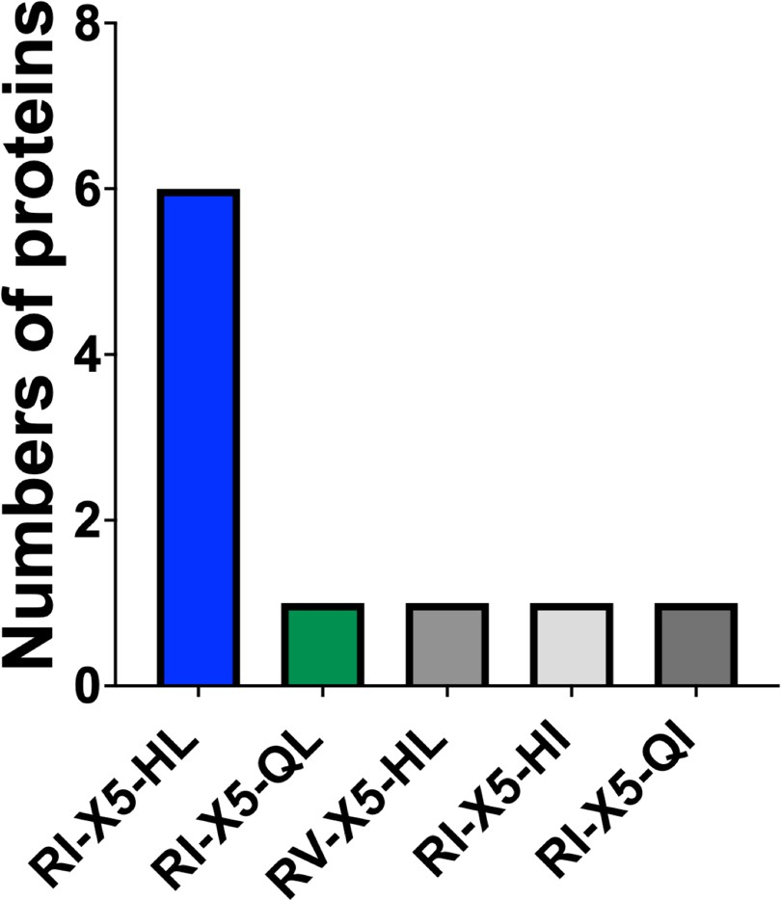

Figure 5. 12 The number of putative D. discoideum PTS2 sequences found in this study. The majority of PTS2-carrying proteins have the RI-X5-HL sequence, which was found in six proteins. The other PTS2 sequences, namely RI-X5-QL, RV-X5-HL, RI-X5-HI, and RI-X5-QI, were each found once.

Approximately one-fifth of the peroxisomal proteins identified in this study possess a PTS2 motif. Two out of the five patterns observed are shared with plants and human peroxisomal proteins. The remaining three patterns have not been detected in other organisms, suggesting that they represent unique PTS2 sequences specific to D. discoideum.

        - Peroxisomal proteins lacked a consensus peroxisomal targeting signal in D. discoideum

Some peroxisomal matrix proteins, like acyl-CoA oxidase (Pox1, Aox) and carnitine acetyltransferase (Cat2p) in S. cerevisiae, can be imported using Pex5 despite not having a PTS1 signal (Kempiński et al., 2020; Kim & Hettema, 2015; Klein et al., 2002). This study also investigated S. pombe Str3 and Lys3 (chapter 3). In D. discoideum, nine peroxisomal matrix proteins, including acyl-coenzyme A oxidase (Q55CT6), did not have a consensus peroxisomal targeting signal but were biotinylated by BirA*-SKL.

It is likely that certain peroxisomal proteins in D. discoideum lack a conventional peroxisomal targeting signal (PTS), but instead they might utilize a peroxisomal pathway known as PTS3. This pathway involves the utilization of the N-terminal domain of Pex5 for their import into the peroxisomal lumen (Rymer et al., 2018). Therefore, additional studies are necessary to enhance our understanding of the peroxisomal import pathway utilized by these proteins.

This study has performed another comparison based on the mass spectrometry data, focusing on partially or exclusively peroxisomal pathways in various organisms which includes D. discodium (Table 5.7).

Table 5. 7 Partially or exclusively peroxisomal pathways in various organisms, including D. discodium. (Modified from Smith & Aitchison, 2013).

Peroxisomal pathways, whether partly or totally  applied. | Protozoa | Fungi | Mammals | D. discoideum | Plants
Biosynthesis
Bile acids |  |  | 
Hormonal signalling  molecules |  |  |  |  | 
Polyunsaturated fatty acids |  |  |  | 
Ether phospholipids  (plasmalogens) |  |  |  | 
Pyrimidines |  |  |  | 
Purines |  |  |  | 
Purine salvage |  |  |  | 
Antibiotics (penicillin) |  | 
Toxins for plant pathogenesis |  | 
Lysine metabolism |  |  | 
Sulfur metabolism |  |  |  |  | 
Biotin |  |  |  |  | 
Secondary metabolites |  |  |  |  | 
Isoprenoid and cholesterol |  |  | Unknown |  | 
Degradation
Prostaglandin |  |  | 
Amino acids |  |  |  | 
Polyamine |  |  |  |  | 
H2O2 degradation by catalase |  |  |  |  | 
Oxidation of fatty acids |  |  |  |  | 
Purine |  |  |  |  | 

Superoxide radical  destruction by superoxide dismutase |  |  |  |  | 
Glycerol metabolism |  | 
Glycolysis |  | 
Methanol degradation |  | 
Glyoxylate cycle |  |  |  |  | 
Photorespiration |  |  |  |  | 

In D. discodium peroxisomes, they not only biosynthesize ether phospholipids (plasmalogens) similar to mammalian cells but also contain the glyoxylate cycle, mirroring the situation found in fungal and plant cells. Furthermore, it has been observed that sulfur metabolism takes place in the peroxisomes of fungi and plant cells. (Barreto et al., 2006; Reumann et al., 2016) Additionally, similar to human peroxisomes, yeast peroxisomes are involved in lysine metabolism (Al-Saryi et al., 2017; Dodt et al., 2000).

In addition, a comparison was conducted by performing a BLAST analysis of the putative biotinylated peroxisomal proteins identified through mass spectrometry against proteins from other organisms. The objective was to identify any peroxisomal homologs of these proteins in these organisms. Additionally, the genomes of these organisms were searched to identify peroxisomal orthologues of statically highly significant proteins listed in the mass spectrometry results. The outcomes of this comparison are presented in Table 5.8. In the table, a "-" symbol was used to indicate proteins that are either not peroxisomal or were not found. For instance, Cycloartenol synthase (CAS1), although found in plants (A. thaliana), was determined to be a mitochondrial protein (McBride et al. 2017). In comparison to the 53 peroxisomal proteins identified in the mass spectrometry list, the analysis revealed that these proteins were homologous to 26 human peroxisomal proteins, 25 U. maydis peroxisomal proteins and 20 peroxisomal proteins in S. cerevisiae. Surprisingly, only 6 S. pombe protein show homology to the proteins identified in the Dictyostelium hit list. Notably, the highest overlap (31) was observed with peroxisomal protein from the plant A. thaliana (Figure 5.13).

Table 5. 8 Comparison of the putative biotinylated peroxisomal proteins identified in D. discoideum through mass spectrometry with proteins from other organisms. Accession numbers were used to identify peroxisomal proteins, while "-" was used to indicate proteins that are either not peroxisomal or were not found.

No. of protei  n | Protein name | D.  discoideum | H. sapiens | U. maydis | S.  cerevisia e | S.  pombe | A. thaliana
4 | NEDD8-conjugating  enzyme Ubc12 | Q54TI6 | - | - | - | - | -
6 | Uncharacterized  protein | Q54RC0 | - | - | - | - | -
7 | Acyl-coenzyme A  oxidase | Q55CT6 | A0A7I2V3X  2 | A0A0D1CK33 | P13711 | - | O65201  (ACX2)
10 | Non-transporter ABC  protein | Q8T6B8 | - | - | - | - | -
11 | Peptidase S1 PA  clan | Q54XC3 | - | - | A6ZMM2  (22.8%) | - | A0A178WEL  7 (DEG15)
12 | Acyl-coenzyme A  oxidase | Q54II1 | A0A7I2V3X  2 | A0A0D1CK33 | P13711 | - | P0CZ23  (ACX3)
13 | Enoyl-[acyl-carrier-  protein] reductase | Q54YT4 | Q9NUI1 | A0A0D1CUH  9 | P32573 | - | Q9FX95  (NQR)
15 | Malate synthase | Q54RR4 | - | A0A0D1DWV  6 | P30952 | - | Q9LZC3  (MLS)
17 | Thiamine  pyrophosphate-  binding enzyme family protein | B0G117 | Q9UJ83 | - | P39994 | Q9Y7M  1 | Q9LF46
18 | Fructose-  bisphosphate aldolase | Q86A67 | - | A0A0D1E8V6  (ortholog) | - | - | -
19 | Peroxisomal acyl-  coenzyme A oxidase | Q54GQ6 | Q15067 | A0A0D1C894 | P13711 | - | A0A178W17  6
20 | Malate synthase | Q8T2K9 | - | A0A0D1DWV  6 | P30952 | - | Q9LZC3  (MLS)
21 | 3-hydroxyisobutyryl-  CoA hydrolase | Q55GN0 | - | - | - | - | Q6NMB0
22 | Probable  peroxisomal membrane protein  PEX13 | Q54CL3 | Q92968 | A0A0D1CPT3 | P80667 | O14136 | Q9SRR0
23 | Delta(3,5)- Delta(2,4)-dienoyl-  CoA isomerase | Q54SS0 | O75521 | A0A0D1CVH5 | Q05871 | - | Q9FHR8
25 | Hydroxy methyl  glutaryl-CoA synthase B | Q86HL5 | - | - | - | - | -

26 | Cycloartenol  synthase | Q55D85 | - | - | - | - | -
28 | Calcium-transporting  ATPase | Q54PE8 | - | - | - | - | -
29 | Amino oxidase  domain-containing protein | Q54HR9 | Q6QHF9 | A0A0D1DU56 | - | - | Q9LYT1
30 | Phosphoglycerate  kinase | Q9GPM4  (Readthrough  ) | - | A0A0D1DSH4  (Readthrough  ) | - | - | -
31 | Small heat shock  protein hspK | Q86H60 | - | - | - | - | -
33 | Peroxisomal  membrane protein PEX14 | Q54C55 | O75381 | A0A0D1E5X2 | P53112 | O60065 | Q9FXT6  (pex14)
34 | LIM domain-  containing protein E | O60952
35 | D-aspartate oxidase | Q556W1 | Q99489 | - | - | - | -
36 | Sterol carrier protein | Q54PA2 | P22307 | A0A0D1E3D1 | - | - | Q9FMN0  (SCP2)
37 | DAO domain-  containing protein “D-aspartate  oxidase” | Q55FP7 | Q99489 | - | - | - | -
38 | Alkyl dihydroxy  acetone phosphate synthase | O96759 | B7Z3Q4 | - | - | - | -
39 | PlsC domain-  containing protein (Glyceronephosphat  e O-acyltransferase) | Q54DN0 | Q6YN16 | - | - | - | -
40 | 60S ribosomal  protein L22 | Q54JE3
41 | DUF829 domain-  containing protein | Q557K5 | - | - | - | - | -
42 | Uridine-cytidine  kinase D | Q9GNF0 | - | - | - | - | -
43 | Probable flavin-  containing  monoamine oxidase A | Q54IT3 | - | - | - | - | Q9SKX5
44 | Elongation factor 1-  beta | Q9GRF8 | P24534 | A0A0D1E5K8 | P32471 | O74173 | A0A5S9Y4A  5
45 | Acyl-coenzyme A  oxidase | Q75JL8 | D6RJ89 | A0A0D1CK33 | P13711 | - | O65201  (ACX2)
47 | Inorganic  pyrophosphatase | Q54PV8 | - | - | - | - | -
48 | Uridine-cytidine  kinase C | Q54R62 | - | - | - | - | -

49 | ECH_2 domain-  containing protein (3-hydroxyisobutyryl-  CoA hydrolase) | Q54JY1 | - | - | - | - | Q6NMB0
50 | Acyl-coenzyme A  oxidase | Q54RB0 | D6RJ89 | A0A0D1CK33 | P13711 | - | O65201  (ACX2)
51 | DUF1446 domain-  containing protein (Propionyl-CoA  carboxylase) | Q54RD7 | - | - | - | - | -
52 | Mitochondrial  substrate carrier family protein | Q76P23 | O43808 | A0A0D1CBN0 | - | - | O04200  (PXN)
53 | Acyl-CoA  dehydrogenase | Q86A74 | Q709F0 | A0A0D1E391 | - | - | A0A5S9XKS  0
54 | Citrate synthase | Q8MQU6 | - | - | P08679 | - | Q9SJH7  (CSY3)
55 | Acyl-CoA  dehydrogenase | Q55BV1 | Q709F0 | A0A0D1E885 | - | - | A0A5S9XKS  0
56 | Probable malate  dehydrogenase 1 | Q54GE6 | - | A0A0D1BZ90 | P32419 | - | Q9ZP05  (PMDH2)
57 | Catalase-A | O77229 | P04040 | Q4P914  (ortholog) | P15202 | P55306 | Q96528  (CAT1)
58 | Uricase | Q54LT2 | - | A0A0D1CH18 | - | O74409 | O04420
59 | Acyl-coenzyme A  oxidase | Q54LF1 | D6RJ89 | A0A0D1CK33 | P13711 | - | O65201
60 | Sulfite oxidase | Q54XJ8 | - | - | - | - | Q9S850
61 | Hydroxysteroid  dehydrogenase-like 2 | Q54DN0 | Q6YN16 | - | Q02207 | - | Q9S9W2
62 | Peroxisomal  multifunctional enzyme A | Q9NKW1 | E7ER27 | A0A0D1CFD2 | Q02207 | - | Q9ZPI5  (MFP2)
63 | (Acetyl-CoA C-  acyltransferase)  (Thiolase family protein) | Q55DN6 | P09110 | A0A0D1E4K0 | - | - | Q56WD9  (PED1)
64 | Enoyl-CoA  hydratase | Q54BX7 | Q08426 | - | - | - | Q6NL24
65 | SMT domain-  containing protein  (Sterol Methyl transferase) | Q553T0 | - | - | - | - | -

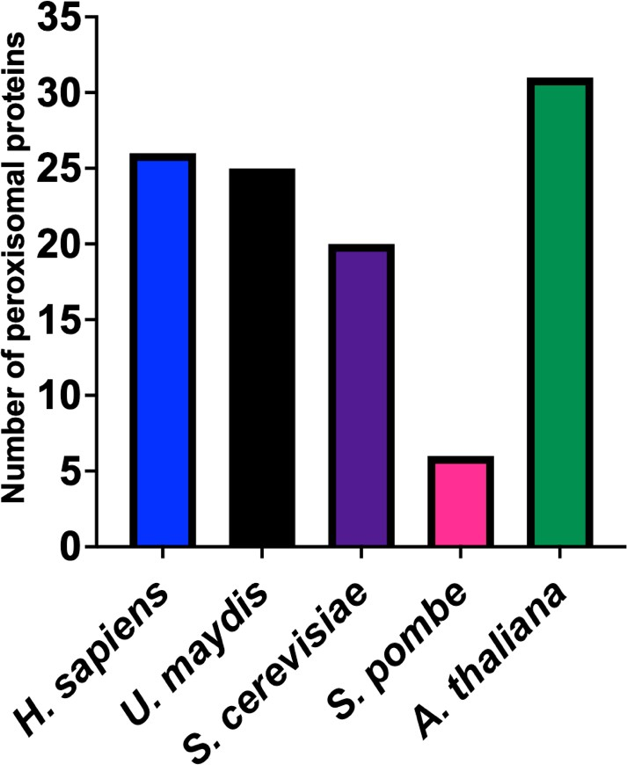
Figure 5. 13 A comparison is shown between peroxisomal proteins found in different organisms and the 53 putative biotinylated peroxisomal proteins identified in D. discoideum through mass spectrometry. H. sapiens has approximately 26 peroxisomal proteins, U. maydis has 25, S. cerevisiae has 20. A. thaliana exhibited the highest number of peroxisomal proteins with 31, while S. pombe had the lowest number with only 6 peroxisomal proteins.

Upon comparing putative biotinylated peroxisomal proteins among various organisms, it becomes interesting to anticipate whether D. discoideum can be regarded as a "walking plant" or a "talking amoeba." The existence of a relatively substantial quantity of peroxisomal proteins, comparable to those observed in plants and mammalian cells, particularly human cells, implies possible resemblances in cellular processes and metabolic pathways. Nevertheless, additional investigation is necessary to thoroughly investigate and comprehend the implications of these similarities.

Discussion

Fatty acid β-oxidation

The mass spectrometry data revealed that almost all of the proteins involved in peroxisomal fatty acid β-oxidation are biotinylated by BirA*-SKL in D. discoideum.

Specifically, six Acyl-coenzyme A oxidase enzymes (Q55CT6, Q54II1, Q54GQ6, Q75JL8, Q54RB0, Q54LF1), as well as an Enoyl-CoA hydratase enzyme (Q54SS0) and two Enoyl CoA isomerase domain-containing proteins (Q54BX7, Q54SN3) were detected in the peroxisomes of D. discoideum (Figure 5.12). All of these proteins possess either a PTS1 or PTS2, indicating their import into peroxisomes through the established import pathways, except for Q55CT6. The entry of Q55CT6 into peroxisomes is presumed to occur through an alternative route. In addition to the Acyl- CoA oxidase (ACOX) enzyme, two equivalent Acyl-CoA dehydrogenases (Q86A74 and Q55BV1) involved in fatty acid β-oxidation were also biotinylated by peroxisomally targeted BirA. Both Oxidases and Dehydrogenases play a role in oxidation reactions. The first enzyme has the PTS2 sequence RIQIISNHL, while the second enzyme carries the PTS1 sequence SKY.

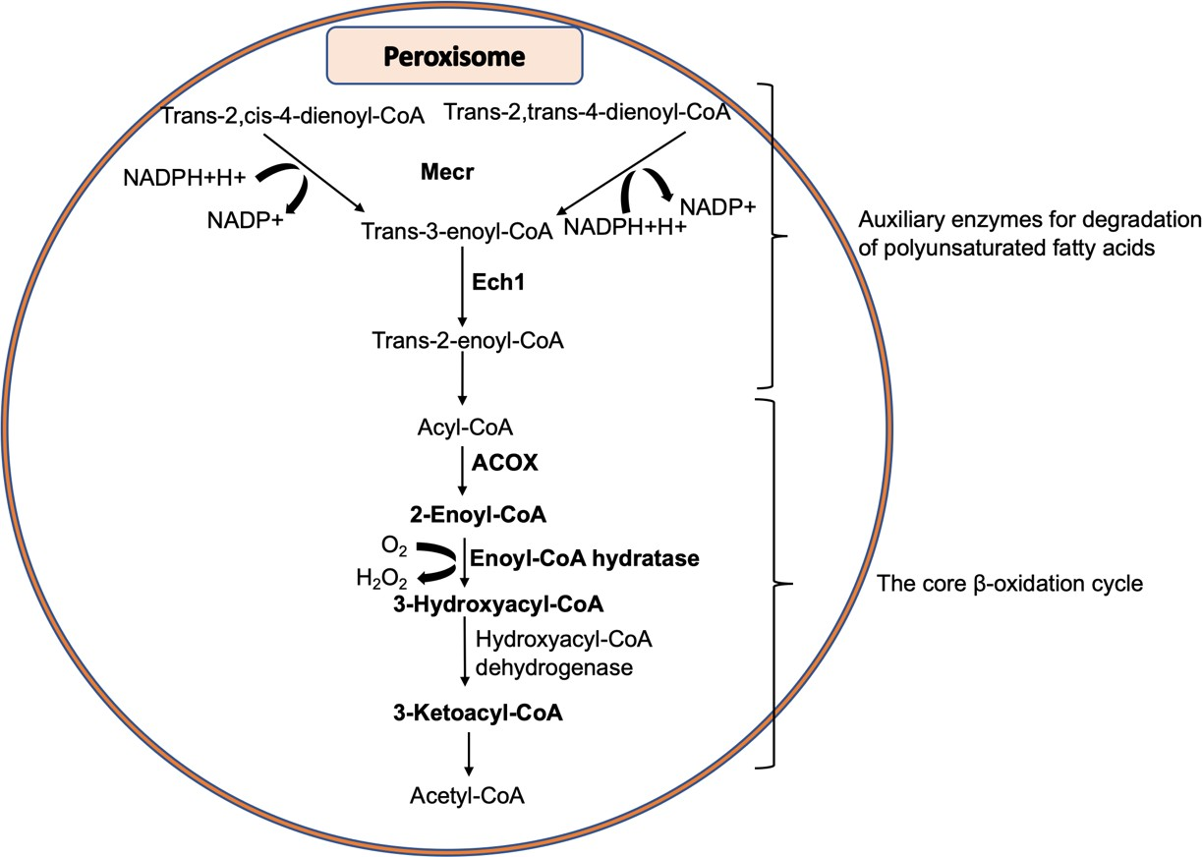
The auxiliary enzymes needed to degrade mono- and polyunsaturated fatty acids with double bonds include the NADPH-dependent 2,4-dienoyl-CoA reductase (Q54YT4) and the ∆3, ∆2-enoyl-CoA isomerase (Q54SS0) enzymes. These enzymes are also found to be biotinylated by peroxisomally targeted BirA and detected in the mass spectrometry analysis of D. discoideum peroxisomes (Figure 5.14).
Figure 5. 14 The β-oxidation pathway and auxiliary enzymes involved in the degradation of polyunsaturated fatty acids are illustrated. The figure specifically highlights the biotinylated

peroxisomal fatty acid β-oxidation and auxiliary enzymes in D. discoideum, with their labels shown in bold. These enzymes were identified as biotinylated through the mutant form of the biotin ligase BirA and were detected in the mass spectrometry analysis of D. discoideum peroxisomes. Notable enzymes depicted in the figure include Mecr (2,4-dienoyl-CoA reductase), Ech1 (∆(3,5)-∆(2,4)-dienoyl-CoA isomerase), and ACOX (Acyl CoA oxidase).

Despite being positioned between yeasts and plants on the phylogenetic tree of eukaryotes (Figure 1.7) (Eichinger et al., 2005), D. discoideum seems to share similarities with mammalian cells in terms of fatty acid breakdown. While the process of β-oxidation occurs exclusively in peroxisomes in yeasts and plants, our bioinformatics search reveals that D. discoideum genome contains genes for both peroxisomal and mitochondrial β-oxidation (See chapter 4).

Ether lipid biosynthesis

In higher plants and their seeds, ether-linked phospholipids constitute less than 1% of the total phospholipids (Horrocks & Sharma, 1982). Additionally, plant peroxisomes lack three crucial enzymes essential for ether phospholipid synthesis: Acyl-CoA: DHAPAT, Alkyl-DHAP synthase, and NADPH Alkyl-DHAP oxidoreductase (Van Den Bosch et al., 1992). Similarly, common yeasts like S. cerevisiae and Hansenula polymorpha typically possess minimal levels of plasmalogens, except for Pullularia pullulans. Furthermore, the peroxisomal DHAP-AT involved in ether lipid biosynthesis in mammalian tissues is not found in yeast (Veenhuis & Harder, 1987). However, our BioID analysis revealed the localization of enzymes related to the biosynthesis pathway of ether lipids within D. discoideum peroxisomes.

In this analysis, two proteins were discovered: the PlsC domain-containing protein (Q54I12), also known as FARAT in D. discoideum. FARAT exhibits a close similarity to human DHAPAT/GNPAT and possesses both a Fatty acyl-reductase (FAR) domain, a homolog of human peroxisomal Fatty acyl-CoA reductase 1 (Honsho et al., 2010), and an Acyltransferase (AT) domain, as reported by Kappelt et al., (2020). Additionally, the protein Alkyl dihydroxyacetone phosphate synthase eapA (O96759) shares homology with the human AGPS (Razeto et al., 2007). Mutations in the human alkyl dihydroxyacetone phosphate synthase or alkyl-DHAP-synthase, which contains PTS2, result in an autosomal recessive disease called rhizomelic chondrodysplasia

punctata (RCDP). This disorder is characterized by the absence of ether lipid synthesis and is associated with various clinical symptoms, including severely impaired growth, mental retardation, abnormal facial appearance, extremely short stature primarily affecting the proximal parts of the extremities, and inherited contractures (Heikoop et al., 1990; Hoefler et al., 1988; Motley et al., 1997). These proteins were found to be biotinylated by the peroxisomally targeted BirA, as depicted in Figure 5.15.

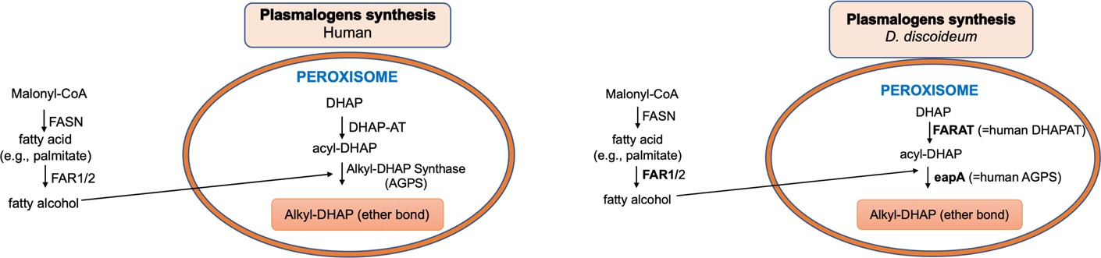
Figure 5. 15 The differences and similarities between ether lipid biosynthesis in humans and D. discoideum, specifically in the peroxisome. This pathway initiates in the peroxisome and continues in the ER, starting with dihydroxyacetone phosphate (DHAP) in the peroxisome. The pathway involves glyceronephosphate acyltransferase (DHAPAT/ GNPAT), FARAT (the Dictyostelium enzyme most closely related to human DHAPAT/GNPAT), and Alkyldihydroxyacetone phosphate synthase (AGPS), which in D. discoideum is encoded by the eapA gene. The figure highlights the biotinylated enzymes in
D. discoideum, with their labels shown in bold. FAR1/2, referring to fatty acyl-CoA reductase 1 and 2, respectively.

Referring to a prior study by Kappelt et al. (2020) and the results presented in this current research, D. discoideum exhibits resemblances to human cells in ether lipid biosynthesis. Additionally, D. discoideum seems to possess key genes essential for ether lipid biosynthesis in its genome. The mass spectrometry techniques were applied to analyse inositol phospholipids from Dictyostelium. It was discovered that most ether lipids constitute the inositol phospholipids in D. discoideum (Clark et al., 2014). In both mammals and Dictyostelium, the hydrocarbon chains of inositol phospholipids exhibit a highly specific subset compared to other phospholipids. This observation implies that distinct molecular selectors are involved in these organisms, yet they serve a shared purpose that has been conserved throughout evolution (Clark et al., 2014).

Mevalonate pathway and Sterol biosynthesis

The mevalonate pathway is believed to occur in different cellular organelles such as the endoplasmic reticulum (ER) and peroxisomes (Kovacs et al., 2007). Initially, it was proposed that two enzymes in the mevalonate pathway, Mevalonate kinase and Farnesyl diphosphate synthase, are both present in peroxisomes of rat liver (Biardi et al., 1994; Krisans et al., 1994). However, this has now been disputed (Hogenboom et al., 2004; Wanders & Waterham, 2006). This led to the suggestion that peroxisomes serve as a subcellular location for all enzymes involved in the pathway, based on the observed reduction in mevalonate pathway enzyme activity in Zellweger's syndrome patients (Krisans et al., 1994). However, this has now been disputed (Wanders & Waterham, 2006). Hence, the precise cellular whereabouts of the enzymes within the MVA pathway are still not well understood. In the D. discoideum genome, there are two enzymes: Hydroxymethylglutaryl-CoA synthase A and B. While Hydroxymethylglutaryl-CoA synthase A is localized in the cytosol, the other enzyme, Hydroxymethylglutaryl-CoA synthase B (Q86HL5), was effectively biotinylated using BirA*-SKL (Figure 5.16). Aside from the present study, this enzyme's peroxisomal localization has been experimentally verified (Alkuwayti, 2014). Additionally, within this pathway, an enzyme such as Phosphomevalonate kinase was tagged, and its subcellular localization in the peroxisomes was validated through experimental verification by Alkuwayti (2014).

Furthermore, in eukaryotic cells, the enzymes participating in the mevalonate pathway have a critical role in providing precursors for other pathways. For example, the mevalonate pathway supplies precursors for dolichol synthesis (Sapir-Mir et al., 2008; Tholl, 2006). Additionally, the mevalonate pathway enables the conversion of acetyl- CoA into farnesyl diphosphate (FDP) in eukaryotic cells. In D. discodium, the peroxisomal localization of the final step in the mevalonate pathway, the Farnesyl diphosphate synthase enzyme, was confirmed by Nuttall et al. (2012) (Figure 5.16).

Sterol synthesis is an essential metabolic process that exhibits variations across various eukaryotic cells. Mammals primarily utilize cholesterol as their predominant sterol, whereas plants synthesize sterols like campesterol, stigmasterol, and sitosterol, which are involved in the production of cellular growth hormones, triterpenoids, and brassinosteroids. Dictyostelium produces dictysterol as its specific sterol, while fungi are capable of synthesizing ergosterol (David Nes et al., 1990; Jordá & Puig, 2020).

The sterol synthesis pathway displays two distinct directions depending on the organism. In plants and algae, squalene epoxide is converted to cycloartenol, whereas in animals and fungi it is converted into lanosterol. Cycloartenol synthase is responsible for synthesizing cycloartenol in plants, whereas Lanosterol synthase is involved in the production lanosterol found in animals and fungi (chapter 1).

Studies have demonstrated that in D. discoideum, the conversion of Squalene epoxide to cycloartenol, a sterol found in plants, has been shown (David Nes et al., 1990). Additionally, research conducted on both A. thaliana and D. discoideum indicates that Cycloartenol synthase, which is responsible for synthesizing cycloartenol, can also catalyse the conversion of cycloartenol to lanosterol (Segura et al., 2003). These findings suggest that the sterol biosynthesis pathway in D. discoideum shares similarities with the pathway found in plants.

The peroxisomal localization of Cycloartenol synthase (Q55D85) and Cycloartenol-C- 24-methyltransferase (Q553T0) in D. discoideum was experimentally confirmed by Alkuwayti (2014). This study also revealed that these two proteins were biotinylated by BirA*-SKL (Figure 5.16).

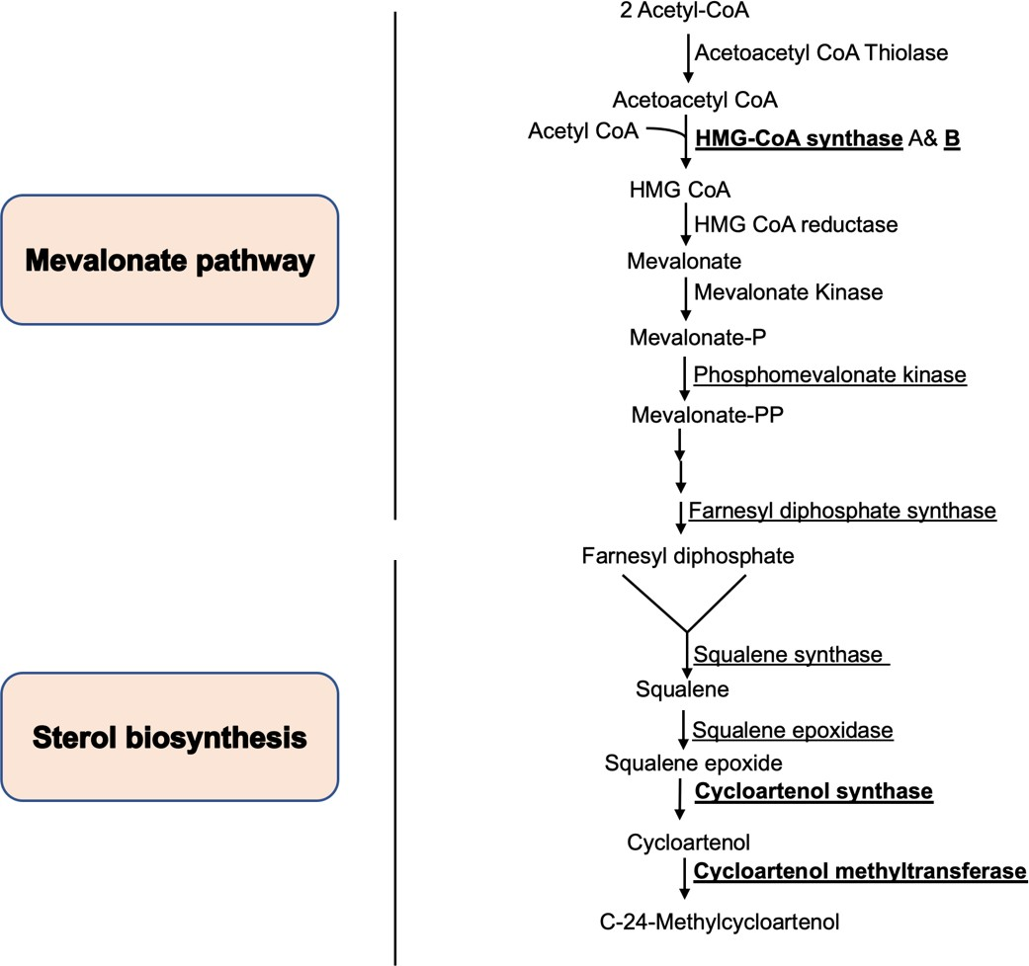
Figure 5. 16 The mevalonate and sterol biosynthesis pathways in D. discoideum, with biotinylated peroxisomal mevalonate and sterol biosynthesis enzymes labelled in bold. The biotinylated enzymes, including HMG CoA B (Q86HL5), Cycloartenol synthase (Q55D85), and Cycloartenol -C-24-methyltransferase (Q553T0), were identified using a mutant form of the biotin ligase BirA in this proteomic analysis. The peroxisomal localization of enzymes involved in mevalonate pathway and sterol biosynthesis was confirmed by Nuttall et al. (2012) and Alkuwayti & Watts (2014), respectively.

Glyoxylate pathway

The glyoxylate cycle is a metabolic pathway that allows the conversion of Acetyl-CoA, derived from the breakdown of stored lipids, into carbohydrates through synthesis. While this process is not present in mammalian cells, it is found in yeasts and plant seed (Van den Bosch et al., 1992; Eastmond and Graham, 2001). This proteomic study reveals that D. discoideum shares similarities with S. cerevisiae and plants in terms of possessing peroxisomal enzymes involved in glyoxylate metabolism. These enzymes include Citrate synthase cshA (Q8MQU6), Malate synthase A (Q8T2K9) and B (Q54RR4), and Malate dehydrogenase (Q54GE6). The peroxisomal cellular localization of the Citrate synthase enzyme in D. discoideum was reported by Huang et al., (2004).

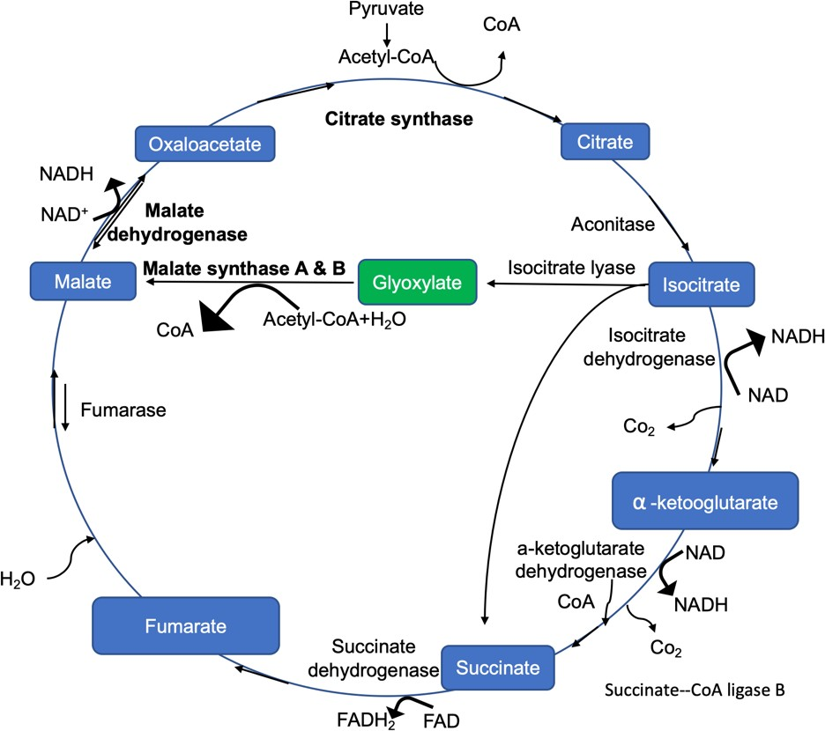
Figure 5. 17 The glyoxylate pathway in D. discoideum, along with the biotinylated peroxisomal enzymes that are labelled in bold. The enzymes Citrate synthase cshA (Q8MQU6), Malate synthase A (Q8T2K9), Malate synthase B (Q54RR4), and Malate dehydrogenase (Q54GE6) were identified as biotinylated by the peroxisomally targeted BirA.

The enzyme Succinate—CoA ligase scsB (Q869S7) is listed among the 63 enriched proteins in the mass spectrometry analysis. Furthermore, this enzyme does not possess a peroxisomal targeting signal (PTS), and the peroxisomal subcellular localization of its homologs in other organisms has not been reported to date. This raises questions about the presence of other enzymes in this pathway. For example, does any of the other enzymes in this cycle have a PTS, or do they enter peroxisomes through a different mechanism such as read-through? Based on the available evidence, it is possible that only a portion of this pathway is localized in peroxisomes. It raises the question of whether this pathway is divided between peroxisomes and mitochondria, and further research is needed to understand the complete subcellular distribution of the enzymes involved.

Reactive oxygen species (ROS) metabolism

The presence of the peroxisomal enzyme catalase is observed in most aerobically respiring organisms, providing cellular protection against the harmful effects of

hydrogen peroxide. Catalase is widely acknowledged as a reliable indicator for peroxisomes, not only in mammalian cells but also in plant cells. In our research, we biotinylated this enzyme using our peroxisomally targeted BirA, and its localization within the cell was already confirmed by Xenia et al., (2000). The D. discoideum catalase-A (O77229) is a homolog of catalases found in humans (P04040), S. cerevisiae (P15202), S. pombe (P55306), and A. thaliana (Q96528), as well as an ortholog of U. maydis (Q4P914).

Previous studies have established a connection between uric acid metabolism and reactive oxygen species (ROS) in plant cells (Corpas et al., 2019). In peroxisomes of plants, the xanthine metabolites uric acid and allantoin have been identified (Corpas, 1997). However, except for bovine kidney and liver peroxisomes (Beard & Kline, 1990; Rao et al., 1988), mammalian peroxisomes lack urate oxidase (Rao et al., 1988). The subcellular localization of Uricase in D. discoideum has been confirmed by Parish, (1975) and Hayashi & Suga, (1978). Additionally, this proteomic study identified the D. discoideum peroxisomal enzyme Uricase (Q54LT2), which shares homology with U. maydis (A0A0D1CH18), S. pombe (O74409), and A. thaliana (O04420) Uricase. Unlike human and S. cerevisiae cells, D. discoideum cells, similar to plants and S. pombe cells, possess Uricase.

The Metabolism of amino acids

In addition to the pathways mentioned earlier, our proteomic analysis revealed the presence of different metabolic pathways in D. discoideum peroxisomes. Using peroxisomally targeted BirA, several enzymes were biotinylated, including two Enoyl- CoA hydratase/isomerase domain-containing proteins (Q55GN0 and Q54JY1). Both proteins were imported into peroxisomes via the PTS2 pathway, with the first having the RIEIIKNHL sequence and the second having RINTIGNHI. These proteins play a role in the Valine catabolic process, which involves the breakdown of Valine and 2- amino-3-methylbutanoic acid. Moreover, through our proteomic analysis, we identified a protein (Q54RD7) in D. discoideum that possesses a DUF1446 domain. This protein in D. discoideum contains a PTS1 sequence (SNL) and potentially participates in the metabolism of long-chain amino acids, like valine. Interestingly, it shares homology

with the Propionyl-CoA carboxylase enzyme found in plants, specifically A. thaliana, although it does not appear to be peroxisomal in nature. In higher plants, Propionyl- CoA is a general intermediate in the peroxisomal catabolism of branched-chain fatty acids (Biacs et al., 1989). Although not highly statistically significant (P value=0.45534), another Propionyl-CoA carboxylase, known as PccA, was identified in our mass spectrometry list. PccA lacks a peroxisomal targeting signal (PTS).

Our mass spectrometry list shows more enzymes that have a role in amino acid metabolism, one of which is D-aspartate oxidase (Q556W1), which has a role in D- amino acid metabolism. The other is an FAD dependent oxidoreductase domain- containing protein (Q55FP7), which is a homologue of human peroxisomal D- aspartate oxidase DDO (F2Z2E0), which also has a role in D-amino acid metabolic process (Camões et al., 2015). Both enzymes have the strongest PTS1 "SKL".

It is intriguing to note that the two proteins containing the Enoyl-CoA hydratase/isomerase domain (Q55GN0 and Q54JY1) identified in the mass spectrometry list of D. discoideum show exclusive homology to proteins found in plants, particularly A. thaliana (Q6NMB0), in comparison to other organisms. Both proteins in D. discoideum possess a peroxisomal targeting signal 2 (PTS2), which is commonly utilized in plants for entry into peroxisomes (Reumann et al., 2009). On the other hand, the human peroxisomal D-aspartate oxidase DDO (Q99489) and (F2Z2E0) are the sole homologs discovered for the D. discoideum D-aspartate oxidase enzymes (Q556W1) and (Q55FP7) proteins identified in this study on amino acid metabolism.

Nucleic acids synthesis

Two Uridine-cytidine kinase enzymes involved in pyrimidine metabolism were also identified using peroxisomally targeted BirA. The first enzyme, Uridine-cytidine kinase D (Q9GNF0), has a PTS2 sequence (RIETISSHL), while the second enzyme, Uridine- cytidine kinase C (Q54R62), has a PTS1 sequence (SKL). Both enzymes are responsible for catalysing the conversion of uridine and cytidine into their respective monophosphate forms in the pyrimidine salvage pathway. Pyrimidine and purine

nucleotides serve as major energy carriers, subunits of nucleic acids, and precursors for the synthesis of nucleotide cofactors such as NAD and SAM (Moffatt & Ashihara, 2002). No peroxisomal homologs have been identified for these proteins among other organisms. However, the S. pombe genome does appear to contain a putative Uridine kinase, SPAC227.14, with a peroxisomal targeting signal 1 (PTS1) sequence (SSL) (Table 5.4).

In addition to the previously mentioned proteins, which have multiple roles in different metabolic pathways in D. discoideum, other peroxisomal proteins were found to be biotinylated in our proteomic analysis. A summary of these proteins and their respective peroxisomal targeting sequences is provided in Table 5.2 in the Appendix.

Chapter 6. General discussion

Introduction

In addition to the widely studied organism S. cerevisiae, this research focused on two other organisms, S. pombe and D. discoideum, which are considered ideal models for various cellular processes. Surprisingly, peroxisomes in both S. pombe and D. discoideum have received limited attention from the research community. Hence, this study aims to investigate the function of peroxisomes in both organisms to extend our understanding of peroxisomes across evolution.

The investigation began by bioinformatically identifying peroxisomal proteins using two approaches: comparing them to known peroxisomal proteins in other organisms and identifying conserved potential peroxisomal targeting sequences (PTS) that direct enzymes to peroxisomes. Subsequently, specific proteins were tagged in the S. pombe genome and expressed in S. cerevisiae to understand the metabolic role of peroxisomes in S. pombe. Additionally, certain genes were deleted from the S. pombe genome and others were labelled with markers to explore their involvement in peroxisomal fission and inheritance (Chapter 3).

Furthermore, an automated analysis of peroxisome numbers in D. discoideum was conducted to investigate whether peroxisomes undergo dynamic regulation in response to different growth conditions. The role of the dymA gene in peroxisomal fission in D. discoideum was also investigated by gene knockout and labelling of peroxisomes (Chapter 4). Lastly, a proximity labelling approach called BioID was employed to explore the components associated with the peroxisomal import pathways and peroxisomal contents in D. discoideum (Chapter 5).

Bioinformatics search

The research commenced by conducting a bioinformatics search that specifically targeted S. pombe and D. discoideum. Although enzymes associated with the peroxisomal β-oxidation pathway, including Acyl-CoA oxidase (ACOX, POX), peroxisomal multifunctional enzyme MFE2, and POT1-Acetyl CoA C Acetyltransferase (3-Ketoacyl-CoA thiolase), are widespread among eukaryotes such as humans, U. maydis, and S. cerevisiae, no matches were discovered in S. pombe (Table 5.1). On the other hand, the bioinformatics search of the D. discoideum genome not only identified proteins involved in peroxisomal fatty acid β-oxidation but also in mitochondrial β-oxidation. The peroxisomal β-oxidation genes included Oxidase (acox1), Hydratase (mfeB), Dehydrogenase (DDB0167901), and Thiolase (DDB0167887). Meanwhile, the mitochondrial β-oxidation genes comprised Acyl-CoA dehydrogenases (acad8, acadsb), Enoyl-CoA hydratase (echs1, auh), 3-Hydroxyacyl- CoA dehydrogenases (DDB0205217, DDB0168688), and 3-ketoacyl-CoA thiolases (DDB_G0271544, DDB0190384).

Furthermore, the bioinformatics search revealed the presence of several peroxisomal proteins in D. discoideum that exhibit homology to human peroxisomal proteins. For instance, Hydroxy acid oxidase HAOX (Jones et al., 2000) showed significant similarity. Notably, some of these proteins were also identified in the mass spectrometry list, such as 2-Hydroxyhytanoyl-CoA lyase (hacl1) and Thiamine pyrophosphate-binding enzyme family protein ilvB (B0G117), both of which are homologous to human peroxisomal 2-Hydroxyhytanoyl-CoA lyase HACL1 (Fraccascia et al., 2011; Kitamura et al., 2017). Similarly, 2,4-dienoyl-CoA reductase (mecr) is a homolog of human peroxisomal 2,4-dionoyl-CoA reductase (DECR2) (De Nys et al.,2001). Another identified homolog is 3,2-enoyl-CoA isomerase (echs1), which shares similarity with human peroxisomal Delta(3,5)-Delta (2,4)-dienoyl-CoA isomerase ECH1 (FitzPatrick et al., 1995). Additionally, D-aspartate oxidase (DDB0189713) and D-amino acid oxidase (ddo-1; ddo-2) are homologs to human peroxisomal D-aspartate oxidase (DDO) (Amery et al., 1998). Furthermore, Hydroxysteroid dehydrogenase-like 2 (DDB0184238) shares homology with human

proteins as well (Kowalik et al., 2009) (Table 5.1 and Table 5.6). This finding further solidifies D. discoideum as an excellent organism for studying these enzymes.

In addition to the findings of this study, it was observed that peroxisomal fatty acid degradation, which predominantly occurs in peroxisomes of yeasts, is absent in S. pombe. The number of peroxisomal proteins in S. pombe appeared to be relatively low when compared to other organisms (Table 5.1). Although peroxisomes are present in
S. pombe, their exact cellular function is not fully understood. This leads to questions regarding the role of peroxisomes in S. pombe and their potential as valuable compartments in the fields of synthetic biology and biotechnology, offering opportunities for the development of novel enzymatic processes. The absence of proteases within peroxisomes of some fungi makes them ideal safe compartments for hosting new biosynthetic pathways. By localizing a pathway's enzymes in a confined space, it is believed to enhance flux through the pathway while preventing toxic intermediates from interfering with cellular metabolism. Consequently, peroxisomes have garnered significant interest in biotechnology and synthetic biology as a platform to boost yields (Chen et al., 2018; Kavšček et al., 2015). Conducting further investigations, such as employing proximity labelling approaches like BioID to target peroxisomes in S. pombe, would be a promising idea to identify peroxisomal proteins in this organism.

  - BioID in peroxisomes of D. discoideum

Every cellular pathway and mechanism rely on a continuous chain of protein interactions and protein compartments (Branon et al., 2017; Branon et al., 2018; Kim & Roux, 2016). A full understanding of these interactions is crucial for comprehending complex biological pathways, leading to the development of advanced medications and a clearer understanding of various disease cases (Larochelle et al., 2019; Roux et al., 2012).

Although conventional methods, such as affinity-capture complex purification coupled with mass spectrometry and yeast two-hybrid, are effective for studying protein interactions, they have significant disadvantages (Kim & Roux, 2016; Roux et al.,

2012). For instance, limitations in isolating and outlining the proteome of cellular organelles hinder the understanding protein-protein interactions (Kim & Roux, 2016) Additionally, these methods have limitations in identifying temporary or weak protein- protein interactions and is complicated by insolubility of chromatin and membrane combine proteins, which are correlated with affinity purification connected to mass spectrometry techniques (Larochelle et al., 2019).

To address these limitations, many proximity labelling methods have been developed. These methods fuse proteins to enzymes to create reactive molecules, which can label proteins in close proximity which allows their identification and purification (Kim & Roux, 2016). Proximity labelling provides an alternative method to analyse proteins within complex cellular pathways, serving as an alternative to immunoprecipitation and biochemical fractionation (Branon et al., 2017). Interestingly, the expression of the proximity labelling protein, BirA* fused to three of the most commonly used mitochondrial matrix targeting sequences (MTS-COX4, MTS-COX8 and MTS-OTC) into the mitochondrial lumen identified large numbers of mitochondrial proteins (Antonicka et al., 2020) and this made us explore its potential to identify peroxisomal proteins in a similar way.

The use of bioinformatics and proximity-dependent labelling methods, such as BioID, is an interesting way to identify the components and import pathways of peroxisomes in D. discoideum. This approach is favoured over conventional cell fractionation and proteomic methods for the analysis of peroxisomal proteins, as peroxisomes are notoriously leaky during subcellular fractionation. Additionally, the BioID technique has been successfully applied in D. discoideum (Batsios et al., 2016).

Putative peroxisomal metabolic pathways in D. discoideum

Fatty acid β-oxidation is a prevalent metabolic pathway present in the peroxisomes of nearly all eukaryotic cells. Notably, one exception is peroxisomes in S. pombe, as demonstrated in this study. Despite their evolutionary divergence, certain organisms like D. discoideum and Trypanosomes possess ether lipid biosynthesis pathways similar to those found in mammalian cells (Kappelt et al., 2020).

It is important to note that while certain peroxisomal metabolic pathways are absent in specific organisms, they are present in others. For example, the glyoxylate pathway is not found in mammals (Van Den Bosch et al., 1992), yet it is present in yeasts and plants (Reumann et al., 2016). Conversely, in the case of D. discoideum, a bioinformatics search of its genome revealed the presence of proteins involved in both peroxisomal fatty acid β-oxidation and mitochondrial processes, similar to mammalian cells, which contrasts with yeast and plant cells. This coexistence of peroxisomal fatty acid β-oxidation and mitochondrial processes in D. discoideum might be a result of those processes being lost in other organisms.

In addition to the previously mentioned roles of lipids in efficient phagocytosis, intracellular signalling, and cytoskeletal dynamics, it has also been discovered that peroxisomes in Dictyostelium are involved in initiating the first steps of ether lipid biosynthesis and contain important enzymes in mevalonate and sterol biosynthesis (Alkuwayti, 2014; Kappelt et al., 2020; Nuttall et al., 2011).

Moreover, while sulfur metabolism is a physiological function of peroxisomes in plants (Reumann et al., 2016) and yeast cells, as evidenced by this study and Barreto et al., (2006), it appears to occur in the cytoplasm of D. discoideum, resembling the pattern observed in mammalian cells.

Interestingly, our lab has discovered that D. discoideum might be the only organism in which the mevalonate pathway and sterol biosynthesis pathways clearly occur within the peroxisome. In addition to this proteomic search, three studies conducted in our lab have demonstrated that both of these pathways occur within the peroxisomes of
D. discoideum. The first study has already been published (Alkuwayti, 2014; Nuttall et al., 2012; Al-hejjaj, 2017).

A comparison was conducted between the outcomes of this proteomic analysis and the results of a proteomic study carried out on peroxisomes from etiolated Arabidopsis (A. thaliana) seedlings (Quan et al., 2013). It was observed that numerous homologous and orthologous peroxisomal proteins serve the same metabolic functions in both organisms (Table 6.1). These shared proteins include enzymes

involved in the core oxidation of fatty acids and an auxiliary enzyme, enzymes from the glyoxylate cycle, Uricase enzyme, Pex14, transport protein, and a peroxisomal protease. Furthermore, DEG15, identified as a peroxisomal protease belonging to the Ser protease family and similar to trypsin, plays a crucial role in removing the N- terminal sequence from proteins containing PTS2 in plants (Helm et al., 2007; Schuhmann et al., 2008).

Table 6. 1 The shared peroxisomal proteins identified in both proteomic analyses of D. discoideum and A. thaliana.

D. discoideum | A. thaliana
Core oxidation of fatty acids
Acyl-coenzyme A oxidase  Q55CT6 | Acyl-coenzyme A oxidase 2 (ACX2)  O65201
Acyl-coenzyme A oxidase  Q75JL8 | Acyl-coenzyme A oxidase 2 (ACX2)  O65201
Acyl-coenzyme A oxidase (acoA)  Q54RB0 | Acyl-coenzyme A oxidase 2 (ACX2)  O65201
Acyl-coenzyme A oxidase  Q54II1 | Acyl-coenzyme A oxidase 3 (ACX3)  P0CZ23
Peroxisomal multifunctional enzyme A  Q9NKW1 | Peroxisomal fatty acid beta-oxidation  multifunctional protein (MFP2) Q9ZPI5
(Acetyl-CoA C-acyltransferase) “Thiolase  family protein” | 3-ketoacyl-CoA thiolase 2 (PED1 /KAT2)  Q56WD9
Auxiliary β -oxidation related
SCP2 domain-containing protein  Q54PA2 | Sterol carrier protein 2 (SCP2)  Q9FMN0
Glyoxylate cycle
Probable malate dehydrogenase 1  Q54GE6 | Malate dehydrogenase 2 (PMDH2)  Q9ZP05
Malate synthase (masA)  Q8T2K9 | Malate synthase (MLS)  Q9LZC3
Malate synthase (masB)  Q54RR4 | Malate synthase (MLS)  Q9LZC3
Citrate synthase (cshA)  Q8MQU6 | Citrate synthase 3 (CSY3)  Q9SJH7
Urate oxidase activity

Uricase (uox)  Q54LT2 | Uricase  O04420
Docking complex
Peroxisomal membrane protein PEX14  Q54C55 | Peroxisomal membrane protein PEX14  (PEX14) Q9FXT6
Transport proteins
Mitochondrial substrate carrier family protein Q  (mcfQ) Q76P23 | Peroxisomal nicotinamide adenine dinucleotide  carrier (PXN) O04200
Ser protease family
Uncharacterized protein  Q54XC3 | DEG15 (peroxisomal protease)  A0A178WEL7

Peroxisomal protein import pathway in D. discoideum

Proteins can traverse various compartments using diverse methods, moving within cells through different mechanisms. They can be transported via gated transport, shuttling between the cytosol and nuclei, transmembrane transport, crossing between the cytosol and organelles like mitochondria, plastids, ER, and peroxisomes, or through vesicular transport, transferring between the ER and Golgi (Boyle, 2008).

Each protein contains signals within its amino acid sequence that guide its movement within the cell, determining its specific location. The journey begins with the protein's synthesis on a ribosome in the cytosol and concludes upon reaching its final destination. Proteins possess at least two types of sorting signals, namely signal sequences and signal patches, both of which are recognized by receptors facilitating the accurate delivery of proteins to their designated cellular locations.

The signal sequence within a protein serves as an identifier for a particular cellular location. There are two types of signal sequences. Unlike the majority of peroxisomal proteins and those destined to return to the ER, which possess a C-terminus signal sequence, most proteins feature an N-terminus signal sequence. PTS1 is a C-terminal signal and functions as a targeting signal that is recognized in the cytosol. It operates on the cytosolic side of the membrane or in the cytosol itself and is responsible for

delivering proteins to the peroxisomes. On the other hand, the ER retention signal, which is also a C-terminal signal, is recognized in the lumen of the Golgi. Hence, it serves as a sorting signal rather than a targeting signal, as it directs proteins to remain within the ER (Boyle, 2008).

While the overall abundance of PTS2-carrying peroxisomal matrix proteins is generally low, varying from a few proteins in S. cerevisiae to approximately 30% of the peroxisomal proteins in A. thaliana (Reumann et al., 2009), a malfunctioning import system for these proteins typically has widespread effects on multiple metabolic pathways. This is because PTS2-containing proteins play essential roles in various metabolic processes. The shared characteristic among all organisms is the presence of the PTS2 motif in Thiolase (3-keto-acyl-CoA Thiolase), responsible for the final step in β-oxidation, which is predominantly confined to peroxisomes in most species. Consequently, when the PTS2-mediated import is impaired, it commonly leads to a disruption in the utilization of fatty acids, except in cases where a significant portion of fatty acid degradation occurs in mitochondria (e.g., chordates) or when another thiolase-containing enzyme with PTS1 is present in peroxisomes (e.g., SCPx) (Kunze, 2020). Like what this study found Sterol carrier protein (Thiolase family protein) DDB0190384 (Q55DN6) which has a PTS1 SKL. On the contrary, numerous metabolic pathways that involve PTS2-carrying proteins are specific to certain organisms. For instance, in animals, ether-phospholipids biosynthesis and α-oxidation relies on the PTS2 containing proteins DHAPAT, AGPS and phytanoyl-CoA hydroxylase (PHYH), respectively (Wanders & Waterham, 2006).

Certain homologs of an enzyme are imported through a PTS2 sequence in one organism, while in another, they are imported through a PTS1 sequence. For instance, in the D. discoideum Citrate synthase cshA (Q8MQU6), the pivotal enzyme of the glyoxylate cycle, the PTS2 RINILANHL is present. The A. thaliana ortholog Citrate synthase 3 CSY3 (Q9SJH7) also possesses a PTS2, RLAVLSGHL. In contrast, the S. cerevisiae homolog protein Citrate synthase CIT2 (P08679) contains a PTS1 SKL.

Additionally, the D. discoideum Acyl-coenzyme A oxidase DDB0188084 possesses the PTS2 RVRNIVNHL, which is the same as the A. thaliana homolog protein Acyl- coenzyme A oxidase 3 ACX3 (P0CZ23), which also possesses the PTS2

RAHVLANHI. In contrast, the human homolog Acyl-coenzyme A oxidase ACOXL (A0A7I2V3X2) possesses the PTS1 AKL. The S. cerevisiae homolog protein Acyl- coenzyme A oxidase POX1 (P13711) peroxisomal protein without PTS. However, unlike the other homologs mentioned above, the S. cerevisiae homolog protein Acyl- coenzyme A oxidase POX1 (P13711) is a peroxisomal protein lacks a PTS1 and PTS2.

Organisms that lack a PTS2 pathway, like C. elegans (Motley et al., 2000), possess homologs proteins of the PTS2-carrying proteins found in organisms that do have a functional PTS2, such as human cells. For instance, the homolog of a human PTS2- carrying peroxisomal Alkyl dihydroxy acetone phosphate synthase AGPS (O00116) in
C. elegans is a PTS1-carrying peroxisomal Alkyl dihydroxy acetone phosphate synthase ads-1 (O45218).

Similar to other organisms, this study revealed that the majority of biotinylated proteins in peroxisomes contain the widely observed PTS1 SKL tripeptide, including the ppa1 protein, which was identified as being imported into peroxisomes through a ribosomal readthrough process. This finding confirms that such a mechanism is not limited to higher eukaryotes but also extends to simple eukaryotic cells like Dictyostelium species (Figure 5.9), indicating its existence early in evolution as this study showed. This mechanism is widespread among organisms, starting from higher eukaryotes, such as animals, including human cells, to Drosophila and other metazoans, plants, and fungi, and even to simple eukaryotic cells (Freitag et al., 2012; Jungreis et al., 2011; Stiebler et al., 2014; Zhang et al., 2023).

Additionally, the analysis uncovered ten proteins that contain the PTS2 signal sequence, with the majority of them exhibiting the RI-X5-HL motif. This motif is also shared by peroxisomal proteins found in humans and plants (Kunze et al., 2011; Pracharoenwattana et al., 2007; Schliebs et al., 2010). These findings further support the conclusion derived from the comparison between peroxisomal proteins in various organisms and the 53 putative biotinylated peroxisomal proteins identified in D. discoideum through mass spectrometry (Figure 5.11), which revealed that plants and humans possess the highest number of peroxisomal proteins among the organisms examined. It is important to note that alternative PTS2 sequences, including RI-X5- QL, RV-X5-HL, RI-X5-HI, and RI-X5-QI, have not been discovered in any other

organisms thus far. Additionally, the analysis identified four membrane proteins that utilize a distinct peroxisomal import pathway.

It is noteworthy that certain peroxisomal matrix proteins, such as acyl-CoA oxidase (Pox1, Aox) and carnitine acetyltransferase (Cat2p) in S. cerevisiae, can enter peroxisomes using Pex5 even in the absence of a conventional PTS1 signal (Kempiński et al., 2020; Kim & Hettema, 2015; Klein et al., 2002). These proteins utilize an alternative import pathway called PTS3, which depends on the N-terminal domain of Pex5 for their translocation into the peroxisomal lumen (Rymer et al., 2018). The proteomic study revealed that several peroxisomal matrix proteins, including acyl- coenzyme A oxidase (Q55CT6), lacked a typical peroxisomal targeting signal but were still subjected to biotinylation by BirA*-SKL.

Conserved targeting of a peroxisomal matrix protein lacking a consensus peroxisomal targeting signal in S. pombe.

Apart from the nine peroxisomal matrix proteins that lacked a consensus peroxisomal targeting signal but were still biotinylated by BirA*-SKL, this study also examined the import mechanism of S. pombe Str3 and Lys3 proteins, which appear to share a similar pathway for their translocation into peroxisomes (Chapter 3). However, additional investigations are required to confirm which domain of the Pex5 receptor interacts with these peroxisomal proteins, as well as to determine if other peroxisomal proteins in S. pombe utilize similar import mechanisms for translocation into peroxisomes. It has been demonstrated that in budding yeast, the N-terminal region of the Pex5 receptor guides Fox2 and Cta1, which are proteins lacking a consensus peroxisomal targeting signal in S. cerevisiae, into peroxisomes, in proximity to the FxxxW domain (Rymer et al., 2018). Thus, subtle mutagenesis of this domain in the S. pombe Pex5 receptor may provide answers.

Peroxisomes fission

To study peroxisome fission in both S. pombe and D. discoideum, peroxisomes were labelled by reporter genes and a number of genes were knocked out.

The Pex11 family has been well characterized for their role in peroxisome fission. In
S. cerevisiae, Pex25p has been shown to interact with Pex27, but both proteins are absent in S. pombe (Kiel et al., 2006) While S. cerevisiae has a single Pex11 protein,
S. pombe Pex11 has a paralog (SPAC1F12.04c). In this study, the pex11 gene and its paralog were tagged at the C-terminus in the S. pombe genome. The tagging of the Pex11 protein had an impact on the number of peroxisomes, whereas it seemed that the Pex11 paralog (SPAC1F12.04c) remained unaffected (Figure 3.17). These findings prompt further investigation into the role of the Pex11 paralog in the process of peroxisome fission in S. pombe.

It has been shown that Pex11 proteins coordinate peroxisomal fission, and giant peroxisomes are formed in pex11 mutant cells (Kamisugi et al., 2016; Koch & Brocard, 2012). Thus, studying Pex11 paralog mutant S. pombe cells with visualization of peroxisomes will help elucidate the role of this protein in peroxisome fission in S. pombe.

In S. pombe, both the vps1∆ and mdv1∆ strains exhibited peroxisome patterns similar to those of the wild-type strain. However, the dnm1∆ strain displayed a diverse range of peroxisome patterns (Figure 3.18). Attempts to generate a double mutant strain were unsuccessful. As a result, a dynamin inhibitor drug called dynasore was employed in vps1∆ cells, following a similar approach used in S. cerevisiae (Alpadi et al., 2013). Nevertheless, the effectiveness of dynasore in inhibiting the function of S. pombe Dnm1 has not been verified, and the mechanism by which dynasore enters S. pombe cells remains unclear. Moreover, the potential impact of dynasore on peroxisomes has yet to be determined. Consequently, further investigation is needed to understand the role of these genes in peroxisome fission in S. pombe. Specifically, it has been discovered that these genes play a significant role in peroxisome fission, as their mutant strains have a considerable impact on the numbers and volumes of peroxisomes in S. cerevisiae (Hoepfner et al., 2001).

After conducting an analysis that involved quantifying the number of peroxisomes in both inp2∆ and wild-type strains (Figures 3.23 and 3.24), it was observed that S. pombe inp2∆ cells displayed a distinct void area at the centre compared to the wild-

type strain. This finding raises questions about the function of this gene in the fission yeast S. pombe, considering that a homologue in the budding yeast S. cerevisiae acts as a specific receptor for the motor protein Myo2. Myo2 is responsible for transporting peroxisomes and plays a crucial role in their inheritance (Hoepfner et al., 2001). However, further investigations are necessary to obtain definitive answers about the role of Inp2 protein in S. pombe peroxisome inheritance. For instance, expressing this protein and tagging it with a reporter gene at the C-terminus to see whether it localizes to peroxisomes, as well as conducting experiments without tags in S. cerevisiae Inp2 mutant cells to assess whether it complements the function of S. cerevisiae Inp2, could be an ideal approach to obtain the answer to its role.

On the other hand, D. discoideum is known to possess a total of five dynamin-like proteins, among which dynamin A and dynamin B share similarities with the yeast proteins Vps1 and Dnm1, respectively (Fujimoto et al., 2019). Studies have demonstrated that D. discoideum cells lacking dynamin A, dynamin-like protein A, or dynamin-like protein B experience difficulties in cytokinesis. Dynamin A localizes at the intercellular bridge connecting the two daughter cells, whereas dynamin-like protein A and dynamin-like protein B coexist at cleavage furrows from the early phase. This suggests distinct roles for these dynamins in cytokinesis at specific stages of cell division (Fujimoto et al., 2019).

In order to investigate peroxisome fission, peroxisomes were labelled with RFP in the dymA∆ strain and subsequently observed under microscopy. The resulting phenotype was then compared to that of the wild-type AX2 strain of D. discoideum (Figure 4.11). The evidence indicates that the primary dynamin protein in D. discoideum, dynamin A, plays a significant role in peroxisome fission. This discovery provides valuable insights into the involvement of dynamin A in peroxisome fission within D. discoideum.

Studies have demonstrated that among the five dynamin-like proteins in D. discoideum, only dynamin B, which is localized on chromosome 3, is initially synthesized as a preprotein and requires processing by mitochondrial proteases to attain its mature form. Additionally, it has been shown that the absence of dynamin B in D. discoideum significantly impacts various aspects of cell motility, cell-cell and cell- surface adhesion, resistance to osmotic shock, and fatty acid metabolism (Rai et al.,

2011). However, additional experiments are required to determine the role of dynamin B in peroxisome fission in D. discoideum. Therefore, by labelling peroxisomes with a reporter gene in a D. discoideum dynamin B mutant strain, similar to what was done with the dynamin A mutant strain in this study, the answer can be obtained.

  - Dynamics of Peroxisomes in D. discoideum

Peroxisomes in D. discoideum were labelled using the mRFP marker integrated into the Dictyostelium genome along with SKL. The strain was cultivated in various growth media, and automated quantification was performed to determine the number and volume of peroxisomes. The main objective of this experimental approach was to investigate the dynamics of peroxisomes in D. discoideum.

In contrast to previous findings in yeasts, peroxisomes in D. discoideum demonstrate reduced sensitivity to changes in growth conditions. Surprisingly, even when lipids are absent, as seen in SIH medium, there is no decrease in the quantity of peroxisomes.

These intriguing findings raise questions about the factors contributing to the limited responsiveness of peroxisomes in D. discoideum, especially considering that the malfunction of the peroxisomal multifunctional enzyme MFE1 in D. discoideum resulted in both cAMP-relay and developmental abnormalities, along with an excess accumulation of cyclopropane fatty acids originating from ingested bacteria (Matsuoka et al., 2003; Matsuoka et al., 2004). The presence of abundant peroxisomes that exhibit minimal sensitivity when dietary lipids are lacking suggests that their primary function may not be directly related to β-oxidation.

Additionally, the growth and multicellular development of D. discoideum cells are affected when the peroxisomal Citrate synthase CshA, which is part of the glyoxylate cycle, is disrupted. The growth deficiency observed in cshA∆ cells has been linked to a decline in phagocytosis and fluid-phase endocytosis (Huang et al., 2004).

In conclusion, this study highlights the diverse and significant roles of peroxisomes in two different organisms, both metabolic and non-metabolic. While peroxisomes

appear to play a crucial role in the growth of D. discoideum, their metabolic role seems limited in S. pombe. The observations pertaining to peroxisomes in both organisms emphasize the need for further research to uncover the underlying mechanisms and achieve a more comprehensive understanding. Future investigations should focus on exploring the factors that influence the responsiveness of peroxisomes, their specific roles in different growth conditions, and the involvement of both metabolic and non- metabolic pathways. Advancing our knowledge in these areas will significantly contribute to a more comprehension of peroxisomes and their functions in these organisms.

References

Alkuwayti, M. (2014). The role of peroxisomes in sterol biosynthesis by the cellular slime mould Dictyostelium discoideum.

Agne, B., Meindl, N. M., Niederhoff, K., Einwä Chter, H., Rehling, P., Sickmann, A., Meyer, H. E., & Girzalsky, W. (2003). Pex8p: An Intraperoxisomal Organizer of the Peroxisomal Import Machinery. Molecular Cell (Vol. 11).

Akşit, A., & van der Klei, I. J. (2018). Yeast peroxisomes: How are they formed and how do they grow? International Journal of Biochemistry and Cell Biology (Vol. 105, pp. 24–34). Elsevier Ltd.

Alpadi, K., Kulkarni, A., Namjoshi, S., Srinivasan, S., Sippel, K. H., Ayscough, K., Zieger, M., Schmidt, A., Mayer, A., Evangelista, M., Quiocho, F. A., & Peters, C. (2013). Dynamin-SNARE interactions control trans-SNARE formation in intracellular membrane fusion. Nature Communications, 4.

Al-Saryi, N. A., Al-Hejjaj, M. Y., Van Roermund, C. W. T., Hulmes, G. E., Ekal, L., Payton, C., Wanders, R. J. A., & Hettema, E. H. (2017). Two NAD-linked redox shuttles maintain the peroxisomal redox balance in Saccharomyces cerevisiae. Scientific Reports, 7(1).

Amery, L., Brees, C., Baes, M., Setoyama, C., Miura, R., Mannaerts, G. P., & Van Veldhoven, P. P. (1998). C-terminal tripeptide Ser-Asn-Leu (SNL) of human D- aspartate oxidase is a functional peroxisome-targeting signal. Biochem. J (Vol. 336).

Annesley, S. J., & Fisher, P. R. (2009). Dictyostelium discoideum-a model for many reasons. In Molecular and Cellular Biochemistry (Vol. 329, Issues 1–2, pp. 73–91).

Antonicka, H., Lin, Z. Y., Janer, A., Aaltonen, M. J., Weraarpachai, W., Gingras, A. C., & Shoubridge, E. A. (2020). A High-Density Human Mitochondrial Proximity Interaction Network. Cell Metabolism, 32(3), 479-497.

Arias, J. A., Moser, A. B., & Goldfischer, S. L. (1985). Ultrastructural and Cytochemical Demonstration of Peroxisomes in Cultured Fibroblasts from Patients with Peroxisomal Deficiency Disorders. The Journal of Cell Biology, Vol100, 1789-1792.

Ayton, Jamie., Mailer, R. J., Graham, Kerrie., & Rural Industries Research and Development Corporation (Australia). (2012). The effect of storage conditions on extra virgin olive oil quality. RIRDC.

Baker, A., & Sparkes, I. A. (2005). Peroxisome protein import: Some answers, more questions. In Current Opinion in Plant Biology (Vol. 8, Issue 6, pp. 640–647).

Barreto, L., Garcerá, A., Jansson, K., Sunnerhagen, P., & Herrero, E. (2006). A peroxisomal glutathione transferase of Saccharomyces cerevisiae is functionally related to sulfur amino acid metabolism. Eukaryotic Cell, 5(10), 1748–1759.

Batsios, P., Meyer, I., & Gräf, R. (2016). Proximity-Dependent Biotin Identification (BioID) in Dictyostelium Amoebae. Methods in Enzymology (Vol. 569, pp. 23–42). Academic Press Inc.

Baudhuin, P., Beaufay, H., & Duve, C. D. (1965). Combined Biochemical and Morphological Study of Particulate Fractions from Rat Liver Analysis of Preparations Enriched in Lysosomes or in Particles Containing Urate Oxidase, D-Amino Acid Oxidase, and Catalase. J Cell Biol, 26, 219-43.

Beard, M. E., Baker, R., Conomos, P., Pugatch, D., & Holtzman, E. (1985). Oxidation of Oxalate and Polyamines by Rat Peroxisomes’. The Journal of Histochemistry and Cytochemistry (Vol. 33, Issue 5).

Beard, M. E., & Kline, N. (1990). The Journal of Histochemistry and Cytochemistry Printedin USA. D-Aspartate Oxidation by Rat and Bovine Renal Peroxisomes: An Electron Microscopic Cytochemical Study’ (Vol. 38, Issue 9).

Behrends, W., Thieringer, R., Engeland, K., Kunau, W., & Kindl, H. (1988). The Glyoxysomal P-Oxidation System in Cucumber Seedlings: Identification of Enzymes Required for the Degradation of Unsaturated Fatty Acids. Archives of Biochemistry and Biophysics (Vol. 263, Issue 1).

Bergman, M. E., Davis, B., & Phillips, M. A. (2019). Medically useful plant terpenoids: Biosynthesis, occurrence, and mechanism of action. Molecules (Vol. 24, Issue 21). MDPI AG.

Bernhardt, K., Wilkinson, S., Weber, A. P. M., & Linka, N. (2012). A peroxisomal carrier delivers NAD + and contributes to optimal fatty acid degradation during storage oil mobilization. Plant Journal, 69(1), 1–13.

Bersch, K., Lobos Matthei, I., & Thoms, S. (2018). Multiple localization by functional translational readthrough. In Subcellular Biochemistry (Vol. 89, pp. 201–219). Springer New York.

Bharti, P., Schliebs, W., Schievelbusch, T., Neuhaus, A., David, C., Kock, K., Herrmann, C., Meyer, H. E., Wiese, S., Warscheid, B., Theiss, C., & Erdmann, R. (2011). PEX14 is required for microtubule-based peroxisome motility in human cells. Journal of Cell Science, 124(10), 1759–1768.

Biacs, P. A., Clrulz, K., Kremioer, T., Gerbhng, H., & Gerhardt, B. (1989). Biological role of plant lipids propionyl-CoA generation and catabolism in higher plant peroxisomes. Biological Role of Plant Lipids, 21-22.
Biardi, L., Sreedhar, A., Zokaei, A., Vartak, N. B., Bozeat, R. L., Shackelford, J. E., Keller, G. A., & Krisans, S. K. (1994). Mevalonate kinase is predominantly localized in peroxisomes and is defective in patients with peroxisome deficiency disorders. Journal of Biological Chemistry, 269(2), 1197–1205.

Biermann, J., & Van Den Bosch, H. (1999). In Vitro Processing of the Human Alkyl- dihydroxyacetonephosphate Synthase Precursor. Archives of Biochemistry and Biophysics Vol. 368, No. 1, 139–146.

Blobel, F. (1996). Identification of a yeast peroxisomal member of the family of AMP- binding proteins. European Journal of Biochemistry, 240(2), 468–476.

Botstein, D., & Fink, G. R. (2011). Yeast: An experimental organism for 21st century biology. Genetics, 189(3), 695–704. https://doi.org/10.1534/genetics.111.130765 Bouvier, F., Rahier, A., & Camara, B. (2005). Biogenesis, molecular regulation and function of plant isoprenoids. In Progress in Lipid Research (Vol. 44, Issue 6, pp. 357– 429).

Boyle, J. (2008). Molecular biology of the cell, 5th edition by B. Alberts, A. Johnson, J. Lewis, M. Raff, K. Roberts, and P. Walter. Biochemistry and Molecular Biology Education, 36(4), 317–318.

Branon, T., Bosch, J., Sanchez, A., Udeshi, N., Svinkina, T., Carr, S., Feldman, J., Perrimon, N., & Ting, A. (2017). Directed evolution of TurboID for efficient proximity labelling in living cells and organisms.

Branon, T. C., Bosch, J. A., Sanchez, A. D., Udeshi, N. D., Svinkina, T., Carr, S. A., Feldman, J. L., Perrimon, N., & Ting, A. Y. (2018). Efficient proximity labeling in living cells and organisms with TurboID. Nature Biotechnology, Vol. 36, Issue 9, 880–898.

Braverman, N. E., & Moser, A. B. (2012). Functions of plasmalogen lipids in health and disease. In Biochimica et Biophysica Acta - Molecular Basis of Disease Vol. 1822, Issue 9,1442–1452.

Breidenbach, R. W., & Beevers, H. (1967). Biochemical and biophysical research communications association of the glyoxylate cycle enzymes in a novel subcellular particle from castor bean endosperm,Vol. 27, Issue 4.

Brul, S., Westerveld, A., Strljland, A., Wanders, R. J. A., Schram, A. W., Heymans, H.
S. A., Schutgens, R. B. H., Van Den Bosch, H., & Tager, J. M. (1988). Genetic Heterogeneity in the Cerebrohepatorenal (Zellweger) Syndrome and Other Inherited Disorders with a Generalized Impairment of Peroxisomal Functions a Study Using Complementation Analysis.

Cabral, M. G., Viegas, C. A., Teixeira, M. C., & S A A-Correia, I. (2003). Toxicity of chlorinated phenoxyacetic acid herbicides in the experimental eukaryotic model Saccharomyces cerevisiae: role of pH and of growth phase and size of the yeast cell population.

Camões, F., Bonekamp, N. A., Delille, H. K., & Schrader, M. (2009). Organelle dynamics and dysfunction: a closer link between peroxisomes and mitochondria. Journal of Inherited Metabolic Disease, 32(2), 163-180.

Camões, F., Islinger, M., Guimarães, S. C., Kilaru, S., Schuster, M., Godinho, L. F., Steinberg, G., & Schrader, M. (2015). New insights into the peroxisomal protein inventory: Acyl-CoA oxidases and -dehydrogenases are an ancient feature of peroxisomes. Biochimica et Biophysica Acta - Molecular Cell Research, 1853(1), 111– 125.

Carmichael, R. E., Islinger, M., & Schrader, M. (2022). Fission Impossible (?)—New Insights into Disorders of Peroxisome Dynamics. In Cells (Vol. 11, Issue 12).

Carson, D. A., Freimark, B. D., SANros, M. J., Imanaka, T., SHIo, H., Small, G. M., & Lazarow, P. B. (1986). Peroxisomal Membrane Ghosts in Zellweger Syndrome- Aberrant Organelle Assembly. In Proc. Natl. Acad. Sci. U.SA (Vol. 38).

Chacko, G., Ling, Q., & Hajjar, K. A. (1998). Induction of acute translational response genes by homocysteine: Elongation factors-1α, -β, and -δ. Journal of Biological Chemistry, 273(31), 19840–19846.

Chaves, R. S., Herrero, P., Ordiz, I., Angeles Del Brio, M., & Moreno, F. (1997). Isocitrate lyase localisation in Saccharomyces cerevisiae cells. Gene (Vol. 198).

Chen, B., Lee, H. L., Heng, Y. C., Chua, N., Teo, W. S., Choi, W. J., Leong, S. S. J.,
Foo, J. L., & Chang, M. W. (2018). Synthetic biology toolkits and applications in Saccharomyces cerevisiae. In Biotechnology Advances (Vol. 36, Issue 7, pp. 1870– 1881). Elsevier Inc.

Chen, L., Zhang, J., & Chen, W. N. (2014). Engineering the Saccharomyces cerevisiae β-oxidation pathway to increase medium chain fatty acid production as potential biofuel. PLoS ONE, 9(1).

Chiu, W. C., Chang, C. P., Wen, W. L., Wang, S. W., & Wang, C. C. (2010).
Schizosaccharomyces pombe possesses two paralogous valyl-tRNA synthetase genes of mitochondrial origin. Molecular Biology and Evolution, 27(6), 1415–1424.

Chowdhary, G., Kataya, A. R. A., Lingner, T., & Reumann, S. (2012). Non-canonical peroxisome targeting signals: identification of novel PTS1 tripeptides and characterization of enhancer elements by computational permutation analysis. BMC Plant Biology, 12.

Clark, J., Kay, R. R., Kielkowska, A., Niewczas, I., Fets, L., Oxley, D., Stephens, L. R., & Hawkins, P. T. (2014). Dictyostelium uses ether‐linked inositol phospholipids for intracellular signalling. The EMBO Journal, 33(19), 2188–2200.

Common, G., Tillman, T. S., & Bell, R. M. (1986). Mutants of Saccharomyces cerevisiae Defective in sn-Glycerol-3-phosphate Acyltransferase simultaneous loss of dihydroxyacetone phosphate acyltransferase indicates a common gene. The Journal of Biological Chemistry (Vol. 261, Issue 20).

Cooper & Beevers, (1969). β Oxidation in Glyoxysomes from Castor Bean Endosperm. The Journal of Biological Chemistry (Vol. 244, Issue 13), 3514-3520.

Corpas, F. J., del Río, L. A., & Palma, J. M. (2019). Plant peroxisomes at the crossroad of NO and H2O2 metabolism. Journal of Integrative Plant Biology, 61(7), 803–816.

Damsz, B., Dannenhoffer, J. M., Bell, J. A., & Webb, M. A. (1994). Immunocytochemical Localization of Uricase in Peroxisomes of Soybean Cotyledons.

Daniel Cietz, R., & Sugino, A. (1988). New yeast-E.coli shuttle vectors constructed with iu vitro mutagenized yeast genes lacking six-base pair restriction sites

(Recombinant DNA; Saccharomyces cerevkiue; mitotic stability; cloning sites; unique cuts; new alleles). In Gene (Vol. 14).

Das, J., Vo, T. V, Wei, X., Mellor, J. C., Tong, V., Degatano, A. G., Wang, X., Wang, L., Cordero, N. A., Kruer-Zerhusen, N., Matsuyama, A., Pleiss, J. A., Lipkin, S. M., Yoshida, M., Roth, F. P., & Yu, H. (2013). Cross-Species Protein Interactome Mapping Reveals Species-Specific Wiring of Stress Response Pathways. NIH Public Access, 6(276).

David Nes, W., Norton, R. A., Crumley, F. G., Madigant, S. J., & Katzt, E. R. (1990). Sterol phylogenesis and algal evolution (ergosterol/alkylation mechanisms/’H NMR/Prototheca wickerhamfi/Dictyostelium discoideum) (Vol. 87).

David, Y., Castro, I. G., Yifrach, E., Bibi, C., Katawi, E., Har-Shai, D. Y., Brodsky, S., Barkai, N., Ravid, T., Eisenstein, M., Pietrokovski, S., Schuldiner, M., & Zalckvar, E. (2022). Pls1 Is a Peroxisomal Matrix Protein with a Role in Regulating Lysine Biosynthesis. Cells, 11(9).

Davidson, A. J., King, J. S., & Insall, R. H. (2013). The use of streptavidin conjugates as immunoblot loading controls and mitochondrial markers for use with Dictyostelium discoideum. BioTechniques, 55(1), 39–41.

Davis, W. L., Goodman, D. B. P., Crawford, L. A., Cooper, J., & Matthews, J. L. (1990). Hibernation activates glyoxylate cycle and gluconeogenesis in black bear brown adipose tissue. In Biochimwa el Biophyxica Acta (Vol. 11).

De Duve, C. (1983). Microbodies in the Living Cell. 248(5), 74–87.

De Duve, C., & Baudhuin, P. (1966). Peroxisomes (microbodies and related particles). Physiological Reviews, 46, 323-57.

De Nys, K., Meyhi, E., Mannaerts, G. P., Fransen, M., & Van Veldhoven, P. P. (2001). Characterisation of human peroxisomal 2,4-dienoyl-CoA reductase. Biochimica et Biophysica Acta (1533), 66-72.

Deparis, Q., Claes, A., Foulquié-Moreno, M. R., & Thevelein, J. M. (2017). Engineering tolerance to industrially relevant stress factors in yeast cell factories. In FEMS yeast research (Vol. 17, Issue 4).

Distel, B., Erdmann, R., Gould, S. J., Blobel, G., Denis Crane, I. I., James Cregg, I. M., Dodt, G., Fujiki, Y., Goodman, J. M., Just, W. W., Jan AKW Kiel, D., Kunau, W.-H., Lazarow, P. B., Mannaerts, G. P., Moser, H. W., Osumi, T., Rachubinski, R. A., Roscher, A., Subramani, S., … Veenhuis, M. (1966). Mini-Review A Unified Nomenclature for Peroxisome Biogenesis Factors. The Journal of Cell Biology, 135(1), 1–3.

Dodt, G., Kim, D., Reimann, S., Mccabe, K., Gould, S. J., & Mihalik, S. J. (2000). The Human L-Pipecolic Acid Oxidase Is Similar to Bacterial Monomeric Sarcosine Oxidases Rather than D-Amino Acid Oxidases.

Duina, A. A., Miller, M. E., & Keeney, J. B. (2014). Budding yeast for budding geneticists: A primer on the Saccharomyces cerevisiae model system. Genetics, 197(1), 33–48.

Ebberink, M. S., Koster, J., Visser, G., van Spronsen, F., Stolte-Dijkstra, I., Smit, G. P. A., Fock, J. M., Kemp, S., Wanders, R. J. A., & Waterham, H. R. (2012). A novel defect of peroxisome division due to a homozygous non-sense mutation in the PEX11β gene. Journal of Medical Genetics, 49(5), 307–313.

Edqvist, J., Rönnberg, E., Rosenquist, S., Blomqvist, K., Viitanen, L., Salminen, T. A., Nylund, M., Tuuf, J., & Mattjus, P. (2004). Plants express a lipid transfer protein with high similarity to mammalian sterol carrier protein-2. Journal of Biological Chemistry, 279(51), 53544–53553.

Effelsberg, D., Cruz-Zaragoza, L. D., Schliebs, W., & Erdmann, R. (2016). Pex9p is a new yeast peroxisomal import receptor for PTS1-containing proteins. Journal of Cell Science, 129(21), 4057–4066.

Eichinger, L., Pachebat, J. A., Glö Ckner, G., Rajandream, M.-A., Sucgang, R., Berriman, M., Song, J., Olsen, R., Szafranski, K., Xu, Q., Tunggal, B., Kummerfeld, S., Madera, M., Konfortov, B. A., Rivero, F., Bankier, A. T., Lehmann, R., Hamlin, N., Davies, R., … Kuspa, & A. (2005). The genome of the social amoeba Dictyostelium discoideum.

Ekal, L., Alqahtani, A. M., & Hettema, E. H. (2023). The dynamin-related protein Vps1 and the peroxisomal membrane protein Pex27 function together during peroxisome fission.

Elgersma, Y., Vos, A., Van den Berg, M., Van Roermund, C. W. T., Van der Sluijs, P., Distel, B., & Tabak, H. F. (1996). Analysis of the carboxyl-terminal peroxisomal targeting signal 1 in a homologous context in Saccharomyces cerevisiae. Journal of Biological Chemistry, 271(42), 26375–26382.

Engeland, K., & Kindl, H. (1991). Purification and characterization of a plant peroxisomal Δ2,Δ3‐enoyl‐CoA isomerase acting on 3‐cis‐enoyl‐CoA and 3‐trans‐ enoyl‐CoA. European Journal of Biochemistry, 196(3), 699–705.

Ensign, S. A. (2006). Revisiting the glyoxylate cycle: Alternate pathways for microbial acetate assimilation. In Molecular Microbiology (Vol. 61, Issue 2, pp. 274–276).

Erdmann, R., & Blobel, G. (1995). Giant Peroxisomes in Oleic Acid-induced Saccharomyces cerevisiae lacking the Peroxisomal Membrane Protein Pmp27p. J Cell Biol 128, 509-523.

Erdmann, R., Veenhuist, M., Mertens, D., & Kunau, W.-H. (1989). Isolation of peroxisome-deficient mutants of Saccharomyces cerevisiae (3ioxidation/catalase/protein import machinery/Zeilweger syndrome). In Cell Biology (Vol. 86).

Escalante, R., & Vicente, J. J. (2000). Dictyostelium discoideum: a model system for differentiation and patterning. Int. J. Dev. Biol. 44, 819- 835.

Espeel, M., & Van Limbergen, G. (1995). Immunocytochemical localization of peroxisomal proteins in human liver and kidney. In J. Inher. Metab. Dis. 18 Suppl (Vol. 1).

Fagarasanu, A., Fagarasanu, M., Eitzen, G. A., Aitchison, J. D., & Rachubinski, R. A. (2006). The Peroxisomal Membrane Protein Inp2p Is the Peroxisome-Specific Receptor for the Myosin V Motor Myo2p of Saccharomyces cerevisiae. Developmental Cell, 10(5), 587–600.

Fang, Y., Morrell, J. C., Jones, J. M., & Gould, S. J. (2004). PEX3 functions as a PEX19 docking factor in the import of class I peroxisomal membrane proteins. Journal of Cell Biology, 164(6), 863–875.

Feng, P., Wu, X., Erramilli, S. K., Paulo, J. A., Knejski, P., Gygi, S. P., Kossiakoff, A. A., & Rapoport, T. A. (2022). A peroxisomal ubiquitin ligase complex forms a retrotranslocation channel. Nature, 607(7918), 374–380.

Fidaleo, M. (2010). Peroxisomes and peroxisomal disorders: The main facts. In Experimental and Toxicologic Pathology (Vol. 62, Issue 6, pp. 615–625).

Fleisch, H. (1998). Bisphosphonates: Mechanisms of Action. Endocrine Reviews 19(1): 80–100.

Forsburg, S. L., & Rhind, N. (2006). Basic methods for fission yeast. In Yeast (Vol. 23, Issue 3, pp. 173–183).

Fraccascia, P., Casteels, M., De Schryver, E., & Van Veldhoven, P. P. (2011). Role of thiamine pyrophosphate in oligomerisation, functioning and import of peroxisomal 2- hydroxyacyl-CoA lyase. Biochimica et Biophysica Acta - Proteins and Proteomics, 1814(10), 1226–1233.

Freitag, J., Ast, J., & Bölker, M. (2012). Cryptic peroxisomal targeting via alternative splicing and stop codon read-through in fungi. Nature, 485(7399), 522–525.

Fujiki, Y., Matsuzono, Y., Matsuzaki, T., & Fransen, M. (2006). Import of peroxisomal membrane proteins: The interplay of Pex3p- and Pex19p-mediated interactions. In Biochimica et Biophysica Acta - Molecular Cell Research (Vol. 1763, Issue 12, pp. 1639–1646).

Fujiki, Y., Yagita, Y., & Matsuzaki, T. (2012). Peroxisome biogenesis disorders: Molecular basis for impaired peroxisomal membrane assembly. In metabolic functions and biogenesis of peroxisomes in health and disease. In Biochimica et Biophysica Acta - Molecular Basis of Disease (Vol. 1822, Issue 9, pp. 1337–1342).

Fujimoto, K., Tanaka, M., Rana, A. Y. K. M. M., Jahan, M. G. S., Itoh, G., Tsujioka, M., Uyeda, T. Q. P., Miyagishima, S. Y., & Yumura, S. (2019). Dynamin-like protein B of Dictyostelium contributes to cytokinesis cooperatively with other dynamins. Cells, 8(8).

Fukuoka, H., Kawase, T., Oku, M., Yurimoto, H., Sakai, Y., Hayakawa, T., & Nakagawa,
T. (2019). Peroxisomal Fba2p and Tal2p complementally function in the rearrangement pathway for xylulose 5-phosphate in the methylotrophic yeast Pichia pastoris. Journal of Bioscience and Bioengineering, 128(1), 33–38.

Fukushima, H., Watanabe, T.-I., & Nozawa, Y. (1976). Studies on tetrahymena membranes in vivo manipulation of membrane lipids by 1-o-hexadecyl glycerol- feeding in tetrahymena pyriformis. In Biochimica et Biophysica Acta (Vol. 436).

Gandre-Babbe, S., & Van Der Bliek, A. M. (2008). The novel tail-anchored membrane protein Mff controls mitochondrial and peroxisomal fission in mammalian cells. Molecular Biology of the Cell, 19(6), 2402–2412.

Gartner, J., Chen, W. W., Kelley, R. I., Mihalik, S. J., & Moser, H. W. (1991). The 22- kD Peroxisomal Integral Membrane Protein in Zellweger Syndrome-Presence, Abundance, and Association with a Peroxisomal Thiolase Precursor Protein. In International Pediatric Research Foundation, Inc (Vol. 29, Issue 2).

Ghaedi, K., Honsho, M., Shimozawa, N., Suzuki, Y., Kondo, N., & Fujiki, Y. (2000). PEX3 Is the Causal Gene Responsible for Peroxisome Membrane Assembly-

Defective Zellweger Syndrome of Complementation Group G. In Am. J. Hum. Genet (Vol. 67).

Giard, J. C., Laplace, J. M., Rincé, A., Pichereau, V., Benachour, A., Leboeuf, C., Flahaut, S., Auffray, Y., & Hartke, A. (2001). Identification of peroxisomal membrane proteins of Saccharomyces cerevisiae by mass spectrometry. Electrophoresis, 22(14), 2955–2968.

Giga-Hama, Y., Tohda, H., Takegawa, K., & Kumagai, H. (2007). Schizosaccharomyces pombe minimum genome factory. Biotechnology and Applied Biochemistry, 46(3), 147.
Goepfert, S., Vidoudez, C., Rezzonico, E., Hiltunen, J. K., & Poirier, Y. (2005). Molecular identification and characterization of the arabidopsis Δ3,5, Δ2,4-dienoyl- coenzyme A isomerase, a peroxisomal enzyme participating in the β-oxidation cycle of unsaturated fatty acids. Plant Physiology, 138(4), 1947–1956.

Goldstein, J. L., & Brown, M. S. (1990). Regulation of the mevalonate pathway. Nature, 343, 425-30.

Gopaldass, N., Patel, D., Kratzke, R., Dieckmann, R., Hausherr, S., Hagedorn, M., Monroy, R., Krüger, J., Neuhaus, E. M., Hoffmann, E., Hille, K., Kuznetsov, S. A., & Soldati, T. (2012). Dynamin A, myosin IB and Abp1 couple phagosome maturation to F-actin binding. Traffic, 13(1), 120–130.

Götte, K., Girzalsky, W., Linkert, M., Baumgart, E., Kammerer, S., Kunau, W.-H., & Erdmann, R. (1998). Pex19p, a Farnesylated Protein Essential for Peroxisome Biogenesis. Molecular and Cellular Biology, 18(1), 616–628.

Green, J. R. (2004). Bisphosphonates: Preclinical Review. The Oncologist, 9(S4), 3– 13.

Gregan, J., Rabitsch, P. K., Rumpf, C., Novatchkova, M., Schleiffer, A., & Nasmyth, K. (2006). High-throughput knockout screen in fission yeast. Nature Protocols, 1(5), 2457–2464.

Griffin, E. E., Graumann, J., & Chan, D. C. (2005). The WD40 protein Caf4p is a component of the mitochondrial fission machinery and recruits Dnm1p to mitochondria. Journal of Cell Biology, 170(2), 237–248.

Grove, J. E., Brown, R. J., & Watts, D. J. (2000). The intracellular target for the antiresorptive aminobisphosphonate drugs in Dictyostelium discoideum is the enzyme farnesyl diphosphate synthase. Journal of Bone and Mineral Research, 15(5), 971– 981.

Gurvitz, A., Wabnegger, L., Yagi, A. I., Binder, M., Hartig, A., Ruis, H., Hamilton, B., Dawesr, I. W., Kalervo Hiltunen, J., & Rottensteiner, H. (1999). Function of human mitochondrial 2,4-dienoyl-CoA reductase and rat monofunctional ∆ 3-∆ 2-enoyl-CoA isomerase in β-oxidation of unsaturated fatty acids. In Biochem. J (Vol. 344).

Halbach, A., Landgraf, C., Lorenzen, S., Rosenkranz, K., Volkmer-Engert, R., Erdmann, R., & Rottensteiner, H. (2006). Targeting of the tail-anchored peroxisomal membrane proteins PEX26 and PEX15 occurs through C-terminal PEX19-binding sites. Journal of Cell Science, 119(12), 2508–2517.

Hanahan, D. (1983). Studies on Transformation of Escherichia coli with Plasmids. In
J. Mol. Biol (Vol. 166).

Hayashi, H., & Suga, T. (1978). Some Characteristics of Peroxisomes in the Slime Mold, Dictyosteliwn discoideum x. In J. Biochem (Vol. 84, Issue 3).
Hayashi, M., & Nishimura, M. (2006). Arabidopsis thaliana-A model organism to study plant peroxisomes. In Biochimica et Biophysica Acta - Molecular Cell Research (Vol. 1763, Issue 12, pp. 1382–1391).

Hébert, A., Casaregola, S., & Beckerich, J. M. (2011). Biodiversity in sulfur metabolism in hemiascomycetous yeasts. FEMS Yeast Research, 11(4), 366–378.

Heikoop, J. C., Van Roermund, C. W. T., Just, W. W., Ofman, R., Schutgens, $ R B H, Heymans, H. S. A., Wanders, R. J. A., Tager, J. M., & Slater, E. C. (1990). Rhizomelic

Chondrodysplasia Punctata Deficiency of 3-Oxoacyl-Coenzyme A Thiolase in Peroxisomes and Impaired Processing of the Enzyme. The American Society for Clinical Investigation, Volume 86,126-130.

Helm, M., Lü Ck ‡, C., Prestele, J., Hierl, G., Huesgen, P. F., Frö Hlich ¶, T., Arnold, G. J., Adamska, I., Gö, A., Lottspeich, F., & Gietl, C. (2007). Dual specificities of the glyoxysomal/peroxisomal processing protease Deg15 in higher plants.

Hettema, E. H., Distel, B., & Tabak, H. F. (1999). Import of proteins into peroxisomes. Biochim. Biophys. Acta - Mol. Cell Res. 1451, 17–34.

Hettema, E. H., Van Roermund, C. W. T., Distel, B., Van Den Berg, M., Vilela, C., Rodrigues-Pousada, C., Wanders, R. J. A., & Tabak, H. F. (1996). The ABC transporter proteins Pat1 and Pat2 are required for import of long-chain fatty acids into peroxisomes of Saccharomyces cerevisiae. EMBO Journal, 15(15), 3813–3822.

Hoefler, G., Hoefler, S., Watkins, P. A., Chen, W. W., Moser, A., Baldwin, V., Mcgillivary, B., Charrow, J., Friedman, J. M., Rutledge, L., Hashimoto, T., & Moser, H. W. (1988). Biochemical abnormalities in rhizomelic chondrodysplasia punctata. The Journal of Pediatrics, Volume 112 (5), 726-733.

Hoepfner, D., Schildknegt, D., Braakman, I., Philippsen, P., & Tabak, H. F. (2005). Contribution of the endoplasmic reticulum to peroxisome formation. Cell, 122(1), 85– 95.

Hoepfner, D., Van Den Berg, M., Philippsen, P., Tabak, H. F., & Hettema, E. H. (2001). A role for Vps1p, actin, and the Myo2p motor in peroxisome abundance and inheritance in Saccharomyces cerevisiae. Journal of Cell Biology, 155(6), 979–990.

Hoffman, C. S., Wood, V., & Fantes, P. A. (2015). An ancient yeast for young geneticists: A primer on the Schizosaccharomyces pombe model system. Genetics, 201(2), 403–423.

Hogenboom, S., Tuyp, J. J. M., Espeel, M., Koster, J., Wanders, R. J. A., & Watersham,
H. R. (2004). Mevalonate kinase is a cytosolic enzyme in humans. Journal of Cell Science, 117(4), 631–639.

Hohmann, S. (2016). Nobel yeast research. In FEMS Yeast Research (Vol. 16, Issue 8). Oxford University Press.

Holtta, E. (1956). Biochemistry 14, 2371. In Biochem. Biophys. Res. Commun (Vol. 28). Princeton University Press.
Honsho, M., Asaoku, S., & Fujiki, Y. (2010). Posttranslational regulation of fatty acyl- CoA reductase 1, Far1, controls ether glycerophospholipid synthesis. Journal of Biological Chemistry, 285(12), 8537–8542.

Hua, R., Gidda, S. K., Aranovich, A., Mullen, R. T., & Kim, P. K. (2015). Multiple Domains in PEX16 Mediate Its Trafficking and Recruitment of Peroxisomal Proteins to the ER. Traffic, 16(8), 832–852.

Huang, Y. C., Chen, Y. H., Lo, S. R., Liu, C. I., Wang, C. W., & Chang, W. T. (2004).
Disruption of the peroxisomal citrate synthase CshA affects cell growth and multicellular development in Dictyostelium discoideum. Molecular Microbiology, 53(1), 81–91.

Huber, N., Guimaraes, S., Schrader, M., Suter, U., & Niemann, A. (2013). Charcot- Marie-Tooth disease-associated mutants of GDAP1 dissociate its roles in peroxisomal and mitochondrial fission. EMBO Reports, 14(6), 545–552.

Insall, R. H. (2005). The Dictyostelium genome: The private life of a social model revealed? In Genome Biology (Vol. 6, Issue 6).

Jedd, G., & Chua, N.-H. (2000). A new self-assembled peroxisomal vesicle required for efficient resealing of the plasma membrane. In Nature Cell Biology (Vol. 2).

Jo, D. S., & Cho, D. H. (2019). Peroxisomal dysfunction in neurodegenerative diseases. In Archives of Pharmacal Research (Vol. 42, Issue 5, pp. 393–406). Pharmaceutical Society of Korea.

Jones, J. M., Morrell, J. C., & Gould, S. J. (2000). Identification and Characterization of HAOX1, HAOX2, and HAOX3, Three Human Peroxisomal 2-Hydroxy Acid Oxidases*.

Jordá, T., & Puig, S. (2020). Regulation of ergosterol biosynthesis in saccharomyces cerevisiae. In Genes (Vol. 11, Issue 7, pp. 1–18). MDPI AG.

Jourdain, I., Sontam, D., Johnson, C., Dillies, C., & Hyams, J. S. (2008). Dynamin- dependent biogenesis, cell cycle regulation and mitochondrial association of peroxisomes in fission yeast. Traffic, 9(3), 353–365.

Jullesson, D., David, F., Pfleger, B., & Nielsen, J. (2015). Impact of synthetic biology and metabolic engineering on industrial production of fine chemicals. In Biotechnology Advances (Vol. 33, Issue 7, pp. 1395–1402). Elsevier Inc.

Jungreis, I., Lin, M. F., Spokony, R., Chan, C. S., Negre, N., Victorsen, A., White, K. P., & Kellis, M. (2011). Evidence of abundant stop codon readthrough in Drosophila and other metazoa. Genome Research, 21(12), 2096–2113.

Kamada-Nobusada, T., Hayashi, M., Fukazawa, M., Sakakibara, H., & Nishimura, M. (2008). A putative peroxisomal polyamine oxidase, AtPAO4, is involved in polyamine catabolism in Arabidopsis thaliana. Plant and Cell Physiology, 49(9), 1272–1282.

Kamisugi, Y., Mitsuya, S., El-Shami, M., Knight, C. D., Cuming, A. C., & Baker, A. (2016). Giant peroxisomes in a moss (Physcomitrella patens) peroxisomal biogenesis factor 11 mutant. New Phytologist, 209(2), 576–589.

Kao, Y. T., Gonzalez, K. L., & Bartel, B. (2018). Peroxisome function, biogenesis, and dynamics in plants. In Plant Physiology (Vol. 176, Issue 1, pp. 162–177). American Society of Plant Biologists.

Kappelt, F., Ma, X. Du, Hasna, B. A., Kornke, J. M., & Maniak, M. (2020). Phospholipids containing ether-bound hydrocarbon-chains are essential for efficient phagocytosis and neutral lipids of the ester-type perturb development in Dictyostelium. Biology Open, 9(7).

Kavšček, M., Stražar, M., Curk, T., Natter, K., & Petrovič, U. (2015). Yeast as a cell factory: Current state and perspectives. In Microbial Cell Factories (Vol. 14, Issue 1). BioMed Central Ltd.

Kempiński, B., Chełstowska, A., Poznański, J., Król, K., Rymer, Ł., Frydzińska, Z., Girzalsky, W., Skoneczna, A., Erdmann, R., & Skoneczny, M. (2020). The Peroxisomal Targeting Signal 3 (PTS3) of the Budding Yeast Acyl-CoA Oxidase Is a Signal Patch. Frontiers in Cell and Developmental Biology, 8.

Kiel, J. A. K. W., Emmrich, K., Meyer, H. E., & Kunau, W. H. (2005). Ubiquitination of the peroxisomal targeting signal type 1 receptor, Pex5p, suggests the presence of a quality control mechanism during peroxisomal matrix protein import. Journal of Biological Chemistry, 280(3), 1921–1930.

Kiel, J. A. K. W., Van Der Klei, I. J., Van Den Berg, M. A., Bovenberg, R. A. L., & Veenhuis, M. (2005). Overproduction of a single protein, Pc-Pex11p, results in 2-fold enhanced penicillin production by Penicillium chrysogenum. Fungal Genetics and Biology, 42(2), 154–164.

Kiel, J. A. K. W., Veenhuis, M., & van der Klei, I. J. (2006). PEX genes in fungal genomes: Common, rare or redundant. In Traffic (Vol. 7, Issue 10, pp. 1291–1303).

Kim, D. I., Jensen, S. C., Noble, K. A., Kc, B., Roux, K. H., Motamedchaboki, K., & Roux, K. J. (2016). An improved smaller biotin ligase for BioID proximity labelling. Molecular Biology of the Cell, 27(8), 1188–1196.

Kim, D. I., & Roux, K. J. (2016). Filling the Void: Proximity-Based Labelling of Proteins in Living Cells. In Trends in Cell Biology (Vol. 26, Issue 11, pp. 804–817). Elsevier Ltd.

Kim, D. U., Hayles, J., Kim, D., Wood, V., Park, H. O., Won, M., Yoo, H. S., Duhig, T.,
Nam, M., Palmer, G., Han, S., Jeffery, L., Baek, S. T., Lee, H., Shim, Y. S., Lee, M., Kim, L., Heo, K. S., Noh, E. J., … Hoe, K. L. (2010). Analysis of a genome-wide set of gene deletions in the fission yeast Schizosaccharomyces pombe. Nature Biotechnology, 28(6), 617–623.

Kim, P. K., & Hettema, E. H. (2015). Multiple pathways for protein transport to peroxisomes. In Journal of Molecular Biology (Vol. 427, Issue 6, pp. 1176–1190). Academic Press.

Kim, S. H., Witte, C. P., & Rhee, S. (2021). Structural basis for the substrate specificity and catalytic features of pseudouridine kinase from Arabidopsis thaliana. Nucleic Acids Research, 49(1), 491–503.

Kitamura, T., Seki, N., & Kihara, A. (2017). Phytosphingosine degradation pathway includes fatty acid α-oxidation reactions in the endoplasmic reticulum. Proceedings of the National Academy of Sciences of the United States of America, 114(13), E2616– E2623.

Klein, A. T. J., Van Den Berg, M. V., Bottger, G., Tabak, H. F., & Distel, B. (2002). Saccharomyces cerevisiae acyl-CoA oxidase follows a novel, non-PTS1, import pathway into peroxisomes that is dependent on Pex5p. Journal of Biological Chemistry, 277(28), 25011–25019.

Klouwer, F. C. C., Berendse, K., Ferdinandusse, S., Wanders, R. J. A., Engelen, M., & Poll-The, B. T. (2015). Zellweger spectrum disorders: Clinical overview and management approach Inherited metabolic diseases. Orphanet Journal of Rare Diseases, 10(1).

Knoops, B., Clippe, A., dric Bogard, C., Arsalane, K., Wattiez, R., dric Hermans, C., Duconseille, E., Falmagne, P., & Bernard, A. (1999). Cloning and Characterization of AOEB166, a Novel Mammalian Antioxidant Enzyme of the Peroxiredoxin Family*.

Koch, J., & Brocard, C. (2012). PEX11 proteins attract Mff and hFis1 to coordinate peroxisomal fission.

Kovacs, W. J., Tape, K. N., Shackelford, J. E., Duan, X., Kasumov, T., Kelleher, J. K., Brunengraber, H., & Krisans, S. K. (2007). Localization of the pre-squalene segment of the isoprenoid biosynthetic pathway in mammalian peroxisomes. Histochemistry and Cell Biology, 127(3), 273–290.

Kowalik, D., Haller, F., Adamski, J., & Moeller, G. (2009). In search for function of two human orphan SDR enzymes: Hydroxysteroid dehydrogenase like 2 (HSDL2) and short-chain dehydrogenase/reductase-orphan (SDR-O). Journal of Steroid Biochemistry and Molecular Biology, 117(4–5), 117–124.

Krisans, S. K., Ericsson, J., Edwards, P. A., & Keller, G. A. (1994). Farnesyl- diphosphate synthase is localized in peroxisomes. Journal of Biological Chemistry, 269(19), 14165–14169.

Kunze, M. (2020). The type-2 peroxisomal targeting signal. In Biochimica et Biophysica Acta - Molecular Cell Research (Vol. 1867, Issue 2). Elsevier B.V.

Kunze, M., Kragler, F., Binder, M., Hartig, A., & Gurvitz, A. (2002). Targeting of malate synthase 1 to the peroxisomes of Saccharomyces cerevisiae cells depends on growth on oleic acid medium. European Journal of Biochemistry, 269(3), 915–922.

Kunze, M., Neuberger, G., Maurer-Stroh, S., Ma, J., Eck, T., Braverman, N., Schmid,
J. A., Eisenhaber, F., & Berger, J. (2011). Structural requirements for interaction of peroxisomal targeting signal 2 and its receptor PEX7. Journal of Biological Chemistry, 286(52), 45048–45062.

Kuravi, K., Nagotu, S., Krikken, A. M., Sjollema, K., Deckers, M., Erdmann, R., Veenhuis, M., & van der Klei, I. (2006). Dynamin-related proteins Vps1p and Dnm1p control peroxisome abundance in Saccharomyces cerevisiae. Journal of Cell Science, 119(19), 3994–4001.

Lanyon-Hogg, T., Hooper, J., Gunn, S., Warriner, S. L., & Baker, A. (2014). PEX14 binding to Arabidopsis PEX5 has differential effects on PTS1 and PTS2 cargo occupancy of the receptor. FEBS Letters, 588(14), 2223–2229.

Larochelle, M., Bergeron, D., Arcand, B., & Bachand, F. (2019). Proximity-dependent biotinylation mediated by TurboID to identify protein-protein interaction networks in yeast. Journal of Cell Science, 132(11).

Lazarow, P. B. (2003). Peroxisome biogenesis: Advances and conundrums. In Current Opinion in Cell Biology (Vol. 15, Issue 4, pp. 489–497). Elsevier Ltd.

Lee, J. G., Lee, Y. J., Lee, C. H., & Maeng, P. J. (2006). Mutational and functional analysis of the cryptic N-terminal targeting signal for both mitochondria and peroxisomes in yeast peroxisomal citrate synthase Cit2p. Journal of Biochemistry, 140(1), 121–133.

Li, X., & Gould, S. J. (2003). The dynamin-like GTPase DLP1 is essential for peroxisome division and is recruited to peroxisomes in part by PEX11. Journal of Biological Chemistry, 278(19), 17012–17020.

Lian, J., Mishra, S., & Zhao, H. (2018). Recent advances in metabolic engineering of Saccharomyces cerevisiae: New tools and their applications. In Metabolic Engineering (Vol. 50, pp. 85–108). Academic Press Inc.

Longtine, M. S., McKenzie, A., Demarini, D. J., Shah, N. G., .. Pringle, J. R. (1998). Additional Modules for Versatile and Economical PCR-based Gene Deletion and Modification in Saccharomyces cerevisiae. Yeast, 14(10), 953-961.

Lord, P. G., & Wheals, A. E. (1980). Asymmetrical Division of Saccharomyces cerevisiae. Journal OF Bacteriology (Vol. 142, Issue 3).

Lorenz, P., Maier, A. G., Baumgart, E., Erdmann, R., & Clayton, C. (1998). Elongation and clustering of glycosomes in Trypanosoma brucei overexpressing the glycosomal Pex11p. The EMBO Journal (Vol. 17, Issue 13).

Majsec, K., Bhuiyan, N. H., Sun, Q., Kumari, S., Kumar, V., Ware, D., & Van Wijk, K.
J. (2017). The plastid and mitochondrial peptidase network in Arabidopsis Thaliana: A foundation for testing genetic interactions and functions in organellar proteostasis. Plant Cell (Vol. 29, Issue 11, pp. 2687–2710). American Society of Plant Biologists.

Mäkelä, A. M., Hohtola, E., Miinalainen, I. J., Autio, J. A., Schmitz, W., Niemi, K. J., Hiltunen, J. K., & Autio, K. J. (2019). Mitochondrial 2,4-dienoyl-CoA reductase (Decr) deficiency and impairment of thermogenesis in mouse brown adipose tissue. Scientific Reports, 9(1).

Marshall, P. A., Krimkevich, Y. I., Lark, R. H., Dyer, J. M., Veenlmis, M., & Goodman,
J. M. (1995). Pmp27 Promotes Peroxisomal Proliferation. J Cell Biol 129, 345-355.

Matsuo, Y., Asakawa, K., Toda, T., & Katayama, S. (2006). A rapid method for protein extraction from fission yeast. Bioscience, Biotechnology and Biochemistry, 70(8), 1992–1994.

Matsuoka, S., Kuwayama, H., Ikeno, D., Oyama, M., & Maeda, M. (2004). Defect in peroxisomal multifunctional enzyme MFE1 affects cAMP relay in Dictyostelium. Development Growth and Differentiation, 46(2), 195–199.

Matsuoka, S., Saito, T., Kuwayama, H., Morita, N., Ochiai, H., & Maeda, M. (2003). MFE1, a member of the peroxisomal hydroxyacyl coenzyme a dehydrogenase family, affects fatty acid metabolism necessary for morphogenesis in Dictyostelium spp. Eukaryotic Cell, 2(3), 638–645.

Matsuzono, Y., Kinoshita, N., Tamura, S., Shimozawa, N., Hamasaki, M., Ghaedi, K., Wanders, R. J. A., Suzuki, Y., Kondo, N., & Fujiki, Y. (1999). Human PEX19: cDNA cloning by functional complementation, mutation analysis in a patient with Zellweger syndrome, and potential role in peroxisomal membrane assembly (Vol. 96).

Matsuzono, Y., Matsuzaki, T., & Fujiki, Y. (2006). Functional domain mapping of peroxin Pex19p: Interaction with Pex3p is essentail for function and translocation. Journal of Cell Science, 119(17), 3539–3550.

Mccammon, M. T., Veenhuis, M., Trapp,’ And, S. B., & Goodman’, J. M. (1990). Association of Glyoxylate and Beta-Oxidation Enzymes with Peroxisomes of Saccharomyces cerevisiae. J. Bacteriol. 172:5861-5827.

Mehus, A. A., Anderson, R. H., & Roux, K. J. (2016). BioID Identification of Lamin- Associated Proteins. In Methods in Enzymology (Vol. 569, pp. 3–22). Academic Press Inc.

Mihalik, S. J., & Rhead, W. J. (1989). The Journal of Blol.og1cal Chemistry L-Pipecolic Acid Oxidation in the Rabbit and Cynomolgus Monkey evidence for differing organellar locations and cofactor requirements in each species* (Vol. 264, Issue 5).

Moffatt, B. A., & Ashihara, H. (2002). Purine and Pyrimidine Nucleotide Synthesis and Metabolism. The Arabidopsis Book, 1, e0018.

Moser, A. B., Rasmussen, M., Naidu, S., Watkins, P. A., Mcguinness, M., Hajra, A. K., Chen, G., Raymond, G., Liu, A., Gordon, D., Garnaas, K., Walton, D. S., Skjeldal, O. H., Guggenheim, M. A., Jackson, L. G., Elias, E. R., & Moser, H. W. (1995). ORIGINAL ARTICLES Phenotype of patients with peroxisomal disorders subdivided into sixteen complementation groups.

Motley, A. M., & Hettema, E. H. (2007). Yeast peroxisomes multiply by growth and division. Journal of Cell Biology, 178(3), 399–410.

Motley, A. M., Hettema, E. H., Hogenhout, E. M., Britesl, P., LMA ten Asbroek, A., Wijburg, F. A., Baas, F., Heijmans, H. S., Tabak, H. F., Wanders, R. J., & Distel, B. (1997). Rhizomelic chondrodysplasia punctata is a peroxisomal protein targeting disease caused by a non-functional PTS2 receptor.

Motley, A. M., Hettema, E. H., Ketting, R., Plasterk, R., & Tabak, H. F. (2000). Caenorhabditis elegans has a single pathway to target matrix proteins to peroxisomes. EMBO Reports, 1(1), 40–46.

Motley, A. M., Nuttall, J. M., & Hettema, E. H. (2012). Pex3-anchored Atg36 tags peroxisomes for degradation in Saccharomyces cerevisiae. EMBO Journal, 31(13), 2852–2868.

Motley, A. M., Ward, G. P., & Hettema, E. H. (2008). Dnm1p-dependent peroxisome fission requires Caf4p, Mdv1p and Fis1p. Journal of Cell Science, 121(10), 1633– 1640.

Moyersoen, J., Choe, J., Fan, E., Hol, W. G. J., & Michels, P. A. M. (2004). Biogenesis of peroxisomes and glycosomes: Trypanosomatid glycosome assembly is a promising new drug target. In FEMS Microbiology Reviews (Vol. 28, Issue 5, pp. 603–643).

Murai, T., Atomi, H., Ueda, M., & Tanaka, A. (1996). Strong Expression of Peroxisomal Malate Synthase Genes from n-Alkane-Utilizable Yeast Candida tropicalis in Saccharomyces cerevisiae. In JOURNAL OF FERMENTATION AND BIOENOINEERINC (Vol. 81, Issue 1).

Nakagawa, T., Imanaka, T., Morita, M., Ishiguro, K., Yurimoto, H., Yamashita, A., Kato, N., & Sakai, Y. (2000). Peroxisomal membrane protein Pmp47 is essential in the metabolism of middle-chain fatty acid in yeast peroxisomes and is associated with peroxisome proliferation. Journal of Biological Chemistry, 275(5), 3455–3461.

Nakatsukasa, K., Nishimura, T., Byrne, S. D., Okamoto, M., Takahashi-Nakaguchi, A., Chibana, H., Okumura, F., & Kamura, T. (2015). The Ubiquitin Ligase SCFUcc1 Acts as a Metabolic Switch for the Glyoxylate Cycle. Molecular Cell, 59(1), 22–34.

Nishimura, M., Yamaguchi, J., Mori, H., Akazawa, T., & Yokota, S. (1986). Immunocytochemical Analysis Shows that Glyoxysomes Are Directly Transformed to Leaf Peroxisomes during Greening of Pumpkin Cotyledons’. In Plant Physiol (Vol. 80).

Nötzel, C., Lingner, T., Klingenberg, H., & Thoms, S. (2016). Identification of New Fungal Peroxisomal Matrix Proteins and Revision of the PTS1 Consensus. Traffic, 17(10), 1110–1124.

Nowak, K., Luniak, N., Witt, C., Wüstefeld, Y., Wachter, A., Mendel, R. R., & Hänsch,
R. (2004). Peroxisomal Localization of Sulfite Oxidase Separates it from Chloroplast- based Sulfur Assimilation. In Plant Cell Physiol (Vol. 45, Issue 12).

Nuttall, J. M., Hettema, E. H., & Watts, D. J. (2012). Farnesyl diphosphate synthase, the target for nitrogen-containing bisphosphonate drugs, is a peroxisomal enzyme in the model system Dictyostelium discoideum. Biochemical Journal, 447(3), 353–361.

Nuttall, J. M., Motley, A., & Hettema, E. H. (2011). Peroxisome biogenesis: Recent advances. In Current Opinion in Cell Biology (Vol. 23, Issue 4, pp. 421–426).

Opperdoes, F. R. (1990). The glycosome of trypanosomes and Leishmania. Biochemical Society Transactions, 18(5), 729–731.

Osumi, T., & Hashimoto, T. (1978). Acyl-CoA oxidase of rat liver: a new enzyme for fatty acid oxidation (Vol. 83, Issue 2).

Pang, K. M., Lynes, M. A., & Knecht, D. A. (1999). Variables Controlling the Expression Level of Exogenous Genes in Dictyostelium.

Papagianni, M. (2012). Recent advances in engineering the central carbon metabolism of industrially important bacteria.

Parent, C. A., & Devreotes, P. N. (1996). Molecular genetics of signal transduction in
Dictyostelium. Am& Rev. Biochem. 65:411-440

Parish, R. W. (1975). Mitochondria and Peroxisomes from the Cellular Slime Mould Dictyostelium discoideum Isolation Techniques and Urate Oxidase Association with Peroxisomes. European Journal of Biochemistry, 58(2), 523–531.

Paschke, P., Knecht, D. A., Silale, A., Traynor, D., Williams, T. D., Thomason, P. A., Insall, R. H., Chubb, J. R., Kay, R. R., & Veltman, D. M. (2018). Rapid and efficient genetic engineering of both wild type and axenic strains of Dictyostelium discoideum. PLoS ONE, 13(5).

Pelmont, J., Tournesac, C., Mliki, A., Barrelle, M., & Beguin, C. (1989). A new bacterial alcohol dehydrogenase active on degraded lignin and several low molecular weight aromatic compounds. FEMS Microbiology Letters, 57(1), 109–114.

Perry, C. J., Warren, E. C., Damstra-Oddy, J. L., Storey, C., Francione, L. M., Annesley,
S. J., Fisher, P. R., Müller-Taubenberger, A., & Williams, R. S. B. (2020). A Dictyostelium discoideum mitochondrial fluorescent tagging vector that does not affect respiratory function. Biochemistry and Biophysics Reports, 22.

Petriv, O. I., Pilgrim, D. B., Rachubinski, R. A., & Titorenko, V. I. (2002). RNA interference of peroxisome-related genes in C. elegans: a new model for human peroxisomal disorders.

Pracharoenwattana, I., Cornah, J. E., & Smith, S. M. (2005). Arabidopsis peroxisomal citrate synthase is required for fatty acid respiration and seed germination. Plant Cell, 17(7), 2037–2048.

Pracharoenwattana, I., Cornah, J. E., & Smith, S. M. (2007). Arabidopsis peroxisomal malate dehydrogenase functions in β-oxidation but not in the glyoxylate cycle. Plant Journal, 50(3), 381–390.

Purevdorj-Gage, B., Sheehan, K. B., & Hyman, L. E. (2006). Effects of low-shear modeled microgravity on cell function, gene expression, and phenotype in Saccharomyces cerevisiae. Applied and Environmental Microbiology, 72(7), 4569– 4575.

Quan, S., Yang, P., Cassin-Ross, G., Kaur, N., Switzenberg, R., Aung, K., Li, J., & Hu,
J. (2013). Proteome analysis of peroxisomes from etiolated arabidopsis seedlings

identifies a peroxisomal protease involved in β-oxidation and development. Plant Physiology, 163(4), 1518–1538.

Rai, A., Nöthe, H., Tzvetkov, N., Korenbaum, E., & Manstein, D. J. (2011). Dictyostelium dynamin B modulates cytoskeletal structures and membranous organelles. Cellular and Molecular Life Sciences, 68(16).

Rangholia, N., Leisner, T. M., & Holly, S. P. (2021). Bioactive ether lipids: Primordial modulators of cellular signaling. In Metabolites (Vol. 11, Issue 1, pp. 1–22). MDPI AG.

Rao, M. S., Usuda, N., Usman, M. I., Kumudavalli Reddy, M., Hashimoio, T., Reddy,
J. K., & Sambasiva Rao, M. (1988). The Jourmil of Histochemistry and Cytochemistry Fatty Acyl-CoA Oxidase, and Catalase in Bovine Kidney (Vol. 36, Issue 3).

Ratbi, I., Falkenberg, K. D., Sommen, M., Al-Sheqaih, N., Guaoua, S., Vandeweyer, G., Urquhart, J. E., Chandler, K. E., Williams, S. G., Roberts, N. A., El Alloussi, M., Black, G. C., Ferdinandusse, S., Ramdi, H., Heimler, A., Fryer, A., Lynch, S. A., Cooper, N., Ong, K. R., … Van Camp, G. (2015). Heimler Syndrome Is Caused by Hypomorphic Mutations in the Peroxisome-Biogenesis Genes PEX1 and PEX6. American Journal of Human Genetics, 97(4), 535–545.

Razeto, A., Mattiroli, F., Carpanelli, E., Aliverti, A., Pandini, V., Coda, A., & Mattevi, A. (2007). The Crucial Step in Ether Phospholipid Biosynthesis: Structural Basis of a Noncanonical Reaction Associated with a Peroxisomal Disorder. Structure, 15(6), 683–692.

Reddy, J. K., & Hashimoto, T. (2001). Peroxisomal β-oxidation and peroxisome proliferator-activated receptor α: An Adaptive Metabolic System.

Ren, Y., & Schulz, H. (2003). Metabolic functions of the two pathways of oleate β- oxidation double bond metabolism during the β-oxidation of oleic acid in rat heart mitochondria. Journal of Biological Chemistry, 278(1), 111–116.

Reumann, S. (2004). Specification of the peroxisome targeting signals type 1 and type 2 of plant peroxisomes by bioinformatics analyses. Plant Physiology, 135(2), 783–800.

Reumann, S., Chowdhary, G., & Lingner, T. (2016). Characterization, prediction and evolution of plant peroxisomal targeting signals type 1 (PTS1s). Biochimica et Biophysica Acta - Molecular Cell Research, 1863(5), 790–803.

Reumann, S., Ma, C., Lemke, S., & Babujee, L. (2004). AraPerox. A database of putative arabidopsis proteins from plant peroxisomes. Plant Physiology, 136(1), 2587– 2608.

Reumann, S., Quan, S., Aung, K., Yang, P., Manandhar-Shrestha, K., Holbrook, D., Linka, N., Switzenberg, R., Wilkerson, C. G., Weber, A. P. M., Olsen, L. J., & Hu, J. (2009). In-depth proteome analysis of arabidopsis leaf peroxisomes combined with in vivo subcellular targeting verification indicates novel metabolic and regulatory functions of peroxisomes1. Plant Physiology, 150(1), 125–143.

Rodriguez-Paris, J. M., Noltas, K. V, & Stecks, T. L. (1993). Characterization of Lysosomes Isolated from Dictyostelium discoideum by Magnetic Fractionation*. The Journal of Biological Chemistry (Vol. 268, Issue 12).

Roscher, A. A., Hoefler, S., Hoefler, G., Paschke, E., Paltauf, F., Moser, A., Moser, H., & Hugo Moser, C. W. (1989). Genetic and Phenotypic Heterogeneity in Disorders of Peroxisome Biogenesis-A Complementation Study Involving Cell Lines from 19 Patients. In International Pediatric Research Foundation, Inc (Vol. 26, Issue 1).

Röthlisberger, S., Jourdain, I., Johnson, C., Takegawa, K., & Hyams, J. S. (2009). The dynamin-related protein Vps1 regulates vacuole fission, fusion and tubulation in the fission yeast, Schizosaccharomyces pombe. Fungal Genetics and Biology, 46(12), 927–935.

Roux, K. J., Kim, D. I., Raida, M., & Burke, B. (2012). A promiscuous biotin ligase fusion protein identifies proximal and interacting proteins in mammalian cells. Journal of Cell Biology, 196(6), 801–810.

Rry Beevers2, H. (1979). Microbodies in higher plants! In Ann. Rev. Plant Physiol (Vol. 30).

Rucktäschel, R., Girzalsky, W., & Erdmann, R. (2011). Protein import machineries of peroxisomes. In Biochimica et Biophysica Acta - Biomembranes (Vol. 1808, Issue 3, pp. 892–900).

Russell, R. R. B. (1975). Two-dimensional SDS-polyacrylamide gel electrophoresis of heat-modifiable outer-membrane proteins. J. Microbiol. 22: 83-91.

Rymer, Ł., Kempiński, B., Chelstowska, A., & Skoneczny, M. (2018). The budding yeast Pex5p receptor directs Fox2p and Cta1p into peroxisomes via its N-terminal region near the FxxxW domain. Journal of Cell Science, 131(17).

Sacchi, S., Cappelletti, P., Giovannardi, S., & Pollegioni, L. (2011). Evidence for the interaction of d-amino acid oxidase with pLG72 in a glial cell line. Molecular and Cellular Neuroscience, 48(1), 20–28.

Sacksteder, K. A., & Gould, S. J. (2000). The genetics of peroxisome biogenesis.

Sapir-Mir, M., Mett, A., Belausov, E., Tal-Meshulam, S., Frydman, A., Gidoni, D., & Eya, Y. (2008). Peroxisomal localization of arabidopsis isopentenyl diphosphate isomerases suggests that part of the plant isoprenoid mevalonic acid pathway is compartmentalized to peroxisomes. Plant Physiology, 148(3), 1219–1228.

Sautter, C. (1987). Structure and Biogenesis of Glyoxysomes and Peroxisomes. In: Herrmann, R.G. (eds) Cell Organelles. Plant Gene Research. Springer, Vienna.

Schauss, A. C., Bewersdorf, J., & Jakobs, S. (2006). Fis1p and Caf4p, but not Mdv1p, determine the polar localization of Dnm1p clusters on the mitochondrial surface. Journal of Cell Science, 119(15), 3098–3106.

Schepers, L., Van Veldhoven, P. P., Casteels&, M., Eysseng, H. J., & Mannaertsll, G.
P. (1990). Presence of Three Acyl-CoA Oxidases in Rat Liver Peroxisomes an inducible fatty acyl-CoA oxidase, a noninducible fatty acyl-CoA oxidase, and a noninducible trihydroxycoprostanoyl-CoA oxidase*. The Journal of Biological Chemistry (Vol. 265, Issue 9).

Schliebs, W., Girzalsky, W., & Erdmann, R. (2010). Peroxisomal protein import and ERAD: Variations on a common theme. In Nature Reviews Molecular Cell Biology (Vol. 11, Issue 12, pp. 885–890).

Schmidt-Dannert, C. (2017). The future of biologically inspired next-generation factories for chemicals. Microbial Biotechnology, 10(5), 1164–1166.

Schrader, M., Grille, S., Fahimi, H. D., & Islinger, M. (2013). Peroxisome interactions and crosstalk with other subcellular compartments in animal cells. Subcellular Biochemistry, 69, 1-22.

Schrader, M., Reuber, B. E., Morrell, J. C., Jimenez-Sanchez, G., Obie, C., Stroh, T. A., Valle, D., Schroer, T. A., & Gould, S. J. (1998). Expression of PEX11 Mediates Peroxisome Proliferation in the Absence of Extracellular Stimuli*.

Schram, A. W., Strujland, A., Hashimotot, T., Wanderst, R. J. A., Schutgenst, R. B. H., & Tager, J. M. (1986). Biosynthesis and maturation of peroxisomal fl-oxidation enzymes in fibroblasts in relation to the Zellweger syndrome and infantile Refsum disease (acyl-CoA oxidase/peroxisomal 3-oxoacyl-CoA thiolase/peroxisomal biogenesis/catalase). In Proc. Nati. Acad. Sci. USA (Vol. 83).

Schuhmann, H., Huesgen, P. F., Gietl, C., & Adamska, I. (2008). The DEG15 serine protease cleaves peroxisomal targeting signal 2-containing proteins in Arabidopsis. Plant Physiology, 148(4), 1847–1856.

Schulz, H., & Kunau, W.-H. (1987). Beta-oxidation of unsaturated fatty acids: a revised pathway.

Schutgens, R. B. H., Heymans, H. S. A., Wanders, R. J. A., Bosch, H. V. D., & Tager,
J. M. (1986). Peroxisomal disorders: A newly recognised group of genetic diseases. In European Journal of Eur J Pediatr (Vol. 144).

Segura, M. J. R., Jackson, B. E., & Matsuda, S. P. T. (2003). Mutagenesis approaches to deduce structure-function relationships in terpene synthases. In Natural Product Reports (Vol. 20, Issue 3, pp. 304–317).

Shamseldin, H. E., Alshammari, M., Al-Sheddi, T., Salih, M. A., Alkhalidi, H., Kentab, A., Repetto, G. M., Hashem, M., & Alkuraya, F. S. (2012). Genomic analysis of mitochondrial diseases in a consanguineous population reveals novel candidate disease genes. Journal of Medical Genetics, 49(4), 234–241.

Shibata, H., Kashiwayama, Y., Imanaka, T., & Kato, H. (2004). Domain architecture and activity of human Pex19p, a chaperone-like protein for intracellular trafficking of peroxisomal membrane proteins. Journal of Biological Chemistry, 279(37), 38486– 38494.
Shimizu, S., & Ohkuma2, S. (1993). Inorganic Pyrophosphatase of Clofibrate-Induced Rat Liver Peroxisomes1. In J. Biochem (Vol. 113).

Shimozawa, N., Suzuki, Y., Zhang, Z., Imamura, A., Tsukamoto, T., Osumi, T., Tateishi, K., Okumoto, K., Fujiki, Y., Orii, T., Barth, P. G., Ronald, Ø., Wanders, J. A., & Kondo,
N. (1998). Peroxisome Biogenesis Disorders: Identification of a New Complementation Group Distinct from Peroxisome-Deficient CHO Mutants and Not Complemented by Human PEX 13. Biochemical and Biophysical Research Communications (Vol. 243).

Short Communication. (1997).

Shoukry, K., & Schulz, H. (1998). Significance of the Reductase-dependent Pathway for the-Oxidation of Unsaturated Fatty Acids with Odd-numbered Double Bonds* mitochondrial metabolism of 2-trans-5-cis-octadienoyl-CoA The abbreviations used are: enoyl-CoA isomerase, 3 , 2-enoyl-CoA isomerase; dienoyl-CoA isomerase. The Journal of Biological Chemistry (Vol. 273, Issue 12).

Sibirny, A. A. (2016). Yeast peroxisomes: Structure, functions and biotechnological opportunities. In FEMS Yeast Research (Vol. 16, Issue 4, pp. 1–14). Oxford University Press.

Smith, J. J., & Aitchison, J. D. (2013). Peroxisomes take shape. In Nature Reviews Molecular Cell Biology (Vol. 14, Issue 12, pp. 803–817).

Sohn, M. J., Yoo, S. J., Oh, D. B., Kwon, O., Lee, S. Y., Sibirny, A. A., & Kang, H. A. (2014). Novel cysteine-centered sulfur metabolic pathway in the thermotolerant methylotrophic yeast Hansenula polymorpha. PLoS ONE, 9(6).

Soubeyrand, E., Kelly, M., Keene, S. A., Bernert, A. C., Latimer, S., Johnson, T. S., Elowsky, C., Colquhoun, T. A., Block, A. K., & Basset, G. J. (2019). Arabidopsis 4- Coumaroyl-CoA ligase 8 contributes to the biosynthesis of the benzenoid ring of coenzyme Q in peroxisomes. Biochemical Journal, 476(22), 3521–3532.

Spranger, J. W., (1971). Heterogeneity of Chondrodysplasia Punctata. Humangenetik 11,190-212.

Steinberg, S. J., Dodt, G., Raymond, G. V., Braverman, N. E., Moser, A. B., & Moser,
H. W. (2006). Peroxisome biogenesis disorders. In Biochimica et Biophysica Acta - Molecular Cell Research (Vol. 1763, Issue 12, pp. 1733–1748).

Stiebler, A. C., Freitag, J., Schink, K. O., Stehlik, T., Tillmann, B. A. M., Ast, J., & Bölker,
M. (2014). Ribosomal Readthrough at a Short UGA Stop Codon Context Triggers Dual Localization of Metabolic Enzymes in Fungi and Animals. PLoS Genetics, 10(10).

Subramani, S. (1993). Protein import into peroxisomes and biogenesis of the organelle. In Annu. Rev. Cell Bioi (Vol. 9).
Tam, Y. Y. C., Fagarasanu, A., Fagarasanu, M., & Rachubinski, R. A. (2005). Pex3p initiates the formation of a preperoxisomal compartment from a subdomain of the endoplasmic reticulum in Saccharomyces cerevisiae. Journal of Biological Chemistry, 280(41), 34933–34939.

Tam, Y. Y. C., Torres-Guzman, J. C., Vizeacoumar, F. J., Smith, J. J., Marelli, M., Aitchison, J. D., & Rachubinski, R. A. (2003). Pex11-related proteins in peroxisome dynamics: A role for the novel peroxin Pex27p in controlling peroxisome size and number in Saccharomyces cerevisiae. Molecular Biology of the Cell, 14(10), 4089– 4102.

Tenney, K., Hunt, I., Sweigard, J., Pounder, J. I., McClain, C., Bowman, E. J., & Bowman, B. J. (2000). hex-1, a gene unique to filamentous fungi, encodes the major protein of the Woronin body and functions as a plug for septal pores. Fungal Genetics and Biology, 31(3), 205–217.

Tholl, D. (2006). Terpene synthases and the regulation, diversity and biological roles of terpene metabolism. In Current Opinion in Plant Biology (Vol. 9, Issue 3, pp. 297– 304).

Titorenko, V. I., & Rachubinski, R. A. (2001). The life cycle of the peroxisome. in nature reviews | molecular cell biology (Vol. 2).

Tolbert, N. E. (1981). Metabolic pathways in peroxisomes and glyoxysomes.

Trotter, P. J. (2001). The genetics of fatty acid metabolism in saccharomyces cerevisiae.

Tsukamoto, T., Yokota, S., & Fujiki, Y. (n.d.). Isolation and Characterization of Chinese Hamster Ovary Cell Mutants Defective in Assembly of Peroxisomes.

Uyama, T., Kawai, K., Kono, N., Watanabe, M., Tsuboi, K., Inoue, T., Araki, N., Arai, H., & Ueda, N. (2015). Interaction of Phospholipase A/acyltransferase-3 with Pex19p: A possible involvement in the down-regulation of peroxisomes. Journal of Biological Chemistry, 290(28), 17520–17534.

Uyama, T., Tsuboi, K., & Ueda, N. (2017). An involvement of phospholipase A/acyltransferase family proteins in peroxisome regulation and plasmalogen metabolism. In FEBS Letters (Vol. 591, Issue 18, pp. 2745–2760). Wiley Blackwell.

Vamecq, J., & Van Hoof, F. (1984). Implication of a peroxisomal enzyme in the catabolism of glutaryl-CoA. In Biochem. J (Vol. 221).

Van Den Bosch, H., Schutgens, R. B. H., Wan, A., Tager, . M, & Slater, E. C. (1992). BIOCHEMISTRY OF PEROXISOMES 1.

Van den Heuvel, R. H. H., Partridge, J., Laane, C., Halling, P. J., & Van Berkel, W. J.
H. (2001). Tuning of the product spectrum of vanillyl-alcohol oxidase by medium engineering. FEBS Letters, 503(2–3), 213–216.

Van Roermund, C. W. T., Elgersma1, Y., Singh2, N., Wanders, R. J. A., & Tabak, H. F. (1995). The membrane of peroxisomes in Saccharomyces cerevisiae is impermeable to NAD(H) and acetyl-CoA under in vivo conditions. In The EMBO Journal (Vol. 14, Issue 14).

Van Roermund, C. W. T., Hettema, E. H., Kal, A. J., Van Den Berg, M., Tabak, H. F., & Wanders, R. J. A. (1998). Peroxisomal β-oxidation of polyunsaturated fatty acids in Saccharomyces cerevisiae: Isocitrate dehydrogenase provides NADPH for reduction of double bonds at even positions. EMBO Journal, 17(3), 677–687.

Van Roermund, C. W. T., Waterham, H. R., Ijlst, L., & Wanders, R. J. A. (2003). Fatty acid metabolism in Saccharomyces cerevisiae. In Cellular and Molecular Life Sciences (Vol. 60, Issue 9, pp. 1838–1851).

Varela, M. D., Jani, P., Zein, W. M., D’Souza, P., Wolfe, L., Chisholm, J., Zalewski, C., Adams, D., Warner, B. M., Huryn, L. A., & Hufnagel, R. B. (2020). The peroxisomal disorder spectrum and Heimler syndrome: Deep phenotyping and review of the literature. American Journal of Medical Genetics, Part C: Seminars in Medical Genetics, 184(3), 618–630.

Veenhuis, m., Mateblowski, m., Kunau, w. h. & Harder, w. 1987. Proliferation of microbodies in Saccharomyces cerevisiae. Yeast, 3, 77- 84.

Vizeacoumar, F. J., Vreden, W. N., Fagarasanu, M., Eitzen, G. A., Aitchison, J. D., & Rachubinski, R. A. (2006). The dynamin-like protein Vps1p of the yeast Saccharomyces cerevisiae associates with peroxisomes in a Pex19p-dependent manner. Journal of Biological Chemistry, 281(18), 12817–12823.

Vo, T. V., Das, J., Meyer, M. J., Cordero, N. A., Akturk, N., Wei, X., Fair, B. J., Degatano,
A. G., Fragoza, R., Liu, L. G., Matsuyama, A., Trickey, M., Horibata, S., Grimson, A., Yamano, H., Yoshida, M., Roth, F. P., Pleiss, J. A., Xia, Y., & Yu, H. (2016). A Proteome- wide Fission Yeast Interactome Reveals Network Evolution Principles from Yeasts to Human. Cell, 164(1–2), 310–323.

Wanders’, J. A., Ten Brink’, H. J., Van Roermund’, C. W. T., Schutgens’, R. B. H., Tagei,
J. M., & Jakobs’, C. (1990). Identification of pristanoyl-CoA oxidase activity in human liver and its deficiency in the Zellweger syndrome. Biochemical and Biophysical Research Communications (Vol. 172, Issue 2).

Wanders, R. J. A. (2018). Peroxisomal disorders: Improved laboratory diagnosis, new defects and the complicated route to treatment. Molecular and Cellular Probes, 40, 60–69.

Wanders, R. J. A., Heymans, H. S. A., Schutgens, R. B. H., Barth, P. G., Van Den Bosch, H., & Tager, J. M. (1988). Peroxisomal disorders in neurology. In Journal of the Neurological Sciences (Vol. 88).
Wanders, R. J. A., & Waterham, H. R. (2006). Biochemistry of mammalian peroxisomes revisited. In Annual Review of Biochemistry (Vol. 75, pp. 295–332).

Wandersl, R. J. R., Borneynl, G. J., Schutgensl, R. B. H., & Tagerz, J. M. (1989). L- PIPEX!OLATE OXIDASE: A DISTIKGC PEBQXISCXQL ENZYME IN WAN (Vol. 164,
Issue 1).

Wang, Z. (ed) (2022). Cell-Cycle Synchronization Methods and Protocols. Methods in Molecular Biology. Springer Protocol 2579.

Waterham, H. R., Ferdinandusse, S., & Wanders, R. J. A. (2016). Human disorders of peroxisome metabolism and biogenesis. Biochimica et Biophysica Acta - Molecular Cell Research, 1863(5), 922–933.

Waterham, H. R., Koster, J., van Roermund, C. W., Mooyer, P. A., Wanders, R. J., Leonard, J. V, & Chemistry HRW, C. (2007). A Lethal Defect of Mitochondrial and Peroxisomal Fission. In N Engl J Med (Vol. 356).

Watts, D. J., & Ashworth, J. M. (1970). Growth of Myxamoebae of the Cellular Slime Mould Dictyostelium discoideum in Axenic Culture. In Biochem. J (Vol. 119).

Weiner, A. M., & Weber, K. (1973). A Single UGA Codon Functions as a Natural Termination Signal in the Coliphage Q/3 Coat Protein Cistron. In J. Mol. Biol (Vol. 89).

Wickner, W. (2002). Yeast vacuoles and membrane fusion pathways. The EMBO Journal Vol. 21 (6), 1241-1247.

Wiemer, C., Lüers, G. H., Nico Faber, K., Wenzel, T., Veenhuis, M., & Subramani, S. (1996). Isolation and Characterization of Pas2p, a Peroxisomal Membrane Protein Essential for Peroxisome Biogenesis in the Methylotrophic Yeast Pichia pastoris.

Wienke, D. C., Knetsch, M. L. W., Neuhaus, E. M., Reedy, M. C., Manstein, D. J., Biophysik, A., Abteilung, †, & Zellforschung, M. (1999). Disruption of a Dynamin Homologue Affects Endocytosis, Organelle Morphology, and Cytokinesis in Dictyostelium discoideum. In Molecular Biology of the Cell (Vol. 10).

Williams, C. P., Schueller, N., Thompson, C. A., Van Den Berg, M., Van Haren, S. D., Erdmann, R., Bond, C. S., Distel, B., Schliebs, W., Wilmanns, M., & Stanley, W. A. (2011). The peroxisomal targeting signal 1 in sterol carrier protein 2 is autonomous and essential for receptor recognition. BMC Biochemistry, 12(1).

Wróblewska, J. P., Cruz-Zaragoza, L. D., Yuan, W., Schummer, A., Chuartzman, S. G., de Boer, R., Oeljeklaus, S., Schuldiner, M., Zalckvar, E., Warscheid, B., Erdmann, R., & van der Klei, I. J. (2017). Saccharomyces cerevisiae cells lacking Pex3 contain membrane vesicles that harbor a subset of peroxisomal membrane proteins. Biochimica et Biophysica Acta - Molecular Cell Research, 1864(10), 1656–1667.

Wylin, T., Baes, M., Brees, C., Mannaerts, G. P., Fransen, M., & Van Veldhoven, P. P. (1998). Identification and characterization of human PMP34, a protein closely related to the peroxisomal integral membrane protein PMP47 of Candida boidinii. European Journal of Biochemistry, 258(2), 332–338.
Xenia, M., Garcia, U., Foote, C., Van Es, S., Devreotes, P. N., Alexander, S., & Alexander, H. (n.d.). Di¡erential developmental expression and cell type speci¢city of Dictyostelium catalases and their response to oxidative stress and UV-light.

Yajima, S., Suzuki, Y., Shimozawa, N., Yamaguchi, S., Orii, T., Fujiki, Y., Osumi, T., Hashimoto, T., & Moser, H. W. (1992). Complementation study of peroxisome-deficient disorders by immunofluorescence staining and characterization of fused cells. In Hum Genet (Vol. 88). Springer-Verlag.

Yang, W., Cao, J., Wu, Y., Kong, F., & Li, L. (2021). Review on plant terpenoid emissions worldwide and in China. In Science of the Total Environment (Vol. 787). Elsevier B.V.

Yifrach, E., Chuartzman, S. G., Dahan, N., Maskit, S., Zada, L., Weill, U., Yofe, I., Olender, T., Schuldiner, M., & Zalckvar, E. (2016). Characterization of proteome dynamics during growth in oleate reveals a new peroxisome-targeting receptor. Journal of Cell Science, 129(21), 4067–4075.

Younis Al-hejjaj, M. (2017). Investigations of the role of peroxisomes in sterol biosynthesis in the slime mould Dictyostelium discoideum.

Yuan, W., Veenhuis, M., & van der Klei, I. J. (2016). The birth of yeast peroxisomes. In Biochimica et Biophysica Acta - Molecular Cell Research (Vol. 1863, Issue 5, pp. 902–910). Elsevier B.V.

Zhang, F., Zhang, P., Zhang, Y., Wang, S., Qu, L., Liu, X., & Luo, J. (2016). Identification of a peroxisomal-targeted aldolase involved in chlorophyll biosynthesis and sugar metabolism in rice. Plant Science, 250, 205–215.

Zhang, Y., Li, H., Shen, Y., Wang, S., Tian, L., Shi, J., Xing, A., Zhang, J., Ali, U., Sami,
A., Gao, C., Zhao, Y., Lyu, Y., Wang, X., Chen, Y., Tian, Z., Wu, S.-B., & Wu, L. (n.d.).
Widespread readthrough events in plants reveal unprecedented plasticity of stop codons 2 3.

Zhang, Z., & Reese, J. C. (2006). Isolation of yeast nuclei and micrococcal nuclease mapping of nucleosome positioning. Methods in Molecular Biology (Clifton, N.J.), 313, 245–255.

Zolman, B. K., Nyberg, M., & Bartel, B. (2007). IBR3, a novel peroxisomal acyl-CoA dehydrogenase-like protein required for indole-3-butyric acid response. Plant Molecular Biology, 64(1–2), 59–72.

Appendix

Chapter 2 Material and methods

Table 2.1 The primers used in this study. Forward primers (F), while Reverse primers (R). Sequences are 5’ to 3’.
Name | Sequence 5’ to 3’ | Application
VIP4757F | CACCAACGTAAGTGCCCTG | Primer 19bp upstream to  SpPEX3 ORF
VIP4758R | GGACACTGCTCAGTCATGG | Primer 78bp downstream to  SpPEX3 stop  codon
vip4740F | TTTTTCATTCTTTGATATTAATTTTCTTACAACCTACTTAAAAAACTATTTCCTTTTGGTCGA  GAGCCTTTATATTGGCTATAGTCTACTTTCTTCAAAACCAGCTGAAGCTTCGTACGC | SpPEX5 knock-  out primer
vip4741R | GTCCTCTAAAAGATATGCCTCAGACAAAAAATTTAAAAAAAAAAACAACCAAATAAATAATA  ACATGAAAAATGAATTAAGCACGTTTGCTTTAAGAGATCCGCATAGGCCACTAGTGGATCT G | SpPEX5 knock-  out primer
vip4760F | GCATCGTTACTTCTTCCG | Primer 179bp  upstream to  SpPEX5 ORF
vip4761R | GGAGAGCGTTCTCTTTTCC | Primer 755bp downstream to  SpPEX5 stop  codon
vip142R | CTGCAGCGAGGAGCCGTAAT | Anneal in the  mid of HIS3  ,G418 & hph  markers
vip3984F | AACAGCGATCGCGTATTTCG | Anneal in the  mid of G418 marker
vip4807F | GGAATAAGCTTGGTGCTG | Anneal in the  mid of SpPex5
vip4808R | CAGCACCAAGCTTATTCC | Anneal in the  mid of SpPex5
vip4595F | GAGTGAAGATTTGATTCGCATCTGTGTCGGCATCGAAAACGTCGATGATCTCAAGGCTGA  CCTCGAAAATGCCCTTGCTCAAGCAAATTTTAAACAGAATGCTGCAGGTCGACGGATC | Primer to tag  SpSTR3  in genome
vip4596R | ATATTTGATGATTTAAAATTCTATATGCACCACAACTAGTAACTTAAGCAACCCTTTCTCCA  GCTTAGTTGTGAATACCACTATGCCTTCATAGACGAAAGCATAGGCCACTAGTGGATC | Primer to tag  SpSTR3  in genome

vip4736F | CATCAACGCAATGGGTGCTG | Anneal in the  mid of SpSTR3  ORF
vip4735R | GTAAGTAGGGATGAAGCG | Primer 250bp downstream to  SpSTR3 stop  codon
vip4742R | TTACTTGTACAGCTCGTCCATGC | Anneal at the  end of mNG in the genome
vip4066F | CTATCAGAGCTTGGTTGACG | Anneal in the  mid of hph  marker in the genome
Vip4310F | AAAGGAGCAGGTGCGGGATCCATGCCCAGCGATTGTAAATATTC | Primer to amplify  SpSTR3, to  clone it at the N- terminus of GFP
Vip4311R | AAATTGATCTATCGATAAGCTTTCAATTCTGTTTAAAATTTGCTTGAGC | Primer to amplify  SpSTR3, to  clone it at the N- terminus of GFP
Vip456F | CCACACAATCTGCCCTTTCG | Anneal in the  mid of GFP tag
Vip478R | GATAAATAATAGTCTATATATACG | Anneal in the  mid of PGK1 terminator
Vip4472F | AAACACATACATAAACGAGCTCAAAATGCCCAGCGATTGTAAATATTC | Primer to amplify  SpSTR3, to  clone it at the C- terminus of GFP
Vip473R | CACCCGCCCCTGCTCCCTGCAGATTCTGTTTAAAATTTGCTTGAGCAAGG | Primer to amplify  SpSTR3, to  clone it at the C- terminus of GFP
Vip81F | GTTTGTATTCTTTTCTTGC | Anneal in the  mid of TPI promoter
Vip4471R | TTTGTGCCCATTAACATCACC | Anneal in the  mid of GFP tag
Vip49F | GTAAAACGACGGCCAGT | M13 in Ycplac
Vip50R | CAGGAAACAGCTATGAC | M13 in Ycplac
Vip4652F | AAAGGAGCAGGTGCGGGATCCATGCCGATCAAGAGATTAGATAC | Primer to amplify ScSTR3, to clone it at the N-  terminus of GFP
Vip4653R | AAATTGATCTATCGATAAGCTTTCATTACAATTTCGAACTCTTAATATTC | Primer to amplify  ScSTR3, to  clone it at the N- terminus of GFP

Vip4541F | ATTAAAAACAAAAAATATCAAGCAAACAACAAAAGCATAGAAGCAAAAAGCAGCTGAAGC  TTCGTACGC | ScSTR3 knock-  out primer
Vip4542R | GGATTTGAACCTTATAAAAAAAAAAAAAAAAGGTACATGCATATTTTCCCGCATAGGCCAC  TAGTGGATCTG | ScSTR3 knock-  out primer
Vip4561F | TCCAGGCATAGAGCTTGCAG | Primer 475bp  upstream to  ScSTR3 ORF
Vip4562R | AGTCCACTCATCATAGTATTATC | Anneal in the  mid of ScSTR3  ORF
Vip4620F | TATAGCTCTAGTTGAAACGATAGG | Primer 626bp  upstream to  ScPEX5 ORF
Vip4621R | AGACTGTTCATAGAAGCATAAGC | Anneal in the  mid of ScPEX5  ORF
Vip1079R | GCGTACGAAGCTTCAGCTG | Anneal in the mid of Leu2 marker in the  genome
Vip4764F | AGCAATTTTTTCAATCTCTACAAATGGTTTCAGATGTAAATCGCTACATGGCAATCGTATTT TCCAGTTTTGATGATTGTGCTGCAGGTCGACGGATC | Primer to tag  SpPEX3  in genome
Vip4765R | GAGGACACTGCTCAGTCATGGTATACGCTGGACCTTTGGCAGGGTAGACACAGTTTGTT  ATATAGTAGAATATTTAATAGGCATAGGCCACTAGTGGATC | Primer to tag  SpPEX3  in genome
Vip4417F | TTTTGGCTTTGAAGGACGTCGACAATGCTCCCGTTTGGGTCAGAGCTAAAAAACTTTATG  AAACCATGGTTCAAAAGCTTGCTGCAGGTCGACGGATC | Primer to tag  SpLYS3  in genome
Vp4418R | AATTTTTGAGAAAATAATATTCAATAATTTGGTGAAACAATATAAAGGACCCGGAACTTTGA  AATTAAATAACATTTATTGCATAGGCCACTAGTGGATC | Primer to tag  SpLYS3  in genome
Vip4755F | CAAGATGACAATGGCAGACG | Anneal in the  mid of SpLYS3  ORF
Vp4756R | GTCCAGAGCATCGAAAATGC | Primer 221bp  downstream to  SpLYS3 stop  codon
Vip4479R | CCTTACTTATACAATTCATCCATACC | Anneal at the  end of mRuby2 in the genome
Vip4308F | AAAGGAGCAGGTGCGGGATCCATGGTTGCTCCTCATCTTTGG | Primer to amplify  SpLYS3, to  clone it at the N- terminus of GFP
Vip4309R | AAAATTGATCTATCGATTTAAAGCTTTTGAACCATGGTTTCATAAAGT | Primer to amplify  SpLYS3, to  clone it at the N- terminus of GFP

Vip4873F | GCAAGGTTGTCAAGGTTTTCATTGAGAACGAGGTCACCGATGTTGATATTTCCTCCGCTG  ACAAGGTCCTTAGCTCTCTTGCTGCAGGTCGACGGATC | Primer to tag  SpPMP20  in genome
Vip4874R | TATCTTTTTGATTCTAAGTTTCGTTCATTAAAGGAAAAAAACATTCCCATCAAAACAATTAG  TACAACAGTTCATCAGATGCATAGGCCACTAGTGGATC | Primer to tag  SpPMP20  in genome
Vip4875F | GTATCCCTAAAACTGCTACTGGAAAAGTGCAACGTCGTTTGGTCTGCGACGCCTTTTTCA  ATCACTCCAAGGCCAAACTCGCTGCAGGTCGACGGATC | Primer to tag  SpFAT2 in genome
Vip4876R | TGCTTTATAAACTCGTAACTAAAATAGACAAATTAGCGAGTTTTGGGGTAAAGAAGCAAAA  TATTGAGTACCAGATACTCGCATAGGCCACTAGTGGATC | Primer to tag  SpFAT2 in genome
Vip3748F | AGGTTAATGACGGATTCGTGGCTGCTGCTGGTATTACCACGAGTCTTATGAGTGTCTATA  AAACATGGATTGGTAGTTACGCTGCAGGTCGACGGATC | Primer to tag  SpPEX11 in genome
Vip3749R | TGGATGTAAATCTATATAAGGTAGATATTTGCCGAATGATACACCATTCGTAAAACATTGTAA  TCTGAAAAGAAAGCAATGCATAGGCCACTAGTGGATC | Primer to tag  SpPEX11 in genome
Vip4941F | GTTAGTATTCCCAACTCTCG | Primer 160bp  upstream to  SpPEX11 ORF
Vip4942R | GGAGATGGCAAAAAGTCG | Primer 346bp  downstream to  SpPEX11 stop  codon
Vip5088F | CGCTTTGGACGCTACAATTCC | Anneal in the  mid of SpPEX11  ORF
Vip4906F | ACCAAATTGGAGTTCTTGGTCTTTTCAGCGCAATTGTACAAACTAGAAAACTAATCCTCTC  TTTGCACAATAAAAGAGCTGCTGCAGGTCGACGGATC | Primer to tag  SpPEX11  paralog in genome
Vip4907R | GAAAACGAAAAATAGTTGAGCACGAATAGAATTACATGAAAAAAGTAACTTCTATTTAAATT TAAAAAGCTCATTCGTAAGCATAGGCCACTAGTGGATC | Primer to tag  SpPEX11  paralog in genome
Vip4943F | CCGATCGACTATAGCAGC | Primer 226bp  upstream to  SpPEX11  paralog ORF
Vip4944R | CCCAAAATTTAAAACGC | Primer 266bp downstream to  SpPEX11  paralog stop  codon
Vip5089F | GGCTAGCCTTCCTTTGTG | Anneal in the  mid of SpPEX11  paralog ORF
Vip4899F | GAACATTAGCGGAAAAACAGCGTAATTTGAGCGGTATTATTTAGTTTTGAAGATTAACGGT  TTACGCGTTTTATTTTCGTGAAGTGTGATTTTCATTTACCCAGCTGAAGCTTCGTACGC | SpINP2 knock-  out primer

Vip4900R | GTTTATATTATATATTTAGTAAATTTTTTGTAGCATGACTTGTAAACGCACGATTGGCGATCT  ATACTTTAAATCTACAGCCATCAAAACTTTAAAAAATCCGCATAGGCCACTAGTGGATCTG | SpINP2 knock-  out primer
Vip4805F | GCAAACATCTTCTACTAGCAGG | Primer 561bp  upstream to  SpINP2 ORF
Vip4806R | GGATAAACCAAAGAAGGCTG | Anneal in the  mid of SpINP2  ORF
Vip4892F | CAAAGGAGCAGGTGCGGGATCCCATTATCCTGAAGTGCAAAC | Primer to amplify  SpINP2, to clone  it at the N- terminus of GFP
Vip4893R | AAAATTGATCTATCGATAAAGCTGTCGACTTAACAGTTTTGACCATAAAAACAGG | Primer to amplify  SpINP2, to clone it at the N- terminus of GFP
Vip4987F | TCGACATATCCGAGTAAACACTACACTACCACAGCACATACCATCAGGTTTGTAACCGCC  CATTCGTAAAATTGTCTATTTAGTGGATCCATAGTTGATACCAGCTGAAGCTTCGTACGC | SpVPS1 knock-  out primer
Vip4988R | AAGGATCTTTAAAGCAATTAAGACATTCATCGATATGAGATCATCTCATAAGGTAACTTAAC  CTCGTTATTTTAGCAGTTTGTTATCATTATATCACCGCATAGGCCACTAGTGGATCTG | SpVPS1 knock-  out primer
Vip4991F | CACTGTCAGCTACGCGTAATG | Primer 636 bp upstream to  SpVPS1 ORF
Vip5022R | GGAGGAATTCTCCCCATTCAG | Anneal in the  mid of SpVPS1  ORF
Vip4992R | CACTGCGTACTCAATTGTCC | Primer 466 bp downstream to  SpVPS1 stop  codon
Vip4989F | TAATCCAAATTGTGCGTGTATCTTATAGGCATAGTTGGCAGCATTCCTGCTTCATTTATTTC  AAATATCCCCGTCTCTTCTTTATTCAAGCTATATTGATCCAGCTGAAGCTTCGTACGC | SpDNM1 knock-  out primer
Vip4990R | TCAACCTATTATATGTGATTTGTTAATATCGCTTCTGATAGCTAGAAGCATAAATATTAGAAA  ATAAAAGTAAATTTTTCCAGAATATCTTAATCTCCGCATAGGCCACTAGTGGATCTG | SpDNM1 knock-  out primer
Vip4993F | CAGAAGAATATTCGTGGCACGC | Primer 563 bp  upstream to  SpDNM1 ORF
Vip5023R | GACTGCCTGTTTCCCCAG | Anneal in the  mid of SpDNM1  ORF
Vip4994R | CGGCGTATGCATAGCTTATG | Primer 360 bp downstream to  SpDNM1 stop  codon
Vip5001F | TTTACGTTTGGGAGATCTGAACCCTTTACCTCATTATTTTAATTCCTTAAAGTATTAAAGTTC  ACTAGCTTTTCTTCTAATTGTTGGCTTTTTTCGTTTTCCAGCTGAAGCTTCGTACGC | SpMDV1 knock-  out primer
Vip5002R | CAAAGCATAAAGACATAAAATTTTAAAATTAACGTTATCCAGATTCAACACAATAACGAGAG  TATAATAAATAAAGGTGTGGATAAAAAATACAAACCGCATAGGCCACTAGTGGATCTG | SpMDV1 knock-  out primer

Vip5009F | AGGGTTTGAAGGGCCAG | Primer 704 bp  upstream to  SpMDV1 ORF
Vip5010R | GAAGGGAGGTGGTGATC | Primer 249 bp downstream to  SpMDV1 stop  codon
Vip5024R | GGGATTTGGATAAACGATGGCG | Anneal in the  mid of SpMDV1  ORF
Vip5090R | CCTTCACCTTCCCCTGTAC | Anneal in the  mid of mRuby2
Vip5092 | GCCGCTGTTGTCGAGAATGG | Anneal in the  mid of SpPMP20  ORF
Vip5093R | CCATCATTTCAAACGCCC | Primer 112 bp  downstream to  SpPMP20 stop  codon
Vip5094F | GAGGCTACCTTCCGTGC | Anneal in the  mid of SpFAT2  ORF
Vip5095R | GGTGCAGTGGACACATAC | Primer 306 bp downstream to  SpFAT2 stop  codon

Chapter 3. Characterisation of peroxisomes in S. pombe

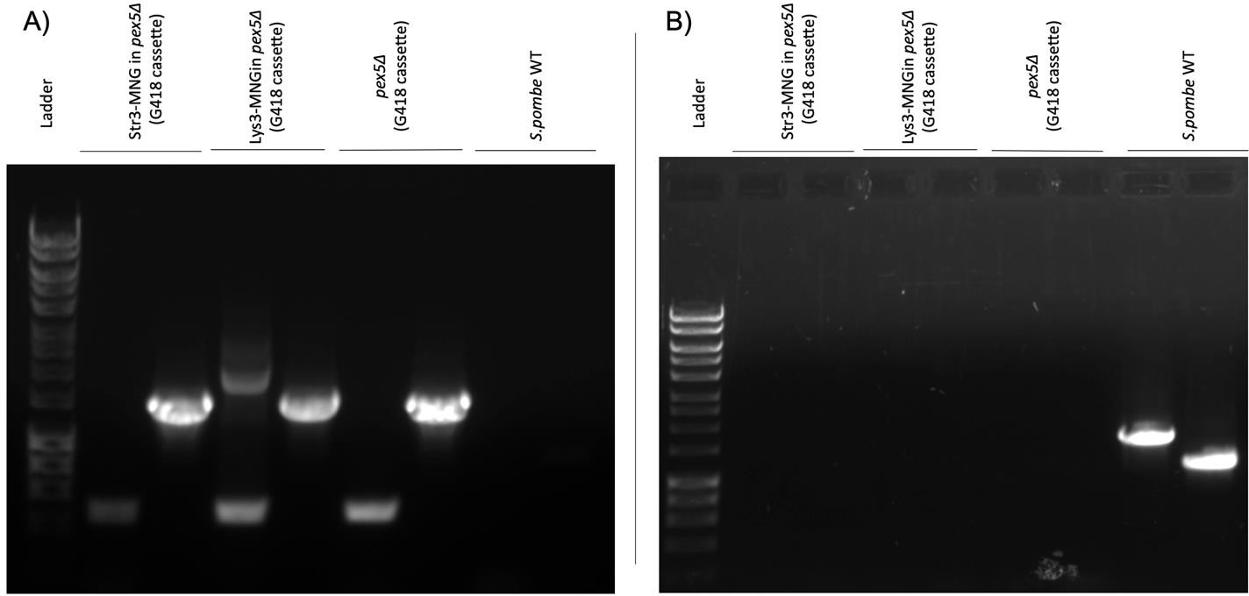

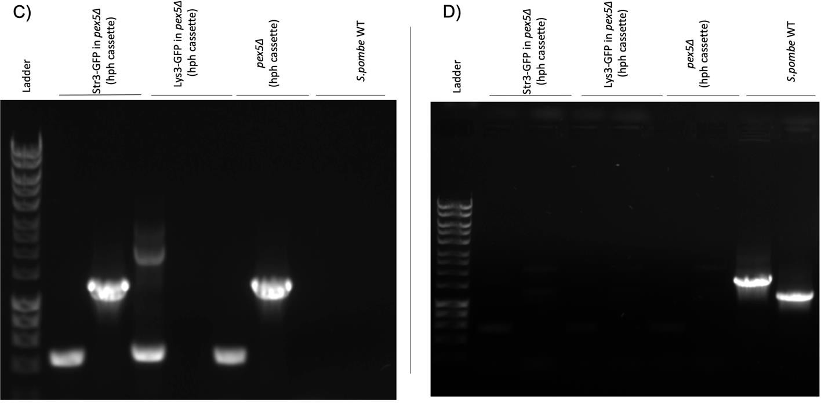
Figure 3.1 PCR confirmation of the S. pombe strain with a deleted PEX5 gene. Two cassettes were used to knock out the Str3 gene from the S. pombe genome: G418 from the PUG6 plasmid and hph from the PAG32 plasmid. The primers used for the pex5∆ strain was vip4740F and vip4741R. Different strains were examined, including pex5∆ with Str3-GFP, pex5∆ with Lys3-GFP, pex5∆ without a tag, and
S. pombe wild type (WT) used as a control. Both upstream and downstream regions of the PEX5 gene, as well as both G418 and hph cassettes, were examined in each strain.
Different sets of primers were used: vip4760F anneals to the upstream of the gene while vip4761R anneals to the downstream of it. Primers vip142R and vip3984F anneal to the middle of the integrated G418 cassette, while vip4807F and vip4808R anneal to the middle of the PEX5 gene of strains that

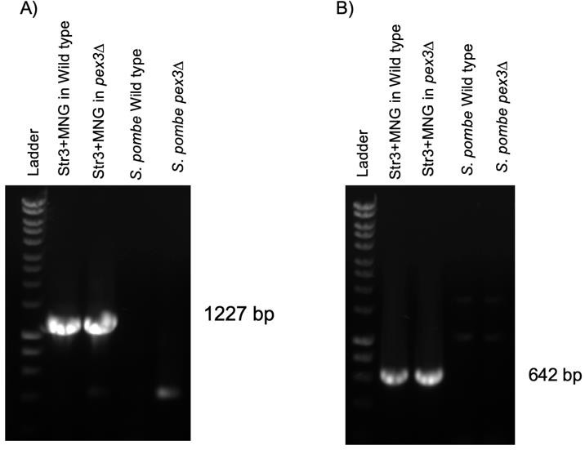
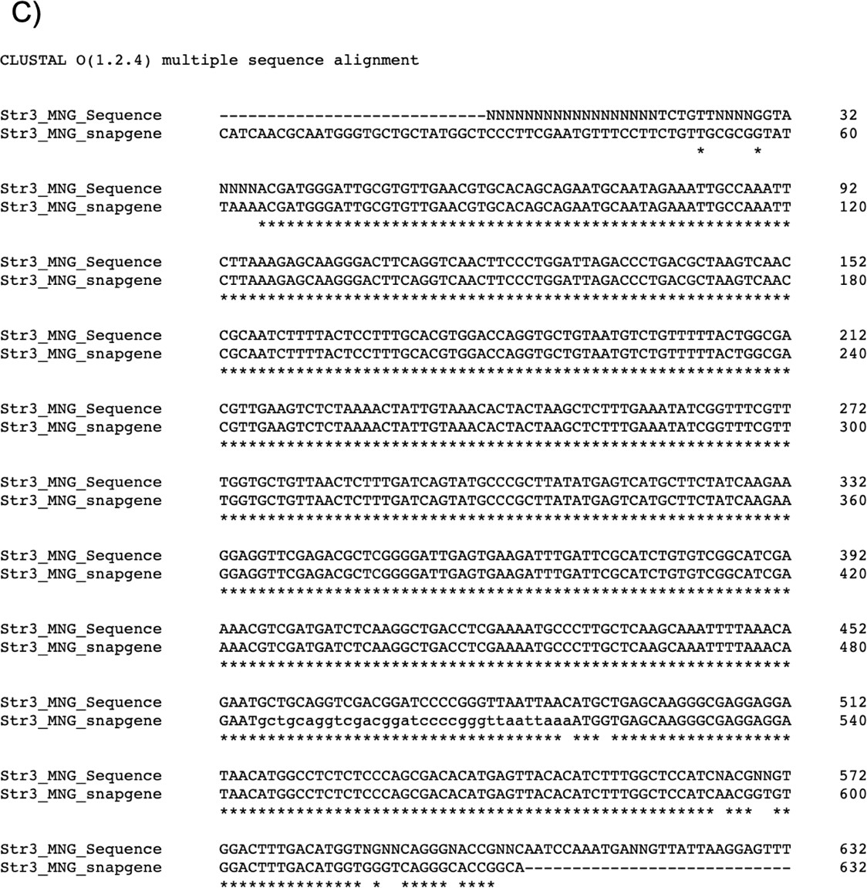
have the G418 cassette. Primers vip142R and vip4066F anneal to the middle of the integrated hph cassette, while vip4807F and vip4808R anneal to the middle of the PEX5 gene of strains that have the hph cassette.

Figure 3.2 Confirmations of mNG C-terminal tagging of the STR3 gene in the S. pombe genome.
(A) Upstream PCR confirmation and (B) Downstream PCR confirmation using primers anneal on the upper stream, downstream and on the middle of the gene. (C) Multiple sequence alignment result. Stars (*) represent the nucleotides that are matching on both the gene sequence and sequencing data.

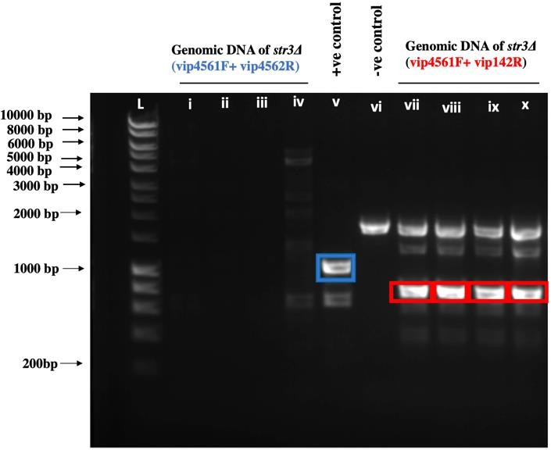
Figure 3.3 PCR confirmation of MAT A S. cerevisiae strain with a deleted STR3 gene. L=ladder, i- iv= Genomic DNA of str3Δ (vip4561F+ vip4562R), v. Genomic DNA of WT (vip4561F+ vip4562R) as a positive control, vi. Genomic DNA of WT as a negative control (vip4561F+ vip142R), vii-x. Genomic DNA of str3Δ (vip4561F+ vip142R). vip4561F+ vip4562R, a primer set which amplify the upstream of STR3 gene until the mid of gene (1053 bp) “blue”, while vip142R is the reverse primer on the mid of the knockout selection marker (HIS3) “red”. Other flanks will be further tested.

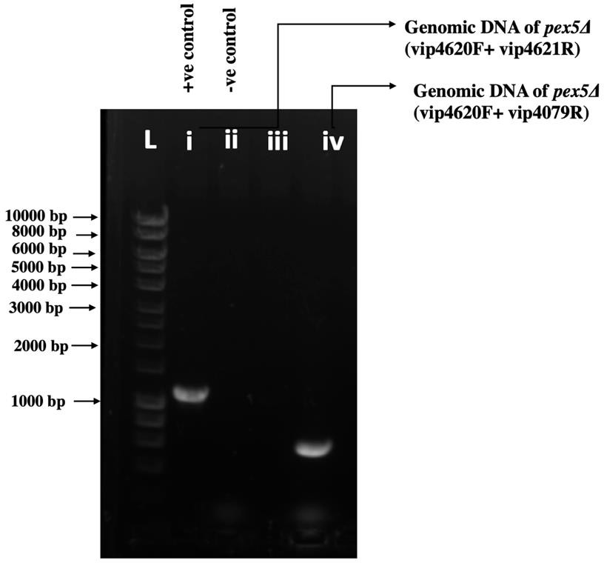
Figure 3.4 PCR confirmation of Scpex5Δ in MAT A Scstr3∆ strain. L=ladder, i. Genomic DNA of WT (vip4620F+vip4621R) as a positive control, ii. Genomic DNA of WT (vip4620F+vip1079R), as a negative control iii. Genomic DNA of pex5Δ (vip4620F+ vip4621R). iv. Genomic DNA of pex5Δ (vip4620F+ vip4079R).
vip4620F+ vip4621R, a primer set which amplify the upstream of PEX5 gene until the mid of gene (1144 bp), while vip1079R is the reverse primer on the upstream flank of the knockout selection marker (Leu2).

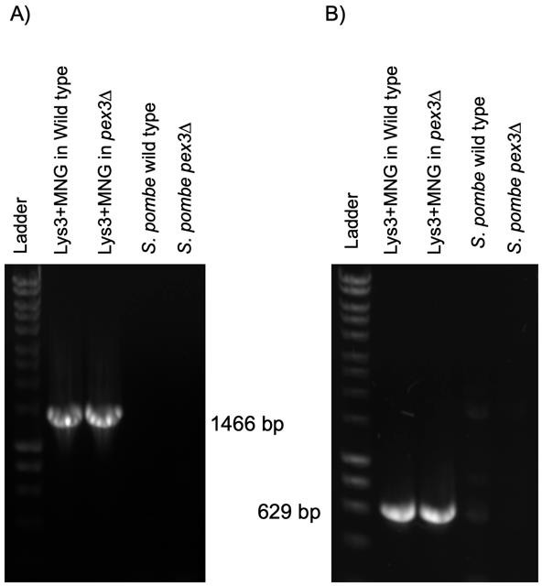
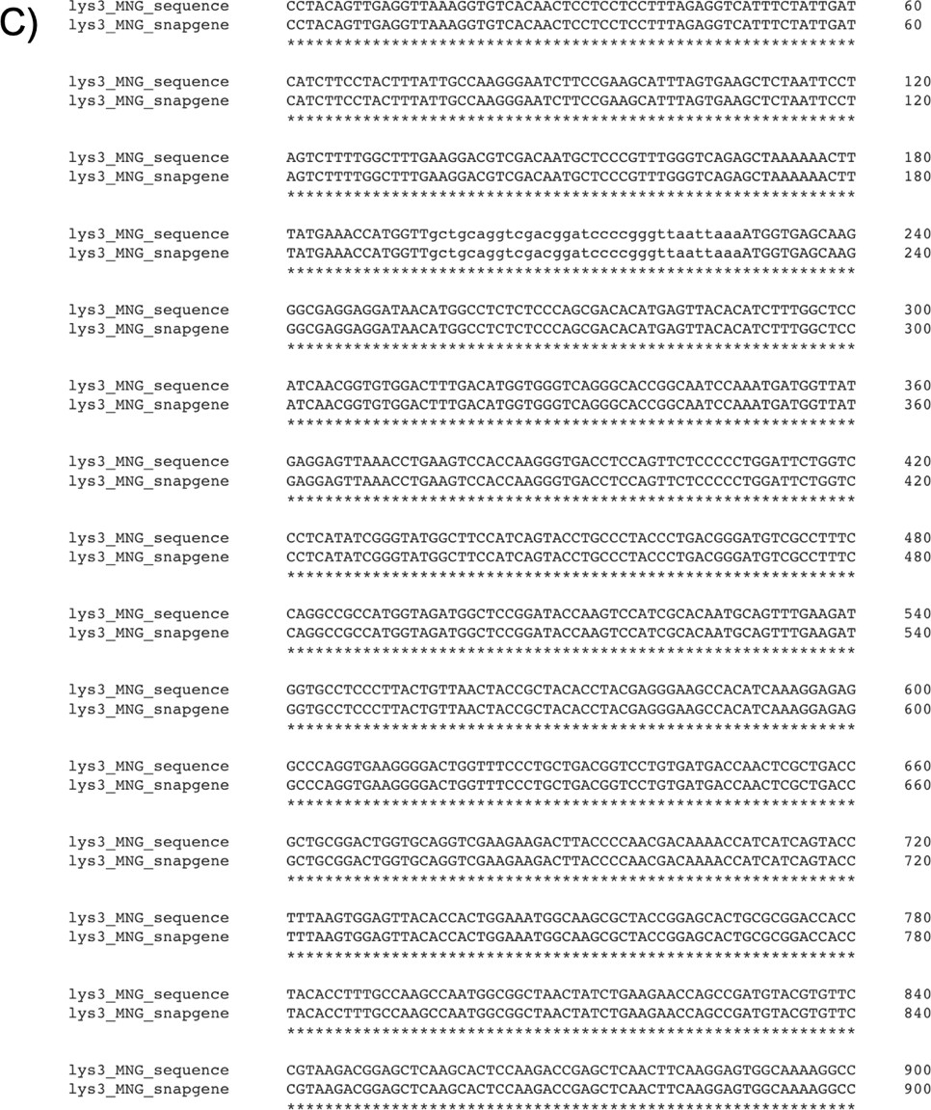

Figure 3.5 Confirmations of mNG C-terminal tagging of the LYS3 gene in the S. pombe genome.
(A) Upstream PCR confirmation and (B) Downstream PCR confirmation using primers anneal on the upper stream, downstream and on the middle of the gene. (C) Multiple sequence alignment result. Stars (*) represent the nucleotides that are matching on both the gene sequence and sequencing data.

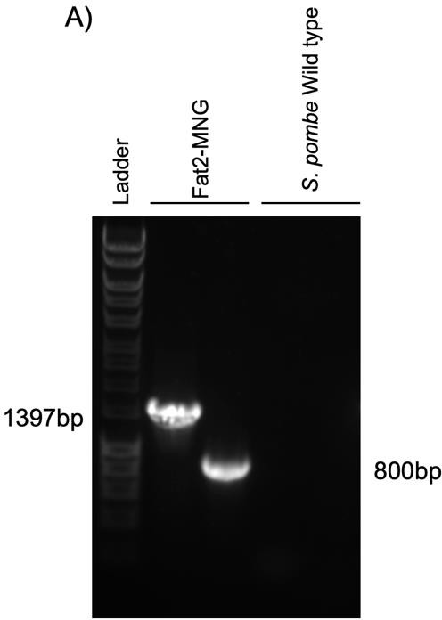

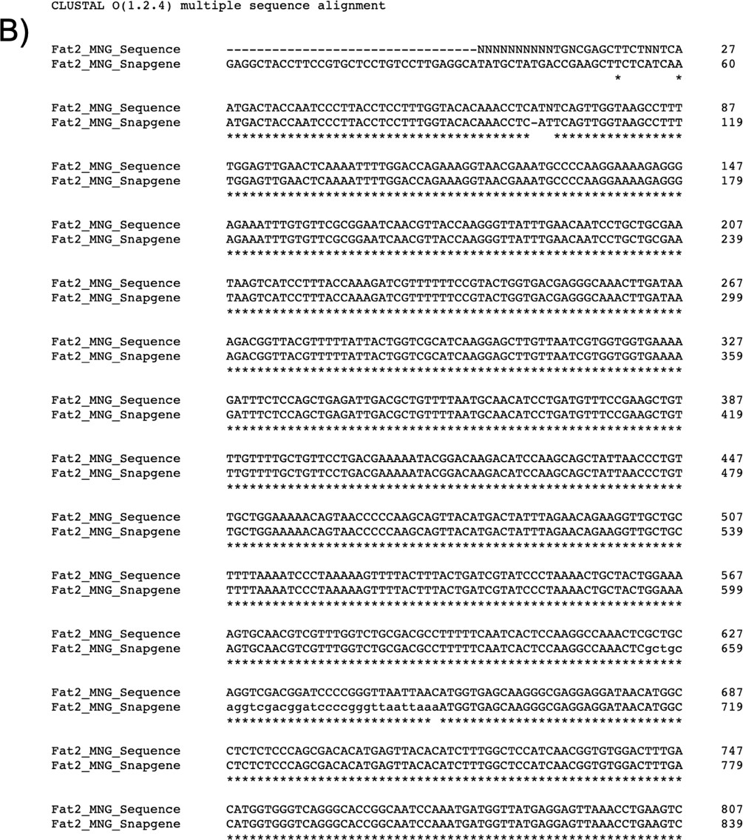

Figure 3.6 Confirmations of mNG C-terminal tagging of the FAT2 gene in the S. pombe genome.
(A) Upstream PCR confirmation and downstream PCR confirmation using primers anneal on the upper

stream, downstream and on the middle of the gene. (B) Multiple sequence alignment result. Stars (*) represent the nucleotides that are matching on both the gene sequence and sequencing data.
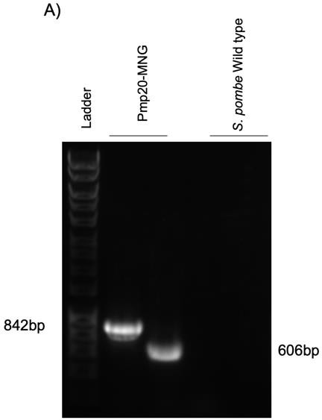

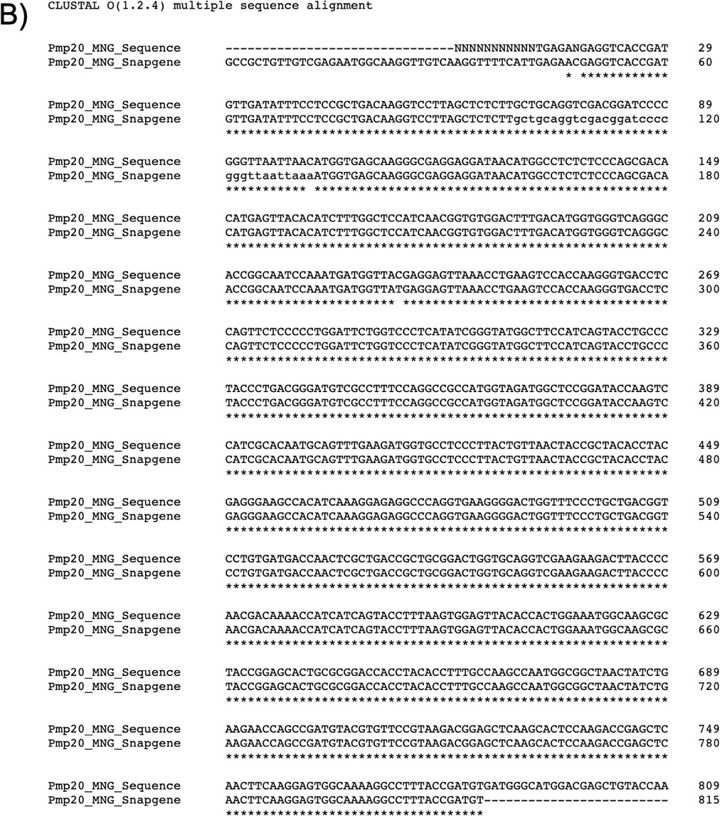

Figure 3.7 Confirmations of mNG C-terminal tagging of the PMP20 gene in the S. pombe genome.
(A) Upstream PCR confirmation and downstream PCR confirmation using primers anneal on the upper stream, downstream and on the middle of the gene. (B) Multiple sequence alignment result. Stars (*) represent the nucleotides that are matching on both the gene sequence and sequencing data.
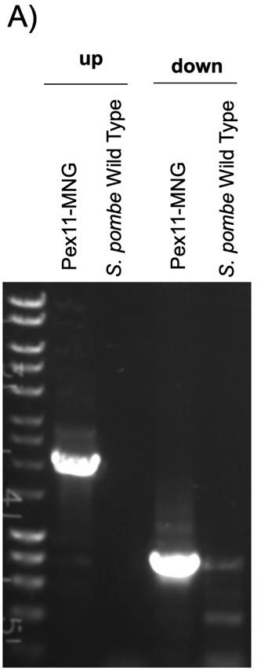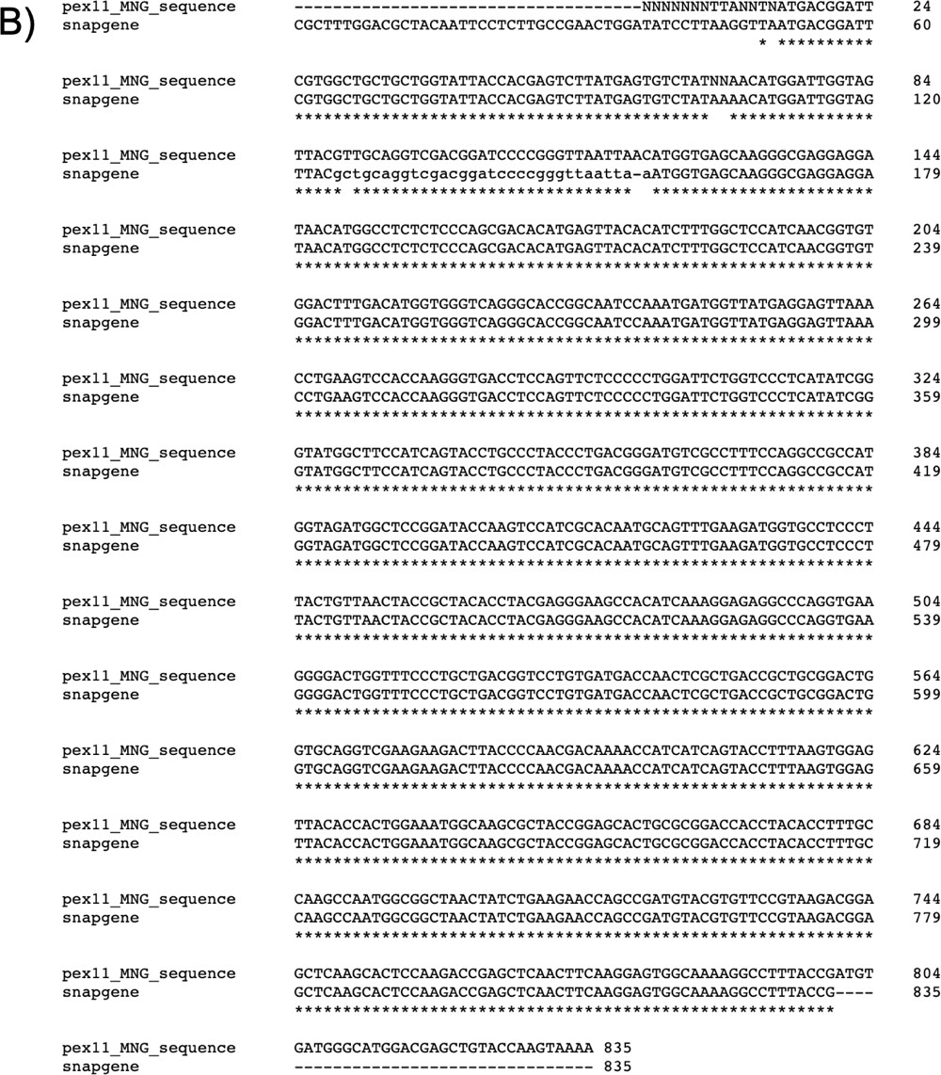
Figure 3.8 Confirmations of mNG C-terminal tagging of the PEX11 gene in the S. pombe genome.
(A) Upstream PCR confirmation and downstream PCR confirmation using primers anneal on the upper stream, downstream and on the middle of the gene. (B) Multiple sequence alignment result. Stars (*) represent the nucleotides that are matching on both the gene sequence and sequencing data.

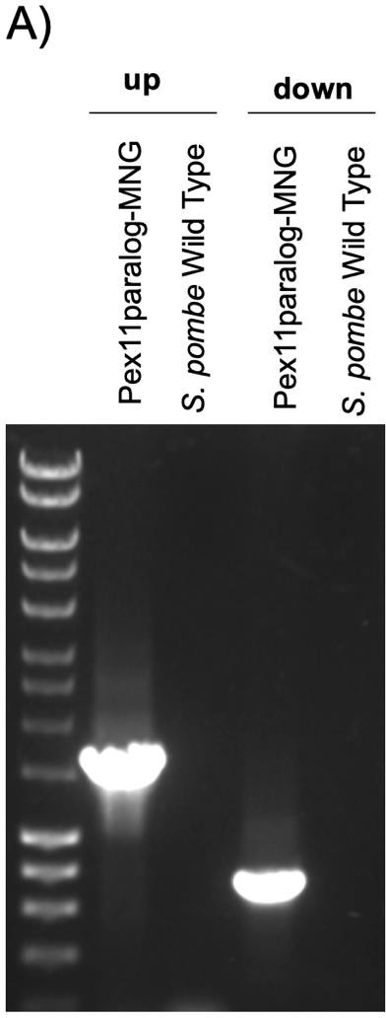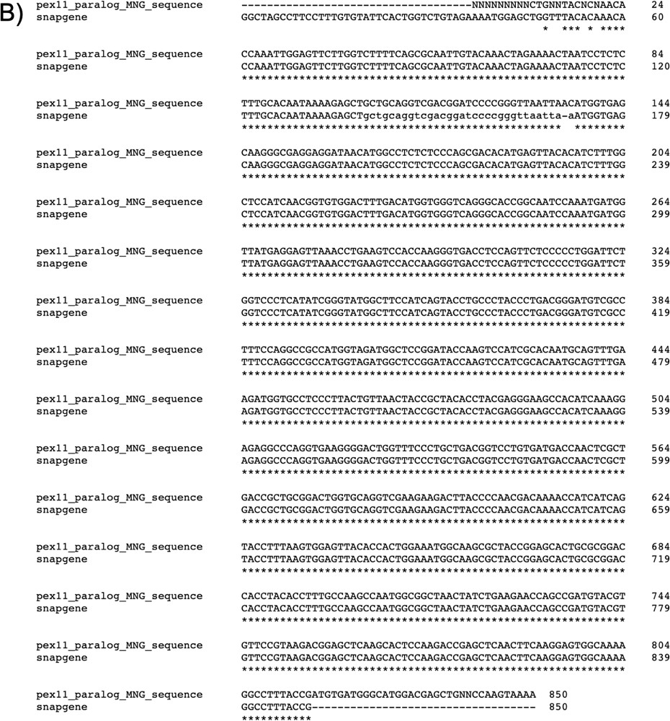

Figure 3.9 Confirmations of mNG C-terminal tagging of the PEX11 paralog gene in the S. pombe genome. (A) Upstream PCR confirmation and downstream PCR confirmation using primers anneal on the upper stream, downstream and on the middle of the gene. (B) Multiple sequence alignment result. Stars (*) represent the nucleotides that are matching on both the gene sequence and sequencing data.

Chapter 5. Identification and characterization of peroxisomal proteins in D. discoideum using BioID

Table 5.1 The sequences of biotinylated peroxisomal proteins, with the detected peptides highlighted in the mass spectrometry analysis.

No | Ac | Name | No of  fragment | Sequence
7 | Q55CT6 | Acyl-  coenzyme A oxidase | 368  127  526 | MERLSIICNHFEDNDSLESNEVAANSNNNNINNNNNNGLATLNQNSL  NNLIQINSKINLDSEKIEKITKILFDHPDKEWTAARNRLIEVLKDPIFEC KPYASFHEQRELAQKRVAHLASIPGGPILKVGEIVSNYKKFSMFQSTL VYCDMSMAVKSSVHWGLFGASVCCLGSEKHEKYYDDIDTCKMSGC FALTELAHGSNVK²⁰⁴GVETIAEYDNKTQEFVIHTPSDTAQK²²⁹WIGNA ATYGCFATVFANLISNGENYGLHPFLVQIR²⁶⁶DTTTLKPLAGITTADN GPKI²⁸⁴GLNGVDNGRLWFNKVRIPRDNLLNKFGDIDANGVYSTPIKN PSVRFNSMLESLIGGR³⁴³ITVANMANSAAK³⁵⁴MGLYIALHYAFSRRQF GPSNGKEVLLIDYITHQRRLFPQLAEVYINQVGINYVINKFQNRTEKD ARDVFLLACGFKAATTWNRSKTLQLCRECCGGQGMAASNKIGILRA DTDVDLTYEGDNTVLMQAVAKALLQEFKSYFTGTKRITGMLSYTYSK GHIGIFLRNKNFFTKRLHTESHLLDPDVLLDAFIYREFKLLRNLIKTLR AKVKNEKMTGLQAWNSSLDLVLQLANAYIERVSIEKFLEEVQKSPEDI KPILTSLCILYELTKIENDLGWFLSNKYFAPVKGQAIGNTINKVCGALK  DHAIPLVKAFDIPSQFLTAPIIGDWVSHFSNPNNC
11 | Q54XC3 | Peptidase  S1 PA  clan | 1274  816  1052 | MVNNFSSNGSDFINNINNNNNNNSNNNSNNNNYNYSNKFNLEEERI  PNLRRSCCIVR⁵⁸VSGIDQSNGTNPNLQSTR⁷⁵SRSFSYSSNGKIIFSC SGFILDLEKGLIITSPTIFLPFILQQQNDNKRNINNNNNNNNNNNNNN QMTESNITKNTKNSIEKILSLINIDIILESDII¹⁷⁶NIRNNVNENNNNNDYS DDKIYDPVNSWR²⁰⁰SCKFIDYLSCSQKTINTLNQLKNHFILSNQSSGF ESSFGLIVLEINDKSSLIINQQQQQQRQQIEHQQHQHQQQQQRINSS VIIGNSVDVRSGNSVYVVGSPFGFISPTMFLNSISNGIVCNCIQSSSS SSSSLFLIDARSLPGNEGSGVFNKDGLLIGFIAPPIRSKNDKLPFTLSP VLPIHSFLPRIESQLSIYPKYRLSNSLSVSCFDPIQQSVNDCQNSIVLV QFKNSWGSGVLISESGYILTNAHLIIPSIPLIQQQIQQQQQQQQQQQ QQQQQQQQQQQTNQTKQTK⁴⁹⁴SSQQQQQQQQQQQQPQPFPIEL YKDK⁵¹⁹KVDLRISSNSIINNNQSSSLHQSSNSSFIWCKGTIEYISHTHL DIALIKIDQHDLSILLNDNNNNNNNNNNNNNNNNNNNNNNNNNNNN NNNNNNNNNNKNNNNNNNQKKHEPIKFQHVICNPILNPKYGESVFV LGYPLIPPTQNPPISVTKGIISNIVYVDNCAVSYQTTASVHSGNSGGG  LFDLKGNFLGIVTCNAKQKNGLIITELNFSIPATSLIHFFHYANGTDEM

GLNLMRSTSTDKFLKALWKLQITPPPLSNTNKNINNTNTNNNNNNNN
NNNNNNNNNNNNNNNISTSTSPIAGKKYSEFLTKMNQQQQQDNNN KIQSKL
12 | Q54II1 | Acyl-  coenzyme A oxidase | 1174  227  1366  521 | MESYEERVRNIVNHLTPPKEILMNDCLSSEEEILNINNTSSTTTSTLT  WNKQELSEYLEAAPDHIKVAKKKLQEIVKDPIFLPKYNMNVQQWREL TLQRAMIIIKAGAISLAEFNRDPMKYLVSMEMLNLVDPSLSVKLGVHF SLFGNAVLNLGTEKHHIKYIKDIDSWKLPGCFGMTELGHGSNVQGV ETTATYDK¹⁹⁸TTQEFIINTPSDSAQK²¹³FWIGNAACHGQACSVFAQLY IDNVHYGVHVFVVPIRNSDGTIAENVRIMDNGHKLGLQGVDNGRIWF DNKRIPRDNLLNK²⁹⁴FGDVEADGTYVSSIPSK³¹⁰SKRFGSMVAPLVG GRVLIAASALNVSKMALMIATRYAYSRKQFGSKGNEIRIIEYLTHQRRL FPMIATSVALSFAVEKLKKIYCEPNKTSQNVKDLHVWSSGLKAVVSW TKTNILQLTRECCGGQGFSSFNQIALFKSDLEIDMTYEGDNHVLLQQ VARNLLVELQKGR⁴⁸⁰YTLTSPNHDSAHIYDYDFQIQTLK⁵⁰³WRESDLV STLSSKIMSQLDQGLSLEQGWNTCLDTITLLGKAFVDR⁵⁴⁹ITLEEFQS GINNAPSSLK⁵⁶⁶QVLELCRNLFFSWKVNEDLGYFLCNDGLATPAALK IQGSINKLCSDMLPIGLDLVNSFNIPEQFIHAPISKPDYIQEFRYGLKR  DY
15 | Q54RR4 | Malate  synthase | 253  654 | MEKINEFLKVLHLEFEGKRQELLKERILIQSNITQSLGKCLKKPIETFEI  RNDSTWKIREIPKILQDRSVDIVCLDVTNYQSMVECVESGSNGVQV DFDDGYSPSHSNNLKAQSNINKIVNDNRLNQSNKALLLVRPRSMNL DEINHCVDGVPISGTIFDLGVFLFNNAAKLIEMNRGPFLYIPKIENYRE AQWWDSLLKRCEQLLSIPPFTIKAIVLIENILASFEMEEIIYYLRDHCIA LNTGRWDYIFSYIKKFSQLPNYNIPSKSMLSFNQEFLVSYYNLLSNIS HKRGCLATGGMAPHYPTNVGQTLSDKELLSIFNGKKEEAKMGFDG ALIAHKSAVSACRNAFKEVIGNDNTNHLSSNRLFKFSPIQCDQYFSN LIKTCKGLT³⁹⁵LENKFNHNYPIASVSIQDV⁴¹⁰KSYLTVLYIYIGNWIFKE KGASSINGVIEDLATSEINRVLLWKWLKFGVAIKEDNNK⁴⁶⁷LLNISTILI NLNDIEK⁴⁸²SLKQQQQQDDIKFTNNQHETIKRLIIQFLTSNQLIDFMPT  LLYPYLLNLNKDIIILKSNL
17 | B0G117 | Thiamine  pyrophos phate- binding enzyme family protein | 738  1054  698 | ¹MLLEQENITK¹⁰GAVIAASVGSVLFSLYFLENRNIIDCDGQIINFKFQK  ⁴⁸SSSGGELVANVLSK⁶¹QGVKFLFTLTGGHIAPILVESDKIGIRVIDVRH  ESTTVFAADGVFR¹⁰⁸LTGIPGVAVVTAGPGLTNTITAVK¹³¹NAQMAQS GVVLIGGATSDLLKGKGSLQDIDQFALLRPHVKWCSHVSTNSDIVPM LERAFYEARNGTPGPVFVEFPIDVLYQESVVRGWYLKNQDQAKSLA SRVINMYMSYHLKKIFSAIDSNIVIHGRVRQHQTRVTSDHVSALLARL VSNKDGACKKPVLIVGSQVTLINDAYSIESLQRSVQSLGIPVFTSSMS RGLLGTSHSNLFRHCRSHALKKADLVILAGVTCDFRLNYGRSINSRA KVFSINRDSIDLYKNKSPNYPYSLDPGSFLVQLSESISELPSSDRSIIE  LKFRDWINELTNLDVSRNVDIANKINIPPSKEGFLNPLKALQMFDEQL

PHKTIMVADGGDFVGSASYIVRPRAPLSWLDPGVFGTLGVGAGFSI
AAKLCRPDHQVWTIYGDGAFGYSIPELDTMVRHKISVGAIIGNDSGW IQILREQQEQLNSDVGCNLAYTDYHQVAIAFGGKGFKSTNESELKFA
LEESNKILNQNQQPVVINCIIERNDFRKGSISA
18 | Q86A67 | Fructose-  bisphosph ate aldolase | 376  40  41  1362 | MNSKFADELIATAKAIVAPGKGILAADESTNTIGARFKKINLENNEENR  RAYRELLIGTGNGVNEFIGGIILYEETLYQKMADGRLFTDVLREQKIHI GIKVDK¹⁰⁵GVVPIPGTDGETSTQGLDGLAER¹²⁷CKKYYEAGARFAK WRAVLKIDLAKNCPSQLSITENAHTLARYAAICQENGLVPIVEPEILMD GNHTVEQSAEVTEKVLAAVFKALNDHHILLEGALLKPNMVVNGTDC PIKATSEQIGKFTVRTLQRTVPPALTGVVFLSGGQTEIEATANLNAMN VLPNRPWALSFSYGR²⁹⁹ALQASVISTWKGESANVEAAR³¹⁹KVYLHR AKCNSLAQLGK³³⁷YTGEESTGSASESLYVK³⁵³DYKY
19 | Q54GQ6 | Peroxiso  mal acyl- coenzyme A oxidase 1 | 1043  1253  1343 | MYCPKAYENEKKNEDLEFER²¹SQSTFSVSELNFILNNNDHNIINIK⁴⁵  NEIKKFIDNDEIISKPQEIHFLSREEQYKRALYVSSKLIEIKKRFGEIGR DQYYQSLFEEIPFVINDIVFACAFKSLASDEQMNRLYSKFENYQYFG SYSQTEIGHGSNVQGIETTCTFIKETGEFELNSPNLTSTKFWIGGLGK LATHTIVFAQLLIPSSIDGKLKNYGPHPFILQVRSLDDHSPLPGVTVGD IGPKLGFNSIDNGFLRLDHVRIPRENMLSRFFRVNEQGEYEKPKHPK LIYAGMVGVRSSMIENSFVSLSRAVTIAIRYSTIRKQFKSNRLDKQEK KIIEYSNQMNRIIPYLAQTFAYFFTGKRFSIEFDQMMKAVKHNQDTTL LSELHANSSGLKSLMTQSTSDGIESCRLSCGGHGYSQFSGLPYLWS NYVHMSSAEGESNLLPQQTTKYLLTILRK⁴⁵⁸VLSGGGGSSDTTTADD DNKPIGK⁴⁸⁰SVK⁴⁸⁴YINDEFQSSFENINQFIQEK⁵⁰³GLNSIIHPDSLLQL FKHRSFILIKSIAESIQEQMSNGNKDIPQIWSDLNVEINHCSKAHCQLY VIQSFYDQILLLSSNSSSCSSSITTVLIQLLQTYSIWIINSNLVDFLQDQ YVELSQIDFLKKSLINFYKLLRPNLVPLVDSFDLCNTTLGSALGSYNG  DVYSTLYKWASTQPFN KNSLPLGFNE TIKPLINSKL
20 | Q8T2K9 | Malate synthase | 1219  1041  1014  1040  969 | MLRGIEIRGKVDKNVKSILTEECLTFLGELERRFGGIRKNLLQKRLDR QIDINNGILPSFLKDSDCKRATDKNWKCSSVPLEIQDRRVEITGPTDR KMVINALNSGAK¹⁰⁹VFMADFEDANCPNWENSIHGQQNMIDANNR¹³⁸ TISFTSAEGRKYELNKQVAVLFVRPRGWHLNEDHLAIDGLSMSGSLF DFGCYIFHNHQILKNRNSNPYFYLPKMESHLEARLWNDVFVFSQNY LGMPIGTIKATVLIETILASFEMDEILYELRDHSAGLNCGRWDYIFSFIK KFQSYPDKMLPDRAKVTMTSPFMDSYVKLLIYTCHKRGVHAMGGM AAQIPIKNNEQANNAAMEKVRLDKQREVRAGHDGTWVAHPALIPIAM EQFNTHMK³⁸²SQNQISYIPSSTAPNFEEIAK^{402/403}SLLSVDPVKPGDI TEDGFR⁴²¹SNIVVGILYLEAWLNGNGCVPIHNLMEDAATAEISR⁴⁵⁸SQI WQWIK⁴⁶⁵HKAPLPDGK⁴⁷⁵SFVTLQYYNR⁴⁸⁴IFKEESDKLEKAHPNSK  TLTDAIQIFNNLIVSPNFIDFLTPSCYKF VVDSERKTFSPKL

21 | Q55GN0 | 3-  hydroxyis obutyryl- CoA hydrolase | 452  441 | MNRIEIIKNHLLFSQLQPQPQQKQFNNNNNVLKEMENNKIKIIEYKNG  CKRIILNRSEALNSLTMEMLKFLSEKLKEFNNDDNCKFVIINSSTEKSF CSGGDIKEFSQLSRSSAGVNEFIRVEYAMDHLIHTFNKPILSFVNGIV MGGGVGLSIHSSHR¹⁶⁰IIGDNVQWAMPENR¹⁷³/¹⁷⁴IGYFPDVGTSYFL SR¹⁸⁸LGSIGLYLAMVGVKINSKDLINVKLATHYIPNELFERTLEELCND DDIEGYRQIEFILNKYRKTLYPDKESSHLVLYQSIINRCFNNKEFKSVK EILNQLKVEIENVDNKNNKDEIEWASKTLSILLDQLCPTSVCVSFEIIK RALQMNIDQIFQMEVRVGTRLGNRQDLTQGVFKTLIDKTHKPIYSPS  SIYDINQSFIDS FFLPFDDGDEKKEFSII
22 | Q54CL3 | Probable  peroxiso mal membran e protein PEX13 | 1032  1176  1177  234  33 | MRR⁴SPPKPWENNSGGGGSTSMTGSGGISR²⁹PMSGPQR³⁷TTSPG  GGSSTTTQTSTLNNTGSPSTSVGGPLVTRPR⁷²TPMRPWESGGAGS SSIDSFGGGVGGSSGYRSSYGGGYRDSYSSGGYGSSGYGSSYGS GGSGGYGSSLYGGGGYSSGGYGGSGYGSSYGGGYGSSYGSGYG SSYGGSGYGSSYGGGYGSSYGGGYGGGYGGGYGQRGYDNMDG KGGALQSVVSSGHSWMEALHSIVDTFSRFSRLLDANFDAVHGSFSS IIRLCQSMSHFSYEIMAIIKTYSLFRMFQSVASRFLRVFRYLLGKKSKS NSSNNNTSSK³²⁰FGSNAITESLR³³⁰QANMDVSDFRNFQNEKKQSVG TLILIIAATFIGVPMVIGQLLNLRRRGQASRLDKGWEEQQGGGYGQV K⁴⁰⁰AIYEFNPETTR⁴¹⁰DLPLRVGDIVNVIDKPHDNWWVGECNGLSGF FPVDFTEKISPNDINNNNNNNNNNNNNINTSVQIYDNNNGFNRNNS NNNLNNSEYSDYSSSNNNNNNNNNNNNNSNYQLQSNFSSNNDGIS  KNIIYNNNNDNQRPISPSKTSQQLSRSE LMDKPYVEES
23 | Q54SS0 | Delta(3,5)  -  Delta(2,4)  -dienoyl- CoA isomeras e, mitochon  drial | 417  254 | MEGSLFFTNATPSTSILKITDYKYLRLEKNDSTFVAELVLCRPKQYNS  MDDDFYNEFISIYDEIQNDSKIRCVILRGEGKGLTAGLNLGK⁹¹IAPLIT GDSEVSQSQNNLDLFK¹¹²MIRRWQASLDKINKCSKPTIALIHGACIG GGVDMITACDIRLCSSDAKFSIRETKLSIIADLGTLQRISKIVGSGFAR ELALTGKDIDAKTAER²⁰⁷FNLVNHVYPDHDTLLSEGR²²⁵KLALSIAQN SPLVVQATKLTLNHADDHTIDEGLYRVALQNAAFLKSDDLNESATSFF EKRQPIFKCNL
25 | Q86HL5 | Hydroxym  ethylgluta ryl-CoA synthase B | 1358  619  642 | MKKTKDIGICAIDIYFPQTYVNQSELKKYDKVSNGKYTIGLGQTNMSF  VGDREDIVSMAMTSVKMMMSK⁷⁰YSIDYQSIGR⁷⁹/⁸⁰LEVGTETIIDK⁹⁰ SKSVKSSIMSLFQEYGNTSLEGVDTLNACYGGTNALFNSLQWIESS YWDGRYALVVTGDIAVYSKGAARPTGGAGVVTMLIGPNATLIFDQSL RGTHMENVNDFYKPDLSSEYPYVDGKLSIECYLRALDKCYLEYKKK FESINDDNKFSMDSFDYVCFHSPYNRLVQKSYAR²⁶⁴LIYNDFLQNPN NPK²⁷⁷YQDLLPFKDLSTGKDSYINSKLDQITLKLSLDDFKTKVNPSTL LSKECGNSYCGSVYSGILSLLSNVNDLNNKKVLVFSYGSGLAASLFS  FRINNNKNRNNNNNNNNCFFKTTNDIGKISNIKERLSNRVKVSPEEF

TRILDIREKSHQMVGARTPIDTLDYISAGTFYLEKIDEKLIRHYKSKPII
SSKL
26 | Q55D85 | Cycloarte  nol synthase | 643  1113  594  209 | MTTTNWSLKVDRGRQTWEYSQEKKEATDVDIHLLR³⁶LKEPGTHCP  EGCDLNR⁵¹AKTPQQAIKKAFQYFSKVQTEDGHWAGDYGGPMFLLP GLVITCYVTGYQLPESTQREIIRYLFNRQNPVDGGWGLHIEAHSDIFG TTLQYVSLRLLGVPADHPSVVKAR¹⁶¹TFLLQNGGATGIPSWGK¹⁷⁷FW LATLNAYDWNGLNPIPIEFWLLPYNLPIAPGRWWCHCRMVYLPMSYI YAKKTTGPLTDLVKDLRREIYCQEYEKINWSEQRNNISKLDMYYEHT SLLNVINGSLNAYEKVHSKWLRDKAIDYTFDHIRYEDEQTKYIDIGPV NKTVNMLCVWDREGKSPAFYKHADRLKDYLWLSFDGMKMQGYNG SQLWDTAFTIQAFMESGIANQFQDCMK³⁹³LAGHYLDISQVPEDAR⁴⁰⁸ DMKHYHRHYSKGAWPFSTVDHGWPISDCTAEGIKSALALRSLPFIEP ISLDRIADGINVLLTLQNGDGGWASYENTRGPKWLEKFNPSEVFQNI MIDYSYVECSAACIQAMSAFRKHAPNHPRIKEINRSIARGVKFIKSIQ RQDGSWLGSWGICFTYGTWFGIEGLVASGEPLTSPSIVKACKFLASK QRADGGWGESFKSNVTK⁶¹⁵EYVQHETSQVVNTGWALLSLMSAK⁶³⁸ YPDRECIERGIKFLIQRQYPNGDFPQESIIGVFNFNCMISYSNYKNIFP  LWALSRYNQLYLK SKI
29 | Q54HR9 | Amino  oxidase domain- containing protein | 880  1289  870  295  857 | MSNVYDIVVIGSGVSGLMCGYKLEKDGYKVLVVEANNIIGGRTR⁴⁵QD  FNFTSYPVELGGEMIHGGDTLYYR⁷⁰LAMENKWELFEVFSMDLFNSP INSTYLYLGRERKLIRADQRDEDIQKLADALVSLSDEIDNPNREMNLL EHLIKKQVPFRVLGLADAIYSKTWATDLDRIGVKEAAREDSKPNTIPN NYKVQQSSKIMLDHFSKSLDINLNWRVKHIDTTKDEKLVK²²⁸VTSYN GQVVQAQR²⁴⁰VVVTVPLQILKDGDITFTPELPERKKIAIKTIGMDGGM KIIAKFNKKFWLNNCQLVLCGDSPVPQIWMDGPPYR³¹⁵PLVPGQPSE YVSVGFITGDQAK³³⁶AISALSPQKQIRTFLDQLDAMFGTSENGWTPA SDSFISHMVYDWQKNPF³⁸⁸GAYSYPSIIPSTYPYKNYPNEILAEPIDN K⁴¹⁷VRLFFAGEATATTYD LSTINGALET GVRVYEELKT  SLPISNKLQSKPKM
30 | Q9GPM4 | Phosphog lycerate kinase (pgkA) | 237  623  632 | MSSNKIGNKLSLDKVDVKGKRVLIRVDYNVPLDKNNNITSTQRIDASI PTLEYCLKNGAKSIVLMSHLGRPDGLVKPEYSLKPVVKVLEDQLKRP IKFLSDCVGEQVEKECANPEEGTVILLENLR¹²⁷FHIEEEGSGVDAEG KK¹⁴²VKANPEKVKEFRESLTK¹⁶⁰LGDVYVNDAFGTAHR¹⁷⁴AHSSMV GINLPQKAAGFLMKKELEYFAKALESPSKPFLAILGGAKVSDKIKLIEN LLYKVDEMIIGGGMAFTFKKFIDNKEIGSSLFEKTAEQITKDIIAKAAKN NVK²⁸³LHFPVDYVIADKFDNDANIK³⁰²TVTQDQGIPEGWMGLDCGP ETIKENRDTISRAKTIVWNGPMGVFEKSNFEAGTKAAMDDVVNATT NGAITIIGGGDTATCAAKYNTEDKVSHVSTGGG ASLELLEGKE  LPGVTALSDL* ILKNKL*

33 | Q54C55 | Peroxiso  mal membran e protein PEX14 | 919  73  939  679  1136  1146  1102 | MDNDDINNNNNNNNNNNNNNNSQELDQQEQTQEEITKQRIQKRKE  EAKRIMEERKKREQQPPSQR⁶⁶QYEDVEDDQQQQPIRPIK⁸³QLPQR QQQYDDNDEPPQQQQYEPKISQRKVPLPPMKQPTTSSTASAATGSI LSPSSNFREDMVKK¹⁴⁹AVLFLNNPNVK¹⁵⁹NTALARKVAYLEKKGLTS DEVKEALK¹⁸⁶RVETGNINGSSTNNSNITQSNSISR²¹⁰TRNDNYGNNN NNSSNNNNNIQQQQYYQQQQQQHQQQQQMALTQIQSYQKRLEAD DQRIAQLMMNNNRFSWNSFLFSVTAIVGAASGLAYLTSNYIIPFLNGG KTNKDASANMDKKITSLQEEIIK³³⁶LQSTIIQQGNDFR³⁴⁸ESTKSLK  ³⁵⁶TLIEQQQQQILQQQQINSVSTTTNSATSASNSSEIVEIKK³⁹⁵ELKNL  INLIGNKENSNNSNNNSNNSNNNNGYSKYNGFNGVYNKSSYDDVS TNNNNK⁴⁵²TNSPPSPNKPTTTTTTTATSTPGSNISNTNK⁴⁸²TLPPIIKT NPYSHLSWKLPTDQPPVIPSWQQKSSNPPSDLSNANDKSSPSNSN PSTPTKPYQSSFNYGDVNSFVGGSNTLNFDEKPTTTTTTSTTPSNE RPSSPSVNNNNNNNNNNNNNNNNNNNNNNNTTIASTSNESNNSKV ETTSNDSDKSTSPSSSSNNTTSTTATTTTITSASTEDNKQQSDETPY SSDFLDVINQLKQGKTPPGIR⁶⁹⁵TDIDDKPLENSTVTK⁷⁰⁹SAKERPKK  PWERDTLTSVTNNLSVEETQTINNTDSSVEK
35 | Q556W1 | D-  aspartate oxidase | 932  136  700  701  616 | MNQNKNNNNKNPKINLLIIGCGCIGLSTGIIALKSGNYKSVSIWAKDLP  PNTTSNKAAALWYPFLCNPLDLVGKWSAETMQYYKDHIINDPKSGTI TKKVNEIFR¹⁰⁶RPHPEDPEWKPYIK¹¹⁹SFRRARKDELPDGYVDGYAI DDGFVMDTDMYMDYLVDQFKSLGGIIEQRHLVDIR¹⁷⁵EAFVDHDVVV NCTGLGSR¹⁹²ELFNDRTIYPGRGQIIVIKNSTDRSIMDEEDHIAYVIPR²  ³²LTNTVLGGTNQEHDYNTNPTKK²⁵³DTEEILKRVAMISPRFAKNRIEI  QGVKVGLRPARHEIR²⁹²LENEFFEGGSK³⁰²LVVHNYGHGGSGFTVS WGCAIEAIKLVDQGLPKLLHFNKLISKL
36 | Q54PA2 | Sterol  carrier protein | 224  950  951 | MSSK⁵FFNDLDATIK¹⁴KDGTLAQKIKGIYQFDITENGTVKHYSVDLKT  APGSFKVGKHEKPECTIIVNEEDFVQILEGKLSEQTAFMKKKLAIKGN MALAMKFRSIVNAVKNNTK¹¹⁴SAPAPAAATTTAPAAGGLDDGTLLG KEFEK¹⁴³LSKTVIANPDLVKKINGVYQFDIDTKKYTVDLKNNKGSVSV GPAPKADCTITMKEADFLSLMSGKLNGQTAFTKGLLKIKGNMGLAMK LGQITKAKPQAKL
37 | Q55FP7 | DAO  domain- containing protein | 803  1033  240  332  719 | MSNNENIK⁹NLIDINNINNNLNQSYWEK²⁷KSLSKYDYIVIGSGIVGLST  AISIKEK⁵⁵SPQSSVLILER⁶⁵DTHPNGASTKNAGFACVGSLTEILDDLK TMSEEEVLNLVNARYRGLELLRKRLGDDNIGYKNNGSFELIDSSSQL SNELLLKEKIESVNKILRKVFPSDAFTLCTNEEMKSFGFSDKICSFLIK NNFEGEIDTGKMMFQYTELALSWNVHIKNGSRVLK²²⁵FIDNDDGVIV HVENPFALSNSTLTK²⁴⁹PMEFQCKKLAICTNAFTGDLVNDIDITPGRG QVLITDPIPGLQLK²⁹⁵GIYHFDEGFYYFR³⁰⁷EKDGCILFGGGRNLDFK TEATTEFKLNPMILNK³⁴¹LYQLLQEHIIPNTK³⁵⁴FTVNTVWCGIMAFGK

DKKPIIEFLNGSKNVVLGVRMGGMGVAIGSLVGKLLSNMLINSNNLN
SNNNNNTINNLISKL
38 | O96759 | Alkyl  dihydroxy acetone phosphat e synthase | 167  168  1350  1047  294  943  111 | MSGEKKEYPKEHIDLYQQIKWNGWGDTRKFLHQLKPSGTIAMTTPE  VSSVPLPSLRGFIKK⁶²ELTLPGEEDKPFVLDETPALQIENIHVDPPKQ YPEFVR⁹⁹ELKAFFLPDQLKDDKLARITHTFGKSLRDLIRVRIGQVKNA PDLIVLPHSHEEVERLVQLAHK¹⁶³YNVVIIPMGGGSNIVGAIEPVSNE R¹⁸⁷FTVSIDMRRMNKVLWVDRREMTACIQVGIMGPELEKQLHKQGV SLGHDPDSFEFSTLGGWLATCSSGHQSDKYGDIEDMAVSFRTVTPT GTLELRNGARSGAGINYKHIILGSEGTLGIITEAVMKVHAVPQAVEYY GFLFPTFAHAVSALQQIR³⁴³SSEVIPTMIR³⁵²VYDPEETQLSFAWKPS K³⁷⁰GAVSEFTSAMVK³⁸⁰KYLHYIRSFDFKNVCLSIIGFEGPKKVVDFH RTSVFDILSKNAAFGLGSAPGKTWAEK⁴⁴⁰RYDLPYIR⁴⁴⁷DFLLDHNM WVDVAETTVSYANLQTLWKDAKQTFVKHFKDQGIPAWICAHISHTYT NGVCLYFIFASKQNENK⁵²⁰DMAQYIEAK⁵²⁸KLMTDIIFKYGGSLSHHH GVGYEHVPWMTRYATRGWINVYRSLKETIDPKDICNPRKLIPTIKEEN  NKEPFLFDVVNVKYPKL
39 | Q54I12 | PlsC  domain- containing protein (Glyceron ephospha te O-  acyltransf erase) | 524  760  1340  1307  706  1242  1269  304  1254 | MVVLANFYAGKTVLITGATGFVGKVLLEKMVRDLPDIEKIYIIIRGNAK  ERFEEDILQSRIWDTCKAKMGEAAFNAHIHNKVVAIGGDLSKEGLGL SSEDYQTVVDQVNVIIHCAASIDFRERLDKAISSNLYASLNMDLSKRL KNVVAYVHCSTAYVNSNREGWLDEELPVLDFNPEEMVDLIMKQDIQ TLER¹⁹⁶ITPNLLGAYPNTYTFTK²¹²AITERILALKRGDIPMCFLRPTIVG GSLKEPVPGWVDSVAAIGAVMLYCGVGLVQFMKGDGR²⁷⁵MVADIVP VDHVANALIASAVAIGNQNVLK³⁰³IHQIGTSHRNPVAWNRISHYVTEY WRNHTPKKSIARSQFSFHSSTVMYEAHFFMR³⁵⁹YGVPSALLQVLST LTGSEDTK³⁷⁹TKAEGFKKMTRAARLICDTFKHFTAHEWVFSVTALEK⁴  ¹⁷VYQDLLDGEDR⁴²⁷VKYNCDAAEINWQSYFCYFCFGLHKYVMKEE  GVRPPTELLNTSIITKSDVNQSGFFQWVFADISWASTSYRHVTQTPL PPRAPTEIRSLVMNSPRVQQAMEKVSREEGVLVSEIEKRANQIMER MQSNLNVSVVRVLGWFLKKVWRKIYQGIHVDEKGIELIREAIKKSPV VLIPTHRSYIDFLIISYIFFEYNLPLPHIAAGEDFLSIIIVRWFFRNAGAFF LRRTFHGDSLYWAIFSEYVQR⁶⁷²LVIDNQPMEFFIEGK⁶⁸⁶RSRTGKSL HPKMGLLSMVCQPFFENR⁷¹³VQDVHIVPIGISYEKVLEGELYSNEMM GESK⁷⁴³TKESFNGLLRASKVLKMNFGRINVVFTPPISIKQYSEDKSNE ISSLRRLNPLSYNINNNNNNNNNTNSNNTSTNNNNNNNNNNTNSDE QSNIIKPVVNTNSANISEGDFETQISKPDTRSIGTYFDPFNNDDDRRL LIQDLGYQVVRDLNKSAIITTTSAVATILLSFRRGINREELISKVEWIRE EIFAR⁹³⁵GGDVAFEGPSDALVDHSLK⁹⁵³LLSNLVSKRRNMYEPGSAQ LGVTNKNYRKNILVLNFYRNQLLHLFLWDGLVSLVILSILQSRSTIEQP AAAAVQQSTINTNNVSTTTTTTLNLNSVDQETLITEVRFLAK  ¹⁰⁶⁴VLSQEFVNQPGYDTDEFILK¹⁰⁸³EINRMVSRGIISKEVSGTTSCYG

VKSEGACGFYANLFYPLIEGYMAGILTLFSIQPEMCIKKNQFLQRMG
WFSEKMFEEGKLNFYESCSMEILSNSIQLFEQMKVVERKRLEEVVG KRTTRSTNSNKKPQKQQNQRRKPAPEEYLQLLPPYQDKDGLLKELA
ERLSKYKKSPQSKHQINDLRRTVVEDFPLLSSKL
42 | Q9GNF0 | Uridine-  cytidine kinase D | 440  618  23  128  1135 | MENRYISRIETISSHLLSTNDVSSQNESESITFVKPLPKNKKDHDQSI  ESDSSFTREKQFEEELDILGEINSKTGLFEIKQVPYQLSFDQGFHAC RAIEILTEKDPKRIICLGIAGPVGAGKTTLANK¹³⁰IGSLVNGVIISLQDFV KLENVKDNNYDDPVLIDFDK¹⁶⁵VISTLNELKENKTVIIPKIVNRKMESR SISLSTSKVIILEGAYALSARIRPLLDISVAITGGVHLDLIKSIMRGIVTSG KNSSK²⁵⁰DVLAQITNVVFPMFKAFVEPDLDQAK²⁷⁵IKIHSSFNPMSQ VVEPVYVCKAKYDNNKQFFDQFLSSLNVVPVKKNFSDMYLYPPKYG VDGISQADKRNWIRIRRSEHGQFNITFYNEMMDGAVNTRPSLNFEIS VK³⁸³TLGGLLSLGYQIGAILNR⁴⁰⁰TVEVWYDKNGVVITKEYIKELEKH FIQIKGHSRREVLDSAEKLKITGNHVPQTFLYLYFKKLKKSKNPNYSK LKPNNTNSKILKNNKDKKNL
43 | Q54IT3 | Probable  flavin- containing monoami ne oxidase A | 1110  590  420  1308  1005  1092  636  987  448  447 | MSTLYDVVIVGGGLTGLNAAYQFKKAGLNVMVLKPKDRFGGR⁴³TESI  KVEDYWFDLGGQWMGGTHK⁶⁵YLKELCDELGVKSFPQYDEGKHVL EINGK⁹⁵KVYYQGNISNLNK¹⁰⁷SYNLEGLFESISK¹²¹IDELSAELNPDK PYAHSKSKEYDQLTVAQWVEK¹⁵³NVKGNDARSIIDWFCRVCVAAEP TEVSFLFFLHFIR¹⁹⁰TAGNYGLLADIHGGAQQDRLIGGSQQISEGLA K²²²KIGEKHYTLNAPVR²³⁷SIIQDANQCTIK²⁴⁸TDNGSTYRSKYIVVAIP PTLAGR²⁷²IHYSPSMPPR²⁸¹RDELTQRMPMGSVIKTITIYDEPFWRKE GYSAEAISDKGPIFICYDDSSHDDKKTAIVGFIAASAAKDWAEKSPEE RKRAVLDCYARWWGPKALSPRIFLEKSWKEEEYSRGCYLGYTSPG TLYQCGEHLRAPVGR⁴¹⁸IHWAGTETASVWIGYMEGALESGFR⁴⁴²VS  KEIKDKLLNSKL
45 | Q75JL8 | Acyl-  coenzyme A oxidase | 648  242  1141  630  180  572  886  1012  532 | MYKNRIEIIKKHLDVNSQTTNNKNEVLEKELFNSIDANINVGELK⁴⁶LLI  DSVEASK⁵⁵YKDAAREFIRNHPK⁷⁰FKENFIGLDMATYR⁸³QLVLEQCV AVANSGLIHLTDIKNNLHRYAGVVEMFSLYNNNVCTKLGVHYTLFGG TIMFLGTSRHEKYIEDANTLK¹⁶⁰TMGCFAMTEIGHGSNVR¹⁷⁶GIETTA HYDKQTKEFIIHSPTPTSEKFWIGGSYLHATYTTVFANLIIDGTNYGVH ALVVPLRCPKSGAIMKGITIKDCGHK²⁵⁸LGLNGIDNGQIR²⁶⁹FDQVRIP R²⁷⁸ENLLNKYSDVSEDGVYK²⁹⁴SQFNTPIKNFAATMAPFIVGRMAITK GCSGAAKTSLSIAIEFSHIR³⁴¹KQFGPSANNELPLITLSSQQR³⁶¹RLM APLARTILFDLYIQRLTNELCQEKLPASIHAHCSGIKAVYSWFCVAALQ TCREACGGQGYRSANRIAEFKNDCDIVCTYEGDNTVLMQQLAKYLL GVKQKQTNTTTNRIYLDGEDAK⁴⁸²SLLFNFSNINQLFETR⁴⁹⁷EEIRLA ELKQIISNSKEPAYFAFNNAIPWAVKLGFAHMTK⁵³⁸IVFQNSINTLK⁵⁴⁸L KNVKPLAHLIMLDALVSIEEDLGWFVSNHLISPNVAQSIPFLIQDLCFE  VTKVSKQIIASFDIPENCKPSS KDLISDLF

47 | Q54PV8 | Inorganic  pyrophos phatase (PPA1) | 112  274  1352  298  676  1049 | MKNFFSFSKLTPHLKNIYHRNMTYTTKQVGETGSLEYRLFFLK⁴⁴DNK  PVSSFHDVPLWVNK⁶⁰EKQIVNMLVEIPRGTNAKLEIATKEYMNPIKQ DVKDGKLR¹⁰¹FVHDKYPFNYGALPQTWESPEHTHPSTGAKGDNDP LDACEIGSGQGVTGEFK¹⁵²QVKVLGVFAMIDAGETDWKILCIDVNDP IASQINSQEDIEKHLPGKINEVYTFLRDYKIPDGKGPNQFAFDGK²²⁶L QSIDFSMK²³⁴IIEETEAEWKDLVGGKTK²⁵³SSLSVVNTTLNDSNTVTA DVAAQK²⁷⁶LNF* LNNNNNKIISKL*
48 | Q54R62 | Uridine-  cytidine kinase | 726  892  792  1250  1127  22  767  629 | ¹MDSLEIEVIPRPDKDDR¹⁷YTIKPLKDTLSFDKGFFLAVRAIQSIRKKS  QGSVIVVGIAGPSGAGKTSIAQKIVSVLPKSILISLDNYLDSSR⁹²QIIEE NYDDYR¹⁰²LVDFELLKK¹¹²NISDLISNKPTDLPLYDFTK¹³¹SGRYAYKR VQPPESK¹⁴⁷VLLIEGIYALHEEIR¹⁶¹HLLDLRVSISGGVHFDLIKRIFRD VHR¹⁸⁹TGQQPHESLQQITDTVYPMYKAFIEPDLQLAEIQVVNK²²⁶FN PFGGLLNPIYILKSVKQGVTVDMIHSVLNKSTIQENTARYYDIYLIPPN TTFANSSSCDWIRVR²⁹³NADGQYSIMFSEEIKEGPFIISPR³¹⁶VDFVV GVNMLGGLMSLGYQMVAIIHRKSTIFKDGKIIISYDELEELGQTFVQIK GFDATSVQEAGKK³⁸⁴LGLENNYLQK³⁹³SYIELYQDKYKKSLSDNSTV  TTLPIGGINNNNTINNNNNNNNNNNLS LSNFINSKL
49 | Q54JY1 | 3-  hydroxyis obutyryl- CoA hydrolase | 620  1017  203  85  1019  1018 | MEKTIKRINTIGNHIVGSLSSTTNSSMTYSKAQQDKSKDSFKPTNADL  KK⁵¹LFEYQAQQEELNKK⁶⁴EPFHLTSIENQTLTLTLNRPK⁸⁶SLNVLNN LFVNLNK¹⁰⁰VFQSYRDNPKLSLMIIKGNGRAYCAGGDIKELSQQTRAI GLLFPRYFFSK¹⁵¹EYNLDYTAATVNKPR¹⁶⁵IAIWDGISMGGGLGISIHS PIRVVTEKTTWAMPEVSIGLFPDVGASYFLSRLKK²²⁰DAIANYIAITGK  ²³¹SLTGADCIEFGVATHYVHSSKLNELEIKLK²⁶²SLVHHQDINLIESIINE  YASVPPTPAPLLK²⁹¹DWDQIVKCFSNRFNSIEEIMNELSRTNTQWSN DIISLIRKKSPTSVKIAFRQIKDGALKSLEECFFMEFRLAIR³⁶⁶SLSNNE FIEGVR³⁷⁷SVIIDKDQNPKWDPQTLEDVSDEYINHYFSNLPDDQEFPI  GNDKIYMPPQ
50 | Q54RB0 | Acyl- coenzyme A oxidase | 164  647  842  649  650  960  724  480 | MDKATLRRIDNTLKHLTKVSDIESLHKSTLKDEIPNVKLLRSILDGEFH FDRDRLR⁵⁷ELFQSSNTFNER⁶⁸FLMEPLSTDEHREQTLQACLEIIQLQ LVQLNDMEKNPKKFLSWFESISMCDPSVSLKFAVQYNLWGGTILFLG TKKHHDKYLSDIATGK¹⁵⁸LLGVFGLTELGHGSNVNGLETTATYDRNT QEFIINSPTWESQK²⁰⁰YWPGNISKHGKMATIFAR²¹⁹LLINDNDIGSGS GSGDSGIKK²³⁹DMGIHAFVVQIR²⁵²SESTSNNKYGELLPGVTVR²⁷⁰DI SLKNCYNGIDNGGLSFNNVRIPRENMLDRFSRVDANGKYHCDLPSN RHFAMTMSVFFIGRLCLSLNALSFMKSGLSIAIGYSINRHQFSTTTKS RQEIPILVYSTTQLRLIPYIARAYALDLAHKMIADLLGNSTISKEVIHSYS SGFKAITSWTSVESLQLAREVLGGQGLRLCNRIPMLLNHADLITTGE GDNTVLCQQVTKFLLAKYHATIKSAEPSNFKGELSYINHLTSQPPTTS LLGGNGGTDNSSVELNSIAFHQWLLEKREYILIKTLHSRLYGR  ⁵⁵⁶MDDELIEPNTER⁵⁶⁷WFSNWNQSLPLCKMITKANVDRLTQSFFLHK

 |  |  | 1317  105  106 | ⁵⁹⁹INQLASTFGSTDTNTITMLK⁶¹⁸NLCRLDTLFQIQKDLGFFINNGLLI  GESK⁶⁴⁸WIQLQDEITHLSRDISPHSHLLTEAFAIPNKFNPLQNSIE⁶⁸⁷
51 | Q54RD7 | Propionyl-  CoA carboxyla se | 439  335  850  291  538  539  1208  781  457  974  975  1139 | MKMKQTTTTTIKMNKDILR²⁰IGSGAGYQGDRVPPAVQLVEKGKLDY  LVLECLAER⁵⁴TLTDSIRRMKNNGKGYDPRLKEWLTSLLPPAKKR⁸⁹N VTIITNMGAADPKGAGEEAFEIAK¹¹³SLGLNHIK¹²²IVVISENIHNNDN NQNNSNNNNNNNKK¹⁴⁸YNIKLSSTNGFAVDGGLDSDQHSIEENWEV GCTYLGADAIIDALKLNPDLVIAGRVADPSLFVAPIAFTFGWDLKNDM NLIAQATLAGHLLECACHLTGGYFAHPLGRDMKFEDLLNLSLPFCDID CNGRIILGKVEGSGGELSERTCKQQLTYEIGNPKEYITPDAIVDFSK³²  ²VEFIPISENSVIAR³³⁵GAIGTQRPKTLLRLVARNAGFKAWAEVSYGGL  GCVERAYWANKLIYHWMESRKKGIMNDVFSYLLGYNSLYFPHGSNF SYPPISIEKLLNNNNSNNDNNNNNNDNNNNNNNSNNNDINIK  ⁴⁵⁶NFQQFNNQYPPEVR⁴⁶⁹LRLDGLFQNKEDAEALGMELQGLGLCGP  AGGGGFAFGIKKDVRLVKQLIPREKINWNTFIFQNNNNNNNNNNNN NNNNNNNLNSINNGYK⁵⁶⁰IINNNNNNDLDIFINEFK⁵⁷⁷TIKNQNIITYSK GFRFNRCNKNNNNNSSNSNNNNNNNSNNNGKVLLYNICHSR⁶³¹SG DKGDTTNVSLIPYDIKDFDR⁶⁵²IKKVVTKEWVSKIYGNLLRGEPDISIY SLPGISSLNIVLNNALDGGVCVSRRIDRHGK⁷¹¹TLSDLILNQWVDLPK  ⁷²⁵LSNL
52 | Q76P23 | Mitochon  drial substrate carrier family protein | 576  343  903  628  634  677  678 | MSEKIHITQNSGNVDHTVEA²¹LGHAISGGVAGMAAIALTYPF⁴¹STVS  TRLQVQQK⁵⁴KQQQGQQSEITTVPYK⁶⁹NSIDAFKRIIKEENWRTLYSG LKSA⁹⁵LIGIGASSFVYYYWYTLLKSI¹¹⁵SLKLKNKQELGTIEN¹³¹LAIAA LAGCANVLTTLPIWVV¹⁵¹NTRLQINSDKGIVGQFKYIIKNE¹⁷⁵GFGGLY K¹⁸²GLIPALILVSNPSV¹⁹⁵QFVSYEK²⁰²LRALWRRQSGRTK²¹⁶LGGLE²  ²¹VFILGAIAKLIAGIVTYPYLL²⁴¹VK²⁴³SR²⁴⁶LQSQSGNASNPESQQQ  QYKGTLDAIGK²⁷²  IFKSDGFLGFFKGMPSKMVQTVIGA²⁹⁸AFMFLVKDKVVIHAVAILFYL³¹  ⁸KRLLNKNNKRV  Transmembrane region
53 | Q86A74 | Acyl-CoA  dehydrog enase | 57  211  345  378  432  699  822  723 | MERIQIISNHLVAGEIKQQKK²²AQPSATDFFDFDGLLTEK³⁹ELAIRKK  AEK⁵⁰FAKEEINSLNINEYYER⁶⁶AEFPLPIIERLK⁷⁹GLNWVGANIKGYG SPELTSMELGLIAMEISK¹⁰⁹SSADIATFYTILLNITMLAIYYSGSEQQKQ YYLPKMTSLEK¹⁵¹IGAFALTEPEAGSDAAGLK¹⁶⁹CTAKQLPNGAGWI LNGEKRWIGNAPMADIIVIWARNIDTNKIHGFILEPSKVASGGDQLRIE TLQKKFAFRSVQNGHIFMKDCFIAEDQR²⁶⁰LTNALDFNSGPGK²⁷²CL FLTRIVVGWIALGVASNAYEKCLQYVKQR³⁰⁴NQFGQPLAQFQLVQER  ³¹⁹LVK³²³MCSNIQAISLMCHR³³⁶VSQLFDQGK³⁴⁶LSSGQVGLLK³⁵⁵AF

 |  |  | 692  163 | STSKAREVVSMAR³⁷¹ELFGGNGILLDDIGR³⁸⁵NFLDMEGIYTFEGTY  DVNTLIAAREITGLSAISSINHSKSQQQQK
54 | Q8MQU6 | Citrate  synthase | 463  1024  379  475  1326  396  177  1200  1201  47  70 | MAHIDRINILANHLSKEEEEENELLTSPVSADKKKETVTVTDNRNGKS  YDFK⁵³IKNDTINALNFK⁶⁴ELQLAKGDGGLMIYDPGFQNTAVVTSYITY IDGDKGILRYR¹⁰⁶GYPIEELAERSNFLEVAYLLINGNL¹³³PNKSQLDG WSNK¹⁴³IMTHTFLHENLVGLMK¹⁵⁸TFR¹⁶²YDAHPMGMLISTVAALGT FYPEANPALAGGDIFK¹⁹⁵SENVRNKQIYRIVGKLPTIAACAWRHRIGR PYNTPVNHLGYTENFLYMLDKLSEPDYKPNPVLCRALEILFILHADHE LNCSTAAMR²⁸³HISSSGTDPYTSVAGAAGALYGPSHGGANEAVLDM LHIGSKENIPQFISDVK³³⁵SKKKKLMGFGHRIYKNYDPRAKIIRR³⁶²VA YEVFESLGKEPLIEVATELEKQALEDEYFVSR³⁹⁵KLYPNVDFYSGLIY K⁴¹¹AMGFPTDMFPVLFTIPRAVGWLAHWVEHLEDPETK⁴⁴⁵IYRPRQ  VYKGEWFRNYVPIDGRPPAKVRSQDSYSSATTKRYSKVTSH
55 | Q55BV1 | Acyl-CoA dehydrog enase | 202  156  639  537  1124  961  1337  283  1257  839 | MAQNIKEKNTQTGYSGR¹⁸EYFQQQSPLLGNQYIEDTQLIR³⁹ALQRV  LPAKILK⁵²EIEGDLTQFGER⁶³VVKDILELGRASENNPPK⁸²LIQYDAWG K⁹⁰RIDK⁹⁵IVVDESWNK¹⁰³LKDIGCSEGLVSIGYERKYQEYSRIYQYIKI YLFACSSAVFDCPMSMTDGAARLIELYGDKGMKEDEYKHFISRDPKT FWTSGQWMTEK¹⁹³TGGSDVSKSETIAVSSGSGDGK²¹⁴TCNLSGYK²  ²³YFTSATTSEGAMVLAR²³⁸DVDDAKTMKGAVEGSRGLSVYFIKLRK  PNGELDRIQVHKLKNKFGTKAVPTAELELMGTPAVRVGPKGRGVPVI ASILNITRIHNVIHSAATMRRCVAIVRDFAHRRTVFGKLLKDNLLYLSTL AEMELEFRASLHLLLDVTLLLGKSERIVEKQSSNSEEQKQIDLLLRIVT PLSKLYTAKQSVTVASEAIEALGGTGYMEDSDMPRLFRDTQVTSIWE GTTNVLSMDIWRTLKEPLTIK⁴⁸⁰FYFQSIENR⁴⁸⁸LIQANKLLNNDNNIQ KVISVIREAMKTIRSVIDK⁵²³VMNGDMEYAESNSR⁵³⁶RFAYLMAQTYM ASLLLEHAVWSKDELDAQVAERWCFVKLENGKTNK⁵⁸³NSTISFTDVD EK⁵⁹⁴WRELDIKLALDLNEHGQPKLGTYDINSTKLRSKY
56 | Q54GE6 | Probable malate dehydrog enase 1 | 75  59  1226  1319  342  691  95 | MEQAILRINNISSQLTGKCPFKAHGGGAGKCPYKLGGGQILDQSK  ⁴⁶AWSLVNVTANVDQVTPIK⁶³VLVTGAAGQIAYSLMFMIASGQMFGP  HQPVILHLLDIPKMADALKGVVMELQDCSYPLLQSVVATTDIQTAFLHI NVAILVGAFPRGPGMQRKDLLKVNVSIFKEQGEALNKYASRGVKVLV VGNPANTNALTALMK²⁰¹ASDLPTSNFSALTR²¹⁴LDQNRAQSMISEK²²⁸ VGTNVDNVHNVIIWGNHSQTQVPDVNHGYILNYPNRGLIEPIPSSVN DDKWLNEQFIPLVQNR²⁹⁰GATVIAARK³⁰⁰LSSAASAANAIVGHVR³¹⁵ DWLLGTK³²³DGEHVSMAVYSDGSYNVPK³⁴¹GLIFSFPVTCHNGQWT  IVQGLKINSSTQQKIDATIKELQ EEKETAMSFLN
57 | O77229 | Catalase-  A | 285  286  818  819 | MSAPVLTTSSGSPIDNNLNSMTAGVNGPILIQDFTLIDKLAHFDRERIP  ERVVHAKGAGAHGYFEVPSSDVPKWCKAKFLNKVGKRTPIFTRFST VGGEKGSSDSERDPRGFAVK¹¹⁶FYTEEGNFDMVGNNTPVFFIRDPS KFPDFIHTQK¹⁴⁹R¹⁵¹NPQTNCKDPNMFWDFLGQTPESTHQVSILFS

 |  |  | 820  633  115  116  255  752  541  110  217  762  763  631  349  350  902  277  278  74  340 | DR¹⁸³GTPKSYRHMHGFSSHTLK²⁰²FVNAQGKPYWVKLHFTSETGIQ  NYTAEEAAKMSMNDPDSATRDLFETIAK²⁵¹GGEPAWKVSIQLMEF²⁸  ²EDALKYRFNPFDVTKIWSHKDYPLIQIGRMVLNRNPENYFAEVEQA  AFSPSHMVPGIEPSPDKMLQGR³³⁴LFSYPDTHRHR³⁴⁶LGVNYQQIP VNCPFAVK³⁶²GGVKNYQRDGFMAVNGNGGK³⁸³GPNYQPNSFGGPE PHPEFAQHKFDVSGFAARQPYNHPNDDFVQPGDLYR⁴³¹LMSEDAK SR⁴⁴¹FVSNLVGHMSGVTIK⁴⁵⁵EIQVR⁴⁶¹AVSNFYKADKDLGAR⁴⁷⁵LCK  ⁴⁷⁹GLGIDVNDVIK⁴⁸⁹FAARSNL
58 | Q54LT2 | Uricase | 63  290  1009  844  1085  845  120  1037  109  1265  1266  1217  696  381  664  665 | M²ATLIDNRYGK¹¹ARVRVLRVFKGPNEYHKVFDFDCRVLLR⁴⁰GAEF  SETYLTGDNSK⁵⁴VVATDTMK⁶³NTVYVIAQKEEFKSLEEYGILLGK⁷⁵H FLATYSWVNGVEVVMRENQWRRIKTSNGKEQAHSFQR¹⁴⁰DREIHSV TVTSSRDKSPVVVSGIDDLLIMK¹⁵⁴TTQSGFEGFHRDKYTSLKETKD R¹⁷⁸VFATVVTANWTYNTLSVDYSK¹⁹⁸VFEQFK²⁰⁵LSVFDIFAQTYSRS VQETLFLIAK²¹⁷DVISK²⁴⁸VPQVEQVHLSLPNKHAFGFDFSRLNIENN QTVFQPVEEPSGLIEGTIKR²⁸²SHSRL
59 | Q54LF1 | Acyl-  coenzyme A oxidase | 852  853  344  465  646 | MLQFKPSNNDVQQKINDQNSKSKLSLSDKLK³²NWSIQGFENHNIRD  ELNR⁴⁴IMSTSEVFKVKELDMTKEANRVLVLKQVLEITRGVFEK⁸⁸GLIQ ISDLRDDPSKILAFIDIVSQFDDASLMTK¹²⁰LIVNNFLFGAAVFNLGTE RHHKLLPDIQSGR¹⁵²LLGCFAMTELGHGSNVRSLETTATYDPKTDE FIIQTPYR¹⁹⁰TSTK¹⁹⁵WWIGNAGHAQISSVFAR²¹¹LIMDDGKDHEVHC

 |  |  | 1010  1324  232  235  236  485  1101  1112  843  651  500 | FLVPIRKSNGVDLLPGVKIGDVGSK²⁵⁰FGLHGVDNGWIQFDNVRIPA  SNLLDRFGSVENGIYSSPIKNPSR²⁹³RFANILAQMITGRITISFGSTRT LKSGLIIATRYACKRLQFGPTSTGPEIPILSYPTHQLTIMPMIASTYAFD AIKIYLGKRFQER³⁸⁰TDEAEIHVLASGLK³⁹³AITSQFTTVSLMELRRLC GGHGYGGYSRLGKLVAAIDVGR⁴³⁴TFEGDNTLLLQQVAK⁴⁴⁸DLLTQF KKEYSGNKFTGTLKYLGK⁴⁷³NTSLLLSGMNPITTMR⁴⁸⁸SDDNHLLSF QFLLDCMEFRSSK⁵¹¹LLIQSAQTVSK⁵²¹NYKKSKESFTAWNQSLEILI HLAKAHTETIILQKFIEK⁵⁶⁰IQSEKDLELASILK⁵⁷³KLCQLYGLYIIREDF EFFRNSNYLKKGKAKAIIKLIGQLCSDLSQQAMLLVKGFGNEEYLMN SPLGMEDGDLYENICNQVGGPFTKDNYIQSKL
60 | Q54XJ8 | Sulfite  oxidase | 746  786  1203  1284  1291  429  1204  1363 | ¹MQHNNNQNVSFANEPYRDPDFTINFK²⁶APFNAEPRQDVLVQQFIT  PTEKFYVR⁵³NHAPVPDINGESYALKVDGLVGNPLILSLSDIK⁸⁵NKFE K⁹¹VTINASIQCAGNR¹⁰³RTMMSEYKKVRGVGWGIASLSTASWSGCR LKDILEYAKVFTKTEGALHAVFWGLDFGCPEDNGKPYGSSITMEKAM DLDGDVLLAYEMNGEPLPRDHGYPLRVIAPGIIGARSVKWLDK  ²²³VTVSSQESESFFQR²³⁶RDYK²⁴¹IFHNGVDWNNVEK²⁵³YWDKTPSL  QELSIQSAICIPAPNSTLYLPFTITGYATSGGGRKVER³⁰⁰VDISLDGGE TWDYAELMGEDK³²⁰GVCNKYWSWVLFK³³⁴YTITQLPQLQNK³⁴⁵DH QKIRLVCRAWDSASNTQPKDVKDIWNLRGVMNNCWHFVDITVLNQ  SIKNKL
61 | Q54DN0 | Hydroxyst  eroid dehydrog enase-like 2 | 324  325  149  218  230  1313  1339  1093  1094  1095  1185  659  660 | MLKGKTIFITGASR¹⁵GIGEAIAIAAGKEGANVVIAAK³⁶TADPHPKLKG  TIFSVQKAVEDAGGKCLACSVDIR⁷¹FEDQIEDAVK⁸⁰KAVEK⁸⁶FGGIDI LINNASAISLTGTLETNSK¹¹⁰KFDLMMGVNTRGTYLTTQKCLPYLLKS K¹³⁹TAHVINLSPPLNMDKKWFANHPAYTMAKYGMSMCVLGMAEEF KGK¹⁸³VAFNALWPK¹⁹³TAIYTAAMEMLGGSDVGK²¹⁰QCR²¹⁴TVDILS DSVMWILK²²⁷QPITTTGNFFIDEYCVKQAGITDLEKYSIVKGA K²⁶²LMNDFFLEDDVDYSILPTPKL²⁸²
62 | Q9NKW1 | Peroxiso  mal multifuncti onal enzyme A | 1299  5  6  455  535  721 | MALNFKDKVVIVTGAGGGIGKVYALEFAKRGAK³⁴VVVNDLGGSHTG  QGSSSK⁵¹AADKVVEEIK⁶²AAGGTAVANYDSVEDGEKIVQTAMDSF GGVDILINNAGILR¹⁰²DVSFGKMTDGDWDLVYRVHAKGAYKLSRAA WNHMREKNFGR¹⁴⁴IIMTSSAAGLYGNFGQANYGSMKMALVGLSNT LAQEGK¹⁸¹SK¹⁸⁴NIHCNTIAPIAASR¹⁹⁷LTESVMPPEILEQMKPDYIVP  LVLYLCHQDTTETGGVFEVGAGWVSKVRLQRSAGVYMKDLTPEK

 |  |  | 789  461  861  35  431  559  556  365 | ²⁶³IKDNWAQIESFDNPSYPTSASESVSGILAAVNSKPADGESVLVRP  PK³⁰⁹VAVPK³¹⁵ALAATPSGSVVVDGYNASKIFTTIQGNIGAK³⁴⁵GAEL VK³⁵²KINGIYLINIKKGTNTQAWALDLK³⁷⁵NGSGSIVVGAGSTKPNVTI TVSDEDFVDIMTGKLNAQSAFTKGKLKISGNMGLATKLGALMQGSK L
63 | Q55DN6 | Sterol  carrier protein (Thiolase family protein) | 759  380  27  722  273  1246  504  117 | ¹MTTTTTNEVYIVDCIR¹⁶TPIGR²²GYSNGSLHSIQPIDLLSYTLDQLM  K⁴⁶RNPNVDRGLVEDVICGVVSPLREQGANIARFAALK⁹⁶AGLPINVPG VQLNRMCGSGQQAIHFGSQA¹¹²IRSGDMDIVIGCGVEMMSIVPMGS DWQLDNPK¹⁴³FVEGFNFKVLHQGVSSEMIAEK¹⁶⁴YNLTRDEIDKFSG RSHELADNATKKGYFK¹⁹⁴DQIIPVTLQDGK²⁰⁵VVDKDEGIRVPVDYKK MSTLKTPFKPNGK²³⁵ISAANASQISDGASAVLLVSGR²⁵⁶LVKKLGLKP RARIVTCTVVGSDPEYMLLGPIPATIKALEKSGLTKDQIDLYEINEAFA SVVLGWKKELNIDLDKINPNGGAIAHGHPLGATGCILMTKMVNELER  SNKKYALQTMCIGFGQATA TIIENCSYKPISKL
64 | Q54BX7 | Enoyl-  CoA hydratase | 90  223  39  174  963  554  46  878  597  405  196  940  1218  896 | MESALNRINIISNQIVVDNNKATFLEINNTSSSSEDKYK⁴⁰FETILIEIKD  ESIALVTLNRPKALNSFNYQMSK⁷²ELLDCCRLLDKDERVKCIVLTGS GTR¹⁰⁸SFACGADIKEMVSHDMVYMMKKGQLIDNLCDLK¹³¹EIEKPII AAVNGYALGGGCEVAMICDIIVAAENAVFGQPETKIGTIPGAGGTQRL IRAVGKSK¹⁹⁵AMEMILTGNPIDAKQALQFGLVSCVVPIDK²²⁴TIETALK IAK²³⁵QISSLSPIVIK²⁴⁵LAK²⁴⁹ETVNHAQESNLTEGLHIERRVFHSTFA LNDRHQGMDSFANK²⁸⁹RNPTWTNK
98 | Q94469 | Glycerald  ehyde-3- phosphat e dehydrog enase | 1238  1347  366  446  1321  453  1342  713  1229 | MVVPIGINGFGRIGRLVLRASLENPECR²⁹VLAINEPFMDVKYMVYMF  K⁴⁷YDSTHGRFK⁵⁷GTVEDINGEFVVNGNKIHVFAEKDPANIKWSSVG AEYIVESTGLFLSTEK¹⁰⁶AGVHLKGGAKKVVISAPSTDAPMYVMGVN EETYESSHDVISNASCTTNCLAPLAK¹⁶²IIHENFGIVEGLMTTVHAITA TQK¹⁸⁵TVDGPSGKDWRAGRSALSNIIPASTGAAKAVGKVLPALNGKL TGMSFRVPNCDVSVVDLTVRLEKKATYEEIKKVMKAASESDKYKR  ²⁷³YIGYTEDEVVSTDFIGDTHSSIFDAHAGIALNDNFVKLVSWYDNE  MGYSTRVIDLLVYISK³³³KN

116 | Q54SN3 | Enoyl-  CoA hydratase  /isomeras e family | 1079  517 | MKWINKKEFGNFYVEQLESNEDIFLLTLNDNENRFNDDNLGHFHKSL  DYVESCENASCLITTSISPKFYSLGLDLDWALPRGAKNFQEFVFRFH ALLQRILVFPIPTISCINGHSFAGGAMFSMAHDYRIMKSDKGFFCLPEI DIHIPLTPGMNAILQCKITNSNIFRDVVLTGKRFGGKEAEKLQLVDKSC TDILEK¹⁹⁹SVELAELLHTK²⁰⁹GKDR²¹⁴ITFGSLKEEMYK²²⁵NASKELLE  KTIGFASRLKLFESKL
117 | Q54P77 | Probable  4-  coumarat e--CoA ligase 1 | 207  1232  1031  459  1122 | MIIKVKGQTYFTSKYPNIIIPEKPVPQLILKHIRSKPDQVLLVDGLTFK  ⁵⁰EYSSHFVADTIEK⁶²VACGLNKLNIKKGDVLGVILPNLPEYVPIFHGT  LLMGGITSLVNPDYTIEELSHTLATVSPRYLAVTLAVYEKIKNDLKRVF PSVEK¹⁵⁰VILVDIAGQTLK¹⁶¹EIDQLTLSSDGIVMSFNQLINNNGKDYPI VRIDPKKDTAIIPFSSGTTGLFKGVCLSHHNIVSNTYQTQTIETSTYKK NDTVMGILPFFHIYGLMLFLMLMVKQGHRVVVLPKFEPVRFLELIQK YKVAISFIVPPVAIMFAK³⁰⁵SPIVDKFDLSSLR³¹⁷TLFSGAAPLSSEVED LIKERFKGRLVIKQGYGATELSPACFVIPSGLVKSGSAGILLPNQLAK³⁸  ¹IISPETGENLGMGEK³⁹⁵GEICIKGPNVMLGYYNNEKATNEVIDKDGF  LK⁴²⁸TGDIGYVDEDGYYFIVDR⁴⁴⁵SKELIKCKGFQVPPAELEALLLSHP  KVADACVVGLSKGDMGEVPRGFVVIKQNESLTEKELLDWAHPKIAN YKHFRGGIFFIPAIPKSATGKLLRKNLKDFNPPKL
65 | Q553T0 | SMT  domain- containing protein (Sterol Methyl transferas e) | 1247  1248  864  80  1228  1224  1365  1364  1260  1210  657  172  173  743  744  1188  938  927  915  60  750  108 | M²VLIQTNHQSK  PIEINQSAEKVIAFLLDVPTVAKCYPFVDSVVK⁴⁴VNANTYKWTMQE RK⁵⁹VGSIQMK⁶⁵ATHIAK⁷²YTKVNATTVQWENMTGGNMSSYGKYTIV STGANK¹⁰⁵CTLSAEANIETDIEIPK¹²³LLVGFAR¹²⁹TMGNR¹³⁵EMTHT WNAFLESIKKTVE  TGSIVK¹⁵⁸IAPQEDVVKDEKFEGVRLKEEK¹⁸¹RVENYNTMVSDYYDIV TETYQSGWGNHFHFAPFK²¹⁴TDTEPLETAVK²²⁶RLEHSVADSAR²³⁶I TKDSLVL DVGCGVGGPTLEICQYTGCKIRGLNINKK²⁷⁴QVGIATQR²⁸¹AKDLGV SDR²⁹¹ASFDHGDAMKMPYPDNTFDVVTFFESTCHMPDKQAFIK³²⁸E CYRVLKPGGR³⁴⁰MSGSEWLQCEKPTEKDIVQFIEPICAHHSVPHMG SLMSYRSMMESAGFYVHIAMDLTQEGNILRNWEVLDNKTINTFK⁴¹⁷ ALPK⁴²²GSVDPTIEMMI  SGAIALSEGAR⁴⁴³AGAFVLGR⁴⁵²FLSSKPNAAKL⁴⁶²  - CoxG (N) domain  - The fusion point between the N & C domains  - Methyl transferase (C) domain

1021
851
361
248

Table 5.2 Metabolic role of detected peroxisomal proteins.

No.* | AC | Name | Metabolic role
25 | Q86HL5 | Hydroxymethyl glutaryl-CoA  synthase B (PTS1: SKL) | - Function: Condenses acetyl-CoA with acetoacetyl-CoA to form HMG-  CoA, which is the substrate for HMG-CoA reductase.  - Pathway: Metabolic intermediate biosynthesis; (R)-mevalonate biosynthesis; (R)-mevalonate from acetyl-CoA: step 2/3.
26 | Q55D85 | Cycloartenol synthase (PTS1: SKI) | - Function: Converts oxidosqualene to cycloartenol  - Pathway: Sterol biosynthetic process; cholesterol biosynthetic process
65 | Q553T0 | SAM_MT_ERG6_SMT domain-  containing protein (Sterol Methyl transferase) (PTS1:  AKL)  ((Sterol 24-c-methyltransferase)) | - It is homologue of yeast Sterol 24-C-methyltransferase ERG6 (P25087) part of the third module of ergosterol biosynthesis pathway, A. thaliana Cycloartenol-C-24-methyltransferase SMT1 (Q9LM02) and U. maydis Putative delta(24)-sterol c-methyltransferase (Erg6) A0A0D1C4Q9. (not peroxisomal in all)  - Pathway: Sterol biosynthetic process SAM stands for S-adenosyl-L-  methionine which is methyl donor in sterol 24-C-methyltransferase process.
54 | Q8MQU6 | Citrate synthase (PTS2  RINILANHL) | - It’s a homologue of S. cerevisiae Citrate synthase CIT2 P08679 and plant  Arabidopsis thaliana CSY3 Q9SJH7.  - Function: involved in the cellular biosynthesis of citrate and required primarily for cell growth and modulation of multicellular development.  - Pathway: Carbohydrate metabolism; tricarboxylic acid cycle; isocitrate  from oxaloacetate: step 1/2.
57 | O77229 | Catalase-A (PTS1: SNL) | - Function: protect cells from the toxic effects of hydrogen peroxide; metal  binding; response to oxidative stress; response to curcumin; response to methanol.  - Pathway: hydrogen peroxide catabolic process; Oxygen metabolism/  oxidation redox equivalents.
39 | Q54I12 | PlsC domain-containing protein  (Glyceronephosphate O- acyltransferase) (PTS1: SKL) | - It’s an ether lipid synthesis enzyme, glycerol phosphate acyltransferase  (acyl-CoA + sn-glycerol 3-phosphate = CoA + 1-acyl-sn-glycerol 3- phosphate.).  It is part of ether lipid synthesis. It’s a homolog of human peroxisomal Fatty acyl-CoA reductase (FAR1) and U. maydis UMAG_11632 (PTS1=AQL).  Pathway  - fatty acid metabolic  - phospholipid biosynthetic  - triglyceride biosynthetic
62 | Q9NKW1 | Peroxisomal multifunctional  enzyme A (PTS1: SKL) | Function: Enzyme acting on the peroxisomal beta-oxidation pathway for  fatty acids. Protects the cells from the increase of the harmful xenobiotic fatty acids incorporated from their diets and optimizes cellular lipid composition for proper.  Pathway: Lipid metabolism; fatty acid beta-oxidation.
18 | Q86A67 | Fructose-bisphosphate aldolase  (No PTS) | - It’s an ortholog of U. maydis UMAG_00674 peroxisomal Fructose-  bisphosphate aldolase (Camões et al., 2015).  Function: breakdown of fructose-1,6-bisphosphate  (Catalytic activity: beta-D-fructose 1,6-bisphosphate = D-glyceraldehyde 3- phosphate + dihydroxyacetone phosphate)

Pathway: Carbohydrate degradation; glycolysis; D-glyceraldehyde 3-
phosphate and glycerone phosphate from D-glucose: step 4/4.
61 | Q54DN0 | Hydroxysteroid dehydrogenase-  like 2 (PTS1: PKL) | - It is a homologue of human peroxisomal hydroxysteroid dehydrogenase-  like 2 (HSDL2) (Q6YN16)(Camões et al., 2015).  - it’s also a homolog of S. cerevisiae Peroxisomal hydratase- dehydrogenase-epimerase (FOX2) Q02207 “27%” the Second trifunctional enzyme acting on the beta-oxidation pathway for fatty acids, possessing hydratase-dehydrogenase-epimerase activities.  - A homolog of A. thaliana Short-chain dehydrogenase/reductase (Q9S9W2) “26.7%” which involved with IBR3 and IBR10 in the peroxisomal beta-oxidation of indole-3-butyric acid (IBA) to form indole-3-acetic acid (IAA).  - Human HSDL2 is a ubiquitously expressed enzyme consisting of an N- terminal SDR domain and a C-terminal SCP2-like domain, containing a peroxisomal targeting signal (ARL).  - Human HSDL2 showed no catalytic activity with the tested steroid and retinoid substrates and has no steroid dehydrogenase activity.  Involvement in fatty acid metabolism may be postulated (Kowalik et al.,  2009)
42 | Q9GNF0 | Uridine-cytidine kinase D (PTS2  RIETISSHL) | Function: Catalyses the conversion of uridine into uridine monophosphate  and cytidine into cytidine monophosphate in the pyrimidine salvage pathway (Catalytic activity ATP + uridine = ADP + H+ + UMP).  Pathway:  Pyrimidine metabolism; CTP biosynthesis via salvage pathway; CTP from cytidine: step 1/3.  Pyrimidine metabolism; UMP biosynthesis via salvage pathway; UMP from  uridine: step 1/1.
48 | Q54R62 | Uridine-cytidine kinase C  (PTS1=SKL)
7 | Q55CT6 | Acyl-coenzyme A oxidase (No  PTS) | Function:  Catalyses the desaturation of acyl-CoAs to 2-trans-enoyl-CoAs. First enzyme of the fatty acid beta-oxidation pathway (Catalytic activity a 2,3- saturated acyl-CoA + O2 = a “2E”-enoyl-CoA + H2O2)  Pathway:  Very long-chain fatty acid beta-oxidation; lipid metabolic process
19 | Q54GQ6 | Peroxisomal acyl-coenzyme A  oxidase 1 (PTS1: SKL)
59 | Q54LF1 | Acyl-coenzyme A oxidase (PTS1:  SKL)
12 | Q54II1 | Acyl-coenzyme A oxidase (PTS2:  RVRNIVNHL)
45 | Q75JL8 | Acyl-coenzyme A oxidase (PTS2  RIEIIKKHL)
50 | Q54RB0 | Acyl-coenzyme A oxidase (PTS2:  RIDNTLKHL)
36 | Q54PA2 | SCP2 domain-containing protein  “Sterol carrier protein” (PTS1=AKL) | - It is a homolog of human SCP2 and U. maydis UMAG_11938.  - It’s is an ortholog of A. thaliana Sterol carrier protein 2 Q9FMN0.
63 | Q55DN6 | Sterol carrier protein (Thiolase  family protein) (PTS1: SKL) ((acetyl-CoA C-acyltransferase)) | - It is a homolog of human 3-ketoacyl-CoA thiolase P09110, U. maydis  Putative acetyl-CoA C-acyltransferase A0A0D1E4K0 and A. thaliana 3- ketoacyl-CoA thiolase 2 Q56WD9 (Camões et al., 2015).  - it’s a homolog of S. cerevisiae Acetyl-CoA acetyltransferase ERG10 (not  a peroxisomal in yeast).

- Belongs to the thiolase-like superfamily. Thiolase family.
Function:
- Plays a crucial role in the peroxisomal oxidation of branched-chain fatty acids.
- Catalyses the last step of the peroxisomal beta-oxidation of branched chain fatty acids (Catalytic activitycholoyl-CoA + propanoyl-CoA = 3alpha,7alpha,12alpha-trihydroxy-24-oxo-5beta-cholestan-26-oyl-CoA + CoA).
- binds fatty acids and fatty acyl Coenzyme A
Pathway:
- mevalonate biosynthesis; (R)-mevalonate from acetyl-CoA: step 1/3.
- steroid biosynthetic process
- fatty-acyl-CoA binding
- fatty acid beta-oxidation
- regulation of phospholipid biosynthetic process
35 | Q556W1 | D-aspartate oxidase (PTS1: SKL) | - It is a homolog of human peroxisomal D-aspartate oxidase (DDO) and D-  amino acid oxidase (DAO) which have a role in amino acid metabolism (Camões et al., 2015).  Function  D-amino-acid oxidase activity D-aspartate oxidase activity  - D-aspartate + H2O + O2 = H2O2 + NH4+ + oxaloacetate  Pathway  D-amino acid catabolic process
37 | Q55FP7 | “FAD dependent oxidoreductase  domain-containing protein”DAO domain-containing protein (PTS1=SKL)  “D-aspartate oxidase” | - It is a homolog of human peroxisomal D-aspartate oxidase (DDO) which  has a role in amino acid metabolism (Camões et al., 2015).  - Could act as a detoxifying agent which removes D-amino acids  (a D-alpha-amino acid + H2O + O2 = a 2-oxocarboxylate + H2O2 + NH4+).
56 | Q54GE6 | Probable malate dehydrogenase 1  (PTS2: RINNISSQL) | - It’s a homolog U. maydis proximal malate dehydrogenase UMAG_11161  (A0A0D1BZ90) and S. cerevisiae MDH3 (P32419) and it is involved in Glycolate/ Glyoxylate metabolism (Camões et al., 2015). Also, it’s a homolog of Arabidopsis thaliana peroxisomal malate dehydrogenase2  PMDH2 Q9ZP05 which also has a PTS2 (Pracharoenwattana et al., 2007). Function: Catalyses the reversible oxidation of malate to oxaloacetate (“S”-malate + NAD+ = H+ + NADH + oxaloacetate).  Pathway: malate metabolic process; NADH metabolic process;  oxaloacetate metabolic process; tricarboxylic acid cycle.
58 | Q54LT2 | Uricase (PTS1: SRL) | - It’s a homolog of U. maydis Uricase UMAG_00672 (A0A0D1CH18)  (Camões et al., 2015).  - homolog of S. pombe O74409, A. thaliana O04420  Pathway: Purine metabolism; urate degradation; (S)-allantoin from urate: step 1/3.  Function: Catalyses the oxidation of uric acid to 5-hydroxyisourate, which is further processed to form (S)-allantoin  -Mitochondria and peroxisomes from the cellular slime mould Dictyostelium discoideum. Isolation techniques and urate oxidase association with  peroxisomes (H. Hayashi & Suga, 1978; PARISH, 1975)
29 | Q54HR9 | Amino oxidase domain-containing  protein (No PTS) | - It’s a homolog of human peroxisomal (poly)amine oxidase (PAOX) and A.  thaliana Q9LYT1. It’s an ortholog of U. maydis UMAG_05850.

- Protein is involved in amine metabolism (Camões et al., 2015).
Function
- oxidoreductase activity
- oxygen-dependent protoporphyrinogen oxidase activity.
(3 O2 + protoporphyrinogen IX = 3 H2O2 + protoporphyrin IX).
43 | Q54IT3 | Probable flavin-containing  monoamine oxidase A (PTS1=SKL) | - It’s a homolog of plant peroxisomal Polyamine Oxidase PAO2  (Arabidopsis thaliana).  Function  - Monoamine oxidase activity  a secondary aliphatic amine + H2O + O2 = a primary amine + an aldehyde  + H2O2
64 | Q54BX7 | Enoyl-CoA hydratase  (PTS2=RINIISNQI) | It’s a homolog of A. thaliana peroxisomal enoyl-CoA hydratase 1 (ECHIA)  Q6NL24 (34.5%) and human peroxisomal bifunctional enzyme (EHHADH) Q08426 (32.6).  Enoly-CoA hydratase, hydroxyacyl- CoA Dehydrogenase.  Bifunctional enzymes  Fatty acid beta-oxidation
116 | Q54SN3 | Enoyl-CoA hydratase/isomerase  family (PTS1=SKL)
38 | O96759 | Alkyl dihydroxy acetone phosphate  synthase (PTS1=PKL) | It’s a homolog of a human peroxisomal Alkyl dihydroxyacetone phosphate  synthase AGPS and it is involved in Ether lipid synthesis (Camões et al., 2015).  Function  - catalyses the exchange of an acyl for a long-chain alkyl group and the formation of the ether bond in the biosynthesis of ether phospholipids (a 1- acylglycerone 3-phosphate + a long chain fatty alcohol = 1-O- alkylglycerone 3-phosphate + a long-chain fatty acid + H+).  Pathway  Glycerolipid metabolism; ether lipid biosynthesis.
22 | Q54CL3 | Probable peroxisomal membrane  protein PEX13 (No PTS) | Component of the PEX13-PEX14 docking complex, a translocon channel  that specifically mediates the import of peroxisomal cargo proteins bound to a PEX5 receptor.  -The PEX13-PEX14 docking complex (A peroxisomal ubiquitin ligase complex forms a retrotranslocation channel) forms a large import pore which can be opened to a diameter of about 9 nm.  - Mechanistically, PEX5 receptor along with cargo proteins associates with the PEX14 subunit of the PEX13-PEX14 docking complex in the cytosol, leading to the insertion of the receptor into the organelle membrane with the concomitant translocation of the cargo into the peroxisome matrix.  - Peroxisomal receptors (PEX5 & PEX7) that accompany cargo into the lumen or integrate into the membrane to become part of a translocation channel is controversial. To start a new import cycle, recycling requires of these receptors have a monoubiquitinated at a conserved N-terminal Cys and returned to the cytosol and extraction by a hexameric double-ring  ATPase Pex1– Pex6 ATPase (Feng et al.,2022).
33 | Q54C55 | Peroxisomal membrane protein  PEX14 (No PTS) | Component of the PEX13-PEX14 docking complex, a translocon channel  that specifically mediates the import of peroxisomal cargo proteins bound to a PEX5 receptor.  -The PEX13-PEX14 docking complex (A peroxisomal ubiquitin ligase complex forms a retrotranslocation channel) forms a large import pore  which can be opened to a diameter of about 9 nm.

- Mechanistically, PEX5 receptor along with cargo proteins associates with
the PEX14 subunit of the PEX13-PEX14 docking complex in the cytosol, leading to the insertion of the receptor into the organelle membrane with the concomitant translocation of the cargo into the peroxisome matrix.
- Peroxisomal receptors (PEX5 & PEX7) that accompany cargo into the lumen or integrate into the membrane to become part of a translocation channel is controversial. To start a new import cycle, recycling requires of these receptors have a monoubiquitinated at a conserved N-terminal Cys and returned to the cytosol and extraction by a hexameric double-ring
ATPase Pex1– Pex6 ATPase (Feng et al.,2022).
47 | Q54PV8 | Inorganic pyrophosphatase  *…. PTS1* (TGA…. SKL) | - Inorganic pyrophosphatase is an essential enzyme that drives the  direction of all biochemical reactions in which pyrophosphate is generated, e.g., DNA and RNA polymerization (Kornberg A 1962).  - Activity of this enzyme has already been detected in isolated rat liver peroxisomes, where it might be important for ATP dependent activation of fatty acids (Shimizu & Ohkuma 1993)  - read through in C. elegans (Stiebler et al., 2014).
30 | Q9GPM4 | Phosphoglycerate kinase  *…. PTS1* (TGA…. NKL) | - It is a glycolytic enzyme (‘2R’-3-phosphoglycerate + ATP = ‘2R’-3-  phospho-glyceroyl phosphate + ADP) and the occurrence of dual targeting of this enzyme in different fungi (Freitag et al., 2012).  - read through in U. maydis and A. nidulans (Freitag et al., 2012)  - In a proteomic analysis study, it was classified as a cytoskeleton and signal transduction enzyme in D. discoideum (Shevchuk et al., 2009).  Pathway  Glycolytic process; phosphoglycerate kinase activity.
15 | Q54RR4 | Malate synthase B (PTS1=SNL) | - It’s a homolog of peroxisomal U. maydis UMAG_15004 and S. cerevisiae  MLS1 and it is involved in Glycolate/ Glyoxylate metabolism (Camões et al., 2015). (Acetyl-CoA + glyoxylate + H2O = (S)-malate + CoA + H+)  Pathway  Carbohydrate metabolism; glyoxylate cycle; (S)-malate from isocitrate: step 2/2.
20 | Q8T2K9 | Malate synthase A (PTS1=PKL)
17 | B0G117 | Thiamine pyrophosphate-binding  enzyme family protein (No PTS) | - It’s another 2-hydroxyacyl-CoA lyase 1 in D. discoideum.  - It’s a homolog of human peroxisomal 2-Hydroxyhytanoyl-CoA lyase (HPCL2) and S. cerevisiae PXP1 and it is involved in a-oxidation (Camões et al., 2015).  - it is also a homolog of U. maydis peroxisomal acetolactate synthase UMAG_03239 which has a role in amino acid metabolism (Camões et al., 2015). ((NO PTS))  - It’s a homolog of A. thaliana Q9LF46 and S. pombe Q9Y7M1.  Function  Peroxisomal 2-OH acyl-CoA lyase involved in the cleavage (C1 removal) reaction in the fatty acid alpha-oxydation in a thiamine pyrophosphate (TPP)-dependent manner. Involved in the degradation of 3-methyl- branched fatty acids and the shortening of 2-hydroxy long-chain fatty acids (a 2-hydroxy-3-methyl fatty acyl-CoA = a 2-methyl-branched fatty aldehyde  + formyl-CoA).  Pathway  Fatty acid alpha oxidation; 2- hydroxy-3-methylhexadecanoyl-CoA lyase; thiamine pyrophosphate binding.
21 | Q55GN0 | ECH_2 domain-containing protein

 |  | (3-hydroxyisobutyryl-CoA  hydrolase) PTS2: RIEIIKNHL | - Valine catabolic process (the breakdown of valine, 2-amino-3-  methylbutanoic acid).  It is a homolog of peroxisomal 3-hydroxyisobutyryl-CoA hydrolase 3 A. thaliana Q6NMB0 (PTS1=AKL) which Involved in valine catabolism.
49 | Q54JY1 | ECH_2 domain-containing protein  (3-hydroxyisobutyryl-CoA hydrolase) PTS2: RINTIGNHI
23 | Q54SS0 | Delta(3,5)-Delta(2,4)-dienoyl-CoA  isomerase, mitochondrial (PTS1=CNL) | - It’s a homolog of human peroxisomal 3,2-enoyl-CoA isomerase ECI2, U.  maydis UMAG_01599 and S. cerevisiae ECI (Camões et al., 2015)  - It has a role in polyunsaturated fatty acids (PUFAs) metabolism (Camões et al., 2015).  - also A. thaliana Q9FHR8.  Function  Isomerization of 3-trans,5-cis-dienoyl-CoA to 2-trans,4-trans-dienoyl-CoA.  Pathway  Lipid metabolism; fatty acid beta-oxidation.
52 | Q76P23 | Mitochondrial substrate carrier  family protein (No PTS) | -If you blast (Q76P23) against human, you will find peroxisomal membrane  protein PMP34 isoform 1 and it is a homolog of plant peroxisomal nicotinamide adenine dinucleotide carrier PXN O04200 (Arabidopsis thaliana).  - U. maydis A0A0D1CBN0  -Pmp47 of yeasts belongs to a mitochondrial family of solute transporters and is localized in peroxisomal membranes. Its human homolog, Pmp34 and it is essential in the metabolism of middle-chain fatty acid in yeast peroxisomes (Candida boidinii) and is associated with peroxisome proliferation (Nakagawa T, et al. 2000).  - A peroxisomal carrier delivers NAD and contributes to optimal fatty acid  degradation during storage oil mobilization in plants (Bernhardt et al., 2012).
53 | Q86A74 | Acyl-CoA dehydrogenase (PTS2:  RIQIISNHL) | - Flavoprotein oxidoreductase enzymes (flavin adenine dinucleotide  binding).  - It is required for Fatty Acid β – oxidation (lipid metabolism).  - No.53 it is the ortholog of human peroxisomal ACAD11 and U. maydis UMAG_01466 (Camões et al., 2015). Also, it’s a homolog of Arabidopsis thaliana Acyl-coenzyme A oxidase 4 A0A5S9XKS0, peroxisomal (PTS1=SRL) which has acyl-CoA dehydrogenase activity.  - No.55 is a homolog of U. maydis A0A0D1E885  -IBR3, a novel peroxisomal acyl-CoA dehydrogenase-like protein required for indole-3-butyric acid response in Arabidopsis (plant) (Zolman et al.,  2007).
55 | Q55BV1 | Acyl-CoA dehydrogenase (PTS1:  SKY)
60 | Q54XJ8 | Sulfite oxidase (PTS1=NKL) | - it’s a homology of A. Arabidopsis peroxisomal Sulfite oxidase (Q9S850)  (Nowak et al., 2004).  - it’s a mitochondrial protein in human and in U. maydis A0A0D1CTR5. Sulfur compound metabolic process.  - Sulfite oxidase activity (H2O + O2 + sulfite = H2O2 + H+ + sulfate.)
11 | Q54XC3 | Peptidase S1 PA clan (PTS1=SKL) | - The name taken from plants and if you blast it against Arabidopsis thaliana  (plant) you will find a peroxisomal protein (A0A178WEL7).  - It’s also homolog of S. cerevisiae Inheritance of peroxisomes protein 2 A6ZMM2 “22.8%” .  Function  Regulation of fatty acid beta-oxidation; serine-type endopeptidase activity. protein processing.

51 | Q54RD7 | DUF1446 domain-containing  protein (Propionyl-CoA carboxylase) (PTS1: SNL) | Maybe have a role in long chain amino acids metabolism (Valine  metabolism)  propionyl-CoA appeared to be a general intermediate of the peroxisomal catabolism of the bFA in higher plants (GerbHng & Gerhardt, 1989).  - There is another one in the mass spec list (No. 74. Propionyl-CoA  carboxylase PccA “No PTS”)
13 | Q54YT4 | Enoyl-[acyl-carrier-protein]  reductase (No PTS) | - Existed in peroxisomal samples only  It’s a homolog of human peroxisomal 2,4-dionoyl-CoA reductase (DECR2),  U. maydis UMAG_10183 and S. cerevisiae SPS19 and It has a role in polyunsaturated fatty acids (PUFAs) metabolism (Camões et al., 2015).  _ It’s a homolog of A. thaliana ARP protein Q9FX95 (PTS1=SRL). (25.6%)  Function  Catalyses the NADPH-dependent reduction of trans-2-enoyl thioesters in mitochondrial fatty acid synthesis (fatty acid synthesis type II). Fatty acid chain elongation in mitochondria uses acyl carrier protein (ACP) as an acyl group carrier, but the enzyme accepts both ACP and CoA thioesters as substrates in vitro (a 2,3-saturated acyl-[ACP] + NADP+ = a (2E)-enoyl- [ACP] + H+ + NADPH).  Pathway  Fatty acid biosynthesis; fatty acid metabolic; trans-2-enoyl-CoA (NADPH) activity.
44 | Q9GRF8 | Elongation factor 1-beta  (PTS1=NKI) | - It’s a homolog of human Elongation factor 1-beta EEF1B2 (PTS1=NKI),  U. maydis Putative translation elongation factor 1 subunit beta UMAG_01189 (PTS1=AKI), S. cerevisiae Elongation factor 1-beta EFB1 (PTS1= QKL), S. pombe Elongation factor 1-beta tef5 (PTS1=SKL) and A. thaliana A0A5S9Y4A5 (PTS1=NKI).  - It is under other proteins with PTS1 in Um or Hs category in Camões et al., (2015).  - Function of human Elongation factor 1-beta: By homocysteine (HC), may mediate accelerated synthesis of free thiol-containing proteins in response to HC-induced oxidative stress (Chacko et al., 1998).  - S. cerevisiae Elongation factor 1-beta involved in Protein biosynthesis,  polypeptide chain elongation.
41 | Q557K5 | DUF829 domain-containing protein  (PTS1=SKL) | - Name from D. purpureum. (Transmembrane protein 53)  - Also has SKL in D. purpureum and existed in all 3 peroxisomal samples.  - It’s a homolog of human 3-hydroxyacyl-CoA dehydrogenase type-2 HSD17B10.  - In human, it is a mitochondrion protein and is involved in pathways of fatty  acid, branched-chain amino acid and steroid metabolism.

