The regulation of plant growth in response to soil volume and neighbour density

Cara Dee Wheeldon

Submitted in accordance with the requirements for the degree of
Doctor of Philosophy

The University of Leeds
School of Biology
Centre for Plant Sciences

September, 2023

The candidate confirms that the work submitted is her own, except where work which has formed part of jointly-authored publications has been included. The contribution of the candidate and the other authors to this work has been explicitly indicated below. The candidate confirms that appropriate credit has been given within the thesis where reference has been made to the work of others.

This copy has been supplied on the understanding that it is copyright material and that no quotation from the thesis may be published without proper acknowledgement.

The right of Cara Dee Wheeldon to be identified as Author of this work has been asserted by her in accordance with the Copyright, Designs and Patents Act 1988.

© 2023 The University of Leeds and Cara Dee Wheeldon

Acknowledgements

Firstly I’d like to thank Dr Tom Bennett for introducing me to the fascinating world of plant developmental biology. Your never-ending encouragement, support and faith in me has been truly appreciated and I cannot express how grateful I am for your involvement in my career so far.

Tom Bennett, Kaori Yoneyama, Catriona Walker, Maxime Hamon-Josse, Hannah Lund, I thank you for your collaborations and contributions to published work, and to previous summer and masters students Julia Wapenhans and Ciara Danes for being wonderful students. Klaus Oldach at KWS, thank you for your collaboration and interest in my project.

I’d like to thank every member of the Bennett lab, past and present; for the comradery, great company and laughs. I would especially like to thank Catriona, for lunch time chats, emotional support and endless snacks, and Pablo for keeping me going when times have got tough.

Thank you to all my family; Mum, Dad, Nanna, Aunty Carol, Uncle John and Uncle Carl for your love and support.

Soph and Becca, thank you for being there for me and always providing a reason to go for brunch.

Finally, Adam, thank you for your unwavering love and support through the hard times and the good. Your meals, endless supply of tea and always knowing what will make me feel better has kept me going the past few months.

This research has been carried out by a team which has included Dr Tom Bennett, Catriona Walker, Maxime Hamon-Josse, Hannah Lund, Kaori Yoneyama, Ciara Danes and Julia Wapenhans. My own contributions, and those of the other members of the group have been as follows:

Wheeldon CD, Hamon-Josse M, Lund H, Yoneyama K, Bennett T. (2022). Environmental strigolactone drives early growth responses to neighbouring plants and soil volume in pea. Current Biology; 32, 3593-3600.e3
Wheeldon CD, Walker CH, Hamon-Josse M, Bennett T (2021). Wheat plants sense substrate volume and root density to proactively modulate shoot growth. Plant, Cell & Environment; 44, 1202-1214.

Figure / Table | Data collection | Publication information | Notes
Chapter 1 Introduction
Figure 1.1 | Cara Wheeldon | Modified from Wheeldon et al (2022) | With additional information from Yoneyama et al (2022), Abe et al (2014), Zhang et al (2014) and Yoneyama et al (2018)
Figure 1.2 | Cara Wheeldon | Modified from Wheeldon et al (2022) | With additional detail from Yoneyama et al (2022) and Waters et al (2017)
Chapter 3 Defining plant growth responses to soil volume and neighbour density
Figure 3.1 and 3.2 | Cara Wheeldon | Modified from Wheeldon et al (2021)
Figure 3.9 | Cara Wheeldon | Modified from Wheeldon et al (2022)
Figure 3.31, 3.32, 3.33, 3.34 | Ciara Danes | Not published | I supervised Ciara Danes for her MBiol project which I designed. All plant care and rhizobox scanning was carried out by Ciara. All image and data analysis presented in this thesis was carried out by myself.
Chapter 4 Defining mechanisms for plant volume and neighbour perception
Figure 4.6 | Cara Wheeldon | Modified from Wheeldon et al (2021) | Additional plant care provided by Catriona Walker
Figure 4.7, 4.8 | Cara Wheeldon | Modified from Wheeldon et al (2021)
Figure 4.9, 4.10 | Cara Wheeldon | Modified from Wheeldon et al (2021)
Figure 4.11, 4.12 | Cara Wheeldon and Julia Wapenhans | Not published | I supervised Julia Wapenhans for a summer project. The experiment was designed by myself, containers were made by Julia but subsequent plant care and data collection was carried out jointly. Data analysis was carried out by myself.
Figure 4.15, 4.16 | Cara Wheeldon | Modified from Wheeldon et al (2021) | The hydroponic system used here was jointly developed for the Bennett lab by Maxime Hamon-Josse and I. A preliminary version of this experiment was carried out jointly by Maxime and I.
Figure 4.17 | Cara Wheeldon | Modified from Wheeldon et al (2021) | Original figure in the paper was created by Tom Bennett.
Chapter 5 Strigolactone as a root exuded signal for neighbour and volume detection
Figure 5.1 | Hannah Lund | Modified from Wheeldon et al (2022) | The experiment was designed by Maxime Hamon-Josse and I.
Figure 5.2 | Kaori Yoneyama | Modified from Wheeldon et al (2022)
Figure 5.3 | Hannah Lund | Modified from Wheeldon et al (2022) | The experiment was designed by Maxime Hamon-Josse and I.
Figure 5.4 | Cara Wheeldon | Modified from Wheeldon et al (2022)
Figure 5.5 | Cara Wheeldon | Modified from Wheeldon et al (2022)

All additional data presented in this thesis was solely carried out by myself.

Abstract
Plants must carefully integrate environmental information and plan for their future growth according to their current and predicted resource availability. Soil volume and the presence of neighbouring plants are two such environmental factors that plants must take into consideration. Soil volume has been shown to strongly inhibit plant growth independently of nutrient availability, and plants sown at high densities show similar inhibition of growth. However, the mechanisms underpinning soil volume and neighbour density detection and response have remained elusive. In this thesis I have assessed inter- and intraspecies responses to soil volume and neighbour density in the shoot and root system, characterising the responses in agronomically important crops such as wheat, barley and pea, as well as Arabidopsis. By carrying out a large phenotyping screen of barley germplasm, I have identified genotypes with elevated and reduced sensitivity to soil volume. I have shown that although plant responses to soil volume and neighbour density are similar, they are not completely interchangeable. I have proposed a two-phase root exudate-based system that plants use to detect and respond to their available soil volume and the presence of neighbouring plants. The first phase involves the recognition of available space by dilution of an exudate and this results in changes in shoot growth. The second phase involves a different signal with much lower mobility, which increases when roots are at high density and results in shoot and root growth inhibition. I have identified that the first phase root exudate is likely exuded strigolactones. This thesis demonstrates a new role for exuded strigolactones as plant-to-plant signals that inhibit the shoot growth of neighbouring plants. This thesis provides a strong basis for integrating the soil volume and neighbour density responses into breeding programs to produce larger plants within a given space without the need for elevated fertiliser inputs.

Table of Contents
Acknowledgements ii
Abstract v
Table of Contents vii
List of Tables xi
List of Figures xii
List of Abbreviations 1
Chapter 1 Introduction 3
1.1. The environment and plant growth 3
1.2. Soil volume and plant growth 4
1.2.1. The relationship between soil volume responses and nutrient and water availability 7
1.2.2. Soil volume responses could involve root impedance and root exuded chemicals 10
1.3. Neighbour density and plant growth 12
1.3.1. Neighbour density studies are often confounded by soil volume 13
1.3.2. Neighbour density in agricultural settings 15
1.3.3. Neighbour detection using root exudates 16
1.4. Strigolactones 19
1.4.1. Strigolactone biosynthesis 20
1.4.2. Canonical and non-canonical strigolactones 22
1.4.3. Strigolactone signalling 23
1.4.4. Could strigolactones have other roles in the rhizosphere? 24
1.5. Aims 26
Chapter 2 Methods and Materials 28
2.1. Plant growth conditions 28
2.1.1. Light and temperature 28
2.1.2. Growth substrates 28
2.1.2.1. Soil based experiments 28
2.1.2.2. Hydroponic experiments 28
2.1.2.3. Rhizoboxes 30
2.1.2.4. Agar plates 30
2.2. Containers used for plant growth 31
2.2.1. Neighbour density experiments 31
2.2.2. Rhizoboxes 32
2.2.3. Hydroponics 33
2.2.4. Container shape and root density 34
2.2.5. Nylon mesh 34
2.3. Phenotypic assessments 36
2.3.1. Branch and tiller counts 36
2.3.2. Dry Biomass 36
2.3.3. Spikelet counts 36
2.3.4. Root system assessments 36
2.3.4.1. Root length and number in rhizoboxes 36
2.3.4.2. Root density measurements 37
2.3.4.3. Arabidopsis agar plates 39
2.4. Plant materials 40
2.4.1. Hordeum vulgare 40
2.4.2. Triticum aestivum 48
2.4.3. Pisum sativum 48
2.4.4. Arabidopsis thaliana 49
2.5. Molecular Biology 49
2.5.1. Genotyping 49
2.6. RNA sequencing 51
2.6.1. RNA extraction 52
2.6.2. Sample information and approach taken by Genewiz for RNA sequencing 53
2.6.3. Barley gene name assignments 57
2.7. Statistical analysis 58
Chapter 3 Defining plant growth responses to soil volume and neighbour density 59
3.1. Introduction 59
3.2. Interspecific variation in shoot response to soil volume and neighbour density 61
3.2.1. Wheat shoot responses to available soil volume and the density of neighbours are largely interchangeable 61
3.2.2. Barley shoot growth responses to soil volume and neighbour density are largely interchangeable 66
3.2.3. Arabidopsis shoot growth responses to soil volume and neighbour density are largely interchangeable 71
3.2.4. Pea shoot growth responses to soil volume and neighbour density are largely interchangeable 76
3.2.5. Interspecific responses to soil volume and neighbour density are similar among species 79
3.3. Barley intraspecific variation in soil volume response 81
3.3.1. Soil volume responses are highly variable in barley germplasm 81
3.4. Response of root system architecture (RSA) to soil volume and neighbour density 93
3.4.1. Root system growth response to soil volume in barley and wheat 94
3.4.2. Barley root system architecture in response to neighbouring plants 103
3.4.3. Root density and shoot system size are uncoupled in barley 108
3.4.4. Root system growth response in wheat landrace lines 115
3.5. Discussion 124
Chapter 4 Defining mechanisms for plant volume and neighbour perception 128
4.1. Introduction 128
4.2. Detection of neighbours occurs less than 24 hours after crowding 129
4.2.1. Barley plants respond to crowding within 4 hours 129
4.2.2. Barley responses to crowding are partially overlapping at 4- and 8-hour timepoints 134
4.2.3. Barley plants initiate a competitive response after neighbour detection 135
4.2.4. Other DEGs of potential interest 140
4.2.5. Resource foraging strategies are prioritised on perception of neighbours 143
4.3. Mechanisms of shoot and root response to soil volume 144
4.3.1. Shoot responses to soil volume occur early in life and are independent of nutrient and water availability 144
4.3.2. Soil volume growth responses show two distinct phases 147
4.3.3. Early growth responses to soil volume availability do not require mechanical impedance or increased root density 152
4.3.4. Late growth responses are likely due to root density 156
4.3.5. Late growth responses are exaggerated when roots are highly aggregated 157
4.3.6. Root density responses are perceived locally and affect root growth allocation 163
4.3.7. The root exuded signal in the first phase cannot fully explain early responses to volume 168
4.4. Discussion 172
Chapter 5 Strigolactone as a root exuded signal for neighbour and volume detection 181
5.1. Introduction 181
5.2. Environmental strigolactone is required for early neighbour and soil volume detection 183
5.2.1. Strigolactone mutants lack early neighbour-induced shoot growth responses 183
5.2.2. Strigolactone exudates released early in life can be taken up by neighbouring plants 186
5.2.3. Detection of neighbouring plants early in the life cycle requires exudation of strigolactones 188
5.2.4. Strigolactone biosynthesis and subsequent exudation is required for early soil volume responses 194
5.2.5. Strigolactones exuded into the belowground environment influence neighbour detection and soil volume sensing 196
5.3. A PDR transporter could act as a strigolactone importer 197
5.3.1. PDR10 could act as the strigolactone importer in Arabidopsis 198
5.4. Discussion 202
Chapter 6 General Discussion 206
Bibliography 216

List of Tables
Table 2.1 Arabidopsis thaliana Salts (ATS) 30
Table 2.2 Barley germplasm using in the soil volume phenotyping screen 47
Table 2.3 Pisum sativum genotypes 48
Table 2.4 Arabidopsis thaliana genotypes 49
Table 2.5 Arabidopsis thaliana PDR genotyping primers 50
Table 2.6 Example gDNA genotyping volumes for PCR 51
Table 2.7 Example PCR for genotyping 51
Table 2.8 RNAseq sample sequencing 54
Table 2.9 RNA seq mapping of sequence reads to the barley genome 55
Table 3.1 Information regarding the lines with the highest and lowest sensitivity to soil volume 90

List of Figures
Figure 1.1 Strigolactone biosynthesis pathway 21
Figure 1.2 Strigolactone signalling pathway 24
Figure 2.1 Cartoons depicting rhizoboxes 32
Figure 2.2 Formation of mesh bags 35
Figure 2.3 Diagram indicating spikelets on a wheat ear 36
Figure 2.4 Root system architecture of wheat and barley 37
Figure 2.5 Root density assessment 38
Figure 2.6 Cartoon of the experimental setup used for RNAseq 52
Figure 2.7 Raw and normalised expression values 56
Figure 2.8 Distance between samples 57
Figure 3.1 Shoot biomass is strongly influenced by soil volume and neighbour density 63
Figure 3.2 Tillering is influenced by soil volume and neighbour density in wheat 64
Figure 3.3 Reproductive traits in wheat are influenced by soil volume and neighbour density 66
Figure 3.4 Shoot biomass of barley plants is influenced by soil volume and neighbour density 68
Figure 3.5 Tiller number in barley is influenced by soil volume and neighbour density 69
Figure 3.6 Shoot biomass of Arabidopsis plants is larger in uncrowded scenarios and when a larger soil volume is available 73
Figure 3.7 Shoot branch number in Arabidopsis plants is elevated when plants are grown singly and in larger soil volumes 74
Figure 3.8 Silique number is affected by soil volume and neighbour density 75
Figure 3.9 Shoot biomass in pea is influenced by root based crowding and soil volume 77
Figure 3.10 Shoot branching is influenced by soil volume and root based crowding in pea 78
Figure 3.11 Modern varieties are more plastic in their response to soil volume availability than traditional and advanced lines 84
Figure 3.12 Peak tiller number varies greatly across barley lines 85
Figure 3.13 Shoot biomass varies greatly across barley lines 86
Figure 3.14 Sensitivity to soil volume is varied across spring barley lines and is reflected in tiller production 87
Figure 3.15 Shoot system size varies greatly across spring barley lines in response to soil volume availability 89
Figure 3.16 Allocation of shoot biomass in response to soil volume in 6 spring barley lines 91
Figure 3.17 Tiller number production varies in spring barley lines 92
Figure 3.18 Root density increases faster in small soil volumes 97
Figure 3.19 Total root number and length differs between soil volumes within the first 3 weeks post germination 99
Figure 3.20 Seminal root growth in wheat and barley is not affected by soil volume 100
Figure 3.21 Barley and wheat produce more and longer lateral roots in small soil volumes compared to large soil volumes 101
Figure 3.22 Soil volume effects are present in shoot systems of plants grown in rhizoboxes 102
Figure 3.23 Barley roots in crowded and uncrowded rhizoboxes 104
Figure 3.24 Barley root production continues regardless of crowding treatment 105
Figure 3.25 Barley roots overlap when grown with other barley plants 106
Figure 3.26 Crowded barley plants produce fewer tillers and shoot biomass per plant than uncrowded plants 107
Figure 3.27 Root density is variable across spring barley lines 110
Figure 3.28 Low and high sensitivity spring barley lines grown in rhizoboxes tiller in a similar manner to those grown in pots 111
Figure 3.29 Root and shoot system size are unlinked in barley 112
Figure 3.30 Root length and root number is generally elevated in small soil volumes in barley lines 114
Figure 3.31 Root density is predictive of shoot system size in wheat 117
Figure 3.32 Shoot biomass and tiller number varies in wheat lines 119
Figure 3.33 Root density varies across wheat lines 121
Figure 3.34 Root length and number are not influenced by angle of root emergence in wheat 123
Figure 4.1 Volcano plots of differentially expressed genes at 4- and 8- hours post crowding 132
Figure 4.2 Biological process GO terms at 4 and 8 hours post crowding 133
Figure 4.3 Overlap of differentially expressed genes at 4- and 8-hours post crowding 134
Figure 4.4 Root based plant crowding affects NRT1/2 and RHD6 expression in the root 139
Figure 4.5 Root based plant crowding affects CEP and UGT85A1 expression in the root 142
Figure 4.6 Soil volume influences tiller number in wheat 146
Figure 4.7 Soil volume effects occur in 2 phases 150
Figure 4.8 Shoot biomass reflects available chemical volume 151
Figure 4.9 Substrate volume sensing is not due to a mechanical factor 154
Figure 4.10 Root density is not involved in early responses to substrate volume 155
Figure 4.11 Container shape influences shoot growth 159
Figure 4.12 Container shape influences the shoot system later in life 161
Figure 4.13 Root density results in shoot growth inhibition 165
Figure 4.14 Root density affects root growth allocation 167
Figure 4.15 Substrate volume limitation can occur in hydroponic scenarios 170
Figure 4.16 Shoot and root biomass increase less in root enclosed conditions 171
Figure 4.17 The substrate volume sensing signal (SVS) is used to detect available space early in plant growth 174
Figure 4.18 The concentration of the root density signal (RDS) increases faster during root aggregation, inhibiting shoot growth 177
Figure 4.19 The root density signal (RDS) inhibits root growth locally with global shoot and root growth consequences 178
Figure 5.1 Exuded strigolactones (SL) influence the shoot branching of neighbours 185
Figure 5.2 Strigolactones exuded from wildtype plants is present in roots of strigolactone synthesis mutants when crowded together 188
Figure 5.3 Strigolactones exuded by neighbouring plants inhibit other plants in the environment 191
Figure 5.4 Strigolactones exuded by neighbouring plants causes shoot-based inhibition of other plants in the environment 193
Figure 5.5 Detection of soil volume early in life requires strigolactone exudation 196
Figure 5.6 Primary root length of pdr10 is unchanged with the addition of GR24 200
Figure 5.7 Lateral root number of pdr10 is unchanged with the addition of GR24 201

List of Abbreviations
µL / mL / L | micro- / milli- / litre
µmol / µM | micromolar
1 plant per pot | 1/pot
4 plants per pot | 4/pot
ANOVA | analysis of variance
Arabidopsis | Arabidopsis thaliana
ATS | Arabidopsis thaliana salts
Barley | Hordeum vulgare
CCD7 / 8 | CAROTENOID CLEAVAGE DIOXYGENASE7 / 8
CEP(s) 1/2/3 | C-TERMINALLY ENCODED PEPTIDEs
CEPR(s) | CEP RECEPTORS
Col | Columbia
Cv | Cultivar
d | day(s)
D14 / 27 | DWARF14 / 27
DEGs | Differentially Expressed Genes
FC | Fold change
GO | Gene Ontology
hrs | hour(s)
M | molarity
MAX | MORE AXILLARY GROWTH
n | number (of samples)
NRT1.5/ 1.8/ 2.1/ 2.2/ 2.4) | NITRATE TRANSPORTER genes
n.s. | non-significant
mm / cm | milli- / centi-metre
ºC | degrees Celsius
PDR | PLEIOTROPIC DRUG RESISTANCE
Pea | Pisum sativum
µg / mg / g | micro- / milli- / gram
Ramous | rms
RDS | Root Density Sensing Signal
RD Score | Root Density Score
RHD6 | ROOT HAIR DEFECTIVE LIKE 6
RNAseq | RNA sequencing
RSA | root system architecture
RSL1 | ROOT HAIR DEFECTIVE6 LIKE1
s.e.m. | standard error of mean
SL(s) | Strigolactone(s)
SMXL | SMAX-LIKE
SVS | Soil Volume Sensing Signal
t-test | Independent samples t test
tZ | trans-zeatin
Wheat | Triticum aestivum
UGT85A1 | UDP-GLYCOSYLTRANSFERASE85 A1
UK | United Kingdom
var. | variety

Introduction

The environment and plant growth
Due to their sessile growth habit, plant survival is dependent on their ability to carefully coordinate their growth in response to environmental stimuli. In higher plants, the growth and development of their shoot system architecture; the spatial organisation of aboveground organs such as branches, light harvesting tissues and reproductive structures (Wang et al., 2018), and their root system architecture; the spatial organisation of root structures and their associated branching (Morris et al., 2017) is highly plastic and strongly influenced by the environment. The plasticity of the shoot and root system allows them to modulate their phenotypic characteristics according to the environmental conditions they are experiencing, to better their success in the environment (Wheeldon and Bennett, 2021). The availability of nutrients, for example, has long since been known to influence shoot and root architecture (Forde, 2002; de Groot et al., 2003; Kudoyarova et al., 2015; Jia et al., 2022). In addition to nutrient availability, plants use a wide range of above- and belowground environmental cues to modulate their growth and development throughout life. This complex environmental information must be communicated across long distances throughout vascular plants to ensure growth is in line with current and future resource availability (Wheeldon and Bennett, 2021). The ability of plants to detect and respond to environmental cues early in life, allows forward planning of their shoot and root growth to ensure the successful production of offspring.
Plants must be able to detect and subsequently modulate their growth according to the amount of space in which they occupy and the presence of other organisms in their vicinity. Plants are rarely found growing alone in their natural habitats, and hence there is a need for a proactive response mechanism to the presence of other plants in their environment who could pose an imminent or future threat to resource availability. How do plants do this?
The aim of this thesis is to understand plant growth in response to available space and neighbour presence and outline the mechanisms which underpin detection and response to these environmental stimuli.

Soil volume and plant growth

As plants work through their developmental plan, their body size increases over time, and hence the environment they occupy can become limiting. Moreover, their inherent body size could eventually exceed the amount of space (soil volume) they occupy and the accompanying resources available which they require to sustain their growth. The amount of space that a plant’s roots can occupy can be limited by a range of factors such as rocks, soil strata that are difficult to penetrate, prior occupation by other plant roots, or the presence of a pot or container (Semchenko et al., 2008). The availability of sufficient space in which to grow is an important environmental stimulus which plants must detect early in life to ensure their growth matches their available space.
Plant responses to soil volume availability are not particularly surprising, but nevertheless cause dramatic effects on plant growth. A beautiful example of this is the bonsai, which to the eye is a perfectly formed miniature tree. Limitations on the available soil volume results in smaller plants than if a greater amount of soil was available to the plant, such that plants grown in small soil volumes generally have lower biomass, branching, decreased photosynthesis and reproductive output than those grown in large soil volumes (Carmi and Heuer, 1981; Krizek et al., 1985; Robbins and Pharr, 1988; Bar-Tal et al., 1995; Bar-Tal and Pressman, 1996; van Iersel, 1997; Poorter et al., 2012). In the case of biomass, a large meta-analysis of pot size studies documented that increasing soil volume by two-fold, generally resulted in an increase in biomass by 43% (Poorter et al., 2012). In terms of photosynthesis, some studies have found that a two-fold increase in soil volume increases photosynthetic rate by 30% or greater (Robbins and Pharr, 1988; Ronchi et al., 2006). This phenomenon has been referred to historically by different terms including root restriction, soil volume limitation and plants becoming ‘pot bound’.
The phenotypic response to soil volume outlined above has been seen in many species from the bedding plants (Salvia splendens) to important food crops such as bean (Phaseolus vulgaris L.), cucumber (Cucumis sativus L.) and tomato (Lycopersicum esculentum Mill), cotton (Gossypium hirsutum) and trees (Northern Red Oak (Quercus rubra L.), and white spruce (Piceaglauca (Moench) Voss)) to name a few (Carlson and Endean, 1976; Carmi and Heuer, 1981; Krizek et al., 1985; Hanson et al., 1987; Bar-Tal and Pressman, 1996; van Iersel, 1997; Kharkina et al., 1999; Yong et al., 2010). Despite the clear implications of soil volume on plant growth, plant science research in other fields rarely factors soil volume into their experimental design, or fails to even define the soil volume used in published reports (Poorter et al., 2012). Hence some of their reported findings may be confounded by soil volume, such that growth changes seen may actually be the result of differences in soil volumes used rather than the factor they are testing. This could be particularly problematic if collaborators use different soil volumes in their systems. A key example of where such lack of attention to soil volume has been problematic is in plant crowding studies (Hess and De Kroon, 2007) which will be discussed in greater detail later.
Soil volume availability has implications for industrial profit, and there are examples in horticulture (Kharkina et al., 1999; Xu et al., 2001) and forestry (Carlson and Endean, 1976) where there has been an interest in maximising plant size in the smallest volume of pot. This could be extrapolated to a much wider scale, in the context of the productivity of field-grown crops where plants are often densely sown (Postma et al., 2021), which would reduce the space each plant can colonise. This therefore poses an intriguing possibility that plant responses to soil volume could be similar to that of plants experiencing neighbour dense growth conditions.
Pots are not a natural environment for plants, nevertheless it would be expected that plants would be able to detect and respond to their available space in nature to ensure survival. But how do they do this? Despite, the large range of phenotypic studies to date, few have attempted to propose a mechanism which plants use to detect and respond to their soil volume availability.

The relationship between soil volume responses and nutrient and water availability

Inherently, a small soil volume will contain less nutrients and water holding capacity than a large soil volume. Therefore, both nutrient and water availability have been proposed to explain limited plant growth in small soil volumes. With decreasing size of pots, this has been associated with increased rate of soil desiccation, hence this has been suggested to result in unanticipated drought stress, which has been proposed to explain soil volume effects (Tschaplinski and Blake, 1985; Ray and Sinclair, 1998). Related to soil desiccation, some studies have found that small soil volumes experience higher temperatures and elevated temperature fluctuations than larger soil volumes (Keever et al., 1986; Townend and Dickinson, 1995) and hence this has also been suggested as a possible explanation for growth differences between soil volumes. Yet, exploration into the effects of temperature and soil desiccation on plant growth in different soil volumes has been limited to these examples (Poorter et al., 2012).
Restricting the availability of nutrients such as nitrogen and phosphorus is well known to cause reduced growth in many species (Sinclair and Horie, 1989; Lynch et al., 1991; Veneklaas et al., 2012), hence this has led to suggestions that soil volume effects could be directly caused by the limitations in soil nutrients. However, it has long been established that nutrients are not the cause of soil volume effects, and this has been demonstrated in both substrate based and hydroponic studies (reviewed in Hess and De Kroon (2007) and Poorter et al., (2012))
Substrate based experiments, where nutrient availability has been carefully controlled in pots of different volumes, have highlighted that soil volume acts independently to nutrient availability to affect plant growth (Carmi and Heuer, 1981; Robbins and Pharr, 1988; McConnaughay and Bazzaz, 1991; Loh et al., 2003; Hess and De Kroon, 2007). One such example comes from the growth of several annual species in multiple volumes containing sterilised sand with varying fertiliser regimes (McConnaughay and Bazzaz, 1991). They found that shoot and root biomass was greatest when plants were grown in the largest substrate volume irrespective of the nutrient regime, however the sensitivity to soil volume varied between the species and this was reflected in differing allocation preferences in the above and belowground tissues (McConnaughay and Bazzaz, 1991).
Hydroponics provides an environment where nutrients and indeed water availability can be carefully controlled and the physical space in which the roots can explore can be manipulated. A particular example of this comes from tomato, where plants were grown in 2 nitrate concentrations (1.0 and 9.0mmol L⁻¹) and the root systems were either placed inside root impermeable mesh bags, which could still exchange water and nutrients (400ml and 1000ml mesh bag volume), or the root systems were able to freely explore the external container (Bar-Tal et al., 1995). The free roots and mesh bag treatments were grown within the same volume of external container, ensuring that nutrient availability and the physically accessible substrate volume (free roots or via the bags) could be carefully controlled. Nutrient availability had minimal effect on the root biomass between the nutrient treatments, instead root biomass was most strongly influenced by the amount of physical space their root systems experienced by the mesh bags (Bar-Tal et al., 1995). These results therefore suggested that the physical space available for root exploration, rather than any influence of nutrients or water availability, resulted in substrate volume responses. The results of other hydroponic studies have supported the findings of reduced root biomass in line with reduced physical volume for root exploration (Hameed et al., 1987; Ternesi et al., 1994; Kharkina et al., 1999).
Other support that nutrient availability is not the cause of soil volume responses comes from measurements of leaf nitrogen levels between plants grown in different soil volumes (assessed in a meta-analysis of many studies) (Poorter et al., 2012). As soil volume increased, the authors found a minimal increase (albeit not significant) in nitrogen levels in leaf tissues, subsequently suggesting that levels of leaf based nitrogen are unaltered by soil volume availability. In addition, a study on soybean which investigated phosphorous levels in the leaves of plants grown in different soil volumes found a similar trend (Krizek et al., 1985), to that of nitrogen.
Together however, the nutrient and water availability in small soil volumes, whether that be in substrate based or hydroponic set ups, cannot be the only explanation for the phenotypic differences seen in both plant size and photosynthesis between soil volumes (Hess and De Kroon, 2007; Poorter et al., 2012).

Soil volume responses could involve root impedance and root exuded chemicals

As plants grown in small soil volumes would have less space for their root systems to explore, it is possible that the pot itself could be impeding root growth leading to the shoot growth consequences observed. Additionally, the hydroponic experiment discussed earlier suggested that the physical space for root exploration impacted plant growth more than the availability of nutrients (Bar-Tal et al., 1995).
Plants do not grow in pots in the wild therefore in some respects a pot could be perceived as an obstacle which a plant attempts to circumvent. Plant root avoidance to obstacles has been long since known (Darwin and Darwin, 1896) and studies have suggested this is caused by root exuded inhibitory substances that build up near an obstacle (Bopp and Klein, 1963; Sachs, 1997; Falik et al., 2005). Potassium permanganate and activated carbon have been used to eliminate organic compounds from soil environments (Mahall and Callaway, 1992; Gates-Anderson et al., 2001; Shaabani et al., 2003), and the application of these in experimental settings has resulted in increased root growth of Pisum sativum towards, rather than in avoidance, to obstacles (Falik et al., 2005). A similar root inhibitory exudate was also suggested by Semchenko et al., (2007).
In addition, this displacement of root growth has also been seen in response to belowground areas that are physically difficult to penetrate such as compacted soil (Kozlowski, 1999; Clark et al., 2003). Soil compaction is an example where the available soil volume which plant roots can explore is limited. The mechanical impedance caused by compacted soil causes several changes in root system growth such as decreased main root length, elevated root density and increased root diameter (Goss, 1977; Bengough, 2003; Clark et al., 2003). Recent research has illustrated that increased soil compaction also results in elevated exudation of root exuded chemicals in Brassica napus (oilseed) which could enable the plant to change soil properties to better their success of penetrating the soil (Duan et al., 2023). However, there could be a possibility that some exuded chemicals under soil compaction conditions could have an inhibitory function such like when plants undergo obstacle avoidance. Therefore, it is possible that such root growth and exudate responses could be seen in small soil volumes but this is understudied.
Bringing together obstacle avoidance and mechanical impedance caused by compacted soil, in laboratory settings a pot could act as an obstacle whereby plants grown in smaller soil volumes are less able to avoid these inhibitory substances than those grown in larger soil volumes. Nuclear resonance imaging (NMR) has been used to assess root distribution of beet (Beta vulgaris) and barley (Hordeum vulgare) grown in cylindrical containers where it was found that more than 50% of the root biomass produced by these plants was located in the exterior 20% of the soil volume assessed (Poorter et al., 2012). Together with the potential role of root inhibitory substances in root avoidance this could provide an explanation for the negative effects of small soil volumes. Root impedance has also been shown to influence the shoot as one study found that increasing the degree of impedance experienced by plant roots led to a fast reduction in the rate in which leaves expand (Young et al., 1997). This suggests that such root based environmental stimuli are quickly communicated to the shoot (Wheeldon and Bennett, 2021) and therefore could provide an explanation for the corresponding small shoot systems seen in plants grown in small soil volumes.
Root exudates could thus play a role in soil volume responses but the identity of these substances is unknown along with details surrounding how such information is communicated to the shoot system. Furthermore, evidence provided by McConnaughay and Bazzaz, (1991) has identified differences in soil volume responses between species. Could this be due to varying concentrations or identities of such root inhibitory exudates? Exploring intraspecies variation to soil volume could lead to understanding the genetic basis of the soil volume response and hence contribute to the development of plants resistant to the negative effects of being grown in small soil volumes.

Neighbour density and plant growth

Plants rarely grow alone in nature, therefore detecting the presence of neighbours and modulating their growth accordingly is crucial for survival. Unlike soil volume research, which has had little interest in recent years, our understanding of how plants detect and respond to each other has dramatically increased, and has been shown to involve multiple detection mechanisms, both above and belowground (reviewed in Wang et al., (2021) and Bilas et al., (2021)). Historically, plant responses to neighbours has been suggested to be rather simplistic, in that plants would only respond to neighbours by detecting the depletion of water, light and nutrients in their environment (Schenk, 2006; Pierik et al., 2013; Bilas et al., 2021). Over the last few decades however, it has become apparent that multiple active neighbour detection mechanisms are utilised by plants. Shoot-based mechanisms can include detection of volatile organic chemicals released from neighbouring shoots (Heil and Karban, 2010; Ninkovic et al., 2021), detection of far red light scattered off nearby leaves (Roig-Villanova and Martínez-García, 2016; Huber et al., 2021) and touch (Massa and Gilroy, 2003; Zhou et al., 2017). Whereas belowground, plants have been observed to use root exudates (Biedrzycki et al., 2010; Yang et al., 2018; Kong et al., 2018; Wang et al., 2021) to detect neighbours. However, there has been a difficulty in defining the importance of each mechanism as, one mechanism can often influence another and some mechanisms such as light and touch are unlikely to provide detailed information about the identity of the neighbour in question (Bilas et al., 2021).

Neighbour density studies are often confounded by soil volume

Understanding plant growth in the context of crowded scenarios in laboratory settings has often been complicated by confounding variables in the experimental design. An example of this are split root studies, which can be set up in several different ways but generally involve two plants grown in the same pot, but the root systems are separated whether that be via a solid divider or some form of root impermeable barrier, or alternatively plants are grown in different pots but their roots can span between them (Gersani et al., 2001; Maina et al., 2002; Falik et al., 2003; O’Brien et al., 2005; Hess and De Kroon, 2007). Assessing the response of the root system to the other plant in the setup is a common way of quantifying the positive or negative influence the other plant has, for example to determine if the response is competitive, passive or cooperative. These studies have led to observations where roots are seen to over-proliferate when two plants share the pot, suggesting competition for the space in which they both occupy (Gersani et al., 2001; Maina et al., 2002). Split root studies however are highly problematic as soil volume and nutrient availability are rarely controlled for which consequently brings in to question the real value of the observations (Schenk, 2006; Hess and De Kroon, 2007; Semchenko et al., 2007). Conflicting other studies have however failed to see the same root based responses to neighbouring plants, in that no over-growth of roots was seen (Semchenko et al., 2007; Nord et al., 2011; McNickle and Brown, 2014), and hence McNickle and Brown (2014) aimed to explain this by suggesting it was due to species specific responses. Nevertheless, these studies were also hindered by failing to control for soil volume in their experimental design.
After many studies with questionable experimental designs, a study in pea carefully controlled for soil volume and nutrient availability in their split root scenarios, and uncovered that root biomass was decreased in crowded scenarios compared to singly grown plants (Chen et al., 2015). Despite the success of this experiment, no defined mechanism as to how the plants integrate soil volume and the presence of neighbouring plants was established.

Neighbour density in agricultural settings

Plants are densely sown in agricultural settings (Hecht et al., 2016) and given the ever-increasing global population, the ability to produce more food per area of land is of great societal importance. In the UK for example, a benchmark of 260 wheat plants/m² and 305 barley plants/m² is currently recommended (AHDB Cereals & Oilseeds, 2023b; AHDB Cereals & Oilseeds, 2023a). The responses of plants to neighbour density have been studied for well over a century (Hickman, 1889) and remain highly relevant today. When the density of planting increases, this results in decreased space between the neighbouring plants. The effect of density on maize (Zea mays) had strong effects on dry biomass as when plants were sown in densities between 1.5- 18 plants/m², total biomass increased as density increased, however, the individual biomass and the seed produced per plant decreased (Li et al., 2015). Support for these findings comes from a meta-analysis of neighbour density experiments across a wide range of species, and they identified that with increased sowing density this resulted in a reduction in tiller number (branch number), biomass and total seed mass of the individual plants (Postma et al., 2021). The role of sowing density on root system architecture in field settings has been minimally studied, but in barley, increased sowing density has been shown to result in an increase in root length density (Hecht et al., 2016) and this was caused by increased production of main roots (Hecht et al., 2019) and in a desert species of the Brassicaceae, lateral root branch number increased when grown at high density (Volis and Shani, 2000).
Increased understanding of how plants detect each other in neighbour dense scenarios could lead to the production of varieties which remain high yielding even when subjected to dense sowing regimes.

Neighbour detection using root exudates

There are a very large number of chemicals, organic molecules, primary and secondary metabolites and signals exuded by plant roots (Bais et al., 2003; Rolfe et al., 2019; Ehlers et al., 2020; Wang et al., 2021). They can be found in the soil environment directly around plant roots, which is referred to as the rhizosphere (Berendsen et al., 2012; Bakker et al., 2013). In addition to root exudates, the rhizosphere contains an array of microorganisms and together this makes the rhizosphere highly chemically complex compared to bulk soil (Berendsen et al., 2012; Bakker et al., 2013). Some root exudates promote beneficial relationships with microorganisms (Lanfranco et al., 2018; Ehlers et al., 2020) and others promote detrimental relationships with organisms such as parasitic plants and plant parasitic nematodes (PPN) (Akiyama et al., 2005; Masson-Boivin and Sachs, 2018; Zagorchev et al., 2021). Therefore, plants must carefully balance between exuding signals with the aim of attracting beneficial organisms and disclosing their location to a detrimental organism. The benefits must provide a strong enough survival reward to make their location disclosure worthwhile (Clark and Bennett, 2023).
The chemically ‘noisy’ characteristic of the rhizosphere provides a complicated setting to explore plant-to-plant detection and response via root exudates. Several studies have shown that the application of root exudates from other plants to test plants can cause changes in plant growth, such as root biomass and root system architecture, even when the plant provider of such exudates is absent from the environment (Biedrzycki et al., 2010; Semchenko et al., 2014; Yang et al., 2018; Kong et al., 2018). This highlights the possibility that the concentration of root exudates surrounding plants may indicate the relative distance from neighbours (Fang et al., 2013). Therefore, this could act in a similar manner to obstacle avoidance described earlier (Falik et al., 2005). Additionally, it has been suggested that some of the rhizosphere components may be present for long periods of time, and hence can potentially influence the other plants and organisms which may occupy that environment at a later time point (Karlovsky, 2008; van der Putten et al., 2013; Hu et al., 2018), this could negatively affect a plants’ ability to make decisions about their future growth.
The ability to recognise neighbours is important as this allows plants to determine current and future ‘competition’ for below- and aboveground resources. There have been suggestions that some species are able to identify that other plants in their environment are different to them (not self) (Broz et al., 2010; Pierik et al., 2013; Karban, 2015), and taking this a step further, some studies have indicated that plants can determine if the neighbour is kin or non-kin (Dudley and File, 2007; Yang et al., 2018; Anten and Chen, 2021). Understanding kin recognition could be highly important in agricultural settings where plants are densely sown with others that are close relatives (Yang et al., 2018). It would be hoped to result in scenarios where plants cooperate rather than compete with their neighbours allowing for increases in yield (Chen et al., 2012; Kiers and Denison, 2014; Murphy et al., 2017; Bilas et al., 2021). Fang et al (2011) suggested that intensive breeding may have caused some crops to no longer be able to detect the identity of their neighbours in conditions where nutrients and other resources are abundant, however this is not the case for all, as some varieties of crops have been shown to respond differently to neighbours depending on how closely related they are (Fang et al., 2011; Fang et al., 2013; Yang et al., 2018). In rice for example, root based growth changes have been evident in response to closely related and more distantly related cultivars thus suggesting that kin recognition is mediated through the root system (Fang et al., 2013).
Despite many studies identifying variations in shoot and root responses to genetically identical or distantly related species using root exuded chemicals, there have been few characterised root exudates with which to attribute plant-to-plant detection. Yang et al (2018), identified that rice (Oryza sativa) plants grown with others of the same or closely related cultivars produced less root biomass, root length and total root area than those grown with distantly related cultivars. These findings were similar when root exudate mixtures from distantly related lines were exogenously applied to the root system without the presence of the distantly related cultivar, highlighting that elements of the root exudates were responsible for this response (Yang et al., 2018). They identified that a root exudate named allantoin was present in the cultivars and varied greatly with genotype. Furthermore, allantoin was able to strongly influence root growth at low concentrations but its effects reduced with increasing concentration (Yang et al., 2018).
In the same year, two other root exudates, jasmonic acid and (-)-loliolide, were identified in wheat, and these were shown to induce the production of an allelochemical called DIMBOA (2,4-dihydroxy-7-methoxy-1,4-benzoxazin-3-one) (Kong et al., 2018). Allelochemicals are suggested to cause inhibition of neighbouring plant growth to diminish their survival ability (Meiners et al., 2012; Bilas et al., 2021), and DIMBOA was previously shown to be produced in wheat roots experiencing crowded scenarios with neighbours of a variety of species including weeds (S.-Z. Zhang et al., 2016; Li et al., 2016).
Combinations of different root exudates may be able to present enough ‘information’ about the neighbours in their environment to enable them to adjust their growth accordingly to ensure they are not too large to sustain with the future availability of resources (Bilas et al., 2021). However, this presumes that different species would have the ability to ‘understand’ what these signals mean (Bilas et al., 2021). Aside from the few root exudates identified above, there have been no other root exudates identified to be plant-to-plant signals to date. Given the high complexity of the rhizosphere, there are likely many other exudates that can influence plant growth in response to neighbours that are yet to be identified. Can some signals act as more general signposts that plants can recognise even if they are unrelated?

Strigolactones

Strigolactones (SLs) are small signalling molecules that were first identified in cotton (Gossypium arboretum) root exudates which were found to induce germination of parasitic plants in the Orobanchaceae family, such as witchweed (Striga lutea) and broomrape (Phelipanche and Orobanche spp) (Cook et al., 1966; Xie et al., 2010). The negative symbiosis caused by the advertisement of the host plant’s location in the soil environment to the Orobanchaceae plants was intriguing, because why would plants exude SLs if this leaves them open to parasitism? However subsequent identification of beneficial interactions of plants with arbuscular mycorrhizal fungi (AMF) stimulated by root exuded SLs (Akiyama et al., 2005; Gutjahr, 2014) have provided some explanation for this. Upregulation of SL synthesis and exudation has been seen in phosphate deprived environments (Yoneyama et al., 2012) and the symbiosis with AMF can overcome phosphate limitation (López‐Ráez et al., 2008). Phosphate limitation has subsequently been utilised in experimental settings to stimulate SL exudation allowing for easier quantification and identification of SLs (Yoneyama et al., 2008; Xie et al., 2013; Wheeldon et al., 2022).
SLs were later identified as plant hormones which regulate shoot branching, where SL synthesis and signalling mutants possess a characteristic high level of shoot branching and semi-dwarf phenotypes (Gomez-Roldan et al., 2008; Umehara et al., 2008). Genes in the SL synthesis pathway have been identified in all land plants (Walker et al., 2019; Wheeldon and Bennett, 2021) Elements of the signalling pathways however have been limited to flowering plants (Walker et al., 2019).

Strigolactone biosynthesis

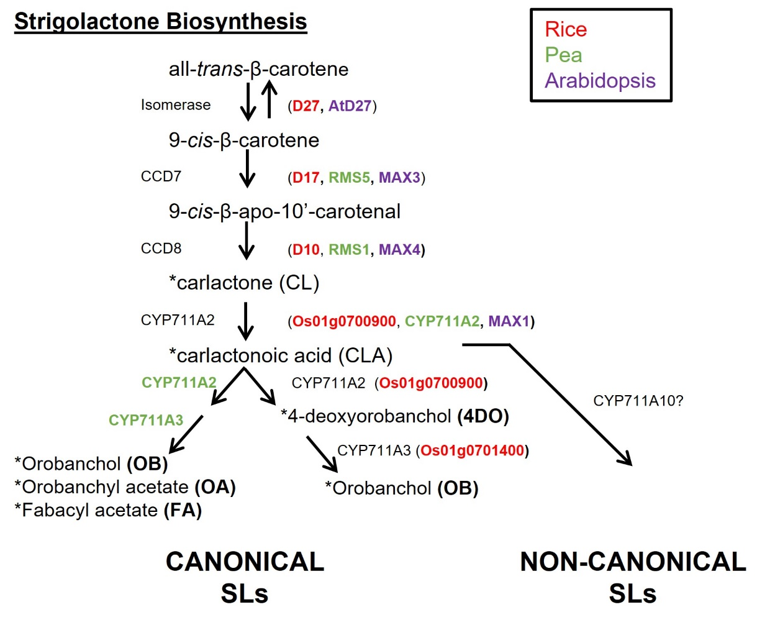
All strigolactones contain a butanolide moiety known as a D ring, however, canonical SLs also contain a tri-cyclic lactone moiety known as the ABC rings which are joined with an enol-ether bridge to the D-ring (Koichi Yoneyama et al., 2018; Machin et al., 2019). The biosynthesis of SLs is primarily located in the roots and begins with the conversion of β-carotene to carlactone (CL) by DWARF27 (D27) and CAROTENOID CLEAVAGE DIOXYGENASE7/8 (CCD7, CCD8) (Alder et al., 2012). Carlactone (CL) is then converted to carlactonic acid (CLA) by MAX1 homologs (Arabidopsis thaliana; CYP711A1 / AtMAX1, Pisum sativum; CYP711A2 and Oryza sativa; CYP711A1/2/3)(K. Zhang et al., 2014; Abe et al., 2014; Kaori Yoneyama et al., 2018; Wheeldon et al., 2022) (Fig. 1.1). The subsequent structures vary between species and can be segregated into canonical and non-canonical strigolactones (Fig. 1.1). The steps subsequent to CL and CLA have evolved repeatedly, and has led to a diverse mix of SLs produced in many species (Clark and Bennett, 2023).

Figure 1.1 Strigolactone biosynthesis pathway
Figure showing the biosynthesis pathway of strigolactones in Pisum sativum (pea), Oryza sativa (rice) and Arabidopsis thaliana (Arabidopsis). Pea genes are shown in green, rice in red and Arabidopsis in purple. * indicates SLs which have been found to be exuded. (Additional information on the following page)
Figure modified from Wheeldon et al, 2022 and supplemented with further detail from the companion paper Yoneyama et al 2022, and further detail from (Abe et al., 2014; Y. Zhang et al., 2014; Kaori Yoneyama et al., 2018)

Canonical and non-canonical strigolactones

In pea, the production of canonical strigolactones is the result of CYP711A2 and CYP711A3 genes which lead to the synthesis of orobanchol (OB), orobanchyl acetate (OA) and fabacyl acetate (FA) (Lopez-Obando et al., 2015; Yoneyama, 2020; Wheeldon et al., 2022). In rice, the same genes result in the production of and 4-deoxyorobanchol (4DO) and orobanchol (OB) (Koichi Yoneyama et al., 2018; Kaori Yoneyama et al., 2018; Wakabayashi et al., 2019; Yoneyama et al., 2022).
As mentioned earlier canonical and non-canonical strigolactones can be differentiated by their structures (Yoneyama et al., 2018; Machin et al., 2019). The structure of non-canonical SLs allows them to be much more diverse than canonical SLs and therefore likely means there will be more non-canonical SLs identified in the future (Koichi Yoneyama et al., 2018). So far, 35 SLs have been identified, with a higher proportion of these being canonical SLs (Koichi Yoneyama et al., 2018; Mashiguchi et al., 2021; Bouwmeester et al., 2021; C. Li et al., 2023; Clark and Bennett, 2023).
The functionality of canonical and non-canonical strigolactones varies amongst species and it is not as simple as classifying one type as root exuded chemicals and the other type as hormonal signalling molecules. For example, in rice, canonical SLs have been shown to act as germination stimulants and AMF signals, whereas non-canonical SLs have been shown to act hormonally influencing shoot growth (Mashiguchi et al., 2022; Ito et al., 2022). In Arabidopsis, non-canonical SLs also act as hormones, while Arabidopsis does not synthesise canonical SLs and has limited or no exudation of SLs (Yoneyama et al., 2020). Intriguingly, a recent study in maize which assessed SL biosynthesis in many cultivars, demonstrated that SL biosynthesis is limited to non-canonical type SLs which have been shown to be exuded but these are also presumed to have a hormonal role (C. Li et al., 2023). Taken together, this illustrates that the functionality of SLs cannot be explained solely by their structural characteristics and there is still much to learn about their functions (Clark and Bennett, 2023). This diversity and the ability of some species to generate multiple different types of exuded SLs brings in to question why this might be and also if these exuded SLs may function in new ways not previously reported in the rhizosphere.

Strigolactone signalling

An α/β hydrolase DWARF14 (D14) is the strigolactone receptor (Waters et al., 2012; Hamiaux et al., 2012) and when bound to SL, this results in conformational change of the receptor leading to an association with an F-box protein (rice: D3, pea: RMS4 and Arabidopsis: MAX2) and members of the SMAX1-LIKE (SMXL) protein family (rice: D53, Arabidopsis: SMXL6/7/8 and pea: PsSMXL7) (Jiang et al., 2013; Soundappan et al., 2015; Waters et al., 2017; Kerr et al., 2021). This association triggers proteolysis and ubiquitination of SMXLs and subsequent degradation of SL by hydrolytic activity of the D14 receptor (Seto et al., 2019) (Fig. 1.2).
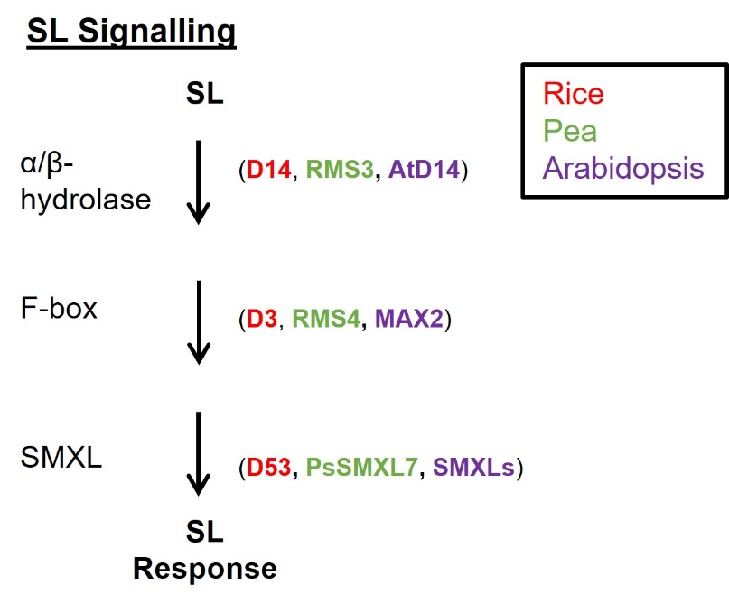

Figure 1.2 Strigolactone signalling pathway
A simplified diagram of the SL signalling pathway in Pisum sativum (pea), Oryza sativa (rice) and Arabidopsis thaliana (Arabidopsis). Pea genes are shown in green, rice in red and Arabidopsis in purple.
Modified from Wheeldon et al (2022) and supplemented with further detail from the companion paper Yoneyama et al (2022). Additional detail from Waters et al (2017).

Could strigolactones have other roles in the rhizosphere?

The broad spectrum of different SLs exuded by many species into the rhizosphere could mean they have other roles aside from as signals to AMF. One such possibility is that SLs could act as plant-to-plant signalling molecules. This has previously been suggested in the moss Physcomitrium patens where moss mutants in the CCD8 biosynthesis enzyme are seen to grow close and, in some cases, overlap with other ccd8 mutant colonies (Proust et al., 2011). These mutants are unable to exude SL, and conversely WT moss colonies were not seen to overlap with each other. Therefore this could suggest that SL exuded by the WT colonies has an inhibitory role on the growth of the other colonies in the growth media (Proust et al., 2011). Could rhizospheric SLs act as plant-to-plant signalling molecules in higher plants?

Aims
Given the background discussed in this introduction I propose the following aims for my PhD thesis.

- To characterise the shoot- and root growth responses of plants subjected to limited soil volume and the presence of neighbouring plants, and to determine if the shoot- based responses to soil volume and neighbour density differ in any way.
- To identify barley germplasm with altered sensitivity to soil volume, to allow for future understanding of the genetics underlying soil volume sensitivity.
- To identify transcriptional changes in response to neighbouring plants and the speed in which neighbours are detected.
- To propose a model for how plants detect and respond to the presence of neighbouring plants.
- To determine if strigolactone is an important root exuded chemical involved in the recognition and response to neighbouring plants and available soil volume.
There is a large amount of research into the phenotypic characteristics of soil volume-limited plants and this thesis aims to address the lacking mechanistic elements to this plant growth response. This investigation involves further shoot based phenotyping with the addition of root-based phenotyping, mainly in economically important crops. Understanding the mechanisms of plant detection and response to the presence of neighbours and the availability of belowground space is a key element in the future development of higher yielding crops within a given area of land.

Methods and Materials

Plant growth conditions

Light and temperature
All experiments were carried out under glasshouse conditions of 16-hour day and 8-hour night at 22°C, under LED lights with an average light intensity of ~250µmol m⁻² s⁻¹, with the exception of Arabidopsis thaliana plants in agar plates which were grown in controlled rooms with white fluorescent tubes at a light intensity of ~120 μmol m^{–2} s⁻¹ with a 16 hour day and 8 hour night at 20°C.

Growth substrates

Soil based experiments
Petersfield No.2 compost was used for soil-based experiments. Pots, containers and rhizoboxes were filled with compost and gently pressed to level the soil at its maximum capacity. Rhizobox experiments required the removal of any large soil clumps whilst filling them with compost, and seeds were pregerminated on damp filter paper on the lab windowsill for 1-7 days as stated inline.
For section 4.3.1, 10ml Arabidopsis thaliana Salts (ATS) (Table 2.1) was applied to half of the plants in each soil volume once a week.
Experiments that were not soil based are specified inline.

Hydroponic experiments
All seeds used in hydroponic experiments were first germinated in 100ml pots containing either perlite (sections 4.2, 4.3.6, 5.2.1) or 50:50 sand:perlite (section 4.3.7) for 1 week, plants of equal size were selected and the perlite or sand:perlite was gently washed off the roots in water and then the plants were transferred to the hydroponic system. 1L black pots with lids were used and filled with water and ATS nutrient solution (Wilson et al., 1990) (Table 2.1). The ATS nutrient solution was made up by using 15ml of the individual stock solutions that would be ordinarily used to make 1L of ATS solution. The water level was checked and subsequently topped up every 1-2 days for the duration of the experiment. For section 4.2 all hydroponate was disposed of and replaced with fresh water and ATS solution at 3 weeks post germination and 4 weeks post germination. For section 4.3.7 all hydroponate was disposed of and replaced with fresh water and ATS solution every 2 weeks for the duration of the experiment (Wheeldon et al., 2021), the same can be said for section 4.3.6. For section 5.2.1, when the plants were 2 weeks old, the rac-GR24 (Chiralix) 10mM stock was diluted to 1µM in 1L hydroponic pots containing ATS solution (as described above), equivalent volume of the acetone was used as the mock control treatment. When the plants were 4 weeks old, the addition of 1µM GR24 was repeated (Wheeldon et al., 2022).

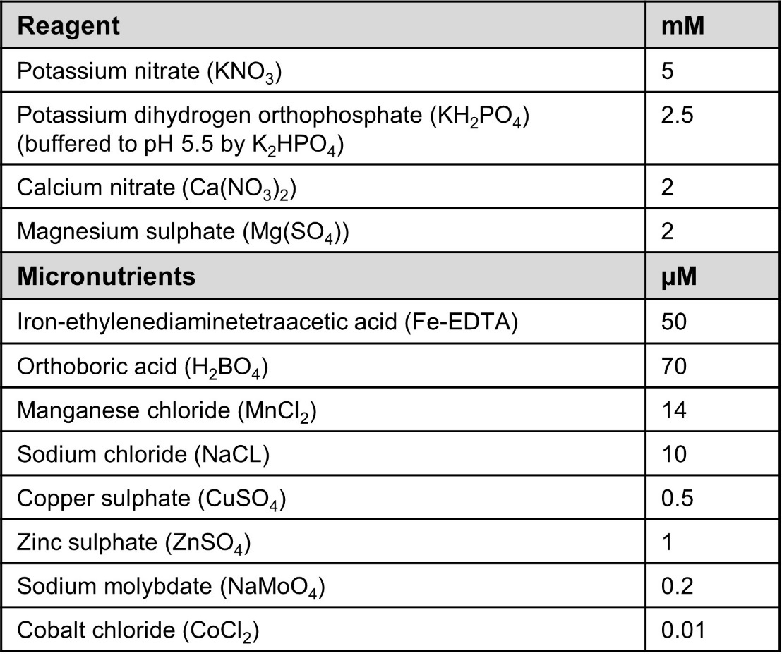

Table 2.1 Arabidopsis thaliana Salts (ATS)
First described in (Wilson et al., 1990)

Rhizoboxes
All seeds used in rhizoboxes were pre germinated on damp paper in petri dishes for the time specified in the experiments.

Agar plates
Arabidopsis thaliana seeds were placed in open 1.5ml tubes, in a tube rack within a sealable plastic box placed in a fumehood. Sterilisation was achieved using chlorine gas produced by 100ml liquid bleach and 3ml 37% hydrochloric acid (HCl) in a beaker inside the plastic box. The plastic box was sealed for ~1.5-2 hours and on completion the plastic box was opened, and tubes sealed and re-opened once in a laminar flowhood before plating onto media plates.
Seeds were sown on to 120mm square petri dishes containing 60ml ATS agar medium as outlined by (Wilson et al., 1990) using 0.8% w/vol Duchefa plant agar and 1 % w/vol sucrose (Table 2.1). rac-GR24 (Chiralix) 10mM stock dissolved in acetone was diluted to 1µM or 5µM in 60ml ATS agar plates as described above, an acetone only control equivalent to the 1µM GR24 treatment was used for control plates. Plates were sealed using micropore and stored for 48h in a 4°C cold room for seed stratification before being placed vertically in walk in growth chambers for the duration of the experiment as specified inline.

Containers used for plant growth
Most soil-based experiments used standard black plastic pots of 100ml, 500ml or 2000ml volume (as stated in line) but in scenarios where this was not the case it has been stated inline, and if required described in greater detail below.
For the barley soil volume phenotyping screen in chapter 3.3, each genotype was sown singly in 100ml and 500ml pots in manageable weekly ‘batches’ of 5 genotypes.

Neighbour density experiments
Chapter 3.2, neighbour density experiments were carried out in either 100ml and 500ml or 500ml and 2000ml pots. The top perimeter of the smallest soil volume pot in the experiment was cut and used as a template for sowing distance in the larger pot.

Rhizoboxes
Greiner bio-one (120 mm) and Corning (245 mm) square plates were modified with 6 holes melted into the bottom edge for drainage and on the opposite edge, a 1 inch hole (uncrowded) (Fig. 2.1A), or a hole spanning the width of the plate (crowded) to allow the shoots to grow out of the plate. Cereal seeds were pre germinated on damp paper for the duration stated in the figure legends. Seeds were transferred to the plates and situated 1cm below the shoot hole. The rhizoboxes were filled with compost, being careful to not dislodge the seed(s). Rhizoboxes were sealed with autoclave tape on the unmodified sides. Plates were then placed in custom-built stainless-steel racks (built by High Peak Sheet Metal LTD), which held the plates at a 45° angle allowing for optimal root visibility (Bontpart et al., 2020) (Fig. 2.1B). The plates were submerged in 1cm of water at all times to ensure even water distribution throughout the soil.
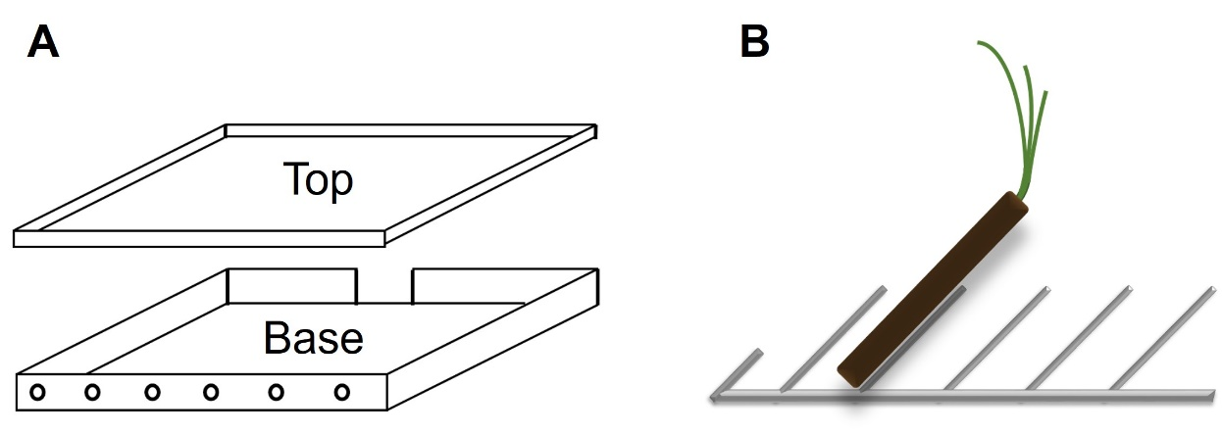
Figure 2.1 Cartoons depicting rhizoboxes
- A cartoon depicting the top (lid) and base of rhizoboxes used in Section 3.4. Circles represent drainage holes melted into the lower edge of the rhizoboxes. And a gap at the opposite edge depicts remove plastic to allow to the shoots to grow out of the plate.
- A cartoon depicting a rhizobox held in a stainless steel rack at a 45° angle

Plates were scanned twice weekly using an Epson Perfection v39 scanner (Sections 3.4.1, 3.4.3 and 3.4.4) or Epson Perfection v850 Pro (Section 3.4.2) at 3-4 day intervals at 300 dpi. Both the base and top of the plates were scanned once roots became visible. Typically, no roots were visible on the tops of the plates until ~13 days post germination. Standard settings were used on the Epson Scan software, with the preference set for photo rather than document capture.

Hydroponics
The hydroponic pots were black plastic pots with matching lids with a capacity of 1L (previously described in Wheeldon et al, 2021 and Wheeldon et al, 2022). Plants were grown in either 1 plant per pot (1/pot) or 4 plants per pot (as specified in line) and the corresponding number of holes to plants was drilled into the lids. Falcon tubes were modified to 2cm in length leaving a short open-ended cylinder. For sections 5.2.1 and 4.3.7, the Falcon tube lid was also modified with a small hole to allow for the roots to be inserted and provided slight support to the shoot. The other hydroponic experiments did not require the lid (section 4.2 and 4.3.6). A foam bung was added around the root- shoot junction inside the shortened falcon tube to secure the plant in place. The modified falcon containing the plant and foam bung was then inserted into a hole made into the lid of the pots. For 4.3.7 an additional modified falcon tube type was required for the ‘enclosed’ treatment, in this case falcon tubes only had the bottom 2cm removed and then the open end was sealed using nylon mesh (described below) which was attached to the falcon using Tensol 12 adhesive. ‘Enclosed’ treatments were checked daily and if any roots forced the mesh to separate from the falcon these plants were disposed of.
Aeration was provided by airstones connected via tubing to aquatic pumps (All Pond Solutions, AP-12-Kit pump).

Container shape and root density
For the experiment described in 4.2.5, containers were made by a summer student, Julia Wapenhans. Laminated laminator sheets were the main material used where outer cylinder ‘pots were made by joining edges of the sheets together using Tensol 12 adhesive and applying an additional seat to the base to seal the container. Inside the outer cylindrical container, a cone was made again using laminator sheets that were sealed together. Further detail is provided inline.

Nylon mesh
35 μm,16% open area, Nylon monofilament mesh (Plastok Associates Ltd) was used for all experiments which specified the use of mesh. Tensol 12 plastic adhesive was used to seal mesh to plastic and mesh to mesh.
For section 4.3.2, 100ml mesh pots were made by cutting a 100ml pot into a net and this was used as a template, tabs were made to allow secure sealing of the corners. The template ensured the mesh pots were of identical volume and shape as the 100ml pots.
For section 4.2.6, mesh bags were created using a semi-circle of impermeable nylon mesh, the semicircle was folded to create a cone by overlapping the straight edge (Fig. 2.2A). The straight edge was sealed together using Tensol 12. The open end, the widest part of the cone had a series of holes made on the edge using a hole punch and string was threaded through the holes. At 4 weeks post germination, the bags were introduced into the hydroponic system as specified inline. The roots were placed inside the bag with the apex pointing down, once all the required roots were in the bag, the drawstring was carefully pulled to draw the bag close to the roots (Fig 2.2B), this produced a volume of 150ml. The string was threaded through the Falcon tube and out the same side as the shoot where the drawstring was knotted to secure it in place. The bags were checked every 2-3 days and if any unwanted roots had grown out of the top of the bag where the drawstring was, the bag was quickly undone, and the root was tucked back inside and the drawstring was pulled closed again.
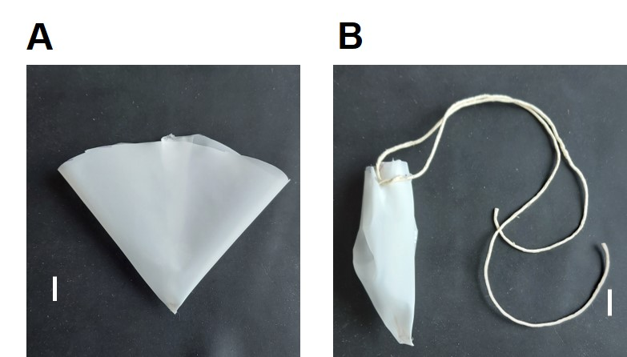

Figure 2.2 Formation of mesh bags
- Image showing a cone shaped mesh bag formed by connecting the 2 straight edges of a semicircular piece of 35 μm,16% open area, Nylon monofilament mesh. Holes were subsequently punched on the curved top edge. Scale bar represents 2cm.
- String was threaded through the punched holes on the curved edge and drawn together to close the bag. This example does not contain plant roots. Scale bar represents 2cm.

For section 4.3.7, this is described in the hydroponics section above.

Phenotypic assessments

Branch and tiller counts
For wheat and barley, tiller number was counted weekly as stated inline. For pea, branches were counted at the stated timepoints when they were longer than 10mm. For Arabidopsis, all branches were counted at the specified time points.

Dry Biomass
Where stated, shoot, ear and root matter per plant was harvested and placed in a 60°C oven for 3 days to dry before being weighed on a balance.

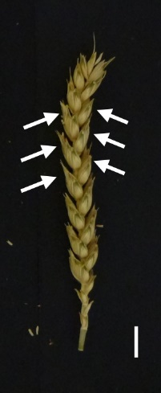
Spikelet counts
Where stated, each individual spikelet on an ear was counted. Total spikelet number per plant was the sum of the number of spikelets per ear on that plant.

Figure 2.3 Diagram indicating spikelets on a wheat ear
Image of a wheat ear, 6 arrows have been added to indicate 6 of the spikelets present on this ear. Scale bar represents 1cm.

Root system assessments

Root length and number in rhizoboxes
Assessments were taken using ImageJ. Images were scaled and the segmented line tool was used to measure the length of each root. From this data root number could be calculated. For wheat and barley; data was separated into seminal and lateral roots per plant. In these assessments I defined seminal roots as roots which have other roots connected to them; the roots which connect to the seminal roots are defined as lateral roots (Fig. 2.4).
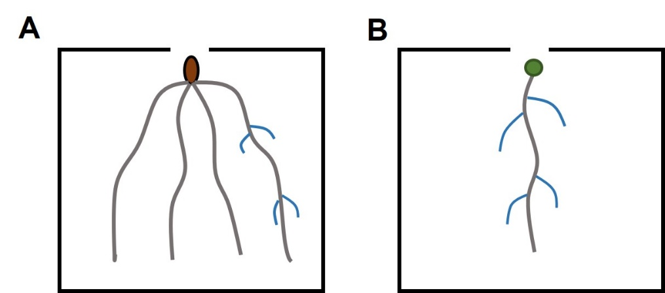

Figure 2.4 Root system architecture of wheat and barley
Cartoon representing the root system architectures of wheat and barley.
A) A cartoon example of RSA in wheat and barley. Grey lines represent seminal roots which emerge from the seed (brown oval). Blue lines represent lateral roots which emerge from the thicker seminal roots (grey).

For root length and number data presented in 3.4.1, 3.4.2, 3.4.3 roots visible on both the top and base of the plates were added together to give the root numbers and lengths. For time points before 13 days post germination, only base measurements are presented. For root length and number data presented in 3.4.4, only base measurements were assessed.

Root density measurements
Rhizoboxes
After ~21 days it became too difficult to accurately measure root length and root number using the method above. Therefore, to quantitatively assess root growth over time, a method was devised to calculate the proportion of white pixels in a given area. The contrast of each image in an experiment was changed to a defined setting to allow for the contrast between dark pixels of the plate (soil) and white pixels (roots) to be more stark (increasing the signal to noise ratio) (Fig. 2.5). White pixels would produce a high number between 0 and 255, compared to the dark pixels of soil. Using ImageJ, the contrast setting used was as follows: 3.4.1: 25, 3.4.2: 25, 3.4.3: 25, 3.4.4: 22. The mean pixel intensities (mpi) were subsequently converted to a percentage (mpi/255x100) (as described in Wheeldon et al, 2021). A Root Density Score was defined as the percentage of white pixels on the base of the plate plus the percentage of white pixels on the top of the plate.
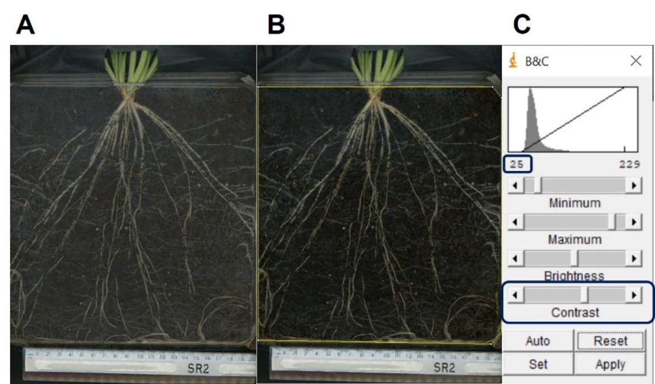

Figure 2.5 Root density assessment
Figure showing example images of root systems assessed for root density.
A) Image of a wheat plant grown in 1100ml rhizobox
B) The same image as A, but with the contrast setting changed to 25 using ImageJ to darken the soil and brighten the roots as described in C
C) Brightness and contrast panel in ImageJ. Contrast toggle highlighted with a navy outline and the corresponding contrast setting, in this example ‘’25’’, also highlighted with a navy outline

Clear pot root density
Images were taken for all 4 sides and the base of the 100ml and 300ml clear sided pots in chapter 4 (as described in Wheeldon et al, 2021). Images were taken every 7 days for the 8 week duration of the experiment. A similar method as described above was utilised with ImageJ. For images taken on the same week, each face (not including the base) was treated the same using a defined contrast setting, but images taken on different weeks were treated differently as the lighting in the room where the photos were taken varied each week. The base however had a much higher colonisation of roots therefore this was assessed separately. The bases had different contrasts to the sides but all the base photos were treated the same within a timepoint. The percentages (as described above), for each face and the base were summed to provide the Root Density Score. Averages between treatments were carried out and this was repeated each for each week of images (as described in Wheeldon et al, 2021).

Arabidopsis agar plates
Images were assessed using ImageJ. Images were scaled, then primary and lateral roots were assessed for their length and number.

Plant materials

Hordeum vulgare
100 Barley genotypes were kindly provided by KWS (Klaus Oldach). Those proceeded with ** in the Accession Number column failed to germinate.
Accession number | Botanic name | Accession name | Country of origin | Status
HOR 17077 | Hordeum vulgare L. | MAHABAD | Iran, Islamic Republic | Traditional cultivar/landrace
HOR 1780 | Hordeum vulgare L. convar. vulgare var. parallelum Körn. | ----- | Iran, Islamic Republic | Traditional cultivar/landrace
HOR 18300 | Hordeum vulgare L. convar. vulgare var. hybernum Viborg | KOORIJAN | Iran, Islamic Republic | Traditional cultivar/landrace
HOR 18364 | Hordeum vulgare L. | AHWAZ | Iran, Islamic Republic | Traditional cultivar/landrace
HOR 14342 | Hordeum vulgare L. convar. vulgare var. hybernum Viborg | BUTSCHAK | Afghanistan | Traditional cultivar/landrace
HOR 15778 | Hordeum vulgare L. | APCEI | Afghanistan | Traditional cultivar/landrace
HOR 16078 | Hordeum vulgare L. | KUSHK-I-NAHOST | Afghanistan | Traditional cultivar/landrace
HOR 18220 | Hordeum vulgare L. convar. vulgare var. asiaticum (Vavilov) Mansf. | SEBAK | Afghanistan | Traditional cultivar/landrace
HOR 1816 | Hordeum vulgare L. convar. vulgare var. violaceum Körn. | ----- | China | Traditional cultivar/landrace
HOR 2369 | Hordeum vulgare L. convar. vulgare var. hybernum Viborg | Lan-hsi-Nacktgerste Nr. 1 | China | Advanced/improved cultivar
HOR 2383 | Hordeum vulgare L. convar. vulgare var. himalayense (Rittig) Körn. | ----- | China | Traditional cultivar/landrace
HOR 16569 | Hordeum vulgare L. convar. vulgare var. coeleste L. | Gerste | India | Traditional cultivar/landrace
HOR 19184 | Hordeum vulgare L. | ASARCHET | India | Traditional cultivar/landrace
HOR 11126 | Hordeum vulgare L. convar. distichon (L.) Alef. var. erectum (Rode) Alef. | Ishukushirazu | Japan | Advanced/improved cultivar
HOR 1251 | Hordeum vulgare L. convar. vulgare var. brevisetum Regel ex Orlov | ----- | Japan | Traditional cultivar/landrace
HOR 18824 | Hordeum vulgare L. | SANHOKO | Japan | Traditional cultivar/landrace
HOR 11409 | Hordeum vulgare L. convar. vulgare var. coeleste L. | Sarubori | Korea | Advanced/improved cultivar
HOR 14876 | Hordeum vulgare L. convar. vulgare var. subparallelum (Orlov) Mansf. | Mehrzeilige Gerste | Nepal | Traditional cultivar/landrace
HOR 18913 | Hordeum vulgare L. convar. vulgare var. brevisetum Regel ex Orlov | KATHMANDU | Nepal | Traditional cultivar/landrace
HOR 7129 | Hordeum vulgare L. convar. intermedium (Körn.) Mansf. var. harlani (Vavilov & Orlov) Mansf. | ----- | Nepal | Traditional cultivar/landrace
HOR 15401 | Hordeum vulgare L. | KAMDESH | Pakistan | Traditional cultivar/landrace
HOR 15860 | Hordeum vulgare L. | ZUSUM | Pakistan | Traditional cultivar/landrace
HOR 18382 | Hordeum vulgare L. | Gerste | Pakistan | Traditional cultivar/landrace
HOR 10742 | Hordeum vulgare L. convar. vulgare var. rikotense Regel | ----- | Georgia | Traditional cultivar/landrace
HOR 10775 | Hordeum vulgare L. convar. distichon (L.) Alef. var. nutans (Rode) Alef. | ----- | Georgia | Traditional cultivar/landrace
HOR 10886 | Hordeum vulgare L. convar. distichon (L.) Alef. var. nutans (Rode) Alef. | ----- | Georgia | Traditional cultivar/landrace
HOR 12830 | Hordeum vulgare L. convar. vulgare var. densum Sér. | ----- | Syria | Traditional cultivar/landrace
HOR 13836 | Hordeum vulgare L. convar. distichon (L.) Alef. var. nigrescens Körn. | ESKISHEHIR | Turkey | Traditional cultivar/landrace
HOR 1626 | Hordeum vulgare L. convar. distichon (L.) Alef. var. medicum Körn. | Kleinasiatische Glattgrannige | Turkey | Advanced/improved cultivar
HOR 16358 | Hordeum vulgare L. | ELMA DAGH | Turkey | Traditional cultivar/landrace
HOR 473 | Hordeum vulgare L. convar. vulgare var. hybernum Viborg | ----- | Turkey | Traditional cultivar/landrace
HOR 610 | Hordeum vulgare L. convar. distichon (L.) Alef. var. nutans (Rode) Alef. | ----- | Turkey | Traditional cultivar/landrace
HOR 8117 | Hordeum vulgare L. convar. distichon (L.) Alef. var. medicum Körn. | ----- | Turkey | Traditional cultivar/landrace
HOR 20269 | Hordeum vulgare L. | GEMBLOUX | Belgium | Traditional cultivar/landrace
HOR 2180 | Hordeum vulgare L. convar. vulgare var. hybernum Viborg | Masovia Kleine Vierzeilige | Czech Rep. | Advanced/improved cultivar
HOR 14439 | Hordeum vulgare L. convar. distichon (L.) Alef. var. nutans (Rode) Alef. | FRANKONIA | Germany | Advanced/improved cultivar
HOR 17591 | Hordeum vulgare L. | TEUTSCHENTHAL | Germany | Traditional cultivar/landrace
HOR 21687 | Hordeum vulgare L. convar. distichon (L.) Alef. var. nutans (Rode) Alef. | DIPPES HANNA | Germany | Advanced/improved cultivar
HOR 6936 | Hordeum vulgare L. convar. distichon (L.) Alef. var. nudum (L.) Alef. | Nackta | Germany | Advanced/improved cultivar
HOR 2970 | Hordeum vulgare L. convar. vulgare var. hybernum Viborg | Triumph (Vierzeilig) | Germany (before 1945) | Advanced/improved cultivar
HOR 337 | Hordeum vulgare L. convar. distichon (L.) Alef. var. nudum (L.) Alef. | ----- | Germany (before 1945) | Traditional cultivar/landrace
HOR 10990 | Hordeum vulgare L. convar. vulgare var. hybernum Viborg | ----- | France | Traditional cultivar/landrace
HOR 12070 | Hordeum vulgare L. convar. vulgare var. hybernum Viborg | Iris | France | Advanced/improved cultivar
HOR 2637 | Hordeum vulgare L. convar. distichon (L.) Alef. var. nutans (Rode) Alef. | Ponote | France | Advanced/improved cultivar
HOR 8819 | Hordeum vulgare L. convar. vulgare var. coeleste L. | Orkisz | Poland | Traditional cultivar/landrace
HOR 10702 | Hordeum vulgare L. convar. distichon (L.) Alef. var. nutans (Rode) Alef. | Gunnar | Sweden | Advanced/improved cultivar
HOR 4653 | Hordeum vulgare L. convar. distichon (L.) Alef. var. nutans (Rode) Alef. | Midas | UK | Advanced/improved cultivar
**KWS Fantex | Hordeum vulgare L. | KWS Fantex | Europe | KWS SB modern variety
**KWS Chrissie | Hordeum vulgare L. | KWS Chrissie | Europe | KWS SB modern variety
KWS 17/2942 | Hordeum vulgare L. | KWS Thalis | Europe | KWS SB advanced breeding line
RGT Planet | Hordeum vulgare L. | RGT Planet | Europe | RAGT SB modern variety
Lauréate | Hordeum vulgare L. | Lauréate | Europe | Syngenta SB modern variety
Fandaga | Hordeum vulgare L. | Fandaga | Europe | Saaten-Union SB modern variety
LG Tosca | Hordeum vulgare L. | LG Tosca | Europe | Limagrain SB modern variety
Concerto | Hordeum vulgare L. | Concerto | Europe | Limagrain SB modern variety
HOR 13987 | Hordeum vulgare L. convar. vulgare var. hybernum Viborg | Mittelgerste | Ethiopia | Traditional cultivar/landrace
HOR 5020 | Hordeum vulgare L. convar. vulgare var. nigrum (Willd.) Link | Tradak | Ethiopia | Advanced/improved cultivar
HOR 5373 | Hordeum vulgare L. convar. distichon (L.) Alef. var. medicum Körn. | ----- | Ethiopia | Traditional cultivar/landrace
HOR 5486 | Hordeum vulgare L. convar. distichon (L.) Alef. var. nutans (Rode) Alef. | ----- | Ethiopia | Traditional cultivar/landrace
HOR 5876 | Hordeum vulgare L. convar. vulgare var. rikotense Regel | No. 122 | Ethiopia | Traditional cultivar/landrace
HOR 6220 | Hordeum vulgare L. convar. labile (Schiem.) Mansf. var. hybernum-deficiens | ----- | Ethiopia | Traditional cultivar/landrace
HOR 6892 | Hordeum vulgare L. convar. distichon (L.) Alef. var. viride (Vavilov & Orlov) Mansf. | ----- | Ethiopia | Traditional cultivar/landrace
HOR 9043 | Hordeum vulgare L. convar. vulgare var. himalayense (Rittig) Körn. | ----- | Ethiopia | Traditional cultivar/landrace
HOR 18201 | Hordeum vulgare L. | ZONI (TIBESTI OASE) | Chad | Traditional cultivar/landrace
HOR 21641 | Hordeum vulgare L. convar. vulgare var. hybernum Viborg | DOBASSO (OASE TIBESTI) | Chad | Traditional cultivar/landrace
HOR 7474 | Hordeum vulgare L. convar. distichon (L.) Alef. var. nutans (Rode) Alef. | B. Caupin | Argentina | Advanced/improved cultivar
HOR 18924 | Hordeum vulgare L. | SANTA CRUZ | Bolivia | Traditional cultivar/landrace
**HOR 18381 | Hordeum vulgare L. | R.T.RAMAGE AP BULK 3 | Mexico | Advanced/improved cultivar
HOR 18385 | Hordeum vulgare L. | R.T.RAMAGE BULK LINE 1 | Mexico | Advanced/improved cultivar
HOR 11431 | Hordeum vulgare L. convar. vulgare var. coeleste L. | ----- | Peru | Traditional cultivar/landrace
HOR 13800 | Hordeum vulgare L. convar. vulgare var. hybernum Viborg | ABARIK | Soviet Union | Traditional cultivar/landrace
HOR 15840 | Hordeum vulgare L. | ODESSKIJ 14 | Soviet Union | Advanced/improved cultivar
HOR 15857 | Hordeum vulgare L. | BELORUSSKY 18 | Soviet Union | Advanced/improved cultivar
HOR 15898 | Hordeum vulgare L. | RUSS.NR.10242 | Soviet Union | Traditional cultivar/landrace
HOR 15905 | Hordeum vulgare L. | KALUGENSE | Soviet Union | Traditional cultivar/landrace
HOR 19952 | Hordeum vulgare L. | NIEPOLEGAJUSZCZIJ | Soviet Union | Advanced/improved cultivar
HOR 3912 | Hordeum vulgare L. convar. distichon (L.) Alef. var. nutans (Rode) Alef. | Cernigovskij | Soviet Union | Advanced/improved cultivar
HOR 7428 | Hordeum vulgare L. convar. vulgare var. nuditonsum (Körn.) Mansf. | ----- | Russia | Traditional cultivar/landrace
**HOR 14411 | Hordeum vulgare L. convar. vulgare var. hybernum Viborg | AEGYPTISCHE VIERZEILIGE | Egypt | Traditional cultivar/landrace
HOR 8659 | Hordeum vulgare L. convar. vulgare var. hybernum Viborg | ----- | Egypt | Traditional cultivar/landrace
HOR 1384 | Hordeum vulgare L. convar. vulgare var. hybernum Viborg | ----- | Greece | Traditional cultivar/landrace
HOR 15908 | Hordeum vulgare L. | INSEL SIRINA | Greece | Traditional cultivar/landrace
HOR 869 | Hordeum vulgare L. convar. distichon (L.) Alef. var. nutans (Rode) Alef. | ----- | Greece | Traditional cultivar/landrace
HOR 10784 | Hordeum vulgare L. convar. distichon (L.) Alef. var. nutans (Rode) Alef. | Marzuolo | Italy | Traditional cultivar/landrace
HOR 12791 | Hordeum vulgare L. convar. vulgare | ----- | Italy | Traditional cultivar/landrace
HOR 13462 | Hordeum vulgare L. convar. distichon (L.) Alef. var. nutans (Rode) Alef. | ----- | Italy | Traditional cultivar/landrace
HOR 18681 | Hordeum vulgare L. | PERUGIA | Italy | Traditional cultivar/landrace
HOR 9724 | Hordeum vulgare L. convar. distichon (L.) Alef. var. nutans (Rode) Alef. | ----- | Libya | Traditional cultivar/landrace
HOR 9927 | Hordeum vulgare L. convar. vulgare var. hybernum Viborg | ----- | Libya | Traditional cultivar/landrace
HOR 16071 | Hordeum vulgare L. | RUMAENE 4 | Romania | Traditional cultivar/landrace
HOR 19313 | Hordeum vulgare L. | TONAT NOERDLICHE SAHARA | Northern Africa
HOR 14689 | Hordeum vulgare L. | CALIFORNIA MARIOUT | USA | Traditional cultivar/landrace
**HOR 15895 | Hordeum vulgare L. convar. vulgare var. glabriparallelum (Orlov) Mansf. | A.HIND | USA | Traditional cultivar/landrace
HOR 2749 | Hordeum vulgare L. convar. vulgare var. rikotense Regel | Custer | USA | Advanced/improved cultivar
HOR 3926 | Hordeum vulgare L. convar. vulgare var. rikotense Regel | Barbless | USA | Advanced/improved cultivar
HOR 4030 | Hordeum vulgare L. convar. distichon (L.) Alef. var. nutans (Rode) Alef. | ----- | USA | Traditional cultivar/landrace
HOR 9492 | Hordeum vulgare L. convar. vulgare var. hybernum Viborg | Canadian Lake Share | USA | Advanced/improved cultivar
HOR 9808 | Hordeum vulgare L. convar. vulgare var. parallelum Körn. | ----- | USA | Traditional cultivar/landrace
HOR 2403 | Hordeum vulgare L. convar. vulgare var. rikotense Regel | Titan | Canada | Advanced/improved cultivar
BCC 1705 | Hordeum vulgare L. convar. distichon (L.) Alef. var. nutans (Rode) Alef. | Clipper | Australia
Table 2.2 Barley germplasm using in the soil volume phenotyping screen
All information kindly provided by Klaus Oldach, KWS.

All other barley experiments were conducted with the spring barley variety Charon (provided by ADAS).

Triticum aestivum
Landrace wheat line Yogi 005, Yogi 020, Yogi 343, Yogi 065, Yogi 101, Yogi 137 were provided by Andrea Harper and experiments involving these are in Section 3.4.4. All other experiments using wheat were carried out using the elite spring wheat variety Mulika, provided by ADAS.

Pisum sativum
Name | Background | Mutation | Source
L77 Wild-type | L77 | N/A | Christine Beveridge
rms1-1 | L77 | X-rays (Symons and Murfet, 1997) | Christine Beveridge
Torsdag Wild-type | Torsdag | N/A | Catherine Rameau
rms1-2T | Torsdag | Backcross of the rms1-2 allele from Weitor background to Torsdag background (Beveridge et al., 1997) | Christine Beveridge
rms3-1 | Torsdag | EMS (Rameau et al., 1997) | Catherine Rameau
rms5-BL298 | Torsdag | NEU (Symons and Murfet, 1997) | Christine Beveridge

Table 2.3 Pisum sativum genotypes
Table is modified from Wheeldon et al (2022) with additional information from (Beveridge et al., 1997; Symons and Murfet, 1997; Rameau et al., 1997). Methods for inducing the mutations included N-nitroso-N-ethyl urea (NEU), X-rays and ethyl methanesulfonate (EMS) mutagenesis.

Arabidopsis thaliana
Name | Background | Mutation | Source
Col-0 | Col-0 | N/A | NASC
SALK_046007 (pdr4-1) | Col-0 | T-DNA | NASC
SALK_113678 (pdr4-2) | Col-0 | T-DNA | NASC
SAIL_5_G10 (pdr6) | Col-0 | T-DNA | NASC
SALK_118823C (pdr10) | Col-0 | T-DNA | NASC
WiscDsLox419G06 (pdr11) | Col-0 | T-DNA | NASC
SAIL_885_E09 (pdr12) | Col-0 | T-DNA | NASC

Table 2.4 Arabidopsis thaliana genotypes
All Arabidopsis thaliana genotypes were sourced from the Nottingham Arabidopsis stock centre (NASC)

Molecular Biology

Genotyping
DNA extraction was carried out on snap frozen (-80°C) cauline leaves of Arabidopsis thaliana pdr mutants, which had been ground using 3mm steel balls and a TissueLyserLT (Qiagen). 400µl Edwards buffer (Edwards et al., 1991) was added to the sample tube and vortexed. Samples were placed in the centrifuge at 13,000 RPM for 5 minutes, 300µl of supernatant was transferred to a new tube and 300µl isopropanol was added and briefly mixed before allowing to sit for 2 minutes. Samples were centrifuged at 13,000 RPM for 10 minutes, supernatant was disposed and 70% ethanol was added to wash the pellet and centrifuged at 13,000RPM for 5 minutes. The supernatant was discarded and pellet air dried for up to 1 hour at 37°C. The pellet was resuspended in 40µl dH₂0 (Fink, 2014).
pdr lines were genotyped for homozygosity using primer sequences provided by T-DNA Express Signal SALK (Table 2.5), all ordered from IDT, using the Sample PCR listed below (Table 2.6-2.7). Samples were run on a 1.2% w/vol agarose gel, agarose was dissolved in 1x Tris-acetate-EDTA (TAE) buffer, with 1ul per 10ml of SYBR™ Safe DNA Gel Stain (Thermo Fisher Scientific). Samples were loaded with Gel Loading Dye, Purple (6X) (NEB) as per recommended protocol. A voltage between 80-100V was used and bands were visualised using a UV transilluminator. Homozygous lines were identified from all lines except pdr6.
Gene | NASC code | Left (LP) or Right (RP) | Primer sequence
PDR4 | SALK_046007.30.30.x | LP | TTCCGTTTTCGGTTTAGTTCC
PDR4 | SALK_046007.30.30.x | RP | TGAATGTTCCTCAACAAACCC
PDR4 | SALK_113678.15.75.x | LP | TTTCCGTTCATATCCAACTGG
PDR4 | SALK_113678.15.75.x | RP | GAAGCTGCGTTTTGAGCATAC
PDR6 | SAIL_5_G10 | LP | GGAGAAATGACTGTGCGAGAG
PDR6 | SAIL_5_G10 | RP | GAAGCCTCATCACTGTGAAGG
PDR10 | SALK_118823.23.95.x | LP | TGGCAATTATTGATGAATATCAAAC
PDR10 | SALK_118823.23.95.x | RP | CTGAAACGTCGTCGAGCTATC
PDR11 | WiscDsLox419G06 | LP | ATCTGCCGCATTTAAACAACC
PDR11 | WiscDsLox419G06 | RP | ATCTGCCGCATTTAAACAACC
PDR12 | SAIL_885_E09 | LP | TCCTGGTTTCTTGTTGGTTTG
PDR12 | SAIL_885_E09 | RP | TCCTGGTTTCTTGTTGGTTTG
Table 2.5 Arabidopsis thaliana PDR genotyping primers
All primer sequences sourced from Signal Salk T-DNA express, and primers ordered from IDT.
Step | Cycles | Temperature (°C) | Time
Initial denaturation | 1 | 95 | 2 minutes
Denaturation | 30 | 95 | 30 seconds
Annealing |  | Variable | 30 seconds
Extension |  | 68 | 30 seconds
Final extension | 1 | 3 | 3 minutes

Table 2.6 Example gDNA genotyping volumes for PCR

Reagent | Volume (µl)
gDNA | 1
Buffer (ThermoPol® Buffer) (NEB) | 2
dNTP (10mM) | 0.2
DMSO | 0.6
Taq DNA Polymerase (NEB) | 0.1
Primer (10mM) | 1
dH₂0 | 15.1

Table 2.7 Example PCR for genotyping

RNA sequencing
Barley (var. Charon) seeds were germinated in individual 100ml pots of perlite for 1 week (Fig. 2.6). Plants were placed in the hydroponic system as described earlier in 1 plant per pot configuration. At 4 weeks post germination, all hydroponate was replaced as described above. A subsection of the plants remained in the 1/pot configuration and the remaining plants were crowded in 4/pot. At 4 and 8 hours after crowding root samples were taken (1cm root tip per root), 2 seminal roots per plant for 4/pot treatments and 4 roots per plant in 1/pot conditions. Per biological replicate per time point, 2x 1/pot plants were pooled (8 root tips: 4x root tips per plant) to provide a biological replicate but for 4/pot, 1 pot (8 root tips: 2x root tips per plant) per biological replicate was used.
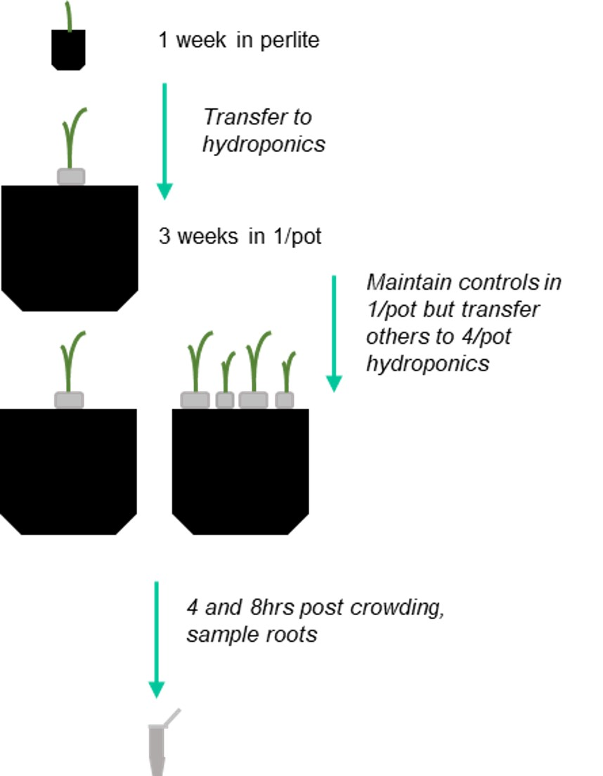
Figure 2.6 Cartoon of the experimental setup used for RNAseq
A cartoon describing the set up of barley plants (cv. Charon), grown hydroponically in 1 plant per pot 1/pot and 4 plants per pot for eventual root sampling for RNA sequencing. Diagram not to scale. 100ml pots were used for perlite, 1L containers used for hydroponics.

RNA extraction
Root tissue was lysed using 3mm steel balls and a TissueLyserLT (Qiagen). Total RNA was extracted using RNeasy kit (Qiagen) following the manufacturers recommended protocol, samples were eluted in 30µl dH₂0. RNA samples were treated with TURBO DNase kit (ThermoFisher Scientific) as per manufacturers protocol. Samples were assessed for concentration and quality on the Nanodrop (spectrophotometry) and all samples were between 1.83 – 2.03 A260/A280 ratio, these were regarded as good quality. RNA integrity and quality was assessed using the Qubit 4 Fluorometer (ThermoFisher Scientific, Waltham, MA, USA) according to manufacturer guidelines, and using pre-saved standards, all samples showed high quality with RNA IQ scores of between 9.2-10.0. Due to high concentrations of RNA for all samples, all samples were diluted in dH₂O to 1µg in a volume of 15µl (66.6666 µg/µl) to be sent to Genewiz.

Sample information and approach taken by Genewiz for RNA sequencing
Genewiz carried out library preparation and Illumina NovaSeqTM 6000 2x150 bp paired end sequencing. Genewiz carried out sample sequencing and assessed the quality of the samples. A sample quality of greater than 30 is satisfactory. All of my samples were higher than this threshold (Table 2.8).

Sample ID | Barcode Sequence | Mean Quality Score | % Bases >= 30
4 hours 1/pot sample 1 (A1) | TGTCGTAG+TTAGCTTT | 35.00 | 88.78
4 hours 1/pot sample 2 (A2) | CAATCATA+AATCTCCA | 34.87 | 88.15
4 hours 1/pot sample 3 (A3) | GTTCTTAT+GTCTAATT | 34.86 | 88.18
4 hours 4/pot sample 1 (B1) | GATGCGAC+CCCAAAGT | 34.93 | 88.36
4 hours 4/pot sample 2 (B2) | GAAGAGGG+TCCGTCCG | 34.84 | 87.96
4 hours 4/pot sample 3 (B3) | TAGTAATC+GGCTCTGC | 34.77 | 87.71
8 hours 1/pot sample 1 (C1) | GTGTGGAG+GATCATGC | 34.54 | 86.35
8 hours 1/pot sample 2 (C2) | ACGTTGTA+TAGGTCGA | 34.84 | 87.91
8 hours 1/pot sample 3 (C3) | GCGCTAAT+GTCAGGGT | 34.58 | 86.72
8 hours 4/pot sample 1 (D1) | AGAGCTGC+CCTTCAAC | 34.91 | 88.26
8 hours 4/pot sample 2 (D2) | CATACTTA+TCCCGTGC | 34.63 | 86.84
8 hours 4/pot sample 3 (D3) | TTGCACCG+TTTATACG | 34.54 | 86.45

Table 2.8 RNAseq sample sequencing
Table indicating quality score per sample and related information provided by Genewiz.

Data analysis was carried out by Genewiz according to their standard procedures. Raw reads were processed to remove any low-quality reads and adapter sequences using Trimmomatic v.0.36. High quality reads were then mapped to the barley reference genome: Hordeum_vulgare.MorexV3 reference genome (EnsemblPlants, 2021) (Table. 2.9).
Sample ID | Total Reads | Total Mapped Reads | % Total Mapped Reads | Unique Mapped Reads | % Unique Mapped Reads
4 hours 1/pot sample 1 (A1) | 27,156,425 | 26,402,902 | 97.23 | 25,956,510 | 95.58
4 hours 1/pot sample 2 (A2) | 17,958,976 | 17,412,589 | 96.96 | 17,053,755 | 94.96
4 hours 1/pot sample 3 (A3) | 29,675,440 | 28,828,018 | 97.14 | 28,204,032 | 95.04
4 hours 4/pot sample 1 (B1) | 19,037,206 | 18,553,173 | 97.46 | 18,180,085 | 95.50
4 hours 4/pot sample 2 (B2) | 21,699,616 | 21,125,148 | 97.35 | 20,691,025 | 95.35
4 hours 4/pot sample 3 (B3) | 31,274,119 | 30,453,836 | 97.38 | 29,854,699 | 95.46
8 hours 1/pot sample 1 (C1) | 32,168,773 | 31,162,180 | 96.87 | 30,493,441 | 94.79
8 hours 1/pot sample 2 (C2) | 22,317,355 | 21,649,918 | 97.01 | 21,205,387 | 95.02
8 hours 1/pot sample 3 (C3) | 27,448,877 | 26,601,367 | 96.91 | 26,050,245 | 94.90
8 hours 4/pot sample 1 (D1) | 26,708,448 | 25,947,980 | 97.15 | 25,444,515 | 95.27
8 hours 4/pot sample 2 (D2) | 28,755,499 | 27,955,932 | 97.22 | 27,363,603 | 95.16
8 hours 4/pot sample 3 (D3) | 29,047,018 | 27,818,246 | 95.77 | 27,192,839 | 93.62
Table 2.9 RNA seq mapping of sequence reads to the barley genome
Table indicating number of reads mapped per sample to the Hordeum_vulgare.MorexV3 reference genome (available on Ensembl plants) and related information, information provided by Genewiz.

Genewiz subsequently assessed gene hit counts that were within exon regions were determined using FeatureCounts (Subread package v.1.5.2). Differential gene expression analysis was executed by Genewiz for the comparison of 4 hours 1/pot and 4 hours 4/pot, and 8 hours 1/pot and 8 hours 4/pot using DESeq2. Log₂ fold changes and P values were generated by the Wald test from this analysis and P values were corrected using the Benjamini and Hochberg’s approach (P adjusted (Padj)), P >0.05. A log₂ fold change (log₂ FC) cut off was administered at −1 < FC > 1 for differentially expressed genes (DEGs).
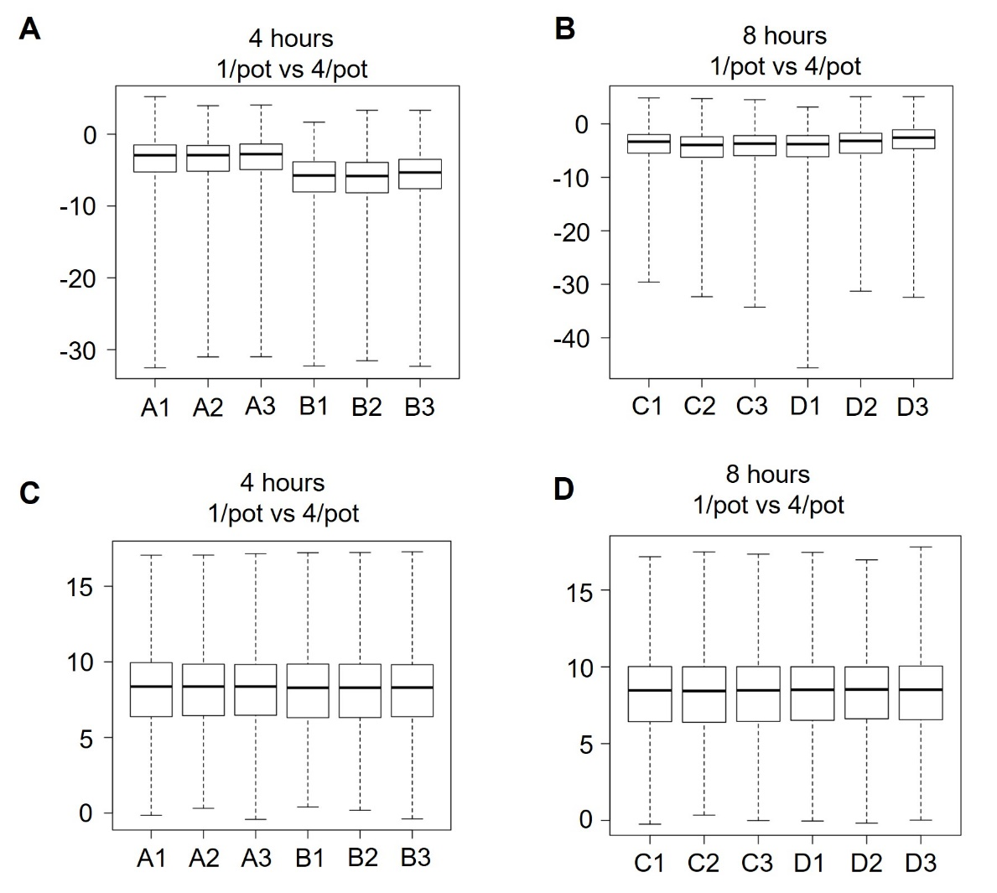
Expression values for each comparison is presented in both raw and normalised forms (Fig. 2.7). Normalisation was done by Genewiz to adjust for variations in sequencing amount, this allows for determination of DEGs.
Figure 2.7 Raw and normalised expression values
Graphs (produced by Genewiz and modified for this thesis) showing barley (cv. Charon) RNAseq data 4 and 8 hours post crowding initiation.
A-B) Boxplots depicting raw expression values for the 2 timepoints assessed, 4 hours 1/pot vs 4/pot (A) and 8 hours 1/pot vs 4/pot (B)
C-D) Boxplots depicting normalised expression values for the 2 timepoints assessed, 4 hours 1/pot vs 4/pot (C) and 8 hours 1/pot vs 4/pot (D). Normalisation was carried out to ensure accurate determination of differentially expressed genes (DEGs).

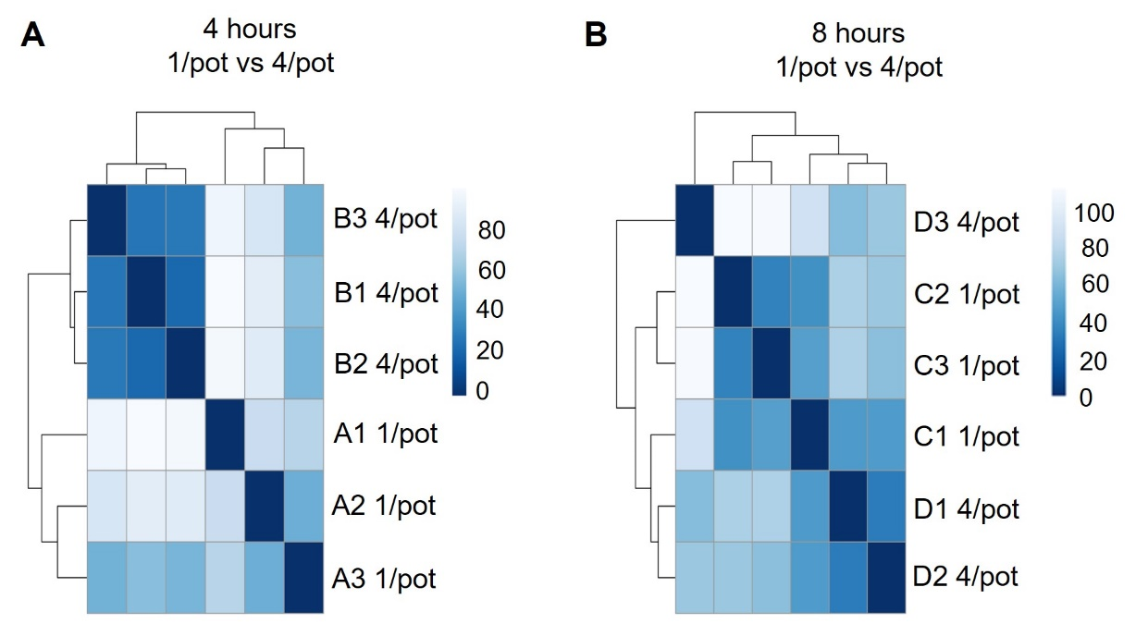

Figure 2.8 Distance between samples
A-B) Heatmaps (produced by Genewiz) showing distance between samples within a comparison using expression values. 4 hour 1/pot vs 4/pot (A) and 8 hours 1/pot vs 4/pot (B). A short distance indicates samples which are closely related. Graphs provided by Genewiz and modified for this thesis.

Barley gene name assignments
Due to the barley genome having fewer genes with functional annotations than Arabidopsis thaliana, differentially expressed gene lists for 1/pot and 4/pot plants at 4- and 8-hours post crowding were assessed for their Arabidopsis orthologs using Ensembl Plants (Yates et al., 2022). If Arabidopsis orthologs were present these were recorded, if not, the barley protein sequence for that gene was blasted against the Tair10 Arabidopsis genome (Berardini et al., 2015) using Ensembl plants (Yates et al., 2022) or Phytozome (Goodstein et al., 2012). Once Arabidopsis orthologous genes were identified, TAIR (Berardini et al., 2015) was used to gain the descriptions of them. Unfortunately, due to the RNAseq taking place towards the end of my PhD, the entirety of the dataset could not be assessed. Instead, only the highest and lowest differentially expressed genes according to their log₂FC were assessed (~100-150 genes for each low and high DEGs at 4 hours 1/pot vs 4/pot and 8 hours 1/pot vs 4/pot. Additionally, genes with high padj, were also screened.

Statistical analysis
Where statistical tests have been performed this was described in the figure legends. In all cases, data was tested for normality in the first instance using IBM SPSS. If data was normally distributed either Independent samples t-test or One way ANOVA with Tukey HSD was applied using IBM SPSS. If the data was not normally distributed, a Mann Whitney U test or a Kruskal-Wallis test with Bonferroni correction was carried out using IBM SPSS. Asterisks were used to indicate statistically significant difference, n.s. depicted no statistical significant difference. If letters were used, groups with the same letter were not statistically different from each other. Graphs were plotted using Origin Pro and Microsoft Excel.

Defining plant growth responses to soil volume and neighbour density

Introduction

As described in chapter 1, many plant species have been assessed for their shoot responses to soil volume availability and neighbour density. When plants are subjected to small soil volumes this results in a strong inhibition of shoot growth (Carmi and Heuer, 1981; Robbins and Pharr, 1988; Bar-Tal et al., 1995; Bar-Tal and Pressman, 1996; van Iersel, 1997; Poorter et al., 2012), which cannot be attributed solely to nutrient availability, (as discussed in Section 1.2.1) despite difficulties to partition nutrient availability and soil volume in experimental design (Hess and De Kroon, 2007; Poorter et al., 2012). The mechanism that plants use to detect their available soil volume remains unknown.
Plants subjected to high density sowing share similar shoot growth inhibition as plants experiencing small soil volumes. For instance, in field grown barley, increased sowing density results in reduced tiller production (Soleymani et al., 2011; Hecht et al., 2016) and shoot biomass per plant (Harper, 1977; Hecht et al., 2016). Plants use their shoot and root systems to detect the presence of neighbouring plants using a range of mechanisms such as root exudates, volatiles and light (Wang et al., 2021; Huber et al., 2021; Ninkovic et al., 2021). However, unpicking the roles and indeed importance of mechanisms in the shoot and the root remains unclear (Wang et al., 2021).
Plants grown at high density effectively experience less ‘free’ soil volume for their roots to explore than if they were sown further apart. Therefore, the similarities in shoot-based changes in response to soil volume and neighbour density highlights the potential to better understand these responses together. However, this also requires being able to delineate the effects caused by neighbour detection in the root and shoot system respectively.
In addition to shoot growth, root growth and changes in root system architecture have been assessed in crowded settings. The three- dimensional architecture of the root system is a key factor in determining the space and subsequently the water and nutrients that the plant is able to forage (Voss-Fels et al., 2018). As discussed in the introduction, understanding plant responses to neighbours has often been confounded by a failure to control soil volume and this issue has been particularly apparent in the root system responses (Gersani et al., 2001; Falik et al., 2003). In addition, how the root system responds to the presence of neighbours has been suggested to differ depending on how closely related the neighbour is and this can influence the number, biomass and length of roots (Gruntman and Novoplansky, 2004; Dudley and File, 2007; de Kroon, 2007). In field-grown wheat and barley, root numbers have been shown to decrease when neighbour density increases (Hecht et al., 2016; Fradgley et al., 2020). Despite many studies investigating root system architecture responses to neighbour density, investigations into root system architecture responses in plants experiencing differing soil volumes have been absent from the literature. This lack of root system visualisation could be hindering our understanding of the mechanisms in which plants use to detect and explore their available soil volume.
In this chapter, I aim to understand the phenotypic relationship between soil volume and neighbour density responses in the shoot and the root systems. I also aim to identify if these shoot and root system responses to soil volume and neighbour density are the same between and within species. In addition, I aim to identify if root- or shoot-based mechanisms are most important for detection of neighbouring plants.

Interspecific variation in shoot response to soil volume and neighbour density

Wheat shoot responses to available soil volume and the density of neighbours are largely interchangeable

I hypothesised that plants grown in crowded treatments would respond similarly to plants grown in limited soil volumes, this is because by increasing the number of plants per pot would mean each plant would have access to a smaller soil volume per plant as the whole pot will need to be shared. To test this hypothesis, wheat (cv. Mulika) plants were grown in 100ml and 500ml pots either singly (1/pot) or crowded, whereby there were 4 plants in the pot (4/pot) (Fig. 3.1A) (Wheeldon et al., 2021). I wanted to ensure that this experiment was only testing shoot growth responses to root-mediated crowding or soil volume, and hence, to control for any possible influence of shoot-mediated crowding, crowded plants were grown at the same distance apart regardless of soil volume. A square plastic template of equal size to the top of a 100ml pot was used as a guide for sowing distance in the 500ml pots. The distance between the shoots was maintained throughout life with the use of stakes (Fig. 3.1A). There would be an inherent increase in shoot mediated neighbour-detection in crowded treatments as the experiment progressed, however between 100ml and 500ml treatments this should be approximately the same.

Using this set-up, I measured the shoot growth of plants by both their maximum (peak) tiller number, and their shoot biomass. I assessed dry shoot biomass at 12 weeks post germination and observed that 1/pot plants grown in 500ml pots were statistically different, producing 4.0-fold more shoot biomass than 1/pot 100ml plants (Fig. 3.1B-C). Similarly, 4/pot plants grown in 500ml pots produced 3.2-fold more shoot biomass per plant than 4/pot 100ml plants. Thus, increasing soil volume strongly promotes increased shoot growth in both solitary and crowded plants. Critically, the 1/pot 100ml plants and the 4/pot 500ml plants, have a similar soil volume/plant and were not statistically different as these had very similar biomasses. Thus, increasing both soil volume and neighbour density results in little overall effect on growth; increased soil volume negates increased density, and vice versa. These results suggest that soil volume and neighbour density are fundamentally interchangeable parameters (Wheeldon et al., 2021).
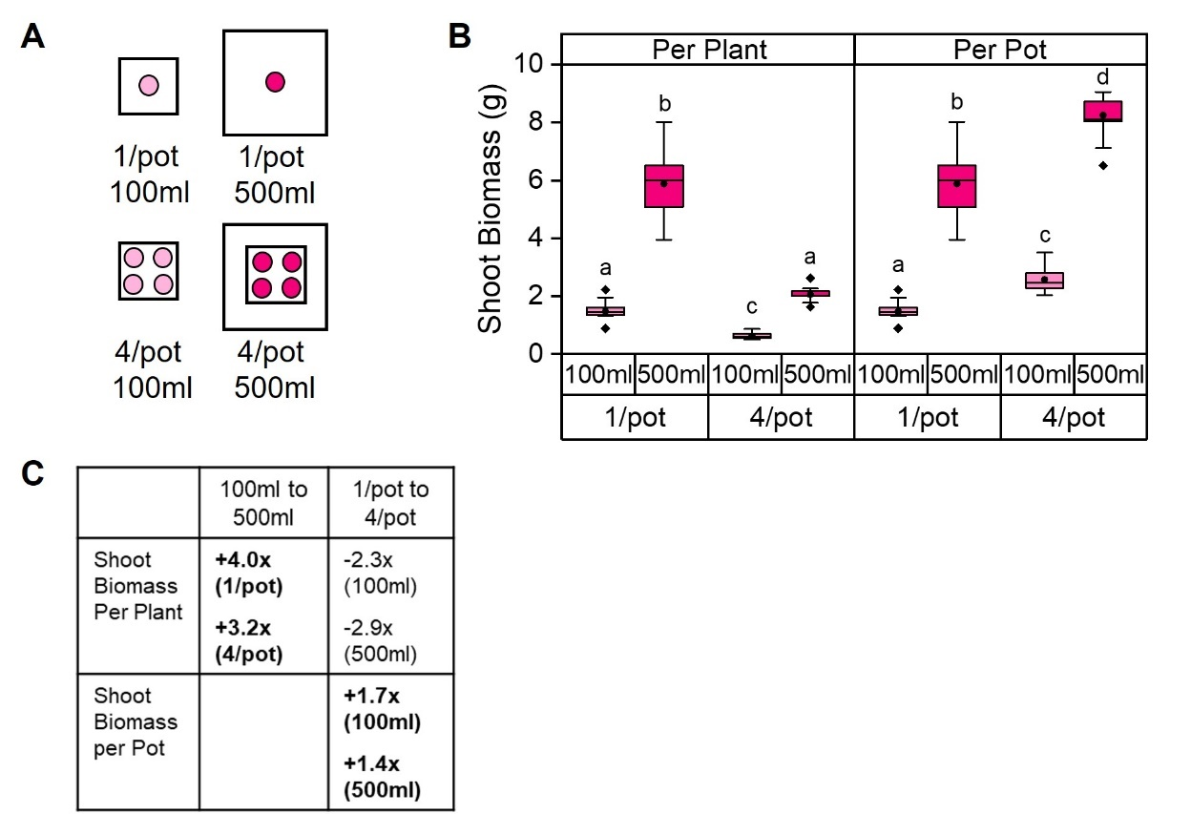
Figure 3.1 Shoot biomass is strongly influenced by soil volume and neighbour density
Graphs showing spring wheat (cv. Mulika) grown in 100ml (light pink) and 500ml (dark pink) pots in either 1 plant per pot (1/pot) or 4 plants per pot (4/pot).
A) Cartoon representing experimental set up. Each circle represents 1 plant.
B) Box plot showing the mean final dry shoot biomass (g) per plant and per pot at 12 weeks post germination Statistical analysis was carried out separately for per plant and per pot. Boxes with the same letter are not significantly different (One-way ANOVA with Tukey HSD, p <0.05) n=11-12. The box indicates the interquartile range, the midline represents the median, the whiskers are the minimum and maximum values, the circle is the mean and the diamonds are outliers.
C) Table showing shoot biomass fold changes between 100ml and 500ml soil volumes, and between 1/pot and 4/pot treatments. Fold changes in bold and with a + represent increased fold change, - represents decreased fold change.
Figure modified from Wheeldon et al, 2021

The results of Fig. 3.1 are supported by the analysis of peak tiller number. Plants grown 1/pot in 500ml pots produced ~2.6-fold more tillers per plant compared to plants grown 1/pot in 100ml pots, while similarly, plants grown 4/pot in 500ml pots produced ~2.9-fold more tillers per plant than those in grown 4/pot in 100ml pots (Fig. 3.2A). Thus, the five-fold greater soil volume available to the 4/pot plants when grown in 500ml pots alleviated much of the effect of crowding, suggesting that soil volume and crowding are interchangeable.
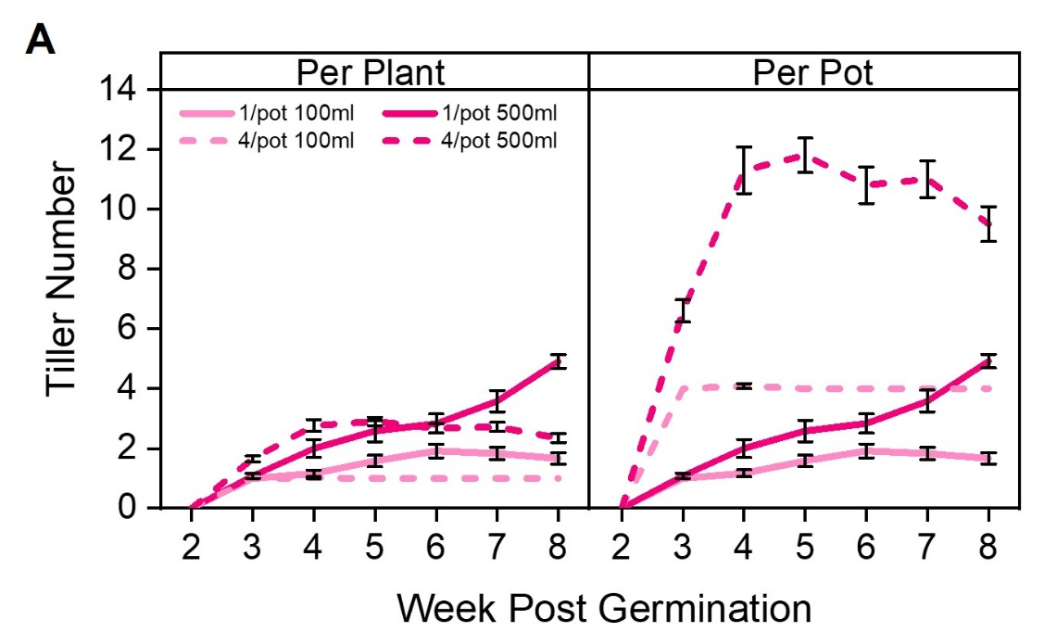
Figure 3.2 Tillering is influenced by soil volume and neighbour density in wheat
Graphs showing spring wheat (cv. Mulika) grown in 100ml (light pink) and 500ml (dark pink) pots in either 1 plant per pot (1/pot) or 4 plants per pot (4/pot) as described in Figure 3.1A.
A) Line graphs showing mean tiller number per plant and per pot from week 2 to 8 post germination. Error bars represent standard error of the mean (S.E.M). n=11-12.
Figure modified from Wheeldon et al, 2021

However, a more detailed analysis of the growth of the plants suggests that the two parameters are not completely interchangeable. For instance, I measured tiller number over time to gain a more detailed view of the growth of wheat plants in these treatments. As expected, 1/pot plants produced a greater number of tillers per plant compared to 4/pot plants, in both soil volumes (Fig. 3.2A). However, the 4/pot plants, in both soil volumes, produced tillers faster, and reached their final tiller numbers earlier than the 1/pot plants. Notably, even though the 4/pot 500ml and 1/pot 100ml plants have a similar average soil volume per plant, the 4/pot 500ml plants responded more quickly to the stimulus, even though the final growth outcomes were the same (Fig. 3.2B). This suggests that crowding causes a more immediate growth response than soil volume limitation, even though the end-points are similar.

When the total growth per pot is considered, it is clear that the crowded plants also ‘over-produce’ biomass compared to solitary plants in the same soil volume. For instance, the 4/pot plants grown in 100ml pots produce 1.7-fold greater shoot biomass than 1/pot plants in the same soil volume. This is also reflected in 500ml pots where 4/pot plants produce 1.4-fold greater shoot biomass per pot than 1/pot plants in the same soil volume (Fig. 3.1B-C). This again suggests that the two parameters are not completely interchangeable, and that the effect of crowding on final biomass is somewhat weaker than the effect of soil volume. However, an alternative explanation is that in the crowded plants there is an additional stimulus promoting the additional shoot growth, for instance the effect of mutual shading between the shoot systems. This supports what is seen in the literature where branching is slightly affected by shoot based shading (Kebrom et al., 2009).

As bread wheat is primarily grown for its grain, I also wanted to assess if yield-related traits are influenced by soil volume and neighbour density. As a proxy for grain production, I counted the number of spikelets (reproductive structures which contain the grain) produced by each ear. As with shoot biomass, the number of spikelets produced per plant was strongly influenced by soil volume and neighbour density and follows similar trends as previously discussed (Fig. 3.3A).
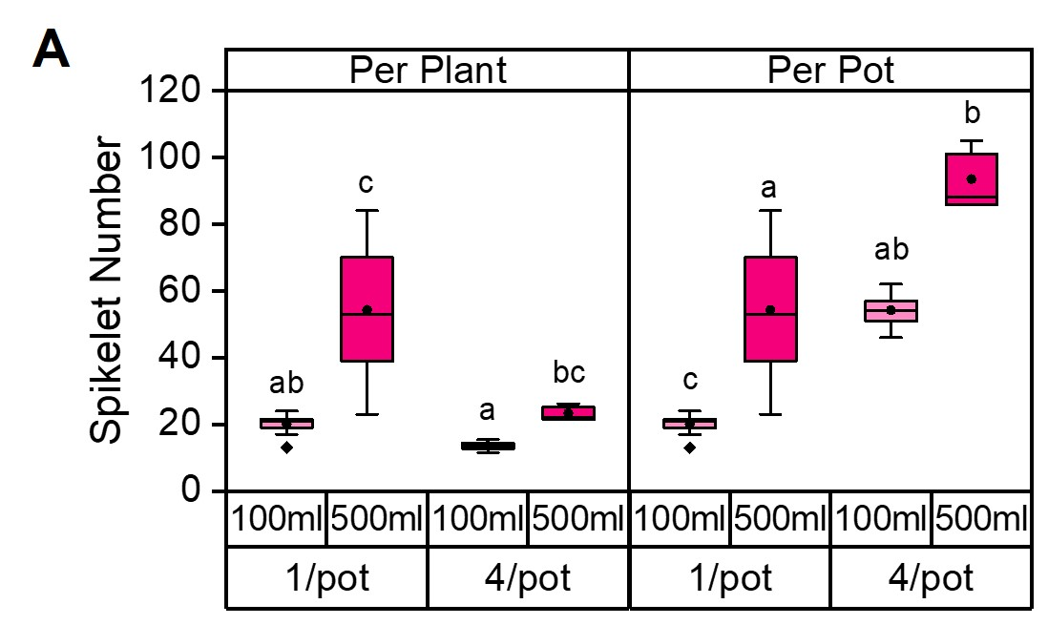

Figure 3.3 Reproductive traits in wheat are influenced by soil volume and neighbour density
Graphs showing spring wheat (cv. Mulika) grown in 100ml (light pink) and 500ml (dark pink) pots in either 1 plant per pot (1/pot) or 4 plants per pot (4/pot) as described in Figure 3.1A.
A) Box plot showing the mean final spikelet number per plant and per pot at 12 weeks post germination Statistical analysis was carried out separately for per plant and per pot. Boxes with the same letter are not significantly different (Kruskal-Wallis test with Bonferroni correction, p <0.05) n=9-12. The box indicates the interquartile range, the midline represents the median, the whiskers are the minimum and maximum values, the circle is the mean and the diamonds are outliers.

Taken together, the data here show that shoot growth responses to soil volume and neighbour density are largely interchangeable in wheat, and that the average soil volume per plant (soil volume/ plant number in the pot) is a strong indicator for final shoot growth.

Barley shoot growth responses to soil volume and neighbour density are largely interchangeable

I next wanted to test if the shoot growth responses seen in wheat are also seen in other species. I hypothesised that there may be differences in soil volume and neighbour density responses in different species such as an increased or decreased sensitivity to the presence of neighbouring plants or available soil volume. Hence, using the same experimental design as with wheat, barley (cv. Charon) was grown in 100ml and 500ml pots, either singly (1/pot) or crowded (4/pot) (Fig. 3.4A).

As with wheat in section 3.2.1, I measured shoot growth by their dry shoot biomass and peak tiller number. At 12 weeks post germination the dry shoot biomass showed that plants grown singly in 500ml pots were statistically different to the singly grown 100ml plants, as they produced 4.1-fold greater shoot biomass than plants grown singly in 100ml pots (Fig. 3.4 B-C). A similar trend can be seen in 4/pot grown plants as these produced 4.6-fold greater shoot biomass in 500ml pots than 100ml pots. Intriguingly, although wheat plants showed a similar trend, barley plants were able to increase their shoot growth by a greater extent when crowded than wheat. Nevertheless, again this suggests that by increasing the soil volume available to plants this allows the increase of shoot biomass in 1/pot and 4/pot plants.

A key observation is that plants grown in 1/pot 100ml pots were not statistically different as they had a similar shoot biomass per plant to those grown in 4/pot 500ml (~3g) (Fig. 3.4 B-C). As both treatments share a similar soil volume per plant, the increase in both neighbour density and soil volume resulted in a small overall effect on shoot growth. As shown in wheat, this therefore suggested that increasing soil volume negates the increased density of plants and vice versa. Taken together, in barley like in wheat, soil volume and neighbour density are fundamentally interchangeable factors.
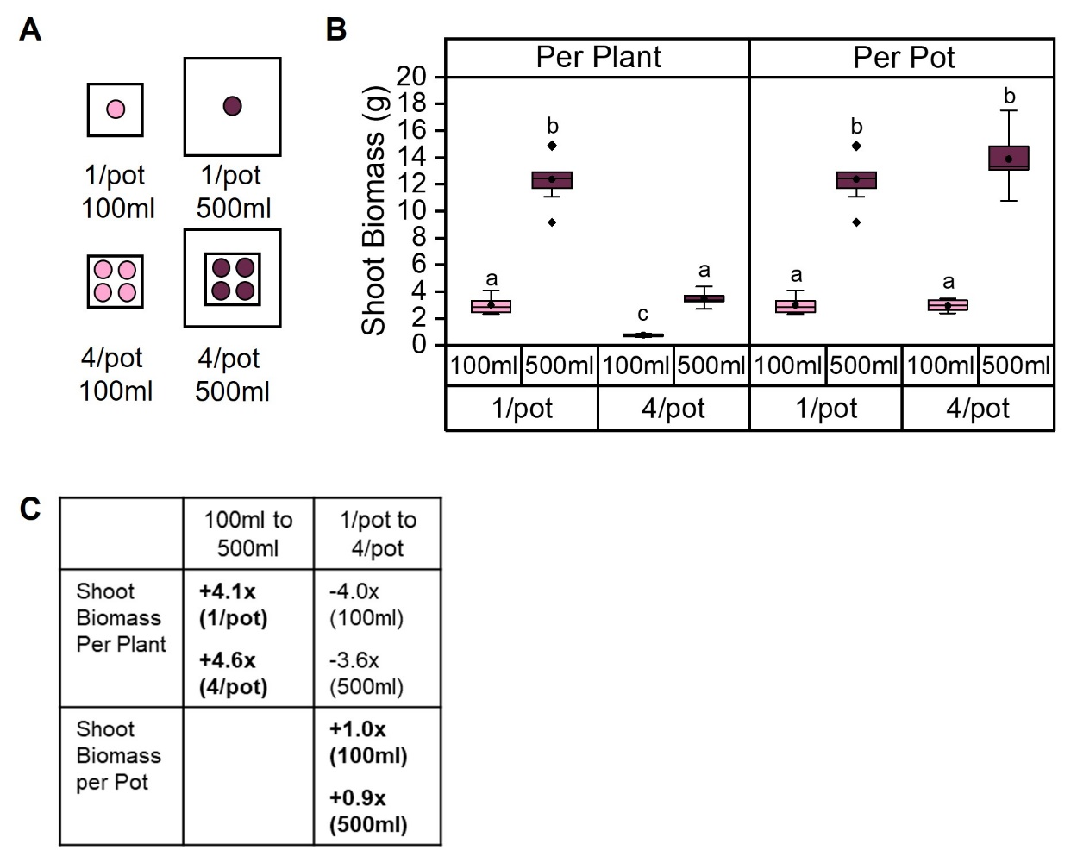
Figure 3.4 Shoot biomass of barley plants is influenced by soil volume and neighbour density
Graphs showing spring barley (Cv. Charon) grown in 100ml (light pink) and 500ml (burgundy) pots in either 1 plant per pot (1/pot) or 4 plants per pot (4/pot).
A) Cartoon representing experimental set up. Each circle represents 1 plant.
B) Box plots showing the mean final dry shoot biomass (g) per plant and per pot at 12 weeks post germination. Statistical analysis was carried out separately for per plant and per pot. Boxes with the same letter are not significantly different (One-way ANOVA with Tukey HSD, p <0.05) n=9-11. The box indicates the interquartile range, the midline represents the median, the whiskers are the minimum and maximum values, the circle is the mean and the diamonds are outliers.
C) Table showing shoot biomass fold changes between 100ml and 500ml pots, and between 1/pot and 4/pot treatments. Fold changes in bold and with a + represent increased fold change, - represents decreased fold change.

The results shown by shoot biomass assessments are supported by peak tiller measurements. Plants grown singly in 500ml pots produce ~2.1 fold more tillers than those grown singly in 100ml pots (Fig. 3.5A). In addition, those grown in 4/pot 500ml treatments produced ~3.0- fold more tillers than plants grown in 4/pot 100ml treatments per plant (Fig. 3.5A). This therefore suggests that increasing soil volume five-fold in 4/pot 500ml plants resulted in an alleviation of most of the effect of crowding. As with wheat this therefore suggests that neighbour density and soil volume are interchangeable. An additional observation is that barley plants are inherently larger than wheat plants, as barley produces ~2-fold greater peak tiller number per plant than wheat in all treatments, for example peak tiller number in 1/pot 500ml pots is ~11 in barley compared to ~5 in wheat (Fig. 3.5A).
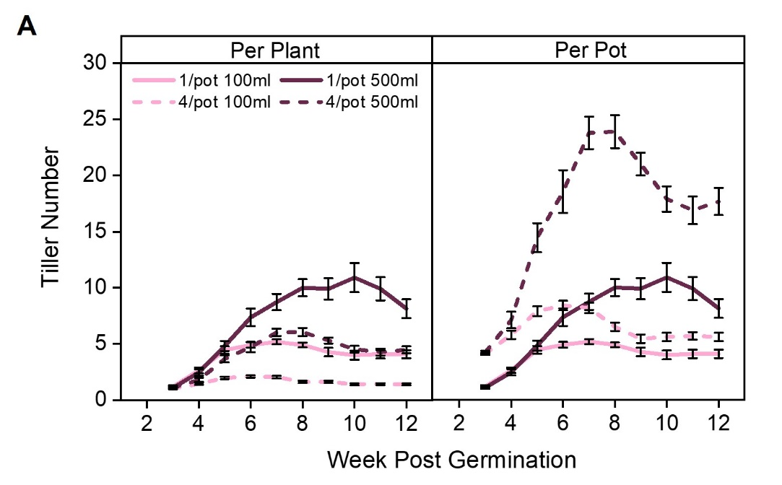

Figure 3.5 Tiller number in barley is influenced by soil volume and neighbour density
Graphs showing spring barley (Cv. Charon) grown in 100ml (light pink) and 500ml (burgundy) pots in either 1 plant per pot (1/pot) or 4 plants per pot (4/pot) as described in Figure 3.4A
A) Line graph showing mean tiller number per plant and per pot over time. Error bars represent standard error of the mean. n=9-11.

However, as in wheat when analysing the tiller growth over time, the data suggests that soil volume and neighbour density are not completely interchangeable. Plants grown singly produced more tillers than those grown in 4/pot, in both soil volumes, which was as expected (Fig 3.5A). However, like in wheat, plants grown with neighbours reached their peak tillers number sooner than those grown singly. Despite those grown in the 4/pot 500ml treatment producing similar final growth outcomes as those grown in the 1/pot 100ml treatment, which ultimately have a similar soil volume per plant, the crowded plants responded sooner (Fig 3.5A). This suggests that as with wheat, neighbour density in barley triggers a more dramatic growth response sooner than a limitation in soil volume, regardless of their shoot growth ultimately reaching a similar end point.

Analysing at the total shoot biomass per pot, as with wheat the crowded barley plants appear to ‘over-produce’ shoot biomass compared to plants grown singly in the same soil volume. In 100ml pots, 4/pot plants produce 1.0- fold more shoot biomass than singly grown plants in the same soil volume. Those grown in 500ml pots behave similarly, as 4/pot plants produce 0.9- fold more shoot biomass than 1/pot plants (Fig. 3.4B-C). These fold changes are lower than in wheat but nevertheless suggest that soil volume and neighbour density are not completely interchangeable. Additionally, the crowding effect on shoot biomass appears to be less strong than the influence of soil volume. As discussed for wheat, there could potentially be another stimulus present in the crowded plants which results in this elevated shoot growth, such as shading affects between the shoots of crowded plants for example.

Taken together, barley responses follow the same trends as wheat responses despite being inherently larger plants, with slight variations in the degree of response to soil volume and crowding. Barley showed an elevated response to soil volume compared to wheat, most notably in crowded plants (1/pot: 4.1- fold in barley, 4.0-fold in wheat, and in 4/pot: 4.6-fold in barley and 3.2-fold in wheat per plant), however a slightly lower fold change per pot when comparing crowded and uncrowded plants in the same soil volume (100ml: 1.0-fold in barley and 1.7-fold in wheat, and in 500ml: 0.9-fold in barley and 1.4-fold in wheat). The lower fold changes in barley when crowded could indicate differences in historic breeding strategies in wheat to breed plants with high tolerance to neighbour density. Nevertheless, like wheat, barley responds to soil volume and neighbour density in a manner than is largely interchangeable and soil volume per plant strongly indicates the final shoot growth of the plant.

Arabidopsis shoot growth responses to soil volume and neighbour density are largely interchangeable

I have previously explored soil volume responses in the weed and model plant Arabidopsis thaliana during my MSc by Research and found that it clearly responds to soil volume (Walker et al., 2021). In addition, a small preliminary experiment during my undergraduate degree also highlighted it responds to crowding too (Wheeldon, 2018). As barley and wheat are cultivated cereal crops, I wanted to investigate if the effect of soil volume and neighbour density is seen to a similar extent in Arabidopsis thaliana (Wild type, Col-0), referred to hereafter as Arabidopsis. Therefore, this was investigated using the same experimental design and growth conditions as wheat and barley.
The growth habit of Arabidopsis means that early growth responses to soil volume cannot be as easily assessed as in cereals and that clear differences in shoot traits between soil volumes can only been seen later in life. While cereal tiller number can be tracked through the life-cycle as a proxy for shoot size, Arabidopsis only produces measurable branches after the floral transition (~4 weeks post germination).
Using the same experimental design as wheat and barley, Arabidopsis Col-0 plants were grown in 100 and 500ml pots in 1/pot and 4/pot treatments (Fig. 3.6A). At 7 weeks post germination total branch number and total silique number were counted and shoots were harvested for shoot biomass assessments.
In wheat and barley shoot growth could be assessed using shoot biomass and peak tiller number, in the case of Arabidopsis this was by shoot biomass and peak branch number. Dry shoot biomass measurements showed that plants grown singly in 500ml pots were statistically different as they were 4.0-fold larger than those grown singly in 100ml pots (Fig. 3.6B-C). Correspondingly, crowded plants in 500ml pots produced 3.1- fold greater shoot biomass than those crowded in 100ml pots (Fig. 3.6B-C). These fold changes are almost identical to that of wheat (Fig. 3.1B-C). Hence, an increase in soil volume also strongly promotes shoot based growth in Arabidopsis plants grown singly and crowded. Most importantly when looking at the shoot biomass of 1/pot 100ml and 4/pot 500ml grown plants, there was no statistical difference, where each plant has a similar soil volume available per plant, this showed limited effects on shoot growth. Therefore, as seen in wheat and barley, soil volume and neighbour density appear to be interchangeable.
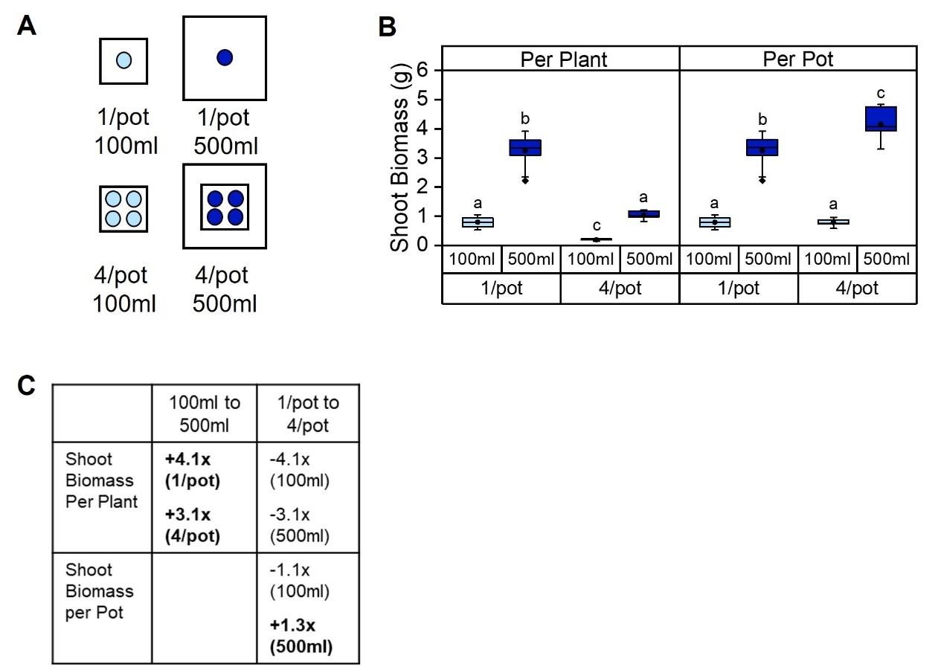
Figure 3.6 Shoot biomass of Arabidopsis plants is larger in uncrowded scenarios and when a larger soil volume is available
Graphs showing A. thaliana (Col-0) grown in 100ml (light blue) and 500ml (dark blue) pots in either 1 plant per pot (1/pot) or 4 plants per pot (4/pot)
A) Cartoon representing experimental set up. Each circle represents 1 plant.
B) Box plots showing mean shoot biomass (g) per plant and per pot at 7 weeks post germination. Boxes with the same letter are not significantly different (One-way ANOVA with Tukey HSD, p <0.05) n=7-12. Statistical analyses were carried out independently for per plant and per pot. The box indicates the interquartile range, the midline represents the median, the whiskers are the minimum and maximum values, the circle is the mean and the diamonds are outliers.
C) Table showing shoot biomass fold changes in 100ml and 500ml pots and 1/pot and 4/pot treatments. + represents a positive fold change, - represents a negative fold change.

When grown singly in 500ml pots Arabidopsis plants produced ~2.9-fold (~2.6-fold in wheat) more branches per plant than those grown singly in 100ml pots (Fig. 3.7A). Whereas in the case of those grown in 4/pot treatments, the 500ml grown Arabidopsis plants are ~3.9-fold larger (~2.9-fold in wheat) than those in 100ml pots (Fig. 3.7A). This branch number data supports the biomass data. This is a stronger response than in wheat but nevertheless, this suggests that the availability of five-fold more soil volume strongly alleviates the effect of root-based crowding in Arabidopsis, indicating that soil volume and neighbour density are interchangeable.
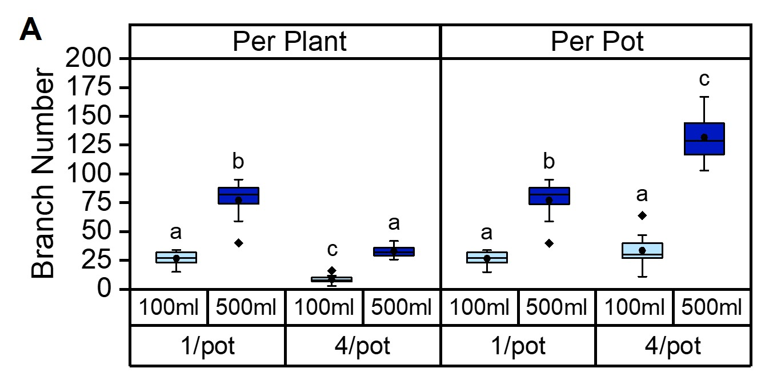
Figure 3.7 Shoot branch number in Arabidopsis plants is elevated when plants are grown singly and in larger soil volumes
Graphs showing A. thaliana (Col-0) grown in 100ml (light blue) and 500ml (dark blue) pots in either 1 plant per pot (1/pot) or 4 plants per pot (4/pot) as shown in Fig 3.6A.
A) Box plots showing mean final total shoot branch number per plant and per pot. Boxes with the same letter are not significantly different (One-way ANOVA with Tukey HSD, p <0.05) n=7-12. Statistical analyses were carried out independently for per plant and per pot. The box indicates the interquartile range, the midline represents the median, the whiskers are the minimum and maximum values, the circle is the mean and the diamonds are outliers.

When assessing total shoot growth per pot, crowded Arabidopsis plants also ‘over-produce’ shoot biomass compared to those grown singly but this is only seen in 500ml pots. When crowded plants are grown in 100ml pots, there is a statistically significant reduction in shoot biomass per plant compared to those grown singly in the same soil volume. Whereas, when crowded in 500ml pots there is a ~1.3-fold increase in shoot biomass. In the case of the 500ml grown Arabidopsis plants, this suggests that neighbour density and soil volume are not completely interchangeable, with crowding effects being less of an influence on shoot biomass than soil volume.
Due to the requirement to wait until late in the Arabidopsis lifecycle to see the effects of crowding and neighbour density on plant growth, I also assessed silique number as plants had ceased their production of siliques at this timepoint (Fig. 3.8A). Siliques contain the seed and hence would allow a proxy for seed production. Silique number response followed a similar trend as shoot biomass (Fig. 3.8A) and the equivalent reproductive architecture trend seen in wheat spikelet number (Fig. 3.3A).
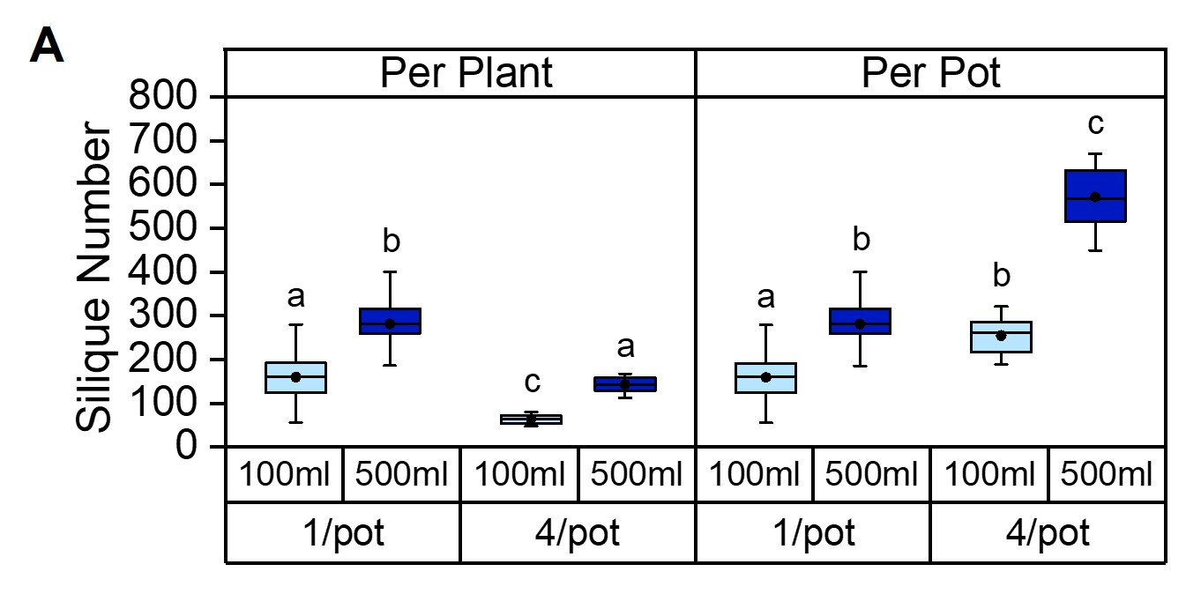

Figure 3.8 Silique number is affected by soil volume and neighbour density
Graphs showing A. thaliana (Col-0) grown in 100ml (light blue) and 500ml (dark blue) pots in either 1 plant per pot (1/pot) or 4 plants per pot (4/pot).
A) Box plots showing mean silique number per plant and per pot at 7 weeks post germination. Boxes with the same letter are not significantly different (One-way ANOVA with Tukey HSD, p <0.05) n=7-12. Statistical analyses were carried out independently for per plant and per pot. The box indicates the interquartile range, the midline represents the median, the whiskers are the minimum and maximum values, the circle depicts the mean.

Looking across all shoot traits assessed, Arabidopsis follows similar trends to wheat and barley. This suggests that soil volume per plant also indicates shoot growth in Arabidopsis.

Pea shoot growth responses to soil volume and neighbour density are largely interchangeable

I next wanted to explore if legumes behave in a similar manner to wheat, barley and Arabidopsis to soil volume and neighbour density. Wild-type Pisum sativum (v. Torsdag background) (pea from herein) plants were grown using the same experimental design as the previous experiments (Fig. 3.9A), however the soil volumes used were 500ml and 2000ml (Wheeldon et al., 2022) as in a preliminary experiment pea plants grown singly in 100ml pots were very small and only produced a single shoot with no branches. Plants were grown for 7 weeks and then shoot branches were counted and shoots were harvested for dry shoot biomass.

Pea plants grown singly in 2000ml pots were statistically different to singly grown 500ml plants, as these produced ~2.2-fold more shoot biomass than those in grown singly 500ml pots. In the case of crowded plants grown in 2000ml, these plants produced ~2.1-fold more shoot biomass than in 500ml pots per plant (Fig. 3.9B-C) (Wheeldon et al., 2022). These fold changes are half that of wheat, but nevertheless show that an increase in available soil volume results in increased shoot growth in both crowded and uncrowded plants. Most notably, 1/pot 500ml and 4/pot 2000ml plants produced a similar shoot biomass per plant (~5g). Consequently, as with the other species assessed in 3.2, neighbour density and soil volume act interchangeably.

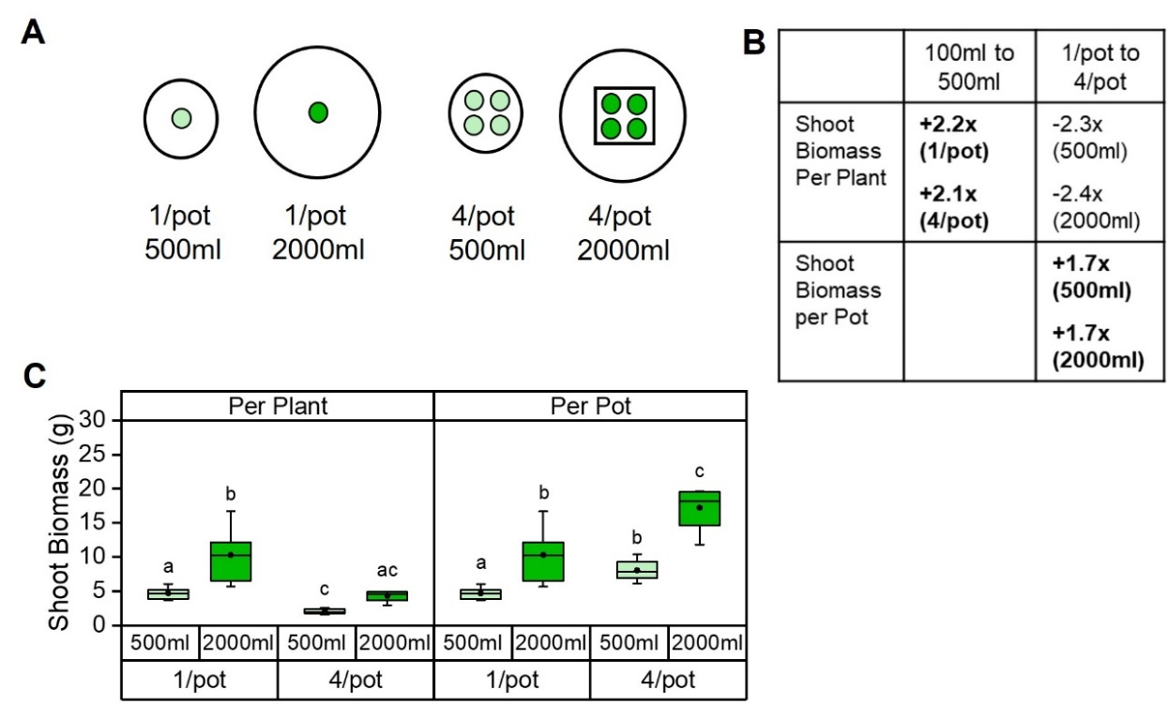
Figure 3.9 Shoot biomass in pea is influenced by root based crowding and soil volume
Graphs showing wildtype P. sativum (pea, cv Torsdag) grown in 500ml (light green) and 2000ml (dark green) pots in either 1 plant per pot (1/pot) or 4 plants per pot (4/pot) treatments.
A) Cartoon representing experimental set up. Each circle represents 1 plant, 4/pot plants were grown at the same distance apart in both soil volumes.
B) Table showing biomass fold change as a result of being subjected to different soil volume and crowding regimes. Numbers with a + indicate an increase in fold change, whereas those with – show a decrease in fold change.
C) Box plots showing mean final shoot biomass (g) per plant and per pot. Boxes with the same letter are not significantly different (One-way ANOVA with Tukey HSD, p <0.05) n=7-12. Statistical analyses were carried out independently for per plant and per pot. The box indicates the interquartile range, the midline represents the median, the whiskers are the minimum and maximum values, the circle is the mean.
Figure modified from Wheeldon et al, 2022

Pea plants grown singly in 2000ml pots produced ~2.6- fold more branches than those grown singly in 500ml pots. When crowded, pea plants grown in 2000ml pots produced ~2.2- fold more branches than those grown 4/pot in 500ml pots (Fig. 3.10A) (Wheeldon et al., 2022). This assessment of final branch number supports that of shoot biomass. Again, this shows that increasing the soil volume available to the plants by five-fold alleviated crowding effects, suggesting soil volume and neighbour density are interchangeable.
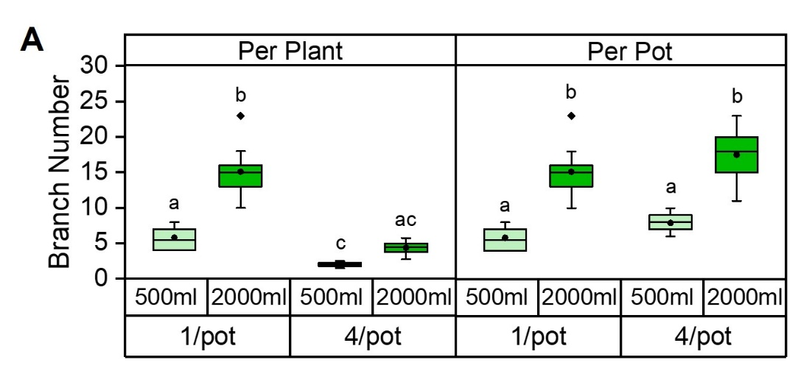

Figure 3.10 Shoot branching is influenced by soil volume and root based crowding in pea
Graphs showing wild-type P. sativum (pea, cv Torsdag) grown in 500ml (light green) and 2000ml (dark green) pots in either 1 plant per pot (1/pot) or 4 plants per pot (4/pot) treatments as described in Fig 3.8A.
A) Box plots showing mean shoot branch number per plant and per pot. Boxes which share the same letter are not significantly different (One-way ANOVA with Tukey HSD, p <0.05) n=9-10. Statistical analyses were carried out independently for per plant and per pot. The box indicates the interquartile range, the midline depicts the median, the whiskers are the minimum and maximum values, the circle is the mean and the diamonds are outliers.
Figure modified from Wheeldon et al, 2022

When considering the growth of plants per pot, as with the other species assessed, pea plants are seen to ‘over-produce’ shoots in the crowded treatments. 4/pot 500ml grown pea plants produced ~1.7-fold greater shoot biomass than those grown singly in 500ml pots. The same fold change is seen when comparing 4/pot 2000ml grown plants with 1/pot 2000ml grown plants (Fig. 3.9B-C) (Wheeldon et al., 2022). Therefore, this suggests that soil volume and neighbour density are not absolutely interchangeable and crowding effects are slightly less strong than that of soil volume.

To conclude, analysis of shoot biomass and branching data in pea show that neighbour density and soil volume are interchangeable to a large extent, with soil volume per plant being a key factor affecting the extent of final shoot growth.

Interspecific responses to soil volume and neighbour density are similar among species

Bringing together the data for wheat, barley, Arabidopsis and pea, all species clearly show the ability to detect and respond to soil volume and neighbour density. These data suggest that increasing the soil volume available to the plants alleviates the effect of crowding and conversely, increasing the density of plants negates the effect of increasing soil volume. As a result of this, plants which have experienced both an increase in available soil volume and neighbour density produce approximately the same shoot biomass as those which have experienced no increase in crowding and soil volume. This highlights that the shoot growth responses to soil volume and neighbour density are largely interchangeable which could suggest that they are driven by the same mechanism. However, the number of tillers produced over time in wheat and barley showed that crowded plants responded much more quickly to the presence of neighbours than to restricted soil volume, however the overall effects of neighbour density on shoot growth were less than that of soil volume. Experiments discussed later in this thesis provide further understanding of these effects, but nevertheless it is clear that neighbour density and soil volume are largely interchangeable and this is not species specific. This lack of species specificity indicates that the mechanism is general and one plausible explanation for this could be that plants perceive root density within the pot.

There are nuanced differences between species, such as in barley where the fold change for total shoot biomass per pot is significantly less than that of wheat. This could suggest that barley plants are more sensitive of neighbour density hence have more restrained growth to prevent overproduction of shoot biomass when crowded. This reduction in sensitivity in wheat plants could be representative of the drive for high sowing densities in wheat breeding programmes. Therefore, understanding the origin of the differences in sensitivity could allow us to gain a better understanding of the mechanism underpinning these responses.

Barley intraspecific variation in soil volume response

Soil volume responses are highly variable in barley germplasm

As seen from data presented thus far in this thesis and the wider literature, all species tested respond to soil volume. However, to date there has been no detailed analysis of soil volume responses between different varieties of the same species. Section 3.2 showed that the sensitivity to neighbours appears to be reduced in wheat, likely due to historic breeding programmes for ‘density resistance’. Therefore, an exploration of differences between wild and crop varieties could lead to better understanding of these responses. For example, in crop species, I hypothesise that there will be variation in the response to soil volume in modern and landrace varieties due to different trajectories in breeding. Understanding diversity in soil volume responses within a species could allow identification of the genetic basis underlying soil volume responsiveness, and allow for the breeding of crops which are less sensitive to the amount of space they have available to them.
With the ultimate aim of uncovering the genetic basis of soil volume responses, I decided to focus on one species, barley. The decision to focus on barley was largely influenced by its shoot growth habit, as responses to soil volume could be easily tracked over time via counting tillers, and the relative simplicity of its genome compared to wheat. In cereals, ears, which contain the grain, emerge from the tillers and in barley there is a strong link between production of tillers and grain yield (Simmons et al., 1982). Tiller number therefore would be a key phenotype to assess as a proxy for ultimate yield.
I performed this work in collaboration with the seed-breeding company KWS. KWS provided me with 100 spring barley lines to assess. These included traditional landrace cultivars, advanced/improved cultivars (of the green revolution era), and modern elite varieties from across the globe (Table 2.2). The spread of material both geographically and historically should provide a large pool of variation to screen.
To identify the diversity in soil volume responses between cultivars, I carried out an initial phenotyping screen to identify lines of interest. This screen consisted of growing each line in 100ml and 500ml pots, in weekly batches of 5 lines. Tillers were counted weekly from week 2-8 post germination and shoots were harvested at 8 weeks post germination for dry shoot biomass. The 8-week duration marked the time when most genotypes ceased new tiller production and a time before transition to floral development. Inherent differences in growth speed were to be expected, but the 8-week duration provided a defined end point to allow for comparisons.
To first investigate if modern varieties show more plastic responses to soil volume than less intensively bred lines, I looked at peak tiller number and dry shoot biomass. For each genotype and soil volume, the week in which the highest tiller number was produced was identified and recorded, and the number of tillers at this time point was defined as the peak tiller number. There were wide variations in soil volume responsiveness among these lines. The lines can be loosely grouped in to four main categories: lines which produced high numbers of tillers in both soil volumes (high-tillering), and others which produced low numbers of tillers in both soil volumes (low-tillering), lines which produced low numbers of tillers in the small soil volume with comparatively large numbers in the large soil volume (high-response), and those which produced a large amount of tillers in small soil volumes with only a small increase in large soil volumes (low-response).
This variation led to the need for a simplification of the analysis to allow for meaningful quantification. To do this, a 500ml:100ml ratio was calculated, where the peak tiller number for the large soil volume was divided by the peak tiller number of the small soil volume (regardless of which week this occurred) for each line. This shows the fold change in tillering on the larger soil volume relative to the smaller volume, irrespective of whether the line is high tillering or low tillering. A low ratio would indicate low sensitivity to soil volume, i.e. these lines produced a similar number of tillers in both soil volumes, whereas a high ratio would indicate a high sensitivity to soil volume, i.e. plants in the large soil volumes are able to take advantage of the larger amount of space and hence grow much larger than those in small soil volumes.
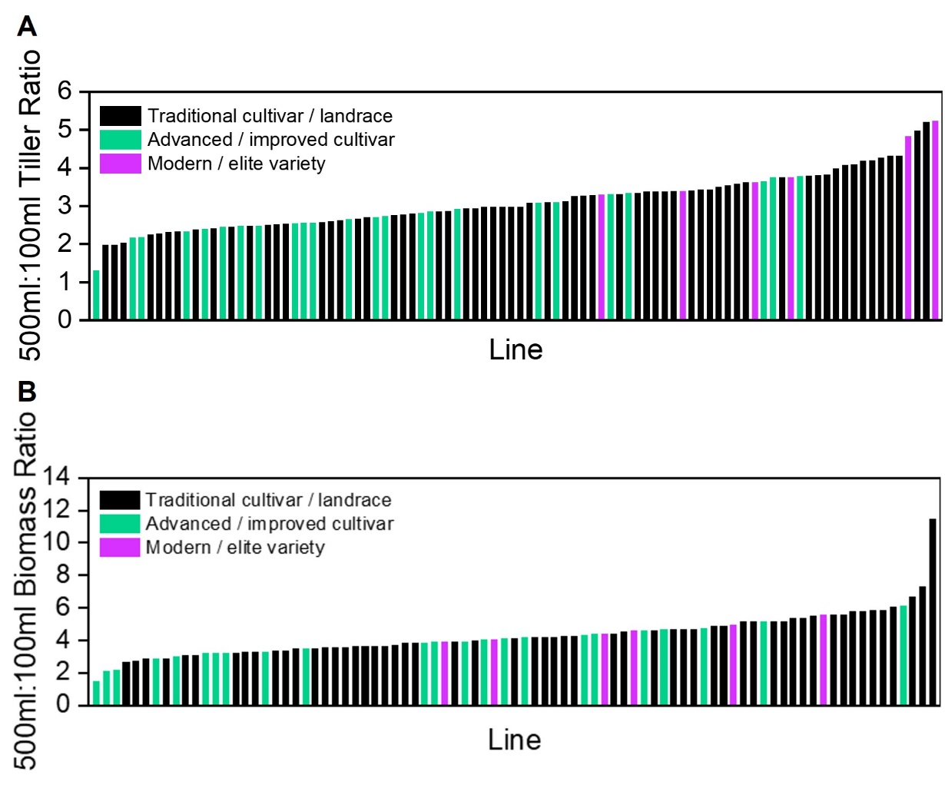
Looking across the spread of biomass and tiller ratios in all the lines, the modern / elite lines (pink) are found on the higher sensitivity end of the spectrum whereas the advanced / improved cultivars are generally found nearer the low sensitivity end of the spectrum (Fig. 3.11A-B). This could suggest a shift in breeding strategies over time. There has been no direct aim from breeders to produce lines with a focus on soil volume characteristics before, therefore this could indicate that genes involved in soil volume sensitivity could be linked to, or function in, other breeding targets such as plant density resistance. This would make sense given the largely interchangeable nature of soil volume and crowding responses shown in Section 3.2.

Figure 3.11 Modern varieties are more plastic in their response to soil volume availability than traditional and advanced lines
A-B) Bar charts showing the 500ml:100ml ratio of peak tiller number (regardless of the week it occurred) (A) and dry shoot biomass at 8 weeks post germination (B) in spring barley lines. Black bars represent traditional cultivar / landrace lines, green bars represent advanced / improved cultivars and purple bars represent modern / elite varieties. n=1-4.

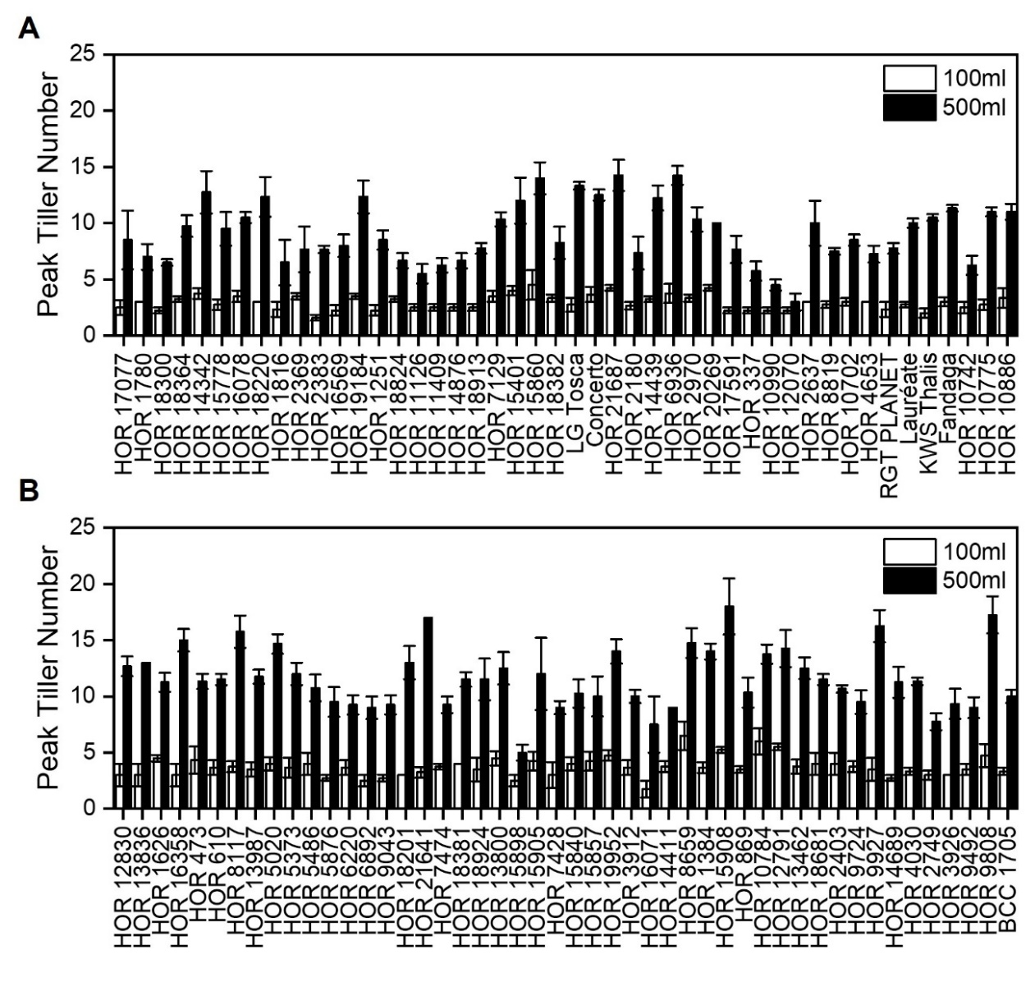
Looking across the lines in more detail there was a large variation in the peak tiller number and shoot biomass in each soil volume. Peak tiller number in 100ml pots ranged from 1.6 to 6.5 tillers whereas in 500ml pots the variation was much greater, between 3-18 tillers (Fig. 3.12A-B). A similar pattern was seen in shoot biomass, with small soil volumes ranging between 0.47-2.22g and in large soil volumes this ranged between 1.81- 9.08g (Fig. 3.13A-B).
Figure 3.12 Peak tiller number varies greatly across barley lines
A-B) Mean peak tiller number (the highest number of tillers produced by each line, regardless of the week post germination in which this occurred) of 94 spring barley lines grown in 100ml (white) and 500ml (black) soil volumes. Error bars represent s.e.m, n=1-4.

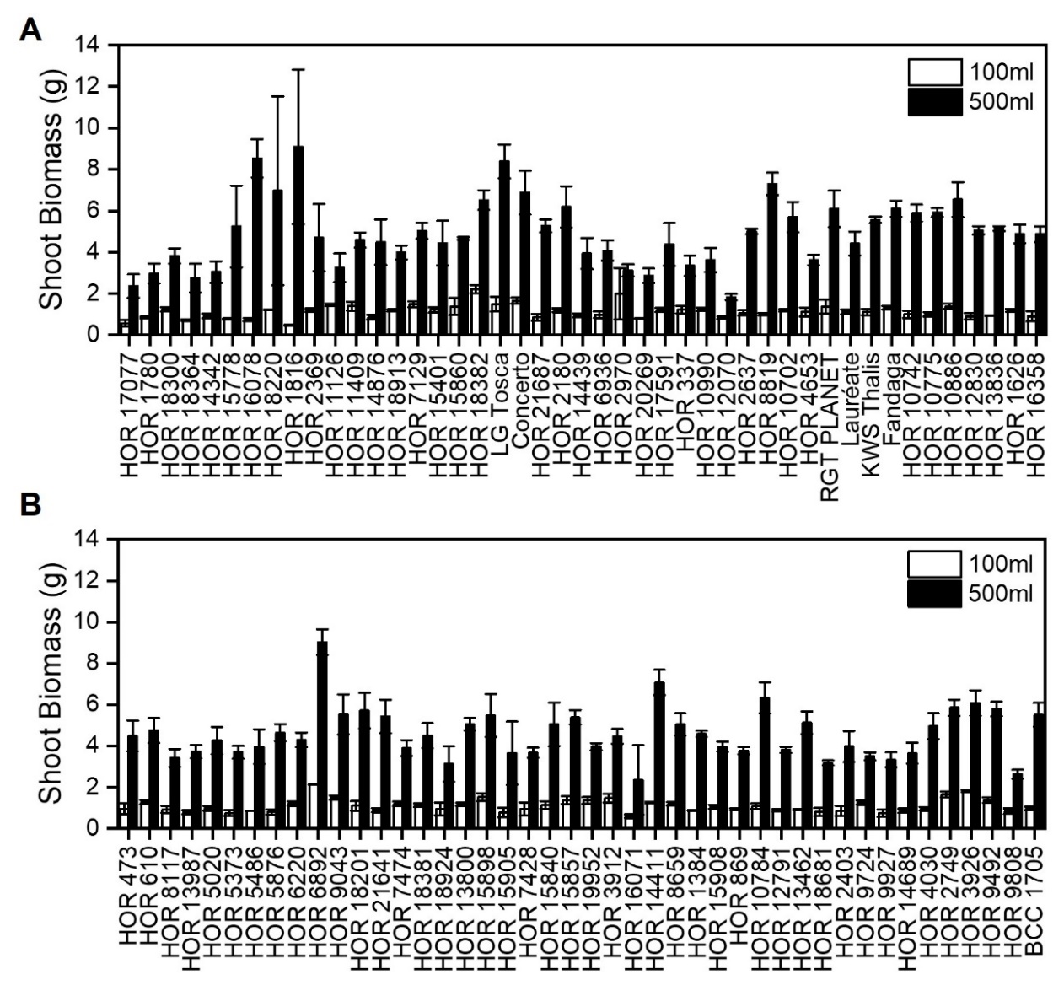

Figure 3.13 Shoot biomass varies greatly across barley lines
A-B) Mean shoot biomass (g) at 8 weeks post germination of 89 spring barley lines grown in 100ml (white) and 500ml (black) soil volumes. Error bars represent s.e.m, n=1-4.

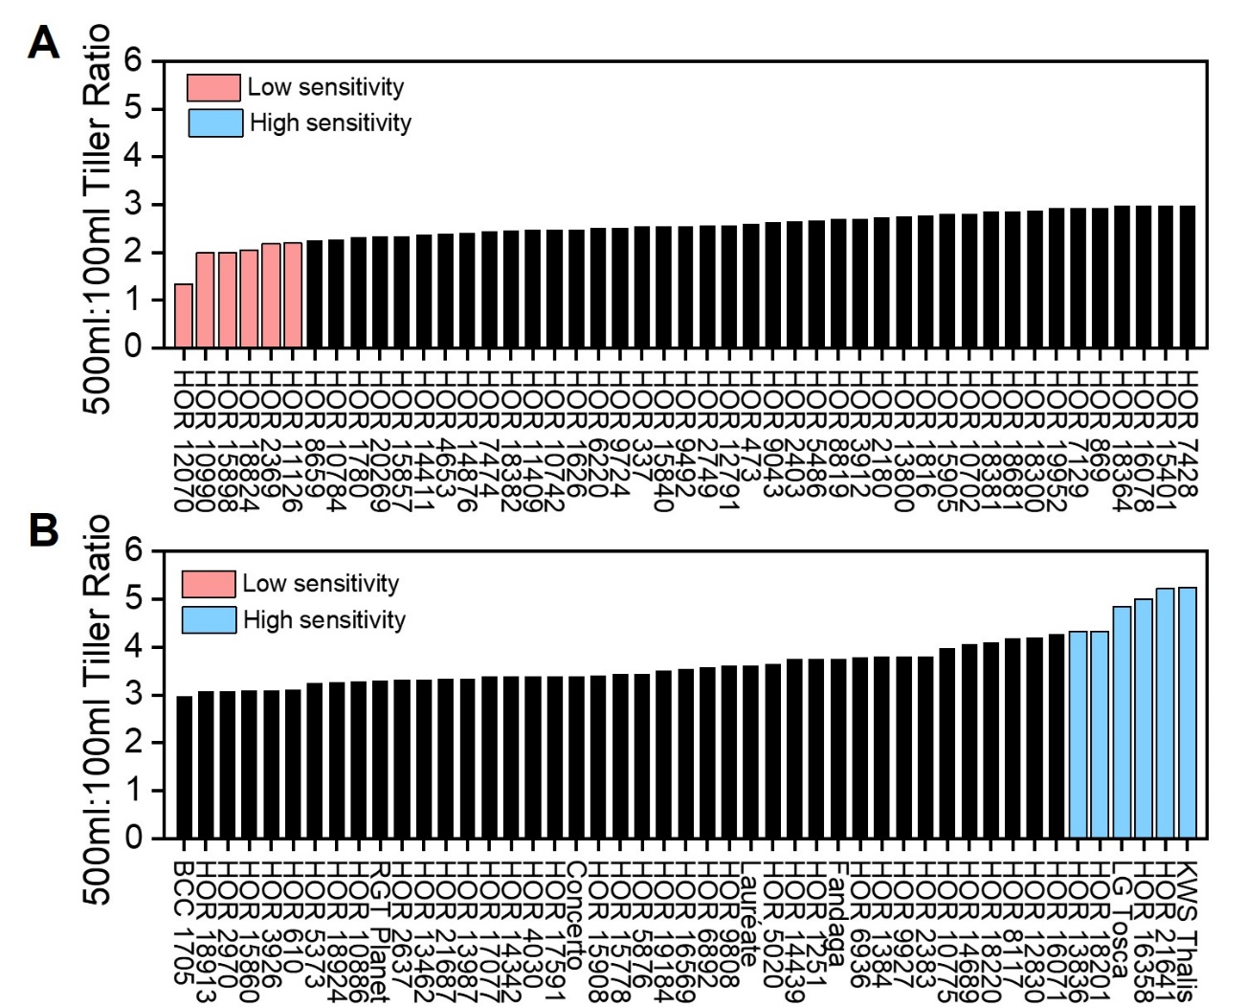
To identify lines of interest that could be useful for uncovering the genetics underpinning this variation in responsiveness to soil volume, peak tiller number and shoot biomass 500ml:100ml ratios were assessed and compared. This aimed to identify several lines where the peak tiller number and biomass ratios were on the same end of the sensitivity spectrum, either high or low. When looking at the 500ml:100ml ratios for peak tiller number this ranged from 1.33-5.25. The 6 lines with the highest (sky blue) and lowest (peach) 500ml:100ml tiller ratio were identified (Fig. 3.14A-B). The high sensitivity lines (lowest to highest respectively) identified were: HOR 13836, HOR 18201, LG Tosca, HOR 16358, HOR 21641, KWS Thalis. The low sensitivity lines (lowest to highest respectively) identified were: HOR 12070, HOR 10990, HOR 15898, HOR 18824, HOR 2369, HOR 11126 (Fig. 3.14A-B).

Figure 3.14 Sensitivity to soil volume is varied across spring barley lines and is reflected in tiller production
A-B) Bar charts showing the 500ml:100ml ratio of peak tiller number (regardless of the week it occurred) in 94 spring barley lines. Peach bars represent low sensitivity lines, sky blue bars represent high sensitivity lines.

The 500ml:100ml shoot biomass ratio also needed to be taken into consideration and this was seen to vary greatly across the lines, from 1.57-11.5 (Fig. 3.15A-B). The lines previously identified via their 500ml:100ml peak tiller ratio were mostly found to cluster in the same end of the sensitivity spectrum as for tiller number. Both the 500ml:100ml peak tiller number and biomass ratios were considered when shortlisting 3 high and 3 low sensitivity lines to assess further (Fig. 3.15A-B).
Regarding the biomass ranking of the low sensitivity lines, HOR 15898 and HOR 2369 were found to cluster towards the middle of the biomass spectrum, hence were no longer regarded as low sensitivity and were not selected for further analysis (Fig. 3.15A). No biomass measurements were able to be taken for HOR 18824 due to COVID-19, hence this line was also removed from the shortlist.
The highly-responsive lines HOR 13836 and HOR 18201 both had a higher (albeit slight) 500ml:100ml shoot biomass ratio than KWS Thalis (Fig 3.15 B). Nevertheless, KWS Thalis was selected over these due to the full genetic history of KWS Thalis being known, and hence providing the potential for better understanding of the genetics underpinning this response.

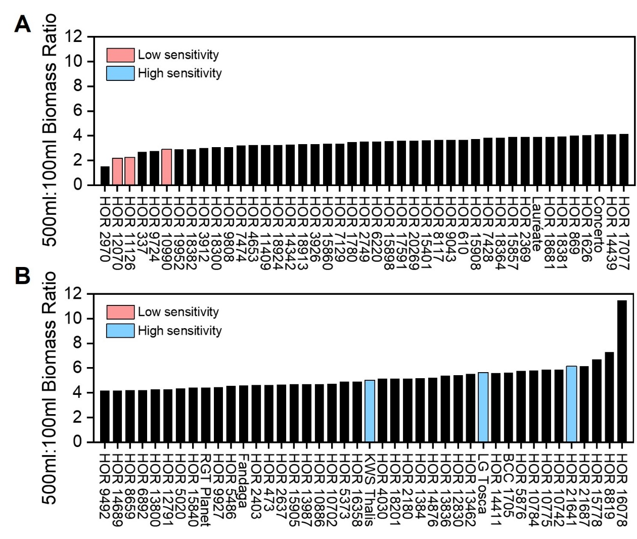
Figure 3.15 Shoot system size varies greatly across spring barley lines in response to soil volume availability
A-B) Bar charts showing the 500ml:100ml ratio of dry shoot biomass at 8 weeks post germination in 85 spring barley lines. Peach bars represent low sensitivity lines, sky blue bars represent high sensitivity lines.

LG Tosca, HOR 21641 and KWS Thalis were thus selected as representative high sensitivity lines for further analysis, and HOR 12070, HOR 10990 and HOR 11126 were selected as the low sensitivity lines. These lines mainly originated in Europe with the exception of HOR 11126 and HOR 21641 which were from Japan and Chad respectively (Table 3.1). Interestingly, the high sensitivity lines comprised of 2 modern lines with one traditional / landrace line, whereas the low sensitivity lines comprised of 2 advanced / improved lines and 1 traditional / landrace line (Table 3.1).
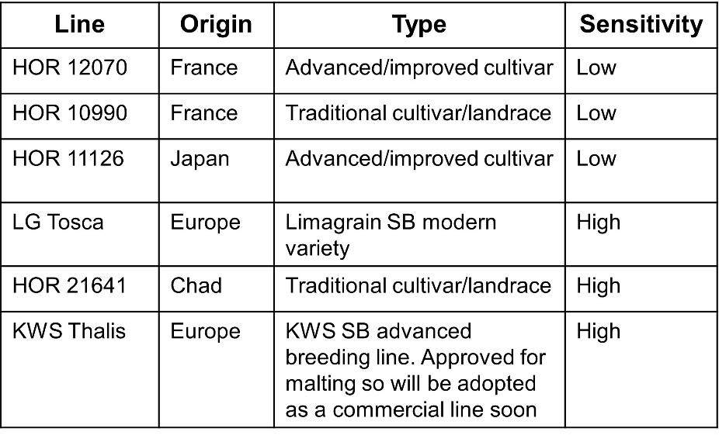

Table 3.1 Information regarding the lines with the highest and lowest sensitivity to soil volume
Table showing the 6 identified spring barley lines which have low and high sensitivity to soil volume and their associated information. Information provided by Klaus Oldach, KWS.

Focussing on the selected lines for further analysis, despite the plants grown in 500ml pots having access to fivefold more soil than those in grown in 100ml pots, the low sensitivity lines only produced 2.18-, 2.24-, 2.91- fold more shoot biomass in 500ml pots (HOR 12070, HOR 10990 and HOR 11126 respectively). The high sensitivity lines were able to produce 5.00-, 5.64-, 6.14- fold more shoot biomass in 500ml pots compared to 100ml pots (KWS Thalis, HOR 21641, LG Tosca respectively) (Fig. 3.13A-B and Fig. 3.16A-B ).

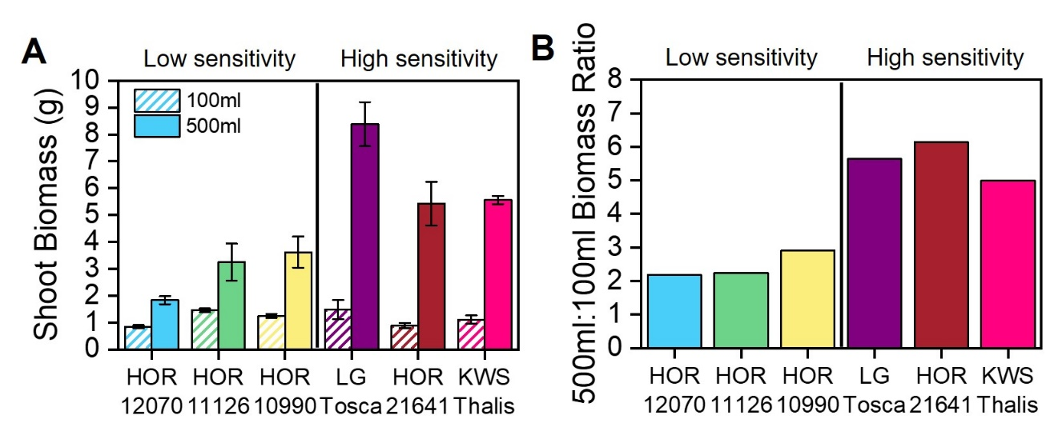
Figure 3.16 Allocation of shoot biomass in response to soil volume in 6 spring barley lines
Low and high sensitivity spring barley lines grown in 100ml and 500ml pots for 8 weeks.
A) Bar chart showing mean dry shoot biomass (g) at 8 weeks post germination of low sensitivity and high sensitivity barley lines to soil volume. Error bars represent s.e.m, n=2-4.
B) Bar chart showing 500ml:100ml dry shoot biomass ratio of low sensitivity and high sensitivity barley lines to soil volume. Error bars represent s.e.m, n=2-4.

Tiller number appeared to be more strongly influenced by soil volume in the low sensitivity lines than shoot biomass as these only produced 1.33-, 2.00- 2.20- fold more tillers in 500ml pots compared to 100ml pots (HOR 12070, HOR 10990 and HOR 11126 respectively) (Fig. 3.17A-B). The high sensitivity lines produced 5.25-, 5.23-, 4.85- fold more tillers in 500ml pots compared to 100ml pots (KWS Thalis, HOR 21641, LG Tosca respectively) (Fig. 3.17A-B). The high sensitivity lines grown in 500ml pots were able to tiller throughout the experiment whereas the low sensitivity lines ceased tiller production early (Fig. 3.17C).

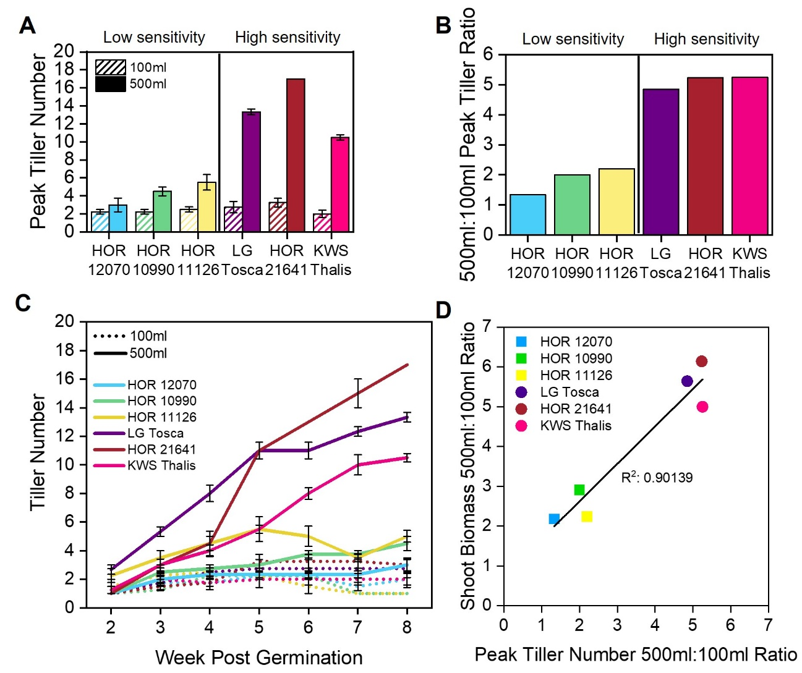
Figure 3.17 Tiller number production varies in spring barley lines
Low and high sensitivity spring barley lines grown in 100ml and 500ml soil volumes for 8 weeks.
A) Bar chart showing peak tiller number on which ever week it occurred between week 2-8 post germination of low sensitivity and high sensitivity barley lines to soil volume. Dashed bars represent plants grown in 100ml pots and solid bars represent plants grown in 500ml pots. Error bars represent s.e.m, n=2-4.
B) Bar chart showing 500ml:100ml peak tiller ratio of low sensitivity and high sensitivity barley lines to soil volume, n=2-4.
C) Line graph showing tiller number between week 2 and 8 post germination of low sensitivity and high sensitivity barley lines to soil volume. Plants grown in 100ml pots are represented as dashed lines and plants grown in 500ml pots are represented as solid lines. Error bars represent s.e.m, n=2-4.
D) Scatterplot of shoot biomass 500ml:100ml ratio and peak tiller number 500ml:100ml ratio, n=2-4. Dots represent high sensitivity lines and squares represent low sensitivity lines. R² is the Adjusted R Square.

These findings were communicated to our collaborator Klaus Oldach at KWS and a series of crosses were carried out by KWS between the high sensitivity lines KWS Thalis and HOR 21641, with the low sensitivity lines: HOR 12070, HOR 11126 and HOR 10990. The doubled haploid technique was used to generate offspring as this produces homozygous offspring much faster than traditional line breeding programs.
The resulting doubled haploid F2 populations from these crosses will been taken forward for phenotyping using the same experimental design as the initial screen. Once this has been completed, quantitative trait loci (QTL) can be mapped, ultimately leading to the identification of genomic regions that are responsible for soil volume sensitivity. Unfortunately, due to time constraints this screen has not yet been carried out.
The data presented here from the initial screen has shown a large amount of variation in soil volume responsiveness amongst the lines investigated. This highlighted that lines which have undergone more intensive breeding are more sensitive to soil volume and thus can take advantage of the additional space available to them more efficiently.

Response of root system architecture (RSA) to soil volume and neighbour density

In sections 3.2 and 3.3, I outlined the shoot growth responses of plants to soil volume and neighbour density. However, despite plants perceiving the available soil volume with their roots, it is not clear what the effects of soil volume on root system architecture are.

By visualising the root system, I aim to investigate if the density of roots in the pot could explain all or part of the shoot-based responses to soil volume. As plants grown in large soil volumes produce greater shoot system size (biomass and tiller number) than those in small soil volumes, I hypothesised that root system size (root number and length) would also follow the same trend, as plants in large soil volumes would have more space for their root systems to explore. Similarly, I hypothesised that plants grown in crowded treatments would have smaller root systems than those grown uncrowded in the same soil volume.

I also wanted to address how and if root system architecture differs between plants in small and large soil volumes. Do plants grown in small soil volumes have the same distribution of root types (seminal and lateral roots) but produce less of them compared to plants in large soil volumes? Or is there a preference of one root type over the other in small pots perhaps to aid resource capture? Therefore, I hypothesised that plants grown in small soil volumes would have more lateral roots to provide a larger surface area for resource capture than those in large soil volumes.

Root system growth response to soil volume in barley and wheat

To explore root system architecture in different soil volumes, I first asked if barley and wheat root system architecture respond in the same way to soil volume availability. I hypothesised they would, given their strong similarities in shoot growth habit when grown in different pot sizes, albeit with barley usually producing a relatively larger shoot system than wheat (Fig. 3.1 and 3.4). In addition, I hypothesised that plants grown in small pots would produce smaller shoot systems than those in larger pots due to increased root density sooner in small pots.
To investigate root system response to soil volume, barley (cv. Charon) and wheat (cv. Mulika) seeds were pregerminated for a week then placed singly into 150ml and 1100ml rhizoboxes filled with compost (Chapter 2). Pre-germination aimed to remove the possibility of sowing seeds in the wrong orientation (i.e. shoots downwards and roots upwards) and also to ensure all rhizoboxes had successfully germinated seed. Rhizoboxes were scanned twice weekly until 64 and 72 (wheat and barley respectively) days post germination when shoots were harvested and dried for biomass measurements.
I first wanted to establish the root system response overtime and identify if the shoot-based differences seen in different soil volumes could involve root density. To do this, I devised a method of assessing root density using a root density score as described in detail in Chapter 2. The root density score does not provide information about absolute root system size, but rather provides an insight into the relative density of roots in the given soil volume.
In the first few weeks, the root density score was highest in the 150ml grown plants in both species (Fig. 3.18A), this is not necessarily surprising given these plants are in a small soil volume.
Analysis of barley showed that, the 150ml plants consistently maintain a high density of roots in their given soil volume compared to those grown in 1100ml rhizoboxes until later on in life. The plants grown in 150ml rhizoboxes continue to increase their root density until ~55 days post germination where root production appears to cease (Fig. 3.18A). The plants in the 1100ml rhizoboxes however appear to continue to steadily produce roots for at least 10 days longer than the 150ml grown plants (Fig. 3.18A), eventually reaching the same root density. This suggests that barley root systems become inhibited in their root growth when their root density reaches a critical threshold, and this occurs earlier in the smaller rhizoboxes. The plants grown in the 1100ml rhizoboxes have more soil volume in which their roots can spread hence can continue to produce roots for longer before reaching this root density threshold and then becoming inhibited.
The same trend can be seen in wheat, however the maximum root density score seen in both soil volumes is lower than in barley (Fig. 3.18A). This could suggest that wheat has a higher sensitivity to root density than barley, hence inhibiting root growth at an earlier time. However, this could be interlinked with inherent differences in their developmental growth speeds as wheat also ceases its tiller production before barley (Fig. 3.22A).

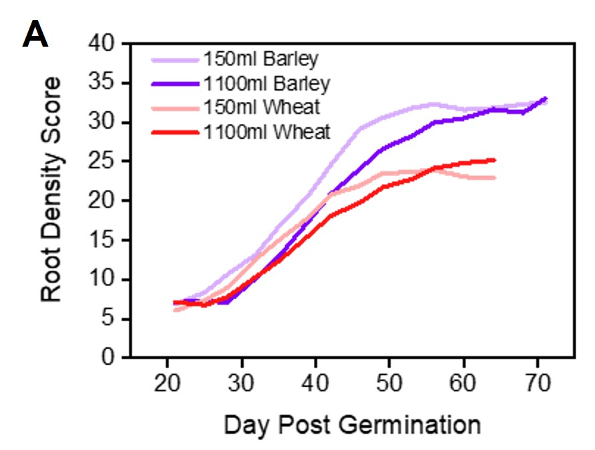

Figure 3.18 Root density increases faster in small soil volumes
Barley (cv. Charon) and Wheat (cv. Mulika) plants were pregerminated for 1 week before transferring into 150ml (barley: lilac, wheat: peach) and 1100ml (barley: purple, wheat: red) rhizoboxes. Rhizoboxes were imaged every 3-4 days from day 11-64 for wheat and day 11-71 for barley.
A) Line graph showing the root density as a percentage of roots (white pixels) to soil (black pixels) (as described Chapter 2) over time as a rolling average of 4 time points each 3-4 days apart.

As plants in small rhizoboxes showed an elevated root density earlier on in plant life than those in large rhizoboxes, I explored root growth in greater detail to identify how that could be achieved. I aimed to understand how the plants allocate root types in different soil volumes and hence I needed to define and measure these. I have defined seminal roots as roots which emerge from the seed, these are generally the thickest roots and often have fine roots which emerge from them (Fig. 2.4). I have defined lateral roots as the fine roots which emerge from the seminal roots, these are often much shorter than the seminal roots (Fig. 2.4). I measured individual root length of seminal and lateral roots for each rhizobox at 11-, 14-, 18- and 21-days post germination and from this I was able to calculate total root length (as a sum of all lateral and seminal root lengths), and total root number (as a sum of the total number of seminal and lateral roots) (Fig. 3.19A-B). By assessing roots in this early time window, I aimed to identify how soon differences in root architecture could be seen between soil volumes and determine if certain features of the root system were more affected by soil volume availability than others.
At 11 days post germination, total root length in barley plants is equal in both soil volumes (Fig. 3.19A). The same can be said of wheat, however wheat plants produced ~2 fold greater total root length at this timepoint than barley plants (Fig. 3.19A). Total root number of barley plants is also equal in both soil volumes at 11 days post germination (Fig. 3.19B). This same trend is also reflected in wheat as total root number is also equal in both soil volumes at this timepoint and these plants produce a similar number of roots to barley (Fig. 3.19B).
After 11 days post germination, a trend begins to emerge in both species where the plants grown in 150ml rhizoboxes produced a greater total number of roots and root length compared to those in 1100ml rhizoboxes. This is maintained until at least 21 days post germination (Fig. 3.19A-B).

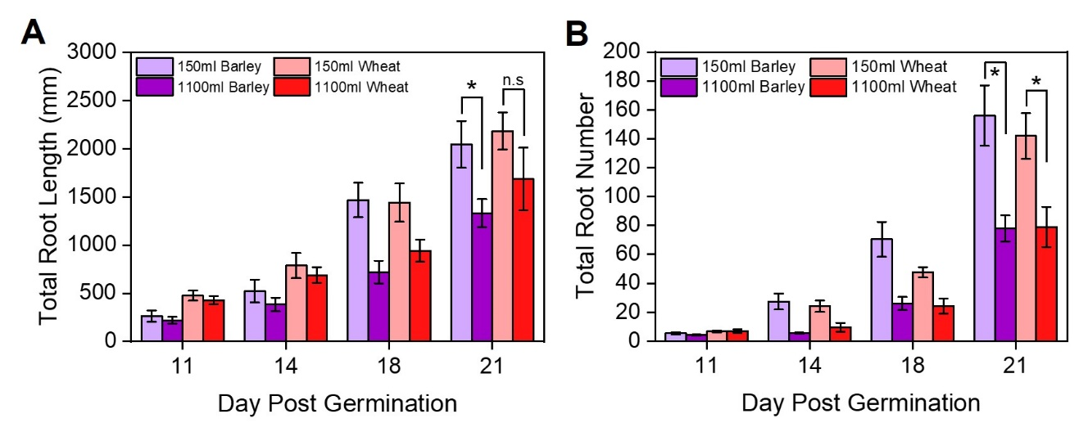
Figure 3.19 Total root number and length differs between soil volumes within the first 3 weeks post germination
Barley (cv. Charon) and Wheat (cv. Mulika) plants were pregerminated for 1 week before transferring into 150ml and 1100ml rhizoboxes. Rhizoboxes were imaged every 3-4 days from day 11-21 post germination.
A-B) Bar charts showing total root length (mm) (A) and total root number (B) at 11, 14, 18 and 21 days post germination. Statistical tests were carried out separately for each species, asterisks indicate significant difference, n.s represents no significant difference (Day 21; A) barley- Mann Whitney U p<0.05, wheat- Independent samples T-test, p<0.05, B) barley and wheat- Independent samples t-test, p<0.05) n=5.

In wheat, plants produced a similar seminal root length and number in both soil volumes at 11 days post germination (Fig. 3.20A-B). However, in barley at this time point, seminal root length is equal in both soil volumes whereas the number of seminal roots is greater in the 150ml rhizoboxes than in 1100ml rhizoboxes (Fig. 3.20A-B). After day 11 post germination however, there does not appear to be a consistent difference in seminal root length and number. At 21 days there was no statistical difference in seminal root number or length between the soil volumes in both wheat and barley (Fig. 3.20A-B).
Together, analysis of the total and seminal root length and number data suggests that at 11 days post germination, plants are unable to sense their available soil volume, perhaps through simply not colonising enough of the space yet.
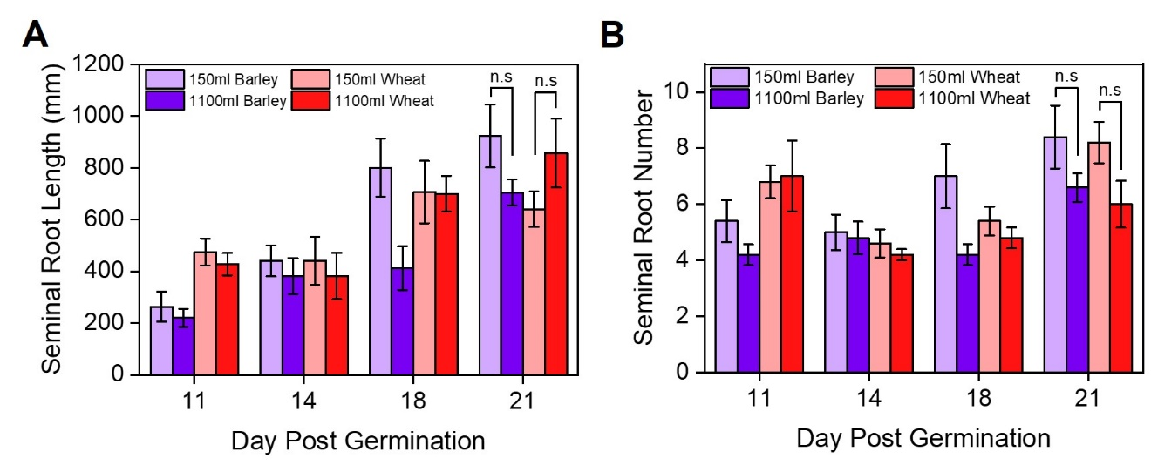
Figure 3.20 Seminal root growth in wheat and barley is not affected by soil volume
Barley (cv. Charon) and Wheat (cv. Mulika) plants were pregerminated for 1 week before transferring into 150ml and 1100ml rhizoboxes. Rhizoboxes were imaged every 3-4 days from day 11-64 for wheat and day 11-71 for barley.
A-B) Bar charts showing mean seminal root length (mm) (A) and mean seminal root number (B) at 11-, 14-, 18- and 21-days post germination. Statistical tests were carried out separately for each species, n.s indicates no significant difference (Day 21; Independent samples t-test, p<0.05) n=5.

This trend of elevated total root number and length in small soil volumes arises from differences in lateral root number and length from 14 days post germination (Fig. 3.21A-B) as there is no clear difference in seminal root length and number before 21 days post germination (Fig. 3.20A-B). This could explain why root density in the 150ml rhizoboxes is higher early in life (Fig. 3.18A).

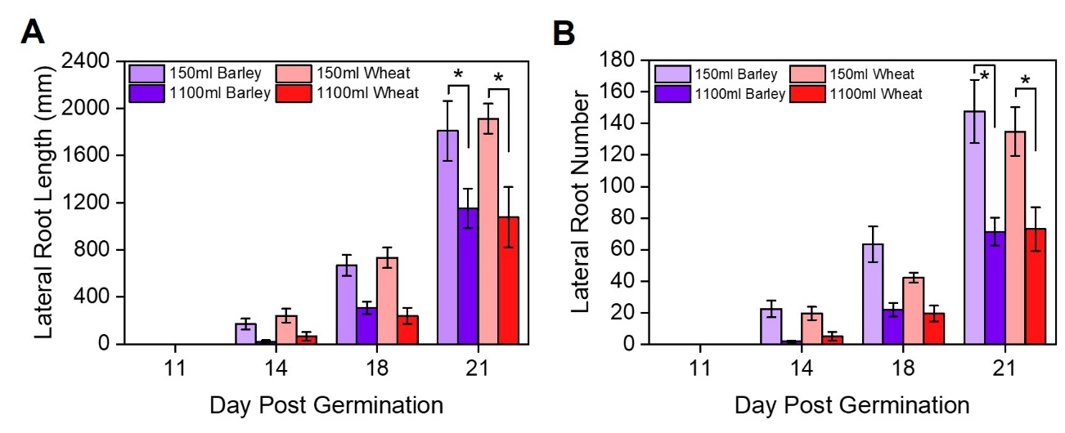
Figure 3.21 Barley and wheat produce more and longer lateral roots in small soil volumes compared to large soil volumes
Barley (cv. Charon) and Wheat (cv. Mulika) plants were pregerminated for 1 week before transferring into 150ml and 1100ml rhizoboxes. Rhizoboxes were imaged every 3-4 days from day 11-21.
A-B) Bar chart showing mean total lateral root length (mm) (A) and mean total lateral root number (B) at 11-, 14-, 18- and 21-days post germination. Statistical tests were carried out separately for each species, asterisks indicate significant difference (Day 21; A) barley: Mann Whitney U p<0.05, wheat: Independent samples t-test, p<0.05, B) barley and wheat: Independent samples t-test, p<0.05) n=5.

To ask if shoot growth was affected by the 2D nature of the rhizoboxes, and hence behaved similarly to that of sections 3.2.1 and 3.2.2, shoot system growth was assessed concurrently with root system growth by assessing tiller number from week 2-8 in wheat and 2-9 in barley and harvesting shoots for dry shoot biomass at the end of the experiment. Shoot growth occurred as expected, with both species produced a greater number of tillers in 1100ml rhizoboxes compared to 150ml rhizoboxes (Fig. 3.22A).
Barley and wheat produced the same peak tiller number of ~6 in 150ml rhizoboxes whereas in 1100ml rhizoboxes, wheat produced ~19 tillers, and barley produces ~25 tillers. Wheat reaches its peak tiller number 2 weeks earlier than barley, with the subsequent senescence of tillers following shortly after (Fig. 3.22A). Wheat plants began senescing tillers around 3 weeks earlier than barley. Root density measurements were also seen to reach the critical threshold earlier in wheat than barley (Fig. 3.18A).
When shoot biomass was assessed, there was a statistically significant difference in 150ml and 1100ml grown plants for both species. Barley plants also had a higher shoot biomass than wheat when grown in 1100ml rhizoboxes. However, both species produced a similar, lower shoot biomass when grown in 150ml rhizoboxes (Fig. 3.22B).
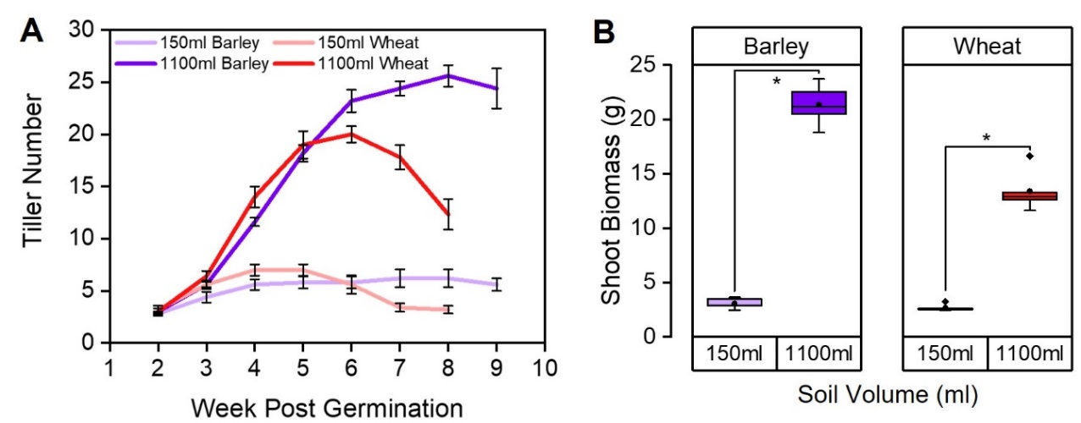
Figure 3.22 Soil volume effects are present in shoot systems of plants grown in rhizoboxes
Barley (cv. Charon) and Wheat (cv. Mulika) plants were pregerminated for 1 week before transferring into 150ml and 1100ml rhizoboxes.
A) Line graph showing tiller number over time. Error bars represent S.E.M, n=5.
B) Boxplots showing mean dry shoot biomass at 64 and 71 days post germination for wheat and barley respectively, grown in 2 rhizobox sizes. Statistical tests were carried out separately for each species, asterisks indicate significant difference (Independent samples t-test, p<0.05) n=5.

Bringing this together, both wheat and barley appear to reach a critical threshold of root density sooner in 150ml rhizoboxes than 1100ml rhizoboxes. Nevertheless, the plants grown in 1100ml rhizoboxes eventually reach the same root density, albeit later in life. Perception of root density could therefore potentially be part of a mechanism in which plants detect and respond to their soil volume (and neighbour density). In addition, the root system architecture of both species appears to respond to soil volume in a similar manner as both species produced a greater number and length of roots in small rhizoboxes compared to the large rhizoboxes early in life.

Barley root system architecture in response to neighbouring plants

In Section 3.2 I showed that available soil volume per plant is an important predictor of final shoot growth. This also showed that crowded plants ‘over-produced’ shoot biomass in crowded treatments, therefore I hypothesised that root growth may act in a similar way given the roots detect the availability of belowground space. To visualise how roots of the same genotype grow when crowded, the rhizobox system was used as described previously. Barley (cv. Charon) seeds were pregerminated on filter paper for 1 day and then transferred into 1100ml rhizoboxes in either 1 plant per pot (1/pot) or 4 plants per pot (4/pot). 4/pot plants were evenly spaced across the rhizobox (Fig. 3.23A).

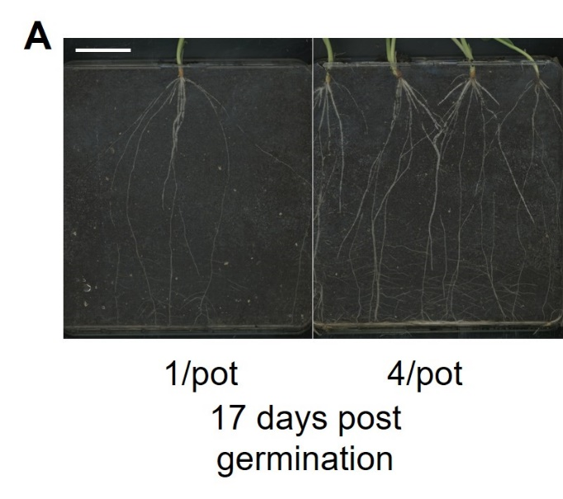

Figure 3.23 Barley roots in crowded and uncrowded rhizoboxes
A) Images of barley (cv. Charon) roots grown either 1/pot or 4/pot at 17 days post germination. Scale bar represents 5cm.

To investigate if there is an overproduction of roots in crowded rhizoboxes, I measured root length and number at 4 time points early in life as described previously in section 3.4.1. Analysis of total root length per plant showed that this was slightly but statistically significantly greater in the 1/pot treatment than the 4/pot treatment within the first 17 days post germination (1.1-, 1.3-, 1.3-, 1.6- fold respectively) (Fig. 3.24A). Total root length per pot was statistically significantly greater in the 4/pot treatment (3.6-, 2.9-, 3.1-, 2.4- fold respectively) (Fig. 3.24B).

Despite producing longer roots in the 1/pot treatment, the total root number per plant was not significantly different between the treatments, and did increase over time, whereas total root number per pot was greater in the 4/pot treatment compared to the 1/pot treatment (4.1-, 4.0-, 3.8-, 3.5- fold respectively) (Fig. 3.24A+B). This suggested that crowded plants also over-produce roots in crowded treatments. Unfortunately, counting individual roots became too difficult after 17 days post germination but, nevertheless this data suggests that in this system the plants did not stop producing roots throughout the experiment regardless of their crowding treatment.
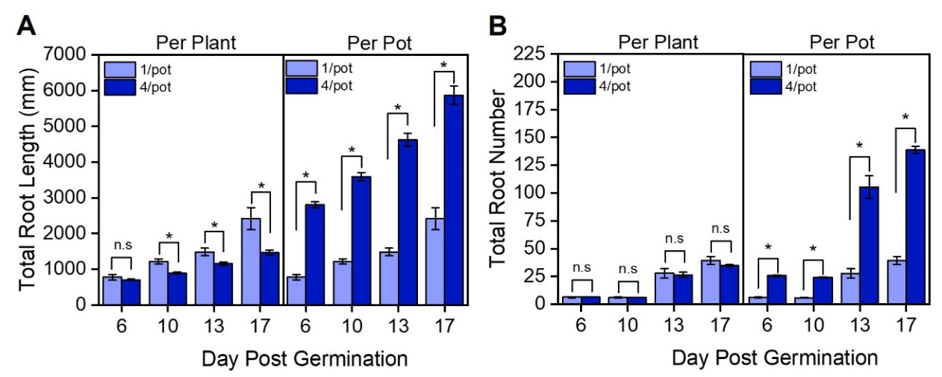
Figure 3.24 Barley root production continues regardless of crowding treatment
Graphs showing spring barley (cv. Charon) grown in 1100ml rhizoboxes in either 1 plant per pot (1/pot) or 4 plants per pot (4/pot).
A-B) Bar charts showing total root length per plant and per pot (mm) (A) and total root number per plant and per pot (B) from day 6 to 17 post germination. Error bars represent S.E.M, Asterisks represent significant difference, n.s represents no significant difference (Independent samples t-test for all except day 10 total root length per plant and per pot where Mann Whitney U was used), n=6-8.

Suggestions have been made in the literature that rice plants of the same genotype appear to avoid each other (Fang et al., 2013). However, at 6 days post germination I could already observe collision and overlap between roots from different plants in the 4/pot treatment (Fig. 3.25A), suggesting that in barley, and in this system, roots of the same genotype do not avoid one and other. From the limited available knowledge on this it is not clear whether this is a species-specific difference, or a difference caused by the system in which the plants are grown. Nevertheless, direct contact with roots of neighbouring plants did not prevent root growth from continuing as shown by the root number and length data in this rhizobox system (Fig. 3.24A+B).

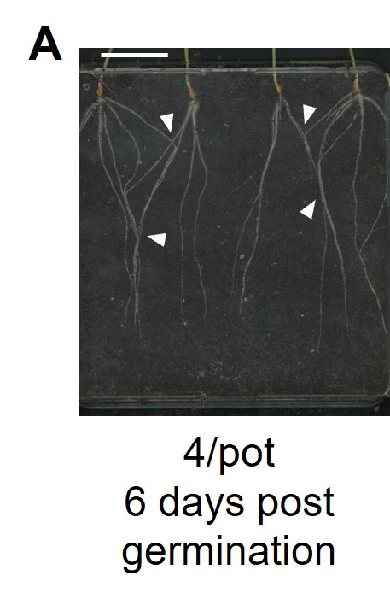
Figure 3.25 Barley roots overlap when grown with other barley plants
Spring barley (cv. Charon) grown in 1100ml rhizoboxes 4 plants per pot (4/pot).
A) Image of wheat roots in a 4/pot rhizobox at 6 days post germination. White arrow heads indicate points of neighbouring plant root collision or overlap. Scale bar represents 5cm.

Again, I aimed to ask that shoot growth behaved similarly as barley plants in section 3.2.2 to ensure root growth seen in this rhizobox system would be comparable, therefore tiller number was assessed from week 2-7 post germination. As expected 1/pot plants produced a greater number of tillers per plant over time than the 4/pot treatment (Fig. 3.26A). The peak tiller number of 1/pot plants was 3.3-fold greater than that of individual plants in the 4/pot. Thus, overall, per pot 4/pot plants produced 1.2-fold more tillers than the 1/pot plants (Fig. 3.26A), again showing an ‘over production’ of shoot growth in the crowded scenario. This supports what was seen previously in pot grown barley section 3.2.2 suggesting that the shoot response to rhizoboxes and pots is the same.
Shoot biomass per plant and per pot was significantly different between the treatments (Fig. 3.26B). Shoot biomass per plant was strongly reduced (~3-fold) in the 4/pot treatment compared to the 1/pot treatment (Fig. 3.26B). Total shoot biomass per pot was 1.3-fold greater in 4/pot treatment than the 1/pot treatment (Fig. 3.26B). This also supports the ‘over-production’ of shoot biomass seen in 3.2.2.
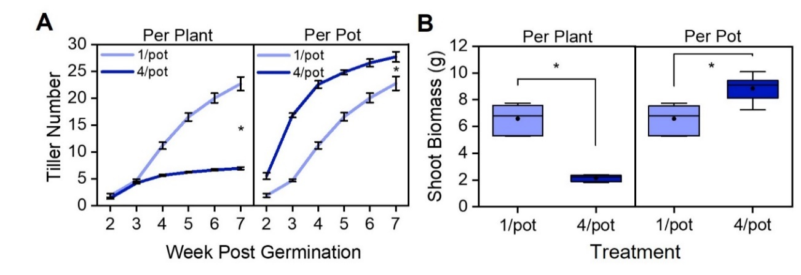
Figure 3.26 Crowded barley plants produce fewer tillers and shoot biomass per plant than uncrowded plants
Graphs showing spring barley (cv. Charon) grown in 1100ml rhizoboxes in either 1 plant per pot (1/pot) or 4 plants per pot (4/pot).
A) Line graph showing mean tiller number per plant and per pot from week 2-7 post germination. Error bars represent S.E.M, Asterisks represent significant difference (Independent samples t-test, p<0.05, n=6-8).
B) Box plot showing the mean final dry shoot biomass per plant and per pot at 7 weeks post germination. Asterisks represent significant difference (Independent samples t-test, p <0.05) n=6-8. The box indicates the interquartile range, the midline represents the median, the whiskers are the minimum and maximum values, the circle is the mean.

Bringing this data together, the number of roots produced per plant between the crowding treatments was equal which could display an inherent ‘minimum’ amount of roots the plants are able to produce in this soil volume. This resulted in an early increase in total number of roots per rhizobox in the case of the 4/pot treatment. Therefore, it could be hypothesised that 4/pot treatments would have higher root density sooner than those in 1/pot treatments, which could explain shoot based differences seen between the treatments.

Root density and shoot system size are uncoupled in barley

In section 3.3, I showed that there is large variation in shoot growth responses (tiller number and shoot biomass) to soil volume due to genetic diversity in the barley lines I screened. I identified three low (HOR 10990, HOR 11126 and HOR 12070) and three high (HOR 21641, KWS Thalis and LG Tosca) soil volume sensitivity lines. I hypothesised that the observed shoot growth responses would also be reflected in the root system growth, i.e. if higher soil volume sensitivity was present in a line I expected to see this in the root system too and that this may be seen in the root density threshold. In addition, I aimed to identify if different lines allocated their root number and length differently which could potentially explain their shoot phenotypes. To test this, I used the same rhizobox system described previously, but the seeds were only pregerminated for 3 days to ensure minimal root growth had occurred before transplantation into the rhizoboxes.

As barley and wheat plants showed a different root density threshold in section 3.3.1, I hypothesised that there may be intraspecific variation in root density in the barley lines of interest. Using the same root density measurement system as in 3.3.1, I saw that the root density scores varied across the lines assessed (Fig. 3.27A). The low sensitivity line HOR 10990 produced a low density of roots compared to the others suggesting this line has a low threshold of root density tolerance before inhibiting root growth. On the converse, the high sensitivity line HOR 21641 appears to be able to tolerate a much higher root density and by the end of the experiment had not yet ceased root production as the root density score is yet to plateau. However, these differences were not seen in all the lines assessed hence root density cannot solely explain the shoot growth phenotypes seen. LG Tosca appears to tightly regulate its root density as this increases at the same rate in both soil volumes, nevertheless the plants in the large rhizoboxes will still produce proportionally more roots than in small rhizoboxes.

This data suggests that the density of roots cannot be the only explanation for the soil volume sensitivity of the lines as this is variable within the sensitivity categories. Therefore, this suggests there is no clear link between root density and shoot growth responses to soil volume in these lines.

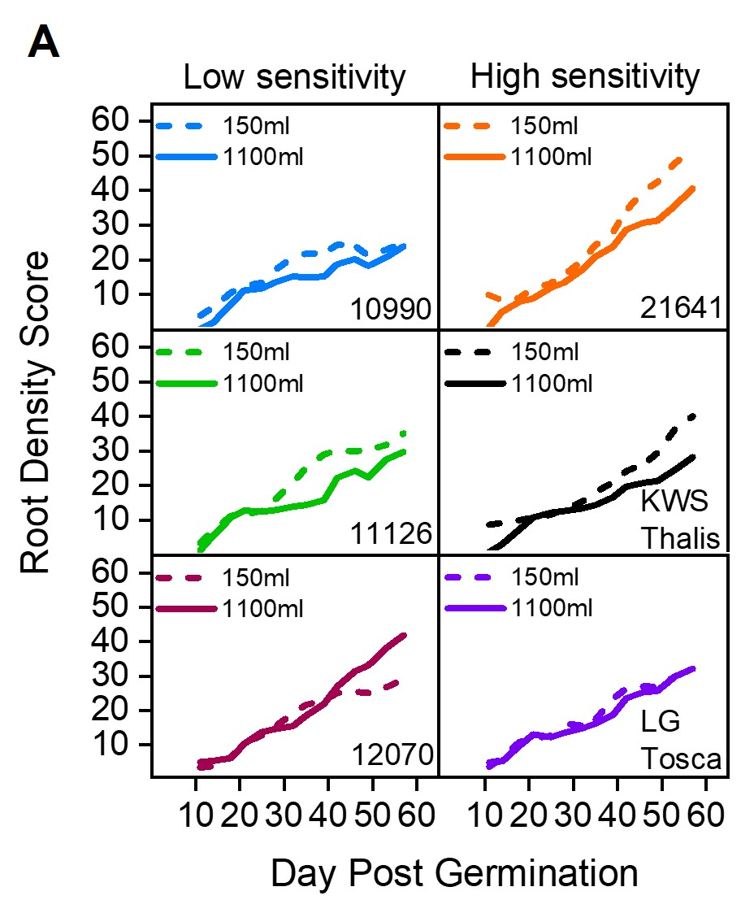

Figure 3.27 Root density is variable across spring barley lines
Figure showing barley lines HOR 10990, HOR 11126, HOR 12070, HOR 21641, KWS Thalis and LG Tosca selected from the soil volume phenotyping screen presented in chapter 3. Plants were pregerminated for 3 days before transferring into 150ml and 1100ml rhizoboxes. Rhizoboxes were imaged every 3-4 days from day 7-57 post germination.
A) Line charts of root density as a percentage of white pixels (roots) to black pixels (compost) in 150ml and 1100ml rhizoboxes from day 7-57 post germination (described in chapter 2). Data is presented as a rolling average of the previous 2 timepoints where each timepoint was 3-4 days apart, n=1-3.

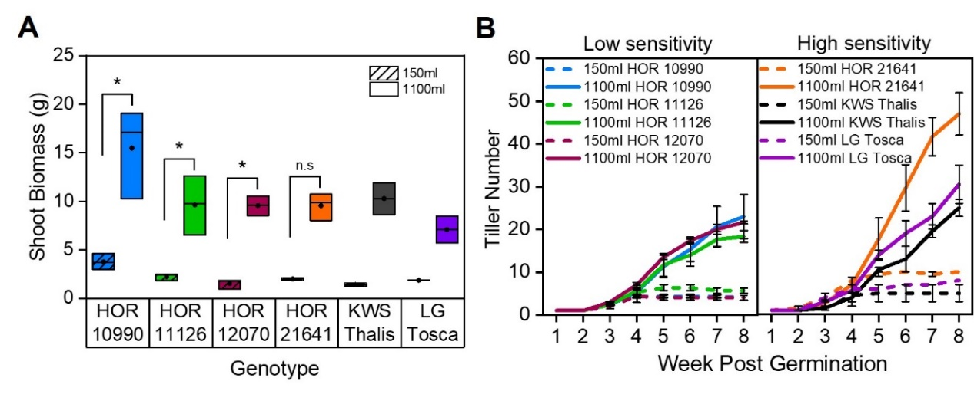
To explore the root and shoot growth responses further, tillering and shoot biomass was assessed. As expected, shoot biomass was greatest in 1100ml rhizoboxes compared to 150ml rhizoboxes, regardless of the variety (Fig. 3.28A). Low sensitivity lines produced fewer tillers in both soil volumes compared to high sensitivity lines, nevertheless, tiller number was always greater for plants in 1100ml rhizoboxes compared to 150ml rhizoboxes (Fig. 3.28B). As these tiller number trends were also seen in the standard pots used for assessments section 3.3, I can be confident that despite the 2D nature of rhizoboxes, they are not leading to the inhibition of shoot growth responses.
Figure 3.28 Low and high sensitivity spring barley lines grown in rhizoboxes tiller in a similar manner to those grown in pots
Figure showing barley lines HOR 10990, HOR 11126, HOR 12070, HOR 21641, KWS Thalis and LG Tosca selected from the soil volume phenotyping screen presented in chapter 3. Plants were pregerminated for 3 days before transferring into 150ml and 1100ml rhizoboxes.
A) Boxplots showing mean dry shoot biomass (g) at 57 days post germination. The box indicates the interquartile range, the midline represents the median, the circle is the mean. Statistical tests were carried out separately for each genotype, asterisks indicate significant difference, n.s indicated so statistical difference (Independent samples t-test for HOR 10990, HOR 11126 and HOR 12070, Mann Whitney U for HOR 21641, p<0.05) n=1-3.
B) Line graphs showing tiller number over time from week 1-8 post germination. Error bars represent S.E.M, n=1-3.

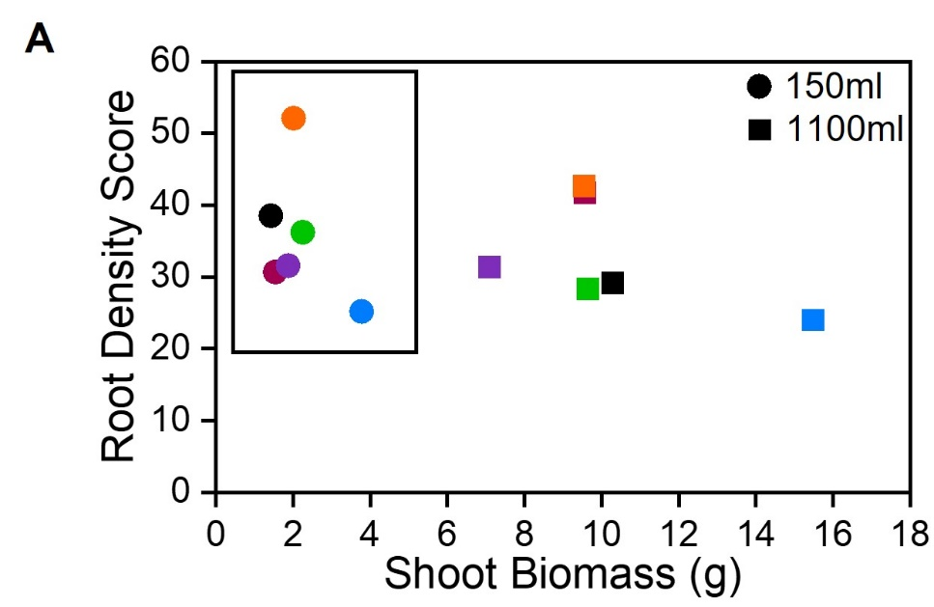
When shoot biomass and root density measurements at 57 days post germination were compared, the lines grown in the 150ml rhizoboxes were found to have similar shoot biomasses regardless of the maximum root density (highlighted with a box) whereas those grown in 1100ml rhizoboxes show the opposite effect; very different shoot biomasses despite similar maximum root density (Fig 3.29A). This suggests that shoot and root system size are not closely coupled in barley and therefore root density is not predictive of shoot system size in barley.

Figure 3.29 Root and shoot system size are unlinked in barley
Figure showing barley lines HOR 10990, HOR 11126, HOR 12070, HOR 21641, KWS Thalis and LG Tosca selected from the soil volume phenotyping screen presented in chapter 3. Plants were pregerminated for 3 days before transferring into 150ml and 1100ml rhizoboxes. Rhizoboxes were imaged every 3-4 days from day 7-57 post germination.
A) Scatter chart with shoot biomass (g) plotted against root density score. Circles indicate 150ml rhizoboxes and squares indicate 1100ml rhizoboxes. The box within the chart surrounds the 150ml data points. HOR 10990 (blue), HOR 11126 (green), HOR 12070 (burgundy), HOR 21641 (orange), black (KWS thalis) and LG Tosca (purple).

To investigate if there are root system architecture differences between the lines, I assessed total root length and number as described in section 3.4.1. At 18 days post germination, trends seen in total root length reflect those seen in 3.3.1 as this was generally greater (although not significantly different) in the plants grown in 150ml rhizoboxes with the exception of HOR 11126 and HOR 12070 (Fig 3.30 A). Total root number also reflects those seen in section 3.4.1, as there are more roots in 150ml rhizoboxes than in 1100ml rhizoboxes (although not statistically significant), with the exception of HOR 12070 and LG Tosca (Fig. 3.30B).

The root system architecture of HOR 12070 was visibly different to the other lines as this had very few seminal roots but a large number of relatively long lateral roots emerging from the lower 2/3rd of the seminal roots (Fig. 3.30C). This explains why the root length and root number of HOR 12070 plants does not exhibit the same responses to the other lines. Other research has supported this finding as seminal root number has significantly increased in modern barley cultivars compared to landrace varieties (Grando and Ceccarelli, 1995), whereas HOR 12070 is not classified as a modern barley variety, instead it is an Advanced/Improved variety (Table 2.2).

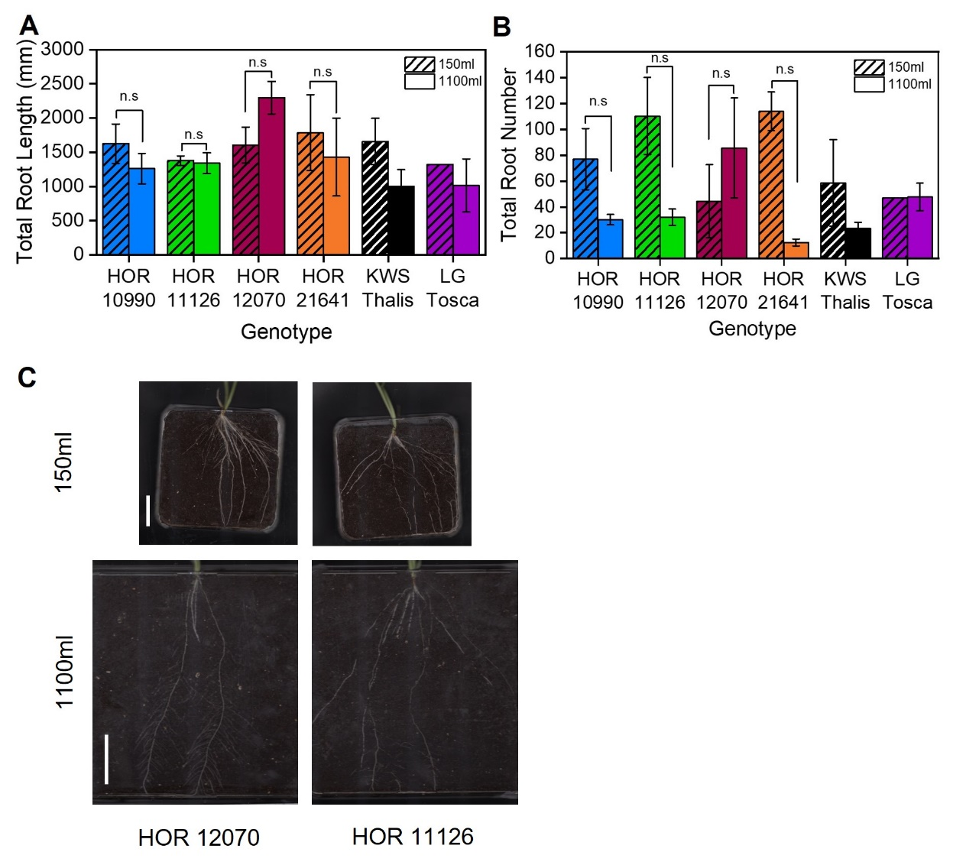
Figure 3.30 Root length and root number is generally elevated in small soil volumes in barley lines
Figure showing barley lines HOR 10990, HOR 11126, HOR 12070, HOR 21641, KWS Thalis and LG Tosca selected from the soil volume phenotyping screen presented in chapter 3. Plants were pregerminated for 3 days before transferring into 150ml and 1100ml rhizoboxes. Rhizoboxes were imaged every 3-4 days from day 7-57 post germination.
A-B) Bar chart showing total mean root length (mm) (A) and total mean root number (B) at 18 days post germination. Statistical tests were carried out separately for each genotype, asterisks indicate significant difference, n.s indicated no statistical difference (Independent samples t-test for HOR 10990, HOR 11126 and HOR 12070, Mann Whitney U for HOR 21641, p<0.05) n=1-3.
C) Images of HOR 12070 and HOR 11126 root systems at 18 days post germination. For 150ml rhizoboxes scale bar represents 30mm. For 1100ml rhizoboxes the scale bar represents 60mm.

Taken together this data suggests that in barley, the growth of the root system and shoot system are uncoupled. Although root length and root number data generally suggested that there were more and longer roots in small rhizoboxes this was not statistically significant therefore there was no difference between the soil volumes. Root density assessments varied greatly across the lines and therefore root density cannot be the only explanation for the sensitivity of plants to their availably soil volume.

Root system growth response in wheat landrace lines

The previous work in this chapter has outlined that there is inter and intraspecific variation in soil volume response. As with barley in section 3.4.3, I also aimed to ask whether diverse wheat lines show differences in their root growth response to soil volume. The barley lines in section 3.4.3 showed that root and shoot system growth are not closely coupled, however I hypothesised that in wheat they likely would be given the intensive breeding programs in wheat and the possibility of trade-offs between the growth of the root and shoot systems. In addition, I hypothesised that the angle of root emergence from the seed may influence plant responses to soil volume. This is because the angle of root emergence from the seed determines the direction in which the roots begin their growth. The angle of root emergence in seedlings has been shown to strongly determine root system architecture later in life (Manschadi et al., 2008). Lines with a steep root angle would likely fail to colonise the upper areas of the soil and hence may perceive they have access to a smaller space than they actually have available to them. On the converse, lines with a shallow rooting angle may allow for upper soil colonisation but these plants may be affected early by mechanical interaction with the side of the pot possibly resulting in a perceived limitation of available space in that regard.

The elite spring wheat cultivar Mulika and six spring wheat landrace lines were selected for this assessment. I used data from a previous screen of wheat lines (F. Walsh, personal communication) to identify lines with steep or shallow root system architectures, determined by their width/depth ratio. I selected 3 spring wheat lines with a steep rooting phenotype (low width/depth ratio) Yogi 005, Yogi 020, and Yogi 343, and 3 lines with a shallow rooting phenotype (high width/depth ratio) Yogi 065, Yogi 101 and Yogi 137.
To first explore if the root and shoot systems of wheat are coupled, I compared shoot biomass and the root density score (both at 56 days post germination) of the lines in both soil volumes (Fig. 3.31A). The points clustered according to their soil volumes, but each separately showed a strong linear relationship. The plants grown in the 150ml rhizoboxes were tightly clustered, whereas those in 1100ml rhizoboxes were more spread (Fig. 3.31A). There was a positive correlation between the root density score and shoot biomass. This suggests that in wheat, root density appears to be a strong predictor of final shoot system size.

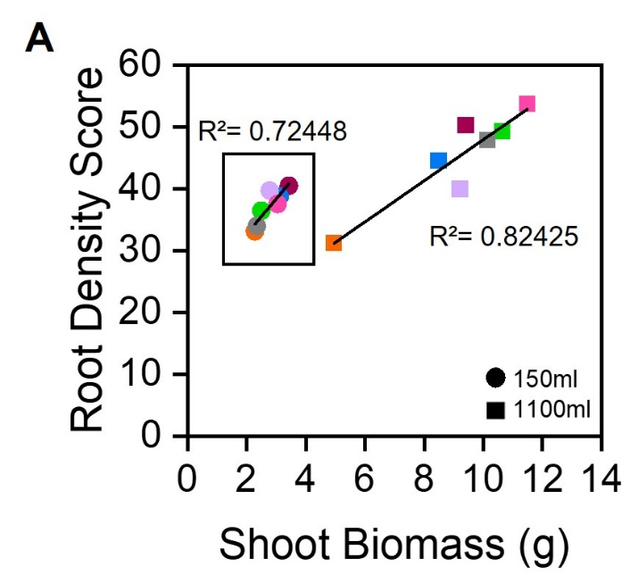

Figure 3.31 Root density is predictive of shoot system size in wheat
Graphs showing spring wheat elite line (cv. Mulika) (grey) and spring wheat landrace lines with a steep angle of root emergence: Yogi 005 (burgundy), Yogi 020 (blue), Yogi 343 (orange) and a shallow angle of root emergence: Yogi 065 (lilac), Yogi 101 (green), Yogi 137 (pink), grown in 150ml and 1100ml rhizoboxes.
A) Scatterplot depicting the relationship between the Root Density Score and Shoot Biomass (g) at 56 days post germination. 150ml rhizoboxes are represented by circles and 1100ml rhizoboxes are depicted by squares. Adjusted R-Square calculated separately for each soil volume, n=2-3.

I then wanted to explore in more detail if the angle of emergence influenced the ability of the plant to detect and respond to soil volume. All lines showed typical shoot responses to soil volume, as plants grown in 1100ml rhizoboxes produced a greater shoot biomass than 150ml plants (Fig 3.32A). Generally, the steep root emergence lines produced less shoot biomass in the 1100ml rhizoboxes compared to the shallow root emergence lines, but all lines assessed produced a similar shoot biomass in 150ml pots. The shoot biomass fold change between the 150ml and 1100ml rhizoboxes in steep root emergence lines was 2.27-, 2.72-and 2.17- fold (Yogi 005, Yogi 020 and Yogi 343 respectively) and for the shallow root emergence lines was 3.31-, 4.25- and 3.77- fold (Yogi 065, Yogi 101, Yogi 137 respectively). These shoot biomass findings are intriguing and could suggest that the steep root emergence lines are less able to take advantage of the additional volume in the 1100ml rhizoboxes than the shallow root emergence lines. However, more investigation would be required to better understand this. A possible future experiment could involve growing these shallow and steep rooting varieties in different depths and widths of pots whilst controlling the soil volumes used. I would expect that the steeper rooting varieties would produce larger shoot systems when experiencing increased depth of container, whereas I would expect that the shallower rooting varieties would produce larger shoot systems in wider pots.

The responses to tillering were varied with some lines producing a high number of tillers in both soil volumes (Yogi 101, Yogi 343), and others producing a low number of tillers in both volumes (Mulika, Yogi 005) (Fig. 3.32B). Nevertheless, tiller number was greater in 1100ml rhizoboxes compared to 150ml rhizoboxes for all lines.
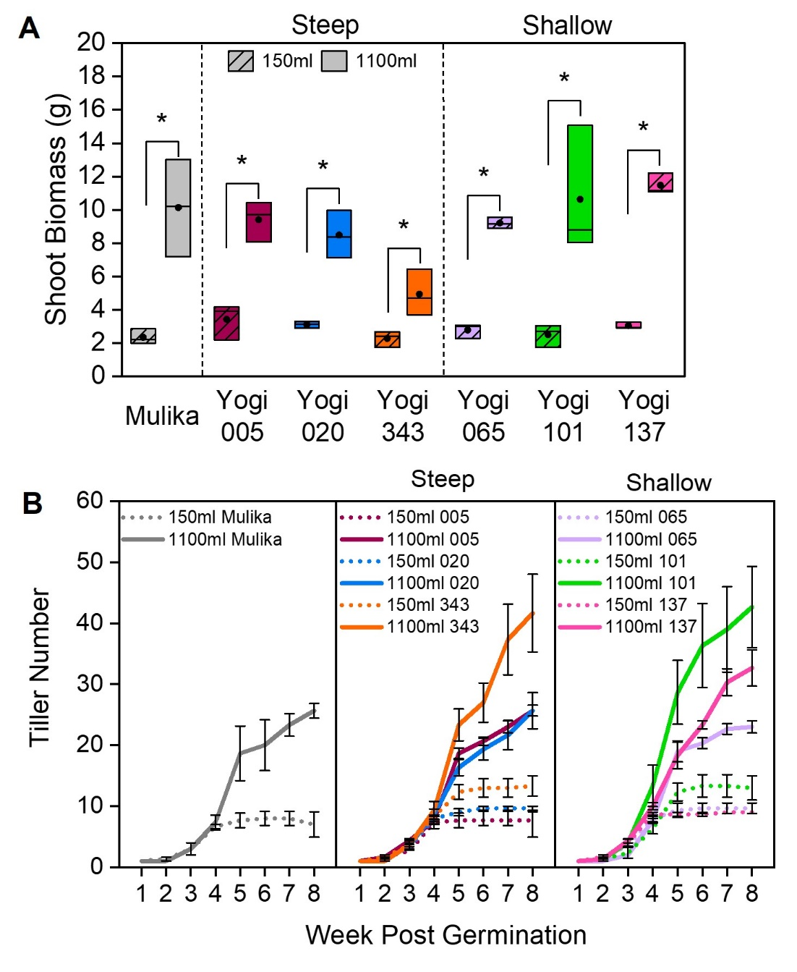
Figure 3.32 Shoot biomass and tiller number varies in wheat lines
Graphs showing spring wheat elite line (cv. Mulika) (grey) and spring wheat landrace lines with a steep angle of root emergence: Yogi 005 (burgundy), Yogi 020 (blue), Yogi 343 (orange) and a shallow angle of root emergence: Yogi 065 (lilac), Yogi 101 (green), Yogi 137 (pink), grown in 150ml and 1100ml rhizoboxes.
A) Boxplots showing dry shoot biomass (g) of lines grown in 150ml (striped) and 1100ml (solid) rhizoboxes (g) at 56 days post germination. The box indicates the interquartile range, the midline represents the median, the circle is the mean. Statistical tests were carried out separately for each genotype, asterisks indicate significant difference. Independent Samples t-test. p<0.05, n=2-3).
B) Line graphs showing tiller number overtime of wheat varieties in 150ml (dotted lines) and 1100ml (solid lines) rhizoboxes. n=2-3. Error bars represent s.e.m.

To explore if the lines differed in their root density over time, root density measurements were taken as described previously. Mulika appears to closely follow the same root density over time in both soil volumes (Fig. 3.33A). This is similar in Yogi 343 which has similar root density in both volumes until ~40 days post germination where this begins to diverge. However, these trends are not seen in other lines and there does not appear to be a similar trend across lines within their root emergence category (Fig. 3.33A). It is important to note that root density assessments were taken for the whole rhizobox, perhaps this could mask possible root density differences between the emergence groups if for example the root density measurements had been taken in 3 vertical subsections of the rhizoboxes.

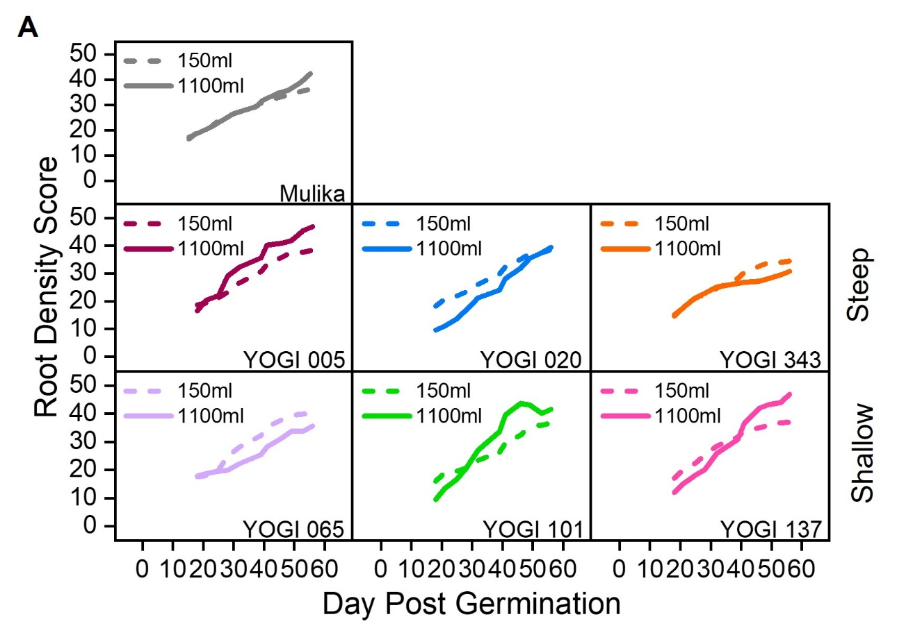
Figure 3.33 Root density varies across wheat lines
Graphs showing spring wheat elite line (cv. Mulika) (grey) and spring wheat landrace lines with a steep angle of root emergence: Yogi 005 (burgundy), Yogi 020 (blue), Yogi 343 (orange) and a shallow angle of root emergence: Yogi 065 (lilac), Yogi 101 (green), Yogi 137 (pink), grown in 150ml and 1100ml rhizoboxes.
A) Line charts of root density shown as a percentage of white pixels (roots) to black pixels (compost) in 150ml and 1100ml rhizoboxes from day 7-56. Data is presented as a rolling average of the previous 4 timepoints where each timepoint was 3-4 days apart, n=2-3.

Finally, I explored if the angle of root emergence influences total root number and total root length. Looking first at 150ml vs 1100ml, at 18 days post germination, root number was greater in 150ml rhizoboxes compared to 1100ml rhizoboxes albeit not always significantly (Fig. 3.34A), this supports what was previously seen in barley lines (Fig. 3.30). However, there does not appear to be a difference in total root number trend between the angle of root emergence groups (Fig. 3.34A).

For total root length, 150ml vs 1100ml differences are not apparent. For most varieties there was no statistical difference between the two soil volumes. Looking numerically, some varieties produced a greater total root length in 1100ml compared to 150ml rhizoboxes (Mulika, Yogi 005, Yogi 101 and Yogi 137), lower total root length in 1100ml rhizoboxes compared to 150ml rhizoboxes (Yogi 065), or no difference between the rhizobox volumes (Yogi 020 and Yogi 343) (Fig 3.34B). Root angle emergence does not seem to influence root length at 18 days post germination.

Root length and root number data suggest that these parameters are not influenced by the angle of root emergence.

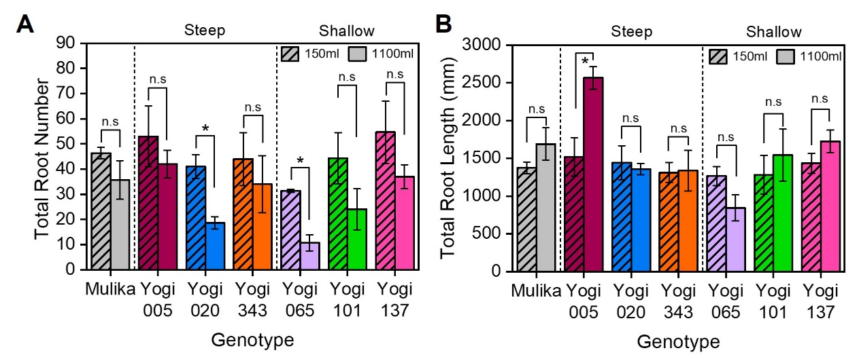
Figure 3.34 Root length and number are not influenced by angle of root emergence in wheat
Graphs showing spring wheat elite line (cv. Mulika) (grey) and spring wheat landrace lines with a steep angle of root emergence: Yogi 005 (burgundy), Yogi 020 (blue), Yogi 343 (orange) and a shallow angle of root emergence: Yogi 065 (lilac), Yogi 101 (green), Yogi 137 (pink), grown in 150ml and 1100ml rhizoboxes.
A) Bar chart showing total root number at 18 days post germination in wheat lines. Striped bars represent plants grown in 150ml rhizoboxes and solid bars represent plants grown in 1100ml rhizoboxes. Statistical tests were carried out separately for each genotype, asterisks indicate significant difference, n.s represents no significant difference (Yogi 343: Mann Whitney U. All other genotypes: Independent Samples t-test. p<0.05, n=2-3).
B) Bar chart showing total root length (mm) at 18 days post germination in wheat lines. Striped bars represent plants grown in 150ml rhizoboxes and solid bars represent plants grown in 1100ml rhizoboxes. Error bar represents s.e.m, n=2-3. Statistical tests were carried out separately for each genotype, asterisks indicate significant difference, n.s represents no significant difference (Yogi 137 and Yogi 343: Mann Whitney U. All other genotypes: Independent Samples t-test. p<0.05, n=2-3). Error bar represents s.e.m.

Taken together, assessment of the root and shoot system growth of wheat lines has highlighted an intriguing contrast to that of barley. In wheat, root density appears to be a strong predictor of shoot system size, suggesting that these are closely linked, whereas in barley there does not appear to be any connection between these parameters. Additionally, the angle of root emergence appears to be an indicator of final shoot system size in wheat.

Discussion

Root density likely plays a role in soil volume and neighbour detection

The design of the neighbour density experiments in section 3.2 (and Wheeldon et al, 2021 and Wheeldon et al, 2022) showed that a root-based mechanism is the primary cause for the resulting shoot growth phenotypes seen here. When crowded plants were grown in larger soil volumes this resulted in a reduction in the negative effects of being grown with neighbours (Section 3.2). Therefore, this points towards plant responses to soil volume and neighbour density being driven the same mechanism. One possible explanation for similar responses to soil volume and neighbour density could be that plants perceive the density of roots in their environment using root exudates (Wheeldon et al., 2021). In small soil volumes it would be expected that root density increases faster than in larger soil volumes, similarly treatments with multiple plants in the pot would also increase root density faster than those grown singly, which could potentially explain the reduction of shoot growth of each plant in small soil volumes and in crowded treatments. Other studies have also shown that root competition is not simply due to neighbours in the environment but a combination of root density and nutrient effects (Tollenaar and Wu, 1999; Schenk, 2006; Tollenaar et al., 2006; Nord et al., 2011; P. Yan et al., 2017). The role of root exudates will be discussed in greater detail in Chapter 4 and 5.

Root system investment early in life in small soil volumes could also explain decreased shoot system size

Investing in the root system is a careful balance between increased growth to forage for resources and the high metabolic cost of producing and sustaining larger root systems (Lynch, 2015). Increasing root system size has been shown to be of high metabolic cost to plants (Lambers et al., 2002), which subsequently reduces the overall rate of plant growth (Hunt, 1982; Poorter and Remkes, 1990). The apparent increased growth of lateral roots in small soil volumes in early life seen in section 3.4.1 could therefore have longer term consequences on overall plant growth and could also contribute directly to the reduced size of their shoot system compared to the plants grown in the larger soil volume.

Final root density is predictive of shoot biomass in wheat but not barley

Intriguingly, when comparing final root density with shoot biomass for the different soil volumes, root density was a very strong predictor of final shoot biomass in wheat but not in barley (Sections 3.4.3 and 3.4.4). This indicates that root density cannot fully explain shoot growth responses to soil volume, and that there must be additional factors involved. The differences between wheat and barley highlight differences in their historic breeding programmes. In wheat, selection pressures for increased yielding varieties with higher ‘harvest index’ has led to decreased root system size, with the accompanying simplification of root system architecture in Chinese wheats (Zhu et al., 2019) and also in UK wheats (Fradgley et al., 2020) suggesting this has occurred independently in many breeding programs. Additionally, breeding for altered flowering time traits in wheat has resulted in decreased root biomass of European varieties, suggesting that certain yield traits are genetically linked to root traits (Voss‐Fels et al., 2017). In barley the converse appears to have happened, as barley seminal root number in seedlings has increased greatly with breeding overtime, which appears to be associated with increases in yield (Grando and Ceccarelli, 1995). Therefore, considering the data presented in Sections 3.4.3 and 3.4.4 it seems likely that in modern wheat, root system size had become a limiting factor on shoot growth, while in modern barley, root system size is not a key limiting factor. The differences in breeding in root system architecture between modern barley and wheat help to explain why root density is predictive of shoot biomass in wheat but not in barley.

Natural variation indicates other factors controlling soil volume responses

Root density assessments in Section 3.4.1 suggested that wheat and barley elite lines initially show a higher root density in the smaller soil volume but over time this is matched by the large soil volume. This suggested that root density could play a part in how plants detect their available space and that perhaps once a critical threshold of root density is reached this inhibits further shoot growth. However, when exploring intraspecific variation in root density over time in multiple wheat and barley lines (landrace and elite) (Sections 3.4.3 and 3.4.4), I observed significant variability in the way that cultivars respond to increasing root density, and in the ‘threshold’ root densities that each line reached. Consequently, this suggests that absolute root density is unlikely to be the only factor controlling soil volume responses in the shoot, and that genetic factors controlling the sensitivity to root density likely play an important role.

In modern agriculture, producing a high amount of yield in a given space is crucial for profitable farming. Therefore, having a crop which can still produce a high yield when subjected to crowding and consequently limited soil volume in which to grow is highly important. Plant breeding has involved selecting for a set of traits which allow for high yield in a range of conditions (Weiner, 2017; Blum, 2018). Therefore it would be expected that this has resulted in cultivars which have rather different responses to neighbour density than landrace and wild relatives (Bilas et al., 2021). Data presented in this chapter supports this view, although admittedly this is mainly based on soil volume responses, rather than neighbour density responses themselves. The soil volume screen in 3.3 showed that modern barley cultivars appear to be more plastic in their ability to respond to their available space, and understanding the genetic basis of this sensitivity to soil volume (and presumably neighbour density) would be highly beneficial for future breeding programs.

Defining mechanisms for plant volume and neighbour perception

Introduction
In chapter 3, I described the shoot and root responses of plants to soil volume and neighbour density, and how these responses likely arise from root-based crowding. It is clear from the literature that plants can detect and respond to the presence of other plants in their environment utilising a variety of different mechanisms including light, volatiles and root exudates (Heil and Adame-Álvarez, 2010; Roig-Villanova and Martínez-García, 2016; Yang et al., 2018; Kong et al., 2018) (discussed in chapter 1), however it is unknown how quickly plants can detect neighbours through their root systems. I hypothesised that this must occur within a short timeframe given the necessity of understanding the limits of available resources, and the potential need to compete for them. Therefore, I aimed to explore how soon plants detect their neighbours, specifically through their root systems. As the roles of the root system in neighbour detection have been unclear (Wang et al., 2021), I aimed to identify root transcriptional changes in response to neighbour presence, and gather new leads to explore for future research.

There have been a few attempts to explain plant responses to soil volume at a mechanistic level, however none have been particularly detailed. Poorter et al (2012) discussed the possible role of mechanical stress associated with root systems colliding with the walls of pots as one mechanism, and also small pots being warmer than larger pots. Others have proposed plants use a root exudate-based mechanism which causes root growth inhibition when subjected to small soil volumes or obstacles in their available soil environment (Falik et al., 2005; Semchenko et al., 2007). Despite attempts to define the mechanism for soil volume detection and response, the details have remained elusive.
A pot is not a natural environment for plants, indeed plants are rarely found growing alone in the wild. Hence, it is likely the response to limited soil volumes is an artifact of the way plants respond to sharing soil with neighbouring plants. This was seen in Chapter 3.2 where plants which had access to the same average soil volume (with or without neighbours) produced the same shoot system size. Given the general interchangeability of soil volume and neighbour density responses, I hypothesised that plants use the same mechanism to sense their soil volume and to detect the presence of neighbours in their root environment.
In this chapter, I aimed to determine how soon plants detect the presence of neighbours and to determine the mechanisms for how plants both detect and respond to their available soil volume and the presence of neighbouring plants.

Detection of neighbours occurs less than 24 hours after crowding

Barley plants respond to crowding within 4 hours
It is clear from data presented in section 3.2 and in the wider literature that plants are able to detect and respond to other plants in their environment (Fang et al., 2013; Li et al., 2015; Roig-Villanova and Martínez-García, 2016; Yang et al., 2018). However, it is unclear how quickly root-based neighbour perception occurs, and what the earliest transcriptional changes are. As I was particularly interested in understanding how root-based sensing of soil volume/neighbour density occurs, I aimed to understand the transcriptional changes that occur in the root after neighbour detection. Initial changes seen in the root system upon the induction of crowding should open new lines of inquiry for understanding the biological response of plants to their neighbours. I hypothesised, based on the knowledge of well-defined mechanisms for plant-to-plant signalling, that transcriptional responses would likely arise quickly after exposure to neighbouring plants. Additionally, previous work by our collaborator Kaori Yoneyama has identified that there are changes in strigolactone biosynthesis gene expression 24 hours post crowding in the roots of rice plants (Yoneyama et al., 2022).

To explore this, barley plants were grown 1 plant per pot (1/pot) in perlite for 1 week. At 1 week post germination plants were transferred into hydroponic pots 1/pot and grown for 3 weeks (hydroponic system described in Chapter 2). At 3 and 4 weeks post germination, all hydroponate was replenished with fresh water and nutrients. At 4 weeks post germination, plants either remained 1/pot or were transferred into 4 plants per pot (4/pot). By replenishing the nutrients frequently, and most importantly immediately before crowding, I could be confident that any gene expression changes seen were a result of recognition of neighbours not nutrient depletion. Root tissue was harvested from both treatments at 4- and 8-hours (hrs) post crowding (3 biological replicates per crowding regime and timepoint). RNA was extracted and purified before being sent to Genewiz for RNA sequencing (RNAseq) analysis (as described in Section 2.6). I then compared gene expression between 1/pot and 4/pot plants at 4- and 8-hours (hrs) post crowding. This should allow the identification of candidate genes involved in the perception of neighbours and the initial response to crowding.
A high number of reads were detected, with 18790 genes at 4 hours and 19110 genes at 8 hours. When only focussing on significantly differentially expressed genes (DEGs) between 1/pot and 4/pot for each timepoint (4 and 8 hours), where any genes with a log₂ fold change (log₂ FC) between 1 and -1 were excluded, there were a total of 3049 DEGs at 4 hours and 3165 DEGS at 8 hours (Fig. 4.1). By focussing on the DEGs, this allows identification of genes which differ in their expression level between the crowded and uncrowded treatment at the two timepoints assessed.

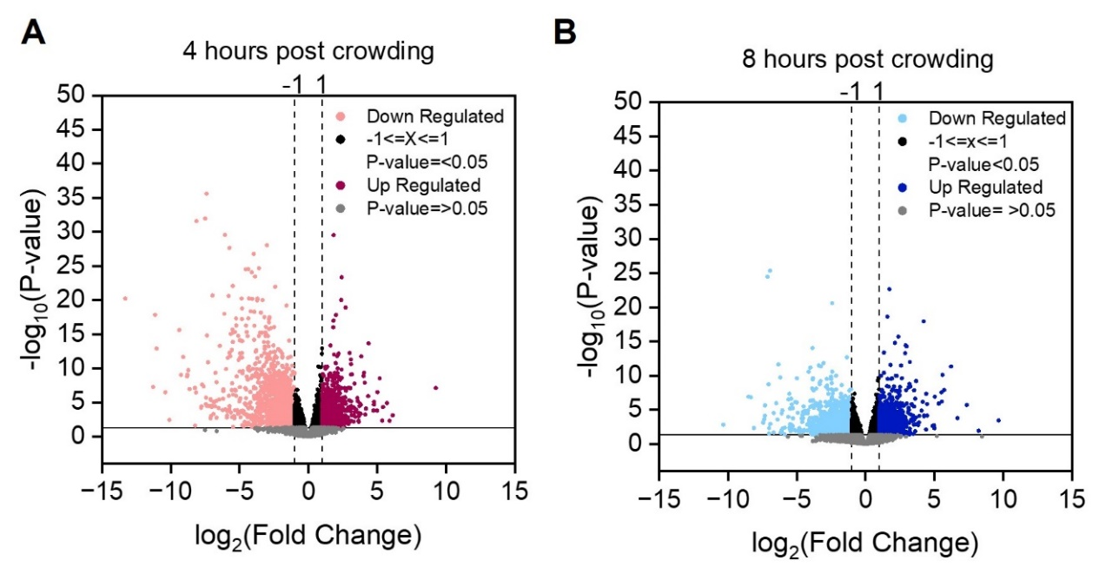
Figure 4.1 Volcano plots of differentially expressed genes at 4- and 8- hours post crowding
Graphs showing barley (cv. Charon) grown hydroponically in 1 plant per pot (1/pot) and 4 plants per pot (4/pot) RNAseq data, 4 and 8 hours post crowding initiation.
A) Volcano plot for 4 hours post crowding initiation. Each dot represents 1 gene. P values were adjusted using Benjamini and Hochberg’s approach converted to -log₁₀(P-value). Genes shown in grey fall below the p<0.05 threshold level and are hence seen below the solid black horizontal line. Genes between log₂ fold change -1 and 1 are shown in black between vertical dashed lines. Genes where the log₂ fold change is below -1 are shown in peach, genes where the fold change is above 1 are shown in burgundy.
B) Volcano plot for 8 hours post crowding initiation. Each dot represents 1 gene. P values were adjusted using Benjamini and Hochberg’s approach converted to -log₁₀(P-value). Genes shown in grey fall below the p<0.05 threshold level and are hence seen below the solid black horizontal line. Genes between log₂ fold change -1 and 1 are shown in black between vertical dashed lines. Genes where the log₂ fold change is below -1 are shown in light blue, genes where the fold change is above 1 are shown in dark blue.

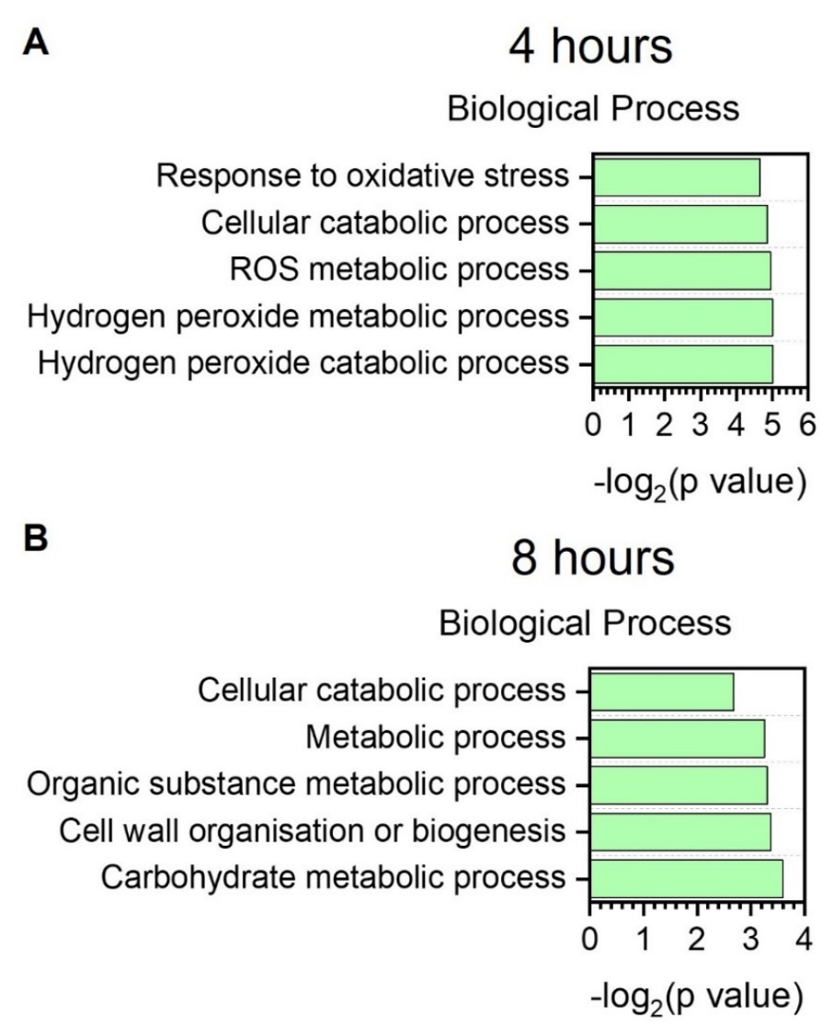
Gene Ontology (GO) analysis was carried out for all the DEGs in both timepoints separately to provide a simplified overview of biological processes that were enriched at these timepoints. At both timepoints, cellular catabolic processes were enriched (Fig. 4.2 A+B). At 4 hours post crowding, 4 of the 5 GO terms are related to oxidative stress, whereas by 8 hours oxidative stress terms were not in the top 5 terms, instead terms such as cell wall organisation or biogenesis are enriched which could suggest a shift to future growth strategies (Fig. 4.2 A+B).

Figure 4.2 Biological process GO terms at 4 and 8 hours post crowding
Graphs showing barley (cv. Charon) grown hydroponically in 1 plant per pot (1/pot) and 4 plants per pot (4/pot) RNAseq data, 4 and 8 hours post crowding initiation.
A-B) Go terms associated with biological process that are differentially expressed (−1.0 < FC > 1.0, Benjamini–Hochberg FDR-corrected, p<0.05) in 4 plant per pot (4/pot) compared to 1 plant per pot (1/pot) hydroponically grown barley (cv. Charon) at 4 hours (A) and 8 hours (B) post crowding. Go enrichment was achieved using the gProfiler website (Raudvere et al., 2019), P value of GO terms from gprofiler was converted using -log₂(pvalue) after revigo removed redundant GO terms (Supek et al., 2011). The 5 most significant categories were plotted.

Barley responses to crowding are partially overlapping at 4- and 8-hour timepoints

At 4 hours there were 1248 upregulated genes and 1801 downregulated genes and at 8 hours there were 1369 upregulated genes and 1796 downregulated genes. From herein, only DEGs will be discussed.

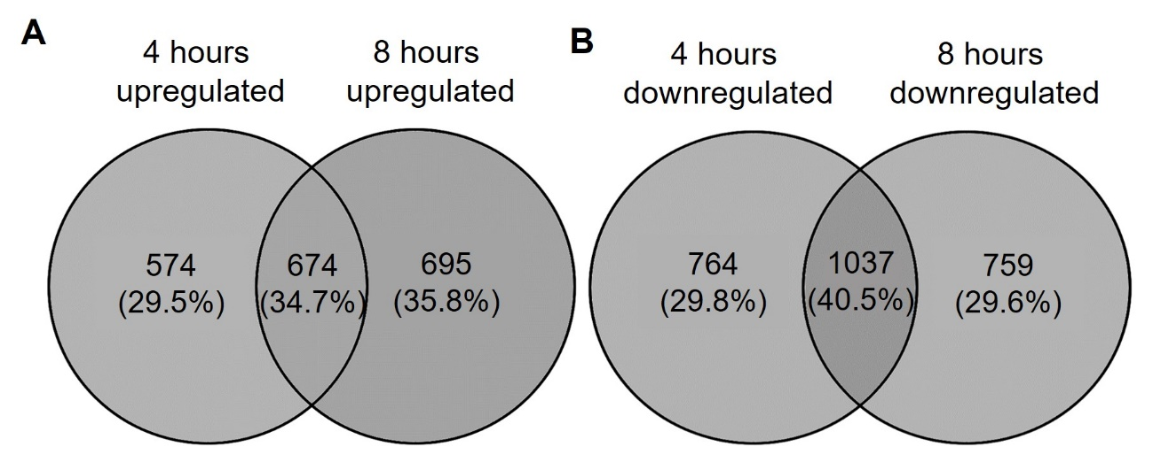
To uncover if any genes were upregulated or downregulated across both the timepoints, gene lists were compared using Venny2.1 (Oliveros, 2007). Comparing upregulated DEGs for 4- and 8-hours post crowding initiation identified 674 (34.7%) overlapping genes (Fig. 4.3A). Whereas for the comparison of downregulated genes 4- and 8-hours post crowding initiation, there is an overlap of 1037 (40.5%) genes (Fig. 4.3B).

Figure 4.3 Overlap of differentially expressed genes at 4- and 8-hours post crowding
Barley (cv. Charon) were grown hydroponically in 1 plant per pot (1/pot) and 4 plants per pot (4/pot). Lists of differentially expressed genes (DEGs) at 4- and 8-hours post crowding were compared.
A) Venn diagram of DEGs with a log₂ fold change greater than +1 (upregulated in crowded treatment) for each time point 4- and 8 hours post crowding were compared. Outer numbers represent the number and percentage of genes exclusively found in 4 hours upregulated (left) and 8 hours upregulated (right). The centre of the venn diagram represents genes present at both timepoints. Venn diagram created using (Oliveros, 2007).
B) Venn diagram of DEGs with a log₂ fold change less than -1 (downregulated in crowded treatment) for each time point 4- and 8 hours post crowding were compared. Outer numbers represent the number and percentage of genes exclusively found in 4 hours downregulated (left) and 8 hours downregulated (right). The centre of the diagram represents genes present at both timepoints. Venn diagram created using (Oliveros, 2007).

This data suggests that within 4 hours there is a fast and substantial number of transcriptional changes that occur in the root. The design of the experiment allowed the root systems of the other plants in the crowded treatment to interact, whether that be by the exchange of root exudates or roots touching. As only root tissue was sampled, this dataset shows responses likely driven by root-based crowding, rather than shoot based shading effects. However, in this experimental design I did not explicitly control for shoot based shading effects, therefore there is a possibility that mutual shading of the shoot systems has occurred, and such information has been communicated to the root (Gao et al., 2021) within the first 4 hours.

Barley plants initiate a competitive response after neighbour detection

Each timepoint was separately investigated and DEGs lists were ordered by their log₂ fold change. Unfortunately, Genewiz were unable to provide annotations for the barley transcriptome, so I hand-annotated the data set, by comparing the sequenced transcripts to the Arabidopsis genome (as discussed in section 2.6). Comparisons were made to the Arabidopsis genome as this is a well annotated genome providing a large number of genes with functional descriptions (Cheng et al., 2017). Due to the RNAseq experiment taking place in the last few months of my PhD, only ~100-150 of the highest upregulated and downregulated barley genes were annotated in this way. Nevertheless, despite this relatively small snapshot of the data, a number of interesting patterns were observed.

NRT2 transporters are upregulated when crowded

To begin to determine which DEGs may be of biological importance for the recognition of crowding, DEGs were ordered by their log₂ FC. Potential genes of interest with a high or low log₂ FC were identified. At 4 hours post crowding HORVU.MOREX.r3.6HG0543580 was upregulated by a log₂ FC of 2.34 (Fig. 4.4 A), this was among the highest log₂ fold changes in the data set for 4 hours. The paralogous genes in Arabidopsis are the high affinity nitrate transporters NRT2.1 (AT1G08090), NRT2.2 (AT1G08100), NRT2.4 (AT5G60770) (Cerezo et al., 2001; Li et al., 2007; Kiba et al., 2012). All of these genes function to uptake nitrate from the soil (Wang et al., 2012) but NRT2.4 has been shown to be particularly upregulated in nitrate deficient environments (Okamoto et al., 2003). At 8 hours post crowding there is a sustained upregulation of these NRT2 genes including the HORVU.MOREX.r3.6HG0543580 transcript identified at 4 hours (log₂ FC 5.72), in addition to the paralogous sequences HORVU.MOREX.r3.6HG0543560, HORVU.MOREX.r3.6HG0543590, HORVU.MOREX.r3.6HG0543390 and HORVU.MOREX.r3.6HG0543380 (log₂ FC 7.36, 4.88, 2.29 and 1.38 respectively) (Fig. 4.4 A).

This is intriguing as the experimental design ensured that plants were supplied with sufficient nutrients and the hydroponic media was changed immediately before the crowding treatment, ensuring the plants were not nutrient deficient, and could not become nutrient deficient within the 4-8 hour timeframe of the experiment. Therefore, this suggests that although the plants were not experiencing nutrient limitation, they may be forecasting this as a possibility for their future given the sudden presence of neighbouring plants. Consequently, this upregulation of nitrate transporters could suggest that crowded plants initiate a competitive response on recognition of neighbours to rapidly uptake nitrate from the environment to prevent future resource limitation caused by neighbours.

NRT1.5 and NRT1.8 transporters are downregulated when crowded

HORVU.MOREX.r3.6HG0605270 was downregulated at 4 hours post crowding by a log₂ FC of -5.66 (Fig 4.4B). The paralogous genes in Arabidopsis are NRT1.5 and NRT1.8 which are low affinity nitrate transporters involved in the root to shoot translocation of nitrate (Wang et al., 2012). First, NRT1.5 in the root loads nitrate into the xylem (Lin et al., 2008) and NRT1.8 regulates the transport of nitrate to the shoot by transporting nitrate out the xylem, returning it to the root cells (Li et al., 2010). Therefore, when viewing this in the context of this experiment, as there is a downregulation of these genes, less nitrate would move shootward, hence this could result in nitrate staying within the root system potentially resulting in enhanced root growth for resource competition with neighbouring plants. This supports the upregulation of NRT2 genes as this would provide the root-based nitrate that would remain in the roots rather than being moved to the shoot.

RHD6 and RHL1 transporters are upregulated when crowded

Root hairs dramatically increase the surface area of the root system to elevate absorption of nutrients and water from the environment (Wei and Li, 2018). The development of root hairs is highly dependent on the environment and can be modulated quickly to increase resource uptake and optimize the root system in challenging environments (Vissenberg et al., 2020). Root hair development is regulated by numerous signals including auxin, ethylene and cytokinin (S. Zhang et al., 2016). A key regulator of root hair development is ROOT HAIR DEFECTIVE 6 (RHD6), a bHLH transcription factor and its close ortholog ROOT HAIR DEFECTIVE6 LIKE1 (RSL1) which is partially redundant (Masucci and Schiefelbein, 1994; Menand et al., 2007). RHD6 functions to control where root hairs are initiated and subsequently promotes their development (Masucci and Schiefelbein, 1994; Menand et al., 2007; Bruex et al., 2012). rhd6 mutant Arabidopsis plants have very few root hairs compared to WT plants (Masucci and Schiefelbein, 1994).

At 8 hours HORVU.MOREX.r3.6HG0608460 which is co-orthologous to RHD6 and RSL1 is upregulated by 3.53 log₂ FC (Fig 4.3C). By upregulating RHD6 / RSL1 this would result in the growth of more root hairs which increases the surface area of the root system consequently allowing increased nutrient uptake from the environment. NRT2.1 has been shown to be expressed in the root hairs as well the cortex and epidermal cells (Wirth et al., 2007). Therefore, RHD6 provides the root hairs in which NRT2 transporters can be expressed.

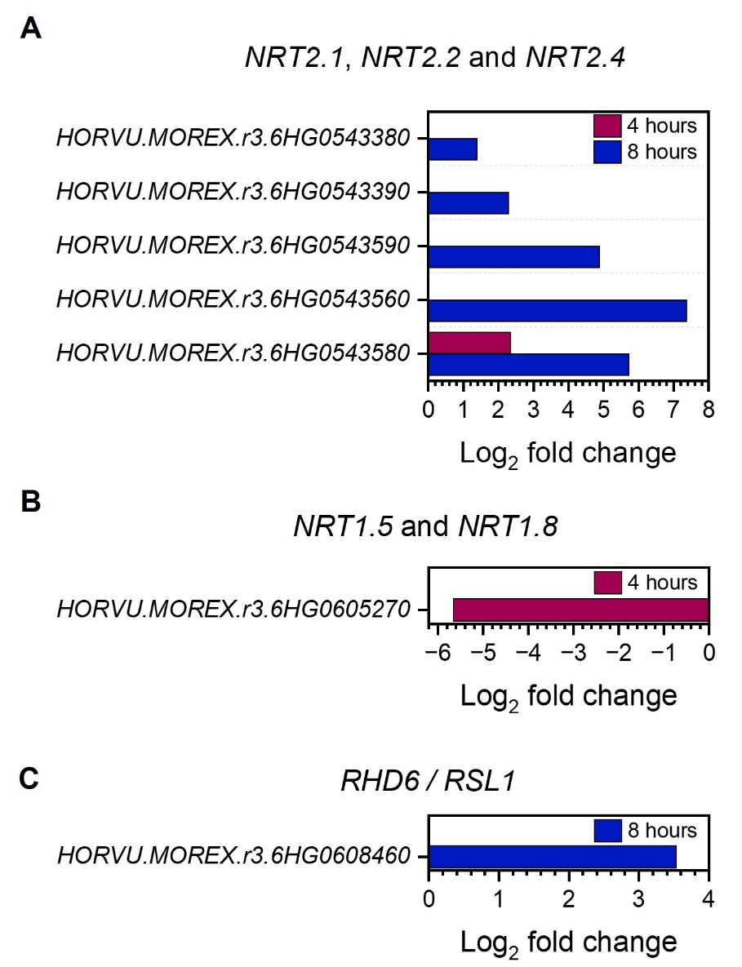
Taking together the upregulation of RHD6 with the upregulation of NRT2 genes, this suggests that the barley plants are initiating a competitive response to uptake as much nitrate from the environment in preparation for nutrient depletion in the future.

Figure 4.4 Root based plant crowding affects NRT1/2 and RHD6 expression in the root
Barley (cv. Charon) were grown hydroponically in 1 plant per pot (1/pot) and 4 plants per pot (4/pot). Figures show the log₂ fold change of differentially expressed genes (DEGs) of interest.
A) Bar chart showing the positive log₂ fold change of barley paralogues of the Arabidopsis genes NRT2.1, NRT2.2 and NRT2.4 at 4- (burgundy) and 8- hours post crowding, n=3.
B) Bar chart showing the negative log₂ fold change of a barley gene paralogous to Arabidopsis NRT1.5 and NRT1.8 at 4- hours (burgundy) post crowding, n=3.
C) Bar chart showing the positive log₂ fold change of barley co-orthologues of the Arabidopsis genes RHD6 and RSL1 at 8- hours (blue) post crowding.

Other DEGs of potential interest

CEP1, CEP2 and CEP3 peptides are downregulated when crowded

As other nitrate related genes were identified in this RNAseq dataset, as discussed above, I was intrigued to see CEP genes also present. HORVU.MOREX.r3.3HG0304230 and HORVU.MOREX.r3.3HG0304500 were downregulated at 4 hours (log₂ FC -2.18) and 8 hours (log₂ FC -3.82) respectively, both these genes are paralogous to the C-TERMINALLY ENCODED PEPTIDEs (CEPs) CEP1, CEP2 and CEP3. CEPs are produced in the roots and move from the root to the shoot to communicate nitrate deficiency in the environment (Tabata et al., 2014). These small signalling peptides are perceived by CEP RECEPTORS (CEPRs), and when in the leaves CEP-DOWNSTREAM PEPTIDES move shoot to root to influence nitrate uptake (Ohkubo et al., 2017). Bringing this together with the down regulation of NRT1.5 and NRT1.8 and a down regulation in CEPs this suggests that as more nitrate is present in the roots, CEPs are not required to signal to the shoot as there is adequate nitrate availability.

UGT85A1 are upregulated and downregulated when crowded

At 4- hours post crowding, the 11th most highly upregulated gene with a log₂ FC of 4.76 was HORVU.MOREX.r3.1HG0008140 (Fig 4.5B) which when BLASTed against the Arabidopsis genome resulted in several UDP-Glycosyltransferase superfamily protein hits. One of which was UGT85A1 (AT1G22400), which when overexpressed has been found to influence the homeostasis of the root-to-shoot cytokinin trans-zeatin (tZ). The authors suggested that this occurs as a result of the O-glycosylation of tZ (Jin et al., 2013), which is the process of attaching a glucose molecule to an isoprenoid N6-side chain hydroxyl group (Jameson, 1994). When UGT85A1 is highly expressed, it has been suggested that this results in the deactivation and storage of tZ type cytokinins (Jin et al., 2013). Therefore, in the context of crowded plants this could suggest that on the recognition of neighbours, plants rapidly store tZ type cytokinins to prevent the shoots from becoming too large to sustain. It is also possible to convert the stored cytokinin O-glycosides into active, useable forms (Brzobohatý et al., 1993; Mok and Mok, 2001).

Other barley genes were also identified to be orthologous to UGT85A1. These however are seen to be downregulated at 4 hours (HORVU.MOREX.r3.6HG0617190, HORVU.MOREX.r3.4HG0408060: log₂ FC -3.66 and -4.93 respectively) and 8 hours (HORVU.MOREX.r3.4HG0408060, HORVU.MOREX.r3.6HG0617100, HORVU.MOREX.r3.6HG0617130 and HORVU.MOREX.r3.6HG0617190: log₂ FC-5.48,-3.86, -3.70 and -2.46 respectively) (Fig 4.4B). This would suggest that tZ is not being converted into its storage form and therefore is potentially being transported to the shoot system.

This apparent up and down regulation of genes of the same function is confusing and calls into question whether this is biologically relevant. More investigation would be required to see if all these paralogues encode UGT85A1 proteins, but regardless this provides a new avenue to investigate.
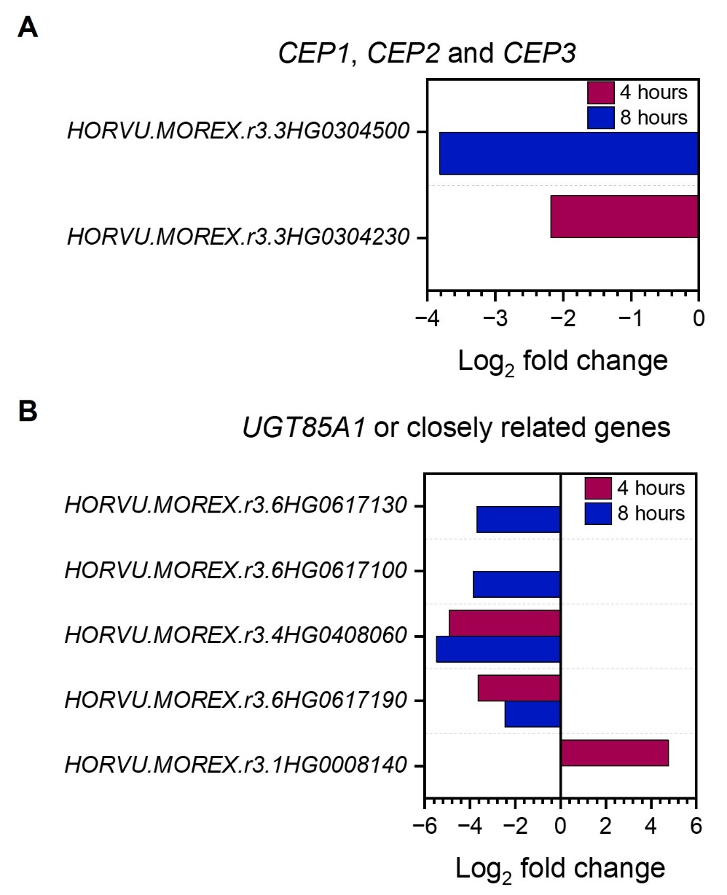

Figure 4.5 Root based plant crowding affects CEP and UGT85A1 expression in the root
Barley (cv. Charon) were grown hydroponically in 1 plant per pot (1/pot) and 4 plants per pot (4/pot). Figures show the log₂ fold change of differentially expressed genes (DEGs) of interest.
A) Bar chart showing the negative log₂ fold change of barley orthologues of the Arabidopsis genes CEP1, CEP2 and CEP3 at 4- (burgundy) and 8- hours post crowding, n=3.
B) Bar chart showing the log₂ fold change of barley orthologues of the Arabidopsis gene UGT85A1 (or closely related genes) at 4- (burgundy) and 8- hours post crowding, n=3.

Resource foraging strategies are prioritised on perception of neighbours

To summarise, it appears that upon the perception of neighbouring plants a large number of transcriptional changes occur within 4 and 8 hours. Some of these DEGs appear to be evidence of a competitive strategy to acquire any resources needed for growth of the plant. Plants appear to achieve this by increasing root hair number (RHD6 / RSL1 genes) and upregulating high affinity nitrate transporters (NRT2 genes). Nitrate however appears to remain in the root system due to the downregulation of root to shoot nitrate transporters (NRT1.5 / NRT1.8 genes), which could allow increased root growth to better aid competition for belowground resources. It can only be speculated at this point, but perhaps on perceiving more about the genetic identity of their neighbours, they may tone down this ‘selfish’ response into a more cooperative response if they are closely related to their neighbours.

Given the late occurrence of this RNAseq analysis during my PhD there may be other interesting leads within the dataset that may be of importance which have not yet been identified. To provide a link between the number of DEGs for each timepoint with the genes of interest discussed sections 4.2.3 and 4.2.4, future data analysis could include filtering the GO terms by specific terms to determine the number of DEGs related to processes of interest at each time point. For example, as several of the genes of interest identified from this RNA seq so far were related to nutrients, GO terms could be filtered by nutrient related terms such as nutrient reservoir activity (GO: 0045735), nitrate transport (GO: 0015706) and response to nitrate (GO: 0010167). It could then be determined how many DEGs are related to nutrients compared to the other DEGs in the timepoint. In addition, no further experimental testing of genes discussed here has been carried out. Follow up experiments should involve qPCR to validate the expression levels of the genes of interest identified in this RNAseq study. In addition, it would be valuable to repeat this experimental design in other species to determine if this transcriptional response, and indeed the timescale of such responses, is present in other species such as wheat. Nevertheless, this is the first RNAseq to investigate the transcriptional changes caused by root-based crowding and for now this has highlighted some interesting candidates for further investigation.

Mechanisms of shoot and root response to soil volume

Shoot responses to soil volume occur early in life and are independent of nutrient and water availability
In previous literature there has been a debate about if soil volume effects are the result of limited nutrients and water availability in small soil volumes compared to large soil volumes (discussed in chapter 1). However, I hypothesised that if nutrients were responsible for these effects, differences between the shoot systems of plants grown in small and large soil volumes would only be visible at later stages in life, once nutrient depletion has occurred in the small soil volumes. Furthermore, I hypothesised that if nutrient depletion is a factor in soil volume responses, the supplementation of additional nutrients should prevent visible differences in the shoot systems between the soil volumes. To test these hypotheses, I chose to use wheat and barley as cereals are particularly useful for studying shoot responses to soil volume, as shown in chapter 3.2.1 and 3.2.2, since tillers are produced from around 3 weeks post germination to flowering, providing an easily-assessable proxy for shoot system size. The initiation and subsequent senescence of tillers results in a bell-shaped progression of tiller number over the plant’s lifetime.
To explore shoot growth in response to soil volume availability, I grew wheat and barley in three soil volumes: 100, 500 and 2000ml (wheat data presented in Wheeldon et al, 2021). To test effects of additional nutrients, half of the plants in each soil volume were supplemented with additional nutrients weekly. I recorded many shoot parameters including tiller number, dry shoot biomass, dry ear biomass, ear number, spikelet number, grain biomass and grain number to determine shoot system size. I found that all parameters, in both nutrient regimes, exhibited a positive correlation between the soil volume in which the plants were grown and the size of the shoot system for both species (Wheeldon et al., 2021), supporting the conclusion that limitations on available soil volume directly restricts the size of the resulting shoot system.
Focussing on wheat (cv. Mulika), I counted tiller number weekly from 3-16 weeks post germination in all soil volumes (Wheeldon et al., 2021). Counting began at 3 weeks post germination as this was the point at which all soil volumes produced their first tillers. Shortly after the first tillers were produced, there was a divergence in the number of tillers produced in each soil volume. This suggests that by 3 weeks post germination the plants have detected the amount of soil volume available to them, and consequently have made a decision regarding their future growth strategy. Despite this, tillering continued for a further 2-4 weeks in all soil volumes. The number of tillers produced within each soil volume did not differ in the plants which were supplemented with additional fertiliser (Fig. 4.6) (Wheeldon et al., 2021).
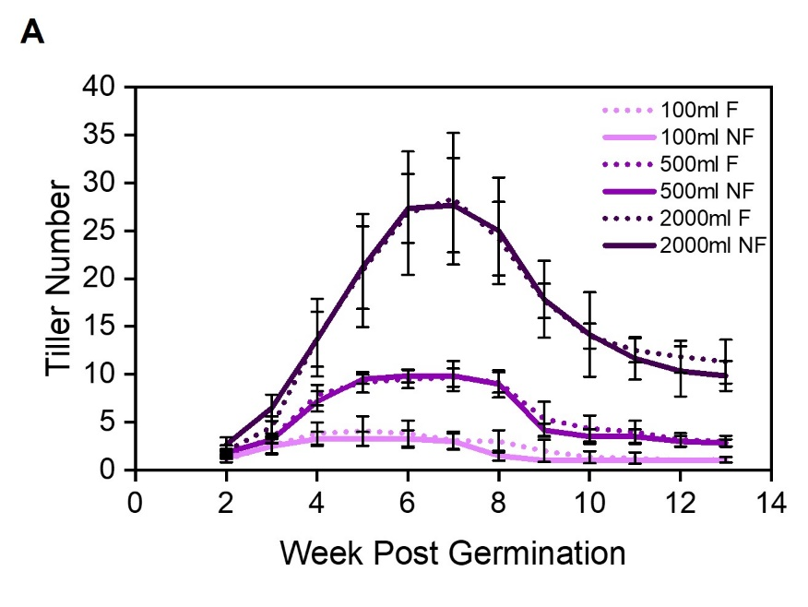

Figure 4.6 Soil volume influences tiller number in wheat
A) Line graph showing spring wheat plants (cv. Mulika), grown in 3 soil volumes: 100ml (lilac), 500ml (purple) and 2000ml (aubergine). Solid lines represent no additional fertiliser/ nutrients (NF) and dotted lines represent additional weekly fertiliser/ nutrients (F). Error bars represent s.e.m, n- 6-12.
Modified from Wheeldon et al, 2021.

As discussed in chapter 1, it is commonly assumed that the effects of small soil volumes are due to limited nutrient or water availability. However, this cannot be the explanation for these responses in this experiment due to there being no water or nutrient deficit at 3 weeks post germination. In the weeks subsequent to this, there was no difference in shoot size between the two nutrient regimes (within the same soil volume) (Fig. 4.6). In all cases, regardless of being supplemented with additional fertiliser or not the wheat plants continued to grow healthily with no visible signs of stress even once tillers stopped being produced (Wheeldon et al., 2021). This is not a surprise as such as other species have been shown to grow healthily even when subjected to small soil volumes (Poorter et al., 2012), however if these growth responses are not driven by water and nutritional limitation, how do plants detect their available soil volume and subsequently modulate their growth in response?

Soil volume growth responses show two distinct phases
Since nutrient availability cannot plausibly explain the shoot growth responses to soil volume seen early in the life cycle, I developed two, non-mutually exclusive alternative hypotheses. Firstly, I hypothesised that wheat plants may use root exuded signals to determine their available space, and secondly, I hypothesised that mechanical interactions with the walls of the pots might allow plants to determine their available space. To try and distinguish between these possibilities, I performed an experiment in which wheat plants (cv. Mulika) were grown singly in 100ml standard pots or 100ml nylon mesh pots filled with compost for 4 weeks (Wheeldon et al., 2021). Importantly, this nylon mesh is impenetrable to plant roots, hence they are unable to grow through this, but any water, nutrients and substances can move through it. At 4 weeks post germination, two sets of plants remained in the same treatments; 100ml standard pots (treatment A) or 100ml mesh pots (treatment B). Three sets of plants were transferred into new treatments (treatments C-E). In one treatment, the 100ml standard pot was removed and the root ball was placed in a 2000ml pot that contained 1900ml of additional compost (treatment C). In a second treatment, plants were retained in 100ml standard pots but 1cm² square holes were cut in the four faces of the pot and then the modified pot was placed within 1900ml of compost (treatment D). Finally, in a third treatment plants grown in 100ml mesh pots were placed within 1900ml of compost (treatment E), still within their nylon mesh pots (Fig 4.7 A) (Wheeldon et al., 2021).
This experimental design allowed me to distinguish between the effects of ‘physical substrate volume’ (the space that roots can grow into and colonise), ‘chemical substrate volume’ (the space that roots can chemically access, even if they cannot physically grow into it) and mechanical impedance. Treatment A and B plants have the same physical and chemical substrate volume. Plants in treatment C and D have 2000ml of physical and chemical substrate volume. Treatment D however had a much higher amount of mechanical impedance, because most roots will still be impeded by the original pot walls. Treatment E has the same physical substrate volume (100ml) as treatments A and B but has the same chemical substrate volume as with treatments C and D (Wheeldon et al., 2021).
Using this set-up, tiller number was measured from week 3-11 post germination (Fig. 4.7 B). As expected, plants with the least available soil volume produced the least number of tillers (Treatments A and B). From 4 weeks post germination, the treatments diverge into 2 groups, treatment A and B, and treatments C, D and E. Treatments A and B behaved as expected, producing a maximum of ~1-2 tillers, strongly reflecting their available soil volume. Treatments C-E had a similar increase in tiller production until 5 weeks post germination where there is a further divergence and a steep increase in tiller production in treatments C and D. Treatments C and D produced a maximum tiller number of ~14 tillers, and treatment E produced a maximum of ~9 tillers (Fig. 4.7 B). In some respects, the greater tiller number in treatments C and D is unsurprising due to having the maximum amount of physical substrate volume for their roots can occupy. Although treatment D plants experience high mechanical stress on their root systems (due to their roots navigating their way out of the holes in the small pot into the larger pot), they still grew as large as treatment C plants. Therefore, this suggests that mechanical stress on the root systems does not explain the growth differences between different soil volumes seen in other experiments. Tiller number production in Treatment E plants was fascinating as these plants had the same physical substrate volume as treatment A and B plants and yet treatment E plants were able to produce a much greater number of tillers, peaking at ~8 tillers (Fig. 4.7 B). This suggested that treatment E plants, were able to access the additional soil volume, perhaps by being able to diffuse some form of root produced signal into the larger soil volume, which allowed them to continue tillering for longer (Wheeldon et al., 2021).
This tillering data highlights that there appears to be 2 distinct phases in which plants detect and respond to their available space. In the first few weeks all treatments produce the same number of tillers (as they are all grown in the same small volume of pot), but then following the introduction of new treatments there is a shift where shoot growth begins to reflect available chemical substrate volume (weeks 3-5), and then a second shift where growth more reflects physical substrate volume (week 5 onwards). Nevertheless, the growth of plants in treatment E was still much greater than their physical substrate volume would have suggested during this timeframe.
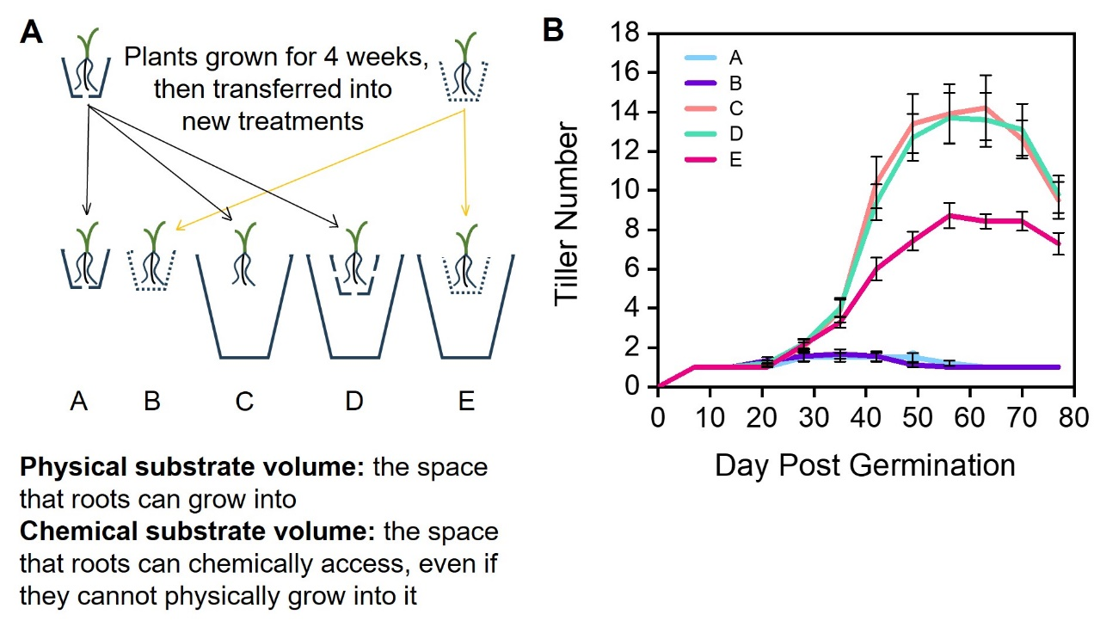
Figure 4.7 Soil volume effects occur in 2 phases
A) Cartoon describing the experimental design. Dotted lines represent nylon mesh, solid black lines represent plastic pots. Treatment D involved 100ml plastic pots with 1x 1cm² holes cut on each face of the pot.
B) Line graph showing mean tiller number of spring wheat plants (cv. Mulika) grown in 5 treatments until 77 days post germination. Error bars represent the s.e.m, n=7-10.
Figure modified from Wheeldon et al (2021)

All treatment E plants were checked at the end of the experiment and any plants whose roots were not completely contained within the mesh pots were discarded from all analysis, therefore 3 plants were removed from the analysis (Fig. 4.8A). The root balls of treatment E plants contained a very high density of roots with very little compost left at the end of the experiment (Fig. 4.8A). This suggests that the plants over-produced roots relative to their physical substrate volume, and more in keeping with their chemical substrate volume.
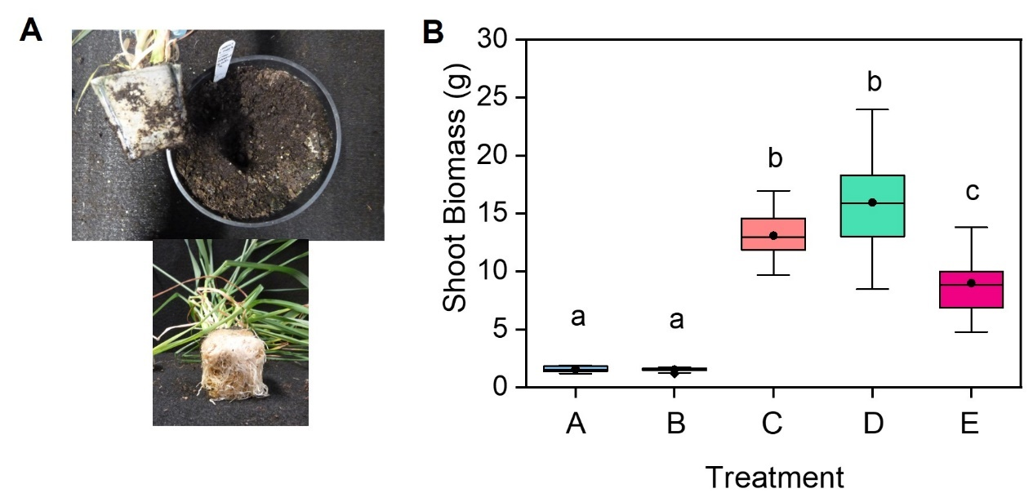
To investigate if trends seen in tillering were reflected in dry shoot biomass, this was assessed at the end of the experiment. This was the case as treatments A and B plants led to the least shoot biomass, treatments C and D led to the greatest and treatment E had plants with intermediate shoot biomass between these groups (Fig 4.8B).

Figure 4.8 Shoot biomass reflects available chemical volume
A) Images of treatment E plants. Top: plant and root ball lifted out of the 2000ml pot showing no escape of roots through the mesh pot into the outer soil volume. Bottom: photo showing the base of the soil ball when the mesh pot was removed from treatment E plant.
B) Boxplot showing dry shoot biomass of wheat plants in treatments described in Fig 4.6 harvested at 77 days post germination. The box is the interquartile range, the midline of the box is the median, the whiskers are the minimum and maximum values, the circle within the box is the mean. Boxes labelled with the same letter are not statistically different (One-way ANOVA with Tukey HSD), p<0.05, n=7-10.
Figure modified from Wheeldon et al (2021)

This experiment highlights that plants are limited by chemical substrate volume as well as physical substrate volume. Whenever wheat plants had a small physical substrate volume paired with a larger chemical substrate volume, this allowed them to grow larger than those which did not have access to additional chemical substrate volume. Therefore, this suggests that plants use root exuded signals to detect their available substrate volume and these can pass through the impermeable mesh to be diluted in the additional soil volume regardless of no physical presence of roots in this additional volume (Wheeldon et al., 2021). This experiment also gives an insight into a possible two phase mechanism of shoot growth in response to soil volume (Wheeldon et al., 2021).

In the second phase of growth, the differences in plants between treatments A and B with treatment E could be explained by two possibilities. The first possibility described above where exudates are able to be diluted into the larger soil volume in treatment E plants. However, the alternative possibility for treatment E plants being larger than treatment A and B plants is that they could simply be able to take up nutrients from the larger soil volume. Therefore, from this experimental design I cannot distinguish between the possibility of signal dilution or the role of nutrients driving the second phase of growth. Nevertheless, given the inability of nutrient addition to overcome growth limitations described earlier in this chapter, this indicates that signal dilution is more likely.

Early growth responses to soil volume availability do not require mechanical impedance or increased root density
I hypothesised that several factors might explain the ability of plants to detect their available soil volume in the first phase of growth, as defined in Section 4.3.2. Firstly, as suggested in chapter 3, I hypothesised that the perception of root density could be a mechanism for the early detection of available space. However, I also hypothesised that early responses could also be due to the roots hitting the sides of the pot (this would likely occur sooner in small pots). Since chemical substrate volume seems very important in the first phase, I also hypothesised that the dilution of a root exudate within the substrate might explain these responses.
To explore these hypotheses, I grew wheat plants (cv. Mulika) in 100 and 300ml of compost in clear plastic containers (Wheeldon et al., 2021). This allowed for root growth to be assessed through the clear walls, whilst also recording tiller number until 7 weeks post germination. Weekly images of each pot face (the four sides and the base) were captured and using a similar method to that described in Section 3.4, root density was assessed (further detail in Chapter 2). I saw that roots had already hit the sides of the pot within the first week of life. This early mechanical stimulus was the same for both soil volumes, suggesting that this is unlikely to be the cause of shoot growth differences seen later in life (Fig. 4.9A) (Wheeldon et al., 2021). As expected, plants grown in the 300ml pots produced a greater shoot biomass than those in the 100ml pots when this was assessed at 8 weeks post germination (Fig. 4.9B).

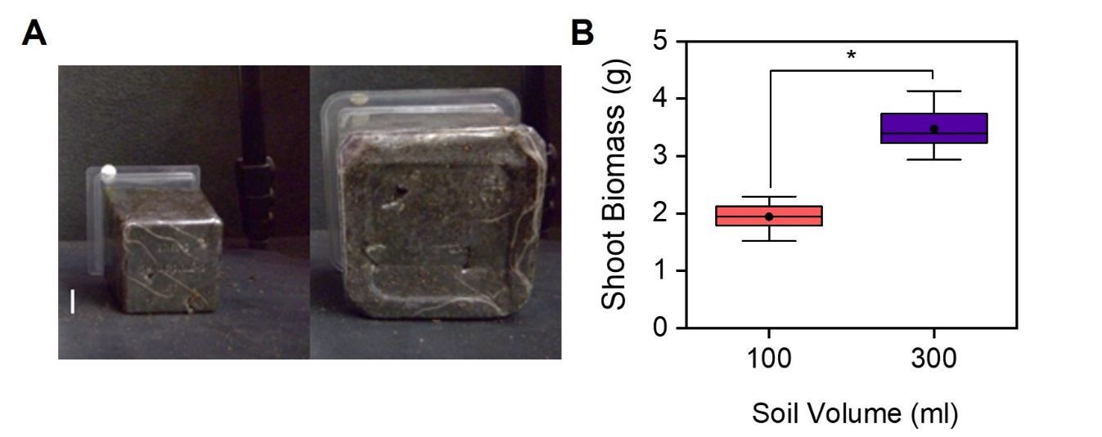

Figure 4.9 Substrate volume sensing is not due to a mechanical factor
Figures showing wheat (cv. Mulika) grown in 2 soil volumes.
A) Images of wheat plants in 100ml (left) and 300ml (right) clear walled containers at 1 week post germination. Scale bar represents 1cm.
B) Boxplot showing dry shoot biomass (g) of wheat plants grown in 2 soil volumes harvested at 8 weeks post germination. The box indicates the interquartile range, the midline indicates the median, the whiskers are the minimum and maximum values, the circle within the box is the mean. Asterisks show significant difference between the treatments (Independent samples t-test, p<0.05), n=8.
Figures adapted from Wheeldon et al, 2021.

To investigate if root density plays a role in early shoot growth responses to substrate volume, I tracked tiller number alongside root growth. I observed that tiller number diverged between week 3 and 4 post germination with more tillers being produced in the 300ml pots. Regardless of the soil volume, tiller production stopped at 4 weeks post germination (Fig 4.10A).
However, comparing this to visible root growth of plants (quantified here by visible density of roots, described in Chapter 2), root growth clearly continued at linear rate in both treatments until 5-week post germination, with root density being elevated in the small pots (Fig. 4.10B). At this point (5 weeks post germination), the plants in the smaller pots seemed to reach their critical root density (as discussed in Chapter 3) and stopped producing new roots. Tiller production ceased (4 weeks post germination) earlier than these changes in the root system, therefore suggesting that the changes in tiller production occurring at 3-4 weeks did not correlate with changes in root growth or reaching a critical root density (Fig. 4.10). These observations suggest that the early phase of growth (up to 4-5 weeks post germination) is only dependent on soil volume, not mechanical impedance or root density. Furthermore, these data show that the early phase of soil volume response only affects shoot growth, and does not affect root growth, which only begins to change in the second response phase (Wheeldon et al., 2021).
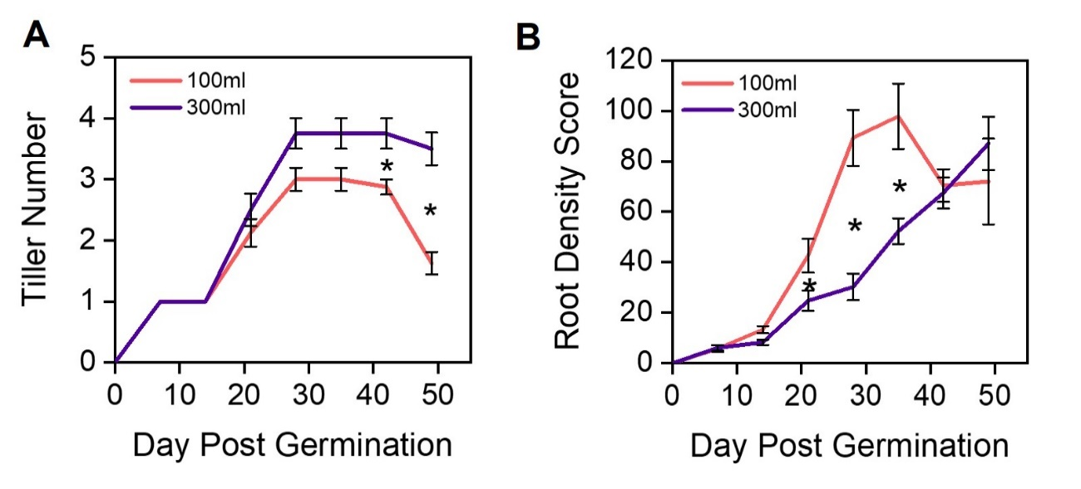

Figure 4.10 Root density is not involved in early responses to substrate volume
Figures showing wheat (cv. Mulika) grown in 2 soil volumes.
A) Line graph showing tiller number overtime until day 49 post germination. Error bars represent S.E.M, asterisks represent statistical significance between the 100ml and 300ml containers (Mann-Whitney U test, p<0.05), n=8.
B) Line graph showing root density visible through the clear walls of the containers in the form of a ‘Root Density Score’. Error bars represent S.E.M, asterisks represent statistical significance between the 100ml and 300ml containers at 3 time points (Independent samples t-test used for day 21 and 28, Mann-Whitney U test used for day 35 post germination, p<0.05), n=5-8.
Figure modified from Wheeldon et al (2021).

Together these data suggest that early growth responses do not involve any effects of mechanical impedance or root density. Instead, they suggest the existence of a highly mobile root exuded chemical that inhibits shoot growth unless diluted, which can diffuse into the available chemical substrate volume allowing the plants to grow larger, even if they have a very limited physical substrate volume.

Late growth responses are likely due to root density

The experiment described in Section 4.3.3 showed additional changes in shoot growth after 5 weeks post germination. Plants began to lose tillers, but at a much greater rate in the smaller soil volume (Fig. 4.10A). As a result, the treatments followed the expected pattern of shoot biomass allocation, where the plants in the 300ml pots produced a higher shoot biomass than those in 100ml pots (Fig. 4.9B). These data seem to indicate that a second phase of shoot growth responses to soil volume also occurred in this experiment.
Unlike the early shoot growth responses, the changes in tiller senescence between the treatments after 5 weeks seems to be associated with changes in root growth. After 5 weeks, root growth seems to cease in the 100ml pots (Fig. 4.10B), perhaps upon reaching a critical root density, as seen in the experiments in Chapter 3.3. Root growth in plants grown in 300ml pots continued after this time which could explain the less dramatic tiller senescence in these plants (Fig. 4.10B). These data tentatively suggest that perception of root density might be responsible for the second phase of shoot growth responses to soil volume (Wheeldon et al., 2021).
Bringing together sections 4.3.3 and 4.3.4, this experiment suggests that there are 2 phases in plant responses to soil volume. The experiment in section 4.3.2 also supports this 2 phase response as this experiment showed that tiller number is influenced by chemical substrate volume in the 1st phase (3-4 weeks post germination), and following this in the 2nd phase, tiller number is influenced by physical substrate volume. Therefore, taken together both these experiments suggest a 2 phase mechanism. The early plant response to soil volume, which does not seem to be the result of mechanical impedance or root density sensing, does not cause changes in root growth but does influence shoot growth. However, the later response seems to be associated with root density, and this response influences both root and shoot growth (Wheeldon et al., 2021).

Late growth responses are exaggerated when roots are highly aggregated

Combining observations from Section 4.3.2 and 4.3.4, the results potentially suggest that plants may be sensing the root density in their environment, possibly through the exudation and perception of a mobile signal that can diffuse across a mesh barrier. However, any possible exudate involved in sensing high root density may not be as mobile as the first phase signal, since having access to additional chemical volume did not completely alleviate the inhibition of shoot growth in Treatment E plants, (Fig. 4.7B). Therefore, I hypothesised that, if such a signal exists, it is much less mobile than the hypothesised signal in the first phase. However, the experiment in Section 4.3.2 does not rule out nutrient availability as the cause of additional shoot growth in the treatment E plants.
To try and distinguish between these possibilities an experiment was designed where soil volume and nutrient availability would remain equal, but the effective density of roots would vary. Changes in container shape were used as a method to achieve this. As roots emerge from the wheat grain, a cone shaped architecture is produced with the seed at the apex (Fig. 4.11A). Hence, I hypothesised that containers with a similar shape to this inherent root architecture would result in the least dense root systems, and that conversely, containers of the ‘incorrect’ shape would cause root aggregation. Therefore I hypothesised that a ‘natural cone’ shape which matched the shape of the root system architecture would cause less inhibition of shoot growth as roots due to the reduced root density.
Wheat (cv. Mulika) plants were therefore grown in hand-made pots, in which the soil occupied an equal volume (320ml). However, the shape of the soil-containing area was different in each treatment (Fig. 4.10B). In treatment A the 320 ml of compost sat on top of a sealed cone sat on the base of a pot, such that roots are actively excluded from their normal growth zone. Treatment B had the same structure, except the cone was filled with 320ml of compost and the apex of the cone was cut open to allow the shoots to grow out of it; the seed was placed at the open apex of the cone. In treatment C, the cone was placed upside-down with the apex at the base of the pot and again filled with 320ml of compost; the seed is placed in the widest part of the cone. Thus, treatment C causes roots to grow in a narrowing cone, rather than the natural widening cone of their root system.
To ask if container shape, and the associating density of roots, can influence final shoot growth, I assessed shoot biomass at 12 weeks post germination. Shoot biomass was greatest in plants grown in treatment B. This suggested that shoot biomass is influenced by container shape, more specifically it is least inhibited when the root system is least condensed (Fig. 4.11C).
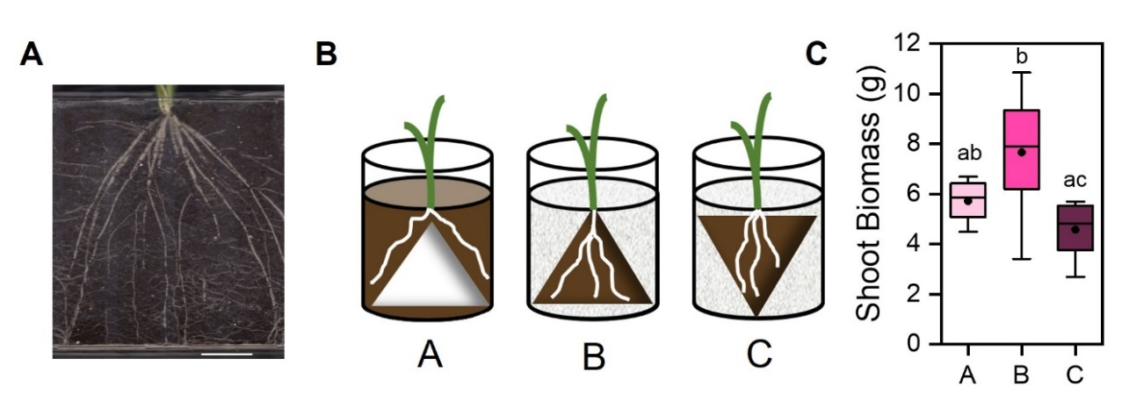
Figure 4.11 Container shape influences shoot growth
Graph showing spring wheat (cv. Mulika) grown in different shaped containers where the accessible soil volume is 320ml in all 3 treatments (A-C).
A) An image of a 35-day old wheat root system grown in a rhizobox which demonstrates the cone shaped architecture, scale bar represents 5cm.
B) In all three treatments the pot is a clear plastic cylinder with alternately shaped internal structures. Treatment A had a cone sat on the base of the pot and covered with compost (brown). In treatment B the cone was filled with compost (brown) and the apex of the cone was cut to allow the shoots to grow out of. In treatment C, the cone was the opposite way round with the apex at the base of the pot. In treatments B and C, the cone was stabilised by using perlite (grey dappled shading) to maintain the position. White curved lines represent roots.
C) Box plot showing the mean final dry shoot biomass (g) per plant at 12 weeks post germination of the 3 treatments described in Fig. 4.11B. Boxes with the same letter are not significantly different (One-way ANOVA with Tukey HSD, p <0.05) n=7-8. The box indicates the interquartile range, the midline represents the median, the whiskers are the minimum and maximum values, the circle is the mean and the diamonds are outliers.

To ask if the effects of root density cause shoot growth changes seen in the later phase of growth, tiller number was recorded weekly from week 4 to 12 post germination. Tiller number was similar in all treatments between 3 and 5 weeks after germination, in the early phase of growth, consistent with previous results as all treatments had access to the same soil volume (Fig. 4.12A). However, after 35 days post germination, a divergence in tiller number was seen. Tillering increased rapidly in treatment B until 49 days post germination where there was a statistically significantly higher number of tillers in plants grown in this treatment, whereas treatments A and C continued on a steady trajectory. Treatment B produced the highest number of tillers (~8) compared to treatments A and C which produced ~6 tillers (Fig. 4.12A). The delay in tillering differences between the treatments further supports that root density influences plant growth later on in life.

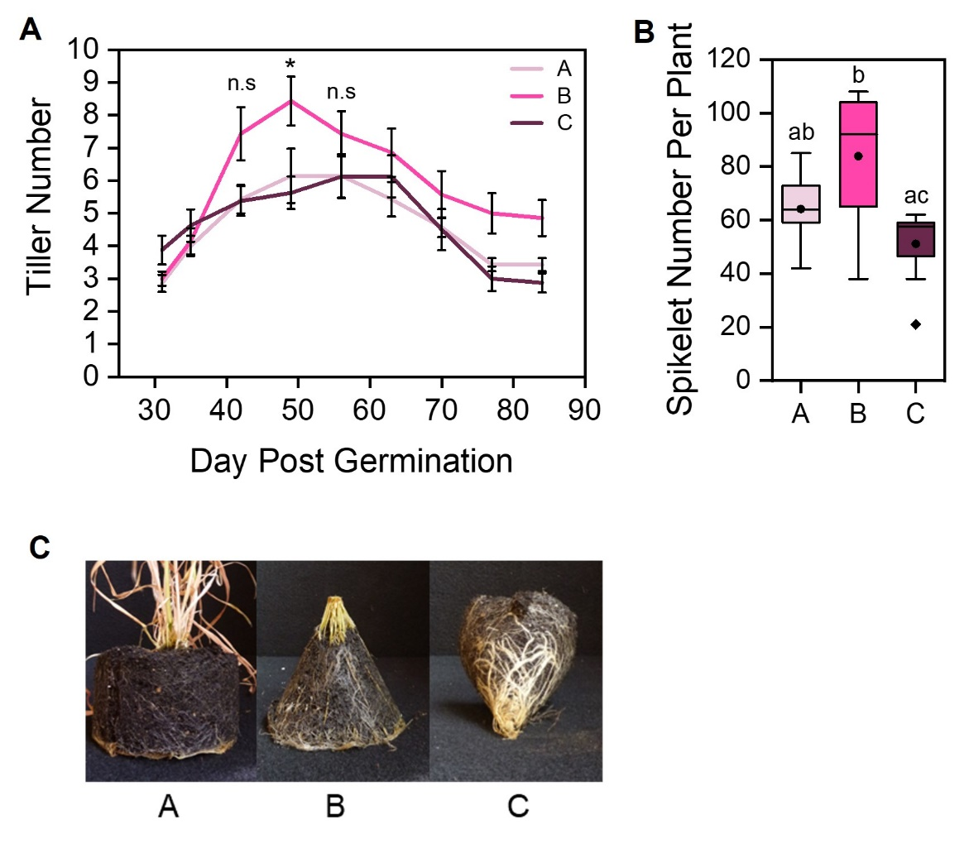
Figure 4.12 Container shape influences the shoot system later in life
Graphs showing spring wheat (Mulika) grown in different shaped containers where the accessible soil volume is 320ml in all 3 treatments (A-C) as described in Fig 4.11B.
A) Line graph showing mean tiller number from day 31 to 84 post germination. Error bars represent s.e.m, n=7-8. n.s represents no statistical difference between the 3 treatments at that time point. An asterisk represents statistical difference between treatments B and C at 49 days post germination however there was no significant difference between treatments A and B and treatments A and C at the same timepoint (Day 49: Kruskal Wallis with Bonferroni correction, Day 42 and 56: One way ANOVA with Tukey’s HSD, p<0.05)
B) Box plot showing mean spikelet number per plant at 12 weeks post germination. Boxes with the same letter are not significantly different (One-way ANOVA with Tukey HSD, p <0.05) n=7-8. The box indicates the interquartile range, the midline represents the median, the whiskers are the minimum and maximum values, the circle is the mean and the diamonds are outliers.
C) Images of soil environment at 12 weeks post germination. Images are to the same scale.

To investigate if the effects seen in shoot biomass were also reflected in reproductive traits, spikelet number per plant was counted. Indeed, these followed the same trend with treatment B plants producing a statistically different greater number of spikelets per plant than treatment C, although there was no statistical difference in spikelet number between plants in treatment B and A (Fig. 4.11B). Therefore, a similar trend was observed in spikelet number as in shoot biomass for these treatments.

Together these data suggest that the shape of the container used in treatment B was optimal, possibly allowing these plants to take greatest advantage of the total available soil volume compared to treatments A and C. This fits with the inherent cone shaped root system architecture found in wheat plants. Treatment B plants are able to grow and spread their roots in a more ‘natural’ way than treatments A and C, whereas the shapes of treatments A and C containers ‘force’ the root systems to be denser in certain areas. These data are not consistent with nutrient availability as an explanation for the second phase of growth due to all the treatments being grown in the same soil volume, but are consistent with the idea that the inhibition of shoot growth in the later phase is caused by a root exuded chemical with relatively low mobility that increases with root density. In plants grown in treatments A and C, the concentration of this later phase signal builds up more quickly than in treatment B plants, as the roots of treatment A and C plants remain highly aggregated, consequently resulting in the shoot growth phenotypes seen. The high aggregation in treatments A and C and the resulting shoot growth inhibition suggests that this later phase signal cannot be efficiently diffused into the rest of the soil volume and instead stays close to the roots. This could suggest that this later phase signal is found in the rhizosheath directly around the roots.

Root density responses are perceived locally and affect root growth allocation

To further explore the properties of the hypothesised second phase signal, I used hydroponics as this allows easy access to the root system throughout life. This allowed me to alter the amount of physical substrate volume and hence create treatments where root density varied, but chemical substrate volume remained equal. I hypothesised that the root density signal has limited mobility based on previous findings in section 4.3, and that this in turn could mean that the signal acts locally on the root system. I therefore wanted an experimental design in which the transfer of these substances was less limited than in soil. This would allow me to test the mobility of the root density associated signal.
I pregerminated wheat (cv. Mulika) seeds 1 plant per pot (1/pot) for 1 week in perlite then transferred plants of equal size to the hydroponic system, 1/pot. Once in the hydroponic system, the plants were allowed to grow for 3 weeks (Fig. 4.13A and Fig. 4.14B). At 4 weeks post germination, plants were separated into 3 treatments (Fig. 4.13A and Fig. 4.14C). Treatment A consisted of no change to the set-up, the roots were free and able to explore the whole hydroponic pot. Treatment B plants had their roots carefully separated, half the root system remaining free, and the other half were carefully placed within an impermeable nylon mesh bag of 150ml volume, with the top of the bag as close to the root-shoot junction as possible. The bag was secured to the pot lid for the duration of the experiment. In treatment C, all the roots were placed within the mesh bag and if any roots grew over the top of the bag were gently pushed back into the bag (Fig. 4.13A and Fig. 4.14C).
To assess how these treatments influenced shoot growth, tiller number was counted weekly from 3-7 weeks post germination. Tiller number was equal in all treatments for the first 5 weeks due to all treatments sharing the same chemical substrate volume. This was as expected as previous experiments such as Section 4.3.2 and 4.3.5 when there were instances of treatments sharing the same chemical substrate volume as others in the experiment. After 5 weeks post germination however, treatment A plants diverged from that of treatment B and C plants, 1 week after the introduction of the mesh bags (Fig. 4.13B). Tiller number was greatest in treatment A with treatments B and C producing a similar number of tillers throughout the 7 weeks. This is consistent with root density as an explanation for shoot growth responses to substrate volume in the second phase. Again, nutrients do not appear a likely explanation, since nutrients were freely and equally available to all treatments here. Furthermore, these data suggest that any amount of increase in root density results in shoot growth inhibition, even if not perceived equally across the root system.
To determine how the different levels of root density affected shoot system size, shoot biomass was assessed at 7 weeks post germination. There was no statistical difference between the treatments therefore this indicated that there was no difference in shoot biomass between the treatments. Although numerically, shoot biomass was greatest in treatment A plants with treatment C producing the least shoot biomass, and treatment B an intermediate shoot biomass, this was not statistically significantly different between treatments (Fig 4.13C).
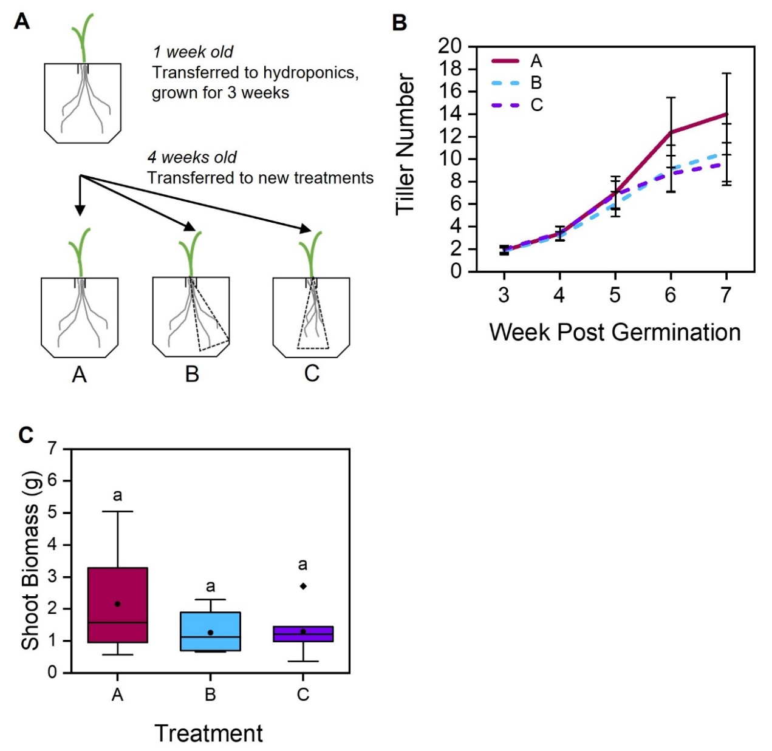
Figure 4.13 Root density results in shoot growth inhibition
Wheat (cv. Mulika) plants were pregerminated for 1 week in perlite before transferring into the hydroponic system and grown for 3 weeks. At 4 weeks post germination, plants were transferred into 3 treatments.
A) A cartoon depicting the experimental design. After all plants had been grown in 100ml pots containing perlite for 1 week, the perlite was washed off and all plants were transferred into 1L hydroponic pots 1 plant per pot (1/pot) for 3 weeks. At 4 weeks old new treatments were introduced. Treatment A: These plants remained the same as the prior 3 weeks with free root systems. Treatment B: half the roots of each plant were placed within a 150ml mesh bag which was secured to the lid of the pot, the other half of the root system remained free. Treatment C: All roots were placed within a mesh bag secured to the lid.
B) Line graph showing tiller number overtime. Treatments which involve a mesh bag are shown as dotted lines (Treatments B and C). Treatment A (pink), treatment B (blue), error bars represent S.E.M, n=8.
C) Boxplot showing dry shoot biomass (g) at 7 weeks post germination. Box indicates the interquartile range, circle indicates the mean, the midline indicates the median, the whiskers are the minimum and maximum values, the diamond represents an outlier. Boxes with the same letter represent no statistical difference (One way ANOVA with Tukey HSD, p<0.05), n=8.

To assess how perceived root density influences root growth, I assessed the dry root biomass for the whole root system in treatments A and C, and the whole root system for treatment B but split into the bagged vs unbagged portions of the root system. Treatment A plants, which were subjected to the lowest root density produced the highest root biomass. Consistent with their much smaller physical volume, treatment C plants made a much smaller amount of root biomass. The case of treatment B plants is intriguing; although not statistically significant, the free roots had a higher root biomass than their bagged counterparts in the same treatment, but the sum of both root biomasses in treatment B only equals that of treatment C (Fig 4.14A). This suggests that the treatment B plants are able to make a proactive decision to prioritise growth of free roots and slow down root growth of the bagged roots, but that the perception of high root density anywhere in the root system reduces overall root growth.

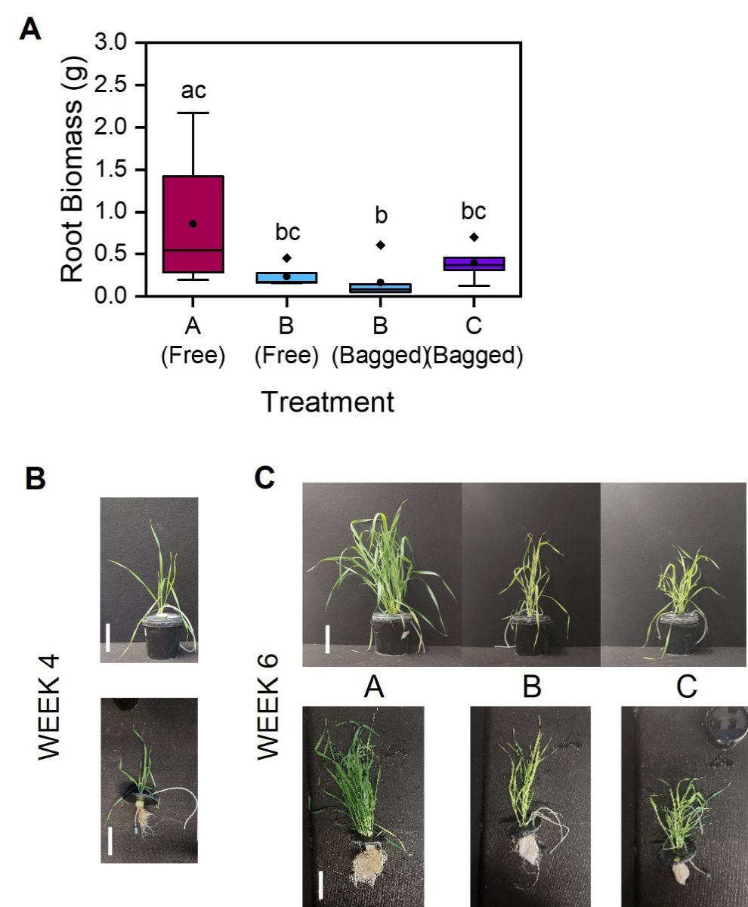

Figure 4.14 Root density affects root growth allocation
Wheat (cv. Mulika) plants were pregerminated for 1 week in perlite before transferring into the hydroponic system and grown for 3 weeks. At 4 weeks post germination, plants were transferred into 3 treatments.
A) Boxplot showing dry root biomass (g) at 7 weeks post germination. Box indicates the interquartile range, circle indicates the mean, the midline indicates the median, the whiskers are the minimum and maximum values, diamonds represent outliers. Boxes with the same letter represent no statistical difference (Kruskal Wallis test with Bonferroni correction, p<0.05), n=8.
B) Photos showing root and shoot system growth at 4 weeks post germination. Scale bar depicts 10cm.
C) Photos showing the root and shoots of example plants from treatments A-C. Scale bar depicts 10cm.

A study was carried out by Bar-Tal et al (1995) (also discussed in the introduction), where the root systems of hydroponically grown tomato plants were either free or enclosed in a cloth bag of 400ml or 1000ml within a pot. They found that the root systems were more severely affected than the shoot systems and that root system size was relative to the amount of physical space the roots had to explore. This supports the findings of section 4.3.6, as these data indicate that any degree of physical root restriction inhibits root and shoot growth, regardless of full chemical access to the hydroponate through the mesh. Bar-Tal et al (1995) however did not have the ability to explore why this might be with their experimental design. Treatment B of Figure 4.14A highlights that the root-based growth inhibition is local, although not statistically significant, not global as plants can redirect their root growth to areas of the root system which are not at high density. This supports the hypothesis that the second phase signal is largely immobile and can influence roots on a localised and not global scale, with corresponding effects on shoot system growth.

The root exuded signal in the first phase cannot fully explain early responses to volume

In section 4.3, I identified that wheat plants detect and respond to soil volume using an early and late phase mechanism which I hypothesised involves two distinct root exuded signals with different properties. However, in this section, I describe an experiment that challenges this model, and highlights that there is likely more complexity than initially proposed.
I hypothesised that the early root exuded signal would be highly mobile, given its ability to diffuse through the mesh pots described in 4.3.2. However, I aimed to assess if, even with access to a large chemical volume, more extreme limits on physical volume can still limit plant growth in the early phase. To test this idea I carried out a hydroponic experiment where wheat (cv. Mulika) plants were sown in 100ml pots containing 50:50 sand:perlite for 1 week and then transferred into 1L containers in the hydroponic system (hydroponic set up details explained in Chapter 2). Plants were grown in an ‘enclosed’ treatment where the root systems were enclosed in a modified 50ml falcon tube where the base had been removed and impermeable mesh had been secured to the now open end to seal it, but still allowing any root exuded chemicals and nutrients to be exchanged but restraining the roots within (Fig. 4.15A). This was the same impermeable mesh described in Sections 4.3.2 and 4.3.6. The other treatment ‘free’ involved a much shorter open ended modified falcon tube, allowing the roots free access to the hydroponate (Fig. 4.15A). The plants in the ‘enclosed’ treatment had the same chemical substrate volume as the ‘free’ plants but the ’enclosed’ plants were subjected to increased mechanical impedance and much less physical substrate volume (Wheeldon et al., 2021).
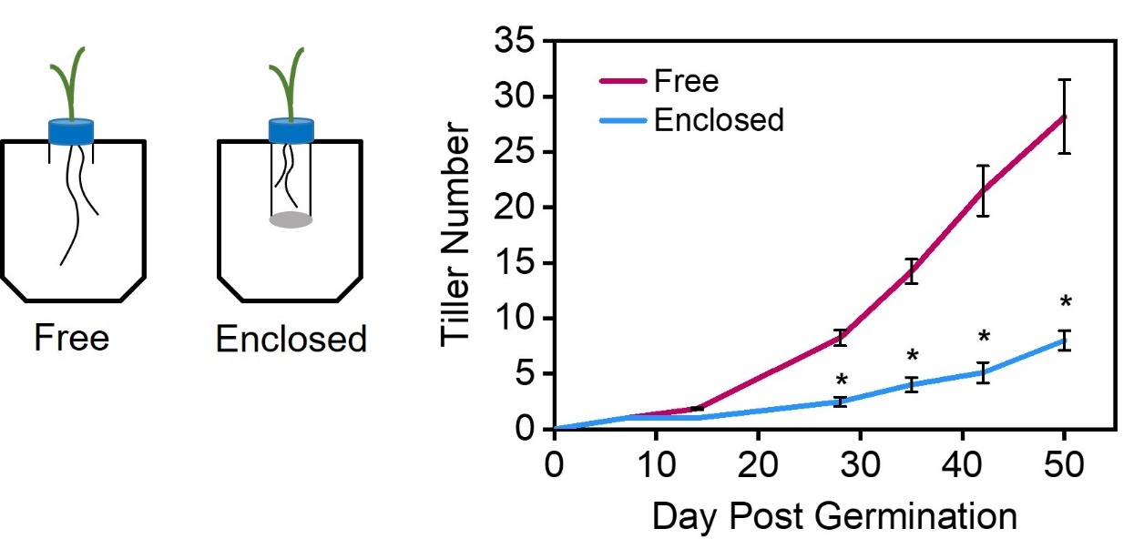
Tiller number was assessed weekly from week 2-7. Statistically significant differences between the treatments were seen from 4 weeks post germination. ‘Free’ plants were able to tiller greatly, producing a maximum of ~ 27 tillers (Fig 4.15B). Intriguingly this was much greater than the tiller number of soil grown plants that had access to double the physical and chemical substrate volume (Fig. 4.7B), and therefore suggests the root exudate is highly mobile and can be diffused in the hydroponate. The ‘enclosed’ plants tillered slower, although they were able to sustain this throughout life (Fig. 4.15B). Crucially, in this experiment, differences were seen in the early phase of growth between the treatments, despite the identical chemical volume. This suggested that the ‘enclosed’ plants recognised the extreme physical limit on their available space early in life. As both treatments had access to the 1L of hydroponic medium, nutrient differences between the treatments can be reasonably ruled out as the reason for the tillering differences seen.
Figure 4.15 Substrate volume limitation can occur in hydroponic scenarios
A) Cartoon describing the experimental design. Wheat (cv. Mulika) plants grown hydroponically in 1L pots. Blue represents falcon tube lids with a hole to allow to the shoot (green) to grow out. Falcon tube lids are attached to modified falcon tubes, left shows a falcon tube sawn down to 2cm in length (free) allowing free movement of roots in the hydroponate, right shows a falcon tube with the bottom sawn off and nylon mesh (grey) glued to the base to stop any escape of roots (enclosed).
B) Line graph showing mean tiller number of wheat plants (cv. Mulika) grown in the set up described above until 52 days post germination. Free plants are shown as a burgundy line, enclosed plants are shown with a blue line. Error bars represent the s.e.m, n=10. Asterisks show statistically significant difference between free and enclosed plants, all Mann-Whitney U test except for day 52 where Independent samples t-test was used, p<0.05).
Figure modified from Wheeldon et al, 2021

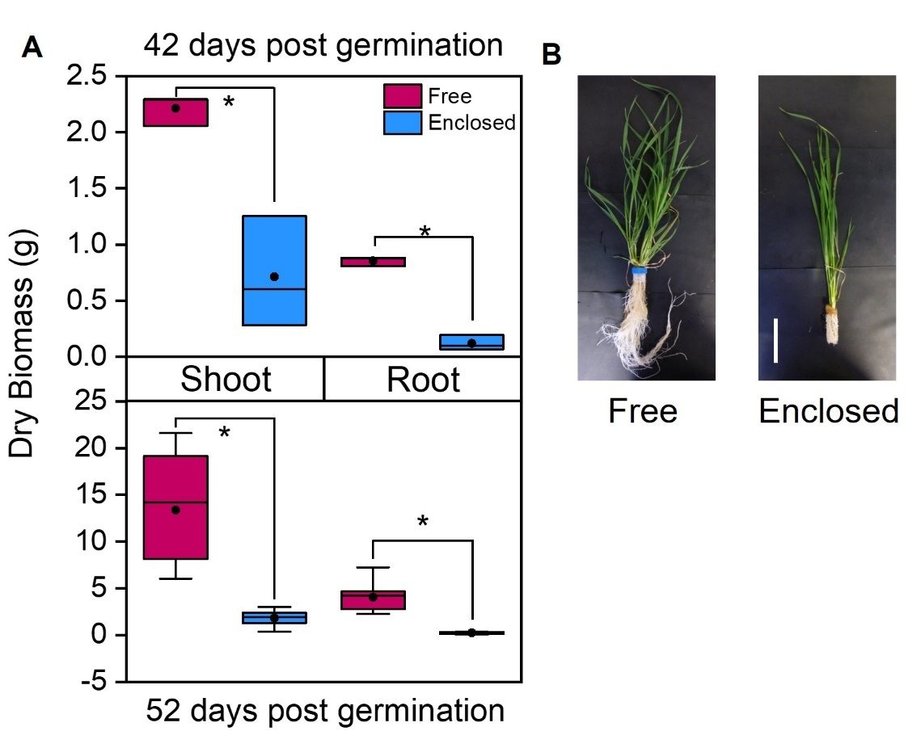
To investigate how shoot and root growth is affected by physical and chemical substrate volume, this was assessed at 2 timepoints. At 42- and 52-days post gemination there is a statistical difference in root and shoot biomass between ‘free’ and ‘enclosed’ plants (Fig. 4.16A). Between these timepoints the biomass of both shoot and root tissue increased ~2-fold in ‘enclosed’ plants. Looking at the ‘Free’ plants however, these increased their root biomass ~4-fold and they increased their shoot biomass ~6-fold. At 42 days post germination, root system size was visibly larger in the ‘free’ plants compared to the ‘enclosed’ plants (Fig. 4.16B) (Wheeldon et al., 2021).

Figure 4.16 Shoot and root biomass increase less in root enclosed conditions
A) Box plots showing shoot (left) and root (right) dry biomass (g) of wheat plants (cv. Mulika) in free (pink) and enclosed (blue) root system treatments as described in Fig 4.15A at 42 days (top) and 52 days (bottom) post germination. The box indicates the interquartile range, the midline indicates the median, the whiskers are the minimum and maximum values, the circle within the box is the mean. Asterisks show significant difference between the treatments (Independent samples t-test, p<0.05), n=8-10.
B) Images of wheat plants in treatments described in Fig. 4.15A at 42 days post germination when removed from the hydroponic pots. Left: ‘free’ treatment, right: ‘enclosed’ treatment with modified falcon tube removed. Scale bar represents 10cm.
Figure modified from Wheeldon et al, 2021

This experiment therefore suggests that even under hydroponic conditions where the first phase signal can theoretically be easily diluted, if a physical substrate volume is particularly small this can still inhibit plant growth. Thus, it may be the case that the second, root density-dependent phase of soil volume responses can begin early, if physical volume is particularly restricted.

Discussion

Plants initiate an immediate competitive response on the recognition of neighbours
The effects of plant-plant interactions on the root system are much less understood than those on the shoot, and in many respects, root-based mechanisms of neighbour detection and response remain rather mysterious (Wang et al., 2021). Prior to this PhD there has been no investigation of the transcriptional changes that occur in the root system after exposure to neighbours in the environment. Therefore, the RNAseq analysis in section 4.2 provides an exciting avenue for future exploration. From the current DEGs identified, this suggests that on the recognition of neighbours, barley plants appear to initiate the growth of any machinery that can uptake resources from the environment. This appears to involve the growth of root hairs, and the strong upregulation of nitrate transporters.
Data presented in section 3.2 clearly shows that crowded plants have an increased rate of shoot growth initially, but this initial rate is not maintained. This could therefore suggest that understanding more about their neighbour, perhaps their genetic identity, plants reduce their initial competitive response, so as to not run out of resources before the end of their lifecycle. There are many studies that have explored the effects of genetic relatedness on responses to neighbouring plants (reviewed in (Bilas et al., 2021)), but this was not investigated in these experiments.
The identification of root hair genes and nitrate transporters from the RNAseq data (Section 4.2) provides new potential areas to explore for responses to neighbour density, and there could yet be other exciting candidates that have not yet been identified due to the RNAseq being performed late in this PhD. Nevertheless, this dataset describes a strong, initial response on the recognition of neighbouring plants that provides transcriptional evidence of a competitive response.

Early responses to substrate volume are the result of a ‘substrate volume sensing signal’
It has previously been recognised in the literature that nutrient availability cannot be the sole cause of plant responses to substrate volume (Hess and De Kroon, 2007; Poorter et al., 2012). In section 4.3 I have described experiments which suggest wheat plants use root exuded chemicals to detect their substrate volume. I propose that in early life wheat plants use a ‘Substrate Volume Sensing Signal’ (SVS) to detect their total available substrate volume. The SVS signal appears to be highly mobile and is diffusible through soil and hydroponic media. SVS is presumably able to be easily diluted into space, even when roots are not physically occupying that space (Wheeldon et al., 2021). When plants grown in small soil volumes are transplanted into larger soil volumes, any shoot growth inhibition caused by the small soil volume is seen to quickly be overcome. The roots of the transplanted plants do not need to have any additional physical substrate volume in which to explore, because SVS can be diluted into the larger chemical substrate volume (Fig. 4.7) (Wheeldon et al., 2021). Thus, SVS appears to cause shoot growth inhibition, unless it can be diluted in a large substrate volume. Early in life, the plant exudes SVS which increases in concentration. This increase in concentration causes shoot growth inhibition, but does not seem to inhibit root growth (Wheeldon et al., 2021). However, there appears to be a threshold of physical volume in which plants can tolerate and if the physical volume is too small the benefits of additional chemical volume and the subsequent dilution of SVS is not reflected in shoot growth. This may be because extreme physical restriction activates the second phase of soil volume responses earlier than normal.
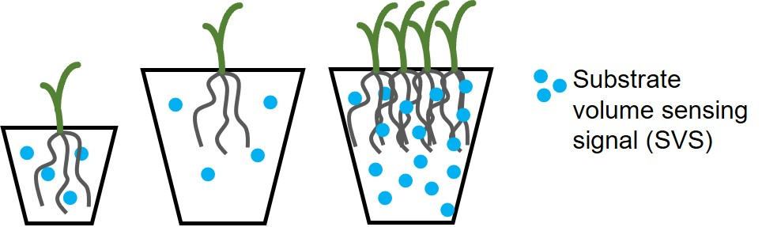
Together, experiments in sections 3.2 and 4.3 have suggested that SVS is highly mobile therefore is likely to be a root exuded chemical of low molecular weight (Wheeldon et al., 2021). The likely identity of SVS will be discussed in chapter 5.

Figure 4.17 The substrate volume sensing signal (SVS) is used to detect available space early in plant growth
Cartoon showing the first few weeks of life in wheat plants. Blue dots represent the substrate volume sensing signal (SVS). In large soil volumes (middle) this is diluted in the available substrate volume more than in small soil volumes. This allows shoot growth to continue for longer in large pots. In crowded pots (right), the concentration of SVS increases faster than in singly sown pots due to the additional plants exuding SVS.
Modified from Wheeldon et al (2021)

Substrate volume responses later in life are the result of root density
While SVS appears to be important early in life, the growth of plants after 5 weeks post-germination shows different properties compared to the defined effects of SVS. The soil-based transfer experiment discussed in section 4.3.2 showed that treatment E plants (mesh pot in 1900ml of soil) showed reduced shoot growth relative to treatment C and D plants which were not subjected to a small physical substrate volume (Wheeldon et al., 2021). Additionally, the ‘enclosed’ roots of plants grown hydroponically showed a reduced shoot growth later in life, that was accompanied by a much lower root growth than ‘free’ root systems (Section 4.3.7) (Wheeldon et al., 2021). This latter idea is supported by the root density measurements carried out in Figure 4.10. This showed that early in life root growth continued in both substrate volumes, but later in life, root growth ceased in small pots and slowed down in large pots (Wheeldon et al., 2021). Work in section 3.4.1 suggested that although plants grown in 150ml rhizoboxes had a higher root density than those in 1100ml rhizoboxes for most of the experiment, later in life the root density in 1100ml rhizoboxes ultimately matched that of the 150ml rhizobox plants. Together, these data suggests that root growth is strongly affected in the second stage of growth, as well as shoot growth. Moreover, data presented in this thesis suggests that when a critical threshold of root density is reached in this second phase, this results in the inhibition of both root and shoot growth.
Nevertheless, the shoot and root growth of plants with a small physical substrate volume, but a larger chemical volume, is higher than would be predicted purely on the basis of physical substrate volume (Fig. 4.7-4.8). This suggests that the accumulation of a second diffusible, exuded chemical might regulate growth responses later in life. However, since growth does not match the chemical volume available, this suggests that this hypothesised ‘root density sensing’ (RDS) is relatively immobile in the substrate (Wheeldon et al., 2021).
The experiment which tested the influence of container shape on shoot growth in section 4.2.5, when the substrate volume is equal but the shape in which the roots can explore is different, resulted in changes in shoot growth in the second phase of growth. When the roots were able to spread in a ‘natural’ way suited to their cone shaped root architecture, this allowed for increased shoot growth. However, when roots were tightly aggregated and unable to spread, this inhibited shoot growth. These data are consistent with a model in which the concentration of the root density signal (RDS) builds up faster than in the more ‘natural’ shaped pot (Fig. 4.11-4.12).

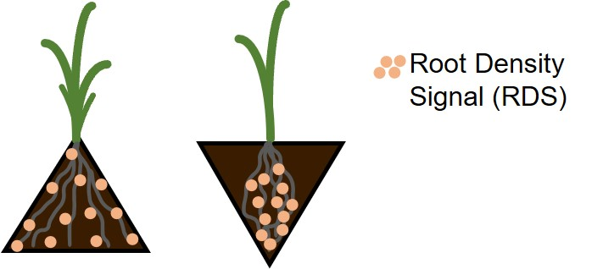

Figure 4.18 The concentration of the root density signal (RDS) increases faster during root aggregation, inhibiting shoot growth
Cartoon representing the second phase of the soil volume sensing mechanism. Wheat plants experiencing different degrees of root aggregation, adapted from Figure 4.11A. Left: plants can spread their roots in a more natural way allowing RDS (peach dots) to be distributed throughout the substrate volume. Right: roots are highly aggregated in a smaller surface area of soil despite being grown in the same substrate volume as those on the left therefore RDS is concentrated in the area of high root density. Subsequently, the increased concentration of RDS in a small area in plants on the right resulted in the inhibition of both root and shoot growth.

Additionally, I explored the mobility of RDS further. Section 4.3.6, highlighted that RDS acts locally on root systems by inhibiting root growth. In this scenario plants are able to redirect their growth to areas where roots are not highly dense. This suggests that RDS is not a very mobile signal, and its local effects on root growth have subsequent inhibitory properties on shoot growth. Any amount of root-based inhibition affects final shoot biomass.

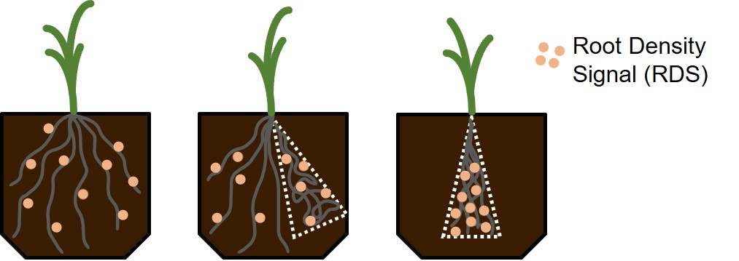
Figure 4.19 The root density signal (RDS) inhibits root growth locally with global shoot and root growth consequences
Cartoon describing the second phase of the soil volume sensing mechanism, modified from Figure 4.13A. Later in life as root density in the soil environment increases, the roots produce and exude a root density signal (RDS) (peach dots). This signal is immobile hence stays close to the roots. In scenarios of low root density, the RDS signal is widespread (left) whereas when the root system is highly dense in a small area, the concentration of RDS is higher in this area and does not diffuse away (right). This results in shoot and root growth inhibition. When part of the root system is highly dense with high concentrations of RDS (middle), if the plant is able to, it prioritises growth to part of the root system that is not densely aggregated. Nevertheless, the shoot system is still subjected to growth inhibition.

While RDS is currently hypothetical, its characteristics are similar to the proposed self-inhibitory signal discussed by Semchenko et al (2007). In their experiments they grew plants in treatments where activated carbon was added to the pots and then the authors assessed root growth with and without it. Activated carbon is known to absorb organic root exudates (Mahall and Callaway, 1992). They found that root and shoot biomass increased in the treatments with activated carbon, suggesting the existence of a root growth self-inhibitory signal, which is organic in nature (Semchenko et al., 2007). The immobile nature of RDS could suggest it remains in the rhizosheath of the roots therefore indicate that it is of a much higher molecular weight than the first phase signal SVS (Wheeldon et al., 2021).

Plants detect and respond to their available space and the presence of neighbouring plants using a two-phase root exudate based mechanism
Bringing these ideas together, I therefore propose that plants detect and respond to their available belowground space in a two-phase root exudate-based mechanism. Early in plant life, the concentration of SVS exuded by the plant is monitored and this determines the rate of shoot growth. Because SVS is highly mobile, this growth corresponds to the chemical substrate volume available to the plant, not the physical substrate volume (Wheeldon et al., 2021). Later on in life, plants exude a second signal, RDS, which accumulates primarily according to the physical substrate volume (Wheeldon et al., 2021), and reaches a genotype-defined critical concentration which inhibits root growth, with the secondary effect of shoot-based inhibition. RDS acts locally on areas of the root system experiencing high root density to inhibit their growth but areas of the root system which are able to escape the high root density are able to grow preferentially. Despite plants being able to prioritise growth into areas of low root density, the negative effects caused by the area of high root density cause knock on effects in the shoot system as shoot growth becomes inhibited.

Future directions
The proposition of the two-phase model elegantly provides a mechanism for how plants detect and respond to their available soil volume and neighbour density, which has failed to be achieved previously. This model allows the plants to detect the resources they currently have available to them, but the detection of physical substrate volume and any other plants in their environment, allows them to make a prediction about what resources they may have available later on in life and as such they plan their growth accordingly (Wheeldon et al., 2021). The wider applications of this model could be beneficial for improving crop growth in monocultures. Developing crops able to grow larger in a given space could have societal, environmental and economic benefits, such that growth and yield gains could potentially be made without the addition of excess fertilisers. If plants were unable to sense the limited space or presence of neighbours by turning off or turning down SVS and RDS this could allow them to grow larger in a given space. This would be an exciting application of the model, but this would require much more investigation and most importantly the identification of the two root exudate signals. However, the most pertinent next steps would involve elucidating the identities of the SVS and RDS signals.

Strigolactone as a root exuded signal for neighbour and volume detection

Introduction

Over the last 30 years, research into how plants detect neighbouring plants has increased greatly and has showed that plants can actively detect, and indeed respond, to other plants in their environment (Bilas et al., 2021). Root exudates have been shown to be one such mechanism of neighbour detection in the roots. However, there has been a difficulty in determining the importance of these due to issues surrounding confounding variables in studies (Hess and De Kroon, 2007; Semchenko et al., 2007). Enhanced understanding of plant responses to neighbours both above and belowground will aid in the development of more density resistant crops, which could potentially increase yield in a given area of land.

Neighbour density experiments carried out in chapter 3.2 determined that the shoot growth responses to neighbour presence was due to neighbour detection via the roots. In chapter 4, I proposed that the detection and response to soil volume and neighbour density likely share the same two-stage mechanism based on the exudation and detection of two distinct root exudates. From the experiments presented in chapter 4, my work has shown that the early shoot growth responses to soil volume, due to the detection of the hypothetical SVS signal, were much more pronounced than root growth responses. I hypothesised that SVS is likely to be highly mobile in both soil and hydroponic conditions and therefore is likely to be of low molecular weight (Wheeldon et al., 2021).

Strigolactones (SLs) are small signalling molecules of low molecular weight (Xie et al., 2010) that are exuded by flowering plants, resulting in arbuscular mycorrhizal fungi (AMF) recruitment to the roots (Akiyama et al., 2005). Their existence was first identified as exuded germination stimulants for parasitic plants (Cook et al., 1966; Bouwmeester et al., 2007), hence their presence as root exudates in the soil environment could also have other rhizospheric functions which have not yet been uncovered. Thus, SLs could be candidates for neighbour detection signals in plants. Indeed, this idea has previously been suggested by a study in moss (Physcomitrium patens) which showed that SLs exuded by wild-type (WT) colonies influenced the growth of other moss colonies (Proust et al., 2011). WT colonies show reduced growth in the presence of neighbouring colonies, whereas Ppccd8 mutant colonies lacking the CCD8 SL biosynthesis gene spread into other Ppccd8 colonies. When WT and Ppccd8 mutant colonies were grown in the same plate, the SL exuded from the WT colonies inhibited the Ppccd8 colonies from extending (Proust et al., 2011). This suggested that the SLs exuded from WT colonies causes growth inhibition in neighbouring colonies and hence highlights the potential of SLs acting as a plant-to-plant signal.

In the shoot, SLs strongly inhibit shoot branching, and mutations in any part of both the SL biosynthesis and signalling pathways cause extreme changes to shoot development (Gomez-Roldan et al., 2008; Umehara et al., 2008). However their effect on root development is minimal and does not follow consistent trends between species (Waters et al., 2017; Machin et al., 2019; Villaécija-Aguilar et al., 2019). Grafting studies have suggested that SLs are primarily synthesised in the roots and can move from the root to the shoots (Beveridge, 2006; Dun et al., 2009), in addition to their high concentration in root tissues compared to the shoots (Yoneyama et al., 2007; Umehara et al., 2010; Xie et al., 2015).

Thus, SLs have characteristics that are similar to the hypothetical SVS signal. In addition, preliminary experiments from my MSc by Research project indicated that SLs may be important for plant-plant responses (Wheeldon, 2019), but the details were yet to be explored. I therefore hypothesised that rhizospheric strigolactones are the hypothesised SVS signal.

In this chapter, I aimed to explore if SLs could act as plant-to-plant signals and determine if SLs could also be the soil volume sensing signal (SVS).

Environmental strigolactone is required for early neighbour and soil volume detection

Strigolactone mutants lack early neighbour-induced shoot growth responses

If rhizospheric SLs acts as the SVS signal, then mutants that do not synthesise SLs should fail to respond to the presence of neighbours early in their life-cycle. Wild-type (WT) pea plants are able to synthesise and exude SLs however ramosus1 (rms1) mutants that lack the CCD8 enzyme (Sorefan et al., 2003) (Fig 5.1A) cannot synthesise SLs, and hence rms1 plants are highly branched and short in stature compared to WT plants. Together with Hannah Lund and Maxime Hamon-Josse, I grew WT (L77) and rms1-1 (rms1 from hereafter) pea plants in 1L hydroponic pots, in 1 plant per pot (1/pot) or 4 plants per pot (4/pot) treatments (Wheeldon et al., 2022). As discussed in chapter 4, using a hydroponic system allowed for careful control of nutrient availability and easy distribution of any soluble root exudate throughout the pot.

Shoot branches were counted weekly to observe any shoot growth responses to neighbouring plants (Fig. 5.1B). WT plants produced more branches in 1/pot treatments than the 4/pot treatments (per plant) as found in previous experiments (Chapter 3.2.4). Between week 3 and 4 post-germination there was a divergence in WT branch numbers between the 1/pot and 4/pot treatments (Fig. 5.1B), consistent with the previously observed SVS effects in wheat (Fig. 3.2). As rms1 plants have increased branching due to a lack of SL synthesis, rms1 plants consistently had higher branch numbers than WT plants throughout the experiment (Fig. 5.1B). Intriguingly, the divergence seen between the WT treatments in weeks 3-4 was not present in rms1 plants. However, by 6 weeks post-germination, the rms1 1/pot plants produced a higher branch number than their rms1 4/pot counterparts (Fig 5.1B). WT 1/pot and 4/pot plants continued to diverge in branch number during this timeframe. This suggested that the rms1 plants lack the early shoot growth response to neighbours but respond normally later on. This suggests that responses to neighbour detection follow the same two-stage mechanism as for soil volume, which is consistent with the interchangeability of neighbour density and soil volume responses (Section 3.2). Together this suggests that in the first phase, SL is important for neighbour detection but in the second, later phase, SL is not required (Wheeldon et al., 2022).
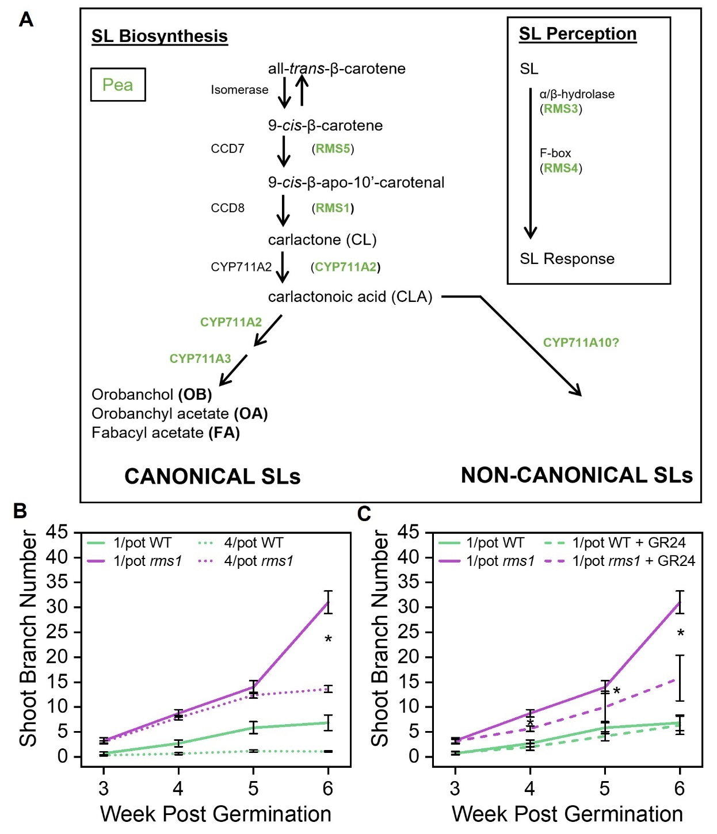
Figure 5.1 Exuded strigolactones (SL) influence the shoot branching of neighbours
Graphs showing wildtype (WT) and rms1-1 (background L77) Pisum sativum (pea) plants grown hydroponically in 1 plant per pot (1/pot) and 4 plants per pot (4/pot).
A) Figure showing the strigolactone (SL) biosynthesis and signalling pathways in Pisum sativum (pea). Specific gene names in pea are shown in green (black gene names preceding these are used in several other species), large black font connected by arrows are the chemical intermediates, 3 of the products of the SL biosynthesis pathway in pea are shown at the bottom left branch of the diagram. Genes required for SL perception in pea are shown within the box on the right of the diagram.
B) Line graph of mean shoot branch number per plant of WT (green) and rms1 (purple) pea plants grown 1/pot (solid line) and 4/pot (dotted line) from weeks 3 to 6 post germination. Error bars are s.e.m, n=4-7. Asterisks show significant difference between the treatments (Independent samples t-test, p<0.05).
C) Line graph of mean shoot branch number per plant of WT (green) and rms1 (purple) pea plants grown 1/pot (solid line) and 1/pot with GR24 (dotted line) from weeks 3 to 6 post germination. Error bars are s.e.m, n=4-7. Asterisks show significant difference between the treatments (Independent samples t-test, p<0.05).
Figure modified from Wheeldon et al, 2022.

To test this idea more directly, also together with Hannah Lund and Maxime Hamon-Josse, the same experimental design was used as described above except instead of 4/pot plants, 1/pot plants were treated with the synthetic SL rac-GR24 (1 µM). Previous studies have shown that the application of exogenous SLs, such as rac-GR24, results in significant reduction in shoot branching (Umehara et al., 2008; Gomez-Roldan et al., 2008; Crawford et al., 2010; Bennett et al., 2016). By applying rac-GR24 to the hydroponic set up we could be certain it would be distributed through the hydroponate and hence determine if the plants could detect and take it up from the environment. Again, shoot branch number was tracked from week 3-6 and this showed that branch number was strongly reduced in the 1/pot rms1 plants which were supplemented with rac-GR24 (Fig 5.1C). Branch number in 1/pot + rms1 rac-GR24 plants was significantly different from that of untreated 1/pot rms1 plants. This therefore suggested that the rms1 plants were able to take up SLs from the environment, and that this compensates for their inability to synthesise SLs (Wheeldon et al., 2022).

Strigolactone exudates released early in life can be taken up by neighbouring plants

To test this finding, our collaborator Kaori Yoneyama further tested the ability of pea plants to take up SL from the environment by assessing SL levels in the roots (Wheeldon et al., 2022). Combinations of WT, rms5-BL298 (which lacks the CCD7 strigolactone biosynthesis gene (Fig 5.1A)) and rms1-2T (all in the Torsdag background) were grown in hydroponic conditions. Plants were grown 2 plants per pot (2/pot) with either another plant of the same genotype, or one of another genotype. Root samples were harvested 7 days post phosphate starvation (a commonly used method to increase SL levels as discussed in section 1.4) and liquid chromatography-mass spectrometry (LC-MS) was carried out to quantify the levels of SL (specifically Fabacyl acetate (FA)) in the root tissue of these plants. Measuring SL is difficult due to their low abundance and therefore only relative levels, defined as “peak areas’’ were measured, and not absolute concentrations (Wheeldon et al., 2022).

Analysis of the rms1 + rms1 and rms5 + rms5 combinations showed that, no FA was detected in the roots of these plants (Fig 5.2A), which makes sense given that rms1 and rms5 plants are unable to synthesise SL (Fig 5.1A). However, when assessing the roots of rms1 plants grown in the rms1 + WT combination and rms5 plants in the rms5 + WT combination it was found that, SL was detected in both of these mutant roots. In addition to these observations there was a decrease in the levels of SL in the roots of WT plants in combination with rms1 and rms5 plants compared to the WT+WT combination (Fig 5.2A) (Wheeldon et al., 2022).
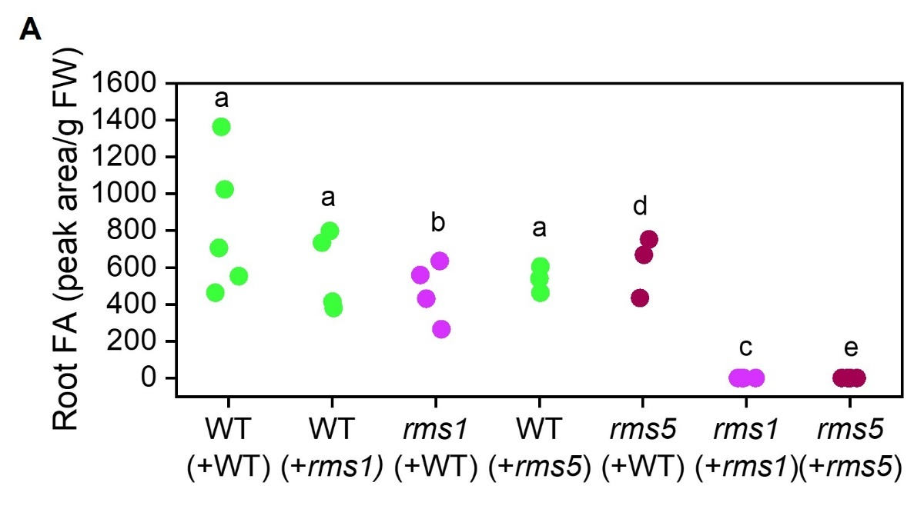
Figure 5.2 Strigolactones exuded from wildtype plants is present in roots of strigolactone synthesis mutants when crowded together
Graphs showing wildtype (WT), rms1-2T and rms5-BL298 (background Torsdag) Pisum sativum (pea) plants grown hydroponically in 2 plants per pot (1/pot) combinations after 7 days of phosphate starvation.
A) Column scatter showing the fabacyl acetate (FA) peak area per gram of fresh root tissue weight, from LC-MS analysis of root tissues. Plotted data represents the focal plant (no brackets) in the presence of a neighbouring plant (brackets). Statistical analysis of the focal plant was carried out separately for the different genotypes and the same letter indicates no statistical difference (WT: One way ANOVA with Tukey HSD, rms1 and rms5: Independent samples t-test, p<0.05), n=3-5.
Figure modified from Wheeldon et al, 2022

These data suggest that SL exuded into the environment is able to be taken up by other plants sharing the same environment (Wheeldon et al., 2022).

Detection of neighbouring plants early in the life cycle requires exudation of strigolactones

Given the data presented thus far, I hypothesised that if SLs are indeed SVS/neighbour detection signals, then the lack of SL synthesis in rms1 plants would make them essentially ‘invisible’ to other plants in the environment early in life. However, I also hypothesised that if this was the case, then rms1 plants would remain receptive to any SLs exuded by other plants in their environment. On the contrary, if SLs are only required for growth responses to other neighbour detection signals, then rms1 plants should still be ‘visible’ to neighbouring plants (because they would still make the neighbour detection signal), but would fail to respond to the presence of neighbours (due to a lack of SLs) (Wheeldon et al., 2022). As mentioned earlier, rms1 plants are highly branched and short in stature, and rms3 plants (which lack the SL receptor D14 (RMS3 in pea, Fig 5.1A)) also share the same shoot phenotypes as rms1 plants. However, rms3 plants are signalling mutants and hence I hypothesised that, if SLs are neighbour detection signals, then rms3 mutants would be unable to sense and respond to SLs in the environment, but would still be able to produce and exude it, and therefore inhibit the growth of neighbours. Therefore, rms3 plants should be unable to perceive the presence of neighbouring plants early in life, but would be able to inhibit the growth of rms1 neighbours via their exuded SL (Wheeldon et al., 2022). However, if SLs are primarily involved in the response to neighbouring plants and do not act as plant-to-plant signals, rms1 and rms3 should behave the same, in an unresponsive manner, to crowding with other plants (Wheeldon et al., 2022).

To explore the possibility that SLs are plant-to-plant signals further, I grew, together with Hannah Lund and Maxime Hamon-Josse, rms1-1 (L77 background) and rms3-1 (Torsdag background) plants in a series of soil-based combinatorial treatments in 500ml pots. Plants were either grown 4 plants per pot of the same genotype (4x), or 4 plants per pot of mixed genotypes where there were 3 plants of 1 genotype and 1 plant of the other genotype (3x rms1 and 1x rms3 respectively, and 1x rms3 and 3x rms1 respectively) (Fig. 5.3A).

Shoot branch number and shoot biomass were measured at 8 weeks post-germination. When each genotype was grown singly (1x), they produced a similar number of branches to each other (Fig. 5.3B). As would be expected from data presented in section 3.2 and Figure 5.1A, when crowded in the same soil volume (4x) there was a reduction in both the number of shoot branches and shoot biomass produced compared to 1x grown plants, in both genotypes (Fig. 5.3C+D). This reduction led to both genotypes producing a similar number of branches and shoot biomass in the 4x treatments (Wheeldon et al., 2022).

When analysing the shoot branch number and biomass of plants grown in the 3x rms1 1x rms3 treatment, there was a small, but not significantly different, decrease seen in the rms1 plants compared with the growth of each plant in the 4x treatment of the same genotype. However, there was a dramatic, statistically significant, increase in branching and biomass of the single rms3 plant in this treatment (Fig. 5.3 C+D). Together, the 3x 1x combination treatment suggests that the single rms3 plant cannot ‘see’ that is has 3x rms1 neighbours in the pot, hence this results in the overproduction of branches and biomass in the rms3 plant. Conversely, the presence of the rms3 plant which is exuding SL, causes mild shoot growth inhibition in the rms1 plants in the pot (Wheeldon et al., 2022).

In the other combination treatment, 1x rms1 3x rms3, the rms3 plants have a statistically significant increase in the number of shoot branches and amount of biomass produced when compared to the 4x treatment of the same genotype (Fig. 5.3 C+D). Conversely, the 1x rms1 plant, although not statistically different from the 3x rms1 plants in the 3x 1x combination, shows a dramatic decrease in the number of shoot branches and amount of biomass produced, more so than in the other combination treatment. Together, this combination treatment suggests that the 3x rms3 plants, whom all produce and exude SL, result in a powerful inhibition of shoot branching and biomass in the rms1 plant. By reducing the size of the rms1 plant, the rms3 plants take advantage of this subsequently resulting in a greater number of branches and biomass compared to when rms3 plants were grown at 4x (Wheeldon et al., 2022).
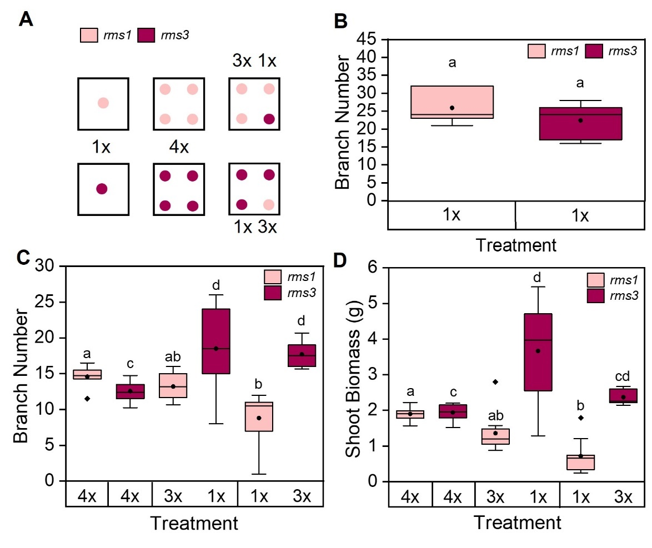
Figure 5.3 Strigolactones exuded by neighbouring plants inhibit other plants in the environment
Graphs showing rms1-1 (background L77) and rms3-1 (background Torsdag) Pisum sativum (pea) plants in soil-based combination treatments of 1 plant per pot (1x), 4 plants per pot (4x) and genotype combinations 3x 1x (rms1 and rms3 respectively) and 1x 3x (rms1 and rms3 respectively).
A) Cartoon representing the experimental set up. Peach dots represent rms1 and burgundy dots represent rms3 plants.
B) Boxplot showing mean shoot branch number per plant for rms1 and rms3 at 8 weeks post germination grown singly (1x). The box indicates the interquartile range, the midline indicates the median, the whiskers are the minimum and maximum values, the circle within the box is the mean. Boxes that share the same letter are not statistically different (Mann-Whitney U test, p<0.05), n=10.
C) Boxplot showing mean shoot branch number per plant for rms1 and rms3 at 8 weeks post germination in combination treatments. The box indicates the interquartile range, the midline indicates the median, the whiskers are the minimum and maximum values, the circle within the box is the mean. Boxes that share the same letter are not statistically different, statistics were carried out separately for each genotype (rms1: Kruskal-Wallis with Bonferroni correction. rms3: One way ANOVA with Tukey HSD. p<0.05), n=7-10.
D) Boxplot showing mean dry shoot biomass (g) per plant for rms1 and rms3 at 8 weeks post germination in combination treatments. The box indicates the interquartile range, the midline indicates the median, the whiskers are the minimum and maximum values, the circle within the box is the mean. Boxes that share the same letter are not statistically different, statistics were carried out separately for each genotype (Kruskal-Wallis with Bonferroni correction. p<0.05), n=7-10.
Figure modified from Wheeldon et al, 2022.

A similar experiment was carried out using WT and rms1 plants where I grew these in the same set up as Figure 5.3A. WT plants behaved similarly in some respects to rms3 plants. For example, WT plants seemed unable to ‘see’ the rms1 plant in the pot (regardless of the number of rms1 plants present) and hence produced elevated numbers of branches and increased shoot biomass than in the 4x WT treatment (Fig. 5.4). However, as WT plants inherently produce much greater shoot biomasses and are much taller than rms1, this acts as a confounding variable. Nevertheless, the data supported what is shown in the rms1/rms3 combination experiment above (Wheeldon et al., 2022).
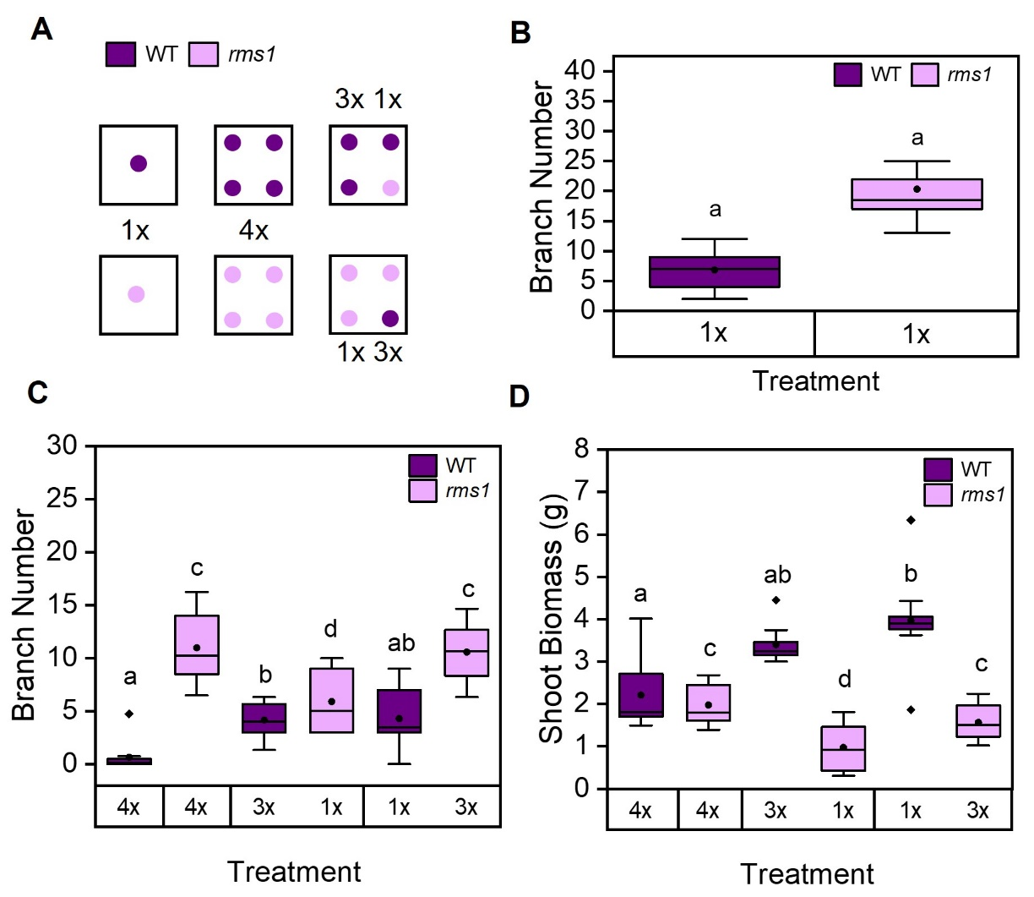
Figure 5.4 Strigolactones exuded by neighbouring plants causes shoot-based inhibition of other plants in the environment
Graphs showing wild-type WT (background L77) and rms1-1 (background Torsdag) Pisum sativum (pea) plants in soil-based combination treatments of 1 plant per pot (1x), 4 plants per pot (4x) and genotype combinations 3x 1x (WT and rms1 respectively) and 1x 3x (WT and rms1 respectively).
A) Cartoon representing the experimental set up. Purple dots represent WT and lilac dots represent rms1 plants.
B) Boxplot showing mean shoot branch number per plant for WT and rms1 at 8 weeks post germination grown singly (1x). The box indicates the interquartile range, the midline is the median, the whiskers are the minimum and maximum values, the circle within the box is the mean. Boxes that share the same letter are not statistically different (Independent samples t-test, p<0.05), n=10.
C) Boxplot showing mean shoot branch number per plant for WT and rms1 at 8 weeks post germination in combination treatments. The box indicates the interquartile range, the midline is the median, the whiskers are the minimum and maximum values, the circle within the box is the mean, diamonds represent outliers. Boxes that share the same letter are not statistically different, statistics were carried out separately for each genotype (Kruskal-Wallis with Bonferroni correction: WT. One way ANOVA with Tukey HSD: rms1. p<0.05), n=9-10.
D) Boxplot showing mean dry shoot biomass (g) per plant for WT and rms1 at 8 weeks post germination in combination treatments. The box indicates the interquartile range, the midline is the median, the whiskers are the minimum and maximum values, the circle within the box is the mean, diamonds represent outliers. Boxes that share the same letter are not statistically different, statistics were carried out separately for each genotype (Kruskal-Wallis with Bonferroni correction: WT, One way ANOVA with Tukey HSD: rms1. p<0.05), n=9-10.
Figure modified from Wheeldon et al, 2022

Taken together, these experiments suggest that SLs exuded into the environment act as plant-to-plant signalling molecules, rather than acting solely in the response to other plant-to-plant signals (Wheeldon et al., 2022).

Strigolactone biosynthesis and subsequent exudation is required for early soil volume responses

In chapter 4, I proposed a model for how plants detect and respond to soil volume and neighbour density (Wheeldon et al., 2021). The evidence that SLs can act as plant-to-plant signals presented in this chapter (Wheeldon et al., 2022) led to the hypothesis that SLs could be the signal involved in the first phase of this model, the ‘soil volume sensing signal’ (SVS). Both SL and SVS act mainly on the growth of the shoot system, and this occurs in a similar timeframe. Therefore, I hypothesised that plants unable to exude SLs would also be unable to respond to their available soil volume early in life. To test this hypothesis, I grew WT (L77) and rms1 (L77) pea plants singly in 500ml and 2000ml of compost, and harvested a subset of each genotype, in each soil volume, at 3 weeks post-germination and the remaining plants at 5 weeks post germination (Fig. 5.5A) (Wheeldon et al., 2022).

At 3 weeks post germination, there is no significant difference in shoot biomass between the soil volumes in either genotypes (Fig. 5.5A). This is consistent with the previously observed divergence of growth in plants grown in different soil volumes after 3 weeks (Chapter 4). However, by 5 weeks post germination, WT plants have increased their shoot biomass by ~1.7 fold in 2000ml pots compared to 500ml pots. Conversely, rms1 plants showed no significant difference between the soil volumes at 5 weeks post germination (Fig. 5.5A) (Wheeldon et al., 2022).

This therefore supports the hypothesis that SL acts as the SVS signal, since rms1 plants which cannot produce and exude SLs, are insensitive to soil volume for at least the first 5 weeks post-germination (Fig. 5.5A) (Wheeldon et al., 2022).

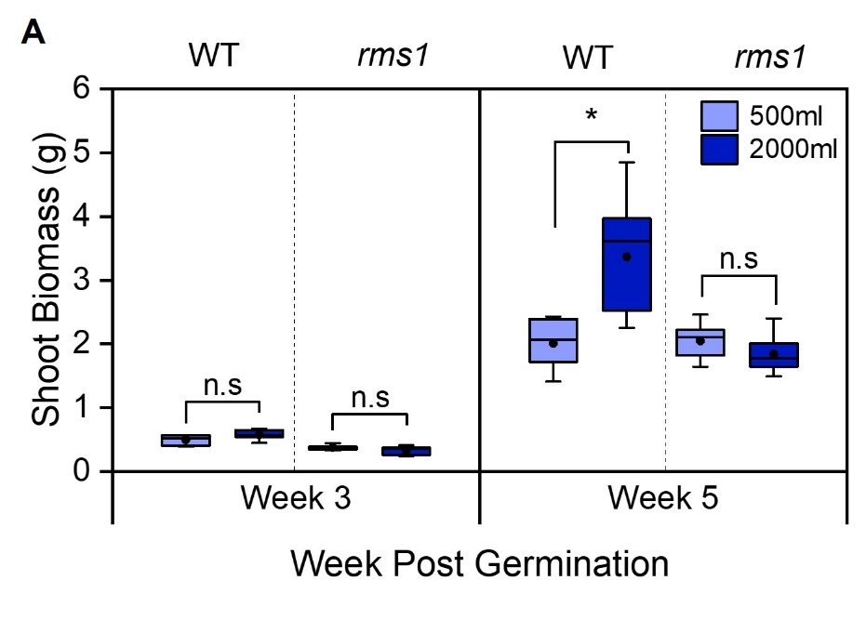

Figure 5.5 Detection of soil volume early in life requires strigolactone exudation
Graphs showing Wild-type (WT) and rms1-1 (background L77) Pisum sativum (pea) plants grown 1 plant per pot (1/pot) in 500ml (sky blue) and 2000ml (dark blue) of compost.
A) Boxplots showing mean dry shoot biomass per plant (g) for singly grown WT and rms1 plants at 3 and 5 weeks post germination, in 2 substrate volumes. The box indicates the interquartile range, the midline is the median, the whiskers are the minimum and maximum values, the circle within the box is the mean. Statistical analysis was only carried out within the same genotype, asterisk represents a statistically significant difference, n.s represents no significant difference (Independent samples t-test, p<0.05), n=6-10.
Figure modified from Wheeldon et al, 2022

Strigolactones exuded into the belowground environment influence neighbour detection and soil volume sensing

Collectively the data presented here shows a new function for exuded strigolactones, as plant-to-plant signals. This data shows that pea plants require the ability to produce strigolactone in order to inhibit the growth of their neighbours within the first few weeks of life, and this is also required to perceive their available soil volume. Plants unable to produce and exude SLs become outcompeted by neighbours that can produce and exude SLs. Detection of neighbours occurs by uptake of SLs from the environment by the roots, and results in shoot growth reduction. This ultimately allows plants to plan their future shoot growth strategies in line with the number of neighbours in their soil environment (Wheeldon et al., 2022).

A PDR transporter could act as a strigolactone importer

Data presented in section 5.2 demonstrates the ability of plants to uptake SLs from neighbouring plants. Therefore, it would be logical to hypothesise that there is a transporter which uptakes SLs from the soil environment, but to date there has been no suggestion of what the ‘strigolactone importer’ could be. A strigolactone exporter has been identified however, and this is an ABCG (ATP-binding cassette type G) transporter, PLEOTROPIC DRUG RESISTANCE 1 (PDR1), first identified in Petunia hybrida (petunia) (Kretzschmar et al., 2012). PDR1 has also been suggested to mediate the transport of SLs through the plant in both the roots and shoots (Kretzschmar et al., 2012; Sasse et al., 2015). The ability to exude SLs has been largely lost in the Brassicaceae (Kretzschmar et al., 2012), and PDR1 is not present in Arabidopsis or other members of the Brassicaceae family. However, when exogenous SL (rac-GR24) is applied to the roots of Arabidopsis this is still able to influence growth (Ruyter-Spira et al., 2011). Therefore, Arabidopsis can still clearly import SLs, and could serve as a model to identify potential SL importers.

PDR10 could act as the strigolactone importer in Arabidopsis

Given the role of PDR1 in SL exudation and to some extent movement of SL within the plant, I hypothesised that another member of the PDR family may act as the SL importer in Arabidopsis. To explore this possibility, I used a reverse genetics approach. I assessed a previously published phylogeny of PDR genes in Arabidopsis (Kretzschmar et al., 2012) for closely related PDR genes to PDR1 and using ePlant (Waese et al., 2017) and Tair (Berardini et al., 2015) I identified several PDR genes which are expressed in the roots, namely PDR4, PDR6, PDR10, PDR11 and PDR12. T-DNA insertion lines were ordered for these genes and they were genotyped to ensure homozygosity. Two T-DNA insertion lines were sourced for PDR4 and will be referred to as pdr4-1 and pdr4-2. All lines, with the exception of pdr6, were homozygous, therefore pdr6 was not assessed further.
Root system responses to exogenously applied SLs are varied and generally weak (Waters et al., 2017; Machin et al., 2019; Villaécija-Aguilar et al., 2019). In Arabidopsis for example rac-GR24 exogenously applied to root systems has been shown to decrease the number of lateral roots produced and to decrease the length of the primary root (Ruyter-Spira et al., 2011). Therefore, I hypothesised that plants lacking the SL importer would be insensitive to root applied SLs, and I could assess this by looking at lateral root number and primary root length.
To test if any of the pdr mutants I selected are insensitive to GR24, I grew Arabidopsis seedlings on agar plates containing 2 concentrations of the synthetic SL, rac-GR24 (hereafter GR24). 5µM has previously been identified to be sufficient to see the root phenotypes described above (Ruyter-Spira et al., 2011), but due to the expense of GR24 I also chose to test if 1µM would be sufficient to see a response, however this also allowed me to see any dose dependent differences between the mutants. The pdr genotypes and Wild-type (Col-0) were sown on agar plates which contained no GR24, 1µM GR24 and 5µM GR24, plates were imaged 13 days post sowing and primary root length and lateral root number was measured at this timepoint.
When primary root length was assessed, all genotypes generally showed a decrease in primary root length with an increase in GR24 concentration, with the exception of pdr10 (Fig. 5.6). Although statistically non-significant, pdr12 shows a decrease in primary root length with an increase in GR24 concentration. However, pdr10 mutant seedlings responded the same regardless of the treatment (Fig. 5.6). Thus, PDR10 stands out as a potential candidate SL importer to explore further.

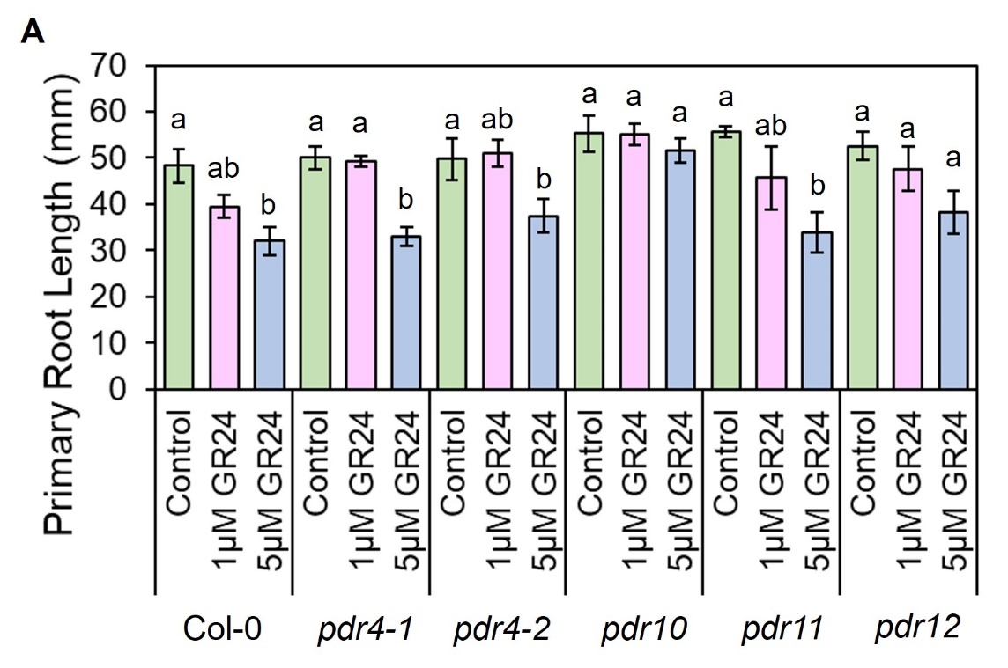

Figure 5.6 Primary root length of pdr10 is unchanged with the addition of GR24
A) Bar chart showing the primary root length (mm) of Arabidopsis seedlings grown on ATS agar plates containing 1µM GR24, 5µM GR24 or control plates containing no GR24 but 1uM of acetone as a solvent control. Error bars represent s.e.m, n=4-8 plants. Statistical analysis was carried out for each genotype separately, bars with the same letter represent no statistical difference (Col-0, pdr4-1, pdr10, pdr12 : One-way ANOVA with Tukey HSD, pdr4-2, pdr11 : Kruskal-Wallis with Bonferroni correction).

To investigate if pdr10 insensitivity to GR24 is also reflected in lateral root number, this was also assessed at 13 days post-germination. Lateral root number was more noisy, but there was a general decrease in lateral root number in the genotypes with the exception of pdr10 (Fig. 5.7). Again, pdr10 showed no difference between the treatments, and inherently pdr10 mutants appear to produce a lower lateral root number than the other genotypes assessed (Fig. 5.7).
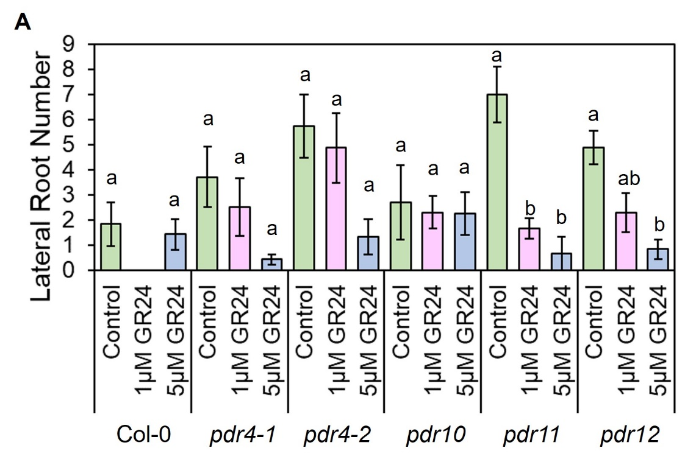

Figure 5.7 Lateral root number of pdr10 is unchanged with the addition of GR24
A) Bar chart showing the lateral root number of 13-day old Arabidopsis seedlings grown on ATS agar plates containing 1µM GR24, 5µM GR24 or control plates containing no GR24 but 1uM of acetone as a solvent control. Error bars represent s.e.m, n=4-8 plants. Statistical analysis was carried out for each genotype separately, bars with the same letter represent no statistical difference (Col-0: Independent Samples t-test, pdr4-1, pdr11 and pdr12: Kruskal-Wallis with Bonferroni correction, pdr4-2 and pdr10: one-way ANOVA with Tukey HSD).

Given the highly preliminary nature of this experiment, much more would need to be investigated to confirm if PDR10 does act as the SL importer. A more detailed look into the RNAseq dataset presented in Section 4.2 could prove valuable for this as there may be differential expression of PDR genes in response to crowding, but up until now this has not been able to be achieved. Additionally, detection of SL in the roots of the pdr mutants with and without the application of GR24 could be carried out using LC MS (LC MS technique as described in Wheeldon et al, 2022). If the importer was mutated, it would be expected that less SL would be detected in the roots compared to the other mutants and WT plants tested. Nevertheless, this preliminary data does tentatively suggest an insensitivity to SLs in pdr10 mutants.

Discussion

Experiments presented in this chapter have identified a new role for SLs exuded into the environment. Other root exudates have previously been identified to play a role in plant neighbour detection (Yang et al., 2018; Kong et al., 2018) and data presented in section 5.2 and Wheeldon et al (2022) clearly show that SLs are an additional plant-to-plant root exudate signal.

SLs negatively affects shoot growth of neighbours

Data presented in this chapter and in Wheeldon et al (2022), shows that the exudation of SLs negatively effects the production of branches and biomass by other plants in the environment. This appears to be advantageous to the SL-exuding plant as the uptake of SL reduces the size of neighbours allowing the SL exuding plant to grow larger due to reduced competition. This observation opens up a new avenue for exploring density resistance in monocultures. If each plant in a densely sown field can exude SL and inhibit the growth of neighbours, it would be expected that this would have a negative effect on economic output. Therefore, if SL exudation is turned down, this could reduce neighbour-based inhibition and increase outputs. Natural variation in SL biosynthesis has been identified in maize (C. Li et al., 2023) and this is likely the case in other agronomic crops. Hence, the potential to explore the role of SL exudation for density resistance could be highly valuable.

SL is likely the Soil Volume Sensing Signal (SVS)

Data presented in section 5.2.4 and (Wheeldon et al., 2022) highlights that SLs are also important for the detection of available soil volume as the SL biosynthesis mutant rms1 is unable to detect and respond to additional soil volume (Fig. 5.5). This could suggest that exuded SL could act as the early-acting ‘soil volume sensing signal’ (SVS), preventing overzealous shoot growth in small soil volumes or neighbour dense environments (Wheeldon et al., 2021). There are similarities between the activities of SLs in sections 5.2 and SVS in 4.3, as both appear to mainly affect the shoot system with this becoming apparent within the first month post germination in both wheat and pea. Early shoot growth changes as a result of SL/SVS allow the plant to match their growth to their available space, which is beneficial throughout life. Many studies have discussed the depletion of soil resources in neighbour-dense scenarios (e.g. (Bilas et al., 2021)), and hence perception of SL/SVS can be beneficial here too, ensuring there are enough soil resources for future plant growth.

Strigolactone is not the only root exudate involved in neighbour detection

SL/SVS acts early in plant life, however it is clear that this cannot be the only neighbour detection mechanism utilised by plants. In addition, section 5.2 suggests that another root exuded chemical is involved in growth responses to neighbouring plants later in life. Although rms1 plants do not detect neighbours in their first few weeks of growth (Fig 5.1A), a shift is seen after 5 weeks where crowded and uncrowded plants diverge in their shoot production. In section 4.3, I proposed that later in plant life, a second root exudate based mechanism is deployed, where the density of roots present in the pot becomes important and affects both shoot and root growth (Wheeldon et al., 2021). Therefore, rms1 plants could begin to initiate this second phase after 5 weeks, which could explain the increase in shoot branching from this point in 1/pot grown plants (Fig 5.1A) (Wheeldon et al., 2022). The identity of this second signal remains unknown, as discussed in Chapter 4.

This idea of an SL independent RDS signal, is also supported by the behaviour of Arabidopsis, discussed in chapter 4 section 4.2.3. Research has identified that the Brassicaceae have lost most of their ability to exude SL (Kretzschmar et al., 2012), however it is clear that they are still able to detect and respond to other plants in their environment (section 4.2.3). The Arabidopsis plants I grew were still clearly able to detect and respond to the presence of other Arabidopsis plants in their belowground space, even though SL exudation is not present in the Brassicaceae. Therefore, the second phase signal using root density later in life might explain the shoot growth differences between crowded and uncrowded Arabidopsis plants.

Future directions

Section 5.2 identifies a new role of SLs in the soil environment, where they act as plant-to-plant signals, however many questions remain regarding the properties of these SL exudates, and how they regulate these interactions. SLs are water soluble, and rapidly-degraded at neutral pH, potentially making them short lived signalling molecules (Bertin et al., 2003; Koichi Yoneyama et al., 2018). However, the rhizosphere tends to be rather acidic, which might increase the lifetime of SL molecules compared to bulk soil (Bertin et al., 2003). This raises several questions; for instance, it is currently unknown how far SLs can travel in the soil before being degraded. In regard to SLs acting as germination stimulants for Striga asiatica, it has been suggested that the parasitic plant seeds must be within 4mm from the SL exuding host plant in order to germinate which suggests the distance of travel for this type of SL is limited (Scott, 2008). Are plant-to-plant SLs able to travel reasonable distances through bulk soil, or are they only stable in the rhizosphere? If plant-to-plant SLs are only stable in the rhizosphere, this would suggest with the context of our previous findings that SLs can only influence neighbours when the rhizospheres of plants overlap.

It is clear that plants can uptake SLs from the environment, however the identity of the SL importer remains a mystery. Work in section 5.3.1 suggests this could be PDR10, nevertheless understanding the identity of the SL importer provides an exciting avenue for future exploration. Furthermore, the exact identity of the SLs involved in plant-plant interactions remains unknown. This could be tested by applying different types of SL to the root system and assessing the shoot based response of the plant. It would be expected that the plant-plant interaction SL type would inhibit shoot growth as described in Section 5.2.3. Answers to these questions would further aid in our understanding of this new function of SLs in the environment and could be instrumental in producing more density resistant crops.

General Discussion

The role of soil volume and neighbour density on plant growth

The data presented in this thesis has provided a model for the mechanistic basis for plant growth responses to soil volume and neighbour density. I have presented a two-phase mechanism, involving two separate root exuded signals. Plants likely exude a soil volume-sensing signal (SVS) early in plant life to detect available soil volume/neighbour density, and it is likely that this signal is composed of exuded strigolactones (Chapter 4 and 5). I further propose that plants exude a qualitatively different root density sensing signal (RDS) which acts after SVS to detect the root density in the environment (Chapter 4 and 5). This thesis provides shoot phenotyping of important agronomic crops, demonstrating similar but not identical shoot growth responses to soil volume and crowding, and provides novel information regarding root system architecture changes in cereals subjected to differing soil volumes (Chapter 3). The progress made to characterise soil volume responses in barley, shows a wide variation in sensitivities to soil volume which has not been apparent prior to this thesis (Chapter 3). And finally, the identified role for SL in the environment as plant-to-plant signals provides an exciting new functionality for SL in the rhizosphere (Chapter 5). However, the results presented here also pose new questions, which are both scientifically intriguing, and which would need to be addressed to allow for the translation of these findings into agricultural contexts.

What is the identity of the second phase root exuded signal?

The second phase signal, RDS, is associated with high root density and causes root and shoot based inhibition when a threshold of root density is reached (Chapter 4). The likely identity of this exudate, however, remains elusive. Signals with similarities to RDS have been suggested previously, as self-inhibitory exudates which aid in obstacle avoidance and to some extent soil volume awareness (Falik et al., 2005; Semchenko et al., 2007). Data presented in Chapter 4, suggests that RDS shows distinctly different mobility properties to SVS, such that RDS appears largely immobile. This implies that it is likely to be of higher molecular weight than SVS, therefore a possible candidate could be peptide signals. There has been significant interest in understanding how peptides act as hormones such that multiple peptides have been identified to modulate growth in response to environmental changes (Motose et al., 2009; Mortier et al., 2010; Reid et al., 2011; Delay et al., 2013; Imin et al., 2013; Tabata et al., 2014; Cederholm and Benfey, 2015).
C-TERMINALLY ENCODED PEPTIDEs (CEPs) are one such peptide, as briefly discussed in chapter 4, CEPs are long-distance signalling peptides which communicate nitrate limitation to the shoot system (Tabata et al., 2014) and have been shown to modulate root and shoot growth (Delay et al., 2013; Tabata et al., 2014; Roberts et al., 2016; Taleski et al., 2018; Chapman et al., 2020; Sin et al., 2022). In regard to root growth, CEP3 is known to inhibit lateral root development in Arabidopsis resulting in fewer lateral roots being produced than in cep3 mutants (Delay et al., 2013). Additionally, another CEP, CEP5, decreases primary root length and lateral root density in Arabidopsis compared to WT controls (Roberts et al., 2016). Analysis of the peptide composition of root exudates of Medicago truncatula identified several CEP species (CEP1/2/5/8), of varying sizes and modifications (Patel et al., 2018). Identified peptides were subsequently synthesised and when applied to the roots, most were seen to cause dramatic decreases to lateral root number (Patel et al., 2018). This root-based inhibition caused by CEPs has similarities to RDS, therefore a CEP could be a possible candidate for RDS.
Additional to CEPs, other peptides have been identified to play a role in root growth such as XYLEM SAP ASSOCIATED PEPTIDE (XAP) and CLAVATA3 (CLE) peptides (Okamoto et al., 2015; Yamaguchi et al., 2016; Patel et al., 2018).
Generation of multiple CEP receptor mutants in cereals would allow for testing of the potential role of CEPs as RDS. The CEP receptor mutants could be grown in similar experimental set ups as Sections 4.3.5 and 4.3.6 and if RDS was a CEP, it would be expected that when experiencing high root density this does not result in inhibition of the root and/ or shoot growth of the CEP receptor mutant.
Understanding the identity of RDS could allow a ‘toning down’ of the strong root and shoot inhibition seen at high root densities and allow plants to grow at higher root densities for longer, potentially also contributing to increased yield with no additional nutrient inputs.

SVS and RDS are unlikely to be the only root exudates plants use to detect neighbours and available soil volume

The rhizosphere is a highly chemically complex environment with many root exudates and microbial signals (Berendsen et al., 2012; Bakker et al., 2013). Therefore, it is naïve to suggest that SVS and RDS are the only exudates which plants detect and respond to under soil volume limited or neighbour dense environments. After the identification of jasmonic acid and (-)-loliolide in wheat plants as neighbour density associated root exudates which result in the biosynthesis of allelopathic DIMBOA (Kong et al., 2018) (discussed in chapter 1), more recent work has suggested that (-)-loliolide functions as part of a general defence mechanism when multiple species such as rice, wheat and soybean are subjected to both biotic and abiotic stress (L. Li et al., 2023). The authors found this resulted in the biosynthesis of plant defence compounds such as flavonoids and phenolic acids and this defence based response has been shown to be facilitated through jasmonic acid (L. Li et al., 2023). Phenolic acids have been found in many plants hence have also been suggested to act as allelochemicals (Inderjit, 1996; Dalton, 1999). Over the last 100 years, selection pressures in European barley breeding programs have unintentionally resulted in variations in allelopathic capabilities, but these have been suggested to have generally decreased over time compared to landraces (Bertholdsson, 2004). Allelopathy is where the effects of chemicals or compounds released by a plant effects a neighbouring plant in either a positive or negative manner (Thiébaut et al., 2019).
The ability for a crop to be allelopathic has been utilised in paddy grown rice as some cultivars have been shown to inhibit weeds (Kong et al., 2008; Kato-Noguchi, 2011; Xu et al., 2021). Barnyard grass is a common weed found to compete with rice, and when rice and barnyard grass were grown together this caused a strong increase in concentration of a compound called momilactone B (Kato-Noguchi, 2011). Momilactone B has been shown to be exuded throughout life in rice (Kato-Noguchi, 2008), therefore it has been suggested that a particular constituent of barnyard grass exudates is able to trigger the release of an elevated concentration of rice produced momilactone B, which in turn inhibits root and shoot growth of barnyard grass in a concentration dependent manner (Kato-Noguchi, 2011). Intriguingly, earlier work suggested that momilactone B has a very minor inhibitory impact on rice roots themselves (Kato-Noguchi, 2008). Subsequent work has shown that in addition to momilactone B another allelochemical, tricin, is synthesised when crowded with barnyard grass and that production of both of these chemicals by rice plants is the result of recognition of barnyard grass exuded (-)-loliolide (Li et al., 2019). Although in the example above of rice allelopathy where the allelochemical momilactone B does not cause much self-inhibition, that is not to say that other allelochemicals act in the same manner. Nevertheless, with the increased understanding of (-)-loliolide and its prevalence in many species (Kong et al., 2018; L. Li et al., 2023), (-)-loliolide could also play a role in general plant-plant interactions.

How is soil volume and neighbour density information communicated to the shoot system?

SVS/SL and RDS show a clear inhibition of shoot system growth when in small soil volumes and neighbour dense environments, but how is this information communicated to the shoot system? This was not an aim of this thesis but nevertheless is important to understand for future. Long distance signalling is key for many biological processes and several hormones (among other signals) are suggested to move from the root to the shoots (reviewed in (Wheeldon and Bennett, 2021). While hormonal long-distance signalling is relatively slow, other forms of long distance signalling such as changes in turgor pressure and calcium signalling have been shown to occur much faster in response to environmental stressors (Christmann et al., 2013; Choi et al., 2017; Kudla et al., 2018). As mentioned earlier, peptides have been shown to move long distances through plants. One such example of the role of peptides in long distance signalling of environmental stressors was highlighted by work in Arabidopsis, which identified the expression of a large number small open reading frames (sORFS) compared to control treatments (Hanada et al., 2007; Hanada et al., 2013). Additional support for this comes from a study which identified that over 100 sORFs are upregulated in Arabidopsis roots and shoots in response to drought (Rasheed et al., 2016). Other peptide signals have been shown to be important for communicating environmental stressors such as root derived CEPs which are transported to the shoot and interact with the CEP receptor (CEPR) which together results in the formation of CEP DOWNSTREAM1/2 (CEPD1/2) peptides which subsequently move rootward to trigger upregulation of NRTs in the root system in response to nitrate deprivation (Delay et al., 2013; Ohkubo et al., 2017; Taleski et al., 2018). CLEs are other peptides which have been shown to travel from the roots to the shoots in response to nitrate levels in the soil (Nishida and Suzaki, 2018).
The possibility that soil volume and neighbour density information could be communicated to the shoot system via proteins or peptides could be investigated further. This could be investigated by grafting combinations of WT and candidate CEP mutant scions and rootstocks in different pot sizes. If the root to shoot signal was a CEP, it would be expected that the combination of WT root stock and CEP receptor mutant scion would produce shoot systems which do not reflect the soil volume they are grown in compared to WT scion with WT rootstock plants. Grafting experiments have been instrumental in demonstrating root to shoot activity of phytohormones such as strigolactone and cytokinin (Morris et al., 2001; Beveridge and Kyozuka, 2010; K. Zhang et al., 2014; Ko et al., 2014; Osugi et al., 2017) therefore using grafting to explore root to shoot communication of soil volume information could be valuable.

How is SL from the environment taken up by plant roots?
SL is clearly taken up by plant roots (Chapter 5) (Wheeldon et al., 2022; Yoneyama et al., 2022) however the means by which this occurs remains unknown. A member of the PDR family of transporters (ATP-binding cassette type G: ABCG transporter) are a likely candidates given one of which; PDR1 has been identified as an SL exporter in the root (Kretzschmar et al., 2012; Sasse et al., 2015). In order to identify the SL importer a key first step would be the generation of a more detailed phylogeny of PDR/ABCG genes across multiple species, to supersede the simple phylogeny presented in Kretzschmar et al., (2012). Many ABCG type genes have been identified in Arabidopsis, barley and rice (43, 49 and 56-63 respectively) (K. Zhang et al., 2014; Andolfo et al., 2015; C. Yan et al., 2017) and incorporating this into the phylogeny would allow the for a more focussed approach for testing of the possibility of the SL importer being a PDR type transporter.

Potential applications

Data presented in this thesis highlight the negative effects on shoot system growth when plants are subjected to small soil volumes and neighbour density. By the year 2000, over half of the land on earth has been influenced by humans and as such is used for arable land, pasture land or human habitation (Ellis et al., 2010). Vertical farming poses an alternative to further land use and multiple projects have been implemented in urban areas, in several countries (Al-Chalabi, 2015; Al-Kodmany, 2018). Vertical farming often uses hydroponic systems and has been utilised for the production of many food crops with a particular focus on leafy greens (Al-Chalabi, 2015; Al-Kodmany, 2018). The use of hydroponic systems poses an ability to dilute SVS, or replace media frequently to ensure its concentration remains low therefore preventing its strong inhibition on the shoot systems of other plants in the environment. This could allow the plants to grow larger for longer, with potential increases in yields. However, further investigations would be required to identify if such yield gains, rather than just biomass gains, are possible.
In arable farming, selection criteria for many agronomically important crop species have mainly aimed to produce high yield in a setting which requires high levels of fertiliser inputs, however this has led to multiple negative environmental consequences including pollution and greenhouse gas emissions (Vitousek et al., 1997; Tilman et al., 2002; Foley et al., 2011; Tilman et al., 2011; Garnett et al., 2013; Blum, 2018; Voss-Fels et al., 2019). There is no doubt that fertiliser application is highly beneficial to yield (Voss-Fels et al., 2019), however application of nitrogen and phosphorus are generally found to be in excess across many crop species (West et al., 2014). Yields of food crops must increase to meet the rising global demand (Foley et al., 2011), and to limit the global food insecurities related to the effects of climate change (Hadley et al., 2023), however such gains need to be made in an environment conscious manner (Tilman et al., 2011; Garnett et al., 2013). Data presented in this thesis has suggested the possibility of increasing plant size without additional nutrition. Plants grown densely in the field, where the soil volume they can explore is shared, could be inhibiting each other’s growth due to available space and the presence of neighbours (Li et al., 2015; Hecht et al., 2016; Postma et al., 2021). Subsequently, additional fertiliser inputs may be being ‘ignored’ by the plant due to detection of space limitations/neighbour density. From work presented in this thesis, by providing increased space between plants in field settings, this could ensure that SVS is diluted in a larger soil volume preventing inhibition of shoot growth early in life allowing crops to grow larger, furthermore additional space would ensure that the density of roots in the environment would not rise as quickly. However, if lines were bred in which SVS and RDS exudation were reduced this could allow for plants to perceive they have more space than they actually do in high density scenarios. This however would need to be carefully managed, as this would only be beneficial so long as the plants do not grow too large for the resources available to them. Thus, the major message from this thesis is that more detailed understanding of how SVS and RDS behave in agricultural settings could unlock the potential to increase yields in crop production without the need for additional fertiliser inputs.

Bibliography

Abe, S., Sado, A., Tanaka, K., Kisugi, T., Asami, K., Ota, S., Il Kim, H., Yoneyama, Kaori, Xie, X., Ohnishi, T., Seto, Y., Yamaguchi, S., Akiyama, K., Yoneyama, Koichi and Nomura, T. 2014. Carlactone is converted to carlactonoic acid by MAX1 in Arabidopsis and its methyl ester can directly interact with AtD14 in vitro. Proceedings of the National Academy of Sciences of the United States of America. 111(50), pp.18084–18089.
AHDB Cereals & Oilseeds 2023a. Barley Growth Guide [Online]. Coventry: Agriculture and Horticulture Development Board. Available from: https://ahdb.org.uk/knowledge-library/barley-growth-guide.
AHDB Cereals & Oilseeds 2023b. Wheat Growth Guide [Online]. Coventry: Agriculture and Horticulture Development Board. Available from: https://ahdb.org.uk/knowledge-library/wheat-growth-guide.
Akiyama, K., Matsuzaki, K.I. and Hayashi, H. 2005. Plant sesquiterpenes induce hyphal branching in arbuscular mycorrhizal fungi. Nature. 435(7043), pp.824–827.
Al-Chalabi, M. 2015. Vertical farming: Skyscraper sustainability? Sustainable Cities and Society. 18, pp.74–77.
Al-Kodmany, K. 2018. The Vertical Farm: A Review of Developments and Implications for the Vertical City. Buildings. 8(2), p.24.
Alder, A., Jamil, M., Marzorati, M., Bruno, M., Vermathen, M., Bigler, P., Ghisla, S., Bouwmeester, H., Beyer, P. and Al-Babili, S. 2012. The path from β-carotene to carlactone, a strigolactone-like plant hormone. Science. 335(6074), pp.1348–1351.
Andolfo, G., Ruocco, M., Di Donato, A., Frusciante, L., Lorito, M., Scala, F. and Ercolano, M.R. 2015. Genetic variability and evolutionary diversification of membrane ABC transporters in plants. BMC Plant Biology. 15(1), p.51.
Anten, N.P.R. and Chen, B.J.W. 2021. Detect thy family: Mechanisms, ecology and agricultural aspects of kin recognition in plants. Plant, Cell & Environment. 44(4), pp.1059–1071.
Bais, H.P., Vepachedu, R., Gilroy, S., Callaway, R.M. and Vivanco, J.M. 2003. Allelopathy and exotic plant invasion: From molecules and genes to species interactions. Science. 301(5638), pp.1377–1380.
Bakker, P.A.H.M., Berendsen, R.L., Doornbos, R.F., Wintermans, P.C.A. and Pieterse, C.M.J. 2013. The rhizosphere revisited: root microbiomics. Frontiers in Plant Science. 4.
Bar-Tal, A., Feigin, A., Sheinfeld, S., Rosenberg, R., Sternbaum, B., Rylski, I. and Pressman, E. 1995. Root restriction and N-NO3 solution concentration effects on nutrient uptake, transpiration and dry matter production of tomato. Scientia Horticulturae. 63(3–4), pp.195–208.
Bar-Tal, A. and Pressman, E. 1996. Root restriction and potassium and calcium solution concentrations affect dry-matter production, cation uptake, and blossom-end rot in greenhouse tomato. Journal of the American Society for Horticultural Science. 121(4), pp.649–655.
Bengough, A.G. 2003. Root Growth and Function in Relation to Soil Structure, Composition, and Strength In: Root ecology [Online]. Berlin, Germany: Springer-Verlag, pp.151–171. Available from: https://link.springer.com/10.1007/978-3-662-09784-7_6.
Bennett, T., Liang, Y., Seale, M., Ward, S., Müller, D. and Leyser, O. 2016. Strigolactone regulates shoot development through a core signalling pathway. Biology Open. 5(12), pp.1806–1820.
Berardini, T.Z., Reiser, L., Li, D., Mezheritsky, Y., Muller, R., Strait, E. and Huala, E. 2015. The Arabidopsis information resource: Making and mining the “gold standard” annotated reference plant genome. Genesis. 53(8), pp.474–485.
Berendsen, R.L., Pieterse, C.M.J. and Bakker, P.A.H.M. 2012. The rhizosphere microbiome and plant health. Trends in Plant Science. 17(8), pp.478–486.
Bertholdsson, N.-O. 2004. Variation in allelopathic activity over 100 years of barley selection and breeding. Weed Research. 44(2), pp.78–86.
Bertin, C., Yang, X. and Weston, L.A. 2003. The role of root exudates and allelochemicals in the rhizosphere. Plant and Soil. 256(1), pp.67–83.
Beveridge, C.A. 2006. Axillary bud outgrowth: Sending a message. Current Opinion in Plant Biology. 9(1), pp.35–40.
Beveridge, C.A. and Kyozuka, J. 2010. New genes in the strigolactone-related shoot branching pathway. Current Opinion in Plant Biology. 13(1), pp.34–39.
Beveridge, C.A., Symons, G.M., Murfet, I.C., Ross, J.J. and Rameau, C. 1997. The rms1 mutant of pea has elevated Indole-3-Acetic Acid levels and reduced root-sap zeatin riboside content but increased branching controlled by graft-transmissible signal(s). Physiology. 115(3), pp.1251–1258.
Biedrzycki, M.L., Jilany, T.A., Dudley, S.A. and Bais, H.P. 2010. Root exudates mediate kin recognition in plants. Communicative & Integrative biology. 3(1), pp.28–35.
Bilas, R.D., Bretman, A. and Bennett, T. 2021. Friends, neighbours and enemies: an overview of the communal and social biology of plants. Plant, Cell & Environment. 44(4), pp.997–1013.
Blum, A. 2018. Plant Breeding for Stress Environments [Online]. CRC Press. Available from: https://www.taylorfrancis.com/books/9781351084161.
Bontpart, T., Concha, C., Giuffrida, M.V., Robertson, I., Admkie, K., Degefu, T., Girma, N., Tesfaye, K., Haileselassie, T., Fikre, A., Fetene, M., Tsaftaris, S.A. and Doerner, P. 2020. Affordable and robust phenotyping framework to analyse root system architecture of soil‐grown plants. The Plant Journal. 103(6), pp.2330–2343.
Bopp, M. and Klein, B. 1963. Vercuch zur analyse protonemaentwicklung der laubmoose. I. Endogene wahestumregulatoren im protonema von Funaria hygrometrica. Portugalia Acta Biologica. A-7, p.95.
Bouwmeester, H., Li, C., Thiombiano, B., Rahimi, M. and Dong, L. 2021. Adaptation of the parasitic plant lifecycle: germination is controlled by essential host signaling molecules. Plant Physiology. 185(4), pp.1292–1308.
Bouwmeester, H.J., Roux, C., Lopez-Raez, J.A. and Bécard, G. 2007. Rhizosphere communication of plants, parasitic plants and AM fungi. Trends in Plant Science. 12(5), pp.224–230.
Broz, A.K., Broeckling, C.D., De-la-Peña, C., Lewis, M.R., Greene, E., Callaway, R.M., Sumner, L.W. and Vivanco, J.M. 2010. Plant neighbor identity influences plant biochemistry and physiology related to defense. BMC Plant Biology. 10(1), p.115.
Bruex, A., Kainkaryam, R.M., Wieckowski, Y., Kang, Y.H., Bernhardt, C., Xia, Y., Zheng, X., Wang, J.Y., Lee, M.M., Benfey, P., Woolf, P.J. and Schiefelbein, J. 2012. A gene regulatory network for root epidermis cell differentiation in Arabidopsis. PLoS Genetics. 8(1), p.e1002446.
Brzobohatý, B., Moore, I., Kristoffersen, P., Bako, L., Campos, N., Schell, J. and Palme, K. 1993. Release of active cytokinin by a β-Glucosidase localized to the maize root meristem. Science. 262(5136), pp.1051–1054.
Carlson, L.W. and Endean, F. 1976. The effect of rooting volume and container configuration on the early growth of white spruce seedlings. Canadian Journal of Forest Research. 6(2), pp.221–224.
Carmi, A. and Heuer, B. 1981. The role of roots in control of bean shoot growth. Annals of Botany. 48, pp.519–527.
Cederholm, H.M. and Benfey, P.N. 2015. Distinct sensitivities to phosphate deprivation suggest that RGF peptides play disparate roles in Arabidopsis thaliana root development. New Phytologist. 207(3), pp.683–691.
Cerezo, M., Tillard, P., Filleur, S., Muños, S., Daniel-Vedele, F. and Gojon, A. 2001. Major alterations of the regulation of Root NO3 − uptake are associated with the mutation of Nrt2.1 and Nrt2.2 genes in Arabidopsis. Plant Physiology. 127(1), pp.262–271.
Chapman, K., Ivanovici, A., Taleski, M., Sturrock, C.J., Ng, J.L.P., Mohd‐Radzman, N.A., Frugier, F., Bennett, M.J., Mathesius, U. and Djordjevic, M.A. 2020. CEP receptor signalling controls root system architecture in Arabidopsis and Medicago. New Phytologist., pp.1809–1821.
Chen, B.J.W., During, H.J. and Anten, N.P.R. 2012. Detect thy neighbor: Identity recognition at the root level in plants. Plant Science. 195, pp.157–167.
Chen, B.J.W., During, H.J., Vermeulen, P.J., de Kroon, H., Poorter, H. and Anten, N.P.R. 2015. Corrections for rooting volume and plant size reveal negative effects of neighbour presence on root allocation in pea J. Schweitzer, ed. Functional Ecology. 29(11), pp.1383–1391.
Cheng, C., Krishnakumar, V., Chan, A.P., Thibaud‐Nissen, F., Schobel, S. and Town, C.D. 2017. Araport11: a complete reannotation of the Arabidopsis thaliana reference genome. The Plant Journal. 89(4), pp.789–804.
Choi, W., Miller, G., Wallace, I., Harper, J., Mittler, R. and Gilroy, S. 2017. Orchestrating rapid long‐distance signaling in plants with Ca 2+ , ROS and electrical signals. The Plant Journal. 90(4), pp.698–707.
Christmann, A., Grill, E. and Huang, J. 2013. Hydraulic signals in long-distance signaling. Current Opinion in Plant Biology. 16(3), pp.293–300.
Clark, J. and Bennett, T. 2023. Cracking the enigma: understanding strigolactone signalling in the rhizosphere. Journal of Experimental Botany.
Clark, L.J.J., Whalley, W.R.R. and Barraclough, P.B.B. 2003. How do roots penetrate strong soil? In: Roots: The Dynamic Interface between Plants and the Earth [Online]. Dordrecht: Kluwer Academic Publishers, pp.93–104. [Accessed 27 January 2019]. Available from: http://link.springer.com/10.1007/978-94-017-2923-9_10.
Cook, C.E., Whichard, L.P., Turner, B., Wall, M.E. and Egley, G.H. 1966. Germination of Witchweed (Striga lutea Lour.): Isolation and properties of a potent stimulant. Science (New York, N.Y.). 154(3753), pp.1189–1190.
Crawford, S., Shinohara, N., Sieberer, T., Williamson, L., George, G., Hepworth, J., Müller, D., Domagalska, M.A. and Leyser, O. 2010. Strigolactones enhance competition between shoot branches by dampening auxin transport. Development. 137(17), pp.2905–2913.
Dalton, B.R. 1999. The Occurrence and Behavior of Plant Phenolic Acids in Soil Environments and Their Potential Involvement in Allelochemical Interference Interactions: Methodological Limitations in Establishing Conclusive Proof of Allelopathy In: Inderjit, K. M. . Dakshini and C. L. Foy, eds. Principles and Practices in Plant Ecology: allelochemical interactions. Boca Raton, FL: CRC Press, pp.57–74.
Darwin, C. and Darwin, F. 1896. The Power of Movement in Plants. New York, USA: D. Appleton.
Delay, C., Imin, N. and Djordjevic, M.A. 2013. CEP genes regulate root and shoot development in response to environmental cues and are specific to seed plants. Journal of Experimental Botany. 64(17), pp.5383–5394.
Duan, X., Jin, K., Mao, Z., Liu, L., He, Y., Xia, S., Hammond, J.P., White, P.J., Xu, F. and Shi, L. 2023. Compacted soil adaptability of Brassica napus driven by root mechanical traits. Soil and Tillage Research. 233, p.105785.
Dudley, S.A. and File, A.L. 2007. Kin recognition in an annual plant. Biology Letters. 3(4), pp.435–438.
Dun, E.A., Brewer, P.B. and Beveridge, C.A. 2009. Strigolactones: discovery of the elusive shoot branching hormone. Trends in Plant Science. 14(7), pp.364–372.
Edwards, K., Johnstone, C. and Thompson, C. 1991. A simple and rapid method for the preparation of plant genomic DNA for PCR analysis. Nucleic Acids Research. 19(6), p.1349.
Ehlers, B.K., Berg, M.P., Staudt, M., Holmstrup, M., Glasius, M., Ellers, J., Tomiolo, S., Madsen, R.B., Slotsbo, S. and Penuelas, J. 2020. Plant secondary compounds in soil and their role in belowground species interactions. Trends in Ecology & Evolution. 35(8), pp.716–730.
Ellis, E.C., Klein Goldewijk, K., Siebert, S., Lightman, D. and Ramankutty, N. 2010. Anthropogenic transformation of the biomes, 1700 to 2000. Global Ecology and Biogeography. 19(5), pp.589–606.
EnsemblPlants 2021. Hordeum vulgare Assembly and Gene Annotation. Available from: https://plants.ensembl.org/Hordeum_vulgare/Info/Annotation/.
Falik, O., Reides, P., Gersani, M. and Novoplansky, A. 2005. Root navigation by self inhibition. Plant, Cell and Environment. 28(4), pp.562–569.
Falik, O., Reides, P., Gersani, M. and Novoplansky, A. 2003. Self/Non-Self discrimination in roots. Journal of Ecology. 91, pp.525–531.
Fang, S., Clark, R.T., Zheng, Y., Iyer-Pascuzzi, A.S., Weitz, J.S., Kochian, L. V., Edelsbrunner, H., Liao, H. and Benfey, P.N. 2013. Genotypic recognition and spatial responses by rice roots. Proceedings of the National Academy of Sciences of the United States of America. 110(7), pp.2670–2675.
Fang, S., Gao, X., Deng, Y., Chen, X. and Liao, H. 2011. Crop root behavior coordinates phosphorus status and neighbors: From field studies to three-dimensional in situ reconstruction of root system architecture. Plant Physiology. 155(3), pp.1277–1285.
Fink, F. 2014. Extraction of genomic DNA using ‘Edwards’ buffer V.1, modified after Edwards et al. , 1991 Nucleic Acids Research. Available from: https://www.protocols.io/view/extraction-of-genomic-dna-using-edwards-buffer-grdbv26.html.
Foley, J.A., Ramankutty, N., Brauman, K.A., Cassidy, E.S., Gerber, J.S., Johnston, M., Mueller, N.D., O’Connell, C., Ray, D.K., West, P.C., Balzer, C., Bennett, E.M., Carpenter, S.R., Hill, J., Monfreda, C., Polasky, S., Rockström, J., Sheehan, J., Siebert, S., Tilman, D. and Zaks, D.P.M. 2011. Solutions for a cultivated planet. Nature. 478(7369), pp.337–342.
Forde, B.G. 2002. The role of long-distance signalling in plant responses to nitrate and other nutrients. Journal of Experimental Botany. 53(366), pp.39–43.
Fradgley, N., Evans, G., Biernaskie, J.M., Cockram, J., Marr, E.C., Oliver, A.G., Ober, E. and Jones, H. 2020. Effects of breeding history and crop management on the root architecture of wheat. Plant and Soil. 452(1–2), pp.587–600.
Gao, Y.-Q., Bu, L.-H., Han, M.-L., Wang, Y.-L., Li, Z.-Y., Liu, H.-T. and Chao, D.-Y. 2021. Long-distance blue light signalling regulates phosphate deficiency-induced primary root growth inhibition. Molecular Plant. 14(9), pp.1539–1553.
Garnett, T., Appleby, M.C., Balmford, A., Bateman, I.J., Benton, T.G., Bloomer, P., Burlingame, B., Dawkins, M., Dolan, L., Fraser, D., Herrero, M., Hoffmann, I., Smith, P., Thornton, P.K., Toulmin, C., Vermeulen, S.J. and Godfray, H.C.J. 2013. Sustainable intensification in agriculture: Premises and policies. Science. 341(6141), pp.33–34.
Gates-Anderson, D.D., Siegrist, R.L. and Cline, S.R. 2001. Comparison of potassium permanganate and hydrogen peroxide as chemical oxidants for organically contaminated soils. Journal of Environmental Engineering. 127(4), pp.337–347.
Gersani, M., Brown, J. s., O’Brien, E.E., Maina, G.M. and Abramsky, Z. 2001. Tragedy of the commons as a result of root competition. Journal of Ecology. 89(4), pp.660–669.
Gomez-Roldan, V., Fermas, S., Brewer, P.B., Puech-Pagès, V., Dun, E.A., Pillot, J.P., Letisse, F., Matusova, R., Danoun, S., Portais, J.C., Bouwmeester, H., Bécard, G., Beveridge, C.A., Rameau, C. and Rochange, S.F. 2008. Strigolactone inhibition of shoot branching. Nature. 455(7210), pp.189–194.
Goodstein, D.M., Shu, S., Howson, R., Neupane, R., Hayes, R.D., Fazo, J., Mitros, T., Dirks, W., Hellsten, U., Putnam, N. and Rokhsar, D.S. 2012. Phytozome: a comparative platform for green plant genomics. Nucleic Acids Research. 40(D1), pp.D1178–D1186.
Goss, M.J. 1977. Effects of mechanical impedance on root Growth in barley ( Hordeum vulgare L.). Journal of Experimental Botany. 28(1), pp.96–111.
Grando, S. and Ceccarelli, S. 1995. Seminal root morphology and coleoptile length in wild (Hordeum vulgare ssp. spontaneum) and cultivated (Hordeum vulgare ssp. vulgare) barley. Euphytica. 86(1), pp.73–80.
de Groot, C.C., Marcelis, L.F.M., van den Boogaard, R., Kaiser, W.M. and Lambers, H. 2003. Interaction of nitrogen and phosphorus nutrition in determining growth. Plant and Soil. 248(1/2), pp.257–268.
Gruntman, M. and Novoplansky, A. 2004. Physiologically mediated self/non-self discrimination in roots. Proceedings of the National Academy of Sciences of the United States of America. 101(11), pp.3863–3867.
Gutjahr, C. 2014. Phytohormone signaling in arbuscular mycorhiza development. Current Opinion in Plant Biology. 20, pp.26–34.
Hadley, K., Wheat, S., Rogers, H.H., Balakumar, A., Gonzales-Pacheco, D., Davis, S.S., Linstadt, H., Cushing, T., Ziska, L.H., Piper, C. and Sorensen, C. 2023. Mechanisms underlying food insecurity in the aftermath of climate-related shocks: a systematic review. The Lancet Planetary Health. 7(3), pp.e242–e250.
Hameed, M.A., Reid, J.B. and Rowe, R.N. 1987. Root Confinement and its Effects on the Water Relations, Growth and Assimilate Partitioning of Tomato (Lycopersicon esculentum Mill). Annals of Botany. 59(6), pp.685–692.
Hamiaux, C., Drummond, R.S.M., Janssen, B.J., Ledger, S.E., Cooney, J.M., Newcomb, R.D. and Snowden, K.C. 2012. DAD2 is an α/β hydrolase likely to be involved in the perception of the plant branching hormone, strigolactone. Current Biology. 22(21), pp.2032–2036.
Hanada, K., Higuchi-Takeuchi, M., Okamoto, M., Yoshizumi, T., Shimizu, M., Nakaminami, K., Nishi, R., Ohashi, C., Iida, K., Tanaka, M., Horii, Y., Kawashima, M., Matsui, K., Toyoda, T., Shinozaki, K., Seki, M. and Matsui, M. 2013. Small open reading frames associated with morphogenesis are hidden in plant genomes. Proceedings of the National Academy of Sciences. 110(6), pp.2395–2400.
Hanada, K., Zhang, X., Borevitz, J.O., Li, W.-H. and Shiu, S.-H. 2007. A large number of novel coding small open reading frames in the intergenic regions of the Arabidopsis thaliana genome are transcribed and/or under purifying selection. Genome Research. 17(5), pp.632–640.
Hanson, P.J., Dixon, R.K. and Dickson, R.E. 1987. Effect of container size and shape on the growth of northern red oak seedlings. HortScience. 22(6), pp.1293–1295.
Harper, J.L. 1977. Population biology of plants. London: Academic Press.
Hecht, V.L., Temperton, V.M., Nagel, K.A., Rascher, U. and Postma, J.A. 2016. Sowing density: A neglected factor fundamentally affecting root distribution and biomass allocation of field grown spring barley (Hordeum Vulgare L.). Frontiers in plant science. 7, p.944.
Hecht, V.L., Temperton, V.M., Nagel, K.A., Rascher, U., Pude, R. and Postma, J.A. 2019. Plant density modifies root system architecture in spring barley (Hordeum vulgare L.) through a change in nodal root number. Plant and Soil. 439(1–2), pp.179–200.
Heil, M. and Adame-Álvarez, R.M. 2010. Short signalling distances make plant communication a soliloquy. Biology Letters. 6(6), pp.843–845.
Heil, M. and Karban, R. 2010. Explaining evolution of plant communication by airborne signals. Trends in Ecology & Evolution. 25(3), pp.137–144.
Hess, L. and De Kroon, H. 2007. Effects of rooting volume and nutrient availability as an alternative explanation for root self/non-self discrimination. Journal of Ecology. 95(2), pp.241–251.
Hickman, J.F. 1889. Experiments in wheat seeding: Comparative test of varieties of wheat. Bulletin of the Ohio Agricultural Experiment Station. ll, pp.9–10.
Hu, L., Robert, C.A.M., Cadot, S., Zhang, X., Ye, M., Li, B., Manzo, D., Chervet, N., Steinger, T., van der Heijden, M.G.A., Schlaeppi, K. and Erb, M. 2018. Root exudate metabolites drive plant-soil feedbacks on growth and defense by shaping the rhizosphere microbiota. Nature Communications. 9(1), p.2738.
Huber, M., Nieuwendijk, N.M., Pantazopoulou, C.K. and Pierik, R. 2021. Light signalling shapes plant–plant interactions in dense canopies. Plant, Cell & Environment. 44(4), pp.1014–1029.
Hunt, R. 1982. Plant Growth Curves: A Functional Approach to Plant Growth Analysis. London: Edwin Arnold.
van Iersel, M. 1997. Root restriction effects on growth and development of Salvia (Salvia splendens). HortScience. 32(7), pp.1186–1190.
Imin, N., Mohd-Radzman, N.A., Ogilvie, H.A. and Djordjevic, M.A. 2013. The peptide-encoding CEP1 gene modulates lateral root and nodule numbers in Medicago truncatula. Journal of Experimental Botany. 64(17), pp.5395–5409.
Inderjit 1996. Plant phenolics in allelopathy. The Botanical Review. 62(2), pp.186–202.
Ito, S., Braguy, J., Wang, J.Y., Yoda, A., Fiorilli, V., Takahashi, I., Jamil, M., Felemban, A., Miyazaki, S., Mazzarella, T., Chen, G.-T.E., Shinozawa, A., Balakrishna, A., Berqdar, L., Rajan, C., Ali, S., Haider, I., Sasaki, Y., Yajima, S., Akiyama, K., Lanfranco, L., Zurbriggen, M.D., Nomura, T., Asami, T. and Al-Babili, S. 2022. Canonical strigolactones are not the major determinant of tillering but important rhizospheric signals in rice. Science Advances. 8(44), p.eadd1278.
Jameson, P.E. 1994. Cytokinin metabolism and compartmentation In: Cytokinins: chemistry, activity and function. CRC Press, pp.113–128.
Jia, Z., Giehl, R.F.H. and von Wirén, N. 2022. Nutrient–hormone relations: Driving root plasticity in plants. Molecular Plant. 15(1), pp.86–103.
Jiang, L., Liu, X., Xiong, G., Liu, H., Chen, F., Wang, L., Meng, X., Liu, G., Yu, H., Yuan, Y., Yi, W., Zhao, L., Ma, H., He, Y., Wu, Z., Melcher, K., Qian, Q., Xu, H.E., Wang, Y. and Li, J. 2013. DWARF 53 acts as a repressor of strigolactone signalling in rice. Nature. 504(7480), pp.401–405.
Jin, S.-H., Ma, X.-M., Kojima, M., Sakakibara, H., Wang, Y.-W. and Hou, B.-K. 2013. Overexpression of glucosyltransferase UGT85A1 influences trans-zeatin homeostasis and trans-zeatin responses likely through O-glucosylation. Planta. 237(4), pp.991–999.
Karban, R. 2015. Plant sensing and communication. Chicago, IL, USA: University of Chicago Press.
Karlovsky, P. 2008. Secondary metabolites in soil ecology. In: Secondary metabolites in soil ecology. Berlin, Heidelberg: Springer Berlin Heidelberg., pp.1–19.
Kato-Noguchi, H. 2011. Barnyard grass-induced rice allelopathy and momilactone B. Journal of Plant Physiology. 168(10), pp.1016–1020.
Kato-Noguchi, H. 2008. Release of momilactone A and B from rice plants into the rhizosphere and its bioactivities. Allelopathy Journal. 22(2), pp.321–328.
Kebrom, T.H., Brutnell, T.P. and Finlayson, S.A. 2009. Suppression of sorghum axillary bud outgrowth by shade, phyB and defoliation signalling pathways. Plant, Cell & Environment.
Keever, G.J., Cobb, G.S. and McDaniel, R. 1986. Effects of container size, root pruning, and fertilization on growth of seedling Pecans. Journal of Environmental Horticulture. 4(1), pp.11–13.
Kerr, S.C., Patil, S.B., de Saint Germain, A., Pillot, J.P., Saffar, J., Ligerot, Y., Aubert, G., Citerne, S., Bellec, Y., Dun, E.A., Beveridge, C.A. and Rameau, C. 2021. Integration of the SMXL/D53 strigolactone signalling repressors in the model of shoot branching regulation in Pisum sativum. Plant Journal. 107(6), pp.1756–1770.
Kharkina, T.G., Ottosen, C.-O. and Rosenqvist, E. 1999. Effects of root restriction on the growth and physiology of cucumber plants. Physiologia Plantarum. 105(3), pp.434–441.
Kiba, T., Feria-Bourrellier, A.-B., Lafouge, F., Lezhneva, L., Boutet-Mercey, S., Orsel, M., Bréhaut, V., Miller, A., Daniel-Vedele, F., Sakakibara, H. and Krapp, A. 2012. The Arabidopsis nitrate transporter NRT2.4 plays a double role in roots and shoots of nitrogen-starved plants. The Plant Cell. 24(1), pp.245–258.
Kiers, E.T. and Denison, R.F. 2014. Inclusive fitness in agriculture. Philosophical Transactions of the Royal Society B: Biological Sciences. 369(1642).
Ko, D., Kang, J., Kiba, T., Park, J., Kojima, M., Do, J., Kim, K.Y., Kwon, M., Endler, A., Song, W.Y., Martinoia, E., Sakakibara, H. and Lee, Y. 2014. Arabidopsis ABCG14 is essential for the root-to-shoot translocation of cytokinin. Proceedings of the National Academy of Sciences of the United States of America. 111(19), pp.7150–7155.
Kong, C.-H., Hu, F., Wang, P. and Wu, J.-L. 2008. Effect of allelopathic rice varieties combined with cultural management options on paddy field weeds. Pest Management Science. 64(3), pp.276–282.
Kong, C.-H., Zhang, S.-Z., Li, Y.-H., Xia, Z.-C., Yang, X.-F., Meiners, S.J. and Wang, P. 2018. Plant neighbor detection and allelochemical response are driven by root-secreted signaling chemicals. Nature Communications. 9(1), p.3867.
Kozlowski, T.T. 1999. Soil compaction and growth of woody plants. Scandinavian Journal of Forest Research. 14(6), pp.596–619.
Kretzschmar, T., Kohlen, W., Sasse, J., Borghi, L., Schlegel, M., Bachelier, J.B., Reinhardt, D., Bours, R., Bouwmeester, H.J. and Martinoia, E. 2012. A petunia ABC protein controls strigolactone-dependent symbiotic signalling and branching. Nature. 483(7389), pp.341–344.
Krizek, D.T., Carmi, A., Mirecki, R.M., Snyder, F.W. and Bunce, J.A. 1985. Comparative effects of soil moisture stress and restricted root zone volume on morphogenetic and physiological responses of Soybean [Glycine max (L.) Merr.]. Journal of Experimental Botany. 36(1), pp.25–38.
de Kroon, H. 2007. How do roots interact? Science. 318(5856), pp.1562–1563.
Kudla, J., Becker, D., Grill, E., Hedrich, R., Hippler, M., Kummer, U., Parniske, M., Romeis, T. and Schumacher, K. 2018. Advances and current challenges in calcium signaling. New Phytologist. 218(2), pp.414–431.
Kudoyarova, G.R., Dodd, I.C., Veselov, D.S., Rothwell, S.A. and Yu. Veselov, S. 2015. Common and specific responses to availability of mineral nutrients and water. Journal of Experimental Botany. 66(8), pp.2133–2144.
Lambers, H., Atkin, O. and Millenaar, F. 2002. Respiratory patterns in roots in relation to their functioning In: Plant Roots [Online]. CRC Press, pp.521–552. Available from: http://www.crcnetbase.com/doi/10.1201/9780203909423.pt6.
Lanfranco, L., Fiorilli, V., Venice, F. and Bonfante, P. 2018. Strigolactones cross the kingdoms: Plants, fungi, and bacteria in the arbuscular mycorrhizal symbiosis. Journal of Experimental Botany. 69(9), pp.2175–2188.
Li, C., Dong, L., Durairaj, J., Guan, J.-C., Yoshimura, M., Quinodoz, P., Horber, R., Gaus, K., Li, J., Setotaw, Y.B., Qi, J., De Groote, H., Wang, Y., Thiombiano, B., Floková, K., Walmsley, A., Charnikhova, T. V., Chojnacka, A., Correia de Lemos, S., Ding, Y., Skibbe, D., Hermann, K., Screpanti, C., De Mesmaeker, A., Schmelz, E.A., Menkir, A., Medema, M., Van Dijk, A.D.J., Wu, J., Koch, K.E. and Bouwmeester, H.J. 2023. Maize resistance to witchweed through changes in strigolactone biosynthesis. Science. 379(6627), pp.94–99.
Li, J.-Y., Fu, Y.-L., Pike, S.M., Bao, J., Tian, W., Zhang, Yu, Chen, C.-Z., Zhang, Yi, Li, H.-M., Huang, J., Li, L.-G., Schroeder, J.I., Gassmann, W. and Gong, J.-M. 2010. The Arabidopsis nitrate transporter NRT1.8 functions in nitrate removal from the xylem sap and mediates cadmium tolerance. The Plant Cell. 22(5), pp.1633–1646.
Li, J., Xie, R.Z., Wang, K.R., Ming, B., Guo, Y.Q., Zhang, G.Q. and Li, S.K. 2015. Variations in maize dry matter, harvest index, and grain yield with plant density. Agronomy Journal. 107(3), pp.829–834.
Li, L.-L., Zhao, H.-H. and Kong, C.-H. 2019. (-)-Loliolide, the most ubiquitous lactone, is involved in barnyardgrass-induced rice allelopathy. Journal of Experimental Botany. 71(4), pp.1540–1550.
Li, L., Li, Z., Lou, Y., Meiners, S.J. and Kong, C. 2023. (−)‐Loliolide is a general signal of plant stress that activates jasmonate‐related responses. New Phytologist. 238(5), pp.2099–2112.
Li, W., Wang, Y., Okamoto, M., Crawford, N.M., Siddiqi, M.Y. and Glass, A.D.M. 2007. Dissection of the AtNRT2.1 : AtNRT2.2 inducible high-affinity nitrate transporter gene cluster. Plant Physiology. 143(1), pp.425–433.
Li, Y., Xia, Z. and Kong, C. 2016. Allelobiosis in the interference of allelopathic wheat with weeds. Pest Management Science. 72(11), pp.2146–2153.
Lin, S.-H., Kuo, H.-F., Canivenc, G., Lin, C.-S., Lepetit, M., Hsu, P.-K., Tillard, P., Lin, H.-L., Wang, Y.-Y., Tsai, C.-B., Gojon, A. and Tsay, Y.-F. 2008. Mutation of the Arabidopsis NRT1.5 nitrate transporter causes defective root-to-shoot nitrate transport. The Plant Cell. 20(9), pp.2514–2528.
Loh, F.C.W., Grabosky, J.C. and Bassuk, N.L. 2003. Growth response of Ficus benjamina to limited soil volume and soil dilution in a skeletal soil container study. Urban Forestry & Urban Greening. 2(1), pp.53–62.
Lopez-Obando, M., Ligerot, Y., Bonhomme, S., Boyer, F.-D.D. and Rameau, C. 2015. Strigolactone biosynthesis and signaling in plant development. Development. 142(21), pp.3615–3619.
López‐Ráez, J.A., Charnikhova, T., Gómez‐Roldán, V., Matusova, R., Kohlen, W., De Vos, R., Verstappen, F., Puech‐Pages, V., Bécard, G., Mulder, P. and Bouwmeester, H. 2008. Tomato strigolactones are derived from carotenoids and their biosynthesis is promoted by phosphate starvation. New Phytologist. 178(4), pp.863–874.
Lynch, J., Läuchli, A. and Epstein, E. 1991. Vegetative growth of the common bean in response to phosphorus nutrition. Crop Science. 31(2), pp.380–387.
Lynch, J.P. 2015. Root phenes that reduce the metabolic costs of soil exploration: opportunities for 21st century agriculture. Plant, Cell & Environment. 38(9), pp.1775–84.
Machin, D.C., Hamon‐Josse, M. and Bennett, T. 2019. Fellowship of the rings: a saga of strigolactones and other small signals. New Phytologist. 225(2), pp.621–636.
Mahall, B.E. and Callaway, R.M. 1992. Root communication mechanisms and intracommunity distributions of two Mojave Desert shrubs. Ecology. 73(6), pp.2145–2151.
Maina, G.G., Brown, J.S. and Gersani, M. 2002. Intra-plant versus Inter-plant Root Competition in Beans: avoidance, resource matching or tragedy of the commons. Plant Ecology. 160, pp.235–247.
Manschadi, A.M., Hammer, G.L., Christopher, J.T. and DeVoil, P. 2008. Genotypic variation in seedling root architectural traits and implications for drought adaptation in wheat (Triticum aestivum L.). Plant and Soil. 303(1–2), pp.115–129.
Mashiguchi, K., Seto, Y., Onozuka, Y., Suzuki, S., Takemoto, K., Wang, Y., Dong, L., Asami, K., Noda, R., Kisugi, T., Kitaoka, N., Akiyama, K., Bouwmeester, H. and Yamaguchi, S. 2022. A carlactonoic acid methyltransferase that contributes to the inhibition of shoot branching in Arabidopsis. Proceedings of the National Academy of Sciences. 119(14), p.e2111565119.
Mashiguchi, K., Seto, Y. and Yamaguchi, S. 2021. Strigolactone biosynthesis, transport and perception. The Plant Journal. 105(2), pp.335–350.
Massa, G.D. and Gilroy, S. 2003. Touch modulates gravity sensing to regulate the growth of primary roots of Arabidopsis thaliana. The Plant Journal. 33(3), pp.435–445.
Masson-Boivin, C. and Sachs, J.L. 2018. Symbiotic nitrogen fixation by rhizobia — the roots of a success story. Current Opinion in Plant Biology. 44, pp.7–15.
Masucci, J.D. and Schiefelbein, J.W. 1994. The rhd6 Mutation of Arabidopsis thaliana Alters Root-Hair Initiation through an Auxin- and Ethylene-Associated Process. Plant Physiology. 106(4), pp.1335–1346.
McConnaughay, K.D.M. and Bazzaz, F.A. 1991. Is physical space a soil resource? Ecology. 72(1), pp.94–103.
McNickle, G.G. and Brown, J.S. 2014. An ideal free distribution explains the root production of plants that do not engage in a tragedy of the commons game S. Schwinning, ed. Journal of Ecology. 102(4), pp.963–971.
Meiners, S.J., Kong, C.-H., Ladwig, L.M., Pisula, N.L. and Lang, K.A. 2012. Developing an ecological context for allelopathy. Plant Ecology. 213(8), pp.1221–1227.
Menand, B., Yi, K., Jouannic, S., Hoffmann, L., Ryan, E., Linstead, P., Schaefer, D.G. and Dolan, L. 2007. An ancient mechanism controls the development of cells with a rooting function in land plants. Science. 316(5830), pp.1477–1480.
Mok, D.W. and Mok, M.C. 2001. Cytokinin metabolism and action. Annual Review of Plant Physiology and Plant Molecular Biology. 52(1), pp.89–118.
Morris, E.C., Griffiths, M., Golebiowska, A., Mairhofer, S., Burr-Hersey, J., Goh, T., von Wangenheim, D., Atkinson, B., Sturrock, C.J., Lynch, J.P., Vissenberg, K., Ritz, K., Wells, D.M., Mooney, S.J. and Bennett, M.J. 2017. Shaping 3D root system architecture. Current Biology. 27(17), pp.R919–R930.
Morris, S.E., Turnbull, C.G.N., Murfet, I.C. and Beveridge, C.A. 2001. Mutational analysis of branching in pea. Evidence that Rms1 and Rms5 regulate the same novel signal. Plant Physiology. 126(3), pp.1205–1213.
Mortier, V., Den Herder, G., Whitford, R., Van de Velde, W., Rombauts, S., D’haeseleer, K., Holsters, M. and Goormachtig, S. 2010. CLE peptides control Medicago truncatula nodulation locally and systemically. Plant Physiology. 153(1), pp.222–237.
Motose, H., Iwamoto, K., Endo, S., Demura, T., Sakagami, Y., Matsubayashi, Y., Moore, K.L. and Fukuda, H. 2009. Involvement of phytosulfokine in the attenuation of stress response during the transdifferentiation of Zinnia mesophyll cells into tracheary elements. Plant Physiology. 150(1), pp.437–447.
Murphy, G.P., van Acker, R., Rajcan, I. and Swanton, C.J. 2017. Identity recognition in response to different levels of genetic relatedness in commercial soya bean. Royal Society Open Science. 4(1).
Ninkovic, V., Markovic, D. and Rensing, M. 2021. Plant volatiles as cues and signals in plant communication. Plant, Cell & Environment. 44(4), pp.1030–1043.
Nishida, H. and Suzaki, T. 2018. Nitrate-mediated control of root nodule symbiosis. Current Opinion in Plant Biology. 44, pp.129–136.
Nord, E.A., Zhang, C. and Lynch, J.P. 2011. Root responses to neighbouring plants in common bean are mediated by nutrient concentration rather than self/non-self recognition. Functional Plant Biology. 38(12), p.941.
O’Brien, E.E., Gersani, M. and Brown, J.S. 2005. Root proliferation and seed yield in response to spatial heterogeneity of below‐ground competition. New Phytologist. 168(2), pp.401–412.
Ohkubo, Y., Tanaka, M., Tabata, R., Ogawa-Ohnishi, M. and Matsubayashi, Y. 2017. Shoot-to-root mobile polypeptides involved in systemic regulation of nitrogen acquisition. Nature Plants. 3(4), pp.1–6.
Okamoto, M., Vidmar, J.J. and Glass, A.D.M. 2003. Regulation of NRT1 and NRT2 gene families of Arabidopsis thaliana: Responses to nitrate provision. Plant and Cell Physiology. 44(3), pp.304–317.
Okamoto, S., Suzuki, T., Kawaguchi, M., Higashiyama, T. and Matsubayashi, Y. 2015. A comprehensive strategy for identifying long-distance mobile peptides in xylem sap. The Plant Journal. 84(3), pp.611–620.
Oliveros, J.C. 2007. Venny. An interactive tool for comparing lists with Venn’s diagrams. Available from: https://bioinfogp.cnb.csic.es/tools/venny/index.html.
Osugi, A., Kojima, M., Takebayashi, Y., Ueda, N., Kiba, T. and Sakakibara, H. 2017. Systemic transport of trans-zeatin and its precursor have differing roles in Arabidopsis shoots. Nature Plants. 3(8).
Patel, N., Mohd-Radzman, N.A., Corcilius, L., Crossett, B., Connolly, A., Cordwell, S.J., Ivanovici, A., Taylor, K., Williams, J., Binos, S., Mariani, M., Payne, R.J. and Djordjevic, M.A. 2018. Diverse peptide hormones affecting root growth identified in the Medicago truncatula secreted peptidome. Molecular & Cellular Proteomics. 17(1), pp.160–174.
Pierik, R., Mommer, L. and Voesenek, L.A. 2013. Molecular mechanisms of plant competition: neighbour detection and response strategies D. Robinson, ed. Functional Ecology. 27(4), pp.841–853.
Poorter, H., Bühler, J., Van Dusschoten, D., Climent, J. and Postma, J.A. 2012. Pot size matters: a meta-analysis of the effects of rooting volume on plant growth. Functional Plant Biology., pp.839–850.
Poorter, H. and Remkes, C. 1990. Leaf area ratio and net assimilation rate of 24 wild species differing in relative growth rate. Oecologia. 83, pp.553–559.
Postma, J.A., Hecht, V.L., Hikosaka, K., Nord, E.A., Pons, T.L. and Poorter, H. 2021. Dividing the pie: A quantitative review on plant density responses. Plant, Cell & Environment. 44(4), pp.1072–1094.
Proust, H., Hoffmann, B., Xie, X., Yoneyama, Kaori, Schaefer, D.G., Yoneyama, Koichi, Nogué, F. and Rameau, C. 2011. Strigolactones regulate protonema branching and act as a quorum sensing-like signal in the moss Physcomitrella patens. Development (Cambridge, England). 138(8), pp.1531–1539.
van der Putten, W.H., Bardgett, R.D., Bever, J.D., Bezemer, T.M., Casper, B.B., Fukami, T., Kardol, P., Klironomos, J.N., Kulmatiski, A., Schweitzer, J.A., Suding, K.N., Van de Voorde, T.F.J. and Wardle, D.A. 2013. Plant-soil feedbacks: the past, the present and future challenges M. Hutchings, ed. Journal of Ecology. 101(2), pp.265–276.
Rameau, C.C., Bodelin, C., Cadier, D., Grandjean, O., Miard, F. and Murfet, I.C. 1997. New ramosus mutants at loci Rms1, Rms3 and Rms4 resulting from the mutation breeding program at Versailles. Pisum genetics. 29, pp.7–12.
Rasheed, S., Bashir, K., Nakaminami, K., Hanada, K., Matsui, A. and Seki, M. 2016. Drought stress differentially regulates the expression of small open reading frames (sORFs) in Arabidopsis roots and shoots. Plant Signaling & Behavior. 11(8), p.e1215792.
Raudvere, U., Kolberg, L., Kuzmin, I., Arak, T., Adler, P., Peterson, H. and Vilo, J. 2019. g:Profiler: a web server for functional enrichment analysis and conversions of gene lists (2019 update). Nucleic Acids Research. 47(W1), pp.W191–W198.
Ray, J.D. and Sinclair, T.R. 1998. The effect of pot size on growth and transpiration of maize and soybean during water deficit stress. Journal of Experimental Botany. 49(325), pp.1381–1386.
Reid, D.E., Ferguson, B.J. and Gresshoff, P.M. 2011. Inoculation- and nitrate-induced CLE peptides of Soybean control NARK-dependent nodule formation. Molecular Plant-Microbe Interactions®. 24(5), pp.606–618.
Robbins, N.S. and Pharr, D.M. 1988. Effect of restricted root growth on carbohydrate metabolism and whole plant growth of Cucumis sativus L. Plant Physiology. 87(2), pp.409–413.
Roberts, I., Smith, S., Stes, E., De Rybel, B., Staes, A., van de Cotte, B., Njo, M.F., Dedeyne, L., Demol, H., Lavenus, J., Audenaert, D., Gevaert, K., Beeckman, T. and De Smet, I. 2016. CEP5 and XIP1/CEPR1 regulate lateral root initiation in Arabidopsis. Journal of Experimental Botany. 67(16), pp.4889–4899.
Roig-Villanova, I. and Martínez-García, J.F. 2016. Plant responses to vegetation proximity: A whole life avoiding shade. Frontiers in Plant Science. 7, p.236.
Rolfe, S.A., Griffiths, J. and Ton, J. 2019. Crying out for help with root exudates: adaptive mechanisms by which stressed plants assemble health-promoting soil microbiomes. Current Opinion in Microbiology. 49, pp.73–82.
Ronchi, C.P., DaMatta, F.M., Batista, K.D., Moraes, G.A.B.K., Loureiro, M.E. and Ducatti, C. 2006. Growth and photosynthetic down-regulation in Coffea arabica in response to restricted root volume. Functional Plant Biology. 33(11), pp.1013–1023.
Ruyter-Spira, C., Kohlen, W., Charnikhova, T., van Zeijl, A., van Bezouwen, L., de Ruijter, N., Cardoso, C., Lopez-Raez, J.A., Matusova, R., Bours, R., Verstappen, F. and Bouwmeester, H. 2011. Physiological effects of the synthetic strigolactone analog GR24 on root system architecture in Arabidopsis: another belowground role for strigolactones? Plant Physiology. 155(2), pp.721–734.
Sachs, T. 1997. Mosses as petri dish models for underground foraging In: Biology of Root Formation and Development. Plenum, New York, USA, pp.341–346.
Sasse, J., Simon, S., Gübeli, C., Liu, G.W., Cheng, X., Friml, J., Bouwmeester, H., Martinoia, E. and Borghi, L. 2015. Asymmetric localizations of the ABC transporter PaPDR1 trace paths of directional strigolactone transport. Current Biology. 25(5), pp.647–655.
Schenk, H.J. 2006. Root competition: beyond resource depletion. Journal of Ecology. 94(4), pp.725–739.
Scott, P. 2008. Physiology and behaviour of plants. Chichester: John Wiley & Sons.
Semchenko, M., Hutchings, M.J. and John, E.A. 2007. Challenging the tragedy of the commons in root competition: confounding effects of neighbour presence and substrate volume. Journal of Ecology. 95(2), pp.252–260.
Semchenko, M., Saar, S. and Lepik, A. 2014. Plant root exudates mediate neighbour recognition and trigger complex behavioural changes. New Phytologist. 204(3), pp.631–637.
Semchenko, M., Zobel, K., Heinemeyer, A. and Hutchings, M.J. 2008. Foraging for space and avoidance of physical obstructions by plant roots: a comparative study of grasses from contrasting habitats. New Phytologist. 179(4), pp.1162–1170.
Seto, Y., Yasui, R., Kameoka, H., Tamiru, M., Cao, M., Terauchi, R., Sakurada, A., Hirano, R., Kisugi, T., Hanada, A., Umehara, M., Seo, E., Akiyama, K., Burke, J., Takeda-Kamiya, N., Li, W., Hirano, Y., Hakoshima, T., Mashiguchi, K., Noel, J.P., Kyozuka, J. and Yamaguchi, S. 2019. Strigolactone perception and deactivation by a hydrolase receptor DWARF14. Nature Communications. 10(1), p.191.
Shaabani, A., Teimouri, F. and Lee, D.G. 2003. Ion exchange catalysis in oxidation of organic compounds with KMnO4. Synthetic Communications. 33(6), pp.1057–1065.
Simmons, S.R., Rasmusson, D.C. and Wiersma, J. V. 1982. Tillering in Barley: Genotype, row spacing, and seeding rate effects. Crop Science. 22(4), pp.801–805.
Sin, W.-C., Lam, H.-M. and Ngai, S.-M. 2022. Identification of diverse stress-responsive xylem sap peptides in Soybean. International Journal of Molecular Sciences. 23(15), p.8641.
Sinclair, T.R. and Horie, T. 1989. Leaf nitrogen, photosynthesis, and crop radiation use efficiency: a review. Crop Science. 29(1), pp.90–98.
Soleymani, A., Shahrajabian, M.H. and Naranjani, L. 2011. Determination of the suitable planting date and plant density for different cultivars of barley (Hordeum vulgare L.) in Fars. African Journal of Plant Science. 5(3), pp.284–286.
Soundappan, I., Bennett, T., Morffy, N., Liang, Y., Stanga, J.P., Abbas, A., Leyser, O. and Nelsona, D.C. 2015. SMAX1-LIKE/D53 family members enable distinct MAX2-dependent responses to strigolactones and karrikins in arabidopsis. Plant Cell. 27(11), pp.3143–3159.
Supek, F., Bošnjak, M., Škunca, N. and Šmuc, T. 2011. REVIGO summarizes and visualizes long lists of gene ontology terms. PLoS ONE. 6(7), p.e21800.
Symons, G.M. and Murfet, I. 1997. Inheritance and allelism tests on six further branching mutants in pea. Pisum Genet. 29, pp.1–6.
Tabata, R., Sumida, K., Yoshii, T., Ohyama, K., Shinohara, H. and Matsubayashi, Y. 2014. Perception of root-derived peptides by shoot LRR-RKs mediates systemic N-demand signaling. Science. 346(6207), pp.343–346.
Taleski, M., Imin, N. and Djordjevic, M.A. 2018. CEP peptide hormones: key players in orchestrating nitrogen-demand signalling, root nodulation, and lateral root development. Journal of Experimental Botany. 69(8), pp.1829–1836.
Ternesi, M., Andrade, A.P., Jorrin, J. and Benlloch, M. 1994. Root-shoot signalling in sunflower plants with confined root systems. Plant and Soil. 166(1), pp.31–36.
Thiébaut, G., Tarayre, M. and Rodríguez-Pérez, H. 2019. Allelopathic effects of native versus invasive plants on one major invader. Frontiers in Plant Science. 10.
Tilman, D., Balzer, C., Hill, J. and Befort, B.L. 2011. Global food demand and the sustainable intensification of agriculture. Proceedings of the National Academy of Sciences. 108(50), pp.20260–20264.
Tilman, D., Cassman, K.G., Matson, P.A., Naylor, R. and Polasky, S. 2002. Agricultural sustainability and intensive production practices. Nature. 418(6898), pp.671–677.
Tollenaar, M., Deen, W., Echarte, L. and Liu, W. 2006. Effect of crowding stress on dry matter accumulation and harvest index in Maize. Agronomy Journal. 98(4), pp.930–937.
Tollenaar, M. and Wu, J. 1999. Yield improvement in temperate Maize is attributable to greater stress tolerance. Crop Science. 39(6), pp.1597–1604.
Townend, J. and Dickinson, A.L. 1995. A comparison of rooting environments in containers of different sizes. Plant and Soil. 175(1), pp.139–146.
Tschaplinski, T.J. and Blake, T.J. 1985. Effects of root restriction on growth correlations, water relations and senescence of alder seedlings. Physiologia Plantarum. 64(2), pp.167–176.
Umehara, M., Hanada, A., Magome, H., Takeda-Kamiya, N. and Yamaguchi, S. 2010. Contribution of strigolactones to the inhibition of tiller bud outgrowth under phosphate deficiency in rice. Plant and Cell Physiology. 51(7), pp.1118–1126.
Umehara, M., Hanada, A., Yoshida, S., Akiyama, K., Arite, T., Takeda-Kamiya, N., Magome, H., Kamiya, Y., Shirasu, K., Yoneyama, K., Kyozuka, J. and Yamaguchi, S. 2008. Inhibition of shoot branching by new terpenoid plant hormones. Nature. 455(7210), pp.195–200.
Veneklaas, E.J., Lambers, H., Bragg, J., Finnegan, P.M., Lovelock, C.E., Plaxton, W.C., Price, C.A., Scheible, W., Shane, M.W., White, P.J. and Raven, J.A. 2012. Opportunities for improving phosphorus‐use efficiency in crop plants. New Phytologist. 195(2), pp.306–320.
Villaécija-Aguilar, J.A., Hamon-Josse, M., Carbonnel, S., Kretschmar, A., Schmidt, C., Dawid, C., Bennett, T. and Gutjahr, C. 2019. SMAX1/SMXL2 regulate root and root hair development downstream of KAI2-mediated signalling in Arabidopsis G. K. Muday, ed. PLOS Genetics. 15(8), p.e1008327.
Vissenberg, K., Claeijs, N., Balcerowicz, D. and Schoenaers, S. 2020. Hormonal regulation of root hair growth and responses to the environment in Arabidopsis. Journal of Experimental Botany. 71(8), pp.2412–2427.
Vitousek, P.M., Mooney, H.A., Lubchenco, J. and Melillo, J.M. 1997. Human domination of Earth’s ecosystems. Science. 277(5325), pp.494–499.
Volis, S. and Shani, U. 2000. The effect of neighbors on the root system of the desert annual Eremobium aegyptiacum. Folia Geobotanica. 35(2), pp.161–168.
Voss-Fels, K.P., Snowdon, R.J. and Hickey, L.T. 2018. Designer roots for future crops. Trends in Plant Science. 23(11), pp.957–960.
Voss-Fels, K.P., Stahl, A., Wittkop, B., Lichthardt, C., Nagler, S., Rose, T., Chen, T.-W., Zetzsche, H., Seddig, S., Majid Baig, M., Ballvora, A., Frisch, M., Ross, E., Hayes, B.J., Hayden, M.J., Ordon, F., Leon, J., Kage, H., Friedt, W., Stützel, H. and Snowdon, R.J. 2019. Breeding improves wheat productivity under contrasting agrochemical input levels. Nature Plants. 5(7), pp.706–714.
Voss‐Fels, K.P., Qian, L., Parra‐Londono, S., Uptmoor, R., Frisch, M., Keeble‐Gagnère, G., Appels, R. and Snowdon, R.J. 2017. Linkage drag constrains the roots of modern wheat. Plant, Cell & Environment. 40(5), pp.717–725.
Waese, J., Fan, J., Pasha, A., Yu, H., Fucile, G., Shi, R., Cumming, M., Kelley, L.A., Sternberg, M.J., Krishnakumar, V., Ferlanti, E., Miller, J., Town, C., Stuerzlinger, W. and Provart, N.J. 2017. ePlant: Visualizing and exploring multiple levels of data for hypothesis generation in plant biology. The Plant Cell. 29(8), pp.1806–1821.
Wakabayashi, T., Hamana, M., Mori, A., Akiyama, R., Ueno, K., Osakabe, K., Osakabe, Y., Suzuki, H., Takikawa, H., Mizutani, M. and Sugimoto, Y. 2019. Direct conversion of carlactonoic acid to orobanchol by cytochrome P450 CYP722C in strigolactone biosynthesis. Science Advances. 5(12), p.eaax9067.
Walker, C.H., Siu-Ting, K., Taylor, A., O’Connell, M.J. and Bennett, T. 2019. Strigolactone synthesis is ancestral in land plants, but canonical strigolactone signalling is a flowering plant innovation. BMC biology. 17(1), p.70.
Walker, C.H., Wheeldon, C.D. and Bennett, T. 2021. Integrated dominance mechanisms regulate reproductive architecture in Arabidopsis thaliana and Brassica napus. Plant Physiology. 186(4), pp.1985–2002.
Wang, B., Smith, S.M. and Li, J. 2018. Genetic regulation of shoot architecture. Annual Review of Plant Biology. 69(1), pp.437–468.
Wang, N., Kong, C., Wang, P. and Meiners, S.J. 2021. Root exudate signals in plant–plant interactions. Plant, Cell & Environment. 44(4), pp.1044–1058.
Wang, Y.-Y., Hsu, P.-K. and Tsay, Y.-F. 2012. Uptake, allocation and signaling of nitrate. Trends in Plant Science. 17(8), pp.458–467.
Waters, M.T., Brewer, P.B., Bussell, J.D., Smith, S.M. and Beveridge, C.A. 2012. The Arabidopsis ortholog of rice DWARF27 acts upstream of MAX1 in the control of plant development by strigolactones. Plant Physiology. 159(3), pp.1073–1085.
Waters, M.T., Gutjahr, C., Bennett, T. and Nelson, D.C. 2017. Strigolactone signaling and evolution. Annual Review of Plant Biology. 68(1), pp.291–322.
Wei, Z. and Li, J. 2018. Receptor-like protein kinases: Key regulators controlling root hair development in Arabidopsis thaliana. Journal of Integrative Plant Biology. 60(9), pp.841–850.
Weiner, J. 2017. Applying plant ecological knowledge to increase agricultural sustainability D. Gibson, ed. Journal of Ecology. 105(4), pp.865–870.
West, P.C., Gerber, J.S., Engstrom, P.M., Mueller, N.D., Brauman, K.A., Carlson, K.M., Cassidy, E.S., Johnston, M., MacDonald, G.K., Ray, D.K. and Siebert, S. 2014. Leverage points for improving global food security and the environment. Science. 345(6194), pp.325–328.
Wheeldon, C.D. 2019. Coordination of shoot growth with the soil environment by long-distance signalling. University Of Leeds.
Wheeldon, C.D. 2018. Root restriction and its effects on plant growth. University of Leeds.
Wheeldon, C.D. and Bennett, T. 2021. There and back again: An evolutionary perspective on long-distance coordination of plant growth and development. Seminars in Cell & Developmental Biology. 109, pp.55–67.
Wheeldon, C.D., Hamon-Josse, M., Lund, H., Yoneyama, K. and Bennett, T. 2022. Environmental strigolactone drives early growth responses to neighboring plants and soil volume in pea. Current Biology. 32(16), pp.3593-3600.e3.
Wheeldon, C.D., Walker, C.H., Hamon‐Josse, M. and Bennett, T. 2021. Wheat plants sense substrate volume and root density to proactively modulate shoot growth. Plant, Cell & Environment. 44(4), pp.1202–1214.
Wilson, A.K., Pickett, F.B., Turner, J.C. and Estelle, M. 1990. A dominant mutation in Arabidopsis confers resistance to auxin, ethylene and abscisic acid. MGG Molecular & General Genetics. 222(2–3), pp.377–383.
Wirth, J., Chopin, F., Santoni, V., Viennois, G., Tillard, P., Krapp, A., Lejay, L., Daniel-Vedele, F. and Gojon, A. 2007. Regulation of root nitrate uptake at the NRT2.1 protein level in Arabidopsis thaliana. Journal of Biological Chemistry. 282(32), pp.23541–23552.
Xie, X., Yoneyama, Kaori, Kisugi, T., Nomura, T., Akiyama, K., Asami, T. and Yoneyama, Koichi 2015. Strigolactones are transported from roots to shoots, although not through the xylem. Journal of Pesticide Science. 40(4), pp.214–216.
Xie, X., Yoneyama, Kaori, Kisugi, T., Uchida, K., Ito, S., Akiyama, K., Hayashi, H., Yokota, T., Nomura, T. and Yoneyama, Koichi 2013. Confirming stereochemical structures of strigolactones produced by Rice and Tobacco. Molecular Plant. 6(1), pp.153–163.
Xie, X., Yoneyama, Kaori and Yoneyama, Koichi 2010. The strigolactone story. https://doi.org/10.1146/annurev-phyto-073009-114453. 48, pp.93–117.
Xu, G., Wolf, S. and Kafkafi, U. 2001. Interactive effect of nutrient concentration and container volume on flowering, fruiting, and nutrient uptake of sweet pepper. Journal of Plant Nutrition. 24(3), pp.479–501.
Xu, Y., Cheng, H., Kong, C. and Meiners, S.J. 2021. Intra‐specific kin recognition contributes to inter‐specific allelopathy: A case study of allelopathic rice interference with paddy weeds. Plant, Cell & Environment. 44(12), pp.3709–3721.
Yamaguchi, Y.L., Ishida, T. and Sawa, S. 2016. CLE peptides and their signaling pathways in plant development. Journal of Experimental Botany. 67(16), pp.4813–4826.
Yan, C., Duan, W., Lyu, S., Li, Y. and Hou, X. 2017. Genome-wide identification, evolution, and expression analysis of the ATP-binding cassette transporter gene family in Brassica rapa. Frontiers in Plant Science. 8.
Yan, P., Pan, J., Zhang, W., Shi, J., Chen, X. and Cui, Z. 2017. A high plant density reduces the ability of maize to use soil nitrogen. PLOS ONE. 12(2), p.e0172717.
Yang, X.F., Li, L.L., Xu, Y. and Kong, C.H. 2018. Kin recognition in rice (Oryza sativa) lines. New Phytologist. 220(2), pp.567–578.
Yates, A.D., Allen, J., Amode, R.M., Azov, A.G., Barba, M., Becerra, A., Bhai, J., Campbell, L.I., Carbajo Martinez, M., Chakiachvili, M., Chougule, K., Christensen, M., Contreras-Moreira, B., Cuzick, A., Da Rin Fioretto, L., Davis, P., De Silva, N.H., Diamantakis, S., Dyer, S., Elser, J., Filippi, C. V, Gall, A., Grigoriadis, D., Guijarro-Clarke, C., Gupta, P., Hammond-Kosack, K.E., Howe, K.L., Jaiswal, P., Kaikala, V., Kumar, V., Kumari, S., Langridge, N., Le, T., Luypaert, M., Maslen, G.L., Maurel, T., Moore, B., Muffato, M., Mushtaq, A., Naamati, G., Naithani, S., Olson, A., Parker, A., Paulini, M., Pedro, H., Perry, E., Preece, J., Quinton-Tulloch, M., Rodgers, F., Rosello, M., Ruffier, M., Seager, J., Sitnik, V., Szpak, M., Tate, J., Tello-Ruiz, M.K., Trevanion, S.J., Urban, M., Ware, D., Wei, S., Williams, G., Winterbottom, A., Zarowiecki, M., Finn, R.D. and Flicek, P. 2022. Ensembl Genomes 2022: an expanding genome resource for non-vertebrates. Nucleic Acids Research. 50(D1), pp.D996–D1003.
Yoneyama, K. 2020. Recent progress in the chemistry and biochemistry of strigolactones. Journal of Pesticide Science. 45(2), pp.45–53.
Yoneyama, Kaori, Akiyama, K., Brewer, P.B., Mori, N., Kawano‐Kawada, M., Haruta, S., Nishiwaki, H., Yamauchi, S., Xie, X., Umehara, M., Beveridge, C.A., Yoneyama, Koichi and Nomura, T. 2020. Hydroxyl carlactone derivatives are predominant strigolactones in Arabidopsis. Plant Direct. 4(5), pp.1–14.
Yoneyama, Kaori, Mori, N., Sato, T., Yoda, A., Xie, X., Okamoto, M., Iwanaga, M., Ohnishi, T., Nishiwaki, H., Asami, T., Yokota, T., Akiyama, K., Yoneyama, Koichi and Nomura, T. 2018. Conversion of carlactone to carlactonoic acid is a conserved function of MAX1 homologs in strigolactone biosynthesis. New Phytologist. 218(4), pp.1522–1533.
Yoneyama, Kaori, Xie, X., Kim, H. Il, Kisugi, T., Nomura, T., Sekimoto, H., Yokota, T. and Yoneyama, Koichi 2012. How do nitrogen and phosphorus deficiencies affect strigolactone production and exudation? Planta. 235(6), pp.1197–1207.
Yoneyama, Kaori, Xie, X., Kusumoto, D., Sekimoto, H., Sugimoto, Y., Takeuchi, Y. and Yoneyama, Koichi 2007. Nitrogen deficiency as well as phosphorus deficiency in sorghum promotes the production and exudation of 5-deoxystrigol, the host recognition signal for arbuscular mycorrhizal fungi and root parasites. Planta. 227(1), pp.125–132.
Yoneyama, Kaori, Xie, X., Nomura, T., Yoneyama, Koichi and Bennett, T. 2022. Supra-organismal regulation of strigolactone exudation and plant development in response to rhizospheric cues in rice. Current Biology. 32(16), pp.3601-3608.e3.
Yoneyama, Kaori, Xie, X., Sekimoto, H., Takeuchi, Y., Ogasawara, S., Akiyama, K., Hayashi, H. and Yoneyama, Koichi 2008. Strigolactones, host recognition signals for root parasitic plants and arbuscular mycorrhizal fungi, from Fabaceae plants. New Phytologist. 179(2), pp.484–494.
Yoneyama, Koichi, Xie, X., Yoneyama, Kaori, Kisugi, T., Nomura, T., Nakatani, Y., Akiyama, K. and Mcerlean, C.S.P. 2018. Which are the major players, canonical or non-canonical strigolactones? Journal of Experimental Botany. 69(9), pp.2231–2239.
Yong, J.W.H., Letham, D.S., Wong, S.C. and Farquhar, G.D. 2010. Effects of root restriction on growth and associated cytokinin levels in cotton (Gossypium hirsutum). Functional Plant Biology. 37(10), pp.974–984.
Young, I.M., Montagu, K., Conroy, J. and Bengough, A.G. 1997. Mechanical impedance of root growth directly reduces leaf elongation rates of cereals. New Phytologist. 135(4), pp.613–619.
Zagorchev, L., Stöggl, W., Teofanova, D., Li, J. and Kranner, I. 2021. Plant Parasites under Pressure: Effects of abiotic stress on the interactions between parasitic plants and their hosts. International Journal of Molecular Sciences. 22(14), p.7418.
Zhang, K., Novak, O., Wei, Z., Gou, M., Zhang, X., Yu, Y., Yang, H., Cai, Y., Strnad, M. and Liu, C.-J. 2014. Arabidopsis ABCG14 protein controls the acropetal translocation of root-synthesized cytokinins. Nature Communications. 5(1), p.3274.
Zhang, S.-Z., Li, Y.-H., Kong, C.-H. and Xu, X.-H. 2016. Interference of allelopathic wheat with different weeds. Pest Management Science. 72(1), pp.172–178.
Zhang, S., Huang, L., Yan, A., Liu, Y., Liu, B., Yu, C., Zhang, A., Schiefelbein, J. and Gan, Y. 2016. Multiple phytohormones promote root hair elongation by regulating a similar set of genes in the root epidermis in Arabidopsis. Journal of Experimental Botany. 67(22), pp.6363–6372.
Zhang, Y., van Dijk, A.D.J., Scaffidi, A., Flematti, G.R., Hofmann, M., Charnikhova, T., Verstappen, F., Hepworth, J., van der Krol, S., Leyser, O., Smith, S.M., Zwanenburg, B., Al-Babili, S., Ruyter-Spira, C. and Bouwmeester, H.J. 2014. Rice cytochrome P450 MAX1 homologs catalyze distinct steps in strigolactone biosynthesis. Nature Chemical Biology. 10(12), pp.1028–1033.
Zhou, L.H., Liu, S.B., Wang, P.F., Lu, T.J., Xu, F., Genin, G.M. and Pickard, B.G. 2017. The Arabidopsis trichome is an active mechanosensory switch. Plant, Cell & Environment. 40(5), pp.611–621.
Zhu, Y.H., Weiner, J., Yu, M.X. and Li, F.M. 2019. Evolutionary agroecology: Trends in root architecture during wheat breeding. Evolutionary Applications. 12(4), pp.733–743.

