

Narrative Experiences of Young People with Autism who Experience Anxiety Related to Attending School.

Laura Eaveson

Supervised by
Claire-Marie Whiting

Research thesis submitted in part requirement for the Doctor of Educational and Child Psychology

The University of Sheffield School of Education

Submitted
July 2023

Acknowledgements

To Dave, you never doubted that I could do this. Thank you for all your love, support and patience.

To Mum, Dad and Nancy for believing in me and supporting me throughout my educational career.

Thank you to my thesis supervisor, Dr Claire-Marie Whiting for the support, advice and wisdom that you offered. I appreciate the time that you dedicated to my research. Thank you also to Dr Scott Johnson for your support and guidance over the last two years.

To Naz, for all the Nando’s debriefs that got me to this point. Thank you for believing in me.

To Ajani and Roxy for providing joy, laughter and chaos and to Hero for keeping me company in my office.

Abstract

Emotionally based school avoidance (EBSA) research is a growing area of interest within psychology, however current research in this area does not account for the complexity of the issues (Knage, 2021) and within the literature, EBSA is rarely linked to autism. Despite this, there seem to be similarities between the risk factors for EBSA and the difficulties that autistic young people can face. In addition, the literature related to EBSA rarely includes the voice of young people in a meaningful way. This study aims to learn more about the experiences of young people who have a diagnosis of autism and who also have experienced anxiety related to attending school. I have conducted three narrative interviews during which the young people had the opportunity to recount stories related to their experience in mainstream school, their experience of special school and their experience of transitioning between the two.

This research provided the opportunity for young people to contribute to knowledge in a meaningful way and to have a voice within the literature (Lundy, 2007). The findings of this study indicate that the young people who were interviewed were not empowered to contribute to decisions about which school they would attend. In their mainstream schools, all the young people described being bullied, however this stopped after they moved schools. The young people reported high levels of anxiety at their mainstream schools and this anxiety seemed to move with them to their new schools. The research has implications for teaching staff, educational psychologists and for future research. The importance of providing young people with safe space where their voices can be heard, and needs and feelings understood and acted upon, is emphasised. Educational psychologists are well placed to support and train school staff to do this effectively.

Contents
Acknowledgements | 2
Abstract | 3
Chapter 1: Introduction | 6
Chapter 2: Literature review  2.1 Emotionally Based School Avoidance  2.2 Risk and Protective Factors for EBSA  2.3 Consequences of EBSA  2.4 The Autism Spectrum and EBSA  2.5 Autism and Trauma  2.6 EBSA and Reintegration into Education  2.7 The Importance of using Voice in Research  2.8 Research Questions | 7  7  7  8  8  11  12  13  14
Chapter 3: Methodology  3.1 Positionality  3.2 Method  3.3 Emancipatory Research and Power  3.4 The Complexity of Narratives  3.5 The Role and Impact of the Researcher in the Production of Narrative  3.6 Participants and Recruitment  3.7 Interview Questions and Prompts  3.8 Conducting the Interviews  3.9 Ethical Considerations  3.10 Pilot  3.11 Analysis  3.12 Quality Considerations in Research  3.13 Conclusion | 16  16  16  17  18  18  19  21  22  24  24  26  28  29
Chapter 4: Findings  4.1 Interview One – James  4.2 Interview Two – Alex  4.3 Interview 3 – Bilal  4.4 Conclusion | 30  30  40  54  64
Chapter 5 – Discussion  5.1 Aims and Research Questions Revisited  5.2 Power  5.3 Anxiety, Fear and Anger  5.4 Bullying  5.5 Peer Relationships  5.6 Limitations of this Study  5.7 What can we Learn from Alex, Bilal and James? Implications for Practice and Future Research  5.8 Concluding Statement | 67  67  67  69  71  71  72  73  76
References | 77
Appendices  Appendix Α – Participant Information Sheet  Appendix B – Participant Consent Form  Appendix C – Parent Information Sheet  Appendix D – Parent Consent Form  Appendix E – Transcript of Interview 1 - James  Appendix F – Transcript of Interview 2 - Alex  Appendix G – Transcript of Interview 3 - Bilal  Appendix H – Timeline  Appendix I – Ethics Approval Letter | 84  84  86  87  90  91  104  122  134  135

Chapter 1: Introduction
I developed an interest in autism and what is often described as emotionally based school avoidance (EBSA), when I taught at a specialist school for children who had been diagnosed with autism and were considered to have social, emotional and mental health needs often related to anxiety (O’Hagan, 2020). All of the students in my class had reported anxiety related to attending school whilst at their previous schools and most of them had had an extended period of absence or home schooling before they found an appropriate school placement. As I built a relationship with my students and they became settled in their new environment, they began to talk to me about the experiences that they had had in their mainstream schools. My students described teachers who did not understand their needs and were punitive in their approach. They talked about sensory sensitivities that were exacerbated by their mainstream environment and relentless bullying. One of my students had received a diagnosis of post-traumatic stress disorder as a result of the anxiety he had experienced when attending mainstream primary school. Some students described feeling terrified to walk through the school gates and suffering panic attacks at the thought of returning to school. It seemed to me to be extremely unfair that this was the experience that my students were describing. Those young people have gone to achieve highly in education however their early school experiences led them to miss out on educational opportunities and to have to fight for experiences that other young people are automatically given, such as the opportunity to access GCSEs. The bravery that it took for them to re-engage with education felt inspiring.
As I began to discuss these issues with my colleagues in other specialist settings, I questioned whether voices like those of my students had been heard or if the struggles that they experienced were fully understood by the wider teaching community, even those within specialist education. The purpose of this research is to raise awareness of the experiences of young people with a diagnosis of autism who have also experienced EBSA, from the perspective of the young person.
EBSA is a growing area of interest within educational psychology research. Quite a significant proportion of the literature related to EBSA that will be discussed in this thesis dates from 2020 onwards. It does not feel like a coincidence that COVID-19 lockdowns were happening during this period. Since engaging in educational psychology training, I have encountered many EBSA related cases, the vast majority reported to have started following the national lockdowns in which children were engaging in learning from home. I have also noticed that in many of these situations the young people either have a diagnosis of autism or are in the process of being assessed for autism. The co-occurrence of autism and EBSA is an evolving area of research. Since 2020, many local authority educational psychology services appear to have engaged in developing a policy related to supporting children and young people who experience EBSA. Lancashire County Council (2023) stated that professional experience indicated autism and EBSA often coincide, although Solihull Metropolitan Borough Council (2019) suggested that there is limited literature in this area. Some local authorities do not mention autism in their EBSA policy at all (Milton Keynes City Council, 2023).
Through this piece of research, I am interested to find out what young people with a diagnosis of autism who have also experienced anxiety related to attending school say about their experiences of mainstream school, specialist school and the transition period in between.
Chapter 2: Literature Review
2.1 Emotionally Based School Avoidance
Emotionally based school avoidance (EBSA) research is a growing area of interest within educational psychology; however, it has been argued that current research in this area does not account for the complexity of EBSA (Knage, 2021). Whilst conducting this literature review, it became clear that as this area gathers interest, the favoured terminology is changing. ‘School refusal’ was a term used frequently throughout the literature to describe young people who do not attend school or struggle to attend for reasons of anxiety. School refusal has been defined as extended absence from school despite reasonable engagement and support from parents, as well as the young people experiencing severe emotional distress at the thought of attending school (Berg, 1997; Bitsika et al, 2022a; Totsika et al, 2020). ‘Persistent absence’ is also frequently used term and has been defined as being absent from school for more than 10% of the available sessions (Totsika et al, 2020). In addition, other terms such as ‘school avoidance’ and ‘truancy’ are referenced within the literature to describe non-attendance at school related to anxiety (Heyne et al, 2019).
In 2019, Elliott and Place conducted a review related to developments in what they referred to ‘conceptualisation’ and ‘treatment’ for school refusal. Elliott and Place (2019) use the term school refusal to describe anxiety or emotional difficulties affecting school attendance. They found that although there had been an increase in research related to school refusal, there were few new guidelines for practice available. Primarily, Elliott and Place (2019) discuss the distinction between the terms ‘school refusal’ and ‘truancy’ and highlight that different form of non-attendance could be viewed more or less sympathetically by school staff. The term ‘truancy’ has legal implications and implications of poor behaviour so it may elicit a more negative response (Elliott and Place, 2019).
It seems that since 2019, the terminology used to describe the phenomenon of anxiety related to attended school has evolved further. Throughout this thesis, I intend to use the term emotionally based school avoidance or EBSA, as this is the term most commonly used within my local authority and many others across the UK (Hampshire County Council, 2021; Lancashire County Council, 2023; Milton Keynes City Council, 2021; Sheffield City Council, 2022; Solihull Metropolitan Borough Council, 2019) to describe the phenomenon of long term refusal to attend school and also experiencing severe emotional distress when thinking about attending school.
This literature search was carried out using Google, Google Scholar, White Rose eTheses Online and Star Plus, the University of Sheffield’s library database. I used the search terms: ‘EBSA’, ‘school refusal’, ‘autism’, ‘student’, ‘young person’, ‘pupil’, ‘autism spectrum disorder’ ‘mainstream school’, ‘special school’, ‘transition’ and ‘narrative’. Individual local authority policy documents were found by specific search e.g., ‘Milton Keynes EPS EBSA’ on Google. These search terms were used in varying combinations to find books, theses, journal articles, web pages and government/local authority publications which have been cited throughout.
2.2 Risk and Protective Factors for EBSA
Bullying has been described as a key risk factor for EBSA (Bitsika et al, 2022a; Sawyer, 2022; Sobba, 2019). This includes both physical bullying and social isolation/ignoring as a form of victimisation. Poor relationships within school, lack of parental monitoring and low academic achievement can also be predictors of EBSA (Sobba, 2019; Tamlyn, 2022). In a paper produced by Solihull Metropolitan Borough Council (2019) a large number of risk factors for EBSA are described and categorised in four ways: school ethos and environment (highlighting bullying); curriculum, teaching and learning (struggling to access the curriculum) (Sawyer, 2022); parent/carer attitudes (for example when parents have minimal involvement in their child’s academic life) and family or community factors (such as high levels of conflict in the home) (Tamlyn, 2022). Children who experience EBSA often demonstrate less effective emotional regulation strategies and at least one anxiety disorder (Hughes et al, 2010). Tamlyn (2022) found that young people who meet the criteria for EBSA are likely to experience anger and fear in school as well as anxiety and find it helpful to have support to develop strategies to cope with these emotions (Bitsika et al, 2022a).
Increased social capital such as participation in school activities and maintaining close relationships with peers and adults in school have been found to be protective factors against EBSA (Higgins, 2022; Tamlyn, 2022; Sobba, 2019). Good relationships and clear communication between school and families have also been identified to be protective for young people at risk of EBSA (Chian, 2022; Tamlyn, 2022). It has been suggested that another protective factor against EBSA is if the staff in school have a good understanding of the emotional needs of young people experiencing EBSA and how to support them with these, including through personalised learning techniques and learning that prioritises the young person’s interests (Chian, 2022; Higgins, 2022; Hughes et al, 2010; Jahromi, 2013; O’Hagan et al, 2022). It has been argued that if staff in schools do not have a good understanding of EBSA, they may be less empathetic towards young people, which in turn may affect their relationships (Chian, 2022). Research has shown that providing a safe, autism inclusive environment can produce an increase in achievement and attendance in children with autism who experience EBSA (Higgins, 2022; Preece and Howley, 2018; Tamlyn, 2022).
This research aims to find out more about what young people with a diagnosis of autism say about experiences that might be described as EBSA, so it has been important to consider risk and protective factors within the context of the literature. These factors will be discussed again in the Discussion chapter with reference to the young people’s narratives.
It is important to note here that there are other reasons besides the experience of anxiety that children and young people may not attend school. Kearney et al (2022) described family and community factors that negatively affect school attendance and engagement. These include harsh discipline from parents and issues following migration. Children and young people from families who migrated to (in this case) France experienced disappointment and mistrust related to the racism and inequalities they experience in their new school which led to disengagement. Kearney at al (2022) also highlighted that a high number of school moves contributes to a reduction in school engagement and attendance. Some of these factors that influence attendance and engagement may also be connected to each other for example, a young person might migrate to a new country and move between schools multiple times before the family settles.
2.3 Consequences of EBSA
Research has suggested that there are a number of consequences for children who experience EBSA. Children who do not attend school regularly are more likely to experience problems such as poor educational attainment, school drop-out, unemployment, mental health problems and suicide (Higgins, 2022; Preece and Howley, 2018; Sobba, 2019). Prabhuswamy (2018) found that children who do not return to school following a period of EBSA show more antisocial behaviour and poorer social adjustment than those who return to school. Prabhuswamy approaches the issue of EBSA from a psychiatric point of view and uses terms (such as ‘antisocial behaviour’) which can appear to blame the issues on the young people. The Power Threat Meaning Framework offers an alternative way of viewing the young people’s situation from a more holistic point of view. The Power Threat Meaning Framework makes the assumption that symptoms or behaviours that young people exhibit are in response to adversities in the environment (Johnstone and Boyle, 2018). When children and young people refuse school and stay at home where they feel safe, this can negatively reinforce the school refusal behaviour since their anxiety is reduced by being at home (Hughes et al, 2010; Bitsika et al, 2022b). This means that children who experience EBSA may be at risk of experiencing further EBSA if they are not appropriately supported to re-engage with education.
Familial consequences of EBSA have also been identified, these include tension within the family, parental stress and burnout (Prabhuswamy, 2018). This can lead to parents engaging in behaviours such as bribery and coercion to encourage children to get back into school (Prabhuswamy, 2018). School staff are also under pressure to boost attendance and ensure that all children attend school regularly. It may be that tension, stress and burnout are also experienced in school as a result of pupils exhibiting EBSA (Prabhuswamy, 2018). Mental health professionals, education professionals and families are often required to work together to support children experiencing EBSA (Prabhuswamy, 2018). This work is extremely beneficial for those young people; however, it is also time consuming and expensive. I believe that it is essential that more research is conducted in this area to contribute to the prevention of EBSA. This was a strong motivation for this study.
2.4 The Autism Spectrum and EBSA
As discussed above, EBSA is the focus of a growing area of research in educational psychology literature however, research investigating the connections between EBSA and autism is in its infancy (Adams, 2021; Bitsika et al, 2022a) despite claims that EBSA is more common in young people with autism (Higgins, 2022; O’Hagan et al, 2022). The DSM-5 describes autism as “...persistent deficits in social communication and social interaction across multiple contexts” and “...restricted, repetitive patterns of behaviour, interests, or activities…” (American Psychiatric Association, 2015, p.50). Autism could also include a learning difficulty or language need, but this is not necessary for diagnosis (Haruvi-Lamden et al, 2018). Having a diagnosis of autism is important to some young people and their families as they feel that it can provide a greater understanding of the needs of the young person or a validation of that person’s experiences (Makino et al, 2021). However, it can also be argued that the diagnosis and the understanding that gives others about the individual holds the power in that person’s life. Diagnoses can be seen by others as objective truths that can separate that person from having ownership of their own experiences (Billington, 2000).
Autism is often associated with increased emotional responses and poor emotional control (Mazefsky et al, 2013). Young people with autism often struggle with emotional regulation and may have intense reactions to stress which, from a cognitive perspective, could be linked to differences or difficulties with information processing (Jahromi et al, 2013; Mazefsky et al, 2013). Emotional regulation difficulties might also increase the risk that a young person might develop a psychiatric disorder (Prabhuswamy, 2018) including an anxiety disorder. Anxiety disorders have been associated with higher likelihood for EBSA (Hughes et al, 2010; Mazefsky et al, 2013). Young people with autism are more likely to avoid attending school if they struggle with emotional regulation (Jahromi et al, 2013). Good quality peer relationships are one of the key protective factors against EBSA (Sobba, 2019).
Jahromi et al (2013) identified components of school success which they drew from papers in that area. They indicated that young people with autism have also been found to score lower on components of school success such as engagement and emotional regulation (Jahromi et al, 2019). The reasons for this could include experiences of being bullied, poor student and staff relationships and lack of flexible teaching methods (O’Hagan et al, 2021). These factors are also key risk factors for EBSA (Sobba, 2019; Solihull Metropolitan Borough Council, 2019; Tamlyn, 2022) which indicates why young people with autism could be at higher risk of experiencing EBSA. Some parents of young people with autism choose to home-school and have found that this alleviates anxiety symptoms related to EBSA and that young people engage better with learning at home (O’Hagan et al, 2021). This is not a possibility for all parents and does not offer a solution for the social difficulties associated with EBSA, therefore I believe that it is important to consider what sort of school provision would enable young people with autism to continue to attend. This provision might support young people to understand and cope with their mental health needs and focus on individual strengths and goals (O’Hagan et al, 2021).
It has been found that there are a number of factors that do make school more successful for young people with autism, including when they have: trusting relationships with school staff; positive peer relationships; good communication between home and school and quiet calm spaces with reduced sensory overload (O’Hagan et al, 2021). O’Hagan’s research focussed on drawing together findings from a small number of papers on the topic of parents of autistic young people who have decided to home-school their children following the children experiencing significant anxiety in mainstream school and their emotional needs not being met. However, this research does not include the views of the young people and focuses only on the parents' perspectives.
The young people who have been recruited for this research are all of secondary age and began to experience EBSA in the time around their transition from primary to secondary school. Transitioning from a smaller primary school to a mainstream secondary school which has lots of unfamiliar teachers and students, increased curriculum demands, new rules and behaviour expectations, and the potential for sensory overload can be traumatic for some young people with autism (Neal & Frederickson, 2016; O’Hagan, 2022; Tso & Strnadová, 2017). This can lead to EBSA as young people with autism can struggle to reduce and cope with their stress and anxiety in secondary school (O’Hagan, 2020; Tyler, 2016). This difficulty can also lead to dysregulation which could result in exclusions for the young person and further damage the relationship between school, the young person and their family (Hughes, 2010). Young people in this situation might feel isolated from school, which has the potential to increase their anxiety related to attending school and returning to school following the exclusion. This increase in anxiety might result in further dysregulation and exclusions and has also been shown to be a risk factor for EBSA (Hughes et al, 2010; O’Hagan, 2020). Research indicates that autistic children and young people are more at risk of exclusion than those without a diagnosis of autism (Brede, 2017). Statistics from the UK indicate that one in five children or young people experience a fixed term exclusion and one in twenty experience a permanent exclusion (Brede, 2017). Parents describe a gradual decline in engagement with school and an escalation in behaviour that results in exclusions, this seems to correlate with the increase in social and academic demands throughout school (Brede, 2017). There is a suggestion that adjustments needed by autistic children and young people are more difficult to accommodate than those needed by children and young people with other types of SEND (special educational needs and disabilities) and that teachers do not feel adequately trained to support autistic children and young people (Brede 2017). Factors that have shown to reduce exclusions for autistic children and young people are trusting relationships in school and supportive adjustments to the environment e.g., the provision of quieter places to learn (Brede, 2017).
Some of the main factors that contribute to EBSA for young people with autism have been found to be difficulties with the school environment, a complex school environment, poor peer and staff relationships and provision which it not suited to their needs (Preece and Howley, 2018). Pellegrini (2007) suggests that EBSA might also be caused by within child factors such as individual sensory or cognition needs. Despite this, it is perhaps more helpful to consider how factors in the environment can be adapted to support the young person. It has been found that young people with autism may benefit from a personalised approach to support them to attend school (Preece and Howley, 2018). Although Preece and Howley’s (2018) research describes the effectiveness of a number of well-known and well researched approaches to supporting young people with autism, it prioritises the voices of the professionals around the young people and their parents. Five young people were invited to participate by filling in a questionnaire; however, the results of their responses are presented in a very limited way within the article. A brief table was presented showing statistics related to student wellbeing and stress with only two quotations from the young people’s questionnaires shown underneath.
In a situation where young people with autism are experiencing EBSA, it is reported that educational psychologists often recommend that school staff build trusting relationships with these young people, however this can be resisted by school staff due to limited time and resources within the school (O’Hagan, 2020). Funding for SEND in UK schools is often not considered sufficient to meet the needs of all children and young people in the schools (Warnes et al, 2021). Teachers report that there is not enough support staff meaning that each member of staff has less time to build good quality relationships with children and young people (Warnes et al, 2021). Relationships with school staff can be either a risk or a protective factor for EBSA depending on the quality of the relationship (Sobba, 2019; Solihull Metropolitan Borough Council, 2019) therefore it is important that schools use their resources to build quality relationships as a protective factor against EBSA. There is very little evidence base to support any recommendations for work with autistic young people who experience a high level of anxiety (O’Hagan, 2020) thus this research aims to provide some insight and evidence related to the experiences of these young people, in order to start to develop an evidence base in this area.
Quantitative data indicates that children and young people with co-occurring autism and attention deficit hyperactivity disorder (ADHD) are most likely to avoid school due to bullying compared to any other of the aforementioned risk factors (McClemont et al, 2021). A suggested reason for this is that children with co-occurring ADHD and autism may have difficulty accessing support and coping with their emotions related to bullying (McClemont et al, 2021). As described above, school staff may struggle to build and maintain relationships with young people with autism (O’Hagan, 2020) because of capacity issues. This is perhaps why some young people find it hard to access support when they have difficulties as they may not always have a trusted member of staff to talk to. However, McClemont et al (2021) did not find that young people with only a diagnosis of autism (as opposed to co-occurring ADHD) were more likely than their peers to avoid school due to bullying, yet children and young people with autism have been shown to have higher EBSA rates than their neurotypical peers (Ochi et al, 2020; Munkhaugen et al, 2017). The reasons suggested for this include being unclear about the expectations in lessons and avoiding specific lessons or conflicts with peers or school staff (Munkhaugen et al, 2017; Adams et al, 2021). Children with autism have also been described as being more likely to experience bullying (Ochi et al, 2020). In order for bullying to be recognised as a reason for EBSA, the young person would have to be able to report it. It might be postulated that because of their social difficulties, young people with autism may not always be able to recognise or articulate when they are being bullied therefore the prevalence of bullying related EBSA may remain underreported.
Research suggests that EBSA tends to occur earlier in children with autism and it may have a different presentation depending on gender, although this has not yet been studied in any detail (Ochi et al, 2020). It is also known that older children are generally more likely to experience EBSA. This could be due to the risk factors such as bullying and poor relationships affecting them for longer (Bitsika at al, 2022b; McClemont et al, 2021) or due to the increasing social and curriculum demands as the progress through school (Brede, 2017; Neal and Frederickson, 2016). I feel that the connection between autism and EBSA therefore requires much more research (Ochi et al, 2020). The majority of the literature related to EBSA, and autism has been developed using parental or teacher reports (Haruvi-Lamden et al, 2020) as opposed to the child’s voice, despite people with autism stating that they wish to be involved in research that concerns them (O’Hagan, 2020).
Bitsika et al (2022b) found that young people with autism were at higher risk for EBSA if they were bullied, but that separation anxiety, not bullying was cited by parents as the reason that the young people avoided attending school. This could be due the young people feeling a sense of security and safety with their parents (Bitsika, 2022b). Separation anxiety and social anxiety have also been shown to be risk factors for EBSA in young people without a diagnosis of autism. The term ‘emerging school refusal’ has been used to describe a period of time when young people’s attendance begins to reduce but it has not met the threshold to count as school refusal or EBSA (Bitsika et al, 2022b). This could be a helpful term as early intervention to prevent EBSA could help to shield young people from negative outcomes associated with EBSA (McClemont et al, 2021; Bitsika et al, 2022b). Parent/carer involvement with school in interventions for EBSA may also increase attendance and willingness to engage in young people (Bitsika et al, 2022b). Bitsika’s (2022b) study stands out from many of the others in this field as although it does rely on quantitative data, it also involves young people who are experiencing EBSA as participants in the research. The findings provide statistics related to bullying and anxiety for these young people, however, there is no further exploration of the experiences of the young people or their perception of their own anxiety.
Children and young people with a diagnosis of autism are absent from an average of 22% of school, which is three times higher than children and young people without that diagnosis (Adams, 2021; Totsika, 2020). When young people have been diagnosed with autism, factors such as parental unemployment, parental mental health difficulties and simply being on role at a mainstream school have all been found to be risk factors for experiencing EBSA (Adams, 2021). In addition to this, 70% of autistic children and young people reported experiencing anxiety, which can also be a risk factor for EBSA (Adams, 2021). Adams (2021) gathered these statistics within a UK and Australian context.
2.5 Autism and Trauma
Autistic children and young people are more likely to experience adversity than their neurotypical peers (Heselton, 2023) and that events that are not typically considered as traumatic could be so for autistic young people (Rumball et al, 2020). Negative social experiences can be a significant source of stress (Haruvi-Lamden et al, 2018) and individuals with autism are more likely to experience difficulty building and maintaining relationships with school staff and peers, and as suggested, are more likely to experience bullying (O’Hagan et al, 2021). Young people with autism are also at risk for academic, social and emotional problems and are less likely to be able to disengage from distressing stimuli (Haruvi-Lamden et al, 2018). Intense reactions to stress are common in people with autism (Mazefsky et al, 2013) as they are more likely to struggle with emotional regulation (Jahromi et al, 2013). Autistic young people may also experience adversity that their neurotypical peers do not such as sensory sensitivity. This can be considered to be highly stressful for autistic young people if their sensory needs are not met. (Heselton, 2023). Experiencing extremely stressful and upsetting events can be described as trauma, however which events count as ‘traumatic’ can vary between individuals (Mind, 2020). As has been described above, young people with autism can experience significant stress and anxiety associated with attending school (Neal & Frederickson, 2016; Tso & Strnadová, 2017; O’Hagan, 2020; Tyler, 2016).
Young people exposed to trauma are at risk for academic, social and emotional problems and experience decreased social competence and peer rejection (Kataoka et al, 2012). Kataoka et al (2012) found that intervening to support trauma can improve well-being and academic achievement. Trauma Informed Schools UK (TISUK) (2023) has developed training programmes to support schools to deliver early intervention against mental health issues such as anxiety that could lead to EBSA (Cohen and Barron, 2021). Research has shown that when young people are not supported with their anxiety, they are more likely to experience significant school difficulties such as EBSA (Chian, 2022). This early intervention could reduce the number of children and young people who go on to experience more complex mental health issues and EBSA (Cohen and Barron, 2021; TISUK, 2023). However, the research described above primarily focusses on neurotypical young people. There is currently a limited amount of research data which describes specifically how to support autistic young people to develop strategies to cope with adversity and trauma (Heselton, 2023). This result of this is that autistic young people may not be well supported to cope with adversity, and they may experience mental health problems such as anxiety as a result of that (Heselton, 2023).
2.6 EBSA and Reintegration into Education
Over the last two years, literature has begun to emerge that investigates the most effective provision to support young people who have experienced EBSA to reintegrate into education. These findings are very similar to previously described findings related to the protective factors against EBSA. Halligan and Cryer (2022) describe these factors under two broad categories: interconnectivity and psychological safety. Interconnectivity involved the young people having trusting relationships with staff and strong peer relationships, as well as a sense of responsibility and autonomy within the setting. This category also included that it was important for staff to have a good understanding of the emotional and academic needs of the young people. Having psychological safety meant that the young people did not feel that they were experiencing bullying, exam times felt calm, the environment was smaller, and the staff were open minded and inclusive. Halligan and Cryer’s (2022) research took place in a special school with young people who had previously experienced EBSA, however, the factors that supported reintegration were much the same as have been found in research related to mainstream schools.
O’Hagan et al (2022) added that it was helpful for reintegration if the young people were able to provide their voice to their support plan and if they felt a sense of belonging in school. It was also useful for them to create a plan for the future and/or goals to focus on whilst in school (Tamlyn, 2022). It was of benefit if the young people had a parent to advocate for them and if they had had some involvement with external agencies. Sawyer (2022) focussed on the needs of parents when a young person is experiencing EBSA. Young people were more likely to be reintegrated into education if parents felt adequately supported and understood in terms of their emotional needs related to the EBSA that their child experienced (Sawyer, 2022). Sawyer also found that relational and person-centred approaches support young people to re-engage with education; in addition, a gradual reintegration into school can be supportive to help young people to re-engage (Chian, 2022).
Chian (2022) described that teacher-reported barriers to providing effective support for young people either to reintegrate following a period of EBSA, or to prevent EBSA, include a lack of funding within school, bullying and young people struggling with the schoolwork. The teachers involved in Chian’s (2022) research also reported a number of within-family factors that were not discussed in other research in this area such as parental mental health, issues within the family (such as divorce or bereavement) and parents who the teachers perceived as ‘over-protective’ (Chian, 2022). Devine (2021) found that teachers were more likely to attribute EBSA to peer and home factors than school factors but that teachers who had had more experience of working with young people who had experienced EBSA were more likely to attribute EBSA to school factors.
2.7 The Importance of using Voice in Research

As described previously, voice from young people has been underrepresented in this area of research, with much of the knowledge coming from quantitative research and research with parents and teachers. Despite this, there is plenty of research which indicates that using voice in research is empowering for young people, particularly young people who are marginalised (Billington, 2000). The United Nations Convention on the Rights of the Child (UNCRC), Article 12, states that children should have the right “to express those views freely in all matters affecting the child” and that “the child shall in particular be provided the opportunity to be heard in any judicial and administrative proceedings affecting the child” (UNICEF, 1989, p.5). However, research has shown that compliance with Article 12 varies and can be tokenistic (Lundy, 2007). Lundy argues that there are three factors that influence adults to be reluctant to gather meaningful voice from young people. These are: that adults don’t believe that children and young people have the capacity to have a meaningful insight into their needs; adults may worry that giving young people more control in their educational experiences might undermine the authority of adults, and compliance with Article 12 can be seen as too much effort and too time consuming (Lundy, 2007). Similar views seem to be common in research related to children and young people, with research and policy development tending to prioritise people who are seen to be articulate and self-confident (Hadfield and Haw, 2001). Young people are often stereotyped as not having enough understanding of themselves or their experiences to be able to express themselves in a way that can be useful to or understood by policy makers or researchers (Billington, 2000; Hadfield and Haw, 2001). This is particularly evident in research related to children and young people with additional needs. Things that are written or said about young people by professionals, for example in reports, often claim or appear to be truths about the young person and then these ‘truths’ have power in the young person’s life (Billington 2000).

It can therefore be argued that when young people are spoken of or written about by professionals, they do not have ownership of this information. However, the information created, stored and distributed by the professional can be used to make decisions in that young person’s life. When young people are excluded from their data in this way, they can become disempowered in their own lives (Billington, 2000). By prioritising the voice of marginalised young people, their voice can be privileged over stories that have previously been dominant in their lives (Hadfield and Haw, 2001). In the case of this research, that might include their stories related to autism or EBSA. Young people can provide a unique perspective on teaching, learning and schooling (Cook-Sather, 2006) and using voice in research can be empowering for young people and give them back ownership of their own story (White and Epston, 1990).

Research has shown that all cases of EBSA are different and come about for different reasons, which means that it is important to hear the voices of young people experiencing EBSA so that professionals working with these young people can gain a better understanding of the issues affecting these them and the most effective ways to offer support (Baker and Bishop, 2015). Autistic people often feel that their experiences are minimised by researchers and professionals who are not autistic (Lebenhagen, 2020). Professionals and researchers can mistakenly assume that young people, particularly young autistic people, are not able to advocate for themselves because of the difficulties they face with communication (Billington, 2000; Lebenhagen 2020). There is research that challenges this view by demonstrating that autistic young people are able to describe their needs in a research situation (Higgins, 2022; Whiting, 2010).

Lundy (2007) devised a model to ensure that young people’s voice is gathered in a meaningful way and that Article 12 of the UNCRC is implemented effectively. This model requires consideration of space, voice, audience and influence. These items are described below:
- Space - the young person needs an appropriate opportunity to express their views.
- Voice - the young person should be facilitated to express their views.
- Audience - the young person should be listened to.
- Influence - the views of the young person should be acted upon as appropriate (with consideration to their age and maturity level).

In this research, I aim to make use of Lundy’s model to provide a meaningful opportunity for young people to express their views related to their experiences at school and to be heard. As this research is shared, the views of the participants in this study will have an influence on how they and young people in a similar situation are understood and supported.

In response to my own professional experience and the information within this literature review, I have designed the following research questions with the aim of gathering and promoting the voice of young people with a diagnosis of autism and who have experienced anxiety related to attending school, which could be described as EBSA.
2.8 Research Questions
The overarching research question for this project is: How have young people who have a diagnosis of autism, and who have issues with school attendance that could be described as EBSA, experienced attending both mainstream and specialist schools and the transition between the two?
The sub questions within this are as follows:
- How have young people, currently attending a specialist setting who have a diagnosis of autism, and have issues with school attendance that could be described as EBSA, experienced mainstream school?
- How have these young people, who have gone on to specialist settings, experienced their transition?
- How have these young people experienced attending a specialist setting?
- What can we learn from these young people and their experiences of mainstream school, specialist school and their transition between the two?

Chapter 3: Methodology
3.1 Positionality
When considering the positionality of a piece of research, it is important to take a reflexive approach and consider one’s own experiences and how they impact on the research design (Holmes, 2020). As described in the introduction, my background is as a teacher in a specialist school. It struck me, during this role, how unfair it seemed that my students were not afforded the same educational opportunities as other young people. This was the first time that I had knowingly encountered cases of anxiety related to attending school that could be described as EBSA and it seemed to me at that time that other professionals were also unaware of this phenomenon. EBSA is now a growing area of research however research linking autism and EBSA is still in its infancy and within that, there is limited voice from young people.
My research takes a social constructionist approach. According to Berger and Luckmann (1966), social constructionism makes the assumption that there is no such thing as objective reality. Someone with an alternative perspective or particular bias may interpret the same phenomenon in a completely different way (Burr, 2003). From the perspective of social constructionism, when people communicate, they share their knowledge and their understanding of the world, and the world as they understand it is constructed through language between people (Burr, 2003). Narrative research is understood to be a co-construction of knowledge between the researcher and the participant (Bold, 2012) in which an understanding of experience is developed through the telling (and hearing) of stories.
The philosophy behind my research could also be described as humanistic, because I aim to gain an understanding of the experiences of the participants in a deep and holistic way (Schneider et al, 2014). Humanist theory assumes that the ‘human’ is able to tell their own story, however, within narrative research, stories are perceived to be potentially constrained by more dominant narratives surrounding them (White and Epston, 1990), which for the young people participating in my research might be their diagnosis of autism, or what they have been told about themselves by those in a position of power. It is hard to establish how much agency a person might have to tell their own story within these constraints. Despite this, narrative interviews tend to encourage the participants to tell their stories in their own way, uninterrupted by the researcher (Anderson and Kirkpatrick, 2016). This means that the researcher should have few expectations about the outcomes of a narrative interview (Schneider et al, 2014). Within this research, then, I wish to encourage the participants to share their own stories about their experiences as freely as they are able to. This is important to me because from my own experiences (described above), I have observed that young people are able to talk about their educational experiences and that it is powerful to hear those voices.
3.2 Method
I have chosen a qualitative approach in order to gain a deeper understanding of participants' experiences than I would using quantitative research (Anderson and Kirkpatrick, 2016). The literature related to the topic of this research already contains a large volume of quantitative data and very little of this has been gathered from young people themselves (Higgins, 2022). I decided that narrative research would provide the opportunity to promote the voices of young people because narrative interviewing positions the participant as a storyteller and the agenda of the interview is changeable depending on the experiences of the participant and the stories they wish to share (Hollway and Jefferson, 2000). Narrative interviews can provide a means of collecting people’s stories about their experiences and prioritising their perspectives despite the constraints imposed by the dominant narratives by which they are surrounded (Anderson and Kirkpatrick, 2016). In narrative interviews, the participants are able to lead the direction of the interview and therefore have some control over the content (Anderson and Kirkpatrick, 2016). The stories that result from narrative interviews can therefore provide a means to gain a deeper understanding of the participants’ experience (Hollway and Jefferson, 2000). I have chosen this method of research for the participants because their voice seems to be less visible in the existing literature in this area. Although Hollway and Jefferson (2000) make explicit their psychoanalytic understanding of narrative research, it is not my intention to go so far as to introduce this thinking within my study as I would be cautious about a psycho-analytical approach also becoming a, "...master narrative that demands absolute obedience once it has been allowed in'' (Parker, 2005, p108). Rather, I have been drawn more to the open nature of their methodological approach as it seems to maximise opportunities for the participants to have agency within the telling of their own story.
I chose to collect narratives from the participants using interviews because it struck me as the most ethical way to gather information on this topic. I would be asking the participants to produce a large volume of data for analysis so to ask for a written narrative in the form of a diary (or similar) seemed unfair and would have placed the responsibility of gathering the data on the participants. I was also aware that it was likely that the participants in this study might have spent some time out of school and may not feel confident in their writing. A writing task may also have led to the participants reliving the experience alone, without support (Bold, 2012).
Narrative interviewing has been described as a method through which a story (or narrative) is generated through conversation between the researchers and the participant (Hollway and Jefferson, 2000; Kartch, 2017). It could be argued that a more structured approach to interviewing could be presumptuous about the participants' experience and limit their responses to the specific themes and experiences that the researcher chooses to ask about (Bold, 2012; Hollway and Jefferson, 2000). Story telling has the potential to be challenge taken for granted meaning by deconstructing existing values and beliefs about a person or their experience (Pino Gavidia and Adu, 2022). By using an open, narrative approach, the participants lead the direction of the conversation and are able to prioritise what they feel is most important about their experience (Kartch, 2017), therefore enabling them agency. A narrative interviewer tends to have no fixed agenda other than starting with open questions related to their research question. The direction of the interview can therefore be changed depending on what is prioritised by the participant (Hollway and Jefferson, 2000).
3.3 Emancipatory Research and Power
Narrative research such as this has the potential to be emancipatory and empowering by providing marginalised people with the opportunity to tell their story in their own words (Oliver, 1997) and to have that story shared with a wider audience. Emancipatory research prioritises confronting social oppression (Oliver, 1997). It is suggested that people with disabilities have been and are still oppressed and have been excluded from taking part in research that is about them and their lives (Barton, 2006). This is illustrated in the fact that young peoples’ voices are almost absent from the literature in relation to autism and EBSA so far. White and Epston (1990) argue that having greater knowledge about a person or an event gives power to the person who has that knowledge. The young people in this study have stories and labels given to them by people who are already in positions of power. Labels such as autism and EBSA seem to provide thin descriptions of the young people (Walther and Fox, 2012) limited to definitions of autism and EBSA. By asking the young people to provide their narratives of their experience in their own words instead, the young people will have the opportunity to thicken their narratives and provide a richer description of their experiences (Walther and Fox, 2012). Narrative research will enable the young people to tell their stories in the way they want them to be told and therefore it has the potential to be empowering.
In order for research to be emancipatory, there needs to be trust, respect, participation and reciprocity (Barton, 2006). As a result, in this research it is important to acknowledge the power imbalance between myself and the participants. As an adult in a school, it is likely that I might be viewed by the participants as a ‘teacher-figure’. The implications of this are that the participants may feel that they have to do what I have told them to do and that they have to participate in the interview (Parker, 2005). It is likely to be impossible to remove all sense of power imbalance in just one meeting (Hollway and Jefferson, 2000), however, I attempted to address this as much as possible by ensuring that the interviews would not take place in a classroom, reminding the participants that the research was not affiliated with their school, and that it was voluntary and they could withdraw at any time. Prior to and during the interview, I also developed trust and rapport between myself and the participant to further address the power imbalance. The purpose of this conversation and rapport building was intended to build trust and respect between myself and the participants in order to enable them to participate in the research more confidently.
3.4 The Complexity of Narratives
Narratives are complex in nature (Andrews et al, 2008) and, as indicated above, the narratives that are told by the young people in this research are likely to have been influenced by other stories that are told about them (Phoenix, 2008). These stories might have come from friends, family and teachers or relate to their diagnoses of autism and/or being described as experiencing anxiety or EBSA. The stories that the young people told me are likely to be different from the stories that they might tell about themselves to other people such as their peers, teachers or family (Riessman, 2007). This depends on the expectations the young people may have about what the researcher wants from the stories and the information that the young person perceives that the researcher already knows (Riessman, 2007).
The dominant stories in the lives of the young people in this research are stories that are told by other people such as those related to their autism diagnoses and their experiences of EBSA. This research provides the young people with the opportunity to tell their stories in their own words and to create an alternative to these problem-saturated narratives (White and Epston, 1990).
3.5 The Role and Impact of the Researcher in the Production of a Narrative
A narrative interview often starts out with a well thought out and open-ended question in order to facilitate the production of a narrative that is relevant to the interests of the researcher and the paper that is being written, whilst making as few judgements about the participants experience as possible (Kartch, 2017). The researcher attempts to adopt the role of the facilitator and listener in the production of the narrative and follows the narrative in the direction that the participant chooses to take (Hollway and Jefferson, 2000; Riessman, 2007). A narrative interviewer might demonstrate active listening by repeating what the participant has said in the participant’s words to check understanding and to prompt further conversation (Hollway and Jefferson, 2000).
It could be argued that the goal of narrative research is to gain a better understanding of the participants in the research and that the primary focus of the research is the people themselves and the sense they make of their experiences (Hollway and Jefferson, 2000). However, if we assume that the story is constructed during the research between the researcher and participant (Hollway and Jefferson, 2000; Riessman, 2007), perhaps it is not a ‘better’ understanding that is achieved but a different understanding that has been co-constructed. In narrative research, prior understandings from both the interviewer and the participant contribute to how the story is told (Riessman, 2007) and as the interviewer interprets the findings of the research, the stories are further co-constructed (Pino Gavidia, 2022). Riessman (2007) argues that the focus of narrative research is, in fact, the event being discussed and the experiences of the participant, and that the goal is to generate detailed accounts of these experiences.
In this research, I have chosen to study a particular area of the participant’s experience and asked that they talk about this part of their lives. This area that I have chosen may not be the aspect of experience that the participants consider to be the most important for their lives or even for their education, therefore simply by choosing a topic of research, it could be argued that I have already limited the potential narratives that could emerge from the participants (Bold, 2012). The focus of my research is to find out about how the participants experience issues related to their attendance at mainstream school, their transition to a specialist setting and their experience of that setting, however, it could equally be argued that my research also focuses on the people themselves as well as these events since young people have been chosen deliberately as a missing voice in this area of research. These young people have been ascribed the narratives of autism and EBSA and have been included in this study based on those narratives. However, this research aims to enable them the potential to provide their own voice within that experience.
In agreeing to participate in this research, the participants and their parents or carers will have read an information sheet (see Appendices A and C) about the study and signed a consent form (see Appendices B and D). The detail which is included in these documents may have prompted the participant to engage in discussion with their parent or carer or to think in advance about their experience and/or what they might say to me (Bold, 2012). I intend to consider the impact that this has had on the narratives during the analysis phase of the research (Bold, 2012). Less experienced interviewers (such as I) may also influence the outcome of the interview by misjudging opportunities for providing prompts to the participants, either by offering too many, too few or inappropriate prompts at inappropriate times (Bold, 2012). However, my intention in this research is to co-produce new meanings between the participant and myself and to share these in order to increase understanding of the experiences of the young people. It is also important to have a reflexive approach to the research and to consider what impact my previous experiences may have had upon my interpretation of my findings.
3.6 Participants and Recruitment
The criteria for recruitment to this study was that the participants have a diagnosis of autism and have experienced difficulties related to attending school that could be described as emotionally based school avoidance (EBSA). These difficulties will have led to them leaving mainstream school and transitioning to a specialist setting.
The first criterion listed in the DSM-5 for autism is, “...deficits in social communication and social interaction” (American Psychiatric Association, 2015, p.50). In light of this description of autism, it might be assumed that these young people would struggle to take part in narrative research, however, there is previous research in this area that shows that young people with a diagnosis of autism are very capable of participating in research of this nature with appropriate support in place (Barrett 2006; Connor, 2000; Whiting, 2010). As the perspective of young people with autism is a clear gap in the research in the area of EBSA, I wanted to utilise a methodology through which their voices could be heard. This means that the participants would need to have some control over the information that they felt was important to share and their experiences could be told in their words (Anderson and Kirkpatrick, 2016). In order to make participation as accessible as possible I felt that it was important during recruitment to be clear about how the interview would proceed and the requirement for verbal communication to ensure that the young people who were recruited would be able to participate. I acknowledge that there are also young people who have experiences similar to the participants of this research but who are non-verbal or may not be easily able to express themselves through words or to an unfamiliar adult. An extension or next step to this research would be to seek to include these young people’s voices in the literature on this topic.
A further requirement for participation in this study was that the young people who were recruited would be settled in a new educational setting and no longer displaying behaviours that are commonly associated with EBSA. The interviews were to be conducted in this educational setting with the assumption that the new setting would be a safe and familiar environment for the young people, enabling access to trusted staff members who could support the young people after the interview had taken place. As a requirement for participation was that young people would not be displaying behaviours associated with EBSA, I expected that they would be attending the new setting full time and therefore that they felt safe there and that it was familiar to them.
This was important in the context of a narrative approach because the setting in which the interview takes place should encourage the participants to want to share their experiences in detail (Jovchelovitch, 2000). This also addressed the ethical issue of potential upset created for the participant by the interview and ensuring there would be support available should this occur.
Narrative research aims to produce a large volume of rich data and a smaller sample size is preferable to ensure that the voice of individual participants is not lost in the volume of data (Lewis, 2014). For this study, I used a convenience sampling approach by contacting settings which I knew admitted young people with a diagnosis of autism who were also likely to have experienced EBSA. I initiated contact via email and was invited in to meet with the assistant head teacher at one of the settings to discuss my research. Following this initial meeting, the assistant headteacher felt that there would be some young people in the school who would fit the criteria for my study and be willing to participate. The setting is a school that exclusively accepts young people in key stages three and four who have a diagnosis of autism and who may also have co-occurring mental health or emotional needs. The young people on roll at the school must have an education, health and care plan (EHCP) and must have had involvement with the Child and Adolescent Mental Health Service (CAMHS). The school aims to provide a safe and nurturing environment for these young people whilst also delivering a broad and balanced curriculum. I was able to recruit one participant from this school. Throughout this thesis, he will be known under the pseudonym ‘James’.
Research has shown that some participants in narrative research prefer to be referred to by their own names (Grinyer, 2002), however, in many of those cases the participants were adults and might be considered less vulnerable than the participants. I decided to allocate pseudonyms to the participants in order to protect their privacy as much as possible. The participants would potentially be describing stressful experiences in education settings and with specific people who might also be identifiable if participant names were provided (Smythe and Murray, 2000). James had attended the specialist setting for about three years. He was fourteen at the time of the interview. He had previously attended a large mainstream school in another part of the city and left part way through year seven to attend the specialist school. For about four months while he was eleven, James was out of mainstream classes and was educated in the school’s special needs hub (referred to as ‘The Base’ in the transcripts). James described not accessing much learning whilst in there.
Following the completion of the first interview, a second participant was not forthcoming from the same setting so I decided to contact three other settings which also support young people who would meet my criteria. This difficulty with recruitment may be linked to the sensitive and emotive nature of my research topic (Van Wijk, 2013). Young people who have been through the experience of EBSA may not want to relive the experience by talking it through with a stranger. As well as this, my intended participant population, by definition given their diagnosis, may have difficulties with social communication and not be keen to engage in conversation with a stranger, or feel able to do so.
I was eventually able to recruit two more participants from another setting. This setting is a special school that accepts young people with an EHCP who are aged two to nineteen. The school also has a resource that caters for young people with autism and social, emotional and mental health needs, however the participants accessed the main school. These participants have been given the pseudonyms Alex and Bilal. Both had attended the school since year seven and had attended different mainstream primary schools. They were both thirteen at the time of the interviews. It wasn’t clear from the interviews how much school Alex or Bilal had missed however both described varying levels of anxiety which affected their engagement in school and ability to participate in school life.
3.7 Interview Questions and Prompts
In preparation for the interviews, I created a short list of questions and prompts that could be used to guide the interview if required. The questions were open in nature, with the intention of facilitating the narrative by addressing the key time periods of interest for the research (mainstream school, transition and new setting). I hoped that the participants would naturally lead the interview, in which case my questions would not be required and, instead, the narrative would be led by the young people as much as possible (Riessman, 2007).
Prepared questions:
● Tell me about what it was like for you at your mainstream school.
● What happened after you left your mainstream school?
● What is it like for you here (in your new setting)?
I also prepared some prompts to support the participants to provide more depth to their answers (Bold, 2012). The aim of the prompts was to support the flow of conversation and to elicit more detail from the participants. The prompts shown here are examples only. It can be argued that in the context of the interview, a prompt that might be needed cannot necessarily be predicted in advance. If the researcher hears some information that they do want to refer to via a prompt, it can be considered important not to interrupt the flow of the conversation, instead, the information might be noted down in a non-intrusive way and returned to in a natural pause in conversation (Anderson and Kirkpatrick, 2016).
Examples of prompts I prepared:
● How did it feel/how did you feel when…?
● How long did that go on for?
● Can you tell me more about that?
3.8 Conducting the Interviews
The data for this study was collected in person, in the education setting that the young person attended, and audio recordings of the interviews were made. The interviews lasted between thirty-five minutes and one hour. I decided to conduct the interviews in person so that I could cue into any discomfort the young people may be experiencing and ensure they were happy for the interview to continue (Bold, 2012). I considered the possibility of conducting the interviews using video call software such as ‘Zoom’, however, I ultimately decided that this would not be appropriate for this piece of research. Whilst online platforms provide convenience and flexibility, they may also disrupt the flow of conversation due to technical failure (Hill et al, 2021). I felt that it was important to conduct the interviews in person in order to achieve rapport and establish a flow of conversation, which seemed crucial in creating a safe space that would enable the young people the best safe and open context for telling their story.
The young people who took part in this study have been diagnosed with autism, which assumes difficulties related to social communication, and they were known to experience anxiety. For that reason, I thought that it was important to spend some time before beginning the interview building rapport with the participants and making some effort to get to know them. Building rapport with participants is important as it can mediate some of the power imbalance between the researcher and the young person (Runswick-Cole, 2011) and it can make the young person feel relaxed and able to share their story (Punch, 2002). Kartch (2017) argues that it is important to build rapport between the interviewer and the researcher so that the participant feels comfortable and trusting of the researcher. This rapport should be built prior to starting the interview but also maintained throughout by showing empathy and responding appropriately to what the participant is saying (Kartch 2017). Empathy can occur naturally during a narrative interview simply by the researcher allowing themselves to be drawn into the story (Fogg, 2017) and this empathy can also be used to maintain rapport throughout the interview. I considered different approaches to building rapport including conversation or playing a game. I found that I was able to build rapport with the participants simply through the initial conversation, before the interview started. I felt that rapport had been established because there was laughter between myself and participants. Having read the information sheets, they indicated to me that they understood what was going to happen and I felt they were keen to get started. Participants expressed verbally to me that they were ready.
I chose to use a small digital voice recorder to record the interview together with a small notebook to record key words and phrases to return to later in the interview. The recorder was small and discreet and allowed for the interview recording to be stored in a secure way so that no data was lost, and the interview could be transcribed (Bold 2012). Before beginning the interviews, I reminded the participants that the interview would be recorded and checked their consent to that. This was also included in the consent form (see Appendix B); however, I was also aware that the use of a digital recorder could make the participants feel anxious or uncomfortable and conscious of what they might say (Oltmann, 2016). This might have been especially so for young people who have a history of experiencing high levels of anxiety such as the participants in this study. In order to mitigate this, I showed the young people the recording device before the interview began and checked again that they understood and were happy to be recorded.
I decided to begin the interview by describing the contents of the information sheet to ensure that the young people understood the purpose of my study and had an idea of what they might be asked about. To support the construction of their narrative, I provided a blank timeline (see Appendix H). Research has shown that timelines can be used to support interview participants to structure and give meaning to their narrative responses, particularly for research in which the participants only complete one interview (Kolar et al, 2017). The timeline was designed to be used as a prompt to encourage the young people to fill in gaps in the narrative and to elaborate on aspects of their experience. It had the three key events marked on it in advance (attending mainstream school, the transition period between the two settings and now, in the new setting) and was intended to be used in a flexible way to support the young person to tell their story. I imagined that the young person might want to write some notes on the timeline or use it to look at to prompt them in their narrative. I provided a pen and a pencil for each young person in case they chose to make notes, but I did not offer to scribe notes for them as I felt it would interrupt the flow of conversation. I also thought I might use it to support the young person to retell their story in chronological order to ensure that we discuss the mainstream school, the specialist school and the transition. However, I was also aware that narrative interviewing is conducted more like a conversation than traditional methods of interviewing and it may not follow a chronological format (Riessman, 2007). Indeed, life story work (a form of narrative research) would not usually follow a chronological format at all and would start with an open-ended question such as ‘tell me your story’ (Bold, 2012).
Nevertheless, I thought that the use of a timeline would allow the participant and myself to organise their storytelling in a visual way as I would be asking the young people to tell me stories which consist of three key periods in their life. I was hoping that this approach may contribute to the co-construction of the narrative by reducing the need for myself as a researcher to ask questions and potentially limit what the participants might say. A timeline can also support participants to sequence and recollect events (Gramling and Carr, 2004) and the use of visual aids is common practice within education to support young people with autism. It is suggested that visual resources can help young people with autism to focus on what they are doing (Dyrbjerg et al, 2007). However, I was also aware that a risk of using a timeline to gather this data was that it could oversimplify the young peoples’ experience, therefore I felt it was important to use this technique in conjunction with narrative interviewing which provides rich data (Patterson, 2013) and with the young people’s narratives being the focus, not the timeline. I wanted to provide opportunities for agency by leaving it up to the young person being interviewed to decide how much they would or would not make use of the timeline resource and how much they would wish to talk about each part of the timeline. The timeline was to be used in a fluid way as an aid to the conversation rather than a structure for the conversation. In the end, James chose not to use the timeline and was able to tell his story with very little prompting. Alex and Bilal made use of the timeline by referring back to it as a reminder of the topic but chose not to write on it.
3.9 Ethical Considerations
This study asks young people to recount a story from their lives about a time that could have been distressing and unsettling for them. Many ethical choices in this research were made with that in mind (see ‘Pilot’ below). As described above, a criterion for recruitment to this study was that the participants were settled in an educational setting and were no longer demonstrating behaviours associated with EBSA such as absence from school. They would have a safe and secure person to talk to in their setting and would be in an environment in which they felt safe following completion of the interview. Again, as indicated, I chose not to return to the participants with the transcripts or analysis of the interviews so as to reduce the number of times that the participants were asked to relive their experience.
As the young people would be telling stories about their lives, it is very likely that people who know them well would be able to identify them from the stories. This was made clear in the information sheet and also explained to the young people before the interview to ensure that they would only talk about information that they were happy for others to know. It is a recognised risk in narrative research that the stories that the participants tell will make them identifiable to people who know them (Riessman, 2008). It was therefore important that I anonymise the data as far as possible by removing all details that could identify the participants, the people they talked about and their schools. Through the write-up and analysis of the data, I have disguised their stories as far as possible (see 3.11 Analysis for more detail about this).
3.10 Pilot
I chose to pilot my study with a colleague rather than with a young person. I decided to do this because I felt that it would not be ethically sound to pilot a methodology that I was unfamiliar with on a vulnerable young person and ask them to share potentially distressing aspects of their experience. It was my opinion that it was unethical to gather data of this nature when it may not be used in the final research (Van Wijk, 2013). The colleague that I chose for the pilot is experienced in research and in working with young people who have been diagnosed with autism. By piloting my study with her, I was able to gather valuable feedback on my interview style as well as the appropriateness of the approach for the young people I intended to interview. See Table 1 for information about the feedback I received from the pilot and how I chose to respond to that feedback.
Feedback | My response
My colleague suggested that I send the timeline to the school in advance of the interview to give the young person time to think about what they are going to say. | I decided not to do this because I was concerned that this might heighten the participants’ anxiety before the interview and because of the ethical implications of the participant feeling that there might be some expectation from me to prepare for the interview (Hollway and Jefferson, 2000). I was also concerned that the participant might then relive aspects of their experience on their own and feel distressed.  I could see how for some participants, having something like the timeline in advance might also decrease their anxiety about what to expect from the interview. I also felt that having the timeline in advance and potentially considering answers in advance would affect the co-construction of the narrative (Willig, 2013) as the participants would have had the opportunity to think about what they were going to say without the researcher being present.
My colleague reminded me to inform the participant of their right to stop the interview whenever they wanted at the start of the interview and throughout if necessary. | I appreciated this feedback and ensured that when I interviewed the young people, they were reminded that they did not have to do the interviews and that they could stop at any time if they wanted to. This was particularly important considering the power imbalance between myself and the young person (Parker, 2005).
My colleague and I discussed using a few closed questions at the start of the interview in order to provide some context to the narrative, for example asking about their education history. | I noticed that when I started the pilot interview, I did not know enough about my colleague’s educational history to begin the interview in a way that made sense, so I needed to ask a few background questions to get the interview started. My colleague noticed that I chose to do this and reflected that starting with that helped the conversation to flow and helped me to approach the interview in a meaningful way.  I used this approach in my research interviews.
My colleague felt that the way I conducted the interview and the way that it was structured was appropriate and sensitive for young people with autism. | I felt that the interview went well and that we had produced a high volume of data. I used the same approach with the participants.
My colleague reflected that the way that I echoed the language she used in order to ask her for more detail about specific aspects of her experience was helpful for her whilst still giving her ownership of the narrative. | Although I chose not to adopt the psychoanalytic aspects of their methodology, this approach is similar to the free association interview approach described by Hollway and Jefferson (2000). I chose to use this approach because I felt that it would allow the participants to have ownership of the content of the interview.  I continued to use this approach in the interviews that I delivered and took a small notebook with me so that I could make verbatim notes of which parts of the narrative I wanted to ask questions about.
(Table 1: Feedback from pilot study.)
Having completed a pilot, I felt more confident to complete the research interviews. Although I took a large notebook with me to the pilot, I found it intrusive and did not end up taking many notes. As described above, I decided to take a small and less intrusive notebook with me to the research interviews so that I could make brief notes of items I needed to remember without interrupting the flow of conversation (Anderson and Kirkpatrick, 2016).
I reflected after the pilot that it had been appropriate to pilot this study with a colleague due the sensitive nature of the study and the fact that I was unfamiliar with practicalities of the research style. Despite this, I also felt that piloting the research with a young person might have provided useful information about what to expect from the interviews and how a young person would respond to my prompts and questioning.
3.11 Analysis
The method of analysis used in this research has been adapted from the work of Labov (1972) and Shah (2018). Labov is a linguist and through his research he identified six features of a story that can be identified within a wider narrative (see Step two below) (Labov, 1972). Shah (2018) used the features to develop a method of analysis through which individual stories can be presented and interpreted by the researcher. Both Labov and Shah applied this method of analysis with marginalised groups as I am doing here. It was important to me that the narratives would be kept as intact as possible, with a focus on the events being described as opposed to features of the language used. This was because the voice of young people seems absent in the current literature and this research provides the opportunity for me to promote that voice in the young people’s chosen words. Labov’s (1972) method of identifying stories within narratives allows for this while also providing a structure through which to analyse the narratives (Patterson, 2008). Within this piece of research, this structure has five steps which have been adapted from the work of Shah (2018) who had six. In Shah’s (2018) research, he chose to identify common themes within the narratives and gave additional attention to the stories and sections of stories that linked to those themes. For this piece of research, I was aware that experiences of EBSA could be very different between different individuals (Baker and Bishop, 2015), and I wanted to give equal priority to all parts of each narrative. I have also chosen to add Gestalt summaries to the findings section which Shah did not do, in order to draw the key points of each interview together.
Step one: the interview recordings were transcribed based on the approach of Braun and Clarke (2013) and Shah (2018). The transcripts were anonymised and annotated to include details such as pauses, laughter and parts of inaudible speech. It was important to include these annotations to provide clarity to the transcripts in a way that promotes the voice of the young people, making their meaning clearer. For example, when laughter is highlighted in the transcript it makes it apparent to the reader that the speaker was making a joke where the words could otherwise be misinterpreted. During some interviews, the participants provided highly identifiable details about their lives or their families. It was important to redact these to protect the anonymity of the participants and their families. This has been reflected in the transcript for purposes of transparency. These are the transcription symbols that were used:
- [pause 2 seconds] - a pause of two seconds or longer.
- [laughter] - to indicate noises such as laughter or when a different voice is used.
- (-) - parentheses used to indicate when the researcher has added some explanation or clarifying detail e.g., Steve (the participant’s class teacher).
- (Inaudible 1 second) - when the speech is inaudible.
- * Used to indicate when an identifying feature (such as a person’s name) has been changed.
- [identifying detail redacted] for example if a young person described where a school was or gave a description of an individual. For longer sections, a time is given: [identifying detail redacted 15 seconds].
It was important to change all identifying information in the transcripts to ensure that the participants in this research were kept as anonymous as possible but also to ensure that any other people they spoke about were also kept anonymous. It was possible that the young people might want to talk about negative events that had happened during their education so keeping all locations and individuals as anonymous as possible was important to ensure their safety and emotional wellbeing (please see 3.9 Ethical Considerations for further discussion related to anonymity in narrative research).
Step two: This step involved reading each of the transcripts multiple times to identify each time if any of the six key elements (below) appeared within the narratives (Labov, 1972). These elements are:
- Abstract - indicates that a narrative is about to begin (this may not always be present).
- Orientation - provides context such as place, people involved and time period.
- Complicating action - a significant event or problem. There may be more than one complicating action.
- Result - how the event or problem is resolved.
- Evaluation - any reflections on feelings throughout the narrative.
- Coda - a signifier that that particular narrative has ended.
These elements were colour coded throughout the transcript. It is not necessary for all six of these elements to be present in every narrative (Riessman, 1993; Shah, 2018). As the participants in this study have a diagnosis that indicates they have some difficulties related to social communication, it was likely that they might approach the process of storytelling in a way that was unexpected. Nevertheless, I feel this step has been important for my research as it provided a way of studying the transcripts whilst keeping the words of the young people intact, and it allowed me to identify the different stories that were emerging throughout the narrative. These elements were helpful in identifying the emerging narratives because the way the colours were grouped in the transcripts highlighted where individual stories were. When elements such as ‘abstract’ and ‘results’ were present, they helped to identify where the stories started and finished and where they were not present, ‘orientation’ and ‘evaluation. served this purpose.
Step three: ‘Stories’ within the narratives were identified. These ‘stories’ could be used to create meaning related to the experiences of the participants. These stories are presented in their original form within the next chapter, alongside my own interpretation of what is being said. I believe that it is important to present the stories in this way because it clearly separates the voice of the young person from my interpretation of their experience. Within the interpretations, I may also describe the young person’s body language if it has impacted my interpretation of what they have said (Brenner, 2006).
Step four: A list of ‘stories’ was produced across all the narratives to identify any commonalities between them, which will be explored within the ‘Discussion’ chapter. It has been important to do this as part of this research as the aim of my research has been to learn more about the stories of the experiences of these young people. Any stories they have in common are worth further consideration as they could provide the basis for future research in this area.
Step five: Gestalt summaries of each narrative were presented at the end of the ‘Findings’ section. The principle of Gestalt focuses on the idea that the whole is greater than the sum of its parts and this method has been adapted by Hollway and Jefferson (2000) from the biographical-interpretive method first used by Rosenthal and Bar-On (1992), Schutz (1993) and Rosenthal (1992). Gestalt summaries aim to preserve the stories of the participants as a whole rather than fragmenting them, which is important for my research as I aim for this research to be empowering by promoting the voices of the participants through their stories.
3.12 Quality Considerations in Narrative Research
Qualitative research such as this does not seek to generalise research findings or make any claims about trends in the data (Chenail, 2010). Instead, the intention is that this study will be an in-depth exploration of the experiences of the participants through the stories they tell. A personal narrative is not intended to be understood as a ‘true’ record of events. Rather, narrative research will develop co-constructed knowledge, in this case related to the areas of autism and EBSA (Willig, 2001), adding richness to the current narratives within this field by focusing on the voice of the person most involved.
Riessman (1993) describes four possible ways to approach validity in narrative research and I applied this model by examining each element alongside my proposed research to ensure that it demonstrates most of these components:
- Persuasiveness - the extent to which the findings of the study are reasonable and convincing. The findings in this study are based directly on the voice of young people, with their voice being preserved in the analysis, which I would suggest helps make this study reasonable and convincing.
- Correspondence - the extent to which the findings of the research can be confirmed by the participants. For ethical reasons, I decided not to take my findings back to the participants of this study for their feedback. As stated, such interviews would potentially involve the participants revisiting an upsetting time in their lives and I felt it would not be ethical to present them with my interpretation of that. It was also possible that through the interview process, or in the time following the interviews, the participants' understanding of their own stories might have changed. However, through the analysis and discussion, I will clearly differentiate between the participants’ voices and my own interpretations (Riessman, 1993).
- Coherence - according to Riessman (1993), there are three levels of coherence: global (the overall story that the participant is trying to tell); local (the language that the participant uses to make their points) and themal (a number of themes appearing repeatedly through the narrative). Riessman describes that interpretations in research should relate to all three levels of coherence, however, this measure of validity assumes that the participants have a plan for the narrative and would communicate in a predictable way (Riessman, 1993). As the participants have a diagnosis of autism, they were perhaps less likely to communicate in a predictable way, so this measure of validity seems less relevant in this research. There are also arguments for resisting coherence in narrative research to avoid fragmenting the participants' stories (Frosh, 2007; Whiting 2010). My aim for this piece of research was prioritise the voice of the participants by presenting intact stories so it was not helpful to seek coherence in this instance.
- Pragmatic use - the extent to which the study contributes to future research. This study will contribute to future research by presenting the voice of young people, which is limited in the current literature related to autism and EBSA.
3.13 Conclusion
This chapter describes the methodology that was used in my research and why it was important to conduct the research in this way. My research takes a social constructionist and humanistic approach. This was important because the aim of the research is to promote the views of young people with a diagnosis of autism identified as experiencing EBSA in their own words. I perceived that this was highly relevant because young people’s voice is largely absent in the literature in this area. For that reason, I chose to conduct narrative interviews and I chose to analyse the data that resulted in a way that allowed the voice of the young person to be richer and much more visible.
The following chapter will focus on my analysis of the data by presenting the stories of their experiences told by the young people in their own words, alongside my interpretation.

Chapter 4: Findings

Within this chapter, each story from the three interviews will be presented in the participant’s own words accompanied by my commentary and interpretation of what the participant is saying. The stories have been presented in the order that the young person told them, and I have separated them into line breaks based on the six key elements: abstract; orientation; complicating action; result; evaluation and coda as described in the chapter above (for the colour coding and full transcripts see Appendices E, F and G). I have chosen to present the stories in this way to preserve the voice of the participants and to show the stories as they were told. I have used the line breaks as described to provide clarity.

In some parts of the transcripts, the stories are broken up by other speech from the participant, and my voice. When this happens, I have removed all speech that is not part of the participants’ same story. I felt that presenting the narratives in this way preserves the story intended by the young person as much as possible. I have made a judgement in these cases to remove parts of the speech from the stories presented as it makes the content of the stories clearer for the reader. An example of times when things the participant said were removed from the stories are times when the participant asks for clarity in the questions asked or when the removed section includes a large amount of identifying information that needed to be redacted. I have chosen to leave incidents of laughter between myself and the participant in the stories as it demonstrates rapport between myself and the participant and indicates that in some instances, they are seeking to tell stories that amuse and entertain.

My interpretations have been provided below the stories as a commentary to give context to the conclusions that will be drawn in the discussion chapter. For some of the stories, I have also provided ‘reflection boxes’. Whilst producing this analysis, some questions occurred to me related to the content of the interview. Some of these questions occurred to me as the interview was taking place but it did not seem an appropriate time to ask them, however, most questions I have included here came to me as I was reflecting during my analysis. These questions and further reflections have been presented in the ‘reflection boxes’. Where I did not have any further questions or reflections beyond the commentary provided, no ‘reflection box’ will be present.
As I write this section, it was important for me to consider my bias within this research. As described in my introduction, my interest in this research stemmed from my work in a specialist setting with young people who experienced good outcomes in that setting. In my interpretations, I may be more likely to see or unintentionally favour the positives of the specialist settings although I will attempt to remain reflexive so that I can pay attention to any unconscious bias that might occur.
4.1 Interview One – James (see Appendix E for full transcript)

Story One - Mainstream School (transcript lines 7-30)

- I went to mainstream I was in year seven so that I believe I would be eleven, twelve years old?
- Er that was [school name] sort of in [place name and description redacted]
- very loud and very overwhelming very at you it's just like (pause 2 seconds) it seemed like something you had to prepare for ok, that place changes people ok I I know of so many like my classmates you know like from my old school from my old class and when we went there it went from [cheery voice] ‘Hello!’ To [sinister whisper] ‘what do you want? What do you want?’
- You could say it changed me
- I had been like diagnosed with autism er spectrum disorder sort of before that and my mum quite kindly of her erm for about a few weeks erm [short sigh] sorry for the first few weeks she would er take me to school you know just being like nice and stuff [laughter] just to support me
- My first day at school as very overwhelming for me and I hated it and [sigh] very loud, very angry place I’d say and no one wants to be there everyone’s doing trying to get through including you, the teachers et cetera and the short and tall of it is that I came home crying

In what I understood to be his first story, James is describing what it was like to start at a mainstream secondary school. His description made it sound as though the school was rushing at him, he described it as loud, overwhelming and, “...very at you”. While speaking to James, I got the impression from his words and his tone of voice that he found his secondary school frightening and that he did not feel prepared for it. Later in the narrative, James does talk about feeling scared. James described that the school changes people and that it changed him. He described the change in the mannerisms of his classmates and how he felt that they became threatening. I asked James how it changed him. He thought for a while and then told me about his diagnosis of autism and how he felt in school (lines five and six).

On line three of the story, I described James’ speech as a ‘sinister whisper’. I made the judgement that this was his intention because while he spoke, he leaned in towards me with a scowl on his face. I understood from that change in tone and body language along with context from the rest of the interview that James was trying to communicate with me that the other students in the school were frightening to him.
Reflection: I still wonder how James perceives that secondary school changed him.
- Was he not usually someone who felt scared at school?
- Was he not usually someone who came home crying?

Story Two - French Class (transcript lines 34-65)

- I’d heard some bad things from my sister you know well she did not like it at all
- I was expecting to not like it and I guess I was right
- Oh here's something interesting
- First day French class I don't speak French
- Well this is what happened,
- And then from that basic stuff, we go right into learning about the French revolution in French and I don't have a clue what's going on and I can just see pictures of people like these oil paintings like okay this seems to be like an angry mob ok erm I'm not sure what a Bastille is I mean I do now.
- So yeah ok I went out of that lesson not a clue which was anyway
- It was just like maths and English but harder and well you know I feel like the teachers going to eat me and spit me out [both laughing] if I get the something wrong
- I guess it was just the atmosphere ok it’s just (pause 3 seconds, sigh) I felt like none of them wanted to work there and they did not like the children at all but you know it's a living

A few times during his narrative, James said something like, “Ohh here’s something interesting” (for example, in line 3) and then told me a story like this one. This gave me the impression that he was trying to think of stories that he could tell me that would be interesting to me and relevant to the research. In this story, he describes his French lessons at secondary school and how after a short amount of time on the basics, they went straight into learning about French history, completely in French. He describes again how he felt that no one, including the teachers, wanted to be there and it seemed to me that he was indicating that he was scared to ask for help and to make a mistake.
Reflection: I wonder if James felt that he was expected to be fluent in French or if he believed that his classmates were?

Story Three - Missing Out (transcript lines 75-88)

- So eventually I got so scared ok that I refused to go to lesson
- Every day of school I would erm I wouldn't go into lesson I would go to this place called the erm The Unit* and erm in The Unit* it was the sort of place I don't know you could say it was a special needs thing but it's not specifically that [pause 2 seconds] I'm not sure how I'd describe it. I don't know look I’m in here, I'm not in lesson that's the most important thing.
- Geez I missed out on so much

In this story, James appears to me to be talking about being scared to attend his lessons; all lessons, not just French, and he was in The Unit all the time. After line three, James paused for around five seconds and appeared thoughtful. He seemed to regret the amount of learning that he had missed. Later in the narrative, James talks about the Unit in more detail.
Reflection: It seemed that James was regretful about the amount of learning he had missed. If this is the case, I wonder how James thinks about this regret. Does he have any blame? Does he blame himself, his teachers?
Story Four - The Transition (transcript lines 94-100)

- In winter that year, I got told I’d been um selected or requested or whatevered to er come to [name of current setting] and then April is when I finally went and you know there wasn’t an in between period really
- It was just one day I'm going there and the other day I'm going there
- And so yeah I came here and it was tough and you know I couldn't say that I enjoyed it that much and arguably I don't enjoy it that much now but it's better than nothing

Here, James briefly describes the move from mainstream to special school. He says that he was told that he would move schools and then he did. It seems as though the decision was made for James and that he did not get the opportunity to talk about what he wanted from a secondary education. James also talks about how he does not enjoy his current school very much either but that it is better than nothing. This implies that he does want a secondary education of some kind.
Reflection: In response to this story, I considered the power imbalances that have impacted James’ access to education. It seemed to me that James was not given a choice about the educational setting he would attend and that the adults around James were making the decisions for him. I had these questions:

- What does James want from a secondary setting?
- How would he describe a setting that he would enjoy?
- To what extent was James consulted about his school move?
- How did James feel when he found out he was moving schools?

Story Five - The Unit (transcript lines 105-114)

- So in The Unit* at first ok yeah we would be given work to do usually from our class and you know,
- I would do it but [sigh] but then of course I er well I started not doing it and well quite frankly neither did anyone else in there
- And well at the time I had constant headaches I was always tired and I just felt terrible
- Well I’d got a headache and and and I'm tired and I'm scared and I'm angry and I'm just frightened and I just feel like I can't escape
- Ok so I have to keep doing this and doing this and doing this and that's just hated that.

James begins to describe The Unit, the work he was given, and how he felt. He said again that he was frightened and described constant headaches. I had the impression that James felt trapped in The Unit and in the school. James said that he started to not complete the work that he was given and neither did the other students in The Unit. James describes The Unit in a way that makes the experience sound relentless. I could hear in his words, and in his voice, the amount of pressure and anxiety that he was feeling.

Story Six – Friends (transcript lines 134-168)

- People I knew from my old school you they didn't really want anything to do with me anymore
- Of course there were exceptions there was Tom*,
- We didn't really hang out we yeah he was nice when we saw each other
- I guess I did have one friend my best friend my cat
- Yeah I know so
- I lived really near to my school not now but
- If I went to the gate at this particular area at the back of school
- If I call his name then he would come under the gate [talking to cat voice] hello
- It made me so happy to see him every day
- That is awesome

James shared that he felt that his peers from primary school did not seem to want to associate with him anymore and even the peer that he identified as nice did not spend time with him. James described how his cat would get under the school gate and how his cat was his best friend.
Reflection:
What did James think about his peers from primary school no longer talking to him? Was this surprising or confusing for him?

The part of the story about James’ cat made me think of the advantages of going to a school in your local community. The cat could visit James because he went to school so close to his house and this made him happy at a time when he was scared.

Story Seven - Staff and Students in The Unit (transcript lines 171-185)

- I guess they're alright
- Some were still pretty angry but they did keep it to themselves I guess a bit more but again though some were just fed up I mean we were just most of the time slacking off and yeah I guess we I’d be angry
- Matthew* who I used to be really jealous of because he could come in in normal shoes and I have to wear these posh leather clogs
- Seen him with a fag and he has offered me one but I didn’t take it so I guess that’s good
- To be honest though I a lot of the time I do just remember hate there

I asked James to describe the staff and students in The Unit. He described the staff as angry but that they hide it better than the staff in the main school and he reflected on the behaviour of himself and the other students in The Unit. Although James had described himself as scared and overwhelmed, he still interpreted his behaviour here as ‘slacking off’. This made me wonder what judgements James made about himself as a result of his educational experiences and what he thinks about himself in light of his educational experiences.

Story Eight - New Class (transcript lines 211-252)

- Well I guess sort of relieved because well again finally an alternative
- I think so, yeah maybe it was like a Friday and then weekend Monday
- So [other site of specialist setting], I didn't even know this existed then erm so I go to [other site of specialist setting]
- And again I hated it
- Because well I still have a lot of that anger still there and again I'm scared and these people annoy me
- Then ok so that first year I was in the group with Darren*, Ryan*, Grace* Charlotte* and Faye*
- And so I abhorred Darren and I still do Faye* is alright Ryan* is alright
- Every days Darren* would start some argument and you know that guys regular speaking voice is shouting
- Hated that still does it, anyway, ok, argument everyday, usually every lesson and I would just take myself out, run away and hide somewhere
- So I was there for erm how many years like so what from year 7 4 years, 3, 4 years
- I did feel like I was surrounded by idiots but I guess that's more my fault slash problem and me not being tolerant is that the right word
- Though I er found people annoying and quite stupid at times erm so I went there I get annoyed I get stressed angry and was just I don't know ok I mean even if this is a different school it still quite a lot like a mainstream you know like still it’s a social nightmare ok that's just being a teenager

In this story, James describes what it was like to start at his specialist setting. James showed his self-reflection skills in this story, he identified that he still held onto a lot of the fear and anger from his previous setting and carried that into his new setting. James described one student, Darren, who he disliked because he was so loud and started arguments. James described that when this happened, he would run away. James talks about this later in the narrative and describes that when he ran away and hid, he was feeling scared. At the end of this story, James described himself as not being very tolerant of his peers who he perceives as idiots. This is the first incidence of James appearing to blame himself for how he feels about his peers, this continues throughout the narrative. James also reflects on the similar social difficulties he has experienced between his two schools.

Story Nine - In the Taxi

- So going off my earlier years and I'm just trying to go back there
- Erm I had a taxi driver who took me from my house to erm school and he was a nice guy ok friendly guy ok
- But he would play the same song over and over and over
- I really didn't need that ok
- first it was actually ok
- Is a big problem because I live right next to it and at 3 o’clock erm it comes out and we
- We erm stop at 2:30 so if you do the maths
- Usually most of the time because the guy’s a fast driver my god ok we get there before they come out and
- I just feel like everyone just wants to eat me and kill me and like
- I call them the goblin horde

James recalled travelling to and from school in a taxi when he first started his new school. He catches a bus with other students now. James spoke positively about the taxi driver except for the music that he played. James describes what it is like to arrive home just as his previous school finishes, he describes the students leaving as a “goblin horde” which felt like a powerful metaphor implying noise, chaos and danger. Indeed, James talked again about feeling that people wanted to kill and eat him. James said the taxi driver was a fast driver. I was not sure if this was a good thing to James because he often beat the “goblin horde” home or if it was a bad thing because it was too fast, and he did not feel safe.

Story Ten – Family (transcript lines 334-343)

- I just felt like they hated me and like a lot of times I would cry and I don't know I just felt like everything was pushing against me
- I'm being squished like a fist you know school family I still feel like my parents not that fond of me I mean and my sister loathes me and I wish she didn’t and well my cat best friend is dead now

I asked James how things were at home while school was difficult for him. James describes that he felt that his parents hated him and that they still are not fond of him, and he feels that his sister loathes him. He describes being pushed and squashed. This reminded me how he also seemed to feel trapped when he was at his mainstream school.

Story Eleven - The Future (transcript lines 363-371)
Reflection: I wondered what led James to feeling that his family disliked him? I remembered from my experience of working with young people and families who had similar experiences to James that EBSA can cause a lot of stress and tension within a family. I wondered if James perceived that because his situation led to stress within the family, that meant that they hated him?

- Erm there is a sixth form here you know I don't want to be going back and forwards erm from [home location] all the time for another few years
- And I can't really study the things I want to study at sixth form
- So I'm hoping I can go to erm [local college] and plus my mate Ben* goes there
- Things I'd like to study are like drama and history and well I guess that's about it
- Because I'm very shallow

James briefly talked about his plans for the future. He describes that he would like to study drama and history which he feels is shallow and referred to a friend called Ben who goes to the college he would like to go to. James had not referred to any friends before and did not refer to any friends for the rest of the narrative.
Reflection:
I wondered what was it about drama and history that made James think that he was shallow? Perhaps James feels that he needs to study a broader range of subjects or that drama and history are not important.

When James talked about other people, he usually talked about them annoying him and not feeling like he had friends. I wonder what was different about Ben? How do they know each other and what is their friendship like?

Story Twelve - Running Away (transcript lines 379-391)

- So usually I would go to the mentor room as it was known there I mean I called it my office
- By how much time I’d hide in there erm usually the teaching assistant after calming everyone in the room down would look for me and you know try to convince me to get me like Charlie*, Charlie*was a great guy, I like Charlie* I haven't seen him in since erm June, July I think he's got a new job now erm and you well you know it would usually go like this ‘go back into lesson’ ‘no’
- ‘Go back into lesson’ ‘no it's scary’
- Erm I’d rather just lay sit there or alright fine you've annoyed me enough, I'll come back in

This story refers back to when James would run away from lessons and hide when he started at his specialist setting. James talks about how he liked the teaching assistant who would come and get him from the mentor room. James described how the teaching assistant would encourage him to go back to his lesson. I got the impression that the teaching assistant was patient and understanding with James.
Reflection:
Hearing this story made me wonder about the level of support that James received at his mainstream school when he was scared to go to lessons. I wondered how and to what extent James was supported to return to lessons and engage in learning at his mainstream school? I wondered what was it about Charlie that James trusted and why did he not seem to have this kind of relationship with any staff members at his mainstream school?

Story Thirteen - Confusing Social Interactions (transcript lines 401-436)

- I love and not hate Jack as in like he's always his head down, he's got his hood up and he's just and mm I've never seen him smile, ever
- Ok and you know most of the time I don't have a clue what he's saying but again though he seems to be smart and he just seems and he just seems like him so he's not too bad and he's quiet so you it's nothing much that complain about
- Ella* Ella* and I we used to go to primary school together and we seem to get along fine and that’s about it really and then next to her is her friend Alice*
- Who loves and hates me or just hates me I don’t know ok what do you do with someone when once they offer to kiss you and then another time they give you the evil eye, I don't know
- I'm so confused and I hate it so much
- Yeah and anyway
- I sit next to Francesca and as I said, I Francesca’s fine I mean yeah,
- Francesca can get lets say like sig.. that's not… wound up quite easily but again though Francesca she's not she's not a bad person she's nice to everyone erm
- Anyway next to me sits Jo-Jo
- And my first thought when I met Jo-Jo was that’s a girl’s name and that’s funny because he thinks he's the hardest bugger on the planet
- Yeah you he hasn't got yeah that's the thing that's what I meant by well not everyone but most people like you to secondary school [happy voice] hello [angry/threatening voice] what are you looking at?
- Ok like I did that ok and you know when I came here I transitioned ok I’m a teddy bear, please hug me
- Chris who sits next to Chris alright yeah anyway people who aren't in right now there are Sarah Sarah is ok Jason Jason ok
- Again though I still have the complex of I'm so much smarter than these other people but you know it's mostly just my little self esteem talking

Here, James describes his current classmates. I had been into his class to collect him for the interview, so he described the class by pointing around the interview room so that I knew who was who. He seems to have a more positive perception of these peers than he had of the “goblin horde” at his previous school. He seems to get along with most of the people in his class. James described a confusing interaction with a girl in his class and also seemed confused by Jack’s behaviour. It struck me that James finds people’s behaviour and motivations difficult to understand which might go some way to explaining why he found the busyness and intensity of mainstream secondary school so frightening.
Reflection:
James described himself as becoming a teddy bear when he moved to his current setting. This implies that he is somebody soft and cuddly. I wonder if this is connected to James need for comfort and reassurance when he is at school?
- What was it about this new environment that made him become a teddy bear?
Story Fourteen – Friends (transcript lines 440-457)

- Look I'm not I don't know. People say I have high standards for friends
- Which is probably true I mean I'll never admit it
- Erm like if you were to ask me I'd say no I don't have any friends
- Ok I know there was [talking to cat voice] [cat nickname] or just [cat name] who I’d say was my best friend but I only started calling him that after he died
- I'm weird I'm annoying I'm
- Yeah but you know that’s that’s human everyone I find everyone weird and annoying that that's my problem ok that's just me being grumpy and tired all the time and just wishing for something being somewhere else
- Ok but ok they’re decent people ok it’s just me
- And also I find them annoying and I hate them

This story is in response to me asking James if he has friends at his current school. He says that he does not have any friends and that he is weird and annoying and that he finds everyone weird and annoying. When I asked him about this, he defended his peers, calling them decent people and that it was him that was the problem. Although James said that he finds everyone annoying and weird, he seemed to consider this to be his fault.

Story Fifteen - Break Times and Lunchtimes (transcript lines 493-522)

- So yeah some people go outside some people stay in people just hang out talk you know do regular stuff really it's quite
- Because I don't really have a place I don't fit in to any kind of group of people I just kind of wander around if something interesting or someone to talk to
- Well I don't know around upstairs downstairs er kitchen out to the building over there
- I have a packed lunch because well because I'm a lunatic I eat it at break time
- Oh anywhere I mean usually just in that room because well I don't have to get up

I asked James what usually happened at break and lunch times in his school. At first, James described what everybody else did. When he was asked what he did, he said that he just wandered around and tried to find something interesting or someone to talk to.
Reflection:
I wonder if James likes to wander around school or if he feels out of place and isn’t sure what to do in social situations? Perhaps he likes to keep his distance from others. I wonder how James enters situations when he does find something interesting happening or someone to talk to. What criteria is required for James to want to become involved?

Story Sixteen - Comparing Mainstream and Special School (transcript lines 549-566)

- This place is for autistic people last place is for everyone
- It's just biggie smallie I guess that's it really
- Well I do think this place is better for me because well I don't feel as bad as I used to to be honest now I’m saying this I'm thinking to myself maybe my opinion isn't the best
- I don't know I guess I'm just biased or closed mindedededed
- Well instead of having constant headaches, I don’t have constant headaches
- I just have on and off headaches
- It’s still work to do still get annoyed still get angry sad etc
- Again it is quite comparable if you ask me

In this story, James describes how he feels better in his current setting than he did in his mainstream school but questions his reliability in this judgement. He also said that he still experienced a lot of the same feelings as he did in his mainstream school, but I got the impression that these feelings were less intense than they had been in his mainstream school because he was able to attend lessons in his specialist school and his headaches had reduced.

4.2 Interview Two – Alex (For full transcript, see Appendix F)

Story One - Autism Diagnosis (transcript lines 11-14)

- Oh well see
- When I was ten I was I came home and my mum had erm I came home my mum er was sat in the kitchen at the table
- And she had a little er she had er a serious looking piece of paper sat on the table
- And I was thinking ‘what's this’?
- She told me to sit down and then she told me that I had been diagno-diagnosed with autism

This is the first story that appears in Alex’s narrative, and it comes in response to me asking why he moved to his current school. This story is the first of two or three stories within his narrative where he retells a short episode from his life in a structured format, requiring no prompt from me. As he told this story, I had the impression that he wanted to make it interesting for me as he built the tension through it by telling me that the paper looked serious and describing what he was thinking before revealing what the piece of paper was at the end. This story indicated to me that from Alex’ perspective, he moved to a special school because he was diagnosed with autism. Alex told this story in a clear and matter of fact way.
Reflection:
I wondered about the power that Alex and his mother felt that the piece of paper and the diagnosis had over his future. Did Alex’s mother seek the diagnosis for Alex with the intention of getting him into a special school? If so, I wonder who is actually holding the power in this situation? I also had the following questions for Alex:
- Does Alex think that people with autism have to or always go to special schools?
- What does Alex think about having autism?
- What was the diagnosis process like for Alex?

Story Two - Choosing a School (transcript lines 18-27)

- Back at my old school
- The teachers were pushing me to go er to go to [local mainstream secondary school]
- Er but my mum denied it cos e-even though I wasn't fully diagnosed she could just tell that I have autism
- And the second I was diagnosed the teachers changed their opinion saying that I should er that I should go to a specialist school
- I I wasn't too sure to be honest

In this story, Alex describes how he felt pushed to go to the mainstream school, but his mother did not want him to, and his teachers seemed to suddenly change their opinion after his diagnosis. Throughout the narrative, Alex often talks about his family and gives the impression that they are a good support network for him. When I asked Alex how he felt about going to a specialist setting, he told me he wasn’t sure.
Reflection:
This story made me consider power again. Alex said that he was not too sure about what he thought about going to a special school. I wonder how much Alex was included in this decision and if he had the opportunity to visit some schools? I wonder if Alex felt that he was entitled to a say at all or if it was up to the adults to make a decision?
Story Three - Describing Primary School (transcript lines 29-55)

- Er well it was kind of difficult at first but I adjusted when I got to er 9-10
- I had behavioural issues a-a-a- and then I'd end up outside the headteacher's office everyday
- But when I got to 9-10 I sort of matured and figured out I figured out I was I was one of the golden students
- It mean it means I was erm er I was really smart good at good at my work I’d rarely ever if I never end up outside the headteacher's office erm yeah
- Oh I I just er I’d find a way of is a getting out of doing work oh I rem I remember one time meh my my my teacher she she would bring an orange in every day
- T-t-to eat at school
- And just to get out to get out of doing my work I made I made I made up a story where I was allergic to oranges
- Er even even eventually I just stopped doing that
- To be honest I just didn't see the point in it

Here, Alex describes how his behaviour changed through primary school. He describes that he matured through primary school as he came to realise that he is a clever student and good at his work. Alex stopped seeing the point in pretending to be allergic to oranges.
Reflection:
I wonder why Alex would pretend to be allergic to oranges to start with? He said he realised that he was a ‘golden child’. Maybe he realised that he was clever and able to do his schoolwork, so this led him to no longer see the point in his mischievous behaviour. Perhaps, like Alex said, he matured.

I wonder if Alex was trying to get a reaction or attention from the teacher through his behaviour but did not get the attention that he wanted so stopped seeing the point.

Story 4 - Making friends (transcript lines 57-85)

- Yeeeah I had a lot of friends
- That that's the thing about me at school
- I've always always have a big friend circle inside and outside of my class
- Well I knew I knew some people
- This other guy in my class Bilal you’ll be seeing him next after me
- We came to school on the same day in September 2020
- And it we made friends that same day
- And we we just had this conversation
- Outside outside the yard at the main site and we I remember
- That it was break time and it was raining but everyone was still outside
- Me me and him were stood on the grass just talking

I had asked Alex about his friends at primary school and in his new setting. Alex described that he always has a lot of friends and seemed confident in his ability to make friends. He described meeting Bilal on the first day of school. The level of detail that Alex recalled in this story (which had taken place a couple of years previously) implied to me that this was an important moment for Alex and Bilal. Bilal also referred to this moment during his interview.
Reflection:
I wonder if this moment was important for Alex and Bilal because they felt anxious about starting the new school and it was a relief to make a friend. I wonder if this is a moment that they look back on frequently in their friendship.

Story 5 - Anxiety Attacks (transcript lines 89-131)

- I did have an anxiety attack before the before I went
- Like the that morning
- It's been a while since it since I’ve a since I've had a panic attack I am very anxiety ridden but I've never I rarely have anxiety attacks or panic attacks.
- Ma my mum my mum takes medi medication for anxiety so she's used to having them so she she knew what to do when I was having one
- There was there was a few things I was worried about there was a few things I had to adjust to
- Cos like where we’d eat lunch it was a re a really big room like the biggest room in the school I I I remember it was huge, I remember having Christmas dinner in there
- Yeah there was big long tables
- The way we’d do it is that a it at at lunch we’d all all the classes would go outside and there just be there’d just be one lady with a walkie talkie erm and so and so and some one would tell them a new class to come in we’d coming for dinner a class at a time
- Cos there was like 200 kids at that school
- With up to 30 kids in a class
- Yeah its just very echoey in there its its a large mostly empty room
- We’d we’d also have er like PE in there
- It wasn't too bad bad I guess.
- It was it was loud but you got used to it
- Hard to have conversations
- Er yeah especially cos I’m I’m hard of hearing so it was even worse

Up until this point, Alex had come across very confidently, but here he spoke about experiencing anxiety. I asked Alex how he felt about his first day at his specialist school and he told me that he had had an anxiety attack that morning. Alex did not tell me what an anxiety attack was like for him, instead he told me about his mother and how she was able to help him. Alex told me about the lunch hall in his primary school and how loud and busy this was as an example of something that causes him anxiety. At the end of the story, Alex appeared to minimise this experience by saying that it wasn’t that bad.
Reflection:
I wondered what exactly Alex felt anxious about before his first day at the special school. Was he only worried about the lunchtime arrangements or were there other things he was worried about?

Towards the end of the story, Alex appears to minimise his experience by saying ‘it wasn’t that bad’. I wonder why he said this after going into detail about the busyness of the dinner hall. Perhaps he did not want to talk about it any further or perhaps having heard himself describe it, he felt embarrassed about how difficult he found it. Later in the narrative, Alex also explains that he does not feel that he is very sensitive to noise. Maybe this is something that has changed for him since primary school.
Story 6 – Lunchtimes (transcript lines 135-181)

- I I always have er packed lunches
- Because that when I were when I was younger I was taken to a nutritionalist because I’m a picky eater but they dismissed me cos I would eat at least one thing from every food er food group
- Er and apparently my br my brother’s even worse than me
- Which is usually why I don’t I don’t like having having dinner outside my own house because I just I just don't like being picky
- But there's nothing I can do about it just like er a texture thing like in my mouth
- Sets off my gag reflex to be honest
- Yeah, at Christmas dinner recently have you had pâté?
- I tried it right
- And the texture of it just made me gag I physically couldn't swallow it
- I had to spit it out into a napkin
- Oh we we all the classes just eat in their classrooms
- Cos the dinner hall has has been erm it it's quite a small room it it fit it fit everyone
- But it's still quite a small room but what they did was when were gone for I think it was the six week holidays they built a wall there and a door
- Just just some doors and walls that weren't there before.
- Where did these come from we were thinking
- And yeah they turned the dinner hall into its own classroom.
- Everyone just eats in their own classrooms. There were some classes that did that anyway.
- Er cos the food isn’t made here, it’s made offsite and brought here.
- They they’re brought in like big metal trolleys that are that are either refrigerated or have heating in them depending on what kind of food it’s carrying.

In this story, Alex describes what usually happens at lunch time at school and his sensory sensitivities related to food. When he spoke about being a picky eater, he appeared frustrated by this but also seemed to feel as though he was helpless and wouldn't be able to change. Since Alex had described the lunch hall in his previous school as a place that caused anxiety, I asked him about the arrangements for eating lunch in his current school. He said it was quieter because everyone eats in their own classrooms.
Reflection:
This made me think about my reflections related to power and the diagnosis letter. I wonder if Alex felt helpless to change anything connected to his autism? Did Alex see the diagnosis and anything he experienced associated with that as fixed and to what extent does Alex feel that he has agency over his feelings and experiences?
Story Seven - The First Day (transcript lines 189-211)

- Er well they are nice.
- B-Bilal* you know him like I said, he’s in my class. The first friend I made here.
- His name’s really difficult to spell cos we were all sat there with our little name cards
- Ugh there was this c…
- Right first day I went there, there was there was a few of us sat sat round a table
- At the mainsite inside that big echoey room
- Yeah cos there was one at the old site
- Yeah there was a few of us sat round the table with Miss Linford* and sat next to Miss Linford* was a kid called Jack Alsham*
- But he w he w he was really tall so I thought he worked here.
- Cos he was wearing like a uniform you know like a school uniform
- Although it’s not really like you don’t have to wear school uniform but some kids do anyway
- I thought he just worked here.

Here, Alex tells me a bit more about his first day at his specialist school. He described the people as nice and again appeared confident when talking about social situations. The story about thinking Jack worked in the school was presented as a funny anecdote rather than something Alex felt worried about.

Story Eight - Too Loud (transcript lines 217-227)

- Er cos she went to [local secondary school name]
- And sh erm her words sh she said that it would be too loud for me.
- No. My my brother my brother went there, my sister went
- There, my mum went there. Not sure where my dad went though. I don’t think he went there. Still we think my dad might be autistic as well but he hasn’t been diagnosed cos he shares something some symptoms
- He denies it

This story comes in response to me asking Alex why his mother wanted him to attend the specialist school instead of the local mainstream school. He explained that he had never been to see the school, but his brother and sister went there as well as his mother.
Reflection: This story made me think again about how much agency Alex had in the decision for him to attend a specialist school. I also wondered what his mother’s other reasons besides the noise level for making the decision that Alex would be better off at a specialist school. I wondered if Alex experienced more school related anxiety than he was willing or able to admit in the interview. He had been identified to me as a candidate for this study because his school staff felt that he had experienced EBSA.
Story Nine - School work (transcript lines 306-332)

- I I’ve always been rather bright so er so it’s not too hard I I do get met with a challenge
- Like in English when were told to write a paragraph about a picture, like describing it using adjectives,
- I’m really good at using like good adjectives to describe something
- Not really the the only lesson I kind of get anxious about is PFA, preparation for adulthood.
- Cos we d cos we do cos we have to do things push our push ourselves out of er out of the comfort zone
- And that’s usually what makes me anxious
- Recently well usually
- We just go go out into [town name] and have a look around go into Aldi to buy some stuff for the tuck shop we have on Monday morning break times
- Erm but we haven't done that in a while but er what we’ve been doing recently er we we’ve been going into other classes and making drinks and offering er biscuits and that to them
- Er well for for me kinda a bit scary to be honest
- I do I do I don’t know, I don’t know what it is that makes me anxious, it just does
- Er I actually just don’t know.
- I’d rather go out into [town] to be honest

Alex talked about his schoolwork and what he is good at in school. When I asked him if he ever gets anxious about the work, he told me about his preparation for adulthood lessons and that he feels anxious when he has to go into other classes for this lesson. He described this as ‘scary’. This seemed very different from the way Alex had been talking so far.
Reflection: Alex was unable to tell me why preparation for adulthood was scary or what it was about preparation for adulthood that made him anxious. I wondered if there was more to Alex’s anxiety than he was either able or willing to tell me in the interview.

Up until this point, Alex had seemed confident about social situations and friendships however, he described walking into another classroom as ‘scary’. Perhaps this is something that Alex has previously struggled with, and his mother felt that the mainstream secondary school would be too overwhelming for him because of the number of people. I wonder what impact Alex’s mother’s perspective had on Alex’s sense of self-belief and hope for the future.

I wondered why Alex felt able to describe walking into another classroom as scary at this point whereas before, he had seemed to minimise his experience of the busy dinner hall. Perhaps he considers social anxiety to be more socially acceptable or easier to understand than sensory sensitivity or perhaps as the interview has progressed, he feels more comfortable talking to me. It is also possible that Alex does not feel that he is impacted by his sensory sensitivities anymore but that his social anxiety is still very real to him.
Story Ten - Incident at Primary School. (transcript lines 340-381)

- There there there were a few things yeah
- Because I I I was I was o o o overweight
- I I I lost weight but I still weigh more than I did back then but that’s because obviously I’ve gotten taller
- There was one incident that always stuck with me and that was it clicked in my head
- Er its just like it was just a little bit of verbal abuse from this one kid
- There there was two er but but the other guy he ch he chose not to do it any more he his name was Harry Harrison*
- Yeah Harry Harrison* and Matt Pearson*.
- Matt was the one who who kept kept doing it
- We remained friends though because I didn’t really feel the effects of verbal abuse
- It just didn’t really click inside my head
- There was this one incident like
- I maybe like two or three years before we actually left for secondary he right I don’t actually remember what happened but he had this tennis ball right we were stood on the field he had this tennis ball,
- He threw it further up the field and he said he turned to me and what he said
- It didn’t affect me at first it made me feel a little bit uneasy but erm I did I didn’t realise until I got to the ball that’s when it clicked inside my head
- Erm he threw the ball and he said to me go get it fatty
- I didn’t think of any any of it at first cos this was like a near daily occurrence
- So I went up to get the ball because I decided I’d have to do it eventually so I went up to get and when I got to the ball I was I was walking there and
- What he said it was just repeating in my head I couldn’t I couldn’t make it stop when I got to the ball, I looked at it and I just decided I ne I need to sit down next to the ball
- One of one of the teachers shouted up to me from down the gravel path just asking if I was alright because I was just sat there for a while
- I walked down to them er with the ball and told them what happened so she she went over to er to talk to Matt about it he tried to deny it at first but he but he did eventually er give himself up and then my teacher started talking to me she said that she that she was a big girl when she was when she was a kid but she lost all that weight in a few years
- I mean I have been doing more healthy choices recen recently
- I don’t I don’t really care about how much I weigh it’s just about how I look physically to be honest

Alex recalls an incident in primary school where another child commented on his weight and how Alex processed that situation. Alex described that he would get verbal abuse from two of his peers but at the time, he did not understand it and just accepted it. This story illustrates a time when Alex began to realise the impact of what his peers were saying to him. Alex was able to give a lot of detail about this incident, what he was thinking and what he was feeling which implies that this was an important and meaningful event in his life.
Reflection: I wonder how Alex felt as he recounted this story to me? Perhaps he felt angry or embarrassed. I wonder if there were other stories similar to this from Alex’s primary school. I wonder if Alex wondered if there were other incidents that he had forgotten or misunderstood at the time.

Story Eleven - Sensory Sensitivities (transcript lines 435-454)

- Hmm not not really
- Nah er I got used to it
- I’m not very noi noise sensitive
- Erm high pitch noises
- That literally makes me physically grit my teeth like clench my jaw.
- I’ve also got a like a this sensory thing in my hands
- Cos I get dry skin every now and again thanks dad!
- I get that from him cos he’s like an engineer so he’s working with like erm a lot of metal and drills and saws and stuff like that its like wha hard work on his skin erm
- Every now and again my hands just get really dry er people tell me I should use a moisturiser on it but I’m not really sure where to get it to be honest

Here, Alex describes some of his sensory needs. Interestingly, he does not feel that he is very noise sensitive although he cited the reason that his mother wanted him to attend specialist school was that the mainstream was too loud, and he described that high pitched noises make him grit his teeth.
Reflection:
I wonder if Alex feels that he is not sensitive to noise because he is not in noisy and busy places so often anymore therefore it is less likely to be a problem for him in everyday life? Or perhaps this sensitivity is something that has lessened as he has got older.

Story Twelve - Spare Time (transcript lines 456-489)

- Thing the thing is though wo I can’t like go out on my own like on my own outside of the house
- I don’t like I don’t have much need to erm I don’t really have many fr have many friends that live close close to us
- I just mainly relax. I like listening to music
- Er lo loads of stuff currently my favourite song is erm it’s an oldie but a goodie retro I suppose people might say its erm it’s called Smile by Nat King Cole.
- It’s an old song from maybe 1950 60s
- Not not really I've got I’ve got Snapchat so I keep in touch with a few of them but usually there isn’t that much to talk about
- erm they they’re mainly off doing someth something else so I either sit and read ah ah I’m I read quite a but yeah I’m like a free reader so
- I can read through like a like I could read through a full Harry Potter book if you give me enough time cos I don’t really w er worry about not being able to read
- Cos I can read qui er quite well erm the main problem is
- Erm when I’m reading out loud I don’t know several times I’m reading or something and I trip over my words I’ve
- It’s happened loads of times

In this story Alex talks about what he does in his spare time. He describes how he keeps in touch with his friends and shows pride in his reading skill. Alex seemed to be comfortable in himself and with his own company. He was happy to talk about his interests with me.
Reflection:
It was interesting to me that Alex chose the song ‘Smile’ by Nat King Cole. I wonder how he first came to hear this song and what it was about the music or the lyrics that resonated with him.

The lyrics of the song are about smiling despite the sadness you may feel. Perhaps Alex finds this song comforting and motivational when he is feeling upset or anxious at school.

Story 13 - Spending time with friends in school (transcript lines 497-545)

- Er well I’ve I’ve got a I’ve got a few every now and again
- What I mainly do is I sit down outside and just watch er watch a little of the boys play football
- Cos they’re yelling at each other a lot to be honest
- My friend says I’m a dec decent kick
- But I used to play football at my old school but I kinda gave up on it to be honest
- Erm there was this one big match there was a lot of people. I think it was a PE lesson. Yeah there was there was a lot of us erm
- And to be honest I wasn't really doing anything to contribute to the match. I tried to to be honest I ran around after the ball but nothing actually I struggle with that I struggle like if someone gives me some instructions I struggle with them if they're not specific
- I k I k I kinda know what to do but I didn't know how to like tackle you know
- So I just kinda I just kinda sit down and watch
- Er well there was these three brick walls near the near that field bit with sort of with the football pitch on with the football pitch you could also use it as a cricket pitch and that cos it was several different layouts dropped on top of each other
- It looked weird but it worked
- It was better if we did the sports on the grass cos if we tripped over we wouldn't hurt ourselves on the gravel.
- Ah I re I remember once
- I f I fell and skidded my right knee s so much that all the skin had come off like that. That big of a thing there w there w there was a lot of blood like I somehow got down to the fat on it
- It wasn't to be honest it it didn't hurt
- Erm well like I said I wasn’t er necessarily healthy so I couldn’t like didn’t have like a lot of stamina
- I don’t know to be honest i i it takes me a minute or two to catch my breath

In this story, Alex talks about how he spends his break and lunchtimes in school. He talks about watching the other students play football. This story provides some insight into things that Alex finds challenging. He describes that although he is a ‘decent kick;’ he wasn’t able to contribute to the match and he struggles with instructions that are not specific.
Reflection: The incident that Alex described in primary school, above, was also related to football. I wondered if that incident had contributed to his lack of confidence to participate in football?

I wondered if the difficulties that Alex described with instructions on the football pitch could also be applied to the classroom and if so, could this have caused him difficulty in primary school and be connected to his mother’s decision that he needed a specialist placement?

During this story, Alex seems to minimise his experiences again. He says that his friend describes him ‘as a decent kick’. It is not unusual for someone of Alex’s age to shy away from talking about his skills, however, I wondered if talking about sports was something that made Alex feel particularly uncomfortable? Alex was happy to tell me how he is a good reader and was a ‘golden child’ at primary school. Alex also described scraping his knee and made it sound quite bad but then said it ‘didn’t hurt that much’. I wonder why Alex felt the need to minimise this experience in that way?
Story Fourteen - Memories of Primary School (transcript lines 578-629)

- I just I like I say I’ve got a horrible memory
- If it if it wasn’t something that affected me like w like what Matt said on the field sticks with me
- But I don't remember most stuff.
- I remember I remember
- I knew this girl called Ava* I used to do something everyday
- That now that I think about it I just I wouldn’t do it now.
- Every day I used to twang her bra strap
- I don't know why I just did it was just I think it was just a sensory thing to be honest
- Yes I think I did it because I got a reaction to be honest
- Yeah probably
- Er back back when people were playing football
- I was something called a ball boy. If the ball got out of bounds I I went to go and get it.
- It w it was simple cos the ball didn't get out of bound that often so you'd just have to sit and watch for it
- Not really
- I remember
- During the summer everyday we'd come out we'd come out of school at the at the end of the school day and the ice cream truck would be sat right outside the gates cos right outside the gates is like erm a little fence and beyond that is just is literally just a a a road and then that road connects to [road name] which I said is up up where I live.
- Yeah yeah
- Oh I
- We we used to have this next door neighbour called erm called Katie* sh sh she now lives further down the road erm no further up the road in a flat. Yeah but when she used to l live next to us me er my my mum my mum and her were friends
- And some sometimes if my mum was busy she would she would pick me up and I I'd stay over at hers for a little while and wait for my mum to get back and I'm the type of person that when I'm at somebody else's house that isn't my own if I need a drink or anything I won't ask for it
- I'm just too scared to just too anxious to which is ev even at my own sisters house I'm ner nervous I just don't
- I'd ra I'd rather just starve to death than ask for something
- Cos I know it'd just make me feel awkward.

I chose to present this extract as one story because it is part of a conversation where I had asked Alex to tell me what he can remember from primary school; however it is also three distinct episodes. Alex told me that he only remembers things that stuck with him or had an impact on him. This provided some insight into experiences that Alex considered impactful. He described an interaction with a peer that he seemed to be embarrassed about now. Alex provided some explanations about why he might have behaved like that with his peer and explained that he would not do it now. Then Alex described the ice cream truck parking near school. Finally, Alex talked about being cared for by his mother’s friend and the anxiety that he experiences when he is at someone else’s house.
Reflection: At the start of this story, Alex talked about being a ball boy. I wondered how Alex felt about this in light of the story he told about Matt and was this role chosen by Alex or given to him by somebody else?

Alex then goes on to describe two more memories. One of them being an ice cream van outside school which suggests a happy childhood memory and the other about being collected from school by his mother’s friend. He describes the anxiety he feels about being at someone else's house. I wonder if the two memories are connected in any way and how many of his childhood memories relate to feelings of anxiety?

Story Fifteen- Hard of Hearing (transcript lines 722-739)

- I watch everything with subtitles
- I just find it easier cos if cos
- I need to read along with it cos when someone says something I read the subtitles really fast cos al almost there's almost a hundred percent that it's going that its going to be like that I heard what he said but it's going to be all mumbled up
- So I look at the subtitles and my brain matches the sounds I heard to the words that were said
- Cos sometimes cos my mum and dad they don't watch it with subtitles
- So when I’m watching something watching sommat with them ev every now and again I wo I’ll ask them they said cos I I just can’t my I can’t understand it.
(when asked if he needed a hearing aid)
- Cos I technically don’t need it don’t need to I can hear I can hear fine

In this story, Alex explains in more detail what he means by ‘hard of hearing’. He describes that he can hear fine but sometimes what he hears is all jumbled up and that he can’t always understand the TV if the subtitles aren’t on.
Reflection: This reminded me about when Alex talked about his difficulty following instructions on the football pitch. I wondered if Alex had difficulties with auditory processing rather than hearing and how this might affect him in the classroom.

I also wondered what Alex’s parents thought about his hearing/processing difficulties and it made me wonder how adults in Alex’s life understood his perception of his own needs.

Story Sixteen - Being in Crowded Places (transcript lines 747-755)

- Mm yeah 200 kids in the in the school total around 30 kids inside each class
- Not really.
- That that's one thing that made me anxious when I moved into a new class all new faces
- So what I’d just kinda do was was I just sat down and didn't speak for the first couple of days. Or or I’d only spoke speak when I needed to I wouldn't like crack a joke in the middle of the class like I usually do cos for years I was always the class clown
- Yeah but r I need to orientate myself with the class before I can start making jokes

This story comes in response to me asking Alex if his hearing difficulties made it hard for him in his busy mainstream classroom. He said not really but he described that it took him a while in a new classroom to be comfortable enough to be himself and make jokes.

Story Seventeen - The Cat (transcript lines 757-788)

- But yeah remember Ava* who I was talking about?
- Er and those metal and plastic classrooms that they put on the yard
- That that was due that was because erm I think the school got bigger
- And the new class took over the main building so we were in these very environments cos erm at the cos at the side of it there was few steps walking up to a little platform then a door you wa you walk in it was just it was a cloakroom where you'd hang your coats and bags up there was a set of hooks on the left wall and a set of hooks on the right wall and then there was two rooms on both sides
- And I and I remember when you walked into it I we were in the classroom n the right
- Yeah
- Hmm not really I did I did well I kinda did need help I’d crawl under the table and pretend to be a cat
- They literally had to call in my mum to come and get me out from underneath the table.
- I don’t know
- I I I have I have this cat
- Who is older than me

This story follows on from the previous one in the narrative. Alex explained to me that his school got bigger and put up some temporary classrooms. When I asked Alex if he needed any help in his class, at first, he said that he did not and then described that he would sometimes crawl under the table and pretend to be a cat to the extent that his mother had to come and get him out. It was not clear if his mother had to come on one occasion or if this was a regular occurrence. Alex was not able to explain why he did this.
Reflection: Earlier in the narrative, Alex referred to having behavioural problems, perhaps he meant incidents like this. At first Alex said that he did not need any help in class but then said that maybe he did and described this incident. I wondered why Alex would crawl under the table and behave like a cat and what happened in the classroom before those incidents happened? Perhaps it was a coping mechanism for him. I wonder how Alex was supported when incidents like this happened.

4.3 Interview 3 – Bilal (for full transcript, see Appendix G)

Story One - Mainstream School (transcript lines 9-21)

- Er think roughly about when I left it was about 2020 time
- Yeah it were
- Er quite difficult actually
- Er well first of all
- The work and how the teachers would interact with me er they weren't as kind as the teachers er that are here now they were er they didn't know my specific needs
- And that was quite hard.
- Well er they didn't know how my anxiety worked and er well I did struggle a lot I did have a few panic attacks there and it didn't get sorted out much.

In this story, Bilal begins to describe the difficulties that he had in his mainstream primary school. He describes that his time in primary school was hard and that the teachers were not kind to him. He described that the teachers did not understand his needs or the anxiety that he experienced. Later in the narrative, Bilal talks in more detail about his anxiety and the importance of his teachers understanding his needs.

Story Two - Difficulties at Mainstream School (transcript lines 27-50)

- They didn't like interact with me as much they like well they gave me harder work
- And er it didn't help at all they didn't help with my anxiety
- Well first of all
- Bullying and like I said the work before but mainly bullying
- Er I managed to do a few things but yeah
- Sometimes but I still struggled
- Well I did need like maybe five minutes out of the classroom you like maybe everyday sometimes when I would er get nervous I would have to tell the teacher and they did take me out which was a good thing just to get like five minutes outside or something you know
- Well er well the well
- They didn't sort out bullying even though they saw it they just completely ignored it
- Which I found like rubbish
- Well
- They bully er people bullied me cos I had autism and my friends as well used to mock me and my friends used to call us nasty names

This story comes in response to me asking Bilal what it was about school that made him feel anxious. He explained that sometimes the work was too hard but the main cause was that he and his friends were bullied and mocked by the other children. Bilal felt that the teachers did not sort out the bullying and it was ignored.
Reflection: I wondered how Bilal felt in his mainstream school. He used words like ‘anxiety’, ‘nervous’ and rubbish’. These words come up repeatedly throughout Bilal’s narrative. I wonder if he felt anxious all the time when he was at mainstream school.
Story Three - Anxiety About School (transcript lines 58-91)

- Almost every day
- yeah I did
- I didn't sometimes I didn't want to go. I would usually have panic attacks or cry or you know
- Scary
- Er I us I usually would just either cry or start to shake and did not want to show my face to anyone.
- Er only when I was overloaded like maybe not much
- But it was scary
- My mum used my mum used to help a lot.
- She erm knew my needs and informed the teachers every time something would go on and she really did help
- Well she like er used to tell me to breathe calm me down sit me in a quiet quiet peaceful room
- And yeah

Bilal describes that almost every day, he felt like he didn’t want to go to school. He described the panic attacks that he would have and how he would feel. On line six, he said that he did not have full panic attacks very much but that they were scary. Bilal then described how his mother would help him with his anxiety.
Reflection: Bilal said he would usually have panic attacks, cry or shake before coming to school. I wondered how often Bilal meant when he said ‘usually’ and what happened to help him to get into school despite feeling so distressed. Perhaps it was something to do with how his mother supported him. He describes her encouraging him to go into a ‘quiet, peaceful room’. The way he emphasised this by using both the word ‘quiet’ and the word ‘peaceful’ implied to me that the quiet room felt safe to him, and he valued being able to go to somewhere quiet.

Story Four - Friends and Bullying (transcript lines 93-113)

- Er I did yeah some. They did have autism like me
- Er they were kind understanding
- And er we did we were different from all the others
- But we didn’t like to think that
- We liked to draw we liked to doodle for like fun as like our hobby
- Er it usually would distract us from bullying er from people bullying us
- I would stay quiet
- Sometimes
- They did but it wouldn’t help that much.
- Cos they would just start it all over again. Like may be after a week or a day
- Er like move them away from me like at the other side of the classroom er that’s one thing they did

In this story, Bilal describes his friends in primary school. He said that they had autism like him and that they did not like to think of themselves as different from the others, but they were. This difference seemed to bring them together and strengthen their friendship. He said that they used to draw together to distract each other from the bullying. Bilal said that he would try to stay quiet when the bullying happened and that when the teachers tried to stop the bullying, it might stop for a short amount of time but then it would start up again.
Reflection: I wondered whether Bilal and his friends ever talked to each other about the idea that they were different from the other children and how they felt about that.
Story Five - New School (transcript lines 119-156)

- No it’s really nice here no bullying lots of friends and the teachers are really understanding
- Er a lot easier
- My favourite thing I would say history
- I like to learn about the past
- Mm well I did like Ancient Egypt and Anglo Saxons
- I like reading about it
- Er they are understanding kind, like the friends in my previous school, and they do support me
- I when I have a bad day they always er help me try to calm me down and I always thank them afterwards
- They’re really kind
- I would say about six or seven
- Er some are in my class some are in different classes
- Usually like to talk about how things are how our weekends have been how our afternoons have been

Here, Bilal talks about his current school and how it is better for him than his previous school. He says that the teachers are understanding, and the work is easier. He describes his friends as understanding and kind and he says that they help to calm him down if he has had a bad day.
Reflection: Bilal continues to mention being understood throughout his narrative. It seems to be extremely important to him that people understand him and he appears to value this in his teachers and his friends. I noticed that Bilal was good at talking about and describing his difficulties in a clear and succinct way and I wonder if he developed that skill as a way to help people to understand him.
Story Six - Moving Schools (transcript lines 172-218)

- Er I w same year I left school er 2020 and I came here in September
- Mm I can’t exactly remember the actual date but
- Er that it would be a new fresh start
- Make lots of friends
- Er cos
- My previous school
- Was hell on Earth
- And er I thought maybe because there are other people like me here they'd be more understanding you know.
- Er I was a bit worried that I wouldn’t make any friends at first new faces
- But I wasn't the only new person here because Alex* who you previously spoke to
- We came on the same day and we made friends like that day.

Bilal described how he felt about starting at a new school. He was looking forward to a new start and hoping to make lots of new friends. He hoped that the people in his new school would be more understanding than in his primary school. Bilal told me about his first time meeting Alex, an event that Alex described in the previous interview.
Reflection: Bilal seems to be a lot clearer than Alex about his reasons for moving schools and he sounds like he was optimistic about the prospect of having a new start. I wonder if Bilal was more involved in the process and decision making around moving schools.

Story Seven - Visiting the Special School (transcript lines 222-233)

- Er it was quite good.
- It wasn’t this school because we moved schools
- Yeah it was the previous school
- And it was really nice er it was quite spacious and quite nice yeah
- Er the people they were really nice kind and caring even though they didn’t know me they still waved at me which I thought was really nice
- Enjoyable. So that was one thing I was looking forward to, making friends
- Er they were kind they greeted me I er said hi got talked about ourselves a bit got to know each other

In this story, Bilal describes what it was like when he went to visit his special school. He described how the people in school were friendly to him even though they did not know him. As Bilal was talking about this experience it seemed like this was a good memory for him and that he felt happy and relieved to be going to the specialist school.

Story Eight – Bullying (transcript lines 249-269)

- Hard
- Cos mainly all the boys in my class were bullies and used to hang out together and bully all my friends.
- Not at breaktimes usually in our free time when we had lessons had finished
- Er me and my friends just like talked about how we are and played games er
- Er like making our own dinosaurs, hide and seek
- Quite hard
- Er try to avoid them but sometimes, some days were not good days
- Er I did but nothing I did kind of mattered that much
- Well they said
- They're going to talk to them the bullies and they were going to try and sort it out
- Though nothing happened there maybe stopped for a day or a week like I said before
- But then it happened all over again

In this story, Bilal talks in more detail about the bullying that he experienced. Bilal said that all the boys in his class were bullies (excluding him and his friends) and that they had to try to avoid the bullies during break times. Bilal again described how the teachers were not able to stop the bullying. I got the impression from talking to Bilal that he and his friends felt that they had to sneak around and try hard not to be noticed so that they wouldn’t get bullied.

Story Nine - Anxiety in School (transcript lines 273-308)

- Er well the anxiety I had to tackle that along with work and bullies and yeah
- Well bullying
- Er pressure from work and yeah
- Well I like say
- We had a test and we had to like complete it in half an hour
- None of the questions I knew
- And it was quite challenging and hard
- Well might have to go to the head teacher’s office or like cos they think you might refuse to do work you know
- So it was quite challenging
- Well that is if they think you’re not doing work
- So if they knew that like say you need to get your head in the game or you know something like that and pressure you into doing it
- Mm may be anxiety attack or for me that is scary
- I tried not to do it at school as much I used to do it all the time at home
- You know once
- I was overloaded with anxiety
- It happened at school though
- I would try not to do it in school because like bullying wise they would like start to make fun of me even more you know
- Nothing would change
- Erm somethings changed like maybe one bully less or

Here, Bilal talks in more depth about his anxiety. He describes worrying about having to go to the head teacher’s office if he was not able to do the work because his teachers might think he was refusing to work. It wasn’t clear whether this actually happened to Bilal or if Bilal had seen it happen to other children and was worried it would happen to him. Bilal said that being pressured to do his work might cause him to have an anxiety attack but that he tried not to have anxiety attacks at school. This is because he was worried that an anxiety attack would trigger the bullies to pick on him. Bilal would mask his anxiety until he arrived home.
Reflection: I wonder what it was like for Bilal to experience this level of anxiety and uncertainty every day. This story also makes me think about power again and the power that the teachers seem to hold over Bilal to pressure him to do his work. How come they do not seem to have the same amount of power over the bullies? What does Bilal think about the fact that the teachers cannot seem to prevent the bullying or make him feel safe?
Story Ten - Mainstream Teachers (transcript lines 310-320)

- Er they were kind
- But they didn’t know my needs some were just pure mean
- Well that I struggle with anxiety my handwriting at the time I used to shake my hand used to shake and er I if I thought that my writing wasn’t perfect I would get into trouble or I’d get shouted at and that pressure led my writing to really bad because my hand kept on shaking
- Er at first but then my mum told the teachers what was happening and eventually it moved and my anxiety went down a bit

Bilal describes the teachers in his mainstream school. Bilal said that although some teachers were kind, they didn’t understand his needs but that some teachers were just mean. Bilal also explained that when his mother spoke to the teachers about his needs, things changed slightly, and his anxiety reduced.
Reflection:
- What did Bilal mean by ‘just plain mean?’
- What did these teachers do?’

Story Eleven - Helpful Teachers (transcript lines 327-359)

- Maybe might have one worry or two but it gets its less than what happened before
- Like tone of voices
- That's one thing I really worry about I can‘t tell the difference between like er normal talking or angry people getting angry I can’t tell the difference
- And I get worried about it
- Er they talk calmly to me make sure sure they I er understand what I’m doing
- And yeah
- Er they listen to my worries they make time for me to like talk if I need to and it’s better than what happened in my old school
- Er it's a TA called not TA sorry a teacher my teacher called Miss Lound* she’s really helpful
- Er I did have a 1:1 who I would talk to she was really kind
- Er she would try to help me as much as she could
- Er she calmed me down she had a calm voice with me and yeah
- Er she did take me out and said if I have any worries like a debrief at the end of the day er she talks calmly to me and er lets me know what her voice is like and if it’s like mad or not. She says she is only mad with other people she knows I don't disrupt the lesson I don't do anything she said

Following on from the previous story, Bilal talks about the teachers in his specialist setting and how they are able to help him. Bilal explained how he sometimes struggles to understand tones of voice and this means he does not always know whether people are angry with him or not. He said that the teachers at his specialist school understand this and describe what tone they’re using and talk to him in a calm voice. Bilal described his relationship with a teacher and how she listens to his worries and makes time for him.
Reflection: Here, Bilal describes some things that a teacher has done to help him to understand that he isn’t in trouble. She describes her tone of voice to him and how she is feeling and offers Bilal a debrief at the end of the day and 1:1 time to reflect on his feelings. These are things that may be helpful to other children and could be implemented in any school.

I wondered if Bilal’s difficulty with tone of voice led to him being more likely to perceive that he was in trouble or that he could get into trouble than he actually was when he was in mainstream school. Did any of his mainstream teachers help him with this?

Story Twelve – Crowds (transcript lines 420-470)

- Well I don’t do good around big crowds
- Er s er that’s not that many crowds here and so it’s easy to relax here
- Er there used to be a sensory room in our old site
- That was er I never went to it
- But that was because that was because there weren’t that many crowds
- Well the hall used to be quite big
- And er on the playground it was like hell for me cos you know
- Mm there was some I would usually tend to find an area that hasn’t got too much people like and just go there
- No I would usually just like hide my face from everyone and yeah
- Er I would try to try to block all the noise out?
- Well it took a long time to learn
- But I would just think about other things you know
- There’s one which I got from a book which I’ve been reading.
- It's a breathing technique I’ve learnt
- Well you put your index finger around your hand when you breathe in you move your finger and when you breathe out it goes down. You go all the way around
- Maybe if I have an anxiety if I’m anxious or like er if I’m worried about something you know
- Well the er when I’m on tables which are quite loud
- Or when I’m in a crowded situation you know

Bilal describes his struggles with big crowds and noise. He said that that is not too much of a problem in his current school because there aren’t usually crowds, but in his primary school, he experienced this problem many times. Bilal explained that he would try to find somewhere quiet to hide and he developed a technique to block the noise out. Bilal described a breathing technique that he learnt from a book and explained that he uses it if he feels anxious.

Story Thirteen - Outside School (transcript lines 486-523)

- Mm well I like to watch TV and I like to doodle
- Er and I like to torment my sister a lot
- Well I sometimes sneak in her room hide in a cupboard when she comes in you know what comes next
- I once did a prank on my mum
- Where I got this bat for Halloween put it on top of the door, hung it on something
- So when she opened the door the bat came down and falls in her face
- I usually only see them at school but my friend from my old school I do phone him every Sunday
- Er we do play tic tac toe together
- My friend’s really good at it
- I'm really happy I usually tend to rub it in my friend’s face. We usually rub it in each other faces when we win

Here, Bilal talks about what he likes to do in his free time. He talked about playing pranks on his family. As Bilal described this, he was happy and laughing. This was almost a different Bilal to the person who was describing being so anxious that his hands were shaking too much to write. Bilal also talked about playing Tic Tac Toe online with a friend from his previous school. This illustrated to me how important friendships are to Bilal and that he makes an effort to keep in touch with his friends.

Story Fourteen - Good Days and Bad Days (transcript lines 526-554)

- Er well I usually tend to have good days on Friday
- Cos in the end we usually tend to do no work and we get interact with each other
- And there’s a lesson in the afternoon where we learn how to interact with each other
- Life skills communication
- Yeah it’s really fun
- Well I’d have all my hard lessons and er mainly have the teachers that I dont like as much
- Not that I don't like you know like
- Er in a list of favourites the non favourites you know what I mean
- You’ve got me thinking now er maybe er
- When my friend has good news or I have good news or we find a good game to play with each other
- Or when I actually get to do the work or something on my level
- That would have been hell on earth
- And I'd be bullied er teachers would be pressuring me to do more work think I'm not doing anything I'm just staying there daydreaming
- Even though I'm trying
- Which is quite hard

In this story, Bilal describes what good and bad days would be like in his current and previous school. Bilal describes life skills lessons in his current school where he has the opportunity to interact with his peers. On a bad day in his current school, he described that he would not have his favourite lessons. Comparatively, a bad day in his previous school is described as ‘hell on Earth’ with bullying and a lot of pressure to do work that is too hard. This story again illustrates the value that Bilal places on his friends. His friends feature in both of his good days and a friend having good news would be included in a good day for him.

Story Fifteen - Getting into Trouble (transcript lines 561-603)

- I would usually keep quiet. Sometimes it’s best to not say anything
- Er I’d just bottle it all up or I’d have a anxiety attack
- It was quite hard
- I used to get shouted at and
- It was quite hard
- Er we didn’t have detentions but sometimes we’d have to stay in on our breaks
- Er once
- Well I er it was fire alarm
- And er people were pushing and er I was told to get to the front and the teacher thought I was running
- Even though there were a lot of people pushing and like
- It reminds me of it reminds me of the experience I had in my old school
- Er im not entirely sure about that yet maybe it depends on what teacher I have
- Well they are kind and understandable
- But they don't know all of my needs yet
(When asked if he felt that he would get into trouble if people didn’t understand his needs:)
- Well er I'd say yeah

In this story, Bilal talks about getting into trouble. He described the experience of getting into trouble and being shouted at at his primary school and said that he found this hard. Bilal wasn’t sure whether or not he would get into trouble in his current school. He felt that that was dependent on the teachers fully understanding his needs.
Reflection: Bilal still seems to experience many of the same anxieties that he did at mainstream school. He still worries about not being understood and getting into trouble however he is able to cope with these worries in the specialist setting. It would be interesting to know in more detail how the staff in Bilal’s current setting support with his anxieties.
4.4 Conclusion

Here, I will summarise each of the participants' narratives in a Gestalt way (Hollway and Jefferson, 2000) with the intention of telling each participant’s story as a whole and drawing together the key points from each interview. Following the summaries of each interview, I present a final paragraph highlighting the key narratives across the three interviews.

James talked about how he found mainstream school loud and overwhelming. He felt scared of the teachers and the other students; scared to ask for help and scared to attend his lessons. He described his French lessons where he was unable to understand what was going on. James described how he felt that everyone hated him, including his family. Eventually, James was put into The Unit with other young people who were not engaged in learning. He said that in The Unit he did not complete much work and neither did the other students, James seemed to regret all the learning he had missed. He described the staff as nicer than the teachers in the main school but still angry and they did not seem to want to be there. The way that James described his mainstream school sounded loud, relentless and frightening. The only positive thing that James described of his mainstream school was seeing his cat who would wander into the school grounds. James also said that he disliked his current school. He said that he still found people annoying and could not identify any friends, however James appeared to blame himself for this, describing himself as intolerant. James did say that his headaches had reduced since being at his current school and he was able to describe times when a staff member (Charlie) was able to support him.

Alex’s first story was about receiving his autism diagnosis letter and how he linked this with being able to start at his specialist school. This made me wonder about the power that piece of paper or the professional who had written it held in Alex’s life. Before receiving the diagnosis, Alex described feeling pushed by his teachers to attend the local mainstream school although his mother did not want him to go there. He felt that this changed after his diagnosis. It did not seem that Alex had very much say in where he went to secondary school and he said that he was not sure what he wanted to do. Alex talked about feeling anxious and having panic attacks before school, however Alex did not go into a lot of detail about how his anxiety affected him and he seemed to minimise his experiences of it. Alex talked about meeting Bilal on his first day. When he talked about social situations, he appeared happy and confident however he later described anxiety related to going into another classroom. I wondered whether Alex’s anxiety was more severe that he was willing to share with me. As a participant in this study, he was identified to me as a young person who had experienced EBSA and he mentioned having panic attacks during the interview. Alex talked about his experiences with sports in his mainstream school including an incident of bullying and later being a ball boy and then choosing to just watch the others play football. I wondered if this was connected to what he said was his difficulty with hearing, that I interpreted as difficulties with processing. Perhaps Alex finds it difficult to follow what is happening in a football game and in school more generally.

It was really important for Bilal that the adults at school understood him and his needs. He talked about this in the first story that he told, as well as mentioning the bullying that he and his friends experienced in primary school and how they felt they had to hide from the bullies. Throughout his narrative, Bilal talked about how he felt that he could get into trouble if the adults did not understand his needs. He described how his mother advocated for him and his hopes that at his specialist school, the teachers would understand him better so he would not need to worry as much. These stories made me wonder about how Bilal perceived the power that the teachers had. He believed that he would get into trouble and that he was pressured to do work, but the teachers also seemed unable to stop the bullying. I considered what Bilal thought about that. Bilal described that there was no bullying at his current school. It seemed clear to me that Bilal’s friendships are very important to him. He talked in detail about his friends and described how they spent time together and supported each other. Towards the end of his narrative, Bilal described how he found tones of voice difficult to understand and sometimes he was not sure if people were shouting at him or not. He mentioned how staff in his current school were able to help him with this.

Throughout each of these three narratives, the idea of power seemed to be a prevalent undercurrent. For Alex, I reflected on the power that his diagnosis letter seemed to have on his future and that power that his autism had over his perception of control in his own life. For James, the power appeared to be held by the adults around him who decided what school he went to, and for Bilal, power related to his teachers, who had the power to pressure him to do work but seemingly had no power to prevent the bullying he experienced.

All the participants talked about being anxious or scared in relation to school, or while they were at school. James and Bilal talked about angry teachers and feeling scared in school about the work and the noise. Alex and Bilal described having panic attacks before school. All three participants talked to a certain extent about struggling with loud and busy environments. Bilal and James both seemed to talk about feeling under pressure. Bilal explicitly said that he felt under pressure to complete work that was too hard for him and the way that James described his mainstream secondary made it sound to me like an intense and pressure-filled environment. Peer relationships also came up in all three narratives, in different ways. Alex and Bilal had both experienced bullying in their primary schools and James described the peers from his mainstream secondary as a ‘goblin horde’. Alex and Bilal had made good friends in their specialist school and Bilal had held onto a friendship from primary school. They both told me the story of how they met each other and made friends. James mentioned one friend called Ben, but it was unclear how they knew each other. James described finding everyone annoying but considered this to be his own fault. I wondered if James’ peers would consider him a friend.

In the discussion chapter, I will explore these findings in more detail alongside my own reflections, drawing upon relevant literature. I will refer back to research questions for this study and consider the extent to which these have been answered. Finally, I will discuss the implications for this piece of research and its limitations.
Chapter 5 - Discussion

Within this chapter, I will discuss some of the shared stories that I perceived the participants told me through their individual narratives. These relate to power; anxiety fear and anger; bullying and peer relationships. I will refer to my findings in the previous chapter, and to the literature. I will also consider what I feel it is important to learn from each participant’s experiences. My research questions will be addressed in light of this discussion and the implications of this research, and its limitations will also be considered.

5.1 Aims and Research Questions Revisited.

The aim of this research is to find out what young people with a diagnosis of autism who experience anxiety related to attending school (and whose needs might be described as EBSA) say about their experiences of attending mainstream school, transitioning to a specialist setting and attending a specialist setting. This is currently an evolving area of research and there is limited research that that utilises the voice of young people, therefore a further aim of this research is to promote the voices of these young people and draw attention to their experiences as told through their own stories. It was important for me in this piece of research to keep the young people’s narratives whole as this piece of research takes a humanist philosophy and assumes that people are able tell their own stories (Schneider at al, 2014). I know from my own experience that young people such as the participants in this research are able to tell their own stories and it was important to me that they did this because story telling has the potential to be emancipatory and empowering (Oliver, 1997).

The main research question for this study is: How have young people who have a diagnosis of autism, and who have issues with school attendance that could be described as EBSA, experienced attending both mainstream and specialist schools?

Within this, there are three sub questions:
- How have young people, currently attending a specialist setting who have a diagnosis of autism, and have issues with school attendance that could be described as EBSA, experienced mainstream school?
- How have these young people, who have gone on to specialist settings, experienced their transition?
- How have these young people experienced attending a specialist setting?
- What can we learn from these young people and their experiences?
5.2 Power
Power seemed to be a thread within all three of the narratives. Although the young people did not mention power specifically, the stories that they told made me consider power and wonder about who held the power in their lives. For all three young people, it seemed to be the adults around them who decided which school they went to and why. Alex described his mother receiving his autism diagnosis letter and he seemed to link this to his move from mainstream to specialist school. Alex said that he wasn’t too sure initially about going to the specialist school but neither did he seem able to elaborate further on the decision-making process. It seemed to me that the professionals who confirmed Alex’s diagnosis of autism held the most power in the decision making since it was this letter that appeared to change his educational future, from Alex’s perspective. Billington (2000) argues that having a diagnosis takes power from individuals as the diagnosis can be viewed as an objective truth separate to that person’s experience. In Alex’s view, the diagnosis letter is the direct cause of the decision for him to move schools. This decision would impact Alex’s future and offer or take away potential social and educational possibilities. James also described moving from one school to another. The way he described it made it sound as though he was in school one day and then suddenly, he moved. He wasn’t able to elaborate on the transition any more than that, which made me think that he had not had any say in what happened. The Special Educational Needs Code of Practice (Department for Education and Department of Health, 2015) states that parents of children who have an EHCP have a right to state a preferred school for their child, however, in my experience, parents often ask teachers and other educational professionals, who might potentially provide a biased opinion, for advice. There is no guidance suggesting how much say a young person should have in choosing their educational setting, although the UNCRC does state that all children should have the right to have a say in matters that affect them (UNICEF, 1989). Lundy (2007) put forward four criteria to ensure that children and young people’s voice is heard in a meaningful way: space, voice, audience and influence. These criteria do not seem to have been applied to these young people to allow them to have any input in choosing their secondary school although this is a major decision that will continue to affect them throughout their lives.
Reflection: This idea made me reflect on the school that I taught at. The young people and their families had often fought hard to gain a place at that school however we did not offer a full range of GCSEs. For some young people and families, this meant a further fight to access the qualification they wanted or another school move. I wonder if some young people missed out on qualifications because they were not offered.

I wonder if Alex, James and Bilal will be able to access all the educational experiences they want and how attending a specialist school will impact their future.
Alex also talked about being a ‘picky eater’ and this seemed to frustrate him. I wondered whether Alex felt empowered to change things about himself that could be connected to his autism, or did he see these things as fixed with his autism and the diagnosis letter having power over how he viewed himself (Billington, 2000). Bilal’s narrative made me think about the power the teachers had over him to make him feel pressured to complete work that was too hard for him. He described how he was worried about getting into trouble if he did not complete the work, however he also described how the adults were unable to stop the bullying he experienced. This suggested to me that Bilal felt that the bullies held even more power in school than the teachers did, as he explained that although the teachers tried to talk to the bullies, things did not change. Bilal also described the teachers seeing the bullying taking place but ignoring it. It is possible that the teachers did not realise the impact that this had on Bilal and his friends, or that they felt powerless to stop it.
The idea of power relates to my second sub-research question about how young people experience transition. The young people in this study did not say very much about the transition between schools and did not seem to have involvement in the process. When I asked them to reflect on the transition and what it was like for Alex and Bilal, it coincided with their move to secondary school, so it was a natural transition point for them. Alex described feeling pressure to go to the mainstream school initially, but his diagnosis changed that. Bilal described having the opportunity to go and visit the school before he started, which indicated that he had more involvement in the transition than Alex or James. The young people in this research did not really speak about their transition between mainstream and secondary school, and when they did, it felt to me that their voice had not been heard in the transition process, which implies an absence of power and control in their lives. This affected the young people in different ways. James had a lot of anger about his school experiences and did not describe himself as happy in either setting, which left me wondering what exactly he wanted from an educational setting and how he would describe a learning environment where he would be happy. I felt that Bilal had placed a lot of trust in his mother to make decisions in his best interests and he seemed happy with the educational experiences he was having. Alex appeared confused about why he had not gone to mainstream school. He was clear from how it had been described by other members of his family that it did not sound like a pleasant place to be, but he did not seem sure why his mother felt that the special school was the best place for him. When asked, he was not sure what he thought about attending the special school, which made me wonder if he was not used to expressing his views in this way.
5.3 Anxiety, Fear and Anger

Research shows that young people who experience EBSA are likely to also experience fear and anger in school (Tamlyn, 2022) and that autistic young people are more likely to experience anxiety (Adams, 2021). All three young people talked explicitly about feeling fear and being anxious. James described being scared all the time in his mainstream school. He was scared of the teachers and felt they were constantly angry and did not want to be there any more than he did. James also described feelings of anger when he was in his mainstream school, and he described how his primary peers seemed to change when they started secondary school. The change from primary school to secondary school appeared to be the turning point for James in terms of EBSA (Neal & Frederickson, 2016; Tso & Strnadová, 2017) because he described how his peers suddenly seemed to change from being friendly to not wanting to associate with him, and he described that he was scared of making a mistake in the lessons and eventually stopped going into them. Bilal described being afraid of his mainstream teachers and feeling pressured to complete work for fear of getting into trouble. Each of these young people gave me the impression that they felt afraid every time they were in their mainstream school but that this fear was interspersed with small moments of happiness: for example, James’ cat; Bilal’s friends and Alex’s ice cream van. My research design meant that the young people led the storytelling however perhaps if I had asked the young people to recount happy times in mainstream school, I would have gained a different impression. The words that James used made the experience sound intense and overwhelming. Even when Bilal was spending time with his friends, he was always needing to be vigilant to ensure that they were safe from bullies. Research has shown that young people who experience EBSA, tend to have less effective emotional regulations strategies (Hughes et al, 2010). Later in his narrative, Bilal spoke about the coping strategies he had developed since being at the special school, to counteract his feelings of anxiety. He also described the support that his mother gave him to cope with his emotions. Having a set of coping strategies such as those Bilal has developed has been shown in research to be supportive for young people who experience EBSA to reduce and cope with their emotions (Bitsika et al, 2022a).

Alex also spoke about anxiety, however in his narrative, I felt that there was more to his experience than he was willing to tell me. He described having a panic attack before starting his new school and feeling anxious when he had to walk into another class. Despite this, Alex often seemed to minimise his experiences of anxiety. This could be because I was a stranger to Alex before this meeting, so he did not feel comfortable to talk about his anxiety in too much detail. It also might be that the memory of the anxiety does not seem as intense for Alex as it was in the moment that it was happening. This also made me think of the contradiction when Alex told me that his mother felt that the mainstream school would be too noisy for him but later told me that he was not sensitive to noise. Perhaps Alex used to be more sensitive to noise than he is now. Equally, perhaps he was used to experiencing more intense anxiety than he does now.

All three of the young people described continuing to have feelings of anxiety in their specialist settings. James described running away and hiding when he first started, and his feelings about himself in relation to making friends. Alex talked about his anxiety when walking into unfamiliar classes, and Bilal spoke of still feeling worried that he could get into trouble if the adults he worked with did not know him well or understand his needs. Bilal did say that this was not the case at the moment, but it was a worry for him with any new staff with whom he worked. James acknowledged that his headaches had reduced since attending his new setting.

This finding links to my first sub-research question which asks how these young people experience mainstream school. All of the participants reported feeling anxious and scared in their mainstream schools, with James also talking about feelings of anger. James’ descriptions of his feelings, in particular, evoke an image of constant fear and anxiety in a hostile environment. This finding also links to the third question which asks how the young people experience the specialist setting, since all three of them describe continuing feelings of anxiety. Bilal’s worries are connected to the possibility that adults may not understand him so he might get into trouble. James describes that in his new setting, his headaches have lessened but not gone completely. This indicates that each of the young people may need ongoing support to reduce and cope with their anxiety. This might be something that their specialist schools are able to offer, since all seemed to have reduced anxiety since starting at specialist school. However, I also wonder if their prior experiences have left a lasting impact and result in continued feelings of anxiety related to school. As James described, “it’s still work to do, still get annoyed still get angry sad” … “it is quite comparable if you ask me” (Appendix E, line number 565-566). James also described feeling that his family hated him when he was at the mainstream school and that they are still not that fond of him now. Research shows that when young people experience EBSA, this can be a source of tension within the family which may indicate why James feels this way (Prabhuswamy, 2018). It is possible that any school context could be difficult for these young people to navigate meaning that their feelings of anxiety, fear and anger could occur in any setting. However, it is also important to note that these states of feeling are experienced by everyone throughout their lives and are not necessarily of concern.

5.4 Bullying

Alex and Bilal both said they experienced bullying in their mainstream school. Bilal described ongoing bullying that his teachers were unable to control. He said that he and his friends were targeted because they had autism and they had to be vigilant and hide from the bullies at break times. Alex described a single incident when a peer made a comment about his weight and made him fetch a tennis ball. He said that he did not always understand when people were verbally abusive to him, but this time he did. This implied that this sort of thing happened repeatedly to Alex, but he did not always realise it at the time. Perhaps this made him more vulnerable to bullying. James did not talk about bullying specifically but he described feeling fearful of his peers at secondary school. James said that his friends at primary school stopped associating with him at secondary school and became more threatening. Research has shown that young people with autism are at higher risk of being bullied and that this can be a risk factor for EBSA (Bitsika, 2022a; Bitsika 2022b; Sobba, 2019).

This illustrates an aspect of experience in mainstream school that these young people do not talk about experiencing in their specialist settings. Bilal explicitly said that he preferred being in the special school because there was no bullying there, and he felt that everyone was friendly.

5.5 Peer Relationships

Bilal was the only participant who talked in detail about having friends in his previous school. Alex said that he had always had a big friendship circle in and out of class but did not go into any more detail about his friends in primary school, except to mention that he had been friends with the boys that were unkind to him with the tennis ball. Alex and Bilal both told me about how they met each other. This indicated to me that their friendship was important to both of them and as they both told the story in a similar way, I wondered if they retold the story often to each other? Bilal spoke about friendships the most out of the three participants. It was clear that his friends were really important to him and a source of support to him. Research shows that people with autism have difficulty making and maintaining friendships because of their social communication difficulties (Petrina et al, 2014). This may be why the friendships that he has are so important to Bilal and why the time they met is such a key memory for both Alex and Bilal. Bilal described that all of his friends at primary school had autism and in specialist school, both young people seemed to have made friends quickly and no longer experienced bullying. Research shows that autistic young people are more likely to make good quality friendships when their differences are normalised and they find people with whom they share interests (Sosnowy et al, 2019). Although the participants may find it difficult to make and maintain friendships, this does not mean that friendships are not important to autistic young people (Sosnowy et al, 2019). Perhaps their needs and social vulnerabilities make friendships even more important.

James only mentioned one friend, Ben, and did not give any more detail than that except that he would like to go to college with Ben. He described most of his peers at mainstream school as scary, although there were some people he got along with. In his specialist setting, James seemed to get along well with most people, but he did not describe any of them as friends. He said he found people weird and annoying but identified this as a fault within himself and that he felt that his peers were good people.

This finding links to my first sub-research question and it indicates that part of the experience of mainstream school is having friendships. This particular aspect of experience is quite different for all three participants. Bilal talks about his friends in detail and describes that he is still in contact with one from primary school whereas James does not identify any particular friends from his mainstream secondary school. Alex explains that he always seems to have a lot of friends but the story about the tennis ball indicates that it is possible that he is at risk of being taken advantage of by those friends. This finding also links to the second sub-research question as it is implied that Alex and Bilal have lost some friendships between primary and secondary school which they may not have done if they had attended their local school. Finally, it links to the third sub-research question since it indicates that friendships are an important aspect of experience in special school. It is only James that is unable to identify any friendships in school however he can identify people that he gets along with in his special school.

In summary, the findings from this research indicate that the young people I interviewed with autism who experience anxiety related to attending school do not seem to have been empowered to contribute to decisions around their education. They experienced a high level of anxiety related to attending school and this anxiety has continued between settings, suggesting that young people with autism and high levels of anxiety need to be adequately supported to express and cope with their emotions related to attending school to ensure that their needs are met. Good quality friendships are also important to, and valued by, these young people, however, they are often at risk of bullying and may need support to ensure that they feel a sense of safety and belonging in school.

5.6 Limitations of this Study

The participants' narratives were co-constructed during the interview and were therefore shaped by my thoughts and interpretations in that moment. The questions and prompts that I chose to use in response to the participants have shaped the stories they told me, and it is possible that I missed out on eliciting certain stories because of those choices. Throughout my findings, I have recorded questions and thoughts that occurred to me during the interviews and the subsequent analysis so that I, and the reader, can reflect on and engage with the stories being told. It is also possible that readers of this research will identify different questions and different interpretations from the transcripts. Approaching the analysis in this way and being transparent about how my interpretations were developed is consistent with the argument that a positive quality of narrative research is that it produces co-constructed, therefore richer, knowledge. (Willig, 2013). It was important to me in this piece of research to allow the young people to guide the discussion and as a result of this, I found that the issue of transition did not come up as frequently as I thought it might which led to me to draw conclusions related to power. However, if I had approached the narrative research in a more structured manner with an explicit focus on transition, combined with an activity designed to draw out this information, I may have learned more about their experiences with transition.

This study only looked at the stories of three boys in the north of England therefore the findings can not necessarily be applied to other young people. However, the intention of qualitative research is not to generalise but rather provide rich information about the experiences of these young people in their own words (Chenail, 2010), which is a valuable contribution to research in this area as young people’s voice is absent in a lot of the literature. This research addresses Lundy’s (2007) model for meaningful research participation by participation since it provides a safe space within which the young people could express their views and feel listened to. I provided this space by utilising the therapeutic skills of attention giving, observing, active listening and responding (Ingram and Robson, 2015). This thesis also provides further opportunities for the narratives to have a wider audience. I hope that my research will also have an influence on practice as I intend to disseminate my findings to my educational psychology service in the first instance and then more widely to other services and educational settings and via publication.

During the interviews, I asked young people to recount stories from a time in their lives that could have been distressing for them. For that reason, I felt it was not ethical to return to the participants with my findings and interpretations; however, I have ensured that the participants' own words are presented fully and that my interpretations are separate so that the participants' voices can be prioritised as it is not possible to be completely impartial in my interpretations. During the interviews, I did not identify any distress in the participants however, I still chose not to return to them with my findings as I was concerned that the power imbalance between us may lead to them confirming my interpretations of their experience or impacting on their understanding of themselves (Hollway and Jefferson, 2000). I was also aware that it is common for people with autism to mask their emotions and I may not have been able to identify distress in the participants as we did not have a pre-existing relationship (Miller et al, 2021).

This means that in this research, I was not able to establish correspondence, meaning that the participants did not confirm my findings (Riessman, 1993). However, referring back to Riessman’s (1993) other criteria for quality research, the findings in this research are based on the young people’s voice which has been preserved throughout the analysis with the intention of making my research convincing. The study will also, hopefully, contribute to future research and knowledge in the area of autism and EBSA since it provides voice from young people which is currently absent in the literature. I would therefore like to think that this study will have pragmatic use (Riessman, 1993).

Towards the start of my findings section, I made a statement about my bias as a researcher. It is possible that unconscious bias as a former teacher in a specialist setting where young people with autism had previously experienced anxiety related to school may have influenced the direction of the interviews and the interpretations that I came to. However, throughout this research I have aimed to be as reflexive as possible and to address this bias where I can. My findings are presented in a transparent manner, with my interpretation sitting underneath the participants’ stories to indicate how they have been co-constructed through the narrative process.

5.7 What can we Learn from Alex, Bilal and James? Implications for Practice and Future Research

Implications for School Staff

The three interviews demonstrate how different each young person’s experience of school can be. It is highlighted in current research that all cases of EBSA are different (Baker and Bishop, 2015), therefore it is important for adults working with young people with autism and anxiety related to attending school, and arguably any young person, to get to know them and to understand the issues that are contributing to their anxiety. Bilal talked about the importance of adults understanding his needs so that he felt safe in school. Adults in school need to have a good understanding, not only of the EBSA and autism, but also of the individuals themselves.

Bilal and James both spoke of feeling scared of teachers and worrying about being shouted at or getting into trouble. Bilal described how his teachers in his new school helped him to understand their tone of voice and feel safe and James was also able to reflect on how the staff helped him. It seems important for adults working with young people with similar needs to ensure that they build positive relationships and trust so that the young people feel safe (Robertson et al, 2003). James talked about feeling that the adults in his mainstream school were all angry and did not want to be in the school. This seemed to contribute to him not feeling safe and comfortable in the school, thus it is important for adults in school to speak calmly and behave in a friendly way (e.g., by smiling and making conversation) in a way that is authentic and believable so that they are more approachable. Maslow’s (1958) Hierarchy of Needs demonstrates the need for a person to feel safe and to feel a sense of belonging before they are able to learn effectively and reach their full potential. There is a body of research that identifies practice that can be used to promote feelings of safety in school for autistic young people. McAllister and Sloan (2017) describe that autistic young people should be given the opportunity to give their views on their educational environment to ensure that it is as autism friendly as possible. Similarly to this, Goodall (2018) stated that young people need support which is specific to their needs in order to access and thrive in education which he claims contributes to feelings of safety. He also highlighted the importance of young people feeling that they belong, feeling valued and being treated in a way that they view as fair in order to feel a sense of safety in school (Goodall, 2018).

Bilal and James both spoke of not being sure of the expectations for learning. Bilal felt under pressure to complete work that was too hard for him and worried about getting into trouble, and James described an experience in French class where he did not understand the language. For me, this shows that it is important for adults working with young people with similar needs to make expectations clear and accessible for individuals. Perhaps James would have felt more comfortable if he understood that the other students were not fluent in French, and Bilal would have felt more comfortable if he knew it was acceptable to simply try his best with the work. Having a usable strategy to ask for help in class may have also been helpful for them.

I feel that the young people’s narratives also highlight how important it is for schools to have a clear and enforceable anti-bullying policy to ensure that all young people feel safe with their peers. Bilal described bullying that the teachers were unable to stop, James described social isolation and losing his friends from primary school and Alex described verbal bullying that initially was not recognised by him (Humphrey and Hebron, 2015) and did not seem to have been identified by the teachers either. The overarching implication from the findings of this study is the importance of school staff providing young people with autism who experience anxiety with a safe space where their feelings, needs and concerns can be heard and acted upon. Research has shown that if a safe and autism inclusive environment is provided, young people who have experienced EBSA show an increase in achievement and attendance (Higgins, 2022; Preece and Howley, 2018; Tamlyn, 2022) and that a relational and person-centred approach, alongside a gradual reintroduction into school can support young people to re-engage with education (Chian, 2022; Sawyer, 2022). If this had been offered to the young people in this research, they may have felt a greater sense of belonging in school and felt more empowered to speak out about their needs and access support when things became overwhelming.

Implications for Educational Psychologists

Educational psychologists are well positioned to work systemically with schools to facilitate the implementation and evaluation of policies and practice (Cameron, 2006). Educational psychologists would not only be able to support schools to design and implement an anti-bullying policy, they would also be able to support staff with strategies to build relationships with students and ensure that they feel safe in school. At a systemic level, they would be able to evaluate current practices in school and facilitate changes to support young people. It is important to be cautious in this however, as research has shown that sometimes when adults intervene in young peoples’ friendships, for example, this can go against their wishes (Calder at al, 2013). As this research has indicated, it is important that the views of the young people determine how this kind of activity proceeds. Educational psychologists have specific training in gathering voice from young people in creative ways. These skills can be utilised to gain an understanding of the specific issues affecting individuals, such as young people experiencing EBSA, to support change that enables them to have a better experience of school. Educational psychologists are well placed to support schools to consider power relationships and how they listen to young people, perhaps through training or within consultations, by drawing on models such as Lundy’s (2007) or asking staff to reflect on Billington’s (2000) writings about how we speak of children.

This research also suggests there could be more opportunities for special schools and mainstream schools to work together and share skills in areas such as reducing and coping with anxiety and building relationships. An educational psychologist who works across multiple schools would be able to facilitate an opportunity for staff from different schools to work together and learn from each other so that young people with autism for whom anxiety is a barrier to them attending school, such as Bilal, Alex and James, can be adequately supported regardless of which school they attend. As well as this, educational psychologists could utilise their skills in systemic practice to bring together key adults to support transition between schools for young people and to facilitate discussion between these adults to ensure that the transition is as successful as possible (Cairns & Fursland, 2008). Educational psychologists can also facilitate information sharing between settings and be involved in planning stages before the transition occurs to facilitate communication between professionals and families and advocate for young people (Morris and Atkinson, 2018).

Conducting this piece of research has also led me to be more reflective about my own practice and the power that any report that I produce may hold in that young person’s life. I have also considered my questioning style during consultations. I try to ask opened ended questions to gather information that the young people and families consider to be important before I move to asking more specific questions and I build the consultation around the information that they provide. I feel that this approach makes my consultations more person centred.

Implications for Future Research

This research tells the stories of three young people who have diagnoses of autism and who have struggled to attend mainstream school and gone on to attend specialist settings and has set out what it is we can learn from their experiences. However, despite providing an account of these young people and their specific experiences, it also raises questions that could be addressed through future research. It would be interesting to conduct further interviews in this style to find out if other young people's experiences in different parts of the country and in different types of schools are similar, and to find out what more can be learned from them. This would add further richness, and potential complexity, to our understanding. In this study, Alex and Bilal attend the same school and James attends a different school. It would be interesting to know if other young people at Alex and Bilal’s school have similar experiences to them and if other young people at James’ school have similar experiences to him.

All the young people in this study described a reduction in feelings of anxiety in their specialist school and Bilal described not experiencing bullying in his new school. It is likely that bullying does still occur in specialist settings however perhaps it is managed in a different way that makes it less apparent to students. It would be interesting to consider systemic research focusing on the cultures and practices in different types of schools to understand what it is that staff are doing to support young people with anxiety, where the power lies, and to reduce bullying. All three young people were attending their special schools every day and were able to take part in their lessons with everyone else. It would be insightful to complete further research with young people who experience similar needs to gain a better understanding of what is different about the special schools and the mainstream schools with lower rates of EBSA that allows this to happen, and whether this could be replicated in all schools. There is evidence of good practice in mainstream schools such as ‘Mapping the Landscape of Fear’ (Ripley, 2015) in which school staff find out more about how young people are experiencing school and adapt the environment to make it more inclusive for them.

The young people in this study are all boys. It would also be interesting for future research to consider how these issues affect young people of all genders and whether different or similar experiences are told through their stories.

5.8 Concluding Statement

I hope that this thesis provides much needed insight into the experiences of young people with a diagnosis of autism who experience anxiety related to attending school. This is something that has been missing from the literature so far and this work provides a starting point which already has the potential to influence practice but can also inform further research in this area.

The participants in this study provided informative and detailed narratives which highlighted the importance for young people of having a voice, adults understanding them and the importance of relationships with friends, as well as making visible some perceived underlying systemic narratives such as how adults wield their power, and the impact of experiences of bullying.

Finally, this research provides suggestions for practice for teachers and educational psychologists, as well as suggestions for ongoing research in considering the experiences of young people with autism who also experience EBSA. It is highlighted that all young people this applies to, including Alex, Bilal and James, are unique and the importance for professionals of building relationships with them and listening to what they have to say so that they can show understanding and support them effectively.

References

Adams, D. (2021). Child and Parental Mental Health as Correlates of School Non-Attendance and School Refusal in Children on the Autism Spectrum, Journal of Autism and Developmental Disorders, 52(8), 3353-3365.
American Psychiatric Association. (2013). Diagnostic and Statistical Manual of Mental Disorders: DSM-5 (5th ed.). American Psychiatric Association.
Anderson, C., & Kirkpatrick, S. (2016). Narrative interviewing. International Journal of Clinical Pharmacy, 38, 631–634.
Andrews, M., Squire, C., & Tamboukou, M. (2008). Introduction: What is Narrative Research. In: M. Andrews, C. Squire & M. Taboukou (Eds.). Doing Narrative Research. Sage.
Baker, M., & Bishop, F. L. (2015). Out of school: a phenomenological exploration of extended non-attendance. Educational Psychology in Practice, 31(4), 354-368.
Barrett, M. (2006). “Like dynamite going off in my ears”: using autobiographical accounts of autism with teaching professionals. Educational Psychology in Practice, 22(2), 95-110.
Barton, L. (2005). Emancipatory research and disabled people: Some observations and questions. Educational Review, 57(3), 317-327.
Berg, I. (1997). School refusal and truancy. Archives of Disease in Childhood, 76, 90-91.
Berger, P., & Luckmann, T. (1966). The Social Construction of Reality: A Treatise in the Sociology of Knowledge. Penguin.
Billington, T. (2000). Separating, Losing and Excluding: Narratives of Difference. Routledge.
Bitsika, V., Heyne, D. A., & Sharpley, C. F. (2022a). The inverse association between psychological resilience and emerging school refusal among bullied autistic youth. Research in Developmental Disabilities, 120, 104-121.
Bitsika, V., Sharpley, C., & Heyne, D. (2022b). Risk for school refusal among autistic boys bullied at school: Investigating associations with social phobia and separation anxiety. International Journal of Disability, Development, and Education, 69, 190–203.
Bold, C. (2012). Using Narrative in Research. SAGE.
Braun, V., & Clarke, V. (2013). Successful Qualitative Research: A Practical Guide for Beginners. SAGE.
Brede, J., Remington, A., Kenny, L., Warren, K., & Pellicano, E. (2017). Excluded from school: Autistic students’ experiences of school exclusion and subsequent re-integration into school. Autism & Developmental Language Impairments, 2.
Brenner, M. E. (2006). Interviewing in Educational Research. In J. L. Green, G. Camilli, & P. B. Elmore (Eds.), Handbook of Complementary Methods in Education Research (pp. 357–370). Lawrence Erlbaum Associates Publishers.
Burr, V. (2003). Social Constructionism. (3rd Ed). Routledge.
Cairns, K., & Fursland, E. (2008). Transitions and endings: a training programme. British Association for Adoption & Fostering.
Calder, L., Hill, V., & Pellicano, E. (2013). ‘Sometimes I want to play by myself’: Understanding what friendship means to children with autism in mainstream primary schools. Autism, 17(3), 296-316.
Cameron, R. J. (2006). Educational Psychology: The distinctive contribution. Educational Psychology in Practice, 22(4), 289–304.
Chenail, R. J. (2010). Getting specific about qualitative research generalizability. Journal of Ethnographic & Qualitative Research, 5(1), 1-11.
Chian, L. (2022). Emotional Based School Avoidance: Exploring Staff and Pupil Voices on Provision in Mainstream Schools (Doctoral thesis, UCL (University College London)). UCL Discovery. https://discovery.ucl.ac.uk/id/eprint/10153415/

Cohen, C., & Barron, I. (2021). Trauma-informed high schools: A systematic narrative review of the literature. School Mental Health, 13(2), 225-234.
Connor, M. (2000). Asperger syndrome (autistic spectrum disorder) and the self-reports of comprehensive school students. Educational Psychology in Practice, 16(3), 285-296.
Cook-Sather, A. (2006). Sound, presence, and power: “Student voice” in educational research and reform. Curriculum Inquiry, 36(4), 359-390.
Department for Education and Department of Health (2015, January) Special Educational Needs and Disability Code of Practice: 0 to 25 Years. https://www.gov.uk/government/publications/send-code-of-practice-0-to-25
Devine, E (2021) An Exploration of Teachers’ Attributions for the Causes of Emotionally Based School Avoidance. (Doctoral thesis, University of Nottingham.). ResearchGate. https://www.researchgate.net/publication/368387455_An_exploration_of_teachers'_attributions_for_the_causes_of_emotionally_based_school_avoidance
Dyrbjerg, P., Vedel, M., & Pedersen, L. (2007). Everyday Education: Visual Support for Children with Autism. Jessica Kingsley Publishers.
Elliott, J. G., & Place, M. (2019). Practitioner review: school refusal: developments in conceptualisation and treatment since 2000. Journal of Child Psychology and Psychiatry, 60(1), 4-15.
Fogg, P. (2017). What use is a story? Narrative in practice. In: A.J. Williams. Critical Educational Psychology. John Wiley & Sons
Frosh, S. (2007). Disintegrating qualitative research. Theory & Psychology, 17(5), 635-653.
Goodall, C. (2020). Inclusion is a feeling, not a place: A qualitative study exploring autistic young people’s conceptualisations of inclusion. International Journal of Inclusive Education, 24(12), 1285-1310.
Gramling, L. F., & Carr, R. L. (2004). Lifelines: A life history methodology. Nursing Research, 53(3), 207-210.
Grinyer, A. (2002). The Anonymity of Research Participants: Assumptions, Ethics and Practicalities. Social Research Update. 36. 4.
Hadfield, M., & Haw, K. (2001). ‘Voice’, young people and action research. Educational Action Research, 9(3), 485-502.
Halligan, C., & Cryer, S. (2022). Emotionally Based School Avoidance (EBSA): Students’ Views of What Works in a Specialist Setting. Continuity in Education, 3(1), 13–24.

Hampshire County Council. (2021). Emotionally Based School Avoidance Hampshire County Council good practice guidance for schools and other support agencies. https://documents.hants.gov.uk/childrens-services/EBSA-good-practice-guidance.pdf
Haruvi-Lamdan, N., Horesh, D., & Golan, O. (2018). PTSD and Autism Spectrum Disorder: Co-Morbidity, Gaps in Research, and Potential Shared Mechanisms. Psychological Trauma, 10(3), 290–299.
Haruvi-Lamdan, N., Horesh, D., Zohar, S., Kraus, M., & Golan, O. (2020). Autism Spectrum Disorder and Post-Traumatic Stress Disorder: An unexplored co-occurrence of conditions. Autism. The International Journal of Research and Practice, 24(4), 884–898.
Heselton, G. A. (2021). Childhood adversity, resilience, and autism: a critical review of the literature. Disability & Society, 1-20.
Heyne, D., Gren-Landell, M., Melvin, G., Gentle-Genitty, C. (2019). Differentiation between school attendance problems: Why and how? Cognitive and Behavioral Practice, 26. 8-34.
Higgins, M. (2022). The Ideal School: Exploring the perceptions of autistic students experiencing Emotionally Based School Non-Attendance (EBSNA) (Doctoral dissertation, University of Essex & Tavistock and Portman NHS Foundation Trust). University of Essex Research Repository. https://repository.essex.ac.uk/33345/
Hill, M. V., Bleicher, R. J., & Farma, J. M. (2021). A how-to guide: virtual interviews in the era of social distancing. Journal of Surgical Education, 78(1), 321-323.
Hollway, W., & Jefferson, T. (2000). Doing Qualitative Research Differently: Free Association, Narrative and the Interview Method. SAGE.
Holmes, A. G. D. (2020). Researcher Positionality--A Consideration of Its Influence and Place in Qualitative Research--A New Researcher Guide. Shanlax International Journal of Education, 8(4), 1-10.
Hughes, E. K., Gullone, E., Dudley, A., & Tonge, B. (2010). A Case-Control Study of Emotion Regulation and School Refusal in Children and Adolescents. The Journal of Early Adolescence, 30(5), 691–706.
Humphrey, N., & Hebron, J. (2015). Bullying of children and adolescents with autism spectrum conditions: A ‘state of the field’ review. International Journal of Inclusive Education, 19(8), 845-862.
Ingram, S. & Robson, M. (2015). Therapeutic Skills. In: S. Pattison, M. Robson, & A. Beynon (Eds.). The Handbook of Counselling Children and Young People. Sage.
Jahromi, L. B., Bryce, C. I., & Swanson, J. (2013). The importance of self-regulation for the school and peer engagement of children with high-functioning autism. Research in Autism Spectrum Disorders, 7(2), 235-246.
Johnstone, L., & Boyle, M. (2018). The power threat meaning framework: An alternative nondiagnostic conceptual system. Journal of Humanistic Psychology, 0.
Jovchelovitch, S., & Bauer, M. W. (2000). Narrative Interviewing. LSE research online.
Kartch, F. (2017). Narrative Interviewing. In: M. Allen. The SAGE Encyclopedia of Communication Research Methods. SAGE.
Kataoka, S., Langley, A. K., Wong, M., Baweja, S., & Stein, B. D. (2012). Responding to students with posttraumatic stress disorder in schools. Child and Adolescent Psychiatric Clinics, 21(1), 119-133
Kearney, C. A., Heyne, D., & Gonzálvez, C. (2020). School attendance and problematic school absenteeism in youth. Frontiers in Psychology, 11.
Knage, F. S. (2021) Beyond the school refusal/truancy binary: engaging with the complexities of extended school non-attendance. International Studies in Sociology of Education, 14, 13-32.
Kolar, K., Ahmad, F., Chan, L., & Erickson, P. G. (2015). Timeline mapping in qualitative interviews: A study of resilience with marginalized groups. International Journal of Qualitative Methods, 14(3), 13-32.
Labov, W. (1972). Language in the Inner City: Studies in the Black English Vernacular, Volume 3. Philadelphia: University of Pennsylvania Press.
Lancashire County Council. (2023). Emotionally based school avoidance (EBSA) guidance and training. https://www.lancashire.gov.uk/practitioners/supporting-children-and-families/send/education-workforce-development-send/ebsa-guidance/
Lebenhagen, C. (2020). Including speaking and nonspeaking autistic voice in research. Autism in Adulthood, 2(2), 128-131.
Lewis, P.J. (2014). Narrative Research. In: J. Mills & M. Birks. Qualitative Methodology. SAGE Publications, Inc.
Lundy, L. (2007). ‘Voice’ is not enough: conceptualising Article 12 of the United Nations Convention on the Rights of the Child. British Educational Research Journal, 33(6), 927-942.
Maslow, A. H. (1958). A Dynamic Theory of Human Motivation. In C. L. Stacey & M. DeMartino (Eds.), Understanding Human Motivation (pp. 26–47). Howard Allen Publishers
Mazefsky, C. A., Herrington, J., Siegel, M., Scarpa, A., Maddox, B. B., Scahill, L., & White, S. W. (2013). The role of emotion regulation in autism spectrum disorder. Journal of the American Academy of Child & Adolescent Psychiatry, 52(7), 679-688.
McAllister, K., & Sloan, S. (2016). Designed by the pupils, for the pupils: an autism‐friendly school. British Journal of Special Education, 43(4), 330-357.
McClemont, A. J., Morton, H. E., Gillis, J. M., & Romanczyk, R. G. (2021). Brief Report: Predictors of School Refusal Due to Bullying in Children with Autism Spectrum Disorder and Attention-Deficit/Hyperactivity Disorder. Journal of Autism and Developmental Disorders, 51(5), 1781–1788.
Miller, D., Rees, J., & Pearson, A. (2021). “Masking is life”: Experiences of masking in autistic and nonautistic adults. Autism in Adulthood, 3(4), 330-338.
Milton Keynes City Council (2023) Emotionally Based School Avoidance (EBSA). https://www.milton-keynes.gov.uk/emotionally-based-school-avoidance-ebsa
Mind. (2020). Trauma. https://www.mind.org.uk/media-a/4149/trauma-2020.pdf
Morris, R., & Atkinson, C. (2018). The role of educational psychologists in supporting post-16 transition: findings from the literature. Educational Psychology in Practice, 34(2), 131-149.
Munkhaugen, E. K., Gjevik, E., Pripp, A. H., Sponheim, E., & Diseth, T. H. (2017). School refusal behaviour: Are children and adolescents with autism spectrum disorder at a higher risk? Research in Autism Spectrum Disorders, 41, 31–38.
Neal, S., & Frederickson, N. (2016). ASD transition to mainstream secondary: a positive experience? Educational Psychology in Practice, 32(4), 355-373.
Ochi, M., Kawabe, K., Ochi, S., Miyama, T., Horiuchi, F., & Ueno, S.-I. (2020). School refusal and bullying in children with autism spectrum disorder. Child and Adolescent Psychiatry and Mental Health, 14(1), 1-7.
O’Hagan, S. (2020). Autism, Anxiety and Enabling Access to Education. (Doctoral thesis, The University of Manchester). The University of Manchester Research Explorer. https://www.research.manchester.ac.uk/portal/files/177287522/FULL_TEXT.PDF
O’Hagan, S., Bond, C., & Hebron, J. (2021). What do we know about home education and autism? A thematic synthesis review. Research in Autism Spectrum Disorders, 80.
O’Hagan, S., Bond, C., & Hebron, J. (2022). Autistic girls and emotionally based school avoidance: supportive factors for successful re-engagement in mainstream high school. International Journal of Inclusive Education, 1-17.
Oliver, M. (1997). Emancipatory research: Realistic goal or impossible dream. Doing Disability Research, 2, 15-31.
Oltmann, S. (2016). Qualitative interviews: A methodological discussion of the interviewer and respondent contexts. Qualitative Social Research, 17, 1-16.
Parker, I. (2005). Qualitative psychology: Introducing Radical Research. Open University Press.
Patterson, W. (2008). Narratives of events: Labovian narrative analysis and its limitations. In: M. Andrews, C. Squire, and Tamboukou. M. (eds). Doing Narrative Research. London: Sage.
Patterson, W. (2013). Narratives of events: Labovian narrative analysis and its limitations. In M. Andrews, C. Squire, & M. Tamboukou (Eds.), Doing Narrative Research (2nd ed., pp. 27–46). Sage.
Pellegrini, D. W. (2007). School non‐attendance: Definitions, meanings, responses, interventions. Educational Psychology in Practice, 23(1), 63-77.
Petrina, N., Carter, M., & Stephenson, J. (2014). The nature of friendship in children with autism spectrum disorders: A systematic review. Research in Autism Spectrum Disorders, 8(2), 111-126.
Phoenix, A. (2008). Analysing narrative contexts. In: M. Andrews, C. Squire & M. Taboukou (Eds.). Doing Narrative Research. Sage.
Pino Gavidia, L. A., & Adu, J. (2022). Critical narrative inquiry: An examination of a methodological approach. International Journal of Qualitative Methods, 21, 1-5.
Prabhuswamy, M. (2018). To go or not to go: School refusal and its clinical correlates. Journal of Paediatrics and Child Health, 54(10), 1117–1120.

Preece, D., & Howley, M. (2018). An approach to supporting young people with autism spectrum disorder and high anxiety to re-engage with formal education - the impact on young people and their families. International Journal of Adolescence and Youth, 23(4), 468–481.

Punch, S. (2002). Interviewing strategies with young people: the ‘secret box’, stimulus material and task‐based activities. Children & Society, 16(1), 45-56.
Riessman, C. K. (1993). Narrative Analysis. SAGE.
Riessman, C. K. (2007). Narrative Methods for the Human Sciences. SAGE.
Ripley, K. (2015). Autism from diagnostic pathway to intervention: checklists to support diagnosis, analysis for target-setting and effective intervention strategies. Jessica Kingsley Publishers.
Robertson, K., Chamberlain, B., & Kasari, C. (2003). General education teachers' relationships with included students with autism. Journal of Autism and Developmental Disorders, 33, 123-130.
Rosenthal, G. (1993). 'Reconstruction of life stories: principles of selection in generating stories for narrative biographical interviews' in R. Josselson and A. Liebnich (eds.), The Narrative Study of Lives, (pp. 59-91). Sage.
Rosenthal, G. and Bar-On, D. (1992). A biographical case study of a victimizer's daughter, Journal of Narrative and Life History, 2, 105-127.
Rumball, F., Happé, F., & Grey, N. (2020). Experience of trauma and PTSD symptoms in autistic adults: Risk of PTSD development following DSM‐5 and non‐DSM‐5 traumatic life events. Autism Research, 13(12), 2122-2132.
Runswick‐Cole, K. (2011). Time to end the bias towards inclusive education? British Journal of Special Education, 38(3), 112-119.
Sawyer, R. (2022). Parents’ views on EBSNA: A solution-based exploration into successful reintegration (Doctoral thesis, University of East Anglia). UEA Digital repository. https://ueaeprints.uea.ac.uk/id/eprint/89363/
Schneider, K. J., Pierson, J. F., & Bugental, J. F. (2014). The Handbook of Humanistic psychology: Theory, Research, and Practice. Sage Publications.
Schutze, F. (1992). Pressure and guilt: the experience of a young German soldier in World War Two and its biographical implications, International Sociology, 7(2),187-208.
Shah, J. (2018) What Can Practitioners Learn from the Narratives of Young Refugees? (Doctoral thesis, University of Sheffield.). White Rose eThesis Online. https://etheses.whiterose.ac.uk/21605/
Sheffield City Council (2022). Anxiety and Emotionally Based School Avoidance. https://www.sheffielddirectory.org.uk/localoffer/health-and-wellbeing/anxiety-and-emotionally-based-school-avoidance/
Smythe, W. E., & Murray, M. J. (2000). Owning the story: Ethical considerations in narrative research. Ethics & Behavior, 10(4), 311-336.
Sobba, K. N. (2019). Correlates and buffers of school avoidance: a review of school avoidance literature and applying social capital as a potential safeguard. International Journal of Adolescence and Youth, 24(3), 380-394.
Solihull Metropolitan Borough Council (2019). Collaborative working to promote attendance and psychological wellbeing. https://socialsolihull.org.uk/localoffer/wp-content/uploads/sites/21/2020/01/CAPW-Guidance-Sept-2019-FINAL.pdf
Sosnowy, C., Silverman, C., Shattuck, P., & Garfield, T. (2019). Setbacks and successes: How young adults on the autism spectrum seek friendship. Autism in Adulthood, 1(1), 44-51.
Tamlyn, G. (2022) An Exploration of the Narratives of Young People Who Have Experienced Emotional Based School Avoidance. (Doctoral Thesis, University of East London School of Psychology). UEL Research Repository. https://repository.uel.ac.uk/item/8v313

Totsika, V., Hastings, R. P., Dutton, Y., Worsley, A., Melvin, G., Gray, K., Tonge, B., Heyne, D. (2020). Types and correlates of school non-attendance in students with autism spectrum disorders. Autism. The International Journal of Research and Practice, 24(7), 1639–1649.

Trauma Informed Schools UK. (2023). What is a trauma and mental health informed school? https://www.traumainformedschools.co.uk/home/what-is-a-trauma-informed-school
Tso, M., & Strnadová, I. (2017). Students with autism transitioning from primary to secondary schools: Parents’ perspectives and experiences. International Journal of Inclusive Education, 21(4), 389-403.
Tyler, S. (2016). Attending to school refusal. https://senmagazine.co.uk/articles/articles/senarticles/school-refusal-how-can-we-help-those-with-asd-attend-school
UNICEF UK. (1989). The United Nations convention on the rights of the child. https://www.unicef.org.uk/wp-content/uploads/2016/08/unicef-convention-rights-child-uncrc.pdf
Van Wijk, E., & Harrison, T. (2013). Managing ethical problems in qualitative research involving vulnerable populations, using a pilot study. International Journal of Qualitative Methods, 12(1), 570-586.
Walther, S., & Fox, H. (2012). Narrative therapy and outsider witness practice: Teachers as a community of acknowledgement. Educational & Child Psychology, 29(2), 8-17.
Warnes, E., Done, E. J., & Knowler, H. (2022). Mainstream teachers’ concerns about inclusive education for children with special educational needs and disability in England under pre‐pandemic conditions. Journal of Research in Special Educational Needs, 22, 31-43.
White, M., & Epston, D. (1990). Narrative means to therapeutic ends. Norton.
Whiting, Claire-Marie (2010) Narratives from the autistic spectrum: what does it mean for a young person to be the bearer of an autistic spectrum diagnosis at secondary school? (Doctoral thesis, University of Sheffield.). White Rose eThesis. https://etheses.whiterose.ac.uk/15169/
Willig, C. (2013). Introducing qualitative research in psychology (3rd Ed.). Open University Press.

Appendices
Appendix A – Participant information sheet



Invitation to take part in research

Who is sending me this?
My name is Laura Eaveson, and I am a student at the University of Sheffield.

What is this?
I am doing some research about the experiences of young people with autism who have experienced anxiety when attending mainstream school. I want to find out what it was like for you and help other people to understand your experience. I also want to find out about your transition to your current school and what that has been like.

Why me?
Your school or your parents think that you might like to talk about the experiences that you have had in school and that your experiences match what I am trying to find out for my research.

What will happen?
If you decide to take part, you will have a conversation with me, and I will ask you to tell me your story. I will record your voice. You will be allowed to have someone you trust from school in the interview with you, if you like.

You might find it difficult or upsetting to talk about things that have happened you.

What will happen to my interview recording?
I will use your interview recording to write up a document called a thesis which explains my research and what I have learnt from talking to you. This document will be read by the university. I will not use your name, the names of your teachers or your schools in my writing.

Your recording will be stored securely in a password protected folder and will be destroyed after I have finished using it and handed in my thesis. This will be by the end of August 2023.

Do I have to?
No! It is your choice. If you start and no longer want to take part that is also ok, just let me or a member of staff know and you can leave the interview.

If you change your mind after completing your interview that is ok as well. Let your parent/carer or school staff know and they will contact me. I will remove and delete your interview data.

What if something goes wrong?
If you have any worries or concerns about this research, you can contact me: leaveson1@sheffield.ac.uk

You can also contact my research supervisor, Claire Whiting: ed4cmw@sheffield.ac.uk

Other information
- This research is organised and funded by the School of Education at the University of Sheffield
- This project has been ethically approved via the University of Sheffield’s Ethics Review Procedure.
Any questions?
Your parent or carer has this information as well so they may be able answer some of your questions.
You can email me at: leaveson1@sheffield.ac.uk if you would like to ask me any questions.
Matt
Carlene
Soya
Laura

Appendix B – Participant consent form

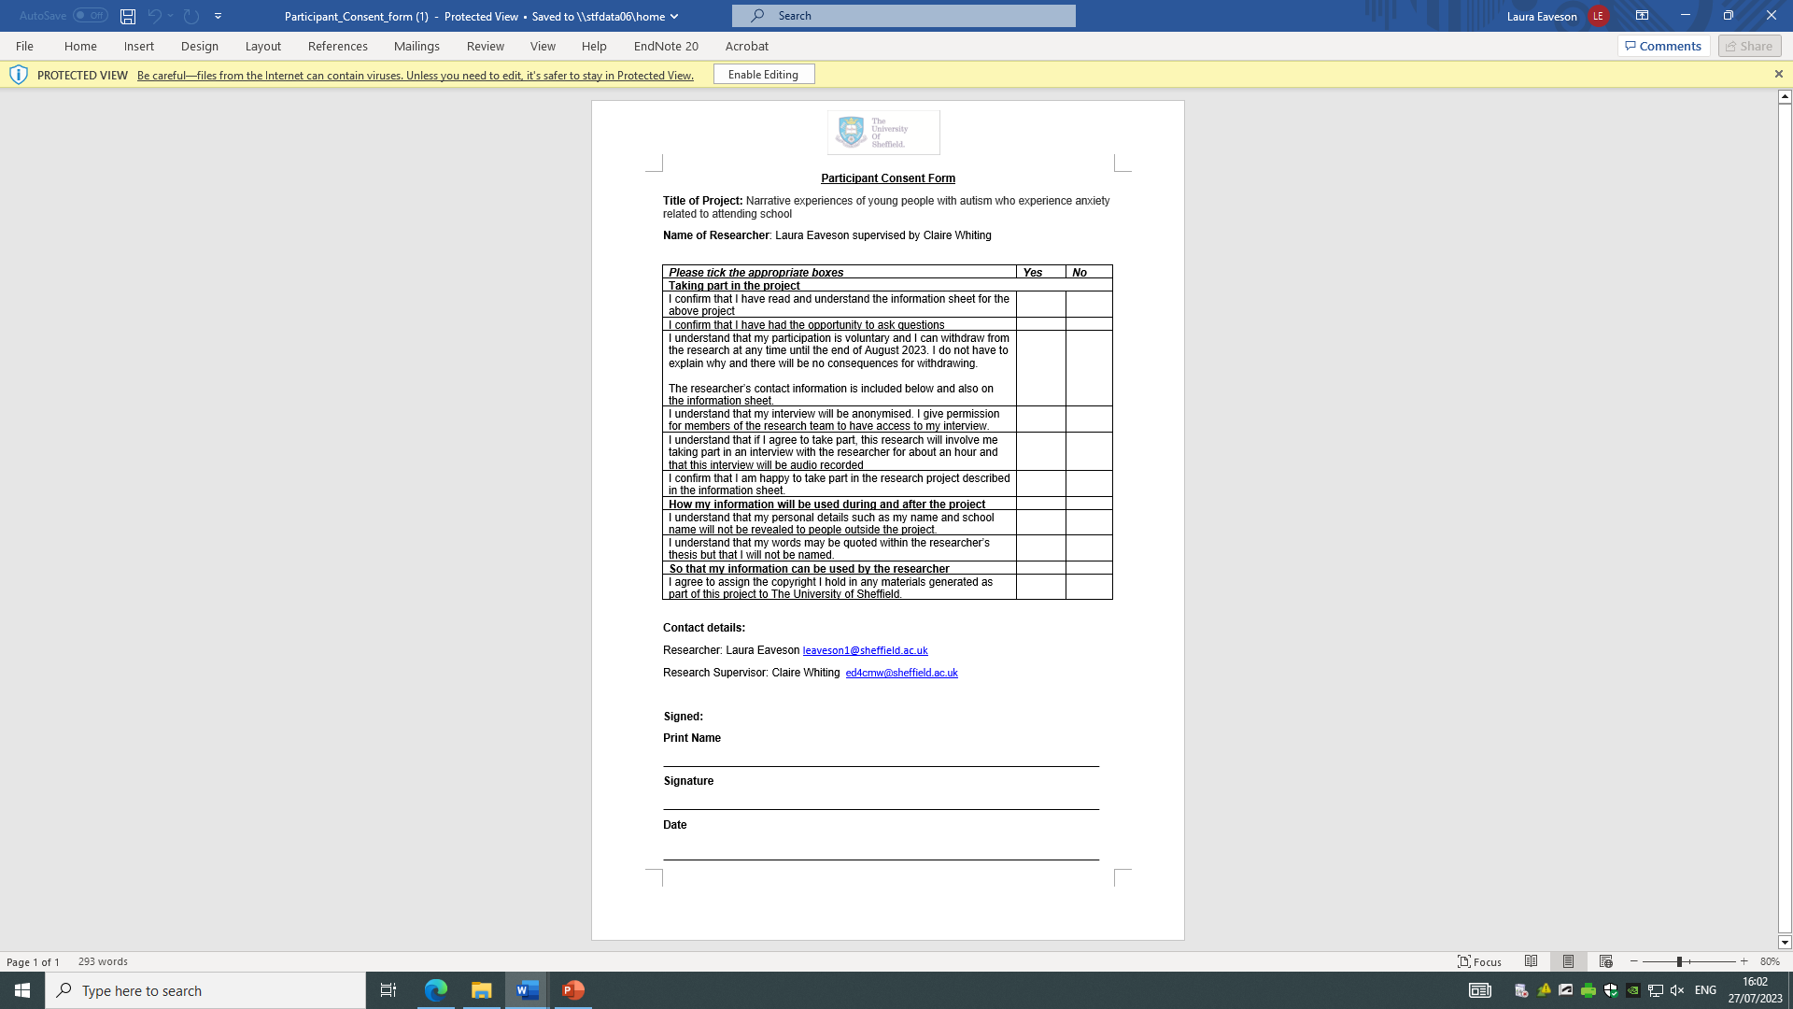
Appendix C – Parents’ information sheet

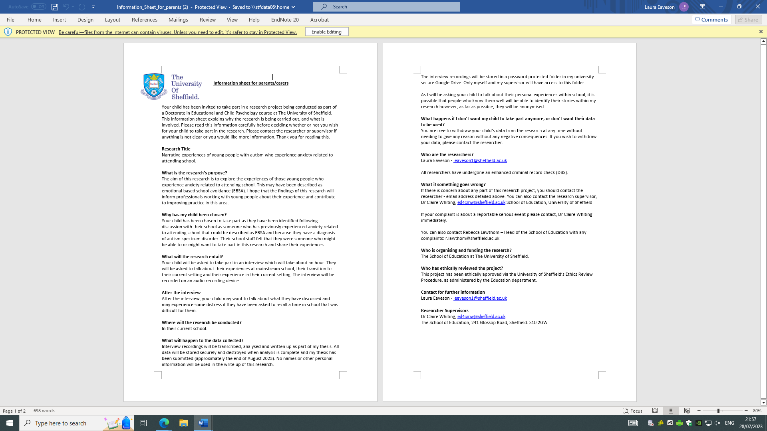

Appendix D – Parents’ consent form

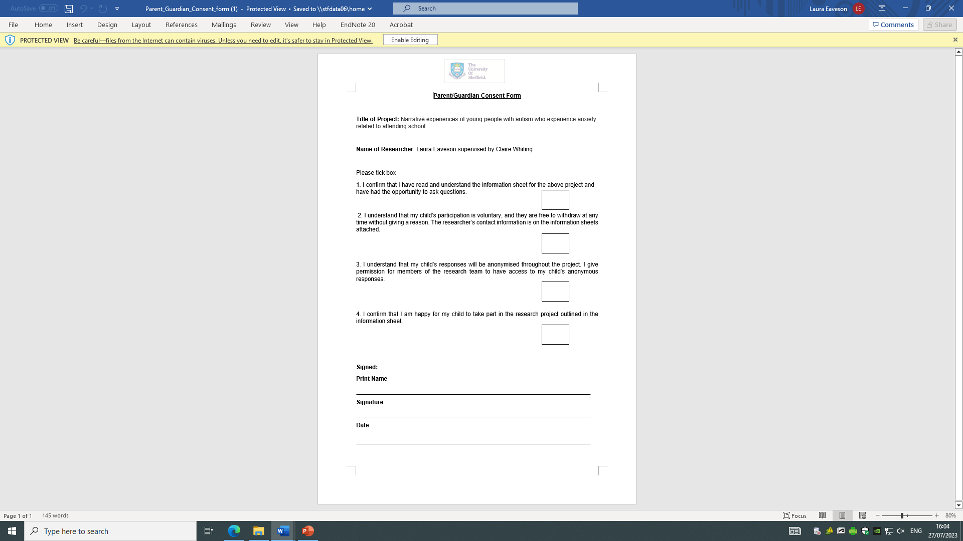

Appendix E – James’ transcript with highlights

Transcript of Interview 1 - James:

- Abstract
- Orientation
- Complicating action
- Result/resolution
- Evaluation
- Coda

L: Hello
J: Hi
L: Hi
L: So you went to mainstream school in the past?
J: Correct.
L: Awesome. So, can you tell me what ages you were when you went to mainstream school?
J: So when I went to mainstream I was in year seven so that I believe I would be eleven, twelve years old?
L: Mhm
J: Okay and well that wasn’t a broad question quite easy (inaudible 1 second)
L: Yeah so that’s start off with a few closed questions. So what school was that?
J: Er that was [school name] sort of in [place name and description redacted]
L: Oh I know where you mean, yeah
J: Yes
L: What was it like there?
J: Erm it was very loud and very overwhelming very at you it's just like (pause 2 seconds) it seemed like something you had to prepare for ok, that place changes people ok I I know of so many like my classmates you know like from my old school from my old class and when we went there it went from [cheery voice] ‘Hello!’ To [ sinister whisper] ‘what do you want? What do you want?’
L: Laughter
J: Ok its [sigh] er er I don't like that I don’t like that or you could say it changed me
L How did it change you?
J: That's a good question. Erm (pause 2 seconds) well I had been like diagnose with autism er spectrum disorder sort of before that and my mum quite kindly of her erm for about a few weeks erm [short sigh] sorry for the first few weeks she would er take me to school you know just being like nice and stuff [laughter] just to support me so that's cool that was great and erm my first day at school as very overwhelming for me and I hated it and [sigh] very loud, very angry place I’d say and no one wants to be there everyone’s doing trying to get through including you the teachers et cetera and the short and tall of it is that I came home crying [small laugh]
L: Ok, so it was, tell me about your first day then was it, did you not expect it to be how it was or
J: Erm well I’d heard some bad things from my sister you know well she did not like it at all and well I guess I didn’t really know what I was expecting, I guess to be honest I was expecting to not like it and I guess I was right [both short laughter] but [pause 2 seconds] I don't know oh here's something interesting first day French class I don't speak French and they s- well this is what happened, sorry I'm tumbling on myself
L: No, that’s great
J: I was so going to French class, hello, welcome to French class ok you know bonjour [inaudible 1 second] French Paris etc and then from that basic stuff, we go right into learning about the French revolution in French and I don't have a clue what's going on and I can just see pictures of people like these oil paintings like okay this seems to be like an angry mob ok erm I'm not sure what a bastille is I mean I do now.
L: I’m not sure if I know!
J: It’s well The Bastille in Paris is sort of like a well have you heard of the storming of the Bastille?
L: Yeah.
J: Well it's that.
L: Ok.
J: It was the bastille that was stormed
L: Ok
J: Ok?
L: Yeah.
J: Anyway that was just [explosion noise]
L: Yeah, yeah I can imagine
J: So yeah ok I went out of that lesson not a clue which was anyway there was maths and English ok and well it was just like maths and english but harder and well you know I feel like the teachers going to eat me and spit me out [both laughing] if I get the something wrong so there's er yeah
L: What was it about the teachers that made you think they were going to eat you and spit you out?
J: I don't know. (pause 3 seconds) I guess it was just the atmosphere ok it’s just (pause 3 seconds, sigh) I felt like none of them wanted to work there and they did not like the children at all but you know it's a living
L: Ok. So were they describe to me like what a typical teacher at [school name redacted] was like.
J: Well if anyone anyone fell out of line and I mean anything ok snap anger out
L: Ok, so did you get sent out of class and stuff?
J: I don’t think so because well I was just petrified I didn't really talk no er er twelve?... correct
L: [laughter] so did you ever get into trouble?
J: Erm kind of of
L: [mmm]
J: But this is more after my first day erm so eventually I got so scared ok that I refused to go to lesson
L: Ok
J: So that every day of school I would erm I wouldn't go into lesson I would go to this place called the erm the base and erm in the base it was the sort of place I don't know you could say it was a special needs thing but its not specifically that [pause 2 seconds] I'm not sure how I'd describe it. I don't know look I’m in here, I'm not in lesson that's the most important thing.
L: Yeah
J: And I as in there until so from September to April
L: Right ok
J: See
L: That's a long time
J: I know! (quieter voice) geez I missed out on so much
(pause 5 seconds)
L: Yeah(pause 3 seconds) so you were in there all that time and then what happened in April?
J: So we so in erm s- (sigh) my brain is just woah
L: Yeah I can imagine. It's a lot of stuff
J: Erm so you know how we in winter that year, I got told I’d been um selected or requested or whatevered to er come to [name of current setting] and then April is when I finally went and you know there wasn’t an in between period really
L: Ok
J: It was just one day I'm going there and the other day I'm going there [pause 2 seconds] and so yeah I came here and it was tough and you know I couldn't say that I enjoyed it that much and arguably I don't enjoy it that much now but it's better than nothing
L: Mm yeah, definitely so in that September to April kind of period when you were in what was it called? The base?
J: Yes
L: The base. Erm what sort of things did you have to do in the base?
J: That's a good question. So in the unit at first ok yeah we would be given work to do usually from our class and you know, I would do it but [sigh] but then of course I er well I started not doing it and well quite frankly neither did anyone else in there and well at the time I had constant headaches I was always tired and I just felt terrible
L: What do you mean by terrible?
J: Well I’d got a headache and (L: ok) and and I'm tired and I'm scared and I'm angry and I'm just frightened (L: mmhmm) and I just feel like I can't escape
L: Yeah
J: ok so I have to keep doing this and doing this and doing this (L: mmhmm) and that's just hated that.
L: Yeah, it sounds horrible.
J: Yeah well I don't know really I don't know why I mean it’s like you’ve been to secondary school and you like [raspberry sound effect]
[both laugh]
J: [wha wha wha sounds that seem to illustrate confusion and panic]
L: [laughter] yeah, it's a bit like that, isn't it?
J: Yeah
L: Yeah
J: Fair enough
L: Erm so the work that they were giving you was that work that you could do or was it hard?
J: Erm lets see, I remember we had to do erm something about who's the guy who flies too close to the sun?
L: Er oh Icarus.
J: Thank you, yeah we had to do something about him I think it was in English so to be honest yeah, I think I remember doing that and yeah I think I did find it hard but yeah I did complete it
L: Ok so there was some stuff that you could do?
J: Yeah
L: Mm and in the in the base or in the school did you have any friends?
J: Not really no. I mean so most of erm people I knew from my old school you they didn't really want anything to do with me anymore
L: oh
J: Of course there were exceptions there was Tom*, Tom’s* a good guy. I haven't seen him in years er Tom* but yeah, Tom* was no we didn't really hang out we yeah he was nice when we saw each other and there was Ellie* who [laughter] you know sort of we didn't have a thing but
L: Yeah
J: We were close let’s say that
L: Ok was she in the base or was she in the school?
J: Er she was in the school erm there was so Claire* who I got on with on and off and there's also Sammy* who is in there now [indicating his current classroom]
L: Oh really?
J: Yeah I know! I was surprised what she when turned up here anyway erm friends alright yeah [L: yeah] there was my sister who was there but
[both laugh]
L: Yeah
J: there was also my mum’s friend’s children who I know but again
L: Yeah [laughter]
J: Too uncool
L: [laughter] yeah, yeah, I can imagine
J: So I guess I did have one friend my best friend my cat
L: Aww
J: Yeah I know so I lived really near to my school not now but
L: Yeah
J: [school name] and if I went to the gate at this particular area at the back of school if I call his name then he would come under the gate [talking to cat voice] hello
L: [laughter] oh wow!
J: I know! It made me so happy to see him every day
L: That is so cute
J: I know
L: Awww
J: I
L: yYeah that's awesome
J: That is awesome
L: [laughter]
L: So in the in the base what were the staff like?
J: Er I guess they're alright some were still pretty angry but they did keep it to themselves I guess a bit more but again though some where just fed up I mean we were just most of the time slacking off and yeah I guess we I’d be angry
L: Mm ok. So the other kids that were in the base were they all ages?
J: Oh yeah different ages so erm no there was me Claire*, Sammy*, Daniel* who I hated also Matthew* who I used to be really jealous of because he could come in in normal shoes and I have to wear these posh leather clogs
L: Ahh
J: With a heel which well I'm not a fan of erm er there was Kian*, Kian* was alright yeah erm there was also Carl* Carl* said he did a lot of boxing and fighting outside of school and I’d seen him with a fag and he has offered me one but I didn’t take it so I guess that’s good
L: That's good, yeah. Ok so did so you kind of got on with some of them but not all of them
J: Mm yeah
L: Yeah
J: To be honest though I a lot of the time I do just remember hate there
L: Hate.
J: When associating with that place
L: Hate from you? Hate from other people?
J: Both.
L: Both. Ok. was there was there so besides er your cat was there anything else about [school name] that you liked?
J: Mmm no.
L: No. no full stop? Fair enough
J: Full stop.
L: Erm so you were only there in year 7 so you were 11, 12 ish?
J: Yeah
L: Then you came here. So did you how far in advance did you so you knew at Christmas you were coming here?
J: I don't th… I think it was winter that year so like January, February (L:ok) that I found out about wha
L: Ok and did you want to leave?
J: Yes
L: Did you want to leave and come to a different school or did you want to just leave?
J: Well I was just looking for any alternative at that point you know I was
L: Ok
J: I mean before that there was talk of me going to a school in [place name redacted]
L: Oh
J: But I didn't go there
L: Mmm ok. So when you found out you were coming to [school name] what did you think? What was your kind of thoughts?
J: Erm it's a good question well I guess sort of relieved because well again finally an alternative
L: Yeah
J: Something else to try or experience or get out of here
[both laugh]
J: So to be honest, I think I remember saying on my last day, see you in hell guys
L: [laugh]
L: So you had your last day at [school name] then you had your first day here
J: I think so, yeah maybe it was like a Friday and then weekend Monday
L: Yeah. So how did that feel then? Did you come here or did you go to [other site]?
J: So [other site], I didn't even know this existed then erm so I go to [other site] and again I hated it
L: Right, ok
J: Because well I still have a lot of that anger still there and again I'm scared and these people annoy me
L: Mmhmm [pause 3 seconds] so what what's it like at [new setting]?
J: So now or…
L: Then.
J: Then ok so that first year I was in the group with Darren*, Ryan*, Grace* Charlotte* and Faye* and so I abhorred Darren and I still do erm Faye* is alright Ryan* is alright erm Grace* and I don't think her name is Charlotte* erm never mind every day Darren* would start some argument and you know that guys regular speaking voice is shouting
L: Oooh, ok
J: Hated that still does it, anyway, ok, argument everyday, usually every lesson and I would just take myself out, run away and hide somewhere
L: Erm ok so how so you’re not at that site anymore, you're at this one, is that right?
J: So I was there for erm how many years like so what from year 7 so that's like oh maths
L: [laughter] oh I’ve just taken you out of maths as well!
[both laugh]
J: 4 years, 3, 4 years
L: Ok wow
J: Well I don't know anyway so yeah I was at [old site] for a while and nothing’s changed a lot of the time I did feel like I was surrounded by idiots but I guess that's more my fault slash problem and me not being tolerant is that the right word
L: Yeah
J: It's just me being you know a negative bumhole
[both laugh]
L: Ok
J: But again though I er found people annoying and quite stupid at times erm so I went there I get annoyed I get stressed angry and was just I don't know ok I mean even if this is a different school it still quite a lot like a mainstream you know like still it’s a social nightmare ok that's just being a teenager
L: Yeah that's true
J: Erm [sigh] oh and Lisa* was in my original class, I like Lisa*
L: Mm so the what were the staff like at [new setting] when you started
J: Erm so a lot of the staff are still here so originally, I had teachers like Rich* is you met Rich*?
L: Erm no?
J: [inaudible] so you know Matt* [L: yeah] I’ve always liked Matt* ok good guy has my back
L: Yeah. I like Matt* as well
J: Makes me do jobs
[both laugh]
L: That's probably for the best
[both laugh]
J: Erm so so so there's Matt* and there's Jack* who’s the head honcho [L: mmhmm] and Rob* he's quite new actually [L: ok] and then there's Morgan* in there [L: yeah, just met him] er yeah Morgan was he was I believe my original form tutor[L: oh was he] so I like Morgan* there's also Rich* the maths teacher, I like Rich* because Rich* is a great guy erm there was Bob* who's not here anymore and he hasn't been for a long time he was erm my sort of history teacher. Bob* was quite strict and but again though he could have a laugh sometimes [L: mm] so you know he's not pure evil
[both laugh]
J: There's also Jenny* who isn't here again I like Jenny* though erm there was also Petra* who was erm sort of what's the right word? Learning mentor?
L: Oh ok yeah, yeah yeah yeah
J: Oh I got along really well with Polly* Polly’s* probably one of the like best people I get along with on this planet which is just [explosion noise]
L: [laugh]
J: because I was really upset when she left
L: Mmm
J: And erm there was also Elizabeth who I spent loads of time with she was erm teachy assistanty
L: Yep
J: Ok and we used to play cards all the time and tell jokes ok talk about things ok and yeah, I was really upset when Elizabeth left
L: Mmm
J: So it sucks [both laugh]
J: Erm
L: Yeah it is hard when people leave
J: What else to say so going off my earlier years and I'm just trying to go back there
L: Yeah
J: Erm I had a taxi driver who took me from my house to erm school and he was a nice guy ok friendly guy ok but he would play the same song over and over and over
L: [laughter]
J: And I just ooorggh
L: [laughter]
J: I really didn't need that ok
L: Is it the same guy that dropped you off picked you up
J: Yes
L: Yeah
J: And now I get a erm full bus-y thingy
L: Oh do you?
J: Yeah
L: What how is it? About half an hour from [home location redacted] to here?
J: Yeah
L: What was that like then? Because that must have been really new when you first started tr…
J: Erm
L: Avelling here
J: So erm so yeah first it was actually ok because so cos [old school name] and yeah is a big problem because I live right next to it and at 3 o’clock erm it comes out and we
L: Oh gosh
J: We erm stop at 2:30 so if you do the maths
L: Ooooh!
J: I know
L: [laughter]
J: Usually most of the time because the guy’s a fast driver my god ok we get there before they come out and
L: Oh that's good
J: You know people aren’t like huhuhuhuhuh hoo hoo hoo look at him
L: Ok
J: Oh then I just feel like everyone just wants to eat me and kill me and like
L: Yeah it’s
J: I call them the goblin horde
L: [laughter] I like that
J: Because there’s so many of them
L: That is what it's like isn’t it when they come spilling out of school
J: Oh yeah
L: Oh there's loads of them, yeah I like that, it's a good image
L: So going back to when you were at [previous school] what was what were things like so you were really angry all the time at school
J: Yeah
L: What were things like at home? With your family?
J: I just I just felt like they hated me and like a lot of times I would cry and I don't know I just felt like everything was pushing against me
L: Mmm
J: I'm being squished like a fist you know school family [sigh]
L: Mmhmm
J: I mean at least I had Mr Fluffy Pants
L: [laughter] yeah that's true. And so what are things like at home now? Do you still feel squished?
J: Ermm not as much but you know I I still feel like my parents not that fond of me I mean and my sister loathes me and I wish she didn’t and well my cat best friend is dead now
L: Awww
J: [inaudible]
L: Aww so it's still not easy at home?
J: Yeah no
L: So what were they happy that you came here?
J: Erm I don’t know what their opinion is actually
L: Ok
L: What does your sister do now?
J: My sister? Erm she's going to college she’s collaging in to be honest I think right now erm she erm in somerset with her boyfriend so poor him
L: [laughter] yeah. And are you you year 10, year 11?
J: Year 11.
L: Year 11 what's you what's your plan
J: Er I don’t have one
L: Oh fair enough. Do you know what you want to do when you're older?
J: Nope.
L: No. erm and how long can you stay? How long will you stay here?
J: Erm
L: Like do people stay until their 19 18 16
J: Erm there is a sixth form here you know I don't want to be going back and forwards erm from [home location] all the time for another few years and I can't really study the things I want to study at sixth form so I'm hoping I can go to erm [localcollege] and plus my mate Ben* goes there
L: Ok that would be nice
J: Yeah that's cool and you know he says it's pretty cool so
L: I think its supposed to be really good. I've heard good things. What is it you want to study?
J: Erm I want to study the well I don't know things I'd like to study are like drama and history and well I guess that's about it because I'm very shallow
L: [laugh]
J: I'm very beige
L: No that sounds good, that sounds exciting actually. Drama and history that sounds pretty good. Erm so you said when you first started here erm you’d run and hide
J: Yeah
L: So what was that like then where did you go? Who came after you? What was the situation?
J: So usually I would go to the mentor room as it was known there I mean I called it my office
L: [laughter]
J: By how much time id hide in there erm usually the teaching assistant after calming everyone in the room down would look for me and you know try to convince me to get me like Charlie*, Charlie* was a great guy, I like Charlie* I haven't seen him in since erm June, July I think he's got a new job now [L: ooh ] erm and you well you know it would usually go like this go back into lesson no
L: [ laughter]
J: Go back into lesson no it's scary
L: So what would happen then would they, would you go back into lesson? Would you do something else?
J: Erm I’d rather just lay sit there or alright fine you've annoyed me enough, I'll come back in
[both laugh]
J: That's usually what would happen
L: Ok. And so now you’re in that class
J: Yeah
L: Yeah what are they like?
J: Eeerrrr its
L: Is it those people all the time?
J: Er yeah, pretty much.
L: Yep
J: So it’s so oh god is it [inaudible] so let’s see from where you were standing erm Jack* er I love and not hate Jack* as in like he's always his head down, he's got his hood up [L: yeah] and he's just and mm I've never seen him smile, ever
L: Aww ok
J: Which yeah, is quite sad erm and you know he talks with like very low voice like [inaudible]
L: [laughter]
J: Ok and you know most of the time I don't have a clue what he's saying but again though he seems to be smart and he just seems and he just seems like him so he's not too bad and he's quiet so you it's nothing much that complain about erm Ella* Ella* and I we used to go to primary school together and we seem to get along fine and that’s about it really and then next to her is her friend Alice* who loves and hates me or just hates me I don’t know ok what do you do with someone when once they offer to kiss you and then another time they give you the evil eye, I don't know [L: very confusing] I'm so confused and I hate it so much
L: Yeah, it does sound confusing
J: Yeah and anyway I sit next to Francesca* and as I said, I Francesca’s* fine I mean yeah, Francesca* can get let’s say like sig.. that's not… wound up quite easily but again though Francesca* she's not she's not a bad person she's nice to everyone erm anyway next to me sits Jo-jo* and my first thought when I met Jo-jo* was that’s a girl’s name and that’s funny because he thinks he's the hardest bugger on the planet
L: [laugh] Jo-jo so what’s Jo-jo* short for then? Joseph?*
J: No, it's just that
L: Oh is it? Interesting name
J: Yeah I know!
L: Oh ok. So Jo-jo thinks he's really hard?
J: Yeah you he hasn't got yeah that's the thing that’s what I meant by well not everyone but most people like you to secondary school [happy voice] hello [angry/threatening voice] what are you looking at?
L: [laughter] yeah
J: Ok like I did that ok and you know when I came here I transitioned ok I’m a teddy bear, please hug me
L: [laughter] yeah
J: Er Chris* who sits next to Chris’* alright yeah anyway people who aren't in right now there are Sarah* Sarah* is ok Jason* Jason* ok again though I still have the complex of I'm so much smarter than these other people but you know it's mostly just my little self esteem talking
L: So you you’ve got friends here?
J: Mmm no
L: No?
J: Look I'm not I don't know. People say I have high standards for friends [L: ok]which is probably true I mean I'll never admit it [L: laughter] erm like if you were to ask me I'd say no I don't have any friends
L: Ok
J: Ok I know there was [talking to cat voice] [cat nickname] or just [cat name] who I’d say was my best friend but I only started calling him that after he died
L: Ok. So what if I asked them in there is James your friend what would they say?
J: No nah
L: Why do you think that?
J: I'm weird I'm annoying I'm
L: But you said they're weird and annoying or not those words but
J: Yeah but you know that’s that’s human everyone I find everyone weird and annoying that that's my problem ok that's just me [L: laughter] being grumpy and tired all the time and just wishing for something being somewhere else
L: Ok
J: Ok but ok they’re decent people ok it’s just me
L: They’re decent people so that's different
J: And also I find them annoying and I hate them [laughter]
L: Well that’s fair enough well that's fine [laughter] so they’re decent people but the people at [old school name] less so?
J: Yeah
L: Yeah ok so that's a big difference erm is are this lot you said when you started here erm there was that Darren* who was screaming well shouting all the time
J: All the bloody time
L: Yeah. Are they quieter? Is that better?
J: Yes and no
L: Ok
J: Sometimes they're less sometimes they are shouty and I do hate that
L: Mmm
J: There's not really anything I can do about that though
L: Mm yeah that's difficult
L: How come you're in this building and not the [other building name]
J: Thats a good question erm so I believe [other building]’s for [noise indicating younger children]
L: Oooh I see
J: Well nowadays it is you know you used to just be everyone from year sevens to elevens but now
L: Yeah, it used to be all over there
J: I mean it used to be just 30 people in one school and that used to be great
L: Yeah. So how many is it now? It’s quite a lot now, isn't it?
J: Loads.
L: [laughter] how many people do you think are in this building? Like students-wise?
J: Not a clue erm I don’t think I’ve ever just tried to count them.
L: Ok
J: So there’s me… [listing people’s names] I’m not counting these I’m just listing them,
L: [laughter] so there was about eight in there wasn't there ish ish
J: Ok so 8 times 1, 2, 3, 4 that's er twenny oh crap my maths [Both:[laugh]] thirty thirty two
L: Thirty two. Yeah yeah ok so about 32 ish. So what's it like at break and lunchtimes here?
J: Er that's a good questions going to say that to every one er well what colour is an orange that's a good question
L: [laughter]
J: Er ra love it when people laugh at my bad jokes
L: So yeah what is like do you all go outside do you stay in?
J: So yeah some people go outside some people stay in people just hang out talk you know do regular stuff really it's quite
L: What do you do?
J: I kind of wander around
L: Mmm
J: Because I don't really have a place I don't fit in to any kind of group of people I just kind of wander around if something interesting or someone to talk to
L: So what did you do today? So I came I arrived like just at the end of lunchtime. What were you doing during lunchtime today?
J: That
L: Wandering?
J: Pretty much
L: Because you weren’t there was a load of people on the front there, I don't think you were there
J: No
L: No so where, where did you go?
J: Well I don't know around upstairs downstairs er kitchen out to the building over there
L: Oh is there I didn't know that ok
J: Erm
L: Erm ok so you just sort of and that’s every sort of day you wander about
J: Pretty much
L: Yeah and do you do you ever join any other groups or any people and talk to them
J: Not really
L: No. and how does lunch work here do people bring their own lunch or is there lunch cooked for you
J: Both
L: Both. What do you do?
J: I have a packed lunch because well because I'm a lunatic I eat it at break time
L: Ohhhkay oh I see so where do you sit to eat that?
J: Oh anywhere I mean usually just in that room because well I don't have to get up
L: No, fair enough that makes sense ok. And what’s break time like 15 minutes?
J: Yes
L: Yeah so do you normally stay in the classroom and have your lunch there
J: mm yeah and then if I'm finished having my lunch either go to the bog or do what I described
L: Yeah. Ok that makes sense. What do other people do? Does it get noisy at break times and lunch times?
J: Not too noisy sometimes it can erm [sigh] mmm brain fart
L: [laughter] erm so what were break and lunch times like at [old school]?
J: Loud, crowded I think once Saskia* and Lottie* poured a bottle of water on me [L: oooohh no] [imitating other students [huhuhu James has weed himself]
L: Ooh no
J: Loud lots of talking just yeah a lot of people
L: What did you do then at break times and lunch times?
J: To be honest, I did the same
L: Yeah? Wandering about?
J: Pretty much yeah it's a big place so yeah you can get a pretty good piece of walking done
L: [laughter] yeah I guess so yeah ok
J: And again though I would say hello
L: Yeah [laughter] ok so if you were to compare the two then erm [old school] and here [current school name] erm what would you say?
J: If I had to compare the two
L: Yeah which is better, which is worse, which where are you happier where are you not happier what is you what's the difference?
J: Er I wouldn't describe either as better or worse that's too linear for me
L: Ok how would you describe them?
J: This place is for autistic people last place is for everyone it's just biggie smallie I guess that's it really
L: Do you think one or the other is better for you?
J: Well I do think this place is better for me because well I don't feel as bad as I used to to be honest now I’m saying this I'm thinking to myself maybe my opinion isn't the best
L: Who’s is then?
J: I don't know
L: [laughter]
J: I don't know I guess I'm just biassed or closed mindedededed
L: You said you think what did you say did you say you think you feel better here?
J: Yeah
L: Yeah so can you describe that for me what's that like?
J: Well instead of having constant headaches, I don’t have constant headaches
L: Good
J: I just have on and off headaches
L: Ok thats an improvement
J: That's an improvement yeah and you know its still work to do still get annoyed still get angry sad etc [L: mhmm] again it is quite comparable if you ask me
L: Ok is there so when you do get annoyed and angry or you have your headaches is there somebody here you can talk to about that?
J: Not really
L: Mm ok
J: I mean I guess that is more me because well stubbornness nd yeah if I do feel bad I will just have to sit there and get on with my work is there any other choice
L: Ok
J: I mean other people yeah will ask to go out when will just take themselves out but I don't know as I said I've gotten close to a few people and now they’ve [disappearing sound effect]
L: Right ok ok so you you're not you don't feel like you're that close to anyone
J: no
L: Ok ok that makes sense but have I asked I don't think I’ve asked this already. You said at [old school] the teachers were all really angry they you didn’t they you didn't feel like they wanted to be there
J: Yeah
L: Is that the case here
J: Some do
L: Some are like that or some aren't like that
J: Some are like that
L: Mm
J: Just I guess it's more subtle
L: Ok
J: And again this is my opinion
L: Yeah yeah yeah
J: This is my ugh all teachers are evil opinion
L: [laughter] ok but some aren't like that some are ok
J: Yeah
L: Ok what about Morgan*
J: Oh yeah Morgan’s* fine Morgan’s* really calm
L: Yeah he's very quiet
J: Oh yeah
L: That's the impression I got
J: Like first days here ok if I had his lesson [miming not being able to hear]
L: [laughter] yeah yeah definitely ok erm I think that's about all my questions is there any else you wanna tell me about your experience here or at [old school]?
J: Mmmm what are what kind of alien are you giving this information to?
L: [laughter]

END.

Appendix F – Alex’s transcript with highlights

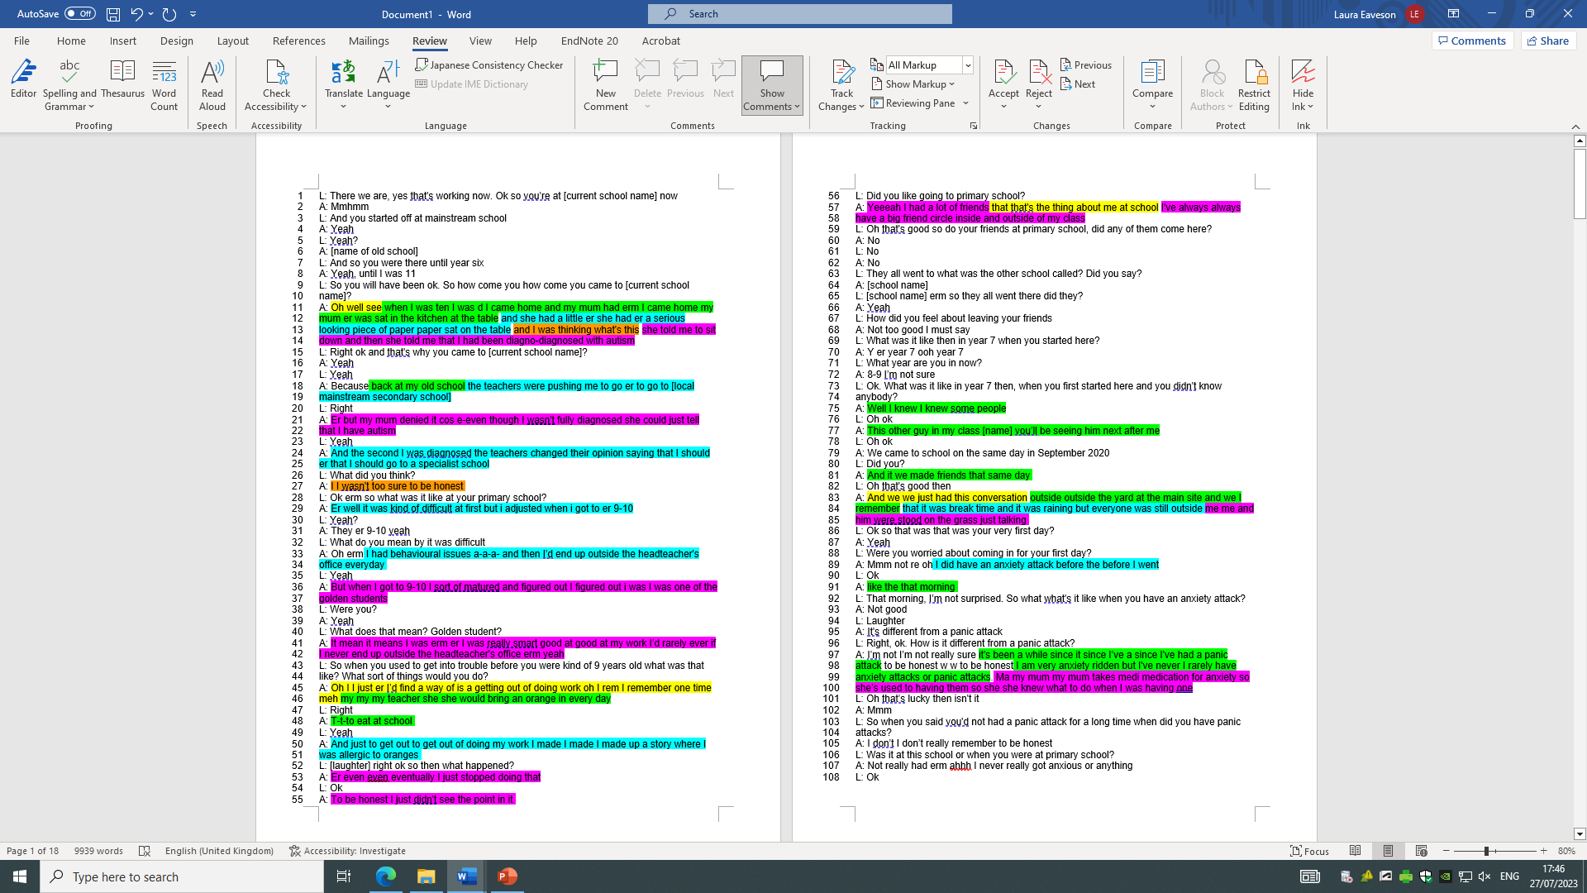

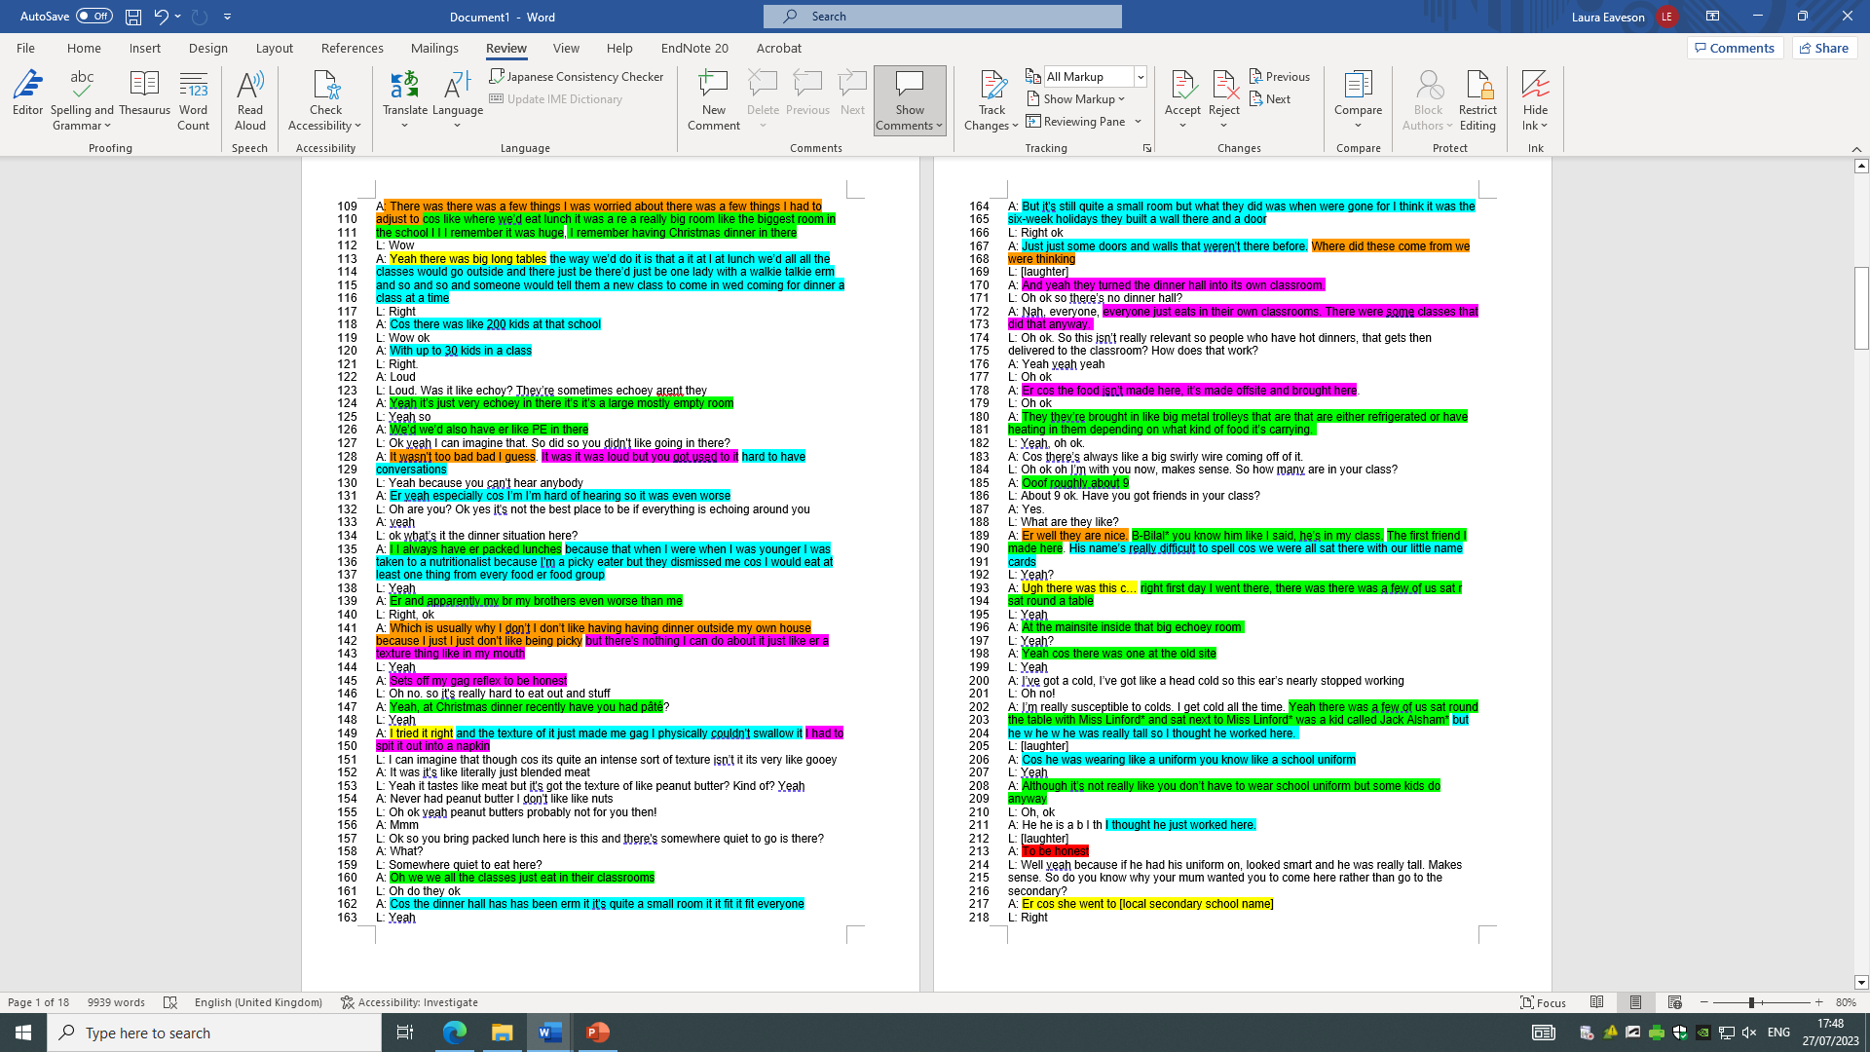

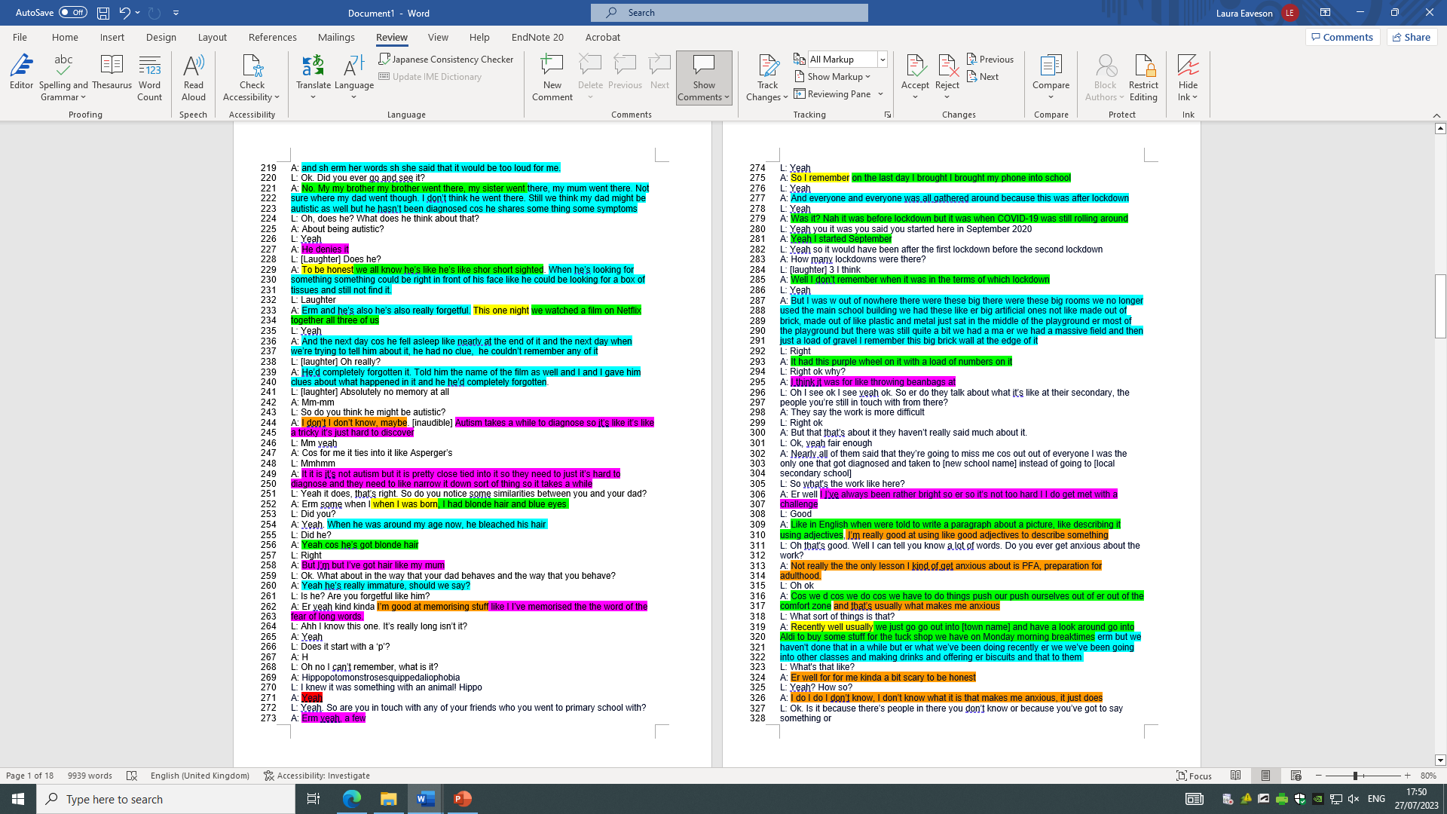

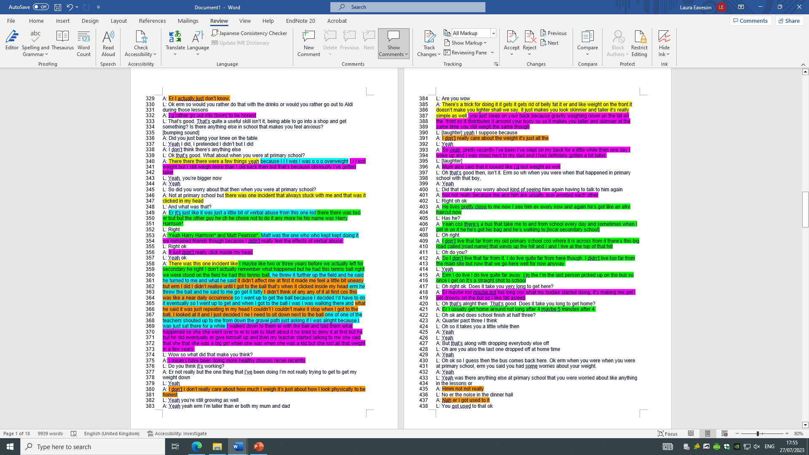

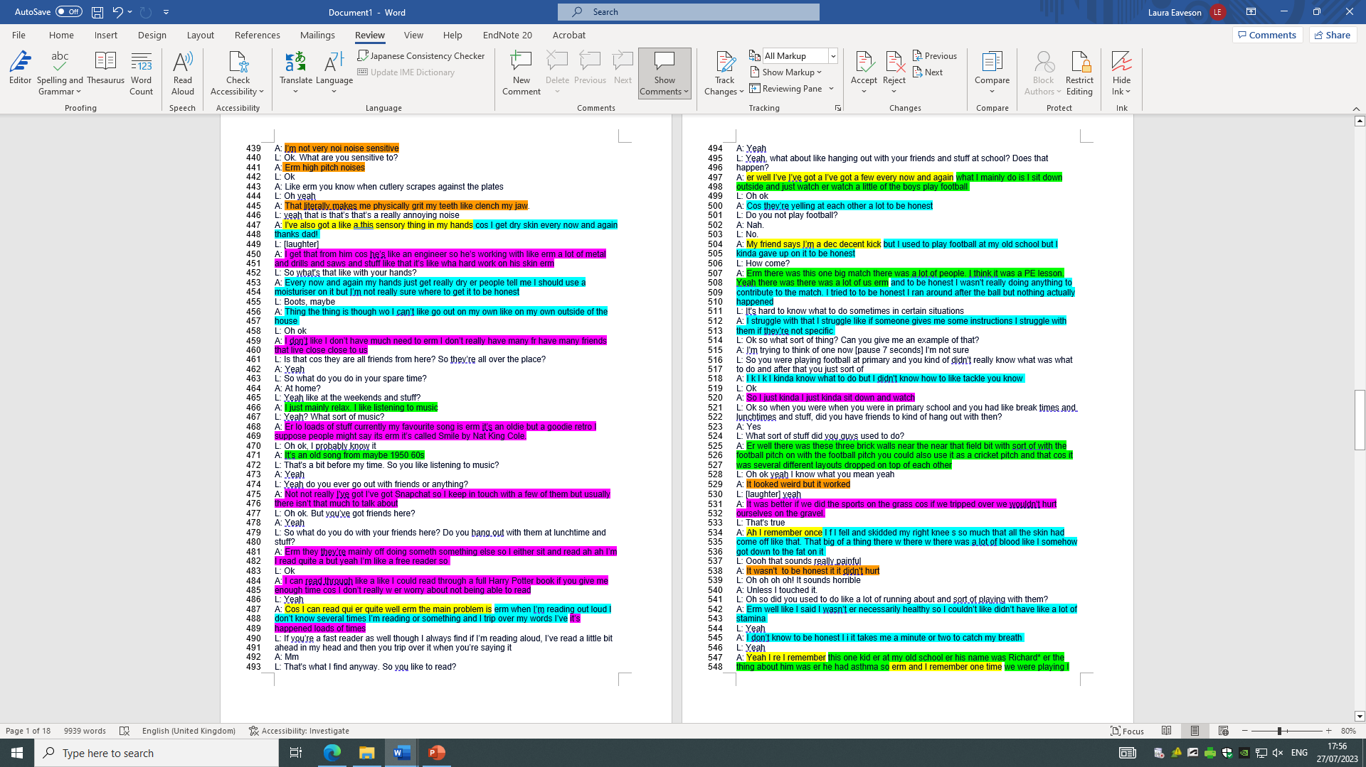

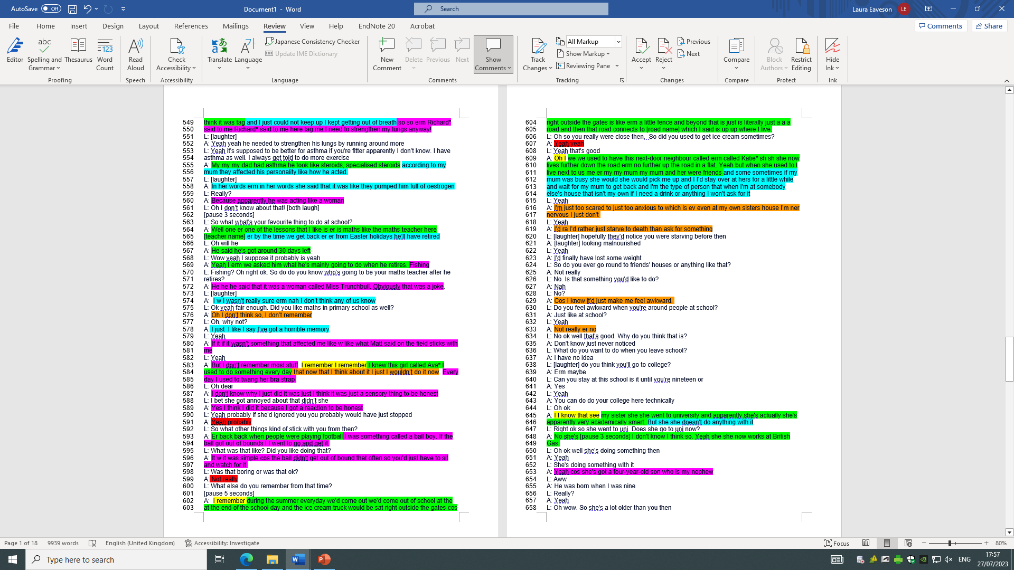

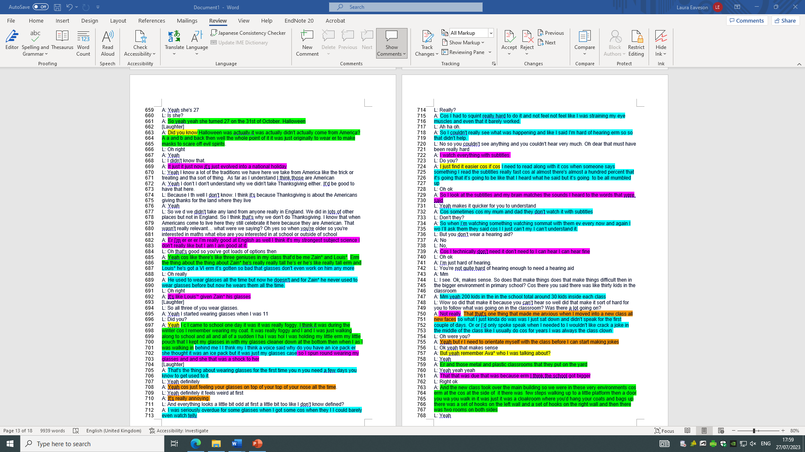

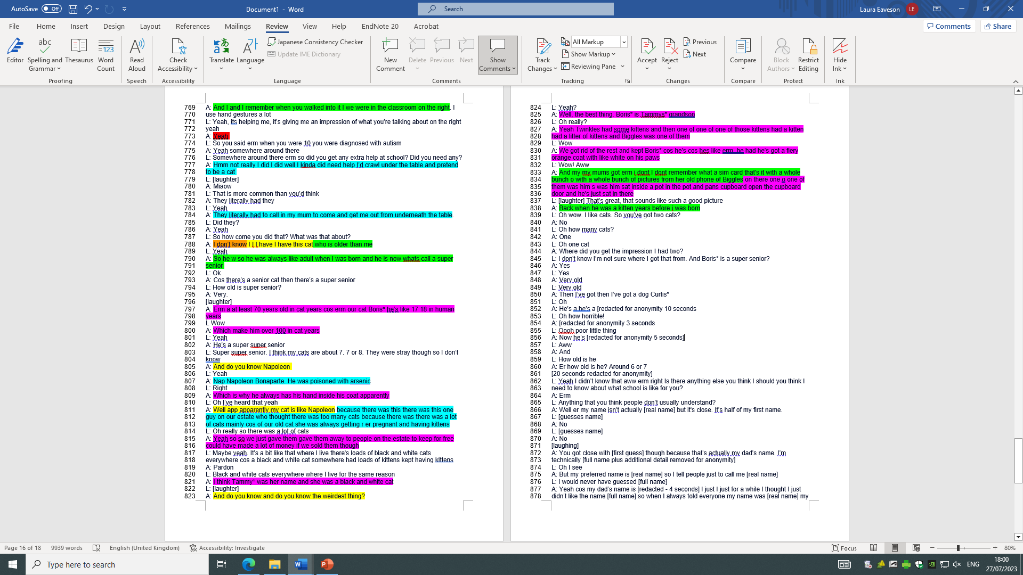

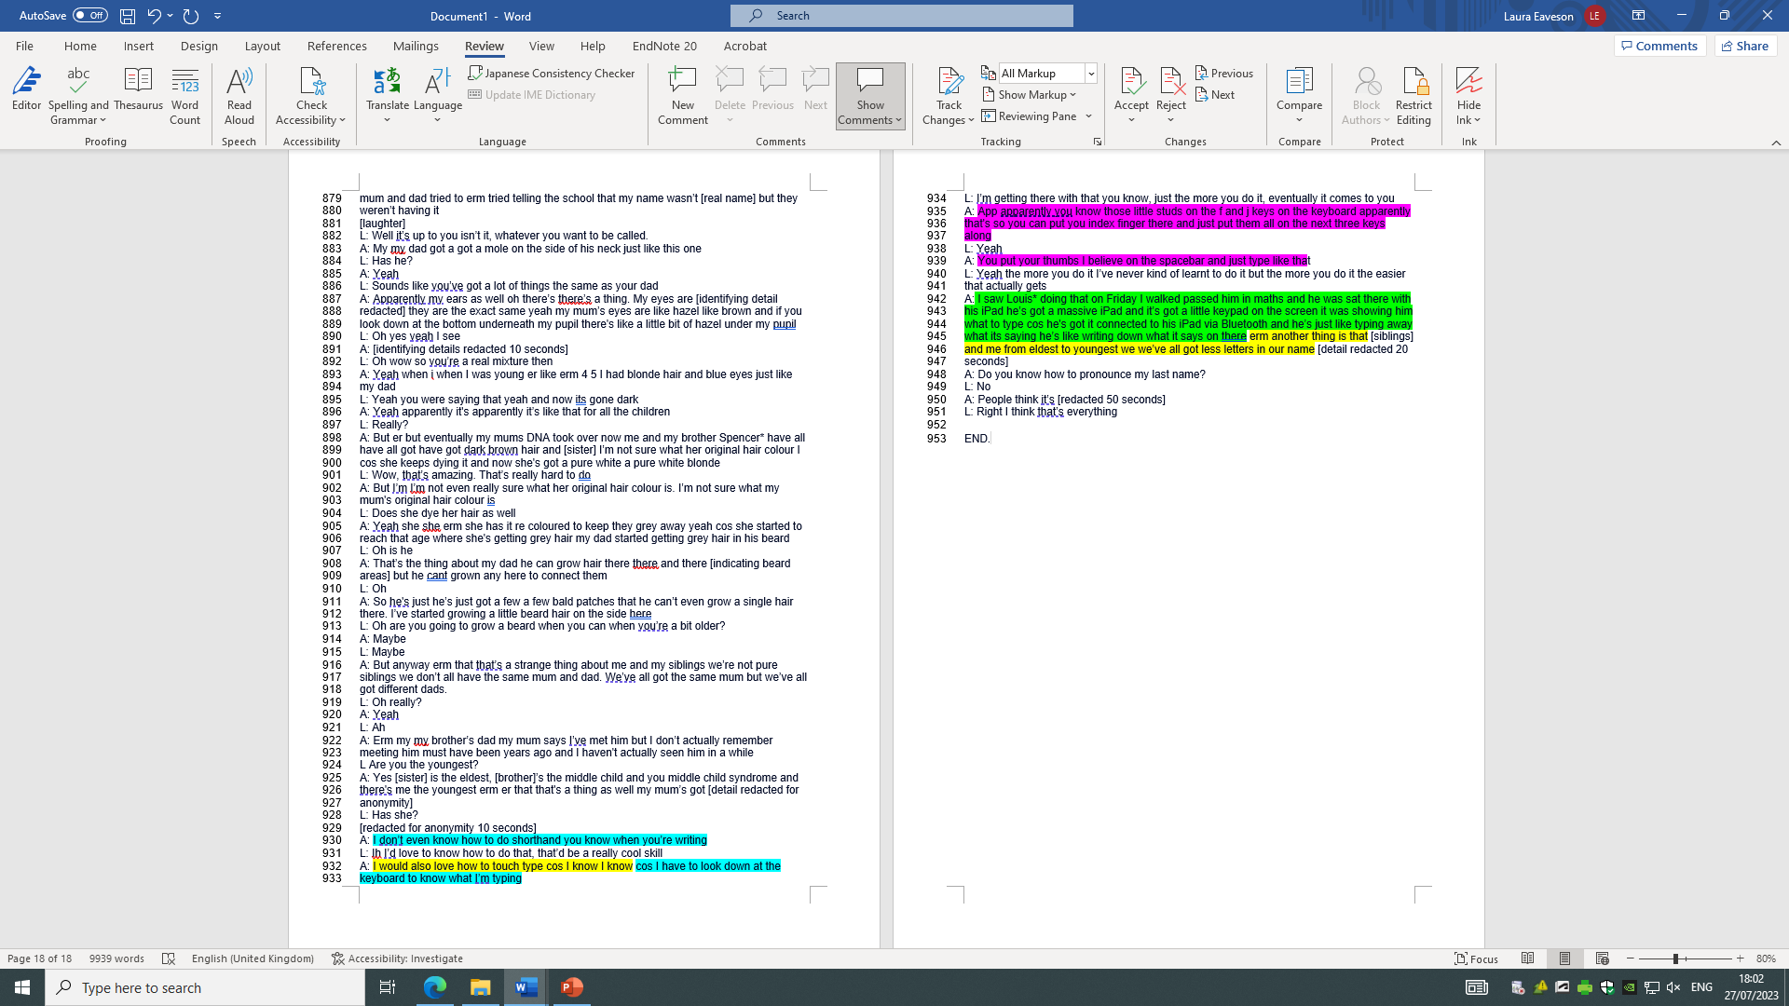

Appendix G – Bilal’s transcript with highlights

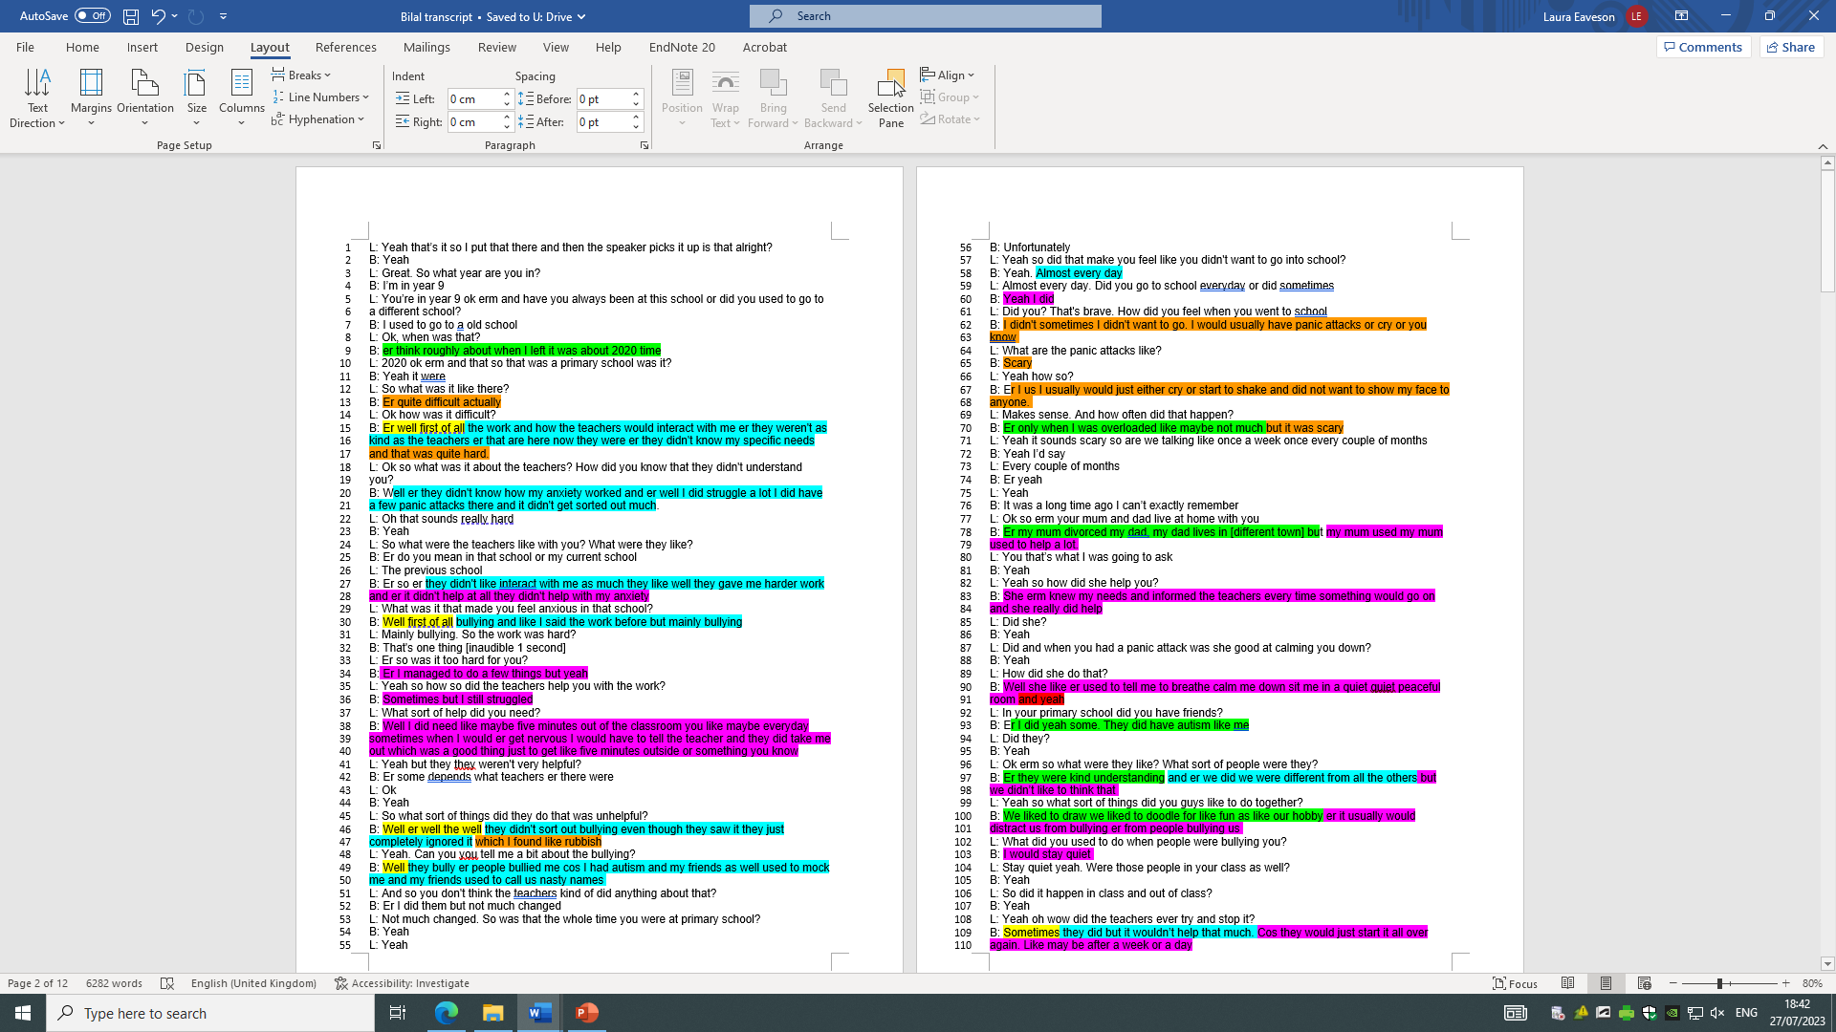

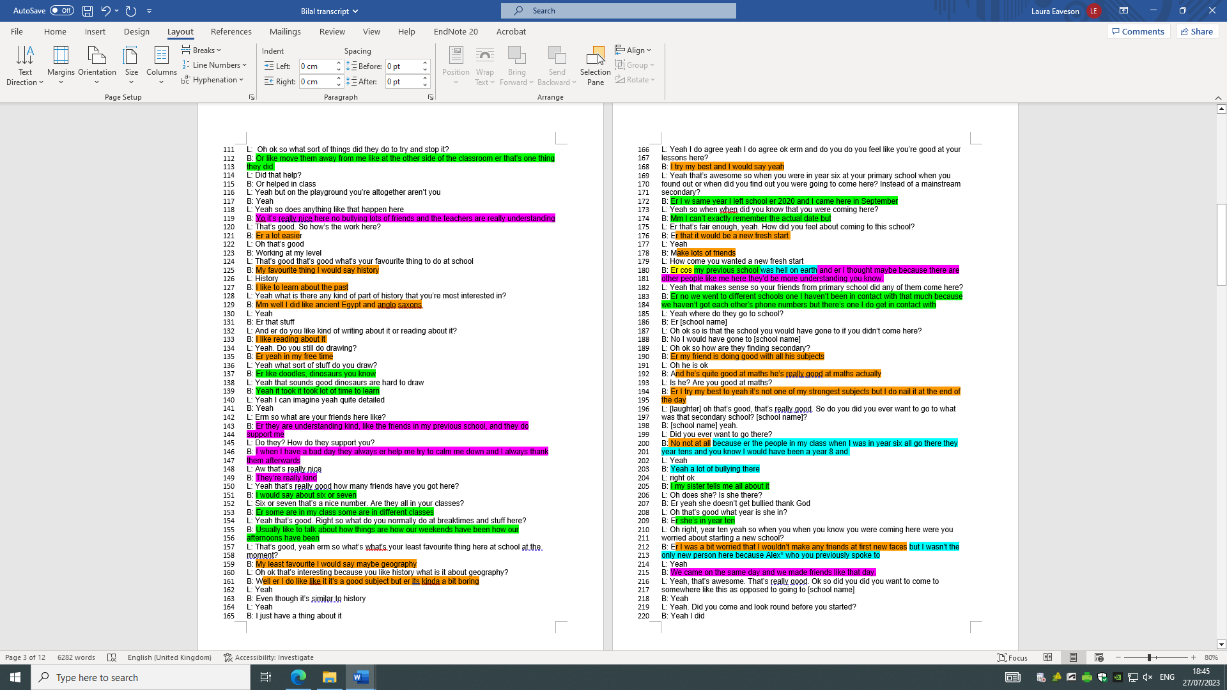

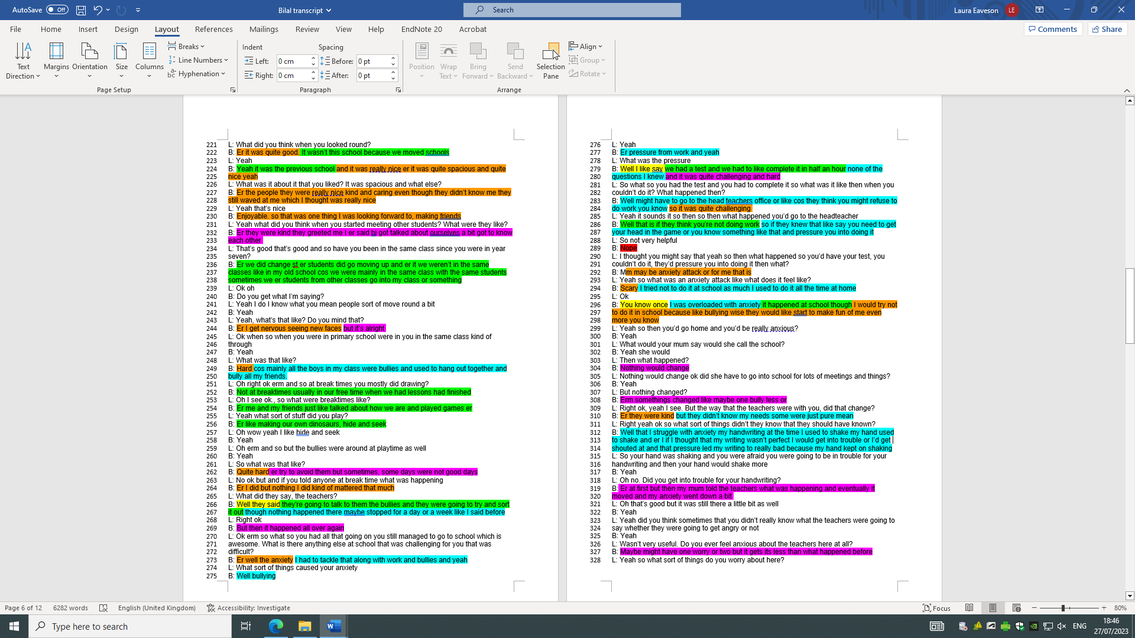

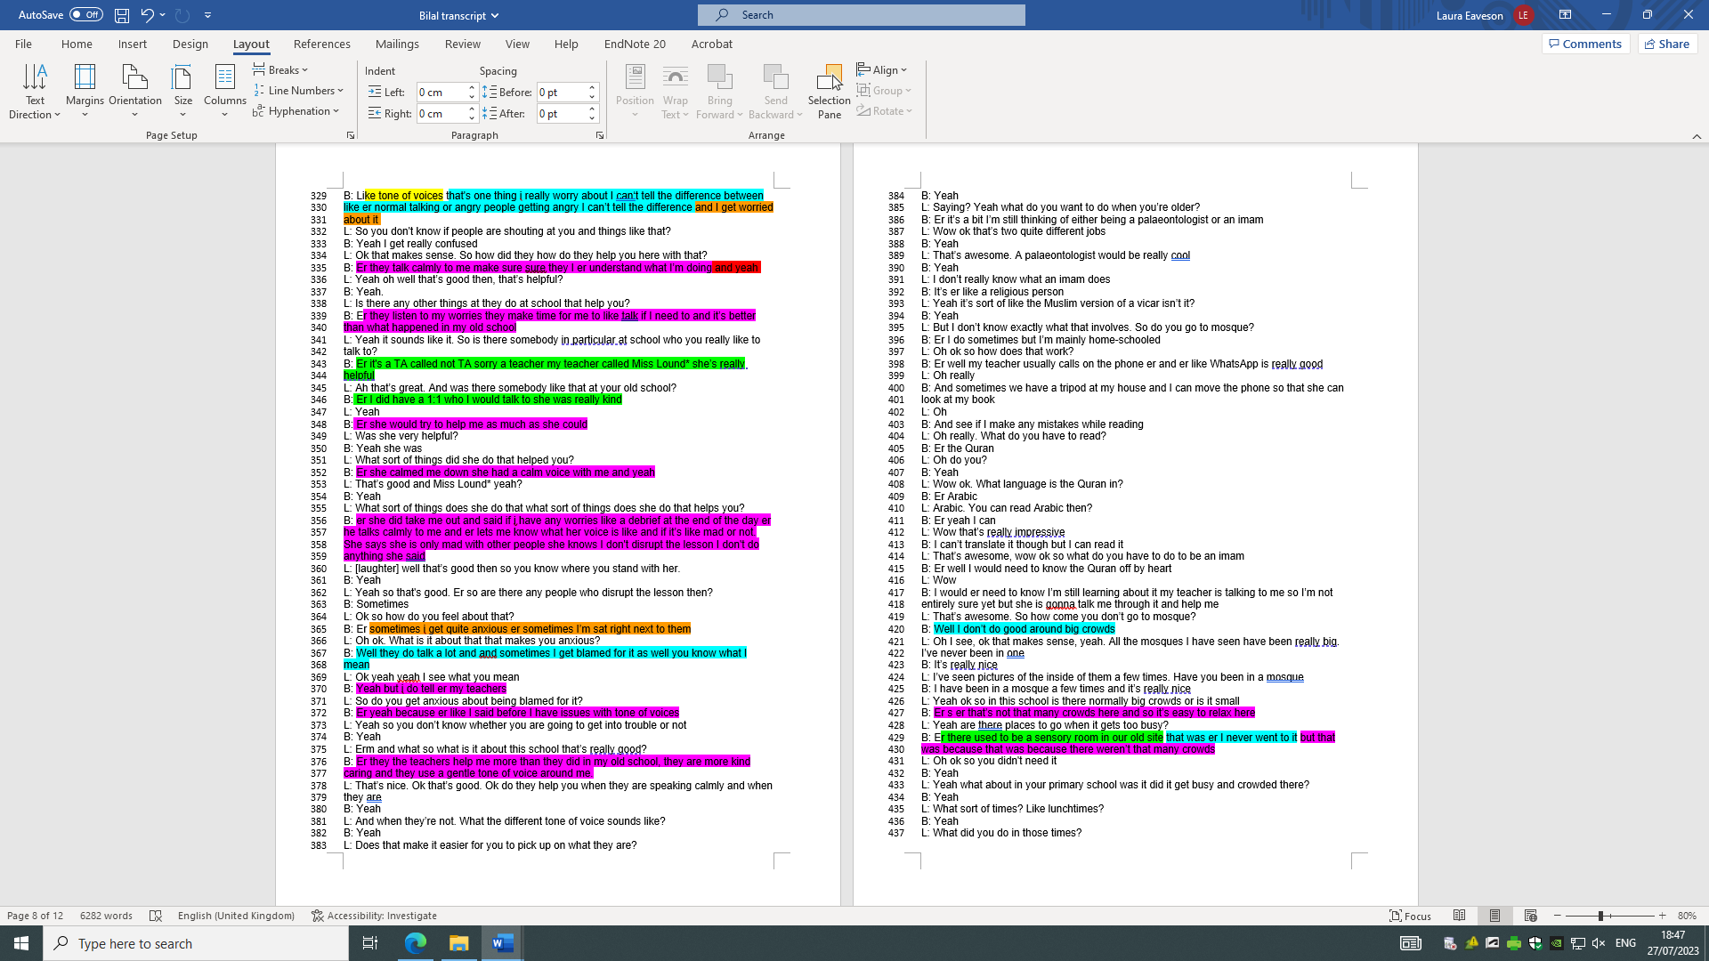

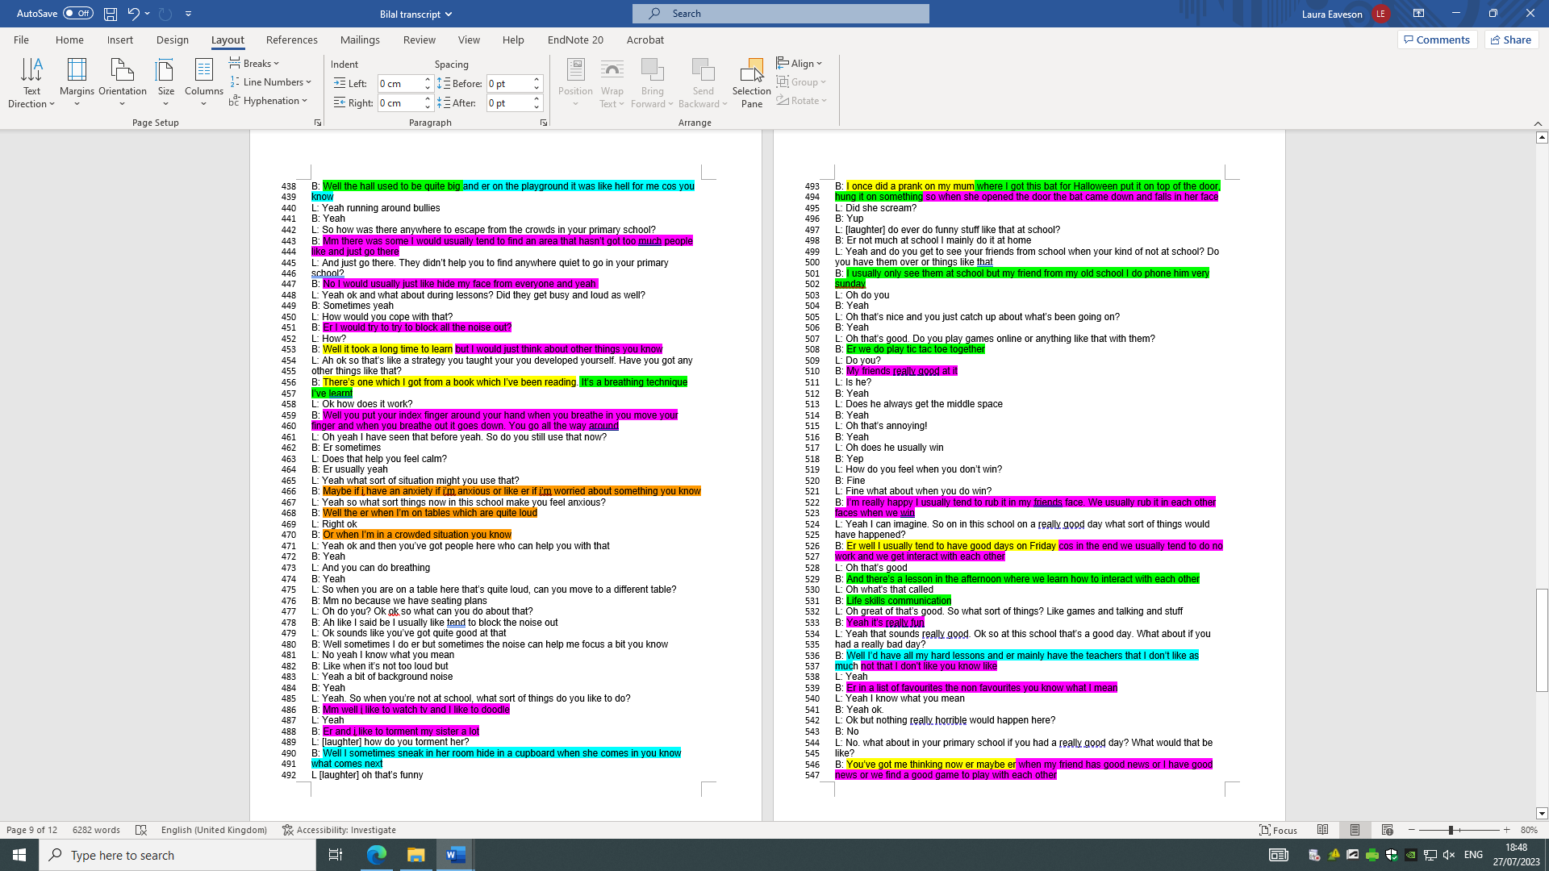

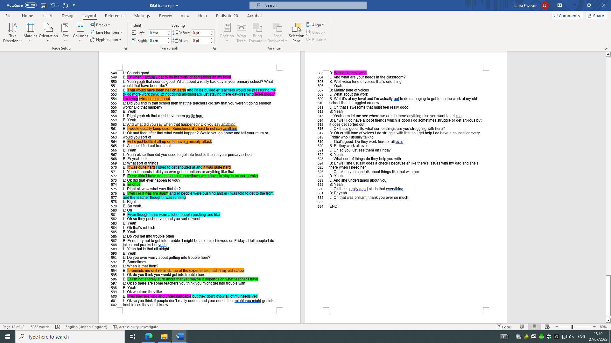

Appendix H – Timeline

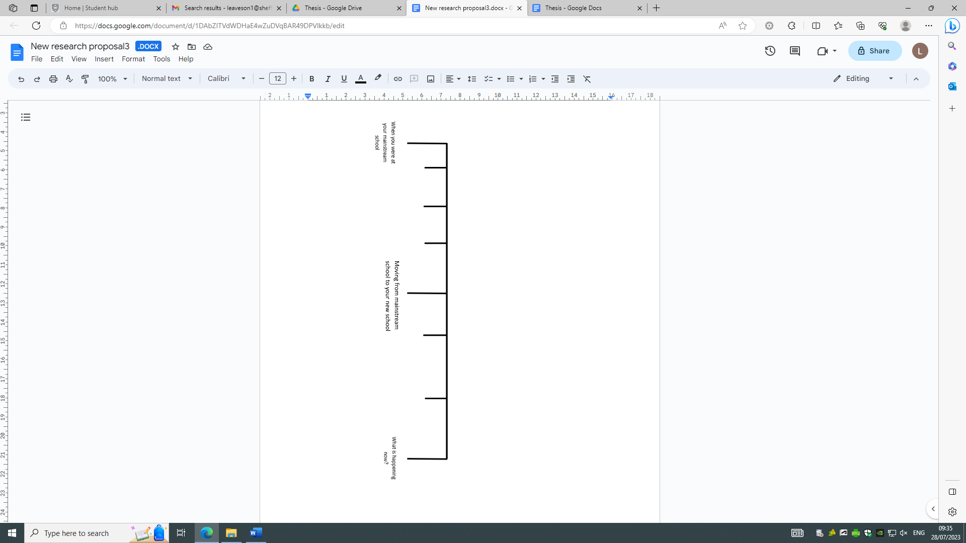
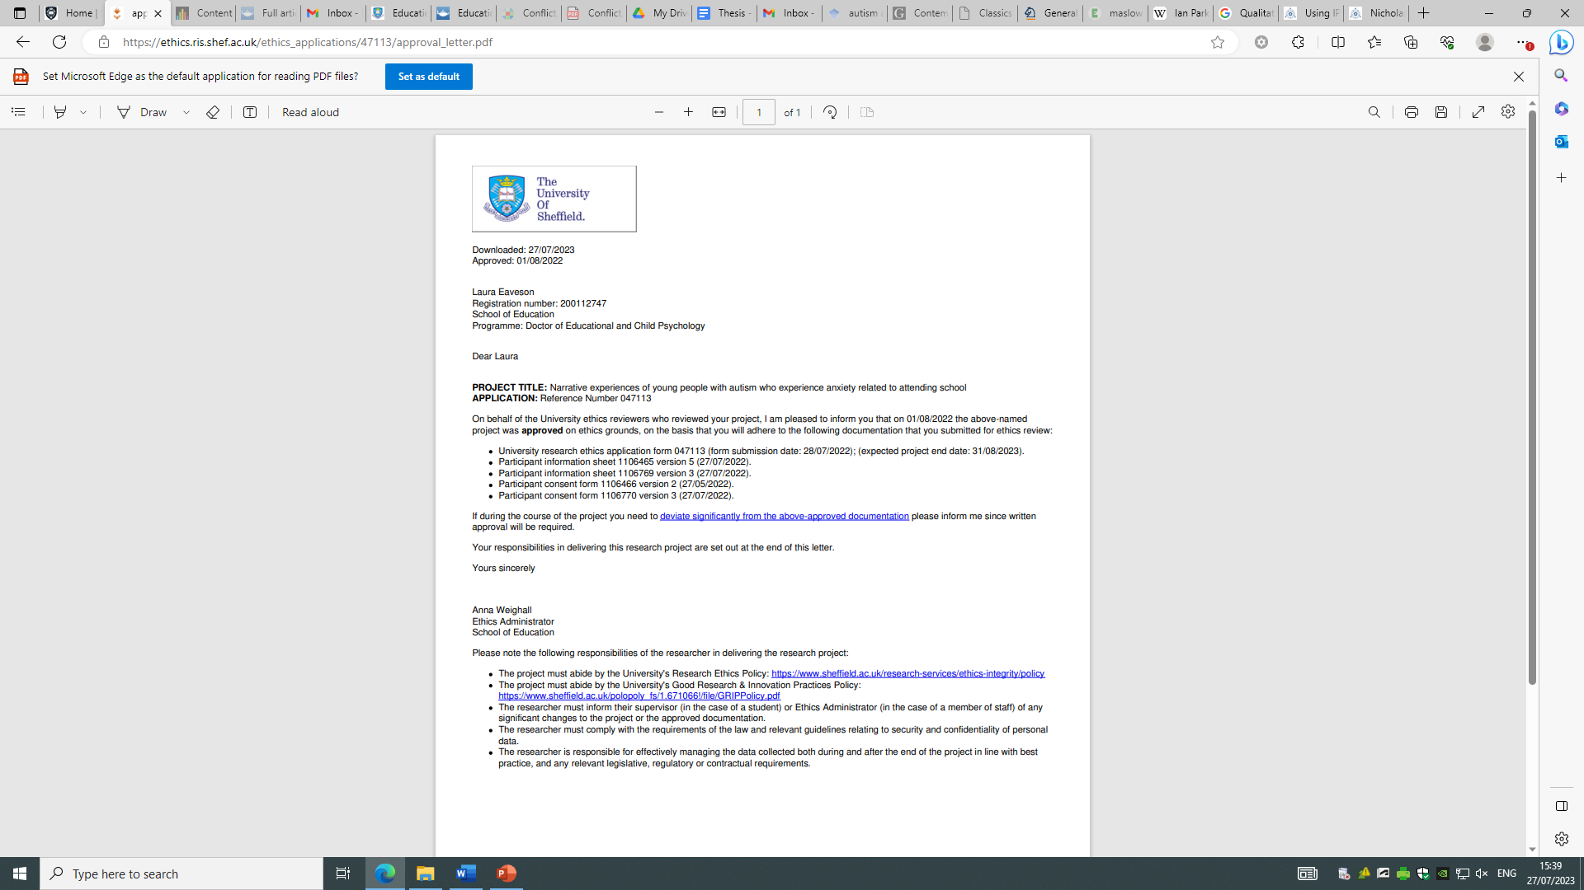
Appendix I – Ethics Approval Letter

