

Advanced Thermal Management of High Torque Density Permanent Magnet Machines
Wei Zhang
A thesis submitted for the degree of Doctor of Philosophy
Department of Electronic and Electrical Engineering
The University of Sheffield, UK
November 2023

Acknowledgement
I would like to express my heartfelt gratitude and appreciation to all those who have played a vital role in the completion of this doctoral thesis and my Ph.D. study, providing both academic and emotional support.
My supervisors: I am indebted to my supervisor, Professor Guang-Jin Li, for his invaluable advice, unwavering guidance, and constant encouragement throughout my Ph.D. research. I deeply appreciate all his support, which has been instrumental in keeping me motivated and dedicated to my study. I also would like to thank my second supervisor, Professor Zi-Qiang Zhu for his instructive advice to my research and publications from this work.
Colleagues: My sincere appreciation also goes to my wonderful colleagues in my group: Mr Yin Qing, Mr Guangbo Zhang, Mr Yangye Ji, Dr Zeting Mei, Dr Rui Zhou, Dr Kai Zhang, Mr Kaile Li, Mr Jian Ye, Mr Issac Rudden and my colleagues of the University of Sheffield: Mr Yangyu Sun, Mr Zixiao Li.
Funding: Funding Acknowledgment: I extend my sincere gratitude to Motor Design Ltd for generously providing financial support and technical assistance. Special thanks to their engineers, Dr. Bo Ren, Dr. Yew Chuan Chong, and Dr. Melanie Michon.
Friends: To my friends: Mr Guanhua Zhang, Mr Hao Chen, Mr Yinzong Liang, Mr Dasong Ma, Miss Jin Qin, and Miss Yonghui Zhang, thank you for your camaraderie that have enriched my study life.
Family: I would like to express my sincere gratitude to my family: Mr Tianan Zhang, Mrs Suzhen Zhang, Mrs Linlin Zhang, and her husband and lovely daughter, for their unwavering encouragement and companionship throughout my life. Their love and patience have been a constant source of motivation. Thank you for always being there for me. Special thanks to my beloved partner, Miss Jin Shi, for her love, encouragement, and understanding. I am deeply grateful for her presence in my life.
I am truly grateful for the support, guidance, and encouragement I have received. This accomplishment would not have been possible without your contributions.
Wei Zhang
University of Sheffield, UK
November 2023

Abstract
Advanced thermal management is a critical field that can improve the electrical machine performance in terms of the torque and power density, efficiency, reliability, and maintenance. This thesis delves into advanced thermal management for high torque density permanent magnet machines. It explores a novel machine configuration that introduces stator modularity in a surface-mounted permanent machine. The influence of the flux gaps on the machine electromagnetic, fluid dynamics, and heat transfer performances has been investigated in this thesis.
In order to accurately predict the influence of different cooling technologies on machine electromagnetic performance, an electromagnetic-thermal coupled model is established based on finite element method, computational fluid dynamics, and lumped parameter thermal network methods. Comparative studies involved the static electromagnetic performance, such as torque and torque ripple, as well as dynamic electromagnetic performance, such as torque speed curve and efficiency map, have been investigated, while considering the electromagnetic-thermal coupling. More accurate predictions of machine dynamics performances have been achieved.
To further elucidate the impact of flux gaps, the coupled model has been employed to investigate the modular SPM machine and its non-modular counterpart with two different advanced cooling technologies: including semi-flooded oil cooling and ventilation cooling. The investigations have revealed that, the machine temperature can be significantly reduced by more than 100$℃$. Moreover, the finding also reveal that introducing flux gaps can further improve cooling efficiency. Additionally, multiphysics models, incorporating magnetic body forces in computational fluid dynamics simulations, have been developed to examine thermomagnetic convection in ferrofluid cooling. The cooling efficiency of ferrofluid cooling methods under different load currents and various coolant properties has been assessed by employing this multiphysics model. A significant temperature decrease can be achieved after introducing ferrofluid cooling. Compared with machine without any cooling, the machine temperature can be reduced by 36.4$℃$ when loading current is around 22.1A/mm². Moreover, the impact of flux gaps on the ferrofluid cooling system has also been revealed in this thesis.
In summary, this thesis comprehensively investigates the influence of flux gaps on machine electromagnetic, fluid dynamics, and heat transfer fields using finite element, computational fluid dynamics methods and their coupled models.

List of Abbreviation
2p | Pole number
AC | Alternating current
AM | Additive manufacture
CFD | Computational fluid dynamics
DC | Direct current
DNS | Direct numerical simulation
DSPM | Double salient permanent magnet
d-axis | Direct axis
EFC | Enclosed fan cooled
EGW | Ethylene Glycol based water
EM | Electromagnetic
EMF | Electromotive force
EV | Electrical vehicle
FE/FEA/FEM | Finite element analysis/method
FF | Ferrofluid
FG | Flux gap
FRPM | Flux reversal permanent magnet
FSPM | Flux-switching permanent magnet
GA | Genetic algorithm
HEV | Hybrid electrical vehicle
HG | Heat guide
IM | Induction machine
IP | Ingress protection
IPM | Interior permanent magnet
LES | Large eddy simulation
LH | Liquid hydrogen
LN₂ | Liquid nitrogen
LNG | Liquefied natural gas
LPTN | Lumped parameter thermal network
Ma | Mach number
MMF | Magnetomotive force
MRF | Moving reference frame
MTPA | Maximum torque per ampere
MTPV | Maximum torque per voltage
NF | Nanofluid
Ns | Slot number
PCM | Phase change material
PC-AL | Polycarbonate aluminium flake
PEEK | Polyether ether ketone
PM | Permanent magnet
PMSM | Permanent magnet synchronous machine
q-axis | Quadrature axis
RANS | Reynolds-average Navier-Stokes
RM | Reluctance machine
SPM | Surface-mounted permanent magnet
SST | Shear stress transport
SVPWM | Space vector pulse width modulation
TEFC | Totally enclosed fan-cooled

Nomenclatures
General symbols
A | Area | $$m^{2}$$
$$d$$ | Average diameter of nano-sized particle | m
$$F$$ | Fitness function
$$L$$ | Axial length | m
$r_{1}$, $r_{2}$ | Radius of inner surface/outer surface | m
$$t$$ | Time | s
$$w$$ | PM thickness | m
$$α$$ | angular spans | rad
$$ε_{error}$$ | Allowable convergence error
$$ρ$$ | Density | $${kg}/{m^{3}}$$
$$τ_{m}$$ | Relaxation time of magnetization | s
$$τ_{e}$$ | Period of alternating current | s
$$τ_{f}$$ | Hydrodynamics and thermodynamics time constant | s
$$v_{c}$$ | Volume ratio of conductors
$$Φ$$ | Volume fraction of nano-sized particle
Electromagnetic symbols
$$\left\{\begin{aligned}a_{(R)} \\ b_{(R)} \\ k_{(R)} \\ ϑ_{(R)}\end{aligned}\right.$$ | Position dependent constant for magnetic field strength calculation | $$\begin{matrix}1/m \\ 1/m \\ \begin{matrix}1/m \\ rad\end{matrix}\end{matrix}$$
$B$, $B$ | Magnetic induction field and its vector | T
$$B_{m}$$ | Magnet flux density | T
$$B_{r}$$ | Remanence of PM | T
$$F_{3d/2d}$$ | A 3D/2D correction factor for PM eddy current loss calculation
$$F_{c}$$ | Magnetomotive force generated by armature current | A
$$F_{m}$$ | Magnetomotive force generated by magnet | A
$H$, $H$ | Magnetic field strength and its vector | $$A/m$$
$$H_{c}$$ | Coercivity of PM | A/m
$$I$$ | Winding carrying current amplitude | A
$$I_{ac}$$ | Current amplitude of alternating current | A
$$I_{dc}$$ | Current amplitude if direct current | A
$i_{d}$, $i_{q}$ | d-axis and q-axis currents | A
$$i_{s}$$ | Rated phase current | A
$$K_{(R)}$$ | Position dependent coefficient
$L_{d}$, $L_{q}$ | d-axis and q-axis inductances | H
$$L_{s}$$ | Synchronous inductance | H
$$m$$ | Magnetic moment of solute | $$A∙m^{2}$$
$M$, $M$ | Magnetization and its vector | A/m
$$M_{0}$$ | Saturation magnetization at reference temperature | A/m
$$M_{s}$$ | Saturation magnetization | A/m
$$P_{out}$$ | Output power | W
$$P_{i}$$ | Iron losses | W
$$P_{m}$$ | PM eddy current loss | W
$$P_{c}$$ | Copper loss | W
$$R$$ | Armature Resistance | $$Ω$$
$$S$$ | Reluctance of the magnetic circuit | A/Wb
$$T_{em}$$ | Electromagnetic torque | Nm
$$T_{max}$$ | Maximum electromagnetic torque | Nm
$$T_{min}$$ | Minimum electromagnetic torque | Nm
$$T_{av}$$ | Average electromagnetic torque | Nm
$V_{d}$, $V_{q}$ | d-axis and q-axis voltages | V
$$V_{s}$$ | DC link voltage | V
$α_{1}$, $α_{2}$ | Temperature dependent coefficient of PM B(H) curve
$β_{1}$, $β_{2}$ | Temperature dependent coefficient of PM B(H) curve
$$η$$ | Efficiency of electrical machine | %
$$μ_{0}$$ | Vacuum permeability | $$N/A^{2}$$
$$μ_{r}$$ | Relative permeability
$$Φ$$ | Flux in the magnet | Wb
$$χ$$ | Magnetic susceptibility
$$ψ_{m}$$ | No-load flux linkage | Wb
$$ω_{2}$$ | Maximum speed at constant voltage stage of electrical machine | rad/s
$$ω_{b}$$ | Base speed of electrical machine | rad/s
$ω_{e}$, $ω_{m}$ | Rotor electrical and mechanical speeds | rad/s
$$ω_{max}$$ | Maximum speed of electrical machine | rad/s
Heat transfer symbols
$$c$$ | Specific heat capacity | $$J/{kg}/K$$
$$h$$ | Convection coefficient | $$W/{m^{2}}/K$$
$$h_{e}$$ | Average convection coefficient | $$W/{m^{2}}/K$$
$q$, $q$ | Heat flux and its vector | W
$$Q$$ | Volumetric heat generation | $$J/K/{m^{3}}$$
$$Q_{s}$$ | Average heat transfer rate per surface area | $$W/{m^{2}}$$
$$R_{1r,2r,3r}$$ | Equivalent thermal resistance in radial direction | $$K/W$$
$$R_{1a,2a,3a}$$ | Equivalent thermal resistance in axial direction | $$K/W$$
$$R_{1c,2c,3c}$$ | Equivalent thermal resistance of trapezoidal components | $$K/W$$
$$T$$ | Temperature | K
$$T_{0}$$ | Reference temperature | K
$$T_{1,2,3,4}$$ | Temperature of the front, rear, outer and inner surface | K
$$T_{bulk}$$ | Reference temperature for convection coefficient | K
$$T_{c}$$ | Curie temperature of ferromagnetic material | K
$$β$$ | Thermal expansion | 1/K
$$ΔT$$ | Temperature difference | K
$$Δ_{NF-FF}$$ | Temperature difference between NF and FF cooling | K
$$λ$$ | Thermal conductivity | $$W/m/K$$
$$λ_{e}$$ | Equivalent Thermal conductivity of windings | $$W/m/K$$
$$λ_{c}$$ | Thermal conductivity of conductors | $$W/m/K$$
$$λ_{r}$$ | Thermal conductivity of impregnations | $$W/m/K$$
Fluid dynamics symbols
$$F$$ | Force density vector | $$N/{m^{3}}$$
$$F_{m}$$ | Magnetic body force vector | $$N/{m^{3}}$$
$$F_{v}$$ | Viscosity force density vector | $$N/{m^{3}}$$
$$g$$ | Acceleration of gravity vector | m/s²
$$h$$ | Surface roughness | m
$$h^{+}$$ | Dimensionless roughness height
$$k_{f}$$ | Dimensionless pressure loss coefficient
$$k_{fs}$$ | Dimensionless pressure loss coefficient for stationary system
$$k_{fr}$$ | Dimensionless pressure loss coefficient for rotational system
$$k_{r}$$ | Correction factor for rotational pressure loss
$$p$$ | Pressure of fluid | Pa
$$Q$$ | Volumetric flow rate | $${m^{3}}/s$$
$$R_{f}$$ | Flow resistance | $${{Pa∙s}^{2}}/{m^{6}}$$
$u$,$u$ | Velocity and velocity vector | $$m/s$$
$$u^{+}$$ | Dimensionless velocity
$$u_{c}$$ | Speed of sound in the medium | $$m/s$$
$$u_{τ}$$ | Friction velocity | $$m/s$$
$$U$$ | Axial velocity of fluid | m/s
$$V_{t}$$ | Tangential velocity of fluid | m/s
$$y$$ | Distance that is normal to the wall | m
$$y^{+}$$ | Dimensionless wall distance
$$Δp$$ | Pressure loss | Pa
$$λ_{μ}$$ | Second coefficient of viscosity | $$Pa∙s$$
$$μ$$ | Dynamic viscosity | $$Pa∙s$$
$$μ_{f}$$ | Dynamic viscosity of liquid base for colloidal suspension | $$Pa∙s$$
$$τ_{w}$$ | Shear stress of the fluid | Pa
$$ν$$ | Kinematic viscosity | $${m^{2}}/s$$

Contents
Acknowledgement i
Abstract ii
List of Abbreviation iv
Nomenclatures vi
Chapter 1 Introduction 1
1.1. General Introduction 1
1.2. Permanent Magnet Machines 2
1.3. Modular SPM Machine 6
1.4. Thermal Managements for PM machines 12
1.4.1 Passive Cooling Technology 13
1.4.2 Active Cooling Technology 18
1.4.3 Cooling Technology for the Modular Machines 28
1.5. Research Scope and Contributions 29
1.5.1 Research Scope 29
1.5.2 Contributions 30
Chapter 2 Electromagnetic Analysis of Modular SPM machine 33
2.1. Introduction 34
2.2. Initial Specification of SPM machines. 35
2.3. Optimization of the Modular Machine 37
2.3.1 Optimization Methods 37
2.3.2 Optimization for the 24-slot/28-pole SPM Machine. 38
2.3.3 Evaluation of Optimized 24-slot/28-pole SPM Machines 42
2.3.4 Optimization for the 24-slot/20-pole SPM Machine. 53
2.3.5 Influence of FG width 53
2.4. Experimental Validation 55
2.4.1 Phase Back EMF 56
2.4.2 Cogging Torque 57
2.4.3 Static Torque 58
2.5. Conclusion 59
Chapter 3 Coupled EM-thermal Modelling for Modular SPM Machines 61
3.1. Introduction 63
3.2. Dynamic EM Performances of the Modular Machine 65
3.2.1 Without EM-thermal coupling 65
3.2.2 With EM-thermal Coupling 68
3.3. Demagnetization Characteristics of the Modular Machine 80
3.3.1 Mechanism of magnet irreversible demagnetization 81
3.3.2 Demagnetization without EM-thermal coupling 83
3.3.3 Demagnetization with Coupled EM-Thermal Modelling 90
3.4. Conclusion 97
Chapter 4 Forced Cooling Systems for the Modular Machine 98
4.1. Introduction 99
4.2. Computational Fluid Dynamics Modelling 101
4.2.1 Governing Equations 101
4.2.2 Model Settings 102
4.2.3 Turbulent Boundary Layer and Wall Treatment 103
4.2.4 Mesh 106
4.2.5 Rough Wall Treatment 106
4.2.6 Convection Coefficient Calculation 107
4.3. Semi-Flooded Oil Cooling 108
4.3.1 CFD Results for the Modular Machine 110
4.3.2 Influence of Flux Gap Width 114
4.3.3 Influence of Inlet/Outlet Area 118
4.4. Ventilation Cooling 120
4.4.1 Comparative Analysis of Different Models 124
4.4.2 Influence of Rotor Speed 131
4.4.3 Combining Flow Phenomenon 134
4.5. Experimental Validation 137
4.5.1 Semi-flooded Oil Cooling System 137
4.5.2 Ventilation Cooling 141
4.6. Conclusion 148
Chapter 5 Ferrofluid Cooling for the Modular SPM Machines 150
5.1. Introduction 152
5.2. Theoretical Background 154
5.2.1 Properties of Ferrofluids 154
5.2.2 Governing Equations 157
5.3. Multiphysics Modelling 159
5.3.1 Machine Topologies and Specifications 159
5.3.2 Ferrofluid Properties 160
5.3.3 Assumptions and Boundary Conditions 160
5.3.4 Mesh Sensitivity Tests 162
5.4. Performances of the Ferrofluid Cooling Machines 163
5.4.1 Cooling Efficiency of Ferrofluid Cooling 164
5.4.2 Influence of Electrical Loading 167
5.5. Influence of Ferrofluid Properties 169
5.5.1 Concentration of Ferrofluid 169
5.5.2 Magnetization Characters of Ferrofluid 170
5.6. Influence of Winding Configurations 172
5.6.1 Nanofluid Cooling 172
5.6.2 Ferrofluid Cooling 175
5.6.3 Electromagnetic Performances Considering Thermal Coupling Models 183
5.7. Ferrofluid cooling for the Modular Machine 186
5.7.1 Different Machine Topologies 186
5.7.2 Different Flux Gap Widths 189
5.8. Experimental Validation 191
5.8.1 Single Coil Motorette 191
5.8.2 Multiple Coils Motorette 197
5.9. Conclusion 201
Chapter 6 Conclusion and Future Work 203
6.1. Conclusion 203
6.2. Future Work 205
Reference 207

Introduction
This chapter provides an overview of the research background for this thesis. It begins by introducing permanent magnet (PM) machines, including the machines with stator modularity. The advantages of the modular PM machines on electromagnetic (EM) performances are explored and elucidated. Furthermore, the chapter delves into the thermal managements for electrical machines, emphasizing its significance for the PM machines. The discussion encompasses various thermal management techniques, including active cooling and passive cooling, highlighting the potential enhancements in machine performances. Moreover, the thermal managements are reviewed with a specific consideration for stator modularity. In addition, this chapter outlines the structure and contributions of this thesis, giving the publications associated with this research project.

General Introduction
Electric motors have played a pivotal role in modern life since the construction of the direct current (DC) electric motor by Thomas Davenport in 1834 and the patenting of the alternating current (AC) induction motor by Nikola Tesla in 1888. These innovations have endowed electrical machines with immense significance, especially in industrial applications, including electrical/hybrid electrical vehicles (EVs/HEVs), aerospace applications, renewable energy. In industrial applications, electrical machines offer a multitude of advantages, including high efficiency, reduced emissions, exceptional reliability, precise control, and minimal maintenance requirements. Various kinds of electrical machines have been developed, such as induction machines (IMs), reluctance machines (RMs), and permanent magnet (PM) machines [1]. Among the pivotal advancements in electrical machine, permanent magnet synchronous machines (PMSMs) hold a prominent position. In contrast to other synchronous machines that implement DC current to establish a constant magnetic field over time within the rotor, the PMSMs generate a constant magnetic field through the excitation provided by PMs [2]. Benefit from the high energy density that rare-earth magnets have, PMSMs have gained significant popularity over the past few decades, owing to a range of attractive features, such as their high efficiency, high torque and power density, and excellent overload capability.
Numerous research studies on PMSMs have been undertaken to improve their electromagnetic (EM) performances, with a particular focus on improving the torque/power density, increasing fault-tolerance capability, and minimizing volume and cost. The PM machine with stator modularity is one kind of the PMSMs. Research studies have revealed that the introduced flux gaps/flux barriers between stator segments holds potential for improving machine EM performance.
In recent years, thermal managements have gained increasing importance in electrical machine designs, driven by increasing demands for high power output [3]. A well-structured cooling system efficiently reduces machine temperatures, thereby allowing for higher current densities, improved reliabilities, and enhanced demagnetization withstand capabilities. Cooling technologies encompass both passive and active cooling methods. Passive cooling methods established effective heat transfer without the need for additional pumps. In contrast, active cooling methods achieve more efficient heat transfer through the use of external pumps. This chapter has provided a review of various cooling technologies, including their applications to modular machines.
To evaluate the performance (e.g., flow profile and heat transfer) of the thermal managements implemented in investigated electrical machines, various methods are employed. The analytical lumped parameter thermal network (LPTN) is recognized for its computational efficiency in predicting the machine temperature, making it particularly appealing for temperature analysis for machine drive cycle assessments [3-5]. The LPTN, based on finite difference method, constructs an equivalent thermal circuit for modelling thermal domains. It utilizes the relationships between temperature, heat flux and thermal resistances due to conduction, convection, and radiation to predict temperature. Two numerical methods commonly used for thermal analysis of electrical machines are finite element analysis (FEA) and computational fluid dynamics (CFD) modelling. In contrast to the LPTN, which neglects the temperature ununiform distribution with each lump, both FEA and CFD modelling can accurately predict the conductive heat transfer and temperature at each element. Additionally, CFD modelling goes a step further by allowing for the prediction of flow profiles, enabling consideration of both convective and radiative heat transfer processes.

Permanent Magnet Machines
Electrical machines play a pivotal role in various industrial applications. The basic characteristics which are required for electrical machines encompass [1]:
- High torque and power densities
- High efficiency
- Intermittent overload capability
- High reliability and robustness
Compared with IMs and switched or synchronous reluctance machines, PM machines have higher power density and efficiency, as well lower mass, and shorter machine active length [6, 7]. Nevertheless, additional costs are incurred due to the high expense associated with PMs. Additionally, the PM machines are attracted for their maintenance-free operation, precise controllability, and exceptional robustness. However, the high cost and volatile supply of rare-earth materials pose significant challenges, potentially inflating the overall machine cost. Therefore, lots of research efforts have been directed towards improving PM machines performance and minimizing PM material consumption.
The torque produced by a PM machine, which is a pivotal factor in machine design, comprises of two components. One component is the magnet torque, generated by the permanent magnet. The other one is the reluctance torque, arising from the difference between the d-axis and q-axis inductances. An increase in magnet torque can lead to higher iron losses and render flux weakening operation more challenging. Designing a machine to emphasize reluctance torque can effectively reduce the consumption of permanent magnets while maintaining similar overall electromagnetic torque.
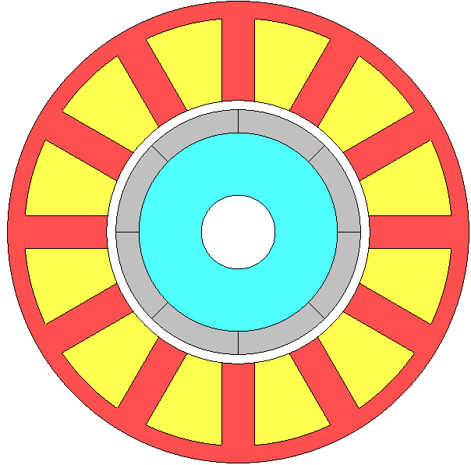 | 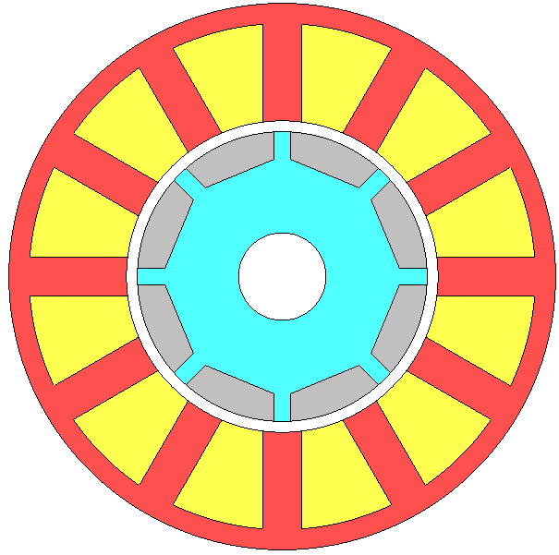 | 
(a) SPM | (b) Inset SPM | (c) IPM
Fig. 1.1. The topologies of rotor-mounted PM machines.
Various PM machine topologies have been proposed. One of the popular machine topologies is rotor-mounted PM machines, including, surface-mounted PM (SPM) machines, inset SPM machines, and interior PM (IPM) machines as shown in Fig. 1.1. It is noteworthy that SPM machines, shown in Fig. 1.1 (a), feature non-salient rotor cores where arc-shaped PMs are affixed to the rotor's surface. In such configurations, the electromagnetic torque is solely generated by the magnet torque. In contrast, both the inset SPM machines and IPM machines exhibit magnetic saliency, resulting in reluctance torque [8].
Numerous research has undertaken a comparative study between SPM and IPM machines. In reference to [9], it was highlighted that IPM machines exhibit better overload capabilities compared to SPM machines, both at low and high speed. Notably, IPM machines achieve substantial reductions in PM losses, especially under high-speed conditions. This assertion was corroborated by [10], which also acknowledged that while SPM machines tend to generate higher PM losses, they achieve a notable reduction in iron losses, leading to higher efficiency. [11] involved a point that, SPM machines experience additional copper losses when weakening the PM flux at high speed. On the other hand, [12] emphasized the advantage of SPM machines, particularly their better dynamic responses and fault-tolerant capabilities, mitigating unbalanced forces, particularly in the presence of rotor eccentricity. However, a concern with SPM machines pertains to PM separation due to centrifugal forces under high-speed conditions, an issue that can be eliminated by introducing rotor sleeve [13]. Meanwhile, IPM machines face more serious mechanical stress, as noted in [7], since their rotor iron bridges subject not only the centrifugal forces, but the magnetic force from magnets. In contrast, [14] showed that higher torque density, while lower vibrations and acoustic noise can be achieved by employing SPM machines. Additionally, [15] proposed that the SPM machines have slight phase voltage distortion, as well lower torque ripple than IPM machines. [16], in a comparison between SPM and IPM machines using large-scale 7MW PM generators, concluded that SPM machines offer advantages in terms of reduced weight and cost, as well as improved demagnetization withstand capability.
IPM machines provide more degree of freedom for machine designs when it comes to rotor structures, a factor that affects several important EM characteristics of machines. These characteristics include torque density, cogging torque, and torque-speed range. Thus, different IPM machines can be implemented to meeting various requirements during industrial applications [8]. Progressed from basic concept of flat magnets [17] as shown in Fig. 1.1 (c), IPM machines have evolved to encompass a diverse array of rotor configurations. These various rotor configurations and their associated advantages are listed in Table 1.1. Remarkably, certain IPM machine designs are capable of achieving exceptionally high reluctance torque, often reaching values in the range of 40% to 50% or even higher of the total torque [17, 18]. This attractive feature has contributed significantly to growing popularity of IPM machines.
Table 1.1 Advantages of Different Rotor Configurations for IPM Machines
Types of PM | Reference | Advantages
V-shaped | [19, 20] | Improved average torque
U-shaped | [19-22] | High torque with low torque ripple  Low PM losses  High efficiency
$∇$-shaped | [22-24] | High machine efficiency  Low torque ripple
Spoke-shaped | [22] | Very high torque density  Reduced back-EMF harmonics
VV-shaped | [19, 25] | Low back-EMF harmonics  High power density
UV-shaped | [26, 27] | Minimized machine size  Doubled back-EMF  Reducing harmonic eddy-current losses  Reducing torque ripple and high-speed core losses
$∇$U-shaped | [24] | Low core loss  Low torque ripple  High efficiency

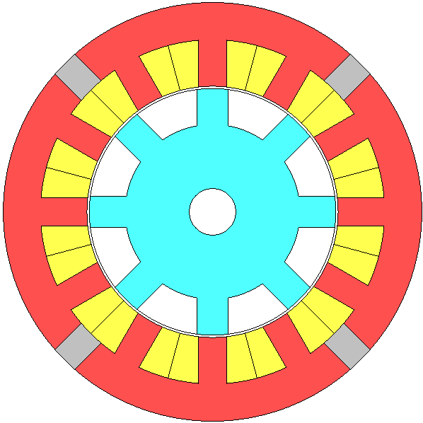 | 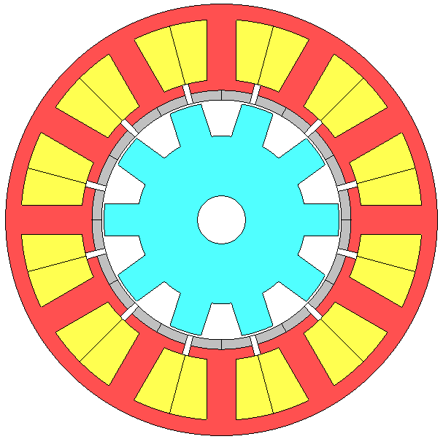 | 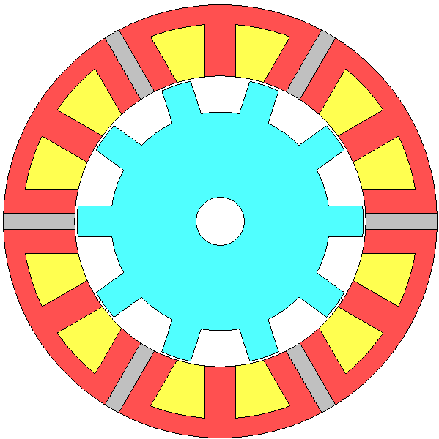
(a) DSPM | (b) FRPM | (c) FSPM
Fig. 1.2. The topologies of stator-mounted PM machines.
In addition to the rotor-mounted PM machines, various stator-mounted PM machines have seen significant development, including the double salient PM (DSPM) machines, the flux reversal PM (FRPM) machines, and the flux-switching PM (FSPM) machines, and their topologies are shown in Fig. 1.2. In contrast to the rotor-mounted PM machines, where the PMs are situated on the rotor, stator-mounted PM machines place windings and PMs on the stator, with the rotor primarily consisting of iron core. This simplified rotor structure results in enhanced robustness and reliability, especially in high-speed applications [28]. As highlighted in references [29] and [30], stator-mounted machines offer improved thermal performance. This improvement arises from the fact that dissipating heat from the rotor for rotor-mounted PM machines is a challenge due to the limitation in the poor thermal conduction within the airgap region.

Modular SPM Machine
In section 1.2, a review of various PM machines with different PM arrangements has been conducted. The findings have revealed significant advancements in the EM performance of these machines. Moreover, a variety of stator and rotor configurations have been developed to improve machines performance. For example, Spooner et al [31-33] introduced a new machine topology, involving a modular arrangement of stator and/or rotor as shown in Fig. 1.3, for a 166-pole/180-slot radial-field PM machine. These modular designs are specifically implemented in generators with power ratings more than 1MW. In contrast to the non-modular, continuous core designs, modular configurations offer distinct advantages in terms of assembly and maintenance. Moreover, these modular designs have the potential to reduce both the machine's mass and its active length.
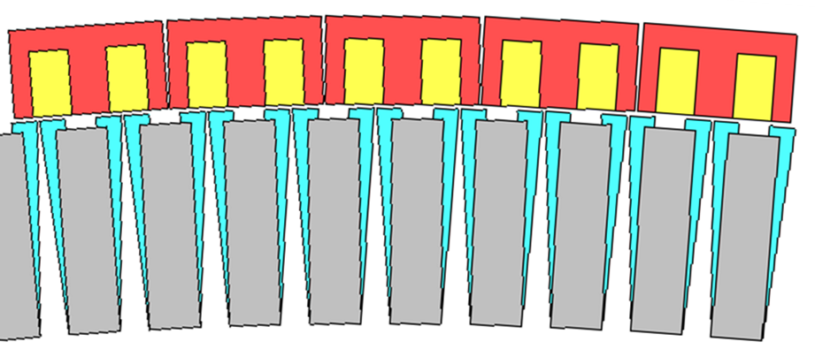
Fig. 1.3. Topology of radial-field PM machine with modular-arranged stator and rotor [33].
Another modular stator structure was explored and presented by Zhu et al. in [34]. A closed-slot stator with segmented teeth and yoke is implemented for a 10-pole/12-slot IPM machine as shown in Fig. 1.4. Additional stator gaps between stator teeth and yoke with nonuniform gap width are introduced due to manufacturing tolerances. This topology effectively minimizes the cogging torque, which is a primary contributor to torque ripple, while having a negligible influence on the back-EMF waveform.
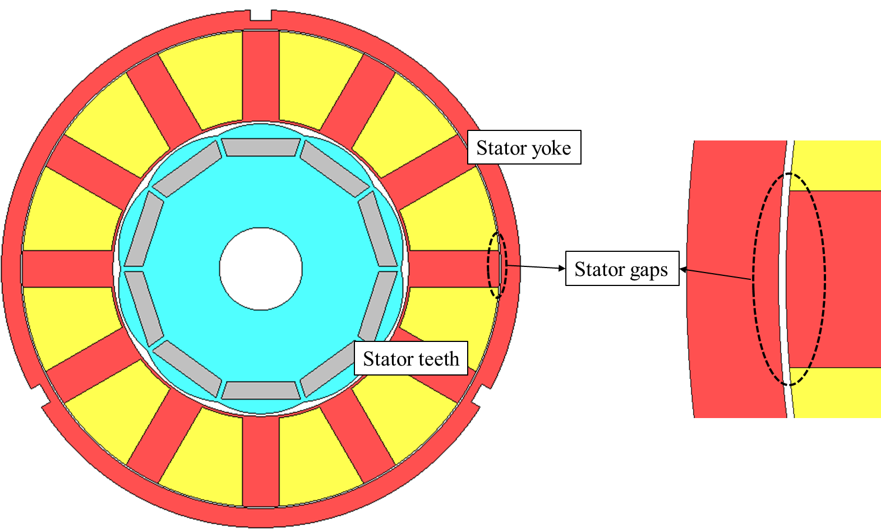
Fig. 1.4. Topology of IPM machine with closed-slot stator with segmented teeth and yoke [34].
The concept of modularity technology extends to the stator design of FSPMs [35, 36]. In this approach, the PM is selectively removed from alternate stator teeth as shown in Fig. 1.5. Research findings revealed that, the modular stator exhibits significantly enhanced fault-tolerant capability but comes at the cost of reduced power density. However, by maintaining the same PM volume, it becomes possible to achieve higher torque and power density in this design [28, 37].
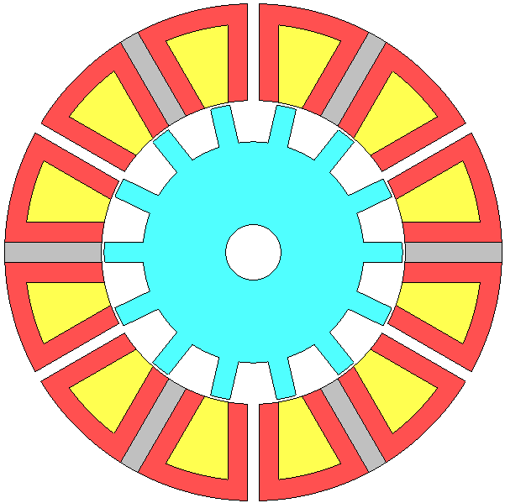
Fig. 1.5. Topology of FSPM with stator modularity [28].
Number of literatures from Li et al [38-47] elves deep into the investigation and analysis of the influence of flux gaps on the electromagnetic performance of modular PM machines as shown in Fig. 1.6. Their research explores the influences of flux gaps on electromagnetic performance of 12-slot/14-pole and 12-slot/10-pole SPM machine with stator modularity, as detailed in [42]. By inserting flux gaps in alternative stator teeth, this topology effectively prevents the flux of one phase from crossing into other phases. This configuration brings about significant reductions in mutual inductance between phases and an enhancement in fault-tolerant capabilities. Moreover, the presence of flux gaps contributes to a reduction in short-circuit currents and diminishes the impact of faults between phases.
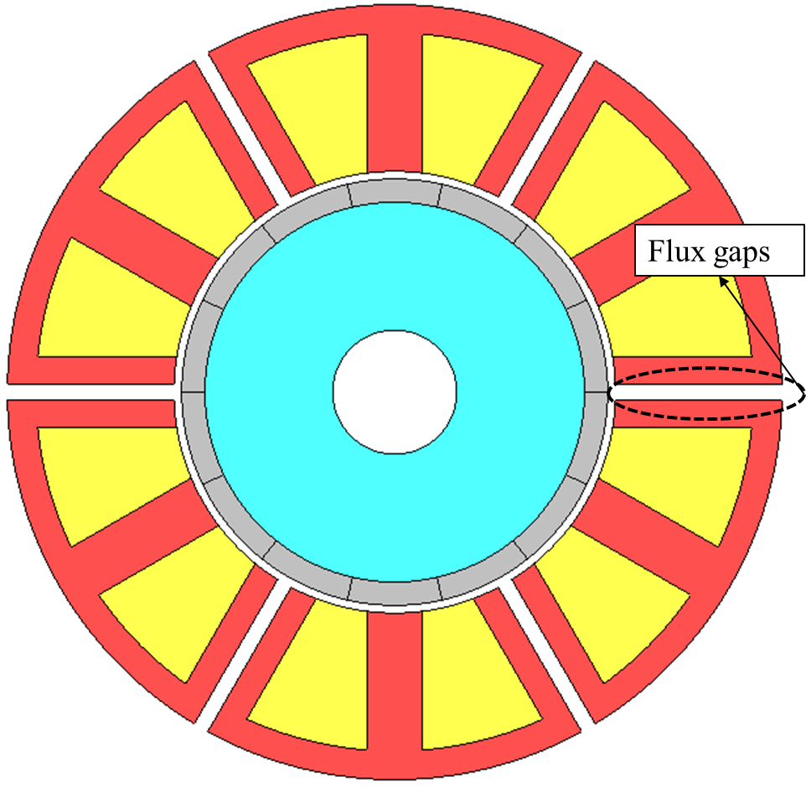
Fig. 1.6. Topology of SPM with stator modularity [42].
In [43], an analytical modelling of the modular SPM machines is established. The findings from this study reveal that the introduction of flux gaps in alternative stator teeth has several significant effects. It not only improves the winding factor, more precisely, pitch factor, but also enhances the open-circuit airgap flux density. Additionally, it introduces an extra flux focusing effect for the machines, but only when their pole number (2p) is larger than slot number (Ns). These threefold effects in modular machine with $2p>Ns$ result in higher torque and power density. It is noteworthy, however, that these threefold effects have a negative impact on modular machines with $2p<Ns$. In such cases, the flux defocusing, together with reduced pitch factor and decreased open-circuit airgap flux density, leads to a reduction in electromagnetic torque.
Furthermore, the introduction of flux gaps in modular machines has been shown to improving demagnetization withstand capability [44]. Similar to its impact on torque and power density, flux gaps can also mitigate magnet demagnetization for the modular machines with $2p>Ns$, in contrast to modular machine with $2p<Ns$, where the introduction of flux gaps exacerbates magnet demagnetization.
Modular machines also exhibit improvements in vibrations and acoustic noise. A study referenced in [41] investigated the influence of flux gaps on machine vibrations and acoustic noise, revealing noteworthy findings. Despite the reduction in resonant frequency due to the stator modularity, the decrease in radial force and magnetic pressure within the airgap contributes to the alleviation of radial displacement, vibrations and sound pressure level.
A concern related to the manufacturing tolerance of the modular machines pertains to segment radial displacement. In a study conducted by Ren et al, as detailed in [46], the influence of flux gaps on segment radial displacement was thoroughly examined. The analysis encompassed the study of back-EMF, on-load torque, cogging torque, and unbalanced magnetic force in modular SPM machines, all of which were evaluated to assess the withstand capability of segment radial displacement. The research indicates that the modular structure, particularly in the case of machines with $2p<Ns$, can improve the withstand capability of the segment radial displacement.
Li et al, as detail in [39], have formulated design guidelines for fractional slot multi-phase modular PM machines. Embracing stator modularity offers several advantages, including streamlining the manufacturing process, notably the winding process, simplifying by necessitating the replacement of only the faulty segment, and providing additional flexibility for cooling designs. Furthermore, the modular topology has the capacity to reduce the sub-harmonics of airgap MMF, thereby mitigating their adverse impact on machine EM performance. These advantages of introducing flux gaps can be extended to multi-phase machines, e.g., four phase, five phase, and even more.
Research on the influence of flux gaps on SPM machines is not limited to a specific type of rotor structure. Similar findings have been established for other rotor structures. For instance, Zhou et al, as presented in [47], investigated two types of modular stators designed for consequent-pole PM machines. One design, as shown in Fig. 1.7 (a), is referred to as the E-core stator, while the other, depicted in Fig. 1.7 (b), is known as the C-core stator. Their findings have demonstrated that the E-core modular stator for consequent-pole PM machines contributes to enhancements in electromagnetic torque, increased machine efficiency, and improved flux-weakening capability. Conversely, the C-core modular stator design helps in reducing the torque ripple, minimizing the on-load unbalance magnetic forces, and enhancing the power factor.
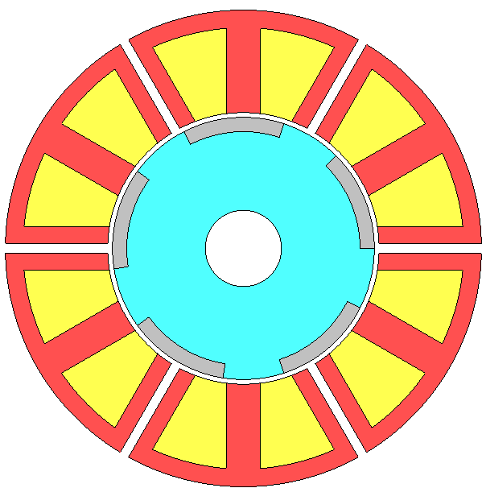 | 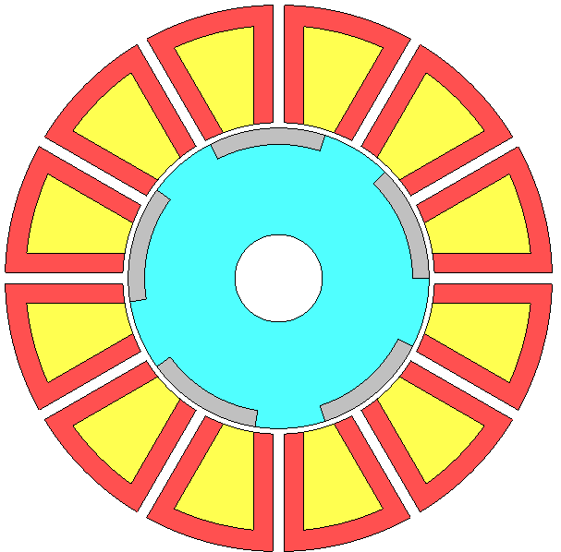
(a) E-core modular stator | (b) C-core modular stator
Fig. 1.7. Topology of modular consequent-pole PM machines with stator modularity [47].
The literature also encompasses an analysis of iron losses in modular inset SPM machines, [45]. The introduction of flux gaps has been shown to result in a substantial reduction in iron losses for these modular inset SPM machines. In addition, the presence of flux gaps has also led to improvements in machine electromagnetic torque.
Stator modularity has also been applied to IPM machines [48-50]. The findings align with Li’s research, demonstrating that introducing flux gaps, also known as flux barriers by Gerling, results in the improvement of machine EM performance, particularly when the machine’s pole number is larger than slot numbers.

Fig. 1.8. Topology of modular SRM [51].
Stator modularity is not limited to PM machines; it also offers advantages for SRMs [51-53]. Modular 12-slot/14-pole and 12-slot/8-pole SRMs were developed in [51]. It is found that, modular 12-slot/14-pole SRM exhibited a high average torque. Its reduced sensitive to magnetic saturation in the back iron allowed it to generate high torque under overload conditions. Furthermore, similar to stator modularity in PM machines, modular SRMs demonstrated lower iron losses and radial force compared to their non-modular counterparts.
Table 1.2 Advantages of Machines with Different Modularity Components
Machine | Modularity | Advantages | Reference
Spoke-type PM machine | Stator & Rotor | - Simplified assembly and maintenance.  - Reduction of machine weight.  - Reduction of machine active length. | [31-33]
IPM | Stator teeth | - Minimized cogging torque. | [34]
FSPM | E-core Stator | - Enhanced fault-tolerant capability.  - Reduction of PM usage. | [28, 35-37]
SPM with $2p>Ns$ | E-core stator | - Increased torque and back-EMF.  - Mitigation of mutual inductance.  - Improved fault tolerant capability.  - Improved demagnetization withstand capability.  - Mitigation of radial displacement, vibrations, and sound pressure level.  - Improved withstand capability of segment radial displacement | [41-44, 46]
Multiphase SPM | E-core stator | - Reduced sub-harmonic of airgap MMF. | [39]
Consequent-pole | E-core stator | - Enhanced average torque.  - Increased machine efficiency.  - Improved flux-weakening capability. | [47]
Consequent-pole | C-core stator | - Reduced torque ripple.  - Lowered on-load unbalance magnetic force.  - Improved power factor. | [47]
Inset SPM | E-core stator | - Reduced iron losses.  - Increased torque. | [45]
IPM | E-core stator | - Increased torque.  - Reduced iron losses and PM losses.  - Reduced sub-harmonic.  - Improved field weakening capability | [48-50]
SRM | E-core | - Increased torque.  - Less sensitive to magnetic saturation.  - Reduced torque ripple.  - Reduced iron losses.  - Reduced radial force. | [51]

In this section, various machines with different machine modularity have been reviewed and their novelties have been investigated and analysed as listed in Table 1.2. In summary, all the reviewed literatures consistently highlight several general advantages associated with the modular structure in machine design, which include:
- Streamlined machine manufacturing process, including assembly, and winding process.
- Lowered cost for machine maintenance and replacement.
- Decreased overall machine weight.
- Mitigation of mutual inductance.
- Improvement of fault tolerant capability by weakening the fault interactions between phases.
- Reduction in iron core losses.

Thermal Managements for PM machines
The preceding sections have delved into number of literatures concerning the designs and investigations of various machine topologies. These studies are primarily focused on improving machine EM performance, such as elevating torque and power density, minimizing machine size and mass, and improving the efficiency. However, a notable constraint in the pursuit of improved EM performances lies in the realm of thermal management. Elevated temperatures, beyond the desired range, lead to irreversible damage for machines. The damage includes derating of power electronics components, irreversible demagnetization of PMs, and the deterioration or expedited aging of wire insulation.
As discussed in the literature reviews conducted in sections 1.2 and 1.3, optimizing machine topology plays a pivotal role in reducing losses. These losses encompass stator and rotor core iron losses, PM eddy current losses, and winding copper losses. This optimization contributes to the improved thermal performance in PM machines. Moreover, the employed advanced cooling technologies can further augment the heat transfer processes, encompassing conduction, convection, and radiation, both within the machine itself and on its external surfaces.
Cooling technologies can be categorized into two main aspects: passive cooling methods and active cooling methods. Passive cooling methods work without additional pumps or devices to circulate coolant. Some of them aim to improve heat conduction within machines, particularly between the end-windings and the machine housing. Others focus on improving heat convection and radiation at the surface of machine components or its external surfaces.
On the other hand, active cooling methods represent another category of cooling technology. They involve the incorporation of additional pumps or devices to establish either a close-loop coolant circulation or throughflow ventilation for machine cooling. This section reviews and compares the existing literature on the design and investigation of cooling technologies for electrical machines.

Passive Cooling Technology

Natural Passive Cooling
The outer surface of the machine housing serves as the primary path for transferring heat from the inner components to surrounding. The objective of the natural passive cooling method is to optimize this mechanism to improve the rate of heat dissipation.
Finned housing, as shown in Fig. 1.9, employs cooling fins on the frame to enlarge the contact surface area of housing and enhance the convection coefficient. The cooling efficiency of finned housing is affected by different parameters, including the number of fins, fin width, fin height, fin pitch, fin angle, etc. These parameters play a crucial role in determining the effectiveness of finned housing.
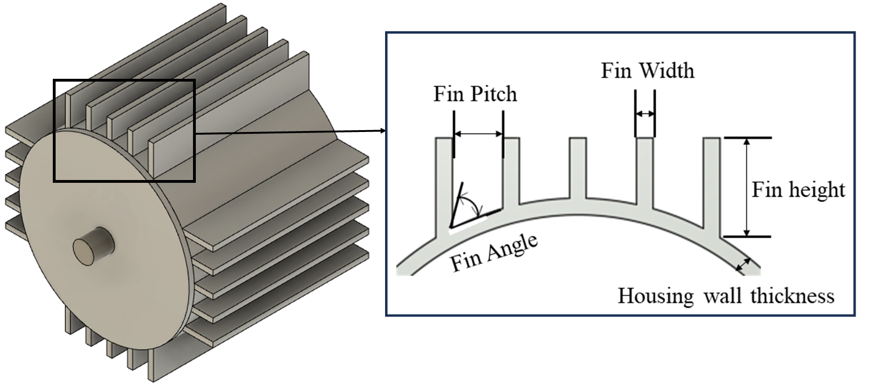
Fig. 1.9. Topology of a finned housing machine and parameters of fins [54].
A research involved on optimizing the finned housing has been conducted in [54]. In this study, 2600 cases of finned housing with various parameters were compared as shown in Fig. 1.10. It is found that the finned housing with higher number of fins tended to exhibit better cooling efficiency. Specially, the study indicated that finned housing with nine fins exhibited the best cooling efficiency in this research. A further increase in the number of fins cannot boost the cooling efficiency. It is worth noting that further increasing the number of fins did not yield enhanced cooling efficiency, as this led to a larger portion of the cooling channel being obstructed.
Furthermore, this study highlighted the importance of the outer contour of the finned housing, suggesting that it is better to follow a circular shape. Deviating from a circular shape may result in significant temperature differences within finned housing, potentially leading to additional heat flow from inner cooling circuit.
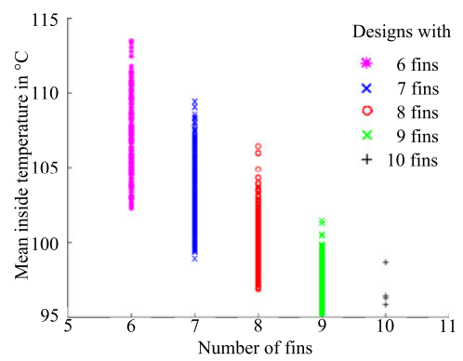
Fig. 1.10. Mean temperature at the inside of the housing (each cross is one case) [54].
The orientation of fins is also important for designing a finned housing. In a study conducted by [55], two orientations of fins were investigated and compared: axial longitudinal fins and radial fins. For both fin configurations, an increase in fin height led to lower housing temperature. Moreover, a comparison of housing temperatures for these two designs under different housing mass is presented in Fig. 1.12. The findings of this comparison demonstrate that radial fins exhibit lower housing temperatures when compared to axial longitudinal fins.
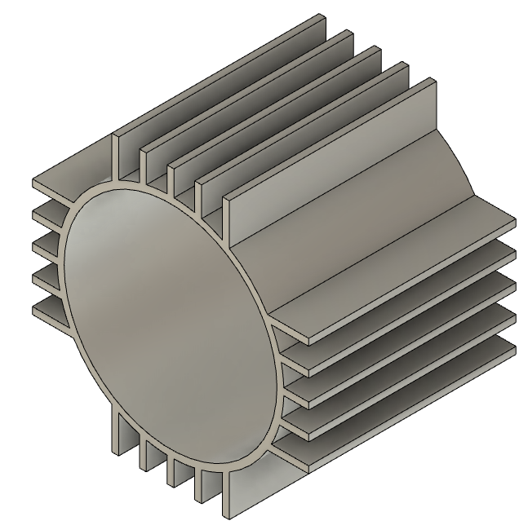 | 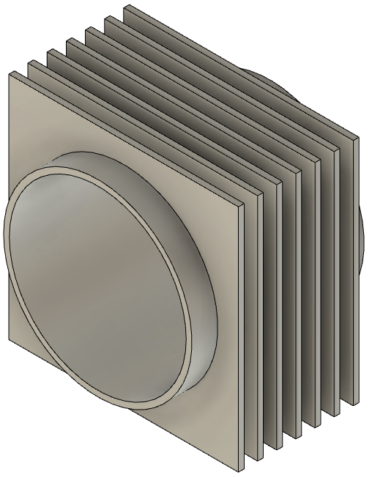
(a) Axial longitudinal fins | (b) Radial fins
Fig. 1.11. Finned housing with different fin orientations [55].
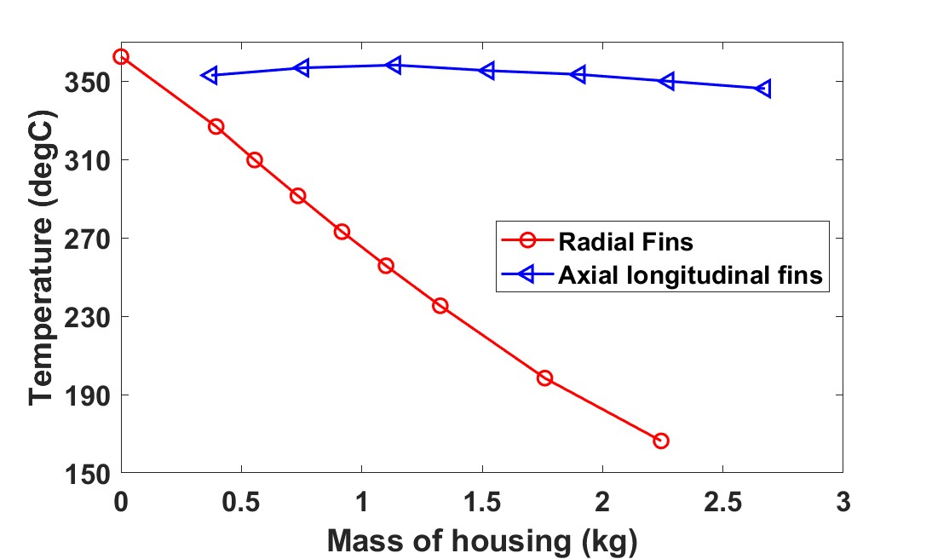
Fig. 1.12. Temperatures of housing for a horizontally mounted motor with radial fins and axial longitudinal fins [55].
It's essential to highlight that the orientation of fins should be carefully considered to avoid disrupting airflow [56]. Consequently, the cooling efficiency of finned housing with axial longitudinal fins, radial fins, or other configurations will be different under different operating conditions. The finned housing is commonly integrated into totally enclosed fan-cooled (TEFC) motors [57-59]. In TEFC motors, axial airflow is prevalent, making axial longitudinal fins a more attracted choice due to their compatibility with axial airflow.

Potting Materials
Particular attention must be given to addressing the two primary areas of concern with electrical machines. One is the rotor, especially in rotor-mounted PM machines, where the issue arises due to a poor heat transfer rate in the airgap region. The other one of concern is end-winding, which characterized by poor heat transfer rate in end space regions [60].
To ameliorate the heat dissipation challenges in end-winding regions, potting materials have been employed to serve the purpose of replacing the air within the end space as shown in Fig. 1.13. The potting material establish highly effective heat conduction between the end-winding and the housing, a process that would be notably inefficient if air were retained. The main reason is the significant higher thermal conductivity of potting materials in comparison to air. Moreover, low air velocity and limited turbulence render it less effective at facilitating heat convection.
It is worth noting that, the cooling efficiency of potting materials is impacted by its thermal conductivity and density. Additionally, the choice of potting materials should consider the allowable temperature limits of these materials. A summary of these properties for various potting materials are listed in Table 1.3.
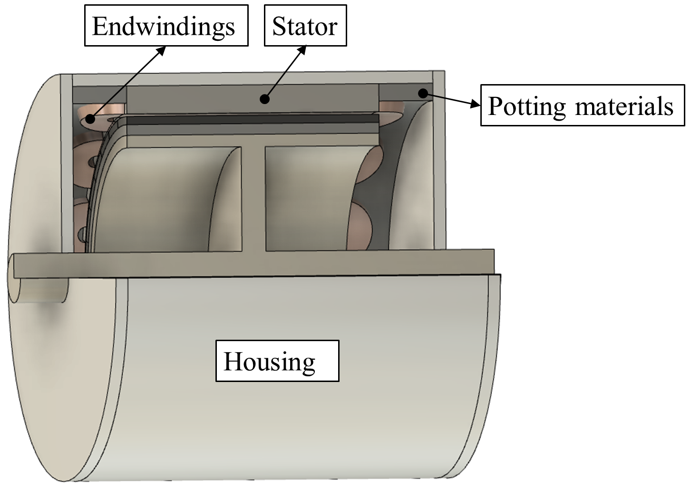
Fig. 1.13. Cut away view of the machines with potting materials.
Table 1.3 Physical Properties of Potting Materials
Materials | Thermal Conductivity ($W/{m/K}$) | Density (${kg}/{m^{3}}$) | Allowable temperature ($℃$) | Reference
Air | 0.026 | 1.185 | - | [61]
Lord SC-320 | 3.2 | 2810 | - | [62]
AIN Compound | 3.8 | 2470 | - | [63]
Stycast 2762 | 1.37 | - | - | [64]
Electrolube ER2218 | 0.28 | 1160 | -50$℃$ to 150$℃$ | [65]

Moreover, various liquids, including liquid hydrogen (LH), liquefied natural gas (LNG) or liquid nitrogen (LN₂) [66], as well as nanofluids [67], ferrofluid (also known as thermomagnetic liquid) [68], and phase change materials (PCMs) [69] can also be introduced in end space regions to improve the heat transfer rate from end-windings to housing. Compared with air, these liquids can provide higher conductive heat transfer. Additionally, the presence of gravity significantly aids in establishing a more efficient coolant circulation when employing liquids.
Moreover, LH, LNG and LN₂ stand out for their ability to provide much lower coolant temperatures, specifically -253$℃$, -161$℃$, and -196$℃$, respectively. This enables highly effective cooling systems, particularly in scenarios such as in superconducting machines where maintaining low operating temperatures is crucial. Furthermore, it is worth noting that, ferrofluids have thermomagnetic convection to create a novel coolant circulation system. This phenomenon occurs when ferrofluids subject a magnetic body force in the presence of magnetic field gradients or discontinuities, enabling efficient heat dissipation and cooling.

Back-Iron Extension and Heat Guides
Potting materials are employed to improve the heat transfer rate from end-windings to housing, mainly aimed at reducing the end-winding temperature. On the other hand, some other cooling technologies are focused on reducing the temperature of the active coils. Back-iron extension is one of these cooling technologies, as shown in Fig. 1.14 [70]. This method offers a simple and cost-effective means to reduce winding temperature, particularly the active coil. The extended back-iron enhances the heat transfer rate from the coils to the stator. However, it is important to consider its potential influence on slot fill factor and end-winding length. The research in [70] demonstrated a significant temperature reduction, with a remarkable decrease of 26.7%.
A similar structure is proposed and investigated in [71]. In contrast to the back-iron extension, the approach utilizes detachable thermal conductive heat guides (HGs) within the slot. There are two kinds of HGs: passive type and active type. The mechanism of the passive HGs is similar to the back-iron extension by improving the heat dissipation from windings. However, due to their detachability, they offer advantages in terms of ease of manufacture, assembly, and maintenance. The incorporation of additive manufacturing, commonly known as 3D-printing, is introduced to fabricate different HGs, as shown in Fig. 1.15. This technology allows for achieving a lighter weight, reduced power loss, and improved heat transfer rate in the HG design. The active type of HGs is more like a heat pipe, which provide a cooling channel for forced cooling systems [72, 73].
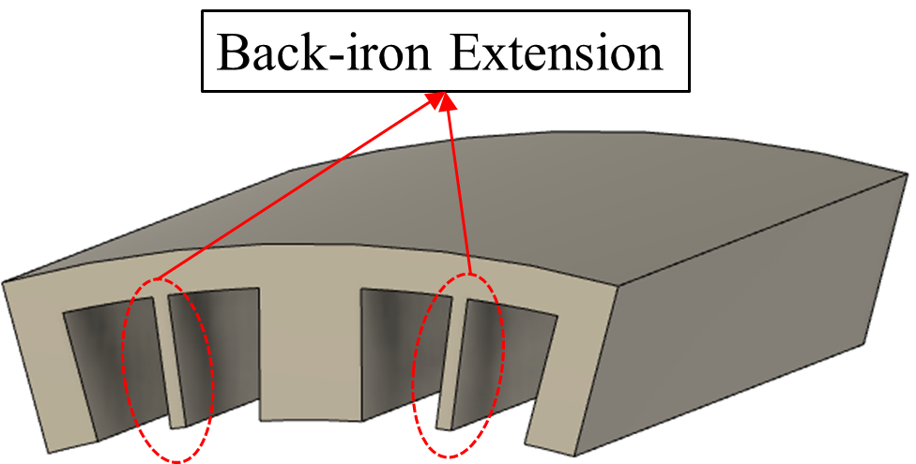
Fig. 1.14. Back-iron extension in machine stator slots [70].
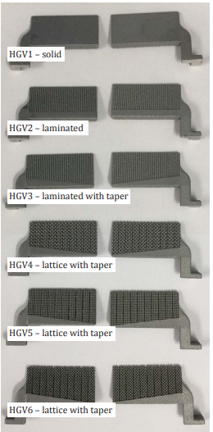
Fig. 1.15. Alternative heat guide designs [71].
These HGs can be employed not only within the slot but also inside the stator, as shown in Fig. 1.16 [74]. In this design, a highly thermal conductive bar, which made of copper as seen in [74], is embedded through the stator iron core. This arrangement allows for more effective transfer of heat generated in stator teeth to the external frame, usually embedded with a water jacket. The placement of these thermal conductive bars aligns with the magnetic flux, resulting in negligible eddy current losses. However, it is worth considering potential mechanical reliability problems associated with this design.
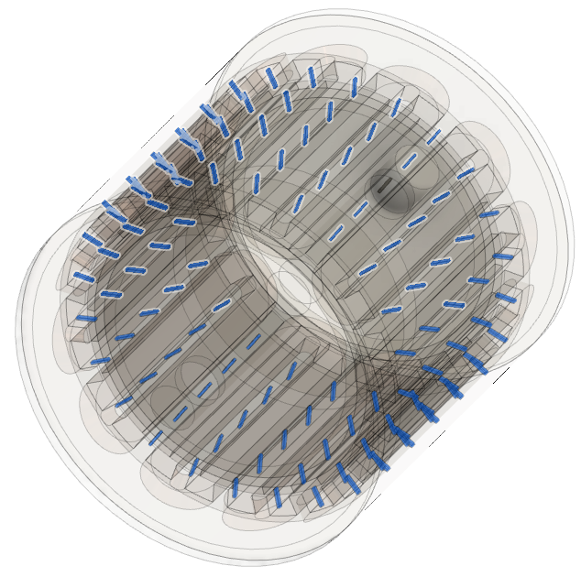 | 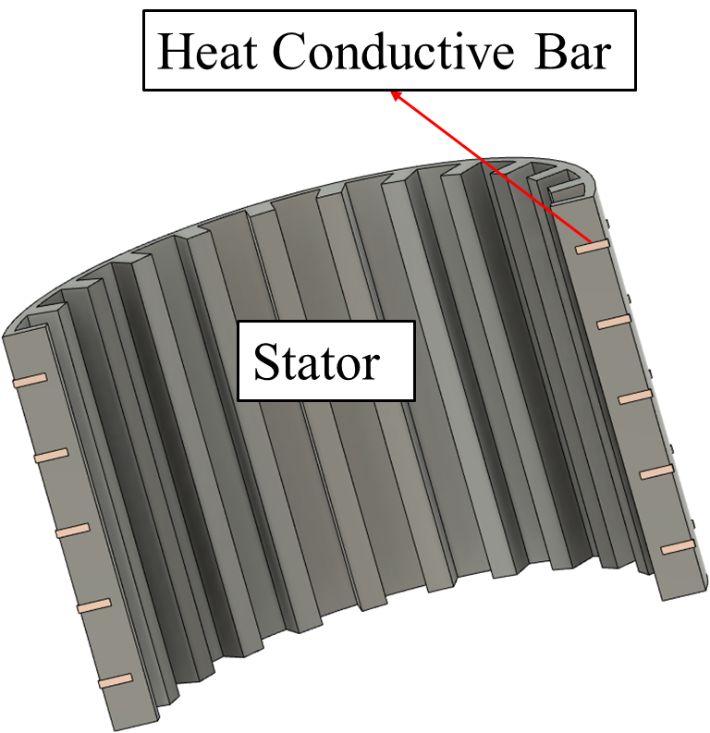
(a) Entail machine | (b) Stator and thermal conductive bar
Fig. 1.16. Machine topology with highlighted thermal conductive bars [74].

Active Cooling Technology
Passive cooling technologies improve machine thermal performance without the need for an external power supply. However, in comparison to active cooling technologies, passive methods generally exhibit lower cooling efficiency as outlined in Table 1.4. Moreover, it is essential to take into account the physical properties of coolants when designing a cooling system. This involves the balancing factors like system volume and mass, cooling efficiency, maximum pressure that can be provided by external pump or device. The physical properties of some commonly used coolants in active cooling systems for electrical machines are detailed in Table 1.5.
Table 1.4 Typical Performance for Different Cooling Technologies [56, 75, 76]
Cooling method |  | Linear current density (kA/m) | Current density (A/mm²) | Convection Coefficient (W/m²/K)
Natural Convection |  | - | 1.5 to 5 | 5 to 30
Forced gas cooling | Air | <80 | 5 to 10 | 20 to 300
Forced gas cooling | Hydrogen | 70-110 | 7 to 12 | 100 to 1000
Forced liquid cooling | Indirect contact | 90 to 130 | 7 to 20 | 100 to 10,000
Forced liquid cooling | Direct contact | 100 to 200 | 10 to 30 | 200 to 25,000
Table 1.5 Physical Properties of Coolants [60, 77, 78]
 | Coolant | Thermal Conductivity  ($W/{m/K}$) | Specific heat capacity  ($J/{{kg}/K}$) | Density  (${kg}/{m^{3}}$) | Dynamic viscosity  ($Pa∙s$)
Gases | Air | 0.026 | 1004 | 1.185 | 1.83$×{10}^{-5}$
Gases | Helium (20$℃$)) | 0.154 | 5193 | 0.16 | 1.98$×{10}^{-5}$
Gases | Hydrogen (20$℃$) | 0.181 | 14360 | 0.083 | 8.9$×{10}^{-6}$
Liquid | Water | 0.607 | 4182 | 997 | 8.90$×{10}^{-4}$
Liquid | Engine oil (50$℃$) | 0.142 | 2006 | 870.6 | 0.143
Liquid | ATL 134 fluid (50$℃$) | 0.135 | 2200 | 822 | 0.017
Liquid | Brayco Micronic 756 (50$℃$) | 0.134 | 1997 | 828.4 | 0.012
Liquid | EGW 50/50 (50$℃$) | 0.405 | 3420 | 1059 | $$1.97×{10}^{-3}$$
Liquid | PGW 50/50 (50$℃$) | 0.375 | 3675 | 1019 | $$2.55×{10}^{-3}$$

Forced Air Cooling
Force air cooling technology employs a fan or a blower to create airflow. The airflow can either pass through the machine outer frame, namely totally enclosed fan-cooled (TEFC) machine, or flow through the machine internal components, as observed in throughflow ventilation machine. The airflow patterns for these two machine configurations are shown in Fig. 1.17.
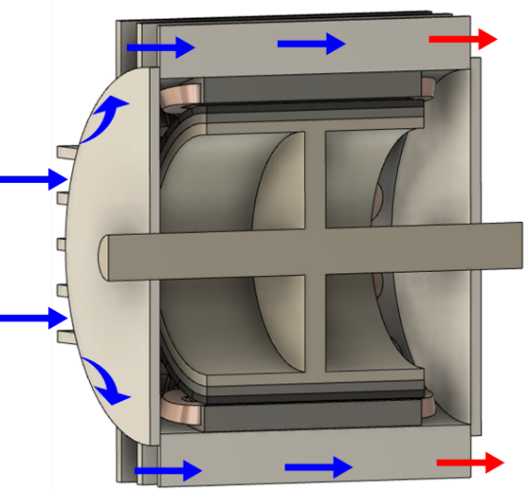 | 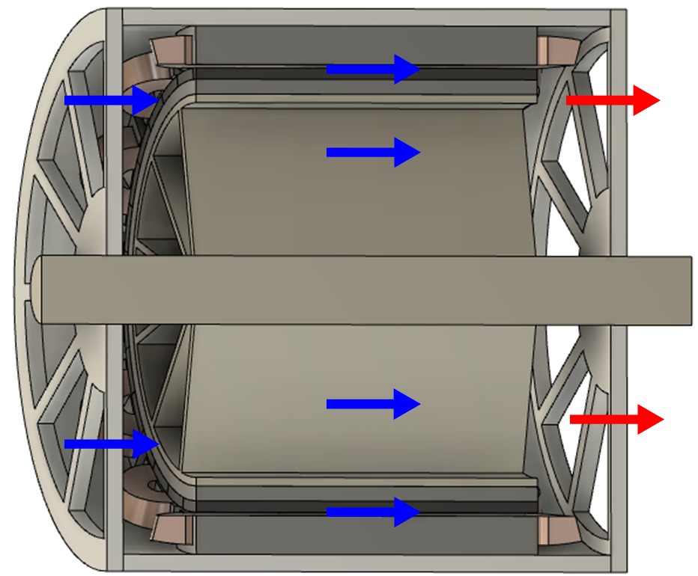
(a) TEFC | (b) Throughflow ventilation machine
Fig. 1.17. Airflows for an electrical machine with forced air cooling systems.
In comparison to passive cooling systems, forced air cooling systems significantly enhance heat convection. Various machine designs utilize fans in different locations to generate different airflow patterns. For example, the enclosed fan cooled (EFC) machine implements a fan outside the totally enclosed machine, as shown in Fig. 1.17 (a) [59, 79-82]. It achieves a significant enhancement of convection coefficient at the outer surface of the frame. However, the cooling efficiency of EFC machines is constrained by the heat transfer within the machines.
To maintain the isolation of the machines from surrounding pollutants while improving heat transfer rate within the machines, inner fan blades are employed and fixed to the shaft for EFC machines as shown in Fig. 1.18 [56, 83]. In addition, wafters can also be integrated into the rotor, as shown in Fig. 1.19 [84-86]. Both shaft mounted fan blades and rotor mounted wafters establish new air circulation within the machines, improving heat transfer from the inner components to the housing frame. However, it is worth noting that the cooling efficiencies of these designs are limited by the machine rotor speed.
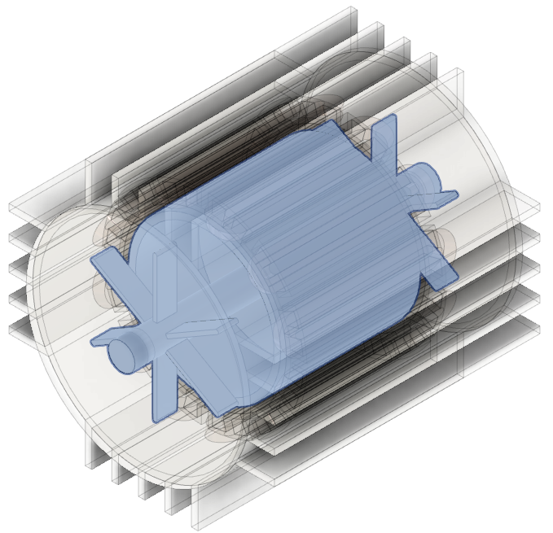 | 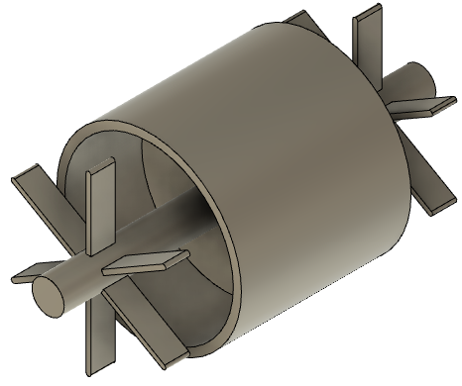
(a) EFC machine with inner fan blades | (b) Shaft design
Fig. 1.18. Topology of EFC machine with inner fan blades.
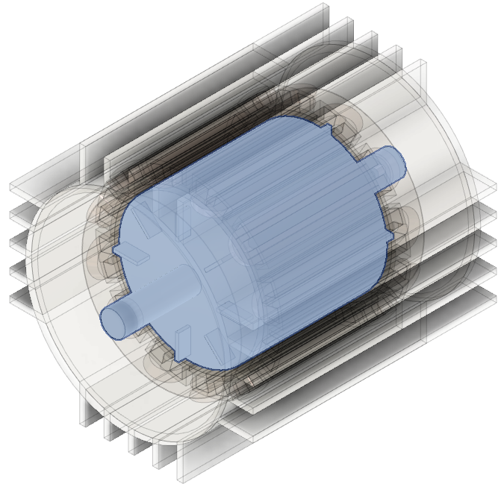 | 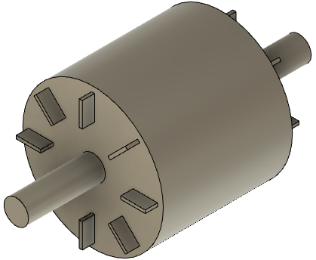
(a) EFC machine with rotor mounted wafters | (b) Shaft design
Fig. 1.19. Topology of EFC machine with rotor mounted wafters.
EFC machines offer advantages such as reduced acoustic noise and lower maintenance cost [83]. However, the totally enclosed frame design limits the cooling efficiency of forced cooling systems. To address this limitation, a new machine configuration, known as throughflow ventilation machine has been introduced [87, 88], as shown in Fig. 1.17. In throughflow ventilation machines, air is continuously drawn from the ambient environment into the machines without recirculation. However, this exposure to the surrounding environment means that ventilated machines are vulnerable to contaminants.
To mitigate this issue, inlet and outlet grills and guards are commonly used to shield ventilated machines from direct exposure to surrounding particles and moisture [56]. Nevertheless, grills and guards raises concerns regarding potential reductions in cooling efficiency, increased system flow resistance, and fan losses [89].
In addition to air, other gases, such as hydrogen and helium, can also be employed as coolants in forced cooling systems with machine configurations similar to those discussed in this section. These gases provide better cooling efficiency compared to air, primarily because of their lower density, reduced dynamic viscosity, and higher heat conductivity, as listed in Table 1.5 [78].

Indirect Forced Liquid Cooling
Liquids are another category of fluid in machine cooling. Typically, liquid cooling systems tend to offer better cooling efficiency than gas cooling systems, as indicated in Table 1.4. This achievement is mainly attributed to the higher thermal conductivity of liquid. Indirect forced liquid cooling technology is widely used, not only for its good cooling efficiency, but also because it prevents direct contact between the coolant and machine components, thereby avoiding potential corrosion issues. In addition, the use if a totally enclosed enclosure enables the designed machine to meet high ingress protection (IP) ratings, e.g., IP67 or IP68, which are important for protection against environmental elements and contaminants.
Housing water jackets are commonly employed in automotive traction motors [90-93]. The heat generated in the windings and stator is conducted to the cooling housing and transferred to the surrounding environment via the coolant within the water jacket. This approach significantly improves convection coefficient at the housing surface, leading to a reduction in machine temperature. The cooling efficiency of a housing water jacket is related on the properties of the coolant employed. The ethylene Glycol based water (EGW) are typically implemented for traction motors [94]. In addition, for aerospace applications [95], aviation turbine fuel and lubricating oil may be implemented as coolants, considering the specific operating conditions off these applications.
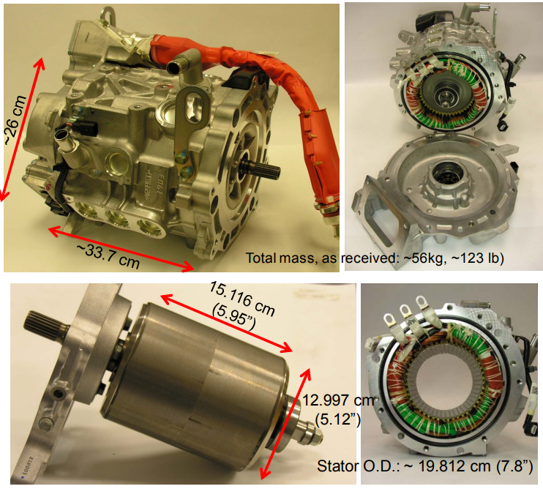 | 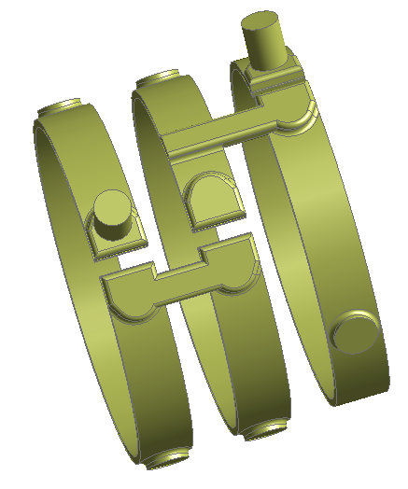
(a) Machine topology | (b) Flow channel design
Fig. 1.20. Nissan-leaf electric motor and its circumferential flow channel design [90, 96].
The cooling efficiency of a housing water jacket is also influenced by the design of the flow channel. One of the flow channel designs is the circumferential flow design, which is employed in the Nissan-leaf electric motor, as shown in Fig. 1.20 [90]. In this design, circumferential flow channels are connected by axial channels, and when combined with external flow channels and heat exchanger, a closed-loop coolant circulation is established to effectively reduce machine temperature. It is worth noting that, in this system, the convection coefficient is non-uniform, and there is a non-uniform temperature distribution of coolant and housing as shown in Fig. 1.21.
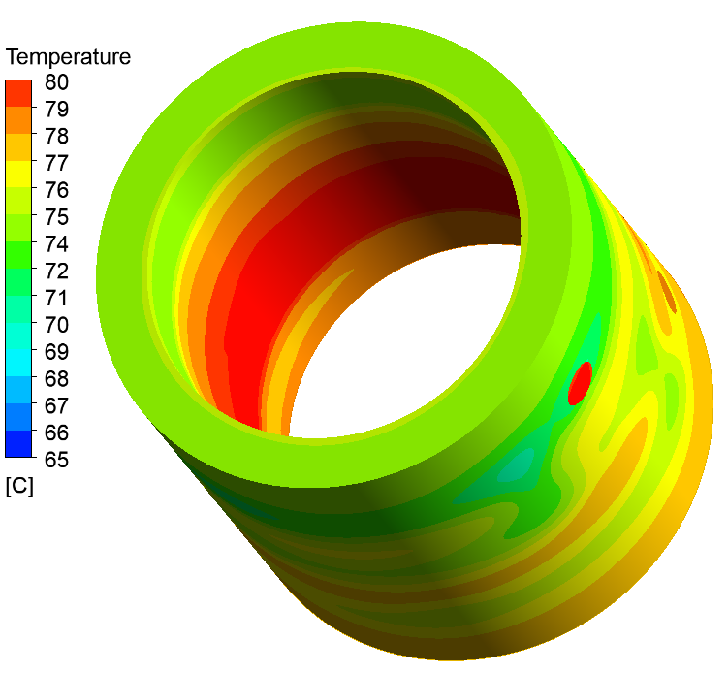 | 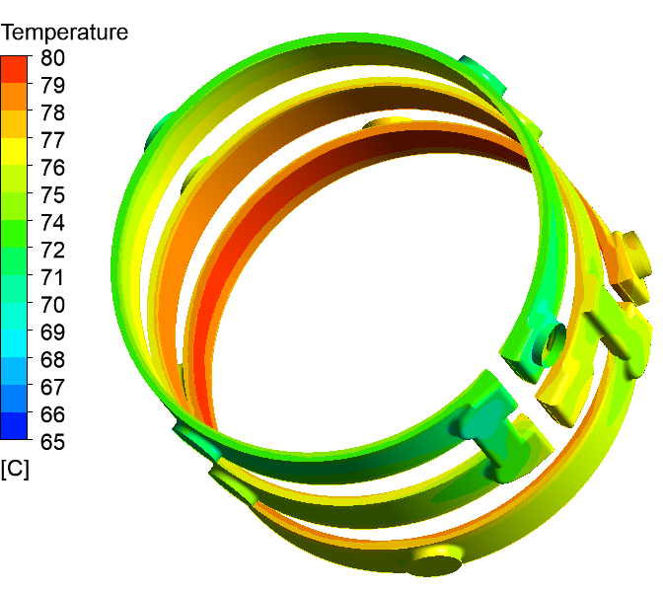
(a) Housing | (b) Coolant
Fig. 1.21. Temperature distributions for the water jacked cooled machine with a flow rate of 6.5 L/min.
The concept of spiral flow channel was proposed in [94]. Compared with a circumferential flow channel, utilizing a spiral flow design leads to a noticeable reduction in flow resistance. For instance, when both designs are subjected to a water flow rate of 6.5 L/min, the pressure loss for circumferential flow channel amounts to 103Pa, while the pressure loss is reduced to 61Pa for the spiral flow channel. The bends in the circumferential flow channel result in higher coolant velocity in the bending area, as shown in Fig. 1.22. Nevertheless, it is important to note that these bends can also introduce additional pressure losses [89].
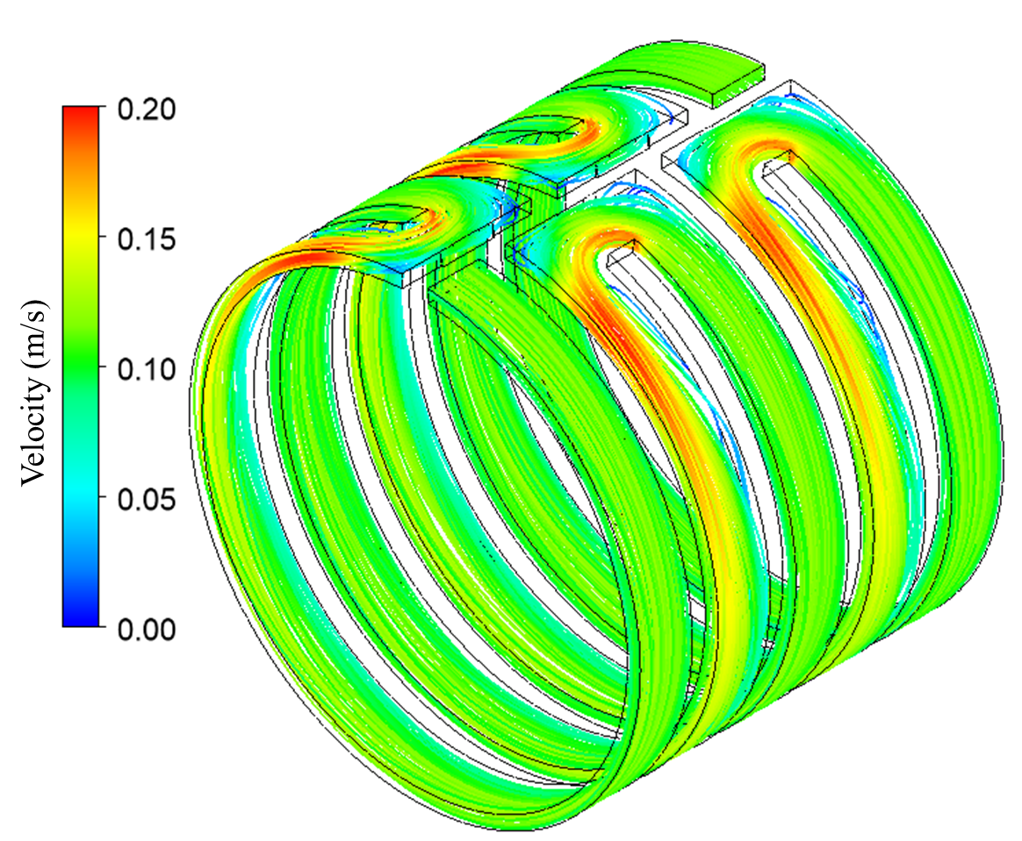 | 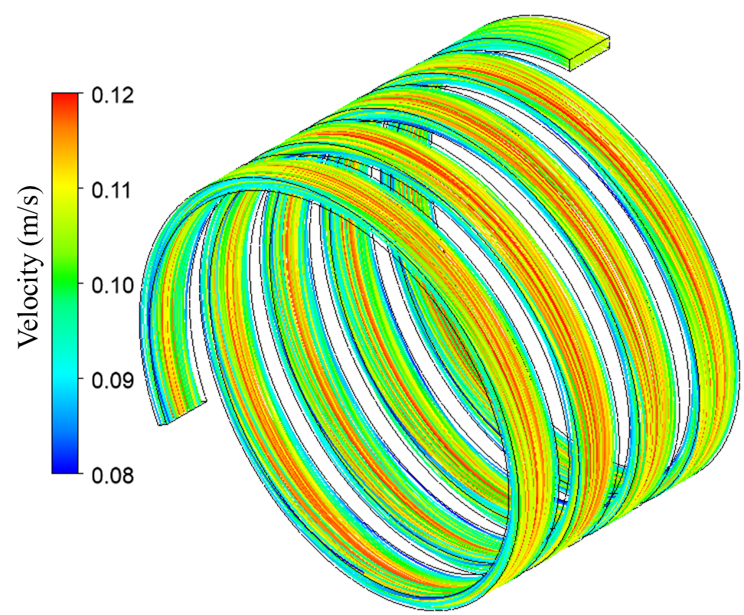
(a) Circumferential flow channel | (b) Spiral flow channel
Fig. 1.22. Coolant velocity distribution for different design of flow channel with a flow rate of 6.5 L/min.
The housing water jacket has noticeable ability to improve the rate of heat dissipation from machines to ambient. However, the poor heat transfer rate from end-winding to the housing frame can limit the overall cooling efficiency. Particularly, the end-winding is typically the region where the hottest spots are encountered. Section 1.4.1-B has reviewed passive methods for improving the heat transfer rate within the end space. Moreover, some active cooling technologies have been developed to achieve the same purpose.
Inserting dedicated liquid cooling pipe into the end-windings offers a direct means to efficiently transfer the heat generated by the end-winding out of machines. Reference [97] proposed a new cooling technology that combines this direct end-winding cooling method with a housing water jacket. This combined system has been demonstrated to significantly reduce machine temperature, particularly in the end-winding regions. Different materials for the dedicated liquid cooling pipe, including metallic pipe, thermoformed polymer, and silicone rubber, have been investigated and compared. The comparisons reveal that silicone rubber exhibits the best cooling efficiency among these materials. This superiority can be attributed to the expansion of the silicone rubber pipe, when carrying pressurized fluid.
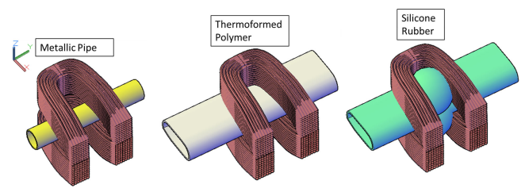
Fig. 1.23. Dedicated liquid cooling pipe for different materials [97].
The additive manufactured (AM) heat guides discussed in section 1.4.1-C can be considered as heat pipes, connecting to an external pump or device to provide effective cooling efficiency. For instance, a polycarbonate aluminium flake (PC-AL) heat pipe, serving as a direct heat exchanger, can be placed within a slot to improve the heat dissipation of windings [72]. Moreover, the heat pipes are not only limited to slot placement, they can also be inserted in shaft, rotor, end-winding, end region cavity and bearing [73].
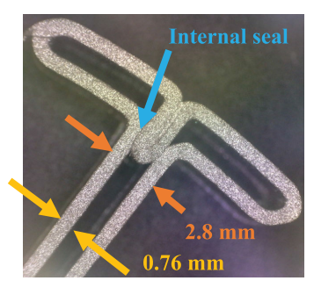 | 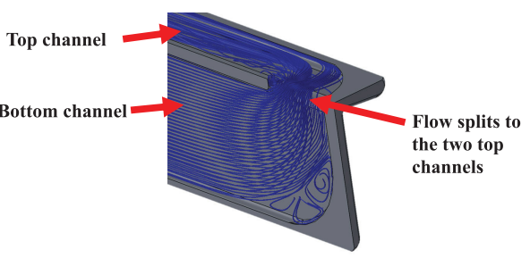
(a) Cross section | (b) Flow profile within AM heat guide
Fig. 1.24. Cross section of AM heat guides and flow profile within AM heat guide [72].
Heat dissipation in machine’s rotating components is more critical than in stationary components, especially in the rotor-mounted PM machines. In these machines, PM eddy current losses can only be conducted through the shaft and convected via the airgap. To improve the heat dissipation from shaft, a hollow shaft topology is employed [98-100], resulting in a significant temperature reduction due to this shaft cooling method. In addition, the rotation of the shaft introduces additional coolant velocity in the tangential direction, caused by the rough wall and coolant viscosity. As the rotation speed increases, the convection coefficient at the shaft surface is enhanced [100].
Indirect forced liquid cooling results in lowering machine temperatures and avoiding corrosion issue. However, concerns regarding coolant leakage and the maintenance of machine and cooling systems should be addressed.
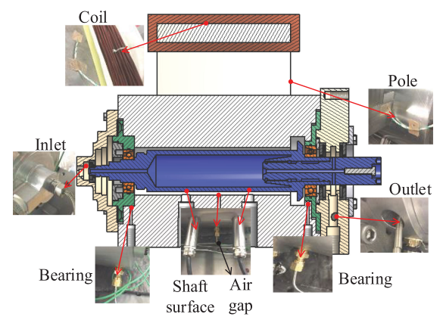
Fig. 1.25. Shaft cooled machine [98].

Direct Forced Liquid Cooling
In contrast to indirect forced liquid cooling systems, direct forced liquid cooling technologies bring the coolant closer to the heat sources, typically the stator iron losses and winding copper losses. Thus, more effective cooling efficiency for direct forced liquid cooling is expected.
Semi-flooded cooling is one of the direct forced liquid cooling, where the coolant is forcibly directed through the components, typically the stationary components such as the stator and windings. This approach involves several flow pathways, as shown in Fig. 1.26. These flow paths include annular gaps between stator and housing [101], stator axial ducts [102], gaps between each conductor in slots [103], gaps in tooth tips for semi-closed slots [102], and flux gaps for the machines with stator modularity [104]. It is worth noting that, the viscosities of the coolants employed in semi-flooded cooling systems are typically higher than that of air. To prevent an increase in friction losses and coolant leakage, a sleeve is employed to separate the machine into oil-flooded stator part and oil-free rotor part, as shown in Fig. 1.27.
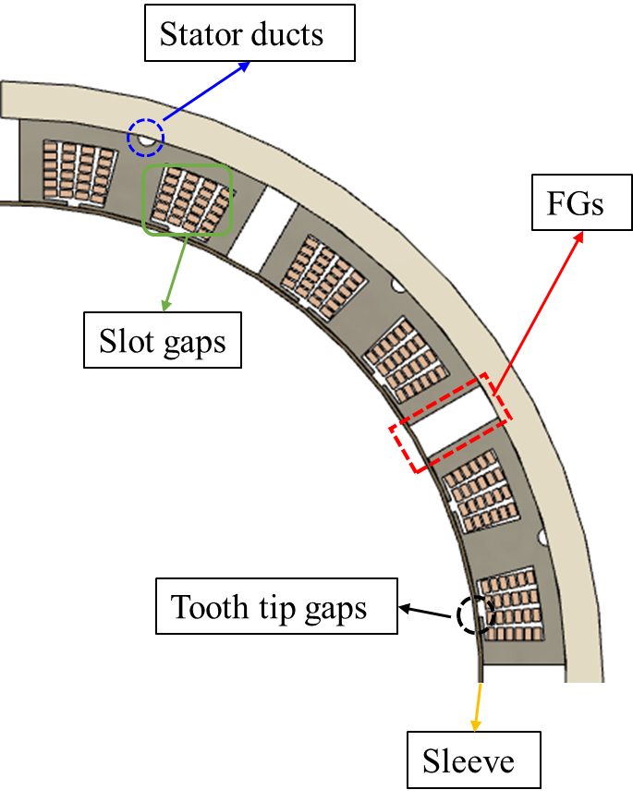
Fig. 1.26. The layout of the flow pathways in stator.
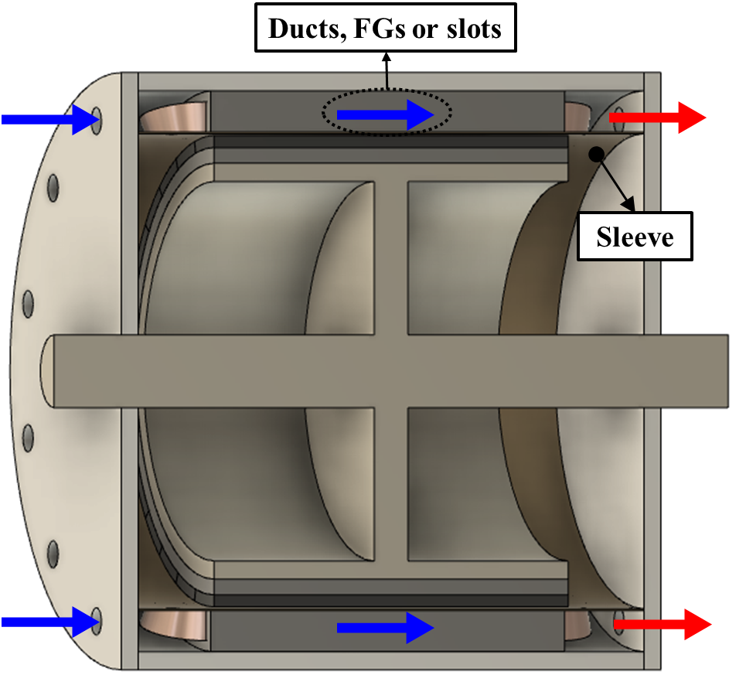
Fig. 1.27. Coolant flow for an electrical machine with direct forced liquid cooling.
Semi-flooded cooling achieves significant temperature reductions in machine stationary components. However, it presents a challenge in cooling the rotational components, particularly the PMs in rotor-mounted PM machines, as they cannot be directly cooled by flooded coolant. To address this issue, the concept of a totally immersed electrical machine has been investigated [105]. In this approach, both the rotational and stationary components are directly cooled by coolant. However, it is important to note that this introduces extra friction losses. To make this concept work effectively, the coolant must be electrically non-conductive and non-magnetic material with a high specific heat capacity and high thermal conductivity. In addition. to mitigate the influence of increased friction losses, the viscosity of coolant should be low.
Oil spray and oil jets represent another form of direct forced liquid cooling [106-108]. For these cooling methods, oil is atomised and breaks into droplets, which are then impinge on the surface of the end-windings, as shown in Fig. 1.28. The impinged oil mitigates the thermal resistance and improves the heat transfer rate between the end-winding and housing. The impingement heat transfer contributes to the high convection coefficient observed in oil spray and oil jets cooling systems [109]. However, it is worth noting that, oil atomisation requires much higher pumping pressure compared to other active cooling technologies. This high-pressure atomised oil rises concern about the potential damage of winding insulation [94]. Careful consideration of the design and operational parameters are crucial to mitigate these concerns.
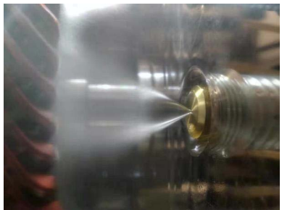
Fig. 1.28. Oil spray for end-winding [106].

Cooling Technology for the Modular Machines
Electrical machines that consider stator modularity have been developed and investigated due to their advantages in improving machine EM performance, as reviewed in section 1.3. These modular machines introduced flux gaps, which not only influence the EM field but also provide an additional degree of freedom for cooling design.
In a study by Zhou et al, a ventilation cooling system was implemented in a consequent PM machine with stator modularity [110]. They investigated the heat transfer and flow profile, finding that extra heat convection occurs in flux gaps, resulting in a significant reduction in machine temperatures. In addition, the presence of flux gaps reduces flow resistance for the whole machine, leading to lower pressure losses. The reduction in pressure losses becomes more significant as increasing flux gap width. Moreover, the semi-flooded cooling system can also benefit from the introduced flux gaps for the same reason, resulting in much lower pressure losses and reduced machine temperature [104].
Nollau et al established a new water jacket for machines with stator modularity [111]. The coolant channel is extended into flux gap region as shown in Fig. 1.29. The bent channel design in the flux gaps not only improves the cooling area but also induces the turbulent flow, leading to 10% higher cooling efficiency than standard water jacket. These innovations demonstrate how flux gaps in stator-modular machines can significantly improve cooling and overall machine performance.
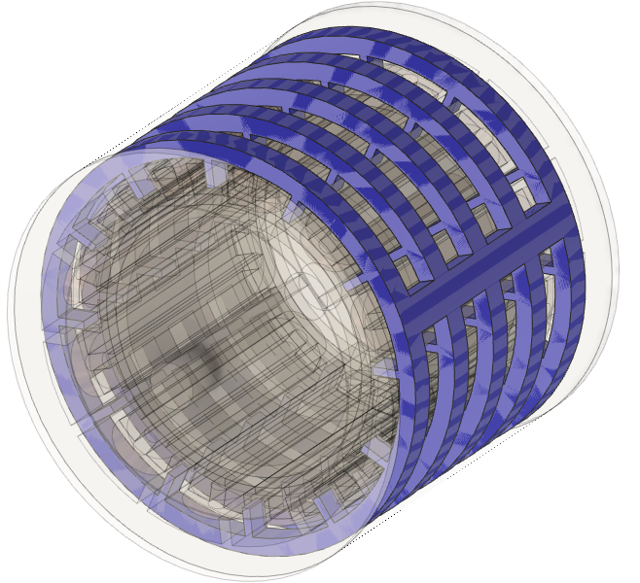 | 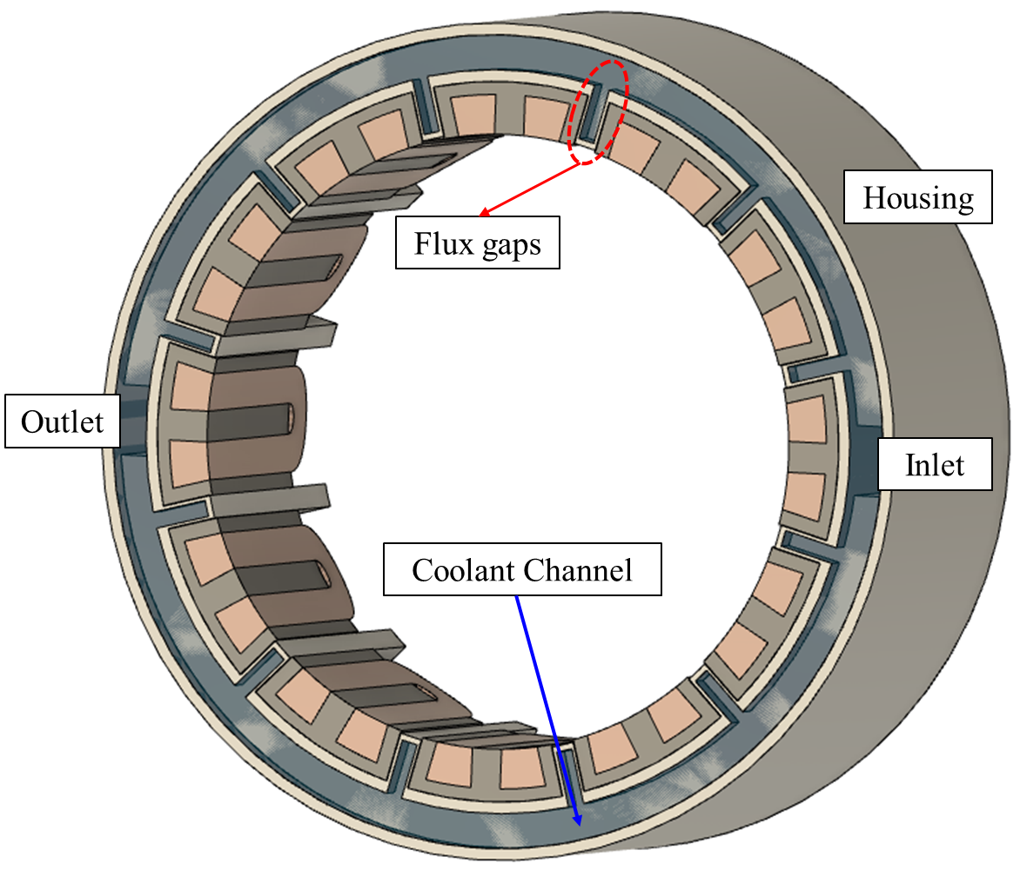
(a) Machine configuration | (b) Coolant channel design
Fig. 1.29. Water jacket design for the modular machine [111].

Research Scope and Contributions

Research Scope
The main topic of this thesis is to investigate advanced thermal management for high torque density permanent magnet machines. The research includes investigating the electromagnetic performances of machines, and the thermal behaviours of machines. Additionally, the interrelation between EM and thermal performances for machines has also been explored. Novel machine topologies, modular SPM machines with 24-slot/20-pole and 24-slot/28-pole configurations are investigated and optimized to fully reveal the influences of introducing flux gaps in alternative teeth for PM machines. Their influences on the static EM performances (e.g., torque, cogging torque, demagnetization characters, and losses) and dynamic performances (e.g., torque speed curve, losses speed curve, and efficiency) are proposed and analysed.
The thermal analyses of the modular SPM machines are also carried out in this thesis. Employing CFD modelling, the convection coefficients at each surface of component within the investigated modular machines are accurately predicted. Subsequently, LPTN models are established to accurately predict the temperatures of each machine components. This is achieved by evaluating the equivalent thermal resistances based on the CFD outcomes. This hybrid method, combining the accuracy of CFD models with computational efficiency of LPTN, has been employed to predict the temperature variations for the investigated modular SPM machine under different operating conditions, i.e., different loadings and different speeds.
Three advanced thermal management technologies have been proposed for the modular SPM machines, with a particular focus on utilizing flux gaps. Among these technologies, two are forced cooling technologies, i.e., semi-flooded oil cooling system and ventilation cooling system. In these cooling systems, coolant is pumped through the throughflow machine, absorbing heat in heat-generating components (e.g., windings, stator, magnets, and rotor). This process results in significant reduction in temperature. Another more “passive” cooling technology, i.e., ferrofluid cooling, has been introduced for the SPM machines. It can also achieve notable temperature reductions without employing external pumps. Furthermore, for better understanding of the thermomagnetic convection of ferrofluid, the ferrofluid cooling is explored across different machine topologies, winding configurations, and loading conditions allowing for comparisons and analysis.

Contributions
The main contributions of this thesis can be summarized as follows:
- The genetic algorithm is utilized to optimize the modular SPM machines with different slot/pole number combinations, such as 24-slot/20-pole and 24-slot/28-pole. The EM performances of optimized modular SPM machine and its non-modular counterpart are analysed and compared. It found that the machine average torque can be improved by 16.1% for the modular machine. Furthermore, an EM-thermal coupled model is developed, taking into consideration of both EM and thermal factors. This coupled model enables a comprehensive investigation of the EM performances of the investigated modular SPM machines. The findings reveal that modular SPM machines exhibit enhanced torque density and improved demagnetization withstand capability, facilitated by appropriately sized flux gaps.
- To further improve machine performances, two kinds of forced cooling technologies are incorporated into the modular machine with throughflow housing: semi-flooded cooling, and ventilation cooling. The machine temperature can be reduced by more than 100$℃$ after introducing forced cooling technologies. The CFD modelling is employed to elucidate the influence of flux gaps on the efficiency of these cooling systems. Additionally, the impact of flow conditions and machine conditions on cooling systems efficiency is also presented.
- Beside the active cooling technologies, an innovative “passive” cooling technology, specifically, ferrofluid cooling, is proposed. The machine temperature can be reduced by around 36$℃$. Multi-physics models are developed to explore the thermomagnetic convection phenomenon within ferrofluid. These models intricately account for the interrelation between EM field, fluid dynamics and heat transfer, enabling an accurate simulation of the magnetic body forces that ferrofluid subjected under magnetic fields. A comprehensive analysis is conducted, encompassing various machine configurations, diverse loading conditions, and varying fluid properties to assess their respective impacts on the efficiency of ferrofluid cooling.
During the PhD study, based on the above contributions, 8 papers in total have been published, which include 6 journal papers and 2 conference paper. Additionally, 1 journal paper is currently under review. The publication list is given as below:
- W. Zhang, G. J. Li, Z. Q. Zhu, B. Ren, and M. Michon, "Optimization of Modular SPM Machines Considering Stator Modularity," in 2021 IEEE International Electric Machines & Drives Conference (IEMDC), 2021: IEEE, pp. 1-6. [Chapter 2]
- W. Zhang, G. J. Li, Z. Q. Zhu, B. Ren, and M. Michon, "Coupled Electromagnetic-Thermal Modelling of Dynamic Performance for Modular SPM Machines." Energies, vol. 16, no. 6, p2516, 2023. [Chapter 3]
- W. Zhang, G. J. Li, Z.Q. Zhu, B. Ren, Y. C. Chong, and M. Michon, "Demagnetization Analysis of Modular SPM Machine Based on Coupled Electromagnetic-Thermal Modelling," Energies, vol. 16, no. 1, p. 131, 2022. [Chapter 3]
- W. Zhang, G. J. Li, R. Zhou, Z. Q. Zhu, B. Ren Y. C. Chong, and M. Michon, “Forced-liquid cooling for high torque density modular PM machines” IET Elect. Power Appl. (Accepted). [Chapter 4]
- W. Zhang, G. J. Li, R. Zhou, Z. Q. Zhu, B. Ren, Y. C. Chong, and M. Michon, “Forced-air cooling for modular PM machines utilizing flux gaps and rotor ducts,” IEEE Trans. Energy Conver. (1st review). [Chapter 4]
- W. Zhang, G. J. Li, B. Ren, Y. C. Chong, M. Michon, "Investigation of Ferrofluid Cooling for High Power Density Permanent Magnet Machines.", IEEE Trans. Magn., vol. 59, no. 1, pp. 1-11, 2022. [Chapter 5]
- W. Zhang, G. J. Li, Z. Q. Zhu, B. Ren, Y. C. Chong, M. Michon, "Investigation of Ferrofluid Cooling in Modular Permanent Magnet Machines.", IEEE Trans. Magn., 2023. [Chapter 5]
- W. Zhang, G. J. Li, B. Ren, Y. C. Chong, M. Michon, "Comparative Study of Ferrofluid Cooling for Permanent Magnet Machines with Different Winding Structures." IEEE ACCESS. (Accepted). [Chapter 5]
- G. J. Li, Y.F. Zhang, W. Zhang, N. Morley, Z. Q. Zhu, "Thermomagnetic Cooling for High Power Density Electrical Machines.", in 2022 IEEE Energy Conversion Congress and Exposition (ECCE), 2022: IEEE, pp. 1-7. [Chapter 5]

Electromagnetic Analysis of Modular SPM machine
This chapter presents the optimization of modular surface-mounted permanent magnet machines considering the effect of stator modularity on machine electromagnetic performances. Different to the existing optimization method for the modular machine, which does not consider flux gap width as a variable, a global optimization for the modular machine is conducted. In order to optimize the electromagnetic performance, the multi-objective genetic algorithm is adopted and 2D finite element method is used. Variables such as stator yoke height, tooth width, flux gap width, split ratio and rotor yoke thickness have been selected for the optimization. The objectives are to achieve maximized average torque, minimized torque ripple, copper loss and total machine mass. Amongst all the variables, the flux gap width is a key parameter which has significant impact on machine electromagnetic performance but has not been included in the optimization process in the literature. The results in this chapter have shown that considering the flux gap width in the optimization will lead to further improvement in machine electromagnetic performance. In addition, for machines with lower slot number than rotor pole number, the optimization process shows that an appropriate flux gap width is needed for optimal electromagnetic performance. However, for machines with higher slot number than pole number, the flux gap width tends to be zero, leading to non-modular machine having the optimal performance. A small prototype of one of optimized modular SPM machine has been built and the FEM predicted results are validated.
Publication related to this chapter is listed below:
1. W. Zhang, G. J. Li, Z. Q. Zhu, B. Ren, and M. Michon, "Optimization of Modular SPM Machines Considering Stator Modularity," in 2021 IEEE International Electric Machines & Drives Conference (IEMDC), 2021: IEEE, pp. 1-6.

Introduction
Permanent magnet (PM) machines have been attracting increasing interest in the applications such as electrical vehicles, wind power and aerospace due to their outstanding performances in terms of high efficiency, high torque, and power density. However, due to high price and volatile supply of rare-earth materials, the cost of PM could be a major part of that of the entire machine. Therefore, lots of research on PM machines are focused on how to improve their performances and to reduce PM consumption. Amongst the developed technologies, the surface mounted PM (SPM) machines with modular stators stand out because of their benefits such as high torque, low mass and much more degrees of freedom in cooling system design [38, 42]. It is found that in the 12-slot and 14-pole modular machine, when the flux gaps are introduced in stator core to improve the pitch factor to nearly 1, the 1st and 5th sub-harmonics of airgap flux density are reduced by 73% and 19%, respectively, while the 7th working harmonic is increased by 16% [43, 112]. Therefore, compared with the conventional non-modular SPM machines, the modular SPM machines could improve the magnet flux linkage, back-electromotive force (EMF) and electromagnetic torque [113].
During the design of electrical machines, their optimization is generally regarded as the basic and essential process. However, electrical machines often have multiple geometrical parameters to be optimized and objectives to be achieved, which make the optimization problems very complex. To address this challenge, many methods have been introduced including hill-climbing direct search [114] and fuzzy logic optimization [115], and genetic algorithm (GA) [116]. Amongst all the above optimization methods, the latter is the most widely for the design of electrical machines as it is able to find the global optimization and avoid the local ones, even though it is more computation intensive [117]. Furthermore, GA could be combined with deterministic gradient search techniques in order to improve the computation efficiency [118]. Nowadays, GAs is often combined with the finite element modelling (FEMs) as machine optimization methods [119-123].
However, in the existing literature about modular machines, their optimization did not consider the flux gap width as variable. Instead, the flux gaps are often introduced after the non-modular PM machines are optimized. This cannot fully reflect the significant impact of flux gaps on machine electromagnetic performance and on other machine parameters. To address this shortcoming in the literature, the flux gap width together with other parameters such as the stator yoke height, stator tooth width, split ratio (rotor outer diameter over stator outer diameter), and rotor yoke thickness (as shown in Fig. 2.1) will be used as variables in the global optimization process in this chapter. The average torque is the primary objective and the torque ripple, copper loss, and total machine mass are considered as secondary objectives. At last, to show the benefits of modular machines, the optimized modular machine will be compared with its optimized non-modular counterpart. This comparison is carried out for machines with different slot/pole number combinations to achieve more general conclusions. In addition, FE results have been compared against test results from an existing laboratory prototype in [38], and good match has been observed.
Table 2.1 Parameters of Modular SPM Machine
Slot number | 24 | Rotor outer radius (mm) | 123
Pole number | 28/20 | Magnet thickness (mm) | 7
Stator outer radius (mm) | 154 | Rotor yoke thickness (mm) | 10
Stator inner radius (mm) | 125 | Stack length (mm) | 210
Stator yoke height (mm) | 9 | Rated phase current ($A_{peak}$) | 100
Tooth width (mm) | 10 | Number of turns per coil | 10
Flux gap width (mm) | 6.2 | Rate speed (rpm) | 1500
Airgap length (mm) | 2 | Power (kW) | 51

Initial Specification of SPM machines.
The initial specifications of the modular and non-modular machines used in aerospace application are given in Table 2.1 and the cross-sections are shown in Fig. 2.1. By introducing the flux gaps into the stator iron core, the effective airgap length is significantly increased due to the high reluctance of the flux gaps, which will in turn affect the airgap flux density [38]. According to [43], a flux focusing/defocusing factor, which relates to the slot/pole number combination, is introduced to take the flux focusing or defocusing effect into account. For example, for machines with slot number lower than pole number, e.g., 24-slot/28-pole, the flux gaps will help to increase the open-circuit airgap flux density. However, this is opposite for machines with slot number higher than pole number, e.g., 24-slot/20-pole. In addition, for SPM machines with slot number lower than pole number, the pitch factor (same for winding factor as the distribution factor is 1 for all the investigated modular machines) will increase with the increased flux gap width. This is the opposite for machines with slot number higher than pole number. The effect of flux gaps on flux focusing/defocusing and winding factor will reflect on the average torque, as can be seen in Fig. 2.2. For 24-slot/28-pole modular SPM, its average torque increases with the increased flux gap width. When the flux gap width is around 12 mm, the average torque is the maximum. This is where the impact of flux gaps on flux focusing and winding factor reach its peak.
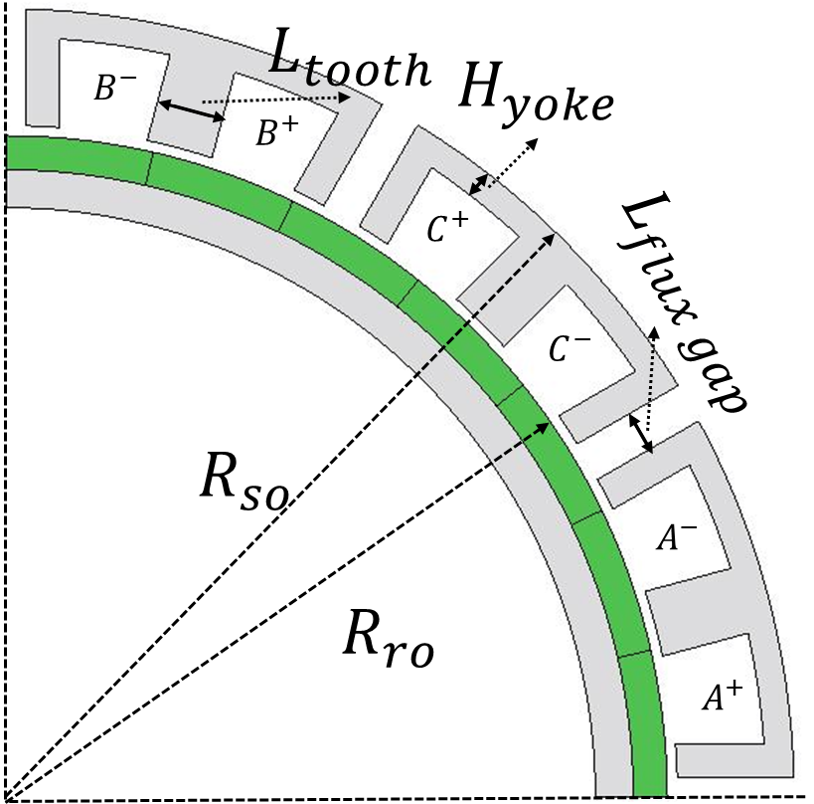 | 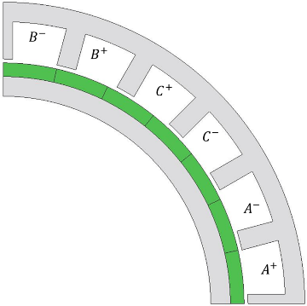
(a) Modular machine | (b) Non-modular machine
Fig. 2.1. Cross-sections of SPM machines.
It is worth noting that the initial specification has not been optimized. It only validates the effect of flux gaps on the electromagnetic performance of modular SPM machines as investigated in the literature. However, once the flux gap width is considered as a variable in the optimization process, the optimized dimensions of the modular machines will be very much different, as will be investigated in the following sections. In order to simplify the analyses in this chapter, the proposed optimization with flux gap width considered as variable is called method 1. However, the approach in existing literature that introduces the flux gaps after the non-modular machine is optimized will be called method 2.
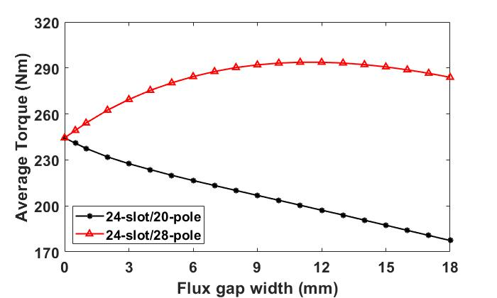
Fig. 2.2. Average torque vs flux gap width for 24-slot/20-pole and 24-slot/28-pole modular machines.

Optimization of the Modular Machine

Optimization Methods
For complex functions that are not differentiable, searching the optimal value is often quite difficult. Therefore, enlightened by genetics of living organisms and natural selection, GAs have been proposed. GAs consist of three main steps: reproduction, crossover and mutation [124]. The multiple iterations of these three steps to create diverse generations and populations can find the global optimal solution and avoid the local optimal solutions that are the limitations of some of other optimization methods.
In order to evaluate the performance of the candidate machines, a fitness function (F) should be introduced [125]. The fitness function for multiple objectives is derived as follows
$$F=1+ \sum_{i=1}^{n}{α_{i}f_{i}}$$ | (2.1)
where $α$ and $f$ are the weight and fitness function for different objectives, respectively. $n$ is the total number of objectives. The fitness function for each objective is derived as follows
$$f_{i}=\frac{χ_{i}-χ_{f}}{χ_{f}}$$ | (2.2)
where the $χ_{i}$ is the objective of the evaluated candidate case, $χ_{f}$ is the objective of the reference case.
It is worth noting that the weight of the primary objective should be larger than the sum of the weights of secondary objectives [126]. For the aerospace application considered in this research, the torque per mass is assumed to be the most important performance of the designed modular machine as higher torque/mass will reduce the fuel consumption. In addition, higher losses lead to higher temperature rise, which may cause overheating and unsafe operation condition. Therefore, minimizing losses particularly copper losses should also be regarded as important objectives for safety-critical applications. However, compared to torque/mass and losses, the cogging torque or torque ripple are relatively less important. Therefore, maximizing the average torque is regarded as the primary objective, which has a weight of 1. The weights for other secondary objectives such as minimum total machine mass, direct current (DC) copper loss and torque ripple are -0.4, -0.2, and -0.1, respectively. Therefore, it is worth noting that the optimal candidate will have the largest fitness function.
The ranges of variables chosen for the global optimization of the modular machines by GAs are shown in Table 2.2. In order to simplify the optimization, the slot fill factor and number of turns per slot are assumed to be constant while the slot area can be changed. In addition, due to the high price of rare earth materials, the volume of permanent magnets is also kept constant during the optimization process. This is the same for the stator outer diameter and the active length. Once the populations are generated by GA, the electromagnetic performance of the modular machine is simulated by FE models. As mentioned previously, the objectives of the global optimization are to search for the maximum average torque while the total machine mass, the copper loss and the torque ripple should be minimized.
Table 2.2 Initial values and Ranges of variables
 | Initial value | Range
Split ratio | 0.80 | [0.65, 0.85]
Stator tooth width (mm) | 10 | [5, 20]
Stator yoke thickness (mm) | 10 | [5, 20]
Rotor yoke thickness (mm) | 10 | [5, 20]
Flux gap width (mm) | 6.2 | [0.5, 12]
Magnet thickness (mm) | 7 | [8.75, 6.2]

Optimization for the 24-slot/28-pole SPM Machine.
In order to optimize the 6 variables shown in Table 2.2, 1397 cases are generated to find the global optimum. As the primary objective, the average torque is used as y-axis to derive the correlation curve with other three secondary objectives and the optimal case is calculated by the fitness function in (2.1) and (2.2), as shown in Fig. 2.3, where the optimal cases are highlighted. The comparison of variables between the initial design and the optimal design is shown in Table 2.3.
After the GA optimization, the average torque is increased by 16.1%. In addition, the total machine mass and torque ripple are reduced by 16.4% and 87.3%, respectively. Even though the copper loss is increased by 25.5%, the efficiency of the optimized modular machine is slightly increased from 95.3% to 95.4%, which benefits from the significant increase in output power. Therefore, significant improvement in electromagnetic performance can be achieved by the optimization. It has been found that the flux gap width needs to be increased for optimized electromagnetic performance. Furthermore, increasing stator yoke height and rotor thickness can also increase the average torque, but their impact diminishes when the value is large enough. It is worth noting that increasing the split ratio can increase the average torque and significantly reduce the total machine mass, while the disadvantage of doing so is the increased copper loss. However, the weight of copper loss (0.2) in the fitness function is much smaller than the sum of that of average torque (1) and total machine mass (0.4) due to specific requirements of aerospace application. Hence, the negative influence of increasing split ratio is little and its value can reach about 0.84 which is close to the top end of the split ratio range, i.e., [0.65, 0.85].
Table 2.3 Comparison between Original and Optimal Cases of 24-slot/28-pole Modular Machines
 | Original | Optimal | Difference (%)
Split ratio | 0.80 | 0.84 | 5.0
Stator tooth width (mm) | 10.0 | 13.2 | 32.0
Stator yoke thickness (mm) | 10.0 | 5.6 | -44.0
Rotor yoke thickness (mm) | 10.0 | 8.6 | -14.0
Flux gap width (mm) | 6.2 | 10.2 | 64.5
Magnet thickness (mm) | 7 | 6.6 | 5.1
Average torque (Nm) | 285.3 | 331.2 | 16.1
Torque ripple (%) | 31.4 | 4.0 | -87.3
Copper loss (W) | 761 | 956 | 25.5
Total machine mass (kg) | 37.3 | 31.2 | -16.4
Efficiency (%) | 95.3 | 95.4 | 0.1
Fitness function | 1 | 1.25 | 25

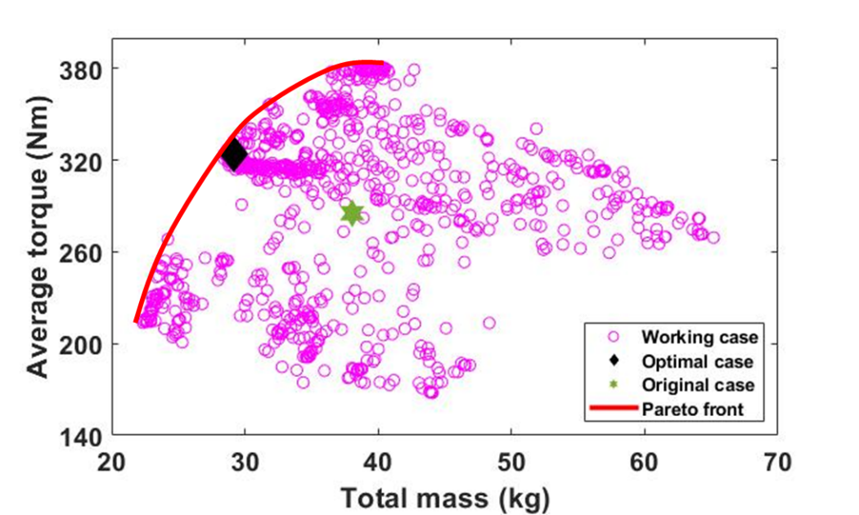
(a) Average torque vs total machine mass
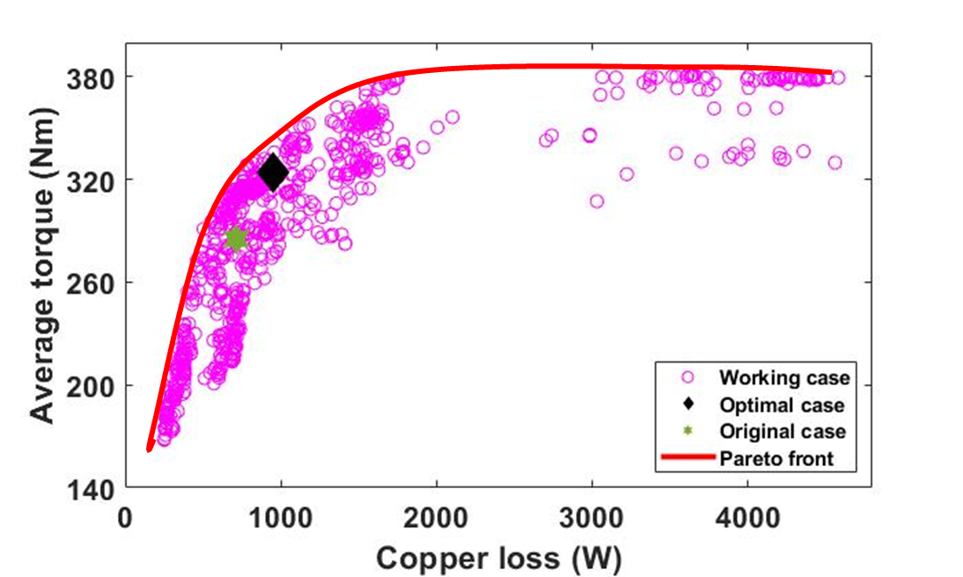
(b) Average torque vs copper loss
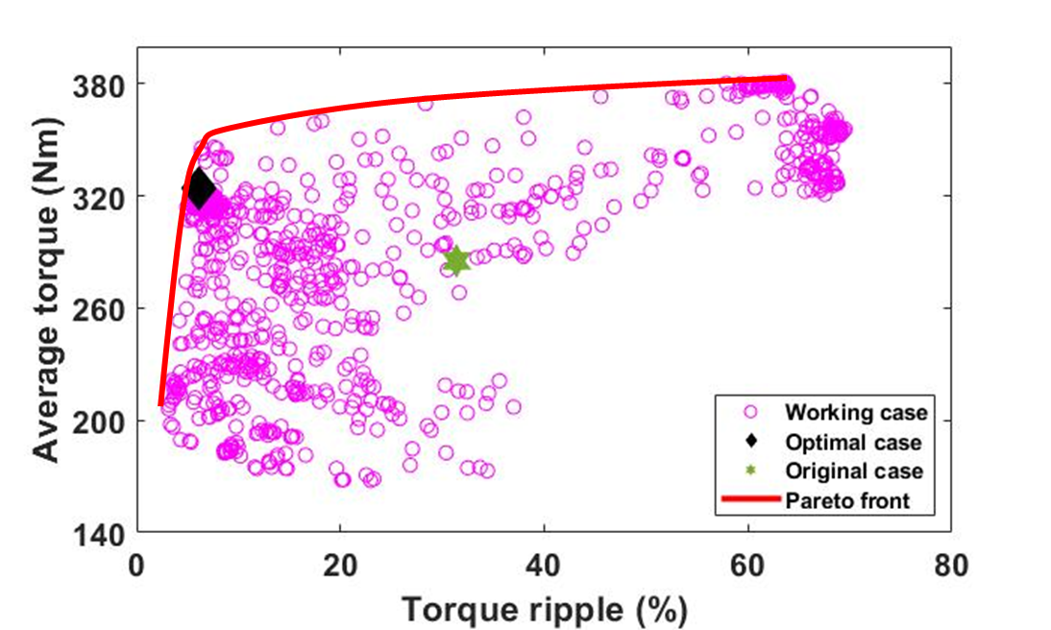
(c) Average torque vs torque ripple
Fig. 2.3. Average torque vs (a) total machine mass, (b) copper loss, and (c) torque ripple of 24-slot/28-pole modular machines.
In order to demonstrate the influence of flux gaps in the optimization process of SPM machines, the conventional non-modular SPM machine is also optimized by GA with the same objectives and constraints as the modular machines. There are 1320 cases generated by GA and the correlation curves are shown in Fig. 2.4, while the specifications of the optimized non-modular machine are listed in Table 2.4. It is worth noting that the optimal design chosen is far away from the Pareto front of the torque and torque ripple correlations because the weight (0.1) of the minimized torque ripple is smaller than the weights for other objectives. After the GA optimization, the average torque is increased by 19.7%, and the total machine mass and torque ripple are reduced by 15.8% and 56.3%, respectively. In addition, the efficiency of the optimized non-modular machine is increased by 0.9%.
Table 2.4 Comparison between Original and Optimal Cases of 24-slot/28-pole Non-modular Machines
 | Original | Optimal | Difference (%)
Split ratio | 0.80 | 0.83 | 3.8
Stator tooth width (mm) | 10.0 | 17.0 | 70.0
Stator yoke thickness (mm) | 10.0 | 5.1 | -49.0
Rotor yoke thickness (mm) | 10.0 | 7.0 | -30.0
Magnet thickness (mm) | 7 | 6.7 | 4.3
Average torque (Nm) | 244.4 | 292.6 | 19.7
Torque ripple (%) | 8.7 | 3.8 | -56.3
Copper loss (W) | 585 | 803 | 37.3
Total machine mass (kg) | 40.0 | 33.7 | -15.8
Efficiency (%) | 94.7 | 95.6 | 0.95
Fitness function | 0.95 | 1.13 | 18.9

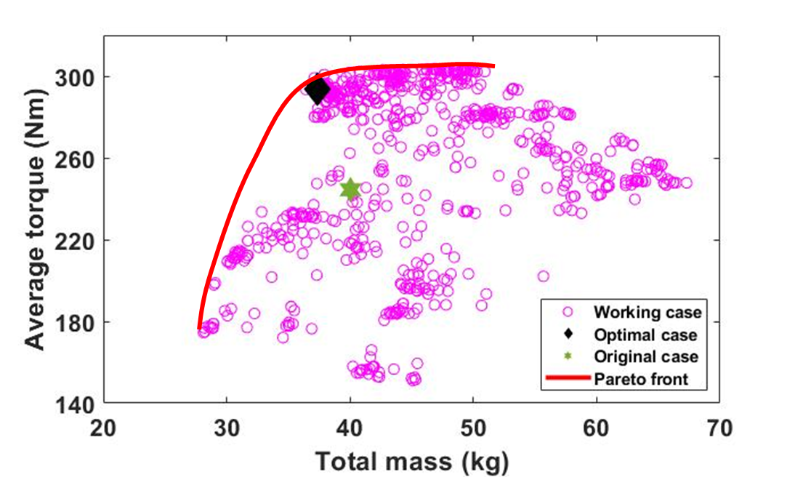
(a) Average torque vs total machine mass
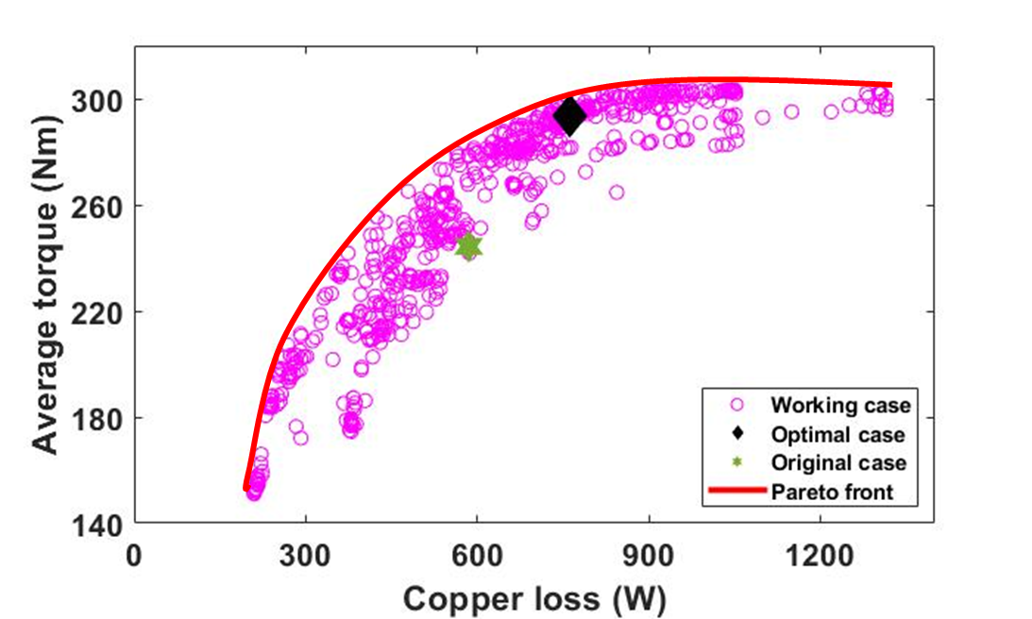
(b) Average torque vs copper loss
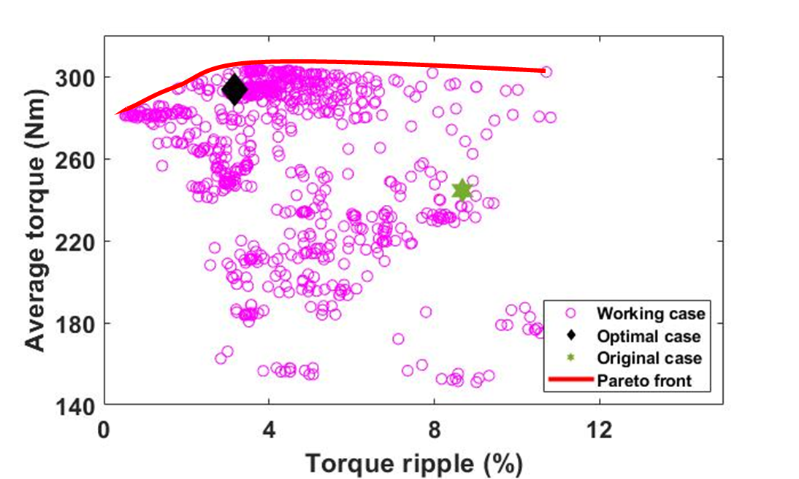
(c) Average torque vs torque ripple
Fig. 2.4. Average torque vs (a) total machine mass, (b) copper loss, and (c) torque ripple of 24-slot/28-pole non-modular machines.

Evaluation of Optimized 24-slot/28-pole SPM Machines
To demonstrate that it is necessary to consider the flux gap width as a variable during the optimization of modular machines (method 1), an optimization method in existing literatures (method 2) about modular machines will be used for comparison in this chapter. For method 2, the non-modular PM machines are optimized first, then a direct search method is used to find the optimal flux gap width.
Table 2.5 Comparison between Optimized Modular Machine Using Method 1 and Method 2
 | Method 1 | Method 2 | Difference (%)
Split ratio | 0.84 | 0.83 | 1.2
Stator tooth width (mm) | 13.2 | 17 | -22.4
Stator yoke thickness (mm) | 5.6 | 5.1 | 9.8
Rotor yoke thickness (mm) | 8.6 | 7.0 | 22.9
Flux gap width (mm) | 10.2 | 5.2 | 96.2
Magnet thickness (mm) | 6.6 | 6.7 | 1.6
Average torque (Nm) | 331.2 | 326.6 | 1.4
Torque ripple (%) | 4.0 | 9.0 | -55.6
Copper loss (W) | 955 | 931 | 2.6
Total machine mass (kg) | 31.2 | 32.5 | -4.0
Efficiency | 95.4 | 96 | 0.6
Fitness function | 1.25 | 1.22 | 2.5

The specifications of the optimized modular machine by different methods are listed in Table 2.5. It is found that although both optimization methods can improve the phase back-EMF, compared with the conventional optimization method (Method 2), the optimization that regards the flux gap width as variable (Method 1) is able to optimize further the machine electromagnetic performance. For example, the back-EMF (as shown in Fig. 2.5) and average torque are increased by 1.4%. In addition, the total machine mass and torque ripple are also reduced by 4% and 55.6%, respectively.
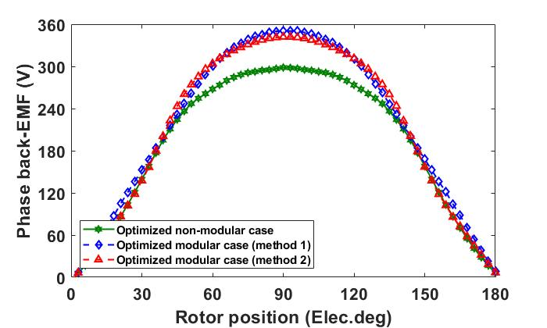
(a) Waveforms
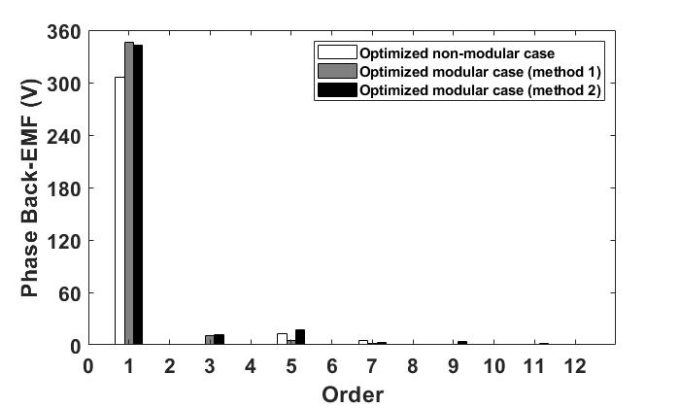
(b) Spectra
Fig. 2.5. Phase back-EMF comparison between method 1 and method 2.
Other performances such as cogging torque and open-circuit airgap flux density have also been compared, as shown in Fig. 2.6 and Fig. 2.7. It is found that by introducing the flux gaps, the cogging torque is increased even though the modular machines have been optimized using method 1 or method 2. This is mainly because minimizing cogging torque or torque ripple has not been chosen as the primary objective. The weight of cogging torque or torque ripple is insignificant for the aerospace application considered in this chapter. Therefore, the influence of torque ripple is less concerned than other objectives. However, for other applications where low torque ripple is a key requirement, the flux gap width should be paid more attention during the optimization process.
Regarding the open-circuit aigap flux density, the optimized modular machines are able to improve its working harmonic (14th, which is also the fundamental harmonic), as shown in Fig. 2.7 (b). This is consistent with the conclusion in previous research [2], [5]. Comparing the modular machines with different optimization methods, it is found that, when the optimization method proposed in this chapter (method 1) is implemented, the working harmonic is sligthly lower than the conventional optimization method (method 2). This is because the stator tooth widths with different optimization methods are quite different. However, since the flux gaps can increase even more the winding factor and also have flux focusing effect, the phase back-EMF of the modular machine, which is optimized by method 1, can still be higher than that of the modular machine optimized by method 2.
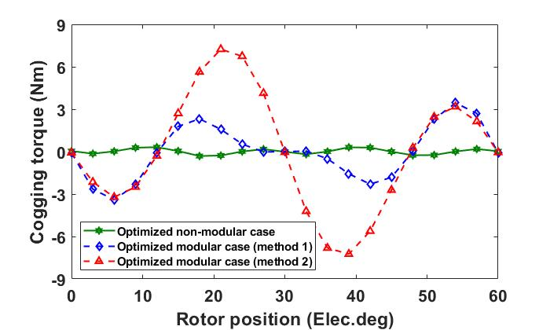
Fig. 2.6. Comparison of cogging torque of the 24-slot/28-pole SPM machines between different optimization methods.
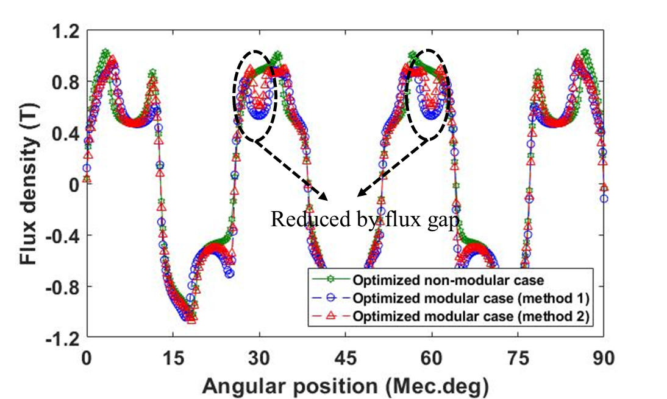
(a) Waveforms
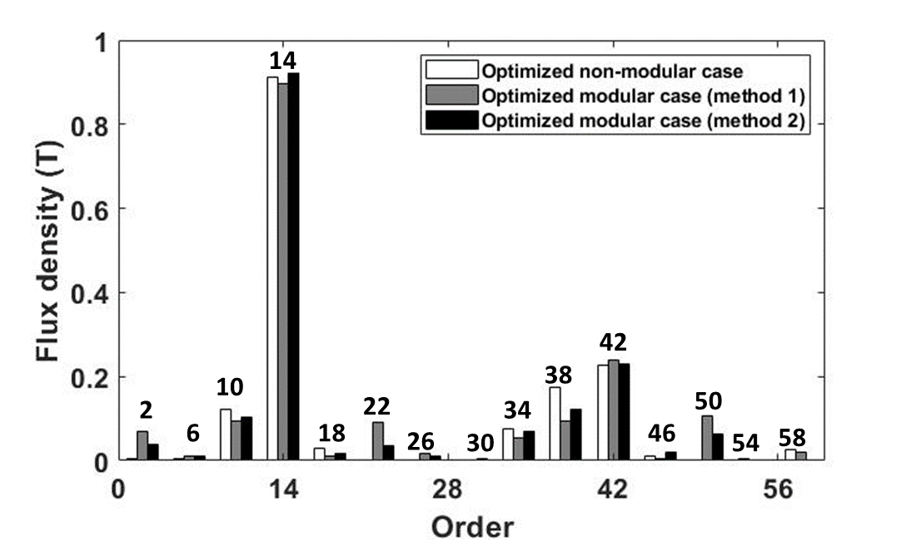
(b) Spectra
Fig. 2.7. Comparison of open-circuit radial airgap flux density between different optimization methods.
Different optimization processes will lead to change not only in torque and copper loss, but also in core iron losses and PM eddy current losses, as shown in Fig. 2.8. Compared with the optimized non-modular machine, the modular machine optimized by method 2, although having the same stator/rotor yoke thickness, stator tooth width and split ratio, can achieve reduced PM eddy current loss. This is because the introduced flux gaps can reduce the flux density variation in PMs. However, the high airgap flux density and hence high stator core flux density of the modular machine leads to higher core iron losses. Together with higher copper loss, the total losses of the modular machine optimized by method 2 can be higher than the non-modular machine. Similarly, the modular machine optimized by method 1 has higher torque and output power than the modular machine optimized by method 2, but it also has higher PM eddy current loss and core iron losses. Therefore, the modular machine optimized by method 1 slightly reduces the efficiency from 96% to 95.4%, as shown in Table 2.5.
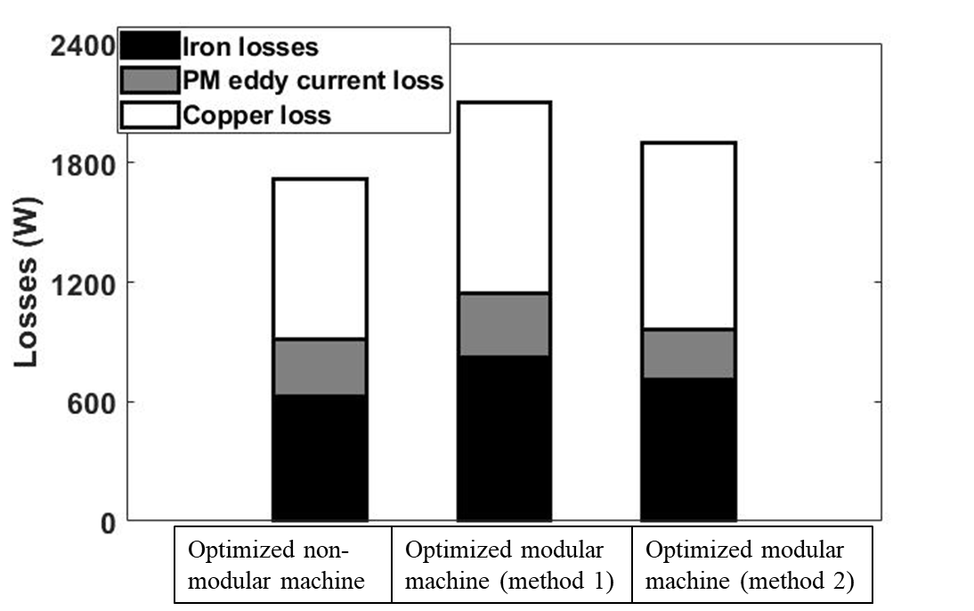
Fig. 2.8. Comparison of losses between optimized non-modular machine and modular machines with different optimization methods.
In addition to previously investigated static performances, the dynamic performances including the torque speed curve and efficiency map have also been compared between non-modular and modular machines optimized by different optimization methods.
The EM behaviour of PM machines is governed by the stator voltage equations. In synchronous reference frame, they can be written as,
$$V_{d}=Ri_{d}+L_{d}\frac{di_{d}}{dt}-ω_{e}L_{q}i_{q}$$ | (2.3)
$$V_{q}=Ri_{q}+L_{q}\frac{di_{q}}{dt}+ω_{e}L_{d}i_{d}+ψ_{m}ω_{e}$$ | (2.4)
where $V$, $i$, $ω_{e}$, $L$, $R$, $ψ_{m}$ denote the voltage, current, rotor electrical speed, inductance, armature resistance, and no-load flux linkage, respectively. The subscripts d and q represent the direct- and quadrature-axis components.
For surface-mounted PM machines, it is assumed that $L_{d}=L_{q}=L_{s}$, where $L_{s}$ is the synchronous inductance. As a result, the EM torque ($T_{em}$) and output power ($P_{out}$) can be derived as
$$T_{em}=\frac{3}{2}pψ_{m}i_{q}$$ | (2.5)
$$P_{out}=T_{em}ω_{m}$$ | (2.6)
where $ω_{m}$=$ω_{e}$⁄p is the rotor mechanical speed.
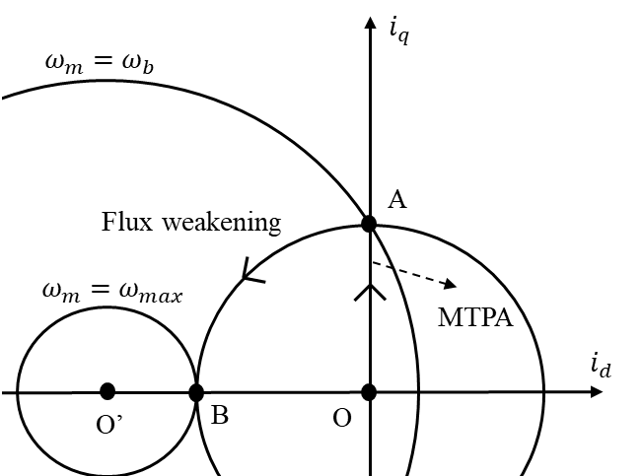
(a) finite maximum speed
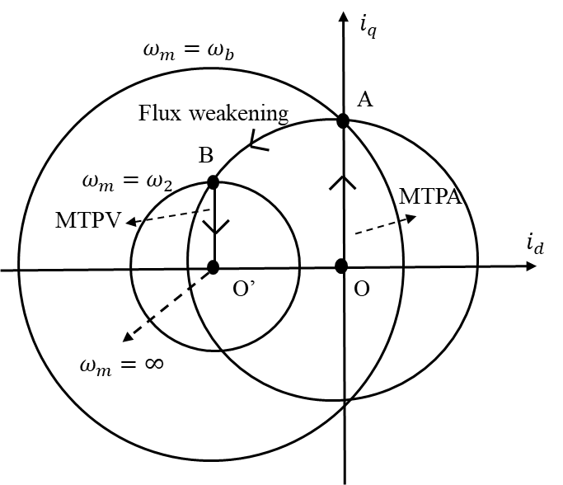
(b) infinite maximum speed.
Fig. 2.9. Optimal current trajectory for SPM machines.
If the rated phase current ($i_{s}$) and the DC-link voltage (${\sqrt{3}V}_{s}$) for standard space vector pulse width modulation (SVPWM) control (i.e., circular track modulation) are given, the torque speed curve of PM machines can be calculated using equations from (2.3) to (2.5). It is worth noting that, valid operating points of SPM machines should meet the constraints of current and voltage as
$$V_{d}^{2}+V_{q}^{2}≤V_{s}^{2}$$ | (2.7)
$$i_{d}^{2}+i_{q}^{2}≤i_{s}^{2}$$ | (2.8)
Furthermore, if the phase resistance is neglected,
$${\left(\frac{ψ_{m}}{L_{s}}+i_{d}\right)}^{2}+I_{q}^{2}≤{\left(\frac{V_{s}}{ω_{e}L_{s}}\right)}^{2}$$ | (2.9)
If $\frac{ψ_{m}}{L_{s}}≥i_{s}$, the optimal current trajectory is shown in Fig. 2.9 (a). The machines can reach a finite maximum speed.
At the first stage (from point O to point A), the machine operates under maximum torque per ampere (MTPA) control. Before the machine speed reaches the base speed ($ω_{b}$), the load condition is given by
$$\left\{\begin{aligned}ω_{b}=V_{s}/\left(p\sqrt{ψ_{m}^{2}+{\left(L_{s}i_{s}\right)}^{2}}\right) \\ i_{d}=0 \\ i_{q}=i_{s} \end{aligned}\right.$$ | (2.10)
At the second stage (from point A to point B), the machine operates under flux-weakening control, the load condition is given by
$$\left\{\begin{aligned}ω_{b}<ω_{m}<ω_{max} \\ i_{d}=\frac{1}{2}\frac{L_{s}}{ψ_{m}}\left({\left(\frac{V_{s}}{ω_{e}L_{s}}\right)}^{2}-{\left(\frac{ψ_{m}}{L_{s}}\right)}^{2}-i_{s}^{2}\right) \\ i_{q}=\sqrt{i_{s}^{2}-i_{d}^{2}} \end{aligned}\right.$$ | (2.11)
The maximum speed at point B is
$$ω_{max}=V_{s}/\left[p\left(ψ_{m}-L_{s}i_{s}\right)\right]$$ | (2.12)
If $\frac{ψ_{m}}{L_{s}}<i_{s}$, the optimal current trajectory is shown in Fig. 2.9 (b). The machines can reach an infinite maximum speed. The condition at second stage is the same as (2.11). However, different from the machines that have $\frac{ψ_{m}}{L_{s}}≥i_{s}$, the condition at point B is
$$\left\{\begin{aligned}i_{d}=-\frac{ψ_{m}}{L_{s}} \\ i_{q}= \sqrt{i_{s}^{2}-{\left(\frac{ψ_{m}}{L_{s}}\right)}^{2}} \\ ω_{2}=\frac{V_{s}}{\sqrt{{\left(L_{s}i_{m}\right)}^{2}-ψ_{m}^{2}}} \end{aligned}\right.$$ | (2.13)
At the third stage (from point B to point O’), the machine also operates under flux-weakening control, but the load condition is given by
$$\left\{\begin{aligned}ω_{2}<ω_{m} \\ i_{d}=-\frac{ψ_{m}}{L_{s}} \\ i_{q}=\frac{V_{s}}{ω_{e}L_{s}}\end{aligned}\right.$$ | (2.14)
After the optimization, the stator modularity is also found to be able to improve the average torque during constant torque region as shown in Fig. 2.10. However, due to the higher phase flux linkage, both investigated modular machines have worsened performance during flux weakening operation, i.e., lower average torque and lower maximum speed. In addition, compared with the conventional optimization method (method 2), the optimization method 1, which considers the flux gap width as variable, can achieve slightly higher average torque at constant torque region but lower maximum speed at flux weakening region.
The EM performance is simulated by 2D FEM. This is accurate enough for calculating performances such as flux linkage, phase back-EMF, on-load torque, and stator and rotor core iron losses. However, during the calculation of PM eddy current losses, the axial and circumferential eddy currents at PM end region are excluded for the calculation of 2D FEM. Therefore, in order to have precise PM eddy current loss results, a 3D/2D correction factor (
$F_{3d/2d}$) has been introduced as [127]
$$F_{3d/2d}=\frac{3}{4}∙\frac{L^{2}}{w^{2}+L^{2}}$$ | (2.15)
where $L$ and $w$ denote the PM axial length and thickness, respectively.
Using the previously calculated iron losses ($P_{i}$) and PM eddy current loss ($P_{m}$) together with the copper loss ($P_{c}$), the efficiency ($η$) can be calculated by
$$η=\frac{P_{out}}{P_{out}+P_{i}+P_{m}+P_{c}}$$ | (2.16)
Due to slightly higher copper loss, iron losses and PM eddy current loss, as shown in Fig. 2.11, the modular machine optimized by method 1 will have slightly reduced efficiency under most operation conditions as shown in Fig. 2.12. This is due to the fact that the main objective of the global optimization is to improve the average torque (weight in the fitness function is 1) and to reduce machine total mass (weight in the fitness function is 0.4). However, reducing the loss (weight in the fitness function is only 0.2) has been considered as a secondary objective, just like the torque ripple (weight in the fitness function is only 0.1).
According to (2.3) to (2.14), the torque speed curve can be calculated for all SPM machines if their PM linkages and inductances are known. Moreover, the losses at each operation point are calculated according to the FE modelling and correction factor in (2.15). Therefore, the efficiency maps of the machines have also been calculated.
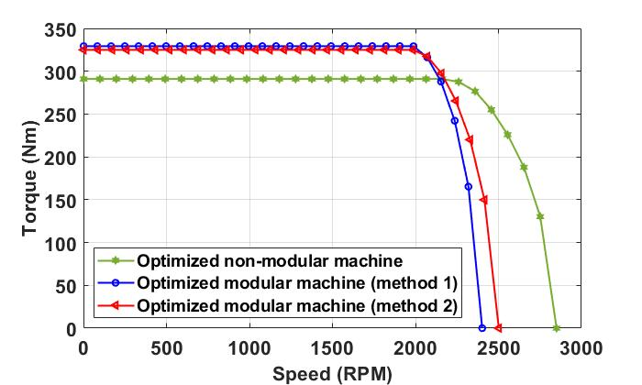
Fig. 2.10. Comparison of torque speed curves between optimized non-modular machine and modular machines with different optimization methods.
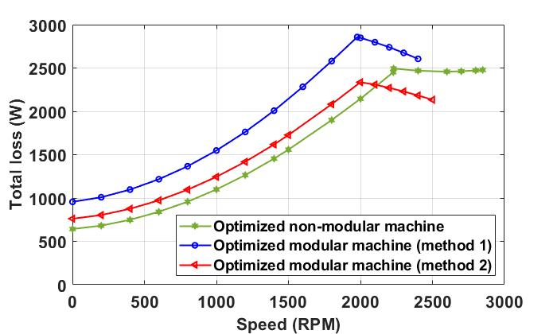
Fig. 2.11. Comparison of losses-speed curves between optimized non-modular machine and modular machines with different optimization methods.
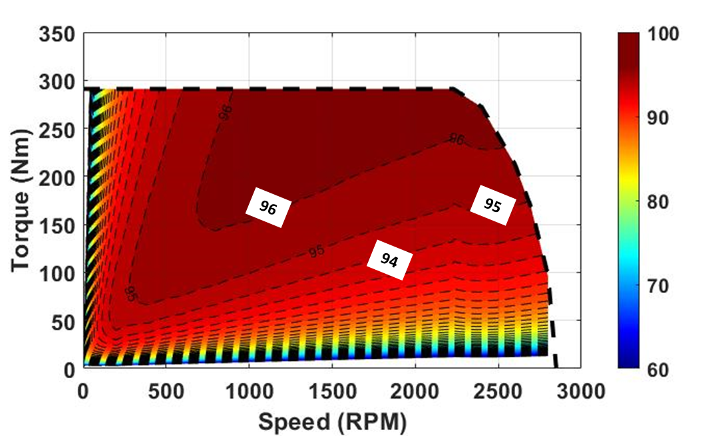
(a) Optimized non-modular machine
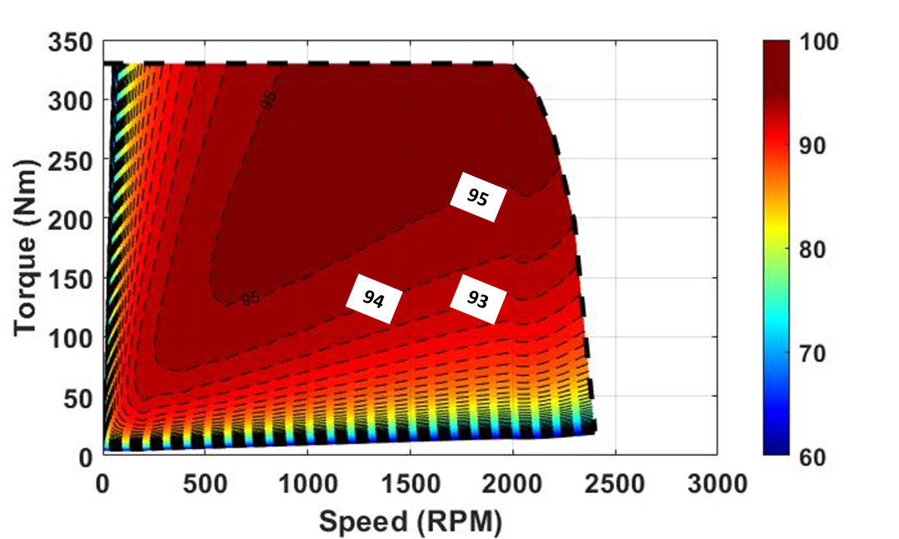
(b) Optimized modular machines by method 1
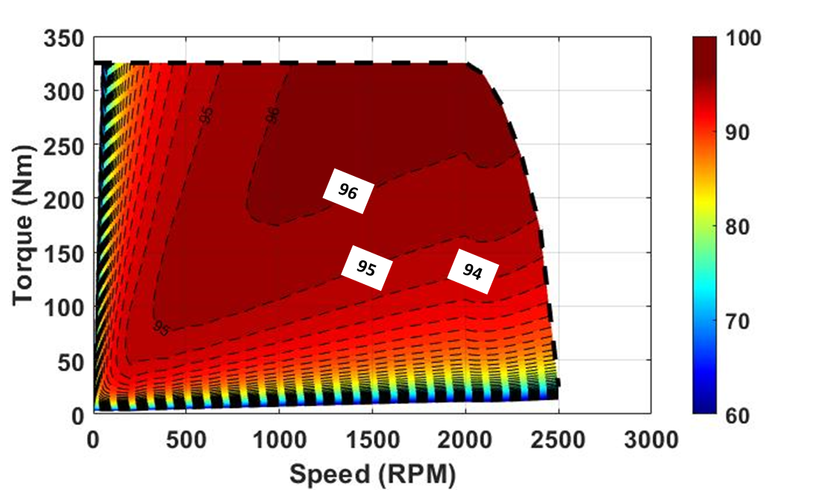
(c) Optimized modular machines by method 2
Fig. 2.12. Efficiency maps.

Optimization for the 24-slot/20-pole SPM Machine.
For comparison purpose, the same optimization process (method 1) is implemented for the 24-slot/20-pole modular and non-modular machines. The optimized machine parameters are listed in Table 2.6. It is worth noting that considering the feasible mesh size in the flux gap region, the minimum flux gap width chosen for the optimization process is 0.5mm, which is exactly the same as the optimized flux gap width for the 24-slot/20-pole modular machine. The results have shown that by introducing the flux gaps, the fitness function will always reduce regardless of the flux gap width, this is the same for the primary objective, i.e., average torque. Therefore, this means that for the 24-slot/20-pole machine, the flux gaps should not be introduced to avoid deteriorating its performance.
Table 2.6 Comparison between Optimized 24-slot/20-pole Modular and Non-Modular Machines
 | Modular | Non-modular | Difference (%)
Split ratio | 0.81 | 0.81 | 0
Stator tooth width (mm) | 16.4 | 16.6 | 1.2
Stator yoke thickness (mm) | 6.2 | 6.7 | 7.4
Rotor yoke thickness (mm) | 9.2 | 8.9 | 3.4
Flux gap width (mm) | 0.5 | - | -
Average torque (Nm) | 280.1 | 287.2 | 2.4
Torque ripple (%) | 6.5 | 8.4 | 22.6
Copper loss (W) | 739 | 756 | 2.2
Total machine mass (kg) | 38.6 | 39.2 | 1.5
Efficiency | 95.3 | 94.4 | -0.95
Fitness function | 1.05 | 1.06 | 0.9

Influence of FG width
For the 24-slot/28-pole modular machine, the influence of flux gap width on average torque, torque ripple, open-circuit airgap flux density and phase back-EMF is further evaluated, as shown in Fig. 2.13 and Fig. 2.14. It is found that if the flux gap width is lower than optimal value, i.e., 10.2mm, the average torque increases with increased flux gap width due to the improved pitch factor, the reduced effective air-gap length and the flux focusing effect. When the flux gap width is larger than 10.2mm, the average torque reduces if flux gap width further increases.
When it comes to the torque ripple, the influence of flux gaps is even more pronounced. It is interesting to see that when the average torque is maximized, the torque ripple [${\left(T_{max}-T_{min}\right)}/{T_{av}}$, where $T_{max}$ is the maximum torque, $T_{min}$ is the minimum torque and $T_{av}$ is the average torque for one electrical period] is almost minimized. This means that both maximized average torque and minimized torque ripple can be achieved simultaneously if an optimal flux gap width is used, which shows the superior performance of modular machines with flux gaps.
Same as the average torque, the maximum value of phase back-EMF is achieved when the optimal flux gap width (10.2mm) is used. However, the optimal flux gap width (12.5mm) for achieving maximized fundamental component of open circuit airgap flux density is slightly different from 10.2mm. This is mainly because the flux gaps do not only have effect on open-circuit airgap flux density, but also have effect on pitch factor (or winding factor) and flux focusing. These different effects lead to different optimal flux gap widths for maximum airgap flux density and average torque.
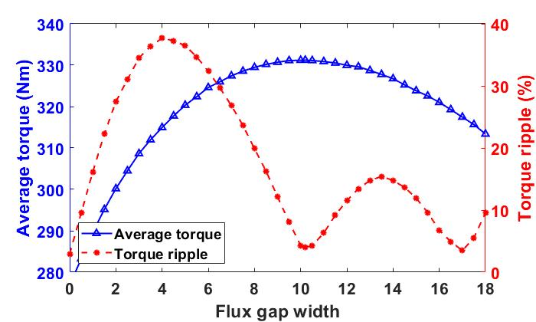
Fig. 2.13. Average torque and torque ripple vs flux gap width for the 24-slot/28-pole modular SPM machine.
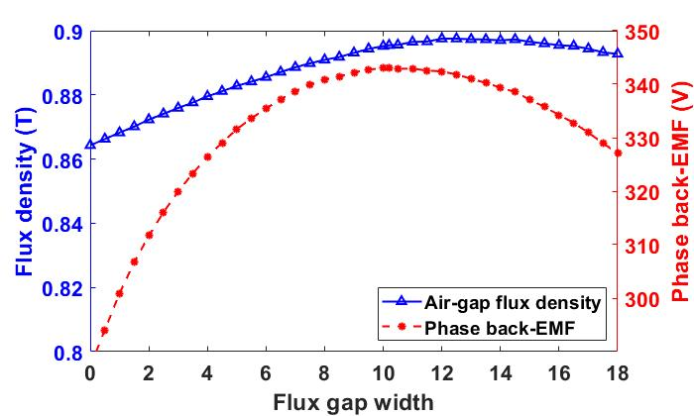
Fig. 2.14. Fundamental open-circuit airgap flux density (radial component) and fundamental phase back-EMF vs flux gap width for the 24-slot/28-pole modular SPM machine.

Experimental Validation
A prototype of modular machine with 12-slot/14-pole (optimized by method 2, which is the conventional optimization method that does not include the FG width as a variable during the optimization) investigated and tested in [38] has been used to validate the FE predictions in this chapter. It is worth noting that, the slot and pole numbers for the prototype are half of the investigated machines in Chapter 2. The EM performances for the tested machine and investigated machines are similar. The cross-section of this machine is shown in Fig. 2.15 (b). The specifications of the prototype are shown in Table 2.7. Compared with the optimization by method 2, the optimization by method 1, that adopted GA for global optimization, does not significantly change the machine structure and dimensions. Therefore, a prototype of modular machine optimized by method 1 is deemed unnecessary and has not been built for this study.
Table 2.7 Parameters of Prototype Modular SPM Machine [38]
Slot number | 12 | Airgap length (mm) | 1
Pole number | 14 | Rotor outer radius (mm) | 27.5
Stator outer radius (mm) | 50 | Magnet thickness (mm) | 3
Stator inner radius (mm) | 28.5 | Stack length (mm) | 50
Stator yoke height (mm) | 3.7 | Rated phase current ($A_{peak}$) | 10.38
Tooth width (mm) | 7.1 | Number of turns per coil | 132
Flux gap width (mm) | 2 | Rate speed (rpm) | 400

After the optimization by method 1, a new topology of modular machine has been achieved, as shown in Fig. 2.15 (a). Similar to the modular machine optimized by method 2 in [38], both maximized torque (weight in the fitness function is 1) and minimized copper loss (weight in the fitness function is 0.5) have been selected as primary objectives in the optimization by method 1. The variables are shown in Table 2.8. After the optimization, the copper loss is increased by 2%, i.e., from $77.3 W$ to $78.9 W$ and the average torque is increase by 5.3%, i.e., from $5.6 Nm$ to $5.9 Nm$. Thereby, the fitness function is improved by 4% by considering the flux gap width as a variable during the optimization. Similar level of improvement in average performance can also be achieved when the copper loss is maintained constant and the same during both optimization processes. For example, when the copper loss is $77.3 W$, the modular machine optimized by method 1 can still produce an average torque 3.6% higher than that produced by the modular machine optimized by the method 2.
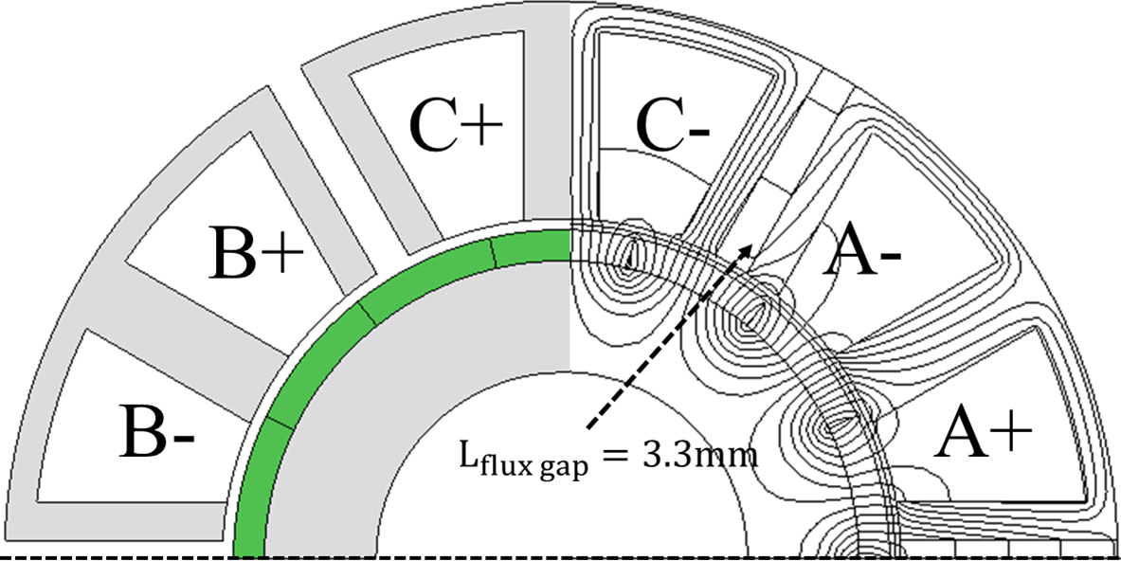
(a) Method 1
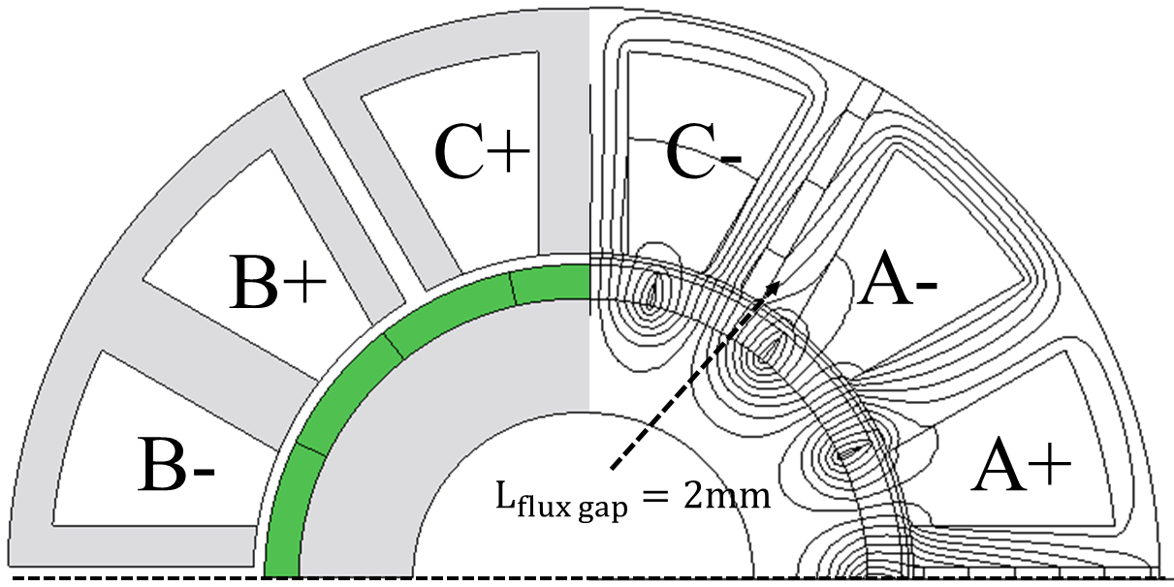
(b) Method 2
Fig. 2.15. Cross-sections of 12-slot/14-pole modular machines optimized by different methods.
Table 2.8 Comparison between Optimized Prototype Modular Machines by Method 1 and Method 2
 | Method 1 | Method 2 | Difference (%)
Split ratio | 0.59 | 0.55 | 7.3
Stator tooth width (mm) | 6.9 | 7.1 | -2.8
Stator yoke thickness (mm) | 2.6 | 3.7 | -29.7
Magnet thickness (mm) | 2.77 | 3 | -7.7
Flux gap width (mm) | 3.3 | 2 | 65
Average torque (Nm) | 5.9 | 5.6 | 5.3
Copper loss (W) | 78.9 | 77.3 | 2.1
Fitness function | 1.04 | 1 | 4

Phase Back EMF
The predicted waveforms and spectra of phase back-EMFs for the modular machine with different optimization methods and the measured back-EMF obtained based on the modular machine optimized by method 2 are shown in Fig. 2.16. The rotor is rotating at rated speed, i.e., 400rpm. A good agreement can be observed between the predicted and measured results for the modular machine optimized by method 2, which proves the accuracy of the FE modelling adopted in this chapter. In addition, as expected, the back-EMF of the modular machine optimized by method 1 is higher than that of the modular machine optimized by method 2.
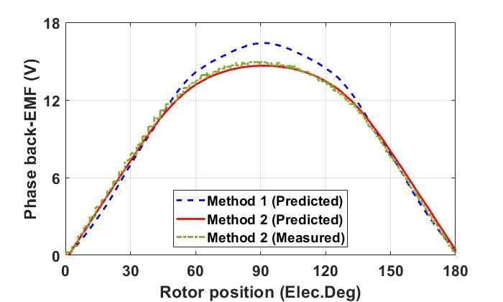
(a) Waveforms
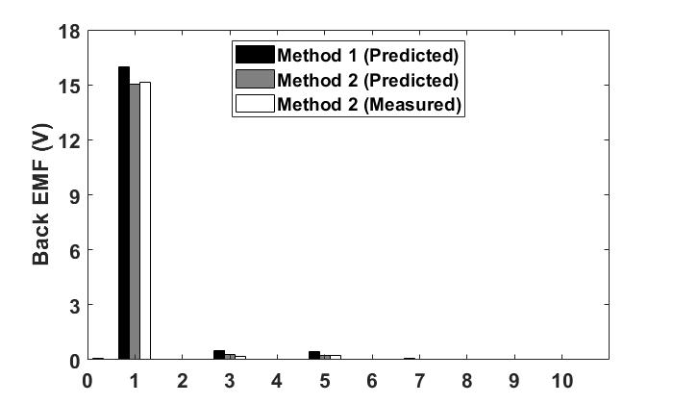
(b) Spectra
Fig. 2.16. Back-EMFs of the modular machines optimized by method 1 (predicted) and method 2 (predicted and measured).

Cogging Torque
The cogging torques of the modular machines optimized using both method 1 and method 2 have been calculated using 2D FEA, as shown in Fig. 2.17. It is found that the modular machines with different optimization methods can achieve almost the same cogging torque. The simulated results have also been compared against the measured results of the modular machine optimized using the method 2 in [38]. It is worth noting that the cogging torque has been measured by the method proposed in [128]. A generally good match can be observed between FE and measured cogging torques for the modular machine optimized by method 2. The discrepancy could result from the manufacturing tolerance and end-effect that have not been considered in the 2D FE models.
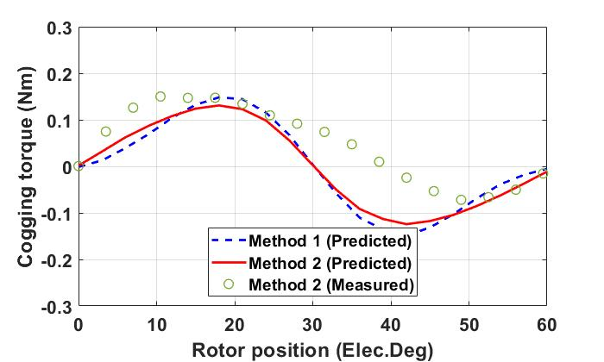
Fig. 2.17. Cogging torques of the modular machines optimized by method 1 (predicted) and method 2 (predicted and measured).

Static Torque
The static torques have also been calculated using 2D FE models for the modular machines optimized using the method 1 and method 2, as shown Fig. 2.18. Again, the simulated results of the modular machine optimized with the method 2 has been compared against the test results in [38]. It is worth noting that during the simulations and tests, the machines are supplied by 3-phase currents in such a way that $I_{a}=I$ and $I_{b}=I_{c}=-\frac{1}{2}I$, where $I$ is dc current and its amplitude can be changed to simulate for different load conditions. In addition, the rotor position is at q-axis, simulating the maximum torque per ampere (MTPA) control. As expected, higher static torque can be found for the modular machine optimized by method 1. However, it is also found that the increase in static torque is slightly lower than that in fundamental phase back-EMF, as shown in Fig. 2.16 (b). This is mainly because the measurement of static torque using the method proposed in [128] also considered the effect of cogging torque. Therefore, unlike the average torque, the static torque does not have a linear relationship with the fundamental phase back-EMF.
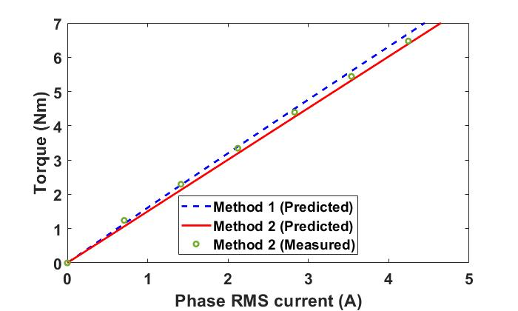
Fig. 2.18. Torque versus rotor position for the original and optimal modular machine.

Conclusion
Global optimization based on genetic algorithm (GA) is introduced in this chapter to optimize the modular machines with the flux gap width being considered as a variable. Compared with the existing approach, which introduces the flux gaps after the non-modular machine is optimized, the proposed method can achieve even better performances for the optimized modular machines. Compared with the conventional optimization method (method 2 in this chapter), the proposed optimization method (method 1 which considers the flux gap width as variable) can increase the average torque by 1.4% while reducing the total machine mass and torque ripple by 4% and 55.6%, respectively. In addition, the efficiency of the modular machine has not been significantly reduced by the optimization method.
Based on the optimized results, it is found that for machines having lower slot number than pole number, e.g., 24-slot/28-pole, due to the influence on winding factor, effective airgap length and flux focusing effect, the flux gap widths generally improve the working harmonic in open-circuit airgap flux density, the fundamental back-EMF and the average torque. However, for machines with higher slot number than pole number, e.g., 24-slot/20-pole, the optimization algorithm points towards the fact that no flux gaps lead to better electromagnetic performance.
Test results published in [38] such as phase back-EMF, cogging torque and static torque of a small scale modular machine optimized using method 2 have been used to validate the 2D FE simulations in this chapter. Generally good agreement between the measured results and FE predicted results can be observed, proving the accuracy of the adopted FE modelling. The findings also show that regardless of the machine power ratings, considering the flux gap width as a variable in the optimization process (method 1) can further improve machine torque performance.

Coupled EM-thermal Modelling for Modular SPM Machines
The static and dynamic EM performances for an optimized modular machine have been proposed in Chapter 2. However, these analyses did not consider the EM-thermal coupling, which could lead to overestimation of machine performances. This chapter presents a coupled EM-thermal modelling of the dynamic performances such as torque speed curve and the efficiency map for surface-mounted permanent magnet machines. One important feature of such model is that it considers the demagnetization caused by magnet temperature rise at different rotor speeds. EM-only simulations such as in Chapter 2, which often assume that the machines operate under constant temperature, have been widely used in the literature. However, the interaction between EM and thermal performances could lead to very different dynamic performance prediction. This is because the material properties, e.g., magnet remanence, coercivity and copper resistivity are temperature-dependent. The temperature rise within electrical machines reduces torque/power density, PM eddy current losses, iron losses but increases copper loss. Therefore, the coupled EM-thermal modelling is essential to determine accurate temperature variation and also to obtain accurate EM performances of electrical machines. In this chapter, the coupled EM-thermal modelling is implemented for both the modular and non-modular machines to reveal the advantages of the modular machine under different operating conditions. The results show that the modular machine generally has better dynamic performance than the non-modular machine due to the fact that the introduced flux gaps in alternate stator teeth can boost both EM and thermal performances.
The coupled EM-thermal modelling is also used to investigate magnet demagnetization characteristics of the modular permanent magnet machine in this chapter. The influence of flux gaps on magnet flux density, losses distribution, torque and demagnetization are analysed for different operating conditions. The magnet demagnetizations caused by three sources such as the PM field, the armature field and the magnet temperature rise are individually investigated using frozen permeability method. For comparison propose, the EM performances with a particular focus on the demagnetization withstand capability for both the modular and non-modular machines are investigated based on the EM-thermal coupling. It is found that, compared to the non-modular machine, the modular machine can achieve higher torque, higher efficiency and better demagnetization withstand capability.
Publications related to this chapters are listed below:
1. W. Zhang, G. J. Li, Z. Q. Zhu, B. Ren, and M. Michon, "Coupled Electromagnetic-Thermal Modelling of Dynamic Performance for Modular SPM Machines." Energies, vol. 16, no. 6, p2516, 2023.
2. W. Zhang, G. J. Li, Z.Q. Zhu, B. Ren, Y. C. Chong, and M. Michon, "Demagnetization Analysis of Modular SPM Machine Based on Coupled Electromagnetic-Thermal Modelling," Energies, vol. 16, no. 1, p. 131, 2022.

Introduction
Thanks to their intrinsic advantages such as high torque and power density, high efficiency, good demagnetization withstands capability and fault tolerant capability, modular SPM machines have been attracting increasing interest in the past decade. These advantages are because the FGs in alternate stator teeth can improve the winding factor (more precisely, pitch factor) and open-circuit airgap flux density and they also have a flux focusing effect [38, 42, 43]. It is worth noting that, these threefold effects are true for the modular machines with pole number (2p) larger than slot number (Ns). By contrast, for the modular machines with 2p < Ns, the introduced flux gaps will reduce the winding factor and also have a flux defocusing effect, which lead to reduced average torque [42].
Although several prior work has already been conducted to show the superior electromagnetic (EM) performances for the modular machines, little research is aimed at the coupled EM-thermal modelling of their dynamic performances [129]. For variable speed high torque/power density application, the coupled EM-thermal modelling is particularly important for accurately predicting machine dynamic performance under different operating conditions. This is mainly because when machine temperature increases, magnet remanent flux density reduces, leading to reduced magnetic loading and hence reduced output torque/power [130]. To maintain the same level of output torque, the phase current (electrical loading) often needs to be increased to compensate the reduced magnetic loading. Together with the increased copper resistivity due to temperature rise, the copper loss can be significantly increased [131]. This might lead to reduced machine efficiency. In addition, as a main heat source, the increased copper loss will lead to further temperature rise and also further reduced magnet remanent flux density [132, 133]. Without coupled EM-thermal modelling, this mutual effect between thermal performance and EM performance cannot be accurately predicted [133]. Therefore, in order to reveal the full potential of the modular machines, the coupled EM-thermal models are proposed in this paper to investigate their dynamic performances and compare against the conventional non-modular machines. The flowchart depicts the coupled EM-thermal analysis is shown in Fig. 3.1. The machine specifications shown in Table 3.1 and also the initial temperature is used to calculate the initial EM performance such as the torque and losses. The losses are then adopted as the input in the 3D lumped parameter thermal network for the thermal analysis. The obtained temperature can be used for updating the magnet properties [based on the temperature dependent B(H) curves] and coil resistance for each iteration. When the temperature difference ($∆T$) is lower than the convergence error ($ε_{error}$), the final temperature distribution and EM performance can be obtained.
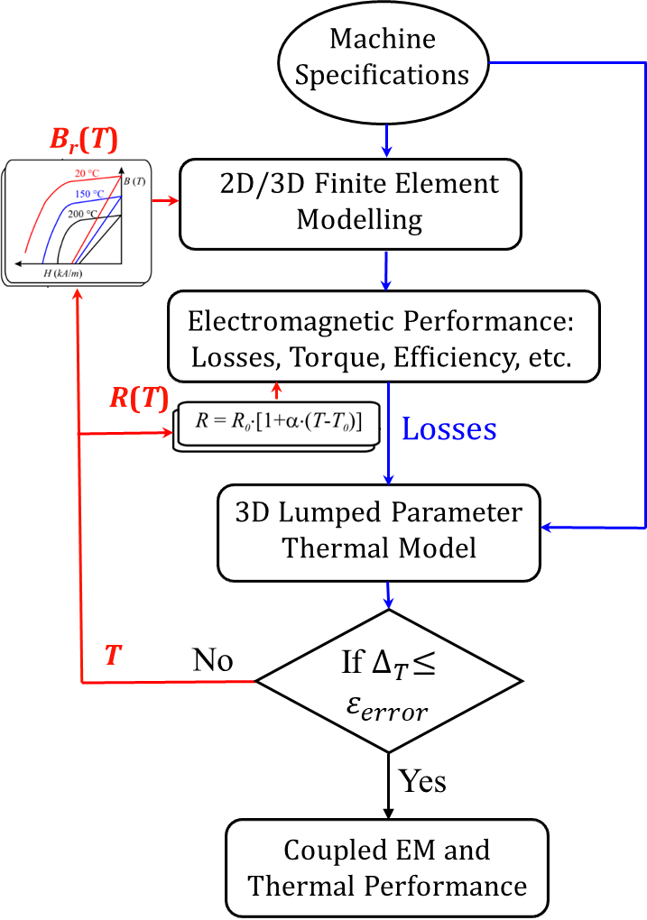
Fig. 3.1. Flowchart of the coupled EM-thermal modelling. T, $B_{r}$, $R$, $ε_{error}$ are the temperature, magnet remanence, phase resistance and convergence error, respectively.
Table 3.1 Parameters of Modular SPM Machine
Slot number | 24 | Rotor outer radius (mm) | 129.4
Pole number | 28 | Rotor yoke thickness (mm) | 8.6
Stator outer radius (mm) | 154 | Stack length (mm) | 210
Stator yoke height (mm) | 5.6 | DC voltage (V) | 800
Tooth width (mm) | 13.2 | Rated phase current ($A_{peak}$) | 100
Flux gap width (mm) | 10 | Number of turns per coil | 10
Airgap length (mm) | 2 | Rate speed (rpm) | 1500
Magnet thickness (mm) | 6.6

The comparison of dynamic performances between modular machine and conventional non-modular machine reveals the advantages of introducing FGs in alternate stator teeth. The different dynamic performances considering the influence of temperature variation are mainly due to the different demagnetization characteristics. In this chapter, machines' demagnetization characteristics, such as magnet flux density distributions at different operating temperatures, for both the investigated machines, will be studied. They can reveal the full potential of the modular machine in improving the machine demagnetization withstand capability. Besides that, the machine EM performances, including PM eddy current loss, stator/rotor iron losses and torque, are significantly affected by the demagnetization. This will also be investigated based on the coupled EM-thermal modelling.

Dynamic EM Performances of the Modular Machine
The dynamic performances such as torque speed curve and efficiency map are critical for variable speed applications such as electrical vehicles, more electrical aircraft and so on. However, in the literature, many papers focused on the dynamic performance without considering the EM-thermal coupling. As the conclusion drawn in section 3.1, this might not be able to predict the real dynamic performance as the temperature rise within electrical machines has significant impact on magnet demagnetization, phase resistance, etc. For the same phase current, the temperature rise could lead to increased copper loss, reduced average torque, reduced stator and rotor core iron losses, and hence has a significant impact on machine dynamic performance such as torque-speed curve and efficiency map. In this section, the modelling with and without considering the EM-thermal coupling has been carried out for the modular SPM machines to reveal the influence of temperature rise on their dynamic performance. For comparison purposes, a conventional non-modular SPM machine, with same parameters as the modular machine as listed in Table 3.1, is implemented as counterpart in this chapter. The only different is that the FGs are not introduced for non-modular machine.

Without EM-thermal coupling

Torque Speed Curve
The torque speed curves for the investigated machines are shown as Fig. 3.2. It is worth noting that when the rotor speed is lower than the base-speed, the machine is operated at constant torque region (maximum torque per ampere). When the rotor speed is beyond the base-speed, the machine enters the flux weakening region and the d-axis current is increased with the increased rotor speed. It is found that compared with the conventional non-modular SPM machine, the modular SPM machine has better performance in constant torque region due to higher $ψ_{m}$, which is achieved by adopting a suitable flux gap width. However, the increased $ψ_{m}$ reduces the base-speed and the maximum speed for the modular machine as can be concluded from (2.10) and (2.12). Therefore, the high-speed performance during flux weakening operation of the modular SPM machine is worsened.
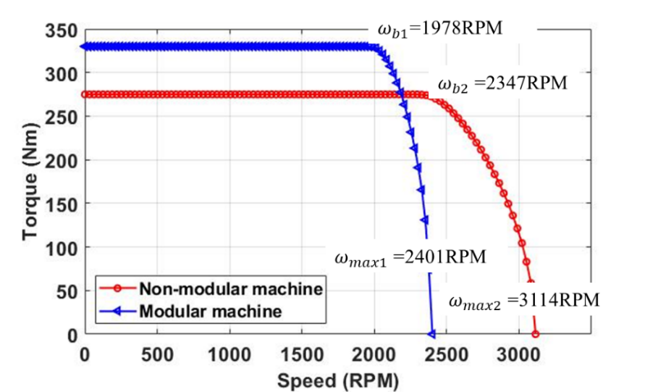
Fig. 3.2. Torque-speed curves for the modular and non-modular machines at room temperature (20$℃$) without considering EM-thermal coupling.

Losses Speed Curve
The stator and rotor core iron losses as well as PM eddy current loss against speed have also been calculated, as shown in Fig. 3.3. It is found that in the constant torque region, the losses, including the PM eddy current losses and stator and rotor iron losses, will all increase with rotor speed for both the investigated machines. In addition, compared with the non-modular machine, the modular machine has lower PM eddy current loss but higher stator and rotor core iron losses. This is mainly due to the introduced flux gaps that lead to increased fundamental and reduced harmonic components in the airgap flux density. However, in flux weakening region, the increase rates of both the stator and rotor core iron losses as well as PM eddy current loss of the non-modular machine have been reduced due to the demagnetization caused by the increase in d-axis current. For the modular machine, its stator and rotor core iron losses as well as the PM eddy current loss even reduce. Beyond 2300rpm, the iron loss of the modular machine can be even lower than that of the non-modular machine.
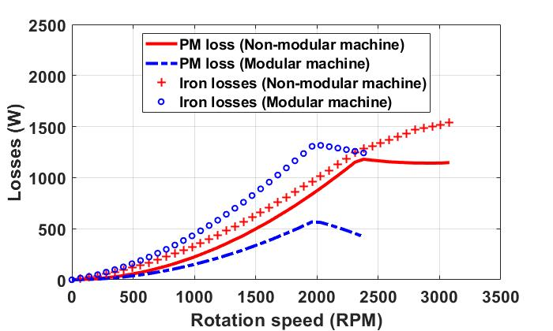
Fig. 3.3. Losses-speed curves for the modular and non-modular machines operating at room temperature (20$℃$).

Efficiency Map
The efficiency maps for the modular and non-modular machines are shown in Fig. 3.4. It is worth noting that, in this figure, the efficiency below 60% has been neglected. It can be found that compared with the non-modular machine, the modular machine has winder highest efficiency range due to its high output power and low PM eddy current loss.
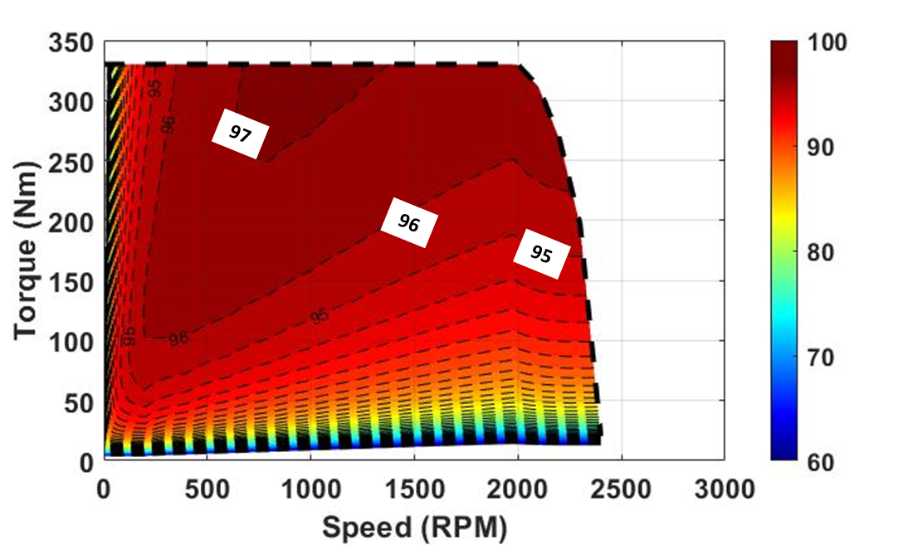
(a) Modular Machine
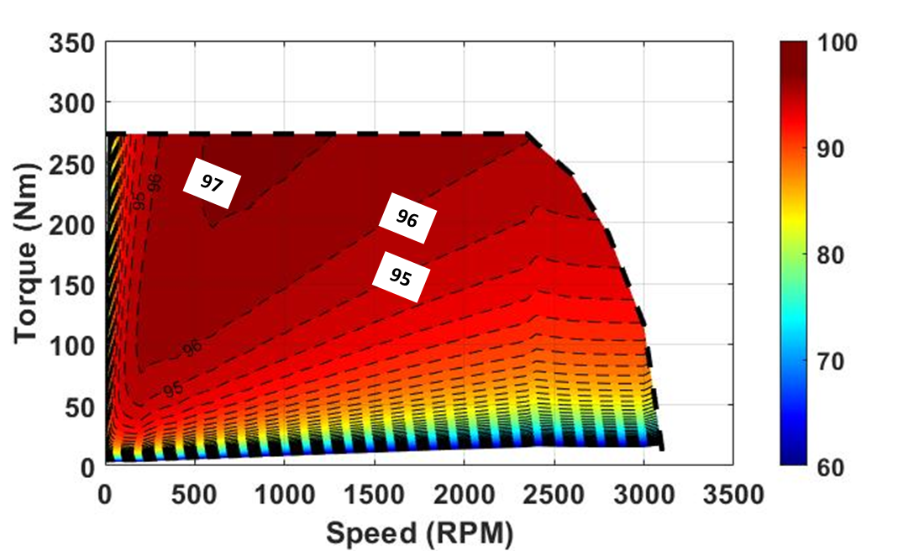
(b) Non-modular Machine
Fig. 3.4. Efficiency maps at room temperature (20$℃$) without considering EM-thermal coupling.

With EM-thermal Coupling
As mentioned previously, the above analyses do not consider the EM-thermal coupling. However, the temperature rise has a significant impact on the temperature dependent magnet B(H) curve and copper resistivity, hence will also have significant influence on the dynamic performance. For the magnet material used in this paper, its B(H) curves at different operating temperatures are shown in Fig. 3.5. The remanence ($B_{r}$) and coercivity ($H_{c}$) are both reduced with temperature rise and the temperature dependent $B_{r}$ and $H_{c}$ can be written as [130]
$$\left\{\begin{aligned}B_{r}\left(T\right)=B_{r}\left(T_{0}\right) \left[1+α_{1}\left(T-T_{0}\right)+α_{2}{\left(T-T_{0}\right)}^{2}\right] \\ H_{c}\left(T\right)=H_{c}\left(T_{0}\right) \left[1+β_{1}\left(T-T_{0}\right)+β_{2}{(T-T_{0})}^{2}\right]\end{aligned}\right.$$ | (3.1)
where $T_{0}$ is the reference temperature and $α_{1}$, $α_{2}$, $β_{1}$ and $β_{2}$ are temperature dependent coefficients. In practice, it is often found that $α_{1}≫α_{2}$ and $β_{1}≫β_{2}$. For example, for the magnet used in this paper, $α_{1}=-1.2×{10}^{-3}$, $α_{2}=-1.5×{10}^{-9}$, $β_{1}=-6.9×{10}^{-3}$ and $β_{2}=1.17×{10}^{-5}$.
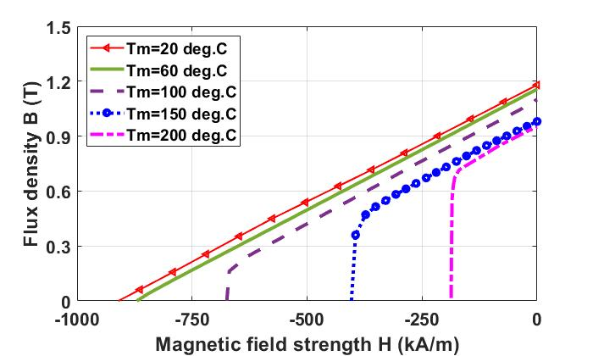
Fig. 3.5. Temperature dependent B(H) curves for PM material used in this paper.

Temperature Dependent PM Flux linkage and Inductance
Considering the temperature dependent properties of the magnets shown in Fig. 3.5, the flux linkage, d- and q-axis inductances have been calculated by 2D FEM, as shown in Fig. 3.6. These parameters will be used for calculating the temperature dependent dynamic performance of the modular and non-modular machines. It has been found in Fig. 3.6 (a) that the d-axis flux linkage of the modular machine is always higher than that of the non-modular machine regardless of the operating conditions. This means that, for a constant q-axis current, the torque of the modular machine will always be higher than that of the non-modular machine as described by (2.5). In addition, when the magnet temperature is > $150℃$, there is a significant reduction in the PM flux linkage for both the investigated machines due to magnet irreversible demagnetization.
Apart from the PM flux linkage, the d- and q-axis inductances vary with magnet temperature and current as well, which can also affect the dynamic performances as descried by the equations from (2.3) to (2.14). As shown in Fig. 3.6 (b) to (c), due to the existence of flux gaps, the d- and q-axis inductances of the modular machine are generally smaller than those of the non-modular machine for different currents and operating temperatures. In addition, the inductances for both the investigated machines increase with temperature rise. This is due to the fact that at higher temperature, the magnet Br reduces, so does the saturation level. This leads to reduced effective airgap length, and hence increased d- and q-axis inductances.
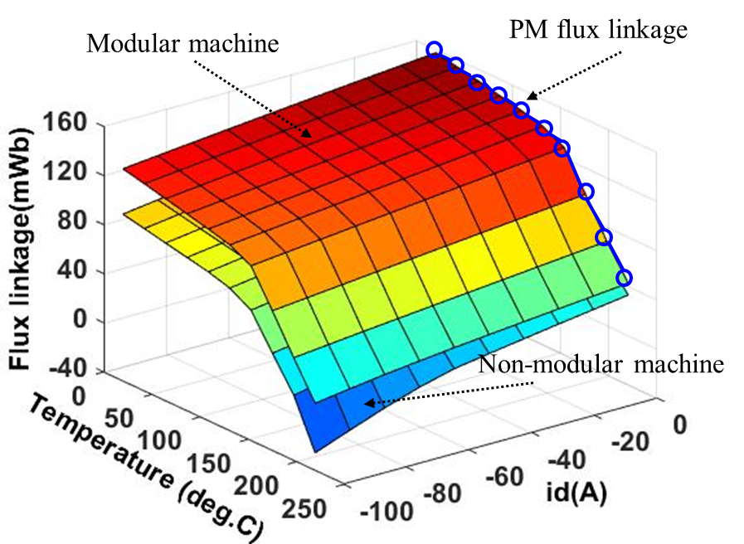
(a) d-axis flux linkage
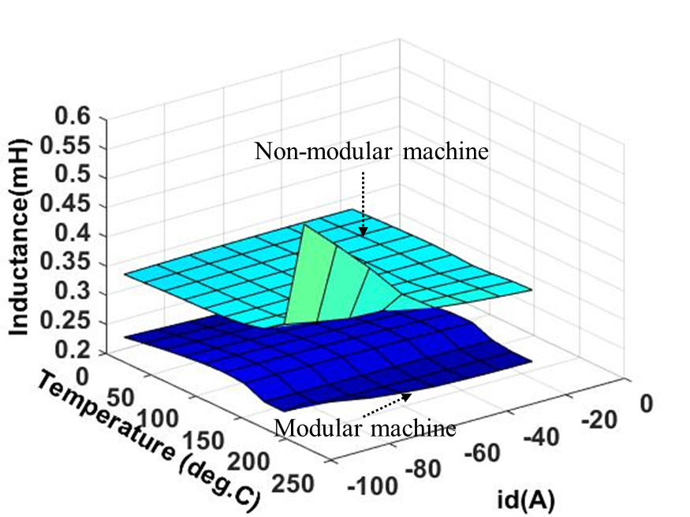
(b) d-axis inductance
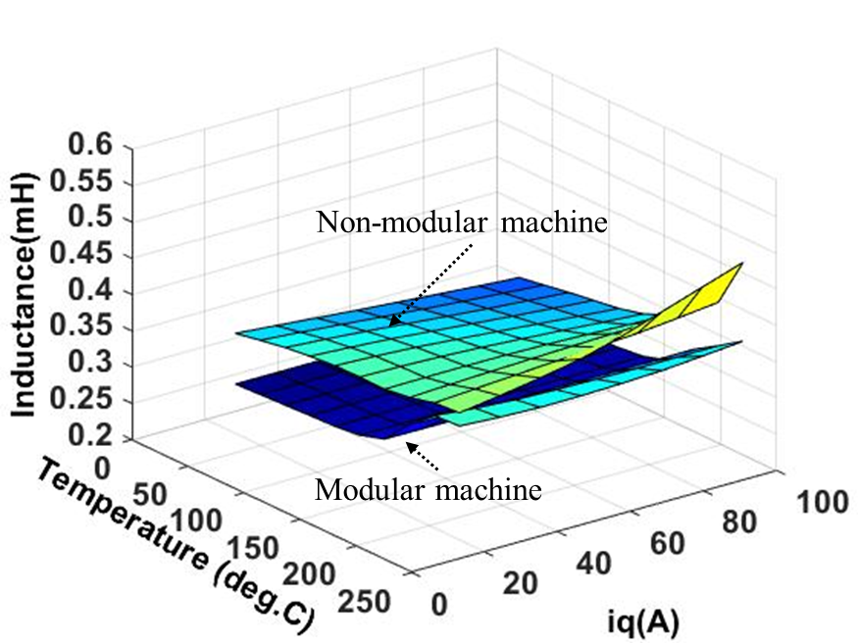
(c) q-axis inductance
Fig. 3.6. Machines properties vs d- or q-axis axis current and magnet temperature for both the modular and non-modular machines.
When temperature rises, the copper loss is also increased, which can be determined by using the temperature dependent coefficient ($3.69×{10}^{-3}/ ℃$) of the electrical resistivity for copper. Here the reference temperature is $20℃$ [131]. This increase in copper loss needs to be feedback to the thermal modelling as it is one of the main heat sources. Therefore, a close-loop coupling between EM and thermal modelling needs to be implemented as described by the flowchart shown in Fig. 3.1 for dynamic performance analysis. Some assumptions need to be made for the close-loop coupling analysis such as
- The electrical resistivity of PM and iron core are independent of temperature variation. This is safe as when temperature increases within a limited range, the increase in resistivity of PM and iron core can be largely negligible [134].
- The investigated machines are designed for the direction control of helicopters that do not require continuous operation. Hence, the duty ratio of 0.2 for the investigated machines has been adopted and one cycle lasts for 4000s.
- The allowable convergence error ($ε_{error}$) is set to be 0.5% in this paper.
It is worth noting that, the convergence error ($∆_{T}$) is identified as the magnet temperature difference described by
$$∆_{T}=\frac{T_{n}-T_{n-1}}{T_{n-1}}$$ | (3.2)

Temperature Speed Curve
In the coupled EM-thermal models for dynamic performance analysis, the temperature variation is critical as it has a direct impact on the PM remanent flux density and phase resistance. To accurately predict the temperature variation for different operating conditions, the Lumped Parameter Thermal Network (LPTN) will be adopted. The LPTN modelling is a well-documented method which is accurate and less time consuming compared to finite element (FE) modelling and computational fluid dynamic (CFD) modelling. These are very desirable features for the coupled EM-thermal modelling in this chapter as temperature distributions under numerous operating conditions are required for the dynamic performance analysis.
In the thermal analysis using LPTN model, electrical machines can be divided into several hollow cylinders, which is the case for the rotor, magnets, and stator yoke, as shown in Fig. 3.7 (a). However, the coils, teeth and end-windings can be regarded as cylindrical components with different angular spans ($α$), as shown in Fig. 3.7 (b).
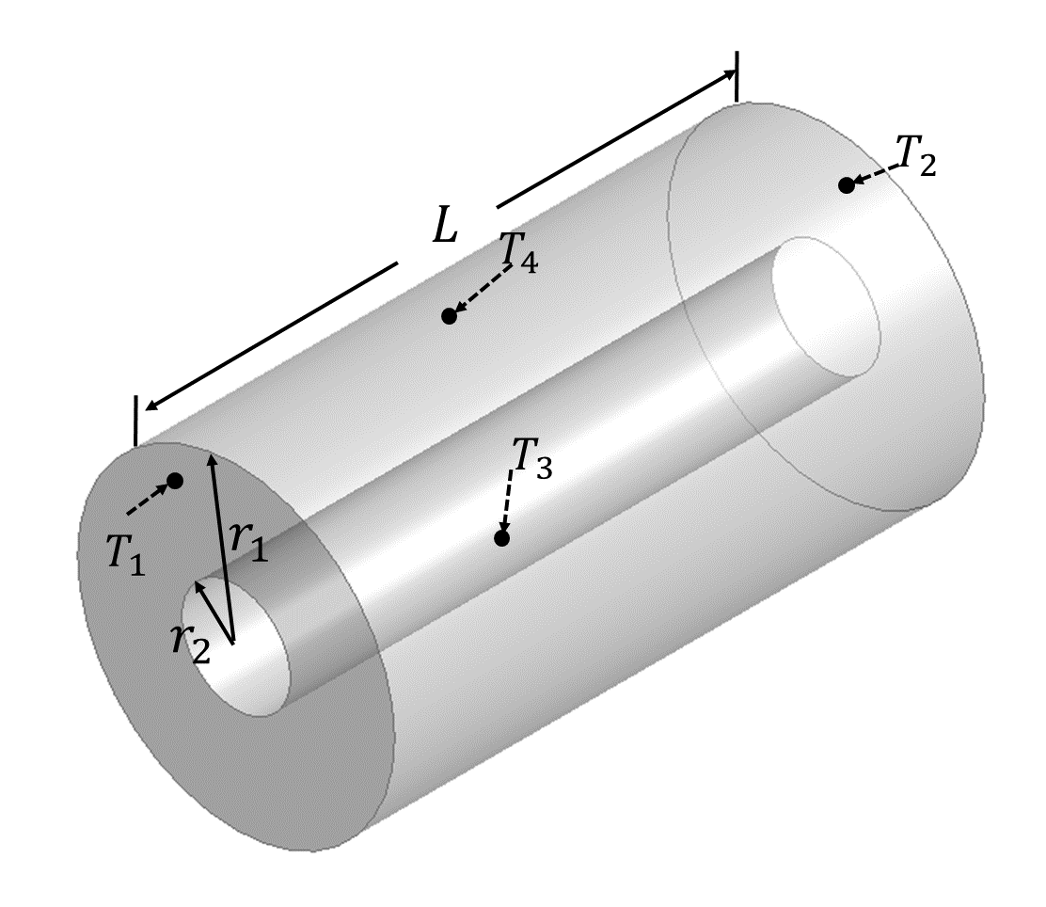 | 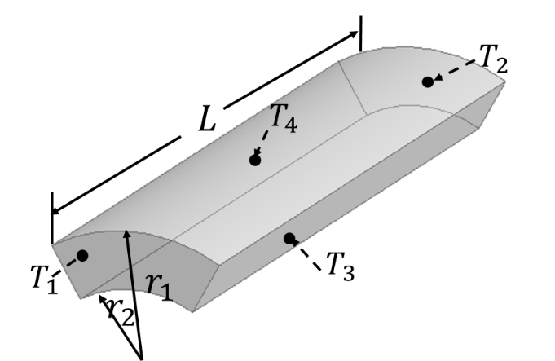
(a) Full cylinder | (b) Cylinder with angular spans
Fig. 3.7. LPTN model based on Motor-CAD for the modular machine. $r_{1}$, $r_{2}$ and $L$ are the radius of inner surface, radius of outer surface and stack length, respectively. $T_{1}$, $T_{2}$, $T_{3}$ and $T_{4}$ are the temperatures of the front, rear, outer and inner surfaces, respectively.
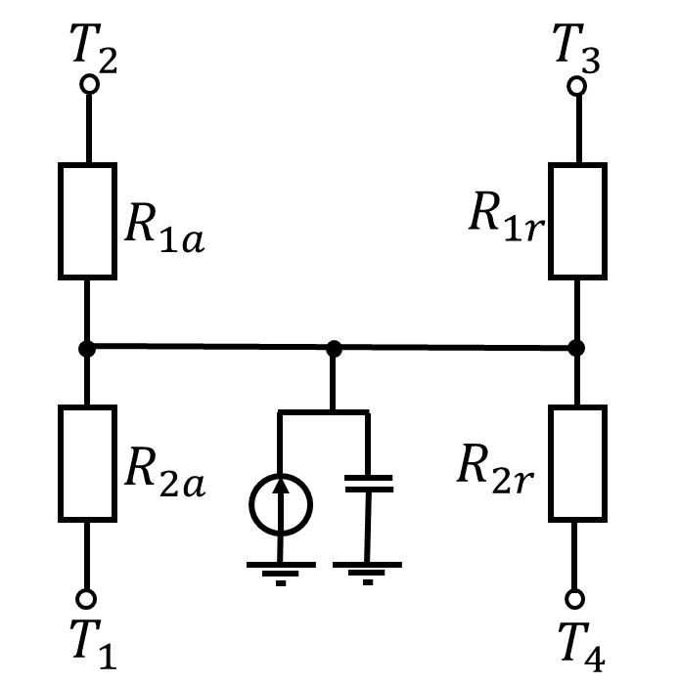 | 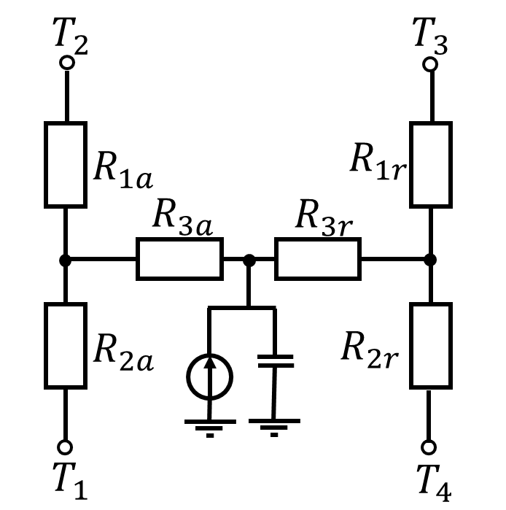
(a) Without heat generation | (b) With heat generation
Fig. 3.8. Equivalent LPTN for cylindrical components.
For the components without heat generation, e.g., shaft and housing, their heat transfer can be represented by the equivalent LPTN shown in Fig. 3.8 (a). Their equivalent thermal resistances are derived by [5, 135-137]
$$R_{1r}=\frac{1}{4πλL}\left[1-\frac{2r_{2}^{2}\ln\left(\frac{r_{1}}{r_{2}}\right)}{\left(r_{1}^{2}-r_{2}^{2}\right)}\right]$$ | (3.3)
$$R_{2r}=\frac{1}{4πλL}\left[\frac{2r_{1}^{2}\ln\left(\frac{r_{1}}{r_{2}}\right)}{\left(r_{1}^{2}-r_{2}^{2}\right)}-1\right]$$ | (3.4)
$$R_{1a}=R_{2a}=\frac{L}{2πλ\left(r_{1}^{2}-r_{2}^{2}\right)}$$ | (3.5)
However, for components with heat generated inside them such as the stator and rotor iron cores and magnets, a third equivalent thermal resistance $R_{3}$ needs to be introduced, as shown in Fig. 3.8 (b). The values of $R_{3}$ in radial and axial directions have been derived using
$$R_{3r}=\frac{-1}{8πλL\left(r_{1}^{2}-r_{2}^{2}\right)}\left[\left(r_{1}^{2}+r_{2}^{2}\right)-\frac{4r_{2}^{2}\ln\left(\frac{r_{1}}{r_{2}}\right)}{\left(r_{1}^{2}-r_{2}^{2}\right)}\right]$$ | (3.6)
$$R_{3a}=\frac{-L}{6πλ\left(r_{1}^{2}-r_{2}^{2}\right)}$$ | (3.7)
Similarly, for the coils, teeth and end-windings having different angular spans $α$, their equivalent thermal resistances can be derived by [138]
$$R_{1r}=\frac{1}{ 2αλL}\left[1-\frac{2r_{2}^{2}\ln\left(\frac{r_{1}}{r_{2}}\right)}{\left(r_{1}^{2}-r_{2}^{2}\right)}\right]$$ | (3.8)
$$R_{2r}=\frac{1}{ 2αλL}\left[\frac{2r_{1}^{2}\ln\left(\frac{r_{1}}{r_{2}}\right)}{\left(r_{1}^{2}-r_{2}^{2}\right)}-1\right]$$ | (3.9)
$$R_{1a}=R_{2a}=\frac{L}{αλ\left(r_{1}^{2}-r_{2}^{2}\right)}$$ | (3.10)
$$R_{3r}=\frac{-1}{4αλL\left(r_{1}^{2}-r_{2}^{2}\right)}\left[\left(r_{1}^{2}+r_{2}^{2}\right)-\frac{4r_{2}^{2}\ln\left(\frac{r_{1}}{r_{2}}\right)}{\left(r_{1}^{2}-r_{2}^{2}\right)}\right]$$ | (3.11)
$$R_{3a}=\frac{-L}{3αλ\left(r_{1}^{2}-r_{2}^{2}\right)}$$ | (3.12)
The consideration of heat transfer in circumferential direction for coils and teeth is also necessary. They can be regarded as trapezoidal components, and their equivalent thermal resistances can be derived by [139]
$$R_{1c}=R_{2c}=\frac{α}{λL\ln\left(\frac{r_{1}}{r_{2}}\right)}$$ | (3.13)
$$R_{3c}=\frac{-α}{3λL\ln\left(\frac{r_{1}}{r_{2}}\right)}$$ | (3.14)
The coil with insulation and potting compound has been regarded as an ideal material with anisotropic thermal conductivity. By assuming that the thermal properties of the insulation layer is close to the potting compound, the Hashin and Shtrikman approximation is able to estimate the equivalent thermal conductivity ($λ_{e}$) in the direction which is perpendicular to the direction of current as [140]
$$λ_{e}=λ_{p}\frac{\left(1+ν_{c}\right)λ_{c}+\left(1-ν_{c}\right)λ_{p}}{\left(1-ν_{c}\right)λ_{c}+\left(1+ν_{c}\right)λ_{p}}$$ | (3.15)
where the copper volume ratio $ν_{c}$ is equal to the packing factor. The subscripts c and p represent the conductors and impregnation, respectively.
The LPTN model of the non-modular machine can be developed using ANSYS Motor-CAD software package. This is the same for the modular machine. The difference however is that, due to the existence of the flux gaps, extra thermal resistances due to convection in the flux gaps will be needed in the LPTN model of the modular machine, as shown in Fig. 3.9.

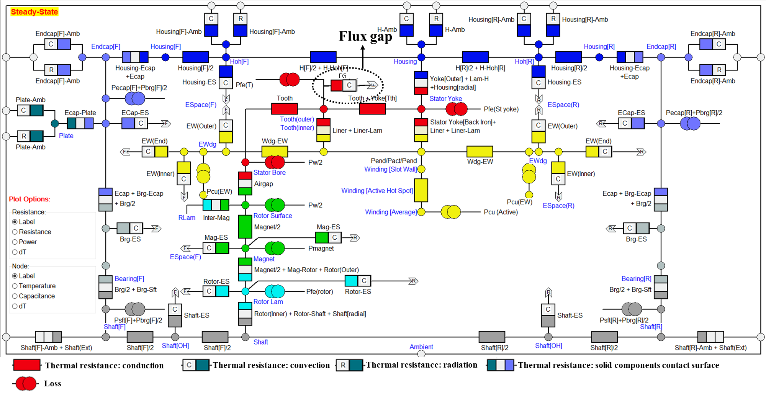
Fig. 3.9. LPTN model based on Motor-CAD for the modular machine.

The steady state temperatures of PMs at different rotor speeds have been calculated by the LPTN as shown in Fig. 3.9. Similar to the trend of losses presented in previous section, the temperatures within both machines increase with increasing rotor speed. It is also found that when the rotor speed is low, the magnet temperatures within the modular machine are slightly higher than those within the non-modular machine due to higher copper loss and iron losses. However, when the rotor speed is beyond the base speed, the temperatures within the modular machine are reduced due to the influence of magnet demagnetization. In addition, to prevent the PM from irreversible demagnetization, the critical temperature of the PM material chosen in this paper is around the 150$℃$ [141]. It can be seen that the magnet temperature in the modular machine is always lower than the critical temperature for the full speed range. By contrast, the temperature of non-modular machine can go beyond the critical temperature, leading to potentially serious irreversible demagnetization.
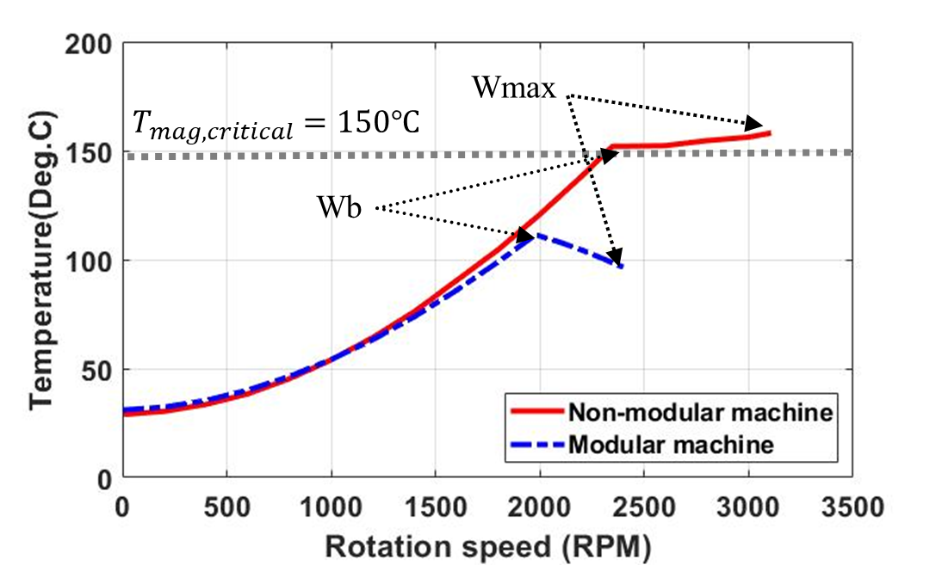
Fig. 3.10. Magnet temperature speed curves of the modular and non-modular machines.

Dynamic Performance
To evaluate the impact of temperature rise on machine EM performance, the temperature dependent B(H) curve and temperature speed curve are implemented to re-evaluate the torque speed curve for the modular and non-modular machines, as shown in Fig. 3.11. It can be found that, for both machines, when the demagnetization caused by temperature rise is considered, the torque is reduced due to reduced PM flux-linkage. Furthermore, the increased temperature improves both the base and maximum speeds also due to reduced PM flux-linkage as calculated by (2.10) and (2.12). Therefore, although the demagnetization can reduce the EM performance in constant torque region, it can improve the performance in flux weakening region.
As shown in Fig. 3.12, the iron losses and PM eddy current losses are reduced due to the demagnetization caused by temperature rise. However, the copper loss will be increased due to the increase in coil temperature. These variations in losses and also on-load torque due to temperature rise will lead to significant change in the efficiency maps for the modular and non-modular machines, as shown in Fig. 3.13 and Fig. 3.14. It can also be found that, similar to the EM-only predictions, although both machines have similar peak efficiency, the area for peak efficiency of the modular machine is larger than that of the non-modular machine.
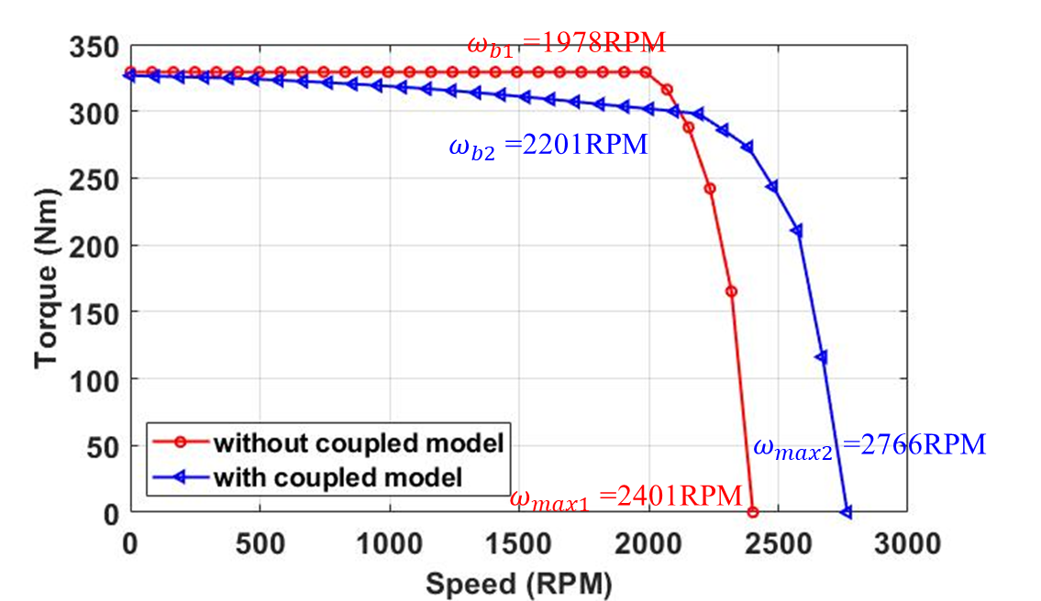
(a) Modular machine
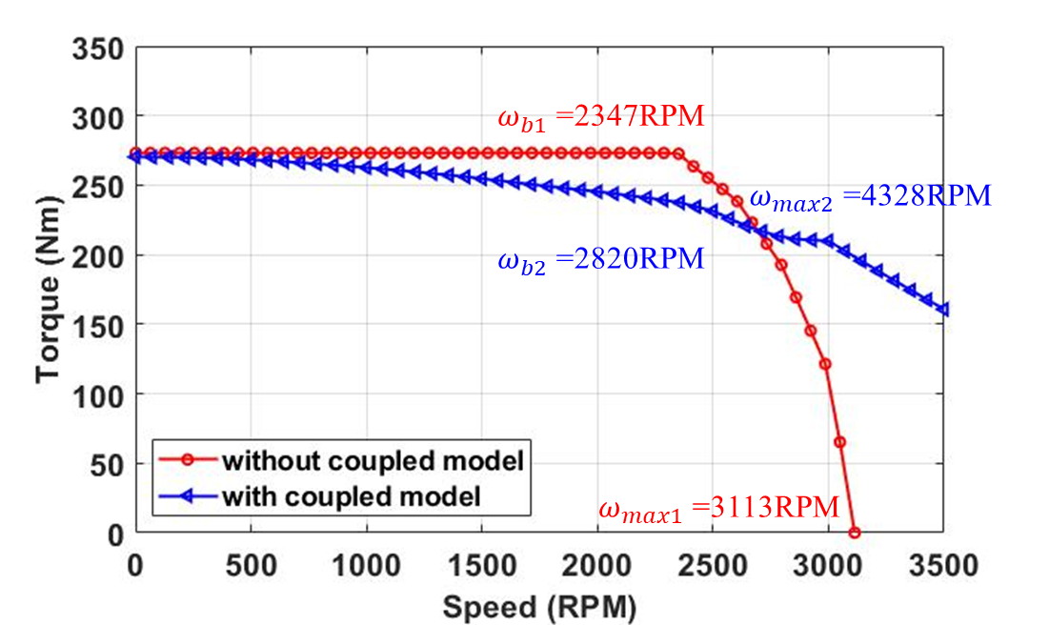
(b) Non-modular machine
Fig. 3.11. Torque-speed curves of investigated machines with or without considering the EM-thermal coupling.
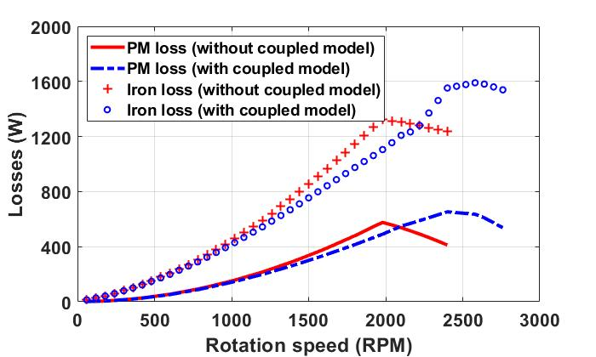
(a) Modular machine
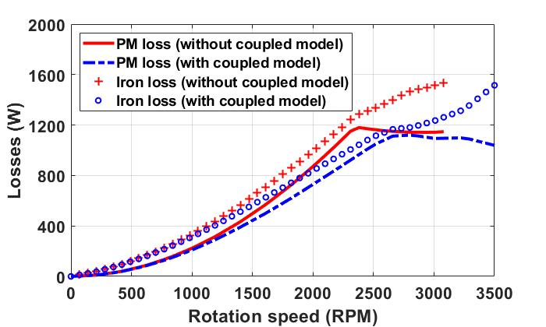
(b) Non-modular machine
Fig. 3.12. Losses-speed curves of investigated machines with or without considering the EM-thermal coupling.
(a) Without EM-thermal coupling
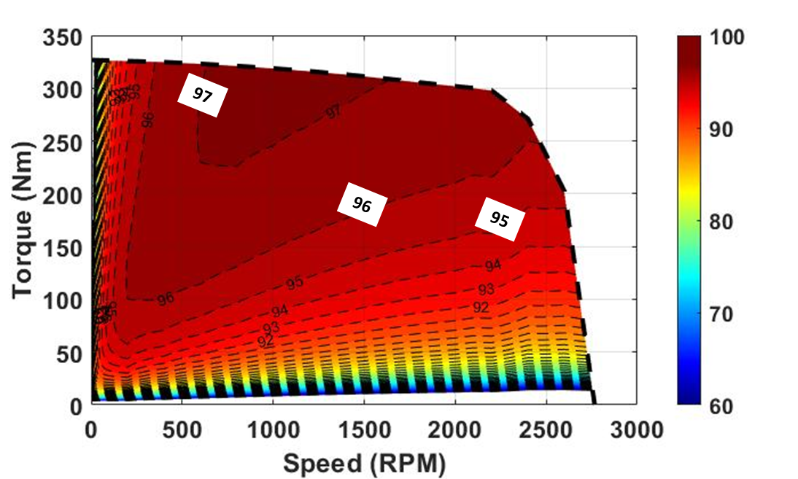
(b) With EM-thermal coupling
Fig. 3.13. Efficiency maps of investigated modular machines with or without considering the EM-thermal coupling.
(a) Without EM-thermal coupling
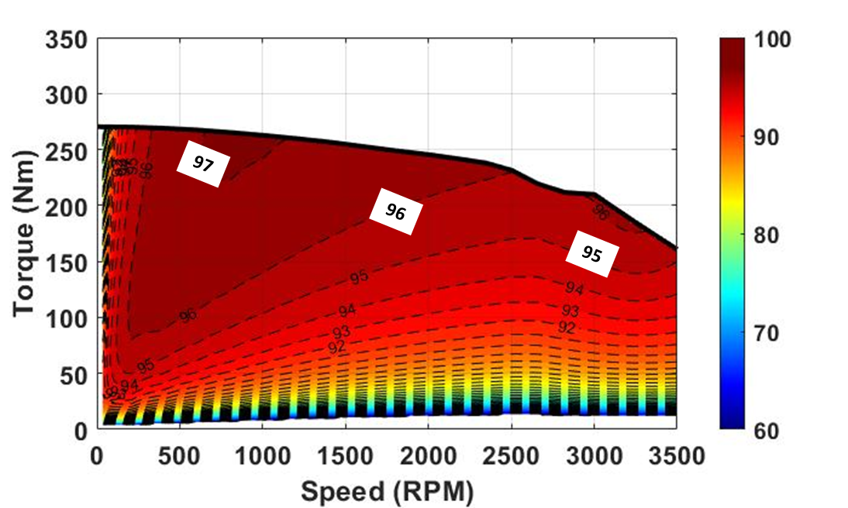
(b) With EM-thermal coupling
Fig. 3.14. Efficiency maps of investigated non-modular machines with or without considering the EM-thermal coupling.

Demagnetization Characteristics of the Modular Machine
The demagnetization characteristics for both investigated machines will be studied in this section. They can reveal the full potential of the modular machine in improving the machine demagnetization withstand capability. In this section, the influence of flux gaps on magnet flux density, losses distribution, torque and demagnetization are analyzed for different operating conditions. The magnet demagnetizations caused by three sources such as the PM field, the armature field and the magnet temperature rise are investigated separately using frozen permeability method. For comparison propose, the EM performances with a particular focus on the demagnetization withstand capability for both the modular and non-modular machines are investigated based on the EM-thermal coupling. It is found that, compared to the non-modular machine, the modular machine can achieve higher torque, higher efficiency and better demagnetization withstand capability.

Mechanism of magnet irreversible demagnetization
The temperature dependent B(H) curves for the magnet material (N35H) used in this chapter are shown in Fig. 3.5. It is found that, with temperature rise, the remanence is reduced, which can reduce the magnet magnetomotive force (MMF) and the machine EM performances. In addition, the temperature rise can also reduce coercivity but increase the knee point, which lead to easier magnet irreversible demagnetization. This can be explained by Fig. 3.15. For a given operating temperature and under different load conditions, the working point moves following the original demagnetization curve having a remanence B_{r0}. Since the working points have the same B_{r0}, the demagnetization will be reversible. However, if the working point moves to below the knee point, it will follow a new demagnetization curve with a lower remanence (B_{r1}). This permanent loss of magnetization is so called “irreversible demagnetization”. After the irreversible demagnetization, the machine will operate under the new B(H) curve with reduced remanence but with the same slope as the original B(H) curve [142, 143].
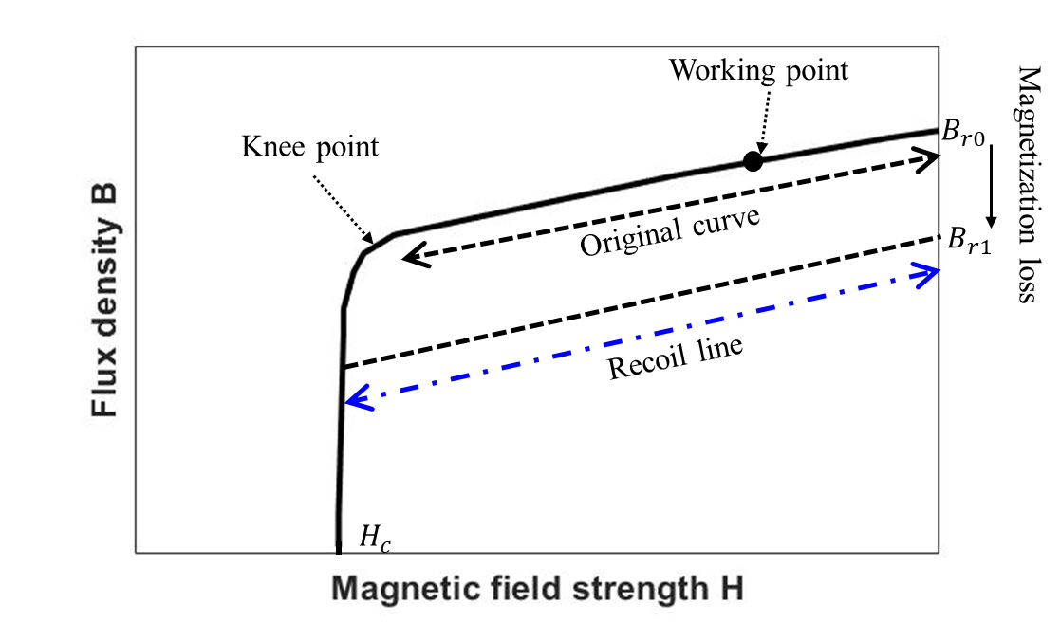
Fig. 3.15. B(H) curves of the used PM material.
The magnet flux density is essential for investigating the machine demagnetization characteristics and evaluating the machine demagnetization withstand capability. This is because under the same operating condition, the machine with higher magnet flux density will generally have better demagnetization withstand capability. It is known that magnet flux density ($B_{m}$) depends on the reluctance of the magnetic circuit ($S$), the magnetomotive force (MMF) generated by PMs ($F_{m}$) and armature current ($F_{c}$), and can be calculated by
$$\left\{\begin{aligned}Φ=\frac{F_{m}+F_{c}}{S} \\ B_{m}=\frac{Φ}{A}\end{aligned}\right.$$ | (3.16)
where $Φ$ and A are the flux in the magnet and magnet area, respectively.
$F_{m}$ and $F_{c}$ can be described by
$$\left\{\begin{aligned}F_{m}=\frac{B_{r}w}{μ_{0}μ_{r}} \\ F_{c}=Ni\end{aligned}\right.$$ | (3.17)
where $B_{r}$, $μ_{0}$, $μ_{r}$, $w$, $N$, and $i$ are the magnet remanence, vacuum permeability, magnet relative permeability, magnet thickness, number of turns and magnitude of armature current.
According to (3.1), (3.16) and (3.17), the magnet flux density variation can be contributed from 3 sources:
- PM field only: the MMF generated by PMs ($F_{m}$) can demagnetize the magnets.
- Armature field only: the MMF generated by 3-phase armature currents ($F_{c}$), particularly under flux weakening operation or during short-circuit fault, can lead to magnet demagnetization.
- Temperature rise: as mentioned previously, the coercivity of most magnets (except for Ferrite) reduces while the knee point increases to be closer to the magnet working point, making the magnets prone to irreversible demagnetization.
In order to investigate the magnet demagnetization, the points along the centre line within a PM (as shown in Fig. 3.16) have been chosen. This is mainly due to the fact that the magnet in this region is more easily affected by demagnetization than other regions [44]. It is worth noting that, in order to separate the influence of the above three sources on the magnet demagnetization, a range of magnet temperatures will be used first in this section without adopting coupled EM-thermal modelling, which will be investigated in section 3.3.3 for more accurate temperature prediction.
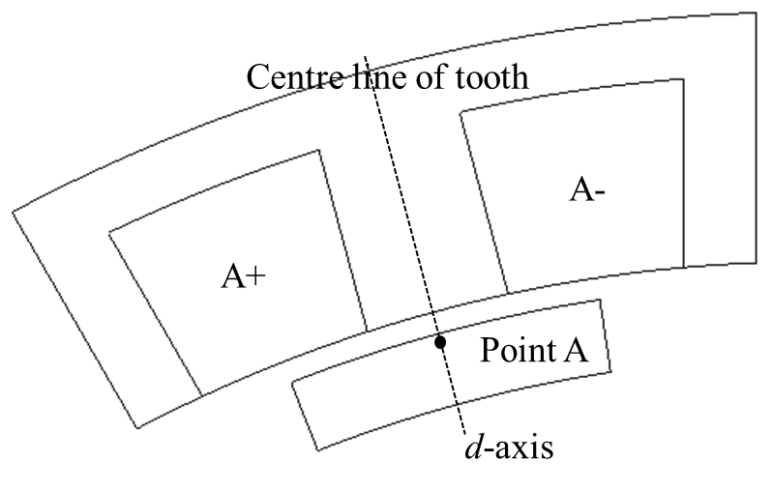
Fig. 3.16. Fundamental open-circuit airgap flux density (radial component) and fundamental phase back-EMF vs flux gap width for the 24-slot/28-pole modular SPM machine.

Demagnetization without EM-thermal coupling
Without considering the magnet temperature variation, temperature rise in particular, the magnet demagnetization is mainly due to the MMFs produced by PMs and armature currents, especially the negative d-axis current, as shown in Fig. 3.17. It is found that, at a magnet operating temperature of 20℃, when the load current is smaller than a critical value, e.g., 200A for the modular machine and 300A for the non-modular machine, the minimum flux density is almost constant when the d-axis current reduces. After the critical value, the minimum magnet flux density reduces almost linearly with reducing d-axis current. Compared with the non-modular machine, the modular machine is found to be able to improve the minimum magnet flux density at different load currents. This means that the introduced flux gaps can improve the demagnetization withstand capability.
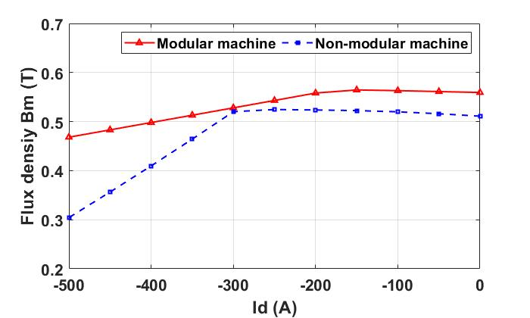
Fig. 3.17. Minimum magnet flux density (radial component) at 20℃ at point A vs the d-axis current for the investigated machines.
The flux density versus rotor position for the modular and non-modular machines is also investigated, as shown in Fig. 3.18. It is found that, if the current is smaller than the critical value, the minimum magnet flux density is reached when the centre line of the PM is aligned with the centre line of the slot (rotor position 2 in Fig. 3.18). And the values of the minimum flux density are almost the same for different currents. On the contrary, when the current is larger than the critical value, the minimum magnet flux density can be reached when the centre line of the PM is aligned with the centre line of the tooth (rotor position 1 in Fig. 3.18). In addition, when the selected PM rotates to the flux gap region, the magnet flux density will reduce until the centre line of the PM is aligned with the centre line of the flux gap (rotor position 3 in Fig. 3.18). This magnet flux density variation is caused by the combined influence between machine topology, MMFs generated by PMs and armature currents, which will be detailed in the following sections.
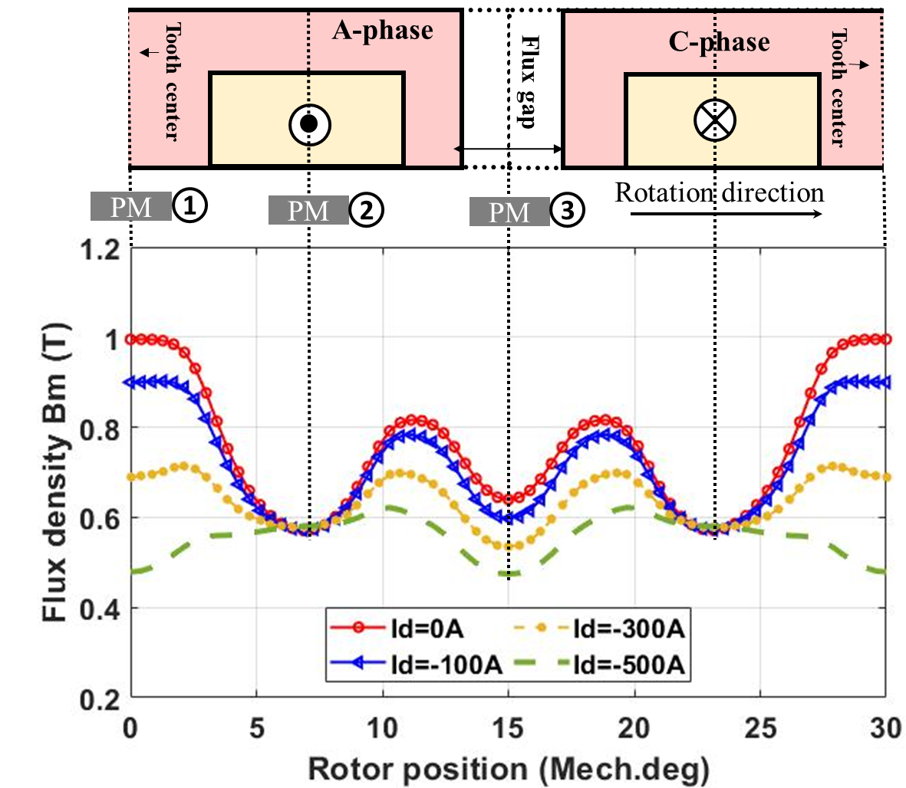
(a) Modular machine
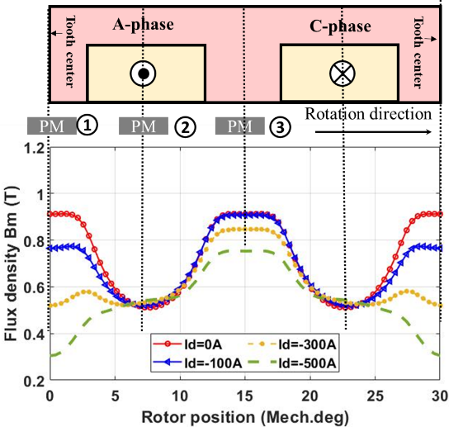
(b) Non-modular machine
Fig. 3.18. Magnet flux density (radial component) at 20$℃$ at point A (see Fig. 3.16).
In order to evaluate the influence of demagnetization caused by PM field only while under the influence of negative d-axis current, the modular and non-modular machines have been simulated at a PM temperature of 20℃. By adopting the FP method, the armature field has been removed and the magnet flux density variation due to the PM field for both investigated machines are shown in Fig. 3.19. Without the armature field, the magnet flux density only depends on the reluctance of the magnetic circuit and the PM MMF ($F_{m}$). It is found that, due to the non-linear characteristics of the iron core, reducing the d-axis current increase its relative permeability ($μ_{r}$), therefore reduces the reluctance while increasing the magnet flux density. The variation in magnet flux density is significant for the non-modular machine as show in Fig. 3.19 (b). However, it is found that, the flux density variation for the modular machine under different load currents is almost the same, as shown in Fig. 3.19 (a). This means that, the introduced flux gaps in the modular machine can significantly reduce the PM flux density variation caused by the variation of iron core permeability.
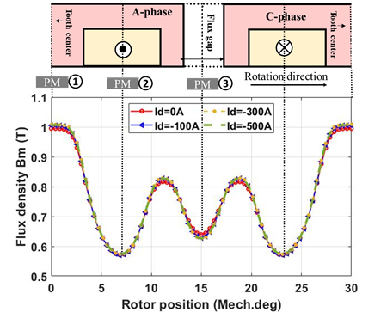
(a) Modular machine
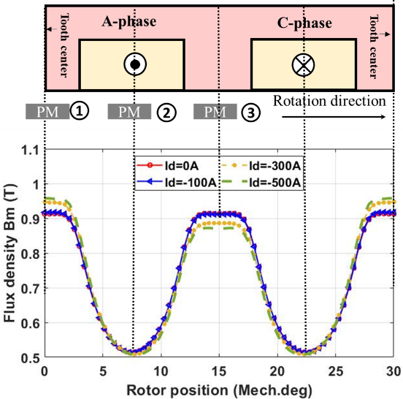
(b) Non-modular machine
Fig. 3.19. Magnet flux density (radial component) generated by PM source at point A within the selected PM vs rotor position.
For both the investigated machines, the maximum flux density is reached at initial rotor position, i.e., centre line of the magnet is aligned with the centre line of the tooth [rotor position 1 in Fig. 3.19 (a)]. This is because the effective airgap length and therefore the reluctance are minimum when the rotor is at the position 1. When rotor rotates and the selected magnet is facing the slot opening, the reluctance increases because of the small relative permeability of copper wires ($μ_{r}$=1) in stator slot. Therefore, the magnet flux density reduces and reaches its minimum value when the centre line of the magnet is aligned with the centre line of the slot opening [rotor position 2 in Fig. 3.19 (a)]. The introduced flux gaps have the same effect as the slot openings, which also reduce the magnet flux density when the selected magnet rotates to the flux gap region. The magnet flux density will keep reducing until the centre line of the magnet is aligned with the centre line of the flux gap [rotor position 3 as shown in Fig. 3.19 (a)].
The results above are for a single flux gap width (10 mm), the minimum magnet flux density variation against flux gap width has also been investigated, as shown in Fig. 3.20 (a). It is found that, when the flux gap width is smaller than 13mm, increasing flux gap width leads to increased minimum flux density. This means improved magnet demagnetization withstand capability. The reason is that, increasing flux gap width leads to reduced slot opening, and hence reduced effective airgap length at rotor position 2. As a result, the minimum flux density at position 2 will be increased, as shown by the red curve in Fig. 3.20 (b). However, when the flux gap width is larger than a critical value (13mm for the investigated modular machine in this chapter), the minimum magnet flux density reduces with increased flux gap width. This is because the flux gap has the same effect with the slot openings. If the flux gap width is large enough (13mm for the investigated modular machine), the magnet flux density at rotor position 3 will be smaller than that at rotor position 2 due to the larger effective airgap length as shown by the blue curve in Fig. 3.20 (b). This means that an optimal flux gap width (13mm) can be found from the magnet demagnetization withstand capability point of view.
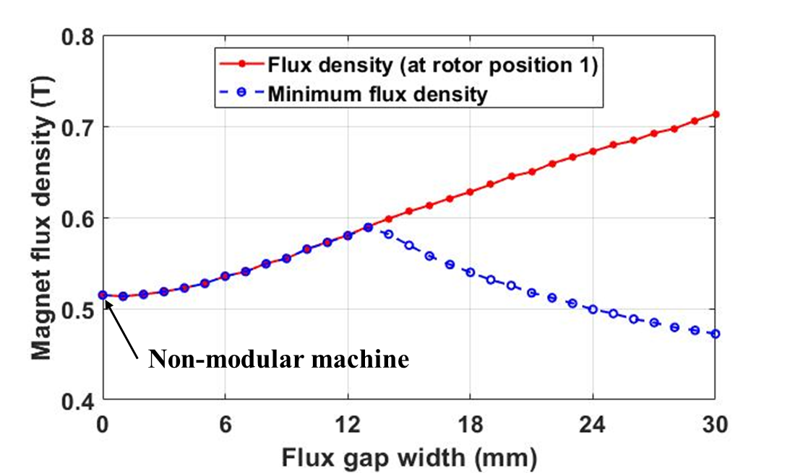
(a) Minimum magnet flux density vs flux gap width
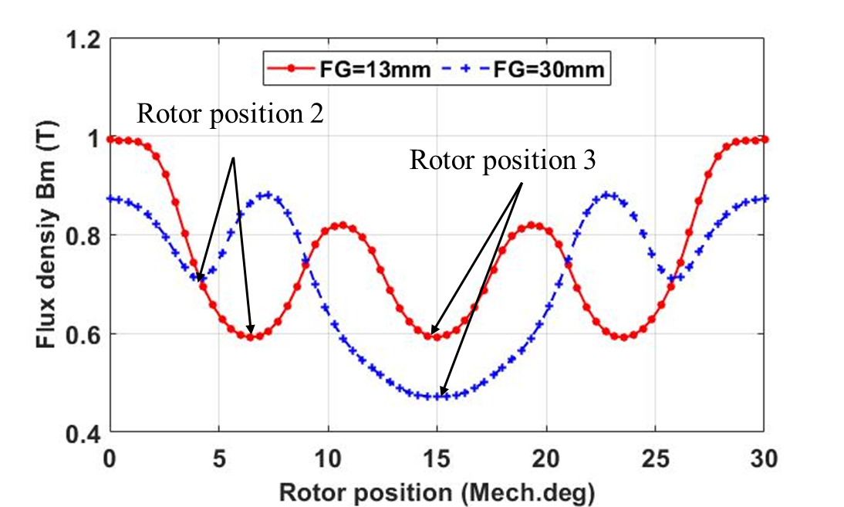
(b) magnet flux density vs rotor position while flux gap widths are 13mm and 30mm
Fig. 3.20. Magnet flux density (radial component) at point A generated by PM MMF at 20℃ for modular machine.
Apart from the PM field in previous section, the applied armature currents can also generate demagnetizing MMF. Again, using the FP method, the magnet flux density (at point A) due to armature field only against the load current has been calculated, as shown in Fig. 3.21. The magnet flux density now depends on the load current, and the effective airgap length as described by (3.16) and (3.17). As a result, for both the modular and non-modular machines, at initial rotor position 1 where the d-axis is aligned with the centre line of the tooth of A-phase, the magnitude of A-phase current reaches its maximum value, and the effective airgap length is the smallest. This leads to the most significant demagnetization and hence the minimum magnet flux density. When the rotor rotates towards slot opening, the effective airgap length is increased. Together with reduced A-phase current, the magnet flux density generated by applied armature field at point A is increased. However, when the rotor rotates by 90 electrical degrees, i.e., 45/7≈6.4 mechanical degrees, named as rotor position 4 in this chapter, the A-phase current is 0A, while the B-phase current is equal to minus C-phase current. Hence, the magnet flux density at point A is 0T.
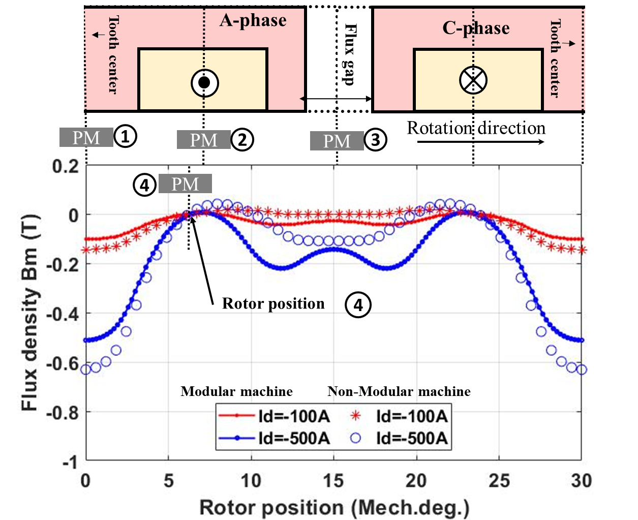
Fig. 3.21. The magnet flux density (radial component) at point A generated by applied 3-phase armature current at 20℃ for modular machine with different load currents.
According to (3.17), the armature MMF is proportional to the current amplitude. Therefore, when the current amplitude increases, the minimum magnet flux density reduces as shown in Fig. 3.22 (a). This is true for both the modular and non-modular machines. However, the modular machine is able to increase the minimum magnet flux density, results from the increased effective airgap length due to the introduced flux gaps as mentioned in previous section. However, this increase in magnet flux density is insignificant when the flux gap width is larger than 10mm, as shown in Fig. 3.22 (b). In addition, the improved minimum magnet flux density for the modular machine reveals that the demagnetization caused by armature MMF in the modular machine can also be mitigated by the introduced flux gaps. This is similar to the demagnetization caused by the PM MMF in previous section.
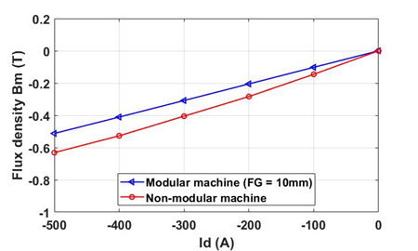
(a) Minimum magnet flux density vs flux gap width
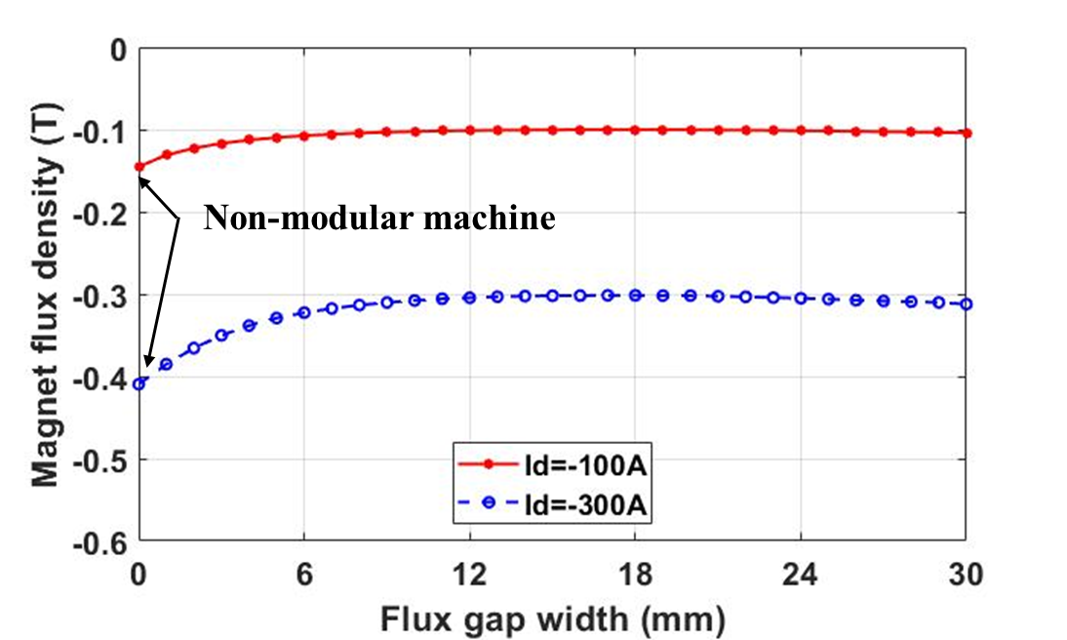
(b) magnet flux density vs rotor position while flux gap widths are 13mm and 30mm
Fig. 3.22. Magnet flux density (radial component) at point A generated by PM MMF at 20℃ for modular machine.

Demagnetization with Coupled EM-Thermal Modelling
As mentioned previously, apart from the influence of the MMFs produced by magnets and armature currents, the temperature rise can also lead to further magnet demagnetization. To evaluate the magnet demagnetization due to temperature rise, the minimum magnet flux density at point A versus magnet temperature and d-axis current are shown in Fig. 3.23. For both the modular and non-modular machines, increasing armature field leads to reduced minimum magnet flux density. In addition, when the PM temperature is below 150℃, the demagnetization is insignificant and the reduction in minimum magnet flux density is small. However, when the magnet temperature increases to beyond 150℃, the machine demagnetization withstand capability significantly deteriorates. As a result, this dramatically reduces the magnet flux density. The overheating of the magnets can even lead to a change of magnet polarity, as shown in Fig. 3.23.
Compared with the non-modular machine, the modular machine (as shown in Fig. 3.23) has higher magnet flux density at different magnet temperatures and d-axis currents. This means that the introduced flux gaps can improve the demagnetization withstand capability at different operating conditions.
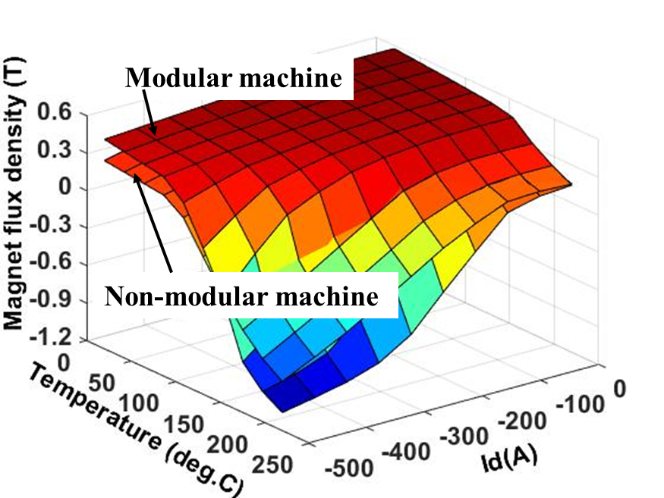
Fig. 3.23. The minimum magnet flux density (radial component) at point A for investigated machines under different operating conditions.
In previous sections, it is found that the machine topologies, load current and temperature rise can significantly affect the flux density distribution within PMs. This will in turn affect the losses, e.g., stator/rotor iron core losses and PM eddy current loss and EM torque. Together with the increase in copper loss due to the temperature dependent electrical resistivity of copper, the variation of losses caused by demagnetization will also lead to the machine temperature variation, which will again affect the EM performance. Therefore, the coupled EM-thermal modelling, as described by the flowchart shown in Fig. 3.1, is essential to account for the interaction between the EM and thermal performances. In this section, the coupled EM-thermal modelling is implemented for both investigated machines. Three operating conditions are considered for the investigations, e.g., condition 1 (rated current $I_{d}$ = 0A and $I_{q}$= 100A), condition 2 (flux weakening, $-I_{d}$ = $I_{q}$ = 50$\sqrt{2}$A) and condition 3 (3 times the rated current $I_{d}$ = 0A and $I_{q}$ = 300A).
Some assumptions need to be made for the coupled EM-thermal modelling such as
- The electrical resistivity of PM and iron core are independent of temperature rise. This is because the increase in resistivity of PM and iron core are negligible when the temperature rise is lower than 300℃ [134].
- For different operating conditions, only steady-state performance is considered to simplify the analyses.
- To avoid the change of magnet polarity as shown in Fig. 3.23, the investigated machines are assumed to operate less than 30 minutes when they are operated under 3 times the rated current.
Using the coupled EM-thermal model, the average PM and coil temperatures for both investigated machines have been obtained, as shown in Table 3.2. Due to the magnet temperature rise, the magnet flux density is reduced for both the investigated machines under different operating conditions, as shown in Fig. 3.24. In addition, the magnet flux density in condition 2 is slightly smaller than that in condition 1. This reduction is mainly due to the introduced d-axis current for flux weakening. However, the amplitude of d-axis current in condition 2 is relatively small and therefore the demagnetization caused by armature field is only marginal.
Table 3.2 Average steady state PM and coil temperatures
 | Modular machine |  | Non-modular machine
 | Tm (℃) | Tc (℃) | Tm (℃) | Tc (℃)
Condition 1 | 160 | 151 | 158 | 142
Condition 2 | 153 | 146 | 148 | 148
Condition 3 | 150 | 152 | 140 | 129
Note: Tm and Tc are the average temperatures of magnets and coils, respectively.

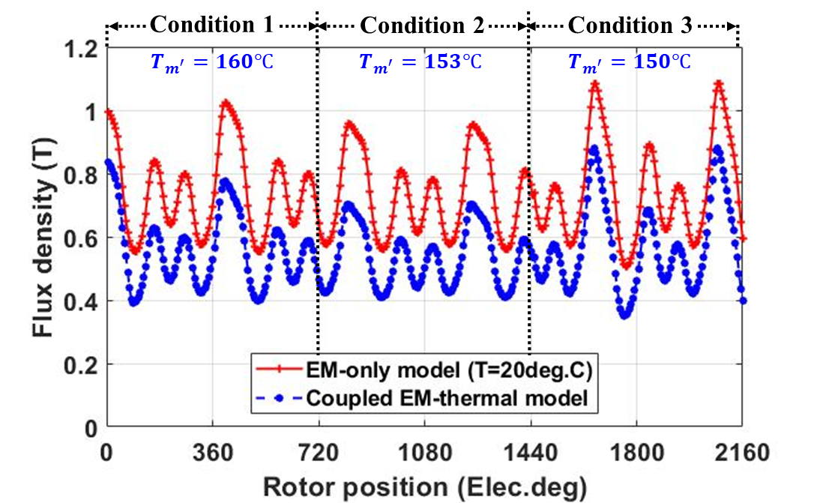
(a) Modular Machine
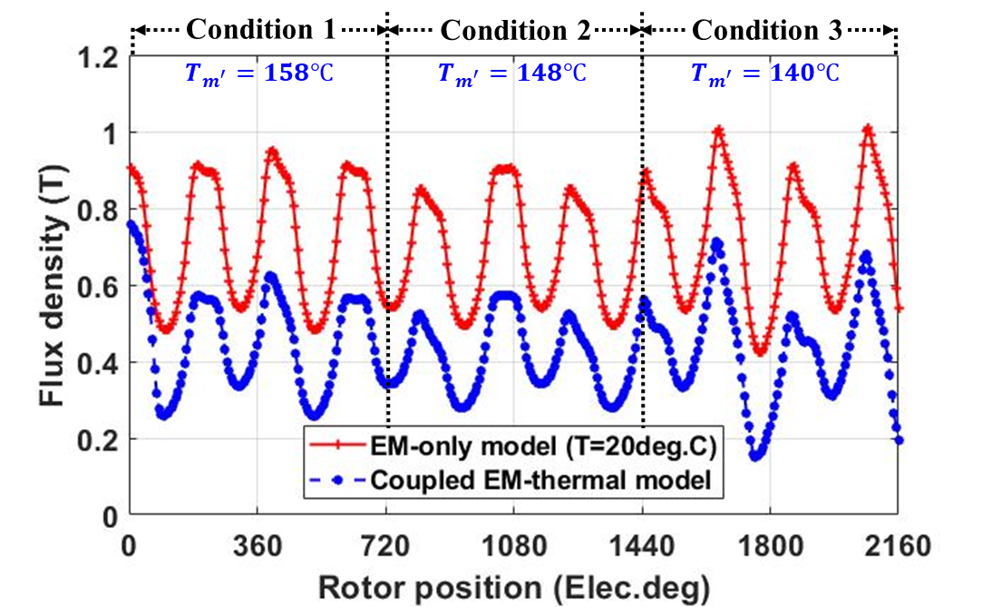
(b) Non-Modular Machine
Fig. 3.24. Magnet flux density variation under different operating conditions. T_{m} denotes the average magnet temperature.
It is worth noting that the PM eddy current loss is proportional to the magnet flux density variation rate ($dB_{m}$/$dt$). Compared with the non-modular machine, the magnet flux density variation rate of the modular machine is smaller, as shown in Fig. 3.24. This is because the increase in effective airgap length, caused by the introduced flux gaps, can reduce the magnet flux density variation rate, and hence can reduce the PM eddy current loss, as shown in Fig. 3.25. This decrease can be more significant when the machines operate under overload conditions, e.g., 3 times the rated current.
In addition, with the coupled EM-thermal model, the losses for different load conditions, including the PM eddy current loss, stator and rotor iron core losses are all reduced for both the investigated machines. This is also due to the demagnetization caused by the PM temperature rise. Furthermore, due to higher copper loss resulted from reduced slot area, the temperatures within the modular machine are higher than those within the non-modular machine under a peak phase current of 100A (conditions 1 and 2). For example, with the introduced flux gaps, the PM temperature increases from 158℃ and 148℃ to 160℃ and 153℃ for the conditions 1 and 2, respectively. When the machines operate under the condition 3, e.g., $I_{q}$ = 300A, the advantage of flux gaps in reducing the PM eddy current loss is more evident, as shown in Fig. 3.25. However, the increase in copper loss can also be more significant due to increased load current. This results in higher coil temperature, which can furthermore increase the copper loss. As a result, the modular machine has higher copper loss and coil temperature [increased from 129℃ (non-modular) to 152℃ (modular)]. In addition, the PM temperature of the modular machine is also affected by this high copper loss, increasing from 140℃ (non-modular) to 150℃ (modular). However, it is worth noting that these results are obtained under the condition that the number of turns per phase and the phase current are the same between the modular and non-modular machines. Given the fact that the modular machine can achieve higher average torque, so if under the same average torque condition, the copper loss of the modular machine will be smaller than that of the non-modular counterpart [42]. This will lead to lower coil and PM temperatures within the modular machines.
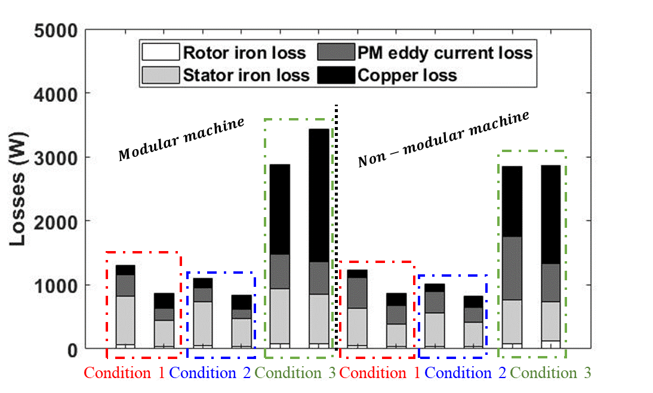
Fig. 3.25. Losses (including stator/rotor iron losses and PM eddy current loss) of both investigated machines under different operating conditions. For each load condition, the left-hand bar is the losses obtained by using EM-only model and the right-hand bar is the losses obtained by using the EM-thermal coupled model.
With the coupled EM-thermal modelling, the partial irreversible demagnetization has also been investigated for both the modular and non-modular machines. The irreversible demagnetization leads to magnetization loss, as shown in Fig. 3.15. The magnetization loss can be evaluated by the demagnetization ratio (also called remanence ratio, k) as [144]
$$k=\left(1-\frac{B_{r1}}{B_{r0}}\right)×100\%$$ | (3.18)
where B_{r0} and B_{r1} are the initial remanence and post-demagnetization remanence, respectively.
The demagnetization ratios for the investigated machines obtained by the coupled EM-thermal modelling are shown in Fig. 3.26. It is found that both machines will experience irreversible demagnetization but the modular machine has smaller irreversible demagnetization region within PMs than the non-modular machine, as shown in Fig. 3.26. This means that the introduced flux gaps can improve the demagnetization withstand capability under different load conditions.
Modular Machine | Non-modular Machine
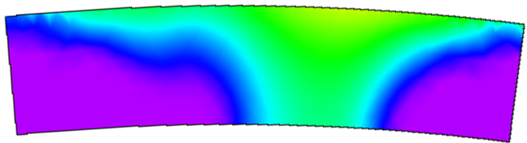 | 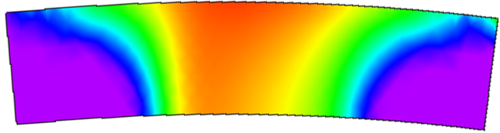 | 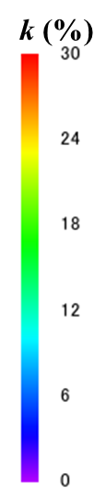
(a) condition 1, $T_{m^{'}}=160℃$ | (d) condition 1, $T_{m^{'}}=158℃$
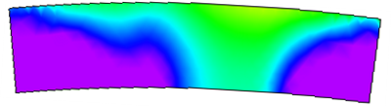 | 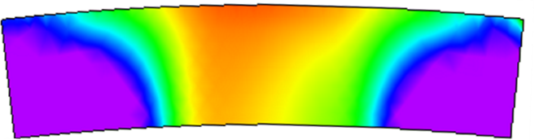
(b) condition 2, $T_{m^{'}}=153℃$ | (e) condition 2, $T_{m^{'}}=148℃$
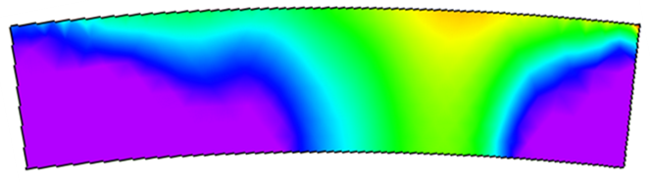 | 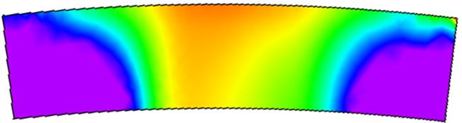
(c) condition 3, $T_{m^{'}}=150℃$ | (f) condition 3, $T_{m^{'}}=140℃$
Fig. 3.26. Demagnetization ratio obtained using the coupled EM-thermal model.
Torque, as one of the most important EM performances for the machines, is also affected by the demagnetization. Compared with the EM-only modelling, the torque of the modular and non-modular machine calculated by using the coupled EM-thermal modelling is lower. This is mainly due to the demagnetization caused by PM temperature rise as shown in Fig. 3.27. Even though the modular machine has higher PM temperature due to copper loss, the decrease in torque is less significant than the non-modular machine. It is shown that, the improved demagnetization withstand capability and reduced PM eddy current loss due to flux gaps allow the modular machines to have better EM performance.
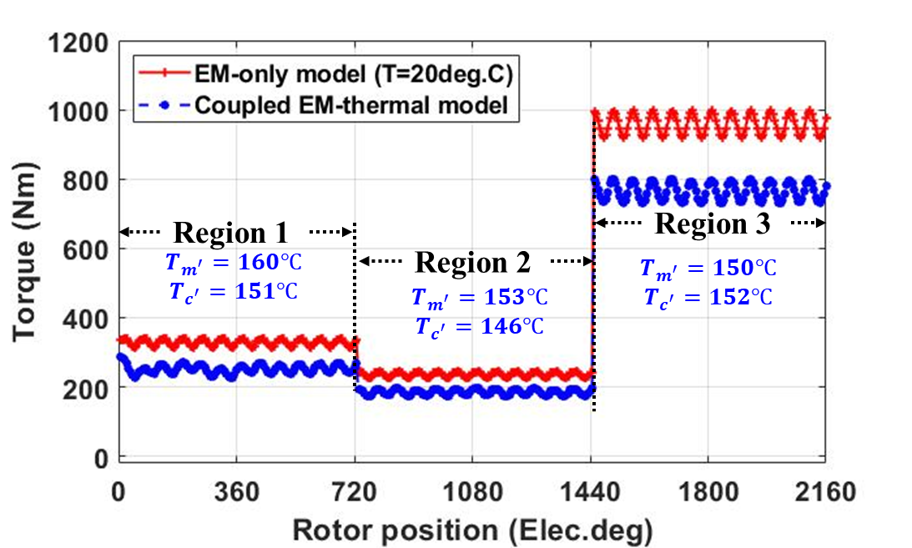
(a) Modular Machine
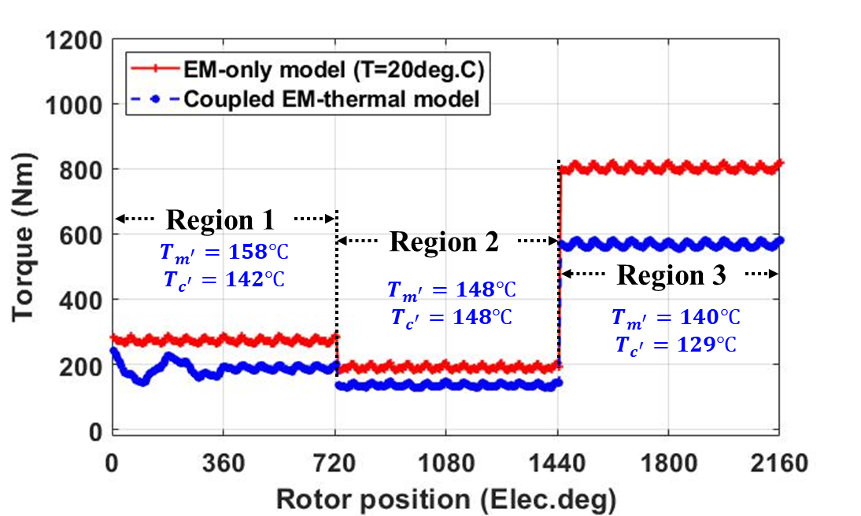
(b) Non-Modular Machine
Fig. 3.27. On-load torque vs rotor position for investigated machines with and without considering EM-thermal coupling. $T_{m'}$ and $T_{c'}$ denote the average steady state magnet and coil temperatures obtained by the coupled EM-thermal model.
The PM demagnetization can be caused by PM field, applied armature field and magnet temperature rise. When temperature varies, the temperature dependent material properties, e.g., the magnet remanence and coercivity and copper resistivity will also change, leading to different losses including stator and rotor core iron losses, magnet eddy current loss and copper loss. The changed losses will in turn lead to temperature variation within electrical machines. Therefore, it is essential to adopt the coupled EM-thermal modelling to predict more accurately the machine EM and thermal performances. By employing the coupled EM-thermal models, the magnet flux density variation, magnet eddy current loss and irreversible magnet demagnetization have been compared between the modular and non-modular machines. It is found that, the introduced flux gaps in the modular machine can improve the machine demagnetization withstand capability. In addition, they can also reduce the PM eddy current loss. Compared to the non-modular machine, the improved demagnetization withstand capability of the modular machine lead to smaller irreversible demagnetization region and also significantly improved on-load torque. Benefits from its higher demagnetization capability, the improving EM performances for the modular machine can be more significant with the coupled EM-thermal modelling, as listed in Table 3.3.
Table 3.3 EM performances for the modular and non-modular SPM machines
 |  | Torque (Nm) | Power (kW) | Efficiency (%)
Without coupling | Modular machine | 330 | 52 | 96.8
Without coupling | Non-modular machine | 273 | 43 | 96.9
With coupling | Modular machine | 326 | 51.2 | 97.1
With coupling | Non-modular machine | 270 | 42.4 | 95.6

Conclusion
In this chapter, the dynamic performances considering the EM-thermal coupling have been investigated for both the modular and non-modular machines. Compared to the non-coupled EM-only analysis, the coupled EM-thermal modelling can consider the effect of temperature rise on magnet properties, e.g., the remanence and coercivity, and copper resistivity. For example, at a given temperature, the EM performance such as the PM flux linkage, stator and rotor core iron losses, PM eddy current loss and copper loss can be calculated. The calculated losses will be used as input in the thermal model to calculate an updated temperature distribution, which in turn will allow the calculation of updated EM performance. This will make accurate analysis of dynamic performance under different operating conditions possible. Based on the results obtained by the coupled EM-thermal models, it has been found that, compared with the non-modular machine, the modular machine generally has higher torque and efficiency under different operating conditions. This is mainly due to the introduced flux gaps in alternate stator teeth that can be used to boost both the EM and thermal performances.
The demagnetization caused by PM field, applied armature field and magnet temperature rise has also been investigated for both the modular and non-modular machines by adopting the coupled EM-thermal modelling. By employing the coupled EM-thermal models, the magnet flux density variation, magnet eddy current loss and irreversible magnet demagnetization have been compared between the modular and non-modular machines. It is found that, the introduced flux gaps in the modular machine are able to improve the machine demagnetization withstand capability. In addition, they can also reduce the PM eddy current loss. Compared to the non-modular machine, the improved demagnetization withstand capability of the modular machine lead to smaller irreversible demagnetization region and also significantly improved on-load torque. Benefits from its higher demagnetization capability, the improving EM performances for the modular machine can be more significant with the coupled EM-thermal modelling. Compared with non-coupled modelling, the efficiency of the modular machine is improved by 0.2%, while it reduces by 1.2% for the non-modular machine.

Forced Cooling Systems for the Modular Machine
The research in Chapter 3 revealed the fact that the electromagnetic performances (torque/power density, efficiency, demagnetization withstand capability, etc.) of the electrical machines are limited by their thermal performances. Employing advanced cooling systems can improve their electromagnetic performances. This chapter presents different cooling systems for the modular SPM machines and their non-modular counterparts. The first one is the semi-flooded oil cooling system. In this cooling system, oil is pumped into the stator to remove heat from the machine stator and coils. However, it is worth noting that a direct contact between the oil and the rotor can significantly increase the friction losses. As a result, a sleeve has been employed to separate the stator and rotor parts. A significant temperature reduction can be observed by introducing semi-flooded oil cooling system. Furthermore, the flux gaps in the modular machine provide extra cooling paths for the oil, which leads to better cooling efficiency. Therefore, the influence of flux gap width on cooling efficiency will be studied in this chapter.
The second cooling system is the ventilation cooling system that has also been investigated in this chapter. Air is pumped into the stator and rotor parts. Different from the semi-flooded cooling, the PMs on the rotor of the SPM machine also benefit significantly from this cooling method. Since the coolant (air) will pass through the stator-rotor annular gap (air gap), as well as rotor and stator ducts, the rotor speed can influence the cooling efficiency of the ventilation cooling system. This effect will be investigated in this chapter.
Some thermal tests have been designed to validate the accuracy of the simulation models. A generally good agreement between the measured and simulated results have been observed.
Publications related to this chapters are listed below:
1. W. Zhang, G. J. Li, R. Zhou, Z. Q. Zhu, B. Ren, and Y. C. Chong, “Forced-liquid cooling for high torque density modular PM machines” IET Electric Power Application 2024. (Accepted).
2. W. Zhang, G. J. Li, R. Zhou, Z. Q. Zhu, B. Ren, and Y. C. Chong, “Forced-air cooling for modular PM machines utilizing flux gaps and rotor ducts,” IEEE ACCESS 2024. (Accepted).

Introduction
When an electrical machine operates, heat will be generated inside it due to different types of losses. These include copper losses, iron losses, PM eddy current losses, and mechanical losses, etc. Heat generated inside the machine will result in temperature increase. Due to the maximum temperature limit of materials, e.g., rare-earth metals such as PMs ($≤$150$℃$ [141]) and coil insulations ($≤$180$℃$ [145-147]), the machine temperatures should be limited to a certain range. To this end, employing an effective cooling systems is one of the solutions widely used for power dense electrical machine [3, 148]. It is well established that heat transfers inside electrical machines through thermal conduction, convection and radiation due to temperature difference [56]. By employing the right cooling technologies, the heat transfer rate of the machine can be improved.
Various cooling technologies have been investigated in literatures. Some of them are passive cooling methods which do not require extra pumps for machine cooling. Some of the passive cooling methods aim to improve the thermal conductivity, such as employing potting materials to fill in the end-space [74, 149], introducing phase change materials in windings [69, 150] by inserting heat flow path [151] or heat pipe [152, 153]. Increasing contact surface area of frame or other machine components by using cooling fins [54] or back iron extension [70] is another passive cooling method. Passive cooling technologies improve machine thermal performance without external power supply. However, compared with active cooling methods, the cooling efficiency of passive cooling methods is limited. Several active cooling methods have also been proposed in literatures. One typical example is the forced air cooling system. In these systems, fans can be located outside of the machines, such as the totally enclosed fan cooled (TEFC) machine to improve the convection coefficient of the housing [83, 154], or the open ventilated cooling machine [88, 155, 156] to directly dissipate heat from heat generation components (e.g., windings, stator/rotor laminations and PMs). The fan can also be located inside the machines such as the shaft mounted fan [157] or wafter cooling [84, 86]. In addition to forced air cooling, other coolant can also be used, i.e., forced liquid cooling. Typical examples are forced water and oil cooling systems [3]. Some of these forced liquid cooling systems are direct forced liquid cooling, such as oil-immersed cooling (semi-flooded cooling) [105, 158-162] and oil spray [155, 163]. They are closed-circuit cooling systems, in which coolant is pumped into the machine. The coolant absorbs heat from the machine components and the surrounding circuit before transferring it to a heat exchanger. For direct forced liquid cooling, the coolant is in contact with the specific components, especially the coils and stator iron core. It can significantly reduce the temperature inside the machine. However, the risks of corrosion and liquid leakage should be considered. Other literatures investigated an indirect forced liquid cooling. The fluid channel can be assembled in the frame [164], the slot [165], the end-windings [166], the stator back-iron [167] or the shaft [99]. These fluid channels can remove heat near them effectively. Such indirect contact between the coolant and the machine components also avoids the corrosion issue presented in the direct forced cooling system. However, like the direct forced liquid cooling method, the liquid leakage remains an issue that needs to be considered.
For all the forced cooling systems, whether forced air or forced liquid cooling, computational fluid dynamics (CFD) modelling is the most popular method for investigating the fluid dynamics and heat transfer of these systems. The CFD modelling is powerful but sometime quite time consuming. This will be elaborated further in section 4.2. Flow network analysis is another method to predict the local flow velocity and to understand the flow profile. The governing equations of the flow network analysis reveal the parabolic relationship between the pressure losses $∆p$ and the volumetric flow rate $Q$:
$$∆p=R_{f}Q^{2}$$ | (4.1)
where $R_{f}$ is introduced to represent the system flow resistance. It can be derived from:
$$R_{f}=\frac{k_{f}∙ρ}{2∙A^{2}}$$ | (4.2)
where $A$ is the cross-sectional area of the coolant path. $k_{f}$ is the dimensionless pressure loss coefficient caused by 1) changing in flow conditions, e.g., expansions, contractions, and bends; and 2) fluid friction at wall surface. The properties of coolant (e.g., viscosity and density), topologies of the machines and the cooling system, and the conditions of the machines (i.e., rotor speed) are all factors that affect $k_{f}$ [56].
For the modular machines, a significant change in machine topology is introduced. According to the flow network analysis, the influence of the flux gaps on fluid dynamics and heat transfer can be significant. Different cooling methods for the PM machines with stator modularity have been investigated in literatures [110, 159, 168]. They indicated that introducing flux gaps/barriers into the machine stator can improve machine electromagnetic and thermal performances. The reason for improving the thermal performance is that, introducing flux gaps can not only increase the contact area between the stator and the coolant, but also significantly reduce the flow resistance of the whole cooling system for the investigated machines. In this chapter, two types of forced cooling technologies will be employed for the modular machines. For example, the semi-flooded oil cooling and ventilation cooling technologies are employed. The influence of the flux gaps on thermal performance of the modular machine will be investigated. In addition, other parameters such as coolant flow rate, and inlet/outlet area of the cooling systems will also be investigated to demonstrate their impact on machine thermal performances. The flow network analysis [89, 169, 170] also points out that rotor speed affects the flow resistance of a stator-rotor annular gap or rotor ducts. Therefore, the thermal performance of the modular machine and its non-modular counterpart will be investigated for different rotor speeds.

Computational Fluid Dynamics Modelling
The behaviour of fluid is governed by a set of nonlinear partial differential equations. Therefore, it is necessary to employ a CFD software to iteratively solve this problem. The CFD software package ANSYS-CFX has been use for this research. In this chapter, the principle, and the governing equations for CFD modelling have been explained in detail as can be seen in the following sections.

Governing Equations
The governing equations of fluid motion represent the mathematical expressions of the basic conservation laws of fluid mechanics. They are [146, 171]:
- Conservation of mass: the mass of a fluid is conserved. Its mathematical expression is:
$$\frac{∂ρ}{∂t}+∇∙\left(ρu\right)=0$$ | (4.3)
where $ρ$ is the fluid density, $t$ is the time and $u$ is the velocity vector.
- Conservation of momentum (Newton’s second law): the change rate of momentum equals to the sum of forces. The conservation of momentum for fluid particle is also known as Navier-Stokes equation as [3]:
$$ρ\frac{∂u}{∂t}+ρ\left(u∙∇\right)u=-∇p+F_{v}+F$$ | (4.4)
where $p$ is the pressure that is a function of temperature and density. $F_{v}$ is viscosity force density vector dependent on the viscosity stress. $F$ are other body forces such as gravitational force, centrifugal force, Coriolis force (occurred because different points on a rotating object have different linear velocities), and electromagnetic force that the fluid particle is subjected to. It is worth noting that, the gravitational force term can be negligible when the working fluid is gas or for the forced convection conditions [146].
- Conservation of energy (first law of thermodynamics): the rate of change of energy is equal to the sum of the net rate of heat added and the net rate of work done. For fluid, the energy conservation equation can be written as:
$$\frac{∂\left(ρT\right)}{∂t}+∇∙\left(ρuT\right)=∇∙\left(\frac{λ}{c}∇T\right)+Q$$ | (4.5)
The term $∇∙\left(\frac{λ}{c}∇T\right)$ is the heat conduction through the boundary of fluid element, where $T$ is the temperature of the fluid, $λ$ is the thermal conductivity, and $c$ is the specific heat capacity. The term $Q$ is the volumetric heat generation. The viscous dissipation function is one of the components of heat source that describes the conversion from mechanical energy into thermal energy. It is proportional to viscosity and gradient of velocity. Hence, it is neglected unless the viscosity and gradient of velocity are very large.

Model Settings
It is worth noting that, the fluid flow in electrical machines is typically considered as turbulent flow. Different simulation methods, i.e., direct numerical simulation (DNS), large eddy simulation (LES), and Reynolds-average Navier-Stokes (RANS) approach, can be employed to solve the turbulent flow issue. Compared with DNS and LES, RANS approach is more popular for the thermal analysis of electrical machines. RANS requires much less computational resources than other simulation methods. For RANS approach, the variables of turbulent flow, e.g., velocity, temperature, and pressure, are divided into mean and fluctuating components. The mean component represents the time-averaged component of the flow, while the fluctuating component represents its turbulent fluctuations. This decomposition allows RANS to average the turbulent fluctuations and to model the influence of turbulence [3]. Those turbulence models describe the statistical behaviour of turbulence in terms of transport equations for turbulent quantities like turbulent kinetic energy and turbulent dissipation rate [172]. They introduce some additional transport equations in RANS flow equations to improve the accuracy and to reduce the complexity of RANS approach turbulence model [146]. Most common models employed in literature are $k$-$ε$ model and $k$-$ω$ model. The transport equation for the turbulent kinetic energy $k$ and turbulence dissipation rate $ε$, and specific turbulence dissipation rate $ω$ are introduced for these two turbulence models. $k$-$ε$ model is often used in electrical machines as it can obtain accurate results and $k$-$ω$ model is more suitable for internal flows at boundary layers [3]. In this chapter, the shear stress transport (SST) $k$-$ω$ model has been employed. Compared with standard $k$-$ω$ model, SST model makes the model stable in viscous-affected region (viscous sublayer), where the viscosity plays an important role in flow behaviour [146].
One of the key considerations for simulating fluid behaviour in electrical machines is the influence of machine rotation. The rotor speed has a profound impact on the fluid velocity and pressure. To reduce the computational burden, the moving reference frame (MRF), also known as the “frozen rotor”, is employed for steady-state analysis of the rotating machines. In the MRF approach, a mesh region for the rotating part acts as a reference frame, while the rest of regions remain static. The reference frame is not moving physically, but the Coriolis force and centrifugal force caused by rotating is included in rotating reference frame. It is worth noting that, MRF approach can only simulate the time-average flow field, where the results calculated are highly dependent on the relative position of the rotating frame and static frame, or in other words, the initial rotor positions of the simulated electrical machines).

Turbulent Boundary Layer and Wall Treatment
The accuracy of the models is often related to the mesh settings. For a CFD modelling of electrical machines, the topologies of which are very complex, the mesh should be fine enough in order to obtain accurate results, especially for the mesh in viscous-affected region, i.e., close to the solid walls. This is because that, the fluid behaviours in viscous-affected region are governed by the shear stress due to wall friction and damping of the turbulent velocity fluctuations. Therefore, the gradients of velocity (both mean and fluctuating components) in viscous-affected region are large. To obtain an accurate prediction of velocity profiles, wall treatment is required for this near-wall boundary layer. To understand the velocity profiles of fluid near the wall boundary, the law of the wall should be proposed firstly. In the law of the wall, the fluid velocity is a function of the distance normal to the wall, the shear stress, the density, and the dynamic viscosity [173]
$$\frac{u}{u_{τ}}=f\left(\frac{yu_{τ}}{ν}\right)$$ | (4.6)
where $u$ is the mean velocity in the direction that is parallel to the wall, $u_{τ}=\sqrt{{τ_{w}}/ρ}$ is the friction velocity, $y$ is the distance that is normal to the wall, $ν=μ/ρ$ is the kinematic viscosity, $τ_{w}$ is the shear stress of the fluid near the wall which is considered to be independent of $y$. The dimensionless velocity $u^{+}=u/{u_{τ}}$ and dimensionless wall distance $y^{+}={yu_{τ}}/ν$ are introduced in the law of the wall, and (4.6) is re-written as
$$u^{+}=f\left(y^{+}\right)$$ | (4.7)
When $y^{+}$ is large, i.e., for turbulent sublayer, $y^{+}≥30$ [146, 174] or $≥50$ [173], viscosity does not play significant role in the interaction between the mean flow and the Reynolds-stress-carrying eddies. The turbulent shear dominates in this turbulent boundary layer. Hence, the fluid velocity is governed by Logarithmic law as [174]
$$u^{+}=\frac{1}{κ}\ln{y^{+}}+C$$ | (4.8)
where $κ≈0.41$ and $C≈5.2$ are the constants that are determined by experiments.
When $y^{+}$ is small ($y^{+}≤5$ [146, 175]), viscous shear dominates in this laminar sublayer. $u^{+}$ is proportional to $y^{+}$:
$$u^{+}=y^{+}$$ | (4.9)
In the transition sublayer (${5≤y}^{+}≤30$), the viscous shear and turbulent shear are both important for building the flow profile. Different functions in the transition sublayer have been identified in [146, 175, 176]. For example, Von Karman 1939 [175] proposed a relationship between $u^{+}$ and $y^{+}$ as:
$$u^{+}=5\ln{\frac{y^{+}}{5}}+5$$ | (4.10)
Based on the law of the wall, the velocity distribution along the wall distance can be plotted as shown in Fig. 4.1. It is found that, the change rate of velocity in low $y^{+}$ region (laminar sublayer) is faster, and it will be slower in high $y^{+}$ region (turbulent sublayer). Consequently, the different kinds of wall treatment need to be employed [177].
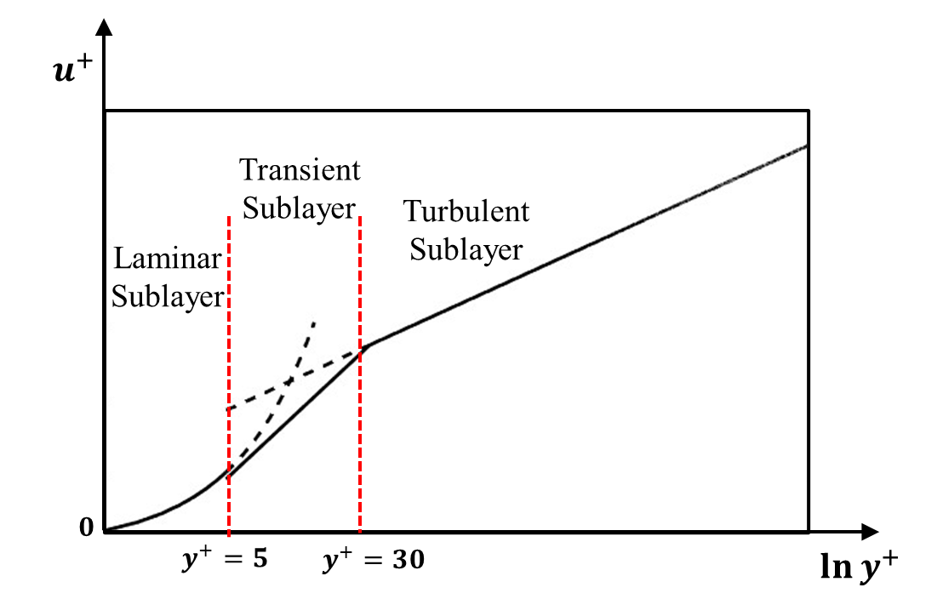
Fig. 4.1. The law of the wall for velocity.
The wall functions approach is one of the wall treatments. It predicts the fluid behaviour (velocity, temperature, and turbulence, etc.) according to the wall functions. For wall functions approach, the mesh can be coarse, and therefore less computational consumption is required. It is sufficiently accurate and robust to predict the flow profile in turbulent sublayer, where $y^{+}≥30$.
The low-Re near wall approach is one of the wall treatments that generates more accurate results in low $y^{+}$ region. Fluid behaviour can be predicted by using the turbulence models but without the need for the wall functions. However, sufficient boundary-layer mesh resolution is required for the Low-Re near wall approach. Compared with the wall functions approach, it is more computationally expensive. It is worth noting that, the low-Re near wall approach is only sufficiently accurate and robust when $y^{+}≤0.2$ and the $k$-$ε$ turbulence model is employed. This value can increase to 2 after employing $k$-$ω$ turbulence model (by introducing Wilcox $k$-$ω$ model [178]). It is another advantage for the $k$-$ω$ model.
In most commercial software (e.g., ANSYS CFX, ANSYS Fluent, Star-CCM+), automatic near-wall treatment is employed to consider the trade-off between computational resource and model accuracy. The wall functions approach is implemented in the region that $y^{+}≥30$ and the low-Re near wall approach is implemented in the region that $y^{+}≤2$. The flow profile in the remaining region is also calculated by the law of the wall while blending the logarithmic law as (4.8) and linear law as (4.9).

Mesh
The mesh generation needs to meet the requirement of the wall treatments. ANSYS CFX 2021 [177] suggested that, for heat transfer predictions, a fine mesh such that $y^{+}$ is around 1 is recommended. Therefore, a fine mesh is required for the fluid adjacent to the wall. Considering the trade-off between accuracy and computational resource, a three-layer inflation mesh is implemented at the walls in the air gap region (1mm thickness) while the first layer thickness is 0.08mm as shown in Fig. 4.2 (c). The spaces for fluid in the flux gaps and end-winding regions are much larger than those in airgap. Therefore, a coarser mesh is implemented in these two regions. A five-layer inflation mesh with a first layer thickness of 0.2mm is generated, as shown in Fig. 4.2 (a) and (b). It is worth noting that, in order to achieve a smooth transitional flow profile, the growth rate for all inflation mesh will be 1.2. Coarse wedge and pyramidal shape of meshes are used in the remaining components. As a result, there are 1358475 mesh nodes and 4654093 mesh elements in the CFD models.
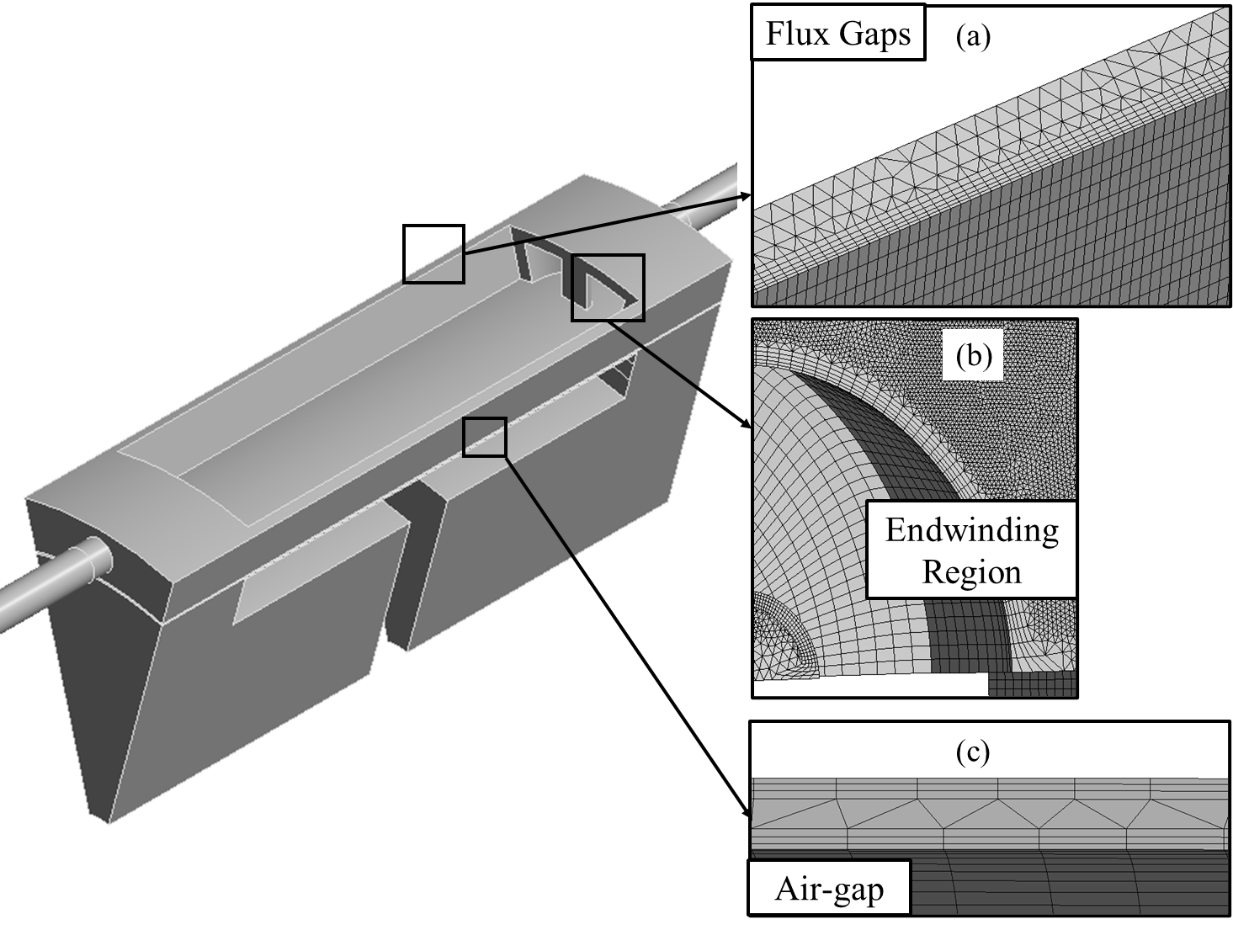
Fig. 4.2. Meshes in the air regions of the investigated modular SPM machine.

Rough Wall Treatment
Surface roughness have a significant influence on the CFD modelling since it can lead to increase in shear stress and heat transfer coefficients. Thus, the effect of surface roughness is essential and needs to be considered in the CFD models. Since the rough wall increases shear stress and breaks up the turbulent flow in viscous-affected region, a downward shift in the logarithmic law governed curve at turbulent sublayer is introduced. When the surface roughness ($h$) is introduced, the wall function (4.8) can be re-written as:
$$u^{+}=\frac{1}{κ}\ln{y^{+}}+C+∆C$$ | (4.11)
$$∆C=\frac{1}{κ}\ln\left(1+0.3h^{+}\right)$$ | (4.12)
where $h^{+}={hu_{τ}}/ν$ is the dimensionless roughness height.

Convection Coefficient Calculation
In general, convection coefficient is an important parameter for investigating heat transfer in electrical machines, especially when the LPTN model is used to predict temperature variations within different machines components. The convection coefficient can be calculated according to CFD modelling. There are two kinds of methods to calculate the convection coefficient for ANSYS CFX and Fluent. In the CFD models, the average convection coefficient ($h_{e}$) can be calculated from the mean convection coefficient ($h_{i}$) of each mesh on the calculated surface (Method 1).
$$h_{e}=\frac{\sum{(A_{i}h_{i})}}{\sum{A_{i}}}$$ | (4.13)
where $A_{i}$ is the area of the contact surface between the fluid and the calculated surface. The convection coefficient of each mesh $h_{i}$ is derived as:
$$h_{i}=\frac{q_{i}^{''}}{{(T}_{wi}-T_{{bulk}_{i}})A_{i}}$$ | (4.14)
where $q_{i}^{''}$ is the heat flux in this mesh, $T_{wi}$ is the wall temperature of this mesh, $T_{{bulk}_{i}}$ is the air temperature adjacent this mesh. $A_{i}$ is its surface area.
For the LPTN model proposed in Chapter 3, the convection coefficient should be calculated from other method (Method 2). In LPTN model, several surfaces are connected to the same node that represent the temperature of the fluid. Thus, the reference temperature ($T_{{bulk}_{i}}$) for those surfaces should be the same. (4.13) can be re-written as:
$$h_{e}=\frac{\sum{(A_{i} q_{i}^{''})}}{\sum{\left({A_{i}T}_{wi}\right)}-T_{bulk}\sum{A_{i}}}=\frac{q_{i,ave}^{''}}{T_{wi,ave}-T_{bulk}}$$ | (4.15)
where $T_{bulk}$ is the average temperature of air for the calculated region. This method (Method 2) will be employed to calculate the convection coefficients of the investigated machines in this chapter.

Semi-Flooded Oil Cooling
Compared with the conventional non-modular SPM machine, the flux gaps introduced in the modular SPM machine provides additional degree of freedom for cooling design. In this section, a semi-flooded oil cooling system is introduced for the modular SPM machine. The machine specification is the same as that used in Chapter 3 (see Table 3.1). Twelve holes are positioned at the same locations on both endcaps, as shown in Fig. 4.3 and Fig. 4.4 (a). The disc-shaped shaft is designed as shown in Fig. 4.4 (b). A polyether ether ketone (PEEK) is employed as sleeve to separate the machine into an oil-flooded stator part and an oil-free rotor part in order to avoid liquid leakage and friction losses. For the forced cooling systems, the gravitational effect has been neglected. Therefore, the circumferential symmetry of the modular SPM machine leads to a circumferentially symmetric distribution of flow field and heat transfer. Thus, a one-twelfth ($30°$) segment is simulated for three-dimensional CFD modelling as shown in Fig. 4.5. It is worth noting that, the axial domain lengths both upstream and downstream of the machine are around 2 times and 3.5 times the machine length to achieve a fully developing flow profile. This can prevent the model from experiencing unwanted ‘backflow’ that can cause poor convergency and inaccurate results.
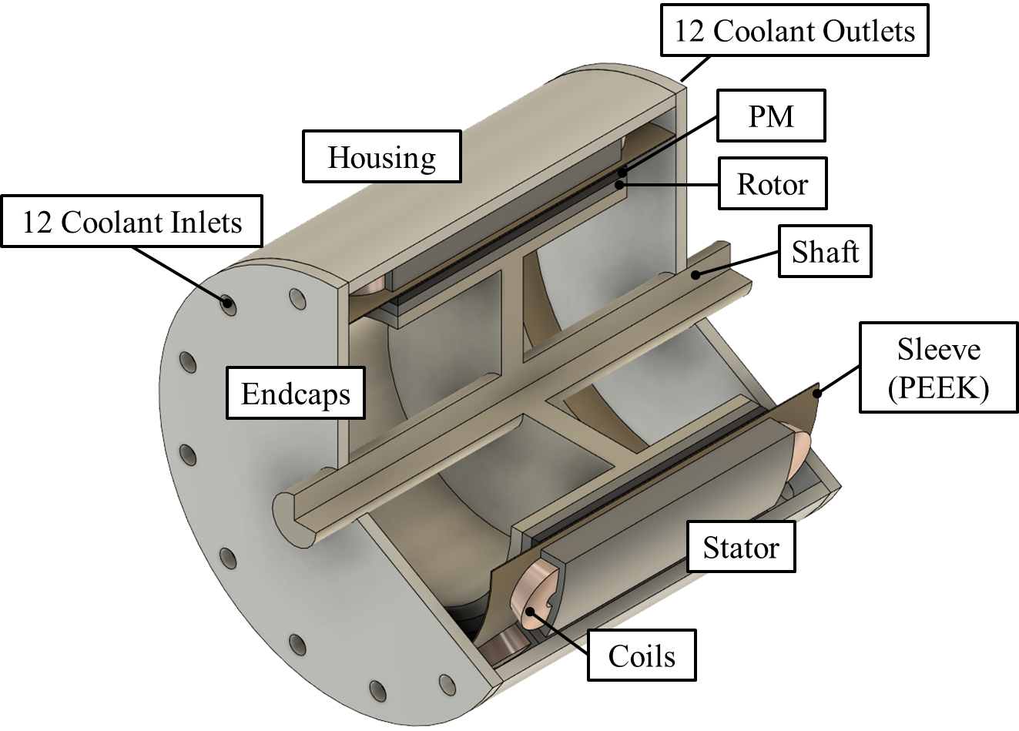
Fig. 4.3. Cut away view of the modular SPM machine with semi-flooded oil cooling system.
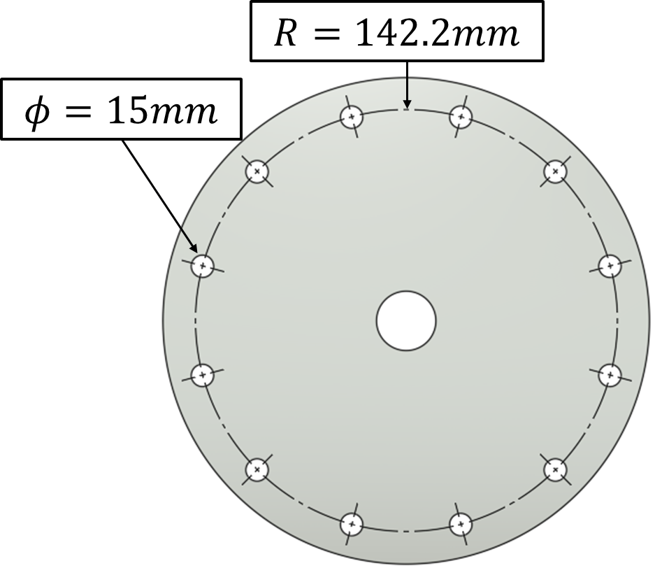
(a) Endcap and coolant inlet/outlet
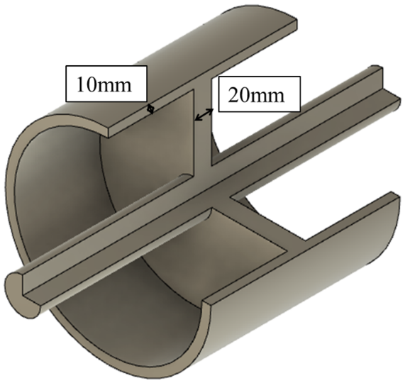
(b) Shaft
Fig. 4.4. Topology of endcap and shaft for the investigated modular machine with semi-flooded oil cooling system.
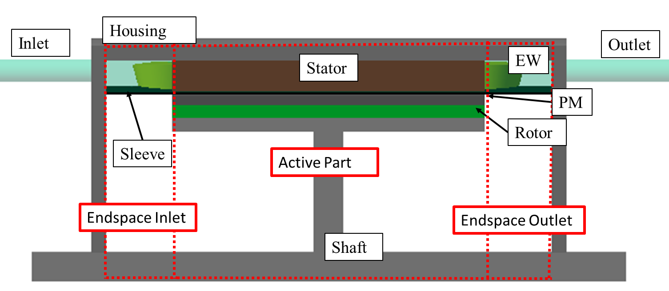
Fig. 4.5. CFD model of the modular SPM machine with semi-flooded oil cooling system.
The thermal properties of machine components are listed in Table 4.1, and the properties of coolant are listed in Table 4.2. To simplify the models, a thermal anisotropy material is introduced for the coils to represent the mixture of copper and impregnation in stator slots. Hashin and Shtrikman approximation in (3.15) is also employed to calculate the anisotropic thermal conductivity of this material. The slot fill factor is assumed to be 0.4 for all the investigated machines and the conductivity that is vertical to the current direction is 0.65$W/{m/K}$, while the conductivity that is parallel to the current direction is 160$W/{m/K}$. The average density is 4269${kg}/{m^{3}}$ and the average specific heat capacity is 1174$J/{kg/K}$.
Table 4.1 Properties of Machine Solid Components [179]
 | Housing | Shaft | Rotor/Stator | Magnet | Impregnation
Density (${kg}/{m^{3}}$) | 2790 | 7800 | 7650 | 7500 | 1160
Thermal conductivity ($W/{m/K}$) | 168 | 52 | 30 | 7.6 | 0.28
Specific heat capacity ($J/{kg/K}$) | 833 | 460 | 460 | 7500 | 1700
Table 4.2 Properties of the Coolant
Density (${kg}/{m^{3}}$) | 879
Thermal conductivity ($W/{m∙K}$) | 0.1731
Dynamic viscosity ($Pa∙s$) | 0.046
Specific heat capacity ($J/{kg/K}$) | 1.685$×{10}^{3}$

CFD Results for the Modular Machine
Based on the conditions and assumptions detailed in previous sections, a CFD model for the modular SPM machine with semi-flooded oil cooling system has been established. It is worth noting that, the convection coefficient at outer surface of the housing, endcaps and shaft are identified as 8 $W/m^{2}/K$, while the reference temperature for those surfaces is 20$℃$. A constant pressure loss between the inlet and outlet is 1000Pa and the inlet coolant temperature is 65$℃$, which is similar to the mainstream coolant temperature used in electrical vehicles (EV). A smooth and no-slip wall is identified for the whole machine surface.
The coolant velocity distribution and temperature distribution are shown in Fig. 4.6 and Fig. 4.7. Due to its circumferential symmetry, one-fourth (90$°$) segment is used to show the flow and thermal profiles. The fluid friction and flow condition change (expansions, contractions, and bends) inside the machine result in variation of coolant flow velocity in different machine regions. The coolant velocity in the endspace inlet and outlet regions (see Fig. 4.5) is low, but higher velocity can be observed in flux gaps region, as shown in Fig. 4.6. The heat generated by the windings (copper loss) and the stator iron core (iron losses) is directly removed by the coolant oil. However, the heat generated by the rotor PMs can only be dissipated by the convection through the airgap (to the stator) and by conduction through the shaft (to the environment). Significant temperature reductions for the stator iron core and the windings can be achieved by the semi-flooded cooling technology, as shown in Fig. 4.7. For example, compared with oil-immersed cooling (no oil pump to provide axial flow), employing semi-flooded cooling technology can reduce the maximum winding temperature by around 100$℃$. Based on (4.14), the convection coefficient distribution on the surfaces of the stator and end-winding are shown in Fig. 4.8. It is worth noting that, the reference temperature ($T_{{bulk}_{i}}$) of the coolant is 65$℃$.
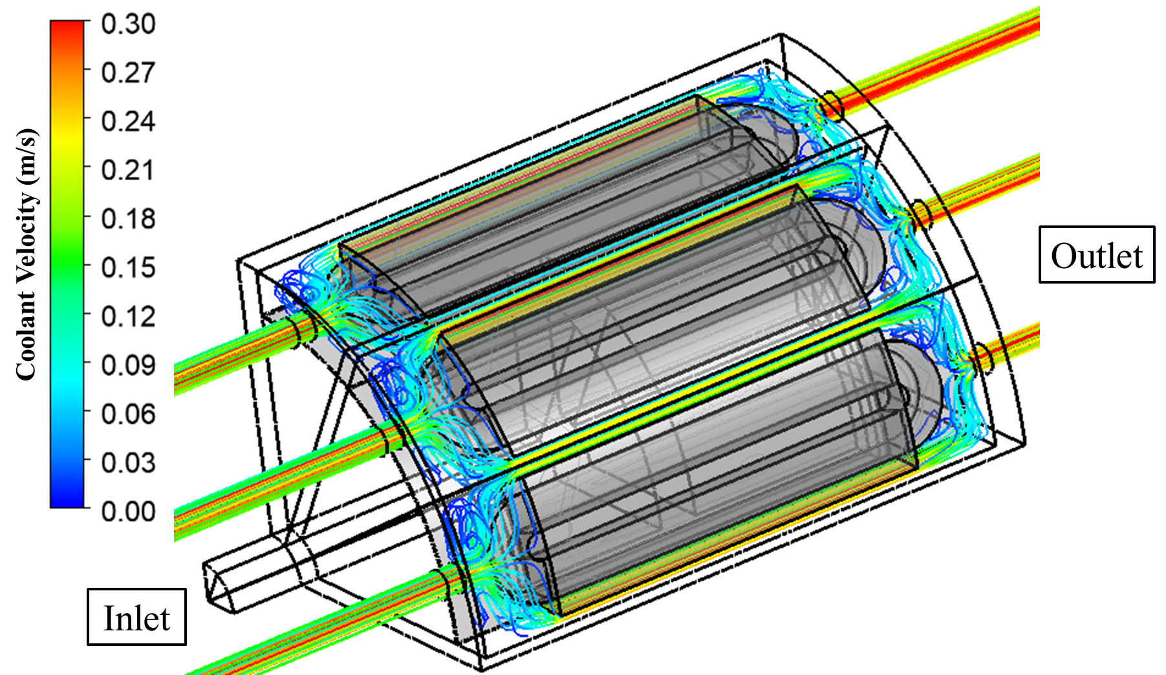
Fig. 4.6. Coolant velocity streamline of the modular SPM machine with a flux gap width of 10mm.
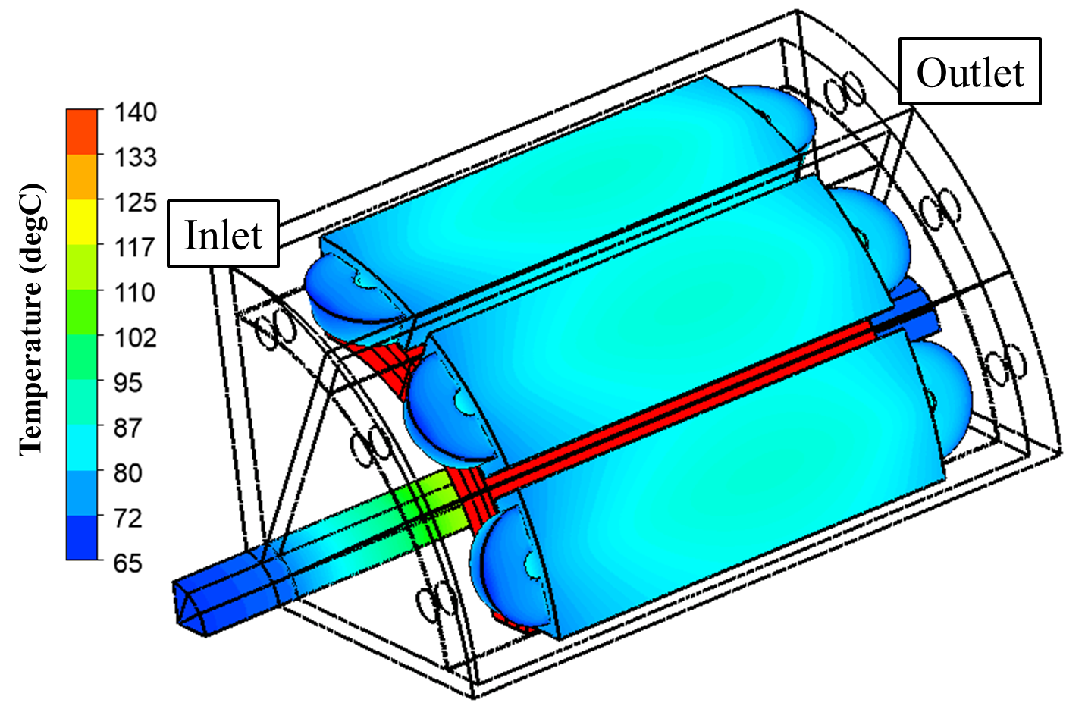
(a) Temperature distribution of different machine components
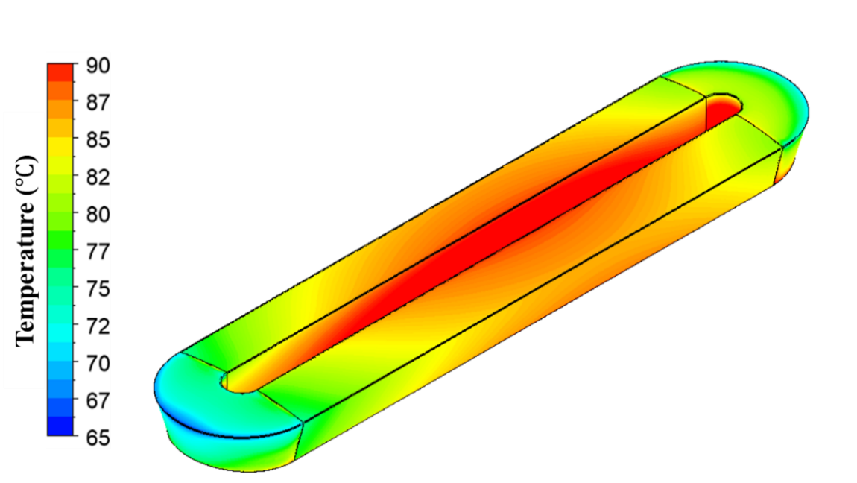
(b) Temperature of one coil
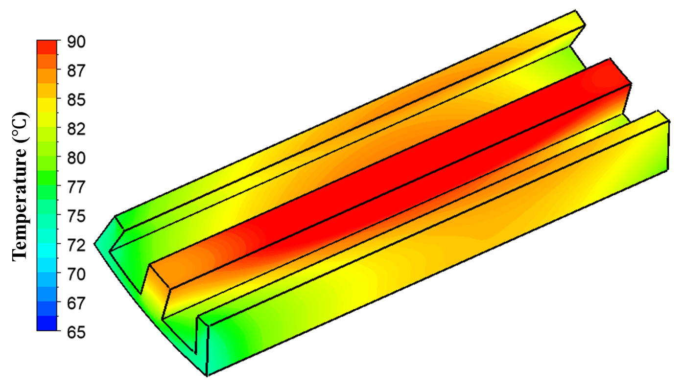
(c) Temperature of one stator segment
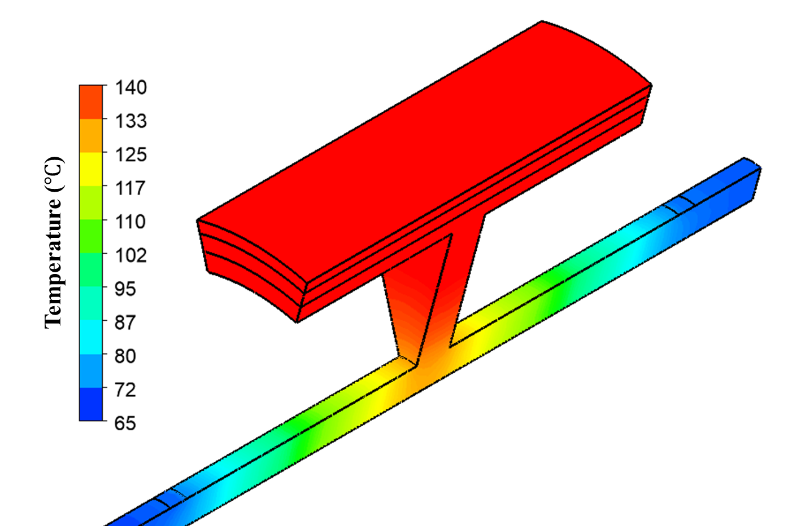
(d) Temperature of the rotor
Fig. 4.7. Temperature distribution of the modular SPM machine with a flux gap width of 10mm.
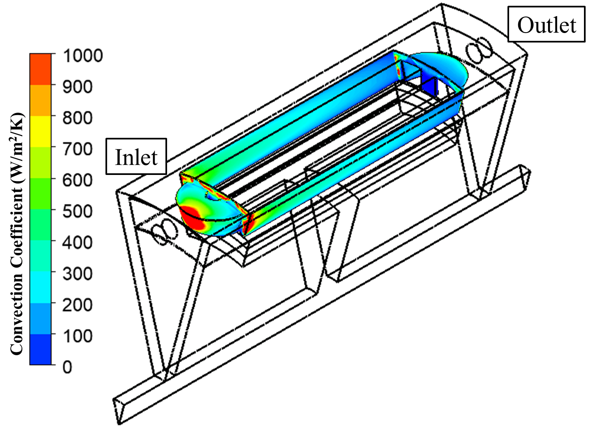
Fig. 4.8. Convection coefficient distribution at the surfaces in contact with the coolant oil for the modular SPM machine with a flux gap width of 10mm.

Influence of Flux Gap Width
According to (4.2), the increase of cross-sectional area of the coolant path can significantly reduce the system flow resistance. This means that, the width of the flux gap can directly affect the cooling efficiency of the semi-flooded cooling system. Thus, the influence of flux gap width on flow profile has been investigated in this section. It is worth noting that, to understand the influence of the flux gap width, the heat sources in the stator iron, windings and PMs for different flux gap widths will be kept the same. A constant pressure loss of 1000Pa between inlet and outlet will be maintained for different flux gap widths. It is worth noting that, the flux gaps are the only coolant path for semi-flooded cooling system that designed in this section. Therefore, the coolant will be fully obstructed when flux gap width is 0mm, corresponding to a non-modular machine. Hence, the cooling system is considered to be an oil-immersed cooling system when the flux gap width is 0mm. In this chapter, considering the manufacturing complexity and tolerance, a minimum flux gap width of 3mm for the modular machines has been selected. It is therefore worth noting that the semi-flooded oil cooling system designed in this chapter may not be suitable for modular machines with narrower flux gaps unless higher pressure loss is acceptable.
The change of system flow resistance affects the relationship between the pressure loss and the flow rate as described by (4.1). If the pressure loss is constant, increasing flux gap width can reduce the flow resistance and improve the volumetric flow rate as shown in Fig. 4.9. However, this improvement becomes gradually insignificant when the flux gap width keeps increasing.
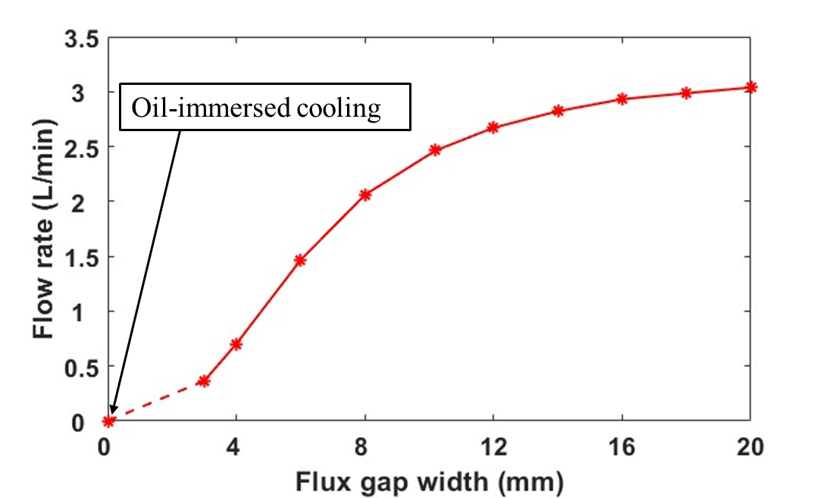
Fig. 4.9. Flow rate vs different flux gap widths for the investigated modular machines.
When the flux gap width increases, the coolant velocity changes as shown in Fig. 4.10. Benefited from the rapid increase of volumetric flow rate as shown in Fig. 4.9, the coolant velocity in the flux gap region also increases when the flux gap width increases until it reaches 8mm. However, increased flux gap width also leads to larger cross-sectional area, which has negative impact on the coolant velocity. Thus, when the flux gap width is larger than 8mm, this negative impact becomes more dominant and the coolant velocity in the flux gaps gradually reduces.
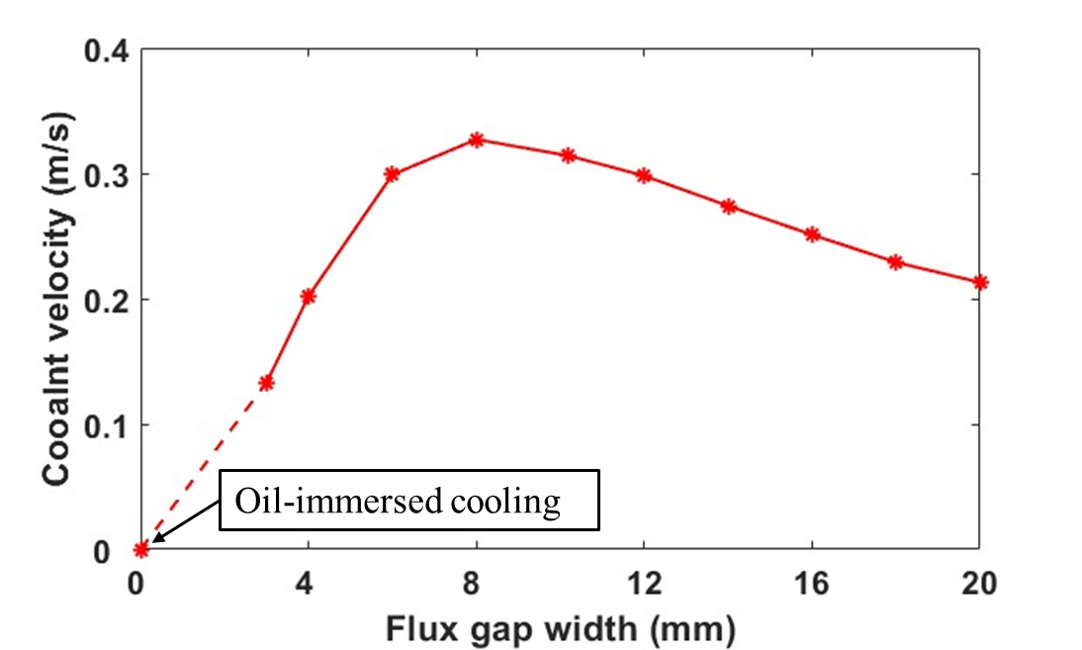
Fig. 4.10. Coolant velocity at the centre of flux gap vs different flux gap widths.
The machine has been divided in to three regions, i.e., end-space inlet region, end-space outlet region and active part, as shown in Fig. 4.5. The total pressure loss for the whole system is the sum of all pressure losses in each region. The pressure losses at each region are shown in Fig. 4.11. When the flux gap width is small, the dimensionless pressure loss coefficient at the active part, i.e., flux gaps region, is much larger than those in the other two regions. According to the flow network analysis, most pressure loss is in the flux gaps region. When the flux gap width increases, the dimensionless pressure loss coefficient significantly reduces. As a result, more pressure loss comes from the end-space regions. It is worth noting that, the dimensionless pressure loss coefficients for the fluid channel expansions and contractions are different [89] as shown in Fig. 4.14, and the pressure losses in the end-space inlet region and outlet region are not the same. More details about the dimensionless pressure loss coefficients for expansion and contractions can be seen in section 4.3.3.
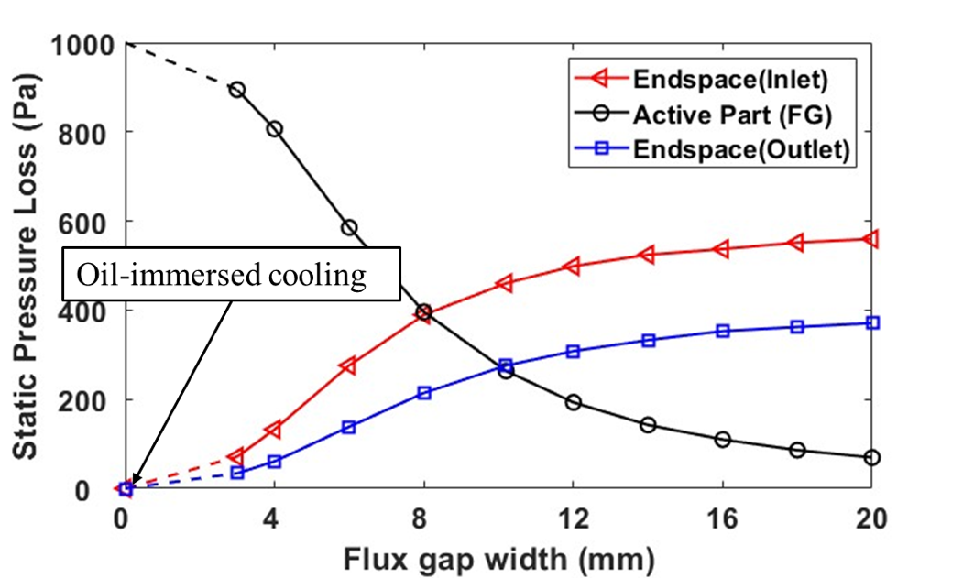
Fig. 4.11. Pressure losses at different machine components (end-space inlet region, end-space outlet region, active part) vs flux gap widths for the investigated modular machines. The total pressure drop is 1000Pa.
The average convection coefficients at the surfaces of flux gaps, inlet and outlet end-winding have been calculated by (4.15) for different flux gap widths, as shown in Fig. 4.12. It demonstrates that, when flux gap width increases, the convection coefficient in the flux gaps increases slightly first, as shown in Fig. 4.9. This is because a larger coolant velocity is available. However, when the flux gap width increases further, the convection coefficient reduces due to lower coolant velocity caused by larger cross-sectional area. In the meantime, more pressure loss occurs in the end-space regions, which leads to increase of convection coefficient in the end-space region, particularly at the surface of inlet winding which directly faces the inlet flow.
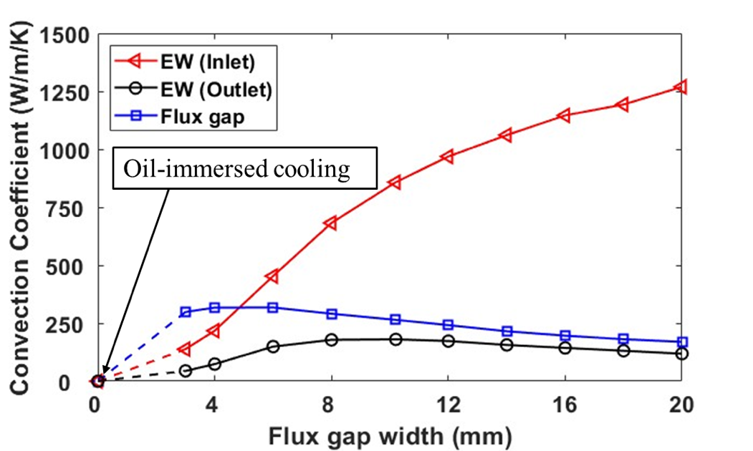
Fig. 4.12. Convection coefficients on different machine surfaces (end-winding in end-space inlet region, end-winding in end-space outlet region and flux gap region) vs different flux gap widths for the investigated modular machines.
The maximum temperatures of the end-windings in the inlet or outlet regions, active coil and PM are shown in Fig. 4.13. The stationary components, i.e., end-windings in inlet or outlet regions, and active coil, benefit much more from the semi-flooded cooling technology than the rotating components, i.e., PM. Same as the flow rate, the machine temperature reduces when the flux gap width increases. However, the reduction rate of temperature becomes smaller when the flux gap width is large.
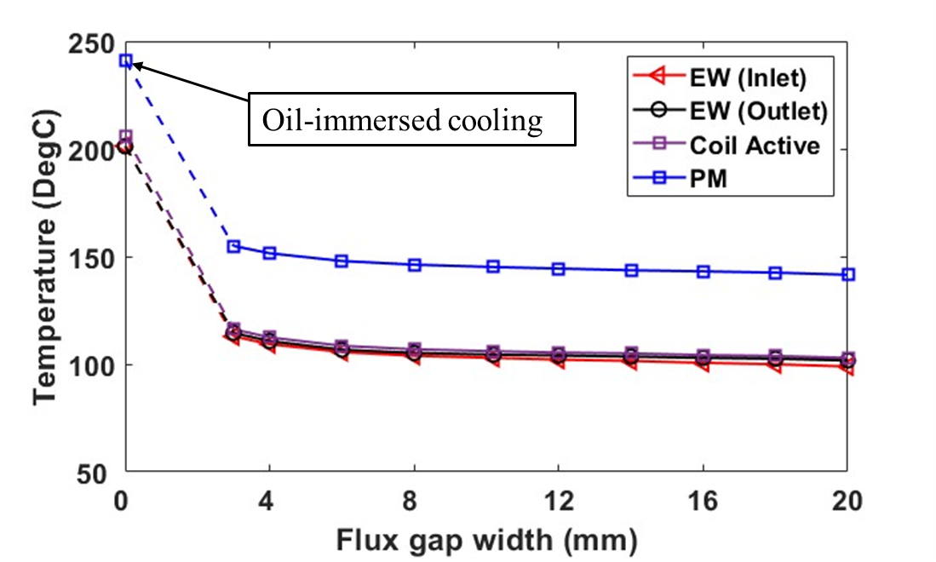
(a) Temperature variations for all machine components
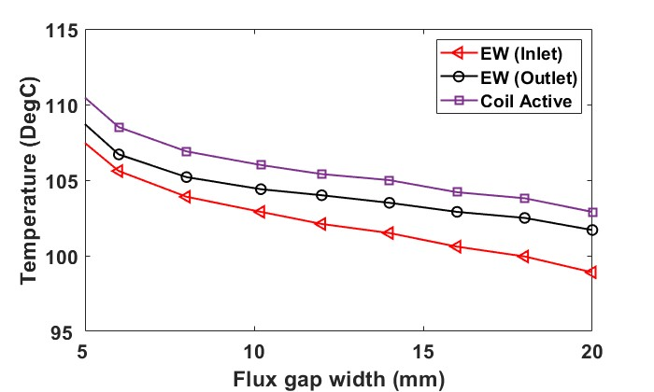
(b) zoom-in view of the stationary components
Fig. 4.13. Maximum temperatures at different machine components (end-windings in end-space inlet and outlet regions, active coil and PM) vs different flux gap widths.

Influence of Inlet/Outlet Area
According to flow network analysis, the expansions and contractions of fluid lead to additional pressure losses. These pressure losses also follow the pressure loss equation described by (4.1) and (4.2). The dimensionless pressure loss coefficient for sudden expansions and contractions are calculated by [89]:
$$k_{f}= \left\{\begin{aligned}{\left(1-\frac{{Area}_{i}}{{Area}_{o}}\right)}^{2} \\ {0.5∙\left(1-\frac{{Area}_{o}}{{Area}_{i}}\right)}^{0.75}\end{aligned}\right.$$ | $${Area}_{i}<{Area}_{o}$$ | (4.16)
 | $${Area}_{i}>{Area}_{o}$$ | (4.16)
where ${Area}_{i}$ and ${Area}_{o}$ denote the upstream and downstream areas of the fluid channel, as shown in Fig. 4.14.
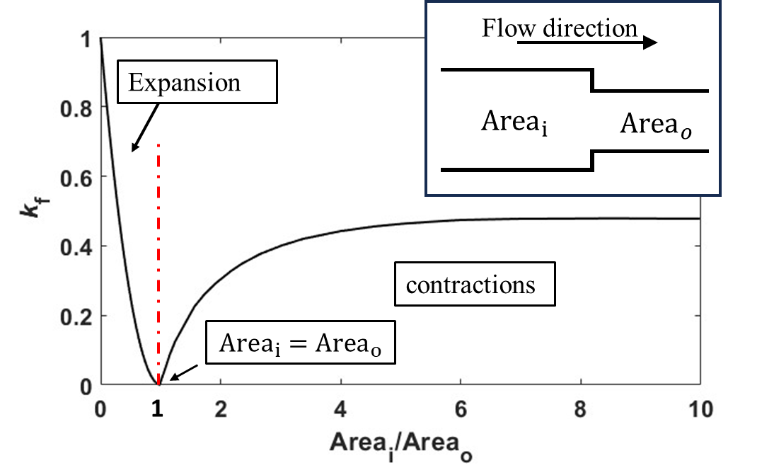
Fig. 4.14. Dimensionless pressure loss coefficient ($k_{f}$) caused by sudden expansions or contractions of fluid channel [89].
Therefore, when the cross-sectional areas of the inlet and outlet increase and the machine inside region is constant, ${{Area}_{i}}/{{Area}_{o}}$ for the end-space inlet region (expansion) and ${{Area}_{o}}/{{Area}_{i}}$ for the end-space outlet region (contraction) both tend to be 1. Thus, $k_{f}$ tends to be 0, as shown in Fig. 4.14. As a result, increasing the cross-sectional area of the inlet/outlet results in lower pressure loss in inlet and outlet regions. And higher flow rate for the whole system can be achieved when the pressure loss is constant, as shown in Fig. 4.15.
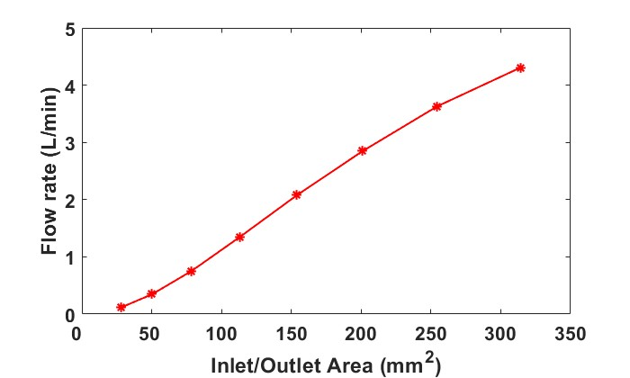
Fig. 4.15. Flow rate vs different inlet or outlet areas.
Due to the influence of inlet/outlet area on the flow rate, the convection coefficient and temperature will also be affected by the change in inlet/outlet area. For example, the inlet and outlet areas increase, the convection coefficients on the surfaces of different machine components all increase as shown in Fig. 4.16. Additionally, the temperatures on the surfaces of different machine components all reduce, as shown in Fig. 4.17. It is also found that the surface of the end-winding facing the inlet flow benefits more from the increase in the inlet/outlet area.
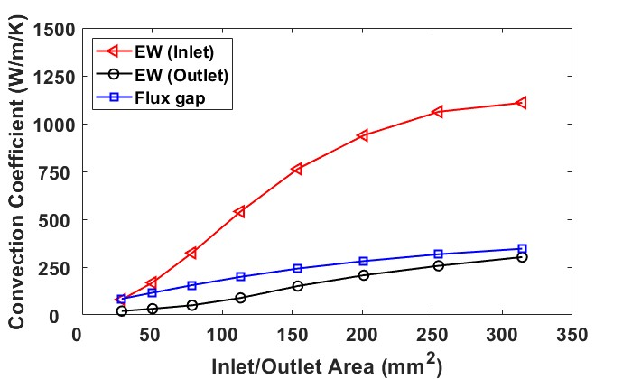
Fig. 4.16. Convection coefficients in different machine regions (end-windings in end-space inlet and outlet regions, and flux gap region) vs different inlet or outlet areas.
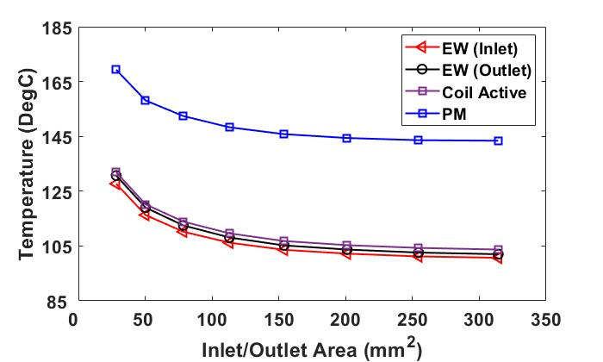
Fig. 4.17. Maximum temperatures in different machine components (end-windings in end-space inlet and outlet regions, and active part) vs different inlet or outlet areas.

Ventilation Cooling
In addition to the semi-flooded oil cooling system for the modular machine, another forced cooling system, namely the ventilation cooling system, has also been employed for the modular machine and its non-modular counterpart. For comparative analyses, eight machine models, from model 1 to model 8, termed ‘M1’ to ‘M8’, as listed in Table 4.3, have been proposed and investigated. These machine models have different designs of endcaps, shafts and stators.
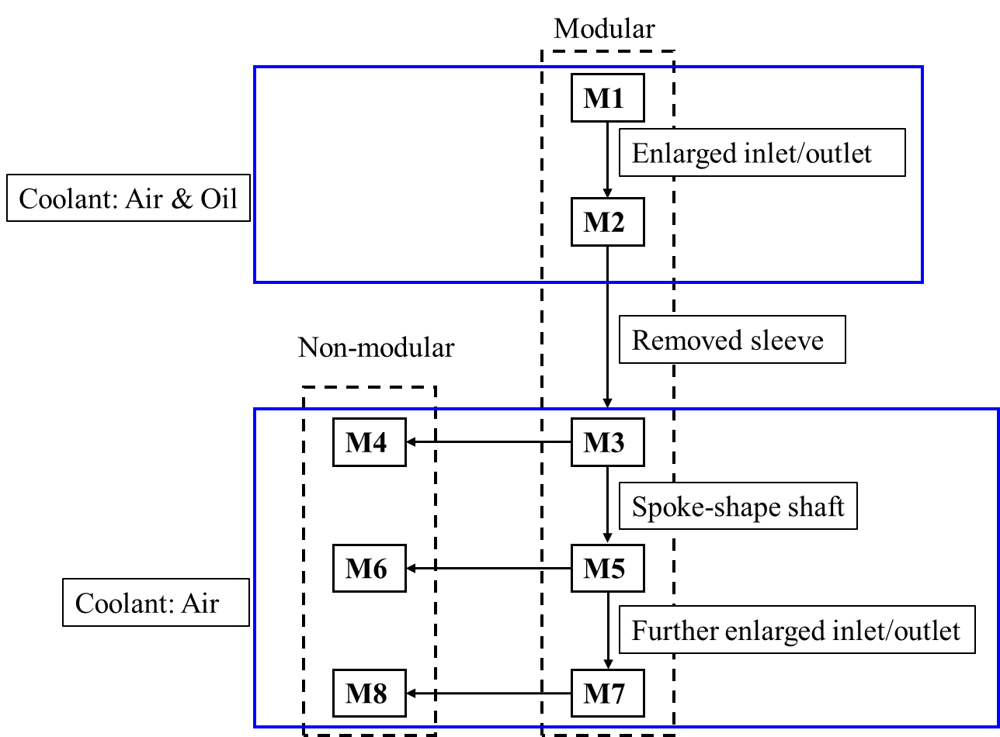
Fig. 4.18. The comparison between different models.
As shown in Fig. 4.18, M1 is the original design previously discussed in section 4.3. M2 enlarges the cross-sectional area of the inlet and outlet of M1. For M1 and M2, both air and oil can be used as coolant materials due to the presence of a PEEK sleeve. M3 omits the sleeve from M1 and M2. Thus, the only permissible coolant is air, which does not require a sleeve to prevent coolant leakage. Once the sleeve is removed, the forced air cooling system can also be adopted for the non-modular machines since the flux gaps are not the exclusive fluid path for the coolant. This leads to the development of M4, which has the same endcaps and shaft as those of M3 but with continuous (non-modular) stator. A spoke-shape shaft can be used to provide additional coolant path for both modular and non-modular machines, termed M5 and M6, respectively. The further enlarged trapezoidal-shape inlet and outlet can be designed to align with the spoke-shape shaft, referred to as M7 and M8. Details of each machine component for different models are listed in Table 4.3-(A) and (B). More details can be seen in section 4.4.1.

Table 4.3-(A) Topologies of Investigated Machines
 | M1 | M2 | M3 | M4
Endcaps | 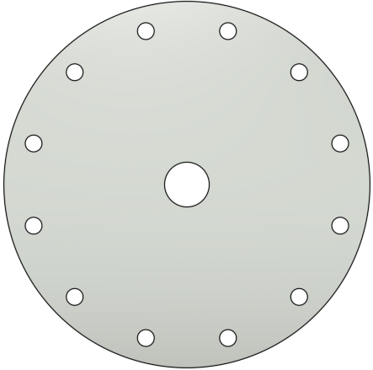 | 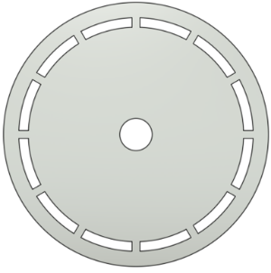 | 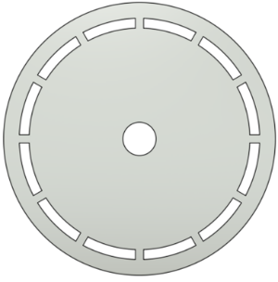 | 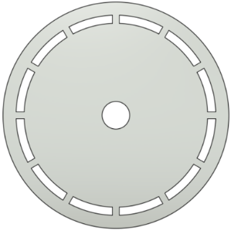
Shaft | 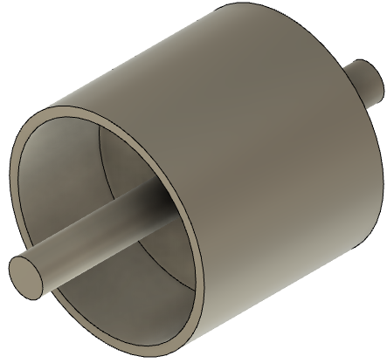
Stator Modularity |  |  |  | 
Sleeve | $$√$$ | $$√$$ | $$×$$ | $$×$$
Coolant materials | Air & Oil | Air & Oil | Air | Air

Table 4.3-(B) Topologies of Investigated Machines
 | M5 | M6 | M7 | M8
Endcaps |  |  | 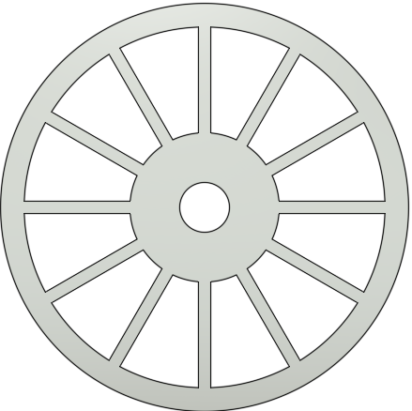
Shaft | 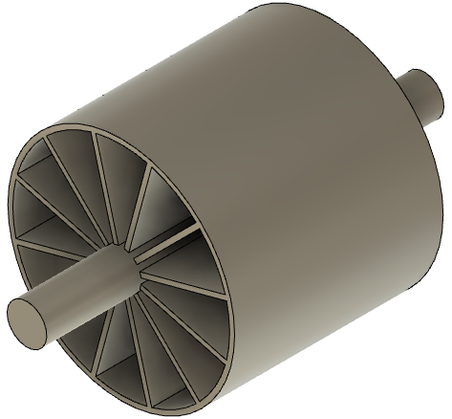
Stator Modularity
Coolant materials | Air | Air | Air | Air
Notes: for all the topologies, no sleeve has been used.

Comparative Analysis of Different Models
M1, which was previously introduced in section 4.3 for forced-oil cooling, will be used at the beginning of this section for investigating the ventilation cooling system. Here, air will be used as coolant, and its cooling performance will be compared against that of the same machine with forced oil cooling.
Table 4.4 Properties of Air
Density (${kg}/{m^{3}}$) | 1.185
Thermal conductivity ($W/{m∙K}$) | 0.0261
Dynamic viscosity ($Pa∙s$) | 1.831$×{10}^{-5}$
Specific heat capacity ($J/{kg/K}$) | 1.004$×{10}^{3}$

The thermal properties of the machine solid components are the same as those used in section 4.3. The properties of air are also listed in Table 4.4. It is worth noting that, since the forced cooling system is employed, the temperature varying properties (especially the density and dynamic viscosity) can be neglected. In addition, during the research of the cooling design for the electrical machines, the Mach number ($M=u/{u_{c}}$, where $u$ is the coolant velocity and $u_{c}$ is the speed of sound in the medium) of the coolant is always lower than 0.3, i.e., 100$m/s$. Therefore, the compressibility of air is negligible. A uniform, fully developed airflow is introduced into the investigated modular machines with a mass flow rate of 0.48${kg}/s$, i.e., 0.04${kg}/s$ or 0.034${m^{3}}/s$ for each segment, and an inlet temperature of 20$℃$.
For comparative analyses, an equal mass flow rate of oil as that of air has also been introduced to investigate the cooling performance. Since the mass flow rate is the same for both coolants (air and oil), the volumetric flow rate of oil is around 2.1$L/{min}$. It is worth noting that this oil volumetric flow rate is approximately $1/{980}th$ of that of air. This significantly reduced volumetric flow rate leads to substantially lower coolant velocity as illustrated in Fig. 4.19. Despite its significantly lower volumetric flow rate compared to air, oil cooling achieves similar cooling efficiency, due to its higher thermal conductivity. Thus, machines with both air and oil cooling exhibit comparable cooling performance. For example, the maximum winding temperatures are 68.5$℃$ for air cooling and 67.4$℃$ for oil cooling, while the maximum PM temperatures are 110$℃$ and 107$℃$, respectively. The temperature distribution of the winding and rotor for machines with different cooling methods are also shown in Fig. 4.20 and Fig. 4.21.
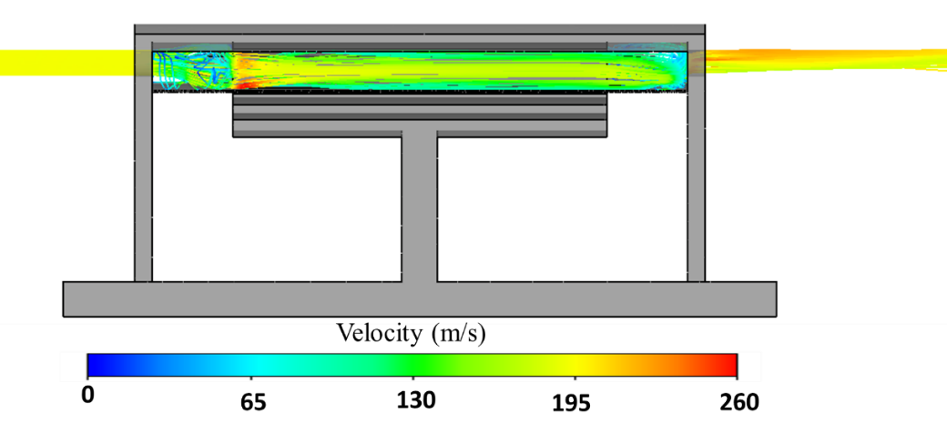
(a) Coolant: Air
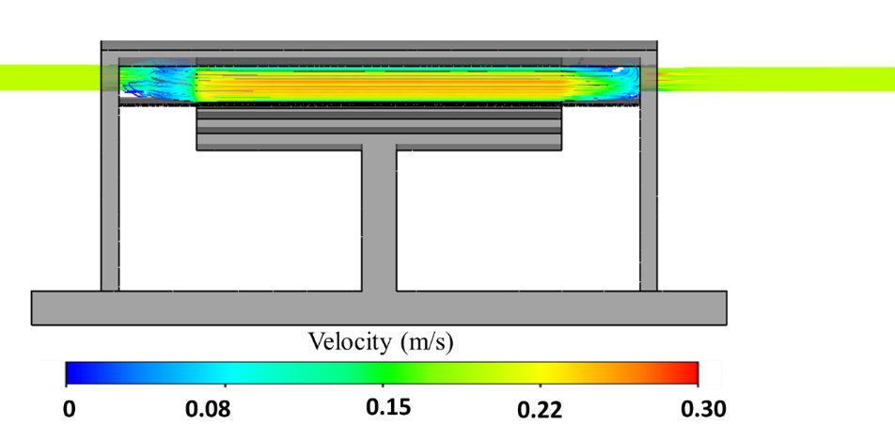
(b) Coolant: Oil
Fig. 4.19. Coolant velocity streamlines of the modular SPM machine with a flux gap width of 10mm.
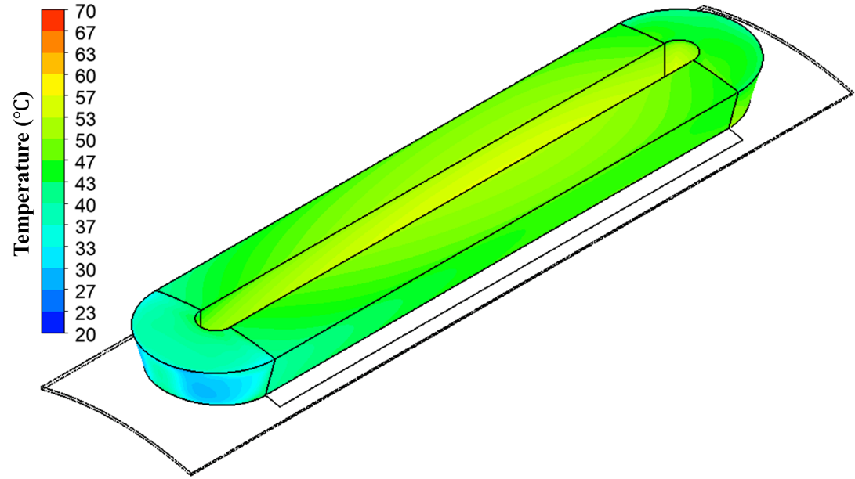
(a) Coolant: Air
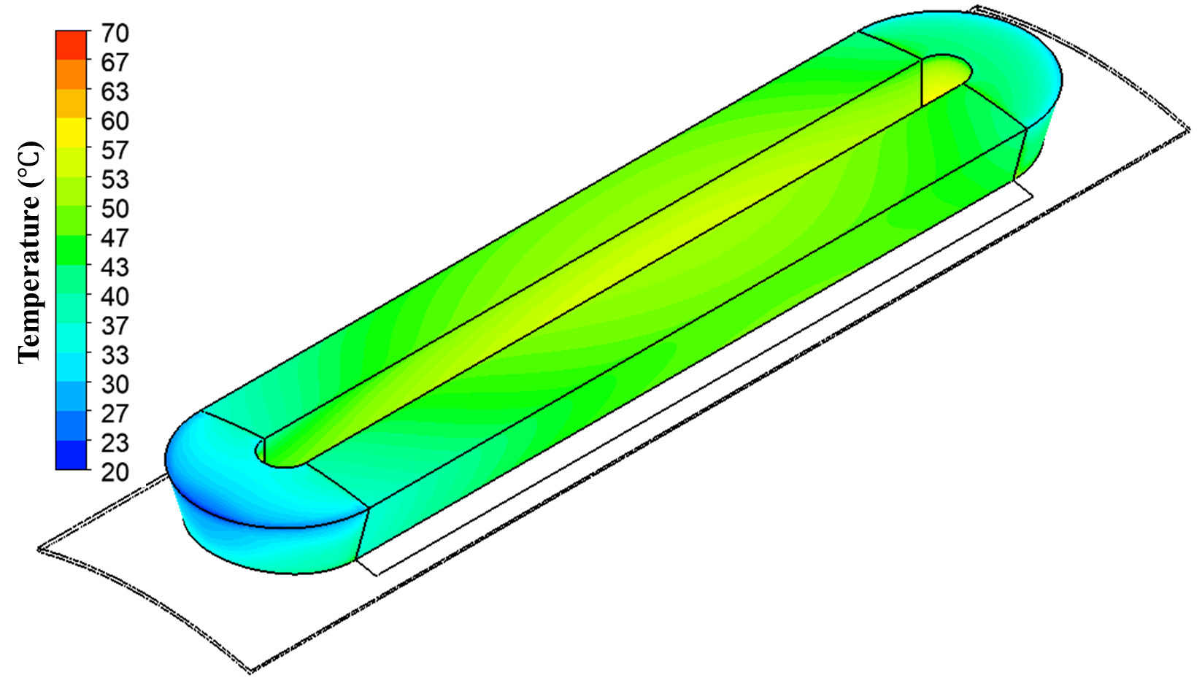
(b) Coolant: Oil
Fig. 4.20. Winding temperature distribution for the modular SPM machine with a flux gap width of 10mm.
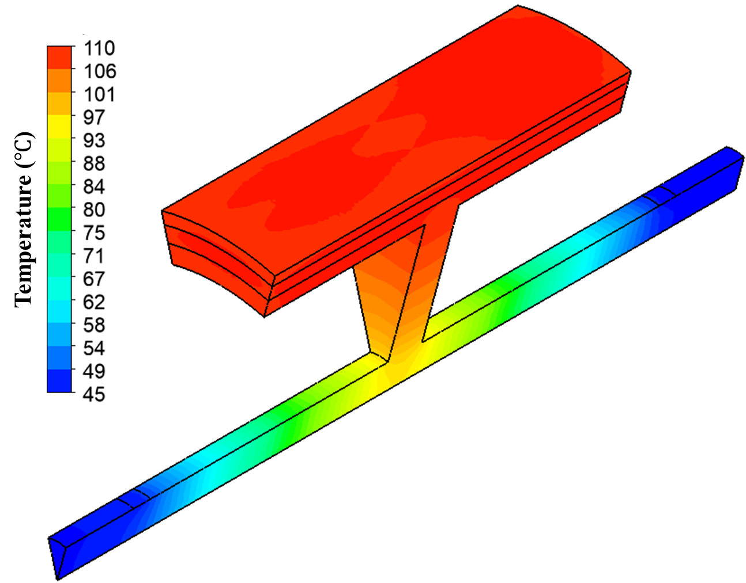
(a) Coolant: Air
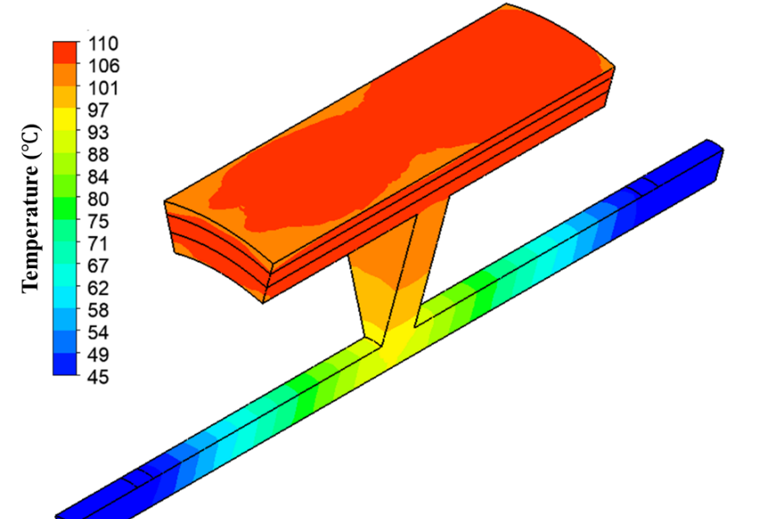
(b) Coolant: Oil
Fig. 4.21. Rotor temperature distribution for the modular SPM machine with a flux gap width of 10mm.
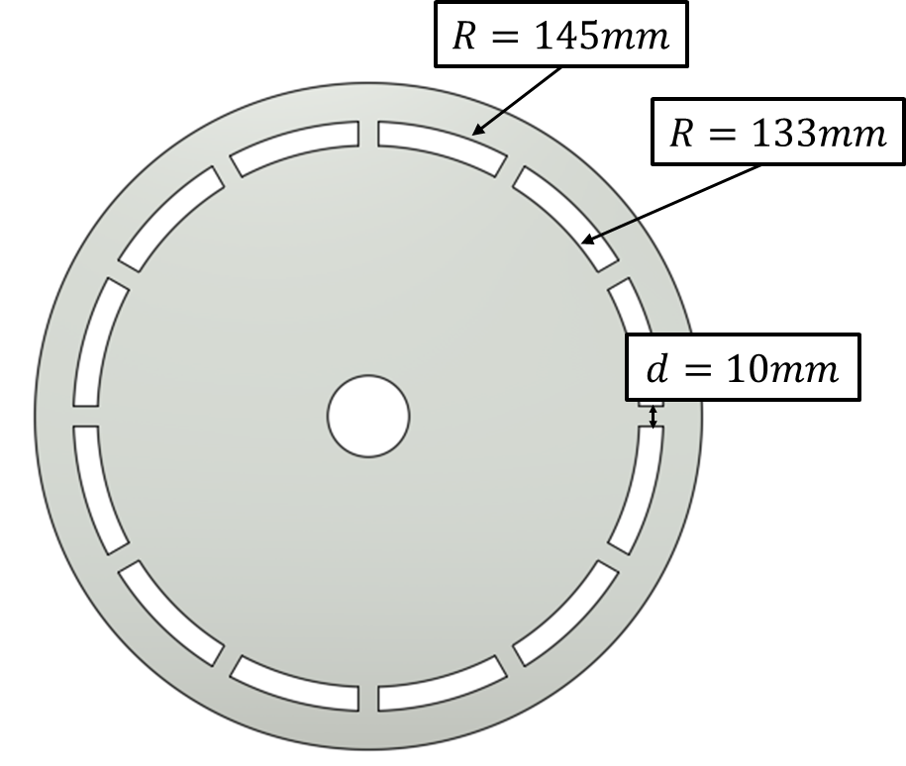 | 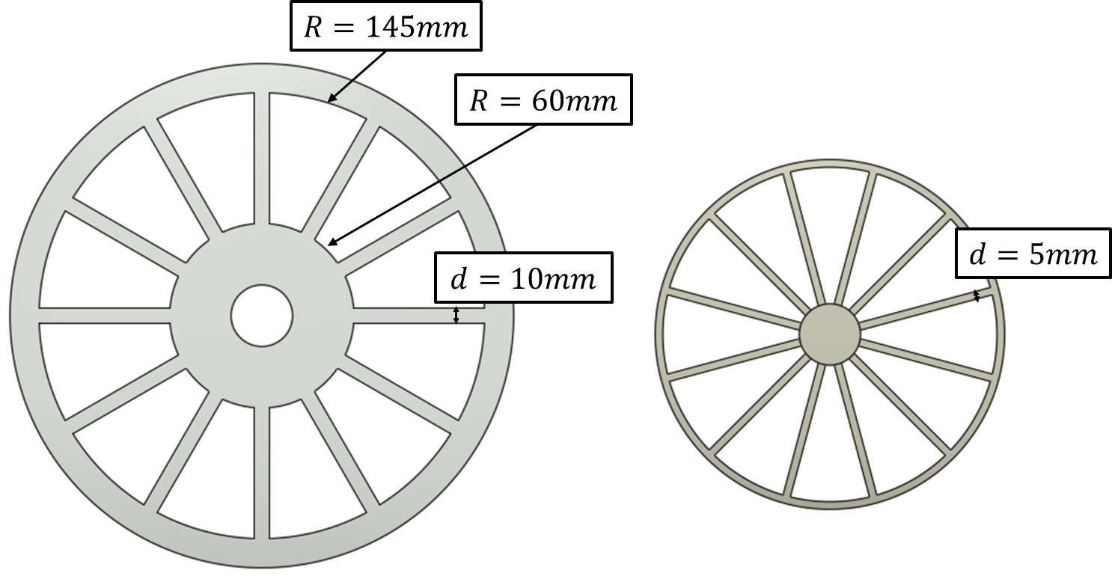
(a) Topology of endcap | (b) Topology of endcap
(c) Spoke-shape shaft
Fig. 4.22. Topologies of endcap and shaft for the investigated modular machine with ventilation cooling.
A design featuring non-circular inlet and outlet shape, as shown in Fig. 4.22 (a), has been adopted to enhance the performance of this cooling technology as discussed in section 4.3.3. This configuration is termed M2. Compared with M1, the cross-sectional area has been increased from 174${mm}^{2}$ to 728${mm}^{2}$. A substantial reduction of dimensionless pressure loss coefficient for sudden expansions and contractions is achieved, leading to a significant reduction of pressure losses, as shown in Fig. 4.23. It is worth noting that this level of pressure loss reduction can also be achievable if the coolant is oil.
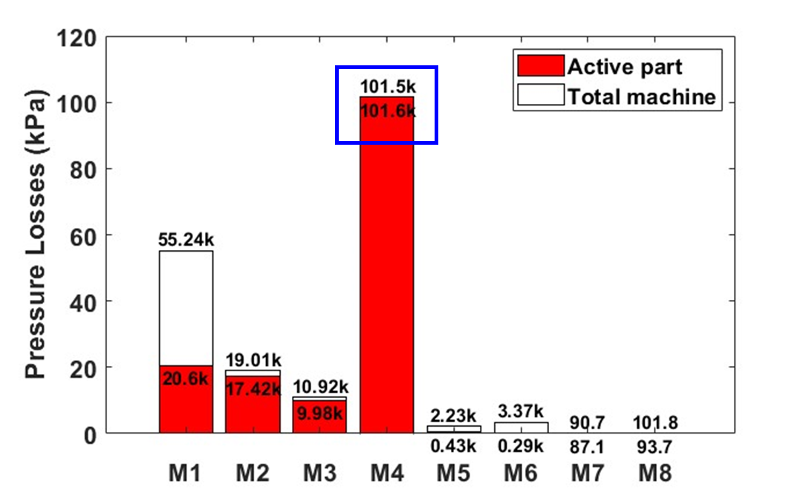
Fig. 4.23. Pressure losses for different machine configurations with ventilation cooling.
Moreover, when oil is replaced by air, the coolant leakage issue can be eliminated. In addition, the PEEK sleeve that used in semi-flooded oil cooling method is no longer needed. This also means that airgap now can be used as an additional fluid path for the cooling systems. This kind of machine topology is termed ‘M3’. A significant pressure reduction can be achieved, as shown in Fig. 4.23. In addition, after removing the sleeve, the coolant directly contacts the machine rotating component, especially the PMs. This results in a significant temperature reduction in rotor region, as shown in Fig. 4.24, as well as a winding temperature reduction, as shown in Fig. 4.25.
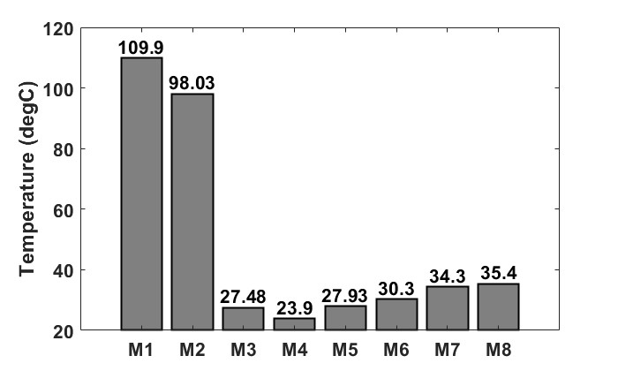
Fig. 4.24. Maximum PM temperatures for different machine configurations with ventilation cooling.
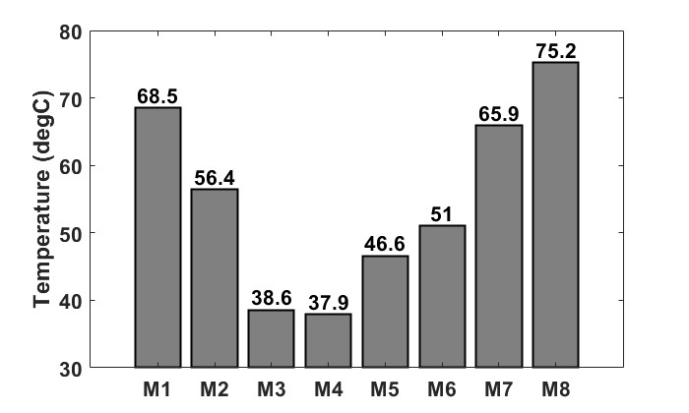
Fig. 4.25. Maximum windings temperatures for different machine with ventilation cooling.
When the PEEK sleeve is removed, it is important to note that the machine’s airgap can serve as an addition fluid path. As a result, non-modular machines can also employ ventilation cooling. This machine configuration is labelled ‘M4’. However, it's worth mentioning that, at the same flow rate, the pressure loss for the M4 machine is much higher than the other models, as shown in Fig. 4.23. Even though the airgap can offer a flow path, its small cross-sectional area leads to an exceedingly high dimensionless pressure loss coefficient, resulting in substantial pressure losses. To be more specific, the pressure loss within the machine active part is 101.6kPa, slightly exceeds the total pressure loss between the inlet and outlet, as indicated by the blue box in Fig. 4.23. It illustrates that the narrower gaps result in a substantially lower absolute pressure within the machine’s downstream part, causing air to be drawn back into the machine from the outlet.
The shafts for all previous designs (from M1 to M4) are disc-shaped and do not have holes for airflow. However, this can be modified to a spoke shape, as shown in Fig. 4.22 (c). This spoke-shape shaft incorporates 12 spokes connecting the hub and the rotor, introducing an additional fluid path for both modular and non-modular machines. This design enhancement results in a substantial improvement in reducing pressure loss within the cooling system. For the modular machines with a spoke-shape shaft, they are termed ‘M5’. For comparative analysis, the spoke shape shaft is also used in the non-modular machines, which is termed ‘M6’. When compared to M3 and M4 configurations, both of these two topologies achieve an effective reduction in pressure losses, largely due to the introduction of rotor ducts, as shown in Fig. 4.23.
Additionally, the inlet and outlet areas can be extended to align with the rotating region, as shown in Fig. 4.22 (b). This leads to the development of new topologies for both the modular and non-modular machines, designated ‘M7’ and ‘M8’, respectively. These modifications have resulted in a further reduction in pressure losses, as shown in Fig. 4.23. While the temperature reductions for these two configurations may not be as significant when compared to other machine topologies, their exceptionally low system dimensionless pressure loss coefficients allow for much higher flow rates, meeting the requirements of external pumps. When considering the trade-off between the cooling efficiency and the requirement of pump pressure, it becomes evident that M7 and M8 configurations exhibit the most optimal performance for machine cooling. Further research in the followed sections will be centred around these two machine configurations. The final design of M7 is shown as Fig. 4.26, which will be used for further investigations in the following sections.
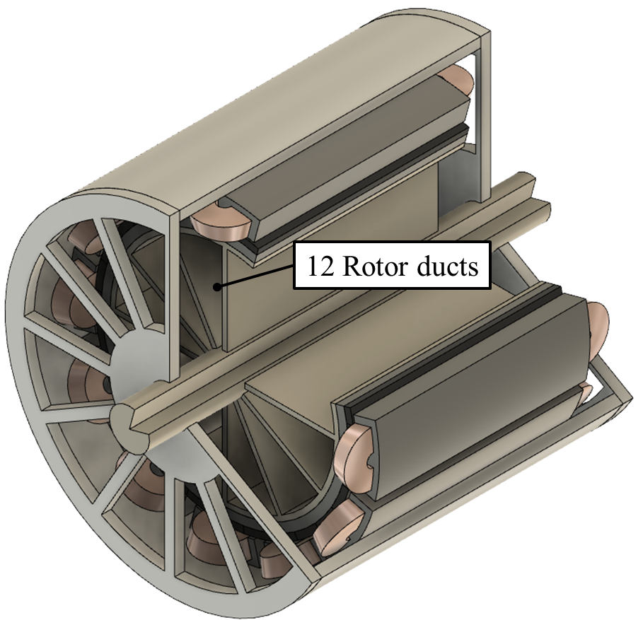
Fig. 4.26. Cut away view of the modular SPM machine with ventilation cooling system.

Influence of Rotor Speed
As mentioned above, for the investigated non-modular machines with ventilation cooling, the flow paths for the ventilated air are mainly the airgap and rotor ducts (spoke-shape shaft). However, for the modular machines, the introduced flux gaps can be considered as additional stator ducts for the air flow. The influences of rotor speed on the flow resistances for those flow paths are essential. The rotor rotation introduces additional pressure losses because the direction of coolant is significantly changed when it enters the rotating ducts in the rotor iron core or shaft. This kind of pressure losses is named as shock losses [180]. In addition, the rotor rotation may also cause additional pressure loss due to friction loss variation and combining flow phenomenon [146].
To meet the requirements of flow network analysis, additional correction factor ($k_{r}$) should be introduced to adjust the dimensionless pressure loss coefficient ($k_{f}$). $k_{fs}$ is used for the stationary system and $k_{fr}$ is used for rotating system, and the correction coefficient is described by:
$$k_{r}=\frac{k_{fr}}{k_{fs}}$$ | (4.17)
Chong 2014 [181] proposed some empirical fitness functions for $k_{r}$ caused by the shock losses as:
$$k_{r,shock}=\left\{\begin{aligned}a∙{\left(\frac{V_{t}}{U}\right)}^{2}+b∙\frac{V_{t}}{U} , for rotor ducts \\ c∙{\left(\frac{V_{t}}{U}\right)}^{2}, for stator-rotor annular gap \end{aligned}\right.$$ | (4.18)
where $a$, $b$ and $c$ are constants that are determined by experiments, which are related to the topologies of rotating components. The rotation ratio (${V_{t}}/U$) is a ratio of the tangential velocity to the axial velocity.
Yamada 1962 [182] proposed the correction factor that caused by friction loss variation:
$$k_{r,friction}={\left[1+{\left(\frac{7}{8}\right)}^{2}{\left(\frac{V_{t}}{2U}\right)}^{2}\right]}^{0.38}$$ | (4.19)
According to (4.18) and (4.19), rotation introduces additional pressure losses components and the rotating pressure losses are significant when the rotor speed is high. The pressure losses in different machine region for the investigated machine have been simulated using CFD models, as shown in figures from Fig. 4.27 to Fig. 4.29. The results demonstrate that the pressure losses in the end-space inlet and the rotor ducts increase with increased rotor speed. It is noticed that the pressure losses in the airgap and flux gaps reduce when the rotor speed increases. This is caused by the combining flow phenomenon, which affects the pressure drop in the airgap and flux gaps. The combining flow phenomenon will be introduced in more details in section 4.4.3.
As both the modular and non-modular machines use the same rotor ducts and inlets/outlets, their pressure losses through the rotor ducts and end-space are similar. However, the pressure losses in the airgap and flux gap are very much different. A significant pressure loss reduction is achieved after introducing the flux gaps. However, this reduction is less significant when the rotor speed increases. This is also caused by the combining flow phenomenon.
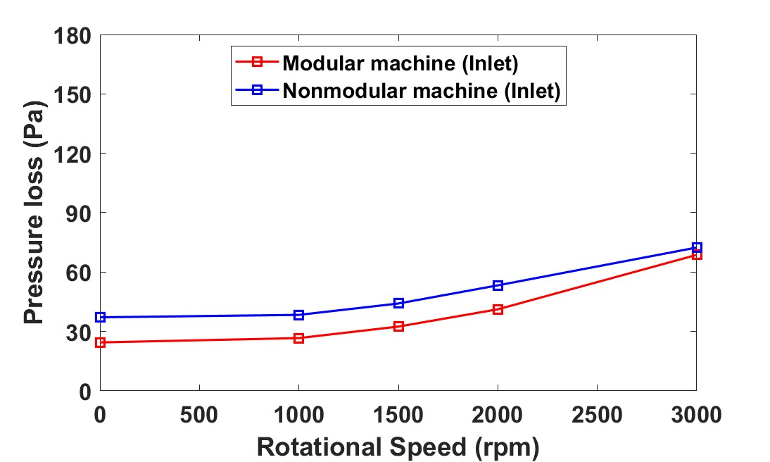
Fig. 4.27. Pressure losses in the end-space inlet region of M7 and M8 vs rotor speed.
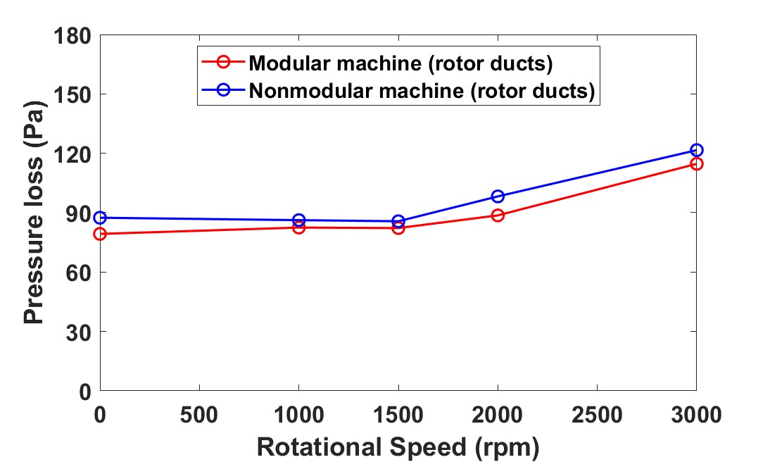
Fig. 4.28. Pressure losses in rotor ducts of M7 and M8 vs rotor speed.
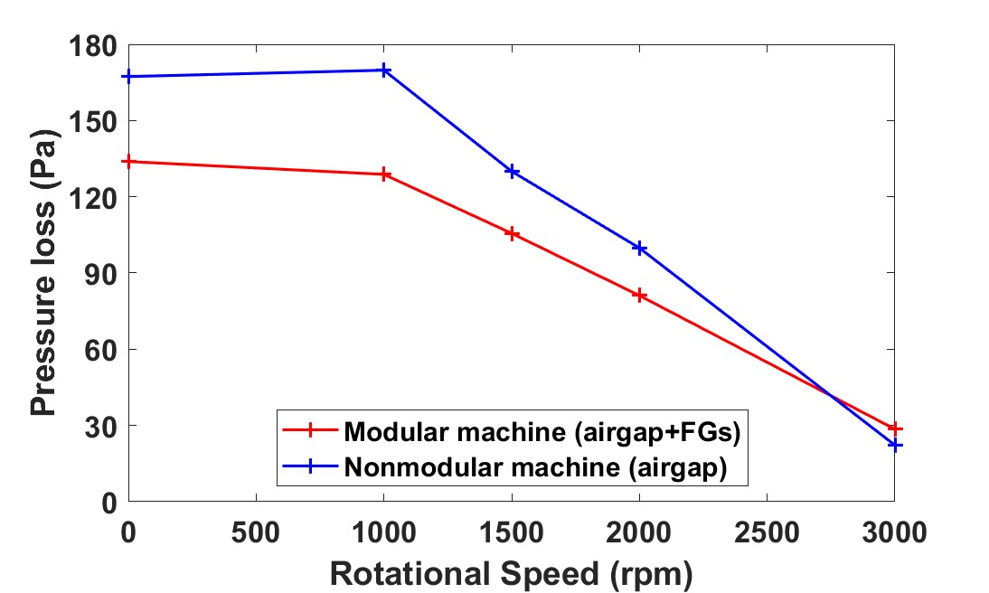
Fig. 4.29. Pressure losses in the airgap and flux gaps (for modular machines) of M7 and M8 vs rotor speed.

Combining Flow Phenomenon
Combining flow phenomenon is another reason for the increased pressure loss in the machine cooling systems. The flow is deflected when it exits from the rotor ducts due to the centrifugal effect. The deflected flow will mix with the flow through the airgap (and the flow through the flux gaps for the modular machines). The flow separation at upstream and the flow combination at downstream result in additional pressure loss, which is named as combining flow loss. It is worth noting that, combining flow phenomenon only occur in turbulent flow. Chong 2015 [146] proposed some empirical fitness functions for $k_{r}$ caused by combining flow as:
$$k_{r,CF}=\left\{\begin{aligned}a∙{\left(\frac{V_{t}}{U}\right)}^{2}+b∙\frac{V_{t}}{U}+c when \frac{V_{t}}{U}>k_{c} \\ 0 when \frac{V_{t}}{U}≤k_{c} \end{aligned}\right.$$ | (4.20)
The flow velocity streamlines for the modular and non-modular machines at different rotor speeds are shown in Fig. 4.30 and Fig. 4.31. When the inlet volumetric flow rate is constant, the air velocity increases with rotor speed. The combining flow phenomenon will occur and aggravate with higher rotor speed. The combining flow also blocks the fluid flow in the flux gaps as shown in Fig. 4.31. When the machine is stationary, the air flows through the flux gaps, resulting in significant reduction in pressure loss. However, as the speed increases, the streamline in the flux gaps thins out. For example, the air barely flows through the flux gaps when the rotor speed is 3000rpm, as shown in Fig. 4.31 (c).
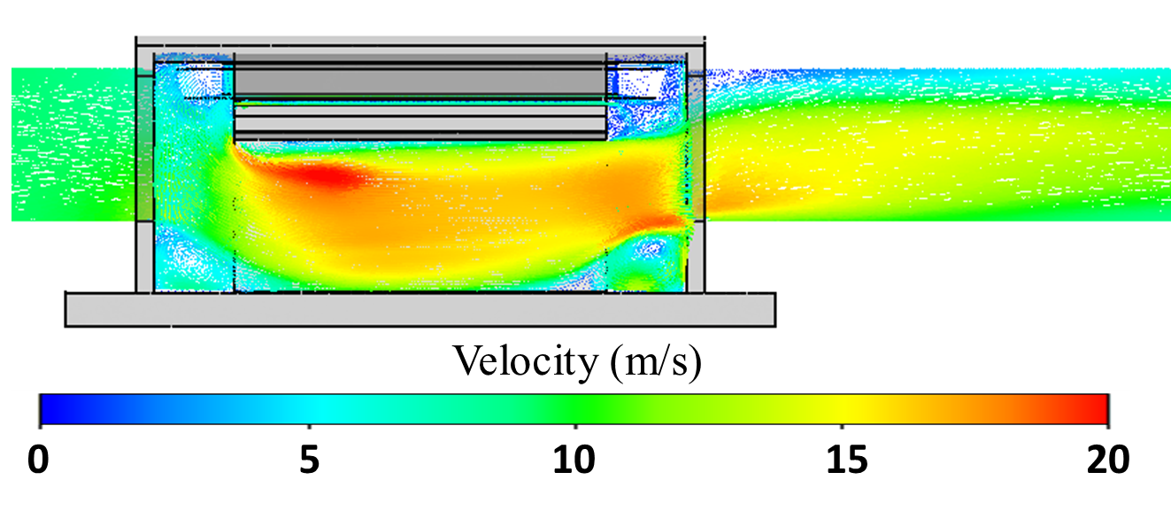
(a) Stationary
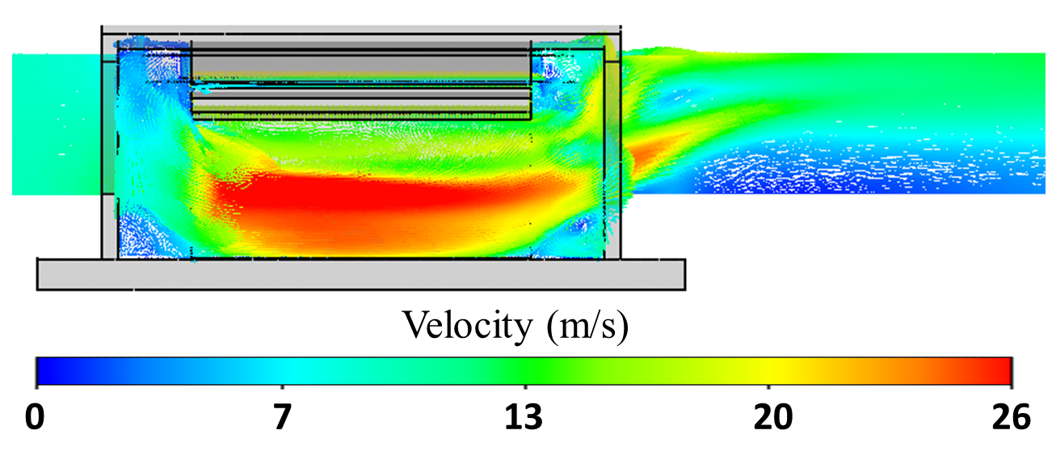
(b) Rotor speed: 1500rpm
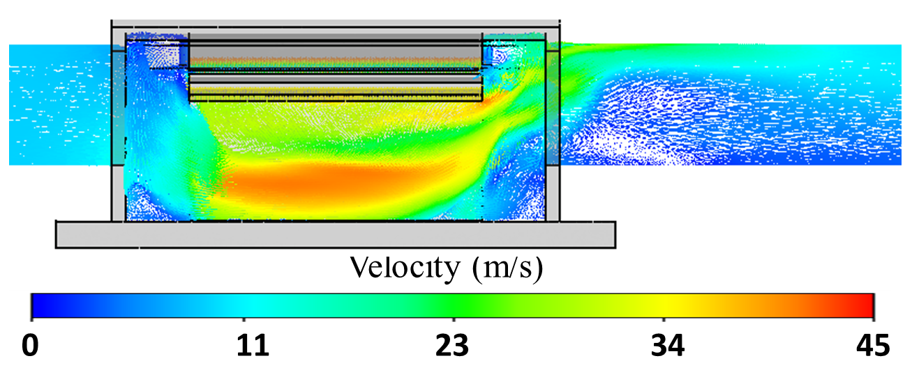
(c) Rotor speed: 3000rpm
Fig. 4.30. Air velocity streamline distributions for the non-modular machine (M8) with different rotor speeds.
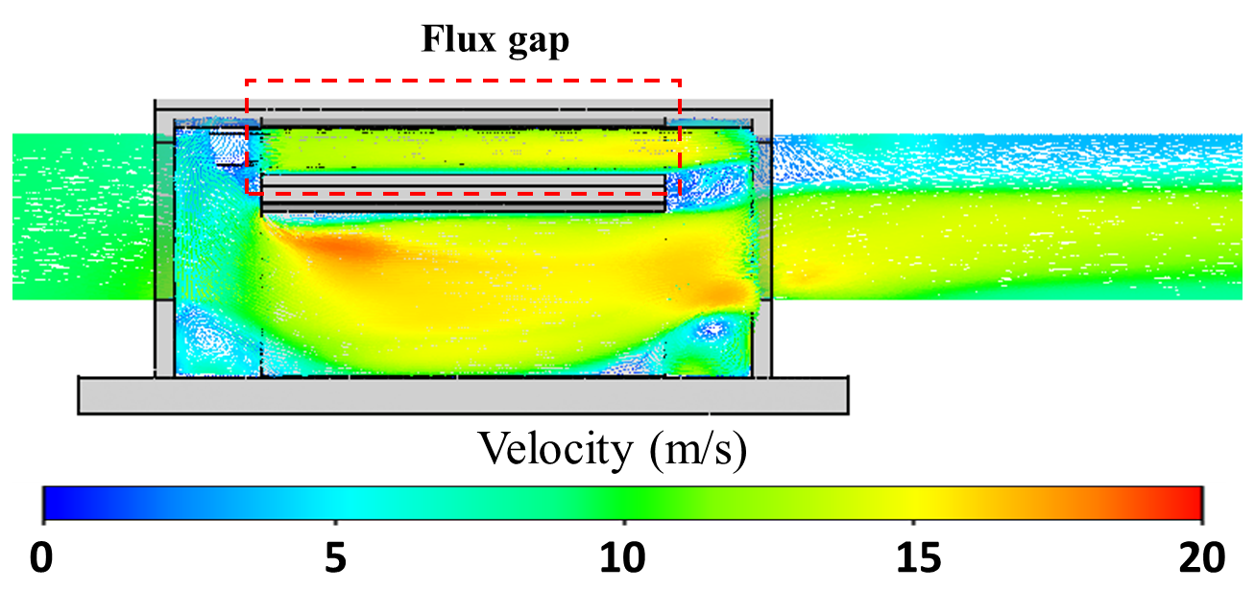
(a) Stationary
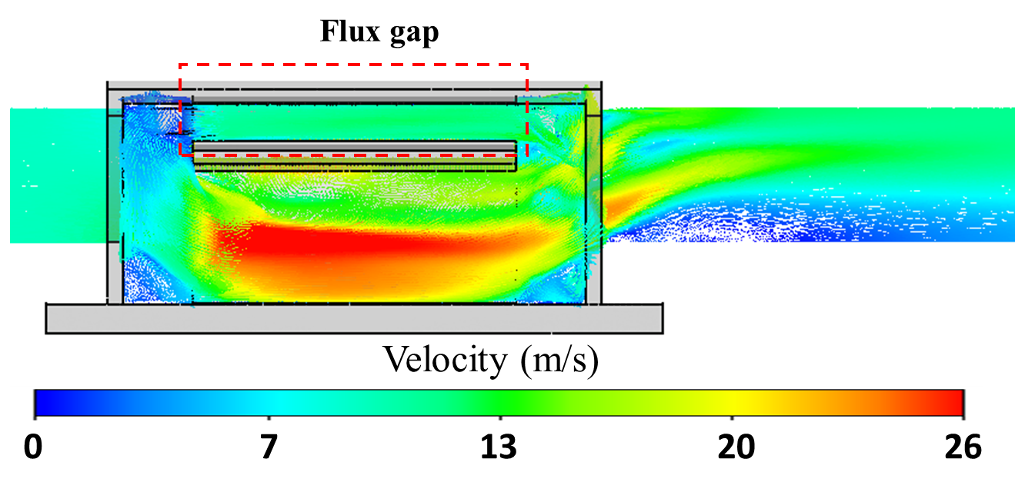
(b) Rotor speed: 1500rpm
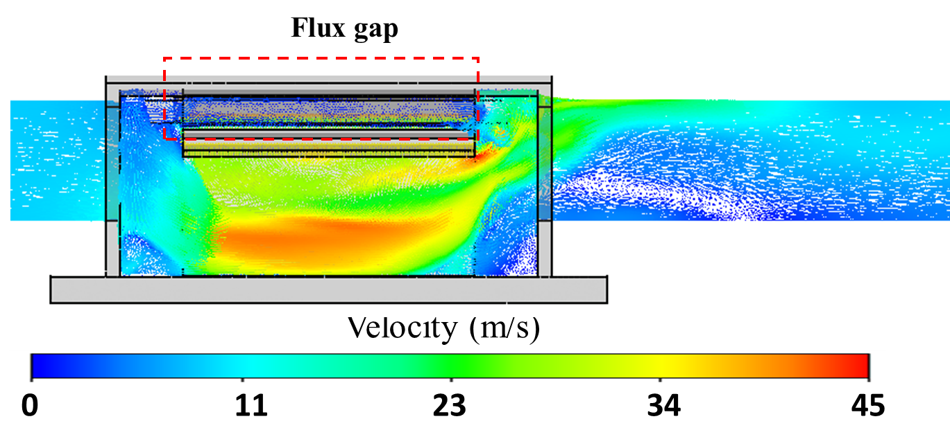
(c) Rotor speed: 3000rpm
Fig. 4.31. Air velocity streamline distributions of the modular machine (M7) with different rotor speeds. Red boxes highlight the air velocity streamlines in the flux gap regions.
The air velocity vector distributions of the modular machine with different rotor speeds are also shown in Fig. 4.32. When the rotor is stationary or the rotor speed is relatively low, e.g., 1500rpm, the ventilated air passes through the flux gaps. However, at a higher rotor speed, i.e., 3000rpm, a combining flow phenomenon occurs, resulting in backflows in the flux gaps regions and blocking the fluid that flows through the flux gaps. This is why air barely flows through the flux gaps when the rotor speed is 3000rpm.
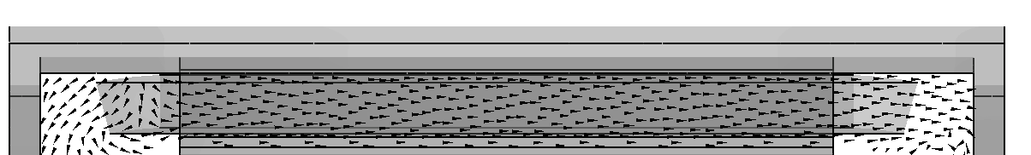
(a) Stationary
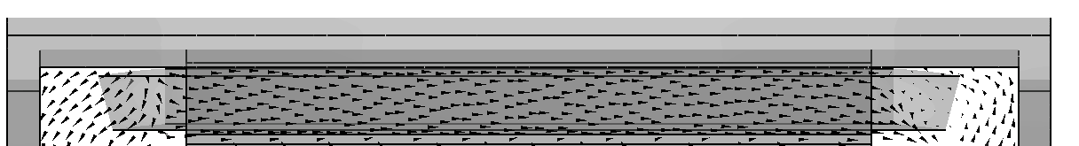
(b) Rotor speed: 1500rpm
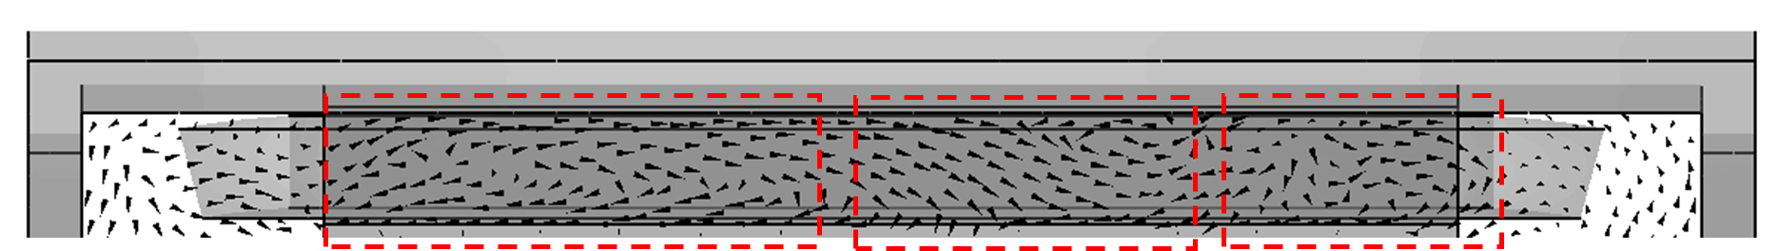
(c) Rotor speed: 3000rpm
Fig. 4.32. Air velocity vector distributions in flux gaps of the modular machine (M7) with different rotor speeds.

Experimental Validation
A series of experiments have been designed to validate the simulations and predictions carried out in this chapter.

Semi-flooded Oil Cooling System
In order to validate the predictions in section 4.3, a motorette representing the modular machine has been manufactured and tested, as shown in Fig. 4.33. The complete test rig is shown in Fig. 4.34. The flux gap width is adjustable and can be changed from 2mm to 8mm. The motorette is connected to a forced oil pump system, and the fluid parameters like fluid temperature, flow rate and pressure are continuously monitored in real-time according to ultrasonic fluid meter SU7200 manufactured by IFM Electronic. The temperature variation of the windings is also continuously monitored in real-time using Pico Technology temperature data logger.
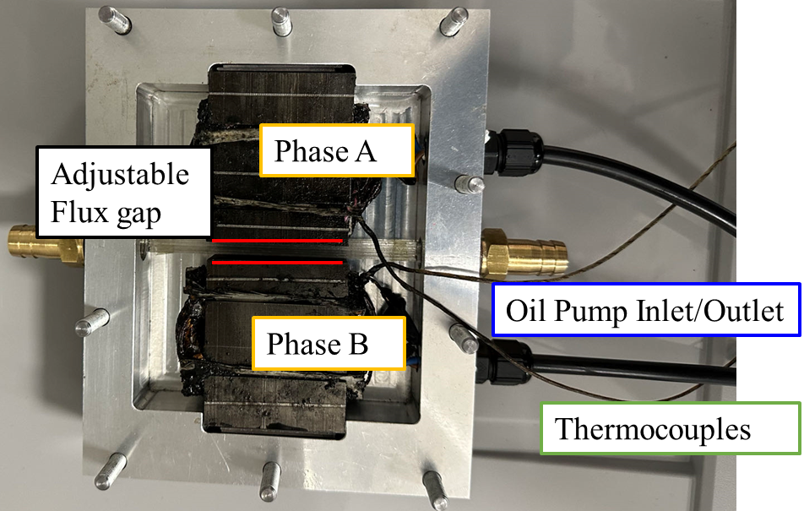
Fig. 4.33. The motorette representing the modular machine.
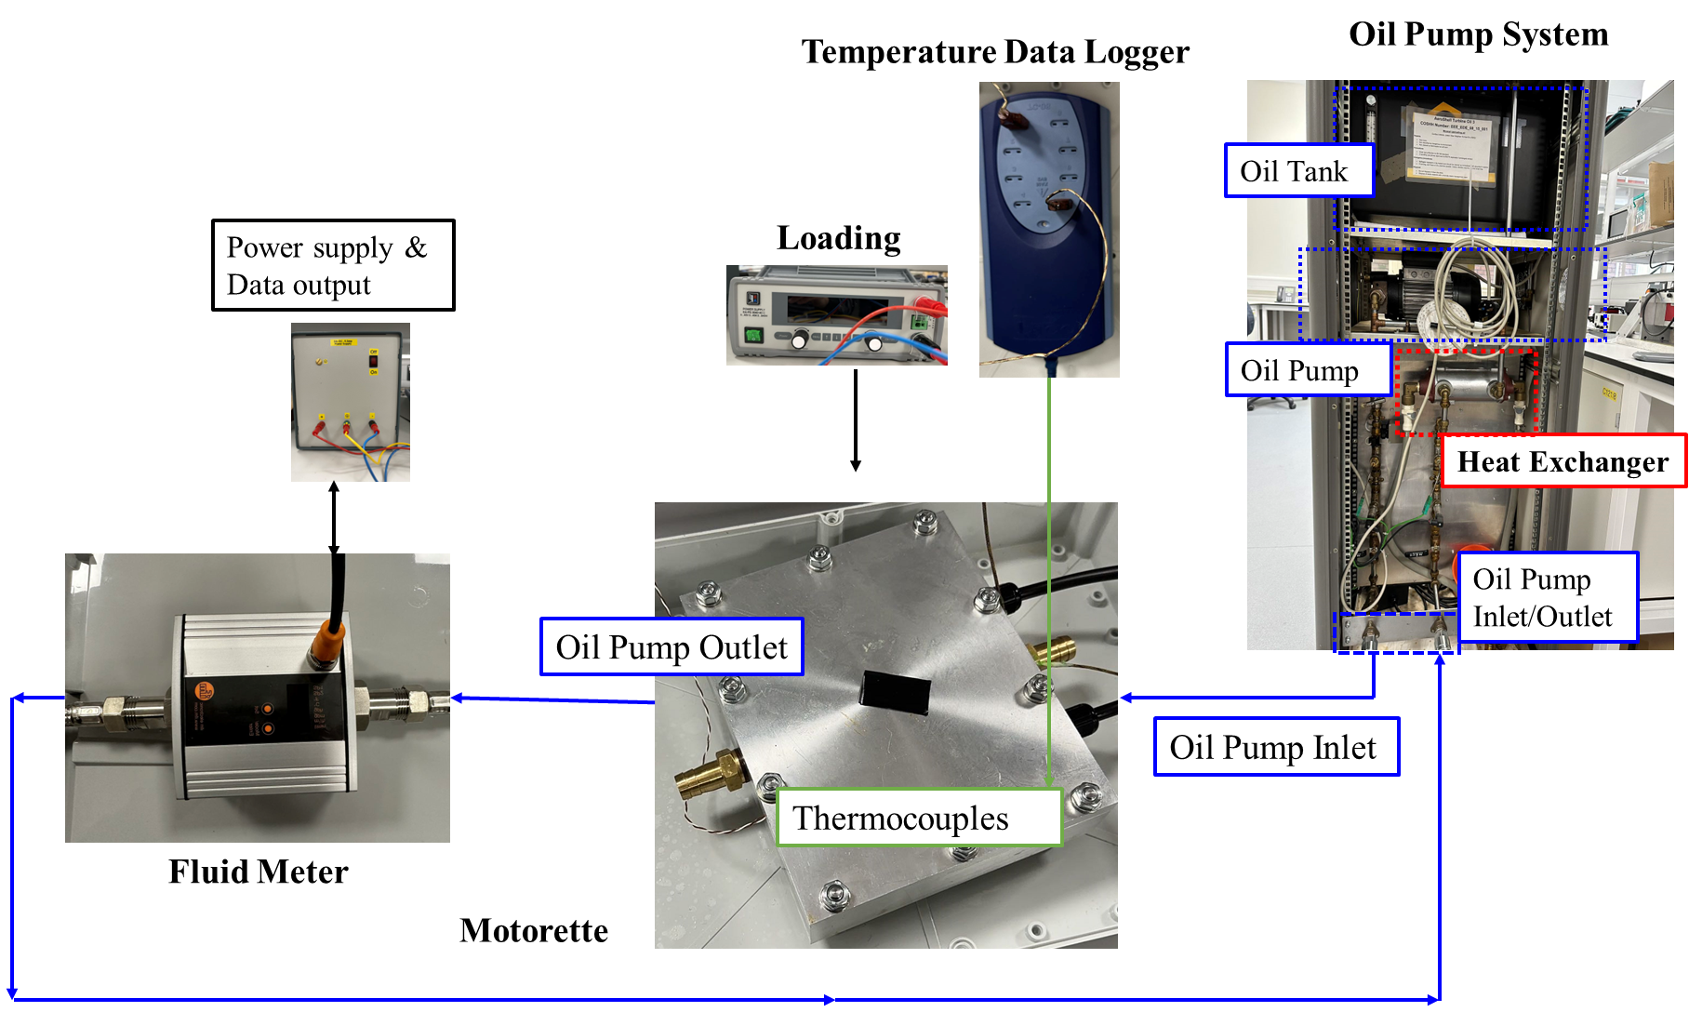
Fig. 4.34. The test rig for semi-flooded oil cooling machine with stator modularity.
Coolant oils with different volumetric flow rates have been pumped into the motorette and the pressure losses for different flux gap widths have been simulated and measured, as shown in Fig. 4.35. Good agreement between the measured and simulated results can be observed. It is worth noting that, the oil properties, particularly the dynamic viscosity, are temperature dependent. They significantly affect the flow rate and pressure drop for the cooling system. Therefore, the pressure losses for all tested objects were measured when the coolant temperature is 20$℃$. The results also confirmed that the increase of flux gap width results in lower system flow resistance, therefore lower pressure losses.
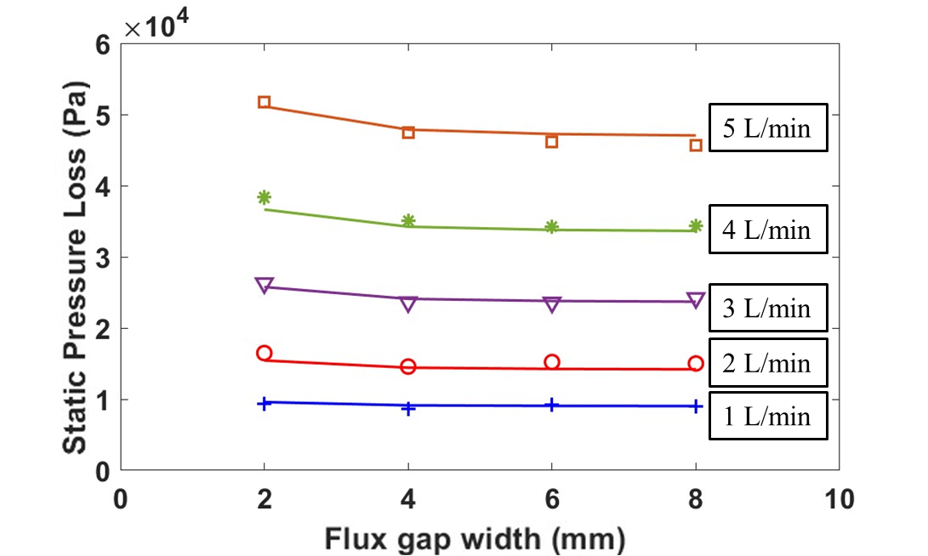
Fig. 4.35. Pressure losses of the whole cooling system for the motorette with different flux gap widths. It is worth noting that, the solid lines represent the simulated results, and the dots represent the experimental results.
The winding temperature variations for the motorette with 2mm and 8mm flux gaps have also been measured to compare against the simulation results. To fully understand the influence of the flux gaps, the cooling system was operated at the same volumetric flow rate of 5L/min. The losses for the tests were generated by a dc power supply with a constant current of 10A. It is worth noting that the dynamic viscosity of the coolant changes over time due to temperature rise, causing variations in both the volumetric flow rate and the total pressure loss during the experiments. The test rig operated only until the coolant temperature reached 30$℃$, and the properties (including dynamic viscosity and thermal conductivity) of the oil are specified at a reference temperature of 30$℃$ for the simulations. It is found that, the measured and simulated temperatures did not match closely, but similar temperature differences were noted for different flux gap widths. A lower winding temperature was found for the motorette with narrower flux gaps, attributed to the faster coolant velocity achieved in these flux gaps. It is worth noting that, the advantage of wider flux gaps was not fully achieved in this experiment. This is because the majority of the pressure loss occurs in other components of the cooling system, such as pipe connections, bent pipes, fluid meters, and heat exchangers, rather than in the motorette itself. Consequently, the reduced flow resistance in the motorette was not as significant as anticipated. However, in practice, the majority of the pressure loss should ideally be situated within the electrical machines to ensure efficient cooling and cost effectiveness. In such cases, the benefits of flux gaps in enhancing machine thermal performance would be more pronounced.
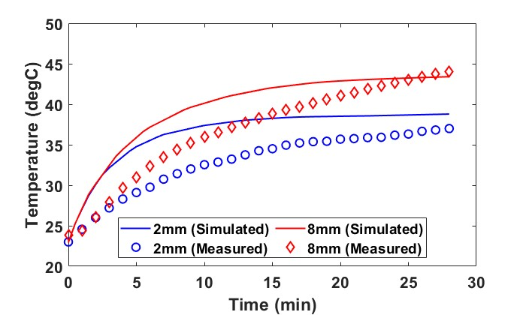
Fig. 4.36. Simulated and measured winding temperatures of the motorette with 2mm and 8mm flux gaps.

Ventilation Cooling
To validate the predictions in section 4.3, a modular SPM machine with 2mm flux gaps, referred to as ‘Modular 1’ (as shown in Fig. 4.37), was fabricated and subjected to testing. The comprehensive specifications of this machine are listed in Table 2.7. To conduct a comparative analysis, its nonmodular counterpart, named ‘Nonmodular’ (shown in Fig. 4.38) was also tested to ascertain the influence of flux gaps on machine cooling.
Sleeves were inserted into the flux gaps to impede the ingress of air into the flux gaps. Ventilation cooling experiments were performed using endcaps, as shown in Fig. 4.39 (a), equipped with 6 trapezoidal inlet and outlet holes. Furthermore, to evaluate the influence of inlet and outlet areas on machine cooling, two plastic sheets with smaller, round-shaped holes was devised to cover the aforementioned endcaps as shown in Fig. 4.39 (b). This alteration established a reduced area for inlet and outlet for the machines, denoted as ‘Modular 2’, specifically designed for ventilation cooling experiments.
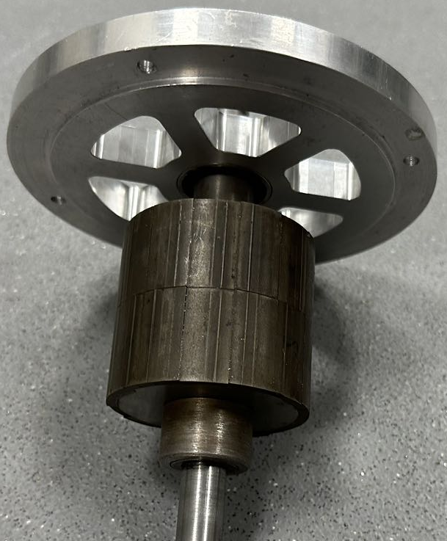 | 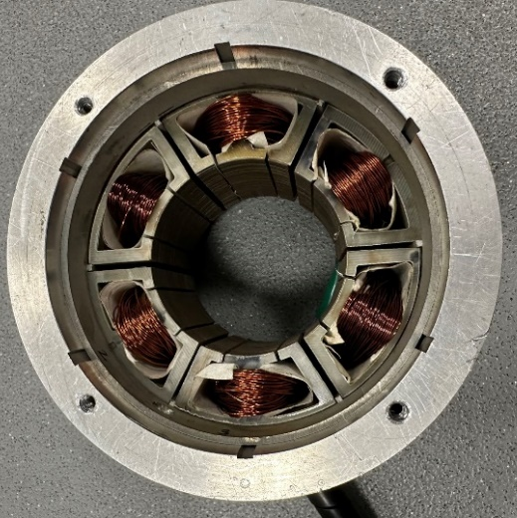
(a) Surface-mounted PM rotor | (b) Stator with stator modularity
Fig. 4.37. 12-slot/10-pole Modular SPM prototype machine.
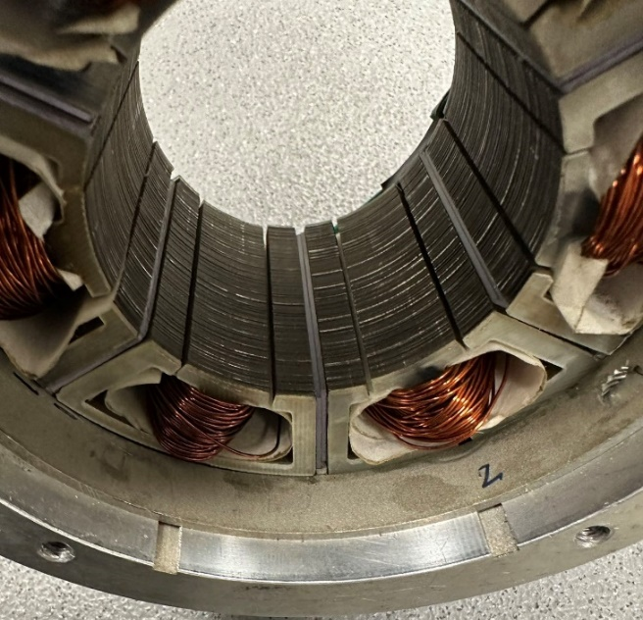
Fig. 4.38. Stator of modular machine with sheets within flux gaps. This removes the flux gaps, leading to an equivalent non-modular machine in a thermal context.
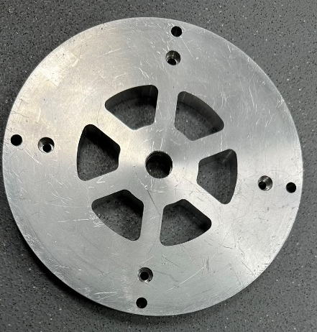 | 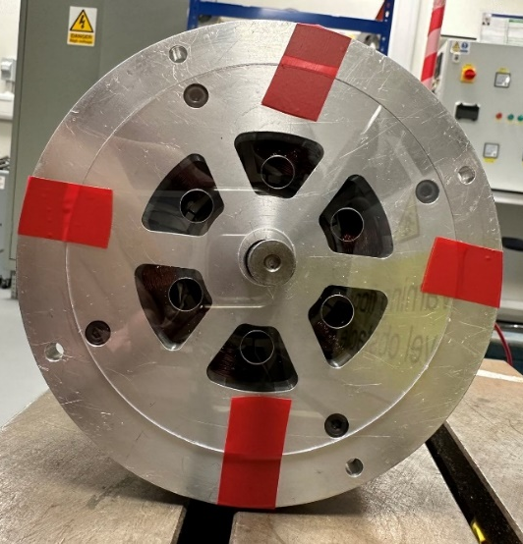
(a) Large trapezoidal inlet and outlet | (b) Small round inlet and outlet
Fig. 4.39. Configurations of different endcap designs.
A ventilation cooling test rig, as shown in Fig. 4.40, has been built to investigate the various machine configurations. The tested machine is driven by a dyno-motor, while ventilated air is produced by an adjustable speed fan. Essential parameters such as pressure losses, air velocity and machine temperatures are meticulously gauged using differential pressure transducer, hot-wire anemometer and T-type thermocouples, respectively.
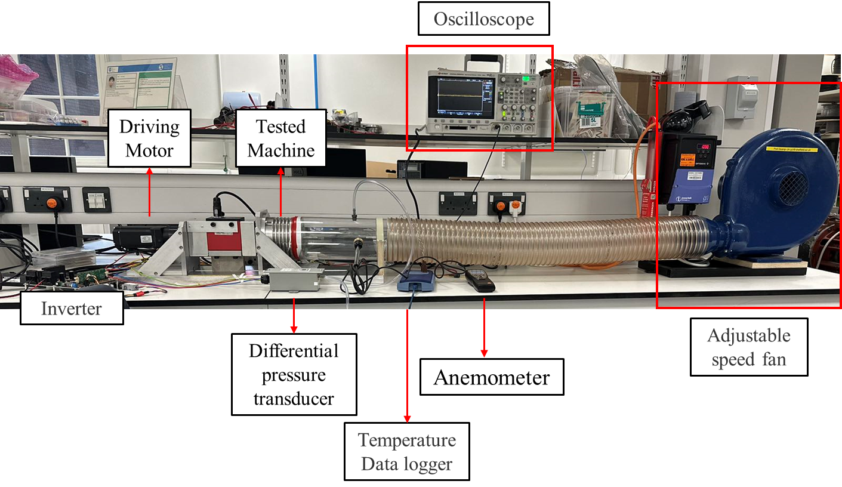
Fig. 4.40. Tested rig for ventilation cooling.
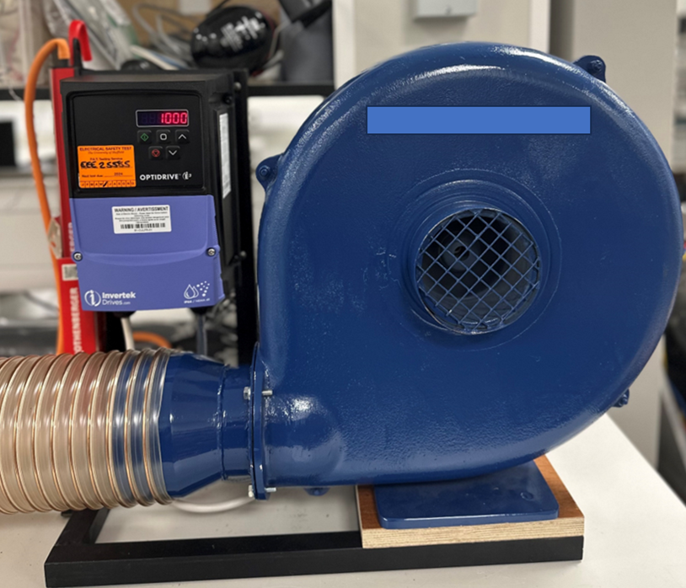
Fig. 4.41. Adjustable speed fan.

The adjustable speed fan is a centrifugal fan (L-28-E), manufactured by B.O.B Stevenson Ltd as shown in Fig. 4.41. At ambient temperature of 20$℃$, the fan can provide a flow rate of 0.14${m^{3}}/s$ (i.e., 300 cfm) at its operating static pressure of 500Pa. Its speed is controlled via an inverter, allowing for adjustable fan speeds ranging from 0rpm to 2500rpm.
Some measurement devices were incorporated for the ventilation cooling test. The differential pressure transducer, Omega PX277-05D5V, was utilized to measure the pressure variances between the upstream and downstream of the tested machines. The location of measured point for upstream flow is illustrated in Fig. 4.42 (a). The downstream pressure was maintained at ambient pressure ($≈1 bar$). The air velocity at upstream of the tested machine was determined using a hot-wire anemometer, with the specific measurement point shown in Fig. 4.42 (b). It is worth noting that, the hot-wire anemometer assesses gas velocity by detecting variation in the electrical resistance of its heated wire, which changes with the passage of gas through it. Moreover, the temperatures of coils within the tested machines were monitored using T-type thermocouples, and the recorded data was logged by a temperature data logger.
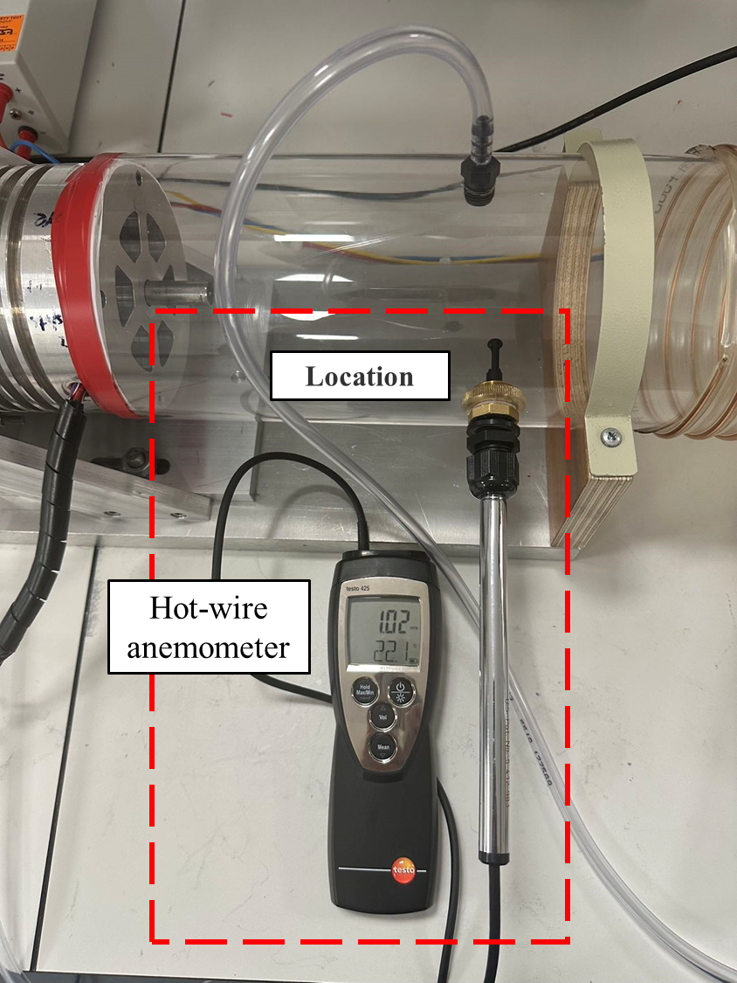 | 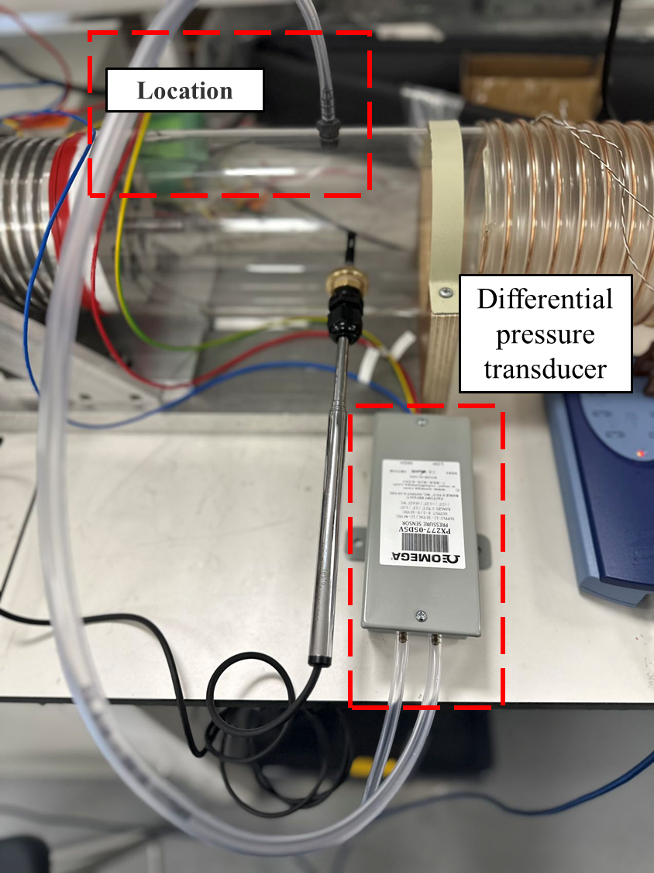
(a) Hot-wire anemometer | (b) Differential pressure transducer
Fig. 4.42. Measurement devices.
The air velocity for different machine configurations was measured at different fan speeds. The ‘Modular 1’ configuration, characterized by both flux gaps and larger trapezoidal inlet and outlet areas, exhibited higher air velocity compared to other machine configurations. However, upon inserting sheets within flux gaps, the air flow was obstructed, preventing it from passing through flux gaps. The system flow resistance is increased, resulting in a slightly lower air velocity. In addition, the measured result of ‘Modular 2’ showed a notably reduced air velocity. This reduction was attributed to very high flow resistance for this configuration, stemming from the reduction in the inlet and outlet area (reduced from 426.38mm² to 78.53mm²).
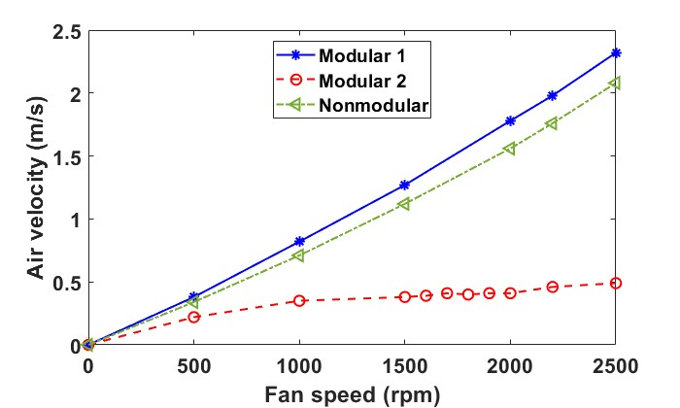
Fig. 4.43. Measured air velocity at different fan speeds for various machine configurations.
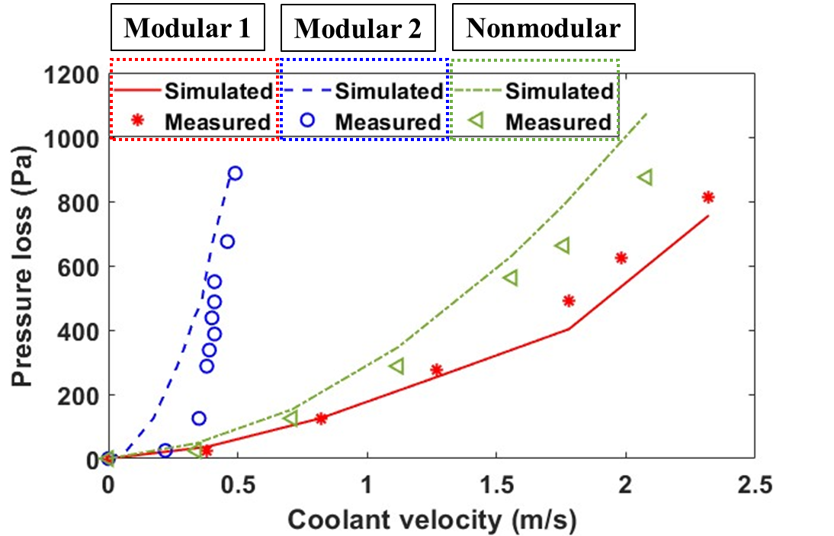
Fig. 4.44. Simulated and measured pressure losses for different machine stators and inlet and outlet area combinations.
The measured and simulated results of pressure losses for all machine configurations at different air velocity are shown in Fig. 4.44. Observably, the pressure losses consistently increased as the air velocity rose. Under the same air velocity conditions, the modular machine featuring larger inlet and outlet areas necessitated less pressure due to its reduced system flow resistance. However, it is important to highlight that due to the manufacturing tolerances, the sheets inserted within the flux gaps did not entirely fill the flux gaps, allowing for a slight passage of airflow. Therefore, the actual flow resistance for this candidate was lower than anticipated, leading to overestimated pressure losses in the simulation, as shown in Fig. 4.44. Moreover, discrepancies between the measured and simulated results were noticeable for the 'Modular 2' configuration. This variance can be attributed to the accuracy limitations of the anemometer and differential pressure transducer. The discrepancy notably decreased with increased fan speeds.
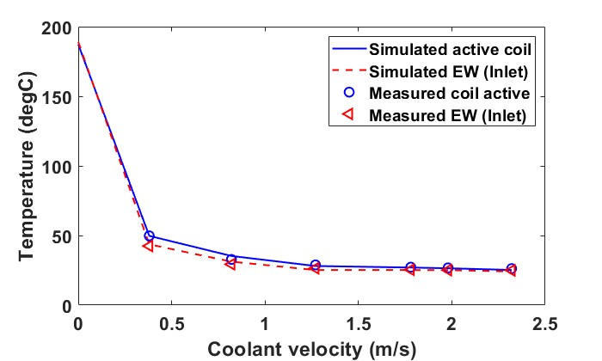
(a) overview of full coolant speed range
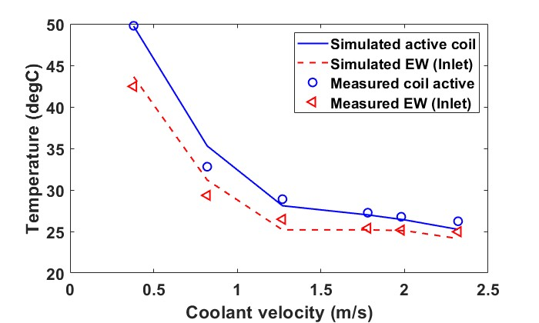
(b) zoom-in view of the high coolant velocity
Fig. 4.45. Simulated and measured machine temperatures for modular machine with large trapezoidal inlet and outlet.
The temperatures of various machine configurations are measured to compare with the simulated results, as shown Fig. 4.45 and Fig. 4.46. The simulated results indicated that without ventilation cooling, the machine temperature was around 186$℃$. However, upon the introduction of ventilated air, the machine temperature reduced significantly to around 50$℃$. Furthermore, consistently increase air velocity contributed to further reductions in machine temperature for both modular and nonmodular machine configurations. Notably, a strong correlation between the measured and simulated results was evident. It is worth noting that, due to the passage of air resulting from manufacturing tolerances, the measured temperatures were slightly lower than expected, as shown in Fig. 4.46.
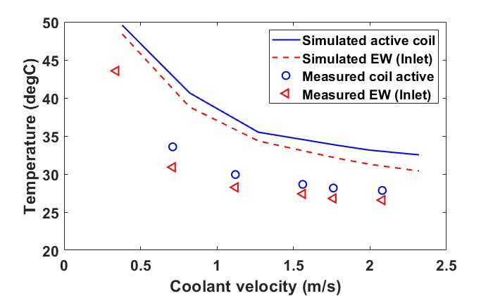
Fig. 4.46. Simulated and measured machine temperatures for nonmodular machine with large trapezoidal inlet and outlet.

Conclusion
In this chapter, two types of forced cooling technologies, i.e., semi-flooded oil cooling and ventilation cooling, have been employed for the modular SPM machine and its non-modular counterpart. To investigate the cooling efficiencies of these technologies, understand the flow profiles and the heat transfers, a series of three dimensional CFD modelling has been carried out. The governing equations, fluid models, and boundary conditions are introduced. The flow network analysis is also presented in this chapter to illustrate the behaviours of fluid within the investigated machines.
The investigations revealed that the semi-flooded oil cooling system significantly reduces the machine temperatures, especially in the stationary components. The influence of flux gaps on machine cooling has also been discussed. Due to their additional flow path, larger surface area of immersed solid, and lower flow resistance, the flux gaps result in lower pressure losses, higher convection coefficient, higher flow rate, and reduced machine temperature for the modular machines. These advantages are amplified when the flux gap width increases. The influences of the cross-sections area of the inlet and outlet for forced cooling technologies have also been investigated. An increased cross-sectional area significantly reduces the dimensionless pressure loss coefficient caused by sudden expansions and contractions. It results in higher flow rate and convection coefficient, and reduced machine temperature. Consequently, a larger cross-sectional area is preferred, provided that the mechanical reliability is not compromised.
The influence of rotor rotation on ventilation cooling efficiency has also been investigated. Due to additional pressure losses caused by shock and friction, a rotating machine results in higher pressure loss compared to the stationary case. Increased rotor speed leads to higher pressure losses and may introduce the combining flow phenomenon in the machines with rotor ducts. This phenomenon further increases the pressure losses for the entire machine cooling system. While the flux gaps in the modular machine result in lower pressure loss, which is the same as the semi-flooded cooling, the reduction of pressure loss is affected by the combining flow phenomenon. Thus, the benefits of flux gaps in improving cooling efficiency of ventilation cooling system may be diminished at higher rotor speed. The simulation models and conclusions in this chapter have been validated by a series of tests using a motorette that represents the investigated modular machines.

Ferrofluid Cooling for the Modular SPM Machines
Forced cooling systems, including the ventilation cooling and semi-flooded oil cooling has been studied in previous chapters. In this chapter, an advanced thermal management method adopting ferrofluid for improving the end-winding cooling of permanent magnet (PM) machines has been investigated. An oil-based liquid with nano-sized ferromagnetic particles (which is known as ferrofluid) is used to fill in the cavity around the end-windings. This is to establish an effective heat flux path between the end-winding that is often regarded as hot spot in electrical machines and the external cooling system, i.e., water jacket, to improve the cooling performance of the PM machines. This improvement does not only result from the higher thermal conductivity and thermal expansion of the nanofluid with metal particles, but also from strong thermomagnetic convection generated by the magnetic body force of the ferromagnetic particles within the ferrofluid. Multiphysics models considering the interaction between the electromagnetic field, the heat transfer and the fluid dynamics have been built to study the thermal performances of a PM machine under different load conditions. Several factors affecting the thermomagnetic convection such as the temperature dependent magnetization curve of the ferrofluid, the concentration and different ferromagnetic materials as well as different current densities have been investigated to analyse their influences on cooling performance. One major finding is that, compared with other coolant without magnetic body force, the ferrofluid can significantly reduce machine peak temperature, e.g., by around $36.4 ℃$ when the current density is $22.1A/{{mm}^{2}}$.
Publications related to this chapters are listed below:
1. W. Zhang, G. J. Li, B. Ren, Y. C. Chong, M. Michon, "Investigation of Ferrofluid Cooling for High Power Density Permanent Magnet Machines.", IEEE Trans. Magn., vol. 59, no. 1, pp. 1-11, 2022.
2. W. Zhang, G. J. Li, Z. Q. Zhu, B. Ren, Y. C. Chong, M. Michon, "Investigation of Ferrofluid Cooling in Modular Permanent Magnet Machines.", IEEE Trans. Magn., 2023.
3. W. Zhang, G. J. Li, and Y. Qin, "Comparative Study of Ferrofluid Cooling for Permanent Magnet Machines with Different Winding Structures." IEEE Access 2024. (Accepted).
4. G. J. Li, Y.F. Zhang, W. Zhang, N. Morley, Z. Q. Zhu, "Thermomagnetic Cooling for High Power Density Electrical Machines.", in 2022 IEEE Energy Conversion Congress and Exposition (ECCE), 2022: IEEE, pp. 1-7.

Introduction
Previous chapters introduced some active cooling technologies, i.e., the ventilation cooling and semi-flooded oil cooling, other more “passive” cooling technologies such as potting materials with high thermal conductivity can also be used to replace the air in the end-winding regions to establish an effective heat removal path between the end-windings and the housing water jacket [74]. In recent years, another passive cooling technology based on ferrofluid (FF) has been proposed. Ferrofluid can be driven by external magnetic field, leading to the self-circulation of the coolant and a phenomenon called thermomagnetic convection. This means that the closed-circuit liquid supply equipped with mechanical pumps, filters, etc. used in the active cooling systems will not be needed, leading to reduced capital and operating costs. Because of the above advantages, ferrofluid has initially been used for power electronics device cooling [183, 184] and transformer cooling [185-188]. Then, some prior works have been carried out to investigate the feasibility of adopting ferrofluid for cooling the end-windings of electrical machines [68]. It is worth noting that, the model in [68] did not account for the gravitational effect and temperature dependent properties of the ferrofluid, and hence has limited model accuracy. More accurate multiphysics models of PM machines with ferrofluid cooling will be developed in this chapter, which consider the strong coupling between the electromagnetic field, the fluid dynamics, and the heat transfer. Using these multiphysics models, the influence of ferrofluid properties such as concentration, magnetization, and Curie temperature as well as electrical loading on machine cooling performances will be studied.
It is worth noting that, same as other passive cooling technologies such as the end-winding potting, the ferrofluid cooling can only improve the heat transfer inside the machine, particularly the end-winding region. Therefore, its efficiency will ultimately be limited by the cooling efficiency of the external cooling system, i.e., the heat transfer on the housing surface or inside the housing with water jacket, for example. To maximize the cooling efficiency of the ferrofluid cooling, this chapter proposes a hybrid cooling system, which includes a passive ferrofluid cooling system in the end-winding region and a housing water jacket, as shown in Fig. 5.1 (a). Here, a sleeve is used to separate the stator and rotor parts and it is located in the end-winding region. This helps prevent fluid leakage to the rotating rotor region.
This chapter also investigates the possibility of adopting ferrofluid for cooling the modular machine. In this study, ferrofluid will be used to fill in the cavity in both the end-space and flux gaps, as shown in Fig. 5.1 (b). The FGs in the modular machine can provide extra coolant circulation of ferrofluid between the stator and the housing. This could help ferrofluid cooling to achieve a better cooling efficiency for the modular machine.
Furthermore, different winding topologies, such as single layer and double layer concentrated windings have different thermal performances, and their different winding structures can provide different distributions of magnetic field, as well different cooling efficiency for ferrofluid cooling. As a result, different winding topologies with ferrofluid cooling have also been compared in this chapter.
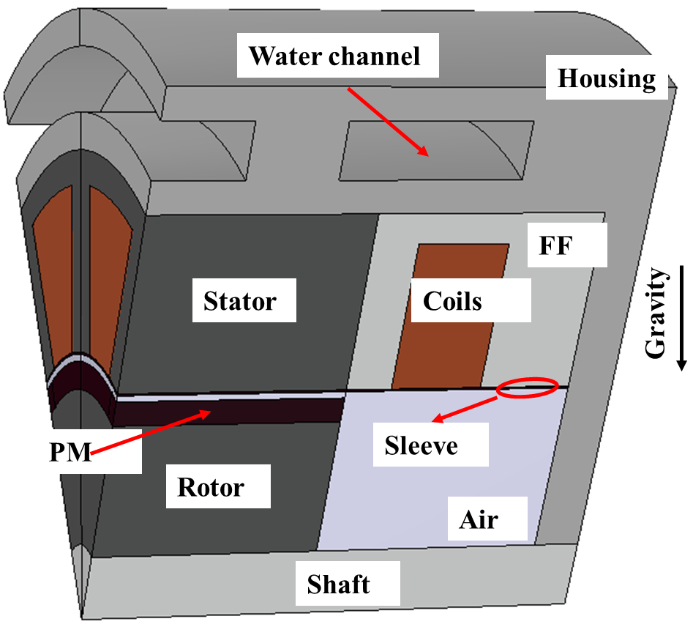
(a) Non-modular machine
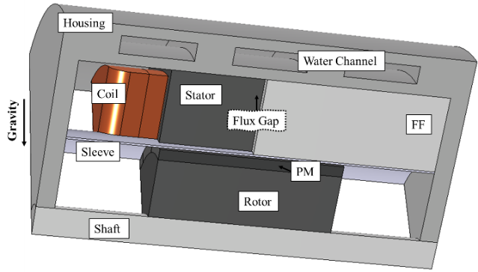
(b) Modular machine
Fig. 5.1. PM machine with ferrofluid around end-windings and water jacket embedded in the housing. FF stands for ferrofluid.

Theoretical Background
Ferrofluid has seen a rapid development since it was first synthesized by Solomon Stephen Papell in 1963. It is often composed of nano-sized ferro- or ferrimagnetic particles and suspended in a liquid base. Typically, the diameter of nano-sized ferromagnetic particles is around $3\sim 15 nm$. This is because larger size of nanoparticles can reduce the suspension stability whilst smaller size ($1\sim 2 nm$) can suppress their magnetic properties [189-191]. The properties of ferrofluid vary with the size of the nanoparticles, the concentration, the temperature, and the applied external magnetic field. This will be detailed in the following sections.

Properties of Ferrofluids
As mentioned above, one reason that the ferrofluids can be used in machine cooling is that under an external magnetic field (often produced by the end-windings), the nanoparticles in the ferrofluid are subjected to a magnetic body force. This magnetic body force will drive the coolant, leading to thermomagnetic convection, which helps cool the end-windings. It is generally true that increasing this magnetic body force can enhance the cooling efficiency of the ferrofluid. The magnetic body force mainly depends on the applied external magnetic field and the magnetization of the ferrofluids. The magnetization, the density, the thermal conductivity, and capacity, as well as the viscosity of ferrofluids are dependent on the temperature, the concentration and the intrinsic properties of the solvent and the solute. These properties need to be carefully investigated in order to maximize the potential of ferrofluids in machine cooling.

Magnetization
The magnetization curve of ferrofluid is similar to that of a ferromagnet, one example is shown in Fig. 5.2. Its magnetization increases with increased external magnetic field strength, while the slope gradually reduces to near 0 when it reaches the saturation magnetization ($M_{0}$) where all the dipoles in the ferrofluid are aligned with the external magnetic field. However, since the ferrofluid is often placed under relatively weak magnetic fields, the Langevin argument ($ξ$) is much smaller than 1. In this case, the ferrofluid can be regarded as superparamagnetic fluid, the magnetization of which increases linearly with the magnetic field strength [190]. According to Brillouin and Langevin law, $ξ$ and the magnetization (M) of a paramagnet can be described by [189, 190, 192]
$$ξ=\frac{μ_{0}mH}{k_{B}T}$$ | (5.1)
$$M=χH$$ | (5.2)
where $χ$ is the magnetic susceptibility, $μ_{0}$ is the vacuum permeability, $m$ is the magnetic moment of solute, $H$ is the magnetic field strength, $k_{B}$ $=1.38×{10}^{-23} J/K$ is the Boltzmann constant, and $T$ is the absolute temperature.
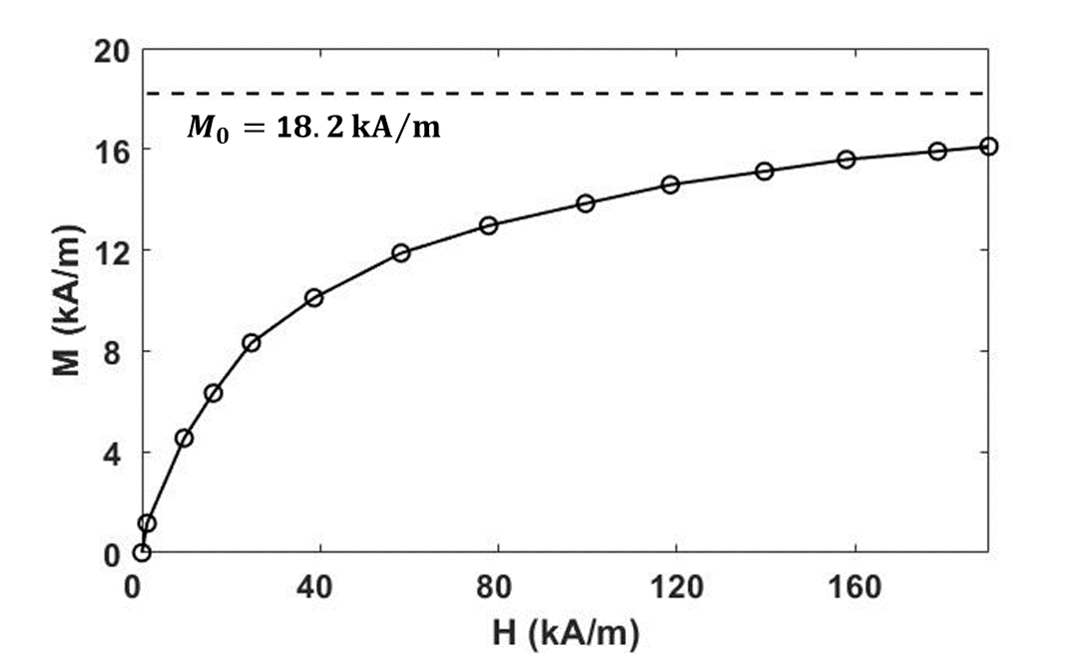
Fig. 5.2. Magnetization curve of ferrofluids used in [190].
It can be found that $χ$ is an important parameter when evaluating the magnetization. It is very small for diamagnet (around $-{10}^{-5}$) and paramagnet (from ${10}^{-5}$ to ${10}^{-2}$) but it can be a relatively large positive value (sometimes > 1000) for ferromagnet and ferrofluid. By approximating the Langevin function, $χ$ of ferrofluid is given as [189]
$$χ=\frac{ϕμ_{0}πd^{3}{M_{s,p}(T)}^{2}}{18k_{B}T}$$ | (5.3)
where $ϕ$ and $d$ are the volume fraction and average diameter of ferromagnetic particles, respectively. $M_{s,p}(T)$ is the temperature dependent saturation magnetization, which can be derived by Bloch’s law [186]:
$$M_{s,p}(T)=\left\{\begin{aligned}M_{0}\left(1-{\left(\frac{T}{T_{c}}\right)}^{1.5}\right),(if T≤T_{c}) \\ 0, (if T>T_{c}) \end{aligned}\right.$$ | (5.4)
where $M_{0}$ and $T_{c}$ are the saturation magnetization at absolute zero kelvins and the Curie temperature of the ferromagnetic particles in the ferrofluid.

Viscosity
The viscosity of liquid determines how easily the liquid flows. The ferrofluid can be regarded as Newtonian fluid whose viscosity is constant at constant temperature. According to Einstein formula, the dynamic viscosity $\left(η\right)$ of ferrofluid can be derived like a colloidal suspension such as
$$μ=μ_{f}\left(1+\frac{5}{2}ϕ\right)$$ | (5.5)
where subscript $f$ is the liquid base.
The viscosity is temperature dependent. The viscosity of fluids usually reduces with increased temperature. This phenomenon can be described by Andrade’s equation [193]
$$μ=Ae^{\frac{B}{T}}$$ | (5.6)
where coefficients $A$ and $B$ are the characteristics of ferrofluid and can be obtained from empirical parameters. In this chapter, $A=1.3×{10}^{-6} Pa∙s$ and $B=3.1{×10}^{3} K$.
The viscosity of ferrofluid is also affected by the applied external magnetic field, namely the magnetoviscous effect [189, 194, 195]. It can be explained by the resistivity of motion for nano-sized ferromagnetic particles in colloidal suspension caused by the applied magnetic field. According to Odenbach and Thurm in [195], this resistivity tends to be more significant under low shear strain rate, high magnetic field strength, high ferromagnet concentration and large ferromagnet sizes. In this chapter, the magnetic field acting on the ferromagnetic particles are the leakage magnetic field around the end-windings, which is a relatively weak magnetic field. In addition, according to the literature, the concentration of ferromagnetic particles is generally quite low, around 5% up to 10%. As a result, the magnetoviscous effect can be neglected for the investigations.

Density
The Bernoulli equation has revealed the significant role of the density gradient when the gravitational effect is considered in the modelling. The density $\left(ρ\right)$ and thermal expansion $\left(β\right)$ of compressible fluid can be derived by [190]
$$\left\{\begin{aligned}ρ_{(T)}=ρ_{0}\left(1-β_{(T)}ΔT\right) \\ ρ_{0}=ρ_{s}ϕ+ρ_{f}\left(1-ϕ\right)\end{aligned}\right.$$ | (5.7)
$$β_{(T)}=\left(β_{s}ϕ+β_{f}\left(1-ϕ\right)\right)$$ | (5.8)
where the subscript $s$ represents the ferromagnetic particles. It is worth noting that (5.7) and (5.8) assume that the density of the liquid base is the same as the surfactant which is often added into the ferrofluid to improve its fluid stability.

Thermal Conductivity and Capacity
Thermal conductivity of ferrofluid ($λ$) can be derived by Maxwell formula of colloidal suspension such as [190]
$$λ=λ_{f}\left[1-\frac{3\left(λ_{f}-λ_{s}\right)ϕ}{2λ_{f}+λ_{s}+ϕ(λ_{f}-λ_{s})}\right]$$ | (5.9)
And the specific heat capacity ($c$) can be calculated using the same mixing rule as the density, as described by
$$c=c_{s}ϕ+c_{f}\left(1-ϕ\right)$$ | (5.10)

Governing Equations
As mentioned before, the ferrofluid is often under weak magnetic field, where $ξ≪1$ as derived in (5.1). As a result, the ferrofluid is considered as superparamagnetic fluid and its magnetic susceptibility can be derived by Langevin function. The behaviours of the ferrofluid in the investigated PM machines will be governed by the coupling between the magnetic field, the fluid dynamics and the heat transfer, and the governing equations will be explained in detail in the following sections.

Fluid Dynamics
The behaviour of ferromagnetic flow is governed by Navier-Stokes equations and its time-varying model considering the body force is obtained by Bernoulli equation:
$$ρ\frac{∂u}{∂t}+ρ\left(u∙∇\right)u=ρg-∇p+F_{v}+F_{m}$$ | (5.11)
where $u$ is the velocity vector, $t$ is the time, $g$ is the acceleration of gravity vector and $p$ is the pressure which is a function of temperature and density.
$F_{v}$ in (5.11) is the viscosity force density vector dependent on the viscosity stress. For a compressible flow, the viscosity force density vector can be described by
$$F_{v}=μ∇^{2}u+\left(λ_{μ}+μ\right)∇\left(∇∙u\right)$$ | (5.12)
where $μ$ is the dynamic viscosity of the fluid and $λ_{μ}$ is the second coefficient of viscosity. In classical theory, the second coefficient of viscosity is identified as $-\frac{2}{3}μ$ because the bulk viscosity coefficient should be 0. However, according to Karim and Rosenhead in [196], there is no correlation between $μ$ and $λ_{μ}$ that can be found. The ratio of $μ$ to $λ_{μ}$ can be a large positive value for the liquid vibrating in the sonic range.
$F_{m}$ in (5.11) is the magnetic body force vector. It can be derived using different methods, including electrical current loop model, magnetic charge model and the Kelvin body force formula. They will be introduced in the following section.

Electromagnetic Field
The magnetic materials, including ferromagnet, ferrimagnet and paramagnet, will experience magnetic body force if they are put under external magnetic field. According to the electrical current loop model [197], $F_{m}$ on a magnetic dipole is derived as
$$F_{m}=∇\left(m∙B\right)$$ | (5.13)
where $m$ is the magnetic dipole moment and $B$ is the magnetic induction field. Since the magnetization field is a Riemann-integrable vector-valued function, the magnetic moment can be represented as [198]
$$m= \int_{Ω}{M}dV$$ | (5.14)
Therefore, $F_{m}$ for ferrofluid can be described by
$F_{m}$ | $=∇\left(M∙B\right)$ | (5.15)
 | $=M×\left(∇×B\right)+B×\left(∇×M\right)+\left(M∙∇\right)B+\left(B∙∇\right)M$ | (5.15)
However, the magnetic charge model leads to a different form of magnetic body force such as [197]
$$F_{m}=\left(M∙∇\right)B$$ | (5.16)
The difference between these two models is that (5.13) considers the Aharonov-Casher effect, which is caused by quantum interference pattern shift phenomenon [199]. Therefore, it is more widely used in atomic and nuclear physics. However, for the investigations in this chapter, (5.16) can be regarded as a close approximation of (5.15) when the following assumptions are made:
- Since the ferrofluid is placed in a time-varying magnetic field, the magnetic relaxation of ferromagnetic particles is evaluated by two mechanisms, i.e., Brownian mechanism and $N\acute{e}el$ mechanism. According to Rosenweig [189] and Berkovsky [190], the magnetic relaxation time (order of ${10}^{-7} s$) for both mechanisms are much smaller than the characteristic hydro-dynamic times. Therefore, the pyromagnetic phenomenon is neglected, and the response of the ferromagnetic particles to the time-varying magnetic field is instantaneous, and hence $M$ is not position dependent. Then (5.15) can be rewritten as:
$$F_{m}=\left(M∙∇\right)B+M×\left(∇×B\right)$$ | (5.17)
- Furthermore, due to the poor electrical conductivity of liquid carrier and low concentration of ferromagnetic particles, the electrical conductivity of ferrofluid can be neglected. As a result, the current density $J$ and the displacement current ($\frac{∂E}{∂t}$) are 0, so is $∇×B$. In this case, (5.16) is equal to (5.17).
Since the ferrofluid is regarded as a superparamagnetic solution that susceptibility is independent of magnetic field intensity, a new form of magnetic body force is derived such as
$$F_{m}=μ_{0}\left(M∙∇\right)H$$ | (5.18)
This new form is widely known as Kelvin body force formula [189]. Compared with the electrical current loop model and the magnetic charge model, it is more concise and neglects the interaction between the nano-sized ferromagnetic particles in the ferrofluid. Therefore, to simplify the simulation, (5.18) will be used in this chapter to calculate the magnetic body force.

Heat Transfer
The heat transfer in solid and liquid can be described by
$$∇∙\left(q\right)+Q=ρc\frac{∂T}{∂t}$$ | (5.19)
where $q$ and $Q$ are the heat flux vector and volumetric heat generation. The heat flux vector for conduction ($q_{s}$) and convection ($q_{f}$) are described by [200]
$$\left\{\begin{aligned}q_{s}=λ∇T \\ q_{f}=ρcTu\end{aligned}\right.$$ | (5.20)
It is worth noting that, the heat flux vector for radiation has been neglected in this chapter.

Multiphysics Modelling

Machine Topologies and Specifications
A conventional permanent magnet synchronous machine (PMSM) is used for the investigations in this chapter. The topology is shown in Fig. 5.1 (a). The specifications of this machine are listed in Table 5.1. It is worth noting that, the gravity needs to be considered in the model and its direction is perpendicular to the rotor shaft as shown in Fig. 5.1 (a). The ferrofluid will be filled in all the stator end-winding regions. To prevent the ferrofluid from leaking to the rotor end space, carbon sleeves are used to separate the stator and rotor end spaces.
Table 5.1 Parameters of the PMSM Machine
Slot number | 12 | Stack length (mm) | 50
Pole number | 14 | End-winding overhang (mm) | 20
Stator outer radius (mm) | 50 | Housing radius (mm) | 65
Stator yoke height (mm) | 3.7 | Housing length (mm) | 120
Tooth width (mm) | 7.1 | Housing thickness (mm) | 10
Airgap length (mm) | 1 | Number of coils per phase | 132
Rotor outer radius (mm) | 27.5 | Wire diameter (mm) | 1.32
Rotor yoke thickness (mm) | 15.5 | Current density ($A/{{mm}^{2}}$) | 18.4
Magnet thickness (mm) | 3 | Rated speed (rpm) | 400
Magnet remanence (T) | 1.2

Ferrofluid Properties
The ferrofluid used in the simulations in this chapter is the same as that used by S. Nasser El Dine et al in [185]. The liquid base for the ferrofluid is vegetable oil. The parameters of the ferrofluid are listed in Table 5.2.
Table 5.2 Parameters of the Ferrofluid
Particle volume fraction (%) | 5.4
Particle average diameter (nm) | 16
Magnetization (A/m) | 3.87$×{10}^{5}$
Curie temperature (K) | 793
Density (${kg}/{m^{3}}$) | 1115
Thermal conductivity ($W/{m∙K}$) | 0.186
Dynamic viscosity ($Pa∙s$) | 0.0787
Specific heat capacity ($J/{kg/K}$) | 1.685$×{10}^{3}$

Assumptions and Boundary Conditions
In order to reduce the simulation time and make the multiphysics model solvable, several assumptions and simplifications should be introduced as below:

Load Current
The relaxation time of magnetization ($τ_{m}$) is of the order of ${10}^{-5}$s that specified by Brownian and Neel mechanisms [190]. The onload current is an alternating current (AC) with a period ($τ_{e}$) of $3/{140}$s. Since $τ_{m}≪τ_{e}$, the direction of the magnetic body force can be considered as the same as the direction of magnetic field. In addition, the hydrodynamics and thermodynamics time constant ($τ_{f}$), ranging from minutes to hours, is much larger than $τ_{e}$. As a result, using a DC to represent the AC has been deemed acceptable. This assumption has been wildly employed in the literature [68, 185-187].

Electric Current and Lorentz Force in Ferrofluid
Based on the findings in [189], the electrical resistivity of the ferrofluid is larger than ${10}^{9}$ $Ω∙$cm. Therefore, the electric current and Lorentz force in the ferrofluid can be neglected.

Gravitational Effect and Thermal Expansion
Based on the simulations, it is found that the gravitational effect (gravity) is significant and can also lead to the circulation of the ferrofluid. Therefore, the gravity has been considered in the simulations and its direction is vertical to the shaft, as shown in Fig. 5.1 (a). The thermal expansion of ferrofluid is $6.62×{10}^{-4} K^{-1}$. This means that the density variation due to thermal expansion is relatively small, and hence the thermal expansion has been neglected in the modelling. To consider the gravitational effect without density variation, the Boussinesq approximation is employed in the models.

Boundary Conditions
For the investigated PM machines, a water jacket is introduced, as shown in Fig. 5.1, to maximize the cooling efficiency of the ferrofluid. The inlet flow rate and temperature of the water jacket are 1.37L/min and 65$℃$, respectively. This inlet flow rate can be achieved by assuming a 1200Pa pressure drop. The water jacket is represented by an effective convection coefficient ($h_{e}$) in the multiphysics models to reduce the computation time. It can be derived by (4.15). Based on the CFD simulations shown in Fig. 5.3, the convection coefficient is 3718 $W/{{m^{2}}/K}$ while the reference temperature is 65$℃$. On the surface of endcaps that is not wrapped by water jacket, natural cooling is used, and the convection coefficient is assumed to be 8 $W/{{m^{2}}/K}$ and the reference temperature is 20$℃$.
 | 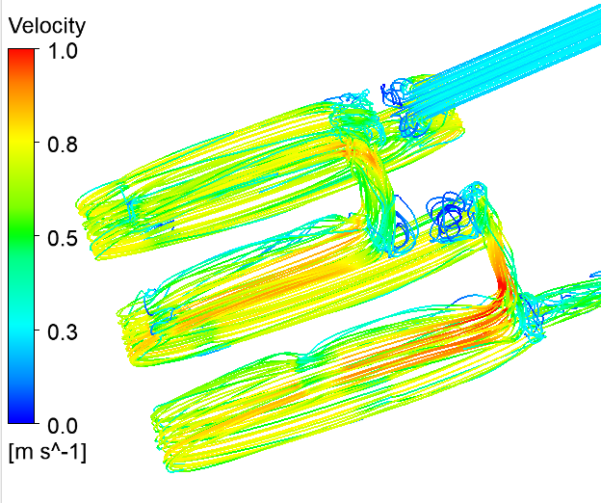
(a) Temperature distribution | (b) Coolant velocity
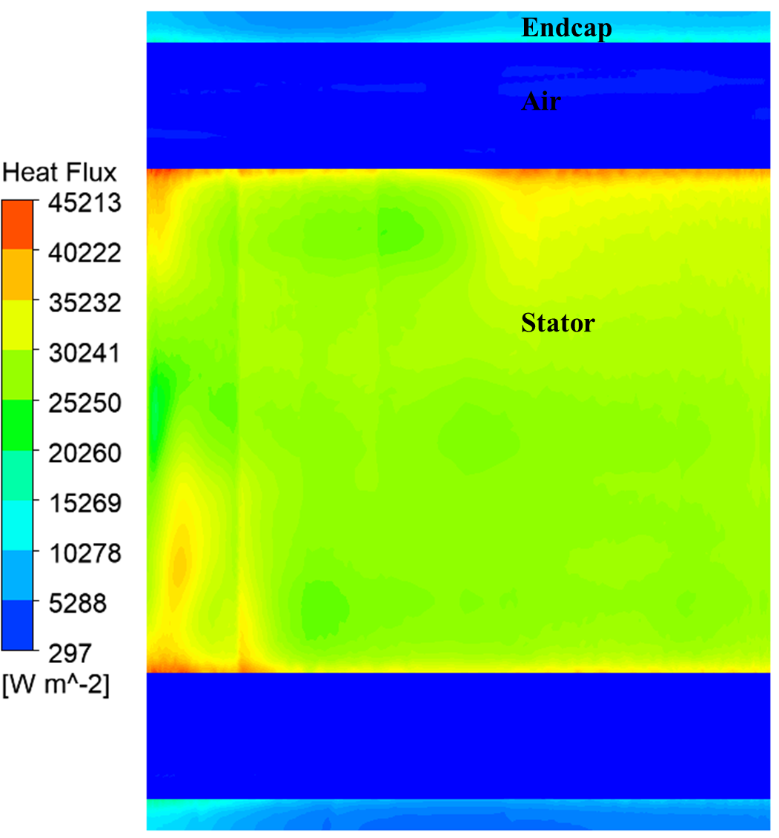
(c) Heat flux through housing surface
Fig. 5.3. CFD simulation results for the machine with water jacket cooling.

Mesh Sensitivity Tests
The number of mesh element for the model investigated in this chapter is 341270. The time step is mutative, and the average value is around 1s to 2s. The model is solved for 8300 iterations (about 57 hours by 8 processors).
To investigate the influence of mesh size on the accuracy of the multiphysics model, different mesh sizes have been compared, as shown in Fig. 5.4. It is worth noting that as the ferrofluid region is the most important region for the multiphysics models, the analyses are focused on the mesh size in the ferrofluid region. The results show that reducing the average mesh size from 3.8mm³ to 0.075mm³ (the maximum mesh length reduces from 5mm to 1mm) will significantly increase the number of mesh elements by more than 8 times and the computation time by around 4.2 times. However, the temperature variation is only 0.3%. Therefore, the mesh size selected in this chapter can be considered a reasonable compromise between the model accuracy and the computation time.
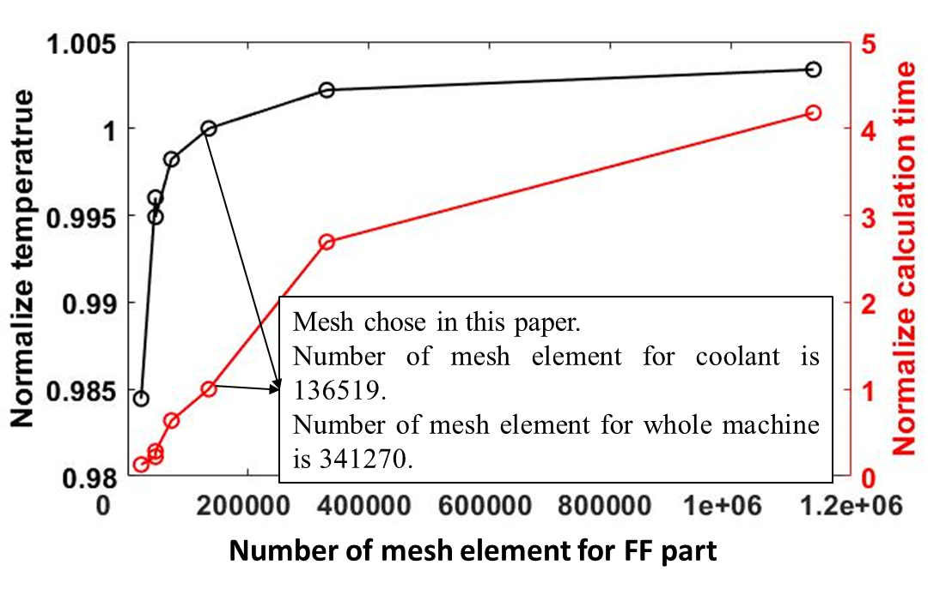
Fig. 5.4. Normalized maximum temperature and calculation time at different number of mesh elements (and different mesh sizes).

Performances of the Ferrofluid Cooling Machines
In order to show the superior cooling performance of ferrofluid, air and non-magnetic liquid (i.e., nanofluid, named as NF) have also been investigated, and compared against the ferrofluid cooling. Nanofluid has the same physical properties as ferrofluid but will not experience magnetic body force from the external magnetic field. This comparison will help investigate the influences of thermomagnetic convection and gravitational effect on ferrofluid cooling.
To visualize the behaviour of different coolants in the investigated machines, two planes which are vertical (plane 1) and horizontal (plane 2) to the shaft are used to show the temperature distribution and fluid flow in the PMSM, as shown in Fig. 5.5 (a). Due to the gravitational effect, the temperature distribution and fluid flow are not circumferentially symmetrical, and they will be different around different end-windings. To clearly visualize this difference, in the post-process of the results, the end-winding region has been separated into 6 identical sections in axial direction and each span 60 degrees and has one coil in each section, as shown in Fig. 5.5 (b). The fluid dynamics and heat transfer results in each section will be investigated and compared in the following sections.
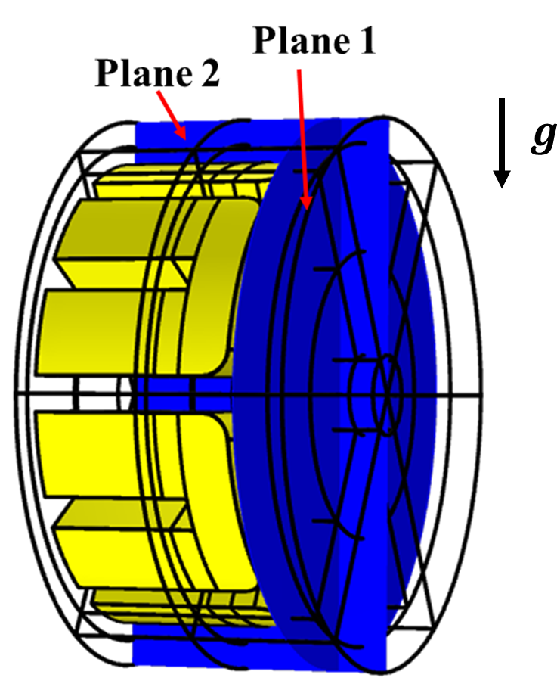 | 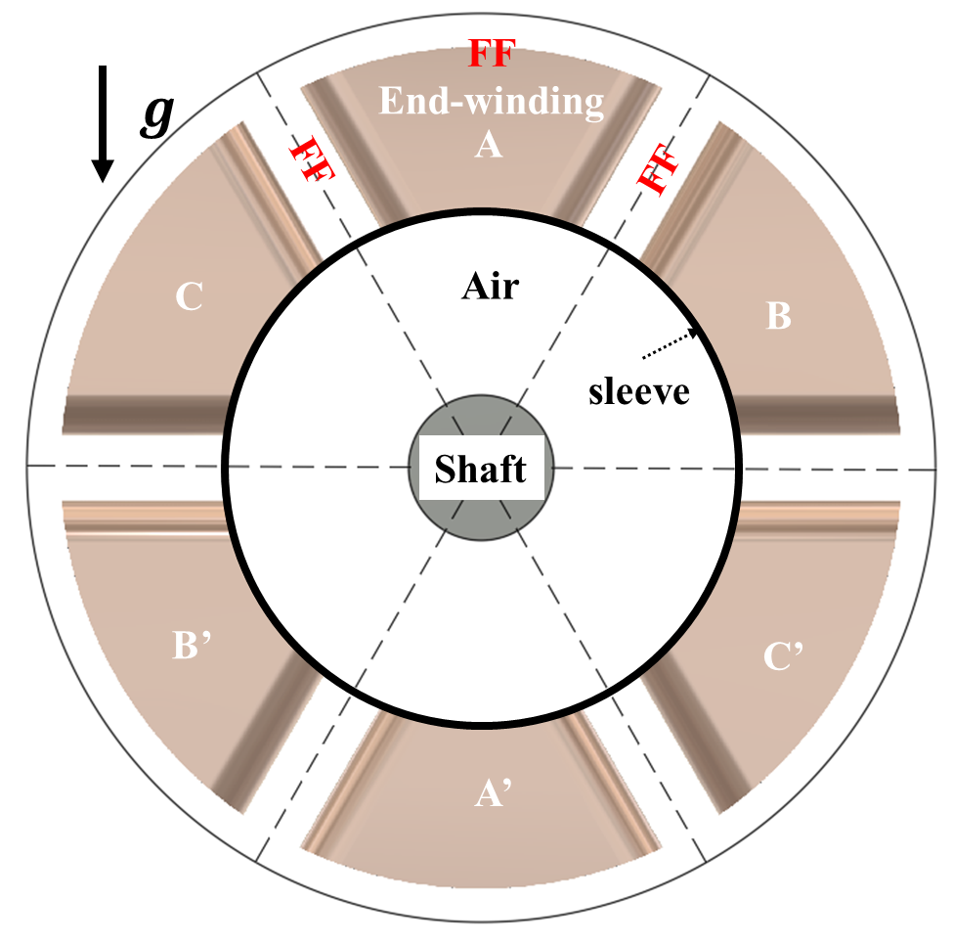
(a) | (b)
Fig. 5.5. (a) Planes chosen to show the temperature distribution and fluid flow and (b) six sections to analyse the fluid dynamics and heat transfer results.

Cooling Efficiency of Ferrofluid Cooling
For different coolants, the peak coil temperatures versus time have been calculated using 3D COMSOL Multiphysics model, and the results are shown in Fig. 5.6. It is found that, when ferrofluid is introduced to replace air in the end-winding region, the peak coil temperature is reduced by $16.2℃$. This temperature reduction is due to two factors, i.e., gravitational effect and magnetic body force.
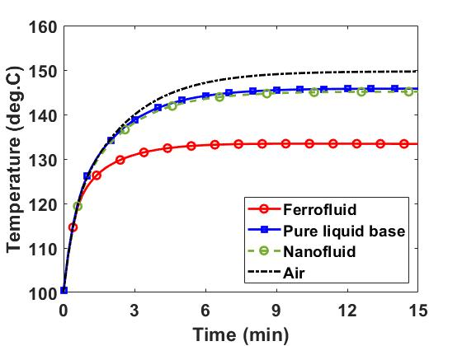
Fig. 5.6. Maximum coil temperatures vs time for different coolants at rated current density of ${18.4 A}/{{mm}^{2}}$.
The nanofluid with the same physical properties as those of the ferrofluid is affected by the same gravitational effect. Due to significant thermal expansion, the density of hotter fluid reduces and moves to the top sections (A, B and C) by buoyancy, whilst the cooler fluid moves towards the bottom sections (A’, B’ and C’), as shown in Fig. 5.7 (a). The fluid behaviour is also reflected in the coolant temperature as shown in Fig. 5.8 (a). Compared to the natural air cooling, this heat exchange helps the nanofluid to reduce the machine temperature by $4.8 ℃$. In addition, buoyancy also causes a circumferential asymmetry within the fluid flow and therefore an asymmetry of the machine temperature distribution, as listed in Table 5.3. The hotter coolant is gathered in the top sections, leading to higher temperature in these sections. It is worth noting that, the temperature reductions by the nanofluid and the pure liquid base are almost the same, as listed in Table 5.3. This is mainly because although the additional nanoparticles improve the conduction coefficient and increase the fluid viscosity, the low concentration of nanoparticles (e.g., 5.4%) very much limits their impact on fluid physical properties. In addition to the gravitational effect, the magnetic body force can further reduce machine temperature. Compared with the nanofluid cooling, the ferrofluid can reduce the peak coil temperature by another $11.4℃$, as shown in Fig. 5.8. The reason is that, due to the existence of magnetic body force, the circulation of the ferrofluid is faster, leading to increased thermomagnetic convection. In addition, the ferromagnetic particles are attracted to the centre of the coil in each section as shown in Fig. 5.7 (b), resulting in more uniform distribution of coolant velocity field, and hence more uniform end-winding temperature distribution.
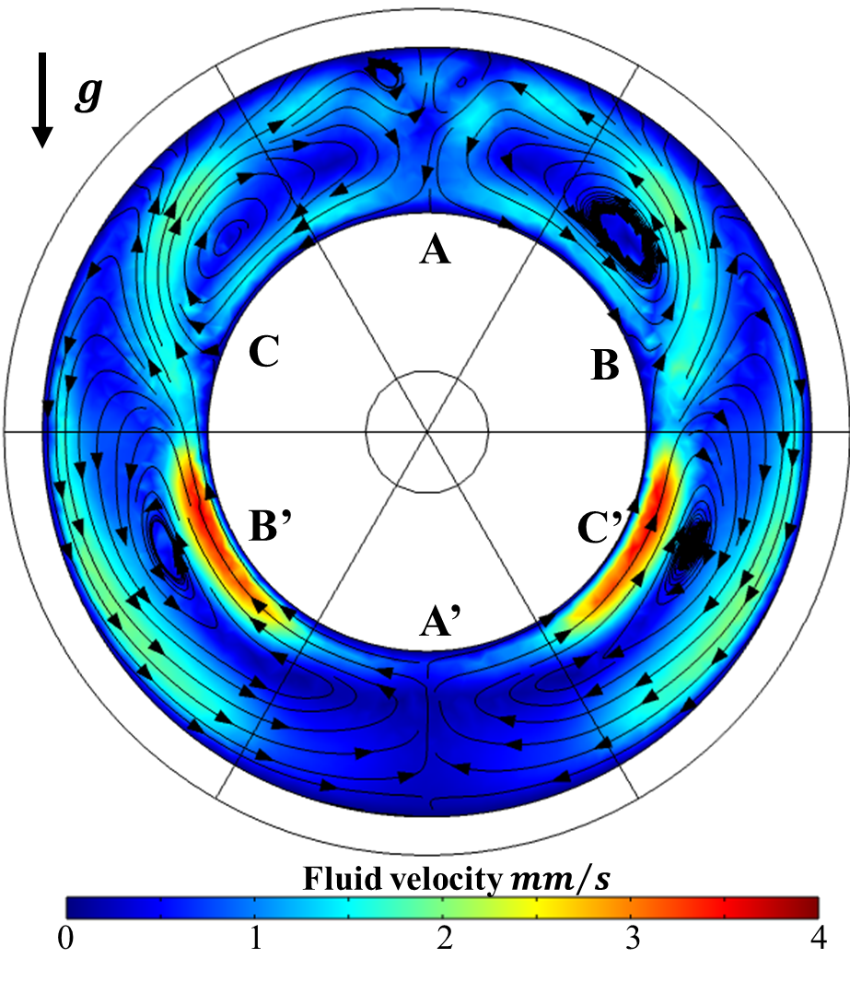 | 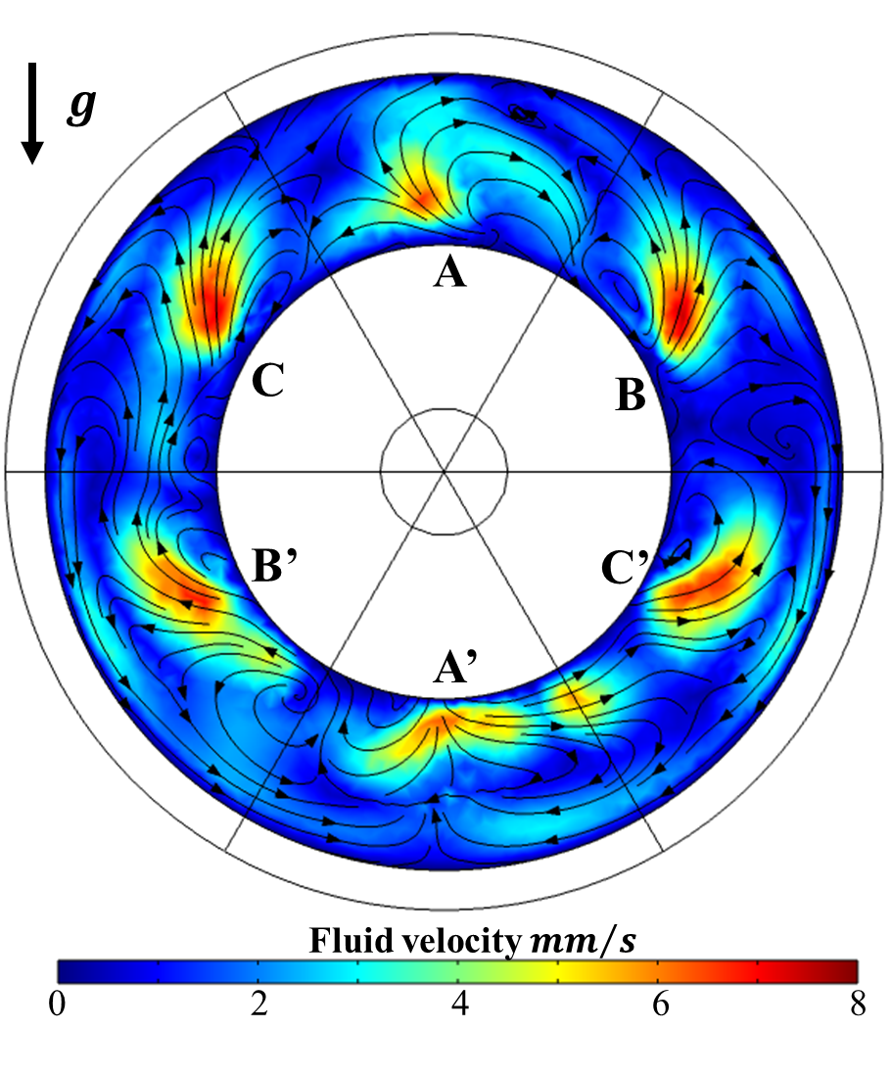
(a) Nanofluid | (b) Ferrofluid
Fig. 5.7. Fluid flow velocity on plane 1 for the machines with different coolant at rated current density of ${18.4 A}/{{mm}^{2}}$.
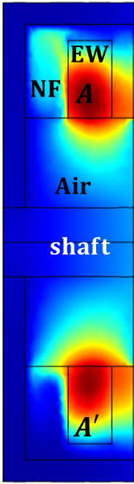 | 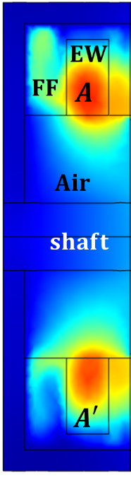 | 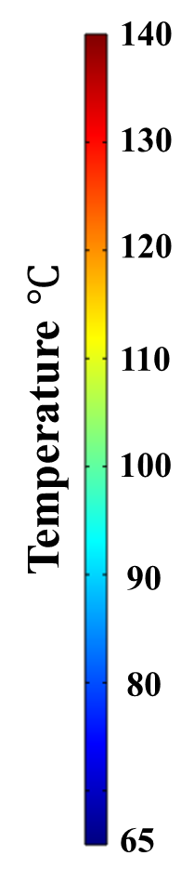
(a) Nanofluid | (b) Ferrofluid
Fig. 5.8. Temperature distribution on plane 2 in the end-winding region for the machines with different coolant at rated current density of ${18.4 A}/{{mm}^{2}}$.
Table 5.3 Maximum Coil Temperatures (in $℃$) in Each Section
Coolant material | A | B | C’ | A’
Ferrofluid | 133.0 | 133.4 | 132.0 | 129.62
Nanofluid | 144.8 | 144.8 | 143.5 | 142.5
Pure liquid base | 145.7 | 145.6 | 144.5 | 143.5
Air | 149.6 | 149.6 | 149.6 | 149.6

Influence of Electrical Loading
Previous results demonstrated that the ferrofluid in end-winding region can improve the machine cooling performance. This means that, without exceeding the maximum allowable temperature of insulations, higher phase current (or electrical loading) may be injected to achieve higher machine power density. When the phase current increases, the copper loss will be increased accordingly, and the advantage of adopting ferrofluid cooling will be more pronounced, as can be seen from Fig. 5.9. This is mainly because the increased current density improves both the gravitational effect and the magnetic body force, and hence improves the thermomagnetic convection.
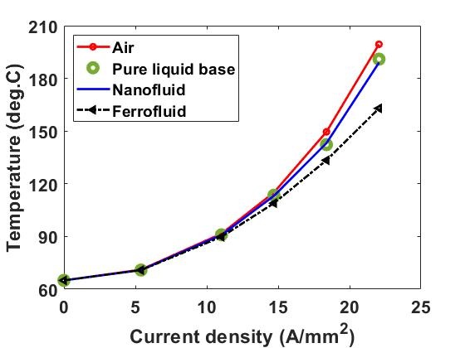
Fig. 5.9. Maximum coil temperatures at steady state vs current density for different coolants.
The gravitational effect can be investigated separately from the thermomagnetic convection by studying the results obtained using the nanofluid as coolant. It is found that when the current density is increased from ${18.4 A}/{{mm}^{2}}$ to ${22.1 A}/{{mm}^{2}}$, the coolant flow velocity for the machine with nanofluid cooling increases from ${3.66 mm}/s$ [Fig. 5.7 (a)] to ${4.93 mm}/s$ [Fig. 5.10 (a)]. This is because a larger temperature gradient within the nanofluid is achieved for machines with increased current density (and increased copper loss). To be more specific, the temperature gradient is increased from $65.1 ℃$ [Fig. 5.8 (a)] to $98.84 ℃$ [Fig. 5.11 (a)] when current density is increased from ${18.4 A}/{{mm}^{2}}$ to ${22.1 A}/{{mm}^{2}}$.
Regarding the magnetic body force attributing to the thermomagnetic convection, according to (5.18), it also increases at a higher current density due to higher magnetic field intensity in the end-winding region. Consequently, the coolant flow velocity increases, leading to increased thermomagnetic convection. When the current density rises from ${18.4 A}/{{mm}^{2}}$ to ${22.1 A}/{{mm}^{2}}$, the maximum coolant velocity for the machine with ferrofluid cooling is increased from ${7.47 mm}/s$ [Fig. 5.7 (b)] to ${11.3 mm}/s$ [Fig. 5.10 (b)]. As a result, a much more significant temperature reduction (by $36.4 ℃$ compared with air cooling) can be achieved, as shown in Fig. 5.11 (b). This large temperature reduction is mainly attributed to much higher magnetic body force at high current density, which accounts for $26 ℃$. The remaining and relatively minor temperature reduction is attributed to the gravitational effect, which accounts for $10.4 ℃$.
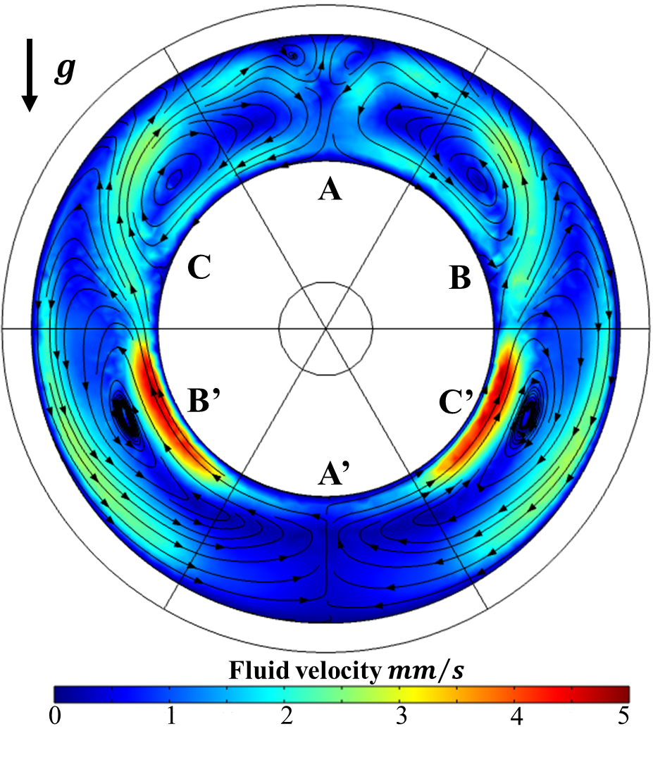 | 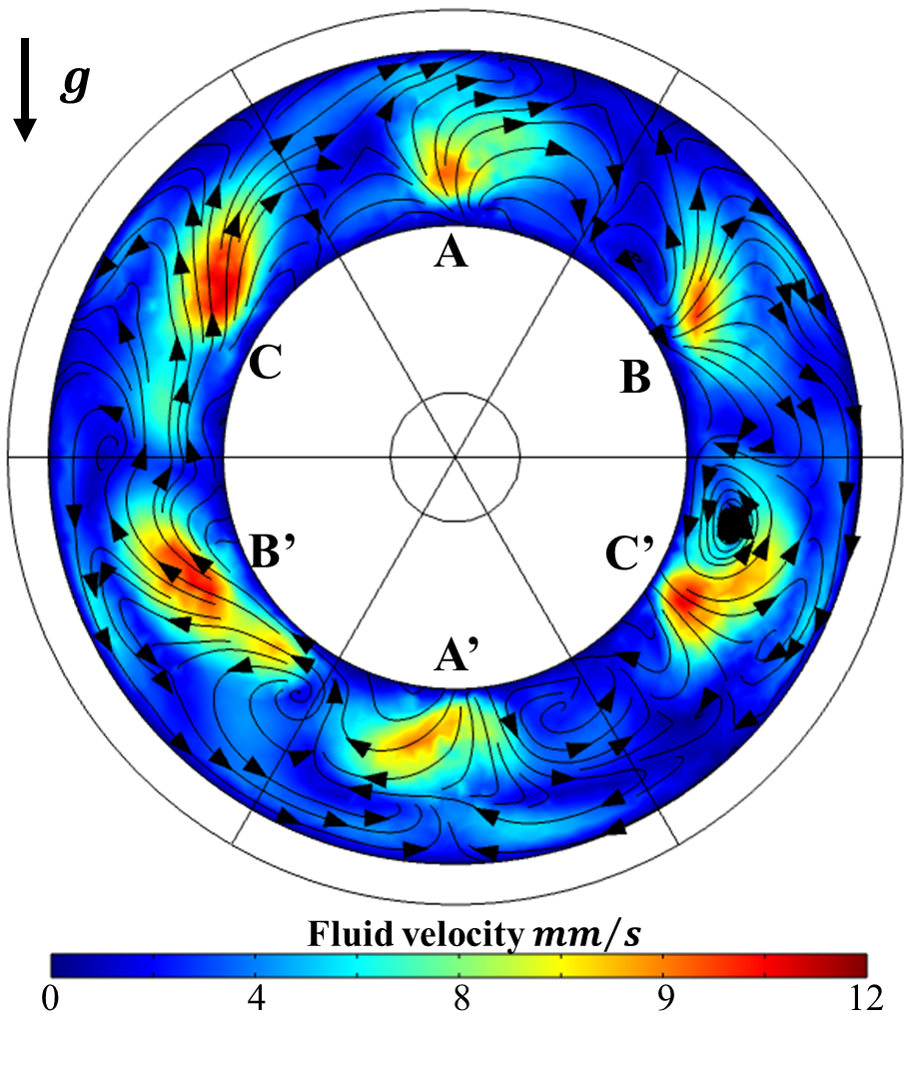
(a) Nanofluid | (b) Ferrofluid
Fig. 5.10. Fluid flow velocity on plane 1 for the machines with different coolant at rated current density of ${22.1 A}/{{mm}^{2}}$.
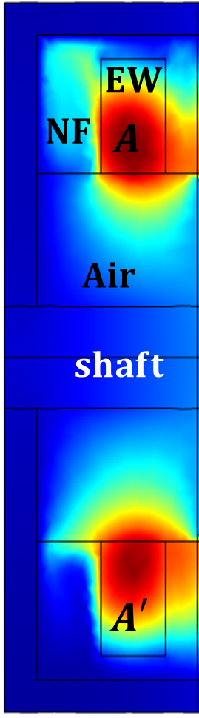 | 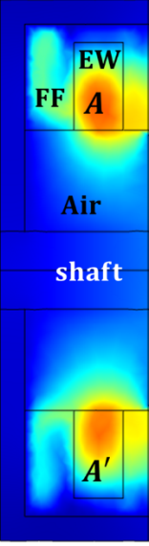 | 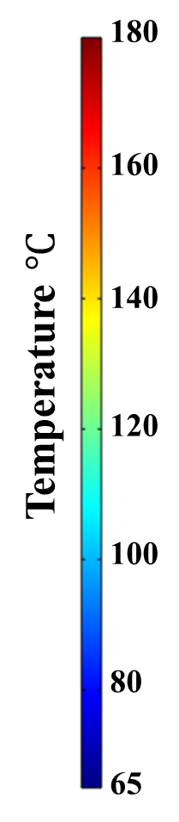
(a) Nanofluid | (b) Ferrofluid
Fig. 5.11. Temperature distribution on plane 2 in the end-winding region for the machines with different coolant at rated current density of ${22.1 A}/{{mm}^{2}}$.

Influence of Ferrofluid Properties
Previous results confirm the ability of ferrofluid in improving the cooling performance of electrical machines. This improvement is due to the existence of the nano-sized ferromagnetic particles in the liquid base as (1) they improve the thermal conductivity; (2) they improve the gravitational effect due to higher thermal expansion; and (3) they can also lead to significant thermomagnetic convection due to magnetic body force. The improvement can be further enhanced by increasing the concentration of ferromagnetic particles or using materials with better temperature dependent magnetization properties, as will be investigated in following sections.

Concentration of Ferrofluid
Increasing the concentration can improve the cooling efficiency for both the nanofluid and ferrofluid. However, the temperature reduction by the ferrofluid is more significant, as can be seen in Fig. 5.12. It is found that compared to a concentration of 0%, i.e., the pure liquid base, the coil temperatures are reduced by only 1.1% when the concentration of the nanofluid is increased to 10%. The marginal temperature reduction is due to slightly increased thermal conductivity and expansion coefficient and hence an enhanced gravitational effect. This is the same case for the ferrofluid. However, the thermomagnetic convection obtained by introducing the ferromagnetic particles can further reduce the machine temperature. The boosted magnetic body force due to a higher concentration as derived in (5.18) leads to a quicker coolant circulation and a larger thermomagnetic convection. As a result, the coil temperatures can be reduced by 11.7% when the concentration of the ferrofluid is 10%.
Although the thermomagnetic convection can be enhanced by increasing the concentration, the concentrations of the ferrofluid in literature are mostly around 5%. This is because higher concentration also increases the interaction between ferromagnetic particles. This could increase their agglomeration and make the fluid unstable. Therefore, ferrofluids with a concentration of up to 10% has been selected for the investigations in this chapter.
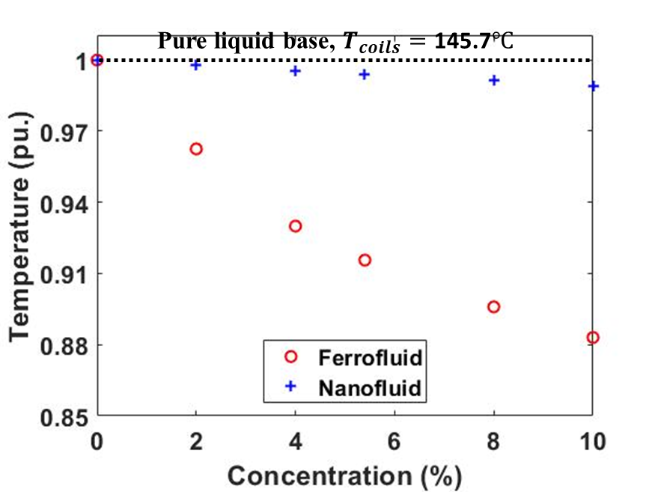
Fig. 5.12. Normalized maximum coil temperatures for different concentrations of ferrofluid at rated current density of ${18.4 A}/{{mm}^{2}}$.

Magnetization Characters of Ferrofluid
Previous results demonstrated the significant role of the thermomagnetic convection in improving machine thermal performance. It is also found that increasing the magnetic body force is an efficient method to improve the thermomagnetic convection, and hence the cooling efficiency of the ferrofluid. The magnetic body force in (4.13) and (5.18) shows that it is affected by the temperature dependent magnetization curve. Since the magnetization curve is the intrinsic properties of materials, different ferromagnetic materials are chosen to investigate the influence of the magnetization curve. Their magnetic properties, i.e., saturation magnetization ($M_{0}$) at 20$℃$ and Curie Temperature ($T_{c}$) are listed in Table 5.4. According to (4.13) and (5.4), higher $M_{0}$ leads to higher magnetic susceptibility, while higher $T_{c}$ also leads to higher susceptibility and lower reduction rate of susceptibility, as shown in Fig. 5.13. It is worth noting that the operating temperature of the ferrofluid in this study is within the range between 70$℃$ and 110$℃$, as shown in the shaded region in Fig. 5.13.
The maximum coil temperatures for ferrofluid with different ferromagnetic particles are shown in Fig. 5.14. It is found that ${Fe}_{3}O_{4}$ achieves lower temperatures due to its higher susceptibility within the selected operating temperature range. However, the highest temperature is achieved by $Cd{Mn}_{2}$ because its Curie temperature is far lower than the selected operating temperature range as listed in Table 5.4. This means that this kind of ferrofluid is fully demagnetized in the selected operating temperature range, and therefore cannot generate magnetic body force from the external magnetic field as described by (5.18). Regarding the cooling performances of $GdCO_{2}$ and $Ni$, an interesting phenomenon has been observed. $GdCO_{2}$ has similar susceptibility at 100$℃$ as $Ni$, whilst its susceptibility reduces much faster when temperature increases. This means that, compared to $Ni$, $GdCO_{2}$ may produce lower magnetic body force under the same magnetic field. However, the coil temperature cooled by ferrofluid using $GdCO_{2}$ is much lower than that cooled by ferrofluid using $Ni$. This interesting phenomenon is because $GdCO_{2}$ subjects to almost the same magnetic body force as $Ni$ in the colder region, but lower magnetic body force in the hotter region. This larger magnetic body force gradient leads to faster coolant circulation, and hence lower machine temperature.
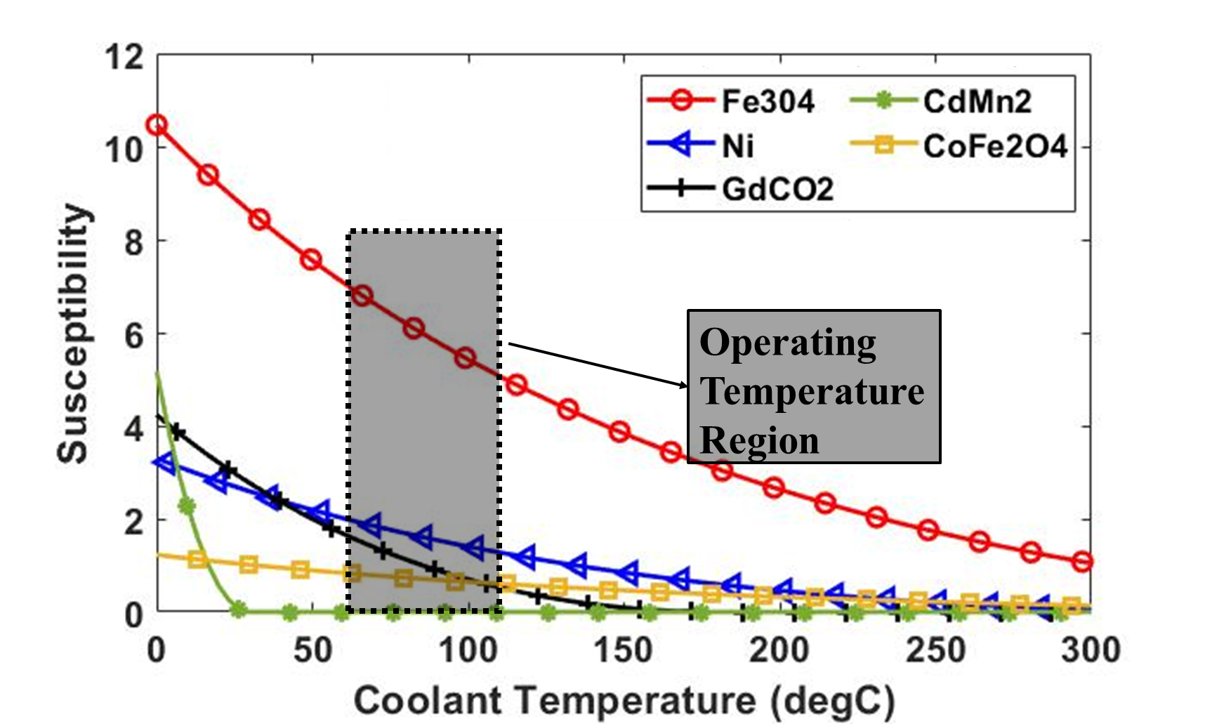
Fig. 5.13. Magnetic susceptibility curve of different ferromagnets.
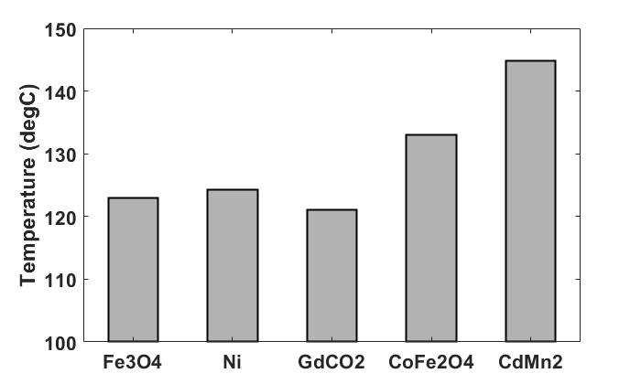
Fig. 5.14. Maximum coil temperatures with different ferrofluids at rated current density of ${18.4 A}/{{mm}^{2}}$.
Table 5.4 $M_{0}$ and $T_{c}$ for Different Ferromagnets [190]
 | Fe3O4 | Ni | GdCO2 | CoFe2O4 | CdMn2
$$M_{0} ({kA}/m)$$ | 875 | 484 | 517 | 387 | 215
$$T_{c} \left(℃\right)$$ | 500 | 358 | 180 | 520 | 30

Influence of Winding Configurations
For ferrofluid cooling, the variation of magnetic field can directly affect the magnetic body force, therefore the efficiency of thermomagnetic convection. As for the electrical machines with different winding configurations, e.g., single layer and double layer winding topologies, they will have different end-winding leakage fluxes. This would lead to different cooling performances when the ferrofluid cooling is employed. For a fairer comparison, only the winding structures are different, and all the other key design parameters are the same as listed in Table 5.1. It is also worth noting that, the number of turns per coil of double layer machine is half of that of the single layer machine. However, as the number of coils of the double layer machine is twice that of the single layer machine, the total number of turns per slot is exactly the same for single and double layer machines. This leads to the same current density for these two winding topologies.

Nanofluid Cooling
Firstly, at rated condition, when both the investigated machines only have air in the end space, the maximum end-winding temperature for the single layer machine is 151$℃$, while for the double layer machine it is 158$℃$. Higher machine temperature for the double layer machine is mainly because an extra insulation paper should be used to separate the different coils in the same slot. The poor thermal conductivity material in slots not only reduces the contact surface between the coils and stator, but also introduces extra thermal resistance between the coils. Even the surface area of the end-winding for the double layer design is 38% higher than that of the single layer design, the poor thermal conductivity of air cannot fully utilize this advantage.
However, when a nanofluid is used to fill in the stator end-winding region for both the winding designs, the thermal performance for the double layer machine can be significantly improved. For the single layer topology, using nanofluid in the end space reduces 5$℃$ of the maximum end-winding temperature (from 151$℃$ to 146$℃$). For the double layer topology, the maximum end-winding temperature is reduced by 17$℃$ (from 158$℃$ to 141$℃$). Since the winding losses for both designs are similar, the gravitational effect for both winding designs is almost the same. Therefore, the coolant velocities are similar as shown in Fig. 5.15 and hence the impact on the cooling efficiency due to the gravitational effect is similar too. However, for the double layer machine, the surface area of the end-windings is higher than that of single layer machine. In addition, the number of turns per coils is only half of that of the single layer machine. Therefore, the heat flux path from the hot spot (often at the centre of coils) to the surface is shorter than the single layer machine. As a result, the end-windings of the double layer machine can benefit more from the nanofluid cooling and hence have lower peak temperature.
 | 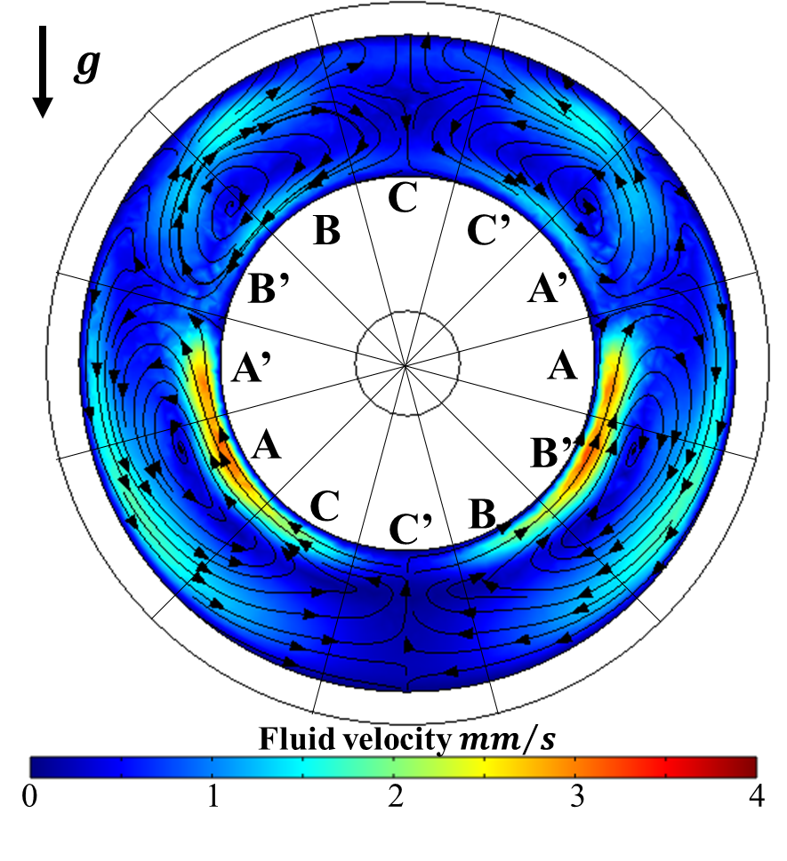
(a) Single layer | (b) Double layer
Fig. 5.15. Fluid flow velocity at plane 1 for investigated machines with nanofluid cooling systems.
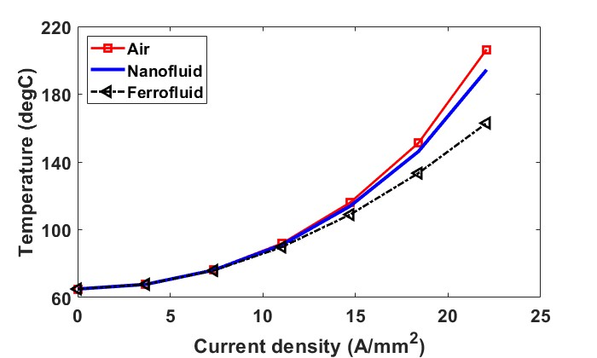
(a) Single layer machine
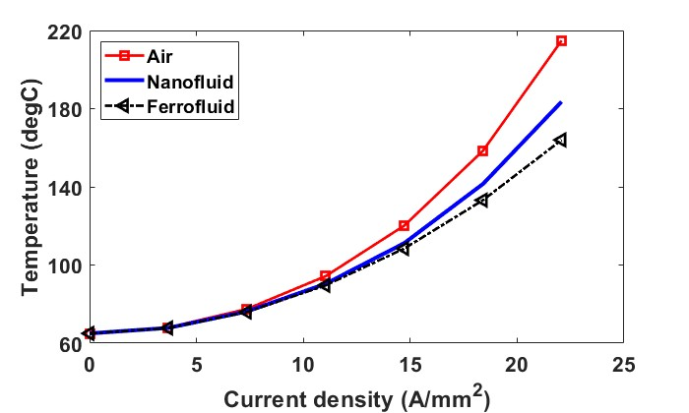
(b) double layer machine
Fig. 5.16. Steady-state peak coil temperatures vs current density for different coolants in the end-space.
The gravitational effect will be more significant when current density increases for both machines, as shown in Fig. 5.16. For the single layer machine, the temperature reduction (using nanofluid to replace air in the end-space) increases from 5$℃$ to 12$℃$ when the current density increases from 18.4A/mm² to 22.08A/mm². Similarly, for the double layer machine, this temperature reduction also improves from 17$℃$ to 31$℃$.

Ferrofluid Cooling
In section 5.4, a multiphysics modelling is introduced to simulate the machines with ferrofluid cooling systems. To simplify the model, DC current is employed to generate magnetic field at end space of machines. In this section, this kind of model is named as model 1. In addition, a new model 2 simulating a 3-phase AC supply will be proposed. Even though the current in each phase for model 2 is a DC current, which is the same as model 1, different amplitudes of current will be injected different rotor positions in model 2. Their average effect will be considered as a more realistic representation of the real machines. More details are provided as follows.

Principle of Different Multiphysics Models
According to lumped-parameter magnetic circuit, the position dependent magnetic field strength ($H_{\left(R\right)}$) generated by only one winding is proportional to the current carried by the winding, and can be derived as
$$H_{\left(R\right)}=k_{\left(R\right)}I$$ | (5.21)
where the index _{R} represents the location in space, i.e., the distance from the winding carrying current I, and $k_{\left(R\right)}$ is a constant which is related to material’s permeability and the distance from the winding.
For electrical machines with a total number of n windings, the magnetic field at specific locations in space can be derived as
$$H_{\left(R\right)}=\sum_{i=1}^{n}{k_{i\left(R\right)}I_{i}}$$ | (5.22)
It is worth noting that $H_{\left(R\right)}$ is the magnetic field generated by the windings only (without consideration of PMs). Since the study is focused on end-winding region, the magnetic field generated by the rotating PMs can be neglected.
The investigated PM machines are assumed to operate under a 3-phase AC supply, the magnetic field strength generated by the windings can be rewritten as
$$H_{\left(R\right)}=I_{ac}∙\sqrt{a_{\left(R\right)}^{2}+b_{\left(R\right)}^{2}}∙\sin\left(2πft+ϑ_{\left(R\right)}\right)$$ | (5.23)
where $a_{\left(R\right)}$, $b_{\left(R\right)}$ and $ϑ_{\left(R\right)}$ are position dependent constants, which are functions of $k_{\left(R\right)}$.
The average value of the magnetic field strength ($\overline{H_{\left(R\right)}}$) is given by
$$\overline{H_{\left(R\right)}}=\frac{2}{π}I_{ac}\sqrt{a_{\left(R\right)}^{2}+b_{\left(R\right)}^{2}}$$ | (5.24)
Using (5.2), (5.18) and (5.23), the magnetic body force and its average value are derived as
$$F_{m(R)}=μ_{0}χ^{2}I_{ac}^{2}∇\left\{\left[a_{\left(R\right)}^{2}+b_{\left(R\right)}^{2}\right]∙\sin^{2}\left(2πft+ϑ_{\left(R\right)}\right)\right\}$$ | (5.25)
And
$$\overline{F_{m(R)}}={\frac{1}{\sqrt{2}}μ}_{0}χ^{2}I_{ac}^{2}∇\left[a_{\left(R\right)}^{2}+b_{\left(R\right)}^{2}\right]$$ | (5.26)
If the machines operate under DC with a current of $I_{dc}$, $H_{\left(R\right)_dc}$ and $F_{m(R)_dc}$ are derived as
$$H_{\left(R\right)_dc}=I_{dc}∙c_{\left(R\right)}$$ | (5.27)
$$F_{m(R)_dc}=μ_{0}χ^{2}I_{dc}^{2}∇c_{\left(R\right)}^{2}$$ | (5.28)
where $c_{\left(R\right)}$ is also a position dependent constant, same as $a_{\left(R\right)}$ and $b_{\left(R\right)}$. Comparing (5.26) and (5.28), the magnetic body force for AC and DC can be equal when
$$I_{dc}=\frac{I_{ac}}{\sqrt{2}}∙K_{\left(R\right)}$$ | (5.29)
where the position dependent coefficient $K_{\left(R\right)}$ is
$$K_{\left(R\right)}=\frac{\sqrt{a_{\left(R\right)}^{2}+b_{\left(R\right)}^{2}}}{c_{\left(R\right)}}$$ | (5.30)
- Model 1:
For the electrical machines that each winding is relatively far apart, for example, the single layer windings, the magnetic field is mostly generated by each winding itself without too much mutual flux from the adjacent windings, $H_{\left(R\right)}$ in (5.22) can be simplified as
$$H_{\left(R\right)}=k_{j\left(R\right)}I_{j}$$ | (5.31)
where j denotes the adjacent winding. Therefore, the position dependent constants can be rewritten as
$$\left\{\begin{aligned}a_{\left(R\right)}=c_{\left(R\right)}=k_{j\left(R\right)} \\ b_{\left(R\right)}=ϑ_{\left(R\right)}=0 \\ K_{\left(R\right)}=1 \end{aligned}\right.$$ | (5.32)
Since $K_{\left(R\right)}=1$, (5.29) can be re-written as
$$I_{dc}=I_{ac}/\sqrt{2}$$ | (5.33)
The equation (5.33) demonstrates that if the windings are relatively far apart, e.g., single layer machine, a DC equals to the rms value of an AC can generate similar magnetic body force as the AC.
- Model 2:
For the electrical machines that have windings close to each other, for example, the double layer windings or integer slot overlapping windings, the magnetic field is often generated by several windings. Therefore, the simplified magnetic field in (5.31) is not accurate enough. A coefficient $K_{\left(R\right)}$ is needed to obtain a more accurate distribution of magnetic body force.
To calculate the coefficient $K_{\left(R\right)}$ in the end-space, 3D FEM (COMSOL software package) has been used. The results (see Fig. 5.17) for the double layer machine show that the variation of position dependent coefficient at different positions within the end-space is significant. It is also worth noting that, the blank region, mostly locates at the centre between two adjacent windings, means that $K_{\left(R\right)}$ is larger than 1. This also means that it is impossible to make the magnetic field at each location within the end-space the same for the DC and AC supplies if a single DC excitation is used.
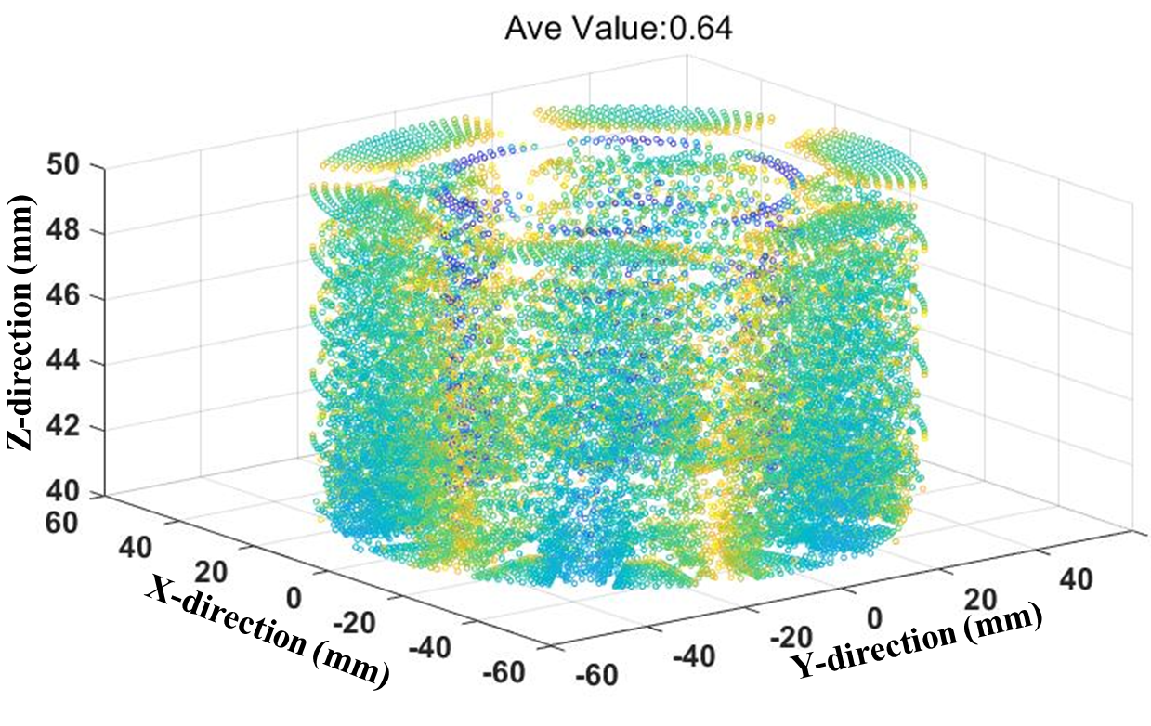 | 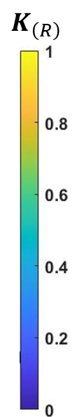
(a) Radial direction
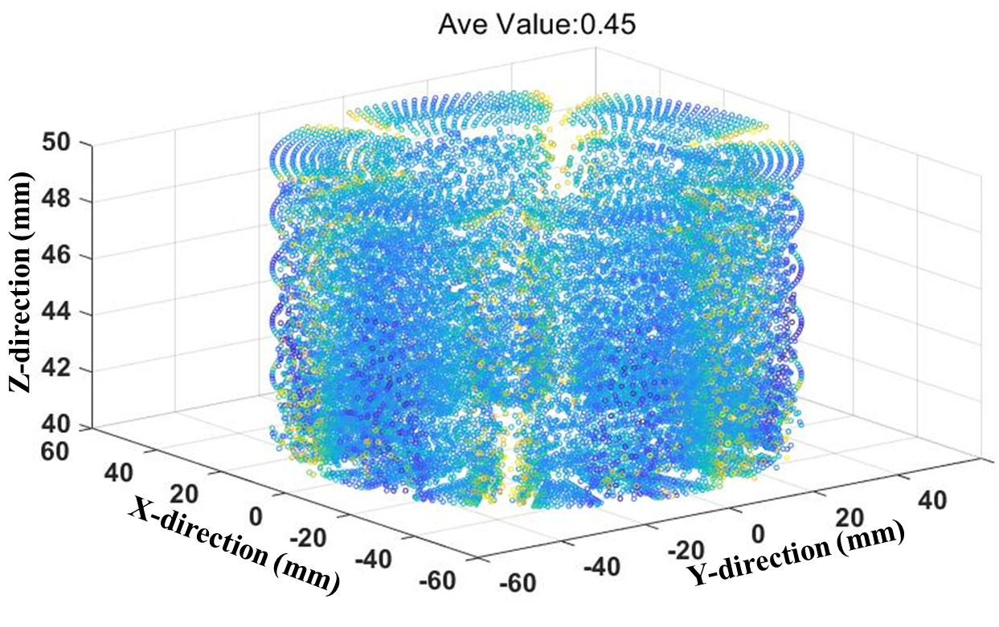
(b) Tangential direction
Fig. 5.17. Position dependent coefficients $K_{\left(R\right)}$ within the end-space of the double-layer machine.
To address this issue, a new model (model 2) with 3-phase excitation but each phase is injected with a DC current to simulate a 3-phase AC supply is proposed. The simulations of the machine at each rotor position have been carried out. It is worth noting that, the machines at different rotor positions are loaded with different 3-phase DC currents. With this kind of current supply, at each rotor position, the steady-state temperatures at different locations within the machine will be obtained. Then these temperatures (at each location within the machine) for different rotor positions will be averaged to work out the temperature distribution that is similar to a real 3-phase AC currents supply.

Comparisons of Different Models
Two kinds of models, i.e., model 1 and model 2 as described previously, have been introduced to investigate the ferrofluid cooling performances for both the single layer and double layer SPM machines. The maximum winding temperatures of these two winding topologies simulated by these two different models have been compared, as shown in Fig. 5.18.

Single layer winding
For the single layer topology [as shown in Fig. 5.18 (a)], when the ferrofluid cooling with magnetic body force for the end-windings is introduced, a significant reduction of end-winding temperature can be achieved. This is validated by the results obtained from both model 1 and model 2. For model 1, the maximum winding temperature is 133$℃$ as shown by the black dashed line. However, for model 2, the peak winding temperature of each phase has a periodical variation, which is similar to sinewave, as shown in Fig. 5.18 (a). Comparing with the phase currents at different rotor positions (see Fig. 5.19), the peak temperature of each phase is almost inversely proportional to the absolute value of the current injected to the corresponding phase. This is because higher current generates higher magnetic field strength, and hence better thermomagnetic convection. As the copper loss (heat source) is assumed to be the same and constant at different rotor positions, better thermomagnetic convection will mean more efficient heat removal from the end-windings.
As the peak temperature of each phase obtained by model 2 varies periodically with rotor position, an average value of 131$℃$ of these peak temperatures for 180 Elec. Deg. is used to approximate the real peak temperature of each winding. This is deemed to be the closest to the case where real AC currents are supplied to the machine windings. Compared to model 1, model 2 is more accurate but its computation time could be 10 times longer. However, the difference of winding temperature obtained by models 1 and 2 is only 1.5%, and hence not significant. This is because, for the single layer design, the magnetic field in the end-winding region is mainly generated by each end-winding itself and not affected by adjacent end-windings. This fact is also demonstrated by the coolant velocity distributions, as shown in Fig. 5.20 (a) and (b). The coolant close to coils reaches high coolant velocity for both models and the value of velocity is relative similar. However, the coolant velocity that is located between the two adjacent coils has been underestimated by model 1. It results from the underestimation of $K_{\left(R\right)}$ in Fig. 5.17. $K_{\left(R\right)}$ is considered as 1 for model 1, but it is actually much larger than 1 in the region that is around the centre of two adjacent coils.
The results obtained from both models 1 and 2 point towards the fact that the thermomagnetic convection is efficient for machine cooling. The temperature differences between nanofluid and ferrofluid cooling systems are 13$℃$ (for model 1) and 15$℃$ (for model 2). This is mainly due to the magnetic body force exerting on the ferromagnetic particles in the ferrofluid that increases the fluid circulation, and hence contributes to better cooling effect. This cooling effect will be more pronounced when higher electrical loading (or current density) is injected, as shown in Fig. 5.16 (a). According to (5.25), increasing the electrical loading improves the magnetic body force, as well as improving the thermomagnetic effect. As a result, the temperature reduction using ferrofluid to replace nanofluid is increased from 13$℃$ to 31$℃$ when the the current density increases from 18.4A/mm² to 22.1A/mm².
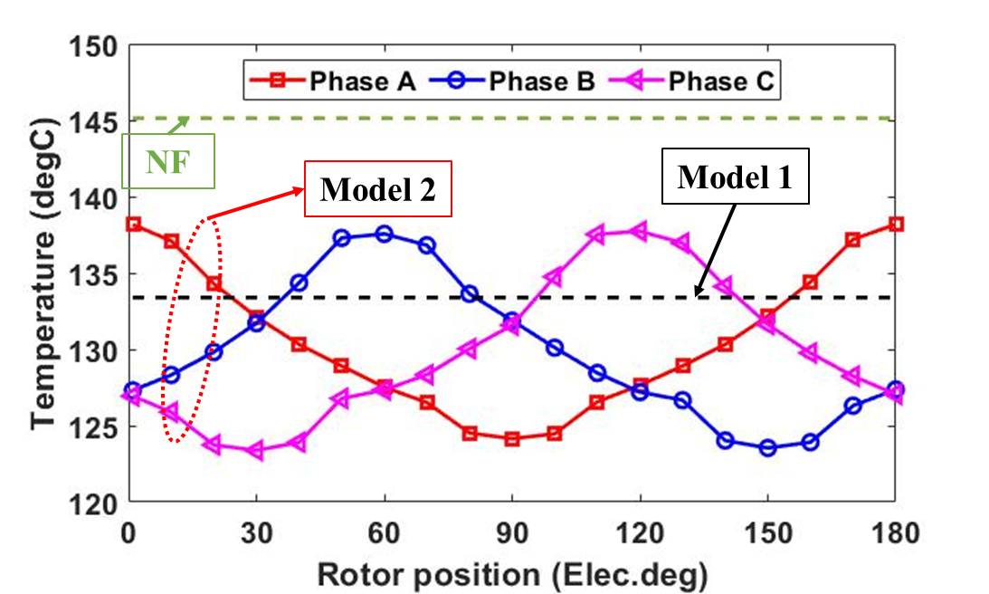
(a) Single layer machine
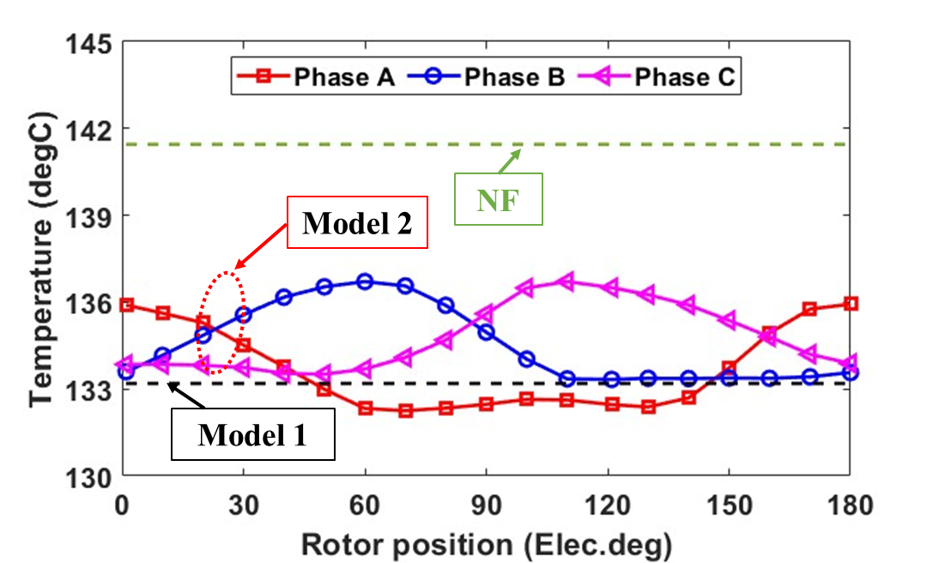
(b) Double layer machine
Fig. 5.18. Maximum coil temperature of each phase for investigated machines.
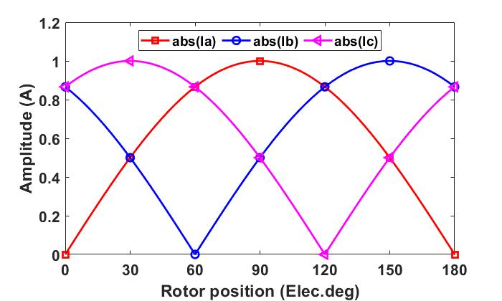
Fig. 5.19. Absolute value of current in each phase vs rotor position for 180 Elec. Deg.
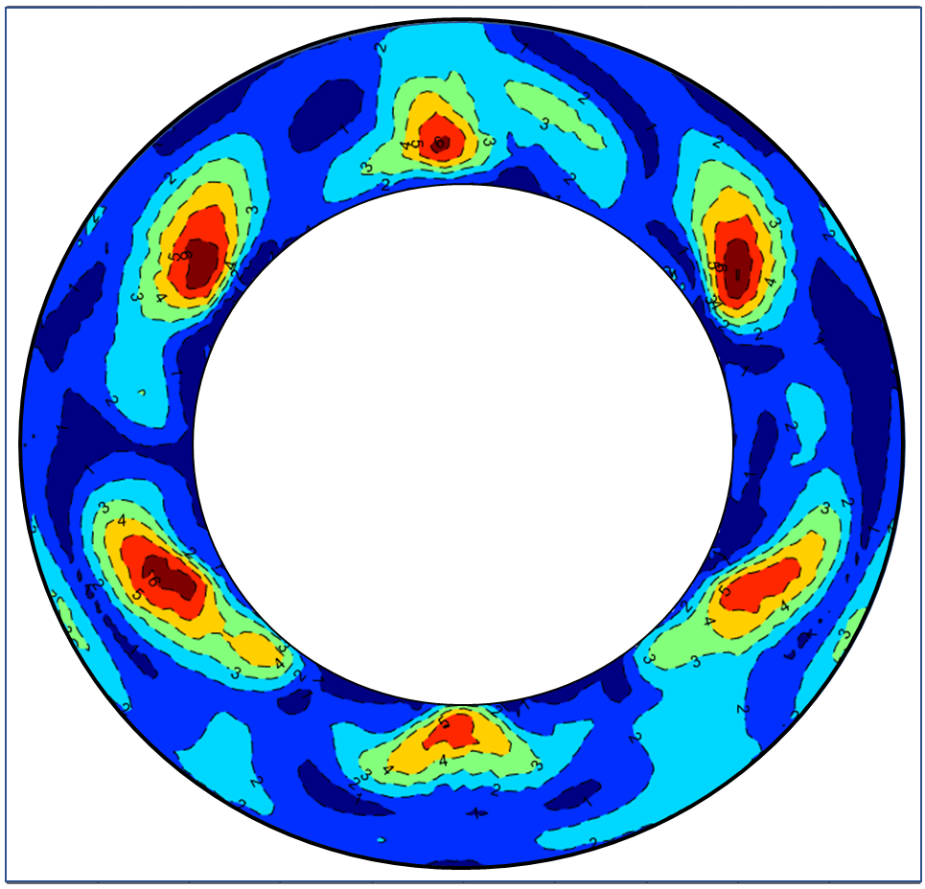 | 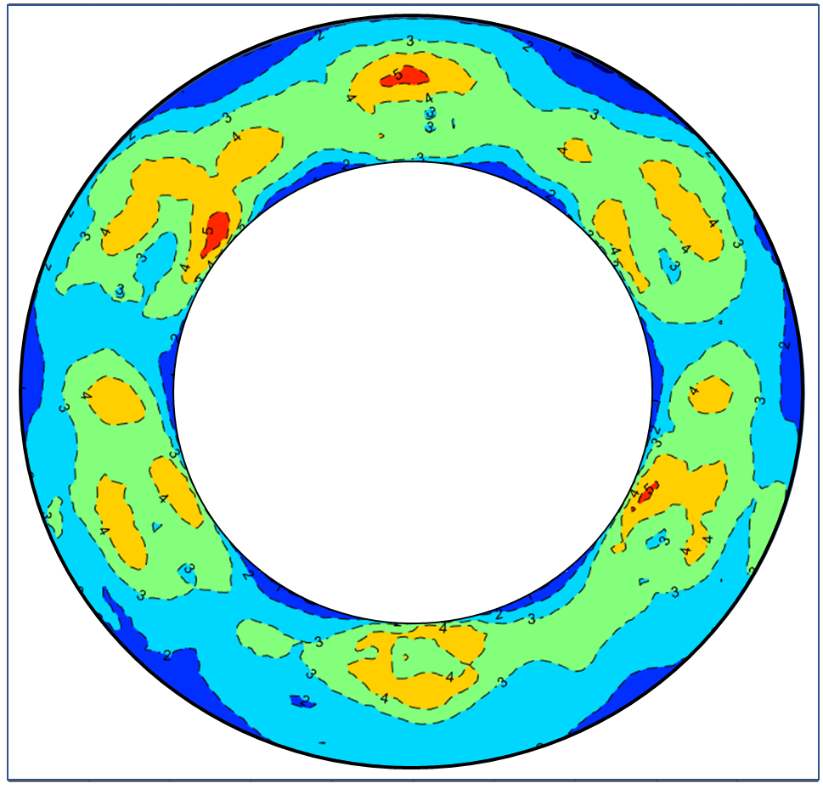
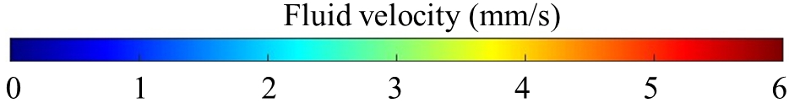
(a) Single layer (model 1) | (b) Single layer (model 2)
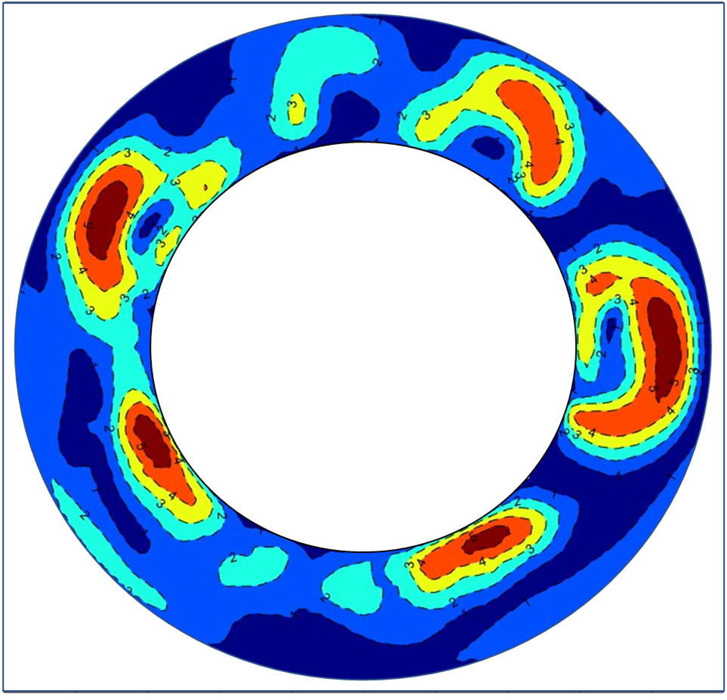 | 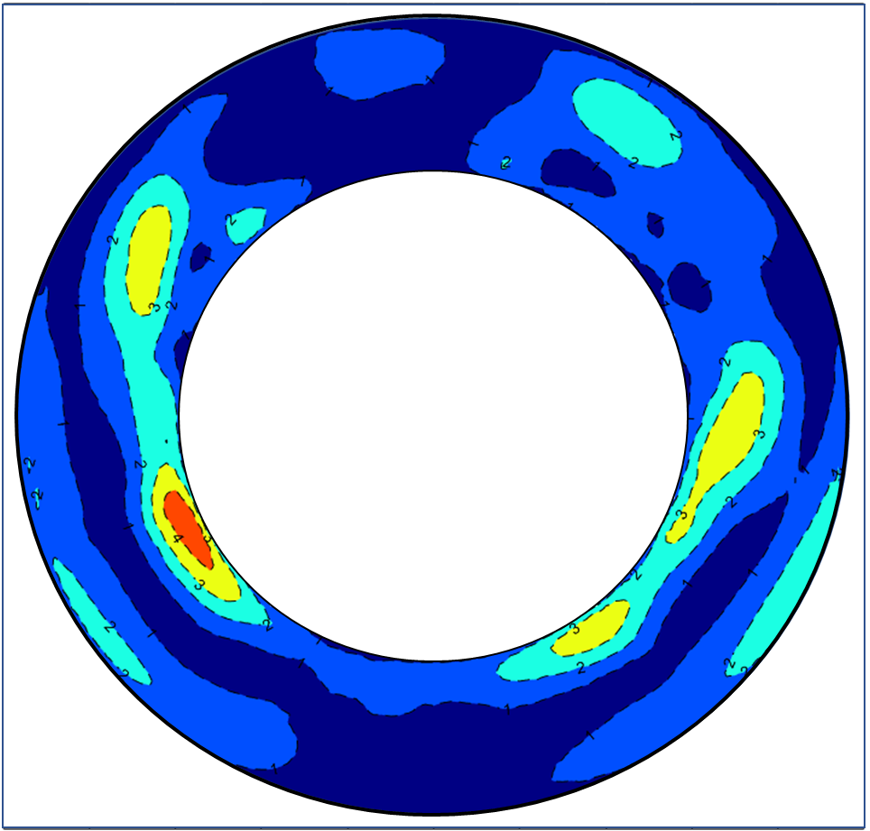
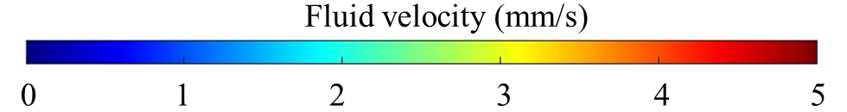
(c) Double layer (model 1) | (d) Double layer (model 2)
Fig. 5.20. Fluid flow velocity at plane 1 for investigated machines by different models.

Double layer windings
The same models have also been built to simulate the thermal performances of the double layer SPM machine, and the variations of peak winding temperatures obtained by different models are shown in Fig. 5.18 (b). After the ferrofluid is introduced, the winding peak temperature is significantly reduced from 141$℃$ to 133$℃$ (obtained by model 1) or 135$℃$ (obtained by model 2). In addition, similar to the single layer machine, the difference between the winding temperatures obtained by models 1 and 2 for the double layer machine is only 1.5%, which is also negligible. However, model 1 cannot well estimate the coolant velocity for the double layer machine as shown in Fig. 5.20 (c) and (d). $K_{\left(R\right)}$ is lower than 1 in most regions of the end space for the double layer machine, as shown in Fig. 5.17. Model 1, which identifies $K_{\left(R\right)}$ as 1, overestimates the magnetic body, resulting in higher coolant velocity in most end-space regions of the double layer machine, as shown in Fig. 5.20 (c) and (d). This inevitably leads to overestimation of the cooling efficiency.
It is also found that, the temperature reduction in the double layer machine (8$℃$ or 6$℃$) is lower than that of the single layer design (13$℃$ and 15$℃$). This is mainly because the number of turns per coil of the double layer winding is half of that of the single layer winding. This leads to lower magnetic field strength (see Fig. 5.21) in the end space of the double layer machine. The lower value and smaller gradient of magnetic field strength lead to lower magnetic body force for the double layer machine. Therefore, the fluid velocity for the double layer machine is lower than that of the single layer counterpart, as shown in Fig. 5.20. The simulation results reveal that the single layer machine benefits more from the ferrofluid cooling system due to its more significant thermomagnetic convection.
Similar to the single layer machine, the cooling efficiency of ferrofluid for the double layer machine will also be improved when the electrical loading increases. As shown in Fig. 5.16 (b), the thermomagnetic effect is also more significant when the current density increases. Using ferrofluid to replace nanofluid can improve machine temperature reduction from 8$℃$ (current density at 18.4A/mm²) to 20$℃$ (current density at 22.1A/mm²).
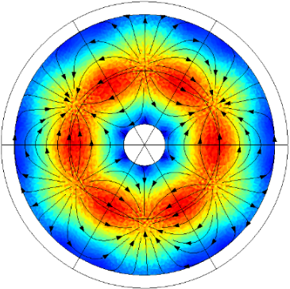 | 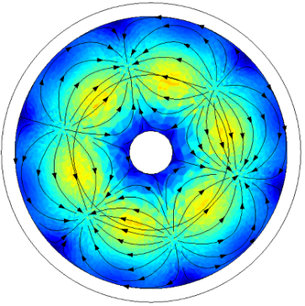
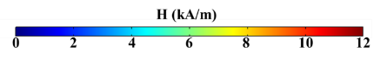
(a) Single layer | (b) Double layer
Fig. 5.21. Magnetic field strength distribution at plane 1 simulated by model 1 investigated machine at plane 1.

Electromagnetic Performances Considering Thermal Coupling Models
The above results showed that if the advanced ferrofluid cooling is applied, the machine peak temperature can be significantly reduced. Since the B-H curve of PMs is temperature dependent, the reduction of machine temperature can improve the remanence of the PM material and hence the machine EM performance. The EM performances of the two SPM machines with different cooling systems will be compared in this section.
It is worth noting that, to fully reveal the advantages of the ferrofluid cooling, the EM performances of the investigated machines will be compared under almost the same ($±0.5\%$) maximum machine temperature. To meet this requirement, the amplitude of load current for different cooling methods will be different as shown in Table 5.5. The poor thermal performance of the machines with air in the end-space allow much lower current density to be injected. When the nanofluid cooling is employed, the current density for both machines can be improved, especially for the double layer machine that benefits more from the nanofluid cooling method due to its larger surface area and shorter heat path between hot spot and the end-windings surface. Regarding the ferrofluid cooling, the current densities for both the machines are the same because the single layer machine has more significant thermomagnetic effect although its end-winding surface area is smaller.
Table 5.6 compares that the torque densities (torque per mass) of the single layer and double layer winding machines when the machine temperatures are almost the same. When nanofluid is employed to replace air in the end-space, the machine mass is increased by around 0.19kg for both the investigated machines. However, the cooling efficiency for the single layer machine is lower than the double layer machine. Therefore, its torque density is reduced by 0.15Nm/kg, whilst for the double layer machine, it is increased by 0.08Nm/kg. By introducing ferrofluid, the machine thermal performance can be further improved, so does the torque density. However, even if the cooling efficiency of ferrofluid for single layer machine is better than the double layer machine, it is found that this high current density has irreversibly demagnetized the single layer machine. The torque constant of the single layer machine is reduced by 10% due to this irreversible demagnetization. Compared with the single layer machine, the demagnetization withstand capability of the double layer machine is better. Under the same load current, no irreversible demagnetization has occurred for the double layer machine. This allows the double layer machine to achieve a much higher torque density when ferrofluid is employed, as shown in Table 5.6.
The torque-speed characteristics of the single layer and double layer machines with different cooling methods have also been compared under the same peak machine temperature, as shown in Fig. 5.22. It is worth noting that, these characteristics are investigated based on EM-thermal coupling modelling. The results show that the base speed of the double layer machine is much higher than that of the single layer machine because the d- and q-axis inductances of the double layer machine are nearly half of those of the single layer machine. The torque in the maximum torque per ampere (MTPA) control region of the double layer machine is lower than that of the single layer machine because of its poorer thermal performance. However, benefited from its higher demagnetization withstand capability and thermal performance, the double layer machine with nanofluid and ferrofluid cooling will have higher maximum torque at MTPA control region, as well as better torque performance for the full speed range.
Table 5.5 Current Density for Different Cooling Systems at the Same machine Temperature
 | Air | Nanofluid | Ferrofluid
Single layer | 16.6 $A/{{mm}^{2}}$ | 17.0 $A/{{mm}^{2}}$ | 18.4 $A/{{mm}^{2}}$
Double layer | 16.2 $A/{{mm}^{2}}$ | 17.5 $A/{{mm}^{2}}$ | 18.4 $A/{{mm}^{2}}$

Table 5.6 Torque Density for Different Cooling Systems at the Same machine Temperature
 | Air | Nanofluid | Ferrofluid
Single layer | 3.15 Nm/kg | 3.00 Nm/kg | 3.07 Nm/kg
Double layer | 3.17 Nm/kg | 3.25 Nm/kg | 3.39 Nm/kg
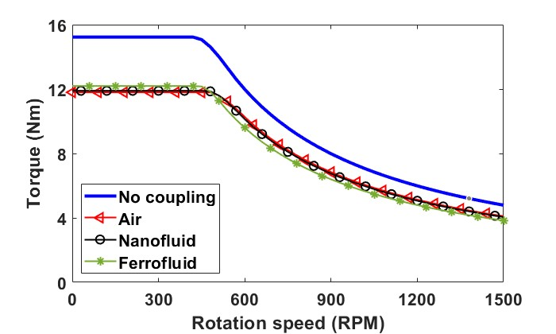
(a) Single layer winding machine
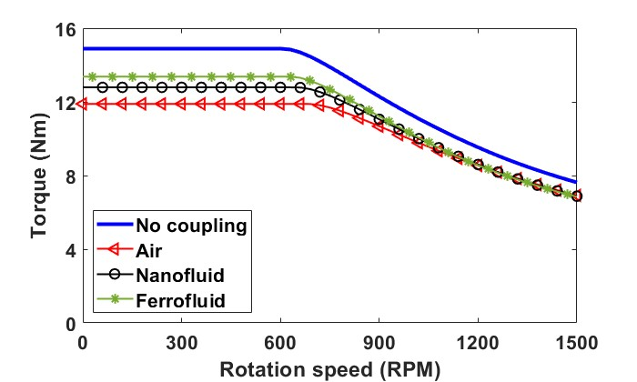
(b) Double layer winding machine
Fig. 5.22. Torque-speed characteristics of investigated machines that employ different cooling methods to reach similar peak machine temperature.

Ferrofluid cooling for the Modular Machine
Previous sections investigated the cooling efficiency of ferrofluid cooling method for conventional non-modular machines. In this section, the modular machine with ferrofluid cooling will also be investigated. It is worth noting that, to highlight the cooling performance of ferrofluid cooling, the total losses are the same for both the non-modular machine and the modular machines with different FG widths.

Different Machine Topologies
For all the investigated machines with different coolants (air, nanofluid and ferrofluid), the initial temperature is the inlet temperature (65$℃$) of the water jacket. The temperature gradually increases to the steady state temperature, as shown in Fig. 5.23. The results show that, the maximum end-winding temperatures of the modular (127.8$℃$) and non-modular (128.1$℃$) machines are very close when air is used as coolant. This indicates that, although the modular machine with 2mm flux gaps rearranges the losses distribution and improve the contact surface area between the stator iron core and coolant (air), the temperature reduction is insignificant due to the poor thermal conductivity of air.
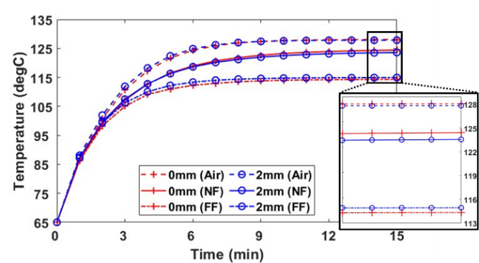
Fig. 5.23. Maximum end-winding temperature for the modular (FG=2mm) and non-modular machines (FG=0mm) with different coolants such Air, NF (nanofluid) and FF (ferrofluid).
However, when nanofluid is used, a noticeable temperature reduction can be achieved as the self-circulation of the nanofluid is much more efficient than air, as shown in Fig. 5.24 and Fig. 5.25. This is because thermal conductivity is increased from 0.025W/m/K (air) to 0.19W/m/K (nanofluid). Faster heat transfer rate allows the coolant to move more heat from end-windings to the housing and end-caps. Therefore, compared with air cooling, nanofluid cooling reduces the winding temperature by 3.7$℃$ for the non-modular machine and the temperature reduction (4.3$℃$) is more pronounced when flux gaps are introduced.
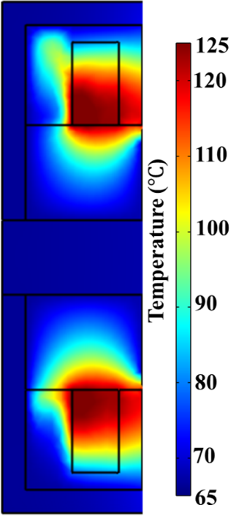 | 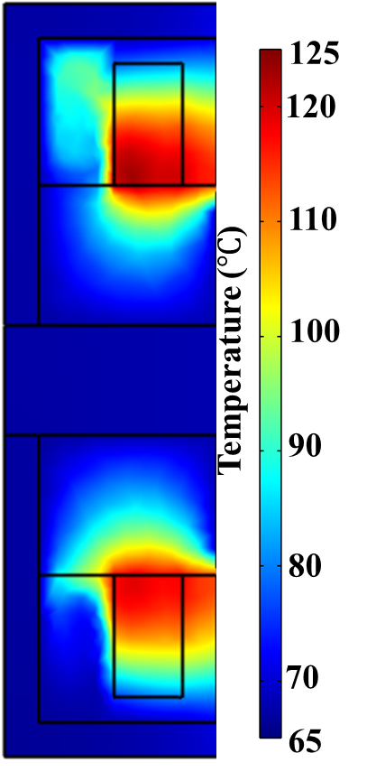 | 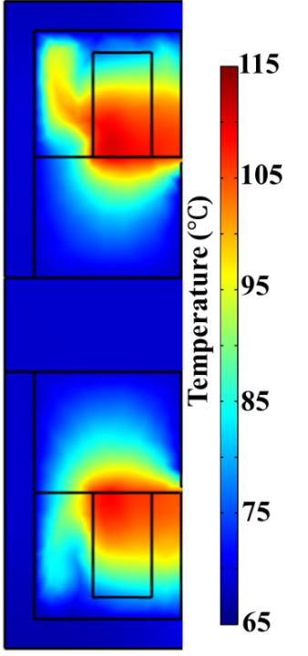
(a) Air cooling | (b) Nanofluid cooling | (c) Ferrofluid cooling
Fig. 5.24. Temperature distributions at plane 2 for the non-modular machine different cooling methods.
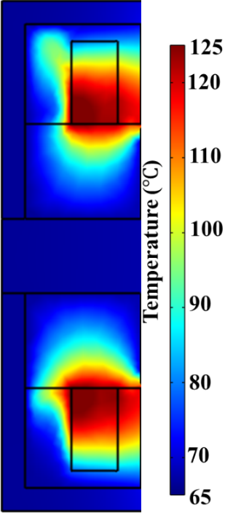 | 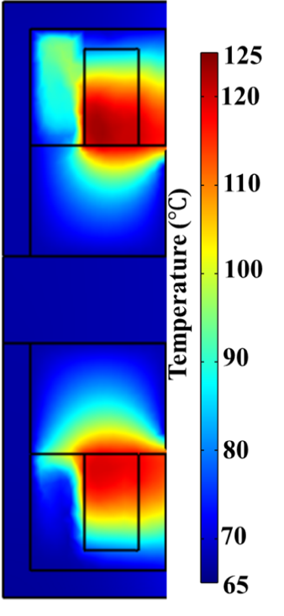 | 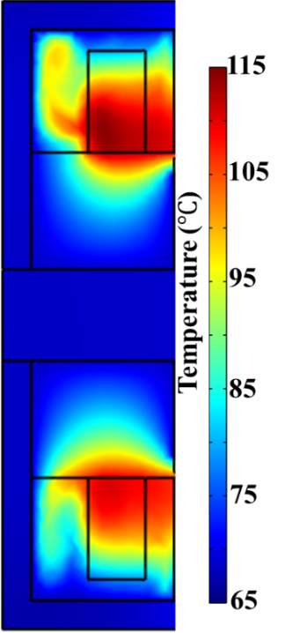
(a) Air cooling | (b) Nanofluid cooling | (c) Ferrofluid cooling
Fig. 5.25. Temperature distributions at plane 2 for the modular machine different cooling methods.
When nanofluid is replaced by ferrofluid, the machine temperature can be further reduced for both the investigated machines. According to Fig. 5.24 (c) and Fig. 5.25 (c), the cooler coolant is attracted by end-windings and moves towards their centres. This is because the direction of the magnetic body force that the ferrofluid is subjected to points towards the end-windings, which are the sources of magnetic field and heat. Therefore, the cooler coolant can be driven to the centre of the end-windings (hotspot), as shown in Fig. 5.26. It can enhance the self-circulation rate of the coolant. As a result, it is found that for the non-modular machine, using the ferrofluid to replace the nanofluid can further reduce the maximum temperature by 10.1$℃$, while it is 8.6$℃$ for the modular machine. It is revealed that, unfortunately, the introduced flux gaps reduce the cooling efficiency of the ferrofluid. This is because different from the magnetic field produced by the end-windings that can generate a coolant circulation between the housing and the end-windings, the magnetic body force of the ferrofluid in the flux gaps drives the cooler coolant, not the warmer coolant, to the housing, as shown in Fig. 5.27. As a result, it slightly deteriorates the cooling efficiency of the ferrofluid in the flux gaps.
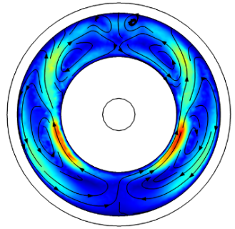 | 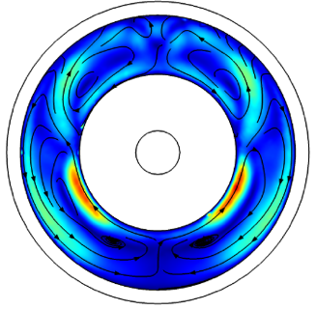
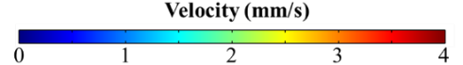
(a) Non-modular machine with NF | (b) Modular machine with NF
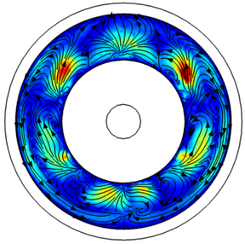 | 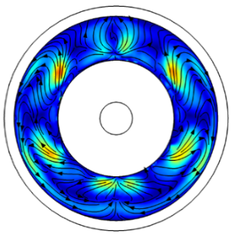
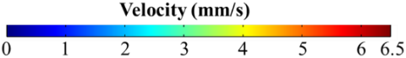
(c) Non-modular machine with FF | (d) Modular machine with FF
Fig. 5.26. Coolant velocity distributions at plane 1 of investigated machines with different cooling methods.
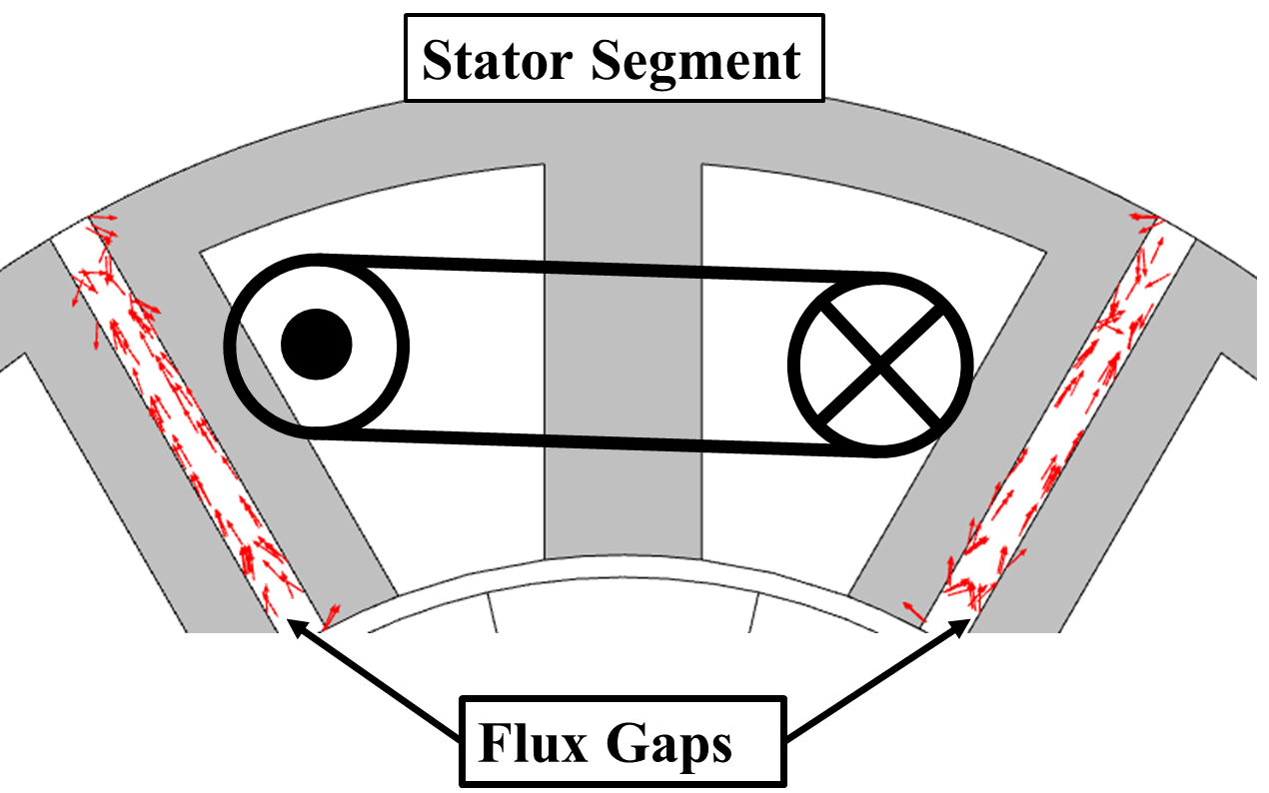
Fig. 5.27. Magnetic body force vectors in the flux gaps.

Different Flux Gap Widths
In the section above, the investigations based on modular machines with a 2mm flux gap width has shown improved cooling performance with ferrofluid cooling. In this section, the influence of different flux gap widths on the cooling performance will be investigated. When the flux gap width increases from 0mm (non-modular machine) to 5mm (modular machine), the maximum winding temperatures for air cooling and nanofluid cooling will gradually reduce as shown in Fig. 5.28 (a), meaning that the cooling efficiency improves. The main reason is that, with the increase in flux gap width, the fluid resistance reduces. The gravitational effect is more significant due to wider flux gaps. Therefore, a faster self-circulation of coolant in the flux gaps can be achieved. For example, the maximum nanofluid velocity in the flux gaps is 0.17mm/s when the flux gap width is 2mm. This value increases to 0.8mm/s when the flux gap width increases to 5mm.
However, when the ferrofluid is used, the trend is not obvious, as some flux gap widths will increase the temperature. This is because although the wider flux gaps will increase gravitational effect of the coolant, same as air and nanofluid cooling, the wider flux gaps can also enhance the influence of magnetic body force. The improved magnetic body force deteriorates the self-circulation of coolant. The temperature difference (Δ_{NF-FF}) between nanofluid and ferrofluid, as shown in Fig. 5.28, shows that wider flux gaps will lead to more significant deterioration of the ferrofluid self-circulation.
In conclusion, the simulation results have demonstrated that, the flux gap width has significant influence on machine cooling performances. And wider flux gaps have positive influence on the gravitational effect but negative influence on the thermomagnetic effect.
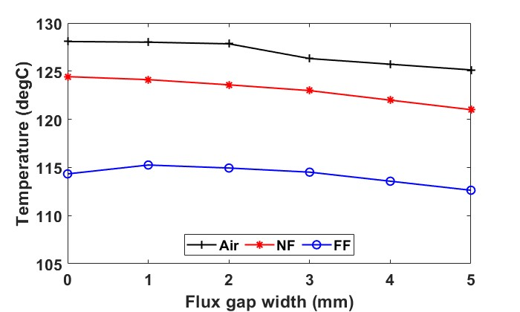
(a) Maximum winding temperature
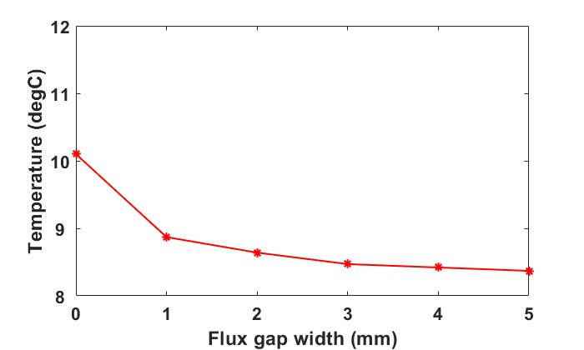
(b) Temperature difference
Fig. 5.28. Maximum winding temperatures vs flux gap width for different coolants such as Air, NF and FF, and temperature difference (Δ_{NF-FF}) between NF cooling and FF cooling vs flux gap width.

Experimental Validation

Single Coil Motorette

Motorette and Test Rig Setup
In order to further validate the multiphysics models, a motorette has been built, as shown in Fig. 5.29. The specifications of this motorette are listed in Table 5.7. The geometries of stator lamination and housing are shown in Fig. 5.30 (a) and (b). An epoxy resin is used to fill the gaps between conductors, as well as the gap between the stator wall and the winding. This helps improve the equivalent thermal conductivity in the stator slots. A ferrofluid called AMG200-50 manufactured by Liquids Research Ltd has been used for the tests, and its properties are listed in Table 5.8. The water jacket [as shown in Fig. 5.30 (c)] is located at the back of the motorette. A commercial pump that can supply 1 L/min inlet flow rate to the water jacket is used for the tests.
A test rig with the above motorette is built for the temperature measurements, as shown in Fig. 5.31. The end-winding temperature is measured using T-type thermocouples with an accuracy of $±0.5℃$ and temperature results are recorded by Pico TC-08 thermocouple data logger.
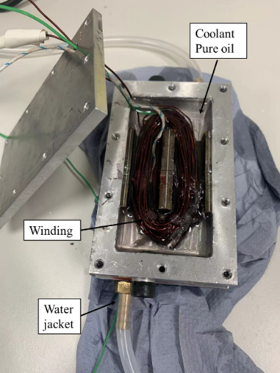
Fig. 5.29. Test motorette.
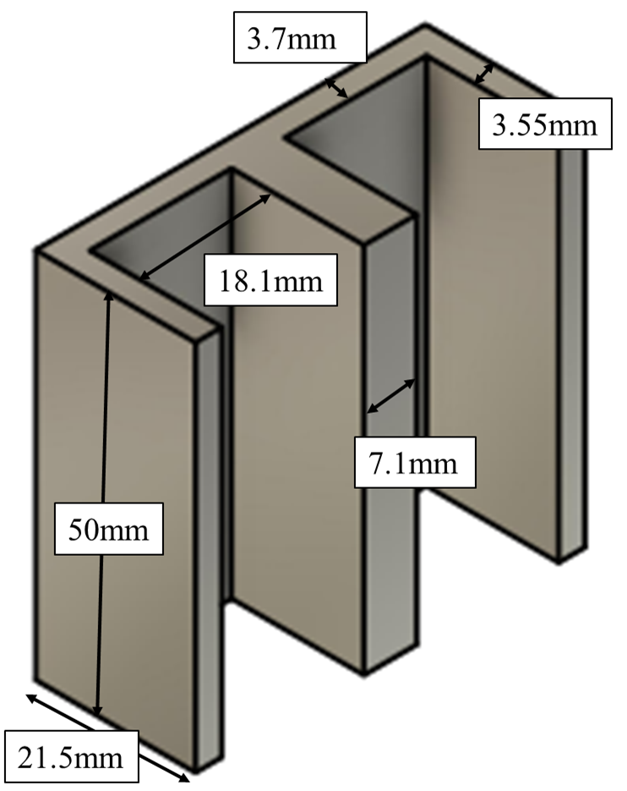
(a) Stator lamination
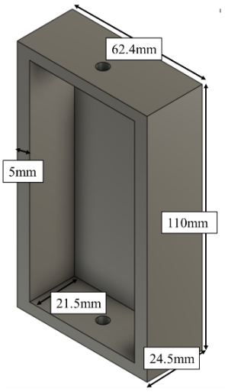 | 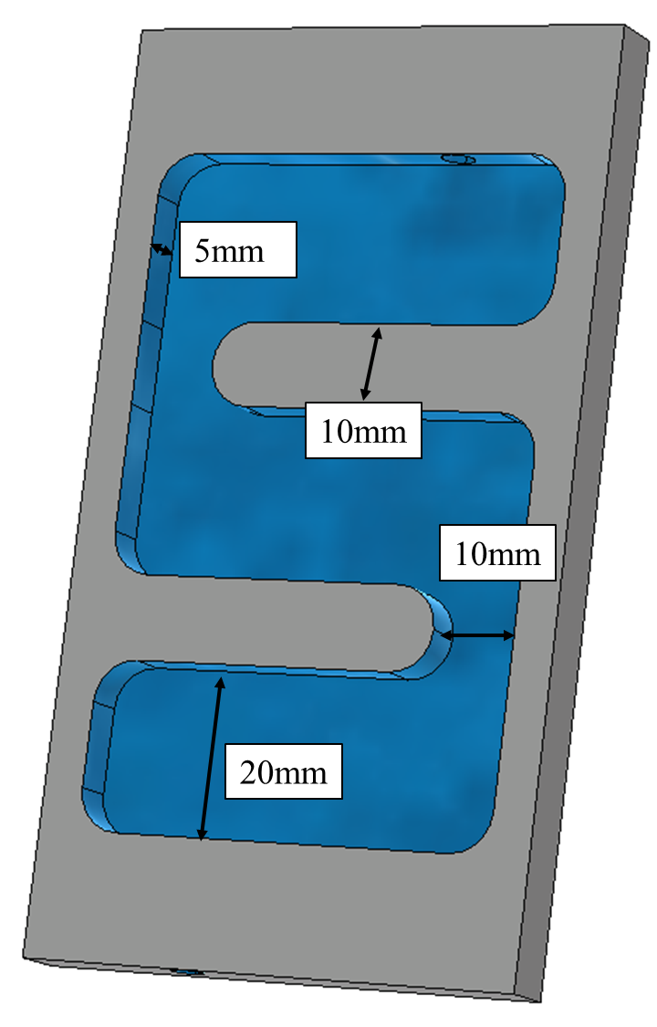
(b) housing | (c) water jacket
Fig. 5.30. (a) Stator lamination, (b) housing and (c) water jacket showing the details of the cooling channel.
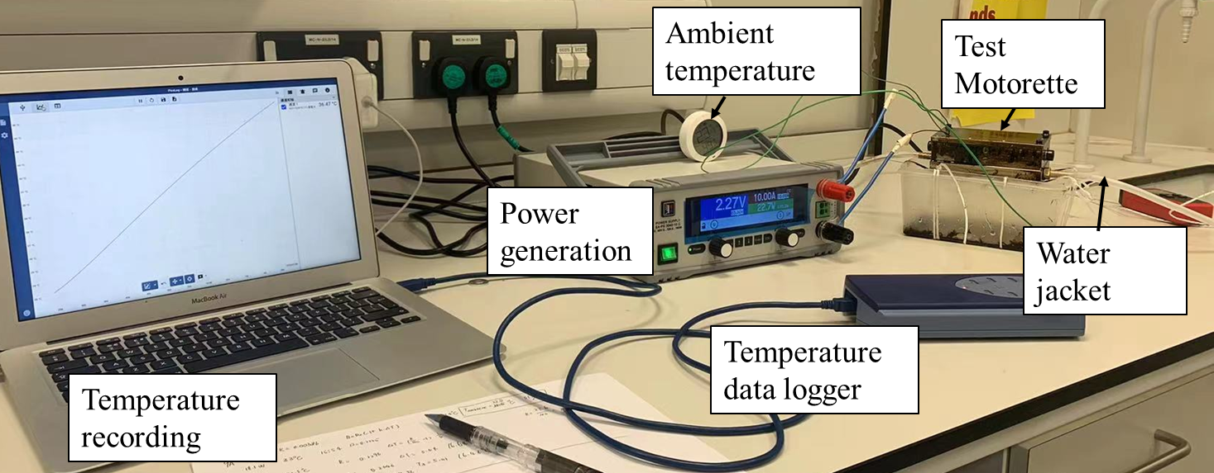
Fig. 5.31. Test rig.
Table 5.7 Specification of Tested Motorette
Stator width (mm) | 50.4 | Housing width (mm) | 62.4
Stator height (mm) | 50 | Housing height (mm) | 110
Stator depth (mm) | 21.5 | Housing depth (mm) | 24.5
Slot depth (mm) | 17.8 | Housing thickness (mm) | 5
Slot width (mm) | 18.1 | Number of turns | 50

Table 5.8 Parameters of the Ferrofluid
Particle volume fraction (%) | $≈$4
Saturation Magnetization (A/m) | $1.54×{10}^{4}$
Density at 25$℃$(${kg}/{m^{3}}$) | 1100
Thermal conductivity ($W/{m∙K}$) | 0.15
Dynamic viscosity ($Pa∙s$) | 0.046
Initial permeability (at 30Oe) | 1.68
Electrical resistivity ($Ω/cm$) | $>{10}^{9}$
Heat capacity ($J/{kg/K}$) | 1700

Temperature Measurement
Based on the motorette, a series of 3D multyphysics simulations have been carried out and will be compared against the measurements in this section. In the multyphysics models, the ambient temperature is set to be 22$℃$ and the convection coefficient on the surfaces of the motorette is 15W/m²/K. The slot fill factor is 0.3, and the corresponding equivalent thermal conductivities of the winding are 0.37 W/m/K and 120 W/m/K in the directions that are perpendicular and parallel to the current, respectively.
A 10A dc current is injected into the coils of the motorette. It can generate 21.5W heat at room temperature ($≈22℃$). Under these conditions, the temperature of the end-windings has been simulated and measured for the motorette, as shown in Fig. 5.32. In order to verify the accuracy of the multiphysics simulations, both oil and ferrofluid have been used as coolant around the end-windings in the simulation and measurement. A very good agreement has been observed between the simulated and measured results, proving the accuracy of the developed multiphysics model in this chapter. In addition, as expected, a significant temperature reduction (by 5.4 $℃$) can be achieved when the ferrofluid is used to replace the oil as the coolant around the end-windings.
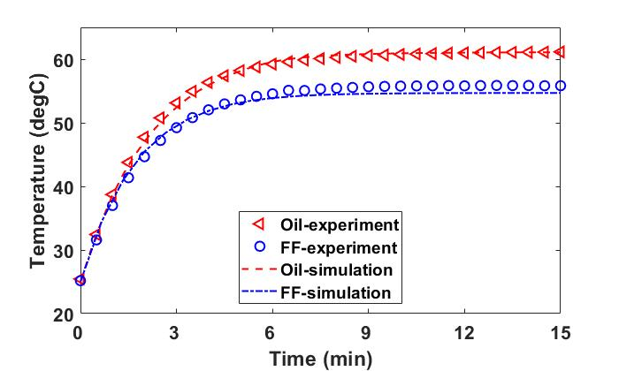
Fig. 5.32. Simulated and measured peak temperatures of the end-windings with oil and ferrofluid as coolant. The current injected into the coil is 10A.
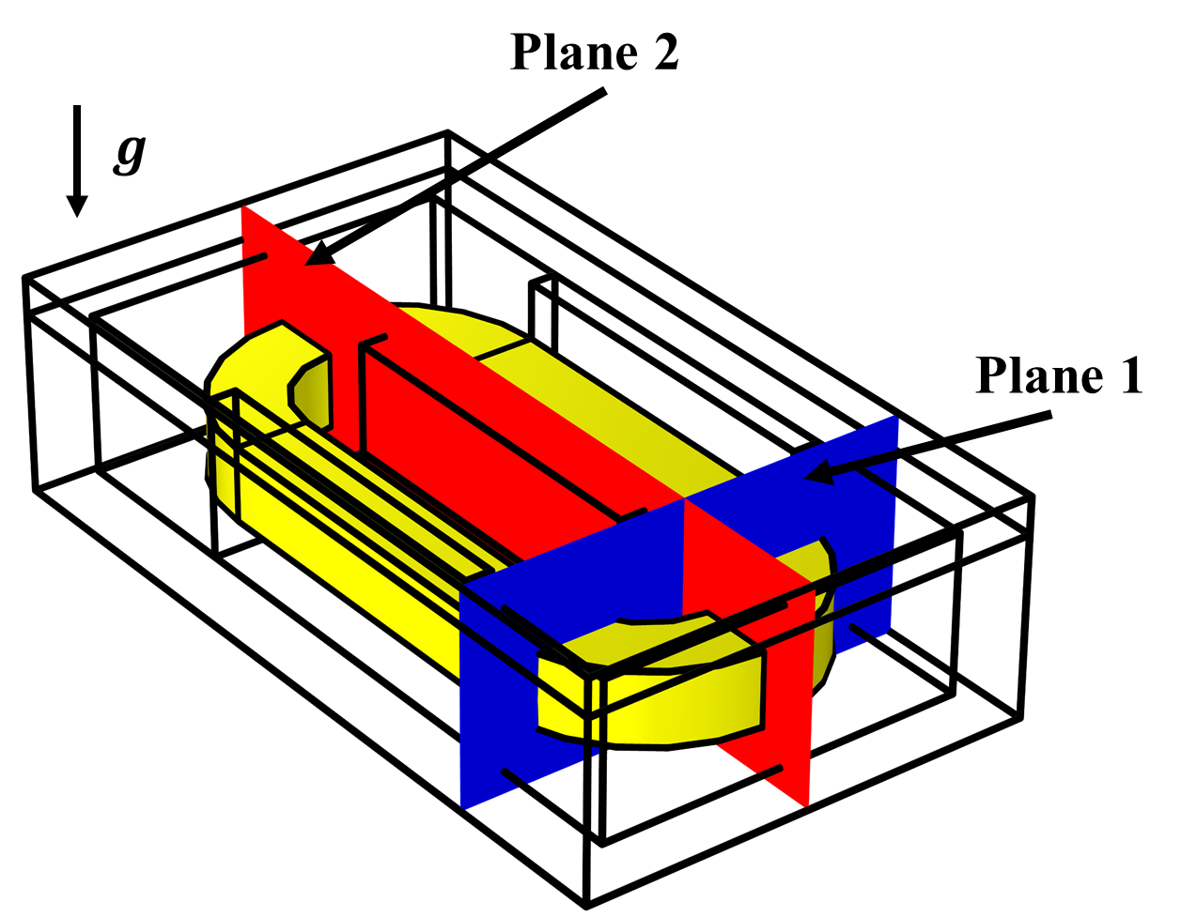
Fig. 5.33. Planes chosen to show the fluid dynamics results of the motorette.
This significant temperature reduction is mainly due to the magnetic body force exerted on the nanoparticles in the ferrofluid, which significantly increases the coolant velocity. To show this phenomenon, two planes (Plane 1 and Plane 2) in the Multiphysics model have been chosen, as shown in Fig. 5.33. The velocity distributions for the motorette with oil and ferrofluid cooling are shown in Fig. 5.34. Due to magnetic body force (in ferrofluid), the coolant velocity is nearly twice as high as that without magnetic body force (in oil).
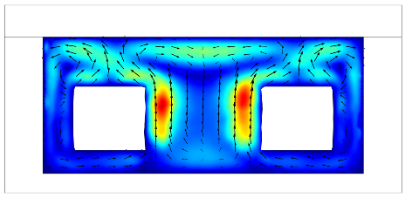 |  | 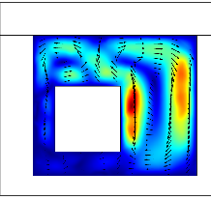
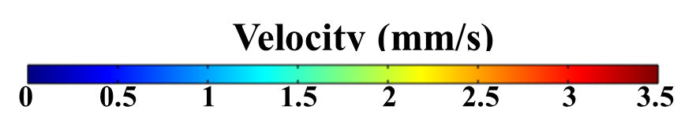
(a) Oil cooling (Plane 1) | (b) Oil cooling (Plane 2)
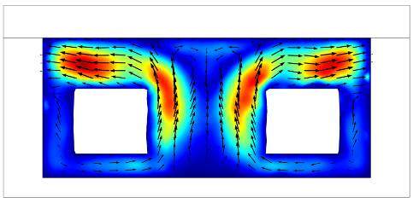 |  | 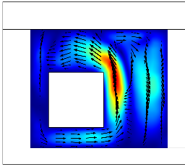
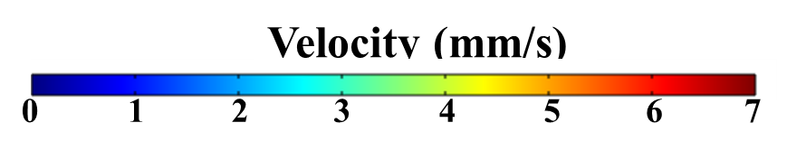
(c) Ferrofluid cooling (Plane 1) |  | (d) Ferrofluid cooling (Plane 2)
Fig. 5.34. Simulated results of coolant velocity for motorette with different coolants.
Table 5.9 Measured and Simulated Temperature of the motorette with Ferrofluid
Current (A) | Measured ($℃$) | Simulation ($℃$) | Difference (%)
5 | 32.0 | 33.1 | 3.4
6 | 35.7 | 36.5 | 2.2
7 | 40.0 | 40.3 | 0.75
8 | 44.1 | 44.4 | 0.68
9 | 48.8 | 49.2 | 0.81
10 | 55.8 | 54.6 | 2.1

In addition, the steady-state peak temperature of the end-windings with ferrofluid as coolant has been measured and simulated for different currents. The measured and simulated results are listed in Table 5.9. Again, regardless of the current levels, a good agreement can be observed between them.

Multiple Coils Motorette

Motorette and Test Rig Setup
In order to validate the multiphysics models, a motorette has been built, as shown in Fig. 5.35 (a). The specifications of this motorette are listed in Table 5.10. An epoxy resin is used to fill the gaps between conductors, as well as the gap between the stator wall and the winding. This helps improve the equivalent thermal conductivity in the stator slots and reduce the uncertainty in thermal modelling. The thermal conductivity and density of this epoxy resin are 0.28 $W/m∙K$ and 1160 $kg/m^{3}$, respectively. A ferrofluid called STG 1010B manufactured by Ferrotec Corporation has been used for the tests, and its properties are listed in Table 5.11. The water jacket is located at the back of the motorette as shown in Fig. 5.35 (a). A commercial pump that can supply 1 L/min inlet flow rate to the water jacket is used for the tests.
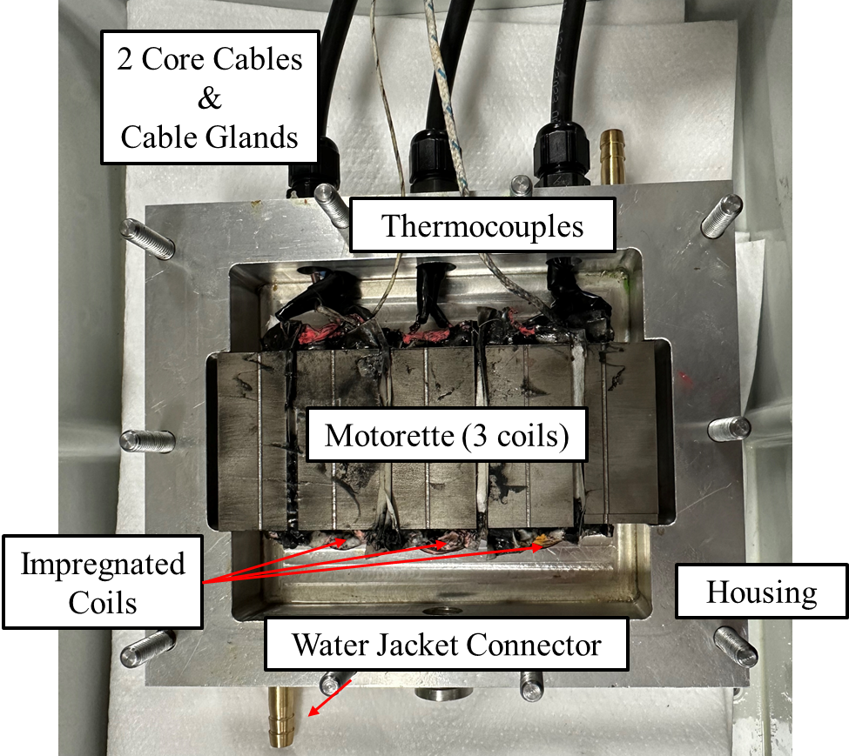
(a) Tested motorette
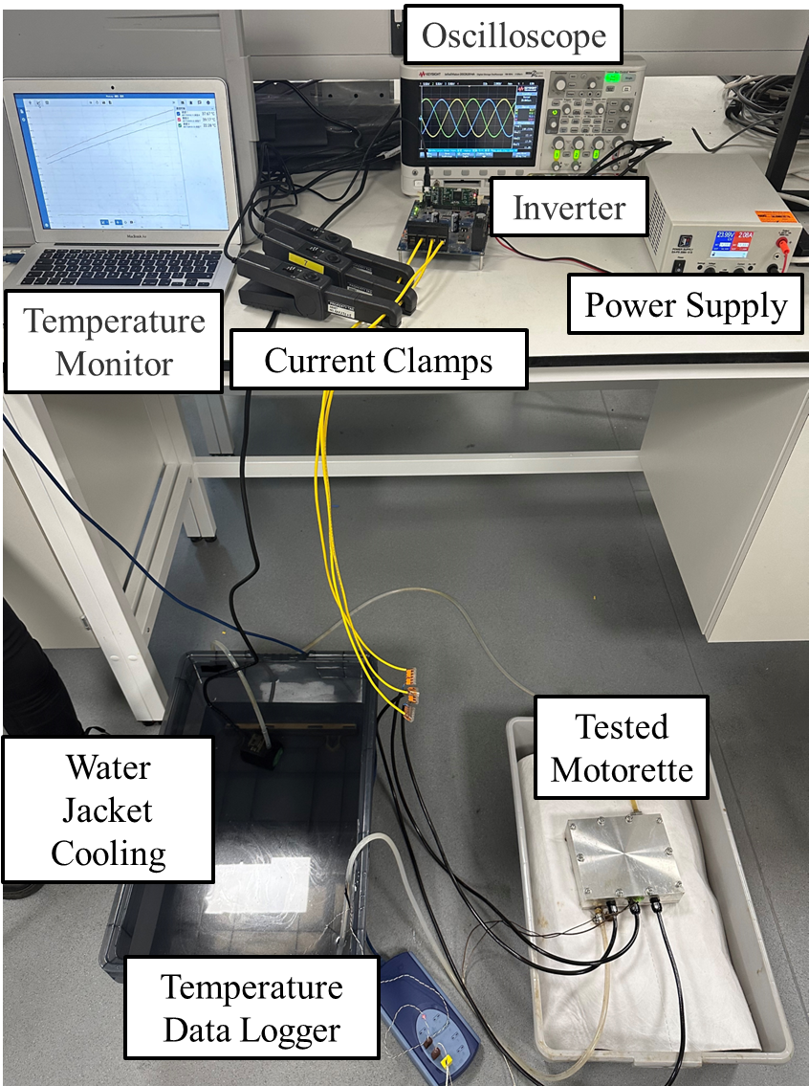
(b) Test rig
Fig. 5.35. (a) Tested motorette and (b) test rig.
Table 5.10 Specification of Tested Motorette
Stator width (mm) | 121 | Housing width (mm) | 151
Stator active length (mm) | 50 | Housing axial length (mm) | 130
Stator depth (mm) | 21.5 | Housing depth (mm) | 26.5
Slot depth (mm) | 15.8 | Housing inner length (mm) | 100
Slot width (mm) | 18.1 | Number of turns per coil | 33
Slot number | 4 | Slot fill factor | 0.34
Table 5.11 Parameters of the Ferrofluid (Fe₃O₄)
Saturation magnetization (mT) | 11 | Dynamic viscosity ($Pa∙s$) | 0.1
Thermal conductivity ($W/{m∙K}$) | 0.15 | Initial permeability (at 30Oe) | 1.68
Thermal expansion coefficient ($×{10}^{-4}1/K$) | $$7.5$$ | Electrical resistivity ($Ω/cm$) | $$>{10}^{9}$$
Density at 25$℃$(${kg}/{m^{3}}$) | 940 | Heat capacity ($J/{kg/K}$) | 1700

Temperature Measurement
3D multiphysics simulations have been carried out and will be compared against the measurements in this section. In the multiphysics models, the ambient temperature is set to be 20$℃$ and the convection coefficient on the surfaces of the motorette is 8 W/m²/K. It is worth noting that, based on Hashin and Shtrikman approximation, the corresponding equivalent thermal conductivities of the windings are 0.39 W/m/K and 68.8 W/m/K in the directions that are perpendicular and parallel to the current, respectively.
An 8A dc current is first injected into all coils of the motorette for both the simulations and experiments. To reveal the importance of the model 2, simulations and experiments with ac currents, which have different frequencies but the same rms current (8A), have also been carried out. As expected, for oil cooling, the machine temperatures, specifically the active coil temperature where the thermal couple is located, are almost independent of current supply, i.e., the dc and ac currents (with different frequencies) have almost the same temperatures, as shown in Fig. 5.36. This also means that the ac losses can be neglected for the tested motorette. Furthermore, the machine temperature is reduced from 63.3$℃$ (oil) to 61.2$℃$ (FF @50Hz ac current supply) and 60.9$℃$ (FF@100Hz ac current supply). By contrast, when a dc current is supplied, the temperature is reduced to 59.8$℃$ (FF).
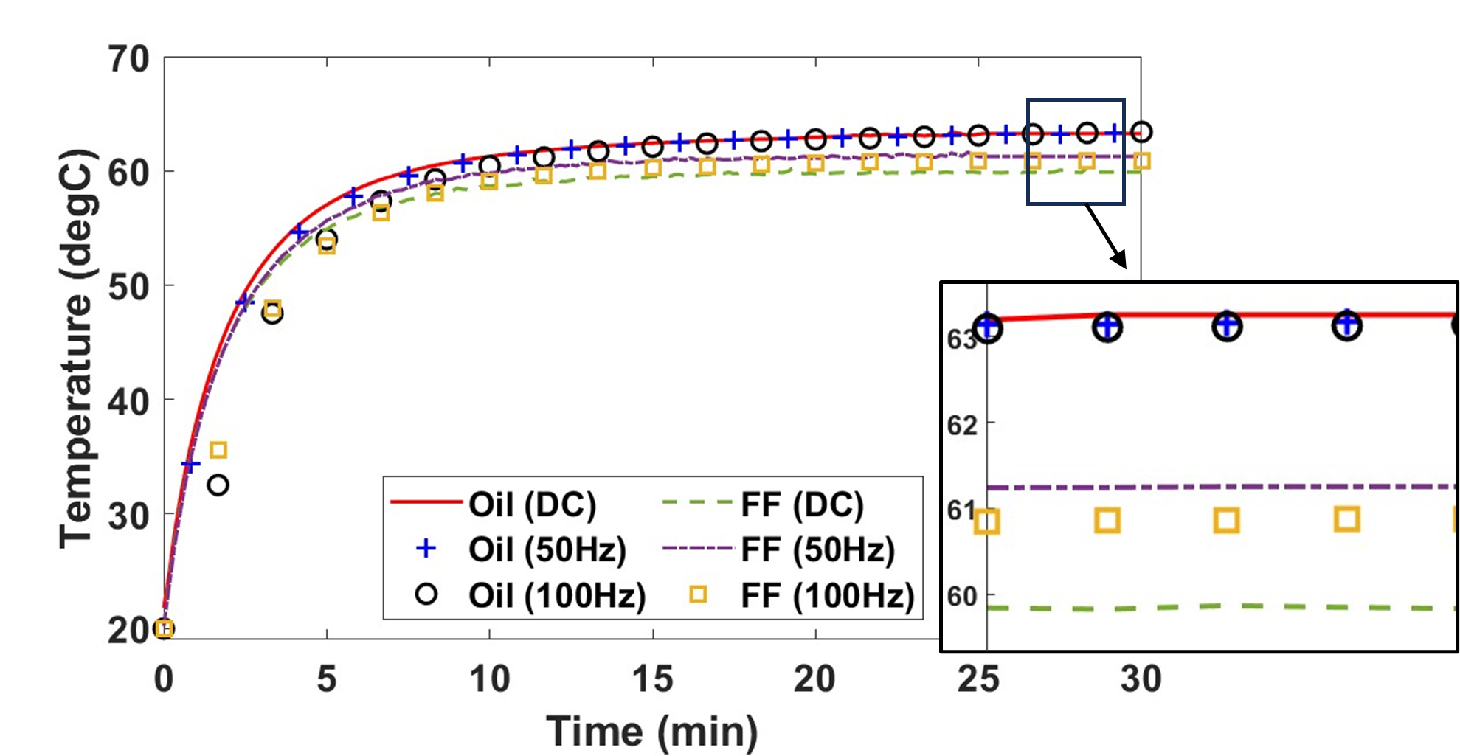
Fig. 5.36. Measured temperatures vs time for both oil and ferrofluid cooling with different current supplies.
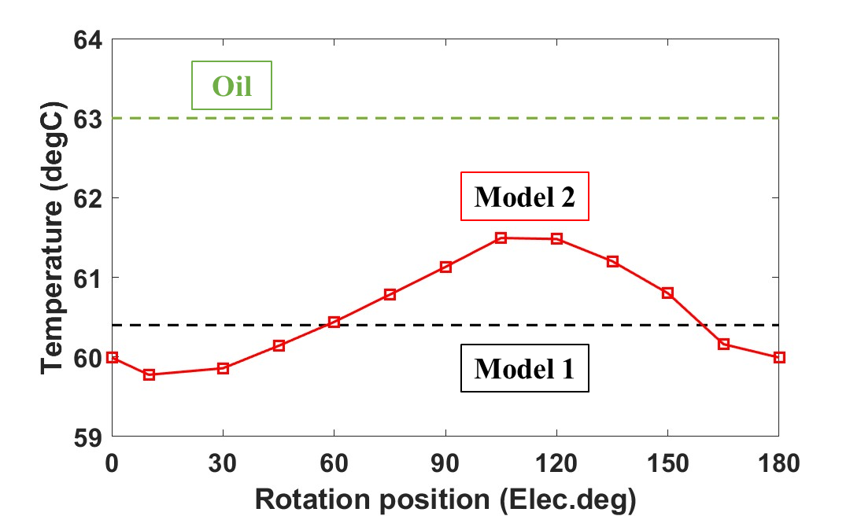
Fig. 5.37. Simulated temperatures vs rotor position for oil and FF cooling. The simulations correspond to the measurements in Fig. 5.36.
Simulations corresponding to the measurements in Fig. 5.36 have been carried out. It is worth noting that these simulations are only steady-state, as the transient state simulations would be excessively time-consuming. In addition, for FF cooling, both model 1 and model 2 have been used, as shown in Fig. 5.37. The simulated results shown in Fig. 5.37 have been compared against the measured results, which are listed in Table 5.12. A generally good agreement can be observed between the simulated and measured results, proving the accuracy of the multiphysics models developed in this paper.
Both measured and simulated results demonstrated that, compared to oil cooling, using ferrofluid as coolant in the end-winding regions can reduce the machine temperature. This is the case for both ac and dc current supplies. Simulated results also demonstrate that, using magnetic field generated by dc current overestimates the ferrofluid cooling efficiency for the double layer machine. This conclusion has also been observed during the experiments. For example, when oil is replaced by ferrofluid as coolant, for the ac current supply, the motorette’s temperature is reduced by around 2.1$℃$, but this reduction is 3.5$℃$ for the dc current supply. In addition, model 2 cannot fully consider the influence of the frequency of the ac current. However, according to the measured results, this limitation might not be an issue, as the temperature difference between the 50Hz and 100Hz ac currents is negligibly small.
Table 5.12 Simulated and Measured Results with Different Coolants.
Coolant | Simulated ($℃$) | Measured ($℃$) | Difference
Oil | 63.0 | 63.3 | 0.47%
Ferrofluid (DC) | 60.4 (Model 1) | 59.8 | 1%
Ferrofluid (AC) | 60.6 (Model 2) | 61.2 (50Hz) | 0.98% (50Hz)
Ferrofluid (AC) | 60.6 (Model 2) | 60.9 (100Hz) | 0.5% (100Hz)

Conclusion
A hybrid cooling technology that combines ferrofluid (for end-windings cooling) and housing water jacket has been proposed and investigated in this chapter. 3D multiphysics models using COMSOL have been developed for the simulations. The temperature and magnetic field dependent ferrofluid properties, e.g., magnetization, viscosity, density and thermal conductivity and capacity, have been considered in the 3D multiphysics models to predict the behaviour of ferrofluid in the end-winding region. It is found that the ferrofluid under external magnetic field generated by the windings will mainly be driven by the magnetic body force. The circulation of the ferrofluid will lead to thermomagnetic convection, which enhances the heat transfer between the end-winding and the housing. The results obtained using the developed multiphysics model have shown that, together with the gravitational effect, the ferrofluid can reduce the maximum coil temperatures. When the current density increases, the temperature reduction using ferrofluid cooling is more pronounced.
The influence of ferrofluid properties on machine cooling performance has also been investigated. It is found that increasing the concentration of ferrofluid can significantly reduce the peak temperature. This improved cooling performance is mainly attributed to the increase in magnetic body force, which leads to improved thermomagnetic convection. In addition, increasing concentration slightly increases the thermal conductivity and the gravitational effect, which also helps improve machine cooling performance. Similarly, the magnetization of ferrofluid also affects the cooling performance. It is found that the ferrofluid with higher magnetization within the selected machine operating temperature range has better cooling performance due to its higher magnetic body force, and hence more significant thermomagnetic convection. In addition, a faster reduction rate of magnetization when temperature rises will provide a larger gradient of magnetic body force within the ferrofluid, leading to a faster coolant circulation and hence a better machine cooling performance. A motorette has been built and the multiphysics models have been validated by a series of experiments.
The ferrofluid cooling is also employed for the modular SPM machine. The results have also revealed the impacts of flux gaps on the cooling efficiency. Compared to conventional SPM machines without flux gaps, the flux gaps in the modular machines provide extra cooling path for coolant circulation and more contact surface between the coolant and the machine active parts. Therefore, if only the gravity for ferrofluid cooling is considered, the machine temperature reduces further by 0.9$℃$ when 2mm flux gaps are introduced. This temperature reduction is enlarged to 3.4$℃$ when flux gap width increases to 5mm. However, when magnetic body force for ferrofluid cooling is also considered, the presence of flux gaps deteriorates the cooling performance due to the magnetic body force. Although ferrofluid has been effective in reducing the temperature, for example, 10.1$℃$ reduction due to magnetic body force for a 0mm flux gap width, i.e., non-modular machine, this reduces to 8.4$℃$ for the modular machine with a flux gap width of 5mm.

Conclusion and Future Work

Conclusion
In this thesis, electromagnetic (EM) and thermal performances of modular surface-mounted permanent magnet (SPM) machines have been investigated. The influence of flux gaps has been fully revealed by establishing EM-thermal coupled models. Furthermore, various advanced thermal managements, which fully consider the advantages of flux gaps in cooling designs, have been proposed and investigated for the modular SPM machines. The fluid behaviours for different cooling methods within the investigated modular SPM machine and its non-modular counterpart have been analysed via computational fluid dynamics (CFD) modelling highlighting the benefits of introducing flux gaps in both EM and thermal performances. A comprehensive and detailed conclusion can be drawn based on the findings presented in each chapter.
To investigate the influence of flux gaps on the EM performance of modular SPM machines, a genetic algorithm was employed. The optimization process considered the flux gap width as one of the variables, while aiming to globally optimize the modular SPM machine with both 24-slot/28-pole and 24-slot/20-pole configurations. Besides the flux gap width, other variables including stator yoke height, tooth width, flux gap width, split ratio, and rotor yoke thickness were selected for optimization. The objectives include maximizing torque, minimizing torque ripple, reducing copper loss, and minimizing machine mass. The results indicated that introducing flux gap and further increasing flux gap width in machines whose pole number is larger than slot number resulted in improved EM performance. These improvements encompassed an increase in average electromagnetic torque, a reduction in machine mass, lower iron losses, and enhanced efficiency. Conversely, introducing flux gaps in machines whose pole number is smaller than slot number worsened the machine performance, and increasing flux gap width further deteriorated the performance.
To consider the influence of temperature on machine EM performance, coupled EM-thermal models have been developed based on a combination of the CFD and lumped parameter thermal network (LPTN) model. The coupled models account for the interactions between electromagnetic, fluid dynamics and heat transfer fields within the machines. These models provide a more accurate analysis of dynamic performance of the investigated machines under different operating conditions. They can provide insights into aspects such as the torque-speed curve and efficiency map, allowing for a comprehensive understanding of machine behaviour and performance across a range of scenarios. Moreover, the demagnetization characteristics of the machines have been studied using coupled modelling. These studies have revealed that, the stator modularity improves the demagnetization withstand capability of the modular machines. This improvement leads to higher torque, especially under overloading conditions.
The impact of flux gaps on machine thermal managements is also clearly demonstrated. Various active cooling technologies were employed in both the investigated modular SPM machine and its non-modular counterpart. The findings from semi-flooded oil cooling and ventilation cooling systems underscore the advantages of introduced flux gaps, which include reduced machine temperature, lowered system flow resistance, enhanced convection coefficient, and increased flow rate. Additionally, the study involves an investigation into the combining flow phenomenon in the modular machines with ventilation cooling systems. It is found that as rotor speed increases, a blocked fluid flow occurs, which can diminish the advantage of flux gaps and result in a limited improvement in reducing flow resistance for the modular machines.
Passive cooling technology, specifically ferrofluid cooling, has been utilized in both the modular machine and its non-modular counterpart. To accurately predict the thermomagnetic convection of ferrofluid, 3D multiphysics models were established, considering the strong coupling between EM, fluid dynamics and heat transfer. Ferrofluid takes advantage of the self-circulation induced by magnetic body force, resulting in a significant temperature reduction. The cooling efficiency of ferrofluid cooling proves to be more effective when higher current density is applied. In addition, the influence of physical properties of ferrofluid, such as concentration, saturation magnetization, and Curie temperature, has been compared. It is worth noting that, ferrofluid cooling can achieve high cooling efficiency for both modular and non-modular machines. However, within flux gap regions, the presence of flux gaps slightly worsens the cooling efficiency of ferrofluid.
In summary, the impact of flux gaps on machine’s EM, fluid dynamics, and heat transfer characteristics has been extensively investigated in this thesis. An optimal flux gap width of approximately 10mm has been identified as the key to achieving the highest torque and power density, along with an effective cooling performance for different cooling methods. Expanding the flux gap width beyond this optimal range results in a reduction in torque and power density, while providing only marginal improvements in cooling efficiency, such as reduced flow resistance and insufficient temperature reduction of the investigated machines.

Future Work
The research undertaken in this thesis has made significant contribution to understanding modular SPM machines. However, for completeness and further expanding our knowledge in this field, some potential work could be explored. They include:
- Design of flux gaps: Investigate the different topologies of flux gaps to create turbulent flow for forced cooling systems. It is expected to enhance the cooling efficiency of cooling system.
- Winding configurations and ferrofluid cooling: Investigate the influence of different winding configurations, such as distributed windings, on the cooling efficiency of ferrofluid cooling technology. This study help understand the ferrofluid in various winding arrangements.
- Design of external magnets for ferrofluid cooling: Introducing magnet around the machine housing. Guiding the flow of ferrofluid to enhance the cooling efficiency of ferrofluid cooling.
The potential future work directions can delve deeper into the refinement of machine designs and optimization strategies, with a particular emphasis on the stator modularity. Moreover, it is worth exploring advanced thermal management techniques tailored to these machine configurations.

Reference
[1] Z. Q. Zhu and D. Howe, "Electrical machines and drives for electric, hybrid, and fuel cell vehicles," Proceedings of the IEEE, vol. 95, no. 4, pp. 746-765, 2007.
[2] D. Gerling, Electrical Machines. Springer, 2016.
[3] D. Staton, E. Chong, S. Pickering, and A. Boglietti, Cooling of Rotating Electrical Machines: Fundamentals, Modelling, Testing and Design. IET, 2022.
[4] P. H. Mellor, D. Roberts, and D. Turner, "Lumped parameter thermal model for electrical machines of TEFC design," in IEE Proceedings B (Electric Power Applications), 1991, vol. 138, no. 5: IET, pp. 205-218.
[5] D. Gerling and G. Dajaku, "Novel lumped-parameter thermal model for electrical systems," in 2005 European Conference on Power Electronics and Applications, 2005: IEEE, pp. 10 pp.-P. 10.
[6] M. Aydin, S. Huang, and T. A. Lipo, "Axial flux permanent magnet disc machines: A review," in Conf. Record of SPEEDAM, 2004, vol. 8, pp. 61-71.
[7] T. He, Z. Zhu, F. Eastham, Y. Wang, H. Bin, D. Wu, L. Gong, and J. Chen, "Permanent magnet machines for high-speed applications," World Electric Vehicle Journal, vol. 13, no. 1, p. 18, 2022.
[8] S. Morimoto, "Trend of permanent magnet synchronous machines," IEEJ Transactions on Electrical and Electronic Engineering, vol. 2, no. 2, pp. 101-108, 2007.
[9] A. Vagati, G. Pellegrino, and P. Guglielmi, "Comparison between SPM and IPM motor drives for EV application," in The XIX International Conference on Electrical Machines-ICEM 2010, 2010: IEEE, pp. 1-6.
[10] P. B. Reddy, A. M. El-Refaie, K.-K. Huh, J. K. Tangudu, and T. M. Jahns, "Comparison of interior and surface PM machines equipped with fractional-slot concentrated windings for hybrid traction applications," IEEE Transactions on Energy Conversion, vol. 27, no. 3, pp. 593-602, 2012.
[11] G. Pellegrino, A. Vagati, P. Guglielmi, and B. Boazzo, "Performance comparison between surface-mounted and interior PM motor drives for electric vehicle application," IEEE Transactions on Industrial Electronics, vol. 59, no. 2, pp. 803-811, 2011.
[12] T. J. Kim, S. M. Hwang, K. T. Kim, W. B. Jung, and C. U. Kim, "Comparison of dynamic responses for IPM and SPM motors by considering mechanical and magnetic coupling," IEEE Transactions on Magnetics, vol. 37, no. 4, pp. 2818-2820, 2001.
[13] A. Damiano, A. Floris, G. Fois, M. Porru, and A. Serpi, "Modelling and design of PM retention sleeves for High-Speed PM Synchronous Machines," in 2016 6th International Electric Drives Production Conference (EDPC), 2016: IEEE, pp. 118-125.
[14] M. Fakam, D. Verbeke, M. Hecquet, V. Lanfranchi, P. Brochet, and A. Randria, "Electromagnetic noise comparaison between’SPM’and’IPM’concentrated winding synchronous machine," in XV International Symposium on Electromagnetic Fields in Mechatronics, Electrical and Electronic Engineering, 2011.
[15] N. Zhao, N. Schofield, and Y. Hu, "Phase voltage distortion of IPM and SPM machines with distributed windings in field weakening region," The Journal of Engineering, vol. 2019, no. 17, pp. 3872-3877, 2019.
[16] H. Chen, R. Qu, J. Li, and B. Zhao, "Comparison of interior and surface permanent magnet machines with fractional slot concentrated windings for direct-drive wind generators," in 2014 17th International Conference on Electrical Machines and Systems (ICEMS), 2014: IEEE, pp. 2612-2617.
[17] R. Dutta and M. Rahman, "Design and analysis of an interior permanent magnet (IPM) machine with very wide constant power operation range," IEEE Transactions on Energy Conversion, vol. 23, no. 1, pp. 25-33, 2008.
[18] E. Agamloh, A. Von Jouanne, and A. Yokochi, "An overview of electric machine trends in modern electric vehicles," Machines, vol. 8, no. 2, p. 20, 2020.
[19] T. Husain and S. T. Lee, "Design considerations for magnet configurations in IPM rotor for high speed traction applications," in 2019 IEEE Energy Conversion Congress and Exposition (ECCE), 2019: IEEE, pp. 6062-6069.
[20] L. Guo and L. Parsa, "Effects of magnet shape on torque characteristics of interior permanent magnet machines," in 2009 IEEE Electric Ship Technologies Symposium, 2009: IEEE, pp. 93-97.
[21] M. Hajdinjak and D. Miljavec, "Analytical calculation of the magnetic field distribution in slotless brushless machines with U-shaped interior permanent magnets," IEEE Transactions on Industrial Electronics, vol. 67, no. 8, pp. 6721-6731, 2019.
[22] F. Charih, F. Dubas, C. Espanet, and D. Chamagne, "Performances comparison of PM machines with different rotor topologies and similar slot and pole numbers," in International Symposium on Power Electronics Power Electronics, Electrical Drives, Automation and Motion, 2012: IEEE, pp. 56-59.
[23] Y. H. Hu, S. S. Zhu, C. Liu, and K. Wang, "Electromagnetic performance analysis of interior PM machines for electric vehicle applications," IEEE Transactions on Energy Conversion, vol. 33, no. 1, pp. 199-208, 2017.
[24] S. Zhu, Y. Hu, C. Liu, and K. Wang, "Iron loss and efficiency analysis of interior PM machines for electric vehicle applications," IEEE Transactions on Industrial Electronics, vol. 65, no. 1, pp. 114-124, 2017.
[25] P. Akiki, M. H. Hassan, M. Bensetti, P. Dessante, J.-C. Vannier, D. Prieto, and M. McClelland, "Multiphysics design of a V-shape IPM motor," IEEE Transactions on Energy Conversion, vol. 33, no. 3, pp. 1141-1153, 2018.
[26] J. D. McFarland, T. Jahns, A. M. EL-Refaie, and P. B. Reddy, "Effect of magnet properties on power density and flux-weakening performance of high-speed interior permanent magnet synchronous machines," in 2014 IEEE Energy Conversion Congress and Exposition (ECCE), 2014: IEEE, pp. 4218-4225.
[27] S. H. Han, T. M. Jahns, and Z. Q. Zhu, "Design tradeoffs between stator core loss and torque ripple in IPM machines," in 2008 IEEE Industry Applications Society Annual Meeting, 2008: IEEE, pp. 1-8.
[28] G. B. Zhang and G. J. Li, "Performance Comparison of Optimized Stator-Mounted Permanent Magnet Machines Focusing on PM Usage," in 2022 IEEE Energy Conversion Congress and Exposition (ECCE), 2022: IEEE, pp. 1-7.
[29] G. B. Zhang and G. J. Li, "Comparative Study of Stator-mounted PM Machines Focusing on Thermal Performance," in 2023 IEEE International Electric Machines & Drives Conference (IEMDC), 2023: IEEE, pp. 1-7.
[30] M. Cheng, W. Hua, J. Zhang, and W. Zhao, "Overview of stator-permanent magnet brushless machines," IEEE Transactions on Industrial Electronics, vol. 58, no. 11, pp. 5087-5101, 2011.
[31] Z. Chen and E. Spooner, "A modular, permanent-magnet generator for variable speed wind turbines," 1995.
[32] E. Spooner, A. Williamson, and G. Catto, "Modular design of permanent-magnet generators for wind turbines," IEE Proceedings-Electric Power Applications, vol. 143, no. 5, pp. 388-395, 1996.
[33] E. Spooner and A. Williamson, "Modular, permanent-magnet wind-turbine generators," in IAS'96. Conference Record of the 1996 IEEE Industry Applications Conference Thirty-First IAS Annual Meeting, 1996, vol. 1: IEEE, pp. 497-502.
[34] Z. Q. Zhu, Z. Azar, and G. Ombach, "Influence of additional air gaps between stator segments on cogging torque of permanent-magnet machines having modular stators," IEEE Transactions on Magnetics, vol. 48, no. 6, pp. 2049-2055, 2011.
[35] E. Hoang, H. B. Ahmed, and J. Lucidarme, "Switching flux permanent magnet polyphased synchronous machines," in EPE 97, 1997.
[36] R. L. Owen, Z. Q. Zhu, A. S. Thomas, G. W. Jewell, and D. Howe, "Alternate poles wound flux-switching permanent-magnet brushless AC machines," IEEE Transactions on Industry Applications, vol. 46, no. 2, pp. 790-797, 2010.
[37] M. J. Jin, C. F. Wang, J. X. Shen, and B. Xia, "A modular permanent-magnet flux-switching linear machine with fault-tolerant capability," IEEE Transactions on Magnetics, vol. 45, no. 8, pp. 3179-3186, 2009.
[38] G. J. Li, Z. Q. Zhu, M. Foster, and D. Stone, "Comparative studies of modular and unequal tooth PM machines either with or without tooth tips," IEEE transactions on magnetics, vol. 50, no. 7, pp. 1-10, 2014.
[39] G. J. Li, B. Ren, and Z. Q. Zhu, "Design guidelines for fractional slot multi‐phase modular permanent magnet machines," IET Electric Power Applications, vol. 11, no. 6, pp. 1023-1031, 2017.
[40] G.-J. Li and Z.-Q. Zhu, "Demagnetization of modular surface mounted permanent magnet machines," in 2016 XXII International Conference on Electrical Machines (ICEM), 2016: IEEE, pp. 702-708.
[41] G. J. Li, X. B. Liang, Z. Q. Zhu, J. Ojeda, and M. Gabsi, "Vibrations and Acoustic Noise Analyses of Modular SPM Machines," in 2020 IEEE Energy Conversion Congress and Exposition (ECCE), 2020: IEEE, pp. 5567-5573.
[42] G. J. Li, Z. Q. Zhu, W. Q. Chu, M. P. Foster, and D. A. Stone, "Influence of flux gaps on electromagnetic performance of novel modular PM machines," IEEE Transactions on Energy Conversion, vol. 29, no. 3, pp. 716-726, 2014.
[43] G. J. Li and Z. Q. Zhu, "Analytical modeling of modular and unequal tooth width surface-mounted permanent magnet machines," IEEE transactions on magnetics, vol. 51, no. 9, pp. 1-9, 2015.
[44] G. J. Li, B. Ren, Z. Q. Zhu, M. Foster, and D. Stone, "Demagnetization withstand capability enhancement of surface mounted PM machines using stator modularity," IEEE Transactions on Industry Applications, vol. 54, no. 2, pp. 1302-1311, 2017.
[45] B. Ren, G. J. Li, Z. Q. Zhu, M. Foster, and D. Stone, "Performance comparison between consequent‐pole and inset modular permanent magnet machines," The Journal of Engineering, vol. 2019, no. 17, pp. 3951-3955, 2019.
[46] B. Ren, G. J. Li, Z. Q. Zhu, M. P. Foster, and D. A. Stone, "Study of manufacturing tolerance of modular permanent magnet machines: Segment radial displacement," in 2019 IEEE International Electric Machines & Drives Conference (IEMDC), 2019: IEEE, pp. 615-622.
[47] R. Zhou, G. J. Li, K. Zhang, Z. Q. Zhu, M. P. Foster, and D. A. Stone, "Performance investigation of consequent-pole PM machines with E-core and C-core modular stators," IEEE Transactions on Energy Conversion, vol. 36, no. 2, pp. 1169-1179, 2020.
[48] G. Dajaku and D. Gerling, "A novel 12-teeth/10-poles PM machine with flux barriers in stator yoke," in 2012 XXth International Conference on Electrical Machines, 2012: IEEE, pp. 36-40.
[49] G. Dajaku and D. Gerling, "Analysis of different PM machines with concentrated windings and flux barriers in stator core," in 2014 International Conference on Electrical Machines (ICEM), 2014: IEEE, pp. 375-384.
[50] J. W. Gerold and D. Gerling, "Analysis of Different Arrangements of Flux Barriers and Different Pole Pairs in a Stator with Concentrated Winding," in 2018 XIII International Conference on Electrical Machines (ICEM), 2018: IEEE, pp. 58-64.
[51] G. Li, X. Ma, G. Jewell, and Z. Zhu, "Novel modular switched reluctance machines for performance improvement," IEEE Transactions on Energy Conversion, vol. 33, no. 3, pp. 1255-1265, 2018.
[52] C. Lee and R. Krishnan, "New designs of a two-phase E-core switched reluctance machine by optimizing the magnetic structure for a specific application: Concept, design, and analysis," IEEE Transactions on Industry Applications, vol. 45, no. 5, pp. 1804-1814, 2009.
[53] S. H. Mao and M. C. Tsai, "A novel switched reluctance motor with C-core stators," IEEE Transactions on Magnetics, vol. 41, no. 12, pp. 4413-4420, 2005.
[54] S. Ulbrich, J. Kopte, and J. Proske, "Cooling fin optimization on a TEFC electrical machine housing using a 2-D conjugate heat transfer model," IEEE Transactions on Industrial Electronics, vol. 65, no. 2, pp. 1711-1718, 2017.
[55] G. Gilson, T. Raminosoa, S. Pickering, C. Gerada, and D. Hann, "A combined electromagnetic and thermal optimisation of an aerospace electric motor," in The XIX International Conference on Electrical Machines-ICEM 2010, 2010: IEEE, pp. 1-7.
[56] Y. H. Gai, M. Kimiabeigi, Y. C. Chong, J. D. Widmer, X. Deng, M. Popescu, J. Goss, D. A. Staton, and A. Steven, "Cooling of automotive traction motors: Schemes, examples, and computation methods," IEEE Transactions on Industrial Electronics, vol. 66, no. 3, pp. 1681-1692, 2018.
[57] D. Staton, A. Boglietti, and A. Cavagnino, "Solving the more difficult aspects of electric motor thermal analysis in small and medium size industrial induction motors," IEEE Transactions on Energy conversion, vol. 20, no. 3, pp. 620-628, 2005.
[58] A. Boglietti, A. Cavagnino, and D. A. Staton, "TEFC induction motors thermal models: A parameter sensitivity analysis," in Conference Record of the 2004 IEEE Industry Applications Conference, 2004. 39th IAS Annual Meeting., 2004, vol. 4: IEEE, pp. 2469-2476.
[59] M. A. Valenzuela and J. A. Tapia, "Heat transfer and thermal design of finned frames for TEFC variable-speed motors," IEEE Transactions on Industrial Electronics, vol. 55, no. 10, pp. 3500-3508, 2008.
[60] ANSYS CFX. ANSYS CFX material database [Online] Available: https://www.ansys.com
[61] M. Polikarpova, P. Lindh, J. Tapia, and J. Pyrhönen, "Application of potting material for a 100 kW radial flux PMSM," in 2014 International Conference on Electrical Machines (ICEM), 2014: IEEE, pp. 2146-2151.
[62] Lord Corp. technical data file. Thermoset SC-320 Thermally Conductive Silicone Encapsulant [Online] Available: www.lord.com
[63] D. Tracy, L. Nguyen, R. Giberti, A. Gallo, C. Bischof, J. Sweet, and A. Hsia, "Reliability of aluminum-nitride filled mold compound," in 1997 Proceedings 47th Electronic Components and Technology Conference, 1997: IEEE, pp. 72-77.
[64] H. Li, K. W. Klontz, V. E. Ferrell, and D. Barber, "Thermal models and electrical machine performance improvement using encapsulation material," IEEE Transactions on Industry Applications, vol. 53, no. 2, pp. 1063-1069, 2016.
[65] Electrolube. Epoxy Resin ER2218 Technical reference [Online] Available: https://uk.rs-online.com
[66] M. Biasion, F. J. Fernandes, P. J. da Costa Branco, S. Vaschetto, A. Cavagnino, and A. Tenconi, "A comparison of cryogenic-cooled and superconducting electrical machines," in 2021 IEEE Energy Conversion Congress and Exposition (ECCE), 2021: IEEE, pp. 4045-4052.
[67] S. Vaschetto, M. A. Darmani, A. Cavagnino, and A. Tenconi, "Nanofluids for rotating electrical machines cooling: perspectives and challenges," in 2019 21st European Conference on Power Electronics and Applications (EPE'19 ECCE Europe), 2019: IEEE, pp. P. 1-P. 10.
[68] G. Karimi Moghaddam, R. D. Gould, S. Bhattacharya, and D. D. Tremelling, "Thermomagnetic liquid cooling: A novel electric machine thermal management solution," in 2014 IEEE Energy Conversion Congress and Exposition (ECCE), 2014: IEEE, pp. 1482-1489.
[69] I. T’Jollyn, J. Nonneman, S. Vanhee, and M. De Paepe, "Measurements on Thermal Buffering of Electric Machine Peak Loads With Phase Change Materials," in 2022 International Conference on Electrical Machines (ICEM), 2022: IEEE, pp. 1934-1940.
[70] F. Y. Zhang, D. Gerada, Z. Y. Xu, X. C. Zhang, C. Tighe, H. Zhang, and C. Gerada, "Back-iron extension thermal benefits for electrical machines with concentrated windings," IEEE Transactions on Industrial Electronics, vol. 67, no. 3, pp. 1728-1738, 2019.
[71] R. Wrobel and A. Hussein, "Design considerations of heat guides fabricated using additive manufacturing for enhanced heat transfer in electrical machines," in 2018 IEEE Energy Conversion Congress and Exposition (ECCE), 2018: IEEE, pp. 6506-6513.
[72] W. Sixel, M. Liu, G. Nellis, and B. Sarlioglu, "Cooling of windings in electric machines via 3-D printed heat exchanger," IEEE Transactions on Industry Applications, vol. 56, no. 5, pp. 4718-4726, 2020.
[73] R. Wrobel and R. J. McGlen, "Heat pipes in thermal management of electrical machines–A review," Thermal Science and Engineering Progress, vol. 26, p. 101053, 2021.
[74] M. Polikarpova, P. Ponomarev, P. Lindh, I. Petrov, W. Jara, V. Naumanen, J. A. Tapia, and J. Pyrhönen, "Hybrid cooling method of axial-flux permanent-magnet machines for vehicle applications," IEEE Transactions on Industrial Electronics, vol. 62, no. 12, pp. 7382-7390, 2015.
[75] D. G. Dorrell, M.-F. Hsieh, M. Popescu, L. Evans, D. A. Staton, and V. Grout, "A review of the design issues and techniques for radial-flux brushless surface and internal rare-earth permanent-magnet motors," IEEE Transactions on Industrial Electronics, vol. 58, no. 9, pp. 3741-3757, 2010.
[76] M. Polikarpova, "Liquid cooling solutions for rotating permanent magnet synchronous machines," 2014.
[77] ANSYS Motor design Ltd., "ANSYS MotorCAD database." [Online]. Available: https://www.motor-design.com.
[78] H. C. Lahne, D. Gerling, D. Staton, and Y. C. Chong, "Design of a 50000 rpm high-speed high-power six-phase PMSM for use in aircraft applications," in 2016 Eleventh International Conference on Ecological Vehicles and Renewable Energies (EVER), 2016: IEEE, pp. 1-11.
[79] M. Roffi, F. J. Ferreira, and A. T. De Almeida, "Comparison of different cooling fan designs for electric motors," in 2017 IEEE International Electric Machines and Drives Conference (IEMDC), 2017: IEEE, pp. 1-7.
[80] A. Boglietti, A. Cavagnino, M. Lazzari, and A. Pastorelli, "A simplified thermal model for variable speed self cooled industrial induction motor," in Conference Record of the 2002 IEEE Industry Applications Conference. 37th IAS Annual Meeting (Cat. No. 02CH37344), 2002, vol. 2: IEEE, pp. 723-730.
[81] C. Kral, A. Haumer, M. Haigis, H. Lang, and H. Kapeller, "Comparison of a CFD analysis and a thermal equivalent circuit model of a TEFC induction machine with measurements," IEEE Transactions on Energy Conversion, vol. 24, no. 4, pp. 809-818, 2009.
[82] Z. Q. Zhu and D. Liang, "Perspective of Thermal Analysis and Management for Permanent Magnet Machines, with Particular Reference to Hotspot Temperatures," Energies, vol. 15, no. 21, p. 8189, 2022.
[83] S. Mizuno, S. Noda, M. Matsushita, T. Koyama, and S. Shiraishi, "Development of a totally enclosed fan-cooled traction motor," IEEE Transactions on Industry Applications, vol. 49, no. 4, pp. 1508-1514, 2013.
[84] C. Micallef, S. J. Pickering, K. A. Simmons, and K. J. Bradley, "Improved cooling in the end region of a strip-wound totally enclosed fan-cooled induction electric machine," IEEE Transactions on industrial electronics, vol. 55, no. 10, pp. 3517-3524, 2008.
[85] J. Mugglestone, D. Lampard, and S. J. Pickering, "Effects of end winding porosity upon the flow field and ventilation losses in the end region of TEFC induction machines," IEE Proceedings-Electric Power Applications, vol. 145, no. 5, pp. 423-428, 1998.
[86] J. Mugglestone, S. J. Pickering, and D. Lampard, "Effect of geometric changes on the flow and heat transfer in the end region of a TEFC induction motor," in 1999. Ninth International Conference on Electrical Machines and Drives (Conf. Publ. No. 468), 1999: IET, pp. 40-44.
[87] C. Yung, "Cool facts about cooling electric motors," in Industry Applications Society 60th Annual Petroleum and Chemical Industry Conference, 2013: IEEE, pp. 1-10.
[88] A. S. Fawzal, R. M. Cirstea, K. N. Gyftakis, T. J. Woolmer, M. Dickison, and M. Blundell, "Fan performance analysis for rotor cooling of axial flux permanent magnet machines," IEEE Transactions on Industry Applications, vol. 53, no. 4, pp. 3295-3304, 2017.
[89] D. A. Staton and A. Cavagnino, "Convection heat transfer and flow calculations suitable for electric machines thermal models," IEEE transactions on industrial electronics, vol. 55, no. 10, pp. 3509-3516, 2008.
[90] Y. Sato, S. Ishikawa, T. Okubo, M. Abe, and K. Tamai, "Development of high response motor and inverter system for the Nissan LEAF electric vehicle," SAE Technical Paper, 0148-7191, 2011.
[91] J. Doerr, T. Attensperger, L. Wittmann, and T. Enzinger, "The new electric axle drives from audi," MTZ worldwide, vol. 79, no. 6, pp. 18-25, 2018.
[92] B. Zhang, R. Qu, W. Xu, J. Wang, and Y. Chen, "Thermal model of totally enclosed water-cooled permanent magnet synchronous machines for electric vehicle applications," in 2014 International Conference on Electrical Machines (ICEM), 2014: IEEE, pp. 2205-2211.
[93] L. Z. Ye, D. S. Li, Y. J. Ma, and B. F. Jiao, "Design and performance of a water-cooled permanent magnet retarder for heavy vehicles," IEEE Transactions on Energy Conversion, vol. 26, no. 3, pp. 953-958, 2011.
[94] Y. C. Chong, D. Staton, Y. Gai, H. Adam, and M. Popescu, "Review of advanced cooling systems of modern electric machines for Emobility application," in 2021 IEEE Workshop on Electrical Machines Design, Control and Diagnosis (WEMDCD), 2021: IEEE, pp. 149-154.
[95] E. Sayed, M. Abdalmagid, G. Pietrini, N.-M. Sa’adeh, A. D. Callegaro, C. Goldstein, and A. Emadi, "Review of electric machines in more-/hybrid-/turbo-electric aircraft," IEEE Transactions on Transportation Electrification, vol. 7, no. 4, pp. 2976-3005, 2021.
[96] T. Burress and S. Campbell, "Benchmarking EV and HEV power electronics and electric machines," in 2013 IEEE Transportation Electrification Conference and Expo (ITEC), 2013: IEEE, pp. 1-6.
[97] V. Madonna, A. Walker, P. Giangrande, G. Serra, C. Gerada, and M. Galea, "Improved thermal management and analysis for stator end-windings of electrical machines," IEEE Transactions on Industrial Electronics, vol. 66, no. 7, pp. 5057-5069, 2018.
[98] Y. H. Gai, J. D. Widmer, A. Steven, Y. C. Chong, M. Kimiabeigi, J. Goss, and M. Popescu, "Numerical and experimental calculation of CHTC in an oil-based shaft cooling system for a high-speed high-power PMSM," IEEE Transactions on Industrial Electronics, vol. 67, no. 6, pp. 4371-4380, 2019.
[99] Y. Gai, M. Kimiabeigi, Y. C. Chong, J. D. Widmer, J. Goss, U. SanAndres, A. Steven, and D. A. Staton, "On the measurement and modeling of the heat transfer coefficient of a hollow-shaft rotary cooling system for a traction motor," IEEE Transactions on Industry Applications, vol. 54, no. 6, pp. 5978-5987, 2018.
[100] Y. Gai, M. Kimiabeigi, J. Widmer, Y. Chong, J. Goss, U. SanAndres, and D. Staton, "Shaft cooling and the influence on the electromagnetic performance of traction motors," in 2017 IEEE International Electric Machines and Drives Conference (IEMDC), 2017: IEEE, pp. 1-6.
[101] Z. Huang, S. Nategh, V. Lassila, M. Alaküla, and J. Yuan, "Direct oil cooling of traction motors in hybrid drives," in 2012 IEEE International Electric Vehicle Conference, 2012: IEEE, pp. 1-8.
[102] A. La Rocca, Z. Xu, P. Arumugam, S. Pickering, C. Eastwick, C. Gerada, and S. Bozhko, "Thermal management of a high speed permanent magnet machine for an aeroengine," in 2016 XXII International Conference on Electrical Machines (ICEM), 2016: IEEE, pp. 2732-2737.
[103] M. Schiefer and M. Doppelbauer, "Indirect slot cooling for high-power-density machines with concentrated winding," in 2015 IEEE International Electric Machines & Drives Conference (IEMDC), 2015: IEEE, pp. 1820-1825.
[104] R. Zhou, G. J. Li, Z. Q. Zhu, M. Foster, D. Stone, C. J. Jia, and P. McKeever, "Novel liquid cooling technology for modular consequent-pole PM machines," in 2021 IEEE International Electric Machines & Drives Conference (IEMDC), 2021: IEEE, pp. 1-7.
[105] P. Ponomarev, M. Polikarpova, and J. Pyrhönen, "Thermal modeling of directly-oil-cooled permanent magnet synchronous machine," in 2012 XXth International Conference on Electrical Machines, 2012: IEEE, pp. 1882-1887.
[106] F. Y. Zhang, D. Gerada, Z. Y. Xu, C. Liu, H. Zhang, T. J. Zou, Y. C. Chong, and C. Gerada, "A thermal modeling approach and experimental validation for an oil spray-cooled hairpin winding machine," IEEE Transactions on Transportation Electrification, vol. 7, no. 4, pp. 2914-2926, 2021.
[107] A. La Rocca, A. Fregni, S. La Rocca, and C. Gerada, "Numerical Thermal Modelling of Multiphase Spray Cooling of Hairpin Windings," in 2020 International Conference on Electrotechnical Complexes and Systems (ICOECS), 2020: IEEE, pp. 1-5.
[108] K. Bennion and G. Moreno, "Convective heat transfer coefficients of automatic transmission fluid jets with implications for electric machine thermal management," in International Electronic Packaging Technical Conference and Exhibition, 2015, vol. 56901: American Society of Mechanical Engineers, p. V003T04A010.
[109] C. F. Ma, Q. Zheng, S. C. Lee, and T. Gomi, "Impingement heat transfer and recovery effect with submerged jets of large Prandtl number liquid—I. Unconfined circular jets," International journal of heat and mass transfer, vol. 40, no. 6, pp. 1481-1490, 1997.
[110] R. Zhou, G. J. Li, Z. Q. Zhu, M. P. Foster, and D. A. Stone, "Improved cooling in modular consequent pole PM machine utilizing flux gaps," in 2020 IEEE Energy Conversion Congress and Exposition (ECCE), 2020: IEEE, pp. 4253-4260.
[111] A. Nollau and D. Gerling, "A flux barrier cooling for traction motors in hybrid drives," in 2015 IEEE International Electric Machines & Drives Conference (IEMDC), 2015: IEEE, pp. 1103-1108.
[112] G. Dajaku and D. Gerling, "Low costs and high-efficiency electric machines," in 2012 2nd International Electric Drives Production Conference (EDPC), 2012: IEEE, pp. 1-7.
[113] G. Dajaku, W. Xie, and D. Gerling, "Reduction of low space harmonics for the fractional slot concentrated windings using a novel stator design," IEEE Transactions on Magnetics, vol. 50, no. 5, pp. 1-12, 2013.
[114] R. Hooke and T. A. Jeeves, "``Direct Search''Solution of Numerical and Statistical Problems," Journal of the ACM (JACM), vol. 8, no. 2, pp. 212-229, 1961.
[115] G. C. D. Sousa, B. K. Bose, and J. G. Cleland, "Fuzzy logic based on-line efficiency optimization control of an indirect vector-controlled induction motor drive," IEEE Transactions on Industrial Electronics, vol. 42, no. 2, pp. 192-198, 1995.
[116] Y. Duan, R. Harley, and T. Habetler, "Comparison of particle swarm optimization and genetic algorithm in the design of permanent magnet motors," in 2009 IEEE 6th international power electronics and motion control conference, 2009: IEEE, pp. 822-825.
[117] N. Bianchi and S. Bolognani, "Design optimisation of electric motors by genetic algorithms," IEE Proceedings-Electric Power Applications, vol. 145, no. 5, pp. 475-483, 1998.
[118] O. A. Mohammed and G. Uler, "A hybrid technique for the optimal design of electromagnetic devices using direct search and genetic algorithms," IEEE Transactions on Magnetics, vol. 33, no. 2, pp. 1931-1934, 1997.
[119] S. Wang, X. Meng, N. Guo, H. Li, J. Qiu, J. G. Zhu, Y. Guo, D. Liu, Y. Wang, and W. Xu, "Multilevel optimization for surface mounted PM machine incorporating with FEM," IEEE Transactions on Magnetics, vol. 45, no. 10, pp. 4700-4703, 2009.
[120] A. Mahmoudi, S. Kahourzade, N. Abd Rahim, and W. P. Hew, "Design, analysis, and prototyping of an axial-flux permanent magnet motor based on genetic algorithm and finite-element analysis," IEEE Transactions on Magnetics, vol. 49, no. 4, pp. 1479-1492, 2012.
[121] W. Min, J. T. Chen, Z. Q. Zhu, Y. Zhu, M. Zhang, and G. H. Duan, "Optimization and comparison of novel E-core and C-core linear switched flux PM machines," IEEE Transactions on Magnetics, vol. 47, no. 8, pp. 2134-2141, 2011.
[122] K. J. Han, H. S. Cho, D. H. Cho, and H. K. Jung, "Optimal core shape design for cogging torque reduction of brushless DC motor using genetic algorithm," IEEE Transactions on Magnetics, vol. 36, no. 4, pp. 1927-1931, 2000.
[123] W. Ouyang, D. Zarko, and T. Lipo, "Permanent magnet machine design practice and optimization," in Conference Record of the 2006 IEEE Industry Applications Conference Forty-First IAS Annual Meeting, 2006, vol. 4: IEEE, pp. 1905-1911.
[124] M. Lukaniszyn, M. Jagiela, and R. Wrobel, "Optimization of permanent magnet shape for minimum cogging torque using a genetic algorithm," IEEE Transactions on Magnetics, vol. 40, no. 2, pp. 1228-1231, 2004.
[125] M. Ruba, F. Jurca, L. Czumbil, D. D. Micu, C. Martis, A. Polycarpou, and R. Rizzo, "Synchronous reluctance machine geometry optimisation through a genetic algorithm based technique," IET Electric Power Applications, vol. 12, no. 3, pp. 431-438, 2018.
[126] C. Lai, G. Feng, K. L. V. Iyer, K. Mukherjee, and N. C. Kar, "Genetic algorithm-based current optimization for torque ripple reduction of interior PMSMs," IEEE Transactions on Industry Applications, vol. 53, no. 5, pp. 4493-4503, 2017.
[127] S. Ruoho, T. Santa-Nokki, J. Kolehmainen, and A. Arkkio, "Modeling magnet length in 2-D finite-element analysis of electric machines," IEEE Transactions on Magnetics, vol. 45, no. 8, pp. 3114-3120, 2009.
[128] Z. Q. Zhu, "A simple method for measuring cogging torque in permanent magnet machines," in 2009 IEEE Power & Energy Society General Meeting, 2009: IEEE, pp. 1-4.
[129] D. Joo, J. H. Cho, K. Woo, B. T. Kim, and D. K. Kim, "Electromagnetic field and thermal linked analysis of interior permanent-magnet synchronous motor for agricultural electric vehicle," IEEE transactions on magnetics, vol. 47, no. 10, pp. 4242-4245, 2011.
[130] P. Zhou, D. Lin, Y. Xiao, N. Lambert, and M. Rahman, "Temperature-dependent demagnetization model of permanent magnets for finite element analysis," IEEE transactions on magnetics, vol. 48, no. 2, pp. 1031-1034, 2012.
[131] J. H. Dellinger, The temperature coefficient of resistance of copper (no. 147). US Department of Commerce and Labor, Bureau of Standards, 1911.
[132] W. Jiang and T. M. Jahns, "Development of efficient electromagnetic-thermal coupled model of electric machines based on finite element analysis," in 2013 International Electric Machines & Drives Conference, 2013: IEEE, pp. 816-823.
[133] Y. W. Shi, J. B. Wang, and B. Wang, "Electromagnetic-thermal coupled simulation under various fault conditions of a triple redundant 9-phase PMASynRM," IEEE Transactions on Industry Applications, vol. 56, no. 1, pp. 128-137, 2019.
[134] K. T. Wu, Y. D. Yao, and I. Klik, "Electrical and magnetic properties of NdFeB films," Applied surface science, vol. 113, pp. 174-177, 1997.
[135] A. M. El Refaie, N. C. Harris, T. M. Jahns, and K. M. Rahman, "Thermal analysis of multibarrier interior PM synchronous machine using lumped parameter model," IEEE Transactions on Energy Conversion, vol. 19, no. 2, pp. 303-309, 2004.
[136] J. Nerg, M. Rilla, and J. Pyrhonen, "Thermal analysis of radial-flux electrical machines with a high power density," IEEE Transactions on industrial electronics, vol. 55, no. 10, pp. 3543-3554, 2008.
[137] D. Roberts, "The application of an induction motor thermal model to motor protection and other functions," 1989.
[138] S. Mezani, N. Takorabet, and B. Laporte, "A combined electromagnetic and thermal analysis of induction motors," IEEE transactions on Magnetics, vol. 41, no. 5, pp. 1572-1575, 2005.
[139] H. Terzioğlu and A. C. Agacayak, "Real-Time Investigation of Temperature Effect on Induction Motor Equivalent Circuit Parameter Change," Elektronika ir Elektrotechnika, 2022.
[140] N. Simpson, R. Wrobel, and P. H. Mellor, "Estimation of equivalent thermal parameters of impregnated electrical windings," IEEE Transactions on Industry Applications, vol. 49, no. 6, pp. 2505-2515, 2013.
[141] T. Sebastian, "Temperature effects on torque production and efficiency of PM motors using NdFeB magnets," IEEE Transactions on Industry Applications, vol. 31, no. 2, pp. 353-357, 1995.
[142] D. K. Woo and B. H. Jeong, "Irreversible demagnetization of permanent magnet in a surface-mounted permanent magnet motor with overhang structure," IEEE Transactions on Magnetics, vol. 52, no. 4, pp. 1-6, 2015.
[143] Z. Q. Zhu, Y. Pang, D. Howe, S. Iwasaki, R. Deodhar, and A. Pride, "Analysis of electromagnetic performance of flux-switching permanent-magnet machines by nonlinear adaptive lumped parameter magnetic circuit model," IEEE Transactions on magnetics, vol. 41, no. 11, pp. 4277-4287, 2005.
[144] G. Choi and T. Jahns, "Post-demagnetization characteristics of permanent magnet synchronous machines," in 2015 IEEE Energy Conversion Congress and Exposition (ECCE), 2015: IEEE, pp. 1781-1788.
[145] Motors and Generators, National Electrical Manufacturers Association, 2021. [Online]. Available: https://www.nema.org/Standards/view/Motors-and-Generators
[146] Y. C. Chong, "Thermal analysis and air flow modelling of electrical machines," Ph.D. dissertation, Dept. Mech. Eng., Edinburgh Univ., Edinburgh, U.K., 2015.
[147] C. Micallef, "End winding cooling in electric machines," University of Nottingham, 2006.
[148] Z. Q. Zhu and D. W. Liang, "Perspective of Thermal Analysis and Management for Permanent Magnet Machines, with Particular Reference to Hotspot Temperatures," Energies, vol. 15, no. 21, p. 8189, 2022.
[149] S. Nategh, A. Boglietti, D. Barber, Y. Liu, and R. Brammer, "Thermal and manufacturing aspects of traction motors potting: A deep experimental evaluation," IEEE Transactions on Energy Conversion, vol. 35, no. 2, pp. 1026-1035, 2020.
[150] S. Ayat, C. Serghine, T. Klonowski, S. Yon, A. Mutabazi, and S. McDaniel, "The use of phase change material for the cooling of electric machine windings formed with hollow conductors," in 2019 IEEE International Electric Machines & Drives Conference (IEMDC), 2019: IEEE, pp. 1195-1201.
[151] M. Galea, C. Gerada, T. Raminosoa, and P. Wheeler, "A thermal improvement technique for the phase windings of electrical machines," IEEE Transactions on Industry Applications, vol. 48, no. 1, pp. 79-87, 2011.
[152] M. Bradford, "The application of heat pipes to cooling rotating electrical machines," in 1989 Fourth International Conference on Electrical Machines and Drives Conf. Publ. No.??), 1989: IET, pp. 145-149.
[153] Y. L. Sun, S. W. Zhang, G. Chen, Y. Tang, and F. Y. Liang, "Experimental and numerical investigation on a novel heat pipe based cooling strategy for permanent magnet synchronous motors," Applied Thermal Engineering, vol. 170, p. 114970, 2020.
[154] A. Boglietti and A. Cavagnino, "Analysis of the endwinding cooling effects in TEFC induction motors," in Conference Record of the 2006 IEEE Industry Applications Conference Forty-First IAS Annual Meeting, 2006, vol. 2: IEEE, pp. 797-804.
[155] M. Popescu, D. A. Staton, A. Boglietti, A. Cavagnino, D. Hawkins, and J. Goss, "Modern heat extraction systems for power traction machines—A review," IEEE Transactions on Industry Applications, vol. 52, no. 3, pp. 2167-2175, 2016.
[156] H. Zhou, W. Tao, G. Jiang, G.-J. Li, and G. Liu, "Reduction of saturation and unipolar leakage flux in consequent-pole PMV machine," IEEE Journal of Emerging and Selected Topics in Power Electronics, vol. 10, no. 2, pp. 1870-1880, 2021.
[157] C. Micallef, S. J. Pickering, K. A. Simmons, and K. J. Bradley, "An alternative cooling arrangement for the end region of a totally enclosed fan cooled (TEFC) induction motor," 2008.
[158] Z. Xu, A. La Rocca, P. Arumugam, S. J. Pickering, C. Gerada, S. Bozhko, D. Gerada, and H. Zhang, "A semi-flooded cooling for a high speed machine: Concept, design and practice of an oil sleeve," in IECON 2017-43rd Annual Conference of the IEEE Industrial Electronics Society, 2017: IEEE, pp. 8557-8562.
[159] R. Zhou, G. J. Li, Z. Q. Zhu, M. P. Foster, D. A. Stone, C. J. Jia, and P. McKeever, "Novel liquid cooling technology for modular consequent-pole PM machines," in 2021 IEEE International Electric Machines & Drives Conference (IEMDC), 2021: IEEE, pp. 1-7.
[160] J. A. Worden and J. M. Mundulas, "Understanding, diagnosing, and repairing leaks in water-cooled generator stator windings," GE Power Systems GER-3751A, 2001.
[161] R. Camilleri, P. Beard, D. A. Howey, and M. D. McCulloch, "Prediction and measurement of the heat transfer coefficient in a direct oil-cooled electrical machine with segmented stator," IEEE Transactions on Industrial Electronics, vol. 65, no. 1, pp. 94-102, 2017.
[162] Y. Liu, Z. R. Zhang, C. Wang, W. W. Geng, and T. Yang, "Design and analysis of oil-immersed cooling stator with nonoverlapping concentrated winding for high-power ironless stator axial-flux permanent magnet machines," IEEE Transactions on Industrial Electronics, vol. 68, no. 4, pp. 2876-2886, 2020.
[163] L. Ye, F. Tao, L. Qi, and W. Xuhui, "Experimental investigation on heat transfer of directly-oil-cooled permanent magnet motor," in 2016 19th International Conference on Electrical Machines and Systems (ICEMS), 2016: IEEE, pp. 1-4.
[164] R. Wrobel and B. Mecrow, "Additive manufacturing in construction of electrical machines–a review," in 2019 IEEE Workshop on Electrical Machines Design, Control and Diagnosis (WEMDCD), 2019, vol. 1: IEEE, pp. 15-22.
[165] G. Venturini, G. Volpe, and M. Popescu, "Slot water jacket cooling system for traction electrical machines with hairpin windings: Analysis and comparison," in 2021 IEEE International Electric Machines & Drives Conference (IEMDC), 2021: IEEE, pp. 1-6.
[166] V. Madonna, P. Giangrande, A. Walker, and M. Galea, "On the effects of advanced end-winding cooling on the design and performance of electrical machines," in 2018 XIII International Conference on Electrical Machines (ICEM), 2018: IEEE, pp. 311-317.
[167] X. F. Yang, A. Fatemi, T. Nehl, L. Hao, W. Zeng, and S. Parrish, "Comparative study of three stator cooling jackets for electric machine of mild hybrid vehicle," IEEE Transactions on Industry Applications, vol. 57, no. 2, pp. 1193-1201, 2020.
[168] A. Nollau and D. Gerling, "Novel cooling methods using flux-barriers," in 2014 International Conference on Electrical Machines (ICEM), 2014: IEEE, pp. 1328-1333.
[169] J. L. Taylor, "Calculating air flow through electrical machines," Electr. Times, pp. 82-84, 1960.
[170] I. E. Idel'čik, Handbook of hydraulic resistance: coefficients of local resistance and of friction. Israel Program for Scientific Translations, 1966.
[171] H. K. Versteeg and W. Malalasekera, An introduction to computational fluid dynamics: the finite volume method. Pearson education, 2007.
[172] G. Alfonsi, "Reynolds-averaged Navier–Stokes equations for turbulence modeling," 2009.
[173] D. Coles, "The law of the wake in the turbulent boundary layer," Journal of Fluid Mechanics, vol. 1, no. 2, pp. 191-226, 1956.
[174] P. G. Huang and P. Bradshaw, "Law of the wall for turbulent flows in pressure gradients," AIAA journal, vol. 33, no. 4, pp. 624-632, 1995.
[175] T. Von Karman, "The analogy between fluid friction and heat transfer," Transactions of the American Society of Mechanical Engineers, vol. 61, no. 8, pp. 705-710, 1939.
[176] G. I. Taylor, "Conditions at the surface of a hot body exposed to the wind," Rep. Memo. of the British Advisory Committee for Aeronautics, vol. 272, pp. 423-429, 1916.
[177] ANSYS, ANSYS CFX-Solver Theory guide Version 2021 R2. Canonsburg, PA, US: ANSYS, Inc., 2021.
[178] D. C. Wilcox, Turbulence modeling for CFD. DCW industries La Canada, CA, 1998.
[179] ANSYS Motor Design Ltd., 2022, "ANSYS Motor-CAD material database", Software built-in database, Wrexham. [Online] Available: www.motor-design.com
[180] J. D. Webb, "The flow of air through axial cooling ducts in a rotor," The English Electric Company Ltd. Department Mechanical Engineering Laboratory, Whetstone, Report No. W/M (2A) p, vol. 85, 1964.
[181] Y. C. Chong, D. A. Staton, M. Mueller, and J. Chick, "Pressure loss measurement in rotor-stator gap of radial flux electrical machines," in 2014 International Conference on Electrical Machines (ICEM), 2014: IEEE, pp. 2172-2178.
[182] Y. Yamada, "Resistance of a flow through an annulus with an inner rotating cylinder," Bulletin of JSME, vol. 5, no. 18, pp. 302-310, 1962.
[183] W. Lian, Y. Xuan, and Q. Li, "Characterization of miniature automatic energy transport devices based on the thermomagnetic effect," Energy Conversion and management, vol. 50, no. 1, pp. 35-42, 2009.
[184] M. Petit, Y. Avenas, A. Kedous-Lebouc, W. Cherief, and E. Rullière, "Experimental study of a static system based on a magneto-thermal coupling in ferrofluids," International journal of refrigeration, vol. 37, pp. 201-208, 2014.
[185] S. N. El Dine, X. Mininger, C. Nore, R. Zanella, F. Bouillault, and J.-L. Guermond, "Impact of magnets on ferrofluid cooling process: Experimental and numerical approaches," IEEE Transactions on Magnetics, vol. 56, no. 1, pp. 1-4, 2019.
[186] R. Zanella, C. Nore, X. Mininger, F. Bouillault, and J.-L. Guermond, "Numerical study of cooling by ferrofluids in an electrical transformer using an axisymmetric model," IEEE Transactions on Magnetics, vol. 57, no. 7, pp. 1-4, 2021.
[187] L. Pîslaru Dănescu, A. M. Morega, M. Morega, V. Stoica, O. M. Marinică, F. Nouraş, N. Păduraru, I. Borbáth, and T. Borbáth, "Prototyping a ferrofluid-cooled transformer," IEEE Transactions on Industry Applications, vol. 49, no. 3, pp. 1289-1298, 2013.
[188] J. Patel, K. Parekh, and R. Upadhyay, "Prevention of hot spot temperature in a distribution transformer using magnetic fluid as a coolant," International Journal of Thermal Sciences, vol. 103, pp. 35-40, 2016.
[189] R. E. Rosensweig, Ferrohydrodynamics. Courier Corporation, 2013.
[190] B. Berkovsky, V. F. Medvedev, and M. S. Krakov, "Magnetic fluids: engineering applications," 1993.
[191] S. W. Charles, "The preparation of magnetic fluids," Ferrofluids: magnetically controllable fluids and their applications, pp. 3-18, 2002.
[192] S. Chikazumi, Physics of ferromagnetism (no. 94). Oxford university press, 1997.
[193] H. Hezaveh, A. Fazlali, and I. Noshadi, "Synthesis, rheological properties and magnetoviscos effect of Fe2O3/paraffin ferrofluids," Journal of the Taiwan Institute of Chemical Engineers, vol. 43, no. 1, pp. 159-164, 2012.
[194] J. P. McTague, "Magnetoviscosity of magnetic colloids," The Journal of Chemical Physics, vol. 51, no. 1, pp. 133-136, 1969.
[195] S. Odenbach and S. Thurm, "Magnetoviscous effects in ferrofluids," in Ferrofluids: magnetically controllable fluids and their applications: Springer, 2002, pp. 185-201.
[196] S. Karim and L. Rosenhead, "The second coefficient of viscosity of liquids and gases," Reviews of Modern Physics, vol. 24, no. 2, p. 108, 1952.
[197] T. H. Boyer, "The force on a magnetic dipole," American Journal of Physics, vol. 56, no. 8, pp. 688-692, 1988.
[198] L. Cecchini and A. Chiolerio, "The magnetic body force in ferrofluids," Journal of Physics D: Applied Physics, vol. 54, no. 35, p. 355002, 2021.
[199] Y. Aharonov and A. Casher, "Topological quantum effects for neutral particles," Physical Review Letters, vol. 53, no. 4, p. 319, 1984.
[200] M. Kaviany, Essentials of heat transfer: principles, materials, and applications. Cambridge University Press, 2011.

