Optimising Techniques for CRISPR/Cas9 Genome Editing as Treatment for Haemoglobinopathies

Dr Clare Samuelson
MBChB MA MRCPCH FRCPath
Registration number 170278364

Thesis submitted in accordance with the
requirements of The University of Sheffield for the
degree of Doctor of Philosophy.

Department of Oncology & Metabolism
Faculty of Medicine, Dentistry & Health

Date: December 2022

Statement of probity:

I confirm that I shall abide by the University of Sheffield’s regulations on plagiarism and that all written work shall be my own and will not have been plagiarised from other paper-based or electronic sources. Where used, material gathered from other sources will be clearly cited in the text.

Signature: ……………………… Date: …31.12.22……………………………
Name (Print): DR CLARE SAMUELSON

Abstract
The problem: Sickle cell disease and β (beta) thalassaemia are among the most common monogenic disorders worldwide, causing significant morbidity and early mortality in affected patients. Both are caused by mutations (including deletions in the case of β thalassaemia) in the β globin gene (HBB), resulting in abnormal or reduced haemoglobin, respectively.
The solution: Over recent decades, genome modification strategies have been developed with the aim of providing long-term amelioration of these conditions without the need for a bone marrow (BM) transplant. One such strategy involves targeted genome editing with the aim of reinducing foetal haemoglobin, which is known to improve symptoms.
Hypothesis: HbF reinduction can be maximised by application of a multiplex genome editing strategy targeting both HBG promoter and BCL11A erythroid enhancer regions.
Methods: CRISPR/Cas9 editing strategies targeting the HBG-113 and BCL11A-ee regions individually, or together either simultaneously or sequentially, were compared in terms of editing efficiencies (by TIDE analysis (Tracking of Indels by Decomposition) after Sanger sequencing) and HbF reinduction (by flow cytometry and high-performance liquid chromatography). Translocation events were measured qualitatively and then quantitatively by standard polymerase chain reaction (PCR) and digital droplet PCR respectively. Experiments were conducted in vitro using human haematopoietic stem and progenitor cells (HSPCs), and in vivo using the humanised mouse model.
Results and Conclusion: Maximum HbF reinduction was observed with the sequential dual editing strategy, which also demonstrated an acceptable cytotoxicity profile and engraftment in vivo. However, dual editing was associated with the development of chromosomal translocations, which persisted in vivo and preclude the further development of such a multiplex editing strategy in this context.
List of Publications Arising from Thesis
Publications reflecting different aspects of the author’s work are listed below:
Samuelson C, Radtke S, Zhu H, et al. Multiplex CRISPR/Cas9 genome editing in hematopoietic stem cells for fetal hemoglobin reinduction generates chromosomal translocations. Mol Ther Methods Clin Dev. 2021;23:507-523. Published 2021 Oct 28. doi:10.1016/j.omtm.2021.10.008
Samuelson, C., Radtke, S., Cui, M., Perez, A., Kiem, H. P., & Humbert, O. (2021). AMD3100 redosing fails to repeatedly mobilize hematopoietic stem cells in the nonhuman primate and humanized mouse. Experimental hematology, 93, 52–60.e1. https://doi.org/10.1016/j.exphem.2020.11.001
Humbert, O., Samuelson, C., & Kiem, H. P. (2021). CRISPR/Cas9 for the treatment of haematological diseases: a journey from bacteria to the bedside. British journal of haematology, 192(1), 33–49. https://doi.org/10.1111/bjh.16807 (joint 1st authorship)
Humbert, O., Radtke, S., Samuelson, C., Carrillo, R. R., Perez, A. M., Reddy, S. S., Lux, C., Pattabhi, S., Schefter, L. E., Negre, O., Lee, C. M., Bao, G., Adair, J. E., Peterson, C. W., Rawlings, D. J., Scharenberg, A. M., & Kiem, H. P. (2019). Therapeutically relevant engraftment of a CRISPR-Cas9-edited HSC-enriched population with HbF reactivation in nonhuman primates. Science translational medicine, 11(503), eaaw3768. https://doi.org/10.1126/scitranslmed.aaw3768

Contents
 |  |  | Page
List of Figures |  |  | 21
List of Tables |  |  | 26
List of Abbreviations |  |  | 27
Acknowledgements |  |  | 32
Statement of Attribution |  |  | 33
1.0 Chapter 1: Background and introduction |  |  | 35
 | 1.1 Introduction to normal haemoglobin structure and physiology |  | 36
 | 1.1.1 Haemoglobin structure and physiology |  | 36
 | 1.1.2 Haemoglobin variants |  | 38
 | 1.1.3 Globin genes |  | 39
 | 1.1.4 Mechanism of the physiological haemoglobin switch |  | 40
 | 1.2 Introduction to β globinopathies: sickle cell disease and β thalassaemia |  | 41
 | 1.2.1 Pathophysiology of β globinopathies |  | 41
 | 1.2.1.1 Sickle cell disease |  | 41
 | 1.2.1.1.1 Genetic basis for disease |  | 41
 | 1.2.1.1.2 Erythrocyte sickling |  | 41
 | 1.2.1.1.3 Humoral factors |  | 43
 | 1.2.1.1.4 Non-erythrocyte cellular factors |  | 44
 | 1.2.1.2 β thalassaemia |  | 45
 | 1.2.2 Epidemiology of sickle cell disease and β thalassaemia |  | 46
 | 1.2.3 Clinical features and current prognosis |  | 51
 | 1.2.3.1 Sickle cell disease |  | 51
 | 1.2.3.2 β thalassaemia |  | 55
 | 1.2.4 Diagnosis of sickle cell disease and β thalassaemia |  | 58
 | 1.2.5 Foetal haemoglobin in β-globinopathies |  | 60
 | 1.3 Current management options in sickle cell disease and β thalassaemia |  | 62
 | 1.3.1 Screening and ‘prevention’ programmes for sickle cell disease and β thalassaemia |  | 63
 | 1.3.2 Non-HSCT management of sickle cell disease |  | 64
 | 1.3.2.1 Preventative measures and education |  | 64
 | 1.3.2.2 Blood transfusion |  | 65
 | 1.3.2.3 Hydroxycarbamide |  | 65
 | 1.3.2.4 Newer non-genome modifying therapies |  | 67
 | 1.3.3 Non-HSCT management of transfusion-dependent thalassaemia |  | 69
 | 1.3.4 Allogeneic HSCT |  | 71
 | 1.3.4.1 Background to HSCT for haemoglobinopathies |  | 71
 | 1.3.4.2 HSCT for sickle cell disease |  | 73
 | 1.3.4.3 HSCT for transfusion-dependent thalassaemia |  | 73
 | 1.3.4.4 Limitations to HSCT availability |  | 74
 | 1.3.5 Summary of treatment options |  | 75
 | 1.4 Background to genome editing technology and genome editing for  haemoglobinopathies |  | 75
 | 1.4.1 CRISPR/Cas9 genome editing: development, clinical applications  and current challenges |  | 75
 | 1.4.1.1 Timeline of CRISPR/Cas9 development |  | 75
 | 1.4.1.2 Genome modification of HSPCs |  | 78
 | 1.4.2 Genome editing for haemoglobinopathies |  | 79
 | 1.4.3 Ongoing challenges facing genome editing therapies |  | 80
 | 1.4.4 Future directions |  | 82
 | 1.5 Rationale for research comparing genome editing strategies for the reinduction of HbF |  | 83
 | 1.6 Background to stem cell mobilisation and apheresis |  | 86
 | 1.7 Aims, Objectives and Hypotheses |  | 92
 | 1.7.1 Experimental Hypothesis |  | 92
 | 1.7.2 Aims and objectives |  | 92
2.0 Chapter 2: Materials and methods |  |  | 93
 | 2.1 Ethics and animal welfare statements |  | 94
 | 2.2 General mouse care protocol details |  | 94
 | 2.3 CD34+ enrichment of PB mononuclear cells |  | 96
 | 2.4 CRISPR/Cas9 editing protocol |  | 98
 | 2.5 Cell culture |  | 99
 | 2.6 DNA extraction |  | 100
 | 2.6.1 DNeasy blood and tissue kit for bulk cells in culture |  | 101
 | 2.6.2 DNA extraction with low cell numbers using Epicenter (Lucigen) |  | 102
 | 2.6.3 DNA extraction with low cell numbers using DNA micro kit  (Qiagen) |  | 103
 | 2.7 Assessment of DNA concentration |  | 104
 | 2.8 Standard PCR |  | 104
 | 2.9 Agarose gel electrophoresis |  | 105
 | 2.10 PCR product purification and preparation for sequencing |  | 107
 | 2.11 Analysis of editing efficiency |  | 107
 | 2.12 Analysis of sequences to confirm translocation presence |  | 108
 | 2.13 Cell counting using the Countess and trypan blue |  | 108
 | 2.14 Editing efficiency and chromosomal translocation incidence  determination |  | 109
 | 2.15 HSPC cell cycle analysis |  | 110
 | 2.16 HbF reinduction assessments |  | 111
 | 2.17 CFU and single BFU-E analyses |  | 112
 | 2.18 Longitudinal assessment of lineage proliferation, persistence of edited cells and chromosomal translocations in vivo after NSG mouse xenotransplantation |  | 113
 | 2.19 Lineage, HSPC, editing and translocation assessments at necropsy |  | 113
 | 2.20 Further assays carried out on mouse bone marrow: CFU analysis and culture in differentiation media |  | 114
 | 2.21 Treatment of NHP PB samples pre- and post-AMD3100 |  | 114
 | 2.22 Treatment of mouse PB samples pre- and post-AMD3100 |  | 115
 | 2.23 Statistical analysis |  | 116
3.0 Chapter 3: Multiplex CRISPR/Cas9 editing of haematopoietic stem and progenitor cells in vitro |  |  | 118
 | 3.1 Introduction |  | 119
 | 3.2 Aims and objectives |  | 122
 | 3.3 Chapter-specific materials and methods |  | 124
 | 3.3.1 Experimental design: single and multiplex genome editing of  HSPCs |  | 124
 | 3.3.1.1 HSPC source |  | 124
 | 3.3.1.2 HSPC preparation and genome editing |  | 124
 | 3.3.1.3 CFU assays |  | 127
 | 3.3.1.4 Liquid culture of modified HSPCs |  | 127
 | 3.3.1.5 Assessment of editing efficiencies |  | 127
 | 3.3.1.6 Calculation of potency of HbF reinduction |  | 127
 | 3.3.1.7 Assessment of HbF reinduction by flow cytometry |  | 128
 | 3.3.1.8 Assessment of HbF reinduction by HPLC |  | 128
 | 3.3.1.9 Qualitative assessment of translocation presence by simple  PCR |  | 128
 | 3.3.1.10 Confirmation of translocation by Sanger sequencing |  | 129
 | 3.3.1.11 Quantitation of translocation frequencies by ddPCR |  | 129
 | 3.3.2 Experimental design: cell cycle experiments |  | 129
 | 3.3.2.1 HSPC source and preparation |  | 129
 | 3.3.2.2 Original experimental protocol: experiment 1 |  | 129
 | 3.3.2.3 Modified experimental protocol: experiments 2-3 |  | 130
 | 3.3.2.4 Assessments of cell proliferation and differentiation: live  cell counts with mathematical standardisation |  | 131
 | 3.3.2.5 Assessments of cell proliferation and differentiation: CFU  assays |  | 131
 | 3.3.2.6 Cell cycle analysis |  | 132
 | 3.3.2.7 Assessment of editing efficiency |  | 132
 | 3.4 Results |  | 132
 | 3.4.1 Results of experiments comparing single and dual  CRISPR/Cas9 editing strategies for HbF reinduction |  | 132
 | 3.4.1.1 Optimal total editing efficiency with sequential dual  CRISPR/Cas9 editing at BCL11A-ee and HBG-113 |  | 132
 | 3.4.1.2 Non-significant trend towards reduced proliferation with  sequential dual editing but maintenance of normal patterns  of differentiation |  | 135
 | 3.4.1.3 Greatest HbF reinduction by flow cytometry with sequential  dual editing approach |  | 137
 | 3.4.1.4 Greatest HbF reinduction by HPLC with sequential dual  editing |  | 139
 | 3.4.1.5 Presumed chromosomal translocations detected by PCR  after both simultaneous and sequential multiplex editing  protocols |  | 142
 | 3.4.1.6 Chromosomal translocation events confirmed by Sanger  sequencing |  | 144
 | 3.4.1.7 Chromosomal translocations are more frequent following  simultaneous than sequential multiplex editing |  | 147
 | 3.4.2 Results of cell cycle experiments |  | 148
 | 3.4.2.1 Live cell counts |  | 148
 | 3.4.2.2 CFU assays |  | 151
 | 3.4.2.3 No significant effect on cell cycle activity results from  exposure to electroporation or AMD3100 |  | 152
 | 3.4.2.4 Pre-treatment with electroporation or AMD3100 do not  improve efficiency of subsequent CRISPR/Cas9 editing |  | 155
 | 3.5 Discussion |  | 157
4.0 Chapter 4: Editing profiles and HbF reinduction within individual BFU-Es after  single or dual CRISPR/Cas9 editing of HSPCs |  |  | 162
 | 4.1 Introduction |  | 163
 | 4.2 Aims and objectives |  | 164
 | 4.3 Chapter-specific materials and methods |  | 165
 | 4.3.1 HSPC source |  | 165
 | 4.3.2 HSPC preparation and genome editing |  | 166
 | 4.3.2.1 Experimental arms for all experiments |  | 166
 | 4.3.2.2 Additional experimental arm in experiment #1 |  | 167
 | 4.3.3 CFU cultures |  | 167
 | 4.3.4 BFU-E picking and splitting |  | 168
 | 4.3.4.1 BFU-E selection |  | 168
 | 4.3.4.2 Initial BFU-E picking and splitting method |  | 169
 | 4.3.4.3 Refinements to BFU-E picking protocol |  | 169
 | 4.3.4.4 Modification of splitting protocol for single BFU-Es |  | 170
 | 4.3.5 DNA extraction |  | 170
 | 4.3.6 PCR and sequencing |  | 171
 | 4.3.7 Analysis of sequencing results |  | 172
 | 4.3.7.1 Exclusions |  | 172
 | 4.3.7.2 Assessment of allele number edited |  | 172
 | 4.3.8 HPLC analysis |  | 173
 | 4.3.8.1 Cell preparation for HPLC |  | 173
 | 4.3.8.2 Analysis of HPLC results |  | 173
 | 4.4 Results |  | 173
 | 4.4.1 Development of single BFU-E sequencing and HPLC analysis |  | 173
 | 4.4.2 Frequency of each indel type at HBG-113 in single BFU-Es |  | 175
 | 4.4.3 Frequency of each indel type at BCL11A-ee in single BFU-Es |  | 177
 | 4.4.4 Frequency of insertions compared to deletions at each locus in  single BFU-Es |  | 179
 | 4.4.5 Indel patterns at HBG-113 within individual BFU-Es arising from  single and both dual CRISPR/Cas9 edited reactions |  | 181
 | 4.4.6 Indel patterns at BCL11A-ee within individual BFU-Es arising from  single and both dual CRISPR/Cas9 edited reactions |  | 184
 | 4.4.7 Proportion of alleles edited at each locus in single BFU-Es arising  from single and dual edited reactions |  | 187
 | 4.4.8 Proportion of single BFU-Es with editing at one or both loci |  | 189
 | 4.4.9 Association between editing efficiency and HbF percentage in  single BFU-Es following single or dual editing |  | 190
 | 4.4.10 Greatest HbF reinduction in single BFU-Es edited at both  BCL11A-ee and HBG-113 loci |  | 192
 | 4.5 Discussion |  | 195
5.0 Chapter 5: Xenotransplantation multiplex CRISPR/Cas9 edited haematopoietic  stem and progenitor cells into mice |  |  | 202
 | 5.1 Introduction |  | 203
 | 5.2 Aims and Objectives |  | 205
 | 5.3 Chapter-Specific Materials and Methods |  | 206
 | 5.3.1 Experimental design |  | 206
 | 5.3.1.1 HSPC source |  | 206
 | 5.3.1.2 HSPC preparation and genome editing |  | 206
 | 5.3.1.3 Transplant procedure |  | 207
 | 5.3.1.4 Longitudinal assessment of human chimerism and lineage  proliferation |  | 207
 | 5.3.1.5 Assessment of human chimerism and lineage  differentiation at necropsy |  | 207
 | 5.3.1.6 Investigations into the persistence of edited cells in each  experimental arm |  | 208
 | 5.3.1.7 Investigations into the persistence of chromosomal  translocation events in vivo |  | 208
 | 5.3.1.8 Ex-vivo analysis of CFU-potential of BM HSPCs |  | 208
 | 5.3.1.9 Culture of BM cells in differentiation media and  assessments of HbF reinduction potential |  | 208
 | 5.3.1.10 In vitro analyses of HSPCs |  | 209
 | 5.4 Results |  | 209
 | 5.4.1 Pilot mouse transplant #1 |  | 209
 | 5.4.1.1 CD34+ purity of enriched MNCs |  | 209
 | 5.4.1.2 Mouse numbers transplanted |  | 210
 | 5.4.1.3 Early loss of human engraftment in all arms on longitudinal  analysis of human chimerism and lineage differentiation |  | 210
 | 5.4.1.4 Low level of human engraftment in all experimental arms at  necropsy |  | 213
 | 5.4.1.5 Cells edited at each locus persist within the human MNC  population over time |  | 215
 | 5.4.1.6 Greatest HbF reinduction potential demonstrated in cells  cultured from BM of sequentially double-edited mice |  | 217
 | 5.4.1.7 Minimal CFU growth from mouse BM cells confirms paucity  of human HSPC engraftment |  | 219
 | 5.4.2 Pilot mouse transplant #2 |  | 219
 | 5.4.2.1 Changes to CD34+ enrichment procedure based on pilot  mouse transplant #1 |  | 219
 | 5.4.2.2 Failure of human engraftment post xenotransplantation |  | 220
 | 5.4.3 Main mouse transplant experiment |  | 221
 | 5.4.3.1 HSPC source |  | 221
 | 5.4.3.2 Longitudinal assessments demonstrate similar levels of  human chimerism and lineage differentiation between  experimental arms in the PB |  | 222
 | 5.4.3.3 Human engraftment including HSPCs and lineage  proportions similar between experimental arms in  haematopoietic tissues at necropsy |  | 224
 | 5.4.3.4 CFU-forming potential of human HSPCs within mouse BM  similar between experimental arms |  | 226
 | 5.4.3.5 Stable or increasing levels of genome edited cells over time  in mice from each edited experimental arm |  | 228
 | 5.4.3.6 Greatest levels of total genome editing at necropsy in mice  transplanted with sequentially double-edited cells |  | 230
 | 5.4.3.7 Frequency of MMEJ-mediated indels in haematopoietic  tissues at necropsy |  | 233
 | 5.4.3.8 Patterns of genome editing levels not fully explained by  differences in infusion product editing efficiency |  | 235
 | 5.4.3.9 Chromosomal translocations are detectable by standard  PCR in the PB of a number of mice from dual edited  experimental arms at 6 weeks post-transplant |  | 237
 | 5.4.3.10 Chromosomal translocations persist in vivo to the point of  necropsy with highest frequency in mice transplanted  with sequentially double-edited cells |  | 239
 | 5.4.3.11 HbF reinduction potential in cells cultured from mouse BM  greatest in the sequentially double-edited arm |  | 242
 | 5.5 Discussion |  | 243
6.0 Chapter 6: Development and optimisation of PCR assays for BCL11A-ee editing  assessment and detection of t(2;11) chromosomal translocations |  |  | 248
 | 6.1 Introduction |  | 249
 | 6.2 Aims and objectives |  | 251
 | 6.3 Chapter-specific materials and methods |  | 252
 | 6.3.1 PCR substrate material |  | 252
 | 6.3.2 PCR reaction set-up using AccuPrime™ GC-rich kit |  | 252
 | 6.3.3 Extraction of DNA from agarose gel |  | 252
 | 6.3.4 HBG-113 primers |  | 254
 | 6.4 Results |  | 256
 | 6.4.1 Initial BCL11A-ee editing PCR primer design |  | 256
 | 6.4.2 Initial BCL11A-ee editing PCR primer pair testing |  | 259
 | 6.4.3 Modified design of BCL11A-ee primers for human specificity |  | 261
 | 6.4.3.1 Amplification of mouse DNA by current BCL11A-ee primers |  | 261
 | 6.4.3.2 Design of human-specific BCL11A-ee primers |  | 262
 | 6.4.4 Testing of human-specific BCL11A-ee editing PCR primers |  | 263
 | 6.4.4.1 Set-up of primer pair combinations and temperature  gradient for comparative testing |  | 263
 | 6.4.4.2 Temperature range and primer pairs with best performance  on initial testing |  | 264
 | 6.4.4.3 Further challenge to human specificity of BCL11A-ee primer  pairs by mixing human and mouse DNA |  | 267
 | 6.4.5 Optimisation steps investigating other PCR reaction reagents |  | 268
 | 6.4.5.1 Ongoing assay failures |  | 268
 | 6.4.5.2 Modifications to polymerase enzyme and PCR buffer |  | 268
 | 6.4.5.3 Investigations into modification of other reagents |  | 269
 | 6.4.6 Improvements to DNA extraction protocol |  | 269
 | 6.4.7 Summary of modifications to BCL11A-ee editing PCR reaction |  | 270
 | 6.4.8 Translocation PCR design and testing |  | 270
 | 6.4.9 Modified translocation PCR for human specificity |  | 274
 | 6.4.9.1 Amplification of mouse DNA by current translocation PCR  reaction |  | 274
 | 6.4.9.2 Attempts to extract and sequence additional DNA band  after translocation PCR applied to ex vivo samples from  humanised mice |  | 275
 | 6.4.9.3 Human-specific BCL11A-ee primers introduced into  translocation PCR assays |  | 276
 | 6.4.9.4 Optimisation of human-specific translocation PCR |  | 277
 | 6.4.9.5 Successful application of translocation PCR to ex vivo  samples from humanised mice harbouring translocation |  | 281
 | 6.4.10 Investigations into additional methods to define and quantify  translocations |  | 282
 | 6.4.10.1 Need for quantitative assay of translocation frequency |  | 282
 | 6.4.10.2 FISH |  | 284
 | 6.4.10.3 Nextera Flex |  | 284
 | 6.4.10.4 ddPCR |  | 285
 | 6.5 Discussion |  | 285
7.0 Chapter 7: Investigation into failure of HSPC remobilisation with repeated  AMD3100 dosing in NHPs and humanised mice |  |  | 289
 | 7.1 Introduction |  | 290
 | 7.2 Aims and objectives |  | 292
 | 7.3 Chapter-specific materials and methods |  | 293
 | 7.3.1 Original NHP apheresis protocol |  | 293
 | 7.3.2 Optimisation of NHP apheresis protocol |  | 293
 | 7.3.3 AMD3100 mobilisation and remobilisation of NHPs |  | 293
 | 7.3.3.1 Preparation and administration of AMD3100 |  | 293
 | 7.3.3.2 AMD3100 administration |  | 293
 | 7.3.3.3 PB draws |  | 294
 | 7.3.3.4 Processing of PB samples: CBC |  | 294
 | 7.3.3.5 Processing of PB samples: flow cytometry |  | 294
 | 7.3.3.6 Processing of apheresis sample |  | 295
 | 7.3.4 AMD3100 mobilisation of humanised mice |  | 295
 | 7.3.4.1 Humanisation of immunodeficient mice |  | 295
 | 7.3.4.2 Preparation of AMD3100 or control injections |  | 296
 | 7.3.4.3 Administration of AMD3100 |  | 296
 | 7.3.4.4 PB draws |  | 297
 | 7.3.4.5 Processing of PB samples: CBC |  | 297
 | 7.3.4.6 Processing of PB samples: flow cytometry |  | 297
 | 7.3.5 CXCL12 assay |  | 298
 | 7.3.5.1 Sample preparation |  | 298
 | 7.3.5.2 CXCL12 ELISA assay |  | 298
 | 7.3.6 Transwell plate experiments |  | 300
 | 7.3.6.1 Cell migration assay #1 : untreated NHP HSPCs |  | 300
 | 7.3.6.2 Cell migration assay #2: untreated vs AMD3100-treated  NHP HSPCs |  | 301
 | 7.3.6.3 Cell migration assay #3: untreated vs AMD3100-treated  human HSPCs |  | 302
 | 7.3.6.4 Cell migration assay #4: untreated vs AMD3100-treated  human HSPCs with replicates |  | 303
 | 7.3.6.5 Flow cytometric assessment of CXCR4 blockade by  AMD3100 low and high dose in NHP and human HSPCs |  | 303
 | 7.4 Results |  | 303
 | 7.4.1 HSPC remobilisation with repeated AMD3100 dosing in NHPs |  | 304
 | 7.4.1.1 Initial AMD3100 remobilisation study |  | 304
 | 7.4.1.2 Investigation into the failure of AMD3100 repeat dosing to  mobilise HSPCs in animal A18094 |  | 305
 | 7.4.1.3 Reduction in WBC mobilisation on repeated AMD3100  dosing |  | 306
 | 7.4.1.4 Reduction in CD34+ HSPC mobilisation on repeated  AMD3100 dosing |  | 307
 | 7.4.1.5 Reduction in CD90+ HSC mobilisation on repeated  AMD3100 dosing |  | 309
 | 7.4.2 Human HSPC remobilisation with repeated AMD3100 dosing in  the humanised mouse model |  | 310
 | 7.4.2.1 Mouse study #1: reduction in MNC mobilisation on  repeated AMD3100 dosing |  | 310
 | 7.4.2.2 Mouse experiment #1: reduction in CD34+ HSPC cell  mobilisation on repeated AMD3100 dosing |  | 313
 | 7.4.2.3 Mouse experiment #1: stable engraftment over course of  experiment |  | 315
 | 7.4.2.4 Mouse study #2: falling human chimerism during  experiment |  | 317
 | 7.4.2.5 Mouse experiment #2: reduction in hCD45+ cell  mobilisation on repeated AMD3100 dosing |  | 318
 | 7.4.2.6 Mouse experiment #2: reduction in CD34+ HSPC  mobilisation on repeated AMD3100 dosing |  | 319
 | 7.4.3 AMD3100 reverses the CXCL12 gradient across the BM in the  humanised mouse model with equivalent efficacy after 1st and  2nd doses (study 2) |  | 321
 | 7.4.4 Cell migration assays with NHP HSPCs |  | 322
 | 7.4.4.1 Cell migration experiment #1: pilot cell migration assay to  optimise methodology using untreated NHP HSPCs |  | 323
 | 7.4.4.2 Cell migration assay using untreated vs AMD3100-treated  NHP HSPCs |  | 326
 | 7.4.4.3 Cell migration assay using untreated vs AMD3100-treated  human HSPCs |  | 329
 | 7.4.4.4 Both high and low dose AMD3100 block most CXCR4  receptor sites in NHP or human HSPCs |  | 333
 | 7.5 Discussion |  | 335
8.0 Chapter 8: Discussion |  |  | 341
 | 8.1 Thesis findings: sequential dual CRISPR/Cas9 genome editing targeting  the BCL11A/HBG pathway results in optimised HbF reinduction but the  consistent development of t(2;11) chromosomal translocations which  persist in vivo |  | 342
 | 8.2 Thesis findings: repeated dosing with AMD3100 fails to effectively  remobilise HSPCs in the NHP and humanised mouse preclinical models |  | 348
 | 8.3 Study Limitations |  | 351
 | 8.4 Future Work |  | 354
9.0 Chapter 9: References |  |  | 357
10.0 Chapter 10: Appendix |  |  | 400
 | 10.1 (Appendix 1) Development of a successful NHP apheresis protocol |  | 401
 | 10.1.1 Failure of apheresis using original protocol |  | 401
 | 10.1.2 Modification of apheresis protocol to account for small size of  NHPs |  | 403
 | 10.1.3 Switch from intermittent to continuous MNC collection |  | 403
 | 10.1.4 Reduction of platelet clumping and coagulation within apheresis  circuits |  | 404
 | 10.1.5 Successful apheresis following modifications to protocol and  equipment |  | 406

List of Figures page

Figure 1.1: Structure of normal adult haemoglobin (HbA), demonstrating 2 α and 2 β globin chains, each centred around a haem group ¹
Figure 1.2: Graph demonstrating the physiological switch between different haemoglobins at various stages of intrauterine and postnatal life ²
Figure 1.3: Oxygen affinity curves demonstrating higher oxygen affinity of foetal than adult haemoglobins ³
Figure 1.4: Chromosomal locations of the α and β globin gene complexes ⁴
Figure 1.5: Sickled erythrocytes ⁵
Figure 1.6: Diagram demonstrating vascular obstruction by deformed erythrocytes in sickle cell disease ⁵
Figure 1.7: Map of estimated prevalence of β thalassaemia across provinces in China ⁶
Figure 1.8: The effects of sickle cell disease on different bodily systems with resultant symptoms and effects ⁷
Figure 1.9: Sequelae of transfusion-dependent thalassaemia
Figure 1.10: Haemoglobin variant diagnosis ⁸
Figure 1.11: Highlights of genome editing development ⁹
Figure 1.12: Simplified mechanism of CRISPR/Cas9 genome editing ⁹
Figure 1.13: Bicyclam ring structure of the AMD3100 molecule ¹⁰
Figure 1.14: CXCR4 and CXCR7 physiology ¹¹
Figure 1.15: Plerixafor binding to CXCR4 ¹⁰
Figure 1.16: AMD3100 effect on mouse bone marrow and peripheral blood ¹²
Figure 3.1: The BCL11A/HBG axis under physiological conditions and following CRISPR/Cas9 genome editing at the BCL11A-ee and HBG-113 regions.
Figure 3.2: Single or dual CRISPR/Cas9 editing of HSPCs: experimental arms
Figure 3.3: Editing efficiencies with single and dual CRISPR/Cas9 editing strategies
Figure 3.4: Colony-forming potential of HSPCs after mock, single or dual CRISPR/Cas9 editing
Figure 3.5: HbF reinduction by flow cytometry following single or dual CRISPR/Cas9 editing of HSPCs
Figure 3.6: HbF reinduction by HPLC following single or dual CRISPR/Cas9 editing of HSPCs
36

37

38
40
42
43

50

54
57
59
77
78
88
88
89
90
122

125
135

136
139

142
Figure 3.7: Presumed translocation events detected following dual CRISPR/Cas9 editing of HSPCs
Figure 3.8: Sequence analysis confirms that products of translocation PCR assays are chimeras of BCL11A-ee and HBG-113
Figure 3.9: ddCPR quantification of translocation events following multiples CRISPR/Cas9 genome editing
Figure 3.10: Effects of electroporation or AMD3100 pre-exposure prior to CRISPR/Cas9 editing on live cell counts
Figure 3.11: CFU potential following electroporation or AMD3100 pre-exposure prior to CRISPR/Cas9 editing
Figure 3.12: Cell cycle activity following electroporation or AMD3100 pre-exposure
Figure 3.13: Editing efficiency following pre-treatment with electroporation or AMD3100
Figure 4.1: Indel frequencies in single BFU-Es after CRISPR/Cas9 editing at HBG-113
Figure 4.2: Indel frequencies in single BFU-Es after CRISPR/Cas9 editing at BCL11A-ee
Figure 4.3: Comparative contributions of insertions and deletions to total indel frequencies at HBG-113 and BCL11A-ee in single BFU-Es after CRISPR/Cas9 editing
Figure 4.4: HBG-113 editing patterns within individual BFU-Es after single, simultaneous or sequential dual CRISPR/Cas9 editing
Figure 4.5: BCL11A-ee editing patterns within individual BFU-Es after single, simultaneous or sequential dual CRISPR/Cas9 editing
Figure 4.6: Distribution of allele numbers edited at BCL11A-ee and HBG-113 within individual BFU-Es following single, simultaneous or sequential dual editing
Figure 4.7: BFU-Es edited at HBG-113, BCL11A-ee or both loci following single, simultaneous or sequential dual editing
Figure 4.8: HbF reinduction in single BFU-Es edited at HBG-113, BCL11A-ee or both loci
Figure 4.9: HbF reinduction in single BFU-Es edited at either HBG-113, BCL11A-ee or both loci
Fig 5.1: Example of flow cytometric quality control result following CD34+ enrichment of PB MNCs

144

146

148
149

152

154
157

176

178
180

183

186

188

190

192
194

210

Figure 5.2: Total human chimerism and lineage specific proportions in mouse PB post-transplantation over time demonstrates early engraftment loss but similar patterns in all experimental arms
Figure 5.3: Total human chimerism and lineage specific proportions in mouse tissues at necropsy demonstrates low overall human engraftment but no significant differences between experimental arms
Figure 5.4: Longitudinal assessment of editing levels within human cells in the PB and in haematopoietic tissues at necropsy demonstrates persistence of edited cells over time
Figure 5.5: HbF reinduction potential of human HSPCs cultured from mouse BM
Figure 5.6: Total human chimerism in mouse peripheral blood post-transplantation highlights failed human cell engraftment
Figure 5.7: Total human chimerism and lineage specific proportions in mouse PB post-transplantation over time demonstrates similar patterns in all experimental arms
Figure 5.8: Total human chimerism and lineage specific proportions in mouse tissues at necropsy demonstrates good BM engraftment in double-edited arms and no significant differences between experimental arms
Figure 5.9: CFU-forming potential of human haematopoietic stem and progenitor cells within mouse BM is not impaired in dual edited arms
Figure 5.10: Longitudinal assessment of editing levels within human cells in the PB demonstrates stable persistence of edited cells over time in each arm
Figure 5.11: Assessment of editing levels within human cells in the haematopoietic tissues at necropsy generally demonstrates maximal proportion of edited cells in the sequentially dual edited mice
Figure 5.12: Assessment of the frequency of particular indels recognised to be associated with the MMEJ pathway within human cells in the haematopoietic tissues at necropsy
Figure 5.13: Analysis of editing levels within haematopoietic tissues in comparison to infusion product delivered at time of transplant suggests additional factors contribute to the difference in percentages of edited cells between experimental arms
Figure 5.14: Demonstration of the presence of a 2:11 chromosomal translocation within the PB of multiple mice transplanted with human haematopoietic stem and progenitor cells edited at both HBG-113 and BCL11A-ee loci
Figure 5.15: Quantitation of chromosomal translocation events within the haematopoietic tissues of mice transplanted with human haematopoietic stem and progenitor cells edited at both the HBG-113 and BCL11A-ee loci by ddPCR

211

214

216

218
221

224

226

228

230

232

234

236

238

241

Figure 5.16: Assessment of HbF reinduction potential of human haematopoietic stem and progenitor cells cultured from mouse BM
Figure 6.1: HBG-113 editing PCR primers
Figure 6.2: BCL11A-ee editing PCR primers designed for initial comparative testing
Figure 6.3: Results of initial BCL11A-ee editing PCR primer pair testing
Figure 6.4: Homology between human BCL11A and mouse DNA
Figure 6.5: Comparative testing of human-specific BCL11A-ee primers with temperature gradient
Figure 6.6: Suspected product of t(2;11) chromosomal translocation amplified by PCR
Figure 6.7: Initial results of translocation PCR applied to ex vivo samples from humanised mice
Figure 6.8: Comparative testing of human-specific translocation PCR primer pairs
Figure 6.9: Successful demonstration of translocation in mice transplanted with dual edited HSPCs
Figure 6.10: Translocation PCR results on in vitro HSPCs following mock, single or dual CRISPR/Cas9 editing
Figure 7.1: Serial dilution method for standard curve production in CXCL12 ELISA
Figure 7.2: Initial HSPC remobilisation study with repeated AMD3100 dosing
Figure 7.3: Trend towards reduced white cell mobilisation with repeated AMD3100 dosing
Figure 7.4: Reduced CD34+ cell mobilisation with repeated AMD3100 dosing in NHPs
Figure 7.5: Reduced CD90+ cell mobilisation with repeated AMD3100 dosing
Figure 7.6: Reduced human CD45+ cell mobilisation with repeat dosing of AMD3100 in the humanised mouse model (study 1)
Figure 7.7: Reduced CD34+ HSPC mobilisation with repeated dosing of AMD3100 in the humanised mouse model (study 1)
Figure 7.8: Stable human engraftment throughout AMD3100 mobilisation in the humanised mouse model (study 1)
Figure 7.9: Falling human chimerism between 1st and 2nd AMD3100 doses in the humanised mouse model (study 2)

243

255
258
260
262

267
273

275

280
282

283
299
305
307

309

310
313
315

316

318

Figure 7.10: Reduced hCD45+ cell mobilisation with repeat dosing of AMD3100 in the humanised mouse model (study 2)
Figure 7.11: Reduced CD34+ HSPC mobilisation with repeat dosing of AMD3100 in the humanised mouse model (study 2)
Figure 7.12: Plasma CXCL12 levels in the humanised mouse model increase to similar levels after 1st or 2nd AMD3100 doses (study 2)
Figure 7.13: Pilot cell migration assay using NHP BM-derived HPSCs to determine the optimum cell counting method
Figure 7.14: Pilot cell migration assay using untreated NHP HSPCs: greater migration towards media containing CXCL12 than standard media
Figure 7.15: Live cell counts in NHP HSPC migration assay, comparing untreated cells to those pre-treated with AMD3100
Figure 7.16: Cell migration in NHP HSPC migration assay, comparing untreated cells to those pre-treated with AMD3100
Figure 7.17: Total live cell counts in human HSPC migration assays comparing untreated and AMD3100 pre-treated cells
Figure 7.18: Cell migration in human HSPC migration assays comparing untreated and AMD3100 pre-treated cells
Figure 7.19: CXCR4 blockade by high and low dose AMD3100 in NHP HSPCs
Figure 7.20: CXCR4 blockade by high and low dose AMD3100 in Human HSPCs
Figure 10.1: Successful first AMD3100 mobilisation but failed apheresis in a NHP

319

320

322
324

325

327
328

330

332
334
335
402
List of tables

Table 1.1: Estimated prevalences of carriers of haemoglobin gene variants and affected conceptions across World Health Organisation regions ¹³
Table 2.1: Primers and probes designed for ddPCR quantification of chromosomal translocation frequency
Table 6.1: Primer pairs specific for HBG1 and HBG2
Table 6.2: BCL11A-ee primer pair combinations for initial testing with human and NHP HSPCs
Table 6.3: Human-specific BCL11A-ee primers selected for comparative testing
Table 6.4: Human-specific BCL11A-ee primer pair combinations used in each master mix for testing of human-specific primer pairs

48
110

256
259

263
264

List of Abbreviations
AF700 Alexa Fluor 700
APC Allophycocyanin
APC-H7 Allophycocyanin-cyanine
ASCT Autologous stem cell transplant
Asp Aspartic acid
BCL11A-ee BCL11A erythroid enhancer region
BD Becton Dickinson
BFU Burst-forming unit
BFU-E Burst-forming unit-erythroid
BM Bone marrow
BTX Electroporation
CBC Complete blood count
CD Cluster of differentiation
CFU Colony forming unit
CFU-G Granulocytic colony forming unit
CFU-M Monocytic colony forming unit
CFU-Mixed Mixed types of colony forming unit
CRISPR/Cas9 Clustered regularly interspaced short palindromic repeat (CRISPR)/ CRISPR-associated
protein 9 (Cas9) system
CXCL12 C-X-C motif chemokine ligand 12
CXCR4 C-X-C chemokine receptor type 4
CXCR7 C-X-C chemokine receptor type 7
Cy7 Cyanine7
D Day
ddPCR Digital droplet polymerase chain reaction
DNA Deoxyribonucleic acid
DNAse Deoxyribonuclease
DSB Double-stranded break
EBMT European Society for Blood and Marrow Transplantation
ELISA Enzyme-linked immunosorbent assay
EMA European Medicines Agency
FACS Fluorescence-activated cell sorting
FBS Foetal bovine serum
FcR Fc receptor
FDA Food and Drug Administration
FHCRC Fred Hutchinson Cancer Research Centre
FITC Fluorescein isothiocyanate
FLT-3 Fms-like tyrosine kinase 3
FSC Forward scatter
GATA1 GATA-binding factor 1
G-CSF Granulocyte colony-stimulating factor
Glu Glutamic acid
GvHD Graft versus host disease
Hb Haemoglobin
HbA Haemoglobin A
HbA2 Haemoglobin A2
HbC Haemoglobin C
HbE Haemoglobin E
HbF Foetal haemoglobin
HBG-113 HBG promoter region
HbS Sickle haemoglobin, also termed Haemoglobin S
HC Hydroxycarbamide
hCD45 Human cluster of differentiation 45
HDR Homology-directed repair
HLA Human leucocyte antigen
HPFH Hereditary persistence of foetal haemoglobin
HPLC High performance liquid chromatography
HSC Haematopoietic stem cell
HSCT Haematopoietic stem cell transplantation
HSPC Haematopoietic stem and progenitor cell
IACUC Institutional animal care and use committee
IL Interleukin
IMDM Iscove's Modified Dulbecco's Medium
Indel Insertion or deletion
mCD45 Mouse cluster of differentiation 45
MFI Mean fluorescence intensity
MMEJ Microhomology-mediated end joining
MNC Mononuclear cell
mPB Mobilised peripheral blood
mPBSC Mobilised peripheral blood stem cells
NAD Nicotinamide adenine dinucleotide
NET Neutrophil extracellular traps
NGS Next generation sequencing
NHEJ Non-homologous end joining
NHP Non-human primate
NHR National Haemoglobinopathy Registry

NSG Non-obese diabetic (NOD)-severe combined immunodeficiency (SCID)-common γ
chain-/-
nt Nucleotide
NTDT Non-transfusion dependent thalassaemia
PAM Protospacer adjacent motif
PB Peripheral blood
PCR Polymerase chain reaction
PE Phycoerythrin
PerCP Peridinin-Chlorophyll-Protein
QC Quality control
RNA Ribonucleic acid
RNP Ribonucleoprotein
RPP30 Ribonuclease P protein subunit p30
SCF Stem cell factor
SDF-1α Stromal cell-derived factor 1 alpha
Seq double Sequential dual editing
SFEM Serum-free expansion medium
sgRNA Single guide ribonucleic acid
shRNA Short hairpin ribonucleic acid
Sim double Simultaneous dual editing
SOP Standard operating procedure
SSC Side scatter
TAE Tris-acetate-EDTA
TC Tissue culture
TDT Transfusion-dependent thalassaemia
TIDE Tracking of Indels by Decomposition
TM Transmembrane alpha helix
TPO Thrombopoietin
US United States
WCC White cell count
WHO World Health Organisation
α Alpha
β Beta
β⁰ Beta zero thalassaemia mutation
β⁺ Beta plus thalassaemia mutation
δ Delta
γ Gamma

Acknowledgements
This work was supported by grants from the National Heart, Lung, and Blood Institute (R01 HL136135 and R01 HL147324), from the National Institute of Allergy and Infectious and Infectious Diseases ( R01 AI135953-01, U19 AI096111 and UM1 AI126623), NIH, Bethesda, MD. The author was also personally supported by charitable grant funding from the British Society for Haematology; the UK Thalassaemia Society and the Sheffield Teaching Hospitals Charity.
I would like to acknowledge the support of my MD supervisors Dr Michelle Lawson, Dr Andrew Chantry, Professor John Snowden and Dr Josh Wright. I would also like to thank my principal investigator Dr Hans-Peter Kiem, and my mentor and co-investigator Dr Olivier Humbert, of the Kiem Laboratory, Fred Hutchinson Cancer Research Center, Seattle, US.
Further detail on colleagues contributing to more practical aspects of the work is outlined in the Statement of Attribution.
Details of associated publications are provided in a separate chapter. I would like to thank and recognise the contributions of my co-investigators and co-authors.

Statement of Attribution
I, Clare Samuelson, confirm that the work submitted in this thesis is my own work. Contributions by others to the intellectual or practical work is fully acknowledged, either here or later within the manuscript. Any information originating from other sources has been indicated. I would specifically like to acknowledge the following people for their contribution to the data in this project:
Dr Hans-Peter Kiem, laboratory PI, for general oversight, provision of reagents and equipment, and for bringing together the teams which made this work possible.
Dr Olivier Humbert for advice and supervision relating to genome editing and guidance on design of editing experiments. Also for assistance with design and ordering of sgRNAs (single guide ribonucleic acids) and PCR (polymerase chain reaction) primers using the Snapgene programme.
Dr Stefan Radtke for advice and supervision relating to flow cytometric analysis and mouse experiments, including provision of the established haematopoietic stem and progenitor cell (HSPC) and lineage assessment antibody panels for flow cytometric analysis of samples from both humanised mouse and non-human primate (NHP).
Dr Kevin Haworth for management of the humanised mouse breeding colonies and allocation of mice to relevant experiments.
Laboratory managers Christina Ironside and Margaret Cui for maintaining the running of our laboratory, including ordering stock and maintaining supply of general laboratory reagents and equipment, as well as advice and training in the use of the software FlowJo and Prism, and in the conduct of a mouse necropsy.
Laboratory technician staff: Anai Peres, Margaret Cui, Emily Fields, Savannah Cook and Mallory Llewellyn. Together they provided practical assistance which included the preparation of some reagents (e.g. pre-mixing of haemolysis buffer, liquid culture media or colony forming unit (CFU) media in some cases); processing of a number of early non-human primate (NHP) blood draws and apheresis product (red cell lysis and flow cytometry); practical assistance with processing in some of the mouse necropsies which involved a larger number of animals and could not therefore be carried out single handedly; and for processing a small proportion of the many hundreds of deoxyribonucleic acid (DNA) and PCR product purifications or sequencing preparations.
Animal husbandry staff at the University of Washington Primate Center and Fred Hutchinson Cancer Research Centre Mouse Laboratory for carrying out all of the hands-on animal work including monitoring animal health and wellbeing, delivering test drugs (or control injections), drawing blood samples and euthanising animals where appropriate.
HPLC (high performance liquid chromatography) was carried out by Dr Olivier Negre of Bluebird Bio Laboratories, who also provided the relevant section for inclusion in Chapter 2, Materials and Methods (section 2.16).
After initial input into the design on digital droplet polymerase chain reaction (ddPCR) primers, the completion of assay design and the carrying out of ddPCR assays were carried out by collaborators within the Jerome Laboratory at the Fred Hutchinson Cancer Research Centre, primarily by Haiying Zhu and Meei-Li W Huang, with oversight from Keith Jerome. They provided the raw data but further interrogation of results including statistical analysis was carried out by the author. They also provided the relevant section for inclusion in Chapter 2, Materials and Methods (section 2.14).

1.0
Chapter 1:
Background and introduction

1.1 Introduction to normal haemoglobin structure and physiology
1.1.1 Haemoglobin structure and physiology
Haemoglobin is an iron-containing tetrameric compound, packed into red blood cells and required for the transport of oxygen around the body. Healthy individuals are expected to express more than one haemoglobin type, but beyond infancy the predominant form of haemoglobin is normally adult haemoglobin (HbA), which is composed of 2 α (alpha) and 2 β (beta) chains, linked around a central haem group (Fig 1.1). ¹

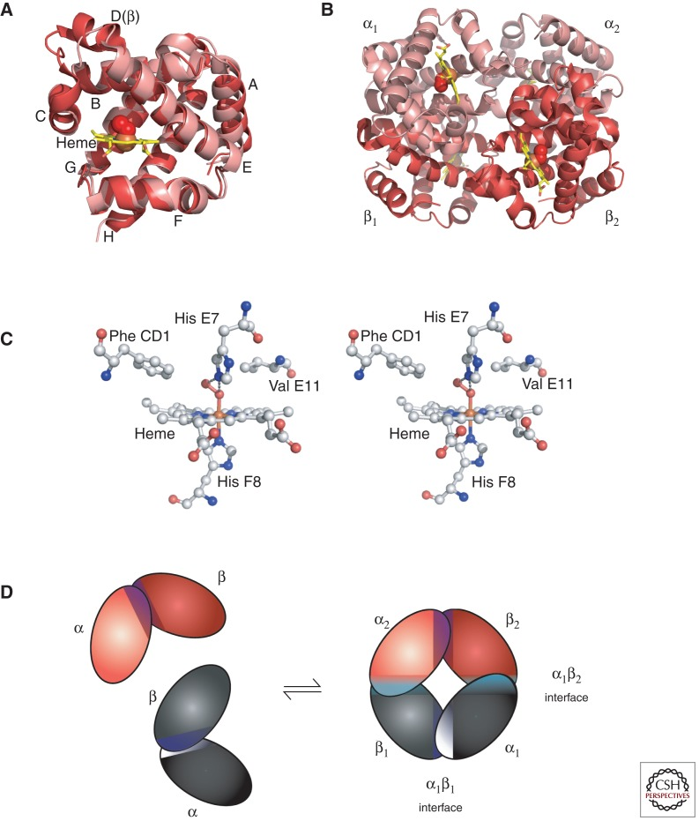
Figure 1.1: Structure of normal adult haemoglobin (HbA), demonstrating 2 α and 2 β globin chains, each centred around a haem group.
Abbreviations: α: alpha, β: beta
Thom, C. S. et al, 2013.

Other forms of haemoglobin normally present at significantly lower proportions in a healthy individual are: haemoglobin A₂ (HbA₂), which is composed of 2 α plus 2 δ (delta) chains and normally present at 2-3.5% total haemoglobin, and foetal haemoglobin (HbF), comprised of 2 α and 2 γ (gamma) chains and present in most individuals at <1%.^{14; 15} This physiological switch between different haemoglobin subunits is demonstrated in the figure below (Fig 1.2).

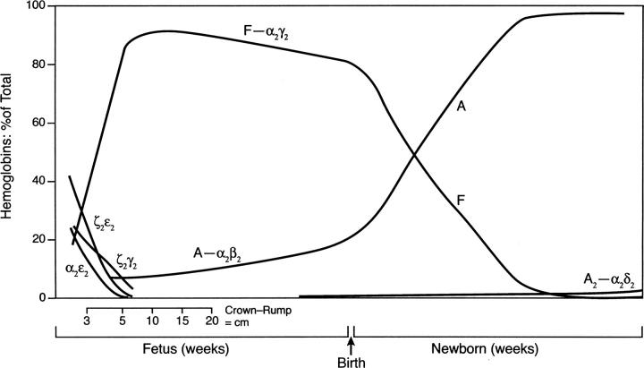
Figure 1.2: Graph demonstrating the physiological switch between different haemoglobins at various stages of intrauterine and postnatal life.
Manning, L.R. et al, 2007

HbF has a significantly higher oxygen affinity than HbA and allows the foetus to extract oxygen from the maternal blood stream via diffusion along an oxygen gradient within the placental circulatory bed, which is why this particular haemoglobin type is beneficial in intra-uterine life, whereas after birth, this property is unnecessary.³ Due to its higher oxygen affinity, higher concentrations of HbF are required than the lower affinity HbA. These factors are likely to provide an evolutionary explanation for the different haemoglobin preferences at different ages (Fig 1.3).
It is therefore physiological for foetuses and young neonates to have mostly HbF, but there is a natural switch to HbA which occurs during the first few months of life in most individuals, so that by 6 months of age, the proportion of HbA normally vastly overtakes HbF.

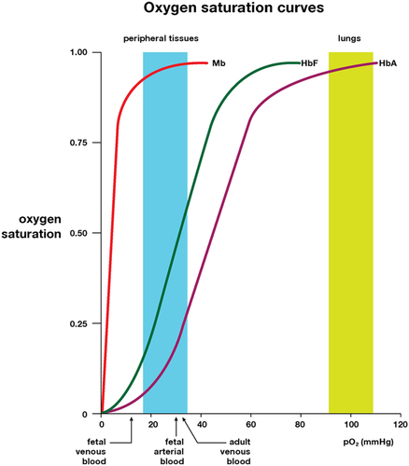
Figure 1.3: Oxygen affinity curves demonstrating higher oxygen affinity of foetal than adult haemoglobins.
Yudin, J. et al, 2019

1.1.2 Haemoglobin abnormalities
There are many hundreds of genetic variations in the haemoglobin genes, although only a minority are pathological. These include variations in the HBB genes encoding for β globin which result in abnormalities of the protein structure produced, resulting in variant haemoglobins such as HbC, HbS, HbD or HbO; reduced or absent production of what would otherwise be normally structured β globin protein, in the case of β thalassaemia; or certain mutations cause a combined abnormality in which there is reduced production of an also abnormally structured globin chain, such as in the case of HbE or HbLepore. There can also be genetic changes within the HBA genes which result in abnormal structure or reduced production of α globin chains. Examples of the former are HbQ-Iran and HbG-Philadelphia, and the latter is α thalasasemia. An estimated 7% of the global population is carrying a haemoglobin variant although the vast majority are benign.^{16; 17}
A number which have received more attention and been described in detail, primarily because most of these are capable of producing symptoms or an abnormal blood picture, but most variants are individually rare.¹
1.1.3 Globin genes
The genes for β, δ and γ globin chains are on chromosome 11 in the β globin gene complex (also known as the β globin gene cluster), and the genes for the α globin chains are located on chromosome 16. There is only 1 β globin gene complex on each chromosome 11 but there are usually 2 copies of the α globin gene on each chromosome 16, although generally only 1 of these is predominantly active on each chromosome (Fig 1.4).

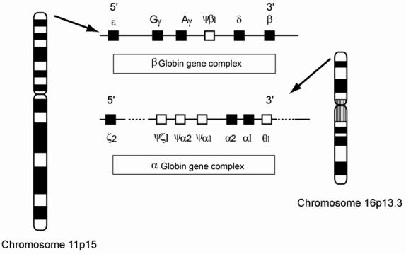
Figure 1.4: Chromosomal locations of the α and β globin gene complexes
Abbreviations: α: alpha, β: beta
Trent, R.J. et al, 2006

1.1.4 Mechanism of the physiological haemoglobin switch
The physiological switch from HbF to HbA has been the subject of very significant research efforts over recent decades. One of the key factors involved in this switch has been demonstrated to be the protein transcription factor BCL11A, encoded for by the BCL11A gene on chromosome 2. After production of BCL11A is stimulated by GATA1 (GATA-binding factor 1), this C2H2 type zinc finger protein transcription factor binds to the HBG promoter region on chromosome 11, inhibiting γ globin chain production and promoting a switchover from the production of γ globin chains to β globin chains, resulting in the production of HbA tetramers rather than HbF.^{18; 19; 20}
Other transcription factors are also involved in mediating the HbF to HbA switch, such as ZBTB7A which binds to a different region of the HBG promoter (approximately 200 bp upstream of the HBG transcription start site whereas BCL11A binds approximately 115 bp upstream).^{19; 21} However, BCL11A is the most well-described transcription factor and most research efforts to date have focused on the BCL11A-HBG axis.
Despite a vast array of different mutations possible in the β globin gene, and therefore its protein structure, only 2 β globinopathies are both common and pathological enough to result in a significant global burden of disease: sickle cell disease and β thalassaemia. It is on therapeutic strategies for these two conditions that this research has focused and therefore from this point on, only these two will be described in further detail.

1.2 Introduction to β globinopathies: sickle cell disease and β thalassaemia
1.2.1 Pathophysiology of β globinopathies
The pathophysiology of sickle cell disease and β thalassaemia are very different and therefore must be described separately. The former is a disorder caused by a variant, pathological form of the β globin chain; the latter is caused by a lack of normal β globin rather than a mutant structure in itself.
1.2.1.1 Sickle cell disease
1.2.1.1.1 Genetic basis for disease
Sickle cell disease is a generic term used for a variety of disorders in which both β globin chains are mutated such that cells form sickle shapes in the circulation. At least one of these mutations is always the sickle mutation itself, and the second can be one of a number of different alterations which interact with this sickle mutation and allow the sickling process to occur.²²
The sickle mutation is a single point mutation in the 6th codon of exon 1 of the β globin gene, leading to a switch from glutamine to valine at position 6 in the β globin polypeptide.²³ This abnormal globin chain is often termed β^{s} and when combined with an α chain results in sickle haemoglobin, HbS. JB Herrick first described the abnormally shaped red blood cell in 1910 and Pauling was the first in to establish that the disease is caused by a defect in the haemoglobin molecule.^{24; 25}
1.2.1.1.2 Erythrocyte sickling
In sickle cell disease, the presence of HbS leads to polymerisation of haemoglobin fibres within the erythrocyte under conditions of reduced oxygen pressure and/or dehydration, leading to a change in conformation of the red blood cells from biconcave discs to sickle shapes.^{26; 27} These sickled red cells have altered rheology due to significantly reduced deformability (Fig 1.5).²⁸

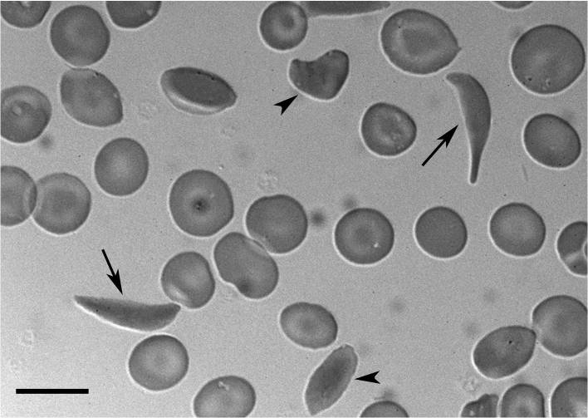
Figure 1.5: Sickled erythrocytes
Blood film from a patient with sickle cell disease, demonstrating the morphology of normal erythrocytes compared to sickle cells (long arrows), and cells midway between the two states (short arrows).
Frenette et al, 2007

The rigid, sickled erythrocytes cause blockage of circulatory vessels, incorporating other cell types into their obstruction over time and increasing blood viscosity.²⁹ This results in hypoxia of distal tissues which do not receive adequate arterial blood supply. Venous circulation can also become blocked, leading to a failure of blood drainage from organs and resulting sequestration of blood. Thus, ischaemia and sequestration are two of the main pathophysiological mechanisms causing organ damage in sickle cell disease (Fig 1.6).
The lifespan of sickle erythrocytes is significantly reduced: approximately 20-30 days or less, in comparison to the normal red cell lifespan of 120 days.³⁰ The results of chronic haemolysis and the anaemia it causes also contribute to the phenotype seen in sickle cell disease patients.

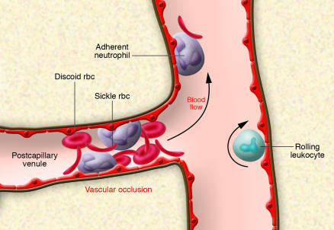
Figure 1.6: Diagram demonstrating vascular obstruction by deformed erythrocytes in sickle cell disease.
Frenette et al, 2007

1.2.1.1.3 Humoral factors
Over recent decades there has been a growing understanding that there is more to the pathophysiology of sickle cell disease than just deformation of erythrocytes. The coagulation and inflammatory responses, adhesion molecules and abnormal lipid profile also play a part in generating the complications seen in this disease.
There is over-activation of the coagulation system, involving thrombin (a distal component of the coagulation cascade) as well as other elements, contributing to a hypercoagulable state and therefore increased thrombosis risk.^{31; 32} Levels of other inflammatory cytokines including interleukin (IL)-6 and IL-1α, IL-1ra/IL1F3 and adhesion molecule P-selectin have also been demonstrated to be significantly increased in the plasma of patients in sickle cell crisis when compared to steady state plasma, and result in an increased neutrophil extracellular trap (NET) response suggesting that NETs are also involved in the development of symptomatic complications of this disease.³³
P-selectin has been a particular focus of research. It is stored in endothelial cells and platelets, and when these cells are activated it is transferred to the cell membrane. Once this occurs, it is an important mediator of the binding of sickle erythrocytes and leucocytes to the endothelial cell surfaces, as well as facilitating binding between blood cells themselves, thereby contributing to vascular obstruction.^{34; 35; 36}
The altered lipid profile in sickle cell disease patients is evident in higher triglyceride and lower high-density lipoprotein cholesterol levels and is associated with haemolysis and inflammation. These markers are known to correlate with risk of cerebrovascular and cardiovascular disease in the general population, and in sickle cell disease patients were associated with acute chest syndrome and vaso-occlusive events. ^{37; 38}
Leucocyte adhesion molecules and nitric oxide depletion contribute to endothelial damage (reviewed in Piccin et al,³⁹). Fat embolism, from infarcted BM (bone marrow), is an additional pathogenic mechanism proposed to contribute to the development of acute chest syndrome and stroke. ^{40; 41}
1.2.1.1.4 Non-erythrocyte cellular factors
Cellular components to vaso-occlusion include not just erythrocytes but also leucocytes – predominantly neutrophils. Higher neutrophil count has long been associated with poorer outcome in sickle cell disease, and it has since been demonstrated that neutrophils from patients with sickle cell disease also exhibit an abnormal activation profile including lower CD (cluster of differentiation) 62L expression and higher CD64 expression.^{42; 43} Platelets exist in an activated state in patients with sickle cell disease, even under steady-state conditions. This contributes to chronic inflammation as well as coagulation risk, and promotes adhesion of sickle erythrocytes to the endothelium via secretion of thrombospondin. ^{44; 45; 46}
Lymphocytes are also implicated. Children with sickle cell disease have been demonstrated to have significantly elevated levels of certain types of lymphocytes (natural killer T-lymphocyte subsets, and a skew towards Th2 (T-helper 2)-like phenotype), although the mechanism for this abnormal ratio and its effects have not yet been fully elucidated.⁴⁷ Autonomic nervous system dysfunction has also been proposed to contribute to the pathophysiology of sickle cell disease.⁴⁸
The complex interplay between sickle erythrocytes and a hyperinflammatory, hypercoagulable state results in the multi-system disease seen in patients with this condition. The pathophysiology of sickle cell disease is complex and it remains sobering that such extensive multi-organ damage can result from a single point mutation in the DNA of one gene.
1.2.1.2 β thalassaemia
Β thalassaemia, on the other hand, is caused not by the production of abnormal haemoglobin but by a lack of β globin chains. Over 400 different mutations and deletions have been described which result in the reduction or absence of β globin chain formation. Some are more common than others, with around 40 most common mutations accounting for the vast majority of cases of β thalassaemia worldwide, the prevalence of each dependent on ethnicity. ^{49; 50}
Where only one mutation is present, an individual will simply be a carrier of β thalassaemia (also known as β thalassaemia trait). To develop clinically significant thalassaemia, two mutations must be present. In most cases, both are simple thalassaemic mutations (or deletions), i.e. resulting in absent β globin chain production or a reduced amount of structurally normal β globin. A similar phenotype can result from the coinheritance of a β thalassaemia allele with a thalassaemic variant haemoglobin, i.e. a structurally abnormal β globin chain which is also produced in reduced amounts, such as HbE (haemoglobin E).⁵¹
The disease phenotype is primarily mediated by the imbalance between α and β globin chain production. The excess α chains accumulate and cause damage to erythroblasts and erythrocytes mediated by reactive oxygen species, resulting in ineffective erythropoiesis.^{52; 53; 54} This in turn leads to anaemia and therefore ineffective oxygen delivery to the tissues. The feedback generated puts pressure on the BM to increase erythropoiesis, and the resultant expansion of the BM space leads to bony deformity, which is a further key feature of the thalassaemia phenotype.
Additional damage is caused by the iron-loading propensity induced by β-thalassaemia, even without the addition of transfusion iron overload. Iron loading is mediated by increased secretion of erythroferrone from the BM, which is a negative regulator of hepcidin. Hepcidin, in turn, is key in negatively regulating iron absorption from the gut. Increased erythroferrone therefore leads to increased iron absorption and eventually iron overload. The pathological effects of iron loading will be described in further detail below. A further effect of elevated erythroferrone levels is heightened osteoclast activity relative to osteoblasts and therefore thinning of the bone cortex and a reduction of bone strength.⁵⁵
Where β globin chain production is absent or below a certain level, the resultant condition is incompatible with life without regular blood transfusions, and is termed ‘transfusion-dependent thalassaemia’ (TDT, previously called thalassaemia major). Where the thalassaemia produces clinical signs and symptoms but a patient is not dependent on red cell transfusion for survival, this is non-transfusion-dependent thalassaemia (NTDT, previously named thalassaemia intermedia).
1.2.2 Epidemiology of sickle cell disease and β thalassaemia
It must be recognised that much of the data guiding epidemiological estimates for β globinopathies, and also for many of the current treatment protocols, is anecdotal at best. There remains a lack of robust randomised-controlled trial data to guide management in many scenarios, although there has been improvement with several randomised controlled trials into the use of transfusion therapy and hydroxycarbamide reported in the past 20 years and newer trials ongoing. ^{56; 57} One ongoing effort to correct the deficit in high quality epidemiological data in the UK is the National Haemoglobinopathy Registry, which aims to collect data on diagnoses and complications.⁵⁸ This group aims to collate long-term outcome data for patients and also examine the impact of specific complications in the population of patients with haemoglobinopathies. For example, they are currently collecting data on haemoglobinopathy patients affected by COVID-19 and have used this to guide specific management recommendations for this patient group.
Globally, around 1.1% of couples are at risk for having children with a haemoglobinopathy and 2.7 per 1000 conceptions are affected.¹³ World Health Organisation (WHO) estimates for the carrier frequency and affected pregnancies for significant haemoglobinopathies per region are summarised in Table 1.1 below.

Table 1.1: Estimated prevalences of carriers of haemoglobin gene variants and affected conceptions across World Health Organisation regions
Modell et al, 2008
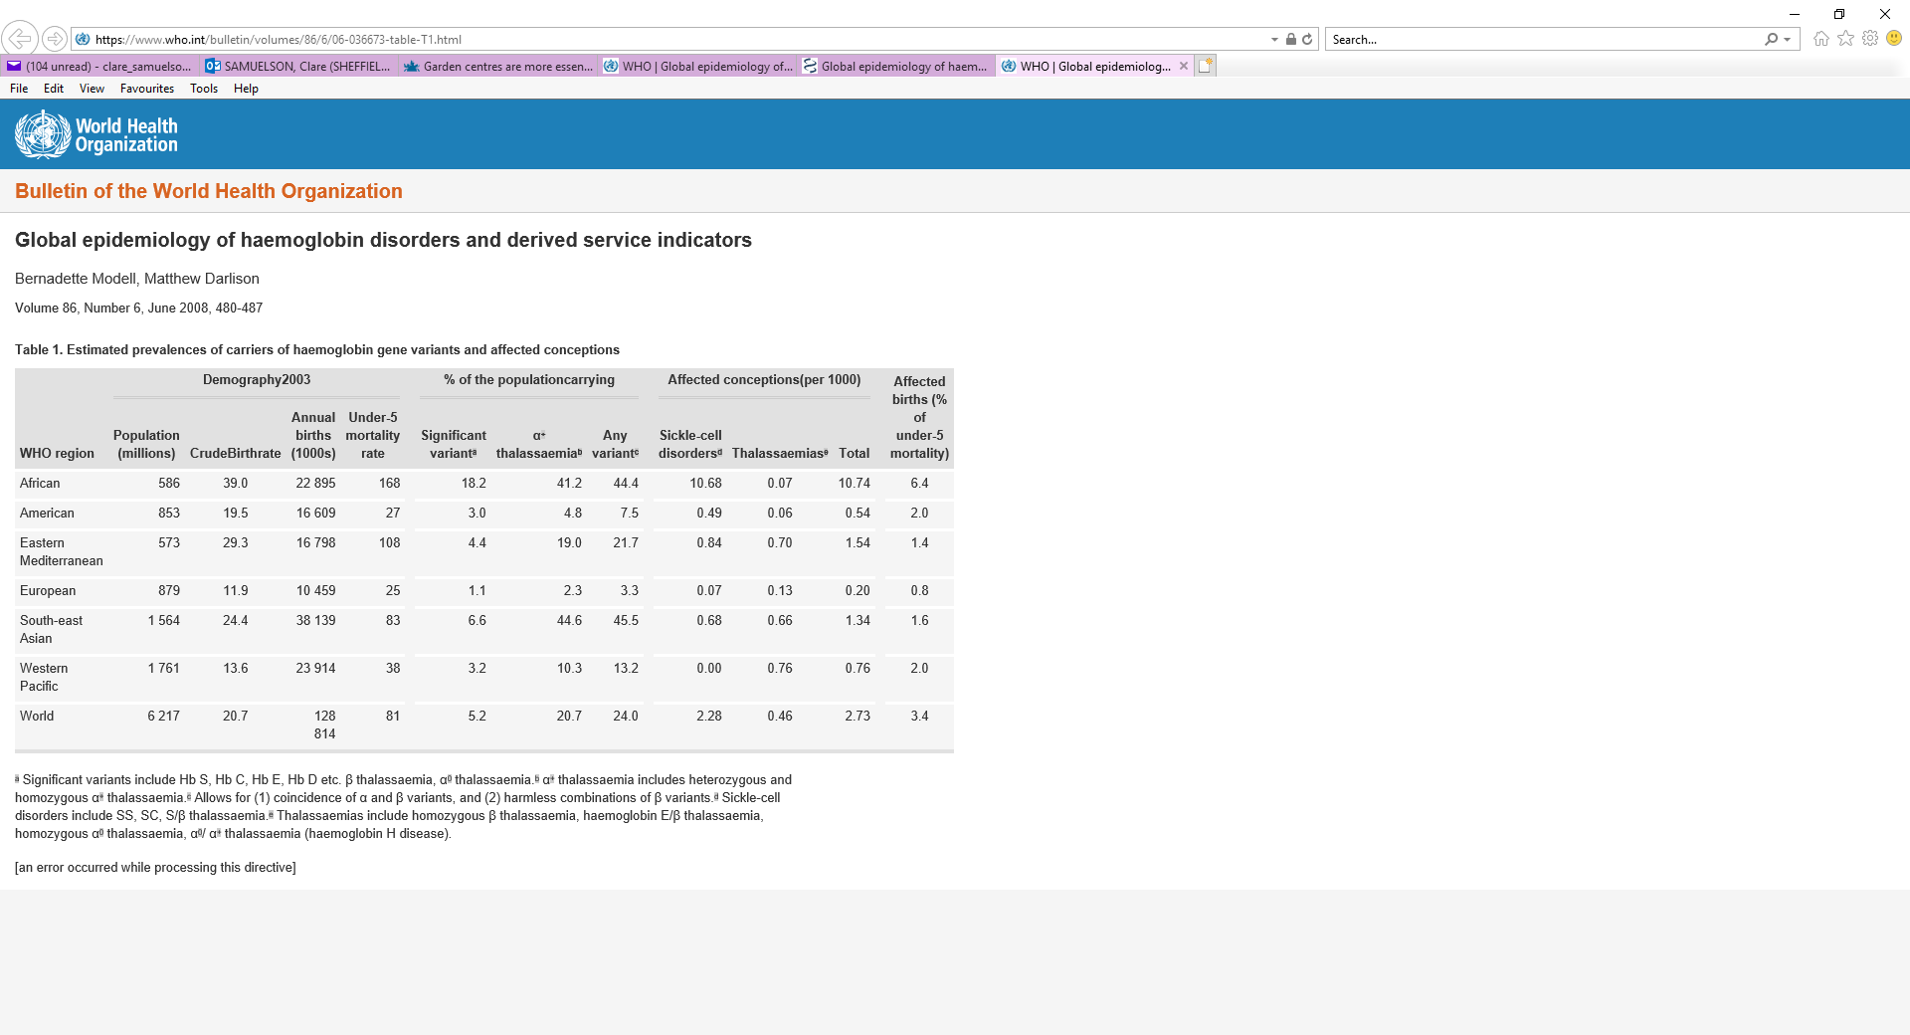

Sickle cell originated in Sub‐Saharan Africa and the Indian subcontinent,⁵⁹ and the mutation has persisted in the population due to a survival advantage conferred to carriers of the trait in malarious regions of the world.⁶⁰ It appears that this protection against malaria for sickle cell carriers is mediated by an increase in damage caused to malaria parasite proteins caused by reactive oxygen species.⁶¹ Due to forced and voluntary migration, sickle cell disease now affects individuals in all global regions, and has been recognised by the United Nations as a global health problem.²²
Sickle cell disease is the most common monogenic disorder worldwide, with an estimated 5-7% of the global population (approximately 367-500 million people) carrying the mutation.^{22; 60; 62} It is estimated that up to 400,000 babies are born with sickle cell disease each year.⁶⁰
In the US, 3.5 million of the African-American population carry the sickle cell trait and 100,000 people are affected by sickle cell disease.^{63; 64} In the UK, approximately 1,000 pregnancies are affected and between 260-350 babies are born with the condition each year. The National Haemoglobinopathy Register (NHR) has a record of over 11,000 individuals in England with sickle cell disease, but since registration is voluntary and also dependent on the treating clinician submitting patient data, the actual number is likely to be higher.¹⁵
Thalassaemia originated in the Mediterranean basin and is also highly prevalent in countries affected by malaria, suggesting an evolutionary advantage to thalassaemia trait related to a degree of protection from fatal malaria infection.⁶⁵ Clinically significant β thalassaemia is estimated to affect around 50,000 conceptions per year globally, and approximately 30,000 of these children have TDT.¹³ Due to the autosomal recessive nature of the condition, β thalassaemia incidence is increased where parents are consanguinous – a scenario with variable frequency dependent on local culture and traditions.^{62; 66}
In mainland China where a significant proportion of β thalassaemia cases are believed to be present, the prevalence of β thalassaemia is estimated to be up to 7% in regions where surveys have been conducted. Accurate estimates of prevalence, however, are significantly hampered by the lack of reliable (if any) epidemiological data for most of China’s provinces, and indeed the same is true of many other developing countries (Fig 1.7).⁶

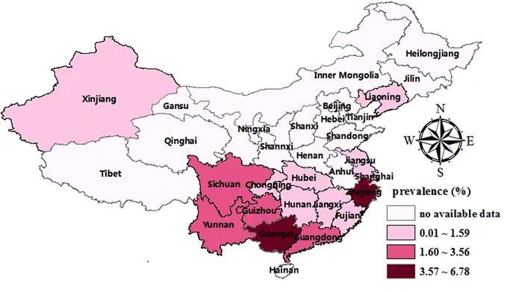
Figure 1.7: Map of estimated prevalence of β thalassaemia across provinces in China
Abbreviations: β: beta
Lai, K et al, 2017

In the UK, TDT is estimated to affect 1 in 27,000 pregnancies. Approximately 20-30 babies are born in the UK with this condition each year and 1,200 individuals with thalassaemic conditions are registered on the NHR.¹⁵
This large global burden of disease related to haemoglobinopathies affects not just affected individuals and their families but entire health services. Practical and financial implications for the treatment of these lifelong conditions are significant.⁶⁷ In the US, the lifetime medical costs associated with caring for a patient with sickle cell disease approach $1 million per individual, with the estimated total cost of caring for all sickle cell disease patients in the United States (US) alone exceeding $1 billion annually.⁶⁸ One estimate of the cost of treating haemoglobinopathies in India projected that by 2026 this would require 19% of their current National Health budget.⁶⁹
1.2.3 Clinical features and current prognosis
β globinopathies are life-limiting disorders which start to cause symptoms from around 4-6 months of age, when infants would normally start to rely predominantly on HbA for their oxygen carrying capacity. Sickle cell disease and thalassaemia present with very different clinical features and complications, but both still result in disease- and treatment-related pathology, and early mortality for most sufferers, even where gold-standard treatment is available.
Predicted life expectancy for β globinopathies also differs dramatically between developing and richer countries primarily due to the differential availability of standard treatment, with cost and lack of infrastructure limiting access to this in many poorer regions. In Sub-Saharan Africa, it is estimated that up to 90% of children affected by sickle cell anaemia die before 5 years of age.^{70; 71} Most children with transfusion-dependent β thalassaemia in the developing world do not receive regular blood transfusions or adequate chelation therapy and therefore are thought to die before the age of 5 years, though robust data from most of these regions is lacking.⁶
While most of the data below relates to patients with haemoglobinopathies in developed countries, it will always be important to recognise that the majority of individuals with these conditions are born in less developed regions and their outcomes remain significantly poorer.
1.2.3.1 Sickle cell disease
Sickle cell disease is a multi-system disease expected to limit life expectancy even in developed countries with excellent healthcare provision. In one recent, large, US-based study, the projected life expectancy in a cohort of individuals with sickle cell disease was 54 years, in comparison to 76 years in the non-sickle cell disease cohort. Quality-adjusted life expectancy was proportionally even more reduced, at 33 years in comparison to 67 years.⁷² These data confirm the findings of another large observational study from the US published in the 1994 which reported an estimated life expectancy of less than 50 years for African-Americans with sickle cell disease compared to over 70 years in a race-matched cohort without sickle cell disease.⁷³ This study separated individuals with homozygous sickle cell anaemia (HbSS) and those with compound heterozygosity for HbS and HbC (HbSC). For patients with HbSS, median age at death was 42 years for males and 48 years for females. For those with HbSC the ages were 60 and 68 years respectively. 18% of deaths occurred in patients with overt chronic organ failure, but 33% of patients were free of organ failure and died during an acute sickle crisis such as acute chest syndrome or stroke, emphasising the role of acute crises in precipitating early mortality.
As summarised in the figure below, the effects of chronic haemolysis, vascular obstruction and anaemia impact on all bodily systems both acutely and more chronically (Fig 1.8).⁷
Painful crises are the most common complication, experienced by the vast majority of sickle cell disease patients and resulting in severe pain, often requiring prolonged hospital admission for pain management. However, if only hospital admission data is examined, the majority of painful episodes are not captured, since patients manage most painful episodes at home. One recent study reported that 28% of young people experience pain most days. Acute chest syndrome is a life-threatening complication often accompanying or following a painful crisis, in which a combination of infarction, infection and sequestration lead to progressive loss of functional lung volume. The resultant hypoxia exacerbates the picture further and rapid deterioration is often observed.^{74; 75; 76; 77; 78; 79}
Ischaemic or haemorrhagic stroke risk is increased in sickle cell disease, particularly in children, often resulting in death or severe disability. One large study prior to introduction of more recent preventative management reported the prevalence of stroke to be 4.01% with incidence of 0.61 per 100 patient-years.⁸⁰ Stroke prevention programmes for children with sickle cell disease have since been introduced to reduce this risk and will be discussed further below in the section on current management, but despite this the risk remains elevated. It has also more recently become recognised that silent infarcts are common in this condition, present in 17% of children in one study, and are associated with cognitive impairment – leading to reasonable objection from some leading authors to the term ‘silent’.^{81; 82; 83}
Acute crisis involving the liver can result in hepatic failure.^{84; 85} Acute sequestration crises resulting from obstruction of vascular outflow from organs can affect the liver, spleen or penis. Where this involves the spleen, or less commonly the liver, patients can become severely anaemic and hypovolaemic, as a large proportion of their blood volume becomes pooled in these organs. One study estimated that 35.4% of children with sickle cell disease had at least 1 episode of splenic sequestration, with the average age at first episode being approximately 48 months and recurrence documented in 78% of patients without intervention.^{76; 86} Priapism (sustained, painful erection) occurs where the penis is affected by such a sequestration mechanism and carries a risk of permanent loss of penile function. One study estimated that priapism was experienced by 14.3% of male patients with sickle cell disease, and as for most complications was more commonly seen in those with the more severe sickle cell genotypes i.e. homozygous HbS (HbSS) or compound heterozygosity for HbS and a beta zero thalassaemia mutation (HbSβ⁰).⁸⁷
Alongside acute complications, chronic organ damage is recognised to be increasingly common as individuals with sickle cell disease progress into adulthood. Chronic renal failure (observed in up to 74% of patients even in childhood in one study from Ghana), chronic respiratory impairment (in 71% of adults with sickle cell disease in one Nigerian study), pulmonary hypertension, impaired cardiac function (up to 30% in adults), retinopathy with risk of visual impairment, gallstones, and leg ulceration are amongst the most well-recognised chronic complications in this patient population. Early cardiac diastolic dysfunction has recently been unmasked by tilt table testing in patients with sickle cell disease, suggesting that the chronic organ damage begins even earlier than previously suggested.^{75; 88; 89; 90; 91}

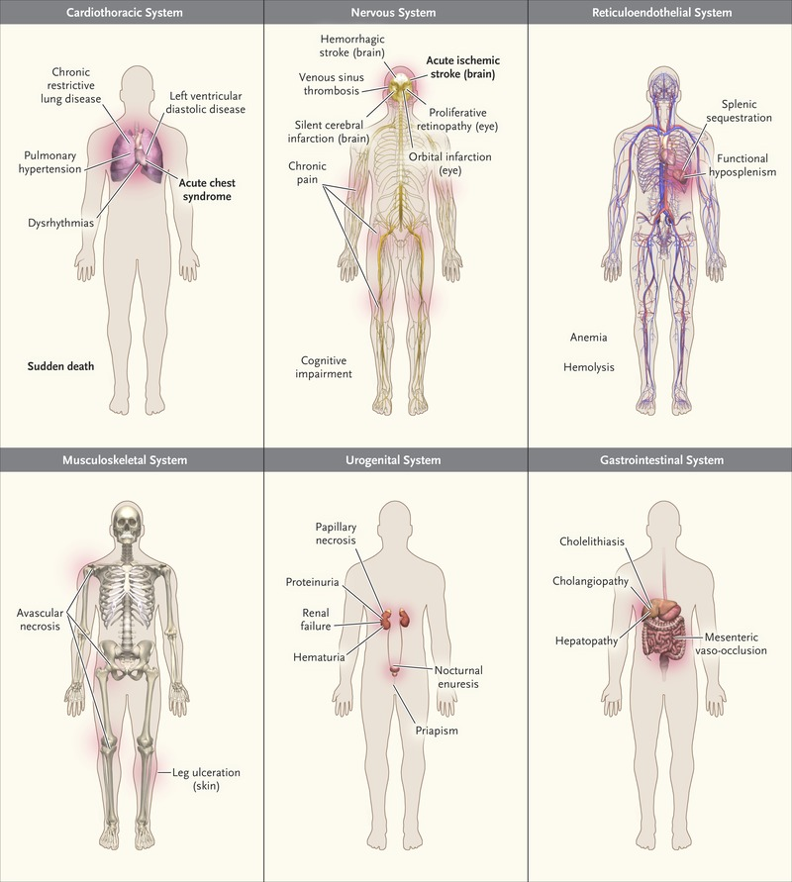
Figure 1.8: The effects of sickle cell disease on different bodily systems with resultant symptoms and effects
Piel, F.B. et al, 2017

Severe and atypical infections are also a risk in patients with sickle cell disease.^{57; 74} By the age of 5 years, most patient with sickle cell anaemia will have auto-atrophied their spleen due to recurrent splenic infarction, secondary to sickling in the splenic blood vessels. This functional hypo- or asplenism results in increased infection risk particularly from encapsulated organisms such as Streptococcus pneumonia. Additional immunocompromise results from defects in complement activation, impaired serum opsonisation and defective lymphocyte function.^{92; 93} There is also an increased risk of bacterial exposure secondary to ischaemic bowel infarcts, from which gut organisms are allowed access to the circulation, and from indwelling central venous access devices where these are required. On top of the risk of life-threatening sepsis itself, infective events can also trigger sickling crises which can themselves result in mortality. Even with current prophylactic measures, sepsis remains a key cause of mortality in both children and adults with sickle cell disease.^{92; 93; 94; 95; 96}
Organisms causing sepsis may be resistant to penicillins and may require broad-spectrum antibiotics. Therefore, patients may continue to deteriorate if given standard antibiotic treatment when presenting with fever, in part since atypical organisms such as salmonella contribute significantly to the burden of cases.^{97; 98; 99; 100; 101; 102; 103} Atypical infections such as osteomyelitis cause significant pathology but are not always considered in these patients, leading to delayed diagnosis and increased morbidity.^{104; 105}
Given these severe and often life-limiting complications, it is not surprising that quality of life including mental health parameters, are severely impacted by sickle cell disease.¹⁰⁶ Rates of anxiety in children and young people with sickle cell disease are higher than in the general population, with psychological impacts in both patients and care-givers associated with markers of disease severity, such as reported pain and requirement for opioid analgesia at home.^{79; 107; 108}
Sickle cell disease also has severe socioeconomic impacts on many who suffer from this condition. A US study in 2019 estimated a lifetime lost income of $695,000 owing to reduced life expectancy. Even this is a very conservative estimate, as the authors did not take into account time lost from education and employment due to acute complications and longer-term disability, nor did they factor in medical costs.⁷² There is also some evidence that social factors influence the rate of presentation with sickle crises, indicative of a bidirectional relationship between a patient’s socioeconomic situation and their sickle cell disease.¹⁰⁹
1.2.3.2 Β thalassaemia
One large study retrospectively analysed patient data from 1087 transfusion-dependent thalassaemia patients across 5 thalassaemia centres in India, where regular transfusion and iron chelation programmes are underway, albeit not to optimal standards in most cases. Under-5 mortality was 7 times higher than in the general population and only 50% of patients survived to 26.9 years. Causes of death were mainly infection, iron overload and allo-immunisation.⁵⁶
As discussed above, because thalassaemia is a condition of decreased haemoglobin production, where this is severe, regular blood transfusion is required for survival after the first months of life unless the child receives an allogeneic stem cell transplant. Where this does not occur, symptoms are caused by severe anaemia and from the resultant extramedullary haematopoiesis, and include lethargy, failure to thrive, cardiac failure, bony expansions, spontaneous fractures and extra-medullary haematopoietic lesions.¹¹⁰ Extramedullary haematopoiesis occurs in the liver and spleen leading to organomegaly, and less often can also occur in other sites such as paravertebral locations with a risk of spinal cord compression. The risk of paraspinal extramedullary haematopoietic mass was reported as being as high as up to 15% in one series, where patients are not adequately transfused.¹¹¹
In developed countries, patients can reliably be expected to receive regular transfusions and the picture of untreated thalassaemia should not be seen. If managed appropriately, these transfusions should supply all haemoglobin requirements and prevent complications associated with BM expansion and extra-medullary haematopoiesis, and therefore the spectrum of pathology observed is very different. Complications seen now mainly result directly and indirectly from the transfusion therapy itself. Primarily, iron overload, red cell alloimmunisation, and in centres without robust blood screening policies, also transfusion-transmitted infection are seen.⁵⁶ In a large Pakistani centre, in patients receiving blood transfusion therapy (and with 90% also on iron chelation treatment), long-term complications were still reported in a large majority of patients with thalassaemia. 75% suffered growth retardation; rates of hepatitis C and B infection were 38% and 30% respectively; and most patients suffered complications of the iron chelation treatment itself, including local reactions, hearing and visual loss.⁶² The potential signs and symptoms of thalassaemia, along with those caused by its treatment with regular transfusion and iron chelation, are summarised below in figure 1.9.

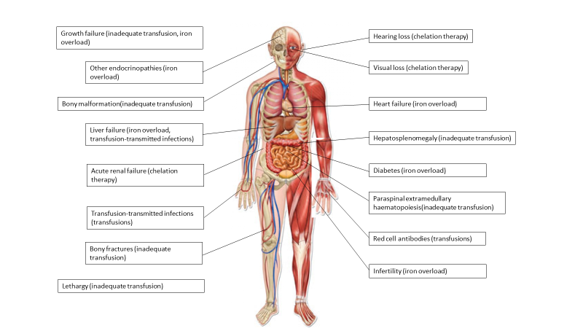
Figure 1.9: Sequelae of transfusion-dependent thalassaemia
Signs and symptoms of transfusion-dependent thalassaemia and its treatment, with causes for each in brackets.
(Central image sourced from google images; labels added by the author)

Not surprisingly given the burden of this disease and its treatment, the quality of life of patients with transfusion-dependent thalassaemia and their carers is significantly reduced when compared to unaffected controls.^{112; 113}
1.2.4 Diagnosis of sickle cell disease and β thalassaemia
In the UK, a robust antenatal and neonatal screening programme allows for the diagnosis of most cases of sickle cell disease and transfusion-dependent β thalassaemia prenatally or shortly after birth. Other scenarios in which testing for β globinopathies is indicated is in screening newly presenting patients who have immigrated from regions with a high prevalence of haemoglobinopathies, or testing patients presenting with symptoms or signs suggestive of these conditions.
Most testing relies on the separation of different haemoglobin fractions based on charge and/or weight, such as gel electrophoresis, capillary electrophoresis, HPLC or isoelectric focusing methods (Fig 1.10).
Sickle cell disease is diagnosed where the presence of HbS is found either in the homozygous state, alongside another interacting abnormal β globin variant, or in conjunction with decreased normal β globin (in the case of β thalassaemia co-inheritance). β thalassaemia is diagnosed based on the absence of normal β globin chains, with or without an interacting thalassaemic haemoglobin variant such as HbE. Given that each method listed here does not conclusively determine the character of the globin chains detected (they can only quantify the proportion in a particular window within which HbS, for example, would be expected to appear), it is important that any diagnosis is confirmed with a second modality of testing. This can be a further test from the haemoglobin separation methods above, or an alternative method.^{114; 115}
Caveats to the above testing include that results in the neonatal period may be difficult to interpret until the physiological switch from γ to β globin production has progressed sufficiently, and repeat testing is required for confirmation of any suspected diagnosis. Similarly, if a patient has been transfused then donor red cell haemoglobin will be detected alongside native globin chains, which again must be taken into account in the interpretation of results.

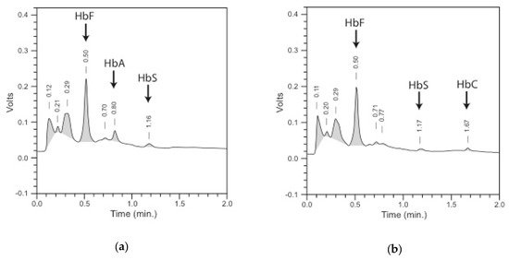
D
C
B
A
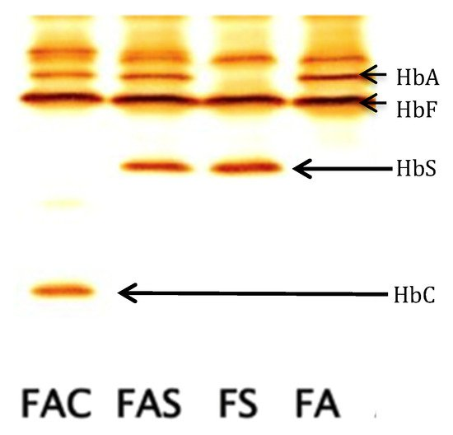
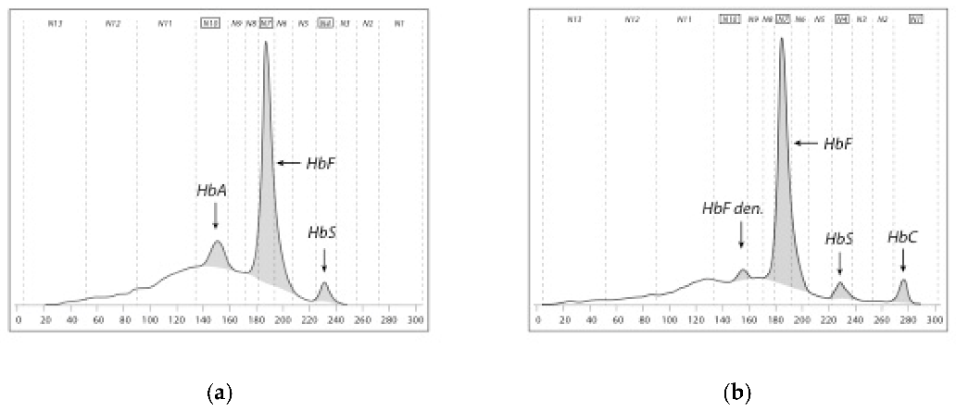
E
Figure 1.10: Haemoglobin variant diagnosis
Examples of results from different haemoglobin separation methods used in the diagnosis of haemoglobinopathies. (A) HPLC trace from a neonate with sickle cell trait, demonstrating mostly HbF but also peaks of HbA and HbS. (B) HPLC trace from a neonate with sickle cell disease (HbSC), demonstrating mostly HbF but also peaks of HbS and HbC. (C) Capillary electrophoretic trace from a neonate with sickle cell trait, demonstrating mostly HbF but also peaks of HbA and HbS. (D) Capillary electrophoretic trace from a neonate with sickle cell disease (HbSC), demonstrating mostly HbF but also peaks of HbS and HbC. (E) Isoelectric focusing trace, with neonatal samples (from left to right) from a HbC carrier (HbF, HbA and HbC present); HbS carrier (i.e. sickle cell trait, HbF, HbA and HbS present); sickle cell disease patient (HbF and HbS only present); and a baby with normal haemoglobin (HbF and HbA only present).
Abbreviations: HbA: Haemoglobin A, HbC: Haemoglobin C, HbF: foetal haemoglobin, HbS: Sickle haemoglobin, HPLC: high performance liquid chromatography
Frommel, C, 2018
Definitive identification of globin chain variants can be carried out using mass spectrometry or molecular genetic assays. Examples where these techniques are employed include antenatal diagnosis (primarily molecular genetic testing), characterisation of a rare or novel globin chain variant, or where results of more simple assays give conflicting or inconclusive results. Tandem mass spectrometry has also been piloted for newborn screening for sickle cell disease and thalassaemia, and found to be an acceptable method provided instruments of sufficient specificity are used. However, the level of staff expertise as well as specialist equipment required to carry out and interpret results of either mass spectrometry or molecular genetic testing have prohibited the more widespread use of this technology.¹¹⁶
For laboratories without access to these more complex tests, or for out of hours testing in an emergency, the presence of HbS can be excluded with a simple sickle solubility test. The most widely used versions of this test utilise sodium hydrosulfite or sodium metabisulphite to reduce HbS, resulting in sickling of sample erythrocytes and opacity of the sample where the patient is either a carrier or is affected by sickle cell disease. While quick and easy to perform, it is still important that the operator is able to interpret the results accurately. There are risks of false negative results (such as with severe anaemia or high HbF), and positive results may be falsely interpreted as meaning a patient has sickle cell disease when in fact they may only have the trait.¹¹⁷
1.2.5 Foetal haemoglobin in β-globinopathies
There is a high degree of variability in clinical phenotype between sickle cell disease patients, and between individuals with β thalassaemia. Whilst much is attributable to the particular β globin gene mutations inherited (for example HbSS or HbSβ⁰ patients generally have a more severe sickle cell disease phenotype than those with compound heterozygosity for HbS and either HbC (HbSC) or a β⁺ thalassaemia mutation (HbSβ⁺)), there are additional genetic factors which also modify disease severity. Similarly, it is not possible to predict with certainty whether a baby with β thalassaemia will go on to require regular blood transfusions or will be transfusion independent.
Co-inheritance of an α globin gene mutation resulting in α thalassaemia trait is known to ameliorate the features of β thalassaemia or HbSβ⁺ sickle cell disease. This is because in the former case, the imbalance of α to β chains is somewhat ameliorated. In the latter case it is because the scarcer α globin chains conjugate with any remaining normal β globin chains in preference to the abnormal (β^{S}) chains, reducing the proportion of sickle haemoglobin.^{77; 118; 119} A further example of another interacting genetic polymorphism is that the presence of an UGTA1A allele responsible for Gilbert’s syndrome (a normally benign inherited condition leading to increased serum bilirubin levels) is known to increase the incidence of symptomatic presentation with gallstones in patients with sickle cell disease.¹²⁰
Finally, and most significantly, the presence of raised HbF levels outside the neonatal period is known to improve clinical phenotype and life expectancy in both sickle cell disease and β thalassaemia.^{73; 121; 122} The inherited persistence of increased levels of HbF after infancy is a condition known as hereditary persistence of foetal haemoglobin (HPFH) and in some cases is co-inherited with mutations causing sickle cell disease or β thalassaemia. In many cases HPFH is caused by one of a spectrum of deletional and non-deletional mutations within the HBG promoter region, which prevent binding of the BCL11A or ZBTB7A transcription factors and thus inhibit activation of the physiological switch from HbF to HbA production.^{19; 123}
In sickle cell disease, increased HbF percentage does not simply dilute the HbS present, but actively inhibits HbS polymerisation and protects against red cell lysis, helping to explain why increased HbF levels so potently reduce sickling complications.¹²⁴ Increased HbF levels are associated with prolonged life expectancy,⁷³ decreased painful episodes,^{125; 126} protection against stroke,^{80; 126; 127} and there is some limited information that they may protect against osteonecrosis.¹²⁸ HPFH is also protective against proliferative retinopathy,^{129; 130} leg ulcers,¹³¹ splenic sequestration,¹²⁶ and helps to maintain normal growth and development.¹³² Co-inheritance of HPFH with sickle cell disease has also been shown to reduce complications in pregnancy for both mother and baby.¹³³
In β thalassaemia, high levels of HbF are associated with less severe anaemia and often transfusion independence.¹³⁴
There are undoubtably additional and as yet undescribed genetic variables influencing the severity of disease in patients with sickle cell disease and β thalassaemia, since the above allelic variations do not account for all of the wide variability in clinical phenotype observed. Now that research is moving from the investigation of single candidate genes to whole genome sequencing and correlation with clinical outcome data, with increased global collaboration to increase sample sizes, there is likely to be an acceleration of understanding when it comes to additional genetic modifiers of these conditions, which may also lead to novel therapeutic approaches. In the meantime though, reinduction of HbF is a valuable target in the treatment of β haemoglobinopathies.

1.3 Current management options in sickle cell disease and β thalassaemia
This document is not intended to be read as a guideline for the treatment of sickle cell disease or β thalassaemia and is not a comprehensive description of all aspects of current treatment. In particular, management of organ-specific disease is outwith the remit of this thesis, with the exception of the most well-evidenced and clinically significant recommendations, such as those pertaining to primary and secondary prevention of stroke.
However, it is important to provide an overview of the current treatment options for patients with these conditions, in order to understand where current management strategies fall short of providing complete symptom relief and also in themselves impose burdens and side-effects on patients. This forms the basis for my case that novel treatment strategies are required for these conditions. While current treatment in developed countries has improved significantly over recent decades, there is still a very long way to go before patients with β haemoglobinopathies can be free of symptoms and complications resulting from their disease as well as its treatment.
1.3.1 Screening and ‘prevention’ programmes for sickle cell disease and β thalassaemia
One approach taken in many countries is to offer antenatal screening, prenatal diagnosis and the option to terminate affected pregnancies, as a method of reducing the number of children born with clinically significant haemoglobinopathies. A variable number of couples with affected foetuses choose to terminate the pregnancy, preventing delivery of the affected child. However, there are many countries in which such an approach is either considered legally or morally unacceptable or is not feasible, including many of those with the highest haemoglobinopathy prevalence. Even in developed countries such as the UK, not all cases are detected by the antenatal screening programme. and where a pregnancy is known to be at risk for sickle cell disease or thalassaemia, parents may choose to proceed with the pregnancy.^{114; 135; 136; 137; 138}
In the UK, the antenatal screening programme bases the need for further antenatal investigation for haemoglobinopathies on answers to a family origin questionnaire filled out by pregnant women, and on their complete blood count (CBC) results tested at their initial booking appointment. In a recent 10-year period, a total of 6,608,575 booking samples were screened, and 154,196 pregnant women required further testing. There were 3,941 prenatal diagnostic tests reported, and of these, 964 affected foetuses were diagnosed. The programme has an ambitious target of completing all screening and diagnostic testing by 12+6 weeks of pregnancy, to facilitate reproductive choice in couples with an affected baby. However, the screening programme has not been able to meet its own standards for the number of pregnancies tested by this date, and there is a high degree of variability in the completeness of testing and follow-up.¹³⁹ A separate report examined outcomes of prenatal diagnosis in the UK from 2008-2017. Where a foetus was diagnosed with sickle cell disease, 34.3% of pregnancies continued; 65.7% were terminated. For β thalassaemia, 20.2% were continued and 79.8% terminated.¹⁵
A small number of countries also offer premarital screening, in order to allow potential couples and their families to make informed choices regarding marriage based in part on the risk of children being affected by haemoglobinopathies.¹⁴⁰ This is usually only going to be appropriate in the context of arranged marriages and would be less applicable in the UK.
It is clear that while ‘prevention’ programmes may reduce the number of babies born with sickle cell disease or β thalassaemia, there will continue to be a large number of patients who need treatment for these conditions.
1.3.2 Non-haematopoietic stem cell transplant (HSCT) management of sickle cell disease
There is a lack of good quality evidence to guide many areas of sickle cell disease patient management.^{64; 141; 142; 143} Much practice is based on consensus guidelines from ‘expert’ groups, but where good quality randomised controlled trials exist, they are highlighted below. The lack of effective treatment options for sickle cell disease is associated with a longstanding relative lack of funding for research into this disease.
1.3.2.1 Preventative measures and education
Treatments which have had the greatest impact on survival in sickle cell disease over the last century remain those seemingly basic tenants of preventative care. Prophylactic antibiotics and additional immunisations to protect from overwhelming sepsis prevented most of the deaths in children under the age of 5 years. Good education of patients, parents and carers in the prevention and simple management of painful crises including maintaining warmth and hydration; avoiding other precipitants such as hypoxia; and the use of good analgesia where required has been vital. Recognition of life-threatening complications such as splenic sequestration, chest crisis or stroke should also be covered during initial consultations with families after a new diagnosis of sickle cell disease is made, and should be revisited regularly as children grow older.^{57; 142; 144}

1.3.2.2 Blood transfusion
It is logical that by replacing sickle haemoglobin with healthy, donor haemoglobin via a red cell transfusion, the complications of sickle cell disease could be averted. However, regular blood transfusion programmes are burdensome to patients and their families, and introduce new risks and side effects in themselves. Therefore, application of transfusion therapy must be guided by the best available evidence. This currently suggests the use of regular transfusions for targeted primary and for secondary stroke prevention, with single top-up or exchange transfusions indicated for the management of multiple acute presentations and prior to surgery.
However this treatment modality is not without its own associated risks and complications. Patients receiving regular or frequent red cell transfusions are at risk of iron overload for which chelation therapy is required, and of alloantibody formation. These complications of regular transfusion therapy are described in detail below in the section pertaining to patients with β thalassaemia, but also apply to patients with sickle cell disease where a regular transfusion programme is instituted. In addition, a posttransfusion complication termed hyperhaemolysis is seen in some patients with sickle cell disease. This is thought to arise as a complication of alloantibody formation, but results in the rapid destruction of not only donor but also autologous red blood cells, leading to severe anaemia, multiorgan failure and death in severe and refractory cases.¹⁴⁵
1.3.2.3 Hydroxycarbamide
Hydroxycarbamide (HC, also known as hydroxyurea) has a long history of being used as a cytotoxic drug in the treatment of haematological malignancies.^{146; 147; 148} It was incidentally observed to increase HbF in these patients which led to it being trialled in sickle cell disease, where it was confirmed to produce this effect without prohibitive toxicity.^{149; 150} In addition to its impact on HbF levels, the clinical benefits observed in HC treatment also relate to an improvement in red cell hydration and deformability; decreased neutrophil count with partial correction of the abnormal neutrophil activation profile; modulation of the plasma protein inflammatory profile; and effects on the endothelium, mediated in part by HC’s property of being a nitric oxide donor, which is a natural vasodilator.^{33; 151; 152; 153; 154; 155}
In the UK, recent guidance advocates offering HC to all patients with HbSS or HbSβ⁰ thalassaemia, and it should also be considered in patients with other forms of sickle cell disease, from the age of 9 months, regardless of markers of disease severity. ^{156; 157} Benefits of HC treatment include a reduction in frequency of painful crises and acute chest syndrome, and a lower transfusion requirement, although these complications are not entirely negated.¹⁵⁸¹⁵⁹
There are also a number of potential side-effects and complications related to the use of HC. These include myelosuppression – with the most severe aspect of this being neutropenia. The drug can also affect renal and liver function, and these must be monitored closely, along with the full blood count on initiation of HC or following dose increase. There has been much discussion around any potential for oncogenic risk. This was based on the observation that where HC has been given to patients who already have clonal haematopoiesis (such as in polycythaemia rubra vera or essential thrombocytosis), HC increases their risk of developing leukaemia.^{160; 161} However, there is no evidence that this risk is increased in patients who did not already have an increased predisposition to haematological malignancy, including those with sickle cell disease.
Another area which must be discussed in depth prior to starting HC is the potential impact on male fertility and teratogenic risk. There is evidence that sperm count is reduced in males taking HC, and while this appears to resolve in most men when the drug is stopped, it is impossible to guarantee that fertility will not be affected.^{162; 163} Finally, based on concerns regarding teratogenicity, it is advised that both men and women on HC stop taking the medication at least 3 months prior to trying to conceive. However, studies showing increased teratogenicity risk were all preclinical, and, in contrast, data collected following the birth of many babies conceived while on HC is reassuring, with no evidence of increased risk of teratogenicity compared to the general population in humans.^{164; 165}
1.3.2.4 Newer non-genome modifying therapies
A number of newer therapies: L-glutamine, crizanlizumab, and voxelotor, have all been approved by the US Food and Drug Administration (FDA) for patients with sickle cell disease, to reduce the frequency of crises. Crizanlizumab recently received conditional NICE approval, but NICE or the European Medicines Agency (EMA) have not yet approved any others for routine use in the UK.¹⁶⁶
L-glutamine supplementation decreases endothelial cell adhesion and may help to prevent oxidative damage to red cells. It is an essential amino acid required to synthesise nicotinamide adenine dinucleotide (NAD), which is an oxidation-reduction cofactor in red cells. L-glutamine is hypothesised to produce clinical benefit in patients with sickle cell disease by increasing intracellular NAD and thereby rebalancing the oxidation-reduction ratio.^{167; 168} In one randomised controlled clinical trial, 230 patients received either L-glutamine or placebo and a modest reduction in painful crises, hospital admissions and acute chest syndrome was observed in those patients on the study drug. There was however an increase in nausea, fatigue, musculoskeletal pain and noncardiac chest pain in those taking L-glutamine.¹⁶⁹
Many US sickle cell centres routinely recommend this supplement to their patients based on this study. However, there were significant problems with the reporting of study results and the randomisation process. For example, there were more patients on HC in the L-glutamine group than the placebo group. Also, a large number of patients dropped out of the study early and their data was not included in the final analyses. Based on these shortfalls the European Medicines Agency (EMA) recommended against authorisation of L-glutamine for the treatment of sickle cell disease in Europe, stating that the published research failed to adequately establish a benefit to L-glutamine therapy in sickle cell disease.
Crizanlizumab (Adakveo, Novartis) is a monoclonal humanised antibody which binds to and inhibits P-selectin, thereby blocking interactions between endothelial cells, erythrocytes, and leucocytes and reducing vascular obstruction. Knockout or inhibition of P-selectin had previously been shown in mice and in ex vivo sickle cell disease patient blood to reduce platelet-neutrophil aggregates and neutrophil activation, and to improve microvascular flow.^{34; 170} Based on this promising preclinical data, the SUSTAIN trial was approved: a randomised, placebo-controlled, double-blind clinical trial of crizanlizumab. 198 patients aged 16 or over were randomised to receive either crizanlizumab or placebo, with significantly fewer painful crises and longer time to first crisis in the group receiving crizanlizumab.¹⁷¹ Following publication of these data, the FDA approved crizanlizumab for use in patients with sickle cell disease aged 16 years and older and NICE has approved a managed access programme in the UK.^{172; 173} An ongoing multicentre, double-blind randomised placebo-controlled trial is currently assessing the efficacy and safety of crizanlizumab at 2 doses in comparison to placebo (STAND study, NCT03814746).¹⁷⁴
A third compound, Voxelotor (formerly GBT440), is also an approved treatment for patients with sickle cell disease over the age of 12 years in the US.¹⁶⁶ It is an allosteric modulator of haemoglobin-oxygen affinity, increasing the oxygenation of haemoglobin and thereby was expected to inhibit HbS polymerisation and resultant erythrocyte sickling.¹⁷⁵ However, despite promising preclinical results and improved haematological parameters (increased haemoglobin levels and decreased markers of haemolysis) in patients on the drug, it failed to significantly reduce the annualised incidence of painful crises in a clinical trial, therefore is considered unlikely to impact in a meaningful way on clinical severity.^{176; 177} Further research and follow-up is ongoing but this treatment does not appear to hold much promise for the treatment of sickle cell disease.
It should be noted that the best possible outcome in all trials of transfusion therapy, HC or novel drug therapies described above are only a reduction in the number of painful crises, stroke and organ dysfunction. None of these treatments are capable of providing a long-term cure, or complete amelioration of associated symptoms of the disease.

1.3.3 Non-HSCT management of transfusion-dependent thalassaemia
As discussed above, the phenotype of untreated transfusion-dependent thalassaemia should no longer be seen in developed countries such as the UK, where regular red cell transfusion programmes with iron chelation are now the standard of care. The clinical complications observed now are largely iatrogenic, due to iron overload and alloimmunisation secondary to regular transfusions, and complications of iron chelation therapy.
Patients with transfusion-dependent thalassaemia need to receive donor red blood cell transfusions on average every 3-4 weeks to provide adequate healthy haemoglobin and to suppress their own ineffective haematopoiesis, but this leads to significant iron overloading without intervention. Death in thalassaemia is associated with high ferritin levels, a marker of iron overload, with the hazard ratio for death increasing to 4.66 once ferritin is above 4000 ug/l (normal range <300 ug/l).^{56; 178} Each unit of packed red cells contains approximately 200-250mg of iron, in comparison to an average 1-2mg/day of iron absorbed from the diet, and there is no physiological mechanism to increase iron excretion from the body, which is static at 1-2 mg iron/day via cellular exfoliation in the absence of bleeding.^{179; 180; 181} Excess iron is progressively deposited in the tissues. Also, once normal iron carrying capacity by transferrin in the blood is exceeded, iron exists in the circulation in alternative forms, interconverting between ferrous (Fe2+) and ferric (Fe3+) compounds and resulting in the generation of toxic free radicals.¹⁸²
Iron accumulates in the liver, heart and endocrine organs. This leads to hepatic disease including cirrhosis, liver failure and hepatocellular carcinoma; heart failure and cardiac arrhythmias– with a high rate of cardiac iron loading found even with seemingly good iron chelation therapy; and also a multitude of endocrine complications. Even with current treatment protocols, liver iron is severely increased in 15 % of patients, with cardiac iron loading present in 28.9 % and severe in 3.2 %. In one study, the mean age of patients with iron overload cardiomyopathy was only 27.5 years, with the prevalence of left ventricular dysfunction 20.7%. Endocrine complications include central hypothyroidism (4.6 % adults with transfusion-dependent thalassaemia), thyroid cancer (0.41 %), growth hormone deficiency (3.0 %), diabetes, and infertility.183; 184; 185; 186; 187; 188; 189
All patients dependent on regular transfusion require iron chelation therapy to reduce iron overload, although as described above this does not entirely prevent siderosis. There are 3 main iron chelating agents used in the clinic, which themselves confer side-effects and potential complications including renal damage, gastrointestinal adverse events, sensorineural hearing loss and visual impairment. The most well-established agent, desferrioxamine, is administered via subcutaneous or intravenous injection, imposing a significant treatment burden on patients and their carers, who are usually required to administer this multiple times a week at home.^{191; 192} At least in part due to these reasons, compliance with chelation therapy is often suboptimal, increasing the risk of progressive iron overload.¹⁹³
Another potentially severe complication of chronic transfusion is alloimmunisation. This term describes the development of an immune response to ‘foreign’ antigens on donor red cells, which are not present on the patient’s own red cells. This can occur in any patient on a regular transfusion programme, but rates are historically higher in those with sickle cell disease or thalassaemia because these patient populations are ethnically distinct from the majority of the blood donor population, meaning the likelihood of antigen mismatch is greater. Even in countries where the donor and recipient populations are more closely matched, alloimmunisation remains a significant problem without extended red cell phenotype matching.^{194; 195} Reported rates of alloimmunisation amongst transfusion-dependent β thalassaemia patients ranged between 2.87 - 30 % in one study, where only ABO and RhD matching of red cell antigens was employed in most centres surveyed.¹⁹⁶ Risks of alloimmunisation include transfusion reactions (such as acute or delayed haemolytic reaction) and an inability to source compatible blood for transfusion.¹⁹⁷

1.3.4 Allogeneic HSCT
1.3.4.1 Background to HSCT for haemoglobinopathies
All lineages of haematopoietic cells are derived from multipotent HSCs, which reside in the BM. These cells proliferate and their progeny progress down a number of different differentiation and maturation pathways, stimulated by various growth factors. Since all mature blood cells are derived from these HSCs, if a patient’s original HSCs are replaced with donor or modified HSCs, all mature blood lineages will subsequently arise from the new HSC population.²¹¹
Where studied in vitro, such differentiation of HSCs can be observed by culturing HSCs on semi-solid growth media with cytokines, after which individual stem cells may differentiate variably into colonies of early erythroid, myeloid or monocytic cells. Such a technique is employed in multiple experiments described later in this thesis, in order to assess the differentiation and growth potential of HSCs exposed to different treatment conditions.
It is this property of HSCs – to differentiate and repopulate all mature blood lineages – which allows both sickle cell disease and β thalassaesmia to be amenable to cure by HSCT. This has thus far required a donor to provide healthy HSCs which can be used to replace the patient’s own ‘faulty’ haematopoiesis.
This process involves clearing out a patient’s own BM stem cells with chemotherapy plus or minus radiotherapy, followed by an infusion of HSCs from a matched donor. The donor HSCs can be obtained directly by BM harvest; or by collection from the peripheral blood (PB) in an apheresis procedure, after stimulating release of the HSCs from the BM into the peripheral circulation using G-CSF and/or Plerixafor. Less commonly HSCs are obtained by collection from the umbilical cord of a neonate. Where allogeneic (donor) HSCT is carried out in the case of a patient with sickle cell disease or thalassaemia, mature erythrocytes produced by the transplanted HSCs would be expected to make normal haemoglobin, thus providing a normal red cell population in place of those with variant or reduced β globin chain production, and hence cure of the haemoglobinopathy. Current UK guidance recommends that haemoglobinopathy networks have pathways for advice and referral for HSCT, and that this option is discussed with all families at least once during their routine clinic visits.^{156; 212}
The benefit of such a strategy of replacing a patient’s HSCs with a new, healthy HSC population is the potential to offer a one-off curative treatment. This is clearly advantageous as the alternative is life-long disease with unpredictable control and complications even despite best-available treatment. However, as will be described in more detail below, the use of allogenic HSCT requires a well-matched donor. The allogeneic nature of the graft also confers a risk that the newly transplanted immune system will recognise the host tissues as foreign and attack them in a condition termed graft-versus-host disease (GvHD), or that the residual host immune system will cause rejection of the graft, leading to transplant failure.
The collection and subsequent return of a patient’s own HSCs is a different type of procedure, known as autologous stem cell transplantation (ASCT). This is currently practiced in patients with certain malignancies, to allow higher-strength cytotoxic therapy to be delivered and subsequent ‘rescue’ of the patient by redelivering these stored (but otherwise unmodified) HSCs back to them to repopulate the BM which has been cleared by the high-strength chemotherapy treatment. With an ASCT procedure the need for a matched donor is avoided, as are risks of GvHD or graft rejection. However, for patients with inherited haematological conditions such as sickle cell disease or thalassaemia, there would be no benefit to returning their own unmodified HSCs as these would still produce abnormal and affected haematopoietic lineages (in these cases, abnormal erythrocytes). However, if patients’ own HSCs could be modified in a way to ameliorate the effects of such conditions and then returned to them, then such a modified ASCT procedure could offer the benefit of a single-treatment cure without the limitations and risks of using allogeneic HSCs. This is the basis for the development of genetic therapies for haemoglobinopathies which seek to correct a patient’s own HSCs rather than rely on a donor HSCT procedure for cure.
1.3.4.2 HSCT for sickle cell disease
HSCT for sickle cell disease is reported to result in a 92 – 94 % survival rate with 75 – 84 % disease-free survival, the best outcomes being in younger recipients. Primary graft failure was reported as 2 – 5 % in the European Society for Blood and Marrow Transplantation (EBMT) series, but a summary of published studies quoted a higher rate of graft failure, of around 20%.²¹³
Cumulative incidence of grade II - IV acute GvHD was 16 %. Rates were generally higher in male recipients, where donors older than 9.6 years were used, or where the donor has positive cytomegalovirus serology. The 4-year cumulative incidence of chronic GvHD was 12 %. Where deaths occurred, they were due to infection or GvHD in the EBMT series. Outcome is best where HSCT is performed prior to significant organ damage, and without significant iron overload.214; 215; 216; 217; 218; 219; 220 HSCT is an imperfect treatment option and, while being potentially curative, comes with significant drawbacks. This is reflected in data showing that many paediatric haematologists do not even discuss the option of allogeneic HSCT with families of their sickle cell disease patients.²²¹
1.3.4.3 HSCT for transfusion-dependent thalassaemia
For TDT, there is now no expected impact on life expectancy with HSCT and it is a more widely accepted treatment than in sickle cell disease – in part because the severity of TDT can be more accurately predicted from an early age.^{222; 223} Event-free survival is now 80 – 85 % due to improvements in pre-transplant preparative treatment, optimised conditioning regimens, better donor selection and peri-transplant supportive care.^{224; 225}
Overall, quality of life is better in patients with TDT who undergo HSCT, than those who do not, and approaches that of the general population.^{226; 227; 228} However, HSCT still carries significant risks in this population also, including acute or chronic graft-versus-host disease, life-threatening infection while neutropenic and/or immunosuppressed, and other late complications including infertility and increased risk of future malignancy.²¹²
The quality of life gains demonstrated in transfusion-dependent thalassaemia patients who undergo HSCT are lost in up to 5 % of patients who develop chronic GvHD.²²⁹ Factors predicting for poorer outcome after HSCT are: hepatomegaly, portal fibrosis and irregular chelation history; greater age at time of transplantation; stem cell source (with cord blood and possibly BM being inferior to PB); or with an unrelated or poorly matched donor.^{230; 231; 232}
1.3.4.4 Limitations to Haematopoietic stem cell transplantation (HSCT) availability
Even for families that would wish to proceed with HSCT, this possibility is often limited by the lack of a human leucocyte antigen (HLA)-matched donor. The best outcomes are obtained where a matched sibling is the donor. However, any non-selected sibling only has a 25% chance of being a full match, and siblings affected by the haemoglobinopathy would of course not be suitable donors, further reducing that percentage. Guidelines for suitability for transplant in sickle cell disease stipulate that HSCT should only be undertaken with an alternative (non-fully matched sibling) donor in exceptional circumstances, although the provision of HSCs from matched unrelated donors or haploidentical transplants (i.e. with 50% of HLA antigens matched – usually from a donor parent) are now considered acceptable clinical options for the treatment of children with thalassaemia.^{156; 233} Even where matched unrelated donors are considered an acceptable source of stem cells, the probability of finding a well-matched donor is lower for children with haemoglobinopathies than for individuals of British Caucasian origin, due to ethnic variation in HLA types.²³⁴
In summary, while HSCT represents curative therapy for β globinopathies, its application is limited even in resource-rich countries by a lack of matched donors, and in resource-poor countries also by the lack of funding and facilities required. Where HSCT can proceed, there are not insignificant risks associated with the procedure. Short-term complications include infection and acute GvHD; longer-term side-effects include chronic GvHD, organ damage from the conditioning regimens used which usually includes infertility; and an increased risk of malignancy later in life. Therefore, while HSCT is an option that should be considered for all patients, it is far from being a panacea and there is currently no other curative options that we can offer our haemoglobinopathy patients in the clinic.
1.3.5 Summary of treatment options
It is clear that while there are curative (allogeneic HSCT) and non-curative treatment options available for sickle cell disease and thalassaemia, all have significant risks, complications and failure rates associated with them. We need new curative therapies to prevent the chronic organ damage, early mortality and treatment burdens which currently face our patients. This has been the motivation and drive behind the search for genetic cures for these genetic diseases.

1.4 Background to genome editing technology and genome editing for haemoglobinopathies
Much of the material in this chapter was researched and written by the author for a requested review, for the British Journal of Haematology.⁹ Therefore, this should be considered an overarching citation for the following pages.
1.4.1 CRISPR/Cas9 genome editing: development, clinical applications and current challenges
1.4.1.1 Timeline of CRISPR/Cas9 (Clustered regularly interspaced short palindromic repeat (CRISPR)/ CRISPR-associated protein 9 (Cas9) system) development
Genome editing primarily effects change to target genes by introduction of a double-stranded break (DSB) using a site-specific nuclease. Several genome editing platforms have been discovered and utilised over the past decades, but none have been as successful as the Clustered Regularly Interspaced Short Palindromic Repeat (CRISPR)/ CRISPR-associated protein 9 (Cas9) system. Applications of CRISPR/Cas9 genome editing now offer the hope of cure for many inherited and acquired conditions, through the correction of pathogenic mutations, introduction of new functional genes, or epigenetic modification. A brief timeline of the major highlights in the discovery and development of genome editing technologies – in particular CRISPR/Cas9 – is included below (Fig 1.11). When understood in the context of historical genetic discoveries, from Mendel’s original description of inheritance patterns in 1866 to Watson and Crick’s publication of the double-helix structure of DNA in 1953, the exponential acceleration in our understanding of and ability to manipulate human genetics is quite awe-inspiring.^{235; 236} Doudna and Charpentier are credited with being the first to demonstrate the introduction of DSBs in a target sequence, in 2012, and shortly afterwards, CRISPR/Cas9 was used to edit human cells.^{237; 238; 239; 240; 241}

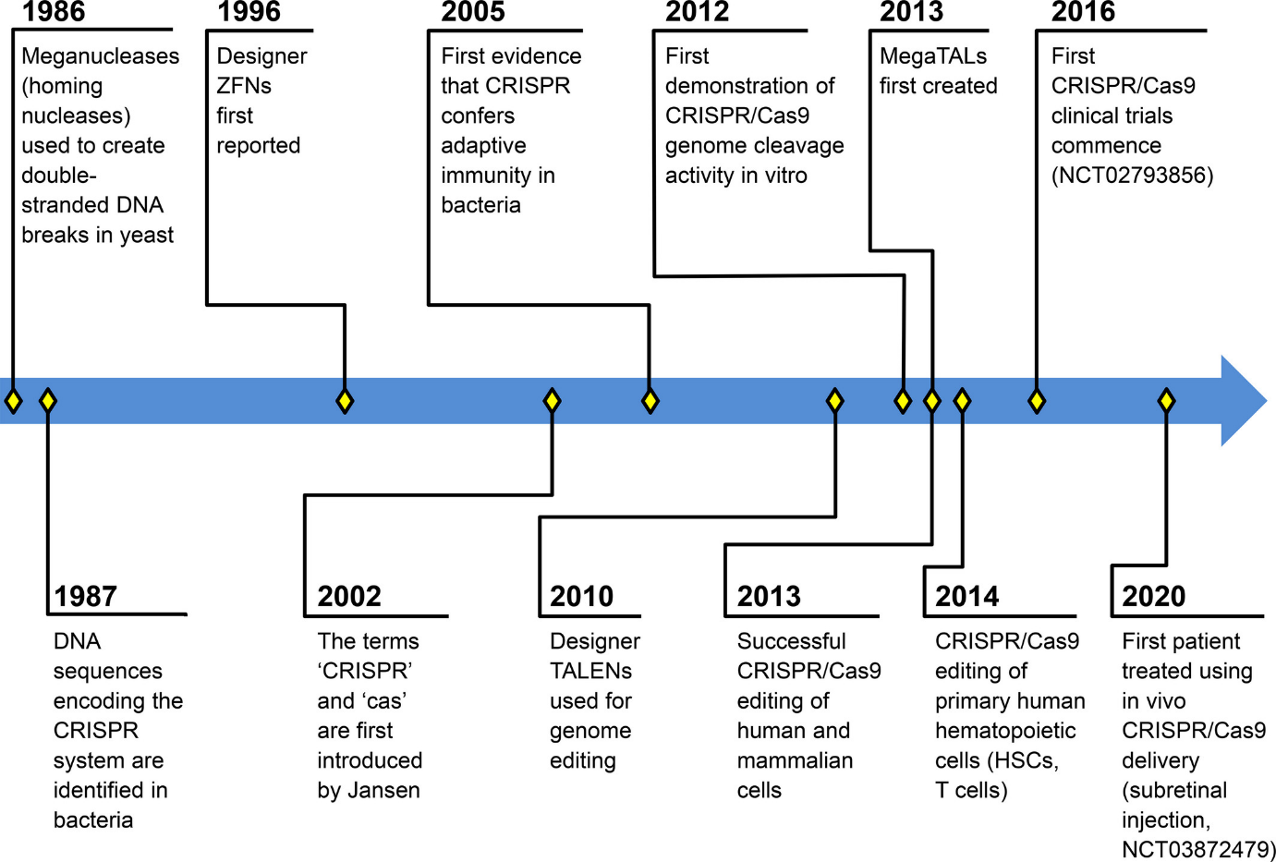

Figure 1.11: Highlights of genome editing development
Timeline describing the important chapters of CRISPR/Cas9 (Clustered regularly interspaced short palindromic repeat (CRISPR)/ CRISPR-associated protein 9 (Cas9) system) and other editing platform development. Notable publications associated with time events: 1986,²⁴² 1987, ²⁴³ 1996, ²⁴⁴ 2002,²⁴⁵ 2005, ^{243; 246; 247} 2010, ^{248; 249} 2013, ^{238; 239; 240; 241; 250} 2014, ^{251; 252}
Adapted from: Humbert-Samuelson et al, 2019

In CRISPR/Cas9 genome editing, the Cas9 protein is complexed with a guide ribonucleic acid (RNA) sequence to form the ribonucleotide protein (RNP) which targets and then creates a DSB at the desired location. Once that DSB is formed, there are two pathways by which the DNA is repaired, known as non-homologous end joining (NHEJ) and homologous recombination (commonly known as homology-directed repair, HDR). Where repair by the NHEJ pathway takes place, this is an error-prone process and there arises the likelihood of small insertions and deletions (indels) at the repair site which may alter or disrupt the function of the gene or epigenetic region. Where CRISPR/Cas9 RNPs are applied without the addition of a DNA template for repair of the disrupted region, NHEJ and resultant disruption of the targeted region is the goal. Alternatively, a template for repair can be provided in the form of a single or double-stranded DNA sequence, in which case inclusion of this new genetic material is the planned outcome. A third pathway for DNA repair has more recently been recognised and is termed microhomology-mediated end joining (MMEJ). This contains elements of both the NHEJ and HDR repair pathways.²⁵³ A pictorial representation of the different DNA repair pathways harnessed during CRISPR/Cas9 editing is featured in figure 1.12 below.

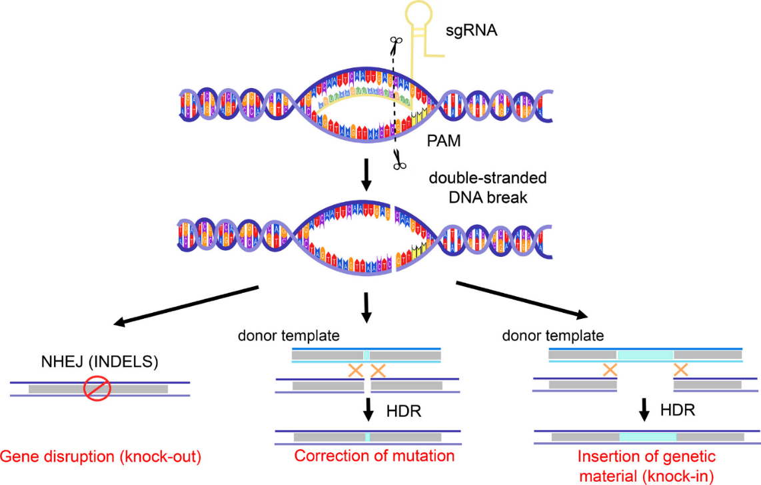
Figure 1.12: Simplified mechanism of CRISPR/Cas9 genome editing
Single guide RNA (sgRNA)‐mediated recognition of the chromosomal target sequence via the protospacer adjacent motif (PAM) sequence. A double‐stranded cut occurs three nucleotides upstream of the PAM sequence and enlists the non‐homologous end joining (NHEJ) or homology‐directed repair (HDR) pathways. INDELS = insertions and deletions.
Humbert-Samuelson et al, 2019, with figure design by M Cui

1.4.1.2 Genome modification of HSPCs
The rationale for targeting HSPCs for genome editing is that these cells self-renew and repopulate all haematopoietic lineages over time. Therefore, genetic modifications applied to HSCs are expected to persist long-term in mature blood cells.^{254; 255} HSPCs were originally targeted for genetic modification using retroviral vectors, and lentiviral gene transfer is now being applied to the treatment of a multitude of clinical disorders.^{256; 257; 258; 259} There are, however, many advantages of genome editing above vector-based therapies. These include a more precise targeting of DNA modification, rather than semi-random insertion, and therefore a lower risk of pathogenic mutagenesis including oncogenesis.^{260; 261; 262} Other advantages can include utilisation of physiological promoters and the avoidance of the need for large-scale clinical-grade vector production, which often limit the efficacy and applicability of lentiviral gene transfer therapies.
1.4.2 Genome editing for haemoglobinopathies
Here I will review in detail the different approaches to genome editing for the cure of haemoglobinopathies, including reactivation of HbF production by disruption within the HBG promoter region or BCL11A enhancer; or introduction of intact haemoglobin genes including HBB (β globin gene), HBG (γ globin gene), or a variant of HBB (such as the Lentiglobin gene used by Bluebird, which is purported to code for a modified β globin chain with anti-sickling properties, but the sequence has unfortunately not been published by the company).
For the sake of improved readability, throughout this thesis the HBG promoter region is referred to simply as ‘HBG-113’ and the BCL11A erythroid enhancer region referred to as ‘BCL11A-ee’. It should be noted that the targets of the experiments have been these promoter and enhancer regions respectively, rather than the coding regions of the genes themselves. Of course, it would be counterproductive to knockout the HBG gene itself since the goal of these experiments was to increase HBG expression. The rationale for avoiding knockout of BCL11A coding regions however requires some further explanation. There had been earlier reports of attempts to knockdown the BCL11A gene itself (with use of interfering RNAs or by genome editing in a non-erythroid specific manner) but where BCL11A expression was significantly reduced in a non-lineage-specific manner, these strategies resulted not only in defective production of mature erythroid cells (in particular, a failure of erythroid enucleation) but an overarching defect of long-term engraftment of edited HSPCs where transplanted into mice, therefore this approach is unsuitable for clinical application. In contrast to this, reduction of BCL11A transcription in an erythroid-specific manner (by application of short hairpin RNA (shRNA) to erythroid progenitors, or by editing at the intronic erythroid-specific BCL11A enhancer) allows for normal engraftment and erythroid maturation.^{263; 264} Editing at the erythroid-specific enhancer of BCL11A targets an intronic region within the enhancer and aims to disrupt a GATAA motif, which is involved in binding of upregulating transcription factors, in particular GATA1 and TAL1, thereby reducing BCL11A transcription in a manner which is erythroid-specific. This, therefore, does not impact on engraftment and differentiation of HSCs or on other haematopoietic lineages.^{263; 265; 266; 267}
One area which requires some further explanation is the reference made to microhomology-mediated end joining (MMEJ). Interestingly, NHEJ-directed CRISPR/Cas9 editing at either HBG-113 or BCL11A-ee loci does not result in an entirely random pattern of insertions and deletions but there are certain deletion lengths which appear to be more common. Small (1-2 nucleotide) insertions and deletions are seen in many cells, which is expected whenever NHEJ editing is applied to any locus. However, there are certain longer deletions which appear to be favoured at these targets as well, and it is hypothesised that these are induced by a microhomology mediated end joining (MMEJ) process. 13nt deletions are commonly seen with HBG-113 editing, whereas 13- and 15nt deletions have both been reported at a higher frequency than would be expected in random indel formation in the case of BCL11A-ee editing.^{268; 269; 270}
There are now over 40 clinical trials involving genome editing, including various platforms and different conditions. Of particular relevance, CRISPR Therapeutics and Vertex Pharmaceuticals (CTX001), and separately, Sanofi and Sangamo Therapeutics (BIVV003, ST400) are currently investigating the use of genome editing to disrupt BCL11A-ee in order to increase circulating HbF levels with the aim of ameliorating sickle cell disease and TDT. HSPCs are modified ex-vivo and then subsequently returned to patients in a modified autologous stem cell transplant procedure. The reader is referred to the Humbert-Samuelson paper for more extensive discussion of the progression of genome editing clinical trials for haemoglobinopathies as well as many other diseases.⁹
1.4.3 Ongoing challenges facing genome editing therapies
Although genome editing treatments have already come a long way, there remain significant obstacles to be overcome before they can be routinely introduced into clinical practice. These include limitations around safety, efficacy, and more practical issues.
As described above, genotoxicity is expected to be significantly lower with genome editing than retroviral vector-based therapies. However, this is not to say that the risk of mutagenesis has been entirely eliminated. Off-target DNA breaks still occur which may disrupt vital genes such as tumour-suppressor genes, or allow the creation of oncogenes.^{271; 272; 273} On- and off-target DNA breaks can result in chromosomal rearrangements with similar results.²⁷⁴ Unintended germline editing must be seriously considered as in vivo applications of genome editing become more popular, the consequences of which are largely unknown. Negative publicity surrounding the unsanctioned genome editing of embryos in China, which were subsequently allowed to progress to term, highlights the vast landscape of unknown unknowns where germline editing is concerned, and it would be irresponsible not to consider the potential for misuse of these technologies.²⁷⁵ Finally, cytotoxic conditioning is still required for the modified autologous transplantation procedures involved in HSPC editing therapies, with further risk of future malignancy as well as other acute and chronic complications.^{276; 277}
As second major challenge is ensuring that a therapeutic level of modified cells persist in the long-term following genome editing treatments. This is particularly a problem where HDR strategies are applied to HSPCs, but lower levels of editing after time is also seen following NHEJ treatments.^{278; 279; 280}
Alongside safety concerns and limited efficacy, there are significant practical challenges involved in the clinical delivery of CRISPR/Cas9 therapies. Where HSPCs are the targets of therapy, these cells normally reside in the BM niche. They can be harvested directly, but this is an invasive procedure and usually requires a general anaesthetic, which confers additional risk particularly in the sickle cell disease population.²⁸¹ Alternatively, HSPCs can be mobilised into the PB and harvested in an apheresis procedure. While this avoids the need for invasive surgery, it can be difficult to collect adequate HSPCs by this method and mobilization is not straightforward in sickle cell disease patients, who cannot receive the most common mobilisation agent – granulocyte colony-stimulating factor (G-CSF) - due to a risk of precipitating life-threatening sickling crises.^{282; 283}
Finally, the costs involved in the development and delivery of genome editing therapies are likely to make these treatments unattainable for the vast majority of patients who require them.²⁸⁴ In developing countries, not only costs but also infrastructure requirements are likely to be prohibitive, such as the need for Good Manufacturing Practice-grade cell processing and manufacturing facilities.
1.4.4 Future directions
Methods to improve in vivo editing levels include increasing editing efficiency of the initial application, and positive selection of modified cells either in vitro or in vivo. Examples of the former approach include chemical modifications applied to the RNP compound to increase target specificity or potency.²⁵¹ A good example of the latter would be the provision of a homing and engraftment advantage to genome edited cells, such as by increasing C-X-C chemokine receptor type 4 (CXCR4) expression on the surface of modified cells pre-transplant so that their homing and engraftment is supported above that of unmodified cells, providing a competitive advantage.^{285; 286} This is an area I have also worked on personally and have reported that while the use of wild-type CXCR4 overexpression is a more established (while still experimental) technique, if a constitutively active mutant of CXCR4 is used instead (introduced into cells via mRNA transfection around the same time as genome editing) the improvement in early homing of modified HSPCs is even greater (abstract presented at International Society for Experimental Hematology, 2020).
Various methods have been proposed to reduce potential genotoxic risk of CRISPR/Cas9 editing. While certainly not a comprehensive list, these include bioinformatic prediction software; higher-fidelity Cas9 variants; targeting of safe-harbour loci and, most recently, base editing platforms. Bioinformatic design and prediction tools should allow production of editing compounds least likely to generate pathogenic off-target mutations (reviewed by Liu et al,²⁸⁷). Higher-fidelity Cas9 preparations are also expected to reduce off-target mutagenesis, and work is ongoing to optimise these without compromising editing efficiency.^{288; 289} Where new genetic material is to be introduced, aiming to incorporate this into ‘safe harbour’ loci is a further approach to increase the safety of such therapies. Here, areas of the genome are targeted for DSB formation where essential genes are not predicted to be disrupted or disturbed, and the risk of oncogenesis is therefore minimised.^{290; 291} Finally, and most recently, editing compounds are being developed which allow precise nucleotide modifications without the creation of DSBs (or at least DSBs occur at a significantly lower rate). Both base editors and prime editors allow alteration of or introduction of new genetic material without the need for DSBs and therefore are expected to decrease genotoxic risk.^{292; 293; 294; 295; 296}

1.5 Rationale for research comparing genome editing strategies for the reinduction of HbF
There are now many published studies demonstrating the efficacy of HbF reinduction by NHEJ genome editing at either HBG-113 or BCL11A-ee (as referenced above). However, there are no published data comparing the two approaches directly. If one target is superior to the other in terms of HbF reinduction, cytotoxicity or engraftment, then this may guide future directions in clinical trials. Therefore, studies were undertaken to compare these single targets for editing.
In these experiments, the concept of multiplex genome editing was introduced, and the potential for dual targeting of both these loci in the same target cells studied – either simultaneously or sequentially. The rationale for the dual targeting approach is that it may result in greater HbF reinduction in one of two ways. Firstly, the total percentage of cells edited in at least one target region may be increased. Secondly, cells edited at both targets may have greater HbF reinduction per cell than cells edited at one target only. This multiplex approach has previously been applied to other cell types such as T lymphocytes including TCR-redirected and CAR-T cells. It has also been used in HSPC for the purpose of generating malignant transformation. However, no published data on multiplexing in HSPCs for therapeutic application is as yet available, making this strategy a novel one in this cell type.^{239; 297; 298; 299; 300}
One drawback to the dual targeting approach is the increased potential for translocation and other chromosomal rearrangement events to occur if multiple DSBs are created simultaneously within a cell’s genome.³⁰⁰ Translocations were reported in all in vitro products and all 3 patients reinfused with T cells which had undergone multiplex genome editing in a clinical study recently published by Stadtmauer.²⁹⁹ The risk of translocation was therefore addressed in these experiments initially by standard qualitative PCR and, following this, was further investigated in a quantitative manner by digital droplet PCR (ddPCR).
Herewithin, multiple in vitro, ex vivo and in vivo experiments are described to compare the individual HBG-113 and BCL11A-ee targets of genome engineering, as well as simultaneous and sequential dual edited approaches. Editing efficiency, cytotoxicity, engraftment and proliferation potential, and HbF reinduction are compared, with the latter being assessed by flow cytometry and also by HPLC.
Non-obese diabetic (NOD)-severe combined immunodeficiency (SCID)-common γ chain-/- (NSG) mice engrafted with human CD34⁺ cells (the most common marker used to identify human HSPCs) have commonly been used as a preclinical model to study HSPC transplantation and multilineage engraftment.^{301; 302; 303} However, recognised limitations with this model include the lack of long-term data on engraftment and editing levels in vivo due to limited survival of the animals, and also that this model does not support the production of human erythrocytes.
Numerous challenges have been overcome and others are still in the process of being tackled:
PCR assays involving BCL11A-ee required significant work to develop and optimise them due to numerous obstacles. The first of these was a high degree of homology between mouse and human BCL11A enhancer regions. In addition there is a high proportion of GC nucleotides around the intended cut site which was thought to be interefering with the denaturing component of the PCR reaction. Finally, there was inadequate purity of DNA extracted using initial techniques. Work to optimise this assay included design and comparison of numerous primer pairs; use of a GC-rich buffer in the PCR reaction; optimisation of the PCR conditions including annealing temperature and cycle number; and the discovery that Epicenter DNA extraction gave suboptimal purity DNA therefore a switch to Qiagen micro DNA kit was made.
Translocation PCR assays also suffered from the same problems as those used to assess BCL11A-ee editing efficiency. While the basic translocation PCR assay post-optimisation is still believed to have limited sensitivity, it now demonstrates reliable specificity. The accuracy has been validated by Sanger sequencing of a number of reactions in which the translocation was demonstrated by PCR, confirming the finding. This assay remains qualitative only, and therefore further work focused on the quantitative assessment of translocation events using ddPCR technology, in collaboration with colleagues in the Jerome laboratory at the Fred Hutch, who had the requisite expertise and technology to assist with the design and set up of these assays.
The use of single BFU-E (burst-forming unit-erythroid) analysis in these experiments is a technique which took many experiments to optimise, and which is now providing very useful information. The benefit of analysing single BFUs (burst-forming units) is that each is expected to be a single genetic clone. There are two main benefits to this. Firstly, following multiplex editing, analysis of bulk cells in vitro can give a percentage of editing at each locus, but does not provide information on whether these edits are within the same cells. Single BFU-E analysis, on the other hand, can answer this important question, by analysis of each potentially edited site within the single clones. In addition, where a second assay for HbF level is superimposed, this starts to provide data on the relationship between the editing profile and HbF reinduction in a granular fashion. Although access to single BFU-E HPLC analysis was limited due to reliance on an industry collaborator, the potential of this approach is clear and the early results presented here demonstrate the importance of being able to make more detailed analysis of genotype-phenotype correlations.

1.6 Background to stem cell mobilisation and apheresis
To date, the vast majority of preclinical and now clinical genome editing studies involving HSPCs have involved the ex vivo modification of these cells. This presents a challenge as HSPCs normally reside in the BM and access to these cells for collection is not straightforward. The same issue is presented during any more routine autologous (i.e. from self) or allogeneic (i.e. from a donor) HSCT, which constitutes the gold standard treatment for many haematological and solid malignancies, BM failure syndromes, immunodeficiencies, with indications for HSCT continuing to expand.³⁰⁴
HSPCs can be collected either directly from the BM, or they must be mobilised from their BM niche into the PB prior to collection via an apheresis procedure.^{282; 305} The former method is an invasive procedure, which is painful and risks causing bleeding, infection and structural damage.^{281; 306} For these reasons it is usually carried out under general anaesthetic, which confers minor side effects for the majority of healthy individuals, but for patients with sickle cell disease requires more extensive pre-operative preparation and carries increased risk of complications, such as the precipitation of painful bony crises or potentially life-threatening chest crises.^{307; 308} To avoid the need for direct BM harvest, in the majority of cases collection of HSPCs from the PB is generally preferred, in a non-invasive, relatively safe and straightforward procedure.²⁸² For patients with sickle cell disease, it is especially important to opt for PB stem cell collection where possible, and current clinical trials of gene therapies for sickle cell disease utilise apheresis-collected PB HSPCs.⁹ A further advantage to transplantation of PB HSPCs rather than BM-derived cells is more rapid haematopoietic reconstitution, ensuring that the period of time during which patients are cytopenic, and at risk of related complications such infection and bleeding, is minimised.^{306; 309}
At the commencement of this work, all NHP modified autologous HSPC transplants including those involving genome editing for HbF reactivation undertaken by our group, had been conducted using cytokine-stimulated, BM-derived HSPCs.²⁸⁰ Cytokines used were stem cell factor (SCF, which is not used in patients) and granulocyte colony stimulating factor (G-CSF, which is in routine clinical use).^{280; 310} In order to improve clinical applicability of our genome editing strategy, our group decided to move towards apheresis-derived PB HSPCs for HbF-reinducing genome edited modified autologous transplants in the NHPs. Therefore, one substantial part of my role during this time was to produce a safe and reliable mobilisation and apheresis protocol for use in the NHPs.
Development of an effective apheresis procedure while avoiding unnecessary risks and toxicities was a major challenge. Even in the clinic, with a vast amount of experience and evidence on which to base practice, apheresis is not straightforward for smaller subjects.³¹¹ It is recognised that special precautions and modifications to standard procedures must be undertaken when small children undergo apheresis, and our animals were significantly smaller than even most of these young patients. All aspects of the process including practicalities such as tubing sizes and programming of the apheresis equipment, down to prevention of intra-luminal platelet clumping or thrombosis had to be addressed.
The issue of HSPC mobilisation was also not easy to address. The most frequently administered HSPC mobilisation agent in clinical practice and preclinical studies is G-CSF.²⁸² Recombinant human G-CSF is a pro-inflammatory cytokine which boosts activity of haematopoietic cells from primitive progenitor cells to mature granulocytes, increasing numbers of these cells in the BM and PB circulation.^{312; 313} However, G-CSF has been reported to precipitate life-threatening sickle cell crises and is therefore unsuitable for use in this patient population.³¹⁴
AMD3100 (Plerixafor, Mozobil) was first approved for clinical use as a second mobilisation agent in 2008, providing an additional or alternative option for patients and HSPC donors. AMD3100 is composed of bicyclam rings connected by a 1.4-phenylenebis(methylene) linker (Fig 1.13).^{10; 315}

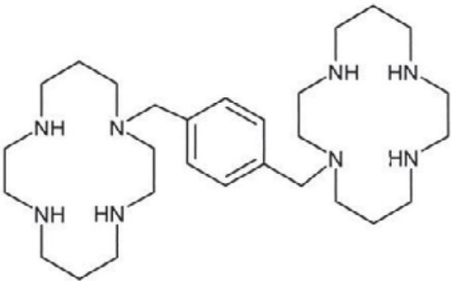
Figure 1.13: Bicyclam ring structure of the AMD3100 molecule
Fricker, 2013

Mechanism of action of AMD3100 is thought to be primarily by reversible, competitive antagonism of the cytokine receptor CXCR4 on the HSPC cell surface, interrupting the bond with its ligand CXCL12 (C-X-C motif chemokine ligand 12) in the BM. Interaction with a second receptor, CXCR7 (C-X-C chemokine receptor type 7), for which AMD3100 acts as an allosteric agonist, is also likely to contribute to its mobilisation properties.^{316; 317} In addition, AMD3100 administration has been demonstrated to reverse the CXCL12 gradient across the BM niche in mice,¹² which may contribute to the egress of HSPCs from the BM into the PB circulation (Fig 1.14-1.16).
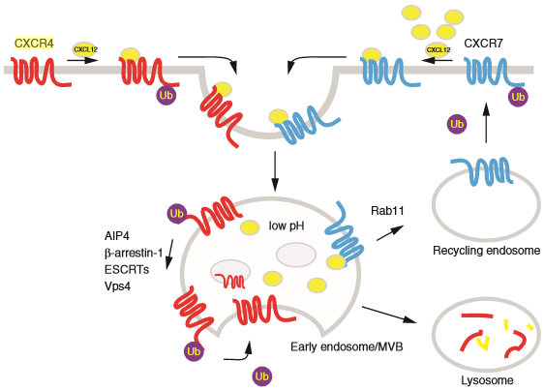
Figure 1.14: CXCR4 and CXCR7 physiology
Physiological mechanisms involved in binding of cell surface cytokine receptors CXCR4 and CXCR7 to their ligand CXCL12. It is these interactions which are interrupted on administration of ADM3100.
Abbreviations: CXCL12: C-X-C motif chemokine ligand 12, CXCR4: C-X-C chemokine receptor type 4,
CXCR7: C-X-C chemokine receptor type 7

Marchese, 2014

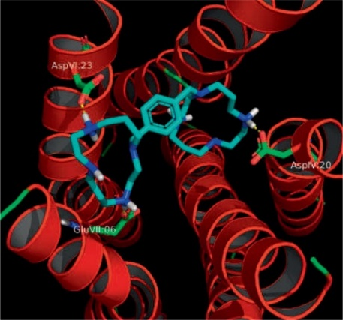
Figure 1.15: Plerixafor binding to CXCR4
The binding mode of plerixafor to CXCR4 showing interactions with AspIV:20, AspVII:23 and GluVII:06 (Asp171, Asp262 and Glu288 on TMIV, TMVI and TMVII respectively).
Abbreviations: Asp: aspartic acid, CXCR4: C-X-C chemokine receptor type 4, Glu: glutamic acid, TM: transmembrane alpha helix
Fricker, 2013

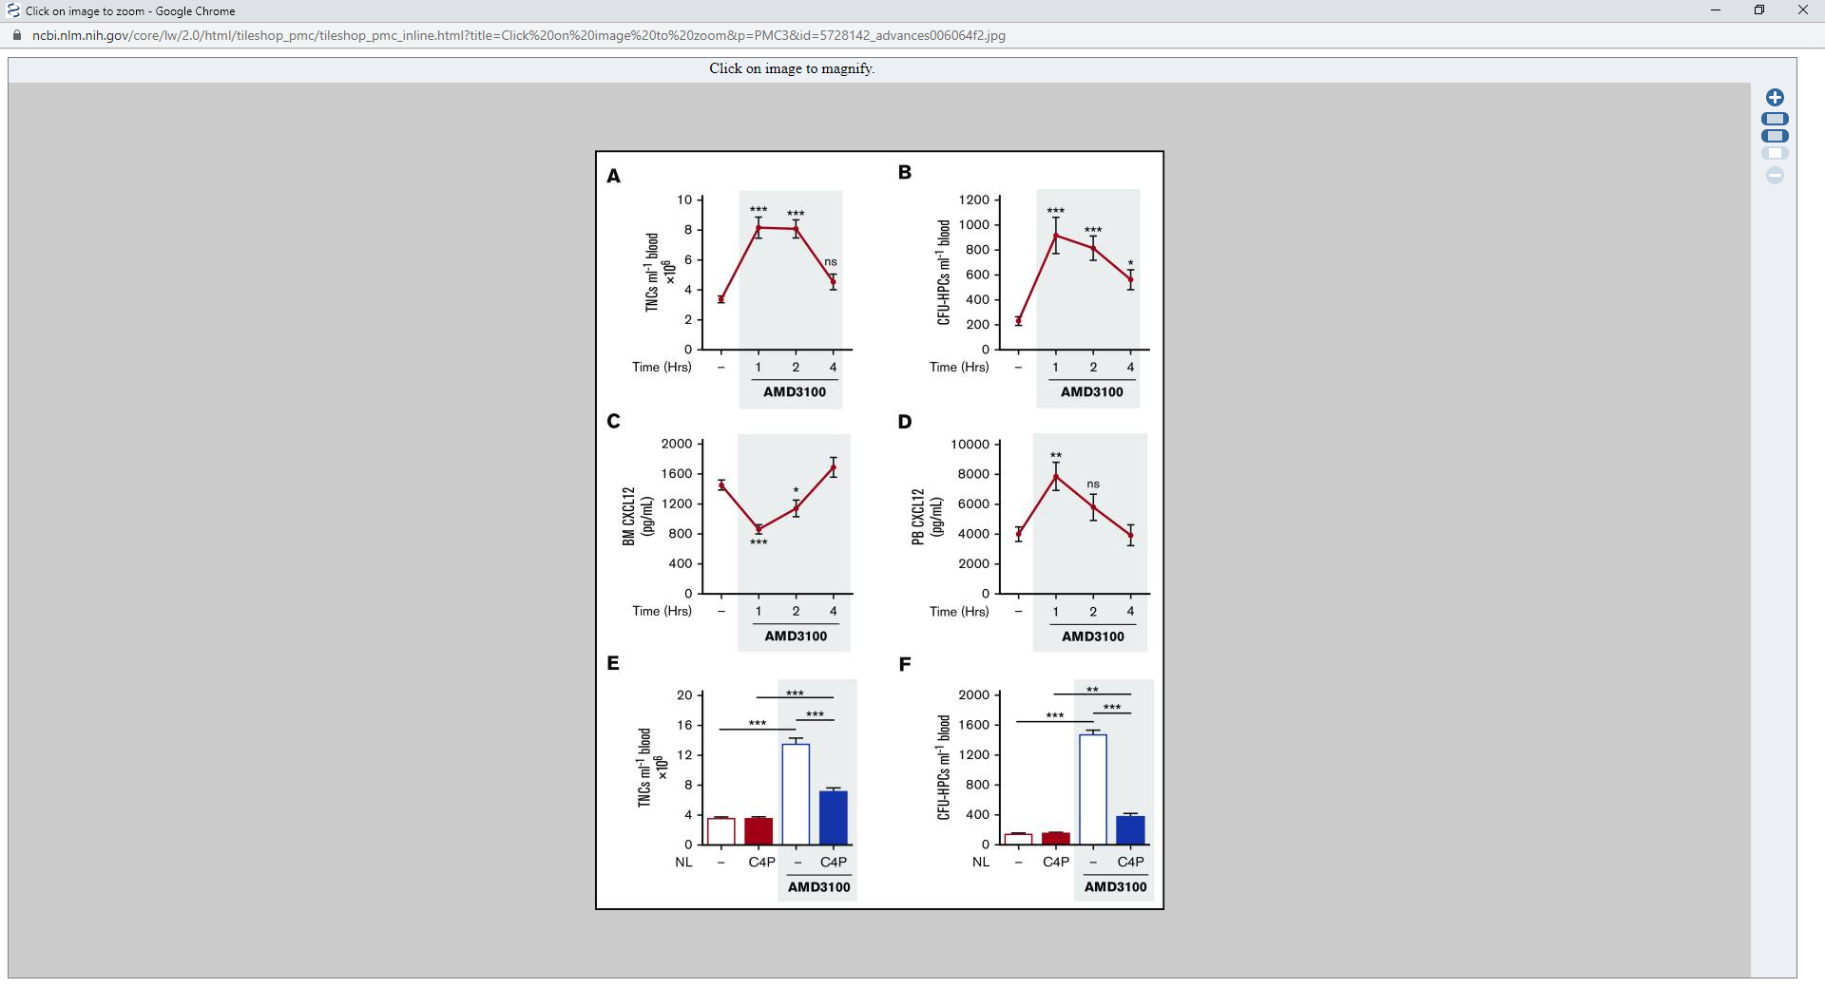
Figure 1.16: AMD3100 effect on mouse bone marrow and peripheral blood
Data demonstrating a reversal of the usual bone marrow (C) : peripheral blood (D) CXCL12 ratio on administration of AMD3100 to mice, associated with egress of nucleated cells (A) and in particular those with CFU-forming potential (B) from the bone marrow into the blood stream.
Abbreviations: CFU: colony forming unit, CXCL12: C-X-C motif chemokine ligand 12
Redpath et al, 2017

While the licence for AMD3100 is currently restricted to use in addition to G-CSF for patients with plasma cell myeloma or non-Hodgkin lymphoma who fail to mobilise adequately with G-CSF alone,³¹⁸ it is already routinely used in the clinic for a significantly broader set of indications, with clinical use continuing to increase,^{319; 320; 321}
AMD3100 is most frequently used alongside G-CSF, where its addition results in higher numbers of circulating HSPCs and better chance of successful harvest to facilitate transplantation.^{322; 323} AMD3100 is also now used as a single mobilisation agent,^{320; 324; 325} thereby circumventing common side-effects and occasionally severe complications associated with G-CSF administration. These include bone pain, flu-like symptoms, and splenic rupture in patients and donors.^{326; 327} AMD3100 administration, on the other hand, is usually associated with minimal side-effects.^{320; 328}
In addition, the kinetics of AMD3100 ensure more rapid mobilisation of HSPCs in comparison to G-CSF. Routine dosing schedule for G-CSF requires 4-5 days of daily or twice-daily parenteral administration prior to apheresis, whereas AMD3100 is often effective as a single dose given only hours prior to harvest.³²⁹ AMD3100 has also successfully been trialled as a single agent in healthy donors where the dramatic reduction in the burden of iatrogenic symptoms and length of preparation time prior to apheresis is particularly meaningful.^{320; 330} Another situation in which AMD3100 must be administered as a single mobilisation agent is in patients with sickle cell disease, in whom HSPCs are collected for the purpose of ex vivo genome modification strategies. As discussed above, G-CSF carries a risk of precipitating life-threatening sickle cell crises, and is therefore contra-indicated.²⁸³ AMD3100, on the other hand, is both safe and effective in this patient population.^{331; 332} To ensure clinical translatability of our genome editing transplant protocols, protocols were developed for the use of AMD3100 alone as a mobilisation agent for NHP transplant candidates prior to apheresis collection.
AMD3100 has previously been demonstrated to effectively mobilise rhesus macaques for apheresis HSPC collection both in conjunction with G-CSF and as a single agent.^{333; 334} Larochelle et al reported successful HSPC mobilisation after administering a 1mg/kg subcutaneous (SQ) dose of AMD3100 and therefore this dosing regimen was emulated in our experiments and we confirmed the efficacy of a first dose of AMD3100 to mobilise HSPCs in our NHP subjects.
An incidental but highly important finding was made during these experiments that while AMD3100 effectively mobilises NHP HSPCs on first administration, it fails to remobilise the same recipients on repeat administration. Once these results were confirmed by repetition in additional animals, further experiments were carried out in humanised mice to establish whether the same effect would be observed in human HSPCs. An inability to effectively re-administer AMD3100 to both preclinical and clinical subjects is expected to have significant impacts on autologous and allogeneic HSCT protocols in both animal subjects and in the clinic, as well as the design of in vivo HSPC genome engineering protocols in the future.

1.7 Aims, Objectives and Hypothesis
1.7.1 Experimental hypothesis
HbF reinduction in NHPs can be maximised by a multiplex CRISPR/Cas9 editing strategy targeting both HBG promoter and BCL11A erythroid enhancer regions, in a genome modified AMD3100-mobilised PB HSCT procedure.
1.7.2 Aims and objectives
- To establish the feasibility of a multiplex CRISPR/Cas9 genome editing strategy targeting both HBG promoter and BCL11A erythroid enhancer regions and to compare cytotoxicity, engraftment potential and HbF reinduction with cells edited at one region only, in vitro and in the humanised mouse model.
- To investigate the possibility of chromosomal rearrangement events being generated where both sites are targeted in a single reaction, either simultaneously or sequentially.
- To investigate the efficacy of HSPC mobilisation into the PB by repeated doses of AMD3100 with apheresis collection in NHPs.
- If the safety and increased efficacy of this dual editing approach can be established in vitro and in the humanised mouse model, to further investigate this strategy using an AMD3100-mobilised PB stem cell (mPBSC) modified autologous transplant in NHPs.

2.0
Chapter 2:
Materials and methods

2.1. Ethics and animal welfare statements
All animal management conforms to recommendations of the Guide for the Care and Use of Laboratory Animals of the National Institutes of Health.³³⁵ All mouse experiments were granted approval by the Institutional Animal Care and Use Committee (IACUC) of the Fred Hutchinson Cancer Research Center and University of Washington, under protocol #1864. NHPs were cared for at the University of Washington Primate Center, and treated on IACUC-approved protocol 3235-01. All animal care and procedures were carried out by appropriately trained veterinary scientists or animal technicians.
2.2 General mouse care protocol details
Pain assessment categories covered were category B (Animals being bred, conditioned, or held for use in teaching, testing, experiments, research or surgery, but not yet used for such purposes. No pain or distress. For example, breeding colonies, holding protocol) and categories C-D (Brief painful procedures for which analgesia or sedation was not required; Pain or distress relieved by appropriate measures). All animal handling and procedures were carried out by appropriately trained and competent staff, or by trainee staff under competent supervision.
NSG mice were housed and bred in-house at the South Lake Union Campus in pathogen-limited housing conditions, managed by the Comparative Medicine department. Housing followed Comparative Medicine standard operating procedure (SOP) 018-1 ‘rodent housing requirements’ and guideline 021-I "Animal Social Housing and Environmental Enrichment’. Weight and health were assessed at least weekly and the protocol for early euthanasia followed by the animal husbandry staff where this applied.
Mice were identified by cage cards and by ear tag as approved in SOP 040-I. Different groups of neonatal mice within the same litter were identified by tail clipping as approved in SOP 036-I. PB draws by retro-orbital collection according to SOP 038-I with isoflurane were performed every 1-3 weeks depending on the experiment. A maximum volume of 200 μl was collected in any 2 week period. Retro orbital bleeds without anaesthesia were performed once competency on the part of the relevant staff member was demonstrated.
At the end of the experiment, a final retro-orbital blood collection of up to 500 μL was taken under isoflurane anaesthesia and immediately followed by CO₂ euthanasia and cervical dislocation according to SOP 039-I.
Criteria for early euthanasia (humane endpoint): Severe loss of weight (20% weight loss indicated immediate euthanasia), severe side-effects of irradiation, no reconstitution leading to severe haematological abnormalities or disorders (e.g. engraftment failure, anaemia, etc.), obvious pain, sepsis, any other indications leading to pain following any procedures. All recommendations of Comparative Medicine veterinary staff were followed for animals in poor health requiring early euthanasia according to SOP 039-I. Occasionally, due to the variability of donor CD34⁺ cells, graft-vs-host disease (GvHD) occurred causing overall health decline in the mice. This was measured by severe weight loss, prolonged hunched posture, and hair loss. Any mice experiencing these symptoms met the criteria for an early euthanasia as outlined above.
Breeding colony information: Breeder pairs were at times supplemented with nutrient-rich food (LoveMesh) which enhances lactation and mild production for successfully maintaining pups (https://www.bio-serv.com/product/S3823P.html). Occasionally, weaned mice are small or runted, especially experimental mice after receiving minor irradiation. If this is case, mice could be left with the dam for additional time, not to exceed 28 days, unless a second litter is born in which case the older litter will be immediately weaned. If weaned mice appear smaller or runted, they may be supplemented with DietGel boost (high calorie diet [http://www.clearh2o.com/research-products/dietgel/dietgel-boost-2.html]) to help them to gain weight.
Breeding animals were monitored weekly. Any animals that exhibit the following criteria qualified for early euthanasia: impaired mobility, inability to reach food and water, hunched posture for > 48 hours, laboured breathing and/or cyanosis (bluish ears, feet or mucous membranes), abnormal response to stimuli (slow to move/does not move or reacts excessively), body conditioning score <2, and skin ulceration and/or necrosis. If any female breeder is observed to be in dystocia, the animal will be euthanised immediately.
2.3 CD34⁺ enrichment of peripheral blood mononuclear cells
PB mononuclear cells (MNCs) were collected by apheresis from adult donors after mobilization with G-CSF, and cryopreserved at -80ºC prior to use. Apheresis products were purchased from the stem cell core at the Fred Hutchinson Cancer Research Centre (FHCRC) or were sourced from the Seattle Cancer Care Alliance from two types of donor. The first was healthy donors who were donating for research. The second scenario was collection of autologous PB HSPCs for the purposes of later autologous HSCT in patients with glioblastoma. Where these patients became ineligible for transplant or did not receive the autologous transplant before death, and where they had consented to their product being used for research, these apheresis products were also sometimes used for CD34-enrichment. As per centre protocols, apheresis product should be stored at -80ºC prior to use.
MNCs were thawed using pre-prepared buffer: 1X PBS with 2% fetal bovine serum (FBS), 1% deoxyribonuclease (DNAse) (DNAse I from bovine pancreas, Millipore) and 0.2% EDTA (EDTA 0.5M, Millipore). The DNAse was to manage clumping of dead cells within the product which interfered with preparation and enrichment processes. Apheresis product was thawed rapidly in its bag then thawing buffer was added to slowly increase the volume to approximately double, which was then drawn out of the bag using a needle and 50ml syringe and transferred into 50ml conical flasks. Depending on the red cell contamination of the product, one lysis step was carried out if required but in many cases was not necessary, likely due to red cell lysis during the freeze-thaw process. Where lysis was required, haemolysis buffer was used which was prepared in-house: 150mM ammonium chloride, 12mM sodium bicarbonate and 0.1mM EDTA were mixed into distilled deionised H₂O and sterile filtered (0.22 uM filter units used). Cells were resuspended in haemolysis buffer in 50ml conical tubes to a total of 45ml and incubated at room temperature for 5 minutes prior to centrifugation at 800 g for 5 minutes.
Depending on how much cell clumping occurred, the product underwent 1-3 filtration steps, being passed through a 70 μm filter to remove non-cellular debris. This is different from manufacturer’s instructions which recommended a 30 μm filter, but using a smaller pore filter resulted in loss of a large number of cells, since there was a significant amount of cell death which caused clumping within the apheresis product and could result in loss of live cells as well as the dead cellular debris with smaller pore filters.
The cells were then spun down at 800g for 5 minutes after which the supernatant was aspirated and cells resuspended in SFEM (Serum-free expansion medium) II media (Stemspan) but in this particular case there were no added cytokines. Cells were incubated at 37ºC for 2 hours which allows loss of non-HSCs, after which cells were spun again and media aspirated.
Cells were resuspended in Miltenyi buffer which was prepared in advance: 1X PBS with 0.2% of 10% bovine serum albumin and 2mM EDTA. CD34⁺ enrichment was carried out using the CD34 UltraPure Human CD34+ MicroBead enrichment kit (Miltenyi) according to manufacturer’s instructions (described below). The following in vitro experiments were undertaken 5 times using 5 separate cryopreserved apheresis products from 4 different donors.
Cells were suspended in Miltenyi buffer at a concentration of 1x10⁸ cells in 300 μL buffer. Following suspension, 100 µL of FcR (Fc receptor) Blocking Reagent was added to the cell suspension. CD34 MicroBeads UltraPure (100 µL) were then added. After mixing, the cells were incubated for 30 minutes at 4ºC. Cells were washed by adding 5−10 mL of Miltenyi buffer then centrifuged at 800 g for 5 minutes and supernatant aspirated.
Cells were then resuspended in 500 µL Miltenyi buffer and magnetic separation carried out on a MACS column (size dependent on cell number, usually LS columns used). The column was placed in the magnetic field of a suitable MACS Separator and prepared by rinsing with 3 ml buffer. Cell suspension was then applied to the column and flow-through collected in a 50 ml conical flask. The column was washed with the same volume of Miltenyi buffer used for the initial preparation step, and this was repeated a further 2 times for 3 washes in total.
The column was removed from the separator and placed into a 15 ml sterile conical tube. 5 ml Miltenyi buffer was pipetted into the column which was immediately flushed by firmly pushing the plunger into the column.
Quality control (QC) was carried out by staining aliquots of CD34-enriched and flow-through fractions with the haematopoietic stem cell (HSC) antibody panel followed by flow cytometric assessment. Antibodies added for QC were: CD45-PerCP (Peridinin-Chlorophyll-Protein) (clone 2D1, BD (Becton Dickinson)) CD34-APC (Allophycocyanin) (clone 563, BD), anti-CD90-PE (phycoerythrin)-Cy7 (Cyanine7) (clone 5e10, Biolegend) and anti-CD45 RA-APC-H7 (APC-cyanine) (clone 5H9, BD). Samples were incubated with antibodies for 25-30 minutes at 4 ºC before flow cytometric analysis. Single colour compensation beads were also run each time and used for voltage setting and post-acquisition analysis using Flowjo V9. Where CD34⁺ purity was inadequate, a further enrichment step was carried out followed by repeat QC. This was particularly important prior to transplant into mice, as a low CD34 purity implied a likely high T cell contamination of the cells, which would lead to GvHD in the mice.
2.4 CRISPR/Cas9 editing protocol
The CRISPR/Cas9 editing protocol commenced 1 day following thaw and CD34-enrichment of MNCs.
Cells in SFEM II media were harvested, centrifuged at 800 g for 5 minutes (which was the maximum speed possible while preserving stem cell integrity) then underwent 2x wash steps with 1x PBS. This was to ensure removal of residual media in which RNAse activity would be present, which could inactivate the gRNA introduced as part of the RNP within the editing procedure.
Cas9 nuclease (Invitgrogen ™ Truecut™ Cas9 Protein V2, 5 ug/ul, ThermoFisher Scientific) and gRNA (Synthego) were mixed in a 1:5 ratio for ribonucleoprotein (RNP) conjugation, with approximately 60 pmol Cas9 and 300 pmol gRNA per 1x10⁶ CD34⁺-enriched cells for each editing target. Incubation of RNP reagents was for 15 minutes at room temperature.
Cells were resuspended in BTX buffer (BTXpress) and split into the appropriate number of separate reactions. Cells were added to RNPs, briefly mixed by pipetting, then transferred to 1 mm or 2 mm electroporation cuvettes (VWR) and electroporated at an appropriate voltage for 5 ms on a BTX 830 electroporator. Untreated reactions were not electroporated; mock treated reactions received electroporation only without the addition of RNPs. Immediately following electroporation, additional SFEM II media was added to the cell solution and cells transferred to non-TC (tissue culture) plates, with additional SFEM II added to give an estimated final concentration of 1x10⁶ cells / ml. Cells were then incubated overnight at 37 °C, 5 % CO₂, in a humid environment.
For single edited reactions, either HBG-113 or BCL11A-ee editing took place on day 0 (D0). For simultaneous double-edited reactions, full concentration of both HBG-113- and BCL11A-ee–directed RNPs were applied by electroporation simultaneously on D0. For sequential double-edited reactions, BCL11A-ee editing took place on D0 followed by HBG-113 editing on day 1 (D1), both utilising full concentration of reagents. Mock treated reactions underwent electroporation according to exactly the same protocol as edited reactions, with the omission of RNP reagents.
2.5 Cell culture
Cells were suspended in culture, counted and manipulated within positive pressure hoods under aseptic conditions.
Two different types of media were used in these experiments for cell culture. The first is referred to as ‘SFEM II’ as this is the major component, but has added cytokines and penicillin streptomycin. This media was always used for cell recovery post enrichment and editing. This media was prepared according to the following instructions: to prepare 100 ml media, 99 ml SFEM II media (Stemspan) was thawed and if it had not already been filter-sterilised (22 μM filter) this was carried out. Penicillin streptomycin (1 ml) was added followed by 100 μl each of: thrombopoietin (TPO), stem cell factor (SCF) and fms like tyrosine kinase 3 (FLT-3). This is according to previously published protocols.³³⁶
The second media described is intended to encourage erythroid differentiation in HSPCs post genome editing, in order to facilitate assessment of HbF reinduction. Cells cultured in SFEM II demonstrate minimal erythroid differentiation, and therefore result in very few cells in which haemoglobin type can be assessed by flow cytometry or HPLC. This media is referred to as ‘epo media’ or ‘differentiation media’ and is prepared according to the following instructions for the preparation of 100 ml: 90 ml IMDM ((Iscove's Modified Dulbecco's Medium) is used and to this is added 10ml foetal bovine serum (FBS) (tet-system approved FBS from Clontech), 1 ml penicillin streptomycin, 75 μl erythropoietin, 50 μl cyclosporin A, 20 μl SCF and 5 μl interleukin 3 (IL3).²⁸⁰
Cells were cultured at 37 ºC in a humid atmosphere with 5 % CO₂, in non-TC treated plates and flasks, and counted regularly (at least every 3 days) while in culture, as described above. Additional media was added as required to ensure that cell concentration did not exceed 1 x 10⁶/l as higher concentration was associated with increased cell death. For cells in epo media it was observed that maximum erythroid differentiation was obtained by keeping cells at a culture density closer to 0.5 x 10⁶/l, presumably due to increased availability of relevant cytokines to cultured cells. Once this was noted, cells were kept at lower densities in epo media.
Where cell numbers were high and the volume of media required would have been excessive to maintain a satisfactory concentration, a volume of cell culture suspension was harvested prior to addition of fresh media. In some cases, cell pellets were frozen to allow for DNA analysis at a future date. Where this took place, cells in suspension were centrifuged at 800 g for 5 minutes then supernatant was aspirated and discarded, before cell pellets were frozen at -20 ºC.
Cells were cultured at 37 ºC in a humid atmosphere with 5 % CO₂.
2.6 DNA extraction
2.6.1 DNeasy blood and tissue kit for bulk cells in culture
DNA was extracted from bulk cells in culture using DNeasy® blood and tissue kit (Qiagen) as per manufacturer’s instructions (2006 version), described below with details of any modifications made to standard operating procedures.
All centrifugation steps were carried out at room temperature (15–25 °C) in a microcentrifuge. Before using a kit for the first time, the appropriate amount of ethanol (96–100%) was added as indicated on the bottle to obtain a working solution. A thermomixer was preheated to 56 °C.
Fresh cultured cells: the appropriate number of cells (maximum 5 x 10⁶) was centrifuged for 5 min at 800 x g. The pellet was resuspended in 200 µl 1x PBS. Next, 20 µl proteinase K was added. When using a frozen cell pellet, cells were allowed to thaw before adding PBS until the pellet can be dislodged by gently flicking the tube. Following this, 200 µl Buffer AL was added (without added ethanol). The tube contents were then mixed thoroughly by pipetting, and incubated at 56°C for 10 min. Next, 200 µl ethanol (96–100%) was added to the sample, and mixed thoroughly by pipetting.
The mixture was pipetted into the DNeasy Mini spin column placed in a 2 ml collection tube and centrifuged at 20,000 g for 30 seconds (note the protocol recommended 6000g for 1 minute with this and similar steps below, but previous experience in the lab had allowed colleagues to confirm that a shorter spin time at higher g worked adequately and saved time). Flow-through and collection tube were discarded. The DNeasy Mini spin column was then placed in a new 2 ml collection tube and 500 µl Buffer AW1 added, then centrifuged at 20,000 g for 30 seconds. Flow-through and collection tube were discarded. DNeasy Mini spin column was placed in a new 2 ml collection tube and 500 µl Buffer AW2 added, then centrifuged for 3 min at 20,000 x g (14,000 rpm) to dry the DNeasy membrane. Flow-through and collection tube were discarded. It was important to dry the membrane of the DNeasy Mini spin column, since residual ethanol may interfere with subsequent reactions. This centrifugation step ensures that no residual ethanol will be carried over during the following elution.
Following the centrifugation step, the DNeasy Mini spin column was removed carefully so that the column did not come into contact with the flow-through, since this would result in carryover of ethanol. DNeasy Mini spin column was placed in a clean 1.5 ml or 2 ml microcentrifuge tube, and 30 µl of Buffer AE pipetted directly onto the DNeasy membrane (protocol specified 200 µl but previous experience had demonstrated that a lower volume resulted in higher DNA concentration being eluted which facilitated more successful PCR reactions. Tubes were incubated at room temperature for 1 min, and then centrifuge for 1 min at 11,000 g (as higher spin speeds resulted in the tube caps becoming detached) to elute.
2.6.2 DNA extraction with low cell numbers using Epicenter (Lucigen)
Initial method used: Epicenter kit (Lucigen), as per manufacturer’s instructions (2019 version), described below.
Cells were pelleted and resuspended in PBS. Proteinase K (1 µL) was added, followed by 300 µL of Tissue and Cell Lysis Solution for each sample. The mixture was combined by either vortexing for 20 seconds or pipette mixing. It was then incubated at 65°C for 15 minutes in a heated shaker block. Samples were placed on ice for 3-5 minutes and then 225 µL of MPC Protein Precipitation Reagent added then vortexed vigorously for 10 seconds. The debris was pelleted by centrifugation at 4°C for 10 minutes at ≥10,000 x g in a microcentrifuge. The supernatant was transferred to a clean microcentrifuge tube and the pellet discarded.
Following this, 600 µL of isopropanol was added to the recovered supernatant and the tube inverted multiple times to mix, so that the nucleic acids precipitated. The nucleic acid was then pelleted by centrifugation at 4°C for 10 minutes in a microcentrifuge. Isopropanol was then extracted by pipetting (note this is a variation on manufacturer’s protocol which recommended pouring out, but pipetting out reduced the risk of losing the pellet). The pellet was rinsed twice with 70% ethanol, being careful to not dislodge the pellet. Centrifugation was carried out after each rinse to ensure the pellet was not lost. Residual ethanol was then removed with a pipette.
The nucleic acid was then resuspended in 20-35 µL of TE Buffer (with the lower volume used where DNA yield was expected to be low and number of PCR reactions required from it also low).
2.6.3 DNA extraction with low cell numbers using DNA micro kit (Qiagen)
Details of the QIAamp DNA micro method are given below, and are based on manufacturer’s instructions (2014 version).
Whole blood (or other tissue), following red cell lysis where appropriate, was pipetted into a 1.5 ml microcentrifuge tube. Buffer ATL was added to a final volume of 100 µl and following this, 10 µl proteinase K was added. Next, 100 µl Buffer AL was added , and the tube contents mixed by pulse-vortexing for 15 seconds. Tubes were incubated at 56°C for 10 min, on a heated shaker block. The tube was then briefly centrifuged to remove drops from inside the lid. Fifty microlitres 100% ethanol was added, and tubes mixed thoroughly by pulse-vortexing for 15 seconds, followed by incubation for 3 min at room temperature.
Tubes were briefly centrifuged to remove drops from inside the lid. The entire lysate was then carefully transferred to the QIAamp MinElute column (in a 2 ml collection tube) without wetting the rim. The lid was closed, and centrifuged at 6000 x g (8000 rpm) for 1 min. The QIAamp MinElute column was placed in a clean 2 ml collection tube, and the collection tube containing the flow-through was discarded. The QIAamp MinElute column was opened and 500 µl Buffer AW1 added without wetting the rim. The tube was then centrifuged at 6000 x g (8000 rpm) for 1 min. The QIAamp MinElute column was then placed in a clean 2 ml collection tube, and the collection tube containing the flow-through was discarded. Five hundred microlitres Buffer AW2 was added without wetting the rim, followed by a further centrifuge step at 6000 x g (8000 rpm) for 1 min.
The QIAamp MinElute column was placed in a clean 2 ml collection tube, and the collection tube containing the flow-through was discarded. Contact between the QIAamp MinElute column and the flow-through was avoided, since this would result in the ethanol-containing flow-through coming into contact with the column. Samples were centrifuged at full speed (20,000 x g; 14,000 rpm) for 3 min to dry the membrane completely, to avoid ethanol carryover into the eluate, which may interfere with PCR reactions.
The QIAamp MinElute column was placed in a clean 1.5 ml microcentrifuge tube and the collection tube containing the flow-through was discareded. 20µl distilled water was added to the center of the membrane. Water was chosen above AE buffer to maximise the purity of the DNA product, and since the stability may have been compromised, DNA extracted in this way was stored at -80 ºC instead of -20 ºC prior to use. A 20μl elution volume was used (the protocol allows up to 100 μl) to maximise the concentration of extracted DNA, since only 2μl is required for each PCR reaction therefore this volume should be adequate. Tubes were incubated at room temperature (15–25 °C) for 4-5 minutes (longer than the basic protocol suggested, to maximise DNA yield) and following this were centrifuged at full speed (20,000 x g; 14,000 rpm) for 1 min.
2.7 Assessment of DNA concentration
A NanoDrop spectrophotometer was generally utilised to assess DNA concentration following DNA extraction. The ND800 programme was used and ‘nucleic acid’ selected. The equipment was first initialised by adding 2 µL of molecular-grade H₂O onto each pedestal. Elution buffer was then used for calibration (for example, AE buffer in the case of DNeasy-extracted DNA and TE buffer where the Epicentre kit had been used). Finally the sample was added and ‘DNA-50’ was selected to measure double-stranded DNA concentration, reflecting the wavelength at which this type of nucleic acid is absorbed.Between 10-200 ng DNA had previously been demonstrated to be ideal for most PCR reactions although some success was also obtained where lower concentrations were used out of necessity.
2.8 Standard PCR
A master mix was created, specific for each PCR reaction. For standard PCR the volume of each reagent per reaction set-up was: 1 µL dNTPs, 1.5 µL MgCl₂ (50 μM concentration), 0.5 µL each of forward and reverse primer (20 μM concentration), 0.25 µL Taq polymerase, 5 µL buffer, and 39.25 µL molecular-grade H₂O. The master mix was combined in a 1.5-2 ml Eppendorf tube on ice and mixed thoroughly by pipetting (vortexing was avoided to prevent shearing of the Taq polymerase). Following this, 48 µL of the master mix was pipetted into each PCR tube, on ice, which were pre-labelled with a numbering system and the key to each reaction noted down. A 2 µL aliquot of DNA solution was then added to each tube, other than the final tube into which 2 µL molecular-grade H₂O was added to form the negative control reaction.
Where it was considered possible that all test reactions may give negative results (i.e. no PCR product formed, and therefore no band on gel electrophoresis seen), a positive control was set up where possible. An example of such a scenario was the setting up of PCRs to detect translocation events in mouse BM samples. In this case, a positive control was set up using cells from in vitro culture, cultured after double editing had been applied and in which the translocation had previously been confirmed.
The PCR reaction was run on an Applied Biosystems Veriti thermal cycler. Standard cycle for PCR for TIDE analysis was: initial hold at 94 °C for 3 minutes, followed by 35 identical cycles: denaturing time 30 seconds at 94 °C , annealing time 30 seconds at temperature 54 °C, extension time 45 seconds at 72 °C, followed by a final hold at 72 °C for 5 minutes, then hold at 4 °C for infinity (i.e. until samples retrieved). Where PCR product could not be purified within 24 hours it was generally frozen at -20 °C until purification.
Primers were supplied in lyophylised state. They were rehydrated using the volume of molecular-grade H₂O stated on the manufacturer’s insert (which varied depending on molecular weight of primer supplied), made up initially into a concentration of 100 μM. Aliquots were taken and further diluted in molecular-grade H²O to a concentration of 20 μM for regular usage. Primers were stored at -20 °C and aliquots of 20 μM concentration primer defrosted at room temperature before use.
2.9 Agarose gel electrophoresis
Gel electrophoresis was used to assess the presence of DNA post PCR reaction in most cases. In some cases it was the presence or absence of PCR product that would provide the answer to an investigation (such as where PCR was looking for the presence of a translocation). In other cases, this step simply demonstrated that the PCR reaction was successful and the PCR product then went on to be purified and sequenced (primarily when sequencing results were to be submitted to TIDE analysis to determine editing efficiency in the sample).
Two percent agarose gel was made by the addition pf 1x TAE (Tris-acetate-EDTA) buffer to agarose powder (2 g agarose for every 100 ml buffer). Reagents were combined in a glass bottle and microwaved to boiling point to allow a solution to be formed. Ready-made agarose gel was heated until liquid, then poured into electrophoretic trays, combs of the desired size and well number inserted, and the gel allowed to solidify. Combs were then removed, and the gel tray re-orientated within a bath of 1x TAE buffer. To allow visualisation of DNA, two methods were employed. Either 5 µL ethylene bromide was added to the agarose gel after pouring and mixed well prior to setting (which would then intercalate within the DNA and could be visualised later with UV light). Or, an alternative method which grew in popularity over the time of these experiments, was the use of GelRed (Sigma-Aldrich) which could be mixed into the agarose gel at the time of first combination, and avoided the use of the potentially carcinogenic ethylene bromide compound. This was also an intercalating nucleic acid stain.
Between 6-8 µL of PCR product was mixed by pipetting with 1-2 µL orange glycerol mix on parafilm, then added to a well in the agarose gel. This process was repeated for each PCR reaction. DNA ladder (1kb plus), 1-2 µL, was mixed with dye and added to the first and in some cases also the last well of the gel. The electrophoresis was then allowed to run at approximately 130 V until the dye was seen to run at least halfway down the gel.
Following electrophoresis, gels were visualised in one of two different ways. For a quick check for DNA presence, gels could be looked at on a UV light box in a dark room (with appropriate eye protection). However, if images had to be recorded, then a Bio-Rad ChemiDoc system with Image Lab software was used.
2.10 PCR product purification and preparation for sequencing
PCR product had to be purified prior to sequencing, to remove primers and other potentially interfering substances and provide high-purity DNA for the Sanger sequencing process. QIAquick PCR purification kit was used for this procedure, according to manufacturer’s instructions, as described below.
First, 500 µL PB buffer was added to precipitate DNA and mixed by pipetting. The mixture was added to the PCR purification column and then spun in the microcentrifuge at room temperature at 20,000 g for 30 seconds. Collection tube and flow-through were discarded. There was one wash step, with the addition of 750 µL PE buffer followed by a spin at the same speed for a further 30 seconds. A further spin at the same speed for 1 minute was then carried out in a clean collection tube to dry the membrane, prior to the column being transferred to a collection tube and the addition of 30 µL molecular-grade H₂O to elute the DNA. This was allowed to sit for a minimum of 1 minute prior to spin, but where DNA yield was expected to be low, this was maximised by leaving for up to 4 minutes prior to spin. A lower spin speed of at 11,000 g was utilised for 1 minute, to prevent shearing of tube caps.
Finally, 8 µL of the eluate was mixed with 1 µL of appropriate primer and the combined mix was submitted for Sanger sequencing by the molecular genetics core facility at the FHCRC. To ensure standardisation of procedure, in each case the reverse primer which had been used in the PCR reaction was utilised for sequencing.
2.11 Analysis of editing efficiency
Deskgen TIDE software was used for analysis of editing (NHEJ) efficiency within reactions. This programme utilises sequence trace decomposition to identify and characterise insertions and deletions in the test sample, when compared to a control (control provided by sequencing an unedited control from the same tissue source).³³⁷
For the purposes of standardisation, the same control sample sequence was used to analyse each test reaction sequence for each given experiment. Alignment window, decomposition window (both left at standard settings) and indel size included (increased to 30) were all standardised wherever possible. The indel window had to be increased from the default setting of 10 in order to include the previously-described common 13nt deletion in the case of HBG-113 editing, and the 13 and 15 nucleotide (nt) deletions where BCL11A-ee editing was applied. In some cases, the indel size window had to be reduced from 30 to 25 to improve the programme’s ability to derive readable results, and where this was the case all reactions within that particular experiment were analysed with a similarly reduced indel size window so that comparisons between reactions were valid.
2.12 Analysis of sequences to confirm translocation presence
US Santa Cruz gene browser was used to upload relevant sequences (HBG promoter region and BCL11A erythroid enhancer region). Once uploaded into Snapgene, the ‘align multiple sequences’ tool was used to look for alignment of sequence from both the HBG and BCL11A sequences with the PCR product from the reaction, to confirm that what was being amplified and then identified on the gel band was actually the expected translocation.
2.13 Cell counting using the Countess and trypan blue
Cells in culture were counted regularly to avoid over-concentration which would lead to increased cell death. After mixing to allow homogenisation of cell culture (as cells tended to congregate on the bottom of the plate), 10 µL of each cell culture reaction was added to a separate well within a 96-well plate. Next, 10 µL of trypan blue (Sigma Aldrich) was added to each well and mixed by pipetting. 10 µL of the mix was then added to a Countess counting slide and inserted into the Countess II Automated Cell Counter (ThermoFisher Scientific) for counting of cells, separated into alive and dead cells.
2.14 Editing efficiency and chromosomal translocation incidence determination
Assessment of editing efficiency was carried out by extraction of DNA from aliquots of cells in liquid culture (DNeasy Blood and Tissues kit, Qiagen) followed by PCR amplification of relevant regions. Sanger sequencing was carried out on the PCR product followed by TIDE analysis (TIDE, Netherlands Cancer Institute).
An initial qualitative assessment for the presence of chromosomal translocation events resulting from the two expected breakpoints at the HBG-113 and BCL11A-ee regions was made by PCR. Primer pairs used were: HBG-113-Forward with BCL11A-ee-Reverse, and BCL11A-ee-Forward with HBG-113-Reverse. The presence of the relevant translocation was highly suspected by the amplification of a PCR product, demonstrated on agarose gel electrophoresis. Confirmation that such gel bands represented chromosomal translocation was confirmed by Sanger sequencing of PCR products, with an assessment of alignment between the generated sequences and relevant regions of the HBG-113 and BCL11A-ee regions.
In order to quantify the incidence of these two translocation events, a ddPCR assay was developed by colleagues in a collaborating laboratory. Two sets of primer and probe were selected based on the BCL11A-ee, HBG-113, BCL11A-ee_HBG-113 chimera and HBG-113 _ BCL11A-ee chimera sequences generated from PCR reactions described above. The combination of these primer and probe sets of HBGFwd1_ BCL11ARev2_BCL11AProbe2 and BCL11AFwd2_HBGRev1_HBGProbe1 would amplify the translocation site located at HBG-113_BCL11A-ee chimera and BCL11A-ee_HBG-113 chimera translocation sites, respectively. Duplex ddPCR is performed with either primer and probe set and human RPP30 (Ribonuclease P protein subunit p30) (Table 2.1).

Table 2.1: Primers and probes designed for ddPCR quantification of chromosomal translocation frequency
Name Sequences
HBGFwd1 TGGCCTCACTGGATACTCTAAGACT
HBGRev1 AAACGGTCCCTGGCTAAACTC
HBGProbe1 FAM-CTGGCCAACCCATG_MGB

BCL11AFwd2 CCACCCTAATCAGAGGCCAAA
BCL11Rev2 CATAACACACCAGGGTCAATACAAC
BCL11Probe2 FAM-TGCACTAGACTAGCTTC_MGB

RPP30_Fwd GATTTGGACCTGCGAGCG
RPP30_Rev GCGGCTGTCTCCACAAGT
RPP30_Probe HEX- TCTGACCTGAAGGCTCTGCGCG–BHQ

The DNA ddPCR was used with ddPCR Supermix for probe (Biorad) and the PCR conditions were 95 °C for 10 min, then 40 cycles at 94 °C for 30 seconds, 60 °C for 1 min followed by 98 °C for 10min. The RNA-ddPCR was used with One-Step RT-ddPCR Advanced kit for Probes (Biorad). The thermal conditions were 50 °C for 60 min for reverse transcription, 95 °C for 10 min, then 40 cycles at 94 °C for 30 seconds, 60 °C for 1 min for the ddPCR followed by 98 °C for 10 min. The translocation and RPP30 copy number were analysed and calculated with QuantaSoft analysis Pro software.
2.15 HSPC cell cycle analysis
The following is adapted from the Thermo Scientific protocol and allows the simultaneous analysis of cell surface markers and intracellular antigens within single cells.
A single cell suspension was prepared in PBS, aiming for a concentration of 2x10⁵ cells in 100 μl. Cells were stained in fluorescence-activated cell sorting (FACS) tubes using the antibodies CD34-Texas Red and CD90-PE with a 20 minute incubation period at 4 ºC, followed by a wash using PBS. 200 µL of Foxp3 Fixation/Permeablization working solution was added to each tube. The Foxp3 Fixation/Permeabilization working solution had previously been prepared by mixing 1 part of Foxp3 Fixation/Permeabilization Concentrate with 3 parts of Foxp3 Fixation/Permeabilization Diluent. Tubes were pulse vortexed to mix and then incubated at 2-8 ºC for 60 minutes in the dark.
Next, 2 ml of 1X Permeabilization Buffer was added to each tube. This was prepared in advance by mixing 1 part of 10X Permeabilization Buffer with 9 parts of distilled water. Samples were centrifuged at 800 g for 5 minutes at room temperature. Supernatant was discarded and cells washed twice with 1X Permeabilization Buffer. Cell pellets were resuspended in the residual volume of 1X Permeabilization Buffer.
Ki67-AF700 (Alexa Fluor 700) antibody (BD), 1 μl, was added to cells and incubated overnight at 4 ºC in the dark. Following incubation, 2ml of 1X Permeabilization Buffer was added to each tube and samples centrifuged at 800 g for 5 minutes at room temperature followed by discarding of supernatant. Cells were resuspended and then 200 µL of 1:5000 Hoechst 33342 added 5 minute prior to flow cytometric analysis. The 1:5000 Hoechst 33342 solution was prepared in advance by the addition of 2 µL Hoechst (Life Technologies) to 10 ml of 1X Permeabilization Buffer.
2.16 HbF reinduction assessments
HbF reinduction was analysed by flow cytometry and high-performance liquid chromatography (HPLC) on cells extracted from liquid culture 10-14 days after D0. For flow cytometric assessment, cells from liquid culture were fixed and permeabilised using the Cytofix/Cytoperm kit (BD Biosciences), as per manufacturer’s instructions. They were then incubated separately with anti-HbF (HbF-1-PE, ThermoFisher) and anti-HbA (Hemoglobin β-FITC (Fluorescein isothiocyanate), clone 37-8, Santa Cruz Biotechnology) antibodies followed by analysis on the Canto 2-1 or Symphony (BD Biosciences) flow cytometers. Total number of cells expressing the relevant haemoglobin fraction was analysed for a qualitative measure of haemoglobin expression, as well as mean fluorescence intensity (MFI), the latter expected to provide a more quantitative assessment of haemoglobin concentration.
Haemoglobin fraction quantification by HPLC was carried out by collaborators at Bluebird Bio. Their method is described below:
Cells were washed in PBS, centrifuged 10 min at 300 g and lysed by hypotonic pressure in HPLC grade water. Haemoglobin was analysed by ion-exchange high-performance liquid chromatography (IE-HPLC). The different forms of haemoglobin were separated based on their charge at pH 6.5 on a PolyCAT A column (PolyLCInc.) with a Prominence chromatograph (Shimadzu) and the LC Solution software (Shimadzu) used for peak integration. Elution was achieved with a gradient mixture of buffer A (Tris 40mM, KCN 3mM; adjusted at 6.5 with acetic acid) and buffer B (Tris 40mM, KCN 3mM, NaCl 200mM; pH adjusted at 6.5 with acetic acid). The wavelength chosen for detection was 418 nm and the flow rate was set at 0.3 mL/min.
2.17 CFU and single BFU-E analyses
For CFU analyses, 400 cells from each reaction were plated per 1ml methocult media (H4435, Stemcell Technologies) on day 2 (D2), with assessments carried out in triplicate for each reaction. MethoCult media was stored at -80 °C therefore had to be thawed prior to use and brought to room temperature. Prior to plating, the tissue culture hood was thoroughly sterilised to avoid contamination of CFU plates. Cells were added to 3ml media and the mix homogenised by vortexing, then allowed to rest until air bubbles were not seen within the media any more. The 3ml media was then transferred using a syringe and blunt-ended needle in 3 equal aliquots into small petri dishes with lids then replaced to ensure sterility. After labelling, these small plates were stored in larger lidded plates along with an open dish containing sterile 1x PBS to further improve the humidity within the local environment and prevent drying out of CFU media.
CFUs were differentiated and counted after a further 13-14 days of culture at 37 ºC with 5 % CO₂. Single erythroid colonies (BFU-Es) were picked into 1X PBS and dissociated by vortexing. Single BFU-Es arising from edited reactions were split into 2 separate aliquots. The first underwent an assessment of editing efficiency at HBG-113 and/or BCL11A-ee (as appropriate) by PCR, sequencing and TIDE analysis as described above. HPLC assessment for haemoglobin fraction quantitation was undertaken on the second aliquot (again by collaborators, as above). Single BFU-Es arising from mock edited reactions underwent HPLC only.
2.18 Longitudinal assessment of lineage proliferation, persistence of edited cells and chromosomal translocations in vivo after NSG mouse xenotransplantation
PB was sampled 3-weekly by retro-orbital draw from 6 weeks post-transplantation for lineage assessment and determination of editing percentage within circulating leucocytes. Lineage assessment was by flow cytometry utilizing antibody panel: anti-human CD45 (hCD45)-PerCP (clone 2D1); anti-mouse CD45 (mCD45)-V500 (clone 30-F11); anti-CD3-APC; (clone UCHT1); anti-CD4-V450 (clone RPA-T4); anti-CD8-APC Cy7 (clone SK1); anti-CD14-PE Cy7 (clone M5E2); anti-CD20-FITC (clone 2H7) (all BD Biosciences), run on the Canto 2-1 flow cytometer (BD Biosciences) . For editing analysis, DNA was extracted using QIAamp DNA micro kit (Qiagen) then processed by PCR amplification, sequencing and TIDE analysis, as described above. PB DNA extracted at 6 weeks post-transplant also underwent qualitative translocation PCR assay to determine the presence or absence of chromosomal translocation events in vivo.
2.19 Lineage, HSPC, editing and translocation assessments at necropsy
Mice underwent euthanasia and necropsy 23 weeks post-transplantation, following maximal PB draw. BM, thymus and splenic tissues were harvested. Lineage assessment by flow cytometry was carried out on PB, BM and thymic tissues, using antibody panel and flow cytometer as for longitudinal lineage assessment. In addition, haematopoietic stem and progenitor cell quantitation within the human mononuclear cell population in extracted BM was undertaken using antibody panel: anti-hCD45-V450 (clone H130, BD Biosciences), anti-mCD45-PECF594 (clone 30-F11, BD Biosciences), anti-CD38-PerCP/Cy 5.5 (clone HIT2, Biolegend), anti-CD34-APC (clone 563, BD Biosciences), anti-CD90-PE Cy7 (clone 5E10, Biolegend) and anti-CD45RA-APC Cy7 (clone 5H9, BD Biosciences), run on the Symphony flow cytometer (BD Biosciences).
Assessment of editing percentage within human cells was undertaken on PB, BM and splenic tissue from necropsy, as per PB analyses post-transplant described above. ddPCR quantitation of translocation event frequencies was also undertaken on each of these tissues from necropsy as per protocol above.
2.20 Further assays carried out on mouse bone marrow: CFU analysis and culture in differentiation media
A concentration of 70x10³/ml cells were plated in ColonyGELTM 1402 (Reachbio) in triplicate from each mouse BM and CFUs differentiated and counted after 14 days. Remaining BM cells were cultured in liquid differentiation media and assessments of haemoglobin fractions made by flow cytometry and HPLC, as described above, on aliquots extracted after 12 days in culture.
2.21 Treatment of NHP PB samples pre- and post-AMD3100
Aliquots of NHP blood underwent CBC testing by the UW Medicine Laboratories using the Sysmex XN 9000 Hematology Automation Line (Sysmex, IL, US) with MNC reported as total white cell count.
Aliquots for flow cytometry underwent red cell lysis with haemolysis buffer which was prepared in-house: 150 mM ammonium chloride, 12 mM sodium bicarbonate and 0.1 mM EDTA were mixed into distilled deionised H₂O and sterile filtered (0.22 μM filter units used). Blood was incubated with haemolysis buffer in approximately a 1:4 volume ratio, mixed by inverting the tube, and incubated for 5 minutes. Following this samples were spun down at 800 g for 5 minutes, the supernatant aspirated (being careful not to aspirate the buffy coat), and repeated once more.
The cell pellet was then resuspended in FACS buffer (2% FBS in 1X PBS) and stained using the following antibody mastermix: anti-NHP CD45-V450 (Clone D058-1283, BD); anti-CD34-APC (clone 563, BD) ; anti-CD90-PE-Cy7 (clone 5e10, Biolegend) and anti-CD45 RA-APC-H7 (clone 5H9, BD). Antibodies were added at a volume of 2 ul/1x10⁶ cells. Incubation with antibodies was for 30 minutes at 4ºC. Unstained controls and compensation beads stained with each antibody individually were run alongside, FACS was carried out on the BD FACSAria II or BD FACSCanto II flow cytometers.
Post-acquisition analysis of flow cytometric data was carried out using FlowJo Version 9.
The percentage of CD34⁺ cells was defined by CD34-high/CD45-low fluorescence within the MNC population (MNCs first being defined by forward and side scatter). Within the bulk CD34⁺ cell population, the proportion enriched for true haematopoietic stem cells as defined by CD34⁺/CD90⁺/CD45RA⁻ (CD90⁺) was determined. At each blood draw timepoint, absolute circulating CD34⁺ count was calculated by multiplication of CD34⁺ fraction of MNCs by the total circulating white cell count. Absolute CD90⁺ cell response was determined by multiplication of CD90⁺ fraction of CD34⁺ cells by absolute CD34⁺ cell number.
2.22 Treatment of mouse PB samples pre- and post-AMD3100
Total white cell count was analysed using the Element HT5 Veterinary Hematology Analyser (Heska). This was analysed on the ‘mouse’ programme after first ensuring that human white blood cells would be detected on this programme. This was done by analysing donor human blood samples (from volunteers in the laboratory) to assess whether the white cell count reported correlated with that expected in healthy adults and was also similar to the result when the same blood sample was run on the ‘primate’ programme. Interestingly, the white cell differential (the percentage of neutrophils, lymphocytes, monocytes etc) was not as expected, suggesting that cellular characteristics used to differentiate these different leucocyte subtypes differ between humans and mice. Since only total white cell count was required for this experiment, this discrepancy was not problematic.
Remaining cells then underwent red cell lysis using BD Pharm LyseTM buffer (BD Biosciences) followed by staining for FACS analysis. Antibody panel utilised for staining included: anti-human CD45 (hCD45)-PerCP or anti-human CD45-PerCP- CyTM5.5 (both clone 2D1); anti-mouse CD45-V500 (clone 30-F11) and anti-CD34-APC (clone 563) (all BD Biosciences). CD34⁺ gating was informed by results of an FMO sample processed with each cohort of blood samples, stained with anti-hCD45 and anti-mCD45 but not anti-CD34 (clones as above). Compensation beads were also run with each batch of samples, with each antibody used to stain separate tubes of beads. Post-acquisition analysis of flow cytometric data was carried out using FlowJo Version 9.
In order to examine the CXCL12 plasma concentration, blood samples were spun down at 1700 rpm for 15 mins after initial extraction of a 25µL aliquot for CBC analysis. Separated plasma was pipetted into cryostore tubes and frozen at -80ºC for analysis.
2.23 Statistical analysis
FlowJo V9 was used for compensation and analysis of flow cytometry results. Excel 2016 for Windows and GraphPad Prism 7 for Windows (Prism) were used for statistical analysis. Paired t-test is applied where each value has an appropriate paired result; unpaired t-test is applied in every other case.
Chi squared test was used to compare proportions of insertions and deletions at HBG-113 and BCL11A-ee in single BFU-Es.
p values of <0.05 are taken to be significant (*) and p values of <0.001 are taken to be highly significant (**).Presentation of graphical data is with Prism.
For assessment of HbF reinduction, 2 separate calculations are employed. For most analyses, HbF/HbA ratio is taken. However, where single BFU-Es are being analysed, the amount of one haemoglobin fraction was below the level of detection by HPLC in some cases, and was therefore reported as ‘0’. In order to avoid this value being used as a denominator, an alternative calculation was used: HbF / (HbF + HbA).

3.0
Chapter 3:
Multiplex CRISPR/Cas9 editing of haematopoietic stem and progenitor cells in vitro

3.1 Introduction
Patients with the severe inherited conditions sickle cell disease or β thalassaemia start to suffer from the manifestations of these diseases only after the first few months of life, when the physiological switch from production of foetal to adult haemoglobin approaches completion.^{2; 126} Reinducing higher levels of HbF is well established as a therapeutic goal in patients with these conditions since higher baseline HbF levels resulting from co-inherited benign genetic variants, termed HPFH, have been recognised for many decades to confer milder symptoms and improved life-expectancy.^{73; 134} The chemotherapeutic agent hydroxycarbamide has been used to this end for many decades, but only rarely provides high enough HbF levels to completely halt the underlying pathogenesis of these conditions, and also carries risks and side-effects which make it unsuitable for some patients.^{158; 159}
As an alternative method of re-inducing endogenous HbF production, genome editing strategies have been employed to recapitulate these natural HPFH variants. These work by disrupting areas of the genome regulating the natural shift from HbF to HbA, thereby reversing this switch and leading to increased HbF production in those erythrocytes which descend from such modified HSPCs. Although other elements of these regulatory pathways have been elucidated, the two primary genetic loci which have been targeted for modification in this way are BCL11A and the HBG promoter region (reviewed by Humbert-Samuelson et al).⁹
In the natural state, the transcription factor BCL11A binds in an inhibitory manner to the HBG promoter, downregulating production of γ globin chains and therefore inhibiting HbF generation. If the erythroid enhancer region within BCL11A is specifically targeted for disruption, this provides erythroid-specific downregulation of BCL11A production in a manner which does not impair HSPC engraftment or maturation into blood cell lineages.^{263; 265; 266} A particular region of the HBG promoter, 113 nucleotides upstream of the coding region, has also been edited successfully, reproducing one of the more common mutations found in individuals with HPFH.^{268; 280} Experiments describing editing of these single loci have and subsequent retransplantation back into NHPs (HBG-113) or into patients (BCL11A-ee) have been published, however, reaching sustainably high enough levels of HbF to reliably deliver a complete cure remains a significant challenge.^{9; 280} It is therefore important that new methodology is found to further increase HbF generation after CRISPR/Cas9 editing of HSPCs.
This chapter investigates the hypothesis that knocking out both the BCL11A-ee and HBG-113 in the same HSPC population will lead to more effective HbF reinduction than disrupting only 1 of these loci (Fig 3.1). This multiplex editing approach to maximise HbF reinduction had not been attempted before, therefore the effects on cell viability required investigation. One particular concern was that by introducing DSBs into the DNA of 2 separate chromosomes within the same cell, the potential for translocation events would arise. The experiments described below represent the first steps in investigating this dual editing strategy, to ascertain its feasibility, efficacy and safety in in vitro. Two different dual editing protocols were designed in order to compare the simultaneous application of genome editing at both loci to a sequential approach, in which each locus is targeted on separate occasions within the same HSPC population. The aim of introducing a sequential dual editing arm was to mitigate the risk of chromosomal translocations being generated. It was hypothesised that if DSBs within different chromosomes in the same cell were created at separate times, the chances of chromosomal rearrangement would be reduced or removed entirely.

A
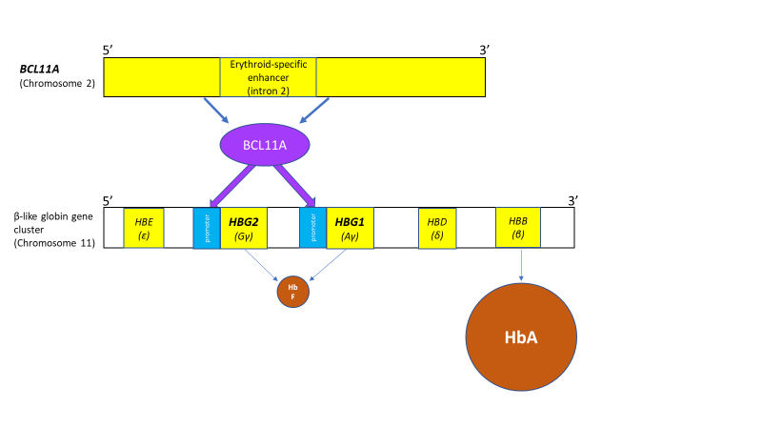
B
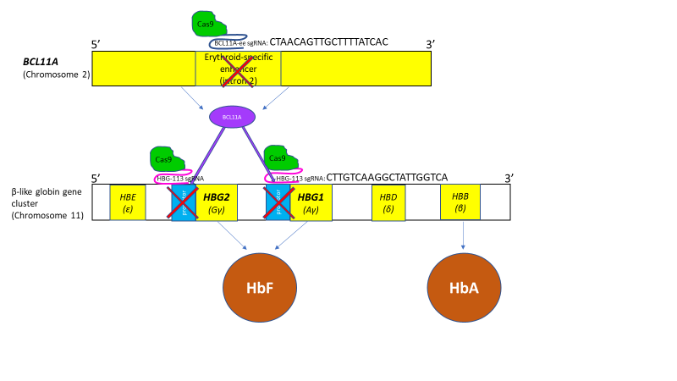
Figure 3.1: The BCL11A/HBG axis under physiological conditions and following CRISPR/Cas9 genome editing at the BCL11A-ee and HBG-113 regions.
(A) The BCL11A/HBG axis enforces the physiological switch from foetal to adult haemoglobin in infancy. BCL11A transcription factor binds to the promoter region of the γ globin genes on chromosome 11, inhibiting production of γ globin chains and promoting formation of HbA over HbF. (B) Disruption of the BCL11A/HBG axis by CRISPR/Cas9 genome editing allows reversal of the haemoglobin switch and increased HbF production. Targeting either the erythroid-specific enhancer of BCL11A or the binding sites for BCL11A within HBG promoter regions as single loci are well established strategies to reinduce HbF. In these experiments, dual targeting of both regions within the same population of haematopoietic stem cells was investigated. By both reducing BCL11A production and also blocking binding of residual transcription factor, it was hypothesised that HbF reinduction would be further potentiated, beyond that seen with the disruption of either single target.
Abbreviations: BCL11A-ee: erythroid-specific enhancer region of BCL11A, CRISPR/Cas9: Clustered regularly interspaced short palindromic repeat (CRISPR)/ CRISPR-associated protein 9 (Cas9) system, HbA: Haemoglobin A, HBG-113: HBG promoter region, HbF: Foetal haemoglobin

3.2 Aims and objectives
The aim of this chapter was to determine the efficacy of simultaneous and sequential dual CRISPR/Cas9 editing targeting both BCL11A-ee and HBG-113 in terms of in vitro editing efficiency and HbF reinduction, and also the effects of multiplex editing on cell proliferation and differentiation. In addition, these experiments were designed to investigate the possibility that chromosomal translocations would arise as a result of such dual editing strategies and to compare the simultaneous to the sequential dual editing protocols in this regard.
As a secondary aim, once it was noted that HBG-113 editing applied as the second edit in a sequential dual editing strategy resulted in particularly good editing efficiencies, it was hypothesised that this may be due to the effect of the previous electroporation episode which stimulated quiescent HSPCs to enter the cell cycle and thereby increased activity of the MMEJ pathway machinery, facilitating formation of the 13nt deletion. The effect of AMD3100 pre-treatment on cell cycling was also investigated as part of an effort to better understand the behaviour or HSPCs after exposure to AMD3100 (in relation to experiments described later in chapter 7).

Main hypothesis: Multiplex CRISPR/Cas9 genome editing at HBG-113 and BCL11A-ee, delivered either simultaneously or sequentially, will improve total editing efficiency and therefore HbF reinduction in HSPCs in vitro without significantly impairing their viability. Any risk that chromosomal translocations may be generated will be mitigated by delivering dual editing in a sequential rather than simultaneous manner.
Secondary hypothesis: Electroporation or exposure to AMD3100 stimulates stem cells to enter active phases of the cell cycle, thereby increasing activity of the MMEJ machinery and improving the efficiency of 13nt deletions after CRISPR/Cas9 editing at the HBG-113 locus.

The objectives of these experiments were:-
- To assess the effects of multiplex CRISPR/Cas9 genome editing on HSPC proliferation and differentiation in vitro, in comparison to editing at a single locus.
- To compare in vitro editing efficiency and HbF reinduction between HSPCs edited at a single locus and those in which both BCL11A-ee and HBG-113 were targeted for CRISPR/Cas9 editing, either simultaneously or sequentially.
- To investigate whether chromosomal translocations arise as a result of multiplex CRISPR/Cas9 editing at both loci, and if so whether this risk is removed by delivering multiplex editing sequentially rather than simultaneously.
- To investigate whether exposure to previous electroporation or AMD3100 affects cell cycle activity and whether these events would impact on the efficiency of subsequent HBG-113 CRISPR/Cas9 editing.

3.3 Chapter-specific materials and methods
Detailed information on the majority of individual techniques performed are given in Chapter 2. Development of PCR assays to quantify editing efficiency and to qualitatively detect the presence of anticipated chromosomal translocations was a considerable piece of work in itself and therefore a separate chapter has been allocated to describe these processes (Chapter 6) in order that the focus of this chapter might remain the editing experiments themselves and their results.
    - Experimental design: single and multiplex genome editing of HSPCs
      - HSPC source
HSPC source was G-CSF-mobilised PBMNCs donated by (anonymised) healthy individuals or patients with a non-haematological condition, with appropriate ethics approval. Cells were received either as frozen apheresis aliquots or as pre-CD34⁺-enriched cells.
      - HSPC preparation and genome editing
Where PBMNCs were provided in the form of a frozen apheresis collection, they were thawed and where necessary underwent red cell lysis. They were recovered in SFEM II media at 37⁰C and subsequently underwent CD34⁺-enrichment on the same day. Where pre-CD34⁺-enriched HSPCs were purchased from the FHCRC stem cell core, these were thawed and recovered in SFEM II media at 37⁰C. In both cases the thaw +/- enrichment occurred on D-1 prior to commencement of the genome editing protocol on D0. Cell cultures were counted on D0 prior to editing and then divided into separate aliquots for treatment by the following conditions:
- Mock electroporation only (i.e. treatment was identical to that in edited reactions with the omission of RNPs) on D0
- Single HBG-113 editing on D0
- Single BCL11A-ee editing on D0
- Simultaneous dual editing on D0
- Sequential dual editing with editing at BCL11A-ee taking place on D0 and editing at HBG-113 taking place on D1.
Following completion of the editing protocol, cells were recovered in SFEM II at 37⁰C until D2 when cells were plated for CFU assessment and the remaining cells transferred into differentiation media to encourage erythroid differentiation (Fig 3.2). The experiment was repeated a total of 5 times using 4 different stem cell donors.
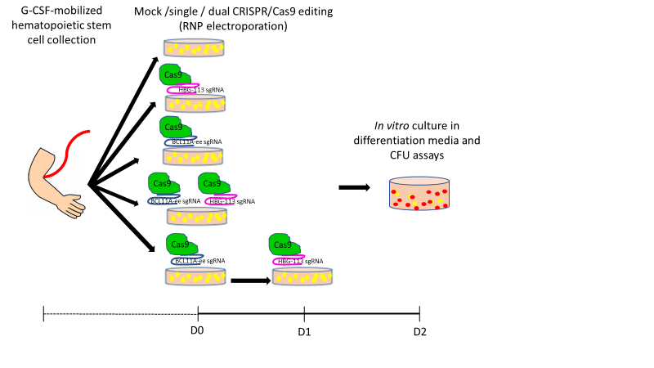
Figure 3.2: Single or dual CRISPR/Cas9 editing of HSPCs: experimental arms
Peripheral blood mononuclear cells enriched for CD34⁺ were treated according to 5 experimental arms in these experiments. On D0 cells underwent either mock editing with electroporation only; single target CRISPR/Cas9 editing with HBG-113 or BCL11A-ee-specific RNPs; or dual editing with RNPs targeting both loci (simultaneous dual editing). In a further sequential dual editing arm, HSPCs underwent single editing at BCL11A-ee on D0 and a second editing procedure targeting HBG-113 on D1. On D2, cells from each reaction were plated onto methocult media for CFU assay and also cultured in liquid media containing erythropoietin in order to encourage erythroid differentiation.
Abbreviations: BCL11A-ee: erythroid-specific enhancer region of BCL11A, CFU: colony forming unit, CRISPR/Cas9: Clustered regularly interspaced short palindromic repeat (CRISPR)/ CRISPR-associated protein 9 (Cas9) system, D0: day 0, D1: day 1, D2: day 2, G-CSF: granulocyte colony-stimulating factor, HBG-113: HBG promoter region, HSPC: Haematopoietic stem and progenitor cell, RNP: ribonucleoprotein, sgRNA: specific guide RNA

      - CFU assays
400 cells from each reaction were plated onto methocult-based media on D2 for assessment of CFU potential. Assessment was carried out in triplicate for each reaction with total and different types of colonies being counted after 13-14 days of culture. Means were taken for each parameter for each arm of the experiment.
      - Liquid culture of modified HSPCs
Remaining cells were transferred into erythropoietin-containing liquid media and cultured at 37ºC for up to 14 days to allow assessment of editing efficiency and HbF reinduction.
      - Assessment of editing efficiencies
Assessment of editing efficiency was carried out following extraction of DNA from aliquots of cells in liquid culture. PCR amplification of the BCL11A-ee and HBG-113 regions was initially undertaken. Sanger sequencing was carried out on the purified PCR product and the results subjected to TIDE analysis (TIDE, Netherlands Cancer Institute, Netherlands) in which the sequence of an edited reaction was compared to a sequence from an unedited aliquot of cells and the percentage in which insertion or deletion was found at the target RNP cut site was derived. Due to challenges obtaining valid results from the PCR reactions (described in full in Chapter 6), aliquots of cells were extracted at multiple timepoints during each experiment for analysis between days 4-9. Given a possibility that editing levels could rise or fall during this time, results included in the analyses were taken from a timepoint at which valid results were obtained for each reaction in a particular experiment, in order to ensure that comparisons were valid. It would have been preferrable that editing be assessed at a standardised timepoint for all experiments, but this was not possible, and so priority was given to ensuring the single timepoint within experiments.
      - Calculation of potency of HbF reinduction
HbF reinduction was examined in cells cultured in differentiation media by flow cytometry and also by HPLC. In each case, the ratio of foetal to adult haemoglobin (HbF/HbA) was calculated. Results were normalised by those obtained for the mock treated reaction in each experiment, to account for otherwise confounding variance in haemoglobin fraction frequency related to factors innate to different stem cell donors or experimental conditions.
      - Assessment of HbF reinduction by flow cytometry
HbF reinduction was quantified by flow cytometry on cells extracted from liquid culture on D10-14. Flow cytometry quantified the proportion of cells containing detectable HbA and the proportion containing detectable HbF in order that the proportion of haemoglobin-containing (i.e. presumably erythroid) cells with detectable HbF (i.e. F-cells) could be calculated. MFI was also assessed for each fluorophore as a semi-quantitative assessment of concentration of each haemoglobin (Hb) type.
      - Assessment of HbF reinduction by HPLC
HbF reinduction was also quantified by HPLC in cells extracted from liquid culture on D10-14. Cells were washed and frozen in concentrated solution prior to shipping to a collaborator at Bluebird Bio, who carried out all of the HPLC assays. HPLC analysis provided a validated quantification of the amount of each Hb type (HbA and HbF) in the cell population as a whole rather than assessment at the level of individual cells, since cell lysis is an initial step in the HPLC assay, providing a haemolysate for analysis.
      - Qualitative assessment of translocation presence by simple PCR
PCR assays were designed to amplify the products of translocation events if they occurred. The breakpoints and therefore the meeting points for translocations were anticipated to be the cut sites at BCL11A-ee and HBG-113. The first primer pair used was a forward primer to bind HBG-113 (HBG-F2) in combination with a reverse primer binding to BCL11A-ee (BCL11A-R1), to pick up what was termed ‘translocation event #1’. The second primer pair was a forward primer to bind BCL11A-ee (BCL11A-F1) in combination with a reverse primer binding to HBG-113 (HBG-R2), to pick up what was termed ‘translocation event #2’. PCR products were run on 2% agarose gel electrophoresis in order to demonstrate the presence or absence of a product of translocation PCR.
      - Confirmation of translocation by Sanger sequencing
A number of PCR products generated using the translocation PCR assays with dual edited HSPC populations as substrate, were sent for Sanger sequencing. This was in order to confirm that the amplicon visualised did indeed consist of the expected chimera, which aligned with relevant regions of both HBG-113 and BCL11A-ee (assessed using the Snapgene programme), thus validating the PCR translocation assay as a qualitative assessment of the presence or absence of chromosomal translocations.
      - Quantitation of translocation frequencies by ddPCR
Frequencies of translocation events #1 and #2 were quantified by ddPCR assay, carried out by collaborators in the Jerome Laboratory at FHCRC. Samples from 3 experiments were analysed rather than all 5, due to constraints in staff time, reagents and equipment.
    - Experimental design: cell cycle experiments
      - HSPC source and preparation
CD34⁺-enriched human G-CSF-mobilised PBMNCs were either purchased from the stem cell core or prepared within the laboratory from donor PBMNCs. Cells were thawed on D-1 and recovered overnight in SFEM II.
      - Original experimental protocol: experiment 1
On D0, an aliquot of cells was separated for an untreated control and the remainder divided into 3 equal portions. Reactions were as follows:
1: Untreated control
2: Standard HBG-113 editing on D0
3: Mock electroporation on D0 followed by standard HBG-113 editing 24 hours later
4: Addition of high-concentration AMD3100 (0.83 ul/ml) on D0 followed by standard HBG editing 24 hours later
      - Modified experimental protocol: experiments 2-3
The initial plan was to conduct experiments, based on the protocol in experiment 1, three times using different stem cell sources to provide results in biological triplicate. In the first experiment, reaction 2 underwent editing on D0, at the same time as mock electroporation of reaction 3 and addition of AMD3100 to reaction 4. This is because according to our standard editing protocol, where a single edit was applied this would be carried out on D0 prior to transplantation on D1, representing normal practice.
However, when results from this first experiment showed higher editing efficiency in both of the pre-treated reactions than the standard edit reaction, the effect of pre-electroporation or AMD3100 exposure could not be separated from the effect of an additional 24 hours in culture. Therefore, for the subsequent 2 experiments, editing of reaction 2 was carried out on D1, at the same time as editing of reactions 3 and 4. This reduced the number of variables which could potentially contribute to differences in editing efficiency between reactions.
Therefore, modified reaction conditions for subsequent experiments were as follows:
1: Untreated control
2: Standard HBG-113 editing on D1
3: Mock electroporation on D0 followed by standard HBG-113 editing 24 hours later on D1
4: Addition of high-concentration AMD3100 (0.83 ul/ml) on D0 followed by standard HBG editing 24 hours later on D1
      - Assessments of cell proliferation and differentiation: live cell counts with mathematical standardisation
Live cell counts were monitored for all 3 experiments and also 1200 cells in total from each reaction were plated into H4435 methocult media on D2 for colony forming potential analysis, to permit assessment of the toxicity of each reaction. As the same number of cells were removed from each reaction for the plating of CFUs, despite the differences in total live cell count at that point in time, this represented a different proportion of depletion from the various reactions. Given the limited number of HSPCs included in each experiment, the difference in proportional reduction was considered potentially significant. Subsequent cell counts are therefore adjusted for this.
As an example of this calculation:
Experiment 2, reaction 2: total live cell counts on D2 (24 hours after editing event) was 0.3725x10^{x}6. 1200 cells were then removed for CFUs, which equated to 0.0012/0.375=0.00322 of the total cell number. Total live cell counts the following day was 0.845x10^{x}6, and this was adjusted by multiplying by 1.00322 to give a total of 0.848. Although these differences are small, it was felt important to add this correction factor since failure to do so would result in differences between cell counts being exaggerated. Due to the small number of cells available, the untreated reactions often had a smaller starting cell count to allow treated reactions to contain a more substantial number of cells. A further adjustment was therefore added to standardise starting cell counts between reactions, with starting cell counts adjusted to 1 x10^{x}6 and subsequent counts adjusted appropriately by dividing the actual count by the cell count for that reaction on D0. For example, where starting cell count in a reaction was 1.2 x10^{x}6, this was adjusted to 1.0 x10^{x}6 and subsequent counts adjusted by dividing by 1.2.
      - Assessments of cell proliferation and differentiation: CFU assays
400 cells from each reaction were plated onto methocult-based media on D2 for assessment of CFU potential. Assessment was carried out in triplicate for each reaction with total and different types of colonies being counted after 13-14 days of culture. Means were taken for each parameter for each arm of the experiment.
      - Cell cycle analysis
A sample was taken on D0 prior to splitting into the different reactions, for cell cycle analysis by flow cytometry. Cells were first gated on forward and side scatter. HSPCs were identified by CD34 positivity and selected for Hoescht positivity, confirming DNA presence. Cells in the active phases of the cell cycle were then identified by Ki67-positivity. This was repeated on D1 prior to editing of reactions 3 and 4 (and also prior to editing of reaction 2 for experiments 2 and 3).
      - Assessment of editing efficiency
Cells from each reaction in liquid culture were extracted on D5-D8 for DNA extraction, PCR and sequencing for the assessment of editing efficiency. Where CFUs had been plated these were also harvested for DNA extraction, PCR and sequencing for the assessment of editing efficiency within colonies. However, the majority of PCR and sequencing for combined CFUs failed to provide readable results therefore these are not reported here.

  - Results
    - Results of experiments comparing single and dual CRISPR/Cas9 editing strategies for HbF reinduction
      - Optimal total editing efficiency with sequential dual CRISPR/Cas9 editing at BCL11A-ee and HBG-113
Total editing efficiency was similar between single edited arms (Fig 3.3A), with editing frequency in the HBG-113 single edited reactions of 46.8% +/- 17.8% and in the BCL11A-ee single edited reactions 47.7% +/-7.0% (mean +/- SD). Total editing (taken to be HBG-113 editing plus BCL11A-ee in double-edited reactions) was greatest in sequentially double-edited cells at 87.5% +/- 33.0% (mean +/- SD), being significantly higher than either the HBG-113 or BCL11A-ee single edited reactions (n=5, p=0.0132 and p=0.0341 respectively). Total editing efficiency in the simultaneously double-edited reactions was lower than in the sequentially double-edited arms, at 67.6% +/- 6.0% (mean +/- SD), (n=5, p>0.05), but was still higher than the HBG-113 single edited arm (n=5, p>0.05) and the BCL11A-ee single edited reactions (n=5, p=0.0036).
Looking in particular at mean editing of the HBG-113 locus: in comparison to the HBG-113 single edited arm, editing efficiency was similar in the sequentially double-edited arm at 49.0% +/- 23.6%, but was significantly lower in the simultaneously double-edited reactions at 30.9% +/- 6.2% (mean +/- SD) (n=5, p= 0.0476). Editing efficiency at the BCL11A-ee locus was similar between simultaneous and sequentially double edited reactions at 36.7% +/- 7.6% and 38.5% +/- 12.0% respectively (mean +/- SD). Both double-edited arms showed non-significantly lower editing efficiency at this locus than the BCL11A-only reaction (n=5, p>0.05).
Detailed examination was made regarding the frequency of those precise deletion lengths previously reported to be commonly found at these particular editing targets and associated with the microhomology-mediated end-joining (MMEJ) pathway.^{269; 280; 338} The 13nt HBG-113 deletion was found in the single edited and sequentially double-edited cells at similar mean levels: 19.9% +/- 20.1% and 21.1% +/- 15.4% respectively, but this particular deletion length was less commonly observed in the simultaneously double-edited reactions (8.0% +/- 8.1%) (mean +/- SD) (n=5, p=0.0222 in comparison to sequential reactions) (Fig 3.3B).
The 13nt deletion at the BCL11A-ee locus was similarly found to be lower in the simultaneously double-edited reaction in comparison to the single edited and the sequentially double-edited arms with mean frequencies of 0.7% +/- 1.1%, 1.2% +/- 1.1% and 1.5% +/- 1.7% respectively (mean +/- SD) (n=5, p>0.05 for all). The same trend was observed for the 15nt deletion at this locus, with frequencies in the simultaneously double-edited, single edited and sequentially double-edited reactions of 1.1% +/- 0.5%, 1.9% +/- 1.9% and 1.9% +/- 1.9% respectively (mean +/- SD) (n=5, p>0.05 for all) (Fig 3.3C).
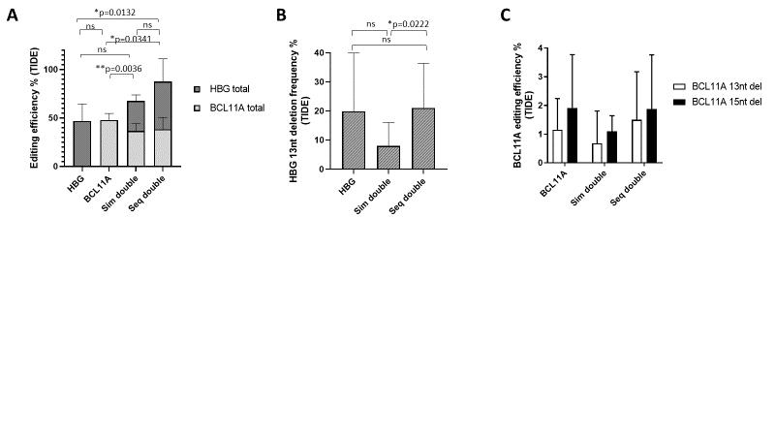
Figure 3.3: Editing efficiencies with single and dual CRISPR/Cas9 editing strategies.
HSPCs underwent CRISPR/Cas9 genome editing targeting either HBG-113 or BCL11A-ee, or both loci either simultaneously or sequentially. Editing efficiency at each locus in each reaction was assessed by PCR, Sanger sequencing and TIDE analysis of the results. (A) Editing at each single locus is shown with significance figures relating to differences in total editing i.e. HBG + BCL11A editing where relevant (n=5) (mean+/-SD). (B) 13nt deletion frequency was analysed as this is expected to comprise a significant proportion of HBG-113 indels and represents activity of the MMEJ pathway (n=5) (mean+/-SD). (C) 13nt and 15nt deletion frequencies within BCL11a-ee were also examined, as these are known to be relatively common large deletions at this site, mediated by the MMEJ (n=5) (mean+/-SD).
Abbreviations: BCL11A or BCL11A-ee: erythroid-specific enhancer region of BCL11A, CRISPR/Cas9: Clustered regularly interspaced short palindromic repeat (CRISPR)/ CRISPR-associated protein 9 (Cas9) system, HBG or HBG-113: HBG promoter region, HSPC: Haematopoietic stem and progenitor cell, MMEJ: microhomology-mediated end joining, ns: not statistically significant (p>0.05), PCR: polymerase chain reaction, 13nt: 13-nucleotide, 15nt: 15-nucleotide.

      - Non-significant trend towards reduced proliferation with sequential dual editing but maintenance of normal patterns of differentiation
HSPCs from each reaction were plated in methocult-based media to assess proliferation and differentiation potential (Fig 3.4). There were no significant differences in the total colony forming unit (CFU) potential of HSPCs from each reaction (n=5, p>0.05 for all), although there was a trend towards reduced total number of colonies following sequential dual editing. The pattern of colony type grown was comparable between arms.
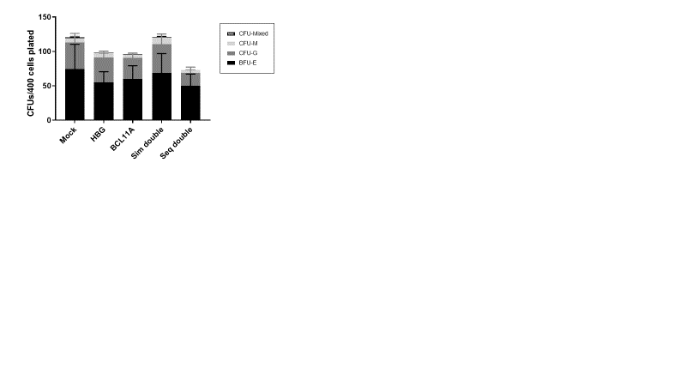
Figure 3.4: Colony-forming potential of HSPCs after mock, single or dual CRISPR/Cas9 editing
HSPCs underwent CRISPR/Cas9 genome editing targeting either HBG-113 or BCL11A-ee, or both loci either simultaneously or sequentially. Cells were then cultured in triplicate for each reaction in methocult-based media for 13-14 days prior to differentiating and counting each colony type (n=5) (mean+/-SD).
Abbreviations: BCL11A or BCL11A-ee: erythroid-specific enhancer region of BCL11A, BFU-E: burst-forming unit-erythroid ,CFU: colony forming unit, CFU-G: granulocytic colony forming unit , CFU-M: monocytic colony forming unit, CFU-Mixed: mixed types of colony forming unit, CRISPR/Cas9: Clustered regularly interspaced short palindromic repeat (CRISPR)/ CRISPR-associated protein 9 (Cas9) system, HBG or HBG-113: HBG promoter region, HSPCs: haematopoietic stem and progenitor cells, Seq double: sequential dual editing of both targets, Sim double: simultaneous dual editing of both targets.

      - Greatest HbF reinduction by flow cytometry with sequential dual editing approach
Flow cytometric assessment of the proportion of cells containing detectable levels of HbF or of HbA was carried out initially (Fig 3.5A-B). The HbF/HbA ratio was increased in comparison to the mock treated reaction in all edited cells, although this only reached statistical significance in the sequentially double-edited cells (n=5, p=0.0469). Mean HbF/HbA ratio was also highest in this reaction, at 2.263 +/-0.995 in comparison to 1.839 +/- 1.019 in HBG-113 single edited cells, 1.397 +/- 0.537 in BCL11A-ee single edited cells and 1.788 +/- 0.976 in simultaneously double-edited cells (mean +/- SD). HbF/HbA ratio was significantly higher in the sequentially double-edited cells were compared to HBG-113 single edited cells (n=5, p=0.0403) and to simultaneously double-edited cells (n=5, p=0.0092). Where single edited arms were compared, there was a trend towards improved HbF reinduction in HBG-113 edited cells in comparison to BCL11A-ee edited cells, despite comparable editing efficiencies between these arms (n=5, p>0.05).
Mean fluorescence intensity (MFI) reported on flow cytometry was separately analysed for HbF and HbA antibody fluorophores followed by calculation of the ratio, in order to permit a more quantitative assessment of HbF reinduction per cell (Fig 3.5C). Once again, by this alternative analysis, HbF reinduction was highest in the sequentially double edited cells, with mean HbF/HbA MFI ratio being 3.927 +/- 1.797 in these reactions compared to 3.259 +/- 1.911 in HBG-113 singe-edited cells, 1.973 +/- 0.722 in BCL11A-ee single edited cells and 2.832 +/- 1.353 in simultaneously double-edited cells (mean +/- SD). This difference reached statistical significance where sequentially double-edited reactions were compared to simultaneously double-edited ones (n=5, p=0.0287). Where single edited arms were compared, the trend towards greater HbF reinduction with HBG-113 editing above BCL11A-ee targeting was even more marked once amplitude of haemoglobin fraction reporting was taken into account.
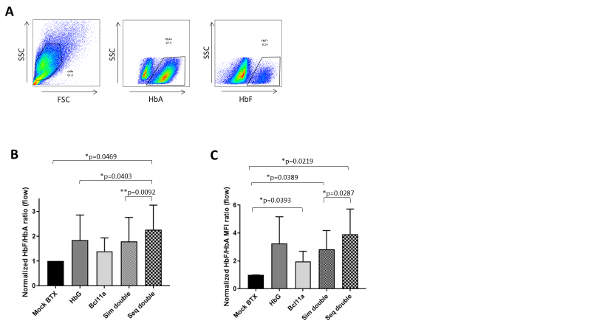
Figure 3.5: HbF reinduction by flow cytometry following single or dual CRISPR/Cas9 editing of HSPCs
HSPCs underwent CRISPR/Cas9 genome editing targeting either HBG-113 or BCL11A-ee as single targets, or both loci either simultaneously or sequentially. After culturing in liquid media designed to encourage erythroid differentiation, cells underwent flow cytometric analysis of HbF reinduction. (A) After gating on forward and side scatter, the proportion of cells staining positive for HbF and the proportion staining positive for HbA were quantified, as well as mean fluorescence intensity being documented for each fluorophore. Ratios for HbF/HbA were calculated and normalised by dividing by values obtained for the mock treated reaction in each experiment. (B) The proportion of haemoglobin-containing cells staining positive for HbF was increased in all edited reactions in comparison to the mock-treated control and highest in sequential dual treated reactions (n=5) (mean+/-SD). (C) MFI was also increased in all edited reactions, and again was highest where cells had undergone sequential dual editing (n=5) (mean+/-SD).
Only statistically significant differences are shown, others are all p>0.05.
Abbreviations: BCL11A or BCL11A-ee: erythroid-specific enhancer region of BCL11A, BTX: electroporation, CRISPR/Cas9: Clustered regularly interspaced short palindromic repeat (CRISPR)/ CRISPR-associated protein 9 (Cas9) system, FSC: forward scatter, HbA: Haemoglobin A, HbF: Haemoglobin F, HBG or HBG-113: HBG promoter region, HSPCs: haematopoietic stem and progenitor cells, MFI: Mean fluorescence intensity, Seq double: sequential dual editing of both targets, Sim double: simultaneous dual editing of both targets, SSC: side scatter

      - Greatest HbF reinduction by HPLC with sequential dual editing
Final analysis of HbF reinduction was by HPLC (Fig 3.6). This provided a validated, quantitative assessment of the HbF proportion and reported patterns almost identical to those seen with MFI analysis in flow cytometric assays. 4 replicates were available for analysis for each reaction, due to failure of HPLC in one experiment. HPLC analysis demonstrated increased HbF/HbA ratio in all edited reactions in comparison to mock-treated cells, as seen with flow cytometric analysis. Again, the greatest increase was in the sequentially double edited reactions. Mean HbF/HbA ratio by HPLC was as high as 4.094 +/- 0.987 in sequentially double-edited cells, in comparison to 3.276 +/- 0.850 in HBG-113 single edited cells, 2.175 +/- 0.506 in BCL11A-ee single edited cells and 2.952 +/- 0.777 in simultaneously double-edited cells (mean +/- SD). This difference was statistically significant where sequentially double-edited reactions were compared to BCL11A-ee single edited reactions (n=4, p=0.0353) or to simultaneously double-edited reactions (n=4, p=0.0128). In this analysis, as in those above, where single edited arms were compared, HbF reinduction was more effective with targeting of the HBG-113 rather than the BCL11A-ee (n=4, p>0.05).

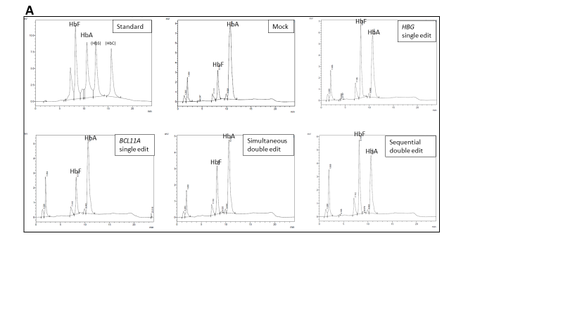
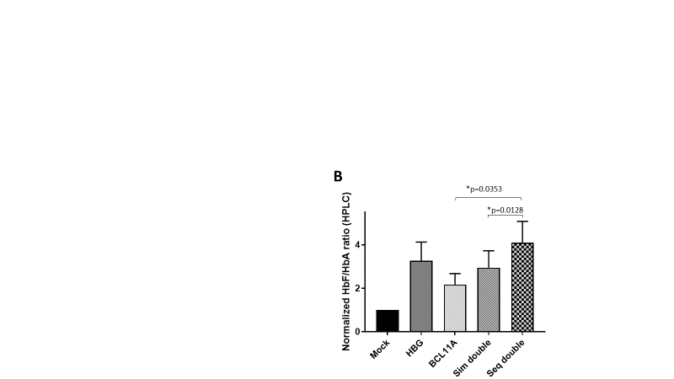

Figure 3.6: HbF reinduction by HPLC following single or dual CRISPR/Cas9 editing of HSPCs
HSPCs underwent CRISPR/Cas9 genome editing targeting either HBG-113 or BCL11A-ee as single targets, or both loci either simultaneously or sequentially. After culturing in liquid media designed to encourage erythroid differentiation, cells underwent haemoglobin fraction quantification by HPLC. (A) Example traces from one experiment are provided along with the results of calibration with control standards for HbF, HbA, HbS and HbC (‘standard’). Ratios for percentage HbF concentration / percentage HbA concentration were calculated for each reaction and normalised by dividing by values obtained for the mock treated reaction in each experiment. (B) Greatest HbF reinduction was observed in sequentially dual edited cells, this difference reaching statistical significance in comparison to BCL11A-ee single edit and simultaneous dual edited reactions (n=4) (mean+/-SD).
Only statistically significant differences are shown, others are all p>0.05.
Abbreviations: BCL11A or BCL11A-ee: erythroid-specific enhancer region of BCL11A, CRISPR/Cas9: Clustered regularly interspaced short palindromic repeat (CRISPR)/ CRISPR-associated protein 9 (Cas9) system, HbA: Haemoglobin A, HbC: Haemoglobin C, HbF: foetal haemoglobin, HBG or HBG-113: HBG promoter region, HbS: Haemoglobin S, HPLC: high performance liquid chromatography HSPCs: haematopoietic stem and progenitor cells, Seq double: sequential dual editing of both targets, Sim double: simultaneous dual editing of both targets.

3.4.1.5 Presumed chromosomal translocations detected by PCR after both simultaneous and sequential multiplex editing protocols
The presence of chromosomal translocations was assessed in bulk cells in liquid culture from each reaction, using primer pairs HBG-113 forward (F2) with BCL11A-ee reverse (R1) (translocation event #1), and BCL11A-ee F1 with HBG-113 R2 (translocation event #2). Chromosomal translocations were suspected by the consistent demonstration of PCR product when these translocation assays were applied to dual edited reactions but not when single or mock-edited reactions were the substrates (Fig 3.7).

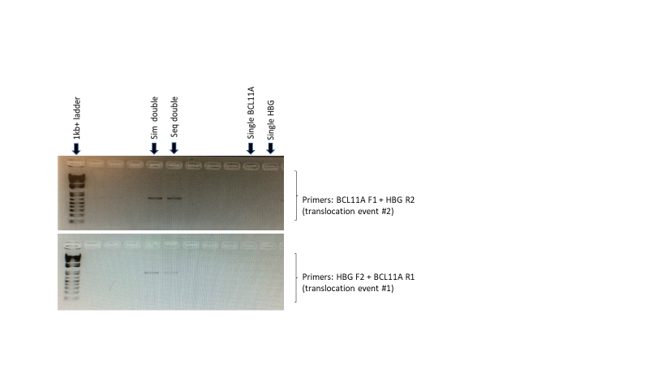
Figure 3.7: Presumed translocation events detected following dual CRISPR/Cas9 editing of HSPCs
HSPCs underwent CRISPR/Cas9 genome editing targeting either HBG-113 or BCL11A-ee as single targets, or both loci either simultaneously or sequentially. PCR was carried out to investigate the possibility that chromosomal translocation events occurred, due to DNA double-stranded breaks forming at both targeted loci in the same cell. Assays were designed to detect 2 separate translocation products anticipated to form if such chromosomal rearrangement occurred. Products of such PCR experiments were visualised on agarose gel electrophoresis. No such product of the translocation PCR assays was observed where negative control reactions (single or mock edited reactions) were the PCR substrate.
Abbreviations: BCL11A or BCL11A-ee: erythroid-specific enhancer region of BCL11A, CRISPR/Cas9: Clustered regularly interspaced short palindromic repeat (CRISPR)/ CRISPR-associated protein 9 (Cas9) system, DNA: Deoxyribonucleic acid, HBG or HBG-113: HBG promoter region, HSPCs: haematopoietic stem and progenitor cells, PCR: Polymerase chain reaction, Seq double: sequential dual editing of both targets, Sim double: simultaneous dual editing of both targets.

3.4.1.6 Chromosomal translocation events confirmed by Sanger sequencing
The PCR product from translocation PCR reactions was confirmed to indeed represent a segment of DNA created by translocation at the breakpoints in chromosomes 2 and 11 by demonstration that the resultant sequence aligned with sections of both BCL11A-ee and HBG-113 regions (Fig 3.8). This confirmation validated the translocation PCR assay. Therefore, subsequently, the demonstration of a product of translocation PCR which was of the expected length and present only in dual edited reactions, but not negative controls (single, mock edited or untreated cells) was considered adequate confirmation of translocation presence without the need to sequence every such reaction.

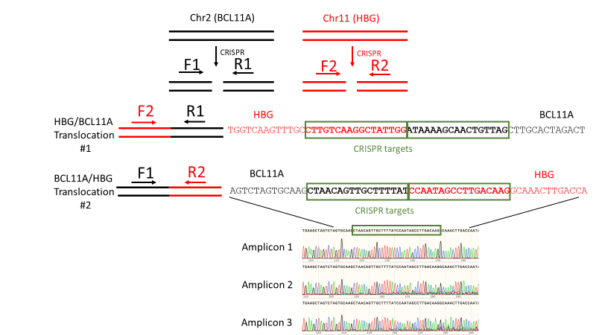
Figure 3.8: Sequence analysis confirms that products of translocation PCR assays are chimeras of BCL11A-ee and HBG-113
HSPCs underwent multiplex CRISPR/Cas9 genome editing targeting both BCL11A-ee and HBG-113. PCR assays were carried out to investigate the possibility of chromosomal cross-over events involving both target sites, using primer combinations designed to bind to each site of the anticipated translocation sequences. In order to confirm that products of such PCR reactions indeed represented chromosomal translocation products, a number of PCR products underwent Sanger sequencing for further analysis. Three examples of confirmed translocation sequence are included in this figure, each demonstrating alignment both with regions of BCL11A-ee and HBG-113, providing positive validation of the translocation PCR assay.
Abbreviations: BCL11A or BCL11A-ee: erythroid-specific enhancer region of BCL11A, Chr: chromosome, HBG or HBG-113: HBG promoter region, HSPCs: haematopoietic stem and progenitor cells, PCR: Polymerase chain reaction.

3.4.1.7 Chromosomal translocations are more frequent following simultaneous than sequential multiplex editing
Following the qualitative demonstration of chromosomal translocations in double-edited reactions, translocation frequency was quantified by ddPCR in a number of experiments and found to be significantly higher where dual editing had been applied simultaneously rather than in a sequential manner. Mean frequencies for translocation event #1 were 0.970% +/- 0.285% in simultaneous reactions and 0.113% +/- 0.085% in sequential ones (mean +/- SD) (n=3, p=0.0420) (Fig 3.9A). For translocation #2 these figures were found to be 0.583% +/- 0.155% and 0.037% +/- 0.012% respectively (mean +/- SD) (n=3, p=0.0296) (Fig 3.9B). Higher reported prevalence of translocation event #1 over translocation event #2 was noted which may be due to a genuine difference in frequency but may also reflect variable sensitivity between these assays therefore firm conclusions could not be drawn regarding differential frequencies of the 2 translocation events.
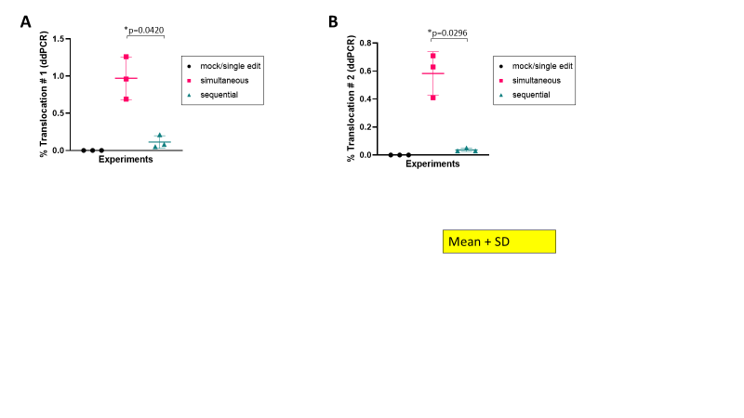
Figure 3.9: ddCPR quantification of translocation events following multiples CRISPR/Cas9 genome editing
HSPCs underwent CRISPR/Cas9 genome editing targeting either HBG-113 or BCL11A-ee as single targets, both loci either simultaneously or sequentially, or mock electroporation only. Following demonstration that translocation events occur between the two loci, ddPCR was employed to quantify the frequency of 2 particular translocation events. (A) Translocation event #1 was assayed using the combination of a forward primer binding to HBG-113 and reverse primer to bind BCL11A-ee. (B) Translocation event #2 was quantified using a forward primer binding BCL11A-ee and reverse primer binding HBG-113. Both translocation events were significantly more frequent following simultaneous rather than sequential multiplex editing (n=3) (mean+/-SD).
Abbreviations: BCL11A-ee: erythroid-specific enhancer region of BCL11A, CRISPR/Cas9: Clustered regularly interspaced short palindromic repeat (CRISPR)/ CRISPR-associated protein 9 (Cas9) system, ddPCR: digital droplet PCR, HBG-113: HBG promoter region, HSPCs: haematopoietic stem and progenitor cells, sequential: sequential dual edited reactions; simultaneous: simultaneous dual edited reactions.

    - Results of cell cycle experiments
      - Live cell counts
For all experiments, cell cultures were counted on D0 and D2. In experiment #1 counts were also taken on D4 and D6. In experiments #2-3 counts were also taken on D3. All treated reactions trended towards lower cell counts from D2 than untreated controls (Figs 3.10A-B). For experiments 2-3 all treated reactions had significantly lower live cell counts than untreated controls on D3. Differences between treated reactions were minimal and not statistically significant (Fig 3.10C).

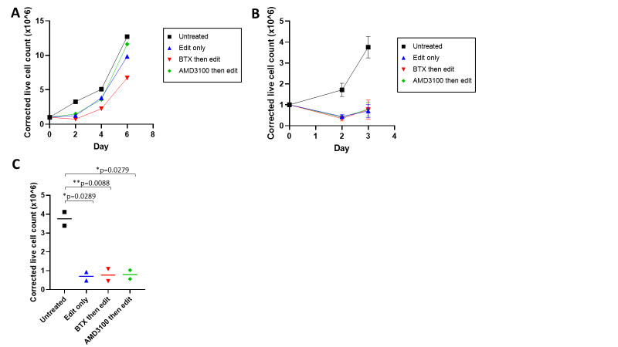
Figure 3.10: Effects of electroporation or AMD3100 pre-exposure prior to CRISPR/Cas9 editing on live cell counts
HSPCs underwent routine CRISPR/Cas9 editing at HBG-113, or editing preceded by electroporation or AMD3100 exposure. Live cell counts were monitored in liquid culture, corrected to account for the removal of a fixed number of cells for colony forming assays and standardised by correcting to a starting cell count of 1.0 x10⁶. (A) In a first experiment, standard editing took place on D0; where cells were pre-treated with electroporation or AMD3100, these were applied on D0 with editing taking place on D1 (n=1). (B) Two subsequent experiments applied editing to all reactions simultaneously on D1 (n=2) (mean +/-SD). (C) Live cell counts were significantly reduced in all edited reactions in comparison to untreated controls but similar to each other on D3 in experiments 2-3 (n=2) (mean).
Abbreviations: BTX: electroporation, CRISPR/Cas9: Clustered regularly interspaced short palindromic repeat (CRISPR)/ CRISPR-associated protein 9 (Cas9) system, D0: day 1, D1: day 1, D3: day 3, HBG-113: HBG promoter region, HSPCs: haematopoietic stem and progenitor cells.
      - CFU assays
Average CFU counts were calculated from technical replicates (triplicate for each reaction) for each experiment. Colony forming potential was not impaired by any of the reaction conditions in comparison to untreated HSPCs, with mean total colony numbers trending towards being higher for all edited reactions in comparison to untreated controls, although differences did not reach statistical significance (Fig 3.11A). Total colony numbers were similar between all edited reactions. Differentiation patterns were similar between all arms (Fig 3.11B).

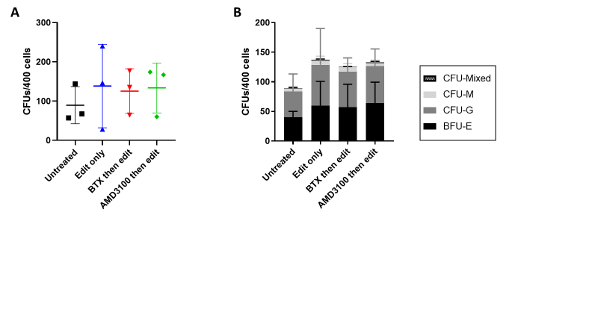
Figure 3.11: CFU potential following electroporation or AMD3100 pre-exposure prior to CRISPR/Cas9 editing
HSPCs underwent routine CRISPR/Cs9 editing at HBG-113, or editing preceded by electroporation or AMD3100 exposure. Cells were plated in triplicate onto methocult-based media for CFU culture, followed by differentiation and counting of colonies. (A) total colony numbers were non-significantly increased in all edited reactions in comparison to untreated controls, with total counts being similar between edited arms (n=3, all p>0.05) (mean+/-SD). (B) Pattern of colony types was comparable between arms (n=3) (mean+/-SD).
Abbreviations: BTX: electroporation, BFU-E: burst-forming unit-erythroid, CFU: colony forming unit, CFU-G: granulocytic colony forming unit, CFU-M: monocytic colony forming unit, CFU-Mixed: mixed types of colony forming unit, CRISPR/Cas9 Clustered regularly interspaced short palindromic repeat (CRISPR)/ CRISPR-associated protein 9 (Cas9) system, HBG-113: HBG promoter region, HSPCs: haematopoietic stem and progenitor cells.

      - No significant effect on cell cycle activity results from exposure to electroporation or AMD3100
Very few cells were actively cycling on D0 (1 day after thaw, prior to any treatment). Regardless of the experimental arm, more cells were in an active phase of the cell cycle on D1 (Fig 3.12A-B). This included untreated cells, suggesting that an extra day in liquid culture in itself resulted in cells being more likely to exit the quiescent phase of the cell cycle and enter more active cell cycling. This difference was most pronounced in the first experiment, with much smaller proportions of cells entering the cell cycle in the other 2 experiments. The reason for this difference between experiments was unclear but considered mostly probably to reflect genetic or acquired differences in the HSPCs used.
After the observation in experiment 1 that cell cycling appeared to be markedly increased on D1 in comparison to D0, the editing procedure in the ‘edit only’ arm was moved to D1, in order to coincide with editing in the electroporation and AMD3100 pre-treatment arms. This was in order that a more valid assessment may be made of the impact that pre-treatment with electroporation or AMD3100 had on editing efficiency, without the confounding variable of different timing. Where editing took place in the edit only arm on D0 but the pre-treatment arms on D1, the impact of the pre-treatment strategies could not be separated from the impact of cells simply having had an additional day in culture prior to editing. For this reason, cell cycle assay results are presented separately for experiment 1 to experiments 2-3, due to this difference in methodology in the edit only arm (Fig 3.12A-B).
It was, however, valid to combine the results of the untreated control and both pre-treatment arms from all 3 experiments, since methodology was standardised across these reactions, and results were highly concordant between these arms (Fig 3.12C). 1.3% +/- 1.94% of HSPCs were actively cycling (i.e. Ki67⁺) on D0 (mean +/- SD). By D1 these figures were 17.2% +/- 25.9% for untreated control reactions, 17.6% +/- 26.9% for cells pre-treated with electroporation and 17.0% +/- 25.2% for AMD3100 pre-treatment arms (mean +/- SD).
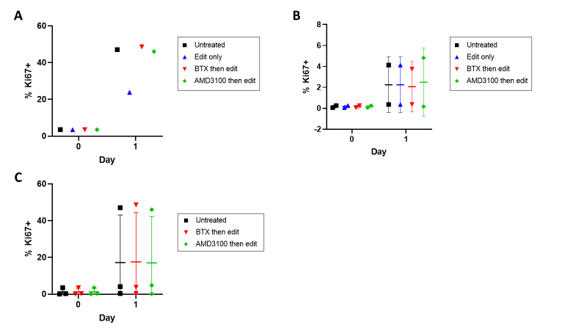
Figure 3.12: Cell cycle activity following electroporation or AMD3100 pre-exposure
HSPCs underwent routine CRISPR/Cas9 editing at HBG-113, or editing preceded by electroporation or AMD3100 exposure, and the effects of such pre-treatment on cell cycle activity (taken to be Ki67-positivity) was assessed by flow cytometry. (A) In a first experiment, standard editing took place on D0; where cells were pre-treated with electroporation or AMD3100, these were applied on D0 with editing taking place on D1. Cell cycle activity was increased in all reactions on D1 after very low activities on D0 (n=1). (B) Two subsequent experiments applied editing to all reactions simultaneously on D1 and demonstrated similar increases in cell cycle activity across all experimental arms including untreated controls at the editing timepoint on D1 (n=2) (mean+/-SD). (C) Results for untreated, electroporation and AMD3100 pre-treatment arms from all 3 experiments were combined for further analysis and showed almost identical increases in cell cycle activity on D1 in all arms (n=3) (mean+/-SD).
Abbreviations: BTX: electroporation, CRISPR/Cas9: Clustered regularly interspaced short palindromic repeat (CRISPR)/ CRISPR-associated protein 9 (Cas9) system, D0: day 0, D1: day 1, HBG-113: HBG promoter region, HSPCs: haematopoietic stem and progenitor cells.

      - Pre-treatment with electroporation or AMD3100 do not improve efficiency of subsequent CRISPR/Cas9 editing
Where editing took place on D0 in the edit only arm, in experiment 1, it was of lower efficiency than the editing which took place on D1 in the pre-treatment arms (Fig 3.13A). Of the latter, editing efficiency was highest in the pre-electroporation arm than the reaction pre-treated with AMD3100, but only to a minor degree. However, where editing took place at the same time in all arms (i.e. experiments 2-3), results for editing efficiency were not improved by pre-treatment with either electroporation or AMD3100 exposure, and in fact trended towards being lower in these arms in comparison to the edit only arm (Fig 3.13B).
Where the 13nt deletion was examined specifically, this followed the same pattern as that seen with total editing in experiment 1 (Fig 13.3C). In experiments 2-3, following pre-treatment with electroporation or AMD3100, results for frequency of 13nt deletion in comparison to editing only were variable, being higher in one experiment but lower in the other (Fig 13.3D).

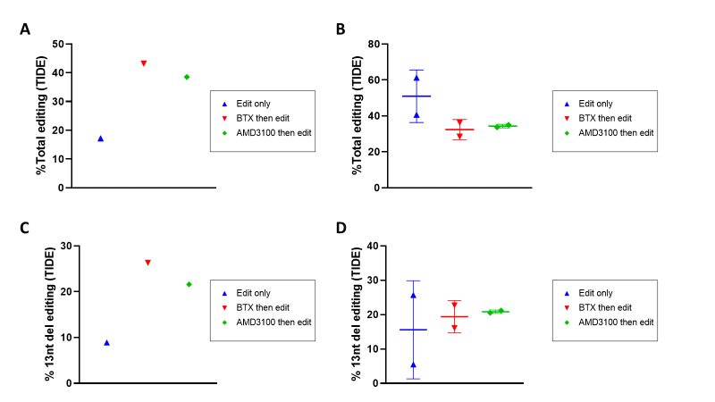
Figure 3.13: Editing efficiency following pre-treatment with electroporation or AMD3100
HSPCs underwent routine CRISPR/Cas9 editing at HBG-113, or editing preceded by electroporation or AMD3100 exposure. Editing efficiency was assessed by PCR, sequencing and TIDE analysis of results. (A) In a first experiment, standard editing took place on D0; where cells were pre-treated with electroporation or AMD3100, these were applied on D0 with editing taking place on D1. Total editing efficiency was higher in pre-treated reactions in comparison to the standard editing arm (n=1). (B) However, two subsequent experiments applied editing to all reactions simultaneously on D1 and pre-treated arms trended towards lower total editing efficiencies compared to standard editing (n=2, all p>0.05) (mean+/-SD). (C) Frequency of the 13nt deletion in experiment #1 followed a similar pattern to that of total editing efficiency (n=1). (D) Mean frequency of 13nt deletion was not significantly different with either pre-treatment strategy in experiments 2-3 (n=2, all p>0.05) (mean+/-SD).
Abbreviations: BTX: electroporation, CRISPR/Cas9: Clustered regularly interspaced short palindromic repeat (CRISPR)/ CRISPR-associated protein 9 (Cas9) system, D0: day 0, D1: day 1, HBG-113: HBG promoter region, HSPCs: haematopoietic stem and progenitor cells, PCR: Polymerase chain reaction, TIDE: Tracking of Indels by Decomposition, 13nt: 13 nucleotide.

3.5 Discussion
CRISPR/Cas9 genome editing is emerging as one of the most promising novel therapies for sickle cell disease and Β thalassaemia. Strategies targeting two distinct loci, BCL11A-ee and HBG-113, have both demonstrated resultant increases in HbF, which is known to ameliorate symptoms and progression of these conditions.^{263; 265; 266; 268; 280} However, inducing and maintaining sufficiently levels of HbF in order to reliably deliver a complete cure remains a significant challenge. In this chapter the results of in vitro experiments are reported investigating the feasibility, efficacy and safety of multiplex editing protocols in which both loci are the focus of disruption by CRISPR/Cas9 editing, either simultaneously or sequentially, with the aim of optimising HbF reinduction.
Cell viability, as far as it can be assessed in vitro, remained adequate following dual editing procedures, based on HSPC proliferation and differentiation potential in CFU assays. Total editing levels were highest following sequential dual editing, whereas there was less of a benefit with simultaneous application of editing at both loci. This reflects a reduction in those precise large deletion lengths known to be associated with the MMEJ cellular repair pathway where both loci were targeted for editing simultaneously. In particular this involves the 13nt deletion within HBG-113, and, to a lesser extent, the 13nt and 15nt deletions at BCL11A-ee.^{268; 269; 270} It is hypothesised that where RNPs designed to disrupt both loci are administered simultaneously, there is increased competition for the limited MMEJ intranuclear machinery, leading to a reduction in the frequency of those larger deletions favoured by this particular repair pathway and a proportional increase in the small indels more likely to result from NHEJ which is a passive rather than an active repair pathway. Where the 2 loci are edited on separate occasions, or in a single editing procedure, there is less competition for the MMEJ pathway and therefore an improved rate of formation of the relevant larger deletions.
HbF reinduction was also greatest in the reactions which underwent sequential multiplex editing. This pattern was consistent whether the proportion of F-cells was assessed by flow cytometry, or a more quantitative measure of HbF concentration was undertaken, in the form of MFI analysis on flow cytometry, or the more recognised and validated quantitative HPLC. There was no such benefit to simultaneous dual editing. These results are consistent with the disproportionate importance of large deletions in effectively disrupting the BCL11A/HBG axis and therefore reversing the physiological switch from HbF to HbA. As the larger, MMEJ-associated deletions are formed less efficiently with simultaneous rather than sequential dual editing, it follows that HbF reinduction potential would also be compromised. Although these experiments were not designed primarily to compare the efficacy of HbF reinduction between the two single editing targets, a consistent trend towards improved HbF reinduction with HBG-113 rather than BCL11A-ee single editing was noted, despite very similar total editing efficiencies at the two loci.
Chromosomal translocations were consistently demonstrated in multiplex edited reactions. This was first a qualitative detection by standard PCR assays designed to amplify two separate products of translocation, an assay which was validated by confirmation that PCR products did indeed represent chimeras which aligned with sections of both BCL11A-ee and HBG-113. ddPCR experiments were then carried out to quantify the frequencies of translocation events. The sequential editing arm of these experiments had been designed with the aim of mitigating the anticipated risk of chromosomal rearrangement events forming at the double-stranded DNA breakpoints of the 2 target loci. While both of the 2 translocation events quantified were found at a significantly lower frequency in sequential than simultaneous dual edited reactions, their presence was still consistently detected.
Although at this point it was unclear whether HSPCs harbouring such chromosomal rearrangements would remain viable in vivo, their presence in vitro already raises serious concerns regarding the safety of such a multiplex editing approach. Chromosomal translocations are known to be associated with oncogenetic risk,^{298; 339} and these results demonstrate that even delivering the two editing episodes on separate days does not adequately abrogate the risk of such rearrangement events.
Following the finding that HBG-113 editing efficiency was higher when delivered as a second editing event rather than simultaneously with BCL11A-ee editing, it was hypothesised that the pre-exposure of HSPCs to an episode of electroporation may have stimulated their entry into a more active phase of the cell cycle, in which the MMEJ repair pathway would be more available. This would be an alternative or additional explanation for the improved formation of 13nt deletions in sequentially dual edited cells, alongside the competition hypothesis discussed above. Therefore, a further set of small experiments were designed to investigate the effect that prior exposure to electroporation had on cell cycling and on the efficiency of CRISPR/Cas9 editing delivered subsequently. In parallel to the experiments described in this chapter, a separate investigational stream was also being undertaken, relating to the effect of AMD3100 exposure on HSPC behaviour (described in full in chapter 7). Whether AMD3100 treatment affected cell cycling, and if so whether it could also be used to optimise editing efficiency, was also considered a pertinent question and therefore an additional arm was added to these experiments to investigate this.
Whether HSPCs were treated with standard editing, or pre-treatment with electroporation or AMD3100 followed by editing, there was an initial drop in live cell count in comparison to untreated cells. Following this there was evidence of recovery and cell growth, confirmed by CFU assays which were plated after the initial period of cell loss and demonstrated in fact increased proliferation with normal differentiation patterns in all edited reactions in comparison to controls, with all treated reactions behaving very similarly.
The proportion of HSPCs in active phases of the cell cycle was not affected by pre-treatment with electroporation or AMD3100, disproving that particular hypothesis. A greater number of HSPCs were actively cycling on D1 compared to D0 but this was the case to a very similar degree in all reactions, including untreated controls, therefore simply representing the effects of an additional day in culture. Where editing was delivered simultaneously to all reactions, there was no improvement in total editing efficiency conferred by either form of pre-treatment, with variable results where the particular indel 13nt deletion was examined.
Since methodology (timing of editing delivered in the standard edit arm) was varied between experiments 1 and experiments 2-3, it would have been preferred that a further repeat using the latter protocol was carried out, to provide results in triplicate and greater statistical power for analysis. Therefore, caution has to be applied to the interpretation of these results given the low number of replicates with each protocol. However, human HSPCs were a particularly precious resource, and the costs of antibodies and flow cytometry also substantial. Since the approaches of pre-treatment with electroporation or AMD3100 had not shown significant promise as strategies to optimise editing efficiency, further repeats were not considered justified, and the decision made not to pursue these avenues of investigation further. Similarly, it would have been of interest to repeat the cell cycle assays at later timepoints in the experiments described above. However, the aim of these investigations was primarily to ascertain whether pre-treatment strategies affected cell cycling at the time of editing therefore due to limited resources, assessment timepoints were also constrained.
In summary, this chapter provides evidence that sequential dual editing of HSPCs at BCL11A-ee and HBG-113 leads to highest total editing and greatest HbF reinduction. The reason for higher HBG-113 editing when applied as a second editing event rather than simultaneously with BCL11A-ee editing does not appear to be related to the pre-exposure of HSPCs to recent electroporation. The reason for this more effective HBG-113 editing as a second event may be due to reduced competition for the MMEJ repair pathway, increased cell cycle activity of HSPCs after an extra day in culture leading to greater MMEJ pathway activity, or other factors not yet elucidated. This would be an interesting area for further research. Despite the initially promising results provided by the sequential dual editing protocol, however, the formation of chromosomal translocations with this approach raises significant concern regarding the safety of such an approach.

4.0
Chapter 4:
Editing profiles and HbF reinduction within individual BFU-Es after single or dual CRISPR/Cas9 editing of HSPCs

4.1 Introduction
Higher levels of HbF are associated with milder disease phenotype in sickle cell disease and β thalassaemia.^{73; 134} CRISPR/Cas9 genome editing has been used to disrupt the pathway regulating the physiological swing away from the formation of HbF in favour of HbA production. This is accomplished by targeting either the erythroid-specific enhancer of the transcription factor BCL11A, or its binding site within the promoter region for the gamma globin gene, HBG. The moderately high levels of HbF generated by targeting either single locus are expected to provide at least some clinical benefit to haemoglobinopathy patients. However, they are not reliably able to deliver adequate, sustained HbF reinduction following retransplantation of modified HSPCs such that complete cure would be assured.^{263; 264; 268; 280}
In the previous chapter (Chapter 3), experiments on bulk HSPCs in vitro provided evidence that HbF reinduction could be further improved by targeting both loci for editing in a sequential manner. However, these results are based on analyses of many thousands, and often over a million, cells per test. They do not provide any detail on the editing patterns within single cells. Given that each cell contains 2 separate BCL11A-ee loci and 4 HBG-113 sites, it was impossible to ascertain whether a smaller number of HSPCs had all available sites edited or whether a lower number of loci were successfully edited in a greater proportion of the HSPCs, for example. Importantly, where reactions underwent editing at both the BCL11A-ee and HBG-113 loci, the degree to which reported editing at each locus overlapped was not clear. It was possible that the reported editing at both loci was taking place predominantly in the same subpopulation of HSPCs, or conversely that HSPCs edited at BCL11A-ee were to a large degree a separate group to those edited at HBG-113. Gathering detailed data looking at the relationship between editing efficiencies at these sites would provide greater insight into the mechanism by which sequential dual editing resulted in optimal HbF reinduction. The impact, if any, that dual editing had on the indel patterns observed in comparison to single edited reactions was also considered of interest.
In this chapter the results of experiments conducted on single erythroid colonies are presented. These were set up to provide single cell-level data on editing patterns and HbF reinduction after the novel dual editing strategies targeting both BCL11A-ee and HBG-113. Other groups have published results of single BFU-E analyses following genome editing at one of these loci,^{263; 268; 340; 341} but such analyses had not previously been undertaken after multiplex editing at both sites. The first step was, therefore, developing techniques to allow tandem sequencing of both BCL11A-ee and HBG-113 loci alongside Hb analysis, all conducted on cells from a single BFU-E.
In a CFU assay, each colony arises from the clonal expansion of a single progenitor cell. Consequently, where a single colony can be isolated and analysed, this is expected to provide information at a single cell level, since all cells within a colony can be assumed to be genetically identical. If a colony arises from a cell edited at 1 of the 2 available BCL11A-ee loci, for example, then all progeny of this cell should also have an identical editing pattern. Similarly, results from Hb fraction analysis conducted on an entire erythroid colony can be applied to each one of the many cells of that particular colony. By conducting both genetic and Hb analysis in tandem on a single erythroid colony, the relationship between editing profile and HbF reinduction can be interrogated at the level of single erythroid progenitor cells.

4.2 Aims and objectives
The purpose of the experiments in this chapter was to analyse single erythroid clones in order to provide single cell-level data on editing patterns following single, or simultaneous or sequential dual, CRISPR/Cas9 editing, at BCL11A-ee and / or HBG-113. The aim was to investigate the number of each loci edited per cell, the types of indel generated, and how these may differ between single and the two dual edited arms of each experiment. This chapter also set out to examine in detail the relationship between editing and HbF generation in erythroid progenitors.

Hypothesis: The number and pattern of indels formed following CRISPR/Cas9 genome editing at BCL11A-ee and HBG-113 will differ between reactions in which each indel is targeted alone and those in which dual editing at both loci is undertaken. Erythroid cells in which both target loci are disrupted will have greater HbF reinduction than cells in which only one target locus is edited.

The objectives of these experiments were:
- To assess the number and types of BCL11A-ee and HBG-113 edits per erythroid clone and to compare patterns between reactions in which HSPCs underwent single, simultaneous dual or sequential dual editing, as well as compare indel patterns between the two loci.
- Where HSPCs underwent dual editing, to ascertain the proportion of clones in which there had been successful disruption at both the BCL11A-ee and HBG-113 loci, and the number of each alleles edited at each locus.
- To compare HbF reinduction between cells in which different proportions of either, or both, loci were edited.

4.3 Chapter-specific materials and methods
Detailed information on the majority of individual techniques performed are given in Chapter 2 and further material relating to the development of PCR assays is outlined in Chapter 6.
4.3.1 HSPC source
HSPC source was G-CSF-mobilised PBMNCs donated by (anonymised) healthy individuals, or patients with a non-haematological condition, with appropriate ethics approval. Cells were received either as frozen apheresis aliquots or as pre-CD34⁺-enriched cells.
4.3.2 HSPC preparation and genome editing
4.3.2.1 Experimental arms for all experiments
Where PBMNCs were provided in the form of a frozen apheresis collection, they were thawed and, where necessary, underwent red cell lysis. They then underwent CD34⁺-enrichment on the same day. Where pre-CD34⁺-enriched HSPCs were purchased from the FHCRC stem cell core, these were thawed and recovered in SFEM II media at 37⁰C. In both cases, the thaw +/- enrichment occurred on D-1 prior to commencement of the genome editing protocol on D0.
On D0, HSPCs were divided into separate aliquots for treatment by the following conditions:
1. Mock electroporation only (i.e. treatment identical to that in edited reactions but RNPs omitted) on D0
2. Single HBG-113 editing on D0
3. Single BCL11A-ee editing on D0
4. Simultaneous dual editing on D0
5. Sequential dual editing with editing at BCL11A-ee taking place on D0 and editing at HBG-113 taking place on D1.
Following completion of the editing protocol, cells were recovered in SFEM II media with cytokines at 37⁰C until D2 when cells were plated for CFU assessment (as described in sections 2.1.4.1. and 2.1.4.4). The experiment was repeated a total of 5 times using 4 different stem cell donors and results combined.
4.3.2.2 Additional experimental arm in experiment #1
In the first experiment only, an additional arm was included, in which sequential dual editing took place as per reaction 5. but with both edits being applied on D0, with 6 hours between them. In subsequent experiments it was decided to include only 1 sequential editing arm, in order to maximise the number of HSPCs available for each reaction, since the number of live HSPCs was lower in subsequent experiments. In selecting which sequential arm to carry forward, it was considered that differences between simultaneous and sequential dual editing would be most efficiently identified by selecting the sequential dual editing arm in which edits were applied 24 hours apart, and this protocol was continued in subsequent experiments.
As the 6-hour sequential editing protocol was only carried out in 1 experiment, results from this arm were not included in analyses of the bulk HSPCs in vitro (Chapter 3). This particular experimental arm was also abandoned prior to commencing in vivo experiments, and for this reason is not referenced in Chapter 7. Data on BFU-Es arising from this arm were not included in the results relating to indel patterns at each locus, as it was considered possible that editing patterns may differ depending on time between sequential edits and therefore, this arm could not be combined with the sequential editing reactions in which editing took place on consecutive days. Equally, it was not included as a separate arm since all BFU-Es arose from one source of HSPCs and, consequently, there were no biological replicates for this experimental arm.
However, a number of BFU-Es arising from this reaction yielded valid results for editing efficiency at each locus and also Hb fraction analysis by HPLC. Given that analysis relating to HbF reinduction did not separate out the different dual edited reaction types but simply looked at HbF fraction in relation to editing level at each locus, it was decided to include the results of BFU-Es from this additional 6-hour sequential dual editing arm in that particular analysis only.
4.3.3 CFU cultures
400 cells from each reaction were plated onto methocult-based media on D2 for CFU culture. In early experiments, this was carried out only in triplicate. However, as it became clear that the success rate for analysing single BFU-Es was suboptimal, in later experiments 6 x 400 cells were plated for each reaction. This was in order to increase the number of available BFU-Es which could be picked. Three plates only were still counted for quantitation of the mean total number and various types of colonies (results reported in Chapter 3), but all 6 plates were used to select and pick BFU-Es.
4.3.4 BFU-E picking and splitting
4.3.4.1 BFU-E selection
Three criteria were used to select BFU-Es for picking:
1 – Size: larger BFU-Es were selected as they were likely to contain the greatest number of cells which was anticipated to improve success of subsequent assays.
2 – Separateness: BFU-Es were only picked if they appeared to be separate enough from all other colonies that the individual BFU-E could be picked without contamination by cells from other colonies.
3 – Haemoglobinisation: well-haemoglobinised BFU-Es were preferred, i.e. those with a deeper red colour. This was in order that the total amount of Hb contained per cell, and accordingly in the colony as a whole, would be greater, which would improve the likelihood that HPLC analysis of the single colony would be successful.
It should be noted that in some cases where the total number of colonies on a plate was higher than average, the degree of crowding made it difficult to select BFU-Es which could be picked without contamination from other colonies. For this reason, plates were monitored carefully from D10-11 to select the optimal time to count and pick colonies. However, haemoglobinisation generally only took place to an adequate degree after this time and, therefore, consideration had to be given to finding the best balance of size and haemoglobinisation (improved with time) versus separateness (compromised with additional time). In every case, the timepoint selected was after 13-14 days of culture.
4.3.4.2 Initial BFU-E picking and splitting method
After 13-14 days of CFU culture, plates were examined and individual BFU-Es were picked into 50 µL of 1X PBS using 10 µL pipette tips. PCR tubes were used in order to accommodate the small volumes. The PBS solution was pipetted in and out of the tip multiple times after colony collection, with the aim of removing all collected cells into solution. Of this 50 µL cell solution, 12.5 µL was extracted for DNA extraction, PCR and sequencing and the remaining 37.5 µL underwent HPLC analysis.
4.3.4.3 Refinements to BFU-E picking protocol
Initial assays on single BFU-Es resulted in a low success rate for sequencing and, to a more moderate degree, also HPLC analysis. In an effort to improve the number of cells collected into solution and the concentration of both DNA and Hb derived from it, advice was sought from colleagues at the Seattle Children’s Hospital Research Institute, who had previously published results of single colony analysis in the past. In particular, Dr Chris Lux, of the David Rawlings laboratory, provided helpful advice on maximising cell collection and results. Following this consultation the following modifications were made to the picking and splitting protocols described in 4.3.4.2:
1 – 20 µL PBS was used for collection of BFU-Es rather than 50ul, in order to increase concentration of collected cells.
2 – Pipette tip was rinsed in PBS prior to commencing collection to reduce sticking of cells to the inside of the tip, which could be difficult to dislodge even with washing.
3 – Pipette tip size was changed from 10 µL to 20 µL tip to reduce the surface area inside the tip making contact with the collected cells, again to reduce sticking of the cells to the plastic.
4.3.4.4 Modification of splitting protocol for single BFU-Es
Following the modifications described in 4.3.4.3, sufficient numbers and concentration of cells were generated per single BFU-E collection to improve the rate of successful HPLC analysis. However, rates for successful genetic sequencing remained lower. For this reason, the ratio used to split the single BFU-E solution into aliquots for DNA extraction : HPLC analysis was altered from 1:3 to 1:1.
In order to ensure that the cell solution was truly homogenous before splitting, the collection tube was vortexed for 10 seconds prior to splitting volumes. This was a change from the earlier method of simply pipetting up and down to mix, which was likely to lead to cell loss on the pipette tip. For mock edited reactions, genetic sequencing was not necessary and the entire BFU-E was sent for HPLC analysis.
These changes improved the yield of successful sequencing results without significantly compromising HPLC assays. It was also decided that, for edited reactions, samples would only be sent for HPLC analysis once it was confirmed that BCL11A-ee and/or HBG-113 (as appropriate) sequencing was successful. This was because HPLC results would only provide additional information where editing data coexisted for the same BFU-E, and because access to HPLC was a particularly limited resource.
4.3.5 DNA extraction
DNA extraction and PCR protocol differed from that utilised for bulk cells in liquid culture, due to the small number of available cells. Cell solution was transferred into a separate PCR tube containing QuickExtractTM DNA Extraction Solution (Lucigen, US) to a total of 50 μl. Tubes were vortexed to mix and then underwent a pre-set cycle in the thermocycler, designed to maximise DNA extraction from single CFUs: 60 ºC for 5 minutes, followed by 95 ºC for 30 minutes and then 4 ºC for ∞.
4.3.6 PCR and sequencing
Aliquots of the DNA solution were utilised separately in BCL11A-ee and HBG-113 PCR assays, designed to amplify the relevant region of DNA. The thermocycler settings were as per standard PCR reactions with the exception that cycle number was increased to 40 in order to increase amplification, given the lower amount of initial substrate DNA. Although the principles of gel electrophoresis to visualise PCR products was the same as for analyses involving bulk cells described in other chapters, pre-formed 96-well gel plates (E-GelTM General Purpose Agarose Gels, 2%, Invitrogen, Thermo Fisher Scientific, US) were used, run on Invitrogen E-Gel Power Snap Electrophoresis Device (Thermo Fisher Scientific, US). PCR reactions were decanted using multichannel pipettes, to maximise time efficiency.
For single edited arms, PCR reactions demonstrating successful amplification (in the form of a clear single band on electrophoresis) underwent purification and sequencing, followed by TIDE analysis of results. For simultaneous or sequential dual edited arms, initially all BFU-Es underwent PCR reactions to amplify both BCL11A-ee and HBG-113. All PCR reactions which appeared successful (based on electrophoretic results) were sequenced and subjected to TIDE analysis. However, a sizeable proportion of PCR reactions failed, and even where a gel band was visualised on electrophoresis, a number of reactions still failed to yield readable sequencing traces. This resulted in a large number of BFU-Es from dual editing arms for which a result for either BCL11A-ee editing or HBG-113 editing was available, but not both. It was decided to prioritise obtaining co-ordinated results for single BFU-Es, i.e. that both BCL11A-ee and HBG-113 editing results be available, in order to provide data on the interplay between editing at each locus whilst conserving resources. Therefore, PCR and sequencing was carried out at one locus first. Once this had been completed, and sequencing and TIDE results were available, then PCR amplification of the second locus was run on the DNA samples which had produced valid results for the first editing assay. Again, only PCR reactions appearing successful based on electrophoresis results were sequenced. Sequencing and TIDE analysis protocols were as previously described for analysis of bulk cells.
4.3.7 Analysis of sequencing results
4.3.7.1 Exclusions
For initial analysis of indel pattern at each locus, all results were included. However, for analyses involving dual edited reactions and specifically examining the proportion of BFU-Es in which only one versus both loci were successfully edited, only those BFU-Es with valid results for both editing assays were included.
4.3.7.2 Assessment of allele number edited
In order to analyse how many of the available alleles were edited at each locus, estimates had to be made in relation to the editing percentages which would be reported by TIDE for each possible number of alleles edited. Limits were set to denote the number of alleles assumed to be edited at each reported total editing frequency. For the HBG-113 locus there are 4 alleles present in each cell which may be amenable to editing. Reported editing of 10-35% was taken to represent editing at 1 allele; 35-60%, 2 alleles; 60-85%, 3 alleles, and where editing was reported as >85%, all 4 alleles were assumed to be edited. For BCL11A-ee, there are 2 potential editing sites per cell. Editing efficiency reported at <20% was assumed to represent 0 alleles edited; 20-60% was taken to indicate that 1 allele was edited; and where editing was reported to be >60% both alleles were taken to be edited. These figures take into account that TIDE has a lower accuracy than the gold-standard of next generation sequencing (NGS) analysis, and also generally under- rather than over-reports editing frequencies.^{342; 343} Frequencies of various editing combinations for BFU-Es arising from simultaneously or sequentially double-edited reactions were reported where a valid editing result at each locus is available.
4.3.8 HPLC analysis
4.3.8.1 Cell preparation for HPLC
Only BFU-Es for which relevant editing data was available were selected to undergo HPLC analysis, after initial validation of methodology. The remaining cell solution, after removal of an aliquot for DNA extraction, was frozen at -20ºC or below prior to shipping to a collaborator at Bluebird Bio for HPLC analysis. There was no washing step or removal of supernatant after centrifuge, as when bulk cells in liquid culture were analysed. This was to avoid the loss of any cells since the number of cells available for analysis was already small, and the team processing HPLC assays agreed to receive cells in solution for this assay.
4.3.8.2 Analysis of HPLC results
HPLC results were included where a peak was visualised at the expected elution time corresponding to at least either HbF or HbA. Peaks were small, as expected given the low number of cellular input per test. In some cases the peak at HbA or HbF elution time was too small to be visualised or measured by the spectrophotometric reader, and that Hb fraction was reported as 0%. In previous Hb analyses involving bulk cells in liquid culture, the measure for HbF reinduction used was the HbF/HbA ratio. However, this could not be applied here in cases where HbA was reported as 0%. Therefore, an alternative calculation was used, to report HbF as a percentage of total Hb (with total Hb taken to be HbF + HbA). The calculation used was: ( HbF / (HbF + HbA) ) x 100.

4.4 Results
4.4.1 Development of single BFU-E sequencing and HPLC analysis
Analyses conducted on single BFU-Es were developed in order to interrogate in detail the patterns of indels formed at each locus after single, simultaneous or sequential dual editing, and the relationship between editing pattern and HbF reinduction. Initial attempts at conducting single colony assays were largely unsuccessful, with failed PCR reactions, unreadable sequencing traces and no detectable haemoglobin fractions on HPLC. Multiple optimisation steps were undertaken: as the number of cells available per assay was so much smaller than with investigations on bulk cells in liquid culture, techniques required optimisation.
Improvements in harvesting procedure were made, including the use of wider-bore pipette tips which were moistened prior to picking, in order to reduce the number of cells which would be lost due to sticking to the tip. Methods for mixing cell solutions were optimised and DNA extraction and PCR protocols more suitable for the small amount of starting DNA available were utilised. Alternations to ratios of cells subjected to sequencing and HPLC were made in order to maximise the frequency with which both aspects of assessment would yield valid results and could therefore be considered together. As a result of the incremental gains garnered from this stepwise optimisation process, there was meaningful improvement in the yield rate of results. DNA yields were successfully increased, as evidenced by a higher rate of successful PCR and accurate sequencing results. HPLC traces also now reported detectable haemoglobin fractions in the HbA and HbF time windows in the majority of samples submitted.
For example, in one experiment conducted after improvements in protocols, 112 BFU-Es were harvested from the simultaneous dual edited reaction and underwent DNA extraction. HBG-113 PCR was conducted first: 109/112 of the PCR reactions demonstrated clear bands on gel electrophoresis and subsequently proceeded to Sanger sequencing. Of the 109 samples sequenced, 101 yielded valid TIDE results on subsequent analysis. BCL11A-ee PCR was then carried out on the DNA corresponding to each of these 101 BFU-Es which had valid results for the HBG-113 editing assay. Of these, 85 PCR products resulted in clear gel bands on electrophoresis and were sequenced. Readable sequencing results were obtained for 66/85. In total, 59% of BFU-Es harvested from this particular dual edited reaction provided results for editing efficiency at both loci.
In the most recent BFU-E HPLC assays, valid results were available for 15/23 (65%) samples assayed. This compared favourably with the only available benchmark: the success rate of this assay observed by our collaborators at the Seattle Children’s Research Institute, who reported close to 50% successful results from HPLC conducted on single BFU-Es (unpublished data).
When compared to initial attempts at the single BFU-E assays, in which the majority failed to provide usable data, these figures represent convincing improvements in assay performance.
4.4.2 Frequency of each indel type at HBG-113 in single BFU-Es
Once protocol optimisation allowed for successful sequencing of the majority of single BFU-Es investigated, granular analysis of indel patterns at each locus was permitted. First, all single BFU-Es subjected to HBG-113 editing were examined, whether they originated from a single or dual edited reaction (n=364). Where HBG-113 was successfully edited (taken to be BFU-Es in which editing was reported to be ≥10%), the most commonly observed indel was the 13nt deletion (Fig 4.1). This was present in at least 1 allele in 39% of edited BFU-Es. When all reported editing frequencies in such BFU-Es were summated, the 13nt deletion comprised 27.5% of all indels. This is consistent with activity of the MMEJ repair pathway which is known to favour this particular deletion length. After the 13nt deletion, the next most frequent indels seen at the HBG-113 locus were small deletions. One and 2nt deletions were seen in 23.1% and 15.3% of edited BFU-Es and comprise 16.2% and 10.7% of reported indels respectively.
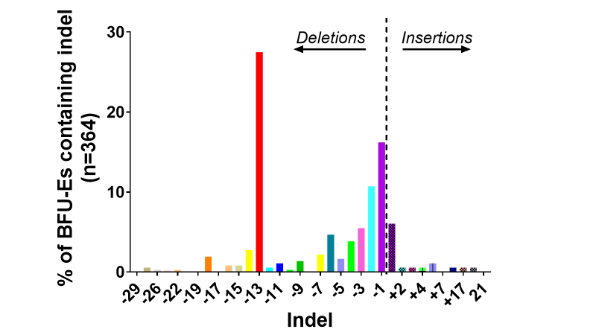
In general, a pattern of decreasing frequency with increasing indel size is noted, as would be expected since the NHEJ pathway favours the formation of smaller indels and is the predominant repair pathway in HSPCs.^{344; 345} However, in addition to the 13nt deletion, 6, 14 and 18nt deletion lengths appear to be outwith this general trend. This may be suggestive of MMEJ pathway activity contributing to a greater incidence of these particular length deletions, though numbers were not large enough to draw firm conclusions regarding this interesting observation.
Figure 4.1: Indel frequencies in single BFU-Es after CRISPR/Cas9 editing at HBG-113
HSPCs were edited at HBG-113 as a single editing target or as part of a multiplex editing strategy also targeting BCL11A-ee. Single BFU-Es cultured from these HSPCs were individually harvested and HBG-113 sequences analysed by TIDE after PCR amplification and Sanger sequencing. The percentage of edited BFU-Es containing each indel type was documented.
Abbreviations: BCL11A-ee: BCL11A erythroid enhancer region, BFU-E: burst-forming unit-erythroid, CRISPR/Cas9: Clustered regularly interspaced short palindromic repeat (CRISPR)/ CRISPR-associated protein 9 (Cas9) system, HBG-113: HBG promoter region, HSPCs: haematopoietic stem and progenitor cells, Indel: Insertion or deletion, PCR: Polymerase chain reaction, TIDE: Tracking of Indels by Decomposition.

4.4.3 Frequency of each indel type at BCL11A-ee in single BFU-Es
The indel pattern is markedly different in the case of BCL11A-ee editing (Fig 4.2). Again, all single BFU-Es subjected to BCL11A-ee editing either as a single or as part of a dual editing strategy were examined (n=245). The most common indel is 1nt insertion, present in 41.4% of BFU-Es edited at ≥1 BCL11A-ee allele (taken to be those with ≥20% total editing reported by TIDE analysis) and comprising 26.5% of total reported indels in these colonies. 13nt and 15nt deletions, reported to be associated with MMEJ pathway activity, were seen in 7.0% and 3.8% of edited colonies, and 4.5% and 2.4% of total colonies respectively.

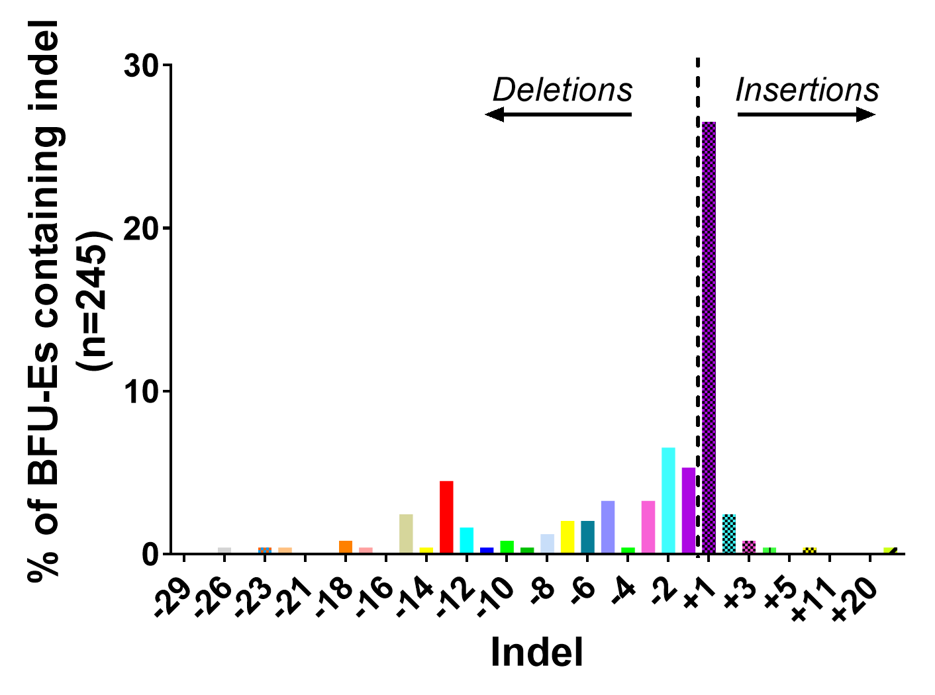
Figure 4.2: Indel frequencies in single BFU-Es after CRISPR/Cas9 editing at BCL11A-ee
HSPCs were edited at BCL11A-ee as a single editing target or as part of a multiplex editing strategy also targeting HBG-113. Single BFU-Es were cultured from these HSPCs, individually harvested and underwent BCL11A-ee sequence analysis by TIDE after PCR amplification and Sanger sequencing. The percentage of edited BFU-Es containing each indel type was documented.
Abbreviations: BCL11A-ee: BCL11A erythroid enhancer region, BFU-E: burst-forming unit-erythroid, CRISPR/Cas9: Clustered regularly interspaced short palindromic repeat (CRISPR)/ CRISPR-associated protein 9 (Cas9) system, HBG-113: HBG promoter region, HSPCs: haematopoietic stem and progenitor cells, Indel: Insertion or deletion, PCR: Polymerase chain reaction, TIDE: Tracking of Indels by Decomposition.

4.4.4 Frequency of insertions compared to deletions at each locus in single BFU-Es
Editing data from all single BFU-Es with editing at each locus were combined and the total frequencies of each indel type were examined. Undefined indels (i.e. the discrepancy between total reported editing and the sum of defined indels reported by TIDE) were excluded from this particular analysis. At HBG-113, there is a clear preference for the formation of deletions rather than insertions, with 90.0% of defined indels comprising deletions of various lengths and only 10.0% being insertions (Fig 4.3).
At BCL11A-ee, however, there is a more even distribution between deletions and insertions (Fig 4.3). Deletions contribute 45.5% of all defined indels whereas insertions make up a similar proportion, at 54.5%. The difference in comparative frequencies of insertions and deletions at the 2 loci was very highly significant (p<0.0001).

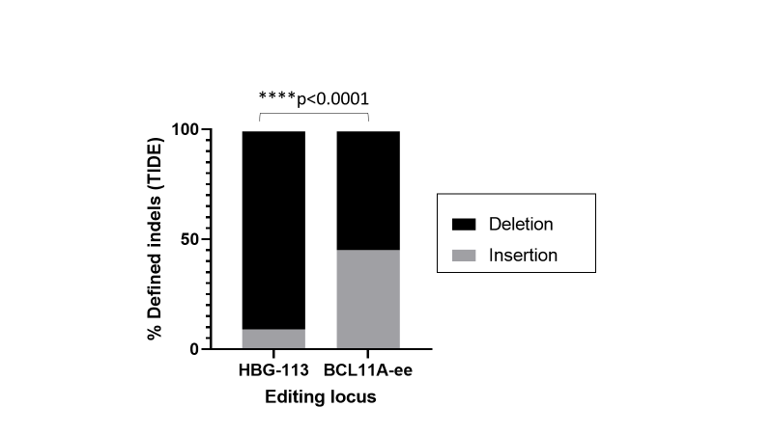
Figure 4.3: Comparative contributions of insertions and deletions to total indel frequencies at HBG-113 and BCL11A-ee in single BFU-Es after CRISPR/Cas9 editing
HSPCs were edited at HBG-113 and/or BCL11A-ee, as single editing targets or as part of a dual editing strategy. BFU-Es were cultured and individually harvested, then underwent PCR, Sanger sequencing and TIDE analysis of each target site. For each locus, the proportion of defined indels comprised of insertions and the proportion of deletions were calculated separately, in order to facilitate comparison of indel type formation between the two loci. Differences between loci were compared using the two-sided Chi-square test.
Abbreviations: BCL11A-ee: erythroid-specific enhancer region of BCL11A, BFU-E: burst-forming unit-erythroid, CRISPR/Cas9: Clustered regularly interspaced short palindromic repeat (CRISPR)/ CRISPR-associated protein 9 (Cas9) system, HBG-113: HBG promoter region, HSPCs: haematopoietic stem and progenitor cells, PCR: Polymerase chain reaction, TIDE: Tracking of Indels by Decomposition.

4.4.5 Indel patterns at HBG-113 within individual BFU-Es arising from single and both dual CRISPR/Cas9 edited reactions
DNA sequencing of single BFU-Es from each reaction allowed the pattern of indel formation to be compared between single edited and each of the double-edited reactions within each locus. At HBG-113, there was a slightly higher proportion of unedited colonies arising from simultaneous dual edited reactions in comparison to single HBG-113 edited HSPCs, but the pattern of edits seen was largely similar (Fig 4.4A-B). Looking in particular at frequency of the 13nt deletion, this was present in 54/167 (32.3%) of BFU-Es arising from single edited reactions, with an average reported frequency within these 54 colonies of 46.8%.
In BFU-Es from simultaneous dual edited reactions the 13nt deletion was present in 39/155 (25.2%) colonies with an average reported frequency within those 39 BFU-Es of 46.3%. There was less data available from analysis of BFU-Es from sequentially dual edited reactions and, therefore, comparisons drawn between this arm and other reactions must be cautious (Fig 4.4C). The total number of edited colonies in BFU-Es from sequential dual edited arms trended towards being lower than either of the other two arms, but where editing had taken place, this was to a high frequency per cell in the majority of edited BFU-Es, with a smaller proportion of clones appearing to contain low or moderate editing levels than in other reactions. The 13nt deletion was present in 10/42 (23.8%) BFU-Es from this arm but with the greatest average frequency out of all 3 experimental arms, at 68.8% within those 10 BFU-Es.

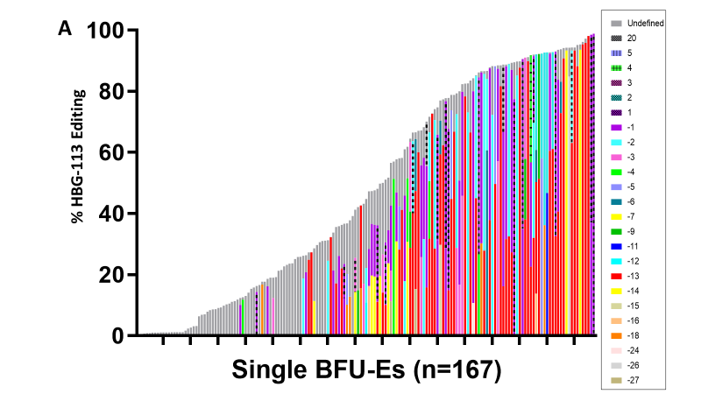
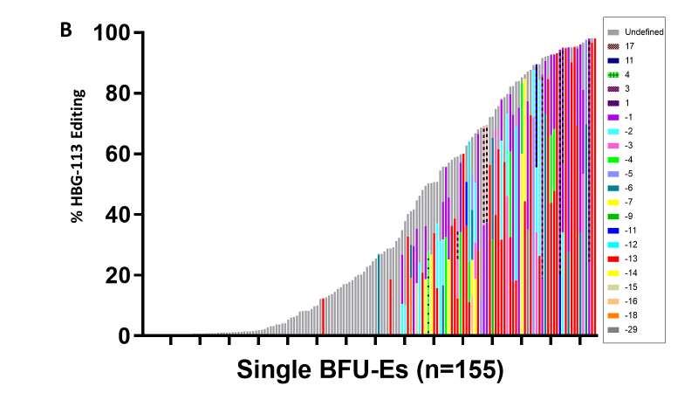
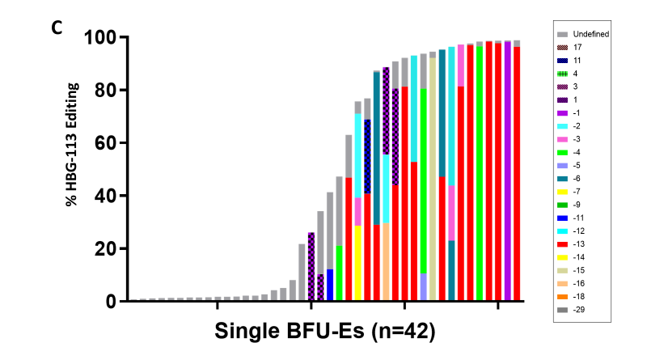
Figure 4.4: HBG-113 editing patterns within individual BFU-Es after single, simultaneous or sequential dual CRISPR/Cas9 editing
HSPCs were edited at HBG-113 as a single editing target, or as part of a multiplex editing strategy also targeting BCL11A-ee, either simultaneously or in a sequential fashion. Single BFU-Es cultured from these HSPCs were individually harvested and HBG-113 sequences analysed by TIDE after PCR amplification and Sanger sequencing. The pattern of total editing and the contribution of specific indel types was examined separately in BFU-Es from single edited (A), simultaneous dual edited (B) or sequentially dual edited (C) reactions.
Abbreviations: BCL11A-ee: erythroid-specific enhancer region of BCL11A, BFU-E: burst-forming unit-erythroid, CRISPR/Cas9: Clustered regularly interspaced short palindromic repeat (CRISPR)/ CRISPR-associated protein 9 (Cas9) system, HBG-113: HBG promoter region, HSPCs: haematopoietic stem and progenitor cells, PCR: Polymerase chain reaction, TIDE : Tracking of Indels by Decomposition.

4.4.6 Indel patterns at BCL11A-ee within individual BFU-Es arising from single and both dual CRISPR/Cas9 edited reactions
Detailed examination of indel types at the BCL11A-ee locus in single BFU-Es from each reaction was then undertaken. As observed at the HBG-113 locus, patterns appeared largely similar between single and simultaneous dual edited reactions (Fig 4.5A-B). However, where the MMEJ-associated larger deletions were studied, the 13nt deletion was again more likely to be present in BFU-Es arising from single edited HSPCs than simultaneous dual edited reactions. This particular indel was present in 6/73 (8.2%) BFU-Es from single edited reactions but only 5/125 (4.0%) from simultaneous dual edited arms, but with the same average frequency where present of 35.2% in each arm. The
15nt deletion was reported in only 1/73 (1.4%) of BFU-Es from single edited reactions, at a frequency of 49.1% in that single colony. In simultaneous dual edited BFU-Es the 15nt deletion was reported in 4/125 (3%), with an average frequency, where present, of 19.5%. There were a smaller number of data available for single BFU-Es arising from sequential dual edited reactions, precluding robust comparison (Fig 4.5C).

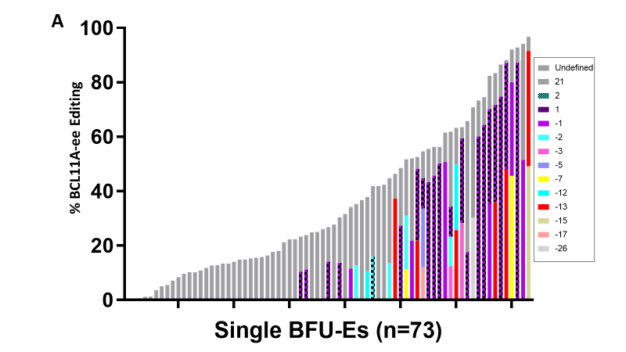
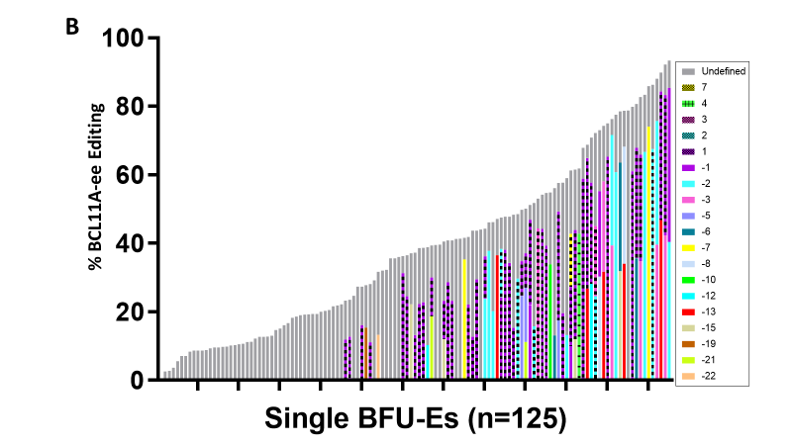
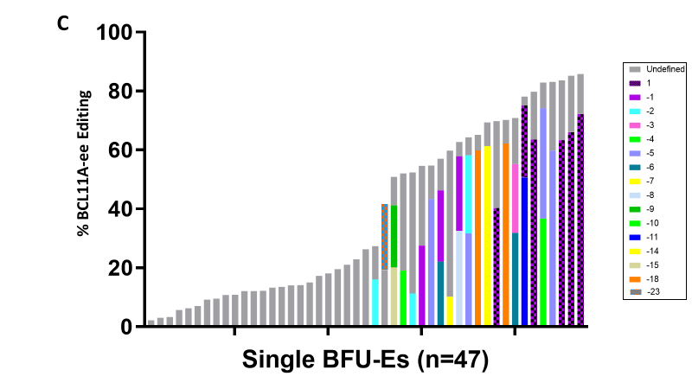
Figure 4.5: BCL11A-ee editing patterns within individual BFU-Es after single, simultaneous or sequential dual CRISPR/Cas9 editing
HSPCs were edited at BCL11A-ee as a single editing target, or as part of a multiplex editing strategy also targeting HBG-113, simultaneously or in a sequential fashion. Single BFU-Es cultured from these HSPCs were individually harvested and BCL11A-ee sequences analysed by TIDE after PCR amplification and Sanger sequencing of this locus. The pattern of total editing, and contribution of specific indel types, was documented separately for BFU-Es from single edited (A), simultaneous dual edited (B) or sequentially dual edited (C) reactions.
Abbreviations: BCL11A-ee: erythroid-specific enhancer region of BCL11A, BFU-E: burst-forming unit-erythroid, CRISPR/Cas9: Clustered regularly interspaced short palindromic repeat (CRISPR)/ CRISPR-associated protein 9 (Cas9) system, HBG-113: HBG promoter region, HSPCs: haematopoietic stem and progenitor cells, PCR: Polymerase chain reaction, TIDE : Tracking of Indels by Decomposition.
.

4.4.7 Proportion of alleles edited at each locus in single BFU-Es arising from single and dual edited reactions
Total editing expressed as number of alleles edited was next scrutinised in BFU-Es arising from the different single or dual edited reactions. Frequencies of various editing combinations for BFU-Es arising from simultaneously or sequentially double-edited reactions were only reported where a valid editing result at each locus is available.
Where BCL11A-ee single editing was applied, a similar number of BFU-Es were edited at 0/2 and 1/2 alleles (38.4% and 39.7% respectively), and approximately half this number (21.9%) had 2/2 alleles edited (n=73) (Fig 4.6A). In BFU-Es from simultaneously double edited reactions, a similar pattern was observed: 33.6% of reactions were edited at 0/2 alleles; 47.3% at 1/2 alleles and 19.1% at 2/2 alleles (n=110) (Fig 4.6B). For sequentially double-edited reactions, the majority of BFU-Es were not found to have any editing at the BCL11A-ee site (56.3%), a smaller number had 1/2 alleles edited (28.1%) and it was rarer to find 2/2 alleles edited (15.6%) (n=32) (Fig 4.6C).
With regards to HBG-113 editing, there was a more equal spread between BFU-Es containing each possible number of edited alleles following application of single HBG-113 editing (Fig 4.6D). 19.2% had 0/4 alleles edited, 24.0% had 1/4, 15.0% had 2/4, 15.6% had 3/4 and 26.3% had 4/4 alleles edited (n=167). With the double-editing approaches, the most frequent number of HBG-113 alleles edited was 0/4 (46.4%, n=73, with simultaneous and 53.1%, n=32, with sequential strategies) (Fig 4.6E-F). However, amongst BFU-Es demonstrating at least some HBG-113 editing following simultaneous or sequential double editing, it was more common to find 4/4 alleles edited rather than a smaller number (20.0% and 31.3% respectively).

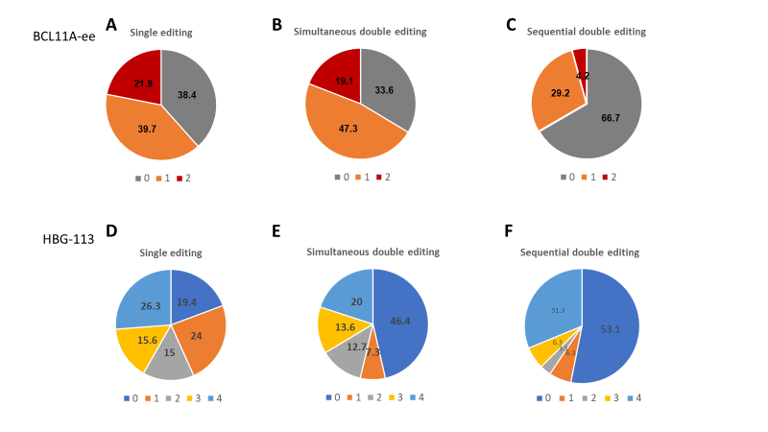
Figure 4.6: Distribution of allele numbers edited at BCL11A-ee and HBG-113 within individual BFU-Es following single, simultaneous or sequential dual editing
HSPCs were edited at BCL11A-ee, as a single editing target (A), or as part of a simultaneous (B) or sequential (C) dual editing protocol; and/or at HBG-113, again as a single (D), simultaneous dual (E) or sequential dual (F) target. Single BFU-Es cultured from these HSPCs were individually harvested and sequences analysed by TIDE, after PCR amplification and Sanger sequencing. The number of alleles edited at each locus was analysed separately in BFU-Es from each reaction, out of a maximum of 2 BCL11A-ee and 4 HBG-113 alleles per cell.
Abbreviations: BCL11A-ee: erythroid-specific enhancer region of BCL11A, BFU-E: burst-forming unit-erythroid, HBG-113: HBG promoter region, HSPCs: haematopoietic stem and progenitor cells, PCR: Polymerase chain reaction, TIDE: Tracking of Indels by Decomposition.
With thanks to O Humbert for designing the layout of these graphs

4.4.8 Proportion of single BFU-Es with editing at one or both loci
In BFU-Es from single edited reactions, the HBG-113 and BCL11A-ee loci had at least 1 allele edited in 80.8% (n=167) and 61.6% (n=73) of colonies studied, respectively (Fig 4.7). BFU-Es from dual edited reactions which had editing data available for both loci were next examined. In BFU-Es arising from simultaneous dual edited reactions: 22.7% did not have editing at either locus; 10.9% were edited at HBG-113 only; 23.6% at BCL11A-ee only and 42.7% had editing at both loci (n=110). In BFU-Es from sequential dual edited arms: 40.6% were unedited; 15.6% were edited only at HBG-113; 12.5% were edited only at BCL11A-ee and only 31.2% were edited at both loci (n=32).

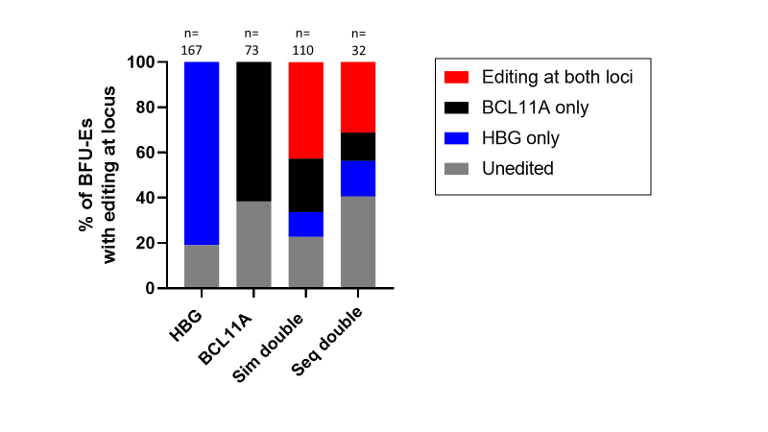
Figure 4.7: BFU-Es edited at HBG-113, BCL11A-ee or both loci following single, simultaneous or sequential dual editing
HSPCs were edited at HBG-113 and/or BCL11A-ee as single editing targets, or as part of a simultaneous or sequential dual editing protocol. Single BFU-Es cultured from these HSPCs were individually harvested and sequences analysed by TIDE, after PCR amplification and Sanger sequencing. The proportion of BFU-Es arising from each reaction in which one or both loci were edited was examined.
Abbreviations: BCL11A: BCL11A-ee single edit reaction, BCL11A-ee: erythroid-specific enhancer region of BCL11A, BFU-E: burst-forming unit-erythroid, HBG: HBG-113 single edit reaction; HBG-113: HBG promoter region, HSPCs: haematopoietic stem and progenitor cells, PCR: Polymerase chain reaction, Seq: sequential, Sim: simultaneous, TIDE: Tracking of Indels by Decomposition.

4.4.9 Association between editing efficiency and HbF percentage in single BFU-Es following single or dual editing
Single BFU-Es with comprehensive editing and HPLC data were examined, in order to investigate the relationship between editing efficiency and HbF reinduction in these clonal populations (Fig 4.8A). Data from an additional arm conducted within a single experiment has also been included here, in which sequential dual editing was applied with a shorter time lag (6 hours) between edits 1 and 2. The particular calculation applied to the HPLC data in this case was an assessment of HbF as a percentage of total haemoglobin (taken to be the sum of HbF + HbA percentages).
Baseline HbF was high even in unedited clones: in BFU-Es with <1 allele edited at either HBG-113 or BCL11A-ee, mean HbF percentage was 31.2% (n=5). In BFU-Es with at least one HBG-113 allele edited (but no BCL11A-ee editing), mean HbF was 40.1% (n=10). Where at least one BCL11A-ee allele was edited (without editing at the HBG-113 locus), HbF was 33.4% (n=12). A weak positive correlation was found between HBG-113 editing and HbF percentage but very little association was observed between BCL11A-ee editing and HbF percentage. It is clear that a wide range of HbF levels were seen within BFU-Es with similar editing frequencies, suggesting that factors other than the basic measure of total number of alleles edited must contribute significantly to the HbF reinduction potential of each BFU-E clone. A clue to the pertinence of the indel type rather than just the volume of editing is suggested by the finding that the association between total HBG-113 editing and HbF reinduction appears to be almost entirely accounted for by the effect of the particular HBG-113 13nt deletion on HbF percentage (Fig 4.8B).
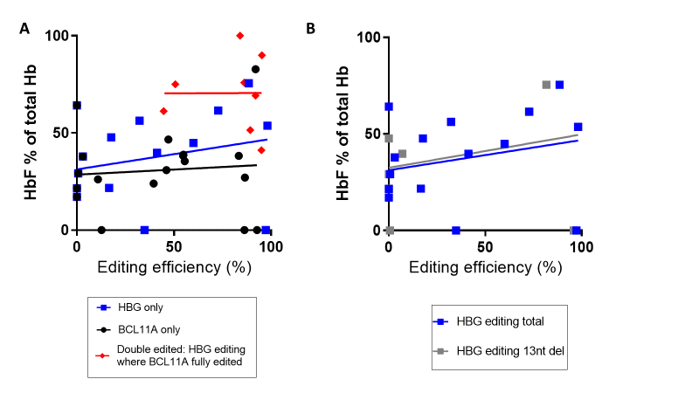
Figure 4.8: HbF reinduction in single BFU-Es edited at HBG-113, BCL11A-ee or both loci
HSPCs were edited at HBG-113 and/or BCL11A-ee as single editing targets, or as part of a simultaneous or sequential dual editing protocol. Single BFU-Es were cultured and individually harvested. Sequences were analysed by TIDE after PCR amplification and Sanger sequencing. HPLC was undertaken to determine HbF percentage of total Hb (taken to be HbF + HbA). (A) The association between editing frequency at each or both loci, and HbF percentage was examined. (B) The association between HbF percentage and both total HBG-113 editing and the 13nt deletion at this site was studied.
Abbreviations: BCL11A or BCL11A-ee: erythroid-specific enhancer region of BCL11A, BFU-E: burst-forming unit-erythroid, Hb: haemoglobin, HbA: haemoglobin A, HbF: foetal haemoglobin, HBG or HBG-113: HBG promoter region, HSPCs: haematopoietic stem and progenitor cells, PCR: Polymerase chain reaction, TIDE : Tracking of Indels by Decomposition, 13nt del: 13 nucleotide deletion.

4.4.10 Greatest HbF reinduction in single BFU-Es edited at both BCL11A-ee and HBG-113 loci
HbF percentage in dual edited BFU-Es was higher than in single edited BFU-Es (Fig 4.9). In clones with ≥60% editing of both BCL11A-ee and HBG-113, mean HbF was 71.3% (n=6) whereas it was only 47.1% with ≥60% editing at HBG-113 only (n=5, p>0.05), and was significantly lower at 29.6% where editing was ≥60% at BCL11A-ee only (n=5, p=0.0373).
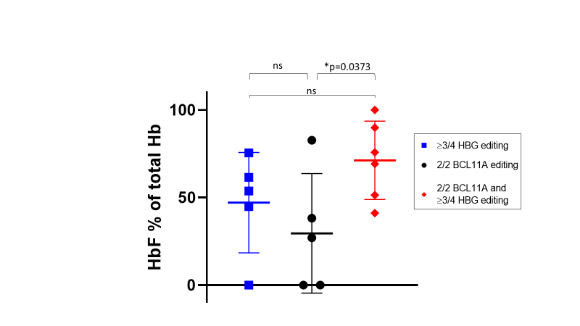
Figure 4.9: HbF reinduction in single BFU-Es edited at either HBG-113, BCL11A-ee or both loci
HSPCs were edited at HBG-113 and/or BCL11A-ee as single editing targets, or as part of a simultaneous or sequential dual editing protocol. BFU-Es were cultured and individually harvested. Sequences were analysed by TIDE after PCR amplification and Sanger sequencing of relevant loci. BFU-Es with ≥60% editing at one or both loci were included in the analysis. This cut-off was taken to represent editing at both available BCL11A-ee sites, or at the majority of the 4 HBG-113 alleles per cell. HPLC was undertaken and HbF as a percentage of total Hb (taken to be HbF + HbA) was calculated. HbF percentage was compared between BFU-Es edited at both BCL11A-ee sites alone; BFU-Es edited at ≥3/4 available HBG-113 sites alone, and BFU-Es edited at both BCL11A-ee sites plus ≥3/4 available HBG-113 sites. This was in order to characterise any additive effect of editing at the secondary site, once a primary site was already completely or almost entirely edited. Mean+/- SD shown.
Abbreviations: BCL11A or BCL11A-ee: erythroid-specific enhancer region of BCL11A, BFU-E: burst-forming unit-erythroid, Hb: haemoglobin, HbF: haemoglobin F, HBG or HBG-113: HBG promoter region, HSPCs: haematopoietic stem and progenitor cells, ns: not statistically significant (p>0.05), PCR: Polymerase chain reaction, TIDE: Tracking of Indels by Decomposition.

4.5 Discussion
The study of singe clones following single or dual CRISPR/Cas9 genome editing allows single cell-level analysis of indel types formed at each of the BCL11A-ee and HBG-113 loci. Different patterns of editing dependent on type of reaction and locus were elucidated, and the relationship between editing frequency and HbF reinduction was examined in detail.
Optimisation of the BFU-E picking and processing protocols were first required in order that valid results could be obtained. The size of pipette tip and preparation by first washing the tip in PBS reduced adherence of colony cells to the tip. Cell loss was further avoided by picking cells into the final volume of PBS and mixing by vortexing, negating the need for pump mixing by pipette, or centrifugation and removal of excess supernatant. The proportions of cell solution allocated to DNA extraction and HPLC was honed. DNA extraction procedure suitable to the smaller cell number was introduced, and the number of PCR cycles increased in order to further amplify the limited number of sequences. Following these improvements, error-free sequencing was now possible for the majority of BFU-Es and HPLC also reported valid results in most cases.
Clear differences in indel patterns between the two loci emerged. Deletions make up the vast majority of indels at HBG-113, including a high frequency of 13nt deletions associated with the MMEJ repair pathway, and also a large proportion of small deletions. At BCL11A-ee, however, insertions were approximately as frequent as deletions. Where the MMEJ-associated 13nt and 15nt deletions at this locus were excluded from analysis, insertions in fact represented a greater proportion of indels than deletions, again with preferential formation of smaller indels. The high frequency of small indels observed was expected, due to primary activity of the NHEJ repair pathway.^{344; 345} However, it is unclear why NHEJ repair leads primarily to deletions at HBG-113 but to a more even distribution of insertions and deletions at the BCL11A-ee locus.
The indel pattern observed following HBG-113 editing is similar to that published in previous studies, with at least 2 other groups each reporting that in addition to the well-recognised 13nt deletion, other longer deletion lengths of 11 and 18 nucleotides occur at higher frequency than would be expected due to NHEJ alone.^{268; 341; 346} Given the consistency of these observations, it is highly likely that the formation of these two particular nt deletion lengths also relate to MMEJ repair pathway activity. Indel patterns observed at BCL11A-ee were also reflective of publications from other groups, in which 13nt and 15nt deletions were particularly prevalent, again consistent with MMEJ pathway activity.^{263; 269} Why the MMEJ-associated 13nt deletion at HBG-113 is so much more frequent than the 13nt and 15nt deletions at BCL11A-ee is unclear. Hypotheses to explain this difference include that the MMEJ machinery may have easier access to certain parts of the genome than others, or that flanking sequences close to the cut site more strongly promote microhomology recognition at the HBG-113 site than the BCL11A-ee locus. This phenomenon warrants further study.
Single cell-level data on editing patterns at each of these loci has previously been published, but this is the first report examining editing patterns following multiplex editing at both loci. On comparing BFU-Es from single and simultaneous dual edited reactions, no clear differences in the pattern of small indels was seen. However, there was a trend towards a reduced prevalence of BFU-Es containing the 13nt deletion at both HBG-113 and BCL11A-ee where editing had been simultaneous at both loci rather than single target only. This was consistent with results seen on analysis of bulk cells in liquid culture, outlined in Chapter 3 (section 3.4.1.1), in which frequency of the 13nt deletion at each locus was lower in simultaneous dual reactions when compared to single edited arms. A similar pattern was expected in relation to the 15nt deletion at BCL11A-ee and although this was not observed, the numbers involved were too small to draw inferences from this.
Due to the paucity of data available for sequentially dual edited reactions, comparisons between this arm and others were necessarily limited. The reasons for a reduced volume of data in this arm relate to the exclusion of BFU-Es from the additional 6-hour sequential dual edit arm in the first experiment and the failure of a large number of the BCL11A-ee PCR reactions where BFU-Es from the sequential dual edit arm of the last experiment were assayed. The reasons for this were unclear and likely relate to technical or reagent problems, but only a limited number of repeats were undertaken due to resource constraints.
Developing tandem editing and Hb analysis on single BFU-Es was challenging, but these results provide an interesting insight into the relationship between edits and HbF reinduction in single erythroid clones. Although the high baseline HbF levels seen in these colonies were likely to dampen associations, a positive correlation between HBG-113 editing level and HbF percentage was documented. Further proof of the strong relationship between indel type (rather than just presence) and efficacy of target locus disruption is borne out by the observations that the association between HBG-113 editing percentage and HbF reinduction in erythroid colonies is almost exactly mirrored by the relationship between the 13nt deletion and HbF, suggesting that this particular indel length is particularly effective at preventing transcription factor binding and may, therefore, be disproportionately responsible for HbF reinduction, in comparison to other indel types.
The association between BCL11A-ee editing and HbF level was observed to be very weak, which was surprising. This may be due to a small number of anomalous results, for example 2 BFU-Es for which close to 100% BCL11A-ee editing was reported but 0% HbF was recorded on HPLC. Accuracy of these HPLC data was considered unlikely, especially given the high baseline HbF levels in many unedited colonies. However, exclusion of such data risked introducing confirmation bias and would have been scientifically unsound. Both the number of datasets generated and, almost certainly, also elements of their accuracy, were limited by sensitivity thresholds of the HPLC assay in the context of single colony analysis. A larger dataset would have been highly desirable in order to increase robustness of this analysis and reduce the effect of such probable inaccuracies. Unfortunately, access to HPLC was limited since it was undertaken by collaborators rather than in-house. Efforts were made to explore the possibility of setting up HPLC analysis at FHCRC in collaboration with the proteomics department. However, the large outlay of finance and time required to purchase, set up, validate and regularly calibrate equipment was considered prohibitive at that point in time.
The levels of HbF observed in single erythroid colonies where biallelic editing of BCL11A-ee had taken place were similar to those reported by Wu et al.²⁶⁹ There was a trend towards these being lower than HbF proportions where all available HBG-113 sites were edited. Our higher mean HbF values reported with quadrallelic editing at HBG-113 were also consistent with those previously reported.³⁴¹
One of the most important findings of this chapter was that HbF percentage was significantly higher in dual edited BFU-Es in comparison to those edited at both BCL11A-ee loci only, and also trended towards being higher than those edited at the majority of HBG-113 loci only. This provides evidence of a further benefit to editing at HBG-113 even where both BCL11A-ee loci have been successfully edited in a single cell, and suggests that the reverse is also the case. This is consistent with results from analysis of bulk cells in vitro, presented in Chapter 3 (sections 3.4.1.3 and 3.4.1.4), in which the most effective HbF reinduction was seen in sequentially dual edited cells. However, in earlier analyses it was not possible to discern whether this benefit was simply due to an increase in the total number of HSPCs which were edited to some degree, or whether there was an additive benefit to modification at a secondary locus within the same cell even if the first was fully edited.
It is hypothesised that this additional benefit to editing HBG-113 in the context of both BCL11A-ee loci already containing indels relates to one or both of the following mechanisms. The first proposed hypothesis relates to the likelihood that only certain indels will effectively disrupt the function of a genetic locus. As a result, the BCL11A enhancer region may still fulfil this function despite containing some indels (predicted to be smaller indels). If such a non-disruptive indel has been introduced, then BCL11A transcription factor will still be produced at normal levels and there would consequently be additional benefit to disrupting its binding site within HBG-113. A second proposed mechanism relates to the fact that BCL11A-ee is not the only transcription factor involved in the HbA to HbF physiological switch.^{19; 21} At least one other such effector protein is known to bind to the HBG promoter region and there may be more. As a result, disruption of this locus removes the binding site for other transcription factors even where BCL11A production has been successfully knocked down, and consequently adds further potency to HbF reinduction.
Parallel hypotheses were proposed to explain the beneficial effect of knocking out BCL11A-ee, even where all available HBG-113 sites may be edited. Indels at HBG-113 may not have effectively disrupted the transcription factor binding site at this location, meaning that BCL11A downregulation could still take effect. Reducing BCL11A production would, in this case, be expected to continue to have an impact on the amount of HbF production taking place. Secondly, BCL11A may have effector sites other than HBG-113 and, therefore, reducing BCL11A production may enhance HbF reinduction by more mechanisms than simply reducing its binding at HBG-113. Further investigation of these proposed mechanisms for the beneficial effect of dual editing within single cells is recommended.
Limitations both to this particular dataset and also to the study of single BFU-Es more generally were considered. The relatively small volume of data from sequential dual edited reaction BFU-Es has already been discussed above, alongside limited availability of HPLC data.
It is recognised that in selecting limits for the definition of specific number of alleles edited, the exact figures chosen necessarily have at least a somewhat arbitrary nature. While the overestimation of editing efficiencies as reported by TIDE was taken into account, without having NGS data to validate the selected limits, their accuracy remained unconfirmed. The lack of NGS data itself is a further limitation to these experiments.
With regards to the study of single colonies more generally, the assumption is made that these were clonal and, due to this characteristic, represent single cell-level data. However, it is possible that cells from more than one colony could be inadvertently harvested. Indeed, in a very small minority of cases, the TIDE results were highly suggestive of non-clonality, on analysis of what had been presumed to be single BFU-Es. This was the case, for example, where >2 types of indel (or 2 indels alongside unedited sequence) were reported at the BCL11A-ee locus (which only has 2 alleles per cell), or >4 types of indel (or 4 different indels plus unedited sequence) at HBG-113 (of which there are 4 sites per cell). Thorough consideration was given to the best method of dealing with such results. On the one hand, failure to reject such data from analyses meant that results from mixed colonies were knowingly included. On the other hand, if they were excluded, this risked introducing systemic bias into the analysis. The reason that bias would be systemic was that the lower the amount of editing present, the less likely a mix of colonies would be picked up and excluded as a result. For example, if 2 unedited colonies were inadvertently collected together, or 1 edited plus 1 unedited colony, this would not be detected by such standards. As a result, mixed highly edited colonies would be more likely to be excluded from the analysis than mixed unedited colonies. This would consequently skew results towards reporting a higher proportion of unedited colonies. It is recognised that by including results with evidence of non-clonality, error is increased and precision decreased. However, this was acceptable given the high number of colonies analysed and the fact that only a very small proportion appeared to show evidence of mixing. On the other hand, introducing systemic bias and skew to results would render conclusions invalid. Therefore, the final decision was that evidence of non-clonality should not be considered an exclusion criterion on examination of sequencing results.
As a further limitation to the analysis of single BFU-Es, even without the problem of contamination, it may not be a correct assumption that HbF proportion will be equivalent in every cell within a single BFU-E. Factors other than genetic sequence may have a significant impact on Hb proportions. For example, cells in the centre of a colony may have reduced exposure to cytokines in the media, or conversely may be influenced to a greater degree by cytokines secreted by neighbouring cells.
It is also possible that BFU-Es for which results were generated were not fully representative of the BFU-E population as a whole, if larger and better haemoglobinised colonies were more likely to have results included in analyses. For example, edited BFU-Es may on average be larger or smaller, better or less well haemoglobinised, leading to differential levels of selection and / or successful analysis between edited and unedited clones.
BFU-Es themselves may also not be representative of other colony types in terms of editing patterns, although this potential concern is allayed to some degree by the finding that the distribution of colony types was not significantly impacted by single or dual editing applied to HSPCs (Chapter 3, section 3.4.1.2). Finally, conclusions drawn based on analysis of single colonies cannot be assumed to apply to cells cultured in alternative conditions or, more importantly, to HSPCs in vivo.
In summary, the investigation of indel formation and HbF reinduction within single erythroid clones adds granular detail to the data garnered by analysis of bulk cells in vitro. Very different editing patterns at BCL11A-ee and HBG-113 were observed, the reasons for which warrant further research in order to expand our understanding of the NHEJ and MMEJ repair pathways resulting in indel formation after the formation of DNA double-stranded breaks by CRISPR/Cas9 RNPs. These results have also demonstrated the additive effect of HBG-113 editing in cells already fully edited at BCL11A-ee, and most likely the converse is also true. This provides further support to the conclusion of Chapter 3, that maximal HbF reinduction results from dual CRISPR/Cas9 editing at both BCL11A-ee and HBG-113.

5.0
Chapter 5:
Xenotransplantation multiplex CRISPR/Cas9 edited haematopoietic stem and progenitor cells into mice

5.1 Introduction
Sickle cell disease and β thalassaemia are two of the most common monogenic disorders worldwide, resulting in a heavy burden of morbidity and early mortality for sufferers.¹⁶ Until now, the only potentially curative therapy was donor HSCT, which is only available to a small proportion of patients and carries inherent risks and complications in and of itself.²¹⁹ Recently, genome editing therapy has emerged as another possibility for long-term curative treatment, by increasing circulating levels of HbF. Raised HbF levels have long been recognised to confer amelioration of disease symptoms in patients with haemoglobinopathies, and may even render them asymptomatic.^{73; 134} Genome editing accomplishes this by disrupting the BCL11A/HBG axis, responsible (at least in part) for the repression of HbF production. Thus far studies have focused on knocking out either the erythroid enhancer region of BCL11A, or the BCL11A binding site within the HBG promoter region, but resultant HbF levels have not consistently been high enough to guarantee cure.^{263; 264; 280} This thesis describes investigation into strategies aiming to disrupt both loci in the same HSPC population, in order to maximise resultant HbF reinduction.
HSPCs targeted for genome editing at a single locus of either HBG-113 or BCL11A-ee have been demonstrated to successfully engraft, proliferate and differentiate into mature blood cell lineages when transplanted into immunodeficient mice.^{263; 269; 341; 346} Previously published data has demonstrated the successful engraftment of single HBG-113-edited HSPCs in non-human primates,²⁸⁰ and single BCL11A-ee-edited HSPCs when retransplanted back into patients (NCT03655678, NCT03745287). Data presented in Chapter 3 established that the simultaneous and sequential dual editing procedures did not prohibit haematopoietic stem and progenitor cells from proliferating and differentiating in vitro, as assessed by colony forming and erythroid differentiation assay analyses. However, it remained to be studied whether such multiplex-edited cells will be able to reliably engraft in vivo following transplantation, and whether they will subsequently differentiate into mature blood cell lineages. It is well established that certain editing targets impair the ability of HSPCs to engraft and differentiate in vivo, such as in the case of whole BCL11A gene knockout rather than just the erythroid enhancer region.^{263; 264} Therefore, investigating any effects on the viability of edited HSPCs is a vital step in establishing the feasibility of these new dual editing strategies for treatment of haemoglobinopathies.
The NSG mouse species is well established as a preclinical model for human haematopoietic stem cell xenotransplantation, and a common first step in the translation from in vitro strategies to clinical application.³⁰³ Therefore, experiments were conducted to investigate the effects of simultaneous and sequential dual editing protocols on the engraftment and normal development of HSPCs after transplantation into NSG mice. Initially 2 small pilot experiments were conducted in order to ensure the feasibility of this transplant strategy and the analyses planned within it, before moving forward with a larger mouse transplant, in order to minimise the total number of animals required for this investigation.
Effects on engraftment and differentiation of the total human HSPC population are not the only concerns post-transplant. One of the most challenging aspects of genome editing transplant experiments is often the failure to maintain an adequate level of edited cells over time post-transplant.^{279; 280; 347} It is insufficient for the total human cell population to persist if the proportion of edited cells within this falls to levels predicted to be subtherapeutic. Therefore it was necessary to assess whether or not the genetically modified cells would continue to contribute an adequate and stable proportion of the human cell population in vivo over time. While mouse transplants generally only continue for around 6 months, this at least would provide data on the medium-term persistence or otherwise of the edited cell population.
Finally, in Chapter 3 data is presented describing the development of 2:11 chromosomal translocations following the application of the dual editing strategies in vitro, due to the formation of double-stranded DNA breaks at the target sites in both the HBG-113 and BCL11A-ee regions in the same cells. This in itself is concerning to a degree, but it may still be possible that such chromosomal rearrangement events in fact render cells non-viable. If that were to be the case, they would not persist in vivo and would not therefore present a risk of oncogenetic change. Therefore the final aspect under investigation in these xenotransplantation experiments was whether the translocation events would persist in vivo and, if so, whether this would be the case regardless of whether dual editing was delivered simultaneously or sequentially.

5.2 Aims and Objectives
The aim of this chapter was to determine the effects of simultaneous or sequential dual editing procedures on HSPC engraftment and lineage differentiation potential, as well as the persistence of editing levels and presence of chromosomal translocations in vivo.

Hypothesis: Dual CRISPR/Cas9 genome editing at HBG-113 and BCL11A-ee, delivered either simultaneously or sequentially, does not impair the post-xenotransplant viability of HSPCs, and edited cells remain at stable levels in vivo. Chromosomal translocations persist following transplantation of dual edited cells.

The objectives of these experiments were:-
- To analyse HSPC engraftment and differentiation into mature haematological lineages, following simultaneous or sequential dual editing at HBG-113 and BCL11A-ee, in comparison to HSPCs edited at either single locus or mock-edited HSPCs.
- To investigate the degree to which edited cells persist in vivo following multiplex editing of HSPCs followed by xenotransplantation, up to the point of necropsy.
- To ascertain whether the chromosomal translocation events detected in vitro following dual editing strategies would persist in vivo following xenotransplantation, up to the point of necropsy.

5.3 Chapter-Specific Materials and Methods
Detailed information on individual techniques performed are given in Chapter 2: General Materials
and Methods.
5.3.1 Experimental design
5.3.1.1 HSPC source
For initial experiments, cell source was G-CSF-mobilised PBMNCs donated by glioblastoma patients who underwent apheresis for the collection of PBSCs as part of a clinical trial. Patients were offered the option of donating their cells to research if they did not proceed to an autologous HSCT and such donated cells were used with patient consent in this experiment.
For the final, larger transplant experiment, G-CSF-mobilised PBMNCs pre-enriched for CD34⁺ cells were purchased from the FHCRC stem cell core.
5.3.1.2 HSPC preparation and genome editing
Human PBMNCs were thawed and where this had not already taken place were enriched for CD34⁺ cells on D-1 followed by flow cytometric quality control assay of the CD34⁺ enrichment, where this had been carried out post-thaw. For the pre-CD34⁺-enriched cells, quality assurance data was provided by the stem cell core documenting adequate CD34⁺ enrichment and purity.
HSPCs were recovered overnight in SFEM II media with cytokines. The CRISPR/Cas9 editing protocol commenced on D0. As described in detail within the genome editing protocol in Chapter 3, HSPCs were edited at either a single locus of HBG-113 or BCL11A-ee on D0; both loci simultaneously on D0; BCL11A-ee on D0 followed by HBG-113 on D1; or underwent mock electroporation only.
5.3.1.3 Transplant procedure
On D2, 5 groups (n=2 mice/group) of adult NSG mice (age 6-8 weeks) were xenotransplanted with cells from each reaction (section 3.3.1.2), with each mouse receiving 1x10⁶ cells which had been spun down at 800 g for 5 minutes at room temperature and resuspended in 1X PBS with 1% heparin (APP Pharmaceuticals) to a total volume of 200 μl. Cell suspension was kept on ice during transport to the mouse facility to optimise cell viability at the point of delivery. Cells were injected via the tail vein. Injection was preceded by sublethal irradiation of 275 cGy.
5.3.1.4 Longitudinal assessment of human chimerism and lineage proliferation
PB was sampled 2-3-weekly by retro-orbital draw from 6-8 weeks post-transplantation for lineage assessment and determination of editing percentage within circulating leucocytes. Lineage assessment was by flow cytometry utilizing antibody panel: anti-human CD45 (hCD45)-PerCP (clone 2D1); anti-mouse CD45 (mCD45)-V500 (clone 30-F11); anti-CD3-APC; (clone UCHT1); anti-CD4-V450 (clone RPA-T4); anti-CD8-APC Cy7 (clone SK1); anti-CD14-PE Cy7 (clone M5E2); anti-CD20-FITC (clone 2H7) (all BD Biosciences), run on the Canto 2-1 flow cytometer (BD Biosciences).
5.3.1.5 Assessment of human chimerism and lineage differentiation at necropsy
Mice underwent euthanasia and necropsy at 23 weeks post-transplantation in the main experiment, earlier euthanasia in the pilot experiments, following maximal PB draw. BM, thymus and splenic tissues were harvested. Lineage assessment by flow cytometry was carried out on PB, BM and thymic tissues, using antibody panel and flow cytometer as for longitudinal lineage assessment in the PB, described above.
In addition, HSPC quantitation within the human cells in extracted BM was undertaken. Within the HSPC population, the long-term repopulating HSC-enriched subpopulation of CD90⁺CD45RA⁻ cells were quantified. These assessments used the antibody panel: anti-hCD45-V450 (clone H130, BD Biosciences), anti-mCD45-PECF594 (clone 30-F11, BD Biosciences), anti-CD38-PerCP/Cy 5.5 (clone HIT2, Biolegend), anti-CD34-APC (clone 563, BD Biosciences), anti-CD90-PE Cy7 (clone 5E10, Biolegend) and anti-CD45RA-APC Cy7 (clone 5H9, BD Biosciences), run on the Symphony flow cytometer (BD Biosciences).
5.3.1.6 Investigations into the persistence of edited cells in each experimental arm
For editing analysis, DNA was extracted from PB, BM and splenic tissues using QIAamp DNA micro kit (Qiagen) then processed by PCR amplification, sequencing and TIDE analysis, as described in Chapter 2 (sections 2.8 – 2.11).
5.3.1.7 Investigations into the persistence of chromosomal translocation events in vivo
For the main transplant experiment, DNA extracted from PB at 6 weeks post-transplant underwent analysis by translocation PCR assay for a qualitative assessment of the presence of the 2:11 chromosomal translocations detected in vitro. PB, BM and splenic samples from the point of necropsy were also subjected to ddPCR analysis for quantitative analysis of translocation presence, as described in detail in Chapter 2 (section 2.14).
5.3.1.8 Ex-vivo analysis of CFU-forming potential of BM HSPCs
A total of 7x10⁴ cells from each mouse BM were plated in ColonyGELTM 1402 (Reachbio) in triplicate from each mouse BM to allow CFU differentiation. This particular methocult media was primarily designed for NHP CFUs but had previously been established by laboratory colleagues as optimal to differentially favour growth and differentiation of human HSPCs while preventing ongoing viability of mouse HSPCs (unpublished data). This is a different media to that used in in vitro experiments involving only human cells where such a differential is not required. CFUs of each type were counted after 14 days incubation.
5.3.1.9 Culture of BM cells in differentiation media and assessments of HbF reinduction potential
Remaining BM cells were cultured in liquid differentiation (erythropoietin-containing) media and assessments of Hb fractions made by flow cytometry and HPLC on aliquots extracted after 12 days in culture.
5.3.1.10 In vitro analyses of HSPCs
In vitro aliquots of edited or mock electroporated human HSPCs were also cultured in differentiation media for analysis of editing efficiencies, quantification of translocation events and assessment of HbF reinduction, and plated out into methocult media for CFU formation. These experiments are described in detail in Chapters 3-4.

5.4 Results
Prior to the larger planned mouse transplant, 2 pilot transplant experiments were carried out with the aim of validating the methods used. Whilst it had also been hoped initially that they would provide an early contribution to the dataset relating to engraftment and lineage differentiation of edited cells in each arm, human engraftment was lost after a short period of time in the first transplant, and in the second there was primary engraftment failure. Both experiments were terminated early and changes made to future transplant protocol including a change in source of human CD34⁺ cells as a result of investigations into these transplant failures and lessons learned.
5.4.1 Pilot mouse transplant #1
5.4.1.1 CD34⁺ purity of enriched MNCs
Following a single passage over the CD34⁺ enrichment column, as was standard practice, quality control flow cytometric analysis of the enriched cellular fraction demonstrated 80% of CD34⁺ cells (Fig 5.1A-B). This was considered adequate to proceed with the transplant experiment.
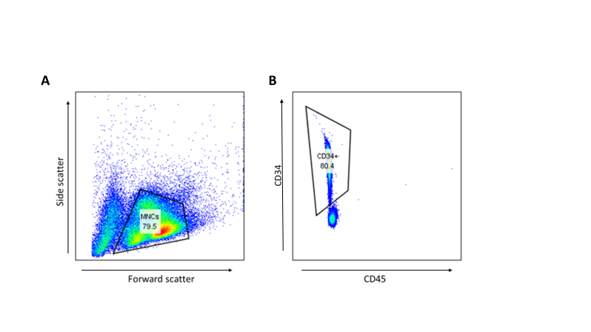
Figure 5.1: Example of flow cytometric quality control result following CD34⁺ enrichment of PB MNCs
In order to assess adequacy of CD34⁺ enrichment prior to modification and transplant of these cells, flow cytometry was carried out to quantify the CD34⁺ fraction, taken to indicate HSPCs. (A) MNCs were initially selected using forward and side scatter. (B) Within this gated population of cells, the HSPC subpopulation was defined as being CD34⁺ and CD45^{low}
Abbreviation: CD: cluster of differentiation, HSPC: Haematopoietic stem and progenitor cell, MNCs: mononuclear cells, PB: peripheral blood.

5.4.1.2 Mouse numbers transplanted
10 mice were enrolled in this initial pilot experiment, with 2 mice being injected with cells from each arm of the experiment.
5.4.1.3 Early loss of human engraftment in all arms on longitudinal analysis of human chimerism and lineage differentiation
Human chimerism at the point of first blood draw at 8 weeks post-transplant was lower than expected in all arms and fell off quickly to less than 10% human contribution to total CD45⁺ cell population in the PB of most mice by 12 weeks (Figure 5.2). Although the 2 mice with close to 0% human chimerism on initial blood draw were both double-edited mice (1 from the sequential double editing and 1 from the simultaneous double editing arm), the other mice in these arms had close to or above average human chimerism level for this experiment. In most mice the human cell population in the PB was composed primarily of CD20⁺ cells, which is unusual particularly at such an early stage of the transplant, with much lower CD14⁺ proportions than would usually be seen. 1 mouse in the BCL11A-ee single edit arm had higher CD3⁺ proportions than all other mice and 1 mouse in the sequential double-edit arm appeared to have higher CD14⁺ levels but otherwise the lineage distribution patterns were reasonably similar between arms (Fig 5.2A-D).
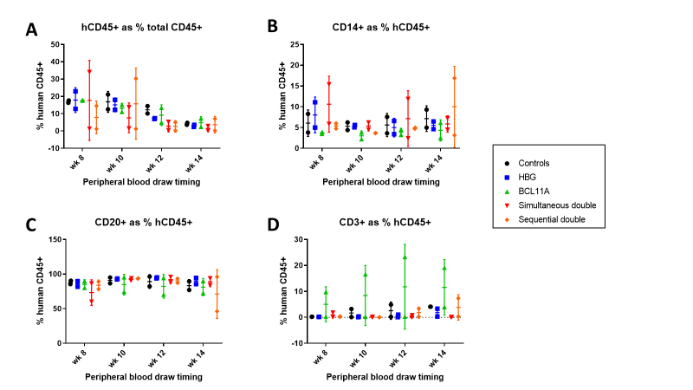
Figure 5.2: Total human chimerism and lineage specific proportions in mouse PB post-transplantation over time demonstrates early engraftment loss but similar patterns in all experimental arms
Flow cytometry was used to assess changes in total human chimerism and lineage-specific cell populations in the PB of humanised mice between 8-14 weeks following transplant of human haematopoietic stem and progenitor cells which had undergone editing at a single locus (HBG-113 or BCL11A-ee), both loci either simultaneously or sequentially in the double-edited arms, or mock electroporation only (control). (A) Human CD45⁺ as a percentage of total CD45⁺ cell population over time, indicative of total human engraftment (mean +/-SD). (B) CD14⁺ proportion of human CD45⁺ cells over time, indicative of myeloid cells (mean +/-SD). (C) CD20⁺ proportion of human CD45⁺ cells over time, indicative of B-lymphocytes (mean +/-SD). (D) CD3⁺ proportion of human CD45⁺ cells over time, indicative of T-lymphocytes (mean +/-SD).
Abbreviations: BCL11A: BCL11A-ee target of genome editing within the BCL11A erythroid enhancer region on chromosome 11, CD: cluster of differentiation, HBG: HBG-113 target of genome editing within the HBG promoter region on chromosome 2, PB: peripheral blood.

5.4.1.4 Low level of human engraftment in all experimental arms at necropsy
Due to rapidly falling human chimerism a decision was made to terminate the experiment early and mice were euthanised shortly following the 14-week blood draw. At necropsy, human chimerism was a little higher in the BM than in the PB and again higher in the spleen, although levels were still less than 30% in most mice even in this tissue (Fig 5.3). In the thymus results were highly variable, but where human chimerism is reported as close to 0% this raises suspicion that the tissue extracted was not actually thymic, since this is usually close to 100% human and simply not visible in animals without adequate human engraftment. As noted above, CD20⁺ cells comprised the major proportion of PB human cells and the same was noted in the spleen.
The pattern in the BM similarly demonstrated a larger than usual proportion of CD20⁺ cells but reassuringly also a significant fraction of myeloid (CD14⁺) cells. CD34⁺ cells as a proportion of human cells in the BM were over 1% in both mock treated mice, both BCL11A-ee single edited mice, and one of the sequentially double edited mice. In other mice CD34⁺ fraction was 0.5-1.0% other than 1 simultaneously double-edited and 1 sequentially double-edited mouse in which it was lower. In the context of generally poor engraftment and small numbers this discrepancy in CD34⁺ levels in the BM was noted but meaningful conclusions could not be drawn. There was inadequate thymic tissue available for lineage analysis (Fig 5.3A-D).

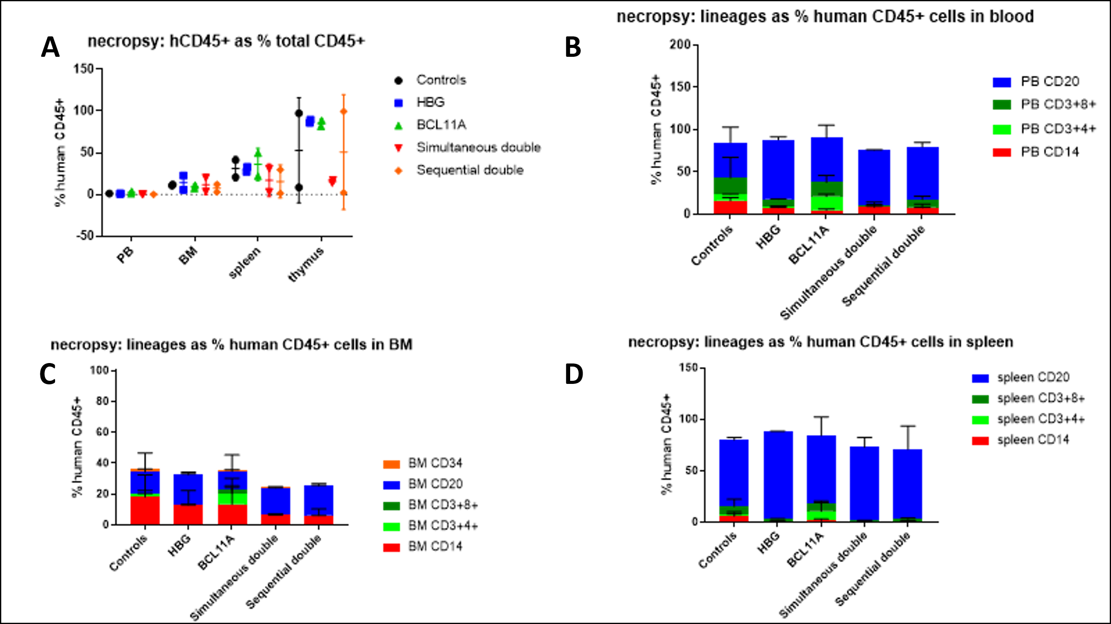
Figure 5.3: Total human chimerism and lineage specific proportions in mouse tissues at necropsy demonstrates low overall human engraftment but no significant differences between experimental arms
Flow cytometric analysis was used to quantify total human chimerism and also lineage-specific contributions to the human cell populations within the PB, BM and spleen of mice extracted at necropsy, following transplant of human haematopoietic stem and progenitor cells which had undergone editing at a single locus (HBG-113 or BCL11A-ee), both loci either simultaneously or sequentially in the double-edited arms, or mock electroporation only. Total human chimerism was also assessed within the thymus. In the BM, the subpopulation of CD34⁺ cells assumed to represent haematopoietic stem and progenitor cells was also analysed. (A) Human CD45⁺ as a percentage of total CD45⁺ cell population in each tissue, as a marker of total human chimerism (mean +/-SD). (B) Haematopoietic lineages as percentages of total human CD45⁺ cells in the PB (mean +/-SD). (C) Mature lineages and CD34⁺ cells as a percentage of total human population in the BM (mean +/-SD). (D) Haematopoietic lineages as percentages of total human CD45⁺ cells in the spleen (mean +/-SD). Abbreviations: BCL11A: BCL11A-ee target of genome editing within the BCL11A erythroid enhancer region on chromosome 11, BM: BM, CD: cluster of differentiation, HBG: HBG-113 target of genome editing within the HBG promoter region on chromosome 2, PB: peripheral blood.

5.4.1.5 Cells edited at each locus persist within the human MNC population over time
Following transplantation there was an initial drop in percentage of edited cells within the circulating human leucocytes in the PB, as is usually seen, but following this editing levels remained stable or increased over time in most mice. This is with the possible exception of BCL11A-ee editing levels in BCL11A-ee single edited mice but since the assay failed on the latter 2 samples from one of these mice, conclusions could not be drawn. Full discussion of challenges involved in obtaining valid results of the BCL11A-ee editing assay in mouse tissue samples is provided in a separate chapter (Chapter 6).
Reassuringly, persistence of edited cells did not appear to be compromised in the double-edited reactions, and in fact trended towards being highest in these mice by the end of the experiment, in the PB. In the BM, HBG-113 editing levels were very low in all mice with the exception of 1 sequentially double-edited mouse, and a similar pattern was seen in the spleen. BCL11A-ee editing was also generally lower in the BM than the PB, while a little better in the spleen. Despite low editing levels overall, the importance of these results is that persistence of edited cells following the novel dual editing approaches is not lower than in single edited arms, providing a degree of reassurance that the dual editing strategy provides stable levels of cells edited at both loci, at least in the short term (Fig 5.4A-D).
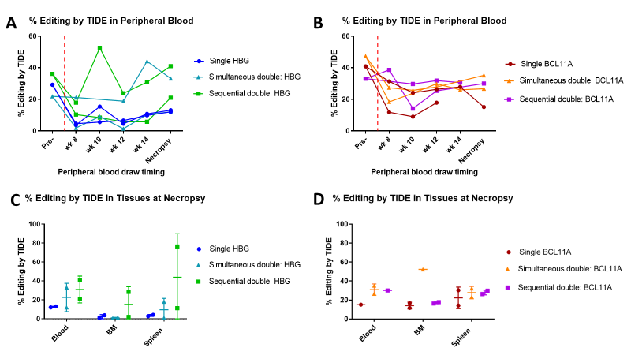
Figure 5.4: Longitudinal assessment of editing levels within human cells in the PB and in haematopoietic tissues at necropsy demonstrates persistence of edited cells over time
Quantification of the percentage of genome editing within the human cell population circulating in the PB over time and in haematopoietic tissues at necropsy was carried out following transplant of human haematopoietic stem and progenitor cells which had undergone editing at a single locus (HBG-113 or BCL11A-ee), or at both loci either simultaneously or sequentially in the double-edited arms. This was achieved by extraction of DNA followed by amplification using the relevant PCR assay, sequencing and TIDE analysis of results. (A) Percentage of cells edited at HBG-113 in the infusion product and in the PB of each mouse over time. (B) Percentage of cells edited at BCL11A-ee in the infusion product and in the PB of each mouse over time. (C) Percentage of human cells edited at HBG-113 in the haematopoietic tissues of each mouse at necropsy (mean +/-SD). (D) Percentage of human cells edited at BCL11A-ee in the haematopoietic tissues of each mouse at necropsy (mean +/-SD).
Abbreviations: BCL11A: BCL11A-ee target of genome editing within the BCL11A erythroid enhancer region on chromosome 11, BM: BM, DNA: Deoxyribonucleic acid, HBG: HBG-113 target of genome editing within the HBG promoter region on chromosome 2, PB: peripheral blood, PCR: Polymerase chain reaction, TIDE: Tracking of Indels by Decomposition.

5.4.1.6 Greatest HbF reinduction potential demonstrated in cells cultured from BM of sequentially double-edited mice
Hb fraction analysis was done by HPLC only in this experiment (Fig 5.5), due to a lack of adequate cells to support both HPLC and flow cytometric measurement. The proportion of HbF within Hb-containing cells trended towards being greater in cells cultured from the BM of mice in all edited arms of the experiment in comparison to mock-treated mice, as expected (p>0.05 for all). Mean HbF proportion was greatest in cells cultured from the BM of mice transplanted with sequentially double-edited cells followed by the BCL11A-ee single edited arm. HbF fraction was lower in cells taken from mice in the simultaneously double-edited arm and the HBG-113 single edited arm (p>0.05 for all differences) (Fig 5.5A-B). Numbers were small and differences not statistically significant but the importance of this experiment was primarily in validating this particular technique, i.e. Hb analysis by HPLC conducted using cells cultured from BM extracted from humanised mice, which had not previously been applied in our laboratory.

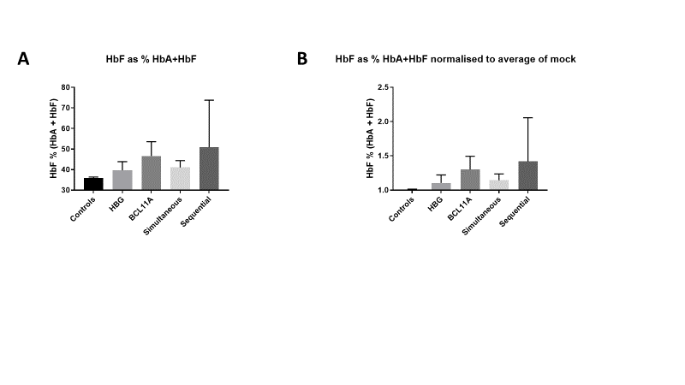
Figure 5.5: HbF reinduction potential of human HSPCs cultured from mouse BM
Cells extracted from the BMs of transplanted mice were cultured in liquid differentiation media to encourage growth and erythroid differentiation of human haematopoietic stem and progenitor cells. BM harvesting took place at the point of necropsy, 14 weeks following transplant of human haematopoietic stem and progenitor cells which had undergone editing at a single locus (HBG-113 or BCL11A-ee), both loci either simultaneously or sequentially in the double-edited arms, or mock electroporation only. Cultured cells were then analysed using HPLC in order to quantify the proportion of HbA and HbF within each cell population and HbF as a percentage of total (HBA + HbF) Hb was calculated for each BM culture. (A) HbF as a percentage of total Hb (mean +/-SD). (B) HbF as a percentage of total Hb, normalised by the results in mock-treated mice as an alternative method of presenting results (mean +/-SD). No difference was statistically significant (all p>0.05).
Abbreviations: BCL11A: BCL11A-ee target of genome editing within the BCL11A erythroid enhancer region on chromosome 11, BM: bone marrow, Hb: haemoglobin, HbA: haemoglobin A, HbF: foetal haemoglobin, HBG: HBG-113 target of genome editing within the HBG promoter region on chromosome 2, HSPC: Haematopoietic stem and progenitor cell, Sequential: sequential double editing of both loci. Simultaneous: simultaneous double editing of both loci.

5.4.1.7 Minimal CFU growth from mouse BM cells confirms paucity of human HSPC engraftment
Only 1 CFU plate was prepared per mouse BM in order to preserve adequate cells for flow cytometric lineage assessment and liquid differentiation culture for HbF assessment. Numbers of colonies grown were very low, confirming above results demonstrating minimal engraftment and survival of human HSPCs following transplant.
5.4.2 Pilot mouse transplant #2
Pilot mouse transplant #1 validated many of the techniques planned for future experiments and, to some degree, provided reassurance that the double-editing technique itself did not result in a deficit in human engraftment or persistence of edited cells in vivo in comparison to mock-treated cells or single edited cells. However, overall engraftment was poor and in particular there appeared to be minimal engraftment of human HSPCs, in comparison to lymphocytes.
As this phenomenon was observed in mice from all arms including the mock-treated arm, it suggested a problem with either the stem cell source, the thaw and enrichment process, or the transplant process itself. Since the transplant protocol was well established in the laboratory and procedures including irradiation and injection were carried out by experienced animal husbandry staff, this latter option seemed least likely.
5.4.2.1 Changes to CD34⁺ enrichment procedure based on pilot mouse transplant #1
Given the suboptimal CD34⁺ percentage in the infusion product used for pilot mouse transplant #1, the initial hypothesis considered as to cause of poor engraftment was that the MNCs had not been adequately CD34⁺ enriched and this had led to a higher than usual proportion of lymphocytes in the infusion product which affected HSPC engraftment. Therefore, in the mouse transplant #2 study it was decided that CD34⁺ percentage of at least 85% would be required in order to proceed to transplant. In order to obtain this, since initial CD34⁺ fraction was again close to 80% after first enrichment of PBMNCs, cells were passed over the enrichment column a second time to further purify the CD34⁺ population.
5.4.2.2 Failure of human engraftment post xenotransplantation
Despite good CD34⁺ enrichment of cells prior to further treatment and transplantation, there was primary engraftment failure in the majority of mice with total human engraftment below 0.5% in most mice at both the 8- and 10-week mark (Fig 5.6). Therefore the experiment was terminated early in accordance with IACUC requirements to minimise length of animal experiments where informative results were not anticipated.
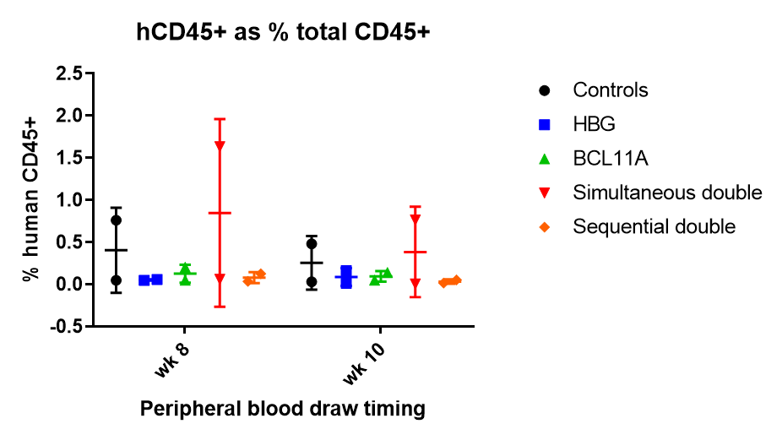
Figure 5.6: Total human chimerism in mouse peripheral blood post-transplantation highlights failed human cell engraftment
Flow cytometry was used to assess changes in total human chimerism and lineage-specific cell populations in the PB of humanised mice from 8 weeks following transplant of human haematopoietic stem and progenitor cells which had undergone editing at a single locus (HBG-113 or BCL11A-ee), both loci either simultaneously or sequentially in the double-edited arms, or mock electroporation only. Human CD45⁺ as a percentage of total CD45⁺ cell population over time is shown, indicative of very poor or absent total human engraftment in all mice (mean +/-SD).
Abbreviations: BCL11A: BCL11A-ee target of genome editing within the BCL11A erythroid enhancer region on chromosome 11, CD: cluster of differentiation, HBG: HBG-113 target of genome editing within the HBG promoter region on chromosome 2, PB: peripheral blood.

5.4.3 Main mouse transplant experiment
5.4.3.1 HSPC source
Failure of adequate engraftment in pilot transplant #2, despite improved CD34⁺ enrichment in this experiment with the modified enrichment protocol, included the mock-treated arm. This indicated that the cause of engraftment failure was not related to the CRISPR/Cas9 editing protocols and further investigation was undertaken. This included requesting records relating to quality control testing and storage conditions of the donated mobilised PB (mPB) MNCs.
Following investigation, it was discovered that the mPBMNCs may not have been stored at a temperature maintained reliably <80ºC. Therefore, for the main mouse transplant experiment below, CD34⁺ enriched HSPCs were purchased from the stem cell core at the FHCRC. Quality control information was provided with these cells and the storage conditions had been closely monitored at all times, providing reassurance that the viability of these stem cells would be adequate. The high cost of purchasing these cells was considered reasonable in order to maximise success of the following transplant and therefore minimise animal numbers involved in these experiments, as per IACUC and NIH guidelines. ³³⁵
5.4.3.2 Longitudinal assessments demonstrate similar levels of human chimerism and lineage differentiation between experimental arms in the PB
Twenty-five adult NSG mice were transplanted with human HSPCs which had been treated according to the different conditions described above (section 3.3.1.2). Four mice received mock-edited (electroporated only) cells; 5 mice received HBG-113 single edited cells; 5 mice received BCL11A-ee single edited cells; 5 mice received simultaneously double-edited cells and 6 mice received sequentially double-edited cells, with the larger number of mice in the latter group due to a greater number of cells available for transplantation into this arm. Two mice were euthanised early for reasons unrelated to health or engraftment (1 mouse each from the BCL11A-ee single edited and simultaneously double-edited arms); remaining mice survived in good health to the point of necropsy at 23 weeks post transplantation.
Total human and lineage-specific engraftment and proliferation were monitored in the PB of transplanted mice from 6 weeks post infusion of human HSPCs by 3 weekly PB draws up until necropsy at 23 weeks, or until early euthanasia. Total human engraftment as defined by human CD45⁺ (hCD45⁺) cells as a percentage of total CD45⁺ (hCD45⁺ + mouse CD45⁺ cells) was similar between mice transplanted with mock, single or double-edited cells from each arm of the experiment.
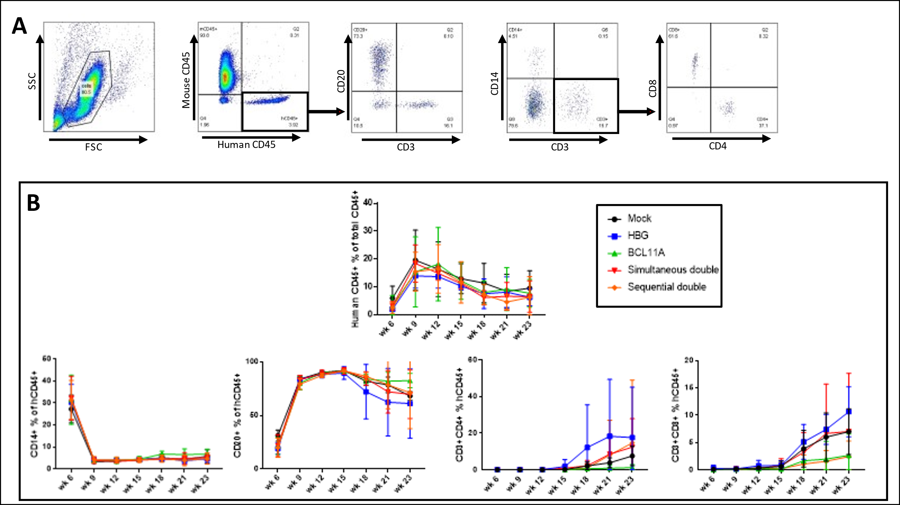
Human engraftment peaked on average at week 9 post-transplant and stabilised by around week 21. Normal patterns of development of different lineages were observed in all arms. A high proportion of CD14⁺ cells was noted early on. By week 9, CD20⁺ cells were circulating in substantial numbers and by week 18 the numbers of CD3⁺CD4⁺ and CD3⁺CD8⁺ cells had started to rise. These patterns were similar in all experimental arms, with slightly wider variability between individual mice, and as a result between experimental arms, where the proportion of CD3⁺ cells was analysed compared to other lineages (Fig 5.7A-B).
Figure 5.7: Total human chimerism and lineage specific proportions in mouse PB post-transplantation over time demonstrates similar patterns in all experimental arms
Flow cytometry was used to assess changes in total human chimerism and lineage-specific cell populations in the PB of humanised mice following transplant of human haematopoietic stem and progenitor cells which had undergone editing at a single locus (HBG-113 or BCL11A-ee), both loci either simultaneously or sequentially in the dual edited arms, or mock electroporation only. (A) Example of flow cytometric gating strategy. Nucleated cells were first selected based on forward and side scatter. Next, cells expressing human CD45 but negative for mouse CD45 were gated for, in order to define the human leucocyte population. Within this population, CD14⁺, CD20⁺ and CD3⁺-expressing lineages were quantified. Finally, within the CD3⁺ population, the proportion of CD3⁺CD4⁺ and CD3⁺CD8⁺ lymphocytes were defined. (B) Longitudinal proportions are shown: human CD45⁺ as a percentage of total CD45⁺ cell population over time, indicative of total human engraftment, followed by CD14⁺, CD20⁺, CD3⁺CD4⁺ and CD3⁺CD8⁺ proportions of human CD45⁺ cells (mean +/-SD).
Abbreviations: BCL11A: BCL11A-ee target of genome editing within the BCL11A erythroid enhancer region on chromosome 11, CD: cluster of differentiation, FSC: forward scatter, HBG: HBG-113 target of genome editing within the HBG promoter region on chromosome 2, PB: peripheral blood, SSC: side scatter.

5.4.3.3 Human engraftment including HSPCs and lineage proportions similar between experimental arms in haematopoietic tissues at necropsy
At necropsy, the proportion of hCD45⁺ cells was comparable between experimental arms in each of the BM, PB and thymus (Fig 5.8A). The proportional contribution of each lineage within the PB and BM was also similar between arms (Fig 5.8B). The presence of human HSPCs in the BM was assessed separately. The total proportion of CD34⁺CD38^{low} cells was similar between mice transplanted with each edited arm of the experiment. The subpopulation of HSC-enriched CD90⁺CD45RA⁻ cells was also analysed and found to be present at comparable levels between arms (Fig 5.8C-D). Splenic tissue was not analysed by flow cytometry as DNA extraction for editing and translocation analysis was prioritised in this experiment.

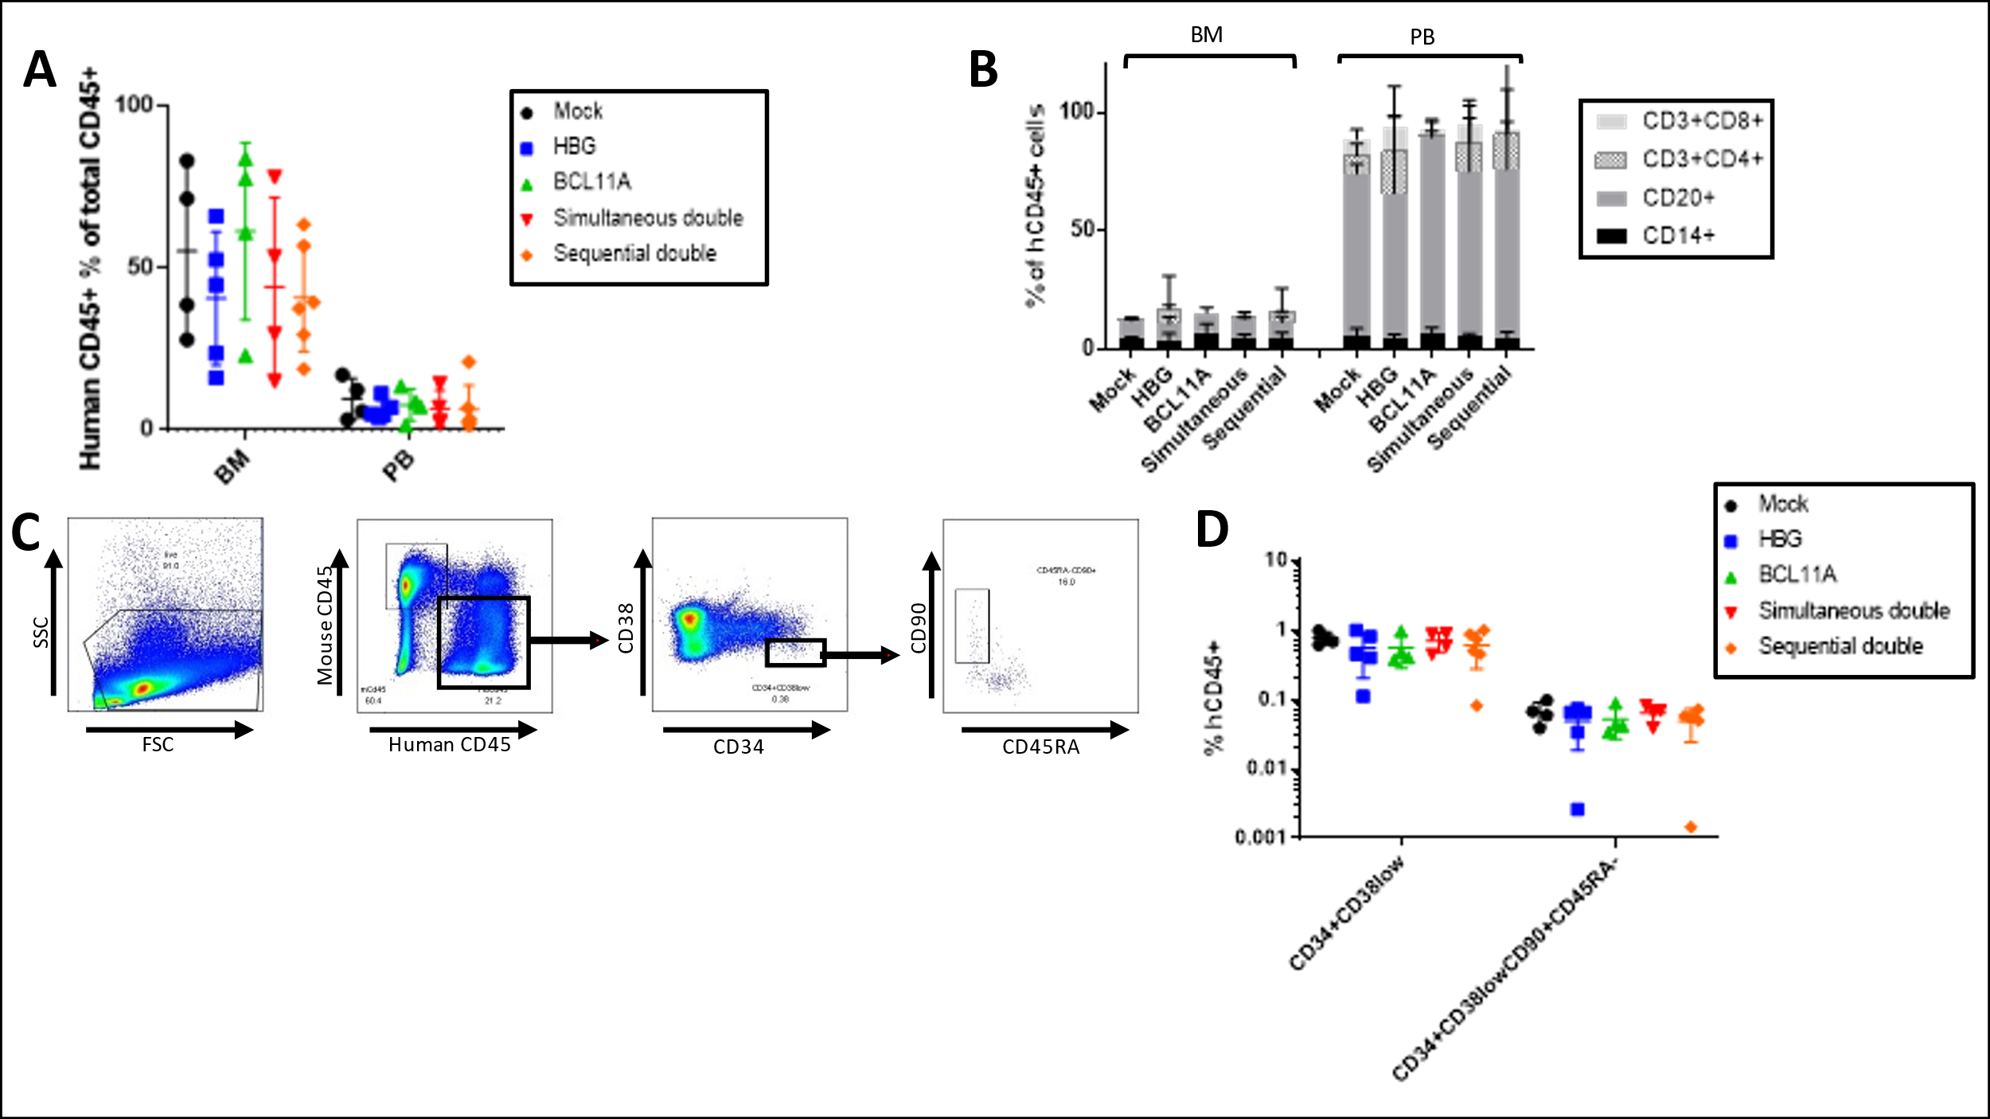
Figure 5.8: Total human chimerism and lineage specific proportions in mouse tissues at necropsy demonstrates good BM engraftment in double-edited arms and no significant differences between experimental arms
Flow cytometric analysis was used to quantify total human chimerism and also mature lineage-specific contributions to the human cell populations within the PB and BM of mice extracted at necropsy, following transplant of human HSPCs which had undergone editing at a single locus (HBG-113 or BCL11A-ee), both loci either simultaneously or sequentially in the double-edited arms, or mock electroporation only. In the BM, the population of human HSPCs was also analysed. (A) Human CD45⁺ as a percentage of total CD45⁺ cell population in each tissue, as a marker of total human chimerism (mean +/-SD). (B) Haematopoietic lineages as percentages of total human CD45⁺ cells in the BM and PB (mean +/-SD). (C) Example of flow cytometric gating strategy used to define the HSPC population in extracted BM cells. First, MNCs were gated for based on forward and side scatter. Human cells were then defined by human CD45⁺/mouse CD45⁻ immunoprofile. Within human cells, the HSPC population was quantified based on the immunophenotype CD34⁺CD38^{low}. Finally, within these cells, the subpopulation enriched for longer-term repopulating HSCs was defined by gating for CD90⁺CD45RA- (D) Percentages of CD34⁺CD38 ^{low} HSPCs and within these the CD90⁺CD45RA- subpopulation within human cells in the BM (mean +/-SD).
Abbreviations: BCL11A: BCL11A-ee target of genome editing within the BCL11A erythroid enhancer region on chromosome 11, BM: bone marrow, CD: cluster of differentiation, HBG: HBG-113 target of genome editing within the HBG promoter region on chromosome 2, HSPC: haematopoietic stem and progenitor cells, MNCs: mononuclear cells, PB: Peripheral blood.

5.4.3.4 CFU-forming potential of human HSPCs within mouse BM similar between experimental arms
Total CFU numbers were relatively low in each arm, reflecting the small proportion of human HSPCs within cells extracted from mouse BM. While there was some variability in total numbers of CFUs, differences between total CFU numbers did not come close to reaching statistical significance between any of the arms. The most meaningful result to note is that the CFU-forming potential was not significantly impaired in either of the dual edited arms in comparison to the mock treated arm. This lends further support to results above which already confirm the hypothesis that these double editing treatments do not cause a deficit in viability or normal lineage differentiation of human HSPCs following transplantation. The proportion of each colony type was also comparable (Fig 5.9).
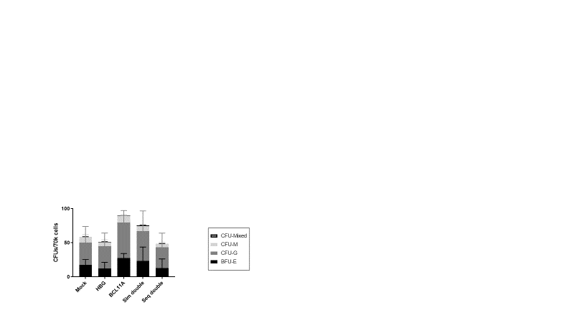
Figure 5.9: CFU-forming potential of human haematopoietic stem and progenitor cells within mouse BM is not impaired in dual edited arms
Mice were transplanted with human haematopoietic stem and progenitor cells which had undergone editing at a single locus (HBG-113 or BCL11A-ee), both loci either simultaneously or sequentially in the double-edited arms, or mock electroporation only. At necropsy, almost 6 months post-transplant, BM cells were harvested and plated onto methocult media in order to assess CFU-potential of the human cells therewithin. There were no significant differences in total colony numbers between arms and the distribution of colony types was also similar between experimental arms (mean +/- SD).
Abbreviations: BCL11A: BCL11A-ee target of genome editing within the BCL11A erythroid enhancer region on chromosome 11, BFU-E: Burst-forming unit-erythroid, BM: bone marrow, CFU: colony forming unit, CFU-G: Granulocytic colony forming unit, CFU-M: Monocytic colony forming unit, CFU-Mixed: Mixed types of colony forming unit, HBG: HBG-113 target of genome editing within the HBG promoter region on chromosome 2, Seq double: sequential dual editing of both targets, Sim double: simultaneous dual editing of both targets.

5.4.3.5 Stable or increasing levels of genome edited cells over time in mice from each edited experimental arm
Editing efficiency assessment of the infusion product transplanted into the mouse cohort demonstrated total HBG-113 editing of 50.4% in the single edited cells, 35.4% in the simultaneously double-edited cells and 74.8% in the sequentially double-edited cells. The frequency of the 13nt deletion within HBG-113 was 23.3% in the single edited reaction, 12.6% with simultaneous double-editing and 35.4% where double editing was applied sequentially. BCL11A-ee editing was 55.5% in the single edited cells, 41.5% in the simultaneously double-edited reaction and 43.3% in the sequentially double-edited cells. This was consistent with the patterns of editing found in other in vitro experiments and described in detail above.
Following transplantation, editing efficiency within the population of human cells was assessed in mouse PB for all edited arms at each PB draw timepoint, and also within BM and spleen at necropsy. Valid results were available for most mice at each timepoint from 9 weeks post-transplant. After an initial drop in the proportion of edited cells, stable or even improving levels of editing within human cells are demonstrated in most arms of the experiment, where each editing locus is considered (Fig 5.10A-B). A number of editing assays carried out on samples of PB drawn at 6 weeks failed, therefore this timepoint is not included.
Tracking of HBG-113 editing levels in the blood over time from weeks 6 to the point of necropsy at 23 weeks post-transplantation demonstrated consistently highest levels of HBG-113 total editing and HBG-113 13nt deletion in the sequentially double-edited arm and generally lowest levels in the simultaneously double-edited arm. In the sequentially double-edited mice there was initially a modest decrease in HBG-113 editing which stabilised by approximately 12 weeks post transplantation. In this arm, mean HBG-113 editing was 41.5% at 6 weeks and 32.0% at 23 weeks. HBG-113 editing levels were relatively stable in the single and simultaneously double-edited arms. In the single edited arm, mean editing frequency was 17.7% at 6 weeks and 18.2% at 23 weeks; these figures were 6.2% and 11.7% respectively in the simultaneously double-edited arm.
The frequency of BCL11A-ee editing was comparable between arms and there was no consistent trend in results over time. Mean editing levels at 9 weeks were 27.9% in single edited mice, 15.6% in simultaneously double-edited mice and 20.9% in sequentially double-edited mice. At the point of necropsy these figures were 19.1%, 24.0% and 33.0% respectively.
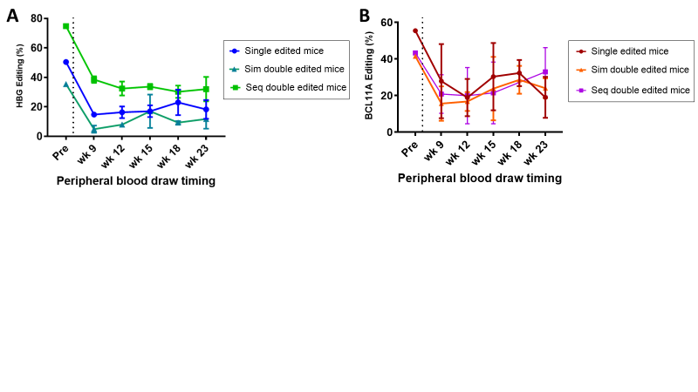
Figure 5.10: Longitudinal assessment of editing levels within human cells in the PB demonstrates stable persistence of edited cells over time in each arm
Quantification of the percentage of genome editing within the human cell population circulating in the PB over time was carried out following transplant of human haematopoietic stem and progenitor cells which had undergone editing at a single locus (HBG-113 or BCL11A-ee), or at both loci either simultaneously or sequentially in the double-edited arms (or mock electroporation only). This was achieved by extraction of DNA followed by amplification using the relevant PCR assay, sequencing and TIDE analysis of results. (A) Percentage of cells edited at HBG-113 in the infusion product and in the PB of mice in each arm over time (mean +/-SD). (B) Percentage of cells edited at BCL11A-ee in the infusion product and in the PB of mice in each arm over time (mean +/-SD).
Abbreviations: BCL11A: BCL11A-ee target of genome editing within the BCL11A erythroid enhancer region on chromosome 11, BM: bone marrow, DNA: Deoxyribonucleic acid, HBG: HBG-113 target of genome editing within the HBG promoter region on chromosome 2, PB: peripheral blood, PCR: polymerase chain reaction, Seq double: sequential dual editing of both targets, Sim double: simultaneous dual editing of both targets, TIDE: Tracking of Indels by Decomposition.

BM: BM, HBG: HBG-113, BCL11A: BCL11A-ee

5.4.3.6 Greatest levels of total genome editing at necropsy in mice transplanted with sequentially double-edited cells
At the point of necropsy: in the PB, the frequency of total HBG-113 editing in sequentially edited mice (n=6) was significantly greater than either the single edited (n=5) or the simultaneously double-edited (n=4) mice (p=0.0137 and p=0.0034 respectively). The differences in 13nt deletion frequency in the sequentially double-edited arm compared to the single edited or to the simultaneously double-edited arms were even more significant (p=0.0013 and p=0.0006 respectively). A greater frequency of HBG-113 editing was also found in the BM of sequentially double-edited mice (n=6) than simultaneously double-edited mice (n=4) (p=0.0063) or than single edited mice (n=5) (p>0.05) (Fig 5.11A). Where BCL11A-ee editing at necropsy was examined, there was also a trend towards highest editing frequencies in the sequentially double-edited arm than in the single or simultaneously double-edited arms found in the PB, BM and spleen (Fig 5.11B).

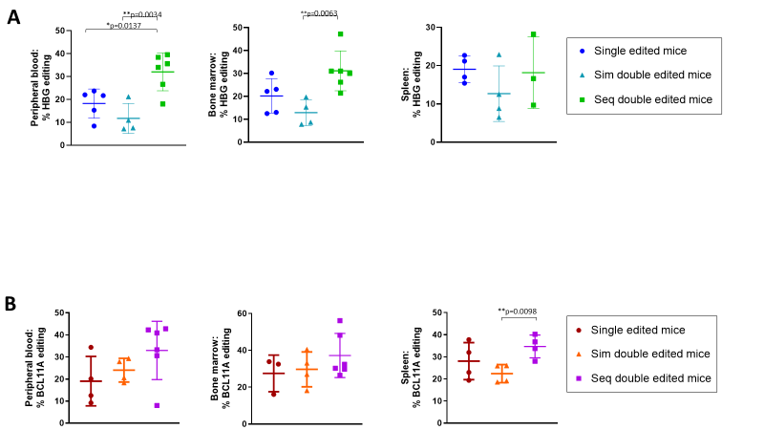
Figure 5.11: Assessment of editing levels within human cells in the haematopoietic tissues at necropsy generally demonstrates maximal proportion of edited cells in the sequentially dual edited mice
Quantification of the percentage of genome editing within haematopoietic tissues at necropsy was carried out following transplant of human haematopoietic stem and progenitor cells which had undergone editing at a single locus (HBG-113 or BCL11A-ee), or at both loci either simultaneously or sequentially in the double-edited arms. This was achieved by extraction of DNA followed by amplification using the relevant PCR assay, sequencing and TIDE analysis of results. (A) Percentage of cells edited at HBG-113 in the PB, BM and spleen of mice in each experimental arm (mean +/-SD). (B) Percentage of cells edited at BCL11A-ee in the PB, BM and spleen of mice in each experimental arm (mean +/-SD).
Abbreviations: BCL11A: BCL11A-ee target of genome editing within the BCL11A erythroid enhancer region on chromosome 11, BM: bone marrow, DNA: Deoxyribonucleic acid, HBG: HBG-113 target of genome editing within the HBG promoter region on chromosome 2, PB: peripheral blood, PCR: Polymerase chain reaction, Seq double: sequential dual editing of both targets, Sim double: simultaneous dual editing of both targets, TIDE: Tracking of Indels by Decomposition. Only statistically significant differences (p<0.05) are shown.

5.4.3.7 Frequency of MMEJ-mediated indels in haematopoietic tissues at necropsy
Where trends in the HBG-113 13nt deletion frequency were examined over time, there was a reduction in frequency in all arms from weeks 6 to 23, and only in the sequentially double-edited arm was this particular deletion length still present at a meaningful level at time of necropsy (Fig 5.12A). Mean frequencies at 6 and 23 weeks respectively were 10.4% and 5.5% in the sequentially double-edited mice; 7.5% falling to 1.3% in the single edited mice; and 1.4% and 0.6% in the simultaneously double-edited mice. BCL11A-ee indels 13nt and 15nt deletions showed variable results between haemopoietic tissues with no consistent pattern (Fig 5.12B).

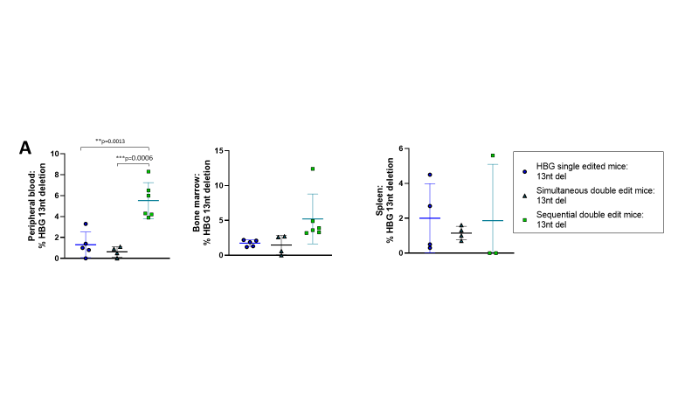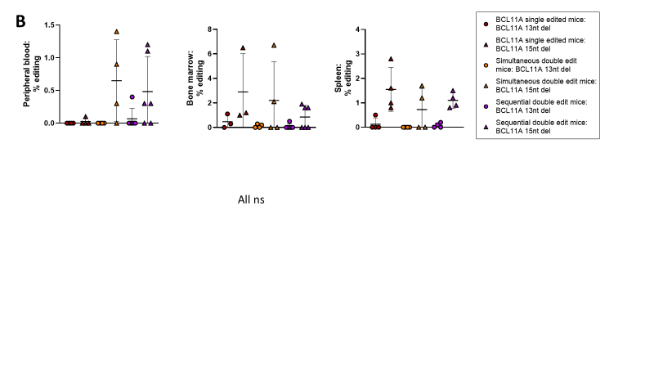
Figure 5.12: Assessment of the frequency of particular indels recognised to be associated with the MMEJ pathway within human cells in the haematopoietic tissues at necropsy
Quantification of the frequency of particular indel lengths known to be associated with activity of the MMEJ repair pathway at the point of genome editing at either selected target was next analysed within the human cell population in mouse haematopoietic tissues at necropsy. This followed transplant of human haematopoietic stem and progenitor cells which had undergone editing at a single locus (HBG-113 or BCL11A-ee), or at both loci either simultaneously or sequentially in the double-edited arms (or mock electroporation only). This was achieved by extraction of DNA followed by amplification using the relevant PCR assay, sequencing and TIDE analysis of results. (A) Percentage of cells containing the 13nt deletion at HBG-113 in the PB, BM and spleen of mice in each experimental arm (mean +/-SD). (B) Percentage of cells containing the 13nt or 15nt deletion at BCL11A-ee in the PB, BM and spleen of mice in each experimental arm (mean +/-SD).
Abbreviations: BCL11A: BCL11A-ee target of genome editing within the BCL11A erythroid enhancer region on chromosome 11, BM: bone marrow, DNA: Deoxyribonucleic acid, HBG: HBG-113 target of genome editing within the HBG promoter region on chromosome 2, MMEJ: microhomology-mediated end joining, nt: nucleotide, PB: peripheral blood, PCR: Polymerase chain reaction, TIDE: Tracking of Indels by Decomposition. Only statistically significant differences (p<0.05) are shown.

5.4.3.8 Patterns of genome editing levels not fully explained by differences in infusion product editing efficiency
At necropsy, editing levels were generally highest in mice transplanted with sequentially double-edited cells. It was recognised that with regards to HBG-113 editing, this pattern reflected that seen in the infusion product. Further analysis was therefore conducted to establish whether differential editing levels in the infusion product could completely account for the different editing levels seen at necropsy or whether other factors may be at play. In order to establish this, the ratio of editing at necropsy to editing in the infusion product for each mouse was calculated for each of the target loci. For HBG-113, in the PB, this ratio was highest in the sequential double-edited arm, although patterns were different in the BM and spleen and differences did not reach statistical significance (Fig 5.13A).
Where editing at BCL11A-ee was considered, the ratio of editing at necropsy to editing in the infusion product was consistently highest in the sequentially edited arm in all tissues. This reached statistical significance in comparison to the single edited arm in the PB (n=4 single edited and n=6 sequentially double-edited mice, p=0.0440) and in the spleen (n=4 each arm, p=0.0219). The difference was also statistically significant in comparison to the simultaneously double-edited arm in the spleen (n=4 each arm, p=0.0150) (Fig 5.13B).
Interestingly therefore, the pattern of greatest editing levels in sequentially double-edited cells cannot simply be explained by differential editing efficiencies in the infusion product, particularly where BCL11A-ee editing is concerned. This suggests that in the sequentially edited arm, a greater number of medium- and/or long-term repopulating HSPCs are successfully edited with this approach, explaining their preferential persistence in comparison to the other edited arms.
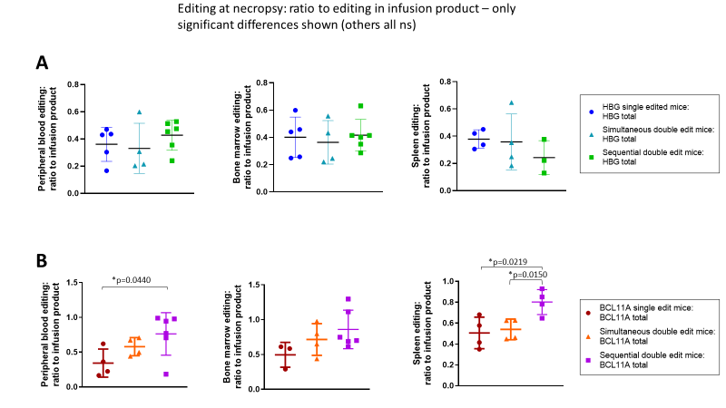
Figure 5.13: Analysis of editing levels within haematopoietic tissues in comparison to infusion product delivered at time of transplant suggests additional factors contribute to the difference in percentages of edited cells between experimental arms
Immunodeficient mice were transplanted with human haematopoietic stem and progenitor cells which had undergone editing at a single locus (HBG-113 or BCL11A-ee), or at both loci either simultaneously or sequentially in the double-edited arms. Total editing levels at each particular target within mouse haematopoietic tissues have already been demonstrated to vary by the time of necropsy dependant on experimental arm, being generally greatest in the sequentially dual edited arm. In order to establish whether this was simply due to differences in editing efficiency within the infusion product transplanted into the mice, the ratio of editing in each mouse tissue at each locus to the editing level at each locus in the infusion product delivered to that mouse was calculated. (A) Ratio of HBG-113 editing in each mouse tissue to that within the infusion product delivered to each mouse (mean +/- SD) (B) Ratio of BCL11A-ee editing in each mouse tissue to that within the infusion product delivered to each mouse (mean +/- SD)
Abbreviations: BCL11A: BCL11A-ee target of genome editing within the BCL11A erythroid enhancer region on chromosome 2, HBG: HBG-113 target of genome editing within the HBG promoter region on chromosome 11. Only statistically significant differences (p<0.05) are shown.

5.4.3.9 Chromosomal translocations are detectable by standard PCR in the PB of a number of mice from dual edited experimental arms at 6 weeks post-transplant
The presence of a 2:11 chromosomal translocation was demonstrated by qualitative PCR assay in PB drawn at 6 weeks post-transplant in 4/5 simultaneously double edited mice but only 2/6 sequentially double-edited mice (Fig 5.14).
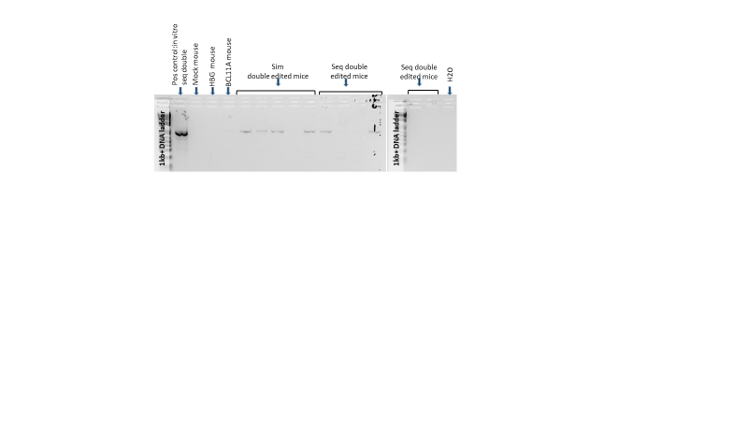
Figure 5.14: Demonstration of the presence of a 2:11 chromosomal translocation within the PB of multiple mice transplanted with human haematopoietic stem and progenitor cells edited at both HBG-113 and BCL11A-ee loci
Immunodeficient mice were transplanted with human haematopoietic stem and progenitor cells which had undergone editing at a single locus (HBG-113 or BCL11A-ee), at both loci either simultaneously or sequentially in the double-edited arms, or mock electroporation only. PB drawn at 5 weeks post-transplant was subjected to a PCR reaction designed to amplify a translocation event occurring between these two breakpoints on chromosomes 2 (HBG-113) and 11 (BCL11A-ee), by using an HBG-113 forward primer with a BCL11A-ee reverse primer. PCR product was run on agarose gel electrophoresis. Samples from mice transplanted with mock- or single edited cells were included as negative controls. A positive control reaction was also included: sequentially dual edited cells from an in vitro reaction which had already been demonstrated to contain the translocation in question, confirmed on sequencing of the PCR product.
Abbreviations: BCL11A: BCL11A-ee target of genome editing within the BCL11A erythroid enhancer region on chromosome 11, DNA: Deoxyribonucleic acid, HBG: HBG-113 target of genome editing within the HBG promoter region on chromosome 2, PB: peripheral blood, PCR: Polymerase chain reaction, Seq double: sequential dual editing of both targets, Sim double: simultaneous dual editing of both targets.

5.4.3.10 Chromosomal translocations persist in vivo to the point of necropsy with highest frequency in mice transplanted with sequentially double-edited cells
Translocation frequency was further analysed quantitatively by ddPCR in the infusion product and in mouse BM, PB and splenic tissue extracted at necropsy. Translocation event #1 was detected in the infusion product at a frequency of 1.26% in simultaneously double-edited cells and 0.05% in sequentially double-edited cells. This persisted in vivo and was detected in the BM of 1/4 simultaneously double-edited mouse at a frequency of 0.07% and 4/6 sequentially double-edited mice, with mean frequency of 0.203% respectively. No translocation was present in analysed mice transplanted with mock-edited (n=2) or single (HBG-113 or BCL11A-ee)-edited (n=4) cells.
Translocation event #2 was present in the infusion product at frequencies of 0.71% and 0.03% in simultaneously and sequentially double-edited reactions respectively. It was later confirmed to be persistent in the BM. It was later confirmed to be persistent in the BM of 3/4 simultaneously dual edited mice at a frequency of 0.05%, these being the mice without translocation event #1 therefore all 4 mice in the simultaneous double edit arm had a translocation of one type detected in their BM. Translocation event #2 was present in 4/6 sequentially double-edited mice at a mean frequency of 0.200%, with only 1 mouse in this arm being negative for both translocation events (Fig 5.15A).
Detection of the translocation by ddPCR in the PB and spleen at necropsy was less common, possibly due to reduced proliferation or lineage differentiation of HSPCs harbouring chromosomal translocation events. Translocation #1 was not detected in the PB of any simultaneously double-edited mouse but was observed in the PB of 2/5 sequentially double-edited mice at frequencies of 0.514% and 0.155% at time of necropsy. This same translocation was again undetectable in the spleens of all simultaneously double-edited mice but was present in the spleen of 1 of 5 sequentially double-edited mouse at a frequency of 0.372%.
Translocation event #2 was not detected in the PB of any of the 4 simultaneously or 5 sequentially double-edited mice. It was also not found in the spleens of any simultaneously double-edited mice but was picked up in the spleen of 1 of 5 sequentially double-edited mice, at a frequency of 0.24% (Fig 5.15B).

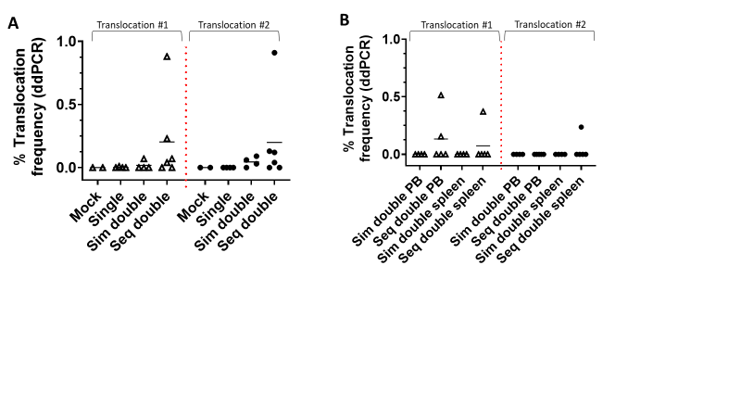

Figure 5.15: Quantitation of chromosomal translocation events within the haematopoietic tissues of mice transplanted with human haematopoietic stem and progenitor cells edited at both the HBG-113 and BCL11A-ee loci by ddPCR
Immunodeficient mice were transplanted with human haematopoietic stem and progenitor cells which had undergone editing at a single locus (HBG-113 or BCL11A-ee), at both loci either simultaneously or sequentially in the double-edited arms, or mock electroporation only. Chromosomal translocations have already been demonstrated where cells are edited at both loci. BM, PB and splenic tissues extracted at necropsy underwent ddPCR analysis in order to detect and quantify the presence of 2 separate translocation types. Translocation event #1 was quantified using an HBG-113 forward and BCL11A-ee reverse primer, and translocation event #2 was assessed using a BCL11A-ee forward and HBG-113 reverse primer. In this way, the two types of translocation products predicted to form when chromosomes rearranged at the two editing breakpoints could be analysed. (A) Frequency of each translocation event within the BM of mice in the simultaneous and sequential double editing arms. A number of mice from the mock or single editing arms were included as negative controls (mean). (B) Frequency of each translocation event within the PB and spleen of mice in the simultaneous and sequential double editing arms (mean).
Abbreviations: BCL11A: BCL11A-ee target of genome editing within the BCL11A erythroid enhancer region on chromosome 11, BM: bone marrow, ddPCR: digital droplet PCR, HBG: HBG-113 target of genome editing within the HBG promoter region on chromosome 2, PB: peripheral blood, Seq double: sequential dual editing of both targets, Sim double: simultaneous dual editing of both targets. All differences are p>0.05.

5.4.3.11 HbF reinduction potential in cells cultured from mouse BM greatest in the sequentially double-edited arm
BM extracted at necropsy was cultured in differentiation media and the Hb fractions assessed by flow cytometry and HPLC. HbF proportion was greatest in cells cultured from the BM of sequentially double-edited mice, with this difference being most marked where analysis was by HPLC (Fig 5.16A-C), consistent with patterns seen during in vitro analyses. As the humanised mouse model does not support significant amounts of human erythropoiesis, this ex vivo analysis on erythroid progeny of human HSPCs persistent in mouse BM almost 6 months post-transplant provided the closest possible surrogate for in vivo Hb assessments.

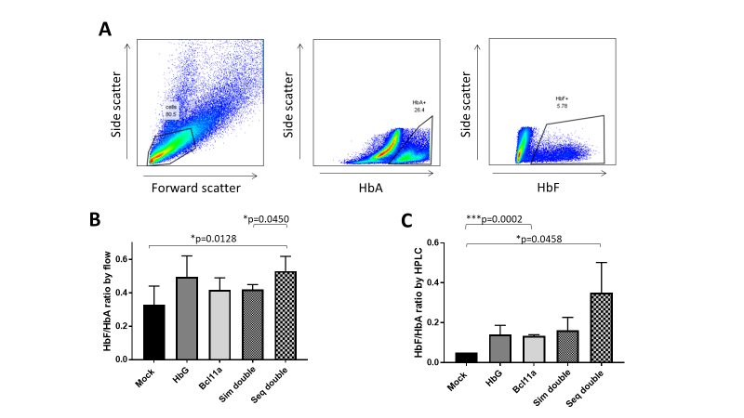
Figure 5.16: Assessment of HbF reinduction potential of human haematopoietic stem and progenitor cells cultured from mouse BM
Immunodeficient mice were transplanted with human haematopoietic stem and progenitor cells which had undergone editing at a single locus (HBG-113 or BCL11A-ee), at both loci either simultaneously or sequentially in the double-edited arms, or mock electroporation only. Cells extracted from mouse BM at necropsy were cultured in liquid differentiation media to encourage erythroid differentiation. The ratio of foetal to adult Hb (HbF/HbA) was measured both by flow cytometry and by HPLC. (A) Example flow plot demonstrating quantification of cells containing HbF and cells containing HbA, after initial gating for mononuclear cells based on forward and side scatter (B) HbF/HbA ratio according to experimental arm, as assayed by flow cytometry (mean +/-SD). (C) HbF/HbA ratio according to experimental arm, measured by HPLC (mean +/-SD).
Abbreviations: BCL11A: BCL11A-ee target of genome editing within the BCL11A erythroid enhancer region on chromosome 11, BM: bone marrow, HbA: haemoglobin A, HbF: foetal haemoglobin, HBG: HBG-113 target of genome editing within the HBG promoter region on chromosome 2, HPLC: high performance liquid chromatography. Seq double: sequential dual editing of both targets, Sim double: simultaneous dual editing of both targets. Only significant differences (p<0.05) are shown.

5.5 Discussion
Genome editing offers the promise of long-term cure for patients with haemoglobinopathies, by the reactivation of HbF production. Editing at either HBG-113 or BCL11A-ee has been demonstrated to result in moderate increases in HbF without compromising HSPC viability including engraftment, but further improvement in HbF reinduction is desirable. Therefore, experiments were carried out to investigate strategies targeting both loci for disruption by CRISPR/Cas9 genome editing within the same HSPC population, with the aim of further increasing HbF levels. In vitro experiments, described in detail in Chapters 3-4, demonstrated maximal HbF reinduction with a sequential dual editing strategy.
The transplant experiments outlined here were designed to investigate the hypothesis that dual CRISPR/Cas9 genome editing at both the HBG-113 and BCL11A-ee loci, delivered either simultaneously or sequentially, does not impair the post-transplant viability of HSPCs, and that edited cells remain at stable levels in vivo. Finally, since chromosomal translocations were evidenced following dual editing in vitro, it was important to establish whether or not HSPCs harbouring translocations would persist post-transplant.
To this end, mice were transplanted with human HSPCs which had undergone dual editing at both of these loci, simultaneously or sequentially, and for comparison arms were also included in which mice received cells edited at only 1 locus or which had undergone mock electroporation only. 2 small pilot experiments were undertaken which validated many of the experimental protocols and assays but led to a change in stem cell source which allowed the main transplant experiment to proceed favourably. All aims and objectives were addressed successfully and all elements of the hypothesis were proven.
Firstly, HSPC engraftment and differentiation into mature haematological lineages was assessed, following simultaneous or sequential dual editing at HBG-113 and BCL11A-ee, in comparison to HSPCs edited at either single locus or mock-edited HSPCs. Data showed no impairment in HSPC engraftment, lineage differentiation and proliferation over time in either of the dual edited arms where compared to single or mock-edited arms, following transplantation into immunodeficient mice. Human chimerism was similar between unedited, single and double-edited arms in the PB throughout the experiment, and in BM at the point of necropsy, at 23 weeks post-transplant. In addition, appropriate maturation into the various haematological lineages was similar between arms when each lineage was examined separately within the PB over time and within the same tissues at necropsy: namely, myeloid cells (hCD45⁺CD14⁺), T lymphocytes (hCD45⁺CD3⁺) and B lymphocytes (hCD45⁺CD20⁺). Within the BM, the same held true for the haematopoietic stem and progenitor cell population (hCD45⁺ CD34⁺CD38^{low}) and, within this, the fraction enriched for long term-repopulating haematopoietic stem cells (CD90⁺CD45RA⁻).
CFU-forming potential of cells harvested from the BMs of mice again did not show any significant differences between arms. The use of a sequential mouse transplant was considered in which the human HSPCs harvested from mouse BM would be further transplanted into another cohort of mice, in order to further prove the longer-term repopulation potential of these dual edited cells. However, the use of additional animals and other resources was not justified since it was already clear this method was not suitable for clinical translation due to the issue of chromosomal translocations.
Secondly, the degree to which edited cells persist in vivo following dual editing of HSPCs followed by xenotransplantation, up to the point of necropsy, was investigated. Stable, or in some cases even increasing, levels of editing in all arms at both editing loci was demonstrated to almost 6 months post-transplant, after the expected early fall in editing levels. In the dual edited arms, modified cells are able to engraft and persist after transplant: in fact the highest levels of editing by the end of the experiment were generally seen in the sequentially double-edited arm. These differences were not entirely explained simply by differences in editing levels within the infusion product and point to most successful editing of the medium or longer-term repopulating HSPCs with this sequential multiplex editing approach, or perhaps an engraftment or survival advantage in edited HSPCs in this arm.
Thirdly, the question of whether the chromosomal translocation events which had been witnessed to occur in vitro would persist following transplantation was addressed. Early evidence of the viability of cells harbouring the translocation was observed when simple PCR was able to detect the translocation in the PB of over 50% of the mice transplanted with dual edited cells at 6 weeks post-transplant. More detailed analysis followed with the application of ddPCR to allow quantification of the 2 different translocation chimerae in the haematopoietic tissues at necropsy. In vitro, both translocation events were detected at higher frequency in the simultaneously-edited cells than those from the sequentially-edited reactions, as presented in Chapter 3. However, in vivo this trend had reversed by almost 6 months post-transplant. Translocations were detected in the BMs of almost all mice which had received dual edited cells from either arm. Mean frequencies were higher in the sequentially double-edited mice than those in the simultaneous dual edited arm. Notably, average frequency of each translocation event in the sequentially double-edited mice was higher than the frequency detected in the infusion product (which was not the case with the simultaneously dual edited mice). This adds further weight to the hypothesis that most editing of the repopulating HSPCs was seen rather than shorter-term haematopoietic cells with sequential dual editing. An alternative hypothesis is acknowledged for the observation of increasing translocation frequency in these sequentially double-edited mice could be a survival advantage conferred to cells containing the chromosomal rearrangements. This is considered less likely since if that were the case a similar increase would be expected in the simultaneously double-edited mice containing the same translocation events.
In previous chapters it has been established that dual CRISPR/Cas9 editing of both HBG-113 and BCL11A-ee, particularly where delivered sequentially, optimises HbF reinduction potential of HSPCs. Results from the ex vivo culture of mouse BM cells in this experiment further support this conclusion, since highest levels of HbF were seen in cells culture from mice transplanted with sequentially dual edited HSPCs. Given that the NSG mouse model does not support human erythropoiesis, this is the closest it was possible to get to in vivo Hb analysis of human erythroid cells.
The hypothesis that dual editing at both loci does not impair HSPC viability post-transplant has been proven, with successful engraftment and lineage differentiation seen in these arms. It has been demonstrated successfully that edited cells remain at stable levels in vivo. However, data has been presented showing the persistence of cells harbouring the chromosomal translocation events resulting from dual editing at both loci in the majority of mice transplanted with such cells. The aim of including an experimental arm in which multiplex editing was delivered sequentially rather than simultaneously was due to a hypothesis that this would be less likely to generate simultaneous DNA double-stranded breaks at both loci within the same cell and therefore lower the risk of translocations developing. In vitro, translocations were certainly less frequent where the sequential double editing strategy was used in comparison to simultaneous dual editing. However, results from this experiment have shown in fact the highest frequency of translocations in the BMs of mice transplanted with sequentially dual edited cells.
It is clear that chromosomal rearrangement events persist post-transplantation of dual edited cells, whichever protocol is used to deliver the double editing approach. This is concerning given the well-recognised link between chromosomal translocations and oncogenesis. A risk of future malignant events arising from multiplex-edited HSPCs precludes this strategy from being considered for clinical application going forwards and therefore testing on higher-order mammals would also be unethical. No further multiplex editing experiments are planned using CRIPSR/Cas9 for HbF reinduction for this reason, but in the main discussion section the possibility that newer editing platforms may allow editing of multiple targets without the associated risk of chromosomal translocations will be considered and discussed.

6.0
Chapter 6:
Development and optimisation of PCR assays for BCL11A-ee editing assessment and detection of t(2;11) chromosomal translocations

6.1 Introduction
Genome editing is a promising novel approach to the treatment of the congenital haematological disorders sickle cell disease and β thalassaemia.⁹ The delivery of precisely targeted RNPs creates double-stranded breaks in pre-specified regions of the DNA in HSPCs. Where this takes place without the provision of a template for exact reconstitution of the fractured region, the result is repair by the error-prone processes NHEJ and, to a lesser extent, also the MMEJ repair pathway. Insertions and deletions are introduced with the aim of disrupting functionality of the targeted region. Genomic engineering can be applied to the treatment of inherited blood diseases by altering the genome of HSPCs, which then replicate and differentiate into all mature blood cells lineages. Genetic modifications introduced into these progenitor cells will persist in their progeny. Therefore, where HSPCs – and particularly the long-term repopulating HSCs - are the object of therapeutic genome editing, long-lasting beneficial effects are anticipated.
Genome editing has been used to target either the HBG promoter region or the erythroid-specific enhancer of the transcription factor gene BCL11A for disruption, as a therapeutic modality for haemoglobinopathies. In this way, the physiological switch from foetal to adult Hb can be at least somewhat reversed.^{263; 268; 280; 340} This leads to increased HbF production, associated with milder disease phenotype and improved life expectancy.^{73; 134} However, only moderate HbF reinduction is generally achieved by editing at one of these loci alone. A greater increase in HbF levels would be desirable, in order to confer increased clinical benefit.
Chapters 3-4 describe the results of in vitro experiments investigating whether targeting both the HBG-113 and BCL11A-ee loci within the same population of HSPCs, either simultaneously or sequentially, would confer further benefit over editing at a single locus only, by improving HbF reinduction without introducing unacceptable cytotoxicities. Chromosomal translocations were also sought, based on the hypothesis that dual editing strategies would confer a risk of cross-over events involving the cut-sites on chromosomes 2 (BCL11A-ee) and 11 (HBG-113), due to the formation of double-stranded DNA breaks at both loci in the same cell. In Chapter 5, the results of xenotransplantation experiments were outlined. Following single or dual CRISPR/Cas9 editing of human HSPCs, these were transplanted into immunodeficient mice in order to study engraftment and differentiation potential of edited cells in vivo, and to examine the persistence of editing levels and translocation frequencies post-transplant.
Throughout all experiments, editing efficiency at each locus was determined by Sanger sequencing following PCR amplification of the relevant region (termed ‘editing PCR’ below), permitting comparison to unedited sequence using the TIDE software programme. Initial translocation assay also utilised simple PCR in order to amplify any such cross-over regions. The same PCR techniques were applied to ex vivo samples from xenotransplanted mice, where, in principle, they would report on editing and translocations within the human cell population specifically. Therefore, the design and optimisation of editing and translocation PCR assays constituted a vital part of the set-up for all experiments described in Chapters 3-5.
An HBG-113 editing PCR had already been developed and validated by our group for use in the NHP population.²⁸⁰ There are only minor differences between human and NHP genetic sequence in this region and the assay had already been successfully adapted for use in human cells. The process of creating a functional BCL11A-ee PCR assay, on the other hand, proved highly challenging. This was particularly the case where samples of haematopoietic tissues from humanised mice were the substrate. Obstacles to successful assay development included highly GC-rich regions around the BCL11A-ee RNP cut-site and striking homology between mouse bcl11a and human BCL11A genes. Similar challenges beset the progress of these novel translocation assays, of which this is the first reported use.
There were a large number of redesign and optimisation steps involved in these assay development processes, which in themselves required multiple experiments. Results were used to guide further modifications. It was decided to report on these assay development processes separately in this chapter, so that earlier results chapters could continue to focus on the results of the experiments they facilitated, and to consolidate description of the processes involved.

6.2 Aims and objectives
The aim of this chapter was to develop PCR assays, to successfully and selectively amplify the BCL11A-ee locus for analysis of editing efficiency and indel type generation, and also to detect the presence of chromosomal translocations between HBG-113 and BCL11A-ee.

Hypothesis: The BCL11A-ee region can be amplified by a PCR reaction which is specific to human DNA and can therefore be used to assess the efficiency and type of genome editing at this locus, within human cells, in vitro and following xenotransplantation into immunodeficient mice. PCR assays can also be designed to detect the presence of chromosomal translocation products, in the event that t(2;11) chromosomal rearrangements take place between these two editing targets.

The objectives of these experiments were:
- To design and develop a PCR assay to amplify the BCL11A-ee region within (and specific to) human HSPCs, providing readable sequence which could be subjected to TIDE analysis of editing efficiency and indel type.
- To design and develop a sensitive PCR assay which would amplify genetic sequences formed by t(2;11) chromosomal translocation events taking place at the target editing sites of BCL11A-ee and HBG-113, in order that the presence of such rearrangements, even at low frequency, could be detected.

6.3 Chapter-specific materials and methods
Detailed information on the majority of individual techniques included in this chapter are given in Chapter 2. Details of xenotransplantation protocol are reported in Chapter 5.
6.3.1 PCR substrate material
HSPCs subjected to PCR assay development experiments were CD34⁺-enriched G-CSF-mobilised PBMNCs donated by (anonymised) healthy individuals, or patients with a non-haematological condition, with appropriate ethics approval. They had undergone CRISPR/Cas9 genome editing at either the HBG-113 locus, the BCL11A-ee locus; both loci together either simultaneously or in a sequential dual editing procedure; or mock editing (i.e. electroporation only). In vitro aliquots of cells were cultured in liquid differentiation media and then underwent DNA extraction prior to PCR reactions being set up. Haematopoietic tissues harvested from humanised mice were also subjected to DNA extraction before PCR experiments took place, after a red cell lysis step in the case of PB.
6.3.2 PCR reaction set-up using AccuPrime™ GC-rich kit
AccuPrime GC-Rich DNA Polymerase kit (Thermo Fisher Scientific, US) was used for BCL11A-ee editing PCR and translocation PCR reactions after initial stages of assay development. PCR reactions using this kit were carried out based on manufacturer’s instructions:
A master mix was prepared using the following volumes of reagents per reaction: 0.5 μl each of forward and reverse primer, 5 μl Buffer A, 0.5 μl polymerase, 16.5 μl molecular-grade H₂O. Aliquots of 23 μl each were pipetted into each tube and 2 μl DNA template was added per reaction. After addition of DNA substrate, reactions were mixed by pipetting up and down a number of times.
6.3.3 Extraction of DNA from agarose gel
DNA bands following electrophoresis of PCR product in 2% agarose were visualised on a UV light block, with appropriate eye protection. The DNA content was highlighted by the inclusion of GelRed Nucleic Acid Stain (Biotium, US) within the agarose gel. Earlier experiments used ethidium bromide (ThermoFisher Scientific, US) within the gel to highlight nucleic acids, but due to the toxic (potentially carcinogenic) nature of ethidium bromide, and better visualisation of DNA bands with GelRed, laboratory policy changed to the use of GelRed for this purpose shortly after these experiments commenced.
The appropriate section of gel was excised using either a scalpel or suction device. DNA was extracted from the gel fragment using the QIAquick Gel Extraction Kit (Qiagen, US), as per manufacturer’s instructions:
Gel slices were transferred into Buffer QG, with approximate volume of 3 x gel volume. Samples were incubated at 50 °C for 10 min or until the gel slice had completely dissolved. To help dissolve gel, samples were mixed by vortexing the tube every 2–3 min during the incubation step. After the gel slice had dissolved completely, a check was made to ensure that the colour of the mixture remained yellow. In the case of the colour having changed to orange or violet, 10 µl of 3 M sodium acetate, pH 6.0, would be added prior to mixing by vortexing. The rationale for this is that the QG buffer contains a pH indicator that is yellow at pH ≤7.5 and orange or violet at higher pH. The adsorption of DNA to the QIAquick membrane is efficient only at pH ≤7.6. therefore it was important to determine that the gel and DNA solution was at optimal pH for DNA binding before proceeding to the next stop.
Isopropanol was next added to the sample at a volume approximately equal to that of the gel band, followed by mixing by vortexing. A QIAquick spin column was placed into a 2 ml collection tube. The sample was applied to the QIAquick column, and then centrifuged at >10,000g for 1 min at room temperature, in a table-top centrifuge. Flow-through was discarded and the QIAquick column replaced back into the collection tube. A further 0.5 ml of Buffer QG was then added to the QIAquick column followed by a further centrifugation step at the same settings for a further 1 min.
To wash the bound DNA, 0.75 ml of Buffer PE was added to the QIAquick column and allowed to stand for 2-5 min followed by further centrifugation at the same settings for 1 min. Flow-through was discarded and the QIAquick column then centrifuged for an additional 1 min at 7,900 g, in order to remove residual buffer and isopropanol, which would interfere with the DNA elution step. QIAquick column was placed into a clean 1.5 ml microcentrifuge tube. To elute DNA, 30 µl of Buffer EB (10 mM Tris·Cl, pH 8.5) was added to the centre of the QIAquick membrane. The column was allowed to stand for 1 min and then centrifuged for 1 min. Thirty rather than 50 µl elution buffer was used in order to increase the concentration of eluted DNA, since this was anticipated to be relatively low.
6.3.4 HBG-113 primers
Generic HBG-113 primers (i.e. complimentary to both HBG-1 and HBG-2) were already available and pre-validated for use in these experiments (Fig 6.1).

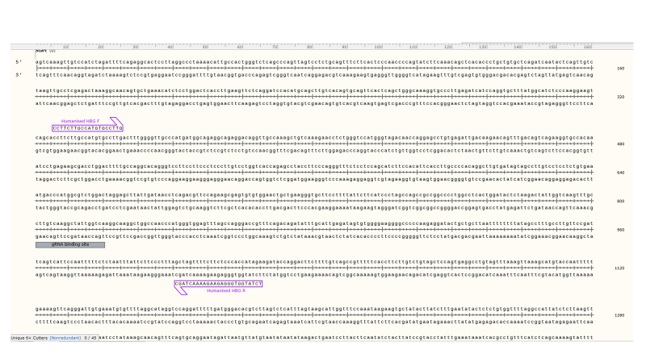
Figure 6.1: HBG-113 editing PCR primers
HBG-113 sgRNA and editing primers used in CRISPR/Cas9 editing experiments, adapted for applicability to human HSPCs.
Abbreviations: CRISPR/Cas9: Clustered regularly interspaced short palindromic repeat (CRISPR)/ CRISPR-associated protein 9 (Cas9) system, gRNA: specific guide ribonucleic acid, HBG-113: promoter region of HBG, HSPCs: haematopoietic stem and progenitor cells.
Primers specific to HBG1 and HBG2 were briefly used and were supplied by collaborators at the Seattle Children’s Research Institute (received with thanks from Dr S. Patthabi) who previously published experiments validating the use of these primers.³⁴⁶ The sequences are listed in Table 6.1.

Table 6.1: Primer pairs specific for HBG1 and HBG2
Genetic locus | Forward primer | Reverse primer
Promoter region for HBG1 | GCGCTGAAACTGTGGCTTTA | AGCATGCACACACCACAAAC
Promoter region for HBG2 | TCCTGCACTGAAACTGTTGCTTTA | AAAGTGTGGAGTGTGCACATGA

6.4 Results
6.4.1 Initial BCL11A-ee editing PCR primer design
Three different forward and 3 reverse primers were designed using the SnapGene programme, with assistance from Dr O. Humbert (supervisor), and ordered from Synthego. Specifications used for design of an ideal primer were:
- 19-25 base pairs long: long enough to provide adequate specificity but short enough for efficient binding within the normal range of annealing temperatures
- 150-200 base pairs away from break site in each direction: too long an amplification fragment would mean less efficient amplification. The primer should also not bind too close to the cut site since when PCR product is sequenced, the beginning of the sequence is often more prone to reading errors.
- Long stretches of A/T should be avoided, to prevent weak binding.
- Long stretches of C/G should be avoided, as binding may be too strong.
- Primer pairs at this point were designed to align with both human and NHP (rhesus macaque) sequences, since at this early stage, work on editing NHP HSPCs at this site was being undertaken in parallel. Given that there were only minor differences in sequence between human and NHP genome at this site, this requirement could be met without compromising the other design criteria.
The primer sequences selected and their alignment with the BCL11A-ee region in relation to the anticipated CRISPR/Cas9 cut site are shown below (Fig 6.2).

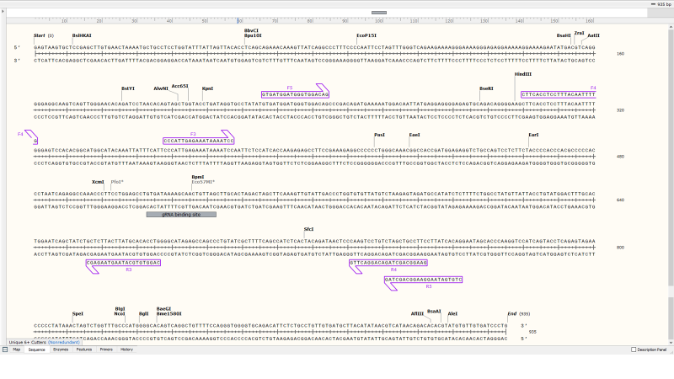
Figure 6.2: BCL11A-ee editing PCR primers designed for initial comparative testing
HSPCs underwent CRISPR/Cas9 editing at the BCL11A-ee locus. PCR primers were designed to amplify the region around this cut site in order that editing efficiency could be quantified and the character of indels described, by TIDE analysis following Sanger sequencing. A number of forward and reverse primers were initially designed in order that comparative testing of primer pairs could be undertaken. Primer sequences are provided and their alignment with the BCL11A-ee region either side of the targeted cut site illustrated. CRISPR/Cas9 cut site is highlighted by inclusion of the binding site for the specific guide RNA.
Abbreviations: BCL11A-ee: erythroid-specific enhancer region of BCL11A, CRISPR/Cas9: Clustered regularly interspaced short palindromic repeat (CRISPR)/ CRISPR-associated protein 9 (Cas9) system, gRNA: specific guide ribonucleic acid, HSPCs: haematopoietic stem and progenitor cells, PCR: Polymerase chain reaction, TIDE: Tracking of Indels by Decomposition.

6.4.2 Initial BCL11A-ee editing PCR primer pair testing
Each possible primer pair combination was tested, to allow selection of the most successful pair. The same human and the same NHP samples were used for each primer pair, each containing >40 μg/ µL DNA. A single volume of all master mix reagents (details given in Chapter 2, section 2.8) minus primers was first constituted, before separation into equal aliquots to which specified primer pairs were added. The primer combinations added to each master mix are presented below in Table 6.2.

Table 6.2: BCL11A-ee primer pair combinations for initial testing with human and NHP HSPCs
Master mix: test primer pair | Forward primer | Reverse primer
1 | F3 | R3
2 | F3 | R4
3 | F3 | R5
4 | F4 | R3
5 | F4 | R4
6 | F4 | R5
7 | F5 | R3
8 | F5 | R4
9 | F5 | R5

Each primer pair was tested with human cells and with NHP cells (since at this point, the provisional strategy was still to progress to testing the newly developed dual editing strategy in NHPs if in vitro and mouse experiments proved successful) as well as with a water control. Small volumes (5 μl) of PCR product from each reaction were loaded into wells in 2% agarose gel for electrophoresis and the resultant electrophoretic gel trace is shown below (Fig 6.3). Successful primer pairs were considered those resulting in a single, clear band when tested with either human or NHP DNA. After repeat testing, primer pair 7 was initially selected and validated by accurate sequencing of both human and NHP amplicons. Standard thermocycler settings were used in this initial experiment (described in Chapter 2, section 2.8).

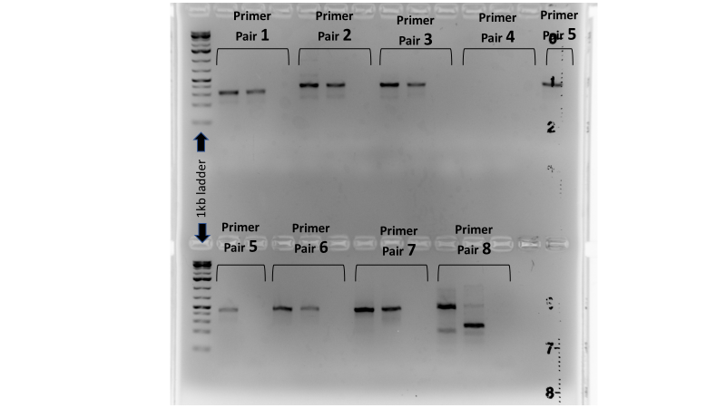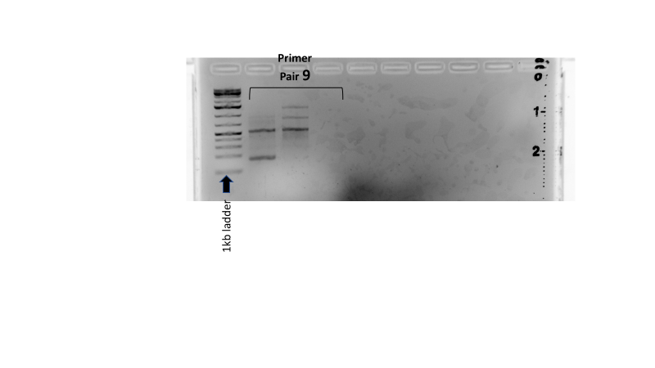
Figure 6.3: Results of initial BCL11A-ee editing PCR primer pair testing
Human and NHP HSPCs underwent PCR reactions with numerous combinations of primer pairs (listed in table 6.2) designed to amplify the BCL11A-ee region, in order to compare efficiency and specificity of amplification. PCR products were run on 2% agarose gel electrophoresis. For each triplet of wells, the sample on the left is human DNA, the middle sample is NHP DNA and on the right is a water control.
Abbreviations: BCL11A-ee: erythroid-specific enhancer region of BCL11A, DNA: deoxyribonucleic acid, HSPCs: haematopoietic stem and progenitor cells, NHP: non-human primate, PCR: polymerase chain reaction.

6.4.3 Modified design of BCL11A-ee primers for human specificity
6.4.3.1 Amplification of mouse DNA by current BCL11A-ee primers
The primer pair selected above (F5 + R3) allowed successful BCL11A-ee amplification when applied to in vitro samples of human HSPCs. However, when the same assay was applied to samples from humanised mice post-xenotransplantation of mock, single or dual edited human HSPCs, reactions were unsuccessful. Gel traces usually demonstrated multiple bands of different sized DNA fragments and sequencing failed to give valid results.
Given that the main difference between these samples and in vitro human HSPCs, for which PCR was successful, was the inclusion of mouse DNA, it was hypothesised that this was due to similarity between human BCL11A and similar region(s) within the mouse genome, which were also being amplified by the BCL11A-ee PCR reaction with these selected. After further investigation using the NCBI’s BLAST programme and the Mouse Genome Database, it was confirmed that there were multiple sites within the mouse genome to which these primers would hybridise.^{348; 349} In particular, the mouse bcl11a gene had a high level of homology to human BCL11A (Fig 6.4). The primers currently being used were binding both to human and mouse DNA, making results unusable.

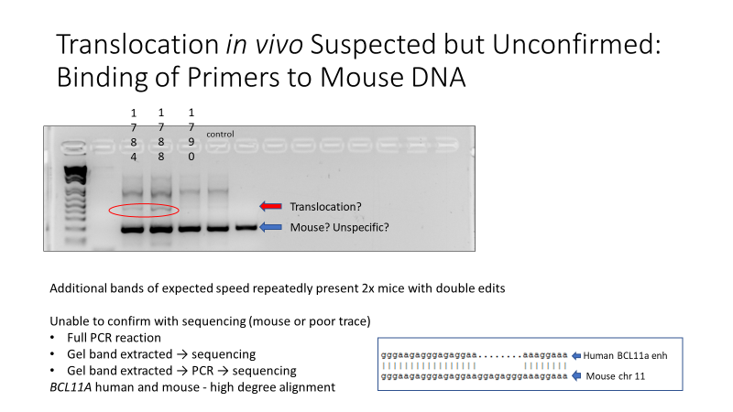
Figure 6.4: Homology between human BCL11A and mouse DNA
The BCL11A-ee PCR assay designed to amplify this region in human cells also resulted in additional reaction products when applied to samples contaminated with mouse DNA. Investigations revealed a high level of homology between human BCL11A on chromosome 2 and mouse bcl11a on chromosome 11. An example of sequences demonstrating this homology is presented.
Abbreviations: BCL11A-ee: erythroid-specific enhancer region of BCL11A, chr: chromosome, DNA: deoxyribonucleic acid, enh: enhancer, PCR : polymerase chain reaction.

6.4.3.2 Design of human-specific BCL11A-ee primers
Primers which were specific to human BCL11A-ee were required, which would not bind to, and amplify, mouse DNA. Advice was sought from collaborators at the Seattle Children’s Research Institute who had expertise on the mouse genome and were familiar with working with PCR assays on samples from humanised mice. Guidance from Dr S. Pattabhi was particularly valuable. Using the PrimerBlast® programme, primers with greater specificity for human DNA were designed.³⁵⁰ Of the initial primer suggestions, those primer pairs which would not cross the gRNA binding site were excluded. Primers selected to progress to further testing were those with the least homology with the mus musculus genome, and where the segment of mouse DNA which had the potential for amplification would be of a significantly different size (particularly where these would be much larger e.g. >3kb) than the human BCL11A-ee region, in order to reduce the likelihood of the PCR reactions resulting in a meaningful amount of mouse DNA amplification. The prefix ‘hupp’ (human primer pair) was used to denote human specific primers. The sequences of primers selected for further testing are listed in Table 6.3.

Table 6.3: Human-specific BCL11A-ee primers selected for comparative testing
Forward primers | Reverse primers
hupp1F: TTCTCCATCAGCAAGAGAGC | hupp1R: CAGGGATCACAACACGTACA
hupp2F: AGCTGGTACTTCATAGGTGC | hupp2R: GGTTCTGCTCTGAGGTACTG
hupp4F GGGAACCTTCACCTCCTTTA | hupp4R GGGTTCTGCTCTGAGGTACT
hupp5F GAGGCAAGTCAGTTGGGAAC
Abbreviations: hupp: human-specific primer pair

6.4.4 Testing of human-specific BCL11A-ee editing PCR primers
6.4.4.1 Set-up of primer pair combinations and temperature gradient for comparative testing
Twelve human-specific primer pairs were initially tested. These included all combinations of hupp1F, hupp2F, hupp4F, hupp5F (forward primers) with hupp1R, hupp2R, hupp4R (reverse primers). Each pair was tested with human and mouse DNA separately, and with a gradient of temperatures from 52 ºC to 62 ºC. The aim of this experiment was to select a primer pair which amplified human BCL11A-ee but not mouse DNA, in order to allow selective amplification and testing of human DNA where this was mixed with mouse cells, as in the case with samples extracted from humanised mice.
The gradient range of annealing temperatures tested was designed to find the greatest balance between adequate amplification of the desired sequence whilst maintaining specificity. A water control was run for each primer pair combination at 52ºC only since this was predicted to provide the greatest sensitivity for picking up false positive results including contamination. Table 6.4 sets out primer pair combinations tested.

Table 6.4: human-specific BCL11A-ee primer pair combinations used in each master mix for testing of human-specific primer pairs
Master mix: test primer pair | Forward primer | Reverse primer
1 | hupp1F | hupp1R
2 | hupp1F | hupp2R
3 | hupp1F | hupp4R
4 | hupp2F | hupp1R
5 | hupp2F | hupp2R
6 | hupp2F | hupp4R
7 | hupp4F | hupp1R
8 | hupp4F | hupp2R
9 | hupp4F | hupp4R
10 | hupp5F | hupp1R
11 | hupp5F | hupp2R
12 | hupp5F | hupp4R
Abbreviations: hupp: human-specific primer pair

6.4.4.2 Temperature range and primer pairs with best performance on initial testing
On analysis of results, reactions at 52 ºC were observed to result in multiple bands of different speeds present for each reaction, including those with mouse DNA as a substrate, pointing to a high frequency of non-specific amplification (Fig 6.5). Between 54-58 ºC, as the temperature increased, there was a lower frequency of multiple bands or amplification of mouse DNA and also a reducing density (as assessed by visualisation only) of the band with human reactions. At 60-62 ºC there was sparse amplification in either human or mouse reaction. The temperatures selected for further testing were 54 ºC, 56 ºC and 58 ºC, as these demonstrated a reasonable amplification of human DNA without significant amplification in the mouse reactions.
Primer pairs 2, 3, 9 and 12 (Table 6.4) appeared to show the best amplification with human DNA without significant band formation where mouse DNA was used as a substrate. These were the primer pairs selected for the next stage of testing.

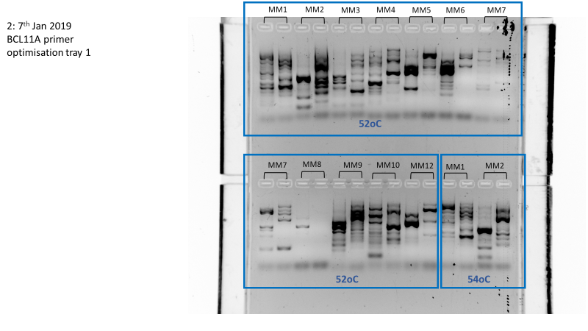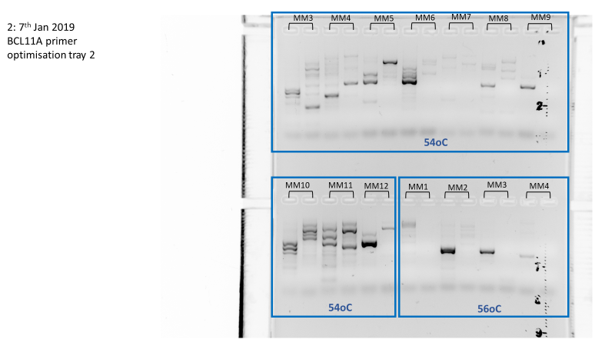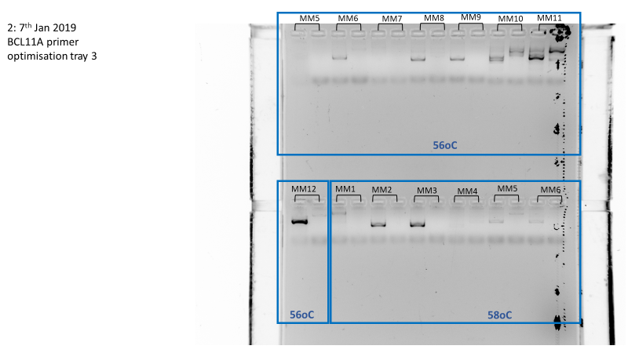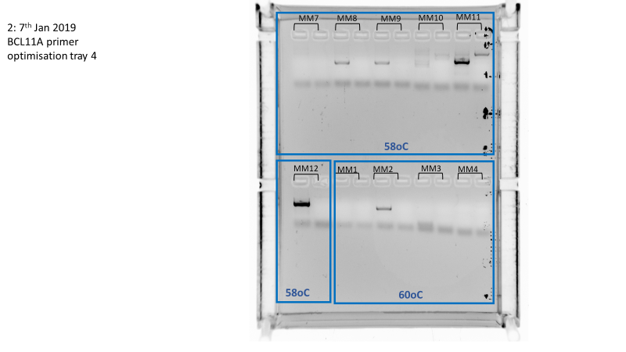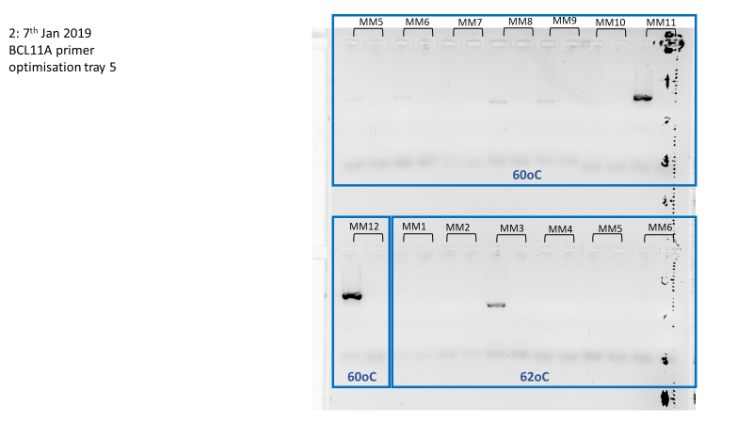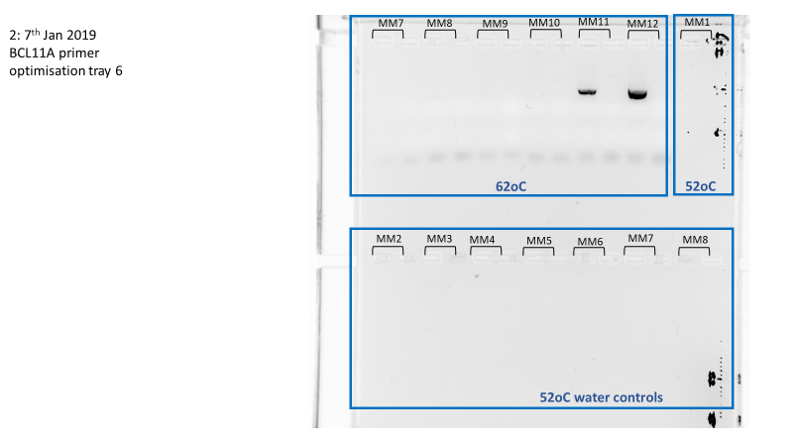
Figure 6.5: Comparative testing of human-specific BCL11A-ee primers with temperature gradient
DNA extracted from human and mouse haematopoietic cells underwent PCR reactions with numerous combinations of primer pairs (one per master mix) designed to specifically amplify the human BCL11A-ee region without amplification of mouse DNA. A gradient of annealing temperatures was also investigated, from 52ºC – 62ºC. Electrophoresis was then undertaken of PCR products on 2% agarose gel. For each duet of wells, the substrate of the reaction being tested on the left is human DNA and on the right is mouse DNA. Water controls were run for each primer pair combination at 52ºC (not all shown). DNA ladder was not run with samples, in order to conserve resources and since further testing of primer pairs showing promise was anticipated.
Abbreviations: BCL11A-ee: erythroid-specific enhancer region of BCL11A, DNA: deoxyribonucleic acid, MM: master mix, PCR: polymerase chain reaction.

6.4.4.3 Further challenge to human specificity of BCL11A-ee primer pairs by mixing human and mouse DNA
For the next stage of testing, the best performing primer pairs were further challenged by their application to a mix of human and mouse DNA. This is because it was anticipated that human specificity of the primer pair may be limited in the context of a relatively low concentration of human DNA with a higher concentration of mouse DNA, as was expected to be the case in many of the mouse tissue samples which would require investigation by this assay.
Therefore human and mouse DNA of similar concentration was mixed in a human:mouse 1:9 volume ratio. The best performing primer pairs selected above were then applied to PCR reactions with this mixed DNA as substrate, at a temperature gradient of 54 ºC, 56 ºC and 58 ºC. Again, water control reactions for each primer pair were run at the lowest included temperature (54 ºC). Primer pair 9 (hupp4F + hupp4R) with annealing temperature 54 ºC was finally selected as the optimal combination, demonstrating selective amplification of human DNA within the mixed human and mouse sample. This was demonstrated by a single band on the gel of the same length as that seen when human DNA alone was used as a substrate. Confirmation that the PCR product consisted of the amplified region of BCL11A-ee as expected was confirmed by Sanger sequencing.
6.4.5 Optimisation steps investigating other PCR reaction reagents
6.4.5.1 Ongoing assay failures
Despite the design and selection of an optimal primer pair and PCR programme as described above, when this assay was applied to DNA extracted from the PB of humanised mice, it still continued to fail in a high proportion of cases. Either multiple bands on gel were still visible after PCR, suggesting further non-specific amplification, or there was an absence of any amplification at all, with no DNA visible on electrophoretic gel after PCR. Therefore, further investigation was made into how the assay and preparation for it could be optimised.
6.4.5.2 Modifications to polymerase enzyme and PCR buffer
As a first step in considering reasons for these ongoing reaction failures, the BCL11A-ee sequence which was the target for amplification was reviewed closely. High GC content was noted and it was hypothesised that this lead to excessively strong binding, making it difficult for sense and antisense strands to separate in order to allow successful PCR cycling. It was considered that reagents optimised for GC-rich sequences should be trialled. A particular GC-rich PCR kit was recommended and purchased (AccuPrime GC-Rich DNA Polymerase, Invitrogen). This kit contained both a modified Taq polymerase enzyme and optimised buffer solutions. The manufacturer does not provide extensive detail on the mechanism by which these modifications improve GC-rich sequence amplification, but even in their own product literature for the standard polymerase enzyme used for PCR reactions so far (Platinum Taq, Thermo Fisher Scientific, US), they report GC-Rich PCR performance as low.
Use of this kit in place of the standard Taq polymerase and buffer resulted in an increased frequency of PCR amplification of DNA, as evidenced by gel bands present after electrophoretic testing of PCR product. However, gel traces were still not clean and multiple bands were often still present.
6.4.5.3 Investigations into modification of other reagents
Further steps included trialling replacing all other reagents used in the PCR reaction with fresh reagents in case of contamination. The use of MgSO₄ instead of MgCl₂ was also investigated
along with varied concentrations of these Mg compounds, given the Mg-dependence of Taq enzymes, but none of these steps resulted in a cleaner gel trace or more successful sequencing reactions.³⁵¹
As part of this process, discussions took place with the Nucleic Acid Sequencing Core team at FHCRC, who carried out the Sanger sequencing reactions on pre-prepared samples. Modifications were also made to their protocol based on the GC-rich sequences involved (at no additional charge per sample). Full details of their methods were not provided and there was only modest improvement in results, at most.
6.4.6 Improvements to DNA extraction protocol
Most PCR reactions at this point continued to result in amplification of multiple PCR products, as demonstrated by the presence of multiple bands of different size on subsequent gel electrophoresis. Since every step of the PCR reaction itself had already been examined, analysis was now broadened to include the process from sample extraction to PCR. Given that the PCR was working well on in vitro samples, areas identified for scrutiny were those for which protocols for in vitro and ex vivo samples differed.
One way in which these processes diverged was in the method of DNA extraction. For cells in vitro, since there was usually an ample number of cells, the standard kit for DNA extraction (DNEasy, Qiagen, US) was used. However, for extraction of DNA from mouse samples, because the number of human cells present was much lower, the Epicenter kit was used as this generally provided a higher DNA concentration post extraction. It was hypothesised that a lack of purity in the DNA substrate produced by Epicentre may be contributing to the non-specific amplification results. A clue to this was given by the trace on the Nanodrop spectrophotometer which was used to measure DNA concentration following extraction. Where DNA had been extracted by the DNEasy kit, there was normally a clear and relatively sharp peak visible at the expected wavelength (260 nm). However, DNA extracted by Epicentre generally resulted in a much flatter curve, suggesting that compounds other than pure dsDNA were present in the sample.
Alternative DNA extraction methods were therefore investigated to determine whether their products would result in more successful PCR reactions. The DNA Micro Kit (Qiagen, US) was trialled using blood from humanised mice. This resulted in the extraction of adequate concentrations of DNA, higher frequency of specific DNA amplification as evidenced by single bands on post-PCR gel electrophoresis, and valid sequencing results.
6.4.7 Summary of modifications to BCL11A-ee editing PCR reaction
Following the modifications to the DNA purification, PCR and sequencing reactions described above, the BCL11A-ee editing PCR assay was functioning well for both in vitro and ex vivo samples. The modified protocol involved using the DNA Micro Kit for DNA extraction of mouse tissue samples, the GC-rich PCR kit for PCR with the selected human-specific primer pair (hupp4F + hupp4R) at optimal annealing temperature of 54ºC. Although these modifications still did not result in a 100% success rate, valid results were now available in the majority of cases and allowed successful analysis of results of ongoing experiments.
6.4.8 Translocation PCR design and testing
Alongside optimisation of the BCL11A-ee editing PCR assay, translocation PCR assays were also being developed. The aim of these tests was to detect the presence of two separate products of suspected t(2;11) chromosomal translocation events, which it was hypothesised would occur between the BCL11A-ee and HBG-113 editing cut sites, in the event that DNA double-stranded breaks were formed at both loci within the same cell. The principle of translocation PCR design is illustrated in Chapter 3 (Fig 3.8).
Each translocation PCR primer pair was created by the combination of one HBG-113-specific primer with another aligning with BCL11A-ee in the reverse direction. This assay suffered from the same challenges as the BCL11A-ee editing PCR reactions. Moreover, there was an added layer of difficulty since the translocation events were attempting to selectively amplify a rare event (i.e. the translocation product) over the much higher concentration of non-translocated DNA.
Initial translocation PCRs were run using BCL11A-ee F5 forward primer and BCL11A-ee R3 primers in combination with HBG-113 primers running in the opposite direction, tested on DNA from in vitro mock, single and dual edited HSPCs. PCR cycle number was increased from the standard 35 to 40 in order to increase sensitivity of the assay, given that the translocation (if present) was expected to be a rare event. Electrophoresis of PCR products showed the presence of multiple bands indicating non-specific amplification, but still managed to suggest the presence of a translocation event by the presence of an additional band observed only with double-edited reactions (Fig 6.6A). This was most clear in reactions amplified by HBG-113 F primer with BCL11A-ee R3, whereas only a very faint additional band was visible in the double-edited reactions amplified by BCL11A-ee F5 with HBG-113 R.
In order to improve the specificity of the PCR reactions for the translocation whilst maintaining sensitivity for translocation detection, various modifications were investigated, including increasing annealing temperature of PCR cycles and altering the number of cycles. The optimal conditions were found to be 40 cycles with annealing temperature of 58ºC, which resulted in successful and specific amplification demonstrated in dual edited reactions which was not present in single edited reactions, and without additional bands visualised on electrophoresis (Fig 6.6B). Translocation PCR products were sequenced and confirmed to represent chimeric sequences which aligned to regions of HBG-113 and also BCL11A-ee (sequencing results presented in Chapter 3, section 3.4.1.6).

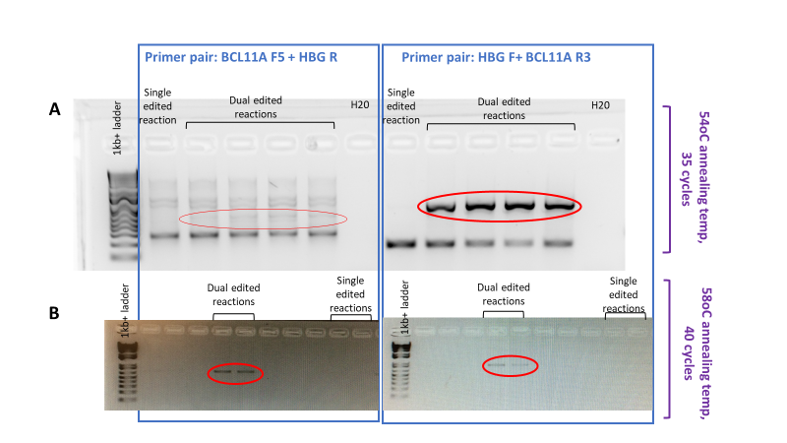
Figure 6.6: Suspected product of t(2;11) chromosomal translocation amplified by PCR
HSPCs underwent single CRISPR/Cas9 editing at either the BCL11A-ee or HBG-113 locus, or dual editing at both loci. PCR reactions were designed with the aim of detecting any chromosomal translocations formed by cross-over events at the two loci. Primer pairs anticipated to bind to either side of the putative chimeric sequence were tested on DNA from single edited reactions (negative controls) and dual edited reactions (test samples). (A) Initial reactions were carried out with thermocycler settings of 35 cycles and annealing temperature of 54ºC. (B) Modifications introduced to improve specificity included increasing annealing temperature to 58ºC and increasing cycle number to 40. Additional bands present in reactions from dual edited cells but not single edited cells are highlighted in red and are suspicious for the presence of translocation events.
Abbreviations: BCL11A or BCL11A-ee: erythroid-specific enhancer region of BCL11A, DNA: deoxyribonucleic acid, HBG or HBG-113: promoter region of HBG, HSPCs: haematopoietic stem and progenitor cells, PCR: polymerase chain reaction.

6.4.9 Modified translocation PCR for human specificity
6.4.9.1 Amplification of mouse DNA by current translocation PCR reaction
The translocation PCR assay was now working successfully where applied to human HSPCs in vitro. However, when the substrate was DNA extracted from humanised mouse tissues, results were less successful due to apparent loss of specificity of the PCR reaction in this context (Fig 6.7). An additional band was often still seen after application of the translocation assay to PB samples from mice transplanted with double edited HSPCs, which was not present in reactions from mice transplanted with single or mock-edited HSPCs. This band was of the length expected to represent the translocation amplicon, but the DNA content of this additional band was observed to comprise only a small proportion of the total amplified DNA. A thicker, faster-moving band was seen in the traces from each mouse including those transplanted with mock-treated or single edited cells each time this experiment was tried. This represented either non-specific amplification of human DNA or amplification of mouse DNA. Since this assay was functioning well with in vitro human HSPCs, it was considered most likely that the lack of specificity when applied to ex vivo samples related to amplification of regions of the mouse genome.

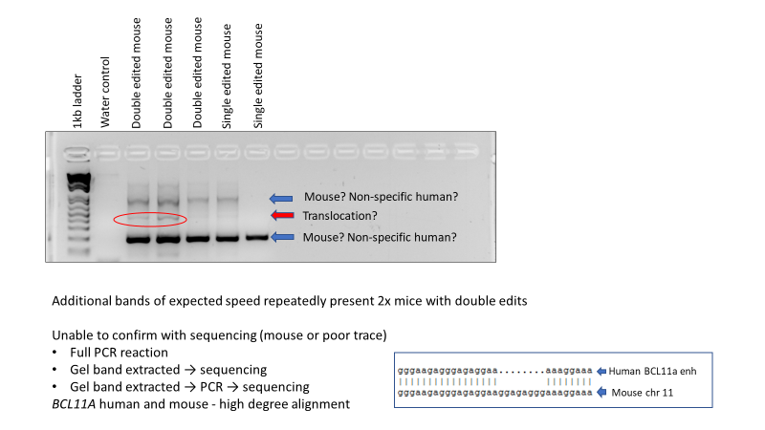
Figure 6.7: Initial results of translocation PCR applied to ex vivo samples from humanised mice
HSPCs underwent single CRISPR/Cas9 editing at either the BCL11A-ee or HBG-113 locus, or dual editing at both loci. Engineered HSPCs were then transplanted into immunodeficient mice and allowed to engraft. Translocation PCR assays were carried out on DNA extracted from mouse blood, in this case utilising a forward primer to bind HBG-113 and a reverse primer to bind BCL11A-ee. The PCR reaction products were then run on gel electrophoresis. An additional band present in a number of samples from dual edited mice but not single edited mice (highlighted in red) was suggestive of the presence of translocation.
Abbreviations: BCL11A-ee: erythroid-specific enhancer region of BCL11A, DNA: deoxyribonucleic acid, HBG-113: promoter region of HBG, HSPCs: haematopoietic stem and progenitor cells, PCR: polymerase chain reaction.

6.4.9.2 Attempts to extract and sequence additional DNA band after translocation PCR applied to ex vivo samples from humanised mice
Translocation PCR assays where applied to humanised mice transplanted with edited HSPCs often demonstrated the presence of an additional product where applied to dual edited arms, which was not present in single or mock edited mice and therefore considered most likely to represent translocation amplicons. Sequencing of the entire PCR reaction in these cases was attempted but unsuccessful, with unreadable sequence reports or complete failure of sequencing reaction. This was considered most likely to be due to the presence of multiple other amplified segments of DNA, which in most cases appeared to contain higher DNA concentration than the additional band suspected of representing translocation product (as demonstrated by darker, thicker band on gel electrophoresis).
An attempt was made to isolate the translocation amplicon from other amplified DNA, by extracting this additional band from the double-edited reaction electrophoresis gel channels. This was followed by purification of the DNA contained in the gel slice using the DNA gel extraction and purification protocol (described in detail in section 6.3.3). However, the resultant sequences remained too poor to read.
Since the gel bands extracted were generally faint, it was hypothesised that sequencing may have failed due to low DNA concentration within these bands. With the aim of expanding the translocation fragments more specifically, a further translocation PCR reaction was run using the DNA extracted from each gel band as substrate. Electophoretic testing of the products of these PCR reactions revealed that purity was still low, with multiple bands again seen on gel electrophoresis, and subsequent sequencing also failed. It was clear that the translocation assays required further modifications to improve their specificity for the translocation sequences, in order to prevent amplification of mouse DNA.
6.4.9.3 Human-specific BCL11A-ee primers introduced into translocation PCR assays
It was hypothesised that the translocation PCR assay primers were binding to and amplifying sections of mouse DNA. Given the homology of human BCL11A and mouse bcl11a, it was hypothesised that the lack of specificity was likely to be related primarily to the BCL11A-ee primers than the HBG-113 primers and therefore modifications to the BCL11A-ee components of the assay were investigated as a first priority.
Concurrent to the development of the translocation PCRs, the BCL11A-ee editing PCR assay was also being optimised for human specificity, having run into similar problems where applied to ex vivo samples from transplanted mice (described in section 6.4.4), and learning points from working with that assay were applied to the translocation PCR process. DNA continued to be extracted from mouse samples using the DNA Micro Kit, in order to improve purity of the DNA template. Following the work described above to design and test BCL11A-ee primers which were more specific for human DNA (rather than mouse), the best performing of these human-specific primers (hupp4F and hupp4R) were taken forward for further work-up of the translocation assays.
At this point, investigation was also being undertaken into the potential benefit of using separate primers specific for each of the HBG promoter regions. There are 2 such alleles per chromosome which have minor differences in their sequences, termed HBG1 and HBG2. One reason that the separate HBG-113 primers were being considered was that, at the time, an alternative method of selectively amplifying and sequencing translocation sequences was being investigated (Nextera Flex – more details given below in section 6.4.10.3). This experimental methodology, if successful, would have permitted an increased level of detail and allowed definition of translocations involving HBG1 from those involving HBG2. However, a decision was made not to pursue the Nextera system and, without that, it was unlikely that that separate primers would be useful. The use of separate HBG1 and HBG2 primers in translocation assays was not progressed further but they were involved in some of the reactions for which results are presented below.
6.4.9.4 Optimisation of human-specific translocation PCR
Comparative testing of primer pairs was carried out initially on in vitro human HSPCs, since mouse samples from the humanised mouse cohorts was a scarcer resource (Fig 6.8). PCR reactions for each primer pair were carried out with DNA from dual edited HSPCs which ad previously been demonstrated to contain both types of translocation sequence, as positive control. A negative control consisted of unedited cells from the same experiment. HBG1, HBG2 and BCL11A-ee amplification PCRs were also run as part of the testing process for the HBG1 and HBG2 PCR assays, and were expected to act as further positive controls, validating experimental conditions including DNA concentration of substrate. Reactions were run at a gradient of annealing temperatures from 54 ºC to 63 ºC.
Primer pairs based on forward primer aligning with HBG-113 and reverse primer BCL11A-ee hupp4R with annealing temperature of at 60 ºC were observed to provide the best results: single bands apparent in the positive control reactions but not the negative controls. The reverse primer pair combinations (i.e. BCL11A-ee hupp4F with a forward HBG-113 primer) did not function well. It was decided to focus on application of this successful primer pair rather than continue to invest time and reagents in efforts to amplify the complimentary translocation event. This was for two reasons. Firstly, because the demonstration of any translocation resulting from dual edited cells was considered to render that treatment strategy unsuitable for clinical application, particularly if persistent in mouse samples post-transplant. The second reason for not aggressively pursuing further development of additional functional primer pairs is that efforts were already focusing by this time on the development of ddPCR testing for both types of translocation event.
PCR products from these reactions were purified and successfully sequenced to confirm that the amplicon was in fact the translocation expected. HBG-113 amplification PCRs were successful in each case but all BCL11A-ee amplification PCR reactions failed. It was noted that these PCR reactions were set up using standard PCR reagents rather than the GC-rich PCR buffer and polymerase, which was assumed to be the cause of these failures.
Further testing steps to confirm these optimal reaction conditions included repetition of translocation PCR reactions using the optimal 2 primer pairs at additional temperatures. In the initial test, 60 ºC appeared to be the optimal temperature at which to run this assay. However, there were 3 ºC between each step in the gradient, therefore, repeats were carried out at 58 ºC, 60 ºC and 62 ºC. Since there looked to be an improvement in performance with 40 cycles over 35, further repeats also compared 40 versus 43 cycles to see whether further benefit would be observed, but this made no apparent difference to results. After the separate HBG1 and HBG2 primers were abandoned, it was confirmed that the assay still worked successfully in these optimal conditions using the generic HBG-113 primers.
Upon completion of these experiments, 58 ºC was determined to be the optimal annealing temperature for the translocation assay, and 40 cycles determined to be the ideal number. The translocation primer pair used for future assays was HBG-113 F with BCL11A-ee hupp4R.

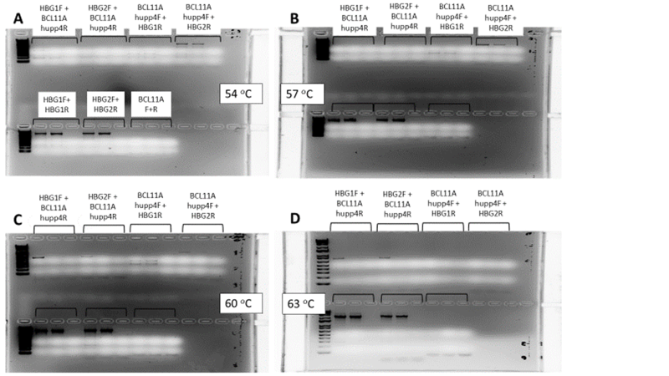
Figure 6.8: Comparative testing of human-specific translocation PCR primer pairs
HSPCs underwent single CRISPR/Cas9 editing at either the BCL11A-ee or HBG-113 locus, or dual editing at both loci. Translocation PCR assays were carried out using different primer combinations (annotated on figure). A range of annealing temperatures was also investigated: 54ºC (A), 57 ºC (B), 60 ºC (C) and 63 ºC (D). PCR reaction products were then run on electrophoretic gel. Each triplet of samples included a positive control on the left (DNA known to contain translocations), a negative control in the middle (DNA from unedited cells) and a water control on the right.
Abbreviations: BCL11A or BCL11A-ee: erythroid-specific enhancer region of BCL11A, CRISPR/Cas9: Clustered regularly interspaced short palindromic repeat (CRISPR)/ CRISPR-associated protein 9 (Cas9) system, DNA: deoxyribonucleic acid, HBG-113: promoter region of HBG, HBG1: promoter region of HBG1, HBG2: promoter region of HBG2, HSPCs: haematopoietic stem and progenitor cells, PCR: polymerase chain reaction.

6.4.9.5 Successful application of translocation PCR to ex vivo samples from humanised mice harbouring translocation
Following optimisation of the human-specific translocation PCR assay using in vitro HSPCs, it was then successfully applied to DNA extracted from the PB of humanised mice (Fig 6.9). The translocation was demonstrated to be present in the majority of ex vivo samples extracted from mice transplanted with dual edited HSPCs, whether the dual editing had been delivered simultaneously or sequentially.
The final result of this work-up is that the translocation assay was successfully applied to PB samples of humanised mice, and demonstrated presence of the translocation in a number of mice transplanted with dual edited HSPCs.

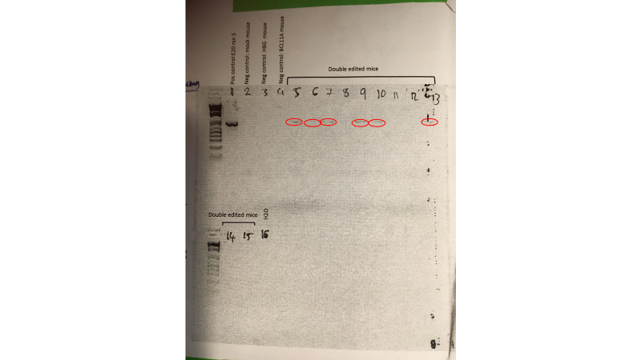

Figure 6.9: Successful demonstration of translocation in mice transplanted with dual edited HSPCs
HSPCs underwent single CRISPR/Cas9 editing at either the BCL11A-ee or HBG-113 locus, or dual editing at both loci. Translocation PCR, using forward primer aligned to HBG-113 and reverse primer aligning with BCL11A-ee, was carried out on DNA extracted from mouse peripheral blood samples, drawn 6 weeks after transplantation. PCR reaction products were then run on electrophoretic gel. Positive control (well 1) was an in vitro aliquot of dual edited HSPCs previously demonstrated to contain the translocation. Negative controls were peripheral blood from mice transplanted with mock edited (well 2) or single edited (wells 3-4) HSPCs. PCR product demonstrated only in samples from dual edited mice, of the same size as that present in positive control, is highlighted with red rings and was highly suggestive that cells harbouring the translocation were present in the peripheral blood of a number of the dual edited mice post-transplant.
Abbreviations: BCL11A or BCL11A-ee: erythroid-specific enhancer region of BCL11A, CRISPR/Cas9: Clustered regularly interspaced short palindromic repeat (CRISPR)/ CRISPR-associated protein 9 (Cas9) system, DNA: deoxyribonucleic acid, HBG or HBG-113: promoter region of HBG, HSPCs: haematopoietic stem and progenitor cells, Neg: negative, PCR: polymerase chain reaction, Pos: positive.
6.4.10 Investigations into additional methods to define and quantify translocations
6.4.10.1 Need for quantitative assay of translocation frequency
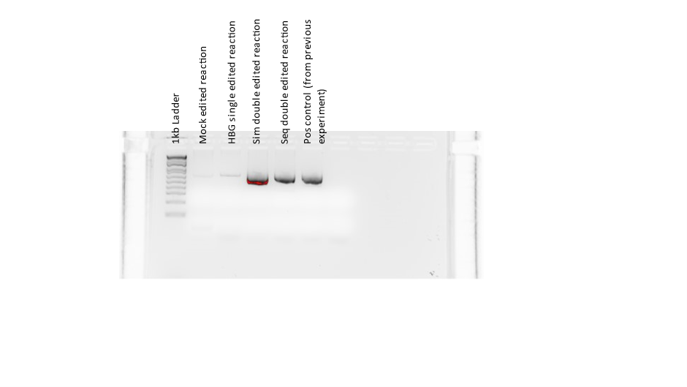
The simple translocation PCR assay was useful in providing a qualitative assessment of the presence of a translocation event. In most cases where this was carried out on in vitro aliquots of experiments investigating single versus dual editing techniques, the ‘translocation’ band appeared to be denser where cells had undergone simultaneous rather than sequential double editing. An example of this phenomenon is provided below (Fig 6.10). However, without access to densitometry for quantification of the DNA band, even with standardisation of DNA concentration inputted into the PCR reactions and of volume of PCR product run on electrophoretic gel, valid comparisons of translocation frequency using standard PCR were prohibited. An alternative assay was required to allow comparative quantitation of translocation frequency between dual edited arms of experiments.
Figure 6.10: Translocation PCR results on in vitro HSPCs following mock, single or dual CRISPR/Cas9 editing
HSPCs underwent single CRISPR/Cas9 editing at either the BCL11A-ee or HBG-113 locus, dual editing at both loci either simultaneously or sequentially, or mock editing. Translocation PCR was carried out using forward primer designed to bind HBG-113 and a reverse primer aligning with BCL11A-ee. PCR reaction products were then run on electrophoretic gel. Positive control was an in vitro aliquot of dual edited HSPCs from a previous experiment already demonstrated to contain the translocation. High density of DNA was highlighted with red.
Abbreviations: BCL11A-ee: erythroid-specific enhancer region of BCL11A, CRISPR/Cas9: Clustered regularly interspaced short palindromic repeat (CRISPR)/ CRISPR-associated protein 9 (Cas9) system, DNA: deoxyribonucleic acid, HBG or HBG-113: promoter region of HBG, HSPCs: haematopoietic stem and progenitor cells, PCR: polymerase chain reaction, Pos: positive, Seq: sequential dual editing, Sim: simultaneous dual editing.

Following the detection of translocation presence in mouse PB samples after xenotransplantation with dual edited HSPCs, the ability to track frequency of the translocation over time in these mice would also provide valuable information on the viability and possibly even survival or proliferation advantage of HSPCs harbouring t(2;11) chromosomal translocations in vivo. Alternative methods which would provide accurate quantification of translocation frequency were therefore investigated. These included fluorescent in situ hybridisation (FISH), a novel PCR method being developed by Illumina (Nextera Flex) and finally digital droplet PCR (ddPCR).
6.4.10.2 FISH
Double-fusion FISH testing was initially considered. Fluorescent probes designed to hybridise to either side of the cut site in HBG-113 and BCL11A-ee could be used to visualise chromosomes in which these had broken apart and re-conjugated with partners in the other gene, creating a secondary colour of fluorescence, in the case of translocation. However, access to cytogenetics expertise or equipment was not available. There was, surprisingly, no cytogenetics core facility at FHCRC. Contact was made with the clinical cytogenetics laboratories at SCCA, Seattle Children’s Hospital and UW but all were continuously at capacity with clinical samples at the time, and quoted up to a year to be able to begin working on research samples. FISH is also known to be less sensitive than molecular genetic methods at detecting the presence of a translocation event. For these reasons, this method was not pursued further.
6.4.10.3 Nextera Flex
The Illumina Nextera Flex method was next investigated.³⁵² In this technology, transposomes linked to magnetic beads are guided by specifically designed probes. The probe library is constructed to conjugate to a high number of regions within sequences of interest. DNA is thus fractured into multiple small fragments by these transposomes which are then pulled out for analysis by their attached magnetic beads. The DNA strands would subsequently be sequenced. This was purported to allow NGS-level data, purely of the regions of interest and small amounts of surrounding DNA. This system was still in the early phases of roll-out by the company but the use of this novel method was attractive and promised an excellent level of detail in data provided, if effective.
The downsides of using a new system, however, included the facts that it was not yet fully tested and validated in similar experiments, therefore results would likely draw such criticisms if published. There would also be a high degree of reliance on the company to design and provide reagents and also initiate result analysis. The probe design and provision of reagents was also very expensive, even with the 50% discount offered by the Illumina team. For these reasons this avenue was not pursued further.
6.4.10.4 ddPCR
The final method considered for quantification of translocation events was ddPCR. This was selected as the method of choice given its ability to accurately quantify a molecular genetic event with high sensitivity, and because a collaborating laboratory at the FHCRC had the equipment and expertise to develop this assay. Sequences demonstrating the translocation amplicons and details of primer pairs used to produce them were provided in order to assist in design of this test. Details and results of these experiments are provided in Chapter 3 (section 3.4.1.7).

6.5 Discussion
This chapter has outlined the developmental process for the BCL11A-ee editing PCR and translocation PCR assays used in experiments investigating the dual CRISPR/Cas9 editing strategy of HSPCs, targeting both HBG-113 and BCL11A-ee loci, with the aim of maximising HbF reinduction. Accurate assays for the quantification and description of editing at both regions were vital. The HBG-113 editing assay was straightforward, however the BCL11A-ee amplification assay required that many obstacles were overcome before useable data could be generated. This was particularly the case when testing samples extracted from humanised mice, transplanted with edited human HSPCs. Challenges included a high GC-component of generated sequences, homology between this region and mouse genome, and poor purity of DNA extracted by standard methodology from mouse samples.
Each step of the pathway from mouse blood processing through to sequencing of PCR product was examined and refined. This included modification of the DNA extraction protocol, selection of an alternative DNA polymerase enzyme with greater efficacy in GC-rich PCR reactions, design and testing of human-specific primer pairs, and investigation into PCR cycle settings which would result in adequate sensitivity of the assay without compromising specificity.
In the early stages, it was anticipated that preclinical development of the dual editing strategies may progress to testing in NHPs, therefore the design of initial primers and preliminary experiments took this into account. However, once it became clear that the multiplex editing protocols were associated with the development of chromosomal translocation events which persisted in vivo following transplantation into immunodeficient mice, this precluded further work-up towards clinical application. Therefore NHP experiments would be unethical and were discarded from planning processes.
It was hypothesised that chromosomal translocations may occur, where double-stranded DNA breaks were formed at both the BCL11A-ee and HBG-113 loci within the same cell. Translocation PCR assays were designed and optimised in order to amplify the products of such translocation events. This assay was also faced with similar difficulties to the BCL11A-ee amplification PCR reaction, but to an even greater degree given the rarity of the sequence sought for expansion. Application of the human-specific BCL11A-ee primers, refinement of thermocycle settings, and continued use of the modified DNA extraction protocol, all contributed to the step-wise improvement of these assays.
By methodical and thorough consideration of all aspects of these reactions, both the BCL11A-ee editing PCR assay and the translocation PCR were successfully developed and applied to in vitro and ex vivo samples.
The need for a quantitative translocation assay was recognised and various options including FISH, and the novel system, Nextera Flex, were investigated. ddPCR showed the most promise and was pursued in collaboration with a partner laboratory at FHCRC.
Limitations to the processes described in this chapter include the small number of repeats of each optimisation step. Due to scarcity of samples, particularly DNA from ex vivo mouse tissues, and also in order to conserve other resources, the largest comparative testing experiments were often performed only once before selecting a smaller number of optimal conditions for further testing. Finally, there was more success in the development of the translocation PCR reaction using a forward primer to bind the HBG-113 region and a reverse primer binding BCL11A-ee than with the BCL11A-ee forward and HBG-113 reverse pairs. The reasons for this are not entirely clear, although it is noted that ddPCR experiments reported in Chapter 3 generally reported a higher frequency of translocations which would have been detected with the former rather than those detected with the latter combination. Again, it is unclear whether this difference in ddPCR-reported frequencies relates to a genuine difference in the frequencies of two translocation events studied, differential sensitivities of the assays, or possibly both.
A final limitation is that some, but not all, of the translocation PCR products underwent sequencing. Having confirmed the alignment of sequenced amplicons from a number of translocation PCR reactions with both sections of BCL11A-ee and HBG-113, it was considered that these validated the use of the translocation PCR assay with use of gel electrophoresis to demonstrate presence or absence of amplicon. Future reactions demonstrating an additional band on gel electrophoresis consistent with the size of those already confirmed to be translocation sequences, were assumed to also represent the presence of translocation, but it is accepted that this was not confirmed in every case.
In summary, intensive and systematic processes were required in order to develop functional BCL11A-ee and translocation PCR assays. The individuality of each genetic locus and the need for a tailored approach to its expansion by PCR was highlighted. The challenges of using PCR to amplify rare events, or those with homology to other species where xenotransplantation has taken place, were also recognised. The assays whose development has been described in this chapter proved vital to the interpretation of results from in vitro and mouse transplant experiments investigating dual CRISPR/Cas9 editing of HSPCs, reported in Chapters 3-5.

7.0
Chapter 7:
Investigation into failure of HSPC remobilisation with repeated AMD3100 dosing in NHPs and humanised mice

7.1 Introduction
Sickle cell disease and β thalassaemia are the most common forms of β-haemoglobinopathy, caused by mutations or deletions in the β-globin gene, leading to aberrant or reduced production of HbA.^{13; 16; 23; 50; 353} Even with the best available supportive treatment, life expectancy and quality of life in these conditions is reduced.^{6; 72} The only curative option currently open to patients is allogeneic HSCT, but this is limited by availability of matched donors, and confers significant risks, including GvHD.^{219; 229; 234}
Genome editing offers the promise of cure by engineering a patient’s own HSPCs, negating the requirement for an HLA-matched donor and the risk of GvHD. The most successful strategy thus far has been targeting genomic regions involved in the regulation of the physiological switch from HbF to HbA, leading to reinduction of HbF production. High HbF levels have long been recognised to confer reduced symptom burden and improved survival,^{73; 134} and at least moderate success has been achieved by targeting the erythroid enhancer region of the transcription factor gene BCL11A, or its binding site within the promoter region for HBG.^{263; 268; 280; 340} However, further improvement in HbF reinduction remains desirable, and a major aim of the work described in this thesis was the investigation of dual editing strategies to knock out both regions in the same HSPC population, with assessment of the effect on HbF reinduction.
Our group has developed an NHP HSCT model, the use of which is an important final step in preclinical testing of novel therapies prior to clinical translation.^{336; 354; 355} Given the high level of genetic and physiological homology between humans and NHPs, in this case rhesus macaques (macaca mulatta), this represented the most robust test of safety and efficacy before application to human subjects. The HBG-113 genome editing strategy had already demonstrated success in the NHP model using BM-derived HSCPs.²⁸⁰ In the event that the dual CRISPR/Cas9 editing strategy for improvement of HbF reinduction proved successful in in vitro and then mouse transplant experiments, application to the NHP transplant model was also planned. NHP HSCTs carried out by the group up until that point, including genome-modified autologous HSCTs, had all been based on BM-derived HSPCs, but the need to transition to a PBSC source was recognised.
The clinical benefits of transplanting PBSCs over BM-derived cells include shorter time to engraftment, and the avoidance of invasive BM harvest procedures.^{281; 356} The latter are particularly risky for patients with sickle cell disease, since the associated general anaesthetic may precipitate life-threatening crises. For these reasons, clinical studies investigating genome editing therapies for sickle cell disease and thalassaemia have also moved towards the use of mPBSCs for modification and retransplantation, after initial trials using BM-derived cells.³⁵⁷ In order to bring the NHP transplant procedures into line with gold-standard clinical practice, a new protocol was required for the extraction, modification and retransplantation of mPBSCs. Such procedures were already being carried out in other primate centres but had not as yet been developed at FHCRC or the UW Primate Centre.
The first step in this process was the mobilisation of HSPCs from their niche in the BM into the PB circulation. This would then be followed by collection in an apheresis procedure. The most common mobilisation agent used in clinical practice is the inflammatory cytokine G-CSF, but this is contraindicated in patients with sickle cell disease due to the risk of associated crisis.^{282; 314} The only other licensed mobilisation agent is AMD3100 (Plerixafor), a small-molecule CXCR4 antagonist which works primarily by interrupting the bond between CXCR4 on the surface of HSCPs and their ligand CXCL12 in the BM.¹¹ AMD3100 is the mobilisation agent of choice in sickle cell disease patients, in whom it has an established safety and efficacy profile.^{331; 332} In order to ensure that the NHP transplant procedures aligned as closely as possible to clinical transplant guidelines for haemoglobinopathy patients, in order to facilitate clinical translation of investigational therapies into this patient group, AMD3100 was selected to be the mobilisation agent used in NHPs for the future testing of genome editing therapies for haemoglobinopathies.
During the process of developing a successful NHP apheresis protocol, challenges relating to the apheresis procedure itself had to be overcome. This work is described fully in Appendix 1. Early results also suggested that, whilst initial dosing with AMD3100 resulted in successful HSPC mobilisation in to the PB, repeated dosing was less effective. Since multiple episodes of mobilisation are often required in order to collect adequate HSPCs for treatment, such a failure of remobilisation with repeated AMD3100 dosing in this preclinical model required thorough investigation. In this chapter, the results of experiments investigating the observed failure of remobilisation with repeated dosing of AMD3100 in the NHP and, subsequently the humanised mouse model, are presented.

7.2 Aims and objectives
The aim of the work in this chapter was to develop a successful NHP apheresis protocol, including the use of AMD3100 mobilisation, in order to harvest PBSCs for genome editing and retransplantation. This was in order to bring the NHP genome-edited autologous transplantation procedures more closely into line with clinical practice in patients with haemoglobinopathies. As a further aim, the failure of HSPC remobilisation with repeated AMD3100 dosing was investigated in order to confirm this phenomenon in NHPs and, subsequently, to investigate whether a similar remobilisation failure would be observed with human HSPCs.

Hypotheses:
- HSPC mobilisation is less successful with subsequent doses of AMD3100 than initial doses, both in the NHP and humanised mouse preclinical models.

The objectives of these experiments were:
- To investigate the phenomenon of HSPC remobilisation failure with repeated AMD3100 dosing in NHPs.
- To establish whether HSPC remobilisation failure with repeated AMD3100 dosing would be observed consistently in NHPs, and whether it would also be demonstrated by human HSPCs within the humanised mouse preclinical model.

7.3 Chapter-specific materials and methods
7.3.1 Original NHP apheresis protocol
A copy of the original NHP apheresis protocol is included in Appendix 1.
7.3.2 Optimisation of NHP apheresis protocol
Work initially focused on updating the NHP apheresis procedure in order to successfully harvest HSPCs from the PB. This work is described in full in Appendix 1.
7.3.3 AMD3100 mobilisation and remobilisation of NHPs
7.3.3.1 Preparation and administration of AMD3100
AMD3100 (octahydrochloride hydrate, Sigma-Aldrich, US) was provided in hydrophylised form. It was reconstituted in sterile conditions using H₂0 to a concentration of 5mg/ml. The sterile H₂0 was injected into the vial using a blunt needle and syringe, and mixed by shaking until powdered AMD3100 was fully dissolved. Contents were transferred to sterile conical flasks and stored at 4ºC until delivery to animal husbandry staff at the UW Primate Centre.
7.3.3.2 AMD3100 administration
AMD3100 was administered at a dose of 1mg/kg SQ according to previously published protocols.^{334; 358} Some animals were given a 2nd administration of AMD3100 6-14 weeks after the 1st, with identical dosing regimen. One animal received a 3rd dose of AMD3100, 4 weeks after the 2nd dose, with dosing carried out in an identical manner.
7.3.3.3 PB draws
Prior to 1st AMD3100 administration, NHPs underwent baseline blood sampling. PB draws were then taken at a minimum of 2 time points between 2-3.5 hours post-dose, into anticoagulated blood collection tubes. One animal was sedated for a longer period of time and had additional blood samples drawn: hourly blood draws from 2-7 hours post dose. Samples were taken for investigation of CBC and for FACS.
Following 2nd dose of AMD3100, blood draws were again taken prior to dosing and at a minimum of 2 timepoints 2-3.5 hours post dose. 2 animals had additional blood draws taken: 1 also had blood drawn at 4 hours post dose and 1 had hourly blood draws from 2-7 hours post dose. Following the 3rd dose of AMD3100, blood draws were taken at baseline, 2 and 2.5 hours following dose.
7.3.3.4 Processing of PB samples: CBC
Aliquots of NHP blood underwent CBC testing by the UW Medicine Laboratories using the Sysmex XN 9000 Hematology Automation Line (Sysmex, IL, US), by scientific staff in this laboratory. Reported white cell count (WCC) was assumed to include all circulating nucleated cells, which would include HSPCs as well as mature leucocytes.
7.3.3.5 Processing of PB samples: flow cytometry
Aliquots for flow cytometry underwent red cell lysis with haemolysis buffer which was prepared in-house: 150 mM ammonium chloride, 12 mM sodium bicarbonate and 0.1 mM EDTA were mixed into distilled deionised H₂O and sterile filtered (0.22 μM filter units used). Blood was incubated with haemolysis buffer in approximately a 1:4 volume ratio, mixed by inverting the tube, and incubated for 5 minutes. Following this, samples were spun down at 800 g for 5 minutes, the supernatant aspirated (being careful not to aspirate the buffy coat), and the process repeated once more.
The cell pellet was then resuspended in FACS buffer (2% FBS in 1X PBS) and stained using the following antibodies: anti-NHP CD45-V450 (Clone D058-1283, BD, US); anti-CD34-APC (clone 563, BD, US) ; anti-CD90-PE-Cy7 (clone 5e10, Biolegend, US) and anti-CD45 RA-APC-H7 (clone 5H9, BD, US). Antibodies were added at a volume of 2ul/1x10⁶ cells. Incubation with antibodies was for 30 minutes at 4ºC. Unstained controls and compensation beads stained individually with each antibody were run alongside. FACS was carried out on the BD FACSAria II or BD FACSCanto II flow cytometers. Post-acquisition analysis of flow cytometric data was carried out using FlowJo Version 9.
The percentage of CD34⁺ cells was defined by CD34-high/CD45-low fluorescence within the MNC population (MNCs first being defined by forward and side scatter). Within the bulk CD34⁺ cell population, a proportion enriched with true haematopoietic stem cells as defined by CD34⁺/CD90⁺/CD45RA⁻ (CD90⁺) was determined. At each blood draw timepoint, absolute circulating CD34⁺ count was calculated by multiplication of CD34⁺ fraction of MNCs by the total circulating WCC. Absolute CD90⁺ cell response was determined by multiplication of CD90⁺ fraction of CD34⁺ cells by absolute CD34⁺ cell number.
7.3.3.6 Processing of apheresis sample
Apheresis product underwent CBC and flow cytometry investigations as per PB aliquots (sections 7.3.4.4 and 7.3.4.5). Total cell count of apheresis product was determined by multiplication of volume by reported WCC on CBC. CD34⁺ and CD90⁺ counts were determined based on calculations as for PB samples.
7.3.4 AMD3100 mobilisation of humanised mice
7.3.4.1 Humanisation of immunodeficient mice
2 cohorts of NSG mice were humanised in adulthood, at the age of 6-8 weeks. Mice were initially subjected to 275 cGy sublethal irradiation. Humanisation was then carried out by a single tail vein injection of human G-CSF-mobilised, CD34⁺-enriched PB MNCs via the tail vein, at 1.5x10⁶ cells per mouse in one cohort, and 0.5x10⁶ cells per mouse in the second, resuspended in phosphate-buffered saline with 1% heparin (APP Pharmaceuticals, IL, US) to a total volume of 200 μl.
Humanisation was confirmed by lineage assessment on PB draws (as described in detail in Chapter 5, section 5.3.2.4) at least once prior to commencement of the experiment.
7.3.4.2 Preparation of AMD3100 or control injections
AMD3100 was reconstituted as described in section 7.3.3.1. AMD3100 equivalent to a dose of 10 mg/kg was transferred to a separate Eppendorf tube for each mouse, based on weight taken within the previous 7 days, recorded and shared using SoftMouse software. Double the required amount of injection mix was prepared for each mouse to facilitate delivery of the full and exact volume required at the time of injection. In order to avoid introducing an additional variable to the experiment by delivering different volumes of injection to different mice, sterile H₂O was added to make up the total volume to 200 µL in total for each tube. For mice in the control arm of each experiment, 200 µL of sterile water alone was transferred to each Eppendorf tube. Injection mixes were stored at 4ºC prior to collection by mouse core technicians.
7.3.4.3 Administration of AMD3100
100 µL of injection mix was administered to each mouse, SQ, according to the IACUC-approved protocol and according to a previously published mobilisation regimen.^{359; 360} This was equivalent to a dose of 5 mg/kg for AMD3100-treated mice. Control mice received sterile H₂0 injections only. Injections were labelled with mouse number only: animal technicians and veterinary staff were blinded to the treatment arm of each mouse.
A 1st mouse cohort received 1st dose AMD3100 20 weeks post humanisation, followed by 2nd dose and for surviving mice a 3rd dose was also given, with time intervals between doses 3-4 weeks. The 2nd cohort received 1st dose AMD3100 9 weeks post humanisation, followed by a 2nd dose 3-4 weeks apart.
7.3.4.4 PB draws
Baseline blood draw was taken prior to administration of AMD3100. PB samples were taken into EDTA-anticoagulated tubes. Following each dose, blood was drawn 1.5-2 hours post AMD3100, to coincide with expected peak of mobilization, for CBC and FACS analysis.¹² According to IACUC protocol SOP 038-I for retroorbital blood draws, no more than 10% of the animal’s blood volume could be drawn during any 2 week timeframe. This would usually approximate to 200 μl. In order to ensure that volumes drawn were equal for treatment and control mice, blood draws were standardised to 50 µL pre AMD3100 and 50 µL post- AMD3100. Pre-dose blood draws were taken 2-3 days prior to AMD3100 administration in each case.
7.3.4.5 Processing of PB samples: CBC
Total WCC was analysed using the Element HT5 Veterinary Hematology Analyser (Heska). This was analysed on the ‘mouse’ programme after first ensuring that human WBCs would be detected on this programme. This was done by analysing donor human PB samples (from volunteers in the laboratory), to assess whether the WCC reported correlated with that expected in healthy adults. As a 2nd check, the same human samples were also run on the ‘primate’ programme and results compared to those reported by the ‘mouse’ programme. Since total WCC correlated between reports run on ‘mouse’ and ‘primate’ programmes and were also those expected in healthy adults, it was concluded that the ‘mouse’ programme would detect and quantify both mouse and human leucocytes. Interestingly, the WBC differentials (the percentage of neutrophils, lymphocytes, monocytes etc) reported where human samples were run on the ‘mouse’ programme were not as expected, consistent with the fact that cellular characteristics used to differentiate these leucocyte subtypes differ significantly between humans and mice. Since only total WCC was required for this experiment, this discrepancy in subtype reporting was not problematic.
7.3.4.6 Processing of PB samples: flow cytometry
Remaining cells then underwent red cell lysis using BD Pharm LyseTM buffer (BD Biosciences, US), followed by staining for FACS analysis. Antibody panel utilised for staining included: anti-human CD45 (hCD45)-PerCP or anti-human CD45-PerCP- CyTM5.5 (both clone 2D1); anti-mouse CD45 (mCD45)-V500 (clone 30-F11) and anti-CD34-APC (clone 563) (all BD Biosciences, US). CD34⁺ gating was informed by results of an FMO sample processed with each cohort of blood samples, stained with anti-hCD45 and anti-mCD45 but not anti-CD34 (clones as above). Compensation beads were also run with each batch of samples, with each antibody used to stain separate tubes of beads. Post-acquisition compensation and analysis of flow cytometric data was carried out using FlowJo Version 9.
7.3.5 CXCL12 assay
7.3.5.1 Sample preparation
Plasma CXCL12 concentrations were measured pre- and post-AMD3100 dosing for 1st and 2nd doses in the 1st mouse cohort. Following CBC analysis, PB samples were spun down at 1700 rpm for 15 mins. Separated plasma was pipetted into cryostore tubes and frozen at -80 ºC prior to analysis. Freezing of samples rather than immediate processing allowed simultaneous testing of all samples, with the aim of ensuring identical testing of pre- and post-AMD3100 samples. Samples were frozen at -80ºC to prevent degradation of CXCL12 levels during storage, since cytokine degradation may occur at higher temperatures.³⁶¹
7.3.5.2 CXCL12 ELISA (enzyme-linked immunosorbent assay)
CXCL12 level within mouse plasma was quantified by ELISA assay using Mouse CXCL12/SDF-1 alpha Quantikine ELISA Kit (R+D Systems, US), according to manufacturer’s instructions:
Reagents and samples were brought to room temperature before use. All samples, standards, and controls were assayed in duplicate. Twenty millilitres of wash buffer concentrate was added to 480 ml deionised water to prepare 500 ml wash buffer. Colour reagents A and B were mixed together in equal volumes, and 200 µL of the resultant mixture used per well. Mouse stromal cell-derived factor 1 alpha (SDF-1α) standard was reconstituted with deionised water, to produce a stock solution of 100 ng/ml. The standard was mixed and allowed to sit for a minimum of 15 minutes prior to making dilutions.
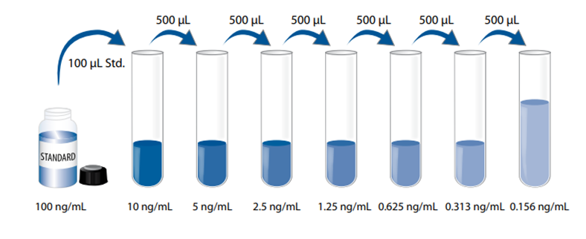
Nine hundred microlitres of calibrator diluent RD6Q was pipetted into the 10 ng/ml tube and 500 µL into the remaining tubes. Stock solution was used to produce a dilution series (Fig 7.1). Each tube was mixed thoroughly before the next transfer. The 10 ng/ml standard served as the high standard. Calibrator diluent RD6Q served as the zero standard. The standard curve was used within 30 minutes of preparation.
Figure 7.1: Serial dilution method for standard curve production in CXCL12 ELISA
The serial dilution method used for producing a standard curve for analysis of results in the plasma CXCL12 ELISA assay is illustrated.
Abbreviations: CXCL12: C-X-C motif chemokine ligand 12, ELISA: enzyme-linked immunosorbent assay
(Reproduced from manufacturer’s literature)

Fifty microlitres of assay diluent was added to each well followed by 50 µL of standard, control, or sample. Wells were then covered with a plate sealer, and incubated at room temperature for 2 hours on a horizontal orbital microplate shaker. Following this, each well was aspirated and washed, repeating the process 3 times for a total of 4 washes. One hundred microlitres of mouse SDF-1α conjugate was added to each well. Wells were covered with a new plate sealer, and incubated at room temperature for a further 2 hours on the shaker. Aspirate and wash step was repeated 4 times.
After this, 200 µL substrate solution was added to each well, followed by a 30 min incubation at room temperature on the benchtop (i.e. not on the shaker) in the dark. On completion of this time, 50 µL stop solution was added to each well. Optical density of each well was determined immediately, using a microplate reader set to 450 nm. For this the Epoch microplate spectrophotometer (Biotek) was used. A standard curve was created using Excel software: a template was supplied which allowed entry of experimental data for the automatic creation of the standard curve followed by conversion of sample optical density results into plasma CXCL12 concentrations. Finally, results were corrected by the dilution factor applied during the experiment.
7.3.6 Transwell plate experiments
7.3.6.1 Cell migration assay #1 : untreated NHP HSPCs
The standard media used in these experiments for HSPC suspension, and control constituent of lower wells, was SFEM II with added cytokines and penicillin (described in detail in Chapter 2, section 2.1.4.1, and referred to simply as SFEM II. Transwell® plates of diameter 6.5 mm with 8.0 um pore polyester membrane inserts (Corning, US) were used for all cell migration experiments (after smaller size pore in the 1st pilot experiment only).
An initial small pilot experiment was set up in duplicate using NHP HSPCs, with lower wells containing:
1 – SFEM II only, or
2 – SFEM II + CXCL12 400 ng/ml
Rhesus CXCL12/SDF-1 protein was sourced from Sino Biological (US) and made up to a stock concentration of 0.15 ng/ml with sterile H₂O as per product literature instructions. A concentration of 400 ng/ml was chosen for this assay based on a previous publication citing the use of 200 ng/ml.³⁶² Double dose was selected for this initial pilot as it was hypothesised that this would increase the chemotactic effect.
CD34⁺-enriched NHP BM cells, suspended in SFEM II at a concentration of 1x10⁶/ml, were added to the inserts over the wells: 500 µL per well. Each condition was set up in duplicate. Forty eight hours later, cells were harvested from one top and bottom well combination from each condition for counting. Cells were harvested using PBS with the aim of collecting as many cells as possible, but the porous membrane itself was not washed since this may have moved cells from one side to the other. Cell solutions were spun down at 800g for 5 minutes followed by resuspension in 500 µL PBS, then counted, and total and live cell numbers were recorded.
Given very low cell numbers counted, the method was modified for further counts. It was considered likely that a large number of cells had been at least mildly adherent to the porous membrane and since this was not washed, these cells were not collected. Therefore, 24 hours later, cells in other wells (top and bottom) were counted, by direct sampling this time, of 10 µL cell suspension after gentle mixing which would also have encouraged resuspension of cells on the membrane. Again, total and live cell counts were recorded. The ratio of live cells bottom well: top well was taken as an indication of the degree of cell mobility from top to bottom wells.
7.3.6.2 Cell migration assay #2: untreated vs AMD3100-treated NHP HSPCs
This experiment was repeated, again using steady state NHP BM CD34⁺-enriched cells. An additional arm was introduced using the standard recommended concentration of CXCL12 (200 ng/ml). As a further addition, incubation of HSPCs with AMD3100 prior to introduction into the Transwell plates was introduced, with control cells remaining untreated.
Transwell plates were set up with wells containing:
1 – SFEM II only
2 – SFEM II + 200 ng/ml CXCL12
3 – SFEM II + 400 ng/ml CXCL12
Cells were suspended in SFEM II at a concentration of 1x10⁶ cells/ml and divided into 3 equal aliquots each for treatment as below:
A – Untreated
B – Low dose AMD3100 (10ug/1x10⁶ cells)
C – High dose AMD3100 (100ug/1x10⁶ cells)
AMD3100 concentrations for treatment were decided upon after review of systemic exposure to AMD3100 following dosing in patients (emc, Mozobil summary of product characteristics). This would suggest the use of approximately 1 μg/1x10⁶ cells. Since dosing is higher for NHPs (approximately x 4 human dose) and humanised mice (approximately x 20 human dose), higher doses of 10 μg/1x10⁶ cells and 100 μg/1x10⁶ cells were tested. Cells were incubated with AMD3100 (or control cells without AMD3100) for 1 hour prior to addition to the top Transwell inserts. Cells were counted by direct sampling from top and bottom wells 24 hours after experiment set-up.
7.3.6.3 Cell migration assay #3: untreated vs AMD3100-treated human HSPCs
The experiment outlined in 7.3.6.2 was repeated using human G-CSF mobilised PB-derived CD34⁺-enriched HSPCs. Conditions and experimental set-up were identical other than the exclusion of the low-dose CXCL12 arm, due to insufficient cells.
7.3.6.4 Cell migration assay #4: untreated vs AMD3100-treated human HSPCs with replicates
The experiment outlined in 7.3.6.3 was repeated, with modifications as follows: in order to prioritise inclusion of technical replicates, wells were set up to include 2 media conditions only. Bottom wells contained either SFEM II only or SFEM II with CXCL12 at the lower concentration of 200 ng/ml.
7.3.6.5 Flow cytometric assessment of CXCR4 blockade by AMD3100 low and high dose in NHP and human HSPCs
In order to investigate the degree to which CXCR4 receptors were being effectively blocked by high and low doses of AMD3100 in the cell migration assays, flow cytometry was used to assess CXCR4 availability. Aliquots of NHP and human HSPCs from the untreated, AMD3100 low dose and AMD3100 high dose arms were sampled. For NHP cells, staining was with anti-NHP CD45 (pCD45)-v450 (clone D058-1283) and anti-CXCR4-PE (mouse anti-human CD184) (both BD, US). For human cells staining was with anti-hCD45-PerCPCy5.5 (clone 2D1) and anti-CXCR4-PE (mouse anti-human CD184) (both BD, US). Cells were incubated at 4ºC for 30-45 mins, in the dark, prior to analysis. Unstained controls were also run with the first timepoint but due to the small number of unavailable cells, the same unstained control plot was used for gating of subsequent reactions, since these were run within 24 hours.
MNCs were initially gated on forward and side scatter, followed by selection for CD45-positivity (pCD45 for NHP cells or hCD45 for human cells). Within the CD45⁺ population, the percentage staining positively for CXCR4 and also the MFI of this fluorophore were quantified. Timepoints for analysis were: 1 hour after AMD3100 incubation commenced on D0 (to coincide with the time at which cells would be added to top Transwell plate wells in cell migration assays), 3 hours after AMD3100 incubation on D0, and approximately 24 hours after AMD3100 commenced, on D1.

7.4 Results
7.4.1 HSPC remobilisation with repeated AMD3100 dosing in NHPs
7.4.1.1 Initial AMD3100 remobilisation study
Initially the apheresis protocol, software and equipment was modified to improve HSPC collection from NHPs (Appendix 1), following this successful a mPBSC-based genome edited modified autologous HSCT was anticipated. Four animals were allocated to this study. There is recognised variation in AMD3100 responsiveness seen in the clinic.^{320; 330} Therefore, it was decided that as part of the preparation for a further transplant attempt, AMD3100 response would be assessed in the 3 animals most suitable for transplant based on weight. Their degree of HSPC mobilisation would be assessed, and the best mobiliser would be selected to undergo repeat mobilisation with apheresis, progressing to transplant provided success of earlier steps.
AMD3100 at standard dose was administered to all 3 animals in order to compare their response, and all 3 mobilised well with a 1st dose AMD3100 (results described fully in sections 7.4.2.2-7.4.2.4). The animal with the best CD34⁺ PB mobilisation was selected (A18094) and preparations made to remobilise with collection of PBSCs by apheresis. The first indication that remobilisation with AMD3100 may be a problem was that this particular animal failed to remobilise with a 2nd dose of AMD3100 (Fig 7.2). Peak CD34⁺ count in the PB following 1st administration was 16.2x10⁶/l and CD90⁺ concentration at this point in time was 4.0x10⁶/l. Following 2nd ADM3100 dose, however, peak CD34⁺ count was only 2.1x10⁶/l and CD90⁺ count only 0.75x10⁶/l.

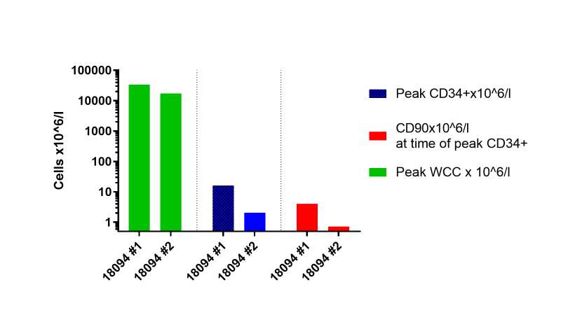
Figure 7.2: Initial HSPC remobilisation study with repeated AMD3100 dosing
First and 2nd doses of AMD3100 1mg/kg SQ were administered 6 weeks apart to a NHP. Peak HSPC mobilisation was assessed by CBC and flow cytometric analysis of post-dose PB samples. Mobilisation of WBCs, CD34⁺ and CD90⁺ HSPCs was good with a 1st dose AMD3100, but HSPC mobilisation was reduced following 2nd dosing episode.
Abbreviations: CD: cluster of differentiation, HSPCs: haematopoietic stem and progenitor cells, NHP: non-human primate, WBCs: white blood cells, WCC: white cell count, PB: peripheral blood, #1: 1st AMD3100 dose, #2: 2nd AMD3100 dose.

7.4.1.2 Investigation into the failure of AMD3100 repeat dosing to mobilise HSPCs in animal A18094
It was essential to establish whether a genuine loss of response to AMD3100 was a feature of the NHP population, or whether this was an incidental finding related to this particular animal or episode. In order to investigate this, a 2nd AMD3100 dose was administered to animals A18092 and A18093 with pre- and post- WCC, CD34⁺ count and CD90⁺ count assessment.
In order to ensure that the AMD3100 failures were not related to the reagent itself (such as aberrant storage conditions), a new batch of AMD3100 was ordered (both batch and LOT numbers different from original supply), prior to the 2nd administration to A18093, but with no improvement in the response to 2nd AMD3100 dose. One animal (A18093) received a 3rd AMD3100 dose in order to investigate whether the response would continue to decline. A final animal (A18091) also received a 1st dose AMD3100 and underwent apheresis with the aim of progressing to genome-edited HSCT. For reasons unrelated to mobilisation or apheresis this did not proceed, but results of AMD3100 response are also included in the analysis below. Therefore, a total of 5 animals received a 1st dose AMD3100, 3 received a 2nd dose and 1 received a 3rd dose.
7.4.1.3 Reduction in WBC mobilisation on repeated AMD3100 dosing
We first investigated kinetics of mononuclear cell (MNC) mobilization (taken to be reported total WCC) in healthy adult rhesus macaques receiving a 1st dose (n=5), a 2nd dose (n=3) and a 3rd dose (n=1) of AMD3100. Peak MNC count in the PB was observed to occur at 2-3 hours post AMD3100 dose, a little earlier than previously reported (Fig 7.3A).³⁵⁸
Mean baseline MNC count prior to the 1st dose of AMD3100 was 10.5x10⁹/l (within the normal range) and rose significantly to 30.5x10⁹/l after treatment (n=5, p=0.0003) (Fig 7.3B). Mean baseline MNC count prior to the 2nd or 3rd dose of AMD3100 was 9.6x10⁹/l, and rose to 24.3x10⁹/l after treatment (n=4, p>0.05). There was no significant difference between baseline MNC counts before 1st vs subsequent dose AMD3100, and the reduction in peak MNC count following 1st vs subsequent doses was also not statistically significant.
Where analysis was restricted to the results pertaining to 1st vs 2nd dose AMD3100 only in animals receiving at least 2 doses (n=3), mean baseline MNC count prior to 1st dose AMD3100 was 11.3x10⁹/l and rose significantly to 31.0x10⁹/l (p= 0.0152). Prior to 2nd dose AMD3100 baseline MNC count was 10.3x10⁹/l and rose to 20.0x10⁹/l (p>0.05). Again, there was no significant difference between baseline or peak MNC count when comparing 1st to 2nd dose AMD3100.
In summary, these data demonstrate successful increase in the MNC count in NHPs following 1st AMD3100, with non-significantly reduced response on repeated treatments.
Figure 7.3: Trend towards reduced white cell mobilisation with repeated AMD3100 dosing
First, 2nd , and, in 1 case, a 3rd dose of AMD3100 1mg/kg SQ were administered to NHPs 4-14 weeks apart. (A) Pre- and serial post-dose blood draws were processed for CBC and WCC (reported as MNC concentration), tracked over time. (B) Peak MNC count following a 1st dose of AMD3100 was compared to peak count after subsequent doses, demonstrating a non-significant trend towards reduced mobilisation with subsequent doses (mean +/- SD).
Abbreviations: MNC: mononuclear cells, NHP: non-human primate, ns: statistically not significant (p>0.05 using paired t-test), SQ: subcutaneous, WCC: white cell count.

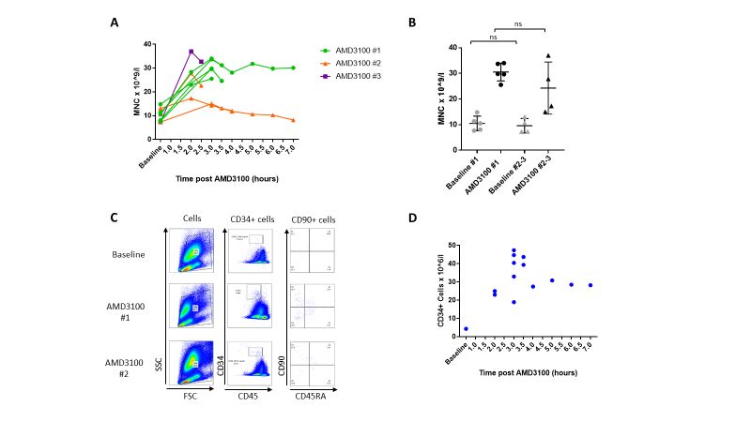
7.4.1.4 Reduction in CD34⁺ HSPC mobilisation on repeated AMD3100 dosing
Peak CD34⁺ count in the PB was assessed by combining flow cytometry results with CBC-reported total WCC (Fig 7.4A). Mobilisation kinetics of CD34⁺ cells after 1st dose of AMD3100 followed a similar trajectory to those of total MNCs (Fig 7.4B). Peak CD34⁺ count was significantly reduced with repeated AMD3100 dosing in comparison to 1st dose (Fig 7.4C). Mean CD34⁺ cell count following 1st dose of AMD3100 for all animals was 38.3x10⁶/l (n=5), whereas peak CD34⁺ count measured after subsequent doses was significantly reduced by nearly 7-fold, with a mean of only 5.7x10⁶/l (n=4, p=0.0005). Where results for animals receiving 1st and 2nd dose AMD3100 only were taken, peak CD34⁺ cell count after 1st dose was 45.2x10⁶/l and after 2nd dose was 5.5x10⁶/l (n=3, p=0.0011).

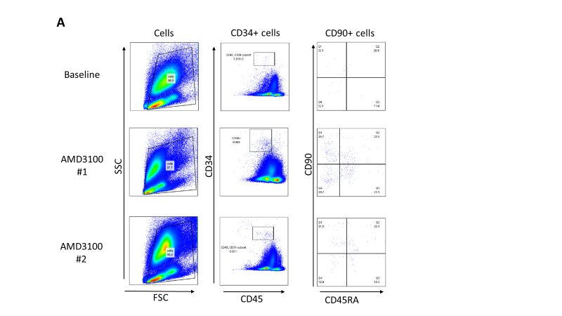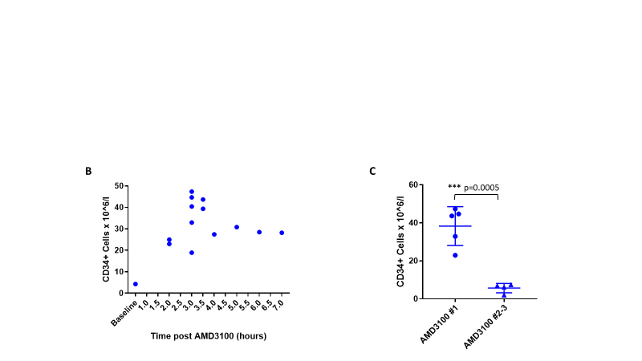
Figure 7.4: Reduced CD34⁺ cell mobilisation with repeated AMD3100 dosing in NHPs
First, 2nd, and, in 1 case, a 3rd dose of AMD3100 1mg/kg SQ were administered to NHPs 4-14 weeks apart. Serial blood draws were taken post dose, analysed by CBC counter and flow cytometry in order to assess CD34⁺ count within the PB. (A) Flow cytometric gating strategy for assessment of both the entire CD34⁺ cell population and, within this, the subpopulation of CD90⁺CD45RA⁻ (CD90⁺) subpopulation. (B) CD34⁺ count in the PB over time following 1st dose AMD3100 demonstrating kinetics of mobilisation. (C) Peak CD34⁺ count following 1st AMD3100 dose is significantly higher than following subsequent doses (mean +/- SD).
Abbreviations: CBC: complete blood count, CD: cluster of differentiation, CD90⁺ cells: CD34⁺CD90⁺CD45RA⁻ cells, FSC: forward scatter, NHP: non-human primate, PB: peripheral blood, SQ: subcutaneous, SSC: side scatter.

7.4.1.5 Reduction in CD90⁺ HSC mobilisation on repeated AMD3100 dosing
Following the demonstration that CD34⁺ HSPC mobilisation was reduced on redosing with AMD3100, investigation was undertaken to determine whether similar results apply to the recently described HSC-enriched immunophenotype CD34⁺CD90⁺CD45RA⁻.³⁵⁴ The timing of CD90⁺ mobilization appears to follow a similar pattern to that expected of the total CD34⁺ population (Fig 7.5A). ^{334; 358} Similarly to bulk CD34⁺ counts, a significant decrease in the number of CD90⁺ cells mobilised after the 2nd or 3rd AMD3100 doses relative to the 1st dose was observed (Fig 7.5B). PB CD90⁺ count at time of peak CD34⁺ mobilization was 12.9x10⁶/l (n=5) after the 1st dose but was reduced to only 0.9x10⁶/l (n=4) after subsequent dosages (p=0.0234). Where results for animals receiving 1st and 2nd dose AMD3100 only were taken, peak CD90⁺ cell counts were 15.0x10⁶/l and 0.5x10⁶/l respectively (p>0.05).

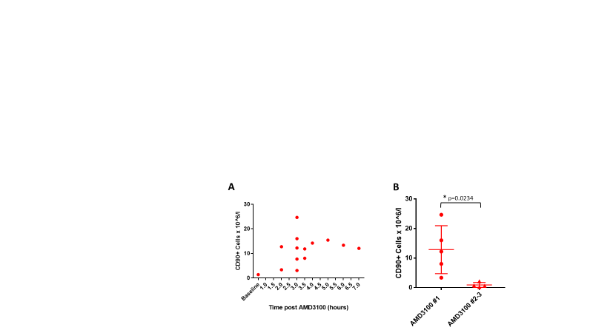
Figure 7.5: Reduced CD90⁺ cell mobilisation with repeated AMD3100 dosing
First, 2nd, and, in 1 case, a 3rd dose of AMD3100 1mg/kg SQ were administered to NHPs 4-14 weeks apart. Serial blood draws were taken post dose, analysed by CBC counter and flow cytometry in order to assess CD90⁺ count within the PB. Flow cytometric gating strategy is illustrated in Fig 7.4. (A) CD90⁺ count in the PB over time following 1st dose AMD3100 demonstrates kinetics of mobilisation. (B) Peak CD90⁺ count following 1st AMD3100 dose is significantly higher than following subsequent dosing episodes (mean +/- SD).
Abbreviations: CBC: complete blood count, CD: cluster of differentiation, CD90⁺ cells: CD34⁺CD90⁺CD45RA⁻ cells, NHP: non-human primate, PB: peripheral blood, SQ: subcutaneous.

7.4.2 Human HSPC remobilisation with repeated AMD3100 dosing in the humanised mouse model
7.4.2.1 Mouse study #1: reduction in MNC mobilisation on repeated AMD3100 dosing
Following confirmation of the unexpected observation that HSPCs fail to re-mobilise with repeat AMD3100 in NHPs, experiments were designed in order to investigate whether or not this phenomenon would be observed with human HSPCs as well. For this, the NSG humanised mouse model was used. Nine NSG mice were engrafted with human CD34⁺ HSPS for 20 weeks, and subsequently received a 1st, then a 2nd dose of AMD3100. The effect on human HSPC mobilization was measured by PB analysis at 1.5 hours after dosing (Fig 7.6A). Four surviving animals also received a 3rd dose of AMD3100. Time between each AMD3100 administration episode was 3-4 weeks.
For the 1st dosing episode, 6 animals received AMD3100 and 3 controls received vehicle only. In the control group there was very little difference in the number of circulating hCD45⁺ cells following injection of vehicle: mean hCD45⁺ count prior to injection was 0.0563x10⁹/l +/- 0.045x10⁹/l, and following control injection was 0.068x10⁹/l +/- 0.055 x10⁹/l (mean +/- SD, n=3, p>0.05) (Fig 7.6B).
After the 1st dosing episode, control mice were transitioned to receive AMD3100 for further dosing episodes in order to increase power of this experiment to detect significant differences between 1st and subsequent doses of AMD3100. One of the mice from initial control group underwent early euthanasia between 1st and 2nd dosing episodes, based on veterinary advice, after being found to have lost 22.2% of its body weight and having a hunched and pale appearance. The surviving 2 control mice which received vehicle only in the 1st dosing episode received their 1st dose AMD3100 in the 2nd dosing episode, and received their 2nd dose AMD3100 in the 3rd dosing episode. A further 2 mice from the original treatment group were euthanised for health reasons prior to receiving a 3rd dose of AMD3100.
The response of total human MNCs was assessed first, as defined by the hCD45⁺ cell population. Baseline and peak levels were compared, with a reduction in peak count being found after sequential AMD3100 doses, in comparison to 1st dose (Fig 7.6C-D). After the 1st dose, mean human MNC count rose from 0.19x10⁹/l +/- 0.22x10⁹/l to 0.50x10⁹/l +/- 0.30x10⁹/l (mean +/- SD, n=8, p=0.0002). After a 2nd dose, the increase was less significant, from 0.17x10⁹/l +/- 0.075x10⁹/l to just 0.27x10⁹/l +/- 0.113x10⁹/l (mean +/- SD, n=8, p=0.0349). Following a 3rd dose of AMD3100, there was no significant increase in circulating human MNCs when comparing baseline 0.24x10⁹/l +/- 0.16x10⁹/l (n=8) to peak count 0.33x10⁹/l +/- 0.153x10⁹/l (n=4, p>0.05) (mean +/- SD). Furthermore, a significant decrease in the amplitude of mobilised hCD45⁺ cell count was noted between 1st and 2nd doses (n=8, p=0.0349) (Fig 7.6E).

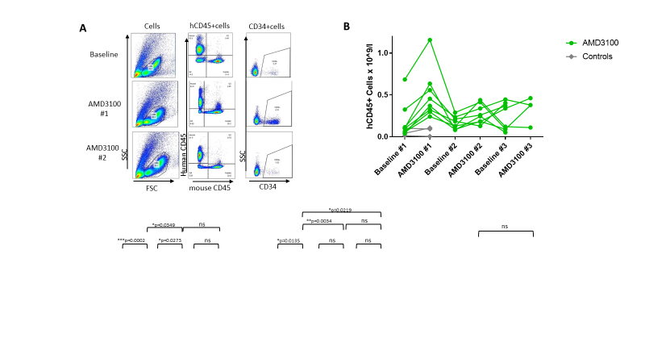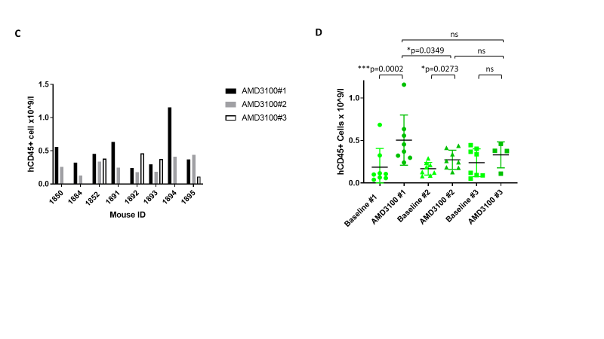
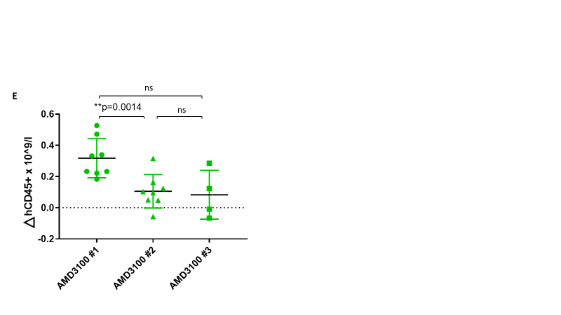
Figure 7.6: Reduced human CD45⁺ cell mobilisation with repeat dosing of AMD3100 in the humanised mouse model (study 1)
Immunodeficient mice were humanised by injection of G-CSF-mobilised PBSCs. Following engraftment, they received 1st injections of either AMD3100 or vehicle only. Second injections were AMD3100 and a number of mice also received 3rd doses of AMD3100, 3-4 weeks apart. PB was taken pre and post each dose in order to assess the efficacy of human MNC mobilisation by CBC combined with flow cytometry. (A) Flow cytometric gating strategy used to define human CD45⁺ cells and, within the human population, CD34⁺ HSPCs. (B) hCD45⁺ count in the PB pre and at anticipated peak level post AMD3100 doses (or injection of vehicle only in control mice). (C) hCD45⁺ count in the PB following 1st, 2nd +/- 3rd AMD3100 doses by individual mouse. (D) Comparison of baseline and post-dose hCD45⁺ levels demonstrates significantly lower hCD45⁺ cell mobilisation following 2nd dose of AMD3100 in comparison to 1st dose (mean +/- SD). (E) Change in hCD45⁺ cell count from baseline to post-dose level was significantly reduced with 2nd AMD3100 dose in comparison to 1st dose (mean +/- SD).
Abbreviations: CBC: complete blood count, CD: cluster of differentiation, FSC: forward scatter, G-CSF: Granulocyte colony-stimulating factor, hCD45: human CD45, HSPCs: haematopoietic stem and progenitor cells, ID: identifier, MNC: mononuclear cells, ns: statistically not significant (p>0.05 using paired t-test), PB: peripheral blood, PBSCs: peripheral blood stem cells, SSC: side scatter.

7.4.2.2 Mouse experiment #1: reduction in CD34⁺ HSPC cell mobilisation on repeated AMD3100 dosing
Even more importantly, the response of human HSPCs, as defined by CD34⁺ cells, was also reduced with repeated doses of AMD3100. In control mice, circulating CD34⁺ count remained stable, with pre-dose mean level of 0.15x10⁶/l +/- 0.13x10⁶/l and post-dose level of 0.30x10⁶/l +/- 0.273x10⁶/l (mean +/- SD, n=3, p>0.05) (Fig 7.7A). With a 1st dose of AMD3100, mean CD34⁺ cell count rose from 0.24x10⁶/l +/- 0.28 x10⁶/l to 1.97x10⁶/l +/- 1.37x10⁶/l (mean +/- SD, n=8, p=0.0135). CD34⁺ counts with the 2nd and 3rd doses, on the other hand, did not rise significantly: with a 2nd dose they fell from 0.59x10⁶/l +/- 0.41x10⁶/l to 0.51x10⁶/l +/- 0.551x10⁶/l (n=8, p>0.05), and with a 3rd dose from 0.19x10⁶/l +/- 0.13x10⁶/l to 0.07x10⁶/l +/- 0.09x10⁶/l (n=4, p>0.05) (mean +/- SD) (Fig 7.7B-C). The amplitude of mobilization of human HSPCs following 2nd or 3rd doses of AMD3100 was also significantly lower than after 1st dose (p=0.0034 and p=0.0219 respectively) (Fig 7.7D). CD90⁺ subpopulation was too small to be reliably quantified.

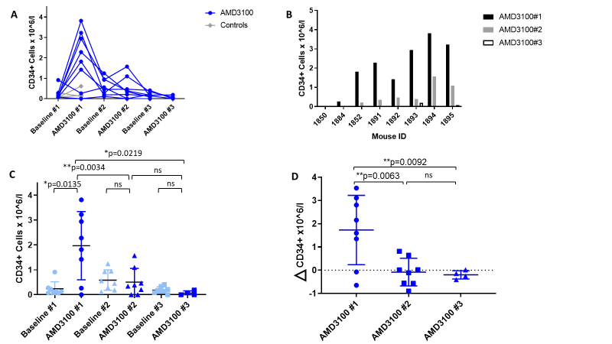
Figure 7.7: Reduced CD34⁺ HSPC mobilisation with repeated dosing of AMD3100 in the humanised mouse model (study 1)
Immunodeficient mice were humanised by injection of G-CSF-mobilised PBSCs. Following engraftment they received 1st injections of either AMD3100 or vehicle only. Second injections were AMD3100, and a number of mice also received 3rd doses of AMD3100, 3-4 weeks apart. PB was taken pre and post each dose in order to assess the efficacy of human HSPC mobilisation by CBC combined with flow cytometry. Flow cytometric gating strategy is illuatrated in Fig 7.6A. (A) CD34⁺ count in the PB pre and at anticipated peak level post AMD3100 doses (or injection of vehicle only in control mice). (B) CD34⁺ count in the PB following 1st, 2nd +/- 3rd AMD3100 doses by individual mouse. (C) Comparison of baseline and post-dose CD34⁺ levels demonstrates significantly lower CD34⁺ cell mobilisation following 2nd or 3rd dose of AMD3100 in comparison to 1st dose (mean +/- SD). (D) Change in CD34⁺ cell count from baseline to post-dose level was significantly reduced with 2nd or 3rd AMD3100 dose in comparison to 1st dose (mean +/- SD).
Abbreviations: CBC: complete blood count, CD: cluster of differentiation, G-CSF: Granulocyte colony-stimulating factor, HSPCs: haematopoietic stem and progenitor cells, ns: statistically not significant (p>0.05 using paired t-test), PB: peripheral blood, PBSCs: peripheral blood stem cells.

7.4.2.3 Mouse experiment #1: stable engraftment over course of experiment
Data so far had demonstrated a reduction in the response of circulating hCD45⁺ cells and CD34⁺ HSPCs in humanised mice with 2nd or 3rd doses of AMD3100, in comparison to a good response to a 1st dose. An alternative hypothesis for this deterioration in mobilisation was that human engraftment in the mice was being lost, leading to a reduced pool of human cells from which mobilisation could occur. In order to investigate this possibility, human engraftment (taken to be represented by the percentage of circulating CD45⁺ cells which were of human origin, i.e. hCD45⁺ / (hCD45⁺ + mCD45⁺) x 100, was calculated at each baseline timepoint, prior to AMD3100 (or vehicle only) dosing (Fig 7.8). Prior to 1st dosing episode, mean human chimerism was 19.73% +/- 21.38% (mean +/- SD, n=8). Prior to dosing episode #2, human chimerism was 10.77% +/- 5.11%, and prior to dosing episode #3 these figures were 15.81% +/- 11.46% (mean +/- SD, n=8, p>0.05 for all).
Figure 7.8: Stable human engraftment throughout AMD3100 mobilisation in the humanised mouse model (study 1)
Immunodeficient mice were humanised by injection of G-CSF-mobilised PBSCs. Following engraftment they received 1st injections of either AMD3100 or vehicle only. Second injections were AMD3100 and a number of mice also received 3rd doses of AMD3100 3-4 weeks apart. PB draws taken prior to each dose were analysed by CBC combined with flow cytometry. Flow cytometric gating strategy is outlined in Fig 7.6A. Human chimerism remained stable throughout the experiment (mean +/- SD).
Abbreviations: CBC: complete blood count, G-CSF: Granulocyte colony-stimulating factor, hCD45: human cluster of differentiation 45, ns: statistically not significant (p>0.05 using paired t-test), PB: peripheral blood, PBSCs: peripheral blood stem cells.

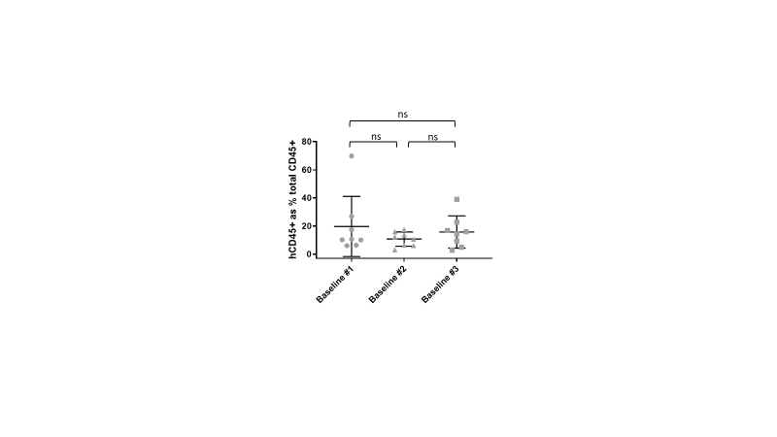
7.4.2.4 Mouse study #2: falling human chimerism during experiment
A 2nd humanised NSG mouse cohort was used to confirm the loss of efficacy of repeated AMD3100 dosages in this model. Planned experimental protocol was mainly as per cohort #1, with 7 mice receiving 2 doses of AMD3100 and 2 mice receiving control injections. In this experiment, control mice remained in the control arm throughout, in order to permit clearer demonstration of a lack of variability in this arm. A 3rd dosing episode was originally planned in this experiment, but the cohort required early euthanasia after the 2nd dose, based on veterinary advice relating to their health and wellbeing.
Human chimerism was noted to fall during the course of the experiment (Fig 7.9). Prior to first AMD3100 (or control) injection, human chimerism was 34.8% +/- 13.5% but this had fallen to 13.5% +/- 5.5% by the second baseline blood draw (n=9, p=0.0015, mean +/- SD). This must be taken into account during interpretation of mobilisation data, as this may reflect a reduction in the available pool of human cells from which mobilisation could occur, and therefore may at least contribute to the reduction in hCD45⁺ and CD34⁺ cell mobilisation observed.

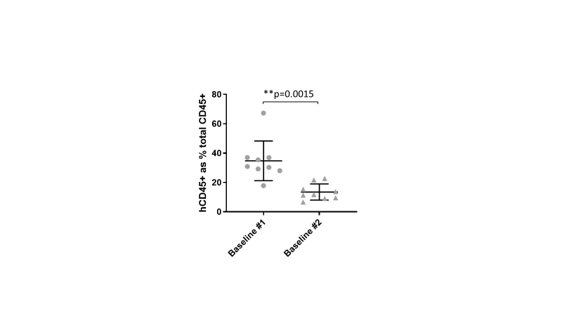
Figure 7.9: Falling human chimerism between 1st and 2nd AMD3100 doses in the humanised mouse model (study 2)
A 2nd cohort of immunodeficient mice were humanised by injection of G-CSF-mobilised PBSCs. Following engraftment, they received 1st and 2nd injections AMD3100 (or vehicle only in control mice) 3-4 weeks apart. PB draws taken prior to each dose were analysed by CBC combined with flow cytometry. Flow cytometric gating strategy is illustrated in Fig 7.6A. Human chimerism was calculated as the percentage of CD45⁺ cells which were of human origin, and was demonstrated to have fallen between 1st and 2nd baseline PB draws (mean +/- SD).
Abbreviations: CBC: complete blood count, G-CSF: Granulocyte colony-stimulating factor, hCD45: human cluster of differentiation 45, PB: peripheral blood, PBSCs: peripheral blood stem cells.

7.4.2.5 Mouse experiment #2: reduction in hCD45⁺ cell mobilisation on repeated AMD3100 dosing
Once again, in this experiment, poorer hCD45⁺ and CD34⁺ cell mobilization were noted with a 2nd dose of AMD3100 when compared to 1st dose. hCD45⁺ level following the 1st dose rose to 1.03 x 10⁹/l +/- 0.27 x 10⁹/l but after 2nd dose only reached 0.52 x 10⁹/l +/- 0.32 x 10⁹/l (n=7, p=0.0065, mean +/- SD) (Fig 7.10A-B).
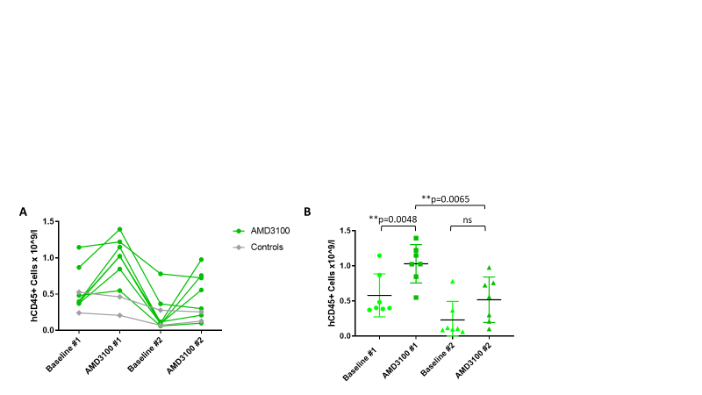
Figure 7.10: Reduced hCD45⁺ cell mobilisation with repeat dosing of AMD3100 in the humanised mouse model (study 2)
A 2nd cohort of immunodeficient mice were humanised by injection of G-CSF-mobilised PBSCs. Following engraftment they received 1st and 2nd injections AMD3100 (or vehicle only in control mice) 3-4 weeks apart. PB was drawn pre and post each dose in order to assess the efficacy of human HSPC mobilisation by CBC combined with flow cytometry. Flow cytometric gating strategy used to define hCD45⁺ cells is illustrated in figure 7.6A. (A) hCD45⁺ count in the PB pre and at anticipated peak level post AMD3100 doses (or injection of vehicle only in control mice). (B) Comparison of baseline and post-dose hCD45⁺ levels demonstrates significantly lower hCD45⁺ cell mobilisation following 2nd dose of AMD3100 in comparison to 1st dose (mean +/- SD).
Abbreviations: CBC: complete blood count, G-CSF: Granulocyte colony-stimulating factor, hCD45: human cluster of differentiation 45, HSPCs: haematopoietic stem and progenitor cells, ns: statistically not significant (p>0.05 using paired t-test), PB: peripheral blood, PBSCs: peripheral blood stem cells.

7.4.2.6 Mouse experiment #2: reduction in CD34⁺ HSPC mobilisation on repeated AMD3100 dosing
CD34⁺ cell response to the 1st dose of AMD3100 reached 25.15 x 10⁶/l +/- 23.33 x 10⁶/l, whereas with the 2nd dose peak level was significantly lower at only 3.19 x 10⁶/l +/- 4.04 x 10⁶/l (n=7, p=0.0225, mean +/- SD) (Fig 7.11A-B).

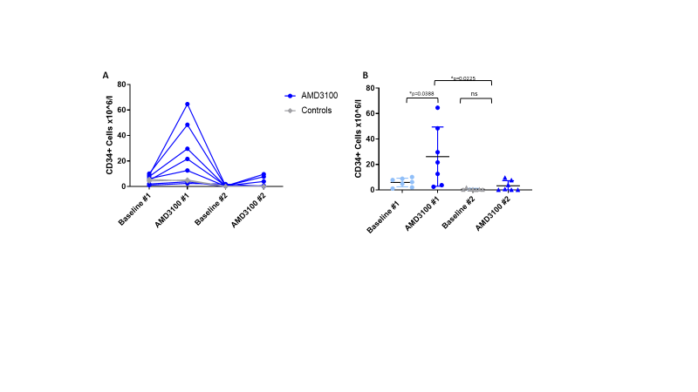
Figure 7.11: Reduced CD34⁺ HSPC mobilisation with repeat dosing of AMD3100 in the humanised mouse model (study 2)
A 2nd cohort of immunodeficient mice were humanised by injection of G-CSF-mobilised PBSCs. Following engraftment, they received 1st and 2nd injections AMD3100 (or vehicle only in control mice) 3-4 weeks apart. PB was drawn pre and post each dose in order to assess the efficacy of human HSPC mobilisation by CBC combined with flow cytometry. Flow cytometric gating strategy used to define human CD45⁺ cells is illustrated in figure 7.6A. (A) CD34⁺ count in the PB pre and at anticipated peak level post AMD3100 doses (or injection of vehicle only in control mice). (B) Comparison of baseline and post-dose CD34⁺ levels demonstrates significantly lower CD34⁺ cell mobilisation following 2nd dose of AMD3100 in comparison to 1st dose (mean +/- SD).
Abbreviations: CBC: complete blood count, CD: cluster of differentiation, G-CSF: Granulocyte colony-stimulating factor, HSPCs: haematopoietic stem and progenitor cells, ns: statistically not significant (p>0.05 using paired t-test), PB: peripheral blood, PBSCs: peripheral blood stem cells.

7.4.3 AMD3100 reverses the CXCL12 gradient across the BM in the humanised mouse model with equivalent efficacy after 1st and 2nd doses (study 2)
Repeated administration of AMD3100 results in decreased mobilisation of human cells in the humanised mouse model. This was demonstrated reliably in mouse cohort #1, and similar results were obtained from the 2nd cohort (although must be interpretated with some caution in the 2nd cohort given the fall in human chimerism during that experiment).
One mechanism by which AMD3100 appears to exert its mobilisation effect on HSPCs is via reversal of the CXCL12 gradient across the BM niche.¹² It has been suggested that this results in HSPCs being drawn out into the peripheral circulation, by increased concentration of this cytokine in the blood. It was therefore hypothesised that the observed loss of ADM3100 efficacy in both NHPs and humanised mice may be related to a loss of this CXCL12 gradient reversal.
Plasma samples pre and post dosing from the 1st mouse cohort were analysed for CXCL12 concentration, using an ELISA assay, in order to investigate whether the change in PB CXCL12 concentration would be blunted with 2nd dose AMD3100, in comparison to 1st dose. Samples had been frozen at -80ºC and were all processed simultaneously, in order to avoid the introduction of any additional variables.
With 1st AMD3100 dose, mean plasma CXCL12 concentration rose from 0.57 ng/ml +/- 0.26 ng/ml to 1.75 ng/ml +/- 0.56 ng/ml (n=8). With a 2nd dose the figures were very similar: concentration increased from 0.56 ng/ml +/- 0.20 ng/ml to 1.76 ng/ml +/- 1.08 ng/ml (n=6) (mean +/- SD) (Fig 7.12A-B). There was no significant difference between post-dose CXCL12 concentration following 1st and 2nd AMD3100 administration episodes (p>0.05).
Originally, further CXCL12 plasma testing was planned, to include the 2nd dose samples from the remaining 2 mice, and pre and post samples from the 3rd dose. However, since the results from 1st and 2nd doses had already been demonstrated to be very similar, additional experiments were not considered a necessary use of resources.
Figure 7.12: Plasma CXCL12 levels in the humanised mouse model increase to similar levels after 1st or 2nd AMD3100 doses (study 2)
Immunodeficient mice were humanised by injection of G-CSF-mobilised PBSCs. Following engraftment, they received 1st injections of either AMD3100 or vehicle only and 2nd injections of AMD3100, 3-4 weeks apart. CXCL12 concentration within plasma, extracted from PB drawn pre and post doses, was analysed by ELISA assay. (A) Plasma CXCL12 level increased following each dose of AMD3100 in most mice, whereas this effect was not observed following injection of vehicle only. (B) The increased plasma CXCL12 level following AMD3100 dosing was almost identical following 1st and 2nd doses (mean +/- SD).
Abbreviations: CXCL12: C-X-C motif chemokine ligand 12, ELISA: enzyme-linked immunosorbent assay, G-CSF: Granulocyte colony-stimulating factor, ns: statistically not significant (p>0.05 using paired t-test), PB: peripheral blood, PBSCs: peripheral blood stem cells.

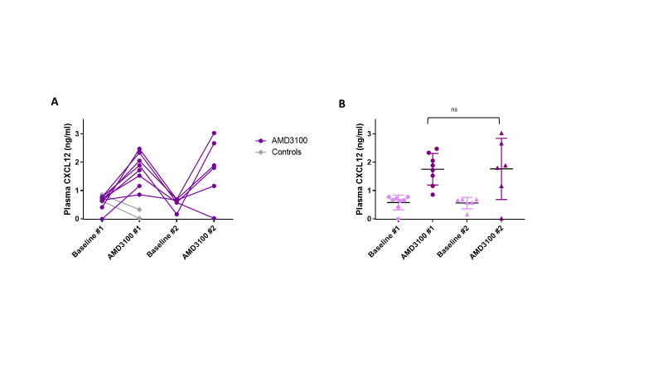
7.4.4 Cell migration assays with NHP HSPCs
7.4.4.1 Cell migration experiment #1: pilot cell migration assay to optimise methodology using untreated NHP HSPCs
One hypothesis suggested for the failure of remobilisation with repeated AMD3100 dosing was that HSPCs mobilised by AMD3100 lost their sensitivity to CXCL12 chemotaxis and were therefore unable to home back to the BM from the peripheral circulation. As a result, it was suggested that they were not, therefore, available for re-mobilisation in response to subsequent AMD3100 administration. Therefore, in vitro cell migration experiments were set up to investigate this hypothesis. These were based on the use of TranswellTM plates, in which cell suspension is added to the top well and the constituents of media in the bottom well can be varied. Cell migration is assessed by counting the number or proportion of cells which have migrated through the porous membrane from the top to bottom well, which is taken as an indicator of the level of chemotaxis exerted by the bottom well solution, as well as the activity levels of cells in the top well.
A pilot cell migration assay was first set up in order to optimise the methodology using NHP HSPCs, comparing HSPC migration with and without CXCL12 chemotaxis. On D0, bottom wells on the Transwell plate were set up with either SFEM II or this media with added CXCL12 (400 ng/ml). A total of 3.2x10⁵ NHP BM-derived HSPCs suspended in SFEM II were then added to each top well. Each condition was set up in duplicate (there were considered inadequate cells for triplicate testing).
Cell counts in top and bottom wells were initially assessed on D2, in one set of wells from each condition (Fig 7.13A). This was carried out by harvesting all cells from both wells using PBS but avoiding washing the membrane itself, spinning the cell solution down and reconstituting in 500 µL PBS. However, this yielded surprisingly low total live cell counts. The ratios of bottom : top cell counts were therefore considered likely to be unreliable and an alternative method of cell counting by direct sampling was instituted for future counting within this and subsequent experiments. On D3, the second set of wells for each condition underwent cell counting with total (i.e. top + bottom) live cell counts being more in keeping with the number of cells introduced into the experiment, and similar between conditions (Fig 7.13B).
Figure 7.13: Pilot cell migration assay using NHP BM-derived HPSCs to determine the optimum cell counting method
NHP HSPCs were introduced into the top wells of Transwell plates in order to investigate their mobilisation into the bottom wells. Bottom wells contained either standard media or media plus CXCL12 (400 ng/ml). (A) Cells in top and bottom wells were counted 2 days after experimental set up by harvesting contents of each well, and resuspending in standardised volumes of PBS. This method resulted in artificially low total live cell counts. (B) An alternative counting strategy of direct sampling from each well after gentle mixing, with immediate counting of cell solution, was employed in duplicate wells, with counts more closely resembling the cell counts at the beginning of the experiment.
Abbreviations: CXCL12: C-X-C motif chemokine ligand 12, HSPCs: haematopoietic stem and progenitor cells, NHP: non-human primate, SFEM II: serum-free expansion medium II.

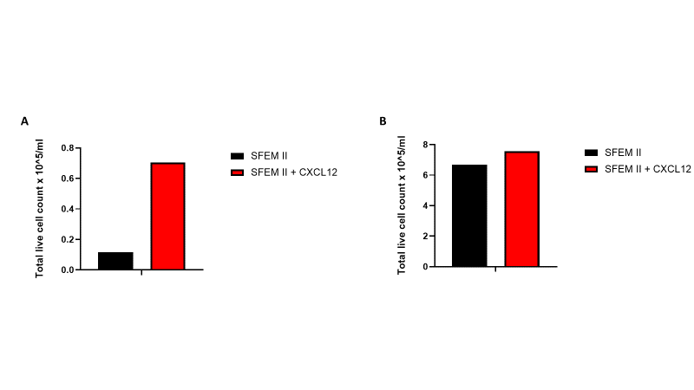

As expected, there was greater cell migration from top to bottom well where CXCL12 had been added to the bottom well media (Fig 7.14). Although this was only an n=1 for each condition (as the duplicate sets of wells were used in the less accurate counting method). Despite this, the pilot experiment was considered adequate to validate most aspects of methodology. However, since only a very small proportion of cells migrated through the membrane to the bottom well, for future experiments, Transwell plates with larger diameter pores were used, in order to improve ease of HSPC migration.
Figure 7.14: Pilot cell migration assay using untreated NHP HSPCs: greater migration towards media containing CXCL12 than standard media
NHP HSPCs were introduced into the top wells of Transwell plates in order to investigate their mobilisation into the bottom wells. Bottom wells contained either standard media or media plus CXCL12 (400 ng/ml). Cells in top and bottom wells were counted 3 days after experimental set up, demonstrating greater cell migration into media with added CXCL12 in comparison to standard media only (n=1).
Abbreviations: CXCL12: C-X-C motif chemokine ligand 12, HSPCs: haematopoietic stem and progenitor cells, NHP: non-human primate, SFEM II: serum-free expansion medium II.

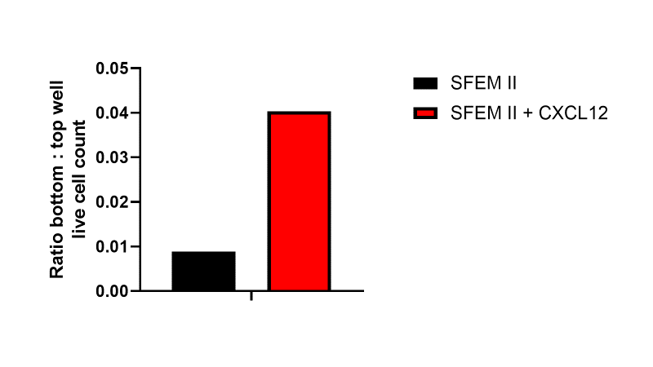
7.4.4.2 Cell migration assay using untreated vs AMD3100-treated NHP HSPCs
Following the initial pilot experiment carried out to validate methodology, this experiment was repeated using NHP cells with or without pre-exposure to AMD3100, in order to investigate whether the chemoattractant property of added CXCL12 would be blunted or lost entirely due to CXCR4 blockade by AMD3100. High and low concentration AMD3100 exposure (100ug/1x10⁶ cells and 10ug/1x10⁶ cells) and also high and low CXCL12 levels (400ng/ml and 200ng/ml) were introduced, in order to investigate whether there would be a dose-related effect of AMD3100 pre-treatment and, if so, whether this would be overcome by higher CXCL12 concentration in the media.
Only a small number of cells were available for this experiment, since it was carried out with residual HSPCs surplus to the requirements of a larger experiment. Therefore, no technical replicates were introduced into this experiment and results must be interpreted with caution.
The number of cells available for each condition was 4.0x10⁵. Top and bottom wells were counted 24 hours after experimental set-up. Total (i.e. top + bottom wells) live cell count did not indicate any particular cytotoxicity of any one condition in comparison to untreated cells in SFEM II only (Fig 7.15). On the contrary, looking at the SFEM II-only arm, live cell count was actually greater following high dose AMD3100 and very similar with low dose AMD3100 in comparison to untreated cells. Similarly, for both untreated and AMD3100 low dose cells, total live cell count was similar between SFEM II and low dose CXCL12 arm and even greater in the CXCL12 high dose arm. In the AMD3100 high dose arm, cell counts were lower in both CXCL12 arms than the SFEM II only arm. However, they remained more in keeping with counts in other arms and the high live cell count in the AMD3100 high dose / SFEM II only arm was more anomalous.
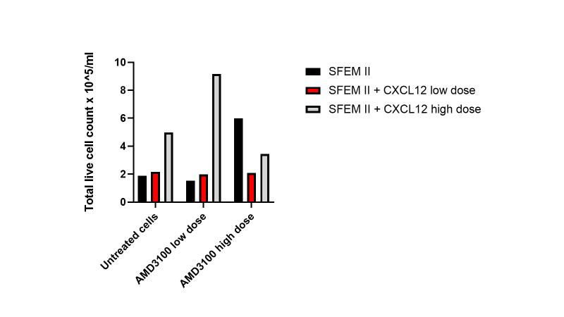
Figure 7.15: Live cell counts in NHP HSPC migration assay, comparing untreated cells to those pre-treated with AMD3100
NHP HSPCs were introduced into the top wells of Transwell plates in order to investigate their mobilisation into the bottom wells. Cells were either untreated, or had undergone a period of incubation in high (100 μg/million cells) or low (10 μg/million cells) dose AMD3100. Bottom wells contained either standard media or media plus CXCL12 at high (400 ng/ml) or low (200 ng/ml) concentration. Live cell counts in top and bottom wells were counted 24 hours after experimental set up and their sum reported as total live cell count (n=1).
Abbreviations: CXCL12: C-X-C motif chemokine ligand 12, HSPCs: haematopoietic stem and progenitor cells, NHP: non-human primate, SFEM II: serum-free expansion medium II.

Looking at untreated cells first, cell migration was higher in both CXCL12 arms than where SFEM II only was added to the bottom well, as would be expected (Fig 7.16). The observed ratio of bottom : top well live cell count was greater with low dose than high dose CXCL12. Where cells had been pre-treated with low dose AMD3100, migration remained higher with high dose CXCL12 than SFEM II only, but was lowest in the low dose CXCL12 arm. With high dose AMD3100 pre-treatment, migration was highest with SFEM II only and similar in both CXCL12 arms.
Figure 7.16: Cell migration in NHP HSPC migration assay, comparing untreated cells to those pre-treated with AMD3100
NHP HSPCs were introduced into the top wells of Transwell plates in order to investigate their mobilisation into the bottom wells. Cells were either untreated or had undergone a period of incubation in high (100 μg/million cells) or low (10 μg/million cells) dose AMD3100. Bottom wells contained either standard media or media plus CXCL12 at high (400 ng/ml) or low (200 ng/ml) concentration. The ratio of live cell counts in bottom well : top well was taken as a measure of cell migration.
Abbreviations: CXCL12: C-X-C motif chemokine ligand 12, HSPCs: haematopoietic stem and progenitor cells, NHP: non-human primate, SFEM II: serum-free expansion medium II.

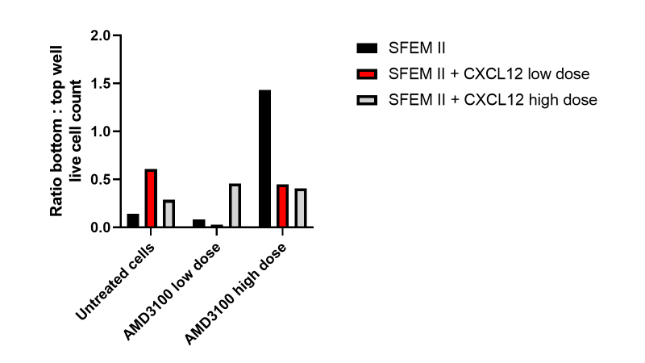
Given the small cell numbers and lack of replicates, this experiment provided a degree of reassurance regarding a lack of immediate cytotoxicity of any treatment arm (since there were 3 reactions each in total treated with low and high dose AMD3100 and low and high dose CXCL12), but repeats would be required before any conclusions could be drawn regarding cell migration. Repeat experiments had initially been planned, however by this point a lack of HSPC remobilisation with AMD3100 had also been demonstrated in humanised mice. Since the consequences of remobilisation failure with human HSPCs were considered of primary importance, given the potential clinical significance, further experiments moved on to using human HSPCs as the cell source.
7.4.4.3 Cell migration assay using untreated vs AMD3100-treated human HSPCs
The cell migration experiment in section 7.4.4.2 was repeated using human G-CSF mobilised PB-derived CD34⁺-enriched HSPCs. Untreated cells were compared to low (10 μg/1x10⁶ cells) and high dose (100 μg/1x10⁶ cells) AMD3100 pre-treated HSPCs, and both a SFEM II control and SFEM II + CXCL12 arms included.
In the first experiment, due to a low number of available cells, only one CXCL12 concentration was investigated, and high dose (400 ng/ml) was selected. Cell number available for each condition combination was 1.0x10⁵. Due to low cell numbers technical replicates were not possible. Therefore, results were interpreted with caution. This experiment was repeated using the same type of human HSPCs from a different donor, with each condition combination was set up in triplicate. The only change in experimental conditions for this second experiment was that a lower dose of CXCL12 was selected in order to more closely replicate physiological conditions. Cell number allocated to each well was 1.5x10⁵ and wells were counted 24 hours after experimental set up.
In the first experiment, total live cell counts for both SFEM II only and CXCL12 arms were higher after cells had been pre-treated with AMD3100 in comparison to untreated cells, whether AMD3100 dose was low or high (Fig 7.17A). In the second experiment, mean total live cell counts were not significantly different between condition combinations although trended towards being greater after low or high dose AMD3100 than for untreated cells (Fig 7.17B). Whether or not CXCL12 was added to the SFEM II in the bottom well did not make any consistent difference to cell counts.
Figure 7.17: Total live cell counts in human HSPC migration assays comparing untreated and AMD3100 pre-treated cells
Human HSPCs were introduced into the top wells of Transwell plates in order to investigate their mobilisation into the bottom wells. Cells were either untreated or had undergone a period of incubation in high (100ug/million cells) or low (10ug/million cells) dose AMD3100. Bottom wells contained either standard media or media plus CXCL12, at 400 ng/ml in experiment 1 (n=1) (A) or 200ng/ml in experiment 2 (n=3) (B). Live cell counts in top and bottom wells were counted 24 hours after experimental set up and their sum reported as total live cell count. Mean +/- SD is shown for experiment 2.
Abbreviations: CXCL12: C-X-C motif chemokine ligand 12, HSPCs: haematopoietic stem and progenitor cells, SFEM II: serum-free expansion medium II.

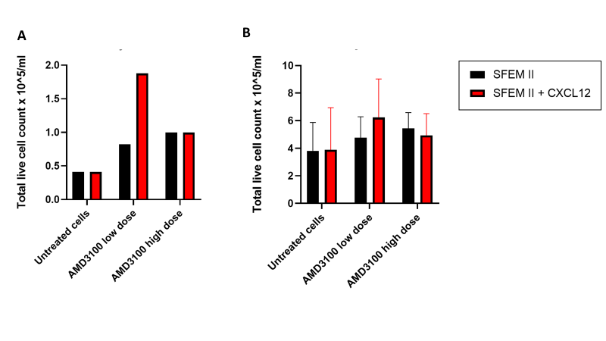
On examination of cell migration in the first experiment (i.e. bottom : top well ratio), this appeared to be lower in the CXCL12 arm in comparison to SFEM II only control, whether cells were untreated or had been subjected to low or high dose AMD3100 pre-treatment (Fig 7.18A). Migration overall was lowest after AMD3100 low dose treatment and highest after AMD3100 high dose treatment, with migration ratio of untreated cells falling between those observed for the AMD3100 arms.
In the second experiment, on examination of bottom : top well ratios, average migration of untreated cells was unexpectedly non-significantly lower in the CXCL12 arm compared to SFEM II only control, at 0.23 +/- 0.05 and 0.28 +/- 0.18 respectively (mean +/- SD) (Fig 7.18B). The reason for this unexpected observation was unclear, although given the small cell numbers and high SD, likely relates to the high variance rather than a genuine decrease in migration in response to CXCL12 addition. This suggests that the experiment has poor power to detect genuine differences rather than that results are actually inaccurate. Given these factors, other results are considered with caution. Where cells had been pre-treated with low dose AMD3100, migration ratio was non-significantly greater where CXCL12 was added to SFEM II in the lower well, than with SFEM II alone: 0.26 +/- 0.15 and 0.16 +/- 0.13 respectively; and a similar pattern was observed following high-dose AMD3100, although the difference between arms was smaller: 0.31 +/- 0.16 with CXCL12 and 0.26 +/- 0.06 with SFEM II only (n=3 for all, mean +/- SD). Overall, mean cell migration towards CXCL12 actually trended towards being greater after AMD3100 exposure than in untreated cells.

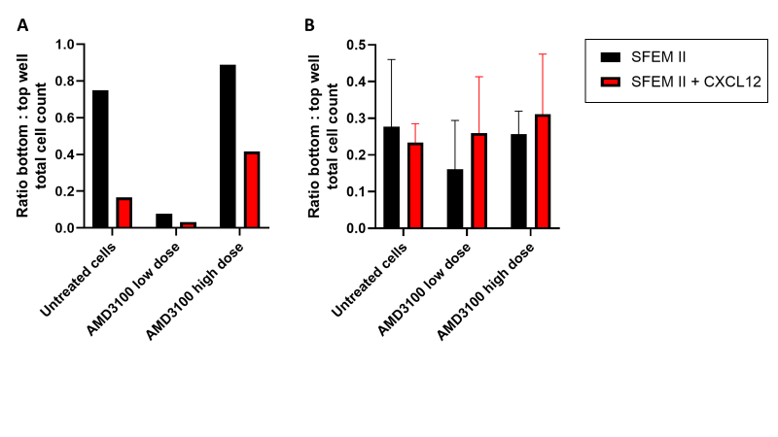
Figure 7.18: Cell migration in human HSPC migration assays comparing untreated and AMD3100 pre-treated cells
Human HSPCs were introduced into the top wells of Transwell plates in order to investigate their mobilisation into the bottom wells. Cells were either untreated or had undergone a period of incubation in high (100 μg/million cells) or low (10 μg/million cells) dose AMD3100. Bottom wells contained either standard media or media plus CXCL12, at 400 ng/ml in experiment 1 (n=1) (A) or 200 ng/ml in experiment 2 (n=3) (B). The ratio of live cell counts in bottom well : top well was taken as a measure of cell migration. Mean +/- SD is shown for experiment 2.
Abbreviations: CXCL12: C-X-C motif chemokine ligand 12, HSPCs: haematopoietic stem and progenitor cells, SFEM II: serum-free expansion medium II.

Further repeats would be desirable in order to investigate whether these findings would be replicated, in particular given that there was no increased cell migration to CXCL12 in the untreated cell arms. A greater number of HSPCs available would also be expected to improve both precision and accuracy. A large number of repeats was anticipated to be required in order for genuine differences to reach statistical significance (most p values in this experiment were >0.4). However, due to a lack of available HSPCs and other resources, and prioritisation of other experiments, further repeats have not been carried out up to this point in time.
7.4.4.4 Both high and low dose AMD3100 block most CXCR4 receptor sites in NHP or human HSPCs
In the cell migration experiments reported here, AMD3100 incubation did not appear to inhibit HSPC migration towards CXCL12. Further investigation was therefore undertaken to examine the efficacy of CXCR4 blockade by both doses of AMD3100 used in these experiments. The hypothesis being investigated by the cell migration studies was that HSPCs would lose their sensitivity to the chemotactic effects of CXCL12 after AMD3100 exposure, due to inability of CXCL12 to bind to its receptor CXCR4, to which AMD3100 had already bound. Results thus far were not supportive of this hypothesis. Therefore, it was important to establish that the administered AMD3100 had effectively bound CXCR4 in these reactions.
In NHP cells, there was almost complete blockade of CXCR4 receptors with either high or low dose AMD3100, particularly 3 hours after incubation with AMD3100 was commenced (Fig 7.19A-B). This effect was reduced by the following day. Examination of MFI revealed a similar pattern (Fig 7.19C). Similarly, in human HSPCs there was again high level of CXCR4 blockade with both low and high dose AMD3100 (Fig 7.20).

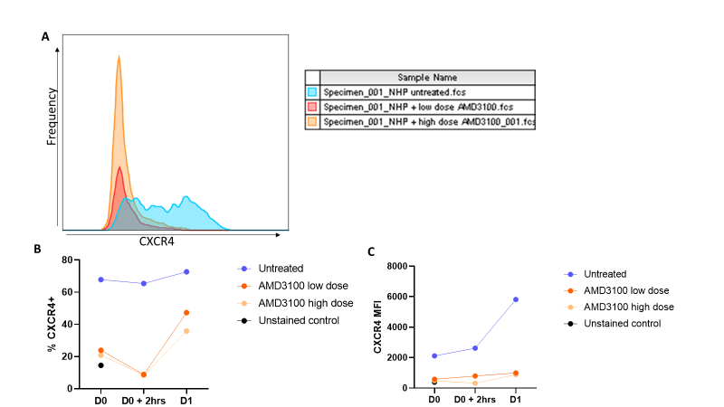
Figure 7.19: CXCR4 blockade by high and low dose AMD3100 in NHP HSPCs
NHP HSPCs were incubated with high (100 μg/million cells) or low (10 μg/million cells) concentration AMD3100, or left untreated. Flow cytometric assessment was undertaken to quantify the proportion of MNCs which were still positive for CXCR4, as well as the associated MFI. Time points for assessment were D0 (time of HSPC addition to Transwell plate assay, 1 hour after AMD3100 incubation commenced), D0 + 2 hrs (3 hours after start of AMD3100 incubation) and D1 (the following day). MNCs were first gated on forward and side scatter, and pCD45⁺ cells selected for analysis. Within this population, CXCR4⁺ cells were quantified and MFI assessed. (A) An example of the flow frequency plot is illustrated. (B) The percentage of CXCR4⁺ cells is similarly reduced in cells treated by either high or low dose AMD3100. (C) CXCR4+ MFI is also similarly and almost completely reduced in cells treated with high or low dose AMD3100.
Abbreviations: CXCR4: C-X-C chemokine receptor type 4, hrs: hours, HSPCs: haematopoietic stem and progenitor cells, MFI: mean fluorescence intensity, MNC: mononuclear cell, NHP: non-human primate, pCD45: NHP CD45.

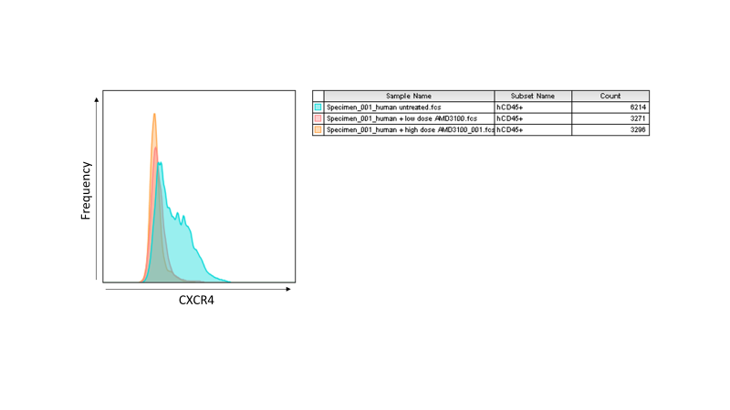
Figure 7.20: CXCR4 blockade by high and low dose AMD3100 in Human HSPCs
Human HSPCs were incubated with high (100 μg/million cells) or low (10 μg/million cells) concentration AMD3100, or left untreated. Flow cytometric assessment was undertaken to quantify the proportion of MNCs which were still positive for CXCR4. Time point illustrated is D0 (time of HSPC addition to Transwell plate assay). MNCs were first gated on forward and side scatter, and CD45⁺ cells selected for analysis. Within this population, CXCR4⁺ cells were quantified.
Abbreviations: CD: cluster of differentiation, CXCR4: C-X-C chemokine receptor type 4, D0: day 0, HSPCs: haematopoietic stem and progenitor cells, MNC: mononuclear cell.

7.5 Discussion
This chapter describes work arising from the overarching goal of carrying out a PBSC genome edited autologous HSCT in the NHP preclinical model, as a final translational step prior to clinical application. This was primarily planned to involve the single HBG-113 CRISPR/Cas9 genome editing strategy, which had already proved successful with a BM-derived stem cell source.²⁸⁰ A modified process involving AMD3100 mobilisation and a PBSC transplant would bring the preclinical protocol into closer alignment with gold standard treatment in the clinic for patients with sickle cell disease, for whom this was anticipated to offer a potentially curative therapeutic option. The dual editing approach targeting both HBG-113 and BCL11A-ee was being investigated concurrently in in vitro and mouse experiments, and had these resulted in improved HbF reactivation without the development of chromosomal translocations, this approach would also have been tested in the NHP prior to recommendations for clinical trials.
The initial work described involved the development of a safe and functional apheresis protocol in order to collect mobilised HSPCs in NHPs. This work is described fully in Appendix 1. To summarise very briefly, these modifications included a switch from intermittent to continuous MNC collection, alteration of tubing set size, and optimisation of periprocedural anticoagulation. Following this work, successful apheresis of the rhesus macaque population was demonstrated. Unfortunately this did not progress to the PBSC-based genome edited HSCT as originally planned, since by this point in time the BCL11A-ee target was already being trialled in the clinic with promising early results.^{363; 364} It was not considered likely that the HBG-113 single editing approach would progress to clinical translation, and by this point the dual editing approach had been demonstrated to result in chromosomal translocation events, raising safety concerns which precluded further development.
During the course of this work, AMD3100 was used as the mobilisation agent of choice, given its demonstrated safety and efficacy in the sickle cell population. It was noted that NHPs who had mobilised efficiently with a 1st dose of AMD3100 failed to remobilise HSPCs successfully upon subsequent administration of this drug. The kinetics of CD34⁺ HSPC mobilisation with 1st dose AMD3100 were similar to those reported by other groups,³⁵⁸ but HSPC response was repeatedly lower with subsequent AMD3100 doses. While there was only a non-significant reduction in total MNC mobilisation, the responses of CD34⁺ HSPCs and the subpopulation of CD90⁺ cells, enriched for longer-term repopulating HSCs, were both significantly reduced with subsequent dosing episodes.
In order to investigate whether a similar loss of HSPC mobilisation would be observed with human HSPCs upon repeated AMD3100 dosing, further experiments were designed using the human mouse model. Once again, a reduced response to subsequent AMD3100 doses in comparison to 1st dose was documented in hCD45⁺ (i.e. total WBC) response, and even more importantly, CD34⁺ HSPC mobilisation. Human chimerism was stable from 1st to 3rd dosing episodes, supporting the conclusion that a genuine loss of response to AMD3100 was the cause for these observations. Similar results were obtained with a 2nd mouse cohort, although in this case human engraftment over the course of the experiment was not stable therefore this in itself may explain at least part of the loss of mobilisation response.
Various explanations for this loss of AMD3100 efficacy with repeated dosing were considered. One mechanism by which AMD3100 is proposed to effect mobilisation is via a reversal of the CXCL12 gradient across the BM niche. Therefore the first hypothesis considered was that this change in CXCL12 gradient does not occur as effectively with 2nd AMD3100 doses as with the 1st administration. To investigate this, an ELISA assay was used to quantify the concentration of CXCL12 in the plasma of the 1st humanised mouse cohort, after 1st and 2nd AMD3100 dosing episodes. No significant difference in the increased CXCL12 plasma levels was observed between doses. Although this experiment was limited by the lack of any analysis of BM CXCL12 levels (since this would have required euthanasia and necropsy), this strongly suggests that the loss of AMD3100 efficacy is not due to a loss of its effect on CXCL12 gradient between BM and plasma.
A further hypothesis considered was that loss of AMD3100 efficacy was due to loss of HSPC sensitivity to the chemoattractant properties of CXCL12, due to CXCR4 blockade by theAMD3100 molecules. It was suggested that this prevented the HSPCs mobilised during a 1st AMD3100 dosing episode from rehoming back into the BM and being available for subsequent mobilisation. This hypothesis was suggested by more than one experienced and well-published clinical transplant professional. The logic of this hypothesis is considered reasonably weak, since HSPCs mobilised by AMD3100 in the clinic are subsequently transplanted back into patients or other recipients in autologous or allogeneic stem cell transplants, with resultant repopulation of the BM by these same cells. This suggests that BM rehoming ability is not significantly impaired by AMD3100 exposure. Also, this would be contradictory to the hypothesis that AMD3100’s mechanism of action at least partly relies on increased plasma CXCL12 levels drawing HSPCs out of the BM. However, given that this explanation was proposed for our findings by multiple sources, investigation was considered reasonable.
Next, in vitro cell migration experiments were designed in order to assess whether human or NHP HSPCs would lose their propensity to migrate towards CXCL12 after exposure to AMD3100. Although the number of experiments, and within those the number of cells per condition and number of replicates (particularly with NHP cells), was low, the results do not support this hypothesis. The majority of experiments demonstrated equivalent or possibly even improved cell migration after AMD3100 exposure in comparison to untreated cells. Again, given low numbers of replicates with high SD, any conclusions must be guarded, but these data mitigate to at least a degree against the hypothesis that AMD3100 exposure reduces CXCL12 attractivity.
A further interesting observation which arose from the experiments involving human HSPCs, was that total live cell counts trended to be higher in the AMD3100-treated arms than untreated cells. It was hypothesised that this may related to stimulation of active cell cycling associated with AMD3100 exposure, via intracellular signalling pathways activated by AMD3100 binding to the CXCR4 receptor.^{316; 317} Cell cycle experiments carried out to investigated this hypothesis were described in Chapter 3 (sections 3.2 – 3.5).
Alongside the lack of repeats of – and within – these experiments, a further limitation is the PB rather than BM source of human HSPCs. As the hypothesis related to the behaviour of BM-derived HSPCs, it is possible that they may represent a different population, or that their behaviour may be different, to HSPCs which have already been mobilised out into the PB by G-CSF. However, human BM-derived HSPCs were not available and therefore PB-derived HSPCs considered the best available surrogate.
Other limitations of the experiments described include a lack of baseline CD34⁺ and CD90⁺ counts prior to 1st AMD3100 administration in some of the NHP subjects, who received this dose before the phenomenon of remobilisation failure was recognised and in whom this had not been felt necessary. There was no reason to suspect that their baseline values for circulating HSPCs would be different to those reported in other animals, although inclusion of this data would have made for a more complete dataset. In the NHP experiments there were a limited number of blood draw timepoints and within the mice only a single post-dose PB sample was taken to assess mobilisation. This was for reasons related to animal health and welfare, but it is possible that peak HSPC mobilisation was not captured. For example, repeated AMD3100 dosing may have resulted in an earlier mobilisation peak in the mice which was missed by the standardised timing of the blood draw. The limited number of blood draws also precluded calculation of area under the curve for HSPC mobilisation which would have been a better measure of the adequacy of mobilisation than simply a peak (or expected peak) level. Finally, the CXCL12 ELISA assay was only applied to humanised mice and not to NHP plasma, which would have provided interesting additional information.
Other hypotheses which have not yet been investigated include the development of an immune response to AMD3100 following 1st dose, resulting in inactivation of subsequently administered doses, or that those HSPCs which were mobilised from the BM in the 1st mobilisation episode are less sensitive to the effects of future AMD3100 doses, although the cause for this is not clear.
Loss of AMD3100 response of human HSPCs has serious consequences. Preclinical testing of in vivo HSPC transduction or transfection in human mice may require multiple mobilisation episodes in order to achieve sufficient HSPC exposure to the modifying agent.^{365; 366} Even more importantly, in the clinic, patients often require repeated HSPC mobilisation if sufficient PB HSPCs are to be collected in order to facilitate standard HSCT.²⁸² It is anticipated that 1/3 patients undergoing ex vivo lentiviral gene additional therapy for sickle cell disease will require more than 1 mobilisation episode for the collection of adequate HSPCs. ³³¹ If AMD3100 cannot be used to effectively mobilise HSPCs on more than 1 occasion, serious consideration regarding the delivery of such treatments to patients with sickle cell disease must be given.

8.0
Chapter 8:
Discussion

8.1 Thesis findings: sequential dual CRISPR/Cas9 genome editing targeting the BCL11A/HBG pathway results in optimised HbF reinduction but the consistent development of t(2;11) chromosomal translocations which persist in vivo
Sickle cell disease and β thalassaemia are severe, inherited blood disorders caused by abnormality and lack of HbA, respectively. Both conditions are rendered less harmful if circulating levels of an alternative haemoglobin, HbF, can be increased. One way to achieve this is to disrupt particular areas of the genome responsible for suppressing HbF production after early infancy. Previously published work has already established both HBG-113 and BCL11A-ee as effective targets for disruption by genome editing, resulting in significant HbF reinduction. The safety of both these individual targets is supported by the absence of off-target mutations and lack of any impairment to engraftment, lineage differentiation or erythroid maturation.^{268; 269; 346} However, in the case of each locus being targeted individually, induced HbF levels have not reliably reached levels expected to confer substantial therapeutic benefit.263; 268; 269; 280; 341; 346; 367 This thesis investigated the hypothesis that by targeting both loci in the same haematopoietic stem cells, HbF reinduction potential would be increased.
In vitro and in vivo experiments were conducted to investigate the hypothesis that dual editing strategies targeting both loci in the same HSPC population would result in improved HbF reinduction without compromising HSPC viability, engraftment or lineage differentiation potential. The risk that inducing dsDNA breaks in 2 chromosomes within the same cell would result in the development of chromosomal translocations was also considered, and analyses were designed to detect and then quantify such events.
Enhanced HbF reinduction was demonstrated following the application of a double editing strategy in which both the BCL11A-ee and HBG-113 regions were targeted sequentially by CRISPR/Cas9 editing. This is consistent with an increase in the sum of total editing events occurring where this strategy is applied. Interestingly, this improvement in HbF levels was not observed where simultaneous targeting of both loci was employed, despite a modest improvement in the sum of editing efficiencies in those reactions. It is hypothesised that this is due to a reduction in the formation of indels of certain sizes, which are particularly effective at disrupting the transcription factor binding sites, and which are reliant on the MMEJ pathway for their formation, where dual editing takes place simultaneously. This would be because, where double editing is applied simultaneously, there is competition for the limited MMEJ machinery within the nucleus of each edited cell. MMEJ is already known to be active in the formation of the 13nt deletion at the HBG-113 locus, as well as the 13nt and 15nt deletions in the BCL11A-ee, all demonstrated here to be reduced in the simultaneously dual edited reactions, in comparison to single edited or sequentially dual edited reactions. These larger deletions may contribute disproportionately to the disruption of the BCL11A/HBG axis and therefore reinduction of HbF. This hypothesis also explains the observation that total HBG-113 editing is greater in sequentially than simultaneously double edited reactions, whereas total BCL11A-ee editing is very similar between these arms, since the MMEJ-dependent 13nt deletion normally comprises a much greater proportion of the total HBG-113 editing than known MMEJ-dependent indels do in the case of BCL11A-ee editing.
One further hypothesis was considered to explain the higher rates of MMEJ-associated indels at HBG-113 following sequential rather than simultaneous dual editing. This theory was that, in the sequential dual editing arm, the editing procedure (and particularly the electroporation episode) on D0 resulted in a higher proportion of HSPCs having entered more active phases of the cell cycle by D+1. It has previously been recognised that HDR repair pathways are more active in cycling HSCs in comparison to quiescent HSCs.³⁴⁴ It was hypothesised that MMEJ repair pathways would also be more active in cycling rather than quiescent cells, and the electroporation encouraged more HSPCs to enter the active phases of the cell cycling, so that by the time of the second editing episode on D+1, a greater activity of the MMEJ pathway would result in higher levels of the 13nt deletion being observed. Additional experiments were conducted to investigate this hypothesis, whereby cell cycling activity was compared between pre-electroporated cells in comparison to untreated controls. Whilst the number of repeats was low, early results did not support this hypothesis. It is considered most likely, therefore, that the lower incidence of 13nt deletions in the simultaneously dual edited reaction relates primarily to saturation of the MMEJ pathway where 2 loci are edited simultaneously within the same cell.
A non-significant trend towards higher HbF levels was found where HBG-113 was targeted for single editing above that noted with single BCL11A-ee editing. This was despite almost identical mean editing efficiencies at these two loci. This finding is consistent with recently published data which also found greater γ-globin mRNA transcription, higher HbF percentage of total haemoglobin, and greater percentage of HbF-positive cells by flow cytometry, with editing at HBG-113 in comparison to BCL11A-ee.³⁶⁷ It is hypothesised that this finding is due to the particular indel types formed at these loci, which in the case of HBG-113, more effectively disrupt the transcription factor binding site than the indels at BCL11A-ee manage to with their respective target, in erythroid precursors. This hypothesis is supported by the report from Wu et al of significant levels of residual BCL11A expression even with high levels of editing efficiency at BCL11A-ee.²⁶⁹ An alternative reason for our observation may be related to the binding of other transcription factors at a similar site within HBG-113, such as ZBTB7A.^{19; 21} Removing the transcription factor binding site within HBG-113 blocks downregulation by all such proteins, whereas reducing BCL11A production modulates only one of a number of effectors.
The detailed analysis of single erythroid colonies provides granular data on the frequency of a wide spectrum of indel types following CRISPR/Cas9 editing at the two targeted loci, and the associations between single or double editing levels and HbF reinduction. The indel pattern after HBG-113 editing is similar to that reported in previous studies, with at least 2 other studies each reporting that in addition to the well-recognised 13nt deletion, other longer deletion lengths of 11 and 18 nucleotides occur at higher frequency than would be expected due to NHEJ alone.^{268; 341; 346} Given the consistency of these observations, it is highly likely that the formation of these two particular nucleotide deletion lengths is also related to the MMEJ pathway. The indel patterns observed at BCL11A-ee are also similar to previous reports, in which 13 and 15nt deletions were particularly prevalent, consistent with MMEJ pathway activity. ^{263; 269}
Analysis of clonal erythroid colonies allowed the additional boost given to HbF reinduction by HBG-113 disruption, even where biallelic BCL11A-ee editing was already present, to be clearly documented. This is likely due to a combination of incomplete knockdown of BCL11A production even with editing at both BCL11A-ee alleles, alongside the existence of additional γ globin-repressor transcription factors which continue to bind to HBG-113 unless this site is also disturbed. Within clones edited at one locus only, HbF percentage remained highly variable between cells with similar levels of editing. This is consistent with the hypothesis that the efficacy of transcription factor binding site disruption depends on the particular type of indel formed. For example, it has previously been demonstrated that a single nucleotide insertion at HBG-113 may allow the core CCAAT box to be preserved and therefore was not associated with HbF reinduction.²⁶⁸
Dual editing did not negatively impact engraftment, lineage differentiation of proliferation following transplantation into immunodeficient mice, and editing levels stabilised over time in vivo. Optimal persistence of edited HSPCs post-transplant was observed in mice transplanted with sequentially dual edited cells, suggesting that at least medium-term repopulating HSPCs were edited most efficiently with this approach. However, despite the improvement in editing efficiency and HbF levels conferred by the sequential double editing approach , this strategy cannot be recommended for clinical translation. This is due to the finding that multiplex editing consistently resulted in the generation of chromosomal translocation events, which persisted in vivo. In vitro, translocations were most frequent where both loci had been targeted simultaneously. However, following transplantation into immunodeficient mice, translocations were found in cells arising from HSPCs in both the sequential and simultaneous double-editing arms, being in fact most frequent in the case of the former. This suggests that translocations were being harboured by longer-term repopulating HSPCs in the case of sequential double editing, and is again consistent with these particular cells being targeted most efficiently with the sequential dual editing approach.
Previously published studies have reported the application of multiplex genome editing to haematopoietic cells in a multitude of scenarios. This approach is already being applied in a number of clinical trials and considered for many more. These include the production of CAR-T cells with optimised potency for the treatment of refractory malignancy, and to overcome the obstacles of immune incompatibility in haematopoietic lineages.^{299; 300; 368; 369} However, where chromosomal translocations have been sought following multiplex editing in these studies, their presence has usually been confirmed.^{299; 369}
It is well recognised that chromosomal translocations often serve as precursor events to malignant, clonal transformations where they occur in vivo. This property of multiplex genome editing has even been harnessed specifically for the production of cancer-relevant translocations such as those characteristic of MLL-rearranged leukaemia, anaplastic large cell lymphoma or Ewing sarcoma, providing evidence that the risk of malignant transformation with multiplex editing approaches is more than just hypothetical.^{298; 339}
It is appreciated that in some scenarios where multiplex editing is already being applied, such as the production of CAR-T cells directed towards aggressive tumours refractory to all other available therapy, the potential risk of future leukemogenesis resulting from the generated chromosomal rearrangements in haematopoietic cells may be outweighed by the urgent need to control a more immediately life-threatening malignancy.^{299; 300; 369} However, where multiplex genome editing is considered for the treatment of non-malignant conditions such as the haemoglobinopathies, such an inherent future risk of iatrogenic oncogenesis may well outweigh any potential benefit.
It should be noted that the generation of chromosomal translocation is not exclusively the preserve of multiplex editing. Large deletions, inversions and other rearrangements are known to occur with single target editing of HBG-113 due to simultaneous editing at the promoter regions of both HBG1 and HBG2.^{341; 346} Translocations may also be found in cells undergoing genome editing with other single targets, due to simultaneous on- and off-target double-stranded DNA breaks. However, this risk may be abrogated and possibly entirely eliminated by the use of higher-fidelity editing systems.^{370; 371} In contrast, the relatively high frequency of chromosomal rearrangement events demonstrated to occur by the active targeting of multiple domains in a multiplex editing strategy must be considered a significant drawback to this approach.
It is noted that there have recently been reports of significantly higher HbF reinduction with single target editing, such as with the use of chemically modified sgRNAs.³⁴¹ However, the results of single erythroid colony analysis in our experiments demonstrated an additional benefit to disrupting a second genomic target even where efficiency of editing at the first has been optimised. This is likely due to incomplete disruption of the relevant locus with certain indel types generated, or in the case of the HBG/BCL11A axis specifically, may reflect the complexity of this system, with multiple transcription factors involved in the physiological switch from foetal to adult haemoglobin production.
No firm conclusion could be drawn from these results as to the superiority of one single editing target above the other. Whilst a trend towards higher HbF reinduction was noted with HBG-113 editing than BCL11A-ee editing in both bulk cells and single erythroid colonies in vitro, consistent with a recently published comparison of these editing targets, these differences were minor and not statistically significant.³⁶⁷ Lamsfus-Calle et al also reported a greater degree of dysregulation in genes associated with cell cycle, p53 signalling, apoptosis and immune pathways with HBG-113 editing than where BCL11A-ee is targeted, raising concern regarding potentially increased risk of malignant transformation with the former. This may at least in part be due to the recognised generation of large deletions, inversions and other rearrangements known to occur with HBG-113 editing due to simultaneous double-stranded breaks formed at the promoter regions of HBG1 and HBG2.^{341; 346} Further investigation is required before one of these editing sites may be conclusively recommended above the other.
This thesis documents the application of multiplex genome editing to maximise HbF reinduction in the erythroid progeny of engineered HSPCs. In conclusion, despite the optimization of HbF reinduction furnished by sequentially targeting both the BCL11A-ee and HBG-113 loci, the safety concerns raised by the invariable generation of chromosomal translocations, demonstrated to persist in vivo, currently preclude the application of this strategy in the clinic.
Novel platforms such as base editor technology may in the future allow multiple loci to be targeted for editing without the frequent formation of dsDNA breaks, thereby mitigating the risk of chromosomal rearrangement events. Such a possibility warrants rigorous investigation.

8.2 Thesis findings: repeated dosing with AMD3100 fails to effectively remobilise HSPCs in the NHP and humanised mouse preclinical models
The NHP transplant model is particularly useful as a final step in pre-clinical investigation of novel therapeutic approaches, and results are most transferrable to clinical practice when methodologies are aligned as closely as possible to those employed in the clinic. Therefore, work was undertaken to develop a protocol allowing NHPs to undergo HSPC mobilisation with single agent AMD3100 followed by stem cell collection, since this regimen is used for patients with sickle cell disease in the clinic.
Chapter 7 presented experimental results which demonstrated significantly poorer mobilisation of HSPCs in NHPs following repeated administration of AMD3100 in comparison to first dose. This was observed to be the case for the CD34⁺ cell population as a whole. Since this is the most commonly used HSPC marker routinely in the clinic, as well as in preclinical NHP transplant protocols, this is highly relevant. Arguably of even greater consequence, the HSC-enriched CD90⁺ subset was also observed to mobilise significantly less well with repeat AMD3100 dosage in NHPs.
Human HSPCs within the humanised mouse model also failed to remobilise effectively with repeated AMD3100 doses, with this phenomenon being demonstrated in 2 cohorts of mice. Total human white blood cell remobilisation also mobilised less effectively with subsequent AMD3100 doses. The humanised mouse is the most commonly used pre-clinical model used for studies into human haematopoiesis, and the NHP model is the closest to human anatomy and physiology, making this particularly valuable as a last step in preclinical testing prior to translation to the clinic. Therefore, the inability to effectively remobilise HSPCs with AMD3100 in these two preclinical models is highly significant and is expected to impact upon preclinical experimental protocols.
Loss of AMD3100 activity on redosing in these animal models will be most problematic in the investigation of therapies for sickle cell disease are being considered, since AMD3100 is the only mobilisation agent available for use in the clinic, which can safely be used in this patient population. The result of being unable to reuse this drug in two of the most important preclinical models may result in preclinical mobilisation protocols which rely on AMD3100 remobilisation being abandoned, introducing a further level of disparity between preclinical and clinical testing.
Other groups have previously published results demonstrating a reduced mobilisation response to G-CSF with repeated exposure. In one study, healthy donors were given repeated doses of G-CSF, up to a year apart. Reduced efficacy of mobilisation was observed with the second dose, demonstrating that the deficit in remobilisation was long-lasting.^{372; 373} Results presented here confirm a similar remobilisation deficit upon repeated dosing with AMD3100, many weeks following initial exposure in some cases.
The mechanism by which AMD3100 redosing fails to effectively remobilise HSPCs in the NHP and humanised mouse models has not yet been defined. One hypothesis was that this may related to a reduced plasma CXCL12 response on repeat AMD3100 dosing. This theory arose from the demonstration by Redpath et al that plasma CXCL12 levels rose in response to AMD3100 in BALB/c mice.¹² However, experiments carried out to compare plasma CXCL12 levels after first versus second AMD3100 dosing in humanised mice did not support this particular hypothesis. Redpath et al also documented a fall in BM CXCL12 following AMD3100 administration, and therefore, whether the magnitude of this effect is reduced with subsequent AMD3100 dosing is recommended as a further avenue for investigation. It should be noted that this manuscript is the first report of plasma CXCL12 response to AMD3100 in humanised NSG mice.
There have been published reports which provide a degree of reassurance that the loss of AMD3100 efficacy has not been seen with repeated dosing in healthy volunteers, and recently also in sickle cell disease patients.^{374; 375} If confirmed in repeat studies, the difference between these results and the preclinical data presented above may be related to the higher doses of AMD3100 delivered to NHPs (approximately 4 x human dose) and humanised mice (approximately 20 x human dose). This may result in a greater proportion of those HSPCs which are amenable to mobilisation by AMD3100 being mobilised during the 1st dosing episode. If AMD3100 reduces the remobilisation potential of exposed cells, then these mobilised HSPCs had reduced mobilisation potential during a 2nd dosing episode. In contrast, in the clinical studies, a lower dose of AMD3100 was adequate for effective mobilisation. It is hypothesised that within human subjects the BM HSPC population is more sensitive to the effects of AMD3100, consistent with the fact that smaller doses are adequate for mobilisation. Since a smaller dose was given, only a small proportion of the pool of cells available for mobilisation by AMD3100 were affected by reduced mobilisation potential in the future. This would leave a larger proportion of cells which had not been mobilised by the 1st dose of AMD3100 and which retained sensitivity for a 2nd dose. The differential observed response of repeated AMD3100 dosing in human, NHP and humanised mouse subjects should be a stimulus for further research into the mechanisms involved.
In conclusion, data has been presented which demonstrates a failure of HSPCs to remobilise with repeated AMD3100 dosing in NHPs and in humanised mice. This must be taken into account in the planning of pre-clinical transplant and genome engineering studies planning to use AMD3100 to repeatedly mobilise HSPCs.

8.3 Study Limitations
Extensive consideration has been given to study limitations. A general criticism would be the small number of repeats in some in vitro experiments, such as the cell cycle and cell mobilisation experiments. This was due to limited resources on which there were multiple demands. As a result, only approaches which demonstrated the most promise early on were pursued. Whilst it is recognised that this is not ideal, such an approach allowed other, potentially more fruitful, avenues of investigation to be pursued.
Moving on to more detailed criticisms pertaining to individual aspects of experiments, the use of flow cytometric analysis of HbF levels is standard in experimental studies, but has the limitation of not being able to differentiate between very high and simply detectable levels of HbF per cell in a validated manner. Whilst MFI may give an element of semi-quantitative data, the test was not calibrated or validated to provide a quantification of HbF per cell, and therefore cannot be taken to demonstrate such. For this reason, HPLC analysis was vital as a supplementary test. Not only is this a gold standard test used in the clinic for haemoglobin analysis, but it provides relative quantification of Hb fractions.^{114; 115} One remaining limitation even with the HPLC studies, however, was that, in contrast to studies on whole blood from patients, for example, the total haemoglobin concentration was not known. Therefore, the ratio of HbF to HbA was the best measure available but actual HbF concentration per cell could not be calculated.
The total number of HPLC assays available to our group was unfortunately limited by the requirement for these to be shipped to a collaborator, and their restriction on the number of samples which could be processed. A greater number of analyses would have been particularly valuable where single BFU-Es were being tested, in order to contribute to assessment of the relationship between particular indel patterns, editing efficiency and HbF reinduction. As a result of recognising the importance of having improved access to HPLC analysis, particularly if the laboratory was going to continue working in the field of haemoglobinopathies, recommendations were made to the proteomics laboratory at the FHCRC that this be prioritised as a service for future development, and this work is underway.
It would have been interesting to carry out in vitro or ex vivo studies to test the dual editing strategy on HSPCs derived from patients with β thalassaemia or sickle cell disease, or on erythroid cell lines containing the relevant mutations. However, once it became clear that translocations were consistently formed, and that therefore this approach was not suitable to continue towards clinical translation, further such studies were not justified. If, in the future, the problem of translocations is solved by the use of alternative editing platforms such as base editors, then such studies would be recommended for additional in vitro validation.
The use of TIDE analysis to estimate editing efficiency and define indel formation carries a degree of inaccuracy in comparison to NGS analysis, and this is acknowledged as a limitation to the editing data presented. In addition, the lack of NGS analysis prevents any comment on the formation, or otherwise, of off-target dsDNA breaks. Previous studies have looked for off-target mutagenesis with both HBG-113 and BCL11A-ee editing and provide reassuring results,263; 268; 269; 280; 341; 346; 367 but it is still reasonable to consider it a limitation of these experiments that such analyses were not repeated here.
Furthermore, mRNA quantification of BCL11A or HBG transcription would have supplemented the datasets available. For example, this may have supported the hypothesis that one reason dual CRIPPR/Cas9 editing at both sites optimises HbF reinduction is by removing the binding site for residual BCL11A transcription factor produced. However, such studies have already been carried out by other groups (for example, demonstrating that even with high editing levels at BCL11A-ee there is still at least moderate production of BCL11A)²⁶⁹ and it was considered that the benefit of repeating such analyses did not justify the resources required.²⁶⁹
It is accepted that whilst 2 reciprocal t(2;11) translocation products were demonstrated, there are also a large number of other possible chromosomal rearrangements, which include inversions and large deletions (particularly at HBG-113, where editing occurs at the promoter regions of both HBG1 and HBG2).^{280; 346} A more extensive analysis of all such mutations would have been warranted if dual editing were currently fit for clinical translation.
On initial submission of the paper detailing results of AMD3100 mobilisation experiments, one peer reviewer criticised the small numbers of animals involved in our studies. However, since statistical difference had reached the point of significance, with both the humanised mouse and NHP models, it would have been ethically questionable to arbitrarily increase the number of animals used in an experiment when such an endpoint has already been reached.³³⁵ This is particularly the case with higher-order animals such as NHPs, in whom a minimisation of the number of animals involved in any experiment is particularly important.
It is also considered a necessary limitation that blood draws were available for only a restricted number of timepoints following AMD3100 administration to humanised mice or NHPs. It is possible, for example, that HSPC mobilisation peaks very early after subsequent doses, and that this was missed by the standardised blood draw regimen. It was also impossible to calculate area under the curve (AUC) for HSPC mobilisation, given the small number of timepoints. It could be reasonably argued that AUC is a more relevant marker of HSPC mobilisation efficacy, as this relates more closely to the success of an apheresis procedure.³⁷⁶ However, as with all animal work, the number of tests and procedures which an animal is subjected to are very rightly limited by consideration of their welfare and relevant regulations.

8.4 Future Work
With regards to the dual CRISPR/Cas9 editing strategy for HbF reinduction, the main recommendation to come out of this work is that methods to overcome the problem of chromosomal translocations with multiplex editing strategies must be developed. Multiplex editing strategies are already increasingly being introduced into clinical practice, and other studies have also confirmed our finding that multiplex editing results in the development of chromosomal rearrangement events.^{299; 300} It is accepted that where multiplex editing is used for the development of new treatments for otherwise refractory, aggressive malignancies, that the risks associated with such translocations may well be outweighed by the benefit derived by a patient, if such a treatment delivers disease control. However, for the treatment of non-malignant conditions such as haemoglobinopathies, justifying such a potential risk to patients becomes much more difficult.
Methods which may prove fruitful in attempting to ameliorate, or entirely remove, this translocation risk, include the use of base editor platforms, which confer a much lower frequency of dsDNA breakage. Shorter half-life Cas9 preparations may also decrease the likelihood of ongoing dsDNA break formation at one site by the time that editing at a second site is introduced. Such possibilities warrant systematic investigation.
A recent paper looked at a similar dual editing strategy to that presented here, and reported a lack of translocations. However, the authors used karyotyping and FISH analysis only to investigate translocation formation.³⁷⁷ A comparison of our data highlights the importance of selecting more sensitive methods for the detection of translocation events, which will usually mean PCR-based methods. Where multiplex editing strategies are being considered for clinical translation, a strong recommendation of this thesis is that molecular methods of the highest possible sensitivity are used to detect any possible chromosomal rearrangements. This is because malignancies such as leukaemia are thought to arise from a single mutated progenitor cell, and therefore there is no lower limit for translocation frequency at which this could be considered risk-free. With the ongoing improvements continually being introduced into bioinformatic tools and protocols, it is anticipated that such analyses will be able to predict the potential negative effects of on- and off-target edits (including translocations) with increasing accuracy. Such information will be vital in weighing up the risk : benefit ratio of delivering treatments which have a residual risk of translocation development.
It would also be interesting to further investigate the mechanisms by which sequential dual editing is more effective than simultaneous dual editing. The hypothesis that this relates to activity of the MMEJ repair pathway, and thereby the formation of certain large indels which most effectively disrupt the locus in question, could be looked into further. In order to facilitate this, a deeper understanding of the pathways and reactions involved in this particular DNA repair pathway are desirable, and further research into this is recommended.
Another approach which remains to be investigated is that of reversing the target order in the sequential dual editing strategy, i.e. targeting HBG-113 first followed by BCL11A-ee. It would be interesting to assess whether results would be different. Again, such studies will be justified if the safety issues around the development of translocation events are resolved.
With regards to the AMD3100 remobilisation failures observed, further studies are recommended to establish the length of time over which such a loss of efficacy would be observed. This will inform future experimental protocols requiring repeated ADM3100 administration in these valuable preclinical models. Whether or not such a loss of potency is also observed when AMD3100 is combined with G-CSF, as it often is in clinical practice, should also be established.²⁸² The studies in healthy human volunteers and patients with sickle cell disease do not appear to show similar loss of AMD3100 efficacy on redosing, and these results are welcomed. However, it is hypothesised that this is due to the size of the residual HSPC ‘well’ left behind in the BM niche after an initial mobilisation episode. Where this is large, as is expected to be the case in people with a healthy BM capacity who are dosed with the standard dose of 240 μg/kg (i.e. 4-20 times lower than that used in the animal models), it is hypothesised that HSPCs which were unaffected by the first mobilisation are ready and available to be mobilised in large numbers following a subsequent dose of AMD3100. However, in individuals with more limited BM activity and reserve, such as those with diseases causing bone marrow failure, this may not be the case. It is recommended that data is collected prospectively on the efficacy, or otherwise, of repeated AMD3100 dosing in such individuals.

9.0
Chapter 9:
References

¹ THOM, C. S. et al. Hemoglobin variants: biochemical properties and clinical correlates. Cold Spring Harb Perspect Med, v. 3, n. 3, p. a011858, Mar 2013. ISSN 2157-1422. Disponível em: < https://www.ncbi.nlm.nih.gov/pubmed/23388674 >.

² MANNING, L. R. et al. Human embryonic, fetal, and adult hemoglobins have different subunit interface strengths. Correlation with lifespan in the red cell. Protein Sci, v. 16, n. 8, p. 1641-58, Aug 2007. ISSN 0961-8368. Disponível em: < https://www.ncbi.nlm.nih.gov/pubmed/17656582 >.

³ YUDIN, J.; VERHOVSEK, M. How we diagnose and manage altered oxygen affinity hemoglobin variants. Am J Hematol, v. 94, n. 5, p. 597-603, 05 2019. ISSN 1096-8652. Disponível em: < https://www.ncbi.nlm.nih.gov/pubmed/30690774 >.

⁴ TRENT, R. J. Diagnosis of the haemoglobinopathies. Clin Biochem Rev, v. 27, n. 1, p. 27-38, Feb 2006. ISSN 0159-8090. Disponível em: < https://www.ncbi.nlm.nih.gov/pubmed/16886045 >.

⁵ FRENETTE, P. S.; ATWEH, G. F. Sickle cell disease: old discoveries, new concepts, and future promise. J Clin Invest, v. 117, n. 4, p. 850-8, Apr 2007. ISSN 0021-9738. Disponível em: < https://www.ncbi.nlm.nih.gov/pubmed/17404610 >.

⁶ LAI, K. et al. The prevalence of thalassemia in mainland China: evidence from epidemiological surveys. Sci Rep, v. 7, n. 1, p. 920, Apr 19 2017. ISSN 2045-2322.

⁷ PIEL, F. B.; STEINBERG, M. H.; REES, D. C. Sickle Cell Disease. New England Journal of Medicine, v. 376, n. 16, p. 1561-1573, 2017/04/20 2017. ISSN 0028-4793. Disponível em: < https://doi.org/10.1056/NEJMra1510865 >. Acesso em: 2020/05/31.

⁸ FRÖMMEL, C. Newborn Screening for Sickle Cell Disease and Other Hemoglobinopathies: A Short Review on Classical Laboratory Methods—Isoelectric Focusing, HPLC, and Capillary Electrophoresis. International Journal of Neonatal Screening, v. 4, n. 4, 2018. ISSN 2409-515X.

⁹ HUMBERT, O.; SAMUELSON, C.; KIEM, H.-P. CRISPR/Cas9 for the treatment of haematological diseases: a journey from bacteria to the bedside. British Journal of Haematology, v. n/a, n. n/a, 2020/06/07 2020. ISSN 0007-1048. Disponível em: < https://doi.org/10.1111/bjh.16807 >. Acesso em: 2020/06/14.

¹⁰ FRICKER, S. P. Physiology and pharmacology of plerixafor. Transfusion medicine and hemotherapy : offizielles Organ der Deutschen Gesellschaft fur Transfusionsmedizin und Immunhamatologie, v. 40, n. 4, p. 237-245, 2013. ISSN 1660-3796
1660-3818. Disponível em: < https://pubmed.ncbi.nlm.nih.gov/24179472 >.Disponível em: < https://www.ncbi.nlm.nih.gov/pmc/articles/PMC3776399/ >.

¹¹ MARCHESE, A. Endocytic trafficking of chemokine receptors. Current opinion in cell biology, v. 27, p. 72-77, 2014. ISSN 1879-0410
0955-0674. Disponível em: < https://pubmed.ncbi.nlm.nih.gov/24680433 >.Disponível em: < https://www.ncbi.nlm.nih.gov/pmc/articles/PMC4268779/ >.

¹² REDPATH, A. N. et al. Two distinct CXCR4 antagonists mobilize progenitor cells in mice by different mechanisms. Blood Adv, v. 1, n. 22, p. 1934-1943, Oct 10 2017. ISSN 2473-9529 (Print)
2473-9529.

¹³ MODELL, B.; DARLISON, M. Global epidemiology of haemoglobin disorders and derived service indicators. Bulletin of the World Health Organization, v. 86, n. 6, p. 480-487, 2008. ISSN 1564-0604
0042-9686. Disponível em: < https://pubmed.ncbi.nlm.nih.gov/18568278 >.Disponível em: < https://www.ncbi.nlm.nih.gov/pmc/articles/PMC2647473/ >.

¹⁴ PHE. sickle
cell and thalassaemia: screening handbook. England, 2018. Acesso em: 24th March 2020.

¹⁵ ______. Sickle cell and thalassaemia screening: data trends and performance analysis. 2018. Disponível em: < https://www.gov.uk/government/publications/sickle-cell-and-thalassaemia-screening-data-trends-and-performance-analysis >.

¹⁶ WEATHERALL, D. J.; CLEGG, J. B. Inherited haemoglobin disorders: an increasing global health problem. Bull World Health Organ, v. 79, n. 8, p. 704-12, 2001. ISSN 0042-9686. Disponível em: < https://www.ncbi.nlm.nih.gov/pubmed/11545326 >.

¹⁷ GIARDINE, B. et al. Systematic documentation and analysis of human genetic variation in hemoglobinopathies using the microattribution approach. Nature Genetics, v. 43, n. 4, p. 295-301, 2011/04/01 2011. ISSN 1546-1718. Disponível em: < https://doi.org/10.1038/ng.785 >.

¹⁸ LIU, N. et al. Direct Promoter Repression by BCL11A Controls the Fetal to Adult Hemoglobin Switch. Cell, v. 173, n. 2, p. 430-442.e17, 04 2018. ISSN 1097-4172. Disponível em: < https://www.ncbi.nlm.nih.gov/pubmed/29606353 >.

¹⁹ MARTYN, G. E. et al. A natural regulatory mutation in the proximal promoter elevates fetal globin expression by creating a de novo GATA1 site. Blood, v. 133, n. 8, p. 852-856, Feb 21 2019. ISSN 0006-4971.

²⁰ XU, J. et al. Corepressor-dependent silencing of fetal hemoglobin expression by BCL11A. Proc Natl Acad Sci U S A, v. 110, n. 16, p. 6518-23, Apr 2013. ISSN 1091-6490. Disponível em: < https://www.ncbi.nlm.nih.gov/pubmed/23576758 >.

²¹ VINJAMUR, D. S.; BAUER, D. E.; ORKIN, S. H. Recent progress in understanding and manipulating haemoglobin switching for the haemoglobinopathies. Br J Haematol, v. 180, n. 5, p. 630-643, Mar 2018. ISSN 0007-1048.

²² WHO. Sickle-Cell Disease: a strategy for the WHO African Region. 2011. Disponível em: < https://apps.who.int/iris/handle/10665/1682 >. Acesso em: 24th March.

²³ INGRAM, V. M. Abnormal human haemoglobins. III. The chemical difference between normal and sickle cell haemoglobins. Biochim Biophys Acta, v. 36, p. 402-11, Dec 1959. ISSN 0006-3002. Disponível em: < https://www.ncbi.nlm.nih.gov/pubmed/13852872 >.

²⁴ HERRICK, J. B. Peculiar elongated and sickle-shaped red blood corpuscles in a case of severe anemia. 1910. Yale J Biol Med, v. 74, n. 3, p. 179-84, May-Jun 2001. ISSN 0044-0086 (Print)
0044-0086.

²⁵ PAULING, L. MOLECULAR DISEASE AND EVOLUTION. Bull N Y Acad Med, v. 40, p. 334-42, May 1964. ISSN 0028-7091. Disponível em: < https://www.ncbi.nlm.nih.gov/pubmed/14146800 >.

²⁶ EATON, W. A. Hemoglobin S polymerization and sickle cell disease: A retrospective on the occasion of the 70th anniversary of Pauling's Science paper. Am J Hematol, v. 95, n. 2, p. 205-211, 02 2020. ISSN 1096-8652. Disponível em: < https://www.ncbi.nlm.nih.gov/pubmed/31763707 >.

²⁷ PAPAGEORGIOU, D. P. et al. Simultaneous polymerization and adhesion under hypoxia in sickle cell disease. Proc Natl Acad Sci U S A, v. 115, n. 38, p. 9473-9478, 09 2018. ISSN 1091-6490. Disponível em: < https://www.ncbi.nlm.nih.gov/pubmed/30190429 >.

²⁸ RAB, M. A. E. et al. Characterization of Sickling During Controlled Automated Deoxygenation with Oxygen Gradient Ektacytometry. J Vis Exp, n. 153, Nov 2019. ISSN 1940-087X. Disponível em: < https://www.ncbi.nlm.nih.gov/pubmed/31762454 >.

²⁹ NADER, E. et al. Blood Rheology: Key Parameters, Impact on Blood Flow, Role in Sickle Cell Disease and Effects of Exercise. Front Physiol, v. 10, p. 1329, 2019. ISSN 1664-042X. Disponível em: < https://www.ncbi.nlm.nih.gov/pubmed/31749708 >.

³⁰ PHE. sickle cell and thalassaemia: screening handbook. England, 2018. Acesso em: 24th March 2020.

³¹ NASIMUZZAMAN, M.; MALIK, P. Role of the coagulation system in the pathogenesis of sickle cell disease. Blood Adv, v. 3, n. 20, p. 3170-3180, 10 2019. ISSN 2473-9537. Disponível em: < https://www.ncbi.nlm.nih.gov/pubmed/31648337 >.

³² ROZEN, L. et al. Is There Any Improvement of the Coagulation Imbalance in Sickle Cell Disease after Hematopoietic Stem Cell Transplantation? J Clin Med, v. 8, n. 11, Oct 2019. ISSN 2077-0383. Disponível em: < https://www.ncbi.nlm.nih.gov/pubmed/31717804 >.

³³ BARBU, E. A. et al. Pro-inflammatory cytokines associate with NETosis during sickle cell vaso-occlusive crises. Cytokine, v. 127, p. 154933, Mar 2020. ISSN 1096-0023. Disponível em: < https://www.ncbi.nlm.nih.gov/pubmed/31778959 >.

³⁴ EMBURY, S. H. et al. The contribution of endothelial cell P-selectin to the microvascular flow of mouse sickle erythrocytes in vivo. Blood, v. 104, n. 10, p. 3378-85, Nov 2004. ISSN 0006-4971. Disponível em: < https://www.ncbi.nlm.nih.gov/pubmed/15271798 >.

³⁵ MATSUI, N. M. et al. P-selectin mediates the adhesion of sickle erythrocytes to the endothelium. Blood, v. 98, n. 6, p. 1955-62, Sep 2001. ISSN 0006-4971. Disponível em: < https://www.ncbi.nlm.nih.gov/pubmed/11535535 >.

³⁶ MATSUI, N. M.; VARKI, A.; EMBURY, S. H. Heparin inhibits the flow adhesion of sickle red blood cells to P-selectin. Blood, v. 100, n. 10, p. 3790-6, Nov 2002. ISSN 0006-4971. Disponível em: < https://www.ncbi.nlm.nih.gov/pubmed/12393591 >.

³⁷ NHS. Cholesterol levels. 2020. Disponível em: < https://www.nhs.uk/conditions/high-cholesterol/cholesterol-levels/ >. Acesso em: 31st May.

³⁸ TEIXEIRA, R. S. et al. Higher values of triglycerides:HDL-cholesterol ratio hallmark disease severity in children and adolescents with sickle cell anemia. Braz J Med Biol Res, v. 52, n. 10, p. e8833, 2019. ISSN 0100-879X (Print)
0100-879x.

³⁹ PICCIN, A. et al. Insight into the complex pathophysiology of sickle cell anaemia and possible treatment. Eur J Haematol, v. 102, n. 4, p. 319-330, Apr 2019. ISSN 1600-0609. Disponível em: < https://www.ncbi.nlm.nih.gov/pubmed/30664257 >.

⁴⁰ GENDREAU, S. et al. Cerebral fat embolism in sickle cell disease. Am J Hematol, v. 95, n. 2, p. E41-E45, 02 2020. ISSN 1096-8652. Disponível em: < https://www.ncbi.nlm.nih.gov/pubmed/31736103 >.

⁴¹ MAITRE, B. et al. Acute chest syndrome in adults with sickle cell disease. Chest, v. 117, n. 5, p. 1386-92, May 2000. ISSN 0012-3692. Disponível em: < https://www.ncbi.nlm.nih.gov/pubmed/10807826 >.

⁴² LUM, A. F. et al. Inflammatory potential of neutrophils detected in sickle cell disease. Am J Hematol, v. 76, n. 2, p. 126-33, Jun 2004. ISSN 0361-8609. Disponível em: < https://www.ncbi.nlm.nih.gov/pubmed/15164377 >.

⁴³ ZHANG, D. et al. Neutrophils, platelets, and inflammatory pathways at the nexus of sickle cell disease pathophysiology. Blood, v. 127, n. 7, p. 801-9, Feb 2016. ISSN 1528-0020. Disponível em: < https://www.ncbi.nlm.nih.gov/pubmed/26758915 >.

⁴⁴ BRITTAIN, H. A. et al. Thrombospondin from activated platelets promotes sickle erythrocyte adherence to human microvascular endothelium under physiologic flow: a potential role for platelet activation in sickle cell vaso-occlusion. Blood, v. 81, n. 8, p. 2137-43, Apr 1993. ISSN 0006-4971. Disponível em: < https://www.ncbi.nlm.nih.gov/pubmed/8471771 >.

⁴⁵ SEMPLE, J. W.; ITALIANO, J. E.; FREEDMAN, J. Platelets and the immune continuum. Nat Rev Immunol, v. 11, n. 4, p. 264-74, Apr 2011. ISSN 1474-1741. Disponível em: < https://www.ncbi.nlm.nih.gov/pubmed/21436837 >.

⁴⁶ VILLAGRA, J. et al. Platelet activation in patients with sickle disease, hemolysis-associated pulmonary hypertension, and nitric oxide scavenging by cell-free hemoglobin. Blood, v. 110, n. 6, p. 2166-72, Sep 2007. ISSN 0006-4971. Disponível em: < https://www.ncbi.nlm.nih.gov/pubmed/17536019 >.

⁴⁷ BOULASSEL, M. R. et al. Elevated levels of circulating invariant natural killer cell subsets are skewed toward Th2-like phenotype in children with sickle cell disease. Clin Immunol, v. 210, p. 108308, Jan 2020. ISSN 1521-7035. Disponível em: < https://www.ncbi.nlm.nih.gov/pubmed/31726101 >.

⁴⁸ VELUSWAMY, S. et al. Vaso-Occlusion in Sickle Cell Disease: Is Autonomic Dysregulation of the Microvasculature the Trigger? J Clin Med, v. 8, n. 10, Oct 2019. ISSN 2077-0383. Disponível em: < https://www.ncbi.nlm.nih.gov/pubmed/31618931 >.

⁴⁹ ALIYEVA, G. et al. Molecular and geographical heterogeneity of hemoglobinopathy mutations in Azerbaijanian populations. Ann Hum Genet, v. 84, n. 3, p. 249-258, May 2020. ISSN 1469-1809. Disponível em: < https://www.ncbi.nlm.nih.gov/pubmed/31755088 >.

⁵⁰ THEIN, S. L. Molecular basis of β thalassemia and potential therapeutic targets. Blood Cells Mol Dis, v. 70, p. 54-65, 05 2018. ISSN 1096-0961. Disponível em: < https://www.ncbi.nlm.nih.gov/pubmed/28651846 >.

⁵¹ FUCHAROEN, S.; WEATHERALL, D. J. The hemoglobin E thalassemias. Cold Spring Harbor perspectives in medicine, v. 2, n. 8, p. a011734, 2012. ISSN 2157-1422. Disponível em: < https://pubmed.ncbi.nlm.nih.gov/22908199 >.Disponível em: < https://www.ncbi.nlm.nih.gov/pmc/articles/PMC3405827/ >.

⁵² GUILLEM, F. et al. XPO1 regulates erythroid differentiation and is a new target for the treatment of beta-thalassemia. Haematologica, Nov 21 2019. ISSN 0390-6078.

⁵³ SAGAR, C. S. et al. DNA damage: beta zero versus beta plus thalassemia. Ann Hum Biol, v. 42, n. 6, p. 585-8, 2015. ISSN 0301-4460.

⁵⁴ VOSKOU, S. et al. Oxidative stress in beta-thalassaemia and sickle cell disease. Redox Biol, v. 6, p. 226-239, Dec 2015. ISSN 2213-2317.

⁵⁵ CASTRO-MOLLO, M. et al. Erythroferrone Regulates Bone Remodeling in β-Thalassemia. Blood, v. 134, p. 2, 11/13 2019.

⁵⁶ DHANYA, R. et al. Life expectancy and risk factors for early death in patients with severe thalassemia syndromes in South India. Blood Adv, v. 4, n. 7, p. 1448-1457, Apr 2020. ISSN 2473-9537. Disponível em: < https://www.ncbi.nlm.nih.gov/pubmed/32282881 >.

⁵⁷ SOCIETY, S. C. Standards
for Clinical Care of Adults with Sickle Cell Disease in the UK 2018.

⁵⁸ NHR. National Haemoglobinopathy Registry
Annual Report 2018/19. 2019. Disponível em: < http://nhr.mdsas.com/wp-content/uploads/2019/06/NHR_AnnualReport201819.pdf >. Acesso em: 3rd June.

⁵⁹ MARTÍ‐CARVAJAL, A. J.; SOLÀ, I.; AGREDA‐PÉREZ, L. H. Treatment for avascular necrosis of bone in people with sickle cell disease. Cochrane Database of Systematic Reviews, n. 3, 2009. ISSN 1465-1858. Disponível em: < https://doi.org//10.1002/14651858.CD004344.pub3 >.

⁶⁰ WEATHERALL, D. J.; CLEGG, J. B. Inherited haemoglobin disorders: an increasing global health problem. Bulletin of the World Health Organization, v. 79, n. 8, p. 704-712, 2001. ISSN 0042-9686. Disponível em: < https://pubmed.ncbi.nlm.nih.gov/11545326 >.Disponível em: < https://www.ncbi.nlm.nih.gov/pmc/articles/PMC2566499/ >.

⁶¹ DÍAZ-CASTILLO, A. et al. Sickle Cell Trait Induces Oxidative Damage on Plasmodium falciparum Proteome at Erythrocyte Stages. Int J Mol Sci, v. 20, n. 22, Nov 16 2019. ISSN 1422-0067.

⁶² TAHIR , H.; SHAHID , S. A.; TAHIR, M. K. Complications
in Thalassaemia Patients Receiving Blood Transfusion. J
Biomed Sci and Res, v. 3, n. 1, p. 339-346, 2011.

⁶³ NIH. Sickle cell disease, 2015. NHLBI 2015.

⁶⁴ YAWN, B. P. et al. Management of sickle cell disease: summary of the 2014 evidence-based report by expert panel members. Jama, v. 312, n. 10, p. 1033-48, Sep 10 2014. ISSN 0098-7484.

⁶⁵ FLINT, J. et al. 1 The population genetics of the haemoglobinopathies. Baillière's Clinical Haematology, v. 11, n. 1, p. 1-51, 1998/03/01/ 1998. ISSN 0950-3536. Disponível em: < http://www.sciencedirect.com/science/article/pii/S0950353698800693 >.

⁶⁶ PREMAWARDHENA, A. P. et al. Marriage patterns in Sri Lanka and the prevalence of parental consanguinity in patients with β-thalassaemia: a cross-sectional descriptive analysis. J Biosoc Sci, p. 1-12, Oct 25 2019. ISSN 0021-9320.

⁶⁷ KARNON, J. et al. Lifetime treatment costs of beta-thalassaemia major. Clinical and laboratory haematology, v. 21, n. 6, p. 377-385, 1999/12// 1999. ISSN 0141-9854. Disponível em: < http://europepmc.org/abstract/MED/10671989 >.Disponível em: < https://doi.org/10.1046/j.1365-2257.1999.00262.x >.

⁶⁸ KAUF, T. L. et al. The cost of health care for children and adults with sickle cell disease. American Journal of Hematology, v. 84, n. 6, p. 323-327, 2009/06/01 2009. ISSN 0361-8609. Disponível em: < https://doi.org/10.1002/ajh.21408 >. Acesso em: 2020/07/25.

⁶⁹ SINHA, S. et al. Haemoglobinopathies in India: estimates of blood requirements and treatment costs for the decade 2017–2026. Journal of Community Genetics, v. 11, n. 1, p. 39-45, 2020/01/01 2020. ISSN 1868-6001. Disponível em: < https://doi.org/10.1007/s12687-019-00410-1 >.

⁷⁰ OPOKA, R. O. et al. Hydroxyurea to lower TCD velocities and prevent primary stroke: the Uganda NOHARM sickle cell anemia cohort. Haematologica, Oct 24 2019. ISSN 0390-6078.

⁷¹ GROSSE, S. D. et al. Sickle cell disease in Africa: a neglected cause of early childhood mortality. American journal of preventive medicine, v. 41, n. 6 Suppl 4, p. S398-405, 2011/12// 2011. ISSN 0749-3797. Disponível em: < http://europepmc.org/abstract/MED/22099364 >.Disponível em: < https://www.ncbi.nlm.nih.gov/pmc/articles/pmid/22099364/?tool=EBI >.Disponível em: < https://doi.org/10.1016/j.amepre.2011.09.013 >.Disponível em: < https://europepmc.org/articles/PMC3708126 >.

⁷² LUBECK, D. et al. Estimated Life Expectancy and Income of Patients With Sickle Cell Disease Compared With Those Without Sickle Cell Disease. JAMA network open, v. 2, n. 11, p. e1915374-e1915374, 2019. ISSN 2574-3805. Disponível em: < https://pubmed.ncbi.nlm.nih.gov/31730182 >.Disponível em: < https://www.ncbi.nlm.nih.gov/pmc/articles/PMC6902797/ >.

⁷³ PLATT, O. S. et al. Mortality in sickle cell disease. Life expectancy and risk factors for early death. N Engl J Med, v. 330, n. 23, p. 1639-44, Jun 9 1994. ISSN 0028-4793 (Print)
0028-4793.

⁷⁴ INUSA, B. P. D. et al. Geographic Differences in Phenotype and Treatment of Children with Sickle Cell Anemia from the Multinational DOVE Study. J Clin Med, v. 8, n. 11, Nov 17 2019. ISSN 2077-0383 (Print)
2077-0383.

⁷⁵ TANABE, P. et al. Adult emergency department patients with sickle cell pain crisis: results from a quality improvement learning collaborative model to improve analgesic management. Academic emergency medicine : official journal of the Society for Academic Emergency Medicine, v. 19, n. 4, p. 430-438, 2012. ISSN 1553-2712
1069-6563. Disponível em: < https://pubmed.ncbi.nlm.nih.gov/22506947 >.Disponível em: < https://www.ncbi.nlm.nih.gov/pmc/articles/PMC3691105/ >.

⁷⁶ NIH. Evidence-Based Management of Sickle Cell Disease: Expert Panel Report, 2014 2014.

⁷⁷ SERJEANT, G. R. The geography of sickle cell disease: Opportunities for understanding its diversity. Ann Saudi Med, v. 14, n. 3, p. 237-46, May 1994. ISSN 0256-4947 (Print)
0256-4947.

⁷⁸ ENYUMA, C. O. et al. Patterns of paediatric emergency admissions and predictors of prolonged hospital stay at the children emergency room, University of Calabar Teaching Hospital, Calabar, Nigeria. African health sciences, v. 19, n. 2, p. 1910-1923, 2019. ISSN 1729-0503
1680-6905. Disponível em: < https://pubmed.ncbi.nlm.nih.gov/31656474 >.Disponível em: < https://www.ncbi.nlm.nih.gov/pmc/articles/PMC6794543/ >.

⁷⁹ STONE, A. L. et al. Daily Associations between Child and Parent Psychological Factors and Home Opioid Use in Youth with Sickle Cell Disease. Ann Behav Med, v. 54, n. 1, p. 61-66, Jan 1 2020. ISSN 0883-6612.

⁸⁰ OHENE-FREMPONG, K. et al. Cerebrovascular accidents in sickle cell disease: rates and risk factors. Blood, v. 91, n. 1, p. 288-94, Jan 1 1998. ISSN 0006-4971 (Print)
0006-4971.

⁸¹ MOSER, F. G. et al. The spectrum of brain MR abnormalities in sickle-cell disease: a report from the Cooperative Study of Sickle Cell Disease. AJNR Am J Neuroradiol, v. 17, n. 5, p. 965-72, May 1996. ISSN 0195-6108 (Print)
0195-6108.

⁸² ADAMS, R. J. et al. Prevention of a First Stroke by Transfusions in Children with Sickle Cell Anemia and Abnormal Results on Transcranial Doppler Ultrasonography. New England Journal of Medicine, v. 339, n. 1, p. 5-11, 1998/07/02 1998. ISSN 0028-4793. Disponível em: < https://doi.org/10.1056/NEJM199807023390102 >. Acesso em: 2020/05/31.

⁸³ PEGELOW, C. H. et al. Silent infarcts in children with sickle cell anemia and abnormal cerebral artery velocity. Archives of neurology, v. 58, n. 12, p. 2017-2021, 2001/12// 2001. ISSN 0003-9942. Disponível em: < http://europepmc.org/abstract/MED/11735775 >.Disponível em: < https://doi.org/10.1001/archneur.58.12.2017 >.

⁸⁴ ZHANG, X. et al. N-Acetylcysteine in the Management of Acute Liver Failure From Sickle Cell Hepatic Crisis. ACG case reports journal, v. 6, n. 8, p. e00161-e00161, 2019. ISSN 2326-3253. Disponível em: < https://pubmed.ncbi.nlm.nih.gov/31737700 >.Disponível em: < https://www.ncbi.nlm.nih.gov/pmc/articles/PMC6791608/ >.

⁸⁵ MASY, V. et al. Fatal type B lactic acidosis in a patient with end-stage liver disease related to homozygous sickle cell disease. Annals of Hematology, v. 98, n. 11, p. 2627-2628, 2019/11/01 2019. ISSN 1432-0584. Disponível em: < https://doi.org/10.1007/s00277-019-03822-8 >.

⁸⁶ BEN KHALED, M. et al. Prevalence and predictive factors of splenic sequestration crisis among 423 pediatric patients with sickle cell disease in Tunisia. Blood Cells Mol Dis, v. 80, p. 102374, Feb 2020. ISSN 1079-9796.

⁸⁷ CINTHO OZAHATA, M. et al. Clinical and Genetic Predictors of Priapism in Sickle Cell Disease: Results from the Recipient Epidemiology and Donor Evaluation Study III Brazil Cohort Study. J Sex Med, v. 16, n. 12, p. 1988-1999, Dec 2019. ISSN 1743-6095 (Print)
1743-6095.

⁸⁸ ARIGLIANI, M. et al. Differences in lung function between children with sickle cell anaemia from West Africa and Europe. Thorax, v. 74, n. 12, p. 1154-1160, Dec 2019. ISSN 0040-6376.

⁸⁹ OZOH, O. B. et al. Pulmonary dysfunction among adolescents and adults with sickle cell disease in Nigeria: Implications for monitoring. Annals of thoracic medicine, v. 14, n. 4, p. 269-277, Oct-Dec 2019. ISSN 1817-1737
1998-3557. Disponível em: < https://pubmed.ncbi.nlm.nih.gov/31620211 >.Disponível em: < https://www.ncbi.nlm.nih.gov/pmc/articles/PMC6784438/ >.

⁹⁰ ANTO, E. O. et al. Renal abnormalities among children with sickle cell conditions in highly resource-limited setting in Ghana. PloS one, v. 14, n. 11, p. e0225310-e0225310, 2019. ISSN 1932-6203. Disponível em: < https://pubmed.ncbi.nlm.nih.gov/31743364 >.Disponível em: < https://www.ncbi.nlm.nih.gov/pmc/articles/PMC6863548/ >.

⁹¹ SUNDD, P.; GLADWIN, M. T.; NOVELLI, E. M. Pathophysiology of Sickle Cell Disease. Annu Rev Pathol, v. 14, p. 263-292, Jan 24 2019. ISSN 1553-4006 (Print)
1553-4006.

⁹² LEIKIN, S. L. et al. Mortality in Children and Adolescents With Sickle Cell Disease. Pediatrics, v. 84, n. 3, p. 500, 1989. Disponível em: < http://pediatrics.aappublications.org/content/84/3/500.abstract >.

⁹³ CETINER, S. et al. Immunological studies in sickle cell disease: comparison of homozygote mild and severe variants. Clin Immunol Immunopathol, v. 53, n. 1, p. 32-9, Oct 1989. ISSN 0090-1229 (Print)
0090-1229.

⁹⁴ NCEPOD; DEATH, N. C. E. I. P. O. A. A
sickle crisis? A report of the national confidential enquiry into patient
outcome and death 2008.

⁹⁵ YANNI, E. et al. Trends in pediatric sickle cell disease-related mortality in the United States, 1983-2002. J Pediatr, v. 154, n. 4, p. 541-5, Apr 2009. ISSN 0022-3476.

⁹⁶ BOOTH, C.; INUSA, B.; OBARO, S. K. Infection in sickle cell disease: a review. Int J Infect Dis, v. 14, n. 1, p. e2-e12, Jan 2010. ISSN 1201-9712.

⁹⁷ BANSIL, N. H. et al. Incidence of serious bacterial infections in febrile children with sickle cell disease. Clin Pediatr (Phila), v. 52, n. 7, p. 661-6, Jul 2013. ISSN 0009-9228.

⁹⁸ BASKIN, M. N. et al. Bacteremia Risk and Outpatient Management of Febrile Patients With Sickle Cell Disease. Pediatrics, v. 131, n. 6, p. 1035, 2013. Disponível em: < http://pediatrics.aappublications.org/content/131/6/1035.abstract >.

⁹⁹ MCCAVIT, T. L. et al. Increase in invasive Streptococcus pneumoniae infections in children with sickle cell disease since pneumococcal conjugate vaccine licensure. The Journal of pediatrics, v. 158, n. 3, p. 505-507, 2011. ISSN 1097-6833
0022-3476. Disponível em: < https://pubmed.ncbi.nlm.nih.gov/21193205 >.Disponível em: < https://www.ncbi.nlm.nih.gov/pmc/articles/PMC3062091/ >.

¹⁰⁰ NARANG, S. et al. Bacteremia in Children With Sickle Hemoglobinopathies. Journal of Pediatric Hematology/Oncology, v. 34, n. 1, 2012. ISSN 1077-4114. Disponível em: < https://journals.lww.com/jpho-online/Fulltext/2012/01000/Bacteremia_in_Children_With_Sickle.4.aspx >.

¹⁰¹ ROGOVIK, A. L. et al. Bacterial blood cultures in children with sickle cell disease. Am J Emerg Med, v. 28, n. 4, p. 511-4, May 2010. ISSN 0735-6757.

¹⁰² SAVLOV, D. et al. Predictors of Bacteremia Among Children With Sickle Cell Disease Presenting With Fever. Journal of Pediatric Hematology/Oncology, v. 36, n. 5, 2014. ISSN 1077-4114. Disponível em: < https://journals.lww.com/jpho-online/Fulltext/2014/07000/Predictors_of_Bacteremia_Among_Children_With.11.aspx >.

¹⁰³ WRIGHT, J.; THOMAS, P.; SERJEANT, G. R. Septicemia caused by Salmonella infection: an overlooked complication of sickle cell disease. J Pediatr, v. 130, n. 3, p. 394-9, Mar 1997. ISSN 0022-3476 (Print)
0022-3476.

¹⁰⁴ NORRIS, C. F.; SMITH-WHITLEY, K.; MCGOWAN, K. L. Positive blood cultures in sickle cell disease: time to positivity and clinical outcome. J Pediatr Hematol Oncol, v. 25, n. 5, p. 390-5, May 2003. ISSN 1077-4114 (Print)
1077-4114.

¹⁰⁵ SADAT-ALI, M. The status of acute osteomyelitis in sickle cell disease. A 15-year review. Int Surg, v. 83, n. 1, p. 84-7, Jan-Mar 1998. ISSN 0020-8868 (Print)
0020-8868.

¹⁰⁶ NELLI, A. M. et al. Prevalence of enuresis and its impact in quality of life of patients with sickle cell disease. Int Braz J Urol, v. 45, n. 5, p. 974-980, Sep-Oct 2019. ISSN 1677-5538 (Print)
1677-5538.

¹⁰⁷ COBHAM, V. E. et al. Systematic Review: Anxiety in Children and Adolescents With Chronic Medical Conditions. J Am Acad Child Adolesc Psychiatry, v. 59, n. 5, p. 595-618, May 2020. ISSN 0890-8567.

¹⁰⁸ KARLSON, C. W. et al. Physical Activity and Pain in Youth With Sickle Cell Disease. Family & Community Health, v. 43, n. 1, 2020. ISSN 0160-6379. Disponível em: < https://journals.lww.com/familyandcommunityhealth/Fulltext/2020/01000/Physical_Activity_and_Pain_in_Youth_With_Sickle.1.aspx >.

¹⁰⁹ CORTRIGHT, L. et al. Social Determinants of Health and Emergency Department Use Among Children With Sickle Cell Disease. J Pediatr Hematol Oncol, v. 42, n. 1, p. e42-e45, Jan 2020. ISSN 1077-4114.

¹¹⁰ LANGHI, D., JR. et al. Guidelines on Beta-thalassemia major - regular blood transfusion therapy: Associação Brasileira de Hematologia, Hemoterapia e Terapia Celular: project guidelines: Associação Médica Brasileira - 2016. Revista brasileira de hematologia e hemoterapia, v. 38, n. 4, p. 341-345, Oct-Dec 2016. ISSN 1516-8484
1806-0870. Disponível em: < https://pubmed.ncbi.nlm.nih.gov/27863763 >.Disponível em: < https://www.ncbi.nlm.nih.gov/pmc/articles/PMC5119672/ >.

¹¹¹ ISMAIL, I. I. et al. Compressive Dorsal Myelopathy Secondary to Extramedullary Hematopoiesis in a Thalassemic Patient. Case reports in neurological medicine, v. 2019, p. 5827626-5827626, 2019. ISSN 2090-6668
2090-6676. Disponível em: < https://pubmed.ncbi.nlm.nih.gov/31781438 >.Disponível em: < https://www.ncbi.nlm.nih.gov/pmc/articles/PMC6855030/ >.

¹¹² METTANANDA, S. et al. Health related quality of life among children with transfusion dependent β-thalassaemia major and haemoglobin E β-thalassaemia in Sri Lanka: a case control study. Health Qual Life Outcomes, v. 17, n. 1, p. 137, Aug 8 2019. ISSN 1477-7525.

¹¹³ ______. Psychological morbidity among children with transfusion dependent β-thalassaemia and their parents in Sri Lanka. PLoS One, v. 15, n. 2, p. e0228733, 2020. ISSN 1932-6203.

¹¹⁴ PHE. Sickle cell and thalassaemia handbook for antenatal
laboratories 2017.

¹¹⁵ ______. Sickle cell and thalassaemia handbook for newborn
laboratories 2017.

¹¹⁶ DANIEL, Y.; HENTHORN, J. Tandem
Mass Spectrometry for Sickle Cell and Thalassaemia Newborn Screening Pilot. ENGLAND, P. H. 2015.

¹¹⁷ TUBMAN, V. N.; FIELD, J. J. Sickle solubility test to screen for sickle cell trait: what's the harm? Hematology Am Soc Hematol Educ Program, v. 2015, p. 433-5, 2015. ISSN 1520-4383.

¹¹⁸ KALANTRI, S. A. et al. Key Determinants of Phenotypic Heterogeneity of Hb E/β Thalassemia: A Comparative Study from Eastern India. Indian J Hematol Blood Transfus, v. 36, n. 1, p. 123-128, Jan 2020. ISSN 0971-4502 (Print)
0971-4502.

¹¹⁹ ABDULAZEEZ, S. et al. Co-inheritance of alpha globin gene deletion lowering serum iron level in female beta thalassemia patients. Mol Biol Rep, v. 47, n. 1, p. 603-606, Jan 2020. ISSN 0301-4851.

¹²⁰ HAVERFIELD, E. V. et al. UGT1A1 variation and gallstone formation in sickle cell disease. Blood, v. 105, n. 3, p. 968-72, Feb 1 2005. ISSN 0006-4971 (Print)
0006-4971.

¹²¹ CHAOUCH, L. et al. New Deletion at Promoter of HBG1 Gene in Sickle Cell Disease Patients With High HbF Level. J Pediatr Hematol Oncol, v. 42, n. 1, p. 20-22, Jan 2020. ISSN 1077-4114.

¹²² WEATHERALL, D. J.; CLEGG, J. B.; WOOD, W. G. A model for the persistence or reactivation of fetal haemoglobin production. Lancet, v. 2, n. 7987, p. 660-3, Sep 25 1976. ISSN 0140-6736 (Print)
0140-6736.

¹²³ MARTYN, G. E. et al. Natural regulatory mutations elevate the fetal globin gene via disruption of BCL11A or ZBTB7A binding. Nature Genetics, v. 50, n. 4, p. 498-503, 2018/04/01 2018. ISSN 1546-1718. Disponível em: < https://doi.org/10.1038/s41588-018-0085-0 >.

¹²⁴ LIZARRALDE IRAGORRI, M. A. et al. A microfluidic approach to study the effect of mechanical stress on erythrocytes in sickle cell disease. Lab on a Chip, v. 18, n. 19, p. 2975-2984, 2018. ISSN 1473-0197. Disponível em: < http://dx.doi.org/10.1039/C8LC00637G >.

¹²⁵ PLATT, O. S. et al. Pain in Sickle Cell Disease. New England Journal of Medicine, v. 325, n. 1, p. 11-16, 1991/07/04 1991. ISSN 0028-4793. Disponível em: < https://doi.org/10.1056/NEJM199107043250103 >. Acesso em: 2020/05/31.

¹²⁶ BAILEY, K. et al. Fetal haemoglobin and early manifestations of homozygous sickle cell disease. Archives of disease in childhood, v. 67, n. 4, p. 517-520, 1992. ISSN 1468-2044
0003-9888. Disponível em: < https://pubmed.ncbi.nlm.nih.gov/1374603 >.Disponível em: < https://www.ncbi.nlm.nih.gov/pmc/articles/PMC1793326/ >.

¹²⁷ ADEKILE, A. D. et al. Silent brain infarcts are rare in Kuwaiti children with sickle cell disease and high Hb F. American Journal of Hematology, v. 70, n. 3, p. 228-231, 2002/07/01 2002. ISSN 0361-8609. Disponível em: < https://doi.org/10.1002/ajh.10143 >. Acesso em: 2020/05/31.

¹²⁸ HAWKER, H. et al. Haematological factors associated with avascular necrosis of the femoral head in homozygous sickle cell disease. Br J Haematol, v. 50, n. 1, p. 29-34, Jan 1982. ISSN 0007-1048 (Print)
0007-1048.

¹²⁹ HAYES, R. J.; CONDON, P. I.; SERJEANT, G. R. Haematological factors associated with proliferative retinopathy in homozygous sickle cell disease. The British journal of ophthalmology, v. 65, n. 1, p. 29-35, 1981. ISSN 0007-1161
1468-2079. Disponível em: < https://pubmed.ncbi.nlm.nih.gov/6160870 >.Disponível em: < https://www.ncbi.nlm.nih.gov/pmc/articles/PMC1039408/ >.

¹³⁰ FOX, P. D. et al. Risk factors for proliferative sickle retinopathy. The British journal of ophthalmology, v. 74, n. 3, p. 172-176, 1990. ISSN 0007-1161
1468-2079. Disponível em: < https://pubmed.ncbi.nlm.nih.gov/2322516 >.Disponível em: < https://www.ncbi.nlm.nih.gov/pmc/articles/PMC1042042/ >.

¹³¹ KOSHY, M. et al. Leg ulcers in patients with sickle cell disease [see comments]. Blood, v. 74, n. 4, p. 1403-1408, 1989. ISSN 0006-4971. Disponível em: < https://doi.org/10.1182/blood.V74.4.1403.1403 >. Acesso em: 5/31/2020.

¹³² SINGHAL, A. et al. Factors affecting prepubertal growth in homozygous sickle cell disease. Archives of disease in childhood, v. 74, n. 6, p. 502-506, 1996. ISSN 1468-2044
0003-9888. Disponível em: < https://pubmed.ncbi.nlm.nih.gov/8758125 >.Disponível em: < https://www.ncbi.nlm.nih.gov/pmc/articles/PMC1511554/ >.

¹³³ MIKOBI, T. M. et al. Homozygous Deletion Alpha-Thalassemia and Hereditary Persistence of Fetal Hemoglobin, Two Genetic Factors Predictive the Reduction of Morbidity and Mortality During Pregnancy in Sickle Cell Patients. A Report from the Democratic Republic of Congo. Mediterranean journal of hematology and infectious diseases, v. 11, n. 1, p. e2019039-e2019039, 2019. ISSN 2035-3006. Disponível em: < https://pubmed.ncbi.nlm.nih.gov/31308915 >.Disponível em: < https://www.ncbi.nlm.nih.gov/pmc/articles/PMC6613621/ >.

¹³⁴ THEIN, S. L. The emerging role of fetal hemoglobin induction in non-transfusion-dependent thalassemia. Blood Rev, v. 26 Suppl 1, p. S35-9, Apr 2012. ISSN 0268-960x.

¹³⁵ BHUKHANVALA, D. S. et al. Antenatal screening for identification of couples for prenatal diagnosis of severe hemoglobinopathies in surat, South gujarat. Journal of obstetrics and gynaecology of India, v. 63, n. 2, p. 123-127, 2013. ISSN 0971-9202
0975-6434. Disponível em: < https://pubmed.ncbi.nlm.nih.gov/24431619 >.Disponível em: < https://www.ncbi.nlm.nih.gov/pmc/articles/PMC3664685/ >.

¹³⁶ MODELL, B. et al. Informed choice in genetic screening for thalassaemia during pregnancy: audit from a national confidential inquiry. BMJ (Clinical research ed.), v. 320, n. 7231, p. 337-341, 2000. ISSN 0959-8138
1468-5833. Disponível em: < https://pubmed.ncbi.nlm.nih.gov/10657326 >.Disponível em: < https://www.ncbi.nlm.nih.gov/pmc/articles/PMC27278/ >.

¹³⁷ ZHAO, P.; WU, H.; WENG, R. Molecular analysis of hemoglobinopathies in a large ethnic Hakka population in southern China. Medicine, v. 97, n. 45, p. e13034-e13034, 2018. ISSN 1536-5964
0025-7974. Disponível em: < https://pubmed.ncbi.nlm.nih.gov/30407298 >.Disponível em: < https://www.ncbi.nlm.nih.gov/pmc/articles/PMC6250515/ >.

¹³⁸ ABDULAZEEZ, S. et al. Genetic disorder prenatal diagnosis and pregnancy termination practices among high consanguinity population, Saudi Arabia. Scientific reports, v. 9, n. 1, p. 17248-17248, 2019. ISSN 2045-2322. Disponível em: < https://pubmed.ncbi.nlm.nih.gov/31754150 >.Disponível em: < https://www.ncbi.nlm.nih.gov/pmc/articles/PMC6872573/ >.

¹³⁹ WEIL, L. G. et al. Sickle cell disease and thalassaemia antenatal screening programme in England over 10 years: a review from 2007/2008 to 2016/2017. J Clin Pathol, v. 73, n. 4, p. 183-190, Apr 2020. ISSN 0021-9746.

¹⁴⁰ HAMALI, H. A.; SABOOR, M. Undiagnosed Hemoglobinopathies: A potential threat to the premarital screening program. Pakistan journal of medical sciences, v. 35, n. 6, p. 1611-1615, Nov-Dec 2019. ISSN 1682-024X
1681-715X. Disponível em: < https://pubmed.ncbi.nlm.nih.gov/31777502 >.Disponível em: < https://www.ncbi.nlm.nih.gov/pmc/articles/PMC6861477/ >.

¹⁴¹ COOPER, T. E. et al. Pharmacological interventions for painful sickle cell vaso-occlusive crises in adults. Cochrane Database Syst Rev, v. 2019, n. 11, Nov 14 2019. ISSN 1361-6137.

¹⁴² RANKINE-MULLINGS, A. E.; OWUSU-OFORI, S. Prophylactic antibiotics for preventing pneumococcal infection in children with sickle cell disease. The Cochrane database of systematic reviews, v. 10, n. 10, p. CD003427-CD003427, 2017. ISSN 1469-493X. Disponível em: < https://pubmed.ncbi.nlm.nih.gov/28994899 >.Disponível em: < https://www.ncbi.nlm.nih.gov/pmc/articles/PMC6485662/ >.

¹⁴³ ANIE, K. A.; GREEN, J. Psychological therapies for sickle cell disease and pain. The Cochrane database of systematic reviews, v. 2015, n. 5, p. CD001916-CD001916, 2015. ISSN 1469-493X. Disponível em: < https://pubmed.ncbi.nlm.nih.gov/25966336 >.Disponível em: < https://www.ncbi.nlm.nih.gov/pmc/articles/PMC7063720/ >.

¹⁴⁴ BATES, K. E. et al. Designing a Multistakeholder Collaboration to Improve Preventive Care for Children With Sickle Cell Anemia. J Pediatr Hematol Oncol, v. 42, n. 3, p. e152-e158, Apr 2020. ISSN 1077-4114.

¹⁴⁵ LEE, L. E. et al. Posttransfusion hyperhemolysis is arrested by targeting macrophage activation with novel use of Tocilizumab. Transfusion, v. 60, n. 1, p. 30-35, Jan 2020. ISSN 0041-1132.

¹⁴⁶ MCMULLIN, M. F. et al. A guideline for the diagnosis and management of polycythaemia vera. A British Society for Haematology Guideline. British Journal of Haematology, v. 184, n. 2, p. 176-191, 2019/01/01 2019. ISSN 0007-1048. Disponível em: < https://doi.org/10.1111/bjh.15648 >. Acesso em: 2020/05/31.

¹⁴⁷ STEARNS, B.; LOSEE, K. A.; BERNSTEIN, J. HYDROXYUREA. A NEW TYPE OF POTENTIAL ANTITUMOR AGENT. J Med Chem, v. 6, p. 201, Mar 1963. ISSN 0022-2623 (Print)
0022-2623.

¹⁴⁸ FISHBEIN, W. N. et al. Clinical trials of hydroxyurea in patients with cancer and leukemia. Clinical Pharmacology & Therapeutics, v. 5, n. 5, p. 574-580, 1964/09/01 1964. ISSN 0009-9236. Disponível em: < https://doi.org/10.1002/cpt196455574 >. Acesso em: 2020/05/31.

¹⁴⁹ PLATT, O. S. et al. Hydroxyurea enhances fetal hemoglobin production in sickle cell anemia. The Journal of clinical investigation, v. 74, n. 2, p. 652-656, 1984. ISSN 0021-9738. Disponível em: < https://pubmed.ncbi.nlm.nih.gov/6205021 >.Disponível em: < https://www.ncbi.nlm.nih.gov/pmc/articles/PMC370519/ >.

¹⁵⁰ CHARACHE, S. et al. Hydroxyurea: effects on hemoglobin F production in patients with sickle cell anemia. Blood, v. 79, n. 10, p. 2555-65, May 15 1992. ISSN 0006-4971 (Print)
0006-4971.

¹⁵¹ NADER, E. et al. Hydroxyurea therapy modulates sickle cell anemia red blood cell physiology: Impact on RBC deformability, oxidative stress, nitrite levels and nitric oxide synthase signalling pathway. Nitric Oxide, v. 81, p. 28-35, 2018/12/01/ 2018. ISSN 1089-8603. Disponível em: < http://www.sciencedirect.com/science/article/pii/S1089860318301903 >.

¹⁵² NAHAVANDI, M. et al. Nitric Oxide Metabolites in Sickle Cell Anemia Patients after Oral Administration of Hydroxyurea. Hematology, v. 5, n. 4, p. 335-339, 2000/01/01 2000. ISSN null. Disponível em: < https://doi.org/10.1080/10245332.2000.11746528 >.

¹⁵³ BENKERROU, M. et al. Hydroxyurea corrects the dysregulated L-selectin expression and increased H2O2 production of polymorphonuclear neutrophils from patients with sickle cell anemia. Blood, v. 99, n. 7, p. 2297-2303, 2002. ISSN 0006-4971. Disponível em: < https://doi.org/10.1182/blood.V99.7.2297 >. Acesso em: 5/31/2020.

¹⁵⁴ CHARACHE, S. et al. Hydroxyurea and sickle cell anemia. Clinical utility of a myelosuppressive "switching" agent. The Multicenter Study of Hydroxyurea in Sickle Cell Anemia. Medicine (Baltimore), v. 75, n. 6, p. 300-26, Nov 1996. ISSN 0025-7974 (Print)
0025-7974.

¹⁵⁵ KHAN, F. et al. Profiling of hydroxyurea-treated β-thalassemia/ serum proteome through nano-LC-ESI-MS/ MS in combination with microsol-isoelectric focusing. Biomed Chromatogr, v. 34, n. 3, p. e4753, Mar 2020. ISSN 0269-3879.

¹⁵⁶ PHE. Sickle
Cell Disease in Childhood: Standards and Recommendations for Clinical Care 2019.

¹⁵⁷ QURESHI, A. et al. Guidelines for the use of hydroxycarbamide in children and adults with sickle cell disease. British Journal of Haematology, v. 181, n. 4, p. 460-475, 2018/05/01 2018. ISSN 0007-1048. Disponível em: < https://doi.org/10.1111/bjh.15235 >. Acesso em: 2020/05/31.

¹⁵⁸ CHARACHE, S. et al. Effect of hydroxyurea on the frequency of painful crises in sickle cell anemia. Investigators of the Multicenter Study of Hydroxyurea in Sickle Cell Anemia. N Engl J Med, v. 332, n. 20, p. 1317-22, May 18 1995. ISSN 0028-4793 (Print)
0028-4793.

¹⁵⁹ WANG, W. C. et al. Hydroxycarbamide in very young children with sickle-cell anaemia: a multicentre, randomised, controlled trial (BABY HUG). Lancet, v. 377, n. 9778, p. 1663-72, May 14 2011. ISSN 0140-6736 (Print)
0140-6736.

¹⁶⁰ HANSEN, I. O.; SØRENSEN, A. L.; HASSELBALCH, H. C. Second malignancies in hydroxyurea and interferon-treated Philadelphia-negative myeloproliferative neoplasms. European Journal of Haematology, v. 98, n. 1, p. 75-84, 2017/01/01 2017. ISSN 0902-4441. Disponível em: < https://doi.org/10.1111/ejh.12787 >. Acesso em: 2020/05/31.

¹⁶¹ BIRGEGÅRD, G. et al. Treatment of essential thrombocythemia in Europe: a prospective long-term observational study of 3649 high-risk patients in the Evaluation of Anagrelide Efficacy and Long-term Safety study. Haematologica, v. 103, n. 1, p. 51, 2018. Disponível em: < http://www.haematologica.org/content/103/1/51.abstract >.

¹⁶² PORTELA, J. M. D. et al. Development and Disease-Dependent Dynamics of Spermatogonial Subpopulations in Human Testicular Tissues. J Clin Med, v. 9, n. 1, Jan 14 2020. ISSN 2077-0383 (Print)
2077-0383.

¹⁶³ SAHOO, L. K. et al. Study of Seminal Fluid Parameters and Fertility of Male Sickle Cell Disease Patients and Potential Impact of Hydroxyurea Treatment. J Assoc Physicians India, v. 65, n. 6, p. 22-25, Jun 2017. ISSN 0004-5772 (Print)
0004-5772.

¹⁶⁴ SAMPSON, M. et al. Perturbation of the developmental potential of preimplantation mouse embryos by hydroxyurea. International journal of environmental research and public health, v. 7, n. 5, p. 2033-2044, 2010. ISSN 1660-4601
1661-7827. Disponível em: < https://pubmed.ncbi.nlm.nih.gov/20623009 >.Disponível em: < https://www.ncbi.nlm.nih.gov/pmc/articles/PMC2898034/ >.

¹⁶⁵ BALLAS, S. K. et al. Exposure to hydroxyurea and pregnancy outcomes in patients with sickle cell anemia. J Natl Med Assoc, v. 101, n. 10, p. 1046-51, Oct 2009. ISSN 0027-9684 (Print)
0027-9684.

¹⁶⁶ DARBARI, D. S.; SHEEHAN, V. A.; BALLAS, S. K. The vaso-occlusive pain crisis in sickle cell disease: Definition, pathophysiology, and management. European Journal of Haematology, v. n/a, n. n/a, 2020/04/16 2020. ISSN 0902-4441. Disponível em: < https://doi.org/10.1111/ejh.13430 >. Acesso em: 2020/05/31.

¹⁶⁷ NIIHARA, Y. et al. Oral L-glutamine therapy for sickle cell anemia: I. Subjective clinical improvement and favorable change in red cell NAD redox potential. Am J Hematol, v. 58, n. 2, p. 117-21, Jun 1998. ISSN 0361-8609 (Print)
0361-8609.

¹⁶⁸ ______. L-glutamine therapy reduces endothelial adhesion of sickle red blood cells to human umbilical vein endothelial cells. BMC blood disorders, v. 5, p. 4-4, 2005. ISSN 1471-2326. Disponível em: < https://pubmed.ncbi.nlm.nih.gov/16042803 >.Disponível em: < https://www.ncbi.nlm.nih.gov/pmc/articles/PMC1198219/ >.

¹⁶⁹ ______. A Phase 3 Trial of l-Glutamine in Sickle Cell Disease. N Engl J Med, v. 379, n. 3, p. 226-235, Jul 19 2018. ISSN 0028-4793.

¹⁷⁰ POLANOWSKA-GRABOWSKA, R. et al. P-selectin-mediated platelet-neutrophil aggregate formation activates neutrophils in mouse and human sickle cell disease. Arteriosclerosis, thrombosis, and vascular biology, v. 30, n. 12, p. 2392-2399, 2010. ISSN 1524-4636
1079-5642. Disponível em: < https://pubmed.ncbi.nlm.nih.gov/21071696 >.Disponível em: < https://www.ncbi.nlm.nih.gov/pmc/articles/PMC3058044/ >.

¹⁷¹ ATAGA, K. I. et al. Crizanlizumab for the Prevention of Pain Crises in Sickle Cell Disease. New England Journal of Medicine, v. 376, n. 5, p. 429-439, 2017/02/02 2016. ISSN 0028-4793. Disponível em: < https://doi.org/10.1056/NEJMoa1611770 >. Acesso em: 2020/05/31.

¹⁷² FDA. FDA
approves crizanlizumab-tmca for sickle cell disease. 2019. Disponível em: < https://www.fda.gov/drugs/resources-information-approved-drugs/fda-approves-crizanlizumab-tmca-sickle-cell-disease >. Acesso em: 29th April.

¹⁷³ NICE. Crizanlizumab for preventing sickle cell crises in sickle cell disease Technology appraisal guidance [TA743]. 2021. Disponível em: < https://www.nice.org.uk/guidance/ta743 >. Acesso em: 26th June.

¹⁷⁴ NIH. Study of Two Doses of Crizanlizumab Versus Placebo in Adolescent and Adult Sickle Cell Disease Patients (STAND). Disponível em: < https://clinicaltrials.gov/ct2/show/NCT03814746 >. Acesso em: 29th April.

¹⁷⁵ METCALF, B. et al. Discovery of GBT440, an Orally Bioavailable R-State Stabilizer of Sickle Cell Hemoglobin. ACS medicinal chemistry letters, v. 8, n. 3, p. 321-326, 2017. ISSN 1948-5875. Disponível em: < https://pubmed.ncbi.nlm.nih.gov/28337324 >.Disponível em: < https://www.ncbi.nlm.nih.gov/pmc/articles/PMC5346980/ >.

¹⁷⁶ BROWN et al. Results
from a phase 2a study (GBT440-007) evaluating adolescents with sickle cell
disease treated with multiple doses of voxelotor (GBT440), an HbS
polymerization inhibitor. 2018. Disponível em: < https://learningcenter.ehaweb.org/eha/2018/stockholm/215147/clark.brown.results.from.a.phase.2a.study.28gbt440-00729.evaluating.adolescents.html?f=topic=1574*media=3 >. Acesso em: 31st May.

¹⁷⁷ VICHINSKY, E. et al. A Phase 3 Randomized Trial of Voxelotor in Sickle Cell Disease. New England Journal of Medicine, v. 381, n. 6, p. 509-519, 2019/08/08 2019. ISSN 0028-4793. Disponível em: < https://doi.org/10.1056/NEJMoa1903212 >. Acesso em: 2020/05/31.

¹⁷⁸ KOPERDANOVA, M.; CULLIS, J. O. Interpreting raised serum ferritin levels. BMJ : British Medical Journal, v. 351, p. h3692, 2015. Disponível em: < http://www.bmj.com/content/351/bmj.h3692.abstract >.

¹⁷⁹ DAINTY, J. R. et al. Estimation of dietary iron bioavailability from food iron intake and iron status. PloS one, v. 9, n. 10, p. e111824-e111824, 2014. ISSN 1932-6203. Disponível em: < https://pubmed.ncbi.nlm.nih.gov/25356629 >.Disponível em: < https://www.ncbi.nlm.nih.gov/pmc/articles/PMC4214798/ >.

¹⁸⁰ REMACHA, A. et al. Guidelines on haemovigilance of post-transfusional iron overload. Blood transfusion = Trasfusione del sangue, v. 11, n. 1, p. 128-139, 2013. ISSN 2385-2070
1723-2007. Disponível em: < https://pubmed.ncbi.nlm.nih.gov/22790272 >.Disponível em: < https://www.ncbi.nlm.nih.gov/pmc/articles/PMC3557483/ >.

¹⁸¹ PIPERNO, A.; PELUCCHI, S.; MARIANI, R. Inherited iron overload disorders. Transl Gastroenterol Hepatol, v. 5, p. 25, 2020. ISSN 2415-1289.

¹⁸² EID, R.; ARAB, N.; GREENWOOD, M. Iron mediated toxicity and Programmed Cell Death: A review and a re-examination of existing paradigms. Biochimica et Biophysica Acta (BBA) - Molecular Cell Research, v. 1864, 12/01 2016.

¹⁸³ DESSÌ, C. et al. Thalassemia major between liver and heart: Where we are now. Blood Cells, Molecules, and Diseases, v. 55, n. 1, p. 82-88, 2015/06/01/ 2015. ISSN 1079-9796. Disponível em: < http://www.sciencedirect.com/science/article/pii/S1079979615000704 >.

¹⁸⁴ HO, P. J. et al. Cardiac and hepatic siderosis in myelodysplastic syndrome, thalassemia and diverse causes of transfusion-dependent anemia: the TIMES study. HemaSphere, v. 3, n. 3, p. e224-e224, 2019. ISSN 2572-9241. Disponível em: < https://pubmed.ncbi.nlm.nih.gov/31723837 >.Disponível em: < https://www.ncbi.nlm.nih.gov/pmc/articles/PMC6746020/ >.

¹⁸⁵ AYDINOK, Y. et al. Prevalence and distribution of iron overload in patients with transfusion-dependent anemias differs across geographic regions: results from the CORDELIA study. Eur J Haematol, v. 95, n. 3, p. 244-53, Sep 2015. ISSN 0902-4441.

¹⁸⁶ DE SANCTIS, V. et al. An ICET-A survey on occult and emerging endocrine complications in patients with β-thalassemia major: Conclusions and recommendations. Acta bio-medica : Atenei Parmensis, v. 89, n. 4, p. 481-489, 2019. ISSN 2531-6745
0392-4203. Disponível em: < https://pubmed.ncbi.nlm.nih.gov/30657116 >.Disponível em: < https://www.ncbi.nlm.nih.gov/pmc/articles/PMC6502100/ >.

¹⁸⁷ ______. A Concise Review on the Frequency, Major Risk Factors and Surveillance of Hepatocellular Carcinoma (HCC) in β-Thalassemias: Past, Present and Future Perspectives and the ICET-A Experience. Mediterranean journal of hematology and infectious diseases, v. 12, n. 1, p. e2020006-e2020006, 2020. ISSN 2035-3006. Disponível em: < https://pubmed.ncbi.nlm.nih.gov/31934316 >.Disponível em: < https://www.ncbi.nlm.nih.gov/pmc/articles/PMC6951357/ >.

¹⁸⁸ CHINPRATEEP, B. et al. Prevalence of left ventricular diastolic dysfunction by cardiac magnetic resonance imaging in thalassemia major patients with normal left ventricular systolic function. BMC Cardiovasc Disord, v. 19, n. 1, p. 245, Nov 6 2019. ISSN 1471-2261.

¹⁸⁹ MOTTA, I. et al. Management of age-associated medical complications in patients with β-thalassemia. Expert Rev Hematol, v. 13, n. 1, p. 85-94, Jan 2020. ISSN 1747-4094.

¹⁹⁰ CAMASCHELLA, C.; NAI, A. Ineffective erythropoiesis and regulation of iron status in iron loading anaemias. Br J Haematol, v. 172, n. 4, p. 512-23, Feb 2016. ISSN 0007-1048.

¹⁹¹ BOLLIG, C. et al. Deferasirox for managing iron overload in people with thalassaemia. Cochrane Database Syst Rev, v. 8, n. 8, p. Cd007476, Aug 15 2017. ISSN 1361-6137.

¹⁹² KONTOGHIORGHE, C. N.; KONTOGHIORGHES, G. J. Efficacy and safety of iron-chelation therapy with deferoxamine, deferiprone, and deferasirox for the treatment of iron-loaded patients with non-transfusion-dependent thalassemia syndromes. Drug design, development and therapy, v. 10, p. 465-481, 2016. ISSN 1177-8881. Disponível em: < https://pubmed.ncbi.nlm.nih.gov/26893541 >.Disponível em: < https://www.ncbi.nlm.nih.gov/pmc/articles/PMC4745840/ >.

¹⁹³ FORTIN, P. M. et al. Interventions for improving adherence to iron chelation therapy in people with sickle cell disease or thalassaemia. Cochrane Database Syst Rev, v. 5, n. 5, p. Cd012349, May 8 2018. ISSN 1361-6137.

¹⁹⁴ BALBUENA-MERLE, R. I. et al. Red Blood Cell Alloimmunization in Pediatric Sickle Cell Disease Population of Puerto Rico: An Observational Study. In: (Ed.). Ann Lab Med, v.40, 2020. p.187-189. ISBN 2234-3814 (Electronic)
2234-3806 (Print)
2234-3806 (Linking).

¹⁹⁵ SANTOS, T. D. et al. Challenges in providing compatible blood with Rh genotype-matching in Brazilian patients with sickle cell disease. Transfus Med, v. 29, n. 6, p. 423-429, Dec 2019. ISSN 0958-7578.

¹⁹⁶ AL-RIYAMI, A. Z.; DAAR, S. Red cell alloimmunization in transfusion-dependent and transfusion-independent beta thalassemia: A review from the Eastern Mediterranean Region (EMRO). Transfus Apher Sci, v. 58, n. 6, p. 102678, Dec 2019. ISSN 1473-0502 (Print)
1473-0502.

¹⁹⁷ ZALPURI, S.; ZWAGINGA, J. J.; VAN DER BOM, J. G. Risk Factors for Alloimmunisation after red blood Cell Transfusions (R-FACT): a case cohort study. BMJ open, v. 2, n. 3, p. e001150, 2012. ISSN 2044-6055. Disponível em: < https://pubmed.ncbi.nlm.nih.gov/22561355 >.Disponível em: < https://www.ncbi.nlm.nih.gov/pmc/articles/PMC3358625/ >.

¹⁹⁸ TAHER, A. T. et al. Overview on practices in thalassemia intermedia management aiming for lowering complication rates across a region of endemicity: the OPTIMAL CARE study. Blood, v. 115, n. 10, p. 1886-92, Mar 11 2010. ISSN 0006-4971.

¹⁹⁹ DIXIT, A. et al. Hydroxyurea in thalassemia intermedia—a promising therapy. Annals of Hematology, v. 84, n. 7, p. 441-446, 2005/07/01 2005. ISSN 1432-0584. Disponível em: < https://doi.org/10.1007/s00277-005-1026-4 >.

²⁰⁰ KARIMI, M.; DARZI, H.; YAVARIAN, M. Hematologic and clinical responses of thalassemia intermedia patients to hydroxyurea during 6 years of therapy in Iran. J Pediatr Hematol Oncol, v. 27, n. 7, p. 380-5, Jul 2005. ISSN 1077-4114 (Print)
1077-4114.

²⁰¹ ANSARI, S. H. et al. Gγ-Xmn I polymorphism: a significant determinant of β-thalassemia treatment without blood transfusion. J Pediatr Hematol Oncol, v. 35, n. 4, p. e153-6, May 2013. ISSN 1077-4114.

²⁰² FOONG, W. C. et al. Hydroxyurea for reducing blood transfusion in non-transfusion dependent beta thalassaemias. The Cochrane database of systematic reviews, v. 10, n. 10, p. CD011579-CD011579, 2016. ISSN 1469-493X. Disponível em: < https://pubmed.ncbi.nlm.nih.gov/27755646 >.Disponível em: < https://www.ncbi.nlm.nih.gov/pmc/articles/PMC6463977/ >.

²⁰³ SHAH, S. et al. Safety and effectiveness of thalidomide and hydroxyurea combination in β-thalassaemia intermedia and major: a retrospective pilot study. Br J Haematol, v. 188, n. 3, p. e18-e21, Feb 2020. ISSN 0007-1048.

²⁰⁴ YANG, K. et al. Thalidomide for Patients with β-Thalassemia: A Multicenter Experience. Mediterranean journal of hematology and infectious diseases, v. 12, n. 1, p. e2020021-e2020021, 2020. ISSN 2035-3006. Disponível em: < https://pubmed.ncbi.nlm.nih.gov/32395210 >.Disponível em: < https://www.ncbi.nlm.nih.gov/pmc/articles/PMC7202343/ >.

²⁰⁵ TAHER, A. et al. Correlation of liver iron concentration determined by R2 magnetic resonance imaging with serum ferritin in patients with thalassemia intermedia. In: (Ed.). Haematologica. Italy, v.93, 2008. p.1584-6. ISBN 1592-8721 (Electronic)
0390-6078 (Linking).

²⁰⁶ TAHER, A. T. et al. Magnetic resonance evaluation of hepatic and myocardial iron deposition in transfusion-independent thalassemia intermedia compared to regularly transfused thalassemia major patients. Am J Hematol, v. 85, n. 4, p. 288-90, Apr 2010. ISSN 0361-8609.

²⁰⁷ FUCHAROEN, S. et al. Clinical manifestation of beta-thalassemia/hemoglobin E disease. J Pediatr Hematol Oncol, v. 22, n. 6, p. 552-7, Nov-Dec 2000. ISSN 1077-4114 (Print)
1077-4114.

²⁰⁸ BORGNA-PIGNATTI, C.; MARSELLA, M.; ZANFORLIN, N. The natural history of thalassemia intermedia. Ann N Y Acad Sci, v. 1202, p. 214-20, Aug 2010. ISSN 0077-8923.

²⁰⁹ VIPRAKASIT, V. et al. Identification and key management of non-transfusion-dependent thalassaemia patients: not a rare but potentially under-recognised condition. Orphanet journal of rare diseases, v. 9, p. 131-131, 2014. ISSN 1750-1172. Disponível em: < https://pubmed.ncbi.nlm.nih.gov/25265971 >.Disponível em: < https://www.ncbi.nlm.nih.gov/pmc/articles/PMC4193991/ >.

²¹⁰ OLIVIERI, N. F. et al. Studies in haemoglobin E beta-thalassaemia. British Journal of Haematology, v. 141, n. 3, p. 388-397, 2008/05/01 2008. ISSN 0007-1048. Disponível em: < https://doi.org/10.1111/j.1365-2141.2008.07126.x >. Acesso em: 2020/05/31.

²¹¹ DOMINICI, M. et al. Hematopoietic cells and osteoblasts are derived from a common marrow progenitor after bone marrow transplantation. Proc Natl Acad Sci U S A, v. 101, n. 32, p. 11761-6, Aug 10 2004. ISSN 0027-8424 (Print)
0027-8424.

²¹² UKTS. Standards
for the Clinical Care of Children and Adults with Thalassaemia in the UK 2016.

²¹³ ROBINSON, T. M.; FUCHS, E. J. Allogeneic stem cell transplantation for sickle cell disease. Current opinion in hematology, v. 23, n. 6, p. 524-529, 2016. ISSN 1531-7048
1065-6251. Disponível em: < https://pubmed.ncbi.nlm.nih.gov/27496639 >.Disponível em: < https://www.ncbi.nlm.nih.gov/pmc/articles/PMC5130409/ >.

²¹⁴ F, B.; G, S.; JP, V. Sickle cell disease and BMT: report of the French experience concerning 26 children transplanted for severe SCD. Bone Marrow Transplant, v. 19, p. 112-115, 1997.

²¹⁵ VERMYLEN, C. et al. Haematopoietic stem cell transplantation for sickle cell anaemia: the first 50 patients transplanted in Belgium. Bone Marrow Transplant, v. 22, n. 1, p. 1-6, Jul 1998. ISSN 0268-3369 (Print)
0268-3369.

²¹⁶ BERNAUDIN, F.; SOUILLET, G.; VANNIER, J. Sickle cell disease and BMT: report of the French experience concerning 26 children transplanted for severe SCD. Bone Marrow Transplant, v. 19, p. 112-115, 1997.

²¹⁷ WALTERS, M. C. et al. Impact of bone marrow transplantation for symptomatic sickle cell disease: an interim report. Multicenter investigation of bone marrow transplantation for sickle cell disease. Blood, v. 95, n. 6, p. 1918-24, Mar 15 2000. ISSN 0006-4971 (Print)
0006-4971.

²¹⁸ CAPPELLI, B. et al. Risk factors and outcomes according to age at transplantation with an HLA-identical sibling for sickle cell disease. In: (Ed.). Haematologica, v.104, 2019. p.e543-e546. ISBN 1592-8721 (Electronic)
0390-6078 (Print)
0390-6078 (Linking).

²¹⁹ ANGELUCCI, E. et al. Hematopoietic stem cell transplantation in thalassemia major and sickle cell disease: indications and management recommendations from an international expert panel. Haematologica, v. 99, n. 5, p. 811-820, 2014. ISSN 1592-8721
0390-6078. Disponível em: < https://pubmed.ncbi.nlm.nih.gov/24790059 >.Disponível em: < https://www.ncbi.nlm.nih.gov/pmc/articles/PMC4008115/ >.

²²⁰ GLUCKMAN, E. et al. Sickle cell disease: an international survey of results of HLA-identical sibling hematopoietic stem cell transplantation. Blood, v. 129, n. 11, p. 1548-1556, 2017. ISSN 0006-4971. Disponível em: < https://doi.org/10.1182/blood-2016-10-745711 >. Acesso em: 5/31/2020.

²²¹ STALLINGS, A. M. et al. Paediatric haematologists' attitudes regarding haematopoietic cell transplantation as treatment for sickle cell disease. Br J Haematol, v. 188, n. 6, p. 976-984, Mar 2020. ISSN 0007-1048.

²²² JAGANNATH, V. A. et al. Hematopoietic stem cell transplantation for people with ß‐thalassaemia major. Cochrane Database of Systematic Reviews, n. 10, 2014. ISSN 1465-1858. Disponível em: < https://doi.org//10.1002/14651858.CD008708.pub3 >.

²²³ TELFER, P. et al. Survival of medically treated thalassemia patients in Cyprus. Trends and risk factors over the period 1980-2004. Haematologica, v. 91, n. 9, p. 1187, 2006. Disponível em: < http://www.haematologica.org/content/91/9/1187.abstract >.

²²⁴ SODANI, P. et al. New approach for bone marrow transplantation in patients with class 3 thalassemia aged younger than 17 years. Blood, v. 104, n. 4, p. 1201-3, Aug 15 2004. ISSN 0006-4971 (Print)
0006-4971.

²²⁵ LUCARELLI, G.; GAZIEV, J. Advances in the allogeneic transplantation for thalassemia. Blood Reviews, v. 22, n. 2, p. 53-63, 2008/03/01/ 2008. ISSN 0268-960X. Disponível em: < http://www.sciencedirect.com/science/article/pii/S0268960X07000677 >.

²²⁶ LA NASA, G. et al. Long-term health-related quality of life evaluated more than 20 years after hematopoietic stem cell transplantation for thalassemia. Blood, v. 122, n. 13, p. 2262-70, Sep 26 2013. ISSN 0006-4971.

²²⁷ JAVANBAKHT, M. et al. Comparison of Blood Transfusion Plus Chelation Therapy and Bone Marrow Transplantation in Patients with β-Thalassemia: Application of SF-36, EQ-5D, and Visual Analogue Scale Measures. International journal of health policy and management, v. 4, n. 11, p. 733-740, 2015. ISSN 2322-5939. Disponível em: < https://pubmed.ncbi.nlm.nih.gov/26673333 >.Disponível em: < https://www.ncbi.nlm.nih.gov/pmc/articles/PMC4629698/ >.

²²⁸ DI BARTOLOMEO, P. et al. Long-term results of survival in patients with thalassemia major treated with bone marrow transplantation. American Journal of Hematology, v. 83, n. 7, p. 528-530, 2008/07/01 2008. ISSN 0361-8609. Disponível em: < https://doi.org/10.1002/ajh.21175 >. Acesso em: 2020/05/31.

²²⁹ CAOCCI, G. et al. Prospective Assessment of Health-Related Quality of Life in Pediatric Patients with Beta-Thalassemia following Hematopoietic Stem Cell Transplantation. Biology of Blood and Marrow Transplantation, v. 17, n. 6, p. 861-866, 2011/06/01/ 2011. ISSN 1083-8791. Disponível em: < http://www.sciencedirect.com/science/article/pii/S1083879110003915 >.

²³⁰ LUCARELLI, G. et al. Bone marrow transplantation in patients with thalassemia. N Engl J Med, v. 322, n. 7, p. 417-21, Feb 15 1990. ISSN 0028-4793 (Print)
0028-4793.

²³¹ LUCARELLI, G.; WEATHERALL, D. J. For debate: bone marrow transplantation for severe thalassaemia (1). The view from Pesaro (2). To be or not to be. Br J Haematol, v. 78, n. 3, p. 300-3, Jul 1991. ISSN 0007-1048 (Print)
0007-1048.

²³² DE DREUZY, E. et al. Current and future alternative therapies for beta-thalassemia major. Biomedical Journal, v. 39, n. 1, p. 24-38, 2016/02/01/ 2016. ISSN 2319-4170. Disponível em: < http://www.sciencedirect.com/science/article/pii/S2319417016000172 >.

²³³ ANURATHAPAN, U. et al. Hematopoietic stem cell transplantation for homozygous β-thalassemia and β-thalassemia/hemoglobin E patients from haploidentical donors. Bone marrow transplantation, v. 51, n. 6, p. 813-818, 2016. ISSN 1476-5365
0268-3369. Disponível em: < https://pubmed.ncbi.nlm.nih.gov/26878659 >.Disponível em: < https://www.ncbi.nlm.nih.gov/pmc/articles/PMC4957689/ >.

²³⁴ PIDALA, J. et al. Race/ethnicity affects the probability of finding an HLA-A, -B, -C and -DRB1 allele-matched unrelated donor and likelihood of subsequent transplant utilization. Bone Marrow Transplantation, v. 48, n. 3, p. 346-350, 2013/03/01 2013. ISSN 1476-5365. Disponível em: < https://doi.org/10.1038/bmt.2012.150 >.

²³⁵ VAN DIJK, P. J.; ELLIS, T. H. N. The Full Breadth of Mendel's Genetics. Genetics, v. 204, n. 4, p. 1327-1336, 2016. ISSN 1943-2631
0016-6731. Disponível em: < https://pubmed.ncbi.nlm.nih.gov/27927898 >.Disponível em: < https://www.ncbi.nlm.nih.gov/pmc/articles/PMC5161265/ >.

²³⁶ WATSON, J. D.; CRICK, F. H. Molecular structure of nucleic acids: a structure for deoxyribose nucleic acid. J.D. Watson and F.H.C. Crick. Published in Nature, number 4356 April 25, 1953. Nature, v. 248, n. 5451, p. 765, Apr 26 1974. ISSN 0028-0836 (Print)
0028-0836.

²³⁷ JINEK, M. et al. A programmable dual RNA-guided DNA endonuclease in adaptive bacterial immunity. Science, v. 337, n. 6096, p. 816-21, Aug 17 2012. ISSN 0036-8075 (Print)
0036-8075.

²³⁸ CHO, S. W. et al. Targeted genome engineering in human cells with the Cas9 RNA-guided endonuclease. Nat Biotechnol, v. 31, n. 3, p. 230-2, Mar 2013. ISSN 1087-0156.

²³⁹ CONG, L. et al. Multiplex genome engineering using CRISPR/Cas systems. Science, v. 339, n. 6121, p. 819-23, Feb 15 2013. ISSN 0036-8075 (Print)
0036-8075.

²⁴⁰ MALI, P. et al. CAS9 transcriptional activators for target specificity screening and paired nickases for cooperative genome engineering. Nat Biotechnol, v. 31, n. 9, p. 833-8, Sep 2013. ISSN 1087-0156 (Print)
1087-0156.

²⁴¹ ______. RNA-guided human genome engineering via Cas9. Science, v. 339, n. 6121, p. 823-6, Feb 15 2013. ISSN 0036-8075 (Print)
0036-8075.

²⁴² KOLODKIN, A. L.; KLAR, A. J.; STAHL, F. W. Double-strand breaks can initiate meiotic recombination in S. cerevisiae. Cell, v. 46, n. 5, p. 733-40, Aug 29 1986. ISSN 0092-8674 (Print)
0092-8674.

²⁴³ MOJICA, F. J. et al. Intervening sequences of regularly spaced prokaryotic repeats derive from foreign genetic elements. J Mol Evol, v. 60, n. 2, p. 174-82, Feb 2005. ISSN 0022-2844 (Print)
0022-2844.

²⁴⁴ KIM, Y. G.; CHA, J.; CHANDRASEGARAN, S. Hybrid restriction enzymes: zinc finger fusions to Fok I cleavage domain. Proc Natl Acad Sci U S A, v. 93, n. 3, p. 1156-60, Feb 6 1996. ISSN 0027-8424 (Print)
0027-8424.

²⁴⁵ JANSEN, R. et al. Identification of genes that are associated with DNA repeats in prokaryotes. Mol Microbiol, v. 43, n. 6, p. 1565-75, Mar 2002. ISSN 0950-382X (Print)
0950-382x.

²⁴⁶ BOLOTIN, A. et al. Clustered regularly interspaced short palindrome repeats (CRISPRs) have spacers of extrachromosomal origin. Microbiology (Reading), v. 151, n. Pt 8, p. 2551-2561, Aug 2005. ISSN 1350-0872 (Print)
1350-0872.

²⁴⁷ POURCEL, C.; SALVIGNOL, G.; VERGNAUD, G. CRISPR elements in Yersinia pestis acquire new repeats by preferential uptake of bacteriophage DNA, and provide additional tools for evolutionary studies. Microbiology (Reading), v. 151, n. Pt 3, p. 653-663, Mar 2005. ISSN 1350-0872 (Print)
1350-0872.

²⁴⁸ CHRISTIAN, M. et al. Targeting DNA Double-Strand Breaks with TAL Effector Nucleases. Genetics, v. 186, n. 2, p. 757, 2010. Disponível em: < http://www.genetics.org/content/186/2/757.abstract >.

²⁴⁹ LI, T. et al. TAL nucleases (TALNs): hybrid proteins composed of TAL effectors and FokI DNA-cleavage domain. Nucleic Acids Research, v. 39, n. 1, p. 359-372, 2011. ISSN 0305-1048. Disponível em: < https://doi.org/10.1093/nar/gkq704 >. Acesso em: 10/17/2020.

²⁵⁰ BOISSEL, S. et al. megaTALs: a rare-cleaving nuclease architecture for therapeutic genome engineering. Nucleic Acids Res, v. 42, n. 4, p. 2591-601, Feb 2014. ISSN 0305-1048 (Print)
0305-1048.

²⁵¹ HENDEL, A. et al. Chemically modified guide RNAs enhance CRISPR-Cas genome editing in human primary cells. Nat Biotechnol, v. 33, n. 9, p. 985-989, Sep 2015. ISSN 1087-0156 (Print)
1087-0156.

²⁵² MANDAL, P. K. et al. Efficient ablation of genes in human hematopoietic stem and effector cells using CRISPR/Cas9. Cell Stem Cell, v. 15, n. 5, p. 643-52, Nov 6 2014. ISSN 1934-5909 (Print)
1875-9777.

²⁵³ BAE, S. et al. Microhomology-based choice of Cas9 nuclease target sites. In: (Ed.). Nat Methods. United States, v.11, 2014. p.705-6. ISBN 1548-7105 (Electronic)
1548-7091 (Linking).

²⁵⁴ CORNU, T. I.; MUSSOLINO, C.; CATHOMEN, T. Refining strategies to translate genome editing to the clinic. Nature Medicine, v. 23, n. 4, p. 415-423, 2017/04/01 2017. ISSN 1546-170X. Disponível em: < https://doi.org/10.1038/nm.4313 >.

²⁵⁵ GONZÁLEZ-ROMERO, E. et al. CRISPR to fix bad blood: a new tool in basic and clinical hematology. Haematologica, v. 104, n. 5, p. 881-893, May 2019. ISSN 0390-6078 (Print)
0390-6078.

²⁵⁶ RIBEIL, J.-A. et al. Gene Therapy in a Patient with Sickle Cell Disease. New England Journal of Medicine, v. 376, n. 9, p. 848-855, 2017/03/02 2017. ISSN 0028-4793. Disponível em: < https://doi.org/10.1056/NEJMoa1609677 >. Acesso em: 2020/05/31.

²⁵⁷ THOMPSON, A. A. et al. Gene Therapy in Patients with Transfusion-Dependent β-Thalassemia. N Engl J Med, v. 378, n. 16, p. 1479-1493, Apr 19 2018. ISSN 0028-4793.

²⁵⁸ RÍO, P. et al. Successful engraftment of gene-corrected hematopoietic stem cells in non-conditioned patients with Fanconi anemia. Nat Med, v. 25, n. 9, p. 1396-1401, Sep 2019. ISSN 1078-8956.

²⁵⁹ MAMCARZ, E. et al. Lentiviral Gene Therapy Combined with Low-Dose Busulfan in Infants with SCID-X1. N Engl J Med, v. 380, n. 16, p. 1525-1534, Apr 18 2019. ISSN 0028-4793.

²⁶⁰ HACEIN-BEY-ABINA, S. et al. Insertional oncogenesis in 4 patients after retrovirus-mediated gene therapy of SCID-X1. J Clin Invest, v. 118, n. 9, p. 3132-42, Sep 2008. ISSN 0021-9738 (Print)
0021-9738.

²⁶¹ BRAUN, C. J. et al. Gene therapy for Wiskott-Aldrich Syndrome-Long-term reconstitution and clinical benefits, but increased risk for leukemogenesis. Rare diseases (Austin, Tex.), v. 2, n. 1, p. e947749-e947749, 2014. ISSN 2167-5511. Disponível em: < https://pubmed.ncbi.nlm.nih.gov/26942098 >.Disponível em: < https://www.ncbi.nlm.nih.gov/pmc/articles/PMC4755244/ >.

²⁶² HOWE, S. J. et al. Insertional mutagenesis combined with acquired somatic mutations causes leukemogenesis following gene therapy of SCID-X1 patients. J Clin Invest, v. 118, n. 9, p. 3143-50, Sep 2008. ISSN 0021-9738 (Print)
0021-9738.

²⁶³ CHANG, K.-H. et al. Long-Term Engraftment and Fetal Globin Induction upon BCL11A Gene Editing in Bone-Marrow-Derived CD34(+) Hematopoietic Stem and Progenitor Cells. Molecular therapy. Methods & clinical development, v. 4, p. 137-148, 2017. ISSN 2329-0501. Disponível em: < https://pubmed.ncbi.nlm.nih.gov/28344999 >.Disponível em: < https://www.ncbi.nlm.nih.gov/pmc/articles/PMC5363298/ >.

²⁶⁴ BRENDEL, C. et al. Lineage-specific BCL11A knockdown circumvents toxicities and reverses sickle phenotype. J Clin Invest, v. 126, n. 10, p. 3868-3878, Oct 3 2016. ISSN 0021-9738 (Print)
0021-9738.

²⁶⁵ BAUER, D. E. et al. An erythroid enhancer of BCL11A subject to genetic variation determines fetal hemoglobin level. Science (New York, N.Y.), v. 342, n. 6155, p. 253-257, 2013. ISSN 1095-9203
0036-8075. Disponível em: < https://pubmed.ncbi.nlm.nih.gov/24115442 >.Disponível em: < https://www.ncbi.nlm.nih.gov/pmc/articles/PMC4018826/ >.

²⁶⁶ CANVER, M. C. et al. BCL11A enhancer dissection by Cas9-mediated in situ saturating mutagenesis. Nature, v. 527, n. 7577, p. 192-7, Nov 12 2015. ISSN 0028-0836 (Print)
0028-0836.

²⁶⁷ VIERSTRA, J. et al. Functional footprinting of regulatory DNA. Nature Methods, v. 12, n. 10, p. 927-930, 2015/10/01 2015. ISSN 1548-7105. Disponível em: < https://doi.org/10.1038/nmeth.3554 >.

²⁶⁸ TRAXLER, E. A. et al. A genome-editing strategy to treat β-hemoglobinopathies that recapitulates a mutation associated with a benign genetic condition. Nat Med, v. 22, n. 9, p. 987-90, Sep 2016. ISSN 1078-8956 (Print)
1078-8956.

²⁶⁹ WU, Y. et al. Highly efficient therapeutic gene editing of human hematopoietic stem cells. Nature Medicine, v. 25, n. 5, p. 776-783, 2019/05/01 2019. ISSN 1546-170X. Disponível em: < https://doi.org/10.1038/s41591-019-0401-y >.

²⁷⁰ SEOL, J.-H.; SHIM, E. Y.; LEE, S. E. Microhomology-mediated end joining: Good, bad and ugly. Mutation Research/Fundamental and Molecular Mechanisms of Mutagenesis, v. 809, p. 81-87, 2018/05/01/ 2018. ISSN 0027-5107. Disponível em: < http://www.sciencedirect.com/science/article/pii/S0027510717300416 >.

²⁷¹ BAYLIS, F. Counterpoint: The Potential Harms of Human Gene Editing Using CRISPR-Cas9. Clin Chem, v. 64, n. 3, p. 489-491, Mar 2018. ISSN 0009-9147.

²⁷² ROMERO, Z. et al. Editing the Sickle Cell Disease Mutation in Human Hematopoietic Stem Cells: Comparison of Endonucleases and Homologous Donor Templates. Mol Ther, v. 27, n. 8, p. 1389-1406, Aug 7 2019. ISSN 1525-0016 (Print)
1525-0016.

²⁷³ SCHAEFER, K. A. et al. Unexpected mutations after CRISPR-Cas9 editing in vivo. Nat Methods, v. 14, n. 6, p. 547-548, May 30 2017. ISSN 1548-7091 (Print)
1548-7091.

²⁷⁴ BAK, R. O. et al. Multiplexed genetic engineering of human hematopoietic stem and progenitor cells using CRISPR/Cas9 and AAV6. eLife, v. 6, p. e27873, 2017. ISSN 2050-084X. Disponível em: < https://pubmed.ncbi.nlm.nih.gov/28956530 >.Disponível em: < https://www.ncbi.nlm.nih.gov/pmc/articles/PMC5656432/ >.

²⁷⁵ CYRANOSKI, D.; LEDFORD, H. Genome-edited baby claim provokes international outcry. In: (Ed.). Nature. England, v.563, 2018. p.607-608. ISBN 1476-4687 (Electronic)
0028-0836 (Linking).

²⁷⁶ LIDONNICI, M. R.; FERRARI, G. Gene therapy and gene editing strategies for hemoglobinopathies. Blood Cells Mol Dis, v. 70, p. 87-101, May 2018. ISSN 1079-9796.

²⁷⁷ BAKER, K. S. et al. New malignancies after blood or marrow stem-cell transplantation in children and adults: incidence and risk factors. J Clin Oncol, v. 21, n. 7, p. 1352-8, Apr 1 2003. ISSN 0732-183X (Print)
0732-183x.

²⁷⁸ PATTABHI, S. et al. In Vivo Outcome of Homology-Directed Repair at the HBB Gene in HSC Using Alternative Donor Template Delivery Methods. Molecular therapy. Nucleic acids, v. 17, p. 277-288, 2019. ISSN 2162-2531. Disponível em: < https://pubmed.ncbi.nlm.nih.gov/31279229 >.Disponível em: < https://www.ncbi.nlm.nih.gov/pmc/articles/PMC6611979/ >.

²⁷⁹ DEVER, D. P. et al. CRISPR/Cas9 β-globin gene targeting in human haematopoietic stem cells. Nature, v. 539, n. 7629, p. 384-389, Nov 17 2016. ISSN 0028-0836 (Print)
0028-0836.

²⁸⁰ HUMBERT, O. et al. Therapeutically relevant engraftment of a CRISPR-Cas9-edited HSC-enriched population with HbF reactivation in nonhuman primates. Sci Transl Med, v. 11, n. 503, Jul 31 2019. ISSN 1946-6234.

²⁸¹ SIDDIQ, S. et al. Bone marrow harvest versus peripheral stem cell collection for haemopoietic stem cell donation in healthy donors. Cochrane Database Syst Rev, n. 1, p. Cd006406, Jan 21 2009. ISSN 1361-6137.

²⁸² DUONG, H. K. et al. Peripheral blood progenitor cell mobilization for autologous and allogeneic hematopoietic cell transplantation: guidelines from the American Society for Blood and Marrow Transplantation. Biol Blood Marrow Transplant, v. 20, n. 9, p. 1262-73, Sep 2014. ISSN 1083-8791.

²⁸³ FITZHUGH, C. D. et al. Granulocyte colony-stimulating factor (G-CSF) administration in individuals with sickle cell disease: time for a moratorium? Cytotherapy, v. 11, n. 4, p. 464-471, 2009. ISSN 1477-2566
1465-3249. Disponível em: < https://pubmed.ncbi.nlm.nih.gov/19513902 >.Disponível em: < https://www.ncbi.nlm.nih.gov/pmc/articles/PMC2747259/ >.

²⁸⁴ WILSON, R. C.; CARROLL, D. The Daunting Economics of Therapeutic Genome Editing. The CRISPR Journal, v. 2, n. 5, p. 280-284, 2019/10/01 2019. ISSN 2573-1599. Disponível em: < https://doi.org/10.1089/crispr.2019.0052 >. Acesso em: 2020/10/17.

²⁸⁵ KAHN, J. et al. Overexpression of CXCR4 on human CD34+ progenitors increases their proliferation, migration, and NOD/SCID repopulation. Blood, v. 103, n. 8, p. 2942-2949, 2004. ISSN 0006-4971. Disponível em: < https://doi.org/10.1182/blood-2003-07-2607 >. Acesso em: 10/22/2020.

²⁸⁶ BRENNER, S. et al. CXCR4-Transgene Expression Significantly Improves Marrow Engraftment of Cultured Hematopoietic Stem Cells. STEM CELLS, v. 22, n. 7, p. 1128-1133, 2004/12/01 2004. ISSN 1066-5099. Disponível em: < https://doi.org/10.1634/stemcells.2003-0196 >. Acesso em: 2020/10/22.

²⁸⁷ LIU, G.; ZHANG, Y.; ZHANG, T. Computational approaches for effective CRISPR guide RNA design and evaluation. Computational and Structural Biotechnology Journal, v. 18, p. 35-44, 2020/01/01/ 2020. ISSN 2001-0370. Disponível em: < http://www.sciencedirect.com/science/article/pii/S2001037019303551 >.

²⁸⁸ CHEN, W. et al. Molecular basis for the PAM expansion and fidelity enhancement of an evolved Cas9 nuclease. PLoS Biol, v. 17, n. 10, p. e3000496, Oct 2019. ISSN 1544-9173 (Print)
1544-9173.

²⁸⁹ KLEINSTIVER, B. P. et al. Engineered CRISPR-Cas12a variants with increased activities and improved targeting ranges for gene, epigenetic and base editing. Nat Biotechnol, v. 37, n. 3, p. 276-282, Mar 2019. ISSN 1087-0156 (Print)
1087-0156.

²⁹⁰ HONG, S. G. et al. Rhesus iPSC Safe Harbor Gene-Editing Platform for Stable Expression of Transgenes in Differentiated Cells of All Germ Layers. Mol Ther, v. 25, n. 1, p. 44-53, Jan 4 2017. ISSN 1525-0016 (Print)
1525-0016.

²⁹¹ PAPAPETROU, E. P. et al. Genomic safe harbors permit high β-globin transgene expression in thalassemia induced pluripotent stem cells. Nature biotechnology, v. 29, n. 1, p. 73-78, 2011. ISSN 1546-1696
1087-0156. Disponível em: < https://pubmed.ncbi.nlm.nih.gov/21151124 >.Disponível em: < https://www.ncbi.nlm.nih.gov/pmc/articles/PMC3356916/ >.

²⁹² GAUDELLI, N. M. et al. Programmable base editing of A•T to G•C in genomic DNA without DNA cleavage. Nature, v. 551, n. 7681, p. 464-471, Nov 23 2017. ISSN 0028-0836 (Print)
0028-0836.

²⁹³ KOMOR, A. C. et al. Programmable editing of a target base in genomic DNA without double-stranded DNA cleavage. Nature, v. 533, n. 7603, p. 420-4, May 19 2016. ISSN 0028-0836 (Print)
0028-0836.

²⁹⁴ ANZALONE, A. V. et al. Search-and-replace genome editing without double-strand breaks or donor DNA. Nature, v. 576, n. 7785, p. 149-157, Dec 2019. ISSN 0028-0836 (Print)
0028-0836.

²⁹⁵ WEBBER, B. R. et al. Highly efficient multiplex human T cell engineering without double-strand breaks using Cas9 base editors. bioRxiv, p. 482497, 2018. Disponível em: < http://biorxiv.org/content/early/2018/11/29/482497.abstract >.

²⁹⁶ ZENG, J. et al. Therapeutic base editing of human hematopoietic stem cells. Nat Med, v. 26, n. 4, p. 535-541, Apr 2020. ISSN 1078-8956.

²⁹⁷ OUSTEROUT, D. G. et al. Multiplex CRISPR/Cas9-based genome editing for correction of dystrophin mutations that cause Duchenne muscular dystrophy. Nat Commun, v. 6, p. 6244, Feb 18 2015. ISSN 2041-1723.

²⁹⁸ SCHNEIDAWIND, C. et al. MLL leukemia induction by t(9;11) chromosomal translocation in human hematopoietic stem cells using genome editing. Blood Adv, v. 2, n. 8, p. 832-845, Apr 24 2018. ISSN 2473-9529 (Print)
2473-9529.

²⁹⁹ STADTMAUER, E. A. et al. CRISPR-engineered T cells in patients with refractory cancer. Science, v. 367, n. 6481, Feb 28 2020. ISSN 0036-8075.

³⁰⁰ POIROT, L. et al. Multiplex Genome-Edited T-cell Manufacturing Platform for "Off-the-Shelf" Adoptive T-cell Immunotherapies. Cancer Res, v. 75, n. 18, p. 3853-64, Sep 15 2015. ISSN 0008-5472.

³⁰¹ RADTKE, S.; HAWORTH, K. G.; KIEM, H. P. The frequency of multipotent CD133(+)CD45RA(-)CD34(+) hematopoietic stem cells is not increased in fetal liver compared with adult stem cell sources. Exp Hematol, v. 44, n. 6, p. 502-7, Jun 2016. ISSN 0301-472x.

³⁰² HAWORTH, K. G. et al. In Vivo Murine-Matured Human CD3(+) Cells as a Preclinical Model for T Cell-Based Immunotherapies. Mol Ther Methods Clin Dev, v. 6, p. 17-30, Sep 15 2017. ISSN 2329-0501 (Print)
2329-0501.

³⁰³ RADTKE, S.; HUMBERT, O.; KIEM, H. P. Mouse models in hematopoietic stem cell gene therapy and genome editing. Biochem Pharmacol, v. 174, p. 113692, Apr 2020. ISSN 0006-2952.

³⁰⁴ MAJHAIL, N. S. et al. Indications for Autologous and Allogeneic Hematopoietic Cell Transplantation: Guidelines from the American Society for Blood and Marrow Transplantation. Biol Blood Marrow Transplant, v. 21, n. 11, p. 1863-1869, Nov 2015. ISSN 1083-8791.

³⁰⁵ NALDINI, L. Genetic engineering of hematopoiesis: current stage of clinical translation and future perspectives. EMBO Mol Med, v. 11, n. 3, Mar 2019. ISSN 1757-4676.

³⁰⁶ HO, A. D. Evolution of Peripheral Blood Stem Cell Transplantation. Methods Mol Biol, v. 2017, p. 1-10, 2019. ISSN 1064-3745.

³⁰⁷ KOSHY, M. et al. Surgery and anesthesia in sickle cell disease. Cooperative Study of Sickle Cell Diseases. Blood, v. 86, n. 10, p. 3676-3684, 1995. ISSN 0006-4971. Disponível em: < https://doi.org/10.1182/blood.V86.10.3676.bloodjournal86103676 >. Acesso em: 5/31/2020.

³⁰⁸ HOWARD, J. et al. The Transfusion Alternatives Preoperatively in Sickle Cell Disease (TAPS) study: A randomised, controlled, multicentre clinical trial. Lancet, v. 381, 01/22 2013.

³⁰⁹ HOLTICK, U. et al. Bone marrow versus peripheral blood allogeneic haematopoietic stem cell transplantation for haematological malignancies in adults. Cochrane Database of Systematic Reviews, n. 4, 2014. ISSN 1465-1858. Disponível em: < https://doi.org//10.1002/14651858.CD010189.pub2 >.

³¹⁰ RADTKE, S. et al. Preparation and Gene Modification of Nonhuman Primate Hematopoietic Stem and Progenitor Cells. J Vis Exp, n. 144, Feb 15 2019. ISSN 1940-087x.

³¹¹ MICHON, B. et al. Complications of apheresis in children. Transfusion, v. 47, n. 10, p. 1837-1842, 2007/10/01 2007. ISSN 0041-1132. Disponível em: < https://doi.org/10.1111/j.1537-2995.2007.01405.x >. Acesso em: 2020/05/31.

³¹² DEMETRI, G. D.; GRIFFIN, J. D. Granulocyte colony-stimulating factor and its receptor. Blood, v. 78, n. 11, p. 2791-808, Dec 1 1991. ISSN 0006-4971 (Print)
0006-4971.

³¹³ BERNITZ, J. M. et al. Granulocyte colony-stimulating factor mobilizes dormant hematopoietic stem cells without proliferation in mice. Blood, v. 129, n. 14, p. 1901-1912, Apr 6 2017. ISSN 0006-4971 (Print)
0006-4971.

³¹⁴ FITZHUGH, C. D. et al. Granulocyte colony-stimulating factor (G-CSF) administration in individuals with sickle cell disease: time for a moratorium? Cytotherapy, v. 11, n. 4, p. 464-71, 2009. ISSN 1465-3249.

³¹⁵ DE CLERCQ, E. The bicyclam AMD3100 story. Nature Reviews Drug Discovery, v. 2, n. 7, p. 581-587, 2003/07/01 2003. ISSN 1474-1784. Disponível em: < https://doi.org/10.1038/nrd1134 >.

³¹⁶ RETTIG, M. P. et al. CXCR4 and mobilization of hematopoietic precursors. Methods Enzymol, v. 460, p. 57-90, 2009. ISSN 0076-6879.

³¹⁷ KALATSKAYA, I. et al. AMD3100 is a CXCR7 ligand with allosteric agonist properties. Mol Pharmacol, v. 75, n. 5, p. 1240-7, May 2009. ISSN 0026-895x.

³¹⁸ MOZOBIL. https://www.mozobil.com. Disponível em: < https://www.mozobil.com >. Acesso em: 31st May.

³¹⁹ MICHELIS, F. V. et al. Mobilization of Leukemic Cells Using Plerixafor as Part of a Myeloablative Preparative Regimen for Patients with Acute Myelogenous Leukemia Undergoing Allografting: Assessment of Safety and Tolerability. Biol Blood Marrow Transplant, v. 25, n. 6, p. 1158-1163, Jun 2019. ISSN 1083-8791.

³²⁰ DE GREEF, G. E. et al. The feasibility and efficacy of subcutaneous plerixafor for mobilization of peripheral blood stem cells in allogeneic HLA-identical sibling donors: results of the HOVON-107 study. Transfusion, v. 59, n. 1, p. 316-324, Jan 2019. ISSN 0041-1132.

³²¹ BALASHOV, D. et al. A Conditioning Regimen with Plerixafor Is Safe and Improves the Outcome of TCRαβ+ and CD19+ Cell-Depleted Stem Cell Transplantation in Patients with Wiskott-Aldrich Syndrome. Biology of Blood and Marrow Transplantation, v. 24, n. 7, p. 1432-1440, 2018/07/01/ 2018. ISSN 1083-8791. Disponível em: < http://www.sciencedirect.com/science/article/pii/S1083879118301198 >.

³²² DIPERSIO, J. F. et al. Phase III Prospective Randomized Double-Blind Placebo-Controlled Trial of Plerixafor Plus Granulocyte Colony-Stimulating Factor Compared With Placebo Plus Granulocyte Colony-Stimulating Factor for Autologous Stem-Cell Mobilization and Transplantation for Patients With Non-Hodgkin's Lymphoma. Journal of Clinical Oncology, v. 27, n. 28, p. 4767-4773, 2009/10/01 2009. ISSN 0732-183X. Disponível em: < https://doi.org/10.1200/JCO.2008.20.7209 >. Acesso em: 2020/05/31.

³²³ ______. Plerixafor and G-CSF versus placebo and G-CSF to mobilize hematopoietic stem cells for autologous stem cell transplantation in patients with multiple myeloma. Blood, v. 113, n. 23, p. 5720-5726, 2009. ISSN 0006-4971. Disponível em: < https://doi.org/10.1182/blood-2008-08-174946 >. Acesso em: 5/31/2020.

³²⁴ SCHROEDER, M. A. et al. Mobilization of allogeneic peripheral blood stem cell donors with intravenous plerixafor mobilizes a unique graft. Blood, v. 129, n. 19, p. 2680-2692, May 11 2017. ISSN 0006-4971.

³²⁵ FLOMENBERG, N. et al. Plerixafor (Mozobil) alone to mobilize hematopoietic stem cells from multiple myeloma patients for autologous transplantation. Biol Blood Marrow Transplant, v. 16, n. 5, p. 695-700, May 2010. ISSN 1083-8791.

³²⁶ PULSIPHER, M. A. et al. Adverse events among 2408 unrelated donors of peripheral blood stem cells: results of a prospective trial from the National Marrow Donor Program. Blood, v. 113, n. 15, p. 3604-11, Apr 9 2009. ISSN 0006-4971.

³²⁷ KUENDGEN, A. et al. Splenic rupture following administration of pegfilgrastim in a patient with multiple myeloma undergoing autologous peripheral blood stem cell transplantation. In: (Ed.). Bone Marrow Transplant. England, v.38, 2006. p.69-70. ISBN 0268-3369 (Print)
0268-3369 (Linking).

³²⁸ DUGAN, M. J. et al. Safety and preliminary efficacy of plerixafor (Mozobil) in combination with chemotherapy and G-CSF: an open-label, multicenter, exploratory trial in patients with multiple myeloma and non-Hodgkin's lymphoma undergoing stem cell mobilization. Bone Marrow Transplant, v. 45, n. 1, p. 39-47, Jan 2010. ISSN 0268-3369.

³²⁹ STEWART, D. A. et al. Pharmacokinetics and pharmacodynamics of plerixafor in patients with non-Hodgkin lymphoma and multiple myeloma. Biol Blood Marrow Transplant, v. 15, n. 1, p. 39-46, Jan 2009. ISSN 1083-8791.

³³⁰ CHEN, Y.-B. et al. Plerixafor alone for the mobilization and transplantation of HLA-matched sibling donor hematopoietic stem cells. Blood advances, v. 3, n. 6, p. 875-883, 2019. ISSN 2473-9537
2473-9529. Disponível em: < https://pubmed.ncbi.nlm.nih.gov/30890544 >.Disponível em: < https://www.ncbi.nlm.nih.gov/pmc/articles/PMC6436017/ >.

³³¹ ESRICK, E. B. et al. Successful hematopoietic stem cell mobilization and apheresis collection using plerixafor alone in sickle cell patients. Blood Adv, v. 2, n. 19, p. 2505-2512, Oct 9 2018. ISSN 2473-9529 (Print)
2473-9529.

³³² HSIEH, M. M.; TISDALE, J. F. Hematopoietic stem cell mobilization with plerixafor in sickle cell disease. Haematologica, v. 103, n. 5, p. 749-750, 2018. ISSN 1592-8721
0390-6078. Disponível em: < https://pubmed.ncbi.nlm.nih.gov/29712818 >.Disponível em: < https://www.ncbi.nlm.nih.gov/pmc/articles/PMC5927977/ >.

³³³ HAYNES, L. D. et al. Collection of hematopoietic CD34 stem cells in rhesus macaques using Spectra Optia. J Clin Apher, v. 32, n. 5, p. 288-294, Oct 2017. ISSN 0733-2459.

³³⁴ LAROCHELLE, A. et al. AMD3100 mobilizes hematopoietic stem cells with long-term repopulating capacity in nonhuman primates. Blood, v. 107, n. 9, p. 3772-8, May 1 2006. ISSN 0006-4971 (Print)
0006-4971.

³³⁵ ANIMALS, N. R. C. U. C. F. T. U. O. T. G. F. T. C. A. U. O. L. Guide for the Care and Use of Laboratory
Animals. Washington DC, US: National Academies Press (US) 2011.

³³⁶ HUMBERT, O. et al. A Nonhuman Primate Transplantation Model to Evaluate Hematopoietic Stem Cell Gene Editing Strategies for beta-Hemoglobinopathies. Mol Ther Methods Clin Dev, v. 8, p. 75-86, Mar 16 2018. ISSN 2329-0501 (Print)
2329-0501.

³³⁷ BRINKMAN, E. K. et al. Easy quantitative assessment of genome editing by sequence trace decomposition. Nucleic Acids Res, v. 42, n. 22, p. e168, Dec 16 2014. ISSN 0305-1048 (Print)
0305-1048.

³³⁸ WEBER, L. et al. Editing a γ-globin repressor binding site restores fetal hemoglobin synthesis and corrects the sickle cell disease phenotype. Sci Adv, v. 6, n. 7, p. eaay9392, Feb 2020. ISSN 2375-2548.

³³⁹ PIGANEAU, M. et al. Cancer translocations in human cells induced by zinc finger and TALE nucleases. Genome research, v. 23, n. 7, p. 1182-1193, 2013. ISSN 1549-5469
1088-9051. Disponível em: < https://pubmed.ncbi.nlm.nih.gov/23568838 >.Disponível em: < https://www.ncbi.nlm.nih.gov/pmc/articles/PMC3698511/ >.

³⁴⁰ WU, Y. et al. Highly efficient therapeutic gene editing of human hematopoietic stem cells. Nat Med, v. 25, n. 5, p. 776-783, May 2019. ISSN 1078-8956 (Print)
1078-8956.

³⁴¹ MÉTAIS, J.-Y. et al. Genome editing of HBG1 and HBG2 to induce fetal hemoglobin. Blood advances, v. 3, n. 21, p. 3379-3392, 2019. ISSN 2473-9537
2473-9529. Disponível em: < https://pubmed.ncbi.nlm.nih.gov/31698466 >.Disponível em: < https://www.ncbi.nlm.nih.gov/pmc/articles/PMC6855127/ >.

³⁴² SENTMANAT, M. F. et al. A Survey of Validation Strategies for CRISPR-Cas9 Editing. Scientific Reports, v. 8, n. 1, p. 888, 2018/01/17 2018. ISSN 2045-2322. Disponível em: < https://doi.org/10.1038/s41598-018-19441-8 >.

³⁴³ KLUESNER, M. G. et al. EditR: A Method to Quantify Base Editing from Sanger Sequencing. The CRISPR journal, v. 1, n. 3, p. 239-250, 2018. ISSN 2573-1602
2573-1599. Disponível em: < https://pubmed.ncbi.nlm.nih.gov/31021262 >.Disponível em: < https://www.ncbi.nlm.nih.gov/pmc/articles/PMC6694769/ >.

³⁴⁴ SHIN, J. J. et al. Controlled Cycling and Quiescence Enables Efficient HDR in Engraftment-Enriched Adult Hematopoietic Stem and Progenitor Cells. Cell Reports, v. 32, n. 9, p. 108093, 2020/09/01/ 2020. ISSN 2211-1247. Disponível em: < https://www.sciencedirect.com/science/article/pii/S2211124720310822 >.

³⁴⁵ ROMÁN-RODRÍGUEZ, F. J. et al. NHEJ-Mediated Repair of CRISPR-Cas9-Induced DNA Breaks Efficiently Corrects Mutations in HSPCs from Patients with Fanconi Anemia. Cell Stem Cell, v. 25, n. 5, p. 607-621.e7, Nov 7 2019. ISSN 1875-9777.

³⁴⁶ LUX, C. T. et al. TALEN-Mediated Gene Editing of HBG in Human Hematopoietic Stem Cells Leads to Therapeutic Fetal Hemoglobin Induction. Mol Ther Methods Clin Dev, v. 12, p. 175-183, Mar 15 2019. ISSN 2329-0501 (Print)
2329-0501.

³⁴⁷ GENOVESE, P. et al. Targeted genome editing in human repopulating haematopoietic stem cells. Nature, v. 510, n. 7504, p. 235-240, Jun 12 2014. ISSN 0028-0836 (Print)
0028-0836.

³⁴⁸ MOUSE GENOME DATABASE (MGD) AT THE MOUSE GENOME INFORMATICS WEBSITE. THE JACKSON LABORATORY, B. H., MAINE. WORLD WIDE WEB (URL: HTTP://WWW.INFORMATICS.JAX.ORG). Disponível em: < http://www.informatics.jax.org >.

³⁴⁹ ALTSCHUL, S. F. et al. Gapped BLAST and PSI-BLAST: a new generation of protein database search programs. Nucleic Acids Res, v. 25, n. 17, p. 3389-402, Sep 1 1997. ISSN 0305-1048 (Print)
0305-1048.

³⁵⁰ YE, J. et al. Primer-BLAST: a tool to design target-specific primers for polymerase chain reaction. BMC Bioinformatics, v. 13, p. 134, Jun 18 2012. ISSN 1471-2105.

³⁵¹ MARKOULATOS, P.; SIAFAKAS, N.; MONCANY, M. Multiplex polymerase chain reaction: a practical approach. J Clin Lab Anal, v. 16, n. 1, p. 47-51, 2002. ISSN 0887-8013 (Print)
0887-8013.

³⁵² BRUINSMA, S. et al. Bead-linked transposomes enable a normalization-free workflow for NGS library preparation. BMC Genomics, v. 19, n. 1, p. 722, Oct 1 2018. ISSN 1471-2164.

³⁵³ WHO; ORGANISATION, W. H. Sickle ‐ cell disease and other haemoglobin disorders: fact
sheet N°308: WHO 2011.

³⁵⁴ RADTKE, S. et al. A distinct hematopoietic stem cell population for rapid multilineage engraftment in nonhuman primates. Science translational medicine, v. 9, n. 414, p. eaan1145, 2017. ISSN 1946-6242
1946-6234. Disponível em: < https://pubmed.ncbi.nlm.nih.gov/29093179 >.Disponível em: < https://www.ncbi.nlm.nih.gov/pmc/articles/PMC6467214/ >.

³⁵⁵ PETERSON, C. W. et al. Long-term multilineage engraftment of autologous genome-edited hematopoietic stem cells in nonhuman primates. Blood, v. 127, n. 20, p. 2416-26, May 19 2016. ISSN 0006-4971.

³⁵⁶ HOLTICK, U. et al. Bone marrow versus peripheral blood allogeneic haematopoietic stem cell transplantation for haematological malignancies in adults. Cochrane Database Syst Rev, n. 4, p. Cd010189, Apr 20 2014. ISSN 1361-6137.

³⁵⁷ FRANGOUL, H. et al. Safety and Efficacy of CTX001 in Patients with Transfusion-Dependent β-Thalassemia and Sickle Cell Disease: Early Results from the Climb THAL-111 and Climb SCD-121 Studies of Autologous CRISPR-CAS9-Modified CD34+ Hematopoietic Stem and Progenitor Cells. Blood, v. 136, n. Supplement 1, p. 3-4, 2020. ISSN 0006-4971. Disponível em: < https://doi.org/10.1182/blood-2020-139575 >. Acesso em: 12/13/2020.

³⁵⁸ KEAN, L. et al. Significant mobilization of both conventional and regulatory T cells with AMD3100. Blood, v. 118, p. 6580-90, 12/15 2011.

³⁵⁹ HOGGATT, J. et al. Rapid Mobilization Reveals a Highly Engraftable Hematopoietic Stem Cell. Cell, v. 172, n. 1-2, p. 191-204.e10, 2018. ISSN 1097-4172
0092-8674. Disponível em: < https://pubmed.ncbi.nlm.nih.gov/29224778 >.Disponível em: < https://www.ncbi.nlm.nih.gov/pmc/articles/PMC5812290/ >.

³⁶⁰ PAGANESSI, L. A. et al. Effective mobilization of hematopoietic progenitor cells in G-CSF mobilization defective CD26-/- mice through AMD3100-induced disruption of the CXCL12-CXCR4 axis. Experimental hematology, v. 39, n. 3, p. 384-390, 2011. ISSN 1873-2399
0301-472X. Disponível em: < https://pubmed.ncbi.nlm.nih.gov/21168468 >.Disponível em: < https://www.ncbi.nlm.nih.gov/pmc/articles/PMC3049260/ >.

³⁶¹ DE JAGER, W. et al. Prerequisites for cytokine measurements in clinical trials with multiplex immunoassays. BMC Immunology, v. 10, n. 1, p. 52, 2009/09/28 2009. ISSN 1471-2172. Disponível em: < https://doi.org/10.1186/1471-2172-10-52 >.

³⁶² REID, J. C. et al. CXCL12/CXCR4 Signaling Enhances Human PSC-Derived Hematopoietic Progenitor Function and Overcomes Early In Vivo Transplantation Failure. Stem cell reports, v. 10, n. 5, p. 1625-1641, 2018. ISSN 2213-6711. Disponível em: < https://pubmed.ncbi.nlm.nih.gov/29742393 >.Disponível em: < https://www.ncbi.nlm.nih.gov/pmc/articles/PMC5995456/ >.

³⁶³ SMITH, A. R. et al. Preliminary Results of a Phase 1/2 Clinical Study of Zinc Finger Nuclease-Mediated Editing of BCL11A in Autologous Hematopoietic Stem Cells for Transfusion-Dependent Beta Thalassemia. Blood, v. 134, n. Supplement_1, p. 3544-3544, 2019. ISSN 0006-4971. Disponível em: < https://doi.org/10.1182/blood-2019-125743 >. Acesso em: 9/16/2021.

³⁶⁴ THERAPEUTICS, C.; . CRISPR Therapeutics and Vertex Announce Positive Safety and Efficacy Data From First Two Patients Treated with Investigational CRISPR/Cas9 Gene-Editing Therapy CTX001® for Severe Hemoglobinopathies . . Zug, Switzerland, 2019. Disponível em: < https://investors.vrtx.com/news-releases/news-release-details/crispr-therapeutics-and-vertex-announce-positive-safety-and >.

³⁶⁵ BAHAL, R. et al. In vivo correction of anaemia in β-thalassemic mice by γPNA-mediated gene editing with nanoparticle delivery. Nature communications, v. 7, p. 13304-13304, 2016. ISSN 2041-1723. Disponível em: < https://pubmed.ncbi.nlm.nih.gov/27782131 >.Disponível em: < https://www.ncbi.nlm.nih.gov/pmc/articles/PMC5095181/ >.

³⁶⁶ RICHTER, M. et al. In Vivo Hematopoietic Stem Cell Transduction. Hematol Oncol Clin North Am, v. 31, n. 5, p. 771-785, Oct 2017. ISSN 0889-8588 (Print)
0889-8588.

³⁶⁷ LAMSFUS-CALLE, A. et al. Comparative targeting analysis of KLF1, BCL11A, and HBG1/2 in CD34+ HSPCs by CRISPR/Cas9 for the induction of fetal hemoglobin. Scientific Reports, v. 10, n. 1, p. 10133, 2020/06/23 2020. ISSN 2045-2322. Disponível em: < https://doi.org/10.1038/s41598-020-66309-x >.

³⁶⁸ GORNALUSSE, G. G. et al. HLA-E-expressing pluripotent stem cells escape allogeneic responses and lysis by NK cells. Nat Biotechnol, v. 35, n. 8, p. 765-772, Aug 2017. ISSN 1087-0156 (Print)
1087-0156.

³⁶⁹ VALTON, J. et al. A Multidrug-resistant Engineered CAR T Cell for Allogeneic Combination Immunotherapy. Molecular therapy : the journal of the American Society of Gene Therapy, v. 23, n. 9, p. 1507-1518, 2015. ISSN 1525-0024
1525-0016. Disponível em: < https://pubmed.ncbi.nlm.nih.gov/26061646 >.Disponível em: < https://www.ncbi.nlm.nih.gov/pmc/articles/PMC4817890/ >.

³⁷⁰ CORRIGAN-CURAY, J. et al. Genome editing technologies: defining a path to clinic. Molecular therapy : the journal of the American Society of Gene Therapy, v. 23, n. 5, p. 796-806, 2015. ISSN 1525-0024
1525-0016. Disponível em: < https://pubmed.ncbi.nlm.nih.gov/25943494 >.Disponível em: < https://www.ncbi.nlm.nih.gov/pmc/articles/PMC4427885/ >.

³⁷¹ KLEINSTIVER, B. P. et al. High-fidelity CRISPR–Cas9 nucleases with no detectable genome-wide off-target effects. Nature, v. 529, n. 7587, p. 490-495, 2016/01/01 2016. ISSN 1476-4687. Disponível em: < https://doi.org/10.1038/nature16526 >.

³⁷² FIALA, M. A. et al. Remobilization of hematopoietic stem cells in healthy donors for allogeneic transplantation. Transfusion, v. 56, n. 9, p. 2331-5, Sep 2016. ISSN 0041-1132.

³⁷³ VELIER, M. et al. A matched-pair analysis reveals marginally reduced CD34+ cell mobilization on second occasion in 27 related donors who underwent peripheral blood stem cell collection twice at the same institution. Transfusion, v. 59, n. 11, p. 3442-3447, 2019/11/01 2019. ISSN 0041-1132. Disponível em: < https://doi.org/10.1111/trf.15545 >. Acesso em: 2020/09/25.

³⁷⁴ PANTIN, J. et al. Effect of high-dose plerixafor on CD34(+) cell mobilization in healthy stem cell donors: results of a randomized crossover trial. Haematologica, v. 102, n. 3, p. 600-609, Mar 2017. ISSN 0390-6078.

³⁷⁵ TISDALE, J. F. et al. Safety and feasibility of hematopoietic progenitor stem cell collection by mobilization with plerixafor followed by apheresis vs bone marrow harvest in patients with sickle cell disease in the multi-center HGB-206 trial. Am J Hematol, v. 95, n. 9, p. E239-e242, Sep 2020. ISSN 0361-8609.

³⁷⁶ TANAKA, H. et al. Impact of Hematopoietic Progenitor Cell Count as an Indicator for Optimal Timing of Peripheral Stem Cell Harvest in Clinical Practice. Journal of clinical and experimental hematopathology : JCEH, v. 56, n. 3, p. 150-159, 2017. ISSN 1880-9952
1346-4280. Disponível em: < https://pubmed.ncbi.nlm.nih.gov/28331129 >.Disponível em: < https://www.ncbi.nlm.nih.gov/pmc/articles/PMC6144176/ >.

³⁷⁷ PSATHA, N. et al. Enhanced HbF reactivation by multiplex mutagenesis of thalassemic CD34+ cells in vitro and in vivo. Blood, Jun 4 2021. ISSN 0006-4971.

³⁷⁸ BOJANIC, I. et al. Large volume leukapheresis is efficient and safe even in small children up to 15 kg body weight. Blood transfusion = Trasfusione del sangue, v. 15, n. 1, p. 85-92, 2017. ISSN 2385-2070
1723-2007. Disponível em: < https://pubmed.ncbi.nlm.nih.gov/27136428 >.Disponível em: < https://www.ncbi.nlm.nih.gov/pmc/articles/PMC5269433/ >.

³⁷⁹ SANDERSON, F. et al. Peripheral blood stem cells collection on spectra optia apheresis system using the continuous mononuclear cell collection protocol: A single center report of 39 procedures. Journal of Clinical Apheresis, v. 32, n. 3, p. 182-190, 2017/06/01 2017. ISSN 0733-2459. Disponível em: < https://doi.org/10.1002/jca.21485 >. Acesso em: 2020/06/11.

³⁸⁰ WESTBROOK, L. et al. Comparison of the Terumo BCT MNC and Cmnc Protocols for Peripheral Blood Stem Cell Collections. Blood, v. 128, n. 22, p. 5731-5731, 2016. ISSN 0006-4971. Disponível em: < https://doi.org/10.1182/blood.V128.22.5731.5731 >. Acesso em: 6/11/2020.

10.0
Chapter 10:
Appendix

10.1 (Appendix 1) Development of a successful NHP apheresis protocol
10.1.1 Failure of apheresis using original protocol
mPBSC genome edited HSCTs in NHPs were planned using the CRISPR/Cas9 HBG-113 editing strategy which had already been demonstrated to effectively increase HbF where BM-derived HSPCs were used as cell source.²⁸⁰ The initial experimental plan was to administer AMD3100, followed by apheresis collection of PBMNCs commencing 3 hours after ADM3100 administration as in a previously published report.³³³ Cells would be enriched for CD34⁺, undergo CRISPR/Cas9 editing at HBG-113 and retransplanted, with the aim of delivering edited HSPCs with HbF reinduction potential for long-term engraftment. An apheresis guideline was already available in the laboratory, but had not previously been successfully used with the rhesus macaque colony.
A 1st animal received AMD3100 which resulted in good PB mobilisation, but on this first attempt, apheresis failed to collect the target cell population adequately. WCC had risen from a baseline of 10.5x10⁹/l to a maximum of 34.0x10⁹/l, 3 hours post AMD3100 administration, with peak CD34⁺ concentration of 28.9x10⁶/ at 7 hours post AMD3100 administration, and peak CD90⁺ concentration at that point in time being 13.6x10⁶ (Fig. 10.1A). Baseline CD34⁺ and CD90⁺ counts were not available as flow cytometric assessment had not been carried out on the baseline PB sample prior to AMD3100 administration in this case. Despite good HSPC mobilisation, the apheresis procedure failed, as evidenced by the poor concentration of HPSCs collected (Fig. 10.1B). Total WBC count collected was 57.8x10⁶but flow cytometric analysis demonstrated a total CD34⁺ cell count of only 0.26x10⁶, and CD90⁺ count of only 0.11x10⁶.
To provide a frame of reference, for a standard autologous HSCT in the clinic, mobilisation is considered adequate for leukapheresis to commence when PB CD34⁺ cell count is >20x10⁶/l, which was exceeded. Minimum requirement for CD34⁺ cell delivery back to a patient is >2x10⁶/kg (and preferably >5x10⁶/kg).²⁸² BM-derived genome-edited HSCT carried out successful by this group in NHPs delivered a total of 83 to 204x10⁶ gene-edited CD34⁺ cells.²⁸⁰ Given that the NHP colony was generally 3-7 kg in weight, it is clear that the number of CD34⁺ cells collected in this case was well below requirements. Therefore, work was undertaken to revise the NHP apheresis protocol in close conjunction with the NHP specialist veterinary staff and animal technicians at the UW Primate Center, so that HSPCs could be collected successfully from the PB, following mobilisation, in future.

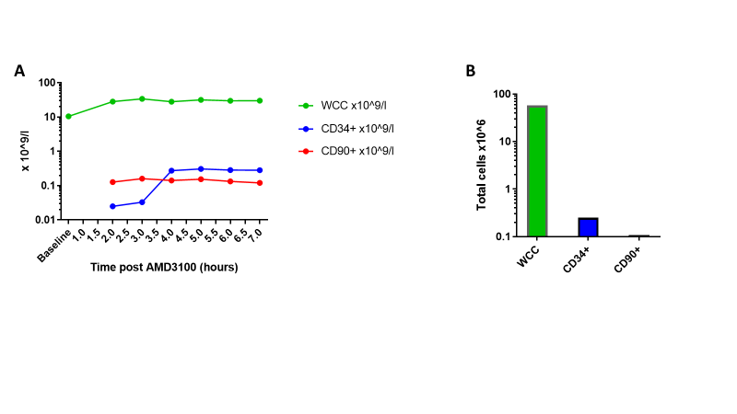
Figure 10.1: Successful first AMD3100 mobilisation but failed apheresis in a NHP
AMD3100 was administered to a NHP at a dose of 1mg/kg SQ, after documenting baseline WCC. (A) Serial measurements of PB WCC (by CBC analysis), CD34⁺ and CD90⁺ cell concentration (by addition of flow cytometric analysis) were recorded, demonstrating good HSPC mobilisation into the PB. (B) Despite good mobilisation, apheresis failed to collect adequate HSPCs. The total number of WBCs, CD34⁺ and CD90⁺ cells within the apheresis product are shown.
Abbreviations: CBC: complete blood count, CD: cluster of differentiation, HSPCs: haematopoietic stem and progenitor cells, NHP: non-human primate, PB: peripheral blood, WBCs: white blood cells, WCC: white cell count.
10.1.2 Modification of apheresis protocol to account for small size of NHPs
The first step taken in the process of modifying the NHP apheresis protocol was consultation with the clinical paediatric haematology apheresis and transplant team at the Seattle Children’s Hospital, in order to learn from their experience of managing apheresis in very small children (<10kg). The size of the rhesus macaques was a major problem with establishing effective apheresis, mirroring the challenges associated with apheresis in small children in the clinical setting.³⁷⁸ Information and advice from Michelle Flores, professional practice manager for apheresis, and Professor Lininberger, both of Seattle Cancer Care Alliance Cellular Therapy team, is acknowledged with thanks.
Anecdotally, some primate research centres avoid apheresing their smaller animals, with weight cut-off of 6.5kg, for example, set by the Oregon Health and Science University IACUC. However, for genome edited transplant studies, the larger animals were less suitable, since they required large volumes of supportive transfusions peri-transplant which could not be supplied by the limited number of donors, who themselves may also be smaller than the transplanted animal. Also, with the larger animals, the cost of enrichment and genome editing reagents would be greater. For these reasons, it was important to be able to collect HSPCs by apheresis in the smaller animals if at all possible.
As well as learning from the experience of the paediatric clinical team, available literature on apheresis in small children was reviewed as well as and the few papers available on apheresis in NHPs. Following these information-gathering steps, the following changes were instituted:
10.1.3 Switch from intermittent to continuous MNC collection
A switch from intermittent to continuous MNC collection was instituted. This altered method involves blood continuously being taken from the patient / animal, undergoing separation within the apheresis equipment, following which the non-MNC fraction is returned. The benefits are: more effective MNC separation in a shorter space of time, reducing the time on the machine; and a lower incidence of clots within the tubing, which cause interruption to blood flow.^{379; 380} The reduced time on the apheresis machine was particularly key, since the reported experience of the primate team was that the longer an animal was on the machine, the more concerns they had about his/her health during the apheresis procedure and immediately afterwards. They were continuously monitoring the animals during apheresis and found that at around 4 hours post start of apheresis, the serum creatinine started to increase, indicative of impending renal damage.
Continuous MNC collection required an alternative software package for the Spectra Optia apheresis machine, was installed by the manufacturer’s representative. A different type of tubing was also required: continuous collection requires a wider-bore tubing set and, the downside to which is that the extracorporeal blood volume at any one time during the procedure is greater. This is in contrast to the intermittent collection procedure, in which a certain volume of blood is taken out, processed, and the non-MNC fraction returned in one cycle, followed by repeated similar cycles. For intermittent collection, a single lumen tube is adequate since blood is only flowing in one direction at once. Although some increase in extracorporeal volume was inevitable on switching from intermittent to continuous collection, it was important that the smallest functional tubing sets were selected. This was to avoid too large a proportion of the animal’s circulating blood volume being within the apheresis circuit at any one time, in order to prevent cardiovascular instability or the need to prime the circuit with large volumes of donor blood. The apheresis team at the Seattle Children’s Hospital kindly provided a small number of such small, continuous collection tubing sets for our use during this optimisation process.
10.1.4 Reduction of platelet clumping and coagulation within apheresis circuits
There were problems with platelet clumping and small clots forming within the tubing (reported as a particular error message by the Spectra Optia). Therefore, additional methods to improve flow within the machine were investigated. Alongside implementation of continuous rather than intermittent collection, data was also collated on best practice from clinical colleagues. Anticoagulation within the apheresis circuit was already used as standard in order to prevent clot formation within tubing, but current protocol required optimisation. The anticoagulation protocol in use during apheresis was refined, incorporating the clinical procedures employed for infants and young children at the Seattle Children’s Hospital, and making appropriate modifications prior to application to our NHP population.
The concentration of ACD-A was increased, and heparin added, to improve anticoagulation of blood within the apheresis system. Where platelet clumping was reported by the machine, additional unfractionated heparin was added. Prior to implementation of this change, IACUC approval of modified guidelines was confirmed.
Consideration was given to the potential complications of increasing anticoagulant exposure, which would primarily be increased risk of traumatic or spontaneous bleeding events. In order to mitigate the risk of bleeding on catheter insertion, it was recommended that surgical strategies used to insert and remove catheters should be designed to minimise bleeding risk (in particular, use of the Seldinger technique rather than open access).
A discussion took place as to the feasibility of inserting and removing catheters at timepoints removed from the apheresis procedure itself, in order to reduce bleeding risk by avoiding anticoagulation administration within temporal proximity to line insertion or removal. However, it was concluded that the risks of prolongating sedation or, alternatively, planning additional episodes of sedation, to facilitate this, would outweigh the benefits, particularly because the levels of systemic anticoagulation were anticipated to be minimal. Veterinary staff were confident that with cautious surgical approach and close monitoring for early treatment of any bleeding, significant bleeding complications would be unlikely, despite increased anticoagulation. Protamine sulphate was made available for emergency use if required, as this reverses the anticoagulant effect of unfractionated heparin, and cautery was also available for the treatment of local bleeding complications.
10.1.5 Successful apheresis following modifications to protocol and equipment
The updated University of Washington Primate Center apheresis protocol with optimised anticoagulant procedures was formalised based on these modifications. Following institution of these revisions, apheresis within the NHP colony proceeded successfully. For example, a further NHP underwent successful apheresis following AMD3100 mobilisation. A total of 19x10⁶ CD34⁺ cells were collected, which included 7.6x10⁶ CD90⁺ cells. The animal weighed 6.6kg therefore 2.9x10⁶ CD34⁺ cells / kg were collected.

