**Modelling and control approaches for a continuous powder to tablet manufacturing process**



**D. Monaco**

A dissertation submitted in fulfilment of the requirements

for a PhD degree

2022

**Modelling and control approaches for a continuous powder to tablet manufacturing process**



**Daniele Monaco**

Department of Chemical and Biological Engineering

The University of Sheffield

A dissertation submitted in fulfilment of the requirements

for a PhD degree

September 2022

Nomenclature xiii

Equation symbols xiii

Acknowledgements xvi

1. Abstract 1

1. Introduction 2

2. Current state of literature 5

Continuous manufacturing in pharma 5

Consigma 25 7

Line stability 8

Twin screw granulator 10

Fluidised Bed dryer 16

Tabletting 19

Modelling 20

DEM 20

Population balance modelling 21

Tablet compaction models 23

Flowsheet models 23

Control in pharmaceutical manufacturing 24

3. Project objectives 26

4. Materials 27

Effect of L/S ratio on drying behaviour 27

Effect of L/S ratio and granule moisture content on tabletting behaviour 28

5. Method 28

Experimental 28

NIR calibration 28

Granule porosity 28

Effect of L/S on drying behaviour 29

Common methodology 29

L/S variation method 29

Cell load behaviour 30

Variation detection 30

Effect of L/S ratio and granule moisture content on tabletting behaviour 30

Dissolution testing 32

Modelling 32

gProms Formulated Products 32

Drying 33

Tabletting 34

Model predictive control models 34

6. Effect of twin screw parameters on drying behaviour 36

Effect of changed L/S 36

Varied throughput constant cell loading 41

Variation detection 44

End of drying detection 46

Drying time correlation 47

Control method 49

Chapter conclusions 53

7. Effect of L/S ratio and granule moisture content on tabletting behaviour 55

Effect of Moisture content 55

Effect of L/S ratio 62

Effect on compressibility and compactability 64

Model implementation 68

Dissolution time modelling 73

Chapter conclusions 76

8. Use of flowsheet models to develop and test control methods 78

PI controller simulations 78

Feed forward control loops 86

Model predictive control 90

Chapter Conclusion 99

9. Literature comparison 101

10. Conclusion 104

11. Future work 107

12. Appendix 110

NIR calibration curves 110

13. Publications 111

14. References 112

Figure 1 Diagram showing batch and continuous manufacturing 2

Figure 2 Block diagram overview of the 3 most common tablet manufacturing routes 5

Figure 3 Block diagram of a Consigma-25 continuous powder to tablet line 7

Figure 4 a)Granulator torque, b)granulator jacket inlet temperature, c)filter pressure and d) mill temperature trends over time [12] 9

Figure 5 a) Tablet mass b) Tablet hardness stability over time [12] 9

Figure 6 Moisture content values over a 1 hour run, C25/n Consigma-25 single run results, C1/n Consigma-1 single run results 10

Figure 7 Twin screw granulator parameter effect on drug release rate. minutes (Numb: number of kneading elements, T: granulator barrel T, Bind: binder addition wet, Thr: throughput, Scr: screw speed, Angle: stagger angle. [16] 11

Figure 8 Effect of twin screw parameter on fines and oversized percentages. minutes (Numb: number of kneading elements, T: granulator barrel T, Bind: binder addition wet, Thr: throughput, Scr: screw speed, Angle: stagger angle. 11

Figure 9 Granule sieve fraction for different screw configuration (CE: conveying only, 6K: 6 Kneading elements, SME: short mixing element) [17] 12

Figure 10 Twin screw regime map showing the relationship between L/S, specific mechanical energy and particle size [19] 13

Figure 11 Sieve fraction of granules produced at different L/S ratio for two different formulations [20] 14

Figure 12 Effects of twin screw parameters and material properties on percentage of fines and oversized granules [21] 15

Figure 13 PSD of particles before and after the wetting zone in a twin screw granulator. A) Low L/S hydrophilic blend, B) High L/S hydrophilic blend, C) Low L/S hydrophobic blend and D) High L/S hydrophobic blend [22] 16

Figure 14 Comparison of moisture content recorded using NIR and calculated via mass balance (MBM) [36] 17

Figure 15Yields for different drying times at different conditions drying condition A T: 40°C Air flow:360m3/hr, B T:60°C Air flow:360m3/hr, C T: 40°C Air flow: 440m3/hr, D T:60°C Air flow:440m3/hr, the 0s fraction represent the size of the granules at the twin screw outlet [37] 18

Figure 16 Effect of Granule bulk density and granule moisture content on tablet hardness [40] 20

Figure 17 Granule PSD validation at 3 twin screw speed R8: 100 rpm, R10 150rpm R11: 170rpm [61] 22

Figure 18 PSD of granules produced at different L/S ratios. (Size scale logarithmic) 27

Figure 19 Drying temperature profile at different L/S ratios 38

Figure 20 Moisture content and temperature profiles during filling and drying at different L/S ratios 39

Figure 21 Product presence reading during filling and drying at different L/S ratios 40

Figure 22 Model and experimental moisture content values during filling and drying at different L/S ratios 41

Figure 23 Moisture content measurements during filling and drying at different powder throughputs 42

Figure 24 Model and experimental moisture content values during filling and drying at powder throughputs 43

Figure 25 Moisture content and liquid mass flow values during filling and drying 44

Figure 26 Model moisture content and liquid flow values during filling and drying 45

Figure 27 Temperature profile during filling and drying at L/S 0.35 and its derivative 47

Figure 28 Drying time relationship to the amount of water used during granulation in a cell 48

Figure 29 Model output moisture content and liquid mass flowrate over time 50

Figure 30 Drying time and total granulation water relationships for different moisture content targets 51

Figure 31 Model output moisture contents over time at 3 different controlled targets 52

Figure 32 Relationship between compression force and tensile strength for granules produced at a 0.22 L/S ratio at different moisture content 57

Figure 33 Relationship between compression force and tensile strength for granules produced at a 0.3 L/S ratio at different moisture content 58

Figure 34 Relationship between compression force and tensile strength for granules produced at a 0.4 L/S ratio at different moisture content 59

Figure 35 Relationship between compression force and porosity for granules produced at a 0.22 L/S ratio at different moisture content 60

Figure 36 Relationship between compression force and porosity for granules produced at a 0.3 L/S ratio at different moisture content 60

Figure 37 Relationship between compression force and porosity for granules produced at a 0.4 L/S ratio at different moisture content 61

Figure 38 Relationship between compression force and tensile strength for granules produced at different L/S ratio and equivalent granule moisture content 62

Figure 39 Relationship between compression force and porosity for granules produced at different L/S ratio and equivalent granule moisture content 63

Figure 40 Graph showing the compactability for all experiments performed. 65

Figure 41 Figure showcasing compressibility results for all tested conditions 66

Figure 42 Compressibility constant and P0 relationship to moisture content at different L/S ratios (L/S 0.22 black, L/S 0.3 Red, L/S 0.4 blue) 67

Figure 43 Relationship between L/S ratio and granule porosity 69

Figure 44 Relationship between granule porosity and P0 69

Figure 45 Compressibility relationship to moisture content and granule porosity. Plane shows the fit. 70

Figure 46 Tensile strength parity results comparing experimental and plane model 71

Figure 47 Tensile strength parity results for experimental and single L/S fit model 72

Figure 48 Different modelling approaches RMSE for each condition tested 73

Figure 49 Normalised conductivity over time during dissolution test of tablets made at different compression forces 74

Figure 50 Effect of the tablet porosity on the dissolution time of tablets made at different L/S ratio 75

Figure 51 Effect of different proportional gain value in a PI controller. (reset time 10s, control time 5s) 79

Figure 52 Effect of different proportional gain value in a PI controller. (reset time 5s, control time 5s) 81

Figure 53 Effect of different proportional gain value in a PI controller. (reset time 20s, control time 5s) 81

Figure 54 Effect of different proportional gain value in a PI controller. (reset time 10s, control time 1s) 83

Figure 55 Effect of different proportional gain value in a PI controller. (reset time 10s, control time 10s) 83

Figure 56 Controlled and non-controlled tablet tensile strength at a high frequency liquid flow rate variability 84

Figure 57 Controlled and non-controlled tablet tensile strength at a medium frequency liquid flow rate variability 85

Figure 58 Controlled and non-controlled tablet tensile strength at a low frequency liquid flow rate variability 86

Figure 59 Simulated granule moisture content and tablet tensile strength over time showing the effect of the drying time being changed from 900s to 550s 87

Figure 60 Simulated granule moisture content and controlled tabletting compaction force over time showing the effect of the drying time being changed from 900s to 550s 89

Figure 61 Tablet tensile strength over time when controlled by a zero and first order feed forward as the drying time was changed from 900s to 550s 90

Figure 62 Compaction force, moisture content and L/S ratio step testing results on tablet tensile strength 94

Figure 63 ARX model tensile strength prediction over time 96

Figure 64 MPC set point test for dissolution time and tensile strength 97

Figure 65 Moisture content PRBS and controlled compaction force 98

Figure 66 Controlled tensile strength and dissolution time during PRBS moisture content testing 99

Figure 67 Moisture probe calibration curve for MCC-Lactose blend 110

Figure 68 Moisture probe calibration curve for MCC-Mannitol blend 111

# Nomenclature

* ARX Auto Regressive eXogenous model.
* d25, d50, d75 Diameter at which 25, 50 and 75% of granules are below the diameter.
* DEM Discrete element model.
* Drying cell A single segmented part of the segmented fluidised bed dryer.
* HPC Hydroxypropyl cellulose.
* L/S ratio Liquid to solid ratio.
* LOD Loss on drying.
* MCC Micro crystalline cellulose.
* MPC Model predictive control.
* NIR Near infra-red.
* PAT Process analytical tools.
* PBM Population balance model.
* PID Proportional integral derivative.
* PRBS Pseudo random binary sequence.
* QbC Quality by control.
* QbD Quality by design.
* RMSE Root mean squared error.
* WBC Water binding capacity.

# Equation symbols

* $η$ Normalised moisture content.
* ${\dot{M}}_{}$ Mass flow between phases.
* $\overline{T}$ Tensile strength at zero porosity.
* $A_{ps}$ Particle surface area.
* $T_{p}$ Particle temperature.
* $Y_{S}$ Suspension gas moisture content.
* $Y_{eq}$ Equilibrium moisture.
* $β_{}$ Mass transfer coefficient.
* $ζ$ Normalised bed height.
* $θ_{p}$ Feed forward control dead time.
* $\dot{ν}$ Normalised drying rate.
* $ρ_{g}$ Gas density.
* $τ_{p}$ Time constant.
* b Bubble gas phase.
* D Tablet diameter.
* e Error from set point.
* F Tablet breaking force.
* g Gas phase.
* H Tablet height.
* Hcap Convex cap height.
* *i*  ARX input value.
* kb Bonding capacity.
* Kc Proportional gain.
* KP Feed forward steady state gain.
* kt Compressibility constant.
* n Number of time steps.
* nk ARX dead time.
* P Applied pressure.
* P0 Pressure at 0 porosity.
* s Suspension gas phase.
* T Tablet tensile strength.
* *t* Time.
* *u* Feed forward observed value.
* *v* Controller output.
* *v*bias Controller bias.
* Y Feed forward control output value.
* ε Final tablet porosity.
* τI Integral time constant.
* $X$ Moisture content.
* $n$ Population fraction.
* $p$ Particle phase.
* $σ$ Tablet tensile strength.
* $τ$ Residence time.
* $υ$ Gas fraction in the bubble flow

# Acknowledgements

I would like to express my gratitude to my primary supervisor Prof. Agba Salman for his guidance and support during the project. I would also like to thank my other supervisors Prof. Jim Litster, Prof. Gavin Reynolds and Dr. Pirjo Tajarobi for their support and insightful comments throughout our meetings during my research journey.

I would also like to say a special thanks to my family and friends for always being by my side, believing in me and helping me to relax and have fun while continuing to work on my project I couldn’t have done it without you.

Finally, I would like to thank all the staff at the University of Sheffield for their help through the years. A special thanks goes to Dr. Chalak Omar, Mark Jones and Simon Canham for their help with dealing with the Consigma-25 and its temperamental behaviour.

# Abstract

The pharmaceutical industry is moving towards continuous manufacturing to improve efficiency, reduce waste and improve product quality. Tablets are the most common form of pharmaceutical products and is therefore important to understand their continuous manufacturing. A Consigma-25 powder to tablet line via wet granulation was used as is a good example of a continuous production line.

The impact of the granulation parameters such as the L/S ratio and filling times on the behaviour of the granules throughout the drying process was investigated. The water mass was found to be the only driver of the drying time required to reach a specific moisture content when the drying conditions were kept constant.

The impact of both the granule moisture content after drying and L/S ratio on the granule compression properties and final tablet properties was investigated. The compactability of the granules remained unchanged while the compressibility was affected by both variables. Both an increase in L/S ratio and moisture content lead to denser and stronger tablets. The dissolution time of the tablets was found to be a function of the tablet porosity with the value increasing exponentially as the porosity got closer to 0.

The data obtained was used to fit flowsheet models for both the drying and compaction processes. The models performed well and were used to develop, tune and test different control methods. A feed forward control loop that maintained the output granule moisture content after the dryer by varying the drying time performed well when tested with random liquid flow variability. Feedback, feed forward and model predictive controllers to control the tablet properties were developed and tested. The controllers worked well showcasing the importance of control during continuous manufacturing and the advantages of models during the development process.

# Introduction

In the past 20 years the pharmaceutical industry has been moving from its traditional batch production practises towards continuous manufacturing. Continuous production has been widely adopted by other industries (e.g., Chemical, Food) for many years but has not yet been widely adopted by the pharmaceutical industry due to regulatory challenges and the relatively larger profit margins compared to other industries. In 2004 a new regulatory guideline from the FDA[1] started the transition and implementation of continuous processes in pharmaceutical manufacturing. The guideline has also pushed the pharmaceutical industry to start implementing a quality by design (QbD) approach to manufacturing, moving away from the traditional quality by testing process [2]. QdB requires to understand the process and how is impacted by variables more deeply and aims to reduce trial and error during the development process and reduce waste during production. The market has also been changing with an increase competition in the sector and a decline in the frequency of new blockbuster drug being developed reducing the profit margins and increasing the pressure on the industry to improve its manufacturing processes [3]. Shown in Figure 1 is the difference between batch and continuous manufacturing, in batch manufacturing all the steps (with loading, processing and discharge) are discrete while in continuous processes the steps all occur at the same time with this difference leading to the advantages of continuous manufacturing.

Figure Diagram showing batch and continuous manufacturing

The main advantages of the continuous approach are:

* Diminished waste, as it allows to divert only the out of specification material to waste or to recycle instead of a whole production batch which can be up to a few hundred kilograms in size depending on the process and manufacturing scale.
* Increased in production flexibility allowing to produce more or less product with the same facility by varying the production time, this allows to easily react to changes in demand, improving stock sizes requirement and reducing waste [4]. Another advantage of the ease of changing scale is that the final manufacturing and clinical trial production can be handled by the same equipment reducing the development time and cost. Continuous manufacturing also tends to be a lot faster, from raw materials to final product, as the residence time is usually measured in minutes instead of hours or days for batch processes.
* Increased automation compared to its batch counterpart, as the units are connected to each other leading to a reduction in the number of employees required and faster production times as transfer and wait times are minimised, this can also improve safety minimising exposure to powders and raw active ingredients [5].
* Smaller facilities required for the same production throughput as continuous production facilities tend to take about 1/3 of the space of a comparable batch plant, this allows a smaller investment in the physical space used for production and allows for higher flexibility in location.

All these advantages paint a very good picture for continuous manufacturing, but it also comes with some challenges. To successfully implement it in the pharmaceutical industry the main challenges are:

* A need for more understanding in how continuous equipment parameters affect both the final product qualities but also the interaction with the other units present in the process and how to optimise the conditions throughout the production line.
* To develop new models for the continuous processes to aid both during development by reducing material requirements and throughout production by providing extra information that can be used for monitoring or control.
* To integrate online measurement and models to create process analytical tools (PAT) [6] which can be used for the development of control systems to minimise variation during production despite variability in environmental conditions and noise such as refilling operations and for online quality assurance allowing a reduction or removal of expensive offline testing procedures [7].
* Another challenge for the industry to move to continuous manufacturing is the slow implementation of new regulations to account for continuous manufacturing processes and control methods and allow to fully leverage the advantages as current good manufacturing process guidelines mostly relay on testing after manufacturing. This has been evolving in the past years and is important that academia, industry and the regulatory bodies work together.
* Lastly continuous manufacturing equipment is still developing and relatively expensive compared to more traditional batch manufacturing equipment which can be a barrier for smaller or newer companies.

In the past few years both academic institutions and industry have been working towards tackling these challenges to aid the transition of pharmaceutical manufacturing from batch to continuous and reduce waste and development time.

# Current state of literature

## Continuous manufacturing in pharma

Liquid, sprays, and creams are all forms that pharmaceutical product can be found in, but by far the most common forms are solid like tablets, capsules and granules which are also referred as solid dosage form. Solid forms are usually more stable, easier to produce and transport, can be readily made into single doses to reduce user error and tend to be easily self-administered [8]. Of all solid products tablets are the most common due to their versatility allowing a wide range in weight and potency and ease of use. 3 main routes are usually taken to produce tablets depending on the formulation properties and company expertise. These are direct compression, dry granulation and wet granulation and are shown in Figure 2.

Figure Block diagram overview of the 3 most common tablet manufacturing routes

Direct compression is the least complex of the approaches and the production line is usually composed by feeders, blenders and a tabletting press. Multiple blending and feeding steps are sometimes present as some materials in the final formulation might require vastly different mixing times (e.g. overmixing solid lubricant can lead to weak tablets). Direct compression processes can have very high throughput and their simplicity makes them easier and cheaper to operate and are becoming the preferred method of production for tablets [9]. Unfortunately, not all formulations are compatible with direct compression as a particular set of physical properties for the blend are required [10]. The flowability of the blend must be good enough to not cause problems during die filling. Poor flowability would cause uneven filling of the die cavity causing a high weight variability in the final process, this problem is exacerbated at high throughput where the time for the formulation to fill the die is minimal. Low bulk density can also be an issue as if is too low it can be physically impossible to reach the required target weight. Segregation of the different blend components can also be a problem causing variability in the product composition. Some materials also might not compress well enough to achieve the required tablet strength even when high compression forces are used. If any of these problems are present in the blend a granulation step is required to improve the characteristics of the blend once it reaches the tabletting step [11].

Granulation is a size enlargement process that is used to aggregate powders into bigger entities called granules. Granules often have more desirable physical properties such as increased flowability, bulk density and a decrease in segregation as the different component of the powder blend are bonded together and can’t separate due to movement. Granulation is therefore often used before a tabletting step if the powder blend has problematic properties. As shown in Figure 2 two granulation routes are used, dry and wet granulation. As the name implies dry granulation doesn’t use any additional liquid binder to form the granules. Roller compaction is the most utilised method for dry granulation. During roller compaction the powder is forced between the gap of two rollers which apply pressure. A solid ribbon is formed which then falls into a mill where is crushed to for the final granules. Both the milling and rollers parameter affect the granule properties. As no liquid is added through the process no further drying of the material is required making this route less complex compared to wet granulation.

During wet granulation processes liquid is added to aid the binding of the powder particles to each other and form granules. For continuous manufacturing processes, a twin screw granulator is often used as is intrinsically continuous. Two corotating screw are located inside a barrel, powder is added at the beginning of the barrel and the liquid is added a short distance along the screw. The rotating screw push the material along and apply the force required to form granules. A drying step is required as the liquid added to aid the granule formation needs to be removed before the granules can be further processed. In the pharmaceutical industry this step is often performed using a fluidised bed drier as they are efficient, can work at relatively low temperatures and can be made to handle different production scales.

Each of the three routes shown in Figure 2 can be continuous if the various units that compose the process are continuous. The work presented in this thesis focuses on the wet granulation and tabletting route.

## Consigma 25

The Consigma-25 has been the one of the most widely adopted pieces of equipment for continuous processing of pharmaceutical powders in to tablets and is composed of 6 main elements as shown in Figure 3. A twin-screw granulator, a segmented fluidised bed dryer, a cone mill, 2 blenders and a tabletting press. The powder is fed into the granulator and granulation liquid is added along the screws to produce granules, the wet granules are then fed in to in one of the 6 segments (cell) of the dryer for a set time before the flow of granules is directed to the next cell while the fully loaded cell continues to dry until it is unloaded and goes to the milling process. The conical screen mill has an interchangeable mesh which size determines the maximum granule size, and the mill aims to reduce oversized granules and improve consistency during the tabletting die filling process. The granules are then transported to two consecutive blenders. Both blenders are helical ribbon blenders, have loss in weight feeder attached to them and are used to add extra granular ingredients which tend to be either moisture or heat sensitive and solid lubricant respectively. After the lubrication step the granules reach the tablet press where they are compressed into tablets.

Figure Block diagram of a Consigma-25 continuous powder to tablet line

When considered in its entirety the process is continuous but between the dryer and the output of the second blender the process uses small batches that move from one unit to the other once each operation is completed. At maximum throughput the Consigma-25 can process 25 kg/hr of powder in to finished tablets. The line was used to produce the first commercially available drug based on a continuous production (Prezista) and has since gained more popularity in the industry. As research in continuous manufacturing has intensified in the past few years the Consigma-25 has been one of the focal equipment for wet granulation processes. Research has been mostly focused on the twin screw granulator, dryer, on the stability of the line and the final tablet properties.

## Line stability

Continuous process might have to run for multiple days uninterrupted so their stability over time is a really important characteristic [12]. Vercruysse et al (2013) looked at the stability of the Consigma-25 line by performing 5 hours continuous runs three times. In Figure 4 the values over time of the granulator torque, pressure drop over the dryer filter, temperature of the granulator jacket and temperature of the mill screen are shown. All but the pressure drop reach a steady state by the end of the 5 hours experiment although at different rates, the pressure drop continues to increase as more and more of the fine powders in the dryer accumulate on the filters.

Figure 5 shows the tablet weight and tensile strength over time, both are stable with the tensile strength showing a wider variability in each test.

The stability of the drying and the results of single cell runs were compared to the lab scale Consigma-1 in a different study [13]. The moisture content of the granules after drying over time and in the single cell runs is shown in Figure 6 and shows good stability. The single cell experiments from both equipment are also comparable with the long run results.

As the line provides a vast amount of information and tends to be stable, models which could detect diminishing performance or problem during running were developed [14]. In the study the clogging of a filter in a cell was automatically detected by a control system.

Figure a)Granulator torque, b)granulator jacket inlet temperature, c)filter pressure and d) mill temperature trends over time [12]

Figure a) Tablet mass b) Tablet hardness stability over time [12]

The flexibility of being able to run short term experiments which closely resemble longer runs results and the ability of using the vast amount of data provided by the sensor during running showcases the potential advantages of continuous manufacturing.

The process robustness of a similar twin screw and fluidised bed continuous tabletting line was tested by varying granulation parameter and monitoring the granule moisture content and tablet properties [15]. Overall, the process was found to be robust and managed to produce tablet with satisfying properties regardless of the different granulation parameter changes.

Figure Moisture content values over a 1 hour run, C25/n Consigma-25 single run results, C1/n Consigma-1 single run results

## Twin screw granulator

The twin screw granulator on the Consigma-25 has had a lot of attention with studies looking at the effect of the different parameters both on the granule properties and on the final tablet properties. Liquid to solid ratio (L/S ratio), powder throughput, screw speed, screw configuration alongside powder properties have been the focus of most studies.

The screws of a twin screw granulator are modular, and the type and order of the elements used to form the screw determine the overall configuration and behaviour of the material inside the granulator barrel. A few studies looked at the effect of the screw elements in the Consigma-25. The effect of the different granulator parameters and screw configurations on the dissolution properties of a tablet is shown in Figure 7. The number of kneading elements has the biggest A screenshot of a cell phone
effect decreasing the amount of drug released after 45 minutes while both the angle and throughput have a smaller effect [16]. This change is due to the increase in kneading elements causing further densification of the produced granules and similar result were reported by another study looking at the kneading elements showing a decrease in porosity of the granules as more kneading elements are present in the screw configuration.

Figure Twin screw granulator parameter effect on drug release rate. minutes (Numb: number of kneading elements, T: granulator barrel T, Bind: binder addition wet, Thr: throughput, Scr: screw speed, Angle: stagger angle. [16]

The screw configuration also affects the granule size distribution with the number of kneading elements reducing the fines amount while increasing the oversized fraction as shown in Figure 8.

Figure Effect of twin screw parameter on fines and oversized percentages. minutes (Numb: number of kneading elements, T: granulator barrel T, Bind: binder addition wet, Thr: throughput, Scr: screw speed, Angle: stagger angle.

In Figure 9 similar results are shown for different screw configuration with different number of kneading elements and short mixing elements with the addition of kneading elements particularly affecting the extremities of the range while the fraction between 250-500µm was mostly impacted by the presence of short mixing elements [17]. Short mixing elements showed a similar result when they were used to replace kneading elements in a Consigma 25 leading to a decrease in d50 and less oversized granules [18].

The effect of varying L/S in the Consigma 25 granulator has also been reported in multiple studies. A higher L/S ratio has been shown to usually produce larger granules. Figure 10 shows this effect using a regime map with the 3 selected properties (d25, d50 and d75) all increasing as the L/S ratio was increased [19]. Similar results are shown for different formulation in Figure 11 with an increase in oversized granules with a corresponding decrease in fines [20]. Figure 12 compares the effect of different parameters in the granulator on particle size highlighting again the importance of L/S ratio [21].

Figure Granule sieve fraction for different screw configuration (CE: conveying only, 6K: 6 Kneading elements, SME: short mixing element) [17]

A higher L/S ratio improves the wetting of the primary powder blend which is the main reason for the reduction in fines. The growth behaviour of the granules along the granulator length was reported by a study highlighting the effect of the L/S ratio and wetting on the amount of fines [22]. Figure 13 shows the behaviour of the two tested blends during wetting, highlighting how the increase in L/S ratio leads to a monomodal distribution due to a smaller percentage of the starting blend remaining non wetted. The effect seems to be more pronounced in the hydrophobic blend and helps to explain other literature results which showed a more monomodal distribution at higher L/S ratios [23].

Figure Twin screw regime map showing the relationship between L/S, specific mechanical energy and particle size [19]

When compared to the traditional batch high shear granulation it was found that a lower L/S ratio was required to produce granules with comparable properties using twin screw granulation which can be advantageous as less time and energy would be required to dry the granules produced [24].

The porosity of the granules was also found to be affected by a change in L/S ratio. An increase in the ratio produced lower porosity granules which is most likely due to the increase in deformability due to wetting leading the granules to be further compacted throughout the process [25].

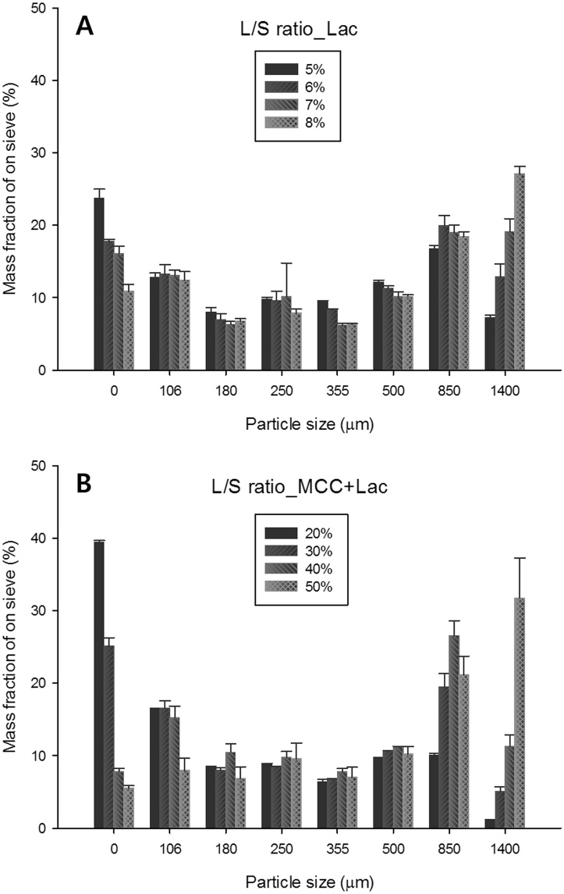

L/S

5%

L/S

6%

L/S

7%

L/S

8%

L/S

20%

L/S

30%

L/S

40%

L/S

50%

Figure Sieve fraction of granules produced at different L/S ratio for two different formulations [20]

Screw speed is related to both the residence time distribution of the materials inside the granulator and the energy applied to the granules during processing but its reported effect on the granule properties has shown to be limited especially when compared to the L/S ratio and the screw configuration. The effect was found to be higher when either no kneading elements were present or at low L/S ratios [26]. In these conditions more fines were produced as the screw speed was increased. The effect of the screw speed in relation to the powder throughput was also tested with a more sizeable decrease in size as the screw speed was increased at higher powder feed rates. The effect of the screw speed seems smaller and influenced by other factors during granulation making it harder to fully pinpoint.

Different materials and their behaviour during granulation and effect on granule and tablet properties have also been a focus of the studies utilising the Consigma-25. The effect on granule and tablet properties of different HPMC concentrations and grades was tested [27]. The wetting capacity of different HPMC grades affected the granule size while the viscosity of the binder solution had a smaller effect. This behaviour is opposite to the one reported in high shear granulation and likely due to the much shorter residence time of the materials in twin screw granulation. The viscosity did affect the tablet performance especially at higher HPMC concentration due to the increased plastic deformation capacity.

Figure Effects of twin screw parameters and material properties on percentage of fines and oversized granules [21]

The effect of variability in the supply chain was also tested using MCC from different sources [21], The water binding capacity (WBC) of the different material batches was found to be particularly important. Higher WBC required a higher L/S to produce comparable size granules. Shown in Figure 12 the effect of WBC on the fine and oversized fraction is comparable to some other important factor such as throughput and screw configuration but remains lower than the amount of liquid used but highlights the importance of understanding which material properties affect the process. The effect of over 70 parameters from material database were combined into a scoring system which consisted of 4 categories by Stauffer et al [28]. The flowability score of the material was found to be the most related to the percentage 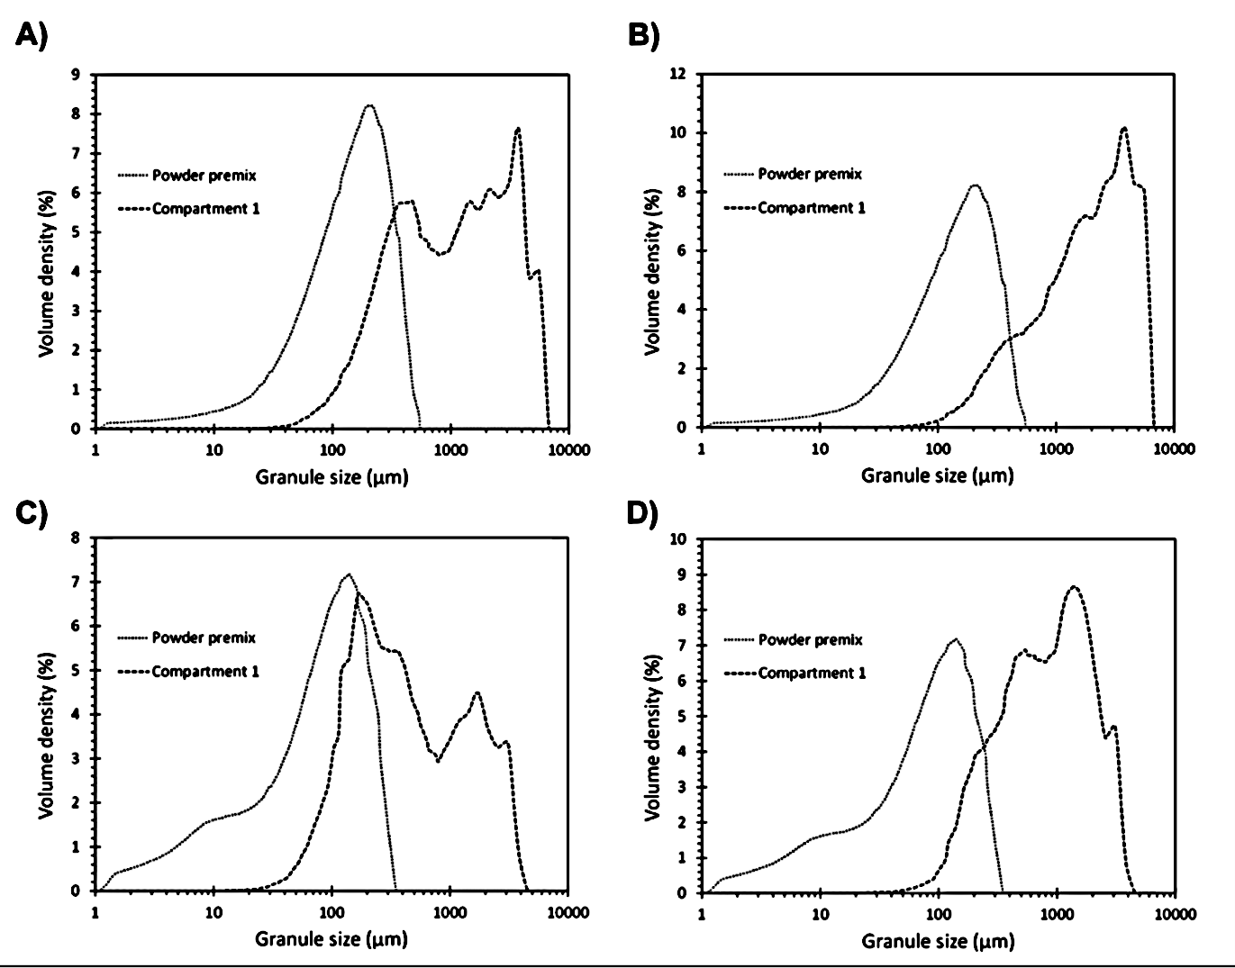of fines and oversized granules.

Figure PSD of particles before and after the wetting zone in a twin screw granulator. A) Low L/S hydrophilic blend, B) High L/S hydrophilic blend, C) Low L/S hydrophobic blend and D) High L/S hydrophobic blend [22]

Overall, the results reported using the Consigma 25 twin screw granulator agree with the wider twin-screw literature with the L/S ratio being the parameter with the larger effect on the granules properties. The study of the effect of the granulation parameter mostly focused on the granule properties while only a smaller part of the studies focused on the effects further down the process.

## Fluidised Bed dryer

The segmented design and continuous feed of granules coming in to the Consigma-25 dryer make it an unconventional fluidised bed dryer. Although unconventional in some ways the main drying mechanics remain the same allowing to transfer the knowledge developed on batch fluidised bed dryers. A wide variety of industries use fluidised bed drying to process a wide variety of material. Despite the variety of material and equipment size the finding tend to agree across different industries. An increase in drying air temperature increases the energy available for drying causing an increase in drying rate. The drying rate is also increased by an increase in airflow as more air is available for mass and heat transfer. The last important parameter is the particle size of the material with smaller particles increasing the drying rate as the surface area per unit mass is increased allowing more heat and mass transfer to occur [29]. These effects have been modelled to different degrees of complexity and required assumptions. The research on the Consigma-25 dryer touches some of this topic and looks at how the segmented design can influence the drying behaviour and granule properties. The effect of the main parameters (Air temperature, air flow) was tested in the Consigma dryer showing agreement with the batch literature. Two studies focused on developing empirical mass and energy balances [30,31]. Using the data from the equipment the amount of water evaporated and drying rates were calculated. The moisture content was predicted over time using the mass balances. Mass and energy balances are very useful to monitor a process and easy to compute but don’t provide further information on the dynamics of the process. Mortier [32] explored using mechanistic models and attempted to validate a single droplet [33] model using the Consigma-25. The model required the fitting of only one parameter related to the diffusivity of the granules but did not account for different particle sizes. The effect of the size was A close up of a map
implemented by fitting different values of the diffusivity parameter for different size ranges [34].

Figure Comparison of moisture content recorded using NIR and calculated via mass balance (MBM) [36]

Near Infra Red (NIR) spectroscopy was used to measure the granule moisture content of the granules during the drying process. A NIR method was calibrated and further validated using Karl Fischer titration [35]. The method was the used in a further study[36] which compared the data measured using the NIR probe to the values calculated by a mass balance using the data, this comparison in shown in Figure 14 where the two methods seem to agree with each other although the NIR readings are only reported after the end of the cell filling time.

The effect of the granule transport in and out of the dryer combined with the drying conditions was studied [37]. The particle size was particularly affected when the granules were conveyed out of the dryer before the drying was completed. Shown in Figure 15 is possible to see how at all conditions the percentage of oversized decreased, and this effect was further increased at lower drying times with the effect levelling off after 100s. The thermal stresses that the granules were subjected during drying at different drying condition was also studied [38]. Harsher drying conditions caused higher stress to the granules as a steeper temperature gradient was applied to the granules. An increase in stress could cause a change in behaviour of the material downstream but was not tested by the study.

Figure Yields for different drying times at different conditions drying condition A T: 40°C Air flow:360m3/hr, B T:60°C Air flow:360m3/hr, C T: 40°C Air flow: 440m3/hr, D T:60°C Air flow:440m3/hr, the 0s fraction represent the size of the granules at the twin screw outlet [37]

Glatt produces a similar segmented dryer connected to a continuous twin screw granulator (GPCG2 CM) with the main two differences being the 10-segment design and the fact that the chamber rotates pushing the granules around the dryer for a complete rotation. The equipment performed well when tested and a mass and energy model was developed using the data provided by the probes [39]. The model performed well when compared to the results obtained from sampling after drying and could be used as a secondary control to make the process more robust.

Although the dryer has been a subject of multiple papers the drying behaviour of the system during the filling process of the cells has not been widely reported. This period is characterised by the simultaneous addition and removal of water through the system and is the main differentiator from a standard batch dryer where the loading is performed in advance. The effect of different conditions during filling on the drying behaviour has also not been as widely reported as the effect of the drying conditions.

## Tabletting

The effect of different conditions and materials on the tensile strength and compression behaviour of different materials has been reported experimentally. In general, an increase in the compaction force or pressure applied during the tabletting process leads to a decrease in the tablet porosity and increase in tensile strength with the magnitude of these changes being related to material used during compression. The effect of both L/S ratio during high shear granulation and moisture content on the tablet tensile strength made of an active ingredient and mannitol was reported [40]. As shown in Figure 16 an increase in moisture content led to an increase in tensile strength while an increase in the granule porosity after granulation lead to a reduction in strength. The effect of moisture on excipient with different deformation types was also reported [41] showcasing slightly different behaviour with an increase in moisture causing a different reduction in porosity depending on the material. Interestingly although showing a reduction in porosity the tensile strength of the tablet involving lactose which was used as an example of brittle material decreased as the moisture increased which is against the usually reported findings were an increase in moisture content up to a certain level causes an increase in tablet tensile strength [42–44]. The effect on the moisture not only on the final porosity and tensile strength but also on the compressibility (relationship between compression force and tablet porosity) and compactability(relationship between tablet porosity and tablet tensile strength) behaviour was also investigated by a number of studies covering different materials [45–47]. Overall, the moisture content seems to affect both the compactability and compressibility of the tested materials leading to a reduction in porosity at the same compaction pressure as the moisture content was increased and an increase in the tensile strength of tablets with the same porosity due to an increase in the particle-particle interaction strength. Although these effects have been reported the relationship between the changes in the compressibility and compactability caused by other parameters has not been widely quantified or modelled.

Figure Effect of Granule bulk density and granule moisture content on tablet hardness [40]

## Modelling

Modelling processes has become more and more important in all industries to improve performance and reduce cost of processes. Development and usage of models in the pharmaceutical industry has also been rising to aid at all stages of development and production. While some processes can be modelled using a set of simple equations more complex phenomena might require the use of other strategies. Two of the main approaches to deal with complex system in pharmaceutical industry are discrete element modelling (DEM) and population balance modelling (PBM)

### DEM

In DEM the position, rotation, velocity, and angular velocity are calculated for each element in the system using Newton’s laws of dynamic. Each entity is considered as a hard or soft spheres. Using hard spheres is the least complex approach where the collisions are instant and are only accounted between 2 particles [48]. The soft sphere approach adds the effect of deformation and particle-particle interaction and therefore requires more computational power. As DEM relies on physical principles it can be used for a wide range of applications and usually requires fewer or no empirical constants based on specific processes and materials [49]. DEM main drawback is speed and scale, as it has to calculate each particle properties for every time step making the time required scale with the number of particles in the system. If the system doesn’t comprise of many particles DEM can run quickly but in powder processes like granulation representing the real number of particles remains practically unfeasible [50]. The usual approach to tackle the large number of particles in powder processes is to increase the size of the particles so that fewer are needed to represent the real volume of the process. Even with some limitation DEM simulations have been used to simulate processes such as wet granulation, blending and tabletting.

DEM can be particularly useful to simulate processes such as the segregation of different size particles during blending as it simulates and tracks the position of each particle throughout the process [51]. The segregation effect caused by both density and particle size differences have been studied [52]. The studies found that bigger differences tend to produce less homogenous mixtures and were also capable to estimate when equilibrium was reached during mixing. Another use of DEM simulation in mixing is the ability of studying the effect of blender parameters and geometry over the 3d flow patterns in the blender which would be practically impossible to do experimentally. This can be extremely helpful to both design and operate mixing equipment [53–56].

DEM has also been used to simulate wet granulation processes with both high shear and twin screw granulation being studied [57,58]. The speed profiles of particles in a twin screw granulator barrel where simulated using DEM and compared to PIV results obtained using a camera and a see through barrel [59]. The experimental method can only provide 2d data while the simulations provide a 3d understanding of the movement of the material in the screw showing how simulations can help in providing deeper insight.

The compaction process has also been the subject of some DEM simulations. One study look at the compaction of bimodal MCC granules using a multicontact model showing good agreement between the simulated result and the experimental data collected [60].

### Population balance modelling

Population balance modelling (PBM) models the evolution of a population over time, the population is divided in to ranges and a series of equations describes the change of the amount in each range. Each property taken in consideration by a population balance is referred as a dimension and the number of dimensions is commonly used to categorise PBMs. Population balance models have been widely used to describe powder processes.

Most twin screw granulation population balance models take a compartmental approach, by using different parameters for the equation based on the screw configuration. This approach was taken as different part of the screw affect the granules very differently, as an example in a kneading zone the breakage of granules is higher than through a conveying zone [61]. In Figure 17 the results from a population balance model using 5 compartments (3 conveying, 2 kneading) and calibrated with experimental data are compared to the experimental results showing good correlation. Other studies took similar approaches focusing mostly on particle size but also including properties such as liquid distribution and porosity of granules [62–65].

Figure Granule PSD validation at 3 twin screw speed R8: 100 rpm, R10 150rpm R11: 170rpm [61]

PBM can deal very well with large system as the scale of the problem simulated does not affect the number of calculations needed making it a lot faster than DEM approaches. On the other hand, PBM models mostly rely on equations with parameters that need to be obtained experimentally by either direct measurement or fitting of results using the models. This process can sometimes be particularly tricky [66]. For example, the parameters for the different compartments in a twin screw model are different but obtaining them can be hard as sampling properties along the barrel of the granulator is tricky. One study worked on fitting the wetting and mixing compartment parameters using independent data and managed to obtain good results although had to use all datasets for calibration [67].

Hybrid approaches have been developed. These studies use DEM simulations to obtain the parameter values needed for PBM which can then be used to run real time simulations with changing parameters. This technique has great potential as it uses the strength of both approaches while trying to mitigate each other main drawback [68].

### Tablet compaction models

The modelling of compaction processes to calculate the porosity and tensile strength has been part of the pharmaceutical and other industries for the past 50 years. Most of the compression models divide the material behaviour in 2 distinct parts: compressibility and compactability. The compressibility describes the relationship between the compaction force of pressure applied to the material and the change in relative density or porosity. The compactability describes the relationship of the tablet porosity and the tablet tensile strength. Although multiple models are used to describe the compressibility of materials the compactability is almost universally described by the Ryshkewitch-Duckworth model [69]. The compressibility behaviour of materials has been modelled in a variety of ways over the years [70–75]. The performance of some of the common models used in the pharmaceutical industry was tested and compared [76]. Overall, the Sonnergaard model[74] showed the smallest deviation from the experimental data but required the fitting of 4 parameters. The Reynolds et al 2017 [75] model performed the best of the 2 parameter fitting models making it easier to fit and use for most situations.

### Flowsheet models

To fully model a complex production process which includes multiple different units a series of connected models are required. This approach is called flowsheet modelling and works by using each model output data as the input for the next one mimicking the progress of the material through the process. Any kind of models can be used in a flowsheet model although usually simple mathematical models and PBM are used as they can be computed quickly to allow the model to cover long time periods. Flowsheet models have been vastly used in the chemical and oil industry where most process involve gas and fluids. Handling modelling for solid processes has been found to be harder [50], but the pharmaceutical industry has been implementing more and more of them especially for direct compression and dry granulation processes.

Early flowsheet models mostly focused on the effect of changing parameters on the model results without comparing it to any experimental results, this can be particularly useful to perform sensitivity analysis [77,78]. In sensitivity analysis parameters are changed randomly to establish the ones with the biggest effect on the output. A flowsheet model taking in consideration 22 variables in a continuous direct compression line highlighted the main variables that affected the output [79]. Using this knowledge an optimal refill strategy for the feeders was devised. Another study [80] used sensitivity analysis to quantify the robustness of continuous direct compression process. In this case the sensitivity analysis identified the range of conditions in which acceptable tablets could still be produced. This can help to identify if a process would be suitable for production and where to focus testing and material specification to have a reliable process.

Flowsheet models have also been used to reduce the amount of experimental test by predicting properties at different conditions. A roller compaction model [81] which included a feeder and mill model managed to reliably predict results with parameters that were not used for calibration. A different study found that the amount of data required to estimate the experimental parameters for every condition can lead to models not being able to perform well outside of the fitted conditions [82]. The same research group also shows that with further work the range of the model can be widened by relating parameters to experimental conditions [83]. This approach reduces the accuracy of the model but makes it more flexible and allows it to be used for other application such as development and implementation of control system.

Flowsheet models with wider ranges can be particularly useful in the development of digital twins. Digital twins are meant to replicate the behaviour of real processes and can be used for a wide variety of application such as training, teaching, control system development and testing and to reduce the number of experiments needed.

## Control in pharmaceutical manufacturing

Control applications have been widely used to decrease waste, increase efficiency, and decrease variability in final product qualities in different industries with great effect. In the past few years, the pharmaceutical manufacturing has been moving towards integrating an increased amount of control during production. A variety of control methods are used in industry. The most common control approach is using PI or PID (proportional integral derivative) controllers which use a feedback loop to control the value of a particular property. PID controllers are widely used but can only act retroactively and require the measurement of the property that needs controlling. PID control loops also usually only work on a single variable. In the recent years more advanced control methods have been making their way into pharmaceutical manufacturing to help the move to quality by design and quality by control [84].

Most of the pharmaceutical manufacturing literature has been focusing on feed forward and model predictive control approaches in to push the industry forward.

A feed forward control loop was implemented on a tabletting process which accounted for the variability in the properties of the feed materials allowing to minimise the effect on the final tablet properties [85]. Another study on the implementation of feed forward control aimed to maintain the tablet composition constant in a direct compression tabletting process controlling feeders and blenders [86]. More advanced model predictive control methods have been tested on different part of the pharmaceutical manufacturing. A hybrid PID-MPC model to control a continuous direct compression process was developed [87]. The hybrid approach was taken to minimise the overall complexity of the approach by using MPC only when needed. To reduce the amount of experimental work required mathematical model of continuous mixing processes were used to develop an MPC controller able to ensure the required mixing while also maximising the throughput of the mixer [88]. A full plant approach was taken by a team at MIT [89] where a continuous pharmaceutical manufacturing process including API synthesis was taken in consideration. The study used models for the manufacturing line to select the best control strategies and to develop the linearised model required for control.

A study involving part of the Consigma-25 showcased the development of MPC on the granulator and dryer using experimental step testing to obtain the required data [90]. The controller achieved good performance especially over the granulator torque. Other papers focused on discussing the method that should be used to determine the best control strategy based on the target critical quality attributes, the process dynamic and the available PAT tools [91]. Overall control in the pharmaceutical industry is a quickly developing field with the more advanced methods described by literature not yet deployed in industry.

# Project objectives

As the pharmaceutical industry moves towards a wider use of continuous manufacturing the importance to understand the interaction of parameters used during production and material properties with the behaviour of the product throughout the process and the final product qualities is becoming more and more important and hasn’t been as widely reported in literature compared to the effect of unit parameters on the direct product properties.

* Understanding the effect of granulation parameters such as L/S ratio and powder throughput on the granules drying behaviour in the segmented fluidised bed dryer using NIR online readings focusing on both the filling and drying stages of the process.
* Understanding the effect of moisture content and L/S ratio over the behaviour of granules during compaction and the final tablet properties using the compactability and compressibility behaviour of the granules to describe the effects.
* Implement flowsheet models which can simulate the varying experimental conditions allowing the use of the flowsheet models to develop, tune and test different control strategies to showcase the opportunities of the use of such approaches on continuous manufacturing equipment.

These developments are important to further improve the efficiency of pharmaceutical manufacturing throughout both development, clinical manufacturing, and full-scale manufacturing by decreasing both the amount of experimental work required and the amount of out of specification product. The implementation of better control approaches could also lead to a reduction in the testing required after manufacturing while the developed models could be used as part of a soft sensor to allow for the in silico real time measurement of hard to measure properties.

Additionally, being able to fully take advantage of the benefits of continuous manufacturing over traditional batch manufacturing would lead to a decrease in waste in terms of both energy and materials. These savings are more and more important not only for the company producing the product but also for humanity as it works towards being more sustainable across all industries.

# Materials

## Effect of L/S ratio on drying behaviour

A 1:1 blend Microcrystalline cellulose (MCC) (Chemicel PH101, Field Group, India, d50=50µm) and of α-lactose monohydrate (Pharmatose 200M, DMV-Fonterra GmbH, Germany, d50=55µm) was used. The powders were blended together in a 20L steel barrel using a Inversina 20L tumbler mixer (Bioengineering AG, Wald, Switzerland). Tap water was used as granulation liquid and 3 L/S ratios were used (0.25, 0.35, 0.475) for the drying experiments. The granule size distribution for the three conditions is shown in Figure 18 with an increase in L/S ratio showing a more bimodal distribution with a bigger peak at around 1400µm. The d50 increased as the L/S ratio increased L/S 0.25=406 μm, L/S 0.35=417 μm and L/S 0.475=732 μm. A Camsizer (Retsch, Germany) using a free fall method was used to obtain the granule size distribution.

Figure PSD of granules produced at different L/S ratios. (Size scale logarithmic)

## Effect of L/S ratio and granule moisture content on tabletting behaviour

A 24% MCC (Chemicel PH101, Field Group, India, d50=50µm), 74% mannitol (Pearlitol 160C, Roquette, Lestrem, France, d50=160 μm), 3% croscarmellose sodium (Ac-Di-Sol SD-711, FMC International, USA, d50=25-55 μm) and 3% hydroxypropyl cellulose (HPC) (Klucel EXF, Ashland Inc., USA d50=45-90 μm) blend was used for granulation. The powders were blended using an Inversina tumbling blender. The blend moisture content prior granulation (3.5%)was recorded using an NIR probe (FP710e, NDC Technology, Dayton, Ohio, USA). 1.4% magnesium stearate (Merck Life Science UK Limited, Gillingham, UK) was added before tabletting as solid lubricant. For dissolution experiments 0.5% citric acid (Merck Life Science UK Limited, Gillingham, UK) was added after the milling step in the extra granular blender.

In both cases a high amount of MCC was used in the formulations to allow for a wider range of L/S ratio without creating a paste during the granulation process. This is particularly important in a continuous process where the output of a process goes straight in to the next. In this case paste formation in the granulator would cause the dryer to completely gunk up the air diffusing plate. This would require the dryer to be cleaned to work again. Lactose and mannitol were used as both are commonly used in fast release tablets as filler ingredients as they are both cheap, slightly sweet and water soluble.

# Method

## Experimental

### NIR calibration

The near infra read probe was calibrated for each blend. Loss on drying (LOD) measurement (M35, Sartorius GA, Germany) were used as reference for calibration. 5 conditions between 0 and 20% moisture were used with each condition repeated 5 times. LOD samples were 3g. The results were averaged and used to calibrate the probe as per the manufacturer guidelines. The NIR probe operated at an integration rate of 1s. The calibration curves for each of the blends are shown in the Appendix.

### Granule porosity

A µCT 35 (Scanco Medical AG, Switzerland) X-ray machine was used to obtain X-ray scans of the granules. As the X-ray doesn’t provide a direct measurment of the porosity, image analysis of the obtained scans was used to calculate the granule porosity. An empty part of the scan was used to calculate an empty pixel treshold value, the ratio between pixel over and under the treshold value of the granule scan was used to calculate the granule porosity. The averages from the scans of 10 granules were used for each porosity measurement.

## Effect of L/S on drying behaviour

### Common methodology

The granulator and dryer of the Consigma-25 line were used. The blend was granulated at 3 L/S with the produced granule directed into the segmented fluidised bed dryer to be dried. The NIR probe was located before the milling process while testing for final moisture content. For the continuous monitoring of the moisture during loading and drying the probe was located at the bottom of cell 5 of the segmented drier as a sampling port is present on that segment. Table 1 shows the common conditions for all experiments.

|  |  |
| --- | --- |
| Table 1 Conditions for the Consigma 25 line | |
| **Variable** | **Set point** |
| Screw speed | 500 rpm |
| Screw configuration | 2 kneading zones (6 elements each, 60° Stagger) |
| Barrel Temperature | 25°C |
| Drying air temperature | 60°C |
| Drying air flow rate | 360 m3/hr |

The drying air moisture content couldn’t be controlled and was usually at around 2% during the drying experiments at 60°C.

### L/S variation method

The liquid mass flow to the twin screw granulator was adjusted to produce different L/S ratios as shown in Table 2. The cell filling time was set at 180s and drying time at 840s with a powder feed rate of 10 kg/hr.

|  |  |
| --- | --- |
| Table 2 L/S ratios and related mass flowrate | |
| **L/S** | **Mass flowrate (g/min)** |
| 0.25 | 41.7 |
| 0.35 | 58.3 |
| 0.475 | 79.2 |

### Cell load behaviour

The powder throughput and filling time were varied to obtain a constant final dry mass of 1kg in a dryer cell as shown in Table 3. The L/S ratio was kept constant at 0.35. The drying time was lengthened to 1200s to observe the full drying behaviour. The other drying and granulation parameters were kept constant.

|  |  |
| --- | --- |
| Table 3 Feed rates and filling times for constant mass experiments | |
| **Powder feed rate (kg/hr)** | **Filling time (s)** |
| 6 kg/hr | 600 s |
| 10 kg/hr | 360 s |
| 20 kg/hr | 180 s |

### Variation detection

The L/S ratio was varied during the filling time as shown in Table 4. The total filling time was 360s and the drying time was set to 1200s. The powder flowrate was set to 10kg/hr and other conditions were kept constant.

|  |  |
| --- | --- |
| Table 4 L/S schedule for dynamic experiments | |
| **L/S** | **Time period** |
| 0.35 | 160 s |
| 0.25 | 100 s |
| 0.475 | 100 s |

## Effect of L/S ratio and granule moisture content on tabletting behaviour

The Consigma-25 line was used to turn the blended powders in to tablets. Table 5 lists the parameters that were kept constant over time along the different units used.

|  |  |
| --- | --- |
| Table 5 Constant Experimental Parameters | |
| **Twin screw granulator** | |
| **Parameter** | **Value** |
| Screw speed | 500 rpm |
| Powder feed rate | 10 kg/hr |
| Jacket Temperature | 25°C |
| **Fluidised bed dryer** | |
| Drying air temperature | 60°C |
| Drying air flow | 360 m3/hr |
| Cell filling time | 180 s |
| **Cone mill** | |
| Mill mesh size | 1496 µm |
| Impeller speed | 1500 rpm |
| Milling time | 100 s |
| **Lubricant blender** | |
| Lubricant mass added | 7 g (1.4%) |
| Blending time | 60 s |
| Blender speed | 72 rpm |

Three different L/S ratio and varied drying times were tested. Table 2 shows the list of experimental combination of L/S ratios and drying time. The limits of the ranges were selected after preliminary testing to ensure that the conditions would lead to a successful production without blockages. The L/S ratio was changed by varying the liquid flow rate.

|  |  |
| --- | --- |
| Table 6 Experimental variables | |
| **L/S ratio** | **Drying times** |
| 0.22 | 300s, 360s,400 s, 500 s, 900 s |
| 0.3 | 450 s, 500 s, 550 s, 600 s, 700 s, 900s, |
| 0.4 | 600s,700 s, 800 s, 900 s, 1000 s |

For each conditions the twin screw granulator was left running continuously until 3 cells in the fluidised bed were filled. The moisture content for each cell was recorded before the milling using the NIR probe and the average used as the moisture content of the granules after drying. Tabletting was performed once all 3 cells had completed processing and reached the tablet press.

A set of 12mm diameter dies with biconvex punches was used to produce the tablets. The target tablet mass was 500mg and the tabletting speed was set at 20 rpm. The compression force range was 5KN to 17.5KN (44.2 MPa to 154.7 MPa of compaction pressure) with tablets produced at 2.5KN intervals to obtain compaction profiles for each experiment. After 24hr relaxation time 15 tablets were tested for each compaction force using a hardness tester (P4, Kramer-Elektronik, Germany). Weight, diameter, thickness, and breaking force were recorded for each tablet. The tensile strength was calculated using Equation 1 [92].

$σ =\frac{10F}{πD^{2}\left(2.84\frac{H}{D}-\left(0.126\frac{H}{\left(H-2Hcap\right)}\right)+\left(3.15\frac{\left(H-2Hcap\right)}{D}\right)+0.01\right)}$ (1)

Where $σ$ is the tablet tensile strength, F is the breaking force of the tablet, D is the diameter, H is the height of the tablet and Hcap is the height of the convex cap (1.21mm for the tooling used in this work). The porosity of the tablets was calculated using the tablet dimensions, mass and true density of the blend.

### Dissolution testing

To test the tablet dissolution 100ml of 35°C deionised water were added to a 250ml glass beaker. A conductivity probe (InLab® 731, Mettler Toledo, Columbus, USA) was submerged and a magnetic stirrer bar added. The stirring was set to 300 rpm, this value was chosen after some testing to ensure good mixing of the solution but not cause additional breakage. Measurements were taken every second from the moment the tablet was dropped into the water. The test was considered complete once the conductivity measurement remained stable over time. 5 repeats per condition tested were performed.

## Modelling

gProms Formulated Products (2.2.0, PSE Siemens, London, UK) was used to construct and to solve the flowsheet models describing the drying and tabletting process.

### gProms Formulated Products

The default solver (Differential-Algebraic Equation Backward Differentiation Formulae DAEBDF) was used for all simulations and solving setting were left on default. The time step was set to 1s for all simulations, this is the maximum length of the timestep as gProms shortens the timestep automatically when detecting changes in results over a certain threshold while using the DAEBDF solver. This behaviour is useful to deal with sudden changes in the system while maintaining and acceptable solving time.

### Drying

The drying model selected was the Burgschweiger and Tsotsas (2002) [93]. The model can be used for both batch and continuous fluidised bed drying modelling. The mass transfer between the drying particles and the gas is described in Equation 2.

|  |  |  |
| --- | --- | --- |
|  | $$\frac{{∂^{2}\dot{M}}_{ps}}{∂τ∂ζ}=n\left(τ\right)\dot{ν}\left(η\right)ρ_{g}β_{ps}A_{ps}\left[Y_{eq}\left(X,T_{p}\right)-Y_{S}\left(ζ\right)\right]$$ | (2) |

where ${\dot{M}}_{}$ is the mass flow between phases ($p$: particle, g: total gas, s: suspension gas and b: bubble gas), $n \left(τ\right)$ is the population fraction based on the residence time $\left(τ\right)$, $\dot{ν} \left(η\right)$ is the normalised drying rate at a normalised moisture content $(η)$, $ρ_{g}$ is gas density, $β_{ps}$ is the mass transfer coefficient between the particles and the suspension gas, $A_{ps}$ is the particle surface area, $Y_{eq} \left(X,T_{p}\right)$ is the equilibrium moisture of the material and is a function of the temperature of the particles $T_{p}$ and moisture content $X$, $Y_{S}\left(ζ\right)$ is the suspension gas moisture content as a function of the normalised bed height $\left(ζ\right)$ and $υ$ is the gas fraction in the bubble flow. The mass and heat transfer are directly coupled in the model rendering the mass transfer equation the main drying equation of the model. The equation takes in account how the moisture content of the air changes as it travels up through the bed of granules and uses the normalised drying rate of the material as the main variable that affects the mass flow between the particle and the drying air.

The mass balance between the liquid in the particle and the gas is described by Equation 3 while the moisture content balance present in the particle is shown in Equation 4.

|  |  |
| --- | --- |
| $$\left(1-υ\right){\dot{M}}_{g}\frac{∂Y_{s}}{∂ζ}=\frac{∂}{∂ζ}({\dot{M}}_{ps}-{\dot{M}}_{sb})$$ | (3) |
| $$\frac{∂(M_{p}nX)}{∂t}+\frac{∂(M_{p}nX)}{∂τ}=-{\dot{M}}_{p,out}nX-\frac{∂{\dot{M}}_{ps}}{∂τ}$$ | (4) |

All simulations were run using the universal drying curve. The curve is described using the critical moisture content and the number of transfer unit [94]. The critical moisture content was calculated using the experimental online NIR reading during drying while the number of transfer units was fitted using the inbuilt fitting tools and the moisture data from a 0.35 L/S ratio experiment. This number is related to the saturation level of the outlet air. The values for both parameters were kept constant throughout all simulations. The model was developed on a more traditional batch fluidised bed dryer, as the dynamics of granules drying don’t change between a batch and continuous dryer this was deemed acceptable. As the model relies on a drying curve to operate its ability to properly represent the drying of a certain material is directly related to the quality of the data used to describe the drying curve. In this case it was found that the universal drying curve could be used by fitting the number of transfer units for the conditions tested.

### Tabletting

The Reynolds 2017 [95] set of equations was used to simulate the tabletting process and calculate tablet porosity and tensile strength. The model uses Equation 5 to describe the compressibility (relationship between compaction pressure and final tablet porosity).

$ε=-1/{k_{t}}ln({P/{P_{0}})}$ (5)

ε is the final tablet porosity, kt is the compressibility constant, P is the applied pressure, and P0 is the theoretical pressure required to obtain a tablet with zero porosity.

The obtained tablet porosity is then used in the compactability (relationship between tablet porosity and tensile strength) which is described in Equation 6.

$T={\overline{T}e}^{-k_{b}ε}$ (6)

Where T is the tablet tensile strength, $\overline{T}$ is the tensile strength at zero porosity and kb is the bonding capacity.

The experimental data was used to fit the compressibility constant, pressure at zero porosity, tensile strength at zero porosity and bonding capacity. One of the models, main drawbacks is the requirement to infer the properties of a tablet with 0 porosity using the data requiring data points at high compression forces even when this would not be practical to properly infer these values.

### Model predictive control models

PharmaMV (Version 8, Applied materials, PerceptiveAPC, United Kingdom) was used to fit and test model predictive control using data from flowsheet simulations. Linear Auto Regressive eXogenous (ARX) models were used to fit the generated data. ARX models are widely used in system identification and control systems. The general equation for a first order ARX model is shown in Equation 7. [96]

$y\left(t\right)=a_{1}y\left(t-1\right)+…+a_{n}y\left(t-n\right)+b_{1}i\left(t-1-n_{k}\right)+…+b_{n}i\left(t-1-n-n_{k}\right)$ (7)

With y being the process output, *t* being time, a and *b* are the model parameters, n the number of time step considered, i being the input value and nk being the time delay between input and output and is usually referred as dead time. The number and size of the time step can be tuned to improve the performance of the model to target the desired complexity and accuracy while the total length of time is a function of how quickly the system reacts to a change. Fitting the data results in a series of a and b values which can be used to predict the behaviour of a system over time.

# Effect of twin screw parameters on drying behaviour

As units in continuous manufacturing are connected to each other the impact of conditions in the different units not only affect the final product properties but also the behaviour of the material in the subsequent units. These interactions need to be fully understood to leverage the

full capability of continuous manufacturing, reduce trial and error and improve manufacturing consistency by applying targeted control measures. As the two first units in the Consigma-25 process, the granulator and dryer have the greatest potential to affect the material behaviour throughout the process before the final product. These two units are strongly linked as the granule produced in the twin screw granulator directly feed into the dryer. The loading of granules into the dryer cell while drying is also taking place is a defining feature of the segmented dryer in the Consigma line which blends continuous and batch behaviour. For these reasons, the understanding of the effect of L/S ratio and throughput during granulation on the overall drying behaviour both through the typical drying phase and the specific drying and filling stage is pivotal to understand and optimise the process.

## Effect of changed L/S

The effect of different L/S during twin screw granulation on the temperature and moisture content behaviour during drying was investigated. The L/S ratio not only affects the output granule properties such as the particle size distribution and porosity but also the amount of water added to the system. For the fixed filling time of 180s used in the experiments the amount of water added to a drier cell for each L/S ratio was L/S 0.25=125g L/S 0.35=175g and L/S 0.475=237.5g respectively.

The temperature and NIR probe are both located at the bottom of the dryer cell just over the perforated plate of the drier which disperse the drying air. Due to the location of the temperature probe the reported temperature when empty is the air temperature while when granules are present the probe reports an average temperature of the granule and air in contact with the probe. This temperature is accepted to be a good representation of the granules surface temperature. Additionally, the moisture content of the inlet and outlet air can be monitored, this can be useful when assessing overall dryer performance but is not as good at providing insight in single cell behaviour during a production run as the moisture is measured before and after is split in to the 6 drying cells and was therefore not used in this study. Figure 19 shows the temperature behaviour for the 3 different L/S ratios. The behaviour can be divided in 4 sections. First as the granules start feeding into the cell the temperature drops steeply due to the low granule temperature compared to the 60°C drying air temperature. After the initial drop the temperature remains constant through and past the filling time (indicated with by the vertical line). The constant temperature is due to all of the air energy being used to remove moisture from the granules. As the granules and temperature probe are in contact and a high amount of moisture is present at the time the temperature recorded is likely close to the wet bulb temperature initially. Once the surface of the granule is fully dried the temperature starts to raise as the moisture from inside the granule moves to the surface and the drying rate reduces. Then air and granules reach equilibrium where the temperature stabilises reaching the same value as the start. The temperature is lower than the 60°C drying air temperature due to the losses between the inlet air temperature probe and the cell temperature probe and is inherent to the design of the equipment. Is also important to notice that all cells provide different temperature readings in a 1.5°C range which is deemed acceptable by the manufacturer and is due to slight differences in airflow and calibration drift of the probes. The dip during this phase was caused by the activation of the blowback system which uses compressed air to clear the filter at the top of the drying cell as is unloading. This behaviour is present at all L/S ratio with the main difference between condition being the length of the stable period where higher L/S ratio lengthens the period due to the increase in surface water to evaporate. The behaviour of the temperature during the filling time is slightly different from the behaviour typically observed in a batch fluidised bed drier with Chart, histogram
the main difference found in the first few seconds.

Figure Drying temperature profile at different L/S ratios

During traditional fluidised bed drying the temperature starts at the granule temperature and typically increases as the air and granules heat up reaching a stable temperature where the moisture starts to evaporate at a significant rate. This preheating behaviour of the granules can’t be recorded using the temperature sensor in the Consigma-25 as the drying air temperature is already at its set point as the granules enter the cell. The amount of granules also varies during the filling time, the continuous filling therefore causes a spread in the properties of the granules over the filling time with the reading providing an average measurement.

Figure 20 shows the behaviour of the moisture content record via the NIR probe. The 3 conditions show similar trends. A spike in moisture content at the beginning of the filling time is present in all conditions. This is due to the initial granules reaching the bottom of the dryer but then quickly moving away leaving the probe uncovered as only a small amount of material is present at the beginning of the filling time. This was confirmed by the readings shown in Figure 21. The figure shows the value of product presence which is calculated using the total amount of light reflected to the probe and provides an estimation of the amount of material surrounding the probe at any time. The product presence also spikes at the beginning of the filling time then increases as the filling of the cell continues. The product presence decreases over the drying time due to the granules drying up and their density decreasing as the moisture is removed causing the granules to float higher, this effect is combined with the percentage of fines produced during granulation being pushed into the filters at the top of the drying cell. The decrease is smaller and slower at higher L/S ratio due to the smaller percentage of fines and denser granules produced at higher L/S ratio. After the initial spike the moisture content increases till the end of the filling time. As no more moisture is added to the system after filling the value starts to decrease in a mostly linear fashion as the surface moisture gets evaporated. Once the surface water is fully evaporated the drying starts to slow down and ends up Chart
plateauing at around 1.5% reaching its equilibrium point. As the L/S ratio is increased the detected moisture and drying time increases as expected. The results collected after the filling time resemble closely the results from tradition batch fluidised bed drying while the results obtained during the filling time are more particular as liquid is transported in by new granules Chart, histogram
and removed by the drying air at the same time.

Figure Moisture content and temperature profiles during filling and drying at different L/S ratios

Figure Product presence reading during filling and drying at different L/S ratios

Figure 22 show both the experimental and simulated data. Overall, the model trends are similar to the one obtained experimentally. The initial moisture content increase is sharper as the simulation is not affected by the location of granules and probe. After the initial increase the simulated moisture content remains constant during the filling time. This is due to the addition of liquid to the system and drying rate balancing out. Once the filling time is completed the simulated moisture starts decreasing in linear fashion as noted in the experiments. Towards the end of the drying the model doesn’t fully capture the decrease in drying rate. The difference in maximum moisture content between the experimental and model results increases as the L/S ratio is increased, this is likely due to the nonlinear response of the probe at high moisture content as it is designed for end of drying moisture detection.

## Chart, line chart Description automatically generatedVaried throughput constant cell loading

Figure Model and experimental moisture content values during filling and drying at different L/S ratios

Continuous processes tend to be easier to scale up and down as usually the process can be run for longer or shorter periods of times but the ability of changing the throughput to scale the process is also important to be able to maximise the operating possibilities and manufacturing flexibility. When running continuously the powder throughput through the twin screw granulator drives the overall tablet production rate. The Consigma-25 segmented dryer design and ability to control the filling time allows to tune the mass of granules entering each cell regardless of the throughput in the granulator allowing to keep the mass in the cell after filling constant as the throughput is changed.

To study the effect of the throughput on the drying behaviour of the granules the filling time was varied alongside the throughput to obtain a dry mass of granules in the cells of 1kg. The mass was kept constant to focus only on the effect of the varying throughput. The L/S ratio was kept constant at 0.35 for the different throughputs. Figure 23 shows the moisture content data for the 3 throughputs with the black vertical lines indicating the 3 filling times. The moisture stabilises during the filling time for all conditions with the highest throughput showing a higher moisture when stable. This is due to the increased liquid flow at higher throughput to maintain the constant L/S ratio while the drying conditions were kept constant resulting in a constant drying rate leading to an increase in the moisture content during filling as this is dictated by the two rates. After the filling time the moisture start to decrease, interestingly the 3 conditions converge together as the end of the next filling time is reached. The 20kg/hr and 10kg/hr are particularly close while the 6kg/hr shows a small deviation compared to the other conditions which reduces towards the end of the drying. This behaviour indicates that the powder throughput does not affect the drying behaviour majorly when the cell load is kept constant. This is important as it means that as long as the mass in the cell of the dryer is kept constant the process can be scaled up and down without additional trials to obtain the same drying performance. A limitation to this approach on the Consigma-25 is caused by its segmented design which limits the minimum filling time to 1/6 of the drying time to ensure that cells are unloaded before a full filling cycle is completed. The minimum filling time value can then be used to calculate the maximum throughput for a set of drying conditions. Another observation Chart, line chart, histogram
that can be obtained from the 3 conditions drying behaviour converging is the fact that the length of the filling time does not affect the drying of the granules in a significant manner. This is important as it will allow to tune the filling and drying time to maximise the total amount of material in between cells without having to account for any effects caused by varying the filling time.

Figure Moisture content measurements during filling and drying at different powder throughputs

Figure 24 shows both the experimental and simulated results. The simulated results show the same trends observed during the experimental runs with an increase in the value of the steady moisture contend during filling time as the throughput was increased. The 3 simulated curves also converge as the lower throughput finishes filling. The experimental and simulated results are also close towards the end of the drying. These results confirm the ability of the model to represent different conditions even when big changes in parameters are applied. It also confirms that the model manages to describe the behaviour of the granules through the drying and filling phase with the increase in the filling time not affecting the overall drying behaviour during the drying only phase.

Figure Model and experimental moisture content values during filling and drying at powder throughputs

## Variation detection

To test the ability of the NIR probe to detect sudden changes during the filling time the L/S solid ratio was varied throughout the filling time in a series of step changes. The L/S ratio was changed by varying the liquid mass flow while the powder mass flow was kept constant at 10 kg/hr. The experiment consisted of 3 parts; the L/S ratio was set at 0.35 as the filling commenced, after 160s the liquid flow was reduced to obtain a L/S ratio of 0.25 after 100s the flow was then increased as the L/S ratio was set to 0.475 which was kept for a further 100s leading to a total filling time of 360s. The first step was made longer to allow the NIR probe to stabilise and minimise the impact of the probe stability on the measurements during the change of the liquid flow. The liquid flow is shown in Figure 25 in blue alongside the moisture content in orange. During the first phase of the filling time the moisture measurement behaves as usual with an initial peak followed by an increase which slows down as the environment around the probe stabilises. The moisture content during filling does react to the changes in liquid flow as it starts decreasing after the first step and increasing again after the flow in increased. The flow changes instantly while the moisture content takes longer to show the changes as the granules have to travel through the granulator and into the dryer with the effect also not being as sharp as the change in liquid flow due to natural mixing process throughout the granulator. The probe remains stable and provides good readings during the changes in the L/S ratio confirming that once enough material is present in the dryer cell the probe can provide consistent and reliable moisture measurement even as the conditions in the granulator are changed. The drying behaviour after the end of the filling time shows the same behaviour as expected as no parameter were varied during that time.

Figure Moisture content and liquid mass flow values during filling and drying

The flowsheet model was also run using the same liquid mass flow steps and the results are shown in Figure 26. The obtained trends closely resemble the one obtained experimentally with the model also capturing some of the dynamics of the system with the slight delay caused by the residence time of the granules in the twin screw while the dampened effect is not present due to the granulator model not accounting for backmixing along the screw.

The ability to calculate and detect the behaviour of the system when not at a steady state can be important to understand the drying behaviour in the process further and monitor the stability of the process during operation. The understanding and the ability to calculate and detect these changes is important to design the control strategies and inform decision making such as diversion or changes in parameters to maintain the final product qualities in the desired range.

Figure Model moisture content and liquid flow values during filling and drying

## End of drying detection

Directly monitoring material properties using online sensor is the most direct and preferred method in both industry and academia. Unfortunately, not every property can be easily directly measured especially in continuous process where online measurements are preferred as sampling and offline testing tend to be too slow to be effective. In the case where direct measurements are not feasible, indirect measurements can be developed to obtain the desired information. In the case of the Consigma-25 the direct measurement of the moisture content during drying to determine when to stop the drying process is only possible in 2 of the 6 cells of the fluidised bed dryer as the other 4 cells are not equipped with a port to install additional probes while a temperature probe is present in each of the 6 drying cells allowing the measurement of the granule temperature in all cells. As the temperature data is easier to obtain a method to detect the end of the drying using the temperature data from the dryer cells was designed and tested at different L/S ratio. The derivative of the temperature over time was used to detect an end of drying point. In Figure 27 the temperature value and its derivative are shown. As the granules enter the drying cell a large negative peak is shown on the derivative reading due to the quick decrease in temperature. After the initial dip the derivative stabilises around 0 as the surface moisture is evaporated during the constant drying period. An upward peak is the displayed by the derivative as the granules reach the falling rate period in their drying. The maximum in this peak was considered as an end of drying marker as further drying would results in small reduction of the moisture content. The drying time detected using this approach was calculated as the time between the start of the filling and the maximum in the derivative.

Using the NIR data it was possible to see that the time obtained using this method targeted around a 2% moisture content for all L/S ratios. This moisture content was also around the point where the drying rate decreased significantly driving the increase in the temperature and resulting in this method naturally targeting a fairly efficient drying end point as most of the energy used after this point does not result in the evaporation of further moisture off the granules. In Table 7 the times obtained using NIR data to reach 2% and the ones obtained using the derivative are shown. The results are close and consistent indicating the viability of the method to target a constant moisture content at different L/S ratios potentially allowing the conditions in the granulator to change while keeping the moisture of the granules after drying constant.

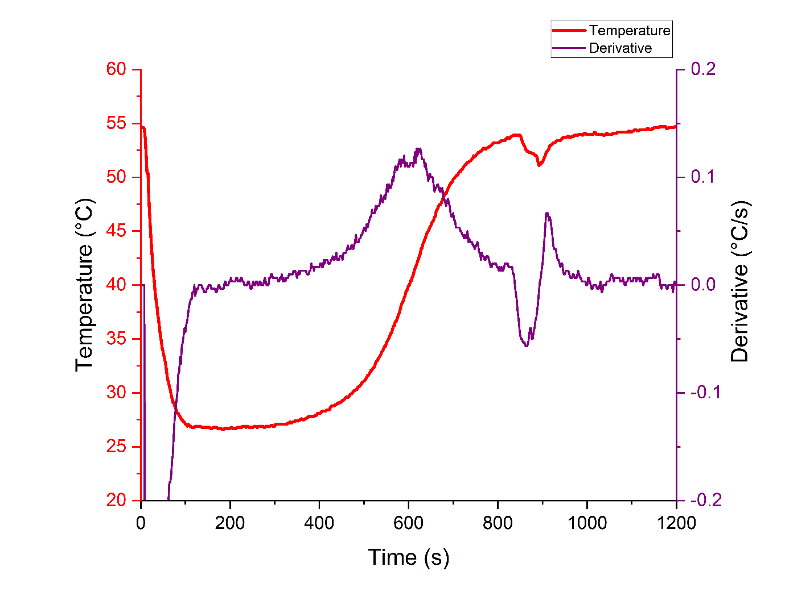 The method also attempts to minimise the amount of drying time spent at low drying rates maximising the efficiency of the process. As the moisture content targeted is likely a function of the drying conditions, especially temperature, when the blend materials are kept constant this method could be further developed to predict a drying air temperature for a specific target moisture content while still maximising the efficiency of the process.

Figure Temperature profile during filling and drying at L/S 0.35 and its derivative

|  |  |  |
| --- | --- | --- |
| Table 7 Table showing the average drying time detected by 2 different methods at different L/S | | |
| **L/S** | **Average drying time via NIR (s)** | **Average drying time derivative (s)** |
| 0.25 | 411±5 | 387±9 |
| 0.35 | 580±6 | 569±18 |
| 0.475 | 860±5 | 835±4 |

## Drying time correlation

The throughput of the granulator was found to have no significant effect over the drying behaviour when the mass of the granules after filling and L/S ratio were kept constant. Therefore the amount of water used during granulation across the filling time was investigated as a variable affecting the drying time required to reach a target moisture content. This approach can allow to account for different L/S ratios, throughputs, and filling times with only one variable decreasing the complexity of the problem.

Figure 28 shows the relationship between the drying time required to reach 2% moisture content and the amount of water used during the granulation process. The data from the NIR was used to determine the time required and the experiments covered the 3 different L/S ratios and powder throughputs. The data clearly shows a linear correlation between the drying time required and the amount of water used, suggesting that the changes in the twin screw conditions and filling times do not affect the drying times required in a meaningful way.

Figure Drying time relationship to the amount of water used during granulation in a cell

The expected decrease in the drying rate due to the decrease in the granule surface area per gram caused by the bigger granules and the increase in resistance for moisture to move from the core to the surface caused by the decrease in porosity caused by the increase in the L/S ratio used during granulation did not seem to be sizeable enough to impact the overall drying time.

The relationship could be used as a tool to scale the process as long as drying conditions are kept constant to reduce the amount of experimentation required. The relationship can also be used to calculate the drying time required after a cell has been filled using the liquid flow data allowing for changes in L/S during the filling time while maintaining the final moisture content of the granules after drying. This can be particularly helpful during refilling operation where the conditions of the liquid tank can be unstable and could lead to big flow variation during the refilling process.

## Control method

The moisture content of the granules after drying can affect the stability of the product based on the ingredients used in the blend, the granule behaviour in other units, and can also lead to unwanted biological growth if too high. For those reasons during manufacturing the moisture content of the granules is an important property to monitor and has to fall between certain limits. Out of specification material is often discarded so it is important to control the output moisture content and maintain it within the designated range to ensure the quality of the final product and minimise the amount of waste generated during the manufacturing process.

To develop and test a control method for the final moisture content after drying the flowsheet model of the granulator and dryer was used. A ±10% variability with a once per minute frequency on the liquid flow to the granulator was introduced into the model. The variability is random but remains constant throughout repeats of the simulation to help in the comparison of the results.

A reference simulation was run by setting the liquid flow to achieve a L/S ratio of 0.35, before the variability is applied, and a fixed drying time of 550s. In Figure 29 the moisture content of the granules after drying obtained in the simulation is shown. Each peak represents the moisture content of the granules as a cell gets unloaded and the material passes in front of the simulated probe. After 17 cells the simulation was stopped. Is possible to see how the added variability affected the moisture content results causing a percentage variance of 13.9%. During actual production this would lead to a big percentage of the material being out of specification causing the waste of significant amounts of material. The average moisture content across the cells was calculated (2.88%) and used as an example target with a 10% variation allowed on either side showed with a green overlay. In this case 13 out of the 17 simulated cells from the drier were outside the specified limits. This amount of rejected cells would lead to only 23% of the material being allowed through further processing highlighting the importance of a control system able to minimise the variation in the output moisture content.

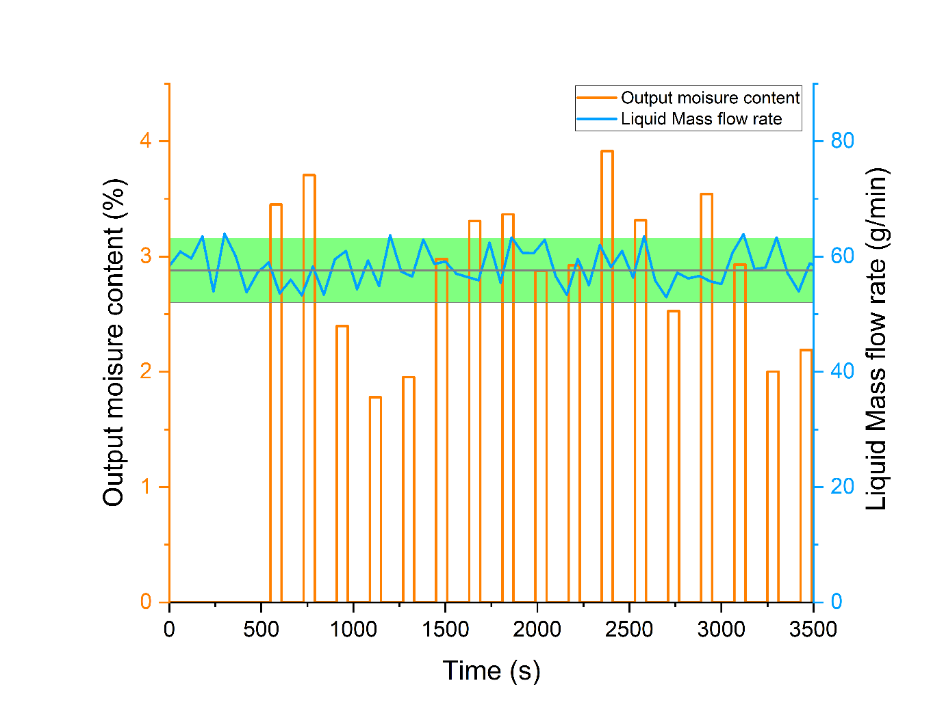 A control method which uses the linear relationship found between the drying time required to target a specific moisture and the water added in each cell was developed using the flowsheet model. A series of simulations were run varying the amount of water present in a cell and logging the drying times required to reach 3 target moisture contents (1%, 2%, 3%). The obtained results are shown in Figure 30 and were fitted using linear relationship. This approach was taken based on the experimental results which showcased the linear relationship between the drying time and granulation water mass when the drying conditions were kept constant. The control system works by integrating the liquid flow over the filling time therefore calculating the total amount of water in each cell at the end of the filling time. After the filling time is completed, the model uses the selected linear fitting to set the required drying time to target the desired moisture content.

Figure Model output moisture content and liquid mass flowrate over time

The simulation with the added variability to the liquid flow was then run for every target moisture content. In Figure 31 the final moisture contents over time for the 3 conditions are shown. The results clearly show that the control feed forward model performs well and manages to target the different final moisture content and maintain it over time regardless of the variability in the liquid feed. The percentage variability was decreased to a 1.3% overall across the tests. The first cell always shows a lower moisture content, this is because the liquid feed used to calculate the amount of water in the cell is the one detected at the granulator feed point without accounting for the residence time in the screw leading to an overestimation of the amount of water in the cell leading to a longer drying time than the one required. If the difference was found to be too large for production a rule to send the first cell to waste could be added to the start-up procedure.

Figure Drying time and total granulation water relationships for different moisture content targets

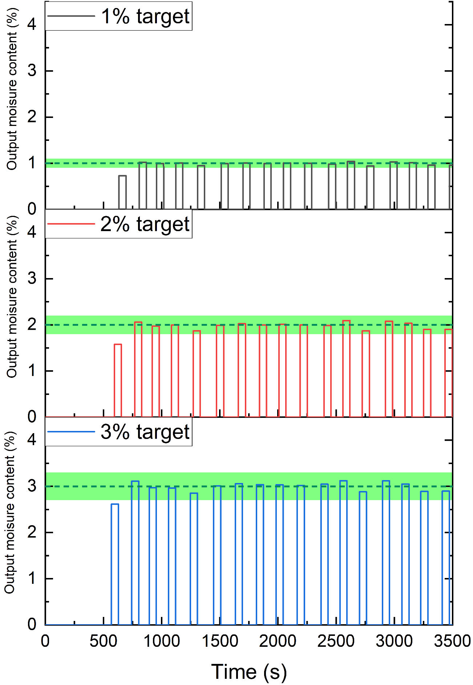 With a 10% acceptance limit from each target moisture (highlighted in green) only the first cell in each of the test would have been out of specification leading to 94% of the material being within specification. This number is a great improvement over the 23% obtained as a baseline and likely be higher if the simulation was run for a longer period of time as only the first cell was out of specification. Overall, the method performs well and shows the potential that flowsheet model offers to design, tune, and test control models for continuous processes including a fluidised bed drier.

Figure Model output moisture contents over time at 3 different controlled targets

## Chapter conclusions

Using the NIR probe inside the dryer cell proved to be a useful tool to further understand the behaviour of the Consigma dryer especially during the filling time. The method has its drawbacks as it struggles during the early filling time due to the lack of coverage around the probe but overall performs well and is also able to detect changes in granulation condition during filling after good coverage of the probe is achieved.

The powder throughput affected the maximum moisture content detected during filling as a higher liquid flow was required to maintain the same L/S ratio while the drying condition and therefore drying rate remained constant. The mass of granules at the end of the drying was kept constant between different throughputs and led to the drying behaviour after the filling process not being affected by the different throughputs with the drying curves remarkably converging at the end of each of the filling times and remaining virtually identical through the rest of the drying period. This shows the great scalability potential of the process and should be kept in consideration when deciding what approach to use during development. It also highlights how the drying during the filling time is equivalent to the drying after the filling is completed and therefore allowing the filling time to be tuned to maximise productivity without having to consider its impact on the drying process.

The L/S ratio affected the drying as expected with more water requiring a longer drying period but did not seem to affect the overall drying rate as when the amount of water was taken in consideration all conditions performed similarly allowing for a linear relationship to be used to predict the drying time for any amount of water in the tested range. Using the amount of water as the variable allows to bundle L/S ratio, throughput and filling time in a single variable and the approach could be further expanded to allow to predict drying times for different target moistures and drying conditions.

The derivative method to detect an end of drying time performed well and was able to target a consistent moisture content across different L/S conditions using just the temperature readings provided by each cell and could be used as part of a more advanced control system.

The flowsheet model performed well and managed to capture both steady state and dynamic condition behaviours such as the effect of the varied L/S ratio during filling on the moisture content. The ability of the model to perform well with varying condition makes it a big asset in developing and testing control strategies without having to use the production equipment. This approach can reduce the development time, cost in operating the machine and reduces the risk on the equipment as the control can be tuned and tested before its implementation.

The model ability to simulate the impact of variability on the liquid feed was used in tandem with the use of the amount of water used in granulation as the variable driving the total drying time for a certain target moisture content to develop and test a feed forward drying control system. The implemented control system performed well during the simulated testing reducing the variance on the output moisture content from 13.6% to 1.3% while the percentage of material in a ±10% range from the target increased from 23% to 94% with only the first cell in the simulation falling outside the target range when control was applied. The flowsheet model showcased great potential to help and accelerate the development of control methods and process understanding which are vital to improve the consistency of the final product qualities, improve the efficiency of the process and minimise waste both during development and during production.

# Effect of L/S ratio and granule moisture content on tabletting behaviour

As the final product of the Consigma-25 is tablets it is important to fully understand how the change in conditions in previous units affect not only the final critical qualities such as tablet strength and porosity but also the behaviour of the granules during compression. The tablet strength affects how the tablets behave during further processing, in transit, and when reaching the customer and is therefore important to control as especially if too low it could lead to broken or chipped tablets either rejected before packaging or reaching the customer. The porosity of tablets mostly affects their behaviour when consumed and the release of the active component after ingestion. The release time is often dictated by the type of application for the product and can be tuned by changing the porosity of the tablet making it an important parameter to control. The porosity and tensile strength of tablets are connected, this relationship is usually referred as compactability while the relationship between the compaction pressure applied and tablet porosity is usually referred as compressibility. These two properties are often used to describe the behaviour of material during compression therefore further understanding on how these are affected by previous processing condition is pivotal to develop accurate models. The L/S ratio and granule moisture content were selected as the parameter tested. The L/S ratio is the most impactful parameter in the granulation process while the granule moisture content is the main property driven by the drying step conditions providing a good overview of the effect of the first two units in the Consigma-25 on the tablet compaction properties.

## Effect of Moisture content

During operation of a Consigma-25 the moisture content of the granules after drying is a function of the amount of water fed into a cell of the fluidised and the drying conditions (Temperature, airflow and drying time). As the amount of water going into the system is usually dictated by other requirements such as the blend ingredients, granule properties and throughput the drying conditions are usually adjusted to target a specific moisture content. During the performed experiment the drying time was changed to obtain a range of granule moisture content prior to tabletting. The drying time was selected as it would not alter the drying behaviour during drying while both the temperature and airflow would affect the drying rate and potentially add more unknowns to the system.

The average moisture content of the granules measured after drying for the different drying times and L/S ratio combinations are shown in Table **8**.

|  |  |  |
| --- | --- | --- |
| Table 8 Average granule moisture content for different L/S ratios and drying times | | |
| L/S | **Drying time (s)** | **Average content (%)** |
| 0.22 | 320 | 6.26±0.24 |
| 360 | 5.1±0.22 |
| 500 | 4.70±0.21 |
| 700 | 4.39±0.18 |
| 900 | 4.01±0.17 |
| 0.3 | 450 | 7.30±0.25 |
| 500 | 6.20±0.22 |
| 550 | 5.01±0.20 |
| 600 | 4.54±0.23 |
| 700 | 4.43±0.14 |
| 900 | 4.28±0.15 |
| 0.4 | 600 | 6.92±0.17 |
| 650 | 6.3±0.25 |
| 700 | 5.91±0.19 |
| 800 | 5.20±0.18 |
| 900 | 4.54±0.11 |
| 1000 | 3.97±0.13 |

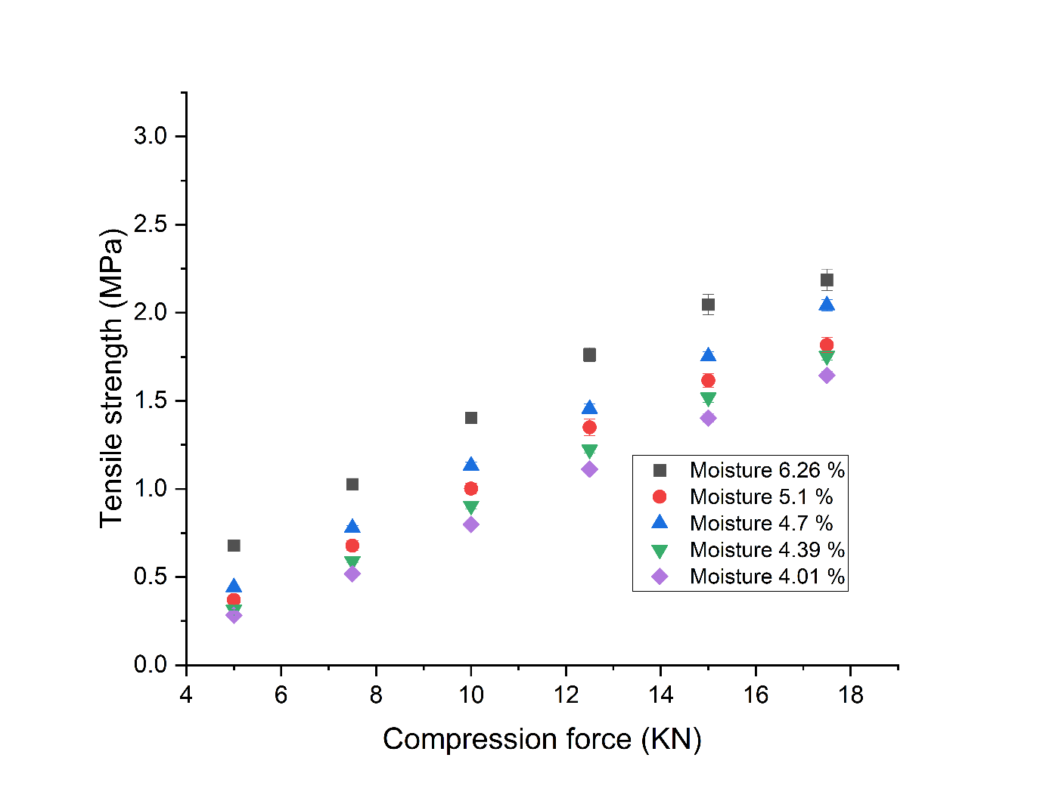Figure 32, Figure 33 and Figure 34 show the effect of the compaction force on the tensile strength for each L/S ratio at the different granule moisture content. The variability in the tensile strength remained low across all conditions highlighting the stability in the tablet press performance. Overall, the increase in moisture content leads to an increase in the tablet tensile strength across the 3 tested L/S ratio and across the tested compression forces. The effect is quite sizeable with up to a 200% increase at the same compression force in the most extreme cases with the effect being relatively larger at lower compression forces while tending to be higher in absolute value at the higher compression forces. The relationship between the compression force and the tensile strength is mostly linear at lower moisture contents. At higher moisture contents the tensile strength exhibits a plateauing behaviour towards higher compression forces with this behaviour being particularly notable at the highest moisture content tested. The plateauing behaviour of the tensile strength is commonly seen when materials are compressed at higher and higher compaction forces and is due to maximum strength limit usually referred as the tensile strength at 0 porosity. This value depends on the material properties and represent the maximum achievable strength for a tablet of a particular Chart, scatter chart
blend or material and act as an asymptote. In this case the moisture content seems to lower the amount of compaction force required to get closer to the limit. To further understand the impact of the moisture content on the tabletting behaviour of the material the porosity for each tablet produced was also calculated using the tablet dimensions and mass.

Figure Relationship between compression force and tensile strength for granules produced at a 0.22 L/S ratio at different moisture content

Figure Relationship between compression force and tensile strength for granules produced at a 0.3 L/S ratio at different moisture content

In Figure 34, Figure 36 and Figure 37 the tablet porosity obtained for the different L/S ratios and compression forces are shown. The experiments at higher moisture content show a decreased porosity at the same compaction force. This indicates that the granule moisture content affects how the granules behave during compression and lead to denser tablets. The lower porosity of the tablets is also connected to the increase in tensile strength. This is due to the lower porosity causing an increase in contact area between the particles making the tablet and therefore leading to an increase in the tensile strength. The porosity also shows a plateauing behaviour especially at higher moisture content where the porosity makes it closer to its limit. As the porosity approaches its limit the amount of force required increases exponentially causing the plateauing behaviour which then leads to the same behaviour being shown in the tensile strength.

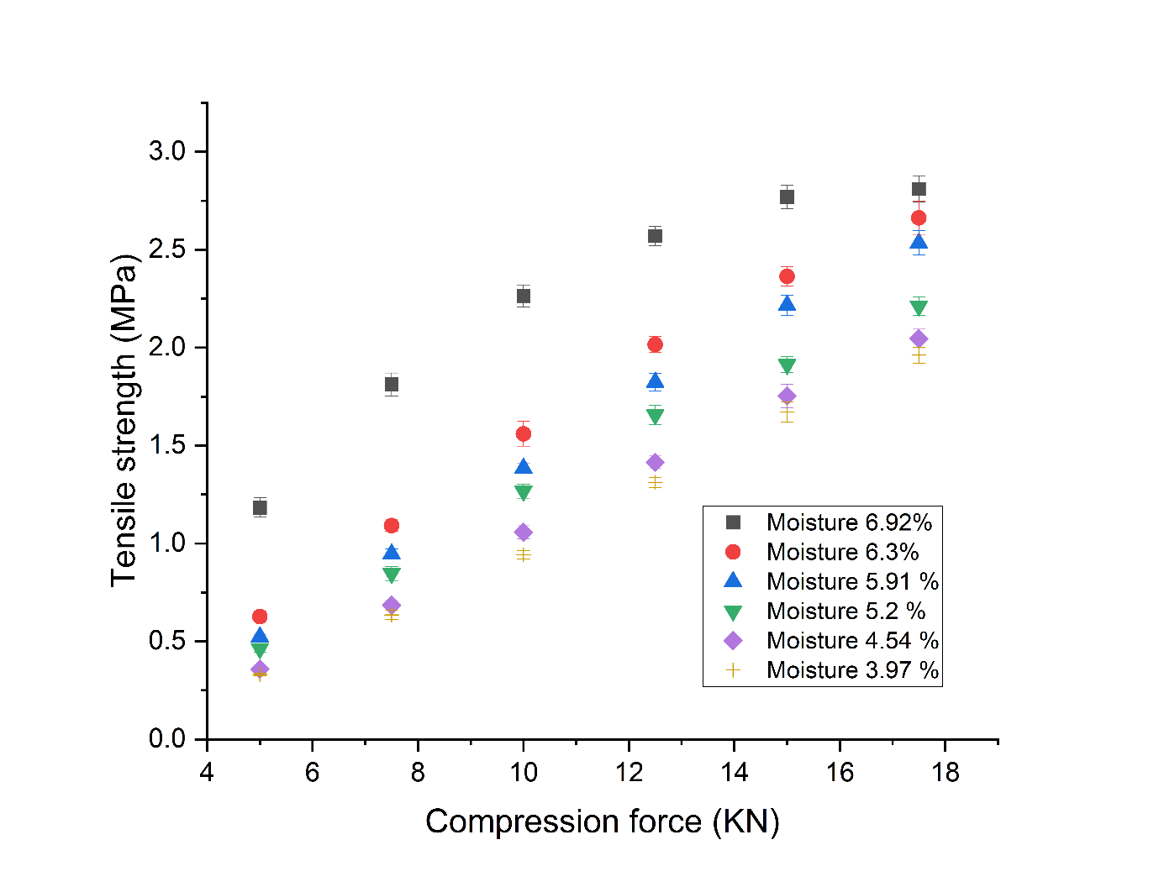This behaviour of the porosity as the moisture content increases as been reported by literature and has been mostly explained by the increase in the plasticity of the granules leading to further deformation during compression and lower porosity tablets.

Figure Relationship between compression force and tensile strength for granules produced at a 0.4 L/S ratio at different moisture content

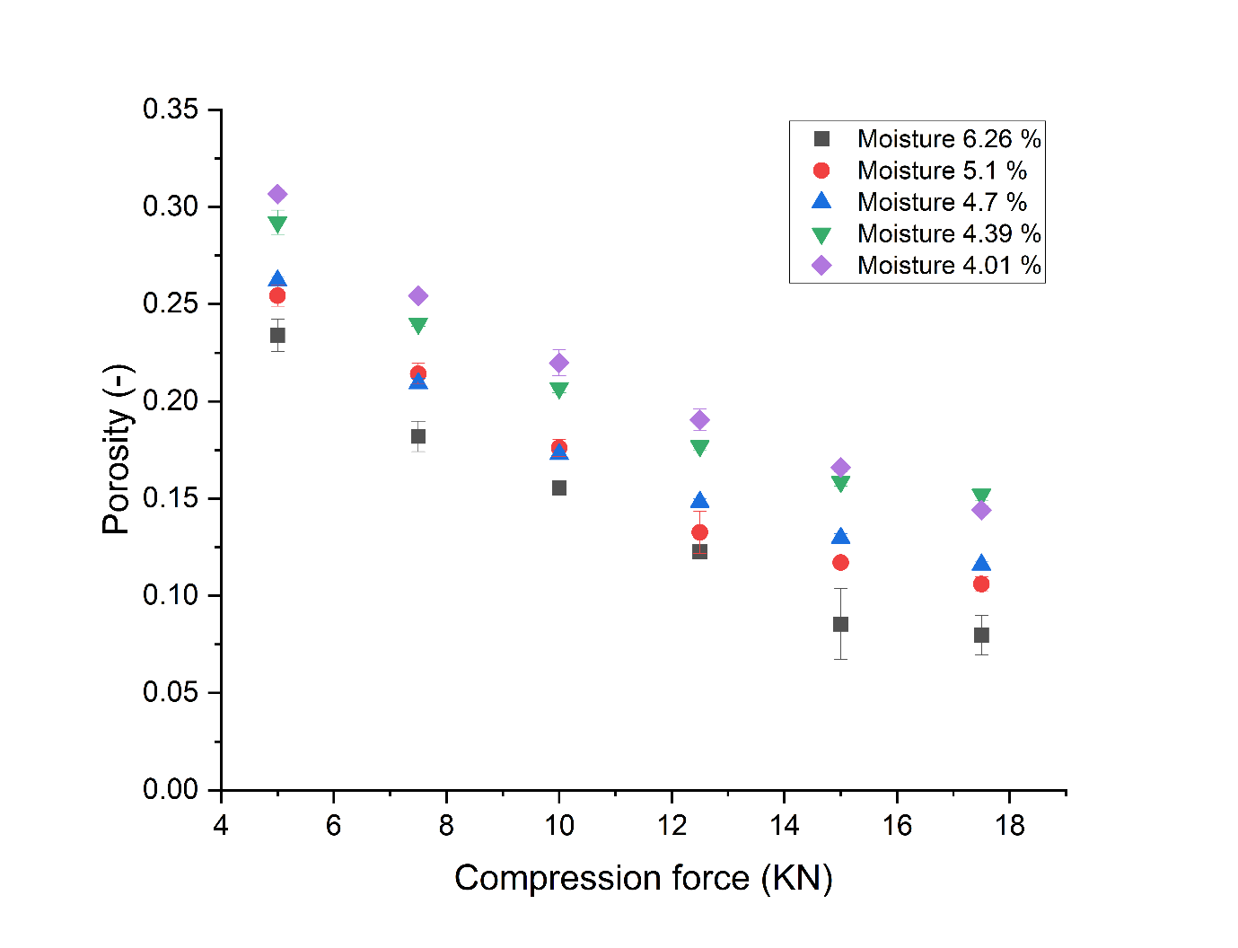

Figure Relationship between compression force and porosity for granules produced at a 0.22 L/S ratio at different moisture content

Figure Relationship between compression force and porosity for granules produced at a 0.3 L/S ratio at different moisture content

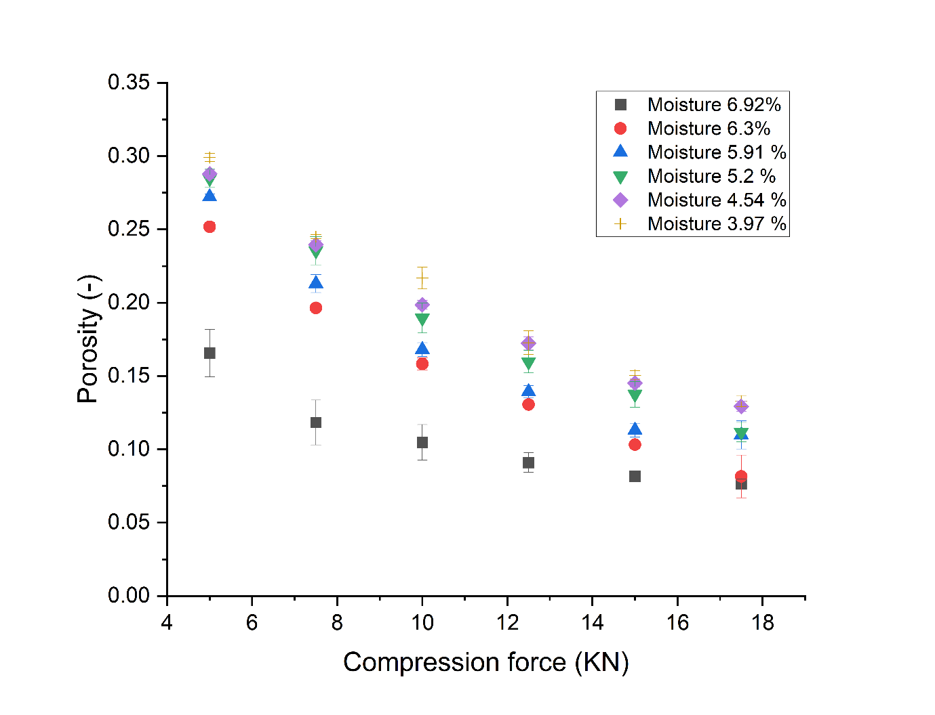

Figure Relationship between compression force and porosity for granules produced at a 0.4 L/S ratio at different moisture content

## Effect of L/S ratio

The L/S ratio is the main parameter affecting the granule properties in twin screw granulation and is usually tuned to obtain the required granule properties such as the particle size distribution, granule porosity, flowability and bulk density. The effect on these properties is mostly well understood. As the tablet properties are the final critical quality attributes it is important to understand how the L/S ratio affects them in order to be able to strike the best compromise to optimise the process.

Experiments with equivalent moisture content after drying were used to evaluate the effect of L/S ratio on both the porosity and tablet tensile strength. The selected moisture content was 4.5% with the 3 L/S ratios all having produced granules with similar moisture content after drying (L/S 0.22: 4.39%, L/S 0.3: 4.54%, L/S 0.4: 4.54%). The tensile strength of the 3 different L/S ratios compaction profiles are shown in Figure 38. An increase in L/S ratio causes an increase in the tensile strength across all compaction forces with similar findings noted in literature for similar mannitol-MCC blends [97]. The absolute difference between experiments increases as the compression force is increased.

Figure Relationship between compression force and tensile strength for granules produced at different L/S ratio and equivalent granule moisture content

The porosity is shown in Figure 39 where the difference between the conditions is less marked especially between the 0.3 and 0.4 L/S ratios while being more noticeable for the lower ratio especially at higher compression forces. This is likely due to the slightly lower moisture content for the experiment at the lowest L/S ratio. Overall, an increase in L/S ratio leads to a small decrease in porosity which then leads to the observed increase in tensile strength. The impact of the L/S ratio on the strength is far more noticeable than on the porosity. This is partly due to the exponential relationship between the two causing small changes in porosity to lead to large changes in tensile strength. Overall, the L/S ratio seems to affect both the final porosity and tensile strength of the tablet, this likely due to change in the granule properties such as porosity and plasticity.

Figure Relationship between compression force and porosity for granules produced at different L/S ratio and equivalent granule moisture content

The impact of the L/S ratio is significantly smaller for both porosity and tensile strength when compared to the effect of a change in moisture content. As an example, the L/S ratio increase from 0.22 to 0.4, which is a ≈80% increase, only led to an increase in tensile strength from 1.75 MPa to 2.05MPa, while a similar relative increase in moisture caused an increase from 1.72MPa to 2.80Mpa for the 0.3 L/S ratio data. This indicates that although both parameters affect the tablet properties the moisture content has a relatively bigger effect when the size of the change is accounted for. To fully understand if the change in tensile strength is fully due to the impact on the porosity of the tablets or a combined effect the compressibility and compactability properties were investigated.

## Effect on compressibility and compactability

The compressibility and compactability can be used to further understand the effect of the L/S ratio and moisture on the material behaviour during compression. Figure 40 shows the compactability data for all experiments. The colour of the points indicates the moisture content of the granules while the size of the symbols is used to represent the compaction force used with the size increasing as the compaction force increases. The higher moisture content granules and higher compression forces produced the strongest tablets and are mostly found in the top left part of the figure while the lower compression and drier granules are mostly towards the bottom right of the figure. Most importantly, although showing some small differences between conditions, all the data aligns on one trend indicating that although the moisture content and L/S ratio affect the porosity and the tensile strength they don’t impact the relationship between the two in a significant way across the tested range. This is unusual as other studies looking at the effect of moisture on the compressibility showed an effect on the compressibility for other materials. The compactability parameters relate to the physical interactions between the particles forming the tablet and are usually found to be affected by the moisture content due to an increase in the surface interaction between the water molecules present on the surfaces. This behaviour is not showcased by the formulation inferring that the increase in the moisture content does not lead to an increase in the surface water interaction between particles. Mannitol and MCC are the major components for the test blend used. While mannitol is soluble in water, it does not absorb water in its structure (hygroscopic) while MCC although insoluble in water is a hygroscopic material and makes 47% of the formulation used. The hygroscopic nature of the MCC might lead to minimisation of the amount of water available to interact between the surfaces present in the tablets minimising its effect on the compactability properties of the granules.

This behaviour allows for one overall fit to be used for all conditions using Equation 5. The fitting gives one set of fitted parameters (T0 = 6.37 ± 0.19 MPa and Kb = 9.81 ± 0.16) with a good overall fit quality represented by a 0.97 R2. Having an overall fit is advantageous as it allows to use the same equation parameters across a wide range of conditions reducing the number of experiments required.

Figure Graph showing the compactability for all experiments performed.

The compressibility is shown in Figure 41 with the colour of the points representing the moisture content. From the figure is possible to see how the compressibility is affected by the different moisture content with each different condition showing its own relationship with the increase in moisture leading to lower porosities. The compressibility describes how the compaction pressure impact the tablet porosity with the compressibility constant describing the rate of the change while the pressure at 0 porosity is an extrapolation of the amount of compaction pressure required to obtain a tablet with 0 porosity. An increase in the compressibility constant signify that the material is easier to compress leading to a faster densification of the tablets. In this case Equation 5 was fitted for every experiment to obtain a pair of P0 and Kt for each compression profile. The obtained P0 and Kt are shown in Figure 42 against the granule moisture content for the 3 different L/S ratio. P0 does not show an obvious relation to the moisture content while Kt seems to increase linearly as the moisture content increases. Both seem to be affected by the L/S ratio with P0 showing a decrease as the L/S ratio is increased and the compressibility constant showing a decrease in value and a decrease in the magnitude of the relationship with the moisture content as the L/S ratio is increased. The P0 not being affected by the moisture but only by the L/S ratio indicates that the difference in granulation condition has caused a change in the granule properties which leads to a decrease in the amount of pressure required to reach a tablet with 0 porosity. The impact of the moisture content on the compressibility constant has been reported by literature [45–47] and has been linked to an increase in the plasticity of the granules which makes the compression process easier leading to lower porosity tablets and leads to a higher compressibility constant value as the moisture content increases. The L/S ratio impact on the compressibility constant indicates again that the granule compaction properties were affected by the L/S ratio this could be due to the lowering of the granule porosity caused by the increase in L/S ratio leading to stronger granules which don’t deform as easily when pressure is applied. Although the compressibility constant was lower at higher L/S ratios which should lead to a higher tablet porosity, the impact of the L/S ratio on the P0 counteracted this leading to the porosity to decrease overall Chart
when the L/S ratio was increased, and the moisture maintained the same. This competing effect of the L/S ratio on the granule compressibility properties leads to the relatively smaller effect of the L/S on the final tablet properties when compared to the effect of the moisture content which only impacts the compressibility constant.

Figure Figure showcasing compressibility results for all tested conditions

As the P0 wasn’t affected by the moisture content of the granule but only by the different L/S ratios an average was taken from the experiments of each L/S ratios reducing it to only 3 values. This was done to minimise the number of parameters used for fitting the data and therefore allowing for a more general approach to the modelling of the compaction process. The values for each L/S ratio were used to fit the data again to obtain an updated set of compressibility constant. The obtained compressibility constants didn’t vary significantly from the ones previously obtained and showed the same trends as the ones obtained by fitting each P0. The findings from the compressibility and compactability help to further describe the dynamics behind the change in the final tablet properties. As the compactability is not majorly affected by either the L/S ratio or granule moisture content the differences in the obtained tablet tensile strength can be attributed to the difference in the tablet porosity due to the impact of those parameters on the compressibility leading to a difference in the porosity of the tablets.

Figure Compressibility constant and P0 relationship to moisture content at different L/S ratios (L/S 0.22 black, L/S 0.3 Red, L/S 0.4 blue)

## Model implementation

The fitted parameters for the compressibility and compactability of the granules at different condition can be used in a flowsheet model to calculate the tablet properties at the different conditions. Using the directly fitted parameters does usually provide the most accurate prediction for the same conditions but is not particularly useful as it only provides the ability to predict properties for a specific set of conditions which has already been tested. To enable the tabletting model to predict across the tested range, the implementation of relationships between the L/S ratio and moisture content and the compactability and compressibility parameters is required. The compactability was independent of changes in both parameters leading to all the conditions requiring a single set of T0 and Kb values. The compressibility parameters are affected by both the L/S ratio and the granule moisture content with the P0 solely impacted by the L/S ratio and kc being affected by both.

The granule porosity for each L/S was measured to replace L/S ratio with granule porosity during modelling. This allows the model to be based on a physical property instead of a unit parameter allowing the model to work even if other conditions impact the porosity of the granules. Figure 43 shows the relationship between the moisture content and the granule porosity. The porosity decreases as the L/S ratio was increased; this is typical for a twin screw granulation process as the increase in liquid leads to an increase in the granulation intensity causing a decrease in the granule porosity. Interestingly the variability in the porosity measurement decreases as the L/S ratio was increased, this is due to more uniform wetting of the material at a higher L/S ratio, leading to more consistent granule porosity. A linear relationship was fitted to allow the model to predict the porosity over the L/S ratio range. This relationship was implemented in the flowsheet model to allow the user to input a L/S ratio instead of a granule porosity while running the simulations.

The relationship between the P0 and the granule porosity is showcased in Figure 44. As the porosity of the granules decreases the P0 also decreases, A linear relationship between the granule porosity and P0 was used, and the fitting parameters were calculated (c=303.05 m=307.82).

For the compressibility constants(z) a 3d fit was required as they are related both to the moisture content(x) and the granule porosity (y). In Figure 45 the data and fitting plane are shown. Drop lines to the fitted plane (z=z0+ax+by) were added to highlight the distance between the fitted plane and the compressibility values. The obtained planar fit (fit parameters z0=-0.44, a=1.56, b= 3.92, R2=0.95) shows larger deviation at the extreme ends of the moisture

Figure Relationship between L/S ratio and granule porosity

Figure Relationship between granule porosity and P0

content range especially at the lower moisture content for L/S ratio 0.4 and the higher moisture content at L/S 0.3. When considering all the parameters and the wide range of conditions tested the obtained fit was considered acceptable. A simple plane fit was used to minimise the number of parameters needed in the model. A fitting which also considered the interaction between the moisture content and granule porosity to calculate the compressibility constant (z= z=z0+ax+by+cxy) was also tested but did not provide significant performance improvements when implemented in the flowsheet model and added an additional fitting parameter.

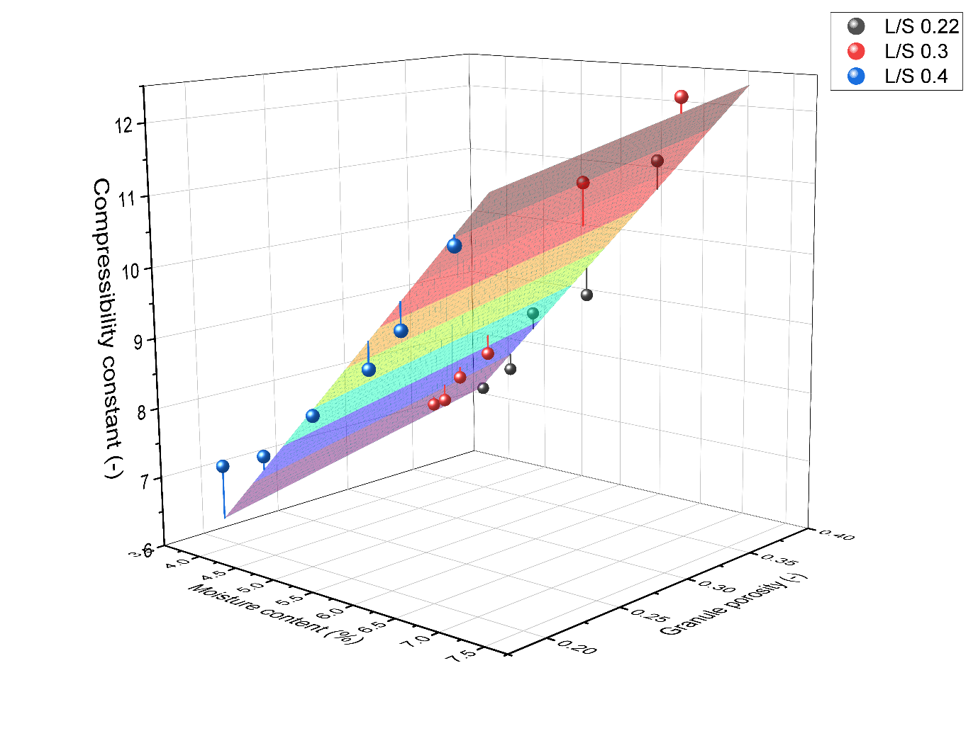Both the linear relationship between P0 and the granule porosity and the plane fit between granule porosity, granule moisture content and the compressibility constant were implemented in the flowsheet model and used to calculate the compressibility parameters for the compression model. The compactability parameters were simply set to the fitted overall values. To test the performance of the flowsheet model all the experimental runs were simulated using the experimental L/S ratio and moisture content. The parity data between the simulated and experimental tensile strength is shown in Figure 46. From the figure is possible to see the model performing well at the lower tensile strength while increasingly underpredicting as the tensile strength rises. This is due to an overprediction of the tablet porosity in the model causing the difference in tensile strength. Overall, for a general model the error can be considered acceptable as the ability to simulate a wide range of conditions can be particularly important for applications such as control development or sensitivity analysis. As expected, the biggest differences between the experimental and model result were found at the conditions with the biggest deviation in the compressibility constant fitting.

Figure Compressibility relationship to moisture content and granule porosity. Plane shows the fit.

|  |  |  |
| --- | --- | --- |
| Table 9 Linear fitting parameters for moisture content-compressibility constant relationship | | |
| **L/S ratio** | **m** | **c** |
| 0.22 | 1.923 | -0.510 |
| 0.3 | 1.733 | -0.103 |
| 0.4 | 0.971 | 3.212 |

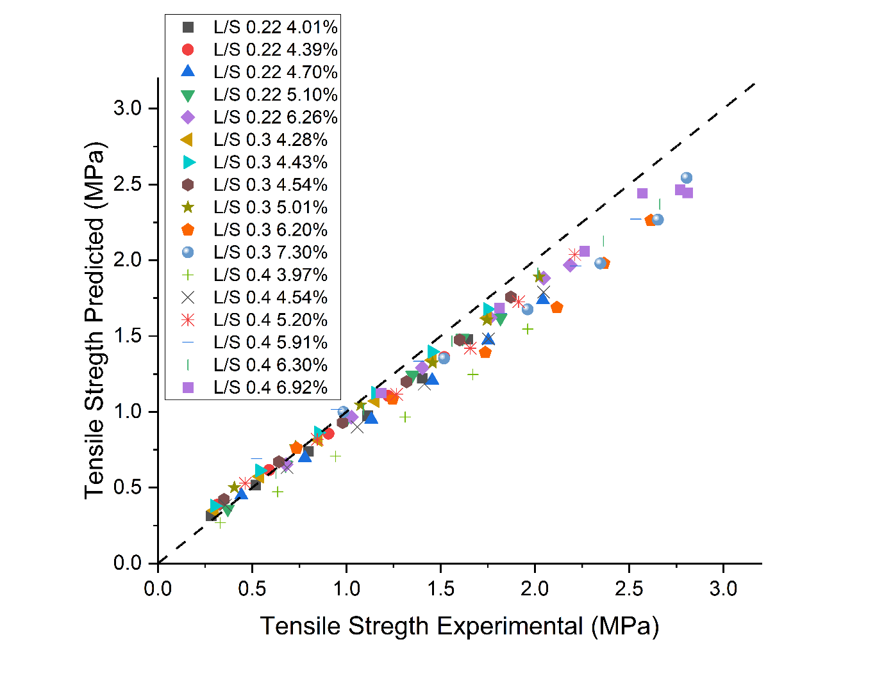For improved precision a fit for each L/S ratio compressibility constant and the use of the average P0 was tested. This approach could be used when the L/S ratio remains constant during production and the model is used as a method to calculate the tablet properties. A linear fit for each L/S ratio set of compressibility constant was calculated with the parameters shown in Table 9. The different relationships were implemented in the flowsheet model and used to calculate the compressibility constant at different moisture contents. The experimental conditions were simulated and the tensile strength. The parity results using this approach and is shown in Figure 47. The deviations are much smaller overall never exceeding 0.25MPa. The

Figure Tensile strength parity results comparing experimental and plane model

shape of the relationship is also slightly different with the model tending to overpredict especially at lower tensile strengths with the amount of overprediction decreasing at higher tensile strength.

The root mean square error (RMSE) was calculated for each experimental condition to assess and better compare the performance of the models across the full compression range for each experiment. This value was calculated for the plane fitting approach, the linear L/S ratio fitting also for the error calculated by using the fitted parameter for each experiment. In Figure 48 the RMSEs for the 3 modelling approaches are shown. In general, the experiments at the moisture content range edges tended to provide a higher mean error this is likely due to the impact of both the moisture content and L/S ratio on the compressibility parameter not being totally linear.

The average RMSE for the general approach was 0.16MPa while the model treating each L/S ratio separately performed better with an average RMSE of 0.08MPa. As expected, the direct use of the fitted parameter showed the smallest average RMSE with a 0.04 value. This value showcase how as the model becomes more and more general the error increases and highlights the trade-offs between a more flexible model and accuracy in this case. Different approaches to calculate the fitting parameters should be used based on the required use of the model.

Figure Tensile strength parity results for experimental and single L/S fit model

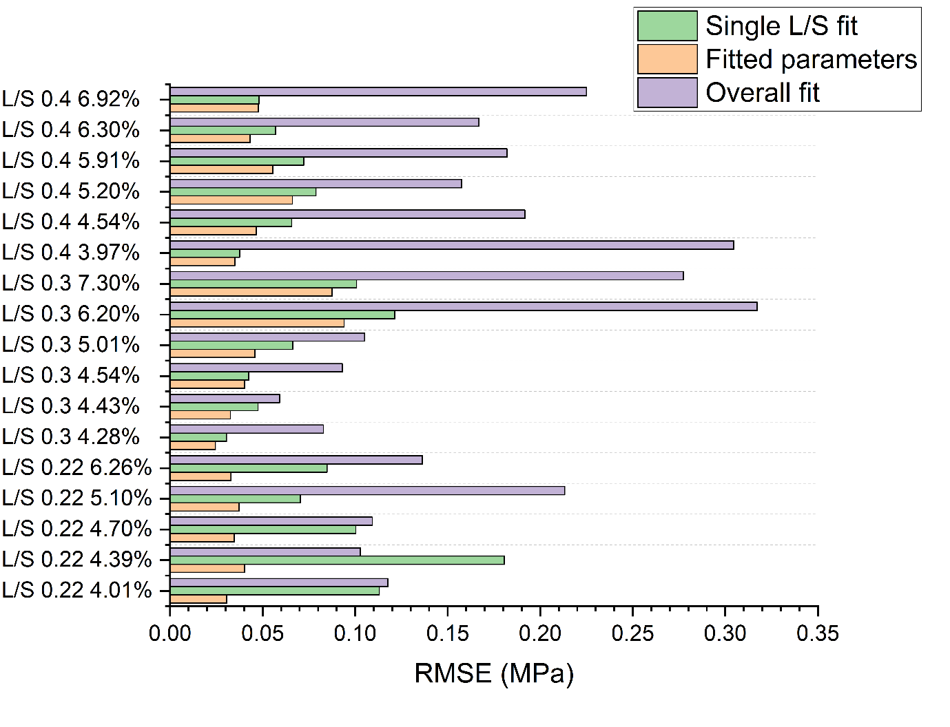

Figure Different modelling approaches RMSE for each condition tested

## Dissolution time modelling

Dissolution time is one of the most important tablet properties as it influences the behaviour of the tablet once is ingested dictating how the active material starts getting absorbed by the body. Is therefore important to make sure that the tablet produced have the required dissolution time so that they work as designed. As an example, a longer dissolution time would be likely used for a longer lasting effect compared to a product design to act quickly once taken.

To measure how tablets dissolved conductivity measurements were used. 0.5% Citric acid was added to the granules after drying as a tracer. Citric acid was selected as a tracer for dissolution testing as it can be sensed at low concentrations allowing the small percentage added to the blend and mimics the behaviour of a quick dissolving active pharmaceutical ingredient. Overall given the presence of citric acid as a fast-dissolving ingredient and croscarmellose sodium as a super disintegrant the blend used in the experiments mostly resembles the formulation for a quickly dissolving, fast acting tablet.

In Figure 49 the dissolution profiles for tablets produced at different compaction process (5,10 and 15KN) are shown. At the lowest compaction force, which has the highest porosity, the conductivity instantly starts to increase as soon as the tablet is submerged and then quickly reaches a steady state as all of the citric acid is dissolved. As the compression force is increased and therefore the tablet porosity decreased the conductivity remains around 0 for longer before starting to increase. This is due to the water taking longer to be absorbed into the tablet due to the lower porosity. The water needs to enter the tablet structure to start breaking the tablet apart and dissolve the citric acid, a denser tablet leads to a slowing down of this process leading to a slower dissolution rate and a longer initial delay. This effect is particularly noticeable at the higher compression force with the conductivity not changing for nearly a minute at the beginning of the process. After the initial delay the conductivity start to raise as the tablet dissolves over time. Is possible to see how the rate of dissolution decreases as the compression force was increased leading to a slower increase in the conductivity. The spikes recorded in the conductivity are due to interference of insoluble part of the tablets during its dissolution passing over the probe and affecting the readings. Towards the end of the dissolution time all tablets display a similar behaviour and plateau reaching an equilibrium as all the citric acid is in solution. The dissolution time was set as the time required to reach 95% of the steady state conductivity from the moment the tablet was lowered in water.

Figure Normalised conductivity over time during dissolution test of tablets made at different compression forces

As highlighted by the different dissolution behaviours shown the tablet porosity has a big impact on the dissolution process as is impact how quickly the water can rush through the structure of the tablet and break it apart leading to the dissolution of the citric acid.

In Figure 50 the dissolution times for tablets of different porosities are plotted. From the data obtained is possible to see how an exponential relationship between the dissolution time and tablet porosity. As the porosity decreases the dissolution time quickly increase due to the difficulty for the water to penetrate the tablet and break it apart starting the dissolution process. Towards the higher end of the porosity spectrum is possible to notice how the time required reaches a plateau higher than 0. This value indicates the minimum dissolution time and is related to the solubility of the soluble components of the blend. In this case as citric acid was used the time obtained is small as citric acid readily dissolves in water. The data was obtained from tablets produced at different L/S ratios and granule moisture content and followed a single relationship showing that the dissolution time is only affected by the porosity of the tablet and not by either the L/S ratio or granule moisture content which affected the behaviour of the material during compression. The data was fitted using an exponential curve and the obtained relationship was added to the flowsheet model. The simulated tablet porosity was used to calculate the final dissolution time, as the model account for the impact of both L/S ratio and granule moisture content on the tablet porosity it can simulate the dissolution time across a range of conditions.

Figure Effect of the tablet porosity on the dissolution time of tablets made at different L/S ratio

## Chapter conclusions

Both the L/S ratio and moisture content of the granules affected the tablet tensile strength and porosity of the tablets. An increase in moisture content led to an increase of the tensile strength and corresponding decrease in the granule porosity. The L/S ratio had a similar but smaller effect on both the tablet porosity and tensile strength. Looking at both the compressibility and the compactability of the granules during compression shows that the change is due to the impact of the L/S ratio and moisture content on the compressibility. The compactability was unaffected by both the change of moisture content and L/S ratio indicating that the effect of the parameters on the tensile strength is solely due to the impact of the parameters on the tablet porosity.

The compressibility was affected by both parameters. The L/S ratio affected both P0 and Kt, P0 decreased as the L/S ratio was increased indicating that a lower compression force was required to reach 0 porosity. The compressibility constant decreased as the L/S ratio was increased and the impact of the moisture content on the compressibility constant was also reduced by an increase in the L/S ratio. The moisture content only affected the compressibility constant causing an increase as the moisture increases. The increase in compressibility increases the effect of the compression force on the porosity of the tablets resulting in lower porosity tablets when the same amount of force is applied to the granules during tabletting. A relationship between the L/S ratio and granule porosity was found and the granule porosity was used to implement the change of the compressibility in the flowsheet model.

The impact of the granule porosity and moisture content on the compressibility constant was implemented using a 3d plane to describe the relationship while P0 was calculated using a linear relationship driven by the granule porosity. The obtained model is able to cover a wide range of conditions and its performance was tested by simulating the experimental conditions and comparing the results. The model performed well over the range of conditions tested with a slight tendency to underpredict at higher tensile strength values due to and over prediction of the porosity. The implementation of 3 different linear relationships between the compressibility constant and the moisture content for each of the L/S ratio was also tested. This approach produced smaller deviations from the experimental data at the cost of the flexibility of the more general model.

The RMSE was used to assess the mean performance at each condition. Overall, both the general model and the model using singular L/S ratio relationships performed well across the tested conditions showing bigger deviations at the moisture content extremities. The more general model had a larger average RMSE value as expected but the implementation of the impact of L/S ratio and moisture content over the tablet properties in the model was considered successful and allows a wide range of conditions to be simulated allowing the model to be used in a variety of situations both during development and production.

The tablet dissolution time was found to be related to the porosity of the tablet and not to be affected by other properties such as L/S ratio or moisture content. Under a certain porosity a minimum dissolution time is reached and is related to the solubility of the measured materials. As the tablet porosity decreases the dissolution time increased exponentially as the liquid finds it harder and harder to penetrate and break apart the tablet structure. The fitted relationship was added to the tabletting model to add the ability of predicting the dissolution time at varying conditions.

# Use of flowsheet models to develop and test control methods

The use of control during pharmaceutical production has been increasing in importance in the past few years. Good control can reduce waste, improve consistency and potentially reduce the required offline test after production. Feedback control method such as PI and PID loops are simple to add to a system but require careful tuning and testing to avoid fluctuating behaviour and maximise the performance of the controller. Some of the most advance control techniques such as model predictive control require a large amount of non-steady state data to develop. This kind of data can sometimes be expensive and time consuming to produce at it requires changing conditions over long period of time for the model to account for the dynamics of the process. Flowsheet models can be particularly helpful to reduce the amount of experimental work by simulating the data required for the model. Not only the flowsheet model can be used to generate the data required but also to test and tune the control models to minimise the amount of material expenditure and machine hours both of which can be expensive. The flowsheet models can also run faster than in real time and don’t require supervision while running allowing for much quicker development. In this study flowsheet models were used to generate data and test and tune different control methods.

The integration of control systems in pharmaceutical manufacturing has been historically lacking due to good manufacturing practices (GMP) regulations locking the manufacturing parameters to the values used during the certification process and therefore not incentivising the use of control method to reduce waste. These regulations have been recently changing both for batch and continuous processes making control in the pharmaceutical industry an exciting prospect to reduce waste, improve quality and potentially reduce the testing requirements for product release allowing for a faster delivery of products to the market.

## PI controller simulations

PI and PID controllers are widely used in industry to maintain a parameter to a set value by controlling a variable in the process. These controllers can work extremely well but require careful tuning in order to achieve a quick but stable response to changes. In this case the tensile strength was the target parameter while the compression force was varied to achieve the target tensile strength. Equation 8 shows the PI loop equation.

$v\left(t\right)=v_{bias}+K_{c}e\left(t\right)+\frac{K_{c}}{τ_{I}}\int_{0}^{t}{e\left(t\right)dt}$ (8)

$v$ (t) is the controller output which in this case is the compaction force used during tabletting, ubias is a constant which is usually set to the value of u(t) when the controller is turned on so that no sudden jumps are present when the controller is activated. Kc is the proportional gain and is one of the two parameters that can be tuned, e(t) is the error from set point which is calculated by subtracting the value of the variable in this case the tablet tensile strength from the target value and τI is the integral time constant which is also referred as the reset time and is the other variable that can be tuned to affect the behaviour of the controller. The formula can be divided in 2 main sections, the proportional part which is driven by the gain and acts based on the instant difference between the measured variable and the set point. The second part of the formula is the integral part and takes in account the error over time and its effect is tuned by the ratio between the gain and reset rate. The frequency at which the controller enacted the changes was also tuned and is referred as the control time.

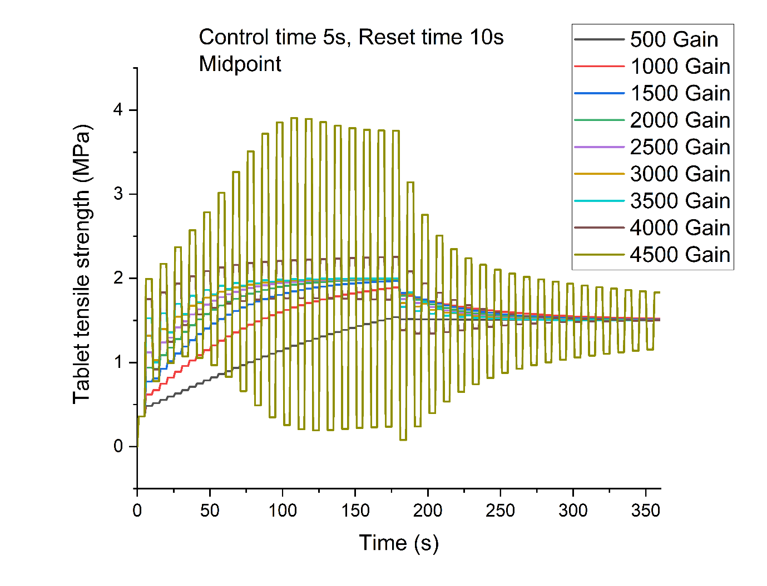To tune the various parameters of the PI controller a compaction flowsheet model was run with a range of values for the controller and the set point for the tablet tensile strength was changed during the simulation to see how the controller would behave given a set of parameters. The set point was changed from 1.9MPa at the beginning of the simulation to 1.5Mpa after 180s. Figure 51 shows the effect of the change in gain as the control time and reset time were kept constant at 5s and 10 s respectively. An increase in gain causes the controller to apply control moves with a bigger amplitude. At low gains the controller is stable but takes a relatively long time to reach the set points with the two lowest gains not reaching the first target before the set point was changed. At very high gains the controller reacts sharply and is unstable, oscillating around the set point and never achieving the target tensile strength. This behaviour is particularly noticeable at a value of 4500 gain. Between 1500 and 3500 gain the controller shows a stable and relatively fast behaviour and highlights the working range of the controller at the specific reset rate and control time.

Figure Effect of different proportional gain value in a PI controller. (reset time 10s, control time 5s)

The effect of a 5s reset time and 20s reset rates on the behaviour of the controller at different gains are shown in Figure 52 and Figure 53. As the reset rate is decreased, the impact of the integral constant increases making the controller more aggressive and causing it to oscillate at lower gain values. At low reset times gains higher than 3500 caused the model to fail as it tried to apply values of compression force less than 0 causing an out of bound error has the compaction force can’t be negative. The longer 20s reset time made the controller react more slowly and only the highest gain value showcases an oscillating behaviour; the amplitude of the oscillation was still greatly reduced, and the controller did manage to reach a steady state towards the end of the simulation even at the higher gain value. As the reset time and gain are interlinked a compromise between the two parameters seems to provide the best performance with a fast responding but stable controller.

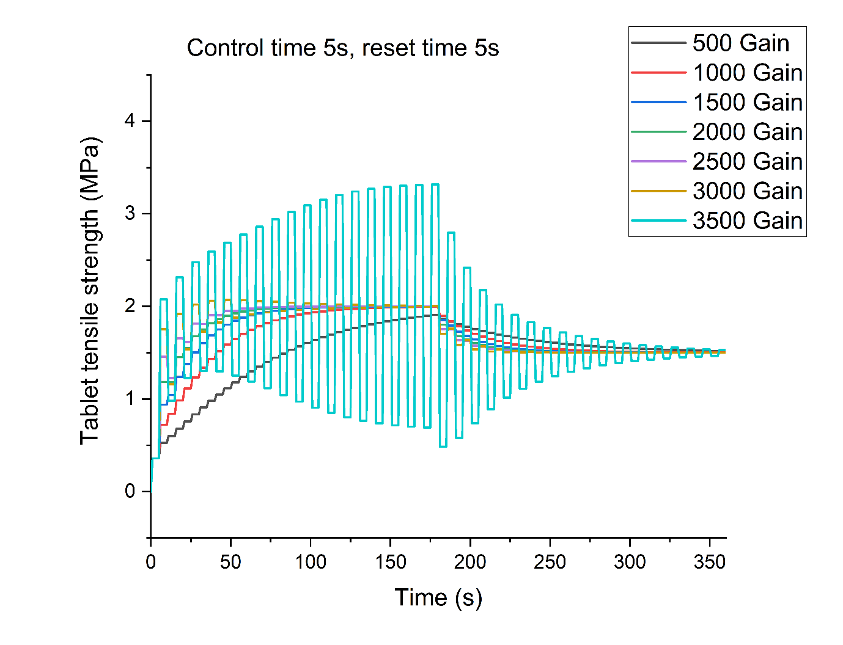The results for the 1s and 10s control time are shown in Figure 54 and Figure 55. From the figures is possible to see how decreasing the control time produces better and more stable control. The high frequency of the controller manages to avoid the oscillating behaviour at higher gain values that was showcased in the 5s control time simulations and allows for a faster response controller. The downside of this approach is that it requires to obtain the measurement of the tensile strength at the same rate to achieve this level of control. The high frequency of 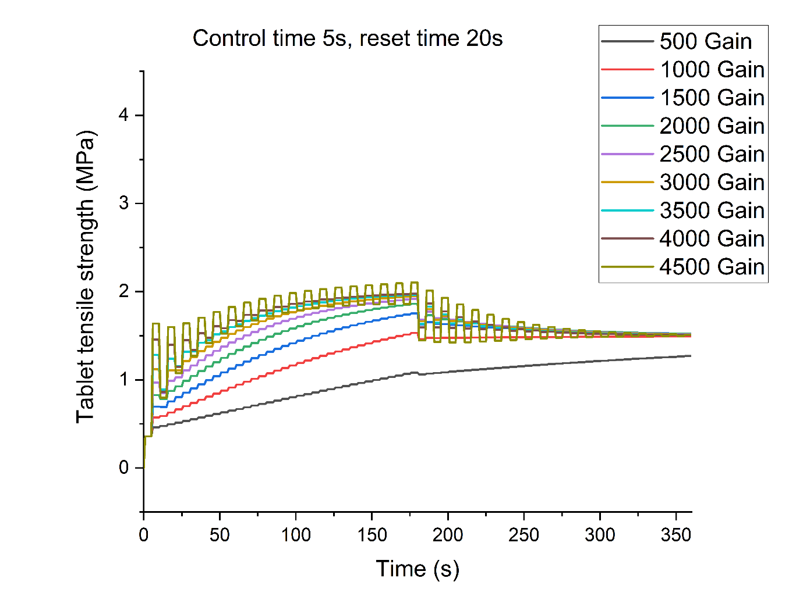the changes might also be hard to implement on a production tablet press as the changes in compression force might not be possible at that rate. The lower frequency of the control requires a reduced number of measurements but provides a slower response and an increase in instability at higher gain levels. The test performed over the different tuning parameters highlighted the need of compromise when tuning a PI controller in order to maximise its speed in reaching a set point, stability and practicality in terms of obtaining reading and applying the control moves to the equipment.

Figure Effect of different proportional gain value in a PI controller. (reset time 5s, control time 5s)

Figure Effect of different proportional gain value in a PI controller. (reset time 20s, control time 5s)

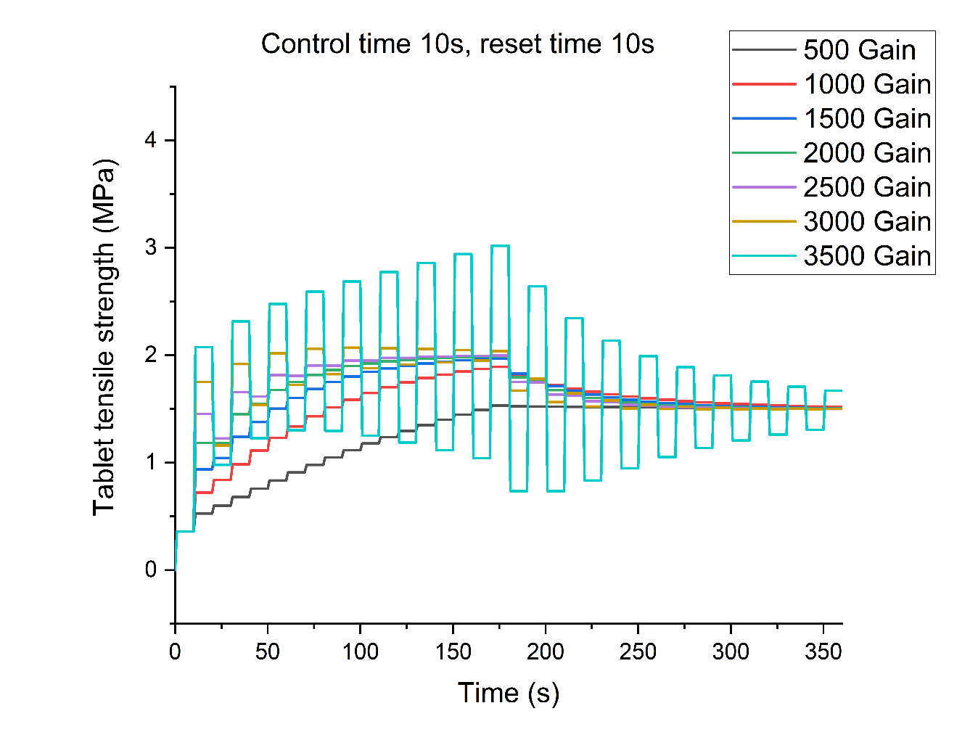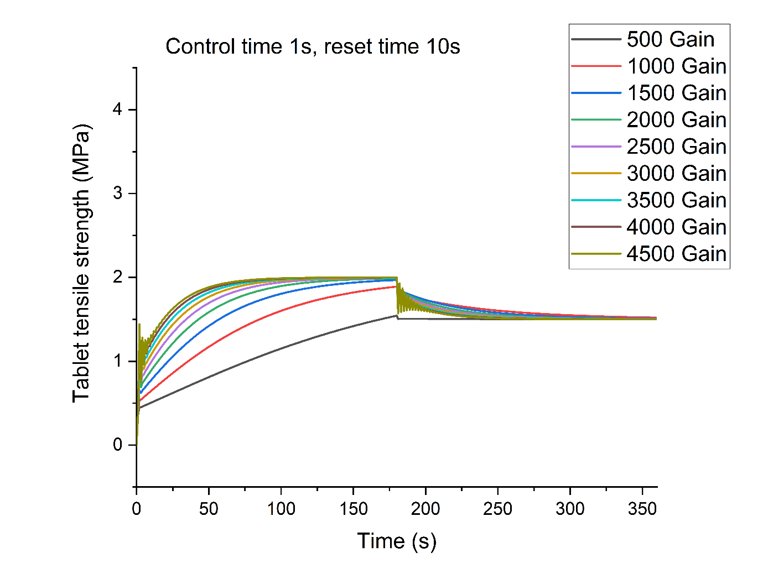

Figure Effect of different proportional gain value in a PI controller. (reset time 10s, control time 1s)

Figure Effect of different proportional gain value in a PI controller. (reset time 10s, control time 10s)

To test the performance of the control when disturbances were present in the system, a flowsheet model with a twin screw granulator, segmented fluidised bed dryer and tablet press was used. Variability was added to the liquid feed of the granulator, while the drying time was kept constant, causing a change in the granule moisture content affecting the tablet tensile strength. 3 variability frequencies were tested to assess how the control reacted to different kinds of variability. The parameters selected for the control loop during the test were a gain of 2500, a reset time of 10s and control time of 10s and the set point was set to 0.9MPa. In Figure 56, Figure 57 and Figure 58 both the controlled and not controlled tensile strength are shown for the 3 different rates of variability. The change in the liquid feed does affect the tensile strength at all frequencies with an increase in the liquid feed leading to stronger tablets as the output moisture of the granules increased leading to swings up to ≈0.2MPa which is slightly over 20% of the average tensile strength over the simulated period. The effect of the change in the liquid feed is also delayed by the residence time through the granulator and drier. This delay is mostly driven by the drying time as it is an order of magnitude bigger than the residence time in the other unit in the model. Interestingly at the highest frequency the changes are not as sharp as the middle frequency this is due to the peculiar, segmented design and operation of the fluidised bed dryer. The filling time bundles the granules produced over the filling time in to one drying cell and the final moisture content is determined by the total liquid added to the cell, this behaviour ultimately allows the system to dampen high frequency variability naturally as the many changes over the filling time average out around the liquid flowrate set point. The main impact on the tensile strength in the high frequency simulation was due to the lower frequency Chart, line chart
changes of the liquid flow over time that was present in the simulation.

Figure Controlled and non-controlled tablet tensile strength at a high frequency liquid flow rate variability

Figure Controlled and non-controlled tablet tensile strength at a medium frequency liquid flow rate variability

Both the middle and low frequency impacted the tensile strength of the tablets when no control was applied leading to fluctuation in the output tensile strength. When the model was simulated with the controller turned on, the variation caused by the change in the moisture content was minimised and the tablet strength remained within ±2% of the target which was highlighted in green in the figures in all scenarios. The small deviations in tensile strength are caused by the time taken for the controller to react and control the change.

Overall, the control system performed well and maintained the target tablet tensile strength at all frequencies with very small variation throughout the test.

The approach showcases how flowsheet models can be used to tune and test PI controllers without having to run experimental tests. This can be particularly useful not only to save material and time but also reduces the risk to the equipment as some conditions showed an unstable behaviour which could lead to increase wear or possible failure of the production equipment. The downside of PI controllers is the requirement for continuous measurement of the output variable. In this case testing the tablets quickly enough could be a challenge as tensile strength measurements mostly rely on offline tests which can take time reducing the potential impact of the controller.

Figure 58 Controlled and non-controlled tablet tensile strength at a low frequency liquid flow rate variability

## Feed forward control loops

Feed forward control loops can be used to maintain the value of a variable and reject the effect of disturbances by starting to act before the change takes places removing the need of always measuring the target variable value. The disadvantage of feed forward controllers is that they require to understand how the two variables are related to each other over a period of time and what is required to maintain the desired value stable. This deeper understanding is not required in a feedback controller as they react to changes on the output afterwards. A flowsheet model comprising of a fluidised bed drier, tablet feed frame and tablet compaction model was used to simulate the data required to implement a successful feed forward control loop.

The drying time in the flowsheet model was changed from 900s to 550s after 1500s to cause a drastic increase in the final moisture content and simulate the effect of this change on the tablet tensile strength. The effect of the drying time change on the moisture of the granules and tensile strength is shown in Figure 59. As the drying time is reduced the moisture content after drying increases from ≈2.5% to ≈7% this increase in moisture content causes an increase of the tablet tensile strength from ≈1.3MPa to ≈3.3MPa when steady state is reached. The change to the Chart, histogram

Figure 59 Simulated granule moisture content and tablet tensile strength over time showing the effect of the drying time being changed from 900s to 550s

moisture content is immediate while the change on the tensile strength takes some time to reach a new steady state. This is due to the mixing of the granules before tabletting in the feed frame of the tablet press dampening the response of the tensile strength to the change in moisture content of the granules. This type of response is typical of continuous processes which have a continuous mixing step in it. Using the initial and final values of the moisture and tensile strength and the compaction model equations it is possible to calculate the change in compaction force required to maintain the tensile strength once a steady state is reached. This approach is referred as a zero-order feed forward loop and is often used when the dynamic of the change in the measured value and the target value are similar, e.g. if both showcased a nearly instantaneous change in values. In this case the change in moisture is immediate and causes a dampened effect on the tensile strength, this kind of situation requires a first order feed forward control approach. Equation 9 describes the first order control approach.

$Y_{(t)}=Y_{(t_{0})}+\left(1-e^{-\left({t-θ_{p}}/{τ_{p}}\right)}\right)K_{p}∆u S(t-θ_{p})$ (9)

Y is the affected variable, t is time, $θ_{p}$ is the dead time, $τ_{p}$ is the time constant (time to reach 63.2%) of the full change in this case this is the compaction force as this is the variable that will lead to the target tensile strength, KP is the steady state gain which is the same as the one used in a zero order feed forward control and its value is described as $\frac{ΔY}{Δu}$, u is the observed value in this case the granule moisture content at the output of the dryer and S is a step function used to account for the dead time. In this case the dead time is the time between the initial change of the moisture content and the first recorded impact on the tensile strength. This time is dictated by the residence time of the material in the units between the moisture content sensor and the tablet press. A feedback control loop was used to easily simulate the amount of compression force required to maintain the tensile strength constant while the moisture content changed. Figure 60 shows the change in compaction force required to maintain the same tensile strength as the moisture content of the granules entering the tablet was impacted by the change in drying time. The different parameters of the equation are highlighted in the figure. ΔY and Δu were easily obtained using the value for the compaction force and moisture at the steady states before and after the change in drying time. Using 63.2% of the ΔY value it was possible to obtain the time at which the value reaches this threshold and therefore obtain the time constant for the process. The dead time was easily identified by analysing the time series data and calculating the time between the initial moisture change and the first change in the compaction force. Once all the data for the feed forward controller was obtained the controller was implemented in the flowsheet model.

To test the model simulations were run with both the zero and first order controllers. In these simulations the initial compaction force was set to target a 2MPa tensile strength and the drying time was cut from 900s to 550s after 2000s to cause a change in the output moisture content of the granules.

In Figure 61 the tensile strength for the zero order and first order feed forward control are shown. The zero-order method shows a big dip in the tensile strength falling as low as 0.36MPa as the compression force is changed immediately when the change in moisture content is detected without accounting for the dampened reaction. Over time the tensile strength did move back the original value following the dynamic of the process. This approach although leading to a constant tensile strength at steady state does cause a long period where the final product is out of specification. The first order controller on the other end was able to maintain the target tensile strength within a ±2% range (highlighted in green) throughout most of the test. A small dip to 1.9Mpa in the tensile strength is noticeable after the change in the drying time, this is caused by the controller reacting slightly too quickly and decreasing the compaction force more than required to maintain a constant tensile strength. This dip was considered acceptable as it caused a maximum 5% deviation from the original target tensile strength which is usually within the limits of commercial tablet manufacturing but could be improved if required by tuning the dead time and time constant value slightly further to reduce the variation caused by the sudden change in the moisture content of the granules.

Figure Simulated granule moisture content and controlled tabletting compaction force over time showing the effect of the drying time being changed from 900s to 550s

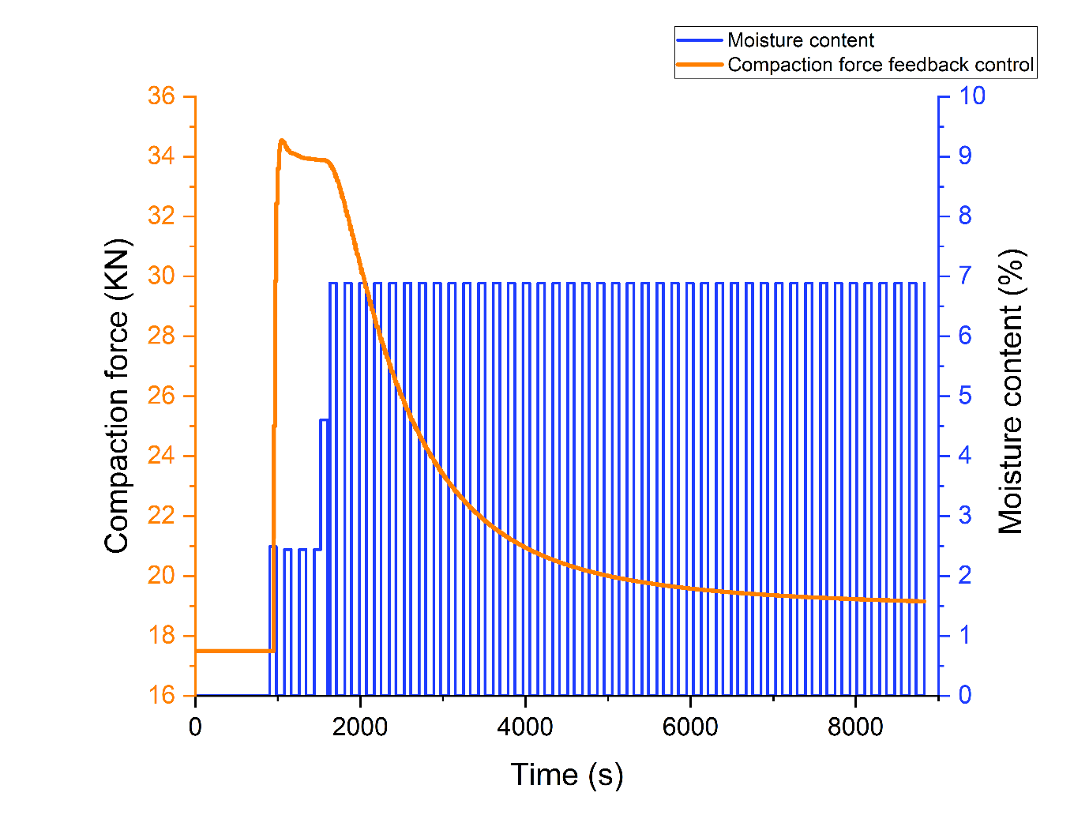

**ΔY**

**Δu**

**τ**

**θt**

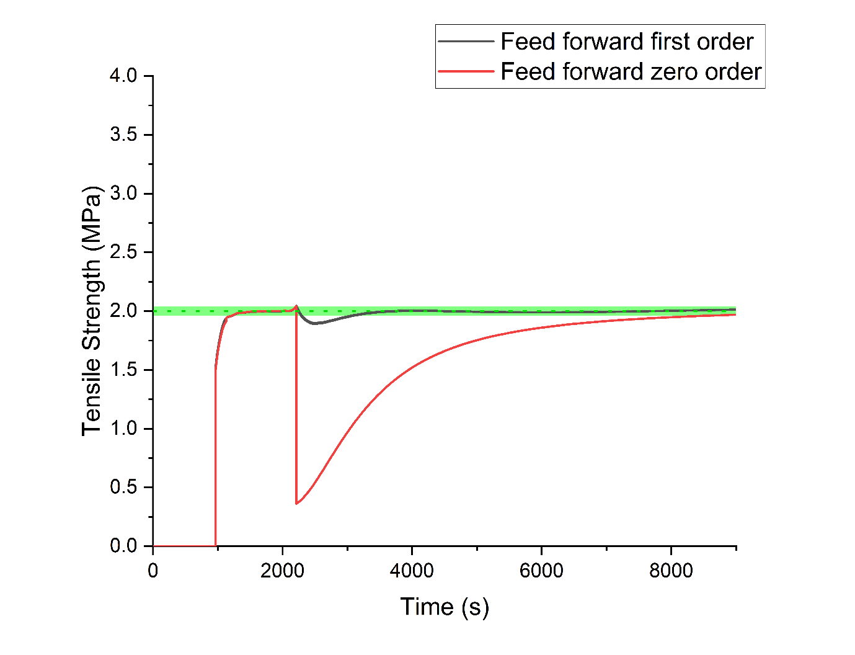The feed forward control model is a good opportunity to control the Consigma line as the moisture content of each cell is recorded continuously and could be used to apply the change in the compression force to maintain the target tensile strength regardless of variations in the granule moisture content after drying. The feed forward control loop would require the implementation of another feedback loop to deal with the potential drift of the target property or to change the set point as the feed forward controller itself only react to external changes so can’t change setpoint by itself. The feedback controller could be run at a slower rate as it is not required as often to account for drift and therefore would rely on a lower number of samples through the process compared to running a feedback controller as the only approach.

Figure Tablet tensile strength over time when controlled by a zero and first order feed forward as the drying time was changed from 900s to 550s

## Model predictive control

In the past few years more advanced control methods have been developed. Model predictive controllers use models to predict the effect of control moves and disturbances on the target variable in the future in order to select the best set of control moves to maximise the performance of the controller. One of the main advantages of model predictive controllers is that they can handle multiple inputs and multiple outputs allowing to control multiple variables at the same time. In the case of the Consigma-25 this can allow to both control the tensile strength and dissolution time using a single control model. To obtain the data required to develop a good model predictive controller a lot of dynamic data is required to be able to properly predict the behaviour of the system as the different variables change. The large amount of data can be generated using a flowsheet model instead of running the production line for a long time. This allows to reduce the amount of material and equipment time required for experimentation while also removing the risk associated with testing edge cases and big changes which are unlikely to be required during normal production. PharmaMV (Version 18, Applied materials, PerceptiveAPC, United Kingdom), an advanced control software, was linked to the flowsheet model developed to predict the tablet properties and used to control its various parameters such as the L/S ratio and granule moisture content and the obtained results were used to develop a control model. The software interfaces with the model in the same way as it does with physical equipment allowing to use the same tools and approaches.

Step testing over a flowsheet model comprising of a granule source, tablet feed frame and tabletting press was used to obtain the desired dynamic data. The simplified model omits the granulator and dryer and allows the simulation to run smoothly which is required for the connection with PharmaMV as it expects a continuous stream of data as it treats the data obtained from the flowsheet model as data coming from a real plant.

The L/S ratio, granule moisture content and compaction force were varied while the tensile strength, porosity and dissolution time were the observed target variables. All other model parameters were kept constant throughout the simulation. The steps were randomly generated using the PharmaMV PRBS(Pseudo random binary sequence) testing utility and the response was automatically recorded. The sequence consists of a series of sudden changes between two states of the variable and is referred as pseudo random because although the value chosen for each step is independent from the previous ones when the sequence is stretched to infinity it will have a repeating pattern. This predictability allows to reproduce the patterns which can be useful when testing systems. For moisture content and L/S ratio the time between random steps was set to 180s while the one for compaction force was set to 15s as the change caused by the compression force in the model is instant while both L/S ratio and moisture content require some time to impact the tensile strength, tablet porosity and dissolution time. These times were selected after running preliminary step tests and analysing the length of the responses and to represent likely scenarios such as variability of the moisture and L/S ratio between different fluidised bed drying cells. The steps values were randomly selected every time in between the given range. The ranges are shown in Table 10

|  |  |
| --- | --- |
| Table 10 PRBS test parameters and range | |
| **Variable** | **Range** |
| L/S ratio | 0.22-0.4 |
| Granule moisture content | 1.5 - 7% |
| Compaction force | 5KN-15KN |

Two types of step testing were run, one where only one variable at the time was changed, the other approach involved varying multiple variables at the same time. These two approaches were used to generate a vast amount of dynamic data.

In Figure 62 part of the step test experiment data is shown. From the data is possible to see the random step generated on the moisture content and its effect on the tablet tensile strength. As the tensile strength, tablet porosity and dissolution time are all linked together the effect of the steps shows the same dynamics and only differs in magnitude. From the figure is possible to see how the change in moisture content is sharp and nearly instantaneous while the impact on the tensile strength takes some time to reach steady state this is due to the mixing stage that is simulated in the tablet feed frame model. As expected, the magnitude of the change in moisture content directly affects the magnitude of the change in the tensile strength. The L/S ratio shows the same impact dynamic on the tablet tensile strength although the magnitude of the changes is smaller as the impact of the L/S ratio on the tablet properties is less pronounced. The compression force has the biggest impact on the tablet tensile strength and acted instantaneously as it’s the final parameter dictating the tablet properties and is not affected by any sort of mixing.

The data was fitted using linear auto regressive exogenous model using the tools build into PharmaMV. These models use a series of linear relationship to describe the changes in the system over time having a relationship for each time step and are described by Equation 6. For this reason, the time step size, overall length of the prediction and delay are critical for the tuning and fitting of this kind of models. The time step size determines the length of the change covered by each of the linear relationship in the series. The length of the prediction determines how long in the future the model can predict and is related to the time required to reach steady state after a change is made once the delay is accounted for. The delay is the time between the change in the variable and the first impact recorded on the target properties and is dictated by the residence time of the material between the change in conditions and the measured outputs, the model uses this time to shift the relationship forward in time and properly describe the 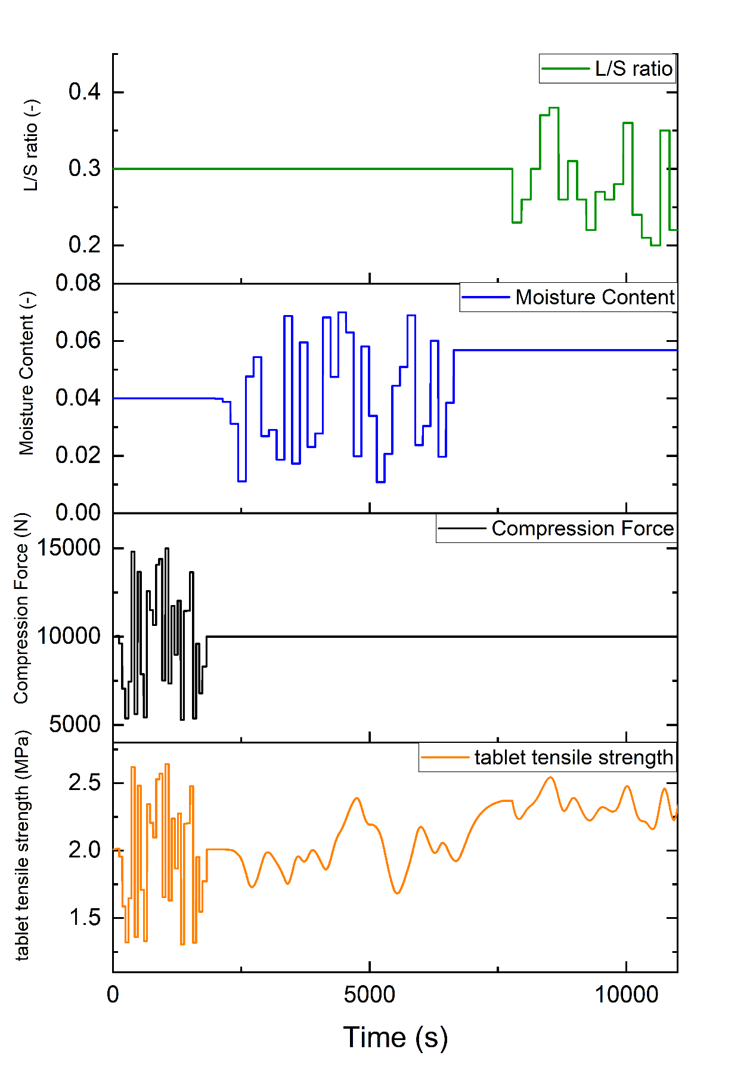change. The ratio between the prediction length and the time step is the number of terms in the ARX series and therefore decides how many parameters are needed to describe the process.

Figure Compaction force, moisture content and L/S ratio step testing results on tablet tensile strength

After fitting and tuning the selected parameters for the length and time step size are shown in Table 11. The time step was set at 5s for both the effect of the L/S ratio and granule moisture as lower values did not provide any benefits while adding to the complexity of the model. A shorter 2s time step was used for the compaction force as its effect on the tablet properties was nearly instantaneous and benefitted the lower value. The prediction length was set at 400s for both the L/S ratio and granule moisture content as this length was found to cover the dynamic of the process. A much shorter time of 30s was used for the compaction force as the impact of its change on the tablet properties was pretty much instantaneous. The delay for both the L/S ratio and granule moisture content was set to 10s for both, this is due to the simplified model used which does not include all the steps present in the Consigma-25 where the two delays will have a different value being spaced apart by the drying time. As the delay simply shifts the model prediction in time it could be easily adjusted to account for the difference between the model used and the actual equipment. A delay of 1s was found for the compression force as its change instantly impacts the tablet properties. A relative ARX approach also proved to perform better overall when compared to the absolute value ARX model and was therefore chosen for the controller. The relative approach describes the system using the change in the variable to calculate the change in the output properties instead of directly relating the specific absolute values of variables and outputs.

|  |  |  |  |
| --- | --- | --- | --- |
| Table 11 ARX model parameters for different variables | | | |
| **Variable** | **Time step (s)** | **Prediction length (s)** | **Delay(s)** |
| L/S ratio | 5s | 400 | 10 |
| Granule moisture content | 5s | 400 | 10 |
| Compaction force | 2s | 30 | 1 |

The obtained ARX model results are shown in Figure 63 and compared to the original data used for the fitting. As seen in the figure the model manages to capture the effect of the change of compression force on all the product qualities with no noticeable differences between the original data and the ARX results. The impact of both the L/S ratio and moisture content changes showed small deviations especially when big step changes were applied with a tendency of over predicting slightly at the beginning of the change while predicting the behaviour in between changes well. Overall, the model performs well for all the parameters and manages to represent the data well over the different changes. This was expected as the original data was produced using a flowsheet simulation which provides cleaner data compared to traditional experimental data. The ARX model manages to reduce the model complexity to describe the tabletting process and can be used for model predictive control.

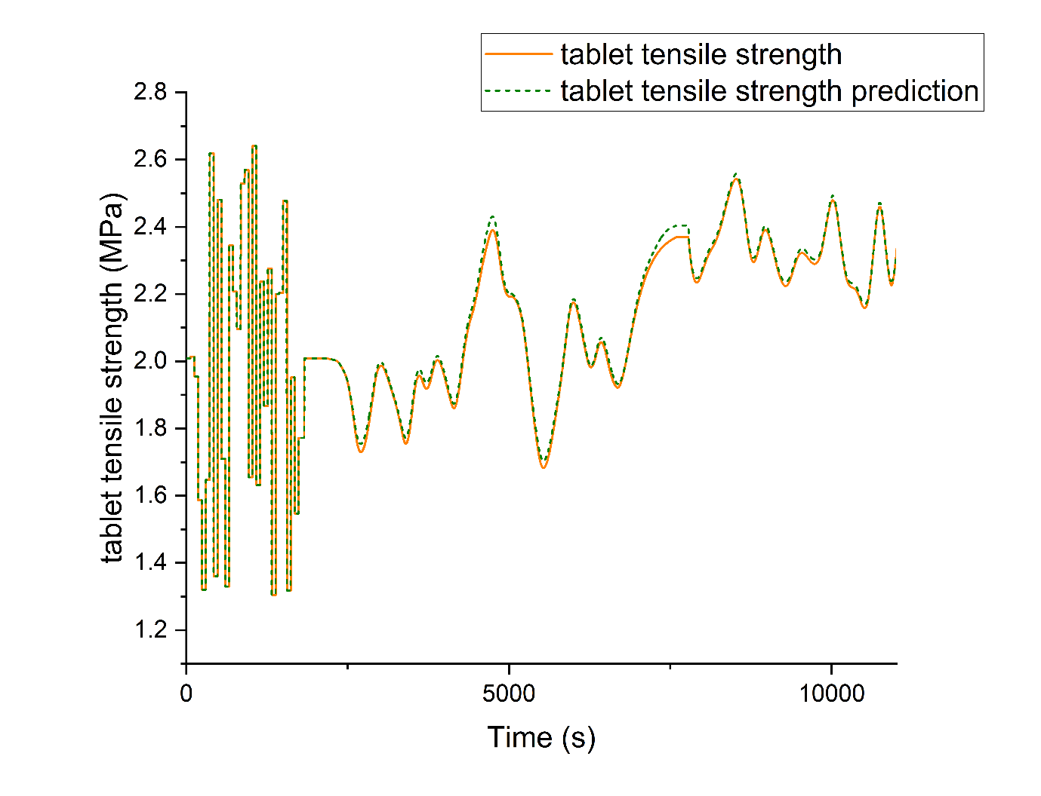To test its control capabilities the obtained model was used as a base of the MPC in PharmaMV and tested using the flowsheet model. The ability to target specific set points, multiple set points at the same time and to react to disturbances and maintain the set points were all tested. The moisture content was always regarded as a disturbance by the controller, the compaction force as a manipulated variable and the L/S ratio was tested both ways.

Figure ARX model tensile strength prediction over time

In Figure 64 the ability of targeting different target output variables and targeting multiple target set points at the same time is shown. The target for tensile strength and dissolution time are both shown. The set points and priorities were changed over time to test the ability of the model to switch between options. When either the tensile strength or dissolution time were set at high priority the model managed to quickly target the given set point. When the set points were given the same priority, the actual value does not reach either of the two. This is due to the target values being related to each other therefore the model aims to minimise the overall error between the two targets. The ability of the control model to switch between which property to prioritise or to take in consideration multiple without having to develop a different control method for each could minimise the development time and allow flexibility during deployment.

By default, the controller uses the compression force to steer the output values towards the targe as it is the quickest route due to its immediate impact on the values while a change in L/S ratio requires longer and might fall out of range given the smaller effect it has. One of the advantages of MPC is its flexibility as this behaviour could be tuned easily and the priority of which parameter to control can be varied based on the process requirement. The controller in general easily manages to change the setpoint of both the dissolution time and tensile strength without incurring in undesired instability.

Figure MPC set point test for dissolution time and tensile strength

A PRBS generator was used to drive the moisture content value to assess the behaviour of the control model and its response to the disturbance. Both high and low frequency variation were tested. In Figure 65 the moisture content step test and the resulting change in compaction force are shown. In Figure 66 both the tensile strength and dissolution time during the PRBS test are shown. The controller manages to reliably maintain the set point stable over the different frequencies of moisture content changes by affecting the compaction force. The controller was also able to reliably change set point as the disturbances were in place.

Overall using a flowsheet model of the tabletting process allowed for the development of ARX models which can be used for model predictive control potentially allowing a more granular control on the tablet properties and to reduce waste due to out of specification tablets.

Figure Moisture content PRBS and controlled compaction force

The flowsheet model facilitates the running of step testing which can be costly especially during early development where material scarcity can increase the cost. It also minimises the equipment time required, and the possibility of issues caused by the steep step changes. As the flowsheet models produces clean data the ARX models fitted well and were able to accurately represent the system. The final control model can also be tuned and tested using the flowsheet model as a replacement for the physical equipment again minimising the time and material required. As the platform and tools used to control the flowsheet model and the real-life equipment are the same this setup could also allow for the training of operators without having to stop a working process.

Figure Controlled tensile strength and dissolution time during PRBS moisture content testing

## Chapter Conclusion

Controlling key quality attributes is becoming more and more important as the pharmaceutical industry moves to diminish the amount of offline testing and strides to improve its overall efficiency by reducing the amount of waste due to out of specification production. Different kind of control techniques such as feedback loops, feed forward control and more advanced model predictive control can be used to deal with the different control scenarios present in pharmaceutical manufacturing. The flowsheet models managed to provide a platform to test and tune the different control approaches while not requiring the utilisation of material or facilities during the development process.

For PI loops it allows to identify both tuning parameters values or change in conditions that can cause instability which not only would affect the final properties of the product but could potentially lead to damage or increase wear on the equipment. Overall, for the control of the tensile strength the model predicted instability at high controller gain value while the control time was shown to improve the controller performance but would require an increase in the rate of testing. During testing with different liquid flow variability, the model also showcased how the segmented drier design manages to damp higher frequency variability due to the filling time aggregating the granules produced. The implemented PI loop managed to reduce the variability in tablet tensile strength due to changes in the liquid flow and therefore granule moisture content considerably, maintaining the tensile strength in a ±2% range across the conditions tested.

The use of the flowsheet model in the feed forward control loop development allows to identify which relationship is best suited based on the process dynamics. It also allows to simulate different conditions to obtain the data required for the control model to perform optimally and reduce the impact of changes over the final properties by applying preventive changes using different sensor readings. Both the zero and first order feed forward controllers implemented managed to maintain the tablet tensile strength at steady state, after the drying time change but behaved differently while the system reached steady state. The zero-order controller did not account for the dynamics of the change and therefore acted as soon as the change was detected leading to out of specification tablets as the system reached its new steady state. The first order controller performed better and allowed a maximum 5% variation straight after the drying time change and maintained the tensile strength in a 2% range from the set point after the initial deviation.

Aiding the development of more advanced model predictive controllers is where the use of a flowsheet model as a development tool really shines. These models often require a wide range of non-steady state data to fit so that they can reliably control the system under different circumstances. This data is often generated by a series of step tests over the interested variables. The use of a flowsheet model allows to generate this data quickly and without the use of material and machine time reducing the cost and time required to develop the control model. By linking the flowsheet model to the control software PharmaMV step tests were run by varying the L/S ratio, moisture content and tablet compaction force. The obtained data was used to fit linear ARX models. The model performed well after fitting showing only slight deviations at sharp changes in moisture content and L/S ratio. The ARX models were used to drive the model predictive controller in PharmaMV. The controller managed to perform well and was able to target different outputs and maintain the target values as the moisture content of the granules was varied using random step testing. As this kind of controller allows for multiple inputs and outputs it can also allow the use of flowsheet models as soft sensor for properties which can be hard to measure online such as dissolution time.

# Literature comparison

The effect of the L/S ratio over the drying behaviour is in agreement with the overall fluidised bed dryer literature with the increase in L/S ratio leading to a longer drying time due to the increase in the amount of water to remove in the system while the drying condition remained unchanged. Interestingly the change in size and porosity of the granules produced at a higher L/S ratio did not seem to affect the overall drying rate of the granules which was reported by other studies.[29,98] This is likely due to the relatively small amount of material dried in each fluidised bed cell when compared to the usual scale of fluidised bed used in traditional batch manufacturing as the effect becomes too small to be measured over the course of the drying cycle in the Consigma-25.

The combined filling and drying phase present at the beginning of the drying period is a quirk of the segmented fluidised bed drying approach as fluidised bed are usually loaded while the drying air is not turned on and has not been reported in the literature. The measurement of the moisture content using NIR of the granules during this phase proved to be particularly challenging due to the lack of enough granules around the probe especially during the first few seconds of the filling time. During the drying only phase the NIR probed provided stable measurement proving the method to be overall viable to fully monitor the process after enough material was added to the fluidised bed drier cell. This agrees with other studies which showcased the use of NIR probes for moisture content reading both as an end of drying solution and to monitor the moisture content during the drying process. [7,36,99,100]

The effect of the change in throughput while maintaining the same final granule mass in the drying cell by changing the filling time was not directly reported by literature as this behaviour is particular to the Consigma-25. As the drying conditions and granule properties overall are not changed is possible to state that the literature and results agrees as no significant difference was measured which is what is expected when drying conditions remained constant. This shows that although the filling and drying phase of the dryer is a unique characteristic of segmented fluidised bed dryer its length does not affect the overall drying behaviour of the granules.

In general, the literature reports a decrease in the tablet tensile strength of tablet as the L/S ratio during wet granulation is increased. [101] This was mostly related to the increase in the intensity of the granulation process producing denser granules which perform worse during the tabletting process. This loss in compaction performance due to the reduction in the porosity of the granules was also reported in dry granulation processes such as roller compaction where an increase in the amount of pressure of the roller caused a reduction in granule porosity and tablet tensile strength [102,103]. The increase in L/S ratio did cause a decrease in the porosity of the granules produced in the experiments. This decrease in porosity lead to an increase in the tensile strength of the tablets and while this opposes most of the literature findings it has been reported for similar mannitol-MCC binary mixtures [97] indicating that the impact of the L/S ratio on the tensile strength is material dependant as the different amounts of granulation water can affect more than the porosity of the granules.

Overall, the moisture content of the granules or powders prior to compression has been shown to have an impact on the tablet tensile strength with most studies showing an increase in the tablet tensile strength as the moisture content is increased due to the increase malleability of the material and increase interaction strength due to the water content. This agrees with the experimental findings in the project as the moisture content showcased a big impact on the tablet tensile strength across the tested L/S ratios [42,44,104]. As the moisture content is increased over a certain threshold it has been shown to cause a decrease in the tensile strength as the additional water start to act as a lubricant between particles causing a decrease in the interaction [43]. This point was not reached during the experiments and is usually outside of the range of moisture content that is acceptable for pharmaceutical manufacturing due to other factors such as product stability and potential for bacterial growth.

The effect of the moisture content on the compressibility and compactability has been reported by a few studies while this effect on the L/S ratio does not appear to have been investigated in regards of its effect on the compressibility and compactability. In general, it was reported that the moisture content affects the compactability by increasing both the binding capacity and tensile strength at 0 porosity as the moisture content is increased [45–47]. This was not observed in the experiment with the tested mixture as all tested conditions fell on an overall compressibility curve with the changes in both moisture content and L/S ratio not affecting the compactability in substantial manner. This is likely due to the properties of the blend used for testing with the high percentage of hygroscopic MCC able to reduce the amount of surface water available to enhance the interactions between particles negating its effect on the compactability properties. The compressibility was affected by both the moisture content and the L/S ratio showcasing an increase in the compressibility at higher moisture contents and a reduction in the Pressure at 0 porosity as the L/S ratio was increased. The findings regarding the moisture content are similar to ones reported for other materials with an increase in moisture content leading to the increase in the compressibility of the material due to the increase in the deformability of the particles as more moisture is present leading to a further reduction in porosity at the same compaction pressure [45–47].

The measured exponential relationship between the tablet porosity and the dissolution time of the tablet fits in with the literature covering the topic with a decrease in the porosity leading to a sharp increase of the dissolution time due to the water finding it harder and harder to penetrate the tablet leading to longer dissolution times [105,106].

As the pharmaceutical industry is moving towards an increase implementation of a variety of control strategies different approaches to develop and test and control methods for different have been reported in literature. The use of different modelling approaches has been used to develop the control strategy for direct compaction processes, blending, API manufacturing to develop both more traditional PI and PID loops to more advance feed forward control loop and model predictive control approaches. The ability to minimise the number of experiments needed to obtain the required data to successfully develop the control strategies was highlighted in the studies [80][87]. The obtained performance of the tested control approaches in the project agrees with the current literature state with the flowsheet model able to be used for a wide variety of tasks both in the development, and the preliminary testing and tuning of different control strategies. This is particularly important as the industry strife to implement more control in its manufacturing both for new and old manufacturing processes reducing the amount of time and material required to develop, test and fully implement the control strategies.

# Conclusion

The pharmaceutical industry is moving to adopt continuous manufacturing and the use of control strategies to improve its efficiency. To fully take advantage of these developments a deep understanding of the process is required. An important part in the understanding of continuous process is the link between the parameters used in a unit and their cascading effect throughout the process. The Consigma-25 continuous powder to tablet line and its wide assortment of equipment provides a great platform to further the understanding on the relationship between wet granulation, drying and tabletting and the opportunities available to improve the manufacturing process.

The use of an NIR probe to measure the moisture content throughout the drying process proved successful and proved important to show the behaviour of the moisture content during the cell filling phase which is a characteristic feature of the segmented design of the dryer. The moisture content was found to reach a steady value after a period of time due to the drying rate and addition of water rate coming to an equilibrium.

The effect of varying parameters in the granulator on the drying behaviour was found to be mostly related to the total amount of water added to each drying cell with the throughput and L/S ratio not affecting the drying process in an impactful way. This behaviour in the dryer can allow for variable conditions during granulation to achieve different targets such as granule size or certain granulator torque, which might be part of the requirement for the process, without having to change the drying parameters to obtain the same final moisture content reducing the amount of experimentation required.

Using a flowsheet model, a control method to automatically vary the drying time was developed. The model used the linear relationship found between the drying time required to reach a certain moisture content and the amount of granulation water. The approach was tested by adding variability to the liquid feed flow and performed well managing to target the moisture content required and the amount of in specification cells moved from 23% without the control active to 94% when using the controller. The ability to target a consistent moisture content as the amount of water in the dryer is varied is particularly important when considering the tabletting process as the moisture content in the granules was found to affect the final tablet properties.

The use of properties such as the compactability and compressibility to describe the compaction properties and how these are affected by granule properties and manufacturing conditions allowed to understand the reasons behind the change in tablet properties. The compactability of the blend utilised in the experiment was independent from both the L/S ratio used during granulation and the moisture content of the granules. The compressibility on the other hand was affected by both with the moisture content having the biggest effect, this effect was successfully described by few linear relationships. For this blend is therefore possible to conclude that the change in tablet tensile strength is driven by the impact of the L/S ratio and moisture content on the porosity of the tablet instead of a direct effect on the strength. Using the relationships, a model capable of simulating the tablet properties at different conditions was implemented. The model performed well overall showcasing a slight tendency to underpredict the tensile strength at higher values. The flexibility of the model in terms of parameter range allows it to be used to develop, test and tune control approaches.

A relationship between the tablet porosity and the dissolution time was also found and added to the compaction model allowing it to calculate this important property over a wide range of conditions.

Control is becoming more and more important in the pharmaceutical industry to minimise waste and potentially decrease the amount of testing required after production decreasing both cost and time to market. The flowsheet model allowed to test a variety of tuning parameter for PID loops and to simulate the data required for feed forward control loops and model predictive control vastly decreasing the amount of material required and allowing for experimentation in control philosophies without the use of the physical equipment. This is especially useful for model predictive control where a vast amount of non-steady state data is advised to fit the models which are then used to drive the control system and can be easily generated using the flowsheet model instead of running experiments. To produce this dynamic data PRBS testing on the compaction force, granule moisture content and L/S ratio was performed. The data obtained was used to fit ARX model. These models were used as the base for the model predictive controller implementation. The controller was tested and managed to both target multiple properties set points and deal with simulated variability showing no signs of instability.

The outlined approach used for the tablet properties can and should be used for other pharmaceutical process and the creation of models to describe the systems should be considered for development as they can reduce the amount of material and time required for the development of control and potentially allowing the implementation of soft sensors for hard to measure online properties allowing for faster responses and a decrease in the time to market of the product.

This is becoming more and more important as the industry moves towards trying to reduce waste and improve its efficiency both in terms of materials and energy. This is important not only to improve the profitability of the company but also important to reduce the environmental impact of manufacturing drugs. This is particularly important as the amount of pharmaceutical production is projected to increase as the average age around the world increases. Continuous manufacturing flexibility in production quantities and smaller facilities will also be pivotal to reduce waste and allow to produce drug products closer to the patients decreasing the impact of transportation over the overall carbon footprint of the products.

# Future work

The time required to reach a specific moisture content was found to be only related to the mass of water present in the dryer when drying conditions were kept constant allowing the prediction of the drying time required for different L/S ratios. This approach should be expanded to account for the effect of different drying conditions. To obtain the data, a set of experiment with different temperatures, air flow and mass of water in the granulation cells should be run. The implementation of the effect of both the air temperature and airflow on the drying time would allow greater flexibility when designing the process as the drying time could be lowered or increased without having to change the amount of water in the dryer cell. This can be particularly important while changing the production throughput as the ratio between the drying time and filling time describes the load efficiency of the drier but, also has an upper limit as a drying cell must be free by the time a full filling cycle is completed. This can lead to situations where the drying rate is not high enough to deal with the throughput in the allotted time or is too high leading to the dryer running partially full, decreasing the energy efficiency of the process as air still flows through the empty dryer cells. Using the temperature or airflow the time could be tuned to maintain as many of the dryer cells full during continuous production to maximise the efficiency of the process. The ability of calculating the time for different temperatures can also be useful if any of the active material are particularly sensitive to temperature and require specific conditions to retain their properties.

The use of the temperature derivative as a mean to automatically trigger the end of the drying time to maximise efficiency could also be expanded by relating the moisture content obtained via this method to the drying air temperature by repeating the experiments at different temperatures. This would allow to select the most efficient temperature to target the final moisture content required, further optimising the production process. To achieve this a series of experiments at different temperature should be performed while monitoring both the temperature and moisture content. The derivative of the temperature should then be taken, and the moisture content recorded at the peak of the derivative should be plotted against the air drying temperature to check for a relationship. If a relationship is found it should be fitted to allow the calculation of the optimal temperature given a specific moisture target.

A study focusing on testing the effect of different L/S ratio on a few other common pharmaceutical materials should be undertaken to understand if the lack of an impact in the drying performance at different L/S ratios, even when notable different in granule properties were present, is material dependant or a characteristic of the drying process present in the Consigma-25. The understanding of this material dependence will help both during the decision process of which materials to use during production and the settings required to target the material properties required across the production line. This test should focus on commonly used materials and the largest L/S ratio difference between conditions should be tested to try and maximise the difference in granule properties.

The use of the compactability and compressibility during the modelling of the tabletting process provided a deeper understanding on how the moisture content and L/S ratio affected the granule behaviour during compaction and how this impacted the final tablet properties. Further work should focus on trying to deepen the understanding on how the properties of the blend affect the impact of the moisture and L/S on the compressibility and compactability. Brittle, plastic, and elastic materials already showed differences in final tensile strength and porosity when tested at different L/S ratios and moisture in the literature. The use of compaction profiles to obtain the compressibility and compactability would likely help to understand the mechanics behind the differences in behaviour. The difference in hygroscopicity should also be taken in consideration as the availability of the moisture to interact might also affect the compaction properties.

Similarly, a study on the impact of the milling parameters such as the milling speed and mill mesh screen size on the compaction properties on the granules should be performed. First a study looking at these two parameters in isolation while keeping the other parameters throughout the line should be performed to assess the impact of the milling parameters. If a change in the compressibility or compactability is measured when changing the parameters, it would be important to understand if the effect is dependent on the L/S ratio and moisture content of the granules. This will allow to fully implement the effect of the mill on the compaction process and therefore on the final tablet properties. As the mill settings will mostly affect the granule size distribution and shape it would be preferrable to be able to relate the granule properties after milling to any effect on the compressibility and compressibility allowing for a more flexible model which could be used on a variety of situations and equipment instead of being bonded to the Consigma-25.

As the control strategies were developed and tested on the flowsheet models, it would be important to test them on the Consigma-25 to validate the performance seen during the simulations and prove the potential of the approach to the industry. As the standard software provided to use the Consigma- 25 does not contain any feature to implement new controllers these must be implemented using third party software. PharmaMV is an example of a control and modelling software that can be interfaced with the equipment allowing to receive data and control the line.

The control method devised for the moisture content should be straightforward to implement by using the flow reading obtained from the liquid pump during the granulation process to calculate the drying time. The liquid flow rate should be varied over time to test the ability of the controller to successfully maintain a stable output moisture content.

Both the feedback and feed forward controllers for the tablet strength should be tested using changes in the granule moisture content after drying as it’s the main cause in the variability of the tablet properties. PRBS testing could be used for testing as it’s likely harsher than any natural variability in the process even when accounting for situation such as refilling the liquid tanks. This more real life scenarios could also be tested to assess their impact on the granule properties during compaction. The feedback control loop test will also allow to verify the viability of the different rate of tablet testing that might be required to maintain control.

As the model predictive control was developed in PharmaMV where the flowsheet model is considered as a piece of physical equipment its integration on the Consigma line should require little changes such as the delay time of the L/S ratio changes on the tablet properties. The tests performed on the flowsheet model to test the control abilities should be run on the equipment and the data compared to confirm the ability of the controller to both maintain and change the target properties and to understand the differences between the simulated and experimental behaviour to further improve the in-silico development process and reduce the amount of work to transition between the two.

The implementation of the compaction flowsheet model as a live digital sensor should be pursued and tested. The model performed well based on the data used for fitting and is able to encompass a wide operating range of granule moisture contents and L/S ratios. Using PharmaMV it is possible to drive the value of the model parameters such as L/S ratio, moisture content and compression force from the real time data obtained from the production equipment. This approach allows the model to predict the tablet properties in real time and could be used as an additional sensor. The sensor could be added as part of a control strategy or as additional information during production allowing operators to change parameters if needed. The sensor should be tested at both steady state and during dynamic changes to confirm the ability of the model to reliably predict the tablet properties during manufacturing.

# Appendix

## NIR calibration curves

Samples containing different amounts of water were produced by running the twin screw granulator while changing the liquid flow. The moisture content in the samples was then measured using Loss on Drying and the NIR probe with its span set to 1 and trim set to 0. This was repeated 5 times for each sample. The measurements were then plotted as shown in Figure 67 Figure 68 and a linear fit calculated. The slope of the fit was then used as the span while the intercept was used as the trim value during the operation of the Consigma-25.

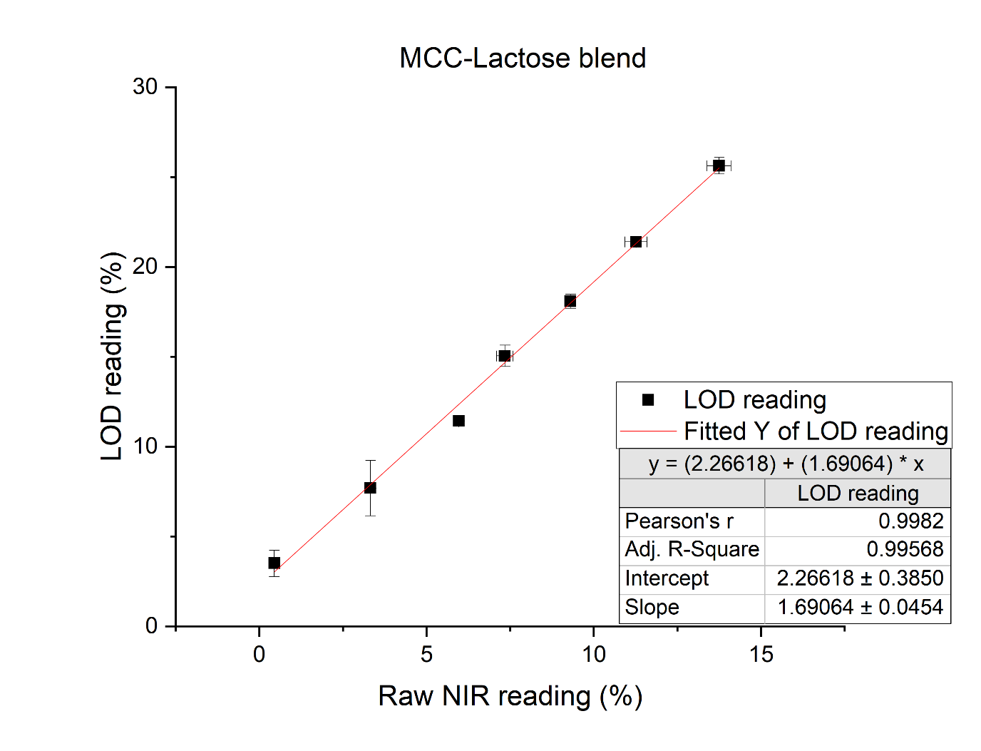

Figure 67 Moisture probe calibration curve for MCC-Lactose blend

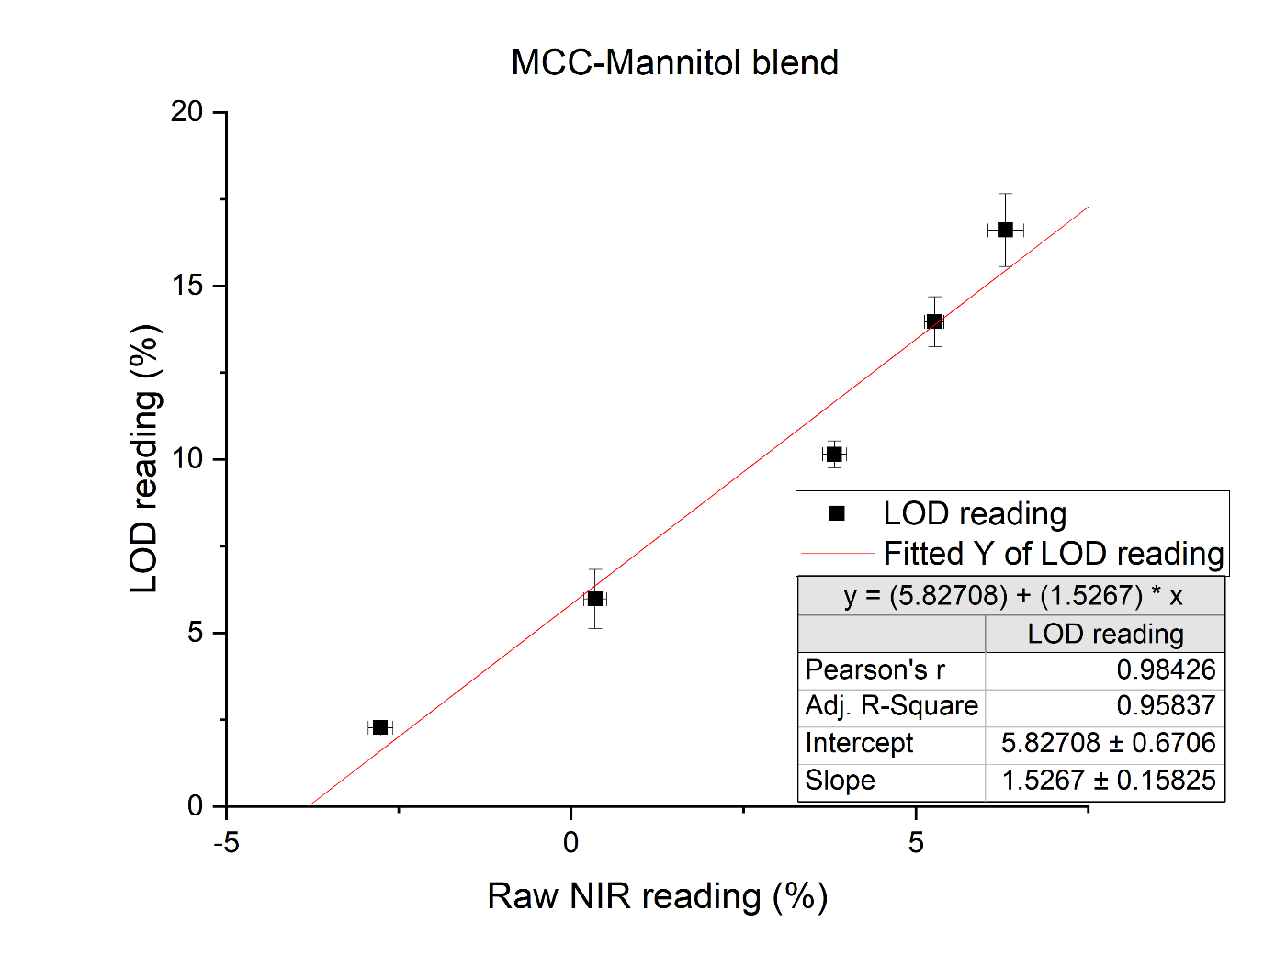

Figure 68 Moisture probe calibration curve for MCC-Mannitol blend

# Publications

Parts of the work presented in this thesis has been published in the following:

Monaco, Daniele, et al. "Drying in a continuous wet granulation line: Investigation of different end of drying control methods." *Powder Technology* 392 (2021): 157-166. <https://doi.org/10.1016/j.powtec.2021.07.004>.

Monaco, Daniele, et al. “Modelling the effect of L/S ratio and granule moisture content on the compaction properties in continuous manufacturing” *International Journal of Pharmaceutics* 633 (2023): 122624. <https://doi.org/10.1016/j.ijpharm.2023.122624>.

# References

[1] F. and D. Administration, Guidance for Industry, PAT-A Framework for Innovative Pharmaceutical Development, Manufacturing and Quality Assurance, Http://Www.Fda.Gov/Cder/Guidance/Published.Html. (2004). http://ci.nii.ac.jp/naid/10025793265/en/ (accessed March 26, 2019).

[2] Q. Su, S. Ganesh, M. Moreno, Y. Bommireddy, M. Gonzalez, G. V. Reklaitis, Z.K. Nagy, A perspective on Quality-by-Control (QbC) in pharmaceutical continuous manufacturing, Comput. Chem. Eng. 125 (2019) 216–231.

[3] J. Rantanen, J. Khinast, The Future of Pharmaceutical Manufacturing Sciences, J. Pharm. Sci. 104 (2015) 3612–3638.

[4] S. Byrn, M. Futran, H. Thomas, E. Jayjock, N. Maron, R.F. Meyer, A.S. Myerson, M.P. Thien, B.L. Trout, Achieving continuous manufacturing for final dosage formation: Challenges and how to meet them May 20-21, 2014 continuous manufacturing symposium, J. Pharm. Sci. 104 (2015) 792–802.

[5] C. Badman, C.L. Cooney, A. Florence, K. Konstantinov, M. Krumme, S. Mascia, M. Nasr, B.L. Trout, Why We Need Continuous Pharmaceutical Manufacturing and How to Make It Happen, J. Pharm. Sci. 108 (2019) 3521–3523.

[6] B. Aksu, T. De Beer, S. Folestad, J. Ketolainen, H. Lindén, J.A. Lopes, M. De Matas, W. Oostra, J. Rantanen, M. Weimer, Strategic funding priorities in the pharmaceutical sciences allied to Quality by Design (QbD) and Process Analytical Technology (PAT), Eur. J. Pharm. Sci. 47 (2012) 402–405.

[7] J.M. Vargas, S. Nielsen, V. Cárdenas, A. Gonzalez, E.Y. Aymat, E. Almodovar, G. Classe, Y. Colón, E. Sanchez, R.J. Romañach, Process analytical technology in continuous manufacturing of a commercial pharmaceutical product, Int. J. Pharm. 538 (2018) 167–178.

[8] F.J. Muzzio, T. Shinbrot, B.J. Glasser, Powder technology in the pharmaceutical industry: The need to catch up fast, Powder Technol. 124 (2002) 1–7.

[9] B. Van Snick, J. Holman, C. Cunningham, A. Kumar, J. Vercruysse, T. De Beer, J.P. Remon, C. Vervaet, Continuous direct compression as manufacturing platform for sustained release tablets, Int. J. Pharm. 519 (2017) 390–407.

[10] M. Leane, K. Pitt, G.K. Reynolds, N. Dawson, I. Ziegler, A. Szepes, A.M. Crean, R. Dall Agnol, The Manufacturing Classification Sy, Manufacturing classification system in the real world: factors influencing manufacturing process choices for filed commercial oral solid dosage formulations, case studies from industry and considerations for continuous processing, Pharm. Dev. Technol. 23 (2018) 964–977.

[11] M. Leane, K. Pitt, G. Reynolds, T.M.C.S. (MCS) W. Group, A proposal for a drug product Manufacturing Classification System (MCS) for oral solid dosage forms, Pharm. Dev. Technol. 20 (2015) 12–21.

[12] J. Vercruysse, U. Delaet, I. Van Assche, P. Cappuyns, F. Arata, G. Caporicci, T. De Beer, J.P. Remon, C. Vervaet, Stability and repeatability of a continuous twin screw granulation and drying system, Eur. J. Pharm. Biopharm. 85 (2013) 1031–1038.

[13] J. Vercruysse, E. Peeters, M. Fonteyne, P. Cappuyns, U. Delaet, I. Van Assche, T. De Beer, J.P. Remon, C. Vervaet, Use of a continuous twin screw granulation and drying system during formulation development and process optimization, Eur. J. Pharm. Biopharm. 89 (2015) 239–247.

[14] S. Zomer, J. Zhang, S. Talwar, S. Chattoraj, C. Hewitt, Multivariate monitoring for the industrialisation of a continuous wet granulation tableting process, Int. J. Pharm. 547 (2018) 506–519.

[15] Y. Roggo, V. Pauli, M. Jelsch, L. Pellegatti, F. Elbaz, S. Ensslin, P. Kleinebudde, M. Krumme, Continuous manufacturing process monitoring of pharmaceutical solid dosage form: A case study, J. Pharm. Biomed. Anal. 179 (2020) 112971.

[16] P. Beer, D. Wilson, Z. Huang, M. De Matas, Transfer from High‐Shear Batch to Continuous Twin Screw Wet Granulation: A Case Study in Understanding the Relationship Between Process Parameters and Product Quality Attributes, J. Pharm. Sci. 103 (2014) 3075–3082.

[17] J. Vercruysse, A. Burggraeve, M. Fonteyne, P. Cappuyns, U. Delaet, I. Van Assche, T. De Beer, J.P. Remon, C. Vervaet, Impact of screw configuration on the particle size distribution of granules produced by twin screw granulation, Int. J. Pharm. 479 (2015) 171–180.

[18] V. Vanhoorne, B. Vanbillemont, J. Vercruysse, F. De Leersnyder, P. Gomes, T. De Beer, J.P. Remon, C. Vervaet, Development of a controlled release formulation by continuous twin screw granulation: Influence of process and formulation parameters, Int. J. Pharm. 505 (2016) 61–68.

[19] A. Kumar, J. Dhondt, J. Vercruysse, F. De Leersnyder, V. Vanhoorne, C. Vervaet, J.P. Remon, K. V. Gernaey, T. De Beer, I. Nopens, Development of a process map: A step towards a regime map for steady-state high shear wet twin screw granulation, Powder Technol. 300 (2016) 73–82.

[20] K.M. Hwang, C.H. Cho, S.D. Yoo, K.I. Cha, E.S. Park, Continuous twin screw granulation: Impact of the starting material properties and various process parameters, Powder Technol. 356 (2019) 847–857.

[21] M. Fonteyne, A. Correia, S. De Plecker, J. Vercruysse, I. Ilić, Q. Zhou, C. Vervaet, J.P. Remon, F. Onofre, V. Bulone, T. De Beer, Impact of microcrystalline cellulose material attributes: A case study on continuous twin screw granulation, Int. J. Pharm. 478 (2015) 705–717.

[22] M. Verstraeten, D. Van Hauwermeiren, K. Lee, N. Turnbull, D. Wilsdon, M. am Ende, P. Doshi, C. Vervaet, D. Brouckaert, S.T.F.C. Mortier, I. Nopens, T. De Beer, In-depth experimental analysis of pharmaceutical twin-screw wet granulation in view of detailed process understanding, Int. J. Pharm. 529 (2017) 678–693.

[23] S. Yu, G.K. Reynolds, Z. Huang, M. de Matas, A.D. Salman, Granulation of increasingly hydrophobic formulations using a twin screw granulator, Int. J. Pharm. 475 (2014) 82–96.

[24] P. Beer, D. Wilson, Z. Huang, M. De Matas, Transfer from High‐Shear Batch to Continuous Twin Screw Wet Granulation: A Case Study in Understanding the Relationship Between Process Parameters and Product Quality Attributes, J. Pharm. Sci. 103 (2014) 3075–3082.

[25] I.P. Gabbott, F. Al Husban, G.K. Reynolds, The combined effect of wet granulation process parameters and dried granule moisture content on tablet quality attributes, Eur. J. Pharm. Biopharm. 106 (2016) 70–78.

[26] A. Kumar, J. Vercruysse, S.T.F.C. Mortier, C. Vervaet, J.P. Remon, K. V. Gernaey, T. De Beer, I. Nopens, Model-based analysis of a twin-screw wet granulation system for continuous solid dosage manufacturing, Comput. Chem. Eng. 89 (2016) 62–70.

[27] V. Vanhoorne, L. Janssens, J. Vercruysse, T. De Beer, J.P. Remon, C. Vervaet, Continuous twin screw granulation of controlled release formulations with various HPMC grades, Int. J. Pharm. 511 (2016) 1048–1057.

[28] F. Stauffer, V. Vanhoorne, G. Pilcer, P.-F. Chavez, S. Rome, M.A. Schubert, L. Aerts, T. De Beer, Raw material variability of an active pharmaceutical ingredient and its relevance for processability in secondary continuous pharmaceutical manufacturing, Eur. J. Pharm. Biopharm. 127 (2018) 92–103.

[29] P. Bareschino, A. Marzocchella, P. Salatino, Fluidised bed drying of powdered materials: Effects of operating conditions, Powder Technol. 308 (2017) 158–164.

[30] S.T.F.C. Mortier, K. V. Gernaey, T. De Beer, I. Nopens, Analysing drying unit performance in a continuous pharmaceutical manufacturing line by means of mass – Energy balances, Eur. J. Pharm. Biopharm. 86 (2014) 532–543.

[31] S.T.F.C. Mortier, T. De Beer, K. V. Gernaey, J. Vercruysse, M. Fonteyne, J.P. Remon, C. Vervaet, I. Nopens, Mechanistic modelling of the drying behaviour of single pharmaceutical granules, Eur. J. Pharm. Biopharm. 80 (2012) 682–689.

[32] S.T.F.C. Mortier, T. De Beer, K. V. Gernaey, J.P. Remon, C. Vervaet, I. Nopens, Mechanistic modelling of fluidized bed drying processes of wet porous granules: A review, Eur. J. Pharm. Biopharm. 79 (2011) 205–225.

[33] M. Mezhericher, A. Levy, I. Borde, Theoretical Drying Model of Single Droplets Containing Insoluble or Dissolved Solids, Dry. Technol. 25 (2007) 1025–1032.

[34] M. Ghijs, E. Schäfer, A. Kumar, P. Cappuyns, I. Van Assche, F. De Leersnyder, V. Vanhoorne, T. De Beer, I. Nopens, Modeling of Semicontinuous Fluid Bed Drying of Pharmaceutical Granules With Respect to Granule Size, J. Pharm. Sci. (2019).

[35] M. Fonteyne, J. Arruabarrena, J. de Beer, M. Hellings, T. Van Den Kerkhof, A. Burggraeve, C. Vervaet, J.P. Remon, T. De Beer, NIR spectroscopic method for the in-line moisture assessment during drying in a six-segmented fluid bed dryer of a continuous tablet production line: Validation of quantifying abilities and uncertainty assessment, J. Pharm. Biomed. Anal. 100 (2014) 21–27.

[36] M. Fonteyne, D. Gildemyn, E. Peeters, S.T.F.C. Mortier, J. Vercruysse, K. V. Gernaey, C. Vervaet, J.P. Remon, I. Nopens, T. De Beer, Moisture and drug solid-state monitoring during a continuous drying process using empirical and mass balance models, Eur. J. Pharm. Biopharm. 87 (2014) 616–628.

[37] F. De Leersnyder, V. Vanhoorne, H. Bekaert, J. Vercruysse, M. Ghijs, N. Bostijn, M. Verstraeten, P. Cappuyns, I. Van Assche, Y. Vander Heyden, E. Ziemons, J.P. Remon, I. Nopens, C. Vervaet, T. De Beer, Breakage and drying behaviour of granules in a continuous fluid bed dryer: Influence of process parameters and wet granule transfer, Eur. J. Pharm. Sci. 115 (2018) 223–232.

[38] M. Mezhericher, Development of drying-induced stresses in pharmaceutical granules prepared in continuous production line, Eur. J. Pharm. Biopharm. 88 (2014) 866–878.

[39] V. Pauli, F. Elbaz, P. Kleinebudde, M. Krumme, Orthogonal Redundant Monitoring of a New Continuous Fluid-Bed Dryer for Pharmaceutical Processing by Means of Mass and Energy Balance Calculations and Spectroscopic Techniques, J. Pharm. Sci. 108 (2019) 2041–2055.

[40] I.P. Gabbott, F. Al Husban, G.K. Reynolds, The combined effect of wet granulation process parameters and dried granule moisture content on tablet quality attributes, Eur. J. Pharm. Biopharm. 106 (2016) 70–78.

[41] P. Thapa, A.R. Lee, D.H. Choi, S.H. Jeong, Effects of moisture content and compression pressure of various deforming granules on the physical properties of tablets, Powder Technol. 310 (2017) 92–102.

[42] S. Malamataris, T. Karidas, Effect of particle size and sorbed moisture on the tensile strength of some tableted hydroxypropyl methylcellulose (HPMC) polymers, Int. J. Pharm. 104 (1994) 115–123.

[43] A. Nokhodchi, M.H. Rubinstein, H. Larhrib, J.C. Guyot, The effect of moisture on the properties of ibuprofen tablets, Int. J. Pharm. 118 (1995) 191–197.

[44] M.J. Mosquera, M. Cuña, C. Souto, A. Concheiro, R. Martínez-Pacheco, J.L. Gómez-Amoza, Effects of hydroxymethylpropylcellulose (HPMC) moisture content on hydrochlorothiazide release from HPMC-based tablets, Int. J. Pharm. 135 (1996) 147–149.

[45] V. García Mir, J. Heinämäki, O. Antikainen, A. Iraizoz Colarte, S. Airaksinen, M. Karjalainen, O. Bilbao Revoredo, O.M. Nieto, J. Yliruusi, Effects of moisture on tablet compression of chitin, Carbohydr. Polym. 86 (2011) 477–483.

[46] G.S. Pande, R.F. Shangraw, Characterization of β-cyclodextrin for direct compression tableting: II. The role of moisture in the compactibility of β-cyclodextrin, Int. J. Pharm. 124 (1995) 231–239.

[47] H. Takasaki, E. Yonemochi, M. Ito, K. Wada, K. Terada, The effect of water activity on granule characteristics and tablet properties produced by moisture activated dry granulation (MADG), Powder Technol. 294 (2016) 113–118.

[48] P.A. Cundall, O.D.L. Strack, A discrete numerical model for granular assemblies, Géotechnique. 29 (1979) 47–65.

[49] K.A. Buist, L.J.H. Seelen, N.G. Deen, J.T. Padding, J.A.M. Kuipers, On an efficient hybrid soft and hard sphere collision integration scheme for DEM, Chem. Eng. Sci. 153 (2016) 363–373.

[50] A. Rogers, M. Ierapetritou, Challenges and opportunities in modeling pharmaceutical manufacturing processes, Comput. Chem. Eng. 81 (2015) 32–39.

[51] K. Terashita, T. Nishimura, S. Natsuyama, Optimization of Operating Conditions in a High-Shear Mixer Using DEM Model: Determination of Optimal Fill Level, Chem. Pharm. Bull. (Tokyo). 50 (2002) 1550–1557.

[52] Y. Zhou, A. Yu, J. Bridgwater, Segregation of binary mixture of particles in a bladed mixer, J. Chem. Technol. Biotechnol. 78 (2003) 187–193.

[53] T.A.H. Simons, S. Bensmann, S. Zigan, H.J. Feise, H. Zetzener, A. Kwade, Characterization of granular mixing in a helical ribbon blade blender, Powder Technol. 293 (2014) 15–25.

[54] M.A. Behjani, Y.G. Motlagh, A. Bayly, A. Hassanpour, Assessment of blending performance of pharmaceutical powder mixtures in a continuous mixer using Discrete Element Method (DEM), Powder Technol. (n.d.).

[55] C. Hildebrandt, S.R. Gopireddy, R. Scherließ, N.A. Urbanetz, A DEM approach to assess the influence of the paddle wheel shape on force feeding during pharmaceutical tableting, Adv. Powder Technol. (2020).

[56] G.R. Chandratilleke, K.J. Dong, Y.S. Shen, DEM study of the effect of blade-support spokes on mixing performance in a ribbon mixer, Powder Technol. 326 (2018) 123–136.

[57] T. Kulju, M. Paavola, H. Spittka, R.L. Keiski, E. Juuso, K. Leiviskä, E. Muurinen, Modeling continuous high-shear wet granulation with DEM-PB, Chem. Eng. Sci. 142 (2016) 190–200.

[58] E.L. Chan, K. Washino, G.K. Reynolds, B. Gururajan, M.J. Hounslow, A.D. Salman, Blade-granule bed stress in a cylindrical high shear granulator: Further characterisation using DEM, Powder Technol. 300 (2016) 92–106.

[59] R.M. Dhenge, K. Washino, J.J. Cartwright, M.J. Hounslow, A.D. Salman, Twin screw granulation using conveying screws: Effects of viscosity of granulation liquids and flow of powders, Powder Technol. 238 (2013) 77–90.

[60] J. Nordström, G. Alderborn, G. Frenning, Compressibility and tablet forming ability of bimodal granule mixtures: Experiments and DEM simulations, Int. J. Pharm. 540 (2018) 120–131.

[61] H.Y. Ismail, S. Shirazian, M. Singh, D. Whitaker, A.B. Albadarin, G.M. Walker, Compartmental approach for modelling twin-screw granulation using population balances., Int. J. Pharm. (2019) 118737.

[62] S. Shirazian, H.Y. Ismail, M. Singh, R. Shaikh, D.M. Croker, G.M. Walker, Multi-dimensional population balance modelling of pharmaceutical formulations for continuous twin-screw wet granulation: Determination of liquid distribution, Int. J. Pharm. 566 (2019) 352–360.

[63] A.D. McGuire, S. Mosbach, K.F. Lee, G. Reynolds, M. Kraft, A high-dimensional, stochastic model for twin-screw granulation – Part 1: Model description, Chem. Eng. Sci. 188 (2018) 221–237.

[64] A.D. McGuire, S. Mosbach, G.K. Reynolds, R.I.A. Patterson, E. Bringley, N. Eaves, J.A.H. Dreyer, M. Kraft, Analysing the effect of screw configuration using a stochastic twin-screw granulation model, Chem. Eng. Sci. (2019) 358–379.

[65] D. Barrasso, A. El Hagrasy, J.D. Litster, R. Ramachandran, Multi-dimensional population balance model development and validation for a twin screw granulation process, Powder Technol. 270 (2015) 612–621.

[66] D. Van Hauwermeiren, M. Verstraeten, P. Doshi, M.T. am Ende, N. Turnbull, K. Lee, T. De Beer, I. Nopens, On the modelling of granule size distributions in twin-screw wet granulation: Calibration of a novel compartmental population balance model, Powder Technol. 341 (2019) 116–125.

[67] S. Shirazian, S. Darwish, M. Kuhs, D.M. Croker, G.M. Walker, Regime-separated approach for population balance modelling of continuous wet granulation of pharmaceutical formulations, Powder Technol. 325 (2018) 420–428.

[68] D. Barrasso, R. Ramachandran, Multi-scale modeling of granulation processes: Bi-directional coupling of PBM with DEM via collision frequencies, Chem. Eng. Res. Des. 93 (2015) 304–317.

[69] F.M. Etzler, T. Bramante, R. Deanne, S. Sienkiewicz, F.J. Chen, Tablet Tensile Strength: An Adhesion Science Perspective, Https://Doi.Org/10.1163/016942410X525687. 25 (2012) 501–519.

[70] K. Kawakita, K.H. Lüdde, Some considerations on powder compression equations, Powder Technol. 4 (1971) 61–68.

[71] H.R. W., Density-pressure relationship in powder compaction, Trans. Met. Soc., AIME. 221 (1961) 671–675. https://cir.nii.ac.jp/crid/1571135650166884864 (accessed August 25, 2022).

[72] I. Wünsch, J.H. Finke, E. John, M. Juhnke, A. Kwade, A Mathematical Approach to Consider Solid Compressibility in the Compression of Pharmaceutical Powders, Pharm. 2019, Vol. 11, Page 121. 11 (2019) 121.

[73] E. Gavi, G.K. Reynolds, System model of a tablet manufacturing process, Comput. Chem. Eng. 71 (2014) 130–140.

[74] J.M. Sonnergaard, Investigation of a new mathematical model for compression of pharmaceutical powders, Eur. J. Pharm. Sci. 14 (2001) 149–157.

[75] G.K. Reynolds, J.I. Campbell, R.J. Roberts, A compressibility based model for predicting the tensile strength of directly compressed pharmaceutical powder mixtures, Int. J. Pharm. 531 (2017) 215–224.

[76] L.G. Wang, C. Omar, J.D. Litster, J. Li, N. Mitchell, S. Bellinghausen, D. Barrasso, A. Salman, D. Slade, Tableting model assessment of porosity and tensile strength using a continuous wet granulation route, Int. J. Pharm. 607 (2021) 120934.

[77] F. Boukouvala, V. Niotis, R. Ramachandran, F.J. Muzzio, M.G. Ierapetritou, An integrated approach for dynamic flowsheet modeling and sensitivity analysis of a continuous tablet manufacturing process, Comput. Chem. Eng. 42 (2012) 30–47.

[78] M. Sen, A. Chaudhury, R. Singh, J. John, R. Ramachandran, Multi-scale flowsheet simulation of an integrated continuous purification-downstream pharmaceutical manufacturing process, Int. J. Pharm. 445 (2013) 29–38.

[79] Z. Wang, M.S. Escotet-Espinoza, M. Ierapetritou, Process analysis and optimization of continuous pharmaceutical manufacturing using flowsheet models, Comput. Chem. Eng. 107 (2017) 77–91.

[80] G. Tian, A. Koolivand, N.S. Arden, S. Lee, T.F. O’Connor, Quality risk assessment and mitigation of pharmaceutical continuous manufacturing using flowsheet modeling approach, Comput. Chem. Eng. 129 (2019) 106508.

[81] S.Y. Park, S.C. Galbraith, H. Liu, H.W. Lee, B. Cha, Z. Huang, T. O’Connor, S. Lee, S. Yoon, Prediction of critical quality attributes and optimization of continuous dry granulation process via flowsheet modeling and experimental validation, Powder Technol. 330 (2018) 461–470.

[82] S.C. Galbraith, B. Cha, Z. Huang, S. Park, H. Liu, R.F. Meyer, M.H. Flamm, S. Hurley, F. Zhang-Plasket, S. Yoon, Integrated modeling of a continuous direct compression tablet manufacturing process: A production scale case study, Powder Technol. 354 (2019) 199–210.

[83] S.C. Galbraith, S. Park, Z. Huang, H. Liu, R.F. Meyer, M. Metzger, M.H. Flamm, S. Hurley, S. Yoon, Linking process variables to residence time distribution in a hybrid flowsheet model for continuous direct compression, Chem. Eng. Res. Des. 153 (2020) 85–95.

[84] Q. Su, S. Ganesh, M. Moreno, Y. Bommireddy, M. Gonzalez, G. V. Reklaitis, Z.K. Nagy, A perspective on Quality-by-Control (QbC) in pharmaceutical continuous manufacturing, Comput. Chem. Eng. 125 (2019) 216–231.

[85] K. Muteki, V. Swaminathan, S.S. Sekulic, G.L. Reid, Feed-Forward Process Control Strategy for Pharmaceutical Tablet Manufacture Using Latent Variable Modeling and Optimization Technologies, IFAC Proc. Vol. 45 (2012) 51–56.

[86] R. Singh, F. Muzzio, M. Ierapetritou, R. Ramachandran, Plant-Wide Control of a Continuous Tablet Manufacturing for Quality-By-Design Based Pharmaceutical Manufacturing, Comput. Aided Chem. Eng. 37 (2015) 2183–2188.

[87] R. Singh, A. Sahay, K.M. Karry, F. Muzzio, M. Ierapetritou, R. Ramachandran, Implementation of an advanced hybrid MPC–PID control system using PAT tools into a direct compaction continuous pharmaceutical tablet manufacturing pilot plant, Int. J. Pharm. 473 (2014) 38–54.

[88] J. Rehrl, J. Kruisz, S. Sacher, J. Khinast, M. Horn, Optimized continuous pharmaceutical manufacturing via model-predictive control, Int. J. Pharm. 510 (2016) 100–115.

[89] A. Mesbah, J.A. Paulson, R. Lakerveld, R.D. Braatz, Model Predictive Control of an Integrated Continuous Pharmaceutical Manufacturing Pilot Plant, Org. Process Res. Dev. 21 (2017) 844–854.

[90] D. Ntamo, E. Lopez-Montero, J. Mack, C. Omar, M.I. Highett, D. Moss, N. Mitchell, P. Soulatintork, P.Z. Moghadam, M. Zandi, Industry 4.0 in Action: Digitalisation of a Continuous Process Manufacturing for Formulated Products, Digit. Chem. Eng. 3 (2022) 100025.

[91] P.-F. Chavez, F. Stauffer, F. Eeckman, N. Bostijn, D. Didion, C. Schaefer, H. Yang, Y. El Aalamat, X. Lories, M. Warman, B. Mathieu, J. Mantanus, Control strategy definition for a drug product continuous wet granulation process: Industrial case study, Int. J. Pharm. 624 (2022) 121970.

[92] K.G. Pitt, M.G. Heasley, Determination of the tensile strength of elongated tablets, Powder Technol. 238 (2013) 169–175.

[93] J. Burgschweiger, E. Tsotsas, Experimental investigation and modelling of continuous fluidized bed drying under steady-state and dynamic conditions, Chem. Eng. Sci. 57 (2002) 5021–5038.

[94] I. Kemp, Drying Models, Myths, and Misconceptions, Chem. Eng. Technol. (2011).

[95] G.K. Reynolds, J.I. Campbell, R.J. Roberts, A compressibility based model for predicting the tensile strength of directly compressed pharmaceutical powder mixtures, Int. J. Pharm. 531 (2017) 215–224.

[96] M. Horner, S.N. Pakzad, N.S. Gulgec, Parameter Estimation of Autoregressive-Exogenous and Autoregressive Models Subject to Missing Data Using Expectation Maximization, Front. Built Environ. 5 (2019) 109.

[97] A. Megarry, A. Taylor, A. Gholami, H. Wikström, P. Tajarobi, Twin-screw granulation and high-shear granulation: the influence of mannitol grade on granule and tablet properties, Int. J. Pharm. 590 (2020) 119890.

[98] H.G. Wang, T. Dyakowski, P. Senior, R.S. Raghavan, W.Q. Yang, Modelling of batch fluidised bed drying of pharmaceutical granules, Chem. Eng. Sci. 62 (2007) 1524–1535.

[99] V. Pauli, F. Elbaz, P. Kleinebudde, M. Krumme, Orthogonal Redundant Monitoring of a New Continuous Fluid-Bed Dryer for Pharmaceutical Processing by Means of Mass and Energy Balance Calculations and Spectroscopic Techniques, J. Pharm. Sci. 108 (2019) 2041–2055.

[100] J. Rehrl, A.P. Karttunen, N. Nicolaï, T. Hörmann, M. Horn, O. Korhonen, I. Nopens, T. De Beer, J.G. Khinast, Control of three different continuous pharmaceutical manufacturing processes: Use of soft sensors, Int. J. Pharm. 543 (2018) 60–72.

[101] B. Khorsheed, I. Gabbott, G.K. Reynolds, S.C. Taylor, R.J. Roberts, A.D. Salman, Twin-screw granulation: Understanding the mechanical properties from powder to tablets, Powder Technol. (2018).

[102] A.D. Rajkumar, G.K. Reynolds, D. Wilson, S.A.C. Wren, A.D. Salman, The effect of roller compaction and tableting stresses on pharmaceutical tablet performance, Powder Technol. (2018).

[103] E. Hadžović, G. Betz, Š. Hadžidedić, S.K. El-Arini, H. Leuenberger, Roller compaction of different pseudopolymorphic forms of Theophylline: Effect on compressibility and tablet properties, Int. J. Pharm. 396 (2010) 53–62.

[104] P. Thapa, A.R. Lee, D.H. Choi, S.H. Jeong, Effects of moisture content and compression pressure of various deforming granules on the physical properties of tablets, Powder Technol. 310 (2017) 92–102.

[105] S. Yassin, D.J. Goodwin, A. Anderson, J. Sibik, D.I. Wilson, L.F. Gladden, J.A. Zeitler, The Disintegration Process in Microcrystalline Cellulose Based Tablets, Part 1: Influence of Temperature, Porosity and Superdisintegrants, J. Pharm. Sci. 104 (2015) 3440–3450.

[106] O. Cruaud, D. Duchěne, F. Puisieux, J.T. Carstensen, Correlation between porosity and dissolution rate constants for disintegrating tablets, J. Pharm. Sci. 69 (1980) 607–608.