 | Chemical and Biological Engineering

Study of growth rates and hydrogen sulphide production rates of D. Vulgaris and E. coli in pure and mixed cultures under varying conditions to aid in the understanding of odour and corrosion issues in sewer systems.

Opusaziba Aranye-Okilo

July 2023

Supervisors:

Dr. Henriette. S. Jensen
Dr. James McGregor

A thesis presented to the University of Sheffield in fulfilment of the thesis requirement for the degree of Doctor of Philosophy in Chemical and Biological Engineering

I. Declaration
I, Opusaziba Aranye-Okilo, declare that I am the sole author of this thesis and that the research presented within, is the result of my own efforts unless acknowledged otherwise in the text. I confirm that this work has not been submitted for any other degrees.

II. List of Tables
No table of figures entries found.

III. Acknowledgements
I am deeply grateful to everyone who has contributed to the completion of this thesis, your support, guidance, and encouragement have been invaluable throughout this journey. Without your unwavering assistance, this work would not have been possible.
I extend my heartfelt appreciation to my esteemed supervisor, Dr Henriette Jensen, for her invaluable guidance and unwavering belief in me. Her insightful feedback, patience and dedication have played a crucial role in shaping this thesis and honing my academic abilities.

I am indebted to the faculty members of the Department of Chemical and Biological Engineering, Dr Esther, Kasia, Mahendra, Duncan and James whose dedication to teaching and research has enriched my knowledge and provided me with a strong foundation for this study.

My gratitude extends to my friends and colleagues, Yuki, Jada, Ore, Rasine, Kenny, Fikayo, and Jide who have been a constant source of encouragement and support.
My deepest appreciation goes to my family especially my parents Dr & Mrs Onyeke Aranye-Okilo, whose sacrifices, encouragement and unwavering love supported me through the rough seasons.
To my forever groom, Deji and daughter, Tamilore, you’re the reason I could do this. I love you both immensely.

Lastly, thank you God for doing this with me. I am yours forever.

IV. Thesis Summary
In the maintenance of sewer systems, bacteria are important. In sewer systems, bacteria that break down organic material produce toxic gases like hydrogen sulphide, which has a distinct smell of rotten eggs (Arthur, 1995). For sewer workers and nearby residents, the release of these offensive gases frequently results in unpleasant and potentially dangerous conditions. Additionally, the corrosion of concrete and metal sewer infrastructure caused by sulphate-reducing bacteria (SRBs) results in the production of hydrogen sulphide, which compromises sewer pipes and structures and may result in expensive repairs or infrastructure failure (Park et al., 2014). Municipalities can ensure effective and sustainable management of sewer systems while preserving the environment and public health by examining and understanding the metabolic processes which take place within sewers to mitigate the problems associated with the interaction of bacteria in the sewer systems.
This thesis examined the impact of varying growth parameters such as temperature, pH and carbon source on the metabolic activity of D.Vulgaris, a sulphate reducing bacterium which ultimately will aid in our understanding of reducing these problems associated with SRB.
Results from the study showed that the highest average sulphide production rate (± 0.04 h⁻¹) and average D.Vulgaris growth rate (± 0.01 h⁻¹) was observed at pH 6 and temperature of 40°C. pH and temperature were observed to influence the growth rate of the strain to an extent even though some of the experimental results showed no reproducibility. The type of carbon source also affected the growth rate of the strain as sodium lactate was preferred over sodium acetate. These findings were compared to typical sewer environments and it was suggested that high temperatures often occur due to microbial activity, exothermic reactions, and heat dissipation from industrial processes (Zeng et al., 2019). This implied that one of the ways of controlling the concentration of sulphide gas emissions in sewer systems could be monitoring the microbial processes which occur in the system for example through microbial sampling, microscopic analysis and online monitoring systems which will provide valuable insight into the microbial processes occurring within the system.

This study further examined the influence of co-culturing D.Vulgaris with a heterotroph like E.coli, representing a metabolically diverse organism. It was relevant to determine how the effects of co-culturing two bacteria species could potentially affect sulphate reduction as well understanding the type of interaction which existed between both species.
The co-culture studies of E.coli and D.Vulgaris suggested that the inherent complexity of microbial interactions and the dynamic nature of co-cultures can lead to variations in outcomes. The experiments were not reproducible and showed no clear trend or type of relationship existing between both species. This was partly due to limitations to lab access forced by covid restrictions at the University. However, a key trend from this study was the correlation between increase in acetate concentrations and decrease in sulphate reduction observed in some of the experiments. Although not conclusive, the results suggested a competitive relationship could potentially exist between both species given that they are capable of utilising sodium acetate as a carbon substrate under anaerobic conditions.
Even though the co-culture study did not produce conclusive evidence of the relationship between E. coli and D. vulgaris, it does highlight the complexity of microbial interactions and the difficulties in understanding their dynamics. Understanding these relationships becomes relevant when managing complex microbial processes in sewers systems, optimising wastewater treatment, and mitigating potential problems like the production of harmful by-products.

Table of Contents
Study of growth rates and hydrogen sulphide production rates of D. Vulgaris and E. coli in pure and mixed cultures under varying conditions to aid in the understanding of odour and corrosion issues in sewer systems. 1
I. Declaration 2
II. List of Tables 3
III. Acknowledgements 4
IV. Thesis Summary 5
Chapter 1 11
1.1 Background 11
1.2 Research aims and objectives. 13
Chapter 2 14
2.0 Introduction 14
2.1 Metabolic pathways 16
2.2 Anaerobic Respiration 18
2.2.1 Hydrogen sulphide production and biocorrosion 19
2.3 Desulfovibrio vulgaris, a specie of Sulphate Reducing Bacteria (SRB) 19
2.3.1 Growth medium, carbon, and energy sources 20
2.3.2 Effect of pH on hydrogen sulphide generation 22
2.3.3 SRB Metabolism 24
2.3.4 Bacteria growth rate curves 24
2.4 Escherichia Coli (E. coli) – A facultative anaerobe 27
2.4.1 Carbon sources and Metabolism 27
2.5 Co-culture studies 27
2.5.1 Growth rate studies on E. coli 29
2.5.2 Effect of pH and temperature on growth rate of E. coli 29
2.5.3 Benefits of E. coli studies 29
2.6 Conclusion 30
Chapter 3 31
3.1 Introduction 31
3.2 Methodology 33
3.2.1 Summary 33
3.2.2 Experimental Approach 34
3.2.3 Growth medium and culturing conditions 35
3.2.3.1 Postgate medium substituted for ATCC medium 37
3.2.4 Medium modification experiments and justification 39
3.2.5 Strain sequencing 40
3.2.6 Strain cultivation and maintenance 41
3.2.7 Analytical Methods 43
3.2.7.1 Methylene blue method for Sulphide determination 43
3.2.7.2 Procedure 43
3.2.7.3 Measurement of bacteria growth 45
3.2.7.4 Acetate analysis 45
3.2.8 Determining growth rates of strain DSM 644 (D. Vulgaris) under varying conditions 46
3.2.9 Statistical Method 47
3.2.9.1 Regression Analysis 47
3.3.1 Growth curve and growth rate determination of D. Vulgaris in pure cultures containing sodium lactate. 49
3.3.2 Determining growth rate of D. Vulgaris under varying pH and temperature conditions. 50
3.3 Results and Discussion 51
3.3.1 Standard growth curve of D.Vulgaris in a sodium-lactate based medium. 51
3.3.2 Adapting D. Vulgaris in a sodium acetate based medium adjusted to a pH of 6.8 and temperature of 37°C. 54
3.3.3 Examining the growth of D.Vulgaris in a sodium-acetate based medium with pH adjusted to 5 and temperature set to 25°C. 57
3.3.4 Examining the growth of D.Vulgaris in a sodium-acetate based medium with pH adjusted to 5 and temperature set to 40°C. 59
3.3.5 Examining the growth of D.Vulgaris in a sodium-acetate based medium with pH adjusted to 6 and temperature set to 25°C. 60
3.3.6 Examining the growth of D. Vulgaris in a sodium-acetate based medium with pH adjusted to 7 and temperature set to 25°C. 65
3.3.7 Examining the growth of D.Vulgaris in a sodium-acetate based medium with pH adjusted to 7 and temperature set to 40°C. 67
3.4 Conclusion 69
Chapter 4 71
4.1 Introduction 71
4.2 Methodology 72
4.2.1 Summary 72
4.2.3 Growth medium and culturing conditions 72
4.2.4 Procedure 73
4.2.4 Carbon sources and experimental conditions 75
4.2.4.1 Experimental conditions 76
4.3 Results and Discussion 77
4.3.1 Determining the specific growth rate of E. coli under aerobic and anaerobic conditions. 77
4.3.2 LB Broth medium supplemented with 100 mM of sodium acetate for the cultivation of E. coli under anaerobic conditions 78
4.3.3 LB Broth medium supplemented with 120 mM of sodium acetate for the cultivation of E. coli under anaerobic conditions. 80
4.3.4 Comparing the average growth rates of E. coli in LB Broth Medium containing 100 mM with LB Broth medium containing 120 mM of sodium acetate. 81
4.3.5 Effect of E. coli growth in Davis Minimal medium supplemented with varying concentrations of sodium acetate. 82
4.3.6 Comparing E. coli growth rate in LB Broth and Davis Minimal Media with the same concentrations of sodium acetate. 84
4.4 Conclusion 85
Chapter 5 87
5.1 Introduction 87
5.2 Methodology 88
5.2.1 Summary 88
5.2.2 Growth Medium and Culturing conditions 89
5.2.3 Analytical methods 89
5.2.4 Statistical methods 89
5.2.5 Repetition of experiments for D. Vulgaris growth in 30 mM sodium acetate concentration under standard conditions. 90
5.2.6 Co-culture study of E. coli and D. Vulgaris cells in an ATCC medium supplemented with sodium acetate at different concentrations (40 mM and 60 mM) under standard conditions. 90
5.2.7 Co-culture study of E. coli and D. Vulgaris cells in a media mix (ATCC and LB Broth Miller) supplemented with sodium acetate at 30 mM and 60 mM concentrations. 91
5.3 Results and Discussion 92
5.3.1 Measuring the growth rate and sulphide production of D.Vulgaris grown in an ATCC medium supplemented with 60 mM sodium acetate. 92
5.3.2 Repetition of monoculture study of D.Vulgaris in 30 mM sodium acetate to examine impact on sulphide concentration. 95
5.3.3 The effect of co-culturing E. coli and D. Vulgaris in an ATCC medium supplemented with 30 mM of sodium acetate on the sulphide production of D. Vulgaris. 97
5.3.4 The effect of co-culturing E. coli and D. Vulgaris in ATCC medium supplemented with 60 mM of sodium acetate on the sulphide production of D. Vulgaris. 99
5.3.5 The effect of co-culturing E. coli and D. Vulgaris in a complex media supplemented with 30 mM sodium acetate. 101
5.3.6 The effect of co-culturing E. coli and D. Vulgaris in mixed media (ATCC + LB Broth) supplemented with 60 mM sodium acetate. 104
5.4 Conclusion 107
Chapter 6 109
Conclusions and Recommendation 109
REFERENCES 112
APPENDIX 122

Chapter 1

Introduction
“Intelligence takes you far but not so far, patience, endurance, and having a positive mindset about what you do, takes you through it all”- Opusaziba, 2020

Background
Every day, man constantly strives for survival which has led to the development and application of technology to enhance the quality of life. As a result of urbanisation, sewer pipes have been constructed and are used in conveying wastewater from point sources to wastewater treatment plants before discharge into waterbodies.
Sewer systems act as bioreactors which support a biological active environment where chemical processes can occur, and biochemically active substances can be produced. Sewer systems have existed for ages and what they do could appear rather mundane but have provided a safe and healthy environment for people living in developed countries. To date, most developing countries still face environmental problems caused by the unsafe discharge of wastewater infiltrating into their drinking water systems thus causing a widespread of diseases. According to (Tortajada, 2020), it has been estimated that over 2 billion people drink from contaminated water sources which pose severe health conditions that could lead to death.
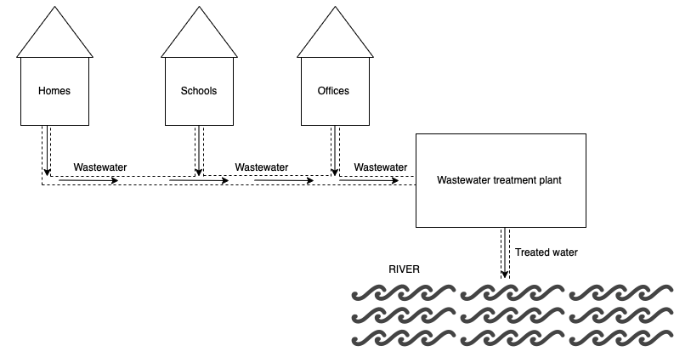
Figure 1.1: Schematic showing underground sewer pipes conveying wastewater to the treatment plant

This highlights the relevance of sewer systems in urban environments. Despite their relevance, they have also posed challenges and are a major concern in sewer management. These challenges are due to chemical and biological reactions in the sewers. A study by (Guisasola et al., 2008) suggested that sulfidogenesis and methanogenesis and the most common reactions occurring in sewer systems.
The formation of sulphide in sewer systems is a bacterially mediated process. This leads to the production of sulfuric acid which corrodes sewer pipes specially made of concrete and steel. Asides corrosion, odour problems have also posed an environmental challenge. The gas is usually a nuisance at gas phase concentrations above 0.0001ppm and can give an unpleasant smell at concentrations above 0.05ppm. However at concentrations above 50ppm, the nuisance may not be detected but could be potentially lethal at 700ppm (Park et al., 2014).
On the other hand, methanogenesis is a process where methane is generated as a final product of an anaerobic metabolism by Methanogenic Archaea. Methane gas poses health and safety concerns due to its flammable property and lower explosive limit (LEL) of 50,000ppm in the atmosphere. Therefore, can potentially lead to lethal explosions if limit is exceeded (Varlet and Augsburger, 2012). It is also considered a greenhouse gas (GHG) which contributes to global warming and has been a concern for water utilities.
The presence of SRB and Methanogenic archaea in sewer systems has been widely studied (Zan et al., 2021; Stephen Lupton and Gregory Zeikus, 1984; Ozuolmez et al., 2015; J. W. H et al., 1994). Findings from these studies have highlighted the important role both species play in the sewer process. The focus on some of these studies has been mostly trying to understand the interaction that exists between them. For example, in the studies carried out by (Ozuolmez et al., 2015), both species are said to coexist depending on the substrates available for their metabolism while other studies (Stephen Lupton and Gregory Zeikus, 1984) have rather reported a competitive relationship between both species. Due to the dynamic nature of these species, it is not clear what conditions lead to competition therefore an understanding of species interaction within sewers becomes imperative as this will provide an understanding of the processes which occur in the system.

1.2 Research aims and objectives.
This study investigates the effects of growth parameters (pH, temperature, and carbon source) on the metabolic activities of two anaerobic species (D. vulgaris and E. coli), which are typically found in wastewater. The aim is to understand how these growth factors ultimately affect the interaction between both species in a co-culture system in order to determine possible strategies on mitigating hydrogen sulphide emissions occurring in sewers. The objectives of this study are;
- Examine the influence of varying pH, temperature, and sodium acetate concentrations on the growth rate of D. Vulgaris and the impact on hydrogen sulphide production.
- Determine the possibility of E.coli utilising sodium acetate as a carbon source under anaerobic conditions by varying the carbon concentrations.
- Assess the interaction between both species when in co-culture by using sodium acetate as a carbon source at constant pH and temperature to determine whether their interaction will help reduce sulphide production or lead to an increase.

Chapter 2

Literature Review
“You never know what you are capable of doing until you try”
―Opusaziba.

Introduction

Sewers are an essential component of modern infrastructure which play a critical role in the management and treatment of wastewater (Carrera et al., 2016). The extensive underground pipe network ensures the effective removal of domestic, industrial, and stormwater effluents, protecting both the environment and public health. The vast network of underground pipes ensure the efficient disposal of domestic, industrial and stormwater effluents, safeguarding public health and the environment. However, despite their relevance, sewers are also hosts to a range of microorganisms, including bacterial colonies which can pose a range of problems (Guisasola et al., 2008).
Despite the fact that bacterial colonies are a common occurrence in sewer systems, they pose a number of problems that can jeopardise the durability and functionality of urban infrastructure. Microbial interactions occur as wastewater moves through the sewer network, initiating biological processes that can have beneficial as well as adverse effects(López-Vázquez et al., 2008).
On the one hand, bacteria are essential for the treatment of wastewater because they help to clean the water before it is released back into the environment by decomposing organic matter and removing pollutants. However, some bacterial actions can result in the production of toxic gases, the deterioration of sewer infrastructure, the clogging of pipes, and the transmission of waterborne illnesses (Brand et al., 2015).
For developing efficient treatment plans and resolving potential problems, it is crucial to understand the types of bacteria that are present in sewers. In environments without oxygen, anaerobic bacteria flourish. They are common in sewer systems, especially where there is low flow or stagnation. Anaerobic processes become relevant for sewer management especially in the breakdown of organic matter, the removal of nitrogen, and the reduction of sulphate (Tanaka and Hvitved-Jacobsen, 2001). On the other hand, aerobic bacteria are found in sewer systems that have enough oxygen, such as well-aerated sections or during the treatment stages. They are important for sewer management because they promote nitrification and oxidation of organic matter. For effective sewer management, both anaerobic and aerobic processes must be taken into account (Rudelle et al., 2013).
The types of bacteria found in sewers vary depending on the location and the source of the wastewater. However, there are several common types of bacteria that are commonly found in sewers such as sulphate reducing bacteria (SRB), E. coli, Pseudomonas aeruginosa, Enterococcus and biofilm-forming bacteria (Günther et al., 2009; Grami et al., 2022; Guvensen, Zorlu and Col, 2017).
Sewer pipes are typically made from a variety of materials which include concrete, cast iron, polyvinyl chloride (PVC), High-Density Polyethylene (HDPE) and fiberglass. Concrete pipes are the most susceptible to corrosion from hydrogen sulphide and have been used for sewer systems for many years. However, PVC pipes are beginning to emerge as the future of sewer pipes due to their eco-friendly and cost-effective characteristic but also because they are resistant to corrosion (Fytianos et al., 2020; Vollertsen et al., 2008)
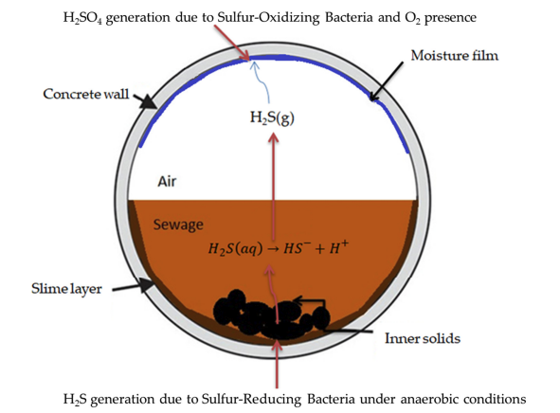
Figure 2.1: Hydrogen sulphide generation in a typical concrete sewer pipe (Fytianos et al., 2020).
Figure 2.1 above shows a typical sewer pipe containing sewage and some sewer sediments. The role anaerobic and aerobic processes play in sewer pipes is crucial to the formation of hydrogen sulphide and corrosion of the pipes.
Primarily, the formation of hydrogen sulphide occurs due to the presence of SRB activities in the sewer pipes under anaerobic conditions. Hydrogen sulphide is then emitted into the headspace of the sewer pipe where oxygen and sulphur oxidizing bacteria are found to be present. Oxidation process occurs which eventually leads to the formation of sulfuric acid that cause sewer corrosion (Fytianos et al., 2020).

Metabolic pathways
Sulphate is used as a terminal electron acceptor by SRB in the degradation of organic matter which produces hydrogen sulphide (H₂S). SRB are major players in anaerobic carbon cycling. Until the early 1980s, it was assumed that SRB only played a minor part in the carbon cycle as the SRB species (Desulfovibrio and Desulfotomaculum) that were known at that time utilised organic compounds like ethanol, formate, lactate, pyruvate, succinate, and hydrogen as an inorganic compound. A study showed that SRB also had the ability to grow on short chain fatty acids and long chain fatty acids including acetate and aromatic compounds (Gerard and Alfons, 2008).
SRB can be divided into three groups. The first group degrade organic compounds incompletely to acetate, the second group degrade organic compounds completely to carbon dioxide and the third group are those that have complete and incomplete degradation (Traore et al., 1983).
The second group use acetate as a growth substrate and two different pathways for acetate oxidation are used; SRB’s like Desulfobacter postgatei use the modified citric acid cycle while other SRB’s like Desulfovibrio, Desulfobacterium, Desulfotomaculum, Desulfococcus species and Desulfobacca acetoxidans use the acetyl-CoA pathway (Traore et al., 1983).
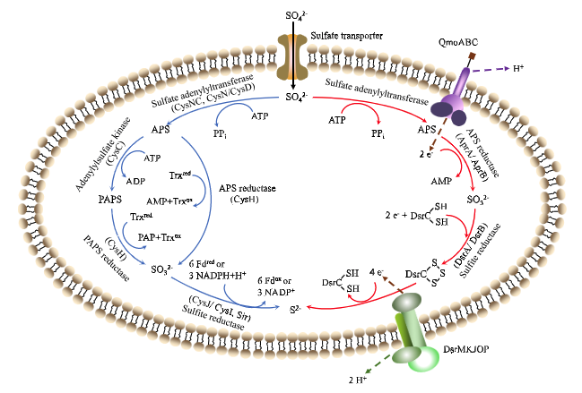
Figure 2.2: Two metabolic pathways of SRB (Blue line shows assimilated sulphate reduction (ASR) and red line shows dissimilatory sulphate reduction (DSR) ((Zhang et al., 2022).
Figure 2.2 above shows the two main pathways for sulphate reduction. The pathway outlined in blue, assimilated sulphate reduction (ASR) is an important biomolecular synthesis method that involves the synthesis of a small amount of sulphate into smaller sulphur-containing components which is of great relevance in industrial biotechnology. The other pathway, DSR outlined in blue reduces a large amount of sulphate to sulphide and involves a two-step process. In the first process shown in Equation 1 and 2 below, sulphate is first activated by sulphate adenylyl transferase (sat) to form APS which consumes two ATP equivalents. APS reductase uses two electrons to reduce APS to hydrogen sulphate. The activation reaction is promoted by the hydrolysis of the released pyrophosphate. In the second step (Equation 3), hydrogen sulphite is reduced by a bisulphite reductase which further leads to the reduction of sulphate as shown in Equation 4.
Sulphate + ATP⁴⁻ + H⁺ → APS²⁻ + pyrophosphate (Equation 1)
APS²⁻ + 2e⁻ + 0.5H⁺ → 0.5${HS0}_{3}^{-}$ + 0.5 ${S0}_{3}^{2-}$+ AMP²⁻ (Equation 2)
0.5${HS0}_{3}^{-}$+ 0.5 ${S0}_{3}^{2-}+$6e⁻ + 7H⁺ → 0.5HS⁻ + 0.5H₂S + 3H₂O (Equation 3)
${S0}_{4}^{2-}$ + ATP⁴⁻ + 8e⁻ + 8.5H⁺ → 0.5HS⁻ + 0.5H₂S + AMP²⁻ + ${HP0}_{4}^{2-}$ + 2H₂0 (Equation 4) (Zhang et al., 2022)
A key metabolic signature of Desulfovibrio is its ability to respire sulphate linked to lactate oxidation. The oxidation of lactate generates reductants through lactate dehydrogenase (LDH) and pyruvate-ferredoxin oxidoreductase (PFOR). Furthermore, PFOR catalyses pyruvate conversion into acetyl-CoA and then to acetate. ATP is generated by substrate-level phosphorylation through acetyl-CoA (Vita et al., 2015).

Anaerobic Respiration
Respiration is a chemical reaction process which occurs in all living things. It is a process which stores energy in the molecular bonds of a sugar or fat molecule and utilises it to make adenosine 5’ triphosphate (ATP) (Welte and Deppenmeier, 2014). Adenosine 5’ triphosphate is an organic compound which provides energy for cellular activities. The process of respiration is common to all living things, but the mode of respiration differs. There are some living things that respire aerobically (use of oxygen) while others respire anaerobically (absence of oxygen). Fermentation and Anaerobic respiration are often used interchangeably which should not be so as they are different processes. The process of fermentation first starts with glycolysis which further leads to the breakdown of carbohydrates; however, the final product of the process is often dependent on the type of fermentation. For example, the human body undergoes lactic acid fermentation which happens especially during exercises. In this type of fermentation, lactic is produced, hence lactic acid fermentation. For anaerobic respiration, although the first step is glycolysis which is like fermentation and aerobic respiration, the pathway created is the pyruvate pathway but often continues in the same way as if it were an aerobic respiration. The difference lies in the final electron acceptor. If that acceptor is oxygen, then the process is considered aerobic but if it is nitrate or sulphate, that process is termed Anaerobic. We can then understand that Aerobic and Anaerobic processes tend to be similar except for their final electron acceptors.

Table 2.1: Types of organisms showing their unique respiration processes.
Type of Organism | Type of Respiration
Facultative anaerobes | Both aerobic and anaerobic. They can utilise oxygen and other substitutes. For example, Escherichia coli (E. coli)
Obligate anaerobes | They can only survive in the absence of oxygen e.g., Methanogens and some SRB’s
Aerotolerant organisms | They thrive in the presence of oxygen but do not utilise for growth

2.2.1 Hydrogen sulphide production and biocorrosion
In a sewer system, Hydrogen Sulphide (H₂S) is formed under anaerobic conditions in the sewage (liquid phase) by the reduction of sulphate. H₂S in its liquid phase then diffuses into the headspace as gaseous H₂S yielding problems such as odour nuisance. At this point, the pH of the sewer pipe is chemically lowered from an alkaline level to a neutral level due to the dissociation of H₂S. Hereafter, the presence of Thiobacillus, a sulphur oxidizing bacteria (SOB) found in sewer pipes, oxidises H₂S to form sulfuric acid (H₂SO₄) which is the leading cause of sewer corrosion (Li et al., 2019). The pH in a sewer system tends to affect the formation and release of H₂S. pH plays an important role in the chemical balance amongst sulphide species (H₂S, HS⁻ and S²⁻). At pH between 4.5-5, sulphide predominantly exists in the form of H₂S while HS⁻ exists under neutral and alkaline conditions (Li et al., 2019).
Sulphidogenesis is a process carried out by SRB’s. It usually occurs in the presence of sulphate where SRB’s reduce sulphate to form H₂S, a toxic gas that has raised a lot of concerns in the wastewater industry. Some SRB’s have been identified to exhibit aerotolerant capabilities and are major contributors of the microbial population especially in sulphate environments (Pankhania, Gow and Hamilton, 1986; Ramel et al., 2015). They also have diverse metabolic capabilities which allow them to interact in various environments such as sediments, biofilms, marine and estuarine.
These processes form a major part of this study and are discussed in-depth in subsequent section of the work.

2.3 Desulfovibrio vulgaris, a specie of Sulphate Reducing Bacteria (SRB)
Desulfovibrio Vulgaris (D. Vulgaris) is a gram negative and rod-shaped specie belonging to the genus Desulfovibrio (Gerard and Alfons, 2008). It has also been extensively studied for the role it plays in metal corrosion and heavy metal bioremediation thus making them beneficial for wastewater treatment (Vita et al., 2015; Brand et al., 2015), (Clark et al., 2012). Furthermore, studies have also shown that Desulfovibrio species can act as opportunistic pathogens often associated with abdominal infections like abscesses and primary bacteraemia.
Generally, the metabolic diversity of SRB is often dependant on the strains and carbon sources available. Sulphate reducers can be classified under two main groups, those that degrade organic compounds incompletely to acetate and the others that degrade completely to carbon dioxide and hydrogen (Plugge et al. 2010). According to (Santana and Crasnier-Mednansky, 2006), the carbon sources commonly utilised by Desulfovibrio species are malate, acetate, lactate, propionate, alcohols, and aldehydes. However, unlike other species belonging to the genus Desulfovibrio, D. Vulgaris (Hildenborough) is not able to utilise substrates like malate and fumarate. In another study, by (Badziong and Thauer, 1978b), it was reported that D.Vulgaris was only able to grow on lactate and then incompletely oxidized to acetate. Although sulphate is a common electron acceptor for Desulfovibrio species, they are known to also utilise nitrate (Plugge et al., 2010). A major observation from these studies is that they have all been carried out under different conditions and it is possible that due to the variance in these conditions, the metabolism of the strains may also have differed, thus resulting in different conclusions regarding the substrates they utilise.

2.3.1 Growth medium, carbon, and energy sources
Growth media have varied in different studies (Badziong and Thauer, 1978a; Brandis and Thauer, 1981; Ramel et al., 2015; Pankhania, Gow and Hamilton, 1986). This is usually because different carbon sources and energy sources are used to carry out these studies. These carbon sources and energy sources also vary in concentration, thus making conditions of each study unique. Growth media also play a role in the specific growth rate of any strain as they contain the ingredients which drive the specie’s metabolism. Organic compounds are the main carbon source supplemented in growth media and studies have shown SRB species have a preference in the utilisation of these organic compounds which translates to their affinities for the substrates(Tao et al., 2014). Generally, a classical growth medium for cultivating D.Vulgaris (Hildenborough) is usually a sodium lactate/sulphate medium supplemented with yeast extract (Brandis and Thauer, 1981). Lactate and sulphate have been added in varying concentrations to media as carbon sources ranging from 10 mM to 60 mM (Phelps, Conrad and Zeikus, 1985). These studies have focused on various aspects of D.Vulgaris ranging from syntrophic interactions especially interspecies hydrogen transfer (Michael and Marvin, 1981), transcriptomic analysis (Clark et al., 2012), genomic sequencing (Fouts et al., 2004) to growth yields and rates of the strain (Badziong and Thauer, 1978a). Although acetate has also been used in some studies as the sole carbon and energy source under anaerobic conditions (Pankhania, Gow and Hamilton, 1986), a study reported the inability for D.Vulgaris (Hildenborough) to grow on acetate. Findings from the results suggested that acetate was not oxidized when combined with CO₂ as carbon sources and H₂/${SO}_{4}^{2-}$ as energy sources (Badziong and Thauer, 1978b). Another study carried out by (Pankhania, Gow and Hamilton, 1986) also reported that acetate could in no way be oxidized when lactate was present, as findings from their study suggested a carbon switch from acetate to lactate when lactate was added to cultures already containing acetate. (Tao et al., 2014) reported that D. Vulgaris (Hildenborough) could grow on H₂/${SO}_{4}^{2-}$ as energy sources and acetate/CO₂ as carbon sources. Their finding was also supported by (Brandis and Thauer, 1981) whose results also suggested that D.Vulgaris (Hildenborough) could grow on H₂/${SO}_{4}^{2-}$ provided the medium was supplemented with acetate and CO₂ as carbon sources. Sulphate reducers are known to have long lag-phase periods of adaptation depending on the conditions they are subjected to. This could be a possible reason why growth on acetate in the other studies may have failed.
This research have mostly focused on the metabolic adaptability of D. Vulgaris under varying conditions, which has spurred greater interest in understanding more about the strain. It can be said that the bacteria is versatile.

2.3.2 Effect of pH on hydrogen sulphide generation
The concentration of sulphide in wastewater varies according to the pH of the wastewater. This results to the presence of different sulphide species depending on the pH.
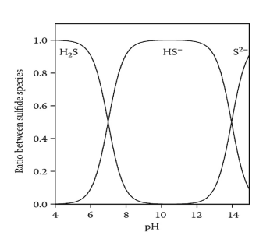
Figure2.3: Ratio between sulphide species and pH (Park et al., 2014).
In Figure 2.3 above, it can be observed that at pH less than 6, H₂S is dominant and as the pH increases above 8, HS⁻ becomes prevalent. When pH is more than 12, we observe S²⁻ is the dominant specie (Park et al., 2014).The ionic forms HS⁻ and S²⁻ are not able to pass through to the headspace of the sewer pipe but H₂S according to Henry’s Gas law can diffuse into the headspace (Rathnayake et al., 2021).Thus, the proportion of H₂S in the liquid phase is directly influenced by the pH and also influences the concentration released to the headspace (Rathnayake et al., 2021).
The pH measures the concentration of hydrogen ions in a solution. The pKa value describes the acidity or basicity of a compound by defining the form or forms of the compound that will be present under specific circumstances (Seybold and Shields, 2015). The pH value often determines whether a chemical specie will accept or donate a proton. This relationship between the pH value and pKa value is such that the pH is dependent on the concentration of the solution while the pKa value specifies the dissociation constants for weakly acidic or basic groups (Seybold, 2014). The pKa value is constant for each type of molecule and is not affected by the concentration (Po and Senozan, 2001).
It had always been an accepted view that sulphate reduction occurred at pH ranging between 6 and 8 (Koschorreck, 2008). Infact, it was reported by (Badziong and Thauer, 1978b) that SRB in batch cultures only grew at circumneutral pH. However, in the last decades, studies have suggested the possibility of sulphate reduction occurring at pH below 5 due to their low metabolic energy yield (Hamilton, 1998). Hydrogen sulphide is considered the most toxic form of sulphide as in pH below 5, the undissociated form is present. However, optimum growth for SRB have been reported to be between 7.0 -7.8 and pH tolerated range between 5.5 – 9.0 (Barton, 1995).
So far, dissimilatory sulphate reduction has been studied in both pure and mixed cultures as well as in natural environments. The pH have ranged between 6.8 - 8.5 (O'Flaherty et al., 1998). Results from their findings indicated a high toxicity of H₂S at high pH.
Nevertheless, growth rate of D.Vulgaris has been found to be strongly dependent on pH and the highest growth rate have been observed at pH of 6.5 at 0.15 h⁻¹ when H₂ and sulphate were used as carbon sources and pH of 6.8 at 0.21 h⁻¹ when H₂ and thiosulphate (Badziong and Thauer, 1978a). These findings were also supported by (Khosrovi and Miller, 1975) who reported that the specific growth rate of D.Vulgaris was 0.15h⁻¹ under a gas phase of Ar/CO₂ (95:5) and H₂/CO₂ (95:5). Another carbon source used to determine growth rate of D. Vulgaris is formate. The maximum growth rate of D.Vulgaris in this carbon source was 0.078h⁻¹ with a doubling time of 9 hours (Martins, Mourato and Pereira, 2015).
Effect of temperature on SRB
So far, temperature has been considered an important environmental factor which usually triggers either an adaptative or partial bacteria response. This suggests that the activity of bacteria in a system could be influenced by temperature levels. In a study carried out by (Mukwevho, Maharajh and Chirwa, 2020) on evaluating the effect of pH, temperature and hydraulic retention time on sulphate reduction using response surface methodology, it was observed that SRB metabolic activity reduced when temperature was decreased from 20°C to 10°C. However, when temperatures were adjusted from 30°C to 20°C, SRB activity and growth was observed as 20°C is a temperature range which supports SRB activity. According to (Nedwell and Abram, 1979), temperature influences sulphate reduction especially in anaerobic saltmarsh sediments. Similarly, (Bo Barker, 1977) also reported that seasonal variations influenced sulphate reduction. In a study by (van Den Brand et al., 2018) where biological sulphate reduction was investigated using acetate and propionate to saline SRB sewage treatment in moderate climates, the consumption rates of both carbon sources were 1.9 times lower at 10°C than at 20°C. This study highlighted the potential effect of temperature on the utilisation of carbon sources by SRB used in treatment of wastewater.

2.3.3 SRB Metabolism
SRB are a diverse group of bacteria which are ubiquitous in nature and exhibit diverse metabolic capabilities which increase their chances of survival in environments where their electron acceptors may be depleting (Plugge et al., 2011). SRB mainly use sulphur in its oxidized form as a terminal electron acceptor for the oxidation of hydrogen and some organic compounds (Plugge et al., 2011). Some studies have also reported a syntrophic relationship with Methanogens depending on the environmental conditions present (de Bok, Plugge and Stams, 2004). Metabolic flexibility of SRB has been long investigated since the 90’s by (Bryant et al., 1977) who revealed that a genus of SRB known as Desulfovibrio could grow on lactate in the absence of sulphate. In their study, it was concluded that a group of archaea known as methanogens utilised the hydrogen produced during the metabolism of Desulfovibrio on lactate thus, acting as an alternative electron sink in the absence of sulphate.

2.3.4 Bacteria growth rate curves
The growth of bacteria usually follows a typical pattern over time which involves 4 phases as illustrated in Figure 2.4 below:
- Lag phase
- Exponential (log phase)
- Stationary phase
- Death phase

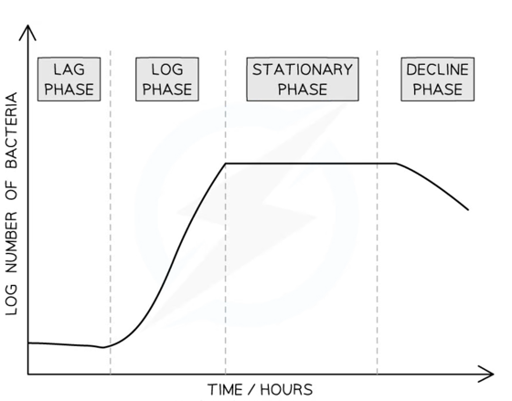
Figure 2.4: A graphical representation of bacteria phases (Save My Exams 2023).
In the lag phase of growth, the bacteria population slowly increase as they adjust to the new environment and gradually start to reproduce. The second phase known as the log phase or exponential is the phase where the bacteria population doubles as the cells divide as nutrients are readily available. As growth increases exponentially, the amount of nutrients available depletes and the bacteria population reach their maximum. The growth curve is observed to level off at this phase as the number of bacteria been produced is proportional to the number of bacteria dying. The last phase known as the death phase or decline phase shows a decline in the curve. Due to insufficient nutrients available for bacteria, they start to die, and their death rate exceeds their rate of reproduction.
Traditional linear scales make it difficult in dealing with experimental data with large numbers thus logarithmic scales become useful when determining the growth rates of bacteria as during the log phase, bacteria grow rapidly, and very large numbers are produced within hours.
The Monod equation is used to relate the growth rate of microbes in an aqueous environment to the concentration of the limiting substrate (Hvitved-Jacobsen, 2013).
The equation is written as:
$$μ= μ_{max}\frac{[S]}{K_{S}+[S]}$$
Where;
$μ$ = growth rate of a microorganism
$μ_{max}$= maximum growth rate of the microorganism
$\left[S\right]$= concentration of the limiting substrate
$K_{S}$= half-saturation constant
The half saturation constant also known as the $K_{S}$ is relevant in determining the concentration of a substrate that can be consumed by a microorganism at a $μ_{max} ($maximum growth rate) of 0.5. This coefficient differs between microorganisms and depends on the environmental factors such as pH, temperature and the composition of the culture medium (Hvitved-Jacobsen, 2013)
A study by (Badziong and Thauer, 1978a) focused on the growth rates and growth yields of Desulfovibrio strain (Marburg) growing on H₂/sulphate and H₂/thiosulfate as the only energy sources. Results from their findings suggested that the highest growth rates and molar growth yields were at pH 6.5 (μ = 0.15h⁻¹) and 6.8 (μ = 0.21h⁻¹). Similar results were found in studies carried out by (Reis et al., 1992) where they studied the effect of hydrogen sulphide growing on lactate and sulphate at different pH values within the range of 5.8 – 7.0. Their findings suggested highest growth rates were observed at pH of 6.6.
Table 2.2 is a summary on various Desulfovibrio species that have been cultured at varying pH and growth rates.
Strain type | Growth rate (h-1) | Carbon source | pH | Reference
D.vulgaris (Marburg) | 0.15 | H₂ and sulfate | 6.5 | (Badziong et al., 1978)
D.vulgaris (Marburg) | 0.21 | H2 and Thiosulphate | 6.8 | (Badziong et al., 1978)
D.Vulgaris (Hildenborough) | 0.13 | H₂ | 6.5 | (Reis et al., 1992)
D.Vulgaris (Hildenborough) | 0.078 | Formate | Not reported | (Medírcio, Leão and Teixeira, 2007)
D.Vulgaris (Hildenborough) | 0.15 | Lactate | 7 | (Khosrovi and Miller, 1975)
Table 2.2: Desulfovibrio species indicating growth rates and various carbon sources.

Diauxic growth
When microbes grow in a mixture of two carbon sources, they first utilise the preferred carbon source before switching to the other carbon source. This leads to two exponential phases which sometimes could be intermitted by a lag phase of minimal growth first before the second exponential phase (Chu, 2017). Diauxic growth is the phenomenon which describes a microbial population exhibiting a bi-phasic growth pattern when introduced with two carbon sources (Chu, 2017). An example of a diauxic growth can be found in early studies carried out by Monod who showed that E.coli exhibited a diauxic growth when grown on glucose and lactose (Monod 1942). Glucose was first consumed as the preferred substrate over lactate. During this phase, the peripheral enzymes for lactose were reduced to low levels until all the glucose was exhausted. Following that, a diauxic lag phase was observed indicating no growth before the utilisation of lactose (second substrate). The duration of the lag phase was dependent on the time required for the enzymes to build up to sufficiently high levels. Finally, after the diauxic lag phase, the log phase corresponding to lactose consumption was observed (Narang and Pilyugin, 2007).
According to(Narang and Pilyugin, 2007), two main mechanisms are responsible for diauxic growth by bacteria and they both depend on the phosphotransferase (PTS) system (Deutscher, 2008). The first mechanism regulates the metabolic genes through global transcription regulators while the second mechanism is a direct uptake mediated inducer exclusion. Generally diauxic growth is believed to be a method utilised by bacteria to optimise growth in environments were there are two carbon substrates (Chu, 2017).

2.4 Escherichia Coli (E. coli) – A facultative anaerobe
About half a century ago, E. coli emerged to colonize the scientific laboratory. Studies have suggested that physiologically E. coli is a facultative anaerobe as it grows both aerobically and anaerobically. It cannot grow at extreme temperatures or pH (Clark, 1989).

2.4.1 Carbon sources and Metabolism
The tricarboxylic acid cycle (TAC) is the main pathway for acetate metabolism in E. coli grown on complex substrates. According to a study, succinate formed from acetate precedes that of other members of the TAC. During this cycle, acetyl coenzyme A may be an intermediate in this conversion (Glasky and Rafelson Jr, 1959). Acetate is a carboxylic acid utilised by microorganisms as an alternative source for cell growth and is known as a common by-product of E. coli growth under anaerobic conditions when it utilises glucose as a carbon source (Chen et al., 2018). On the other hand, the strain can also metabolise acetate for its cell growth under anaerobic conditions whereas under aerobic conditions, the presence of excess glucose leads to production of acetate (Philip et al., 2018).
The growth of E.coli anaerobically on glucose yields fermentation products such as ethyl alcohol, formate and lactate (Higgins and Johnson, 1970).

2.5 Co-culture studies
In natural ecosystems, microbial populations do not function solely as most often than not interactions between species of bacteria, viruses or parasites occur within these systems which lead to new discoveries. The essence of co-culturing has long existed in natural habitats and is only beginning to emerge in the science world as humans constantly seek to address global challenges and improve scientific methods that will aid in further understanding the versatility of species. Co-culture methods have been used in studying the interactions between cells of any kind or population. Typical reasons for co-culturing methods have been i) to study the natural interactions between cell populations which is of interest to synthetic biologists and ii) establishing synthetic interactions between populations. The interaction of microbial population in systems give rise to many beneficial effects and possess diverse metabolic capabilities which show more robustness to environmental fluctuations than individual populations. (Goers, Freemont and Polizzi, 2014; Zeidan, Rådström and van Niel, 2010). These systems are controllable and are less complex in comparison to natural communities. A principle of coculture studies is that two or more species of bacteria are cultured together with some level of contact between them which allows them to interact (Heyse et al., 2019).
One of such interactions can be observed in a study carried out by Harcombe (2010) involving Salmonella enterica and an E.coli mutant unable to synthesize an essential amino acid. However, when co-cultured in a lactose media, the study showed that E.coli was able to metabolise lactose and secrete amino acid which Salmonella was able to utilise. This interaction showed a cooperative or interspecific relationship.
The concept of coculturing microbes is not new. A few studies have focused on coculturing for the benefit of understanding the dynamic interaction of microbes as well as mixed population stability (Haoran et al., 2015; Barca et al., 2016; Phelps, Conrad and Zeikus, 1985).
Co-culture studies of E. coli and D. Vulgaris have not been studied before however we can gain an understanding of how other species of bacteria adapt in co-culture studies from past studies.
Barca et al (2016) demonstrated that D. Vulgaris and Clostridium acetobutylicum as a mixed consortium in synthetic wastewater could change their metabolic fluxes and increase the production of hydrogen. The study was focused on scaling up hydrogen production from batch to continuous in an up-flow anaerobic packed-bed reactor which was fed continuously with glucose. Findings from these results showed that the production of hydrogen in the reactors became stable after 3-4 days of operation and the production rate of hydrogen increased significantly. Conclusively, stable production of hydrogen was attained when both species were studied in co-culture.
(Haoran et al., 2015) report a design and scale-up of E. coli in co-culture which is applicable for the biosynthesis of industrial products. The significance of their study was highlighted in the production of industrial compounds by engineering the microbial consortia to express biosynthetic pathways in other to produce valuable compounds thus reducing the need for the use of non-renewable petroleum products, thus increasing the use of renewable resources.
Generally, these studies have all highlighted the benefits of co-culturing species but more than that highlighted the possibility of discovering and providing insight into the diverse metabolic lifestyles of these species.

2.5.1 Growth rate studies on E. coli
Growth rate
Growth rate is an important physiological parameter which characterises bacteria. The composition of a bacterial culture influences the growth rate of the microbe (Pinhal et al., 2019).

2.5.2 Effect of pH and temperature on growth rate of E. coli
The optimal pH range of E. coli growth is between 6.5 and 7.5 which is dependent on temperature. One study on effects of temperature and oxygen tension on growth of E. coli in milk suggested that E. coli growth was inhibited as temperature increased from, 37°C to 41°C at anaerobic conditions (Goldberg, 1994).

2.5.3 Benefits of E. coli studies
In the past, E. coli has been metabolically engineered for the synthesis of polyhdroxyalkanoates (PHA) using acetate as a carbon source. The application of acetate as a carbon source for microbial fermentation has the potential to reduce the consumption of food and agro-based renewable bioresources for biorefineries (Chen et al., 2018).

2.6 Conclusion
Growth parameters play a huge role in determining the metabolism as well as growth rate of several species of bacteria. Although this has been established, only a few studies have focused on these parameters. However, none of the studies have focused on a combination of pH, temperature, and carbon source in one study instead each parameter has been individually studied. It can be said that the influence of all three combinations cannot be compared to an influence of one hence this study has been designed to highlight the impact of 3 growth parameters on the specific growth rate of bacteria strains under varying conditions. Furthermore, compared to all other studies, this study will focus on pure and co- cultures of bacteria strain.
The overall objective of this thesis is to highlight the impact of these factors on the metabolism of anaerobic bacteria strains in order to provide a better understanding of sewer management with respect to mitigating sewer odour and sewer pipe corrosion. Therefore, a quantitative methodological approach was used in this study which required the application of both analytical and statistical methods.

Chapter 3

Temperature, pH, and carbon substrate influence on growth rate of Sulphate Reducing Bacteria (SRB).

Introduction
Over the past years, Sulphate Reducing Bacteria (SRB) have been studied extensively (Badziong and Thauer, 1978a; Brandis and Thauer, 1981; Phelps, Conrad and Zeikus, 1985) as they are known to play important roles in global sulphur and carbon cycling, thus establishing their importance as environmental bacterial species (Tao et al., 2014). SRB activity in wastewater is of importance due to the formation of hydrogen sulphide (H₂S). H₂S is a highly toxic gas that is characterised by a rotten egg smell and the main cause of sewer odour. It is formed during the reduction of sulphate and oxidation of organic compounds present in wastewater. Within the sewer network, a collection of pipes convey wastewater from the point source to a wastewater treatment plant before discharge. The presence of SRB in wastewater affects its quality but most importantly, pose environmental concerns not only because of its odorous property but also corrosive nature as it leads to the corrosion of sewer materials because of the chemical and biological process which occur. Although, while some studies (Brand et al., 2015; Lens et al., 2002) evaluate the potential for applying SRB in wastewater treatment, others (Rudelle et al., 2012)present conceptual models to predict wastewater quality changes during collection and conveyance. On the other hand, laboratory culture studies (Tao et al., 2014; Scholten et al., 2007; Plugge et al., 2010) have been conducted to understand SRB better. Desulfovibrio vulgaris have been used as a model strain for several SRB research. Previous studies often report about its syntrophic interaction with other species and substrate affinity, but less is known about its growth rate under varying conditions. Growth rate is considered an important factor in understanding how bacteria behave but more importantly highlight the metabolic capabilities of the strain. D.vulgaris is known to possess diverse metabolic capabilities and it was important in this study to focus on the growth rate of D. vulgaris as it pertains to varying conditions which is typical in any sewer environment, one which is known to be dynamic.
pH is an important factor in determining the growth of SRB. (Koschorreck, 2008) found that organisms like SRB with a low metabolic energy yield might be susceptible to low pH and their metabolic products (hydrogen sulphide and organic acids) could be toxic at low pH. This toxicity is often related to the ability of free sulphide to react with metal ions, functional groups of electron carrier systems and metabolic coenzymes (Hao, 1995). The formation of free sulphide is dependent on the pH as below pH 5, the undissociated H₂S is formed and from studies (O'Flaherty et al., 1998; Moosa and Harrison, 2006), it is considered the most toxic form of hydrogen sulphide.
Since most of the SRB studies conducted focused on neutral and basic pH (Brand et al., 2014a; Tao et al., 2014; Badziong and Thauer, 1978b) and a few have studied acidic pH (Badziong and Thauer 1978b), This study focused on pure culture studies of an SRB model strain, Desulfovibrio vulgaris. For a while, it was a generally accepted view that SRB preferred habitats with pH between 6 and 8 (Hao, 1995). At that time, the presence of SRB in acidic environments was attributed to microniches with higher pH. However, this view became the past as decades later, new evidence emerged that microbial sulphate reduction below pH 6 was possible (Koschorreck, 2008). Despite this, most of the pH studies on SRB have rather focused on neutral pH except for (Reis et al., 1992) who studied a culture of SRB growth in lactate at different pH values in the range (5.8 to 7.0) for the purpose of determining the influence of acetic acid produced during the growth of SRB.
On the other hand, temperature is considered a key parameter for microbiological processes. Sulphate reduction at varying temperatures is limitedly investigated and for this reason, this study will focus on SRB growth in mesophilic and thermophilic temperatures.
Finally, the last parameter which forms a major part of this study is the carbon substrate. Despite the metabolic versatility of SRB, they tend to have an affinity for certain substrates over another. They mainly use sulphate as the terminal electron acceptor during the oxidation of organic compounds. Although SRB often compete with methanogenic archaea for similar substrate like acetate, formate, and hydrogen. Acetate is a major product of fermentation processes but also an important substrate for SRB. However, acetate has rarely been used as a sole carbon source for SRB studies in pure cultures. This study primarily grows SRB in a lactate based medium and then adapts it to an acetate based medium. The main purpose of this study was to determine how these parameters ultimately influence the growth rate of SRB and whether these parameters are statistically significant in the growth of this bacteria.

Methodology

Summary
Desulfovibrio Vulgaris Hildenborough (D. vulgaris DSM 644) was used as a SRB model strain to study the impact of varying levels of pH, temperature, and fixed carbon substrate concentration on its growth rate.
To carry out this study, the growth medium was modified. The pH of the original ATCC medium which was pH 6.8 was adjusted to 5 and 6 all within a range that allows bacteria growth before autoclaving (Parsek et al., 2010). Temperature levels were adjusted during incubation to 25°C and 40°C. Finally, the carbon source of the original medium (sodium lactate) was substituted for (sodium acetate) after standard growth measurement studies were conducted.
Both analytical and statistical analyses were carried out to determine growth rates and sulphide production and any correlation between parameters.
This study was of importance as it highlighted the impact of temperature and pH on SRB metabolism. The carbon source also played an important role as it proved to influence the growth rate of the SRB strain. This monoculture study of SRB also revealed the dynamic nature of systems as no two systems are the same. This study becomes relevant especially during the design of stable process systems within wastewater sewer networks.

3.2.2 Experimental Approach
This quantitative research was carried out to fulfil one of the objectives of this study which was to determine the impact of varying growth parameters on the growth rate of D.Vulgaris in monoculture studies. To achieve this objective, experiments were designed to test a cause-and-effect relationship. D.Vulgaris, a widely studied SRB model organism was used for this study with major focus on the impact of some growth parameters on its metabolism.
The experiments designed to achieve this objective of determining the impact of growth parameters on D. Vulgaris metabolism comprised of analytical methods to calculate growth rates and sulphide production of D. Vulgaris. Samples during each experiment were collected and measured regularly for 120 – 160 hours depending on the conditions set for that experiment as some experiments had a longer lag phase compared to others. These measurements were carried out by determining the absorbance at a wavelength of 600nm using a spectrophotometer (Jenway 7315).
Sulphide in samples was measured using the methylene blue method according to (Joel, 1969)
Acetate degradation in samples were measured using a Gas Spectrophotometer as it was important to evaluate the rate at which acetate was utilised by the strain for its metabolism. Subsequent sections of this thesis discuss the methods and results in detail.

3.2.3 Growth medium and culturing conditions
At the preliminary stages of this research, a protocol for the preparation of a Desulfovibrio Postgate Medium according to the German Collection of Microorganisms and Cell Cultures (DSMZ) was used to cultivate the strain. It contained the following ingredients in their respective amounts as shown in Table 3.1 below
Table 3.1: Postgate Medium for SRB cultivation.
DESULFOVIBRIO POSTGATE MEDIUM
Ingredients | Mass (g/L)
Solution A
K₂HPO₄ | 0.5
NH₄Cl | 1.0
Na₂SO₄ | 1.0
CaCl₂.2H₂0 | 0.1
MgSO₄.7H₂0 | 2.0
Na-DL- Lactate | 2.0
Yeast Extract | 1.0
Distilled water | 980 ml
Solution B
FeSO₄.7H₂O | 0.5
Distilled water | 10.0 ml
Solution C
Na-thioglycolate | 0.1
Ascorbic acid | 0.1
Distilled water | 10.0 ml

According to the protocol, each solution (A-C) was prepared in glass bottles according to their respective volumes. The pH of each solution was adjusted using 0.5M HCl or 1M NaOH to 7.8 with a pH meter (Thermo Scientific STAR A111). Ingredients of Solution A were heated on a hot plate adjusted to medium heat for 15 minutes then cooled to room temperature. Solutions B and C were then added to Solution A and left for another 5 minutes before brought to cool. This step was carried out to ensure all ingredients in the medium were homogenously mixed. Total volume of media after mixing was 1L. In 120ml serum glass bottles, 50ml of media was aliquoted into each serum bottle. The bottles were then gassed under 100% N₂ in batch using a sparging rig consisting of four (4) sparging probes as shown in Figure 3.2. This procedure was carried out to exclude as much oxygen as possible from the medium as experiments were to be carried out under anaerobic conditions. For each batch of 4 bottles sparged, the procedure lasted for 20 minutes before bottles were sealed using 20 mm butyl rubbers and crimped with 20 mm aluminium caps as shown in Figure 3.3. All bottles were autoclaved at 121°C for 15 minutes before inoculation.
After autoclaving procedure, black precipitates were observed at the bottom of media bottles and after inoculation as shown in Figure 3.1. This was because the medium contained FeSO₄.7H₂O which forms ferrous iron and sulphide thus causing the formation of precipitates. This caused an interference with spectrophotometric analysis.

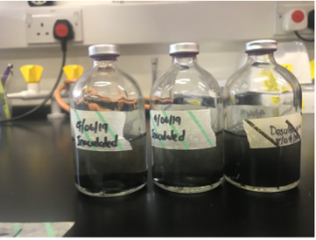
Figure 3.1: Postgate medium showing black precipitates
Figure 3.2: Nitrogen sparging rig | Figure 3.3: Serum bottles sealed and crimped

3.2.3.1 Postgate medium substituted for ATCC medium
Due to the challenges (black precipitate interfering with results) experienced with the first medium, an alternative medium was used. The ATCC Modified Baar’s medium for sulfate reducers contained the following ingredients in their respective amounts as shown below. Medium was different from previous one as it excluded ferrous sulfate which was not a required ingredient for the cultivation of the strain.

Table 3.2: Medium for growing SRB.
ATCC MODIFIED BAAR’S MEDIUM
Ingredients | Mass (g/L)
Magnesium sulphate | 2.0
Sodium citrate | 5.0
Calcium sulphate dihydrate | 1.0
Ammonium chloride | 1.0
Dibasic potassium sulphate | 0.5
*Sodium lactate | 3.5
Yeast Extract | 1.0
Distilled water | 1000mL
*Refers to carbon sources added to the medium

All ingredients were first dissolved, and pH was adjusted to 7.5 according to the protocol. As already described in section 3.2.3, aliquoting media into bottles and sparging procedures were carried out followed by inoculation.
Before inoculation, 0.5ml of 3% stock of sodium thioglycolate was added to each bottle as a reducing agent and left for a day to react with residual oxygen. Inoculations were done from fridge stock cultures stored at 4°C where cells were still considered viable or from frozen glycerol stock stored at -80°C in instances where the fridge stock cultures had been stored for more than 3 months in the refrigerator. Culture bottles were incubated in an incubator set at 37°C. Cells were then harvested in their late log phase where most cells in the population were considered viable to start subsequent experiments. The growth rate of D. Vulgaris (Hildenborough) was first determined under standard conditions (pH 7 & 37°C) using this medium. This growth medium was then used for subsequent experiments.

Medium modification experiments and justification
Medium was modified based on the objectives of this study. pH, temperature, and carbon source were the 3 parameters considered. The influence of these parameters on the metabolism of the strain, D. Vulgaris was the focus of the study.

Table 3.3: Growth conditions for all experiments in this study
pH | Temperature (°C) | Carbon source | Concentration (mM)
5 | 25 and 40 | Sodium Acetate | 40
6 | 25 and 40
7 | 25 and 40

Sodium acetate was of particular interest as it is considered one of the most common volatile fatty acids (VFA’s) present in wastewater (Chen, Randall and McCue, 2004; Mino, van Loosdrecht and Heijnen, 1998). Monoculture studies of D. Vulgaris have been rarely carried out. Most of the studies based on literature have focused on the syntrophic interactions between the strain and other strains (J. W. H et al., 1994; Paulo, Stams and Sousa, 2015; Bhattacharya, Uberoi and Dronamraju, 1996). Therefore, it was important to carry out this study to highlight the impact of these growth parameters on D. Vulgaris metabolism as it has been previously detected in samples from sewers (Mohanakrishnan et al., 2009).
The study of D.Vulgaris with the combination of the above parameters shown in Table 3.3 will provide more understanding on the metabolic versatility of D.Vulgaris in pure cultures.

Strain sequencing
To validate the specific strain used for this study, DNA extraction and PCR quantification techniques were carried out. Primers were first designed (28F/25R (5’-ATATGAACCGCCGCAAGTTCCCC-3’); (5’-GTCACCATGCGCCGAAGGGAGAGTA-3’) to hybridize with the DNA of the sample to define the region that needed to be amplified. Secondly, the genomic DNA was extracted from monocultures of D. Vulgaris by collecting 1ml of sample from an active growing culture bottle using a hypodermic needle (21g) and syringe(1ml). Sample was centrifuged at 4500 rpm for 2 minutes and resuspended with 100μl of Distilled water after supernatant was carefully removed. Following that, liquid was then transferred in duplicates into PCR tubes and heated to 98°C in a thermal cycler (Veriti 96 Well Thermal Cycler) for 5 minutes.
PCR quantification commenced with preparing a 50μl reaction mix using Q5 High Fidelity DNA Polymerase reaction mix. For each 50μl reaction, the following components were added.

Table 3.4: Sequencing reaction mix
Component | Reaction volume (μL)
5 × Q5 Reaction buffer | 10
10 mM dnTPs | 1
10 uM Forward Primer | 2.5
10 uM Reverse Primer | 2.5
Q5 High Fidelity DNA polymerase | 0.5
5 × Q5 High GC enhancer | 10
Nuclease-free water | 31.5
Template DNA | 2

The thermocycling conditions are shown in Table 3.5 below
Table 3.5: Thermocycling conditions
Stage | Temperature (°C) | Time
1 - Initial Denaturation | 98 | 30 secs
2 - 35 cycles | 98 | 30 secs
3 - Final extension | 72 | 1 min

Strain cultivation and maintenance
D.Vulgaris was obtained as a freeze-dried culture from the German Collection of Microorganisms and Cell Cultures (DSMZ) which was routinely maintained in ATCC Modified Baar’s medium. The strain was then revived by suspending fresh media into the glass vial containing pellets of freeze-dried culture which was left to dissolve completely before inoculation procedures commenced. 0.5ml of inoculum was each withdrawn from the glass vial using a hypodermic needle and syringe, then inoculated into 3 120ml serum bottles containing 50ml of fresh media. All procedures were carried out in an anaerobic chamber (857-OTA, PLAS LABS) shown in Figure 3.5 to prevent oxygen entrainment. The bottles were incubated at 37°C for 4 days after which OD measurements of the culture were taken as the cells needed to be harvested in their log phases. Some of the active cultures were stored in 25% glycerol at -80°C to slow down growth while the remaining cultures were maintained at 4°C in a refrigerator for subsequent sub-culturing. Sub-culturing procedures were carried out using the Hungate method (Hungate and Macy, 1973) as shown in Figure 3.4. This procedure was also another way of preventing oxygen from entering the bottles during inoculation.

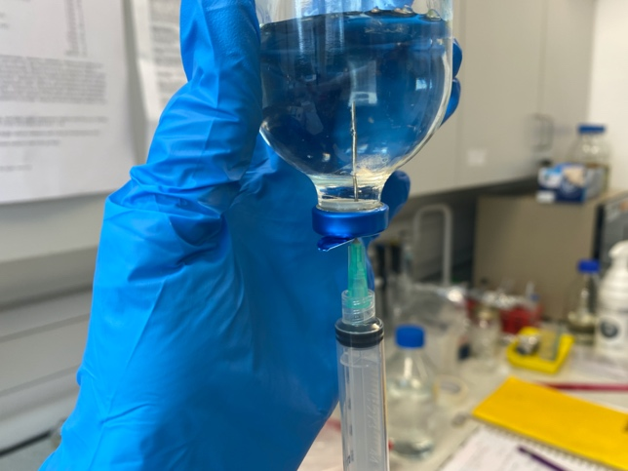  Figure 3.4: Hungate technique | 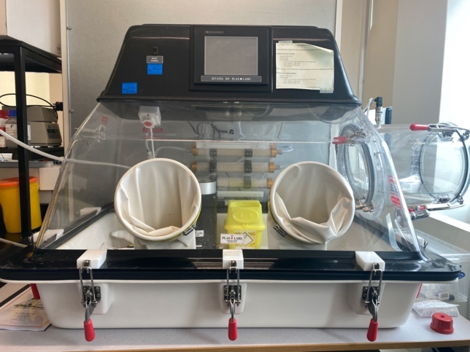  Figure 3.5: Anaerobic Chamber unit

Analytical Methods

3.2.7.1 Methylene blue method for Sulphide determination
Sulphide in the samples was precipitated and fixed as ZnS in a zinc acetate solution followed by the addition of a diamine reagent in HCl which formed a blue colour. This method was adopted from (Joel, 1969). The exact sulphide concentration was determined by iodometric titration and colour development through the addition of a Diamine reagent to known amounts of sulphide.
The diamine reagent was prepared by mixing 500 ml of concentrated HCl in 500 ml of distilled water and left to cool. 4.0g of N, N-dimethyl-p-phenylendiamine and 6.0 g of FeCl₃.6H₂O were added and dissolved in the solution. The solution was then stored in a refrigerator for several months.
Zinc acetate solution (10%) was prepared by dissolving a 100g of Zinc acetate to 1 litre of Distilled water containing 1ml of concentrated acetic acid.

3.2.7.2 Procedure
The methylene blue method was able to measure sulphide concentrations in samples within 1-20 mg S/L. 0.5ml of each sample containing sulphide was precipitated in Zinc sulphide (ZnS) containing 0.5ml Zinc Acetate (ZnAc) as shown in Figure 3.6. Samples were either analysed immediately or stored in the refrigerator at 4°C where they were kept stable.
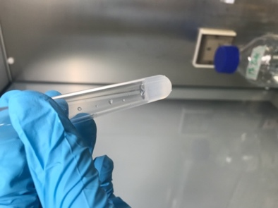
Figure 3.6: Test tube containing sulphide precipitated in ZnAc solution

During the analysis, each sample was brought to a total volume of 5ml with distilled water followed by the addition of 0.4ml of a Diamine reagent for colour development. The samples were covered and tilted upside down for homogeneity and left for 30 minutes but not more than 2 hours before spectrophotometric analysis at 670 nm. The wavelength 670 nm was used because methylene blue has two absorption peaks at 635 and 670nm. However, the complete absorption spectrum ranges between 609-690nm (Giannelli and Bani, 2018) . Absorption was measured in a 1cm cuvette using distilled water as a blank. Absorbance readings were recorded at measurements below 0.9 and diluted if measurements were above this value.
A calibration curve was prepared from a triplicate set of standard solutions (0.5 ml, 1.0 ml, 1.5 ml, 2.0ml, 2.5ml and 3ml) with known concentrations of sulphide. The preparation of the calibration curve was adopted from (Joel, 1969). 100 mg of Na₂S.9H₂O was dissolved in 1% ZnAc and diluted 10x. Using a 10ml test tube, standard solutions containing sulphide were aliquoted in their respective volumes, topped up with 1% ZnAc to a total volume of 5ml with 0.4ml Diamine reagent added for colour development.
The equation below was used to calculate unknown sulphide concentrations in samples based on the constants (0.0644 and 0.0591) generated from the curve shown below in Figure 3.7 for slope and intercept. The absorbance of each solution was measured after colour development at an OD of OD670 nm.
$H_{2}S$ (mg/L) = [Slope ×Absorbance-Intercept] × Dilution factor
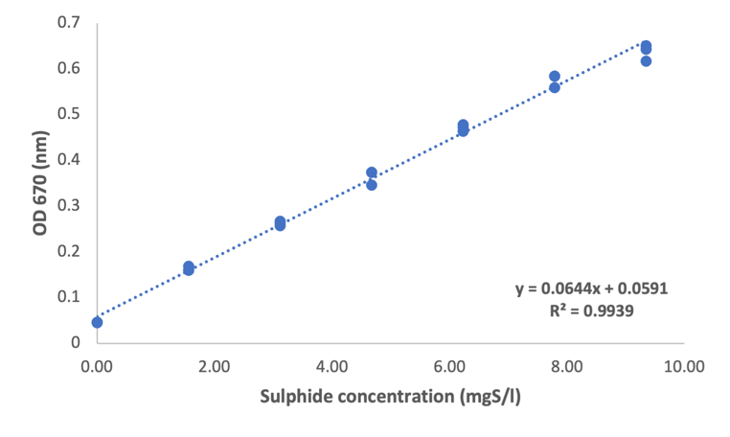
Figure 3.7: Sulphide standard curve from triplicate measurements

3.2.7.3 Measurement of bacteria growth
The bacteria growth in each sample was measured by carrying out a turbidimetric analysis using a spectrophotometer (7315 Jenway). 1 ml of suspended culture was collected from each sample bottle and dispensed into a 1 cm cuvette. The optical density was measured at a wavelength of OD600 nm for each sample and a fresh medium used as blank. Measuring bacteria growth at OD600 is considered the easiest way of measuring all stages of bacteria growth as it measures the degree at which light is scattered by the bacteria in the culture. This means the optical density can increase as bacteria increases. The wavelength 600nm is specifically chosen because it is not harmful to bacteria culture and it minimizes cell damage and growth (Beal et al., 2020).

3.2.7.4 Acetate analysis
Acetate in the samples were analysed using a Gas Chromatograph (Perkin- Elmer Clarus 500) equipped with an autosampler, column DB-FFAP, 30m, 0.32 mm diameter, film 0.25 um and a detector flame ionisation detector (FID). The injection and detector temperatures were 250°C and 230°C respectively, operating at a flow rate of 2.6ml/min nitrogen carrier gas. The injection split ratio was 40: 1 at a 1ul sample volume for each run.
The oven temperature programme was set at 70°C (3 minutes hold), 70°C-180°C, ramp 20°C/min and 180°C (3 minutes hold).

Determining growth rates of strain DSM 644 (D. Vulgaris) under varying conditions
All growth rates of the strain under varying conditions were determined from bacteria growth measurements taken at specific time intervals depending on the condition. For example, absorbance readings to determine the specific growth rate of D.Vulgaris at standard conditions were taken at 2 hours interval for a duration of 36 hours because it was expected that at this condition, the growth of the strain was optimum and so cells grew faster.
Growth curves were then plotted as a function of time and optical density (OD600 nm) using
Microsoft Excel. Each growth experiment was carried out in triplicates for reproducibility and average growth rates were often recorded.
To determine the growth rates under each condition, the exponential or lag phases of the growth curve were plotted as a function of time shown in Figure 3.8. This is the most important phase in the bacteria growth curve as cells increase in a logarithmic fashion. The growth rate is calculated from a simple equation below formula below was used to calculate the growth rate of each curve. Figure 3.9 shows the growth rate generated from a linear equation as calculated using Microsoft Excel tool.
$$N= N_{0 }e^{μ t}$$
Where;
N = number of newly produced cells
N₀ = cell number at time 0
e = exponential
μ = growth rate
t = time
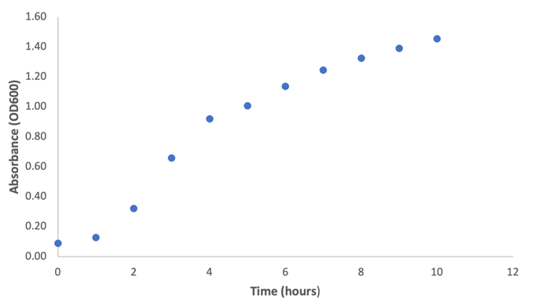  Figure 3.8: Graph plot of cell biomass measured at wavelength of 600nm over time | 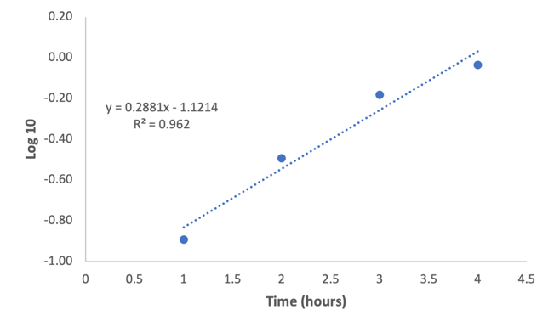  Figure 3.9: Graph plot of log phase as a function of time and equation displaying slope.

Statistical Method

3.2.9.1 Regression Analysis
A Linear regression analysis was performed to predict the amount of sulphide (dependent variable) produced in each sample bottle from the amount of cell biomass (independent variable) formed. The multiple linear regression assessed the ability of cell biomass (independent variable) to predict the amount of sulphide and acetate (dependent variables) produced in each sample given that the carbon source utilised for the experiment was lactate. Furthermore, it also assessed the ability of cell biomass (independent variable) to predict acetate degradation and sulphide production (dependent variables) for experiments where acetate was utilised as the sole carbon source.
Table 3.6 shown below is a summary table showing all dependent and independent variables used for this study during each type of analysis.

Table 3.6: Summary table showing all dependent and independent variables used for Regression Analysis
Type of Regression Analysis | Independent variable | Dependent variable(s)
Linear | Cell biomass | Sulphide production

A t-test was then conducted to determine if the slope of the linear regression was statistically different from zero. A Null and Alternative hypothesis were considered.
The Null hypothesis for the regression analysis stated that there was no relationship between amount of cell biomass produced in relation to sulphide production.
The Alternative hypothesis stated that there was a relationship between the paired samples. The hypothesis was then verified over a set significance level (p = 0.05). If the significance level was found to be higher than the set significance level, then the null hypothesis was accepted. However, if it was found to be below the set level, the null hypothesis was rejected.
The Null hypothesis for the first Multiple linear regression stated that the slope of the regression was zero, meaning that the sulphide and acetate production did not change with a changing amount of cell biomass formed while the second stated sulphide production and acetate degradation were not correlated with the cell biomass. Alternative hypothesis for both multiple regression analysis were the opposite statements of their Null hypothesis. The significance level also remained the same as in Linear analysis.

3.3.1 Growth curve and growth rate determination of D. Vulgaris in pure cultures containing sodium lactate.
The growth curve of D.Vulgaris in a pure culture medium containing sodium-lactate was determined by measuring the absorbance (OD 600) of 1ml of culture samples collected at time intervals for a duration of 36 hours.
Two sample bottles containing freshly prepared sodium-lactate based medium with pH adjusted to 6.8 were inoculated with 5ml each of active growing culture of D. Vulgaris. The bottles were incubated at 37°C. These conditions were considered standard conditions in this experiment.
Two (2) biological replicates were used to determine the growth rate of D. Vulgaris under standard conditions. 3.5g of sodium lactate was added to the medium as carbon source and pH adjusted to 6.8. The sample bottles were inoculated with 5ml of inoculum harvested at an OD of 0.4 to achieve a starting OD of 0.05. The bottles were incubated at a temperature of 37°C for a duration of 36 hours. This experiment was conducted to determine the growth curve and growth rate of D.Vulgaris under standard conditions using sodium lactate as a carbon source. The equation below was used to calculate the starting OD for each sample bottle.
$$Starting volume=\frac{Medium volume × Starting OD 600}{OD of active growing culture (inocculum)}$$
Where;
Medium volume = 50ml
Starting OD 600 = 0.05
OD of inoculum = 0.509
The second carbon source used to determine the growth rate of D. Vulgaris at standard conditions was sodium acetate. 3.3g of sodium acetate was added to the same medium as described above. Three (3) biological replicates were used to carry out this experiment and each inoculated with an inoculum harvested at an O.D of 0.3. pH and incubation temperature were kept the same for a duration of 10 hours. Growth curves and growth rates were determined using the same equation as above. However, sulphide concentrations for this experiment were not determined.

3.3.2 Determining growth rate of D. Vulgaris under varying pH and temperature conditions.
After the growth rate of D. Vulgaris was determined under standard conditions with sodium lactate as a carbon source, an experiment was then carried out to determine the growth rate using sodium acetate under standard conditions. 3.3g of sodium acetate was added to the medium. Acetate is one of the most common volatile fatty acids found in wastewater and this experiment was aimed at understanding the growth kinetics of the strain in a medium containing acetate. Considering the dynamic nature of a sewer system and the fact that the strain had been detected in sewer samples, this study also focused on the influence of varying temperatures (25 and 40°C) and pH (5, 6 and 7) on the growth of the strain in pure culture conditions. The sulphide production rate was also evaluated on all conditions.
Medium was prepared as already described in section 3.2.3 with pH adjusted. Experiments at varying pH and temperature of 25°C were carried out for a duration of 72 hours while experiments at 40°C were carried out for 156 hours.

Results and Discussion

3.3.1 Standard growth curve of D.Vulgaris in a sodium-lactate based medium.
Sodium lactate was used as a carbon source to optimise the growth of D.Vulgaris under conditions set at a pH of 6.8 and temperature of 37°C. The medium used to cultivate the strain was the ATCC medium for sulphate reducers and the ingredients have already been described in Section 3.2.3.1 above. Sampling measurements were carried out for a duration of 36 hours at 2 hours interval where samples were collected to measure cell biomass and sulphide production from duplicate cultures.
Average growth rate results of D.Vulgaris from duplicate cultures was ± 0.12 h⁻¹ and the average sulphide production rate was ± 0.11 h⁻¹.
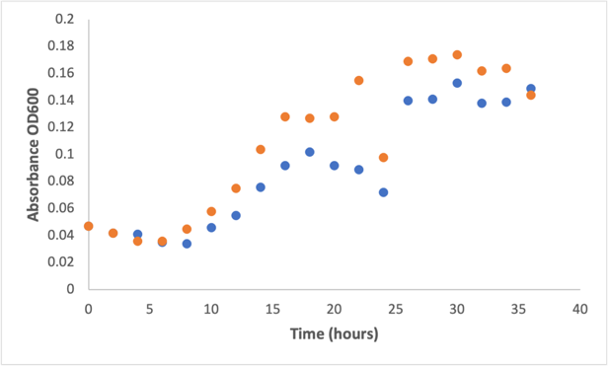 | 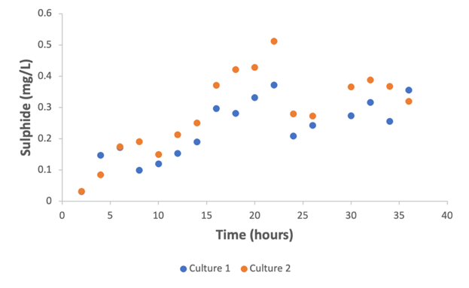
Figure 3.10: Cell biomass measurements and sulphide production of D.Vulgaris from duplicate cultures
The first graph in Figure 3.10 shows the growth curve of D.Vulgaris. The curve depicted a bacteria growth pattern showing a short exponential phase, followed by an exponential phase and then stationary phase. The data points in the sulphide production curve for both cultures shown in the second graph appeared to vary, however an exponential phase was observed between 6 and 22 hours.
A regressional analysis statistical method was used to determine the relationship between cell biomass and sulphide concentrations, p value was < 0.05 for each culture bottle which meant the null hypothesis was rejected and alternative hypothesis accepted that stated a positive correlation existed between cell biomass and sulphide production. Furthermore, the graph in Figure 3.11 below shows a linear relationship between cell density and sulphide production for both duplicate cultures.
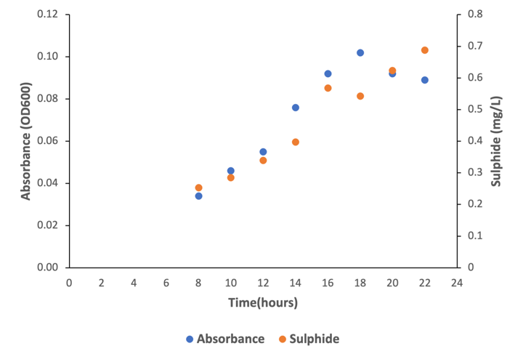 | 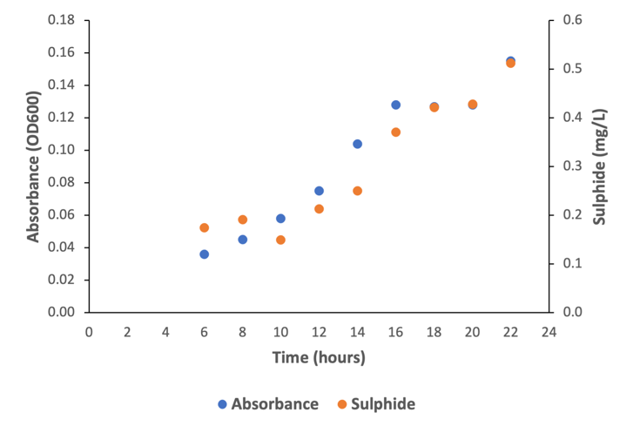
Figure 3.11: Graph plots of cell biomass and sulphide production at their exponential phases in duplicate cultures in a sodium lactate medium.
Table 3.7: Tabular representation of both average growth rate results and sulphide production from duplicate cultures of D. Vulgaris growing in sodium lactate
Growth rate (h⁻¹)
Culture 1 | Culture 2 | Average growth rate | Standard Deviation
0.11 | 0.13 | 0.12 | ± 0.007
Sulphide production rate (h⁻¹)
Culture 1 | Culture 2 | Average growth rate | Standard Deviation
0.11 | 0.10 | 0.11 | ±0.007
Bacteria growth rates are relevant depending on the strain of the bacteria as they can have both beneficial and detrimental effects on a system. A benefit of bacteria growth rates in a sewer system could be how fast it takes the strain to break down organic matter which help reduce the concentration of pollutants (Brand et al., 2014a). On the other hand, excessive growth rates of bacteria can lead to odours and corrosion which is a major problem in sewers (Fytianos et al., 2020). The growth rate of D.Vulgaris has been measured in some studies (Badziong and Thauer, 1978a; Brandis and Thauer, 1981). Sodium lactate is often a preferred carbon source for the cultivation of the strain because the strain is known to grow well in a medium containing this carbon source (Vita et al., 2015).
(Badziong and Thauer, 1978b) cultivated a D.Vulgaris (Marburg) strain on hydrogen plus sulphate and hydrogen plus thiosulphate as energy sources with acetate plus carbon dioxide as carbon sources in varying pH (6.5 and 6.8). The growth rates recorded were 0.15 h⁻¹ and 0.21 h⁻¹ respectively and they were found to be strongly dependent on pH. In another study, (Ramel et al., 2015) the various genotypes of D.Vulgaris (Hildenborough) strains in a lactate and sulphate medium under anaerobic conditions were examined and the results from their growth rate studies showed that the strain grew at a growth range between 0.04 h⁻¹ and 0.13 h⁻¹. When comparing the growth rate measured in this study with previous studies, it could be observed that the D.Vulgaris strain tends to grow slowly. It can be said that the
energy metabolism of SRB’s influence their growth rate as they use sulphate as a final electron acceptor which is less efficient than aerobic respiration thus resulting to the slower growth rates. Findings from these results were consistent with the average growth rate results on D. Vulgaris reported by Clark et al (2006) where D. Vulgaris was cultivated in a LSD4 medium which contained 60 mM sodium lactate.
In this experiment, sulphide production was also measured from the cultures and the average levels (0.16 mgS/L) were compared to a previous study (Ai et al., 2019). D.Vulgaris was identified in this study as one of the dominant SRB from a lab-scale gravity sewer. The study looked at methane and hydrogen sulphide production at different COD/sulphate ratios and they suggested that sulphide and methane levels in the sewers were influenced by varying COD/sulphate ratios with the highest sulphide level measured at 27.65 mg. Although within the scope of this thesis, COD/sulphate ratio was not considered, however it can be observed that the levels of sulphide measured in the lab-scale gravity sewer compared to pure culture studies were much higher perhaps because sulphate is limited in a lab-controlled environment.
The sulphide concentration measured in this study in comparison to a typical gravity or pressure main sewer is considered minor from below 0.5mgS/L and moderate or medium for concentrations ranging between 0.5 and 3 mgS/L (Carrera et al., 2016). Regular maintenance of the sewers is still required where proper ventilation is carried out to maintain oxygen levels in the sewers which can reduce the build-up of sulphides. Managing low concentrations of sulphides in sewers is important not only to mitigate odour but to prevent the corrosion of sewer pipelines and infrastructure and promoting public health.

3.3.2 Adapting D. Vulgaris in a sodium acetate based medium adjusted to a pH of 6.8 and temperature of 37°C.
After D. Vulgaris adapted well to the medium containing sodium lactate, experiments were conducted to examine the strain’s adaptability to sodium acetate. Sodium lactate was substituted in the growth medium for sodium lactate in 30 mM concentration and the conditions for this experiment were set to a pH of 6.8 and temperature of 37°C.
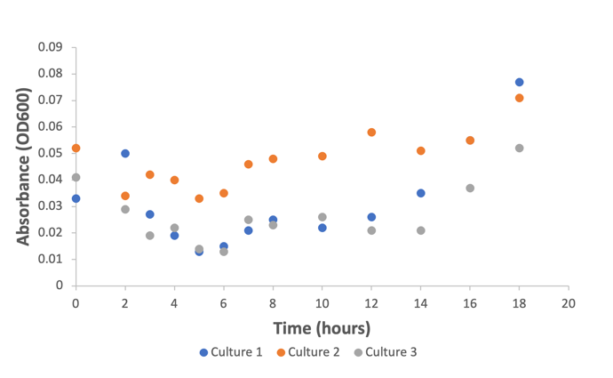
Figure 3.12: Graph showing growth curve of D. Vulgaris in triplicate cultures in a sodium-acetate based medium.

Figure 3.12 above shows the growth curve from triplicate culture studies of D.Vulgaris in a growth medium containing 30 mM of sodium acetate. Variable growth was observed in all cultures with periods of rapid growth interspersed with periods of little or no growth. Although the culture bottles were inoculated with the same volume of inoculum, the growth curve showed that the cultures had different starting optical density measurements which could have been due to variability in the inoculum or uneven distribution of cells. Between 0 and 6 hours, the curve showed a decline pattern. As the inoculum used for this experiment was initially grown on lactate, it is possible that the bacteria were trying to adapt to the new environment which could be suggested to have been a lag phase. Approximately after 6 hours, bacteria growth was observed for another 2 hours and then a stationary phase occurred for about 6 hours. Steady biomass concentration was observed across all replicates after 14 hours.

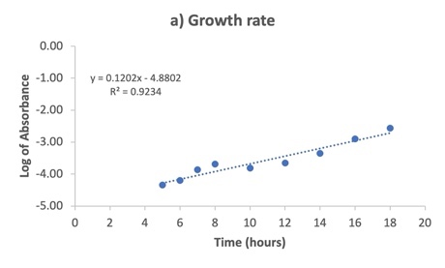 | 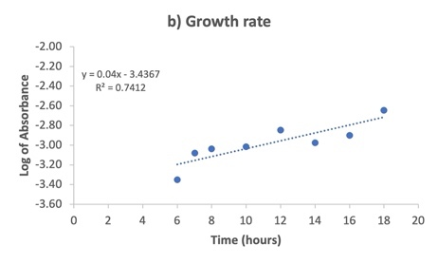
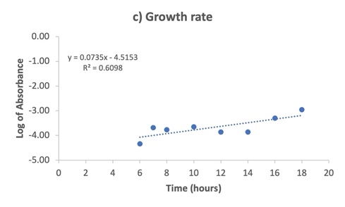

Figure 3.13: Linearised graph plots of growth rates determined from logarithmic data points of each culture bottle of D.Vulgaris grown in a sodium-acetate based medium.

Table 3.8 below shows a summary of the individual growth rates for each culture and the average growth rate result for the experiment including the standard deviation.
Growth rate (h⁻¹)
Culture 1 | Culture 2 | Culture 3 | Average growth rate | Standard Deviation
0.12 | 0.04 | 0.07 | 0.08 | ±0.04

In comparing the results from both growth curves of D. Vulgaris grown in sodium lactate as shown in Figure 3.10 and sodium acetate shown in Figure 3.12. It was found that the maximum absorbance and hence inferred biomass concentration was higher on lactate compared to acetate, however the results did produce growth in similar order of magnitudes.
The results suggest that D. Vulgaris adapted well in the sodium-lactate medium from the previous experiment in Section 3.3.1 to produce growth at similar scales compared to the sodium-acetate based medium.
A plausible reason why the growth rates in this study could have varied across all culture asides the change in carbon source may have been due to oxygen contamination during sampling of the bottles as the method for sampling required using a syringe attached to a needle to inject the septum of the bottles and taking out 1ml sample at different time intervals. The number of times the needle would have punctured the septum could have given room for oxygen entrainment and affected the growth of the strain.
Data from these results show that D. Vulgaris exhibited a low growth rate under the conditions studied which could have been due to the carbon source as acetate may not be a preferential carbon source for the strain. A study by Pankhania et al (1986) asessed the effect of hydrogen on the growth of D. Vulgaris in separate cultures containing acetate and lactate. They observed that when D.Vulgaris growing on lactate was added to cultures containing acetate, a switch from acetate to lactate utilisation occurred resulting in a biphasic growth.
Although acetate is an important substrate in SRB metabolism, the D.Vulgaris strain is a hydrogenotrophic sulphate reducer which means it utilises hydrogen as an electron donor and sulphate as an electron acceptor for its metabolism (Ozuolmez et al., 2015).
For this experimental study, 100% nitrogen was used as the gas phase which may have influenced the growth of the strain ultimately. However, studies have shown that it is capable of utilising other electron donors such as formate and ethanol to carry out sulphate reduction (Ozuolmez et al., 2015). These electron donors are found in wastewater influents at all varying levels and influence sulphate reduction in the systems (Chui, Fang and Li, 1994; Sun et al., 2005).
Generally, results from this experimental study highlight the influence of carbon sources on the growth of D.Vulgaris and studying the influence of carbon sources on the growth of D.Vulgaris is important in understanding its role in the environment especially sewer systems and not only that but advancing our understanding of microbial physiology and metabolism.

3.3.3 Examining the growth of D.Vulgaris in a sodium-acetate based medium with pH adjusted to 5 and temperature set to 25°C.
D.Vulgaris was grown in a medium containing 30 mM of sodium acetate adjusted to pH 5 and temperature of 25°C. The objective of this experiment was to examine the effect of varying pH and temperature on the metabolism of D. Vulgaris. Sampling was carried out for a duration of 72 hours at 12 hours interval.
The results generally suggested that D.Vulgaris did not grow under the conditions it was studied.
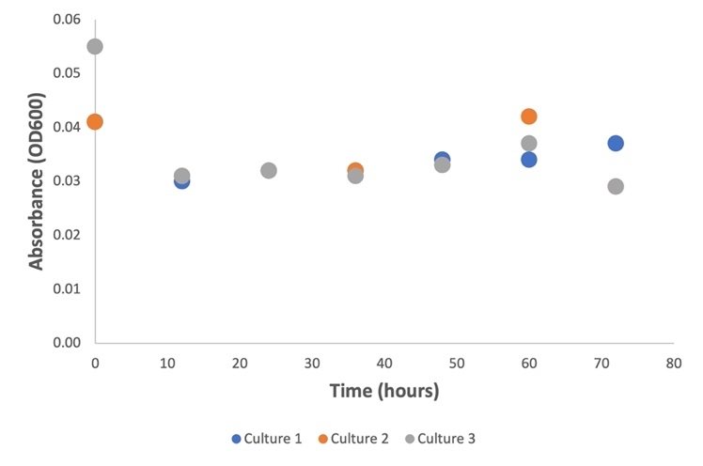
Figure 3.14: Growth curve of D. Vulgaris growing at pH of 5 and temperature at 25 degrees
Figure 3.14 above shows the growth curve results from the triplicate culture experiments conducted. The growth curve pattern did not indicate an exponential phase occurred as a stationary phase was observed for all three culture bottles throughout the duration of the experiment. It was observed that all three cultures started with an OD between 0.04 and 0.06 but the rate of cell growth slowed down, and a stationary phase was observed throughout the experiment. Several conditions could have contributed to the slow cell growth of D.Vulgaris such as cells been passaged too many times before inoculation (Merck,2023), limited carbon concentration in growth medium, the pH and temperature which the strain was studied. Although SRB activities have been observed to occur in acidic environments, D.Vulgaris strains have been categorised as acidophilic, alkaliphilic or neutrophilic and D.Vulgaris has been categorised as neutrophilic which are thought only to be able to grow at a pH range between 6-8 (Tran et al., 2021b). However, the strain has been shown to survive in acidic environments from later studies (Thuy et al., 2020; Tran et al., 2021a).
Microbial corrosion is often influenced by temperature and for this experimental study, 25°C was used. It is not clear whether the slow cell growth observed in this experiment was a result of the temperature but (Ismail et al., 2014) studied the effect of pH and temperature on corrosion of steel subject to SRB where they focused on identifying the optimum temperature and pH value. Their results showed that among the range of pH and temperature studied to determine the corrosion rate, pH 9.5 and 37°C was the favourable temperature for the growth of the bacteria with influence on the corrosion rate.
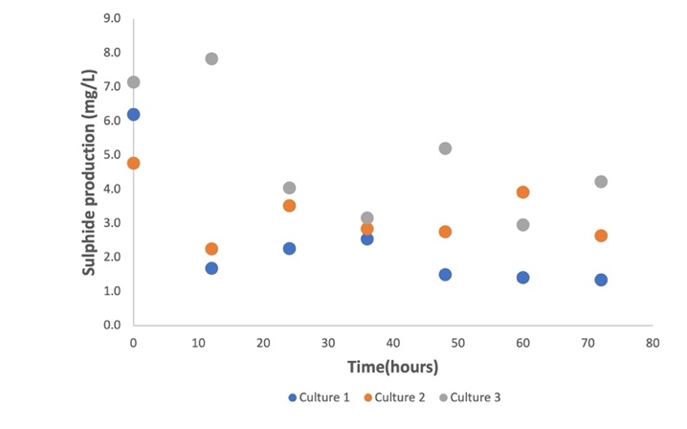
Figure 3.15: Sulphide production of D. Vulgaris growing at pH of 5 and temperature at 25°C degrees.
Figure 3.15 above shows the sulphide production curve obtained from this experimental study. The growth curve was seen to vary across all triplicates. No steady increase of sulphide production was observed during this study as the data points varied all through the experiment. As already been discussed in literature, microbial sulphate reduction produced by SRB activity can be in the form of sulphide ions depending on the pH. At low pH, the sulphide ions decrease and hydrogen gas formation increases (Ismail et al., 2014). Sulphide concentrations were measured only in the liquid phase and the gas phase was not taken into account. It may have been possible that hydrogen sulphide was present in the gas phase at this pH.
Generally, the results for D.Vulgaris growth under the conditions studied suggested that the strain did not adapt well to the conditions and as no exponential growth was observed.

3.3.4 Examining the growth of D.Vulgaris in a sodium-acetate based medium with pH adjusted to 5 and temperature set to 40°C.
D. Vulgaris did not adapt well to pH 5 and a temperature of 25°C, according to earlier experiments conducted in Section 3.3.3. To ascertain how a change in temperature would affect D. Vulgaris metabolism, the pH was kept constant throughout this experimental study. For 156 hours, sampling was done at 12-hour intervals.
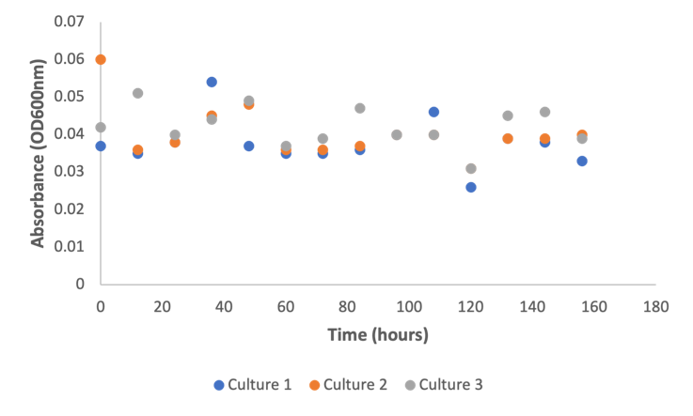
Figure 3.16: Growth curve of D. Vulgaris growing at pH 5 and 40°C.
Figure 3.16 shows the growth curve results of D. Vulgaris from triplicate cultures.
The growth curve of D. Vulgaris in Figure 3.16 revealed a stationary phase for the duration of the experiment, which is similar to the growth pattern seen in Figure 3.14. Since there was no obvious exponential phase on the curve, growth rate was not measured. The stationary phase shows the end of growth, but bacteria cells can still be metabolically active during this time (Jaishankar and Srivastava, 2017).
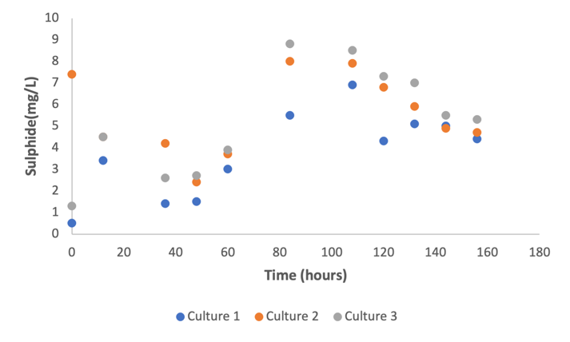
Figure 3.17: Sulphide production of curve of D.Vulgaris grown in a sodium acetate based medium at pH 5 and temperature 40°C
The sulphide production curve of D. Vulgaris under the conditions used in this experimental study is shown in Figure 3.17. The graph demonstrated that all three culture bottles produced sulphide. Sulphide production was seen to start to decline after an exponential phase that lasted between 48 and 84 hours. With an average sulphide production rate of ± 0.03h⁻¹, the calculated average sulphide production was 7.4 mg/L.
These findings suggested that sulphide production occurred when the growth medium temperature was adjusted from 25°C to 40°C, indicating that the increase in temperature may have had an impact on the strain's ability to produce sulphide.
Overall, the findings demonstrated that sulphate reduction occurred in the absence of an evident exponential phase indicative of cell growth. This is frequently the case when bottles are contaminated with other microorganisms during sampling, which might have prevented the strain from growing while sulphate reduction was still occurring (Guvensen, Zorlu and Col, 2017). Since D. Vulgaris is known to have growth requirements for temperature, pH, nutrient availability, and electron donor/acceptors, suboptimal growth conditions may also have been a contributing factor (Ramel et al., 2015). Even in unfavourable growth conditions, the strain might have still been able to perform sulphate reduction by using residual nutrients or alternative energy sources (Kushkevych, Dordević and Vítězová, 2019).
To comprehend potential causes of sulphate reduction without detectable cell growth in culture bottles, it is critical to evaluate the culture conditions, cell viability, and potential metabolic activity inhibitors. Additional testing and research, such as transcriptomic or proteomic studies, can shed light on the precise metabolic pathways and regulatory mechanisms utilised by D. vulgaris in these circumstances.

3.3.5 Examining the growth of D.Vulgaris in a sodium-acetate based medium with pH adjusted to 6 and temperature set to 25°C.
Previous research in Section 3.3.4 indicated that the temperature change from 25°C to 40°C at pH 5 had an impact on sulphide production. In order to further investigate the impact of these growth parameters on the strain's general metabolism, the pH and temperature were adjusted in this study to 6 and 25 C, respectively.
The sampling process took place over the course of 72 hours, with 12-hour intervals. The findings demonstrated that D. vulgaris did not grow under the conditions examined.
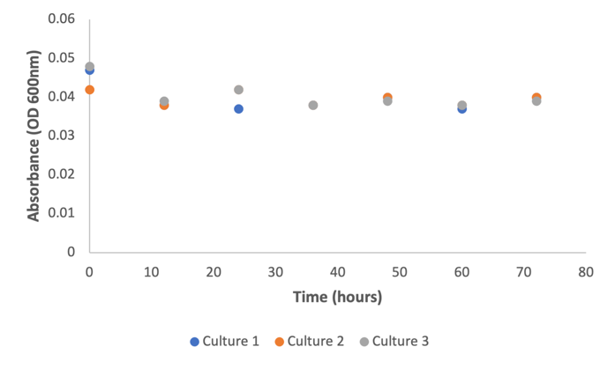
Figure 3.18: Growth curve of D. Vulgaris at pH 6 and temperature 25°C
The growth curve from experiments conducted in three separate batches under the conditions described is depicted in Figure 3.21 above. The growth curve suggested that D. Vulgaris did not show any growth during the sampling period and remained in a stationary phase. Additionally, no sulphide was produced in any of the cultures.
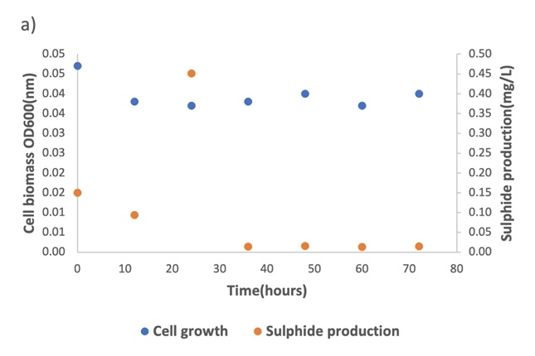 | 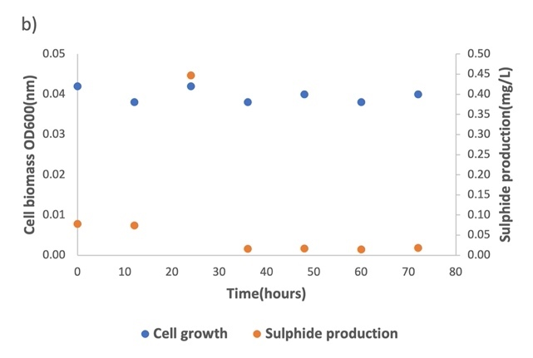
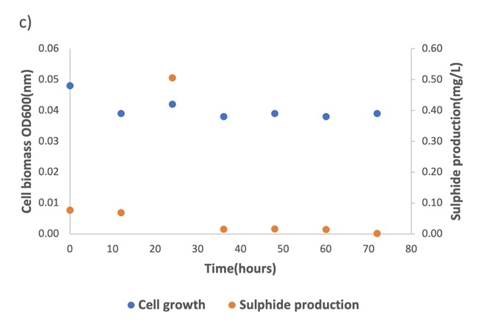
Figure 3.19: Graph plots of cell biomass and sulphide production of 3 replicates at pH 6 and temperature at 25°C
Figure 3.19 above shows a graphical plot of cell biomass and sulphide production for all triplicate cultures and the results showed that sulphide was not produced for the duration of the sampling.
The results show that D. Vulgaris did not adapt well to the conditions under which it was studied because it did not exhibit any significant increase in cell biomass or sulphide production. While some SRB can function at pH 6 (Badziong and Thauer, 1978a), the ideal pH for sulphate reduction can vary among different SRB species, which may explain why sulphate reduction and D. Vulgaris growth did not occur under these conditions.
Most SRB species thrive at a pH range of 6.5 to 7.5(Reis et al., 1992), which is considered neutral. Studies (Gyure et al., 1990; Moosa and Harrison, 2006; Mukwevho, Maharajh and Chirwa, 2020)have revealed that, compared to the ideal pH range, D. Vulgaris activity may be slightly reduced at pH 6, and its growth and sulphate reduction rates may be slower.
Additionally, D. Vulgaris is a known obligate anaerobe, which means it cannot survive in an oxygen-rich environment. Small amounts of oxygen may have been introduced into the culture bottles during sampling, which could have prevented sulphate reduction in this study.
Due to some of these growth factors, such as fluctuating pH, temperature, the presence of inhibitory substances, and competition with other microorganisms within the sewers, sewer environments can also present difficulties for SRB activity and growth(Kushkevych, Dordević and Vítězová, 2019). Anaerobic microorganism activity can also be restricted by localised conditions in sewers, such as areas with high oxygen exposure to toxic substances(Kushkevych, Dordević and Vítězová, 2019).
Conclusively within sewers, the complex and fluctuating conditions in sewers including nutrient limitations, competition and localised oxygen exposure can affect the extent and efficiency of sulphate reduction by SRB (Carrera et al., 2016).

    - Examining the growth of D.Vulgaris in a sodium-acetate based medium with pH adjusted to 6 and temperature set to 40°C.

According to the experiments from section 3.3.5, D. vulgaris did not grow in the environments that were examined. Because it was unclear from earlier experiments whether temperature, carbon concentration, or pH affected the growth, the temperature was adjusted in this experiment.
A total of 156 hours of sampling measurements were performed at 12-hour intervals.
The results of this study suggested that D. Vulgaris adapted well under the conditions it was studied. The average growth rate for this study was ± 0.01 h⁻¹, and the average rate of sulphide production was ± 0.04 h⁻¹.
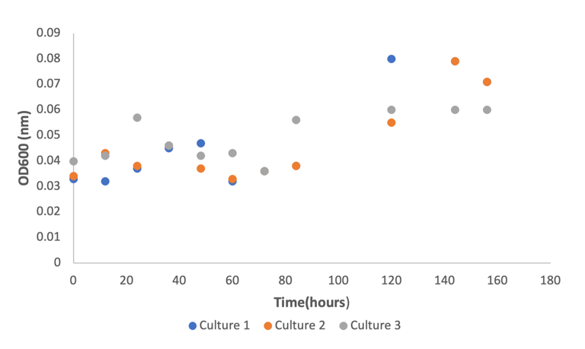
Figure 3.20: Growth curves of D. Vulgaris in medium adjusted to pH 6 and incubated at temperature 40°C
Figure 3.20 above shows the growth curve of D.Vulgaris strain in triplicate cultures. The growth curve suggested that D.Vulgaris grew exponentially after 40 hours of incubation which lasted till 120 hours after which a stationary phase was observed.

Table 3.8 below shows the average growth rate results under the conditions studied.
Average growth rate (h⁻¹)
Culture 1 | Culture 2 | Culture 3 | Average | Standard Deviation
0.015 | 0.012 | 0.005 | 0.01 | ± 0.005

Table 3.9: Table showing individual sulphide production rates from triplicate cultures, average growth rate and standard deviation.
Sulphide production rate (h⁻¹)
Culture 1 | Culture 2 | Culture 3 | Average | Standard Deviation
0.05 | 0.02 | 0.04 | 0.04 | ± 0.01

Overall, results from this study suggested that the increase in temperature at a constant pH of 6 influenced the growth rate of D.Vulgaris.

Examining the growth of D. Vulgaris in a sodium-acetate based medium with pH adjusted to 7 and temperature set to 25°C.
The growth of D. Vulgaris was examined in earlier sections of the experimental studies in this chapter at pH values of 5 and 6 and temperatures ranging between 25°C and 40°C.
To examine the effects of changing these growth factors on the rate of D. Vulgaris growth, pH was set to 7 and temperature to 25°C for this section. The sampling process took place over the course of 72 hours, with 12-hour intervals.
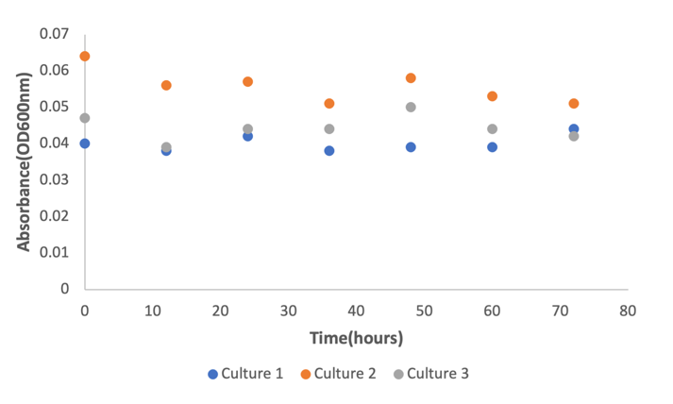
Figure 3.21: Growth curve of D. Vulgaris grown in a sodium-acetate based medium adjusted to pH 7 and incubated at temperature 25°C.
The growth curve shown in Figure 3.24 above suggested that D.Vulgaris remained in a stationary phase for the duration of sampling. This suggested that D.Vulgaris did not adapt well under the conditions it was studied and no growth was measured as there was an absence of an exponential phase.
The triplicate cultures were also sampled for sulphide production and the graph can be found below.

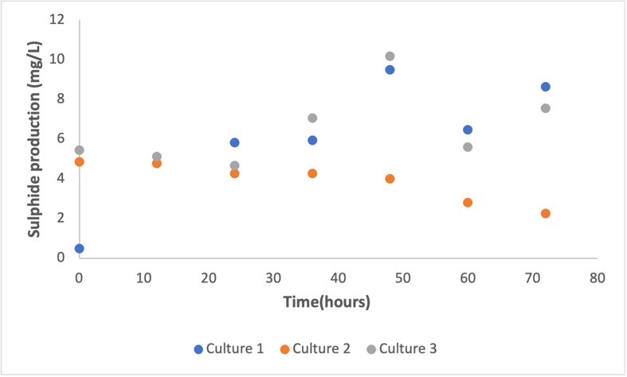
Figure 3.22: Sulphide production curve of D.Vulgaris in triplicate cultures growing in a sodium acetate based medium at pH 7 and temperature 25°C.
Figure 3.22 above shows the sulphide production curve for each culture. It was observed that Culture 2 was found to decline indicating a decrease in sulphide production while an exponential phase was observed in Culture 1 and 3 for a duration of 48 hours.
The sulphide production rates for Culture 1 and 3 were 0.02 h⁻¹ and 0.03 h⁻¹ respectively as shown in graph a and c in Figure 3.26 below.

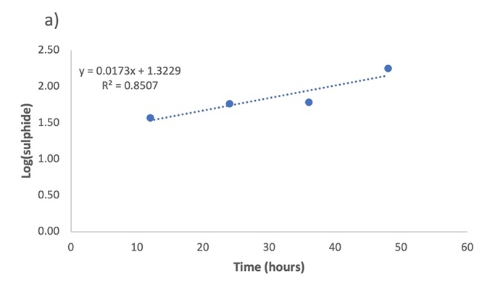 | 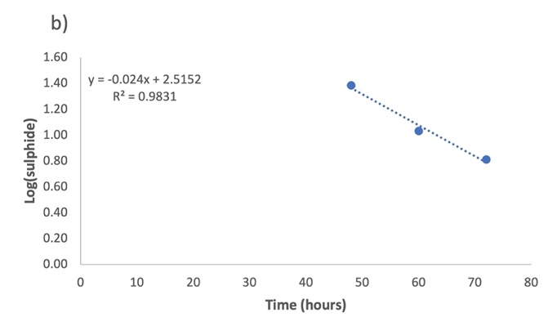
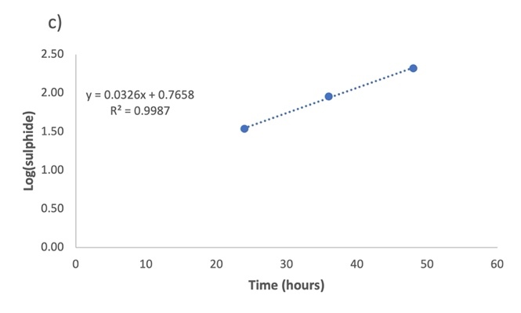
Figure 3.23: Linearised graph plots of sulphide production rate of D. Vulgaris growth in pH 7, temperature 25°C
Results from this experimental study suggested that D. Vulgaris showed no growth in all culture bottles, but sulphide production was measured in Culture 1 and 3 while Culture 2 showed a decrease in sulphide production. This result was like the experiments conducted in Section 3.3.4 where D.Vulgaris was grown at pH of 5 and temperature of 40°C. The results suggested that sulphide production could occur in culture bottles despite lack of cell biomass growth. The findings from the experiments conducted in Section 3.3.4 and this current section are in line with studies by (Jaishankar and Srivastava, 2017) who explained that bacteria cells can be metabolically active even in their stationary phase. This would mean that in the case of D.Vulgaris, the cells may have been metabolically active and produced hydrogen sulphide as a by-product of their metabolism.

Examining the growth of D.Vulgaris in a sodium-acetate based medium with pH adjusted to 7 and temperature set to 40°C.
The experiments conducted in Section 3.3.6 showed that D.Vulgaris remained in a stationary phase throughout the duration of the experiment but may have been metabolically active as sulphide production was measured in two out of the three culture bottles.
The experiment in this study was the final condition D.Vulgaris was studied in, where the temperature was adjusted to 40°C and the pH was kept constant at 7. Sampling was carried out for a duration of 156 hours at 12 hours interval.
The average growth rate of D.Vulgaris calculated in this experimental study was ± 0.01h⁻¹.
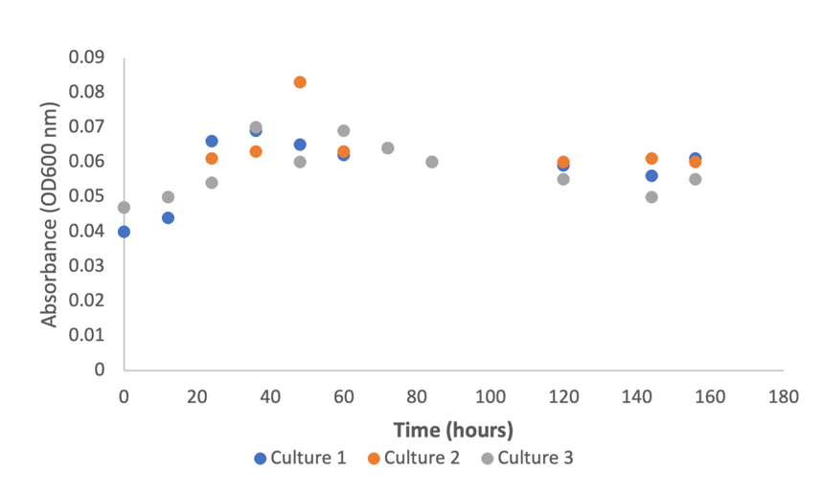
Figure 3.24: Growth curve of D.Vulgaris grown in a sodium-acetate based medium adjusted to a pH of 7 and temperature of 40°C.
Figure 3.24 above shows the growth curve of D.Vulgaris. From the graph, it can be observed that D.Vulgaris grew exponentially during the first 48 hours and remained in a stationary phase for the duration of the experiment. The gap in data points between 80 and 120 hours was where no sampling occurred.
These results were compared with experimental results recorded in Section 3.4.7. The results suggested that the cell biomass of D.Vulgaris increased with an increase in temperature. On the other hand, the sulphide production levels seemed to vary across all culture bottles as shown in Figure 3.30 below
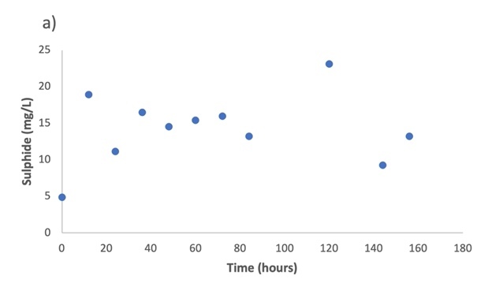 | 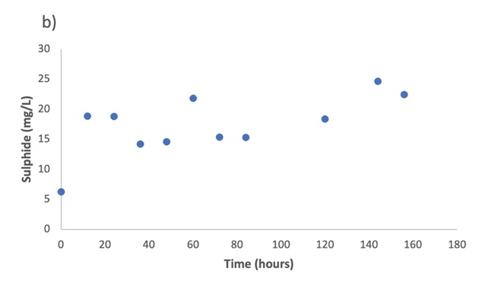
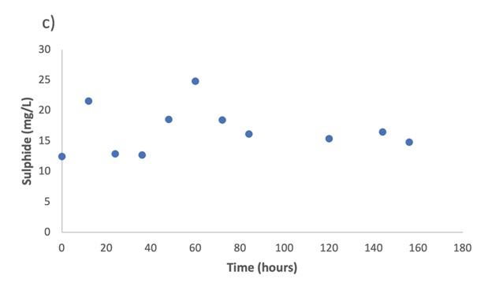
Figure 3.25: Sulphide production curve of D. Vulgaris under the conditions studied.
There could be several reasons why this may have occurred. Sulphate is an essential nutrient that is required for the growth of the strain. Although sulphate concentrations were not measured in this experimental study, it may have been possible that the medium where the strain grew lacked sufficient sulphate which could have overall influenced the sulphide production in all cultures.

3.4 Conclusion
The emission of sulphide within sewer networks causing odour and corrosion which is detrimental to human health and sewer infrastructure has become apparent within the sewer environment. This experimental study examined the impact of some growth parameters like temperature, pH and carbon source on the growth and sulphide production rate of D.Vulgaris and how these findings are linked to sewer systems.
After an extensive analysis on the growth of D.Vulgaris in varying temperatures and pH conditions, the results showed that the highest sulphide production rate (± 0.04 h⁻¹) and growth (± 0.01 h⁻¹) of D.Vulgaris was observed at pH 6 and temperature of 40°C. The lowest average sulphide production rate (± 0.02 h⁻¹ ) was recorded from growth medium adjusted to pH 7 and temperature of 25°C.
The growth of D. Vulgaris and the reduction of sulphate were both generally observed to be influenced by temperature and pH variations. Sulphate reduction was discovered to occur in culture bottles where cells were seen to be in a lag phase, which suggested that sulphate reduction was not correlated with the growth of cell biomass in some experimental studies.
Findings from this experimental study suggested that D.Vulgaris produced hydrogen sulphide at a high temperature of 40°C. This finding was compared to typical sewer temperatures, and it was found that elevated temperatures can occur due to microbial activity, exothermic reactions, and heat dissipation from industrial processes as thermophilic and mesophilic SRB with some temperature tolerance can be present in sewer systems (Zeng et al., 2019). The presence of these species of SRB make it feasible for sulphate reduction to occur at elevated temperatures.
In addition, the availability of organic carbon and microbial interactions within the sewer microbial community influence the extent of sulphate reduction at elevated temperatures.
It was observed that D.Vulgaris adapted well to the growth medium containing sodium lactate than sodium acetate as a previous study (Tao et al., 2014) highlighted D.Vulgaris preference for lactate over other carbon sources.
Sulphate reduction was observed to occur at pH 5 in this study. This finding could imply that sulphate reduction occurring at low pH in sewer environments may increase the solubility of hydrogen sulphide potentially leading to odour issues and increased corrosion risks in sewer infrastructure. Therefore, pH control becomes essential in sewer management as it helps regulate the growth and metabolic activity of microorganisms. Understanding these processes is essential for managing sewer systems, dealing with odour problems, and reducing the potential effects of corrosion and sulphide generation (Jes et al., 2015).
On the other hand, pH affects the entire process in a sewer system, not just sulphate reduction. The risk of corrosion in sewer infrastructure can be reduced by monitoring and managing pH (Park et al., 2014). In addition, effective temperature management can support the maintenance of infrastructure and the desired microbial processes.
Understanding and controlling pH and temperature parameters can help with efficient sewer management, support the activity of SRB's in the sulphur cycle, and reduce any potential negative impacts like odour issues and infrastructure deterioration (Park et al., 2014).

Chapter 4
An anaerobic growth study of E.coli in a sodium acetate-based medium.

4.1 Introduction
Generally, the study of anaerobic respiration in microorganisms has gained interest due to its relevance in various natural and industrial processes. E.coli is a well characterised bacterium which has studied for its diverse capabilities and its adaptability to different growth conditions (Glasky and Rafelson Jr, 1959; Guo et al., 2020). The anaerobic metabolic pathway of E.coli involves a variety of metabolic routes which allow it to generate energy and metabolise essential carbon substrates in the absence of oxygen (Enjalbert et al., 2015). Understanding the metabolic pathway of E.coli under anaerobic conditions and its utilisation of sodium acetate as a carbon source is relevant because it can provide insights on the strain’s metabolic versatility. This understanding can form the basis of further co-culture studies on E.coli and D.Vulgaris, in other to determine whether we can establish an cooperative or competitive relationship existing between both species that will aid in understanding how to reduce sewer corrosion.
Sodium acetate is a carbon source that has gathered interest in anaerobic studies because it is a common compound found in natural environments and one of the main volatile fatty acids in wastewater (Brand et al., 2014a; Brand et al., 2014b). Most laboratory studies on E.coli have been carried out using glucose since it’s a preferred carbon and energy source for most bacteria (Hua et al., 2007). Other carbon sources other than glucose such as lactate have been used to cultivate E.coli under aerobic conditions (Chen et al., 2018; Higgins and Johnson, 1970) Lactate, acetate, ethyl alcohol and formate are fermentation products formed when E.coli is anaerobically grown on glucose (Higgins and Johnson, 1970). However, acetate utilisation by E.coli under anaerobic conditions has not been studied. The objective of this study is then to examine the anaerobic growth of E.coli when cultivated in a medium containing acetate and to also determine the influence of varying concentrations of sodium acetate on the growth rate of the strain.
By investigating the anaerobic growth of E.coli, this study aims to expand our understanding of the bacterium’s metabolic capabilities. The findings from this study will become relevant in the subsequent experimental chapter where the strain will be co-cultured with D.Vulgaris.

4.2 Methodology

4.2.1 Summary
Escherichia Coli - E. coli (K12-MG1655) was cultivated in two types of media (LB Broth Miller and Davis Minimal) with sodium acetate added as carbon source supplement. This study was aimed at determining the growth of E. coli is a medium containing sodium acetate. Sodium acetate as a carbon source supplement was relevant for this study because it was later used in co-culture with D. Vulgaris to determine a possible interaction that could aid in potentially reducing sulphide production.

4.2.3 Growth medium and culturing conditions
Both LB Broth Miller and Davis Minimal media were used to culture E. coli. The medium composition varied. Different media compositions were used in this study to evaluate the potential impact of the varying compositions on the strain’s specific growth rate. The purpose of this was to mimic systems where concentration of nutrients varies from time to time and to also understand how these variances could influence the growth rate of the strain.
The composition of LB Broth Miller and Davis Minimal medium can be seen in Tables 4.2.3.1 and 4.2.3.2 below.
LB Broth was prepared by dissolving 25g of granulated LB Broth powder in a glass bottle containing 1 litre of distilled water and Davis Minimal medium was prepared by dissolving 11g of Davis Minimal powder in a glass bottle also containing 1 litre of distilled water.
Table 4.1: LB Broth Medium  Medium composition  Ingredients Amount (grams/Litre)  Yeast Extract 5.0  Peptone from casein 10.0  Sodium chloride 10.0 | Table 4.2: Davis Minimal medium  Medium composition  Ingredients Amount (grams/Litre)  Dextrose 1.0  Dipotassium phosphate 7.0  Monopotassium phosphate 2.0  Sodium citrate 0.5  Magnesium sulphate 0.1  Ammonium sulphate 1.0

4.2.4 Procedure
Studies were first carried out under aerobic conditions before anaerobic conditions to evaluate the difference in growth rates of both strains as the anaerobic conditions usually have a low energy yield which mean a lower growth rate compared to aerobic conditions.
The temperature conditions for aerobic experiments were set to 37°C and pH of media adjusted to 7. After medium was prepared and sterilised, experiments were carried out in 3 biological replicates using 50ml falcon tubes containing 5ml of fresh medium. Each falcon tube was inoculated with a colony of E. coli picked from E. coli strains already grown on agar plates stored in the refrigerator. The colonies were picked using an inoculating loop which was gently dipped into every falcon tube and swirled for proper mixing before incubating overnight at 200 rpm at 37°C. This procedure was carried out to be able to work with E. coli strains in active culture for subsequent experiments. All procedures were carried out under aseptic conditions to prevent any contamination. Evidence of growth was observed by physical examination of falcon tubes containing culture as they all appeared turbid. The OD600 was measured using a spectrophotometer. This was important as it determined the phase at which the cells were at. Typical OD of an overnight E. coli culture is usually between 0.5-0.9. After the first OD had been recorded, a sub-culturing procedure was carried out. For this procedure, (3) 250ml conical flasks were sterilised. 100ml of fresh media was aliquoted into each flask. Using a syringe and needle, 1ml each of active growing culture from one of the falcon tubes was withdrawn and dispensed into each conical flask. The rest were stored in a refrigerator for not more than 3 months. A schematic of the experimental set up is shown in Figure 4.1 below.
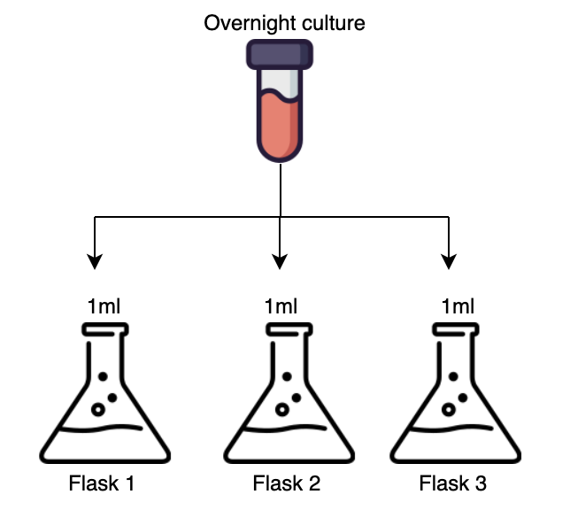
Figure 4.1: Schematic of experimental set up for aerobic conditions

The temperature conditions for anaerobic conditions were the same as the aerobic conditions. Growth medium was first prepared in a 1 litre glass bottle and aliquoted into 120 ml serum bottles in 50 ml volumes. The bottles were gassed under 100% N₂ to exclude as much oxygen as possible since the condition was anaerobic. Following that, all bottles were then sealed with butyl rubbers and crimped with aluminium caps to prevent oxygen entrainment. Finally, bottles were autoclaved.
Before inoculations were carried out, 0.5ml of 3% sodium thioglycolate stock solution was introduced into each serum bottle used for experiments and left for a few hours to react. This solution was used a reducing agent to oxidize any residual oxygen in the bottles before any experiment started. At the start of the experiment, 3 biological replicates were used. 1ml of culture was inoculated into each serum bottle. Figure 4.2 below shows a schematic of the experimental set up under anaerobic conditions.
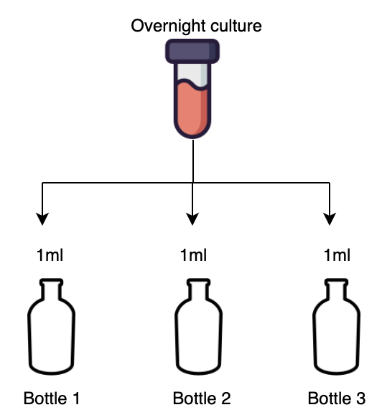
Figure 4.2 : Schematic of experimental set up under anaerobic conditions

4.2.4 Carbon sources and experimental conditions
Each growth medium was first used to cultivate E. coli strain and subsequently supplemented with varying concentrations of sodium acetate. Sodium acetate was used as a carbon source for these experiments as it was important to determine the effect the substrate had on E. coli growth because it is rarely used for E. coli studies. It was important to establish whether the strain utilised sodium acetate as a carbon source in pure cultures under the conditions present.
Varying amounts of sodium acetate were supplemented in the medium at 20, 40, 60, 80, 100 and 120 mM concentrations.

4.2.4.1 Experimental conditions
The table below provides a summary of the experimental conditions set in this study. E.coli was studied under both aerobic and anaerobic conditions. 1 experiment was carried out under aerobic condition and the other 9 experiments were carried out under anaerobic conditions. All experiments were carried out in triplicates and the medium contained varying concentrations of sodium acetate.
Table 4.3: Tabular summary of experimental conditions set in this study
Conditions | Media and additional supplements
Aerobic | LB Broth Miller
Anaerobic | LB Broth Miller
Anaerobic | LB Broth Miller + 100 mM sodium acetate
Anaerobic | LB Broth Miller + 120 mM sodium acetate
Anaerobic | Davis Minimal + 20 mM sodium acetate
Anaerobic | Davis Minimal + 40 mM sodium acetate
Anaerobic | Davis Minimal + 60 mM sodium acetate
Anaerobic | Davis Minimal + 80 mM sodium acetate
Anaerobic | Davis Minimal + 100 mM sodium acetate
Anaerobic | Davis Minimal + 120 mM sodium acetate

4.3 Results and Discussion

4.3.1 Determining the specific growth rate of E. coli under aerobic and anaerobic conditions.
E. coli MG1655 was anaerobically adapted to a LB Broth medium to determine its growth rate. Similarly, the strains were adapted to LB Broth medium under aerobic conditions. Results showed that E. coli cells successfully grew in LB Broth media under anaerobic conditions at a growth rate of 0.19h⁻¹. (Hasona et al., 2004) reported a growth rate of 0.26h⁻¹ for an E. coli strain growing in minimal medium and supplemented with glucose.
Under aerobic conditions, the E. coli cells grew at a growth rate of 0.7h⁻¹ which was consistent with the finding by (Smirnova and Oktyabrsky, 2018) who determined the growth rate of a wild type (wt.) E.coli strain in a M9 minimal medium containing glucose and reported a growth rate result of 0.63 h⁻¹. The difference in growth rates observed for both conditions was due to ATP yield during E. coli metabolism as anaerobically grown cells display a lower growth rate compared to aerobically grown cells due to less ATP generated per unit substrate (Shewaramani et al., 2017). In addition, under aerobic conditions during E. coli metabolism, glucose is completely oxidized which yields to a faster growth of the strain in comparison to anaerobic conditions where glucose is partially oxidized, and it yields less energy hence the lower growth rate observed (Murashko and Lin-Chao, 2017).

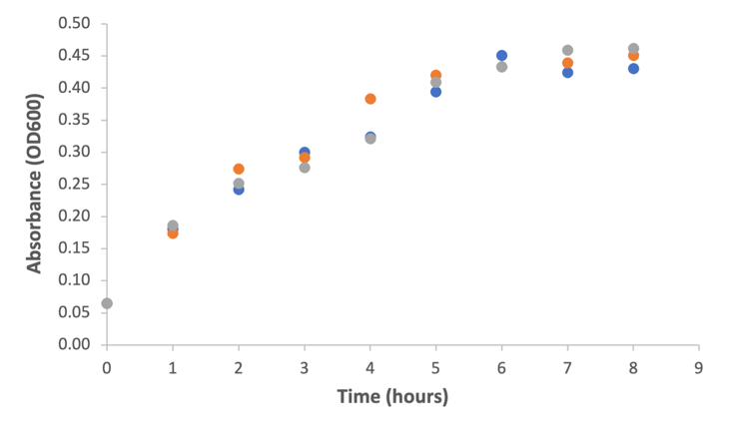  Figure 4.3: Growth curve from triplicate measurements of E. coli under anaerobic conditions | 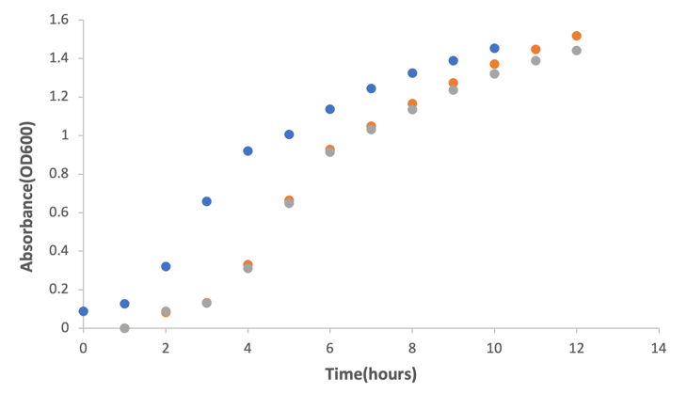  Figure 4.4: Growth curve from triplicate measurements of E. coli under aerobic conditions.

Triplicate growth curve experiments of E. coli under anaerobic conditions in Figure 4.3 showed no clear lag phase. The lag phase is usually defined as an adaptive period where bacteria tend to adjust to a new environment. A plausible explanation of this could have been that since the inoculum used for the experiments was from a similar environment under similar conditions such as pH and temperature, there was no adaptive period for the cells leading to no lag phase. (Bertranda, 2019) suggested that the magnitude of change between two environments is positively correlated to the lag time duration. In this case, the cells for the inoculum were harvested in their exponential phase and a longer lag phase lasting for about 5 hours followed by a stationary phase.
The growth curve indicated cells had already attained a late-log phase during the time of sampling. Figure 4.3 shows the growth curve of E. coli under aerobic conditions. The growth curve showed a bacterial growth pattern of an exponential phase lasting for and stationary phase.
Average exponential phase was attained at an optical density (OD₆₀₀) of 0.9 under aerobic conditions while average exponential phase under anaerobic conditions ceased at OD₆₀₀ of 0.4.
Conclusively, the results from both growth curve experiments show that E. coli grew in LB Broth media under anaerobic and aerobic conditions. The results further suggest that E. coli growth under aerobic conditions is a favourable metabolic pathway for the growth of the strain due to oxygen limitation under anaerobic conditions.

4.3.2 LB Broth medium supplemented with 100 mM of sodium acetate for the cultivation of E. coli under anaerobic conditions
The effect of sodium acetate as an additional carbon source on the growth rate of E.coli was investigated. It was observed from this study that all E.coli in all three culture bottles shown in Figure 4.3-4.5 below exhibited a diauxic growth. Within the LB Broth Miller are catabolisable amino acids and not sugars which E.coli utilise as carbon sources for growth. E.coli in a previous study has been observed to exhibit a diauxic growth when cultivated in a medium containing glucose at a limited concentration and lactose as carbon sources. The study suggested that E.coli growth in a medium containing multiple carbon sources at limiting concentrations can be diauxic depending on the carbon sources supplied. For example, the presence of either gluconate or glucose and lactose can lead to a diauxic growth as it has been shown that in a medium contain both carbon sources, bacteria first utilise glucose in the initial growth phase and utilize lactose after the depletion of glucose as a second growth phase. The growth curves in Figure 4.5, 4.6 and 4.7 suggest that E. coli may have utilised the catabolisable amino acids in the LB Broth medium and later utilised sodium acetate after the depletion of the amino acids thus leading to a second growth phase observed in the culture bottles.
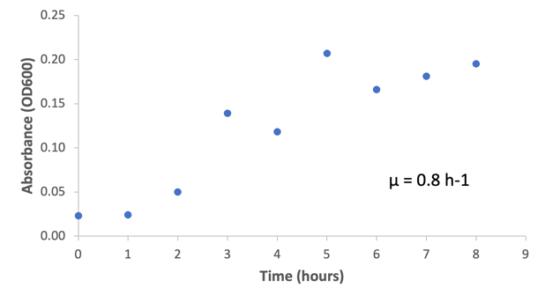  Figure 4.5: Growth curve 1 of E. coli in LB Broth with 100 mM Acetate | 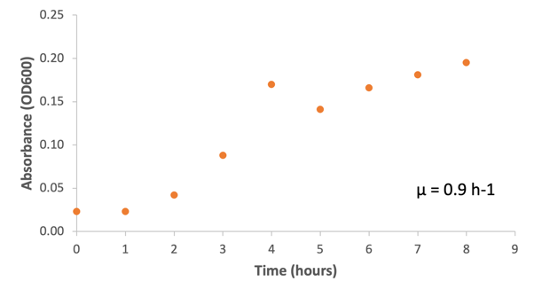  Figure 4.6 Growth curve 2 of E. coli in LB Broth with 100 mM Acetate
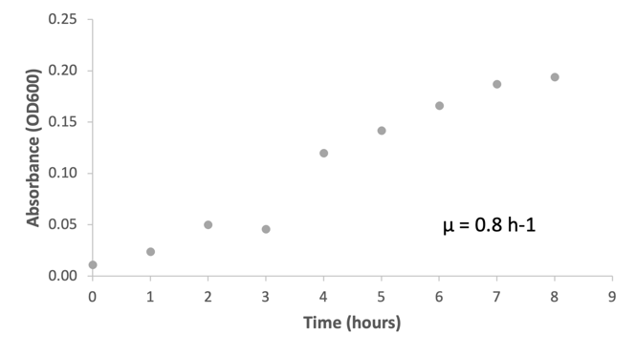
Figure 4.7 Growth curve 3 of E. coli in LB Broth with 100 mM Acetate

According to three independent measurements, the average growth rate of E. coli at a pH of 7 and a temperature of 37°C was 0.8 h⁻¹. The findings suggest that the growth rate of E. coli in LB Broth medium supplemented with 100 mM of sodium acetate was higher than the growth rate seen under the same conditions but without an additional carbon source presented in Figure 4.4. By giving bacteria a source of energy and the ingredients for cellular synthesis, adding more carbon substrate to the growth medium can accelerate bacterial development. Furthermore, bacteria utilise the energy and chemical groups in carbon-based substrates to fuel a number of biological functions, including growth, reproduction, and metabolism. As a result, providing more carbon substrate may result in the bacterial population growing more quickly (Brock and Madigan, 1984; Tortora, Funke and Case, 1998).

4.3.3 LB Broth medium supplemented with 120 mM of sodium acetate for the cultivation of E. coli under anaerobic conditions.
To observe the influence on E. coli growth, sodium acetate concentration in the LB Broth medium was adjusted to 120 mM Figure 4.7 to 4.9 illustrates the growth measures in triplicate.
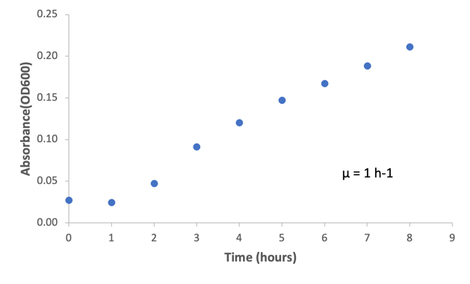  Figure 4.8: Growth curve 1 of E. coli in LB Broth with 120 mM Acetate | 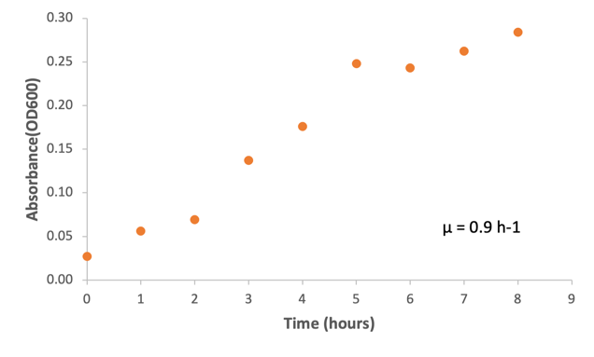  Figure 4.9 Growth curve 2 of E. coli in LB Broth with 120 mM Acetate
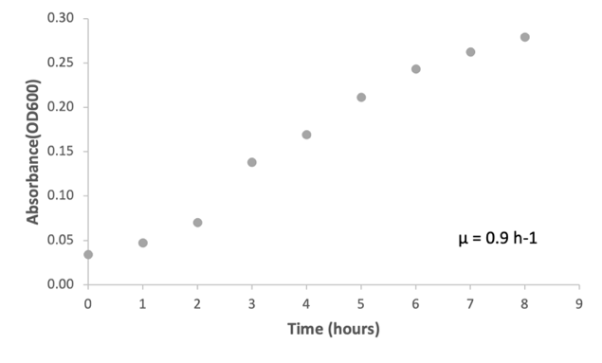
Figure 4.10: Growth curve 3 of E. coli in LB Broth with 120 mM Acetate

The growth rate was 0.9 h⁻¹ on average. The findings show that when compared to the growth rate of E. coli measured in growth media containing 100 mM sodium acetate, increasing the concentration of sodium acetate in the medium did not significantly alter growth rate. This finding supports Brock and Madigan's (1984) literature, which suggests that nutrition availability and other growth factors can affect the rate at which bacteria grow. However, if the bacteria are already utilising all of the available carbon, increasing the concentration of a carbon source may not have a significant impact on the rate of development of the bacteria. The bacterium's ability to use the carbon source in this situation may be constrained by the availability of other nutrients or by the capacity of its metabolic pathways.
Overall, this study suggests that the growth rate of E. coli was not significantly influenced by the increase in the concentration of sodium acetate in the growth medium. However, it is important to note that the optimal concentration of substrates for E.coli growth may vary depending on the specific strain and environmental conditions.

4.3.4 Comparing the average growth rates of E. coli in LB Broth Medium containing 100 mM with LB Broth medium containing 120 mM of sodium acetate.

Similar growth patterns with 100 mM acetate were observed in the growth curve results of this experiment using 120 mM acetate as shown in Figure 4.11 below. The lag phase duration as shown in the graph were the same as in 100 mM. The exponential phase lasted a bit longer than the phase in 100 mM and stationary phases were similar. As shown in Figure 4.12, the average growth rate results for this experiment were 0.4h⁻¹ which did not vary much compared to the average growth rate at 100 mM of acetate.

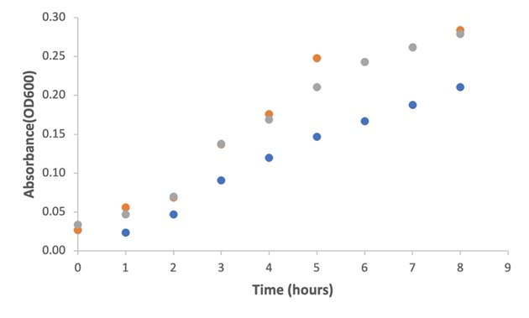  Figure 4.11: Growth curve graph of E. coli in LB Broth with 120 mM Acetate | 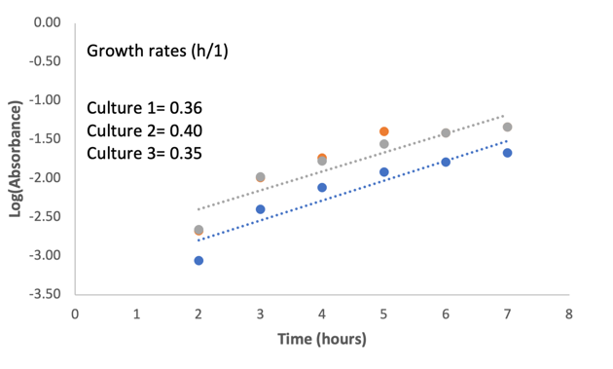  Figure 4.12: Growth rates of E. coli in LB Broth with 100 mM Acetate

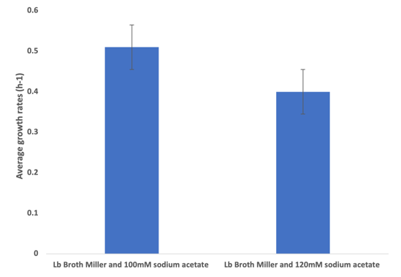
Figure 4.13: Average growth rates of E. coli in growth medium supplemented with 100 and 120 mM sodium acetate in LB Broth medium.
It was expected that increasing the sodium acetate concentration could have led to an increase in the growth rate of the E.coli. However, the average growth rate results shown in Figure 4.13 suggest that an increase in acetate concentration slowed the growth rate of the strain. A study suggested that at high substrate concentration, the metabolic by products of a bacteria could become toxic to the bacteria for example excessive glucose concentrations in medium cultivating E.coli have been found to cause metabolic imbalances that could release toxic by-products leading to a slower growth or cell death (Clark, 1989).
This could have been due to a saturation effect occurring during the metabolic activity of E.coli. Studies have shown that the metabolic activity of a bacteria could be saturated such that an increase in substrate concentration does not significantly influence the growth rate of the strain. This could suggest that E.coli may have been operating at their maximum metabolic rate.

4.3.5 Effect of E. coli growth in Davis Minimal medium supplemented with varying concentrations of sodium acetate.

This experiment was designed to determine the effect of Davis Minimal medium supplemented with varying concentrations of acetate on the growth rate of E. coli.
Davis Minimal media was supplemented with varying concentrations of acetate to determine the effect of media composition on the growth rate of the bacteria. For this experiment, there was a wide range of sodium acetate concentrations used from 20, 40, 60, 80, 100 and 120 mM.
Findings from these results suggested that lowest growth rates were observed at concentrations below 80 mM. At 80, 100 and 120 mM, average growth rates recorded where 0.6, 0.6 and 0.5 h⁻¹ respectively.

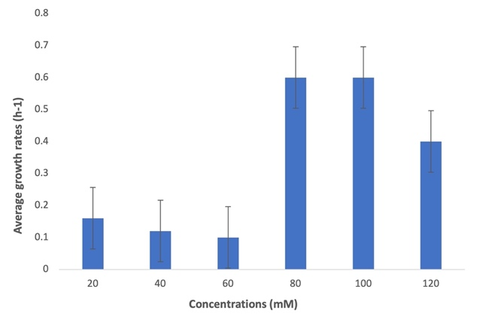
Figure 4.14: Bar charts showing average growth rates of E. coli grown in different concentrations of sodium acetate

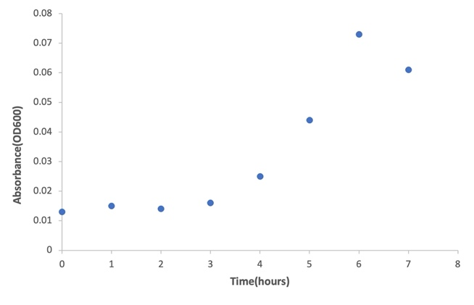 | 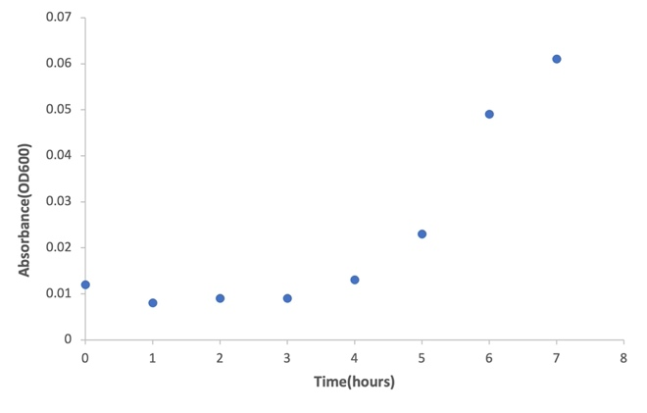
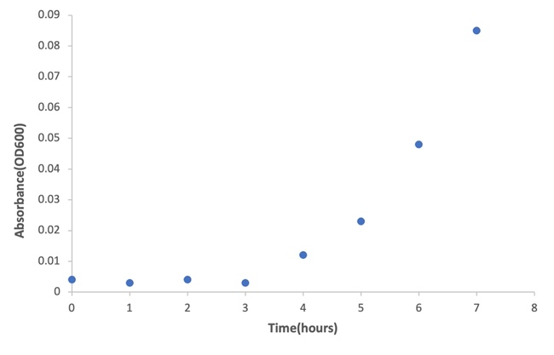
Figure 4.15: Growth curve of one of the E.coli cultures grown in sodium acetate.

4.3.6 Comparing E. coli growth rate in LB Broth and Davis Minimal Media with the same concentrations of sodium acetate.
The growth rate of E. coli was compared based on the type of media used. LB broth Miller containing 100 and 120 mM concentrations of acetate was compared with Davis Minimal media containing the same concentrations of sodium acetate.
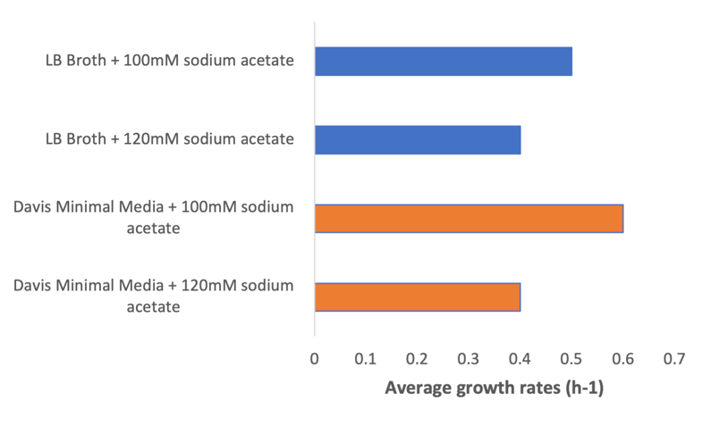
Figure 4.16: Bar chart showing average growth rates of two types of mediums in varying sodium acetate concentrations

Results from the experiments showed a slight variance in growth rates between both media sources. Davis Minimal media supplemented with 120 mM sodium acetate produced an E.coli growth rate, 0.1h⁻¹ higher than the growth rate recorded when LB broth Miller was supplemented with the same concentration of sodium acetate. When 100 mM sodium acetate was used as supplement in LB broth Miller, the growth rate of E. coli was also observed to be 0.1 h⁻¹ higher than growth rate achieved with the broth.
Generally, it was observed that highest growth rates achieved for both media sources where those supplemented with 80 and 100 mM sodium acetate concentration. When E. coli was grown in Davis Minimal media under varying concentrations, it was observed that between 20 and 60 mM, the average growth rates did not vary significantly. However, at 100 mM and 120 mM sodium acetate, the growth rate was significantly different from the first 3 concentrations as it went as high as 0.6 h⁻¹ shown in Figure 4.10. Finally, at 120mM, it was expected that with a high concentration, growth rate could have increased in both types of media. However, this was not the case and perhaps could be due to inhibition of E.coli by high concentrations of acetate as reported by (Pinhal et al., 2019).

4.4 Conclusion
Preliminary experiments in this study were carried out to determine the specific growth rate of E.coli under aerobic and anaerobic conditions in an LB Broth medium. Results from this experiment revealed that the average growth rate under aerobic conditions was found to be higher than the anaerobic conditions. Results reported for both conditions were 0.7 h⁻¹ and 0.19 h⁻¹ respectively. This finding is in line with literature which describes the energy yield under aerobic conditions to be much higher compared to anaerobic conditions because under aerobic conditions, glucose is fully utilised (Von Wulffen et al., 2016; Amato and Brynildsen, 2014; Glasky and Rafelson Jr, 1959).
When LB Broth medium was supplemented with 100 mM sodium acetate, the average growth rate of the strain was seen to increase from 0.19 h⁻¹ to 0.5 h⁻¹. The addition of sodium acetate increased the growth rate of the strain and led to a diauxic growth pattern which is described as a phenomenon where in the presence of two carbon substrates, the much-preferred carbon source will be utilised first before the second carbon source is consumed. This will be interfered by a lag phase before the second carbon substrate is utilised. the growth of the strain on another substrate precedes after growth on glucose. Average growth rates between medium supplemented with 100 mM and 120 mM in LB Broth medium were compared. At 120 mM, the average growth rate was 0.4 h⁻¹ which did not vary much from average growth rates at 100 mM. This could have been because of substrate saturation as the increase in the concentration of the substrate in a medium influence the rate at which enzymes are catalysed and when the molecules become saturated, the reaction rate is said to level off. Therefore, a continuous increase in the concentration of substrates could possibly still result in the same activity.
At 100 and 120 mM concentration of sodium acetate supplemented in Davis Minimal media, the growth rates were 0.6 h⁻¹ and 0.4 h⁻¹ respectively. These average growth rate results compared to the average growth rates in LB Broth medium showed no major difference in the use of two different mediums. For the LB Broth medium, the growth rates were 0.5 h⁻¹ and 0.4 h⁻¹ at 100 and 120 mM concentration of sodium acetate. At other concentrations, 20, 40, 60 and 80 mM, average growth rates were 0.16, 0.12, 0.10 and 0.6 h⁻¹ respectively and the highest growth rates recorded were at 80 and 100 mM.
Generally, findings from this study have shown that E. coli is a facultative anaerobe capable of growing under both aerobic and anaerobic conditions. Sodium acetate can be utilised by the strain as a carbon source under both aerobic and anaerobic conditions thus leading to a diauxic growth pattern where the substrate precedes after glucose utilisation. This finding fulfils the second objective of this study. Although the strain (M.barkeri) was substituted for E. coli, the growth rate of E. coli under varying concentrations of carbon source was studied as it would have if it were the previous strain. The only conditions which were not considered were varying temperature and pH because E. coli is known to grow best at pH 7 and temperature 37°C. Therefore, the major focus of this study since the strain was substituted was then to ascertain whether sodium acetate could be utilised by E. coli as a carbon source under varying concentrations because E. coli was to be co-cultured with D. Vulgaris in the next study which this study proved.
To the best of the author’s knowledge, this is the first study that determines the growth rates of E. coli in varying concentrations of sodium acetate under anaerobic conditions.
Future studies on this strain under anaerobic conditions could also focus on analysing the degradation of acetate and glucose during E. coli metabolism as the current study did not address that.

Chapter 5

Determining the effect of co-culturing D. Vulgaris and E. coli in sodium acetate.

Introduction
Co-culturing of distinct microbial species have emerged as a promising approach in microbiology and biotechnology fields (Haoran et al., 2015). This approach has helped researchers understand the synergistic interactions and enhanced metabolic capabilities which microbial species can exhibit which could improve bioprocess performance.
D.Vulgaris and E.coli are distinct microbial species that have been studied in monocultures and also in co-culture with other species (Harada, Uemura and Momonoi, 1994; Urui et al., 2021; Ozuolmez et al., 2015). These studies have highlighted the metabolic versatility of each specie and their benefits. For example, two different strains of E.coli have been co-cultured to produce muconic acid from glycerol (Haoran et al., 2015). Another study compared mono-cultures and co-cultures of E.coli for biosynthesis of protocatechuic acid and hydroquinone (Guo et al., 2020).
Co-culture study on D.Vulgaris and E.coli have been rarely carried out. E.coli is known for its versatility as a facultative aerobic bacteria and its widespread use in various biotechnological applications, while D.Vulgaris a sulphate reducing bacterium is known to reduce sulphate as a terminal electron acceptor in its metabolic process. Results from the previous chapters of this thesis suggested that E.coli and D.Vulgaris could metabolise sodium acetate as a carbon source under anaerobic conditions. However, it was observed that sodium lactate was a much preferred carbon source for D.Vulgaris than sodium acetate as the growth rate was higher.
The objective of this experimental chapter is to investigate the co-culturing dynamics and potential synergistic effects between both species in co-cultures. Co-culturing both species offers the potential for co-operative interactions like cross-feeding or competitive interactions that could aid in our understanding of sewer corrosion caused by the metabolic by-product of SRB’s.
This chapter aims to contribute to our understanding of microbial interactions and the potential for harnessing co-operative relationships in engineered microbial systems.

Methodology

5.2.1 Summary
The interaction between D. Vulgaris and E. coli in co-culture study was examined. This study was aimed at determining whether a competitive or coexisting relationship existed between both species as this could be relevant in mitigating sewer odours and corrosion. Here both species were co-cultured in two different types of growth medium to evaluate the impact of varying compositions of media particularly focusing on the interaction between both species in utilising sodium acetate as a carbon source.
In previous experimental chapters, D. Vulgaris was cultivated in ATCC medium containing 30mM of sodium acetate. In this chapter, the concentration of this carbon source concentration was increased to 60mM to assess the impact of increasing the carbon source on the sulphate reduction rate of D.Vulgaris.
This study focused on the interaction between D. Vulgaris and E. coli with acetate as the sole carbon source under different concentrations. A major objective of this study was to determine whether the growth of both strains in co-culture would have an impact on the sulphide concentrations as compared to pure culture studies.
Following previous chapters, both strains were already studied in pure cultures to evaluate the impact of varying sodium acetate concentrations, pH, and temperature on their maximum specific growth rates and sulphide production in the case of D. Vulgaris metabolism.
The study investigated the growth of both strains under optimum conditions and at varying concentrations of acetate. In addition, two types of growth medium were explored, the ATCC medium and LB Broth medium. Sulphide production was analysed for each medium. Considering the typical medium used for E. coli growth was LB Broth, it was important to examine the impact of the medium on the growth of the strain when mixed with ATCC medium.
All analytical methods remained the same as in previous studies except otherwise stated.

Growth Medium and Culturing conditions
The ATCC medium for sulphate reducers discussed in section 3.2.3 was used to cultivate D. Vulgaris and the LB Broth medium discussed in section 4.2.3 was used for the cultivation of E. coli. Sodium acetate was added to each medium and gassed under 80% N₂ and 20% H₂.

Analytical methods
By creating a calibration curve using a number of standard solutions (0.5 ml, 1.0 ml, 1.5 ml, 2.0 ml, 2.5 ml and 3.0 ml) with known sulphide concentrations, sulphide in the samples was measured. This is the methylene blue method, which depends on the formation of a blue-coloured complex as a result of the reaction between sulphide and methylene blue dye. By comparing the sample's absorbance with the corresponding sulphide concentration on the calibration curve, the sulphide concentration in each sample was ascertained.
Acetate in the samples were analysed using a Gas Chromatograph (Perkin- Elmer Clarus 500) equipped with an autosampler, column DB-FFAP, 30m, 0.32 mm diameter, film 0.25 um and a detector flame ionisation detector (FID). The injection and detector temperatures were 250°C and 230°C respectively, operating at a flow rate of 2.6ml/min nitrogen carrier gas. The injection split ratio was 40:1 at a 1ul sample volume for each run.
The oven temperature programme was set at 70°C (3 minutes hold), 70°C-180°C, ramp 20°C/min and 180°C (3 minutes hold).

Statistical methods
Results from this study were statistically analysed using a t-test analysis assuming unequal variances to determine the significance of the results. P values were set to 0.05. Based on the results of each statistical analysis, conclusions were drawn whether to accept or reject the null hypothesis and alternative hypothesis.
The Null hypothesis in this study stated that no relationship between cell density and sulphide production in this study existed. The alternative hypothesis stated a significant relationship existed between cell density and sulphide production.
At p values greater than 0.05, the null hypothesis was accepted, and alternative hypothesis rejected.
At p values less than 0.05, the null hypothesis was rejected, and alternative hypothesis accepted.

Repetition of experiments for D. Vulgaris growth in 30 mM sodium acetate concentration under standard conditions.

As sulphide production was not measured in the previous experiment of D. Vulgaris cells grown in 30 mM carried out in Chapter 3 of this study, the experiments were repeated to measure hydrogen sulphide concentrations/ production rates. It was important to measure these levels to determine the impact of varying sodium acetate concentrations on the sulphide production rates.

5.2.6 Co-culture study of E. coli and D. Vulgaris cells in an ATCC medium supplemented with sodium acetate at different concentrations (40 mM and 60 mM) under standard conditions.
In this study, D. Vulgaris and E. coli were grown in two different acetate concentrations added to an ATCC medium.
The sulphide concentrations were measured to determine whether the interaction resulted in lower rates of sulphide compared to the rates pure culture studies. The study was to ascertain whether co-culturing D. Vulgaris and E. coli cells could lead to low sulphide production which could potentially help mitigate sewer corrosion.
For each sodium acetate concentration added to the medium, 3 biological replicates were carried out. E. coli cells in pure culture were harvested at an OD of 0.4 in the LB Broth media while D. Vulgaris cells were harvested at an OD of 0.3 in the ATCC medium. 0.5ml each of the active growing cultures of both species was used as inoculum. The ATCC medium was adjusted to a pH of 7 and aliquoted in 120 ml serum vials in 50 ml volumes. 3 culture bottles were inoculated with 0.5 ml each of the active growing cultures and incubated at a temperature of 37°C with a shaking speed of 200 rpm. Sampling was carried out at time intervals to measure sulphide and acetate concentrations.

5.2.7 Co-culture study of E. coli and D. Vulgaris cells in a media mix (ATCC and LB Broth Miller) supplemented with sodium acetate at 30 mM and 60 mM concentrations.

For this experiment, 1 Litre each of ATCC media and LB Broth Miller were prepared. Each media was prepared separately in sodium acetate concentrations of 30 mM and 60 mM. 50% v/v of ATCC and LB Broth Miller were mixed for each sodium acetate concentration so that each litre then contained a mix of LB Broth Miller and ATCC medium to depict a sewer environment with varying compositions of different nutrients. The media was then aliquoted into 120 mL serum bottles in 50 ml volumes.
6 biological replicates were used in total for this study. 3 biological replicates at 30 mM and 3 biological replicates at 60 mM. The pH for each media was adjusted to 7 at an incubation temperature of 37°C with a shaking speed of 200 rpm and sampling was carried out at time intervals to measure the sodium acetate and sulphide concentration in the culture bottles. The objective of this study was to determine whether a media mix could influence the interaction between E. coli and D. Vulgaris and ultimately the sulphide production.

5.3 Results and Discussion

Measuring the growth rate and sulphide production of D.Vulgaris grown in an ATCC medium supplemented with 60 mM sodium acetate.
The main objective of this experiment was to examine the impact of increasing the carbon concentration in the growth media containing D.Vulgaris as it was observed from experiments carried out in Chapter 3 of this work that at 30 mM of sodium acetate, D.Vulgaris grew slowly.
Figure 5.2 below shows the growth curve of D.Vulgaris grown in media containing 60 mM of sodium acetate. The curves from all triplicates varied which may have been due to the viability of the cells during inoculation. However, short and long exponential phases were observed with the longest exponential phase occurring in Culture 3 while the other cultures presented short phases.

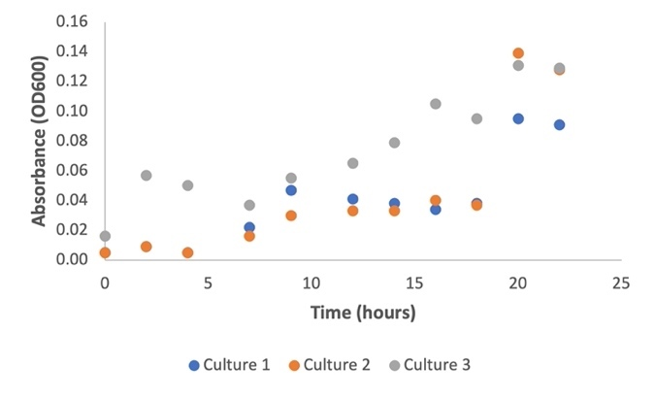
Figure 5.1: Growth curve of D. Vulgaris in ATCC medium supplemented with 60 mM sodium acetate under pH 7 and incubation temperature of 37°C.
When compared with the average growth rate results obtained in Chapter 3 experiments, it was observed that the growth rate of D.Vulgaris in this experiment was 0.22h⁻¹ higher than the results obtained in its growth in 30 mM sodium acetate. Below is a tabulated summary of the individual growth rates of the triplicates.

Table 5.1: Individual and Average growth rates of D.Vulgaris grown in ATCC medium containing 60 mM sodium acetate.
Growth rates (h⁻¹)
Culture 1 | Culture 2 | Culture 3 | Average growth rate(h⁻¹) | Standard Deviation
0.4 | 0.3 | 0.1 | 0.3 | ± 0.1
The sulphide concentration was measured, and sulphide production occurred at a rate of 0.19 h⁻¹.
Table 5.2 below shows a summary of the individual sulphide production rates and the standard deviation.
Table 5.2: Table summary of individual and average sulphide production rate of D.Vulgaris ATCC medium containing 60 mM sodium acetate.
Sulphide production rates (h⁻¹)
Culture 1 | Culture 2 | Culture 3 | Average rate (h⁻¹) | Standard deviation
0.1 | 0.2 | 0.1 | 0.19 | ± 0.05

The data generally suggests that the increase in carbon concentration influenced the growth of D.Vulgaris. Sodium acetate serves as a carbon source for D. Vulgaris and an essential component for sulphate reduction (Postgate, 1959). The availability of acetate as a substrate for D. Vulgaris may also have increased because of the increase in sodium acetate concentration. This may have resulted in increased metabolic activity and sulphate reduction thus leading to sulphide production. A study showed that acetate is not only a carbon source but an energy source (Kutscha and Pflügl, 2020). Higher concentrations of sodium acetate provide more energy for cellular processes, including growth and reproduction. With increased energy availability, D. Vulgaris can grow and multiply at a faster rate, leading to a larger population. As a result of this, there are more cells actively engaged in sulphate reduction, resulting in higher sulphide production.
Sewers provide an environment where microbial communities, including sulphate reducing bacteria like D.Vulgaris interact with different organic carbon sources (Shi et al., 2020).
Higher concentration of sodium acetate in sewers which can occur due to changes in wastewater composition caused by fermenting microorganisms or direct discharges can potentially stimulate the activity of sulphate reducing bacteria, leading to increased sulphide production (Guisasola et al., 2008; Nielsen et al., 2005).
Understanding the relationship between organic carbon availability particularly in the form of volatile fatty acids, such as sodium acetate and sulphide production is crucial in managing sewer systems. It allows for the optimisation of wastewater treatment processes and the mitigation of issues related to odours, corrosion and environmental impacts associated with high sulphide production.

Repetition of monoculture study of D.Vulgaris in 30 mM sodium acetate to examine impact on sulphide concentration.
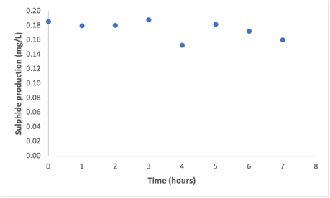 | 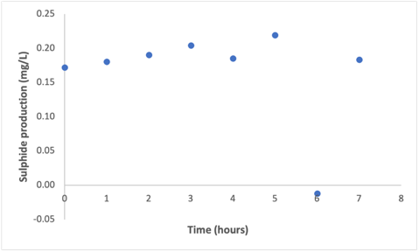 | 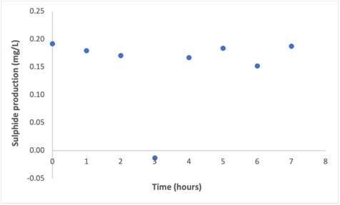
This experiment was repeated to determine the sulphide production rate of D.Vulgaris when supplemented with 30 mM of sodium acetate in an ATCC medium as the previous experiments carried out in Chapter 3 did not measure sulphide.
Figure 5.2: Sulphide production curves of triplicate cultures of D.Vulgaris grown in ATCC medium containing 30 mM sodium acetate.
Figure 5.2 showed that the sulphide production fluctuated across all triplicates and no clear or sustained increase in sulphide concentration was observed.

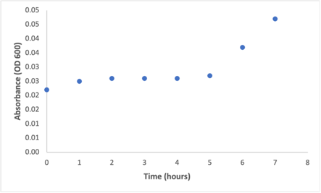 | 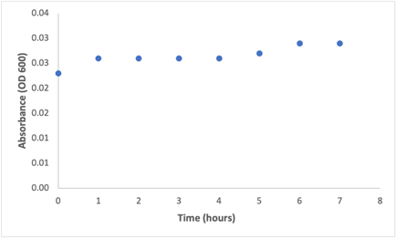
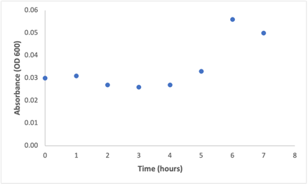
Figure 5.3 : Growth curves of D.Vulgaris of triplicate cultures of D.Vulgaris grown in ATCC medium containing 30 mM sodium acetate.

The sulphide production curves presented in Figure 5.2 above suggest that sulphate reduction did not occur in cultures although it was observed in D.Vulgaris growth curve presented in Figure 5.3 that there was an increase in cell biomass in the 1st and 3rd culture bottles while D.Vulgaris cells remained in a lag phase throughout the duration of the experiment in 2nd culture .
D.Vulgaris is a slowly growing anaerobic bacteria which means given the conditions it was studied, it may have required more time to adapt to the medium. Sampling hours were impacted by Covid restrictions within the department which led to a short sampling time of 8 hours.
The increase in cell biomass observed in the 1st and 3rd culture could indicate that the cells were utilising the available nutrients in the media for growth even in the absence of sulphate reduction (Pereira et al.,2007). Brand et al (2014) revealed that acetate is one of the main volatile fatty acids (VFA’s) present in sewage. In their study, the impact of acetate on SRB activity were investigated under different conditions. One of their key findings revealed that sulphate reduction could occur in batch reactors fed solely with acetate as SRB’s are capable of utilising acetate as a substrate for its metabolism.
Although from the data presented in this study, it can be said that sulphate reduction did occur under the conditions studied, however it does not fully reflect the actual metabolic capabilities of the strain as the process of sulphate reduction itself is metabolically demanding and driven by other factors other than the carbon source concentration.
It is worth understanding that the sulphate reduction and cell biomass production of D.Vulgaris is relevant when it relates to managing microbial processes in sewers. Optimising conditions to support the metabolic activities such as sulphate reduction or biomass production is essential for wastewater treatment.

5.3.3 The effect of co-culturing E. coli and D. Vulgaris in an ATCC medium supplemented with 30 mM of sodium acetate on the sulphide production of D. Vulgaris.
The D. vulgaris triplicate cultures did not produce hydrogen sulphide, according to the results of the previous monoculture study described in section 5.3.2, despite the fact that cell biomass increased in all of the cultures.
In order to study the interaction between the two strains, D. Vulgaris and E. coli were co-cultured in a medium containing 30 mM sodium acetate.
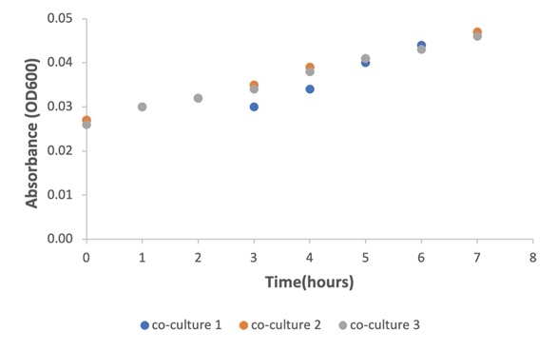 | 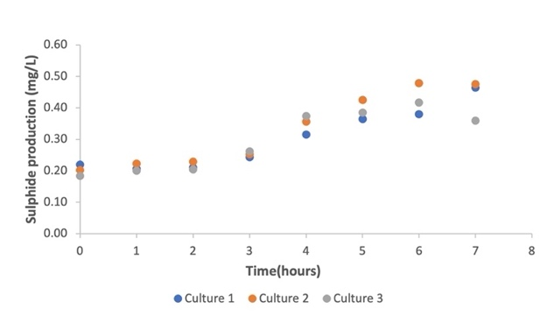

Figure 5.4: Growth curve and sulphide production rates of co-culture strains in a medium containing 30 mM of sodium acetate.
The growth from both species in co-culture is combined in the growth curve shown above in Figure 5.4. The triplicate cultures growth curve shown in Figure 5.4 had an average sulphide production rate of 0.19 h⁻¹ and an average growth rate of 0.09 h⁻¹.
In general, the adaptability of both strains of bacteria (E.coli with D. Vulgaris) by the reduction of sulphate suggests that a synergistic metabolic reaction between E. coli and D. Vulgaris may have enhanced the latter. In a study by Oyewole et al (2020), both species were co-cultured in an M9 medium, and it was discovered that E. coli produces a compound called a sulphide growth enhancer, which promoted the growth of SRB.
This result supported previous research by Kushkevych et al (2019) and Shi et al (2020), which also noted that the co-culture of both species might produce organic by-products from E. coli that act as an electron donor thus enhancing its sulphate reduction activity.
Prior to making a comparison between the rates of sulphide production measured in this study and those seen in sewer systems, it is critical to consider the complexity and diversity of microbial dynamics within sewer environments (Rudelle et al., 2012).
Microbial communities in sewer systems are made up of a variety of species. Based on a number of variables, such as wastewater composition, temperature, hydraulic conditions, and the presence of inhibitory compounds, the growth and sulphide production rates observed in sewer systems can vary significantly (van Den Brand et al., 2018; Mohanakrishnan et al., 2009).
Depending on the species and environmental factors, the growth rates of microorganisms in sewer systems can typically range from fractions of hours to several hours (Badziong and Thauer, 1978b; Wang, 2018). Similarly, the availability of sulphate, the presence of organic matter, and the metabolic ability of the SRB species in question can all have a significant impact on the rates of sulphide production (Rudelle et al., 2012).
It's important to note that the specific strains and experimental setup used in this co-culture study might not be representative of the microbial community structure and surroundings in sewer systems. Therefore, when directly comparing laboratory scale studies to real-world sewer environments, some level of caution should be used.

5.3.4 The effect of co-culturing E. coli and D. Vulgaris in ATCC medium supplemented with 60 mM of sodium acetate on the sulphide production of D. Vulgaris.
Earlier studies reported in Section 5.3.3 suggested that D. Vulgaris and E. coli co-cultures grown in media supplemented with 30 mM sodium acetate might experience sulphate reduction.
In this study, the concentration of sodium acetate was increased from 30 to 60 mM to mimic the dynamic nature of sewers and to determine whether the interaction between both species in co-culture would be influenced by the increase in carbon source, possibly by increasing the production of sulphide or decreasing its concentration.
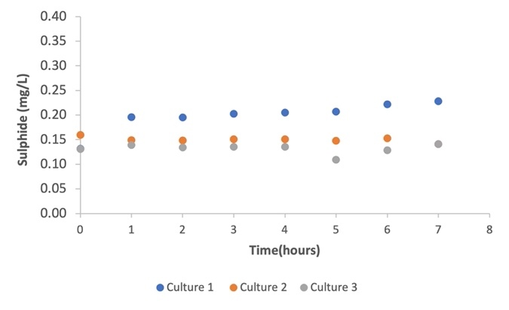
Figure 5.5: Sulphide production from co-culture studies of D. Vulgaris and E.coli in medium containing 60 mM sodium acetate
The sulphide production curve depicted in Figure 5.5 suggests there was no increase in sulphide production over the course of the experiment. However, a sulphide production rate of 0.19 h⁻¹ was recorded in monoculture studies of D. Vulgaris growth in ATCC medium containing 30 mM sodium acetate, as described in Section 5.3.1 of this study. The absence of sulphate reduction occurring in this study may have been due to a competitive interaction between both species as already discussed in section 5.3.4.
Co-culture systems can generally be complex, dynamic, and influenced by a variety of factors (Goers, Freemont and Polizzi, 2014). In addition, sulphate reduction in a co-culture system often relies on synergistic interactions between different microbial species. It is possible that the increase in the carbon source concentration may have altered the balance of interaction between E.coli and D.Vulgaris which resulted in an inhibition (Moosa and Harrison, 2006).
Sewers can be rich in organic compounds such as acetate from wastewater that serves as a carbon source for various organisms (Brand et al., 2014b). The presence of high acetate concentrations, particularly in situations of excessive organic loading, could potentially disrupt sulphate reduction processes that are crucial for the removal of sulphates from wastewater (Li et al., 2019; Mohanakrishnan et al., 2009).

5.3.5 The effect of co-culturing E. coli and D. Vulgaris in a complex media supplemented with 30 mM sodium acetate.
The earlier experiments carried out in this study's Section 5.3.4 showed that an increase in carbon concentration did not result in sulphate reduction.
In this laboratory experiment, LB Broth and ATCC were combined to investigate if a complex media composition would have an impact on the extent to which both species interacted. This was relevant because, according to the findings of the experiments presented in Chapter 4, E. coli was found to grow on LB Broth supplemented with sodium acetate.

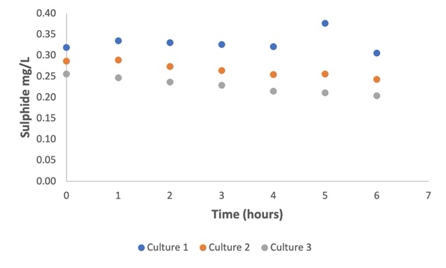
Figure 5.6: Sulphide production of D. Vulgaris in coculture with E.coli grown in a mixed media containing 60 mM of sodium acetate
The graph shown in Figure 5.6 above suggested that sulphide concentrations decreased across all cultures, but two of the cultures (Culture 2 and Culture 3), shown in Figure 5.7 below, showed an increase in acetate concentrations.
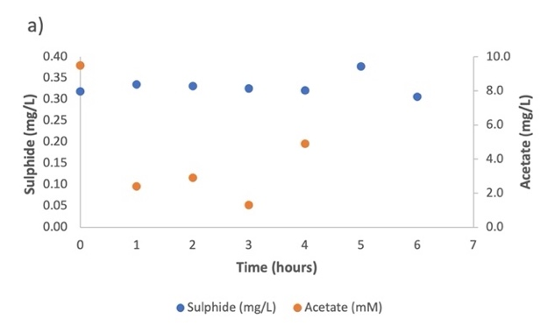 | 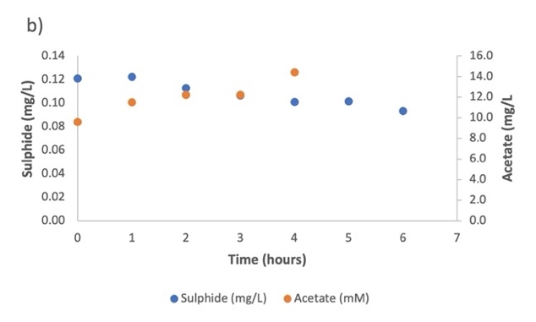
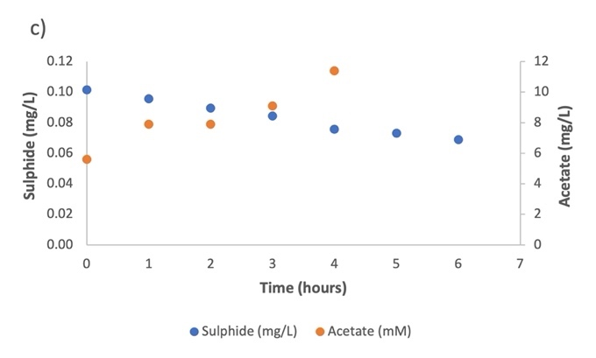

Figure 5.7: Graph showing increase in acetate production and decrease in sulphide production.
A competitive relationship between the two species may have been the cause of the decrease in sulphide production and an increase in acetate concentration from two out of the three replicate cultures observed in this study (Oyewole et al., 2020; Zhao et al., 2023). Previous research has shown that both species can use acetate as a carbon source (Higgins and Johnson, 1970; Enjalbert et al., 2015; Pankhania, Gow, and Hamilton, 1986). Due to E. coli's rapid growth, it's possible that it outcompeted D. vulgaris for the use of the available acetate in the co-culture, increasing the amount of acetate produced and reducing the amount available for D. Vulgaris (Enjalbert et al., 2015). Due to this, D. Vulgaris may be unable to perform sulphate reduction, which would lead to a decrease in the production of sulphur dioxide (Moosa and Harrison, 2006). This is particularly likely to have happened as the experiments was constrained due to covid working hours.
The media mix and the presence of LB Broth and ATCC in the coculture system could have influenced microbial behaviour as LB Broth contains various nutrients and growth factors that can promote the growth of E.coli (Sezonov, Joseleau-Petit and D'Ari, 2007). The abundance of nutrients and favourable growth conditions might have enhanced E.coli’s metabolic activities leading to increased acetate production.
Similar dynamics can occur in sewer systems because these systems are frequently habitats to complex microbial communities, including E. coli and SRB's like D. Vulgaris. The metabolic interactions between various microbial species can be influenced by sewer conditions such as wastewater composition, temperature, and oxygen availability (Carrera et al., 2016; Li et al., 2019).
As a recommendation, it would be beneficial to look into the specific metabolic pathways, gene expression patterns, and physiological responses of E. coli and D. vulgaris in this co-culture system to gain a more thorough understanding of the observed reduction in sulphide production and increase in acetate production.

5.3.6 The effect of co-culturing E. coli and D. Vulgaris in mixed media (ATCC + LB Broth) supplemented with 60 mM sodium acetate.

Acetate production increased and sulphide production decreased in some cultures, according to the results of the previous experimental study described in Section 5.3.5. The findings indicated that there may have been competition between the two species in co-culture.
To better understand how the availability of carbon affects the interaction between the two species, the concentration of sodium acetate in this experiment was raised to 60 mM.
The sulphide production curve for each culture was shown in the graph below in Figure 5.10, and it was noted that sulphide production only increased in Culture 3 at a rate of 0.09 h-1. No increase in sulphide concentrations was indicated by the sulphide curves in Cultures 1 and 2 shown in Figure 5.8.
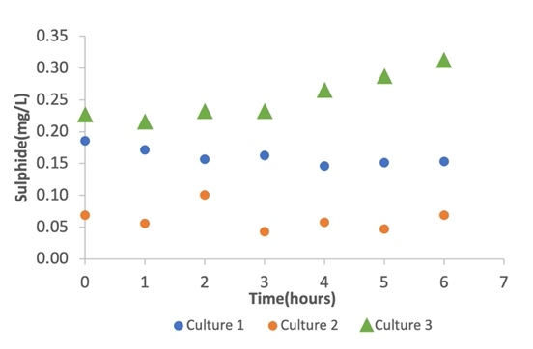  Figure 5.8: Graph plot showing sulphide production in all 3 replicates | 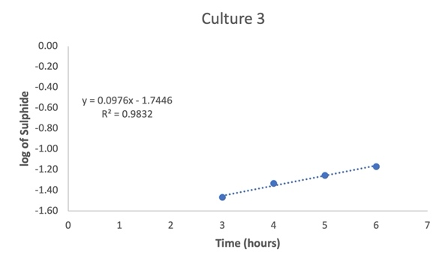  Figure 5.9: Graph plot showing sulphide production rate in culture 3

Microbial heterogeneity may be responsible for the differences in sulphide production between triplicate cultures of co-cultured E. coli and D. Vulgaris in a media mixture of LB Broth and ATCC supplemented with 60 mM sodium acetate (Heyse et al., 2019). Even in the same culture conditions, microbial populations can show inherent variation. It is possible that the triplicate cultures' initial microbial compositions were slightly different, which caused variations in their metabolic processes, including the production of sulphide (Heyse et al., 2019). Natural heterogeneity can result from variations in the physiological states of individual cells, genetic diversity, or stochastic fluctuations (Xiong, Cooper and Tsimring, 2018; Heyse et al., 2019).
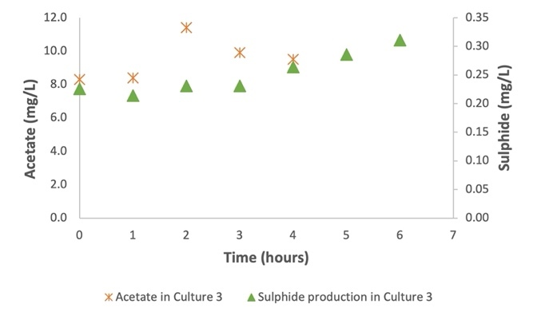 | 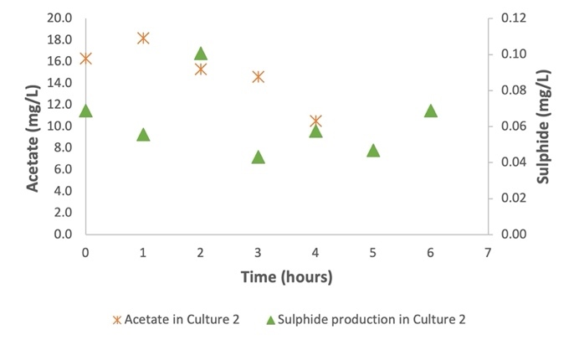
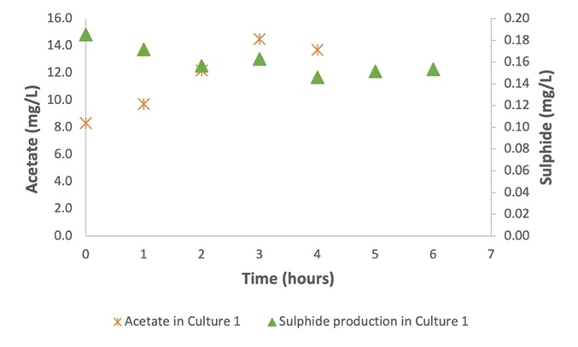
Figure 5.10: Graph showing trend of sulphide and acetate in replica series of D. Vulgaris growing in co-culture with E. coli
Acetate concentration varied among all of the triplicate cultures, as shown by the graphs in Figure 5.9. In Culture 1, it was found that as acetate levels increased, sulphide production declined. This trend was also observed in the results from Section 5.3.5 however not in all cultures. While we can suggest the possibility of a competitive relationship between both species as previously discussed in other sections of this chapter, it is worth nothing that these results do not show reproducibility and it cannot be concluded that the relationship existing between both species is competitive.
The variances in results observed in this experimental study could have been due to spatial and temporal variations can have an impact on how bacteria interact and how their metabolism develops (Jensen et al., 2016). Microenvironments within the culture vessel can differ, resulting in variations in nutrient distribution, diffusion rates and availability which may have occurred with these experiments (Fox et al., 2014). Also, the microbial growth dynamics including cell density and population dynamics can vary over time which may impact metabolic activities such as sulphide production (Fox et al., 2014).
The variability in sulphide production among triplicate cultures can be related to the dynamic nature of microbial communities in sewers. Sewer systems are highly complex environments with spatial heterogeneity and fluctuating conditions (Mohanakrishnan et al., 2009). Microbial populations in sewers can exhibit variability in composition, metabolic activities, and response to different substrates, including acetate (Mohanakrishnan et al., 2009).

Conclusion
In order to determine whether the relationship between these two species can improve the mitigation of hydrogen sulphide (H₂S) by SRB in the sewer or wastewater systems, this study examined the relationship between E. coli and D. Vulgaris.
A trend was observed in the experiments conducted at 30 mM and 60 mM of sodium acetate concentration supplemented in a complex media for E. coli and D. Vulgaris growth that sulphide production declined each time acetate concentration increased in the culture bottles. This trend was attributed to a potential competitive relationship existing between both species however it was observed that variances in sulphide and acetate concentrations occurred in some cultures which meant the results were not reproducible and inconclusive as to which of the relationships existed between both species.
It was understood from this study that given the conditions and factors considered, the inherent complexity of microbial interactions and the dynamic nature of co-cultures could lead to variations in outcomes. In addition, spatial and temporal dynamics within the culture vessels (batch reactors) used in this study may have further contributed to variations in nutrient availability that may have affected the sulphide and acetate concentrations. The complexity of co-culture dynamics and the limitations of the experimental setup such as sampling under anaerobic conditions might have contributed to the irreproducibility of the results.
The complexity and variability seen in this co-culture study which is relevant to sewer systems, reflect the difficulties in comprehending microbial dynamics in sewer environments. Diverse microbial communities can be found in sewer systems, where they interact and compete for resources. The balance between co-existing and competitive relationships can be influenced by elements like the availability of organic matter, hydraulic conditions, and the presence of other microorganisms.
While this co-culture study did not yield conclusive evidence regarding the specific relationship between E. coli and D.Vulgaris, it highlights the intricate nature of microbial interactions and challenges in deciphering their dynamics. Understanding these relationships is vital for managing microbial processes in sewer systems, optimising wastewater treatment and mitigating potential issues such as the production of hydrogen sulphide, sewer odours and pipe corrosion.

Chapter 6

Conclusions and Recommendation
This thesis examined the impact of varying growth parameters such as temperature, pH and carbon source on the metabolic activity of D.Vulgaris, a sulphate reducing bacterium.
Assessing the impact of these parameters on D.Vulgaris metabolism was key in understanding how sulphate reduction occurs and some possible strategies that could be adapted in mitigating the effects of sulphate reduction occurring in sewer systems for example results from the study showed that the highest sulphide production rate (± 0.04 h⁻¹) and growth rate (± 0.01 h⁻¹) of D.Vulgaris was observed at pH 6 and temperature of 40°C. The lowest average sulphide production rate (± 0.02 h⁻¹ ) was recorded from growth medium adjusted to pH 7 and temperature of 25°C. The growth of D. Vulgaris and the reduction of sulphate were both generally observed to be influenced by temperature, pH variations and carbon source as D.Vulgaris was observed to prefer sodium lactate over sodium acetate.
Key findings from this study highlighted the possibility of sulphate reduction increasing at elevated temperatures of 40°C when in pure cultures. This suggested that although D.Vulgaris species have been categorised as mesophilic bacteria, they could still thrive in environments with elevated temperatures. pH also played a role in sulphate reduction as it was observed to occur at a low pH of 5 in pure cultures which is considered to be acidic. These findings were linked back to sewer environments, and it was highlighted that sulphate reduction occurring at pH 5 could pose detrimental effects to sewer infrastructure due to the speciation of H₂S towards the molecular form hence enhances the amount available for transfer to the sewer atmosphere and hence the potential sewer corrosion. In addition, the study also highlighted that carbon sources influenced the metabolic activity of the strain as D.Vulgaris was seen to prefer lactate over acetate. This implied that the composition of sewer influents could have an impact on sulphate reduction and generally influence the microbial processes occurring within the sewers.
This study further examined the influence of co-culturing D.Vulgaris with a heterotroph like E.coli, representing a metabolically diverse organism. It was relevant to determine how the effects of co-culturing two bacteria species could potentially affect sulphate reduction as well as understanding the type of interaction which existed between both species.
The carbon source concentrations were varied in the experiments to determine the impact of different concentrations of carbon source on the metabolic activity of both strains.
E.coli was studied in pure cultures under anaerobic conditions, and it was observed that E.coli could utilise sodium acetate as a carbon source under varying concentrations at pH 7 and temperature 37°C and the highest growth rates were observed at 80 mM (0.6 h⁻¹) and 120 mM (0.6 h⁻¹).
The co-culture studies of E.coli and D.Vulgaris suggested that the inherent complexity of microbial interactions and the dynamic nature of co-cultures can lead to variations in outcomes. The experiments were not reproducible and showed no clear trend or type of relationship existing between both species. This was partly due to limitations to lab access forced by covid restrictions at the University. However, a key trend from this study was the correlation between increase in acetate concentrations and decrease in sulphate reduction observed in some of the experiments. Although not conclusive, the results suggested a competitive relationship could potentially exist between both species given that they are capable of utilising sodium acetate as a carbon substrate under anaerobic conditions.
Even though this co-culture study did not produce conclusive evidence of the relationship between E. coli and D. vulgaris, it does highlight the complexity of microbial interactions and the difficulties in understanding their dynamics. Understanding these relationships becomes relevant when managing complex microbial processes in sewers systems, optimising wastewater treatment, and mitigating potential problems like the production of hydrogen sulphide, sewer odour and potential sewer pipe corrosion .
This study could have focused on a limited number of growth parameters and the variability of the parameters could have been limited to one rather than all of them as this would have allowed for a more systematic and in-depth investigation of the impact of the parameter on the metabolic activities of SRB.
While the study comprehensively examined the impacts of growth parameters on the metabolic activities of D. Vulgaris, the influence of sulphate concentrations was not explored as sulphate availability is a critical factor in the sulphate reduction process and it directly affects the growth and metabolic activity of the SRB. By investigating the effect of different sulphate concentrations on D.Vulgaris growth, the study could have explored the growth kinetics and specific metabolic responses of D.Vulgaris under varying sulphate availability. Understanding the relationship between sulphate concentration and the growth of D.Vulgaris would provide valuable insights into sulphate reduction capabilities and help optimise its application in various biotechnological and environmental contexts. In addition, this understanding would be particularly relevant for wastewater treatments or environments with fluctuating sulphate concentrations.

REFERENCES

Amato, S. M. and Brynildsen, M. P. (2014) 'Nutrient transitions are a source of persisters in Escherichia coli biofilms', PLoS One, 9(3), pp. e93110-e93110.

Arthur, G. B. (1995) 'Septicity in sewers: Causes, consequences and containment', Water science and technology, 31(7), pp. 237.

Badziong, W. and Thauer, R. (1978a) 'Growth yields and growth rates of Desulfovibrio vulgaris ( Marburg) growing on hydrogen plus sulfate and hydrogen plus thiosulfate as the sole energy sources', Archives of Microbiology, 117(2), pp. 209-214.

Badziong, W. and Thauer, R. K. (1978b) 'Growth yields and growth rates of Desulfovibrio vulgaris (Marburg) growing on hydrogen plus sulfate and hydrogen plus thiosulfate as the sole energy sources', Arch Microbiol, 117(2), pp. 209-214.

Barca, C., Ranava, D., Bauzan, M., Ferrasse, J.-H., Giudici-Orticoni, M.-T. and Soric, A. (2016) 'Fermentative hydrogen production in an up-flow anaerobic biofilm reactor inoculated with a co-culture of Clostridium acetobutylicum and Desulfovibrio vulgaris', Bioresour Technol, 221(221), pp. 526-533.

Barton, L. L. (1995) Sulfate-reducing bacteria. Biotechnology Handbooks New York ; London: New York ; London : Plenum, c1995.

Beal, J., Farny, N. G., Haddock-Angelli, T., Selvarajah, V., Baldwin, G. S., Buckley-Taylor, R., Gershater, M., Kiga, D., Marken, J., Sanchania, V., Sison, A. and Workman, C. T. (2020) 'Robust estimation of bacterial cell count from optical density', Commun Biol, 3(1), pp. 512-512.

Bertranda, R. L. (2019) 'Lag Phase Is a Dynamic, Organized, Adaptive, and Evolvable Period That Prepares Bacteria for Cell Division', J Bacteriol, 201(7).

Bhattacharya, S. K., Uberoi, V. and Dronamraju, M. M. (1996) 'Interaction between acetate fed sulfate reducers and methanogens', Water Research, 30(10), pp. 2239-2246.

Bo Barker, J. (1977) 'The Sulfur Cycle of a Coastal Marine Sediment (Limfjorden, Denmark)', Limnology and oceanography, 22(5), pp. 814-832.

Brand, T., Roest, K., Brdjanovic, D., Chen, G. and Loosdrecht, M. (2014a) 'Influence of acetate and propionate on sulphate-reducing bacteria activity', Journal of Applied Microbiology, 117(6), pp. 1839-1847.

Brand, T., Roest, K., Brdjanovic, D., Chen, G. and Loosdrecht, M. (2014b) 'Temperature effect on acetate and propionate consumption by sulfate- reducing bacteria in saline wastewater', Applied Microbiology and Biotechnology, 98(9), pp. 4245-4255.
Brand, T., Roest, K., Chen, G., Brdjanovic, D. and Loosdrecht, M. (2015) 'Potential for beneficial application of sulfate reducing bacteria in sulfate containing domestic wastewater treatment', World Journal of Microbiology and Biotechnology, 31(11), pp. 1675-1681.

Brandis, A. and Thauer, R. K. (1981) 'Growth of Desulfovibrio species on Hydrogen and Sulphate as Sole Energy Source', Journal of general microbiology, 126(1), pp. 249-252.
Brock, T. D. and Madigan, M. T. (1984) 'Biology of microorganisms'.

Bryant, M. P., Campbell, L. L., Reddy, C. A. and Crabill, M. R. (1977) 'Growth of Desulfovibrio in Lactate or Ethanol Media Low in Sulfate in Association with H2-Utilizing Methanogenic Bacteria', Appl Environ Microbiol, 33(5), pp. 1162-1169.

Carrera, L., Springer, F., Lipeme-Kouyi, G. and Buffiere, P. (2016) 'A review of sulfide emissions in sewer networks: overall approach and systemic modelling', Water Sci Technol, 73(6), pp. 1231-1242.

Chen, J., Li, W., Zhang, Z.-Z., Tan, T.-W. and Li, Z.-J. (2018) 'Metabolic engineering of Escherichia coli for the synthesis of polyhydroxyalkanoates using acetate as a main carbon source', Microb Cell Fact, 17(1), pp. 102-102.

Chen, Y., Randall, A. A. and McCue, T. (2004) 'The efficiency of enhanced biological phosphorus removal from real wastewater affected by different ratios of acetic to propionic acid', Water Res, 38(1), pp. 27-36.

Chu, D. (2017) 'Limited by sensing - A minimal stochastic model of the lag-phase during diauxic growth', J Theor Biol, 414, pp. 137-146.

Chui, H. K., Fang, H. H. P. and Li, Y. Y. (1994) 'Removal of Formate from Wastewater by Anaerobic Process', Journal of environmental engineering (New York, N.Y.), 120(5), pp. 1308-1320.

Clark, D. P. (1989) 'The fermentation pathways of Escherichia coli', FEMS Microbiol Rev, 63(3), pp. 223-234.

Clark, M. E., He, Z., Redding, A. M., Joachimiak, M. P., Keasling, J. D., Zhou, J. Z., Arkin, A. P., Mukhopadhyay, A. and Fields, M. W. (2012) 'Transcriptomic and proteomic analyses of Desulfovibrio vulgaris biofilms: carbon and energy flow contribute to the distinct biofilm growth state', BMC Genomics, 13(1), pp. 138-138.

de Bok, F. A. M., Plugge, C. M. and Stams, A. J. M. (2004) 'Interspecies electron transfer in methanogenic propionate degrading consortia', Water Research, 38(6), pp. 1368-1375.
Enjalbert, B., Cocaign-Bousquet, M., Portais, J.-C. and Letisse, F. (2015) 'Acetate exposure determines the diauxic behavior of Escherichia coli during the glucose-acetate transition', J Bacteriol, 197(19), pp. 3173-3181.

Fouts, D., Seshadri, R., Selengut, J., Kolonay, J. F., Methe, B., Wall, J. D., Brinkac, L. M., Madupu, R., Radune, D., Peterson, J. D., Heidelberg, J. F., Sullivan, S. A., Deboy, R. T., Voordouw, G., Daugherty, S. C., Paulsen, I. T., Fraser, C. M., Zhou, L., Feldblyum, T. V., Zafar, N., Gill, J., Haveman, S. A., Davidsen, T. M., Hance, M., Durkin, A. S., Dimitrov, G., Tran, K., Dodson, R. J., Khouri, H., Haft, D. H., Hemme, C. L., Utterback, T. R., Ward, N., Nelson, W. C. and Eisen, J. A. (2004) 'The genome sequence of the anaerobic, sulfate-reducing bacterium Desulfovibrio vulgaris Hildenborough', Nat Biotechnol, 22(5), pp. 554-559.

Fox, Emily P., Cowley, Elise S., Nobile, Clarissa J., Hartooni, N., Newman, Dianne K. and Johnson, Alexander D. (2014) 'Anaerobic Bacteria Grow within Candida albicans Biofilms and Induce Biofilm Formation in Suspension Cultures', Curr Biol, 24(20), pp. 2411-2416.

Fytianos, G., Baltikas, V., Loukovitis, D., Banti, D., Sfikas, A., Papastergiadis, E. and Samaras, P. (2020) 'Biocorrosion of concrete sewers in Greece: Current practices and challenges', Sustainability (Basel, Switzerland), 12(7), pp. 2638.

Gerard, M. and Alfons, J. M. S. (2008) 'The ecology and biotechnology of sulphate-reducing bacteria', Nature Reviews Microbiology, 6(6), pp. 441.

Giannelli, M. and Bani, D. (2018) 'Appropriate laser wavelengths for photodynamic therapy with methylene blue', Lasers Med Sci, 33(8), pp. 1837-1838.

Glasky, A. J. and Rafelson Jr, M. E. (1959) 'The utilization of acetate-C14 by Escherichia coli grown on acetate as the sole carbon source', J Biol Chem, 234(8), pp. 2118-2122.

Goers, L., Freemont, P. and Polizzi, K. M. (2014) 'Co-culture systems and technologies: taking synthetic biology to the next level', J. R. Soc. Interface, 11(96), pp. 20140065.

Grami, E., Salhi, N., Sealey, K. S., Hafiane, A., Ouzari, H. I. and Saidi, N. (2022) 'Siphoviridae bacteriophage treatment to reduce abundance and antibiotic resistance of Pseudomonas aeruginosa in wastewater', International journal of environmental science and technology (Tehran), 19(4), pp. 3145-3154.

Guisasola, A., de Haas, D., Keller, J. and Yuan, Z. (2008) 'Methane formation in sewer systems', Water Research, 42(6), pp. 1421-1430.

Guo, X., Wang, X., Chen, T., Lu, Y. and Zhang, H. (2020) 'Comparing E. coli mono-cultures and co-cultures for biosynthesis of protocatechuic acid and hydroquinone', Biochemical engineering journal, 156, pp. 107518.

Guvensen, N. C., Zorlu, Z. and Col, B. (2017) 'Diversity of culturable detrimental biofilm-forming bacteria in wastewater treatment system', Journal of environmental biology, 38(4), pp. 665-673.

Gyure, R. A., Konopka, A., Brooks, A. and Doemel, W. (1990) 'Microbial sulfate reduction in acidic (pH 3) strip‐mine lakes', FEMS microbiology letters, 73(3), pp. 193-201.
Günther, S., Trutnau, M., Kleinsteuber, S., Hause, G., Bley, T., Röske, I., Harms, H. and Müller, S. (2009) 'Dynamics of Polyphosphate-Accumulating Bacteria in Wastewater Treatment Plant Microbial Communities Detected via DAPI (4',6'-Diamidino-2-Phenylindole) and Tetracycline Labeling', Appl Environ Microbiol, 75(7), pp. 2111-2121.
Hamilton, W. (1998) 'Sulfate-reducing bacteria: Physiology determines their environmental impact', Geomicrobiol. J., 15(1), pp. 19-28.

Hao, O. J. (1995) 'Modeling of anaerobic corrosion influenced by sulfate-reducing bacteria', Water environment research, 67(5), pp. 875-877.

Haoran, Z., Brian, P., Zhengjun, L. and Gregory, S. (2015) 'Engineering Escherichia coli coculture systems for the production of biochemical products', Proc Natl Acad Sci U S A, 112(27), pp. 8266-8271.

Harada, H., Uemura, S. and Momonoi, K. (1994) 'Interaction between sulfate-reducing bacteria and methane-producing bacteria in UASB reactors fed with low strength wastes containing different levels of sulfate', Water Research, 28(2), pp. 355-367.

Harcombe, W. (2010) 'NOVEL COOPERATION EXPERIMENTALLY EVOLVED BETWEEN SPECIES', Evolution, 64(7), pp. 2166-2172.

Hasona, A., Kim, Y., Healy, F. G., Ingram, L. O. and Shanmugam, K. T. (2004) 'Pyruvate Formate Lyase and Acetate Kinase Are Essential for Anaerobic Growth of Escherichia coli on Xylose', J Bacteriol, 186(22), pp. 7593-7600.

Heyse, J., Buysschaert, B., Props, R., Rubbens, P., Skirtach, A. G., Waegeman, W. and Boon, N. (2019) 'Coculturing Bacteria Leads to Reduced Phenotypic Heterogeneities', Applied and environmental microbiology, 85(8).

Higgins, T. E. and Johnson, M. J. (1970) 'Pathways of Anaerobic Acetate Utilization in Escherichia coli and Aerobacter cloacae', J Bacteriol, 101(3), pp. 885-891.

Hua, Q., Joyce, A. R., Palsson, B. Ø. and Fong, S. S. (2007) 'Metabolic Characterization of Escherichia coli Strains Adapted to Growth on Lactate', Appl Environ Microbiol, 73(14), pp. 4639-4647.

Hungate, R. E. and Macy, J. (1973) 'The Roll-Tube Method for Cultivation of Strict Anaerobes', Bulletins from the Ecological Research Committee - N.F.R., (17), pp. 123-126.
Hvitved-Jacobsen, T. (2013) Sewer processes [electronic resource] : microbial and chemical process engineering of sewer networks. Second edition. edn. Boca Raton: Boca Raton : CRC Press, 2013.

Ismail, M., Noor, N. M., Yahaya, N., Abdullah, A., Rasol, R. M. and Rashid, A. S. A. (2014) 'Effect of pH and Temperature on Corrosion of Steel Subject to Sulphate-reducing Bacteria', Journal of environmental science and technology, 7(4), pp. 209-209.
J. W. H, S., Elferink, O., Visser, A., Hulshoff Pol, L. W. and Stams, A. J. M. (1994) 'Sulfate reduction in methanogenic bioreactors', FEMS Microbiology Reviews, 15(2-3), pp. 119-136.

Jaishankar, J. and Srivastava, P. (2017) 'Molecular basis of stationary phase survival and applications', Front Microbiol, 8, pp. 2000-2000.

Jes, V., Nohemy, R., Thorkild, H.-J. and Asbjørn Haaning, N. (2015) 'Modeling Sulfides, pH and Hydrogen Sulfide Gas in the Sewers of San Francisco', Water Environ Res, 87(11), pp. 1980-1989.

Joel, D. C. (1969) 'Spectrophotometric Determination of Hydrogen Sulfide in Natural Waters', Limnology and oceanography, 14(3), pp. 454-458.

Khosrovi, B. and Miller, J. D. A. (1975) 'A COMPARISON OF THE GROWTH OF DESULFOVIBRIO VULGARIS UNDER A HYDROGEN AND UNDER AN INERT ATMOSPHERE', Plant and soil, 43(1), pp. 171-187.

Koschorreck, M. 2008. Microbial sulphate reduction at a low pH.

Kushkevych, I., Dordević, D. and Vítězová, M. (2019) 'Analysis of pH dose-dependent growth of sulfate-reducing bacteria', Open Med (Wars), 14(1), pp. 66-74.

Kutscha, R. and Pflügl, S. (2020) 'Microbial upgrading of acetate into value-added products—examining microbial diversity, bioenergetic constraints and metabolic engineering approaches', Int J Mol Sci, 21(22), pp. 1-30.

Lens, P., Vallerol, M., Esposito, G. and Zandvoort, M. (2002) 'Perspectives of sulfate reducing bioreactors in environmental biotechnology', Reviews in Environmental Science and Biotechnology, 1(4), pp. 311-325.

Li, X., O'Moore, L., Song, Y., Bond, P. L., Yuan, Z., Wilkie, S., Hanzic, L. and Jiang, G. (2019) 'The rapid chemically induced corrosion of concrete sewers at high H2S concentration', Water research (Oxford), 162, pp. 95-104.

López-Vázquez, C. M., Hooijmans, C. M., Brdjanovic, D., Gijzen, H. J. and van Loosdrecht, M. C. M. (2008) 'Factors affecting the microbial populations at full-scale enhanced biological phosphorus removal (EBPR) wastewater treatment plants in The Netherlands', Water Res, 42(10-11), pp. 2349-2360.

Martins, M. n., Mourato, C. u. and Pereira, I. s. A. C. (2015) 'Desulfovibrio vulgaris Growth Coupled to Formate-Driven H2 Production', Environ. Sci. Technol, 49(24), pp. 14655-14662.

Medírcio, S. N., Leão, V. A. and Teixeira, M. C. (2007) 'Specific growth rate of sulfate reducing bacteria in the presence of manganese and cadmium', J Hazard Mater, 143(1), pp. 593-596.
Michael, J. M. and Marvin, P. B. (1981) 'Anaerobic Degradation of Lactate by Syntrophic Associations of Methanosarcina barkeri and Desulfovibrio Species and Effect of H2 on Acetate Degradation', Applied and Environmental Microbiology, 41(2), pp. 346-354.

Mino, T., van Loosdrecht, M. C. M. and Heijnen, J. J. (1998) 'Microbiology and biochemistry of the enhanced biological phosphate removal process', Water Research, 32(11), pp. 3193-3207.

Mohanakrishnan, J., Sharma, K. R., Meyer, R. L., Hamilton, G., Keller, J. and Yuan, Z. (2009) 'Variation in Biofilm Structure and Activity Along the Length of a Rising Main Sewer', Water Environ Res, 81(8), pp. 800-808.

Moosa, S. and Harrison, S. T. L. (2006) 'Product inhibition by sulphide species on biological sulphate reduction for the treatment of acid mine drainage', Hydrometallurgy, 83(1), pp. 214-222.

Mukwevho, M. J., Maharajh, D. and Chirwa, E. M. N. (2020) 'Evaluating the effect of ph, temperature, and hydraulic retention time on biological sulphate reduction using response surface methodology', Water (Basel), 12(10), pp. 1-17.

Murashko, O. N. and Lin-Chao, S. (2017) 'Escherichia coli responds to environmental changes using enolasic degradosomes and stabilized DicF sRNA to alter cellular morphology', Proc Natl Acad Sci U S A, 114(38), pp. E8025-E8034.

Narang, A. and Pilyugin, S. S. (2007) 'Bacterial gene regulation in diauxic and non-diauxic growth', J Theor Biol, 244(2), pp. 326-348.

Nedwell, D. B. and Abram, J. W. (1979) 'Relative Influence of Temperature and Electron Donor and Electron Acceptor Concentrations on Bacterial Sulfate Reduction in Saltmarsh Sediment', Microb Ecol, 5(1), pp. 67-72.

Nielsen, A. H., Yongsiri, C., Hvitved-Jacobsen, T. and Vollertsen, J. (2005) 'Simulation of sulfide buildup in wastewater and atmosphere of sewer networks', Water Sci Technol, 52(3), pp. 201-208.

O'Flaherty, V., Mahony, T., O'Kennedy, R. and Colleran, E. (1998) 'Effect of pH on growth kinetics and sulphide toxicity thresholds of a range of methanogenic, syntrophic and sulphate-reducing bacteria', Process Biochemistry, 33(5), pp. 555-569.

Ozuolmez, D., Na, H., Lever, M. A., Kjeldsen, K. U., Jørgensen, B. B. and Plugge, C. M. (2015) 'Methanogenic archaea and sulfate reducing bacteria co- cultured on acetate: teamwork or coexistence?', Frontiers in microbiology, 6(MAY), pp. 492-492.

Pankhania, I. P., Gow, L. A. and Hamilton, W. A. (1986) 'The Effect of Hydrogen on the Growth of Desulfovibrio vulgaris (Hildenborough) on Lactate', Journal of general microbiology, 132(12), pp. 3349-3356.
Park, K., Lee, H., Phelan, S., Liyanaarachchi, S., Marleni, N., Navaratna, D., Jegatheesan, V. and Shu, L. (2014) 'Mitigation strategies of hydrogen sulphide emission in sewer networks – A review', International biodeterioration & biodegradation, 95, pp. 251-261.

Parsek, M. R., Peterson, S. B., Hibbing, M. E. and Fuqua, C. (2010) 'Bacterial competition: surviving and thriving in the microbial jungle', Nat Rev Microbiol, 8(1), pp. 15-25.

Paulo, L., Stams, A. and Sousa, D. (2015) 'Methanogens, sulphate and heavy metals: a complex system', Reviews in Environmental Science and Bio/Technology, 14(4), pp. 537-553.

Phelps, T. J., Conrad, R. and Zeikus, J. G. (1985) 'Sulfate-Dependent Interspecies H2 Transfer between Methanosarcina barkeri and Desulfovibrio vulgaris during Coculture Metabolism of Acetate or Methanol', Applied and Environmental Microbiology, 50(3), pp. 589-594.

Philip, P., Kern, D., Goldmanns, J., Seiler, F., Schulte, A., Habicher, T. and Büchs, J. (2018) 'Parallel substrate supply and pH stabilization for optimal screening of E. coli with the membrane-based fed-batch shake flask', Microb Cell Fact, 17(1), pp. 69-69.

Pinhal, S., Ropers, D., Geiselmann, J. and De Jong, H. (2019) 'Acetate metabolism and the inhibition of bacterial growth by acetate', J Bacteriol, 201(13), pp. 147-166.

Plugge, C. M., Scholten, J. C. M., Culley, D. E., Nie, L., Brockman, F. J. and Zhang, W. (2010) 'Global transcriptomics analysis of the Desulfovibrio vulgaris change from syntrophic growth with Methanosarcina barkeri to sulfidogenic metabolism', Microbiology, 156(9), pp. 2746-2756.

Plugge, C. M., Zhang, W., Scholten, J. C. M. and Stams, A. J. M. (2011) 'Metabolic flexibility of sulfate-reducing bacteria', Front Microbiol, 2(MAY), pp. 81-81.

Po, H. N. and Senozan, N. M. (2001) 'The Henderson-Hasselbalch Equation: Its History and Limitations', J. Chem. Educ, 78(11), pp. 1499-1503.

Postgate, J. (1959) 'Sulphate Reduction by Bacteria', Annu. Rev. Microbiol., 13(1), pp. 505-520.

Ramel, F., Brasseur, G., Pieulle, L., Valette, O., Hirschler-Réa, A., Fardeau, M. L. and Dolla, A. (2015) 'Growth of the obligate anaerobe desulfovibrio vulgaris hildenborough under continuous low oxygen concentration sparging: Impact of the membrane-bound oxygen reductases', PLoS One, 10(4), pp. e0123455-e0123455.

Rathnayake, D., Bal Krishna, K. C., Kastl, G. and Sathasivan, A. (2021) 'The role of pH on sewer corrosion processes and control methods: A review', Sci Total Environ, 782, pp. 146616-146616.
Reis, M. A. M., Almeida, J. S., Lemos, P. C. and Carrondo, M. J. T. (1992) 'Effect of hydrogen sulfide on growth of sulfate reducing bacteria', Biotechnology and Bioengineering, 40(5), pp. 593-600.

Rudelle, E., Vollertsen, J., Hvitved-Jacobsen, T. and Nielsen, A. H. (2012) 'Modeling anaerobic organic matter transformations in the wastewater phase of sewer networks', Water Sci Technol, 66(8), pp. 1728-1734.

Rudelle, E. A., Vollertsen, J., Hvitved-Jacobsen, T. and Nielsen, A. H. (2013) 'Kinetics of aerobic oxidation of volatile sulfur compounds in wastewater and biofilm from sewers', Water Sci Technol, 68(11), pp. 2330-2336.

Santana, M. and Crasnier-Mednansky, M. (2006) 'The adaptive genome of Desulfovibrio vulgaris Hildenborough', FEMS Microbiol Lett, 260(2), pp. 127-133.

Scholten, J. C., Culley, D. E., Brockman, F. J., Wu, G. and Zhang, W. (2007) 'Evolution of the syntrophic interaction between Desulfovibrio vulgaris and Methanosarcina barkeri: Involvement of an ancient horizontal gene transfer', Biochem Biophys Res Commun, 352(1), pp. 48-54.

Seybold, P. G. (2014) 'Computational approaches for the prediction of pKa values'.
Seybold, P. G. and Shields, G. C. (2015) 'Computational estimation of pKa values', WIREs Comput Mol Sci, 5(3), pp. 290-297.

Sezonov, G., Joseleau-Petit, D. and D'Ari, R. (2007) 'Escherichia coli Physiology in Luria-Bertani Broth', J Bacteriol, 189(23), pp. 8746-8749.

Shewaramani, S., Finn, T. J., Leahy, S. C., Kassen, R., Rainey, P. B. and Moon, C. D. (2017) 'Anaerobically Grown Escherichia coli Has an Enhanced Mutation Rate and Distinct Mutational Spectra', PLoS Genet, 13(1), pp. e1006570-e1006570.

Shi, X., Gao, G., Tian, J., Wang, X. C., Jin, X. and Jin, P. (2020) 'Symbiosis of sulfate-reducing bacteria and methanogenic archaea in sewer systems', Environ Int, 143, pp. 105923-105923.

Smirnova, G. V. and Oktyabrsky, O. N. (2018) 'Relationship between Escherichia coli growth rate and bacterial susceptibility to ciprofloxacin', FEMS Microbiol Lett, 365(1).
Stephen Lupton, F. and Gregory Zeikus, J. (1984) 'Physiological basis for sulfate- dependent hydrogen competition between sulfidogens and methanogens', An International Journal, 11(1), pp. 7-11.

Sun, X., Chang, Z., Liu, H., Wang, F. and Zhang, Y. (2005) 'Recovery of Butyl Acetate in Wastewater of Penicillin Plant by Solvent Sublation I. Experimental Study', Separation science and technology, 40(4), pp. 927-940.

Tanaka, N. and Hvitved-Jacobsen, T. (2001) 'Sulfide production and wastewater quality - Investigations in a pilot plant pressure sewer', Water Sci Technol, 43(5), pp. 129-136.
Tao, X., Li, Y., Huang, H., Chen, Y., Liu, P. and Li, X. (2014) 'Desulfovibrio vulgaris Hildenborough prefers lactate over hydrogen as electron donor', Annals of microbiology, 64(2), pp. 451-457.

Thuy, T. T. T., Kannoorpatti, K., Padovan, A. and Thennadil, S. (2020) 'Effect of alkaline artificial seawater environment on the corrosion behaviour of duplex stainless steel 2205', Applied sciences, 10(15), pp. 5043.

Tortajada, C. (2020) 'Contributions of recycled wastewater to clean water and sanitation Sustainable Development Goals', npj clean water, 3(1).

Tortora, G. J., Funke, B. R. and Case, C. L. (1998) 'Microbiology : an introduction'.

Tran, T. T. T., Kannoorpatti, K., Padovan, A. and Thennadil, S. (2021a) 'Effect of pH regulation by sulfate-reducing bacteria on corrosion behaviour of duplex stainless steel 2205 in acidic artificial seawater', R Soc Open Sci, 8(1), pp. 200639-200639.

Tran, T. T. T., Kannoorpatti, K., Padovan, A. and Thennadil, S. (2021b) 'Sulphate-reducing bacteria’s response to extreme ph environments and the effect of their activities on microbial corrosion', Applied sciences, 11(5), pp. 1-19.

Traore, A. S., Gaudin, C., Hatchikian, C. E., Gall, J. L. and Belaich, J. P. (1983) 'Energetics of growth of a defined mixed culture of Desulfovibrio vulgaris and Methanosarcina barkeri: maintenance energy coefficient of the sulfate-reducing organism in the absence and presence of its partner', J Bacteriol, 155(3), pp. 1260-1264.

Urui, M., Yamada, Y., Ikeda, Y., Nakagawa, A., Sato, F., Minami, H. and Shitan, N. (2021) 'Establishment of a co-culture system using Escherichia coli and Pichia pastoris (Komagataella phaffii) for valuable alkaloid production', Microb Cell Fact, 20(1), pp. 200-200.

van Den Brand, T., Snip, L., Palmen, L., Weij, P. and Sipma, J. (2018) 'Sulfate reducing bacteria applied to domestic wastewater', Water Practice and Technology, 13(3), pp. 542-554.

Varlet, V. and Augsburger, M. (2012) 'Confirmation of natural gas explosion from methane quantification by headspace gas chromatography–mass spectrometry (HS-GC-MS) in postmortem samples: a case report', Int J Legal Med, 127(2), pp. 413-418.

Vita, N., Valette, O., Brasseur, G., Lignon, S., Denis, Y., Ansaldi, M., Dolla, A. and Pieulle, L. (2015) 'The primary pathway for lactate oxidation in Desulfovibrio vulgaris', Front Microbiol, 6, pp. 606-606.

Vollertsen, J., Nielsen, A. H., Jensen, H. S., Wium-Andersen, T. and Hvitved-Jacobsen, T. (2008) 'Corrosion of concrete sewers—The kinetics of hydrogen sulfide oxidation', Sci Total Environ, 394(1), pp. 162-170.
Von Wulffen, J., Sawodny, O., Feuer, R., Takors, R., Löffler, M., Simen, J., Ederer, M., Lischke, J., Kunz, S., Rieß, O., Schäferhoff, K., Sprenger, G. and Trachtmann, N. (2016) 'Transition of an anaerobic Escherichia coli culture to aerobiosis: Balancing mRNA and protein levels in a demand-directed dynamic flux balance analysis', PLoS One, 11(7), pp. e0158711-e0158711.

Wang, H. (2018) 'Competition and regulation of sulfate-reducing bacteria and methanogenic archaea in sewers', Chinese Journal of Environmental Engineering, 12(7), pp. 1853-1864.

Welte, C. and Deppenmeier, U. (2014) 'Bioenergetics and anaerobic respiratory chains of aceticlastic methanogens', BBA - Bioenergetics, 1837(7), pp. 1130-1147.

Zan, F., Tang, W., Jiang, F. and Chen, G. (2021) 'Diversion of food waste into the sulfate-laden sewer: Interaction and electron flow of sulfidogenesis and methanogenesis', Water research (Oxford), 202, pp. 117437.

Zeidan, A. A., Rådström, P. and van Niel, E. W. J. (2010) 'Stable coexistence of two Caldicellulosiruptor species in a de novo constructed hydrogen-producing co-culture', Microb Cell Fact, 9(1), pp. 102-102.

Zeng, Q., Hao, T. W., Mackey, H. R., van Loosdrecht, M. C. M. and Chen, G. H. (2019) 'Recent advances in dissimilatory sulfate reduction: From metabolic study to application', Water Research, 150, pp. 162-181.

Zhang, Z., Zhang, C., Yang, Y., Zhang, Z., Tang, Y., Su, P. and Lin, Z. (2022) 'A review of sulfate-reducing bacteria: Metabolism, influencing factors and application in wastewater treatment', Journal of cleaner production, 376, pp. 134109.

APPENDIX
A1: DSM 63 Postgate Medium Protocol
Solution A | Amount (g/L)
Potassium hydrogen phosphate | 0.5
Ammonium chloride | 1.0
Sodium sulfate | 1.0
Calcium chloride dihydrate0.1 | 0.1
Magnesium sulphate heptahydrate | 2.0
Sodium lactate | 2.0
Yeast extract | 1.0
Resazurin solution (0.1% w/v) | 0.5 ml
Distilled water | 980 ml
Solution B
Iron (ii) sulfate heptahydrate | 0.5
Distilled water | 10 ml
Solution C
Sodium thioglycolate | 0.1
Ascorbic acid | 0.1
Distilled water | 10 ml

