

Sustainably minimising the environmental consequences of timber production

Christopher Bousfield

A thesis submitted in partial fulfilment of the requirements for the degree of Doctor of Philosophy.
2023

The University of Sheffield
School of Biosciences
August 2023

Table of Contents

General Summary iii
Acknowledgements v
Declaration vi
Chapter 1: General introduction 1
1.1 The Anthropocene 2
1.2 The global importance of forests 3
1.3 Global timber production 4
1.4 The future of timber production 7
1.5 Thesis overview 10
Chapter 2: Land-sharing logging is more profitable than land sparing in the Brazilian Amazon 14
2.1 Abstract 15
2.2 Introduction 16
2.3 Methods 18
2.4 Results 25
2.5 Discussion 32
2.6 Supplementary Information 38
Chapter 3: Carbon payments can cost-effectively improve logging sustainability in the Amazon 53
3.1 Abstract 54
3.2 Introduction 55
3.3 Methods 57
3.4 Results 63
3.5 Discussion 69
3.6 Supplementary Information 76
Chapter 4: Large‐scale impacts of selective logging on canopy tree beta‐diversity in the Brazilian Amazon 81
4.1 Abstract 82
4.2 Introduction 84
4.3 Methods 87
4.4 Results 95
4.5 Discussion 102
4.6 Supplementary Information 109
Chapter 5: Major and increasing wildfire-driven losses of timber stocks globally 120
5.1 Abstract 121
5.2 Introduction 122
5.3 Results 123
5.4 Discussion 133
5.5 Methods 135
5.6 Supplementary Information 144
Chapter 5: General Discussion 155
5.1 Summary 156
5.2 Wider applicability of findings 158
5.3 Conservation implications 160
5.3.1 Opportunity costs of conservation 160
5.3.2 Minimising opportunity costs 161
5.3.3 The threat of illegal logging 163
5.3.4 Adapting to a changing climate 163
5.4 Conclusions and recommendations 165
Bibliography 167

General Summary

Timber production is pervasive across the globe and unsustainable logging depletes forest biodiversity and carbon stocks. Improving the sustainability of logging will therefore be crucial for maintaining biodiversity and meeting climate targets. This thesis broadly addresses options for improving logging sustainability, particularly across the tropics. In Chapter 1 I developed selective logging harvest simulations and combined this with detailed financial data to estimate the financial returns from two competing harvest strategies: land sparing and land sharing. Whilst land sparing is generally regarded as more beneficial for biodiversity, I found this strategy to be significantly less profitable than land sharing, raising questions about the likelihood of its adoption across the Amazon without additional economic incentives. In Chapter 2 I built on the harvest models to predict the carbon losses and profitability of selective logging harvests and estimate the required carbon price for REDD+ or PES schemes to fund more sustainable logging practices. I found moderate carbon prices of <$10.50 per tCO2 are enough to promote the retention of a greater number of trees or prevent logging entirely. In Chapter 3 I consider how logging affects biodiversity. Whilst many studies have reviewed the impact of selective logging on alpha-diversity of trees, it’s impact on beta-diversity is poorly known. Here I simulated selective logging harvests on a detailed spatial dataset of >150,000 adult trees across >3100 hectares of the Brazilian Amazon, finding logging to have a negligible effect on canopy tree diversity at broad scales, but causing substantial degradation of diversity of the largest trees in the forest. For Chapter 4, I took a global scale approach to consider the current and future threat of wildfires to timber production by combining global spatial datasets detailing the extent of timber-producing forests and forest-destroying wildfires in the 21st century. I found widespread timber losses already in the 21st century, with 19.5-24.7 million hectares of timber-producing forest lost in this period, and detected an increasing trend in annual burned area throughout the 21st century, pointing towards substantial timber losses in the future under climate change. In combination, this thesis suggests that reducing the environmental impacts of selective logging will be difficult without further economic incentives, since less damaging practices (e.g. land sparing, reduced logging of the largest trees) are found to result in significant opportunity costs. In addition, if future climate change causes further destruction of timber-producing forests through increased wildfires globally, the pressure on tropical forests to make-up for the shortfall in global timber supply will be exacerbated, undermining global climate and biodiversity goals.

Acknowledgements

Firstly, I would like to thank my supervisor Professor David Edwards for his continued guidance, advice and support throughout the duration of the PhD. Your contributions and feedback have been invaluable. Additional thanks go to Professor Carlos Peres for providing much of the data used throughout this thesis, and support and guidance throughout the process. Also to Mike Massam, for providing data on Brazilian logging concessions and finances, and providing much assistance and advice on all things spatial, and to David Lindenmayer for advice and guidance on matters of wildfire and timber.
Thank you to all members of the Mynas lab group for your support and insightful discussions throughout the years, and the odd pub trip to take our minds off the science. You made my whole PhD experience far more enjoyable.
Thanks to the Natural Environment Research Council for providing the opportunity for me to undertake this work, and the ACCE (Adapting to the Challenges of a Changing Environment) doctoral training programme for the exciting opportunities to learn and develop.
To Meg, thank you for all your unconditional support these past few years, motivating me during the lockdowns, allowing me to rant to you whenever, and just generally keeping me sane. Thanks to Mum, Dad and the rest of the family for always supporting and encouraging me to chase my dreams, and to Grandad for the constant reminders I needed to hurry up and get myself a proper job. Hopefully I can now.

Declaration

The work presented in this thesis is my own and has not been submitted for any other award at this or any other institution. Additionally, this work owes considerable thanks to the intellectual contributions of my supervisor (D.P.E), and collaborators throughout the thesis (C.A.P, M.M and D.B.L)
Chapter II has been published as:
Bousfield, C.G., Massam, M.R., Acosta, I.A., Peres, C.A. and Edwards, D.P., 2021. Land-sharing logging is more profitable than land sparing in the Brazilian Amazon. Environmental Research Letters, 16(11), p.114002.
The published manuscript is reproduced in full here with only minor alterations. Author contributions are as follows, C.G.B, D.P.E and M.M conceived the ideas and designed methodology; C.A.P and M.M obtained the data; C.G.B and M.M analysed the data; and C.G.B. wrote the first draft of the manuscript with all co-authors substantially contributing to revisions.
Chapter III has been published as:
Bousfield, C.G., Massam, M.R., Peres, C.A. and Edwards, D.P., 2022. Carbon payments can cost-effectively improve logging sustainability in the Amazon. Journal of Environmental Management, 314, p.115094.
The published manuscript is reproduced in full here with only minor alterations. Author contributions are as follows, C.G.B, D.P.E and M.M conceived the ideas and designed methodology; C.A.P and M.M obtained the data; C.G.B analysed the data; and C.G.B. wrote the first draft of the manuscript with all co-authors substantially contributing to revisions.

Chapter IV has been published as:
Bousfield, C.G., Massam, M.R., Peres, C.A. and Edwards, D.P., 2023. Large‐scale impacts of selective logging on canopy tree beta‐diversity in the Brazilian Amazon. Journal of Applied Ecology, 60(6), pp.1181-1193.
The published manuscript is reproduced in full here with only minor alterations. Author contributions are as follows, C.G.B, D.P.E and M.M conceived the ideas and designed methodology; C.A.P obtained the data; C.G.B analysed the data; and C.G.B. wrote the first draft of the manuscript with all co-authors substantially contributing to revisions.
Chapter V is currently in review as:
Bousfield, C.G., Lindenmayer, D.L. and Edwards, D.P., 2023. Major and increasing wildfire-driven losses of timber stocks globally. Nat. Geosci. (In review)
Author contributions are as follows, C.G.B, D.P.E and D.B.L conceived the ideas and designed methodology; C.G.B obtained the data; C.G.B analysed the data; and C.G.B. wrote the first draft of the manuscript with all co-authors substantially contributing to revisions.

Chapter 1: General introduction

General introduction

1.1 The Anthropocene

The increased dominance of human activity across the planet is a recent, but hugely significant phenomenon. Since 1750, more than 555 billion metric tons of carbon have been released into the atmosphere, leading to atmospheric CO₂ levels not seen for more than 800,000 years (Ciais et al. 2013). In addition, rates of species extinction have risen to between 100 and 1000 times greater than pre-human levels (Pimm et al.1995). This has led scientists to suggest that the Earth is now experiencing its sixth mass extinction event (Ceballos et al. 2020), and has entered into a new human-dominated geological epoch, the Anthropocene (Lewis & Maslin, 2015).
Antrhopogenic activity now influences ecosystems all over the globe, with 75% of the land surface experiencing measurable human pressures (Venter et al. 2016), and this influence is spreading. Only 23% of the Earth’s terrestrial now remains biologically and ecologically intact and mostly free from human disturbance, with 330 million hectares lost in the last two decades (Watson et al. 2016). Almost half of the terrestrial surface is within 5km of a road (Ibisch et al. 2016), whilst only 22% of global forests are characterised as intact forest landscapes with limited human pressure or fragmentation (Potapov et al. 2017).
Despite humanity’s reliance on nature to underpin its global social and economic systems (Costanza et al. 2013), evidence suggests the pressure being placed on nature is reaching a breaking point. The ‘great acceleration’ of economic activity since the 1950s threatens to cause fundamental shifts in the functioning of the earth system (Steffen et al. 2015a). Human activity has already gone beyond what is deemed a ‘safe operating space’ for global biochemical flows and biosphere integrity, whilst for land-use change and climate change we are currently in a zone of uncertainty and increasing risk (Steffen et al. 2015b). As human activity increases in the future, we must ensure we stay within safe planetary boundaries to avoid catastrophic future environmental change on a global scale (Rockstrom et al. 2009).

1.2 The global importance of forests

Forests cover roughly one third of global land area, support most of the world’s terrestrial biodiversity, act as key carbon sinks, and provide a wide range of ecosystem services such as resource and food provision, erosion protection, and cultural and spiritual wellbeing (Taye et al. 2021). Forests provide habitat for 80% of amphibian species, 75% of bird species and 68% of mammal species, whilst about 60% of all vascular plants are found in tropical forests (FAO, 2020). Tropical forests in particular are globally important centres of biodiversity, home to more than two-thirds of the world’s terrestrial biodiversity (Pimm & Raven, 2000)
Alongside biodiversity, forests play a key role in the global carbon cycle. The global forest carbon stock is estimated to be 861 ± 66 Pg C, with forests having acted as a sink of 2.4 Pg C per year between 1990-2007 (Pan et al. 2011). Again, the tropics are of crucial importance in global carbon cycling. Tropical forests cover less than 12% of the world’s ice-free terrestrial surface, yet they account for one third of global net primary productivity and hold one quarter of the carbon found in the terrestrial biosphere (Barlow et al. 2018; Bonan, 2008).
However, forests are under increasing threat across the globe. Between 2002 and 2012, 230 million hectares of forest were lost globally, with only 80 million hectares of forest gained (Hansen et al. 2013). Forest loss is most prevalent in the tropical domain, with estimates suggesting 17% of tropical moist forests have disappeared since 1990, and at least 10% of the remaining 1071 million hectares of tropical forest are already degraded (Vancutsem et al. 2021). The primary reason for forest loss varies across the globe. Across much of the Northern hemisphere forestry practices are responsible for the majority of forest loss (56% in North America, 99% in Europe), whilst wildfire dominates across the boreal North (Curtis et al. 2018; Tyukavina et al. 2022). In the tropics, forest loss is chiefly associated with permanent deforestation for commodity production (e.g. soy, oil palm, cattle ranching) which accounts for 56% and 78% of forest loss in Latin America and Southeast Asia, respectively, whilst in Africa shifting agriculture accounts for 92% of forest loss (Curtis et al. 2018).
In addition to the threat of deforestation, rampant forest degradation is placing further pressure on forests. Forest degradation is defined as the reduction in the capacity of a forest to produce ecosystem services such as biodiversity, carbon storage and timber provision (Thompson et al. 2013), often occurring through anthropogenic activities such as unsustainable logging and agriculture, or fire. In the past 30 years more than 106.5 million hectares of tropical forest has been degraded (Vancutsem et al. 2021), primarily due to timber extraction, followed by fuelwood collection, charcoal production, uncontrolled fires and livestock grazing (Hosonuma et al. 2012). Global economic development and consumption of forest resources in the future is likely to place even greater pressure on the Earth’s forests.

1.3 Global timber production

Timber is a natural resource of global importance, harvested for use as construction material, paper and energy. It is a key part of the global economy, contributing more than $USD 1.5 trillion towards national economies in 2015, whilst the forestry sector employs around 33 million people (accounting for 1% of global employment; FAO, 2022). The spatial footprint of timber production on the global scale is enormous, with estimates suggesting that in 2020 at least one third of all forest worldwide was being used for production in some form (FAO, 2020).
Across much of the Northern Hemisphere, timber harvesting has typically followed conventional forest management techniques to maximise production. This often takes the form of clearcut logging and subsequent regeneration of natural forests that leads to even-aged, mono-specific or species poor stands (Puettmann et al. 2015), with long rotation periods (80+ years) between harvests (Burton et al. 1999). Such intensively managed forests tend to have low conservation value (Betts et al. 2021), with reduced biodiversity (Demarais et al. 2017) and a lower carbon stock compared to old growth forest (Keith et al. 2014). Alternative and perhaps more sustainable silvicultural approaches exist and interest in these have greatly increased in the past three decades, particularly in developed economies (Brukas and Weber, 2009), though such approaches are typically unable to match conventional forestry in yield (Newton & Cole, 2015).
Fast-growing timber plantations are an alternative to the harvesting of natural forests and are increasing in extent globally. The FAO define plantation forests as ‘intensively managed, composed of one or two species, even-aged, planted with regular spacing, and established mainly for productive purposes’, with much shorter rotation times compared to the harvesting of natural forest. Plantations now cover 131 million hectares globally, with 21.2 million hectares of plantation forest established between 2000 and 2010 (FAO, 2020). Plantations in the Northern Hemisphere typically comprise of native species such as Pinus, Populus, and Picea, whilst in the tropics and Southern Hemisphere (where plantations are expanding rapidly; McEwan et al. 2020) they typically feature non-native species such as Pinus, Eucalyptus and Acacia (Wingfield et al. 2015). Despite plantations representing only 3% of global forest, they account for roughly 33% of global roundwood production, and are likely to significantly increase this share in the future (Jürgensen et al. 2014).
Tree plantations do come at an ecological cost. A global meta-analysis considering 264 studies from 53 countries found that tree plantations support on average 30% lower species-specific abundances than native old-growth forest, 33% less aboveground biomass, and reductions in erosion control and water yield (Hua et al. 2022). However, despite a lower ability to support biodiversity and provide ecosystem services, timber plantations supported a 223% higher wood volume than native forest of a similar age (Hua et al. 2022). The high wood production levels of plantations compared to native forests may provide an opportunity to match production over much smaller areas using plantations, sparing more native forest for biodiversity conservation and ecosystem service provision (Edwards et al. 2014; Betts et al. 2021), making plantations a key element of the future global timber system.
Despite increasing presence of timber plantations across the tropics (McEwan et al. 2020), the dominant form of timber production in this region is selective logging, which occurs across up to 400 million hectares of tropical forest (Blaser et al. 2011). Selective logging, whereby large, commercially valuable trees are harvested, leaving non-marketable trees behind (Edwards et al. 2014), is the primary driver of tropical forest degradation (Hosonuma et al. 2012) and accounts for 6% of tropical greenhouse gas emissions (Ellis et al. 2019). Harvest intensities vary greatly throughout the tropics and are typically dictated by the availability of commercial species in the native forest. In Southeast Asia, where tropical forests are dominated by Dipterocarps of high commercial value, harvest intensities are high (e.g. > 150 m³ per hectare in Borneo; Fisher et al. 2014). By contrast, in the Amazon, where extremely valuable species are rare and interspersed amongst low-value or non-marketable species (Fisher et al. 2014), harvest intensities are generally much lower (< 20 m³ per hectare; Bousfield et al. 2020).
Meta-analyses of the impact of selective logging on biodiversity find that selective logging has relatively low impacts compared to other forms of land-use (Gibson et al. 2011), and selectively logged forests harbour 85-100% of the species richness of mammals, birds, invertebrates and plants found in primary forest (Putz et al. 2012). However, the biodiversity impacts of selective logging are heavily influenced by harvest intensity. Greater harvest intensity leads to reduced plant species richness (Martin et al. 2015), whilst intensities of 38 and 63 m³ per hectare are enough to cause a halving of mammal and amphibian species richness, respectively (Burivalova et al. 2014). Moreover, whilst species richness can be retained, there are often significant shifts in species composition, as generalist species can colonise post logging whilst forest specialists disappear (Hamer et al. 2003; Hamer et al. 2015; Constantini et al. 2016), and particularly valuable tree species are vulnerable to local population collapses (Richardson & Peres, 2016). Reduced Impact Logging (RIL), which implements detailed pre-harvest plans and directional felling to minimise damage to the forest (Putz et al. 2008), can reduce the biodiversity impacts of selective logging (Bicknell et al. 2014) but concerns over increased costs associated with RIL have hampered its uptake (Putz et al. 2012).
Selectively logged forests often also retain a number of the ecosystem services provided by primary forests. Whilst carbon stocks are reduced, selectively logged forests retain on average 76% of the above-ground carbon found in primary forest (though this varies considerably with harvest intensity; Putz et al. 2012). However, selectively logged forests can take over 45 years to recover carbon stocks to primary forest levels (Blanc et al. 2009; Butarbutar et al. 2015), whilst emissions from soil carbon and deadwood mean logged forests can act as carbon sources for at least 10 years after logging (Mills et al. 2023). To reduce the emissions associated with selective logging, implementing RIL techniques across the tropics would have the potential to halve tropical logging emissions (Ellis et al. 2019). Alternatively, active restoration of selectively logged forests through enrichment planting and liberation cutting increases post-logging carbon sequestration rates (Cerullo & Edwards, 2018), but both methods come with additional costs. The sheer extent of selectively logged forests across the tropics, and their ability to retain significant biodiversity and carbon stocks compared to other land uses (e.g. agriculture), mean they are increasingly seen as important assets for conservation (Edwards et al. 2014).

1.4 The future of timber production

Global demand for timber is colossal, with more than 2 billion m³ of roundwood produced in 2020 (FAOSTAT, 2022). This demand is set to increase in the future, with predictions ranging from a 54% increase to a quadrupling in demand by the year 2050 (Penq et al. 2023; Indufor, 2012), whilst the spatial extent of timber plantations is projected to increase by 70% (Indufor, 2012). Increasing demand will occur due to economic and population growth, and as countries move away from more carbon-intensive construction materials such as concrete and steel in favour of wood (Mishra et al. 2022). Timber will thus continue to play a vital societal role in the future, and ensuring production can match demand whilst minimising environmental impact will be a key challenge in the 21st century.
Given their global importance for biodiversity and carbon storage (Pimm & Raven, 2000; Pan et al. 2011), the tropics are perhaps one of the most important areas where timber production must be improved to reduce the negative environmental impacts as much as possible. The huge extent of selective logging across the tropics (over 400 million hectares) and its possible negative impacts on biodiversity and carbon storage (Putz et al. 2012) means that strategies to minimise these impacts are increasingly required.
Of high importance is the timber harvest strategies implemented at the landscape scale across the tropics. Drawing on similar debates from agricultural production (Balmford et al. 2005; Green et al. 2005; Phalan et al. 2011), two alternative selective logging strategies have been proposed: land sparing and land sharing. Land-sparing harvests involve higher intensity timber extraction across a smaller area, sparing parts of the timber concession as primary forest. By contrast, land sharing advocates low-intensity logging throughout the entirety of a timber concession (Edwards et al. 2014). In Borneo, land sparing has been found to retain higher abundances of bird, ant and dung beetle species than land sharing (Edwards et al. 2014), whilst the strong sensitivity of Amazonian dung-beetles (an indicator species) to even low intensity logging suggests land sparing is best for maintaining dung-beetle communities (Franca et al. 2017; Cerullo et al. 2023). Approaches that implement a mixture of both strategies may also have merit, since they create a range of habitats capable of supporting more butterfly species (Montejo-Kovacevich et al., 2018) and in some cases, dung-beetles (Cerullo et al. 2023). However, the economic costs and benefits associated with either strategy, which will play a large role in dictating the uptake of less damaging logging practices, remains poorly understood.
The growing strength of the carbon market and increased interest in the use of carbon-based payments for ecosystem services may also present opportunities to improve the sustainability of selective logging in the tropics. Whilst much attention focuses on the deforestation element of programmes such as REDD+, reducing the emissions associated with forest degradation, which currently stands at 2.1 billion tons of CO₂ annually (Pearson et al. 2017), should also be a priority. Such programmes could provide funding to either prevent the logging of some areas of old-growth forests entirely or reduce the extent or intensity of timber extraction by placing an economic value on the trees left behind. Previous research has found the breakeven cost of using carbon payments to prevent selective logging in Borneo to be prohibitively expensive at US$22–28 per tCO₂, making this a poor option for wider prevention of forest degradation (Fisher et al. 2011). However, in Cambodia, permitting some logging of the most valuable trees in the forest but reducing the overall harvest intensity led to a lower carbon price required to offset the opportunity costs of forgoing full logging harvests (Warren-Thomas et al. 2018). Despite it being the world’s largest as-of-yet unexploited source of tropical timber (Merry et al. 2010), such options are yet to be explored in the Amazon.
Although global demand for timber will increase in the future, climate change may lead to less hospitable growth conditions for timber trees across the globe. According to the IPCC, climate change could lead to temperature increases of 1.4-4.4 degrees C by 2100 compared to pre-industrial levels (IPCC, 2021). Such changes in climate conditions are likely to cause more frequent extreme weather events such as heatwaves (Meehl and Tebaldi, 2004), droughts (Dai, 2013), floods (Hirabayashi et al. 2013) and wildfires (Bowman et al. 2020). Timber production in the future may be threatened by such events, as wildfires could destroy forests and the timber growing within them (Bowman et al. 2020), and heat stress and droughts could lead to mass tree mortality (Allen et al. 2010; Anderegg et al. 2013). Of particular concern is the threat of wildfires to timber production. Stand-destroying forest wildfires have been increasing in extent over the past 20 years (Tyukavina et al. 2022), and are expected to increase in both frequency and severity by the end of the century (Senande-Rivera et al. 2022; Flannigan et al. 2013). Such intense wildfires threaten to destroy forests and plantations that would otherwise have been harvested for timber, placing a further strain on our ability to meet future timber demand. However, we don’t currently know how much impact wildfires are already having on global timber production, and whether this has changed across recent years, making it difficult to plan for more extreme conditions in the future.

1.5 Thesis overview

Timber production across the globe threatens biodiversity and depletes forest carbon stocks. However, timber is a material of global importance, and demand for timber is set to continue rising throughout the 21st century. Minimising the environmental impact of timber production is thus a key challenge for the 21st century. The overall aim of this thesis was to assess the validity of different methods to reduce the negative environmental consequences of timber production within the Brazilian Amazon, and to consider the current and future impact of extreme events such as wildfires on the global timber production system.
Firstly, I used detailed spatial maps of marketable trees and financial data from logging concessions to develop a harvest model implementing land sparing and land-sharing timber harvests in the Brazilian Amazon. I then estimated the profitability of both timber production strategies. Next, I used the harvest models I had developed to predict the carbon emissions associated with business-as-usual timber harvests and estimated the required carbon breakeven price to fund more sustainable harvest strategies. I then used highly detailed spatial data on all adult trees found within a forest concession to predict the beta-diversity impacts of selective logging on tree communities of different sizes. Finally, I conducted a global-scale analysis mapping the current threat of wildfires to timber production globally and evaluated trends in timber losses to wildfire in the 21st century.
Chapter 2- Land-sharing logging is more profitable than land sparing in the Brazilian Amazon
Research from across the tropics demonstrates that land-sparing logging results in less damage to biodiversity than land-sharing, suggesting this approach be implemented to reduce the environmental impacts of selective logging. However, we do not currently know how feasible this is from an economic standpoint, with logging practitioners unlikely to engage in such an activity if it leads to significant economic losses. Using individual-level tree data from logging concessions across the Brazilian Amazon, and detailed financial data from a logging company, I develop harvest and economic models to predict the profitability of varying harvest strategies. The specific aims were to compare the profitability of (1) land sparing and land-sharing timber harvests under business-as-usual, (2) mixed harvest strategies, and (3) land sparing and land-sharing harvests under increased conservation-based restrictions.
Chapter 3- Carbon payments can cost-effectively improve logging sustainability in the Amazon
Carbon-based payments for ecosystem services are becoming increasingly popular, but previous research suggests that in Borneo the opportunity costs of forgoing logging are too great for carbon payments to prevent logging at current market rates. Despite the Amazon holding the greatest stores of as-of-yet unexploited timber, we do not currently know how carbon payments could help to reduce the extent of selective logging, or improve the sustainability of logging where it occurs. Here I use the harvest simulations developed in Chapter 1 to estimate the carbon emissions associated with business-as-usual timber harvests and more sustainable harvests. I do so to understand the cost-effectiveness of using carbon payments to achieve the following objectives: (1) forgoing logging entirely to protect undisturbed primary forests; (2) restricting harvest to higher-value species and preventing harvest of lower-value timber classes; and (3) reducing extraction intensity of higher-value timber species, while preventing logging of lower-value species.
Chapter 4- Large‐scale impacts of selective logging on canopy tree beta‐diversity in the Brazilian Amazon
Much research has focused on the alpha-diversity impacts of selective logging on biodiversity, using metrics such as species richness and abundances to infer the damage done to biological communities when a forest is logged. However, how selective logging impacts tree beta-diversity and community composition remains poorly understood. In this chapter I combine selective logging harvest simulations with a detailed spatial dataset of >150,000 adult trees covering 3100 ha of Amazonian forest to ask, for both the wider canopy tree community and across different tree size classes: (1) whether tree beta-diversity and composition is affected by selective logging across large spatial scales and through which mechanism this occurs (i.e., heterogenisation or homogenisation); (2) whether nestedness or turnover are primarily responsible for explaining community change; and (3) how does the spatial scale of sampling influence the beta-diversity effects observed.
Chapter 5 – Major and increasing wildfire-driven losses of timber stocks globally
Timber is a natural resource of vital importance globally, with future demand for timber set to increase due to population growth, economic development, and as countries move away from more carbon-intensive construction materials. However, forest fires have been increasing throughout the 21st century, and are predicted to become more frequent and severe with climate change, presenting a future threat to global timber production. Despite this, we currently lack a robust understanding of how wildfires are already influencing global timber production. In this chapter I combine global spatial datasets detailing the spatial footprint of timber production with annual data on stand-destroying wildfires to answer the following specific questions: (1) How much timber-producing forest is being lost to stand-replacing wildfires globally, and where do these losses occur? And ii) What are the temporal trends in annual burned area of timber-producing forests since the turn of the century, at global, regional, and national scales?

Chapter 2: Land-sharing logging is more profitable than land sparing in the Brazilian Amazon

Land-sharing logging is more profitable than land sparing in the Brazilian Amazon

Published as: Bousfield, C.G., Massam, M.R., Acosta, I.A., Peres, C.A. and Edwards, D.P., 2021. Land-sharing logging is more profitable than land sparing in the Brazilian Amazon. Environmental Research Letters, 16(11), p.114002.

2.1 Abstract
Selective logging is pervasive across the tropics and a key driver of forest degradation. Two competing harvest management strategies have been proposed: Land sharing via low-intensity logging throughout a concession; and high-intensity land-sparing logging across a smaller area, protecting part of the concession as primary forest. Empirical research points to land sparing being more optimal for maintaining biodiversity and carbon, especially under secure land tenure, but a key question for forest-based economies is how each strategy affects the profitability of logging. We combine detailed financial data with harvest simulations to assess the profitability of land sharing and land-sparing logging in the Brazilian Amazon. Under business-as-usual, land sharing is significantly more profitable than land-sparing logging, whether sparing is conducted in a single block or targeting the highest-density timber stocks, highlighting a conflict between economic and conservation priorities. Land-sharing logging is also more profitable than hybrid strategies whereby a mix of land sharing and land-sparing logging is employed. Conservation-based restrictions that apply quotas on species in different size classes reduces the opportunity cost of land sparing, but even under tight restrictions land sharing remains more profitable and land sparing often returns a loss. Additional financial incentives, including timber certification schemes and carbon-based payment for ecosystem services, are needed to bridge the opportunity cost of land-sparing logging and minimise ecological damage to tropical rainforests.

2.2 Introduction
Over 403 million hectares of tropical forest are committed to selective logging (Blaser et al. 2011), with the expansion of logging set to continue to meet increasing demand from growing populations, increased urbanisation, and consumerism (Defries et al. 2010; Edwards et al. 2019). Yet the tropics are home to two-thirds of global biodiversity (Pimm & Raven, 2000) and key carbon stocks (Pan et al. 2011). As the most powerful force of tropical forest degradation (Hosonuma et al. 2012; Pearson et al. 2017), selective logging is responsible for 6% of tropical greenhouse gas emissions (Ellis et al. 2019) and reductions in forest-interior biodiversity (Edwards et al. 2014; Bousfield et al. 2020).

To minimize ecological damage, governments, certification schemes (e.g. Forest Stewardship Council- FSC, Programme for the Endorsement of Forest Certification- PEFC), and emerging carbon-based payments for ecosystem service schemes (e.g. REDD+) mandate or incentivise implementation of improved logging practices. Adoption of Reduced Impact Logging (RIL; Putz & Pinard, 1993) to reduce residual damage and soil compaction (Pinard et al. 2000), enhance biomass recovery (West et al. 2014) and lessen biodiversity losses (Bicknell et al. 2014) is one example, whilst legally restricting maximum harvest intensities (Martin et al. 2015) and minimum cutting diameters (Sist et al. 2003) also contributes towards improving sustainability.

The spatial arrangement of logging within a concession—embodied by the land sharing and land sparing paradigm (Edwards et al. 2014; Betts et al. 2021)—can also generate varied environmental outcomes. Under land sharing, low-intensity timber extraction is implemented throughout the entire forest concession, whereas under land sparing, smaller areas of a concession are harvested at high intensity allowing the remainder to be protected as unlogged forest. In Borneo, more bird, dung beetle and ant species have higher abundance under land-sparing regimes (Edwards et al. 2014), while in the Amazon, a mixed strategy would benefit understorey butterflies (Montejo-Kovacevich et al. 2018), and high sensitivity of dung beetles to even low-intensity logging suggests that land-sparing logging would be beneficial (França et al. 2017). More broadly, pan-tropical modelling suggests that land sparing would benefit both biodiversity and forest carbon under secure land tenure scenarios (Griscom et al. 2014). Conversely, it has been suggested that better conservation outcomes can instead be achieved through focusing on improved logging management strategies (e.g. RIL; Runting et al. 2019), or that mixed strategies can better achieve all forest stakeholder objectives (Law et al. 2017).
A crucial knowledge gap is whether land sparing or land-sharing logging yields higher net profitability, underpinning attempts to identify an optimal balance between more sustainable economic production and environmental protection. Financial incentives are strong drivers of ecological exploitation (Geist & Lambin, 2002), with the potential opportunity costs of implementing either land sharing or land-sparing logging, plus the impacts of increasingly stringent harvest regulations (Putz et al. 2008; Burvialova et al. 2019), likely the core driver of harvest strategy. Thus, improved understanding of the profitability of timber extraction strategies can underpin appropriate incentives for improved logging practice, and associated policy and sustainable development goals.
Here, we focus on the Brazilian Amazon, which has the largest unexploited timber reserves globally, with an estimated 1.2 billion m³ of profitable timber valued at over $15.4 billion (Merry et al. 2009). Currently, 55 forest reserves covering over 30 million hectares in the Brazilian Amazon—an area roughly the size of Germany—are slated for timber extraction, of which 1.5 million hectares have already been granted as forest concessions. We use spatial maps of >660,000 adult trees across seven Amazonian logging concessions spanning 52,000 ha and detailed financial data from concessionaires and the Brazilian Institute of Environment and Natural Resources (IBAMA) to generate harvest simulations. Using our simulations, we estimate the profits associated with land sparing, land sharing and hybrid harvest strategies, under varying conservation scenarios that restrict yields or access to harvestable tree species.

2.3 Methods
Study Sites
We used seven logging concessions located throughout the Brazilian Amazon as study sites. (Figure 1). These sites span a broad spectrum of forest structure profiles, including high basal-area closed-canopy stands and lower basal-area stands containing high densities of natural canopy gaps. The terra firme forests store large amounts of carbon, contain diverse canopy tree communities reaching heights of up to 50m and support extensive biodiversity. Annual rainfall across sites ranges from 2005-3324mm and the max elevation is 236m.
Extensive pre-harvest forest inventories were carried out in each concession, where all trees ≥40 cm DBH representing commercially viable species were georeferenced and tagged. These forest inventories provide us with specific attribute data for >660,000 individual trees, including species, size and geo-location, spanning a total of ~52,000 ha of undisturbed Amazonian forest.

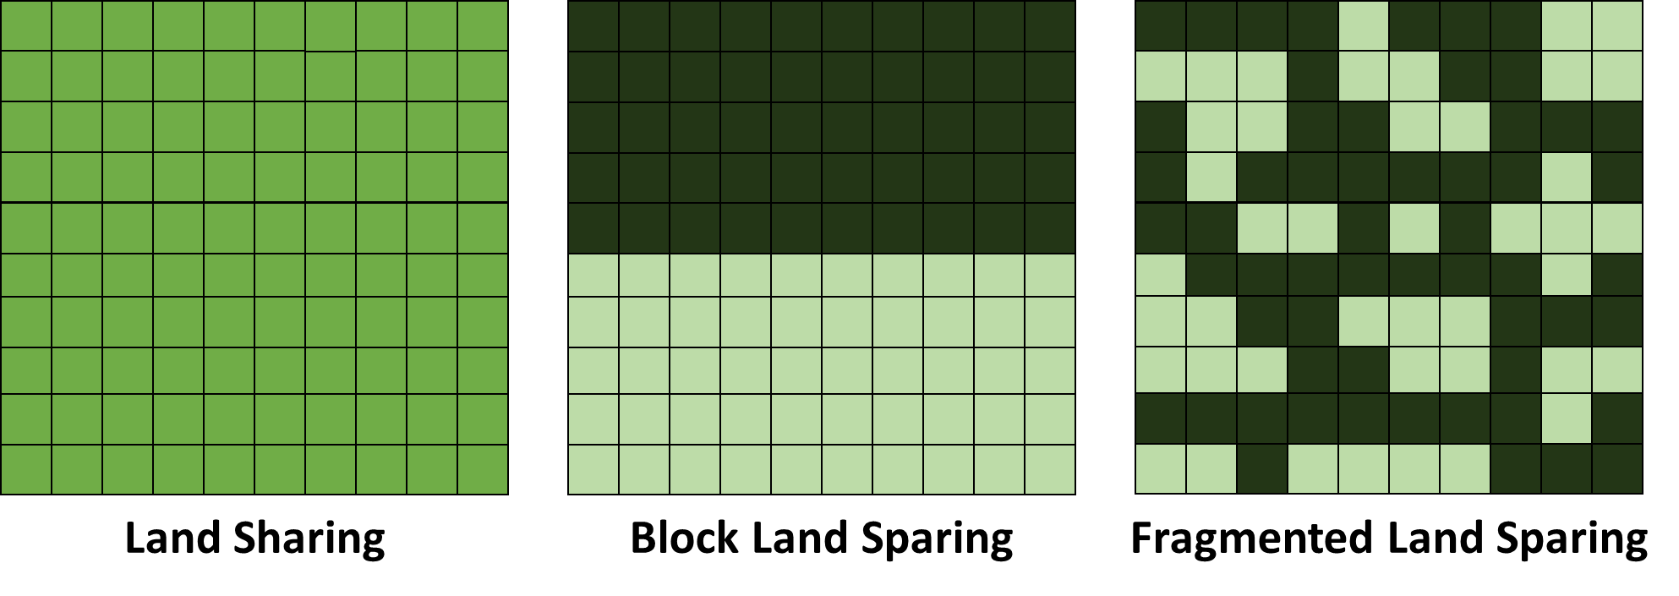
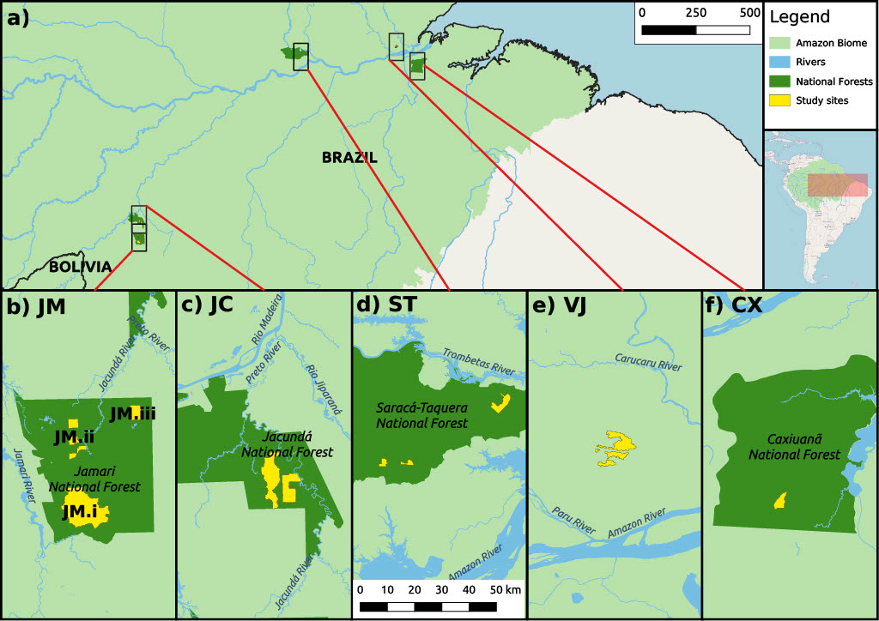
g)
Figure 1. Concession map and harvest strategies. a) Map of studied logging concessions within the Brazilian Amazon. b) Three are located in the Jamari National Forest (JM.i, JM.ii, JM.iii) in Rondônia; c) one is located within the Jacundá National Forest (JC) in Rondônia; d) one in the Saracá-Taquera (ST) National Forest Pará (one concession in several locations); e) one in the Jari Valley region (VJ), Pará; f) and one in Caxiuanã (CX) National Forest, Pará. Concession areas are marked in yellow, whilst dark green areas depict the boundaries of the National Forests. g) Three alternative logging harvest strategies. Land sharing involves low-intensity logging throughout the entire concession (mid-green squares) whilst land sparing involves high intensity logging throughout part of the concession (pale green squares), whilst setting aside the remaining area of unlogged primary forest for conservation (dark-green squares). Here two forms of land sparing are simulated: block land sparing, where retention of large contiguous areas of unlogged primary forest is prioritised; and fragmented land sparing, where only the most valuable forest areas are prioritised for harvesting.

Harvest Simulations
Simulating new forests
For each concession, we simulated 100 new spatially explicit forests based on the original tree distributions within each concession. Each simulated forest contained a new community of trees, in which species aggregation patterns, tree volumes and DBH were reproduced based on models of the original species-specific spatial and size distributions and DBH-volume relationships (SOM Methods 1). Harvest simulations were subsequently conducted on each simulated forest. Harvests were also simulated on the original concessions, but we present the results from the simulated forests as they exhibit the same patterns.
Simulating Harvests
Under all scenarios, harvests were simulated following legal guidelines. The most common and/or valuable commercially viable species were included in the pool of trees available for harvest (>200 species), leaving protected species, non-marketable species, and trees <50 cm DBH unharvested (in accordance with Brazilian law) [28]. The harvest quota in terms of basal area density for land sharing and land sparing comparisons was 20 m³ ha⁻¹, as is typical in National Forests such as the concessions studied here, but intensities of 10 m³ ha⁻¹ and 30 m³ ha⁻¹ were also simulated.

Land sharing under business-as-usual
To simulate land-sharing harvests, we created a function that divided the concession up into 25-hectare grid cells, and then harvested the most valuable standing tree in each cell in a continuous cycle until the average harvest intensity reached the pre-assigned quota.
Land sparing under business-as-usual
To simulate land-sparing harvests, two different functions representing different harvest priorities were used (Figure 1). The first is ‘Block land sparing’, where harvesting prioritises maintaining a large area of spatially contiguous unlogged forest by restricting the harvest to a single block of intensively logged forest. Here, concessions were divided into 25-hectare grid cells, with harvesting starting in one corner of the concession and fanning out to adjacent grid cells. All harvestable trees in each harvested cell were taken until the average quota was met, thereby sparing the rest of the concession as contiguous primary forest. The second is ‘Fragmented land sparing’, in which areas of the greatest economic value are targeted for harvesting. This function divided the concession into 25-hectare grid cells, then ranked cells by the total value of all trees within the cell. All harvestable trees in the most valuable cells were harvested until the total volume logged reached the harvest quota.
We undertook sensitivity analysis to test the impact of future scenarios of variable transport and infrastructure costs, as well as reduced stumpage fees on the profitability of both land-sparing and land-sharing logging (SOM Methods 2).
Hybrid harvest strategies
We tested the profitability of a mixed range of hybrid harvest strategies, whereby differing proportions of the concession were allocated to land sharing and land sparing harvests. For this scenario, we randomly selected 10 forests from each concession to undergo each level of a mixed strategy (i.e. from 100% sharing and 0% sparing, to 0% sharing and 100% sparing in increments of 1%) and calculated the resulting profits from each mixed strategy. We used only block-sparing as the land sparing method in this scenario (not fragmented sparing), as this represents the purest form of land sparing which would be implemented within a mixed strategy to achieve ecological benefits.
Conservation Measures
We tested the effect of increased conservation-based restrictions on the profitability of each harvest method by re-running harvest simulations requiring minimum percentages of all species to be protected from harvest. We tested two different conservation measures:
Scenario 1: Protection of the smallest adult trees. Requirement to protect up to 60% of all adult trees (>50 cm DBH) of each species, allowing harvesting of the largest trees to permit higher incomes and promote retention of adult trees for future harvest [29].
Scenario 2: Protection of the largest adult trees. Requirement to protect up to 50% of the largest trees of each species, to maintain forest structure and the key ecological roles fulfilled by large trees (Lindenmayer & Laurance, 2017; Pinho et al. 2020) including seed production, habitat provision (Sist et al. 2003) and carbon storage (Sist et al. 2014).
For each iteration of the conservation-restriction harvests, we randomly selected 10 of the 100 simulated forests for each concession to undergo logging under each level of restriction (i.e. from 1-60% protection at 10 m³ ha⁻¹, 10 random forests were selected for each proportional protection, totalling 600 simulated harvests per concession). The maximum protected percentage varied between harvest intensities to ensure the required harvest quota could still be met.

Profit calculations
The net revenue accrued from each harvest was calculated using species-specific timber prices, extraction costs and yield data. Our detailed revenue and cost data came from AMATA (JM.i), a sustainable timber harvesting company responsible for timber harvest in the Jamari National Forest, Rondônia. AMATA’s cost data was reprojected on to the other concessions for profit estimations (whilst controlling for concession size or volume output). All but one of the concessions are located in National Forests and form part of the ongoing initiative by the Brazilian Government to award logging concessions on public forested lands. We thus assumed they would market similar wood products at similar prices and incur similar harvest costs as FSC-certified forest concessions. Average selling prices for commercial timber species present in other concessions but not sold by AMATA were obtained through IBAMAs Document of Forest Origin (IBAMA, 2017) and price transformed to match the premium charged by AMATA for high quality, FSC-certified timber (SOM Methods 3).
Revenue
Gross revenue per tree was calculated using species-specific timber prices and yield data. Revenue considered the wastage of wood in the sawmill processing phase and was calculated for each individual tree (R_{n}) thus:
$$R_{n} = \sum{V_{n}O_{y}P_{y}}$$
Eq. 1

Where V_{n} is the total volume of the logged tree n, O_{y} is the proportional output yield after processing of species y, and P_{y} is the sale price per m³ of processed wood for species y.

Costs
Detailed harvesting costs were divided into direct costs associated with tree felling and harvest costs incurred throughout the harvest.
Direct Costs
Direct costs were calculated per m³ of timber and included contractually agreed government stumpage fees, costs of felling and sawmill costs. Direct harvest costs were calculated for each tree (C_{n}) thus:
$$C_{n}= \sum{V_{n }\left(S_{y}+ Cf\right)+ V_{n}O_{y}M_{y}}$$
Eq. 2

Where V_{n} is the total volume of the logged tree n, S_{y} is the stumpage fee per m³ for species y, Cf is the cost of felling per m³, O_{y} is the output yield after processing of species y, and M_{y} is the cost of operating the sawmill per m³ of processed wood produced for species y.
Harvest Costs
Harvest costs were calculated as a total cost across the concession and included administration (wages), conducting a full forest census, road network construction, skidding and roundlog transport. These costs were calculated post-harvest for harvest h thus:
Eq. 3
$${HC}_{h} =\sum{{CA}_{t}+{CE}_{s}+ {RC}_{t}+{SK}_{t}+LT_{t}}$$

Where CA_{t} is the total administrative costs (including wages) for t m³ of timber harvested, CE_{s} is the total cost of conducting a full tree census of a concession s hectares in size, RC_{t} is the total road construction cost for t m³ of timber harvested (weighted for each harvest method- SOM 4), SK_{t} is the total cost of skidding for t m³ of timber harvested, and LT_{t} is the total cost of roundlog transport for t m³ of timber harvested.
Profit
The total profit (P) from harvest h of n trees was calculated as such:
Eq. 4
$$P_{h}=\left(\sum_{i=1}^{n}{R_{n}}-C_{n}\right)-{HC}_{h}$$
Where R_{n} represents the revenue of harvested tree n, C_{n} is the direct costs associated with harvesting tree n, and HC_{h} is the harvest costs incurred throughout harvest h. All calculations were made in Brazilian Real (R$) before being converted to US Dollars (USD$) based on the average exchange rate for 2018 (1R$ = 0.28 USD$). We calculated profits on a per hectare basis, as well as a per m³.

2.4 Results
Land sharing and land sparing with varying logging intensity
In all concessions across all three harvest intensities, land sharing was more profitable per hectare than either form of land sparing (Figure 2). At 20 m³ ha⁻¹, land sharing generated mean profits of $512 ± 449 per hectare whilst block and fragmented land sparing generated mean losses of $117 ± 220 and $10 ± 254 per hectare, respectively, with the broad confidence intervals reflecting high variation in profitability between concessions. Land sharing was also most profitable at all harvest intensities on a volumetric (per m³) basis, although land-sparing profitability per m³ improved slightly with harvest intensity while land sharing profitability fell, reducing the difference between the two strategies (Figure S3).
Profitability was highly dependent on the concession, with some generating net profits of over $1,000 per hectare under sharing scenarios and $500 under sparing, whereas others generated losses of up to $200 per hectare under sharing and $400 per hectare under sparing. In five of the six concessions where it was possible to extract up to 30 m³ ha⁻¹, land sharing was more profitable at 20 m³ ha⁻¹ than at 30 m³ ha⁻¹. In the four concessions where profitability was low and harvests generated a loss in most scenarios, land sharing at 10 m³ ha⁻¹ was the most profitable of all methods.
Under our 20 m³ ha⁻¹ harvest scenarios, the average extent of harvest was 99.4 ± 1.5% of the concession area under land sharing, 44.1 ± 9.1% for fragmented sparing and 49.6 ± 8.3% for block sparing. There were minimal differences in the costs per m³ harvested between any of the harvest methods (Table S2).
Altering the transport costs and applying reduced stumpage fees found the profitability benefit of land sharing to be robust to even the most drastic future changes (i.e. a 200% increase in transport costs and 100% stumpage fee reduction). For all harvest types, road construction and skidding costs exhibited a negative linear relationship with profit, but land sharing remained the most profitable harvest method in all scenarios (Figure S5). Reducing the stumpage fees increased profits in all scenarios but also had minimal effect on the relative profit benefit of land sharing over land sparing (Figure S6).
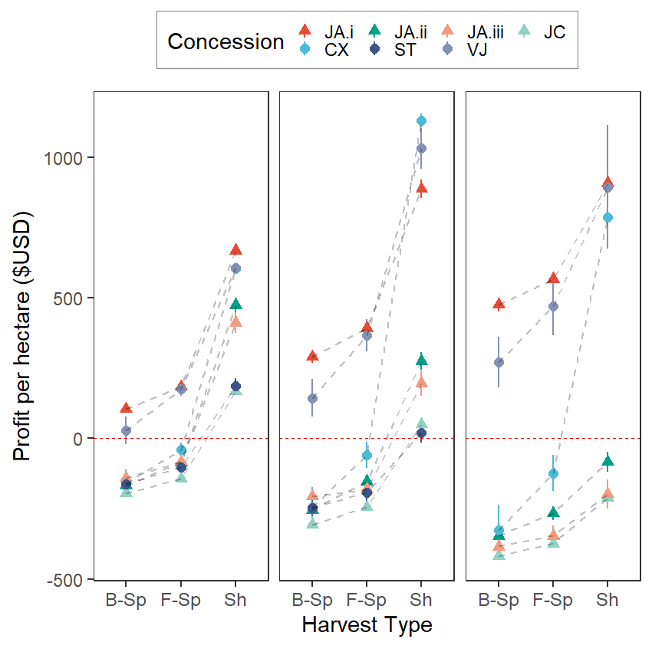
Figure 2. Profit per hectare ($USD) associated with block land sparing (B-Sp), fragmented land sparing (F-Sp), and land-sharing (Sh) timber harvest strategies in the Brazilian Amazon. Predictions are based on 100 simulated forests for each concession with an average harvest intensity of (a) 10, (b) 20 and (c) 30 m³ ha⁻¹. Points represent the mean, and lines extend one standard deviation away from the mean. Red line represents breakeven point where neither a profit nor a loss is made. Triangles represent concessions within Rondônia, circles represent concessions within Pará. Concession codes are as follows: JA.i = Jamari (Rondônia); JA.ii = Jamari (Rondônia); JA.iii = Jamari (Rondônia); JC = Jacunda (Rondônia); CX = Caxiuanã (Pará); ST = Saracá-Taquera (Pará); VJ = Jari Valley (Pará).

a)
b)
c)

Mixed Harvest strategies
Mixed harvest strategies from complete sparing to complete sharing revealed a negative linear correlation between the proportion of land allocated to land sparing and the average profitability per hectare for six concessions, and a negative non-linear relationship in one concession (JC) (Figure 3). Complete land sharing (i.e. 100% of land allocated to sharing) was more profitable than any mixed combination of sparing and sharing strategies in all concessions, although the impact on timber revenues of increased sparing allocations varied between concessions. In one concession (CX) an even mix of sparing and sharing resulted in a 62% lower profit than full sharing but in another concession (JA.i) an even mix only resulted in a 32% lower profit. An even mix of strategies led to harvests making losses in three of the seven concessions.

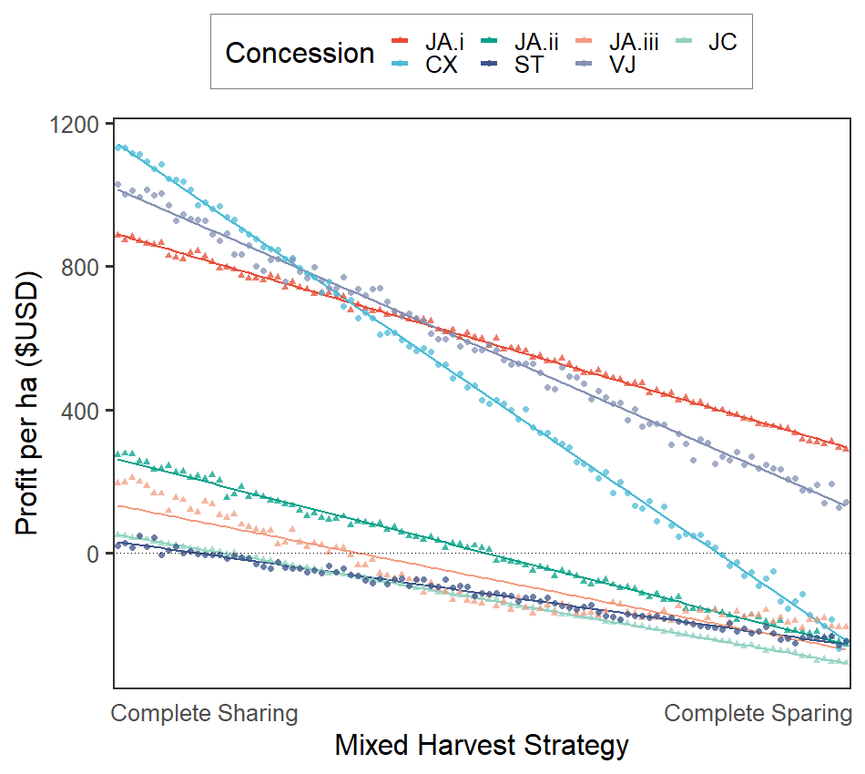
Figure 3. Profit per hectare ($USD) along a continuum of mixed harvest strategies at an intensity of 20 m³ ha⁻¹, ranging from complete land sharing to complete land sparing. Points represent the mean profit of the concession at each level of strategy mix, solid line represents a linear model fit. Dotted line represents the breakeven point where neither a profit nor a loss is made. Triangles and circles represent concessions within the Amazonian states of Rondônia and Pará, respectively. Concession codes are as follows: JA.i = Jamari (Rondônia); JA.ii = Jamari (Rondônia); JA.iii = Jamari (Rondônia); JC = Jacunda (Rondônia); CX = Caxiuanã (Pará); ST = Saracá-Taquera (Pará); VJ = Jari Valley (Pará).

Land sharing and sparing under conservation restrictions
The relative benefit of land sharing over land-sparing logging was highest with no conservation restrictions (e.g. $522-630 per ha more profitable at 20 m³ ha⁻¹). As increasingly stringent conservation restrictions were introduced, the relative profit benefit of land sharing declined (Figure 4). Where the smallest adult trees were protected (Scenario 1), land sharing profitability declined non-linearly at all intensities, with increasingly severe reductions in profitability at higher protection levels, whereas land-sparing profits either remained stable or decreased slightly. Nevertheless, even at the highest level of protection land sharing remained the most profitable method (e.g. $168-231 more profitable at 20 m³ ha⁻¹ with 60% of each species protected; Figure 4a-c).
When the largest adult trees of each species were protected (Scenario 2), increasing protection levels had a negative impact on the profitability of both land sharing and fragmented land sparing, although sharing profits suffered greater declines. At the highest levels of protection under all harvest intensities sharing remained the most profitable method, but the relative profit benefit over sparing was much lower (e.g. $96-114 more profitable at 20 m³ ha⁻¹ with 25% of the largest individuals protected; Figure 4d-f).
In both conservation scenarios, the percentage of species protection was positively correlated with the spatial extent of harvest for both fragmented and block land sparing. At an intensity of 20 m³ ha⁻¹, harvests covered 44 ± 9% (fragmented) and 50 ± 8% (block) of the concession with no species protection, but under Scenario 1 harvests extended to 72 ± 11% and 77 ± 10%, respectively, of the concession area at 60% protection. At the highest restriction for 30 m³ ha⁻¹ harvests (30% species protection), land-sparing harvests covered >84% of the concession. Similar patterns were observed under Scenario 2 (largest adults protected; Figure S4).
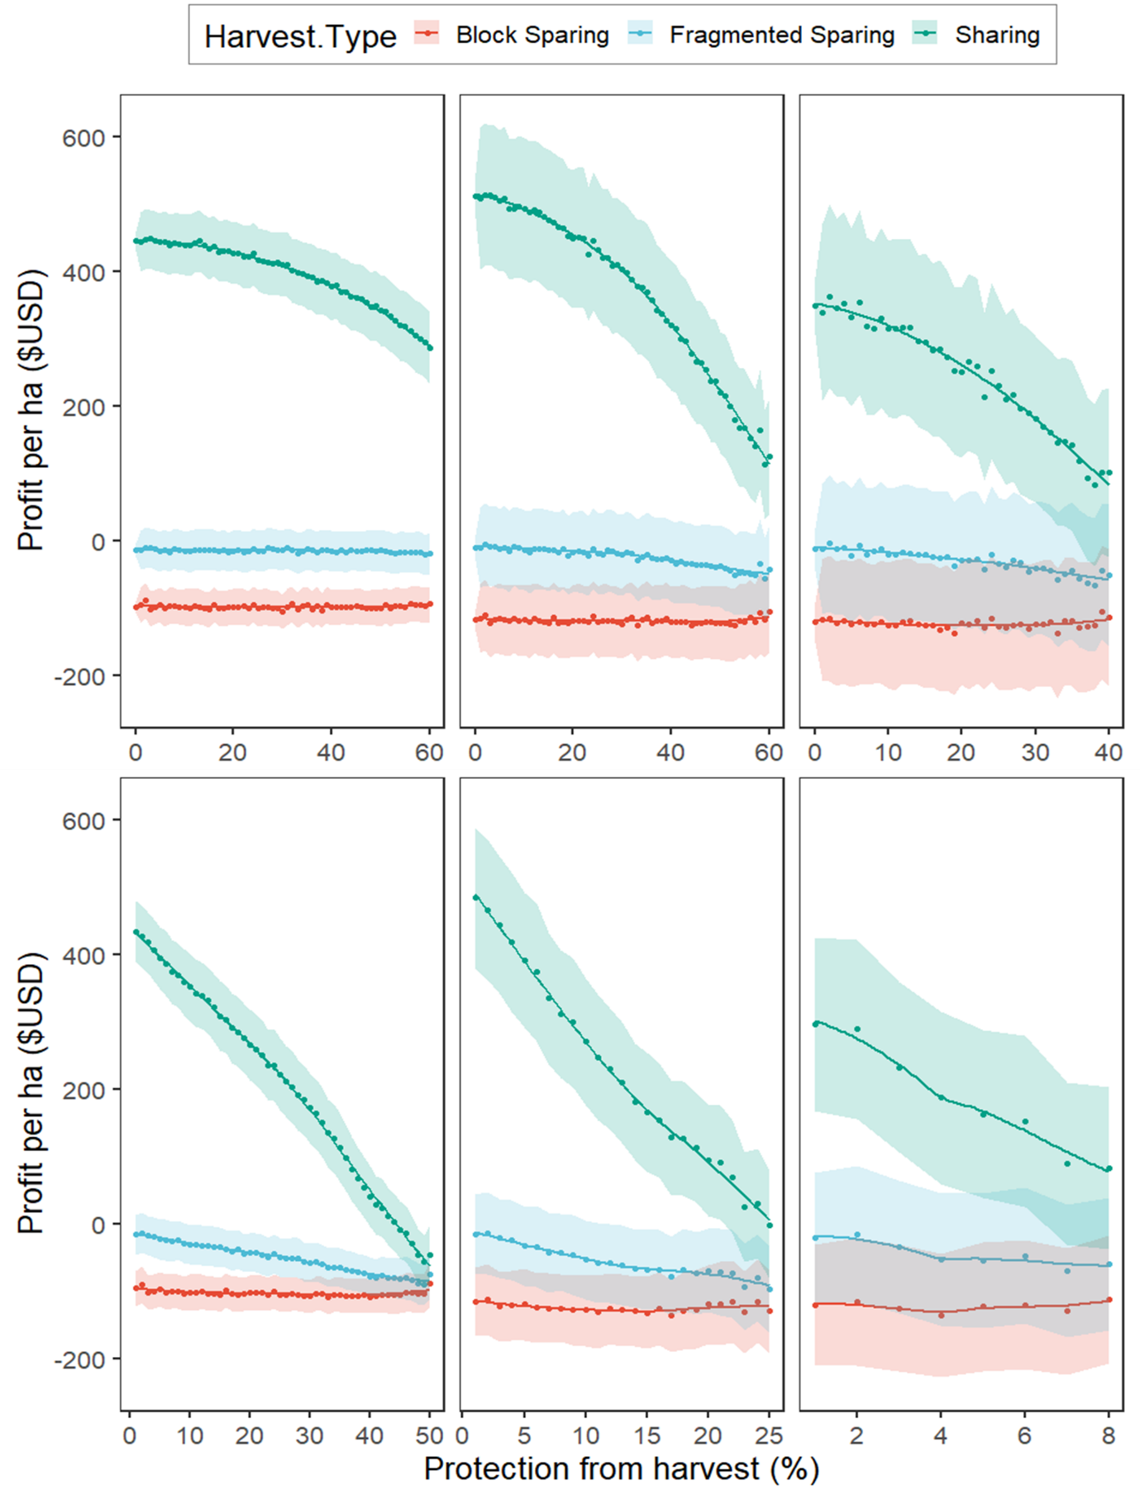
Figure 4. Profit per hectare($USD) of land sparing and land-sharing logging under conservation measures. (a-c) Increasing percentage of smallest adult trees (DBH>50cm) of all species that must be protected from harvest (0-60%) at intensities of 10 (a), 20 (b) and 30 m³ ha⁻¹ (c). (d-f) Increasing percentage of largest adult trees (DBH>50cm) of all species that must be protected from harvest (0-30%) at intensities of 10 (d), 20 (e) and 30 m³ ha⁻¹ (f). Points represent the mean values of all concessions whilst coloured areas represent the 95% confidence interval.
a)
b)
c)
d)
e)
f)

2.5 Discussion
We found land sharing to be considerably more profitable than land-sparing logging across a broad spectrum of forest structure profiles in the southwestern central and eastern Brazilian Amazon, including high basal-area closed-canopy stands and lower basal-area stands containing high densities of natural canopy gaps. Imposing conservation restrictions on harvests reduces the relative profit benefit of land sharing over land sparing, but often makes land sparing unprofitable. Our study highlights the need for economic incentives to protect primary forest patches within the logged forest matrix, reduce road penetration and associated forest degradation, and limit over-harvesting of target species. Such options would likely minimise the local ecological and biodiversity damage of selective logging in the Amazon, improving sustainability, although at larger scales may increase the rate of concession licensing and entry into old-growth forest.
Land-sharing logging across the entire concession was more profitable than land sparing, which returned a loss in four of the seven concessions. Amazonian tree communities are typically dominated by low-value species, with large high-value trees rare and sparsely distributed (Fisher et al. 2014). Logging throughout the concession at low intensities thus facilitates exploitation of rare higher-value stems, driving elevated profits. Similar timber value structures throughout the Amazon suggests the profit patterns reported here would be replicated in concessions across Amazonia. In South-east Asia, forests are dominated by dipterocarp tree species of similar value (Fisher et al. 2011), likely favouring the profitability of land sparing. Furthermore, no mixed strategy of land sparing and land sharing across concessions improved profits over complete sharing, despite suggested ecological benefits of this approach (Betts et al. 2021; Montejo-Kovacevich et al. 2018).
While the profit benefit of land sharing declined relative to land-sparing logging under increasingly stringent conservation scenarios, it remained more profitable. Brazilian law requires a minimum of 10% of adult trees of each species to be protected (Brancalion et al. 2018), which our simulations show has minimal impact on the profits of either sharing or sparing. Retention of more individuals promotes longer-term profitability beyond the first harvest (Barreto et al. 1998; Boltz et al. 2001), as high value stems are present in future cutting cycles. However, the increased spatial extent of land-sparing logging under conservation restrictions highlights a trade-off that could threaten the ecological benefits of land sparing from primary forest retention via reduced harvest extent and smaller road networks (Edwards et al. 2014). Stringent conservation restrictions thus push land-sparing logging towards an increasingly land sharing-type strategy. Currently, logging practices in the Brazilian Amazon are unsustainable (Piponiot et al. 2019; Sist et al. 2021) and without reducing the intensity of timber extraction, increasing species retention (as simulated here), and extending recovery time between harvests, it is unclear whether land sparing or land-sharing logging would be sustainable beyond the first harvest.
Our simulations have five caveats. Firstly, estimates are based on the revenue and costs of a logging organisation employing RIL techniques, marketing premium FSC-certified products (Kollert & Lagan, 2007) processed at their nearby sawmill, pointing to higher profits than operations using conventional logging techniques, marketing non-certified products, or lacking a sawmill. Secondly, we used species-specific prices and stumpage fees, providing more accurate revenue predictions than previous studies that categorise Amazonian species into three timber value bands (Merry et al. 2009; Holmes et al. 2002). Price volatility between years could render low-value stems – often harvested under land sparing – unprofitable in some years. Thirdly, we modelled economic returns across a single harvest, but available timber in subsequent harvests (Brazilian law requires a minimum 30-year cycle between harvests) may only recover 50% of its original volume under optimistic 30-year scenarios (Sist & Ferreira, 2007; Putz et al. 2012), likely negatively impacting the profitability and sustainability of future harvests under both strategies. Thus, in all but our most stringent (and often unprofitable) conservation scenarios, a single harvest rotation would likely require over a century of recovery before timber yields and profitability can recover. Fourthly, despite widespread illegal logging in the Amazon at high intensities (~40 m³ ha⁻¹; Brancalion et al. 2018; De Lima et al. 2007), we did not model harvests above the legal limit of 30 m³ ha⁻¹ because they exceeded the average volume of profitable timber in our concessions, plus illegal operations do not engage in spatial planning or other attempts to reduce ecological damage. Finally, we were unable to account for spatial differences in harvest costs across the concession (e.g. higher harvest costs in difficult to harvest areas such as steep slopes). Under block sparing, harvest costs could be optimised by focusing on cheaper areas of harvest.
The economic benefit of timber extraction under land sharing in the Brazilian Amazon suggests that logging companies will preferentially use this approach, which will have key implications for Amazonian biodiversity. For Bornean birds, dung beetles, ants and Amazonian dung beetles, land sparing appears optimal (Edwards et al. 2014; França et al. 2017), while mixed strategies are optimal for Amazonian butterflies (Montejo-Kovacevich et al. 2018) underscoring the importance of retaining large blocks of unlogged primary forest. While decreased timber extraction better maintains local forest structure (Cazolla-Gatti et al. 2015) and carbon stocks (Ellis et al. 2019), concession-wide estimates of carbon impacts of land-sparing and land-sharing logging suggest the least damaging practice is strongly influenced by land tenure security (Griscom et al. 2014). Further, construction of roads leads to forest cover losses of 0.6-8% within concessions, contributing up to 50% of logging carbon emissions (Umunay et al. 2019), plus facilitating increased human migration, forest clearance and hunting after logging operations cease (Kleinschroth et al. 2017). Our harvest simulations suggest that block land sparing saves ~50% of the concession as primary forest, which could be spatially optimised to protect areas with the highest conservation value, whilst meeting harvest quotas, significantly reducing road network size, and thus offering a key pathway for reducing carbon and biodiversity losses under land sparing. Land sparing therefore appears more optimal than land sharing for Amazonian biodiversity, but low profitability presents a barrier to its implementation across the Amazon.
Policy Implications and Conclusion
Promoting land sparing over land-sharing logging to limit forest degradation requires either more stringent government regulation or market-based incentive mechanisms. Governments may act to protect longer-term wood security, timber-earned revenue streams, and employment, or more broadly to deliver on climate and biodiversity goals (e.g. SDGs 13 and 15). For Brazilian logging concessions in public forests, the government already offers tax reductions for beneficial activities, including social investments (Azevedo-Ramos et al. 2015). Linking reductions in stumpage fees to less-disruptive harvest strategies would reduce the opportunity cost of doing so, e.g. a 25% reduction in stumpage fee would switch some land sparing operations from loss to profit making. Additionally, given that profit per hectare of current logging practices (i.e. land sharing) at 30 m³ ha⁻¹ was lower than profit per hectare at 20 m³ ha⁻¹ in the majority of concessions, reducing the legal cutting limits in lower basal area forests to 20 m³ ha⁻¹ would protect economic returns whilst reducing unnecessary damage to forest biodiversity and carbon stocks. However, any concerted attempt to shift land management strategies (e.g., towards land sparing) must consider the social and institutional implications for all stakeholders beyond profitability and ecological conservation aims. In particular, key considerations will be the impact on timber-related job provisioning and the local community benefits of sustainable forestry in these areas.
Market-based mechanisms, including timber certification schemes, REDD+ and RIL-C (which explicitly focus on improving carbon retention via improved harvest strategies; Griscom et al. 2014), could remove the opportunity cost of land-sparing logging through price premiums and carbon payments, especially when applying more stringent cutting limits on a per species basis. For instance, inclusion of land-sparing logging criteria within FSC-certification requirements would create an explicit link to the FSC timber price premiums of 27-57% (Kollert & Lagan, 2007). Similarly, if land sparing reduces emissions, especially via reduced road networks, then carbon payments could be leveraged to eliminate the opportunity cost.
Our simulations demonstrate that land sharing is more profitable than land-sparing logging in the Brazilian Amazon across a range of logging intensities and conservation-focused harvest restrictions. This suggests a conflict between economic interests and conservation of biodiversity and carbon. Stringent harvest restrictions reduce the opportunity cost of land sparing, improve its longer-term profitability, and minimise multi-decade forest compositional decay through persistent high-grading (Richardson & Peres, 2016), but economic incentives will be required to promote genuine shifts in logging behaviour towards land-sparing logging. While there is some scope for legal frameworks to promote this shift, market-based mechanisms are critical in promoting change. Accurately quantifying the differences in carbon emissions between the two methods will be crucial in assessing this possibility. As Brazil and other Amazonian countries continue to look towards large-scale timber concessions as a means of economic production, ensuring widespread use of optimal harvest strategies will become progressively more important in protecting the globally significant biodiversity and carbon that these forests support.

Acknowledgements
We thank the AMATA and Jari Florestal logging companies, as well as the Serviço Florestal Brasileiro (Brazilian Forest Service), for their help in providing detailed financial records and tree census maps for use in simulations and analyses. This work was supported by the Natural Environment Research Council [grant number NE-S00713X-1].

2.6 Supplementary Information
Supplementary Methods
Methods 1- Point pattern modelling
To simulate new forests, we accounted for variation in the spatial distribution and clustering of each species via a two-step process. Firstly, determining whether a given species’ distribution departed from complete spatial randomness (CSR) then fitting log-Gaussian Cox models where spatial point patterns were significantly departed from CSR.
Departures from CSR were determined via the pair correlation function summary statistic, which quantifies spatial patterns at distinct spatial scales, giving the mean number of points falling between concentric circles with radii r and r + h, where h is a small distance increment, standardised by point density. We accounted for border effects using the Ripley correction (Baddeley et al. 2015).
Significant departure from complete spatial randomness (CSR) was tested against 499 simulations of the homogeneous Poisson model using DCLF goodness-of-fit tests (Diggle, 1986; Loosmore & Ford, 2006). Figure S1 shows results from the pair correlation function for Ipê-roxo, exhibiting significant aggregation up to ~2500m (p = 0.002).
To model clustering for each species, we implemented the log-Gaussian Cox process models. Here, aggregation is modelled by the random intensity function:
$$\log{\bigwedge{\left(u\right)= μ+D(u) }}$$
Eq 6
where µ is the intercept and D(u) is the flexible Matérn Covariance Function (MCF) which describes clustering by two parameters, cluster size and cluster intensity. We optimised model fit for pair correlation in the MCF by considering cluster shape values of 0.25, 0.5, 1, 4 and 100 and selecting the best model by minimum contrasts. The subsequent model was then used to simulate point patterns for each species across the concession area.
After the point patterns were simulated, DBH was assigned to each tree by randomly sampling from the observed DBH-density distribution of each species. Volume was subsequently assigned using family-specific cross-validated DBH-volume relationships utilised by AMATA.
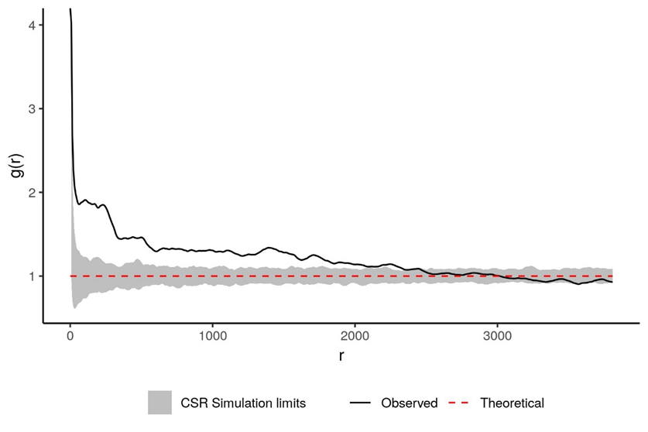

Figure S1. Pair correlation function for the tree species Ipê-roxo in concession JM.i, which exhibits significant aggregation up to ~2500m (p = 0.002).

Methods 2- Sensitivity analyses
We tested how sensitive logging profits were to market fluctuations in the price of fuel, machinery and other inputs by remodelling the 20 m³ ha⁻¹ harvest with both deflated and inflated road construction and skidding costs. For road construction and skidding costs we generated 100 random multipliers between 0.5 (i.e. 50% deflation) and 3 (i.e. 200% inflation) and applied these multipliers to each of the 100 forests simulated, before recalculating the profitability of the resultant harvests.
We also tested the impact of reduced stumpage fees on profitability of both sparing and sharing harvests. The stumpage fees used in our simulations are those agreed by the concessionaire and the Brazilian Government, but these can be significantly higher than stumpage fees incurred outside of public National Forests. We therefore re-ran the harvest simulations at 20 m³ ha⁻¹ with the stumpage fee per tree reduced in increments of 5% of its original value all the way to a 100% reduction (i.e. no fee).
Methods 3- Timber prices
Timber prices used in the simulations were based on species-specific timber prices provided by AMATA. Prices were based on the sale of processed wood that had been treated at the sawmill (Table S1.). For merchantable tree species present in the other concessions but without AMATA price information, we used the IBAMA Document of Forest Origin (IBAMA, 2017) which contains information on the quantities and value of traded timber species across Brazil. For each of the merchantable species found within our concessions, we calculated an average selling price for sawnwood (excluding outliers) from the DOF. Since our cost information is based on AMATA financial data, we then calculated the average deviance from DOF prices for species where we had both DOF and AMATA price data and applied this multiplier to the selling price of the other species (x3.60), to capture the price premium charged by AMATA for high-quality, FSC sawnwood and ensure prices matched costs.
Stumpage fees for each concession were assigned based on the agreed fees between concessionaire and IBAMA as per the concession contract. Where stumpage fees were categorized into four separate value bands, we assigned each species to a stumpage value band based on which price quartile it fell into.
Table S1. Average selling price per m3 of processed wood (USD$) by species in 2018, as reported by AMATA.
Common Name | Scientific Name | Price ($USD/m³ processed wood)
Angelim-amargoso | Vataireopsis speciosa | 675.00
Angelim-pedra | Hymenolobium heterocarpum | 690.00
Angelim-rajado | Vatairea guianensis | 675.00
Cambará-rosa | Qualea paraensis | 710.00
Cedromara | Cedrelinga cateniformis | 580.00
Cedro-rosa | Cedrela fissilis | 672.00
Cinzieiro | Erisma bicolor | 650.00
Cumaru | Dipteryx odorata | 1100.00
Cumarurana | Dipteryx alata | 1100.00
Cupiúba | Goupia glabra | 819.00
Embireira | Couratari stellata | 700.00
Faveira-ferro | Dinizia excelsa | 730.00
Freijó | Cordia goeldiana | 920.00
Garapeira | Apuleia leiocarpa | 863.00
Garrote | Bagassa guianensis | 725.00
Guariúba | Clarisia racemosa | 710.00
Ipê-amarelo | Handroanthus incanus | 1450.00
Ipê-roxo | Tabebuia impetiginosa | 1450.00
Muiracatiara | Astronium lecointei | 750.00
Muirapiranga | Brosimum rubescens | 800.00
Paricá | Schizolobium parahyba | 650.00
Pequi | Caryocar villosum | 580.00
Pequiarana | Caryocar glabrum | 580.00
Roxão | Peltogyne venosa | 900.00
Roxinho | Peltogyne paniculata | 920.00
Sucupira-amarela | Bowdichia nitida | 800.00
Sucupira-preta | Diplotropis rodriguesii | 475.00
Tauari-vermelho | Cariniana micrantha | 650.00

Methods 4- Road Costs
To calculate an average road cost per m³ harvested, harvests were first pre-simulated in the AMATA concession (the only concession for which we had detailed road maps and road cost data) to predict an average road cost per m³ for each harvest type (sharing, block sparing, fragmented sparing). Road costs were split by harvest type due to significantly different road network requirements between sparing and sharing, where sharing requires larger road networks per m³ of timber harvested due to the harvests wider spatial extent. Road costs were also split by harvest intensity (10, 20 and 30 m³ ha⁻¹) to account for lower per m³ road costs when harvesting at higher intensities.
The total road construction cost for AMATA was calculated using the cost data provided to us by AMATA, and then divided by the total length of AMATA’s existing road network to get a per metre cost of road construction ($1.48 per metre). Using the road network created by AMATA as a model, the network was reprojected for each harvest type, with roads only being included if they fell within areas that were to be harvested (Figure S2). The total road network length for each harvest was then multiplied by the per metre road construction cost to get a final road network cost, specific to each harvest type and intensity. We then calculated the average road cost per m³ harvested and applied the same road network costs across each of the different concessions.
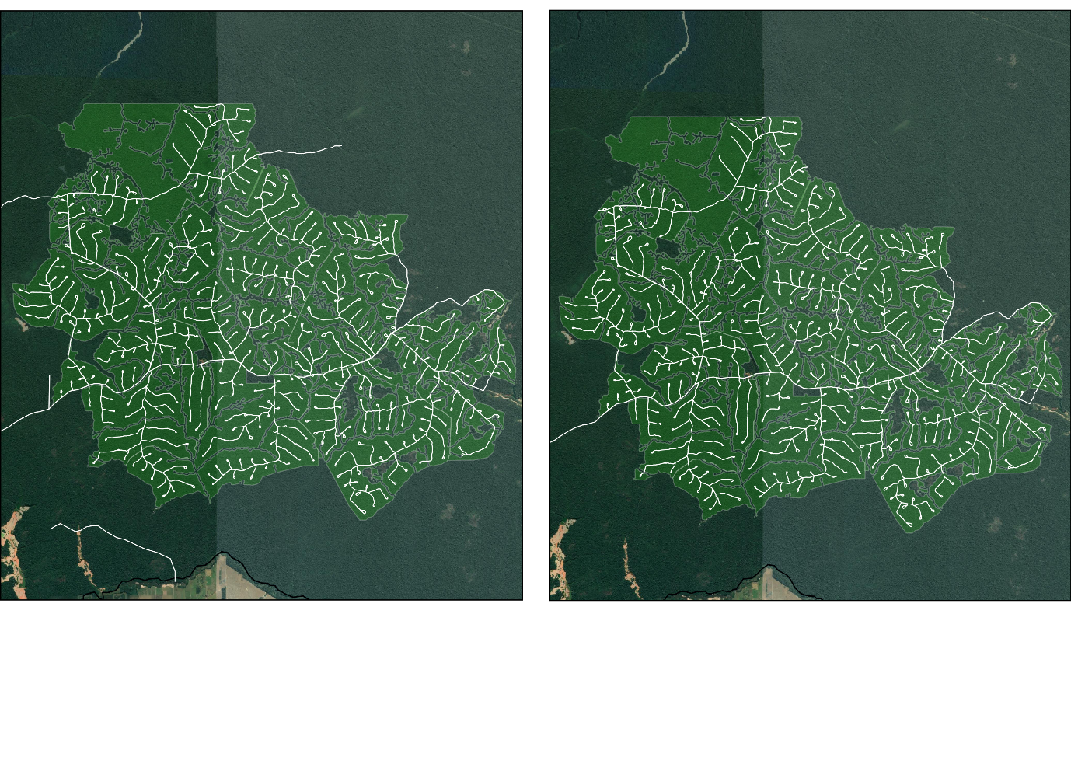
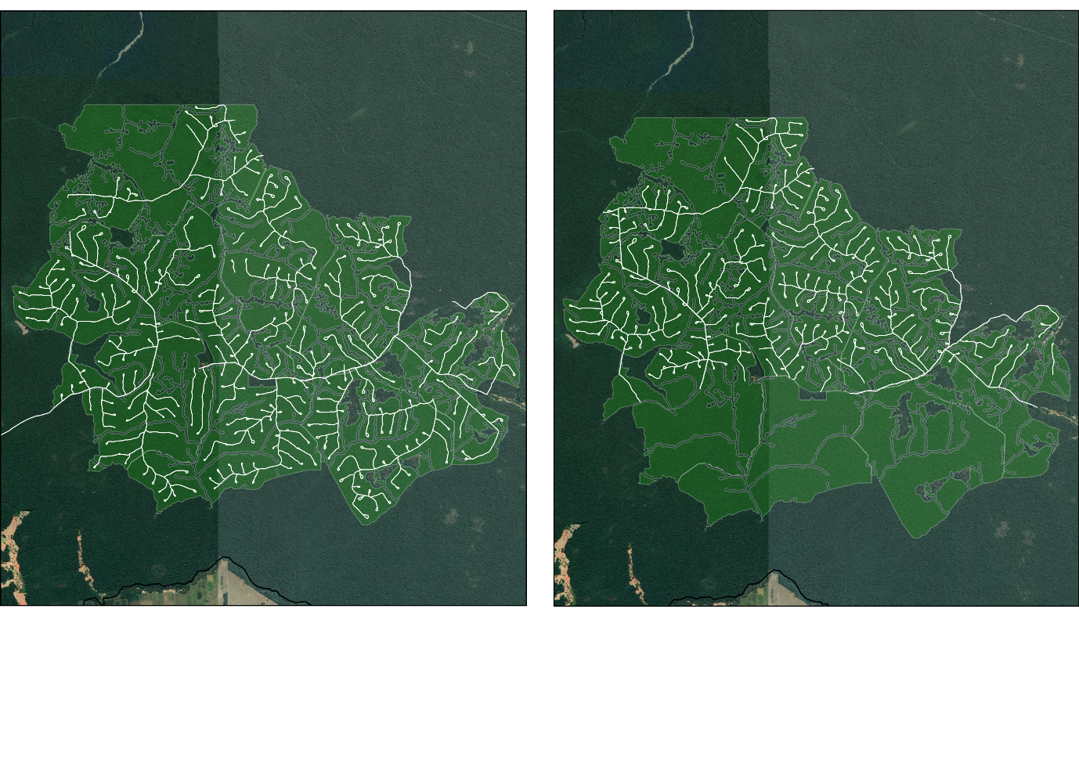
(a)
(b)
(d)
(c)

Figure S2. Map of real and simulated road networks in the AMATA concession (JM.i, Rondônia) (a) Real road network in the concession provided to us by AMATA, (b) the road network generated for land sharing,(c) the road network generated for fragmented land sparing and (d) the road network generated for block land sparing. Road networks for sharing and sparing harvests are based on GPS measurements of the real AMATA road network and cropped to only include roads within grid cells where trees were selected for harvest. Average road costs per m³ were then calculated for each harvest type and used to estimate road costs across all concessions. Images taken from Google Satellite.

Supplementary Results
Land sharing and land sparing with varying logging intensity- profitability per m³
Profitability per m³ harvested followed the same overall pattern as profitability per hectare, in that land sharing was significantly more profitable than both forms of land sparing at intensities of 10, 20 and 30 m³ ha⁻¹. However, land-sparing profitability per m³ improved slightly with harvest intensity while land sharing profitability fell, reducing the strength of difference between strategies (Figure S3).

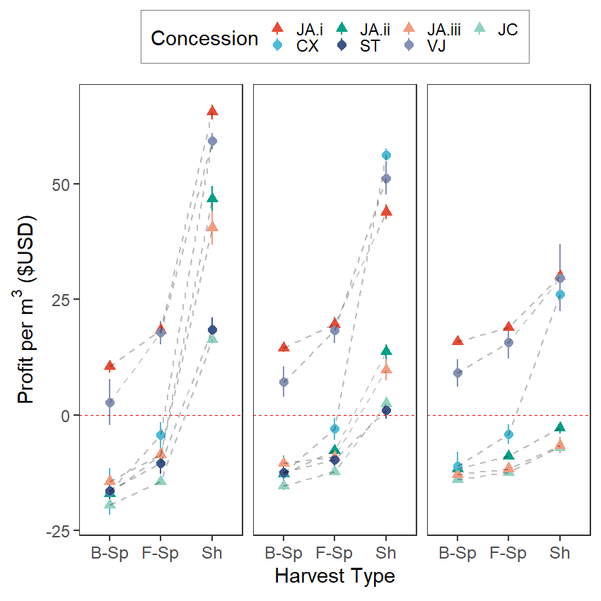
Figure S3. Profit per m³ harvested ($USD) associated with block land sparing (B-Sp), fragmented land sparing (F-Sp), and land-sharing (Sh) harvest strategies in the Brazilian Amazon. Predictions are based on 100 simulated forests for each concession with an average harvest intensity of 10(a), 20 (b) and 30(c) m³ ha⁻¹. Points represent the mean, lines extend one standard deviation away from the mean. Red line represents breakeven point where neither a profit nor a loss is made. Triangles represent concessions within Rondônia, circles represent concessions within Pará. Concession codes are as follows: JA.i = Amata, Jamari (Rondônia); JA.ii = Madeflona, Jamari (Rondônia); JA.iii = Sakura, Jamari (Rondônia); JC = Jacunda (Rondônia); CX = Caxiuanã (Pará); ST = Saracá-Taquera (Pará); VJ = Jari Valley (Pará).
a)
c)
b)

Total cost per m³ of each harvest type and intensity, including wood processing
Total cost per m³ of wood produced was consistent between harvest types. Costs per m³ fell with increased harvest intensity above 10 m³ ha⁻¹ as economies of scale were achieved, but this difference was marginal.

Table S2. Mean cost per m³ of wood produced for each harvest method (land sharing, block land sparing and fragmented land sparing) at harvest intensities of 10, 20 and 30 m³ ha⁻¹. The mean values shown are the means across all seven concessions and the standard deviations are reported alongside.
Harvest Method | Intensity (m³ ha⁻¹) | Total cost per m³ ($USD)
Sharing | 10 | 139.8 ± 7.6
Block Sparing | 10 | 139.2 ± 8.5
Fragmented Sparing | 10 | 139.6 ± 8.3
Sharing | 20 | 135.5 ± 7.8
Block Sparing | 20 | 135.0 ± 8.4
Fragmented Sparing | 20 | 135.1 ± 8.3
Sharing | 30 | 135.6 ± 7.1
Block Sparing | 30 | 135.3 ± 7.9
Fragmented Sparing | 30 | 135.2 ± 7.8

Extent of land sharing and land-sparing harvests under conservation restrictions
In both conservation scenarios, the percentage of species protection was positively correlated with the spatial extent of harvest for both fragmented and block land sparing. At an intensity of 20 m³ ha⁻¹, harvests covered 44 ± 9% (fragmented) and 50 ± 8% (block) of the concession with no species protection, but under Scenario 1 harvests extended to 72 ± 11 and 77 ± 10 %, respectively, of the concession at 60% protection. At the highest restriction for 30 m³ ha⁻¹ harvests (30% species protection), land-sparing harvests covered >84% of the concession. Similar patterns were observed under Scenario 2 (Figure S4).
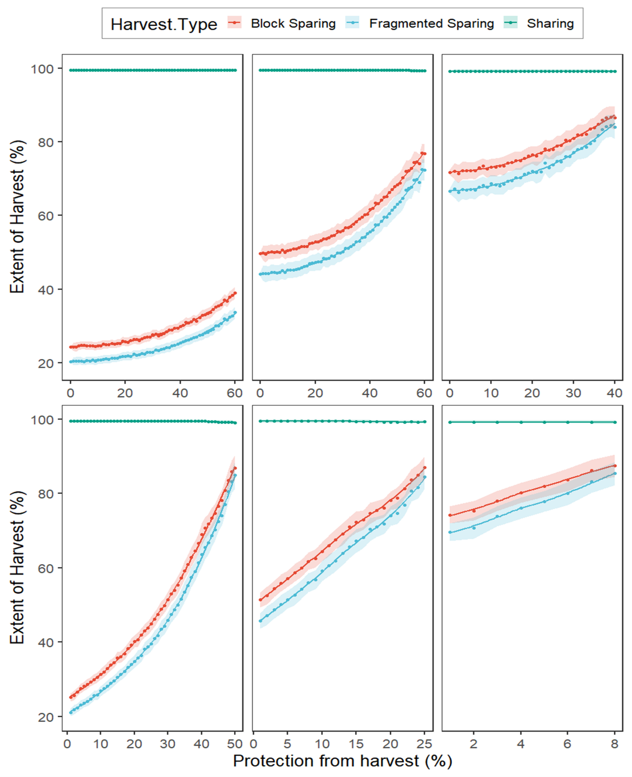
Figure S4. Extent of land sparing and land-sharing logging harvests as a percentage of total concession area under conservation measures. (a-c) Increasing percentage of smallest adult trees (DBH>50cm) of all species that must be protected from harvest (0-60%) at intensities of 10 (a), 20 (b) and 30 m³ ha⁻¹ (c). (d-f) Increasing percentage of largest adult trees (DBH>50cm) of all species that must be protected from harvest (0-30%) at intensities of 10 (d), 20 (e) and 30 m³ ha⁻¹ (f). Points represent the mean values of all concessions whilst coloured areas represent the 95% confidence interval.
f)
e)
d)
a)
c)
b)
Sensitivity Analysis- Road and Skidding costs
Simulated inflation and deflation of road construction and skidding costs found land sharing to remain the most profitable method in all scenarios (Figure S5). All harvest methods in all concessions demonstrated a negative linear relationship between transport costs and profitability.

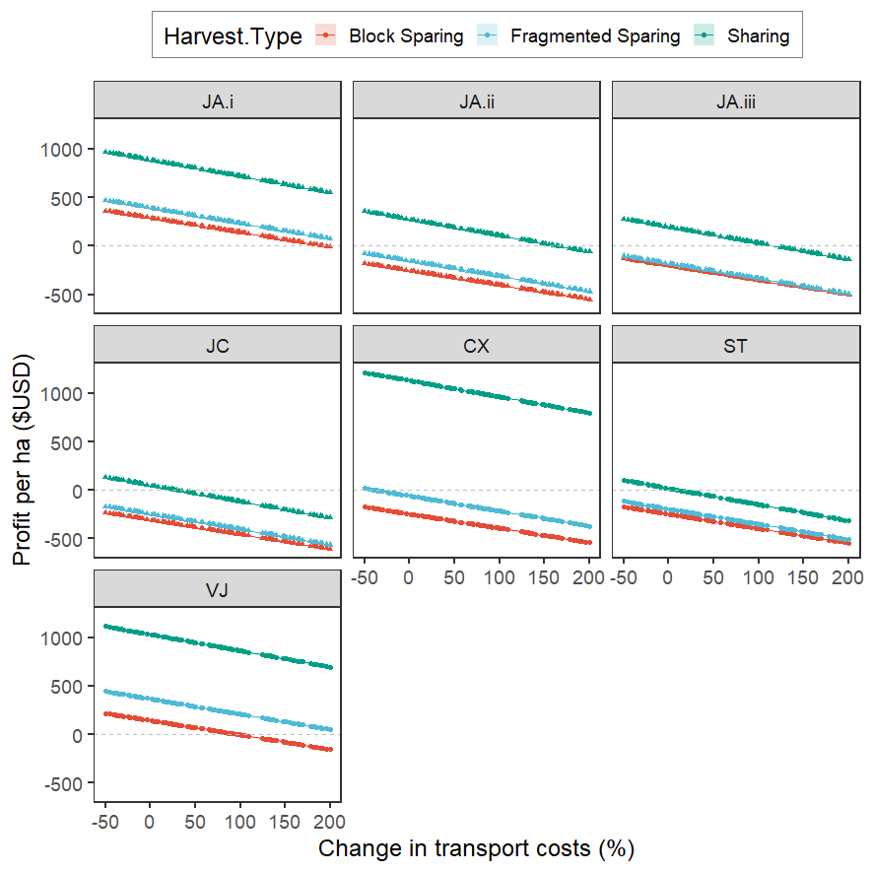
Figure S5. Profit per hectare ($USD) of land sparing and land-sharing logging harvests at harvest intensities of 20 m³ ha⁻¹ in various scenarios of transport cost inflation or deflation. Points represent the mean value for each concession whilst coloured areas represent the 95% confidence interval. Dotted line represents breakeven point where neither a profit nor a loss is made. Triangles represent concessions within Rondônia, circles represent concessions within Pará. Concession codes are as follows: JA.i = Jamari (Rondônia); JA.ii = Jamari (Rondônia); JA.iii = Jamari (Rondônia); JC = Jacunda (Rondônia); CX = Caxiuanã (Pará); ST = Saracá-Taquera (Pará); VJ = Jari Valley (Pará).
Sensitivity Analysis- Stumpage fees
We also looked at how sensitive profits were to reductions in stumpage fees paid to the government, which account for ~20% of all total costs under the current contracts. Decreasing the stumpage fees had significant effects on the profitability of logging operations (Figure S6), with mean profit per hectare ($USD) across all concessions increasing by 46% when stumpage fees were halved and 89% when stumpage fees were removed altogether. Although removal of stumpage fees altogether would not prove practical, even a modest reduction of 25% permit some land sparing operations to switch from loss to profit making.
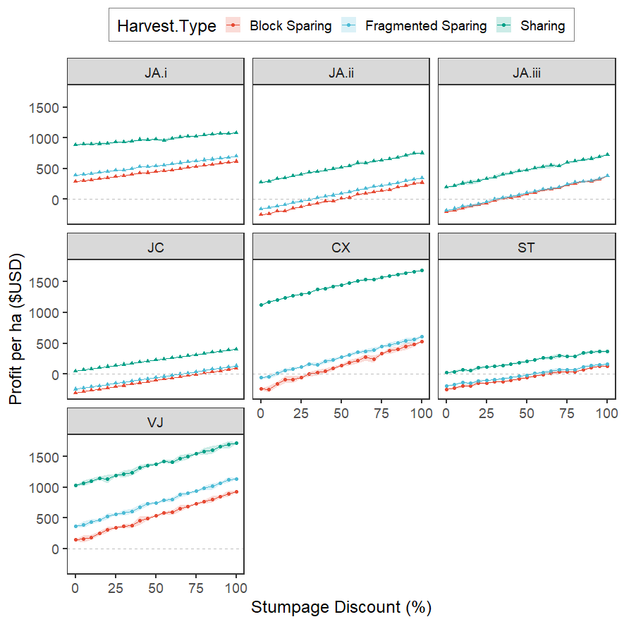
Figure S6. Profit per hectare ($USD) of land sparing and land-sharing logging at harvest intensities of 20 m³ ha⁻¹ under increasing stumpage fee discount (0-100% i.e. full discount). Points represent the mean value for each concession whilst coloured areas represent the 95% confidence interval. Dotted line represents breakeven point where neither a profit nor a loss is made. Triangles represent concessions within Rondônia, circles represent concessions within Pará. Concession codes are as follows: JA.i = Jamari (Rondônia); JA.ii = Jamari (Rondônia); JA.iii = Jamari (Rondônia); JC = Jacunda (Rondônia); CX = Caxiuanã (Pará); ST = Saracá-Taquera (Pará); VJ = Jari Valley (Pará).

Chapter 3: Carbon payments can cost-effectively improve logging sustainability in the Amazon

Carbon payments can cost-effectively improve logging sustainability in the Amazon

Published as: Bousfield, C.G., Massam, M.R., Peres, C.A. and Edwards, D.P., 2022. Carbon payments can cost-effectively improve logging sustainability in the Amazon. Journal of Environmental Management, 314, p.115094.

3.1 Abstract
Selective logging is pervasive across the tropics and unsustainable logging diminishes forest biodiversity and carbon stocks. Improving the sustainability of logging will be crucial for meeting climate targets. Carbon-based payment for ecosystem service schemes, including REDD+, give economic value to standing forests and can protect them from degradation, but only if the revenue from carbon payments is greater than the opportunity cost of forgone or reduced logging. We currently lack understanding of whether carbon payments are feasible for protecting Amazonian forests from logging, despite the Amazon holding the largest unexploited timber reserves and an expanding logging sector. Using financial data and inventories of >660,000 trees covering 52,000 ha of Brazilian forest concessions, we estimate the carbon price required to protect forests from logging. We estimate that a carbon price of $7.90 per tCO₂ is sufficient to match the opportunity costs of all logging and fund protection of primary forest. Alternatively, improving the sustainability of logging operations by ensuring a greater proportion of trees are left uncut requires only slightly higher investments of $7.97-10.45 per tCO₂. These prices fall well below the current compliance market rate and demonstrate a cost-effective opportunity to safeguard large tracts of the Amazon rainforest from further degradation.

Keywords: selective logging, carbon, biodiversity, REDD+, tropical forest, Amazon, forest degradation

3.2 Introduction
Tropical forests support globally important biodiversity and carbon stocks, but are being deforested and degraded at alarming rates (Hansen et al. 2013; Vancutsem et al. 2021). The key driver of tropical forest degradation is selective logging (Hosonuma et al. 2012; Houghton et al. 2012; Pearson et al. 2017), which covers an area of at least 403 million hectares worldwide (Blaser et al. 2011) and is responsible for 6% of tropical greenhouse gas emissions (Ellis et al. 2019). Forests logged sustainably can retain significant proportions of their carbon stocks and harbour high species richness (Putz et al. 2012), yet most selective logging is done unsustainably (Edwards et al. 2014; Bousfield et al. 2020) and a mentality that prioritises profit over the environment prevails. High-value tree species are often preferentially logged at high intensities, leading them to become extremely rare or commercially extinct (Richardson & Peres, 2016), and forests become increasingly depleted with each harvest (Piponiot et al. 2019). However, large timber demand makes selective logging an important economic activity in many tropical economies and balancing sustainable economic production with global climate targets and biodiversity protection remains a critical challenge.
Carbon-based payments for ecosystem service schemes, such as the REDD+ (Reducing Emissions from Deforestation and Degradation) programme, seek to achieve the balance between development and conservation by giving tangible economic value to standing forests. Placing value on carbon retention provides economic incentives for selective loggers to reduce their emissions through improved logging practice (eg. RIL-C; Ellis et al. 2019) or forgoing logging entirely, provided carbon payments can meet or exceed the opportunity cost of doing so (Fisher et al. 2011; Fisher et al. 2014).
In Malaysian Borneo, the high carbon prices required to meet logging opportunity costs (US$22-28 per tCO₂) means carbon payments are not a cost-effective conservation measure (Fisher et al. 2011)¹³, while in Cambodia, carbon payments can cost-effectively prevent logging at prices of US$2.43-$4.27 per tCO₂ (Warren-Thomas et al. 2018). In sub-Saharan Africa, carbon payments could fund more sustainable logging management regimes for US$4.40-$25.90 per tCO₂ (Ndjondo et al. 2014). We currently lack an understanding of carbon payment feasibility in the Amazon, where forest structure and composition differs significantly from South-east Asia (Fisher et al. 2014). Amazonian forests consist of many low-value tree species and small numbers of rare, high-value species that are targeted by logging. Due to this heavily skewed value structure, permitting a low level of logging whilst restricting the extent and intensity of harvest could significantly reduce the opportunity cost of protection, whilst still providing carbon and biodiversity benefits (Sist et al. 2021). Preventing the commercial extinction of target species requires the retention of many more individuals (Richardson & Peres, 2016; Zarin et al. 2007), and carbon markets may play a major role in facilitating this transition to more sustainable harvests (Salzman et al. 2018).
Here, we tackle the key question of whether carbon payments can viably protect Amazonian forest by preventing all logging or by improving logging sustainability. We focus on the Brazilian Amazon, where approximately 35 million hectares of public forest are available to be designated for timber harvest with 1.6 million hectares having already been granted as forest concessions (Sist et al. 2021). We use detailed financial data and spatial harvest simulations for multiple logging concessions to calculate the opportunity cost and carbon breakeven price of forgoing logging entirely as well as improving logging sustainability. We do so to understand the cost-effectiveness of the following objectives: (1) forgoing logging entirely to protect undisturbed primary forests; (2) restricting harvest to higher-value species and preventing harvest of lower-value timber classes; and (3) reducing extraction intensity of higher-value timber species, while preventing logging of lower-value species.

3.3 Methods
Study Site
We focused on seven logging concessions located throughout the Brazilian Amazon (Bousfield et al. 2021) and spanning a broad spectrum of forest structure profiles. Extensive pre-harvest inventories were undertaken by the logging companies whereby all trees ≥40 cm DBH representing commercially viable species were georeferenced and tagged. The forest inventories across the seven concessions provide us with specific attribute data for >660,000 individual trees spanning ~52,000 ha of undisturbed Amazonian forest.
Simulating new forests
For each concession, we simulated 100 new spatially explicit forests based on the original tree distributions within each concession. Each simulated forest contained a new tree species community, where species aggregation patterns, tree DBH and harvestable volumes were reproduced based on models of the original species-specific spatial and size distributions and DBH-volume relationships (see SOM Methods in Bousfield et al., 2021). Harvest simulations were subsequently conducted on each simulated forest.
Simulating full and restricted harvests
We simulated a business-as-usual logging harvest for all concessions as well as a number of restricted harvests whereby carbon payments were used to protect certain trees from harvest.
Business-as-usual Logging
To calculate the opportunity cost of forgoing selective logging entirely in the concession, we simulated a full harvest of all profitable timber within the concession according to legal restrictions. The volumetric amount of profitable timber varied between concessions, with harvests spanning a wide range of intensities from 5-20 m³ ha⁻¹.
Restricting harvest with carbon payments
We simulated three harvest restriction scenarios whereby carbon payments would be used to protect trees that would otherwise have been harvested.
Objective 1: Preventing logging entirely - all trees within the concession were protected from logging, retaining the whole concession as unlogged primary forest.
Objective 2: Preventing logging of certain species based on value classes - tree species were grouped into four decreasing timber value classes (very high: Class I, high: Class II, medium: Class III and low: Class IV) based on their market sale price (Bousfield et al. 2021). Species-specific timber values were obtained from actual transaction prices based on financial records of a Brazilian logging company based at one of the study sites (AMATA) and timber transaction details recorded by IBAMA. Consecutive harvests were then simulated with logging prevented for an increasing number of value classes, with Class IV being the first to be restricted (i.e., logging permitted for Classes I, II and III), then Classes III and IV restricted (logging permitted for Classes I and II), then Classes II, II and IV restricted (logging permitted for Class I only) and finally all Classes restricted (i.e. no harvest).
Objective 3: Reducing extraction intensity of higher-value timber species, while restricting logging of lower-value species - Assuming loggers would have a greater desire to harvest higher than lower value stems (due to higher economic returns), we tested the carbon prices required to spare increasing proportions of each tree species in the higher value timber classes from logging (from the legally required 10% up to 90%) whilst also restricting the logging of all trees in the lower value classes. For this we used two baseline scenarios: (1) logging permitted in Classes I and II (no logging of Classes III and IV), with increasing proportions of trees of each species in Classes I and II also spared from harvest; (2) logging permitted in Class I only (no logging of Classes II, III and IV), with increasing proportions of trees of each species in Class I also spared from harvest.
Harvests were simulated on all 100 modelled forests from each of the seven concessions. The resulting profit from each harvest and the carbon emitted was then estimated and compared with the full harvest baseline to calculate the opportunity cost of harvest and the total amount of carbon saved. The breakeven carbon price required to make forest protection through compensatory carbon payments a financially viable alternative to business-as-usual logging was then estimated.
Estimating carbon stocks and emissions
Estimating Carbon stocks in unlogged primary forest
To estimate the mean carbon stock per hectare in each of our concessions prior to any logging activity, we used plot inventory data from the RADAMBRASIL (1973-1983) network that comprehensively mapped forests in 2,719 1-ha (20 × 500 m) tree plots throughout Brazilian Amazonia. All trees with a CBH ≥100 cm (i.e., DBH ≥31.8 cm) were sampled, except for arborescent palms, and tree genera identified by experienced parabotanists.
Using the DBH, location and genus-specific wood density (Chave et al. 2009), we calculated the above-ground biomass (AGB) of all trees in each 1-ha plot using the allometric equations developed by Chave et al. (2014) through the R package BIOMASS (Rejou-Mechain et al. 2017). We used genus-level rather than species-level tree identification due to higher taxonomic certainty at the genus level for all RADAMBRASIL tree plots (Peres et al. 2016). Below-ground biomass (BGB) was estimated to be 0.235 that of the AGB (Mokany et al. 2006), which was added to the AGB to give the total biomass (tonnes) in each plot. Following Peres et al. (2016), we then accounted for the additional biomass contribution of trees 10-31.8 cm DBH based on empirical observations within the Brazilian Amazon (10-31.8 cm DBH trees account for 94% of the aboveground tree biomass represented by large trees >31.8 cm DBH) before converting total biomass to total carbon content (tC) using the standard factor of 0.47 (IPCC, 2006).
To estimate the mean carbon stock per hectare in each concession, the primary vegetation type of the concession was identified as per each RADAMBRASIL survey. We then took the nearest 50 RADAMBRASIL plots of the same primary vegetation type and calculated a mean biomass and carbon stock per hectare from these plots, which was then assigned to each concession.
Estimating carbon emitted during harvests
The carbon pools considered during our harvest simulations were carbon loss (above- and below-ground) of trees harvested, carbon loss through residual damage during harvest and carbon loss through the creation of logging road infrastructure. For simplicity, and to follow the previous literature (Pearson et al. 2017; Warren-Thomas et al. 2018; Griscom et al. 2014; Zalman et al. 2019), we assumed the carbon within harvested trees to be emitted fully at the time of harvest, focusing on committed emissions and following the IPCC Tier 1 assumption that all carbon extracted is emitted at the time of felling. We did not include soil carbon loss due to lack of data and highly variable findings of the impact of logging on soil carbon (Johnson & Curtis, 2001; James & Harrison, 2016; Riutta et al. 2021).
Carbon stock of felled trees
We calculated the AGB (t) of each tree felled during the harvest using the BIOMASS package (Rejou-Mechain et al. 2017) and allometric equations developed by Chave et al. (2014). Below-ground biomass of each tree was estimated to be 0.235 that of the AGB (Mokany et al. 2006). Total below and above-ground biomass were multiplied by 0.47 (IPCC, 2006) to predict the total carbon content of each tree in tC. The carbon stock lost during harvest was therefore estimated as the sum of the total carbon stored in all trees harvested.
Residual damage
Residual damage of the surrounding tree stand is commonplace in selective logging operations. We used the linear model (r = 0.43, P < 0.01) developed by Sist & Ferreira (2007) based on empirical field measurements of residual damage in a Brazilian logging concession implementing reduced impact logging (RIL) techniques to estimate residual damage. The percentage of the forest stand killed during harvest (y) based on the logging intensity (x, in m³ha⁻¹) was therefore calculated as:
Eq. 1
$$y=0.43x+6.8$$
To estimate the total carbon lost across the harvest through residual damage during logging, the percentage residual damage was multiplied by the total pre-harvest carbon (tC) estimate for the concession.
Road network emissions
We used spatial maps of road networks in one of the concessions (JM.i – AMATA) to estimate the percentage of road cover per hectare of logged forest. We divided the road map into three road types: Primary access roads, secondary roads and tertiary roads and assigned them an average width of 15 m, 8 m and 5 m, respectively (based on communications with AMATA). We calculated the total road area in the concession and divided this by the total area logged to calculate the percentage road cover per hectare of logged forest. We estimated percentage road cover to be 1.58%, which is consistent with the literature, and close to the median global estimate of 1.7% (Kleinschroth & Healey, 2017). We assumed that all trees >10 cm DBH overlapping the road network were destroyed during its creation, therefore estimating the total carbon lost during road construction to be 1.58% of the total area logged (in hectares) multiplied by the average carbon stock per hectare (tC) in the concession.

Total carbon emitted during harvest
We estimated the total carbon (TC) emitted through logging harvest h as:
Eq. 2
$${TC}_{h}= \sum{{CF}_{n}+{RD}_{h}+{RN}_{h}}$$
Where CF_{n} is the total carbon stored in n trees felled during harvest h, RD_{h} is the total carbon lost through residual damage during harvest h, and RN_{h} is the total carbon lost through creation of a road network to facilitate harvest h.
Estimating the net profit of harvest
We used detailed financial records from one of the concessions (JM.i- AMATA) as well as public logging price data (IBAMA, 2017) to estimate the costs and returns of harvests across all seven concessions. All concessions were assumed to market FSC-certified processed sawnwood and employ RIL techniques during harvest, as declared in the concession contracts with the Brazilian Forestry Service (SFB). We adopted the profit calculations used in Bousfield et al. (2021) and estimated the net profit (P) of a harvest h of n trees as:
Eq. 3
$$P_{h}=\left(\sum_{i=1}^{n}{R_{n}}-C_{n}\right)-{HC}_{h}$$
Where R_{n} represents the revenue of harvested tree n, C_{n} is the direct costs associated with harvesting tree n (including the cost of felling, processing and stumpage fees), whereas HC_{h} is the harvest costs incurred throughout harvest h (including wages, tree inventory, road construction, skidding and log transport). All calculations were made in Brazilian Real (R$) and then converted into US Dollars (USD$) based on the average exchange rate for 2018 (1R$ = 0.28 USD$). See supplementary information for a more detailed breakdown of revenue and cost calculations.
Calculating a breakeven carbon price
Opportunity costs were defined as the forgone profits of logging all profitable timber within the concession. We simulated full business-as-usual harvests of all profitable timber (up to the legal maximum of 30 m³ ha⁻¹, but harvest intensities varied between concessions based on available timber), as well as restricted timber harvests, estimating the profit made and carbon emitted during each harvest and using these figures to calculate the breakeven carbon price (BE_{x} - US$ per tCO₂) of each type of restricted harvest as:
$${BE}_{x}= \frac{{(P}_{x}-P_{y})+T_{y}}{3.67 ×{(C}_{x}-C_{y})}$$
where P_{x} is the net profit generated under a full business-as-usual harvest x, P_{y} is the net profit generated under restricted harvest y, T_{y} is the total REDD+ project implementation and transaction costs (estimated at $1.17/tCO₂ after accounting for inflation; Olsen & Bishop, 2009), 3.67 the conversion factor from tC to tCO₂, C_{x} the carbon emitted during full business-as-usual harvest x and C_{y} the carbon emitted during restricted harvest y.
Eq. 4

3.4 Results
Preventing logging entirely
Undertaking a full harvest of all profitable timber within concessions in accordance with Brazilian Law resulted in an average remaining carbon stock of 128.4 ± 14.2 tC per hectare. This equates to 78.6 ± 6.5 % of the original pre-harvest forest carbon stock (163.3 ± 9.7 tC per hectare). The carbon price (in 2018 US$) required to cover the opportunity cost of the full logging harvest and protect the forest from logging averaged $7.90 ± 1.88 per tCO₂ across the concessions (Figure 1). Concessions showed considerable variation in carbon breakeven prices (from $4.85-10.42 per tCO₂) due to the varying opportunity costs that reflect the spatial variation in the value of pre-harvest timber stocks (Figure S1).

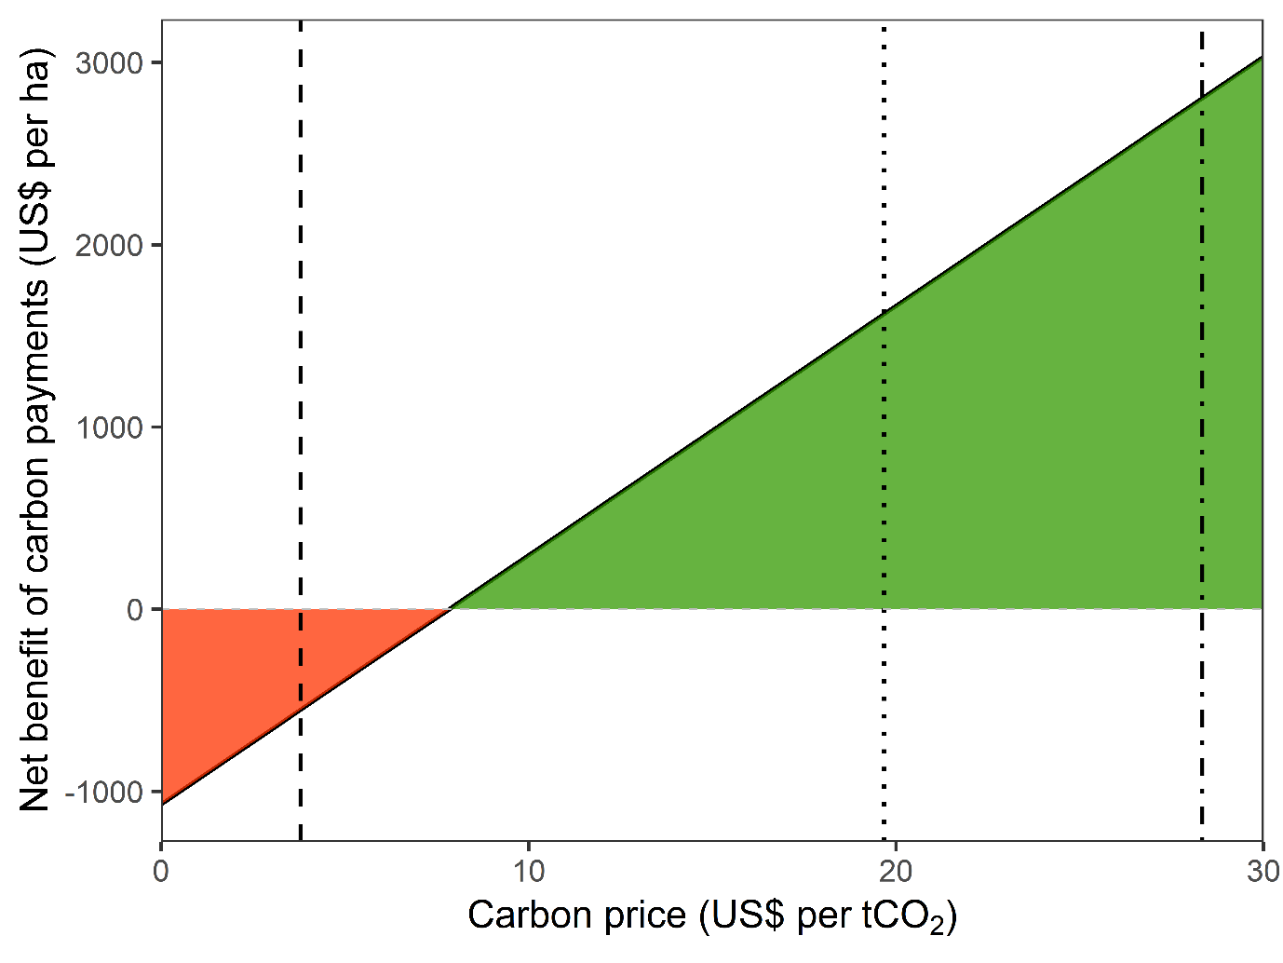Figure 1. The opportunity cost of forgoing logging in public logging concessions in the Brazilian Amazon. Where no carbon finance is used, forgoing logging carries an opportunity cost of ~$1071 per hectare. This opportunity cost is eliminated when carbon finance is used at a carbon price of $7.90 per tCO₂. Areas shaded in red represent carbon prices at which the opportunity cost of not harvesting is greater than the revenue provided through carbon finance, areas shaded in green represent carbon prices at which the opportunity cost of forgoing logging is exceeded and income from carbon payments generates greater returns than logging. Dashed line represents the voluntary market carbon price in 2019 (US$3.80), dotted line represents the 5-year average EU ETS carbon market price (US$19.68), and dot-dashed line represents the 2020 EU ETS average (US$28.33). These carbon prices equate to net benefits of carbon payments of -$551, $1621, and $2803 per ha, respectively.
Preventing logging of certain species based on value classes
Restricting logging of Class IV, such that only individuals in timber value Classes I, II and III were logged, maintained on average 84.9 ± 3.7% of the original forest carbon stocks. Further restrictions saved only marginally more of the original forest carbon stock, with logging only Class I and II individuals retaining 86.9 ± 3.6% and logging only Class I individuals retaining 90.5 ± 1.6% (Figure 2a). Preventing logging of Classes III and IV, such that only Classes I and II were logged, resulted in an average carbon breakeven price of $7.97 ± 1.08 per tCO₂ (Figure 2b). Logging Classes I, II and III (protecting Class IV) was 12.6% more expensive than logging only Classes I and II, whilst logging Class I only (protecting Classes II, III and IV) was 19.8% more expensive. Preventing logging entirely (i.e., sparing all timber trees across all value classes) thus remained the cheapest option at $7.90 ± 1.88 per tCO₂.
Reducing extraction intensity of higher-value timber species, while preventing logging of lower-value species
Increasing the proportion of individuals from species in the higher value classes spared from harvest, whilst restricting logging to only higher value species in Classes I and II (Scenario 1) or only Class I (Scenario 2) resulted in an increase in retained carbon stocks in both scenarios. As expected, remaining carbon stocks were higher when logging of only Class I species was permitted (scenario 2) than when logging was permitted for both Classes I and II (scenario 1) (Figure 3a,b).
Increasing the percentage of individuals in the highest value classes spared from harvest required increasingly high carbon payments up to 80% retention. At lower proportions of higher-value individuals spared (up to 60%), carbon breakeven prices were consistently lower in scenario 1 (logging of Classes I and II) than in scenario 2 (Class I only logged): $9.44 ± 1.45 versus $10.01 ± 2.10 per tCO₂ at 50% retention. The breakeven price for increased retention of higher-value individuals thus ranged from $8.23-10.46 per tCO₂ (Figure 3c,d).

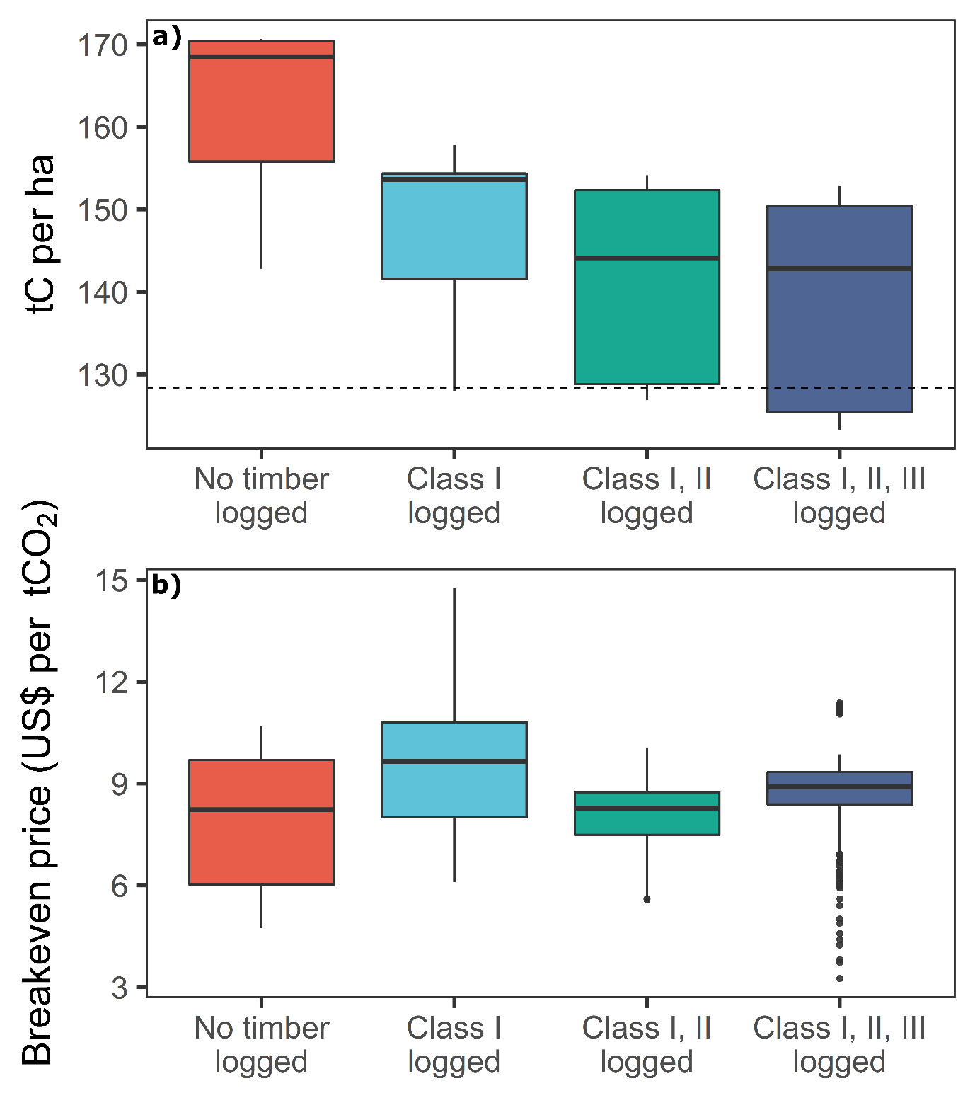Figure 2. Remaining carbon stocks (tC per hectare) (a) and breakeven carbon price (US$ per tCO₂) (b) for different levels of forest protection based on timber value classes, averaged across the seven concessions examined. Species were divided into four value classes based on market sale prices and timber sparing strategies were assessed, including no logging, logging only the most valuable species (Class I), logging the two most valuable species classes (Class I, II) and logging the three most valuable species classes (Class I, II, III). Central bar shows median, box shows upper and lower quartiles, whiskers extend to 1.5× the inter-quartile range, and outliers are presented as dots. Dashed grey line represents the mean remaining carbon stock (tC per ha) of a forest where all profitable timber has been logged (up to the legal maximum harvest of 30 m³ha⁻¹).
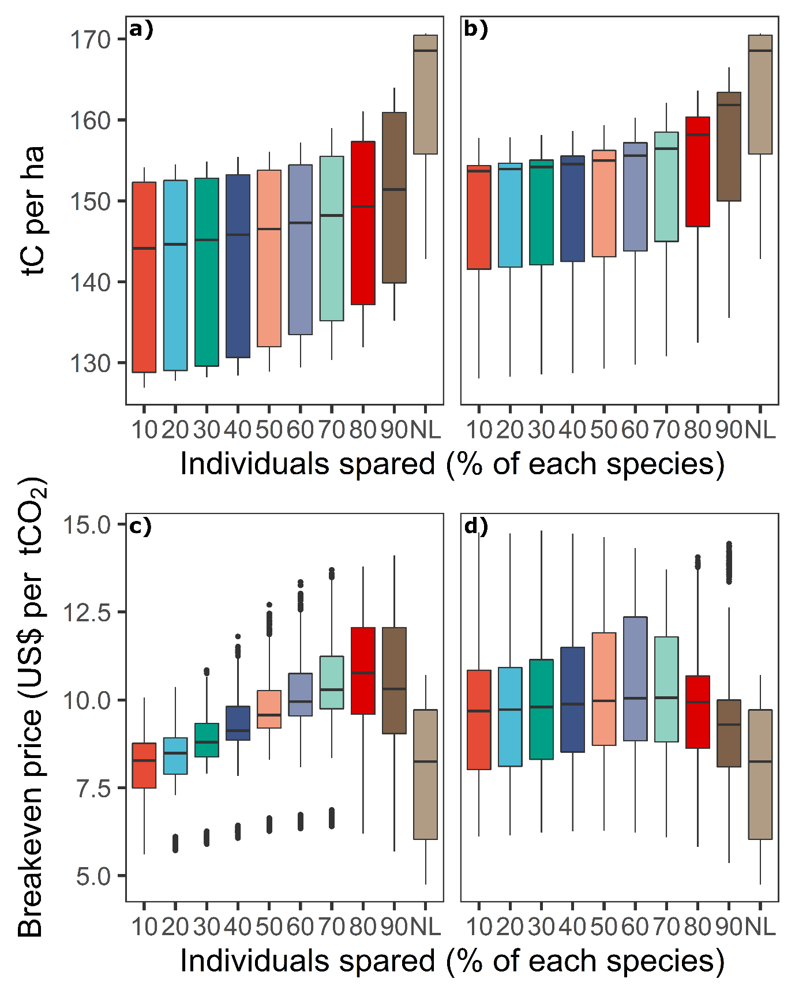Figure 3. Remaining carbon stocks (tC per hectare) (a,b) and breakeven carbon price (US$ per tCO₂) (c,d) for different levels of forest protection where logging is restricted to higher-value classes only (I or I and II) whilst sparing from harvest an increasing proportion (10-90%) of individuals from each species in these classes, averaged across the seven concessions examined. (a, c) Logging permitted for Classes I and II only (scenario 1), with increasing proportions (10-90%) of individuals of each species in Classes I and II spared from harvest. (b, d) Logging permitted for Class I only (scenario 2), with increasing proportions (10-90%) of individuals of each species in Class I spared from harvest. Central bar shows median, box shows upper and lower quartiles, whiskers extend to 1.5× the inter-quartile range, outliers presented as dots. NL represents scenario where no logging occurs.

3.5 Discussion
Our simulations demonstrate that the least expensive carbon payment option to reduce the environmental damage of Amazonian logging is to prevent logging entirely, requiring payments of US$7.90 ± 1.88 per tCO₂. However, if some logging must occur — for instance, because governments would prioritise supporting downstream wood-related businesses — then permitting logging of higher-value timber species only (and sparing individuals in Classes III and IV) requires just a 12.6% higher investment whilst retaining 87% of forest carbon stocks. To alleviate significant logging pressure on populations of high-value timber tree species, only $8.59 per tCO₂ could cover the opportunity cost of sparing 30% of these individuals, while again discontinuing logging of lower-value species entirely.
Protecting forest from all logging is cost effective
Our estimates for the cost of protecting areas of the Brazilian Amazon from logging are considerably lower than previous estimates for Borneo ($22–$28 per tCO₂; Fisher et al. 2011), where the opportunity costs of forgoing higher intensity logging than in the Amazon (Ruslandi et al. 2011) increase the required breakeven carbon price. In Cambodia, estimates were slightly lower ($4.27 per tCO₂; Warren-Thomas et al. 2018) than those found here, but were based on farm-gate timber prices for unprocessed timber, which points to lower profitability (and smaller opportunity costs) than the processed, FSC-certified timber products sold on the domestic and international markets we modelled (Kollert & Lagan, 2007). Our breakeven estimates also fall within the range of previous estimates for improved timber management in Gabon, where carbon payments could be leveraged to lengthen cutting cycles and increase minimum cutting diameters for US$4.40-25.90 (Ndjondo et al. 2014).
The carbon price of protection in Asia rises dramatically when also considering the opportunity cost of land conversion to agriculture ($46-48 and $30-51 per tCO₂ for Borneo and Cambodia, respectively), whereas forest conversion is prohibited in Brazilian public forest reserves. Our breakeven prices are therefore enough to protect forests entirely from legal logging or clearance, although additional costs may be incurred in enforcing the protection of these areas from illegal activities (estimated at $1.17-3.51 ha⁻¹ year⁻¹; Nepstad et al. 2009). These breakeven prices fall well below the 2020 average EU ETS carbon market price of US$28.33 ± 4.21 per tCO₂ (5-year average = $19.68 ± 11.69) and the US Government’s social cost of carbon ($51 per tCO₂), making Amazonian forest protection a cost-effective investment in the compliance carbon market. However, average REDD+ carbon prices paid in the voluntary market in 2019 were lower at ~$3.80 per tCO₂, making forest protection currently too expensive for the voluntary market.
Logging concessions in public forests currently cover 1.6 million hectares of the Brazilian Amazon. Using our predicted carbon retention and breakeven prices, carbon payment projects that fully protect these concessions from logging at a price of $7.90 per tCO₂ would avoid logging-related carbon losses of ~55.92 million tC at a total cost of ~$1.62 billion. With logging concessions set to expand across Brazil, full protection of the 35 million hectares of public forest open to gazettement as concessions (Sist et al. 2021) could avoid carbon losses of ~1.22 PgC whilst generating ~$35.47 billion for the Brazilian economy. This carbon saving is roughly twice the net AGB carbon loss for the entire Brazilian Amazon between 2010-2019 due to deforestation and degradation (Qin et al. 2021). These estimates are based on simulations covering a range of different Amazonian forest structure profiles and timber densities, but should be treated with caution as they may still overlook the complex spatial variation in carbon and timber stocks across the Brazilian Amazon. Furthermore, widespread reduction of timber production could increase reliance on higher-emission building materials, such as steel or cement⁴⁰, and lead to significant job losses in the timber sector.
In addition to carbon retention, significant biodiversity benefits could be achieved through carbon payments that restrict logging entirely. Firstly, primary forests are irreplaceable for sustaining tropical biodiversity (Gibson et al. 2011). Furthermore, when no logging occurs, no road networks are created. Logging roads cause forest cover losses of 0.6-8% within concessions (Kleinscroth & Healey, 2017), facilitate further ecological exploitation through improved access for hunters and illegal loggers (Poulsen et al. 2011; Wilkie et al. 2000), and increase edge effects (Edwards et al. 2017). In the Brazilian Amazon, 95% of deforestation occurs <5 km from roads (Barber et al. 2014), demonstrating the significant benefit of full forest protection through carbon payments in avoiding further deforestation and forest degradation.
Improving the sustainability of logging operations using carbon payments
Whilst forgoing logging entirely represents the cheapest and most optimal option for carbon stock and biodiversity protection, policymakers may require some logging activities to meet timber demand and create jobs. Using carbon payments to prevent the logging of lower-value timber stocks still represented a cost-effective option only $0.07 per tCO₂ more expensive than full forest protection, well below the 2020 EU compliance market price with the added benefit of providing jobs and income. Reducing logging intensity using carbon payments also offers a pathway for biodiversity conservation whilst permitting low levels of economic extraction. Well-managed selectively logged forests can still retain significant amounts of biodiversity (Putz et al. 2012), especially when RIL techniques are employed (Bicknell et al. 2014), whilst lower logging intensities result in smaller declines in species richness amongst mammals, amphibians, invertebrates, and forest-specialist birds (Burivalova et al. 2014). Nevertheless, permitting low-intensity logging would still lead to forest degradation, including extensive road networks to facilitate extraction, fragmentation of the canopy, and residual damage to the forest (Bousfield et al. 2020). Methods to prevent such degradation, and their resultant costs, would have to be considered and included during design and implementation of any carbon payment scheme.
Undertaking post-logging silvicultural interventions, such as liberation cutting and enrichment planting, could provide further biodiversity and carbon benefits whilst improving the long-term sustainability of timber harvests (Cerullo & Edwards, 2019). Alternatively, using carbon payments to protect areas of high ecological value within the concession from logging would improve conservation outcomes for old-growth specialists (Edwards et al. 2014).
When logging focuses on high-value timber species, harvests tend to be demographically unsustainable (i.e., high grading), leading to significant changes in forest community composition (Richardson & Peres, 2016). In addition to preventing the logging of lower-value trees, carbon payments could also protect a proportion of higher-value, typically rare species (Fisher et al. 2014). Increasing the proportion of each species in value Class I and II left unharvested from the legal minimum (10%) to 30% would require an additional carbon payment of $0.62 per tCO₂, and to 50% an additional $1.47 per tCO₂. A small additional investment to restrict extraction levels of high-value timber species would prevent functional homogenisation of the remaining tree community, with potential knock-on effects for biodiversity (Richardson & Peres, 2016; Tabarelli et al. 2012), and retain a greater proportion of standing timber beyond the first harvest (Perreira et al. 2002).

Study caveats
Our simulations have four caveats. Firstly, we base our opportunity cost estimations on large FSC-certified concessions marketing high-quality, processed timber pointing to high profitability (Kollert & Lagan, 2007) whilst our residual damage estimates are based on RIL harvest methods (Sist & Ferreira, 2007) that cause less canopy damage than conventional logging methods (Perreira et al. 2002; West et al. 2014). Where logging operations market lower-quality or unprocessed timber harvested with conventional logging techniques, opportunity costs will likely be lower whilst carbon emissions are greater, thus resulting in cheaper breakeven carbon prices. Secondly, we assume maximising profitability to be the only driver of land-use decision-making by concessionaires, but this does not capture the influence of non-carbon ecosystem services (e.g., water provisioning), cultural attachment to forests (Watson et al. 2018; Rozzi et al. 2012), or governmental policies. Thirdly, we simulate outcomes for Brazilian public forests concessions, and do not include community forests or land owned by indigenous groups. Whilst forest management in such areas can be sustainable and profitable (Humphries et al. 2012), and rates of degradation are often reduced (Sze et al. 2021), our economic and yield data do not allow us to address the potential of REDD+ to work in these areas. Finally, we considered harvest emissions through loss of live biomass carbon, but did not account for associated emissions from heavy machinery and vehicles (Pearson et al. 2017), additional damage through skid trails construction (Goodman et al. 2019), or changes to forest soil carbon (Riutta et al. 2021). These would likely increase carbon emissions saved under restricted harvests, meaning our breakeven carbon prices may be slightly overestimated.
More broadly, REDD+ and carbon payment projects are complex. Large-scale reduction of logging activities in public forests through REDD+ could restrict timber supply, encouraging leakage to meet demand via the expansion of timber plantations (particularly in Brazil’s species-rich cerrado woodlands; Stickler et al. 2009) and logging activities elsewhere (West et al. 2020). Moreover, ensuring the longevity of a project (at least the 35-year logging cycle) is difficult, and strong enforcement would be needed to prevent illegal loggers from harvesting the trees protected by carbon payments (Nasi et al. 2011). Monitoring, reporting, and verification of carbon credits can be costly and difficult to set up (Kohl et al. 2020), whilst carbon credit payments must be transparent and avoid marginalising local people.
REDD+ roll-out and conclusions
Despite the clear ecological benefits of using carbon payments to protect vast tracts of Amazonian forest, there are additional policy barriers to ensuring the success of carbon projects. Currently, the Brazilian government does not permit such projects in national forest concessions (Azevedo-Ramos et al. 2015) and imposes a minimum tax on the concessionaire regardless of whether any logging occurs. Without this minimum tax the cost of fully protecting primary forest drops to $7.06 per tCO₂. Understandably, governments may not view logging activities purely through the lens of economic production, but also through tax income and job provision or, alternatively, as detrimental to their climate goals. The minimum tax imposed by the government could therefore be waved for carbon projects if guarantees were made for investment of the carbon payments into local economies. Indeed, regional or national governments could themselves set up carbon payment projects instead of allocating land to concessionaires. This would significantly reduce opportunity costs and provide the government a chance to contribute towards climate targets and invest in local communities and economies.
In conclusion, we have demonstrated that full protection of forest allocated for selective logging in the Brazilian Amazon is cost-effective under realistic carbon payment scenarios. Full protection of intact forests represents the most beneficial option for ecological and climate goals, as primary forests are irreplaceable for protecting biodiversity and store large carbon stocks. Alternatively, if some level of logging is to occur to meet timber supply and support economies, carbon payments remain a cost-effective way of restricting the intensity of logging, improving logging sustainability and maintaining significant (although still reduced) biodiversity and carbon, at only a small additional cost. If viewed as an opportunity to provide investment into local communities whilst contributing to long-term climate goals, REDD+ projects in public forest concessions represent a cost-effective opportunity to protect the hyper-diverse biodiversity and extensive carbon supported by the Brazilian Amazon.
Acknowledgements
We thank the AMATA and Jari Florestal logging companies, as well as the Serviço Florestal Brasileiro (Brazilian Forest Service), for their help in providing detailed financial records and tree census maps for use in simulations and analyses. This work was supported by the Natural Environment Research Council [grant number NE-S00713X-1].

3.6 Supplementary Information
Calculating Revenues and costs of harvest
Our detailed revenue and cost estimates follow the methodology of Bousfield et al. (2021). The data came from AMATA, an FSC-certified timber harvesting company based in the Jamari National Forest, Rondônia. AMATA’s revenue and cost data was applied to the other concessions whilst controlling for concession size/volume output. Average selling prices for commercial timber species present in other concessions but not sold by AMATA were obtained through IBAMAs Document of Forest Origin and price transformed to match the premium charged by AMATA for high-quality, FSC-certified timber. Revenue and costs were estimated as detailed below, before profits generated in each harvest were estimated as per the details in section 2.5.
Revenue
Gross revenue per tree was calculated using species-specific timber prices and yield data. Revenue considered the wastage of wood in the sawmill processing phase and was calculated for each individual tree (R_{x}) thus:
$$R_{x} = \sum_{1}^{x}{V_{x}O_{y}P_{y}}$$

Where V_{x} is the total volume of the logged tree x, O_{y} is the proportional output yield after processing of species y, and P_{y} is the sale price per m³ of processed wood for species y.

Costs
Detailed harvesting costs were divided into direct costs associated with tree felling and harvest costs incurred throughout the harvest.
Direct Costs
Direct costs were calculated per m³ of timber and included contractually agreed government stumpage fees, costs of felling and sawmill costs. Direct harvest costs were calculated for each tree (C_{X}) thus:
$$C_{x}= \sum_{1}^{x}{V_{x }\left(S_{y}+ Cf\right)+ V_{x}O_{y}M_{y}}$$
Where V_{x} is the total volume of the logged tree x, S_{y} is the stumpage fee per m³ for species y, Cf is the cost of felling per m³, O_{y} is the output yield after processing of species y, and M_{y} is the cost of operating the sawmill per m³ of processed wood produced for species y.
Harvest Costs
Harvest costs were calculated as a total cost across the concession and included administration (wages), conducting a full forest census, road network construction, skidding and roundlog transport. These costs were calculated post-harvest for harvest h thus:
$${HC}_{h} ={CA}_{x}+{CE}_{s}+ {RC}_{x}+{SK}_{x}+LT_{x}$$
Where CA_{x} is the total administrative costs (including wages) for x m³ of timber harvested, CE_{s} is the total cost of conducting a full tree census of a concession s hectares in size, RC_{x} is the total road construction cost for x m³ of timber harvested, SK_{x} is the total cost of skidding for x m³ of timber harvested, and LT_{x} is the total cost of roundlog transport for x m³ of timber harvested.
Supplementary Results
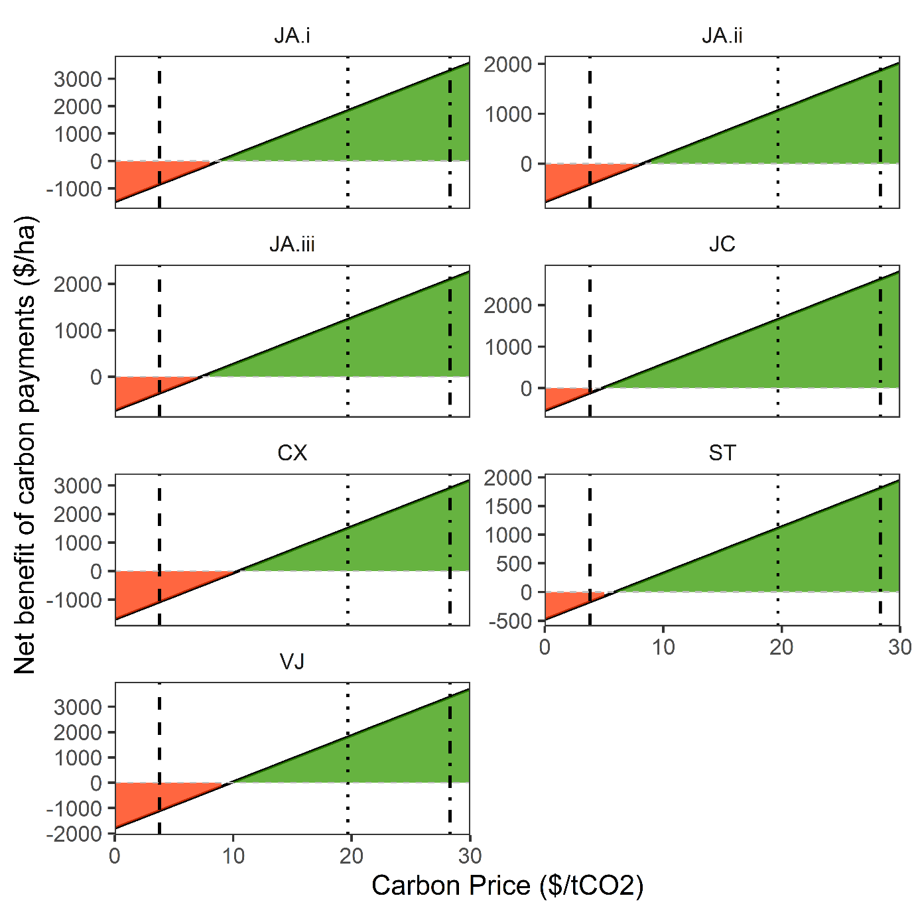Figure S1. The opportunity cost of forgoing timber extraction in public logging concessions in the Brazilian Amazon, split by concession. Areas shaded in red represent carbon prices at which the opportunity cost of not harvesting is greater than the revenue provided through carbon finance. Areas shaded in green represent carbon prices where the opportunity cost of forgoing logging is exceeded and income from carbon payments generates greater returns than logging. Dashed line represents the voluntary market carbon price in 2019 (US$3.80), dotted line represents the 5-year average EU ETS carbon market price (US$19.68) and dot-dashed line represents the 2020 EU ETS average (US$28.33). Concession codes are as follows: JA.i = Jamari (Rondônia); JA.ii = Jamari (Rondônia); JA.iii = Jamari (Rondônia); JC = Jacunda (Rondônia); CX = Caxiuanã (Pará); ST = Saracá-Taquera (Pará); VJ = Jari Valley (Pará).

Figure S2. Breakeven carbon price (US$ per tCO2) for each concession under different levels of forest protection based on timber value classes. Species were divided into four value classes based on selling price and strategies tested were no logging, logging only the most valuable species (Class I), logging the two most valuable species classes (Class I, II), logging the three most valuable species classes (Class I, II, III) and a full harvest of all species. Central bar shows median, box shows upper and lower quartiles, whiskers extend to 1.5× the inter-quartile range, and outliers are presented as dots. Concession codes are as follows: JA.i = Jamari (Rondônia); JA.ii = Jamari (Rondônia); JA.iii = Jamari (Rondônia); JC = Jacunda (Rondônia); CX = Caxiuanã (Pará); ST = Saracá-Taquera (Pará); VJ = Jari Valley (Pará).
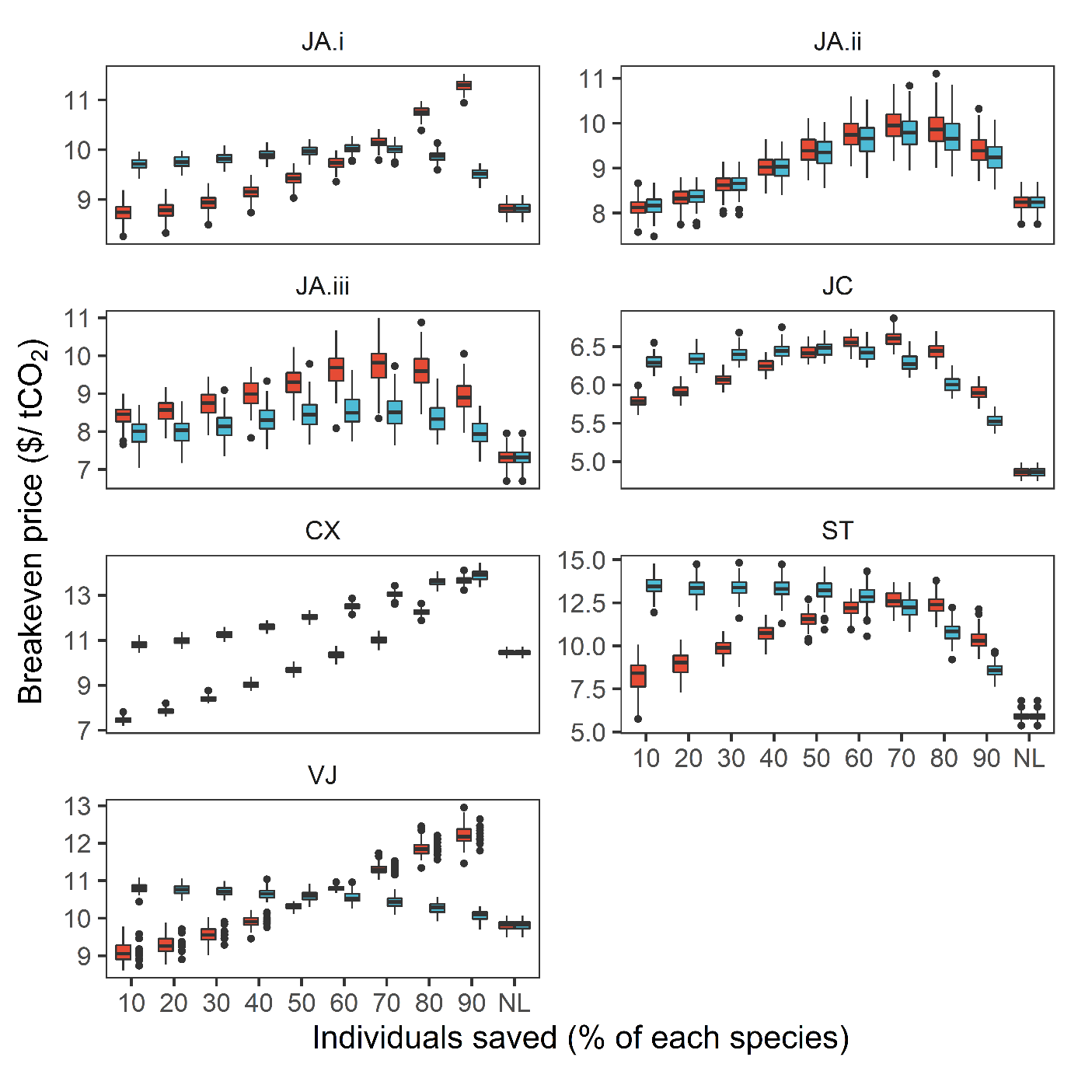Figure S3. Breakeven carbon price (US$ per tCO2) for each concession under different levels of forest protection where logging is restricted to higher-value classes (I or I and II) whilst protecting an increasing minimum percentage (10-90%) of individuals from each species in these classes. Red boxes represent scenario where logging is permitted for Classes I and II only (scenario 1), blue boxes represent scenario where logging is permitted for Class I only (scenario 2), with increasing proportions (10-90%) of individuals of each species in logged classes protected from harvest. Central bar shows median, box shows upper and lower quartiles, whiskers extend to 1.5× the inter-quartile range, and outliers are presented as dots. NL represents scenario where no logging occurs. Concession codes are as follows: JA.i = Jamari (Rondônia); JA.ii = Jamari (Rondônia); JA.iii = Jamari (Rondônia); JC = Jacunda (Rondônia); CX = Caxiuanã (Pará); ST = Saracá-Taquera (Pará); VJ = Jari Valley (Pará).

Chapter 4: Large‐scale impacts of selective logging on canopy tree beta‐diversity in the Brazilian Amazon

Large‐scale impacts of selective logging on canopy tree beta‐diversity in the Brazilian Amazon

Published as: Bousfield, C.G., Massam, M.R., Peres, C.A. and Edwards, D.P., 2023. Large‐scale impacts of selective logging on canopy tree beta‐diversity in the Brazilian Amazon. Journal of Applied Ecology, 60(6), pp.1181-1193.

4.1 Abstract
- Selective logging is one of the largest drivers of tropical forest degradation. Whilst logged forests often retain high alpha-diversity of tropical trees at local spatial scales, understanding how selective logging impacts tree beta-diversity and community composition across far larger spatial scales remains a key unresolved question.
- We leverage large datasets of more than 155,000 adult trees over 35 cm DBH covering 3,100 hectares of Amazonian rainforest to inform simulations of selective logging harvests across a gradient of logging intensity (0-40 m³ ha⁻¹). These simulations incorporate real world price data, account for all forest damage throughout the harvest process and assume preferential harvest of the most valuable stems. We use the simulations to assess how selective logging affects canopy tree beta-diversity and composition across large spatial scales, whether nestedness or turnover of species best explains variation in communities across space, and how the spatial scale of sampling influences observed beta-diversity effects.
- Selective logging had minimal impacts on beta-diversity across the canopy tree community, but caused substantial subtractive heterogenization in community composition for larger trees, in particular very large trees over 110 cm DBH. Turnover is the dominant component of tree beta-diversity in unlogged and logged forests. Increasing the spatial grain of sampling reduced the observed importance of logging in explaining patterns of beta-diversity in very large tree communities.
- Synthesis and applications: Minimal impacts on tree beta-diversity across large spatial scales points towards the retention of substantial conservation value in logged tropical forests. Strong subtractive heterogenization in very large trees indicates the breakdown of broad scale patterns of composition with potential negative consequences for recruitment processes, fauna reliant upon emergent trees, and other ecosystem functions and services. Avoiding large-scale erosion of very large tree community composition in the Amazon requires stronger conservation policies, including enforced retention or maximum cutting diameters.

4.2 Introduction
Tropical forests support extensive biodiversity (Pimm & Raven, 2000) and maintain globally significant carbon stocks (Pan et al., 2011). Yet these forests are subject to widespread selective logging (Blaser et al., 2011), which is the primary driver of tropical forest degradation (Hosonuma et al., 2012; Pearson et al., 2017). Selective logging involves the harvesting of commercially valuable species of a minimum cutting size, leaving behind non-commercial species, smaller individuals, and a degraded forest structure with a fragmented canopy and patches of intense sunlight. Despite this disturbance, selectively logged forests often retain most of their biodiversity and ecosystem services relative to primary forest (Putz et al., 2012; Edwards et al., 2014a) and are much more biodiverse than competing land-uses, especially agriculture (Gibson et al., 2011).
Harvest intensity plays an important role in determining the severity of logging impacts on biodiversity, with higher intensities resulting in greater losses of tree species richness (Martin et al., 2015). Large, valuable trees targeted by selective logging are vulnerable to local population collapses (Richardson & Peres, 2016), yet play irreplaceable ecological roles in tropical forests (Lindenmayer et al., 2012; Pinho et al., 2020). They provide food and habitat for a multitude of organisms, giving structure that provides humid, dark, cool microclimates, and account for a large proportion of total forest biomass and carbon (Nascimento and Laurance, 2002). Selective logging thus also drives losses of favourable microclimates in the short term (Mollinari et al., 2018) and large tree biomass and above-ground carbon over longer timescales (Sist et al., 2014).
Understanding of the impacts of selective logging on tree diversity has tended to focus on alpha diversity (i.e., local species richness) and associated changes in community composition measured at small spatial scales (Gourlet-Fleury et al., 2013; Cazolla-Gatti et al., 2015; Martin et al., 2015). However, focusing on species richness across small areas within a few relatively small plots (1 ha or smaller) risks underestimating the impacts of selective logging at larger spatial scales. Logging activity is not evenly distributed across a forest, often creating a heterogenous mosaic of patches that undergo different levels of disturbance (Cannon et al., 1994). Such heterogeneity in local conditions could lead to shifts in landscape-level community composition and diversity that are not detected by local-scale assessments (Berry et al., 2008), with observed community responses to disturbance being heavily impacted by the spatial scale of sampling (Hill & Hamer, 2004; Dumbrell et al., 2008). Furthermore, the spatial grain of sampling (i.e., size of sampling units) can influence observed variation in community composition (Barton et al., 2013). A key question, therefore, is how selective logging impacts tree community composition over large areas and across varying spatial grains.
Beta diversity – the component of regional (gamma) diversity that accumulates due to variations in local species assemblages (Socolar et al., 2016) – could be impacted by selective logging through two processes. Firstly, heterogenization, whereby communities become increasingly different from each other, as the same set of high-value shared species is consistently targeted by logging across the entire landscape. Alternatively, homogenization, whereby communities become increasingly similar as the same species are left behind. Furthermore, beta-diversity can be partitioned into two separate components, turnover and nestedness, which could both be impacted by selected logging (Baselga, 2010). Turnover occurs when species are present at one site, but lost at another where they are replaced by different species. Alternatively, nestedness occurs when one site contains only a subset of the species present at another site.
Our understanding of these potential impacts of selective logging on tree beta-diversity is limited. In Borneo, logged forests had higher levels of beta-diversity and increased turnover of species across large spatial scales compared to unlogged forests, suggesting logging-induced heterogenization (Berry et al., 2008). In the Amazon, similar patterns were observed at small scales ~10 years after logging, but tree community composition recovered towards a pre-logging state within 25 years (Gaui et al., 2019). However, these studies relied on a small number of 1 ha plots (30 and 12, respectively) dispersed across the landscape, which fails to capture both the substantial turnover of species in these hyperdiverse communities and the large heterogeneity of disturbances that could affect beta-diversity patterns across entire landscapes, particularly when different sampling scales are considered. Understanding the impacts of selective logging on beta-diversity across large contiguous areas of forest is thus of high importance to policy and conservation efforts aiming to maintain ecological diversity at larger scales (Socolar et al., 2016).
In this study, we tackle the key question of how logging impacts tree beta-diversity at large spatial scales. We do so by leveraging detailed tree distribution maps containing information on more than 155,000 large trees (DBH >35 cm) across 3,100 ha of continuous tropical forest within an Amazonian logging concession. The Amazon has hyperdiverse tree communities (Ter Steege et al., 2013), including some highly valuable timber species (e.g., big-leaf mahogany- Swietenia, ipê- Tabebuia, and jatobá- Hymenaea; Schulze et al., 2008), and contains the largest unexploited tropical timber stocks globally (Merry et al., 2009). Within the Brazilian Amazon, the Brazilian Forestry Service (Serviço Florestal Brasileiro; SFB) has been undertaking an ambitious programme since 2006 to create a network of long-term legal timber concessions within National and State Forests (FLONAs and FLOTAs). In combination with other areas designated for sustainable use, up to 35-50 million hectares is potentially available for harvest in the coming decades (de Marques et al., 2016; Sist et al., 2021). Ensuring that logging does not erode diversity patterns at scale is thus a key issue. We generate harvest simulations across a gradient of logging intensity to ask, for both the wider canopy tree community and across different tree size classes: (1) whether tree beta-diversity and composition is affected by selective logging across large spatial scales and through which mechanism this occurs (i.e., heterogenisation or homogenisation); (2) whether nestedness or turnover are primarily responsible for explaining community change; and (3) how does the spatial scale of sampling influence the beta-diversity effects observed.

4.3 Methods
Study site
The study area consists of the wet tropical lowland forest of the northern Amazon Basin and within the Guianan Shields, in the Vale do Jari region, Pará, Brazil (1°13’12”S 52°33’36”W). The site was granted to the Grupo Orsa Florestal forestry company as a 'reduced-impact logging' (RIL) concession for sustainable forest management by the Brazilian Institute of Environment and Renewable Natural Resources (IBAMA). Between 2001-2003, a complete forest census was undertaken, spatially mapping within a 5-m positional accuracy all large tree stems ≥35 cm in diameter at breast height (DBH), each of which was identified to species level by a team of highly experienced parabotanists. This team of five people was led by Mr. Domingos Sanches, an expert tree parabotanist who had been working at the site since the mid 1980s and was completely familiar with the local tree flora.
The accuracy of species-level field identifications at Jari was enhanced by cross-referencing either fertile or infertile vouchers collected in situ with those deposited at the herbaria of Embrapa Amazônia Oriental and Museu Paraense Emílio Goeldi, and later the Herbarium Felisberto Camargo of the Universidade Federal Rural da Amazônia. The credibility of species-level tree identifications at this concession was further strengthened by collections of wood samples that were cross-referenced at the Jari Xylotheque, which houses 4,672 wood samples of over 397 canopy tree species (Ferreira, 2009).
Spatial mapping was conducted manually, operating within 12.5 m width bands, covering a total area of 5,083 ha of undisturbed forest that excluded riparian forest areas. Fieldwork permission was not required for this study. The tree inventory data on which this study is based was carried out within Annual Production Units (UPAs) 1 and 2, which spanned an area of 1,635 and 3,448 ha, respectively, and included a total of 291,027 identified and mapped individual trees ≥35 cm DBH representing 377 species, 196 genera, and 56 families. Species nomenclature was standardised to adhere to The Plant List database (TPL, 2013). Before harvest, the study site had a mean canopy tree (DBH >35 cm) density, basal area, and standing volume of 49.7 ± 9.2 stems ha⁻¹, 10.46 ± 2.35 m³ ha⁻¹, and 81.2 ± 27.2 m³ ha⁻¹, respectively, with a mean DBH of 49.2 ± 16.2 cm and maximum DBH of 254 cm.
Creating plots for pairwise comparisons
To create a network of sampling plots, we overlaid a 3-ha grid of plots across the 5100-ha forest landscape. We then increased the number of plots by manually shifting and/or rotating grid cells in order to fit within the irregular shaped boundaries of the concession. This resulted in a sampling network of 1,036, 3-ha plots (total sample area = 3,108 ha) with a mean tree density of 151 (range = 48-244), containing 156,601 individual trees ≥35 cm DBH (Figure 1).
Simulating logging of the forest
We tested the influence of selective logging on tree beta-diversity across two levels of logging intensity. The first, a lower-intensity logging scenario, whereby logging occurred at an average intensity of 20 m³ ha⁻¹, which represents the typical logging intensity of legal forestry concessions in the Brazilian Amazon. The second was a higher-intensity logging scenario, where logging occurred at an average intensity of 40 m³ ha⁻¹, thus exceeding the legal limit of 30 m³ ha⁻¹ and representing a scenario where high-intensity logging is conducted beyond legal limits.
To generate a landscape of plots that had either been logged (at high or low intensity) or left unlogged, we randomly allocated one third of the 1,036 plots to each of the three logging treatments (Figure 1). To account for any impact of random allocation on the tree communities found for each logging treatment type, we repeated harvest simulations over 999 random iterations in which a new suite of plots were randomly allocated to each logging class.

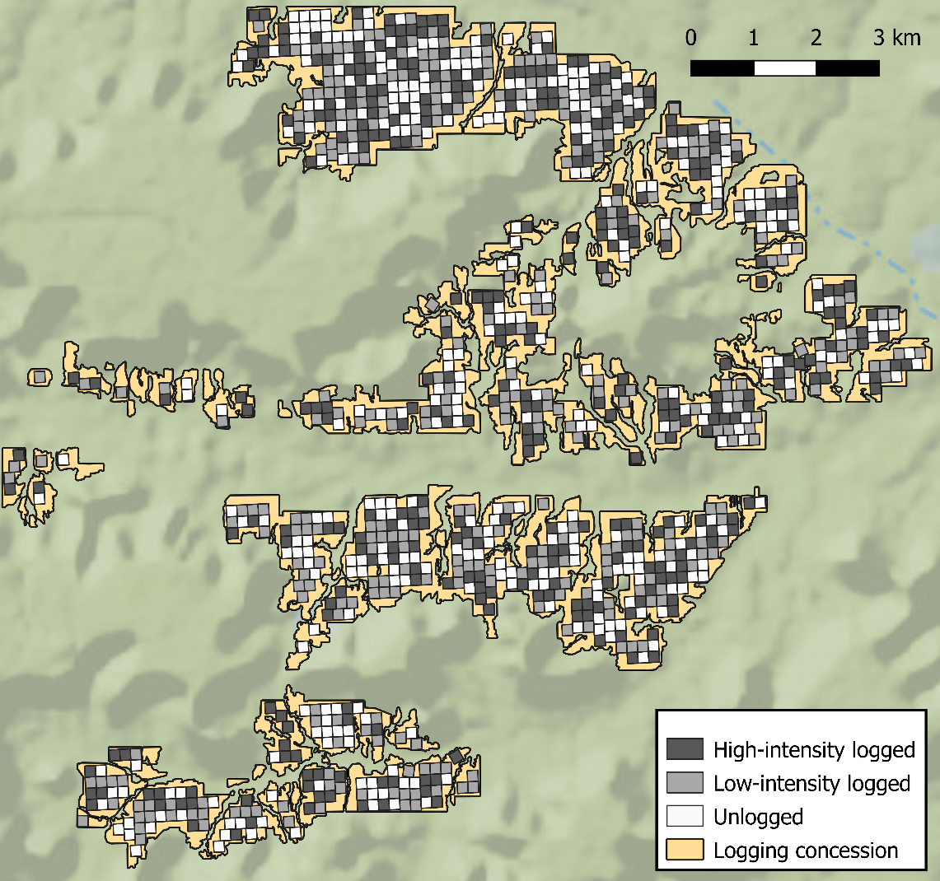

Figure 1. The forest inventory of Vale do Jari, Pará, Brazil. The concession was divided in 1,036 three-ha plots, which were randomly assigned 1 of 3 treatments (Unlogged, Low-intensity logging, and High-intensity logging), to generate a contiguous area of forest that had undergone different levels of logging. The colours represent the treatment assignments of a single simulation.

To simulate a typical logging cycle within logged plots, we used financial data from Bousfield et al. (2021) to estimate the value of each individual tree within the logged plots (accounting for the estimated volume of each tree, and species-specific processing yields and selling prices). Assuming loggers would preferentially log the most valuable stems first, we then ranked all trees within the logged plots (≥50 cm DBH following legal limits) based on their estimated value. We then assigned the most valuable trees to be logged until the cumulative volume of logged trees met the logging quota (either 20 m³ ha⁻¹ in lower-intensity logged forest or 40 m³ ha⁻¹ in higher-intensity logged forest).
Simulating residual damage of the forest
To account for the residual damage that occurs when a tree is logged and removed from a forest, we used the linear model (r = 0.83, P < 0.01) developed by Sist & Ferreira (2007) based on empirical field measurements of residual damage in a Brazilian logging concession that implemented Reduced Impact Logging (RIL) techniques. For each 3-ha plot, the total number of trees logged were calculated, and the resulting percentage of the original tree stand killed by residual damage was estimated as:
$$y=1.5x+2.7$$
Where y represents the percentage of the original tree stand destroyed through residual damage and x represents the logging intensity in the plot (in trees ha⁻¹). We assumed that each logged tree could only kill trees that were smaller or equal in size, and within a 20 m radius of the logged tree. Trees fitting these criteria were considered under threat of mortality by residual damage, before a random sample matching the estimated proportion of trees killed (Eq 1) was taken, with all trees that were selected assumed to have died from residual damage during the logging harvest.

Simulating road network and skid trail damage
To account for the destruction of trees caused by the creation of a road network to facilitate the extraction of timber from the forest, we adopted the methods of Bousfield et al. (2022), which used detailed road maps provided by a sustainable logging company (AMATA based in Rondônia) to estimate the typical extent of road networks required in Brazilian logging concessions. The total combined extent of road and log deck construction was thus estimated as 1.82% of the logged area, in line with other estimates in Brazil (Carvalho et al., 2017) and the global median of 1.7% (Kleinschroth and Healey, 2017). To account for the damage this would cause to the tree community, we randomly allocated 1.82% of the area of each logged plot as being lost to road construction and deemed any trees inside this area to be killed during the logging process.
To account for the impact of skid trails during harvest, we used detailed skid trail maps from the same concession (AMATA) to estimate the area extent of skid trails required for harvest. Using these maps, we estimated a skid trail cover of 1.6% of concession area at a harvest intensity of 12 m³ ha⁻¹ (again close to previous estimates; Carvalho et al., 2017). Readjusting to the higher logging intensities simulated here, we estimated skid trails to cover 2.66% and 5.32% of land logged at low (20 m³ ha⁻¹) and high (40 m³ ha⁻¹) intensity, respectively. To account for this damage, we randomly allocated this proportion of land in each logged plot to skid trails, and assumed all smaller trees (35 cm ≤ DBH < 50 cm) in this area to be killed through skid trail construction. As per standard practice by logging concessionaries, we assumed large trees (i.e. DBH > 50 cm) located on a skid trail would simply be avoided due to the large financial costs and labour requirement involved in removing them, and did not assign them as killed during skid trail construction. As a precaution, we conducted a reanalysis whereby all trees of any size in a skid trail were destroyed, but this had minimal impact on the results (Figure S7). After simulating the logging extraction, residual damage and damage through road and skid trail construction across all plots, we were left with a continuous network of forest plots that depicted the surviving canopy tree community after varying levels of logging harvests had occurred.
Harvest assumptions
All further analysis of the beta-diversity impact of selective logging on Amazonian canopy tree communities are based on the results of our simulated logging harvests. Conclusions are therefore made in the context of the assumptions and caveats contained within our harvest simulation models, which are:
- Large trees only – our data is limited to trees with DBH values >35 cm, thus focusing on the largest trees most important for biodiversity and carbon storage, and the group specifically targeted by logging. Our simulations thereby exclude stems that are <35 cm DBH. Because these stems are not directly targeted by logging, but may suffer residual damage from felling and extraction, their beta-diversity may be differentially impacted compared to the canopy tree community.
- First harvest using RIL – due to data limitations, we simulate the first logging harvest of a primary old-growth forest, conducted under RIL techniques. Additional timber harvests (after the 30-35 year minimum cycle time) and those conducted using Conventional Logging techniques will cause further damage to the tree canopy community not simulated here.
- Preference for large, valuable trees – our harvest model assumes that trees are harvested preferentially in order of their value, which typically results in the largest individuals of commercial species being harvested first. Beta-diversity impacts will therefore be skewed towards trees in larger size classes, although to structure logging around smaller or less-valuable species would likely be uneconomic (Bousfield et al., 2021).
- Road and skid trail damage – our simulations of the damage caused by road and skid trail creation are conservative. In many concessions, road creation may deliberately miss the largest trees, while skid trails will likely avoid trees in the 35 – 50 cm DBH class.

Logging impacts on tree beta-diversity in Amazonian tropical forests
To analyse beta-diversity patterns across gradients of logging intensity, we employed generalised dissimilarity modelling (Ferrier et al., 2007) in R version 4.1.0 using the GDM package (Fitzpatrick et al., 2021). The GDM method is an extension of matrix regression, designed specifically to accommodate two common types of non-linearity found in larger-scaled ecological data sets: (1) the curvilinear relationship between increasing ecological distance, and observed compositional dissimilarity between sites; and (2) the variation in the rate of compositional turnover at different positions along environmental gradients (Ferrier et al., 2007). This approach fits non-linear functions to each predictor variable using flexible i-splines, which are then combined to estimate the ‘ecological distance’ between a pair of cells. The maximum height of each i-spline thus indicates the amount of compositional turnover associated with each variable whilst holding all other variables constant. The GDM allowed us to quantify the importance of selective logging in driving beta-diversity patterns, whilst holding other variables (e.g., geographic separation) constant, and to assess how the impact of selective logging changes along a gradient of logging intensity (from 0 to 40 m³ ha⁻¹).

We used pairwise Bray-Curtis dissimilarity between pairs of plots as our dissimilarity measure (>500,000 comparisons), and included logging intensity and geographic distance between plots as predictors. We then fitted a GDM using three i-spline basis functions per predictor and quantified the importance of each variable in explaining beta-diversity by randomising each variable’s position in the dissimilarity matrix in turn for 50 permutations and noting the loss in explanatory power. We also tested dissimilarities in community composition using the Jaccard index, square root transformed, presence-absence transformed data and basal area. We present the raw abundance-based results (i.e. number of individual trees) of Bray-Curtis dissimilarity as all measures resulted in similar outcomes (see S3-S6 for comparison).
To ascertain how the impacts of selective logging on beta-diversity vary across different tree size classes, we grouped trees into the following three classes: medium (35 cm ≤ DBH <50 cm), large (50 cm ≤ DBH <110 cm), and very large (DBH ≥110 cm), resulting in communities with overall species richness of 339, 336 and 59, respectively. The above analysis was then repeated separately for tree communities within each size class.

Does nestedness or turnover best explain observed beta-diversity patterns in unlogged and logged forests?
To estimate the proportion of beta-diversity attributable to either turnover or nestedness for each logging type (unlogged, low-intensity logged, and high-intensity logged), for all trees, and each size class, we used the bray.part function from the betapart package (Baselga et al., 2021). Here logging treatments were conducted across the entirety of the logging concession, such that there were three repeats of the original logging concession that each underwent a different logging treatment. Pairwise comparisons of all plots from the same treatment concession were then made, and the levels of Bray-Curtis dissimilarity, and its constituent parts (nestedness and turnover) were calculated.
How does the spatial scale of sampling influence the beta-diversity effects observed?
To test how the spatial scale of sampling impacts the patterns observed, we repeated the GDM analysis for plots at 5 different spatial scales: 1 ha, 3 ha, 5 ha, 10 ha, and 25 ha. The same method was adopted to create each set of plots, by imposing a grid over the forest landscape and allocating as a plot all grids that were bounded entirely within the concession. The number of plots used in analysis for each plot size thus varied, but the total area of forest assessed remained constant.

4.4 Results
Harvest simulations resulted in the felling and harvesting of 4.1 ± 0.2 and 13.1 ± 0.3 trees ha⁻¹ under low-intensity (20 m² ha⁻¹) and high intensity (40 m² ha⁻¹) harvests, respectively. This represents a mean basal area of 2.3 ± 0.02 and 4.9 ± 0.04 m² ha⁻¹ for low- and high-intensity harvests, respectively (i.e. 22 and 47% of the total basal area of trees >35 cm DBH before logging). These harvests thus accurately represent real-world harvest intensities that occur within the Amazon (Fig S1). Residual damage resulted in the loss of 4.4 ± 0.2 and 11.4 ± 0.3 trees ha⁻¹, for low- and high-intensity scenarios, respectively, representing 8.9 ± 0.4 and 22.9 ± 0.5 % of the canopy tree community.
Impact of selective logging on tree beta-diversity and composition in Amazonian forests
Across the canopy tree community, selective logging had a significant but relatively small impact on community composition, accounting for 22.4 ± 1.3% of the explained variation between unlogged and logged plots, compared to the 77.6 ± 1.3% explained by geographic separation. However, when considering only very large tree communities (DBH ≥110 cm), selective logging was the dominant driver of changes in beta-diversity between unlogged and logged forest, accounting for 89.2 ± 2.2% of explained community variation compared to only 10.8 ± 2.2% explained by geographic distance (Figure 2). Similarly, for large tree communities (50 cm ≤ DBH < 110 cm), selective logging accounted for 72.4 ± 3.4% of the explained variation in community composition compared to the 27.6 ± 3.4% explained by geographic distance. For medium-sized tree communities (DBH < 50 cm), there was an effect of logging on beta-diversity, but this effect was very small and only accounted for 7.5 ± 0.8% of explained community variation. Logging intensity was found to be a significant predictor of canopy tree community composition across all tree size classes (mean harmonic p-value < 0.001; Wilson, 2019, see Table S1 for model summaries).
In all scenarios, the impact of selective logging on beta-diversity increased along the logging-intensity gradient. For the whole canopy tree community, there was no effect of low-intensity logging (i.e., <20 m³ ha⁻¹), but a small effect that increased in size at higher logging intensities (i.e., >30 m³ ha⁻¹) (Figure 2). For very large emergent trees, logging strongly altered community composition even at low logging intensities (<20 m³ ha⁻¹), but at high intensity the shift in community composition attributable to logging was ~15% larger. Logging up to 20 m³ ha⁻¹ had little impact on beta-diversity in large trees, but at higher intensities (>20 m³ ha⁻¹) logging started to cause stronger changes in community composition (Figure 2). Logging had little effect on beta-diversity of medium-sized trees across the entire intensity gradient. Removing the effect of residual damage from harvest simulations led to similar patterns, but with a slightly reduced impact of logging on beta-diversity (Figure S2).
When considering species basal area instead of abundance, the impact of selective logging on community turnover was greater for all canopy trees and in medium-sized canopy trees, but the effect size remained relatively low, and did not change in large and very large tree communities (Figure S3). Different measures of beta-diversity also demonstrated similar patterns to the Bray-Curtis results presented here (Figures S4, S5, S6).
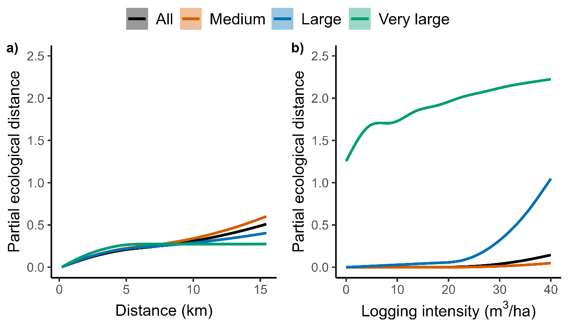Figure 2. I-splines from GDM indicating the relative role of geographic separation (a) and logging intensity (b) in accounting for community turnover (partial ecological distance) between sites for all canopy trees, and medium-, large-, and very large-sized trees. The maximum height of each i-spline indicates the amount of community turnover attributable to that variable whilst holding all others constant, and the shape of the i-spline demonstrates how the rate of turnover changes across the ecological gradient. I-splines shown are aggregated from the i-splines produced by 999 random permutations of selective logging, whereby each plot was randomly assigned one of three logging treatments (no logging, low-intensity logging, and high-intensity logging).

Does nestedness or turnover best explain observed beta-diversity patterns in unlogged and logged forests?

The dominant component of beta-diversity in unlogged forest tree communities was turnover, with little nestedness present between plots. The same pattern was observed in both lower- and higher-intensity logged tree communities (Figure 3a). There was a small increase in average Bray-Curtis dissimilarity between plots logged at the highest intensities, suggesting only slight heterogenization due to selective logging (Figures 3 & S8).
In very large tree communities in unlogged forests, turnover remained the dominant component of beta-diversity, although nestedness accounted for a larger proportion of beta-diversity than it did for medium and large tree communities. However, very large tree communities in logged forest (both low and high intensity) demonstrated extremely high turnover and little to no nestedness compared to unlogged forest (Figure 3d). Total beta-diversity of very large trees increased after logging (Figure S8). In both medium and large tree communities, turnover was the main component of beta-diversity in all forest types, with total beta-diversity increasing slightly along the logging gradient (Figure 3b,c).

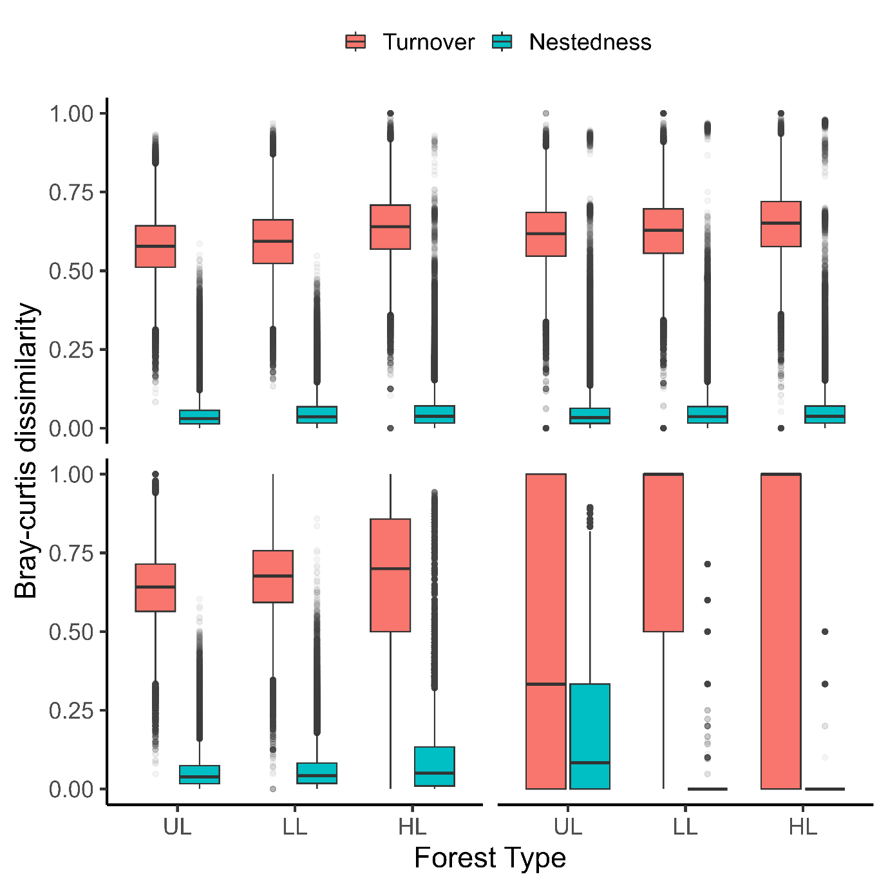
Figure 3. Pairwise Bray-Curtis dissimilarity of tree communities across all canopy trees (a), medium- (b), large- (c) and very large- (d) sized trees attributable to turnover and nestedness in unlogged (UL), low-intensity logged (LL) and high-intensity (HL) logged forest plots. Central bar shows median, box shows upper and lower quartiles, whiskers extend to 1.5× the inter-quartile range, and outliers are presented as dots.

How does the spatial scale of sampling influence the beta-diversity effects observed?
For all, medium, and large canopy trees, the importance of geographic separation in explaining changes in the canopy tree community composition remained relatively constant up to 10 ha before dropping in 25 ha plots (Figure 4a). By contrast, for very large trees the importance of geographic separation increased as sampling plots became larger (Figure 4c). For all canopy trees, geographic separation explained 69.4 ± 3.1% of the explained community variation in 1-ha plots compared to 61.4 ± 9.2% in 25-ha plots, whereas in very large trees, it accounted for 17.7 ± 5.7% in 1-ha plots compared to 41.3 ± 11.3% in 25-ha plots. Geographic separation remained a significant predictor of beta-diversity at all spatial grains across the canopy tree community and all size classes (mean harmonic p-value < 0.001, see Table S2 for model summaries).
For the whole canopy tree community (Figure 4b), as well as for medium and large canopy trees (Figure S9), the observed influence of logging intensity on tree beta-diversity was relatively stable across plot sizes, whereas the observed effect of logging was consistently weakened in larger plots for very large tree communities. For all canopy trees, logging intensity accounted for 30.6 ± 3.1% of the explained community variation between 1-ha plots compared to 38.6 ± 9.2% in 25-ha plots, whilst in very large trees it accounted for 82.3 ± 5.7% of the community variation between 1-ha plots compared to only 58.7 ± 11.3% in 25-ha plots (Fig 4d). Logging intensity remained a significant predictor of beta-diversity at all spatial grains across the whole canopy tree community and all size classes (mean harmonic p-value < 0.001).
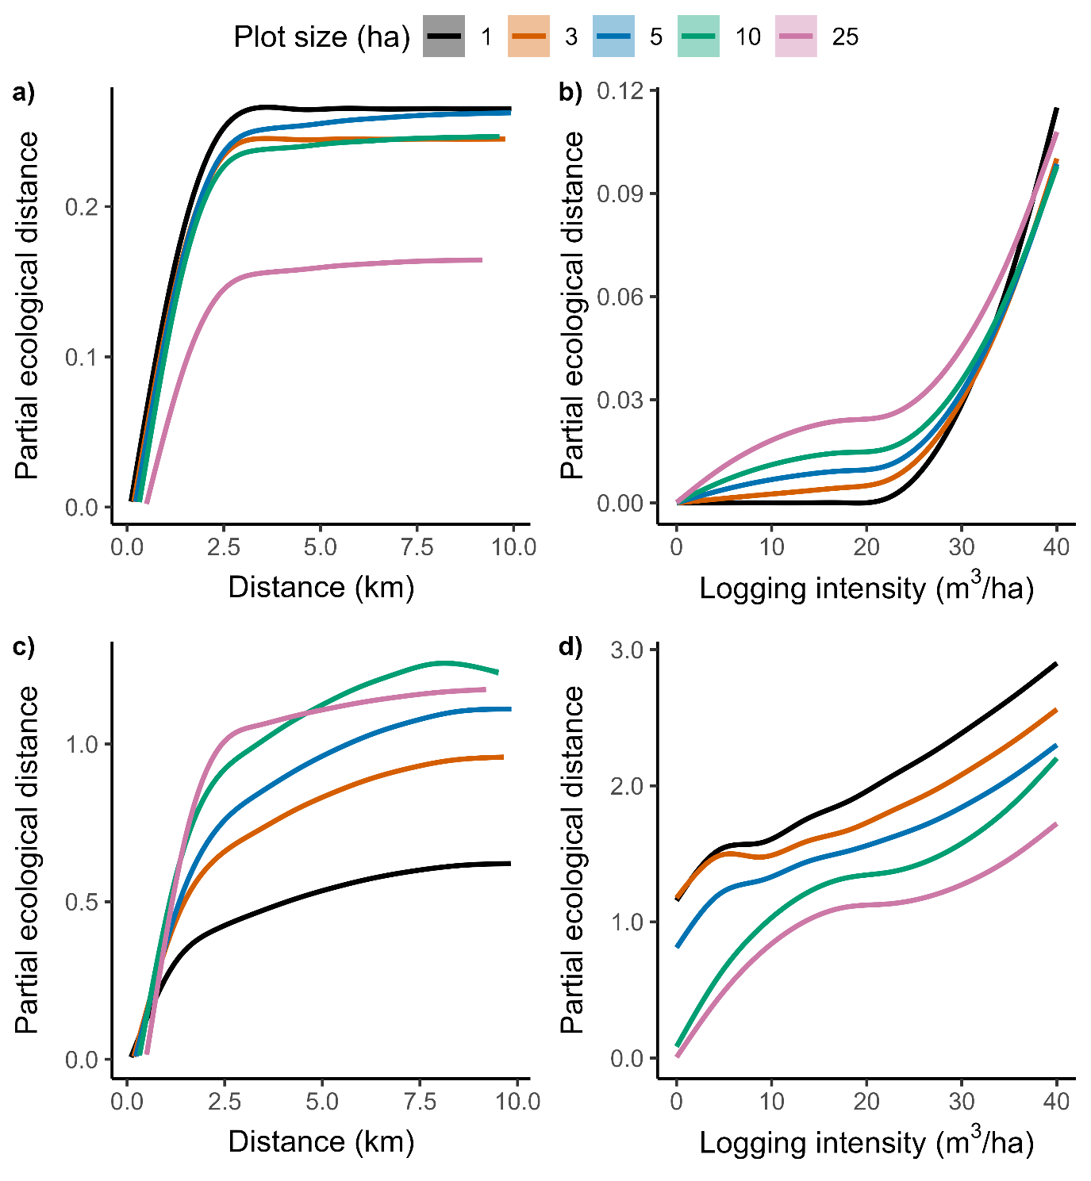
Figure 4. I-splines from GDM indicating the relative role of geographic separation (a,c) and logging intensity (b,d) in accounting for community turnover between sites for all canopy trees (a,b) and very large trees (c,d) for 1-ha, 3-ha, 5-ha, 10-ha and 25-ha plots. The maximum height of each i-spline indicates the amount of community turnover attributable to that variable whilst holding all others constant, and the shape of the i-spline demonstrates how the rate of turnover changes across the ecological gradient. I-splines shown are aggregated from the i-splines produced by 999 random permutations of selective logging, whereby each plot was randomly assigned one of three logging treatments (no logging, low-intensity logging, and high-intensity logging).

4.5 Discussion
Selective logging is a primary driver of tropical forest degradation, occurring across vast areas, yet a key question is how logging impacts tree diversity across large spatial scales. Focusing on a ~3,100 ha forest landscape in the Brazilian Amazon, we show that logging across a range of intensities had minimal effect on composition of the canopy tree community, with turnover the principal component of beta-diversity in both unlogged and logged forest. However, selective logging was the key driver of beta-diversity changes between unlogged and logged forests in very large tree communities (DBH ≥ 110 cm) and, to a lesser extent, large tree communities (50 cm ≤ DBH < 110 cm). Given the critical ecological importance of very large trees to forest ecosystems, improved conservation policies are required to prevent logging-induced large-scale shifts in their community composition across the Amazon.
Selective logging has minimal impacts on the beta-diversity of the wider canopy tree community
The small effect of logging on beta-diversity as a whole suggests that under current intensities (typically <20 m³ ha⁻¹), logging is not driving any large-scale change in Amazonian canopy tree community composition (≥35 cm DBH) in the short term. These conclusions are supported by longer-term, small-scale experimental plots that demonstrate recovery towards pre-logging species composition in the Amazon within 25 years (Gaui et al., 2019). By contrast, logged forests in Borneo have higher beta-diversity than unlogged forest, suggesting logging-induced heterogenization (Berry et al., 2008), but here logging can occur at intensities of ~150 m³ ha⁻¹ (Fisher et al., 2011) resulting in a far more disturbed landscape. Indeed, under RIL regimes (as simulated here), Bornean logged forest tree communities more closely resembled unlogged forests than conventionally logged forests (Imai et al., 2012). Our results thus point to the high conservation value of selectively logged Amazonian forests across large spatial scales.
Partitioning beta-diversity into its constituent parts indicates that in both unlogged and logged Amazonian forest, changes in canopy tree community composition across the forest landscape are primarily a result of species turnover (Baselga, 2010). High turnover between plots suggests that to maintain a diverse canopy tree community, conservation efforts protecting larger forest areas would be more beneficial than targeting a few of the most species-rich sites (Socolar et al., 2016). Given that low-intensity logging (<20 m³ ha⁻¹) had little impact on the wider canopy tree community composition, and that logged and unlogged plots had similarly high levels of turnover, our results suggest that land-sharing style logging (Edwards et al., 2014b) would be less detrimental to maintaining tree species diversity across a large forest landscape than land sparing, supporting similar conclusions from a theoretical study (Ramage et al. 2013). While such an approach would also be more profitable (Bousfield et al., 2021), it could be damaging for other important biological groups such as birds and dung-beetles (Edwards et al., 2014b; França et al., 2017), thus highlighting a trade-off in forest management.
Although logging had limited impact on tree beta-diversity at lower intensities, the increased impact on beta-diversity as logging intensity increases above legal limits (30 m³ ha⁻¹) is cause for concern given the prevalence of extensive illegal logging occurring at high intensities across the Amazon (Brancalion et al., 2018; Finer et al., 2014). Although we show limited impacts of even high-intensity logging on tree beta-diversity, this would amount to a sizeable effect given the huge footprint of illegal logging in the Amazon (Matricardi et al,. 2020), particularly if illegal harvests occur at higher intensities than we simulated. Furthermore, selective logging alters community composition in Amazonian butterflies (Montejo-Kovacevich et al., 2018), bats (Peters et al., 2006), and dung beetles (França et al., 2017), with Neotropical fauna apparently more sensitive to logging disturbance than their analogues in Afrotropical and Indomalayan forests (Burivalova et al., 2014). Logging-induced shifts in community composition across the ecosystem are complex and a wide range of taxa must be considered when assessing logging impacts across entire communities.
While the range of logging intensities simulated here is contextually relevant to the Amazon (Martin et al., 2015), the world’s largest store of as-of-yet unexploited tropical timber (Merry et al., 2009), in the context of the global tropics they are relatively low. Commercial species availability and Brazilian law restrict harvests to 30 m³ ha⁻¹, yet logging intensities in South-East Asia have regularly exceeded 100 m³ ha⁻¹ (Martin et al., 2015). In Borneo, selectively logged forests demonstrate increased tree species turnover and differ significantly in species composition when compared with primary forest (Berry et al., 2008). Furthermore, logging intensities in tropical Africa range from 5-100 m³ ha⁻¹ (Martin et al., 2015), with logging at higher intensities leading to a marked reduction in tree species richness and changes to the vertical forest structure that persist for decades (Cazolla-Gatti et al., 2015). Understanding how selective logging impacts tropical tree beta-diversity in other tropical regions where forest damage is generally higher (Putz et al., 2012) is thus an important area for future research.
Selective logging primarily affects beta-diversity of larger, emergent trees
Selective logging in the Amazon targets primarily large, commercially-valuable tree species (Richardson and Peres, 2016), and there was a strong signal of subtractive heterogenization after logging in these communities (Socolar et al., 2016). Along the logging intensity gradient, very large and large logged canopy tree communities became increasingly different from one another compared to unlogged communities, likely a result of increased turnover through logging-induced loss of highly prized shared species. This was particularly the case in very large tree communities, which were less species-rich than medium- and large-sized classes, making them more susceptible to greater changes in beta-diversity as large trees of highly-valued species are removed from the forest. Furthermore, whilst the logging impact on large tree communities was limited until high logging intensities (>20 m³ ha⁻¹), logging-induced subtractive heterogenization of very large emergent tree communities was evident even at low logging intensities typical in the Brazilian Amazon (< 20 m³ ha⁻¹), making this a concern for most forestry operations.
Very large trees have high ecological importance (Lindenmayer et al., 2012; Pinho et al., 2020), harbouring important forest biodiversity, biomass, and carbon stocks (Sist et al., 2014), and take centuries to replace through regeneration (Cannon et al., 2022). Our study provides further ecological support for restricting the harvest of these emergent trees (Mazzei et al., 2010; Sist et al., 2014). Despite potential short-term financial losses of protecting very large trees given their economic value, current logging intensities mean Brazilian timber concessions cannot support timber yields beyond the first harvest cycle (Piponiot et al., 2019; Sist et al., 2021). Retention of a significant proportion of the larger trees beyond the first harvest would reduce the impact of logging on these tree communities and associated ecosystem functions and services, whilst also contributing towards more sustainable economic production across future harvests.
Where the effect of logging on beta-diversity was strong (i.e., for very large trees), increasing the spatial grain of sampling (from 1 ha to 25 ha plots) consistently reduced the importance of logging intensity in explaining beta-diversity patterns. Sampling extent influences observed impacts of disturbance on community composition (Hill and Hamer, 2004; Dumbrell et al., 2008) and beta-diversity tends to decrease with increasing spatial grain of sampling, because larger sampling units observe greater proportions of the total community increasing their similarity to one another (Barton et al., 2013; Steinbauer et al., 2012). We extend this thinking by demonstrating that the spatial grain of sampling also influences the observed importance of ecological disturbances (here selective logging) in driving beta-diversity changes, highlighting the need to consider a range of spatial extents and sampling grains when assessing the impacts of disturbance on communities.
Our results have four caveats. Firstly, the logging census only recorded trees ≥35 cm DBH. Whilst trees of this size account for more than half of above-ground biomass (Cummings et al., 2002; Peres et al., 2016), we cannot make conclusions on the beta-diversity impact of logging on smaller trees (<35cm DBH) that can constitute >66% of species and ~98% of individuals in Amazonian tree communities (Valencia et al., 2004). Although smaller trees are not directly harvested through logging, tree death through road construction and residual damage is typically high (Pinard and Putz, 1996) and could drive greater erosion of beta-diversity than for the canopy tree community. Secondly, our simulations did not consider post-logging regrowth or colonisation from pioneer species exploiting logging gaps (Berry et al., 2008). Our results thus represent a snapshot of conditions immediately after logging; however, our focus was on large to very large trees which mature on multi-decadal to centennial timescales. Thirdly, our estimates of residual damage are based on field data from RIL harvests, which can significantly reduce impacts on the surrounding canopy (Pereira et al., 2002; Sist & Ferreira, 2007). For “hit-and-run” logging operations using conventional logging techniques that cause greater damage, the impact of selective logging on tree beta-diversity could be larger. Finally, we simulate logging across only one timber harvest, but in Brazilian concessions a second logging harvest is permitted within 35 years (Sist et al., 2021). At current typical harvest rates (~ 20 m³ ha⁻¹), timber production cannot be maintained beyond the first harvest (Sis et al., 2007; Sist et al., 2021). Without significant reform to long-term concession management, subsequent harvests may cause increased damage to canopy tree communities and erosion of beta-diversity across the smaller size classes as trees that remained after the first harvest are targeted for logging.

Conclusions
Our simulations found selective logging to have minimal impact on large-scale beta-diversity in the canopy tree community as a whole in a large Amazonian forest concession, but that logging causes increasingly strong subtractive heterogenization in very large tree communities. Logging-induced shifts in the community composition of very large trees is cause for concern given the widespread extent of unregulated selective logging in the Amazon (Asner et al., 2005; Sist et al., 2021) and the vital ecological roles such trees fulfil (Lindenmayer et al., 2012; Pinho et al., 2020). Targeted harvesting of the largest, most valuable trees over multiple harvest cycles thus risks large-scale canopy tree community shifts, thereby calling for improved conservation and protection of these very large tree communities during logging. This could be achieved through the introduction of a maximum cutting diameter or the enforced retention of a greater proportion of the largest trees of each species within the forest (Mazzei et al., 2010; Sist et al., 2014; Bousfield et al., 2021). Such measures would aid in preventing logging-induced shifts in Amazonian canopy tree community composition, whilst protecting the longer-term sustainability of timber harvests, the structural integrity of logged forests, and the biodiversity and carbon they support.
Authors Contributions
Christopher G. Bousfield, David P. Edwards, and Mike R. Massam conceived the ideas and designed methodology; Carlos A. Peres obtained the data; Christopher G. Bousfield and Mike R. Massam analysed the data; Christopher G. Bousfield led the writing of the manuscript. All authors contributed critically to the drafts and gave final approval for publication.

Acknowledgements
We thank the AMATA and Jari Florestal logging companies, as well as the Serviço Florestal Brasileiro (Brazilian Forest Service), for their help in providing detailed financial records and spatially-explicit forest inventories for use in simulations and analyses. This work was supported by the UK’s Natural Environment Research Council [grant number NE-S00713X-1].
Data Availability Statement
The data used in this study was made confidentially available to Carlos A. Peres by Jari Florestal. Due to its sensitive nature, we are unable to make this publicly available, as openly-available geo-location data of all commercially valuable trees, including threatened and CITES-listed species could leave the concession vulnerable to exploitation.
Conflict of Interest
The authors declare no competing conflict of interest.

4.6 Supplementary Information

Table S1. GDM model summaries for all canopy trees, medium, large and very large tree communities. Significance values are the harmonic mean p values of the 999 iterations of each model where a different suite of sample plots were allocated to each logging treatment. Values displayed are the means from the 999 iterations and standard deviations are shown. Bold coefficients represent the most important predictor of beta-diversity for that size class.
Canopy Tree Community | Deviance explained (%) | Sum of geographic coefficients | Sum of logging coefficients | Geographic significance | Logging significance
All trees | 16.7 ± 0.7 | 0.51 ± 0.02 | 0.15 ± 0.01 | <0.001 | <0.001
Medium | 11.7 ± 0.3 | 0.61 ± 0.01 | 0.05 ± 0.01 | <0.001 | <0.001
Large | 41.9 ± 3.4 | 0.41 ± 0.04 | 1.07 ± 0.1 | <0.001 | <0.001
Very large | 22.3 ± 2.6 | 0.27 ± 0.05 | 2.26 ± 0.2 | <0.001 | <0.001

Table S2. GDM model summaries for all canopy trees, medium, large and very large tree communities with sampling plots 1, 3, 5, 10 and 25 ha in size. Significance values are the harmonic mean p values of the 999 iterations of each model where a different suite of sample plots were allocated to each logging treatment. Values displayed are the means from the 999 iterations and standard deviations are shown. Bold coefficients represent the most important predictor of beta-diversity for that size class.
Canopy Tree Community | Plot size (ha) | Deviance explained (%) | Sum of geographic coefficients | Sum of logging coefficients | Geographic significance | Logging significance
All trees | 1 | 6.0 ± 0.7 | 0.27 ± 0.01 | 0.12 ± 0.02 | P < 0.001 | P < 0.001
All trees | 3 | 12.5 ± 1.7 | 0.24 ± 0.01 | 0.10 ± 0.02 | P < 0.001 | P < 0.001
All trees | 5 | 16.8 ± 2.5 | 0.26 ± 0.01 | 0.10 ± 0.03 | P < 0.001 | P < 0.001
All trees | 10 | 20.8 ± 3.8 | 0.25 ± 0.01 | 0.10 ± 0.03 | P < 0.001 | P < 0.001
All trees | 25 | 24.5 ± 7.8 | 0.16 ± 0.01 | 0.05 ± 0.01 | P < 0.001 | P < 0.001
Medium | 1 | 2.8 ± 0.3 | 0.27 ± 0.01 | 0.04 ± 0.01 | P < 0.001 | P < 0.001
Medium | 3 | 7.3 ± 0.7 | 0.25 ± 0.01 | 0.03 ± 0.02 | P < 0.001 | P < 0.001
Medium | 5 | 10.5 ± 1.3 | 0.26 ± 0.02 | 0.03 ± 0.02 | P < 0.001 | P < 0.001
Medium | 10 | 13.7 ± 2.0 | 0.24 ± 0.02 | 0.03 ± 0.02 | P < 0.001 | P < 0.001
Medium | 25 | 18.4 ± 2.5 | 0.17 ± 0.01 | 0.03 ± 0.02 | P < 0.001 | P < 0.001
Large | 1 | 8.5 ± 1.9 | 0.30 ± 0.02 | 0.48 ± 0.08 | P < 0.001 | P < 0.001
Large | 3 | 24.4 ± 6.7 | 0.29 ± 0.02 | 0.44 ± 0.11 | P < 0.001 | P < 0.001
Large | 5 | 32.0 ± 9.9 | 0.31 ± 0.03 | 0.42 ± 0.14 | P < 0.001 | P < 0.001
Large | 10 | 43.0 ± 14.1 | 0.29 ± 0.03 | 0.40 ± 0.17 | P < 0.001 | P < 0.001
Large | 25 | 51.0 ± 19.8 | 0.19 ± 0.05 | 0.46 ± 0.26 | P < 0.001 | P < 0.001
Very large | 1 | 23.9 ± 4.3 | 0.62 ± 0.21 | 2.91 ± 0.43 | P < 0.001 | P < 0.001
Very large | 3 | 24.7 ± 5.6 | 0.96 ± 0.31 | 2.57 ± 0.47 | P < 0.001 | P < 0.001
Very large | 5 | 22.2 ± 6.2 | 1.12 ± 0.35 | 2.31 ± 0.47 | P < 0.001 | P < 0.001
Very large | 10 | 22.1 ± 7.0 | 1.27 ± 0.69 | 2.22 ± 0.54 | P < 0.001 | P < 0.001
Very large | 25 | 23.4 ± 8.4 | 1.17 ± 0.41 | 1.74 ± 0.72 | P < 0.001 | P < 0.001

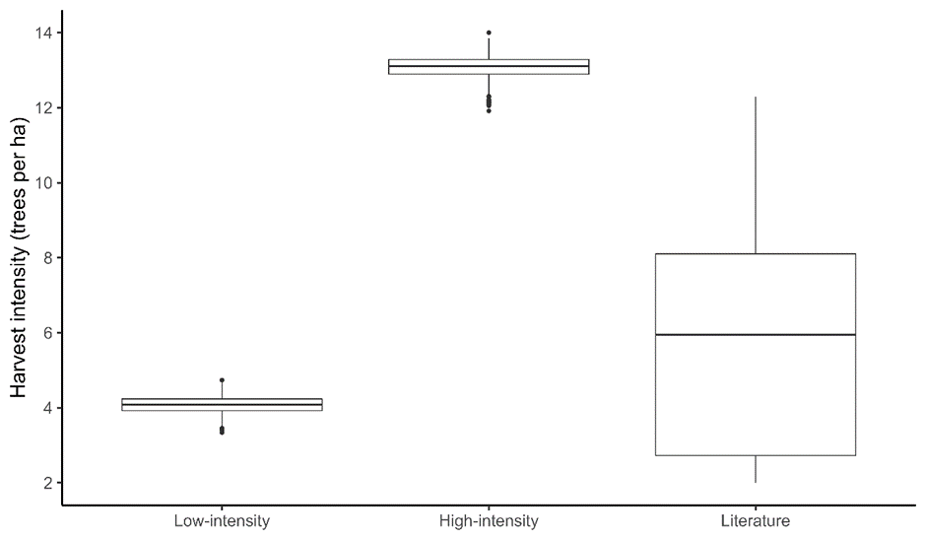
Figure S1. Harvest intensities (trees ha⁻¹) reported under the simulated low and high intensity harvests from this study, compared with those reported from post-harvest field data in the literature (n=12).

Figure S2. I-splines from GDM indicating the relative role of geographic separation (a) and logging intensity (b) in accounting for community turnover (partial ecological distance) between sites for all canopy trees, and medium-, large-, and very large-sized trees, without accounting for residual damage. The maximum height of each i-spline indicates the amount of community turnover attributable to that variable whilst holding all others constant, and the shape of the i-spline demonstrates how the rate of turnover changes across the ecological gradient. Both geographic distance and logging intensity were found to be significant predictors of canopy tree community turnover across all trees and all individual size classes (mean harmonic p<0.001). I-splines shown are aggregated from the i-splines produced by 999 random permutations of selective logging, whereby each plot was randomly assigned one of three logging treatments (no logging, low-intensity logging and high-intensity logging).

Figure S3. I-splines from GDM indicating the relative role of logging intensity in accounting for canopy tree community turnover between sites using species abundances (a) and basal area (b). The maximum height of each i-spline indicates the amount of community turnover attributable to that variable whilst holding all others constant, and the shape of the i-spline demonstrates how the rate of turnover changes across the ecological gradient. I-splines shown are aggregated from the i-splines produced by 999 random permutations of selective logging, whereby each plot was randomly assigned one of three logging treatments (no logging, low-intensity logging and high-intensity logging).

Figure S4. I-splines from GDM using alternative beta-diversity metrics (Bray-Curtis, Jaccard, square-rooted Bray-Curtis and presence-absence Bray-Curtis) indicating the relative role of geographic separation (a) and logging intensity (b) in accounting for canopy tree community turnover between sites. The maximum height of each i-spline indicates the amount of community turnover attributable to that variable whilst holding all others constant, and the shape of the i-spline demonstrates how the rate of turnover changes across the ecological gradient. I-splines shown are aggregated from the i-splines produced by 999 random permutations of selective logging, whereby each plot was randomly assigned one of three logging treatments (no logging, low-intensity logging and high-intensity logging).

a)
c)
b)
Figure S5. I-splines from GDM using alternative beta-diversity metrics (Bray-Curtis, Jaccard, square-rooted Bray-Curtis and presence-absence Bray-Curtis) indicating the relative role of geographic separation in accounting for community turnover between sites for medium (a), large (b) and very large (c) sized trees. The maximum height of each i-spline indicates the amount of community turnover attributable to that variable whilst holding all others constant, and the shape of the i-spline demonstrates how the rate of turnover changes across the ecological gradient. I-splines shown are aggregated from the i-splines produced by 999 random permutations of selective logging, whereby each plot was randomly assigned one of three logging treatments (no logging, low-intensity logging and high-intensity logging).

a)
c)
b)
Figure S6. I-splines from GDM using alternative beta-diversity metrics (Bray-Curtis, Jaccard, square-rooted Bray-Curtis and presence-absence Bray-Curtis) indicating the relative role of selective logging in accounting for community turnover between sites for medium (a), large (b) and very large (c) sized trees. The maximum height of each i-spline indicates the amount of community turnover attributable to that variable whilst holding all others constant, and the shape of the i-spline demonstrates how the rate of turnover changes across the ecological gradient. I-splines shown are aggregated from the i-splines produced by 999 random permutations of selective logging, whereby each plot was randomly assigned one of three logging treatments (no logging, low-intensity logging and high-intensity logging).

Figure S7. I-splines from GDM indicating the relative role of geographic separation (a) and logging intensity (b) in accounting for community turnover (partial ecological distance) between sites for all canopy trees, and medium-, large-, and very large-sized trees, where all trees located on a skid trail were considered destroyed. The maximum height of each i-spline indicates the amount of community turnover attributable to that variable whilst holding all others constant, and the shape of the i-spline demonstrates how the rate of turnover changes across the ecological gradient. I-splines shown are aggregated from the i-splines produced by 999 random permutations of selective logging, whereby each plot was randomly assigned one of three logging treatments (no logging, low-intensity logging, and high-intensity logging).
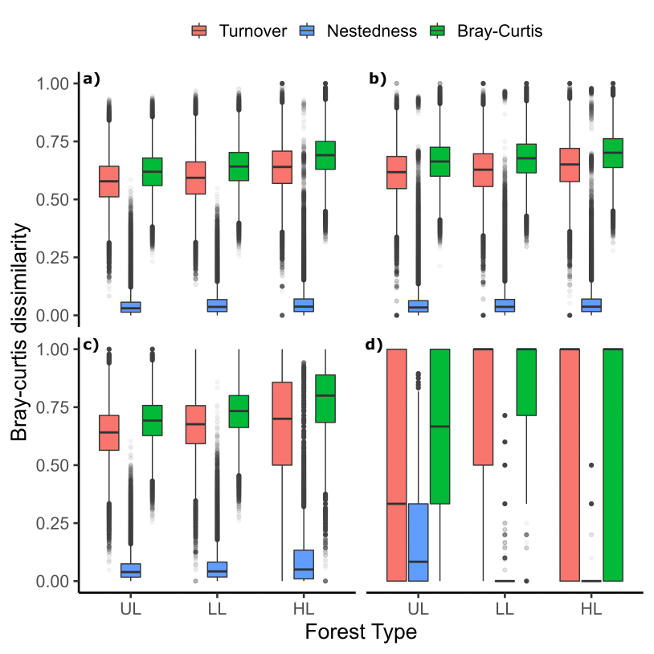Figure S8. Pairwise Bray-Curtis dissimilarity of tree communities across all canopy trees (a), medium- (b), large- (c) and very large- (d) sized trees, demonstrating total Bray-Curtis diversity and the portions attributable to turnover and nestedness in unlogged (UL), low-intensity logged (LL) and high-intensity (HL) logged forest plots. Central bar shows median, box shows upper and lower quartiles, whiskers extend to 1.5× the inter-quartile range, and outliers are presented as dots.

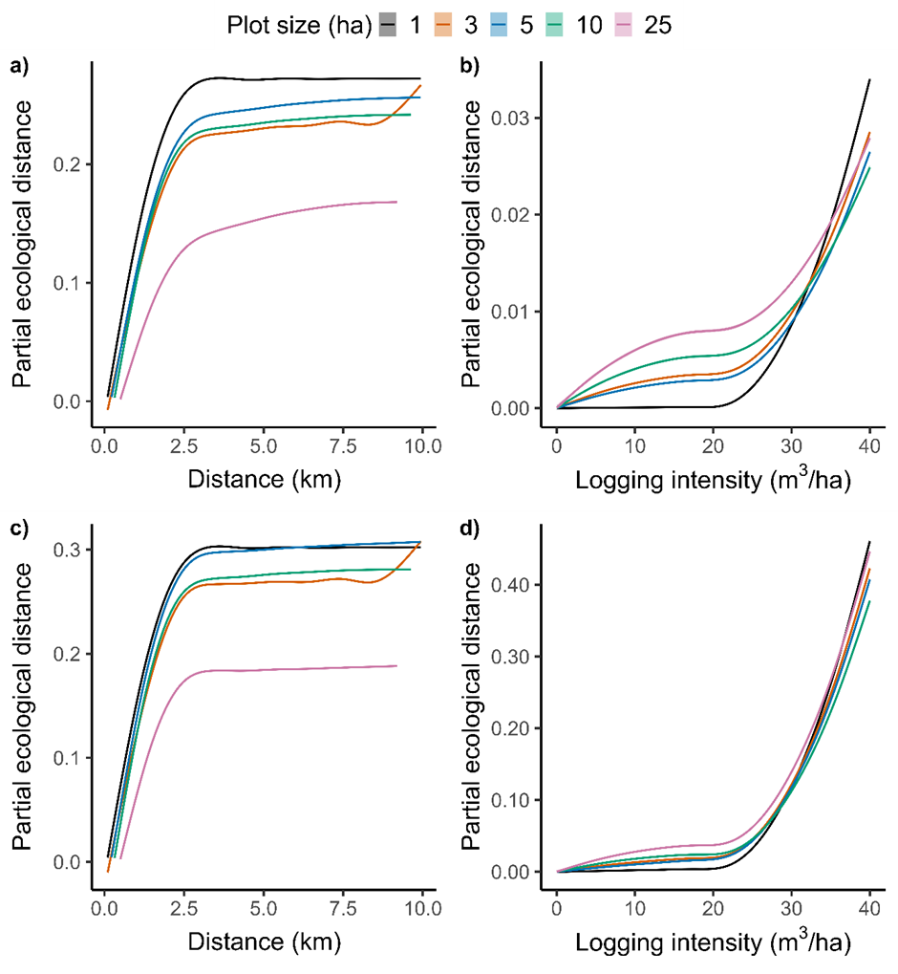
Figure S9. I-splines from GDM indicating the relative role of geographic separation (a,c) and logging intensity (b,d) in accounting for community turnover between sites for medium (a,b) and large trees (c,d) for 1 ha, 3 ha, 5 ha, 10 ha and 25 ha plots. The maximum height of each i-spline indicates the amount of community turnover attributable to that variable whilst holding all others constant, and the shape of the i-spline demonstrates how the rate of turnover changes across the ecological gradient. I-splines shown are aggregated from the i-splines produced by 999 random permutations of selective logging, whereby each plot was randomly assigned one of three logging treatments (no logging, low-intensity logging and high-intensity logging).

Chapter 5: Major and increasing wildfire-driven losses of timber stocks globally

Major and increasing wildfire-driven losses of timber stocks globally

5.1 Abstract

One third of global forest is harvested for timber, generating ~$US1.5 trillion annually. High-severity wildfires threaten this timber production. Here, we combine global maps of logging activity and stand-replacing wildfire to assess how much timber-producing forest has been lost to wildfire this century and quantify spatio-temporal changes in annual area lost. Between 2001-2021, 18.5-24.7 M ha of timber-producing forest – an area the size of Great Britain – experienced stand-replacing wildfires, with extensive burning in western USA and Canada, Siberian Russia, Brazil, and Australia. Annual burned area increased significantly throughout the 21st century, pointing to substantial wildfire-driven timber losses under increasingly severe climate change. To meet future timber demand, producers must adopt new management strategies and emerging technologies to combat the increasing threat of wildfires.

5.2 Introduction

Timber is a globally important natural resource used for construction materials, paper, and energy. In 2015, the forestry sector contributed over $USD1.5 trillion to national economies (FAO, 2022), and in 2020 at least one third of all forest globally was being used for timber production (FAO, 2020). Timber demand is expected to almost triple by 2050 (Barua et al. 2014), via greater human demand and population growth, increasing urbanisation, and as net-zero climate targets promote the replacement of carbon-intensive building materials, such as concrete and steel, with wood (Mishra et al. 2022). Ensuring that timber supply can meet future demand is therefore a key challenge in the 21st century.
Wildfires are a natural ecological process in many ecosystems. However, forest wildfire and associated forest loss have been increasing throughout the 21st century (Andela et al. 2017; Curtis et al. 2018; Tyukavina et al. 2022), with >110 million hectares of forest lost to wildfires between 2001-2019 (Tyukavina et al. 2022). Fire season length and fire extent are expected to increase significantly by 2100 because of climate change (Flannigan et al. 2013; Senande-Rivera et al. 2022), placing forests under increasing threat of high-severity burning. Given the long-term nature of timber production, typically on 40-100+ year cutting cycles (Burton et al. 1999; Messier et al. 2013), future crops of timber trees will face a very different climate as they mature towards harvest.
We currently lack a robust understanding of how wildfires have influenced global timber production. High-severity, stand-replacing wildfires represent a significant threat to timber stocks within forests managed for wood production (Bowman et al. 2020), and the increasing frequency of such wildfires in the 21st century is a serious concern. Understanding where fire-induced losses of timber-producing forests occur and at what rate is therefore of critical importance in initiating efforts to ensure that timber production, and associated trade and financial investment, can be maintained in a more climatically hostile future. In this study, we combine spatial data detailing the global extent of forestry practices (Curtis et al. 2018; Lesiv et al. 2022) with annual layers of forest loss due to wildfire (Tyukavina et al. 2022) to conduct the first global assessment of the threat of wildfire to timber production. We answer the following key questions: i) How much timber-producing forest is being lost to stand-replacing wildfires globally, and where do these losses occur? And ii) What are the temporal trends in annual burned area of timber-producing forests since the turn of the century, at global, regional, and national scales?

5.3 Results

Wildfire impacts on the timber industry in the 21st century
To understand where timber-producing forests are burning, we used two datasets that map global logging activity from Lesiv et al., and Curtis et al., focusing primarily on clearcut logging of native forest and timber plantations. We overlaid these logging layers with global data on stand-replacing wildfires (Tyukavina et al. 2022), where fire severity was high enough to cause a significant loss of tree cover, and thus timber (see Methods), and present the results from both layers together.
Since 2001, between 18.5 (SE: 16.5-20.7) and 24.7 (SE:21.8-27.5) million hectares (M ha) of timber-producing forest—an area roughly the size of Great Britain—has been lost due to wildfires (Fig. 1). This equates to between 1.0 (SE: 0.9-1.1) -1.7 (SE: 1.5-1.9)% of global forestry land burned since the turn of the century. Across both logging layers, fire-induced loss of timber-producing forest was particularly high in north-western USA and Canada, north-eastern Russia, south-eastern Australia, and Brazil (Fig. 1a,b). Central and Northern Europe experienced limited losses, as did parts of southern Asia and sub-Saharan Africa (see Fig. S1 for a more spatially detailed map).
At the national scale, the three countries with the largest absolute wildfire-induced losses of timber-producing forest were Russia, the USA and Canada, where between 2.9 (SE:2.6-3.4) and 6.5 (SE: 5.8-7.2) M ha, 3.8 (SE:3.4-4.1) and 4.3 (SE:3.9-4.8) M ha, and 2.3 (SE: 2.2-2.5) and 3.9 (SE: 3.7-4.1) M ha were lost, respectively (Fig. 1c,d). This accounts for 1.1% (SE: 0.9-1.2%) to 2.6% (SE: 2.3-2.9%), 1.6% (SE: 1.4-1.7%) to 2.1% (SE: 1.9-2.3%), and 1.8% (SE:1.7-2.0%) to 2.8% (SE: 2.7-3.0%) of their total national timber-producing forest, respectively. Portugal and Australia were characterized by the highest percentage of their forestry land lost, with 12.5% (SE: 11.1-14.0%) to 13.6% (SE: 12.1-15.2%) and 6.2% (SE: 5.9-6.5) to 10.1% (SE: 9.4-10.6%) burning, respectively (Fig. 1e,f). Such high losses of timber stock will leave a significant shortfall in internal timber supply, threatening timber-related jobs and likely forcing increased reliance on imports or shifts to faster wood production through plantations (Cary et al. 2021).

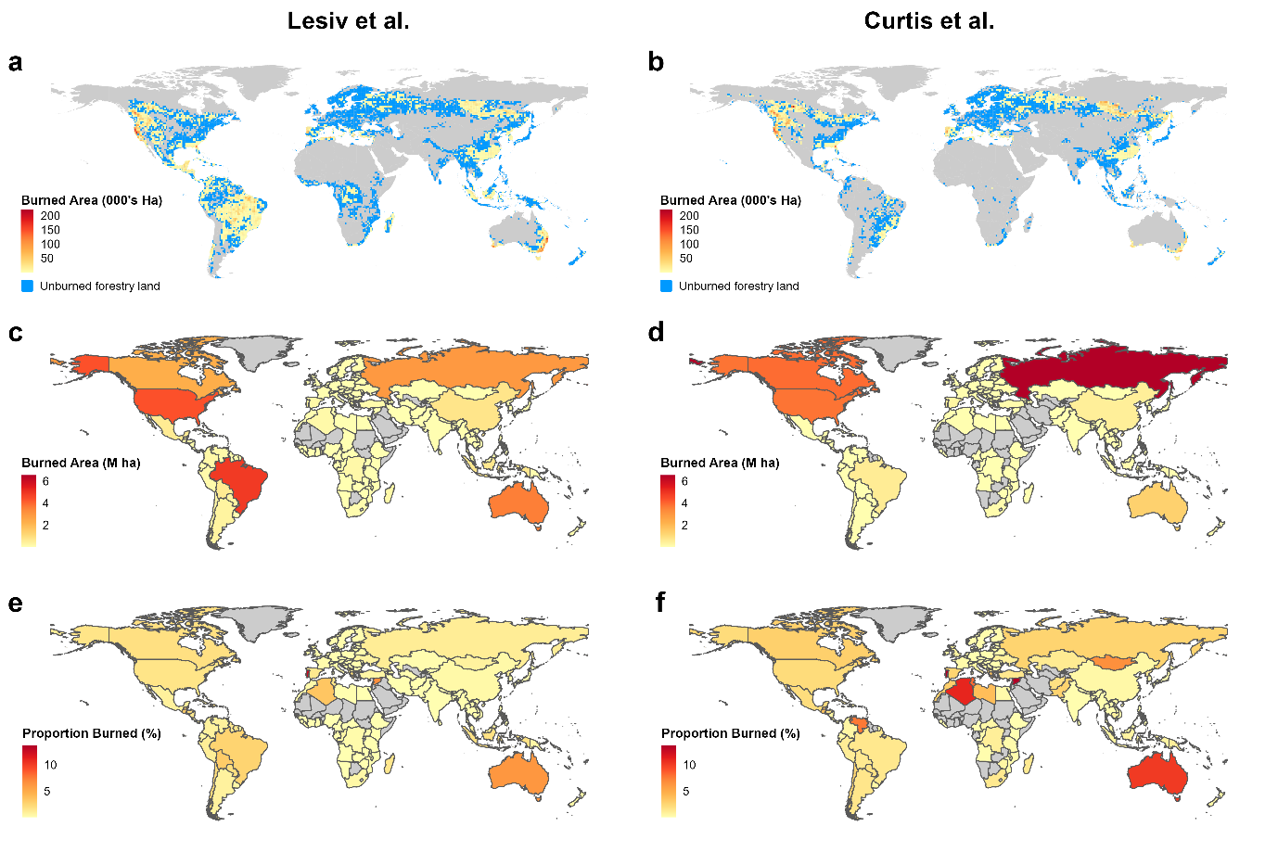 Fig. 1. Global patterns of timber-producing forest loss through stand-replacing wildfires. (a, b) Hotspots of severe burning in timber-producing forests, (c, d) total area and (e, f) proportion of forestry land severely burned nationally between 2001-2021, using Lesiv et al. map of global forest management (a,c,e) and Curtis et al. map of forest loss due to forestry (b,d,f). (a,b) Areas of warmer red represent increasing burn, blue represents areas where logging occurs but wildfires did not or were limited (< 1000 ha per cell), grey represents areas where logging is not prevalent. Western USA and Canada, north-eastern Russia, south-eastern Australia, and Brazil suffered particularly high losses of timber-producing forest to wildfire, whilst much of Central and Northern Europe, and parts of South-Asia and sub-Saharan Africa experienced limited wildfire induced losses.

Whilst reliable burn data are available since only the turn of the century, timber rotation times across the globe (and especially in much of the Northern Hemisphere) are often far longer than 21 years, indicating even greater timber losses across a whole rotation cycle. For example, rotation times in the boreal forests of Russia and Canada can be ~100 years (Burton et al. 1999), meaning fire-induced losses of timber forests could reach 5.1-12.3% and 8.7-13.5%, respectively, across one rotation cycle under current burn conditions. Similarly, losses in the areas of the USA that employ rotations of 80 years (e.g. the Northwest; Hudiburg et al. 2009) could reach 6-8% across a harvest cycle.
Most logging globally entails clearcutting of native forest and timber plantations (FAO, 2020), which is captured well by both logging layers used (see Fig. S2 for a spatial comparison of the two). Additionally, Lesiv et al. attempted to include selectively logged forest within their forest management map. Using this layer, we identified large areas of burnt timber-producing forest across the tropics (~8.1 M ha, SE: 7.0-9.1 M ha) particularly in Latin America (~6.8 M ha, SE: 6.0-7.5 M ha). However, selective logging is far more difficult to detect via satellites than clearcutting or plantation forestry (Hethcoat et al. 2019), so these results should be interpreted with caution.
Whilst we find a concerningly large area of timber-producing forest has already been lost to wildfire this century (18.5-24.7 M ha), there are limitations in the available forest management data that will affect these results. Curtis et al. had levels of high accuracy for mapped forestry areas (Users: 87%) but sample-based estimates suggest they slightly overestimated total forestry area. Conversely, mapped accuracy for the timber-producing forest classes mapped by Lesiv et al. were lower (Users: 58-71%) with sample-based estimates suggesting in this study forestry areas were underestimated. A third product (Schulze et al. 2019) also maps patterns of forest use globally but is based on FAO data where national self-reporting is inconsistent and forest-use classes do not allow for accurate spatial classification of all timber-producing forest. Nevertheless, global hotspots of timber-producing forest loss through wildfire identified using Lesiv et al. and Curtis et al. remain largely the same when using Schulze et al. (see SOM results, Fig. S3).

Increasing annual wildfire-induced losses of timber-producing forest across the 21st Century
Globally, the annual area of timber-producing forest lost to stand-replacing wildfires showed an increasing trend between 2001-2021 using both Lesiv et al. (Mann-Kendall test, p < 0.001, Sen’s slope trend size = +68,400 ha per year) and Curtis et al. (p < 0.01, trend size = +37,800 ha per year) forest management data, with strong correlation between the two layers in annual burned area (r=0.83). In the past six years, mean annual loss from severe fire was 1.3-2.5 M ha, which is 2-4 times greater than in the previous 15 years (Fig. 2, see Fig. S4 for raw data results). This increasing trend post-2015 is much sharper when using the Lesiv et al. forest management dataset, which is likely due to a combination of widespread fires in Latin America after a strong El Ñino in 2015-16 that were not identified in the Curtis et al. layer, and possible under-reporting of burned timber production forest prior to 2014 in the Lesiv et al. layer (Supplementary Text).
Changes to the forest loss detection model employed by Global Forest Watch (Hansen et al. 2013) that underpin the fire data used (Tyukavina et al. 2022) have improved forest loss detection in recent years, but we do not believe this impacts our observed increasing trends. Firstly, the fire data our study employs (Tyukavina et al. 2022) shows no post-2015 spike in forest loss, which has been previously implicated as a clear signal of temporal inconsistencies in loss detection (Ceccherini et al. 2020; Palahi et al. 2021). Secondly, the fire data uses v1.7 of the forest loss data, where loss detection algorithms are consistent between 2011-2020. We find no sudden jump in the years after 2010, and whilst the introduction of the Landsat-8 OLI imagery in 2013 may have improved detection rates, we still find increasing trends in annual forestry burned area when considering only the years 2013-2021 (Lesiv et al.: p = 0.029, trend = + 237,000 ha/yr; Curtis et al.: p = 0.076, trend = +85,000 ha/yr). Finally, Tyukavina et al. tested their fire data against another dataset that applied the newest forest-loss detection algorithms consistently across the whole period back to 2001, and found both methods demonstrated the same temporal trends (Tyukavina et al. 2022), This suggests algorithm inconsistencies between the 2001-2010 and 2011-2021 periods has little impact on observed trends in annual forest loss due to wildfires in the 21st century.

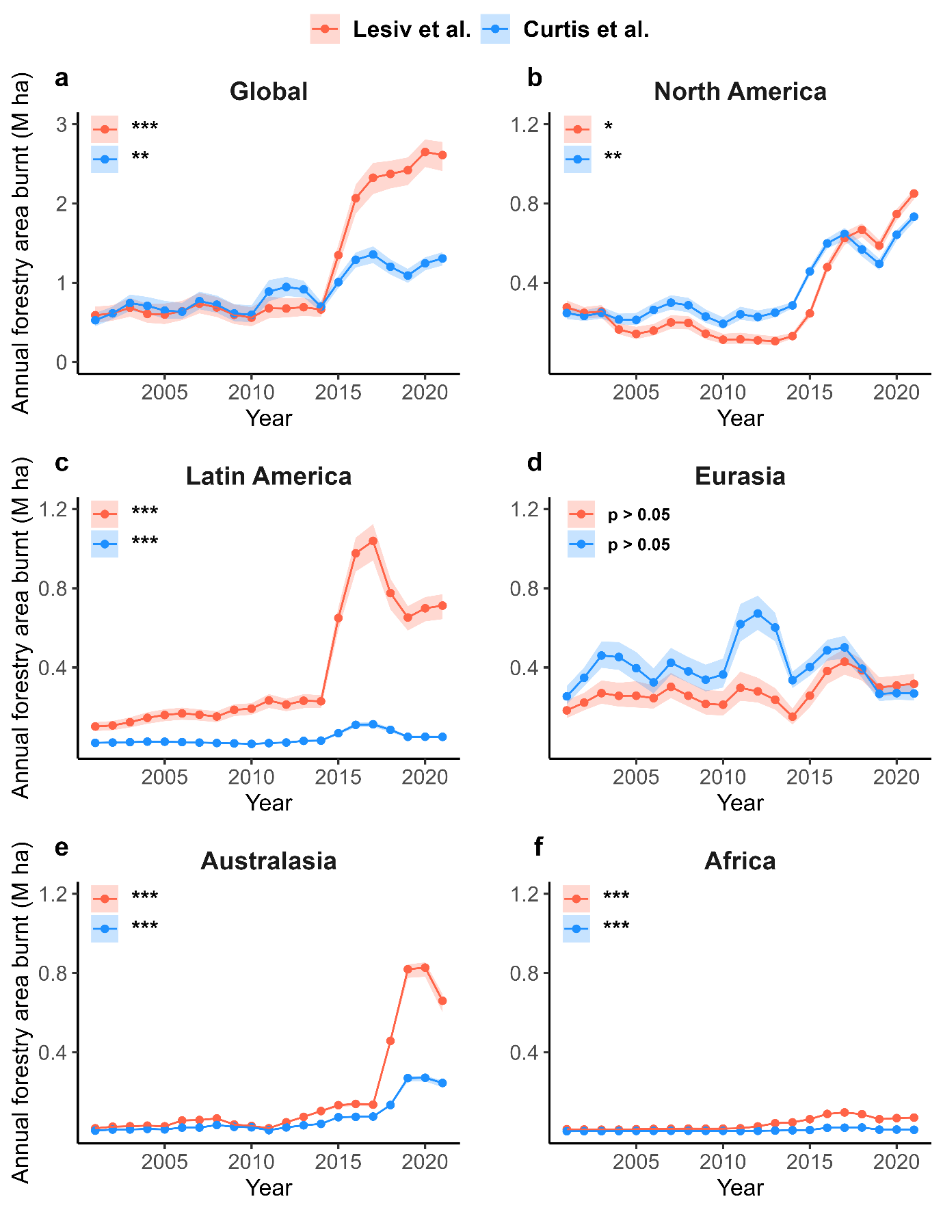
Fig. 2. Global and regional three-year average annual area of timber-producing forest lost to wildfires in the years 2001-2021. Using Lesiv et al. map of global forest management (red) and Curtis et al. map of forest loss due to forestry (blue), split by global region: Global (a), North America (b), Latin America (c), Eurasia (d), Australasia (e) and Africa (f). Significant increasing regional trends in annual area of timber-producing forest burnt are present for all regions except Eurasia and are marked with * (Mann-Kendall test, p < 0.05), ** (0.001 ≤ p < 0.01), and *** (p < 0.001). Lines represent three-year rolling average, shaded areas represent three-year rolling average ± 1 SE.

We found an increasing trend in annual wildfire-induced loss of timber-producing forest across all regions globally (Mann-Kendall test, p < 0.05), except for Eurasia which exhibited no trend (Fig. 2- see Fig. S5 for free-scaled bar chart of regional annual burn). North America and Eurasia, the two largest timber-producing regions globally (FAO, 2022), both exhibited the largest total losses across the period, between 6.6 (SE:6.1-7.2) and 7.6 (SE: 7.1-8.3) M ha and 5.8 (SE: 4.7-7.1) and 8.6 (SE: 7.4-9.9) M ha, respectively. Europe has suffered several major heatwaves and droughts across our study period (e.g. in 2003, 2010, and 2017; Tueling et al. 2018) and has experienced strong increasing trends in heatwave frequency and intensity (Rousi et al. 2022). Nevertheless, this is not reflected in Eurasia’s annual fire-induced loss of timber-producing forest, which remained stable across the period (Fig. 2). Similarly, droughts and heatwaves have become prominent in North America (particularly the extreme heatwave of 2021; Thompson et al. 2007), and burned area in Western USA and Canada has been steadily increasing across recent decades (Bowman et al. 2020). Unlike Eurasia, annual wildfire-induced losses of timber-producing forest in North America are increasing and were particularly high in the years 2016-2021, equating to a two- to four-fold increase relative to 2001-2015.
Latin America exhibited losses of between 0.8 (SE: 0.7-1.0) and 7.9 (SE: 6.9-8.7) M ha, with a sharp increase in 2016-2017 after a strong El Ñino event in 2015-2016 (Rifai et al. 2019). Australia and Oceania lost between 1.3 (SE: 1.2-1.4) and 3.6 (SE: 3.4-3.7) M ha, the bulk of which occurred in 2019-2020, due to unprecedented wildfires across Australia (Boer et al. 2020), following years of drought (King et al. 2020). Africa was characterized by a significant increasing trend in annual timber-producing forest lost due to fire, but total losses remained low compared to other regions at 0.1-0.8 M ha.
Increasing burning trends at global and regional scales suggest that the threat of wildfires to timber production will be exacerbated under future climate change. Wildfires are expected to become more frequent and severe across many regions (Bowman et al. 2020), with regional models supporting increased fire activity in important timber-producing areas such as western USA (Anderegg et al. 2022), Canada (Flannigan et al. 2005), boreal Russia (De Groot et al. 2013), the Amazon (Abatzoglou et al. 2018), and Australia (Canadell et al. 2021).
Three of the five largest timber producing nations—USA, Canada, and Brazil, who together accounted for 33% of industrial roundwood production in 2021 (FAO, 2022)— exhibited increasing trends in their annual area of timber-producing forest burnt in at least one mapped product (Fig. 3). Increasing trends were also evident in many Latin American countries, Portugal, Italy, Ukraine, Australia, New Zealand, South Africa, Ethiopia, Kenya, and Vietnam (Fig. 3).

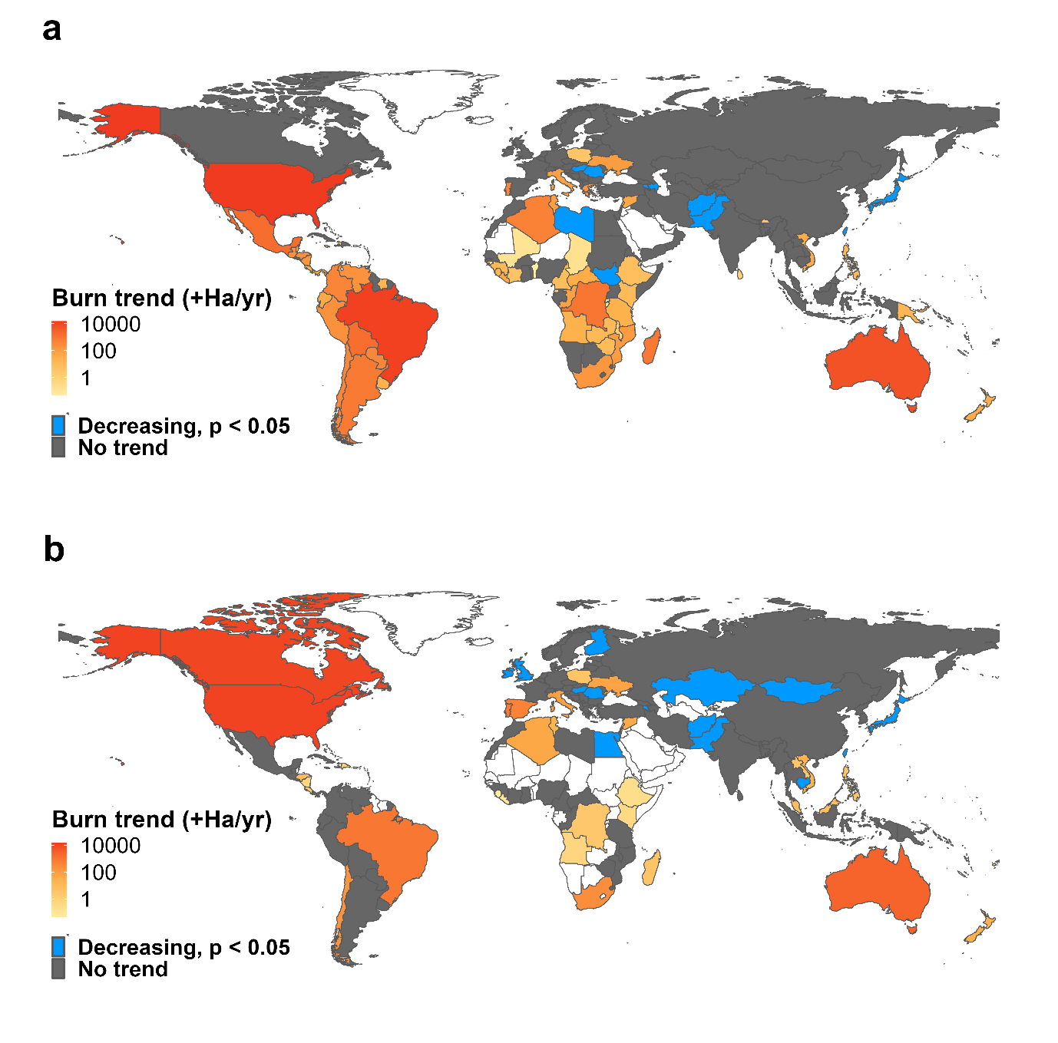
Fig. 3. National trend in timber-producing forest lost due to wildfire annually between 2001-2021. Using (a) Lesiv et al. map of global forest management and (b) Curtis et al. map of forest loss due to forestry. Countries in orange-red demonstrated significant increasing trends in annual loss to wildfire, with the scale representing the median slope of the trend across the period (in hectares burned per year). Countries in blue showed significant decreasing trends (up to a maximum slope of -650 ha per year in China). Dark grey represents countries with no significant trend in annual burned area across the time period, whilst countries shown in white have either limited mapped logging activity or forest-loss inducing wildfires. Strong increasing trends are present in the US, Brazil, and Canada (using Curtis et al.), as well as Australia and many Latin American countries.
There was some variation between mapped products in national-level patterns. Canada showed a significant increasing trend using Curtis et al., but no change over time with Lesiv et al. This result was possibly due to Curtis et al. mapping more logging activity in the fire prone areas of western Canada (Hanes et al. 2019). In addition, many countries in sub-Saharan Africa and Latin America revealed an increasing burn trend using Lesiv et al. but not Curtis et al., probably because Curtis et al. mapped limited forestry activity in these areas due to the dominance of forest loss through shifting agriculture and commodity production (Curtis et al. 2018). Only a small number of countries, including Japan and the UK, were characterized by a decreasing trend across our study duration (Fig 3ab). In combination, therefore, countries showing a significant increasing trend in annual losses of timber-producing forest through stand-replacing wildfires together account for ~43-50% of global industrial roundwood production, whereas those that showed a decreasing trend only accounted for ~2-6% (FAO, 2022).

5.4 Discussion
Stand-replacing wildfires have caused major losses of forest used for timber production, with an increasing trend in annual burned area between 2001-2021. Based upon FAO data (FAO, 2022), these findings point to an estimated wildfire-induced loss of ~393-667 million m³ of industrial roundwood timber across the period, which if exported at the 2021 global mean export price of $115 per m³, would be worth ~US$45-77 billion. Some burnt timber may be harvested in post-fire ‘salvage’ logging operations. However, such wood is often of low quality, whilst salvage logging has strong negative environmental impacts (Thorn et al. 2018; Leverkus et al. 2020) and can increase the likelihood of future forest disturbances (Leverkus et al. 2021).
Greater frequency and severity of wildfires under climate change (Bowman et al. 2020) indicates that threats to global wood production will increase. Overlapping current timber production areas (Curtis et al. 2018’ Lesiv et al. 2022) with future fire prediction maps (Tyukavina et al. 2022) suggests that ~29-62% of current production forest will experience an increase in fire prone years, and ~44-80% will be subject to longer fire seasons by 2100. To ensure increasing timber demand is met (Barua et al. 2014), timber producers need to minimise the risk of fire to future timber crops today, via better selection of crop species, improved spatial planning, and adoption of new technologies for fire detection and suppression.
Plantations produce ~33% of global industrial roundwood (Jürgensen et al. 2014) on ~3% of forest area (Lindemayer et al. 2023) and this will likely increase as fast-growing timber is needed to meet rising demand (Barua et al. 2014), and regions move away from clearcut harvesting of natural forests (Lindenmayer et al. 2023). Expanding production through plantations will decrease the risk of fire-induced timber losses, as harvest rotations are typically far shorter, providing a greater chance of producing a crop before it is lost to fire. Where possible, fast-growing timber species should be introduced in plantations, sparing large tracts of old-growth forest elsewhere to support biodiversity and carbon stocks (Edwards et al. 2014; Betts et al. 2021). However, timber plantations are highly flammable (Gómez-González et al. 2018). Shifting production in fire-prone regions from monocultures of highly flammable timber species (e.g. Pinus radiata, Eucalyptus globulus; Gómez-González et al. 2018; Guerrero et al. 2022) towards heterogenous mosaics of less-flammable species of varying ages will be vital in reducing timber losses through burning (Leverkus et al. 2022).
Improved spatial planning of forestry activities can reduce wildfire risk to timber. At the global scale, establishment of plantations in areas of high wildfire risk should be avoided in favour of regions less likely to burn. One concerning example is the recent rapid expansion of highly-flammable Eucalyptus plantations in the Brazilian Cerrado (Galizia et al. 2019), despite globally high wildfire prevalence in this region (Andela et al. 2017). At a landscape scale, establishment of plantations on slopes, where fires burn more severely and spread rapidly, should be prevented (Lindenmayer et al. 2021). Spatial contagion in fire can be reduced by avoiding large areas of contiguous plantations, with more ‘fragmented’ timber plantations interspersed with less flammable land-use types (e.g., grazing lands) and ‘green’ firebreaks (Lindenmayer et al. 2023).
The timber industry must also adopt emerging technologies to reduce the impact of wildfires where they occur. Improved modelling techniques allow for more accurate spatial prediction of fire ignitions (Gora et al. 2020), whilst adoption of infrared-sensing drones and on-the-ground camera networks could allow for swift, 24h detections (Lindenmayer et al. 2023). Once detected, autonomous ‘water gliders’ could follow GPS signals to carry water or flame retardants to the ignition source and extinguish the fire before it has time to expand (Lindenmayer et al. 2023). In areas that do burn, locally effective post-fire management practices will be required, as salvage logging and replanting post-fire can lead to more severe burning in the future (Thompson et al. 2007; Leverkus et al. 2022).
Failure to adopt approaches like those outlined above could lead to massive future timber losses, with falling timber supply driving higher prices. Concerningly, higher timber prices will increase the opportunity costs of conservation in tropical forests, especially in the Amazon and Congo Basin, making intensive selective logging economically attractive. Such economic feedbacks could make carbon-market payments prohibitively expensive (Phelps et al. 2013), undermining global climate and biodiversity goals. We must urgently tackle the emerging timber production crisis to meet humanity's needs and prevent severe unintended environmental feedbacks.

5.5 Methods

To determine how much timber has already been lost to wildfires in recent years, we overlaid spatial data detailing the global extent of forestry practices (Curtis et al. 2018; Lesiv et al. 2022) with annual layers of forest loss due to wildfire from 2001-2021 (Tyukavina et al. 2022). For a summary of the different datasets used within the study, see Table 1.
Logging layers
To understand where timber production occurs globally, we used the best available datasets that attempt to map global timber harvesting activity:
Global map of forest management (Lesiv et al. 2022) -This map used GeoWiki and classification algorithms to produce a global map of forest management type at 100-m spatial resolution. To make the classification, GeoWiki users and experts were asked to classify satellite images into different forest management types at 226K different points, before the outputs were then used to train classification algorithms to classify all areas of forest, using PROBA-V satellite imagery from the period 2014-2016. Multiple forest management types were included within the map, but to represent possible timber-producing forest, we included only the following three management classes: (i) Naturally regenerating forest with signs of management, e.g., logging, clear cuts etc; (ii) Planted forests (rotation >15 years); and (iii) Plantation forests (rotation ≤ 15 years), covering a total of >2.4 billion hectares of logged forest and timber plantations (see Lesiv et al. for full definitions). We also performed precautionary re-analyses, whereby we excluded both ‘Planted forests’ and ‘Plantation forests’ from the analysis. Results showed broadly the same patterns and are displayed in Table S1.
Global map of forestry as the dominant driver of forest cover loss (Curtis et al. 2018) – This map used satellite data and machine learning to classify the most dominant driver of forest loss between 2001-2019 at a spatial resolution of 10km. Drivers were attributed as one of the following: urbanisation, commodity-driven deforestation (e.g. palm oil, soy), shifting agriculture, wildfire or forestry. We included all areas mapped as forestry in our analysis using this layer, which covered a total of ~1.6 billion hectares of logged forest. Due to the coarse spatial resolution of this layer, we applied a mask of forest cover in the year 2000 (Hansen et al. 2013), including only areas that had >10% tree cover (following the FAO definition of forest and the threshold used in Lesiv et al.). This left a mapped area of 1.08 billion hectares of clearcut logged forest and plantation area.
Global map of forest use (Schulze et al., 2018) - This third dataset was considered but not included in the main analysis. This map used national and sub-national forest management data and classification models trained with predictor variables to identify types of forest use globally at a 1-km resolution for the year 2000. However, the FAO’s Forest Resources Assessment data used in this study is inconsistent between countries (which self-report their national statistics to the FAO) and the prevalence of the ‘mixed use’ forest class does not allow for accurate classification of all timber-producing forest globally. In addition, we identified multiple regions where timber production classification is inaccurate and large areas of logging concessions and plantations are not included within the map (e.g. south-eastern Australia; Lindenmayer et al. 2020). The results from our analysis using this layer should thus be interpreted with caution, and are not included within the main text, but can be found in Fig. S3. Due to the coarse resolution of the map, we again applied a mask of forest cover for the year 2000 (Hansen et al. 2013), including only areas that had >10% tree cover (following the FAO definition of forest). Forest use patterns are grouped into four different classes: Production, Mixed Use, Other and Unknown. The FAO defined ‘Production’ forest as ‘Forest where the management objective is production of wood, fibre, bio-energy and/or non-wood forest products’, whilst ‘Mixed Use’ is defined as ‘Forest where the management objective is a combination of several purposes and where none of them is significantly more important than the other’. For the analysis, we assumed ‘production’ forest to represent timber-producing forest. We also included ‘Multiple Use’ forest in our analysis. Whilst ‘Multiple Use’ forest may not necessarily be used specifically for timber production, we included this management class as local forest definitions meant that many large timber-producing countries (e.g. Canada, Australia, Germany) had limited to no mapped ‘production’ forest.
Fire layer
Since our primary interest was in large, stand-replacing fires that deplete an area of forest of its timber stock, we used recent map layers describing stand-replacing wildfires (Tyukavina et al. 2022), where fire severity was high enough to cause forest loss (defined as ‘the removal of woody vegetation exceeding 5m in height’). This layer is an extension of the work by Curtis et al., and uses Hansen et al. Landsat-based forest loss data and machine learning to identify whether wildfire or an alternative driver caused a forest loss event in the years 2001-2021, at a 30-m resolution. Classification models were trained on visually collected data, with separate models developed for five global regions (North America, Latin America, Africa, Northern Eurasia, and combined South and Southeast Asia, Australia, and Oceania). We elected not to implement the widely used MODIS Burned Area dataset (Giglio et al. 2018) as our measure of fire activity, as these data map burned area without differentiating between stand-replacing fires and low-severity burns. Across many regions, low-severity burns may not cause enough damage to trees to render the majority of their timber unusable, so we focused on high-severity fires that would do so. In producing their map of wildfire-induced forest loss, Tyukavina et al. undertook a sample-based area estimate and ensured the final map matched the sample-based area estimate for all global regions (except Africa) as well as providing maps containing the estimate ± SE. This allows for estimation of burnt area in timber-producing forests that matches sample-based area estimates, as well as inclusion of uncertainty through estimates of burn ± SE for all regions except Africa.
Economic cost analyses of high-severity stand-replacing wildfires on timber-producing forests reveal extreme loss of timber stock and economic value. For example, severe wildfires in the Rocky Mountains in 2000 resulted in the burning of ~7 million m³ of timber, of which <5% was salvaged (Prestemon et al. 2006). Similarly, two wildfire events in south-eastern Australia (2003 and 2006/7) resulted in >$2 billion worth of lost timber, with salvage operations occurring across <4% of burned native forest (Stephenson et al. 2013). In Russia, assessment of forests post-wildfire found that crown fires had dominated the burning, often resulting in total tree mortality (Kukayskaya et al. 2013). Given the significant environmental damage caused by salvage logging (Thorn et al. 2017; Leverkus et al. 2020), and associated price depression when poor-quality salvaged timber floods the market (Prestemon et al. 2006), we assumed that the stand-replacing wildfires mapped in Tyukavina et al. result in near-total loss of harvestable timber stock and economic value.
Data Analysis
We completed all spatial data operations and analysis using R version 4.2.1. We downloaded the global map of forest management from Lesiv et al. (https://doi.org/10.5281/zenodo.5879022), the global map of forest-loss by driver (Curtis et al., 2018) through the Global Forest Watch website (https://www.globalforestwatch.org/map/) and the global map of forest-loss through wildfire from Tyukavina et al. (https://glad.umd.edu/dataset/Fire_GFL/). We downloaded the global map of tree cover in 2000¹⁹ through Google Earth Engine and reprojected to a 100-m resolution to match the highest resolution available for our logging data. We projected all spatial data in EPSG:4326 (WGS84) CRS and projected into ESRI:54009 where area calculations or intersections were computed. We used the following R packages: raster (v3.5.29), sf (v1.0.8), terra (1.6.7), rnaturalearth (v0.1.0), Kendall (v2.2.1), trend (v1.1.5).
We divided the world into five regions (North America, Latin America, Eurasia, Africa and South-East Asia and Australasia), following the regional models of fire-induced forest loss used by Tyukavina et al. For each region, we created a network of grid cells 0.25 degrees in size for increased computational efficiency.
For each grid, we cropped the logging and fire raster data by the spatial extent of the grid using the terra package, and converted the resulting objects into a simple features polygons using the sf package. For the Curtis et al. logging layer, we then applied a forest mask using global forest cover for 2000 (Hansen et al. 2013), and retained only areas of timber-producing forest where tree cover was > 10% (following the FAO definition of forest and the same masking threshold used by Lesiv et al. when creating their map). We aggregated the total area of timber-producing forest in each grid to estimate the total global area of forest being used for timber production in each logging layer (Lesiv et al.: 2.4 billion ha, Curtis et al.: 1.08 billion ha).
Using the sf package, we calculated the total timber-producing forest present in each grid cell (for each logging layer used), as well as the intersection of timber-producing forest with wildfire-induced forest loss in each year of the time series. We then recorded the spatial extent of forest-loss inducing fires for each year in timber-producing forests within the grid. We repeated this process using different combinations of pixel certainty in the Tyukavina et al. dataset to also produce uncertainty estimates representing ± SE.
How much timber-producing forest is being lost to wildfires globally, and where do these losses occur?
We aggregated total burned area and total timber production area globally, regionally, and nationally to create estimates of the global, regional, and national area of timber-producing forest burned during our study period. For national level analysis, we used the R package rnaturalearth for country boundaries to determine the total area and proportion of timber production forest burned on a national scale. We calculated total area burned in m² before conversion to hectares. For estimates of the proportion of timber-producing forest burned, we divided the total burned area of timber-producing forest across all years by the total area of timber-producing forest estimated from each logging dataset.
What are the temporal trends in annual area burned since the turn of the century, at global, regional, and national scales?
We aggregated the total area of timber-producing forest burned by year of burn, to create an estimate of the annual burn area across the time period at global, regional and national scales (2001-2021). To estimate the trend in annual burn area, we used a Mann-Kendall test for monotonic trend in a time series from the Kendall package on the raw data and report these results. To estimate the size of the trend, we conducted a Sen’s slope analysis using the trend package.

Table 1. Summary of datasets included within the study, their uses and features.

Data Source | Use | Summary | Additional Notes
Global map of forest management - Lesiv et al., 2022 | Logging activity layer | 100-m resolution forest management map (2015) – based on remote-sensing and classification algorithms trained on ‘expert’ classified data. | Management classes used in this study to represent timber-producing forest:  - Naturally regenerating forests with signs of forest management, e.g., logging, clear cuts etc.  - Planted forests (rotation >15 years)  - Plantation forest (rotation ≤15 years)  Also attempts to include selective logging across the tropics, much harder to detect via remote sensing than clearcut and plantation forestry.
Global map of forest loss drivers – Curtis et al., 2018 | Logging activity layer | 10-km resolution map of key driver of forest loss (2001-2019) – based on Hansen forest loss data and classification algorithms trained on visually inspected images. | Assigned forest loss to one of five drivers: urbanisation, commodity-driven deforestation (e.g. palm oil, soy), shifting agriculture, wildfire or forestry.  Forestry class used in our study to represent timber producing forest. Classification based on forest loss detectable from Landsat, so forestry class represents chiefly clearcut and plantation forestry.
Global map of forest loss due to fire – Tyukavina et al., 2022 | Fire occurrence layer | 30-m resolution map of where fire caused detectable forest loss (2001-2021) – extension of Curtis et al. work based on Hansen forest loss data and classification algorithms trained on visually inspected images. | Assigns forest loss event as caused by wildfire or some other driver. Maps date of burn to allow for temporal analysis of burn trends.
Global map of forest use – Schulze et al., 2018 | Logging activity layer (supplementary) | 1-km resolution map of forest use type (2000) – based on FAO reported data and classification models trained with predictor variables. | Not included within our main analysis as FAO data unreliable and forest use definitions (production, mixed use) make it difficult to determine forests managed chiefly for timber.
Global forest change data – Hansen et al., 2013 | 10% forest cover mask | 100-m resolution map of % forest cover, gains and loss in years 2000-2012 – mapped global tree cover, loss and gain using Landsat data. | Used to mask Curtis et al. logging layer to include only areas marked as forestry with at least 10% tree cover in the year 2000 (according to FAO definition of forest, the same threshold was used in Lesiv et al.).

Corresponding Author: Correspondence to Christopher Bousfield
Author contributions: CGB, DBL, DPE conceived the study. CGB, DBL, DPE developed the methodology. CGB performed the analysis and drafted the original manuscript. All authors contributed to reviewing and editing the manuscript.
Competing interests: Authors declare that they have no competing interests.
Data availability: All data originally used in this study are publicly available online: Tyukavina et al.⁷ fire data (https://glad.umd.edu/dataset/Fire_GFL/), Curtis et al.⁶ forestry data (https://data.globalforestwatch.org/documents/tree-cover-loss-by-dominant-driver/about), Lesiv et al.¹³ forest management data ( https://zenodo.org/record/5879022#.ZCa9IXbMKUk) and Hansen et al.⁵⁰ forest cover data (https://earthenginepartners.appspot.com/science-2013-global-forest/download_v1.7.html).
Code availability: The code used to generate the results will be freely accessible and archived online.

5.6 Supplementary Information
Extended Data
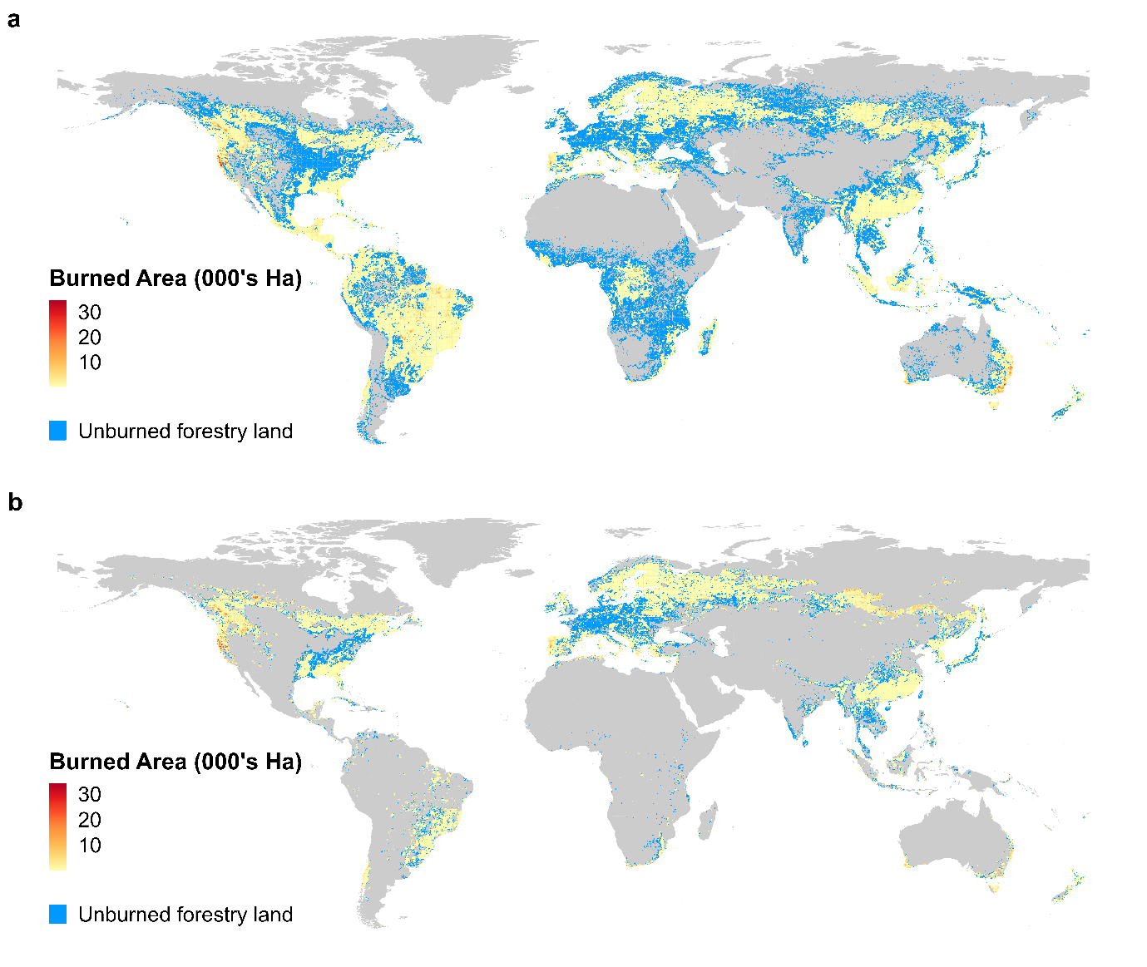
Fig. S1. Spatially explicit global map of timber-production forest burned in each grid cell (000’s Ha) between 2001-2021 using (a) Lesiv et al. forest management map and (b) Curtis et al. map of forestry as the dominant driver of forest loss, at a spatial resolution of 0.25 degrees. Areas of warmer red represent increasing burn, blue represents areas where logging occurs but wildfire did not, grey represent areas where logging is not prevalent.

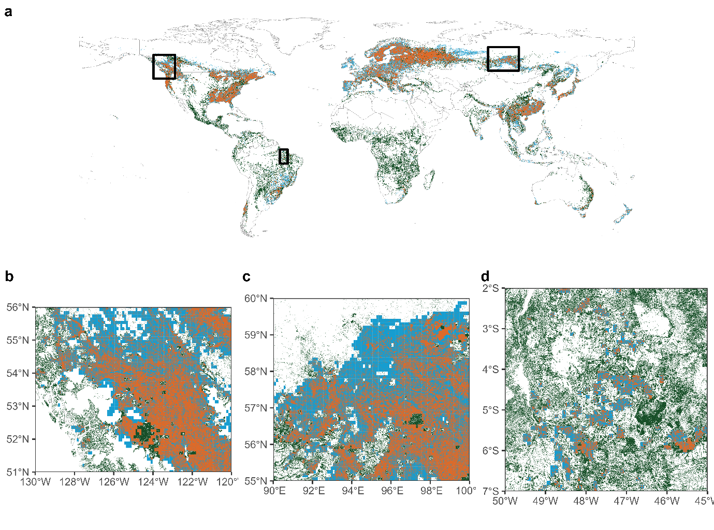 Figure S2. Global comparison of forestry layers used in this study. Areas coloured in green represent forestry activity unique to Lesiv et al., areas in blue represent forestry activity unique to Curtis et al., whereas areas in orange represent forestry activity mapped by both layers. Zoom in insets show differences in greater detail for burning hotspots in the US/Canada (a), Russia (b) and Brazil (c).

Results using Schulze et al. global map of forest use
Using the Schulze et al. global map of forest use suggested that ‘production’ forest and ‘mixed use’ forest together cover 1.6 billion hectares of forest. Between 2001-2021, 63.9 (SE: 60.8-66.8) M ha- an area larger than France- of potential timber-producing forest burned. This represents 4.1% (SE: 3.9-4.3%) of global timber-production forest. Similar to the other logging datasets, most of this burned area was centred in Russia (38.9 M ha, SE: 37.4- 40.1 M ha), Canada (10.7 M ha, SE: 10.4-11.0 M ha), the US (5.6 M ha, SE: 5.3-6.0 M ha) and Australia (2.4 M ha, SE: 2.34—2.44 M ha) (Fig. S3a), where 7.8, 5.3, 3.9 and 13.2 % of the total national timber-producing forest was lost in just 21 years (Fig. S3b). Globally, annual burned area experienced an increasing trend between 2001-2021 (Mann-Kendall test, p < 0.01; Sen’s slope trend, +136,000 ha per year; Fig. S3c), driven largely by significant increasing trends in Eurasia, Latin America and Africa.
Using Schulze et al. suggested far greater burn in Russia (38.9 M ha) than under Lesiv et al. (2.9 M ha) or Curtis et al. (6.5 M ha), largely due to Schulze et al. classifying large swathes of remote north-eastern Russia (an area highly prone to wildfires) as production or multiple use forest. Whilst all datasets demonstrated increasing trends of annual burned area globally, Lesiv et al. and Curtis et al. both demonstrate increasing trends in North America and Australia, whereas using Schulze et al. demonstrates no trend in either of these regions and an increasing trend in Eurasia.
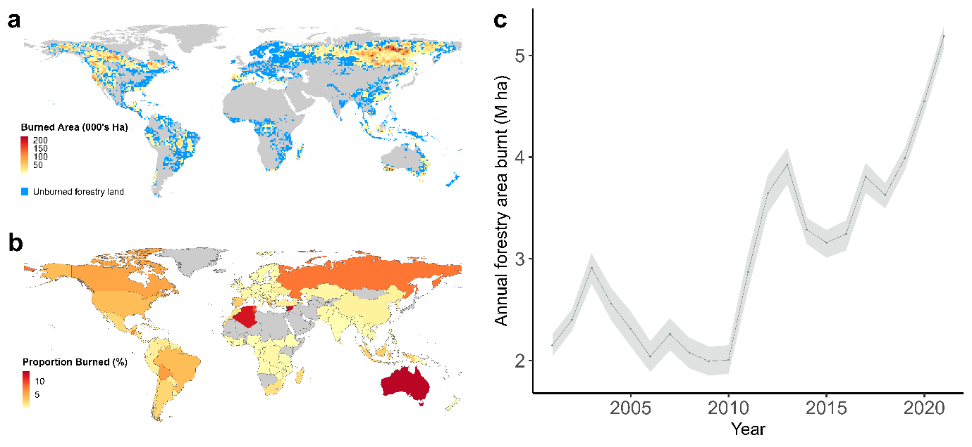
Fig. S3. Hotspots of severe burning in timber-producing forests (a), proportion of forestry land severely burned nationally (b) and three-year average annual area of timber-producing forest burned in wildfires globally (c) in the years 2001-2021, using Schulze et al. global map of forest management patterns. Areas of warmer red represent increasing burn, blue represents areas where logging occurs but wildfire did not, grey represent areas where logging is not prevalent.
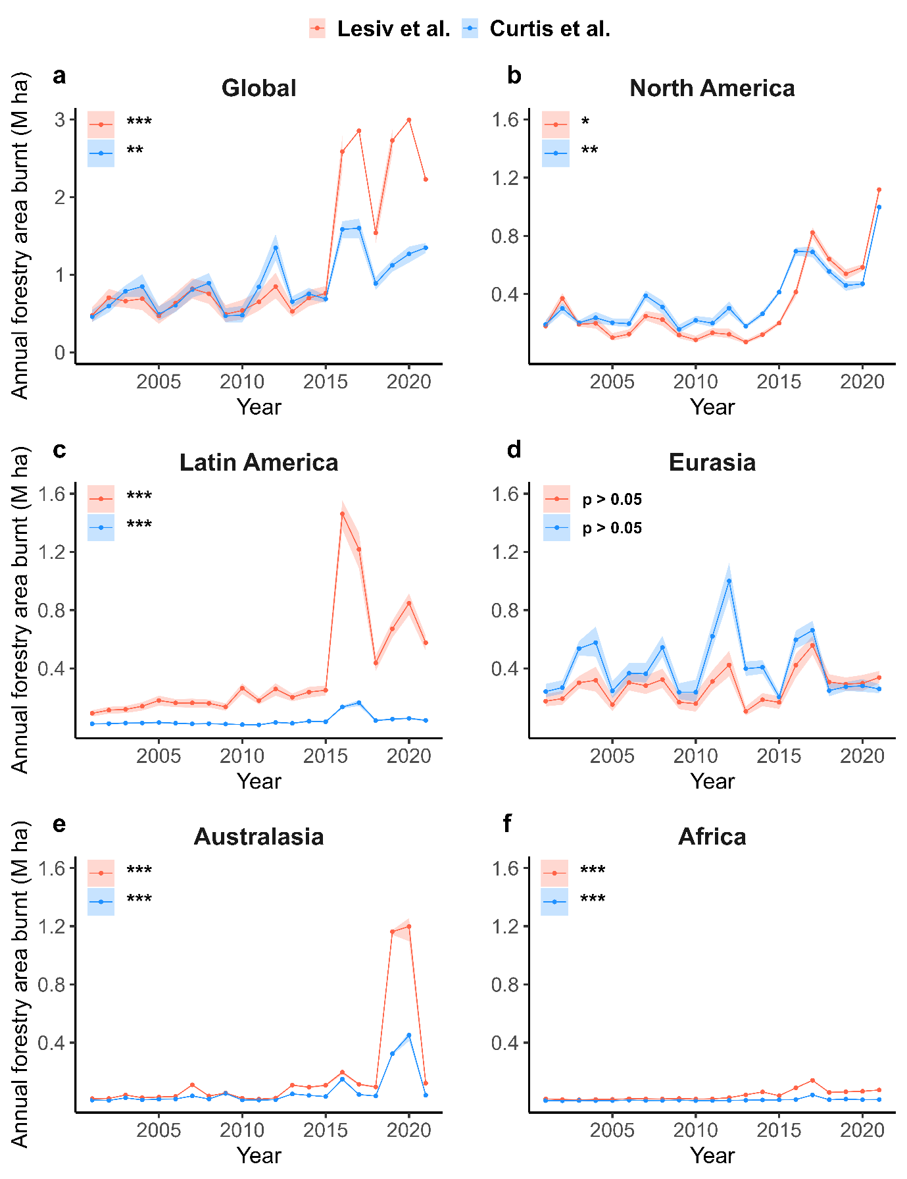Fig. S4. Global and regional annual area of timber-producing forest lost to wildfires in the years 2001-2021. Using Lesiv et al. map of global forest management (red) and Curtis et al. map of forest loss due to forestry (blue), split by global region: Global (a), North America (b), Latin America (c), Eurasia (d), Australasia (e) and Africa (f). Significant increasing regional trends in annual area of timber-producing forest burnt are present for all regions except Eurasia and are marked with * (Mann-Kendall test, p < 0.05), ** (0.001 ≤ p < 0.01), and *** (p < 0.001). Lines represent annual value, shaded areas represent annual value ± 1 SE.

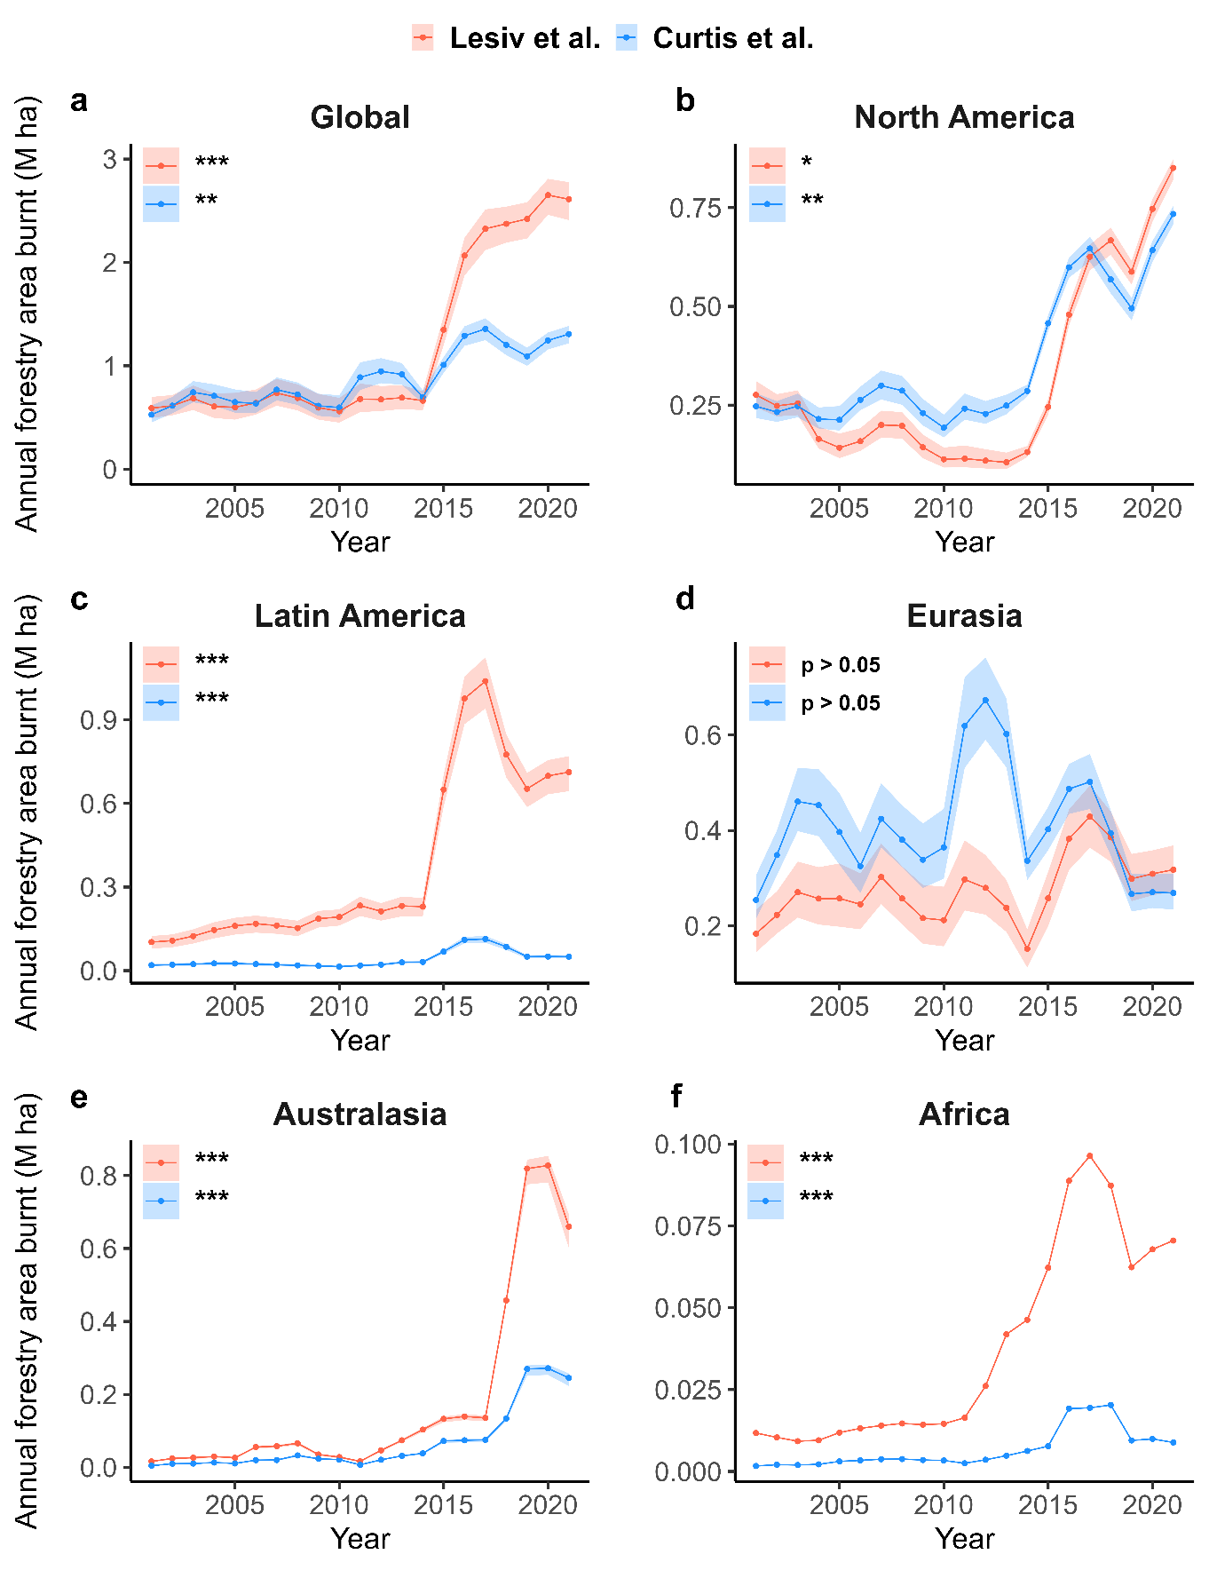
Fig. S5. Global and regional three-year average annual area of timber-producing forest lost to wildfires in the years 2001-2021. Using Lesiv et al. map of global forest management (red) and Curtis et al. map of forest loss due to forestry (blue), split by global region: Global (a), North America (b), Latin America (c), Eurasia (d), Australasia (e) and Africa (f). Significant increasing regional trends in annual area of timber-producing forest burnt are present for all regions except Eurasia and are marked with * (Mann-Kendall test, p < 0.05), ** (0.001 ≤ p < 0.01), and *** (p < 0.001). Lines represent three-year rolling average, shaded areas represent three-year rolling average ± 1 SE.

Table S1. Comparison of total logging area, area burned, proportion burned and global annual burn trend between different logging layers used. For Lesiv et al. the analysis was conducted including all three forestry-related categories (i) logging, clear cuts etc; (ii) Planted forests (rotation > 15 years); and (iii) Plantation forests (rotation ≤ 15 years). Two precautionary reanalyses were conducted, removing first the ‘Planted forests’ category, then removing both ‘Planted forests’ and ‘Plantation forests’ categories. The results are compared with using all three categories from Lesiv et al., as well as with Curtis et al and Schulze et al. Annual trend represents the significance level of the positive annual burn area trend, and is marked with ** (Mann-Kendall test, 0.001 ≤ p < 0.01) and *** (p < 0.001).

 | Lesiv – All logging forest types | Lesiv – Natural logged forest and Plantation | Lesiv – Natural logged forest only | Curtis | Schulze
Logged area (M ha) | 2,415 | 2,208 | 2,126 | 1,076 | 1,567
Burned area (M ha) | 24.7 | 23.6 | 22.8 | 18.5 | 63.9
Proportion burnt (%) | 1.02 | 1.07 | 1.07 | 1.73 | 4.08
Annual trend | *** | *** | *** | ** | **

Supplementary Text
Caveats and Limitations
There are several caveats to our analysis which are important to highlight, and are linked to the global forestry and fire datasets currently available. Most of these caveats suggest that our estimates of the total proportion of the world’s timber-producing forest lost through wildfire are underestimates. These are:
- Lesiv et al., forest management data – the remote sensing imagery used to create the global map of forest management are based on PROBA-V satellite imagery for the years 2014-2016. Forest management classifications are thus made based on the state of a forest area in this 2014-2016 period. When assigning forest areas to management classes, forests that were deemed “disturbed by natural disturbances, i.e., wildfire, wind throw, flooding, or insect/disease” were classified as naturally regenerating forest without signs of management. Forests managed for timber that burned prior to 2014 may therefore have been misclassified as forests showing no signs of management. The sharp increase in annual burn in our analysis post 2015 using Lesiv et al. data (Fig. 2.) may then be exaggerated, but this also suggests our estimate of total timber-producing forest lost to wildfire across the entire period is an underestimate.
- Curtis et al., forestry data – due to the coarse resolution of this data (10 km²), and the fact that only the most dominant driver of forest loss is mapped, there is a high likelihood that some areas where forestry occurs alongside other drivers (which may be slightly more prevalent) are not mapped. In particular, cells where forestry occurs frequently alongside wildfires (e.g. Russia, Canada) but wildfire accounts for >50% of tree cover loss in the 10 km² cell will be mapped as wildfire, not forestry (as is described in Curtis et al., supplementary materials). Again, this would make our total estimate of timber-producing forest lost to wildfires an underestimate, as forestry operations in fire prone regions go unmapped despite high likelihood of burning.
- Tyukavina et al., fire data - this dataset evaluated only the first forest-loss causing event across the time period in each 30-m cell. Whilst this allowed us to assess temporal trends in annual burned area across the time period, it meant we were not able to deduce whether any regions of forest had burned more than once. Multiple burns in timber-producing forest creates additional losses of timber not accounted for in our analysis. Additionally, since only the first forest-loss event in each cell is evaluated as wildfire-induced or not, any forest area where a timber harvest was conducted, and during subsequent regrowth a wildfire occurred, will not be mapped as burned forest in this dataset.
- Static maps of forestry activities globally – an issue with all currently available datasets on global forestry activities is that they present a static snapshot of timber production. Lesiv et al.’s map of forest management is based on the year 2015, whilst Curtis et al.’s covers the 2001-2019 period but does not detail in which year forestry activity was observed. Development of a new dataset that tracks the global extent of forestry activity across both time and space would allow for improved analysis of threats to global timber production across time (e.g. fire, drought, insect outbreaks).

Chapter 5: General Discussion

General Discussion

5.1 Summary

As global economic activity and resource consumption continue to increase, we are placing ever greater pressure on the natural world that provides us with the resources that underpin human society (Costanza et al. 2013). Timber is one such resource, and future projections of timber demand suggest that the world’s hunger for timber will only grow throughout the 21st century (Penq et al. 2023; Indufor, 2012). How best to manage the world’s forests in a changing climate, to meet timber demand whilst minimising the negative impacts of timber harvest on the vital ecosystem services provided by forests, represents a key global challenge.
In Chapter 2 I combined harvest simulations with economic data to estimate the profitability of land sparing and land-sharing timber harvests under both business-as-usual and conservation-based scenarios in the Brazilian Amazon. I found that in all cases land sharing was more profitable than land sparing or any mixed strategy (Bousfield et al. 2021). This work highlights the tension between economic drivers of resource extraction and conservation-based goals, since land sparing has previously been shown across the tropics to result in better biodiversity outcomes (Edwards et al. 2014; Franca et al. 2018; Cerullo et al. 2023). Such large opportunity costs involved with switching to land-sparing harvests means the strategy is unlikely to receive much uptake amongst logging organisations that prioritise profit, and further economic incentives would be required to promote increased implementation of land-sparing timber harvests across the Amazon.
In Chapter 3 I extended my harvest simulations by incorporating carbon estimates to test the feasibility of using carbon payments to improve the sustainability of selective logging in Amazonian timber concessions. I found that preventing logging entirely was cheaper than any other option at $7.90 per tCO₂ due to significant cost savings when no road networks are required, yet options that reduced the intensity of harvest whilst permitting some level of logging were still possible at competitive market prices of $7.97–10.45 per tCO₂. These required breakeven prices are competitive in today’s market, and a much more feasible alternative to preventing logging in Borneo which would cost $22-28 per tCO₂ (Fisher et al. 2011), whilst being similarly expensive to logging prevention options in Cambodia or central Africa (Warren-Thomas et al. 2018; Njondo et al. 2014). However, policy barriers remain in Brazil that would prevent the implementation of carbon payment projects in public concessions.
In Chapter 4 I considered the largely unknown impacts of selective logging on the community composition of trees across wide spatial scales in the Amazon, using a unique dataset containing geo-spatial information on >150,000 adult trees identified down to species level across > 3000 hectares of Amazonian rainforest. I found that whilst selective logging generally has limited impact on canopy tree beta-diversity as a whole, it does cause strong subtractive heteroginisation in the largest tree size classes. In addition, turnover is the dominant component of beta-diversity in both primary and selectively logged Amazonian forests. Given the strong impact of even low-intensity logging on the largest tree communities, stricter limits on how many large trees can be harvested, or indeed the introduction of a maximum cutting diameter, would help prevent large-scale erosion of tree diversity patterns across the Amazon.
Finally, Chapter 5 used freely accessible satellite-derived data layers describing the spatial footprint of timber production (Curtis et al. 2018; Lesiv et al. 2022) and stand-destroying wildfires (Tyukavina et al. 2022) to assess the current impact of wildfires on global timber production. I estimated that in the last 21 years an area of timber-producing forest the size of Great Britain (19-25 M ha) had been lost to wildfires (equating to losses worth a possible $45-77 billion of timber), with widespread burning across the Western USA and Canada, Siberian Russia, Australia and Brazil. In addition, since 2001, the annual burned area of timber producing forest has increased significantly across the globe, and in all regions except Eurasia. This is serious cause for concern given future climate change predictions suggest wildfires will increase in both frequency (Bowman et al. 2020; Senande-Rivera et al. 2022) and severity (Flannigan et al. 2013). Future research needs to focus on estimating the possible impact wildfires could have on timber production in the future under climate change, and methods to reduce this impact, potentially through increased plantation use, better spatial planning on global and local scales, and the swift adoption of the latest fire detection and extinguishing technology (Lindenmayer et al. 2023).

5.2 Wider applicability of findings

Chapters 2-4 all have important implications for timber production in legal logging concessions throughout the Brazilian Amazon. Such concessions currently cover > 1.6 million hectares, with up to 35 million hectares available for conversion to concessions in the coming years (Sist et al. 2021). Given this large extent, how Brazil manages its forest concessions in the future will have significant implications on Amazonian biodiversity and climate targets. However, the work presented in this thesis was based on legal timber concessions supplying high-quality FSC certified timber products harvested using RIL methods (Bousfield et al. 2021, 2022, 2023). As of 2019, forest concessions accounted for just 2% of the timber extracted from the region and covered just 8% of the 20-million-hectare government target (Sist et al. 2021). Uptake of new concessions since their introduction in 2006 has been slow due to high stumpage prices and uncertainties from local communities (Vidal et al. 2020). These barriers must be overcome if Brazil is to expand its forest concession timber production in the future.
Beyond Brazil, Chapters 2 through 4 also have implications for timber production management across the wider Amazon region, where forest structure is similar. Throughout the Amazon we find low frequencies of high-value species and many non-marketable or low value species, meaning timber harvest intensities are generally much lower than in other tropical regions such as South-East Asia (Edwards et al. 2014; Bousfield et al. 2020). The economic and biodiversity outcomes of harvest practices in the Brazilian Amazon are therefore likely to be similar in other Amazonian countries that practice timber harvests in this manner. Although Brazil is the dominant producer of timber in this region (FAO, 2022), timber production is expanding in many Latin American countries and how to best manage timber extraction whilst reducing environmental damages is becoming an increasingly important question across the region.
Chapter 5 is of global relevance given the scale of the study we conducted. Wildfires are a threat to timber production across the globe, and the potential future scale of the threat is something that has been widely ignored until now. We detect significant total losses in countries such as the USA, Canada, Russia and Australia, whilst identifying the large proportion of forestry land already lost in countries like Portugal and Australia. The findings are therefore of particular importance to forestry practitioners in these countries, who already need to start adapting their production methods to prevent catastrophic losses of timber in the future. In addition, countries that aren’t currently major players in timber production who experienced low losses and decreasing annual trends, such as the UK or Japan, may see this as an opportunity to expand their timber production capacity and play a larger role in international timber supply in the future.
However, despite recent advances with satellite data we still have a fairly poor understanding of exactly where forests are managed for timber globally and through which system (e.g. clearcut, plantation). One of the chief sources of forestry data globally comes from the FAO, who conduct Forest Resource Assessments (FRA) every five years. Whilst these are useful for understanding national and global trends in forestry operations, self-reporting of data by individual countries can be incomplete or inaccurate from one country to the next, and the reports lacks any spatially explicit data, so we don’t know exactly where the timber is being produced (MacDicken, 2015). In Chapter 5 we used two sources of forestry data that instead rely on integrating machine learning and satellite imagery to identify where forests are being managed for timber. The first from Curtis et al. (2018) maps forestry with high accuracy (87%), but this is at a very coarse resolution of 10km and ignores many lower-intensity forestry operations throughout the tropics. The second from Lesiv et al. (2022) is at a much finer resolution of 100m, and attempts to include selective logging, but accuracies are considerably lower than in Curtis et al. for timber-producing forest classes (58-71%). In addition, both are static maps of forestry activity, covering either a single year (Lesiv et al. 2022) or a period of time (2000-2019) but giving no indication in which years forestry activity is occurring (Curtis et al. 2018). Improving the resolution and accuracy of global forestry maps (Jung et al. 2023) and incorporating temporal activity into such maps so we can better understand what type of timber production is happening where, and when, will be vital to improving our understanding of global timber production systems and the threats they face in the future.

5.3 Conservation implications

5.3.1 Opportunity costs of conservation

Chapter 2 demonstrates that despite the biodiversity benefits of land-sparing logging, they come with significant opportunity costs that will likely prevent voluntary uptake of this practice (Bousfield et al. 2021). Similarly, Chapter 4 indicates that current selective logging practices threaten to erode diversity patterns of the largest trees in the forest (Bousfield et al. 2023), but implementing a maximum cutting diameter or stricter harvest restrictions on large trees would likely cause significant losses in profit (Bousfield et al. 2021). These findings highlight the frequent problem with implementing conservation-based measures to resource extraction, they come with significant costs.
Reduced Impact Logging (RIL) is a good example of the friction between environmental goals and profitability that has hampered improvements to the selective logging sector in the past. RIL involves detailed pre-planning of target trees and road paths to minimise damage, directional felling, increased safety practices and post-harvest evaluations (Putz et al. 2008). RIL reduces the area disturbed by skid trails and roads and associated soil disturbance (Pinard et al. 2000), maintains better forest structure post-harvest (West et al. 2014), consistently reduces the negative impacts of logging on biodiversity (Bicknell et al. 2014), and has superior environmental outcomes in 76% of cases assessed (Burivalova et al. 2017). Despite its environmental benefits however, concerns over its financial costs are one of the primary barriers to its widespread adoption (Putz et al. 2000), with the chief Sarawak Timber Association (Malaysia) suggesting in 2001 that RIL actually stood for “reduced-income logging” (Putz et al. 2008). Whilst such ‘cut and run’ profit-focused attitudes remain prevalent in the timber industry, the implementation of less environmentally damaging practices will receive little attention if they are seen to harm profits.

5.3.2 Minimising opportunity costs

Promoting the uptake of land-sparing logging throughout the Amazon to retain greater biodiversity (Edwards et al. 2014; França et al. 2017; Cerullo et al. 2023) will therefore require additional economic incentives (Bousfield et al. 2021). One potential pathway is to associate land-sparing style harvests with certification schemes, such as the FSC, pairing land sparing with access to more premium market prices to increase revenue (Kollert & Lagan, 2007). However, FSC certification has previously had limited reach in tropical forests, with less than 2% having been granted FSC status, and certification currently does not guarantee better outcomes for biodiversity (Campos-Cerqueira et al. 2019). Even if land sparing was to be associated with certification there is therefore no guarantee logging organisations would pursue it. An alternative route to close the profitability gap could be through government-provided tax breaks, particularly on the royalty fees for timber harvest, which are already viewed as excessive by would-be timber concessionaires (Vidal et al. 2020). In Brazil, the government already offer tax reductions if companies engage in beneficial activities for the wider community (Azevedo-Ramos et al. 2015), and a 25% reduction in stumpage fees could switch loss-making land sparing operations to profit making (Bousfield et al. 2021).
An alternative method for funding less environmentally damaging logging practices is through carbon-based payments for ecosystem services, as explored in Chapter 3. Such carbon payments could be used to reduce or remove entirely the opportunity costs of land-sparing harvests, but only if solid evidence showing reduced carbon emissions and enhanced carbon storage through land sparing were to be found. Alternatively, carbon payments could be used to reduce the intensity of harvest, thereby limiting the extent of damage to the forest (Burivalova et al. 2014; Martin et al. 2015). Chapter 3 demonstrated this method to be a cost-effective way (at $7.97–10.45 per tCO₂) to cut carbon emissions whilst reducing the negative environmental impacts of logging (Bousfield et al. 2022). However, REDD+ carbon projects are notoriously difficult to run effectively and are easily manipulated, whilst poor involvement of local communities in FPIC measures (Phelps et al. 2010) and benefits sharing is common (Guerra & Moutinho, 2020). In the Brazilian Amazon, West et al. (2020) found that projects consistently overestimated their impact in reducing deforestation through inflated baselines of forest loss with no intervention. Movements towards eliminating this flawed counterfactual approach to estimating baselines in favour of more accurate approaches, such as matching techniques (West et al. 2020; Guizar-Coutiño et al. 2022; Pauly & Tosteson, 2022) will be required if carbon payment projects are to become a serious option for improving logging sustainability.

5.3.3 The threat of illegal logging

Promoting more sustainable logging through economic means is already a difficult task, but it is made even harder by the widespread illegal logging throughout the Amazon (Brancalion et al. 2018). In the Brazilian Amazon in particular, illegal logging affects a larger area than deforestation (Matricardi et al. 2020) and accounted for 44% of all timber production in Parà State between 2015 and 2016 (Vidal et al. 2020). Such widespread illegal logging generally drives down market prices of timber due to its much lower operating costs and reduces the timber stock available for harvest in legal concessions (Sist et al. 2021). Research aiming to improve the sustainability of legal logging practices is important, particularly in a future where legal logging concessions expand throughout the Amazon. However, its significance will be undermined if Brazil and the other Amazonian countries cannot reign in the rampant illegal logging that occurs throughout Amazonia. Whilst the Bolsonaro administration rolled back environmental protection, defunded environmental agencies, and overlooked illegal logging and mining (Peres et al. 2023a), the Lula administration provides hope of a new era of protection for the Amazon that may turn the tide in the battle against illegal exploitation (Peres et al. 2023b).

5.3.4 Adapting to a changing climate

We must also look beyond current flaws in tropical timber production and consider how conditions in the future may place further strains on tropical forests. Climate change is likely to increase extreme weather events such as wildfires, droughts, floods and heatwaves which will threaten forests and timber stocks all over the world (Bowman et al. 2020; Hirabayashi et al. 2013; Meehl and Tebaldi, 2004). Chapter 5 demonstrates the significant damage wildfire already inflicts on the global timber industry, with this effect only likely to get worse in the future. Without serious shifts in production methods to alleviate these risks, losses could become catastrophic, driving down global timber supply, with large shortfalls in areas such as the US, Canada, Australia and Russia. Restrictions on global supply would thus drive up the price of timber, perhaps promoting further illegal and legal exploitation of the Amazon for its highly prized timber species (e.g. big-leaf mahogany- Swietenia, ipê- Tabebuia, and jatobá- Hymenaea; Schulze et al., 2008). and undermining the implementation of more sustainable harvest measures. The economic benefits of land sharing over land-sparing logging estimated in Chapter 2 will likely be extended further (Bousfield et al. 2021), whilst increased opportunity costs of forgoing logging will undermine carbon-payment projects and increase the required breakeven prices to well beyond those estimated in Chapter 3 (Bousfield et al. 2022) that cannot be matched by carbon financing (Phelps et al. 2013).
Increased global use of timber plantations, where fires are actively prevented, and shorter rotations provide a higher likelihood of harvest without wildfires occurring could alleviate some of this risk (Lindenmayer et al. 2023). Plantations are predicted to double in extent across South America by 2050 (McEwan et al. 2020), but less reliance on non-native species with low fire resistance and high flammability (e.g. Pinus radiata, Eucalyptus globulus; Gómez-González et al. 2018; Guerrero et al. 2022) in fire prone areas will be required. In Brazil, 75% of timber plantations are Eucalyptus, with native species plantations poorly developed (Sist et al. 2021). Expanding the use of timber plantations across Brazil in previously deforested lands would help contribute to meeting timber demand and tropical reforestation goals under global initiatives such as the Bonn Challenge, whilst relieving pressure from the remaining primary forest and promoting more sustainable timber production and conservation of remaining natural forests (Sist et al. 2021).

5.4 Conclusions and recommendations

This thesis attempted to address key questions on how timber demand can be met in a more sustainable and less environmentally damaging way, with a particular focus on the Brazilian Amazon. There are four main findings from this work. First, despite its apparent benefits for biodiversity, land-sparing timber harvests are not economically competitive in the Amazon compared to land sharing. To promote the uptake of land-sparing logging techniques in the future, further financial incentives such as tax breaks, certification premiums and subsidies will be required. Second, the use of carbon payments to prevent or reduce the intensity of logging in the Amazon is a cost-effective measure, requiring only $7.90–10.45 per tCO₂. Whilst widespread prevention of logging is clearly not an option, using carbon payment programmes to reduce the intensity of logging (and thus the damage to the surrounding forest) is possible under sound carbon-payment projects that use effective counterfactuals and engage with local stakeholders. Third, selective logging across large areas of Amazon rainforest has little impact on community composition of canopy trees as a whole. However, the intense targeting of the largest, most valuable trees leads to significant heteroginsation of the largest tree communities. Given the significant expanse of logging concessions in the Amazon, such practices have the potential to erode tree diversity patterns across large areas. Options to prevent this are the introduction of maximum cutting diameters, or stricter restrictions on the number of large trees that are permitted to be cut. Finally, wildfires are already having an impact on timber production globally, and the annual area of timber producing forest that has been lost to wildfires has been increasing throughout the 21st century. This is serious cause for concern given that wildfires are expected to become more prevalent in the future because of climate change, and methods to reduce the impact of fires in the future need to be implemented today.
Future research should focus on obtaining empirical estimates of carbon emissions and remaining carbon stocks associated with land sparing and land-sharing timber harvests in the Amazon. If land sparing is found to emit significantly less carbon than land sharing (e.g. through far reduced road requirements), tying carbon payments to the implementation of land sparing may reduce the opportunity cost associated with land sparing and promote its uptake. More broadly, this thesis has highlighted the large and increasing threat of wildfires to global timber production, and the likely increased threat in the future under climate change. Future research in this area is vital to ensure timber supply can be met throughout the 21st century. This research should focus firstly on using future climate projections to model the impact of wildfires on business-as-usual timber production. Following this, the potential of different methods to reduce fire risk such as increased plantation production and the shifting of global and regional timber production areas must be assessed.
Beyond research, governments and policymakers in tropical countries need to create environments where it is economically feasible to harvest timber in a more sustainable way. Tax breaks or subsidies for companies harvesting in less damaging ways (e.g. land sparing) or employing RIL techniques can make them more financially competitive. Most importantly, illegal logging, particularly in the Brazilian Amazon, must be tackled head-on to prevent legal and more sustainable timber harvesters being undercut and forced out of business. Increased funding to environmental agencies is needed to ensure monitoring and proper enforcement, and whilst these agencies were degraded and defunded under Bolsonaro there is hope the new Lula administration will reverse this attack on the Amazon and the institutions that protect it.

Bibliography

Abatzoglou, J.T., Williams, A.P., Boschetti, L., Zubkova, M., Kolden, C.A., 2018. Global patterns of interannual climate–fire relationships. Global Change Biology 24, 5164–5175. https://doi.org/10.1111/gcb.14405

Allen, C.D., Macalady, A.K., Chenchouni, H., Bachelet, D., McDowell, N., Vennetier, M., Kitzberger, T., Rigling, A., Breshears, D.D., Hogg, E.H. (Ted), Gonzalez, P., Fensham, R., Zhang, Z., Castro, J., Demidova, N., Lim, J.-H., Allard, G., Running, S.W., Semerci, A., Cobb, N., 2010. A global overview of drought and heat-induced tree mortality reveals emerging climate change risks for forests. Forest Ecology and Management 259, 660–684. https://doi.org/10.1016/j.foreco.2009.09.001

Andela, N., Morton, D.C., Giglio, L., Chen, Y., Van Der Werf, G.R., Kasibhatla, P.S., DeFries, R.S., Collatz, G.J., Hantson, S., Kloster, S., Bachelet, D., Forrest, M., Lasslop, G., Li, F., Mangeon, S., Melton, J.R., Yue, C., Randerson, J.T., 2017. A human-driven decline in global burned area. Science 356, 1356–1362. https://doi.org/10.1126/science.aal4108

Anderegg, W.R.L., Chegwidden, O.S., Badgley, G., Trugman, A.T., Cullenward, D., Abatzoglou, J.T., Hicke, J.A., Freeman, J., Hamman, J.J., 2022. Future climate risks from stress, insects and fire across US forests. Ecology Letters 25, 1510–1520. https://doi.org/10.1111/ele.14018

Anderegg, W.R.L., Kane, J.M., Anderegg, L.D.L., 2013. Consequences of widespread tree mortality triggered by drought and temperature stress. Nature Clim Change 3, 30–36. https://doi.org/10.1038/nclimate1635

Asner, G.P., Knapp, D.E., Broadbent, E.N., Oliveira, P.J.C., Keller, M., Silva, J.N., 2005. Selective Logging in the Brazilian Amazon. Science 310, 480–482. https://doi.org/10.1126/science.1118051

Azevedo-Ramos, C., Silva, J.N.M., Merry, F., 2015. The evolution of Brazilian forest concessions. Elementa: Science of the Anthropocene 3, 000048. https://doi.org/10.12952/journal.elementa.000048

Baddeley, A., Rubak, E. and Turner, R., 2015. Spatial point patterns: methodology and applications with R. CRC press.

Balmford, A., Green, Rhys.E., Scharlemann, J.P.W., 2005. Sparing land for nature: exploring the potential impact of changes in agricultural yield on the area needed for crop production. Global Change Biol 11, 1594–1605. https://doi.org/10.1111/j.1365-2486.2005.001035.x

Barber, C.P., Cochrane, M.A., Souza, C.M., Laurance, W.F., 2014. Roads, deforestation, and the mitigating effect of protected areas in the Amazon. Biological Conservation 177, 203–209. https://doi.org/10.1016/j.biocon.2014.07.004

Barlow, J., França, F., Gardner, T.A., Hicks, C.C., Lennox, G.D., Berenguer, E., Castello, L., Economo, E.P., Ferreira, J., Guénard, B., Gontijo Leal, C., Isaac, V., Lees, A.C., Parr, C.L., Wilson, S.K., Young, P.J., Graham, N.A.J., 2018. The future of hyperdiverse tropical ecosystems. Nature 559, 517–526. https://doi.org/10.1038/s41586-018-0301-1

Barreto, P., Amaral, P., Vidal, E., Uhl, C., 1998. Costs and benefits of forest management for timber production in eastern Amazonia. Forest Ecology and Management 108, 9–26. https://doi.org/10.1016/S0378-1127(97)00251-X

Barton, P.S., Cunningham, S.A., Manning, A.D., Gibb, H., Lindenmayer, D.B., Didham, R.K., 2013. The spatial scaling of beta diversity: Spatial scaling of beta diversity. Global Ecology and Biogeography 22, 639–647. https://doi.org/10.1111/geb.12031

Baselga, A., 2010. Partitioning the turnover and nestedness components of beta diversity: Partitioning beta diversity. Global Ecology and Biogeography 19, 134–143. https://doi.org/10.1111/j.1466-8238.2009.00490.x

Baselga, A., Orme, D., Villeger, S., De Bortoli, J., Leprieur, F. and Baselga, M.A., 2018. Package ‘betapart’. Partitioning beta diversity into turnover and nestedness components, version, 1(0).

Berry, N.J., Phillips, O.L., Ong, R.C., Hamer, K.C., 2008. Impacts of selective logging on tree diversity across a rainforest landscape: the importance of spatial scale. Landscape Ecol s10980-008-9248–1. https://doi.org/10.1007/s10980-008-9248-1

Betts, M.G., Phalan, B.T., Wolf, C., Baker, S.C., Messier, C., Puettmann, K.J., Green, R., Harris, S.H., Edwards, D.P., Lindenmayer, D.B., Balmford, A., 2021. Producing wood at least cost to biodiversity: integrating T riad and sharing–sparing approaches to inform forest landscape management. Biol Rev 96, 1301–1317. https://doi.org/10.1111/brv.12703

Bicknell, J.E., Struebig, M.J., Edwards, D.P., Davies, Z.G., 2014. Improved timber harvest techniques maintain biodiversity in tropical forests. Current Biology 24, R1119–R1120. https://doi.org/10.1016/j.cub.2014.10.067

Blanc, L., Echard, M., Herault, B., Bonal, D., Marcon, E., Chave, J., Baraloto, C., 2009. Dynamics of aboveground carbon stocks in a selectively logged tropical forest. Ecological Applications 19, 1397–1404. https://doi.org/10.1890/08-1572.1

Blaser, J., Poore, D., Chandrasekaran, C., Hirakuri, S., Johnson, S., Rubin, H. and Sobral Filho, M., 2006. Status of Tropical Forest Management 2005. Summary Report. International Forestry Review, 8(3), pp.372-374.

Boer, M.M., Resco De Dios, V., Bradstock, R.A., 2020. Unprecedented burn area of Australian mega forest fires. Nat. Clim. Chang. 10, 171–172. https://doi.org/10.1038/s41558-020-0716-1

Boltz, F., Carter, D.R., Holmes, T.P., Pereira, R., 2001. Financial returns under uncertainty for conventional and reduced-impact logging in permanent production forests of the Brazilian Amazon. Ecological Economics 39, 387–398. https://doi.org/10.1016/S0921-8009(01)00231-2

Bonan, G.B., 2008. Forests and Climate Change: Forcings, Feedbacks, and the Climate Benefits of Forests. Science 320, 1444–1449. https://doi.org/10.1126/science.1155121

Bousfield, C.G., Cerullo, G.R., Massam, M.R., Edwards, D.P., 2020. Protecting environmental and socio-economic values of selectively logged tropical forests in the Anthropocene, in: Advances in Ecological Research. Elsevier, pp. 1–52. https://doi.org/10.1016/bs.aecr.2020.01.006

Bousfield, C.G., Massam, M.R., Acosta, I.A., Peres, C.A., Edwards, D.P., 2021. Land-sharing logging is more profitable than land sparing in the Brazilian Amazon. Environ. Res. Lett. 16, 114002. https://doi.org/10.1088/1748-9326/ac2b5f

Bousfield, C.G., Massam, M.R., Peres, C.A., Edwards, D.P., 2023. Large‐scale impacts of selective logging on canopy tree beta‐diversity in the Brazilian Amazon. Journal of Applied Ecology 60, 1181–1193. https://doi.org/10.1111/1365-2664.14403

Bousfield, C.G., Massam, M.R., Peres, C.A., Edwards, D.P., 2022. Carbon payments can cost-effectively improve logging sustainability in the Amazon. Journal of Environmental Management 314, 115094. https://doi.org/10.1016/j.jenvman.2022.115094

Bowman, D.M.J.S., Kolden, C.A., Abatzoglou, J.T., Johnston, F.H., Van Der Werf, G.R., Flannigan, M., 2020. Vegetation fires in the Anthropocene. Nat Rev Earth Environ 1, 500–515. https://doi.org/10.1038/s43017-020-0085-3

Bradshaw, C.J.A., Warkentin, I.G., Sodhi, N.S., 2009. Urgent preservation of boreal carbon stocks and biodiversity. Trends in Ecology & Evolution 24, 541–548. https://doi.org/10.1016/j.tree.2009.03.019

Brancalion, P.H.S., De Almeida, D.R.A., Vidal, E., Molin, P.G., Sontag, V.E., Souza, S.E.X.F., Schulze, M.D., 2018. Fake legal logging in the Brazilian Amazon. Sci. Adv. 4, eaat1192. https://doi.org/10.1126/sciadv.aat1192

Brukas, V., Weber, N., 2009. Forest management after the economic transition—at the crossroads between German and Scandinavian traditions. Forest Policy and Economics 11, 586–592. https://doi.org/10.1016/j.forpol.2009.08.009

Burivalova, Z., Allnutt, T.F., Rademacher, D., Schlemm, A., Wilcove, D.S., Butler, R.A., 2019. What works in tropical forest conservation, and what does not: Effectiveness of four strategies in terms of environmental, social, and economic outcomes. Conservation Science and Practice 1, e28. https://doi.org/10.1111/csp2.28

Burivalova, Z., Hua, F., Koh, L.P., Garcia, C., Putz, F., 2017. A Critical Comparison of Conventional, Certified, and Community Management of Tropical Forests for Timber in Terms of Environmental, Economic, and Social Variables: Certified and community forest management. CONSERVATION LETTERS 10, 4–14. https://doi.org/10.1111/conl.12244

Burivalova, Z., Şekercioğlu, Ç.H., Koh, L.P., 2014. Thresholds of Logging Intensity to Maintain Tropical Forest Biodiversity. Current Biology 24, 1893–1898. https://doi.org/10.1016/j.cub.2014.06.065
Burton, P.J., Kneeshaw, D.D., Coates, K.D., 1999. Managing forest harvesting to maintain old growth in boreal and sub-boreal forests. The Forestry Chronicle 75, 623–631. https://doi.org/10.5558/tfc75623-4

Butarbutar, T., Soedirman, S., Neupane, P.R., Köhl, M., 2019. Carbon recovery following selective logging in tropical rainforests in Kalimantan, Indonesia. For. Ecosyst. 6, 36. https://doi.org/10.1186/s40663-019-0195-x

Campos‐Cerqueira, M., Mena, J.L., Tejeda‐Gómez, V., Aguilar‐Amuchastegui, N., Gutierrez, N., Aide, T.M., 2020. How does FSC forest certification affect the acoustically active fauna in Madre de Dios, Peru? Remote Sens Ecol Conserv 6, 274–285. https://doi.org/10.1002/rse2.120

Canadell, J.G., Meyer, C.P., Cook, G.D., Dowdy, A., Briggs, P.R., Knauer, J., Pepler, A., Haverd, V., 2021. Multi-decadal increase of forest burned area in Australia is linked to climate change. Nat Commun 12, 6921. https://doi.org/10.1038/s41467-021-27225-4

Cannon, C.H., Peart, D.R., Leighton, M., Kartawinata, K., 1994. The structure of lowland rainforest after selective logging in West Kalimantan, Indonesia. Forest Ecology and Management 67, 49–68. https://doi.org/10.1016/0378-1127(94)90007-8

Cannon, C.H., Piovesan, G., Munné-Bosch, S., 2022. Old and ancient trees are life history lottery winners and vital evolutionary resources for long-term adaptive capacity. Nat. Plants 8, 136–145. https://doi.org/10.1038/s41477-021-01088-5

Cary, G.J., Blanchard, W., Foster, C.N., Lindenmayer, D.B., 2021. Effects of altered fire intervals on critical timber production and conservation values. Int. J. Wildland Fire 30, 322–328. https://doi.org/10.1071/WF20129

Cazzolla Gatti, R., Castaldi, S., Lindsell, J.A., Coomes, D.A., Marchetti, M., Maesano, M., Di Paola, A., Paparella, F., Valentini, R., 2015. The impact of selective logging and clearcutting on forest structure, tree diversity and above-ground biomass of African tropical forests. Ecol Res 30, 119–132. https://doi.org/10.1007/s11284-014-1217-3

Ceballos, G., Ehrlich, P.R., Raven, P.H., 2020. Vertebrates on the brink as indicators of biological annihilation and the sixth mass extinction. Proc. Natl. Acad. Sci. U.S.A. 117, 13596–13602. https://doi.org/10.1073/pnas.1922686117

Ceccherini, G., Duveiller, G., Grassi, G., Lemoine, G., Avitabile, V., Pilli, R., Cescatti, A., 2020. Abrupt increase in harvested forest area over Europe after 2015. Nature 583, 72–77. https://doi.org/10.1038/s41586-020-2438-y

Cerullo, G., França, F., Finch, T., Erm, P., Griffiths, H., Louzada, J., Bousfield, C.G., Massam, M.R., Peres, C.A., Barlow, J., Green, R.E., Edwards, D.P., Balmford, A., 2023. Sparing old-growth maximises conservation outcomes within selectively logged Amazonian rainforest. Biological Conservation 282, 110065. https://doi.org/10.1016/j.biocon.2023.110065

Cerullo, G.R., Edwards, D.P., 2019. Actively restoring resilience in selectively logged tropical forests. J Appl Ecol 56, 107–118. https://doi.org/10.1111/1365-2664.13262
Chave, J., Coomes, D., Jansen, S., Lewis, S.L., Swenson, N.G., Zanne, A.E., 2009. Towards a worldwide wood economics spectrum. Ecology Letters 12, 351–366. https://doi.org/10.1111/j.1461-0248.2009.01285.x

Chave, J., Réjou-Méchain, M., Búrquez, A., Chidumayo, E., Colgan, M.S., Delitti, W.B.C., Duque, A., Eid, T., Fearnside, P.M., Goodman, R.C., Henry, M., Martínez-Yrízar, A., Mugasha, W.A., Muller-Landau, H.C., Mencuccini, M., Nelson, B.W., Ngomanda, A., Nogueira, E.M., Ortiz-Malavassi, E., Pélissier, R., Ploton, P., Ryan, C.M., Saldarriaga, J.G., Vieilledent, G., 2014. Improved allometric models to estimate the aboveground biomass of tropical trees. Glob Change Biol 20, 3177–3190. https://doi.org/10.1111/gcb.12629

Ciais, P., Gasser, T., Paris, J.D., Caldeira, K., Raupach, M.R., Canadell, J.G., Patwardhan, A., Friedlingstein, P., Piao, S.L., Gitz, V., 2013. Attributing the increase in atmospheric CO2 to emitters and absorbers. Nature Clim Change 3, 926–930. https://doi.org/10.1038/nclimate1942

Costantini, D., Edwards, D.P., Simons, M.J.P., 2016. Life after logging in tropical forests of Borneo: A meta-analysis. Biological Conservation 196, 182–188. https://doi.org/10.1016/j.biocon.2016.02.020

Costanza, R., De Groot, R., Sutton, P., Van Der Ploeg, S., Anderson, S.J., Kubiszewski, I., Farber, S., Turner, R.K., 2014. Changes in the global value of ecosystem services. Global Environmental Change 26, 152–158. https://doi.org/10.1016/j.gloenvcha.2014.04.002

Cummings, D.L., Boone Kauffman, J., Perry, D.A., Flint Hughes, R., 2002. Aboveground biomass and structure of rainforests in the southwestern Brazilian Amazon. Forest Ecology and Management 163, 293–307. https://doi.org/10.1016/S0378-1127(01)00587-4

Curtis, P.G., Slay, C.M., Harris, N.L., Tyukavina, A., Hansen, M.C., 2018. Classifying drivers of global forest loss. Science 361, 1108–1111. https://doi.org/10.1126/science.aau3445

Dai, A., 2013. Increasing drought under global warming in observations and models. Nature Clim Change 3, 52–58. https://doi.org/10.1038/nclimate1633

Davis, S.J., Lewis, N.S., Shaner, M., Aggarwal, S., Arent, D., Azevedo, I.L., Benson, S.M., Bradley, T., Brouwer, J., Chiang, Y.-M., Clack, C.T.M., Cohen, A., Doig, S., Edmonds, J., Fennell, P., Field, C.B., Hannegan, B., Hodge, B.-M., Hoffert, M.I., Ingersoll, E., Jaramillo, P., Lackner, K.S., Mach, K.J., Mastrandrea, M., Ogden, J., Peterson, P.F., Sanchez, D.L., Sperling, D., Stagner, J., Trancik, J.E., Yang, C.-J., Caldeira, K., 2018. Net-zero emissions energy systems. Science 360, eaas9793. https://doi.org/10.1126/science.aas9793

De Carvalho, A.L., d’Oliveira, M.V.N., Putz, F.E., De Oliveira, L.C., 2017. Natural regeneration of trees in selectively logged forest in western Amazonia. Forest Ecology and Management 392, 36–44. https://doi.org/10.1016/j.foreco.2017.02.049

De Groot, W.J., Flannigan, M.D., Cantin, A.S., 2013. Climate change impacts on future boreal fire regimes. Forest Ecology and Management 294, 35–44. https://doi.org/10.1016/j.foreco.2012.09.027

De Marques, A.A.B., Schneider, M., Peres, C.A., 2016. Human population and socioeconomic modulators of conservation performance in 788 Amazonian and Atlantic Forest reserves. PeerJ 4, e2206. https://doi.org/10.7717/peerj.2206

DeFries, R.S., Rudel, T., Uriarte, M., Hansen, M., 2010. Deforestation driven by urban population growth and agricultural trade in the twenty-first century. Nature Geosci 3, 178–181. https://doi.org/10.1038/ngeo756

Demarais, S., Verschuyl, J.P., Roloff, G.J., Miller, D.A., Wigley, T.B., 2017. Tamm review: Terrestrial vertebrate biodiversity and intensive forest management in the U.S. Forest Ecology and Management 385, 308–330. https://doi.org/10.1016/j.foreco.2016.10.006

Diggle, P.J., 1986. Displaced amacrine cells in the retina of a rabbit: analysis of a bivariate spatial point pattern. Journal of Neuroscience Methods 18, 115–125. https://doi.org/10.1016/0165-0270(86)90115-9

Dumbrell, A.J., Clark, E.J., Frost, G.A., Randell, T.E., Pitchford, J.W., Hill, J.K., 2008. Changes in species diversity following habitat disturbance are dependent on spatial scale: theoretical and empirical evidence. Journal of Applied Ecology 45, 1531–1539. https://doi.org/10.1111/j.1365-2664.2008.01533.x

Edwards, D.P., Gilroy, J.J., Woodcock, P., Edwards, F.A., Larsen, T.H., Andrews, D.J.R., Derhé, M.A., Docherty, T.D.S., Hsu, W.W., Mitchell, S.L., Ota, T., Williams, L.J., Laurance, W.F., Hamer, K.C., Wilcove, D.S., 2014a. Land-sharing versus land-sparing logging: reconciling timber extraction with biodiversity conservation. Glob Change Biol 20, 183–191. https://doi.org/10.1111/gcb.12353

Edwards, D.P., Socolar, J.B., Mills, S.C., Burivalova, Z., Koh, L.P., Wilcove, D.S., 2019. Conservation of Tropical Forests in the Anthropocene. Current Biology 29, R1008–R1020. https://doi.org/10.1016/j.cub.2019.08.026

Edwards, D.P., Tobias, J.A., Sheil, D., Meijaard, E., Laurance, W.F., 2014b. Maintaining ecosystem function and services in logged tropical forests. Trends in Ecology & Evolution 29, 511–520. https://doi.org/10.1016/j.tree.2014.07.003

Edwards, F.A., Finan, J., Graham, L.K., Larsen, T.H., Wilcove, D.S., Hsu, W.W., Chey, V.K., Hamer, K.C., 2017. The impact of logging roads on dung beetle assemblages in a tropical rainforest reserve. Biological Conservation 205, 85–92. https://doi.org/10.1016/j.biocon.2016.11.011

Ellis, P.W., Gopalakrishna, T., Goodman, R.C., Putz, F.E., Roopsind, A., Umunay, P.M., Zalman, J., Ellis, E.A., Mo, K., Gregoire, T.G., Griscom, B.W., 2019. Reduced-impact logging for climate change mitigation (RIL-C) can halve selective logging emissions from tropical forests. Forest Ecology and Management 438, 255–266. https://doi.org/10.1016/j.foreco.2019.02.004

FAO [Forestry Production and Trade]. License: CC BY-NC-SA 3.0 IGO. Extracted from: [https://www.fao.org/faostat/en/#data/FO]. Data of Access: [21-12-2022].

FAO. The State of the World’s Forests 2022. Forest pathways for green recovery and building inclusive, resilient and sustainable economies. Rome, FAO (2022). https://doi.org/10.4060/cb9360en

FAO. Global Forest Resources Assessment 2020: Main report. Rome. FAO (2020). https://doi.org/10.4060/ca9825en

Ferreira, GC, 2009. Environmental modeling of tree species in Vale do Jari, Monte Dourado, Pará using forest inventory data (Doctoral dissertation, Instituto de Pesquisas Jardim Botânico do Rio de Janeiro).

Ferrier, S., Manion, G., Elith, J., Richardson, K., 2007. Using generalized dissimilarity modelling to analyse and predict patterns of beta diversity in regional biodiversity assessment. Diversity and Distributions 13, 252–264. https://doi.org/10.1111/j.1472-4642.2007.00341.x

Finer, M., Jenkins, C.N., Sky, M.A.B., Pine, J., 2014. Logging Concessions Enable Illegal Logging Crisis in the Peruvian Amazon. Sci Rep 4, 4719. https://doi.org/10.1038/srep04719

Fisher, B., Edwards, D.P., Giam, X., Wilcove, D.S., 2011. The high costs of conserving Southeast Asia’s lowland rainforests. Frontiers in Ecology and the Environment 9, 329–334. https://doi.org/10.1890/100079

Fisher, B., Edwards, D.P., Wilcove, D.S., 2014. Logging and conservation: Economic impacts of the stocking rates and prices of commercial timber species. Forest Policy and Economics 38, 65–71. https://doi.org/10.1016/j.forpol.2013.05.006

Fitzpatrick, M., Mokany, K., Manion, G., Nieto-Lugilde, D., Ferrier, S., Lisk, M., Ware, C., Woolley, S., Harwood, T. and Fitzpatrick, M.M., 2022. Package ‘gdm’.

Flannigan, M., Cantin, A.S., De Groot, W.J., Wotton, M., Newbery, A., Gowman, L.M., 2013. Global wildland fire season severity in the 21st century. Forest Ecology and Management 294, 54–61. https://doi.org/10.1016/j.foreco.2012.10.022

Flannigan, M.D., Logan, K.A., Amiro, B.D., Skinner, W.R., Stocks, B.J., 2005. Future Area Burned in Canada. Climatic Change 72, 1–16. https://doi.org/10.1007/s10584-005-5935-y

França, F.M., Frazão, F.S., Korasaki, V., Louzada, J., Barlow, J., 2017. Identifying thresholds of logging intensity on dung beetle communities to improve the sustainable management of Amazonian tropical forests. Biological Conservation 216, 115–122. https://doi.org/10.1016/j.biocon.2017.10.014

Freitas, J.V.D., Pinard, M.A., 2008. Applying ecological knowledge to decisions about seed tree retention in selective logging in tropical forests. Forest Ecology and Management 256, 1434–1442. https://doi.org/10.1016/j.foreco.2008.03.001

Galizia, L.F.D.C., Rodrigues, M., 2019. Modeling the Influence of Eucalypt Plantation on Wildfire Occurrence in the Brazilian Savanna Biome. Forests 10, 844. https://doi.org/10.3390/f10100844

Gaui, T.D., Costa, F.R.C., Coelho De Souza, F., Amaral, M.R.M., De Carvalho, D.C., Reis, F.Q., Higuchi, N., 2019. Long-term effect of selective logging on floristic composition: A 25 year experiment in the Brazilian Amazon. Forest Ecology and Management 440, 258–266. https://doi.org/10.1016/j.foreco.2019.02.033

Geist, H.J., Lambin, E.F., 2002. Proximate Causes and Underlying Driving Forces of Tropical Deforestation. BioScience 52, 143. https://doi.org/10.1641/0006-3568(2002)052[0143:PCAUDF]2.0.CO;2

Gibson, L., Lee, T.M., Koh, L.P., Brook, B.W., Gardner, T.A., Barlow, J., Peres, C.A., Bradshaw, C.J.A., Laurance, W.F., Lovejoy, T.E., Sodhi, N.S., 2014. Correction: Corrigendum: Primary forests are irreplaceable for sustaining tropical biodiversity. Nature 505, 710–710. https://doi.org/10.1038/nature12933

Gómez-González, S., Ojeda, F., Fernandes, P.M., 2018. Portugal and Chile: Longing for sustainable forestry while rising from the ashes. Environmental Science & Policy 81, 104–107. https://doi.org/10.1016/j.envsci.2017.11.006

Goodman, R.C., Harman Aramburu, M., Gopalakrishna, T., Putz, F.E., Gutiérrez, N., Mena Alvarez, J.L., Aguilar-Amuchastegui, N., Ellis, P.W., 2019. Carbon emissions and potential emissions reductions from low-intensity selective logging in southwestern Amazonia. Forest Ecology and Management 439, 18–27. https://doi.org/10.1016/j.foreco.2019.02.037

Gora, E.M., Muller‐Landau, H.C., Burchfield, J.C., Bitzer, P.M., Hubbell, S.P., Yanoviak, S.P., 2020. A mechanistic and empirically supported lightning risk model for forest trees. J Ecol 108, 1956–1966. https://doi.org/10.1111/1365-2745.13404

Gourlet-Fleury, S., Beina, D., Fayolle, A., Ouédraogo, D.-Y., Mortier, F., Bénédet, F., Closset-Kopp, D., Decocq, G., 2013. Silvicultural disturbance has little impact on tree species diversity in a Central African moist forest. Forest Ecology and Management 304, 322–332. https://doi.org/10.1016/j.foreco.2013.05.021

Green, R.E., Cornell, S.J., Scharlemann, J.P.W., Balmford, A., 2005. Farming and the Fate of Wild Nature. Science 307, 550–555. https://doi.org/10.1126/science.1106049

Griscom, B., Ellis, P., Putz, F.E., 2014. Carbon emissions performance of commercial logging in East Kalimantan, Indonesia. Glob Change Biol 20, 923–937. https://doi.org/10.1111/gcb.12386

Guerra, R., Moutinho, P., 2020. Challenges of Sharing REDD+ Benefits in the Amazon Region. Forests 11, 1012. https://doi.org/10.3390/f11091012

Guerrero, F., Carmona, C., Hernández, C., Toledo, M., Arriagada, A., Espinoza, L., Bergmann, J., Taborga, L., Yañez, K., Carrasco, Y., Muñoz, A.A., 2022. Drivers of Flammability of Eucalyptus globulus Labill Leaves: Terpenes, Essential Oils, and Moisture Content. Forests 13, 908. https://doi.org/10.3390/f13060908

Guizar‐Coutiño, A., Jones, J.P.G., Balmford, A., Carmenta, R., Coomes, D.A., 2022. A global evaluation of the effectiveness of voluntary REDD+ projects at reducing deforestation and degradation in the moist tropics. Conservation Biology 36. https://doi.org/10.1111/cobi.13970

Hamer, K.C., Hill, J.K., Benedick, S., Mustaffa, N., Sherratt, T.N., Maryati, M., K., C.V., 2003. Ecology of butterflies in natural and selectively logged forests of northern Borneo: the importance of habitat heterogeneity: Bornean forest butterflies. Journal of Applied Ecology 40, 150–162. https://doi.org/10.1046/j.1365-2664.2003.00783.x

Hamer, K.C., Newton, R.J., Edwards, F.A., Benedick, S., Bottrell, S.H., Edwards, D.P., 2015. Impacts of selective logging on insectivorous birds in Borneo: The importance of trophic position, body size and foraging height. Biological Conservation 188, 82–88. https://doi.org/10.1016/j.biocon.2014.09.026

Hanes, C.C., Wang, X., Jain, P., Parisien, M.-A., Little, J.M., Flannigan, M.D., 2019. Fire-regime changes in Canada over the last half century. Can. J. For. Res. 49, 256–269. https://doi.org/10.1139/cjfr-2018-0293

Hansen, M.C., Potapov, P.V., Moore, R., Hancher, M., Turubanova, S.A., Tyukavina, A., Thau, D., Stehman, S.V., Goetz, S.J., Loveland, T.R., Kommareddy, A., Egorov, A., Chini, L., Justice, C.O., Townshend, J.R.G., 2013. High-Resolution Global Maps of 21st-Century Forest Cover Change. Science 342, 850–853. https://doi.org/10.1126/science.1244693

Hethcoat, M.G., Edwards, D.P., Carreiras, J.M.B., Bryant, R.G., França, F.M., Quegan, S., 2019. A machine learning approach to map tropical selective logging. Remote Sensing of Environment 221, 569–582. https://doi.org/10.1016/j.rse.2018.11.044

Hill, J.K., Hamer, K.C., 2004. Determining impacts of habitat modification on diversity of tropical forest fauna: the importance of spatial scale: Diversity in tropical forests. Journal of Applied Ecology 41, 744–754. https://doi.org/10.1111/j.0021-8901.2004.00926.x

Hirabayashi, Y., Mahendran, R., Koirala, S., Konoshima, L., Yamazaki, D., Watanabe, S., Kim, H., Kanae, S., 2013. Global flood risk under climate change. Nature Clim Change 3, 816–821. https://doi.org/10.1038/nclimate1911

Holmes, T.P., Blate, G.M., Zweede, J.C., Pereira, R., Barreto, P., Boltz, F., Bauch, R., 2002. Financial and ecological indicators of reduced impact logging performance in the eastern Amazon. Forest Ecology and Management 163, 93–110. https://doi.org/10.1016/S0378-1127(01)00530-8

Hosonuma, N., Herold, M., De Sy, V., De Fries, R.S., Brockhaus, M., Verchot, L., Angelsen, A., Romijn, E., 2012. An assessment of deforestation and forest degradation drivers in developing countries. Environ. Res. Lett. 7, 044009. https://doi.org/10.1088/1748-9326/7/4/044009

Houghton, R.A., House, J.I., Pongratz, J., Van Der Werf, G.R., DeFries, R.S., Hansen, M.C., Le Quéré, C., Ramankutty, N., 2012. Carbon emissions from land use and land-cover change. Biogeosciences 9, 5125–5142. https://doi.org/10.5194/bg-9-5125-2012

Hua, F., Bruijnzeel, L.A., Meli, P., Martin, P.A., Zhang, J., Nakagawa, S., Miao, X., Wang, W., McEvoy, C., Peña-Arancibia, J.L., Brancalion, P.H.S., Smith, P., Edwards, D.P., Balmford, A., 2022. The biodiversity and ecosystem service contributions and trade-offs of forest restoration approaches. Science 376, 839–844. https://doi.org/10.1126/science.abl4649

Hudiburg, T., Law, B., Turner, D.P., Campbell, J., Donato, D., Duane, M., 2009. Carbon dynamics of Oregon and Northern California forests and potential land-based carbon storage. Ecological Applications 19, 163–180. https://doi.org/10.1890/07-2006.1

Humphries, S., Holmes, T.P., Kainer, K., Koury, C.G.G., Cruz, E., De Miranda Rocha, R., 2012. Are community-based forest enterprises in the tropics financially viable? Case studies from the Brazilian Amazon. Ecological Economics 77, 62–73. https://doi.org/10.1016/j.ecolecon.2011.10.018

IBAMA 2017 Document of forest origin report, consolidated report available at: www.ibama.gov.br/flora-e-madeira/dof/relatorios-dof (Accessed March 2021)

Ibisch, P.L., Hoffmann, M.T., Kreft, S., Pe’er, G., Kati, V., Biber-Freudenberger, L., DellaSala, D.A., Vale, M.M., Hobson, P.R., Selva, N., 2016. A global map of roadless areas and their conservation status. Science 354, 1423–1427. https://doi.org/10.1126/science.aaf7166

Imai, N., Seino, T., Aiba, S., Takyu, M., Titin, J., Kitayama, K., 2012. Effects of selective logging on tree species diversity and composition of Bornean tropical rain forests at different spatial scales. Plant Ecol 213, 1413–1424. https://doi.org/10.1007/s11258-012-0100-y

IPCC, 2., 1995. IPCC guidelines for national greenhouse gas inventories. OECD.

James, J., Harrison, R., 2016. The Effect of Harvest on Forest Soil Carbon: A Meta-Analysis. Forests 7, 308. https://doi.org/10.3390/f7120308

Johnson, D.W., Curtis, P.S., 2001. Effects of forest management on soil C and N storage: meta analysis. Forest Ecology and Management 140, 227–238. https://doi.org/10.1016/S0378-1127(00)00282-6

Jung, M., Lesiv, M., Warren-Thomas, E., Shchepashchenko, D., See, L., Fritz, S., 2023. The importance of capturing management in forest restoration targets. Nat Sustain. https://doi.org/10.1038/s41893-023-01192-8

Jurgensen 2014 timber plantations C. Jürgensen, W. Kollert, A. Lebedys, Assessment of Industrial Roundwood Production from Planted Forests. Planted Forests and Trees Working Paper Series, No, Tech. rep., FP/48/E, The Food and Agricultural Organization of the United Nations (FAO), Rome, Italy, 2014.

Keith, H., Lindenmayer, D., Mackey, B., Blair, D., Carter, L., McBurney, L., Okada, S., Konishi-Nagano, T., 2014. Managing temperate forests for carbon storage: impacts of logging versus forest protection on carbon stocks. Ecosphere 5, art75. https://doi.org/10.1890/ES14-00051.1

King, A.D., Pitman, A.J., Henley, B.J., Ukkola, A.M., Brown, J.R., 2020. The role of climate variability in Australian drought. Nat. Clim. Chang. 10, 177–179. https://doi.org/10.1038/s41558-020-0718-z

Kleinschroth, F., Healey, J.R., 2017. Impacts of logging roads on tropical forests. Biotropica 49, 620–635. https://doi.org/10.1111/btp.12462

Köhl, M., Neupane, P.R., Mundhenk, P., 2020. REDD+ measurement, reporting and verification – A cost trap? Implications for financing REDD+MRV costs by result-based payments. Ecological Economics 168, 106513. https://doi.org/10.1016/j.ecolecon.2019.106513

Kollert, W., Lagan, P., 2007. Do certified tropical logs fetch a market premium? Forest Policy and Economics 9, 862–868. https://doi.org/10.1016/j.forpol.2006.03.005

Law, E.A., Bryan, B.A., Meijaard, E., Mallawaarachchi, T., Struebig, M.J., Watts, M.E., Wilson, K.A., 2017. Mixed policies give more options in multifunctional tropical forest landscapes. J Appl Ecol 54, 51–60. https://doi.org/10.1111/1365-2664.12666

Lesiv, M., Schepaschenko, D., Buchhorn, M., See, L., Dürauer, M., Georgieva, I., Jung, M., Hofhansl, F., Schulze, K., Bilous, A., Blyshchyk, V., Mukhortova, L., Brenes, C.L.M., Krivobokov, L., Ntie, S., Tsogt, K., Pietsch, S.A., Tikhonova, E., Kim, M., Di Fulvio, F., Su, Y.-F., Zadorozhniuk, R., Sirbu, F.S., Panging, K., Bilous, S., Kovalevskii, S.B., Kraxner, F., Rabia, A.H., Vasylyshyn, R., Ahmed, R., Diachuk, P., Kovalevskyi, S.S., Bungnamei, K., Bordoloi, K., Churilov, A., Vasylyshyn, O., Sahariah, D., Tertyshnyi, A.P., Saikia, A., Malek, Ž., Singha, K., Feshchenko, R., Prestele, R., Akhtar, I.U.H., Sharma, K., Domashovets, G., Spawn-Lee, S.A., Blyshchyk, O., Slyva, O., Ilkiv, M., Melnyk, O., Sliusarchuk, V., Karpuk, A., Terentiev, A., Bilous, V., Blyshchyk, K., Bilous, M., Bogovyk, N., Blyshchyk, I., Bartalev, S., Yatskov, M., Smets, B., Visconti, P., Mccallum, I., Obersteiner, M., Fritz, S., 2022. Global forest management data for 2015 at a 100 m resolution. Sci Data 9, 199. https://doi.org/10.1038/s41597-022-01332-3

Leverkus, A.B., Buma, B., Wagenbrenner, J., Burton, P.J., Lingua, E., Marzano, R., Thorn, S., 2021. Tamm review: Does salvage logging mitigate subsequent forest disturbances? Forest Ecology and Management 481, 118721. https://doi.org/10.1016/j.foreco.2020.118721

Leverkus, A.B., Gustafsson, L., Lindenmayer, D.B., Castro, J., Rey Benayas, J.M., Ranius, T., Thorn, S., 2020. Salvage logging effects on regulating ecosystem services and fuel loads. Front Ecol Environ 18, 391–400. https://doi.org/10.1002/fee.2219

Leverkus, A.B., Thorn, S., Lindenmayer, D.B., Pausas, J.G., 2022. Tree planting goals must account for wildfires. Science 376, 588–589. https://doi.org/10.1126/science.abp8259

Lewis, S.L., Maslin, M.A., 2015. Defining the Anthropocene. Nature 519, 171–180. https://doi.org/10.1038/nature14258

Lindenmayer, D., Taylor, C., Blanchard, W., 2021. Empirical analyses of the factors influencing fire severity in southeastern Australia. Ecosphere 12. https://doi.org/10.1002/ecs2.3721

Lindenmayer, D.B., Laurance, W.F., 2017. The ecology, distribution, conservation and management of large old trees: Ecology and management of large old trees. Biol Rev 92, 1434–1458. https://doi.org/10.1111/brv.12290

Lindenmayer, D.B., Laurance, W.F., Franklin, J.F., 2012. Global Decline in Large Old Trees. Science 338, 1305–1306. https://doi.org/10.1126/science.1231070

Lindenmayer, D.B., Yebra, M., Cary, Geoffrey.J., 2023. Perspectives: Better managing fire in flammable tree plantations. Forest Ecology and Management 528, 120641. https://doi.org/10.1016/j.foreco.2022.120641

Loosmore, N.B., Ford, E.D., 2006. STATISTICAL INFERENCE USING THE G OR K POINT PATTERN SPATIAL STATISTICS. Ecology 87, 1925–1931. https://doi.org/10.1890/0012-9658(2006)87[1925:SIUTGO]2.0.CO;2

MacDicken, K.G., 2015. Global Forest Resources Assessment 2015: What, why and how? Forest Ecology and Management 352, 3–8. https://doi.org/10.1016/j.foreco.2015.02.006

Martin, P.A., Newton, A.C., Pfeifer, M., Khoo, M., Bullock, J.M., 2015. Impacts of tropical selective logging on carbon storage and tree species richness: A meta-analysis. Forest Ecology and Management 356, 224–233. https://doi.org/10.1016/j.foreco.2015.07.010

Matricardi, E.A.T., Skole, D.L., Costa, O.B., Pedlowski, M.A., Samek, J.H., Miguel, E.P., 2020. Long-term forest degradation surpasses deforestation in the Brazilian Amazon. Science 369, 1378–1382. https://doi.org/10.1126/science.abb3021

Mazzei, L., Sist, P., Ruschel, A., Putz, F.E., Marco, P., Pena, W., Ferreira, J.E.R., 2010. Above-ground biomass dynamics after reduced-impact logging in the Eastern Amazon. Forest Ecology and Management 259, 367–373. https://doi.org/10.1016/j.foreco.2009.10.031

McEwan, A., Marchi, E., Spinelli, R., Brink, M., 2020. Past, present and future of industrial plantation forestry and implication on future timber harvesting technology. J. For. Res. 31, 339–351. https://doi.org/10.1007/s11676-019-01019-3

Meehl, G.A., Tebaldi, C., 2004. More Intense, More Frequent, and Longer Lasting Heat Waves in the 21st Century. Science 305, 994–997. https://doi.org/10.1126/science.1098704

Merry, F., Soares-Filho, B., Nepstad, D., Amacher, G., Rodrigues, H., 2009. Balancing Conservation and Economic Sustainability: The Future of the Amazon Timber Industry. Environmental Management 44, 395–407. https://doi.org/10.1007/s00267-009-9337-1

Mills, M.B., Malhi, Y., Ewers, R.M., Kho, L.K., Teh, Y.A., Both, S., Burslem, D.F.R.P., Majalap, N., Nilus, R., Huaraca Huasco, W., Cruz, R., Pillco, M.M., Turner, E.C., Reynolds, G., Riutta, T., 2023. Tropical forests post-logging are a persistent net carbon source to the atmosphere. Proc. Natl. Acad. Sci. U.S.A. 120, e2214462120. https://doi.org/10.1073/pnas.2214462120

Mishra, A., Humpenöder, F., Churkina, G., Reyer, C.P.O., Beier, F., Bodirsky, B.L., Schellnhuber, H.J., Lotze-Campen, H., Popp, A., 2022. Land use change and carbon emissions of a transformation to timber cities. Nat Commun 13, 4889. https://doi.org/10.1038/s41467-022-32244-w

Mokany, K., Raison, R.J., Prokushkin, A.S., 2006. Critical analysis of root : shoot ratios in terrestrial biomes: ROOT : SHOOT RATIOS IN TERRESTRIAL BIOMES. Global Change Biology 12, 84–96. https://doi.org/10.1111/j.1365-2486.2005.001043.x

Mollinari, M.M., Peres, C.A., Edwards, D.P., 2019. Rapid recovery of thermal environment after selective logging in the Amazon. Agricultural and Forest Meteorology 278, 107637. https://doi.org/10.1016/j.agrformet.2019.107637

Montejo-Kovacevich, G., Hethcoat, M.G., Lim, F.K.S., Marsh, C.J., Bonfantti, D., Peres, C.A., Edwards, D.P., 2018. Impacts of selective logging management on butterflies in the Amazon. Biological Conservation 225, 1–9. https://doi.org/10.1016/j.biocon.2018.06.012

Nascimento, H.E.M., Laurance, W.F., 2002. Total aboveground biomass in central Amazonian rainforests: a landscape-scale study. Forest Ecology and Management 168, 311–321. https://doi.org/10.1016/S0378-1127(01)00749-6

Nasi, R., Putz, F., Pacheco, P., Wunder, S., Anta, S., 2011. Sustainable Forest Management and Carbon in Tropical Latin America: The Case for REDD+. Forests 2, 200–217. https://doi.org/10.3390/f2010200

Ndjondo, M., Gourlet-Fleury, S., Manlay, R.J., Engone Obiang, N.L., Ngomanda, A., Romero, C., Claeys, F., Picard, N., 2014. Opportunity costs of carbon sequestration in a forest concession in central Africa. Carbon Balance Manage 9, 4. https://doi.org/10.1186/s13021-014-0004-3

Nepstad, D., Soares-Filho, B.S., Merry, F., Lima, A., Moutinho, P., Carter, J., Bowman, M., Cattaneo, A., Rodrigues, H., Schwartzman, S., McGrath, D.G., Stickler, C.M., Lubowski, R., Piris-Cabezas, P., Rivero, S., Alencar, A., Almeida, O., Stella, O., 2009. The End of Deforestation in the Brazilian Amazon. Science 326, 1350–1351. https://doi.org/10.1126/science.1182108

Newton, M., Cole, L., 2015. Overstory Development in Douglas-Fir-Dominant Forests Thinned to Enhance Late-Seral Features. Forest Science 61, 809–816. https://doi.org/10.5849/forsci.14-194

Olsen, N. and Bishop, J., 2009. The financial costs of REDD: evidence from Brazil and Indonesia. IUCN.

Palahí, M., Valbuena, R., Senf, C., Acil, N., Pugh, T.A.M., Sadler, J., Seidl, R., Potapov, P., Gardiner, B., Hetemäki, L., Chirici, G., Francini, S., Hlásny, T., Lerink, B.J.W., Olsson, H., González Olabarria, J.R., Ascoli, D., Asikainen, A., Bauhus, J., Berndes, G., Donis, J., Fridman, J., Hanewinkel, M., Jactel, H., Lindner, M., Marchetti, M., Marušák, R., Sheil, D., Tomé, M., Trasobares, A., Verkerk, P.J., Korhonen, M., Nabuurs, G.-J., 2021. Concerns about reported harvests in European forests. Nature 592, E15–E17. https://doi.org/10.1038/s41586-021-03292-x

Pan, Y., Birdsey, R.A., Fang, J., Houghton, R., Kauppi, P.E., Kurz, W.A., Phillips, O.L., Shvidenko, A., Lewis, S.L., Canadell, J.G., Ciais, P., Jackson, R.B., Pacala, S.W., McGuire, A.D., Piao, S., Rautiainen, A., Sitch, S., Hayes, D., 2011. A Large and Persistent Carbon Sink in the World’s Forests. Science 333, 988–993. https://doi.org/10.1126/science.1201609

Pauly, M., Tosteson, J., 2022. Safeguarding natural forests through the voluntary REDD+ scheme. Nat. Plants 8, 861–866. https://doi.org/10.1038/s41477-022-01208-9

Pearson, T.R.H., Brown, S., Murray, L., Sidman, G., 2017. Greenhouse gas emissions from tropical forest degradation: an underestimated source. Carbon Balance Manage 12, 3. https://doi.org/10.1186/s13021-017-0072-2

Peng, L., Searchinger, T.D., Zionts, J., Waite, R., 2023. The carbon costs of global wood harvests. Nature 620, 110–115. https://doi.org/10.1038/s41586-023-06187-1

Pereira, R., Zweede, J., Asner, G.P., Keller, M., 2002. Forest canopy damage and recovery in reduced-impact and conventional selective logging in eastern Para, Brazil. Forest Ecology and Management 168, 77–89. https://doi.org/10.1016/S0378-1127(01)00732-0

Peres, C.A., Campos-Silva, J., Ritter, C.D., 2023a. Environmental policy at a critical junction in the Brazilian Amazon. Trends in Ecology & Evolution 38, 113–116. https://doi.org/10.1016/j.tree.2022.11.011

Peres, C.A., Emilio, T., Schietti, J., Desmoulière, S.J.M., Levi, T., 2016. Dispersal limitation induces long-term biomass collapse in overhunted Amazonian forests. Proc. Natl. Acad. Sci. U.S.A. 113, 892–897. https://doi.org/10.1073/pnas.1516525113

Peres, C.A., Ritter, C.D., Campos-Silva, J., 2023b. Renewed environmental governance scenarios in the Brazilian Amazon. Trends in Ecology & Evolution 38, 389–390. https://doi.org/10.1016/j.tree.2023.02.009

Peters, S.L., Malcolm, J.R., Zimmerman, B.L., 2006. Effects of Selective Logging on Bat Communities in the Southeastern Amazon. Conservation Biology 20, 1410–1421. https://doi.org/10.1111/j.1523-1739.2006.00526.x

Phalan, B., Onial, M., Balmford, A., Green, R.E., 2011. Reconciling Food Production and Biodiversity Conservation: Land Sharing and Land Sparing Compared. Science 333, 1289–1291. https://doi.org/10.1126/science.1208742

Phelps, J., Carrasco, L.R., Webb, E.L., Koh, L.P., Pascual, U., 2013. Agricultural intensification escalates future conservation costs. Proc. Natl. Acad. Sci. U.S.A. 110, 7601–7606. https://doi.org/10.1073/pnas.1220070110

Phelps, J., Webb, E.L., Agrawal, A., 2010. Does REDD+ Threaten to Recentralize Forest Governance? Science 328, 312–313. https://doi.org/10.1126/science.1187774

Pimm, S.L., Raven, P., 2000. Extinction by numbers. Nature 403, 843–845. https://doi.org/10.1038/35002708

Pimm, S.L., Russell, G.J., Gittleman, J.L., Brooks, T.M., 1995. The Future of Biodiversity. Science 269, 347–350. https://doi.org/10.1126/science.269.5222.347

Pinard, M.A., Barker, M.G., Tay, J., 2000. Soil disturbance and post-logging forest recovery on bulldozer paths in Sabah, Malaysia. Forest Ecology and Management 130, 213–225. https://doi.org/10.1016/S0378-1127(99)00192-9

Pinard, M.A., Putz, F.E., 1996. Retaining Forest Biomass by Reducing Logging Damage. Biotropica 28, 278. https://doi.org/10.2307/2389193

Pinho, B.X., Peres, C.A., Leal, I.R., Tabarelli, M., 2020. Critical role and collapse of tropical mega-trees: A key global resource, in: Advances in Ecological Research. Elsevier, pp. 253–294. https://doi.org/10.1016/bs.aecr.2020.01.009

Piponiot, C., Rödig, E., Putz, F.E., Rutishauser, E., Sist, P., Ascarrunz, N., Blanc, L., Derroire, G., Descroix, L., Guedes, M.C., Coronado, E.H., Huth, A., Kanashiro, M., Licona, J.C., Mazzei, L., d’Oliveira, M.V.N., Peña-Claros, M., Rodney, K., Shenkin, A., De Souza, C.R., Vidal, E., West, T.A.P., Wortel, V., Hérault, B., 2019. Can timber provision from Amazonian production forests be sustainable? Environ. Res. Lett. 14, 064014. https://doi.org/10.1088/1748-9326/ab195e

Potapov, P., Hansen, M.C., Laestadius, L., Turubanova, S., Yaroshenko, A., Thies, C., Smith, W., Zhuravleva, I., Komarova, A., Minnemeyer, S., Esipova, E., 2017. The last frontiers of wilderness: Tracking loss of intact forest landscapes from 2000 to 2013. Sci. Adv. 3, e1600821. https://doi.org/10.1126/sciadv.1600821

Poulsen, J.R., Clark, C.J., Bolker, B.M., 2011. Decoupling the effects of logging and hunting on an Afrotropical animal community. Ecological Applications 21, 1819–1836. https://doi.org/10.1890/10-1083.1

Puettmann, K.J., Wilson, S.M., Baker, S.C., Donoso, P.J., Drössler, L., Amente, G., Harvey, B.D., Knoke, T., Lu, Y., Nocentini, S., Putz, F.E., Yoshida, T., Bauhus, J., 2015. Silvicultural alternatives to conventional even-aged forest management - what limits global adoption? For. Ecosyst. 2, 8. https://doi.org/10.1186/s40663-015-0031-x

Putz, F.E., Dykstra, D.P., Heinrich, R., 2000. Why Poor Logging Practices Persist in the Tropics. Conservation Biology 14, 951–956. https://doi.org/10.1046/j.1523-1739.2000.99137.x

Putz, F.E. and Pinard, M.A., 1993. Reduced-impact logging as a carbon-offset method. Conservation Biology, 7(4), pp.755-757.

Putz, F.E., Sist, P., Fredericksen, T., Dykstra, D., 2008. Reduced-impact logging: Challenges and opportunities. Forest Ecology and Management 256, 1427–1433. https://doi.org/10.1016/j.foreco.2008.03.036

Putz, F.E., Zuidema, P.A., Synnott, T., Peña-Claros, M., Pinard, M.A., Sheil, D., Vanclay, J.K., Sist, P., Gourlet-Fleury, S., Griscom, B., Palmer, J., Zagt, R., 2012. Sustaining conservation values in selectively logged tropical forests: the attained and the attainable: Sustaining tropical forests with forestry. Conservation Letters 5, 296–303. https://doi.org/10.1111/j.1755-263X.2012.00242.x

Qin, Y., Xiao, X., Wigneron, J.-P., Ciais, P., Brandt, M., Fan, L., Li, X., Crowell, S., Wu, X., Doughty, R., Zhang, Y., Liu, F., Sitch, S., Moore, B., 2021. Carbon loss from forest degradation exceeds that from deforestation in the Brazilian Amazon. Nat. Clim. Chang. 11, 442–448. https://doi.org/10.1038/s41558-021-01026-5

Ramage, B.S., Marshalek, E.C., Kitzes, J., Potts, M.D., 2013. Conserving tropical biodiversity via strategic spatiotemporal harvest planning. J Appl Ecol 50, 1301–1310. https://doi.org/10.1111/1365-2664.12149

Réjou‐Méchain, M., Tanguy, A., Piponiot, C., Chave, J., Hérault, B., 2017. biomass : an r package for estimating above‐ground biomass and its uncertainty in tropical forests. Methods Ecol Evol 8, 1163–1167. https://doi.org/10.1111/2041-210X.12753

Richardson, V.A., Peres, C.A., 2016. Temporal Decay in Timber Species Composition and Value in Amazonian Logging Concessions. PLoS ONE 11, e0159035. https://doi.org/10.1371/journal.pone.0159035

Rifai, S.W., Li, S., Malhi, Y., 2019. Coupling of El Niño events and long-term warming leads to pervasive climate extremes in the terrestrial tropics. Environ. Res. Lett. 14, 105002. https://doi.org/10.1088/1748-9326/ab402f

Riutta, T., Kho, L.K., Teh, Y.A., Ewers, R., Majalap, N., Malhi, Y., 2021. Major and persistent shifts in below‐ground carbon dynamics and soil respiration following logging in tropical forests. Glob Change Biol 27, 2225–2240. https://doi.org/10.1111/gcb.15522

Rockström, J., Steffen, W., Noone, K., Persson, Å., Chapin III, F.S., Lambin, E., Lenton, T.M., Scheffer, M., Folke, C., Schellnhuber, H.J. and Nykvist, B., 2009. Planetary boundaries: exploring the safe operating space for humanity. Ecology and society, 14(2).

Rousi, E., Kornhuber, K., Beobide-Arsuaga, G., Luo, F., Coumou, D., 2022. Accelerated western European heatwave trends linked to more-persistent double jets over Eurasia. Nat Commun 13, 3851. https://doi.org/10.1038/s41467-022-31432-y

Rozzi, R., Center for Environmental Philosophy, The University of North Texas, 2012. Biocultural Ethics: Recovering the Vital Links between the Inhabitants, Their Habits, and Habitats. Environmental Ethics 34, 27–50. https://doi.org/10.5840/enviroethics20123414

Runting, R.K., Ruslandi, Griscom, B.W., Struebig, M.J., Satar, M., Meijaard, E., Burivalova, Z., Cheyne, S.M., Deere, N.J., Game, E.T., Putz, F.E., Wells, J.A., Wilting, A., Ancrenaz, M., Ellis, P., Khan, F.A.A., Leavitt, S.M., Marshall, A.J., Possingham, H.P., Watson, J.E.M., Venter, O., 2019. Larger gains from improved management over sparing–sharing for tropical forests. Nat Sustain 2, 53–61. https://doi.org/10.1038/s41893-018-0203-0

Ruslandi, Venter, O., Putz, F.E., 2011. Overestimating conservation costs in Southeast Asia. Frontiers in Ecology and the Environment 9, 542–544. https://doi.org/10.1890/11.WB.030

Salzman, J., Bennett, G., Carroll, N., Goldstein, A., Jenkins, M., 2018. The global status and trends of Payments for Ecosystem Services. Nat Sustain 1, 136–144. https://doi.org/10.1038/s41893-018-0033-0

Santos De Lima, L., Merry, F., Soares-Filho, B., Oliveira Rodrigues, H., Dos Santos Damaceno, C., Bauch, M.A., 2018. Illegal logging as a disincentive to the establishment of a sustainable forest sector in the Amazon. PLoS ONE 13, e0207855. https://doi.org/10.1371/journal.pone.0207855

Schulze, K., Malek, Ž., Verburg, P.H., 2019. Towards better mapping of forest management patterns: A global allocation approach. Forest Ecology and Management 432, 776–785. https://doi.org/10.1016/j.foreco.2018.10.001

Schulze, M., Grogan, J., Landis, R.M., Vidal, E., 2008. How rare is too rare to harvest? Forest Ecology and Management 256, 1443–1457. https://doi.org/10.1016/j.foreco.2008.02.051

Senande-Rivera, M., Insua-Costa, D., Miguez-Macho, G., 2022. Spatial and temporal expansion of global wildland fire activity in response to climate change. Nat Commun 13, 1208. https://doi.org/10.1038/s41467-022-28835-2

Sist, P., Ferreira, F.N., 2007. Sustainability of reduced-impact logging in the Eastern Amazon. Forest Ecology and Management 243, 199–209. https://doi.org/10.1016/j.foreco.2007.02.014

Sist, P., Mazzei, L., Blanc, L., Rutishauser, E., 2014. Large trees as key elements of carbon storage and dynamics after selective logging in the Eastern Amazon. Forest Ecology and Management 318, 103–109. https://doi.org/10.1016/j.foreco.2014.01.005

Sist, P., Piponiot, C., Kanashiro, M., Pena-Claros, M., Putz, F.E., Schulze, M., Verissimo, A., Vidal, E., 2021. Sustainability of Brazilian forest concessions. Forest Ecology and Management 496, 119440. https://doi.org/10.1016/j.foreco.2021.119440

Sist, P., Sheil, D., Kartawinata, K., Priyadi, H., 2003. Reduced-impact logging in Indonesian Borneo: some results confirming the need for new silvicultural prescriptions. Forest Ecology and Management 179, 415–427. https://doi.org/10.1016/S0378-1127(02)00533-9

Socolar, J.B., Gilroy, J.J., Kunin, W.E., Edwards, D.P., 2016. How Should Beta-Diversity Inform Biodiversity Conservation? Trends in Ecology & Evolution 31, 67–80. https://doi.org/10.1016/j.tree.2015.11.005

Steffen, W., Broadgate, W., Deutsch, L., Gaffney, O., Ludwig, C., 2015a. The trajectory of the Anthropocene: The Great Acceleration. The Anthropocene Review 2, 81–98. https://doi.org/10.1177/2053019614564785

Steffen, W., Richardson, K., Rockström, J., Cornell, S.E., Fetzer, I., Bennett, E.M., Biggs, R., Carpenter, S.R., De Vries, W., De Wit, C.A., Folke, C., Gerten, D., Heinke, J., Mace, G.M., Persson, L.M., Ramanathan, V., Reyers, B., Sörlin, S., 2015b. Planetary boundaries: Guiding human development on a changing planet. Science 347, 1259855. https://doi.org/10.1126/science.1259855

Steinbauer, M.J., Dolos, K., Reineking, B., Beierkuhnlein, C., 2012. Current measures for distance decay in similarity of species composition are influenced by study extent and grain size: Scale-dependency of distance decay. Global Ecology and Biogeography 21, 1203–1212. https://doi.org/10.1111/j.1466-8238.2012.00772.x

Stickler, C.M., Nepstad, D.C., Coe, M.T., McGRATH, D.G., Rodrigues, H.O., Walker, W.S., Soares-Filho, B.S., Davidson, E.A., 2009. The potential ecological costs and cobenefits of REDD: a critical review and case study from the Amazon region. Global Change Biology 15, 2803–2824. https://doi.org/10.1111/j.1365-2486.2009.02109.x

Sze, J.S., Carrasco, L.R., Childs, D., Edwards, D.P., 2021. Reduced deforestation and degradation in Indigenous Lands pan-tropically. Nat Sustain 5, 123–130. https://doi.org/10.1038/s41893-021-00815-2

Tabarelli, M., Peres, C.A., Melo, F.P.L., 2012. The ‘few winners and many losers’ paradigm revisited: Emerging prospects for tropical forest biodiversity. Biological Conservation 155, 136–140. https://doi.org/10.1016/j.biocon.2012.06.020

Taye, F.A., Folkersen, M.V., Fleming, C.M., Buckwell, A., Mackey, B., Diwakar, K.C., Le, D., Hasan, S., Ange, C.S., 2021. The economic values of global forest ecosystem services: A meta-analysis. Ecological Economics 189, 107145. https://doi.org/10.1016/j.ecolecon.2021.107145

Ter Steege, H., Pitman, N.C.A., Sabatier, D., Baraloto, C., Salomão, R.P., Guevara, J.E., Phillips, O.L., Castilho, C.V., Magnusson, W.E., Molino, J.-F., Monteagudo, A., Núñez Vargas, P., Montero, J.C., Feldpausch, T.R., Coronado, E.N.H., Killeen, T.J., Mostacedo, B., Vasquez, R., Assis, R.L., Terborgh, J., Wittmann, F., Andrade, A., Laurance, W.F., Laurance, S.G.W., Marimon, B.S., Marimon, B.-H., Guimarães Vieira, I.C., Amaral, I.L., Brienen, R., Castellanos, H., Cárdenas López, D., Duivenvoorden, J.F., Mogollón, H.F., Matos, F.D.D.A., Dávila, N., García-Villacorta, R., Stevenson Diaz, P.R., Costa, F., Emilio, T., Levis, C., Schietti, J., Souza, P., Alonso, A., Dallmeier, F., Montoya, A.J.D., Fernandez Piedade, M.T., Araujo-Murakami, A., Arroyo, L., Gribel, R., Fine, P.V.A., Peres, C.A., Toledo, M., Aymard C., G.A., Baker, T.R., Cerón, C., Engel, J., Henkel, T.W., Maas, P., Petronelli, P., Stropp, J., Zartman, C.E., Daly, D., Neill, D., Silveira, M., Paredes, M.R., Chave, J., Lima Filho, D.D.A., Jørgensen, P.M., Fuentes, A., Schöngart, J., Cornejo Valverde, F., Di Fiore, A., Jimenez, E.M., Peñuela Mora, M.C., Phillips, J.F., Rivas, G., Van Andel, T.R., Von Hildebrand, P., Hoffman, B., Zent, E.L., Malhi, Y., Prieto, A., Rudas, A., Ruschell, A.R., Silva, N., Vos, V., Zent, S., Oliveira, A.A., Schutz, A.C., Gonzales, T., Trindade Nascimento, M., Ramirez-Angulo, H., Sierra, R., Tirado, M., Umaña Medina, M.N., Van Der Heijden, G., Vela, C.I.A., Vilanova Torre, E., Vriesendorp, C., Wang, O., Young, K.R., Baider, C., Balslev, H., Ferreira, C., Mesones, I., Torres-Lezama, A., Urrego Giraldo, L.E., Zagt, R., Alexiades, M.N., Hernandez, L., Huamantupa-Chuquimaco, I., Milliken, W., Palacios Cuenca, W., Pauletto, D., Valderrama Sandoval, E., Valenzuela Gamarra, L., Dexter, K.G., Feeley, K., Lopez-Gonzalez, G., Silman, M.R., 2013. Hyperdominance in the Amazonian Tree Flora. Science 342, 1243092. https://doi.org/10.1126/science.1243092

Teuling, A.J., 2018. A hot future for European droughts. Nature Clim Change 8, 364–365. https://doi.org/10.1038/s41558-018-0154-5

Thompson, I.D., Guariguata, M.R., Okabe, K., Bahamondez, C., Nasi, R., Heymell, V. and Sabogal, C., 2013. An operational framework for defining and monitoring forest degradation. Ecology and Society, 18(2).

Thompson, J.R., Spies, T.A., Ganio, L.M., 2007. Reburn severity in managed and unmanaged vegetation in a large wildfire. Proc. Natl. Acad. Sci. U.S.A. 104, 10743–10748. https://doi.org/10.1073/pnas.0700229104

Thompson, V., Kennedy-Asser, A.T., Vosper, E., Lo, Y.T.E., Huntingford, C., Andrews, O., Collins, M., Hegerl, G.C., Mitchell, D., 2022. The 2021 western North America heat wave among the most extreme events ever recorded globally. Sci. Adv. 8, eabm6860. https://doi.org/10.1126/sciadv.abm6860

Thorn, S., Bässler, C., Brandl, R., Burton, P.J., Cahall, R., Campbell, J.L., Castro, J., Choi, C.-Y., Cobb, T., Donato, D.C., Durska, E., Fontaine, J.B., Gauthier, S., Hebert, C., Hothorn, T., Hutto, R.L., Lee, E.-J., Leverkus, A.B., Lindenmayer, D.B., Obrist, M.K., Rost, J., Seibold, S., Seidl, R., Thom, D., Waldron, K., Wermelinger, B., Winter, M.-B., Zmihorski, M., Müller, J., 2018. Impacts of salvage logging on biodiversity: A meta-analysis. J Appl Ecol 55, 279–289. https://doi.org/10.1111/1365-2664.12945

Tyukavina, A., Potapov, P., Hansen, M.C., Pickens, A.H., Stehman, S.V., Turubanova, S., Parker, D., Zalles, V., Lima, A., Kommareddy, I., Song, X.-P., Wang, L., Harris, N., 2022. Global Trends of Forest Loss Due to Fire From 2001 to 2019. Front. Remote Sens. 3, 825190. https://doi.org/10.3389/frsen.2022.825190

Umunay, P.M., Gregoire, T.G., Gopalakrishna, T., Ellis, P.W., Putz, F.E., 2019. Selective logging emissions and potential emission reductions from reduced-impact logging in the Congo Basin. Forest Ecology and Management 437, 360–371. https://doi.org/10.1016/j.foreco.2019.01.049

Valencia, R., Foster, R.B., Villa, G., Condit, R., Svenning, J., Hernández, C., Romoleroux, K., Losos, E., Magård, E., Balslev, H., 2004. Tree species distributions and local habitat variation in the Amazon: large forest plot in eastern Ecuador. Journal of Ecology 92, 214–229. https://doi.org/10.1111/j.0022-0477.2004.00876.x

Vancutsem, C., Achard, F., Pekel, J.-F., Vieilledent, G., Carboni, S., Simonetti, D., Gallego, J., Aragão, L.E.O.C., Nasi, R., 2021. Long-term (1990–2019) monitoring of forest cover changes in the humid tropics. Sci. Adv. 7, eabe1603. https://doi.org/10.1126/sciadv.abe1603

Venter, O., Sanderson, E.W., Magrach, A., Allan, J.R., Beher, J., Jones, K.R., Possingham, H.P., Laurance, W.F., Wood, P., Fekete, B.M., Levy, M.A., Watson, J.E.M., 2016. Sixteen years of change in the global terrestrial human footprint and implications for biodiversity conservation. Nat Commun 7, 12558. https://doi.org/10.1038/ncomms12558

Vidal, Á.T., Barreto, J.O.M., Rattner, D., 2020. Barreiras à implementação de recomendações ao parto normal no Brasil: a perspectiva das mulheres. Revista Panamericana de Salud Pública 44, 1. https://doi.org/10.26633/RPSP.2020.164

Warren-Thomas, E.M., Edwards, D.P., Bebber, D.P., Chhang, P., Diment, A.N., Evans, T.D., Lambrick, F.H., Maxwell, J.F., Nut, M., O’Kelly, H.J., Theilade, I., Dolman, P.M., 2018. Protecting tropical forests from the rapid expansion of rubber using carbon payments. Nat Commun 9, 911. https://doi.org/10.1038/s41467-018-03287-9

Watson, J.E.M., Evans, T., Venter, O., Williams, B., Tulloch, A., Stewart, C., Thompson, I., Ray, J.C., Murray, K., Salazar, A., McAlpine, C., Potapov, P., Walston, J., Robinson, J.G., Painter, M., Wilkie, D., Filardi, C., Laurance, W.F., Houghton, R.A., Maxwell, S., Grantham, H., Samper, C., Wang, S., Laestadius, L., Runting, R.K., Silva-Chávez, G.A., Ervin, J., Lindenmayer, D., 2018. The exceptional value of intact forest ecosystems. Nat Ecol Evol 2, 599–610. https://doi.org/10.1038/s41559-018-0490-x

Watson, J.E.M., Shanahan, D.F., Di Marco, M., Allan, J., Laurance, W.F., Sanderson, E.W., Mackey, B., Venter, O., 2016. Catastrophic Declines in Wilderness Areas Undermine Global Environment Targets. Current Biology 26, 2929–2934. https://doi.org/10.1016/j.cub.2016.08.049

West, T.A.P., Börner, J., Sills, E.O., Kontoleon, A., 2020a. Overstated carbon emission reductions from voluntary REDD+ projects in the Brazilian Amazon. Proc. Natl. Acad. Sci. U.S.A. 117, 24188–24194. https://doi.org/10.1073/pnas.2004334117

West, T.A.P., Vidal, E., Putz, F.E., 2014. Forest biomass recovery after conventional and reduced-impact logging in Amazonian Brazil. Forest Ecology and Management 314, 59–63. https://doi.org/10.1016/j.foreco.2013.11.022

Wilkie, D., Shaw, E., Rotberg, F., Morelli, G., Auzel, P., 2000. Roads, Development, and Conservation in the Congo Basin. Conservation Biology 14, 1614–1622. https://doi.org/10.1111/j.1523-1739.2000.99102.x

Wilson, D.J., 2019. The harmonic mean p -value for combining dependent tests. Proc. Natl. Acad. Sci. U.S.A. 116, 1195–1200. https://doi.org/10.1073/pnas.1814092116

Wingfield, M.J., Brockerhoff, E.G., Wingfield, B.D., Slippers, B., 2015. Planted forest health: The need for a global strategy. Science 349, 832–836. https://doi.org/10.1126/science.aac6674

Zalman, J., Ellis, P.W., Crabbe, S., Roopsind, A., 2019. Opportunities for carbon emissions reduction from selective logging in Suriname. Forest Ecology and Management 439, 9–17. https://doi.org/10.1016/j.foreco.2019.02.026

Zarin, D.J., Schulze, M.D., Vidal, E., Lentini, M., 2007. Beyond Reaping the First Harvest: Management Objectives for Timber Production in the Brazilian Amazon. Conservation Biology 21, 916–925. https://doi.org/10.1111/j.1523-1739.2007.00670.x

