

The Role of Coping and Gratitude in the Wellbeing of those with Rheumatoid Arthritis.

Rebecca Hinch

A thesis submitted in partial fulfilment of the requirements for the award of Doctorate in Clinical Psychology (DClinPsy)

Clinical and Applied Psychology Unit
Department of Psychology
The University of Sheffield

May 2023

Declaration
This thesis has not been submitted to any other degree or institution.

Structure and Word Counts

Abstracts
Lay Summary 377
Literature review 207
Empirical study 249

Part I: Literature Review
Excluding references and tables 6642
Including references and tables 10619

Empirical Study
Excluding references and tables 7642
Including references and tables 11769

Total Word Count
Excluding references and tables 14284
Including references and tables 22388

Lay Summary
Living with rheumatoid arthritis is akin to living with chronic stress, therefore understanding factors that are protective or detrimental to the mental wellbeing of this population is imperative for developing effective psychological interventions. Gratitude and coping are both considered related to psychological wellbeing, and this thesis explores the impact of these two concepts on psychological wellbeing in rheumatoid arthritis. Gratitude can be conceptualised as both an emotion and as a personality trait and has been found to relate to wellbeing in other populations. Coping strategies can be either adaptive or maladaptive: adaptive strategies involve facing the stressor head-on, whereas maladaptive strategies involve turning attention away from the stressor and ignoring it.
Part I investigated the relationship between coping and psychological distress in rheumatoid arthritis populations. It is well-documented that how individuals cope with stress can have important implications for subsequent distress. Therefore, understanding how adaptive and maladaptive coping strategies relate to psychological distress in rheumatoid arthritis was of interest, in order to inform psychological interventions. A systematic search of the literature resulted in two meta-analyses. Greater use of maladaptive coping strategies was related to increased psychological distress. This suggests that psychological therapies should incorporate coping skills, like cognitive restructuring, to identify and reduce engagement with maladaptive coping strategies. The relationship between adaptive coping and psychological distress was not significant. Future research is needed to investigate whether the use of maladaptive strategies impairs the potential benefits of adaptive coping strategies on distress in this population.
Part II examined whether a two-week gratitude intervention affected pain, stress, and sleep in adults with rheumatoid arthritis. Such interventions have been shown to improve biological and psychological outcomes in people with, and without, chronic health conditions. Participants either listed three things they were grateful for, or listed three things they had done, every other day for two weeks. Gratitude, pain, stress, and sleep were all related to each other, with higher levels of gratitude being related to less pain and stress, and better sleep quality. The intervention did not increase gratitude, and no changes were found in pain, stress, or sleep, which contrasts with findings from previous studies. More research is needed to understand what the optimum frequency and duration of gratitude interventions are in both healthy and chronic illness populations.

Acknowledgements
Firstly, I would like to thank my supervisor, Professor Fuschia Sirois, for your support and guidance throughout this process. I would also like to thank all the participants who dedicated their time to making this research possible.
To my mum and dad, thank you for always believing in me even when I have doubted myself. I am incredibly grateful for all the invaluable support and encouragement you have given that has got me to where I am today. I could not have done this without you.
To Kieran, you have been there to support me every day through the ups and downs, the tears, and all the laughter. I cannot thank you enough for your patience, motivation, and love. You always found a way to make me smile, even during the most stressful times on the course.
Finally, I would like to thank the amazing friends I have made whilst studying on this doctorate. Your support, humour, and kindness – as well as the numerous lunches - have gotten me through this journey. I feel very lucky to have gone through this course with you and have no doubt you will all be incredible clinical psychologists.

Table of Contents
Declaration ii
Structure and Word Counts iii
Lay Summary iv
Acknowledgements vi
Part I: Literature Review
Abstract 2
Practitioner Points 3
Introduction 4
Methods 10
Protocol Registration 10
Literature Search 10
Inclusion Criteria and Article Coding 11
Data Extraction 13
Categorisation of Coping 14
Quality Assessment 15
Analysis 16
Results 18
Study and Sample Characteristics 18
Quality Appraisal 24
Meta-Analyses 28
Moderator Analyses 29
Publication Bias 30
Sensitivity Analysis 31
Discussion 32
Strengths and Limitations 35
Conclusion 36
References 38
Appendices 52
Appendix A: Reference List of Inaccessible Papers 52
Appendix B: Meta-Regression Analyses 54
Appendix C: PRISMA Checklist 56
Part II: Empirical Project
Abstract 60
Practitioner Points 61
Introduction 62
Methods 68
Participants 68
Measures 75
Procedure 79
Statistical Analyses 81
Results 82
Preliminary Analyses 82
Main Analyses 84
Acceptability 90
Discussion 91
Strengths and Limitations 93
Implications and Recommendations for Future Research 95
Conclusions 96
References 97
Appendices 110
Appendix A: Example of Recruitment Advert for Social Media 110
Appendix B: Ethical Approval 111
Appendix C: Information Sheet and Consent Form 112
Appendix D: Data Management Plan 117
Appendix E: Measures After Each Task 120
Appendix F: Baseline and Follow-up Questionnaires 122
Appendix G: All Email Correspondence to Participants 131
Appendix H: Task Instructions 135
Appendix I: Debrief Sheet 136
Appendix J: Histograms of Baseline and Post-Intervention Outcome Measures 138
Appendix K: CASP Randomised Controlled Trial Standard Checklist 143

Part I: Literature Review

The Association Between Coping Styles and Psychological Distress in Rheumatoid Arthritis: A Meta-analysis

Abstract
Objectives
Living with rheumatoid arthritis is akin to living with chronic stress: how one copes with that stress can have important implications for any subsequent psychological distress. The current meta-analysis examined the relationship between coping and psychological distress in this population.
Methods
Database searches (PsycInfo, Scopus, MedLine, and Google Scholar) identified eligible studies. Meta-analyses examined the relationship between distress and adaptive coping (strategies that turn attention towards the stressor) and maladaptive coping (strategies that turn attention away from the stressor). Quality appraisal was conducted using a bespoke tool. Moderator analyses were conducted.
Results
Systematic searches identified 1161 potential studies. Eighteen were included overall, 12 in the adaptive coping meta-analysis and 14 in the maladaptive coping meta-analysis. Maladaptive coping was positively associated with psychological distress, and was significantly moderated by distress type, with larger effects found for those studies with effects for depression. Multi-methods risk of bias tests indicated a low risk of publication bias. The association between adaptive coping and psychological distress was not significant.
Conclusions
Maladaptive coping is significantly associated with greater psychological distress in adults with rheumatoid arthritis. Psychological interventions should involve cognitive restructuring to identify and reduce engagement with maladaptive coping strategies. Further research is needed to identify other moderators of this relationship.

Practitioner Points
- Biopsychosocial assessments for rheumatoid arthritis should consider what coping strategies patients employ to manage the chronic and acute stressors associated with the disease.
- Further research is required to understand whether maladaptive coping mediates the efficacy of psychological interventions for rheumatoid arthritis.
- Longitudinal research is needed to determine causality.

Key words: ‘rheumatoid arthritis’, ‘psychological distress’, ‘coping’

Introduction
Rheumatoid Arthritis and Psychological Distress
Rheumatoid arthritis is a chronic, systemic, autoimmune disease characterised by joint pain, swelling, stiffness, and progressive joint destruction (McInnes & Schett, 2011). It is the most common form of inflammatory arthritis, affecting over 400,000 individuals in the United Kingdom (Symmons et al., 2002), and around 0.24% of the global population (Cross et al., 2014). Chronic health conditions can have a significant impact on wellbeing and are akin to living with a chronic stressor (Barskova & Oesterreich, 2009). The prevalence of psychological distress, defined as depression, anxiety, or general stress, is greater in those with rheumatoid arthritis than the general population, with estimates ranging between 13-20% (Dickens et al., 2002; Gettings, 2010; Pincus et al., 1996).
The relationship between rheumatoid arthritis and psychological distress is bidirectional: the symptoms and stressors associated with having rheumatoid arthritis impact psychological wellbeing, and psychological distress can influence inflammatory processes, worsening the physical symptoms of rheumatoid arthritis (Cohen et al., 2012). Psychological distress in this population has been associated with adverse outcomes for disease activity and severity (Matcham et al., 2018), and evidence suggests psychological distress is associated with increased fatigue, functional impairment, and pain (Jamshidi et al., 2016; Majnik et al., 2022; Sharpe et al., 2002). Given these bidirectional relationships, a biopsychosocial approach to managing chronic health conditions such as rheumatoid arthritis is receiving increasing attention (Keefe et al., 2002). Understanding how psychological factors influence psychological distress in this population can aid the development of interventions that target such factors and improve wellbeing. Coping is associated with distress in other chronic conditions; consequently, the current study examines the effect of coping on psychological distress in rheumatoid arthritis.
Chronic pain, the unpredictability of symptom flare ups, the demands associated with frequent medical appointments and adjusting to medical treatment and restrictive movement are all stressors thought to contribute to psychological distress in chronic health condition populations, including rheumatoid arthritis (Cutolo & Straub, 2006; Newman, 1993). As rheumatoid arthritis often involves physical disability and functional deterioration (Strand & Khanna, 2010), coping resources may be essential for tolerating or managing everyday tasks and stressors (Lok et al., 2010). Indeed, in rheumatoid arthritis samples, maladaptive coping styles have been associated with greater expectations of arthritis-related disability (Felton & Revenson, 1984; Ferrari & Russell, 2010) and are thought to influence help-seeking behaviours and the use of medical services (Dickens & Creed, 2001). Coping is therefore associated with different outcomes in rheumatoid arthritis, and it is then plausible that coping may have important implications for subsequent psychological distress in this population.
Coping Strategies
Lazarus and Folkman (1984) define coping as “constantly changing cognitive and behavioural efforts to manage specific internal and/or external demands that are appraised as taxing or exceeding the resources of the person” (p.141). Various methods of classifying coping styles have been proposed (Carver & Connor-Smith, 2010); for example, problem-focused versus emotion-focused (Lazarus & Folkman, 1984), engagement versus disengagement (Roth & Cohen, 1986), accommodative versus meaning-focused (Skinner et al., 2003). Many classification methods have been criticised for failing to integrate all coping styles, or for multiple coping styles being able to belong to more than one category (Stanislawski, 2019). Similarly to the method proposed by Ewert et al. (2021), the current review integrates some of these classifications into two broad categories: adaptive coping versus maladaptive coping. Coping strategies which involve turning towards the stressor (for example, those considered either problem-focused or emotion-focused) are considered adaptive, as research suggests these are more likely to bring about enduring change and have been associated with positive psychological outcomes in the long-term (Skinner et al., 2003). Adaptive strategies may involve taking action or seeking the resources to tolerate or manage the stressor (Sirois & Kitner, 2015). Conversely, coping styles which involve turning the focus of attention away from the stressor (such as emotional-avoidance strategies including denial or behavioural disengagement) are considered maladaptive as these strategies fail to have a lasting impact on the threat that has triggered the distress (Stanton et al., 2000).
Moos and Holahan (2007) define eight coping strategy categories that are employed to manage stressors associated with chronic illness: searching for meaning, positive reappraisal, seeking support, problem-solving, cognitive avoidance, acceptance, seeking alternative rewards, and emotional discharge. In chronic illness populations, coping strategies that turn towards the difficulty (adaptive strategies) are associated with fewer symptoms and less psychological distress, whereas those that are avoidance-focused are associated with poorer psychological outcomes (Moos & Holahan, 2007). Positive reappraisal, which involves accepting one’s symptoms and seeing them in a more favourable light, support seeking, which helps individuals gain a sense of control by seeking support from others, and problem-solving, which involves taking action to manage a situation head-on, are all thought to have the clearest adaptive functions. Conversely, avoidance coping (for example, denial or distraction) is considered maladaptive as use of these strategies is related to poorer treatment adherence and poorer physical and mental health-related outcomes (Sherbourne et al., 1992).
Evidence supports a link between coping strategies and psychological distress in rheumatoid arthritis. A systematic review by Vriezekolk et al. (2011) found avoidant-oriented coping styles to be a potential predictor of later psychological distress in rheumatoid arthritis; less evidence supported a relationship between engagement coping and later distress. However, the authors’ choice of classifying strategies as either engagement-coping or disengagement-coping is not in keeping with Lazarus & Folkman’s (1984) model of coping and stress. For example, some strategies that were classified as engagement-coping (distraction and negative emotion-focused) may be better classified as maladaptive due to the gap between the stressors’ demands and the individuals’ resources to deal with this not reducing whilst using these strategies, resulting in greater distress.
Coping with Chronic Conditions
Research has demonstrated that coping is associated with psychological distress in other chronic health conditions. Significant associations have been found between coping and distress in chronic obstructive pulmonary disease (Andenaes et al., 2006), human immunodeficiency virus (HIV; McIntosh & Rosselli, 2012), as well as other autoimmune conditions such as inflammatory bowel disease (van der Zaag-Loonen et al., 2004). Given the importance of coping on distress evidenced in other chronic health conditions, and the potential for this relationship to inform psychological interventions, the current meta-analysis aims to examine the relationship between coping styles and psychological distress in rheumatoid arthritis.
There are substantial individual differences in how individuals respond to acute and chronic perceptions of threat, harm, and loss (Larsen, 2000). Lazarus and Folkman’s (1984) transactional model of stress and coping suggests that coping responses are key to preventing distress: the model proposes that an individual’s ability to cope and adjust to stressors is a result of bidirectional interactions that occur between the individual and their environment. The model suggests that appraisals of the stressor influence the choice of coping strategies utilised, and the effectiveness of these coping strategies influence appraisals of both the stressor and of the individual’s own ability to cope with the difficult situation. In the primary appraisal stage, situations are classified as harmless or potentially challenging. Individuals then assess the required resources necessary to tolerate, or eliminate, the potentially challenging situations and the stress that the situation produces. Distress occurs if one feels their resources are insufficient to manage or tolerate the stressor, resulting in the coping strategy being employed. For example, if an individual feels they lack the resources to cope with a challenging situation, such as living with a chronic disease, the disease is likely to be interpreted as a permanent threat to which they feel helpless to influence and they are likely to use passive coping strategies which can lead to depressive symptoms (Abramson et al., 1978).
In the context of chronic conditions like rheumatoid arthritis, Geisser et al. (1999) propose a model that suggests adjustment (defined as an individual’s psychological wellbeing and ability to carry out physical and psychosocial activities) is primarily determined by the individual’s beliefs and the coping strategies they employ. The authors hypothesise that, based on the existing literature, maladaptive coping is the strongest determinant of chronic pain adjustment, and that maladaptive coping and beliefs about pain also influence the likelihood of individuals engaging with adaptive coping strategies. Consequently, the presence of maladaptive coping and beliefs may impair any positive benefits of adaptive coping styles. Whilst research indicates a positive association between adaptive coping and wellbeing, and a negative association between maladaptive coping and wellbeing, in conditions such as diabetes and multiple sclerosis (Duangdoa & Roesch, 2008; Grech et al., 2018), in chronic pain samples stronger associations have been found between maladaptive coping and depression, than between adaptive coping and depression in chronic pain samples (Tan et al., 2011).
The Current Study
The theories outlined above, in addition to existing research of coping and psychological distress in both healthy and chronic illness populations, supports the use of a meta-analytic approach to examine this relationship in those with rheumatoid arthritis. Understanding the magnitude and direction of this relationship in this population may inform interventions to ease the burden of psychological distress prevalent in those with rheumatoid arthritis. The current meta-analysis examined the association between adaptive and maladaptive coping styles and psychological distress in individuals with rheumatoid arthritis. Based on the existing research and theories of coping in chronic illness outlined above, it was hypothesised that adaptive coping (emotional approach and problem-focused strategies) would be negatively associated with psychological distress, and maladaptive coping (emotion-avoidance) would be positively associated with psychological distress. Furthermore, moderator analyses were used to determine whether these relationships were strengthened or weakened by variables including gender, disease duration, type of distress, and age.
Gender moderates the relationship between both adaptive and maladaptive coping and distress in healthy populations. Research suggests that the relationship between more adaptive coping and lower distress is stronger in women than in men (Hamid et al., 2023), and more maladaptive coping is associated with greater distress in women than men (Hamid et al., 2023; Osei-Kuffour & Peprah, 2020; Zuckerman et al., 2017). Research has explored the association between coping and different types of distress (for example, depression versus anxiety: Dempster et al., 2015). Due to the variations found in effect sizes of such research, the current study will assess whether the type of distress examined strengthens or weakens the coping-distress relationship. The age of participants is also known to affect the relationship between adaptive coping and psychological distress: increased age weakens the association between the two variables in healthy samples and in those with chronic illnesses (Duangdao & Roesch, 2008; Matt & Dean, 1993). This finding has not been replicated in research investigating the association between maladaptive coping and psychological distress. Finally, longer illness duration has strengthened the relationship between maladaptive coping and distress in other health conditions, including diabetes (Duangdao & Roesch, 2008). Based on the aforementioned research, it was anticipated that the magnitude of the associations between coping and psychological distress would be stronger in studies with samples comprised of a greater proportion of female participants, a younger mean age, and a longer illness duration. Type of psychological distress was expected to also moderate the associations; however, this analysis was exploratory as research was not clear as to the nature of the association.

Methods

Protocol Registration
This meta-analysis was pre-registered on PROSPERO, which can be accessed via the following link: https://www.crd.york.ac.uk/prospero/display_record.php?ID=CRD42023390492

Literature Search
Scoping searches were conducted to assess the feasibility of the proposed meta-analyses. The Cochrane Database of Systematic Reviews was searched for existing reviews prior to commencing this meta-analysis, and no ongoing or completed reviews that addressed the specific questions posed by the current meta-analysis were found.
Three electronic databases were searched without any date constraints: Scopus, MedLine, and PsycINFO. These databases were chosen to cover a comprehensive search of psychological research. Additionally, the first ten pages of Google Scholar were searched to include grey literature. The systematic search was conducted on 13th January 2023, and alerts were set up to retrieve any newly published studies between 13th January and 13th February 2023.
The Preferred Reporting Items for Systematic Reviews and Meta-Analyses guidelines (PRISMA; Moher et al., 2009) were followed during the screening process (Figure 1). An examination of the abstracts and titles of the articles found through the scoping search guided the search term development. Where available, the ‘map term to search’ heading was used, and subject headings were auto-exploded in PsycINFO and MedLine. The symbol * was used for truncation. Searches of titles, abstracts, and key words included variations of the following terms:
- cope OR coping
- “psychological stress” OR “psychological distress” OR stress OR distress OR depress* OR anxiet*
- “rheumat* arthritis”
Once the databases were systematically searched, the identified literature was combined, and duplicates removed. Articles were then screened for the inclusion criteria based on their titles and abstracts, with reasons for rejection recorded. The full texts of the remaining articles were then reviewed for eligibility, with reasons for rejection recorded. There were 13 papers whereby either the abstracts or full text of papers were inaccessible (Appendix A). Corresponding authors were contacted when possible, and when contact information was unavailable, access was requested via ResearchGate. Forwards and backwards searches of references and citations were conducted for articles that met the inclusion criteria, with eligible articles included in the current meta-analysis. Of the 108 full text articles that were reviewed, 90 were not deemed eligible. Consequently, 18 studies were included in the final meta-analysis.

Inclusion Criteria and Article Coding
Eligible articles met the following criteria: (1) the article was available in English; (2) the study design was cross-sectional or longitudinal; (3) the study utilised quantitative or mixed methods; (4) participants were 18 years old or older and had rheumatoid arthritis; (5) the results for participants with rheumatoid arthritis were discernible from the results for participants with other types of arthritis; and (6) studies include a quantitative measure of coping styles, and psychological distress, anxiety, depression, stress, or general distress.
The meta-analysis excluded articles that (1) did not meet the eligibility criteria; (2) utilised non-validated measures of psychological distress; (3) were an editorial, letter, book review, conference paper, discussion paper or guidance document. Additionally, systematic, scoping, critical and literature reviews were excluded.

Figure 1
A PRISMA Flow Diagram (Moher et al., 2009) Outlining the Screening Process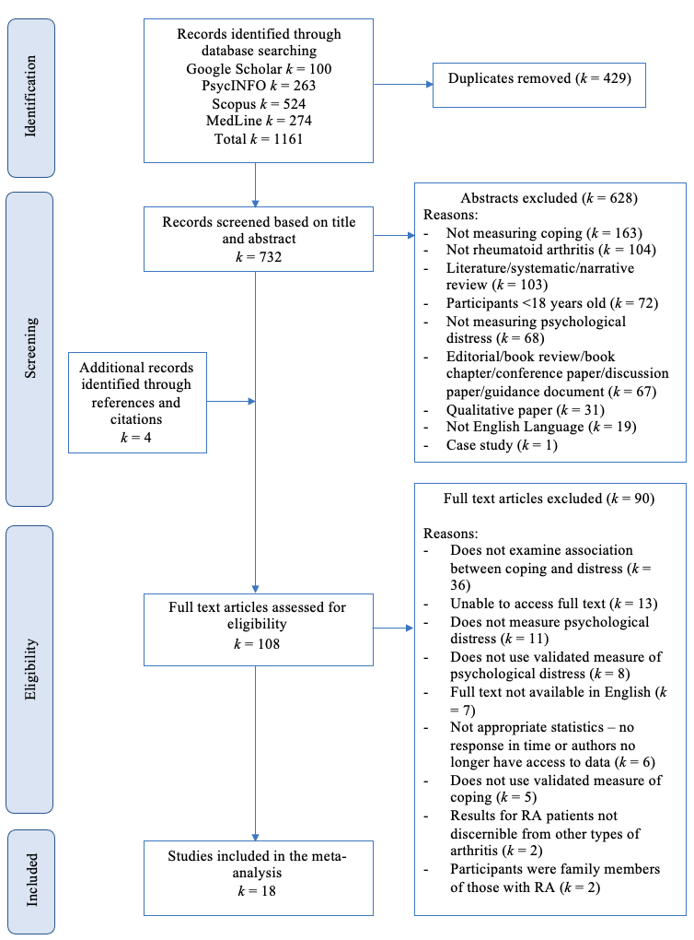

Data Extraction
Key data was extracted from the eligible articles, including the author(s), year of publication, country of origin, available sample demographics (size, gender, mean age, mean disease duration), measures used to assess psychological distress and coping styles. In studies with a longitudinal design, baseline cross-sectional Pearson’s coefficients were extracted for analysis; however, where this was not reported, the r value of the association between baselines coping styles and psychological distress at the next closest time point were extracted. All data was extracted by the researcher and recorded on Microsoft Excel. To check for accuracy of data extraction, a third of the included studies (k = 6) were randomly selected and data extracted independently by an additional reviewer.
Nine authors were contacted via email and ResearchGate (where possible) for further information if relevant demographic data or statistical analyses were missing. Where only significant bivariate correlations were reported, authors were contacted to obtain data for correlations that did not reach significance. Of those contacted two provided the requested data, five no longer had access to the data, and two did not reply. Six papers were excluded from this meta-analysis due to missing vital statistical information.
In studies with longitudinal designs, cross-sectional data was examined at baseline when available. Where studies did not report cross-sectional data, but reported longitudinal correlation coefficients, the r value for the association between baseline coping and psychological distress at the next closest timepoint was extracted.

Categorisation of Coping
The classification of coping styles as either adaptive or maladaptive in the current meta-analysis followed the structure used by Ewert et al., (2021) (see Figure 2.). Adaptive coping involved all emotional approach coping or problem-focused coping styles whereby the individual turns their attention towards the stressor, whereas maladaptive coping comprises those whereby the individual’s attention is turned away from the stressor. The coding of coping styles was based on the individual study’s description of the coping scales and on review of the coping scales themselves where these were accessible.

Figure 2
Hierarchical Classification of Coping
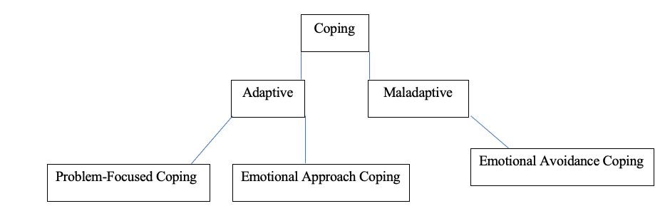

Quality Assessment
The methodological quality of the studies included in this sample was assessed via a bespoke quality assessment tool that was created following the recommendations outlined by Quintana (2015). Aspects of the study quality including sampling strategy, representativeness of the sample, sample, size, clarity of the hypotheses and methods used, and appropriateness of the analysis were considered. Two raters independently rated the studies utilising this tool, the first rater assessed all studies, whereas the second rater assessed a third of the papers, selected at random.
In accordance with the quality assessment tool, the studies were rated a ‘1’ if the study included the relevant information to satisfy the criterion, ‘0’ if it did not and ‘x’ if the raters were unsure. An overall sum for each study was produced, producing a maximum score of 11 and a minimum score of zero. Criteria rated ‘x’ were counted as zero. Studies with an overall sum of nine or more were considered high quality, those rated between six and eight were considered moderate quality, and those rated zero to five were considered low quality. If any studies were rated low in quality, sensitivity analyses would be conducted to assess the impact of these studies on the overall meta-analyses.

Analysis
The statistical software package Comprehensive Meta-Analysis (CMA; Version 3; Borenstein et al., 2013) was used to conduct a random-effects meta-analysis. Almost all studies reported a Pearson’s r statistic. Where studies reported other effect sizes, these were converted to an r value. Where more than one measure of psychological distress, or more than one measure of adaptive or maladaptive coping styles were reported, CMA calculated weighted averages which were then converted into one combined effect size for each study, which is a common approach for this issue (Card, 2012). Forest plots were utilised as graphical representations of the relative strengths of the effect sizes to better understand the statistical information that contributed to the analysis.
A random effects meta-analysis model was chosen to reduce the chance of a Type 1 error (Borenstein et al., 2010; Hunter & Schmidt, 2000), as this assumes variability across and within studies to be due to sampling error in addition to variability in the population of effects. CMA converted the correlation coefficients automatically into Fisher’s z scores (Hedges & Olkin, 1985) to calculate the integrated effect size, before being converted back. In line with Cohen’s (1992) guidelines for the magnitude of effect sizes, r = 0.10 is considered small, r = 0.30 to be medium and r = 0.50 to be large. These guidelines were used to assess the magnitude of the effects. In accordance with Bornstein et al.’s (2010) guidance, statistical significance was determined by an alpha value of <0.05.
Two primary meta-analyses were conducted: one explored the relationship between adaptive coping and distress, and the other explored the relationship between maladaptive coping and distress. Both meta-analyses calculated a pooled correlation co-efficient for the included studies. Cochrane’s Q and I² statistics (Higgins et al., 2003) were used to assess heterogeneity between studies. Q statistics examine the total variability amongst the pooled effect sizes (Card, 2012). A significant Q statistic indicates that the heterogeneity in the sample is significantly more than can be explained by sampling error (Borenstein et al., 2010). I² statistics assess the proportion of variability that is unaccounted for by sampling error within studies (Higgins & Thompson, 2002). An I² value of 25% is deemed to indicate low variance, 50% indicated moderate variance, and 75% or greater indicated high variance (Higgins et al., 2003).
Moderator analyses were conducted for those effects that were significant to explain the sources of heterogeneity. Three or more studies were required in each subgroup to be able to conduct moderator analyses, in accordance with the guidelines suggested by Card (2012). Method of moments meta-regressions were conducted to examine the moderating effects of the continuous variables including mean age, gender (percent female), and mean illness duration (Quintana, 2015), studies that did not report the necessary information were excluded from the meta-regressions. Sensitivity analysis was conducted to assess the impact of the longitudinal studies whereby cross-sectional data was unavailable, and longitudinal associations were used instead.
Publication Bias
Studies that find smaller effects are sometimes less likely to be published than studies with larger effects, which leads to an upward bias in the summary effects, this is known as the publication bias (Nair, 2019). To assess and remove publication bias, a multi-method approach was employed, as recommended by Card (2012): funnel plots, statistical tests of funnel plot asymmetry, and fail-safe N were all utilised.
Funnel plots combined the effect sizes at the study-level and were assessed for asymmetry; asymmetric funnel plots suggest evidence of reporting bias (Peters et al., 2008; Card 2012). Given the potential for subjectivity in visual interpretations, Egger’s Regression test (Egger et al., 1997) was utilised to examine whether the association between estimated effect size and study size is greater than what would be expected to occur by chance, with a risk of publication bias being indicated by a significant intercept test value. The ‘trim-and-fill’ method (Duval & Tweedle, 2004) was also used to assess asymmetry of the funnel plots by estimating and imputing hypothetically missing studies to provide an adjusted bias-corrected summary effect. Results are deemed to indicate publication bias if they are not comparable to the original values (Card, 2012).
Finally, Rosenthal’s (1979) fail-safe N method estimates the number of additional studies with a minimal effect that would be required to increase the p value for the pooled meta-analysis effect to be above p < .05, and therefore no longer significant. The fail-safe N was only calculated for those effects that reached statistical significance, defined by an alpha value of p > .05, in accordance with Bornstein et al.’s (2010) guidance. As a guideline, an adequately high fail-safe N was considered to be 5k + 10, where k equates to the number of studies included.

Results

Study and Sample Characteristics
The researcher extracted and recorded all data from all studies, and a second reviewer (RB, University of Sheffield), selected and extracted data from a third of the included studies (k = 6) to check for accuracy of extraction. Inter-rater agreement was high prior to discussion (94.45%). Discussion between the two data extractors occurred when extracted data was incongruent. Following discussion, inter-rater agreement increased to 100%.
Of the 18 studies (and 26 effect sizes) identified for inclusion five were conducted in North America, four in Ireland, two in Poland, two in the Netherlands, two in the United Kingdom, one in Eastern Slovakia, one in Australia, and one in Canada (see Table 1). Ten of the studies used large samples (N ≥ 100), and all used population-based samples. Ten studies used a cross-sectional design, and eight were longitudinal. Mean age of the samples ranged from 48.94-60.10 years, with females comprising 64.29-100% of the samples. Mean disease duration varied between 0.58-14.86 years. All studies used self-report measures to assess coping strategies and psychological distress (see Table 2). Ten different measures of coping strategies were employed across the studies. Seven different measures of psychological distress were employed, which reduced to six when excluding translations of the same measures. Despite searching the grey literature, all included papers were published and peer reviewed.
Figure 3 depicts the coping styles reported in the included studies, categorised into the hierarchical structure.

Figure 3
Hierarchical Structure of the Meta-Analysed Coping Strategies
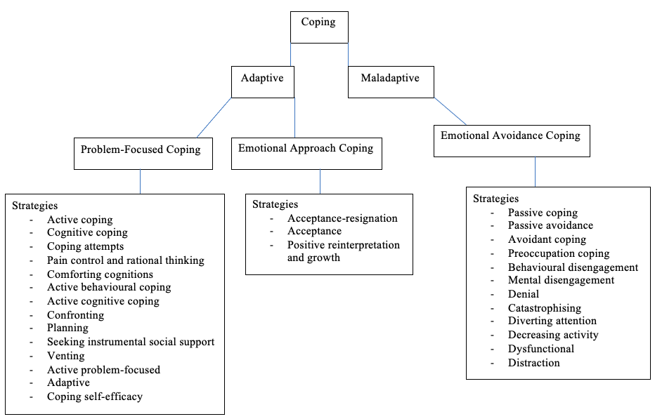

Table 1
Characteristics of Included Studies
Author (Year of Publication) | Analysed Sample Size | Country of Study | Study Design | Mean Age | % Female (n) | Disease Duration
Beckham et al. (1991) | 65 | United States | Cross-sectional | 55.20 | 66.69% (44) | 11.70
Benka et al. (2014) | 248 | Eastern Slovakia | Cross-sectional | --- | --- | ---
Covic et al. (2006) | 134 | Australia | Cross-sectional | 58.50 | 76.87% (103) | 13.20
Curtis et al. (2004) | 52 | Ireland | Longitudinal | 60.00 | 100% (52) | 13.00
Curtis et al. (2005) | 59 | Ireland | Cross-sectional | 60.00 | 100% (59) | 13.00
Dobkin et al. (2008) | 165 | Canada | Cross-sectional | 55.50 | 69.09% (114) | 0.58
Evers et al. (2002) | 95 | Netherlands | Longitudinal | 57.00 | 70.53% (67) | ---
Griffin et al. (2001) | 56 | United States | Longitudinal | 55.00 | 64.29% (36) | ---
Groarke et al. (2005) | 75 | Ireland | Cross-sectional | 60.10 | 100% (75) | 12.60
Keefe et al. (1988) | 223 | United States | Longitudinal | 52.70 | 74.89% (167) | 3.50
Lowe et al. (2008) | 127 | UK | Longitudinal | 56.20 | 79.53% (101) | 4.45
Smith & Wallston (1992) | 239 | United States | Longitudinal | 50.50 | 76.15% (182) | 3.20
Treharne et al. (2007) | 134 | UK | Longitudinal | 55.44 | 75.37% (101) | 7.29
van Lankveld et al. (2000) | 109 | Netherlands | Longitudinal | 56.10 | 66.97% (73) | 13.30
Wright et al. (1996) | 141 | United States | Cross-sectional | --- | --- | ---
Ziarko et al. (2014) | 210 | Poland | Cross-sectional | 54.92 | 83.81% (176) | 12.40
Ziarko et al. (2019) | 85 | Poland | Cross-sectional | 48.94 | 80.00% (68) | 14.86
Zyrianova et al. (2011) | 68 | Ireland | Cross-sectional | 52.30 | 69.12% (47) | 13.42
Note. --- indicates required data not reported/obtainable

Table 2
Meta-Analysed Effect Sizes Between Adaptive Coping (AC), Maladaptive Coping (MC) and Psychological Distress (PD)
Author  (Publication Year) | N | Coping Measures | Psychological Distress Measures | AC-PD  r | MC-PD  r
Beckham et al. (1991) | 65 | CSQ (coping attempts & pain control and rational thinking subscales) | BDI | -0.33 | ---
Benka et al. (2014) | 248 | CSE | HADS | -0.39 | ---
Covic et al. (2006) | 134 | CSQ | CES-D | --- | 0.5
Curtis et al. (2004) | 52 | COPE | AIMS (depression and anxiety subscales) & PANAS | --- | 0.44
Curtis et al. (2005) | 59 | COPE | AIMS (depression subscale) & PANAS | 0.01 | 0.29
Dobkin et al. (2008) | 165 | CHIP | CES-D | --- | 0.39
Evers et al. (2002) | 95 | UCL | IRGL (anxiety and depressed mood subscales) | -0.15 | 0.27
Griffin et al. (2001) | 56 | COPE | PANAS | 0.15 | 0.48
Groarke et al. (2005) | 75 | COPE | AIMS (depression and anxiety subscales) | -0.18 | 0.40
Keefe et al. (1988) | 223 | CSQ (catastrophising subscale) | CES-D | --- | 0.62
Lowe et al. (2008) | 127 | MCMQ | HADS | 0.38 | 0.25
Smith & Wallston (1992) | 239 | VPMI | CES-D | --- | 0.33
Treharne et al. (2007) | 134 | CSS | HADS | 0.02 | ---
van Lankveld et al. (2000) | 109 | CORS | IRGL | -0.29 | 0.22
Wright et al. (1996) | 141 | CSQ | CES-D | -0.16 | ---
Ziarko et al. (2014) | 210 | Brief-COPE | CES-D | --- | 0.40
Ziarko et al. (2019) | 85 | CSQ | HADS | -0.26 | 0.06
Zyrianova et al. (2011) | 68 | VPMI | BDI & BAI | 0.22 | 0.42
Overall effect size |  |  |  | -0.09 | 0.37
Note. Abbreviations: BDI (Beck Depression Inventory; Beck et al., 1961), BAI (Beck Anxiety Inventory; Beck et al., 1988), HADS (Hospital Anxiety and Depression Scale; Zigmond & Snaith, 1983), CES-D (Centre for Epidemiologic Studies – Depression Scale; Radloff, 1977), AIMS (Arthritis Impact Measurement Scale; Meenan et al., 1982), IRGL (Invloed van Reuma op Gezondheid en Leefwijze (Dutch health status questionnaire derived from AIMS); Huiskes et al., 1990), PANAS (Positive And Negative Affect Scale; Watson et al., 1988), CSQ (Coping Strategies Questionnaire; Rosenstiel & Keefe, 1983), COPE (Coping Orientation to Problems Experience; Carver et al., 1989), UCL (Ultrecht Coping List; Schreurs et al., 1993), CSE (Coping Self-Efficacy scale; Chesney et al., 2006), CHIP (Coping with Health Injuries and Problems scale; Endler & Parker, 1998), MCMQ (Medical Coping Modes Questionnaire; Feifel et al., 1987), CSS (Coping Schedule for Stress; Tyler & Cushway, 1995), CORS (Coping with Rheumatoid Stressors; van Lankveld et al., 1994), Brief-COPE (Brief Coping Orientation to Problems Experience; Carver, 1997), VPMI (Vanderbilt Pain Management Inventory; Brown & Nicassio, 1987).

Quality Appraisal
The quality of the studies was appraised by two raters independently; the first rater rated all studies, and the second rater (RB, University of Sheffield) assessed a third of the studies (k = 6) that were selected at random. Inter-rater agreement was high (87.88%), and this increased to 100% following discussion about the discrepancies.
Most studies achieved either a moderate (k = 10) or high (k = 8) quality rating (Table 2). One study (Evers et al., 2002) achieved a maximum score. One study that was included in the maladaptive meta-analysis (Ziarko et al., 2014) was rated as low in quality. Consequently, a sensitivity analysis was conducted to assess whether the pooled effect size was affected by the low-quality study.
Common reporting pitfalls included a lack of clearly defined participant inclusion criteria and the use of convenience sampling methods. A lack of clearly defined inclusion criteria negatively impacted the replicability of the methods. Most studies (k = 14) recruited participants from rheumatology outpatient services or registries, two (Ziarko et al., 2014; Ziarko et al., 2019) recruited participants who were hospitalised on rheumatology wards, and two utilised data collected from participants who had chosen to participate in stress management interventions (Lowe et al., 2008; Wright et al., 1996). Whilst the sampling methods employed by all studies ensured participants had a diagnosis of rheumatoid arthritis, it is likely these methods excluded individuals who were not actively or regularly accessing their outpatient services; for example, they may have been too unwell to do so. Additionally, some studies failed to report how participants were recruited from the outpatient services; for example, it is unclear whether all patients accessing a service were invited to participate, and how individuals were contacted. Furthermore, the two studies that recruited participants who were hospitalised on rheumatology wards were accessing patients who may have been acutely unwell, and who therefore may have been experiencing increased psychological distress or be unable to employ their typical coping mechanisms due to environmental restrictions.
Despite the variety of measures of psychological distress and coping styles employed, all studies utilised validated and reliable measures. Additionally, most studies reported potential limitations of the methods employed, and all clearly defined the study’s aims and target population.
Table 3
Quality Appraisal

Study | Quality Criteria
Study | Were the hypotheses/aims/objectives of the study clear? | Was the method of obtaining the data clearly described? | Were criteria for inclusion in the sample clearly defined? | Was the target/reference population clearly defined? | Was the sample taken from an appropriate population base so that it closely represented the target/reference population under investigation? | Was the selection process likely to select participants that were representative of the target/reference population under investigation? | Were the outcome variables measured using validated and reliable means? | Was the independent variable measured using validated and reliable means? | Was appropriate statistical analysis used? | Were the methods (including statistical methods) sufficiently described to enable them to be repeated? | Did the study describe any limitations? | Overall Sum
Beckham et al. (1991) | 1 | x | x | 1 | 1 | x | 1 | 1 | 1 | 0 | 1 | 7
Benka et al. (2014) | 1 | 1 | 1 | 1 | 1 | x | 1 | 1 | 1 | 1 | 1 | 10
Covic et al. (2006) | 1 | 1 | 0 | 1 | 1 | 0 | 1 | 1 | 1 | 0 | 1 | 8
Curtis et al. (2004) | 1 | x | 0 | 1 | 0 | 0 | 1 | 1 | 1 | 0 | 1 | 6
Curtis et al. (2005) | 1 | x | 0 | 1 | 1 | x | 1 | 1 | 1 | 0 | 1 | 7
Dobkin et al. (2008) | 1 | 1 | 1 | 1 | 1 | x | 1 | 1 | 1 | 1 | 1 | 10
Evers et al. (2002) | 1 | 1 | 1 | 1 | 1 | 1 | 1 | 1 | 1 | 1 | 1 | 11
Griffin et al. (2001) | 1 | 1 | 1 | 1 | 1 | x | 1 | 1 | 1 | 1 | 1 | 10
Groarke et al. (2005) | 1 | 1 | 1 | 1 | 0 | 0 | 1 | 1 | 1 | 1 | 1 | 9
Keefe et al. (1988) | 1 | x | 0 | 1 | 1 | x | 1 | 1 | 1 | 0 | x | 6
Lowe et al. (2008) | 1 | 1 | 0 | 0 | x | x | 1 | 1 | 1 | 0 | 1 | 6
Smith & Wallston (1992) | 1 | 1 | 0 | 1 | 1 | x | 1 | 1 | 1 | 0 | 1 | 8
Treharne et al. (2007) | 1 | 1 | 1 | 1 | 1 | x | 1 | 1 | 1 | 1 | 1 | 10
van Lankveld et al. (2000) | 1 | 1 | 1 | 1 | 1 | x | 1 | 1 | 1 | 1 | 1 | 10
Wright et al. (1996) | 1 | x | 1 | 1 | x | x | 1 | 1 | 1 | 1 | 1 | 8
Ziarko et al. (2014) | 1 | x | 0 | 1 | 0 | 0 | 1 | 1 | 1 | 0 | 0 | 5
Ziarko et al. (2019) | 1 | x | 0 | 1 | 0 | 0 | 1 | 1 | 1 | 0 | 1 | 6
Zyrianova et al. (2011) | 1 | 1 | 0 | 1 | 1 | x | 1 | 1 | x | 0 | 1 | 7

Meta-Analyses
Adaptive Coping
The association between adaptive coping and psychological distress was not significant (k = 12, n = 1262, r = -0.09, 95% CIs [-.23 - 0.07], z = -1.11, p = .267). There was evidence of significant heterogeneity Q (11) = 77.86, p = .000; I² = 85.87%, T² = 0.01. Effect sizes ranged from r = 0.38 to r = -0.39 (Figure 3).

Figure 3
Forest Plot for Adaptive Coping Styles and Psychological Distress Meta-analysis.
Maladaptive Coping
A significant medium effect size was found between maladaptive coping and psychological distress (k = 14, n =1697, r = 0.37, 95% CIs [0.29 - 0.45], z = 8.23, p = .000). There was evidence of moderate heterogeneity Q (13) = 45.40, p = 0.000; I² = 71.36%, T² = 0.02, warranting moderator analyses. Effect sizes ranged from r = 0.62 to r = 0.06 (Figure 4).

Figure 4
Forest Plot for Maladaptive Coping Styles and Psychological Distress Meta-analysis.

Moderator Analyses
As noted above, moderator analyses were conducted to assess potential reasons for the heterogeneity in the maladaptive coping meta-analysis.
Distress Type
Studies were grouped according to the type of psychological distress they measured: anxiety only, depression only, stress only, or mixed if they measured more than one type of distress. Five studies measured only depression (total n = 971), and nine measured a combination of different distress types (total n = 726). No studies measured only stress or anxiety. The subgroup analysis indicated that the effect sizes of the studies that measured depression only (r = 0.45; 95% CIs [0.40 - 0.50]; p = .000) were significantly greater than the effect sizes of the studies that measured a mixture of different distress types (r = 0.30; 95% CIs [0.23 - 0.36]; p = 0.000), Q_{between} (1) = 4.19, p = .041.
Gender
All but one study (k = 13, total n = 1474) reported participant gender and were included in the meta-regression (Appendix B Figure A1). There were no gender-related differences in the associations between maladaptive coping and psychological distress (b = 0.01, 95% CIs [-0.66 - 0.67], z = 0.02, Q_{model} (1) = 0.00 p = .983, Q_{residual} (11) = 20.34 p = .041). The effects were therefore robust to the influence of gender.
Age
All but one study (k = 13, total n = 1474) reported data on participant age and were included in the meta-regression (Appendix B Figure A2). There were no age-related differences in the associations between maladaptive coping and psychological distress (b = 0.02, 95% CIs [-0.004 - 0.04], z = 1.53, Q_{model} (1) = 2.34, p = .126, Q_{residual} (11) = 16.98, p = .109). The effects were therefore robust to the influence of age.
Illness Duration
Eleven studies (total n = 1323) reported participant illness duration and were included in the meta-regression (Appendix B Figure A3). There were no illness duration-related differences in the associations between maladaptive coping and psychological distress (b = -0.001, 95% CIs [-0.017 - 0.015], z = -0.09, Q_{model} (1) = 0.01, p = .925, Q_{residual} (9) = 18.12, p = .034). The effects were therefore robust to the influence of illness duration.

Publication Bias
For the maladaptive coping and psychological distress meta-analysis, all tests indicated the absence of publication bias. The funnel plot (Figure 5) does not display any asymmetry, and Egger’s Regression test was also non-significant, b₀ = -2.07, 95% CIs [-6.30 - 2.16], t (12) = 1.07, p = .307. Furthermore, the trim-and-fill test resulted in no studies being trimmed, producing identical obtained and imputed effects (r = 0.39, [0.35 - 0.43]. Finally, the fail-safe N method estimates that 879 studies with effects above p<.05 would be needed for the pooled meta-analysis effect size to no longer be significant, which is well above the required the k = 80 suggested by the guidelines.

Figure 5

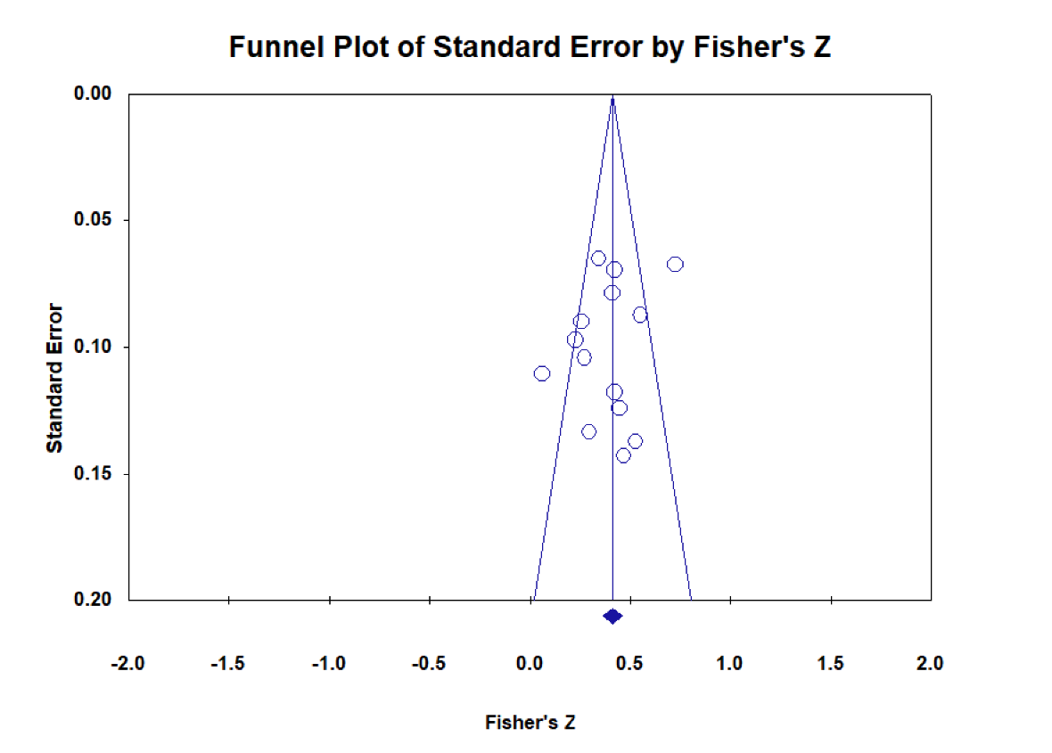
Publication Bias Funnel Plot for the Maladaptive Coping and Psychological Distress Meta-Analysis

Sensitivity Analysis
To examine if the pooled effect size was influenced by the different methodological designs used in some studies, a sensitivity analysis was conducted. Three studies (Curtis, 2004; Keefe et al., 1988; Smith & Wallston, 1992) did not report baseline correlations between coping styles and psychological distress; as such, the obtained effects referred to the association between baseline coping styles and psychological distress at the next closest timepoint. After removing these studies from the analysis, the result remained largely unchanged k = 11, r = 0.34, 95% CIs [0.27 - 0.41], z = 8.36, p = .000.
To examine if the pooled meta-analysis effect size was susceptible to influence from the study rated as low quality (i.e., rated a score of five or below on the quality analysis tool), this study (Ziarko et al., 2014) was removed from the meta-analysis. The results remained largely unchanged (k = 13, r = 0.37, 95% CIs [0.28 - 0.46], z = 7.34, p = .000). This suggests that the pooled effect size is robust to the effect of the poor-quality study, supporting the decision to keep this study in the meta-analysis.

Discussion
The current study is the first comprehensive and systematic review of research investigating the association between coping and psychological distress in rheumatoid arthritis. Two meta-analyses were conducted, one investigating adaptive coping styles, and one investigating maladaptive coping styles. In line with the hypothesis, maladaptive coping styles were significantly associated with greater psychological distress across the pool of studies. In contrast, adaptive coping styles were not significantly associated with reduced distress as hypothesised. Subgroup and meta-regression analyses indicated that the pooled association between maladaptive coping and distress was robust to the influence of age, gender, and illness duration. However, this association was significantly moderated by distress type, with larger effects found for those studies with effects for depression. The findings indicate that the coping styles that are employed in an attempt to tolerate or manage the chronic or acute everyday stressors associated with rheumatoid arthritis are important for psychological wellbeing. Additionally, the findings support the theories that link psychological distress to coping.
The findings from the maladaptive meta-analysis are consistent with previous research of other chronic illness, such as inflammatory bowel disease (van der Zaag-Loonen et al., 2004) and chronic obstructive pulmonary disease (Andenaes et al., 2006), and extends the findings of the systematic review by Vriezekolk et al. (2011). This meta-analysis is in line with the transactional model of coping (Lazarus & Folkman, 1984), as it suggests that when individuals with rheumatoid arthritis employ coping strategies that involve turning the focus of attention away from the stressor, this leads to psychological distress, potentially due to these strategies failing to have a lasting impact on the triggering stressor (Abramson et al., 1978; Stanton et al., 2000).
There was no significant association between adaptive coping and psychological distress, which is in contrast to the study hypothesis and previous findings. Geisser et al.’s (1999) model of adjustment to chronic pain provides a possible explanation for these null findings. This model posits that maladaptive coping and pain beliefs are the strongest determinants of psychological distress and may even impair the benefits of adaptive coping. This proposition is also consistent with research indicating that the associations between maladaptive coping and depression are stronger than those between adaptive coping and depression in chronic pain samples (Snow-Turek et al., 1996; Tan et al., 2011) In summary, the current research may suggest that interventions that are aimed at identifying and targeting maladaptive coping styles may be of greater benefit for psychological wellbeing. This may be particularly true in chronic illness samples, whereby stressors are typically chronic in nature.
Moderator analyses attempted to explain the moderate amount of heterogeneity observed in the maladaptive coping meta-analysis. Disease duration, gender, and age did not explain the observed heterogeneity, despite previous studies showing that these variables strengthen or weaken the relationship between maladaptive coping and distress. Previous research found the coping and distress relationship to be stronger in women than in men, however, this research was conducted in healthy samples rather than in populations with chronic illnesses (González-Morales et al., 2006; Hamid et al., 2023; Matt & Dean, 1993; Osei-Kuffour & Peprah, 2020; Zuckerman et al., 2017). Consequently, gender might not strengthen or weaken this relationship in chronic illness samples. Interestingly, disease duration has been found to moderate the coping and wellbeing relationship in other chronic health conditions, including Duangdao and Roesch’s (2008) study of diabetes. These contrasting findings may suggest that different variables strengthen or weaken the association between coping and wellbeing depending on the type of chronic condition individuals have. This may be due to the different types of stressors that accompany different chronic illnesses. Whilst research has found age to be negatively related to the effects of adaptive coping and distress (Duangdao & Roesch, 2008); Matt & Dean, 1993) these studies did not find that age moderated the effect of maladaptive coping and distress. The latter finding is consistent with the current study; consequently, for people of all ages, learning how to cope with stressors is important for wellbeing. Whilst studies examining depression had stronger coping-distress associations, there were too few studies that looked at stress and anxiety individually therefore it was not possible to fully explore the strength of the association for these types of distress. Future research should aim to consider other potential moderators of these relationships.
The findings of this meta-analysis provide further support for the importance of taking a biopsychosocial approach to managing rheumatoid arthritis (Keefe et al., 2002; NICE, 2018), and have important implications for clinical practice. This meta-analysis provides support for psychological interventions to identify what coping strategies they typically employ in response to the stressors they encounter. The findings suggest individuals with rheumatoid arthritis may benefit from avoiding coping strategies that involve turning attention away from the stressor. Furthermore, as no significant relationship was found between adaptive coping and psychological distress, and in accordance with Geisser et al.’s (1999) proposal that maladaptive coping may impair the benefits of adaptive coping, it would be recommended that psychological interventions focus on reducing the use of maladaptive coping strategies. Additionally, psychoeducation could be provided to inform individuals that, whilst such coping strategies may provide relief in the short-term, avoidance of the stressors may lead to further subsequent distress in the longer-term. The most researched psychological interventions for rheumatoid arthritis include cognitive behavioural therapy (CBT), psychotherapy, and mindfulness-based cognitive therapy (Prothero, 2018). The efficacy of these interventions is mediated by improvements in coping (Knittle et al., 2010), further highlighting the importance of coping for psychological wellbeing and psychological interventions. CBT typically involves coping skills training, of which the primary aim is to identify maladaptive coping strategies that the client engages in alongside encouraging problem-solving techniques (adaptive coping) to increase clients’ coping self-efficacy (Wadsworth, 2015). This involves using cognitive restructuring techniques to understand the maladaptive cognitions that lead to maladaptive strategies being engaged with, and reformulating these thoughts into alternative, adaptive ones (Wadsworth, 2015). Reviews of psychological interventions for rheumatoid arthritis reported that these interventions can improve coping skills in patients with the disease, and these improvements can remain significant at follow-up (averaging eight and a half months; Astin et al., 2002); however, further research is required to understand the mechanisms through which the interventions work, and whether particular coping styles mediate the observed benefits (Prothero et al., 2018). Additionally, further research could examine how effective cognitive restructuring is at reducing engagement with maladaptive coping strategies specifically, and how much this mediates the effect of the overall psychological intervention on reducing psychological distress.

Strengths and Limitations
Interpretation of the findings of these meta-analyses should be considered in the context of their strengths and limitations. The accuracy of data extraction and quality assessment was improved by having an additional, independent extractor/rater, and the inter-rater reliability was high. Risk of bias was thoroughly examined through quality analysis and multiple assessments of publication bias, increasing the validity and reliability of the findings.
The study is limited in that most findings included in the analyses came from cross-sectional data. Therefore, it is not possible to draw causal conclusions, making longitudinal research on this topic necessary. Caution must also be taken in generalising the results of the current meta-analyses to the wider rheumatoid arthritis population. It could be argued that many of the studies may be vulnerable to selectivity bias, in that only those well enough to attend an outpatient clinic, or only those severely unwell who required hospitalisation were included. These findings may therefore be more relevant to those with either better physical and psychological health, or those who are in acute distress. Furthermore, whilst subgroup analysis found a stronger association between maladaptive coping and distress in studies that examined depression, there were insufficient studies that examined other types of distress to form individual subgroups for comparison. As such, more research is needed to better understand the relationship between coping and psychological distress of other types (for example, anxiety), the moderator findings may have differed if further subgroups were included.

Conclusion
For individuals with rheumatoid arthritis, the coping styles that are employed in attempts to tolerate or manage the chronic or acute everyday stressors associated with the disease are important for psychological wellbeing. Meta-analyses found that maladaptive coping is associated with increased psychological distress, however, no significant relationship was found between adaptive coping and distress. Consequently, psychological interventions for this population should involve techniques such as cognitive restructuring to identify and reduce engagement with maladaptive coping strategies. Further research can examine whether incorporating these techniques into psychological interventions improves the efficacy of the overall interventions in reducing psychological distress. There was some difference in the magnitude of the effect size between the studies, partially accounted for by the type of distress that the studies measured, in that stronger associations were found for studies that examined depression. Further research is needed to identify factors that strengthen or weaken the association between maladaptive coping and distress.

References
Abramson, L. Y., Seligman, M. E. P., & Teasdale, J. D. (1978). Learned helplessness in humans: Critique and reformulation. Journal of Abnormal Psychology, 87(1), 49-74. https://doi.org/10.1037/0021-843X.87.1.49
Andenæs, R., Kalfoss, M. H., & Wahl, A. K. (2006). Coping and psychological distress in hospitalized patients with chronic obstructive pulmonary disease. Heart & Lung, 35(1), 46-57. https://doi.org/10.1016/j.hrtlng.2005.09.009
Astin, J. A., Beckner, W., Soeken, K., Hochberg, M. C., & Berman, B. (2002). Psychological interventions for rheumatoid arthritis: A meta‐analysis of randomized controlled trials. Arthritis Care & Research, 47(3), 291-302. https://doi.org/10.1002/art.10416
Barskova, T., & Oesterreich, R. (2009). Post-traumatic growth in people living with a serious medical condition and its relations to physical and mental health: A systematic review. Disability and Rehabilitation, 31(21), 1709-1733. https://doi.org/10.1080/09638280902738441
Beck, A. T., Epstein, N., Brown, G., & Steer, R. A. (1988). An inventory for measuring clinical anxiety: Psychometric properties. Journal of Consulting and Clinical Psychology, 56(6), 893–897. https://doi.org/10.1037/0022-006X.56.6.893
Beck, A. T., Ward, C. H., Mendelson, M., Mock, J., & Erbaugh, J. (1961). An inventory for measuring depression. Archives of General Psychiatry, 4(6), 561-571. https://doi.org/10.1001/archpsyc.1961.01710120031004
*Beckham, J. C., Keefe, F. J., Caldwell, D. S., & Roodman, A. A. (1991). Pain coping strategies in rheumatoid arthritis: Relationships to pain, disability, depression and daily hassles. Behavior Therapy, 22(1), 113-124. https://doi.org/10.1016/S0005-7894(05)80249-7
*Benka, J., Nagyova, I., Rosenberger, J., Macejova, Z., Lazurova, I., Van der Klink, J., Groothoof, J., & Van Dijk, J. (2014). Is coping self-efficacy related to psychological distress in early and established rheumatoid arthritis patients?. Journal of Developmental and Physical Disabilities, 26(3), 285-297. https://doi.org/10.1007/s10882-013-9364-y
Borenstein, M., Hedges, L. V., Higgins, J. P., & Rothstein, H. R. (2010). A basic introduction to fixed-effect and random-effects models for meta-analysis. Research Synthesis Methods, 1(2), 97–111. https://doi.org/10.1002/jrsm.12
Borenstein, M., Hedges, L., Higgins, L., & Rothstein, H. R. (2013). Comprehensive meta-analysis (version 3) [Computer software]. www.meta-analysis.com
Brown, G. K., & Nicassio, P. M. (1987). Development of a questionnaire for the assessment of active and passive coping strategies in chronic pain patients. Pain, 31(1), 53-64. https://doi.org/10.1016/0304-3959(87)90006-6
Card, N. A. (2012). Applied meta-analysis for social science research. Guilford Press.
Carver, C. S., Scheier, M. F., & Weintraub, J. K. (1989). Assessing coping strategies: A theoretically based approach. Journal of Personality and Social Psychology, 56(2), 267-283. https://doi.org/10.1037/0022-3514.56.2.267
Carver, C. S. (1997). You want to measure coping but your protocol’s too long: Consider the brief cope. International Journal of Behavioral Medicine, 4(1), 92-100. https://doi.org/10.1207/s15327558ijbm0401_6
Carver, C. S., & Connor-Smith, J. (2010). Personality and coping. Annual Review of Psychology, 61, 679-704. https://doi.org/10.1146/annurev.psych.093008.100352
Chesney, M. A., Neilands, T. B., Chambers, D. B., Taylor, J. M., & Folkman, S. (2006). A validity and reliability study of the coping self‐efficacy scale. British Journal of Health Psychology, 11(3), 421-437. https://doi.org/10.1348/135910705X53155
Cohen, J. (1992). A power primer. Psychological Bulletin, 112(1), 155-159. https://doi.org/10.1037//0033-2909.112.1.155
Cohen, S., Janicki-Deverts, D., Doyle, W. J., Miller, G. E., Frank, E., Rabin, B. S., & Turner, R. B. (2012). Chronic stress, glucocorticoid receptor resistance, inflammation, and disease risk. Proceedings of the National Academy of Sciences, 109(16), 5995-5999. https://doi.org/10.1073/pnas.1118355109
*Covic, T., Tyson, G., Spencer, D., & Howe, G. (2006). Depression in rheumatoid arthritis patients: Demographic, clinical, and psychological predictors. Journal of Psychosomatic Research, 60(5), 469-476. https://doi.org/10.1016/j.jpsychores.2005.09.011
Cross, M., Smith, E., Hoy, D., Carmona, L., Wolfe, F., Vos, T., Williams, B., Gabriel, S., Lassere, M., Johns, N., Buchbiner, R., Woolf, A., & March, L. (2014). The global burden of rheumatoid arthritis: Estimates from the global burden of disease 2010 study. Annals of the Rheumatic Diseases, 73(7), 1316-1322. http://dx.doi.org/10.1136/annrheumdis-2013-204627
*Curtis, R., Groarke, A., Coughlan, R., & Gsel, A. (2004). The influence of disease severity, perceived stress, social support and coping in patients with chronic illness: A 1 year follow up. Psychology, Health & Medicine, 9(4), 456-475. https://doi.org/10.1080/1354850042000267058
*Curtis, R., Groarke, A., Coughlan, R., & Gsel, A. (2005). Psychological stress as a predictor of psychological adjustment and health status in patients with rheumatoid arthritis. Patient Education and Counselling, 59(2), 192-198. https://doi.org/10.1016/j.pec.2004.10.015
Cutolo, M., & Straub, R. H. (2006). Stress as a risk factor in the pathogenesis of rheumatoid arthritis. Neuroimmunomodulation, 13(6), 277-282. https://doi.org/10.1159/000104855
Dempster, M., Howell, D., & McCorry, N. K. (2015). Illness perceptions and coping in physical health conditions: A meta-analysis. Journal of Psychosomatic Research, 79(6), 506-513. https://doi.org/10.1016/j.jpsychores.2015.10.006
Dickens, C., & Creed, F. (2001). The burden of depression in patients with rheumatoid arthritis. Rheumatology, 40(12), 1327-1330. https://doi.org/10.1093/rheumatology/40.12.1327
Dickens, C., McGowan, L., Clark-Carter, D., & Creed, F. (2002). Depression in rheumatoid arthritis: A systematic review of the literature with meta-analysis. Psychosomatic Medicine, 64(1), 52-60. https://doi.org/10.1097/00006842-200201000-00008
*Dobkin, P. L., Filipski, M., Looper, K., Schieir, O., & Baron, M. (2008). Identifying target areas of treatment for depressed early inflammatory arthritis patients. Psychotherapy and Psychosomatics, 77(5), 298-305. https://doi.org/10.1159/000142522
Duangdao, K. M., & Roesch, S. C. (2008). Coping with diabetes in adulthood: A meta-analysis. Journal of Behavioral Medicine, 31(4), 291-300. https://doi.org/10.1007/s10865-008-9155-6
Duval, S., & Tweedie, R. (2004). Trim and fill: A simple funnel‐plot–based method of testing and adjusting for publication bias in meta‐analysis. Biometrics, 56(2), 455-463. https://doi.org/10.1111/j.0006-341x.2000.00455.x
Egger, M., Smith, G. D., Schneider, M., & Minder, C. (1997). Bias in meta-analyses detected by a simple, graphical test. British Medical Journal, 315(7109), 629-634. https://doi.org/10.1136/bmj.315.7109.629
Endler, N. S., Parker, J. D., & Summerfeldt, L. J. (1998). Coping with health problems: Developing a reliable and valid multidimensional measure. Psychological Assessment, 10(3), 195-205. https://doi.org/10.1037/1040-3590.10.3.195
*Evers, A. W., Kraaimaat, F. W., Geenen, R., Jacobs, J. W., & Bijlsma, J. W. (2002). Long-term predictors of anxiety and depressed mood in early rheumatoid arthritis: A 3 and 5 year follow-up. The Journal of Rheumatology, 29(11), 2327-2336.
Ewert, C., Vater, A., & Schröder-Abé, M. (2021). Self-compassion and coping: A meta-analysis. Mindfulness, 12(2), 1063-1077. https://doi.org/10.21037/cdt-20-692
Feifel, H., Strack, S., & Nagy, V. T. (1987). Degree of life-threat and differential use of coping modes. Journal of Psychosomatic Research, 31(1), 91–99. https://doi.org/10.1016/0022-3999(87)90103-6
Felton, B. J., & Revenson, T. A. (1984). Coping with chronic illness: A study of illness controllability and the influence of coping strategies on psychological adjustment. Journal of Consulting and Clinical Psychology, 52(3), 343-353. https://doi.org/10.1037/0022-006X.52.3.343
Ferrari, R., & Russell, A. S. (2010). Correlations between coping styles and symptom expectation for rheumatoid arthritis. Clinical Rheumatology, 29(12), 1445-1448. https://doi.org/10.1007/s10067-010-1551-y
Geisser, M. E., Robinson, M. E., & Riley, J. L. (1999). Pain beliefs, coping, and adjustment to chronic pain: Let's focus more on the negative. Pain Forum, 8(4), 161-168. https://doi.org/10.1016/S1082-3174(99)70001-2
Gettings, L. (2010). Psychological well‐being in rheumatoid arthritis: A review of the literature. Musculoskeletal Care, 8(2), 99-106. https://doi.org/10.1002/msc.171
González-Morales, M. G., Peiró, J. M., Rodríguez, I., & Greenglass, E. R. (2006). Coping and distress in organizations: The role of gender in work stress. International Journal of Stress Management, 13(2), 228-248. https://doi.org/10.1037/1072-5245.13.2.228
Grech, L. B., Kiropoulos, L. A., Kirby, K. M., Butler, E., Paine, M., & Hester, R. (2018). Target coping strategies for interventions aimed at maximizing psychosocial adjustment in people with multiple sclerosis. International Journal of MS Care, 20(3), 109-119. https://doi.org/10.7224/1537-2073.2016-008
*Griffin, K. W., Friend, R., Kaell, A. T., & Bennett, R. S. (2001). Distress and disease status among patients with rheumatoid arthritis: Roles of coping styles and perceived responses from support providers. Annals of Behavioral Medicine, 23(2), 133-138. https://doi.org/10.1207/S15324796ABM2302_8
*Groarke, A., Curtis, R., Coughlan, R., & Gsel, A. (2005). Predictors of physical, psychological and social adjustment in women with rheumatoid arthritis. The Irish Journal of Psychology, 26(4), 161-176. https://doi.org/10.1080/03033910.2005.10446218
Hamid, A. A., Al Miskry, A. S. A., & Darweesh, A. H. M. (2023). The relationship between coping and distress among faculty members and students during COVID-19 pandemic lockdown: The moderating effect of gender. Frontiers in Psychiatry, 14, 1103049. https://doi.org/10.3389/fpsyt.2023.1103049
Hedges, L.V. & Olkin, I. (1985). Statistical methods for meta-analysis. Academic Press.
Higgins, J. P., & Thompson, S. G. (2002). Quantifying heterogeneity in a meta‐analysis. Statistics in Medicine, 21(11), 1539-1558. https://doi.org/10.1002/sim.1186
Higgins, J. P., Thompson, S. G., Deeks, J. J., & Altman, D. G. (2003). Measuring inconsistency in meta-analyses. BMJ, 327, 557-560. https://doi.org/10.1136/bmj.327.7414.557
Huiskes, C. J. A. E., Kraaimaat, F. W., & Bijlsma, J. W. J. (1990). Development of a self-report questionnaire to assess the impact of rheumatic diseases on health and lifestyle. Journal of Rehabilitation Science, 3(3), 65-70.
Hunter, J. E., & Schmidt, F. L. (2000). Fixed effects vs. random effects meta‐analysis models: Implications for cumulative research knowledge. International Journal of Selection and Assessment, 8(4), 275-292. https://doi.org/10.1111/1468-2389.00156
Jamshidi, A. R., Banihashemi, A. T., Paragomi, P., Hasanzadeh, M., Barghamdi, M., & Ghoroghi, S. (2016). Anxiety and depression in rheumatoid arthritis: An epidemiologic survey and investigation of clinical correlates in Iranian population. Rheumatology International, 36(8), 1119-1125. https://doi.org/10.1007/s00296-016-3493-4
*Keefe, F. J., Brown, G. K., Wallston, K. A., & Caldwell, D. S. (1989). Coping with rheumatoid arthritis pain: Catastrophizing as a maladaptive strategy. Pain, 37(1), 51-56. https://doi.org/10.1016/0304-3959(89)90152-8
Keefe, F. J., Smith, S. J., Buffington, A. L., Gibson, J., Studts, J. L., & Caldwell, D. S. (2002). Recent advances and future directions in the biopsychosocial assessment and treatment of arthritis. Journal of Consulting and Clinical Psychology, 70(3), 640-655. https://doi.org/10.1037/0022-006X.70.3.640
Knittle, K., Maes, S., & De Gucht, V. (2010). Psychological interventions for rheumatoid arthritis: Examining the role of self‐regulation with a systematic review and meta‐analysis of randomized controlled trials. Arthritis Care & Research, 62(10), 1460-1472. https://doi.org/10.1002/acr.20251
Larsen, R. J. (2000). Toward a science of mood regulation. Psychological Inquiry, 11(3), 129-141. https://doi.org/10.1207/S15327965PLI1103_01
Lazarus, R. S., & Folkman, S. (1984). Stress, Appraisal, and Coping. Springer.
Lok, E. Y. C., Mok, C. C., Cheng, C. W., & Cheung, E. F. C. (2010). Prevalence and determinants of psychiatric disorders in patients with rheumatoid arthritis. Psychosomatics, 51(4), 338–339. https://doi.org/10.1016/S0033-3182(10)70705-2
*Lowe, R., Cockshott, Z., Greenwood, R., Kirwan, J. R., Almeida, C., Richards, P., & Hewlett, S. (2008). Self-efficacy as an appraisal that moderates the coping-emotion relationship: Associations among people with rheumatoid arthritis. Psychology and Health, 23(2), 155-174. https://doi.org/10.1080/14768320601139160
Majnik, J., Császár-Nagy, N., Böcskei, G., Bender, T., & Nagy, G. (2022). Non-pharmacological treatment in difficult-to-treat rheumatoid arthritis. Frontiers in Medicine, 9, 991677. https://doi.org/10.3389/fmed.2022.991677 .
Matcham, F., Galloway, J., Hotopf, M., Roberts, E., Scott, I. C., Steer, S., & Norton, S. (2018). The impact of targeted rheumatoid arthritis pharmacologic treatment on mental health: A systematic review and network meta‐analysis. Arthritis & Rheumatology, 70(9), 1377-1391. https://doi.org/10.1002/art.40565
Matt, G. E., & Dean, A. (1993). Social support from friends and psychological distress among elderly persons: Moderator effects of age. Journal of Health and Social Behavior, 34(3), 187-200. https://doi.org/10.2307/2137201
McInnes, I. B., & Schett, G. (2011). The pathogenesis of rheumatoid arthritis. New England Journal of Medicine, 365(23), 2205-2219. https://doi.org/10.1056/NEJMra1004965
McIntosh, R. C., & Rosselli, M. (2012). Stress and coping in women living with HIV: A meta-analytic review. AIDS and Behavior, 16(8), 2144-2159. https://doi.org/10.1007/s10461-012-0166-5
Meenan, R. E, Gertman, P. M., Mason, J. H., & Dunait, R. (1982). The arthritis impact measurement scales: Further investigations of a health status measure. Arthritis and Rheumatism, 23(9), 1048-1053. https://doi.org/10.1002/art.1780250903
Moher, D., Liberati, A., Tetzlaff, J., & Altman, D. G. (2009). Preferred reporting items for systematic reviews and meta-analyses: The PRISMA statement. Annals of Internal Medicine, 151(4), 264-269. https://doi.org/10.1371/journal.pmed.1000097
Moos, R. H., & Holahan, C. J. (2007). Adaptive tasks and methods of coping with illness and disability. In Martz, E., & Hanoch, L. (Eds.), Coping with chronic illness and disability (pp. 107-128). Springer.
Nair, A. S. (2019). Publication bias: Importance of studies with negative results. Indian Journal of Anaesthesia, 63(6), 505-507. https://doi.org/10.4103/ija.IJA_142_19
Newman, S. (1993). Coping with rheumatoid arthritis. Annals of the Rheumatic Diseases, 52(8), 553-554. https://doi.org/10.1136/ard.52.8.553
National Institute for Health and Care Excellence. (2018). Rheumatoid arthritis in adults: management [NICE Guideline No.NG100]. https://www.nice.org.uk/guidance/ng100
Osei-Kuffour, F., & Peprah, W. K. (2020). The moderating effect of gender on adaptive coping mechanisms and financial stress. Archives of Business Research, 8(1), 82-93. https://doi.org/10.14738/abr.81.7347
Peters, J. L., Sutton, A. J., Jones, D. R., Abrams, K. R., & Rushton, L. (2008). Contour-enhanced meta-analysis funnel plots help distinguish publication bias from other causes of asymmetry. Journal of Clinical Epidemiology, 61(10), 991-996. https://doi.org/10.1016/j.jclinepi.2007.11.010
Pincus, T., Griffith, J., Pearce, S., & Isenberg, D. (1996). Prevalence of self-reported depression in patients with rheumatoid arthritis. Rheumatology, 35(9), 879-883. https://doi.org/10.1093/rheumatology/35.9.879
Prothero, L., Barley, E., Galloway, J., Georgopoulou, S., & Sturt, J. (2018). The evidence base for psychological interventions for rheumatoid arthritis: A systematic review of reviews. International Journal of Nursing Studies, 82, 20-29. https://doi.org/10.1016/j.ijnurstu.2018.03.008
Quintana, D. S. (2015). From pre-registration to publication: A non-technical primer for conducting a meta-analysis to synthesize correlational data. Frontiers in Psychology, 6, 1549. https://doi.org/10.3389/fpsyg.2015.01549
Radloff, L. S. (1977). The CES-D scale: A self-report depression scale for research in the general population. Applied Psychological Measurement, 1(3), 385-401. https://doi.org/10.1177/014662167700100306
Rogers, M. P., & Fozdar, M. (1996). Psychoneuroimmunology of autoimmune disorders. Advances in Neuroimmunology, 6(2), 169-177. https://doi.org/10.1016/0960-5428(96)00015-0
Rosenstiel, A. K., & Keefe, F. J. (1983). The use of coping strategies in chronic low back pain patients: Relationship to patient characteristics and current adjustment. Pain, 17(1), 33-44. https://doi.org/10.1016/0304-3959(83)90125-2
Rosenthal, R. (1979). The file drawer problem and tolerance for null results. Psychological Bulletin, 86(3), 638-641. https://doi.org/10.1037/0033-2909.86.3.638
Roth, S., & Cohen, L. J. (1986). Approach, avoidance, and coping with stress. American Psychologist, 41(7), 813-819. https://doi.org/10.1037/0003-066X.41.7.813
Schreurs, P. J. G., van de Willige, G., Tellegen, B., & Brosschot, J. F. (1993). Herziene handleiding Utrechtse Coping Lijst (UCL). Swets & Zeitlinger.
Sharpe, L., Sensky, T., & Allard, S. (2001). The course of depression in recent onset rheumatoid arthritis: The predictive role of disability, illness perceptions, pain and coping. Journal of Psychosomatic Research, 51(6), 713-719. https://doi.org/10.1016/S0022-3999(01)00266-5
Sherbourne, C. D., Hays, R. D., Ordway, L., DiMatteo, M. R., & Kravitz, R. L. (1992). Antecedents of adherence to medical recommendations: Results from the Medical Outcomes Study. Journal of Behavioral Medicine, 15(5), 447-468. https://doi.org/10.1007/BF00844941
Sirois, F. M., & Kitner, R. (2015). Less adaptive or more maladaptive? A meta–analytic investigation of procrastination and coping. European Journal of Personality, 29(4), 433-444. https://doi.org/10.1002/per.1985
Skinner, E. A., Edge, K., Altman, J., & Sherwood, H. (2003). Searching for the structure of coping: A review and critique of category systems for classifying ways of coping. Psychological Bulletin, 129(2), 216-269. https://doi.org/10.1037/0033-2909.129.2.216
*Smith, C. A., & Wallston, K. A. (1992). Adaptation in patients with chronic rheumatoid arthritis: Application of a general model. Health Psychology, 11(3), 151. https://doi.org/10.1037/0278-6133.11.3.151
Snow-Turek, A. L., Norris, M. P., & Tan, G. (1996). Active and passive coping strategies in chronic pain patients. Pain, 64(3), 455-462. https://doi.org/10.1016/0304-3959(95)00190-5
Stanisławski, K. (2019). The coping circumplex model: An integrative model of the structure of coping with stress. Frontiers in Psychology, 10, 694. https://doi.org/10.3389/fpsyg.2019.00694
Stanton, A. L., Kirk, S. B., Cameron, C. L., & Danoff-Burg, S. (2000). Coping through emotional approach: Scale construction and validation. Journal of Personality and Social Psychology, 78(6), 1150-1169. https://doi.org/10.1037/0022-3514.78.6.1150
Strand, V., & Khanna, D. (2010). The impact of rheumatoid arthritis and treatment on patients' lives. Clinical and Experimental Rheumatology, 28(3), 32–40.
Symmons, D., Turner, G., Webb, R., Asten, P., Barrett, E., Lunt, M., Scott, D., & Silman, A. (2002). The prevalence of rheumatoid arthritis in the United Kingdom: New estimates for a new century. Rheumatology, 41(7), 793-800. https://doi.org/10.1093/rheumatology/41.7.793
Tan, G., Teo, I., Anderson, K. O., & Jensen, M. P. (2011). Adaptive versus maladaptive coping and beliefs and their relation to chronic pain adjustment. The Clinical Journal of Pain, 27(9), 769-774. https://doi.org/0.1097/AJP.0b013e31821d8f5a
*Treharne, G. J., Lyons, A. C., Booth, D. A., & Kitas, G. D. (2007). Psychological well‐being across 1 year with rheumatoid arthritis: Coping resources as buffers of perceived stress. British Journal of Health Psychology, 12(3), 323-345. https://doi.org/10.1348/135910706X109288
Tyler, P., & Cushway, D. (1995). Stress in nurses: The effects of coping and social support. Stress Medicine, 11(1), 243–251. https://doi.org/10.1002/smi.2460110140
van der Zaag-Loonen, H. J., Grootenhuis, M. A., Last, B. F., & Derkx, H. H. F. (2004). Coping strategies and quality of life of adolescents with inflammatory bowel disease. Quality of Life Research, 13(5), 1011-1019. https://doi.org/10.1023/B:QURE.0000025598.89003.0c
van Lankveld, W., Bosch, P. V. T. P., Van De Putte, L., Närbng, G., & Van Der Staak, C. (1994). Disease-specific stressors in rheumatoid arthritis: Coping and well-being. Rheumatology, 33(11), 1067-1073. https://doi.org/10.1093/rheumatology/33.11.1067
*van Lankveld, W., Näring, G., Bosch, P. V. T. P., & van de Putte, L. (2000). The negative effect of decreasing the level of activity in coping with pain in rheumatoid arthritis: Sn increase in psychological distress and disease impact. Journal of Behavioral Medicine, 23(4), 377-391. https://doi.org/10.1023/A:1005552901946
Vriezekolk, J. E., van Lankveld, W. G., Geenen, R., & van den Ende, C. H. (2011). Longitudinal association between coping and psychological distress in rheumatoid arthritis: A systematic review. Annals of the Rheumatic Diseases, 70(7), 1243-1250. http://doi.org/10.1136/ard.2010.143271
Wadsworth, M. E. (2015). Development of maladaptive coping: A functional adaptation to chronic, uncontrollable stress. Child Development Perspectives, 9(2), 96-100. https://doi-org.sheffield.idm.oclc.org/10.1111/cdep.12112
*Watson, D., Clark, L. A., & Tellegen, A. (1988). Development and validation of brief measures of positive and negative affect: The PANAS scales. Journal of Personality and Social Psychology, 54(6), 1063-1070. https://doi.org/10.1037/0022-3514.54.6.1063
*Wright, G. E., Parker, J. C., Smarr, K. L., Schoenfeld‐Smith, K., Buckelew, S. P., Slaughter, J. R., Johnson, J. C., & Hewett, J. E. (1996). Risk factors for depression in rheumatoid arthritis. Arthritis & Rheumatism: Official Journal of the American College of Rheumatology, 9(4), 264-272. https://doi.org/10.1002/1529-0131(199608)9:4<264::AID-ANR1790090411>3.0.CO;2-K
*Ziarko, M., Mojs, E., Piasecki, B., & Samborski, W. (2014). The mediating role of dysfunctional coping in the relationship between beliefs about the disease and the level of depression in patients with rheumatoid arthritis. The Scientific World Journal, 2014(1), 585063. https://doi.org/10.1155/2014/585063
*Ziarko, M., Siemiątkowska, K., Sieński, M., Samborski, W., Samborska, J., & Mojs, E. (2019). Mental health and rheumatoid arthritis: Toward understanding the emotional status of people with chronic disease. BioMed Rsearch International, 2019(1), 147395. https://doi.org/10.1155/2019/1473925
Zigmond, A. S., & Snaith, R. P. (1983). The hospital anxiety and depression scale. Acta Psychiatrica Scandinavica, 67(6), 361-370. https://doi.org/10.1111/j.1600-0447.1983.tb09716.x
Zukerman, G., Korn, L., & Fostick, L. (2017). Religious coping and posttraumatic stress symptoms following trauma: The moderating effects of gender. Psychology of Religion and Spirituality, 9(4), 328-336. https://doi.org/10.1037/rel0000075
*Zyrianova, Y., Kelly, B. D., Sheehan, J., McCarthy, C., & Dinan, T. G. (2011). The psychological impact of arthritis: the effects of illness perception and coping. Irish Journal of Medical Science, 180(1), 203-210. https://doi.org/10.1007/s11845-010-0522-2

Appendices

Appendix A

Reference List of Inaccessible Papers
Bendsten, P., & Hornquist, J. (1994). Rheumatoid arthritis, coping and well-being: Cross-sectional sub-group comparisons and correlational analyses. Scandinavian Journal of Social Medicine, 22(2), 97-106. https://doi-org.sheffield.idm.oclc.org/10.1177/140349489402200204
Brown, G. K. (1988). A causal analysis of pain and depression in rheumatoid arthritis with social support and coping resources as mediators. [Doctoral thesis, Vanderbilt University].
Covic, T., Adamson, B., Howe, G., & Spencer, D. (2002). The role of passive coping and helplessness in rheumatoid arthritis depression and pain. Journal of Applied Health Behaviour, 4(1-2), 31-35.
Hart, W. R. (1979). Rheumatoid arthritis, depression, and preceding life events: A study of event desirability, anticipation, control, and coping effectiveness. [Doctoral thesis, Indiana University]. ProQuest Dissertations and Theses Global.
Menefee, L. A. (1995). The effect of social support on coping and psychological adjustment in rheumatoid arthritis. [Doctoral thesis, University of Iowa]. ProQuest Dissertations and Theses Global.
Mojs, E., Ziarko, M., Kaczmarek, Ł., & Samborski, W. (2011). Anxiety level and its determinants in rheumatoid arthritis patients. Chirurgia Narzadow Ruchu i Ortopedia Polska, 76(4), 219-224.
Morgan, C. G. (1986). Social and psychological well-being, pain, functional ability, and choice of coping strategies in patients with rheumatoid arthritis. [Doctoral thesis, University of California].
Newman, S., & Lamb, R. (1990). Patterns of coping in rheumatoid arthritis. Psychology and Health, 4(3), 187-200. https://doi.org/10.1080/08870449008400389
Oliveira, P., & Costa, M. E. (2009). Psychosocial predictors of health status in fibromyalgia: A comparative study with rheumatoid arthritis. Journal of Pain Management, 2(2), 135-144.
Parker, J., McRae, C., Smarr, K., Beck, N., Frank, R., Anderson, S., & Walker, S. (1988). Coping strategies in rheumatoid arthritis. Journal of Rheumatology, 15(9), 1376-1383.
Scharloo, M., Kaptein, A. A., Weinman, J. A., Hazes, J. M., Breedveld, F. C., & Rooijmans, H. G. (1999). Predicting functional status in patients with rheumatoid arthritis. Jorunal of Rheumatology, 26(8), 1686-1693.
Sebro, B., & Dubravica, M. (1993). Spontaneous use of active and passive coping strategies for pain in patients with rheumatoid arthritis. Reumatizam, 40(1), 1-44.
Wilkins, K. E. (2000). A psychosocial model for the impact of rheumatoid arthritis on well-being. [Doctoral thesis, Wayne State University]. ProQuest Dissertations and Theses Global.

Appendix B

Meta-Regression Analyses
Figure A
Meta-Regression Analysis of Gender

Figure B
Meta-Regression Analysis of Age
Figure C
Meta-Regression Analysis of Illness Duration

Appendix C

PRISMA Checklist
Section and Topic | Item # | Checklist item | Location where item is reported
TITLE |  |  | Page
Title | 1 | Identify the report as a systematic review. | 1
ABSTRACT
Abstract | 2 | See the PRISMA 2020 for Abstracts checklist. | 2
INTRODUCTION
Rationale | 3 | Describe the rationale for the review in the context of existing knowledge. | 8
Objectives | 4 | Provide an explicit statement of the objective(s) or question(s) the review addresses. | 9
METHODS
Eligibility criteria | 5 | Specify the inclusion and exclusion criteria for the review and how studies were grouped for the syntheses. | 11-12
Information sources | 6 | Specify all databases, registers, websites, organisations, reference lists and other sources searched or consulted to identify studies. Specify the date when each source was last searched or consulted. | 10
Search strategy | 7 | Present the full search strategies for all databases, registers and websites, including any filters and limits used. | 11
Selection process | 8 | Specify the methods used to decide whether a study met the inclusion criteria of the review, including how many reviewers screened each record and each report retrieved, whether they worked independently, and if applicable, details of automation tools used in the process. | 11-12
Data collection process | 9 | Specify the methods used to collect data from reports, including how many reviewers collected data from each report, whether they worked independently, any processes for obtaining or confirming data from study investigators, and if applicable, details of automation tools used in the process. | 13-14
Data items | 10a | List and define all outcomes for which data were sought. Specify whether all results that were compatible with each outcome domain in each study were sought (e.g. for all measures, time points, analyses), and if not, the methods used to decide which results to collect. | 11-14
Data items | 10b | List and define all other variables for which data were sought (e.g. participant and intervention characteristics, funding sources). Describe any assumptions made about any missing or unclear information. | 11-14
Study risk of bias assessment | 11 | Specify the methods used to assess risk of bias in the included studies, including details of the tool(s) used, how many reviewers assessed each study and whether they worked independently, and if applicable, details of automation tools used in the process. | 15-16
Effect measures | 12 | Specify for each outcome the effect measure(s) (e.g. risk ratio, mean difference) used in the synthesis or presentation of results. | 22
Synthesis methods | 13a | Describe the processes used to decide which studies were eligible for each synthesis (e.g. tabulating the study intervention characteristics and comparing against the planned groups for each synthesis (item #5)). | 15 & 20
Synthesis methods | 13b | Describe any methods required to prepare the data for presentation or synthesis, such as handling of missing summary statistics, or data conversions. | 14
Synthesis methods | 13c | Describe any methods used to tabulate or visually display results of individual studies and syntheses. | 15 & 20
Synthesis methods | 13d | Describe any methods used to synthesize results and provide a rationale for the choice(s). If meta-analysis was performed, describe the model(s), method(s) to identify the presence and extent of statistical heterogeneity, and software package(s) used. | 17
Synthesis methods | 13e | Describe any methods used to explore possible causes of heterogeneity among study results (e.g. subgroup analysis, meta-regression). | 17
Synthesis methods | 13f | Describe any sensitivity analyses conducted to assess robustness of the synthesized results. | 17
Reporting bias assessment | 14 | Describe any methods used to assess risk of bias due to missing results in a synthesis (arising from reporting biases). | 17-18
Certainty assessment | 15 | Describe any methods used to assess certainty (or confidence) in the body of evidence for an outcome. | 16-18
RESULTS
Study selection | 16a | Describe the results of the search and selection process, from the number of records identified in the search to the number of studies included in the review, ideally using a flow diagram. | 13
Study selection | 16b | Cite studies that might appear to meet the inclusion criteria, but which were excluded, and explain why they were excluded. | 13
Study characteristics | 17 | Cite each included study and present its characteristics. | 21
Risk of bias in studies | 18 | Present assessments of risk of bias for each included study. | 24-26
Results of individual studies | 19 | For all outcomes, present, for each study: (a) summary statistics for each group (where appropriate) and (b) an effect estimate and its precision (e.g. confidence/credible interval), ideally using structured tables or plots. | 22-23
Results of syntheses | 20a | For each synthesis, briefly summarise the characteristics and risk of bias among contributing studies. | 24-27
Results of syntheses | 20b | Present results of all statistical syntheses conducted. If meta-analysis was done, present for each the summary estimate and its precision (e.g. confidence/credible interval) and measures of statistical heterogeneity. If comparing groups, describe the direction of the effect. | 28-31
Results of syntheses | 20c | Present results of all investigations of possible causes of heterogeneity among study results. | 29-30
Results of syntheses | 20d | Present results of all sensitivity analyses conducted to assess the robustness of the synthesized results. | 31
Reporting biases | 21 | Present assessments of risk of bias due to missing results (arising from reporting biases) for each synthesis assessed. | 30
Certainty of evidence | 22 | Present assessments of certainty (or confidence) in the body of evidence for each outcome assessed. | 28-31
DISCUSSION
Discussion | 23a | Provide a general interpretation of the results in the context of other evidence. | 32
Discussion | 23b | Discuss any limitations of the evidence included in the review. | 35
Discussion | 23c | Discuss any limitations of the review processes used. | 35
Discussion | 23d | Discuss implications of the results for practice, policy, and future research. | 34-35
OTHER INFORMATION
Registration and protocol | 24a | Provide registration information for the review, including register name and registration number, or state that the review was not registered. | 10
Registration and protocol | 24b | Indicate where the review protocol can be accessed, or state that a protocol was not prepared. | 10
Registration and protocol | 24c | Describe and explain any amendments to information provided at registration or in the protocol. | n/a
Support | 25 | Describe sources of financial or non-financial support for the review, and the role of the funders or sponsors in the review. | n/a
Competing interests | 26 | Declare any competing interests of review authors. | n/a
Availability of data, code and other materials | 27 | Report which of the following are publicly available and where they can be found: template data collection forms; data extracted from included studies; data used for all analyses; analytic code; any other materials used in the review. | n/a

Part II: Empirical Project

The Effects of a Gratitude Intervention on Pain, Stress and Sleep for Individuals with Rheumatoid Arthritis: A Randomised Controlled Trial

Abstract
Objectives
Research indicates that gratitude interventions improve biopsychosocial outcomes in both healthy and chronic illness populations. The current study examined the effectiveness of a gratitude intervention in adults with rheumatoid arthritis. It was hypothesised that participants who listed three things they were grateful for would experience increased gratitude and improvements in sleep, stress and pain compared to a neutral diary control condition.
Design
This Randomised Controlled Trial utilised a single-blind, repeated measures, between-subjects design. The study was recruited for, and completed, online.
Methods
Participants were randomised to the gratitude (n = 57) or control condition (n = 54) and completed their tasks every other day for two-weeks. Baseline and follow-up data was collected. Per-protocol analyses (ANOVAs and ANCOVAs) were compared to Intention-to-Treat (ITT) analyses (repeated measures and independent t-tests), as the study was statistically underpowered.
Results
The gratitude intervention did not increase state gratitude. No significant differences were observed in either group for pain, stress, or sleep from baseline to follow-up. At baseline, increased pain, greater stress, and poorer sleep were all associated with one another. Higher levels of trait and state gratitude were significantly correlated with less stress and better sleep, but not pain. Baseline trait gratitude was a covariate for follow-up pain, and baseline disease severity was a significant covariate for follow-up stress, sleep, state and trait gratitude.
Conclusions
The gratitude intervention did not significantly increase gratitude relative to the control group. Caution is needed in interpreting the results due to the study being statistically underpowered.

Practitioner Points
- A two-week long, every other day, online gratitude intervention was not effective in cultivating gratitude. No significant changes were observed in the dependent variables: pain, stress, or sleep following the gratitude intervention when compared to a neutral active control condition.
- Further research is needed to understand the optimum ‘dosage’ (frequency and duration) of gratitude interventions in both healthy and chronic illness populations.

Key words: ‘rheumatoid arthritis’, ‘gratitude intervention’, ‘pain’, ‘stress’, ‘sleep’

Introduction
Rheumatoid arthritis is a chronic, autoimmune disorder that affects the synovium lining of joints (Firestein, 2003), causing fluctuating joint pain, swelling, stiffness, and progressive joint destruction (McInnes & Schett, 2011). Evidence suggests that rheumatoid arthritis affects almost all aspects of physical, psychological, and social functioning (Fex et al., 1998; Young, 1992) and quality of life is compromised in individuals with the disease (Haroon et al., 2007). Chronic pain, poor sleep quality, and stress are prevalent in this population (Drewes et al., 1998; Rahim & Cheng, 2018; Scott et al., 2010).
Increasing attention is being given to biopsychosocial approaches to managing chronic pain conditions (Keefe et al., 2002). But despite advances in pharmacological treatments, patients with rheumatoid arthritis continue to experience psychological distress and pain (Majnik et al., 2022), consequently, psychological interventions are needed to support wellbeing. Psychological interventions for rheumatoid arthritis are considered effective adjuncts to the conventional medical management of the disease (Astin et al., 2002), and are recommended by the National Institute of Health and Care Excellence (NICE) for the management of rheumatoid arthritis (2019). Given the mutually reinforcing relationships between pain, sleep quality, and stress (Hamilton et al., 2007), psychological interventions which alleviate any of these symptoms may improve quality of life for individuals with rheumatoid arthritis (Sirois, 2014). Gratitude is important for well-being in people with rheumatoid arthritis: Sirois and Wood (2017) found that trait gratitude predicted lower depression in individuals with arthritis and inflammatory bowel disease, both initially and longitudinally at a six-month follow-up, even after controlling for other variables such as baseline wellbeing. Consequently, the current study will examine the effects of a brief gratitude intervention on pain, stress, and sleep for individuals with rheumatoid arthritis.

Pain, Stress, and Sleep in Rheumatoid Arthritis
Increased pain and stress, and poorer sleep are obstacles to quality of life in rheumatoid arthritis (Benlidayi, 2016; Jakobsson & Hallberg, 2002; van Lankveld et al., 1993). The limiting nature of pain causes stress to individuals living with arthritis (Cutolo & Straub, 2006), and stress is involved in the initiation, exacerbation, and maintenance of arthritic symptoms (Straub & Kalden, 2009; Walker et al., 1999). Indeed, a prospective study of individuals with rheumatoid arthritis found that daily stress was predictive of pain, joint swelling, and self-reported disease activity (Evers et al., 2013). Furthermore, stress management training has been found to improve pain (Parker et al., 1995) and to reduce stress-induced cortisol responses in rheumatoid arthritis (de Brouwer et al., 2013). Sleep disruption is also prevalent amongst rheumatoid arthritis populations, with research suggesting disruption occurs in up to 50% of individuals (Drewes et al., 1998; Taylor-Gievre et al., 2011). In people with rheumatoid arthritis, sleep loss has been found to exacerbate pain, fatigue, and depression (Irwin et al., 2012), and both stress and pain have been found to predict sleep disruption in rheumatoid arthritis (Treharne et al., 2002; Wolfe et al., 2006). Given the evidenced reciprocal and mutually reinforcing relationships between stress, pain, and sleep quality in those with rheumatoid arthritis, it is important for interventions to aim to improve these in order to improve quality of life.
Theory supports the proposal that psychological interventions should aim to improve pain, stress, and sleep. Indeed, Vlaeyen and Linton’s (2000) fear-avoidance model of chronic pain suggests that individuals’ appraisals of their pain can result in patterns of avoidance and deconditioning that can lead to further pain and suffering. In rheumatoid arthritis, chronic pain is associated with higher levels of fear-avoidance beliefs and poorer quality of life (Loof et al., 2014). Current psychological interventions that have been applied to rheumatoid arthritis such as Cognitive Behavioural Therapy (CBT) and Mindfulness Based Cognitive Therapy (MBCT), aim to reduce stress, fatigue, and perceived pain (Cramp et al., 2013; Felce & Perry, 1995). Whilst small effects on pain reduction and improved sleep have been observed with such interventions (Hewlett et al., 2011; Knittle, 2010), these improvements are often not maintained months later (for example, Astin et al., 2002). Consequently, research is needed to find alternative interventions to support the wellbeing of individuals with rheumatoid arthritis.
Gratitude and Wellbeing
Psychological research with arthritis populations has typically focused on identifying factors that contribute to poor adjustment, rather than factors that are protective (Sirois, 2014). However, positive psychology focuses on an individual’s character strengths such as optimism, hope, and gratitude to encourage psychological wellbeing, as opposed to focusing on the difficulties in an individual’s daily life (Hackett, 2017). Indeed, evidence that demonstrates the potential of gratitude to improve wellbeing is accumulating (see Portocarrero et al., 2020 for a meta-analytic review), and there is growing support for personality traits or qualities, like gratitude, to improve wellbeing and be beneficial for adjustment to chronic illness (de Ridder et al., 2008)
Gratitude can be conceptualised as both an emotional state and an affective trait. State gratitude is considered a positive emotion experienced when an unjustified act of compassion or generosity is given by another (Emmons & McCullough, 2004). Trait gratitude can be understood as a wider life orientation towards focusing on, and appreciating, the positives in life (Wood et al., 2010).
There are different perspectives on how, and why, gratitude may promote wellbeing. Nelson (2009) proposes that gratitude impacts wellbeing in two ways: directly, as a causal concept, and indirectly, through acting as a buffer against negative emotions, such as the stress that is associated with enduring arthritic symptoms. Frederickson’s broaden-and-build theory of positive emotions (1998; 2001) is also a useful framework to understand how gratitude may enhance wellbeing. Frederickson (2004) argues that, where negative emotions narrow attention and promote behaviours or ways of coping that facilitate short-term survival, positive emotions, such as gratitude, broaden attention and promote behaviours and coping strategies that encourage individuals to live well in the long-term; this may be important for rheumatoid arthritis given the chronic nature of the disease. Wood et al. (2010) propose a similar explanation in the form of the coping hypothesis, which suggests that those who are more grateful are more likely to engage in coping strategies that are considered adaptive, such as seeking instrumental social support. Watkins’ (2014) amplification theory of gratitude suggests gratitude enhances wellbeing by amplifying the focus on what is going well in one’s life, which encourages individuals to focus their resources on pursuing these things. Indeed, in support of the aforementioned theories, Millstein et al. (2016) found that gratitude, measured two weeks after an acute coronary syndrome, was associated with increased compliance with medical recommendations (such as exercise, medication adherence, and diet) six months later. In chronic illness populations, gratitude may promote wellbeing through the mechanisms of stress and sleep, as it may down-regulate the stress response by altering distressing cognitions, generating positive emotions, facilitating interpersonal functioning, and promoting health behaviour engagement (Wood & Tarrier, 2010; Wood et al., 2010). This idea is supported by research of rheumatic and musculoskeletal disease which has found gratitude to be inversely related to psychopathology and functional impairments included stress, and positively related to sleep quality (Hisch et al., 2021). Together, this research and theory suggest that gratitude is important to consider in physical health populations, such as rheumatoid arthritis, as it may promote positive behaviours that improve psychological outcomes in the long-term.

Cultivating Gratitude
Given the difficulties associated with rheumatoid arthritis that are known to impact wellbeing, and the proposed benefits of gratitude on psychological outcomes, cultivating gratitude is an important consideration. Gratitude can be cultivated through different interventions that typically involve engaging in brief activities on a regular basis. Activities can be reflective, such as listing what one is grateful for, writing in a gratitude journal, and drawing a picture of something one is thankful for, or expressive, such as writing gratitude letters to others, and giving tokens of appreciation (Davis et al., 2016; Dickens et al., 2017).
Randomised controlled trials have found gratitude-cultivating interventions to improve sleep (Jackowska et al., 2016) and stress (Wood et al., 2008) in healthy samples. There is a dearth of literature exploring these associations in chronic condition populations, and the findings to date are mixed (Boggiss et al., 2020). Whilst gratitude interventions have not found improvements in pain in some chronic conditions, such as chronic back pain (Baxter et al., 2012), studies of arthritic samples have found significant improvements. In a study of participants with osteoarthritis, a six-week positive psychological program, which included a gratitude intervention, showed improvements in pain, stiffness, and physical functioning for up to six months following intervention completion (Hausmann et al., 2017). Additionally, a mindfulness and gratitude intervention improved pain anxiety, interference, and intensity as well as fear of movement and pain self-efficacy in individuals with different forms of arthritis (Swain et al., 2020). These results may suggest that the efficacy of gratitude interventions differs depending upon the type of chronic conditions. Indeed, in their Randomised Controlled Trial (RCT) on the effects of gratitude on biomarkers for inflammation and stress in participants with heart disease, (Redwine et al., 2016) found that an eight-week gratitude intervention marginally, yet significantly, reduced overall biomarker concentrations. Given the role of inflammatory processes in rheumatoid arthritis, this provides support for gratitude interventions to be explored in this population. The current study may be of clinical benefit, as psychiatric disorders are more prevalent in individuals with rheumatoid arthritis in comparison to healthy controls (van’t Land et al., 2010), and individuals who have chronic health conditions are overrepresented in mental health services. Therefore, a brief, self-delivered psychological intervention has the potential to be both cost-effective and widely accessible.
Meta-analyses have found small to medium effect sizes for the effectiveness of gratitude intervention on improving psychological and physical wellbeing (Davis et al., 2016). It has been suggested that the characteristics of the gratitude intervention may explain the varied effect sizes (Dickens et al., 2017). In their meta-analysis, Dickens et al. (2017) found the magnitude of effects to be variable depending on the valence of the comparison condition: they suggested that negative tasks (such as listing three bad things that have happened that day) raised the risk of large differences between groups that appeared to suggest the gratitude intervention was efficacious, but actually reflected the negative impact of the control condition. Furthermore, a meta-analysis by Bogiss (2020) of gratitude and physical health, found that 90% of the interventions that involved participation daily or at least three to five days each week showed significant effects, whereas once a week participation only resulted in significant effects in 25% of the included studies, this suggests that the frequency of gratitude tasks impacts the magnitude of effect the gratitude intervention has on outcomes.
The Current Study
Given the prevalence of stress, pain, and poor sleep quality in individuals with rheumatoid arthritis, and the proposed theories and evidence for the relationship between gratitude and psychological and physical wellbeing, the current study aimed to examine the effects of an online gratitude intervention on these factors. Such studies are needed to extend the research base on interventions for rheumatoid arthritis due to existing psychological interventions failing to have lasting effects on the outcomes of interest. As increased gratitude predicts enhanced psychological effect and quality of life in individuals with arthritis and other inflammatory diseases (Eaton, 2014; Sirois & Wood, 2017), the current study will examine whether a gratitude intervention can improve pain, stress, and sleep in this population.
Due to the known impact of gratitude intervention characteristics on the efficacy of such interventions, the current study will employ a neutral task for the control condition and will administer the intervention every other day to increase the chance of significant findings. The study will also account for several covariate variables, including disease severity, given its known link to gratitude (Dickens, 2017). The gratitude intervention was hypothesised to:
- Increase state gratitude in individuals with rheumatoid arthritis, from pre- to post-intervention.
- Improve sleep quality in individuals with rheumatoid arthritis, from pre- to post-intervention.
- Reduce pain in individuals with rheumatoid arthritis, from pre- to post-intervention.
- Reduce stress in individuals with rheumatoid arthritis, from pre- to post-intervention.

Methods

Participants
Participants included 111 adults aged over 18 who have a self-reported diagnosis of rheumatoid arthritis from their physician. Participants were recruited across English speaking countries (i.e., UK, USA, Canada, and Australia) and eligible participants were able to read and write in English. Participants were excluded if they were unable to read or write in English; were under 18 years old; or did not have rheumatoid arthritis.
Arthritis charities were contacted and asked to distribute details of the study to their wider audiences, however most required a fee for this which was not possible for the current study. Adverts of the study were shared on social media websites, including Facebook, Instagram, Reddit, and Twitter (Appendix A). Local community support groups were also contacted and asked to distribute information to their members. Due to time constraints, recruitment closed prior to the target number of participants being met, the implications of this are detailed throughout this report.
Randomisation resulted in three extra participants in the intervention group compared to the control group (see Table 1). Self-reported mental health diagnosis prevalence was greater than previous estimates of 13-20% (Dickens et al., 2002; Gettings, 2010; Pincus et al., 1996) in the current sample population (34.2%). There was a 5.35:1 female to male ratio in the current study’s sample, this is greater than the 2.1:1 prevalence estimate for the United Kingdom (Symmons et al., 2002). There was an over-representation of white participants than other ethnicities in the current sample. Furthermore, the average age of those with rheumatoid arthritis has been estimated at 66.8 years (Helmick et al., 2007), whereas the mean for the current sample is 42.26 years. Under-representation of males, ethnic minorities, and older people is a known issue in RCTs of this population (Strait et al., 2019; Yip & Navarro-Millan, 2021).

Table 1
Socio-demographic Characteristics of the Sample Stratified by Condition and Protocol Group
Demographics | Mean (SD) or n (%)
Demographics |  | Total Sample  (n = 111) | GC  (n = 57) | Control Group  (n = 54) | Per-protocol sample  (n = 63) | Per-protocol GC  (n = 32) | Per-protocol CC  (n = 31)
Gender | Male | 17 (15.3%) | 8 (14%) | 9 (16.7%) | 9 (14.3%) | 5 (15.6%) | 4 (12.9%)
Gender | Female | 91 (82.0%) | 46 (80.7%) | 45 (83.3%) | 53 (84.1%) | 26 (81.3%) | 27 (87.1%)
Gender | Non-binary/third gender | 2 (1.8%) | 2 (3.5%) | --- | 1 (1.6%) | 1 (3.1%) | ---
Gender | Prefer not to say | 1 (0.9%) | 1 (1.8%) | --- | --- | --- | ---
Age |  | 42.26 (14.12) | 43.58 (14.81) | 40.87 (13.35) | 44.71 (14.69) | 47.03 (15.79) | 42.32 (13.28)
Ethnicity | White | 90 (81.1%) | 45 (78.9%) | 45 (83.3%) | 49 (77.8%) | 25 (78.1%) | 24 (77.4%)
Ethnicity | Black | 7 (6.3%) | 5 (8.8%) | 2 (3.7%) | 3 (4.8%) | 1 (3.1%) | 2 (6.5%)
Ethnicity | Asian | 7 (6.3%) | 4 (7.0%) | 3 (5.6%) | 6 (9.5%) | 4 (12.5%) | 2 (6.5%)
Ethnicity | Mixed or multiple ethnic groups | 3 (2.7%) | 1 (1.8%) | 2 (3.7%) | 2 (3.2%) | 1 (3.1%) | 1 (3.2%)
Ethnicity | Other | 4 (3.6%) | 2 (3.5%) | 2 (3.7%) | 3 (4.8%) | 1 (3.1%) | 2 (6.5%)
Country | United Kingdom | 44 (39.6%) | 21 (36.8%) | 23 (42.6%) | 25 (39.7%) | 12 (37.5%) | 13 (41.9%)
Country | Europe | 8 (7.2%) | 2 (3.5%) | 6 (11.15) | 2 (3.2%) | --- | 2 (6.55)
Country | Canada | 8 (7.2%) | 5 (8.8%) | 3 (5.6%) | 6 (9.5%) | 4 (12.5%) | 2 (6.5%)
Country | USA | 45 (40.5%) | 25 (43.9%) | 20 (37.0%) | 26 (41.3%) | 14 (43.8%) | 12 (38.7%)
Country | Australia | 2 (1.8%) | 1 (1.8%) | 1 (1.9%) | 1 (1.6%) | --- | 1 (3.2%)
Country | South America | 1 (0.9%) | 1 (1.8%) | --- | --- | --- | ---
Country | Other | 3 (2.7%) | 2 (3.5%) | 1 (1.9%) | 3 (4.8%) | 2 (6.3%) | 1 (3.2%)
Employment status | Full-time employed | 54 (48.6%) | 29 (50.9%) | 25 (45.3%) | 27 (42.9%) | 13 (40.6%) | 14 (45.2%)
Employment status | Part-time employed | 21 (18.9%) | 12 (21.1%) | 9 (16.7%) | 13 (20.6%) | 7 (21.9%) | 6 (19.4%)
Employment status | Unemployed | 10 (9.0%) | 2 (3.5%) | 8 (14.8%) | 3 (4.8%) | --- | 3 (9.7%)
Employment status | Retired | 11 (9.9%) | 9 (15.8%) | 2 (3.7%) | 10 (15.9%) | 8 (25.0%) | 2 (6.5%)
Employment status | Disabled/Sickness leave | 15 (13.5%) | 5 (8.8%) | 10 (18.5%) | 10 (15.9%) | 4 (12.5%) | 6 (19.4%)
Education level | High school or less | 42 (37.8%) | 20 (35.1%) | 22 (40.7%) | 23 (36.5%) | 11 (34.4%) | 12 (38.7%)
Education level | Undergraduate degree | 28 (34.2%) | 24 (42.1%) | 14 (25.9%) | 22 (34.9%) | 12 (37.5%) | 10 (32.3%)
Education level | Postgraduate degree | 31 (27.9%) | 13 (22.8%) | 18 (33.3%) | 18 (28.6%) | 9 (28.1%) | 9 (29.0%)
Relationship status | Married/Living with an intimate other | 71 (64.0%) | 39 (68.4%) | 32 (59.3%) | 43 (68.3%) | 24 (75%) | 19 (61.3%)
Relationship status | Separated/divorced | 9 (8.1%) | 4 (7.0%) | 5 (9.3%) | 6 (9.5%) | 2 (6.3%) | 4 (12.9%)
Relationship status | Never married | 29 (26.1%) | 13 (22.8%) | 16 (29.6%) | 12 (19.0%) | 5 (15.6%) | 7 (22.6%)
Relationship status | Widowed | 2 (1.8%) | 1 (1.8%) | 1 (1.9%) | 2 (3.2%) | 1 (3.1%) | 1 (3.2%)
Finances | Comfortable, don’t worry too much about money | 55 (49.5%) | 29 (50.9%) | 26 (48.1%) | 36 (57.1%) | 23 (71.9%) | 13 (41.9%)
Finances | Making ends meet, getting by | 49 (44.1%) | 25 (43.9%) | 24 (44.4%) | 23 (36.5%) | 9 (28.1%) | 14 (45.2%)
Finances | Struggling a lot, have some immediate financial concerns | 7 (6.3%) | 3 (5.3%) | 4 (7.4%) | 4 (6.3%) | --- | 4 (12.9%)
RA | Age of RA diagnosis | 30.41 (14.77) | 30.79 (15.72) | 27.56 (15.48) | 32.46 (14.66) | 34.03 (14.61) | 30.84 (14.78)
RA | Illness duration | 11.94 (13.20) | 12.96 (14.07) | 10.85 (12.26) | 12.25 (13.80) | 13.00 (14.61) | 11.48 (13.08)
RA | Age of first RA symptoms | 27.35 (14.54) | 30.02 (13.82) | 27.12 (13.61) | 28.84 (14.46) | 30.06 (14.32) | 27.58 (14.93)
RA | RA surgery | 28 (25.2%) | 14 (24.6%) | 14 (25.9%) | 15 (23.8%) | 8 (25.0%) | 7 (22.6%)
RA | RA medication prescription | 103 (92.8%) | 53 (93.0%) | 50 (92.6%) | 60 (95.2%) | 31 (96.9%) | 29 (93.5%)
Mental health | Mental health diagnosis prevalence | 28 (34.2%) | 20 (35.1%) | 18 (33.3%) | 21 (33.3%) | 12 (37.5%) | 9 (29.0%)
Note. GC = gratitude condition; CC = control condition; SD = standard deviation; n = number of participants.

All 111 participants who met the eligibility criteria completed the baseline data in full. Table 2 shows the number and percentage of participants that completed each time point (baseline, follow-up, and each task) stratified by condition. In total, 48 participants (43.24%) did not complete at least four tasks and the follow-up questionnaire, this consisted of 23 (42.59%) participants from the control group and 26 (48.15%) participants from the intervention group.

Table 2
Proportion of the Sample that Participated at Each Time Point
Data point | Task completers n (percentage)
Data point | Overall | Intervention | Control
Baseline | 111 (100%) | 57 (100%) | 54 (100%)
Task 1 | 78 (70.27%) | 38 (66.66%) | 40 (74.07%)
Task 2 | 79 (71.17%) | 39 (68.42%) | 40 (74.07%)
Task 3 | 72 (64.87%) | 35 (61.40%) | 37 (68.52%)
Task 4 | 69 (62.16%) | 31 (54.39%) | 38 (70.37%)
Task 5 | 65 (58.59%) | 32 (56.14%) | 33 (61.11%)
Task 6 | 65 (58.59%) | 31 (54.39%) | 34 (62.96%)
Task 7 | 63 (56.76%) | 31 (54.39%) | 32 (59.26%)
Follow-up | 64 (57.66%) | 32 (56.1%) | 31 (59.26%)

To establish the minimum sample size required to find an effect, a priori power analysis was calculated using Cohen’s table (Cohen, 1992). The power analysis was calculated based on a repeated within-between measures ANOVA analysis. A meta-analysis by Davis et al. (2016) was used to determine the effect size for the power analysis. In this analysis, effect size for gratitude interventions with active control conditions was d = 0.46 (rounded to a medium effect size of d = 0.50). Consequently, the current study aimed to use an assumed estimated medium effect size of d = 0.50, a significance level of α = 0.05, and 80% power, therefore, the minimum sample size suggested from Cohen’s table (Cohen, 1992) is 49 participants in each group.
High attrition rates for self-performed online interventions were expected (Wood et al., 2010). Swain et al.’s (2020) online intervention for arthritis had a 51% attrition rate; therefore, this study attempted to recruit an additional 49%, making the total target 192 participants (96 per group). Email reminder prompts were sent in an effort to reduce participant dropouts. As the target sample size was not met the study was significantly underpowered and the implications of this are discussed throughout.

Measures
George and Mallery (2003) recommend the following categorisation for interpretation of internal reliability statistics, which was adopted by the current study: α < 0.5 is considered unacceptable, 0.5 ≤ α < 0.6 is poor, 0.6 ≤ α < 0.7 is questionable, 0.7 ≤ α < 0.8 is acceptable, 0.8 ≤ α < 0.9 is good, and α > 0.9 is considered excellent.
Demographics and Arthritis Information
A socio-demographic questionnaire was developed with information pertaining to age, gender, ethnicity, relationship, educational, occupational, and financial status. Information was also gathered on aspects of participants’ arthritis including participants’ age at disease diagnosis, their prescribed medication for their arthritis, whether their medication changed three months prior to participating and whether this changed during participation, and whether they had ever had surgery for their symptoms. Participants were also asked how many flares they had experienced whilst participating in the study and how many days these lasted for, and whether these symptom flares impacted their ability to complete the tasks.
Gratitude
Trait and state gratitude were measured at baseline and follow-up. Trait gratitude was measured using the six-item Gratitude Questionnaire-6 (GQ-6; McCullough et al., 2002). Responses are provided on a Likert scale ranging from 1 (strongly disagree) to 7 (strongly agree). Two items are reverse scored. Higher scores represent greater dispositional gratitude. The GQ-6 was administered to examine whether baseline trait gratitude moderated the effects on the outcomes of the intervention and has demonstrated good internal consistency in both previous investigations (α = .87, McCullough et al., 2002) and the current study (α = .89).
The Gratitude Adjective Checklist measured state gratitude (GAC; McCullough et al., 2002), and was administered as a manipulation check to assess whether the gratitude intervention increased state gratitude. This three-item measure asks participants to rate how strongly they feel appreciative, thankful, and grateful on a five-point Likert scale ranging from ‘1’ (very slightly or not at all) to ‘5’ (extremely). Higher scores represent greater state gratitude. In previous research the GAC has demonstrated good internal consistency (α = .87, McCullough et al., 2002), and it showed excellent internal consistency in the current study (α = .92)
Pain
Five items from the Arthritis Impact Measurement 2 that specifically measure arthritic pain (AIMS-2; Meenan et al., 1992) were used to assess pain at baseline and at follow-up. These items asked participants how often in the last month they had experienced different types of pain using a 5-point Likert-type scale from ‘1’ (all days/severe) to ‘5’ (none/no days). The timeframe of this question was adapted to ask participants to rate the frequency of their pain in the past two weeks. Scores were reverse coded with higher values reflecting more frequent pain. Internal consistency of the entire AIMS-2 has ranged between .72 and .91 in rheumatoid arthritis populations (Meenan et al., 1992) and the adapted five-item measure utilised in the current study demonstrated good internal consistency (α = .87).
After each task was completed, a Visual Analogue Scale (VAS) was used to measure pain intensity. The VAS consists of a ten centimetre straight horizontal line which represents a continuum of intensity. The continuum is anchored by descriptors representing ‘no pain’ at the bottom end and ‘pain as bad as it can be’ at the top. Participants placed a mark at the point along the scale that best represents the intensity of their pain experience. The VAS is scored by measuring the distance from the left endpoint to the mark made by the participant. This distance represents that quantitative measure of the participants’ pain experience and can range from ‘0’ (no pain) to ‘100’ (pain as bad as it can be). The VAS has been shown to be both a valid and reliable instrument for the assessment of pain (Bijur et al., 2001), and is significantly associated with rating of disease activity and joint count in rheumatoid arthritis (Gaston-Johansson & Gustafsson, 1990).
Stress
Baseline and follow-up stress was measured using the Perceived Stress Scale, 10-item version (PSS-10; Cohen & Williamson, 1988). Responses are provided on a Likert scale ranging from ‘0’ (never) to ‘4’ (very often). Four items are reverse scored. Higher scores represent greater perceived stress. The 10-item PSS has demonstrated superior psychometric properties in comparison to the 14-item PSS and is considered easy to use with established acceptable validity and test-retest reliability (Lee, 2012). The PSS-10 has demonstrated good internal consistency in both previous investigations (α=.89; Cohen & Williamson, 1988) and the current study (α = .86).
Stress after each task was measured using the Perceived Stress Scale 4-items version (PSS-4; Cohen et al., 1983). This measure asks respondents to rate how often in the last month they experienced difficulties with stress. The measure was adapted to ask participants to rate how often they experienced this since they last filled out the survey. Scores are presented on a four-point, Likert-type scale ranging from ‘0’ (never) to ‘4’ (very often). Two questions are reverse scored, and higher scores represent greater stress. In previous investigations the PSS-4 has demonstrated questionable internal reliability (α = 0.6; Cohen et al., 1983), however, it demonstrated good internal consistency in the current study (α = .89).
Sleep
At baseline and at follow-up, sleep quality was measured using the Sleep Quality Scale (SQS; Yi et al., 2006) which consists of 28 items. Using a four-point, Likert-type scale, respondents indicate how frequently they exhibit certain sleep behaviours ranging from ‘0’ (few) to ‘3’ (almost always). Five items are reverse scored, and higher scores represent more acute sleep problems. The SQS has demonstrated excellent internal consistency in both previous studies (α = .92; Yi et al., 2006) and the current study (α = .92).
After each task was completed, sleep quality was assessed with a single item from the Pittsburgh Sleep Quality Index (PSQI; Buysse et al., 1989). This item asks respondents to rate their overall sleep quality and was adapted to ask about their sleep quality since they last filled in the writing task. Scores are presented on a four-point, Likert-type scale ranging from ‘0’ (very good) to ‘3’ (very bad). Higher scores represent poorer sleep quality.
Acceptability of the Gratitude Intervention
To assess the acceptability of the gratitude interventions, participants were asked at follow-up to rate how satisfying, helpful, pleasant, and easy they found the gratitude task, this is akin to other studies of online gratitude interventions (for example, Krentzman et al., 2015). Scores ranged from ‘0’ (not at all) to ‘1’0 (extremely) and were combined to produce an overall acceptability score that ranged from 0 to 40. Higher scores represent greater perceived acceptability. Qualitative feedback was also gained at follow-up.

Procedure
Prior to commencing the study, information about the project was provided to a local community support group and feedback was requested regarding the acceptability and accessibility of the intervention. The feedback from a trustee deemed the intervention accessible and suggested that it would be helpful to measure disease severity, via the number of flare-up days participants experienced whilst participating in the study.
Ethical approval was permitted by the University of Sheffield ethics committee (Appendix B). To obtain informed consent an information sheet was provided (Appendix C). Participants were informed that participation was voluntary, and that they could withdraw from the study by contacting the researcher within a given timeframe. Participants were provided with details of sources of support if they experienced any distress whilst participating. The researcher’s email address was also provided in case concerns arose regarding participants’ participation in the study. A data management plan (Appendix D) ensured data was managed and stored appropriately, and data was anonymised prior to analysis and dissemination. Identifiable information was destroyed upon completion of the research (May 2023).
This quantitative RCT implemented a single-blind, repeated measures, between-subjects design to address the research questions. Participants were allocated to either the intervention or control group. The entire study was conducted online via Qualtrics (https://www.qualtrics.com). The protocol for this randomised controlled trial was registered on the Open Science Framework: https://osf.io/vq4hw/
Recruitment ran from July 2022 to March 2023. Potential participants followed a link that was presented in the recruitment advert. On clicking the link, participants were taken to Qualtrics where they were able to view the information sheet and complete the consent form prior to completing the screening questions that determined their eligibility to participate. Shorter measures of stress, pain, and sleep were completed after each of the seven tasks (Appendix E). At follow-up participants provided information about their arthritic symptoms during their participation.
Sociodemographic information and details about participants’ arthritis were collected at baseline. Measures of trait gratitude, state gratitude, stress, pain, and sleep were completed at both baseline and at follow-up (Appendix F). Within the baseline questionnaire participants answered a question that Qualtrics used to randomise them into either the intervention or the control group. Participants were blind to their group allocation throughout their participation; however, it was necessary for the researcher to be aware of the random allocation to send the correct surveys. The day after completing the baseline survey, participants received an email with a link to their online task (sent between 8 and 9am; see Appendix G for all email correspondence), this was then repeated every other day for two weeks (totalling seven tasks). Standardised reminder emails were sent 24 hours later to participants who had not completed their task. On clicking the link in the emails, participants were taken to a Qualtrics webpage where they completed the task relevant to their group allocation (see Appendix H for tasks). Participants allocated to the intervention group were asked to list three things that they were grateful for, either from that day or in life more generally (akin to tasks used in previous research, for example, Emmons and McCullough, 2003). Participants in the control group were given a neutral activity and asked to write down three things that have happened in their day.
Two days following the final task email distribution, participants were sent an email with a link to the follow-up questionnaire. Once complete, participants accessed a debrief page of the study (Appendix I) and were given the opportunity to enter a prize draw to win one of five £25 Amazon vouchers. After participating in the study, participants were also asked to provide feedback on their experience of taking part. This information is summarised below and offers insight into the participants’ experiences of the task.

Statistical Analyses
Normality assumptions were assessed through visual inspection of histograms in addition to skewness and kurtosis tests (Ghasemi & Zahediasl, 2012; Oztuna et al., 2006). Data was deemed normally distributed if the histograms were bell-shaped and displayed symmetry, and skewness and kurtosis fell within ±2 (Tabachnick & Fidell, 2001). Outliers in the data were identified as those with a z score of ±3.29 (Tabachnick & Fidell, 2001).
Descriptive statistics were calculated for the demographic data and for each variable. Independent sample t-tests were completed to ensure baseline equivalence between conditions for trait gratitude, state gratitude, pain, stress, and sleep, this also examined participant randomisation. Relationships between baseline variables were assessed by calculating the Pearson’s r bivariate correlation coefficients. Significance was set at p ≤ .05. Descriptive statistics were calculated for the acceptability of the intervention.
Due to the high observed attrition rate (43.24%) and to analyse as much data as possible, Intention-to-Treat (ITT) analyses were conducted and compared with results from per-protocol analyses. To replace missing values multiple imputation analyses utilised five imputations, as recommended by Rubin (1987) and pooled results were reported where possible.
A repeated-measures t-test was conducted as a manipulation check using baseline and follow-up state gratitude data from participants in the gratitude condition, to assess whether the gratitude intervention increased state gratitude as expected. IBM Statistical Package for Social Sciences (SPSS; Version 28) was used for all data analysis. However, due to constraints of the software it was not possible to conduct mixed method Analysis of Variance (ANOVA) or Analysis of Covariance (ANCOVA) analyses using the ITT sample. Consequently, per-protocol (participants who completed at least four tasks and the follow-up questionnaire) ANOVAs examined differences between conditions on follow-up outcome variables, and per-protocol ANCOVAs controlled for medication change during participation, baseline trait gratitude, and disease severity (as measured by number of flare-up days). ANCOVA/ANOVA findings were described in addition to independent sample t-tests (completed with ITT data) of the follow-up variables. Repeated measures t-tests compared baseline and follow-up state gratitude, pain, stress, and sleep for both conditions. Changes in pain, stress, and sleep following each task for the per-protocol sample were observed utilising graphs.

Results

Preliminary Analyses
Three outliers were identified within the data. Due to the study being underpowered (Morgan, 2017), the number of outliers making up less than 1% of the dataset and outliers potentially being legitimate cases representing natural variations in the population (i.e., not due to data entry error; Anscombe, 1960; Yang & Berdine, 2016), the authors decided against removing these from the dataset to avoid data manipulation which may introduce bias. Visual inspection of histograms and tests of skewness and kurtosis statistics suggested normal distribution across all measures (Appendix I).
Baseline equivalence checks were conducted to ensure participants were accurately randomised into conditions and to reduce the chance of the findings being biased based on differences between the conditions on entering the study. Independent sample t-tests revealed no significant differences in baseline trait gratitude, state gratitude, pain, sleep, and stress between conditions using the ITT sample (see Table 3). Per-protocol analyses were consistent with ITT results.

Table 3
ITT Baseline Homogeneity Results Comparing Outcome Measures Across the Assigned Conditions
Baseline Measure | Assigned Condition | Independent Samples t-test
Baseline Measure | Assigned Condition | N | Mean (SD) | t | df | p | d
Trait Gratitude | Intervention | 57 | 32.37 (6.62) | -.46 | 108 | .648 | -.09
Trait Gratitude | Control | 54 | 32.96 (6.91)
State Gratitude | Intervention | 57 | 10.65 (2.54) | -.10 | 99.49 | .923 | -.02
State Gratitude | Control | 54 | 10.70 (3.30)
Pain | Intervention | 57 | 14.32 (4.91) | -.02 | 109 | .986 | -.01
Pain | Control | 54 | 14.33 (5.23)
Stress | Intervention | 57 | 21.53 (6.87) | -.11 | 109 | .915 | -.02
Stress | Control | 54 | 21.67 (6.88)
Sleep | Intervention | 57 | 69.35 (14.43) | -1.0 | 109 | .319 | -.19
Sleep | Control | 54 | 72.28 (16.37)
Note. N = number analysed; SD = standard deviation; t = t-value; df = degrees of freedom; p = p-value; d = Cohen’s effect size

Pain was the only variable not significantly associated with state or trait gratitude (see Table 4 for baseline correlations). State and trait gratitude were negatively associated with stress, and positively associated with sleep quality. Pain was positively associated with stress and negatively associated with sleep quality. Stress was positively correlated with pain, and negatively with sleep quality. Pain was negatively associated with sleep quality.

Table 4
Results of Baseline Variable Correlations
Baseline Variable | M (SD) | Pearson’s r Correlations
Baseline Variable | M (SD) | TG | SG | Pain | Stress | Sleep
TG | 31.42 (7.18) | ---
SG | 10.68 (2.92) | .64** | ---
Pain | 13.42 (5.13) | -.07 | -.06 | ---
Stress | 21.60 (6.84) | -.47** | -.39** | .23* | ---
Sleep | 70.78 (15.40) | -.31** | -.25** | .50** | .52** | ---
Note. TG = trait gratitude; SG = state gratitude; M = mean; SD = standard deviation; * indicates correlation is significant at p ≤ .05; ** indicates correlation is significant at p ≤ .01.

Main Analyses
No significant difference was found in state gratitude from baseline (M = 10.65) to post-intervention using ITT analysis (M = 10.78), t (40) = -.31, p = .755 (see Table 5). No significant difference was found from baseline (M = 10.01, SD = 2.44) to post-intervention (M = 11.25, SD = 2.41), t (31) = -.85, p = .20 with per-protocol analysis either. This indicates the gratitude intervention did not increase state gratitude in the intervention condition.
Outcome | Condition | Independent Samples t-test
Outcome | Condition | N | Mean | t | df | p
Trait Gratitude | Intervention | 57 | 32.54 | .29 | 27777 | .769
Trait Gratitude | Control | 54 | 32.12
State Gratitude | Intervention | 57 | 10.78 | .40 | 43695 | .688
State Gratitude | Control | 54 | 10.57
Pain | Intervention | 57 | 13.61 | -.96 | 64 | .341
Pain | Control | 54 | 14.64
Stress | Intervention | 57 | 19.59 | -.77 | 530 | .445
Stress | Control | 54 | 20.58
Sleep | Intervention | 57 | 67.32 | -1.49 | 1527 | .136
Sleep | Control | 54 | 72.07
Note. It is not possible to report effect sizes or standard deviations using pooled imputations; N = number analysed; t = t-value; df = degrees of freedom; p = p-value.
Table 5
ITT Independent Samples t-tests Comparing Conditions

Repeated measures t-tests indicate that neither the control group, nor the intervention group, reported changes in pain, stress, or sleep from baseline to post-intervention (Table 6). Results are reported for ITT analyses; however, the per-protocol analyses did not differ from the ITT analyses.

Table 6
Outcome | Time Point | Gratitude Condition (n = 57) |  |  |  |  | Control Group (n = 54)
Outcome | Time Point | Mean | CIs | t | df | p | Mean | CIs | t | df | p
Trait Gratitude | Baseline | 32.27 | [.50-.43] | .84 | 126 | .738 | 32.48 | [-.76-1.48] | .65 | 48 | .520
Trait Gratitude | FU | 32.54 | [.50-.43] |  |  |  | 32.12 | [-.76-1.48]
State Gratitude | Baseline | 10.65 | [-1.00 - .73.] | .73 | 40 | .755 | 10.70 | [-.83-1.09] | .28 | 56 | .784
State Gratitude | FU | 10.78 | [-1.00 - .73.] |  |  |  | 10.57 | [-.83-1.09]
Pain | Baseline | 14.32 | [-1.15-2.56] | 2.56 | 20 | .435 | 14.33 | [-1.81-1.19] | -.41 | 90 | .686
Pain | FU | 13.61 | [-1.15-2.56] |  |  |  | 14.64 | [-1.81-1.19]
Stress | Baseline | 21.53 | [-.11-3.99] | 3.99 | 154 | .063 | 21.67 | [-.74-2.91] | 1.17 | 307 | .241
Stress | FU | 19.59 | [-.11-3.99] |  |  |  | 20.58 | [-.74-2.91]
Sleep | Baseline | 69.35 | [-1.75-5.82] | 1.06 | 698 | .292 | 72.28 | [-4.34-4.75] | .09 | 1018 | .930
Sleep | FU | 67.32 | [-1.75-5.82] |  |  |  | 72.07 | [-4.34-4.75]
Note. FU = Follow-up; n = number analysed; SD = standard deviation; CIs = confidence intervals; t = t-value; df = degrees of freedom; p = p-value; It is not possible to provide effect sizes with pooled imputations.
ITT Repeated Measures t-tests Comparing Baseline to Post-intervention Across Both Conditions

Changes in stress, pain, and sleep, as measured after each of the seven tasks are presented for illustrative purposes (see Figures 1-3).
Figure 1
Mean Pain Scores Measured by the VAS After Each Time Point for Each Condition

Figure 2
Mean Stress Scores Measured by the PSS-4 After Each Time Point for Each Condition

Figure 3
Mean Sleep Quality Scores Measured by the PSQI After Each Time Point for Each Condition

ANCOVAs controlling for the effect of disease severity, trait gratitude, and medication changes were conducted using per-protocol data (see Table 7). There were no significant differences in any of the dependent variables when adjusting for medication changes. There was a significant difference between conditions for follow-up trait gratitude, state gratitude, stress, and sleep when adjusting for baseline trait gratitude: state and trait gratitude was greater, stress was lower, and sleep was poorer in participants in the gratitude condition than participants in the neutral task conditions. There was a significant difference between conditions for pain at follow-up when adjusting for disease severity: participants in the gratitude condition reported significantly less pain than the neutral task condition.

Table 7
ANCOVAs Controlling for Disease Severity, Trait Gratitude, and Medication Changes

 | Condition | N | ANCOVA results
 | Condition | N | Mean | SD | Variable | F | df₁ | df₂ | p | N² | pβ
Trait Gratitude | I | 32 | 33.94 | 5.95 | DS | .47 | 1 | 61 | .495 | .01 | .10
Trait Gratitude | C | 31 | 32.65 | 9.07 | TG | 279.10 |  |  | <.001* | .83 | 1.00
Trait Gratitude |  |  |  |  | MC | 3.57 |  |  | .064 | .06 | .49
State Gratitude | I | 32 | 11.25 | 2.41 | DS | 3.35 | 1 | 61 | .072 | .06 | .44
State Gratitude | C | 31 | 10.81 | 3.32 | TG | 44.48 |  |  | <.001* | .43 | 1.00
State Gratitude |  |  |  |  | MC | 3.96 |  |  | .051 | .06 | .50
Pain | I | 32 | 13.66 | 4.62 | DS | 12.27 | 1 | 61 | <.001* | .18 | .93
Pain | C | 31 | 15.00 | 5.93 | TG | .85 |  |  | .360 | .01 | .15
Pain |  |  |  |  | MC | .72 |  |  | .399 | .01 | .13
Stress | I | 32 | 19.28 | 6.51 | DS | 1.11 | 1 | 61 | .297 | .02 | .18
Stress | C | 31 | 20.87 | 6.81 | TG | 28.34 |  |  | <.001* | .33 | .99
Stress |  |  |  |  | MC | .87 |  |  | .354 | .02 | .15
Sleep | I | 32 | 64.94 | 15.15 | DS | .03 | 1 | 61 | .859 | .00 | .05
Sleep | C | 31 | 71.49 | 16.87 | TG | 6.17 |  |  | .016* | .10 | .69
Sleep |  |  |  |  | MC | .08 |  |  | .775 | .00 | .06
Note. I = intervention condition; C = control condition; DS = disease severity; TG = trait gratitude; MC = medication change; N = number analysed; SD = standard deviation; F = F-value; df = degrees of freedom; p = p-value; N² = partial eta squared; pβ = power; * indicates significance at p ≤ .05.

To reduce the risk of a false-negative/ positive reporting error, analyses were run with and without covariates (Simmons et al., 2011). One-way ANOVAs indicated no significant differences between conditions for: state gratitude (F (1, 61) = .37, p = .545), pain (F (1, 61) = 1.01, p = .319), stress (F (1, 61) = .90, p = .347), or sleep (F (1, 61) = 2.63, p = .110).

Acceptability
Combined acceptability scores for the gratitude intervention per-protocol sample ranged from 10 to 40, with a mean of 31.78 (SD = 7.89), suggesting that the intervention was somewhat acceptable. Formal analysis of the qualitative data was not completed; however, representative themes were extracted from the text-based responses are presented below:
      - Participants felt they benefitted from focusing on positives when they were struggling. One participant wrote, “I have been so focused on my treatment, watching and waiting for a reduction in my symptoms that I lose track of the positive things happening, this study reminded me of that side of things”. Another wrote, “I found it made me take a good look at what is positive in my life, not just the pain”.
      - Reflecting on what they were grateful for helped participants stay in the present. One participant said, “So often we go through life just ‘being’, but this has made me stop and think about what’s important in life… I’ve been able to reassess what’s happening with my RA and I think I’ve come out of it well”. Another wrote “This task gave me the ability to go deeper into my basic feelings. I was reminded of things that are happening in my life and how well I’m dealing with them”. One participant said, “This survey helped me to remind myself to be grateful and to live in the present”.
      - Some participants found the task to be repetitive which made the task more difficult at times. One wrote “Most of my days are similar, I found it hard to change my answers which were often very similar”. Another said, “Asking the same question was very repetitive and as my life is relatively stable, I was answering the same nearly every time”. One participant suggested further instruction or prompts might make the task easier to complete: “I liked having to sit down and think about things I was grateful for, but I could have written more if I had prompts”.

Discussion
The current study is the first to investigate the effects of an online gratitude intervention on pain, stress, and sleep in adults with rheumatoid arthritis. It was hypothesised that a gratitude task would cultivate state gratitude and be associated with reductions in self-reported pain and stress, and improvements in sleep quality when compared to a neutral control condition. Due to the study being significantly underpowered, per-protocol and ITT analyses were conducted which yielded mixed results regarding support for the hypotheses. The per-protocol ANCOVAs that adjusted for disease severity found significant differences for follow-up pain: in support of the hypothesis, the gratitude task condition reported less pain than the neutral task condition. After adjusting for baseline trait gratitude, the per-protocol ANCOVA revealed significant differences between the conditions for stress, sleep, state and trait gratitude. In line with the hypotheses, those in the gratitude condition reported less stress, better sleep, and higher levels of state and trait gratitude at follow-up than those in the neutral task condition. However, the ITT analyses did not find any significant findings.
Whilst the study did not produce the expected results, baseline correlations did reveal significant associations between stress, pain, and sleep which is consistent with previous research (for example, Hamilton et al., 2007). Higher levels of state and trait gratitude were significantly associated with better sleep and lower levels of stress at baseline which is consistent with cross-sectional research with other rheumatoid arthritis samples (Hirsch et al., 2021). Whilst baseline associations provide support for the importance of gratitude in wellbeing (Bono et al., 2004; Rash et al., 2011; Portocarrero et al., 2020), it is not possible to determine causality from these associations.
Unlike previous research, the gratitude intervention did not significantly increase state gratitude. A potential explanation for this may be related to the ‘dose’ of the intervention, i.e., how frequently participants completed their gratitude lists, and how long these were completed for. Whilst meta-analyses of gratitude interventions in healthy populations have failed to find a potential moderating effect of ‘dosage’ on outcomes in healthy adults (Davis et al., 2016), frequency of task completion has been found to moderate the effects on outcomes in chronic illness populations (Bogiss et al., 2020). As such, it may take time for one to cultivate a grateful mindset.
The dosage of the gratitude intervention may explain why the current study’s findings are inconsistent with previous research. Redwine et al.’s (2016) RCT found a small, but significant, reduction in inflammatory biomarkers following an eight-week daily gratitude intervention in those with a cardiac condition. However, Hausmann et al.’s (2017) study of osteoarthritis involved a six-week intervention programme whereby participants completed the three good things task, and whilst they found improvements in happiness and anger, no significant change was observed in pain. Hausmann et al.’s (2017) study did result in significant changes in gratitude. Evidently, further research is necessary to understand the optimum duration and frequency of gratitude interventions to cultivate gratitude in chronic health conditions.
The prevalence of mental health conditions in the current sample may also explain why the intervention did not increase state gratitude as anticipated, as psychopathology has been identified as a barrier to engagement in online interventions (Banerjee et al., 2018; Kaczmarek et al., 2014). The prevalence of mental health conditions in the current sample was 34.2% which is greater than previous estimates which have ranged between 13 and 20% (Dickens et al., 2002; Gettings, 2010; Pincus et al., 1996). Evidence suggests that there are difficulties in being grateful when experiencing depression. Jans-Beken et al., (2018) found that the presence of psychopathology on entering their prospective research was the strongest predictor of psychopathology seven and a half months later, irrespective of gratitude. Furthermore, Kaczmarek et al. (2014) suggest that depressed adults hold beliefs that are inconsistent with benefitting from gratitude interventions, as they may expect such an intervention to be of less use and unnecessarily difficult. Future research may benefit from including measures of psychopathology (such as anxiety and depression) and exploring whether baseline psychopathology moderates the effects of gratitude interventions.

Strengths and Limitations
The current findings should be considered in light of several limitations. Firstly, attrition rates for the current study (43.24%) were akin to other self-performed online interventions of gratitude (Swain et al., 2020; Wood et al., 2010). Attrition rates and difficulties with recruitment resulted in the current study being underpowered, limiting the choice of analysis, and reducing the chance of detecting a true effect.
Given the risk of overestimating clinical effectiveness through per-protocol analysis in underpowered studies, it is recommended to employ ITT analyses (Fisher et al., 1989). ITT analyses were completed to increase the reliability and validity of the results, as this preserves the sample size and instead of reducing statistical power and is recommended by the Consolidate Standards of Reporting Trials (CONSORT) for reporting RCTs (Moher et al., 2001). As ITT analysis is thought to aid unbiased interpretations regarding intervention effectiveness (McCoy, 2017), and the results of the ITT analyses and per-protocol analyses differed, interpretation of the per-protocol results should be carefully considered.
A further limitation of the current study is the lack of assessment of intervention fidelity. Whilst the instructions for the gratitude group were aimed at encouraging reflection on what participants were grateful for, participant responses were not examined to see whether they adhered to the intended task. If participants struggled to think of things that they were grateful for they may have been left with more negative feelings. Additionally, the acceptability questions were completed at the follow-up time point, and participants who had struggled may have dropped-out before then, potentially leading to bias in the findings.
It was not possible to confirm whether participants had an established diagnosis of rheumatoid arthritis which is a limitation of the recruitment methodology. The original plan to exclude participants had they not reported being prescribed medication for their arthritis to decrease the likelihood of participants without established diagnoses taking part. However, as individuals with rheumatoid arthritis may go through periods of symptom remission, during which they may not require medication, excluding potential participants on the basis of medication prescription was deemed inappropriate. Future research may benefit from recruiting from rheumatology clinics whereby it is possible to confirm all participants have an established diagnosis of rheumatoid arthritis.
The choice of convenience sampling via recruiting participants through adverts on social media has both benefits and limitations. Often RCTs with this population recruit participants from rheumatology outpatient services, however, this is often criticised for excluding participants who may be too unwell to attend these clinics in person (van Boheemen et al., 2021). It could be argued that the sampling methods employed by the current study could have allowed for such individuals to participate as they would have been able to do so from their own homes. However, in addition to not being able to confirm a rheumatoid arthritis diagnosis, using social media for recruitment and conducting the experiment through online tasks will have resulted in the exclusion of participants who do not have access to this technology.
Finally, the participant sample may not be representative of the wider rheumatoid arthritis population based on demographic information. It is well documented that RCTs in this population fail to recruit participants who are male, from ethnic minorities, and older adults (Strait et al., 2019; Yip & Navarro-Millan, 2021); indeed, this appears to be the case for the current study. Further research should consider how their sampling methods might be adapted to make their studies more accessible to these groups. Existing research findings suggesting age- and sex-related differences in the experience of coping with rheumatic pain and functional disability suggest these require further exploration.

Implications and Recommendations for Future Research
Whilst ITT analyses did not find the expected results, baseline correlations do indicate that state and trait gratitude are related to stress, pain, and sleep in those with rheumatoid arthritis. These findings, in addition to previous literature of the association between gratitude and psychopathology, suggest that consideration of gratitude interventions for wellbeing in this population are warranted. Therefore, to optimise gratitude-cultivation, future research should consider investigating the factors that inhibit the development of gratitude in chronic health conditions, and control for these when undertaking gratitude-cultivating interventions. Additionally, future research should examine whether the frequency and duration of gratitude interventions impact the efficacy of these in those with rheumatoid arthritis. Such research could then determine the optimum frequency and duration in order to effectively cultivate gratitude. Future research should aim to build upon the current study and address the aforementioned limitations.
Due to the observed level of attrition, a future feasibility study should be considered to determine whether online gratitude interventions are appropriate for future testing with this population or other populations with chronic pain. Gratitude interventions may be deemed less acceptable for those experiencing chronic pain due to the greater prevalence of psychopathology associated with this population. Research has found that when asked to express feelings of gratitude, individuals with depression may experience strong discomfort (Jans-Beken et al., 2018), and consequently gratitude interventions may not result in improved wellbeing as intended. A feasibility study could explore the acceptability of gratitude interventions in rheumatoid arthritis; for example, such a study could qualitatively assess participant’s reactions to a gratitude task using focus groups to understand how the intervention is received. Such research may highlight areas of the intervention to focus on, and to develop, to reduce the burden on participants, which in turn may reduce attrition (Bowen et al., 2009).
Furthermore, as the prevalence of mental health difficulties observed in this participant cohort was greater than previous estimates, it is important for rheumatology clinics to consider their clinical psychology provisions. Indeed, despite current guidance to offer psychological interventions to aid adjustment to living with rheumatoid arthritis (NICE, 2018), psychologists are rarely members of the multi-disciplinary teams in rheumatology departments in the United Kingdom (UK; Silverthorne et al., 2023). Furthermore, research has revealed that three quarters of rheumatology departments feel their mental health support provisions require improvement (Dures et al., 2014), and only one fifth of patients with arthritis describe being asked about their mental health by their rheumatology healthcare professionals (Dures et al., 2016). Together these findings, alongside the prevalence of mental health difficulties observed in the current study sample, support the need for more clinical psychology input in rheumatology departments in the UK. Such support could include providing psychological assessment and interventions to support adjustment to living with rheumatoid arthritis.

Conclusions
Pain, stress, and poor sleep are prevalent in those with rheumatoid arthritis. Gratitude has been shown to improve sleep and to reduce pain and stress in healthy populations and in those with chronic illness; however, the effectiveness of gratitude interventions in rheumatoid arthritis populations has not been previously examined. A two-week long gratitude intervention, completed every other day, did not significantly cultivate gratitude, or result in changes to self-reported pain, stress, and sleep. These results suggest cultivating gratitude in this population requires a longer, and/or more frequent approach.

References
Anscombe, F.J. (1960). Rejection of outliers. Technometrics, 2(2), 123-147. https://doi.org/10.1080/00401706.1960.10489888
Astin, J. A., Beckner, W., Soeken, K., Hochberg, M. C., & Berman, B. (2002). Psychological interventions for rheumatoid arthritis: a meta‐analysis of randomized controlled trials. Arthritis Care & Research, 47(3), 291-302. https://doi.org/ 10.1002/art.10416
Banerjee, M., Cavanagh, K., & Strauss, C. (2018). Barriers to mindfulness: A path analytic model exploring the role of rumination and worry in predicting psychological and physical engagement in an online mindfulness-based intervention. Mindfulness, 9, 980-992. https://doi-org.sheffield.idm.oclc.org/10.1007/s12671-017-0837-4
Baxter, H. J., Johnson, M. H., & Bean, D. (2012). Efficacy of a character strengths and gratitude intervention for people with chronic back pain. Australian Journal of Rehabilitation Counselling, 18(2), 135–147. https://doi.org/10.1017/jrc.2012.14
Benlidyai, I. C. (2018). Sleep impairment: an obstacle to achieve optimal quality of life in rheumatoid arthritis. Rheumatology International, 38(12), 2183-2192. https://doi.org/10.1007/s00296-018-4155-5
Bijur, P. E., Silver, W., & Gallagher, E. J. (2001). Reliability of the visual analog scale for measurement of acute pain. Academy of Emergency Medicine, 8(12), 1153-1157. https://doi.org/ 10.1111/j.1553-2712.2001.tb01132.x
Boggiss, A. L., Consedine, N. S., Brenton-Peters, J. M., Hofman, P. L., & Serlachius, A. S. (2020). A systematic review of gratitude interventions: Effects on physical health and health behaviors. Journal of Psychosomatic Research, 135, 110165. https://doi.org/10.1016/j.jpsychores.2020.110165
van Boheemen, L., Ter Wee, M. M., Seppen, B., & van Schaardenburg, D. (2021). How to enhance recruitment of individuals at risk of rheumatoid arthritis into trials aimed at prevention: understanding the barriers and facilitators. Rheumatic and Musculoskeletal Diseases Open, 7(1) 1-8, http://dx.doi.org.sheffield.idm.oclc.org/10.1136/rmdopen-2021-001592
Bono, G., Emmons, R. A., & McCullough, M., E. (2004). Gratitude in practice and the practice of gratitude. John Wiley & Sons, Inc. https://doi.org/10.1002/9780470939338.ch29
Bowen, D. J., Kreuter, M., Spring, B., Cofta-Woerpel, L., Linna, L., Weiner, D., Bakken, S., Kaplan, C. P., Squier, L., Fabrizio, C., & Fernandez, M. (2009). How we design feasibility studies. American Journal of Preventative Medicine, 36(5), 452-457. https://doi.org/10.1016/j.amepre.2009.02.002
Braaten, T. J., Zhang, C., Presson, A. P., Breviu, B., Clegg, D., & Walsh, J. A. (2019). Gender differences in psoriatic arthritis with fatigue, pain, function, and work disability. Journal of Psoriasis and Psoriatic Arthritis, 4(4), 192-197. https://doi.org/10.1177/2475530319870776
de Brouwer, S. J., van Middendorp, H., Kraaimaat, F. W., Radstake, T. R., Joosten, I., Donders, A. R. T, Eijsbouts, A., Koulil, S. S., van Riel, P., & Evers, A. W. (2013). Immune responses to stress after stress management training in patients with rheumatoid arthritis. Arthritis Research & Therapy, 15(6), 1-8. https://doi.org/10.1371/journal.pone.0027432
Buysse, D. J., Reynolds, C. F., Monk, T. H., Bernan, S. R., & Kupfer, D. J. (1989). The Pittsburgh Sleep Quality Index: a new instrument for psychiatric practice and research. Psychiatry Research, 28(2), 193-214. https://doi.org/ 10.1016/0165-1781(89)90047-4
Cohen, J. (1992). A power primer. Psychological Bulletin, 112, 155–159. doi: http://dx.doi.org/10.1037/0033-2909.112.1.155
Cohen, S., & Williamson, G. (1988). Perceived stress in a probability sample of the United States. In S. Spacapan & S. Oskamp (Eds.), The Social Psychology of Health (1st ed., pp. 31-67). Sage.
Cohen, S., Kamarck, T., & Mermelstein, R. (1983). A global measure of perceived stress. Journal of Health and Social Behavior, 24(4), 385-396. https://doi.org/10.2307/2136404
Cramp, F., Hewlett, S., Almeida, C., Kirwan, J. R., Choy, E. H., Chalder, T., Pollock, J., & Christensen, R. (2013). Non‐pharmacological interventions for fatigue in rheumatoid arthritis. Cochrane Database of Systematic Reviews, 50(8), 183-186. https://doi.org/10.1002/14651858.CD008322.pub2
Cutolo, M., & Straub, R. H. (2006). Stress as a risk factor in the pathogenesis of rheumatoid arthritis. Neuroimmunomodulation, 13(5-6), 277-282. https://doi.org/10.1159/000104855.
Davis, D., Choe, E., Meyers, J., Wade, N., Varjas, K., Gifford, A., Quinn, A., Hook, J., Van Tongeren, D., Griffin, B., & Worthington, E. (2016). Thankful for the little things. Journal of Counselling Psychology, 63(1), 20-31. https://doi.org/10.1037/cou0000107.
Dickens, C., McGowan, L., Clark-Carter, D., & Creed, F. (2002). Depression in rheumatoid arthritis: A systematic review of the literature with meta-analysis. Psychosomatic Medicine, 64(1), 52-60. https://doi.org/10.1097/00006842-200201000-00008
Dickens, L. R. (2017). Using gratitude to promote positive change: A series of meta-analyses investigating the effectiveness of gratitude interventions. Basic and Applied Social Psychology, 39(4), 193-208. https://doi.org/10.1080/01973533.2017.1323638
Drewes, A. M., Svendsen, L., Taagholt, S. J., Bjerregård, K., Nielsen, K. D., Hansen, B. (1998). Sleep in rheumatoid arthritis: A comparison with healthy subjects and studies of sleep/wake interactions. British Journal of Rheumatology 37(1), 71–81. https://doi.org/ 10.1093/rheumatology/37.1.71.
Dures, E., Almeida, C., Caesley, J., Peterson, A., Ambler, N., Morris, M., Pollock, J., & Hewlett, S. (2014). A survey of psychological support provision for people with inflammatory arthritis in secondary care in England. Musculoskeletal Care, 12(3), 173-181. https://doi.org/10.1002/msc.1071
Dures, E., Almeida, C., Caesley, J., Peterson, A., Ambler, N., Morris, M., Pollock, J., & Hewlett, S. (2016). Patient preferences for psychological support in inflammatory arthritis: A multicentre survey. Annals of the Rheumatic Diseases, 75(1), 142-147. https://doi.org/10.1136/annrheumdis-2014-205636
Eaton, R. J., Bradley, G., & Morrissey, S. (2014). Positive predispositions, quality of life and chronic illness. Psychology, Health & Medicine, 19(4), 473-489. https://doi.org/10.1080/13548506.2013.824593
Emmons, R. A., & McCullough, M. E. (2004). The psychology of gratitude. New York: Oxford University Press. https://doi.org/10.1093/acprof:oso/9780195150100.001.0001
Emmons, R.A., and McCullough, M.E. (2003). Counting blessings versus burdens: An experimental investigation of gratitude and subjective well-being in daily life. Journal of Personality and Social Psychology, 84(1), 377–389. https://doi.org/10.1037/0022-3514.84.2.377
Evers, A. W., Verhoeven, E. W., van Middendorp, H., Sweep, F. C., Kraaimaat, F. W., Donders, A. R. T., Eijsbouts, A. E., van Laarhoven, A. I. M., de Brouwer, S. J. M., Wirken, L., Radstake, T. R. J., & van Riel, P. L. (2014). Does stress affect the joints? Daily stressors, stress vulnerability, immune and HPA axis activity, and short-term disease and symptom fluctuations in rheumatoid arthritis. Annals of the Rheumatic Diseases, 73(9), 1683-1688. https://doi.org/10.1136/annrheumdis-2012-203143
Felce, D., & Perry, J. (1995). Quality of life: Its definition and measurement. Research in Developmental Disabilities, 16(1), 51-74. https://doi.org/10.1016/0891-4222(94)00028-8
Fex, E., Larsson, B. M., Nived, K., Eberhardt, K. (1998). Effect of rheumatoid arthritis on work status and social and leisure time activities in patients followed 8 years from onset. The Journal of Rheumatology, 25(1), 44-50.
Firestein, G. S. (2003). Evolving concepts of rheumatoid arthritis. Nature, 423(6937), 356-361. https://doi.org/10.1038/nature01661
Fisher, L. D., Dixon, D. O., Herson, J., Frankowski, R. F., Hearron, M. S., & Peace, K. E. (1989). Statistical Issues in Drug Research and Development. Routledge.
Fredrickson, B. L. (1998). What good are positive emotions?. Review of General Psychology, 2(3), 300-319. https://doi-org.sheffield.idm.oclc.org/10.1037/1089-2680.2.3.300
Fredrickson, B. L. (2001). The role of positive emotions in positive psychology: The broaden-and-build theory of positive emotions. American Psychologist, 56(3), 218-226. https://doi.org/10.1037/0003-066X.56.3.218
Fredrickson, B. L. (2004). The broaden–and–build theory of positive emotions. Biological Sciences, 359(1449), 1367-1377. https://doi-org.sheffield.idm.oclc.org/10.1098/rstb.2004.1512
Gaston-Johannsson, F., & Gustafsson, M. (1990). Rheumatoid arthritis: Determination of pain characteristics and comparison of RAI and VAS in its measurement. Pain, 41(1), 45-40. https://doi.org/10.1016/0304-3959(90)91106-S
Gettings, L. (2010). Psychological well‐being in rheumatoid arthritis: A review of the literature. Musculoskeletal Care, 8(2), 99-106. https://doi.org/10.1002/msc.171
Ghasemi, A., & Zahediasl, S. (2012). Normality tests for statistical analysis: A guide for non-statisticians. International Journal of Endocrinology and Metabolism, 10(2), 486–489. https://doi-org.sheffield.idm.oclc.org/10.5812/ijem.3505
Hamilton, N. A., Catley, D., & Karson, C. (2007). Sleep and the affective response to stress and pain. Health Psychology, 26(3), 288-295. https://doi.org/10.1037/0278-6133.26.3.288
Haroon, N., Aggarwal, A., Lawrence, A., Agarwal, V., & Misra, R. (2007). Impact of rheumatoid arthritis on quality of life. Modern Rheumatology, 17(4), 290-295. https://doi.org/10.1007/s10165-007-0604-9
Hausmann, L. R. M., Youk, A., Kwoh, C. K., Ibrahim, S. A., Hannon, M. J., Weiner, D. K., Gallagher, R. M., Parks, A. (2017). Testing a positive psychological intervention for osteoarthritis. Pain Medicine, 18(10), 1908–1920. https://doi.org/10.1093/pm/pnx141
Helmick, C. G., Felson, D. T., Lawrence, R. C., Gabriel, S., Hirsch, R., Kwoh, C. K., Lian, M. H., Kremers, H. M., Mayes, M. D., Merkel, P. A., Pillemer, S. R., Reveille, J. D., Stone, J. H., & National Arthritis Data Workgroup. (2008). Estimates of the prevalence of arthritis and other rheumatic conditions in the United States: Part I. Arthritis & Rheumatism, 58(1), 15-25. https://doi-org.sheffield.idm.oclc.org/10.1002/art.23177
Hewlett, S., Ambler, N., Almeida, C., Cliss, A., Hammond, A., Kitchen, K., Knops, B., Pope, D., Spears, M., Swinkels, A., & Pollock, J. (2011). Self-management of fatigue in rheumatoid arthritis: A randomised controlled trial of group cognitive-behavioural therapy. Annals of the Rheumatic Diseases, 70(6), 1060-1067. http://dx.doi.org.sheffield.idm.oclc.org/10.1136/ard.2010.144691
Hirsch, J. K., Altier, H. R., Offenbächer, M., Toussaint, L., Kohls, N., & Sirois, F. M. (2021). Positive psychological factors and impairment in rheumatic and musculoskeletal Disease: Do psychopathology and sleep quality explain the linkage?. Arthritis Care & Research, 73(1), 55-64. https://doi.org/10.1002/acr.24440
Irwin, M. R., Olmstead, R., Carillo, C., Sadeghi, N., Fitzgerald, J. D., Ranganath, V. K., & Nicassio, P. M. (2012). Sleep loss exacerbates fatigue, depression, and pain in rheumatoid arthritis, Sleep, 35(4), 537-543. https://doi.org/10.5665/sleep.1742
Jackowska, M., Brown, J., Ronaldson, A., & Steptoe, A. (2016). The impact of a brief gratitude intervention on subjective well-being, biology and sleep. Journal of Health Psychology, 21(10), 2207-2217. https://doi.org/10.1177/1359105315572455
Jakobsson, U. L. F., & Hallberg, I. R. (2002). Pain and quality of life among older people with rheumatoid arthritis and/or osteoarthritis: a literature review. Journal of Clinical Nursing, 11(4), 430-443. https://doi.org/10.1046/j.1365-2702.2002.00624.x
Jans-Beken, L., Lataster, J., Peels, D., Lechner, L., & Jacobs, N. (2018). Gratitude, psychopathology and subjective well-being: Results from a 7.5-month prospective general population study. Journal of Happiness Studies, 19, 1673-1689. https://doi-org.sheffield.idm.oclc.org/10.1007/s10902-017-9893-7
Kaczmarek, L. D., Kashdan, T. B., Drążkowski, D., Bujacz, A., & Goodman, F. R. (2014). Why do greater curiosity and fewer depressive symptoms predict gratitude intervention use? Utility beliefs, social norm, and self-control beliefs. Personality and Individual Differences, 66, 165-170. https://doi.org/10.1016/j.paid.2014.03.032
Keefe, F. J., Smith, S. J., Buffington, A. L., Gibson, J., Studts, J. L., & Caldwell, D. S. (2002). Recent advances and future directions in the biopsychosocial assessment and treatment of arthritis. Journal of Consulting and Clinical Psychology, 70(3), 640-655. https://doi.org/10.1037/0022-006X.70.3.640
Knittle, K., Maes, S., & De Gucht, V. (2010). Psychological interventions for rheumatoid arthritis: Examining the role of self‐regulation with a systematic review and meta‐analysis of randomized controlled trials. Arthritis Care & Research, 62(10), 1460-1472. https://doi.org/10.1002/acr.20251
Krentzman, A. R., Mannella, K. A., Hassett, A. L., Barnett, N. P., Cranford, J. A., Brower, K. J., Higgins, M. M., & Meyer, P. S. (2015). Feasibility, acceptability, and impact of a web-based gratitude exercise among individuals in outpatient treatment for alcohol use disorder. The Journal of Positive Psychology, 10(6), 477-488. https://doi-org.sheffield.idm.oclc.org/10.1080/17439760.2015.1015158
van't Land, H., Verdurmen, J., Ten Have, M., van Dorsselaer, S., Beekman, A., & de Graaf, R. (2010). The association between arthritis and psychiatric disorders; results from a longitudinal population-based study. Journal of Psychosomatic Research, 68(2), 187-193. https://doi.org/ 10.1016/j.jpsychores.2009.05.011
van Lankveld, W., Näring, G., Van der Staak, C., van't Pad Bosch, P. V., & van de Putte, L. (1993). Stress caused by rheumatoid arthritis: relation among subjective stressors of the disease, disease status, and well-being. Journal of Behavioral Medicine, 16(3), 309-321. https://doi.org/10.1007/BF00844762
Lee, E. H. (2012). Review of the psychometric evidence of the perceived stress scale. Asian Nursing Research, 6(4), 121-127. https://doi.org/10.1016/j.anr.2012.08.004
Lööf, H., Demmelmaier, I., Welin Henriksson, E., Lindblad, S., Nordgren, B., Opava, C. H., & Johansson, U. B. (2015). Fear-avoidance beliefs about physical activity in adults with rheumatoid arthritis. Scandinavian Journal of Rheumatology, 44(2), 93-99.
Majnik, J., Császár-Nagy, N., Böcskei, G., Bender, T., & Nagy, G. (2022). Non-pharmacological treatment in difficult-to-treat rheumatoid arthritis. Frontiers in Medicine, 9, 991677. https://doi.org/10.3389/fmed.2022.991677
McCoy, C. E. (2017). Understanding the intention-to-treat principle in randomized controlled trials. Western Journal of Emergency Medicine, 18(6), 1075-1078. https://doi.org/10.5811/westjem.2017.8.35985
McCullough, M. E., Emmons, R. A., & Tsang, J. (2002). The grateful disposition: A conceptual and empirical topography. Journal of Personality and Social Psychology, 82(1), 112-127. https://doi.org/10.1037//0022-3514.82.1.112
McInnes, I. B., & Schett, G. (2011). The pathogenesis of rheumatoid arthritis. New England Journal of Medicine, 365(23), 2205-2219. https://doi.org/10.1056/NEJMra1004965
Meenan, R. F., Mason, J. H., Anderson, J. J., Guccione, A. A., & Kazis, L., E. (1992). The content and properties of a revised and expanded Arthritis Impact Measurement Scales Health Status Questionnaire. Arthritis Rheumatology, 34(1), 1-10. https://doi.org/10.1002/art.1780350102
Millstein, R. A., Celano, C. M., Beale, E. E., Beach, S. R., Suarez, L., Belcher, A. M., Januzzi, J. L., & Huffman, J. C. (2016). The effects of optimism and gratitude on adherence, functioning and mental health following an acute coronary syndrome. General Hospital Psychiatry, 43, 17-22. https://doi.org/10.1016/j.genhosppsych.2016.08.006
Moher, D., Schulz, K. F., Altman, D. G., & CONSORT Group. (2001). The CONSORT statement: Revised recommendations for improving the quality of reports of parallel group randomized trials. Annals of Internal Medicine, 134(8), 657-662. https://doi-org.sheffield.idm.oclc.org/10.7326/0003-4819-134-8-200104170-00011
Morgan, C. J. (2017). Use of proper statistical techniques for research studies with small samples. American Journal of Physiology-Lung Cellular and Molecular Physiology, 313(5), 873-877. https://doi.org.sheffield.idm.oclc.org/10.1152/ajplung.00238.2017
National Institute for Health and Care Excellence. (2018). Rheumatoid arthritis in adults: management [NICE Guideline No.NG100]. https://www.nice.org.uk/guidance/ng100
Nelson, C. (2009). Appreciating gratitude: Can gratitude be used as a psychological intervention to improve individual well-being? Counselling Psychology Review, 24(3-4), 38–50.
Öztuna, D., Elhan, A. H., & Tüccar, E. (2006). Investigation of four different normality tests in terms of type 1 error rate and power under different distributions. Turkish Journal of Medical Sciences, 36(3), 171-176.
Parker, J. C., Smarr, K. L., Buckelew, S. P., Stucky‐ropp, R. C., Hewett, J. E., Johnson, J. C., Wright, G. E., Irvin, W. S., & Walker, S. E. (1995). Effects of stress management on clinical outcomes in rheumatoid arthritis. Arthritis & Rheumatism, 38(12), 1807-1818. https://doi.org/10.1002/art.1780381214
Pincus, T., Griffith, J., Pearce, S., & Isenberg, D. (1996). Prevalence of self-reported depression in patients with rheumatoid arthritis. Rheumatology, 35(9), 879-883. https://doi.org/10.1093/rheumatology/35.9.879
Portocarrero, F. F., Gonzalez, K., & Ekema-Agbaw, M. (2020). A meta-analytic review of the relationship between dispositional gratitude and well-being. Personality and Individual Differences, 164(1), 110101. https://doi.org/10.1016/j.paid.2020.110101
Rahim, R. A., & Cheng, C. H. (2018). Self-reported symptoms of depression, anxiety and stress among patients with Rheumatoid Arthritis in a Malaysian rheumatology centre-prevalence and correlates. Med J Malaysia, 73(4), 227.
Rash, J. A., Matsuba, M. K., & Prkachin, K. M. (2011). Gratitude and well‐being: Who benefits the most from a gratitude intervention?. Applied Psychology: Health and Well‐Being, 3(3), 350-369. https://doi.org/10.1111/j.1758-0854.2011.01058.x
Redwine, L., Henry, B. L., Pung, M. A., Wilson, K., Greenberg, B., Maisel, A., & Mills, P. J. (2016). A pilot randomized study of a gratitude journaling intervention on HRV and inflammatory biomarkers in Stage B heart failure patients. Psychosomatic Medicine, 78(6), 667-676. https://doi.org/10.1097/PSY.0000000000000316
de Ridder, D., Geenen, R., Kuijer, R., & van Middendorp, H. (2008). Psychological adjustment to chronic disease. The Lancet, 372(1), 246–255. http://doi.org/10.1016/S0140-6736(08)61078-8
Rubin, D. B. (1987). Multiple imputation for nonresponse in surveys. John Wiley & Sons.
Scott, D. L., Wolfe, F., & Huizinga, T. W. J. (2010). Rheumatoid arthritis. The Lancet, 376(9746), 1094–1108. https://doi.org/10.1016/S0140-6736(10)60826-4
Silverthorne, C., Daniels, J., Thompson, M., Robson, J. C., Ndosi, M., Swales, C., Wilkins, K., & Emma, D. (2023). Health professionals’ perspectives on psychological distress and meeting patients’ support needs in rheumatology care settings: A qualitative study. Musculoskeletal Care, 21(2), 537-544. https://doi-org.sheffield.idm.oclc.org/10.1002/msc.1730
Sirois, F. M. (2014). Positive psychological qualities and adjustment to arthritis. OA Arthritis, 1(2).
Sirois, F. M., & Wood, A. M. (2017). Gratitude uniquely predicts lower depression in chronic illness populations: A longitudinal study of inflammatory bowel disease and arthritis. Health Psychology, 36(2), 122-132. https://doi.org/10.1037/hea0000436
Strait, A., Castillo, F., Choden, S., Li, J., Whitaker, E., Falasinnu, T., Schmajuk, G., & Yazdany, J. (2019). Demographic characteristics of participants in rheumatoid arthritis randomized clinical trials: A systematic review. JAMA Network Open, 2(11), 1-12. https://doi.org/10.1001/jamanetworkopen.2019.14745
Straub, R.H., & Kalden, J.R. (2009). Stress of different types increases the proinflammatory load in rheumatoid arthritis. Arthritis Research and Therapy, 11(3), 114. https://doi.org/10.1186/ar2712
Swain, N., Lennox-Thompson, B., Gallagher, S., Paddison, J., & Mercer, S. (2020). Gratitude Enhanced Mindfulness (GEM): A pilot study of an internet-delivered programme for self-management of pain and disability in people with arthritis, The Journal of Positive Psychology, 15(3), 420-426. https://doi.org/10.1080/17439760.2019.1627397
Symmons, D., Turner, G., Webb, R., Asten, P., Barrett, E., Lunt, M., & Silman, A. (2002). The prevalence of rheumatoid arthritis in the United Kingdom: New estimates for a new century. Rheumatology, 41(7), 793-800. https://doi-org.sheffield.idm.oclc.org/10.1093/rheumatology/41.7.793
Tabachnick, B. G., & Fidell, L. S. (2001). Using Multivariate Statistics. (4th ed.). Allyn & Bacon.
Taylor-Gjevre, R. M., Gjevre, J. A., Nair, B., Skomro, R., Lim, H. J. (2011) Components of sleep quality and sleep fragmentation in rheumatoid arthritis and osteoarthritis. Musculoskeletal Care, 35(4), 537-543. http://dx.doi.org/10.1002/msc.208
Treharne, G. J., Lyons, A. C., Booth, D. A., & Kitas, G. D. (2002). Daily stress, coping, and helpful support in relation to symptoms and mood in rheumatoid arthritis (RA) patients. Rheumatology, 41(1), 73-74.
Vlaeyen, J. W. S., & Linton, S. J. (2000). Fear-avoidance and its consequences in chronic musculoskeletal pain: A state of the art. Pain, 85(3), 317-332. https://doi.org/10.1016/S0304-3959(99)00242-0
Walker, J. G., Littlejohn, G. O., McMurray, N. E., & Cutolo, M. (1999). Stress system response and rheumatoid arthritis: A multilevel approach. Rheumatology, 38(11), 1050-1057. https://doi-org.sheffield.idm.oclc.org/10.1093/rheumatology/38.11.1050
Watkins, P. C. (2014). Gratitude and the good life: Toward a psychology of appreciation. Springer.
Webers, C., Essers, I., Ramiro, S., Stolwijk, C., Landewe, R., van der Heijde, D., van den Bosch, F., Dougados, M., & van Tubergen, A. (2016). Gender-attributable differences in outcome of ankylosing spondylitis: Long-term results from the outcome in ankylosing spondylitis international study. Rheumatology, 55(3), 419-428. https://doi-org.sheffield.idm.oclc.org/10.1093/rheumatology/kev340
Wolfe, F., Michaud, K., Li, T. (2006). Sleep disturbance in patients with rheumatoid arthritis: Evaluation by Medical Outcomes Study and visual analog sleep scales. Journal of Rheumatology, 33(10), 1942–1951.
Wood, A. M., & Tarrier, N. (2010). Positive clinical psychology: A new vision and strategy for integrated research and practice. Clinical Psychology Review, 30(1), 819–829. https://dx.doi.org/10.1016/j.cpr.2010.06.003
Wood, A. M., Froh, J. J., & Geraghty, A. W. (2010). Gratitude and well-being: A review and theoretical integration. Clinical Psychology Review, 30(7), 890-905. https://doi.org/10.1016/j.cpr.2010.03.005
Wood, A. M., Maltby, J., Gillett, R., Linley, P. A., & Joseph, S. (2008). The role of gratitude in the development of social support, stress, and depression: Two longitudinal studies. Journal of Research in Personality, 42(4), 854-871. https://doi.org/10.1016/j.jrp.2007.11.003
Yang, S., & Berdine, G. (2016). Outliers. The Southwest Respiratory and Critical Care Chronicles, 4(13), 52-56.
Yi, H., Shin, K., & Shin, C. (2006). Development of the Sleep Quality Scale. Journal of Sleep Research, 15(4), 465-465. https://doi.org/10.1111/j.1365-2869.2006.00544.x
Yip, K., & Navarro-Millán, I. (2021). Racial, ethnic, and healthcare disparities in rheumatoid arthritis. Current Opinion in Rheumatology, 33(2), 117-121. https://doi.org/10.1097/BOR.0000000000000782
Young, L. D. (1992). Psychological factors in rheumatoid arthritis. Journal of Consulting and Clinical Psychology, 60(4), 619. https://doi.org/10.1037/0022-006X.60.4.619

Appendices

Appendix A

Example of Recruitment Advert for Social Media
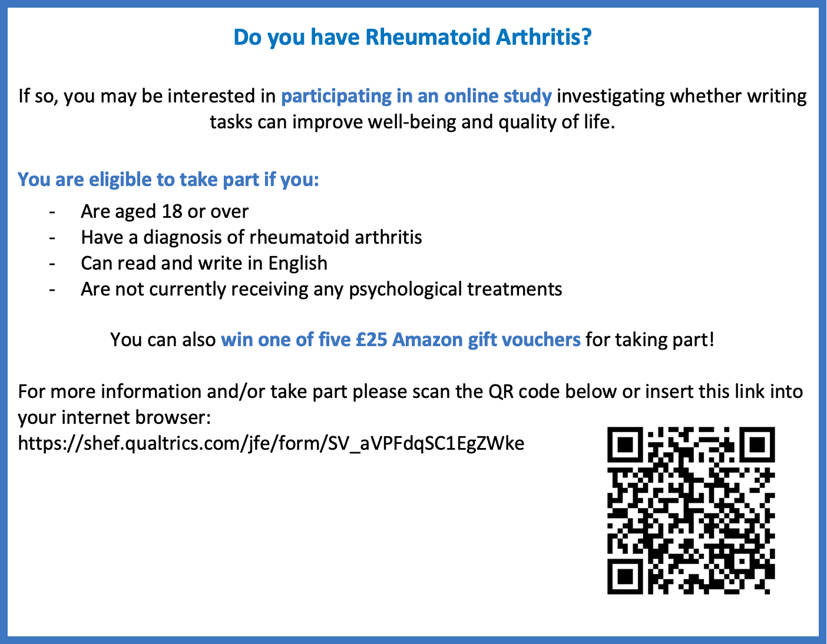

Appendix B

Ethical Approval

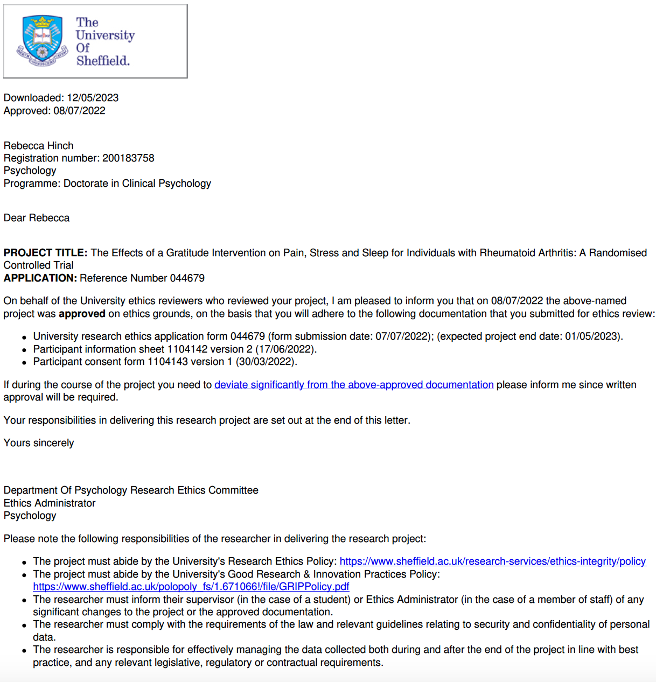

Appendix C

Information Sheet and Consent Form

A study examining the effects of a writing intervention for rheumatoid arthritis
This is an investigation looking at the effects of monitoring and reflecting on daily events and how this relates to physical and mental well-being in people living with rheumatoid arthritis.

Who can take part?
To be included in the study, you should be aged 18 or over, be able to read and write in English, have a diagnosis of rheumatoid arthritis and not be currently receiving any psychological treatments. If you do not match these criteria, you are unable to take part in this research.

What does the study involve?
The entire study is conducted online, and is accessible on your smart phone, tablet and computer devices.
- You will be asked to complete an anonymous survey that asks questions about your background, diagnosis and well-being, so we get a better sense of who you are and your current health status. You will then be asked to fill in some questionnaires exploring your diagnosis and the impact it has on your physical and psychological wellbeing.

- You will then be asked to do a short monitoring exercise every two days, over a period of two weeks where you will be recording three things about your day. There will also be some short tick-box questions to answer following this.

- Once you have finished the monitoring exercises, you will be asked to fill in the initial survey again.

- You will have the opportunity to provide feedback on how you found the exercise.
How long will this take?
The initial survey will take approximately 5 minutes to complete. The exercise will take no more than 8 minutes to complete.
However, if you wish to spend longer on the survey and exercise, you are welcome to do so.

What will happen to my information?
Your participation in this study is voluntary and you have the right to withdraw from the study at any time. You may also request to withdraw your data from the study up to two weeks after completing the final exercise.

Any personal information you provide, such as your email address will be kept safe and secure and will only be accessed by the researcher.

The results of the study will be written up and submitted as a doctoral thesis as part of the Clinical Psychology Doctorate (DClinPsy) at the University of Sheffield. Additionally, the study will be submitted for publication in a scientific journal. Information regarding individual participants will not be included and you will not be identifiable from any reports or publications of the study.
General Data Protection Regulations:
New data protection legislation came into effect across the EU, including the UK, on 25 May 2019; this means that we need to provide you with some further information relating to how your personal information will be used and managed within this research project. This is in addition to the details provided within the information sheet that has already been given to you.
The University of Sheffield will act as the Data Controller for this study. This means that the University is responsible for looking after your information and using it properly.
In order to collect and use your personal information as part of this research project, we must have a basis in law to do so. The basis that we are using is that the research is ‘a task in the public interest’. As we will be collecting some data that is defined in the legislation as more sensitive (information about you and your health) we also need to let you know that we are applying an additional condition in law: that the use of your data is ‘necessary for scientific or historical research purposes.
Further information, including details about how and why the University processes your personal information, how we keep your information secure, and your legal rights (including how to complain if you feel that your personal information has not been handled correctly), can be found in the University’s Privacy Notice https://www.sheffield.ac.uk/govern/data-protection/privacy/general.
You may request a copy of the study results when they are available.
If you have any questions or concerns about the study, please contact:
Rebecca Hinch (rhinch1@sheffield.ac.uk)
If you are happy to continue with the study, please complete the consent form and screening questions below.

Consent Form

Please tick the appropriate boxes |  |  | Yes | No
Taking Part in the Project
I have read and understood the project information sheet dated DD/MM/YYYY or the project has been fully explained to me. (If you will answer No to this question please do not proceed with this consent form until you are fully aware of what your participation in the project will mean.)
I have been given the opportunity to ask questions about the project.
I agree to take part in the project. I understand that taking part in the project will include completing questionnaires and undergoing a writing intervention every other day for a period of two weeks.
I understand that my taking part is voluntary and that I can withdraw from the study at any time up until two weeks after I have completed the intervention. I do not have to give any reasons for why I no longer want to take part and there will be no adverse consequences if I choose to withdraw.
How my information will be used during and after the project
I understand my personal details such as name, phone number, address and email address etc. will not be revealed to people outside the project.
I understand and agree that my words may be quoted in publications, reports, web pages, and other research outputs. I understand that I will not be named in these outputs unless I specifically request this.
I understand and agree that other authorised researchers will have access to this data only if they agree to preserve the confidentiality of the information as requested in this form.
I understand and agree that other authorised researchers may use my data in publications, reports, web pages, and other research outputs, only if they agree to preserve the confidentiality of the information as requested in this form.
I give permission for the questionnaire data that I provide to be deposited in [name of data repository] so it can be used for future research and learning
So that the information you provide can be used legally by the researchers
I agree to assign the copyright I hold in any materials generated as part of this project to The University of Sheffield.

Appendix D

Data Management Plan

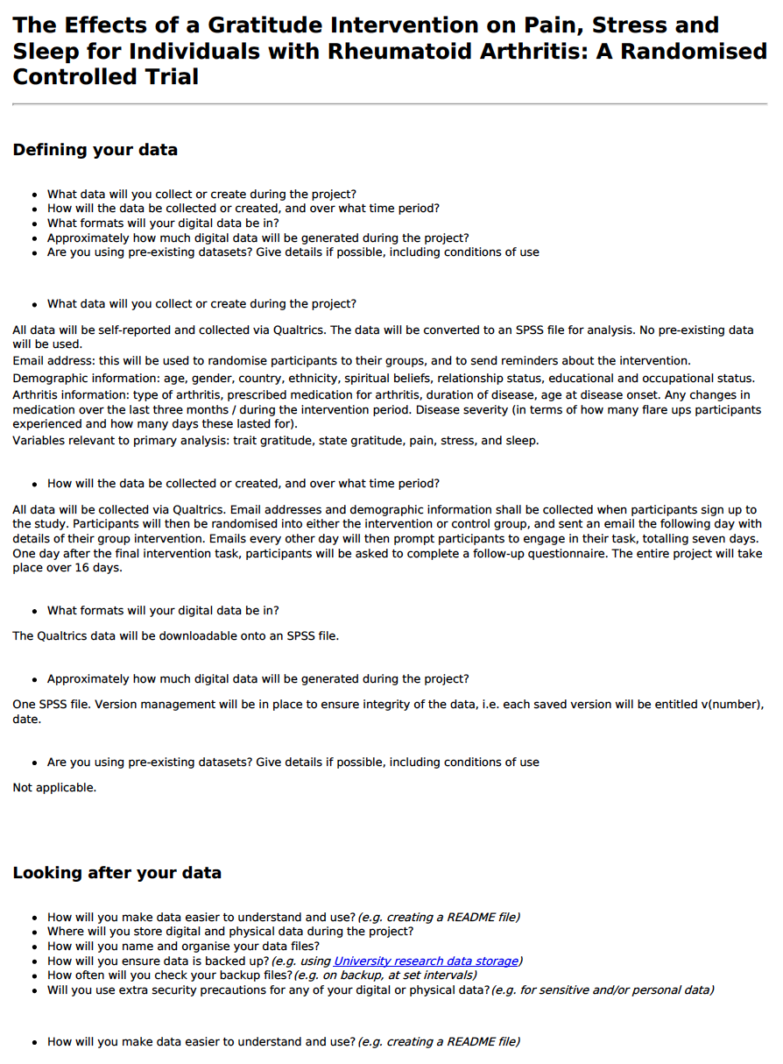
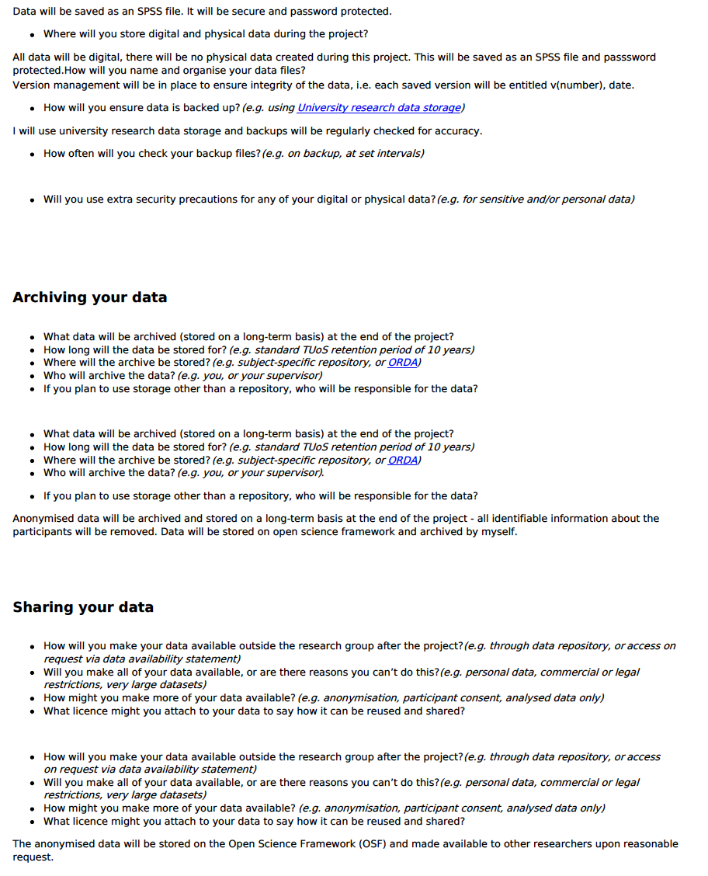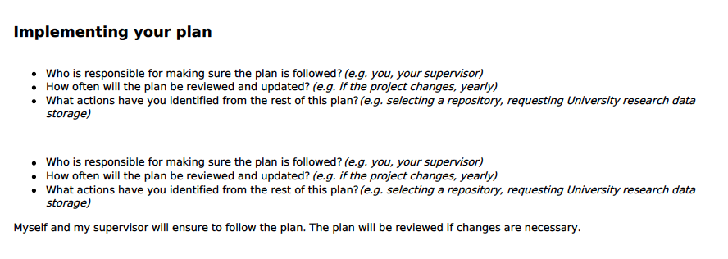

Appendix E

Measures After Each Task
[Questionnaires removed due to copyright]
Pain Post-Task Measure - Visual Analog Scale

Stress Post-Task Measure - PSS-4
Sleep Post-Task Measure - PSQI

Appendix F

Baseline and Follow-up Questionnaires

Eligibility Screening Questionnaire
- Are you over the age of 18? Yes/No
- Have you received diagnosis of Rheumatoid Arthritis by a doctor or physician? Yes/ No
- Can you read and write in English? Yes/No
- Are you currently receiving any psychological treatments from a professional? Yes/No
If participant meets the criteria: Thank you. Your responses to these questions indicate that you are eligible to take part in this research.

If participant does not meet the criteria: Thank you for your responses. Unfortunately, as you do not meet the inclusion criteria stated in the information sheet, you are not eligible to take part in this research. Thank you for your time and interest in this research.

Demographic Questionnaire at Baseline
What is your current age? ____________________
Sex:
❑ Male ❑ Female ❑ Non-binary/Third Gender ❑ Prefer not to say
What country/continent do you live in?
❑ Canada
❑ USA
❑ Australia
❑ South America
❑ United Kingdom
❑ Europe
❑ Other (please list) ___________________________________

What is your highest level of education?
❑ Some high school
❑ High school graduate
❑ Some college/university
❑ College/university graduate
❑ Some graduate school
❑ Graduate degree

What is your employment status?
❑ Full-time ❑ Part-time ❑ Disabled/Sickness leave
❑ Unemployed ❑ Retired

What is your first language? ____________________
What ethnic background do you most identify with? (For example: Caucasian, Asian, Black, African, Caribbean, etc.) ___________________________________
What is your relationship status? (please choose the one that applies best to you)
❑ Married/living with an intimate partner
❑ Separated/divorced
❑ Never married
❑ Widowed

Financially, would you say that you are:
❑ Comfortable, don't worry too much about money
❑ Making ends meet, getting by
❑ Struggling a lot, have some immediate financial concerns
Have you been diagnosed with any psychiatric or mental health conditions?
❑ Yes ❑ No
If YES, please list all:

Arthritis questionnaire

Pre-intervention:
When were you first diagnosed with rheumatoid arthritis?
How old were you when you first started experiencing rheumatoid arthritis symptoms?
Have you ever had surgery for rheumatoid arthritis?
Please list any medications you are currently taking for rheumatoid arthritis:
Have you changed medication for rheumatoid arthritis in the last three months?

Post-intervention:
Have you changed medication for rheumatoid arthritis whilst taking part in this study?
How many flare ups have you had during your participation in this study?
If you did experience flare ups of your arthritic symptoms during your participation in this study, how many days in total did you experience a flare of your symptoms?
Have your flare ups impacted your ability to complete the writing tasks?

Baseline and Post Intervention Completion Questionnaires

[Questionnaires removed due to copyright]

Trait Gratitude - Gratitude Questionnaire 6 (GQ-6)

State Gratitude - Gratitude Adjectives Checklist (GAC)

Pain - AIMS-2

Appendix G

All Email Correspondence to Participants
First email after signing up:
Hello!
Welcome to your first written task as part of the study entitled: The effect of writing tasks on well-being in people with Rheumatoid Arthritis.
Please click on the link below to complete the written task followed by short questionnaires. This should take you between 5-10 minutes. We are truly grateful for you being willing to complete the research and giving your time and effort to this.
Remember, completion of tasks means you will be in with a chance of winning one of five £25 Amazon vouchers. For any queries, please email the primary researcher Rebecca Hinch on rhinch1@sheffield.ac.uk
Thank you again for your time and thoughtful responses.
Rebecca Hinch
Trainee Clinical Psychologist / Main Researcher
University of Sheffield
Follow this link to the Survey:
Or copy and paste the URL below into your internet browser:

Email invitations for 2nd-6th tasks:
Hello!
Welcome to task two of seven, as part of the study entitled: The effect of writing tasks on well-being in people with Rheumatoid Arthritis.
Please click on the link below to complete the written task followed by short questionnaires. This should take you between 5-10 minutes.
Don’t worry if you’ve missed a previous task, you can still take part and your valuable data will still be useful to us. We are truly grateful for you being willing to complete the research and giving your time and effort to this.
Remember, completion of tasks means you will be in with a chance of winning one of five £25 Amazon vouchers. For any queries, please email the primary researcher Rebecca Hinch on rhinch1@sheffield.ac.uk
Thank you again for your time and thoughtful responses,
Rebecca Hinch
Trainee Clinical Psychologist / Main Researcher
University of Sheffield
Follow this link to the Survey:
Or copy and paste the URL below into your internet browser:
Email invitations for final tasks:
Hello!
Welcome to the final task, as part of the study entitled: The effect of writing tasks on well-being in people with Rheumatoid Arthritis.
Please click on the link below to complete the written task followed by short questionnaires. This should take you between 5-10 minutes.
Don’t worry if you’ve missed a previous task, you can still take part and your valuable data will still be useful to us. We are truly grateful for you being willing to complete the research and giving your time and effort to this.
Remember, completion of tasks means you will be in with a chance of winning one of five £25 Amazon vouchers. For any queries, please email the primary researcher Rebecca Hinch on rhinch1@sheffield.ac.uk
Thank you again for your time and thoughtful responses,
Rebecca Hinch
Trainee Clinical Psychologist / Main Researcher
University of Sheffield
Follow this link to the Survey:
Or copy and paste the URL below into your internet browser:
Email invitations for follow-up questions & link to debrief:
Hello!
Thank you for completing the tasks as part of the study entitled: The effect of writing tasks on well-being in people with Rheumatoid Arthritis.
Please click on the link below to complete the final set of questionnaires. This should take you between 5-10 minutes.
Don’t worry if you missed any of the tasks, you can still take part and your valuable data will still be useful to us. Once you have finished these you will be provided with information about the study and you will have the opportunity to enter a prize draw to win one of five £25 Amazon vouchers.
We are truly grateful for you being willing to complete the research and giving your time and effort to this.
Thank you again for your time and thoughtful responses,
Rebecca Hinch
Trainee Clinical Psychologist / Main Researcher
University of Sheffield
Follow this link to the Survey:
Or copy and paste the URL below into your internet browser:

Appendix H

Task Instructions

Gratitude intervention instructions:
There are many things in our lives, both large and small, that we may be grateful for. Think back over the past two days and write down any three things in your life that you are grateful or thankful for. These can include new things that you’re grateful for that have occurred in the last two days, or in other things you are grateful for in life more generally.

Control group instructions:
There are many things in our lives, both large and small, that we may do over the course of the day. Think back over the course of the past two days and write down any three things that you have done.

Appendix I

Debrief Sheet

The Effect of a Gratitude Intervention on Pain, Stress, and Sleep for Individuals with Rheumatoid Arthritis: A Randomised Controlled Trial

Research has shown that people living with chronic health conditions such as rheumatoid arthritis, report having a difficulties with pain, stress, and sleep. There is growing evidence that gratitude, a positive psychology factor, can be beneficial for adjustment to chronic health conditions. Interestingly, gratitude can be developed through doing simple exercises such as writing a list of things one is grateful for each day. However, there has been no research that examines whether a simple gratitude exercise can improve pain, stress, or sleep in people with rheumatoid arthritis.

This research aimed to investigate whether an accessible and positive psychological intervention could increase gratitude and quality of life; including stress, sleep, pain. You were asked to fill in some background information about yourself and then were allocated to either an intervention group or the control group. If you were in the intervention group, every other day for 14 days you were asked to write down three things you were thankful for during your day. If you were in the control group, you were asked to write down three things you had done that day. Regardless of your group, you were then asked to fill in some questions that measured your pain, stress, sleep, and gratitude. This was so that we could look at whether these measures changed from the start to the end of the testing period.
We would like to thank you for participating in this research. Your time and thoughtful responses are greatly appreciated.

- If participating in this study has raised any concerns for you, please contact your GP/ physician or call Samaritans on 116 123 (free 24-hour helpline). For advice relating to arthritis please contact Versus Arthritis; Telephone 0800 5200 520 or on their website www.versusarthritis.org
If you wish to withdraw your data you can do so without reason, by emailing the researcher listed below and providing details of your email address that was registered in the study. You can withdraw your data up to two weeks after completing the entire study.
All your data will be kept securely in a password protected file that only the researcher has access to. None of your details will be identifiable in the write up of the research.

Contact details of research team;
Rebecca Hinch – Lead Researcher (rhinch1@sheffield.ac.uk)
Fuschia Sirois – Researcher Supervisor (fsirois@sheffield.ac.uk)
Amrit Singh – Research support officer

Appendix J

Histograms of Baseline and Post-Intervention Outcome Measures
Figures A1 and A2
Baseline and Follow-up Trait Gratitude Distribution
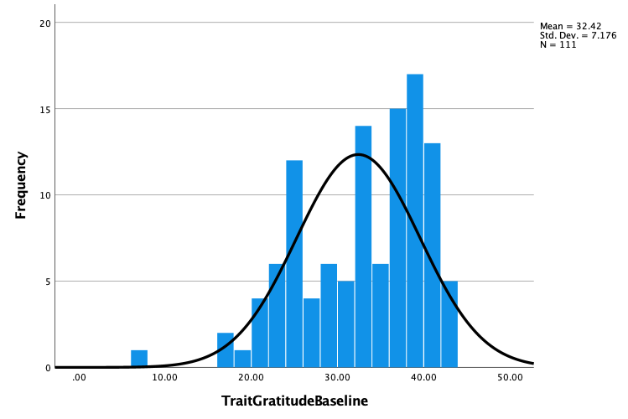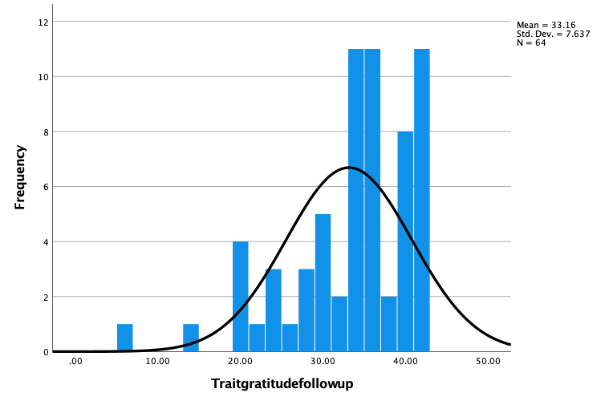

Figures A3 and A4
Baseline and Follow-up State Gratitude Distribution
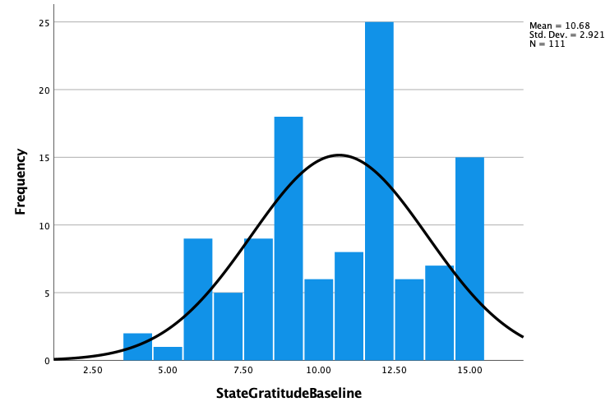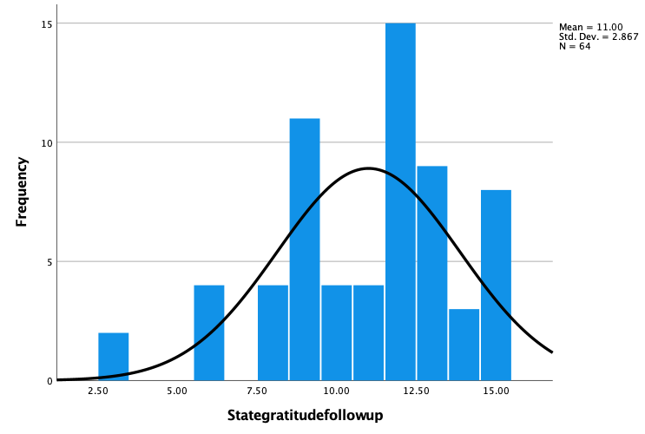

Figures A5 and A6
Baseline and Follow-up Pain Distribution
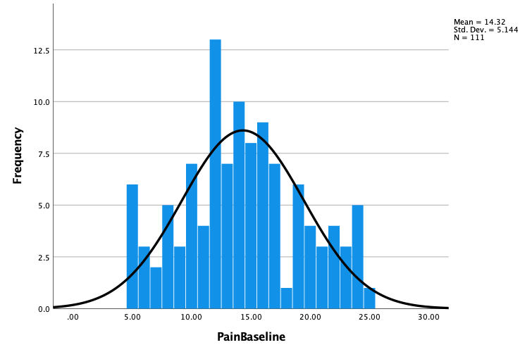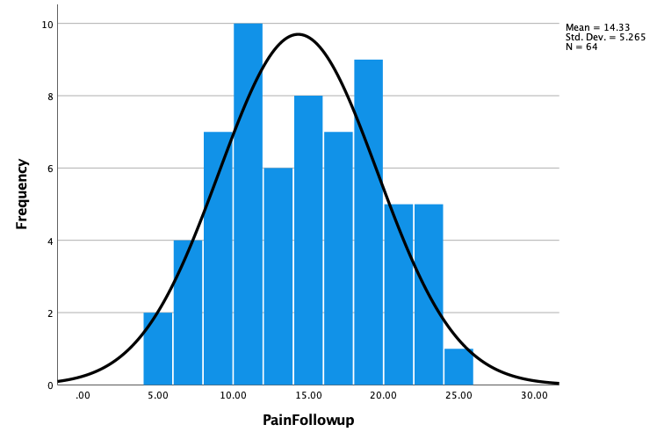

Figures A7 and A8
Baseline and Follow-up Stress Distribution
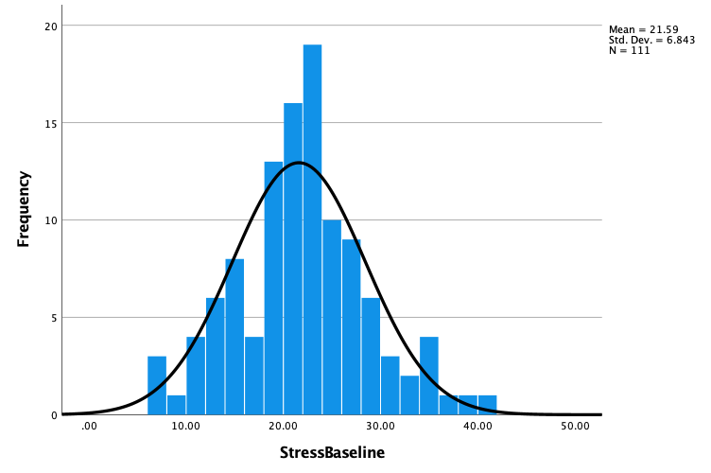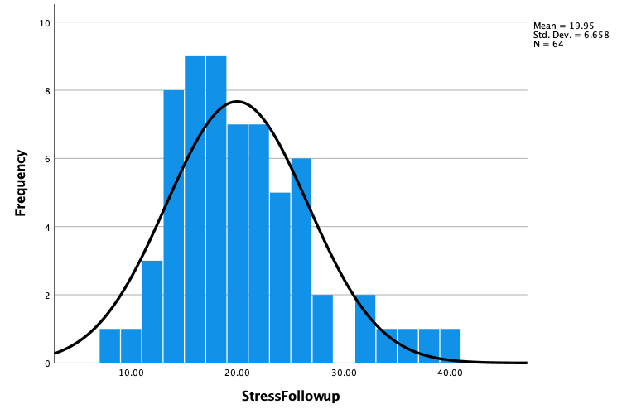

Figures A9 and A10
Baseline and Follow-up Sleep Distribution

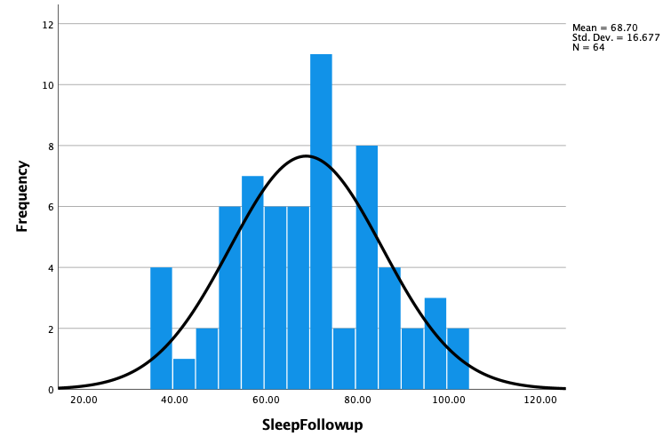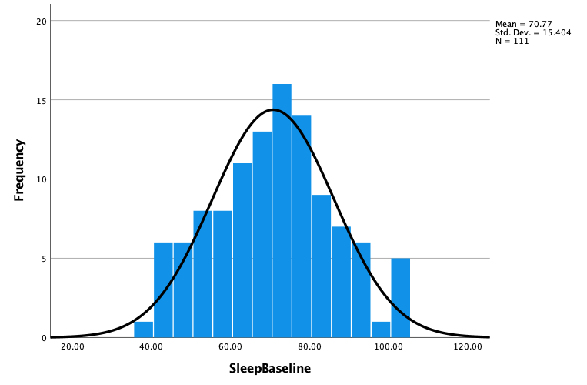

Appendix K

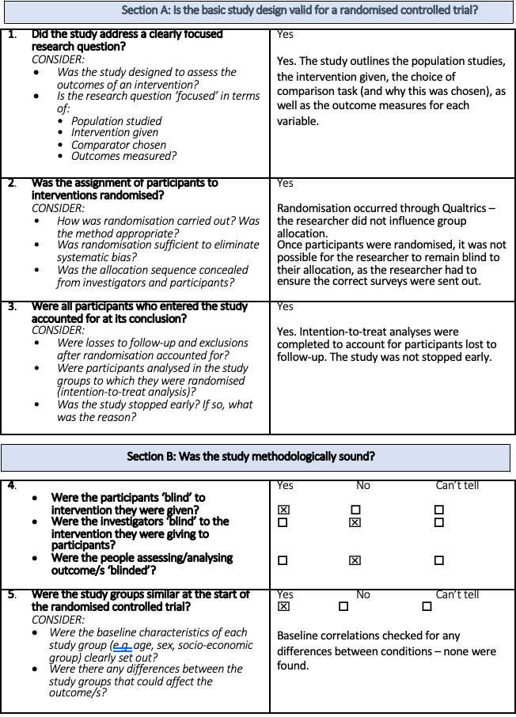
CASP Randomised Controlled Trial Standard Checklist

