

VEGFA ISOFORM EXPRESSION AND ITS REGULATION OF THE TUMOUR MICROENVIRONMENT IN SOFT TISSUE SARCOMA

A thesis submitted in partial fulfilment of the requirements for the degree of Doctor of Philosophy

Claudia Madrigal Esquivel

The University of Sheffield
Faculty of Medicine, Dentistry & Health
The Medical School

September 2022

ACKNOWLEDGMENTS
I would like to thank CONACYT and the University of Sheffield for giving me this life-changing opportunity that has led me to grow not only professionally but also personally. Thanks to my supervisor Dr Will English for his patience, experience, and guidance during this project. Thanks also to Dr Dennis Wang and Dr Manoj Valluru for their support and advice on bioinformatics, a whole new world for me. I am very grateful as well to all the staff from the University including technicians and colleagues from other groups who have given me so much of their time and help.
I also would like to thank the English group members to become not only my colleagues but also my friends. A special thanks to Nada who has been with me since day 1 of this roller coaster. You have been a very great support at all moments. I am so grateful to be able to share this experience with you.
This thesis is just a small representation of years of hard work which could not be possible without the support and love of my parents and sister. Although there is a big ocean between us, you have been always by my side at all moments and motivated me to never give up. I will be always in debt to you for all the love, support, and happiness you give me. Without you, I could not be where I am right now.
Last, but not least thanks to Manuel for the endless support and love. You have always encouraged me to pursue my dreams and not be afraid to try. Thank you for being with me through all the difficulties and for helping me to survive through all these hectic years. I am so excited to see how many adventures the future has for us.

ABSTRACT
Soft Tissue Sarcomas (STS) are a heterogeneous group of tumours of mesenchymal origin. Their diagnosis is challenging; few new treatments have become available. As a result, novel treatments are needed. Targeting angiogenic pathways and immune regulatory mechanisms within the tumour microenvironment (TME) might provide promising results.
Published studies have shown that fibrosarcomas expressing VEGFA120 (fsVEGFA120) isoform in mice led to formation of poorly functioning vasculature and increased metastasis to the lung that was more sensitive to anti-VEGFA therapy in contrast to fsVEGFA18. Unpublished analysis of RNAseq data from these fsVEGFA120 revealed expression enrichment in PD-1 signalling and PD-L1. Further bioinformatics analysis from The Cancer Genome Atlas-SARComa in our laboratory revealed decrease overall survival and increased expression of PD-L1 signalling pathways in myxofibrosarcoma (MFS) patients with increased VEGFA121 mRNA.
This PhD thesis aimed to build on these preliminary studies additional evidence of VEGFA isoform measurement as a potential biomarker for the use of anti-VEGFA and immune checkpoint inhibitors in MFS.
Previous studies used immunocompromised mice; thus, new models of sarcoma are needed in immunocompetent mice. Firstly, this thesis characterised the TME of tumours grown from the T241 fibrosarcoma cell line in C57Bl6J mice. Then new cell lines were made from T241 cells that expressed increased levels of VEGFA120 or VEGFA188. Both cell lines were characterised in vitro, with only VEGFA188 being characterised in vivo using immunocompetent mice due to time constraints.
In vitro characterisations showed differences between cells lines overexpressing the different VEGFA isoforms, including morphology, migration speed, ECM expression, and mesenchymal markers suggesting isoform expression can regulate the TME. In vivo characterisation of VEGFA188 tumours showed a tendency to regression after initial growth, which might suggest increased anti-tumoural immune cells activity. VEGFA188 tumours had a more mature vasculature and similar or lower immune cell infiltrations compared to WT tumours.
A new data set was created by combining the VORTEX and TCGA SARC data to increase pleomorphic patient numbers. Analysis of this new dataset showed patients with high VEGFA121 expression had enriched expression of host-immune response genes and PD-1 signalling.
Our findings indicate that VEGFA isoform expression is associated with changes that may be advantageous for an improved therapeutic response in MFS patients.

DECLARATION
I, the author, confirm that the Thesis is my own work. I am aware of the University’s Guidance on the Use of Unfair Means (www.sheffield.ac.uk/ssid/unfair-means). This work has not been previously been presented for an award at this, or any other, university.
TABLE OF CONTENTS
ACKNOWLEDGMENTS 2
ABSTRACT 4
DECLARATION 6
TABLE OF CONTENTS 7
LIST OF FIGURES 15
LIST OF TABLES 21
LIST OF ABBREVIATIONS 22
CHAPTER I 25
Introduction 25
1.1 Sarcomas 26
1.1.1 Introduction 26
1.1.2 Epidemiology 26
1.1.3 Soft Tissue Sarcoma 27
1.1.3.1 Genetic classifications 31
1.1.3.1.1 ‘Simple’ STS 34
1.1.3.1.2 ‘Complex’ STS 35
1.1.3.2 Diagnosis, Staging and Grading 36
1.1.3.3 Treatment in STS 41
1.1.3.4.1 Standard care 41
1.1.3.4 Targeted Therapies in STS 43
1.1.3.5 Immunotherapy in STS 47
1.2 Overview of the Tumour Microenvironment in STS 51
1.2.1 Introduction 51
1.2.2 Mesenchymal Stem Cells 52
1.2.3 Fibroblasts 54
1.2.4 Cancer-associated fibroblasts 55
1.2.5 Sarcoma-associated fibroblasts 57
1.2.6 Immune Cells and Immune checkpoint expression in STS 58
1.2.6.1 Macrophages 65
1.2.6.2 Lymphocytes 68
1.2.7 Blood vessels 72
1.3 Vascular Endothelial Growth Factor (VEGF) 78
1.3.1 VEGF Family- an Overview 78
1.3.2 VEGF-VEGFR signalling 80
1.3.3 VEGF and its immunosuppressive role 84
1.3.4 VEGF-A gene and isoforms 86
1.3.4.1 Differences in vessel growth in tissues according to VEGF-Axxx isoforms 92
1.3.4.2 Vascular patterns in tumours expressing different VEGF-A isoforms 94
1.4. Main predictive biomarkers for therapy response in STS 96
1.5 Necessity of new mice models of STS 99
1.6 Background data 109
1.7 Hypothesis and aims 114
1.7.1 Hypothesis 114
1.7.2 Aims 114

CHAPTER II 115
Material and Methods 115
2.1 Mammalian Tissue Culture 116
2.1.1 Cell lines and maintenance 116
2.1.2 Cell thawing 117
2.1.3 Cell passaging 118
2.1.4 Cell counting and viability measurement. 118
2.1.5 Cell freezing 118
2.2 Development of the transposase vector for the generation of T241-GFP-VEGFA-120 stably expressing cell lines 119
2.2.1 Transformation of competent cells and antibiotic selection 120
2.2.2 Plasmid Purification 120
2.2.3 DNA Restriction Digestion 120
2.2.4 Agarose gel electrophoresis 121
2.2.5 DNA gel extraction 121
2.2.6 DNA Ligation 121
2.2.7 DNA sequencing 122
2.2.8 Transient transfection of mammalian cells 122
2.3 Transfection of T241-GFP cells to generate cell lines stably overexpressing VEGFA120 123
2.3.1 Transfection with pCLIIP-CMV plasmids to overexpress VEGFA120 and VEGFA188 124
2.3.2 Isolation of single-cell clones 125
2.3.3 Quantification of PDGF-BB levels by ELISA 127
2.4 MTT assay as a proxy for cell proliferation 127
2.5 Single-cell live imaging 128
2.6 Treatment of cells with inhibitors of VEGFA signalling 128
2.7 Western Blotting 129
2.7.1 Protein Extraction 129
2.7.2 Protein quantification by Bicinchoninic Acid (BCA) Assay 130
2.7.3 SDS-PAGE gel electrophoresis 130
2.7.4 Protein Transfer to nitrocellulose membrane 132
2.7.5 Antibody incubations 132
2.7.6 Western Blot protein detection 135
2.7.7 Stripping and reprobing membranes 135
2.8 Immunohistochemistry (IHC) of tumour sections 136
2.8.1 Haematoxylin and Eosin staining 136
2.8.2 Immunofluorescence staining of tumours and analysis. 136
2.8.3 Immunocytochemistry (ICC) 140
2.8.4 Scanning sections 141
2.9 Use of recombinant adenoviruses to detect fibroblasts. 141
2.10 Flow cytometry 143
2.11 Real-Time PCR 143
2.11.1 RNA isolation and quantification 143
2.11.2 Removal of contaminating DNA 145
2.11.3 A standard curve using plasmids with VEGFA isoform for AQRT-PCR 145
2.11.4 Synthesis of cDNA- Reverse Transcription 146
2.11.5 Performing Real-Time PCR Amplification using SYBR Green 148
2.12 In vivo experiments 149
2.12.1 Genotyping by PCR 150
2.12.2 Activation of transgene system with 4-OHT Hydroxytamoxifen 155
2.12.3 In vivo imaging of transgenic mice 157
2.12.4 Subcutaneous injection of cells 158
2.12.5 Radiotherapy treatment for transgenic mice 158
2.13 In silico analysis 159
2.13.1 Differentially expressed gene analysis (DEG) 160
2.13.2 Gene set enrichment analysis (GSEA) 162
2.13.3 Immune cell population analysis 162
2.14 Statistical Analysis 163

CHAPTER III 164
Investigating the suitability of the C1-CreERt transgenic mice for the study of SAFs in fibrosarcoma 164
3.1 Introduction 165
3.2 Results 168
3.2.1 Identifying the effect of tamoxifen on T241 fibrosarcoma growth. 170
3.2.2 Imaging to assess the activation of the transgenic mice system. 175
3.2.3 Quantification analysis of fluorescent levels in diverse body regions of transgenic mice 177
3.2.4 Detection of tdT fluorescence ex-vivo 180
3.2.5 Use of radiotherapy to stimulate the Col1α2 transgene in tumours 183
3.2.6 Using diverse tamoxifen concentrations to activate the Col1α2 transgene ex-vivo 187
3.2.7 Recombinant adenoviruses with a Cre activated GFP reporter to detect activation of the Col1α2 transgene in explant cultured cells. 189
3.2.8. Recombinant adenoviruses with a GFP reporter activate the Col1α2 transgene in fibrosarcoma and carcinoma cultured cells. 194
3.2.9 Expression of collagen-I in T241 and LLc1 cell lines 197
3.3 Discussion 199

CHAPTER IV: Characterisation of the tumour microenvironment of a fibrosarcoma model in comparison with a lung carcinoma model. 210
4.1 Introduction 211
4.2 Results 215
4.2.1 Characterisation of the vasculature in T241 and LLc1 tumours 215
4.2.2 Identification of differences in expression of ECM proteins between T241 and LLc1 tumours 217
4.2.3 Comparisons between the immune cell infiltration in T241 and LLc1 tumours 221
4.2.4 Characterisation of PD-L1 immune checkpoint expression in fibrosarcomas 224
4.3 Discussion 226

CHAPTER V 235
Development and in vitro characterisation of murine fibrosarcoma cell lines expressing increased levels of VEGFA isoforms. 235
5.1 Introduction 236
5.2 Results 238
5.2.1 pCLIIP-CMV-VEGFA plasmids used for the creation of overexpressing VEGFA isoforms system. 238
5.2.2 Stable fibrosarcoma cell line expressing VEGF isoforms and selection 241
5.2.3 Comparison of VEGFA mRNA isoform expression between T241-GFP WT and VEGFA120 and VEGFA188 over expressing clones 244
5.2.4 Characterisation of VEGFA overexpressing T241-GFP clones in vitro 247
5.2.4.1 Cell proliferation of overexpressing VEGFA isoforms in vitro 247
5.2.4.2 Comparison of morphology and migration characteristics between T241-GFP WT cells and VEGFA isoform overexpressing clones 251
5.2.4.3 Characterisation of ECM protein expression in T241-GFP WT cells and VEGFA isoform expressing clones 257
5.2.4.4 Changes in mesenchymal proteins associated with epithelial to mesenchymal transition (EMT) in T241-GFP WT cells and VEGFA isoform expressing clones. 261
5.2.4.5 Kinase signalling in T241 WT and VEGFA isoform overexpressing clones 265
5.2.4.6 The impact of anti-VEGFA antibodies on kinase phosphorylation in T241 WT and VEGFA isoform overexpressing clones cell lines 269
5.2.4.7 The influence of VEGFA isoform overexpression on kinase phosphorylation and inhibition with pazopanib in fibrosarcoma cells 273
5.3 Discussion 279

CHAPTER VI 289
The influence of VEGFA188 isoform overexpression within the fibrosarcoma tumour microenvironment 289
6.1 Introduction 290
6.2 Results 294
6.2.1 Tumour growth rates of T241-CMV-VEGFA188 clones and T241-GFP WT 294
6.2.2 Quantification of GFP⁺ cells in VEGFA188 expressing cell lines 297
6.2.3 Necrosis in tumours overexpressing VEGFA188 299
6.2.4 Influence of VEGFA188 isoform overexpression on the tumour vasculature 301
6.2.5 The role of VEGFA188 isoform overexpression on immune cell infiltration 305
6.2.5.1 CD4⁺FOXP3⁺ T regulatory cell infiltration in fibrosarcomas increased levels of VEGFA188 305
6.2.5.2 CD8+ Cytotoxic T cells infiltration in fibrosarcomas with increased VEGFA188 307
6.2.5.3 F4/80⁺ Macrophage infiltration in fibrosarcomas with increased VEGFA188 309
6.3 Discussion 311

CHAPTER VII: 320
Relationship between the expression of VEGFA mRNA isoforms and immune response genes in pleomorphic sarcoma subtypes 320
7.1 Introduction 321
7.2 Results 324
7.2.1 VORTEX Biobank dataset population 324
7.2.2 Expression of PD-L1 gene among VORTEX soft tissue sarcoma subtypes 327
7.2.3 Distribution of VEGFA isoform expression within VORTEX patients 329
7.2.4 Enriched gene expression in MFS clusters from VORTEX Biobank 331
7.2.5 PD-L1 gene expression among MFS clusters from VORTEX patients 333
7.2.6 Survival of MFS patients in VEGFA isoform expression clusters from the VORTEX dataset 335
7.2.7 Merger of the VORTEX and TCGA-SARC datasets 337
7.2.8 Enriched gene expression in MFS clusters from VORTEX Biobank and TCGA SARC 341
7.2.9 Enrichment for curated gene sets for anti-VEGFA therapy response in MFS subtype 346
7.2.10 VEGFA isoform expression distribution model of VORTEX and TCGA-SARC patients 348
7.2.11 Enriched gene expression in pleomorphic clusters from the combined VORTEX-TCGA-SARC dataset 350
7.2.12 Enrichment for curated gene sets for anti-VEGFA therapy response in Pleomorphic subtypes 354
7.2.13 Predicted immune cell infiltration among pleomorphic STS subtypes 356
7.3 Discussion 358

CHAPTER VIII: 366
General discussion and Future work 366
8.1 Challenges in identifying sarcoma-associated fibroblasts in fibrosarcoma 367
8.2 Investigating the impact of VEGFA isoforms in the Tumour Microenvironment of fibrosarcomas. 373
8.3 VEGFA isoform as a potential biomarker for immune checkpoint response 383
8.4 Future directions 385
SUPPLEMENTARY DATA 388
REFERENCES 399

LIST OF FIGURES

Figure 1.1 Subtypes of STS based on their cell origins. 29
Figure 1.2 Overview of TME compponents 52
Figure 1.3. MSCs and their differentiation 53
Figure 1.4. The origins of CAFs 56
Figure 1.5. Development of blood vessels. 75
Figure 1.6 VEGF family and VEGFR signalling 83
Figure 1.7 Human VEGF-A gene structure and isoforms 90
Figure 1.8. Genetic expression pattern of Myxofibrosarcomas in relationship with VEGF-A isoforms 112

Figure 2. 1. Scheme of recombinant adenoviruses 142
Figure 2. 2. Detection of Cre and tdT genes in mice by Polymerase Chain Reaction (PCR) 154
Figure 2. 3. The Col1α2 (C1) transgenic mouse system used to detect SAF 156
Figure 2. 4. Representation of tamoxifen schemes for activation of transgene Col1a2 system 157
Figure 2. 5 Treatment with radiotherapy to increase transgene activation. 159

Figure 3. 1. PDGF-Bβ expression levels among T241- WT and T241- PDGF-BB cell lines by ELISA 169
Figure 3. 2 T241-GFP-PDGF-BB tumour growth in transgenic positive and negative mice stimulated with 4-OHT 174
Figure 3. 3. Representative images of fluorescence imaging by IVIS Ilumina system of activated transgene system 176
Figure 3. 5. Quantification of fluorescence in previous experiment performed by W. English. 179
Figure 3. 6. Explant visualisation using microscopy with a fluorescent channel 181
Figure 3.7 Ear and Tail tissue explants visualisation using microscopy with a fluorescent channel. 182
Figure 3. 8. Radiotherapy treatment to stimulate the Col1α2 transgene activation 185
Figure 3. 9. Visualisation of tumours with radiotherapy explants using fluorescent microscopy 186
Figure 3. 10. Detection of tdT expression in cells from tumour explants treated with different doses of 4-OHT ex-vivo. 188
Figure 3. 11. Recombinant adenoviruses to label Col1-tissue specific producers 190
Figure 3. 12. Validation of C1-Cre system using recombinant adenoviruses in normal dermal human fibroblast by Flow Cytometry 191
Figure 3. 13. Fluorescent images of T241-GFP tumour cells grown from explants transduced with CAG and Col1α2 activated GFP expressing adenovirus 193
Figure 3. 14. Quantification of GFP+ cells using recombinant adenovirus in two murine cell lines by Flow Cytometry 195
Figure 3. 15. Collagen-1 expression in T241 and LLc1 tumour and cell lines 198

Figure 4. 1. Mean vascular density between T241 and LLc1 tumours 216
Figure 4. 2. Pericyte coverage analysis between T241 and LLc1 tumours 216
Figure 4. 3. Laminin expression in T241 and LLc1 tumours and cell lines 218
Figure 4. 4. Fibronectin expression in T241 and LLc1 tumour and cell lines 220
Figure 4. 5. Infiltration of Cytotoxic T cells (CD8+) in T241 and LLc1 tumours 222
Figure 4. 6. Infiltration of murine Macrophages (F4/80⁺) in T241 and LLc1 tumours 222
Figure 4. 7. Infiltration of CD4/FOXP3+ cells in T241 and LLc1 tumours 223
Figure 4.8. PD-L1 detection in fibrosarcomas overexpressing VEGFA isoforms 225

Figure 5. 1. pCLIIP-CMV-VEGFA120 plasmid map 239
Figure 5. 2. pCLIIP-CMV-VEGFA188 plasmid map 240
Figure 5. 3. VEGFA expression in T241-CMV-VEGFA120 clones measured by ELISA 242
Figure 5. 4. VEGFA188 isoform expression levels by measured by relative quantitative RT-PCR 243
Figure 5. 5. VEGFA isoform expression levels in cell lines over expressing VEGFA120 or VEGFA188 in comparison with T241-GFP WT. 246
Figure 5. 6. T241-GFP WT and VEGFA isoform over expressing clones proliferation analysis using the MTT assay 249
Figure 5. 7. T241-GFP WT and VEGFA isoform over expressing clones proliferation analysis by counting viable cells after Trypan Blue staining. 250
Figure 5. 8. Cell morphology of fibrosarcoma cell lines overexpressing VEGFA isoforms compared to T241-GFP WT by microscopy 254
Figure 5. 9. Morphology of fibrosarcoma cell lines overexpressing VEGFA isoforms on different ECM coated surfaces compared to T241-GFP WT cells. 255
Figure 5. 10. Analysis of morphology, migration speed and distance migration of fibrosarcoma cell lines by live video microscopy 256
Figure 5. 11. Immunoblotting of ECM proteins in T241-GFP WT VEGFA isoform overexpression cells 259
Figure 5. 12. Semi-quantitative analysis of ECM protein expression in T241-GFP WT and VEGFA isoform overexpressing clones 260
Figure 5. 13. Immunoblotting of mesenchymal EMT markers in T241-GFP WT and VEGFA isoform overexpression cells 263
Figure 5. 14. Semi-quantitative analysis of mesenchymal EMT associated markers in T241-GFP WT and VEGFA isoform overexpression cells 264
Figure 5. 15. Immunoblotting of kinase activation in T241-GFP WT and VEGFA isoform overexpressing cells using Western blot 267
Figure 5. 16. Semi-quantitative analysis of kinase expression and phosphorylation in T241-GFP WT VEGFA isoform overexpression cells quantified by Western blot 268
Figure 5. 17. Inhibition of kinases by an anti-VEGF antibody in T241-GFP WT and VEGFA isoform overexpressing clones detected by Western blot. 271
Figure 5. 18. Semi-quantitative analysis of kinases inhibition by an anti-VEGFA antibody in T241-GFP WT and VEGFA isoform overexpressing clones in vitro. 273
Figure 5. 19. Inhibition of kinases by a RTK inhibitor (Pazopanib) in T241-GFP WT and VEGFA isoform overexpressing clones detected by Western blot. 276
Figure 5. 20. Semi-quantitative analysis of kinases inhibition by different doses of Pazopanib in T241-GFP WT and VEGFA120 isoform overexpressing clones in vitro 276
Figure 5. 21. Semi-quantitative analysis of kinase inhibition by different doses of Pazopanib in T241-GFP WT and VEGFA188 isoform overexpressing clones in vitro 278

Figure 6. 1 Tumour growth of T241-GFP WT and VEGFA188 overexpressing clones 296
Figure 6. 2. Representative images of tumours overexpressing VEGFA188 isoforms appearance 297
Figure 6. 3 Analysis of GFP+ cells in T241-GFP WT and VEGFA188 overexpressing cell lines 298
Figure 6. 4 Haematoxylin and eosin analysis of T241-GFP WT and VEGFA188 overexpressing cell lines 300
Figure 6. 5. Mean vascular density in fibrosarcomas overexpressing VEGFA188 compared to T241-GFP WT 303
Figure 6.6 Pericyte coverage density in fibrosarcomas overexpressing VEGFA188 compared to T241-GFP WT 304
Figure 6. 7 Infiltration of Treg (CD4+FOXP3+) in fibrosarcomas overexpressing VEGFA188 and T241-GFP WT 306
Figure 6. 8 Infiltration of Cytotoxic T cells (CD8+) in fibrosarcomas overexpressing VEGFA188 compared to T241-GFP WT 308
Figure 6. 9 Infiltration of murine Macrophages (F4/80⁺) in fibrosarcoma overexpressing VEGFA188 compared to T241-GFP WT 310

Figure 7.1. VORTEX clinical trial study design 322
Figure 7. 2 MDS plots of RNAseq data from patients of the VORTEX-Biobank 326
Figure 7. 3 Representative graph of PD-L1 expression distribution among VORTEX sarcoma subtypes 328
Figure 7. 4 Differential distribution of VEGFA isoforms in STS patients of the VORTEX dataset 330
Figure 7. 5 Volcano plot showing DEG between VEGFA isoform expression clusters in MFS patients from the VORTEX dataset 332
Figure 7. 6 Normalised Enrichment Scores (NES) in MFS with HighVEGFA121 group (High121) from VORTEX 333
Figure 7. 7 The distribution of PD-L1 gene expression in MFS clusters from the VORTEX dataset 334
Figure 7. 8 Survival analysis for MFS with high VEGFA121 (Myxo_121) compared to myxo_rest group. 336
Figure 7.9 MDS plots of RNAseq data from patients of the VORTEX and TCGA-SARC datasets 339
Figure 7.10 Differential VEGFA isoform percentage distribution in Myxofibrosarcoma patients in the VORTEX-TCGA combined dataset 342
Figure 7. 11 Volcano plot showing DEG between VEGFA isoform expression clusters in MFS patients from the VORTEX-TCGA combined dataset 344
Figure 7. 12 Normalised Enrichment Scores (NES) in MFS with HighVEGFA121 group (High121) from VORTEX and TCGA SARC 345
Figure 7. 13 Enrichment plots for genes sets related to response to anti-VEGFA therapy in Pleomorphic STS groups 347
Figure 7. 14 Differential VEGFA isoform distribution in pleomorphic STS patients in the VORTEX-TCGA combined dataset 349
Figure 7. 15 DEG between each pleomorphic cluster’s comparisons 352
Figure 7. 16 Bar plots for Normalised Enrichment Score (NES) in Pleomorphic group with HighVEGFA121 using GSEA 353
Figure 7. 17 Enrichment plots for genes sets related to response to anti-VEGFA therapy in Pleomorphic STS groups. 355
Figure 7. 18 Cell type abundance in Pleomorphic tumour groups 357

Figure S1. T241-GFP-PDGF-Bβ tumour growth comparison between gender, transgene presence and treatments. 389
Figure S2. Expression ratio of MAPK, Src and Akt of phosphorylated kinases to total kinase in T241, T241 overexpressing VEGFA120 and T241 overexpressing VEGFA188 cell lines with no treatment, antiangiogenic treatment and a tyrosine kinase inhibitor (Pazopanib) and respective treatment controls in vitro. 390
Figure S3. Representative images of AQRT-PCR standard curves created with plasmids 391
Figure S4 Barplot of unnormalised and normalised VORTEX RNAseq data 392
Figure S5 Barplot of unnormalised and normalised TCGA-VORTEX RNAseq data 393

LIST OF TABLES
Table 1.1 Main features of common subtypes of STS 30
Table 1.2 Genetic Classification of STS and related features 32
Table 1.3 TNM system for staging in STS 38
Table 1.4 FNCLCC grading system in STS. 40
Table 1.5. Main immune checkpoint and ligands and their expression among diverse cell types. 64
Table 1.6 Main features and examples of STS models available in the research 101
Table 2. 1 Details of kits used for this project. 116
Table 2. 2 Sequencing primers 122
Table 2. 3 Composition of buffers used for western blotting 131
Table 2. 4 Antibodies used for Western Blotting 134
Table 2. 5 Antibodies for Immunofluorescence staining 139
Table 2. 6 Settings for the synthesis of cDNA 146
Table 2. 7 Conditions for the synthesis of cDNA 148
Table 2. 8 The sequence of primers for mouse VEGFA isoforms 149
Table 2. 9 Parameters used for aqRT-PCR software 149
Table 2. 10 Primer sequences for tandem-dimer Tomato and Cre PCR reaction 152
Table 2. 11 Thermocycler program for PCR detection of Cre and tdT detection for genotyping 153
Table 3. 1 Summary of GFP percentage expression of cell lines infected with recombinant adenoviruses 196
Table 7. 1 Subtypes of STS patients in the VORTEX dataset 325
Table 7. 2 Subtypes of STS patients in the VORTEX and TCGA-SARC dataset 340
Table S 1. Top 50 of differentially expressed genes in MYXO121 when compared to the rest of MFS from VORTEX dataset. 395
Table S 2 Top 50 of differentially expressed genes in MYXO121 when compared to the rest of MFS from TCGA-VORTEX dataset. 398

LIST OF ABBREVIATIONS
4-OHT 4-Hydroxitamoxifen
AQRT-PCR Absolute Quantitative Real Time-PCR
BCA Bicinchoninic acid
Bps Base pairs
BSA Bovine serum albumin
CAF Carcinoma Associated Fibroblast
cDNA Complementary DNA
CI Confidence interval
Cm Centimetre
CMV Cytomegalovirus
CPM Counts per million reads mapped
Ct Cycle threshold
CTL-4 T-lymphocyte associated antigen 4
DEG Differentially expressed genes
DMEM Dulbecco's Modified Eagle Medium
DMSO Dimethyl sulfoxide
DNA Deoxyribonucleic acid
DTT Dithiothreitol
EC Endothelial cells
ECL Enhanced chemiluminescence
ECM Extracellular matrix
EDTA Ethylenediaminetetraacetic acid
ELISA Enzyme-linked immunosorbent assay
EMT Epithelial–mesenchymal transition
FBS Fetal bovine serum
FC Fold change
FDR False discovery rate
FFPE Formalin-fixed Paraffin-embedded
eGFP Enhanced Green fluorescent protein
GSEA Gene set enrichment analysis
H&E Haemotoxylin and Eosin
HIF Hypoxia-inducible factor
HR Hazard ratio
HRE Hypoxia response element
HRP Horseradish peroxidase
IFN-γ Interferon gamma
IFP Interstitial fluid pressure
IHC Immunohistochemistry
IP Intraperitoneal
IVIS In Vivo Imaging System
LMS Leiomyosarcoma
MFS Myxofibrosarcoma
MHC Major histocompatibility complex
miRNA MicroRNA
MMP Metalloproteinase
mRNA Messenger RNA
MSC Mesenchymal Stem Cells
MTT 3-(4,5-Dimethylthiazol-2-yl)-2,5-Diphenyltetrazolium Bromide
MVD Microvascular density
NICE National Institute of Health and Care Excellence
NRP Neuropilin
NSG NOD scid gamma
O2 Oxygen
OCT Optimal cutting temperature compound
OS Overall survival
PALETTE Pazopanib explored in Soft TIssue sarcoma
PBS Phosphate buffered saline
PCR Polymerase chain reaction
PD-1 Programmed cell death-1 receptor
PD-L1 Programmed death ligand 1
PDX Patient derived xenografts
PFS Progression-free survival
PlGF Placental growth factor
Pxl Pixels
RIPA Radioimmunoprecipitation assay buffer
RNA Ribonucleic acid
RTK Receptor tyrosine kinase
SAF Sarcoma associated fibroblast
SC Subcutaneous
SCID Severe combined immunodeficiency
STS Soft Tissue Sarcoma
SOC Super optimal broth with catabolite repression
TAM Tumour associated macrophage
TA-MSC Tumour associated-MSC
TBE Tris-borate-EDTA
TBS Tris-buffered saline
TCGA The Cancer Genome Atlas
Tdt Tandem Dimer Tomato Fluorescent Protein
TEMED Tetramethylethylenediamine
TGF-β Transforming growth factor beta
TIL Tumour Infiltrating Lymphocytes
TKI Tyrosine kinase inhibitor
TMB 3,3′,5,5′-Tetramethylbenzidine
TME Tumour Microenvironment
TPM Transcripts per million
Treg Regulatory T cell
UPS Undifferentiated pleomorphic sarcoma
UTR Untranslated region
VDGs VEGF-dependent gene signature
VEGF Vascular endothelial growth factor
VEGFR Vascular endothelial growth factor receptor
VPF Vascular permeability factor
WT Wild type

CHAPTER I
Introduction

1.1 Sarcomas
1.1.1 Introduction
Sarcomas are a group of rare heterogeneous tumours of mesenchymal origin (Cancer Research UK, 2021; World Health Organisation (WHO), 2020; Sannino et al., 2017). The mesenchymal stem cells (MSCs) have a pluripotency differentiation comprising connective tissue structures such as muscle, fat cells, bone, and vasculature. Therefore, more than 50 subtypes of sarcomas exist, each with features that create extensive heterogeneity in sarcomas (Katz, Palmerini and Pollack, 2018).
These subtypes can be classified broadly into two main categories: sarcomas from bone and sarcomas from soft-tissue (STS) such as muscle, fat cells, and blood vessels (Grünewald et al., 2020; WHO 2020; Dancsok, Asleh-Aburaya and Nielsen, 2017; Cancer Research UK, 2021 ).
1.1.2 Epidemiology
Sarcomas account for approximately one per cent of all diagnosed malignancies in adults (WHO 2020; Katz, Palmerini and Pollack, 2018; Gamboa, Gronchi and Cardona, 2020). Among bone sarcoma and STS, uttermost features can be found, such as incidence, the population affected, clinical presentation and treatments. Osteosarcoma is the leading subtype of bone sarcoma, mainly affecting children and young adults (Lee et al., 2021). Meanwhile, STS have its highest rate of incidence in older adults, with an increase of up to 5% in cases since 2013-2015 in England (Cancer Research UK, 2022).
Due to their mesenchymal origins, sarcomas can occur almost anywhere in the body. However, more than half of these tumours arise in the extremities, followed by the retroperitoneum, trunk, head, and neck (WHO, 2020)
The aetiology of the tumour is often unknown, but most are thought to occur de novo. Nonetheless, some related risk factors include viral infections such as Epstein Barr Virus; genetic mutations (hereditary syndromes such as Li-Fraumeni syndrome), and previous radiotherapy treatments in cancer (Dangoor et al., 2016; Sinha et al., 2011).
As previously mentioned, there is a wide variety of sarcomas; however, this project will be focused on STS. Thus, the rest of the introduction will be directed toward this group.
1.1.3 Soft Tissue Sarcoma
STS comprise around 85% of all sarcoma cases per annum (Cancer Research UK, 2022). As STS arise from soft connective tissue, there is an extensive variety of subtypes based on their tissue origin. According to the World Health Organisation (WHO), there are more than 70 different histological subtypes (Figure 1.1). The most common subtypes are Leiomyosarcoma (LMS), Undifferentiated Pleomorphic Sarcoma (UPS), Myxofibrosarcoma (MFS), Liposarcoma (LPS) and Gastrointestinal Stromal Tumours (GIST) (Table 1.1) (WHO, 2020; Taylor 2011; Grünewald et al., 2020). This high heterogeneity represents the major obstacle in the study of STS as each subtype has its characteristics, including clinical presentation, pathology, and treatment response (WHO, 2020).

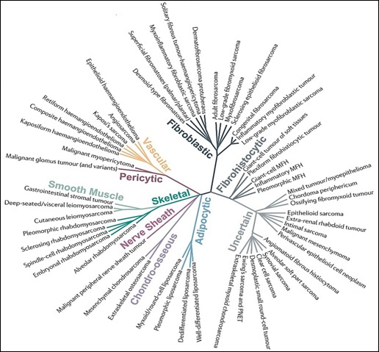

Figure 1.1 Subtypes of STS based on their cell origins.

Representative image of main STS subtypes STS and its lineage defined initially by the WHO 2002. This representation excludes benign tumours. Related lineages are closer in distance, whereas subsequent branching reflects the similarity in prognosis Figure adapted from Taylor et al., 2011—license number 4620740898879.

Table 1.1 Main features of common subtypes of STS

The table shows the main characteristics of the spectrum of STS based on the clinical features of the most common subtypes of STS. * Previously known as a single entity called Malignant Fibrous Histiocytoma
STS Subtype | Tissue of origin | Percentage of cases of STS | Site in the body | Histological types
Leiomyosarcoma | Smooth muscle cells | 10-20% | Extremities, uterus, abdomen, retroperitoneum | Two:  Uterine Leiomyosarcoma  Soft tissue leiomyosarcoma
Liposarcoma | Adipocytes | 13% | Trunk, extremities, and retroperitoneum | Four:  Well-differentiated (WDLS)  Dedifferentiated (DDLS)  Myoid/round cell  Pleomorphic
Myxofibrosarcoma (MFS)* | Fibrous and Mixoid tissue | 10-20% | Anywhere but mainly extremities, trunk, head and neck | Two:  Low grade  High grade
Undifferentiated pleomorphic sarcoma (UPS)* | Unknown/ Stem Cells? | 50% | Extremities | Four:  Storiform-Pleomorphic  Myxoid  Giant
Gastrointestinal Stromal Tumour (GIST) | Interstitial cells of Cajal | ~20% | Stomach and small intestine | Four:  Wild-type  Paediatric  Syndromic  Familial

1.1.3.1 Genetic classifications
Sarcomas can also be classified by their genetic profiles. There are two main categories for simplicity: simple and complex genetic profiles. Nonetheless, over time newest molecular biology techniques have helped to redefine STS into a spectrum of genomic profiles and complexity-detecting translocations, mutations, and amplifications among all subtypes (Vibert and Watson, 2022; Gamboa, Gronchi and Cardona, 2020; Lim, Poulin and Nielsen, 2015; Taylor et al., 2011) (Table 1.2).

Table 1.2 Genetic Classification of STS and related features

The table shows the main genetic characteristics of the spectrum of STS based on their genetic profile. The main groups are simple and complex karyotypes, whereas there is an intermediate subtype that shares the characteristics of both groups. Malignant Peripheral Nerve Sheath Tumour (MPNST)

 | Simple | ‘Intermediate-complex’ | Complex
Karyotype | Simple | Simple to Complex | Unbalanced/Complex
Molecular alterations | Specific alterations: oncogenic gene fusion, activation/inactivation point mutations and gene amplifications | Recurrent gene amplifications, inactivation, oncogenic mutations | Inconsistent alterations: many genomic rearrangements, the copy number of variations, and point mutations.
Mutational burden | + | ++ | +++
Molecular markers | Yes, specific |  | No
Subtypes examples | Synovial sarcoma,  Myxoid liposarcoma,  Dermatofibrosarcoma protuberans. | GIST,  Embryonal rhabdomyosarcoma,  MPNST,  Epithelioid sarcoma, | Pleomorphic subtypes: Undifferentiated Pleomorphic Sarcoma,  Myxofibrosarcoma, Leiomyosarcoma

1.1.3.1.1 ‘Simple’ STS

Simple soft tissue sarcomas are tumours with specific pathognomonic molecular alterations with simple karyotypes that comprise roughly one-third of sarcomas (Mariño-Enríquez and Bovée, 2016; Lim, Poulin and Nielsen, 2015). A subset of sarcomas, accounting for approximately 15-20% of cases, is characterised by chromosomal translocations that consequently encode abnormal transcription factors that disrupt normal cellular biology, activating oncogenes and promoting tumour cell growth. An example of this is the sarcoma translocation in the t(X;18) (p11; q11) seen in synovial sarcoma (Vibert and Watson, 2022; Taylor et al., 2011).
Activating/inactivating/deleterious mutations, gene amplifications, epigenetic silencing, and deletions are among the genetic changes that are present in the remaining 30–35% of "simple" STS (Mariño-Enríquez and Bovée, 2016). Compared to the previous subset of 'simple' karyotypes, these sarcomas often exhibit more sophisticated genetic abnormalities. These complex abnormalities illustrate the broad spectrum of STS, which in Table 1.2, we tried to represent with an 'intermediate complexity' state where tumours cannot fit simple or complex karyotype definitions (Taylor et al., 2011). An example of this subset is Gastrointestinal Stromal Tumour (GIST), which is characterised by activating mutations of the 4a12 locus for the gain-of-function mutation of KIT (~75% of cases) and gain-of-function mutation of platelet-derived growth factor receptor α (PDGFRα) (10% of cases) which are mutually exclusive (Taylor et al., 2011; Vibert and Watson, 2022). Nonetheless, the identification of loss-of-function of additional genes like succinate dehydrogenase (SDH) subunit A, B, C and D genes have been found in approximately 15% of cases (Mariño-Enríquez and Bovée, 2016). Clinical differences among GIST with KIT mutations and PDGFRα mutations are present such as a tendency to be more aggressive and higher recurrence in GIST with KIT mutations. Lastly, rare subtypes of GIST have been found with new oncogenic mutations such as NF1 inactivation, BRAF and KRAS activation (Mei et al., 2018; Vibert and Watson, 2022)

1.1.3.1.2 ‘Complex’ STS

These types of STS are featured by an unbalanced karyotype harbouring no specific or recurrent genetic aberrations (Taylor et al., 2011). This type counts for more than half of the STS cases. The complex karyotype shows high genomic instability, copy number variations and point mutations with additional loss of tumour suppressor genes such as TP53, retinoblastoma protein (RB1) and loss of chromatin remodelling factor by ATRX, which are likely in the early stages of sarcomagenesis. Thus, using molecular techniques for their diagnosis is less practical than "simple" STS (Vibert and Watson, 2022; Mariño-Enríquez and Bovée, 2016). Moreover, complex STS show heterogeneity in morphology with high histological grade and a higher mutational burden that make these subtypes potential candidates for treatments with immunotherapy (Mariño-Enríquez and Bovée, 2016; Petitprez et al., 2020). Examples of these STS include pleomorphic subtypes like Leiomyosarcoma, UPS and MFS.

1.1.3.2 Diagnosis, Staging and Grading
STS diagnosis presents a significant challenge for health services due to their diverse subtypes. Patients with a growing painless mass may exhibit no other symptoms. This characteristic is considered the classic clinic presentation. The tumour, therefore, tends to be discovered in its advanced stages, exacerbating its malignancy and reducing the patient’s survival (Sinha et al., 2011). Unfortunately, ten per cent of the cases tend to have metastasis to the lungs when finally diagnosed. For that reason, a new version of NICE guidelines (updated in 2015) was introduced in order to detect STS in its early stages. This guideline suggests the urgent reference to a
sarcoma centre for everyone with an increasing mass or a mass greater than 5 cm with or without pain (Dangoor et al., 2016). They then must urgently undergo an ultrasound scan. Patients must also complete a clinical history, physical examination, ultrasound imaging, tissue biopsy, and specific imaging.
Histological findings serve as the basis for tumour grading, whereas staging incorporates considerations like size and features of the diverse STS subtypes (Amin et al., 2017). In terms of staging, the most common approach used is the Tumour, Node and Metastasis (TNM) classification developed by the American Joint Committee on Cancer (AJCC) (Table 1.3). This widely adopted system enables the prediction of patient survival based on the classification system (Amin et al., 2017; Cancer Research UK, 2021; Gamboa, Gronchi and Cardona, 2020; Smolle et al., 2021). In the UK, a dual grading system called 'number stages' considers tumour size and lymph nodes only—this system rates from stage 1 to 4 (Cancer Research UK, 2021).

Table 1.3 TNM system for staging in STS

Tumour, Node and Metastasis (TNM) classification system developed by the AJCC 8th edition. Modified from Cancer Research UK (2021). STS is not commonly spread to lymph nodes except for rhabdomyosarcoma and angiosarcoma.

Tumour Size | Stages | Description
 | T1 | Sarcoma <5 cm
 | T2 | >5 cm but < 10cm
 | T3 | >10 cm but <15 cm
 | T4 | >15 cm
Node lymphs
 | N0 | No sarcoma cells in the lymph nodes OR test could not detect if there are sarcoma cells in nodes.
 | N1 | Existence of sarcoma cells in at least one lymph node
Metastasis
 | M0 | Sarcoma has not spread to other parts of the body.
 | M1 | Sarcoma has spread to other areas of the body.

The Fédération Nationale des Centres de Lutte Contre le Cancer (FNCLCC) grading system used for sarcoma patients involves features such as differentiation, mitotic count and necrosis. The sum of the three factors will determine the tumour grade (1 to 3). Grade 1 is a value of 2 or 3; grade 2 is a total of 4 and 5; and grade 3 is a total of 6 to 8. Grade 1 is considered low grade, whereas grades 2 and 3 are considered high grade (Table 1.4). A lower grade is considered to have a slower growth rate, no metastasis and better overall survival (OS) compared to a high grade (Cancer Research UK, 2021; Gamboa, Gronchi and Cardona, 2020).

Table 1.4 FNCLCC grading system in STS.

Fédération Nationale des Centres de Lutte Contre Le Cancer Grading system used in STS. Grading aids in predicting the probability of metastasis and overall survival.

Differentiation (how is the appearance of cancer cells compared to normal cells) | Score | Description
 | 1 | Similar
 | 2 | Moderately different
 | 3 | Abnormal, very different
Mitotic count (How many cells are dividing) | Score
 | 1 | <10 cells dividing
 | 2 | >10 cells but <20 cells
 | 3 | >20 cells
Necrosis | Score
 | 0 | No necrosis
 | 1 | <50% tumour necrosis
 | 2 | >50% tumour necrosis

Due to the rarity and the high diversity of STS, creating a grading system that accounts for every possible combination of histological subtypes and anatomical location is challenging. The FNCLCC and the grading system are considered useful assessments; however, evaluating STS should always take to the entire disease context.

1.1.3.3 Treatment in STS

1.1.3.4.1 Standard care

Like other tumours, the treatment depends on subtype, tumour size, site, and staging parameters. In localised and primary STS cases, the standard approach is curative with surgery, occasionally combined with pre- and post-radiotherapy (Monika & Olle, 2015). However, the efficacy of these treatments could be improved due to toxicity and partial resistance.
The primary goal of surgery in STS is to achieve a clear resection margin, minimising the risk of local recurrence. The addition of radiotherapy aims to preserve function while maintaining comparable rates of local control and survival compared to radical resection, which is no longer considered compulsory (Gómez and Tsagozis, 2020). Nonetheless, the molecular variability of sarcomas is highlighted by the fact that not all STS subtypes display susceptibility to these therapies (Forker et al., 2018). Also, t there is ongoing debate regarding the optimal timing of radiotherapy, whether it should be administered preoperatively or postoperatively (Dangoor et al., 2016). Unfortunately, approximately half of STS patients will experience recurrence, often with inoperable or metastatic disease, and most deaths in these patients are attributed to metastasis (Linch et al., 2014).
In advanced disease cases, surgical resection and systemic therapy are mainly employed, with a median overall survival of around 19 months. Most of these treatments are palliative in nature (Gómez and Tsagozis, 2020; Phillips et al., 2022; Dangoor et al., 2016). Anthracycline (doxorubicin), with or without combination therapy with ifosfamide, is commonly the first-line treatment. However, no significant results have been found with the use of the therapy combination (Gómez and Tsagozis, 2020; Linch et al., 2014). So far, research has not shown differences in progression-free survival nor overall survival but increased toxicity when compared to surgery and radiotherapy treatments during localised disease. However, age, absence of liver metastases, and good performance status are considered predictors for improved response and survival rates (Dangoor et al., 2016). Second-line treatments include trabectedin, eribulin, and gemcitabine, among others. Results have shown that some subtypes exhibit chemosensitivity; thus, treatment decisions should be based on histology-based (Linch et al., 2014; Gamboa, Gronchi and Cardona, 2020). For instance, dacarbazine has shown an overall response rate of 15.5%, increasing to 37% when combined with doxorubicin (D’Ambrosio et al., 2018). Moreover, the FDA has approved eribulin for liposarcomas after showing significant improvement in the overall survival of 13.5 months for liposarcomas but not for LMS (Schöffski et al., 2015).
Despite the extensive research efforts in the development of new treatments for STS, there have been limited advancements regarding survival. However, innovative technologies have contributed to a better understanding of sarcoma biology to create new advanced approaches like targeted therapies.
1.1.3.4 Targeted Therapies in STS

Targeted therapies represent the best approach to overcoming the difficulties in effective treatments for advanced STS due to their heterogeneity and rarity. Within the targeted therapies, different approaches to tackle intracellular pathways, such as angiogenesis, cell proliferation, cell migration, and apoptosis, have been studied due to their importance in tumour development and metastases (Li et al., 2018; Yuan, Li, and Yu, 2021) such as vascular endothelial growth factor receptor (VEGF-R), mechanistic target of rapamycin (mTOR), platelet-derived growth factor receptor (PDGF-R), Wnt, Hedgehog, and insulin-like growth factor type 1 receptor (IGF-1R) (Carmeliet and Jain, 2011). Thus, inhibitors targeting these signalling pathways that modulate the activity of intracellular signalling have been studied to overcome sarcomas. Some of these inhibitors are tyrosine kinase inhibitors (TKI), Wnt inhibitors, mTOR inhibitors, and Notch and Hedgehog inhibitors (Dancsok, Asleh-Aburaya and Nielsen, 2017). Overall, tyrosine kinases are the drugs that have shown the results with the most potential in STS (Kyriazoglou et al., 2022). Nonetheless, translational treatments cannot apply to all subtypes. Broad understanding has been done in GIST, but challenges in understanding the biology and developing new treatments for non-GIST subtypes still need to be tackled.
Pazopanib is an oral multi-target TKI that has been described to have anti-angiogenic properties by inhibiting VEGFR-1, VEGFR-2 and VEGFR-3, PDGFR and cKIT. Pazopanib (Votrient®) became the first molecular targeted therapy approved by the FDA for non-GIST, non-adipocytic STS patients in 2012. This approval was a consequence of phase 3 clinical trial, PAzopanib expLorEd in SofT-Tisue Sarcoma (PALETTE), which showed improvement in progression-free survival by a median of 3 months in non-adipocytic and non-GIST subtypes like LMS and synovial sarcoma, previously treated with chemotherapy when treated with pazopanib. Nonetheless, no significant difference was found in OS between the pazopanib-treated and placebo-treated groups (van der Graaf et al., 2012). Similarly, another study (DESMOPAZ) reported pazopanib efficiency in desmoid-tumour/aggressive fibromatosis. Moreover, similar results were found with sorafenib (another multi-kinase inhibitor), leading to thinking that TKIs have a potential therapy for desmoid fibromatosis (Toulmonde et al., 2019). Additionally, pazopanib has been studied in addition to neoadjuvant chemoradiotherapy for newly intermediate- or high-grade STS in children and adults (ARST1321, phase 2 trial), showing 90% of pathological response in 58% of the patients (Weiss et al., 2020). After these potential results, more research has been done with pazopanib as a single agent and in combination, as well as further new TKIs such as sunitinib, sorafenib, cediranib, regorafenib, among others (Kyriazoglou et al., 2022; Cren et al., 2020; Dancsok, Asleh-Aburaya and Nielsen, 2017).
Regarding anti-angiogenic non-tyrosine kinase inhibitors, Bevacizumab (Avastin ®) stands out as a notable example. Bevacizumab is a monoclonal antibody that targets VEGF-A, effectively impeding its function. The advantage of Bevacizumab lies in its easy combination with chemotherapy enhancing its effect, as it has been approved by the FDA for solid tumours such as colon cancer and kidney cancer (Cren et al., 2020; Dickson et al., 2015). While Bevacizumab has demonstrated activity as a single agent in angiosarcomas (Agulnik et al., 2013), its combination with chemotherapy (the standard treatment for advanced STS) has also been explored
in other subtypes. A phase 2 clinical trial investigating the combination of Bevacizumab with paclitaxel in angiosarcoma reported no additional benefit in the combination but increased toxicity (Ray-Coquard et al., 2015).
Similarly, a phase 2 trial examining the use of Bevacizumab with doxorubicin as a new approach for metastatic LMS, synovial sarcoma, and liposarcoma, amongst other subtypes, failed to demonstrate superior efficacy compared to doxorubicin alone. In contrast, another study (NCT00276055) evaluated the combination of Bevacizumab with gemcitabine and docetaxel as a neoadjuvant treatment in advanced or recurrent STS subtypes like LMS, UPS, synovial sarcoma, angiosarcoma. This study showed a clinical benefit of 82.8% with minimal toxicity (Verschraegen et al., 2012). Furthermore, the same combination was assessed in subtypes of STS previously treated, primarily UPS and LMS, showing a 3-months PFS rate of 76% without a significant increase in toxicity (Dickson et al., 2015). As demonstrated above, using targeted therapies in several subtypes of STS has yielded promising results. Thus, a combination of targeted therapies, acting as synergists, can be used as promising therapies for cancer patients.

1.1.3.5 Immunotherapy in STS
Understanding the tumour microenvironment and STS has progressed significantly in recent years. It was previously believed to be non-immunogenic with low mutational burden. However, advancements in technology have shown that specific subtypes, such as pleomorphic subtypes like UPS and MFS, exhibit immune cell infiltration and inflammatory gene expression (Abeshouse et al., 2017; Pollack et al., 2018; Petitprez et al., 2020). Consequently, novel therapeutic strategies have been explored for advanced STS, including immune checkpoint inhibitors, oncolytic viruses, antigen-based vaccines, and adoptive cell transfer using engineered T cells (Gamboa, Gronchi and Cardona, 2020). Nonetheless, the application of these therapies faces challenges such as a lack of specific antigens, extensive heterogeneity, and the poorly characterised TME within subtypes.
Adoptive cellular therapies encompass engineered T cell receptor (TCR), receptor chimeric antigen receptor (CAR) T-cell and tumour-infiltrating (TIL) therapy. These therapeutics are designed to overcome the immune evasion strategies employed by tumours. Engineered TCR therapy targets specific peptides for tumours, redirecting T cell activity against tumours (Mata and Gottschalk, 2015; Mahalingam et al., 2022). In sarcomas, some tumour-associated antigens like New York oesophagal squamous cell carcinoma-1 (NY-ESO-1) and MAGE family antigens have been reported in synovial sarcoma (Mata and Gottschalk, 2015), while MAGE, BAGE and GAGE family tumour-associate antigens have been reported for rhabdomyosarcomas (Dalerba et al., 2001). Clinical investigations using NY-ESO-1 and MAGE family have reported objective responses in synovial sarcoma (Robbins et al., 2011; Lai et al., 2012).
On the contrary, CAR T-cell treatment involves modifying patient T cells to express a chimeric antigen receptor that combines an antigen-binding domain with T cell activation domains. This antigen-binding domain targets tumour surface antigens with potential targets like HER2, EGFR, GD2, and GPC3, among others. This approach is being studied, particularly in osteosarcoma and rhabdomyosarcomas (Terry et al., 2021; Ahmed et al., 2015; DeRenzo and Gottschalk, 2020). CAR T therapy has not demonstrated significant efficacy in solid tumours compared to haematological malignancies (Terry et al., 2021). TIL therapy is a therapeutic approach that isolates TIL, naturally infiltrated in a patient's tumour. These TILs are expanded in vitro and later reintroduced into the patient to promote the immune response against the tumour (Mata and Gottschalk, 2015). Although TIL therapy has shown utility in melanoma, with an overall response rate of 49%, its efficacy has not been established in other tumours, including sarcomas (Rohaan et al., 2022; Albarran et al., 2023).
Among immunotherapies explored in STS, immune checkpoint inhibitors (ICIs) are the most studied approach. These inhibitors block the interaction between checkpoints receptor and their ligands, which control the immune response, the mechanism used by tumoural cells as a method for immune evasion. Thus, ICIs help the immune system effectively against the tumoral cells (Birdi et al., 2021; Gamboa, Gronchi and Cardona, 2020). Cytotoxic T-lymphocyte-associated protein 4 (CTLA-4), programmed cell death protein 1 (PD-1), and its ligand programmed cell death ligand 1 (PD-L1) are the main checkpoints investigated. Evaluation of the efficacy of ICIs in STS was done in the SARC028 trials, which studied the use of pembrolizumab (an anti-PD-1) in STS and bone sarcomas. This trial reported response in STS, particularly in UPS and dedifferentiated liposarcomas (DDLPS) subtypes but reported no responses in bone sarcomas (Tawbi et al., 2017). A subsequent extension of the study with an increased number of UPS and Liposarcoma patients showed an objective response of 23% in UPS compared to liposarcomas (Burgess et al., 2019). Based on these results, the combination of ICIs has also been evaluated in STS (Katz, Palmerini and Pollack 2018). A combination of nivolumab (anti-PD-1) with and without
ipilimumab (anti-CTLA4) was evaluated in the Alliance trial (A091401) for metastatic sarcomas showing a positive response with combinational therapy when compared to monotherapy. The primary responder subtypes were LMS, UPS, MFS, and alveolar soft part sarcoma (ASPS) (D'Angelo et al., 2018). The combination of ICI and chemotherapy have also been used in conjunction. For instance, combining pembrolizumab with doxorubicin has shown an objective response rate of 36.7% compared to chemotherapy as a single agent in various STS subtypes. Interestingly, this study's UPS patients (n=4) achieved the objective response (Livingston et al., 2021).
Immunotherapies, particularly ICIs, have emerged as a promising approach for treating STS. Despite the initial perception of sarcoma as an immune desert, studies have demonstrated promising responses under immunotherapy in subtypes like UPS, DDLPS, LMS, MFS and ASPS. Moreover, the efficacy of immunotherapies has been shown to be enhanced by combinational therapy.
The Sarcoma therapy landscape is evolving, with an increased focus on combinational treatments that could act synergistically. So far, immunotherapies are the following path to treating STS patients. Hence, combining immunotherapy with chemotherapy or targeted treatments can potentially improve response rates and clinical outcomes. To fully realise the potential of these combination strategies, unravelling the complex tumour microenvironment in sarcomas is essential for identifying biomarkers that guide treatment decisions among STS patients.
1.2 Overview of the Tumour Microenvironment in STS
1.2.1 Introduction

The tumour microenvironment (TME) is part of a bidirectional and dynamic process among tumour cells, non-tumoral cells and extracellular matrix (ECM). It has been established that these can play a crucial role during tumorigenesis. Non-tumoral cell types within the TME include fibroblasts, resident epithelial cells, vascular and lymphovascular endothelial cells and immune cells (Figure 1.2). These act as supportive tissue with their function within the environment during tumorigenesis. Cancer cells have an altered metabolism under the influence of oncogenes and hypoxia. They secrete lactate to the TME, affecting the physiological functions of cells, such as secretion and immunity response (Hadrup et al., 2013). This chapter, therefore, describes the role of the components of TME during the process required to create a permissive microenvironment for cancer progression. In terms of STS, microenvironment information is limited compared to carcinoma. However, this review will include information as possible about sarcoma.
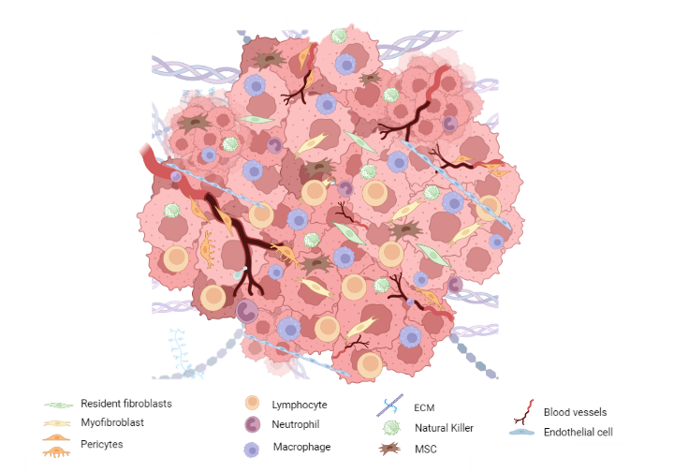
Figure 1.2 Overview of TME components

The representative image of the TME comprises diverse cell types like fibroblasts, pericytes, immune cells, extracellular matrix (ECM), mesenchymal stem cells (MSC) and blood vessels. All these components are part of the ecosystem surrounding the tumour cells. Created by Biorender.com

1.2.2 Mesenchymal Stem Cells
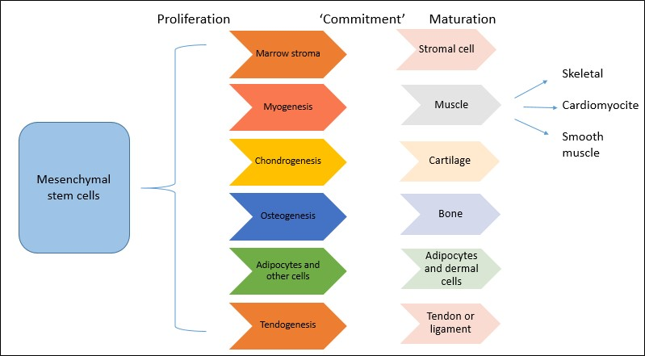
Mesenchymal stem cells (MSCs) are multipotent, self-renewing progenitor cells. These mainly reside in the bone marrow but can exist in almost all tissues. These cells are mainly characterised by their tri-lineage differentiation potential in vitro (osteoblasts, chondrocytes and adipocytes) (Dominici et al., 2006); however, they can also differentiate into other cell types (Figure 1.3). The main functions of MSCs are infiltration of sites of injury and suppression of immune reactions. They can also assist in the repair and regeneration of damaged tissues.

Figure 1.3. MSCs and their differentiation

MSC are non-hematopoietic stromal cells with a multipotential lineage differentiation, contributing to cartilage regeneration, muscle, ligaments/tendons, far, and others. Adapted from Singer and Caplan, 2011.

In terms of tumorigenesis, it has been found that MSCs migrate to the tumour stromal tissue and later convert into 'tumour-associated MSCs' (TA-MSC) and cancer-associated fibroblasts (CAFs) (Shi et al., 2017). However, how MSCs promote tumour progression, and metastasis is still not fully understood. Nonetheless, literature has shown that the interaction between immune-related cells produces by-products such as cytokines, chemokines and growth factors that promote cellular infiltration and tumour cell survival (Shi et al., 2017).
1.2.3 Fibroblasts
Fibroblasts are the primary type of cellular component in the connective tissue of mesenchymal origin. Despite their principal function to deposit fibrillar extracellular matrix, they have other roles, such as regulation of inflammation and wound repair. For example, fibroblasts become" activated" during wound healing, leading to infiltration and replication. There is also increased production of growth factors, such as transforming growth factor-beta (TGF- β) and ECM, including Collagen-I and Fibronectin. These may act as a scaffold that leads to wound contraction (Li et al., 2007).
In physiological conditions, once the wound is repaired, fibroblasts decrease and return to their original phenotype. It has been reported that within the TME, fibroblasts remain activated and become hyper-activated fibroblasts as ‘wounds that do not heal’ (Dvorak, 2015; Raghu & Michael, 2006). This ́reactive ́ stroma is associated with an important number of fibroblasts, higher capillary density and increased deposition of collagen and fibrin (Dvorak, 2015), which leads
to chemoattraction of inflammatory cells and endothelial cells. These cause the secretion of vascular endothelial growth factor (VEGF), inducing microvascular permeability, which results in the extravasation of plasma proteins and further recruitment of more cellular lines. Finally, the cascade of reactions creates a loop, which results in desmoplasia. A desmoplastic stroma tends to have increased interstitial fluid pressure and lower oxygen levels that eventually may lead to necrosis (Raghu & Michael, 2006).
1.2.4 Cancer-associated fibroblasts
The chemo-attracted fibroblasts to the tumour stroma have been defined as cancer-associated fibroblasts (CAFs). Notably, it has been observed that there is a relationship between a higher number of CAFs with metastasis in various cancers, such as breast and lung cancer (Zhou et al., 2015). According to Kalluri et al., (2016), resident tumoural fibroblasts exposed to stimuli induce their activation, resulting in CAFs. However, it is theorised that CAFs have heterogeneous origins. Following this, many types of cells within the microenvironment can be recruited as their predecessors by diverse processes such as Endothelial-Mesenchymal Transition (EMT). The cells undergoing these processes can achieve new characteristics to develop invasive and migratory abilities to benefit tumour cells (Figure 1.4) (Kalluri & Weinberg, 2009).
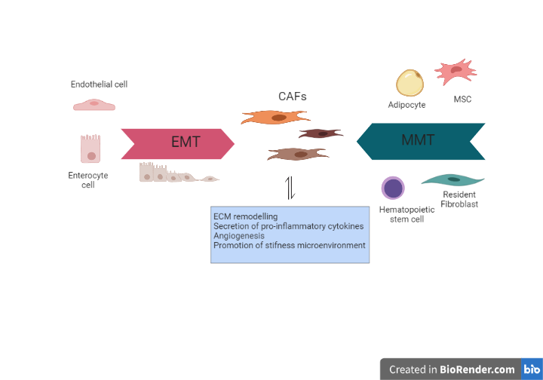
Due to their diverse origins, markers such as α-smooth muscle actin (α-SMA), fibroblasts activation protein-alpha (FAP) and platelet-derived growth factor (PDGF) are used to identify CAFs (Zhou et al., 2015). It has been reported that in vitro, TGF-β can induce phenotypic features of CAFs (Kalluri & Weinberg, 2009). Their functions and origins, however, are still not completely understood.
Figure 1.4. The origins of CAFs

Cancer-associated fibroblasts (CAFs) might use transition processes such as Endothelial-Mesenchymal Transition (EMT) or Mesenchymal-Mesenchymal Transition (MMT) to convert diverse cell types into CAFs. These cells within the tumour microenvironment create a hostile stroma that enhances tumour aggressiveness and maintenance and survival of cancer cells (Kalluri & Weinberg, 2009). Created in BioRender.com

CAFs play an essential function during tumorigenesis via the synthesis, deposit and remodelling of the ECM, the secretion of growth factors such as hepatocyte growth factor (HGF) and cytokines that induce tumour growth. Functions such as the secretion of pro-inflammatory cytokines and chemokines result in the degradation of ECM proteins. This process facilitates the migration of cancer cells and increases tumour stiffness leading to higher oxygen species production. It can also promote tumorigenicity of the cells, such as resistance to therapy (Erdogan et al., 2017; Jeremy Soon Kiat et al., 2017). Furthermore, CAFs are related to metastasis by providing a cell niche which can develop the growth of a subset of cancer cells (Kalluri, 2016).
1.2.5 Sarcoma-associated fibroblasts
Regarding sarcoma, a cell type called sarcoma-associated fibroblast (SAF) has been defined as myofibroblasts neighbouring sarcoma cells. Their origin may be the result of a fusion between fibroblasts and myofibroblasts. This origin is theorised due to their positive expression of smooth muscle cells markers such as α-SMA and stromal cell type markers such as FAP. The origins, however, are still not clear. Even though myofibroblasts are derived from bone-marrow, resident fibroblasts and fibroblasts precursors are considered SAFs primary sources (Yu et al., 2011). Lagacé et al., (1980) identified the presence of myofibroblasts within soft tissue sarcoma subtypes in collagen-rich zones and also in areas of desmoplasia (Lagacé et al., 1980).
SAFs are known to secrete protumorigenic factors. These include hepatocyte-growth factor (HGF) and TGF-β that leads to ECM synthesis and remodelling, facilitating the invasion of sarcoma cells (Koga et al., 2007). According to Salvatore et al., . (2015), co-cultures of human fibroblasts with sarcoma cell lines can lead to an upregulated expression of tumour necrosis factor-alpha (TNF-α), VEGF and Metalloproteinase-1. These can affect tumour progression, angiogenesis and metastasis (Salvatore et al., 2015). Nonetheless, their role during sarcomagenesis remains unclear compared to the information known about CAFS. More information about SAFs will be discussed in Chapter 3.
1.2.6 Immune Cells and Immune checkpoint expression in STS
As noted above, the tumour microenvironment is a reactive stroma. This environment can chemo attract immune cells such as neutrophils, macrophages and lymphocytes. These cells may produce pro-inflammatory cytokines, which result in an increased immune cell migration. Furthermore, among diverse types of cancer, a relationship between immune cell infiltration and prognosis has been observed (Jochems & Schlom, 2011). Overall, the immune cells infiltrated can act as pro-tumorigenic or anti-tumorigenic. The former group comprises cells that aim to promote tumour growth and immune surveillance by enhancing angiogenesis, migration and metastasis.
In contrast, the latter group aim to destroy the tumoural cells. Pro-tumoural cells include Regulatory T-cells (Treg), M2 macrophages, Myeloid-Derived Suppressor Cells (MDSCs), and N2 neutrophils. Anti-tumorigenic cells are cytotoxic T cells, natural killer (NK) cells, Dendritic cells (DC), M1 macrophages and B cells (Gally et al., 2020). In sarcomas, the most prevalent immune cells reported are Macrophages and T cells (Smolle et al., 2021; Fujiwara et al., 2021, Zhu and Hou, 2020); thus, in this section, the review will focus on these two subtypes of cells.
The immunological activity has its regulators; the activation of lymphocytes during immune reaction induces the expression of molecular surface proteins called ‘immune checkpoints’. (Liu et al., 2019). Immune checkpoints identified include programmed cell death-1 (PD-1), cytotoxic T-lymphocyte-associated antigen 4 (CTLA-4), Lymphocyte-activation gene 3 (LAG3), T-cell immunoglobulin and mucin domain-containing protein 3 (TIM3), among others (Table 1.5)( Kim and Ha., 2021; Zhang et al., 2021).These proteins act as inhibitory pathways that regulate the immune response to avoid tissue lesions and maintain self-tolerance (Ostroumov et al., 2018). During tumorigenesis, tumour cells upregulate these suppressive mechanisms on infiltrating T cells leading to T cell exhaustion, especially CD8+ T cells.
Consequently, T cells lose effector functions, and the expression of more inhibitory pathways leads to immune tolerance. This mechanism is an immune evasion strategy (Zhang et al., 2021). Due to the interest of this project, PD-1 signalling is the immune checkpoint data that will be shown in this thesis.
In the context of PD-1 signalling, the phosphorylation and activation of PD-1 occur upon interaction with its ligands, PD-L1 and PD-L2, mainly expressed on antigen-presenting cells or tumour cells. The activation of this pathway recruits SHP2, which dephosphorylates signalling molecules such as PI3K/AKT and Ras/MEK/ERK pathways, suppressing T cell activation and proliferation (Zhang et al., .2021). PD-1 also inhibits antigen and co-stimulatory signalling by suppressing genes induced by TCR signalling (He and Xu, 2020). The expression of PD-L1 can be upregulated in many tumour cell types, such as melanomas and glioblastomas, but its expression seems to be variable among cancers and sarcoma subtypes (Drew, 2012; Greenwald et al., 2005). The response to immunotherapy is often associated with TILs infiltration and PD-L1 expression in tumours and immune cells. Consequently, current research aims to determine the potential of immune checkpoint blockade as a treatment option for STS (Petitprez et al., 2020; Zhen et al., 2018; Klaver et al., 2020; Klemen, Kelly and Bartlett, 2021).
In sarcomas, PD-L1 expression exhibits considerable variability, with subtype dependent being more likely present in pleomorphic subtypes and higher-grade sarcomas (van Erp et al., 2017; Cunningham et al., 2021; Kim et al., 2016). A literature analysis of 14 studies revealed that subtypes like DDLP, epithelioid sarcomas, pleomorphic sarcoma, and myxoid/round cell liposarcomas displayed higher percentages of PD-L1 expression (Cunningham et al., 2021). Kelany et al., (2021) reported a high prevalence of PD-L1 expression in desmoid tumours and rhabdomyosarcoma. Additionally, Pollack et al., (2017) found that UPS exhibited the highest levels of PD-L1 and PD-1 by immunohistochemistry (IHC) among the most common STS subtypes. Meanwhile, an RNAseq data analysis by the Abeshouse et al. (2017) found that Soft Tissue Leiomyosarcoma had a significantly higher PD-L1 score than Uterine Leiomyosarcoma. Another study of RNAseq data of STS samples showed that PD-L1 expression was correlated with subtypes such as LMS and liposarcomas, complex genetic profiles and high-risk, classified by CINSARC (Bertucci et al., 2017).
The expression of PD-1/PD-L1 and its prognostic value have also been studied. In this regard, Kim et al., (2013) reported high PD-L1 expression significantly associated with high tumour grade in LMS, UPS, angiosarcoma, and other subtypes,
as well as distant metastasis; high tumour grade, and necrosis, as measured by IHC. Similar findings were made by Bertucci et al., (2017), who reported that high expression of PD-L1 was an independent unfavourable factor for metastatic relapse. PD-1 overexpression is associated with poor overall survival, metastasis-free survival and event-free survival, according to a meta-analysis of bone and soft tissue sarcoma. High PD-L1 expression was also associated with tumour metastasis and T lymphocyte infiltration (Wang et al., . 2020). In line with this study, another meta-analysis of bone and STS reported an association between poor overall survival and poor event-free survival. However, no relationship was found between PD-L1 and tumour grade, metastasis, chemotherapy, gender, and age, among other clinical features (Zheng et al., 2018). Additionally, Kim et al., (2017) did not observe significant differences in PD-L1 expression in relationship with age, gender, histological grade, tumour size and adjuvant treatment. However, they did find it to be an independent factor associated with poor overall survival.
In reviewing the literature on sarcomas, immune checkpoint controversy is found as contradictory results have been published. Nonetheless, it is essential to highlight that no standard methodology has been established to identify PD-L1, which could be responsible for the published variable results. Numerous methods have been used, including IHC, RNAseq analysis and PCR. Also, challenges such as determining the best cut-off for ‘positive’ expression and small sample sizes of different subtypes further complicate the field. However, further studies are warranted as promising results have been found for specific subtypes.

Table 1.5. Main immune checkpoint and ligands and their expression among diverse cell types.

Immune checkpoint expressed | Cell type
PD-1 | Activated T cell (CD4+, CD8+, Treg cells)
 | B cell
 | NK cell
 | Dendritic cell
 | Macrophages
PD-L1 and PD-L2 | Dendritic cell
 | Macrophages
 | B cell
 | Tumour cells
 | Hematopoietic cells (only PD-L1)
 | T cells
CTLA-4 | Activated T cells (CD4+ and Treg cells)
CD80 (ligand) | Dendritic cells
 | Macrophages
 | B cell
 | Tumour cells
LAG-3 | Activated T cells (CD8+ and Treg cells)
MHC class II (ligand) | Macrophages
 | B cell
TIM-3 | T cells
 | NK cells
 | Dendritic cells
 | Macrophages
Galectin-9 and CEACAM1 (ligands) | Tumour cells
 | Dendritic cells
 | Macrophages
 | B cells

1.2.6.1 Macrophages
Macrophages are the major population of immune cell types within the tumour stroma and are called 'Tumour-Associated Macrophages' (TAMs). TAMs have diverse cell precursors, some circulating in blood like blood monocytes, monocyte-related myeloid-derived suppressor cells (M-MDSCs), and tissue residents-macrophages (Fujiwara et al., 2021). These cells are attracted to TME by cytokines such as macrophage-colony-stimulating-factor (CSF-1), Interleukin-34 (IL-34), vascular endothelial growth factor (VEGF) and some chemokines like CCL-1 secreted by the tumour tissue and non-malignant cells present in the tumour stroma (Lewis & Pollard, 2006). These chemokines and cytokines, including IL-1, IL-4, IL-10, il-13 and TGF-β, induce transcription factors contributing to TAMs polarisation. This polarisation skewed macrophages into specific phenotypes, 'M1' and 'M2', with the former described as having anti-tumorigenic activity and the latter having pro-tumorigenic activity.
Thus, the polarisation of TAMs into a protumorigenic phenotype is a typical feature in tumours (De Palma & Lewis, 2013). Surface markers such as CD80, CD86, iNOS, CD14, CD16, and Human Leukocyte Antigen (HLA) are associated with M1 macrophages, while CD206, CD163, and CD209 are expressed in M2 macrophages (Gok Yavuz et al., 2019).
Based on the specific phenotypes consequence of the polarisation, TAMs can influence the properties of the TME. M2 promote an immunosuppressive microenvironment by reducing the infiltration of CD8+ T cell through the secretion of TGF- β and IL-10. They also expressed PD-L1-1, which activates immune checkpoint signalling and inhibits T cell-mediated immune response (Cook & Hagemann, 2013). Furthermore, M2 also contribute to tumour development and invasion by secreting VEGF-A for angiogenesis and immunosuppression and producing proteolytic enzymes that help ECM degradation and tumour dissemination, such as metalloproteinase-2 and 9 (MMP2, MMP9) (Fujiwara et al., 2021). M2 TAMs also play a role in promoting metastasis by secreting VEGF-C, which induces lymphangiogenesis. Additionally, producing IL-1 induces the accumulation of tumoral cells at distant sites and can move to distant sites to provide a supportive niche for the metastatic cells (Lewis & Pollard, 2006). Furthermore, M2 can influence the effectiveness of chemotherapy by secretion of IL-6 and tumour necrosis factor (TNF-α) (De Palma & Lewis, 2013).
Some examples of the role of TAM in STS are the following. TAM M2 were reported with a higher presence compared to M1, being LMS, MFS, DDLPS and UPS as the subtypes with the higher prevalence (Tsagozis et al., 2019). Similarly, Dancsok et al., (2020) reported a high number of TAM among diverse sarcomas subtypes when compared to TIL, especially in UPS, MFS, LMS and DDLP, and within the TAMs, the M2 phenotype outnumbers M1 macrophages, particularly in UPS and LMS subtypes. Similarly, an analysis of The Cancer Genome Atlas Sarcoma (TCGA-SARC) RNAseq data showed UPS/MFS and DDLPS subtypes with the highest macrophage scores within sarcoma subtypes (Abeshouse et al., 2017). Klaver et al., (2020) also found high M2 in MFS and UPS, among other subtypes.
Moreover, the infiltration of macrophages, especially the M2 phenotype, has shown a clinical impact on STS. The high density of M2 macrophages was associated with poor overall survival in human and mice UPS and high stage in human UPS (Komohara et al., 2019; Shiraishi et al., 2018). Additionally, M2 presence was higher in metastasis osteosarcomas, whereas M1 phenotypes were associated with localised disease (Dumars et al., 2016). Among LMS, M2 infiltration correlates with a worse prognosis (Ganjoo et al., 2011). On the contrary, high CD163, an M2 marker, predicted a lower progression-free survival, whereas DDLP was a favourable prognostic factor (Dancsok et al., 2020). Regarding the correlation of therapy
response with TAMS, the analysis of SARC028 samples, a trial to test the efficacy of pembrolizumab, showed that responder- subtypes had high infiltration of TAM expressing PD-L1 at baseline when compared to non-responder subtypes (Keung et al., 2020).
1.2.6.2 Lymphocytes
T-cells, also known as ‘Tumour Infiltrating Lymphocytes’ (TILs), have gained attention in cancer over the past few years. The presence of TILs among various types of cancer is variable, but it is not yet fully understood why this happens. One proposed explanation is the expression of CCR4 (C-C motif receptor 4) by T regulatory (Treg cells) and the production of cytokines such as chemokine ligand 22 (CCL22) by tumoural cells. This factor can lead to an increased number of infiltrating FOXP3+CD4+T-reg cells (Nishikawa & Sakaguchi, 2014). The number of TILs in STS varies significantly depending on the subtypes, with higher infiltration reported in pleomorphic subtypes, such as UPS and MFS (Smolle et al., 2021).
A study involving 105 cases of various subtypes of STS examined the expression of PD-1+ TILs and PD-1 expression among the tissue samples. The study revealed that 58% of the STS cases expressed PD-L1-1, while 65% of the patients presented TILs. Additionally, tumoural cells PD-L1+ and PD-1+ TILs were discovered to be independent prognostic variables for OS (Kim et al., 2013).
Another study by Movva et al., (2015) using IHC found that 50% of the samples expressed PD-L1 and PD-1 TILs, with LMS, chondrosarcoma and liposarcoma showing higher expression levels. Another author demonstrated that UPS had high levels of PD-L1 and PD-1 by IHC. Also reported was a correlation between T-cell infiltration and clonality with PD-1 and PD-L1 expression (Pollack et al., 2017). Furthermore, based on B cell expression levels in different sarcoma subtypes, Petitprez et al., (2020) clustered STS samples into different groups, showing diverse immune cell gene expression profiles. The diversity of the groups went from lower (mainly LMS subtype), intermediate (mainly DDLPs subtype) and higher groups (LMS, DDLPS and UPS similar). The group with the highest immune gene profile exhibited high levels of T cells, CD8+ T cells, NK cells, and immune checkpoints such as PD-1, PD-L2, and CTLA-4, as well as a high mutational burden in some samples. These profiles were tested by IHC in samples from the SARC028 cohort, confirming the presence of a high density of CD3+, CD8+ and CD20+ and PD-1 in the samples that responded to pembrolizumab (an anti-PD-1) treatment.
Regulatory- T cells (T-reg) are commonly found in high numbers among TME. Despite their main function to prevent autoimmune processes, tumoural cells can be used to benefit
tumour development. Treg can hinder immune surveillance and can prevent the development of anti-tumour immunity in cancer by secreting immunosuppressive cytokines, like TGF-β and VEGFA, which hinders T cell proliferation and downregulation of MHC Class I molecules (Janssen et al., 2017; Ohue and Nishikawa, 2019). In the context of STS, Smolle et al., (2021) reported a positive correlation between higher tumour grade and the presence of CD3+ T cells. Additionally, older STS patients had increased levels of CD3+, CD4+ and Foxp3+ Treg cells which were linked to a higher risk of local recurrence but no effect on overall survival (OS). Similarly, high levels of Treg were associated with poor disease-free survival and OS in a study by Que et al., (2017). Concerning immunotherapy, an analysis of samples from sarcoma patients responders to pembrolizumab showed a high density of memory cytotoxic cells and Treg compared to non-responders samples (Keung et al., 2020).
Furthermore, other T cell subtypes can be found within the tumour stroma. High infiltration of CD8+ and CD4+ T cells in various solid tumours has been associated with better survival, according to a meta-analysis (Gooden et al., 2011). However, diverse authors have reported contradictory information on sarcomas (Boxberg et al., 2017; D'Angelo et al., 2015; Kim et al., 2013; Sorbye et al., 2011). While CD4+T helper cells generate cytokines that stimulate CD8+ T lymphocytes, CD8+ cytotoxic cells act as tumoural cell killers. Thus, CD8+ T cells are relevant for controlling tumour progression (Ostroumov et al., 2018).
In STS, Klaver et al., (2020) found a higher number of CD8+ in three main subtypes GIST, MFS and UPS. These cells expressed immune checkpoint markers PD-1, TIM3, and LAG-3 in UPS and MFS, with a similar distribution along the tumour margin and centres. According to Boxberg et al., (2017), PD-L1 expression in the UPS subtype is correlated with high numbers of CD3⁺ and CD8⁺ cells. A high-density density of CD8⁺ TILs was also found as an independent positive prognostic marker for OS and disease-free survival (DFS). An analysis of the prevalence of TILs and PD-1 done by D'Angelo et al., (2015) using IHC reported that 90% of diverse STS samples analysed had a low density of CD4⁺ cell, and GIST, LMS, Liposarcoma, SS, and chondrosarcoma had lower CD8⁺ cell densities. Although a high proportion of CD8+ cells was found in patients with metastasis and larger tumours, no significant impact of CD3⁺ CD8⁺ on prognosis or survival was observed.
Moreover, Sorbye et al., (2011) reported that by univariate analysis, high levels of CD4⁺ and CD20⁺, a marker for B cells, were correlated to improve disease-specific survival in patients with wide resection margins, but no correlation was found with infiltration of CD8⁺ TILs in non-GIST sarcomas. An analysis of the TCGA-SARC RNAseq data showed that among
different sarcoma subtypes, DDLP had the highest score of CD8+ cells (Abeshouse et al., 2017). In contrast, another analysis of TCGA-SARC showed that a high density of effector memory CD4+ cells was significantly associated with better OS. Nonetheless, Treg and activated CD4+ did not show a significant association among all sarcoma subtypes (Bi et al., 2021).
To sum up, the investigation of the immune landscape in sarcomas has yielded exciting results showing that some subtypes are not 'cold' tumours as was thought. Identifying specific features such as immune cell infiltration and immune checkpoint expression among these subtypes suggests a possible direction regarding sarcoma treatments. Nonetheless, challenges persist in investigating this area, like sample sizes, poor representation of subtypes, and use of different methodologies. To overcome this, further investigation is imperative to comprehend the complex mechanisms behind sarcoma biology.
1.2.7 Blood vessels
Blood vessels are the unit of the vascular networks that play a crucial role by transporting and delivering oxygen, nutrients, metabolites and metabolic waste. The vascular network is a complex system that comprises arteries, veins and capillaries,
each having unique properties (Tucker, Arora and Mahajan, 2022). Overall, endothelial cells (ECs) form layers that make up the walls of blood vessels. These layers are ECs joined together by molecules such as claudins and VE-cadherin that preserve the integrity of the endothelial layer and its relationship to the basal membrane. Smooth muscle cells and pericytes, also referred to as 'mural cells', are in close relationship with ECs and help to regulate blood pressure while conserving vascular integrity and limiting permeability and vascular leakage. These cells also possess contractile capabilities to maintain and control vessel diameter and blood pressure. Arteries contain multiple concentric layers of smooth muscle in their walls along with endothelial cells, whereas veins have fewer layers of smooth cells in their walls (Lugano, Ramachandran and Dimberg, 2020). Lastly, capillaries, as the vessels with the smaller diameter, are formed by a single endothelial layer supported by pericytes. These mural cells are related to the maturation and stabilisation of the blood vessels. Moreover, a facilitated exchange of nutrients and metabolites occurs in the capillaries (Viallard and Larrivee, 2017; Lugano; Ramachandran and Dimberg, 2020).).
Different processes can create blood vessels; however, the two main processes are the de novo formation resulting from the differentiation of endothelial precursor cells, called 'vasculogenesis' and 'angiogenesis', characterised by the
sprouting of pre-existing vessels. Vasculogenesis primarily occurs during embryological development, while angiogenesis mainly contributes to the growth of blood vessels through capillaries afterbirth and during tumour development (Apte, Chen and Ferrara, 2019). In both processes, the migration, proliferation and activation of endothelial precursor cells (EPCs) or ECs is necessary for tissue initiation, maintenance and survival (Viallard & Larrivée, 2017).
During vasculogenesis, EPCs, which are stem cells, are recruited from the bone marrow by growth factors and clustered into blood islands. Peripheral cells in these islands, called angioblasts, convert into endothelial cells, whereas the ones at the centre differentiate into hematopoietic cells during embryological development. In cancer, growth factors and hypoxia signalling, secreted by tumour cells, attract EPCs that differentiate into endothelial cells and can integrate into areas of active neovascularisation (Lugano, Ramachandran and Dimberg, 2020).
In angiogenesis, a specialised EC known as a 'tip cell' emerges from the pre-existing vessel. This cell undergoes phenotypic modifications by extending filopodia and acquiring motility and invasiveness abilities to migrate towards a chemotactic path of pro-angiogenic factors, mainly VEGF-A, secreted by tumour cells. Following the tip cell, more ECs called 'stalk cells' proliferate and express junctional molecules forming a vascular lumen and creating anastomose with the original vessel. The newly created vessels must mature, pericytes must be recruited, and cell-cell adhesion must be strengthened to maintain a correct function(Figure 1.5) (Viallard & Larrivée, 2017).
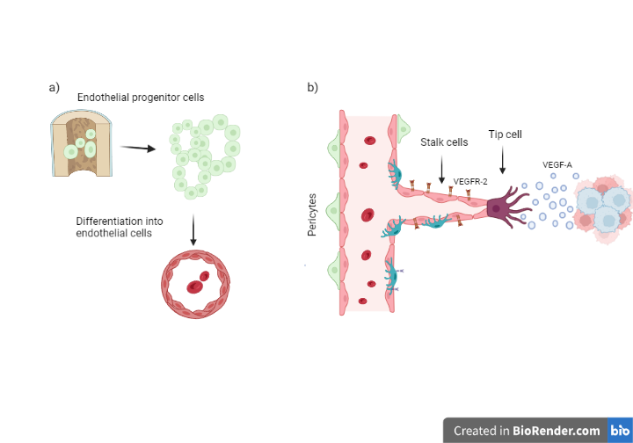
Figure 1.5. Development of blood vessels.
Representative image of the two primary mechanisms involved in the formation of blood vessels: vasculogenesis and angiogenesis. A) In vasculogenesis, endothelial progenitor cells (EPCs), stem cells, are stimulated by growth factors and grouped into early vascular structures. After that, EPCs undergo endothelial cell differentiation, which can contribute to forming new vascular structures or incorporate them into already-existing vascular networks. B) Angiogenesis is the process of blood vessels sprouting from a pre-existing one. The process starts with the tip cell, a specific type of cell that modifies its phenotype to be able to follow a chemotactic gradient of growth factors. Following the tip cell, stalk cells build the vascular walls of the new blood vessels and anastomose the new vessels with the pre-existing ones. Maturation and pericyte coverage of the new vessels are crucial to their functionality. Promoted by PDGF, pericytes migrate to cover the new blood vessel wall and act as supportive cells. Created with BioRender.com
The 'angiogenic switch' is a process that occurs during tumour development characterised by increased activation of pro-angiogenic factors and signalling exceeding the anti-angiogenic factors resulting in the rapid formation of blood vessels that aid the tumour growth (Lugano, Ramachandran and Dimberg, 2020; Apte, Chen and Ferrara, 2019). Due to the increased demand for nutrients in the tumour tissue, immature and aberrant blood vessels are formed in an unorganised manner, compromising the functioning and the amount of oxygen delivered. Consequently, the oxygen levels in the tumour stroma can be dramatically decreased, creating a hypoxic microenvironment. This hypoxic state can be transient in certain areas or permanent in others (Jiang et al., 2020).
Hypoxia-inducible factors (HIFs) accumulate and become stable under hypoxic conditions, triggering genetic alterations that allow tumour cells to develop an adaptive cellular response to low oxygen levels (Petrova et a., 2018). The HIF family includes two subunits: α and β, with HIF1-α as the most extensively investigated. The accumulating HIF1-α binds HIF1-β inside the nucleus to later bind the hypoxia response elements promoter of target genes (Weidemann and Johnson, 2008). As a result, target genes will be activated and start to promote angiogenesis (VEGFA, angiopoietin), cell growth and proliferation (TGF-β) and glucose metabolism (glucose transporters 1 and 3) to cope with the inadequate nourishment and the hostile environment. Moreover, hypoxia promotes the production of metalloproteinases, such as MMP-2, which contribute to tumour invasion and metastases by degrading the extracellular matrix (Al Tameemi et al., 2019; Jiang et al., 2020).
As previously mentioned, Vascular Endothelial Growth Factor (VEGF) plays a critical role in tumour development and is primarily secreted by tumour cells in response to hypoxia. The secretion of VEGF leads to an increase in angiogenesis to supply the tumour and compensate for low oxygen levels. Nonetheless, it is essential to mention that the role of VEGF extends beyond angiogenesis and encompasses a range of effects within the TME. Some of these effects will be discussed in the following sections.

1.3 Vascular Endothelial Growth Factor (VEGF)
1.3.1 VEGF Family- an Overview
The vascular Endothelial Growth Factor (VEGF) family encompasses several growth factors, including VEGF-A, VEGF-B, VEGF-C, VEGF-D, VEGF-E and Placental growth factor (PlGF). The diverse nature of this family is derived from various processes such as proteolytic processing, alternative ribosomal start sites, and mRNA splicing, each of it having unique features (Napoleone et al., 2003); Vempati et al., 2014; Mamer, Wittenkeller and Imoukhuede, 2020). VEGF-A will be discussed in greater detail for this project due to its significance.
VEGFR-1 (also known as Flt.1), VEGFR-2 (also known as Klk.1/KDR), VEGFR-3, and as well as the co-receptors neuropilin1 and 2 (NRP1, NRP2), are members of the receptor tyrosine kinases (RTKs) family. These receptors are characterised by their structure as type-I transmembrane proteins consisting of an extracellular ligand-binding immunoglobin domain, a transmembrane domain, and an intracellular tyrosine kinase domain (Simons, Gordon and Claesson-Welsh, 2016). On the cell surface, VEGFRs typically reside as inactive monomers. Following ligand interaction, dimerisation of the receptor occurs, creating homodimers or heterodimers between VEGRFs. This dimerisation process produces functional receptor complexes that initiate intracellular signalling cascades (Koch et al., 2011).
Despite sharing structural similarities, VEGFs and VEGFRs exhibit diverse functions in cellular biology depending on their expression on cellular surfaces (Apte, Chen and Ferrara, 2019; Koch et al., 2011; Shibuya, 2011). VEGF-A, for instance, binds to both VEGFR-1 and VEGFR-2 to activate angiogenesis, vascular permeability, and cell migration in endothelial cells. Angiogenesis is principally regulated by VEGFR-2, mainly expressed in endothelial cells and their precursors (Koch et al., 2011). Nonetheless, VEGFR-2 has also been detected in neuronal cells and hematopoietic stem cells. To increase its affinity for binding VEGFR-2, VEGF-A can additionally attach to NRP-1 (Apte, Chen and Ferrara, 2019). Additionally, VEGF-A can stimulate cytoskeletal arrangements and macrophage migration by activating VEGFR-1 (Domokos et al., 2023).
On the other hand, PlGF and VEGF-B bind to VEGFR-1, generating a weaker signal compared to VEGFR-2 for angiogenesis in physiological circumstances. However, a synergistic effect between PlGF and VEGF-A has been observed to promote angiogenesis under pathological conditions like ischemia (Carmeliet et al., 2001). Additionally, through VEGFR-1, VEGF-B promotes the metabolism of lipids in highly metabolic organs, including the heart and skeletal muscle (Koch et al., 2011; Shibuya, 2011; Karpanen et al., 2018).
VEGF-C and VEGF-D can bind to VEGFR-2 and VEGFR-3. These proteins are synthesised initially as pre-proteins, which are then transformed into mature forms by a proteolytic process. The unprocessed full-length forms are ligands of VEGFR-3, primarily expressed in lymphatic endothelial cells to regulate lymphangiogenesis, but the fully processed forms have increased affinity for VEGFR-2, contributing to angiogenesis (Jiang et al., 2020). VEGF-C has been widely studied as the main regulator of lymphangiogenesis, especially during embryological development. In contrast, VEGF-D has shown effects on the maturation of the lymphatic vessels after birth, as disruptions in this growth factor have been demonstrated to cause drainage defects in the lymphatic vascular in animal models (Paquet-Fifield et al., 2013; Bower et al., 2017).
1.3.2 VEGF-VEGFR signalling.
The initiation of VEGF signalling occurs through binding specific ligands to receptor monomers, leading to the formation of homodimers or heterodimers, a process called homodimerisation or heterodimerisation. This ligand-receptor interaction activates the intracellular tyrosine kinase domain,
which leads to the autophosphorylation of tyrosine residues (Peach et al., 2018; Koch et al., 2011). The phosphorylated tyrosines and other amino acids are binding sites for cytoplasmic adapter molecules, which subsequently start intracellular signalling pathways. These downstream signalling pathways play significant roles in various cellular processes. Examples of these pathways include phosphatidyl inositol-3 kinase (PIP3)/AKT, PLC-γ, ERK 1/2, p38MAPK, Janus kinase (JNK), FAK, signal transducer and activator of transcription (STAT), nuclear factor kappa B (NFK-β) and mTOR (Figure 1.6)(Abhinand et al., 2016; Peach et al., 2018). Downstream signalling will depend on the VEGFR cellular localisation and the type of VEGF ligand.
The VEGFA-VEGFR-1/2 signalling pathway has been extensively studied as its central role is linked to increased permeability and proliferation of endothelial cells (Abhinand et al., 2016). Given the focus of this project, the interaction between VEGF-A and VEGFR2 will be emphasised in further detail.
Upon activation by VEGF-A, the phosphorylation of specific sites on VEGFR-2 is essential for regulating signalling pathways related to proliferation, migration, survival, and vascular tube formation in endothelial cells (Peach et al.,
2018). For instance, the phosphorylation of Tyr1054 and Tyr1059 sites enables Src signal transducer recruitment. Phosphorylation of Tyr1175 facilitates the binding of proteins, like PLC- γ and SHB, to FAK (focal adhesion kinase) which promotes cell-cell attachment, migration, and permeability in endothelial cells. Additionally, the activation of Tyr1175 by PLC- γ activates PKC (proteinase kinase C) to promote cell proliferation via the ERK pathway (Koch et al., 2011). But research is still being done to fully understand individual phosphorylation sites and how it affects their association activities. It has been shown that other adaptor proteins can activate diverse functions in VEGFR-2. For example, the binding of p85 generates PIP3, which activates Rac to promote cell motility and the PI3K/AKT pathway, which inhibits apoptosis (Koch et al., 2011; Peach et al., 2018).

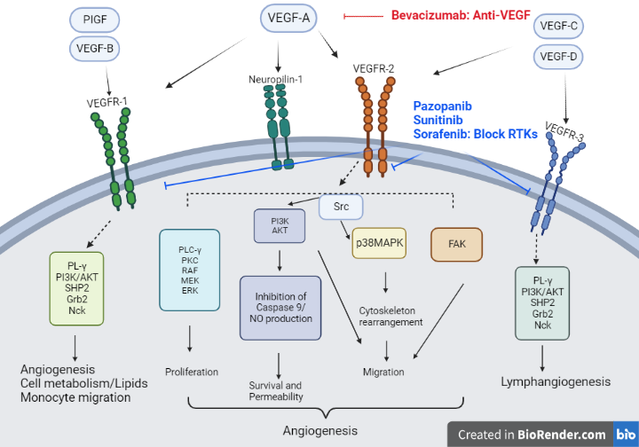
Figure 1.6 VEGF family and VEGFR signalling

Representative image of the VEGF family and their interaction with their corresponding receptors (VEGFRs). VEGF-A exhibits affinity towards both VEGFR-1 and VEGFR-2. Despite VEGFR-1 being related to angiogenesis and has a higher affinity to VEGF-A, it is VEGFR-2, the one primarily in charge of the transduction of multiple responses in endothelial cells, including proliferation, survival, permeability, structural changes and migration linked to angiogenesis. VEGF-B and Placental Growth Factor (PlGF) bind to VEGFR-1, which participates in angiogenesis in a weaker manner and pathological conditions. Notably, VEGF-B also activates pathways for increased lipids metabolism in specific tissues. Furthermore, VEGF-C and VEGF-D are ligands for VEGFR-2 and VEGR-3, primarily promoting lymphangiogenesis while also playing a role in angiogenesis. Examples of targeted therapies include Bevacizumab, a monoclonal that blocks secreted VEGF-A to inhibit the ligand-receptor binding to avoid signalling transduction. Other examples of targeted therapies included are RTK inhibitors which target the tyrosine kinases' enzymatic activity of the VEGFRs to disrupt the downstream signalling pathways. Created with BioRender.com

1.3.3 VEGF and its immunosuppressive role
VEGF has historically been recognised for its central role in angiogenesis and as a modulator of vascular permeability (Bates et al., 2002). However, it has been shown that VEGF receptors are expressed in other cell types beyond endothelial cells, including immune cells, osteoblasts, and neurons (Li, Zhao, & Ren, 2016). This varied expression pattern suggests that VEGF may have additional roles outside angiogenesis (Tammela et al., 2005).
It has been well established that VEGF affects immune cells acting as an immunosuppressive factor during tumour development (Li, Zhao and Ren, 2016).
The production of VEGF by cancer cells, including breast and colon cancer cells, has been demonstrated to inhibit hematopoietic stem cells from differentiating and maturating into dendritic cells (DCs), thereby affecting T-cell activation Gabrilovich et al., 1996; Goel and Mercurio, 2013). Furthermore, VEGF can induce the differentiation of immature DCs to endothelial-like cells, consequently promoting angiogenesis during tumour development (Li, Zhan and Ren, 2016). Regarding macrophages, M2-phenotype and cancer cells are the primary sources of VEGF. This growth factor affects macrophages inducing cytoskeletal arrangements and migration by activating VEGFR-1 (Domokos et al., 2023). At the same time, VEGF can enhance the immunosuppressive state by upregulating the expression of PD-L1 on M2 (Wu et al., 2017)
Additionally, VEGF can attract myeloid-derived suppressor cells (MDSCs), which are immunosuppressive. A positive autocrine feedback loop is created when VEGF and VEGF-R2 interact with MDSCs upregulating hypoxia-induced factor 1 (HIF1α) that causes the transcription of hypoxia response genes, including VEGF (Vetsika, Koukos and Kotsakis, 2019). Immunosuppressive functions of MDSCs include the release of anti-inflammatory and inhibitory cytokines such as IL-10, TGF-β, and ROS. These promote M2-phenotype polarisation in macrophages, activation of Treg cells and inhibiting T-cell proliferation (Vetsika, Koukos and Kotsakis, 2019; Li, Zhao and Ren, 2016).
Furthermore, VEGF exerts suppressive effects on T cells by inhibiting T cell development and reducing the cytotoxic activity of peripheral blood T cells (Yang, Yan and Liu, 2018). These mechanisms are controlled by the upregulation of VEGF-R2 upon T-cell activation that consequently secretes VEGFA (Ziogas et al., 2012). Additionally, increased expression of immune checkpoints associated with CD8+T cell exhaustion, such as PD-1, CTLA-4, Tim-3 and LAG3, are related to secreted VEGF. In vivo cancer models have shown that this effect is reversible when treated with VEGF-R2 inhibitors (Voron et al., 2015)
Given its immunosuppressive role and its crucial participation in tumour angiogenesis, inhibition of the VEGF/VEGFR pathway has attracted a lot of interest, especially in combination with other treatments, such as immune checkpoint inhibitors. These therapies could act synergistically under the rationale of anti-angiogenic therapy, leading to the normalisation of blood vessels and enhanced anti-tumour immune response by blocking the inhibitory immune regulators through immune checkpoint inhibitors (Ciciola et al., 2020; Tamura et al., 2020).
1.3.4 VEGF-A gene and isoforms
Although there are other members of the VEGF family, VEGF-A is the one that has been the subject of the most research due to its critical role in angiogenesis in health and disease conditions. Eight exons and seven introns constitute the human VEGFA gene on chromosome 6 at locus 6p21.1 (Arcondéguy et al., 2013). Numerous cell types, such as endothelial cells, macrophages, fibroblasts, platelets, and tumour cells, secrete VEGF-A. Moreover, VEGFA expression can be increased by cellular conditions such as hypoxia and inflammation (Peach et al., 2018).
The alternative pre-MRNA splicing of the VEGF-A gene produces a variety of isoforms by removing introns and forming unique arrangements of exons. These alternative splicing processes result in a variety of VEGF isoforms with diverse characteristics in terms of exon content, receptor affinity and matrix binding (Vempati et al., 2014). VEGF-A121, VEGF-A145, VEGF-A165, VEGF-A189 and VEGF-A206 are examples of alternative isoforms produced by the splicing of exons 6 and 7 (Figure 1.7) (Napoleone et al., 2003). The VEGF-A gene can also be found as multiple isoforms in mice, although the mouse gene is one amino acid shorter. For instance, VEGFA-120 in mice is equivalent to VEGFA-121 in humans.
Each isoform has distinctive features since it contains different exons. Exons 1 to 5 are present in all isoforms and contain amino acid residues necessary for binding to the VEGFR-1 and VEGFR-2. Exons 6 and 7 interact with negatively charged ECM proteins, particularly heparan sulphates, indicating their relationship with the diffusion characteristics of the isoforms (Peach et al., 2018). The endothelial cell proliferation properties of the isoforms are mediated by exon 8, which is also present in all isoforms (Melincovici et al., 2018).
The three mainVEGF-A isoforms are VEGF-A121, VEGF-A165 and VEGF-A189, with VEGF-A165 as the most effective regulator of angiogenesis and, as a result, has been the subject of most research (Arcondéguy et al., 2013). VEGF-A189 contains exons 6a and 7, which makes it particularly suited to bind to the ECM with high affinity. On the other hand, VEGF-A165 has a moderate affinity to the ECM due to the presence of exon 7 only. Heparin-binding exons are absent in VEGF-A121, allowing the isoforms to diffuse freely (McFee, Rozzell and Cupp, 2012).
Differences between the three main VEGF-A isoforms, VEGF-A121, VEGF-A165 and VEGF-A189, have been investigated concerning angiogenesis and their signalling pathways (Peach et al., 2018). Both VEGF-R1 and VEGF-R2 have been reported to bind to these isoforms. However, VEGF-R2 has been more extensively studied. Regarding VEGF-R1 affinity, VEGF-A165 exhibits the highest binding affinity, whilst VEGF-A121 shows the lowest affinity (Mamer et al., 2020). On the other hand, for VEGF-R2, all isoforms have comparable affinities. Nonetheless, the activation of receptors and signal amplification does not have a linear link (Peach et al., 2018).
The biological differences created between isoforms can not only be attributed to their binding affinity. In this regard, VEGF-A165 has been linked with higher activation of Akt and ERK1/2 compared to VEGF-A121, leading to a twofold increase in endothelial cell proliferation (Fearnley et al., 2016). Furthermore, VEGF-A121 stimulated HUVEC cells less than VEGF-A165 in terms of motility, sprouting and proliferation. VEGF-A121 also shows reduced activation of VEGF-R2, ERK and PLC-γ and slower endocytosis of VEGF-R2 when compared to VEGF-A165 (Peach et al., 2018; Fearnley et al., 2016).
Because of the presence of VEGFA in different compartments like ECM, tissue and blood, accurately measuring its levels is difficult. Nevertheless, according to a predictive computational model by Clegg and Mac Gabhann (2017), the relative expression of the isoforms with VEGF-A121 has the lowest expression level, VEGF-A189 has intermediate levels, and VEGF-A165 has the highest levels.
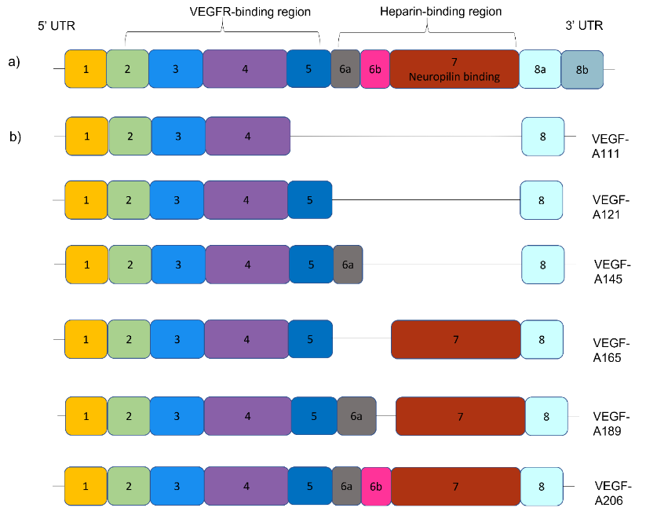
Figure 1.7 Human VEGF-A gene structure and isoforms

Representative image of VEGFA gene structure in humans and structure variations of its isoforms. a) Human VEGF-A gene structure model consists of eight exons and spans 16 272 bps. b) Alternative splices of exons 6 and 7 in the VEGFA gene structure create a variety of isoforms with unique features. Exons from 1 to 5 are constitutive exons which form part of the VEGFR-binding sites in all isoforms. Meanwhile, exons from 6 and 7 promote the interaction with the extracellular matrix and interaction with co-receptor like neuropilins. Thus, the lack of these exons will create shorter and more soluble isoforms, such as VEGF-A121. Lastly, exon 8a form part of the pro-angiogenic isoforms naming all of these isoforms 'pro-angiogenic', whereas isoforms with exon 8b are considered 'anti-angiogenic'.

In 2002, Bates et al., discovered a new isoform in human renal carcinomas by reverse-transcriptase (RT)-PCR, named VEGF-A165b, a variation of the already known VEGF-A165 isoform. This VEGF-A165b isoform differs by replacing exon 8a for exon 8b with alternative sequences in the C-terminal
region (Bates et al., 2002). Later, additional isoforms were reported, including VEGF-A189b and VEGF-A121b. These discoveries make apparent that the splicing of the exon 8 can generate two different groups of VEGFA proteins: VEGF-Axxx with pro-angiogenic properties and VEGF-Axxxb with anti-angiogenic properties (Peach et al., 2018). Overall, VEGF-A pro-angiogenic family are the isoforms most studied.
Mamer, Wittenkeller and Imoukhuede (2020) reported that VEGF-A165 and VEGF-A165b have similar binding affinities to VEGFR-2. However, unlike its counterpart, VEGF165b did not appear to stimulate angiogenesis responses. This function suggested that VEGF-Axxxb isoforms would compete with their pro-angiogenic counterpart for its receptor, hence their name ‘anti-angiogenic’ (Bates et al., 2002). The signal transduction efficacy of VEGF-A165b has recently been shown to have a weaker potency than VEGF-A165 (Cébe et al., 2006). This could be explained as the VEGF-Axxxb family having a decreased affinity to neuropilin-1 and Heparin Sulfate-chain, which function as co-receptors and bind to VEGF-R2 (Mamer, Wittenkeller and Imoukhuede, 2020).
The existence and function of the anti-angiogenic family have been controversial and the subject of discussion (Dardente et al., 2020; Bowler and Oltean, 2019; Chesnokov et al., 2018; Harris et al., 2012). Different authors have reported that their presence exists only in a small proportion among tissue and tumours (Mikhail et al., 2018). Meanwhile, the presence of the anti-angiogenic family has been reported to count as more than 50% of the total VEGFA expression in primary culture cells like podocytes and colonic epithelial cells by other published literature (Bowler and Oltean, 2019). The presence of VEGFAxxxb, on the other hand, is questioned by some authors, who argue that their quantity in tissue may be minimal or a rsults of PCR artefact (Dardente et al., 2020; Harris et al., 2012)
The distinction between these two groups highlights the importance of a balanced ratio of the pro and anti-angiogenic factors for optimal tissue function (Nowak et al., 2008). To fully comprehend the complex biological properties shown by these VEGF-A isoforms and to explore their potential as targeted therapeutic agents.
1.3.4.1 Differences in vessel growth in tissues according to VEGF-Axxx isoforms
Some differences in the characteristics of vessel growth among VEGF-A isoforms can be found. These differences are related to their capability of diffusion within the TME, pericellular sequestration and the interaction with some receptors (Napoleone et al., 2003). Diverse tissues among the body express different ratios of VEGF-A isoforms according to their necessities. Nonetheless, it has been suggested that all isoforms work together to optimise vascular development (Xin et al., 2016).
In vivo experiments with mice models expressing only one VEGF-A isoform have been used to explore their functions. Regarding this, it has been reported that VEGFA-120 can facilitate the initiation of vessel outgrowth, but other forms are needed to continue the vascularisation and maturation (Vempati et al., 2014). Thus, mice that only expressed VEGFA-120 presented impaired angiogenesis and died due to ischemic cardiomyopathy soon after birth. The outcome blood vessels are reported to be fragile, with inadequate pericyte coverage and a decrease in vessel density (Peter et al., 1999). In contrast, mice expressing only VEGFA-188 showed higher vascular density, pericyte coverage, and well-structured blood vessels (Vempati et al., 2014).
Many studies have been carried out to study the vascular patterns among VEGF-A isoforms during embryonic stages and tumorigenesis. For the aim of this project, we will discuss vascular patterns in tumours expressing VEGF-A isoforms later as part of the background.

1.3.4.2 Vascular patterns in tumours expressing different VEGF-A isoforms
As previously discussed, differences in vessel growth among VEGF-A isoforms can be found. Studies with severe combined immunodeficiency (SCID) mice models have been used to understand the behaviour of tumour blood vessels in the presence of different VEGF-A isoforms. Also, their vascular susceptibility to vascular normalisation (Akerman et al., 2013; W. R. English et al., 2017; Gillian M. Tozer et al., 2008).
The overexpression of different isoforms during tumorigenesis results in increased angiogenesis, with differences in blood vessel functions, linking the expression of VEGFA-120 with haemorrhagic events compared to other isoforms (Gillian M. Tozer et al., 2008). Similarly, Akerman et al., (2013) reported that fibrosarcomas expressing VEGFA-120 in mice presented higher interstitial fluid pressure (IFP) and were associated with haemorrhage compared to VEGFA-188 tumours. Also, VEGFA-120 tumours, after treatment with a receptor tyrosine kinase inhibitor with activity against VEGFR-2, responded with vascular normalisation compared to VEGF188 tumours which not responded (Akerman et al., 2013). Moreover, another study reported that VEGFA-120 tumours were the most vascularised compared to VEGFA-164 expressing tumours. Meanwhile, the expression of VEGFA-188 was associated with high recruitment of pericytes and vascular maturity, being resistant to haemorrhage (G. M. Tozer et al., 2008).
Finally, a link between leaky and immaturity blood vessels and metastasis has been thought. Kanthou et al., (2014) reported for the first-time evidence related to the differences among motility, proliferation and survival in fibrosarcoma cells expressing VEGFA-188 and VEGFA-164/VEGFA-120. Tumour cells with VEGFA-188 expression presented mesenchymal motility, slower proliferation and increased apoptosis. Meanwhile, VEGFA-164 and 120 were related to a rounded shape, increased proliferation and survival (Kanthou et al., 2014). These results are similar to other results where overexpression of VEGFA-189 in pulmonary adenocarcinoma was related to metastasis and less survival (Nishi et al., 2005).
In addition, another study reported that fibrosarcomas expressing only VEGFA-120 were related to a higher lung metastasis compared to the wild-type or VEGFA-188 tumours. Furthermore, VEGFA-120 tumours showed decreased metastasis when treated with anti-mouse/human function-blocking recombinant antibody B20-41.1 compared to other VEGF-A isoforms expressing tumours (p<0.05). However, the effect was on the primary tumour (William R. English et al., 2017).
1.4. Main predictive biomarkers for therapy response in STS
Like other findings in STS, the response to therapies has been reported to be subtype-dependant, as we discussed in Chapter1, Section 1.1.3.3. However, efforts are being made to identify biomarkers for diagnosis, surveillance and therapy response. Regarding this project, the primary topic of discussion will be the biomarkers currently being explored concerning therapy response.
Since TME plays a crucial role in the development and metastases, research in this area has gained more attention. Petitprez et al., (2020) reported a high infiltration of B cells, identified by the CD20+ marker, along with CD8+ and PD-1 expression have been demonstrated to be associated with a favourable response to PD-1 blockade therapy. This result shows the potential use of levels of B cells as potential biomarkers in STS patients for immunotherapy. Similarly, in the SARC028 trial, Keung et al., (2020) observed that patients who responded to pembrolizumab (an anti-PD-1) had high densities of CD8+, CD3+ T cells, PD-1+ and TAMs expressing PD-L1 at baseline. However, no association between tumour cell PD-L1 expression and the response to the immunotherapy was found, as a response to treatment was also seen in patients with no PD-L1 expression. Likewise, in melanoma, renal carcinoma, and colorectal tumour samples, a higher response to immunotherapy (anti-PD-1) was found in tumour cells expressing PD-L1-1. However, therapy response was also seen in tumours with negative PD-L1 expression (Taube et al., 2014).
These findings demonstrate the variability of PD-1/PD-L1 expression in tumours, suggesting that it may not be accurate as a reliable biomarker for itself as initially anticipated, but in conjunction with another biomarker could help. It also suggests that underlying mechanisms other than PD-1/PD-L1 expression are involved in response to PD-1/PD-L1 signalling therapies (Dajsakdipon et al., 2022). However, more research utilising standardised techniques is required as the variability of the results might be influenced by this.
Patients who responded effectively to neoadjuvant chemotherapy showed alterations in the macrophage markers CD68, CD163 (M2-phenotype) and the ratio between these markers (Shailaja et al., 2019). A phase 2 clinical trial using STS and GIST patients samples assessed the combination of low doses of chemotherapy and pembrolizumab. This trial reported a limited activity of the combination treatment and found a high density of M2-macrophages expressing indoleamine 2, 3-dioxygenase 1 (IDO1), an immunosuppressive enzyme, in non-responders subtypes. These subtypes include LMS, UPS, and GIST. These results raise the possibility that the IDO1 pathway and M2-phenotype infiltration may contribute to the immunosuppressive state and resistance of anti-PD-1 therapy in some subtypes of STS (Toulmonde et al., 2018).
Regarding genetic biomarkers, tumour mutational burden (TMB) and microsatellite instability have been linked to a favourable immunotherapy response (Palmeri et al., 2021). Despite subtype variations, STS typically demonstrates a low TMB (Pillozi et al., 2021; Chalmers et al., 2017; Petitprez et al., 2020). The main subtypes with high TMB include UPS, angiosarcoma and MPNST, while Ewing's sarcomas and liposarcoma have the lowest TMB (Chalmers et al., 2017). Similarly, an in silico analysis by Klaver et al., (2020) showed that MFS and UPS have a high mutational load compared to LMS and Liposarcomas. Additionally, low TMB has also been documented in Ewing’s sarcoma and alveolar STS (Pillozi et al., 2021)
Genomic alterations of TP53, which are frequently observed in STS, have shown a relationship with the objective response rate to anthracycline treatment (Nassif et al., 2021). Similarly, genomic amplification of murine double minute 2 (MDM2) and variable MDM2 levels in DDLPS demonstrated variable sensitivity to doxorubicin treatment in vitro. In contrast, inhibition of MDM2 to DDLPS in in vivo models improved the response to doxorubicin (Bill et al., 2019). Additionally, it has been demonstrated that extracellular vesicles from DDLPs contain high levels of MDM2, which can cause preadipocytes to produce metalloproteinases (Casadei et al., 2019).
Lastly, in primary sarcomas in vivo and samples of locally advanced STS patients, hypoxia-inducible factor-1 α (HIF-1α) has also been reported to have a link between high levels and poor radiotherapy response (Zhang et al., 2015; Szumera-Ciećkiewicz et al., 2023).
Since established predictive biomarkers have not been discovered, more studies are necessary to determine their identification and potential applications. The advancement of genomics research in this field holds enormous promise for breakthroughs that will revolutionise how STS is treated.
1.5 Necessity of new mice models of STS
Mouse models have long been a crucial tool for comprehending the biology of sarcoma and its complex biology. Nonetheless, most of the literature is still based on SCID mice most of the literature is based on SCID mouse models, which makes translating some discoveries into clinical trials difficult. The rising use of immunotherapy and its potential outcomes in carcinomas have brought attention to the importance of a thorough study of the TME in sarcomas. As a result, research has been conducted to discover a helpful model with biology comparable to the human body for therapeutic testing. However, Table 1.6 shows they all have benefits and drawbacks (Grünewald et al., 2020; Lu et al., 2018; Dood, Mito and Kirsch, 2010).

Table 1.6 Main features and examples of STS models available in the research
Type of model | General advantages | General disadvantages | Examples
In vitro:  Cell lines  3D culture | Easy to manipulate.  Reproducibility  Availability  Cost-effectiveness  Allow drug tests and the effects at the cellular level | Lack of complexity of the TME interactions  Epigenetic changes that allow adaptations of cells in vitro can hinder actual biology.  Diverse backgrounds  Loss of tumour heterogeneity as cell lines as derived by single clones | Human STS established cell lines:  Synovial sarcoma SW982  Fibrosarcoma HT-1080, SW-684  Liposarcoma SW872, HS-30  UPS HS-90  Rhabdomyosarcoma RD  Primary human cell lines (Salawu et al., 2016):  UPS Shef-UPS 01, Shef-UPS02  Myxofibrosarcoma Shef- MFS01  Murine cell lines:  Fibrosarcoma Lewis T241 fibrosarcoma, MCA-205
Xenografts:  Patient-derived xenografts (PDX)  Cell-derived xenografts (CDX)  Orthotopic xenografts | Maintain the tumour heterogeneity.  Allow drug test  Control for the type of model, intraosseous or intramuscular  Conserve the genetic profile of the original sarcoma | Lack of immune response process by using immunodeficient mice  The low success rate of engraftment and high cost  Complex implantation methods  Rare spontaneous metastases  Extended time frame until the clinical application  It may not represent the entire tumour part. | CDX:  UPS MZ-UPS-1 MZ-UPS-2 (Becker et al., 2016)  Ewing’s sarcoma TC71, EWS-925 (Merchant et al., 2004)  PDX:  Sarcoma SA0209 (Wang et al., 2018)
In vivo:  Animal models (rat, mouse, zebrafish)  Genetically Engineered Mice models (GEMMs)  Chick chorioallantoic membrane | Representation of TME: infiltration of immune cells and non-immune cells  Allow drug test  Preservation of tumour heterogeneity  Evaluation of tumour biology: angiogenesis, growth, invasion and metastases  Translation relevance  Imaging facility  Use of transgenic cell lines  Inducible and spontaneous tumours | Anatomical differences between species with humans (e.g. lack of lungs in zebrafish)  Cost of maintenance of animals  Common use model  Not fully replicability in human biology | Transgenic animal model:  Embryonal rhabdomyosarcoma embryos Kras^{G12D} in transgenic zebrafish (Langenau et al., 2007)  GEMMs:  UPS Ad-Cre-generated Kras^{G12D/+}; p53^{flox/flox} (Kirsch et al., 2007)  Pleomorphic rhabdomyosarcoma Cre-injectable Kras^{G12V/+}; p53^{flox/flox} (Tsumura et al., 2006⁾
Sarcoma cell lines have been widely used for the research of sarcoma genesis. Nonetheless, human sarcoma cell lines can present genetic or epigenetic mutations that could influence and modify cellular behaviour, including cell growth, morphology and response to drug testing masking the proper biology (Grünewald et al., 2020). However, using existing cell lines has several benefits, like the capacity to quickly expand, storage and availability, time efficiency, costs, and their potential use in vitro and in vivo with reproducible results.
Additionally, it has been demonstrated that cell lines are vital for assessing potential biomarkers (Grünewald et al., 2020; Hattori, Oyama and Kondo, 2019; Salawu et al., 2016). The recent development of 3D culture techniques has provided a valuable tool to test drug efficacy. This approach includes tumoroids with a variety of cell types, including both cancerous and non-cancerous cells, as well as bioprinted tissue structures customised with biomechanical properties that mimic the TME and the cell-cell interaction (Ma et al., 2018; Fischetti et al., 2021; Grünewald et al., 2020). However, the use of these technologies is still in the initial stages, especially in sarcomas.
The predominant approach in sarcoma research using in vivo models has been using sarcoma cell lines, patient-derived xenografts (PDX), or cell-line derived xenografts (CDX), injected into immunocompromised mice to allow the tumour development. This strategy, however, has resulted in limited findings, especially not considering the immune system. Nonetheless, compared to in vitro strategies, xenografts can better mimic the biology of tumour development and preserve the tumour's cellular genomics. Additionally, these models allow the drug test in the 3D environment in their response to individual patient-specific tumours (Stewart et al., 2017; Wang et al., 2018)
To overcome the limitations associated with immunocompromised mice, using syngeneic cell lines produced from immunocompetent mouse strains, such as C57BL/6, emerges as a viable approach that provides a more precise picture of tumour biology. These syngeneic lines are genetically related to the host organism, making it possible to closely resemble the underlying biological traits (Hattori, Oyama and Kondo, 2019). Examples of syngeneic cell lines in sarcoma include MCA-20, a 3-methylcholanthrene-induced fibrosarcoma in a C57BL/6 with a weakly immunogenic response (Rossi et al., 2020), K7M2 cell line derived from spontaneous osteosarcoma with aggressive behaviour (Grisez et al., 2018) and Lewis T241 murine fibrosarcoma cell line, another weak immunogenic sarcoma cell line derived from a primary fibrosarcoma tumour in C57BL5/6 mice (Cao et al., 1998; Gautman and Deodharl, 1981).
With this project, the cell line Lewis T241 was employed, aligning with our research purposes of investigating the blood vessels and the immune system. Although the T241 cell line is considered weakly immunogenic, it has been observed that the increased infiltration of immune cells after blood vessel normalisation occurs within the fibrosarcomas (Rolny et al., 2011). Additionally, Prof. Yihao Cao kindly donated to us the
Lewis T241 cell line overexpressing PDGF-Bβ (Hosaka et al., 2016), which played a prominent role in the initial experimental part of our project, the investigation of SAFs in fibrosarcomas.
Transgenic models and Genetically Engineered Mouse (GEMMs) are considered reliable in vivo models that aid in simulating the biology of the TME in sarcomas (Grünewald et al., 2020). Transgenic mice are created by introducing outside DNA into the mouse genome, such as retroviral injections. This newly introduced gene may come from the same or another specie. On the other hand, GEMMs are models that have a direct modification in their genome using methods like CRISPR/Cas-9 (Lampreht Tratar, Horvat and Cemazar, 2018).
Overall, animal models with genetic modifications have helped to clarify the importance of oncogenes and gene mutations in the biology of cancer (Lampreht Tratar, Horvat and Cemazar, 2018). Although alterations of p53 are the most prevalent genetic abnormality in sarcomas, additional oncogenic mutations have been documented to cause sarcomagenesis in some subtypes, particularly in those with complex karyotypes (Dodd, Mito and Kirsch, 2010). For instance, Kirsch et al., (2007) created the Ad-Cre-activated Kras^{G12D/+;} p53^{flox/flox} model of a high-grade UPS by conditional mutations in K-ras and p53 under the control of the CreER system activation by intramuscular Cre injections. This model also showed the ability to cause metastasis to the lungs in 50% of the cases, a characteristic of sarcomas. Thus, this model may be utilised to research metastasis and potential treatments. Also, it helped to clarify the importance of helped to elucidate the importance of K-ras in the formation of UPS.
Other examples of using in vivo models are the humanised mice models, considered GEMMs. These models involve the engraftment of human hematopoietic stem cells (HPSCs) or human peripheral blood mononuclear cells (PBMCs) into immunodeficient mice strains like NOD.Cg-Prkdc^{scid} Il2rg^{tm1WjI}/SzJ (NSG) or NOD/Shi-said-IL2rγnull (NOG) strain mice, a created immunodeficient mice. This deep immunodeficiency allows the engrafted human cells to differentiate and maturate, resulting in the development of a functional human immune system (Ito et al., 2002; Ishikawa et al., 2005; Yaguchi et al., 2018). Using this mice model, Wang et al., (2018) demonstrated a significantly inhibitory growth effect of a CDX (triple negative breast cancer cell line) and three different PDX tumour models, including a sarcoma, when treated with pembrolizumab, in humanised mice versus non-humanised mice (p<0.001). The same author showed that inhibition of tumour growth was dependent on human CD8+T cells (Wang et al., 2018).
Another example of the creation and use of humanised mice in research is the MHC dKO NOG mice. This model was created by a MHC double-gene deficiency in MHC class I and class II genes introduced into NOG mice (Ito et al., 2009). These genetic alterations permit the transplantation of PBMCs and the investigation of human T and B cell response with a milder xenograft versus host disease response compared to other humanised models (Ito et al., 2009; Yaguchi et al., 2018). Using this humanised model, Ashizawa et al., (2018) found that anti-PD-1 therapy led to increased TILs and a reduction of tumour size of over 50% in two CDX tumours (lymphoma cell line and a glioblastoma cell line). These findings highlight the potential of this animal model for assessing the effectiveness of immunotherapies. Overall, humanised mice models offer a viable method for immunotherapy research using in vivo models since they mirror the immune response during tumour development and use human immune cells, offering a more accurate representation of human biology. Nonetheless, it is essential to acknowledge that this approach still has disadvantages, including the complexity of the techniques involved, the high cost of creating and maintaining the animal models, and ethical considerations.
Overall, these models are complex, difficult to access and difficult to alter in order to study the effects of increased VEGF-A isoforms expression. Thus, the "VEGFA isoform expression and its regulation of the Tumour Microenvironment in Soft Tissue Sarcoma" project aims to develop a novel sarcoma model with an immune system that allows for the characterisation of the TME and facilitates the evaluation of combined anti-VEGF therapy with immune checkpoint blockade as promising therapeutic targets. The generation of this new model will be using an immunocompetent mouse since most of the previous investigations are carried out in immune-deficient mice or complex models and with the use of Lewis T241 murine fibrosarcoma cell line expressing increased levels of the VEGFA-120 isoform.

1.6 Background data
A bioinformatics analysis made by Dr Valluru M, a member of our laboratory group, was done to explore the quantification and distribution of three VEGF-A mRNA isoform expression levels among STS patients: VEGF-A165, VEGF-A121 and VEGF-A189. The patient's data was obtained from The Genome Cancer Atlas RNAseq dataset. According to the distribution of VEGF-A mRNA expression levels, three different isoform patterns among the data were found: VEGFA165_121, VEGFA-165 and VEGFA189_121.
High levels of VEGF-A165 and VEGF-A121 (named VEGFA165_121) were the main isoform pattern among all STS subtypes. LMS subtype was the only exception, with VEGF-A165_189 as the predominant pattern (Figure 1.6A)
Myxofibrosarcoma patients within the VEGFA165_121 isoforms group presented significantly poor overall survival (29.9 months, 95% IC 11.0-48.7) compared to the rest of the MFS patients (Figure 1.6B). Further investigation of the MFS VEGFA165_121 group showed gene enrichment of the PD-L1 (CD274) immune checkpoint and a higher tumour mutational burden when compared to the rest of MFS (Figure 1.6C). (Valluru M, English W, not published). This preliminary data suggests that VEGFA165_121 myxofibrosarcoma patients could be responsive to immune checkpoint therapies.
In our laboratory group, further investigations in our laboratory showed the inhibition of tumour growth and reduction in vascular density of fibrosarcomas expressing single VEGF-A120 (fs120) isoform when treated with anti-angiogenic therapy (B20-4.1.1) using an in vivo model. Furthermore, the fs120 cell line showed inhibition of proliferation in vitro when exposed to B20-4.1.1 treatment (English et al., 2017). Nonetheless, these findings were obtained using immunodeficient mouse models and tumours that express a single VEGF-A isoform, which limits our understanding of the underlying biology behind the treatment response.
Together these data suggest that VEGF-A121 isoform levels could potentially serve as a predictive biomarker for therapy response in MFS patients. Although the previously mentioned results look promising, developing a new model with the expression of all VEGF-A isoforms and exploring the influence of an immune system is needed to verify and replicate the previous results.

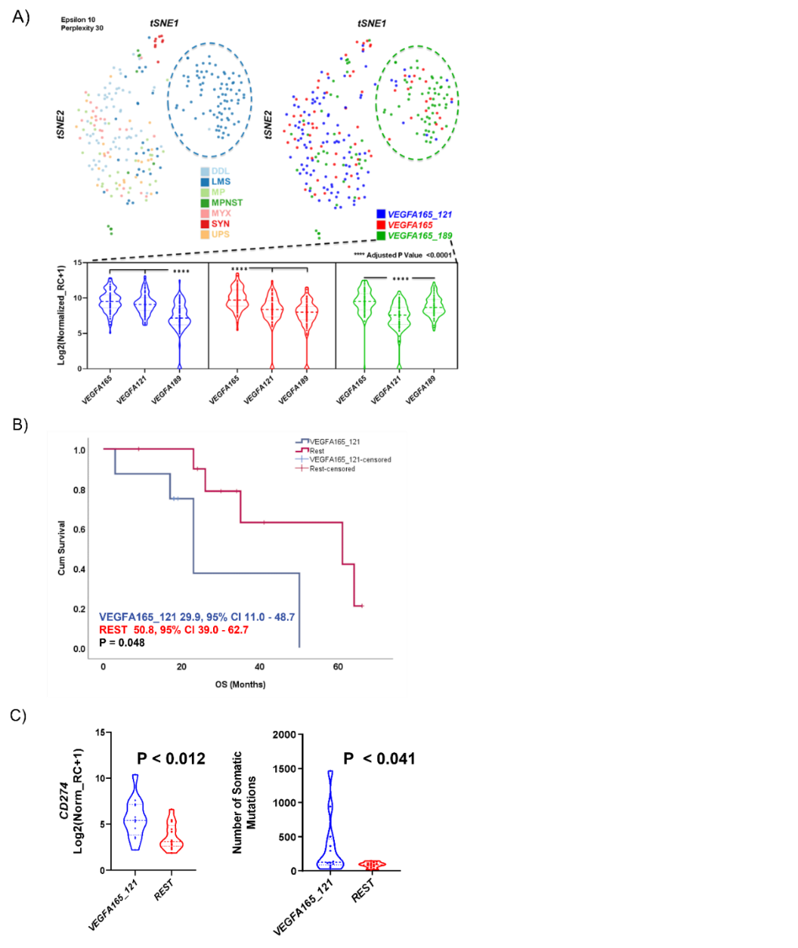
Figure 1.8. Genetic expression pattern of Myxofibrosarcomas in relationship with VEGF-A isoforms

A) tSNE plot demonstrating the different distribution patterns of mRNA expression for three VEGF-A isoforms among subtypes of STS. Most subtypes exhibit a predominant expression pattern of VEGFA165_121 (blue dots) except for Leiomyosarcoma (LMS), where VEGFA165_189 is the primary expression pattern. B) Kaplan Meier plot. MFS expressing higher levels of VEGFA165_121 showed significantly reduced overall survival (OS) compared to the rest of the MFS. C) Gene set enrichment plot showing MFS patients with high levels of VEGFA165_121 had significantly higher expression levels of PD-L1 (CD274) and significantly higher tumour mutational burden than the rest of MFS.
1.7 Hypothesis and aims
1.7.1 Hypothesis
Sarcomas with high ratios of VEGFA-120: VEGFA-165 expression may respond better to anti-VEGFA and anti-PD-L1treatment.
1.7.2 Aims
The aims of this project are:
- To create a syngeneic mouse model of STS using T241 fibrosarcoma cells in C57B16J mice.
- To characterise the tumour microenvironment of murine T241 fibrosarcoma cells tumours including leukocytes populations, SAFs and the vasculature.
- To create T241 cells expressing increased levels of VEGFA-120 and VEGFA-188 isoform.
- To compare the characteristics of the tumour microenvironment among T241, T241-VEGFA120, T241-VEGFA188 tumours especially with regards to the vasculature and immune microenvironment.

CHAPTER II

Material and Methods
A list of all kits used to perform the experiments are detailed in Table 2.1.

Table 2. 1 Details of kits used for this project.
Name of Kit | Company | Catalogue Number
Adeno-X™ Rapid Titre Kit | Takara | 632250
GenEluteTM Mammalian Genomic DNA Miniprep Kit | Sigma-Aldrich | G1N70
GenEluteTM Total RNA Purification Kit | Sigma-Aldrich | RTN70
High-Capacity cDNA Reverse Transcription Kit | Invitrogen | 4374966
In fusion HD Cloning | Takara | 639650
Monarch® DNA Gel Extraction Kit | New England BioLabs | T1020S
Mouse/Rat PDGF-BB DuoSet ELISA | R&D systems | DY8464-05
Mouse VEGFA DuoSet ELISA | R&D systems | DY493-05
MTT Vybrant® Cell Proliferation Assay | Thermo Fisher Scientific | V-13154
Pierce™ BCA Protein Assay | Thermo Fisher Scientific | 23227
QIAprep® HiSpeed® Plasmid Maxi Kit | Qiagen | 12643
QIAprep® Spin Miniprep Kit | Qiagen | 27104

2.1 Mammalian Tissue Culture
2.1.1 Cell lines and maintenance
The cell lines used for this project were a murine T241 fibrosarcoma cell line with the expression of green fluorescent protein (eGFP) and a murine T241 fibrosarcoma cell line
derived from these overexpressing protein Platelet-derived growth factor subunit B (PDGF-BB). These were obtained from Prof Yihai Cao from Karolinska Institutet (Hosaka et al., 2016). All cell lines were maintained in Dulbecco's Modified Eagle’s Medium (D6429, Sigma) supplemented with 1% w/v of Penicillin, (100 units) /Streptomycin (100 μg/ml) (P4333, Sigma), 2 mM of L-Glutamine (G7513, Sigma) and 10% v/v Heat Inactivated Foetal Bovine Serum (FBS) (F9665, Sigma). This medium is referred as ‘working medium’. Cells were incubated in a humidified incubator at 37°C and 5% CO². Dulbecco's medium was stored at 4ºC and pre-warmed before use. The medium was replaced with a fresh medium every two days.
Cell lines were confirmed negative for mycoplasma by the department’s mycoplasma testing service before use.
2.1.2 Cell thawing
To thaw new cells, cryovials containing the selected cells were placed in a water bath at 37°C, and samples were transferred to a centrifuge tube with pre-warmed cell cultured medium. The cells were centrifuged at 400 xG for 5 min. After this, the supernatant was discarded, the cell pellet was resuspended in a fresh medium before transferring into a T25 flask containing 5 ml of pre-warmed cell culture medium.
2.1.3 Cell passaging
Once the cell’s confluency reached 80-90%, the medium was discarded from the flask, cells were washed with 10 mL of phosphate-buffered saline (PBS) (14190-144, Gibco). 2 mL of trypsin-ethylenediaminetetraacetic (EDTA) (T3924, Sigma) was added to detach the cells from the flask’s surface. The flask was incubated in a humidified incubator for 1-2 minutes until all cells were detached. Then, 2 mL of pre-warmed working medium was added to neutralise the trypsin. The harvested cells were collected in a 15 ml tube and then centrifuged at 400 xG for 5 min. The supernatant was discarded, and the cell pellet was resuspended in 1 mL of fresh cell culture medium to be splited into new sterile flasks.
2.1.4 Cell counting and viability measurement.
To measure cell number and viability, 10 μL of resuspended cells were gently mixed with 10 μL of Trypan Blue (1450021, BioRad). 10 μL of this mix was loaded into a counting slide (1450011, BioRad) and inserted into the TC20™ BioRad automated cell counter (Bio-Rad). Cell count and viability were recorded for each cell line.
2.1.5 Cell freezing
Cells were trypsinised using trypsin/EDTA (0.5 g/l trypsin and 0.2 g/l EDTA) as mentioned above and resuspended in freezing medium containing 90% v/v FBS and 10% v/v DMSO. 1 x 10⁶ cells were aliquoted into cryovials. Each cryovial was labelled with the type of cell, passage number, owner, and date. The cryovials were stored at -80ºC for short term storage and in nitrogen for long term storage.
2.2 Development of the transposase vector for the generation of T241-GFP-VEGFA-120 stably expressing cell lines
To create the transposase vector pCLIIP-HRE(x5) minCMV-VEGFA-120, as a way to enable the regulation of the VEGFA120 expression under hypoxic conditions via the HIF response element, we used the pCLIIP-LS plasmid (pCyl150, Linker, Insulator, Insulator, Puro, Luciferase2, mStrawberry) made by Scot K Lyons (Cold Spring Harbour, US as described in English et al., 2017) containing the HRE(x5)-minCMV-VEGFA-120 expression cassette (synthesised by Genewiz), consisting of five HRE from the VEGFA promotor coupled to the minimum CMV promoter (minCMV) to drive expression of VEGFA120.
To generate the vector pCLIIP-HRE(x5) minCMV-VEGFA-120, the following methods were used:

2.2.1 Transformation of competent cells and antibiotic selection
30 μL of DH5alpha E. coli were mixed with 0.5 μL of the HRE(x5) minCMV-VEGFA-120 from Genewiz in a 1.5 ml centrifuge tube per transformation. The tubes were incubated on ice for 30 minutes and then put into a heat block at 42ºC for 20 seconds (heat shock) and moved onto the ice again for 2 minutes. After this, 970 μL of pre-warmed SOC medium (15544-034, Invitrogen) was added to each tube, and these were incubated at 37ºC for 1 hour at 225 rpm. Finally, 100 μL of the resulting transformation was spread onto agar plates with 100 μg/ml of ampicillin and incubated at 37ºC overnight.
2.2.2 Plasmid Purification
Single bacteria colonies were taken and cultivated in 5 mL of LB-Lennox Agar containing 50 μg/ml of Ampicillin for 12 hours. Plasmid purification was performed using a Qiagen Spin Miniprep Kit following the manufacturer’s instructions.
2.2.3 DNA Restriction Digestion
To perform a double digestion with restriction enzymes to enable cloning of the expression cassette into the pCLIIP-LS vector, 2 μg of HRE(x5) minCMV-VEGFA120 insert, and pCLIIP-LS vector were digested with 2 units of FseI (NEB), 2 units of MIUI-HF (NEB), 80 μL of distilled water and 1x of CutSMART Buffer (NEB). This mixture was incubated for 15 minutes at 37ºC.

2.2.4 Agarose gel electrophoresis
Complete digestion was confirmed by agarose gel electrophoresis. A 1% w/v agarose was prepared with 1% v/v Tris/Borate/EDTA running buffer (B9-0020, Geneflow) and SYBR Safe DNA gel stain. A DNA ladder was used as a molecular size reference. All samples were mixed with a 6x loading gel buffer and nuclear-free water. The gel electrophoresis was run at 100 volts for 50 min.
2.2.5 DNA gel extraction
The digested DNA for the expression cassette and pCLIIP vector was excised from the agarose gel and the Monarch DNA Gel extraction kit was used to purify the DNA following the manufacturer’s instructions.
2.2.6 DNA Ligation
The HRE(x5) minCMV-VEGFA-120 insert was mixed with the digested pCLIIP vector at a 1:3 ratio, using T4 DNA Ligase (NEB). A sample of 50 ng of the plasmid was added to 23.7 ng of the insert with 2 μL of T4 DNA Ligase Reaction Buffer and 1 unit of T4 DNA Ligase (NEB) that was mixed with nuclear-free water to get a final volume of 20 μL. The ligation solution was incubated at room temperature for 10 minutes and heat-inactivated at 65ºC for 10 minutes.
Transformation into competent E. Coli and plasmid purification was as described previously in section 2.2.1.
2.2.7 DNA sequencing
Sequencing was performed by the Genomics Core Facility at the University of Sheffield using primers listed in the following table (Table 2.2). Sequences were analysed using Finch TV and Snapgene software.

Table 2. 2 Sequencing primers
Primer | Orientation | Sequence 5’ -> 3’
VEGFA-120 | Forward | GTAACGATGAAGCCCTGG  AG
VEGFA-120 | Reverse | CCTTGGCTTGTCACATTTT  TC

2.2.8 Transient transfection of mammalian cells
Transient transfection of the human colorectal cell line (HCT116) was performed to check the functionality of the cloned vector. HCT116 cells (purchased from ECACC, 90091005, Merck) were seeded in a 6-well plate at 3x10⁵ cells per well using Dulbecco's Modified Eagle’s Medium (D6429, Sigma) supplemented with 1% w/v of Penicillin, (100 units)/Streptomycin (100 μg/ml) (P4333, Sigma), 2 mM of L-Glutamine (G7513, Sigma) and 10% v/v Heat Inactivated Foetal Bovine Serum (FBS) (F9665, Sigma). A transfection solution was prepared with 1 μg of plasmid DNA, 3 μL of X-tremeGENE DNA transfection reagent (06366244001, Roche) and 100 μL of DMEM per well and incubated for 20 min at room temperature before the solution was added to each well. Transfected cells were incubated for 48 hours, and the medium was collected to measure the expression of mouse VEGFA using an ELISA kit by R&D systems following manufacturer’s instructions. This R&D Systems Duo Plus mouse VEGFA ELISA shows similar selectivity for VEGFA120 and VEGFA164 (isoform supplied as the ELISA standard) but approximately 10-fold less sensitivity for VEGFA188 (WR English, personal communication).

2.3 Transfection of T241-GFP cells to generate cell lines stably overexpressing VEGFA120
The murine T241-GFP fibrosarcoma cell line stably expressing increased VEGFA120 was made using a piggyBac transposon-based system (described above, section 2.2). Cells were seeded at a density of 1.6 x 10⁴ cells/well overnight in a 6-well plate with ‘working medium’. The day after, the medium was replaced with 100 μL of DMEM, 1 μg of pmPB (kindly provided by Allan Bradley, Sanger Institute, UK), 1 μg of pCLIIP-HRE(x5)-VEGFA-120 and 3 μL X-tremeGENE® HP DNA Transfection Reagent (06366244001, Roche) per well. Once the cell density was 90%, transfected cells were expanded into T25 flasks (156367, Nunc Thermo Fisher) with working medium supplemented with 1.5 μL/ml of puromycin for selection.
Transfected cells selected by puromycin resistance were seeded in a 6-well plate at a confluence of 3x10⁴ cells (140675, Nunclon Thermo Scientific). After 48 hours, medium was collected for analysis using a Mouse VEGFA ELISA kit (Table 2.1) to confirm the overexpression of VEGFA from the new stable cell line.
2.3.1 Transfection with pCLIIP-CMV plasmids to overexpress VEGFA120 and VEGFA188
To generate T241-GFP cell lines overexpressing VEGFA120 or VEGFA188 under the control of a strong promoter, pCLIIP-CMV plasmids were made using an In-fusion HD Cloning Kit (Table 2.1) by a member of our lab group (PhD student Yu-Chin Lee). Once ready, 3 x10⁴ T241-GFP cells were seeded in a 6-well plate and incubated for 48 hours at 37ºC. The transfection with the pCLIIP-CMV plasmids was conducted when cells were at a confluence of 70% using the TransIT-X2 Reagent. Warm TransIT-X2 was mixed with OptiMEM® and 1 μg of piggyBac transposon-based and 1 μg of either Pcliip-CMV-VEGFA120 or VEGFA188. The protocol was performed following the transfection protocol for plasmid DNA from TransIT-X2® Dynamic Delivery System (MIR 6004, Mirus). Once the cell density was 90%, transfected cells were expanded into T25 flasks (156367, Nunc Thermo Fisher) with working medium supplemented with 1.5 μL/ml of puromycin.
Transfected cells were seeded in a 6-well plate at a confluence of 3 x 10⁴ cells (140675, Nunclon Thermo Scientific). After 48 hours, medium was collected for analysis using a Mouse VEGFA ELISA kit (Table 2.1) to confirm the overexpression of VEGFA from the new cell line.
2.3.2 Isolation of single-cell clones
The T241-GFP transfected cell line was passaged and counted as described in section 2.1.3 and 2.1.4. A cell suspension of 2 x 10⁴ cells/ml was prepared. A 96-well plate was filled with 100 μL of medium except for well A1, which was filled with 200 μL of the cell suspension. Then, 100 μL of A1 was transferred to well B1, and then 100 μL from B1 to C1, using 1:2 dilutions to the entire column discarding 100 μL from well H1 (First dilution series). Next, a serial dilution 1:2 across the columns was used (second serial dilution).
The 96-well plate (3595, Costar) was incubated for 14 days. All wells with a single colony were identified with a 10x microscope. Once these had proliferated, the wells were trypsinised and transferred into 24 well-plates (3524, Costar) to continue growing. These cells were seeded at a confluence of 3x10⁴ cells per well into a 6- well plate (140675, Nunclon Thermo Scientific). After 48 hours, medium was collected for analysis by a Mouse VEGFA ELISA kit to confirm the overexpression of VEGFA.

2.3.3 Quantification of PDGF-BB levels by ELISA
The transfected cells were seeded in a 6-well plate with ‘working medium’ at 3x10⁵ cells and incubated for 48 hours. The working medium used was collected and frozen for further study. The samples medium was used to check the expression of PDGF-BB using a mouse/rat PDGF-BB ELISA kit , following the manufacturer’s protocol.
2.4 MTT assay as a proxy for cell proliferation
To check the viability of the cells, an MTT assay was performed using the MTT Vybrant Cell Proliferation Assay (V13154, Thermo Fisher). Using a 96-well plate, fibrosarcoma cells were seeded at 5 x10³ cells per well and incubated for 24 hours. The cell culture medium was removed and one hundred μL of fresh medium supplemented with 10 μL of 12 mM MTT was added to each well. The plate was incubated at 37ºC for 4 hours. After incubation, the cell culture medium was carefully removed from the wells and 100 μL of dimethyl sulfoxide (DMSO) was mixed by pipetting to function as a solubilizing agent. The plate was incubated at 37ºC for 10 minutes and read with a plate reader at 540 nm of absorbance.

2.5 Single-cell live imaging
Selected clones and wild type cell lines were seeded at a density of 2.5 x 10⁴ cells/well in a 12-well plate previously coated with 1 ml of 5 μg/ml fibronectin diluted in PBS (FC010, Millipore) or without any coating in 1 ml of working medium. The next day, images of the cells were acquired using a Leica AF-6000 Time Lapse and 20x objective. Time interval between images was 15 minutes. Three randomly selected positions were taken for each well. The total duration of the imaging was 5 hours. During the entire process, cells were maintained inside a 37ºC, 5% CO₂ controlled chamber. The Manual Tracking tool from ImageJ software v1.53f51 was used to track the cell migration. Thirty cells per cell line were tracked and distance and speed were calculated using the Ibidi Chemotaxis tool in ImageJ.
2.6 Treatment of cells with inhibitors of VEGFA signalling
To treat cells to inhibit VEGFA signalling, selected cell lines were cultured in T75 flasks. 20 μg/ml anti-VEGFA antibody (B20-4.1.1, Genentech Inc) (Liang et al., 2006) or 20 μg/ml of control IgG (BE5, Genentech Inc) was added to the cell culture medium when the confluency of the cells was about 70% and incubated for 24 hours at 37ºC, 5% CO₂. Cells were treated with 1μM and 5 μM of the VEGFR targeting TKI inhibitor Pazopanib (S3012, Selleckchem) (Lee et al., 2019) or 5 μM DMSO (as control) when 70% confluency was reached and incubated for 6 hours at 37ºC, 5% CO₂.
After the proper incubation time, cells were ready for protein extraction for immunoblotting.
2.7 Western Blotting
2.7.1 Protein Extraction
Protein Extraction was performed once cells in a T75 flask were 70-80% confluent. Cell lysates were made using 1 ml of cold lysis buffer with inhibitors. This buffer was prepared using 5 ml of Pierce TM RIPA buffer (Thermo Scientific), one tablet of cOmplete™ Mini EDTA-free Protease Inhibitor Cocktail (Roche), 100 µl of Phosphatase Inhibitor Cocktail Set II (Merk Millipore), and 50µl of 0.5 mM Ethylenedinitrilotetraacetic acid (EDTA) (E8008, Sigma).
All flasks were kept on ice during the procedure. The cell culture medium was removed from the flask and cells were washed with cold PBS. Cells were scraped using 1 ml of the lysis buffer previously prepared and a cell scraper, and the mix was transferred to a 1.5 ml pre-chilled tube. The cells were passed through a syringe needle (27 gauge), 3-5 times to lyse the cells and centrifuged at 4°C for 10 min at 10,000 x g. The supernatant was collected and stored at -20ºC for further use.
2.7.2 Protein quantification by Bicinchoninic Acid (BCA) Assay
Protein quantification was determined using the Pierce Bicinchoninic Acid (BCA) Protein Assay kit (Table 2.1). Standards used for this kit were prepared in duplicate according to the manufacturer's instructions using a stock of 2 mg/ml bovine serum albumin (BSA) and making a serial dilution from 100 µg/ml to 3.125 µg/ml in PBS.
The working reagent was made by mixing BCA Reagent A with Reagent B (50:1 part). 150 µl of a cell lysate diluted 1:15 with PBS was added to each well in triplicate. 150 µl of this working reagent was added to the cell lysate. The plate was incubated for 30 min at 37ºC and once cooled, the absorbance was measured using a spectrophotometer at 560 nm. Protein concentrations were estimated by using the BSA standard curve and linear regression analysis. Finally, the calculated concentration was multiplied by the dilution factor to obtain the final concentration.
2.7.3 SDS-PAGE gel electrophoresis
8-12% w/v poly-Acrylamide gel was prepared for detection of proteins of interest based on their molecular weight ranges. First, the resolving buffer mix (ProtoGel 30% acrylamide with bis-acrylamide, National Diagnostics) was prepared following manufacturer’s protocol, casted into the cassette, and let for polymerisation. Later, a stacking buffer mix (Stacking gel buffer (x 4 concentrate, National Diagnostics) was prepared following manufacturer’s instructions and poured into the cassette to fill up the entire mould. Finally, a comb was placed carefully, and the gel was left to rest for 50 minutes to polymerise. The resolving buffer used for each mix was Resolving buffer (x 4 concentrate, National Diagnostics).
A mix of 40 μL of the cell lysates and 10 µl of the 4x Laemmli sample buffer (Bio-Rad) was prepared as the loading product. Each sample contained 0.1 M of DTT. Protein denaturation was performed by heating samples at 95ºC for 5 minutes. Later, 35 µl of the mixture and the Protein Molecular Weight (10-250 kDa) (Bio-Rad) along with the biotinylated marker were loaded to the SDS-PAGE gel. The gel was run with running buffer (Table 2.3) for 1.15 hours at 120 V.

Table 2. 3 Composition of buffers used for western blotting
Buffer | Composition
Transfer buffer | *10% v/v Tris-Glycine Electroblotting buffer (10 x, National Diagnostics)  *10% v/v methanol  * Up to 1 L dH₂0
TBS-T | *5% v/v Tris-buffered saline (TBS) (20x stock, Chem Cruz)  *0.1% w/v Tween-20® (Sigma)  *Up to 1 L with dH₂0
Running buffer | *10% v/v Tris-Glycine SDS PAGE Buffer  *90% v/v dH₂0

2.7.4 Protein Transfer to nitrocellulose membrane
Once the gel electrophoresis was finished, a nitrocellulose membrane was cut in the size of the gel and soaked in transfer buffer (Table 2.3) along with two thick blotting papers (Bio-Rad). A sequence of assembly layers was performed in this order: electrode plate, thick blotting paper, nitrocellulose membrane, gel, thick blotting paper, and an electrode plate. This sandwich materials were put in a transfer chamber using a semi-dry system (BioRad) and ran at 15 V for 1 hour.
2.7.5 Antibody incubations
After the transfer, the nitrocellulose membrane was washed 3 times with TBS-T buffer (Table 2.3) for 15 minutes per wash. Using 5% w/v of milk (Non-fat dried powdered milk) with a TBS-T buffer, the membrane was blocked at room temperature for 30 minutes. Later, the blocking agent was removed, and the primary antibody was added to the membrane using the appropriate working dilution (Table 2.4) with 5% w/v of fat-free dried milk/BSA and TBS-T. The membrane was incubated overnight at 4ºC on a shaker.
The next day, the membrane was washed 3 times with TBS-T buffer and incubated with the secondary HRP-antibody in the specific working dilution (Table 2.4) with 3% w/v milk in TBS-T for 1 hour at room temperature. Finally, the membrane was rinsed three times with TBS-T for 15 minutes for each wash.

Table 2. 4 Antibodies used for Western Blotting
Primary Antibody (Catalogue no, Company) | Host Specie | Working Dilution | Molecular Weight
Collagen I (ab765P, Abcam) | Rabbit | 1:500 | 70-90
Fibronectin (ab2413, Abcam) | Rabbit | 1:1000 | 262
Laminin (ab11575, Abcam) | Rabbit | 1:1000 | 200
A-sma (ab5694/ Abcam) | Rabbit | 1:10000 | ~42kDa
N-cadherin (ab18203, Abcam) | Rabbit | 1:1000 | ~100kDa
Sm22a (14106, Abcam) | Rabbit | 1:1000 | ~23kDa
SOX2 (ab97959, Abcam) | Rabbit | 1:1000 | ~34kDa
Vimentin (ab8978, Abcam) | Rabbit | 1:1000 | 57
Neuropilin-1 (3725, Cell Signalling) | Rabbit | 1:1000 | 130-140
AKT (9272S/ Cell Signalling) | Rabbit | 1:1000 | 60
p-AKT (9271S/Cell Signalling) | Rabbit | 1:1000 | 60
SRC (2109S/ Cell Signalling) | Rabbit | 1:1000 | 60
p-SRC (2101S/ Cell Signalling | Rabbit | 1:1000 | 60
MAPK (9102S/ Cell Signalling) | Rabbit | 1:1000 | 42, 44
p-MAPK (9101S/ Cell Signalling) | Rabbit | 1:1000 | 42, 44
VEGFR1 (32152, Abcam) | Rabbit | 1:1000 | 151
VEGFR2 (2479S/Cell Signalling) | Rabbit | 1:1000 | 170
GAPDH (ab8245, Abcam) | Mouse | 1:10,000 | ~36kDa
Secondary Antibody | Host Specie | Working Dilution | Molecular Weight
Anti-mouse HRP (715035150, Jackson Immunoresearch) | Donkey | 1:10,000 | -
Anti-rabbit HRP (715035152, Jackson Immunoresearch) | Donkey | 1:10,000 | -

2.7.6 Western Blot protein detection
For protein detection, the Enhanced chemiluminescence (ECL) method was used with the ECL™ Western blotting detection kit (RPN2106, GE Healthcare). A sample of 0.5 ml of Reagent A (luminol solution) and 0.5 ml of Reagent B (peroxide solution) were mixed and incubated with the membrane for 1 minute, protected from the light. Protein detection was performed using the ChemiDoc™ MP Imaging System by Bio-Rad.
2.7.7 Stripping and reprobing membranes
The membrane was to be reprobed another antibody e.g., the housekeeping gene GAPDH, the following methods was used. The membrane was rinsed in TBS-T briefly and then incubated with 10 ml of Restore™ Plus Western Blot Stripping Buffer (46430, Thermo Scientific) for 15 minutes to remove the previously bound antibodies. The membrane was washed with TBS-T for 15 minutes three times and blocked with 5% w/v dried milk in TBS-T for 1 hour. The blocking solution was removed, and the new primary antibody was added to the membrane using the working dilution (as mentioned in the table above) in TBS-T with 5% w/v dried milk and incubated for 1 hour. The membrane was washed three times with TBS-T for 15 minutes and incubated with the HRP-secondary antibody diluted in TBS-T with 3% w/v dried milk on a shaker for 1 hour. Once incubated for 1 hour, the membrane was washed three times with TBS-T for 15 minutes and protein detection was performed as mentioned in Section 2.7.6.
2.8 Immunohistochemistry (IHC) of tumour sections
Frozen tumour sections were cut into 10 μm sections using a cryostat. Tumour sections were kept at -80°C for further use.
2.8.1 Haematoxylin and Eosin staining
Sections were air-dried for 1 hour and fixed in methanol/acetone (1:1) at RT for 20 minutes. All sections were washed with PBS twice per 3 minutes each time. To stain the slides, the sections were submerged in Gill's Haematoxylin for 20 seconds and washed using tap water for 5 minutes. After this, sections were submerged in 70% and 90% alcohol for 3 minutes for each concentration. Eosin staining was performed by submerging the slides in eosin in 95% alcohol for 40 seconds and submerged in 100% alcohol for 1 minute. Finally, the slides were mounted and let dry at room temperature overnight. Next day, images were scanned following the section 2.8.4.
2.8.2 Immunofluorescence staining of tumours and analysis.
Frozen sections were air-dried for 5 minutes, fixed in ice-cold methanol/acetone (1:1 ratio) at -20°C for 20 minutes and rehydrated with PBS for 5 minutes. Tissue slides were blocked with 1% v/v BSA or 10% v/v goat serum in PBS for 2 hours at room temperature according to the antibodies manufacturer guides. Following this, sections were blocked using a blocking serum (10% Rabbit serum (2D0627A, Vector Labs) with 1% v/v BSA in PBS) for 1 hour at room temperature. Then, the slides were incubated with the primary antibody (Table 2.5) overnight at 4°C. Negative controls were incubated with only BSA in PBS.
The next day, slides were washed in PBS-T 3 times for 15 minutes and incubated with the appropriate secondary antibody (1:500) for 1 hour at room temperature. After this, three washes were performed with PBS-T and the tissue was mounted with a drop of ProLong Diamond Antifade with DAPI. Finally, the slides were kept in the dark at RT for 24 hours to dry.
Images were taken using the EVOS cell imaging system (AMEX1000-ThermoFisher Scientific) at 20x magnification from five random fields per tumour. For image analysis, positive cells were counted using the ImageJ v1.53f51 counting cell tool and comparing the mean taken from the five fields.
Perivascular cell coverage was analysed by co-staining CD31⁺ vessels and αSMA⁺ perivascular cells. αSMA⁺ cells were counted as pericyte positive if they were elongated and in contact with the CD31+ vessel. Mean vascular density (MVD) was calculated by counting CD31+ vessels in viable tumour regions at 10x magnification. Both counting methods are described in English et al., 2017.

Antibody (Catalogue no, Company) | Host Specie | Working Dilution
Collagen I (ab765P, Abcam) | Rabbit | 1:200
Fibronectin (ab2413, Abcam) | Rabbit | 1:100
Laminin (ab11575, Abcam) | Rabbit | 1:100
Anti CD31 (557355, BioPharmigen) | Rat | 1:500
αSMA (ab5694, Abcam) | Rabbit | 1:200
Alexa Fluor 647 Anti-mouse CD4 (100426, BioLegends) | Rat | 1:100
Alexa Fluor 647 Anti-mouse CD8a (100724, BioLegends) | Rat | 1:200
Anti F4/80 (ab6640, Abcam) | Rat | 1:100
Anti PD-L1 (ab238697, Abcam) | Mouse | 1:100
FOXP3 antibody (PA1-46126, Invitrogen) | Rabbit | 1:500
Alexa Fluor 555 anti-mouse (A21424, Invitrogen) | Goat | 1:500
Alexa Fluor 555 anti-rat (A21435, Invitrogen) | Goat | 1:500
Alexa Fluor 488 anti-rabbit (A11034, Invitrogen) | Goat | 1:500

Table 2. 5 Antibodies for Immunofluorescence staining

2.8.3 Immunocytochemistry (ICC)
For ICC, the wells of an 8-well Ibidi chamber were coated with 300 μl of 20 μg/ml Collagen-I or 5 μg/ml laminin-1 in PBS at RT for 2 hours. Wells coated with 1 ml of 5 μg/ml fibronectin were incubated for 2 hours at 37°C. After the incubation time, wells were washed with 1 ml of PBS twice and then rinsed with 1 ml of the ‘working medium’ in Section 2.1.1. A number of 2.5 x 10⁴ cells in 300 μL of working medium were added to each well and incubated overnight.
The cell culture medium was removed, and cells were washed twice with 500 μL of HBSS for 3 minutes. Using 4% w/v paraformaldehyde cells were fixed for 20 minutes at RT. After this, cells were washed twice with HBSS for 5 minutes and incubated with 0.1% v/v Triton-X in 1% BSA w/v for 5 minutes. Cells were blocked with 1% BSA in PBS w/v for 20 minutes and incubated with Alexa Fluor 633 Phalloidin (1:400 A22284, Invitrogen) in 1% w/v BSA in PBS for 30 minutes. The cells were washed with PBS for 5 minutes three times. Finally, 100 μL of ProLong Diamond Antifade with DAPI was added to each well and let dry at RT, covered from light.
Images were taken using the EVOS cell imaging system (AMEX1000-ThermoFisher Scientific) at 40x magnification.

2.8.4 Scanning sections
Images were scanned using a slide scanner machine (3DHistech, Pannoramic) at 20x objective. Image analysis and cell percentage were calculated using the Cell detection tool by QuPath software v0.2.3
2.9 Use of recombinant adenoviruses to detect fibroblasts.
Detection of functioning Cre recombinase system was done using recombinant adenoviruses kindly provided by Prof George Bou-Gharios (University of Liverpool). Recombinant adenoviruses used were Collagen1α2-Cre-adenovirus (C1-adenovirus), CAG-Cre (CAG-adenovirus) and CAG-LoxStopLox-eGFP adenovirus (eGFP-adenovirus). C1-adenovirus had a tissue-specific enhancer Col1a2 which expressed Cre recombinase, CAG-adenovirus contains CAG expression unit, which was used to express Cre recombinase and finally, eGFP-adenovirus expresses eGFP once the LSL is removed by Cre recombinase (Inagaki et al., 2005) (Figure 2.1). The tritre of the adenoviruses was done using the Adeno-X™ Rapid Titer kit (Table 2.1) by a member of our lab (PhD student Sarah MacFarlane). A number of 2 x 10⁵ cells were cultured in 6-well plates in 1 ml of cell culture medium with 100, 200 or 300 infectious units per cell of two different combinations of adenovirus and incubated at 37°C, 5% CO₂ for 48 hours. The combinations used for infecting cells were C1-adenovirus + eGFP-adenovirus and CAG-adenovirus + eGFP-adenovirus (positive control). PBS was used as a negative control.
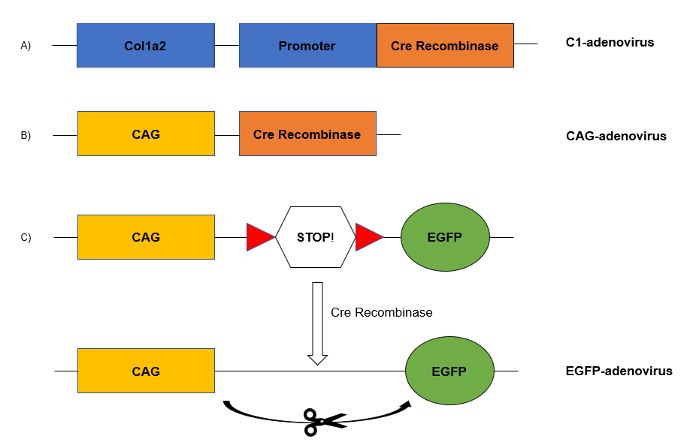
Figure 2. 1. Scheme of recombinant adenoviruses

Representative figure of adenoviruses cassette used. A) C1- adenovirus: Col1 α2 tissue specific enhancer which express Cre Recombinase B) CAG-adenovirus: CAG portent unit which express Cre Recombinase C) EGF-adenovirus: CAG expression unit contains a lox-stop-lox (LSL) which once activated by the presence of Cre Recombinase expresses Enhances Green Fluorescent Protein (eGFP).

2.10 Flow cytometry
Infected cells were trypsinized, resuspended in complete medium and centrifuge at 400 xG for 5 minutes. Cell pellets were resuspended in buffer (5% v/v FBS in PBS) and centrifuged at 1200 xG for 5 minutes twice. Finally, the cell pellets were resuspended in the FACS buffer and counted. A dilution was made to get 1x10⁶ cells in 500 μL of FACs buffer. Flow cytometry data were analysed using the BD LSR II flow cytometer. Result files were processed using FlowJo® Software. Samples were run in biological duplicates.
2.11 Real-Time PCR
2.11.1 RNA isolation and quantification
RNA isolation from the wild type T241 fibrosarcoma and VEGFA188 expressing clones was performed using the GeneElute Mammalian Total RNA Miniprep kit (Table 2.1). The procedure was adapted from the manufacturer’s instructions.
First, the lysis solution/2-ME mixture was prepared according to the sample size, 5 x 10⁶ cells. Three ml of Lysis Solution (Sigma, L8285) were mixed with 30 μL of 2-mercaptoethanol (Sigma, M3148). Then, 250 μL of the mix was added to each of the flasks for up to 5x10⁶ cells and the cells were pipetted up and down thoroughly until they were fully resuspended. Then, the resuspended cells were moved to the GenElute Filtration Columns (Sigma, C9346) and centrifuged at 10,000 xG for 2 min. The filtration column was discarded and 250 μL of 70% ethanol solution were added to the filtered lysate and pipetted thoroughly to mix. Once mixed, the solution was moved to a GenElute Binding Column (Sigma, C9471) and was centrifuged at 10,000 xG for 15 seconds. After this, the resultant liquid was discarded, the filter was retained and moved to a 2 μL collection tube. The first column wash was performed by pipetting 500 μL of the Wash Solution 1 (Sigma, W3136) into the column and centrifuge at maximum speed for 15 seconds. Again, the binding column was kept and transferred to a new 2 mL centrifuge tube where 500 μL of Wash solution 2 (Sigma, W3261) was added into the filter and centrifuged for 15 seconds at maximum speed. This step was repeated twice but the second time the centrifuge was made for 2 minutes to dry the binding column. Finally, the binding column was moved to a new 2 mL centrifuge tube and 50 μL of Elution Solution (Sigma, E8024) was pipetted and centrifuged for 1 minute at maximum speed.
The concentration of each sample was measured using NANODROP and the samples were stored at -80ºC for further use.

2.11.2 Removal of contaminating DNA
RNA samples were decontaminated from DNA before RNA-PCR amplification using the Invitrogen Deoxyribonuclease I amplification Grade. To make a 10 μL reaction, 1 μg of RNA samples were mixed with 1 μL of 10x DNase I Reaction Buffer, 1 μL of DNase I Amp Grade (1 U/μL) and filled up to 10 μL of DEPC-treated water in an RNase-free microcentrifuge tube. The mixture was incubated at room temperature for 15 minutes and 1 μL of EDTA was added after this incubation to inactivate the DNase. Finally, the samples were heated at 65ºC for 10 minutes.
2.11.3 A standard curve using plasmids with VEGFA isoform for AQRT-PCR
Absolute quantification in RT-PCR is made using a standard calibration curve. Standard curves are made by known DNA concentrations (Pfaffl et al., 2002).
The CMV-VEGFA plasmids containing the cDNAs for VEGFA120, VEGFA164 and VEGFA188 mouse isoforms were designed by a colleague in the group’s laboratory (PhD Brenda Aguero). A linearisation of the plasmids was done using the HindIII digestion enzyme to create a standard curve following a 10-fold serial dilution from 2.5 to 2.5 x 10⁵copies. A standard curve of each VEGFA mouse isoform was included in each AQRT-PCR experiment and quantification of the isoforms for every unknown sample was calculated by linear regression of using Ct versus copy number plots from the cDNA standards for the isoforms (Supplemental Data. Figure X).
2.11.4 Synthesis of cDNA- Reverse Transcription
The synthesis of cDNA from RNA was made by reverse transcription using the High-Capacity cDNA Reverse Transcription kit (Table 2.1). First, a master mix was created using the volumes shown in Table 2.6 from the components included in the kit.

Table 2. 6 Settings for the synthesis of cDNA

Component | Volume per Reaction (μL)
10x RT Buffer | 2
25X dNTP Mix (100 mM) | 0.8
10x RT Random Primers | 2
MultiScribe Reverse Transcriptase | 1
RNase Inhibitor | 1
Nuclease-free water | 3.2
Total per reaction | 10
Ten μL from the master mix were mixed by pipetting up and down with 10 μL of the RNA sample (previously decontaminated from DNA). This mixture was made for all the RNA samples. After this, the mixture was centrifuged to spin down the liquid and all the tubes were loaded into the thermal cycler machine using the following conditions (Table 2.7), to set the reverse transcription reaction. Once finished, all cDNA samples were stored at -20ºC until use.

Table 2. 7 Conditions for the synthesis of cDNA
 | Step 1 | Step 2 | Step 3 | Step 4
Temperature (°C) | 25 | 37 | 85 | 4
Time (minutes) | 10 | 120 | 5

2.11.5 Performing Real-Time PCR Amplification using SYBR Green
RT-PCR was performed to measure the VEGFA isoform levels of VEGFA120, VEGFA188 and VEGFA164 in the murine fibrosarcoma cell lines. The following steps were adapted from Invitrogen FAST SYBR Green Master Mix instructions (4385610, Applied Biosystems). The SYBR green dye detects PCR products by binding to the new copies of DNA formed during the PCR process. Using 10 ng of RNA converted to cDNA or linearised isoform standards, 200 nM of primers (forward and reverse) (Table 2.8) and 5 μL of SYBR Green PCR Master Mix were mixed and put in a 384-well plate.
The PCR reaction was conducted using the QuantStudio 7 Flex machine (ThermoScientific) using the parameters in Table 2.9. Three biological replicates were made for all isoforms.

Table 2. 8 The sequence of primers for mouse VEGFA isoforms
Target | Forward  Primer (5-’3) | Reverse Primer (5-’3) | Amplicon
Mouse VEGFA120 | GCCAGCACATAGGAGAGATGAGC | GGCTTGTCACATTTTTCTGG | 95 bp
Mouse VEGFA164 | GCCAGCACATAGGAGAGATGAGC | CAAGGCTCACAGTGATTTTCTGG | 97 bp
Mouse VEGFA188 | GCCAGCACATAGGAGAGATGAGC | AACAAGGCTCACAGTGAACGCT | 171 bp

Table 2. 9 Parameters used for aqRT-PCR software
Step | Temperature | Time
Enzyme activation | 95ºC | 20 seconds
40 cycles | 95ºC | 1 second
 | 60ºC | 20 seconds
Melting curve

2.12 In vivo experiments
All in vivo experiments were carried out following the United Kingdom Home Office Animals (Scientific Procedures) Act 1986, with local ethical approval, under the Home Office Project License 70/8323 and PDA78C678 (Dr. William English) and personal licence IF9BD58CB (Miss Claudia Madrigal). 5-12 weeks old female and male transgenic mice C57B16/J7 (C1-creERT-tandem dimer Tomato), and 10-12 old female and male C57Bl6J were used for the experiments. Regulation levels were maintained in the room where mice were kept. Temperature 20-13C, humidity 45-55 %, and illumination on a 12-hour cycle. All mice had food and water as free demand through all the experiments.
Transgenic mice C1-creERt (Collagen1α2-creERt) were generously provided by Prof George Bou-Gharios (University of Liverpool, United Kingdom). These mice have a fibroblast-specific transcriptional enhancer in the murine Col1 gene (Bou-Gharios et al., 1996). Mice homozygous for the Cre reporter R26R-tandem dimer Tomato (tdT), were generously provided by Maria Fragiadaki (University of Sheffield, United Kingdom). Both homozygous transgenic mice were crossed to create the C1-creRT-tdT mice and maintained as a colony at The University of Sheffield.
C57BI6J mice were purchased from Charles River UK and left to adapt to new conditions before any experiment.
2.12.1 Genotyping by PCR
Ear clips were used as a method of identification and genotyping of transgenic mice. Ear clips were lysed in 50 μL of DirectPCR-Ear Lysis Reagent (401-E, Viagen Biotech), 0.05% w/v of Proteinase K (P2308, Sigma) and incubated at 55°C overnight. On the following day, they were incubated at 85°C for 45 mins to inactivate the proteinase K.
For the Cre PCR reaction, 15 μL of Taq DNA polymerase (BioMix Red Bio-25006, BioLine), 13.25 μL of distilled water and 0.5 μL of each primer (Table 2.10) were mixed with 0.80 μL of the DNA from the ear clip digest. For the tandem-dimer tomato (tdT) PCR reaction, 15 μL of Taq DNA polymerase (BioMix Red Bio-25006, BioLine), 12.25 μL of distilled water, 0.5 μL of each primer was mixed with 0.80 μL of the DNA from the ear clip digest. After this, a total of 30 μL of the mix was put into a PCR machine (T3-0170, SensoQuest Labcycler). Cycle times, temperatures and settings are shown in table 2.11. The resulting sample was run on a 1% w/v Agarose (AGD00132, Cambridge Reagents) with 10x of SYBR-Safe DNA Gel stain (S33102, Invitrogen) using gel at 100 volts for 50 minutes with a 2-log ladder (N055A, NEB). Finally, the gel was imaged on a UVP UV Transilluminator system (Figure 2.2).

Table 2. 10 Primer sequences for tandem-dimer Tomato and Cre PCR reaction
Gene | Orientation | Sequence 5’ -> 3’
TomWT | Forward | AAG GGA GCT GCA  GTG GAG TA
TomWT | Reverse | CCG AAA ATC TGT GGG  AAG TC
TomMut | Forward | CTG TTC CTG TAC GGC  ATG G
TomMut | Reverse | GGC ATT AAA GCA  GCG TAT CC
Cre 010 | Forward | GCA TTA CCG GTC GAT  GCA ACG AGT GAT  GAG
Cre 011 | Reverse | GAG TGA ACG AAC  CTG GTC GAA ATC AGT  GCG

Table 2. 11 Thermocycler program for PCR detection of Cre and tdT detection for genotyping
PCR Gene | Steps | Cycles
Cre | Denaturation 94ºC for 2 minutes  Annealing 65ºC for 15 minutes *  68ºC for 10 minutes *  Extension 94ºC for 30 minutes *  Final extension 60ºC for 30 minutes  Hold 4ºC | *30
Tandem-dimer Tomato | Denaturation 96ºC for 1 minute  Annealing 65ºC for 1 minute *  Extension 72ºC for 35 s *  Final extension 72ºC for 1 minute *  Hold 4ºC | *30

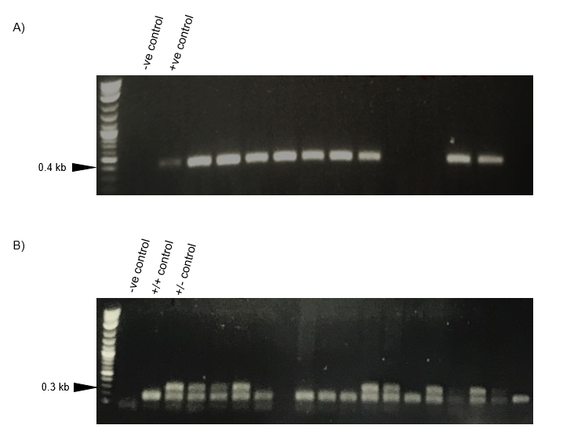
Figure 2. 2. Detection of Cre and tdT genes in mice by Polymerase Chain Reaction (PCR)

PCR products were electrophoresed on a 1% w/v agarose gel and visualised with SYBR Safe DNA. a) Cre positive gene can be observed as a band at ~400 bp in the positive control lane b) Corresponding bands to the wildtype allele is at 297 bp and the mutant allele (tdT) is at ~196 bp. -ve control= negative control, +ve control= positive control, +/+ control= homozygous control, +/- control= heterozygous control, kb= kilobases. dH2O was used as a negative control.

2.12.2 Activation of transgene system with 4-OHT Hydroxytamoxifen
Transgenic mice were used in order to detect collagen1α2 cell-producers as we were interested in fibroblasts The Colα2 transgene (C1) drives expression of CreERt in fibroblasts making collagen-I (Ponticos et al., 2004). The system starts when the recombinase Cre in the transgene, which is fused to a mutated oestrogen receptor domain (ERt), its activated in the presence of tamoxifen. This allowed CreERt to translocate to the nucleus and remove the floxed stop cassette between the CAG promoter and tdT, allowing its expression. This expression will be seen in fibroblasts making collagen (Figure 2.3).
For the activation of the transgene system, 2 tamoxifen administration schemes were used (Inagaki et al., 1998; Ponticos et al., 2004). In regimen 1, 10-weeks old female and male mice, randomly distributed in control and treated groups, received intraperitoneal injections with 4-OHT (4-Hydroxytamoxifen) or vehicle (corn oil) according to the mice weight (50 mg/kg final). Two days later, all groups received a subcutaneous injection with fibrosarcoma cells in the rear dorsum. Mice were injected weekly until they reached the desired tumour volume.
In regimen 2, 5 weeks old female and male transgenic mice received an intraperitoneal injection with 4-OHT (4-Hydroxytamoxifen) or vehicle (corn oil) according to the mice weight (50 mg/kg final) during two consecutive days. After this, at week 10, mice were injected subcutaneously with the murine fibrosarcoma cell line (Figure 2.4).
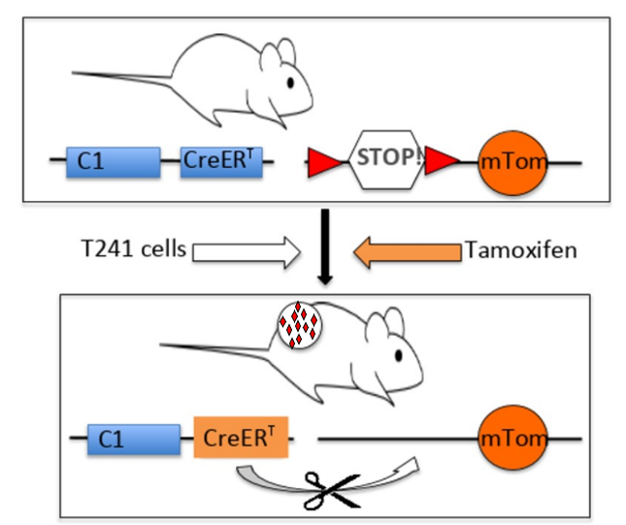
Figure 2. 3. The Col1α2 (C1) transgenic mouse system used to detect SAF

C1-CreERt mice were crossed with R26R – tdT mice. The Col1 α 2 transgene (C1) drives expression of CreERt in fibroblasts making collagen-I. The system starts when the recombinase Cre in the transgene, which is fused to a mutated oestrogen receptor domain (ERt), its activated in the presence of tamoxifen. This allowed CreERt to translocate to the nucleus and remove the floxed stop cassette between the CAG promoter and tdT, allowing its expression. This expression will be seen in fibroblasts making collagen-1.

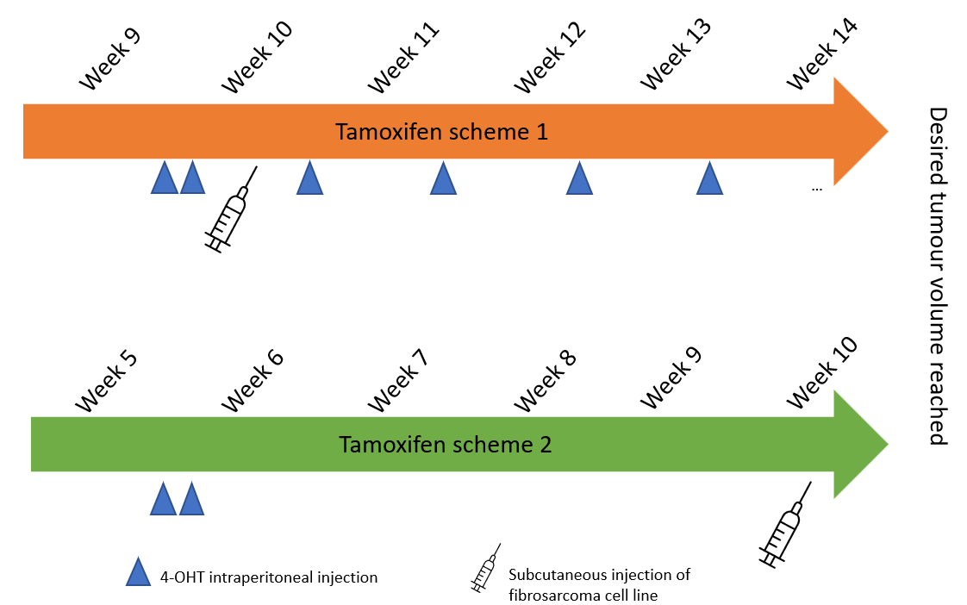
Figure 2. 4. Representation of tamoxifen schemes for activation of transgene Col1a2 system

In vivo experiments were made using transgenic mice. Mice used for scheme 1 received two days of consecutive 4-OHT injections at 9 weeks old, previous subcutaneous fibrosarcoma injections. After this, mice were injected once a week until tumours reached the desire size. Mice used for scheme 2 received two days of consecutive 4-OHT injection at 5 weeks old. Later, mice were injected with the fibrosarcoma cell line at 10 weeks old.

2.12.3 In vivo imaging of transgenic mice
The activation was images using de Ds Red Channel (Exc 558 and Em 583) using an IVIS Ilumina II system (Perkin Elmer). Dorsal pictures from ears, paw, tail, tumour, and skin were taken to be analysed (photons/second/cm²/sr) . Average radiance from the pictures was calculated using the Living Image v4.3.1 Software.
Injections were performed under anaesthesia using 2-3% isoflurane in O₂ and hair clipped from around the injection site to enable monitoring of tumour growth. Tumour growth was measured using an electronic calliper every other day until it reached 800-1000 mm³ volume was measured in mm as V = 0.52 x length x ((width + height)/2)².
2.12.4 Subcutaneous injection of cells
Cell lines were cultivated in T175 flasks and grown to 80% of confluence. Cells were counted and prepared at 2x10⁶ cell density per 50 μL in PBS. 50 μL was injected subcutaneously into the rear dorsum of each C57Bl6/J7 C1-creERt x tdT transgenic mouse. Subcutaneous tumours were measured using an electronic calliper every other day until they reached a tumour volume of 800-1000 mm³. Mice were killed by cervical dislocation and death was confirmed by exsanguination.
2.12.5 Radiotherapy treatment for transgenic mice
After subcutaneous injections of T241-GFP-PDGF-BB cells, mice were treated with fractionated external beam radiotherapy. Like previous protocols, the tamoxifen scheme 1 was used for activation and maintenance of the transgene system (See Figure 2.2). Matched numbers of mice were divided into two groups to receive different external beam radiotherapy treatments. Group 1 received a total dose of 6 Gy fractionated in 2 Gy on consecutive days. Group 2, received a total dose of 4 Gy, fractionated in 2 Gy on consecutive days. Mice were treated when tumour volume reached 100mm³ (Figure 2.5).

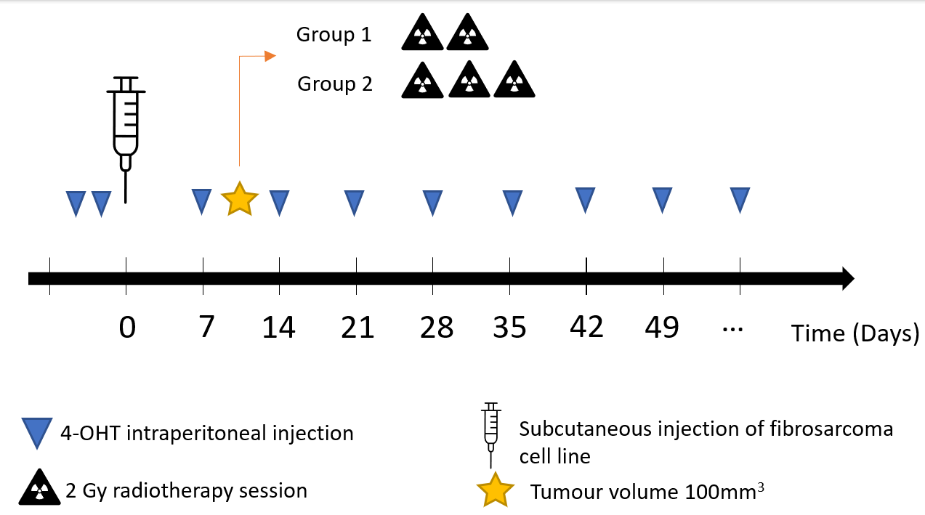
Figure 2. 5 Treatment with radiotherapy to increase transgene activation.

Mice injected with T241-PDGF-BB cells were treated with two radiotherapy schemes. One group were irradiated three times with 2Gy in consecutive days to a final dose of 6Gy. The second group were irradiated twice with 2Gy to a final dose of 4 Gy.

2.13 In silico analysis
RNAseq data from VORTEX Biobank and The Cancer Genome Atlas Sarcoma (TCGA-SARC were used for in silico analysis. TCGA-SARC RNAseq data was previously analysed and shared by a member of our lab (Dr Manoj, Valluru). RSEM (v1.2.28) was used to count the number of reads mapping to each transcript and gene. MultiQC (v1.7) was used to create quality control metrics.
VORTEX-Biobank is a collection of human samples linked to the Randomised Trial of Volume of Post-operative Radiotherapy Given to Adult Patients With eXtremity Soft Tissue Sarcoma (VorteX) trial. Samples were collected at diagnosis after patient’s consent for RNA sequencing by Prof Catherine West (University of Manchester) and her team. Data analysed came from VORTEX-Biobank with permission of North West - Greater Manchester East Research Ethics Committee (approved on 27 July, 2021) (See Supplemental Data). RNA sequencing (RNA-seq) analysis and FASTQ files were downloaded through a secured server to SHARC. Reads were aligned to the GENCODE GRCh38 human reference genome using the STAR (v2.6.1b) software package. After alignment, RSEM (v1.2.28) was used to count the number of reads mapping to each transcript and gene. MultiQC (v1.7) was used to create quality control metrics.
2.13.1 Differentially expressed gene analysis (DEG)
Once, poor quality samples were filter, the edgeR-limma package in RStudio software version 1.4.1106 was used to find differentially expressed genes (DEGs) among the samples. Using Gene E Morpheus web tool Z-score normalised counts of the three main VEGFA isoforms (VEGFA165, VEGFA121 and VEGFA189) expression were used to create groups and obtain the Hierarchical plots showed. RNAseq RSEM genes raw counts were used to detect differentially expressed genes in each group. A 1 CPM threshold was set to filter the low expressed read counts. For raw count normalisation, the default TMM (Trimmed Mean of M-values) method from the edgeR package was used.
Before the DEG analysis, a multi-dimensional scaling (MDS plot) was done using the function ‘plotMDS’ from the limma package. This plot displays similarities and differences between the data in an unsupervised manner. Samples who shared the same conditions, ought to ideally cluster closely.
Afterwards, the limma package functions were employed for fitting the data from each gene to a linear model. Contrasts for pairwise comparisons between the groups (obtained by the Hierarchichal plots) were performed and the DEGs list was generated using the empirical Bayes technique. The Bayes approach improve the statistical power of DEGs by aiding the estimation of gene specific (Chen, Lun and Smyth, 2016). The cut-off used for the DEG identification was a False Discovery Rate (FDR) q value <0.05.
Lastly, a volcano plot was done to show the adjusted p-value versus the log fold-change using the previously DEGs list data. This was done using the command ‘volcanoplot’ from the limma package.
2.13.2 Gene set enrichment analysis (GSEA)
GSEA software v4.1.0 was used to perform the gene set enrichment analysis using the DEGs list made in R software. The default options were used for pre-ranked analysis. The ranked list of genes was made by scoring the p-value and the fold change direction of each gene (rank = sign (FC)*-log10 (p-value)). Significant values were genes with an FDR q value <0.05. The gene sets used for this analysis were the Hallmark gene set (Liberzon et al., 2015), Reactome gene set (Garapati 2009), Cancer Immunome Atlas (Charoentong et al., 2016), Bindea gene set (Bindea et al., 2013) and Şenbabaoğlu Y et al., (2016) gene set.
2.13.3 Immune cell population analysis
The xCell method (Aran et al., 2017) was used to investigate the immune population subgroups. This method is a gene signature-based methodology that permits the identification of 64 immune cell types. CPM values used for the GSEA analysis were uploaded to the xCell software. The xCell score for distinct immune subsets was calculated and compared between groups with distinct levels of VEGFA isoforms. A Kruskal-Wallis test was used to perform statistical analysis. P values <0.05 were considered statistically significant.
2.14 Statistical Analysis
Data were plotted and analysed using GraphPad Prism 9 (GraphPad Prism Software Inc). Statistical differences between the two groups were assessed using an unpaired Student t-test or Mann-Whitney for parametric and non-parametric data respectively. Significance between data was analysed using a one-way ANOVA test for parametric data and the Kruskal-Walli’s test was performed for non-parametric data followed by a Dunn’s multiple comparison test. The significance between timeframes to reach a predetermined humane endpoint as a surrogate for survival was measured using Kaplan–Meier analysis with GraphPad Prism 9 software. Error bars in graphs are mean ± SEM. p< 0.05 (*), p< 0.01 (**), p< 0.001 (***), and p< 0.0001 (****) were used to determine statistical significance.

CHAPTER III
Investigating the suitability of the C1-CreERt transgenic mice for the study of SAFs in fibrosarcoma

3.1 Introduction
Soft Tissue Sarcomas (STS) are a group of heterogeneous mesenchymal-derived tumours. Due to their rarity and atypical clinical presentation their diagnosis is difficult. According to the NCRAS Public Health data in the UK, the five-years survival for STS patient’s is ~55%. Despite current treatments such as surgery, radiotherapy, and chemotherapy, recurrence may occur with resistance to previous treatments (Gamboa, Gronchi and Cardona, 2020). This outlook led us to investigate options for further therapies, especially for this cluster of patients. Novel treatments could include targeting pathways within the Tumour Microenvironment (TME), such as angiogenesis, immune cell infiltration, and the extracellular matrix. But a deeper comprehension of the TME in sarcoma is needed to identify new therapeutic targets. Nonetheless, STS represent a big challenge for research due to the rarity and the heterogeneity of the tumours.
In the TME, activated-fibroblasts, often called ‘cancer-associated-fibroblasts’ (CAFs) have been widely studied in diverse tumours showing their pro-tumorigenic influence. Also, their presence has been linked to poor outcome among carcinomas, in which the overwhelming majority of studies into CAF function have been conducted (Sahai et al., 2020). Regarding sarcomas, there is very limited information known about sarcoma-associated fibroblasts’ (SAFs) in STS and inconsistent findings have been found. Some studies have referred to SAFs as myofibroblasts/CAF-like cells found in desmoplastic areas and have high production of alpha-SMA (Lagacé, Schürch and Seemayer et al.,
1980; Yu et al., 2011). Meanwhile, other authors discovered that SAFs had mesenchymal stem cell (MSCs) characteristics and can also be sarcomas initiating cells. Shared characteristics and signalling pathways between mesenchymal stem cells/myofibroblasts and sarcoma cells due to their mesenchymal origin provide difficulties in these studies (Morozov et al., 2010; Xiao et al., 2013).
This is in contrast with carcinomas where epithelial to mesenchymal cell signalling is seen between two distinct compartments of cancer cells and stroma. This represents a big challenge as there is a lack of specific SAFs markers and results have varied among STS subtypes. These results lead to questions whether SAFs presence and function may change among STS subtypes? or whether the differentiation stage of STS affect SAFs? This emphasises the need for further investigations of SAFs to be made before they could be considered as targets for therapy in STS.
Thus, the development of a model that enables to identify and isolate SAFs would greatly benefit research in this field. Transgenic mouse models have proven to be a useful tool for studying the role and effects of fibroblast within an in vivo setting. However, the existing models that are best characterised and understood are primarily focus in fibrotic disorders. Given the mesenchymal origin and properties of fibroblasts, they are recognised as the main source of collagen synthesis (Nissen, Karsdal and Willumsen, 2019). As a result, using collagen-1 as a reporter for identification of SAFs might has potential in advancing our understanding of this cell population in STS.
By being released by stromal cells such as CAFs, Collagen-1, a glycoprotein composed by two α1 chains and one α2 chain, have a significant role during tumour development (Shi et al., 2022). Regarding Col-1, Prof Bou-Gharios’ research group had demonstrated the utility of the Col1α2 1.5 kb upstream enhancer and the proximal TGF-β/IFNγ response element as a reporter of collagen transcription and deposition exclusively by fibroblasts during embryonic development and the in the adult in physiological and pathological processes like wound healing and liver fibrosis in murine models (Ponticos et al., 2004; Bou-Gharios et al., 1996, Inagaki et al., 2005). The use of the Col1α2 transgene made from these regulatory elements coupled to CreERt expression to activate Cre reporters or for gene ablation on administration of tamoxifen in mice developed by Bou-Gharios’ group and colleagues have shown utility in the study of fibroblasts in several models of connective tissue remodelling and pathology (See Figure 2.3, Chapter 2) (Denton, 2001; Li et al., 2017). Moreover, the use of the enhancer is not limited to transgenic mouse models, but it has been also used in recombinant adenoviruses which shown efficiency in treating hepatic fibrosis in mouse models (Inagaki et al., 2005).
Detection of SAFs will be performed using the T241-GFP cell lines to create fibrosarcoma models in C57Bl6J mice containing the Col1α2 transgene driving a Cre reporter system. The T241-GFP and T241-PDGF-Bβ cell lines used in this thesis were kindly provided by Prof. Yihao Cao (Karolinska Institute). Platelet-derived growth factor (PDGF) has been described as a principal factor related to the transition of mesenchymal cells to CAFs within the tumour stroma. It is thought that pericytes can be recruited to convert into CAFs by a process called ‘pericyte-fibroblast transition’ (PFT). This transition is induced by PDGF-Bβ/PDGR-beta signalling (Schrimpf and Duffield, 2011; Chen et al., 2011) During this transition, pericytes change their phenotype and gain expression of fibroblast markers such as FSP-1. Additionally, PDGF-Bβ has shown to increase stromal cells that could be myofibroblasts (Chen et al., 2011; Hosaka et al., 2016). The relationship between PDGF-Bβ/PDGFR and CAFs might be explained through mechanisms such as cell migration and differentiation into fibroblasts to produce interstitial fibrosis (Chen et al., 2011). This background led us to consider PDGF-Bβ/PDGFR as a potentially effective model of fibrosarcoma to facilitate the characterisation and isolation of CAFs.
Overall, this chapter will show our results using the tissue specific Col1α2 enhancer in transgenic mice and recombinant adenoviruses in the identification of SAFs. Main experiments were done based on the looking of collagen-1 cell producers from the TME; however, in our last experiment, the examination of collagen-1 synthesis by the tumoral cells was shown.
3.2 Results
As mentioned, we chose to employ the T241-GFP (also mentioned as T241-WT) and T241-PDGF-Bβ cell line in our in vivo transgenic models to enhance the PFT process and thus increase the presence of fibroblasts in T241 tumours.
Firstly, an ELISA was used to check the expression levels of PDGF-
Bβ in both T241 cell lines. To do this, tissue culture media from the T241 cell lines culture, was used for the assay. The ELISA revealed that the T241-GFP-PDGF-Bβ (also known as T241 PDGF-Bβ) cell line had significant higher levels of PDGF-Bβ when compared to T241-GFP (WT) cell line (Figure 3.1).

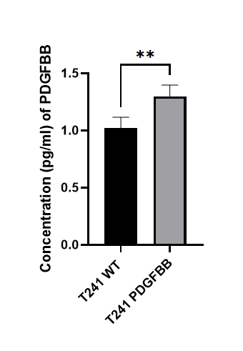

Figure 3. 1. PDGF-Bβ expression levels among T241- WT and T241- PDGF-BB cell lines by ELISA

Quantification of PDGF-Bβ levels in T241-GFP WT (referred as T241 WT) and T241-GFP-PDGF-Bβ cell line (referred as T241-PDGF-Bβ) were measured using an ELISA. The cell culture media of both cell lines was used. Data are expressed as mean± SEM. Two independent biological replicates were used. Paired t-test was used for the statistical test. Data values are mean ± SEM. **p-value <0.001.

3.2.1 Identifying the effect of tamoxifen on T241 fibrosarcoma growth.
The aim of the in vivo experiments presented in this chapter was to create a sarcoma model where the presence of SAFs would be easily identified using a fluorescent protein tandem dimer tomato (tdT) as a marker. This will be possible using a transgenic murine model C1-CreERT-tdT (See Figure 2.3, Chapter 2). To activate the Col1α2 transgene system, two different administration schemes of 4-Hydroxytamoxifen by intraperitoneal injections were conducted. These aimed to take advantage of the different activating patterns of the transgene in mice through postnatal development then adulthood (Ponticos et al., 2004). While the mice are growing (up to approx. 8 weeks), collagen is expressed widely through the body by immature resident fibroblasts/committed mesenchymal stem cells involved in ECM remodelling (Ponticos et al., 2004).
Previous studies by Bou-Gharios, Denton and colleagues showed that activation of the C1-CreERt transgene at 4-5 weeks of age led to activation of reporters or gene ablation that would be maintained through adulthood, essentially for lineage-tracing studies (Ponticos et a., 2004; Li et al., 2017.) The advantage of the C1 transgene is that its activation is significantly reduced in tissues when mice reach adulthood (Ponticos et al., 2004) as connective tissue remodelling is very low with the exception of highly collagenous tissues like the ears, tails and paws.
Tamoxifen scheme 1 was used based on the rationale that transgene expression of Col1α2 is an informative reporter of collagen transcription
and deposition (Denton et al., 2001). This occurs widely through tissues containing mesenchymal cells during embryonical development up to 6 – 8 weeks, after which the expression of the transgene is decreased in almost all tissues by the age of 10-12-weeks old but reactivated in case of injury or pathological processes that involve fibrosis and ECM remodelling (Denton et al., 2001; Ponticos et al., 2004; Inagaki et al., 2005; Inagaki et al., 1998). Based on this, we hypothesized tamoxifen administration scheme 1, where the transgene was inactivated in 10–12-week-old mice at the time of tumour initiation and during tumour growth would lead to tdT expression in only collagen producing fibroblasts in the adult mice. These cells should become tdT positive as the Col1α2 transgene is activated due to tissue remodelling i.e. SAFs (Ponticos et al., 2004). However, it was possible this might prove inefficient, as although C1-CreERt activation had been successful in other disease models (Denton et al., 2001; Ponticos et al., 2004; Inagaki et al., 2005; Fragiadaki et al., 2011), we could not be certain 4-OHT activation of the C1-CreERt transgene in tumours would be as effective.
To this end we also used tamoxifen administration scheme 2 where 4-OHT was given at 4-5 weeks of age to label all fibroblasts into adulthood taking advantage of the lineage-tracing potential (Li et al., 2017). Col1α2 mRNA proved to remain high in all tissues up to 4-weeks-old in young mice as collagen synthesis is required for growth and development (Ponticos et al., 2004). Nonetheless, a modification of the original protocol was done based on personal experience of Dr. Will English co-working with Prof. George Bou-Gharios using the transgenic models. During the second scheme it was expected that all fibroblasts in all tissues should become tdT positive through their lifetime. This will enable to isolate these cells and also lineage tracing into the adult mice (Li et al., 2017; Florin et al., 2004). Both schemes were used taking into advantage either the inactivation/activation or the constant activation of collagen 1 cell producers.
Mice groups were selected randomly, matched by transgene expression. In both tamoxifen schemes, mice under anaesthesia were injected intraperitoneally with 4-OHT or vehicle (corn oil) according to their initial weight. One important question we wished to understand early on in designing our experiments was the impact of tamoxifen on tumour growth, as this could make comparisons between groups difficult and would determine which control groups to choose.
For scheme one, 10–12-week-old female and male transgenic mice were used to identify SAFs. Tamoxifen scheme 1 showed differences in tumour growth among groups (n= 6 per group). Overall, transgene positive mice bearing T241-GFP-PDGF-Bβ tumours grew faster than transgene negative mice with tumours. Between transgene positive mice, the group stimulated with 4-OHT growth faster than the group stimulated with the vehicle. No significant differences in growth rates between groups were found. Some mice presented high percentage of tumour ulceration without any tendency between groups. Lastly, transgene negative mice bearing T241-GFP-PDGF-Bβ tumours stimulated with vehicle showed slower growth rate among all groups.
On the other hand, 5-week-old female and male transgenic mice were used to perform tamoxifen scheme 2. Tamoxifen scheme 2 showed no big differences in fibrosarcomas growth rate between groups (n=7). Transgene negative mice stimulated with 4-OHT (n=3) showed higher tumour volume than transgene positive mice stimulated with 4-OHT (n=4) at the same time. However, no significant differences were found between growth rates (Figure 3.2). An additional analysis comparing the growth rates by gender and treatment was done. Statistical differences were found between gender within the vehicle treatments, as well as within transgene expression and treatments in male mice (See Supplemental Figure S1).
Finally, to assess activation of the Col1α2 transgene in our transgenic mice by the different schemes, all mice were imaged. In vivo imaging was performed after one week of tamoxifen administration.

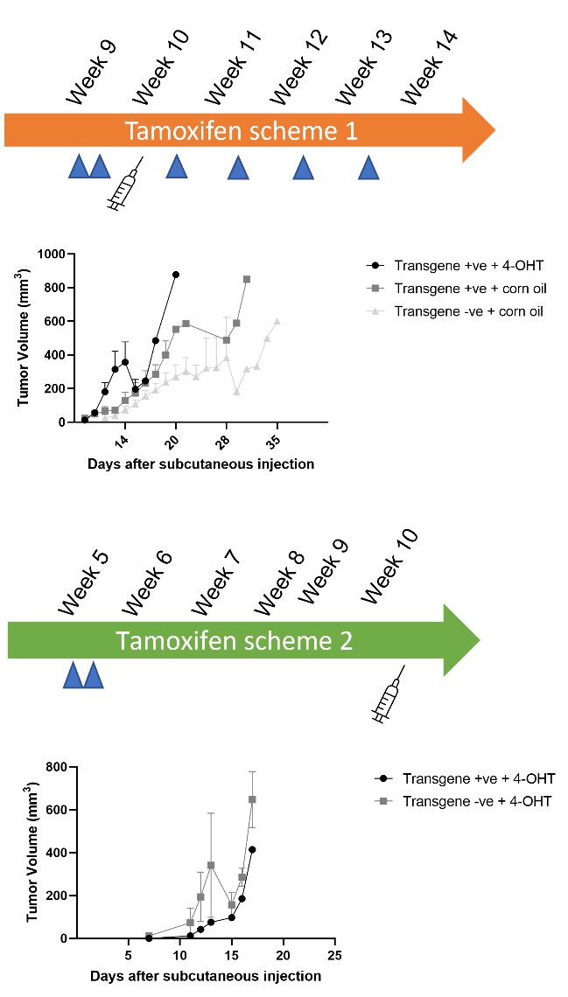
Figure 3. 2 T241-GFP-PDGF-BB tumour growth in transgenic positive and negative mice stimulated with 4-OHT

Transgenic positive and negative mice were divided into groups unbiased by sex and genotyping. Using these groups, pilot in vivo experiments were done to assess the influence of the activation of the transgenic system with two different tamoxifen administration schemes. Also, to check whether 4-OHT have an influence on tumour growth rates. Each symbol represents the tumour growth mean per group. First graph represents tumour growth of mice under the tamoxifen scheme 1 administration (n=18). Second graph represents tumour growth of mice under the tamoxifen scheme 2 administration (n=7). Data values are mean ± SEM. Only significant p values are shown.

3.2.2 Imaging to assess the activation of the transgenic mice system.
For both schemes of tamoxifen injections, mice were analysed using the IVIS software under the dsdRed channel immediately after the subcutaneous injection of tumoural cells. In vivo fluorescence imaging showed transgene activation via a fluorescent reported tandem-dimer Tomato (tdT) signalling in mice stimulated with 4-OHT injections and less intense expression in transgene negative mice. For both transgenic type of mice, regions where collagen-I biosynthesis is high, such as the ears, paws, tail, and skin, had increased fluorescence (Fig 3.3).

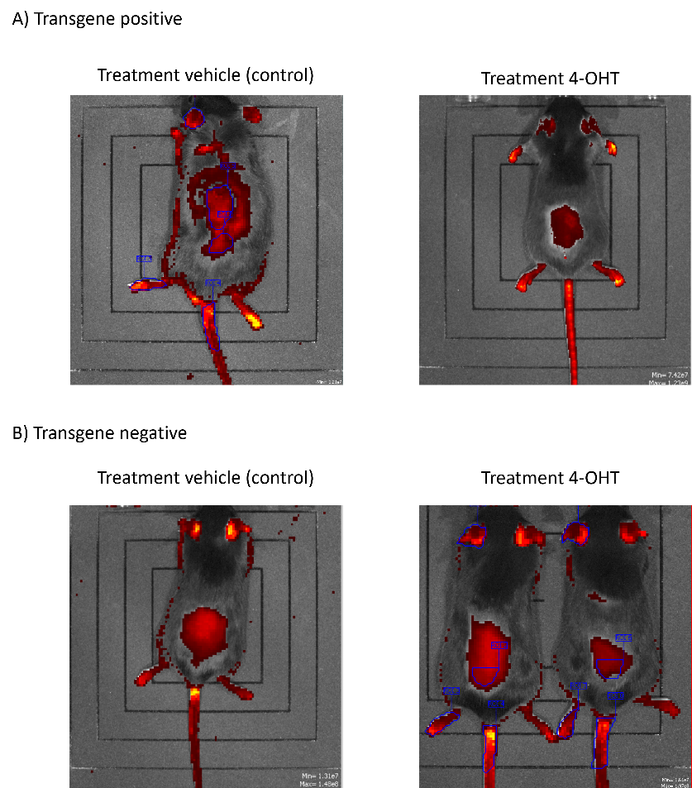

Figure 3. 3. Representative images of fluorescence imaging by IVIS Ilumina system of activated transgene system

Representative images of fluorescence imaging to detect tandem-dimer Tomato marker in transgenic mice. Activated system with 4-OHT injections was visualised as red fluorescence signalling in areas with collagen deposition including paws, tail, ears and shaved skin areas previous subcutaneous injections. A) Transgenic positive mice treated with corn oil (vehicle) and 4-Hydroxitamoxifen. (4-OHT) B) Transgenic negative mice treated with corn oil (vehicle) and 4-Hydroxytamoxifen (4-OHT).

3.2.3 Quantification analysis of fluorescent levels in diverse body regions of transgenic mice
A comparison of fluorescent tdT levels was made between positive and negative transgenic mice stimulated with 4-OHT and vehicle control using Tamoxifen scheme 1 As shown in Figure 3.4, the positive transgenic mice stimulated with 4-hydroxytamoxifen (4-OHT) reported significantly more bioluminescence than the other three groups in all regions, except for the skin and ear.

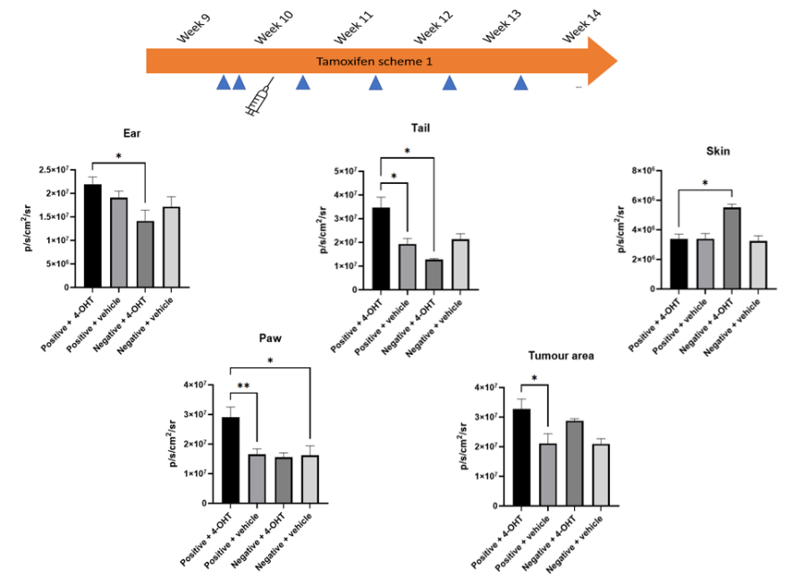
Figure 3. 4. Quantification of tdT fluorescence in different regions of Col1α2-CreERt transgenic mice

Quantification of tdT fluorescence was performed in all mice under Tamoxifen scheme 1 between transgene positive and negative and stimulated and non-stimulated mice. A comparison among positive and negative mice stimulated and non-stimulated with 4-OHT was conducted. Bioluminescence output was measured as photons per second per cm² of tissue that radiate into a solid angle of one steradian (p/s/cm²/sr). Only significant p values are shown. One-way ANOVA with Dunnett’s test for multiple comparisons was done. n=18. *p-value 0.05, ** p-value 0.001. Error bars are mean ± SEM

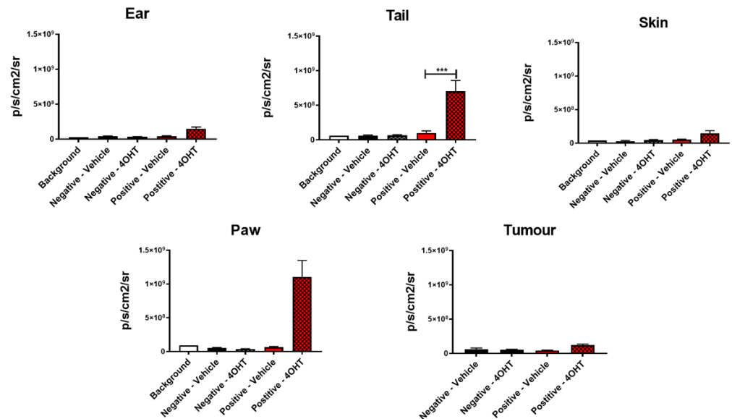
Although, a trend of higher fluorescence was seen in the transgenic positive mice with 4-OHT in our results. Overall, a lower amount of fluorescence was detected compared to the first in vivo experiments by W. English prior to starting this PhD (Figure 3.5). It became apparent much later the reason for this discrepancy was a significant deterioration of the fluorescence filters in the IVIS II between experiments. When this was discovered, there was insufficient time to repeat these experiments. However, these results suggested that tamoxifen administration using scheme 1 is sufficient to activate the transgene in regions of the mouse where elevated levels of collagen biosynthesis are known to occur.

Figure 3. 5. Quantification of fluorescence in previous experiment performed by W. English.

Quantification of tdT fluorescence was performed using the IVIS by Dr W English. A comparison among positive and negative mice stimulated with 4-OHT/vehicle using Tamoxifen Scheme 1 was conducted. Bioluminescence output was measured as photons per second per cm² of tissue that radiate into a solid angle of one steradian (p/s/cm²/sr). Error bars are mean ± SEM.

3.2.4 Detection of tdT fluorescence ex-vivo
The results obtained using in vivo imaging showed detection of tdT fluorescence in the tumour region was challenging as fluorescence detected showed discrepancies between the tumour region and the surrounding skin. Initial studies by Dr. W. English found increased fluorescence detected in the tumour area may come from activation of the transgene in tumour-adjacent subcutaneous fat rather than the tumour itself. To confirm transgene activation within the tumours ex vivo analysis was used. Tumours from transgenic positive and negative mice were dissected in half with one half used for cell culture ex-vivo. The other half was embedded in OCT to keep for further experiments. Chopped pieces of tumour tissues were cultured in working media supplemented with and without 1 μM of 4-OHT for 72 hours. After this, fluorescence microscopy was used to detect tdT positive cells. However, we did not find evidence of red cells and scarcely any fibroblast-like cells could be seen, and these were not clearly tdT positive (Figure 3.6)

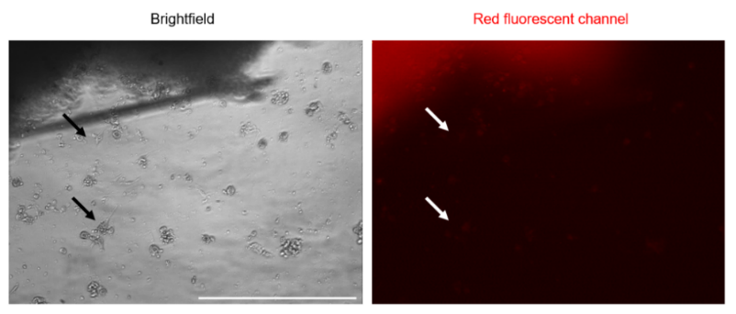
Figure 3. 6. Explant visualisation using microscopy with a fluorescent channel

Representative images of microscopy imaging showing tumour explant edges where the presence of few fibroblasts-like shape cells was visualised (marked with blue arrows). However, images using the red channel fluorescence showed no tdT signalling expressed by the fibroblasts-like cells. Images were taken using a fluorescent microscope. Scale bar 400 μm. 20x objective.
As previously showed, no red fluorescent fibroblasts-like cells were seen using explant cultures. Thus, a positive control was necessary. For an initial experiment, small pieces of mouse skin were used to isolate dermal fibroblasts. Sadly, the primary cultures showed fungal contamination and were discarded. In following experiment, cartilage from ear and tail were used as controls as these areas shown high deposits of collagen 1 when imaging through the IVIS system (See Figure 3.3).
Figure 3.7 shows representative images of the ear and tail explant cultures. Figure 3.7A exhibits explants tissue showing red fluorescence. However, few cells were obtained from these tissues. When cells were obtained, the morphology of the cells were rounded, and few fibroblast-like cells could be seen. Under the fluorescence microscope, a weak red signal was observed (Figure 3.8B). Efforts were made to maintain the cells and explants in culture, but their lifetime was very short (~3 days).
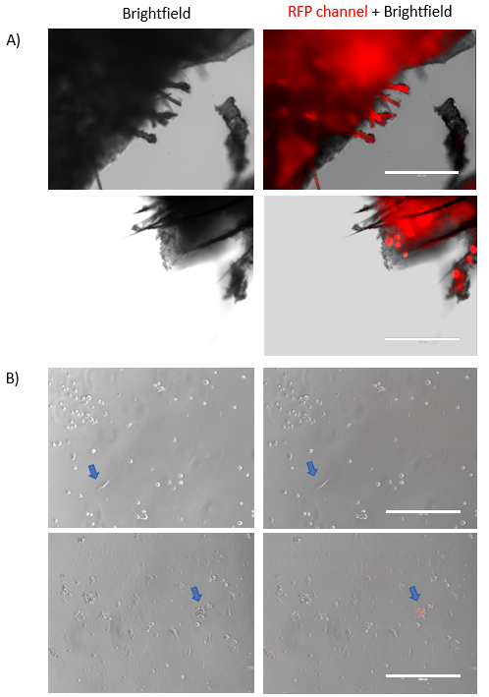
Figure 3.7 Ear and Tail tissue explants visualisation using microscopy with a fluorescent channel.

Representative images of microscopy imaging showing ear and tail explants from positive transgenic mice. A) Images show edges of ear and tail tissue where high red fluorescence signal can be found. B) Images of primary cells derived from ear mainly. A weak fluorescence signal can be found in some of the cells. Red signal was detected in fibroblasts-like cells and rounded cells (blue arrows). Scale bar 400 μm. 10x objective.
3.2.5 Use of radiotherapy to stimulate the Col1α2 transgene in tumours
A pilot in vivo experiment employing external beam radiation was conducted since we were unable to identify the activation of a clear signal of tdT fluorescence in tumoral cell cultures. Through the "radio-induced fibrosis" process (RIF), radiation will form fibrotic lesions and encourage the infiltration of myofibroblasts (Wang et al., 2019). Consequently, it would be expected that the C1 transgene activation will be increased.
RIF process is derived by DNA molecule breakage and hydrolisation of water of the cells. The DNA damage produce reactive oxygen species (ROS), which in turn triggers cell apoptosis and the release of profibrotic factors such TGF-β TNF, and IL-13. These factors cause the recruitment, activation, and proliferation of nearby fibroblasts as well as the deposition of ECM where collagen I is the main molecule (Jin et al., 2020; Straub et al., 2015).
Low doses of fractionated radiotherapy were used as we were not interested in ablate cancer cells, just enough to create cell DNA damage as release of ROS in our animal model. Also, fractionated radiotherapy was based on permission given by the animal licence. Two groups of 10–12-week-old male and female transgene positive and negative mice were used (n=8 per group). Group one had transgene positive mice and Group two had transgene negative mice. The T241-PDGF-Bβ cell line was injected in both groups and received fractionated external beam radiotherapy sessions before tumour growth were exponential (~100 mm3). Group 1 and Group 2 received either 6 Gy total dose or 4 Gy total dose of radiotherapy in 2Gy size fractions, respectively (Figure 3.8). Some tumours could not reach the optimum volume due to ulcerations without any trend among the groups. The group with 6 Gy dose of radiotherapy reached the endpoint faster compared to the other group. Nonetheless, no significant difference was found between both groups (p value=0.96).

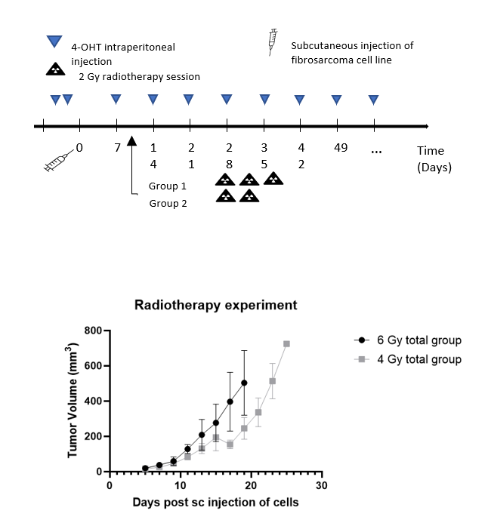
Figure 3. 8. Radiotherapy treatment to stimulate the Col1α2 transgene activation

Graph showing tumour growth rate between the 2 mice groups treated with different doses of radiotherapy and tamoxifen scheme. C1-creERT-tdT mice injected with T241-GFP-PDGF-Bβ cells were treated with two different radiotherapy schemes at 100 mm³ tumour volume. Group 1 received 3 radiotherapy doses of 2 Gy on consecutive days to a final dose of 6 Gy. Meanwhile, group 2 received 2 radiotherapy doses of 2 Gy each in consecutive days to a final dose of 4 Gy. n=8 per group. Mann-Whitney test was used. Only p-values <0.05 are shown. Data values are mean ± SEM. mm = millimetres. 4-OHT= Hydroxytamoxifen.

To examine the activation of the Col1α2 transgene, tumours were used for explants. Some of the explants showed outgrowth of mesenchymal type, spindle-shaped cells around the tumour explants. However, these cells did not show tomato fluorescence under fluorescence microscopy. Overall, cells with red fluorescence indicating activation of tdT expression under control of the Col1α2 transgene (SAFs) could not be detected in any explant culture (Figure 3.9).
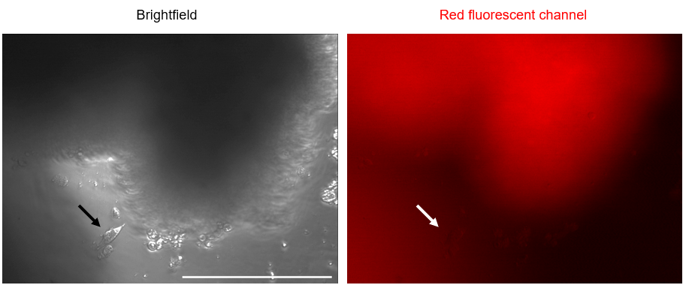

Figure 3. 9. Visualisation of tumours with radiotherapy explants using fluorescent microscopy

Representative image of microscopy imaging showing tumour explant treated with radiotherapy (total dosis 6 Gy). The presence of few fibroblasts-like shape cells was visualised (marked with blue arrows). However, under the red fluorescence channel, no tdT signalling was detected from the fibroblasts-like cells. Images were taken using a fluorescent microscope. Scale bar 400 μm 20x objective.

3.2.6 Using diverse tamoxifen concentrations to activate the Col1α2 transgene ex-vivo
Lastly, non-radiated tumour explants were cultured as previous described to determine if the concentrations of tamoxifen used were not optimal by increasing tamoxifen concentrations. Tamoxifen concentrations of 2 μM, 6 μM, 10 μM and 14 μM were used. An explant cultured with ethanol only was used as a negative control. The T241 explant activated with 2 μM of 4-OHT in the cell culture media was the one expressing red fluorescence in fibroblast-like cells. As can it be seen from figure 3.10, as a higher concentration of hydroxytamoxifen was used, cells tend to change their morphology to rounded cells which could indicate toxicity. In addition, no red cells with fibroblast-like shapes were seen among high concentrations of tamoxifen.

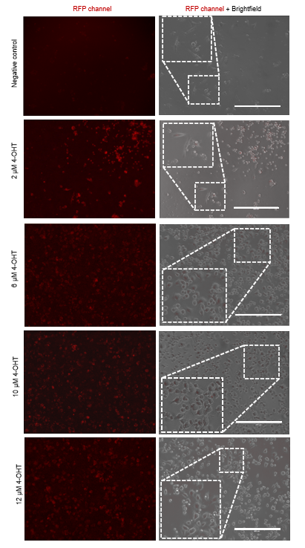
Figure 3. 10. Detection of tdT expression in cells from tumour explants treated with different doses of 4-OHT ex-vivo.

Chopped tumour pieces were cultured with working media and supplemented with different tamoxifen doses. Brightfield and Red fluorescent channels were used to visualise tdT expression in the tumour explants. Scale bar 400 μm. Images were taken using a fluorescent microscope. 10x objective.

3.2.7 Recombinant adenoviruses with a Cre activated GFP reporter to detect activation of the Col1α2 transgene in explant cultured cells.
As shown before, using hydroxytamoxifen in the cell culture medium to activate and isolate SAFs ex-vivo did not show high amounts of tdT positive cells as expected. Thus, we decided to assess whether the Col1α2 transgene system was able to be activated using another method. For this purpose, we used recombinant adenoviruses with an eGFP reporter to label collagen-producing cells as reported by Inagaki et al., 2005. Recombinant adenoviruses were constructed to express selectively in cells that produce collagen I. This was possible as the virus possess a Col1α2 enhancer sequence. Recombination was activated based on a Cre/LoxP basis. In our experiments, three adenoviruses were used: RAd- Col1α2 -Cre (referred as C1-adenovirus), RAd-CAG-Cre (referred as CAG-adenovirus) and RAd-CAG-FSF-eGFP, (referred as eGFP-adenovirus) (Figure 3.11)

Figure 3. 11. Recombinant adenoviruses to label Col1-tissue specific producers

RAd- Col1α2 -Cre (referred as C1-adenovirus), RAd-CAG-Cre (referred as CAG-adenovirus) and RAd-CAG-FSF-eGFP, (referred as eGFP-adenovirus) cassettes used. eGFP adenovirus contains a Lox-STOP-Lox region which is excised once the virus is exposed to Cre recombinase. Consequently, eGFP expression is activated.

Firstly, we checked whether the recombinant adenoviruses were functional. To do this, efficiency of the adenoviruses was validated by infecting normal human dermal fibroblasts (NDHF) with the recombinant adenoviruses and a flow cytometry method for GFP detection. PhD student Miss Sarah McFarlane performed this validation.
C1-adenovrius or CAG-adenovirus were combined with eGFP-adenovirus. CAG-GFP combination showed a percentage of 33.8% of cells expressing GFP+, this combination was used as a positive control. As expected, cells treated with PBS (negative control) resulted in non
GFP+ cells. The combination of C1-GFP using 100 infectious units (ifu) per cell exhibited an expression of the 10% of GFP+ cells out of 100% (Figure 3.12).
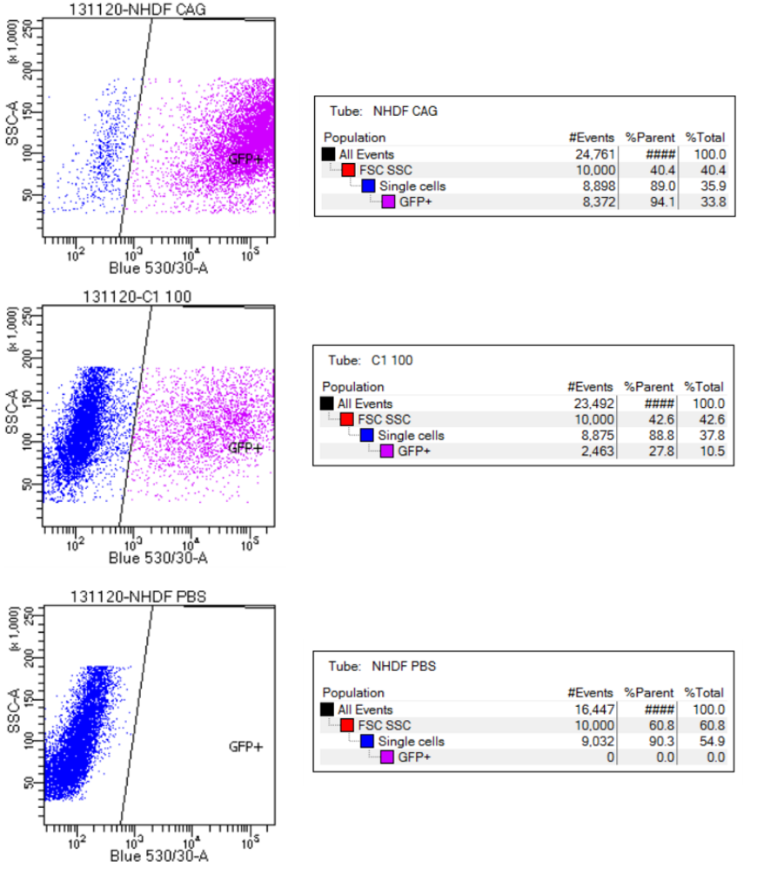
Figure 3. 12. Validation of C1-Cre system using recombinant adenoviruses in normal dermal human fibroblast by Flow Cytometry

Normal dermal human fibroblasts infection with the different recombinant adenoviruses combinations was performed. The activation of the recombinant systems was checked by the FACS system. Quantification of GFP+ cells was made using the FlowJo software. Results obtained by PhD student Miss Sarah MacFarlane. Ifu/cell= infection units per cell.

Once the validation of the adenoviruses was done with dermal fibroblasts, the infection of cells culture derived from tumour explants was performed. For this purpose, T241-GFP cells derived from tumour explants were used. Explant cultured cells from murine fibrosarcoma were double-infected with a combination of the eGFP- adenovirus with either C1- adenovirus or CAG-adenovirus (used as a positive control) (Inagaki et al., 2005). Two different concentrations of adenoviruses were used to infect cells: 200 and 600 ifu per cell. PBS was used as a negative control for treatment.
After 24 hours of viral infection, fluorescence microscopy was used to confirm the eGFP expression in Col1α2 cell-producers. Microscopic examination showed that explant cells infected with C1-GFP adenovirus at 200 ifu/cell showed little eGFP expression in fibroblast-like cells. Explant cells infected with C1-GFP adenovirus at 600 ifu/cell showed overall an intense signalling of eGFP signalling compared to 200 ifu/cell. Nonetheless, fluorescence signalling from adipose tissue was present at both concentrations. The explant cells infected with CAG-eGFP adenovirus at 600 ifu/cell showed the highest number of cells expressing eGFP (Figure 3.13).

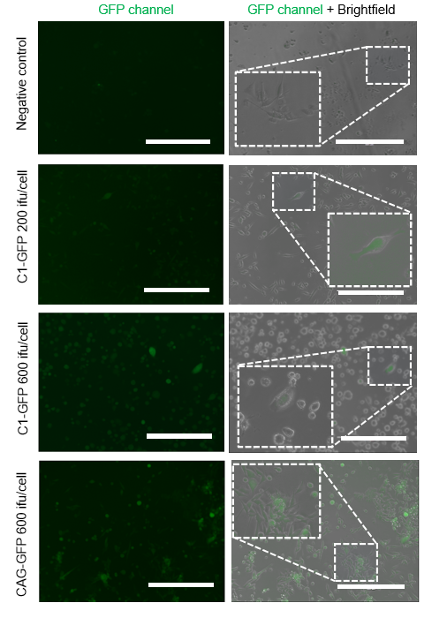

Figure 3. 13. Fluorescent images of T241-GFP tumour cells grown from explants transduced with CAG and Col1α2 activated GFP expressing adenovirus

Representative fluorescent images of T241-GFP explant cells. Explants cells were infected with C1- adenovirus and GFP- adenovirus with 200 or 600 ifu/cell. CAG-GFP recombinant adenovirus was used as a positive control. PBS was used as a negative control. Scale bar 400 μM. Images were taken using a fluorescent microscope.10x objective.

3.2.8. Recombinant adenoviruses with a GFP reporter activate the Col1α2 transgene in fibrosarcoma and carcinoma cultured cells.
Using our T241 fibrosarcoma cells and the LLc1 carcinoma cells murine cells, two different concentrations of viral particles per cell were used for this purpose. PBS was used as a negative control. Overall, data do not show high activation of the system using the viruses in the T241-GFP cell line nor LLc1 cell line. The T241 cell line treated with 100 ifu/cell C1-GFP adenoviruses combination showed a 2.1% increase in GFP+ cells after correction from the baseline and 3.5% of increased GFP+ cells with CAG-GFP adenovirus. Lewis lung carcinoma cell line (LLc1) treated with the same viral units increased by 0.2% for the C1-GFP combination and 2.1% for the CAG-GFP combination, respectively (Figure 3.14).
To raise the percentage of GFP+ cells, the infectious viral particles were increased to 600 ifu/cell. Nonetheless, the T241 cell line treated with the C1-GFP combination of adenoviruses was 0% while a percentage of 2% of GFP+ cells were detected using CAG-GFP adenovirus (Table 3.1).
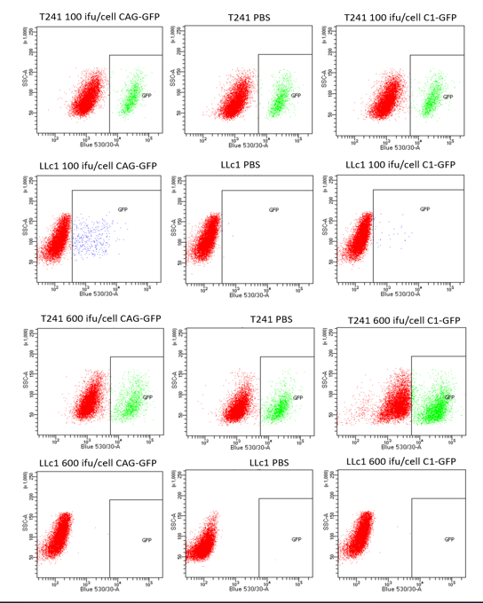
Figure 3. 14. Quantification of GFP+ cells using recombinant adenovirus in two murine cell lines by Flow Cytometry

T241 WT and LLc1 cell lines were cultured in 6-well plates in 1 ml of fresh cell culture medium. 200 ifu/cell and 600 ifu/cell were used to activate the C1-Cre system and incubated for 24 hours. Quantification of GFP+ cells was made using a LSRII (BD) machine. CAG-GFP was used as a positive control. PBS was used as a negative control. Ifu/cell= infection units per cell.

Table 3. 1 Summary of GFP percentage expression of cell lines infected with recombinant adenoviruses

Representative table with percentages of GFP expression cells in T241-GFP WT and LLc1. Previous analysis, cell lines were infected with recombinant viruses to activate Col1a2 collagen system. T241 WT and Two different viral concentration were used: 200 ifu/cell and 600 ifu/cell. Quantification of GFP+ cells was made using a LSRII (BD) machine. CAG-GFP was used as a positive control. PBS was used as a negative control. Ifu/cell= infection units per cell
Cell line | Treatment | Ifu/cell | GFP expression (%)
T241-GFP WT | PBS | NA | 16.2%
T241-GFP WT | C1-GFP | 100 | 18.3
T241-GFP WT | CAG-GFP | 100 | 19.7
T241-GFP WT | C1-GFP | 600 | 7.5
T241-GFP WT | CAG-GFP | 600 | 12
LLc1 | PBS | NA | 0%
LLc1 | C1-GFP | 100 | 0.2
LLc1 | CAG-GFP | 100 | 2.1
LLc1 | C1-GFP | 600 | 0
LLc1 | CAG-GFP | 600 | 0

3.2.9 Expression of collagen-I in T241 and LLc1 cell lines
Finally, as low detection of collagen-I producers cells was detected using different methods, we pondered whether collagen-I was produced by the tumoral cells rather than by cells in the TME. To investigate this, T241 and LLc1 tumour sections were stained using an anti-collagen-1 antibody (Figure 3.15A). Images were taken in two different areas of the tumours (edge and centre) to compare any difference between the two tumour models. Staining showed a difference in pattern between carcinomas and sarcomas. Collagen type 1 seem to have a more organised pattern in LLc1 tumours compared to T241 tumours, especially at the tumour edges. However, more collagen-1 deposition was observed in centre of the T241 tumours. Moreover, cell lysates of T241 and LLc1 cell lines were used for a semiquantitative analysis by Western blot. Our results showed only a band ~55-60 kDa among both cell lines. A commercial purified murine collagen-I lysate was used as a positive control (Figure 3.15B). The analysis of the bands obtained showed increased expression in LLc1 cells compared to T241 cell line. Nonetheless, no statistically significant results were found between both groups (Figure 3.15C).

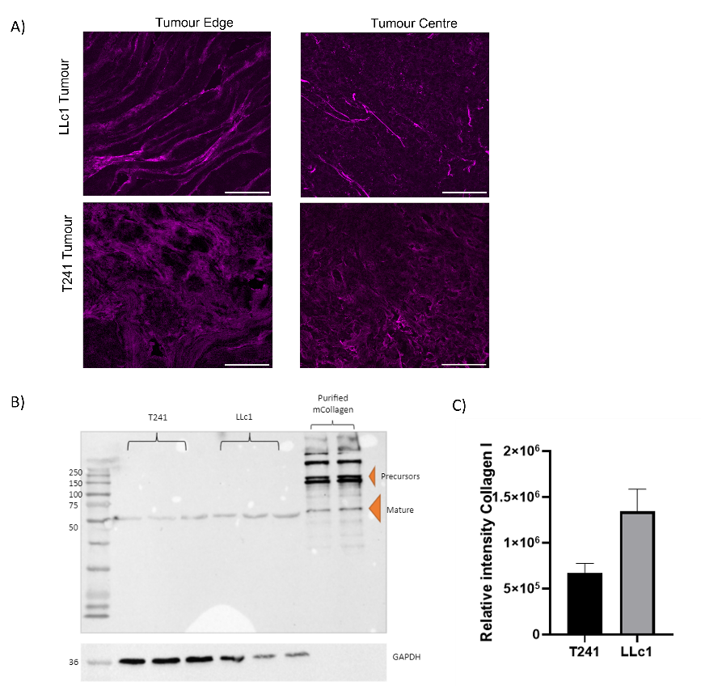

Figure 3. 15. Collagen-1 expression in T241 and LLc1 tumour and cell lines

T241 and LLc1 tumours sections were stained using, anti-collagen-1 and DAPI. A) Representative image of collagen fibres between T241 and LLc1 tumour B) Representative immunoblotting of collagen-1 expression between T241 and LLc1 cell lines. GAPDH was used as a loading control (~36 kDa). c) Relative intensity of Collagen-1 between T241 and LLc1 cell lines. Data are mean±SEM. Unpaired t- test was done. Only p-values <0.05 are shown. Three independent biological replicates were used for the immunoblotting. Scale bar 100 μm

3.3 Discussion
This chapter presents the experiments performed using a transgenic sarcoma model to pursue our first objective of the PhD project, to study the role of SAFs in sarcoma. The transgenic animal model was developed using a Col1α2 tissue-specific promoter/enhancer in a transgenic mouse and the murine fibrosarcoma cell line T241 which overexpressed Platelet-Derived Growth Factor B (PDGF-Bβ) (provided by Prof. Yihao Cao). Literature has shown that tumours in mice with the overexpression of PDGF-Bβ increased levels of FSP1+ and αSMA+ myofibroblasts and increased levels of stromal components (Hosaka et al., 2016) Additionally, PDGF-Bβ/PDGFRβ signalling has been linked to activation of fibroblasts in the TME due to its mitogenic and chemotactic properties on surrounding mesenchymal cells (Heldin, 2013). Hence, the transgenic murine model with the T241- PDGF-Bβ cell line might facilitate the isolation of ‘sarcoma-associated fibroblasts’ to further investigation of their role in sarcomas.
Initial experiments before the use of the transgenic mice, include the quantification of the PDGF-Bβ levels in our cell line and genotyping by PCR of Cre recombinase and tdT reporter were made to corroborate the presence of the transgenes. The quantification of PDGF-Bβ ELISA showed that the overexpressing PDGF-Bβ cell line had significantly higher levels compared to the WT cell line, however; levels of PDGF-Bβ were not as high as initially reported by Prof Cao group (Cao et al., 2004).
The transgenic mice used in these experiments were C1-transgene-lox-stop-lox- tdT, which in the presence of 4-OHT by intraperitoneal injections, activate of the Cre-lox system under the transcriptional control of Col1α2 promoter/enhancer sequences. Due to this activation, areas and cells where the transcription of Col1α2 was high, such as myofibroblasts, the expression of the fluorescent reporter tdT should be seen. Thus, this transgenic animal model has been reported useful to study fibrotic pathologies (Denton et al., 2001; Denton et al., 2003 Ponticos et al., 2015; Fragiadaki et al., 2011; Ramirez, Tanaka and Bou-Gharios, 2006).
To activate and maintain the Cre-transgene system, 2 different intraperitoneal protocols of 4-hydroxytamoxifen were used. First scheme was used, as the transgene system has demonstrated its activation during wound healing in adult mice by transcription of collagen-1 (Ponticos et al., 2004). Considering the hypothesis of ‘cancer as wound that do not heal’ (Dvorak, 2015) where wound repairs and cancer development share response signalling to their favour such as induction of angiogenesis and deposition of dense fibrosus connective tissue (Wieder, 2023; Sundaram, Quah and Sampath, 2018; Dvorak 2015) this scheme was thought to be successful to identify fibroblasts in our model.
Ponticos et al., (2004) demonstrated that transcription of Col1α2 dropped after birth and tended to diminish as the mice get older using the Col1α2 promoter/enhancer. However, some tissues remain with high levels until weeks 4 of age, such as skin. Thus, lineage tracing can be performed as the promoter is tissue-specific and the maintenance of the transgene system might last during the lifetime of the cell with transcription of the Col-1 (Li et al., 2017; Muzumdar et al., 2007). During the second scheme, the activation was made when mice were 5 weeks old, based on Li et al., 2017 protocol but slightly varied based on experimental experience of Dr. Will English and Prof Bou-Gharios.
To check the activation of both schemes, fluorescence expression was evaluated by using the IVIS Ilumina II system. Red fluorescence was seen in areas such as the ear, paw, tail, skin, and tumour areas, as expected. Statistically higher levels of fluorescent protein expression were found in transgene positive mice treated with 4-OHT compared to treatment with vehicles or transgene negative treated with 4-OHT/vehicle, except for the skin. Comparable results were found by Li et al., (2017) were fibroblasts tdT positive were found in the ears, paw and tail using the IVIS system and the presence of fibroblasts in areas such as nearby blood vessels in soft tissue, in the eye and the skin, specifically in the dermis but no epidermis. However, our results showed a decrease in the levels of fluorescence compared to previous results obtained by Dr. W. English. This needs to be highlighted as a degradation of the filters was found after my experiments were conducted and this was not repaired in time to repeat the experiments.
These results differ with literature where the Col1α2 transgenic mice were suitable for the identification of collagen transcription in adult mice under different circumstances. These circumstances include sites of injury or a skin fibrotic disease (Ponticos, 2004; Chujo et al., 2005). The latter model also showed increase of ECM production and the
increased number of activation fibroblasts in their model. Nonetheless, in both experiments exogenous growth factors as TGF-β and Connective tissue growth factor were used to promote fibrosis. In addition, results obtained were based on analysis of tissue sections and not in cell culture as we did, which may be more challenging.
Additionally, despite observing increased levels of transgene expression in the IVIS analysis, the tumour’s primary tissue cultures failed to exhibit a consistent tdT signal. As a result, the addition of a positive control was necessary to ensure the functioning of the system. The selection of positive controls was based the IVIS imaging, where tissue such as ears, paws and tail had a strong fluorescence signal suggesting high collagen-1 deposit. These controls had to be included since they served as a reference point to validate whether the system was properly activated. Despite efforts, few cells were obtained. To the best of our knowledge, there is no literature where ear tissue is used as a positive control using the same transgenic mice model as ours. But culture of fibroblasts derived from ear/ tail has proven to be successful in previous studies (Khan and Gasser, 2016; Bravo, Kim and Benayoun, 2021). Differences between our protocol and protocols published include the use of increased washes with ethanol, the use of antibiotics during tissue harvesting, and the use of enzymes to promote tissue and cell dissociation. These variations could influence the success of fibroblast culture since primary tissue culture contamination is known to be the principal challenge in primary tissue.

In another attempt to isolate SAFs, the murine model was subjected to non-lethal doses of external beam radiotherapy. This protocol was based on the concept of ‘radiation-induced fibrosis’ (RIF) which, as mentioned in Section 3.2.5, involves the chemotaxis of surrounding fibroblasts and the deposition of ECM (Wang et al., 2019; Straub et al., 2015; Kalluri et al., 2009, Jin et al., 2020; Ejaz, Greenberger and Rubin, 2019). No statistically significant changes were found in the tumour growth between two different dosages of radiation. Subsequently, using explant radiated tumours we could not growth a substantial amount of fibroblast nor red fluorescent cells. This outcome suggests the need of the optimisation of radiotherapy treatment. Treatment optimisations include precise-dose, and dose distribution over time. Limitation of these results include the lack of a standardised method applicable to a sarcoma model, as mostly are published to mimic fibrotic diseases. Furthermore, within the fibrotic diseases, a variety of radiation dosages and treatment length are used in the study of these pathologies. (Ghita et al., 2019; Jin et al., 2020; Dabjan et al., 2016; Butterworth, Prise, and Verhaegen, 2015). Also, our results may differ from previous literature, as many variables can affect the animal models and their susceptibility to radiotherapy, such as mice strains, age, husbandry conditions (Dabjan et al., 2016; Butterworth, Prise, and Verhaegen, 2015; Verhaegen, 2018).
Future work employing the RIF in our transgenic model may use a longer radiotherapy treatment, as fibrosis is a chronic response to radiation, with the same low dosage as our objective is not to disrupt the tumour growth (Straub et al., 2015), Additionally, initial investigation of the resulting tumours needs to demonstrate the increase of collagen-1 by the radiation. This could be done by utilising Masson’s Trichrome or Picro Sirius Red staining for collagen -1 in half of the tumours (Cohen and Erez, 2019). An alternative approach, albeit more expensive, is to employ RT- PCR to examine Col1α2 mRNA expression in tumour tissue. Once established that collagen deposition increased, an anti-tdT antibody can be used to identify the activated transgenic cells in cell culture or the use of RT-PCR to detect tdT.
Lastly, non-radiated tumour explants were cultivated and maintained in well plates with a medium supplemented with 1 μM of 4-OHT. Secondly, inverted microscope imaging was used to assess the presence of SAFs. Using phase-contrast microscopy, cells surrounding the tumour explant could be seen, the majority of which looked like attached rounded cells and some were fibroblast-like shaped cells. However, the tumour explants in our in vitro experiment did not show the red fluorescence and a fibroblast-like shape. The only fluorescence that was found was the explant per se which might be related to the presence of autofluorescence by adipose cells. Similarly, in a study to determine the presence of myofibroblasts among STS subtypes, in a sample of 5 fibrosarcomas, (Lagacé et al., 1980) reported that there was just one sample which had myofibroblasts among the STS tumours, which could suggest these cells may be low in number in STS. Therefore, it may not be easily detected in a fibrosarcoma model using a transgene dependent on collagen-I expression. Otherwise, in case the system was useful for our sarcoma model, different methodologies such as single cell sequencing (Deng et al., 2021) or immunofluorescence methods can be considered. For instance, a double fluorescent antibody marker like FSP1+ and αSMA+ for myofibroblasts, could be useful as shown by Hosaka et al., in 2016, or single marker such as vimentin, which is frequently used in myofibroblasts (Ostrowska-Podhorodecka et al., 2022), could be utilised in cell culture or Flow Cytometry.
Regarding our findings, there are no findings across the literature which are consistent with ours, due potentially to limited research in the field and, the techniques and subtypes of STS employed. However, studies have reported the presence of abundant fibroblast-like shaped cells and a high amount of collagen among tumours from fibroblastic and histiocytic sarcomas using light microscopy (Churg and Kahn, 1977).
An explanatory approach to our findings could be that even if the system is poorly activated in vivo, in vitro also manifests low activation. One reason might be that the concentration of 4-OHT in the medium could not be efficient enough to activate the system in vitro. There is no consensus in the literature about the exact protocol for the activation of Cre among diverse cell types. A range of 0.5 μM to 2 μM of 4- OHT can be found for treatment purposes in vitro. Regarding this, Li and colleagues (2014) reported that in vitro activation of Cre using lymphoma cell lines with 1 μM of hydroxytamoxifen increased apoptotic cells suggesting cellular toxicity. On the contrary, Aghajani et al., (2012) using increased doses of hydroxytamoxifen (to a maximum of 2 μM) on consecutive days increased almost 50% the expression of
the fluorescent protein compared to the controls in white blood cells (Aghajani et al., 2012; Li et al., 2014). These findings suggest that variable results in the literature regarding Cre activation in vitro can be found without any standard protocol.
As shown in the results sections, the attempts to identify and isolate SAFs gave us few results. Therefore, we use a different approach to label SAFs. For this purpose, a double infection method was used with recombinant adenoviruses and a tissue specific Col1α2 enhancer sequence. These viruses were provided by Prof Bou-Gharios and made by Sarah McFarlane and were firstly assessed using normal dermal human fibroblasts. These results showed the system was working. A comparison between the combination of the viruses, showed using in explant cells and cell culture cells was then made. Although using fluorescent microscopy an increase of green cells could be seen, the quantification of GFP+ cells by Flow Cytometry showed that the CAG-GFP system has more efficacy than C1-GFP. Similarly, Inagaki et al., (2005) showed to obtain a larger number of cells expressing GFP+ using the CAG-adenovirus expression compared to C1-adenovirus. Thus, a further work needs to consider treatment of primary cell cultures with a profibrotic cytokine. TGF- β is cytokine which is known to be key in a transition called ‘epithelial-mesenchymal transition’. Also, it has shown to differentiate cultured epithelial cells into collagen cell producers with a myofibroblasts morphology (Lamouille, Xu and Derynck, 2014; Tie et al., 2022). Therefore, the use of TGF- β as a supplemental element in the culture medium might be useful.
The previous findings resulted in new inquiries about Collagen-1 expression in our fibrosarcoma model and whether sarcoma cells make their own Collagen-1. To address these questions, an anti-collagen 1 antibody was used. Tumour sections were stained using IHC, and immunoblotting was carried out on tumour cells lines. The IHC staining revealed the presence of collagen fibres within the sarcoma and carcinoma sections. Additionally, immunoblotting of the cell lines showed expression of collagen-1, however no statistically significant differences between them. However, caution is needed in interpreting these data, as the band obtained in our immunoblotting study (~55-60 kDa) was different size from the predicted band for Collagen type 1 (MerckMillipore, 2023). The molecular weight of the collagen type 1 precursor is predicted to be within 140-210 kDa, while mature collagen type 1 is anticipated to yield a band of 70-90 kDa. Factors involved in the expression of lower bands could include post-translation modifications, protein degradation or protein expression under cellular stress. Nonetheless, to validate the expression, the use of RT-PCR to detect Collagen-1 could be done.
In reviewing the literature, little is known about the history and characteristics of the ECM in STS, particularly Collagen 1. According to published research, STS arising from fibroblasts and myofibroblasts have an abundance of overall collagen by histopathology (Nielsen et al., 2003; Pankova et al., 2021). Nonetheless, the source of collagen-1 is not clearly determined.

An explanation that no SAFs could be isolated, arises from the thought that fibrosarcoma, as a subtype of STS, is a tumour derived from mesenchymal cells that can be formed by a variety of undifferentiated fibroblasts/cells that can have dual functions such as the production of collagen I and moderation of tumour growth. Overall, based on our results, we may suggest that our fibrosarcoma model might not have SAFs. We hypothesise that this is due to the origin and differentiation of fibrosarcomas from mesenchymal progenitors. Due to the closest relationship between SAFs and fibrosarcoma cells, the neighbouring cells might not need to go through any transition to convert into SAFs (Chang et al., 2012; Hosaka et al., 2016) as these tumors already have a fibroblast/myofibroblast phenotype, supporting the single-compartment model stated by Tomlinson (Tomlinson et al., 1999).
Similarly, Sannino et al., (2017) established the term ‘metastable’ cells, within diverse sarcoma subtypes. This term refers to an ‘intermediate’ phase where tumoral cells express mesenchymal and epithelial markers. Because of this characteristic, cells can undergo a mesenchymal-epithelial transition or vice versa to facilitate the invasion and migration of tumoral cells according to necessity. Furthermore, as has been established in the literature, sarcomas are heterogeneous tumours because of the incomplete differentiation inherent in this specific type of sarcoma. Hence, the histopathological characteristics of fibrosarcoma cells might fulfil the role of SAFs. Fibrosarcomas have already been reported to have areas with variable differentiation from fibroblasts (Sannino et al., 2017).
These findings may be somewhat limited due to these experiments were performed and interrupted during the COVID pandemic where the time, activities and money were limited. Issues such as degradation of the IVIS fluorescent filters, which were not known until later and were not immediately repaired, having to stop the breeding in the colony of transgenic mice, and limitations to conducting in vivo experiments were presented. A necessity of finishing an optimisation with recombinant adenovirus needs to be done or the possibility to stimulate the cells with factors such as TGF-β or PDGF-Bβ to induce the production of SAFs might be considered. Also, techniques such as the use of antibodies for tdT could be considered using transgenic mice to identify SAFs in the future.
To sum up, our first system using transgenic mice did show an activation of the Cre/lox system by IVIS imaging. Nonetheless, the level of fluorescence obtained was lower compared to previous findings. When these tumours and skin were dissected, very few red fluorescent cells were obtained and could no longer be isolated. A possible explanation for this might be that fibrosarcoma cells, as tumours which raise from fibroblasts, might share characteristics with fibroblasts which provide a dual function within the tumour. Thus, the necessity of activated fibroblasts is small. These results need to be interpreted with caution because this hypothesis might apply only to STS which are derived from fibroblasts. Also, all these experiments used small samples as the optimisation was conducted.

CHAPTER IV: Characterisation of the tumour microenvironment of a fibrosarcoma model in comparison with a lung carcinoma model.

4.1 Introduction
Soft Tissue Sarcomas (STS) represent a big clinical challenge as patients do not exhibit symptoms at the initial stages of tumour development and consequently diagnosis is delayed. Nowadays, treatment for sarcoma patients is largely restricted to radiotherapy, chemotherapy, and surgery and new treatments are needed. Immunotherapy is a promising therapy for diverse tumours. Although a favourable response has been reported with this therapy in diverse cancers, not all patients and not all cancer types are sensitive. To approach this problem, the identification of biomarkers to predict therapy response is necessary. Hence, the understanding of the TME and the crosstalk between ECM and cells may be helpful to find new targets. Based on the host-immune system response, there are two types of tumours: “hot” and “cold.” These definitions are related to the infiltration of immune cells, being the former highly infiltrated whereas the latter has a lack of immune-cell response. The immune system possesses regulating signalling that helps to moderate the host response. These pathways are called immune checkpoints, examples of these include PD-1 and CTLA-4 (Han, Liu and Li., 2020).
In this context, STS is considered a poorly immunogenic tumour. However, subtypes like Undifferentiated pleomorphic sarcoma (UPS), dedifferentiated liposarcoma (DDL) and myxofibrosarcoma (MFS) have demonstrated partial response to immunotherapy agent such as pembrolizumab an anti-PD-1 agent (Tawbi et al., 2017; Song et al., 2018). Hence, the description of the TME in these tumours might help us understand the immune response within these tumours to find new specific targets and biomarkers.
Within the TME, an imbalance of pro-angiogenic and anti-angiogenic factors cause abnormalities in the blood vessels, resulting in poor blood flow and increased vascular leakage, leading to high interstitial fluid pressure (IFP) and poor oxygen perfusion. This impaired perfusion and IFP creates a hypoxic microenvironment and limits both the entry of drugs. The immature tumour vasculature also fails to express key endothelial receptors required for the infiltration of immune cells (Fukumura et al., 2018). Vascular normalisation is a therapy approach introduced by Jain R in 2001. It seeks to restore the balance between angiogenic factors by administering smal doses of anti-angiogenic therapy (Jain, 2001). This strategy aims to prune deficient blood vessels and enhance the performance of the remaining vessels. As a result, this normalisation would reduce the hypoxic state, improve drugs delivery, and facilitate the infiltration of immune cells. Thus, vascular normalisation can create a therapeutic window that allows the simultaneous use of other treatments (Jain 2005; Jain 2014; Fukumura et al., 2018).
Previous research in our laboratory used mouse fibrosarcoma cell lines with single VEGFA isoform expression injected into immunocompromised mice. The results showed that metastasis of VEGFA120 expressing fibrosarcomas (fs120) were more sensitive to anti-VEGFA therapy compared to fibrosarcomas expressing the VEGF188 isoform (fs188) (English et al., 2017). Subsequent analysis of RNAseq data from these tumours showed VEGFA120 expressing tumours also had increased expression of PD-L1 and immune checkpoint signalling pathways. Initial analysis of TCGA-SARC data showed that MFS with high expression of VEGFA121 were enriched for PD-1 signalling and had a high tumour mutational burden (Valluru, M, unpublished). Thus, VEGFA isoforms could potentially be used as a biomarker for response to immune checkpoint and anti-VEGFA among these groups of patients. This is particularly attractive as anti-VEGFA therapy combined with immune therapy has proven synergistic in some cancers (Fukumura et al., 2018). As mentioned, previous research in our group have studied fibrosarcomas and its characterisation. However, these cells are not from a pure strain of mice and have to be grown in immunocompromised mice which limits studies into the role of VEGFA expression on the adaptive immune system.
To tackle our hypothesis the study of the fibrosarcoma microenvironment was essential. Thus, the use of cell lines to develop a new tumour model was convenient especially with the exploration of the immune response. Few fibrosarcoma cell lines are available for this. One of the earliest cell lines developed is the HT1080, however this a human-derived cell line. Patient-derived xenografts have limitations including diverse background, limitation of the tumour study in early stages, incompatibility between the human and mouse microenvironment, and use of immunocompromised mice. All these variables might affect the results of fibrosarcomas and make difficult the study of the immune system (Dodd et al., 2010).
Therefore, we aimed to create a new model using a syngeneic cell line that could be grown in mice with a functioning immune system. Following this, the T241-eGFP murine fibrosarcoma cell line (kindly donated by Dr Yihao Cao) was used for our experiments. Lewis Sarcoma T241 cell line is a murine fibrosarcoma derived from a C57BL/6 mouse that could allow us to grow the tumours in immunocompetent mice. Microvasculature and pericyte coverage have been widely study using this cell line as a representative of solid tumours (Abramsson, Lindblom and Betsholtz, 2003; Hosaka et al., 2016; Xian et al., 2006)
This chapter aims to show a baseline characterisation of the T241 cell line (WT) and the differences with the carcinoma model (Lewis Lung carcinoma 1, LLc1) by immunohistochemistry and immunoblotting experiments.
4.2 Results
4.2.1 Characterisation of the vasculature in T241 and LLc1 tumours
T241 fibrosarcomas and LLc1 carcinomas were characterised with respect to vascularity and pericyte coverage using immunofluorescence staining. Tumour slides were stained with anti-CD31 to identify the vasculature. Cells expressing CD31, a transmembrane protein, was stained with an Alexa Fluor 488 secondary antibody (green). Quantification of the mean vascular density for T241 and LLc1 tumours was 91.09± 4.94 and 89.8 ± 4.8, respectively. No statistical difference was found between both groups (p=0.6943) (Figure 4.1). Of note, vascularity in T241 tumours was found more disruptive than vascularity in carcinomas, showing longer blood vessels. No differences in the vascularity distribution were found between the rim and the centre of tumours.
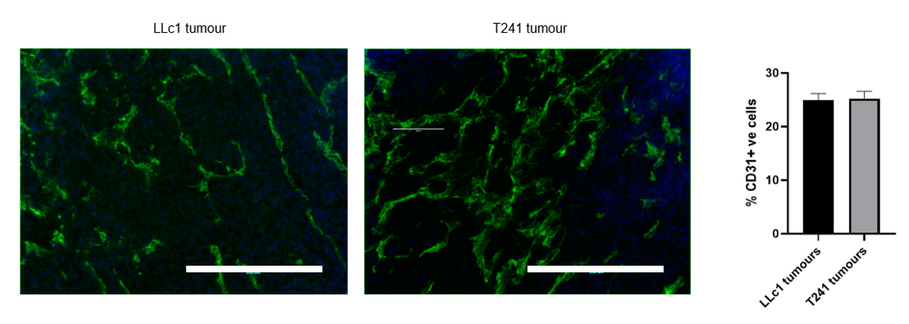
Figure 4.2 shows the identification of pericytes was made through co-staining of α-SMA+VE cells in close contact with CD31+VE blood vessels. Although the vasculature between both models was similar, α-SMA staining showed significantly higher pericyte coverage in LLc1 tumours compared to the T241 tumours (p=0.0048).
Figure 4. 1. Mean vascular density between T241 and LLc1 tumours

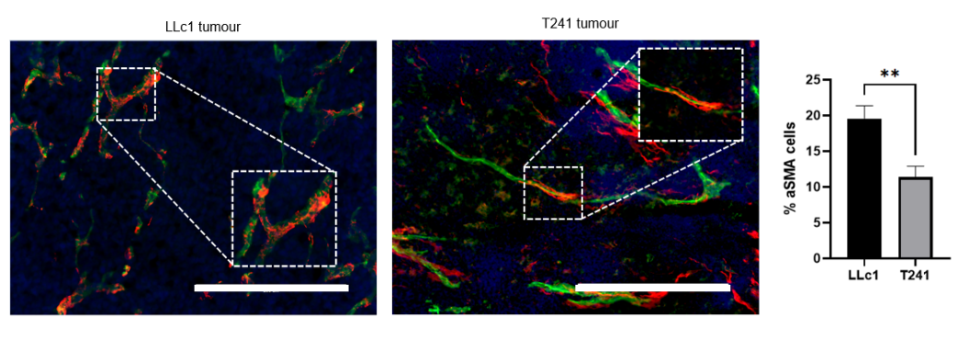
T241 and LLc1 tumour sections were stained using an anti-mouse CD31 antibody (green), and DAPI (blue) for the nucleus. Mean Vascular Density was calculated by counting the positive cells in 5 random images per tumour. Analysis graph reports percentage of CD31+ vasculature in the total image area. Data are mean ± SEM. Mann-Whitney test was done. n= 8, 20x objective. Scale bar 200 μm

Figure 4. 2. Pericyte coverage analysis between T241 and LLc1 tumours

T241 and LLc1 tumour sections were stained using an anti-mouse CD31 antibody (green), anti-mouse α-SMA (red), and DAPI (blue) for the nucleus. Representative image of α-SMA+ and CD31 cells in tumour slides and analysis of pericytes population between T241 and LLc1 tumours. Analysis graph reports percentage of percentage α-SMA colocalised in vasculature. Data are mean ± SEM. Mann-Whitney test was done. n= 8, ** p-value <0.005. 20x objective. Scale bar 200 μm

4.2.2 Identification of differences in expression of ECM proteins between T241 and LLc1 tumours
Differences were found in laminin and collagen-I between fibrosarcoma models overexpressing single VEGFA isoforms as reported by English et al.,., 2017. Hence, we aimed to explore the proteins of the ECM due Laminin was stained using anti-pan laminin and Alexa Fluor 555 in T241 and LLc1 tumour sections. As shown in Figure 4.3A, laminin fibres in the carcinoma model have a homogenous pattern where most cells are surrounded by laminin, whereas in the fibrosarcoma model the pattern is more heterogeneous with sparser but denser staining seen. Next, a quantification of laminin (~220 kDa) expression was made by immunoblotting for pan-laminin using GAPDH as a housekeeping gene and fs188 cell line as a positive control according to Kanthou et al., 2014 (Figure 4.3B). Quantification of the protein expression showed that the LLc1 cell line expresses statistically higher levels of laminin compared to the T241 cell line (p= 0.0016) (Figure 4.3C).

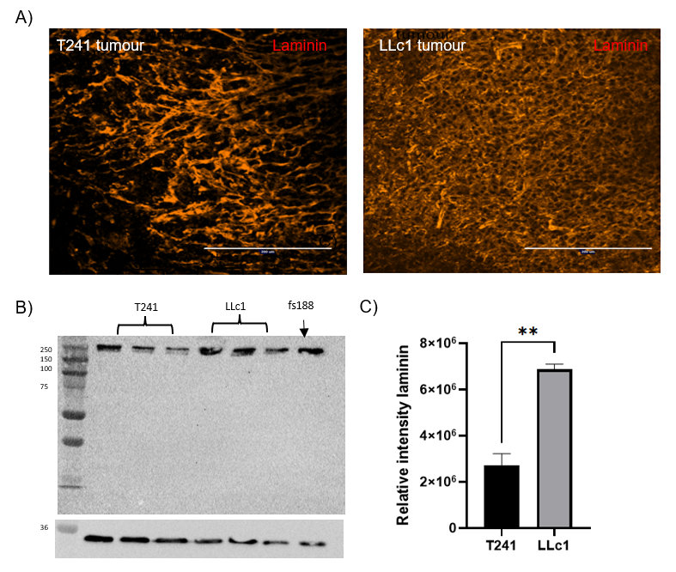

Figure 4. 3. Laminin expression in T241 and LLc1 tumours and cell lines

T241 and LLc1 tumours sections were stained using, anti-pan-laminin and DAPI a) Representative image of laminin fibres between T241 and LLc1 tumours (Alexa fluor 555, red) b) Representative immunoblotting of laminin expression between T241 and LLc1 cell lines. GAPDH was used as a loading control (~36 kDa). c) Relative intensity of laminin between T241 and LLc1 cell lines. Data are mean±SEM. ** p value< 0.005. Unpaired t- test was done. Three independent biological replicates were used for the immunoblotting. Scale bar 200 μm

Fibronectin is an adhesive protein which has been reported to have a significant role in tumour progression and therapy response (Han and Lu., 2017). Therefore, we aimed to check the expression of fibronectin across both tumour models as part of the ECM characterisation. Although using the immunofluorescence method we could stain fibronectin in the T241 fibrosarcoma model (Figure 4.4A), immunoblotting the same model did not show bands in the expected size among the three independent biological replicates of the cell line in vitro (Figure 4.4B). On the other hand, the carcinoma model showed stained fibres by immunofluorescence and by immunoblotting of cultured LLc1 cells. The protein expression analysis between both cell lines showed higher levels of fibronectin in the LLc1 cell line compared to the T241 cell line. However, no statistically significant differences were found (Figure 4.4C).

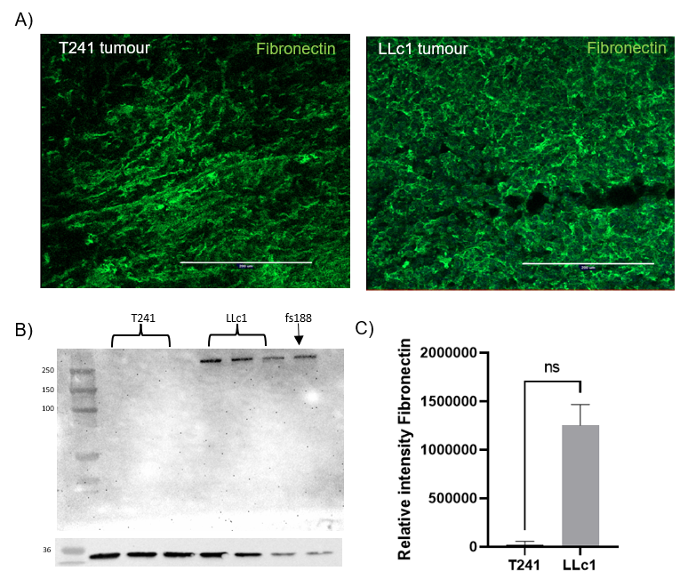
Figure 4. 4. Fibronectin expression in T241 and LLc1 tumour and cell lines

T241 and LLc1 tumours sections were stained using anti-fibronectin and DAPI a) Representative image of fibronectin fibres between T241 and LLc1 tumours (Alexa fluor 555, red) b) Representative immunoblotting of fibronectin (220 kDa MW) expression between T241 and LLc1 cell lines. GAPDH (36 kDa MW) was used as a loading control. c) Relative intensity of fibronectin between T241 and LLc1 cell lines. Data are mean±SEM. ns= not significant. Mann-Whitney test was done. Three independent biological replicates were used for the immunoblotting. Scale bar 200 μm
4.2.3 Comparisons between the immune cell infiltration in T241 and LLc1 tumours
The objective of immunotherapy is to activate and enhance the pathways related to the response of the immune cells. Our results showed that infiltration of CD8⁺ (Cytotoxic T cells) is statistically higher in the T241 fibrosarcoma tumour compared to the LLc1 tumours (Figure 4.5). F4/80 staining was used as a marker to identify murine macrophages. Immunofluorescence analysis showed an increased level of macrophages in the T241 tumours compared to the LLc1 tumours. This difference was statistically significative (p-value <0.0001) (Figure 4.6). Lastly, we identified Treg cells using CD4⁺/FOXP3⁺ markers. Figure 4.6 showed an increased number of Treg cells within T241 tumours compared to LLc1 tumours, but this difference was not significant (p-value 0.1098) (Figure 4.7).

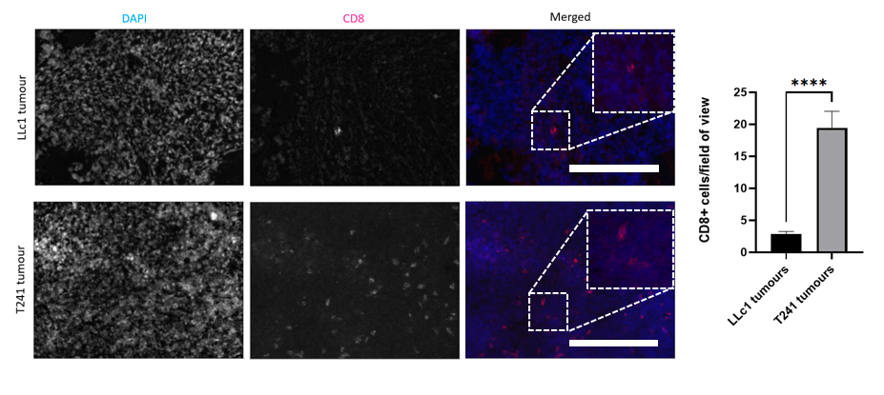
Figure 4. 5. Infiltration of Cytotoxic T cells (CD8+) in T241 and LLc1 tumours

T241 and LLc1 tumour sections were stained using anti-CD8, and DAPI (nuclei). The density of positive cells was calculated by counting the positive cells in 5 random images for each tumour tissue. a) Representative image of CD8+ cells and quantification analysis. Data are mean ± SEM. Mann-Whitney test was done. n=6, ****p value <0.0001. Scale bar 200 μm
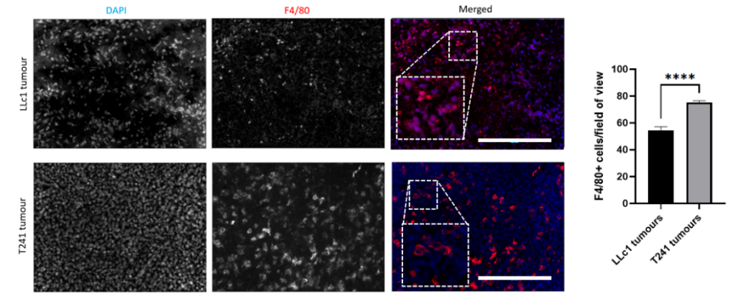
Figure 4. 6. Infiltration of murine Macrophages (F4/80⁺) in T241 and LLc1 tumours

T241 and LLc1 tumour sections were stained using anti-F4/80, and DAPI (nuclei). The density of positive cells was calculated by counting the positive cells in 5 random images for each tumour tissue. a) Representative image of F4/80+ cells and quantification analysis. Data are mean ± SEM. Mann-Whitney test was done. n=6, ns= not significant, ****p value <0.0001, Scale bar 200 μm

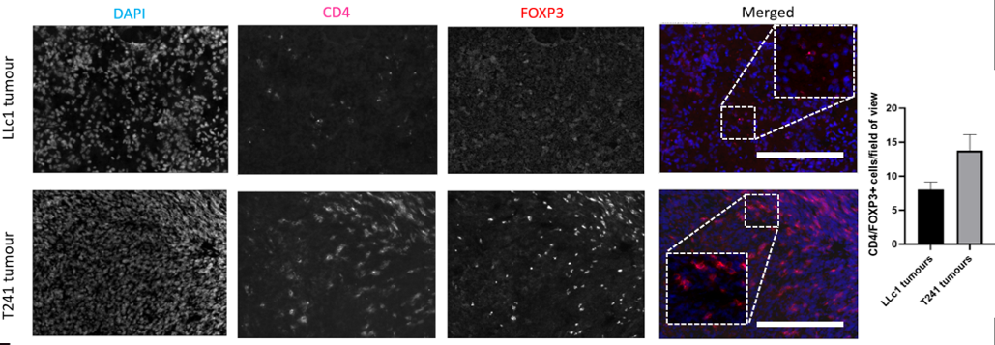
Figure 4. 7. Infiltration of CD4/FOXP3+ cells in T241 and LLc1 tumours

T241 and LLc1 tumour sections were stained using anti-CD4/anti-FOXP3, and DAPI (nuclei). The density of positive cells was calculated by counting the positive cells in 5 random images for each tumour tissue. a) Representative image of CD4/FOXP3+ cells and quantification analysis. Data are mean ± SEM. Mann-Whitney test was done. n=6, ns= not significant. Only p-values < 0.05 are shown. Scale bar 200 μm

4.2.4 Characterisation of PD-L1 immune checkpoint expression in fibrosarcomas
As previously stated in Chapter 1, Section 1.6, prior analysis in our lab by bioinformatic analysis and mRNA analysis on human samples and mouse fibrosarcomas (fs) revealed a relationship between the VEGFA120 isoform and enrichment of PD-1/PD-L1 signalling. Thus, the investigation of PD-L1 expression in our cell lines was important. Hence, to optimise the use of an anti-PD-L1antibody of our T241 model, it was decided the use of previously created fibrosarcomas overexpressing single VEGFA isoforms (fs120 and fs188) as initial samples.
Firstly, the anti-PD-L1 antibody was used in IHC as shown in Figure 4.8A. This analysis includes tissue sections from fs120 and fs188 treated with an anti-VEGF (B20-4.1.1) or treated with control (BE5). The quantification of positive cells revealed a slight decreased in PD-L1 expression in fs120 treated with the anti-angiogenic therapy when compared to fs120 treated with control. Analysis in fs188 cells showed an opposite trend with higher levels in fs188 treated with antiangiogenic therapy. Nonetheless, none of these differences were statistically significant.
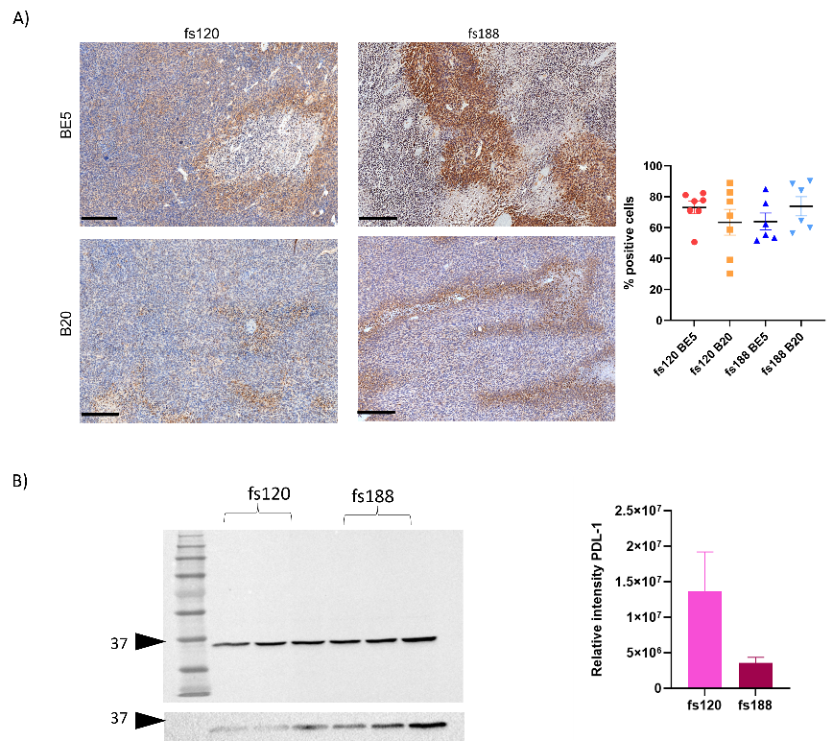
Additionally, PD-L1 expression was also studied by Western Blot using non-treated fs cell lines (Figure 4.8B). Analysis of the immunoblotting indicated higher PD-L1 expression in fs120 cells compared to fs188. However, it is noteworthy that the expression range in fs120 is quite large, leading to the lack of statistical significance between the difference of both cell lines.

Figure 4.8. PD-L1 detection in fibrosarcomas overexpressing VEGFA isoforms

A) Representative images of IHC and analysis to detect PD-L1 expression detection fs120 and fs188 tumours treated with anti-angiogenic (B20) therapy and control (BE). One way- ANOVA test. n=7 samples per group. B) Representative images of Western blot of PD-L1 (~34 kDa) and among fibrosarcoma overexpressing either VEGF120 or VEGF188 isoform (fs120, fs188). GAPDH was used as a housekeeping gene. Unpaired t-test with Welch’s correction. Only p-values < 0.05 are shown. Data values are mean ± SEM of three independent experiments.

4.3 Discussion
Sarcomas are rare and have a high variety of subtypes which makes characterisation of them it difficult. Therefore, little is known about the next viable options for targeted therapies against them. Previous work in our laboratory group showed that a murine fibrosarcoma model with prominent levels of the VEGF120 isoform had enriched PD-1/PD-L1 signalling, an immune checkpoint pathway that can be targeted for therapy (Valluru, M, unpublished data). This same model showed a greater response to anti-VEGF therapy (English et al., 2017). Therefore, we aimed to investigate whether differences in sarcomas VEGFA isoform expression can benefit from a combination of both therapies as seen in preclinical studies in carcinomas, such a breast and colon cancer (Fukumura et al.,., 2018). To assess this hypothesis, using an animal model with a T241 fibrosarcoma, we characterised the TME, especially the immune cell infiltrations.
Thus, this chapter described the tumour microenvironment of the T241 a murine fibrosarcoma cell line which we intend to use as a fibrosarcoma model for investigating VEGFA isoform expression by comparing it to a carcinoma model that has been characterised in terms of its sensitivity to anti-VEGFA and PD-1 therapy (Yang et al., 2010; Croci et al., 2014; Wu et al., 2020). Mice were divided into different tamoxifen scheme groups, regarding gender. However, we have found statistically significant differences of tumour growth rate between gender. This suggest that future in vivo experiments need to count this factor when planning and sorting out the mice.
During tumour development, the angiogenesis process within the tumours can be disruptive and blood vessels are considered ‘immature.’ These characteristics enhance a hypoxic microenvironment which can promote tumour progression and therapy resistance (Muz et al., 2015). Our results showed that there are no differences in the vasculature between both tumour models. Nonetheless, the carcinoma model has a significative higher pericyte coverage (αSMA⁺ cells) compared to the T241 fibrosarcoma model. Also, we found that the pattern coverage of α-SMA⁺ of the blood vessels is variable, whereas in the LLc1 tumours the coverage is more consistent. These results are alike to those of Abramson (2003) who found T241 blood vessels with a wide range of pericyte coverage (0-100%) within the same area. This feature suggests that T241 tumours might have a more hypoxic environment compared to the LLc1 model, as pericytes are known to stabilise the vessel structures and prevent leaking (Yamazaki and Mukouyama, 2018).
Hypoxic conditions will increase the production of the Hypoxia-Inducible Factor (HIF) as well as the VEGF family to compensate for the hypoxia via angiogenesis. Additionally, hypoxic microenvironment impacts cell behaviour and infiltration of immunosuppressor cells such as TAM2 and T regulatory cells (Abou Khouzam et al., 2021). Production of HIF has been linked to expression of PD-L1 by malignant and immune cells via HIF-1α (Shurin and Umansky, 2022). Thus, future work might include the investigation of hypoxia in our tumour models and its relationship with the TME and the relationship with VEGFA isoforms. This can be performed using immunohistochemistry with hypoxia markers such as HIF-1α and Carbonic anhydrase IX (CAIX) such as performed by Forker et al., (2018).
Murine tumours have shown that low pericyte coverage vessels are related to the high activity of angiogenesis and small-calibre vessels. Therefore, these blood vessels may be prone to a good response to vessel normalisation with anti-VEGF therapy (Gee et al., 2003). Although, it is important to mention that the presence of pericytes can be influenced by other factors and pathways such as PDGF-Bβ (Hosaka et al., 2016). Due to their mesenchymal origin and differentiating characteristics, pericytes can be recruited as another type of cell undergoing diverse processes such as MET as we discuss in Chapter 3. Another principal factor related to pericyte coverage is the VEGFA isoforms expression. Fibrosarcomas expressing only VEGFA120 have less pericyte coverage than VEGFA188 expressing tumours (English et al., 2017; Tozer et al., 2009). Regarding VEGFA isoforms levels, the next chapter will show our results in the exploration of the T241 fibrosarcoma cell line. This may influence the low pericyte coverage found in the tissue sections. Nevertheless, this hypothesis will need to be supported by measuring VEGFA isoforms levels of the LLc1 cell line. Furthermore, it is important to consider that αSMA is not the only marker for pericytes, several markers are commonly used such as NG2, PDGFR-β, and desmin. However, αsma has been demonstrated to be a good marker for pericytes, especially during tumorigenesis and inflammatory processes (Armulik, Genové and Betsholtz, 2011).
We also aimed to investigate ECM proteins like fibronectin and laminin between the fibrosarcoma and the carcinoma model as previous fibrosarcomas showed differences within ECM proteins. These proteins have been described to regulate the infiltration, activation, and polarisation of the immune cells in the TME (Simon and Bromberg 2017; Mushtaq et al., 2018). In our results, the immunoblotting showed significantly increased levels of both proteins in LLc1 cell lines, and the immunofluorescence showed a homogeneous pattern in the carcinoma model compared to the T241 sections. These results suggest that T241 and LLc1 tumours might have a poor prognosis based on the increased levels of laminin by immunoblotting (seen in LLc1 tumours) and an atypical distribution of laminin by immunofluorescence (seen in T241 tumours) which also have been related with an invasive behaviour (Henke et al.,2020). However, low fibronectin levels were detected in the T241 cell lysates by immunoblotting. This result could be in relationship with the low expression of pericytes and leaky blood vessels as a deficiency in the basement membrane as has been shown in the blood-brain barrier by Gautam, Cao, and Yao, 2020. In contrast to our findings, Stenman and Vaheri 1981, reported an increased expression of fibronectin in diverse STS subtypes including one fibrosarcoma. But we need to consider that across time and modern techniques, the classification of the STS has been changing and tumours have been suffering different histologic diagnoses. In this context MFS, UPS, and pleomorphic tumours are not the exception among the STS. Also, this study has a small sample size (1 fibrosarcoma) which leads to minimising the impact of the results.
Immunotherapy has been proven as a novel and useful therapeutic among diverse tumours such as non-small lung carcinoma, renal cell carcinoma, and ovarian carcinoma. Nevertheless, speaking of the efficacy of immunotherapy, features such as hot tumours need to be considered. Hence, immunotherapy may apply to a limited subset of cancer patients only. To overcome the variability of response within patients is important to understand the TME bearing in mind that the response to treatment is related to the nature of the immune system and its functions (Marin-Acevedo et al., 2018).
Thus, to approach this we intend to characterise the TME of both models as infiltration of immune cells. These cells, such as TILs, macrophages, and myeloid-derived suppressor cells can influence the outcome and prognosis of the tumours. Our immunohistochemistry results showed that the T241 fibrosarcoma model has significantly higher levels of CD8⁺ cells (Cytotoxic cells) and F4/80⁺ (murine macrophages) compared to the LLc1 model. These findings suggest that T241 is more immunogenic than LLc1. These results are consistent with Lechner et al., (2013) who also found low infiltration of effector cells in LLc1 tumours using IHC and Flow cytometry. Also, the author reported a significantly smaller number of Treg cells within the LLC model compared to other tumour models like CT26 colon carcinoma or MAD109 lung carcinoma. However, this study also showed that LLc1 tumours have a high prevalence of F4/80⁺ cells. This differs from our findings. An explanation of this could be that the LLc1 model could have more monocytes than macrophages, as monocytes have been described to express low levels of F4/80 but high levels of CD11b. Hence, the co-staining with CD11b need to be considered to identify these immune cell subsets in a future panel of markers.
Besides, Gianni et al.,. 2021 observed low effector CD4, CD8 T-cells infiltration, weak immune-related gene expression such as CD4, CD83, CD25, and no response to immune checkpoint blocking treatment in LLc1 tumours.
Together, these investigations support our results, showing LLc1 as a weak immunogenic model with little immune cell infiltration. In this context, we need to highlight that even though, our results showed that T241 have a higher number of immune cells infiltration compared to the LLc1 model, the T241 model has also been reported as weakly immunogenic tumour (Gautman and Deodharl, 1981). Nonetheless, it has been shown an augmentation of immune cell infiltration when blood vessel normalisation occurs in T241 tumours (Rolny et al.,., 2011). Thus, the strategy of vessel normalisation with anti-angiogenic drugs may be useful to enhance an immunotherapy response. The vessel normalisation hypothesis was stated by Jain R in 2001, postulating the importance of pruning immature blood vessels by eliminating the excess abnormal endothelial cells with an antiangiogenic therapy and leaving behind the mature ones, which can deliver efficiently anti-tumour therapies and play their normal functions (Jain R, 2001; Huang et al., 2018; Mpekris et al., 2020). It is almost certain that the anti-angiogenic effect can be done via diverse pathways against growth factors such as VEGFA, PlGF, TGF-β and/or receptor tyrosine kinases (Fallah et al., 2019). However, previous research in our laboratory showed a promising response in a fibrosarcoma model expressing VEGFA120 using anti-VEGF therapy (English et al., 2017). Thus, we hypothesise that T241 as a fibrosarcoma model could be responsive to anti-VEGF therapy which can also be combined with immunotherapy.
Even though this chapter provides insightful information, caution must be used as a basic panel of markers for immune cell was employed. The availability and cost of these markers along with the project’s time constraints were the main determinants of the markers used. Nevertheless, it is worth noting that CD4, CD8, FOXP3 and F480 are fundamental surface markers frequently used to identify T cells subsets and macrophages (Hogquist and Jameson, 2014; Dos Anjos Cassado, 2017). However, the individual use of markers to identify specific cells is somewhat limited due to share expression of surface markers such as CD8 and the narrow scope of cell subsets identification.
For example, initially believed to be exclusively expressed in T cells, CD8 has been found to also been expressed in Natural Killer cells (NK) (Rosenberg and Huang, 2018). In this case, the addition of a cell surface marker specific for T cells, like CD3, along with CD8 could prove advantageous to distinguish between NK and cytotoxic T cells. Moreover, the utilisation of alternative techniques such as Flow Cytometry allow the use of multiple markers to employ a detailed analysis of immune cells, including activation status. For instance, the use of CD3, CD4, CD25, CD45RA, CD127, FOXP3 for human activated T regulatory cells (Santegoets et al., 2015).

Finally,, the preliminary findings obtained using the anti-PD-L1 antibody in fibrosarcoma samples showed promising results that aligned with our hypothesis. Nonetheless, is important to note that after these results were obtained, the discontinuation of the antibody (ab238697) was announced by the producer company due to its lack of specificity in its applications. As a result, the reliability of these findings became questionable.
Unfortunately, due to restriction of time during the project, the optimisation of a new antibody (BioLegend 124301), was not finished. Nevertheless, the bioinformatics analysis chapter presented in this thesis, include alternative approaches where we evaluate PD-1/PD-L1 signalling in STS and whether the expression levels this signalling can be influenced by VEGFA isoforms. Furthermore, it is important to consider other methodologies such as Flow Cytometry as there is a higher variety of antibodies to detect PD-1/PD-L1 expression using this technique compared to antibodies assessed for IHC.

CHAPTER V
Development and in vitro characterisation of murine fibrosarcoma cell lines expressing increased levels of VEGFA isoforms.

5.1 Introduction
The investigation of VEGFA as a potential target for therapy has been considered promising in diverse tumours such as breast and ovarian cancer. However, anti-angiogenic therapy has been shown to be beneficial only for a narrow group of patients. Nonetheless, the study of VEGFA and VEGFA isoforms in STS has had attention compared to other cancers. Therefore, the creation of appropriate in vitro STS models to investigate VEGFA isoform function is important. This way results will be able to be translated into preclinical and clinical research.
Previous research has characterised the role of the VEGFA isoform expression using mouse fibrosarcoma models (English et al., 2017; Tozer et al., 2009; Kanthou et al., 2014; Akerman et al., 2013). However, these studies have two principal limitations. First, the use of immunocompromised mice as a model and second, these models express only single isoforms. Therefore, this project aimed to develop a new model from a fibrosarcoma cell line which overexpressed a single VEGFA isoform while simultaneously expressing the other isoforms from the endogenous gene. This new model will allow us to characterise the TME and investigate its relationship with VEGFA isoform signalling and be useful for pre-clinical research.
To do this, a murine fibrosarcoma cell line (T241-GFP) was used that is syngeneic with C57Bl6J mice. This cell line was transfected using a transposon-based system which had shown high efficiency in transfection of mammal cell lines (Zhao et al., 2016). Previous bioinformatics analysis in our lab showed that myxofibrosarcomas (MFS) with high VEGFA120 and high VEGFA165 might be responsive to anti-VEGFA and anti-PD-L1 (an immune checkpoint inhibitor) (English W and Valluru M, unpublished data). These results promise optimistic results for these patients in terms of novel therapies. Thus, to explore and investigate this in detail, the creation of a useful sarcoma model for use immunocompetent mice is needed.
The selection of accurate models is essential as the use of model systems to overexpress isoforms can modify expression levels of the endogenously expressed isoforms. Regarding this, an accurate quantification method such as AQRT-PCR was used in order to double check the correlation of our results with the overexpression of the diverse range of VEGFA isoforms. According to the literature, the expression of different VEGFA isoforms had an impact on features like migration, morphology, proliferation, ECM deposition and response to anti-VEGFA antibodies (Kanthou et al., 2014; English et al., 2017). Therefore, this chapter shows the process of selection and characterisation of T241 cell lines overexpressing VEGFA120 or VEGFA188 through different methodologies such as AQRT-PCR, live imaging, and Western blot before their further use in in vivo models.
5.2 Results
5.2.1 pCLIIP-CMV-VEGFA plasmids used for the creation of overexpressing VEGFA isoforms system.
An approach based on a transposase system was employed to produce cell lines that will stably overexpress VEGFA isoforms in the T241 murine fibrosarcoma cell line. The transposon employed is a mobile genetic element that is successfully transplanted into the genome using the transposase PiggyBac (by a "cut and paste" response). Due to Piggy Bac's robust transposition activity, security, and greater integration efficiency as compared to other techniques, it has been widely employed in genomic studies (Zhao et al., 2016). The creation of the vector was made by removing the Luciferase2-E2A-mStrawberry fragment from the pCLIIP-C-LS vector (pCyl50, Linker, Insulator, Insulator, Puro resistance) constructed by Scott Lyons (English et al., 2017) and adding the CMV-VEGFA120 or CMV-VEGFA188 fragment by an In-fusion cloning method. The expression fragment was designed by Dr Brenda Aguero and cloned into pCLIIP-C-LS by Ms Yu-Chin Lee in the English group. Figure 5.1 and figure 5.2 show the maps of the final plasmids.
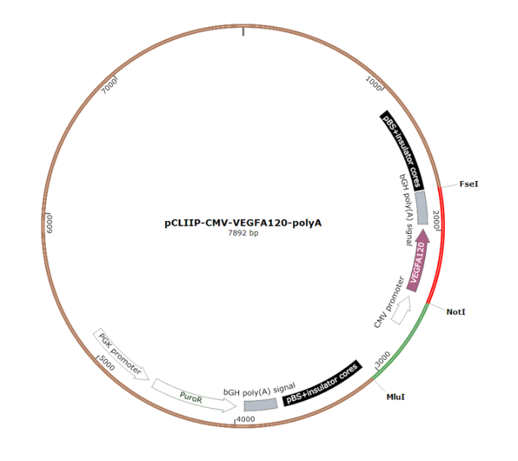
Figure 5. 1. pCLIIP-CMV-VEGFA120 plasmid map

Plasmid map of pCLIIP-CMV-VEGFA120. Cells transfected with the plasmid overexpress VEGFA120 under the control of a cytomegalovirus (CMV) promoter. The final plasmid was checked by DNA sequencing.

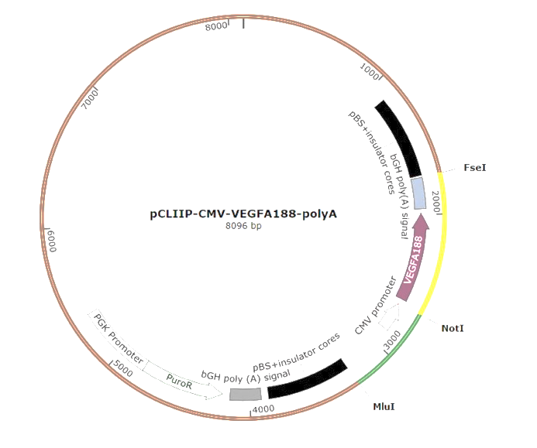
Figure 5. 2. pCLIIP-CMV-VEGFA188 plasmid map

Plasmid map of pCLIIP-CMV-VEGFA188. The plasmids were made using an In-fusion cloning method by Yu-Chin Lee. Cells transfected with this plasmid overexpress VEGFA188 under the control of a cytomegalovirus (CMV) promoter. The final plasmid was checked by DNA sequencing.

5.2.2 Stable fibrosarcoma cell line expressing VEGF isoforms and selection
We sought to create T241 murine fibrosarcoma cell lines that overexpressed VEGFA120 or VEGFA188 isoforms along with the endogenous isoforms using the earlier described plasmids. To create stable cell lines, T241-GFP WT cells were transfected with the pCLIIP and pmPB PiggyBac transposon vectors. Following this, a puromycin selection was conducted according to Chapter 2, Section 2.2.1. Later, single-cell clones from the transfected pools were obtained using a serial dilution technique. To assess the VEGFA expression levels in the clones, a mouse specific VEGFA ELISA was employed. Thus, we used this method as a first filter to detect cell lines with high VEGFA expression.
Figure 5.3 shows the VEGFA expression levels of all VEGFA120 clones obtained. Overall, clones 120.16, 120.18 and 120.19 had the highest expression levels among all the samples. Nonetheless, only clone 120.16 was significantly higher compared to the T241-GFP WT cell line (p-value <0.005) (referred as T241 WT). Thus, these three clones were selected for further characterisation.
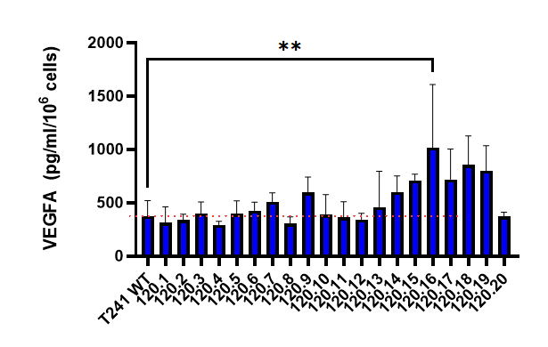
Figure 5. 3. VEGFA expression in T241-CMV-VEGFA120 clones measured by ELISA

Mouse VEGFA secreted by the cell lines was quantified by an ELISA using their cell culture media. The concentration of VEGFA per 1 x 10⁶ T241-GFP (T241-WT) and T241-CMV-VEGFA120 clones was used to correct for difference in cell number between experiments. Data values are mean ± SEM of three independent experiments. One-way ANOVA and Dunnett’s multiple comparisons test were used. **p-value < 0.005. Only p-values < 0.05 are shown.

For selection of the VEGFA188 expressing clones from the puromycin resistant pool QRT-PCR was used. This method was used as the R&D ELISA system predominantly measures VEGFA120 and VEGFA164, with sensitivity for VEGFA188 tenfold lower (English W, personal communication). Our results showed that the T241-GFP WT cell line expressed very low levels of the VEGFA188 isoform. Among all the clones, clone 2 and clone 12 (referred to as 188.2 and 188.12 respectively) produced statistically significantly higher levels of VEGFA188 compared to the T241-GFP WT (94-fold-change and 89-fold change respectively) (Figure 5.4). Thus, 188.2 and 188.12 clones were selected for further characterisation.

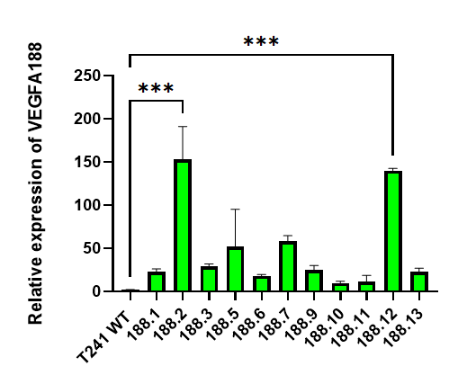
Figure 5. 4. VEGFA188 isoform expression levels by measured by relative quantitative RT-PCR

VEGFA188 isoform expression was quantified by relative expression with QRT-PCR (ΔΔ Ct values) in selected T241-GFP-CMV-188 clones. Data values are expressed as mean ± SEM of two independent experiments. One-way ANOVA test and multiple comparisons (Dunnett's test) were used. Only p-values < 0.05 are shown. ***p-value < 0.0001

5.2.3 Comparison of VEGFA mRNA isoform expression between T241-GFP WT and VEGFA120 and VEGFA188 over expressing clones
Our previous research into the role of VEGFA isoforms has focused on the expression of single isoforms instead of their interaction with the simultaneous expression of other isoforms from the vegfa gene. Where VEGFA isoforms have been over expressed, the impact on the expression of the other isoforms has not been investigated. Our recent experiences in over expressing single isoforms in mouse models of ovarian cancer has shown isoforms expressed from the endogenous vegfa gene can increase in some clones after puromycin selection, making interpretation of results difficult (Aguero, PhD thesis). Therefore, we were interested in measuring all three dominant isoforms among the clones in comparison to the WT cells to ensure only the overexpressed isoforms increased significantly.
The mouse VEGFA ELISA kit used previously for the first screening can only detect soluble VEGFA isoforms rather than each VEGFA individual isoform. Thus, AQRT-PCR was performed to quantify changes in VEGFA120, 164 and 188 isoform mRNA levels in the selected clones in comparison to T241-GFP WT cells. This will give us the exact number of mRNA copies from samples based on known amounts of a control plasmid containing the VEGFA isoform cDNA. To do this, a standard curve established is used for each plasmid amplifying known quantities of target DNA (Boulter et al., 2016).
The efficiency of the PCR reaction was determined for each isoform: VEGFA120 ~97%, VEGFA165 ~98% and VEGFA188 ~93% (Supplemental data). In our results, clones CMV-VEGFA120.18 and 120.19 showed a statistically significant increase in VEGFA120 expression levels (3-fold change and ~4-fold change, respectively) compared to the T241-GFP WT cell line. A small but not statistically significant increase in VEGFA164 was detected with no statistically significant increase VEGFA188 (Figure 5.5A). In addition, the clones T241-CMV-VEGFA188.2 and 188.12 showed a statistically significant increase in VEGFA188 expression levels (67-fold change and 98-foldchange, respectively) compared to the T241-GFP WT and no change in VEGFA120 or VEGFA164 (Figure 5.5B).

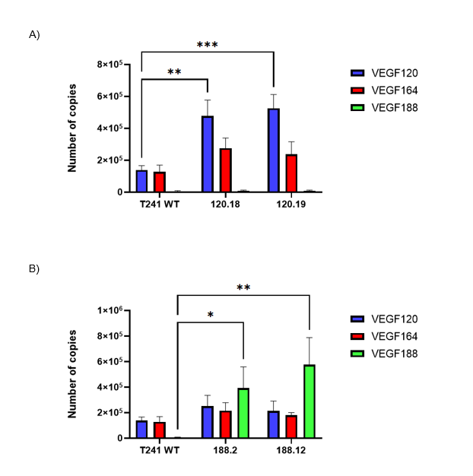

Figure 5. 5. VEGFA isoform expression levels in cell lines over expressing VEGFA120 or VEGFA188 in comparison with T241-GFP WT.

VEGFA120, VEGFA164 and VEGFA188 levels were quantified by AQRT-PCR for the VEGFA120 and VEGFA188 overexpressing clones and compared to VEGFA isoform levels from the T241-GFP WT cells. The number of copies was normalised using Ct values of the GAPDH. Data values are mean ± SEM of three independent experiments. Two-way ANOVA and Dunnett’s multiple comparisons test were used. *p-value <0.05 **p-value < 0.005, *p-value<0.0005. Only p-values < 0.05 are shown.
5.2.4 Characterisation of VEGFA overexpressing T241-GFP clones in vitro
5.2.4.1 Cell proliferation of overexpressing VEGFA isoforms in vitro
To investigate the influence of the overexpression of VEGFA isoforms, cell proliferation was examined using the selected clones in comparison with the T241-GFP WT cell line. This was accomplished using an MTT test and double-checked with Trypan Blue staining. The MTT (3-(4,5-dimethylthiazol-2-yl)-2,5-diphenyl-2H-tetrazolium bromide) reagent is a salt which after a reduction in viable cells is converted to a violet molecule called ‘Formazan’. Formazan is solubilised by Dimethyl Sulfoxide (DMSO) and the absorbance of the transmitted light is measured and reported in Optical Density. The optical density is considered to be a linear representation of the formazan concentration and also of viable cells. As a result, MTT has been utilised to measure cell viability/proliferation and metabolic activity as well as drug toxicity (Ghasemi, et al., . 2021).
On the other hand, Trypan Blue (TB) assay is a dye exclusion assay that stains dead cells in which membrane integrity was damaged. This assay was performed to confirm previous results obtained the with MTT assay (Strober, 2015).
Our MTT analysis showed that clone 120.18 had higher proliferation compared to clone 120.19 and WT, however, the differences were not statistically significant (Figure 5.6A). On the other hand, Figure 5.6B shows that T241-GFP WT and clone 188.2 had a similar growth pattern over the 72. Nonetheless, clone 188.12 showed statistically significantly higher proliferation rates at 72 hours compared to the T241-GFP WT.
Also, the viability of the cell lines was assessed by Trypan Blue staining at 24, 48 and 72 hours. The number of viable cells over the 72 hours was similar between the two VEGFA120 clones and the T241-GFP WT cells and no statistically significant differences were found (Figure 5.7A). Similarly, a similar pattern was observed between the VEGFA188 expressing clones and the T241-GFP WT cells. Despite clone 188.12 presenting a higher cell number compared to the rest of the cell lines as seen in the MTT, no statistically significant differences were found with the Trypan Blue assay (Figure 5.7B).
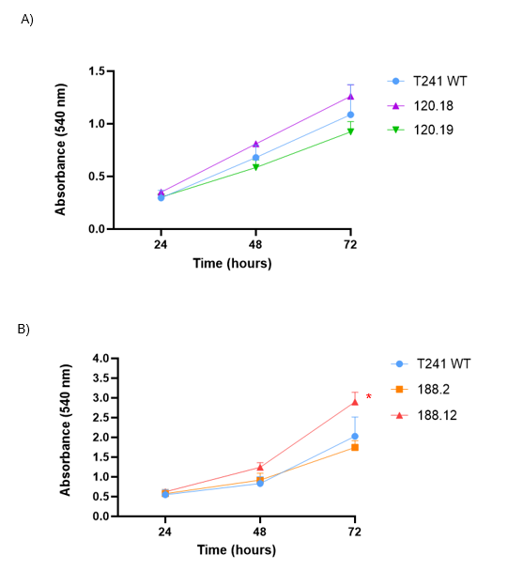
Figure 5. 6. T241-GFP WT and VEGFA isoform over expressing clones proliferation analysis using the MTT assay

Cell proliferation was assessed using the MTT assay at 24, 48 and 72 hours. A) T241-GFP WT and VEGFA120 overexpressing clones proliferation. B) T241-GFP WT and VEGFA188 overexpressing clones proliferation. Data values are expressed as mean ± standard error of three independent experiments. Two-way ANOVA and Dunnett’s multiple comparisons test were used. *p-value < 0.05. Only p-values < 0.05 are shown.

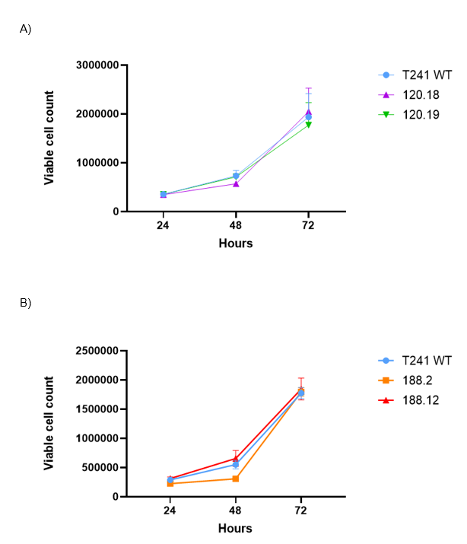
Figure 5. 7. T241-GFP WT and VEGFA isoform over expressing clones proliferation analysis by counting viable cells after Trypan Blue staining.

Cell proliferation and viability was assessed by a Trypan Blue assay at 24, 48 and 72 hours. A) T241-GFP WT and overexpressing VEGFA120 clones cell proliferation B) T241-GFP WT and selected overexpressing VEGFA188 clones cell proliferation. Data values are expressed as mean ± standard error of three independent experiments. Two-way ANOVA and Dunnett’s multiple comparisons test were used. Only p-values < 0.05 are shown.

5.2.4.2 Comparison of morphology and migration characteristics between T241-GFP WT cells and VEGFA isoform overexpressing clones
According to Kanthou et al., (2014), fibrosarcomas with overexpression of single VEGFA isoforms showed changes in cell morphology between different isoform expression. Fibrosarcomas expressing VEGFA188 showed a mesenchymal shape when compared to fibrosarcomas expressing VEGFA120 or VEGFA165. The same morphology changes were presented when cells were cultured onto ECM-coated surfaces.
Therefore, we wondered whether our fibrosarcoma cells overexpressing VEGFA isoforms also had a change in shape. The morphology of selected clones and the T241-GFP WT cell lines were observed by microscopy. Clones overexpressing the VEGFA120 isoform presented a similar morphology to the T241-GFP WT cells. However, we found a prominent elongation in clones overexpressing VEGFA188 compared to T241-GFP WT and the VEGFA120 overexpressing clones (Figure 5.8).
To confirm changes in cell morphology previously seen, the cell morphology was observed on different ECM-coated surfaces. On collagen, the T241-GFP WT and the selected clones presented a mix of round and elongated features. The T241-GFP WT and clone 120.19 showed a more rounded morphology whereas the rest of the cell lines preserved the morphology seen on uncoated surfaces. On laminin, all cell lines presented a more rounded morphology including the T241-GFP WT cell line (Figure 5.9).
Finally, we decided to perform a single cell live imaging to determine whether these differences might influence cell migration as reported by English et al., (2017). Figure 5.10A shows the average ratio of length: width between the cell lines. A ‘rounded’ or epithelial-like cell will have a ratio closer to 1 whereas as higher the ratio the more elongated, fibroblast-like, or mesenchymal-like morphology the cell will present. In this context, both clones T241-GFP-CMV-VEGFA188 had the highest ratios compared to both T241-GFP-CMV-VEGFA120 and T241-GFP WT cell lines. The differences in high ratios between the overexpressing VEGAF188 and the WT were statistically significant. Meanwhile, clones T241-GFP-CMV-VEGFA120 showed a similar ratio compared to the T241-GFP WT, without any statistically significant difference.
In addition, using the same imaging method, quantification of the speed and distance cell migration was conducted. Among all cell lines, T241-GFP WT and clone 120.18 showed the fastest migration without statistically significant difference between them. Meanwhile, both VEGFA188 overexpressing clones and clones 120.19 had a slower rate of migration compared to the T241-GFP WT cells. Clones 120.19 and 188.2 had statistically significant differences in speed compared to the T241-GFP WT (Figure 5.10B). Regarding distance, clones 120.19, 188.2 and 188.12 migrated less distance among all cell lines. Nonetheless, clone 188.2 showed a statistically significant reduction migratory distance when compared to the T241-GFP WT (Figure 5.10C). These results are also similar to the speed found in the cell lines.

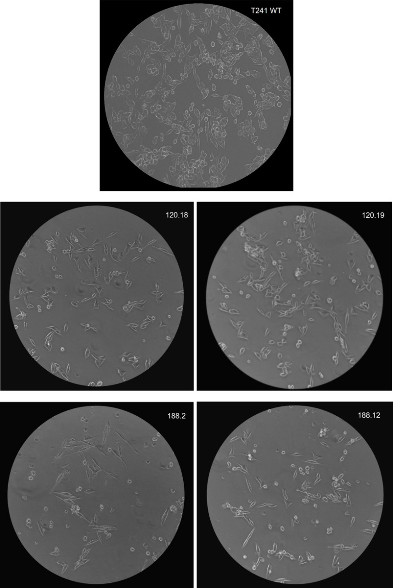

Figure 5. 8. Cell morphology of fibrosarcoma cell lines overexpressing VEGFA isoforms compared to T241-GFP WT by microscopy

Phase contrast images of selected VEGFA overexpressing clones in cell culture medium conditions. 20x objective. Scale bar=270 μm

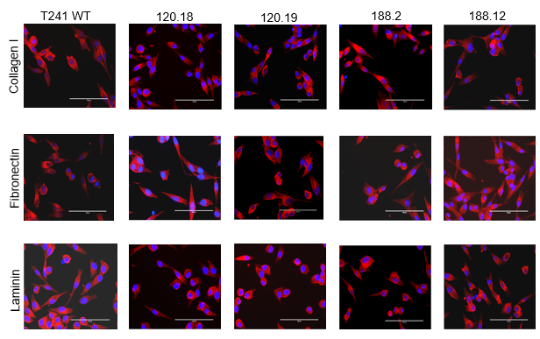

Figure 5. 9. Morphology of fibrosarcoma cell lines overexpressing VEGFA isoforms on different ECM coated surfaces compared to T241-GFP WT cells.

Selected VEGFA overexpressing clones and the T241-GFP WT cell line were cultured on Collagen I, Fibronectin or Laminin coated surfaces. Cells were stained lived with Phalloidin for actin-filaments staining (red) and DAPI for nucleus (blue). Scale bar= 100 μm.

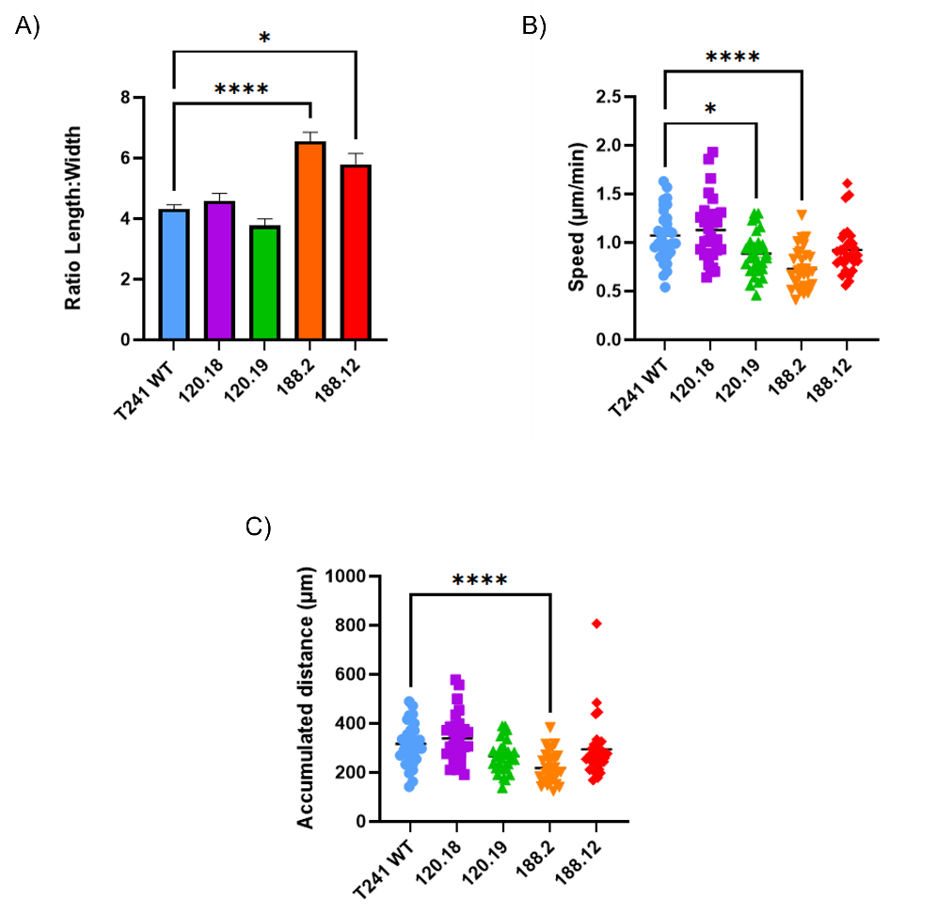

Figure 5. 10. Analysis of morphology, migration speed and distance migration of fibrosarcoma cell lines by live video microscopy

A) Morphology ratio (length/width) of T241-GFP WT and VEGFA isoform overexpressing clones. The ratio of all cell lines was created by measuring and dividing length by width using Fiji2. B) Single cell migration analysis between T241-GFP WT and VEGFA isoform overexpressing clones. C) Analysis of total distance covered during a trajectory of T241-GFP WT and VEGFA isoform overexpressing clones. Data values are expressed as mean ± standard error. Kruskal-Wallis test and multiple comparisons (Dunnett’s test) was used. Only significant p-values are shown. **** p-value <0.0005, * p-value <0.05

5.2.4.3 Characterisation of ECM protein expression in T241-GFP WT cells and VEGFA isoform expressing clones
ECM as part of the non-cellular components in the TME, serves not only as a physical support for tumours, but also as an influence for cell behaviour. The ECM can function as a reservoir for growth factors which can be beneficial for the tumoral cells and promote metastasis. Also, deposition of ECM is related with stiffness of the TME that leads to cell migration and EMT processes (Jiang, Y., 2022). Previous analysis showed differences in ECM deposition between VEGFA single expression tumours, showing fibrosarcoma VEGFA120 tumours with high laminin and low collagen-I compared to VEGFA188 (English et al., 2017).
Thus, we performed Western blots to detect whether the overexpression of VEGFA isoforms influence the ECM expression in our fibrosarcoma cell lines (Figure 5.11). Our analysis of bands on Western blot showed that fibronectin, laminin, and collagen I were highly expressed in clone 120.18 when compared to the rest of the cell lines. The differences in fibronectin levels were statistically significant compared to the T241-GFP WT cell line. On the other hand, clone 120.19 had lower levels of fibronectin and laminin but a similar expression of laminin compared to the T241-GFP WT. None of the differences were statistically significant (Figure 5.12A).
As seen in Figure 5.12B, the analysis of VEGFA188 overexpressing clones demonstrated that clone 188.2 had statistically significantly higher levels of fibronectin and collagen I when compared to the WT cell line. Clone 188.12 exhibited similar expression levels of fibronectin and collagen to the T241-GFP WT cell line, except for laminin which was statistically significantly higher.

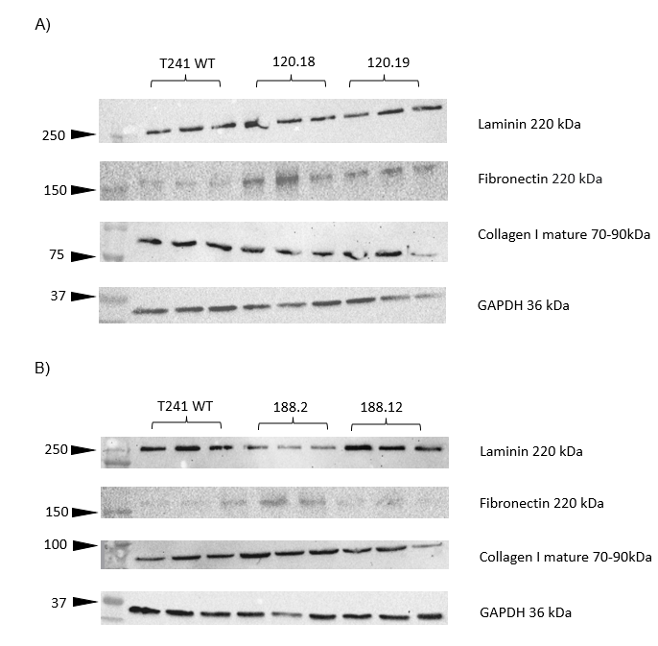
Figure 5. 11. Immunoblotting of ECM proteins in T241-GFP WT VEGFA isoform overexpression cells

A) Representative images of Western blots of ECM proteins among selected VEGFA120 isoform overexpressing cells and T241-GFP WT. B) Representative images of Western blots of ECM proteins among selected VEGFA188 isoform overexpressing cells and T241-GFP WT. GAPDH was used as a housekeeping gene for all Western blots.

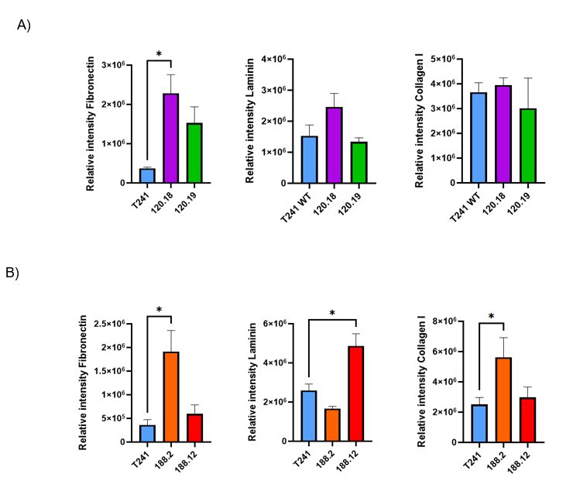

Figure 5. 12. Semi-quantitative analysis of ECM protein expression in T241-GFP WT and VEGFA isoform overexpressing clones

Relative intensity analysis of ECM proteins detected by Western blot among VEGFA120 isoform overexpressing cells compared to T241-GFP WT. B) Relative intensity analysis of ECM proteins by Western blot among VEGFA188 isoform overexpressing cells compared to T241-GFP WT. Data values are expressed as mean ± standard error of three independent experiments. Kruskal-Wallis test and multiple comparisons (Dunnett's test) was done. Only significant p-values are shown. * p-value <0.05

5.2.4.4 Changes in mesenchymal proteins associated with epithelial to mesenchymal transition (EMT) in T241-GFP WT cells and VEGFA isoform expressing clones.
EMT has been observed in cancer cells to acquire motility and invasion features which promotes cancer metastasis (Huang, Hong and Weis, 2022). Regarding sarcomas, EMT research is under discussion as the origin of sarcoma is mesenchymal. However, a new feature of sarcoma cells called ‘metastable’ has been proposed. This feature promotes the differentiation of sarcoma cells according to their necessities (Sannino et al., 2017). Fibrosarcomas expressing single VEGFA isoforms showed changes in morphology when expressing different isoforms. VEGFA120 confers an epithelial-rounded morphology unless on specific ECM when it becomes mesenchymal, whereas VEGFA188 preserves a mesenchymal phenotype under all conditions, suggesting VEGFA120 isoform expression leads to increased plasticity (Kanthou et al., 2014; Yamamoto et al., 2016).
Therefore, we evaluated mesenchymal markers in our cell lines to investigate whether their expression changes according to VEGFA isoform overexpression. To achieve this, the protein expression of SOX2, αSMA, sm22α, N-cadherin and vimentin was investigated using Western blots (Figure 5.13). These proteins showed that all cell lines expressed mesenchymal markers. An analysis of the immunoblotting showed that there were no statistically significant differences in SOX2 and sm22α expression between the clones and the WT cell line. The expression of N-cadherin, a classic mesenchymal marker, was not detected in any of the cell lines. Vimentin a showed statistically significant increase in clone 120.18 when compared to the T241 WT cell line. Also, increased levels were found in clone 188.2. However, the difference in levels were not statistically significant. On the other hand, statistically significant differences were found in αSMA expression. The clone 120.18 and 188.12 expressed statistically significantly higher levels of αSMA when compared to the T241-GFP WT with p-values <0.005 and p-value<0.05, respectively (Figure 5.14).

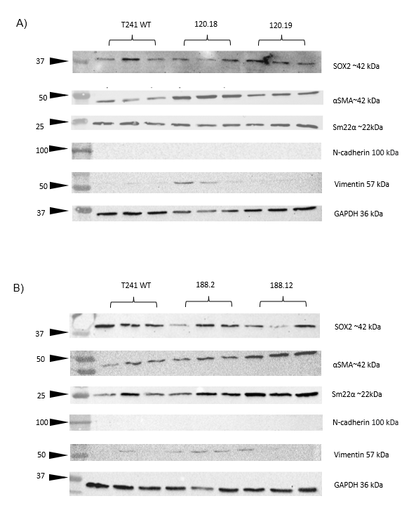
Figure 5. 13. Immunoblotting of mesenchymal EMT markers in T241-GFP WT and VEGFA isoform overexpression cells

Representative images of Western blots of mesenchymal markers among selected VEGFA120 overexpressing clones. B) Representative images of Western blots of mesenchymal markers among selected VEGFA188 overexpressing clones. GAPDH was used as a housekeeping gene for all Western blots.

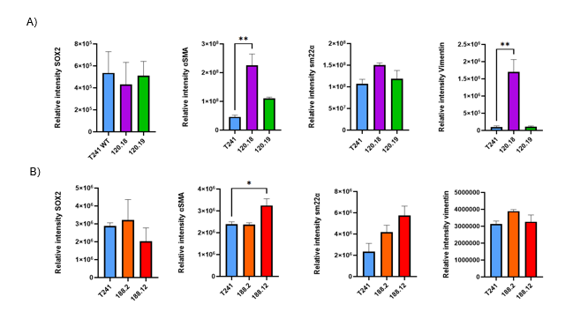
Figure 5. 14. Semi-quantitative analysis of mesenchymal EMT associated markers in T241-GFP WT and VEGFA isoform overexpression cells

The relative intensity of mesenchymal markers among selected VEGFA120 isoform overexpressing cells and T241-GFP WT. B) Relative intensity of some epithelial and mesenchymal markers among selected VEGFA188 isoform overexpressing cells and T241-GFP WT Data values are expressed as mean ± standard error of three independent experiments. One way ANOVA and Dunnett’s multiple comparison test were used. Only p-values ,0.05 are shown. **p-value <0.005, * p-value <0.05

5.2.4.5 Kinase signalling in T241 WT and VEGFA isoform overexpressing clones
Kinases regulate the activation of transcriptional pathways involved in cellular homeostasis such as proliferation, migration, and apoptosis. Thus, an impairment activity of these proteins can affect cells behaviour leading to initiation or progression of tumours (Paul and Mukhopadhyay, 2004). As we found differences in morphology and migration, we investigated the impact of VEGFA isoforms expression on kinases which participates in main signalling pathways downstream of the VEGFRs that could be linked to these differences using Western Blots (Figure 5.15).
Our results showed that total AKT was higher in both VEGFA overexpressing clones compared to the T241-GFP WT. The difference in AKT expression levels of clone 120.18 versus the T241-GFP WT was statistically significant. On the contrary, the expression of phosphorylated-AKT (p-AKT) (Ser473) was higher in the T241-GFP WT compared to the clones without statistically significant differences. In terms of total Src and its phosphorylated version (Tyr416), both VEGFA120 clones showed higher levels than the T241 WT. However, no statistically significant differences were found (Figure 5.16A). In terms of the VEGFA188 overexpressing clones, AKT and phosphorylated-AKT expression levels were lower than the T241-GFP WT. Nonetheless, no statistically significant differences were found. The T241-GFP WT showed higher Src expression levels when compared to both VEGFA188 clones. The difference between the T241-GFP WT and clone 188.2 was statistically significant. On the other hand, higher levels of phosphorylated Src (p-Src) were found in both VEGFA188 clones when compared to the T241-GFP WT without statistically significant differences (Figure 5.16B).

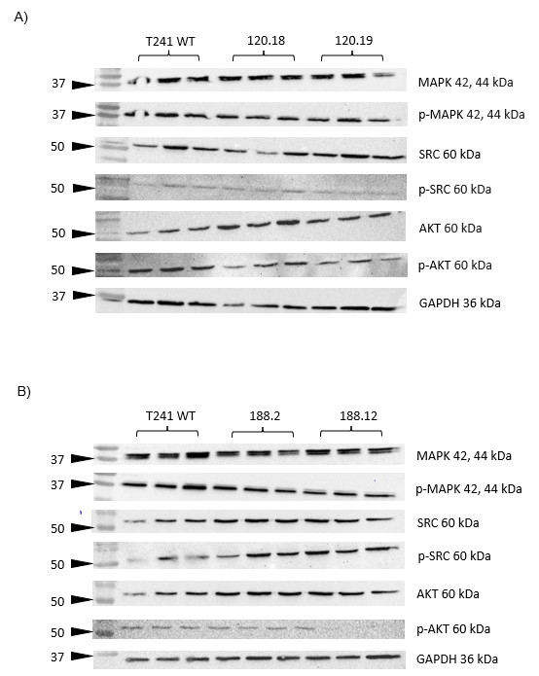

Figure 5. 15. Immunoblotting of kinase activation in T241-GFP WT and VEGFA isoform overexpressing cells using Western blot

A)Representative images of immunoblots of total and phosphorylated kinases Src/ p-SRC (Tyr416), AKT/ p-AKT (Ser473) and p42/44 MAPK/p-p42/44 MAPK in T241-GFP WT compared to VEGFA120 overexpressing clones. B) Representative images of immunoblots of total and Src/ p-SRC (Tyr416), AKT/ p-AKT (Ser473) and p42/44 MAPK/p-p42/44 MAPK in T241-GFP WT compared to selected VEGFA188 overexpressing clones. GAPDH was used as a housekeeping gene to demonstrate equal loading of protein samples for all western blots. Lysates from three independent sample replicates are shown for each cell line.

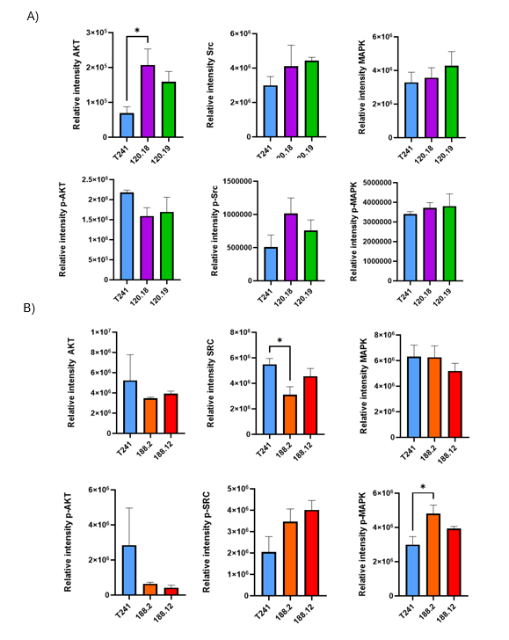
Figure 5. 16. Semi-quantitative analysis of kinase expression and phosphorylation in T241-GFP WT VEGFA isoform overexpression cells quantified by Western blot

A) The relative intensity of kinases among VEGFA120 isoform overexpressing cells and T241-GFP WT. B) Relative intensity of kinases among VEGFA188 isoform overexpressing cells and T241-GFP WT. Data values are expressed as mean ± standard error of three independent experiments. One-way ANOVA and Dunnett’s multiple comparisons test were used. **p-value < 0.005. * p-value <0.05 Only p-values < 0.05 are shown.

5.2.4.6 The impact of anti-VEGFA antibodies on kinase phosphorylation in T241 WT and VEGFA isoform overexpressing clones cell lines
An anti-mouse/human VEGFA therapy (B20.4.1.1) has shown to influence subcutaneous tumours from fibrosarcomas overexpressing VEGFA120 affecting their growth in vivo but also affecting migration in vitro when compared to VEGFA188 expressing tumours and cell lines (English et al., 2017). Hence, we aimed to examine the effect of this anti-VEGFA antibody (referred as B20) and a control IgG (BE5) on VEGFA isoform overexpressing cell lines and whether this might affect kinase expression and phosphorylation (Figure 5.17).
Overall, no major differences were found across all clones treated with B20 or BE5. VEGFA120 overexpressing clones exhibited similar expression levels of total AKT and total p42/44 MAPK between cell lines with the two different treatments. Nonetheless, the same clones showed higher levels of total Src in cell lines treated with B20 when compared to BE5 treated cell lines, especially the clone 120.19, but no statistical differences were found. VEGFA120 cell lines with B20 treatment had a reduced expression of p-Src, again without statistical differences (Figure 5.18A).
As seen in Figure 5.18B, similar levels of total AKT were exhibited in the T241-GFP WT and clone 188.2. In contrast, clone 188.12 showed higher AKT levels when treated with B20. No statistically significant difference was found. T241-GFP WT and clone 188.12 presented similar levels of p-AKT between antibody treatments, except for clone 188.2 which had an increase in activated AKT in the presence of B20 when compared to those treated with BE5. Src levels showed variable expression levels independently of treatment. However, we found higher levels of Src in the 188.12 cell line when treated with B20 versus treated with control IgG BE5. This difference was not statistically significant. Regarding p42/44 MAPK expression, higher expression levels were found in all cell lines treated with the control IgG BE5 compared to treatment with B20. Nonetheless, activated p42/44 MAPK (p42/44 p-MAPK) showed increased expression in clone 188.12 treated with BE5 when compared to those treated with B20.

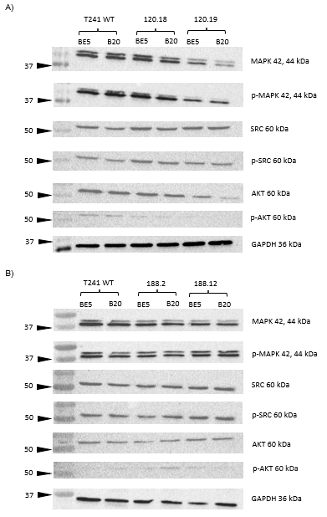

Figure 5. 17. Inhibition of kinases by an anti-VEGF antibody in T241-GFP WT and VEGFA isoform overexpressing clones detected by Western blot.

A) Representative images of immunoblots of total and phosphorylated levels of kinases Src/ p-SRC (Tyr416), AKT/ p-AKT (Ser473) and p42/44 MAPK/p-p42/44 MAPK after treatment with an anti-VEGF (B20.4.1.1) (referred as B20) or IgG control (BE5) antibody in T241-GFP WT and VEGFA120 overexpressing clones. B) Representative images of immunoblots of total and phosphorylated kinases Src/ p-SRC (Tyr416), AKT/ p-AKT (Ser473) and p42/44 MAPK/p-p42/44 MAPK after treatment with an anti-VEGF (B20.4.1) (referred as B20) or IgG control (BE5) anti body in T241-GFP WT and VEGFA188 overexpressing clones. GAPDH was used as a housekeeping gene to check for equal protein loading
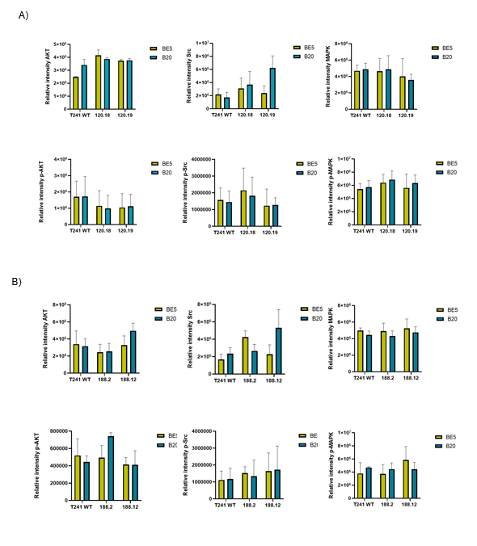
Figure 5. 18. Semi-quantitative analysis of kinases inhibition by an anti-VEGFA antibody in T241-GFP WT and VEGFA isoform overexpressing clones in vitro.

A) The relative intensity of total and phosphorylated/activated expression levels of kinases Src/ p-SRC (Tyr416) , AKT/ p-AKT (Ser473) and p42/44 MAPK/p-p42/44 MAPK after treatment with an anti-VEGF (B20.4.1) (referred as B20) or IgG control BE5 in T241-GFP WT and VEGFA120 overexpressing clones B) The relative intensity of total and phosphorylated/activated expression levels of kinases Src/ p-SRC (Tyr416), AKT/ p-AKT (Ser473) and p42/44 MAPK/p-p42/44 MAPK after treatment with an anti-VEGF (B20.4.1) (referred as B20) or IgG control (BE5) in T241-GFP WT and overexpressing VEGFA188 clones. Data values are expressed as mean ± SEM of three independent experiments. One-way ANOVA followed by Dunnett’s test for multiple comparison was used. Only significant p-values are shown.

5.2.4.7 The influence of VEGFA isoform overexpression on kinase phosphorylation and inhibition with pazopanib in fibrosarcoma cells
Once knowing the importance of kinases in cell biology and tumorigenesis, many efforts has been done to develop prospective drugs targeting kinases. Pazopanib is a multi-target TKIs that inhibits receptor tyrosine kinase (RTKs) which activate downstream signalling pathways related to tumour angiogenesis, cell growth and survival. Examples of RTKs include Vascular Endothelial Growth Factor receptor (VEGFR), Platelet Derived Growth Factor receptor (PDGFR), Epidermal Growth Factor receptor (EGFR) (Regad, 2015; Lee, Jones, and Huang 2019).
In this experiment, we assessed the influence of a multitargeted TKI treatment exploring its impact on kinases expression and the influence of the overexpression of VEGFA isoforms in our cell lines. Two different doses were used in vitro to assure the inhibition of kinases according to IC50 Pazopanib profile by Kumar et al.,. 2007. DMSO was used as a control treatment. After treatment cell lines were lysed and analysis of kinases expression was explored by Western blots as shown in Figure 5.19.
Overall, our results demonstrated no big differences in the expression of kinases or their phosphorylation between both doses of multi-target RTKI treatment among all cell lines. Clones overexpressing VEGFA120 treated with DMSO showed similar or even lower expression levels of kinases compared to treatment with Pazopanib (Figure 5.20A).
The p-AKT(Ser473), p-MAPK (p42/44) and p-Src (Tyr416) expression levels showed a trend of diminished activation in cells overexpressing VEGFA188 isoform when treated with the anti-multitarget TKI compared to the DMSO. A statistically significant difference was found only in the T241-GFP WT cells treated with 1 μM of Pazopanib versus the control (DMSO). Although no statistical differences were found between the kinase phosphorylation, a trend can be visualised exhibiting a sensitivity of VEGFA188 cells to a multi-targeted TKI (Figure 5.20B). An additional analysis was made to calculate the ratio between the phosphorylated expression of kinases in relation to the total expression which showed minimal activation of the kinases (Supplemental data. Figure S2).
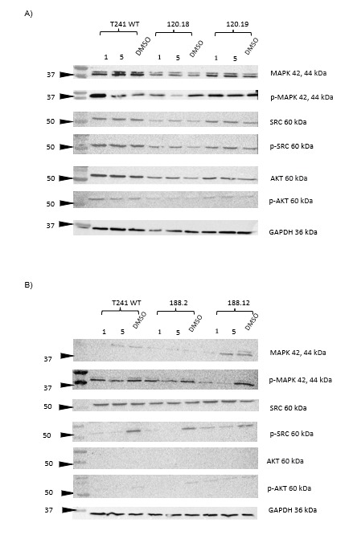
Figure 5. 19. Inhibition of kinases by a RTK inhibitor (Pazopanib) in T241-GFP WT and VEGFA isoform overexpressing clones detected by Western blot.

Representative images of immunoblots of total and phosphorylated expression levels of kinases Src/ p-SRC (Tyr416), AKT/ p-AKT (Ser473) and p42/44 MAPK/p-p42/44 MAPK after treatment with 1 μM, 5 μM of Pazopanib or DMSO in T241-GFP WT and overexpressing in VEGFA120 clones (Figure 5.19A) and in VEGFA188 clones (Figure 5.19B). GAPDH was used as a housekeeping gene to normalise.
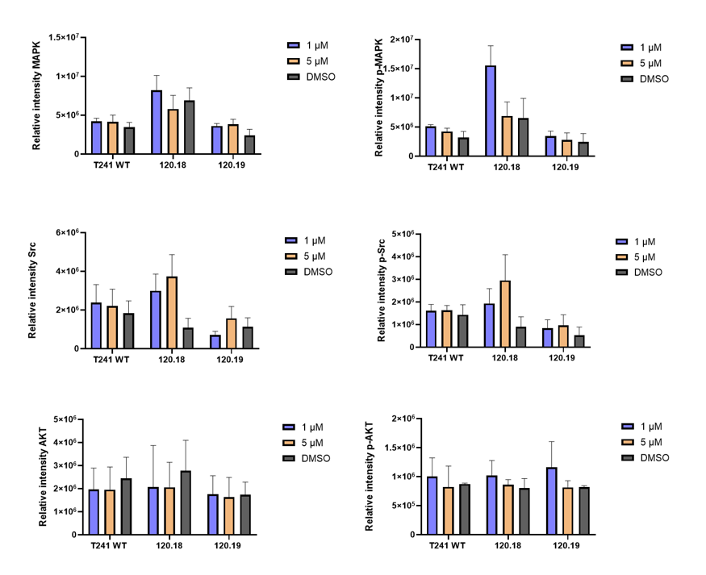

Figure 5. 20. Semi-quantitative analysis of kinases inhibition by different doses of Pazopanib in T241-GFP WT and VEGFA120 isoform overexpressing clones in vitro

The relative intensity of total and phosphorylated expression levels of kinases Src/ p-SRC (Tyr416), AKT/ p-AKT (Ser473) and p42/44 MAPK/p-p42/44 MAPK after treatment with 1 μM, 5 μM of Pazopanib or DMSO in T241-GFP WT and overexpressing VEGFA120 clones. GAPDH was used as a housekeeping gene to normalise. Data values are expressed as mean ± standard error of three independent experiments. One-way ANOVA followed by Dunnett’s test for multiple comparison was used. Only significant p-values are shown. *p value< 0.05

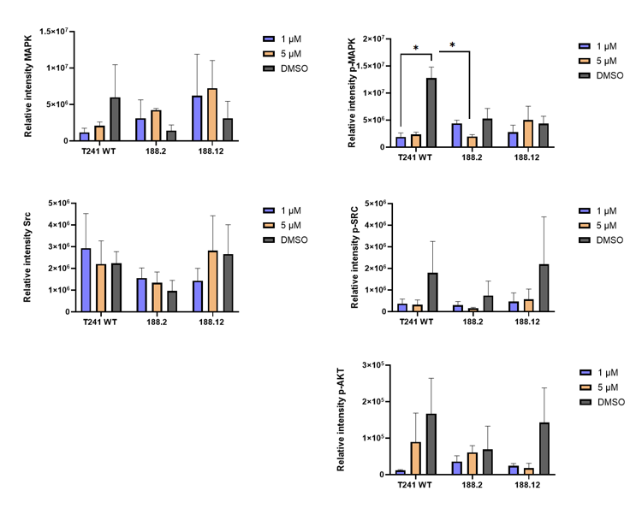

Figure 5. 21. Semi-quantitative analysis of kinase inhibition by different doses of Pazopanib in T241-GFP WT and VEGFA188 isoform overexpressing clones in vitro

The relative intensity of total and phosphorylated expression levels of kinases Src/ p-Src (Tyr416), AKT/ p-AKT (Ser473) and p42/44 MAPK/p-p42/44 MAPK after treatment with 1 μM, 5 μM of Pazopanib or DMSO (control) in T241-GFP WT and overexpressing VEGFA188 clones. Of note, the relative intensity outcome of AKT were unsatisfactory for graphical representation. GAPDH was used as a housekeeping gene to normalise. Data values are expressed as mean ± standard error of three independent experiments. One-way ANOVA and Dunnett’s multiple comparisons test were used Only significant p-values are shown. *p value< 0.05

5.3 Discussion
As mentioned in the introduction to this thesis, previous studies have reported the influence on fibrosarcoma cells expressing single VEGFA isoforms on tumour growth, migration, and response to treatments (Akerman et al., 2013, Tozer et al., 2008; Kanthou et al., 2014; English et al., 2017). However, these experiments have limitations including their use of xenografts in immunocompromised mice. To overcome this, our objective was to create a cell line overexpressing VEGFA isoforms which could be grown in syngeneic mice C57BI6. This with help us to test our hypothesis about the relationship between isoforms and the TME.
As was shown in the results part of this chapter, the system pCLIIP-CMV-VEGFA proved to be an efficient method for overexpression of VEGFA120 and VEGFA188 isoforms in mouse fibrosarcoma cells. To initially screen for potential clones overexpressing VEGFA isoforms, we used the mouse VEGF DuoSet ELISA (R&D systems). This assay measures natural and recombinant mouse VEGFA120 and VEGF164. However, it reports a 11.1% of cross-reactivity for VEGFA188 and cross-reaction with recombinant mouse VEGFR-1/Fc chimera with concentrations higher than 62.5 pg/ml (R&D systems, 2023). Moreover, previous experience in our lab showed that overexpression of a specific isoforms can impact the expression levels of other isoforms (Aguero-Burgos B, PhD thesis). In this case, the use of an additional method for VEGFA quantification was needed.
Absolute quantitative RT-PCR of VEGFA120, VEGFA188 and VEGFA164 isoforms was performed in the selected clones which helped us to accurately know the number of copies of each isoform. Surprisingly, the T241-GFP WT cell line expressed similar levels of VEGFA164 and VEGFA120 but almost no VEGFA188 isoform. Also, our results showed that selected clones significantly increased the expression of the desired VEGFA isoform when compared to the T241-GFP WT with no statistically significant increase in the other isoforms from the endogenous gene. Therefore, clones 120.18, 120.19, 188.2 and 188.12 were used for further experiments.
Characterisation of proliferation and viability in vitro showed similar patterns for all the selected clones without significant differences compared except for 188.12. On the third day, 188.12 exhibited higher proliferation with significant differences. A similar proliferation pattern between VEGFA120 and VEGFA164 was reported in the literature before. However, the significant difference between the WT (which produces higher amounts of VEGFA164) and the clone 188.12 is contrary to what was reported by Tozer et al., (2008). This publication showed that VEGFA164 and VEGFA120 expressing cells had higher proliferative ratios compared to VEGFA188 expressing cells. Nonetheless, it is necessary to consider that although our cells overexpress VEGFA188, they also express VEGFA164 and VEGFA120 simultaneously. These make us question whether our results might be influenced by the expression of the other isoforms even at lower levels?
Our cell morphology analysis exhibited that the VEGFA188 cell line had a notable change in morphology. Additionally, migration analysis showed that clone 120.19 and both VEGFA188 clones were significantly slower compared to the T241 WT. Differences in speed between 120.19 and 188.2 were statistically significant when compared to the fibrosarcoma WT. Morphology results showed that VEGFA188 overexpressing clones had features consistent with a mesenchymal shape which could lead us to think that the migration of these cells will be faster as shown by Kanthou et al., . (2014). However, our migration results do not correlate with the ‘mesenchymal migration’ reported in the literature (Pankova K et al., 2010). Regarding our results, it is important to highlight the methodology used to induce VEGFA isoform overexpression using a transposon system. The Piggy Bac transposon used in this experiment is frequently acknowledged as a trustworthy and effective instrument for transfection above other types of transposon systems (Ding et al., 2005; Woltjen et al., 2009; Muñoz-López and García-Pérez, 2010; Zhao, et al., 2016), Nonetheless, overall transposable elements insertions and removals are often imprecise. This can have diverse biological consequences in nearby host sequences such as expression of genes (and its isoforms) or disruptions of gene sequences that can alter physiological processes such as signalling pathways, cellular structures, DNA instability, etc (Bourque et al., 2018). Hence, future investigations to explain the mechanisms behind these physiological changes include for example the use of in vitro inhibitors targeting specific VEGFA isoforms to determine the influence of a particular overexpression of these molecules. Another option could be using PCR or sequencing analysis (NGS) as a way to verify the transposon site insertions within the host cell or as a global result of the clonal selection.
Another possible explanation to morphology changes might be related to an endothelial-mesenchymal transition (EMT) process-like. Several soft tissue sarcomas subtypes are classified as mesenchymal cells since the beginning, therefore whether sarcomas cells can undergo an EMT is controversial. However, it has been reported the expression of epithelial markers like E-cadherin in subtypes of sarcoma such as leiomyosarcoma or synovial sarcoma. Supporting that sarcoma can undergo through a related EMT/MET process (Yang et al., 2014). This supports our findings were, although cells might have suffered phenotypic changes (more mesenchymal shape), they still expressed epithelial markers such as laminin but mainly mesenchymal markers like alpha-sma. In this context, Sannino et al., (2017) proposed the term 'metastable cells' where sarcoma cells have a dual function, either transform to mesenchymal or epithelial, according to the tumour necessity. This characteristic could lead to an aggressive behaviour during sarcomagenesis in some sarcoma subtypes. In this case, future work could include the examination of more epithelial markers such as E-cadherin and β-catenin or examine miRNAs known to be related to the EMT process such as the miR-200 family (Mongro and Rustgi, 2010).
Fibronectin and Collagen I were increased in our selected clones without any preference for VEGFA isoforms. Differences in fibronectin levels were statistically significant in one VEGFA120 clone and one VEGFA188 clone. On the other hand, laminin did not present statistically significant changes among the cell lines except for the 188.12 clone compared to the fibrosarcoma will type cell line. English et al., 2017 showed that fibrosarcoma cells overexpressing VEGFA120 presented higher levels of laminin and elevated levels of collagen I were related to overexpression of VEGFA188. However, our results differ from this study as prominent levels of both proteins were seen in fibrosarcomas overexpressing either VEGFA120 or VEGFA188 cell lines. Also, fibronectin levels are not shown in this paper. The behaviour of collagen I and fibronectin may be explained as there is a close relationship between the expression of both proteins where the assembly of collagen I in the ECM is co-dependent on fibronectin expression in vivo and in vitro (Paten et al., 2019; Kubow et al., 2015; Sottile et al., 2007).
The study of kinase families as regulators of cellular proliferation and survival has led us to understand their critical role in cancer diseases and their influence as targeted therapy. Based on the PALETTE clinical trial results, Pazopanib has been approved by the FDA for advanced non-GIST STS. Once receptor tyrosine kinases (RTKs) are activated, they participate in signal transduction for diverse cellular processes. Therefore, aberrant signalling among these receptors is commonly observed in cancer (Paul and Mukhopadhyay, 2004). In this case, the use of receptor tyrosine kinases inhibitors (RTKIs) has proven useful in STS (Qin et al.,., 2019; Du and Lovly, 2018). Overall, initial characterisation of our chosen clones failed to show any significant changes in cell viability or proliferation that might suggest variations in RTKs signalling. Nevertheless, morphological changes were observed specially in clones overexpressing VEGFA188, which exhibited an elongated shape in contrast to the rest of our cell lines. This observation suggests potential cytoskeletal remodelling. Therefore, we ought to investigate if RTKs signalling were responsible of these morphological alterations. This finding aligns with a study by Kanthou et al.,., (2014), where murine fibrosarcomas overexpressing single VEGFA188 displayed a mesenchymal shape along with highly activated AKT, p42/44 MAPK and Stat3 signalling (Kanthou et al., 2014). Moreover, VEGFA189 in human cancer has been linked with tumour progression, distant metastases and K-ras mutations (Nishi et al., 2005; Regina et al., 2008). Thus, examining RTKs signalling in our selected cell lines holds significant relevance.
Our characterisation showed that p42/44 MAPK did not present substantial changes in the total form and the phosphorylated p42/44 MAPK version in VEGFA120 overexpressing clones when compared to the T241-GFP WT. Also, no statistical differences were found in the total p42/44 MAPK between the fibrosarcoma cell lines. However, statistically significantly higher levels of phosphorylated p42/44 MAPK were found in the 188.2 clone. This might suggest that clone 188.2 could be related to aggressive behaviour as reported by Serrano et al.,. (2016) who also reported an elevation of phosphorylated ERK 1/2 in one-third of their patients with UPS. A sarcoma subtype which was considered in the past as part of the same family as MFS due to their similarities.
Regarding AKT, overexpression of VEGFA120 and VEGFA188 isoforms reduced p-AKT levels. Meanwhile, VEGFA120 clones showed elevated levels of total AKT which indicates that although VEGFA120 had Akt signalling this is inactive. Therefore, we could hypothesise that the overexpression of VEGFA120 and VEGFA188 might had less proliferative signalling concerning AKT pathways. Like our results, Kanthou et al.,. (2014) reported that VEGFA120/ VEGFA164 overexpressing cells had no activation of Akt. Also, that VEGFA188 fibrosarcoma cells had elevated levels of activated p42/44 MAPK but no activation of VEGFR-2 which might indicate that elevated levels of p42/44 MAPK did not result from VEGF-dependent autocrine activity via tyrosine kinase VEGF receptors.
Another goal for the characterisation of our cell lines was to test whether expression of kinases might be influenced by VEGFA isoform expression and therefore, influence by an anti-VEGFA treatment in our cell lines. To do this, first we evaluated treatments in vitro with the anti-mouse/human VEGFA function-blocking recombinant antibody B20-4.1.1 and IgG control. Our results did not show statistically significant differences of the kinases expression or phosphorylation among our cells on treatment with B20. These results were independent of expression of VEGFA isoforms. In this context, it is important to mention that B20-4.1.1 blocking is not selective among VEGFA isoforms.
Meanwhile, treatment with a multitarget RTKI, Pazopanib, at 1 μM or 5 μM or with the DMSO vehicle control was chosen according to the kinase inhibitory profile (IC50) by Kumar et al., 2007 were mostly of oncogenic pathways related with angiogenesis, PI3K and MAPK pathway were inhibited with up to 5 μM. Overall, no statistically significant results were found among VEGFA120 and VEGFA188 overexpressing cells. Nonetheless, a trend can be seen in VEGFA188 cells which presented lower levels of activated/phosphorylated SRC, AKT and p42/44 MAPK. Our thought is that no significant results are due to the large deviation in error, this could be reduced with an increase of biological repeats. However, due to shortage of time, more than three biological replicates were not possible.
Our results agree with diverse literature which reports the inhibition of kinases phosphorylation among diverse tumours in vivo and in vitro. BRAF-mutated breast cancer cell lines used for in vivo models treated with Pazopanib limited metastasis along with reduction of MAPK pathways activation (Gril, et al.,., 2011). Also, anti-VEGFA treatment in cervical cancer showed a relationship between the activation/inhibition of VEGFA and activation/inhibition of p13/AKT/mTOR pathways which influence the growth and invasion of the tumours (Chen et al.,., 2014). A partial effect of Akt and MAPK pathways has been reported under a high dose of pazopanib treatment which may suggest their activation might be via other receptors like insulin-like-growth factor receptor 1 (IGFR1) (Grünewald et al.,., 2020). Also, Tavallai et al., . 2014, reported comparable results where the signal of AKT and p42/44 MAPK suffered modest changes when fibrosarcoma cells were treated in vitro with pazopanib and valproate. However, when activated signalling was present by induction, the cytotoxic cellular effect was almost abolished by the treatments which might confer protection for the cells. These reports led us to think that Pazopanib seems to be a promising treatment for VEGFA188 overexpressing cell lines, reducing the pro-proliferative behaviour shown in our results, whereas VEGFA120 did not show an important sensitivity to the multitarget-RTK therapy. Regarding, the relationship between VEGFA isoforms and response to Pazopanib, limited information is available to our knowledge.
Unfortunately, due to the COVID pandemic, the laboratory work was interrupted and consequently, there was reduced time to perform experiments. So far, our results presented regarding changes in VEGFA188 expression show promising results to continue with in vivo models. Due to these reasons, further experiments to create an in vivo model were limited to exploring only the T241-GFP-CMV-VEGFA188 clones, 188.2 and 188.12 versus the T241-GFP WT. The results of our animal models will be presented in the next chapter.

CHAPTER VI
The influence of VEGFA188 isoform overexpression within the fibrosarcoma tumour microenvironment

6.1 Introduction
Treatment for sarcoma patients is commonly defined as surgical, chemotherapeutic and/or radiotherapy-based approaches. Nonetheless, recurrence of the disease is often seen in patients where tumoral cells become non-responsive to conventional treatments. In this case, research has been obliged to find new treatment approaches. Nowadays, immunotherapy has had a substantial impact on the treatment of solid tumours such as melanoma, lung cancer and prostate cancer. These results have guided studies into immunotherapy as a new treatment option for sarcoma.
STS are considered 'cold' tumours. However, initial research on the TME and immune cell infiltration had shown surprising results in some subtypes of sarcoma. For example, the TCGA Research Network group studied the genomics of diverse subtypes of sarcoma showing that pleomorphic subtypes exhibited a high gene expression signature of immune response pathways (Abeshouse et al., 2017). Thus, the interest in immune response has started to be investigated in the most common subtypes such as gastrointestinal stromal tumour (GIST), leiomyosarcoma (LMS) and undifferentiated pleomorphic sarcoma (UPS).
Another approach to cancer therapy is anti-angiogenic treatment. This is based on the general knowledge about the importance of blood supply through tumour development and metastasis. VEGFA is known to have a key role in angiogenesis (creation of new blood vessels from previously formed). In this context, anti-VEGFA could prune blood vessels and starve tumoral cells (Folkman, 1990). However, this innovative approach to therapy will also block the delivery of therapies. Thus, the 'Normalisation of tumour blood vessels' theory was proposed by Jain RK (2005). This theory proposed the restoration of tortuous, immature, and leaking blood vessels to those more comparable to normal vessels within the TME by anti-angiogenic agents. This normalisation will offer a time window for the delivery of other treatments. Despite this advantage, vessel normalisation also offers an escape opportunity for tumoral cells. Hence, a complementary treatment was needed.
Based on these results, Tozer et al., (2008) showed fibrosarcomas only expressing VEGFA120 have poor functioning vasculature with very few pericytes in contrast to fibrosarcomas expressing VEGFA188, suggesting VEGFA188 may lead to vascular normalisation. Following this, English et al., (2017) have shown that fibrosarcomas overexpressing the single isoform VEGFA120 have increased metastasis to the lung and respond better to an anti-VEGFA treatment in murine models compared to VEGFA188 models.
Subsequent unpublished investigations using RNAseq from VEGFA120 and VEGFA188 expressing tumours in our laboratory showed that VEGFA120 expressing tumours have increased gene expression associated with immune response and immune repression including PD-L1 itself. Thus, we speculate that VEGFA164/120 tumours might promote immune response and exhausted T cells status where immune checkpoint expression is fundamental (Valluru, not published). This suggests VEGFA isoform measurement could be useful as a biomarker for immunotherapy response. In addition, increasing VEGFA188 expression could increase sensitivity to tumour targeting immune cells or sensitivity to immunotherapy. Thus, this tumour status could provide a promising opportunity for sarcomas to be treated with immune checkpoint inhibitors. However, these previous fibrosarcoma models expressing single VEGFA isoforms were in immunocompromised mice and are unsuitable for further studies of the adaptive immune system in relation to VEGFA isoform expression in the TME.
To investigate this further, we aimed to create a new fibrosarcoma model in immunocompetent mice to investigate the TME, the adaptive immune system and its relationship with the different VEGFA isoforms. This will help us to elucidate whether sarcoma models are responsive to combination therapy of anti-angiogenics and immunotherapy. The T241-GFP Fibrosarcoma cell line was used to create these models to be able to grow tumours in syngeneic mice to study host immune response. This is fundamental as previous literature have been using xenografts in SCID mice and mainly human sarcoma cell lines (Dodd, Mito, and Kirsch, 2010). These main limitations limit the study of sarcomas and highlight the complexity of the study of sarcoma in vivo. To characterise the TME we use an immunofluorescence (IF) method since it is easy-to-perform given the time limitations and the English group has extensive experience performing it.
Hence, this chapter will show the baseline characterisation of the tumour microenvironment, especially focused on immune infiltration. This will contribute in some extent to the knowledge about VEGFA isoforms, their interaction with the immune system and their use as a biomarker for response to treatment in soft tissue sarcoma patients.

6.2 Results
6.2.1 Tumour growth rates of T241-CMV-VEGFA188 clones and T241-GFP WT
To evaluate the role of VEGFA188 overexpression within the TME and the treatment response, selected VEGFA188 overexpressing clones and T241-GFP WT cells were injected subcutaneously on the dorsum of female and male (1:1) C57BL6/J mice (n=12).
Throughout the experiment, tumour growth was monitored every other day using a calliper. After one week from the inoculation, T241-GFP WT and T241-CMV-VEGFA188-12 cells (referred to as 188.12) showed as a small bump. Meanwhile, T241-CMV-VEGFA188-2 cells (referred to as 188.2) had a slower growth to form tumours compared to the T241-GFP WT tumours (Figure 6.1A). After detection of small tumours among both VEGFA188 clones, some tumours regressed in size until they disappeared (Figure 6.1B) and some reached 500 mm3 (6/12 in 188.2 tumours, 8/12 in 188.12 tumours, and 11/12 in T241-GFP WT). Figure 6.1C shows a Kaplan-Meier graph which represents the time taken by the different tumours to reach their humane endpoint. A significant difference was found between 188.2 tumours and T241-GFP WT tumours (p=0.032).
Of note, the VEGFA188 overexpressing tumours which reached the humane endpoint appeared highly necrotic (Figure 6.2)

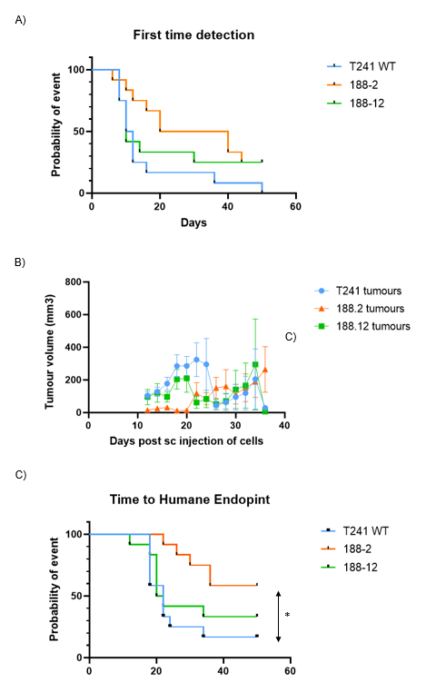

Figure 6. 1 Tumour growth of T241-GFP WT and VEGFA188 overexpressing clones

A) Kaplan-Meier curve of T241-GFP WT and VEGFA188 overexpressing clones showing time to first detection (30 mm3). B) Tumour growth rates of T241-GFP and VEGFA188 overexpressing clones during all experiment C) Kaplan-Meier curve of T241-GFP WT and VEGFA188 overexpressing clones showing time humane endpoint (500 mm3) n=12. Log-rank (Mantel-Cox) test was used. Only p-values < 0.05 are shown. *p<0.05.

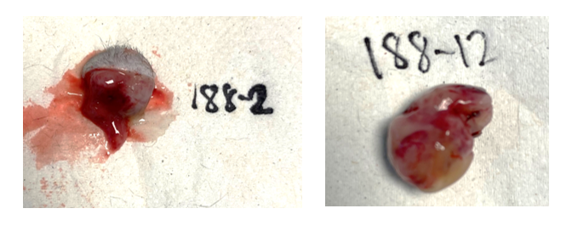
Figure 6. 2. Representative images of tumours overexpressing VEGFA188 isoforms appearance

Representative images of subcutaneous tumours from selected T241-GFP VEGFA188 overexpressing cell lines after dissection in C57BI6J mice. Tumours which reached humane end-point (volume size around 500 mm3) presented highly necrotic appearance.

6.2.2 Quantification of GFP⁺ cells in VEGFA188 expressing cell lines
As described in the previous chapter, T241-GFP-CMV-VEGFA188 cell lines were derived from the transfection of the T241-GFP cell line. In this case, after tumour regression, we wondered whether this behaviour could be related to changes in GFP expression. Although GFP is a widely used fluorescent marker, it is known that its expression can lead to cellular damage by Reactive Oxygen Species (Ansari et al., 2016).
Hence, we analysed the expression levels of GFP among our cell lines by flow cytometry. Our analysis showed that the T241-GFP WT cell lines had 1.26% of GFP⁺ cells whereas VEGFA188 cell lines expressed <1% (Figure 6.3). Thus, we assumed that regression was not related to GFP toxicity.
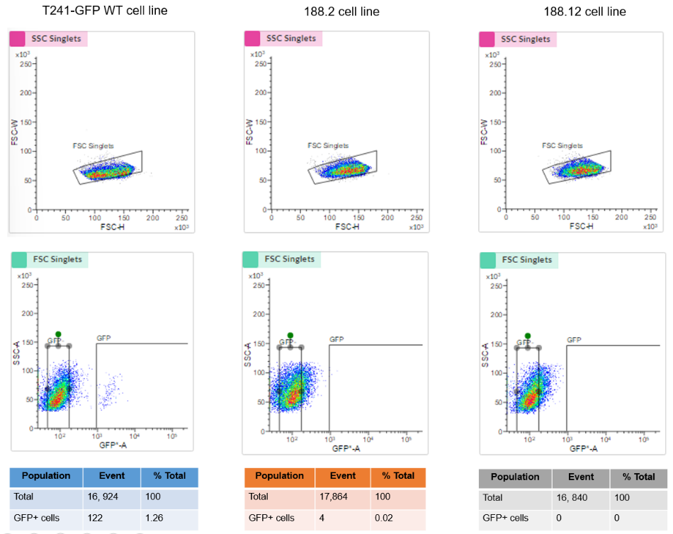

Figure 6. 3 Analysis of GFP+ cells in T241-GFP WT and VEGFA188 overexpressing cell lines

Scatter density plots showing T241-GFP WT and clones overexpressing VEGFA188 clones analysis by Flow Cytometry. This assay was performed to quantify GFP⁺ cells. T241-GFP WT cell line showed ~1.3% of GFP⁺ cells whereas T241-GFP clones overexpressing VEGFA188 had no GFP expression. FSC=size, SSC= granularity. One biological replicate was examined.
6.2.3 Necrosis in tumours overexpressing VEGFA188
Fibrosarcomas which reached ≥ 400 mm³ presented with a necrotic appearance (Figure 6.4A). Therefore, to analyse and quantify the necrotic areas within our models, haematoxylin and eosin staining was done. The quantification of necrotic areas showed that 188.2 tumours had a higher percentage of necrotic areas compared to the WT and 188.12 fibrosarcomas (Figure 6.4B). Nonetheless, no statistically significant differences were found when comparisons were made versus the T241-GFP WT tumours. Additionally, a percentage of necrosis was correlated with the tumour percentage found (Figure 6.4C). Although an increase trend was found, no significant differences were found (p value=0.2841). R squared showed that variance of necrosis was explained by tumour volume roughly by 10% (R² = 0.094).
It is important to highlight that a fibrotic capsule was found surrounding all tumour edges. Of note, 188.12 tumours showed a denser capsule among all tumours.

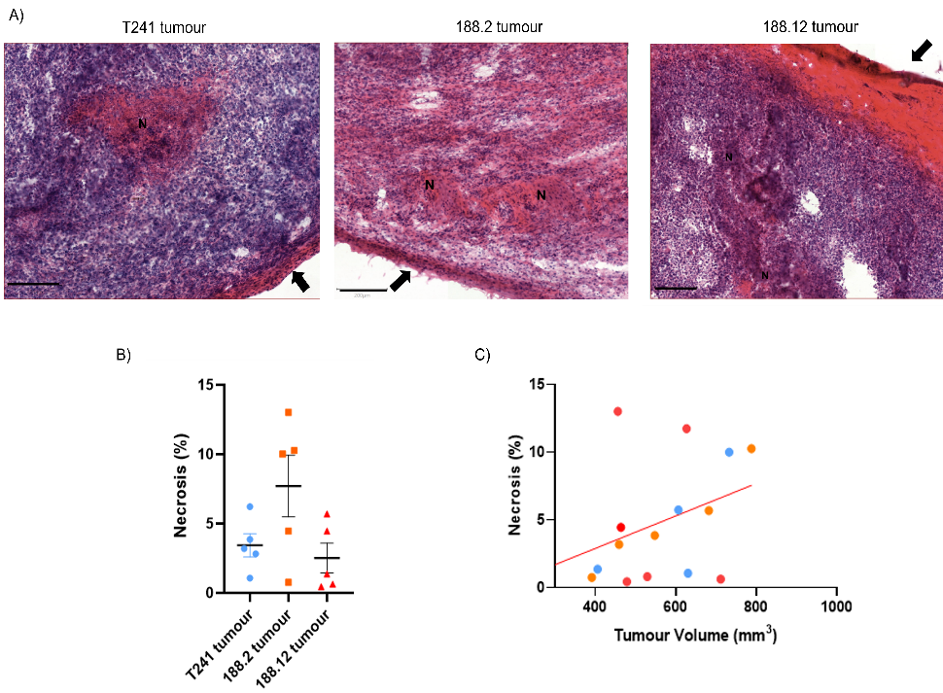

Figure 6. 4 Haematoxylin and eosin analysis of T241-GFP WT and VEGFA188 overexpressing cell lines

T241-GFP WT and tumours derived from clones overexpressing VEGFA188 were stained using Haematoxylin (nucleus) and eosin (cytoplasm). The percentage of necrosis was calculated using QuPath software (v0.2.3). A) Representative image of necrotic areas in tumour slides and IF analysis. B) Graph showing necrosis percentage data across the three types of tumours. Data are mean ± SEM. One-way ANOVA followed by Dunn's multiple comparisons test were used. n= 5 per group. C) Graph showing correlation between necrosis percentage found and tumour volume (mm³). A linear regression was done. R²=0.09. Graphs B and C were made using GraphPad Prim software. N letters shows necrotic areas. Arrows showing tumour capsule. C)Scale bar= 200 μm. Only p-values < 0.05 are shown.

6.2.4 Influence of VEGFA188 isoform overexpression on the tumour vasculature
Descriptions of vascularity differences between tumours overexpressing diverse isoforms has been published previously. These have revealed that VEGFA120 expression impacts the vascular development, resulting in leaky vascularity with limited pericyte coverage and high interstitial fluid pressure (Carmeliet et al., 1999; Akerman et al., 2013). Altogether, enhancing tumoral metastasis (Cooke et al., 2012).
Therefore, we aimed to investigate if overexpression of VEGA188 in our fibrosarcomas impacted on the tumour vascularity. T241-GFP WT and T241-GFP-VEGFA188 clones were stained for blood vessels (anti-CD31) and pericytes (anti- α-SMA) as described in Chapter 2, Section 2.8.2. Our results showed that T241-GFP WT tumours had a higher mean vascular density compared to fibrosarcomas overexpressing VEGFA188. The differences between 188.2 and 188.12 tumours and T241-GFP WT tumours were statistically significant, with p values of p<0.0022 and p<0.0358 respectively (Figure 6.5). Of note, higher vascular density was found on the tumours periphery independently of VEGFA expression. Thus, analysis was made choosing randomly sections of tumours away from the tumours outer edge.

Analysis of anti-α-SMA to detect pericyte populations showed that tumours derived from cell lines 188.2 had a higher content of pericytes coverage followed by the T241-GFP WT tumours. Also, 188.12 had a slightly lower number of pericytes among all tumours. However, no significant differences were found between the tumours (Figure 6.6). Disruption of the integrity of vessels in tumours expressing VEGFA188 could be seen when compared to WT tumours.

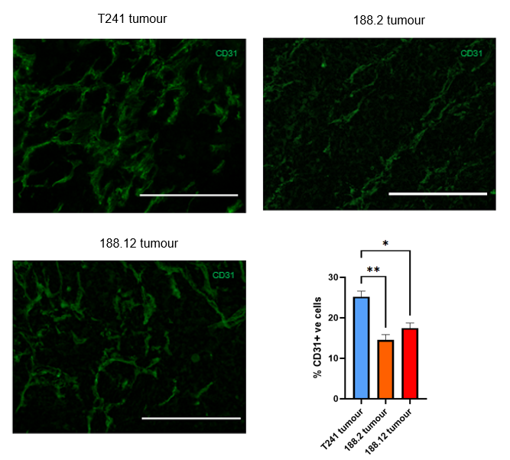
Figure 6. 5. Mean vascular density in fibrosarcomas overexpressing VEGFA188 compared to T241-GFP WT

T241-GFP WT and tumours derived from clones overexpressing VEGFA188 were stained using anti-mouse CD31 antibody (green). A) Representative images of CD31 positive vasculature in tumour sections and analysis of mean vascular density. Data are mean ± SEM. One-way ANOVA followed by Dunn's multiple comparisons test were used. n= 6, *p-value <0.05, ** p-value <0.005. Only p-values < 0.05 are shown. 20 x objective. Scale bar 200 μm

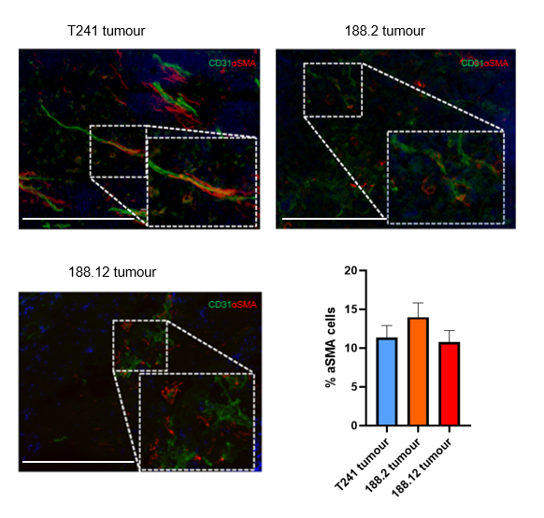

Figure 6.6 Pericyte coverage density in fibrosarcomas overexpressing VEGFA188 compared to T241-GFP WT

T241-GFP WT and tumours derived from clones overexpressing VEGFA188 were stained using anti-α-SMA (red). Representative images of pericyte coverage (CD31 vessels associated with α-SMA) in tumour sections and analysis. Data represents the average of positive cells per field of view. Data are mean ± SEM. One-way ANOVA followed by Dunn's multiple comparisons test were used. n= 6. Only p-values < 0.05 are shown. 20 x objective. Scale bar 200 μm

6.2.5 The role of VEGFA188 isoform overexpression on immune cell infiltration
6.2.5.1 CD4⁺FOXP3⁺ T regulatory cell infiltration in fibrosarcomas increased levels of VEGFA188
To meet our aim about characterisation of immune cell infiltration, an indirect immunofluorescence technique was used in our fibrosarcomas. To investigate the immune response and its relationship between VEGFA isoforms, tumour sections were stained with CD4⁺ and FOXP3⁺ co-localisation to detect Regulatory T cells (Treg).
Previous analysis in STS human samples which include fibrosarcomas showed an association between high expression of Treg cells with high local recurrence (Smolle et al., 2021) and poor disease-free survival and overall survival (Que et al., 2017).
Our immunofluorescence analysis presented similar levels of Treg cells between the T241-GFP WT tumours and 188.12 tumours. Meanwhile, lower levels were found in 188.2 tumours. No statistical differences were found between tumours overexpressing VEGFA188 isoforms and T241-GFP WT tumours (Figure 6.7). Of note, presence of Treg cells were found in tumour edges.

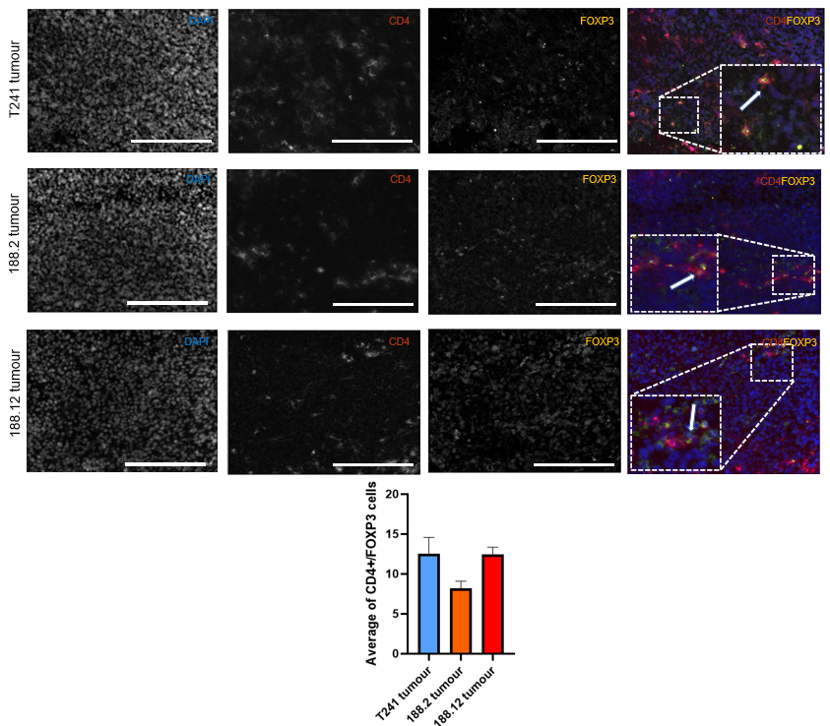

Figure 6. 7 Infiltration of Treg (CD4+FOXP3+) in fibrosarcomas overexpressing VEGFA188 and T241-GFP WT

T241-GFP WT and tumours derived from clones overexpressing VEGFA188 were stained using an anti-CD4 antibody (green), anti-FOXP3 (red), and DAPI (blue) for the nucleus. Data represents the average of positive cells per field of view. Data are mean ± SEM. One-way ANOVA followed by Dunn's multiple comparisons test was used. n= 6. Only p-values < 0.05 are shown. Arrows indicate examples of positive cells. 20 x objective. Scale bar 200 μm

6.2.5.2 CD8+ Cytotoxic T cells infiltration in fibrosarcomas with increased VEGFA188
Research of immune-infiltration population in STS, have shown controversial results between diverse authors about CD8+ T cells. Among STS subtypes, myxofibrosarcomas have been detected as one of the subtypes with higher infiltration (Klaver et al., 2020). Additionally, STS tumours that respond to anti-PD-1 had important increased amounts of activated T cells (CD8⁺CD3⁺ PD-1⁺) (Komohara et al., 2019).
Once knowing that myxofibrosarcomas might present higher CD8⁺ infiltrations, we wondered if VEGFA isoform expression could influence the immune TME. Thus, CD8⁺ cytotoxic T cells were stained by immunofluorescence using Alexa Fluor 647 (red/orange) and DAPI for the nucleus (Figure 6.8). The immunofluorescence analysis showed T241 WT had higher levels of CD8⁺ infiltration than tumours derived from VEGFA188 overexpressing cell lines. The difference in cytotoxic cell infiltration between 188.12 tumours and T241-GFP WT tumours was statistically significant (p.values =0.007)

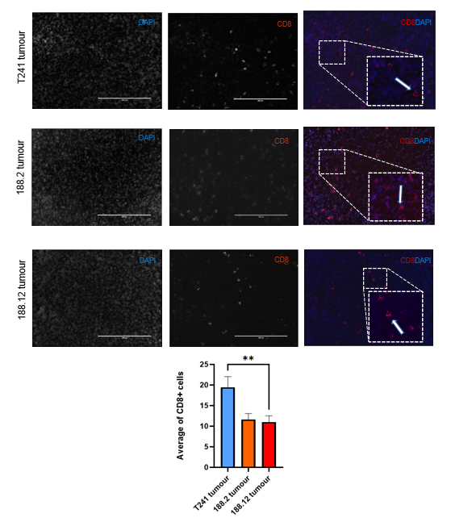
Figure 6. 8 Infiltration of Cytotoxic T cells (CD8+) in fibrosarcomas overexpressing VEGFA188 compared to T241-GFP WT

T241-GFP WT tumours and tumours derived from clones overexpressing VEGFA188 were stained using an anti-CD8 antibody (orange/red), and DAPI (blue) for the nucleus. Data represents the average of positive cells per field of view .Data are mean ± SEM. One-way ANOVA followed by Dunn's multiple comparisons test were used. n= 6. Only p-values < 0.05 are shown. 20 x objective. Arrows indicate examples of positive cells. Scale bar 200 μm
6.2.5.3 F4/80⁺ Macrophage infiltration in fibrosarcomas with increased VEGFA188
The TCGA-SARC data analysis published by Abeshouse et al., (2017) showed that macrophages genes signatures score was higher in subtypes such as UPS and Myxofibrosarcoma.
Thus, we wonder if overexpression of VEGFA188 isoform in fibrosarcomas, might impact on the F4/80⁺ cells infiltrations. Sections of T241 WT, 188.2 and 188.12 tumours were stained for immunofluorescence analysis using an anti-F4/80 antibody (Figure 6.9). Quantification showed that T241-GFP WT tumours had a small increase in F4/80⁺ cells when compared to tumours overexpressing VEGFA188. Although 188.2 and 188.12 fibrosarcomas presented similar levels of F4/80⁺ cells, only the difference between WT and 188.2 fibrosarcomas was statistically significant.

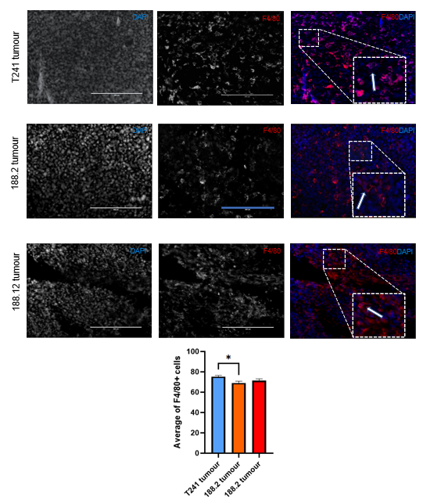
Figure 6. 9 Infiltration of murine Macrophages (F4/80+) in fibrosarcoma overexpressing VEGFA188 compared to T241-GFP WT

T241-GFP WT tumours and tumours derived from clones overexpressing VEGFA188 were stained using anti-F4/80 antibody (red), and DAPI (blue) for the nucleus. Data are mean ± SEM. One-way ANOVA followed by Dunn's multiple comparisons test were used= 6. Arrows indicate examples of positive cells. Only p-values < 0.05 are shown. *p-value <0.05. 20x objective. Scale bar 200 μm
6.3 Discussion
The literature has shown that TME plays an important role in tumour development. Potential cancer therapy methods have evolved as investigation of the TME continuing in diverse tumours. Thus, we aimed to characterise the TME between the T241-GFP WT and T241 overexpressing VEGFA188 tumours.
Previous studies investigating the effects of VEGFA isoforms using in vivo models have been using immunocompromised mice and therefore, scarce knowledge about host-immune response is known. To overcome this, the creation of tumour models in immunocompetent mice is necessary. Thus, cell lines overexpressing VEGFA188 were created using C57BI6J syngeneic sarcoma cell line T241-GFP. Results of this chapter demonstrate the characterisation of the TME using immunofluorescence methods.
The VEGFA188 overexpressing cell lines selected for use in this chapter were injected in C57BJL6 mice to investigate the role of VEGFA188 in the TME, especially with respect to immune cell infiltrations. However, tumours derived from the T241-GFP-CMV-VEGFA188 cell lines showed increased levels of tumour regression. The literature has reported the relationship between the immune system, such as infiltration of Natural Killer or CD8⁺ T cells, and apoptosis as the main processes in tumour regression (Ricci and Cerchiari, 2010). First, we checked GFP expression in our cells as GFP has been reported as cytotoxic by the production of ROS and by inducing apoptosis. Hence, we conducted Flow Cytometry analysis of the cell lines but almost no expression of GFP was found. This discrepancy may be attributed to clonal variation, as both cell lines were derived from a single cell that could possess a low number of copies of the eGFP gene. Another possible explanation is that cells used for establishing clones could underwent into epigenetic modifications because of the transfection process consequently altering eGFP expression. However, further work such as RNA sequencing of the cell lines need to be done to investigate the underlying cause. Important levels of apoptosis in cells overexpressing VEGFA188 have been reported when compared to VEGFA164 and VEGFA120 in overexpressing fibrosarcomas and breast cancer cells (Kanthou et al., 2014; Di Benedetto et al., 2015). In this sense, other experiments to analyse apoptosis could be considered for future work. An example is TUNEL assay as it detects DNA breakage in tissue samples whereas an in vitro analysis of caspase activation could be used (Mirzayans and Murray, 2020).
Later experiments showed a high percentage of necrosis cells in the 188.2 tumours but not in 188.12 tumours. Of note, the distribution of necrosis was heterogeneous but larger areas were found at the centre of the tumour. Core distribution of necrosis in solid tumours is highly reported in the literature which is commonly related to a poor blood supply and a hypoxic environment (Liu and Jiao, 2019). This is following our vascular density analysis which showed that 188.2 tumours were poorly vascularised. Although, a lower density of vessels was found in 188 tumours, we found high pericyte coverage. Pericytes are stabilising cells for wall vessels which suggest maturity of blood vessels and few permeability of these.
Mouse models expressing exclusively one VEGFA isoform have help to elucidate the vascular phenotype related to VEGFA isoforms. Mice producing VEGFA120 only, showed larger-sized vessels but extensive vascular defects which consequently increase permeability (Carmeliet et al., . 1999; Mitchell et al., 2006). On the contrary mice with VEGFA188 expression presented high vascular density with a disruptive pattern (Ruhrberg et al., 2002). Other studies, use a different approach to study vascularity using tumours expressing VEGFA isoforms. Publications using cells expressing only one VEGFA isoforms reported similar results as those found in animal models. Tumours derived from VEGFA188 showed less mean vascular density but high population of pericytes but also, VGEFA120 tumours showed increased permeability and vasodilation (English et al., 2017; Tozer et al., 2008). These authors have demonstrated the different functions and impact of VEGFA isoforms during angiogenesis.
Another explanation of tumour regression seen in our models include the adaptive immune system response. As we tried for the first time our fibrosarcoma cell lines in immunocompetent models, the characterisation of the TME was necessary, as well to tackle part of our aims to explore the TME and the impact of VEGFA isoforms on it. One of the big challenges that STS present is the heterogeneity of subtypes which makes difficult their study and the generalisation of knowledge among all subtypes. There is a lack of studies about TME in STS, especially focused on immune cells as sarcomas have been considered as immunodeserts. However, Pleomorphic subtypes like UPS/myxofibrosarcoma have shown high expression of immune response genes in diverse studies (Pollack et al., 2017; Abeshouse et al., 2017). Although STS present lower immune cell infiltration compared to other solid tumours, the study of immune cells might represent a hint for future novel therapeutic targets. T regulatory cells have a key effect by regulating immune host response and promoting self-tolerance. Thus, its infiltration within the TME can inhibit the antitumour immunity and promote tumour development. A high number of Treg has been linked to poor prognostic factor commonly found in advanced diseases and elder patients with STS (Smolle et al., 2021; Kim et al., 2013, Que et al., 2017). Regarding Treg infiltration, our results showed that one VEGFA188 tumour had similar levels of Treg compared to the T241-GFP WT. Meanwhile, tumour 188.2 had lower levels of Treg among all tumours. This might be related with the high percentage of necrosis in 188.2 tumours. The study of human and murine tumours indicated a relationship of cellular necrosis and release of ions in the tumour interstitial fluid (TIF). According to Eil et al., (2016) the activity of T cells CD4⁺ and CD8⁺ can be inhibited by the potassium released due to the necrosis process which is related with low levels of CD8⁺ infiltration. However, In our case affecting more CD4⁺/FOXP3⁺ cells, as we can see in tumour 188.2. To assess this hypothesis, future work might include the analysis of TIF within our model to test potassium levels.
Using markers such as CD8⁺ for cytotoxic T-cells and F480⁺ for murine macrophages, tumours with overexpression of VEGFA188 seemed to have less immune cell infiltration. Quantification of CD8⁺ T cells showed that the difference between 188.12 tumours and T241 WT tumours was significant whereas both tumours presented similar levels of Tregs cells. Motz et al., (2014) described the specific expression of Fas ligand (FasL) in vessels of murine solid tumours. The expression of this ligand promotes a selective killing of CD8⁺ T cells by apoptosis whereas T reg cells infiltration seems to not be affected. Growth factors such as VEGFA regulated the expression of Fas in endothelial cells. This led us to wonder whether the high expression of VEGFA188 can be related to the high expression of the Fas / FasL pathway. To evaluate this further investigation needs to be conducted in future work by staining CD31⁺ (blood vessels) and FasL⁺ and to elucidate is this could be VEGFA isoform dependent. Nonetheless, it is important to mention that expression of Fas is not only promoted by VEGFA but also by hypoxia-factors within the TME (Motz et al.,., 2014). To investigate this in detail, future work can consider explore the effect of hypoxia in our fibrosarcoma cells or tumour models.
Tumour-associated macrophages (TAMs) are common cells found within the TME. In UPS patients, Shirashi et al.,. (2018) presented a correlation between a high density of CD163⁺ TAMs (an M2 phenotype marker) in elderly patients and high tumour grade. Also, a quantification of IHC by Dancsok et al., (2020) showed that a higher number of infiltrations of M1 and M2 cells were found in pleomorphic subtypes such as UPS and myxofibrosarcoma. Bearing this in mind, we analysed the F480⁺ cells in our fibrosarcoma models to identify murine macrophages. Our results showed lower levels in VEGFA188 tumours, especially in tumour 188.12 which presented a significant difference. These results make us think that although VEGFA has an immunosuppressive effect on immune cells, in our case VEGFA188 isoform specifically does not seem to have an enormous impact on macrophages in fibrosarcomas. However, it is important to note that our analysis does not identify the polarization of these TAMs. In this case, further work should include a specific marker for M1 and M2 TAMs such as HLA-DR, iNOS and CD163, CD204, respectively.
Although previous bioinformatic analysis of TCGA-SARC in our lab showed as myxofibrosarcomas as possible responders to immune checkpoints blockade therapy, we were unable to perform analysis for PD-1/PD-L1 in our tumours. However, literature has shown myxofibrosarcomas as one of the subtypes with higher infiltration along with expression of PD-1 and LAG-3 (Klaver Y et al., 2020) whereas GIST, liposarcoma, synovial sarcoma and chondrosarcoma presented less infiltration of these cells subtype reported by D’Angelo et al., 2015. In a similar manner, Boxberg M et al., (2018) published their findings correlating a high number of CD8⁺ and CD3⁺ T cells with a high number of PD-L1 expression in UPS subtypes. These results support our hypothesis of pleomorphic subtypes, especially myxofibrosarcoma, to be beneficial with an anti-PD-1 therapy. Thus, future work should include PD-1 expression in our models with methods such as IF staining or Flow Cytometry.
With this chapter we intend to contribute with useful knowledge to fill this gap in the investigation of therapeutic targets, especially focused on immune cell infiltration and its implications in immunotherapy response. Unfortunately, due to the COVID pandemic, experiments were reduced due to time limits and consequently, to conduct more experiments. Limitations of this project include the small number of samples analysed per group as a large portion of VEGFA188 overexpressing tumours regressed. This could be improved for further work by repeating the experiment and reducing the humane endpoint to gather as many tumours as possible before regression, also the use of a new overexpressing system such as a Tet-ON or Tet-OFF based system which could allow the activation of VEGFA188 expression after tumours have established.
Another limitation to consider is the few numbers of markers used for immune cell detection. Further work should consider an increased panel of markers for the identification of specific immune cells detection by Flow Cytometry. Finally, it is important to recognise that majority of analyses of IHC in published works are done by a specialised pathologist.
Overall, we created new models of fibrosarcoma overexpressing the VEGFA188 isoform while expressing simultaneously the rest from the endogenous gene. The analysis of these models showed that tumours using cell overexpressing VEGFA188 had less immune cell infiltration when compared to tumours created with cells overexpressing VEGFA164/120. In other words, these results might support that myxofibrosarcomas VEGFA164/120 are more immunogenic compared to VEGFA188 which might be promising to investigate in terms of immune checkpoint markers expression. Future work with this project should include the characterisation of the TME using the VEGFA120 selected cell lines and the staining of PD-L1 for detection either by IHC or Flow Cytometry. In addition, the measure of isoform levels should be considered as hypoxia might influence the expression of other VEGFA isoforms. Also, these models might be useful to finally evaluate the response to anti-VEGFA therapy and anti-PD-L1 as the literature has proven.

CHAPTER VII:
Relationship between the expression of VEGFA mRNA isoforms and immune response genes in pleomorphic sarcoma subtypes
.

7.1 Introduction
The development of RNAseq technology allows a detailed study of the genes in diverse diseases including tumours. This has facilitated the understanding of the role of VEGFA isoform expression in soft tissue sarcomas. Following our research into mouse fibrosarcomas and their relationship between VEGFA isoforms and the TME, we decided to expand our investigation to human samples. We performed our investigation using RNAseq data. Therefore, we used RNAseq data from human samples to investigate the expression of the PD-1 pathway and the immune microenvironment in relation to VEGFA isoform expression.
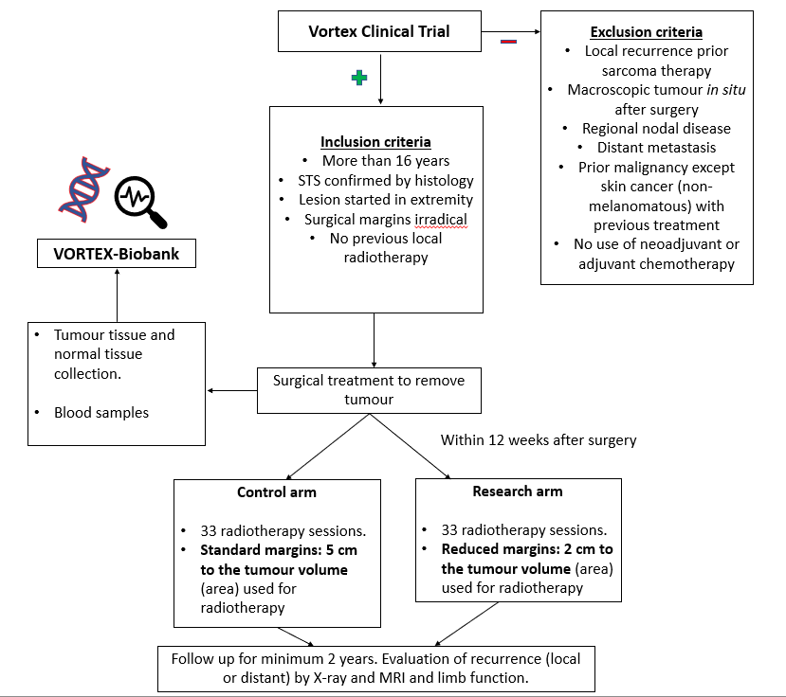
Currently, diverse clinical trials have collected tumour samples for the extraction of RNA and the study of the TME, providing an invaluable tool to study sarcomas. One example of these trials includes VORTEX trial (NCT00423618) which is a randomised study that aims to determine whether a reduced dose of post-operative radiotherapy can enhance limb function in patients with STS in extremities. Patients involved in VORTEX were invited to participate in the VORTEX-Biobank, which is a collection of pre-treatment tumours and normal tissue for RNA microarray analysis (Figure 7.1). These sample data have been used subsequently to validate biomarkers for prognosis and response to therapy in STS such as Carbonic Anhydrase IX (CAIX) (Forker et al., 2018; Forker et al., 2023). Another example is The Cancer Genome Atlas-Sarcoma (TCGA-SARC). The TCGA-SARC is considered one of the biggest databases of human STS samples which includes 6 complex karyotype subtypes including Leiomyosarcoma (LMS), Myxofibrosarcoma (MFS), and Undifferentiated Pleomorphic Sarcoma (UPS).
Figure 7.1. VORTEX clinical trial study design

VORTEX is a randomised phase III clinical trial in the United Kingdom which aims to evaluate if a STS patient can improve the limb function with a reduced dose of external radiotherapy after surgical removal of the tumour. The treatment consisted of 33 treatment sessions for both groups within 12 weeks of tumour surgery. However, the control group received radiotherapy using the standard area/margins for the treatment whereas the research group received radiotherapy in a reduced area of the operation site. VORTEX trial (NCT00423618).

Previous investigation using the TCGA-SARC dataset, by Dr. Manoj Valluru in the English group, showed that MFS expressing higher levels of VEGFA165_121 have significantly decreased OS (p=0.048), high tumour mutational burden and high expression of PD-L1 compared to the rest of MFS suggesting MFS with high VEGFA121 may respond better to immune checkpoint therapy (data not published, Valluru M)(Chapter 1, Section 1.6). However, the main limitation of these results was the small sample size (n=12). MFS is an STS subtype with a complex karyotype that, previously, was considered part of UPS. Therefore, little is known about MFS as a completely independent entity and few samples have been collected compared to other subtypes. Previous research in the English lab showed pleomorphic subtypes as the most like our mouse fibrosarcoma models (Valluru M, unpublished). Likewise, an analysis of TCGA-SARC by Abeshouse et al., (2017) and results reported by Tawbi et al., . (2017) from the SARCC028 (NCT02310399) trial suggested a promising response to immune checkpoint inhibitors for UPS and MFS.
Hence, this chapter will display our in silico analysis using human samples derived from the datasets mentioned above to investigate the relationship between VEGFA isoform expression and immunecheckpoint pathways made by myself. The analysis will include the analysis of RNAseq of MFS from VORTEX, followed by the analysis of VORTEX and TCGA-SARC data combined for MFS and pleomorphic sarcomas to increase the sample size and add statistical power to our analysis for both MFS and the pleomorphic sarcomas more generally.

7.2 Results
7.2.1 VORTEX Biobank dataset population
An analysis of the TCGA-SARC showed that pleomorphic subtypes such as UPS and myxofibrosarcoma (MFS) were the closest to our fibrosarcoma models (Valluru M, not published). Therefore, to reproduce TCGA-SARC results we used the VORTEX Biobank dataset (phase III clinical trial, NCT00423618) sequencing data kindly provided by Professor Catharine West and Dr Laura Forker. A total of 132 FASTQ files were downloaded through a secured server to SHARC, and reads were aligned to the GENCODE GRCh38 human reference genome. After alignment, the number of reads mapping to each transcript and gene were counted. Lastly, a quality control measure was applied to evaluate the mRNA data, resulting in a subset of 122 samples. The downloading and preprocessing of the VORTEX data was conducted by Dr. Manoj Valluru as described. Subsequent analysis of the 122 samples that passed the quality control were performed by myself as described in Chapter 2, Section 2.13, and results are presented in this chapter.
Diverse subtypes were found among the patient's samples. However, the three main groups were UPS (33%), MFS (25%) and MXL (15%) (Table 7.1). The normalisation of raw counts was made by the default method by the edgeR package (Robinson, McCarthy and Smyth et al., 2010) (Supplemental Data. Figure S3). Unsupervised analysis of the subtypes was performed to check similarities between subtypes. Most subtypes are left-sided whereas myxoid liposarcoma (MXL) seems to be the subtype with the biggest differences among all subtypes (Figure 7.2).

Table 7. 1 Subtypes of STS patients in the VORTEX dataset

Descriptive table of larger subtypes of VORTEX-Biobank dataset patients. Subtypes with less than 3 patients are not shown. Data obtained from VORTEX-Biobank dataset

Subtype | Patients n (%)
Undifferentiated Pleomorphic Sarcoma (UPS) | 40 (33%)
Myxofibrosarcoma (MFS) | 31 (25%)
Myxoid Liposarcoma (MXL) | 18 (15%)
Leiomyosarcoma (LM) | 3 (2%)
Malignant Solitary Fibrous Tumour (MSFT) | 4 (3%)
Malignant Peripheral Nerve Sheat Tumour (MPNST) | 4 (3%)
Synovial Sarcoma (SS) | 3 (2%)
Dedifferentiated Liposarcoma (DDL) | 5 (4%)
Extraskeletal myxoid chondrosarcoma (ECM) | 3 (2%)

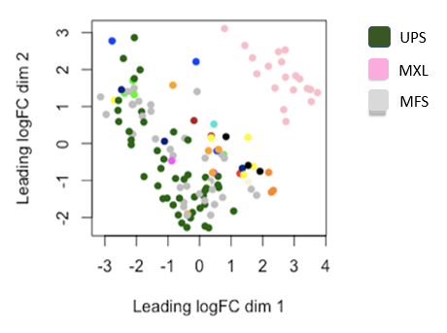

Figure 7. 2 MDS plots of RNAseq data from patients of the VORTEX-Biobank

MDS plot showing similarities between sample data over dimensions 1 and 2 based on mRNA levels. Spatial distribution of VORTEX samples data. Only the three main subtypes are indicated. UPS= Undifferentiated Pleomorphic Sarcoma (UPS), Myxoid Liposarcoma (MXL) and Myxofibrosarcoma (MFS).

7.2.2 Expression of PD-L1 gene among VORTEX soft tissue sarcoma subtypes

We used the normalised log expression values of PD-L1 gene to visualise the expression distribution among all the STS subtypes of VORTEX. Our data showed that pleomorphic subtypes with a complex karyotype such as UPS and MFS had higher expression levels of the PD-L1 gene compared to the rest of the subtypes (Figure 7.3)

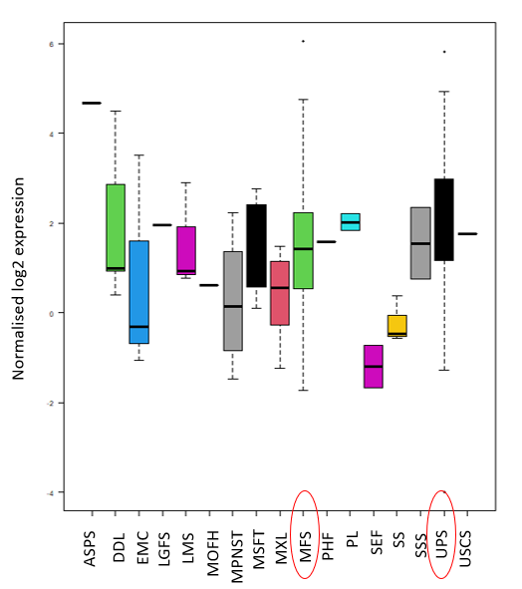
Figure 7. 3 Representative graph of PD-L1 expression distribution among VORTEX sarcoma subtypes

An exploratory boxplot and whiskers graph showing distribution of normalised log2 expression values of PD-L1 gene (y-axis) between the diverse subtypes samples (x-axis) from VORTEX patients. Myxofibrosarcoma (MFS) and Undifferentiated Pleomorphic Sarcoma (UPS) subtypes showed higher levels of PD-L1 expression. Box represents data distribution between lower and upper quartiles, line inside the box represents the median value and whiskers extends to cover all the data except for outliers. Outliers are represented by a dot.
7.2.3 Distribution of VEGFA isoform expression within VORTEX patients
Most of the available literature focuses on the function of total VEGFA expression in tumours rather than the function of the individual VEGFA isoforms. The potential utility of VEGFA isoforms as biomarkers for response to therapy is therefore not well understood. VEGFA isoforms differ from one another in terms of their biological features. Therefore, the amount of VEGFA and the variation in isoform ratios across STS patients may have an impact on tumour development and response to therapy.
To investigate the VEGFA isoform role in our patients’ samples, the percentage expression of each isoform in MFS patients were compared and used for clustering. Hierarchical clustering of z-transformed percent expression of each isoform showed three main isoform switches according to relationship in isoforms between our population: 1) HighVEGFA121, 2) LowVEGFA189, and 3) HighVEGFA165 (Figure 7.4)

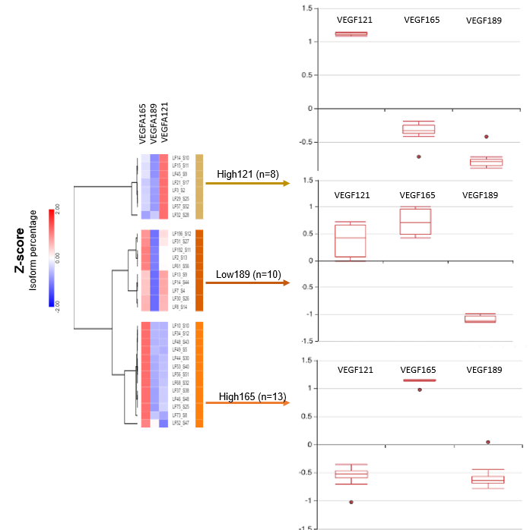

Figure 7. 4 Differential distribution of VEGFA isoforms in STS patients of the VORTEX dataset

MFS patients were grouped into three main groups based on isoform percentage values Z-score transformed. VEGFA isoform expression patterns. The switches were High121 group (n=8), Low189 group (n=10) and High165 (n=13). Cluster associations were conducted with one minus Pearson correlation and complete linkage method. The distribution of each isoform within each group is represented in graphs. Hierarchical clustering was performed by Gene E Morpheus software.

7.2.4 Enriched gene expression in MFS clusters from VORTEX Biobank
To understand the influence of VEGFA isoforms in the signalling in MFS, differentially expressed genes (DEG) and enriched pathways analysis was conducted. Clusters with Low189 and High165 were merged into one group named myxo_rest. A comparison of myxofibrosarcomas with high121 (n=8) and myxo_rest (n=23) showed 2,851 genes differentially expressed of which 1,619 were upregulated whereas 1,232 were downregulated (Figure 7.5)
Differentially expressed genes in MFS with the high VEGFA 121 (High121) group were linked to gene sets involving hypoxia, glycolysis and immune response when compared to the hallmark gene sets. When compared to other gene sets such as the Reactome gene set and Cancer Immunome Atlas, PD-1 signalling, activated CD8 T cells, and MSDC were gene sets enriched in the High121 group (Figure 7.6)

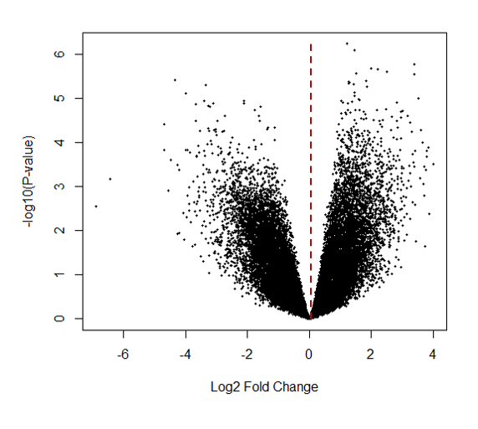
Figure 7. 5 Volcano plot showing DEG between VEGFA isoform expression clusters in MFS patients from the VORTEX dataset

MFS with a high VEGFA121 isoform expression group was compared to the rest of myxofibrosarcomas (LowVEGFA189 and HighVEGFA165 expression groups). The volcano plot shows down and up-regulated gene expression in the groups. The cut-off value for significance was FDR <0.05. Each point represents each significant gene.

Figure 7. 6 Normalised Enrichment Scores (NES) in MFS with HighVEGFA121 group (High121) from VORTEX

Gene set enrichment analysis (GSEA) in MFS with high VEGFA121 (High121) (n=8) and (myxo_rest) rest (n=23) was conducted. The gene sets (V7.1 MSigDB) shown were significantly upregulated in the myxo_121 group. Significance was considered as FDR q-value <0.05.

7.2.5 PD-L1 gene expression among MFS clusters from VORTEX patients
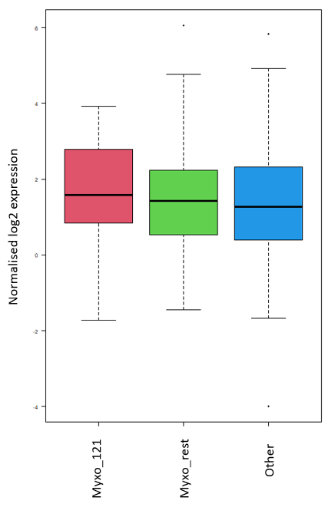
Plots to visualise the distribution expression of immune checkpoints genes, among the subtypes of STS subtypes were performed using RStudio software (graphics version 3.6.2.). Differentially expression gene analysis showed no significant differences in immune checkpoint gene expression in MFS with high VEGFA121 (referred as myxo_121) (n=8) compared to the myxo_rest group (n=23) (Figure 7.7). Adjusted p-values for PD-L1comparison was 0.937122.

Figure 7. 7 The distribution of PD-L1 gene expression in MFS clusters from the VORTEX dataset

Immune checkpoint genes were visualised using a scatter plot among the MFS samples from the VORTEX dataset. Each sample is represented by a coloured dot. The y-axis represents the normalised log2 expression values of the PD-L1 gene. Myxo_121= High VEGFA121 group, Myxo_rest = LowVEGFA189 and High VEGFA165 groups, Other= non-MFS subtypes samples. Box represents data distribution between lower and upper quartiles, line inside the box represents the median value and whiskers extends to cover all the data except for outliers. Outliers are represented by a dot.
7.2.6 Survival of MFS patients in VEGFA isoform expression clusters from the VORTEX dataset
Using the same MFS clusters, a survival analysis was performed between MFS with high VEGFA121 (referred as Myxo_121) and MFS with Low VEGFA189 and High VEGFA165 (referred as myxo_rest). (Figure 7.8A). The median overall survival (OS) for myxo_121 was 1639.5 days whereas the median overall survival for the myxo_rest group was undefined as less than 50% of the patients had died at the last time data was obtained. Kaplan-Meier curve showed that myxofibrosarcoma patients with high VEGFA121 had poor survival compared to the rest of MFS. Nonetheless, the log-rank test did not show any significant difference between both groups (p-value of 0.4553).
In addition, disease-free survival (DFS) was also analysed between our MFS groups. Local recurrence, distance recurrence or death was considered DFS event. Median DFS for myxo_121 was 749.5 days whereas for myxo_rest the median DFS was 2540 days. No significant differences were found between the two groups (p-value 0.2629) (Figure 7.8B).

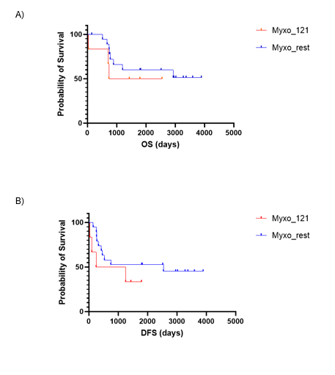
Figure 7. 8 Survival analysis for MFS with high VEGFA121 (Myxo_121) compared to myxo_rest group.

Kaplan-Meier plots were executed for overall survival (OS) analysis and Disease-free survival (DFS) analysis among myxofibrosarcoma patients VEGFA isoform expression clusters: MFS with High VEGFA121 (referred as Myxo_121) and Myxo_rest group. Analyses were performed using GraphPad Prism software (v9.4.1). Log-rank (Mantel-Cox) statistical test was used. P-value <0.05 was considered statistically significant. OS= Overall Survival. DFS= disease-free survival.

7.2.7 Merger of the VORTEX and TCGA-SARC datasets
To increase the statistical power, the combination of two datasets of STS subtypes was performed. In the previous merging of both datasets, the initial analysis of VORTEX was made using the same pipeline as the one previously done by PhD Manoj Valluru with the TCGA-SARC. Both datasets were aligned to the same genome version and raw counts were normalised using the edgeR package user’s manual.
To check whether data was similar and correct to combined and analysed, unsupervised analyses were done using MDS plots. An MDS plot is a multivariate analysis technique used to visualise the distance/similarities over a spatial representation. The distance between each point correlates to the similarities between these points. Hence, Figure 7.9A shows that majority of VORTEX and TCGA-SARC RNAseq data is similar, as we see the blue points (VORTEX data) and red points (TCGA-SARC data) overlapping. Figure 7.9B represents the STS subtypes from both datasets and the UPS, MFS, DDL, MP and MPSNT subtypes overlapped with each other. Leiomyosarcoma (LMS) and synovial sarcoma (SS) are the subtypes with the most differences from the rest of the subtypes. Among our subtypes of interest (MFS and UPS) no batch effect was visualised by MDS plot.
The Cancer Genome Atlas contains data from complex karyotype subtypes of STS such as UPS and MYX. Therefore, we aimed to increase the population and reproduce our previous results. Once both datasets were merged, subtypes in common were only considered for further analysis, making the total number of patients was 341 (Table 7.2). This total includes 56 MFS subtypes. Nonetheless, according to The Cancer Genome Atlas Research Network, UPS and MFS subtypes are molecularly similar (Cancer Genome Atlas Network, 2017) Following this, we decided to join both subtypes to increase the sample size. This new group was called ‘Pleomorphic’ with a total of 146 samples.

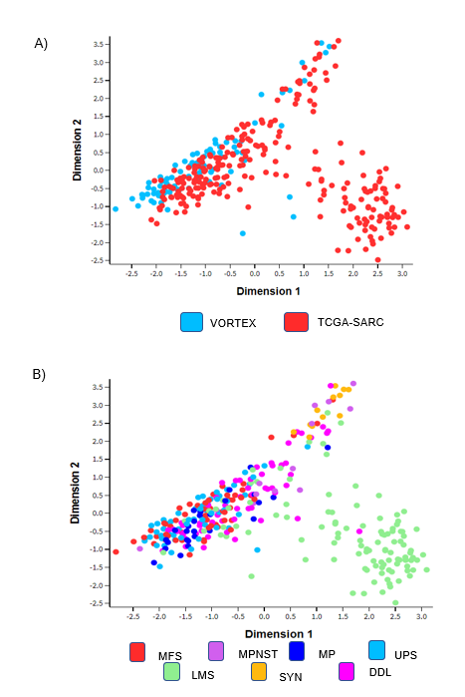

Figure 7.9 MDS plots of RNAseq data from patients of the VORTEX and TCGA-SARC datasets

MDS plot showing similarities between sample data over dimensions 1 and 2 based on mRNA levels. A) Spatial distribution of VORTEX and TCGA-SARC data. The majority of samples showed similarities between datasets. B) Spatial distribution of STS subtypes from both datasets. LMS and SYN subtypes are less like other subtypes.

Table 7. 2 Subtypes of STS patients in the VORTEX and TCGA-SARC dataset

After alignment and normalisation, the raw count of gene expression of VORTEX and TCGA-SARC datasets were merged. Descriptive table of STS subtypes in common of both datasets.

STS Subtype | Patients (n, %)
Dedifferentiated Liposarcoma (DDL) | 62 (18%)
Leiomyosarcoma (LMS) | 109 (32%)
Malignant Peripheral Nerve Sheat Tumour (MPNST) | 12 (4%)
Myxofibrosarcoma (MFS) | 56 (16%)
Synovial Sarcoma (SS) | 12 (4%)
Undifferentiated Pleomorphic Sarcoma (UPS) | 90 (26%)
Total | 341 (100%)

7.2.8 Enriched gene expression in MFS clusters from VORTEX Biobank and TCGA SARC
Using only MFS data from patients (n=56) of combined datasets, we formed clusters according to VEGFA isoform percentage distribution as previously done. This was done with the aim of increase the sample size as similarities between datasets were found in previous MDS analysis. The MFS clusters found were called Myxo121 (also referred as High121, n=22), Myxo165 (also referred as High165, n=28) and Myxo189 (also referred as High189, n=6) (Figure 7.10).
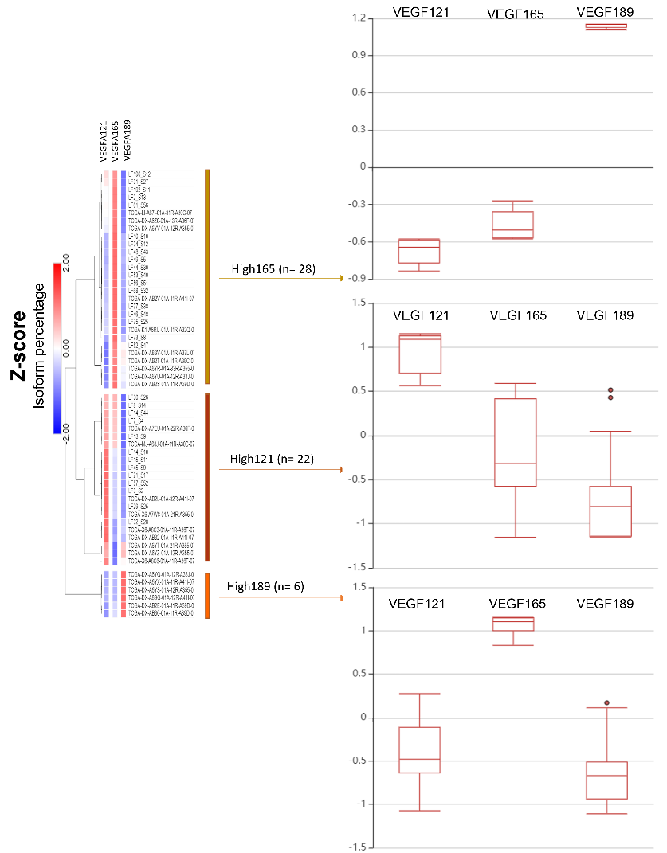
Figure 7.10 Differential VEGFA isoform percentage distribution in Myxofibrosarcoma patients in the VORTEX-TCGA combined dataset

MFS patients from VORTEX-TCGA SARC were grouped into three main groups based on isoform percentage values Z-score transformed. VEGFA isoform expression patterns. The switches were High165 group (n=28), High121 group (n=22) and High189 (n=6). Cluster associations were conducted with one minus Pearson correlation and complete linkage method. The distribution of each isoform within each group is represented in graphs. Hierarchical clustering was performed by Gene E Morpheus software.

DEG and enriched pathways analysis were performed between the groups. Samples data in groups High189 and High165 were merged into one group named Myxo_rest. The comparison between MFS with High121 vs Myxo_rest showed 5,220 genes differentially expressed of which 2,619 were upregulated whereas 2601 were downregulated (Figure 7.11)
Differentially expressed genes between Myxo121 and Myxo_rest groups were used for a gene set enrichment analysis. The cluster Myxo121 showed enrichment of genes linked to oxidative phosphorylation, p53 pathway and immune host response (IFN- α and IFN- β gene sets) when compared to Hallmark gene sets. Later, using curated gene sets, we found enrichment of genes related to activation of CD8 T cells and T cells using Cancer Immunome Atlas gene set and Senbabaouglu gene set. Finally using Reactome gene set we evaluated for PD-1 signalling, which showed enrichment in Myxo121 group when compared to the rest of myxofibrosarcomas (FDR value 0.002) (Figure 7.12).

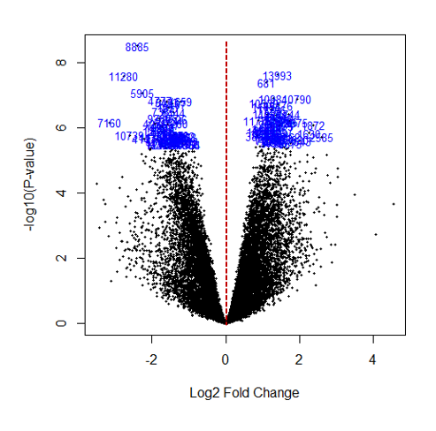

Figure 7. 11 Volcano plot showing DEG between VEGFA isoform expression clusters in MFS patients from the VORTEX-TCGA combined dataset

MFS data from VORTEX and TCGA SARC analysis of top 100 differentially expressed genes between Myxo121 group versus the rest of myxofibrosarcomas. The volcano plot shows down and up-regulated gene expression in the groups. The cut-off value for significance was FDR <0.05. Each point represents a gene.

Figure 7. 12 Normalised Enrichment Scores (NES) in MFS with HighVEGFA121 group (High121) from VORTEX and TCGA SARC

Gene set enrichment analysis (GSEA) in MFS with high VEGFA121 (Myxo121) compared to the rest of myxofibrosarcomas was conducted. The gene sets (V7.1 MSigDB) shown were significantly upregulated in the Myxo121 group (Significance was considered as FDR q-value <0.05).

7.2.9 Enrichment for curated gene sets for anti-VEGFA therapy response in MFS subtype
As English et al., (2017) had shown mouse fibrosarcomas expressing VEGFA120 were more sensitive to anti-VEGFA therapy, we investigated whether this can be testes in our pleomorphic groups. First, we used a VEGFA-dependent gene signature (VDG) created by Yin et al., (2016). The enrichment in this set includes vascular and membrane associated genes which could be used to predictive a response to bevacizumab. The enrichment plot showed positive enrichment values for the Myxo121 group but no statistically significant differences we found when compared to the rest of MFS.
Later, second gene set denominated VEGF-dependent vasculature (VDV) genes was used to assess the enrichment. This was developed by Brauer et al., (2013). Our results showed enrichment of this gene set but no statistically significant differences we found (Figure 7.13).

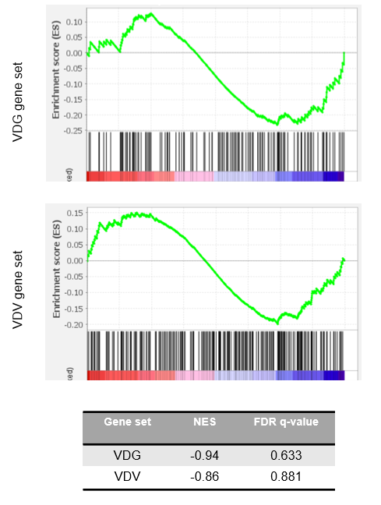

Figure 7. 13 Enrichment plots for genes sets related to response to anti-VEGFA therapy in Pleomorphic STS groups

Enrichment plot for Anti-VEGFA therapy response gene sets in pleomorphic groups by GSEA. The cut-off value for significance was FDR <0.05. VDG= VEGFA-dependent gene signature. VDV= VEGF-dependent vasculature. No statistical enrichment for the Pleomorphic group with a high 121 was found.

7.2.10 VEGFA isoform expression distribution model of VORTEX and TCGA-SARC patients
As mentioned before, UPS and MFS are subtypes which resemble each other at the molecular level. Thus, we wondered whether the results found in our previous VORTEX and VORTEX-TCGA analysis of MFS patients could be reproduced in our ‘Pleomorphic’ group. VEGFA isoform expression percentages of the ‘pleomorphic’ group were used to make clusters as before. Three main groups for the pleomorphic subtypes were identified: Pleo121 (n=62), Pleo189 (n=19) and Pleo165 (n=65). From each group, we investigated the distribution ratio of VEGFA isoforms (Figure 7.14).

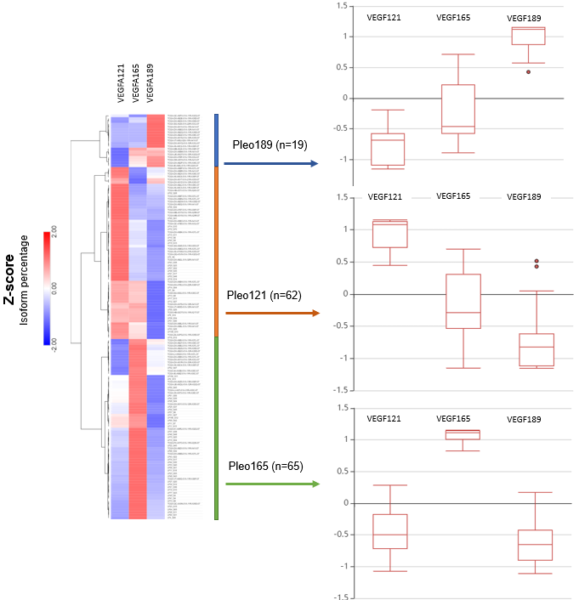

Figure 7. 14 Differential VEGFA isoform distribution in pleomorphic STS patients in the VORTEX-TCGA combined dataset

Samples from pleomorphic subtypes (MFS and UPS) were grouped into three main groups according to VEGFA isoform expression patterns. The switches of VEGFA isoforms were Pleo189 (n=19), Pleo121 group (n=62), and Pleo165 (n=65). The distribution of each VEGFA isoform within each group is represented in graphs. Hierarchical clustering was performed by Gene E Morpheus software.

7.2.11 Enriched gene expression in pleomorphic clusters from the combined VORTEX-TCGA-SARC dataset
Using the previous pleomorphic clusters, DEG and pathway enrichment analyses were conducted. Three main comparisons were performed: Pleo121 vs Pleo165, Pleo121 vs Pleo189 and Pleo165 vs Pleo189.
A total of 15,971 genes were examined, the summary of DEGs between the groups is shown in Figure 7.15. In the comparison between Pleo121 vs Pleo165, 2,031 genes were up-regulated, 2,660 were down-regulated and 11,280 genes, were not statistically significant. Comparisons between the Pleo121 group vs Pleo189 group showed 4,497 genes up-regulated, 5,276 down-regulated and 6,198 genes not statistically significant. Meanwhile, a comparison of Pleo189 vs Pleo165 did not show any up-regulated genes whereas 1 gene was down-regulated, and the rest of the genes were not significant.
DEGs from the comparisons between pleomorphic highVEGFA121 (Pleo121) with the Pleo189 group were linked to gene sets involving oxidative phosphorylation, DNA repair, reactive oxygen species production when compared to Hallmark gene set. Also, we compared curated gene sets to analyse immune infiltration, such as Cancer Immunome Atlas, Senbabaouglu gene set (Şenbabaoğlu et al.,. 2016), Bindea gene set (Bindea et al.,., 2013) and Reactome gene set (Matthews et al., 2009). The analysis with curated sets showed enriched gene sets linked to Immature Dendritic cells (IDC), T cells and MDSC. Finally, to assess our hypothesis about PD-1 signalling, analysis of the Reactome PD-1 signalling gene set enrichment was not statistically significant in the Pleomorphic_121 group (NES 0.79) (q value 0.806) (Figure 7.16A).
On the other hand, comparisons between Pleo121 and Pleo165 were related to Oxidative Phosphorylation, DNA repair and ROS pathways when compared to the Hallmark gene set. Additionally, curated gene sets comparison showed enrichment of activated CD8 T cells, MDSC and T cells. The Reactome PD-1 gene set was also tested, but not statistically significant in Pleo121 (NES1.38) (FDR q-value 0.80) (Figure 7.16B).

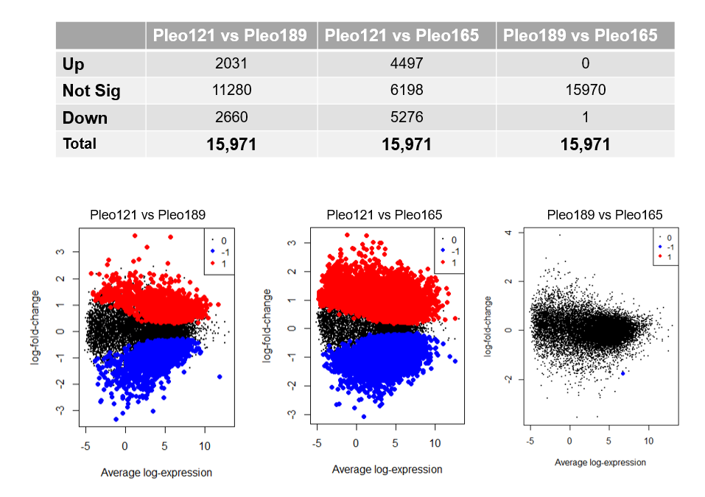

Figure 7. 15 DEG between each pleomorphic cluster’s comparisons

Pleomorphic samples were grouped by VEGFA isoforms percentage and comparisons between groups were performed. The MDS plots show up-regulated (red), down-regulated (blue), and not significant (black) gene expression in each comparison. The cut-off value for significance was FDR <0.05. Each point represents each significant gene.

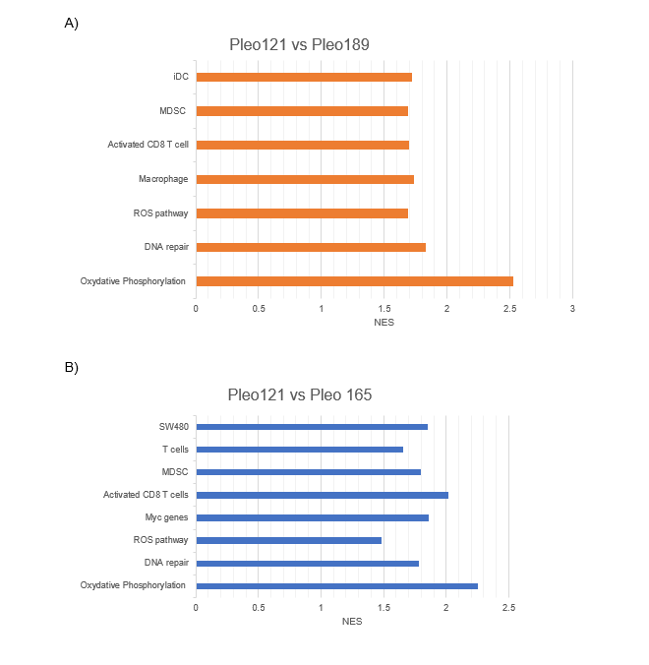

Figure 7. 16 Bar plots for Normalised Enrichment Score (NES) in Pleomorphic group with HighVEGFA121 using GSEA

Gene set enrichment analysis (GSEA) in pleomorphic subtypes with high VEGFA121(referred as Pleo121) (n=62) and Pleo_189 (n=19) and Pleo_165 (n=65) was conducted. A) The gene sets (V7.1 MSigDB) shown were significantly upregulated in the Pleo_121 group when compared to Pleo_189 B) The gene sets (V7.1 MSigDB) shown were significantly upregulated in the Pleo_121 group when compared to Pleo_165 (FDR q-value ≤ 0.05).
7.2.12 Enrichment for curated gene sets for anti-VEGFA therapy response in Pleomorphic subtypes
The VEGFA-dependent gene signature (VDG) created by Yin et al., (2016) previously used was tested in our data of conjunction subtypes with high VEGFA121 (Pleo121) The enrichment plot showed positive enrichment values for the Pleo121 group but there were no statistically significant differences in comparison of Pleo121 versus either Pleo189 or Pleo165.
Also, VEGF-dependent vasculature (VDV) genes were to test in our groups. Although, positive enrichment values were found for the Pleo121 group no significant differences were found for any of the comparisons between groups (Figure 7.17).
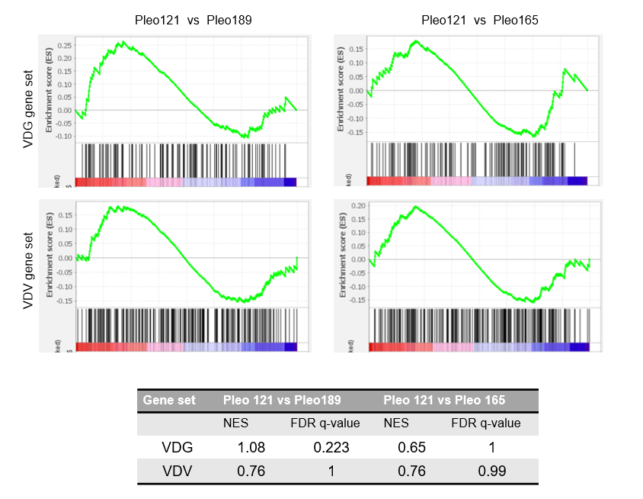

Figure 7. 17 Enrichment plots for genes sets related to response to anti-VEGFA therapy in Pleomorphic STS groups.

Enrichment plot for Anti-VEGFA therapy response gene sets in pleomorphic groups by GSEA. The cut-off value for significance was FDR <0.05. VDG= VEGFA-dependent gene signature. VDV= VEGF-dependent vasculature. No statistical enrichment for the Pleomorphic group with a high 121 was found.

7.2.13 Predicted immune cell infiltration among pleomorphic STS subtypes
To further investigate the immune infiltration in our datasets, we use the normalised gene expression of our samples to perform enrichment analysis of immune and stromal cells using the xCell webtool (Aran, Hu, and Butte, 2017).
The abundance of diverse immune and stromal cell types was obtained for our pleomorphic groups. Here, we show the graphs with the highest cell abundance among our groups. From the data, we found that the abundance of cells was variable in all groups, which is represented with large error bars. The Pleomorphic 121 group showed higher levels of B cells, CD8 T cells, Pericytes and Fibroblasts among all pleomorphic groups. However, no significant results were found.
Statistical higher levels of T reg cells and Immunoscore were found in the Pleomorphic 165 group when compared to the Pleomorphic 121 group. On the other hand, Pleomorphic 189 was found to be the group with the lowest immune cell abundance compared to the rest of the pleomorphic groups, except for pericytes and fibroblasts which showed almost similar levels to the Pleomorphic 121 group (Figure 7.18)

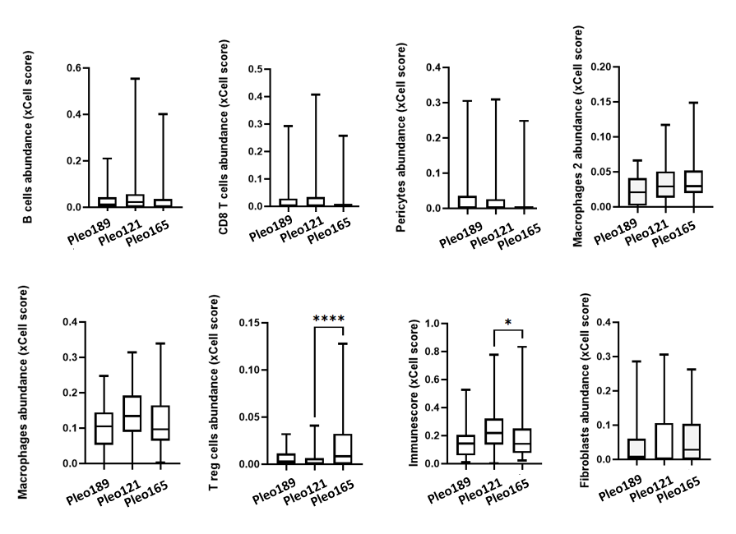
Figure 7. 18 Cell type abundance in Pleomorphic tumour groups

From each Pleomorphic group, a comparison of xCell score for cell type abundance was obtained. Box values extends from the 25th to the 75th of the values and line inside the box represent the median. Whiskers represent min and max values. Differences between the groups were evaluated using Kruskal-Wallis tests followed by Dunn’s multiple comparison test. Only p-values < 0.05 are shown. **** p-value <0.0001, *p-value <0.05

7.3 Discussion
Due to the diverse number of subtypes and the low incidence of STS compared to carcinomas, clinical samples of STS are difficult to study. The VORTEX-Biobank and TCGA-SARC are some of the datasets with the highest number of recruited samples for STS. Hence, the exploration of these datasets promises a deeper knowledge of STS subtypes. Regarding, MFS little is known and there are no biomarkers for survival or response to therapy.
To tackle our hypothesis, we aimed to perform an in silico analysis of a larger set of human STS samples to explore the use of VEGFA isoforms as biomarkers for response to immunecheckpoint therapy and anti-angiogenic therapy combination. For this we used sample’s information in VORTEX-Biobank data and TCGA-SARC data.
Our analysis of MFS samples from VORTEX showed switches in expression of VEGFA isoforms and heterogeneity in distribution among the samples. This method showed that the predominant isoforms are VEGFA165 and VEGFA121 within MFS. Gene expression analysis demonstrated that MFS with high VEGFA121 is linked to host-immune response mediated by interferon-alpha and gamma but also activation of cytotoxic CD8 T-cells and immune checkpoint signalling (PD-1). Previous analysis of the TCGA-SARC data by Abeshouse et al., (2017) showed that genetically complex subtypes like MFS and UPS had higher immune cell infiltration including macrophages among other subtypes. Regarding other solid tumours, Charoentong et al., . (2016), presented an analysis of melanoma patients who responded to anti-PD-1 treatment. This group of tumours showed enrichment in cytotoxic CD8 T cells and NK cells versus non-responder tumours.
Results from our analysis of Hallmark gene set analysis by GSEA showed that MFS with high VEGFA121 had down-regulation of the angiogenesis gene set (NES -0.70) and down-regulation of endothelial-to-mesenchymal transition gene set (NES -0.83). Hugo et al., . (2016) showed that EMT, ECM remodelling and angiogenesis have an important role in PD-1 resistance. This supports our results, suggesting that MFS with high VEGFA121 might be more responsive to PD-1 treatment.
Additionally, survival analysis revealed that MFS with high VEGFA121 had reduced overall survival and less time for recurrence than the rest of MFS expressing another VEGFA isoforms ratio, supporting the initial hypothesis from the forming analysis obtained from the TCGA-SARC dataset by Dr Manoj Valluru. Nonetheless, these results were not statistically significant.

A combination of TCGA-SARC and VORTEX RNAseqdata to analyse MFS patients with high VEGFA121 showed enriched immune host response gene set such as IFN- α and IFN- and activation of CD8 T cells. These group also demonstrated enrichment of gene set for PD-1 signalling.
Limitations of these analyses include the small population in each group which reduces the statistical stringency in differential expression of single genes (cut-off by value, not log fold change). Also, the methodology for clustering of samples by the group could be done by using other methods, such as percentiles or quartiles or another criterion like DNA methylation patterns as Ogura et al., . (2018). This might be explored in future work, as it will modify the group’s population which can influence gene set results but also statistical p-values.
In past years, UPS and MFS have been considered as one entity due to their similarities. However, since the revised WHO classification of 2022, MFS has been considered as a distinct subtype from UPS. The TCGA-SARC datasets analysis of RNAseq showed similarities at the molecular level between UPS and MFS. Thus, during previous analyses, these two subtypes were considered as one subtype (UPS/MFS) (Abeshouse et al., 2017). Following this, we decided to consider UPS and MFS as one entity which we called the ‘pleomorphic’ subtype. This decision overcame the most difficult limitation in our STS study which is the low number of samples. Also, during the analysis of VORTEX samples as for TCGA-SARC data, the methodology and cut-offs were the same, also data processing and filtering.
Previous statistical analysis, unsupervised cluster analyses were done with the data from both datasets. This clustering method showed similarities within the datasets in to know whether the comparison of both datasets was possible. We found that data from both datasets were clustering closely together, without external influence, which suggests that the data was alike and without batch effects to consider for our model. Batch effects can cause biased results as this effect influences statistical significance (Nygard, Rodland and Hoving, 2016). Next, an unsupervised analysis was done to observe the spatial distribution of the subtypes in common from both datasets. We could observe an overlap of most of the subtypes except for synovial sarcoma (SS) and Leiomyosarcoma (LMS). However, these two subtypes were not used for our analysis. Regarding UPS and MFS; samples were similar as points from both subtypes were clustering together.
A hierarchical clustering method was used to form groups of pleomorphic subtypes, based on the switches of VEGFA isoforms. This method was selected as it is easy to implement, and the clusters were easy to identify. The distribution of VEGFA isoforms was heterogeneous and formed three main groups, which showed most patients with high expression of VEGFA165, followed by VEGFA121 and lastly VEGFA189 isoform expression. This correlates with the literature where VEGFA165 is the most abundant isoform and thus, the most studied (Seyedarabi et al., 2013; Byrne, Bouchier-Hayes and Harmey, 2005). A similar pattern was found in our VORTEX analysis among MFS only.
Differentially genes expression demonstrated that the Pleomorphic group with high VEGFA121 (Pleo121) had enrichment for genes related to immunosuppression of the host-response such as Immature Dendritic cells (IDC) and MDSC when compared to the other Pleomorphic groups. These findings are consistent with the literature, as it is known that VEGF, aside from its role in angiogenesis, has an immune suppressive role (Gabrilovich et al., 1996; Lee et al., 2020). The infiltration of these cells promotes angiogenesis by secretion of VEGFA, IL-10, etc therefore forming a feedback loop to form the immunosuppressive TME. To note, activated CD8⁺ T cells were linked to the Pleo121 group when compared to the rest of the pleomorphic groups. This is promising in these patients as CD8⁺ T cells are considered as one of the most relevant cells against tumour cells and immunotherapy (Raskov et al., 2021; Farhood, Najafi and Mortezaee, 2019). The most significant predictor for PD-1/PD-L1 therapy response, according to an analysis of various tumour RNAseq data from TCGA, was CD8 T cell infiltration, followed by tumour mutational burden (Lee and Ruppin, 2019). Once CD8⁺ T cells are activated a continuous antigenic stimulus can produce an exhausted state where normal functions start to deteriorate. Immune checkpoints are inhibitory receptors considered exhaustion markers (Kurachi, 2019). In both group comparisons, the Pleo121 showed an enrichment for the PD-1 signalling pathway, but no significant results were found.
Also, two gene sets proposed for anti-VEGFA therapy response were tested by GSEA. However, no significant results were found. These results suggest that Pleo121 might not be a feasible group for anti-VEGFA treatment. Nonetheless, murine models of fibrosarcoma with high120 showed a response in metastasis rather to the primary tumour using anti-VEGFA according to data published by English et al., 2017. Although, our analysis is in human samples whereas English et al., (2017) used murine models which represents the major hindrance in translational research.
Regarding human samples, a meta-analysis made by Wang, Dai and Zhu (2020) about the efficacy and safety of anti-angiogenic therapy in STS showed beneficial results for long-term PFS and OS in patients with recurrence and metastasis of STS. Although this meta-analysis provides promising results for STS patients, we need to highlight the variety of STS subtypes and usually, the low number of representative subtypes studies in the literature.
Enrichment analysis using GSEA, is a method which enables researchers to focus on a priori made gene set list with shared biological processes, biological functions or locations. By applying statistical methods to a comprehensive list of DEG, the analysis aims to identify the ‘enrichment’ of these genes within a long list of DEGs (Subramanian et al., 2005). Analysis of the DEGs list alone challenges not only to obtain genes profiles but for the translation to biology mechanisms and the missing of the general view of pathways (Mootha et al., 2003; Subramanian et al., 2005). In this project, the analysis of enrichment genes and DEG need to be used with precaution as our samples size due to the limited sample size in some comparisons. Small samples might not fully represent the complex biology and thus, potentially leading to inconsistent results. However, there is no standard method to determine the optimal sample size for reproducible results during gene set analysis.
Based on an analysis of 11 tools for DEG analysis, Schurch et al., (2016) suggested a minimum of 20 biological replicates per sample to obtain more than 85% of all significant differentially expressed genes. To address the limitation posed by small sample size, the combination of two datasets, VORTEX and TCGA-SARC, was done as an attempt to increase the initial sample size. Although not applied in all cases, the use of this combined dataset resulted in an increased sample size over 20 samples per group. Analysis of these larger groups showed the reproducibility of the initial results, thus indicating the reliability of the results. Furthermore, it is important to highlight that STS are rare tumours and within STS, the pleomorphic group is not the most prevalent subtype.
Additional it is worth nothing that a potential limitation of our analysis includes that most of the gene sets used for GSEA analysis were primarily derived from studies conducted on other cancer types such as ovarian, colorectal cancer and breast cancer. Consequently, the interpretation of the results should be approach with caution. Furthermore, in future work, a consideration to explore the use of a less stringent cut-off it may be worthwhile, as the number of samples may impact the robustness of the statistical test.
Overall results showed that the VEGFA isoform expression ratios might impact the TME and therefore treatment targets. These analyses showed that although STS tumours are considered an immune dessert, some subtypes such as MFS could benefit from immunotherapy. Contradictory results were found in response to anti-angiogenesis therapy; however, further analysis could be explored with specific genes for either MFS or pleomorphic groups.

CHAPTER VIII:
General discussion and Future work

8.1 Challenges in identifying sarcoma-associated fibroblasts in fibrosarcoma
Research on STS represents diverse challenges in their study, which include the low incidence compared to other solid tumours and the heterogeneity of the TME between subtypes. Given these features, patients who are diagnosed with advanced STS currently have limited treatment options. In this regard, targeted therapies developed by new technologies are a feasible approach to the selection of appropriate treatments. However, there is a lack of reliable biomarkers for the treatment of many subtypes of STS. Thus, a detailed understanding of STS biology and its TME will provide valuable insights for future therapies.
The TME comprises cellular and non-cellular components that regulate the tumour development and faith. As part of the cellular components, cancer-associated fibroblasts (CAFs) have a vital role in the tumour stroma. CAFs can be generally described as cells that have mesenchymal markers but do not have epithelial, endothelial, or leukocyte markers, have an elongated shape, and lack of mutations of cancer cells. However, there are no specific markers for their identification. (Sahai, et al., 2020). CAFs vary from normal fibroblasts, as the former remain activated with enhanced proliferative and migratory properties (Kalluri and Zeisberg 2006; Li, Fan, and Houghton 2007). Actions of the CAFs, such as deposition of matrix and secretion of growth factors, can modulate the tumoural tissue and its surroundings. Thus, the study of CAFs have been studied as potential therapeutic targets (Liu, et al., 2019).
Published literature regarding CAFs is limited in sarcomas, which can also be referred to as sarcoma-associated fibroblasts (SAFs). However, sarcomas and SAFs shared a mesenchymal origin, a feature that represents the biggest challenge for the identification between sarcoma cells and SAFs. Considered to be like CAFs, SAFs might have an important role in the development of sarcomas and can be considered as potential targeted therapeutic cells. Thus, as part of the investigation of novel therapeutic targets in sarcoma, we aimed to identify SAFs and further study their role in STS.
To address this aim, we use a fibrosarcoma cell line (T241) in transgenic mice that use tissue-restricted expression of the Cre recombinase and a reporter gene (tandem-dimer Tomato) to create a fibrosarcoma model. The expression of the reporter is attached to a tissue specific Col1α2 enhancer discovered by Bou-Gharios et al., (1996). The reporter proved to be activated in fibroblasts for deposition of collagen 1 in diverse biological processes. These included embryonic development, fibrotic diseases, and wound healing (Ponticos et al., 2004; Ponticos et al., 2009; Rajkumar et al., 2006). In chapter 3, we showed the pilot experiments with the different approaches we carried out to attempt to identify SAFs in our sarcoma model using Col-1 transcription.
Initially, we showed the different approaches to activate and maintain the transgenic system using different schemes of tamoxifen injections in our murine fibrosarcoma model. Overall, the transgenic mice under fluorescent microscopy, showed fluorescent signals in areas rich in cartilage such as ears, paw and tails which led us to assume the system work. These areas with fluorescent signals were also reported by Li et al., (2017) when using the same transgenic model. Nonetheless, when the tumours were dissected and used for explants did not show a reliable fluorescent signal which suggested the presence of SAFs in vitro. This differs from the findings by Denton et al., (2001) where he proved the functionality of the system in vitro using a Lac-Z reporter. However, previous use of the transgenic model has shown it to be useful for identification of col-1 cell producers in fibrotic models and embryological developments, not in sarcoma models.
Later, we tried the enhancement of fibrosis by small doses of external beam radiotherapy following the rationale of the ‘radiation-induced fibrosis process’. This process attracts fibroblasts and creates inflammation derived from the DNA damage produced by the radiation (Kalluri et al., 2009; Straub et al., 2015). This, theoretically will increase the chances of the presence of Col-1-producing cells. Nonetheless, no detection of red cells was found when we explored the tumour explants of radiated mice. Literature in this regard shows diverse protocols and schedules for radiation with no standard methods to follow. It is important to mention that positive controls for the in vitro identification of SAFs were missing as could not be able to isolate col-1 producers when tried. The use of ears, tail and skin was thought to be good positive control to as published literature consider the isolation of fibroblasts to be easy and successful using these tissue (Khan and Gasser, 2016; Bravo, Kim and Benayoun, 2021) Moreover, this tissue showed fluorescent signal during fluorescent microscopy in vivo. Nonetheless, our attempts to isolate fibroblasts were not successful due to two main reasons: contamination of the cell culture or the lack of fibroblasts showing reporter signalling.
When fibroblasts were obtained from the ‘positive tissue’, no high fluorescent signal was obtained. When checking IVIS signalling, lower signal was found compared to previous experiments in our group using the transgenic mice and the same protocols. Afterwards, we discovered a deterioration of fluorescence filters used, but at this point time constraints and money did not allow us to repeat the experiments using new filters. This led us to wonder whether the system was indeed working but with lower levels of fluorescence. Additionally, the protocol used differs from the ones previously shown by Li et al., 2017, where isolation of fibroblasts in fibrosis diseases or embryological development were carried out in a promptly manner than us. Nonetheless, this should not influence the results as the Cre signal is supposed to stay in the tissue in the cell lifetime for cell lineage tracing (Li et al., 2017) and maintenance of the system was carried out by weekly tamoxifen injections. To address the idea of low activation in vivo, the addition of tamoxifen in vitro was done to activate the Cre system in col-1 producers cells. Although fibroblast-like cells were found, no reliable fluorescence signal was found.
Afterwards, we use a different approach to label SAFs using the previous enhancer in explants cells. A double infection method was used with recombinant adenoviruses with a green fluorescent reporter and a tissue specific Col1α2 enhancer sequence. These viruses were developed by a member of our group, and validation of the system was done with human fibroblasts. Although, the system showed increased fluorescence signal in explants, most of the signal was made by adipose-like cells. This differs from findings by Inagaki et al., (2005) when studying fibroblasts in hepatic fibrosis in mice. However, it is important to mention that the author used an additional external pro-fibrotic factor TGFβ in vitro to promote the activation of fibroblasts.
Lastly, we wanted to test whether the expression of collagen-1 was made by the cancer cells. Using an anti-collagen type 1 antibody in tumour sections, stained fibres were seen which resemble collagen-1 deposition in the tumour. Nonetheless, when the same antibody was used in immunoblotting, a product was found but not at the expected band (mature collagen 70-90 kDa and precursor 140-210 kDa) (MerckMillipore, 2023) whereas in the positive control bands for mature collagen and products of collagen in smaller sizes were found. This might suggest the action of other factors involved in the expression of lower bands such as technical effects and/or biological effects such as translation modifications in our samples.
Overall, results in this chapter showed different approaches to isolate SAFs with inconclusive results illustrating the challenges of SAFs identification. Nonetheless, a trend of no SAFs was seen using different methodologies. These findings led us to hypothesise that fibrosarcomas, as mesenchymal-originated tumours, do not need the infiltration of fibroblasts to produce collagen. Following this context in STS, Sannino et al., . proposed that sarcoma cells, due to their mesenchymal origin, can remain in a “metastable” state, which confers them the flexibility to transform into mesenchymal or epithelial cells depending on the needs of the tumour (Sannino et al., 2017). Additionally, the expression of a non-typical collagen type-1 by sarcoma cells could explain why no Col1a2 was found in our model. In this regard, a recent study by Chen et al., (2022) has shown that pancreatic cancer cell can produce collagen-1 homotrimer (α1/α1/α1) compared to the heterotrimer collagen 1 produced by fibroblasts. This abnormal collagen is derived from epigenetic silencing of the Col1α2 gene. This could be a possible explanation for our previous findings. But further study of this genetic change needs to be explored in STS.
8.2 Investigating the impact of VEGFA isoforms in the Tumour Microenvironment of fibrosarcomas.
Angiogenesis has a key role in tumorigenesis to supply nutrients to tumour cells and is considered a hallmark in cancer (Hanahan and Weinberg, 2011). VEGFA is considered the main factor for angiogenesis. Different isoforms of VEGFA are produced by alternative splicing of the VEGFA (Harper and Bates, 2008). These isoforms cooperate physiologically to promote angiogenesis. Preclinical studies using fibrosarcoma models have demonstrated the impact of individual VEGFA isoforms in the TME and the response to anti-angiogenic therapy (English et al., 2017; Tozer et al., 2008; Woolard et al., 2009; Byers et al., 2017). However, these findings neglect two important biological factors. First, they fail to consider the expression and biological functions of the other isoforms present under physiological conditions, as these models typically overexpress a single isoform. Second, the absence of an immune system narrows the biological perspective during sarcomagenesis.
Research made by the English group discovered that myxofibrosarcomas with high levels of VEGFA121 display an enrichment of immune checkpoint signalling after analysing human sarcomas using the TCGA-SARComa dataset. Based on these findings, we hypothesised that MFS with high levels of VEGFA121 may respond favourably to a combination of anti-angiogenic therapy and immune checkpoint blockade. Sarcomas have been referred to be "cold tumours," hence there isn't much evidence available about the characteristics of immune cell infiltration in them (Rytlewski et al., 2021; Grünewald et al., 2020) and only a few syngeneic fibrosarcoma cell lines are available to explore this. Chapters, 4, 5, and 6 in this thesis present the results about the creation and characterisation of a murine fibrosarcoma cell lines overexpressing VEGFA120 and VEGFA188 to test our hypothesis. However, although the development of the T241 overexpressing VEGFA120 and VEGFA188 were successful, the obtention of these cells lines were at different times and time constraints during this project only allowed to use the first transfected cell line obtained, which was VEGFA188. Consequently, Chapter 6 only present the characterisation of the fibrosarcomas overexpressing VEGFA188 tumours.
Chapter 4 compares the T241 fibrosarcoma model to a carcinoma model LLc1 to provide a baseline characterisation. Overall, the findings suggest that the fibrosarcoma model may have a hypoxic microenvironment characterised by low vascular density and low pericyte coverage when compared to a carcinoma model. The low pericyte coverage is related with leaking blood vessels with an impaired supply which can develop a hypoxic microenvironment leading to metastasis and poor prognosis. Like our results, among STS patients, the pleomorphic group (MFS and UPS) have been related with high proportion of hypoxia among STS subtypes and poor clinical outcome (Forker et al., 2023). Hypoxic tumour within the STS generally presented poor overall survival (Nordsmark et al., 2001; Francis et al., 2007; Forker et al., 2018; Forker et al., 2023). Furthermore, we observed differences in ECM proteins were laminin, fibronectin and collagen-1 showed low levels compare to carcinoma. Using ECM genes such as COL1α1, Fibronectin 1, Pearce et al., (2018) created a matrix index list of genes that showed association between high index of ECM and poor survival when analysed TCGA data in diverse cancers including HSOG ovarian cancer and sarcomas. However, we need to note that TCGA-SARC was use a whole entity where there is an extensive variety subtypes and where MFS samples are not the main subtypes represented in the dataset.
Baseline characterisation of the immune cell infiltration of the T241 WT model was done by immunofluorescence. Our findings suggest that the T241 fibrosarcoma model is more immunogenic than the carcinoma model LLc1. In comparison to the LLc1 tumours, the T241 WT tumours showed a higher infiltration of CD4⁺/FOXP3⁺, CD8⁺ and F480⁺ cells in the T241 tumours compared to the LLc1 tumour. These results are surprising as T241 fibrosarcoma is generally to be poorly immunogenic (Gautam, Fyfe and Deodhar 1979; Gautam 1983). To note, a few subtypes of immune cell were identify as the panel of markers used was reduced. Thus, further investigation with an extensive panel needs to be considered.
In Chapter 5, we focused on developing T241 fibrosarcoma cell lines that overexpress either VEGFA120 or VEGFA188 isoforms while allowing the remaining VEGFA isoform to function in the background. The T241 cell lines used for this PhD project showed high levels of VEGFA120 or VEGFA188 compared to the other VEGFA isoforms, as determined by absolute quantitative RT-PCR (aqRT-PCR). Overexpression of VEGFA188 isoforms in the fibrosarcoma cell line, resulted in noticeable morphological changes associated with a mesenchymal phenotype whereas 120 clones showed a similar phenotype to the WT cells. Additionally, in vitro proliferation rates between overexpressing cell lines and the WT cell lines did show an impact by VEGFA isoforms, reducing the speed and migration distance in VEGFA120 and VEGFA188 cells. Our findings in regarding morphology changes align with other studies (Tozer et al., 2009; Kanthou et al., 2014; English et al., 2017) suggesting that high levels of VEGFA188 in fibrosarcoma can promote morphological changes that facilitates migration (mesenchymal migration), and consequently, affects the clinical outcome of these tumours. Interestingly, despite the mesenchymal-like shape observed in selected cell lines overexpressing VEGFA188, we did not observe increased speed nor migration distance compared to the T241 WT. These findings contrast with the observations in fibrosarcomas overexpressing VEGFA120 or VEGFA164, which migrated more slowly than those overexpressing VEGFA188 (Tozer et al., 2009; Kanthou et al.,2014; English et al., 2017). However, it remains unclear whether these contradictory results are due to the expression of the other VEGF isoforms in the background or clonal selection.
Although our cell lines, are mesenchymal from origin, we found diverse expression levels of mesenchymal and epithelial markers expression variable between our cells expressing VEGFA isoforms. For instance, VEGFA120 showed no significant morphology changes compared to VEGFA188 cell lines, but they exhibited higher expression of αSMA in contrast with VEGFA188 cells. These findings suggest a metastable status of our cells, where the expression of mesenchymal and epithelial markers can be found in cells that can act according to tumour necessities, supporting the single-compartment model in STS (Sannino et al.,., 2017). These findings further support the results from Chapter 3, where no SAFs were identified despite various attempts.
The characterisation of our cell lines includes to test whether expression of kinases can be influenced by VEGFA isoform expression, as shown by Kanthou et al., (2014) and whether this influence can also affect anti-VEGFA treatment response, as shown by English et al., (2017) and in clinical studies (Van Cutsem et al., 2012; Jayson, Hicklin and Ellis, 2012). Treatment in vitro with the anti-mouse/human VEGFA function-blocking recombinant antibody B20-4.1.1 (analogue for Bevacizumab) did not show statistically significant differences of the kinases expression or phosphorylation. These results were independent of expression of VEGFA isoforms. In this context, it is important to mention that B20-4.1.1 blocking is not selective among VEGFA isoforms which could explain our result, suggesting the influence of other isoforms. However, according to English et al., (2017) fibrosarcomas expressing single VEGFA188 showed sensibility in migration when treated with B20, a result that could affect the RTK signalling tested.
Clinical trials have examined the efficacy of Bevacizumab in STS and with different treatment combinations. The use of bevacizumab a single-agents or in combination with other treatments, have not shown a big response nor an increase progression-free survival sufficient in STS, except for metastatic rhabdomyosarcomas in children (Chisholm et al.,2017; Verschraegen et al., 2012; Ray-Coquard 2015). Nonetheless, the exploration of Bevacizumab as a treatment in pleomorphic cell lines is still limited.
Based on results of PALETTE study, Pazopanib obtained approval for its use in non-adipocytic STS (Van der Graaf et al., 2012). Thus, we thought important to check the response of our cell lines to this treatment. Overall, T241-VEGFA188 cell lines showed a trend of reduce the levels of activated/phosphorylated SRC, AKT and p42/44 MAPK with the no significative changes with the rest of the cell lines. According to previously published reports, fibrosarcoma cells treated in vitro with Pazopanib and Valproate showed very minor changes in the expression of AKT, p42/44 MAPK (Tavallai et al., 2014). Although clinical efficacy of the Pazopanib has been showed, it is still limited. Patients treated with Pazopanib have been narrowed due to intrinsic resistance has become the main problem and patients have not shown significant survival benefit when compared to placebo (Van der Graaf et al., 2012). So far, no predictive biomarkers for Pazopanib response have been discovered. Our results may suggest that overexpression of VEGFA188 in MFS may work as a biomarker for response to therapy. Nonetheless, it is important to consider that RTKs as related to VEGF receptors and downstream signalling that due to time constraints in this project, we could not investigate. It is important to consider that aberrant signalling of these, can cause variations of signalling as shown by Kanthou et al., . (2014) that could explain some of our results.
The use of in vivo models to elucidate the study the impact of VEGFA isoforms have been used among diverse tumours, but few studies are published in relation of VEGFA189 role (VEGFA188 in mouse). Regardless the development of T241 overexpressing VEGFA120 and VEGFA188 cell lines during this project, the use of these cells in in vivo models was limited to the T241 overexpressing VEGFA188 clones. Thus, Chapter 6 described the characterisation done in these tumours when compared to the WT.
Our findings showed that wildtype tumours have statistically significantly higher rate of tumour growth compared to the T241-VEGFA188 tumours. Similarly, Nakamura et al., (2002) reported that human colon cancer transfected with VEGFA165 showed an enhanced tumour compared to the cell lines transfected with VEGFA189 and VEGFA121 which showed similar tumour growth patterns. In fibrosarcomas, in vitro and in vivo analysis of VEGFA isoforms showed that cells with overexpression of VEGFA164 and VEGFA120 presented higher proliferative rates than VEGFA188. Nonetheless, it is worth to mention that most of our VEGFA188 tumours, presented tumour regression. Analysis of necrosis showed no statistical differences between the tumours. In this note, overexpressing VEGFA188 fibrosarcomas have been reported to show pro-apoptotic behaviour in vitro and in vivo that could explain this regression. Thus, further analysis of apoptosis needs to be carried out to elucidate whether this is the cause of the regression (Kanthou et al., 2014). Nonetheless, another explanation for the tumour regression might be explained by immune response or paracrine signalling within the TME (Ricci & Cerchiari, 2010; Petitprez et al., 2020; Grünewald et al., 2020).
Analysis of vascular differences and pericyte coverage showed lower blood vessel density in VEGFA188 tumours when compared to the WT but higher pericyte coverage. This agrees with Tozer et al., (2008) and English et al., (2017) results, were VEGFA188 vessels contain high pericyte coverage. Additionally, Tozer et al., (2008) showed the low damage caused in vasculature of VEGFA188 tumours by a vascular disrupting agent. This highlights the importance of VEGFA isoforms expression influence the response to vascular treatments.
Lastly, the characterisation of T241 fibrosarcoma cells overexpressing VEGFA188 also explored the impact of VEGFA on immune cells, particularly cytotoxic T cell, T regulatory cells and tumour-associated macrophages (TAMs). Our findings showed no differences in T regulatory cells. Meanwhile, we found a lower infiltration of immune cells including CD8⁺ T cells and TAMS. However, differences were not statistically significant.
Overall, these data suggest that VEGFA188 is less immunogenic than fibrosarcoma WT. Nonetheless, it is important to consider two main factors in our results, firstly the tumours analysed presented larger necrotic areas which could influence the TME components and not be completely representative of these tumours. Secondly, antibodies used for this characterisation cover basic surface markers for TAM and cytotoxic cells. A larger and detail selection of markers are needed to characterise thoroughly the immune cells such as M2 macrophages, DCs, NK cells and immune checkpoint markers like PD-1/PD-L1, CTLA-4.
To our knowledge, there is a lack of studies about immune response in STS, as sarcomas have been considered as immune deserts. Nonetheless, novel methods and newest results has made sarcomas gain interest in their exploration of immune-host response as promising targets, especially in complex karyotypes STS subtypes. For instance, UPS patients, Shirashi et al., . (2018) presented a correlation between a high density of CD163⁺ TAMs (an M2 phenotype marker) in elderly UPS patients with high tumour grade. Also, Boxberg M et al., . (2018) reported high number of CD8⁺ and CD3⁺ T cells with a high number of PD-L1 expression in UPS subtypes. These literatures support our hypothesis of pleomorphic subtypes, especially myxofibrosarcoma, to be beneficial with an anti-PD-1 therapy.
8.3 VEGFA isoform as a potential biomarker for immune checkpoint response
As our part of our aims of tumour characterisation, the investigation of the expression of PD-1/PD-L1 was important in myxofibrosarcomas. Nonetheless, as we mentioned our initial experiments using an anti-PD-L1 antibody were affected as the antibody shown poor efficacy and consequently, was took out from the market. A second attempt to use a new antibody was not completed due to the COVID pandemic. Consequently, due to time limitation within the project, the identification of immune cells and immune checkpoint PD-1/PD-L1 was not possible.
Thus, we explored whether VEGFA isoform expression influence the TME of myxofibrosarcoma using in silico methods and two datasets: VORTEX-Biobank and TCGA-SARC. Chapter 7 described our analysis in silico and our methodology to increase the sample size. Firstly, we analysed VORTEX-Biobank data which included pleomorphic subtypes or our interest MFS. However, as increase of the size sample was important, we wondered whether the conjunction of MFS and UPS subtypes was beneficial.

Our VORTEX sample analysis showed similarities between UPS and MFS subtypes which previously were classified as Malignant Fibrous Histiocytoma (MFH) (Widemann and Italiano, 2018). Analysis of enriched genes in MFS showed variable switches in expression of VEGFA isoforms and heterogeneity in distribution among the samples. Gene enrichment in MFS with high VEGFA121 showed enrichment of host-immune response genes. An analysis of TCGA-SARC data reported that genetically complex STS subtypes like MFS and UPS showed higher immune cell infiltration which goes in line with our results (Abeshouse et al., 2017). The same group showed an enrichment of PD-1 signalling and a trend of poor survival (not statistically significant) which is like previous analysis in our laboratory by Dr Valluru M.
When data from UPS and MFS with high VEGFA121 expression was conjoined, comparable results were found as only MFS group, enrichment genes related to host immune response were found showing that pleomorphic subtypes with high VEGFA121 expression could not be immune deserts.
Finally, the analysis of the pleomorphic subtypes (MFS and UPS) from VORTEX-Biobank and TCGA-SARC showed enriched genes related to immunosuppression as presence of immature dendritic cells but also activation of CD8 T cell in pleomorphic groups with high VEGFA121 when compared to VEGFA189 groups. According to Lee and Rupin, (2019) an analysis of various tumour RNAseq data from TCGA, CD8 T cell infiltration is a predictor to PD-1/PD-L1 therapy response.
Regarding, anti-VEGFA response, we used a gene signature related to bevacizumab response in our Pleomorphic group with high VEGFA121 expression which did not show any significative enrichment for these genes. Nonetheless, it is important to highlight that these gene set was developed in ovarian cancer and not in sarcoma. Regarding our results, this finding goes along with our results, where cell lines did not show a significant effect by an anti-VEGFA treatment. Nonetheless, this enrichment analysis needs to be taken cautiously as the gene sets used were derived from research in ovarian cancer cells.
8.4 Future directions
Overall, our data has demonstrated that changes in VEGFA isoform expression can directly impact the TME. These results suggest potential translational utility of measuring VEGFA isoform expression levels in predicting therapy response. However, there remain unanswered questions that could further refine the work presented in this thesis.

The identification of SAFs could be initially approach by measuring Collagen-1 expression in our fibrosarcomas through mRNA sequencing. Once confirmed, the use of known markers by CAFs as could be used by RNAscope, IF or Flow Cytometry to check whether an initial detection is possible. However, extensive work is necessary to explore SAFs markers and create a SAFs specific panel of markers. Using the same transgenic model, changes like the use of new tamoxifen schemes, a detection of TdT expression by an anti-tdT antibody and reduced the timeframe between the initial activation and the obtention of the tumours can be explored.
Additionally, future work should include a comprehensive characterisation of VEGF receptors, VEGFR-1, VEGFR-2 and neuropilin-1, in our developed cell lines, as these can also be influenced by changes in the VEGFA levels. Consequently, changing downstream signalling.
The lack of significance in some of our results, particularly in the analysis of the tumours developed by overexpressing VEGF188, may be related with a small sample size. Thus, repeating the in vivo models with shorter humane-end point could aid to avoid significant necrotic areas and tumour regression. Additionally, the repetition of the tumours in vivo would provide an opportunity to characterise the expression of VEGFA in tumours as well, as it is uncertain whether the expression between in vitro and in vivo remains consistent.
Importantly, future work will need to also attempt to developed tumours in vivo with the fibrosarcoma cell lines overexpressing VEGFA120. These tumours could be tested with anti-PD-L1 therapy and the TME could be analysed by Flow Cytometry, which would allow for an increased panel of markers and a through characterisation, including M1, M2 macrophages, T cells, PD-L1-1, etc. Future works developing this model, will need to accurately represent the VEGFA isoform switches found in the MFS population with our bioinformatic analysis. In this way, we fully test our hypothesis.
Finally, bioinformatic findings should be validated using IHC, and/or RNA scope to confirm the translation relevance of our results using the VORTEX Biobank samples. Moreover, a generation of our own gene set for STS could be done for immune cell infiltration, immune checkpoint response and anti-VEGFA response, as mostly of the gene sets are based on carcinomas.

SUPPLEMENTARY DATA

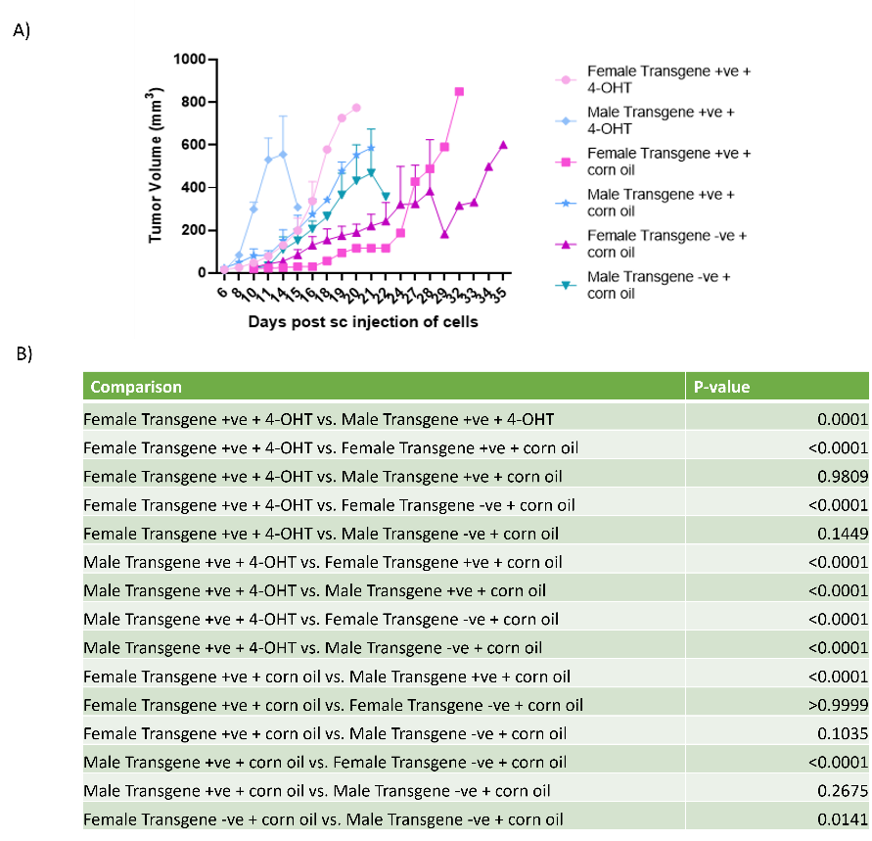
Figure S1. T241-GFP-PDGF-Bβ tumour growth comparison between gender, transgene presence and treatments.

A)Representative graph of T241 fibrosarcoma tumours growth showed by gender, transgene presence and treatment. B) Table showing multiple comparisons between the groups data. Multiple comparisons were done among all groups. Data showed is based on pilot in vivo experiments to activate the transgenic systems. Data values are mean ± SEM. Two-way ANOVA with multiple comparison test was done. n=18.

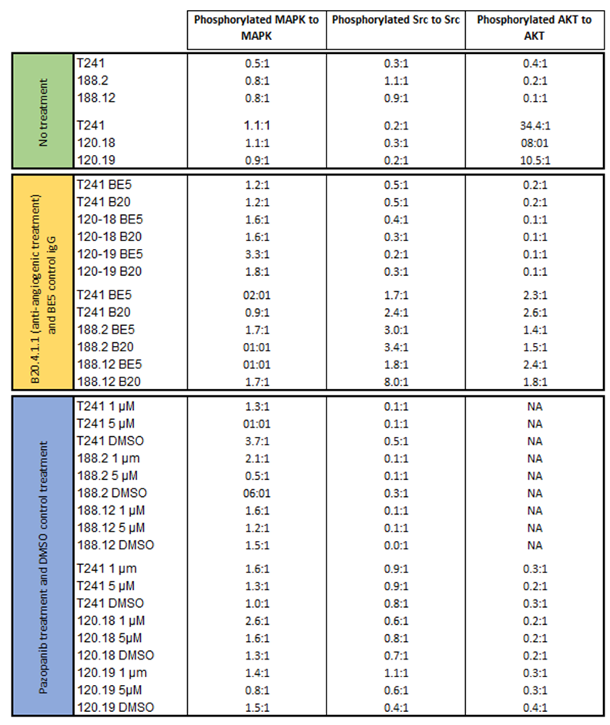
Figure S2. Expression ratio of MAPK, Src and Akt of phosphorylated kinases to total kinase in T241, T241 overexpressing VEGFA120 and T241 overexpressing VEGFA188 cell lines with no treatment, antiangiogenic treatment and a tyrosine kinase inhibitor (Pazopanib) and respective treatment controls in vitro.

Figure S3. Representative images of AQRT-PCR standard curves created with plasmids

Examples of AQRT-PCR standard curves created with 10-fold dilution of linearised CMV-VEGFA120, CMV-VEGFA188 and CMV-VEGFA164 plasmid.

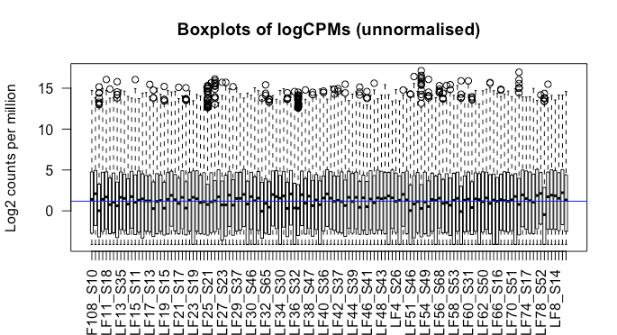

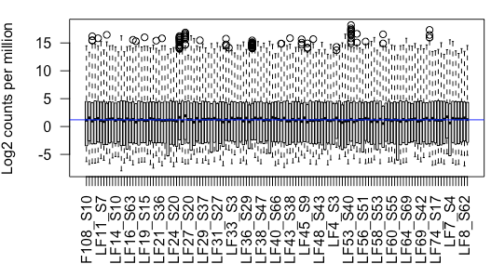
Figure S4 Barplot of unnormalised and normalised VORTEX RNAseq data

Unnormalised (Upper barplot) and edgeR-normalisation (Lower barplot) of RNAseq data from TCGA-VORTEX to further analysis in silico. Blue line shows the median log2 counts per million across all samples.

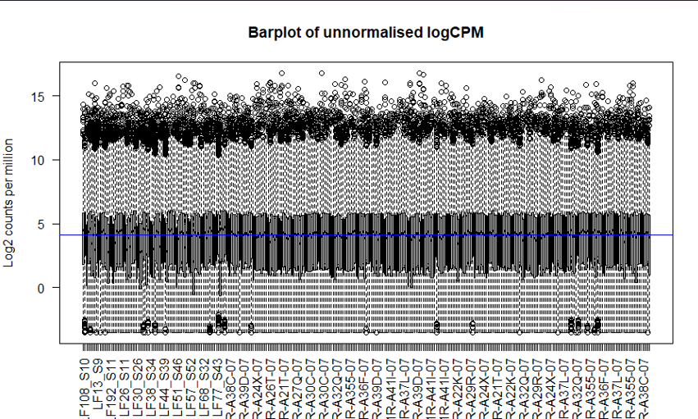

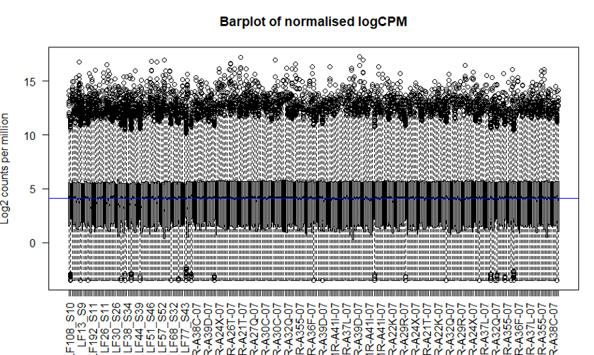

Figure S5 Barplot of unnormalised and normalised TCGA-VORTEX RNAseq data

Unnormalised (Upper barplot) and edgeR –normalisation (lower barplot) of RNAseq data from TCGA-VORTEX to further analysis in silico. Blue line shows the median log2 counts per million across all samples.

hgnc_symbol | logFC | P. Value
EIF2B2 | 1.243546817 | 4.84E-07
 | 2.017264994 | 5.38E-07
KCNN4 | 3.496188475 | 7.20E-07
MRPL43 | 1.494072876 | 7.93E-07
RPL29P11 | 2.547141509 | 1.15E-06
DPCD | 2.288393753 | 1.22E-06
S100A3 | 3.626948632 | 1.93E-06
STN 1.00 | 1.286080665 | 2.54E-06
HMGA1 | 3.452989743 | 3.68E-06
JAGN1 | 1.30891083 | 3.98E-06
SKAP1 | 2.74177753 | 4.02E-06
VPS37B | 1.332158828 | 4.75E-06
ZDHHC16 | 1.47712059 | 4.85E-06
ZP3 | 2.979889959 | 4.96E-06
FAM89B | 1.51538068 | 5.19E-06
PPM1G | 1.311346639 | 5.64E-06
METTL27 | 2.349131434 | 6.45E-06
SCO2 | 3.426759084 | 6.89E-06
VPS33B | 1.062933019 | 8.16E-06
 | 2.293282331 | 8.19E-06
INO80B | 1.5094067 | 8.55E-06
CUEDC2 | 1.897089176 | 8.70E-06
STX1A | 2.56949751 | 8.86E-06
CHCHD1 | 1.402997474 | 1.04E-05
DRAP1 | 1.849671882 | 1.08E-05
STK16 | 1.11165424 | 1.21E-05
NDUFB8 | 1.62703029 | 1.26E-05
INKA1 | 2.408609357 | 1.27E-05
PRR34-AS1 | 2.949766386 | 1.30E-05
 | 3.317778612 | 1.35E-05
NAA80 | 1.678155058 | 1.37E-05
ITGB7 | 2.14412019 | 1.46E-05
TRAPPC4 | 1.057817345 | 1.47E-05
OTUD3 | -1.57605274 | 1.51E-05
EXOSC1 | 1.282274434 | 1.51E-05
TEAD4 | 2.442509121 | 1.56E-05
ERFL | 2.821526115 | 1.87E-05
IFTAP | 1.222559094 | 1.94E-05
WDR54 | 2.34156823 | 1.98E-05
ZNF48 | 1.178650295 | 2.01E-05
RPL21P16 | 2.260194285 | 2.07E-05
TMEM101 | 1.365520915 | 2.07E-05
COMTD1 | 2.460846804 | 2.22E-05
PSME2P2 | 2.141265059 | 2.29E-05
UBTD1 | 1.8141706 | 2.32E-05
SNX17 | 1.266173842 | 2.33E-05
GLTP | 1.100095964 | 2.43E-05
MRPL53 | 1.738971583 | 2.50E-05
S100A2 | 3.82164399 | 2.55E-05

Table S 1. Top 50 of differentially expressed genes in MYXO121 when compared to the rest of MFS from VORTEX dataset.

hgnc_symbol | logFC | P.Value
MYSM1 | -2.39508 | 3.17E-09
NME2 | 1.415616 | 2.41E-08
ACER2 | -2.77679 | 2.60E-08
MRPL43 | 1.124185 | 4.05E-08
LCA5 | -2.25553 | 8.68E-08
MRPL11 | 1.304314 | 1.28E-07
MRGPRF | 1.930586 | 1.31E-07
EFNB2 | -1.78712 | 1.46E-07
CHD6 | -1.22062 | 1.58E-07
KIF3A | -1.58632 | 1.61E-07
EXOSC1 | 1.048395 | 1.76E-07
TUT4 | -1.46881 | 1.80E-07
MRPL53 | 1.431431 | 2.05E-07
EIF3F | 1.108007 | 2.21E-07
AFF4 | -1.55946 | 2.41E-07
FAM89B | 1.244175 | 2.78E-07
SHPRH | -1.69737 | 3.18E-07
FAM13A | -1.40365 | 3.43E-07
TWF2 | 1.140667 | 3.79E-07
CPNE5 | 1.720252 | 3.80E-07
RPL19 | 1.357663 | 4.15E-07
RPL12 | 1.425093 | 5.00E-07
TMEM161B | -1.80222 | 5.10E-07
ZNF644 | -1.37372 | 5.29E-07
COA3 | 1.316476 | 5.67E-07
INO80B | 1.349384 | 5.89E-07
MRPS16 | 0.891064 | 5.92E-07
DDX3X | -1.53976 | 5.94E-07
C11orf68 | 1.415778 | 6.33E-07
ISOC2 | 1.726046 | 6.36E-07
TEAD4 | 1.855099 | 6.88E-07
DRAP1 | 1.529926 | 6.97E-07
GULP1 | -3.16049 | 7.00E-07
SLC19A2 | -1.92485 | 7.31E-07
KLHL8 | -1.35373 | 7.34E-07
NDUFB8 | 1.205544 | 7.83E-07
MED13L | -1.56919 | 8.16E-07
FIBP | 1.464336 | 8.22E-07
RASSF7 | 2.383589 | 8.38E-07
UBTD1 | 1.532951 | 8.77E-07
ARPC1B | 1.252812 | 9.51E-07
PCMTD2 | -1.78046 | 9.71E-07
GORAB | -1.72826 | 9.76E-07
TCP11L2 | -1.7143 | 9.91E-07
ATP5MC2 | 1.112363 | 1.01E-06
VEGFB | 1.459158 | 1.17E-06
DEDD2 | 1.06236 | 1.19E-06
HDDC3 | 1.135573 | 1.20E-06
N4BP2 | -1.94327 | 1.25E-06

Table S2 Top 50 of differentially expressed genes in MYXO121 when compared to the rest of MFS from TCGA-VORTEX dataset.

REFERENCES
Abeshouse, A., et al. (2017). "Comprehensive and Integrated Genomic Characterization of Adult Soft Tissue Sarcomas." Cell 171(4): 950-965.e928.
Abhinand, C. S., et al. (2016). "VEGF-A/VEGFR2 signaling network in endothelial cells relevant to angiogenesis." J Cell Commun Signal 10(4): 347-354.
Abou Khouzam, R., et al., (2020). "Tumour Hypoxia Regulates Immune Escape/Invasion: Influence on Angiogenesis and Potential Impact of Hypoxic Biomarkers on Cancer Therapies." Front Immunol 11: 613114.
Abramsson, A., et al., (2002). "Analysis of Mural Cell Recruitment to Tumour Vessels." Circulation 105(1): 112-117.
Abramsson, A., et al., (2003). "Endothelial and nonendothelial sources of PDGF-B regulate pericyte recruitment and influence vascular pattern formation in tumours." J Clin Invest 112(8): 1142-1151.
Aghajani, K., et al., (2012). "Generation of CD4CreER(T²) transgenic mice to study development of peripheral CD4-T-cells." Genesis 50(12): 908-913.
Agulnik, M., et al. (2013). "An open-label, multicenter, phase II study of bevacizumab for the treatment of angiosarcoma and epithelioid hemangioendotheliomas." Ann Oncol 24(1): 257-263.
Ahmed, N., et al. (2015). "Human Epidermal Growth Factor Receptor 2 (HER2) -Specific Chimeric Antigen Receptor-Modified T Cells for the Immunotherapy of HER2-Positive Sarcoma." J Clin Oncol 33(15): 1688-1696.
Akerman, S., et al., (2013). "Influence of soluble or matrix-bound isoforms of vascular endothelial growth factor-A on tumour response to vascular-targeted strategies." Int J Cancer 133(11): 2563-2576.
Al Tameemi, W., et al. (2019). "Hypoxia-Modified Cancer Cell Metabolism." Front Cell Dev Biol 7: 4.
Albarrán, V., et al. (2023). "Current Landscape of Immunotherapy for Advanced Sarcoma." Cancers (Basel) 15(8).
Alcolea, M. P. and P. H. Jones (2013). "Tracking cells in their native habitat: lineage tracing in epithelial neoplasia." Nat Rev Cancer 13(3): 161-171.
Amin, M. B., et al., (2017). "The Eighth Edition AJCC Cancer Staging Manual: Continuing to build a bridge from a population-based to a more "personalized" approach to cancer staging." CA Cancer J Clin 67(2): 93-99.
Ansari, A. M., et al., . (2016). "Cellular GFP Toxicity and Immunogenicity: Potential Confounders in in vivo Cell Tracking Experiments." Stem Cell Rev Rep 12(5): 553-559.
Apte, R. S., et al. (2019). "VEGF in Signaling and Disease: Beyond Discovery and Development." Cell 176(6): 1248-1264.
Aran, D., et al., . (2017). "xCell: digitally portraying the tissue cellular heterogeneity landscape." Genome Boil 18(1): 220.
Armulik, A., et al., . (2011). "Pericytes: developmental, physiological, and pathological perspectives, problems, and promises." Dev Cell 21(2): 193-215.
Ashizawa, T., et al., . (2017). "Antitumor Effect of Programmed Death-1 (PD-1) Blockade in Humanized the NOG-MHC Double Knockout Mouse." Clin Cancer Res 23(1): 149-158.
Augsburger, D., et al., . (2017). "Current diagnostics and treatment of fibrosarcoma -perspectives for future therapeutic targets and strategies." Oncotarget 8(61): 104638-104653.
Bates, D. O., et al. (2002). "VEGF165b, an inhibitory splice variant of vascular endothelial growth factor, is down-regulated in renal cell carcinoma." Cancer Res 62(14): 4123-4131.
Bates, D. O., et al., . (2002). "Regulation of microvascular permeability by vascular endothelial growth factors." J Anat 200(6): 581-597.
Becker, M., et al. (2016). "Xenograft models for undifferentiated pleomorphic sarcoma not otherwise specified are essential for preclinical testing of therapeutic agents." Oncol Lett 12(2): 1257-1264.
Bertucci, F., et al. (2017). "PD-L11 expression is a poor-prognosis factor in soft-tissue sarcomas." Oncoimmunology 6(3): e1278100.
Betgen, A., et al., . (2013). "Volume changes in soft tissue sarcomas during preoperative radiotherapy of extremities evaluated using cone-beam CT." J Radiat Oncol 2(1): 55-62.
Beyer, M. and J. L. Schultze (2006). "Regulatory T cells in cancer." Blood 108(3): 804-811.
Bi, Q., et al. (2021). "Predicted CD4(+) T cell infiltration levels could indicate better overall survival in sarcoma patients." J Int Med Res 49(1): 300060520981539.
Bill, K. L. J., et al. (2019). "Degree of MDM2 Amplification Affects Clinical Outcomes in Dedifferentiated Liposarcoma." Oncologist 24(7): 989-996
Bindea, G., et al., . (2013). "Spatiotemporal dynamics of intratumoral immune cells reveal the immune landscape in human cancer." Immunity 39(4): 782-795.
Bou-Gharios, G., et al., . (1996). "A potent far-upstream enhancer in the mouse pro alpha 2(I) collagen gene regulates expression of reporter genes in transgenic mice." J Cell Biol 134(5): 1333-1344.
Boulter, N., et al., . (2016). "A simple, accurate and universal method for quantification of PCR." BMC Biotechnol 16: 27.
Bourque, G., et al. (2018). "Ten things you should know about transposable elements." Genome Biol 19(1): 199.
Bower, N. I., et al. (2017). "Vegfd modulates both angiogenesis and lymphangiogenesis during zebrafish embryonic development." Development 144(3): 507-518.
Bowler, E. and S. Oltean (2019). "Alternative Splicing in Angiogenesis." Int J Mol Sci 20(9).
Boxberg, M., et al., . (2018). "PD-L1 and PD-1 and characterization of tumor-infiltrating lymphocytes in high grade sarcomas of soft tissue - prognostic implications and rationale for immunotherapy." Oncoimmunology 7(3): e1389366.
Brauer, M. J., et al., . (2013). "Identification and analysis of in vivo VEGF downstream markers link VEGF pathway activity with efficacy of anti-VEGF therapies." Clin Cancer Res 19(13): 3681-3692.
Bravo, J. I., et al. (2021). "Protocol for isolation of adult mouse ear pinnae-derived primary fibroblasts." STAR Protoc 2(2): 100406.
Butterworth, K. T., et al. (2015). "Small animal image-guided radiotherapy: status, considerations and potential for translational impact." Br J Radiol 88(1045): 20140634.
Byers, R. A., et al., . (2017). "Vascular patterning of subcutaneous mouse fibrosarcomas expressing individual VEGF isoforms can be differentiated using angiographic optical coherence tomography." Biomed Opt Express 8(10): 4551-4567.
Byrne, A. M., et al., . (2005). "Angiogenic and cell survival functions of vascular endothelial growth factor (VEGF)." J Cell Mol Med 9(4): 777-794.

Cancer Research UK (2022), Soft Tissue Sarcoma incidence statistics, https://www.cancerresearchuk.org/health-professional/cancer-statistics/statistics-by-cancer-type/soft-tissue-sarcoma/incidence#heading-One, Accessed [June 2022]
Cancer Research UK (2021), Stages and grades of soft tissue sarcoma, https://www.cancerresearchuk.org/about-cancer/soft-tissue-sarcoma/stages-grades, Accessed [June 2022].
Cancer Research UK (2021), Types of soft tissue sarcomas, https://www.cancerresearchuk.org/about-cancer/soft-tissue-sarcoma/types, Accessed [June 2022].
Cancer Research UK (2021), What are soft tissue sarcomas?, https://www.cancerresearchuk.org/about-cancer/soft-tissue-sarcoma/about, Accessed [June 2022].
Cao, R., et al. (2004). "PDGF-BB induces intratumoral lymphangiogenesis and promotes lymphatic metastasis." Cancer Cell 6(4): 333-345.
Cao, Y., et al. (1998). "Expression of angiostatin cDNA in a murine fibrosarcoma suppresses primary tumor growth and produces long-term dormancy of metastases." J Clin Invest 101(5): 1055-1063.
Carmeliet, P. and R. K. Jain (2011). "Molecular mechanisms and clinical applications of angiogenesis." nature 473(7347): 298-307.
Carmeliet, P., et al. (2001). "Synergism between vascular endothelial growth factor and placental growth factor contributes to angiogenesis and plasma extravasation in pathological conditions." Nat Med 7(5): 575-583.
Carmeliet, P., et al., . (1999). "Impaired myocardial angiogenesis and ischemic cardiomyopathy in mice lacking the vascular endothelial growth factor isoforms VEGF164 and VEGF188." Nat Med 5(5): 495-502.
Casadei, L., et al. (2019). "MDM2 Derived from Dedifferentiated Liposarcoma Extracellular Vesicles Induces MMP2 Production from Preadipocytes." Cancer Res 79(19): 4911-4922.
Cébe Suarez, S., et al. (2006). "A VEGF-A splice variant defective for heparan sulfate and neuropilin-1 binding shows attenuated signaling through VEGFR-2." Cell Mol Life Sci 63(17): 2067-2077
Chalmers, Z. R., et al. (2017). "Analysis of 100,000 human cancer genomes reveals the landscape of tumor mutational burden." Genome Medicine 9(1): 34.
Chan, J. S., et al., . (2017). "Cancer-associated fibroblasts enact field cancerization by promoting extratumoral oxidative stress." Cell Death Dis 8(1): e2562.
Chang, F. C., et al., . (2012). "Novel insights into pericyte-myofibroblast transition and therapeutic targets in renal fibrosis." J Formos Med Assoc 111(11): 589-598.
Chao, C., et al., . (2001). "Vascular endothelial growth factor and soft tissue sarcomas: tumor expression correlates with grade." Ann Surg Oncol 8(3): 260-267.
Charoentong, P., et al., . (2017). "Pan-cancer Immunogenomic Analyses Reveal Genotype-Immunophenotype Relationships and Predictors of Response to Checkpoint Blockade." Cell Rep 18(1): 248-262.
Chen, B., et al., . (2014). "Molecular regulation of cervical cancer growth and invasion by VEGFa." Tumour Biol 35(11): 11587-11593.
Chen, X. and E. Song (2019). "Turning foes to friends: targeting cancer-associated fibroblasts." Nat Rev Drug Discov 18(2): 99-115.
Chen, Y., et al. (2022). "Oncogenic collagen I homotrimers from cancer cells bind to α3β1 integrin and impact tumor microbiome and immunity to promote pancreatic cancer." Cancer Cell 40(8): 818-834.e819
Chen, Y. T., et al., . (2011). "Platelet-derived growth factor receptor signaling activates pericyte-myofibroblast transition in obstructive and post-ischemic kidney fibrosis." Kidney Int 80(11): 1170-1181.
Chesnokov, M. S., et al., . (2018). "Shift in VEGFA isoform balance towards more angiogenic variants is associated with tumor stage and differentiation of human hepatocellular carcinoma." PeerJ 6: e4915.
Chisholm, J. C., et al. (2017). "Open-label, multicentre, randomised, phase II study of the EpSSG and the ITCC evaluating the addition of bevacizumab to chemotherapy in childhood and adolescent patients with metastatic soft tissue sarcoma (the BERNIE study)." Eur J Cancer 83: 177-184.
Chujo, S., et al. (2005). "Connective tissue growth factor causes persistent proalpha2(I) collagen gene expression induced by transforming growth factor-beta in a mouse fibrosis model." J Cell Physiol 203(2): 447-456.
Churg, A. M. and L. B. Kahn (1977). "Myofibroblasts and related cells in malignant fibrous and fibrohistiocytic tumors." Hum Pathol 8(2): 205-218.
Ciciola, P., et al. (2020). "Combining Immune Checkpoint Inhibitors with Anti-Angiogenic Agents." J Clin Med 9(3).
Clegg, L. E. and F. Mac Gabhann (2017). "A computational analysis of in vivo VEGFR activation by multiple co-expressed ligands." PLoS Comput Biol 13(3): e1005445.
Cohen, N. and N. Erez (2019). "FACS Analysis of Col1α Protein Levels in Primary Fibroblasts." Methods Mol Biol 1944: 221-228.
Cook, J. and T. Hagemann (2013). "Tumour-associated macrophages and cancer." Curr Opin Pharmacol 13(4): 595-601.
Cooke, V. G., et al., . (2012). "Pericyte depletion results in hypoxia-associated epithelial-to-mesenchymal transition and metastasis mediated by met signaling pathway." Cancer Cell 21(1): 66-81.
Coralli, C., et al., . (2001). "Limitations of the reporter green fluorescent protein under simulated tumor conditions." Cancer Res 61(12): 4784-4790.
Cren, P. Y., et al. (2020). "Anti-Angiogenic Agents in Management of Sarcoma Patients: Overview of Published Trials." Front Oncol 10: 594445
Croci, D. O., et al., . (2014). "Glycosylation-dependent lectin-receptor interactions preserve angiogenesis in anti-VEGF refractory tumors." Cell 156(4): 744-758.
Cunningham, C. R., et al. (2021). "PD-L1 expression in sarcomas: An immunohistochemical study and review of the literature." Ann Diagn Pathol 55: 151823.
D'Ambrosio, L., et al. (2018). Doxorubicin plus dacarbazine (DoDa), doxorubicin plus ifosfamide (DI) or doxorubicin alone (Do) as first line treatment for advanced leiomyosarcoma (LMS): A retrospective study from the EORTC Soft Tissue and Bone Sarcoma Group (STBSG), American Society of Clinical Oncology.
D'Angelo, S. P., et al. (2018). "Nivolumab with or without ipilimumab treatment for metastatic sarcoma (Alliance A091401): two open-label, non-comparative, randomised, phase 2 trials." Lancet Oncol 19(3): 416-426.
D'Angelo, S. P., et al., . (2015). "Prevalence of tumor-infiltrating lymphocytes and PD-L1 expression in the soft tissue sarcoma microenvironment." Hum Pathol 46(3): 357-365.
Dabjan, M. B., et al., . (2016). "A survey of changing trends in modelling radiation lung injury in mice: bringing out the good, the bad, and the uncertain." Laboratory Investigation 96(9): 936-949.
Dajsakdipon, T., et al. (2022). "Immunotherapy and Biomarkers in Sarcoma." Current Treatment Options in Oncology 23(3): 415-438.
Dalerba, P., et al. (2001). "MAGE, BAGE and GAGE gene expression in human rhabdomyosarcomas." Int J Cancer 93(1): 85-90
Dancsok, A. R., et al., . (2017). "Advances in sarcoma diagnostics and treatment." Oncotarget 8(4): 7068-7093.
Dancsok, A. R., et al., . (2020). "Tumor-associated macrophages and macrophage-related immune checkpoint expression in sarcomas." Oncoimmunology 9(1): 1747340.
Dangoor, A., et al., . (2016). "UK guidelines for the management of soft tissue sarcomas." Clin Sarcoma Res 6: 20.
Dardente, H., et al. (2020). "Debunking the Myth of the Endogenous Antiangiogenic Vegfaxxxb Transcripts." Trends Endocrinol Metab 31(6): 398-409.
De Palma, M. and C. E. Lewis (2013). "Macrophage regulation of tumor responses to anticancer therapies." Cancer Cell 23(3): 277-286.
Deng, C.-C., et al. (2021). "Single-cell RNA-seq reveals fibroblast heterogeneity and increased mesenchymal fibroblasts in human fibrotic skin diseases." Nature Communications 12(1): 3709.
Denton, C. P., et al. (2003). "Fibroblast-specific expression of a kinase-deficient type II transforming growth factor beta (TGFbeta) receptor leads to paradoxical activation of TGFbeta signaling pathways with fibrosis in transgenic mice." J Biol Chem 278(27): 25109-25119.
Denton, C. P., et al., . (2001). "Activation of a fibroblast-specific enhancer of the proalpha2(I) collagen gene in tight-skin mice." Arthritis Rheum 44(3): 712-722.
DeRenzo, C. and S. Gottschalk (2020). "Genetically Modified T-Cell Therapy for Osteosarcoma: Into the Roaring 2020s." Adv Exp Med Biol 1257: 109-131.
DeVita, V. T., et al., . (2011). Cancer: Principles & Practice of Oncology: Primer of the Molecular Biology of Cancer, Wolters Kluwer Health/Lippincott Williams & Wilkins.
Di Benedetto, M., et al., . (2015). "MDA-MB-231 breast cancer cells overexpressing single VEGF isoforms display distinct colonisation characteristics." Br J Cancer 113(5): 773-785.
Dickson, M. A., et al. (2015). "Phase II Trial of Gemcitabine and Docetaxel with Bevacizumab in Soft Tissue Sarcoma." Sarcoma 2015: 532478.
Ding, S., et al. (2005). "Efficient transposition of the piggyBac (PB) transposon in mammalian cells and mice." Cell 122(3): 473-483.
Dodd, R. D., et al., . (2010). "Animal models of soft-tissue sarcoma." Dis Model Mech 3(9-10): 557-566.
Dominici, M., et al., . (2006). "Minimal criteria for defining multipotent mesenchymal stromal cells. The International Society for Cellular Therapy position statement." Cytotherapy 8(4): 315-317.
Domokos, A., et al. (2023). "The transcriptional control of the VEGFA-VEGFR1 (FLT1) axis in alternatively polarized murine and human macrophages." Front Immunol 14: 1168635.
Dos Anjos Cassado, A. (2017). "F4/80 as a Major Macrophage Marker: The Case of the Peritoneum and Spleen." Results Probl Cell Differ 62: 161-179.
Doyle, L. A. (2014). "Sarcoma classification: an update based on the 2013 World Health Organization Classification of Tumors of Soft Tissue and Bone." Cancer 120(12): 1763-1774.
Du, Z. and C. M. Lovly (2018). "Mechanisms of receptor tyrosine kinase activation in cancer." Mol Cancer 17(1): 58.
DuBois, S. and G. Demetri (2007). "Markers of angiogenesis and clinical features in patients with sarcoma." Cancer 109(5): 813-819.
Dumars, C., et al. (2016). "Dysregulation of macrophage polarization is associated with the metastatic process in osteosarcoma." Oncotarget 7(48): 78343-78354.
Dvorak, H. F. (2015). "Tumors: wounds that do not heal-redux." Cancer Immunol Res 3(1): 1-11.
Ehnman, M. and O. Larsson (2015). "Microenvironmental Targets in Sarcoma." Front Oncol 5: 248.
Eil, R., et al., . (2016). "Ionic immune suppression within the tumour microenvironment limits T cell effector function." Nature 537(7621): 539-543.
Ejaz, A., et al. (2019). "Understanding the mechanism of radiation induced fibrosis and therapy options." Pharmacol Ther 204: 107399.
Ellis, L. M. and D. J. Hicklin (2008). "VEGF-targeted therapy: mechanisms of anti-tumour activity." Nat Rev Cancer 8(8): 579-591.
English, W. R., et al., . (2017). "Differential Expression of VEGFA Isoforms Regulates Metastasis and Response to Anti-VEGFA Therapy in Sarcoma." Cancer Res 77(10): 2633-2646.
Erdogan, B., et al., . (2017). "Cancer-associated fibroblasts promote directional cancer cell migration by aligning fibronectin." J Cell Biol 216(11): 3799-3816.
Fallah, A., et al., . (2019). "Therapeutic targeting of angiogenesis molecular pathways in angiogenesis-dependent diseases." Biomed Pharmacother 110: 775-785.
Farhood, B., et al., . (2019). "CD8(+) cytotoxic T lymphocytes in cancer immunotherapy: A review." J Cell Physiol 234(6): 8509-8521.
Fearnley, G. W., et al. (2016). "VEGF-A isoforms program differential VEGFR2 signal transduction, trafficking and proteolysis." Biol Open 5(5): 571-583.
Ferrara, N. (2009). "Vascular endothelial growth factor." Arterioscler Thromb Vasc Biol 29(6): 789-791.
Ferrara, N., et al., . (2003). "The biology of VEGF and its receptors." Nat Med 9(6): 669-676.
Fiori, M. E., et al. (2019). "Cancer-associated fibroblasts as abettors of tumor progression at the crossroads of EMT and therapy resistance." Molecular Cancer 18(1): 70.

Fischetti, T., et al. (2021). "3D Printing and Bioprinting to Model Bone Cancer: The Role of Materials and Nanoscale Cues in Directing Cell Behavior." Cancers (Basel) 13(16).
Fletcher, C., et al. (2013). WHO classification of tumours of soft tissue and bone: WHO classification of tumours, vol. 5, World Health Organization.
Florin, L., et al. (2004). "Cre recombinase-mediated gene targeting of mesenchymal cells." Genesis 38(3): 139-144.
Folkman, J. (1990). "What is the evidence that tumors are angiogenesis dependent?" J Natl Cancer Inst 82(1): 4-6.
Forker, L., et al., . (2018). "The hypoxia marker CAIX is prognostic in the UK phase III VorteX-Biobank cohort: an important resource for translational research in soft tissue sarcoma." Br J Cancer 118(5): 698-704.
Forker, L. J., et al. (2023). "Technical development and validation of a clinically applicable microenvironment classifier as a biomarker of tumour hypoxia for soft tissue sarcoma." British Journal of Cancer.
Fragiadaki, M., et al. (2011). "Interstitial fibrosis is associated with increased COL1A2 transcription in AA-injured renal tubular epithelial cells in vivo." Matrix Biol 30(7-8): 396-403.
Francis, P., et al. (2007). "Diagnostic and prognostic gene expression signatures in 177 soft tissue sarcomas: hypoxia-induced transcription profile signifies metastatic potential." BMC Genomics 8(1): 73.
Fujiwara, T., et al. (2021). "Role of Tumor-Associated Macrophages in Sarcomas." Cancers (Basel) 13(5).
Fukumura, D., et al., . (2018). "Enhancing cancer immunotherapy using antiangiogenics: opportunities and challenges." Nat Rev Clin Oncol 15(5): 325-340.
Gabrilovich, D. I., et al., . (1996). "Production of vascular endothelial growth factor by human tumors inhibits the functional maturation of dendritic cells." Nat Med 2(10): 1096-1103.
Galli, F., et al. (2020). "Relevance of immune cell and tumor microenvironment imaging in the new era of immunotherapy." Journal of Experimental & Clinical Cancer Research 39(1): 89.
Gamboa, A. C., et al., . (2020). "Soft-tissue sarcoma in adults: An update on the current state of histiotype-specific management in an era of personalized medicine." CA Cancer J Clin 70(3): 200-229.
Ganjoo, K. N., et al. (2011). "The prognostic value of tumor-associated macrophages in leiomyosarcoma: a single institution study." Am J Clin Oncol 34(1): 82-86
Garcia, J. M., et al., . (2000). "Mutational status of K-ras and TP53 genes in primary sarcomas of the heart." Br J Cancer 82(6): 1183-1185.
Gautam, J., et al., . (2020). "Pericytic Laminin Maintains Blood-Brain Barrier Integrity in an Age-Dependent Manner." Transl Stroke Res 11(2): 228-242.
Gautam, S. and S. D. Deodhar (1981). "T-cell-mediated antitumor immune response induced by oncofetal antigens." J Natl Cancer Inst 67(4): 939-945.
Gautam, S. C. (1983). "Production of immunosuppressive factor(s) by a weakly immunogenic fibrosarcoma T 241." Anticancer Res 3(4): 263-268.
Gautam, S. C., et al. (1979). "Augmentation of immune response to syngeneic fibrosarcoma T241 with in vivo protection." Cancer Immunology, Immunotherapy 6(2): 81-88.
Gautam, S. C., et al. (1981). "Influence of progressive growth of a weakly immunogenic fibrosarcoma (T241) on the immune status of mice." Journal of Cancer Research and Clinical Oncology 101(3): 265-274
Gee, M. S., et al., . (2003). "Tumor vessel development and maturation impose limits on the effectiveness of anti-vascular therapy." Am J Pathol 162(1): 183-193.
Ghasemi, M., et al., . (2021). "The MTT Assay: Utility, Limitations, Pitfalls, and Interpretation in Bulk and Single-Cell Analysis." Int J Mol Sci 22(23).
Ghita, M., et al. (2019). "Preclinical models of radiation-induced lung damage: challenges and opportunities for small animal radiotherapy." Br J Radiol 92(1095): 20180473.
Gianni, T., et al., . (2021). "Genotype of Immunologically Hot or Cold Tumors Determines the Antitumor Immune Response and Efficacy by Fully Virulent Retargeted oHSV." Viruses 13(9).
Goel, H. L. and A. M. Mercurio (2013). "VEGF targets the tumour cell." Nat Rev Cancer 13(12): 871-882.
Gok Yavuz, B., et al., . (2019). "Cancer associated fibroblasts sculpt tumour microenvironment by recruiting monocytes and inducing immunosuppressive PD-1(+) TAMs." Sci Rep 9(1): 3172.
Gooden, M. J., et al., . (2011). "The prognostic influence of tumour-infiltrating lymphocytes in cancer: a systematic review with meta-analysis." Br J Cancer 105(1): 93-103.
Greenwald, R. J., et al., . (2005). "The B7 family revisited." Annu Rev Immunol 23: 515-548.
Gril, B., et al., . (2011). "The B-Raf status of tumor cells may be a significant determinant of both antitumor and anti-angiogenic effects of pazopanib in xenograft tumor models." PLoS One 6(10): e25625.
Grisez, B. T., et al. (2018). "Highly metastatic K7M2 cell line: A novel murine model capable of in vivo imaging via luciferase vector transfection." J Orthop Res.
Grünewald, T. G., et al., . (2020). "Sarcoma treatment in the era of molecular medicine." EMBO Mol Med 12(11): e11131.
Ha, S. Y., et al. (2014). "The prognostic significance of cancer-associated fibroblasts in esophageal squamous cell carcinoma." PLoS One 9(6): e99955.
Haas, R. L., et al., . (2015). "A phase I study on the combination of neoadjuvant radiotherapy plus pazopanib in patients with locally advanced soft tissue sarcoma of the extremities." Acta Oncol 54(8): 1195-1201.
Hadrup, S., et al., . (2013). "Effector CD4 and CD8 T cells and their role in the tumor microenvironment." Cancer Microenviron 6(2): 123-133.
Han, Y., et al., . (2020). "PD-1/PD-L1 pathway: current researches in cancer." Am J Cancer Res 10(3): 727-742.
Han, Z. and Z. R. Lu (2017). "Targeting Fibronectin for Cancer Imaging and Therapy." J Mater Chem B 5(4): 639-654.
Hanahan, D. and R. A. Weinberg (2011). "Hallmarks of cancer: the next generation." Cell 144(5): 646-674.
Harper, S. J. and D. O. Bates (2008). "VEGF-A splicing: the key to anti-angiogenic therapeutics?" Nat Rev Cancer 8(11): 880-887.
Harris, S., et al. (2012). "Do anti-angiogenic VEGF (VEGFxxxb) isoforms exist? A cautionary tale." PLoS One 7(5): e35231.
Hattori, E., et al. (2019). "Systematic Review of the Current Status of Human Sarcoma Cell Lines." Cells 8(2).
He, X. and C. Xu (2020). "Immune checkpoint signaling and cancer immunotherapy." Cell Research 30(8): 660-669.
Heldin, C.-H. (2013). "Targeting the PDGF signaling pathway in tumor treatment." Cell Communication and Signaling 11(1): 97.

Helman, L. J. and P. Meltzer (2003). "Mechanisms of sarcoma development." Nat Rev Cancer 3(9): 685-694.
Henke, E., et al., . (2019). "Extracellular Matrix in the Tumor Microenvironment and Its Impact on Cancer Therapy." Front Mol Biosci 6: 160.
Hogquist, K. A. and S. C. Jameson (2014). "The self-obsession of T cells: how TCR signaling thresholds affect fate 'decisions' and effector function." Nature Immunology 15(9): 815-823.
Hosaka, K., et al., . (2016). "Pericyte-fibroblast transition promotes tumor growth and metastasis." Proc Natl Acad Sci U S A 113(38): E5618-5627.
Hu, J. L., et al. (2019). "CAFs secreted exosomes promote metastasis and chemotherapy resistance by enhancing cell stemness and epithelial-mesenchymal transition in colorectal cancer." Mol Cancer 18(1): 91
Huang, Y., et al., . (2022). "The molecular mechanisms and therapeutic strategies of EMT in tumor progression and metastasis." J Hematol Oncol 15(1): 129.
Huang, Y., et al., . (2018). "Improving immune-vascular crosstalk for cancer immunotherapy." Nat Rev Immunol 18(3): 195-203.
Hugo, W., et al., . (2016). "Genomic and Transcriptomic Features of Response to Anti-PD-1 Therapy in Metastatic Melanoma." Cell 165(1): 35-44.
Inagaki, Y., et al., . (2005). "Cell type-specific intervention of transforming growth factor beta/Smad signaling suppresses collagen gene expression and hepatic fibrosis in mice." Gastroenterology 129(1): 259-268.
Inagaki, Y., et al., . (1998). "Activation of Proalpha2(I) collagen promoter during hepatic fibrogenesis in transgenic mice." Biochem Biophys Res Commun 250(3): 606-611.
Ishikawa, F., et al. (2005). "Development of functional human blood and immune systems in NOD/SCID/IL2 receptor {gamma} chain(null) mice." Blood 106(5): 1565-1573.
Ito, M., et al. (2002). "NOD/SCID/gamma(c)(null) mouse: an excellent recipient mouse model for engraftment of human cells." Blood 100(9): 3175-3182.
Ito, R., et al. (2009). "Highly sensitive model for xenogenic GVHD using severe immunodeficient NOG mice." Transplantation 87(11): 1654-1658.
Jain, R. K. (2001). "Normalizing tumor vasculature with anti-angiogenic therapy: a new paradigm for combination therapy." Nat Med 7(9): 987-989.
Jain, R. K. (2005). "Normalization of tumor vasculature: an emerging concept in antiangiogenic therapy." Science 307(5706): 58-62.
Jain, R. K. (2014). "Antiangiogenesis strategies revisited: from starving tumors to alleviating hypoxia." Cancer Cell 26(5): 605-622.
Janssen, L. M. E., et al., . (2017). "The immune system in cancer metastasis: friend or foe?" J Immunother Cancer 5(1): 79.
Jayson, G. C., et al. (2012). "Antiangiogenic therapy--evolving view based on clinical trial results." Nat Rev Clin Oncol 9(5): 297-303.
Jiang, Y., et al. (2022). "Targeting extracellular matrix stiffness and mechanotransducers to improve cancer therapy." J Hematol Oncol 15(1): 34.
Jiang, Y., et al., . (2022). "Targeting extracellular matrix stiffness and mechanotransducers to improve cancer therapy." J Hematol Oncol 15(1): 34.
Jin, H., et al. (2020). "Radiation-Induced Lung Fibrosis: Preclinical Animal Models and Therapeutic Strategies." Cancers (Basel) 12(6).
Jochems, C. and J. Schlom (2011). "Tumor-infiltrating immune cells and prognosis: the potential link between conventional cancer therapy and immunity." Exp Biol Med (Maywood) 236(5): 567-579.
Jolly, M. K., et al., . (2016). "Stability of the hybrid epithelial/mesenchymal phenotype." Oncotarget 7(19): 27067-27084.
Kalluri, R. (2016). "The biology and function of fibroblasts in cancer." Nature Reviews Cancer 16(9): 582-598.
Kalluri, R. and R. A. Weinberg (2009). "The basics of epithelial-mesenchymal transition." J Clin Invest 119(6): 1420-1428.
Kalluri, R. and M. Zeisberg (2006). "Fibroblasts in cancer." Nat Rev Cancer 6(5): 392-401.
Kanthou, C., et al., . (2014). "Tumour cells expressing single VEGF isoforms display distinct growth, survival and migration characteristics." PLoS One 9(8): e104015.
Karpanen, T., et al. (2008). "Overexpression of vascular endothelial growth factor-B in mouse heart alters cardiac lipid metabolism and induces myocardial hypertrophy." Circ Res 103(9): 1018-1026.
Karsdal, M. A., et al., . (2017). "The good and the bad collagens of fibrosis - Their role in signaling and organ function." Adv Drug Deliv Rev 121: 43-56.
Katz, D., et al. (2018). "More Than 50 Subtypes of Soft Tissue Sarcoma: Paving the Path for Histology-Driven Treatments." Am Soc Clin Oncol Educ Book 38: 925-938.
Kelany, M., et al. (2021). "Prevalence and Prognostic Implications of PD-L1 Expression in Soft Tissue Sarcomas." Pathol Oncol Res 27: 1609804.
Keung, E. Z., et al. (2020). "Correlative Analyses of the SARC028 Trial Reveal an Association Between Sarcoma-Associated Immune Infiltrate and Response to Pembrolizumab." Clin Cancer Res 26(6): 1258-1266.
Khan, M. and S. Gasser (2016). "Generating Primary Fibroblast Cultures from Mouse Ear and Tail Tissues." J Vis Exp(107).
Kim, C., et al., . (2016). "Prognostic implications of PD-L1 expression in patients with soft tissue sarcoma." BMC Cancer 16(1): 434.
Kim, J. R., et al., . (2013). "Tumor infiltrating PD1-positive lymphocytes and the expression of PD-L1 predict poor prognosis of soft tissue sarcomas." PLoS One 8(12): e82870.

Kim, M. J. and S. J. Ha (2021). "Differential Role of PD-1 Expressed by Various Immune and Tumor Cells in the Tumor Immune Microenvironment: Expression, Function, Therapeutic Efficacy, and Resistance to Cancer Immunotherapy." Front Cell Dev Biol 9: 767466.
Kirsch, D. G., et al., . (2007). "A spatially and temporally restricted mouse model of soft tissue sarcoma." Nat Med 13(8): 992-997.
Klaver, Y., et al., . (2020). "Differential quantities of immune checkpoint-expressing CD8 T cells in soft tissue sarcoma subtypes." J Immunother Cancer 8(2).
Klemen, N. D., et al. (2021). "The emerging role of immunotherapy for the treatment of sarcoma." J Surg Oncol 123(3): 730-738.
Koga, K., et al., . (2007). "Emmprin in epithelioid sarcoma: expression in tumor cell membrane and stimulation of MMP-2 production in tumor-associated fibroblasts." Int J Cancer 120(4): 761-768.
Komohara, Y., et al., . (2019). "Positive correlation between the density of macrophages and T-cells in undifferentiated sarcoma." Med Mol Morphol 52(1): 44-51.
Kondo, Y., et al., . (2000). "Enhancement of Angiogenesis, Tumor Growth, and Metastasis by Transfection of Vascular Endothelial Growth Factor into LoVo Human Colon Cancer Cell Line." Clinical Cancer Research 6(2): 622-630.
Kubow, K. E., et al., . (2015). "Mechanical forces regulate the interactions of fibronectin and collagen I in extracellular matrix." Nat Commun 6: 8026.
Kumar, R., et al., . (2007). "Pharmacokinetic-pharmacodynamic correlation from mouse to human with pazopanib, a multikinase angiogenesis inhibitor with potent antitumor and antiangiogenic activity." Mol Cancer Ther 6(7): 2012-2021
Kurachi, M. (2019). "CD8(+) T cell exhaustion." Semin Immunopathol 41(3): 327-337.
Kyriazoglou, A., et al. (2022). "Tyrosine kinase inhibitors in sarcoma treatment." Oncol Lett 23(6): 183.
Lagacé, R., et al., . (1980). "Myofibroblasts in soft tissue sarcomas." Virchows Arch A Pathol Anat Histol 389(1): 1-11.
Lai, J.-P., et al. (2012). "NY-ESO-1 expression in synovial sarcoma and other mesenchymal tumors: significance for NY-ESO-1-based targeted therapy and differential diagnosis." Modern Pathology 25(6): 854-858.
Lamouille, S., et al. (2014). "Molecular mechanisms of epithelial-mesenchymal transition." Nat Rev Mol Cell Biol 15(3): 178-196.
Lampreht Tratar, U., et al. (2018). "Transgenic Mouse Models in Cancer Research." Front Oncol 8: 268.
Langenau, D. M., et al. (2007). "Effects of RAS on the genesis of embryonal rhabdomyosarcoma." Genes Dev 21(11): 1382-1395.
Lechner, M. G., et al., . (2013). "Immunogenicity of murine solid tumor models as a defining feature of in vivo behavior and response to immunotherapy." J Immunother 36(9): 477-489.
Lee, A. T. J., et al., . (2019). "Pazopanib in advanced soft tissue sarcomas." Signal Transduct Target Ther 4: 16.
Lee, J. S. and E. Ruppin (2019). "Multiomics Prediction of Response Rates to Therapies to Inhibit Programmed Cell Death 1 and Programmed Cell Death 1 Ligand 1." JAMA Oncol 5(11): 1614-1618.
Lee, W. S., et al., . (2020). "Combination of anti-angiogenic therapy and immune checkpoint blockade normalizes vascular-immune crosstalk to potentiate cancer immunity." Exp Mol Med 52(9): 1475-1485.
Lee, Y. H., et al., . (1999). "Cell-retained isoforms of vascular endothelial growth factor (VEGF) are correlated with poor prognosis in osteosarcoma." Eur J Cancer 35(7): 1089-1093.
Lewis, C. E. and J. W. Pollard (2006). "Distinct role of macrophages in different tumor microenvironments." Cancer Res 66(2): 605-612.
Li, H., et al., . (2007). "Tumor microenvironment: the role of the tumor stroma in cancer." J Cell Biochem 101(4): 805-815.
Li, I. M. H., et al., . (2017). "Characterization of Mesenchymal-Fibroblast Cells Using the Col1a2 Promoter/Enhancer." Methods Mol Biol 1627: 139-161.
Li, S., et al. (2020). "Tumor Vessel Normalization: A Window to Enhancing Cancer Immunotherapy." Technol Cancer Res Treat 19: 1533033820980116.
Li, T., et al. (2018). "Tumor angiogenesis and anti-angiogenic gene therapy for cancer." Oncol Lett 16(1): 687-702.
Li, Y., et al., . (2014). "miR-17-92 explains MYC oncogene addiction." Mol Cell Oncol 1(4): e970092.
Li, Y. L., et al. (2016). "Relationship of VEGF/VEGFR with immune and cancer cells: staggering or forward?" Cancer Biol Med 13(2): 206-214.
Liang, W. C., et al., . (2006). "Cross-species vascular endothelial growth factor (VEGF)-blocking antibodies completely inhibit the growth of human tumor xenografts and measure the contribution of stromal VEGF." J Biol Chem 281(2): 951-961.
Lim, J., et al. (2015). "New Strategies in Sarcoma: Linking Genomic and Immunotherapy Approaches to Molecular Subtype." Clin Cancer Res 21(21): 4753-4759.
Linch, M., et al. (2014). "Systemic treatment of soft-tissue sarcoma-gold standard and novel therapies." Nat Rev Clin Oncol 11(4): 187-202.
Liu, D., et al., . (2019). "Mechanisms of Resistance to Immune Checkpoint Blockade." Am J Clin Dermatol 20(1): 41-54.
Liu, T., et al. (2019). "Cancer-associated fibroblasts: an emerging target of anti-cancer immunotherapy." Journal of Hematology & Oncology 12(1): 86.
Liu, Z. G. and D. Jiao (2019). "Necroptosis, tumor necrosis and tumorigenesis." Cell Stress 4(1): 1-8.
Livingston, M. B., et al. (2021). "Phase II Study of Pembrolizumab in Combination with Doxorubicin in Metastatic and Unresectable Soft-Tissue Sarcoma." Clin Cancer Res 27(23): 6424-6431.
Lu, W., et al. (2018). "Patient-derived xenograft models in musculoskeletal malignancies." Journal of Translational Medicine 16(1): 107.
Lugano, R., et al. (2020). "Tumor angiogenesis: causes, consequences, challenges and opportunities." Cell Mol Life Sci 77(9): 1745-1770.
Ma, X., et al. (2018). "3D bioprinting of functional tissue models for personalized drug screening and in vitro disease modeling." Adv Drug Deliv Rev 132: 235-251.
Mahalingam, P., et al. (2022). "Immunotherapy of sarcomas with modified T cells." Curr Opin Oncol 34(4): 362-370.
Mamer, S. B., et al. (2020). "VEGF-A splice variants bind VEGFRs with differential affinities." Scientific Reports 10(1): 14413.
Mantovani, A., et al. (2017). "Tumour-associated macrophages as treatment targets in oncology." Nature Reviews Clinical Oncology 14(7): 399-416.
Marin-Acevedo, J. A., et al., . (2018). "Next generation of immune checkpoint therapy in cancer: new developments and challenges." J Hematol Oncol 11(1): 39.
Mariño-Enríquez, A. and J. V. Bovée (2016). "Molecular Pathogenesis and Diagnostic, Prognostic and Predictive Molecular Markers in Sarcoma." Surg Pathol Clin 9(3): 457-473.
Mata, M. and S. Gottschalk (2015). "Adoptive cell therapy for sarcoma." Immunotherapy 7(1): 21-35.
Matthews, L., et al., . (2009). "Reactome knowledgebase of human biological pathways and processes." Nucleic Acids Res 37(Database issue): D619-622.
McFee, R. M., et al. (2012). "The balance of proangiogenic and antiangiogenic VEGFA isoforms regulate follicle development." Cell and Tissue Research 349(3): 635-647.
Mei, L., et al. (2018). "Gastrointestinal Stromal Tumors: The GIST of Precision Medicine." Trends Cancer 4(1): 74-91.
Melincovici, C. S., et al. (2018). "Vascular endothelial growth factor (VEGF) - key factor in normal and pathological angiogenesis." Rom J Morphol Embryol 59(2): 455-467.
Merchant, M. S., et al. (2004). "Interferon gamma enhances the effectiveness of tumor necrosis factor-related apoptosis-inducing ligand receptor agonists in a xenograft model of Ewing's sarcoma." Cancer Res 64(22): 8349-8356.
Miles, D. W., et al. (2013). "First-line bevacizumab in combination with chemotherapy for HER2-negative metastatic breast cancer: pooled and subgroup analyses of data from 2447 patients." Ann Oncol 24(11): 2773-2780.
Mirzayans, R. and D. Murray (2020). "Intratumor Heterogeneity and Therapy Resistance: Contributions of Dormancy, Apoptosis Reversal (Anastasis) and Cell Fusion to Disease Recurrence." Int J Mol Sci 21(4).
Mirzayans, R. and D. Murray (2020). "Do TUNEL and Other Apoptosis Assays Detect Cell Death in Preclinical Studies?" Int J Mol Sci 21(23).
Mitchell, C. A., et al., . (2006). "Unique vascular phenotypes following over-expression of individual VEGFA isoforms from the developing lens." Angiogenesis 9(4): 209-224.
Mongroo, P. S. and A. K. Rustgi (2010). "The role of the miR-200 family in epithelial-mesenchymal transition." Cancer Biol Ther 10(3): 219-222.
Mootha, V. K., et al. (2003). "PGC-1alpha-responsive genes involved in oxidative phosphorylation are coordinately downregulated in human diabetes." Nat Genet 34(3): 267-273.
Morozov, A., et al., . (2010). "Benign mesenchymal stromal cells in human sarcomas." Clin Cancer Res 16(23): 5630-5640.
Motz, G. T., et al., . (2014). "Tumor endothelium FasL establishes a selective immune barrier promoting tolerance in tumors." Nat Med 20(6): 607-615.
Movva, S., et al., . (2015). "Multi-platform profiling of over 2000 sarcomas: identification of biomarkers and novel therapeutic targets." Oncotarget 6(14): 12234-12247.
Mpekris, F., et al., . (2020). "Combining microenvironment normalization strategies to improve cancer immunotherapy." Proc Natl Acad Sci U S A 117(7): 3728-3737.
Muñoz-López, M. and J. L. García-Pérez (2010). "DNA transposons: nature and applications in genomics." Curr Genomics 11(2): 115-128.
Mushtaq, M. U., et al., . (2018). "Tumor matrix remodeling and novel immunotherapies: the promise of matrix-derived immune biomarkers." J Immunother Cancer 6(1): 65.
Muz, B., et al., . (2015). "The role of hypoxia in cancer progression, angiogenesis, metastasis, and resistance to therapy." Hypoxia (Auckl) 3: 83-92.
Muzumdar, M. D., et al. (2007). "A global double-fluorescent Cre reporter mouse." Genesis 45(9): 593-605.
Nakamura, M., et al., . (2002). "Pathological significance of vascular endothelial growth factor A isoform expression in human cancer." Pathology International 52(5-6): 331-339.
Nassif, E. F., et al. (2021). "TP53 Mutation as a Prognostic and Predictive Marker in Sarcoma: Pooled Analysis of MOSCATO and ProfiLER Precision Medicine Trials." Cancers (Basel) 13(13).
Nielsen, H. L., et al., . (2003). "Collagen gel contraction serves to rapidly distinguish epithelial- and mesenchymal-derived cells irrespective of alpha-smooth muscle actin expression." In vitro Cell Dev Biol Anim 39(7): 297-303.
Nishi, M., et al., . (2005). "Cell binding isoforms of vascular endothelial growth factor-A (VEGF189) contribute to blood flow-distant metastasis of pulmonary adenocarcinoma." Int J Oncol 26(6): 1517-1524.
Nishikawa, H. and S. Sakaguchi (2014). "Regulatory T cells in cancer immunotherapy." Curr Opin Immunol 27: 1-7.
Nowak, D. G., et al., . (2008). "Expression of pro- and anti-angiogenic isoforms of VEGF is differentially regulated by splicing and growth factors." J Cell Sci 121(Pt 20): 3487-3495.
Nygaard, V., et al., . (2016). "Methods that remove batch effects while retaining group differences may lead to exaggerated confidence in downstream analyses." Biostatistics 17(1): 29-39.
Ogura, K., et al., . (2018). "Integrated genetic and epigenetic analysis of myxofibrosarcoma." Nat Commun 9(1): 2765.
Ohue, Y. and H. Nishikawa (2019). "Regulatory T (Treg) cells in cancer: Can Treg cells be a new therapeutic target?" Cancer Sci 110(7): 2080-2089.
Ostroumov, D., et al., . (2018). "CD4 and CD8 T lymphocyte interplay in controlling tumor growth." Cell Mol Life Sci 75(4): 689-713.
Ostrowska-Podhorodecka, Z., et al. (2022). "Impact of Vimentin on Regulation of Cell Signaling and Matrix Remodeling." Front Cell Dev Biol 10: 869069.
Pàez-Ribes, M., et al., . (2009). "Antiangiogenic therapy elicits malignant progression of tumors to increased local invasion and distant metastasis." Cancer Cell 15(3): 220-231.
Palmeri, M., et al. (2022). "Real-world application of tumor mutational burden-high (TMB-high) and microsatellite instability (MSI) confirms their utility as immunotherapy biomarkers." ESMO Open 7(1): 100336.
Panková, K., et al., . (2010). "The molecular mechanisms of transition between mesenchymal and amoeboid invasiveness in tumor cells." Cell Mol Life Sci 67(1): 63-71.
Pankova, V., et al., . (2021). "The Extracellular Matrix in Soft Tissue Sarcomas: Pathobiology and Cellular Signalling." Front Cell Dev Biol 9: 763640.
Paquet-Fifield, S., et al. (2013). "Vascular endothelial growth factor-d modulates caliber and function of initial lymphatics in the dermis." J Invest Dermatol 133(8): 2074-2084.
Pardoll, D. M. (2012). "The blockade of immune checkpoints in cancer immunotherapy." Nat Rev Cancer 12(4): 252-264.
Paten, J. A., et al., . (2019). "Molecular Interactions between Collagen and Fibronectin: A Reciprocal Relationship that Regulates De Novo Fibrillogenesis." Chem 5(8): 2126-2145.
Paul, M. K. and A. K. Mukhopadhyay (2004). "Tyrosine kinase - Role and significance in Cancer." Int J Med Sci 1(2): 101-115.
Pearce, O. M. T., et al., . (2018). "Deconstruction of a Metastatic Tumor Microenvironment Reveals a Common Matrix Response in Human Cancers." Cancer Discov 8(3): 304-319.
Petitprez, F., et al. (2020). "B cells are associated with survival and immunotherapy response in sarcoma." nature 577(7791): 556-560.
Petrova, V., et al. (2018). "The hypoxic tumour microenvironment." Oncogenesis 7(1): 10.
Pfaffl, M. W. (2001). "A new mathematical model for relative quantification in real-time RT-PCR." Nucleic Acids Res 29(9): e45.
Phillips, E., et al. (2022). "Efficacy of Eribulin in Soft Tissue Sarcomas." Front Pharmacol 13: 869754.
Picci, P., et al., . (1993). "Prognostic significance of histopathologic response to chemotherapy in nonmetastatic Ewing's sarcoma of the extremities." J Clin Oncol 11(9): 1763-1769.
Ping, Q., et al. (2021). "Cancer-associated fibroblasts: overview, progress, challenges, and directions." Cancer Gene Therapy 28(9): 984-999.

Pollack, S. M., et al., . (2018). "Emerging Targeted and Immune-Based Therapies in Sarcoma." J Clin Oncol 36(2): 125-135.
Ponticos, M., et al., . (2004). "Col1a2 enhancer regulates collagen activity during development and in adult tissue repair." Matrix Biol 22(8): 619-628.
Ponticos, M., et al., . (2009). "JunB mediates enhancer/promoter activity of COL1A2 following TGF-β induction." Nucleic Acids Research 37(16): 5378-5389.
Ponticos, M., et al. (2015). "Failed degradation of JunB contributes to overproduction of type I collagen and development of dermal fibrosis in patients with systemic sclerosis." Arthritis Rheumatol 67(1): 243-253.
Qin, S., et al., . (2019). "Recent advances on anti-angiogenesis receptor tyrosine kinase inhibitors in cancer therapy." Journal of Hematology & Oncology 12(1): 27.
Que, Y., et al., . (2017). "PD-L1 Expression Is Associated with FOXP3+ Regulatory T-Cell Infiltration of Soft Tissue Sarcoma and Poor Patient Prognosis." J Cancer 8(11): 2018-2025.
Raj, S. K., et al. (2019). "Prognostic implications of tumor associated macrophages (TAMs) in soft tissue sarcoma." Journal of Clinical Oncology 37(15_suppl): e22548-e22548.
Rajkumar, V. S., et al., . (2006). "Platelet-derived growth factor-beta receptor activation is essential for fibroblast and pericyte recruitment during cutaneous wound healing." Am J Pathol 169(6): 2254-2265.
Ramirez, F., et al. (2006). "Transcriptional regulation of the human alpha2(I) collagen gene (COL1A2), an informative model system to study fibrotic diseases." Matrix Biol 25(6): 365-372.
Raskov, H., et al., . (2021). "Cytotoxic CD8(+) T cells in cancer and cancer immunotherapy." Br J Cancer 124(2): 359-367.
Ray-Coquard, I. L., et al. (2015). "Paclitaxel Given Once Per Week With or Without Bevacizumab in Patients With Advanced Angiosarcoma: A Randomized Phase II Trial." J Clin Oncol 33(25): 2797-2802.
Regad, T. (2015). "Targeting RTK Signaling Pathways in Cancer." Cancers (Basel) 7(3): 1758-1784.
Regina, S., et al. (2008). "Tissue factor expression in non-small cell lung cancer: relationship with vascular endothelial growth factor expression, microvascular density, and K-ras mutation." J Thorac Oncol 3(7): 689-697.
Ribeiro, A. L. and O. K. Okamoto (2015). "Combined effects of pericytes in the tumor microenvironment." Stem Cells Int 2015: 868475.
Ricci, S. B. and U. Cerchiari (2010). "Spontaneous regression of malignant tumors: Importance of the immune system and other factors (Review)." Oncol Lett 1(6): 941-945.
Robbins, P. F., et al. (2011). "Tumor regression in patients with metastatic synovial cell sarcoma and melanoma using genetically engineered lymphocytes reactive with NY-ESO-1." J Clin Oncol 29(7): 917-924.
Robinson, M. D., et al., . (2010). "edgeR: a Bioconductor package for differential expression analysis of digital gene expression data." Bioinformatics 26(1): 139-140.
Rohaan, M. W., et al. (2022). "Tumor-Infiltrating Lymphocyte Therapy or Ipilimumab in Advanced Melanoma." N Engl J Med 387(23): 2113-2125.
Rolny, C., et al., . (2011). "HRG inhibits tumor growth and metastasis by inducing macrophage polarization and vessel normalization through downregulation of PlGF." Cancer Cell 19(1): 31-44.
Rosenberg, J. and J. Huang (2018). "CD8(+) T Cells and NK Cells: Parallel and Complementary Soldiers of Immunotherapy." Curr Opin Chem Eng 19: 9-20.
Rossi, A., et al. (2020). "Tumor-Intrinsic or Drug-Induced Immunogenicity Dictates the Therapeutic Success of the PD1/PD-L1 Axis Blockade." Cells 9(4).
Ruhrberg, C., et al., . (2002). "Spatially restricted patterning cues provided by heparin-binding VEGF-A control blood vessel branching morphogenesis." Genes Dev 16(20): 2684-2698.
Rytlewski, J., et al., . (2021). "Turning 'Cold' tumors 'Hot': immunotherapies in sarcoma." Ann Transl Med 9(12): 1039.
Sahai, E., et al., . (2020). "A framework for advancing our understanding of cancer-associated fibroblasts." Nature Reviews Cancer 20(3): 174-186.
Salawu, A., et al. (2016). "Establishment and molecular characterisation of seven novel soft-tissue sarcoma cell lines." British Journal of Cancer 115(9): 1058-1068.
Salvatore, V., et al., . (2015). "Changes in the gene expression of co-cultured human fibroblast cells and osteosarcoma cells: the role of microenvironment." Oncotarget 6(30): 28988-28998.
Sannino, G., et al., . (2017). "Epithelial-to-Mesenchymal and Mesenchymal-to-Epithelial Transition in Mesenchymal Tumors: A Paradox in Sarcomas?" Cancer Res 77(17): 4556-4561.
Santegoets, S. J., et al. (2015). "Monitoring regulatory T cells in clinical samples: consensus on an essential marker set and gating strategy for regulatory T cell analysis by flow cytometry." Cancer Immunol Immunother 64(10): 1271-1286.
Schöffski, P., et al. (2011). "Activity of eribulin mesylate in patients with soft-tissue sarcoma: a phase 2 study in four independent histological subtypes." Lancet Oncol 12(11): 1045-1052.
Schrimpf, C. and J. S. Duffield (2011). "Mechanisms of fibrosis: the role of the pericyte." Curr Opin Nephrol Hypertens 20(3): 297-305.
Schurch, N. J., et al. (2016). "How many biological replicates are needed in an RNA-seq experiment and which differential expression tool should you use?" Rna 22(6): 839-851.
Şenbabaoğlu, Y., et al., . (2016). "Tumor immune microenvironment characterization in clear cell renal cell carcinoma identifies prognostic and immunotherapeutically relevant messenger RNA signatures." Genome Biol 17(1): 231.
Serrano, C., et al., . (2016). "RAS/MAPK pathway hyperactivation determines poor prognosis in undifferentiated pleomorphic sarcomas." Cancer 122(1): 99-107.
Seyedarabi, A., et al., . (2013). "Production of soluble human vascular endothelial growth factor VEGF-A165-heparin binding domain in Escherichia coli." PLoS One 8(2): e55690.
Shi, R., et al. (2022). "Targeting type I collagen for cancer treatment." Int J Cancer 151(5): 665-683.
Shi, Y., et al., . (2017). "Tumour-associated mesenchymal stem/stromal cells: emerging therapeutic targets." Nat Rev Drug Discov 16(1): 35-52.
Shibuya, M. (2011). "Vascular Endothelial Growth Factor (VEGF) and Its Receptor (VEGFR) Signaling in Angiogenesis: A Crucial Target for Anti- and Pro-Angiogenic Therapies." Genes Cancer 2(12): 1097-1105.
Shiraishi, D., et al., . (2018). "CD163 Is Required for Protumoral Activation of Macrophages in Human and Murine Sarcoma." Cancer Res 78(12): 3255-3266.
Shurin, M. R. and V. Umansky (2022). "Cross-talk between HIF and PD-1/PD-L1 pathways in carcinogenesis and therapy." J Clin Invest 132(9).
Siegel, R. L., et al., . (2018). "Cancer statistics, 2018." CA Cancer J Clin 68(1): 7-30.
Simon, T. and J. S. Bromberg (2017). "Regulation of the Immune System by Laminins." Trends Immunol 38(11): 858-871.
Singer, N. G. and A. I. Caplan (2011). "Mesenchymal stem cells: mechanisms of inflammation." Annu Rev Pathol 6: 457-478.
Sinha, S. and A. H. Peach (2010). "Diagnosis and management of soft tissue sarcoma." Bmj 341: c7170.
Sleijfer, S., et al., . (2009). "Pazopanib, a multikinase angiogenesis inhibitor, in patients with relapsed or refractory advanced soft tissue sarcoma: a phase II study from the European organisation for research and treatment of cancer-soft tissue and bone sarcoma group (EORTC study 62043)." J Clin Oncol 27(19): 3126-3132.
Smolle, M. A., et al., . (2021). "T-regulatory cells predict clinical outcome in soft tissue sarcoma patients: a clinico-pathological study." Br J Cancer 125(5): 717-724.
Smolle, M. A., et al. (2021). "Comparison of the 7th and 8th version of the AJCC classification system for soft tissue sarcomas of extremities and trunk in patients with localised, intermediate or high-grade disease treated at European tertiary sarcoma centres." Eur J Surg Oncol 47(8): 2182-2188.
Song, H. N., et al., . (2018). "Pembrolizumab for Refractory Metastatic Myxofibrosarcoma: A Case Report." Cancer Res Treat 50(4): 1458-1461.
Sorbye, S. W., et al. (2011). "Prognostic impact of lymphocytes in soft tissue sarcomas." PLoS One 6(1): e14611.
Sottile, J., et al., . (2007). "Fibronectin-dependent collagen I deposition modulates the cell response to fibronectin." Am J Physiol Cell Physiol 293(6): C1934-1946.
Stenman, S. and A. Vaheri (1981). "Fibronectin in human solid tumors." Int J Cancer 27(4): 427-435.
Stewart, E., et al. (2017). "Orthotopic patient-derived xenografts of paediatric solid tumours." nature 549(7670): 96-100.
Straub, J. M., et al., . (2015). "Radiation-induced fibrosis: mechanisms and implications for therapy." J Cancer Res Clin Oncol 141(11): 1985-1994.
Strober, W. (2015). "Trypan Blue Exclusion Test of Cell Viability." Curr Protoc Immunol 111: A3.B.1-a3.B.3.
Subramanian, A., et al. (2005). "Gene set enrichment analysis: a knowledge-based approach for interpreting genome-wide expression profiles." Proc Natl Acad Sci U S A 102(43): 15545-15550.
Sundaram, G. M., et al. (2018). "Cancer: the dark side of wound healing." Febs j 285(24): 4516-4534.
Szumera-Ciećkiewicz, A., et al. (2023). "Predictive Biomarkers of Pathological Response to Neoadjuvant Chemoradiotherapy for Locally Advanced Soft Tissue Sarcomas." Cancers (Basel) 15(11).
Talbott, H. E., et al. (2022). "Wound healing, fibroblast heterogeneity, and fibrosis." Cell Stem Cell 29(8): 1161-1180.
Tammela, T., et al., . (2005). "The biology of vascular endothelial growth factors." Cardiovasc Res 65(3): 550-563.
Tamura, R., et al. (2019). "The role of vascular endothelial growth factor in the hypoxic and immunosuppressive tumor microenvironment: perspectives for therapeutic implications." Medical Oncology 37(1): 2.
Taube, J. M., et al. (2014). "Association of PD-1, PD-1 ligands, and other features of the tumor immune microenvironment with response to anti-PD-1 therapy." Clin Cancer Res 20(19): 5064-5074.
Tavallai, S., et al., . (2014). "Pazopanib and HDAC inhibitors interact to kill sarcoma cells." Cancer Biol Ther 15(5): 578-585.
Tawbi, H. A., et al., . (2017). "Pembrolizumab in advanced soft-tissue sarcoma and bone sarcoma (SARC028): a multicentre, two-cohort, single-arm, open-label, phase 2 trial." Lancet Oncol 18(11): 1493-1501.
Taylor, B. S., et al., . (2011). "Advances in sarcoma genomics and new therapeutic targets." Nat Rev Cancer 11(8): 541-557.
Terry, R. L., et al. (2021). "Chimeric Antigen Receptor T cell Therapy and the Immunosuppressive Tumor Microenvironment in Pediatric Sarcoma." Cancers (Basel) 13(18).
Thway, K. (2009). "Pathology of soft tissue sarcomas." Clin Oncol (R Coll Radiol) 21(9): 695-705.
Tie, Y., et al. (2022). "TGF-beta signal transduction: biology, function and therapy for diseases." Mol Biomed 3(1): 45.
Tokunaga, T., et al., . (1998). "Vascular endothelial growth factor (VEGF) mRNA isoform expression pattern is correlated with liver metastasis and poor prognosis in colon cancer." Br J Cancer 77(6): 998-1002.
Tomlinson, J., et al., . (1999). "Different patterns of angiogenesis in sarcomas and carcinomas." Clin Cancer Res 5(11): 3516-3522.
Torre, L. A., et al., . (2016). "Global Cancer Incidence and Mortality Rates and Trends--An Update." Cancer Epidemiol Biomarkers Prev 25(1): 16-27.
Toulmonde, M., et al. (2018). "Use of PD-1 Targeting, Macrophage Infiltration, and IDO Pathway Activation in Sarcomas: A Phase 2 Clinical Trial." JAMA Oncol 4(1): 93-97.
Toulmonde, M., et al. (2019). "Pazopanib or methotrexate-vinblastine combination chemotherapy in adult patients with progressive desmoid tumours (DESMOPAZ): a non-comparative, randomised, open-label, multicentre, phase 2 study." Lancet Oncol 20(9): 1263-1272.
Tozer, G. M., et al., . (2008). "Blood vessel maturation and response to vascular-disrupting therapy in single vascular endothelial growth factor-A isoform-producing tumors." Cancer Res 68(7): 2301-2311.
Tsumura, H., et al. (2006). "Cooperation of oncogenic K-ras and p53 deficiency in pleomorphic rhabdomyosarcoma development in adult mice." Oncogene 25(59): 7673-7679.
Tucker, W. D., et al. (2023). Anatomy, Blood Vessels. StatPearls. Treasure Island (FL), StatPearls Publishing
Van Cutsem, E., et al. (2012). "Bevacizumab in combination with chemotherapy as first-line therapy in advanced gastric cancer: a biomarker evaluation from the AVAGAST randomized phase III trial." J Clin Oncol 30(17): 2119-2127.
van der Graaf, W. T., et al., . (2012). "Pazopanib for metastatic soft-tissue sarcoma (PALETTE): a randomised, double-blind, placebo-controlled phase 3 trial." Lancet 379(9829): 1879-1886.
van Erp, A. E. M., et al. (2017). "Expression and clinical association of programmed cell death-1, programmed death-ligand-1 and CD8(+) lymphocytes in primary sarcomas is subtype dependent." Oncotarget 8(41): 71371-71384.
Vempati, P., et al., . (2014). "Extracellular regulation of VEGF: isoforms, proteolysis, and vascular patterning." Cytokine Growth Factor Rev 25(1): 1-19.
Verhaegen, F., et al. (2018). "ESTRO ACROP: Technology for precision small animal radiotherapy research: Optimal use and challenges." Radiother Oncol 126(3): 471-478.
Verschraegen, C. F., et al. (2012). "Phase IB study of the combination of docetaxel, gemcitabine, and bevacizumab in patients with advanced or recurrent soft tissue sarcoma: the Axtell regimen." Ann Oncol 23(3): 785-790.
Vetsika, E. K., et al. (2019). "Myeloid-Derived Suppressor Cells: Major Figures that Shape the Immunosuppressive and Angiogenic Network in Cancer." Cells 8(12).
Viallard, C. and B. Larrivée (2017). "Tumor angiogenesis and vascular normalization: alternative therapeutic targets." Angiogenesis 20(4): 409-426.
Vibert, J. and S. Watson (2022). "The Molecular Biology of Soft Tissue Sarcomas: Current Knowledge and Future Perspectives." Cancers 14(10): 2548.
Vodanovich, D. A. and M. C. PF (2018). "Soft-tissue Sarcomas." Indian J Orthop 52(1): 35-44.
Wang, F., et al. (2020). "Prognostic Value of Programmed Cell Death 1 Ligand-1 in Patients With Bone and Soft Tissue Sarcomas: A Systemic and Comprehensive Meta-Analysis Based on 3,680 Patients." Front Oncol 10: 749.
Wang, M., et al., . (2018). "Humanized mice in studying efficacy and mechanisms of PD-1-targeted cancer immunotherapy." Faseb j 32(3): 1537-1549.
Wang, N., et al., . (2015). "Down-regulated E-cadherin expression is associated with poor five-year overall survival in bone and soft tissue sarcoma: results of a meta-analysis." PLoS One 10(3): e0121448.
Wang, X., et al., . (2016). "Importance of the interaction between immune cells and tumor vasculature mediated by thalidomide in cancer treatment (Review)." Int J Mol Med 38(4): 1021-1029.
Wang, Y., et al., . (2020). "Efficacy and safety of anti-angiogenesis medicines for advanced soft tissue sarcoma: a meta-analysis." Transl Cancer Res 9(3): 1536-1546.
Wang, Z., et al. (2019). "Cancer-associated fibroblasts in radiotherapy: challenges and new opportunities." Cell Communication and Signaling 17(1): 47.
Weidemann, A. and R. S. Johnson (2008). "Biology of HIF-1α." Cell Death & Differentiation 15(4): 621-627.
Weiss, A. R., et al. (2020). "Pathological response in children and adults with large unresected intermediate-grade or high-grade soft tissue sarcoma receiving preoperative chemoradiotherapy with or without pazopanib (ARST1321): a multicentre, randomised, open-label, phase 2 trial." Lancet Oncol 21(8): 1110-1122.
Weskamp, P., et al. (2022). "Risk Factors for Occurrence and Relapse of Soft Tissue Sarcoma." Cancers (Basel) 14(5).
West, C. C., et al., . (2005). "Microvessel density does not predict outcome in high grade soft tissue sarcoma." Eur J Surg Oncol 31(10): 1198-1205.
WHO, 2020, WHO Classification of Tumours Editorial Board, Soft Tissue and Bone Tumours, International Agency for Research on Cancer, WHO classification of tumours series, 5th ed, Vol. 3, Lyon (France), https://publications.iarc.fr/588, Last accessed (April 2023)
Widemann, B. C. and A. Italiano (2018). "Biology and Management of Undifferentiated Pleomorphic Sarcoma, Myxofibrosarcoma, and Malignant Peripheral Nerve Sheath Tumors: State of the Art and and Perspectives." J Clin Oncol 36(2): 160-167.
Wieder, R. (2023). "Fibroblasts as Turned Agents in Cancer Progression." Cancers (Basel) 15(7).
Woltjen, K., et al. (2009). "piggyBac transposition reprograms fibroblasts to induced pluripotent stem cells." nature 458(7239): 766-770.
Woolard, J., et al. (2009). "Molecular diversity of VEGF-A as a regulator of its biological activity." Microcirculation 16(7): 572-592.
Wu, J., et al., . (2020). "Synergic effect of PD-1 blockade and endostar on the PI3K/AKT/mTOR-mediated autophagy and angiogenesis in Lewis lung carcinoma mouse model." Biomed Pharmacother 125: 109746.
Xian, X., et al., . (2006). "Pericytes limit tumor cell metastasis." J Clin Invest 116(3): 642-651.
Xiao, W., et al., . (2013). "Mesenchymal stem cell transformation and sarcoma genesis." Clinical Sarcoma Research 3(1): 10.
Xin, H., et al., . (2016). "Evidence for Pro-angiogenic Functions of VEGF-Ax." Cell 167(1): 275-284.e276.
Yaguchi, T., et al. (2018). "Human PBMC-transferred murine MHC class I/II-deficient NOG mice enable long-term evaluation of human immune responses." Cellular & Molecular Immunology 15(11): 953-962.
Yamamoto, H., et al., . (2016). "Autocrine VEGF Isoforms Differentially Regulate Endothelial Cell Behavior." Front Cell Dev Biol 4: 99.
Yamazaki, T. and Y. S. Mukouyama (2018). "Tissue Specific Origin, Development, and Pathological Perspectives of Pericytes." Front Cardiovasc Med 5: 78.
Yang, C., et al., . (2010). "Low density lipoprotein receptor mediates anti-VEGF effect of lymphocyte T-derived microparticles in Lewis lung carcinoma cells." Cancer Biol Ther 10(5): 448-456.
Yang, J., et al., . (2014). "Mesenchymal to epithelial transition in sarcomas." Eur J Cancer 50(3): 593-601.
Yang, J., et al. (2018). "Targeting VEGF/VEGFR to Modulate Antitumor Immunity." Front Immunol 9: 978.
Yarchoan, M., et al. (2017). "Tumor Mutational Burden and Response Rate to PD-1 Inhibition." N Engl J Med 377(25): 2500-2501.
Yin, X., et al., . (2016). "A VEGF-dependent gene signature enriched in mesenchymal ovarian cancer predicts patient prognosis." Sci Rep 6: 31079.
Yu, L., et al., . (2011). "Fusion between cancer cells and myofibroblasts is involved in osteosarcoma." Oncol Lett 2(6): 1083-1087.
Yuan, J., et al. (2021). "Molecular targeted therapy for advanced or metastatic soft tissue sarcoma." Cancer Control 28: 10732748211038424.
Yudoh, K., et al., . (2001). "Concentration of vascular endothelial growth factor in the tumour tissue as a prognostic factor of soft tissue sarcomas." British Journal of Cancer 84(12): 1610-1615.
Zhang, H., et al. (2021). "Regulatory mechanisms of immune checkpoints PD-L1 and CTLA-4 in cancer." Journal of Experimental & Clinical Cancer Research 40(1): 184.
Zhang, M., et al. (2015). "HIF-1 Alpha Regulates the Response of Primary Sarcomas to Radiation Therapy through a Cell Autonomous Mechanism." Radiat Res 183(6): 594-609.
Zhao, S., et al., . (2016). "PiggyBac transposon vectors: the tools of the human gene encoding." Transl Lung Cancer Res 5(1): 120-125.
Zhou, L., et al., . (2015). "Perspective of Targeting Cancer-Associated Fibroblasts in Melanoma." J Cancer 6(8): 717-726.
Zhu, N. and J. Hou (2020). "Assessing immune infiltration and the tumor microenvironment for the diagnosis and prognosis of sarcoma." Cancer Cell International 20(1): 577.
Ziogas, A. C., et al. (2012). "VEGF directly suppresses activation of T cells from ovarian cancer patients and healthy individuals via VEGF receptor Type 2." Int J Cancer 130(4): 857-864.

