PROTECTIVE MECHANISM OF SIRT1 ON SUBVENTRICULAR ZONE DERIVED NEURAL STEM CELLS DURING AGING IN MICE
by
Jie Ren

Submitted for the degree of Doctor of Philosophy (PhD)

Sheffield Institute for Translational Neuroscience University of Sheffield



August 2022

ABSTRACT
Adult neurogenesis is important for the maintenance of nervous system function during ageing. As the source of adult neurogenesis, the adult neural stem cells (NSC) pool declines with age. As a result, DNA double-strand break (DSB) accumulates in adult stem cells leading to their dysfunction in various tissues from the aged organism, but less is known for NSCs. SIRT1 is an essential anti-ageing protein, protecting multiple kinds of tissue from ageing-related insults, including DSBs.
We thus proposed that SIRT1 plays the protection role in NSCs confronting DSBs during ageing in mice. We obtained some findings in the study with in vivo and in vitro investigations. First, the activated NSCs from the SVZ of aged mice displayed decreased cell number, cell proliferation and DSBs but enhanced NHEJ repair capacity. Second, Sirt1 loss in SVZ NSCs of young mice increased cell proliferation, impaired DSB repair and ultimately led to premature ageing of SVZ. Third, Sirt1 loss in SVZ NSCs of aged mice increased the proliferative cells that could be apoptotic induced by DSB accumulation. Last, SIRT1 deacetylated NICD to suppress cell proliferation and KU70 to promote NHEJ repair of DSBs in adult SVZ NSCs; the reduced ubiquitination mediated proteasome degradation of SIRT1 protein may account for the low proliferation and few DSBs in SVZ NSCs of aged mice.
In conclusion, the study demonstrates the critical role of SIRT1 in protecting SVZ NSCs during ageing in mice.

ACKNOWLEDGMENTS
This project would not have been completed without the support from my supervisors, teachers, advisors, friends and families.
First, I would like to express my gratitude to Dr Ke Ning, who provided generous help on this journey of international exchange in the UK and the years after I returned to China. By now, this journey has become one of the most critical turning points in my life. With his help, I finally decided to move forward and become independent. I am very honoured to become one of his students. I also want to thank Dr Tennore Ramesh, Dr Andrew J Grierson, Dr Martina E Daly and Prof Dame Pam Shaw. They encouraged me a lot when I was in difficulties or doubted myself. I always regard them as my role models.
Second, I would like to thank everyone who helped me during the year of exchange amid COVID-19. Third, I want to thank Sheffield Medicine School's PGR team and the friends and colleagues I have met in Sheffield. Finally, I especially thank Anushka Bhargava, who helped me and was a great roommate.
Next, I thank Dr Jun Xu, my supervisor at Tongji University. As my mentor, he constantly supported me for years.
Last but not least, I want to thank my family. They believe me and encourage me no matter what happens. I also dedicate this thesis to my beloved grandparents; I hope for my grandmother’s longevity and happiness.

This thesis is dedicated to my family.

PUBLICATIONS
Articles
Ren J, Wang X, Dong C, Wang G, Zhang W, Cai C, Qian M, Yang D, Ling B, Ning K, Mao Z, Liu B, Wang T, Xiong L, Wang W, Liang A, Gao Z, Xu J. Sirt1 Protects Subventricular Zone-Derived Neural Stem Cells from DNA Double-Strand Breaks and Contributes to Olfactory Function Maintenance in Aging Mice. Stem Cells. 2022 May 27;40(5):493-507.

Zhu L, Sun C, Ren J, Wang G, Ma R, Sun L, Yang D, Gao S, Ning K, Wang Z, Chen X, Chen S, Zhu H, Gao Z, Xu J. Stress-induced precocious aging in PD-patient Ipsc-derived NSCs may underlie the pathophysiology of Parkinson’s disease. Cell Death Dis. 2019 Feb 4;10(2):105.

Wang G, Wang F, Ren J, Qiu Y, Zhang W, Gao S, Yang D, Wang Z, Liang A, Gao Z, Xu J. SIRT1 Involved in the Regulation of Alternative Splicing Affects the DNA Damage Response in Neural Stem Cells. Cell Physiol Biochem. 2018;48(2):657-669.

Table of Contents

ABSTRACT I

ACKNOWLEDGMENTS II

PUBLICATIONS IV

LIST OF FIGURES XI

LIST OF TABLES XVI

LIST OF ABBREVIATIONS XVII

CHAPTER 1: INTRODUCTION 1

1.1 Adult neurogenesis 2

1.2 Adult neurogenesis diminishes with age 6

1.3 DNA damage and adult neurogenesis maintenance 11

1.4 SIRT1 maintains adult neurogenesis 19

CHAPTER 2: MATERIALS AND METHODS 29

2.1 Materials 30
2.1.1 Mice, cell lines and plasmids 30
2.1.2 Reagents, antibodies, synthesized DNA 31

2.2 Methods 40
2.2.1 The generation of NSC-specific Sirt1 knockout and genetic tracing mice 40
2.2.1.1 The generation of NSC-specific Sirt1 knockout mice 40
2.2.1.2 The generation of NSC-specific tracing mice 41
2.2.1.3 Mouse genotyping and tamoxifen administration 42
2.2.1.4 X-ray irradiation of Mouse 43
2.2.2 The culture, quiescence and activation induction and differentiation of mouse SVZ-derived NSCs 44
2.2.2.1 The culture of NSCs from mouse SVZ 44
2.2.2.2 The neurospheres formation assay 44
2.2.2.3 The quiescence and activation induction of NSCs 45
2.2.2.4 The differentiation of NSCs 46
2.2.3 Immunohistochemistry and immunocytochemistry 47
2.2.3.1 Immunohistochemistry 47
2.2.3.2 Immunocytochemistry 48
2.2.4 The construction of the overexpression vectors, the lentivirus production and the infection of NSCs with lentivirus 50
2.2.4.1 The construction of Sirt1 overexpression vector 50
2.2.4.2 Lentivirus production 53
2.2.4.3 The transduction of NSCs with lentivirus 54
2.2.5 RNA extraction, RT-qPCR and RNA-Seq 56
2.2.5.1 Total RNA extraction 56
2.2.5.3 RNA-Seq 57
2.2.6 Protein extraction, Immunoprecipitation, Co-immunoprecipitation and Western Blotting 60
2.2.6.1 Immunoprecipitation (IP) and Co-immunoprecipitation (CoIP) 60
2.2.6.2 Western blotting 61
2.2.7 HR and NHEJ reporter assay 62
2.2.7.1 The illustration of HR and NHEJ reporter assay 62
2.2.7.2 The test of HR and NHEJ repair efficiency of NSCs 63
2.2.8 The Social Transmission of Food Preference (STFP) assay 65
2.2.8.1 The illustration of STFP assay 65
2.2.8.2 The experimental procedure of STFP assay 66

CHAPTER 3: The DNA Damage of The Activated Neural Stem Cells in Ageing Mice 68

3.1 Introduction 69

3.2 Aim 70

3.3 Results 71
3.3.1 Increases of DNA DSBs and Apoptosis imaging Mice Neurons 71
3.3.2 Mouse NSCs exist in both quiescent and activated status 73
3.3.3 The number and proliferation of NSCs decrease in ageing mice SVZ 77
3.3.4 The DSBs in activated NSCs are fewer in aged Mice SVZs 78
3.3.5 Enhanced NHEJ repair in activated NSCs of aged mice SVZs 80

3.4 Discussion 83

CHAPTER 4: SIRT1 Affects The Activated NSCs in SVZ of Young Mice 86

4.1 Introduction 87

4.2 Aim 88

4.3 Results 89
4.3.1 Sirt1 loss promotes the proliferation of SVZ NSCs in young mice 89
4.3.2 Sirt1 loss accelerates the NSC pool shrinking of mice during ageing 93
4.3.3 Sirt1 ablation diminishes neurogenesis in ageing mice SVZs 95
4.3.4 Sirt1 loss results in DSB repair defects in activated SVZ NSCs of mice 100

4.4 Discussion 105

CHAPTER 5: SIRT1 Functions in Activated NSCs in SVZ of Ageing Mice 108

5.1 Introduction 109

5.2 Aim 109

5.3 Results 110
5.3.1 SIRT1 protein highly expresses in activated SVZ NSCs of ageing mice 110
5.3.2 Sirt1 loss promotes proliferation of activated SVZ NSCs in ageing mice 113
5.3.3 Sirt1 loss dose not affect the neurogenesis of olfactory neurons from SVZ 115
5.3.4 Sirt1 loss increases the accumulation of DSBs and the apoptosis of NSCs 117
5.3.5 Sirt1 loss compromises the NHEJ repair in activated SVZ NSCs 122

5.4 Discussion 123

CHAPTER 6: Upstream and Downstream Regulation of SIRT1 Protein in NSCs 126

6.2 Aim 128

6.3 Results 129
6.3.1 Transcriptomic and proteomic analysis of the activated SVZ NSCs of Mice 129
6.3.2 SIRT1 suppresses proliferation by deacetylating NICD 133
6.3.3 SIRT1 promotes DSB repair by deacetylating KU70 136
6.3.4 Ubiquitin proteasome mediated SIRT1 degradation in activated NSCs 139

6.4 Discussion 144

CHAPTER 7: GENERAL DISCUSSION 147

7.1 Discussion 148
7.1.1 Decreased proliferation and DSBs in activated SVZ NSCs of Ageing Mice 148
7.1.2 The exhaustion of NSCs due to proliferation and accumulation of DSBs in ageing mice 150
7.1.3 The upregulated SIRT1 protein in activated NSCs of ageing mice SVZs 153
7.1.4 The DSBs in adult NSCs and other tissue stem cells 155

7.2 Conclusion 157

7.3 Future perspectives 157

REFERENCES 160

APPENDICES 177

LIST OF FIGURES
Figure No. | Title | Page
Figure 1.1 | The adult neurogenesis in the SGZ of mouse hippocampus | 5
Figure 1.2 | The adult neurogenesis in the SVZ of mouse ventricle | 6
Figure 1.3 | The characterizations of NSCs during ageing in mice and rats | 8
Figure 1.4 | The cell division model of NSCs during ageing | 11
Figure 1.5 | The responses of DNA double-strand breaks in cells | 13
Figure 1.6 | The NHEJ and HR repair of DSBs | 15
Figure 1.7 | The DSBs in stem cells contributing ageing and cancer | 17
Figure 1.8 | The molecules affected by SIRT1 contributing to anti-ageing | 22
Figure 1.9 | The protective role of SIRT1 in maintaining genomic stability | 24
Figure 1.10 | The impact of SIRT1 protein on NSC fating | 27
Figure 2.1 | The schematic presentation of the generation of NSC-specific Sirt1 knockout mice | 40
Figure 2.2 | The schematic presentation of the generation of NSC-specific Sirt1 knockout and genetic tracing mice | 41
Figure 2.3 | The presentation of mouse genotying results | 43
Figure 2.4 | The plasmid map of the pLenti-CMV-TagGFP-P2A-Puro vector | 51
Figure 2.5 | The plasmid map of the pLenti-CMV-mSirt1-TagGFP-P2A-Puro vector | 52
Figure 2.6 | The example of the quality of RNA sample analysed by Agilent 2100 | 58
Figure 2.7 | The distribution of base percentage and qualities along reads in data filtering | 59
Figure 2.8 | The illustration of the HR and NHEJ reporter assay | 62
Figure 2.9 | The gating strategy of the flow cytometry in the HR and NHEJ reporter assay | 64
Figure 2.10 | Thes chematic representation of the STFP assay to test the olfactory memory of mice | 66
Figure 3.1 | The apoptosis and DNA DSBs of neurons in ageing mice | 72
Figure 3.2 | The in vivo characterisation of quiescent and activated NSCs with immunostaining | 74
Figure 3.3 | The in vitro characterisation of the induced quiescent and activated NSCs with immunostaining | 75
Figure 3.4 | The cell cycle analysis of the induced quiescent and activated NSCs with flow cytometry | 76
Figure 3.5 | The characterisation of the differentaion of induced reactivated NSCs with immunostaining | 76
Figure 3.6 | The number and proliferatin of activated NSCs in mice SVZ decreases with age | 77
Figure 3.7 | The DSBs showing by γH2AX in activated NSCs in mice SVZs decrease with age | 78
Figure 3.8 | The DSBs showing by 53BP1 in activated NSCs in mice SVZs decrease with age | 79
Figure 3.9 | The DSBs in cultured activated NSCs in mice SVZs decrease with age | 81
Figure 3.10 | Enhanced NHEJ repair in activated NSCs of aged mice SVZs | 82
Figure 4.1 | The in vivo validation of NSC-specific Sirt1 knockout | 90
Figure 4.2 | The in vitro validation of NSC-specific Sirt1 knockout | 90
Figure 4.3 | The in vivo detection of the proliferation of SVZ NSCs with one-month loss of Sirt1 | 91
Figure 4.4 | The in vitro detection of the proliferation of SVZ NSCs | 92
Figure 4.5 | The in vitro detection of the proliferation of SVZ NSCs with neurosphere formation assay | 92
Figure 4.6 | The detection of the activated NSCs in mice SVZs with 12-month loss of Sirt1 | 93
Figure 4.7 | The detection of the proliferative NSCs in mice SVZs with 12-month loss of Sirt1 | 94
Figure 4.8 | The detection of GFP traced SVZ NSCs and their descendants along SVZ-RMS-OB axis | 96
Figure 4.9 | The detection of neurons in olfactory bulbs of GFP traced mice | 97
Figure 4.10 | The behaviour analysis of mice in STFP assay | 98
Figure 4.11 | The food preference of mice in STFP assay | 99
Figure 4.12 | The detection of DSBs in SVZ NSCs of mice 3 hrs post IR | 101
Figure 4.13 | The detection of DSBs in SVZ NSCs of mice 4 days post IR | 101
Figure 4.14 | The detection of DSBs in cultured SVZ NSCs treated with IR | 102
Figure 4.15 | The detection of DSBs in SVZ NSCs of mice 12 months post Sirt1 loss | 103
Figure 4.16 | The detection of apoptosis of SVZ NSCs of mice 12 months post Sirt1 loss | 104
Figure 5.1 | Western blot analysis of SIRT1 expression in activated SVZ NSCs | 111
Figure 5.2 | Flow cytometry analysis of SIRT1 expression in activated SVZ NSCs | 111
Figure 5.3 | Immunostaining analysis of SIRT1 expression in activated SVZ NSCs | 112
Figure 5.4 | The detection of the proliferative NSCs in ageing mice SVZs with 1-month loss of Sirt1 | 113
Figure 5.5 | The detection of the proliferative NSCs in ageing mice SVZs with BudU | 114
Figure 5.6 | The detection of the activated NSCs in ageing mice SVZs with 1-month loss of Sirt1 | 115
Figure 5.7 | The detection of the BrdU labelled cells in ageing mice OBs with 1-month loss of Sirt1 | 116
Figure 5.8 | The detection of the DSBs in SVZ NSCs in ageing mice with 1-month loss of Sirt1 | 118
Figure 5.9 | The detection of the apoptotic cells in SVZ of ageing mice with 1-month loss of Sirt1 | 119
Figure 5.10 | The detection of the activated SVZ NSCs in young mice with 1-month loss of Sirt1 | 120
Figure 5.11 | The detection of the activated SVZ NSCs in IR treated young mice with 1-month loss of Sirt1 | 121
Figure 5.12 | The detection of the HR and NHEJ repair in activated SVZ NSCs of young mice with 1-month loss of Sirt1 | 122
Figure 6.1 | The gene expression analysis of activated SVZ NSCs from embryonic and 1-month old mice | 130
Figure 6.2 | The gene expression analysis of activated SVZ NSCs from mice with different ages | 131
Figure 6.3 | The GO analysis of the differentially expressed proteins between NSCs from postnatal and 1-month old mice | 131
Figure 6.4 | The expression analysis of the candidates in activated SVZ NSCs from mice with 1- and 24-month old | 132
Figure 6.5 | SIRT1 downregulates the acetylation of NICD in activated SVZ NSCs | 134
Figure 6.6 | SIRT1 interacts with NICD in activated SVZ NSCs | 134
Figure 6.7 | The NICD inhibitor surpress the proliferation of activated SVZ NSCs | 135
Figure 6.8 | SIRT1 interacts with KU70 in activated SVZ NSCs | 137
Figure 6.9 | SIRT1 downregulates the acetylation of KU70 in activated SVZ NSCs | 137
Figure 6.10 | SIRT1 enhances the DSB repair in activated SVZ NSCs | 138
Figure 6.11 | SIRT1 is degraded by proteasome in activated SVZ NSCs | 140
Figure 6.12 | SIRT1 is less degraded in ageing activated SVZ NSCs | 141
Figure 6.13 | SIRT1 regulates PGC1A in activated SVZ NSCs | 143

LIST OF TABLES
Table No. | Title | Page
Table 1 | Reagents used for cell culture | 31
Table 2 | Reagents used for in vitro experiments | 33
Table 3 | Antibodies | 36
Table 4 | The synthesized DNA sequences | 38

LIST OF ABBREVIATIONS
53BP1 | Tumor Protein P53 Binding Protein 1
ATCC | American Type Culture Collection
ATM | Ataxia Telangiectasia Mutated
bFGF | basic Fibrolast Growth Factor
BMP4 | Bone Morphogenetic Protein 4
BrdU | 5-Bromodeoxyuridine
BSA | Bovine serum albumin
CHQ | Chloroquine
CHX | Cycloheximide
cKO | Conditional knockout
CMV | Cytomegalovirus
CNS | Central nervous system
DAPI | 4',6-diamidino-2-phenylindole
DDR | DNA damage response
DSB | Double-strand break
DTT | Dithiothreitol
ECL | Enhanced chemiluminescence
EDTA | Ethylene Diamine Tetraacetic Acid
EGF | Epidermal Growth Factor
EGFP | Enhanced green fluorescence protein
EGFR | Epidermal Growth Factor Receptor
FACS | Fluorescence activated cell sorting
FBS | Fetal bovine serum
FITC | Fluorescein isothiocyanate
GABA | γ-aminobutyric acid
GCL | Granule cell layer
GFAP | Glial Fibrillary Acidic Protein
GFP | Green fluorescence protein
GO | Gene Ontology
HBSS | Hank's balanced salt solution
HR | Homologous recombination
HRP | Horse Radish Peroxidase
Hu | Hydroxyurea
ICR | Institute of Cancer Research
IgG | Immunoglobulin G
IP | Immunoprecipitation
IR | Ionising radiation
K-Ace | Lysine acetylation
KO | Knockout
KU70 | ATP-Dependent DNA Helicase II, 70 KDa Subunit
ML | Molecular layer
MSC | Mesenchymal stem cell
NAD | Nicotinamide adenine dinucleotide
NESTIN | Nestin
NHEJ | Non-homologous end joining
NICD | NOTCH intracellular domain
NMN | Nicotinamide Mononucleotide
NMNAT1 | Nicotinamide Nucleotide Adenylyltransferase 1
NOTCH1 | Notch Receptor 1
NPC | Neural progenitor cell
NSC | Neural stem cell
OB | Olfactory bulb
OCT | Optimal cutting temperature
OE | Overexpression
ORF | Open reading frame
PAGE | Polyacrylamide gel electrophoresis
PBS | Phosphate Buffer Saline
PCR | Polymerase chain reaction
PFA | Paraformaldehyde
PGC1A | Peroxisome Proliferator-Activated Receptor Gamma Coactivator 1-Alpha
PMSF | Phenylmethylsulfonyl fluoride
PTM | Post-translational modification
PVDF | Polyvinylidene difluoride
RMS | Rostral migratory stream
RPKM | Reads Per Kilobase per Million mapped reads
RT-qPCR | Reverse transcriptional quantitive PCR
SDS | Sodium dodecyl sulfate
SGZ | Sub granular zone
SIRT1 | Sirtuin 1
SOX2 | SRY-Box Transcription Factor 2
ssDNA | Single-stranded DNA
STFP | Social transmission of food preference
SVZ | Subventricular zone
TAP | Transient amplifying progenitor
TBST | Tris Buffered Saline-Tween
UV | Ultroviolet
WT | Wild type
XRCC6 | X-Ray Repair Cross Complementing 6
γH2AX | Phosphorylated H2A Histone Family Member X

CHAPTER 1: INTRODUCTION

1.1 Adult neurogenesis
Most metazoan neurogenesis occurs in the embryo, and the neural tube develops into central nervous system (CNS) compartments. Neural progenitors migrate from the points of origin to the destinations where they synapse with each other and wire into neural circuits to fulfil their information passaging and processing functions. Neurodevelopment persists after birth; however, the culmination of neurogenesis is over in the CNS of most species, especially after adulthood.
In the adult brain, the neurogenesis concerning the generation of new neurons in certain regions is generally referred to as adult neurogenesis. Adult neurogenesis is evident in some major vertebrate classes. Taking zebrafish as an example in bony fishes, new neurons are widely generated in multiple areas of the adult brain, including the telencephalon, diencephalon, mesencephalon, rhombencephalon and cerebellum (Zupanc 2006, Ganz and Brand 2016). Neurogenesis in adult amphibians, such as frogs, is less widely distributed than in fishes but persists in brain regions, including the preoptic, thalamus, hypothalamus, midbrain and cerebellum (Raucci, Di Fiore et al. 2006, Kaslin, Ganz et al. 2008). In reptiles and birds, taking lacertilian lizards and songbirds as examples, adult neurogenesis mainly occurs in the ventral and dorsal telencephalon (Font, Desfilis et al. 2001, Nottebohm 2002, Paredes, Sorrells et al. 2016). Adult neurogenesis has been profoundly studied in mammals; in rattus, the generation of new neurons is restricted to two specific regions in the brain, the subventricular zone (SVZ) and the hippocampal subgranular zone (SGZ) (Gage 2000, Aimone, Jessberger et al. 2007).
Adult neurogenesis is detected or confirmed by in vivo labelling or tracing techniques. The stem cells and their descendants are labelled with permanent signals and detected by cell-specific markers. In early studies, the materials that can be incorporated into the DNA of cells during DNA syntheses, such as ¹⁴C, [³H]-thymidine and BrdU, were used to label the dividing cells in vivo. In recent years, genetic labels with fluorescent protein have been widely used for in vivo tracing in animal models. In both situations, the labelled cells were characterised by cell-specific markers to identify the cell types.
Technological advances have significantly improved the knowledge about adult neurogenesis in mammals, especially mice. However, it is unlikely to apply radioactive tags as a tracing technique in humans. As such, no evidence is convincing enough to prove the existence of adult neurogenesis in human beings. Decades ago, one case study based on the detection of BrdU in NeuN (a marker for neuron) positive cells in the postmortem human brain from cancer patients who had been treated with BrdU indicated the presence of neurogenesis in the adult human hippocampus (Eriksson, Perfilieva et al. 1998). However, the other study based on the detection of ¹⁴C in human NeuN-positive neurons for the birth of time analysis demonstrated that no detectable new neurons were generated in the adult human cerebral neocortex (Bhardwaj, Curtis et al. 2006).
Recently, one of the profound arguments was between two groups in the year 2018. Sorrells SF et al. claimed that human hippocampal neurogenesis barely exists anymore in the subgranular zone of the dentate gyrus of the adult human hippocampus (Sorrells, Paredes et al. 2018). Notwithstanding, Boldrini M et al. argued that neurogenesis persists in the adult hippocampus and even could be observed in ageing brains (Boldrini, Fulmore et al. 2018). Both studies made the conclusions mainly based on the immunostaining results of DCX (doublecortin) and PSA-NCAM (polysialylated neural cell adhesion molecule), two neurogenesis markers widely used in animals in human brain postmortem. These studies then triggered intense discussions, and the arguments were finally dropped into the questions about the immunostaining of DCX and PSA-NCAM (Kempermann, Gage et al. 2018, Paredes, Sorrells et al. 2018, Tartt, Fulmore et al. 2018, Moreno-Jiménez, Terreros-Roncal et al. 2021, Sorrells, Paredes et al. 2021). The group supporting the presence of adult neurogenesis in humans questioned the other with the inappropriate protocols for the immunostaining of DCX and PSA-NCAM (Moreno-Jiménez, Terreros-Roncal et al. 2021), while the latter questioned the usage of DCX as the only evidence for neurogenesis (Sorrells, Paredes et al. 2021).
Despite the arguments, in adult mice brains, neurogenesis is evident. The proliferative NSCs in adult mice SGZs have been named radial glial-like cells; in the streamline of neurogenesis, the radial glial-like cells differentiate into the neural progenitor cells (NPC), neuroblast cells and immature neurons. After migrating to the hippocampus's granule cell layer (GCL), immature neurons connect their dendrites to the molecular layer (ML) while synapsing with the CA3 regional resident neurons with axons. Thus these newly generated neurons wire themselves into the local circuits and start to function and mature new granule cells (Figure 1.1) (Zhao, Teng et al. 2006, Ming and Song 2011). Likewise, in mice SVZ, adult NSCs develop into neuroblast cells and migrate through the long journey of the rostral migratory stream (RMS) to the olfactory bulb (OB). In the OB, the immature neurons integrate themselves into the OB functional circuits and become interneurons (Figure 1.2) (Lois, Garcia-Verdugo et al. 1996, Lledo, Alonso et al. 2006, Ming and Song 2011).
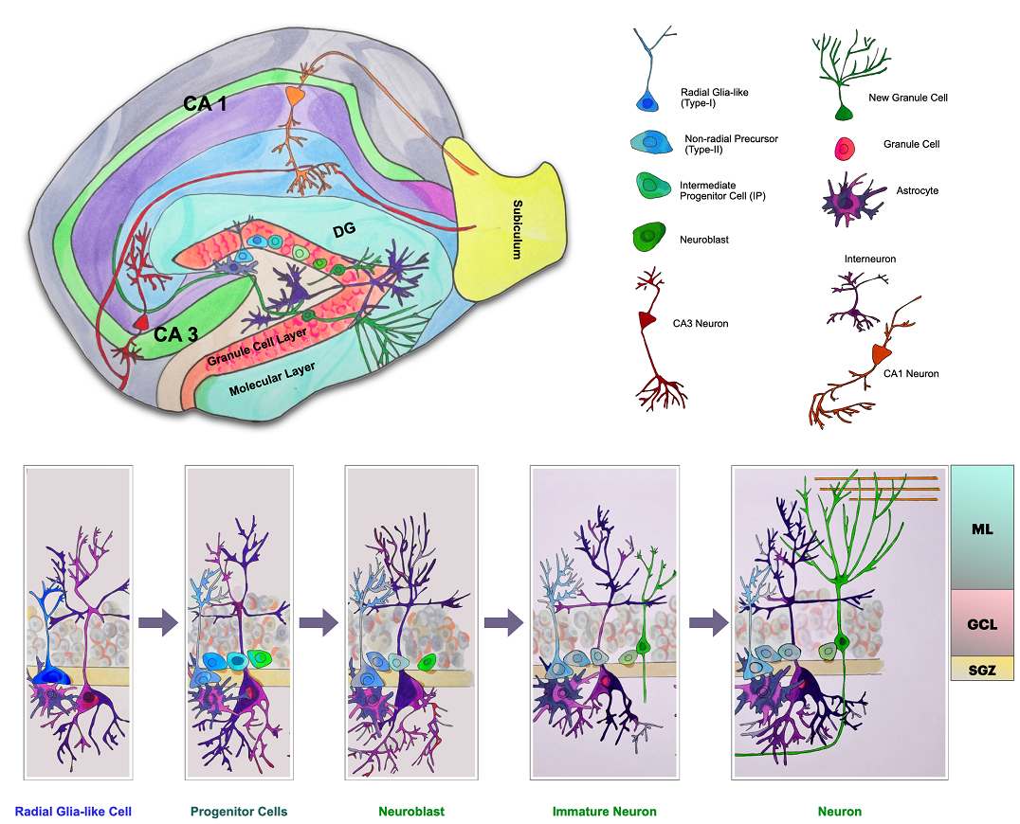

Figure 1.1: The adult neurogenesis in the SGZ of mouse hippocampus. The radial glial-like cells differentiate into neural progenitor cells (NPC), neuroblast cells and immature neurons. After migrating to the hippocampus's granule cell layer (GCL), the immature neurons connect their dendrites to the molecular layer (ML) while synapsing with the CA3 regional resident neurons with axons. Figure adapted from (Ming and Song 2011).

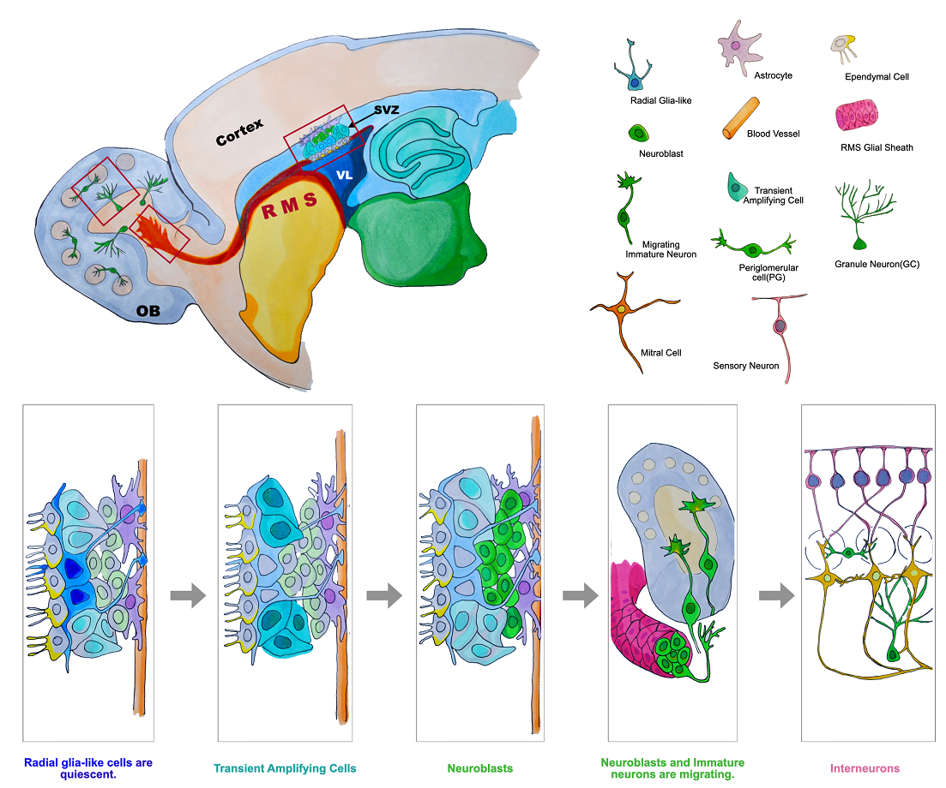

Figure 1.2: The adult neurogenesis in the SVZ of mouse ventricle. The quiescent radial glial-like cells turn into the transient amplifying cells, neuroblast cells and immature neurons through the long journey of the rostral migratory stream (RMS) to the olfactory bulb (OB). In the OB, the immature neurons integrate themselves into the OB functional circuits and become interneurons. Figure adapted from (Ming and Song 2011).

1.2 Adult neurogenesis diminishes with age
Neurons produced by adult neurogenesis are vital for the functions of the hippocampus and the olfactory bulbs in adult mice brains. The newborn neurons in the hippocampus SGZ recapitulate the resident neurons, exhibiting a more remarkable synaptic plasticity (Schmidt-Hieber, Jonas et al. 2004, Ge, Sailor et al. 2008, Mongiat and Schinder 2011). These newly generated neurons rewire into the existing circuits in the hippocampus with communicative support from glial cells and the extracellular matrix embedded in this brain region. Thus, they play their parts in hippocampal functions, such as learning, memory, emotions and social behaviour (Sahay and Hen 2007, Deng, Aimone et al. 2010, Aimone and Gage 2011, Sahay, Wilson et al. 2011, Akers, Martinez-Canabal et al. 2014, Cope and Gould 2019, Kempermann 2022).
Neurons generated from the SVZ to the OB of adult mice are diversified, including the γ-aminobutyric acid (GABA) neurons, dopaminergic neurons and glutamatergic neurons. The SVZ to OB adult neurogenesis maintains the structural and functional integrity of mice’s OB, eventually preserving olfactory memories and olfactory-based social behaviours (Brill, Ninkovic et al. 2009, Feierstein, Lazarini et al. 2010, Apple, Fonseca et al. 2017, Adamson, Zheng et al. 2021).
The SVZ and SGZ-originated adult neurogenesis diminishes with ageing processes. The imminent consequence of neurogenesis decline is reducing newborn neurons in their target areas, impairing the related neural functions. Researchers have learnt that the decreased SGZ neurogenesis compromised the memories in ageing rats, while decremental SVZ neurogenesis weakens the capacities of odour discrimination in ageing mice (Drapeau, Mayo et al. 2003, Enwere, Shingo et al. 2004). In an ageing brain, the environment becomes more unforgiving for a newly-produced neuron to survive; on the other hand, fewer NSCs transform into new neurons(Kuhn, Dickinson-Anson et al. 1996, Ben Abdallah, Slomianka et al. 2010, Trinchero, Buttner et al. 2017, Mercau, Patwa et al. 2022). Many have reported that, in ageing brains (primarily rats and mice), the adult NSC pool size shrinks, and the number of NSCs in both activated and quiescent status reduces. The quiescent NSCs become harder to awake, proliferate and differentiate into neurons (Figure 1.3) (Maslov, Barone et al. 2004, Ahlenius, Visan et al. 2009, Encinas, Michurina et al. 2011, Encinas and Sierra 2012, Capilla-Gonzalez, Cebrian-Silla et al. 2014, Leeman, Hebestreit et al. 2018, Obernier, Cebrian-Silla et al. 2018, Kalamakis, Brüne et al. 2019, Takei 2019, Xie and Laks 2020).

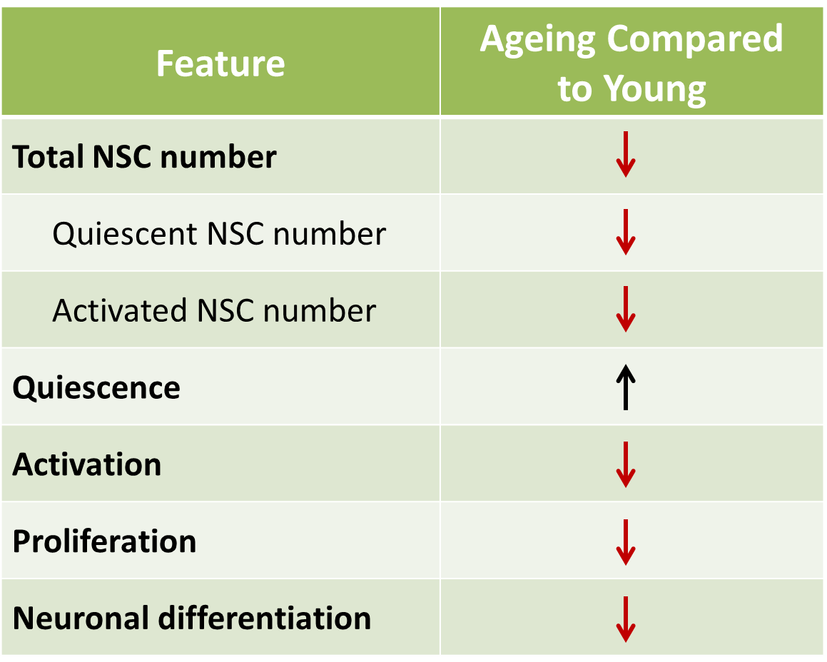

Figure 1.3: The characterisations of NSCs during ageing in mice and rats. The adult NSC pool size shrinks, the number of NSCs in both activated and quiescent status reduces, and the quiescent NSCs become harder to awake, proliferate and differentiate into neurons.
Previous studies have extensively inspected the neurogenesis procedures. Researchers nowadays are familiar with the cellular behaviours of NSC and neurons, such as proliferation, differentiation, migration and maturation. Great efforts have also been made to elucidate the molecular mechanisms regulating these neurogenesis Field steps(Jones and Connor 2012, Bond, Ming et al. 2015, Lim and Alvarez-Buylla 2016, Obernier and Alvarez-Buylla 2019). Moreover, in the ageing brains of mice, it has been proven that the adult NSCs were maintained even though downscaled. The size of the adult brain's NSC pool dictates neurogenesis's intensity.
In contrast, the exhaustion of the NSCs impairs adult neurogenesis from the beginning. Recent studies put considerable effort into studying the maintenance of the adult NSC pool and the subsequent neurogenesis in an ageing individual (Signer and Morrison 2013). Like adult stem cells in other tissue, adult NSCs comprise two interchangeable forms, the quiescent and active (Morshead, Reynolds et al. 1994, Li and Clevers 2010, Codega, Silva-Vargas et al. 2014, Llorens-Bobadilla, Zhao et al. 2015, Leeman, Hebestreit et al. 2018, Kalamakis, Brüne et al. 2019). In an older brain, quiescent NSCs become more reluctant to be activated. We deduce that the breakage of the quiescence of the ageing NSCs may stimulate neurogenesis, hence postponing senescence in mice’s brains. However, it is also possible that the dormancy of NSCs may protect the NSC pool from being quickly consumed.
It is still unconvincing to explain the dwindling of the NSC pool relying on the increasing quiescent NSC numbers. Other studies have introduced models based on cell cycles and cell divisions. One recent study described the consumption pattern of the SVZ NSC pool by tracing the cell dividing lineages: the asymmetrical division of an NSC produces a new NSC and a transient amplifying progenitor (TAP); nevertheless, the symmetric division of an NSC yield two NSCs or two TAPs. In mouse SVZ (P21), about 20% of the total NSC population is still self-renewable. In comparison, up to 80% of the NSC pool enters the terminal differentiation (Figure 1.4) (Calzolari, Michel et al. 2015, Basak, Krieger et al. 2018, Obernier, Cebrian-Silla et al. 2018). Therefore, NSCs could be used up as age grows in adult mice.

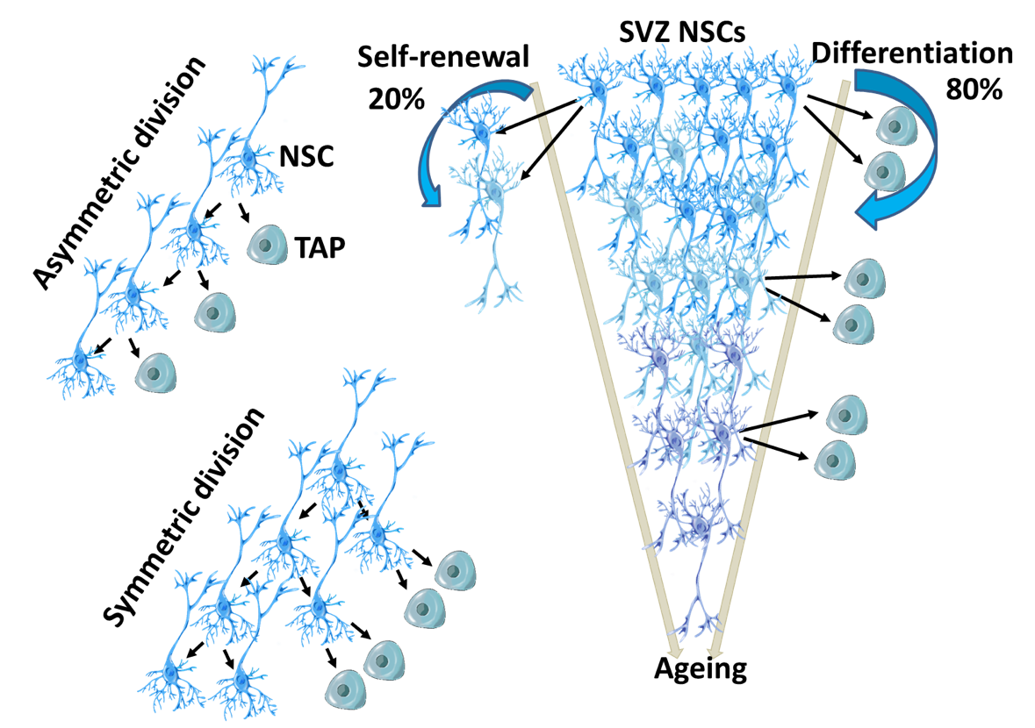

Figure 1.4: The cell division model of NSCs during ageing. The asymmetrical division of an NSC produces a new NSC and a transient amplifying progenitor (TAP), and the symmetric division of an NSC yield two NSCs or two TAPs. In the SVZ of the mouse (P21), about 20% of the total NSC population is still self-renewable, and 80% of the NSC pool enters the terminal differentiation, which leads to a declined number of NSCs during ageing. Figure adapted from (Obernier and Alvarez-Buylla 2019).

1.3 DNA damage and adult neurogenesis maintenance
DNA damage has long been considered an essential contributor to ageing. DNA damages pose severe threats to the homeostasis of the genome, eventually the survival of the cells exposed to all sorts of stimulating factors across an individual’s life span. Lesions on the DNA helices are caused by environmental stimuli containing physical characteristics such as UV, chemical and biological reagents, and cellular activities, i.e. the ROS and the mistakes made in DNA replication processes (Linn 2003, Hoeijmakers 2009, Bohlander and Kakadia 2015). Confronting the DNA damage, cells developed a set of responses. Firstly, the damages are recognised and alarmed; a repertoire of proteins will be recruited to passage the information and initiate the repair system. The responsive series of events post the DNA damages are summarised as the DNA damage responses (DDR) (Sancar, Lindsey-Boltz et al. 2004, Lord and Ashworth 2012). In three aspects, DNA damage was connected with ageing. First, many DNA damages were found accumulating in the nucleus of ageing cells; Second, unrepaired DNA damages are reported to induce cells and organs to display senescence-related features; Finally, deficiency in DDR corresponding genes causes premature ageing (progeria) (Kolodner, Putnam et al. 2002, Gerson 2005, Lombard, Chua et al. 2005, Liu and Rando 2011, Moskalev, Shaposhnikov et al. 2012).
Specific DNA damage triggers distinct DDRs that vary with cell types and cellular developments. DNA double-strand breaks (DSBs) are the most hazardous type of DNA damage. In this study, we intend to investigate DSBs and their consequences in NSCs. The DDR pathways for DSBs are under extensive investigation; however, many details are yet to be elucidated. First, the DSBs are sensed, and the signals are transduced, then the mediators recruit different effectors leading to various cellular outcomes, such as DNA repair, cell cycle arrest, apoptosis or senescence. It has been reported that cell cycles and the P53 protein activities may dominate the results of the DDRs (Figure 1.5) [70](Ciccia and Elledge 2010, Blanpain, Mohrin et al. 2011, Fortini, Ferretti et al. 2013, Vitale, Manic et al. 2017, Weeden and Asselin-Labat 2018).

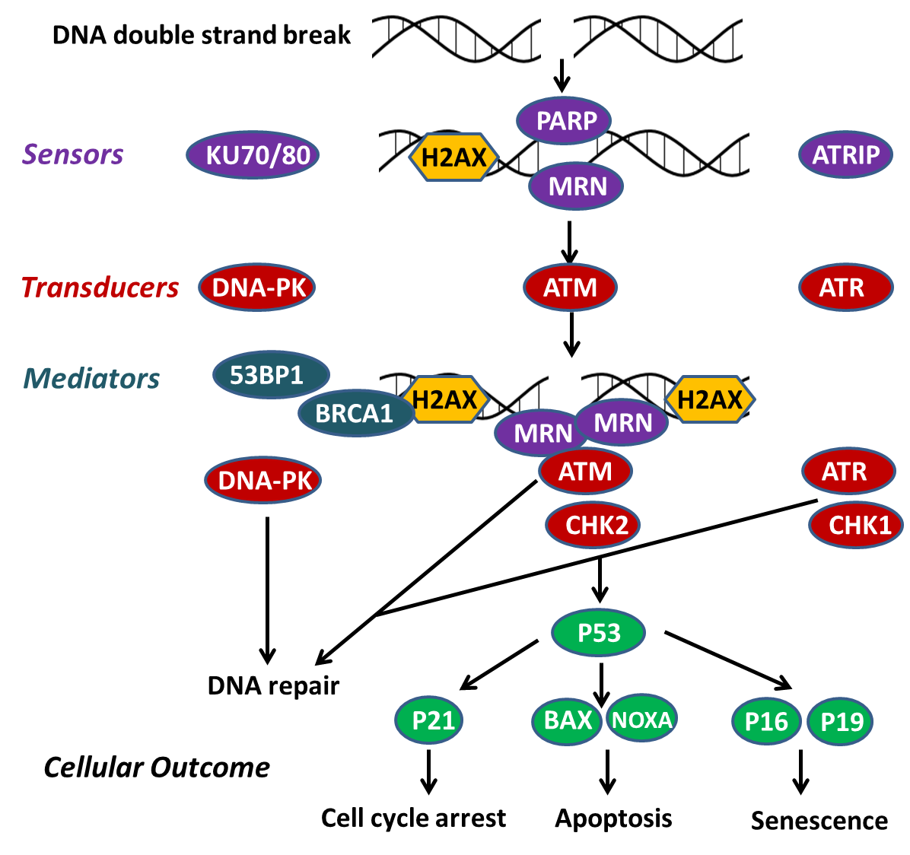

Figure 1.5: The responses of DNA double-strand breaks in cells. The major players of the DDRs are sensors, transducers, mediators and effectors. Depending on the success or failure of the DSB repair, cells choose to recover from a halting status, commit apoptosis, cell senescence or remain poised. Figure adapted from (Blanpain, Mohrin et al. 2011).
DSBs in the cellular genome are repaired by the non-homologous end joining (NHEJ) or the homologous recombination (HR) (Figure 1.6). In a typical NHEJ DNA repair procedure, KU70/KU80 complex recognises the DSBs on DNA molecules, recruits DNA-dependent DNA-PKCs and then the nuclease Artemis to trim the outstanding DNA ends, leaving the gap refilled with the DNA Polymerases µ and λ. Finally, the LIG4/XRCC4/XLF DNA ligase complex is summoned to anneal the broken strands. NHEJ can repair the DSBs at any cell cycle stage, as templates are not required (Lieber, Ma et al. 2003, Lieber 2010, Lans, Marteijn et al. 2012).
The HR DNA repair keeps a high fidelity as the templates are presented. Therefore, it is only observed during the late S phase and G2 phase when DNA replicates. As DSB occurs, the MRE11-RAD50-NBS1 (MRN) complex functions with the CtIP (CtBP interacting protein) protein to generate a short single-stranded DNA (ssDNA) at the DSB ends; nucleases and helicases, including Exonuclease 1 (EXO1), DNA replication ATP-dependent helicase/nuclease DNA replication helicase/nuclease 2 (DNA2) and Bloom syndrome protein (BLM) are recruited to extend the ssDNA and from the DNA end resection. So that the Replication protein A (RPA) coats the extending DNA and RAD51 lands on the complex to construct the homologous recombination intermediate, thus accurate DNA repair could be accomplished (Bernstein and Rothstein 2009, Blanpain, Mohrin et al. 2011, Scully, Panday et al. 2019).

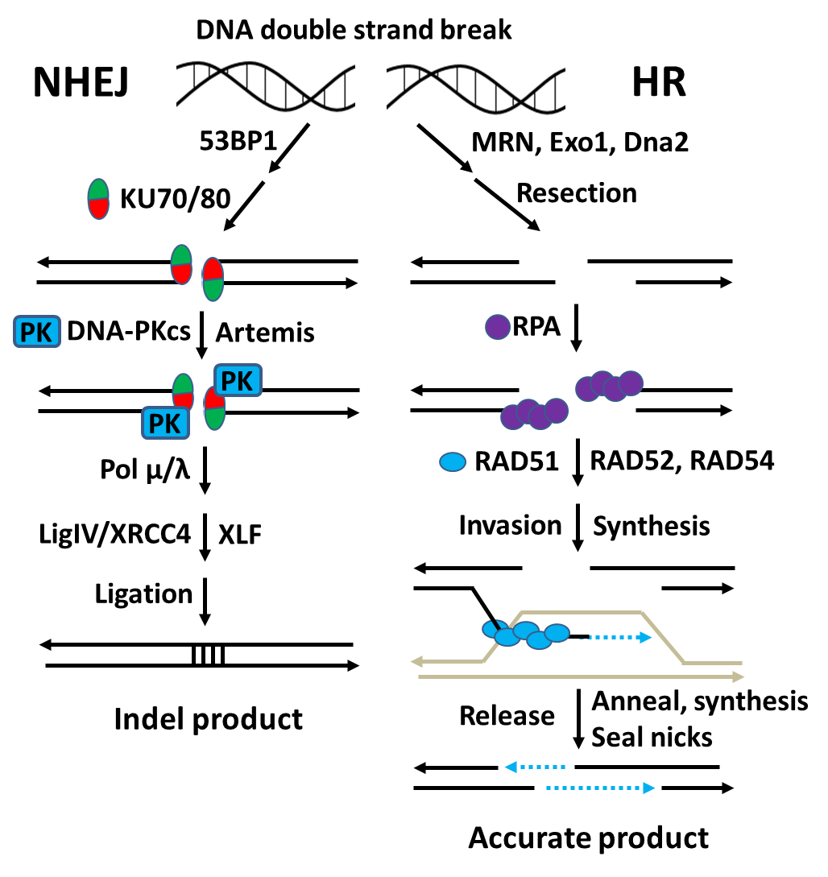

Figure 1.6: The NHEJ and HR repair of DSBs. In NHEJ, the DSBs are recognised by KU70/KU80 complex, then DNA-PKCs are recruited. With the participation of the nuclease Artemis trimming the DNA ends and the DNA Polymerase refilling the gaps, the LIG4/XRCC4/XLF DNA ligase complex finally produces the indel DNA products. In HR, the DSBs are processed to generate ssDNAs coated by RPAs. The recombinases (RAD51 family members) are recruited for strand invasion and synthesis. The recombinases are released at the end of the recombination, the strands are then annealed and synthesised, and the nicks are sealed to generate accurate DNA products.
Figure adapted from (Nickoloff, Taylor et al. 2021).

DDR is crucial for maintaining adult stem cells in ageing animals. DSB repair deficiencies could cause apoptosis and hence the exhaustion of the stem cells; furthermore, the mistakes accumulated by inaccurate DNA repair may expose cells to the risk of cancer (Figure 1.7) (Kenyon and Gerson 2007, Signer and Morrison 2013, Insinga, Cicalese et al. 2014). It has been widely reported that DSBs accumulate in the stem cells of various ageing tissues such as blood, skin, muscle, intestine, mesenchymal matrix and the germline (McNeely, Leone et al. 2020). In these tissues, DSB repair deficiencies trigger the differentiation, apoptosis and senescence of the stem cells and the exhaustion of the related stem cell pools (Nijnik, Woodbine et al. 2007, Rossi, Bryder et al. 2007, Ruzankina, Pinzonguzman et al. 2007, Takubo, Ohmura et al. 2008, Inomata, Aoto et al. 2009, Sperka, Wang et al. 2012, Wang, Sun et al. 2012, Sotiropoulou, Karambelas et al. 2013, Titus, Li et al. 2013, Beerman, Seita et al. 2014, Zhang, Li et al. 2015, Inagaki, Roset et al. 2016, Diao, Wang et al. 2018).

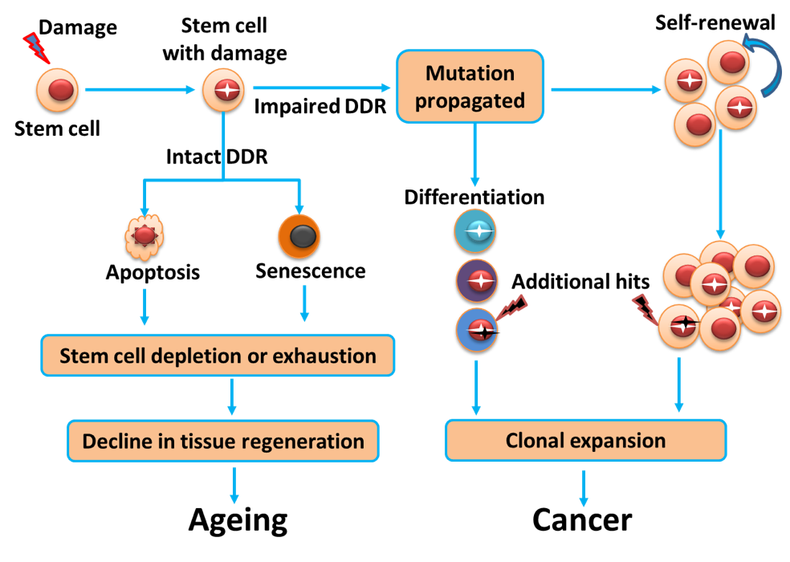

Figure 1.7: The DSBs in stem cells contributing ageing and cancer. DSB repair with high fidelity maintains stem cell function. Defects in DSB repair lead to apoptosis andageing of adult stem cells, which leads to the depletion of tissue stem cells. Non-fidelity repair leads to the malignant transformation of stem cells through the gradual accumulation of gene mutations. Figure adapted from (Mandal, Blanpain et al. 2011).
Heterogeneity has been noticed in the adult NSC populations. Mice brains exposed to a single dose of X-ray radiation witnessed cell deaths of the proliferative SGZ NSCs and the prolonged decline of neurogenesis in a dose-dependence manner (Mizumatsu, Monje et al. 2003). One day post the gamma radiation, the proliferative NSCs survived the trauma and halted the regeneration until two months later; However, cell regeneration and neurogenesis were still impaired six months after the radiation (Mineyeva, Bezriadnov et al. 2018). X-ray radiation to the SVZ region of mice induced the deaths of proliferative NSCs and the NPCs; additionally, the processed NSCs were unable to transfer to the NPCs (Achanta, Capilla-Gonzalez et al. 2012). On the other hand, the mice skull under X-ray radiation at the same dose caused an irreversible proliferation inhibition and an astrocyte glial characteristic of the SVZ NSCs (Schneider, Pellegatta et al. 2013). It has also been observed that SVZ NSCs were more sensitive to radiation-induced DSBs than SGZ NCSs. X-ray radiation at the same level induced NSC apoptosis in the SVZ, whereas SGZ NSCs were not significantly affected (Barazzuol, Rickett et al. 2015, Barazzuol and Jeggo 2016). Nevertheless, the quiescent NSCs are more resistant to the DSBs than the activated ones. It has been proposed that the activated NSCs are apoptotic-prone when confronting the DSBs for economic reasons. Immediate consumption of the activated NSCs when the condition is unfavourable could protect the quiescent NSC pool while preventing the DSBs in the activated NSCs from being carried on for further neurogenesis (Barazzuol, Ju et al. 2017).
These previous studies show that exogenous factors induced DSBs to impede adult NSC generation and neurogenesis. In contrast, the endogenous factors that caused DSBs have not been sufficiently discussed. NSCs derived from the ageing mice showed loss of heterozygosity in the genomes and loss of fragments in the chromosomes (Bailey, Maslov et al. 2004). It is concludable that DNA damages and error-prone DNA repairs (e.g. NHEJ repair for DSBs, base excision repair for damaged bases) caused mutations accumulated in the ageing NSC. However, a recent study examined the DSBs in NSCs from ageing mice by the comet assay, demonstrating no significant ageing related DSB accumulation in NSCs. (Kalamakis, Brüne et al. 2019). As a result, much work is needed to illuminate how DSBs under ageing affect NSC statuses and the subsequent neurogenesis.

1.4 SIRT1 maintains adult neurogenesis
The Silent Information Regulator 2 (SIR2) gene, encoding a NAD-dependent deacetylase, was famous for extending the life span of yeasts, worms and flies (Kaeberlein, McVey et al. 1999, Tissenbaum and Guarente 2001, Rogina and Helfand 2004). The homologues of the SIR2 gene in mammals include seven members, namely sirtuins 1-7 (Sirt1-7). The proteins encoded by different sirtuins, namely SIRT1-7, are relatively conserved but display distinct subcellular localisation and possess enzymatic activities for other substrates (Haigis and Guarente 2006).
In mammals, sirtuins encode protein deacetylases that are classified as the third type (Class III) of the four histone deacetylase (HDAC) types (Class I to IV). HDACs are responsible for deacetylating histones to silence the gene transcription (Parbin, Kar et al. 2014, Seto and Yoshida 2014). Besides, all classes of HDACs can deacetylate the non-histone proteins to regulate diverse cellular processes. Distinguishing from all other zinc-dependent HDACs (Class I, II and IV), the NAD+-dependent SIRTs play essential roles in regulating cellular processes at the metabolic level (Haigis and Guarente 2006, Haigis and Sinclair 2010).
Mammalian SIRTs localise in different subcellular compartments and display variant roles (Haigis and Guarente 2006, Wang and Lin 2021). SIRT1, SIRT6 and SIRT7 localise in the nucleus. As the most studied sirtuins family member, SIRT1 broadly participates in the metabolic regulation of many tissues and the cellular responses to oxidative stress and DNA damage, (Revollo and Li 2013). The most notable role of SIRT6 is the promotion of the DNA repair (Qian, Liu et al. 2018), and that of SIRT7 is the promotion of rDNA transcription and ribosome biogenesis (Ford, Voit et al. 2006, Song, Hotz-Wagenblatt et al. 2017). SIRT3, SIRT4 and SIRT5 are mitochondrial sirtuins important for maintaining mitochondrial function (Haigis and Guarente 2006). Cytoplasmic SIRT2 regulates various biological processes concerning metabolism and cell cycle control (Wang and Lin 2021).
The SIRT1 protein has long been considered an anti-ageing remedy since the overexpression of the protein extended the life span of many organisms, including yeasts, worms, flies and mice (Kaeberlein, McVey et al. 1999, Tissenbaum and Guarente 2001, Rogina and Helfand 2004, Satoh, Brace et al. 2013). Early studies demonstrated that the disruption of SIR2 in yeasts led to the repression of silent genes and the defects in the NHEJ repair of DNA DSBs (Tsukamoto, Kato et al. 1997, Kegel, Sjöstrand et al. 2001). However, these results were not completely applied to the situations in mice. The disruption of Sirt1 (the presumed ortholog of SIR2), producing SIRT1 protein with either a missing part of the catalytic domain or no detectable level, led to developmental defects and neonatal lethality in mice (Cheng, Mostoslavsky et al. 2003, McBurney, Yang et al. 2003). The cells harbouring Sirt1 disruption displayed few changes in global gene silencing but increased sensitivity to DNA damage compared to the wild-type cells (Cheng, Mostoslavsky et al. 2003, McBurney, Yang et al. 2003). More recent studies were performed with mice containg targeted loxp-Sirt1-loxp and CreER system, in which the Sirt1 gene was conditionally disrupted in distinct tissues at the specific time (Burns, Ayoub et al. 2007, Li, Rajendran et al. 2007). The details about the tissue or cell-specific disruption of Sirt1/SIRT1 will be included in the following discussions about the molecular functions of the SIRT1 protein.
As a Sirtuin protein family member, SIRT1 functions as a deacetylase. Conversely, SIRT1 is deeply entangled in many signalling and transcription modification pathways (Tsang and Escalantesemerena 1998, Frye 2000, Borra 2003, Haigis and Guarente 2006, Satoh, Brace et al. 2010, Preyat and Leo 2013). Thus, SIRT1 participates in many cellular functions, such as energy metabolism, mitochondria biogenesis, lysosomal autophagy, DNA damage response and the process of cell senescence (Chen, Zhou et al. 2020). In addition, SIRT1 protein deacetylates the pillar proteins of the signalling pathways, thus promoting anti-ageing procedures (Figure 1.8). For instance, SIRT1 deacetylates P65 protein to inhibit the NF-κB-induced inflammation reactions (Yeung, Hoberg et al. 2004, Edwards, Perrien et al. 2013, Gano, Donato et al. 2014); SIRT1 deacetylates P53 and FOXO to depress DNA damages and the reactive oxygen species (ROS) reactions (Luo, Nikolaev et al. 2001, Vaziri, Dessain et al. 2001, Langley, Pearson et al. 2002, Brunet, Sweeney et al. 2004, Motta, Divecha et al. 2004, Hori, Kuno et al. 2013, Lamichane, Baek et al. 2019); The PGC1A is deacetylated by SIRT1 to enhance mitochondria biogenesis (Zarzuelo, López-Sepúlveda et al. 2013, Dilberger, Baumanns et al. 2019, Kitada, Ogura et al. 2019, Wang, Luo et al. 2019), and the TSC2 and LKB1 are deacetylated to accelerate autophagy (Lan, Cacicedo et al. 2008, Ghosh, McBurney et al. 2010, Kauppinen, Suuronen et al. 2013, García-Aguilar, Guillén et al. 2016).

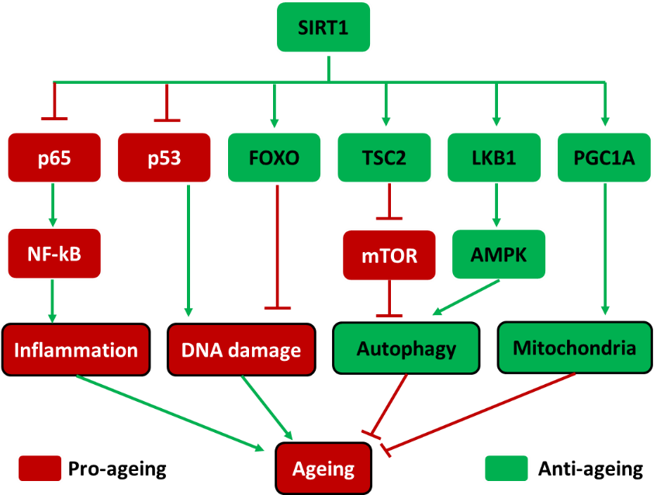

Figure 1.8: The molecules affected by SIRT1 contributing to anti-ageing. SIRT1 protein suppresses the inflammation and DNA damage and promotes autophagy and mitochondria function to confront ageing processes. Figure adapted from (Chen, Zhou et al. 2020).

Many have reported that SIRT1 suppresses DNA damage-triggered apoptosis via deacetylation of its downstream targets in promoting DNA damage repair (Haigis and Sinclair 2010, Alves-Fernandes and Jasiulionis 2019). In the nucleus, SIRT1 deacetylates the histones and makes the chromatin more compact in the structure; On the other hand, the DDR-related proteins are activated by SIRT1. Thus, the SIRT1 protein protects chromatin homeostasis from being interrupted (Figure 1.9) (Ura, Araki et al. 2001, O'Hagan, Mohammad et al. 2008, O'Hagan, Wang et al. 2011, Kumar, Horikoshi et al. 2012, O'Hagan 2014). SIRT1 deacetylates the WRN, NBS1 and RAD51 to promote HR repair; moreover, KU70 deacetylation promotes NHEJ repair while inhibiting the BAX to repress apoptosis (Cohen, Lavu et al. 2004, Jeong, Juhn et al. 2007, Yuan, Zhang et al. 2007, Li, Casta et al. 2008, Oberdoerffer, Michan et al. 2008). In mammalian stem cells, SIRT1 protein dissociates from other DNA sites, relocates to the DSB point, and activates the ATM signalling pathways to enhance DNA repair; Further, the chromatin structure changes caused by the relocation of the SIRT1 protein alter the expression of some ageing related genes (Oberdoerffer, Michan et al. 2008).

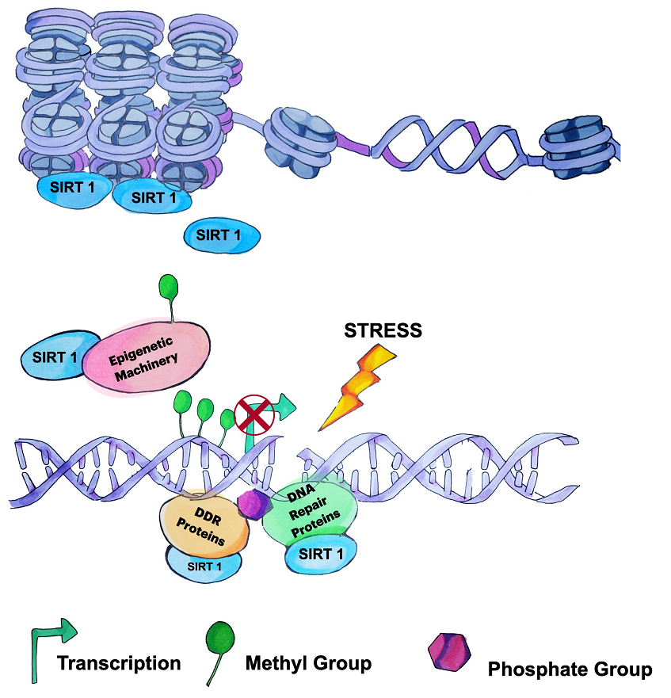

Figure 1.9: The protective role of SIRT1 in maintaining genomic stability. SIRT1 promotes the formation of heterochromatin to inhibit gene transcription. When DSB occurs, the SIRT1 protein will locate to the DSB site mediating the transcriptional changes and participate in the recruitment and deacetylation of DDR and DSB repair proteins. Figure adapted from (Alves-Fernandes and Jasiulionis 2019).

SIRT1 proteins play a protective role in a wide range of organs and tissues, for instance, increasing insulin secretion, gluconeogenesis in the liver and fatty acid oxidation in the muscle; at the same time, decreasing the cardio inflammation responses and the fatty acid synthesis. (Fr, eacute et al. 2004, Rodgers, Lerin et al. 2005, Lagouge, Argmann et al. 2006, Qiao and Shao 2006, Milne, Lambert et al. 2007, Z, Rodgers et al. 2007, Brandes 2008, Borradaile and Pickering 2009, Purushotham, Schug et al. 2009, Haigis and Sinclair 2010, Bordone, Motta et al. 2012). SIRT1 protein also protects the nervous system in many aspects (Libert and Guarente 2012). It has been proven that SIRT1 protein maintains the stability of neuronal structure through ROCK kinase and AKT, promotes the CREB and BDNF-regulated synapsis formation and enhances the DSB repair by repressing the genome instabilities (Ferrante, Browne et al. 1997, Oberdoerffer, Michan et al. 2008, Gao, Wang et al. 2010, Li, Chen et al. 2013). It has been reported that SIRT1 ameliorates the progression of neurodegeneration diseases to some extent (Herskovits and Guarente 2014, Chandramowlishwaran, Vijay et al. 2020). Overexpression of SIRT1 protein significantly cleared the β-Amyloid plaque formation in the Alzheimer mice models (Chen, Zhou et al. 2005, Donmez, Wang et al. 2010, Min, Cho et al. 2010, Cohen, Guo et al. 2011). In cases of the Parkinson’s Disease models, α-synuclein aggregating was prevented by exploiting the SIRT1 agonists (Donmez, Arun et al. 2012, Raynes, Jr et al. 2012). Resveratrol, the renowned SIRT1 agonist, is introduced to tissue and cell protection in radiation therapy according to SIRT1’s protective function against radiation-induced DNA damage (Agbele, Fasoro et al. 2020, Qin, Zhang et al. 2021).
SIRT1 proteins are regulative to adult stem cells from various tissues. In the procedure of hematopoiesis, SIRT1 protein loss accelerated abnormal stress-induced hematopoiesis; Moreover, SIRT1 loss triggered genome instability and long-term deficiency in hematopoiesis in hematopoietic stem cells (Rossi, Bryder et al. 2007, Leko, Varnum-Finney et al. 2012, Singh, Williams et al. 2013). In muscle, tissue-specific SIRT1 inactivation dwindled the muscle fibres' diameter while impeding the muscle tissue regeneration (Ryall, Dell'Orso et al. 2015). In another mouse model of premature ageing, the mesenchymal stem cells (MSC) in the adult bone marrow are rejuvenated. The progeria phenotypes are rescued to some extent when the SIRT1 protein is activated by Resveratrol (Liu, Ghosh et al. 2012). Nevertheless, SIRT1 loss in the MSCs causes defects in MSC-originated tissues, such as fat and bone (Simic, Zainabadi et al. 2013).
Neural stem cells are characterised by self-renewability and triple differentiating (neurons, astrocytes and oligodendrocytes) potential. SIRT1 protein affects NSC lineages by regulating cell proliferation, differentiation and apoptosis during embryonic development (Figure 1.10) (Sakamoto, Miura et al. 2004, Hisahara, Chiba et al. 2008, Cai, Xu et al. 2016). In adults, the SIRT1 expression level is still significant in NSCs from both SVZ and SGZ regions (Ramadori, Lee et al. 2008, Zakhary, Ayubcha et al. 2010). Saharan et al. showed that the SIRT1 protein inhibits neuronal differentiation while SVZ and SGZ NSC proliferation is unaffected (Saharan, Jhaveri et al. 2013). According to Rafalski and colleagues’ study, SIRT1 loss in SVZ NSCs promotes oligodendrocyte differentiation while neuronal differentiation is still expected (Victoria A. Rafalski 2013). However, Ma et al. demonstrated that the SIRT1 protein represses the proliferation, differentiation and regeneration of SGZ NSCs (Ma, Yao et al. 2014). Despite the discrepancies in these studies, a common conclusion is that SIRT1 affects adult NSC behaviours profoundly. We suppose that SIRT1 functions could vary with the microenvironments.

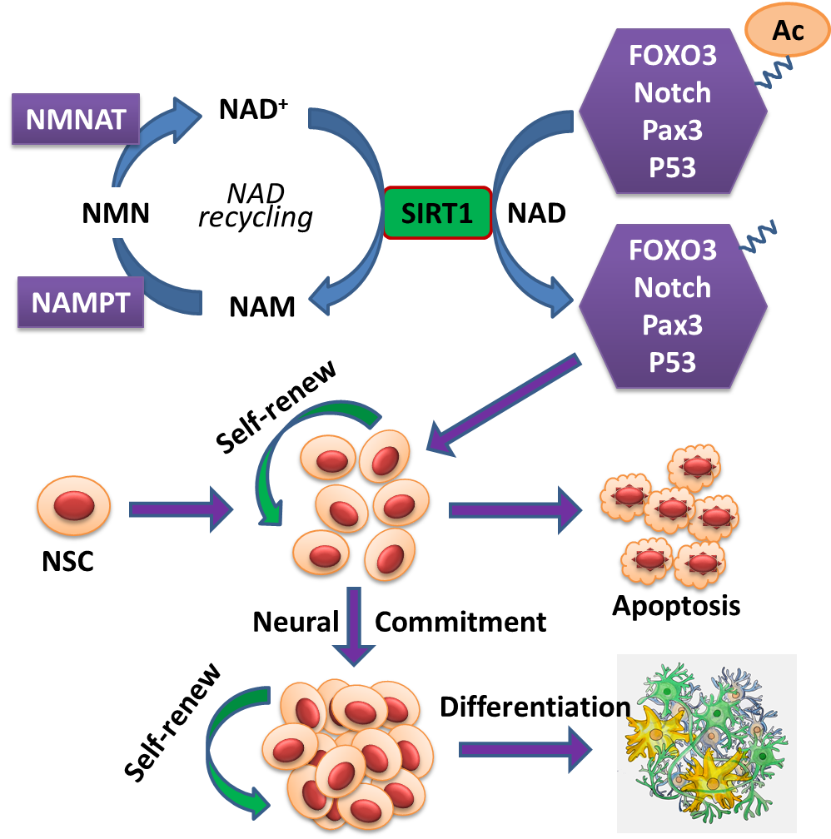

Figure 1.10: The impact of SIRT1 protein on NSC fate. Upon the action of NAD⁺ (Nicotinamide Adenine Dinucleotide), SIRT1 protein deacetylates a series of NSC fate determinants, such as FOXO3, NOTCH1, PAX6 and P53, thereby affecting NSC self-renewal, differentiation and apoptosis (Cai, Xu et al. 2016).
1.5 Aims of the study
The study aims to investigate the role of Sirt1 in NSCs of mice during ageing. Specifically, we aim to dissect the DSB accumulation in mouse NSCs during ageing, the DSB repair affected by SIRT1 in ageing NSCs, and the impact of Sirt1 on the maintenance of NSCs in ageing mice.
To investigate, we employed a natural ageing mice model along with the specifically deleted Sirt1 gene in adult NSCs. We examined the NSC proliferation, DSB and DSB repair in vivo or in vitro and inspected the molecular mechanisms behind the DSB repair and NSC behaviours.

CHAPTER 2: MATERIALS AND METHODS

2.1 Materials

2.1.1 Mice, cell lines and plasmids
Transgenic mice, including Nestin-CreER^{T1} (JAX #012906) (Burns KA et al, 2007), Sirt1^{loxP} (JAX #008041) (Li H et al, 2007) and Rosa-26-EGFP (JAX #007906) (Madisen L et al, 2010) were obtained from The Jackson Laboratory (Maine, the United States of America). The wild type C57/BL6 and ICR mice were purchased from SLAC Animal (Shanghai, China). All mice were housed in Tongji University Experimental Animal Center under SPF (specific pathogen-free) conditions. Animal care and all experimental procedures were reviewed and approved by the Animal Committee of the School (Tongji University, Shanghai, People’s Republic of China, TJmed-010-10).
HEK293T cells were obtained from the American Type Culture Collection (ATCC). The mouse neural stem cells were isolated and cultured in our own laboratory.
pCMV delta R8.2 and pCMV-VSV-G were used for lentivirus packaging. pCMV delta R8.2 was a gift from Didier Trono (Addgene plasmid #12263), and pCMV-VSV-G was a gift from Bob Weinberg (Addgene plasmid #8454). The empty vector pLenti-CMV-TagGFP-P2A-Puro for gene overexpression was obtained from OriGene Technologies (Wuxi, China). The HR/NHEJ reporter plasmids were kindly provided by Zhiyong Mao (Tongji University, Shanghai, China).

2.1.2 Reagents, antibodies, synthesized DNA
The reagents used for cell culture are listed in Table 1. The reagents used for in vitro experiments are listed in Table 2. The antibodies are listed in Table 3. The sequences of the synthesized DNA (Sangon, Shanghai, China) are listed in Table 4.
Table 1. Reagents used for cell culture.
Reagents | Origins | Suppliers | Catalogs
0.05% Trypsin-EDTA | USA | Gibco | #25300
1 M Hepes | China | Sangon | #E607018
B27 supplement | USA | Gibco | #17504-044
bFGF | USA | R&D | #233-FB
BMP4 | USA | PEPROTECH | #120-05
DispaseII | USA | Roche | #04942078001
DMEM | USA | Gibco | #11965-092
DMEM/F12 | USA | Gibco | #11330-032
EGF | USA | R&D | #236-EG
FBS | USA | Gibco | #13562-049
GlutaMAX | USA | Gibco | #35050-061
HBSS | USA | Hyclone | #14175-095
Heparin | USA | Sigma | #H3149
Lipo293™ Reagent | China | Beyotime | #C0521
Lipo8000™ Reagent | China | Beyotime | #C0533
Matrigel | USA | Corning | #354230
PBS | USA | Hyclone | #SH30256.01
Penicillin-Streptomycin | USA | Gibco | #GB15140-122
Polybrene | USA | Sigma | #107689
Puromycin | China | Sangon | #A610593
Cycloheximide | China | Selleck | #S7418
Chloroquine | China | Selleck | #S6999
MG-132 | China | Selleck | #S2619

Table 2. Reagents used for in vitro experiments.
Reagents | Origins | Suppliers | Catalogs
2x Hieff Clone® kit | China | YEASEN | #10922ES20
5 x TBST | China | Sangon | #C520009
5x SDS loading buffer | China | Beyotime | #P0283
Agarose | USA | ThermoFisher | #75510019
BamHI | USA | ThermoFisher | #FD0054
BSA | USA | JACKSON | #001-100-162
Chloroform | China | Sinoreagent | #10006828
Citric acid | China | Sangon | #A100529
Corn oil | China | aladdin | #C116023
DH5α | China | Sangon | #B528413
DNA ladder | China | Transgene | # BM301
Dnase/RNase  free water | USA | ThermoFisher | # AM9937
ECL substates | China | Beyotime | #P0018
EcoRI | USA | ThermoFisher | #FD0274
EDTA | China | Sangon | #B540625
Ethanol | USA | Sigma | #1.07017.2511
Glycerol | China | Sangon | #A100854
Glycine | China | Sangon | #A610235
Isopropanol | China | Sangon | # A600918
Methanol | China | Sangon | #A601617
NaCl | China | Sangon | #A100241
NaN₃ | China | Solarbio | #S8200
NP-40 | USA | ThermoFisher | #85124
OCT compound | USA | Sakura | #TISSUE-TEK  4583
PAGE gel  preparation kit | China | Epizyme | #PG111
PCR mix | China | Transgene | #AS111
Pentobarbital sodium | China | Solarbio | #P8410
PFA | China | Solarbio | #P8430
Plasmids DNA  isolation kit | Germen | MACHEREY-NAGEL | #NucleoBond®  Xtra Midi EF
Plasmids  preparation kit | China | TIANGEN | #DP103
PMSF | China | Beyotime | #ST506
Pre-stained  protein marker | China | Sangon | #C520010
PrimeScript™  1st Strand cDNA synthesis kit | Japan | TAKARA | #6110A
PrimeSTAR® GXL DNA polymerase | Japan | TAKARA | #R050B
PVDF membrane | USA | Millipore | #IPVH00010
qPCR mix | China | Transgene | #AQ601
SDS | China | Sangon | #A100227
Sucrose | China | Sangon | #A100335
SYBR Safe | USA | ThermoFisher | #S33102
Tamoxifen | USA | Sigma | #T5648
TransScript All  in One kit | China | Transgene | #AT341
Tris | China | Sangon | #A600149
Triton X100 | China | Sangon | # A110694
TRIzol | USA | invitrogen | #15596026
Western/IP cell  lysis buffer | China | Beyotime | # P0013

Table 3. Antibodies.
Antigens | Origins | Suppliers | Catalogs | Dilutions
53BP1 | USA | Bethyl | #A300-272A | 1:500
ACTIN | USA | Cell Signaling | #CST4970 | 1:1000
BrdU | USA | SIGMA | #B2531 | 1:1000
CCND3 | USA | Cell Signaling | #CST2936 | 1:1000
Cleaved-Caspase-3 | USA | Cell Signaling | #CST9661 | 1:1000
CNPase | USA | Millipore | #MAB326 | 1:500
DAPI | USA | Sigma | #D9542 | 1:1000
EGFR | USA | Millipore | #06-847 | 1:500
GFAP | USA | Millipore | #MAB360 | 1:3000
HES5 | USA | abcam | #ab194111 | 1:1000
K-Ace | USA | Cell Signaling | #CST9441 | 1:1000
Ki67 | USA | ThermoFisher | #MA5-14520 | 1:1000
KU70 | China | ABclonal | #A2076 | 1:1000
NESTIN | USA | Abcam | #ab6142 | 1:1000
NeuN | USA | Millipore | #MAB377 | 1:500
NICD | USA | Cell Signaling | #CST4147 | 1:1000
NOTCH1 | USA | SantaCruz | #sc6014 | 1:1000
Oligo2 | USA | CHEMICON | #AB9610 | 1:500
PGC1A | China | Sangon | #D162041 | 1:1000
SIRT1 | USA | Millipore | #07-131 | 1:1000
SOX2 | USA | Santa Cruz | #sc-17320 | 1:1000
Tuj1 | USA | covance | #PRB-435P | 1:10000
Ubiquitin | USA | SantaCruz | #sc8017 | 1:1000
γH2AX | USA | Epitomics | #2212-1 | 1:1000
Mouse normal IgG | USA | SantaCruz | #sc2025 | 1:200
Rabbit normal IgG | USA | SantaCruz | #sc2027 | 1:200
CF488/CF543/CF633 | USA | Biotium |  | 1:1000
HRP conjugated anti-mouse | USA | Cell Signaling | #CST7076 | 1:2000
HRP conjugated anti-rabbit | USA | Cell Signaling | #CST7074 | 1:2000
Protein A/G Agarose | USA | SantaCruz | #sc2003

Table 4. The synthesized DNA sequences.
Cre genotyping
5’-GAACCTGATGGACATGTTCAGG-3’
5’-AGTGCGTTCGAACGCTAGAGCCTGT-3’
Sirt1 genotyping
5’-GGTTGACTTAGGTCTTGTCTG-3’
5’-CGTCCCTTGTAATGTTTCCC-3’
Rosa-26 genotyping for wild type
5’- AAGGGAGCTGCAGTGGAGTA-3’
5’-CCG AAAATCTGTGGGAAGTC-3’
Rosa-26 genotyping for transgene
5’-AACCAGAAGTGGCACCTGAC-3’
5’-GGCATTAAAGCAGCGTATCC-3’
Sirt1 gene clone
5’-GGGCGGCCGGGAATTatggcggacgaggtgg -3’
5’-CCCCGCTCATGCTCGAGGATCCtgatttgtctgatggatagtttaca -3’
Gapdh RT-qPCR
5’- TCCCACTCTTCCACCTTCGATGC -3’
5’- GGGTCTGGGATGGAAATTGTGAG -3’
Sirt1 RT-qPCR
5’- CTCTAGTGACTGGACTCCGC -3’
5’- AACAATCTGCCACAGCGTCA -3’
Notch1 RT-qPCR
5’- GATGGCCTCAATGGGTACAAG -3’
5’- TCGTTGTTGTTGATGTCACAGT -3’
Hes5 RT-qPCR
5’- AGTCCCAAGGAGAAAAACCGA -3’
5’- GCTGTGTTTCAGGTAGCTGAC -3’
Ccnd3 RT-qPCR
5’- CGAGCCTCCTACTTCCAGTG -3’
5’- GGACAGGTAGCGATCCAGGT -3’
Nmnat1 RT-qPCR
5’- TGGCTCTTTTAACCCCATCAC -3’
5’- TCTTCTTGTACGCATCACCGA -3’

2.2 Methods

2.2.1 The generation of NSC-specific Sirt1 knockout and genetic tracing mice

2.2.1.1 The generation of NSC-specific Sirt1 knockout mice
The generation of NSC-specific Sirt1 knockout mice is shown in Figure 2.1.
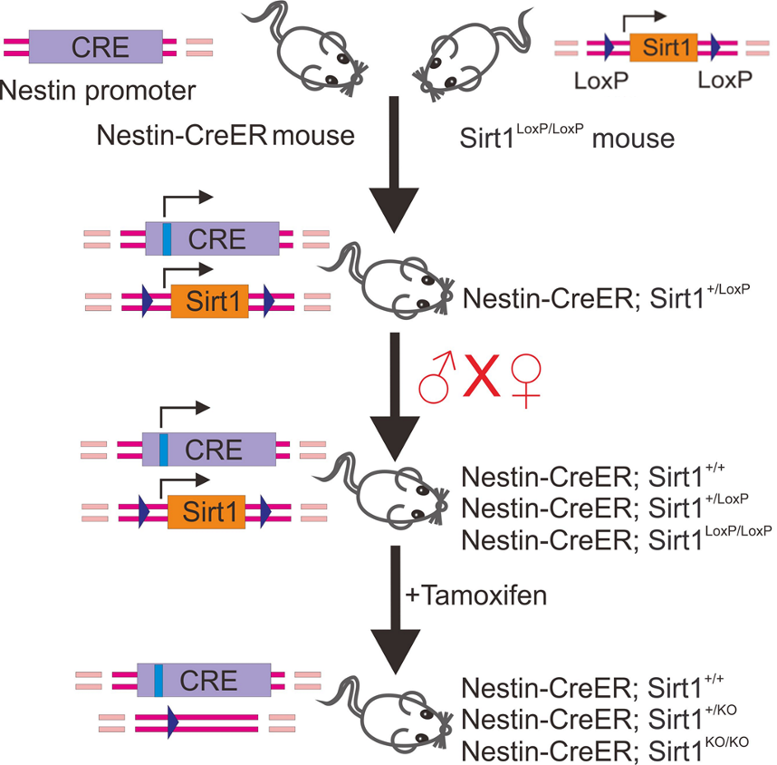

Figure 2.1: The schematic presentation of the generation of NSC-specific Sirt1 knockout mice. The Nestin-CreER mouse genome contains a gene fragment expressing CreER driven by a Nestin promoter, and the Sirt1 gene of Sirt1^{LoxP/LoxP} mouse is floxed by LoxP sites. The CreER gene encodes a fusion protein, which is Cre recombinase fused with estrogen receptor. The CreER proteins are located in the cytoplasm, which enter into the nucleus to cut Loxp sites within the genomic DNA upon the introduction of tamoxifen. The Nestin-CreER mice were crossed with Sirt1^{LoxP/LoxP} mice to get Nestin-CreER/Sirt1^{+/LoxP} mice, which were intercrossed to generate Nestin-CreER/Sirt1^{+/+ or +/LoxP or LoxP/LoxP} mice. Upon the administration of tamoxifen, the Sirt1 gene floxed by Loxp sites was deleted. The Nestin-CreER/Sirt1^{+/+ or +/LoxP or LoxP/LoxP} mice were the wild type (Sirt1^{+/+}), heterozygous (Sirt1^{+/KO}) and homozygous (Sirt1^{KO/KO}) for Sirt1 knockout, respectively.

2.2.1.2 The generation of NSC-specific tracing mice
The generation of NSC-specific tracing mice is shown in Figure 2.2.
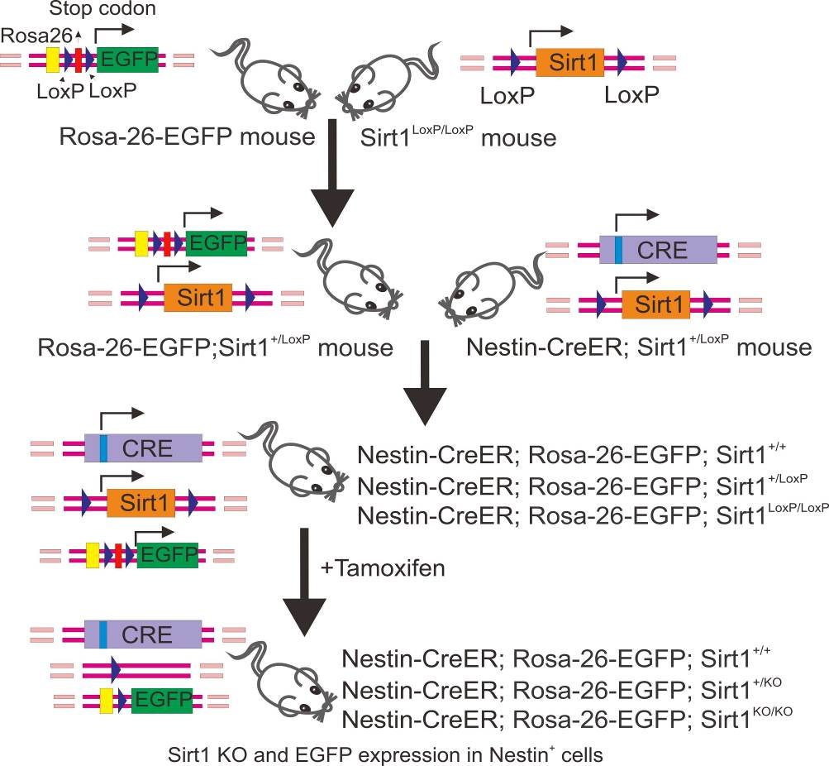

Figure 2.2: The schematic presentation of the generation of NSC-specific Sirt1 knockout and genetic tracing mice. the Rosa-26-EGFP mouse genome contains a gene fragment Loxp-Stop codon-Loxp-EGFP at Rosa-26 sites, so the EGFP can only be expressed when the stop codon is removed by Cre recombinase. The Rosa-26-EGFP mice were crossed with Sirt1^{LoxP/LoxP} mice to obtain Rosa-26-EGFP/Sirt1^{+/LoxP} mice, then crossed with Nestin-CreER/Sirt1^{+/LoxP} mice to generate Rosa-26-EGFP/Nestin-CreER/Sirt1^{+/+ or +/LoxP or LoxP/LoxP} mice. Upon the administration of tamoxifen, the stop codon and Sirt1 gene floxed by Loxp sites were deleted. Then the Rosa-26-EGFP/Nestin-CreER/Sirt1^{+/+ or +/LoxP or LoxP/LoxP} mice were the wild type (Sirt1^{+/+}), heterozygous (Sirt1^{+/KO}) and homozygous (Sirt1^{KO/KO}) for Sirt1 knockout, in the meantime, the cells were labelled with EGFP.

2.2.1.3 Mouse genotyping and tamoxifen administration
Seven to ten days after birth, the toe of each mouse pup was clipped and numbered. Then, each toe tissue was collected into individual 1.5 ml microtubes containing 100 μl 25 mM NaOH. The tissues were incubated in a boiling water bath for 30 min. After cooling to room temperature, 100 μl 40 mM Tris-HCL was added to each tube and mixed thoroughly.
Tubes were centrifuged at 1,2000 g for 5 min. Then, the supernatant containing genomic DNA was transferred to a new tube. PCR reactions (genomic DNA solution 1 μl, 10μM forward primer 0.1μl, 10μM reverse primer 0.1 μl, 2x EasyTaq PCR SuperMix 5μl, ddH₂O 3.8 μl) with the amplification procedure (94℃ 15 s, 60℃ 15 s, 72℃ 30 s, 38 cycles). PCR products were examined with 2% agarose gel electrophoresis and checked signal with gel imaging system. The genotype of each sample displayed as Figure 2.3. For tamoxifen administration, adult mice (~8-week old) were intraperitoneally injected with 100 μl tamoxifen (dissolved in corn oil, 20 mg/ml) daily for five successive days, and 7 days after the last injection, the mice could be analyzed for the gene knockout.
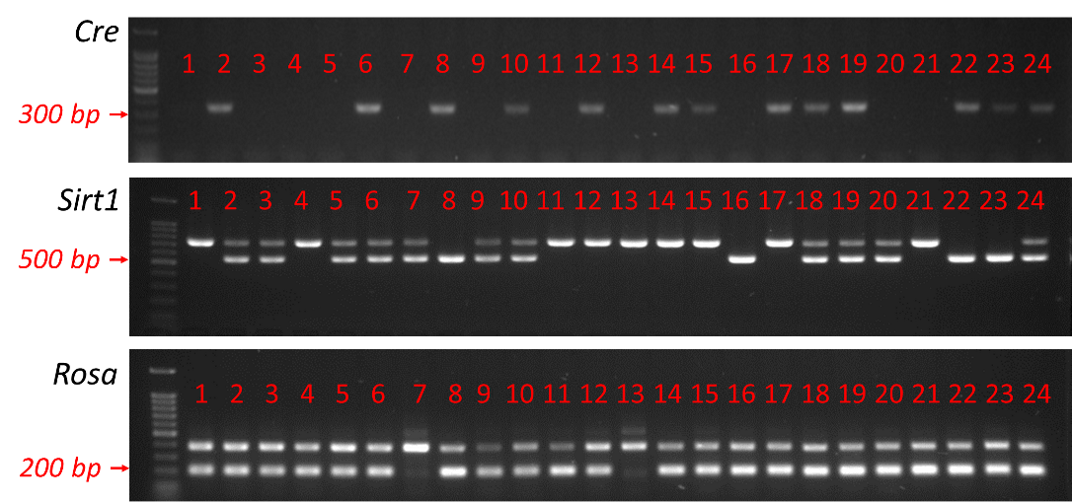

Figure 2.3: The presentation of mouse genotyping results. Bands of 320 bp (primers are located to the targeted DNA sequences of the Cre gene) are Cre positive. A single band at 550 bp (primers are located to the bilateral introns of exon 4 of the wild type Sirt1 gene) is wild type, at 750 bp (primers are located to the bilateral introns of exon 4 of the targeted DNA sequences of Sirt1 gene) is homozygous and double bands at both 550 and 750 bp is heterozygous for Sirt1. Bands of 197 bp (primers are located to the targeted DNA sequences of WPRE and ZsGreen) are ROSA-26-EGFP positive.

2.2.1.4 X-ray irradiation of Mouse
The mice anaesthetise was performed with pentobarbital sodium (50mg/kg body weight). The skulls of anaesthetised mice were irradiated at 1 Gy/min for 10 min in an X-ray system (RX-650, Faxitron), with the rest of the body protected by a lead shield.
The generation of NSC-specific Sirt1 knockout and genetic tracing mice was helped by Dr Guangming Wang.

2.2.2 The culture, quiescence and activation induction and differentiation of mouse SVZ-derived NSCs

2.2.2.1 The culture of NSCs from mouse SVZ
The mouse was sacrificed by cervical dislocation, and then the whole brain was removed and washed with ice-cold PBS containing 1% Penicillin/Streptomycin in a tissue culture dish. The washing was performed on at least six different dishes. Dissected out and collected the SVZ tissue in a 15 ml centrifuge tube containing 1 ml Dispase II and added 2 ml Dispase II after pipetting the tissue with 1 ml tips several times. Incubated the centrifuge tube in a 37℃ water bath for 1 h and then centrifuged at 110 g for 3 min. Discarded the supernatant, suspended the pellet with 1 ml basal medium (DMEM/F12 containing 1% Penicillin/Streptomycin and 1% GlutaMAX) and pipetted with 1 ml tips for 15 times. The tube was centrifuged at 110 g for 3 min after adding 4 ml basal medium. Repeated the washing step and suspended the pellet with growth medium (basal medium containing 20 ng/ml bFGF, 20 ng/ml EGF, 1% B27 supplement and 5 μg/ml Heparin). Cells were plated into 6-well tissue culture plates and incubated at 37˚C with 5% CO₂ in an incubator. After 5-7 days, the neurospheres should have formed and were ready for the subsequent experiment.

2.2.2.2 The neurospheres formation assay
The neurospheres were recollected in a 15 ml tube and centrifuged at 110 g for 1 min. Discarded the medium and suspended the pellet with 1 ml 0.05% Trypsin-EDTA. The tubes were incubated for 1 min at room temperature and then centrifuged at 110g for 3 min after adding 4 ml basal medium (DMEM/F12 containing 1% Penicillin/Streptomycin and 1% GlutaMAX). The medium should then be discarded and changed into 1 ml growth medium (basal medium containing 20 ng/ml bFGF, 20 ng/mL EGF, 1% B27 supplement and 5 μg/ml Heparin). The cell and medium mixture were pipetted with 1 ml tips about twenty times. After cell counting, the cell suspension was diluted to a final cell density of 500 cells/ml. Cells were plated in 6-well tissue culture plates (2 ml per well) and incubated at 37˚C with 5% CO₂ in an incubator. After 7 days, the neurospheres were then counted.

2.2.2.3 The quiescence and activation induction of NSCs
A 6-well tissue culture plate was coated with coating medium (Matrigel 1:300 diluted in DMEM/F12, 2 ml per well) and incubated at 37 ˚C for 2 h before use. Neurospheres and single-cell suspension should be collected and prepared to induce quiescence per the previous description (section 2.2.2.2). After the coating medium completely changed into a growth medium, cells were plated on the coated plate and incubated at 37˚C with 5% CO₂. When the cells got 60-70% confluency, the growth medium was completely replaced by 2 ml quiescence induction medium after washing the plates twice with basal medium (basal medium containing 20ng/ ml bFGF, 20ng/ ml BMP4, 1% B27 supplement, 5 ug/ ml Heparin). Incubated at 37˚C with 5% CO₂ for at least 6 days, and medium changed every 3 days. The medium was removed for the induction of activation from quiescence, and the cells dissociated with 0.05% Trypsin-EDTA (0.5 ml per well). At the same time, the cells were incubated at 37˚C for 2 min. 2 ml basal medium 2 min was added to each well to forbid the enzyme, and then the cell suspension was transferred into a 15 ml tube. After centrifuging at 110g for 3 min, discarding the medium, the cells were suspended with 5 ml basal medium and centrifuged again at 110g for 3 min. After discarding the medium, the cells were suspended with growth medium, plated into coated 6-well plates and incubated at 37˚C with 5% CO₂.

2.2.2.4 The differentiation of NSCs
The 24-well tissue culture plate was coated with coating medium (Matrigel 1:300 diluted in DMEM/F12, 2 ml per well) and incubated at 37 ˚C for 2 h before use. Single-cell suspension from neurospheres or attached cells were prepared as previously described (sections 2.2.2.2 and 2.2.2.3). For the coated 24-well tissue culture plate, the coating medium was completely removed and cell suspensions were plated in and incubated at 37˚C with 5% CO₂. The medium was replaced with a 1 ml differentiation medium when the cell density reached about 80% confluent (basal medium containing 0.05% FBS) after washing the plates twice with the basal medium. Incubate at 37˚C with 5% CO₂ for 7 days.

2.2.3 Immunohistochemistry and immunocytochemistry

2.2.3.1 Immunohistochemistry
The mice were anaesthetised with pentobarbital sodium (50mg/kg body weight) and perfused with 50 ml PBS following 50 ml ice-cold 4% paraformaldehyde. The whole mouse brain was dissected, extracted and put into a 15 ml tube containing 5 ml ice-cold 4% paraformaldehyde, incubated overnight at 4°C. The next day, the 4% paraformaldehyde solution was entirely replaced by 5 ml 30% sucrose to submerge the brain, and then the sucrose was discarded and replaced by 5 ml fresh 30% sucrose. At this point, specimens were stored at 4°C overnight. When the brain sank to the bottom of the tube, it was ready to be embedded the brain with Tissue-Tek optimal cutting temperature (OCT) compound and to be stored at -80°C. The freezing microtome needed to be pre-cold to optimised temperature; the OCT-embedded brain specimens were then moved into the chamber for a temperature balance of around 1 h. Coronally section the specimens at 20-μm intervals. For each brain, sections should be numbered consecutively and collected into 8 wells (number #1 to #8) of a 24-well plate containing 1 ml PBS (including 0.1% NaN3) per well, each well contained an 8-interval series of sections: #1 well contains sections #1, 9, 17…, #2 well contain sections 2, 10, 18…, etc. Store the sections at 4°C.
For the immunostaining procedure, the sections were transferred into wells of 6-well plates containing 2 ml washing buffer (PBS, containing 0.25% Triton X100) per well. Been washed for 3 x 10 min on a rotating device. The sections should be transferred into a 10-cm tissue culture dish containing 50 ml PBS. The sections then should have been wholly unfolded. Then sections needed to be mounted onto the adhesive glass slides. After resting at room temperature for 1-2 h, the mounted sections were prepared for staining. For the staining of BrdU, the slides were pre-incubated in 2N HCl for 20 min at room temperature and then dehydrated after washing with PBS five times. The antigen retrieval buffer (0.01 M citric acid, pH 6.0) was pre-warmed to 95℃ in a chamber in a water bath. The slides were immersed into the 95℃ buffer for 15 min. After cooling to room temperature, the slides were washed in PBS at least three times. A closed circle was drawn along the outer edge of the tissues on the slide with a pap pen. Specimens were incubated with blocking buffer (3% normal donkey serum and 0.25% Triton X100 in PBS) for 1 h at room temperature, followed by primary antibodies diluted in blocking buffer at 4°C. After overnight incubation, the slides were washed by washing buffer for 3 x 10 min on an orbital shaker. Incubated with secondary antibodies diluted in blocking buffer for 1 h at room temperature, the specimens were incubated with DAPI for 10 min under the same condition. The slides were then washed with washing buffer for 3 x 10 min on an orbital shaker, mounted by the slides and detected the signal by a confocal fluorescence microscope with 40× or 63× oil objectives.

2.2.3.2 Immunocytochemistry
For the cells cultured in coated 24-well plate, the medium was discarded and added 0.5 ml PBS per well; the plate was gently shaken several times. PBS discarded, 0.5 ml ice-cold 4% paraformaldehyde was added per well and incubated at room temperature for 15 min. Then paraformaldehyde was removed, and cells in each well were rinsed with 0.5 ml PBS three times. Discarded the PBS and then added 0.5 ml PBS containing 0.25% Triton X100 to each well. After incubating for 15 min, the Triton solution was discarded and added 0.5 ml of blocking buffer (3% normal donkey serum and 0.25% Triton X100 in PBS) was added into each well. After incubating for 45 min at room temperature, the blocking buffer was replaced by primary antibodies diluted in the blocking buffer at room temperature for 2 h. After washing each well with 0.5 ml PBS for 3 x 10 min on an orbital shaker, the specimen was incubated with secondary antibodies diluted in blocking buffer at room temperature for 1 h, followed by incubation with DAPI for 10 min under the same condition. Each well was washed with 0.5 ml PBS for 3 x 10 min on a shaking device, the signals were checked on a fluorescence microscope.
Dr Chuanming Dong and Xianli Wang Wang helped with the performing of immunohistochemistry and immunocytochemistry.

2.2.4 The construction of the overexpression vectors, the lentivirus production and the infection of NSCs with lentivirus

2.2.4.1 The construction of Sirt1 overexpression vector
Total NSC RNA is isolated with TRIzol reagent (section 2.3.5.1). Preparation of cDNA: with 1 μg total RNA using PrimeScript™ 1st Strand cDNA kit in a 20 μl volume to make a 50 ng/μl cDNA mix. Preparation PCR reaction: 50 ng/μl cDNA mix 1 μl, 10 μM forward and reverse primer 0.5 μl each, dNTPs 2 μl, 5x PrimeSTAR® GXL buffer 5 μl, PrimeSTAR® GXL DNA polymerase 1 μl and nuclease-free water 15μl. The Amplifications of the Sirt1 gene were performed with a set program (94℃ 15 s, 60℃ 15 s, 68℃ 2 min, 38 cycles), and the PCR results were examined with 1% agarose gel electrophoresis.
Preparation of the restriction enzyme reaction mix: pLenti-CMV-TagGFP-P2A-Puro 1 μg, BamHI 1μl, EcoRI 1μl, 10 x Fast Digest buffer 2μl, nuclease-free water to 20 μl. The reaction mix was incubated at 37℃ for 45 min. Preparation of the homologous recombination clone mix: The reaction mix was incubated digested vector mix 1.5 μl, PCR product 6 μl, 2x Hieff Clone® Universal Enzyme Premix 7.5 μl at 50℃ for 25 min. The cloned products were transferred into competent Escherichia coli DH5α resolutions. The bacterial suspension was plated onto agar-coated plates containing 34 μg/ml chloromycetin. After overnight incubation at 37℃, single colonies were picked into 15 ml tubes containing 3 ml Luria-Bertani medium amid 34 μg/ml chloromycetin. After culturing the bacteria at 37℃ in a shaking incubator for over 16 h, the plasmids were extracted, and the success of construction was examined by commercial DNA sequencing. Scale up the culture of the clones containing successfully constructed plasmids. The interested plasmids were prepared for subsequent use by the NucleoBond® Xtra Midi kit. Figure 2.4 and Figure 2.5 show the empty and the cloned vector, respectively.
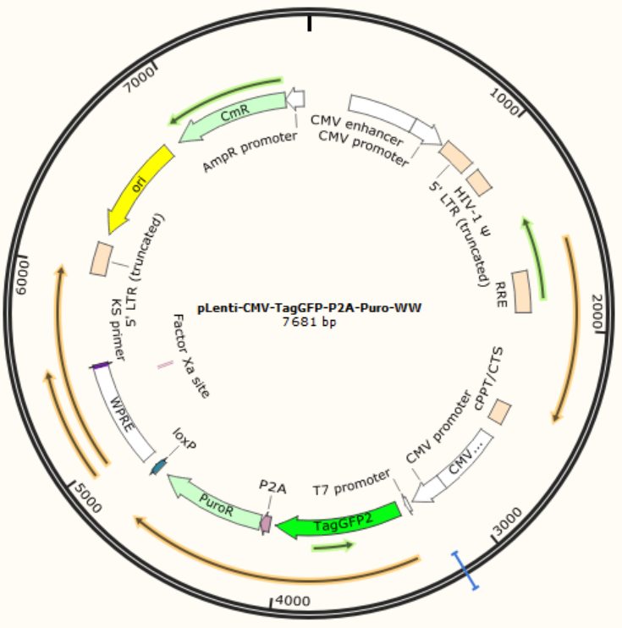

Figure 2.4: The plasmid map of the pLenti-CMV-TagGFP-P2A-Puro vector. This is a third generation lentiviral vector. In this vector, the ori means replication origin, the CmR and AmpR promoter indicates the chloromycetin resistance, the 5’ LTR (long terminal repeat) truncated, HIV-1 Ψ, RRE and cPPT/CTS are elements for lentiviral packaging. The first CMV enhancer and promoter (before the 5’ LTR) is used to increase the efficiency of the lentiviral production and the second CMV enhancer and promoter drives the expression of TagGFP2, which is followed by P2A (porcine 2A peptide) and PuroR (puromycin resistance). The WPRE (woodchuck hepatitis virus posttranscriptional regulatory element) is used to increase the expression of genes.

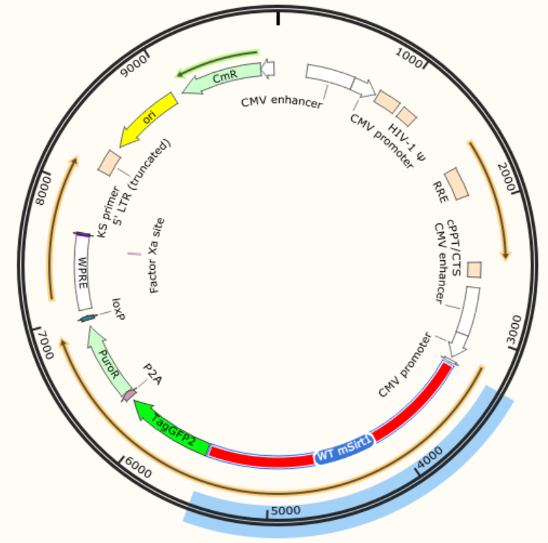

Figure 2.5: The plasmid map of the pLenti-CMV-mSirt1-TagGFP-P2A-Puro vector. This is the vector containing the cloned wild-type Sirt1 gene of the mouse (WT mSirt1) based on the empty one (Figure 2.4). The fragment of WT mSirt1 was inserted into the position between the second CMV promoter and TagGFP2. The expression product of WT mSirt1 is fused with TagGFP2.

2.2.4.2 Lentivirus production
The revival of the HEK293T cells stored in liquid nitrogen proceeded in a 37°C water bath with gentle agitation. Cells were transferred into a pre-warmed 15 ml tube containing 5 ml growth medium (10% FBS and 1% Penicillin/Streptomycin in DMEM). The tube was centrifuged at 110 g for 3 min. The supernatant was removed, and the cell pellets were gently resuspended by 1 ml growth medium. Then the cell suspension was plated into a 10 cm tissue culture dish containing 9 ml growth medium. The dish was carefully shaken in crossing directions to distribute the cells evenly and culture the cells in a 37°C humidified incubator with 5% CO₂. After 2-3 days of culture, the medium was aspirated when the cells reached about 90% confluency. 3 ml sterile PBS was gently refilled to submerge the cells. After aspirating the PBS, 3 ml 0.05% Trypsin-EDTA was added to the plate and incubated in a 37°C humidified incubator. After 3-5 min incubation, the plate was gently tapped to detach the cells. A 3 ml growth medium was added to the plate to terminate enzyme digestion. The cell suspension was then transferred into a 15 ml tube for centrifuging at 110 g for 3 min. The supernatant was aspirated, and 1 ml growth medium was added and to be resuspended with 1 ml pipette tip. Then the cell suspension was plated into a 10 cm tissue culture dish containing 9 ml growth medium. For routine cell maintenance, cells were passaged at 1:6 and 1:3 for lentivirus production.
The next day after cell passage, transfection for lentivirus production was performed when the cells were about 80% confluent. For one 10 cm dish, two 1.5 ml sterile tubes (tube A and B), each containing 0.5 ml DMEM should be compared. 45 μl Lipo293™ transfection reagent was added to tube A, and plasmids mix (pCMV-dR8.2 7.5 μg, pCMV-VSV-G 5 μg and expressing vector 10 μg) to tube B. Each tube was mixed well. The plasmids mixture was transferred from tube B to tube A and mixed well. After incubating the mix at room temperature for 15 min, the total mixture was added dropwise to cell solutions in a 10 cm dish. The dish was shaken gently back and forth several times and incubated the dish in a 37°C humidified incubator with 5% CO_{2.}
48 h post-transfection, the medium was collected and stored at 4°C. 10 ml fresh growth medium was added to the cells and kept culturing in the incubator. 24 h later, the medium was collected again. Totally 20 ml medium was centrifuged at 200 g for 10min and filtrated through a 0.45 μM filter. The supernatant was then transferred to ultracentrifuge tubes (BECKMAN COULTER, #344058) and was centrifuged at 17,500 rpm for 2 h using the JS-24.38 swinging-bucket rotor (BECKMAN COULTER, #360743). The supernatant was removed entirely and replaced with 100 μl DMEM/F12 medium to resuspend the pellet. The suspension was transferred to a sterile 1.5 ml tube, and another 100 μl medium was added to the ultracentrifuge tube's bottom. The medium was then collected in the same 1.5 ml tube and stored at 4°C overnight. The tubes were then at 12,000 g for 3 min; the supernatant was transferred to a new sterile 1.5 ml tube. Transduction of the cells with the virus was then processed.

2.2.4.3 The transduction of NSCs with lentivirus
NSCs were cultured in coated 6-well plates as described before (section 2.2.2.3). The transduction was processed when the cells were about 30% confluent. For each well of the 6-well plate, 1 μl polybrene (10 mg/ml stock) was added. After incubating for 2 h, aspirate 1 ml medium from each well and 20μl of the concentrated virus was applied. The plate was shaken back and forth several times and incubated in a 37°C incubator with 5% CO₂ for 6 h. The 2 ml fresh growth medium was added to replace the lentivirus-containing medium. 3 days later, cells were cultured in the growth medium containing 1 μg/ml puromycin for at least 3 more days.

2.2.5 RNA extraction, RT-qPCR and RNA-Seq

2.2.5.1 Total RNA extraction
About ~2 x 10⁶ cells were collected into a 1.5 ml tube, and centrifuged at 800 g for 3 min. Aspirated the supernatant and added 300 μl TRIzol to the tube, the cells were thoroughly pipetted and incubated in the tube at room temperature for 5 min. RNA isolation should be immediately performed or the cell lysates should be stored at -80℃. For cell lysates stored at -80℃, samples were completely thawed at room temperature before the extraction procedures.
To each tube containing 300 μl TRIzol lysates, 60 μl chloroform was added, and then the solutions were mixed well by inverting the tubes several times. After the tube had been incubated at room temperature for 3 min, they were centrifuged at 12,000 g/4℃ for 10 min. The colorless upper aqueous phase was carefully transferred to a new DNase/RNase-free 1.5 ml tube. Next, 250 μl isopropanol was added to each tube and cap the tubes were capped and mixed well by flopping up and down for several times. The samples were incubated at room temperature for about 10 min and then centrifuged at 12,000 g /4℃ for 10 min. After carefully removed the supernatant, 500 μl 75% ethanol was added to suspend the pellet and the tube was vortexed for a few seconds. After that, tubes were centrifuged at 7,500 g for 5 min at 4℃. The supernatant was carefully aspirated. The tubes were rested at room temperature for 10 min. No more than 30 μl DNase/RNase-free water was added to each tube to suspend the pellet and incubated t in a 55℃ heat block for 10 min. After that, the cDNA synthesis was performed or the RNA sample were stored at -80℃.
2.2.5.2 RT-qPCR
For each reverse transcription, 20 μl reaction mix (total RNA 1 μg, 5X TransScript All in One SuperMix 4 μl, gDNA Remover 1μl, RNase-free water up to 20 μl) was prepared and added in a 200 μl RNase-free microtube. Gently mixed well and incubated at 42℃ for 15min and then 85℃ for 5s in a PCR thermocycler. The reaction mix solution was mixed well and transferred into a 1.5 ml tube containing 180 μl DNase/RNase-free water. Preparation of the PCR reactions as such: cDNA mix 4 μl, 10μM forward and reverse primers, 0.5 μl each, dNTPs 2 μl, 2x qPCR SuperMix 10 μl and RNase-free water 5 μl. For each gene of every sample, triplicates were prepared. Ran the reactions on an ABI Prism7500 device with a set amplification program (94℃ 5 s, 60℃ 15 s, 72℃ 10 s, 40 cycles) and the fluorescence signal acquisition time of 34 s. Analyse the results using 2^{-Δ(ΔCT)} method.

2.2.5.3 RNA-Seq
The quality of each RNA sample was examined by Agilent 2100 Bioanalyzer (Figure 2.6). For the qualified RNA samples, the genomic DNA was removed by DNase I and mRNA enrichment was processed using Oligo (dT) beads. cDNA libraries were obtained after mRNA fragmentation, cDNA synthesis and PCR amplification. cDNA libraries were qualified and performed sequencing using Illumina Hiseq2000.
The sequence qualification was generated by FastQC sequencing and filtered out low-quality sequences to ensure clean reads (Figure 2.7). The clean reads were aligned to reference genomes and genes using SOAP2 to obtain each gene's RPKM (Reads Per Kilobase Per Million Mapped Reads) value. Finally, DESeq analysed the differential gene expression.
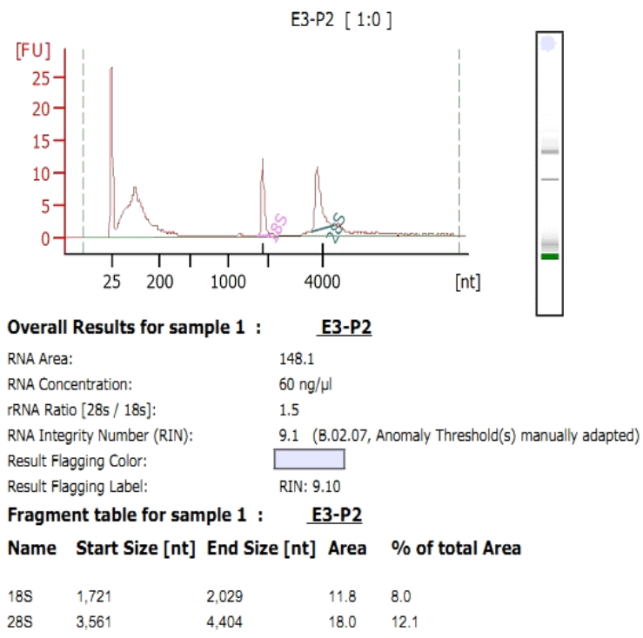

Figure 2.6: The example of the quality of RNA sample analysed by Agilent 2100.
The representative results of the RNA sample analysed by Agilent 2100 were shown.

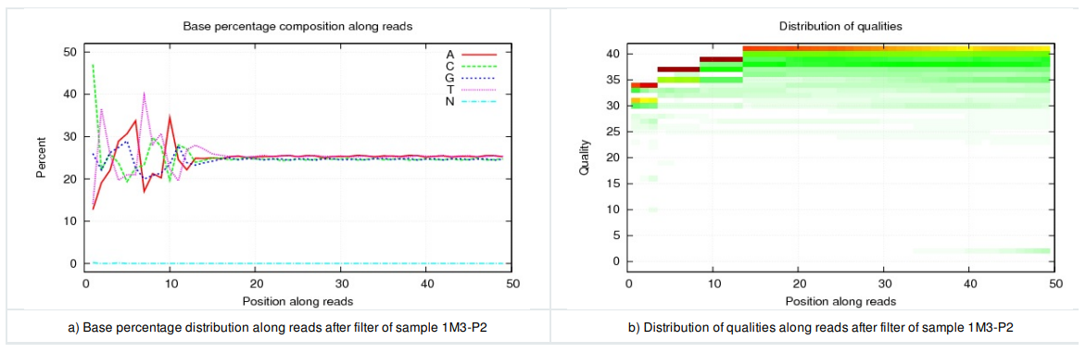

Figure 2.7: The distribution of base percentage and qualities along reads in data filtering. The base percentage distribution and the base qualities distribution along the reads of the filtered sample were shown.

2.2.6 Protein extraction, Immunoprecipitation, Co-immunoprecipitation and Western Blotting

2.2.6.1 Immunoprecipitation (IP) and Co-immunoprecipitation (CoIP)
For protein extraction, cells were collected into 1.5 ml tubes and centrifuged at 600 g for 3 min. The supernatant was discarded, and 0.5 ml ice-cold PBS was added to suspend the cells. The supernatant was discarded again and resuspended the cells with 100 μl Western/IP cell lysis buffer (add freshly made 1 mM PMSF) per 1.0 x 10⁶ cells. The tubes were incubated on ice for 20 min and centrifuged at 14,500 g/4℃ for 15 min. The supernatant was then transferred into new 1.5ml tubes.
The protein sample was diluted with (250 mM Tris-HCl, 10% SDS, 0.04% bromophenol blue, 30% glycerol, and 500 mM DTT) for western blotting and boiled in a boiling water bath for 5 min.
For IP or Co-IP, 1/10 of each protein sample was left aside for input groups. The input samples were diluted with 5 x SDS loading buffer and boiled in a water bath for 5 min. The primary antibodies or IgG from the same species used for producing the antibodies were added for the rest of each protein sample. The samples were incubated at 4℃ on a rotating device overnight. Next, Protein A/G agarose was added to each sample (20 μl per 1 ml cell lysates) and incubated at 4℃ on a rotating device for 4 h. The tubes were centrifuged at 1000g/4℃ for 2 min. The supernatant was discarded without disturbing the agarose pellet. Next, the pellet was washed with washing buffer (25 mM Tris-HCl, 1 mM EDTA, 1% NP-40, 150 mM NaCl and 10% glycerol) four times by centrifuging at 1000g/4℃ for 2 min. After the last time of washing, the supernatant was discarded, and the pellet was resuspended with 100 μl 1 x SDS loading buffer (5 x SDS loading buffer diluted in Western/IP cell lysis buffer). The samples were boiled for 5 minutes in a water bath.

2.2.6.2 Western blotting
SDS-PAGE gels were prepared using PAGE Gel Quick Preparation Kit. The boiled samples were thoroughly thawed at room temperature if stored at -20℃. Samples were loaded into the wells of the gels along with the pre-stained protein maker. Electrophoresis was launched at a constant voltage of 60 V for 10 min. It was followed by 90 V for 2-3 h to separate protein bands according to their theoretical molecular weight in running buffer (25 mM Tris, 192 mM glycine and 0.1% SDS). The gels with frames were taken out and washed with running water. The sandwich-like module made of the filter paper was prepared, and PVDF membrane and filter paper in transferring buffer (25 mM Tris, 192 mM glycine and 20% methanol) were pre-cooled at 4℃. The sandwich-like module was then transferred into an electrophoresis chamber containing a pre-chilled transferring buffer and ran the electrophoresis at a constant current of 250 mA for 2-3 h. The membrane was rinsed once in TBST buffer. The membrane was incubated in blocking buffer (5% BSA in TBST) for 1 h at room temperature and then with primary antibodies diluted in blocking buffer for 2 h at 37℃ or overnight at 4℃. The membranes were washed with TBST for 3 x 10 min on a shaking device, followed by incubation with HRP-conjugated secondary antibodies diluted in blocking buffer for 1 h at room temperature. The membranes were washed with TBST, and then detected the signal with ECL chemiluminescence.

2.2.7 HR and NHEJ reporter assay

2.2.7.1 The illustration of HR and NHEJ reporter assay
The illustration of HR and NHEJ reporter assay is shown in Figure 2.8 (Seluanov, Mao et al. 2010). In this assay, HR or NHEJ reporter constructs were linearised by I-SceI enzyme, purified, and co-transfected with DsRed into cells. FACS then analysed the transfected cells, and the repair efficiency was calculated as the ratio of GFP⁺/DsRed⁺ cells.
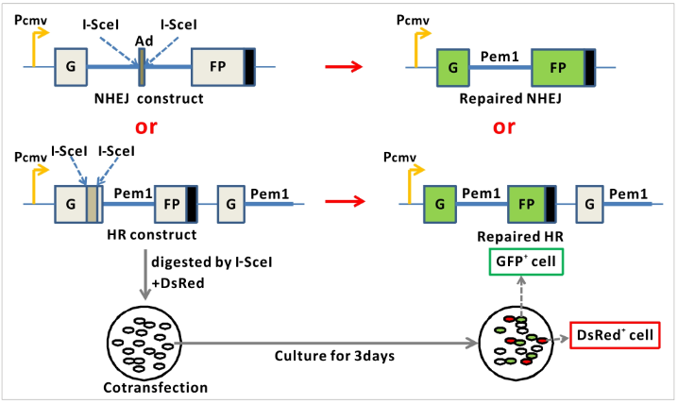

Figure 2.8: The illustration of the HR and NHEJ reporter assay. The NHEJ reporter construct contains a GFP gene with an engineered intron from the Pem1 gene (Pem1) which includes an adenoviral exon (Ad) flanked by recognition sequences for I-SceI endonucleases for induction of DSBs. The intact NHEJ construct is GFP negative as the adenoviral exon disrupts the GFP ORF(open reading frame). Upon induction of DSBs by I-SceI, the adenoviral exon is removed and the repaired NHEJ restores function of the GFP gene. In the HR construct, the first exon of the GFP gene interrupted by the Pem1 intron contains two inverted I-SceI restriction sites and is followed by a promoter-less/ATG-less GFP-Pem1. This intact construct is GFP-negative. Upon induction of a DSB by I-SceI digestion, the functional GFP gene is reconstituted by intramolecular or intermolecular gene conversion between the two mutated copies of the first GFP exon.

2.2.7.2 The test of HR and NHEJ repair efficiency of NSCs
The HR or NHEJ reporter constructs were linearised by I-SceI digestion, and the digested products were purified using a Qiagen Qiaex II Purification Kit. Culture NSCs were cultured in coated 6-well plates as described before (section 2.2.2.3). Transfection was performed when cells were about 60% confluent. For one well of the 6-well plate, two 1.5 ml sterile tubes (tube A and B), each containing 0.1 ml DMEM medium, was prepared. To tube A, 5 μl Lipo8000™ transfection reagent was added, and 2.5μg plasmids were to tube B. Gently mix each tube well. Transfer the plasmids mix in tube B to tube A and mix well. After incubating the mix at room temperature for 15 min, the total mix was added dropwise to cells in the plates. The dishes were gently shaken back and forth several times and incubated the dish in a 37°C humidified incubator with 5% CO₂. Three days after transfection, single-cell suspensions were prepared, analysing the samples on a FACSVerse Flow Cytometer. Results were analysed by Flowjo software (Figure 2.9).
Note: Prepared control wells for gating for flow cytometry analysis. Control wells included transfections with 2.5 μg plasmids expressing no fluorescence, GFP, or DsRed. Each experimental well was co-transfected 2 μg linearised HR or NHEJ plasmids with 0.25 μg DsRed. Triplicates were prepared for each experimental group.
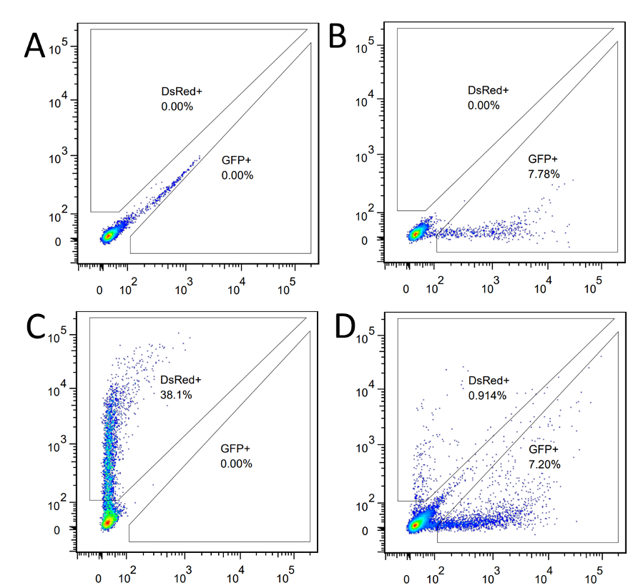

Figure 2.9: The gating strategy of the flow cytometry in the HR and NHEJ reporter assay. Flow cytometry analysis of cells transfected with plasmids expressing no fluorescence (A), GFP (B), DsRed (C) and co-transfected linearised reporter constructs with DsRed (D). In the flow cytometry analysis, the FITC (Fluorescein isothiocyanate) and PE (Phycoerythrin) channels were used to detect GFP and DeRed, respectively. The compensation of the two fluorescence was adjusted to exclude interference between each other. The gating was then performed based on the compensated fluorescence channels.
Dr Guangming Wang helped with this assay.

2.2.8 The Social Transmission of Food Preference (STFP) assay

2.2.8.1 The illustration of STFP assay
The STFP assay for the olfactory memory test of mice was described in a published protocol (Wrenn, 2004). As shown in Figure 2.10, the STFP assay comprised three phases: the habituation phase, the interaction phase, and the choice phase. In the habituation phase, all mice were trained to be habituated to eat powdered food. The demonstrator mice were habituated to eating cued powdered food, while observer mice were habituated to eating chain powdered food. Mouse with an intake of 0.2 g of powdered food was considered to be successfully habituated. In the interaction phase, the observer mice were allowed to interact with and receive cued food information from the demonstrator mice. Before the interaction, the demonstrator and the observer mice were deprived of food for 18 h. Following food deprivation, the demonstrator mice were given cued food for 1 h and then allowed to interact freely with the observer mice in a new cage for 30 min. During the choice phase, the observer mice were put into choices between the novel food and the cued food. 24 hours post the interaction, the observer mice were allowed free access to cued and novel food for 1 h. At the end of the test, the cued and novel food in each cage was weighed, and the respective cued and novel food intake for each observer mouse was calculated. During the interaction and the choice phase, the behaviours of the observer mice were videotaped and analysed later for sniffs to the demonstrator’s muzzles and jar climbs on jars containing cued and novel food.
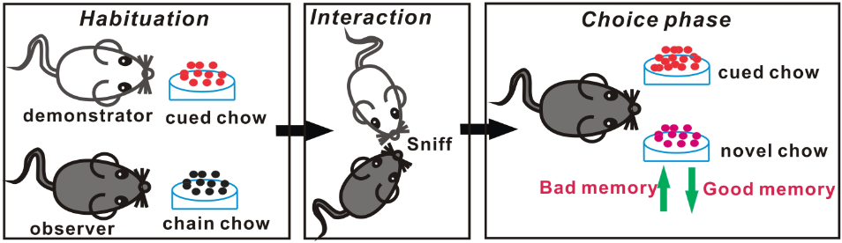

Figure 2.10: The schematic representation of the STFP assay to test the olfactory memory of mice. In brief, the observer mice, habituated with chain chow, were allowed to interact with the demonstrator mice that had been habituated with cued chow to gain the memory of the cued chow. They were then allowed to choose between the novel and cued chow. The greater the preference for the novel chow, the worse the memory.

2.2.8.2 The experimental procedure of STFP assay
Adult C57BL/6 mice (half male and half female) were exploited as the observers, and adult ICR mice (female) as the demonstrators. After an 18 h deprivation of food, each mouse was singly housed in one cage containing a food jar of powdered chain chow for the observers or 2% cocoa powdered chow for the demonstrators. The mice were allowed to eat the food for 1 h. Each mouse was placed in the home cages containing normal food and water. The jars were weighed before and after the presentation to each mouse. The habituation was processed for 2-3 days. The mouse with an intake of 0.2 g or more powered food were employed for the subsequent experiments.
All successfully habituated mice were singly housed in cages containing no food and water after an 18 h deprivation of food. The demonstrating mice were allowed to freely eat the 2% cocoa powdered chow for 1 h. The demonstrators were placed in cages of the observers. Free interaction between the two groups was for 30 min. The mice's behaviours were videotaped during the interaction with the camera set half a meter away. At the end of each interaction, the demonstrators were placed into home cages containing normal food and water. The observers were housed singly in new cages containing two food jars, one of which contained 2% cocoa-powered chow. The other one contains 1% cinnamon. The observers were allowed to eat freely for 1 h and videotape the behaviours of the mice. At the end of the feeding, each observer mouse was singly placed into new cages with free access to water but not food and weighed the net consumption of each food. 24 h later, the food choice test was performed again. The behaviour analysis was processed after the end of the test.
Dr Guangming Wang helped with this assay.

CHAPTER 3: The DNA Damage of The Activated Neural Stem Cells in Ageing Mice

3.1 Introduction
Neural stem cells (NSCs) and neurons are essential in the nervous system. The NSCs are the sources of the generation of neurons that execute neural functions. Adult neurogenesis in mice is active in the subgranular zone (SGZ) and the subventricular zone (SVZ), although the existence of which in the human brain is under debate. In the SGZ, granule cells generated from NSCs participate in neural functions of learning and memory, and the interneurons derived from NSCs of the SVZ take part in the maintenance of the olfactory function (Ming and Song 2011).
The nervous system ages with time. On the one hand, neurogenesis decreases with age. On the other hand, the neurons are constantly lost due to the accumulation of various injuries during ageing. The decreasing neurogenesis and the losing neurons render the ageing of the nervous system irreversibly worse and worse (Drapeau, Mayo et al. 2003, Enwere, Shingo et al. 2004). Adult stem cells exist in quiescent and active states (Li and Clevers 2010). In mice, the quiescence state is thought to be one of the mechanisms for lifelong maintenance of the NSC pool during the ageing (Kalamakis, Brüne et al. 2019). However, the more quiescent and reluctant to be-activated of NSCs in ageing mice also contribute to the ageing (Leeman, Hebestreit et al. 2018).
DNA damage has long been deemed as one of the main contributors to ageing, which has been evidenced by the accumulation of DNA damage in ageing cells, the senescence-related features in cells with DNA damage induction and the premature ageing caused by DDR (DNA damage response) deficiencies (Kolodner, Putnam et al. 2002, Gerson 2005, Lombard, Chua et al. 2005, Liu and Rando 2011, Moskalev, Shaposhnikov et al. 2012).
DNA DSB (double-strand break) is the most dangerous type of DNA damage. DSBs can be repaired with high fidelity by homologous recombination (HR) or with error tolerance through a non-homologous end joining (NHEJ) (Sancar, Lindsey-Boltz et al. 2004). Besides, DNA DSBs trigger different responses that ultimately lead to cell cycle arrest, apoptosis or senescence of adult stem cells (Blanpain, Mohrin et al. 2011).
DNA DSBs accumulate in stem cells of different tissues during ageing, such as blood, skin, muscle, intestine, mesenchymal matrix and the germline (McNeely, Leone et al. 2020). However, this ageing-related DSB accumulation has yet to be studied in NSCs.

3.2 Aim
The aim of this chapter is to evaluate the status of DSB in NSCs during ageing. In order to achieve this aim, we used a natural ageing model of mice and focused on SVZ niche. We first took the ageing related phenotypes of neurons in ageing mice as contrast and characterized the quiescence and activation of ageing NSCs. Then we employed in vivo detection of DSB related markers to check the DSBs in ageing SVZ NSCs of mice.

3.3 Results

3.3.1 Increases of DNA DSBs and Apoptosis imaging Mice Neurons
First, we sliced the brains of young (1-month old) and aged (24-months old) mice and marked the neurons with NeuN. We applied Cleaved Caspase 3 and γH2AX to show the apoptosis and DNA DSBs. We then calculated the percentages of Caspase 3 positive and γH2AX positive neurons in both specimens and found that the apoptosis and DSBs are more likely to occur in neurons from elder mice (Figure 3.1).
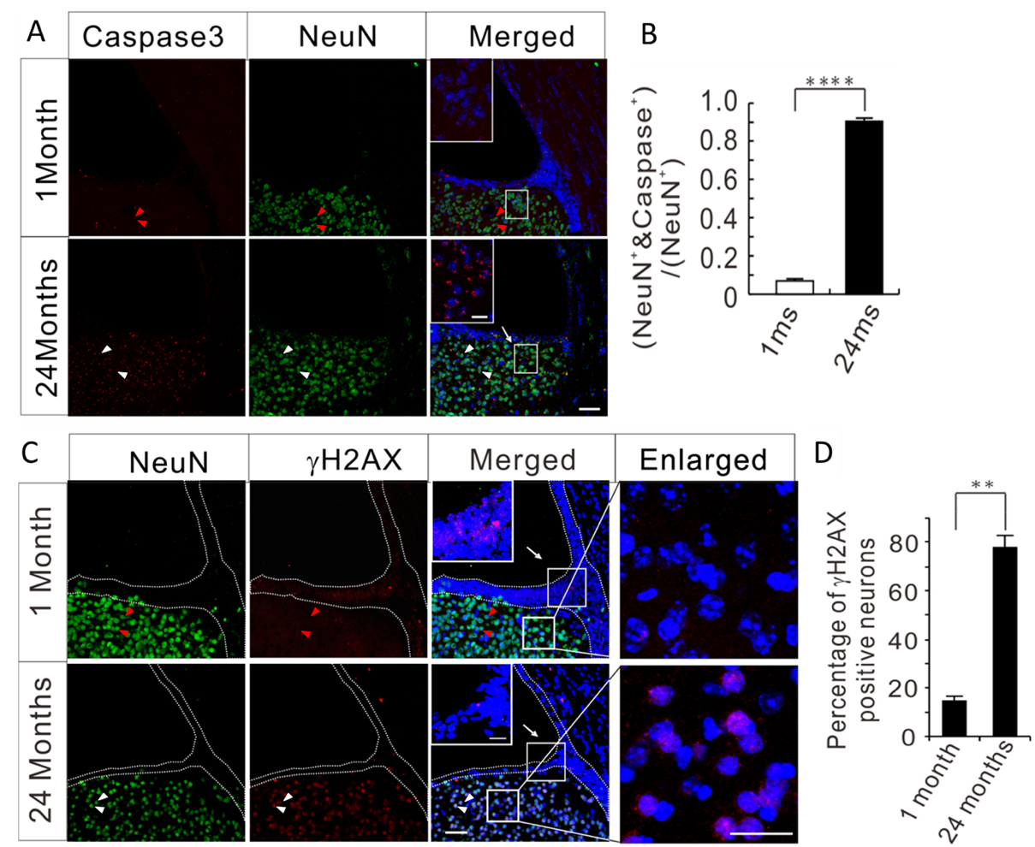

Figure 3.1: The apoptosis and DNA DSBs of neurons in ageing mice. (A) Immunostaining for NeuN and Cleaved Caspase 3 and the nuclei were counterstained with DAPI. The red triangles point out the Caspase 3⁻ NeuN⁺ cells and the white triangles point out the Caspase 3⁺ NeuN⁺ cells. (B) The quantification of the apoptotic neurons in the SVZ-neighboring regions of mice at 1 and 24 months of age. (C) Immunostaining for NeuN and γH2AX and the nuclei were counterstained with DAPI. The red triangles point out the γH2AX⁻ NeuN⁺ cells and the white triangles point out the γH2AX 3⁺ NeuN⁺ cells. (D) The quantification of the DNA DSBs in neurons (percentage of γH2AX-positive neurons) in the SVZ-neighboring regions of mice at 1 and 24 months of age. Scale bars, 50 μm. Scale bars in insets, 20 μm. Five coordinated sections from each mouse were used for quantification. Data from three male mice of different ages were used for statistical analysis. ** p<0.01, **** p<0.001, Student’s t-test, data are presented as means ± SEM. Dr Chuanming Dong and Xianli Wang contributed to the immunohistochemistry in this result.

3.3.2 Mouse NSCs exist in both quiescent and activated status
The NSCs harboured in adult mouse brains exist in both quiescent and activated states. The quiescent NSCs can be marked simultaneously by SOX2 and GFAP, while the activated NSCs can be characterised by the colocalisation of SOX2 and EGFR or SOX2 and NESTIN (Codega, Silva-Vargas et al. 2014). By such markers, we tested the NSCs in adult mouse brain sections with the features mentioned above and identified NSCs in the two states (Figure 3.2). To confirm the interchangeability between activated and quiescent grades of the SVZ NSCs, we set up an in vitro system to induce the NSCs to switch from activation to quiescence (with the combination of FGF and EGF) or otherwise (with the combination of FGF and BMP) (Figure 3.3). We then tested the cell cycles of the cultured NSCs with Ki67 and PI (Propidium Iodide) staining, followed by flow cytometry analysis. The results indicate that up to 70% of the activated NSCs are in the S-G2-M phase, whereas over 80% of the quiescent NSCs are under the G0 phase (Figure 3.4). We also induced the NSCs to go through the circle of activation-quiescence-reactivation. We then differentiated those particular cells into neurons (Tuj1 positive), astrocytes (GFAP positive) and oligodendrocytes (CNPase and Olig2 co-localize) separately to confirm that these NSCs were still tri-potent (Figure 3.5).
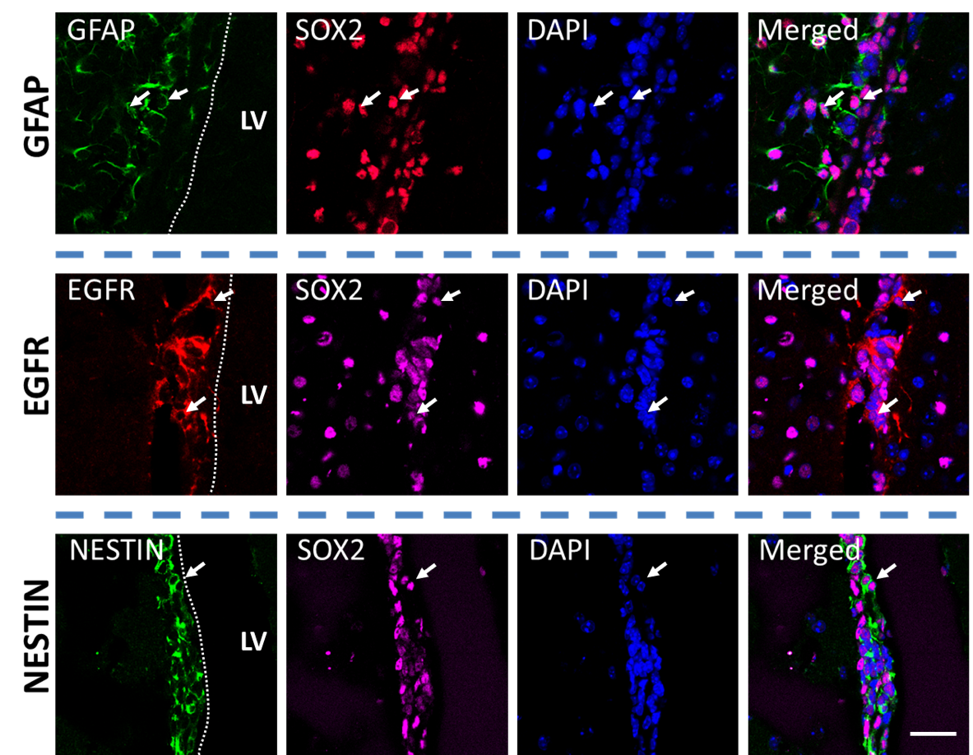

Figure 3.2: The in vivo characterization of quiescent and activated NSCs with immunostaining. The co-immunostaining of GFAP or EGFR or NESTIN with SOX2 in the SVZs of 1-month-old mice. The quiescent NSCs are marked by co-expression of SOX2 and GFAP, and the activated NSCs are characterised by the co-expression of SOX2 and EGFR or SOX2 and NESTIN. The white arrows are examples of cells with co-expression. LV, lateral ventricule. The white dash line indicates the margin of the SVZ. Scale bar, 50 μm.

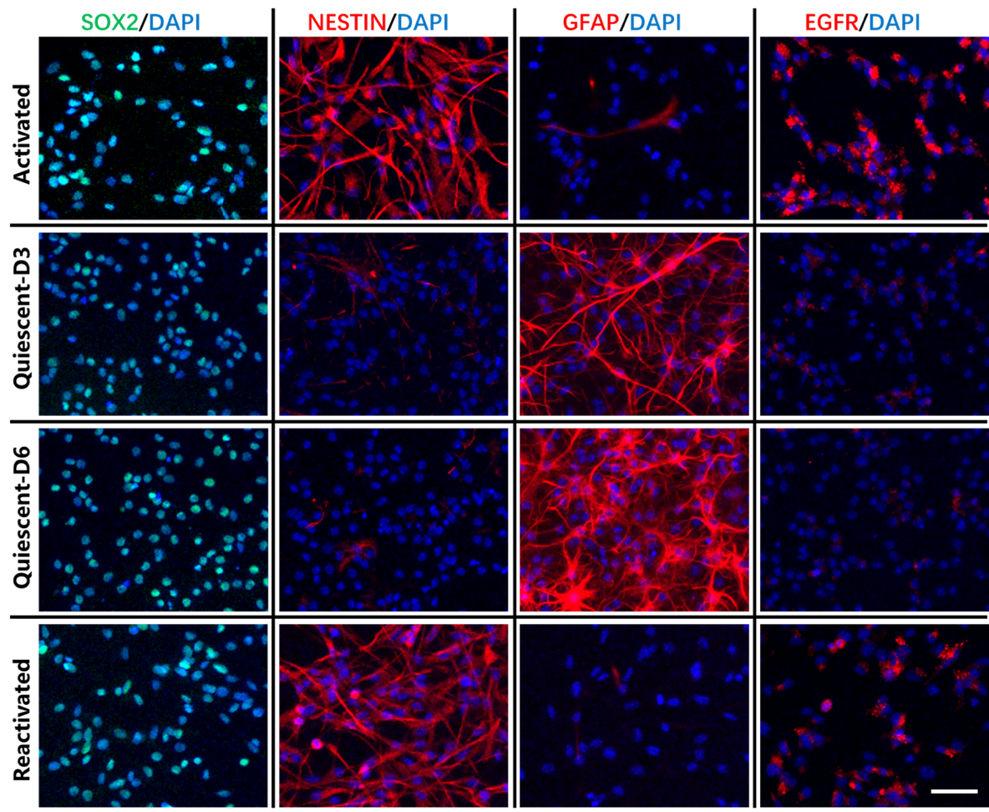

Figure 3.3: The in vitro characterization of the induced quiescent and activated NSCs with immunostaining. The immunostaining of SOX2 or GFAP or EGFR or NESTIN in cultured NSCs. The quiescent NSCs are positive for GFAP and negative for EGFR or NESTIN. The activated NSCs are positive for EGFR or NESTIN but negative for GFAP. Scale bar, 50 μm.

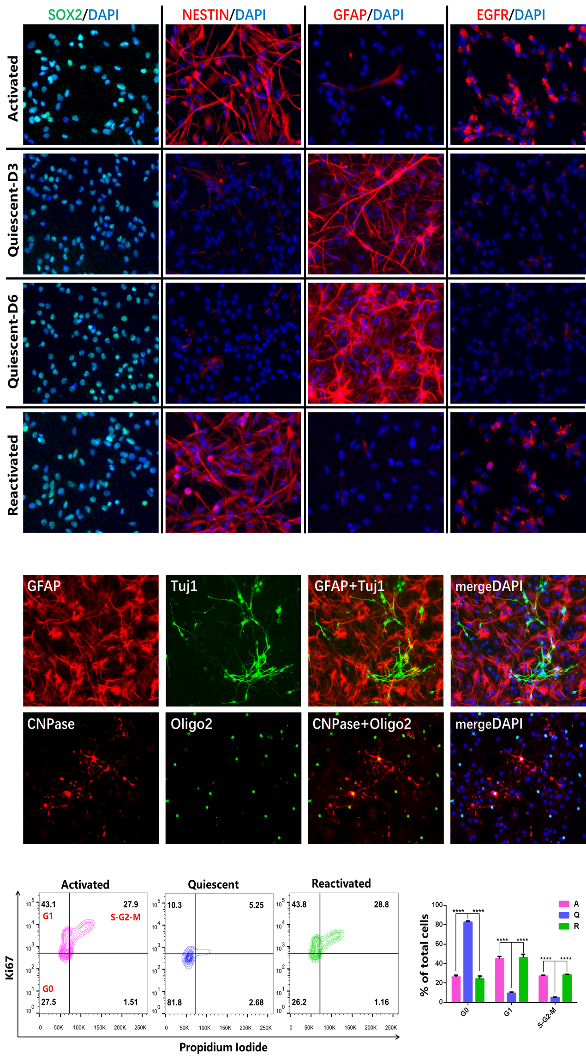

Figure 3.4: The cell cycle analysis of the induced quiescent and activated NSCs with flowcytometry. Cells without staining, with Ki67 alone staining and PI (Propidium Iodide) alone staining were used for gating control, and then cells with Ki67/PI double staining were analyzed. Cells in G0 phase are PI and Ki67 double negative. Cells in G1 phase are PI negative and Ki67 positive. Cells in S-G2-M phase are PI (Propidium Iodide) and Ki67 double positive. A, Activated; Q, Quiescent; R, Reactivated. Triplicates for each group. *** p<0.005, Student’s t-test. Three independent experiments were performed.

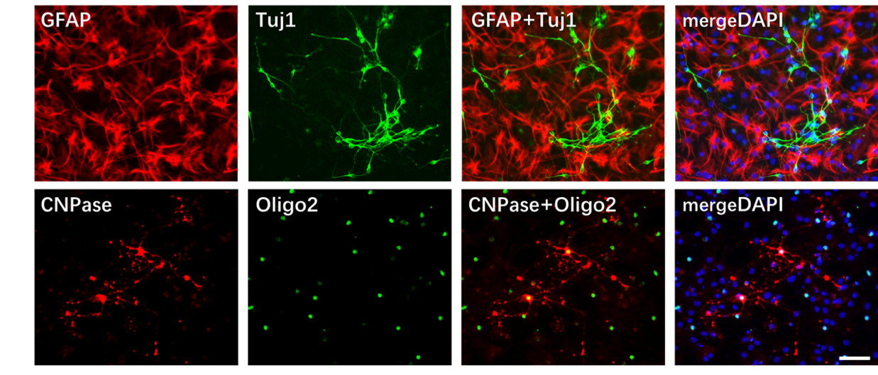

Figure 3.5: The characterization of the differentaion of induced reactivated NSCs with immunostaining. The co-immunostaining of GFAP with Tuj1 and CNPase with Oligo2 in differentiatted cells. Neurons are Tuj1 positive, astrocytes are GFAP positive and oligodentrocytes are CNPase and Olig2 positive. Scale bar, 50 μm.

3.3.3 The number and proliferation of NSCs decrease in ageing mice SVZ
We characterised the proliferation of the activated NSCs (colocalisation of NESTIN and Ki67) in SVZs of mice in different age groups (1, 6 and 24 months old). By quantifying and comparing these age groups, we noticed that the total number and the proliferation of activated NSCs in mice SVZs decreases with age (Figure 3.6).
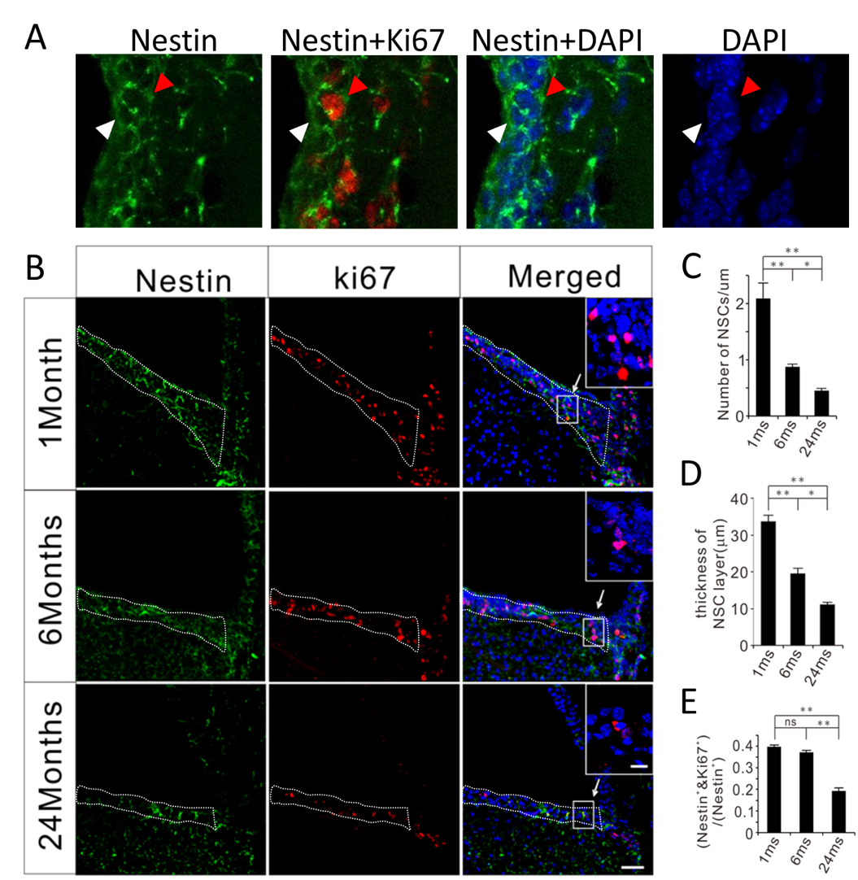

Figure 3.6: The number and proliferatin of activated NSCs in mice SVZ decreases with age. (A) Example of the immunostaining for Nestin and Ki67 in the SVZs of mice. The red triangles point out the Nestin⁺/Ki67⁺ cells and the white triangles point out the Nestin⁺/Ki67⁻ cells. (B) Immunostaining for Nestin and Ki67 in the SVZs of mice with different ages. (C) The quantification of the number of NSCs (Nestin⁺ with DAPI) in NSC layer. (D) The quantification of the thickness of the NSC layer. (E) The quantification of active NSCs (Nestin⁺ & Ki67⁺/Nestin⁺) in NSC layer. The area surrounded by white dashed lines was used for quantification. Five coordinated sections from each mouse were used for quantification. Data from three male mice of different ages were used for statistical analysis. Scale bars, 50 μm. Scale bars in insets, 20 μm. * p<0.05, ** p<0.01, Student’s t-test. Dr Chuanming Dong and Xianli Wang contributed to the immunohistochemistry in this result.

3.3.4 The DSBs in activated NSCs are fewer in aged Mice SVZs
We then examined the DNA DSBs with the general marker γH2AX in SVZs from mice in different age groups (1, 6 and 24 months old), finding that the γH2AX marked DSBs were reduced with the increasing ages (Figure 3.7). We also applied 53BP1, another generally accepted DSB marker, to confirm further that the DSBs were fewer in ageing mice SVZs (Figure 3.8).
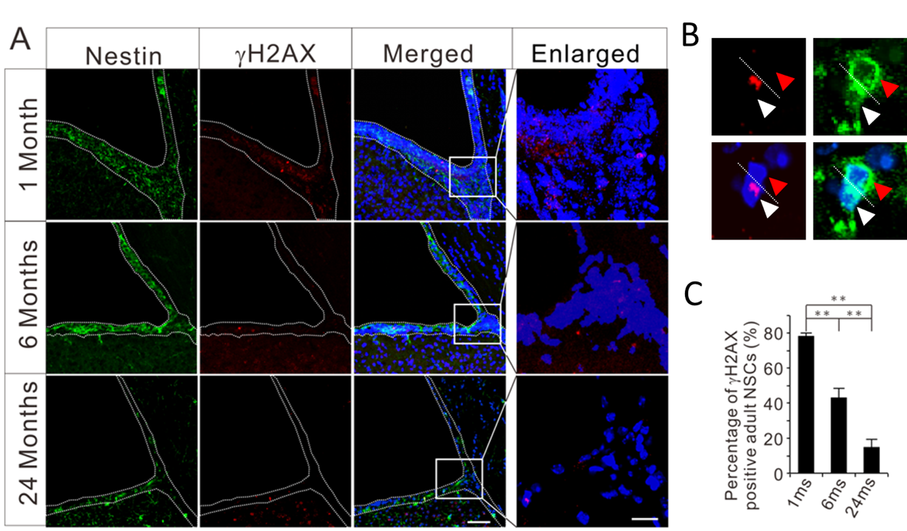

Figure 3.7: The DSBs showing by γH2AX in activated NSCs in mice SVZs decrease with age. (A) Immunostaining for Nestin and γH2AX (a marker for DSB, red) in SVZs of mice with different ages. The dotted lines demark the SVZ. (B) The example of γH2AX-positive (pointed out with white triangles) and γH2AX-negative (red triangles) NSCs for quantification. (C) The quantification of the DSBs in SVZ NSCs (percentage of γH2AX-positive NSCs) from mice of different ages. Five coordinated sections from each mouse were used for quantification. Data from three male mice of different ages were used for statistical analysis. Scale bars, 50 μm. ** p<0.01, Student’s t-test. Dr Chuanming Dong and Xianli Wang contributed to the immunocytochemistry in this result.
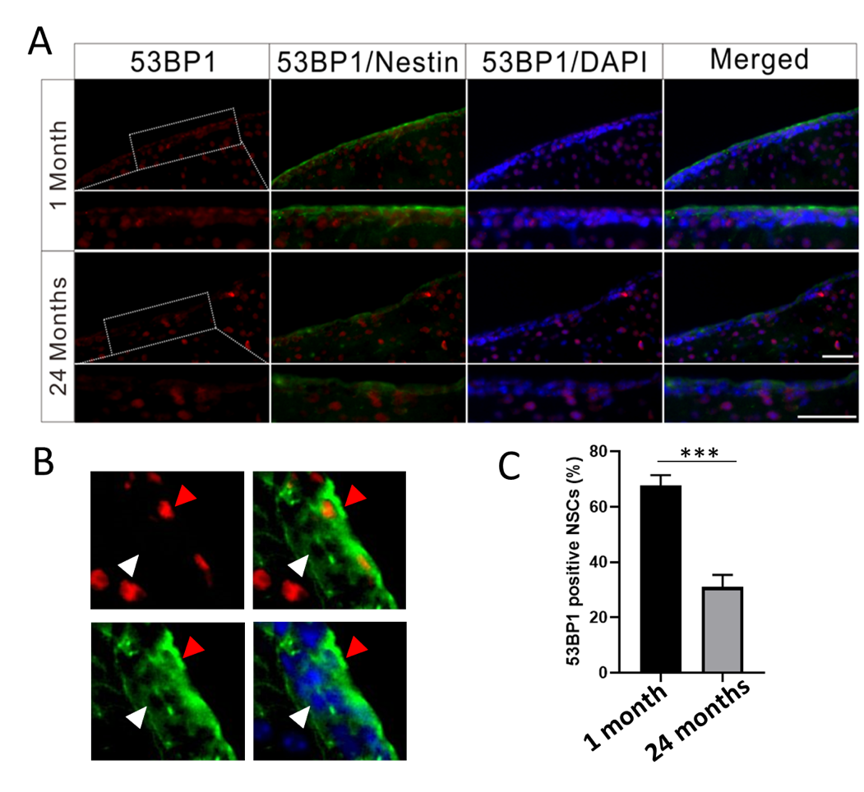

Figure 3.8: The DSBs showing by 53BP1 in activated NSCs in mice SVZs decrease with age. (A) Immunostaining for Nestin and 53BP1 (a marker for DSB, red) in SVZs from mice of 1 month and 24 months old. (B) The example of 53BP1-positive (pointed out with red triangles) and 53BP1-negative (white triangles) NSCs for quantification. (C) The quantification of the 53BP1-positive NSCs in SVZs from mice of different ages. Five coordinated sections from each mouse were used for quantification. Data from three male mice of different ages were used for statistical analysis. Scale bars, 50 μm. *** p<0.001, Student’s t-test. Dr Guangming Wang contributed to the immunohistochemistry in this result.

3.3.5 Enhanced NHEJ repair in activated NSCs of aged mice SVZs
We then derived SVZ NSCs from mice in different age groups (1, 6 and 24 months old) to thoroughly observe the DSBs in these cells. We recapitulated the γH2AX staining in activated NSCs cultured in vitro. We found that the DSB level decreases with the growing age of mice (Figure 3.9), which is consistent with our in vivo studies. To further test the consequences of DSBs, we checked the DNA damage repairs in activated SVZ NSCs. Cells exploit homologous recombination (HR) and non-homologous end joining (NHEJ) to cope with DSBs. We then applied an HR/NHEJ repair efficiency system to check the efficiency of DNA repairs in cultured SVZ NSCs derived from mice in different age groups. The results showed that in aged groups of activated SVZ NSCs, the NHEJ repair was more efficient than in younger groups of mice; nevertheless, the HR repair showed a contrary tendency (Figure 3.10).

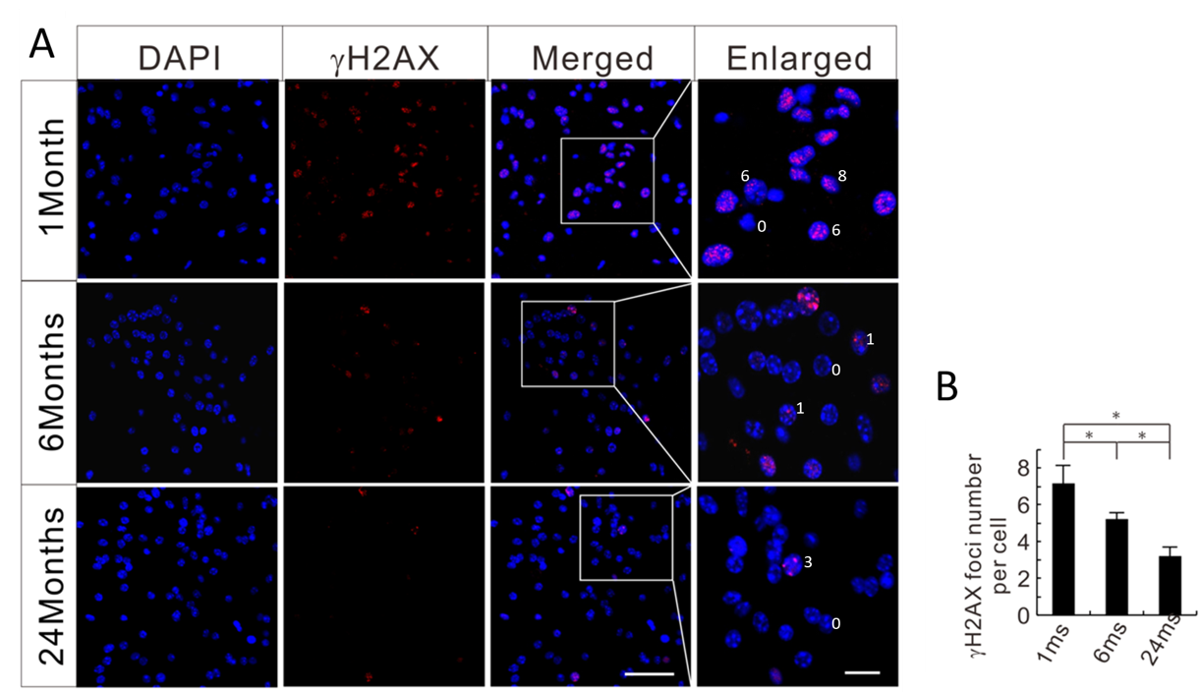

Figure 3.9: The DSBs in cultured activated NSCs in mice SVZs decrease with age. (A) Immunostaining for γH2AX (a marker for DSB, red). (B) The quantification of the DSBs in NSCs (γH2AX foci number per cell) derived from the SVZs of mice with different ages. The number at the side of the nucleus (Enlarged) shows the γH2AX foci number of the cell. Five random fields of each sample were used for quantification in one experiment. Scale bars, 50 μm. ** p<0.01, Student’s t-test. Three independent experiments were performed. Dr Chuanming Dong and Xianli Wang contributed to the immunocytochemistry in this result.

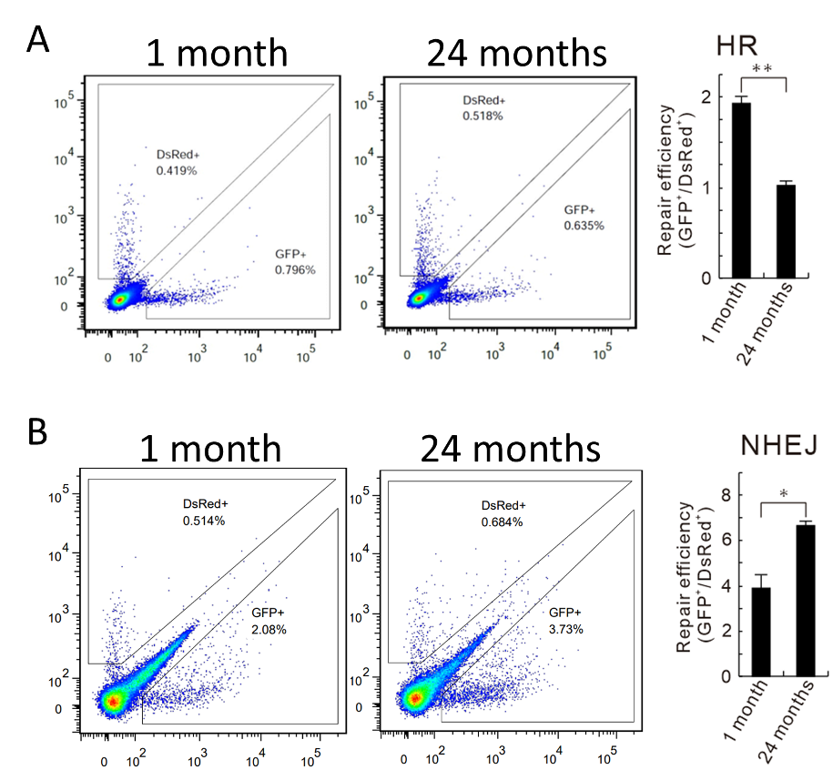

Figure 3.10: Enhanced NHEJ repair in activated NSCs of aged mice SVZs. (A) The HR repair efficiency of the cultured activated NSCs from SVZs of mice at 1 and 24 months old. (B) The NHEJ repair efficiency of the cultured activated NSCs from SVZs of mice at 1 and 24 months old. For each experimental well, 2 μg linearized HR or NHEJ plasmids together with 0.25 μg DsRed (as transfection control) were co-transfected. The repair efficiency was calculated by GFP⁺/DsRed⁺. Triplicates for each group. * p<0.05, ** p<0.01, Student’s t-test. Three independent experiments were performed.

3.4 Discussion
In this part, we first tracked the accumulation of DSBs (γH2AX staining) and increment of apoptosis (Cleaved Caspase 3 staining) of neurons in aged mice brains (Figure 3.1), which might be the expected situations during ageing and served as a comparative result for our subsequent analysis for NSCs.
An adult or ageing brain may adapt to the environment by producing newly generated neurons; thus, the states of adult NSCs are vital for adult neurogenesis and the protection of the central nervous system (CNS). With in vivo immunostaining of cell-specific markers that are widely accepted in the area (Codega, Silva-Vargas et al. 2014), we confirmed that the quiescent (co-expression of GFAP with SOX2) and the activated (co-expression of NESTIN or EGFR with SOX2) NSCs co-exist in SVZ (Figure 3.2). Further, with the reported in vitro transition system (Martynoga, Mateo et al. 2013), we successfully induced the activated NSCs into quiescence and reactivated them (Figure 3.4 and Figure 3.5) and confirmed that NESTIN and EGFR were highly expressed in activated NSCs and GFAP was highly expressed in quiescent ones (Figure 3.3).
Using the above criteria, we noticed a decreased number and proliferation rate of activated NSCs in ageing mice (Figure 3.6), as reported by others (Leeman, Hebestreit et al. 2018). Actually, we also observed a similar result in quiescent NSCs (data not shown). The limitation of our results is the lack of the absolute quantification of SVZ NSCs in mice with age; we only drew a comparative analysis between different ages. The reason for this is that the absolute quantification of SVZ NSCs in ageing mice needs massive work, which is beyond the purpose of our study.
We then adopted γH2AX and 53BP1, two widely used markers for DSB, to detect the DSBs in activated SVZ NSCs. We were surprised that the DSBs were less severe in ageing mice SVZ-derived activated NSCs than in their younger counterparts (Figure 3.7 and Figure 3.8) since these results were different from the findings in stem cells of other tissues, such as blood and muscle (Chakkalakal, Jones et al. 2012, Gutierrez-Martinez, Hogdal et al. 2018).
Using the in vitro HR and NHEJ reporter assay (Seluanov, Mao et al. 2010), we noticed that the NHEJ pathway of DSB repair was more efficient than the HR pathway in ageing NSCs (Figure 3.10), which could be caused by the lower proliferation rate of activated NSCs in aged mice giving the launching conditions of HR and might contribute to the fewer DSBs in NSCs of ageing mice. In this assay, the GFP⁺ cell propotion was lower in HR groups than that in NHEJ groups, which was consistent with the original research and could be caused by the difference in repair efficiency between HR and NHEJ.
The limitation of the reporter assay is only the relative repair efficiency for the specific HR or NHEJ can be compared between different cell groups, neither the absolute repair efficiency nor the comparasion of HR and NHEJ for the same cells. Each value of the repair efficiency calculated by GFP⁺ cell (repaired cells) propotion dividing DsRed⁺ cell (transfection control) propotion depends heavily on the amount of vectors for transfection. In our experiments, the low DsRed⁺ cell propotion could be the reason of low amount of DsRed for transfection. While without disturbing our mian results, the various amounts of DsRed could have been tested.
In summary, in this chapter, we first found that, compared to the younger mice, the SVZ NSCs generated from ageing mice were less proliferative under an activated status. It seemed that ageing could cause such a low level of proliferation and subsequently impair the capacity of neurogenesis. Thus, it is interesting to investigate how cellular proliferation would be regulated molecularly in the activated NSCs in ageing mice's brains. On the other hand, we would try to investigate why the ageing and activated NSCs maintained such relatively fewer DSBs and how such a phenomenon would affect the mice physically.

CHAPTER 4: SIRT1 Affects The Activated NSCs in SVZ of Young Mice

4.1 Introduction
In the previous chapter, we examined the cellular characteristics of activated NSCs from SVZs of mice’s brains and found relatively decreased proliferation and DSBs with growing ages. The neurogenesis in the ageing brains is slowing down for obvious reasons, e.g. increased quiescence of NSCs, reduced number of NSCs (Encinas and Sierra 2012, Leeman, Hebestreit et al. 2018); by the same token, with the shrinking capacity of proliferation in activated NSCs from ageing brains, the severity of DSBs should have been escalating instead of ameliorating (as we had observed). We wanted to decipher this phenomenon.
It has long been accepted that SIRT1 plays a vital role in DNA damage-related anti-ageing process (Wang, Luo et al. 2019, Chen, Zhou et al. 2020). The SIRT1 protein participates in the deacetylation of targets deeply associated with cellular functions like proliferation and DNA damage repair, such as NICD (Guarani, Deflorian et al. 2011), P53 and FOXO (Hori, Kuno et al. 2013).
Sirt1 is essential for the maintenance of various tissue stem cells. For example, loss of Sirt1 has been reported to lead to tissue regeneration deficiency in hematopoietic stem cells, muscle stem cells, and mesenchymal stem cells (Rossi, Bryder et al. 2007, Leko, Varnum-Finney et al. 2012, Simic, Zainabadi et al. 2013, Singh, Williams et al. 2013, Ryall, Dell'Orso et al. 2015). Moreover, studies show that SIRT1 is essential in maintaining neurogenesis in mouse brain regions such as SVZ and SGZ (Victoria A. Rafalski 2013, Ma, Yao et al. 2014). On the other hand, one of our previous studies demonstrated that SIRT1 could delay the progression of Parkinson’s disease by regulating cell autophagy (Liang Zhu et al. 2019).
It is undoubtedly that SIRT1 protein plays a vital role in the maintenance of adult NSCs. However, few studies have concerned the role of SIRT1 in the long-term maintenance of NSCs during ageing. Furthermore, the DNA damage and repair affected by SIRT1 were much less studied in NSCs during ageing.

4.2 Aim
In this chapter, we decided to focus on the function of SIRT1 in activated NSCs of the ageing mouse brain to investigate the relationship between the decreased DSBs and ageing. By conditionally knocking out Sirt1 in mouse NSCs, we started with the young mice and tried to explore the functions of SIRT1 protein in cell proliferation and DNA damage repair during ageing.

4.3 Results

4.3.1 Sirt1 loss promotes the proliferation of SVZ NSCs in young mice
We applied mice conditionally knocked out (cKO) of Sirt1 genes, specifically in NSCs, to investigate the effect of SIRT1 proteins on the DNA damage repair in NSCs located in the SVZs. We first tested the knockout efficiencies. Then, by immunostaining of the mice brain sections and the staining and the western blotting of the NSCs derived from the mice, we confirmed that Sirt1 had been successfully knocked out in NESTIN-positive NSCs (Figure 4.1 and Figure 4.2).
We then exploited Ki67 immunostaining to mark the proliferative NSCs. By Ki67 and NESTIN colocalisation, we identified the proliferating activated NSCs. After one month of Sirt1 cKO, in SVZ, up to 38% of activated NSCs were Ki67 positive, whereas only 25% of activated NSCs were Ki67 positive in WT groups (Figure 4.3). On the other hand, we also observed higher proliferative levels of activated NSCs in the cKO group than in the WT group by in vitro cell culture (Figure 4.4). Moreover, the activated NSCs of the cKO group formed significantly more neurospheres than the WT group by neurosphere assays (Figure 4.5). In summary, the immediate effect of SIRT1 loss was to accelerate the proliferation of the activated NSCs.

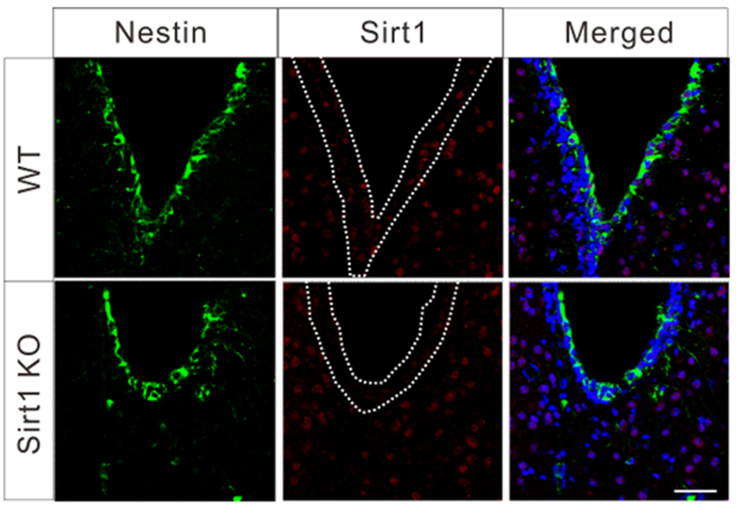

Figure 4.1: The in vivo validation of NSC-specific Sirt1 knockout. The images depict the co-immunostaining of SIRT1 and NESTIN in the SVZ of wild-type (WT) and Sirt1 conditional knockout (cKO) mice following TAM treatment.

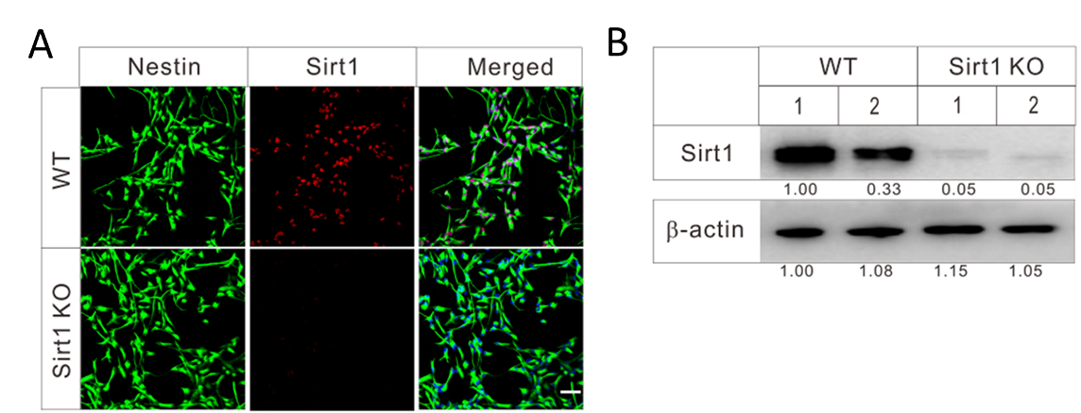

Figure 4.2: The in vitro validation of NSC-specific Sirt1 knockout. (A) In vitro validation of NSC-specific Sirt1 KO with immunostaining in cultured SVZ-derived NSCs. (B) In vitro validation of NSC-specific Sirt1 KO with immunoblotting in cultured SVZ-derived NSCs. Scale bars, 30 μm.

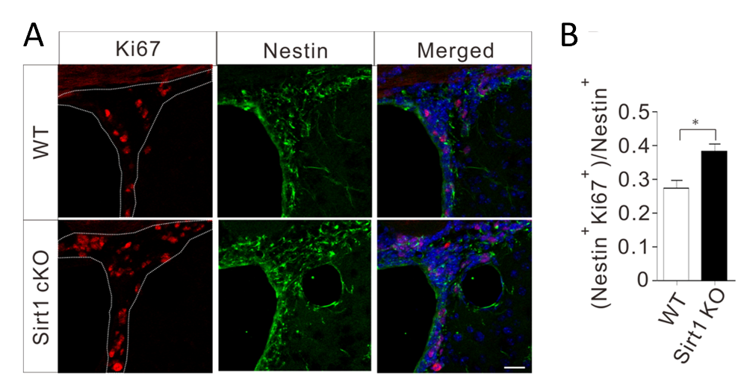

Figure 4.3: The in vivo detection of the proliferation of SVZ NSCs with one-month loss of Sirt1. (A) Immunostaining for Nestin (green) and Ki67 (a marker of proliferating cells). (B) The quantification of the proliferative NSCs (Nestin⁺ Ki67⁺/Nestin⁺) in the SVZs of WT and Sirt1 cKO mice. The quantification was performed with the same way in Figure 3.6A. Three coordinated sections from each mouse were used for quantification. Data from three mice of different groups were used for statistical analysis. Scale bars, 50 μm. * p<0.05, Student’s t-test.
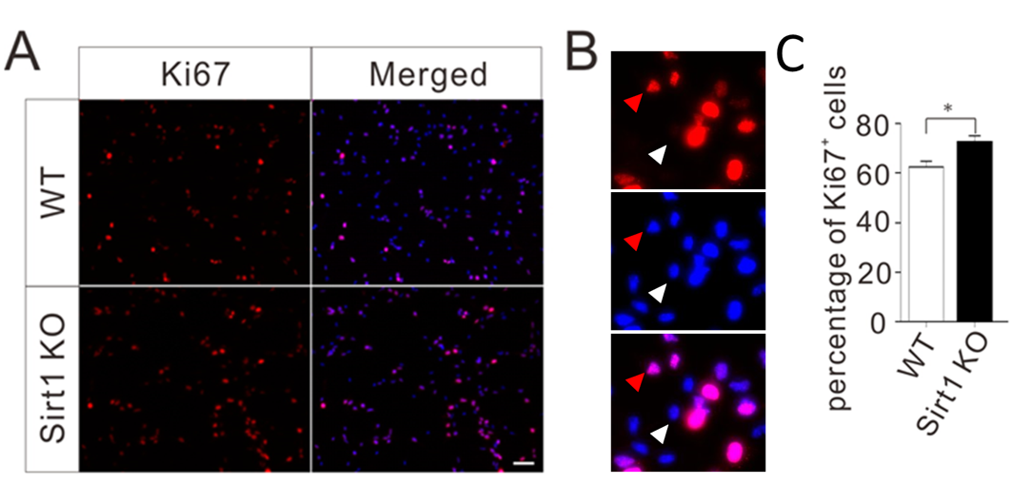

Figure 4.4: The in vitro detection of the proliferation of SVZ NSCs. (A) Immunostaining of Ki67 (red) on cultured SVZ NSCs. (B) The example of Ki67⁺ (pointed out with red triangles) and Ki67⁻ (white triangles) NSCs for quantification. (C) The quantification of the proliferative NSCs (Ki67⁺ cell propotion). Five random fields of each sample were used for quantification in one experiment. Scale bars, 50 μm. * p<0.05, Student’s t-test. Three independent experiments were performed.
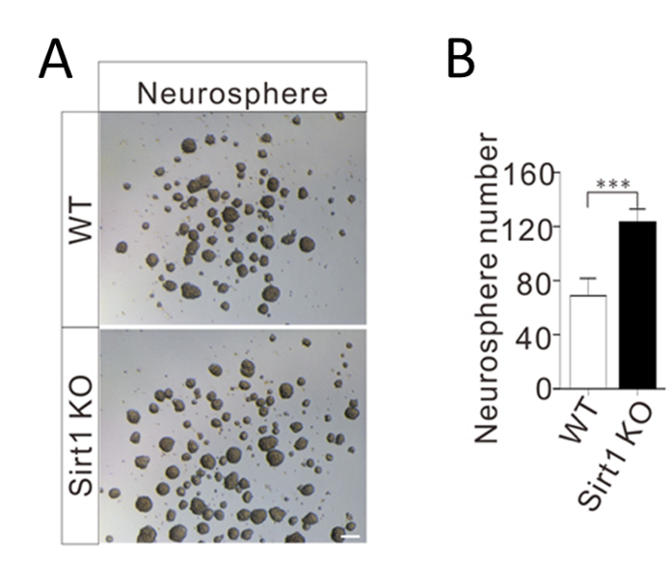

Figure 4.5: The in vitro detection of the proliferation of SVZ NSCs with neurosphere formation assay. (A) The bright-field images of neurospheres. (B) The quantification of neurosphere numbers for cultured SVZ-derived NSCs from WT and Sirt1 KO mice. Three wells of each sample were used for quantification in one experiment. Scale bars, 50 μm. *** p<0.001, Student’s t-test. Three independent experiments were performed.

4.3.2 Sirt1 loss accelerates the NSC pool shrinking of mice during ageing
We then studied the prolonged effects of Sirt1 loss in mice with age. After 12 months of Sirt1 deletion, we quantified the activated NSCs and their proliferation in the SVZs of the mice brains in WT and cKO groups. It showed that compared to the WT group, the number of activated NSCs in SVZs of cKO mice was about 30% less (Figure 4.6); among them, the number of Ki67 positive NSCs was about 25% less (Figure 4.7).
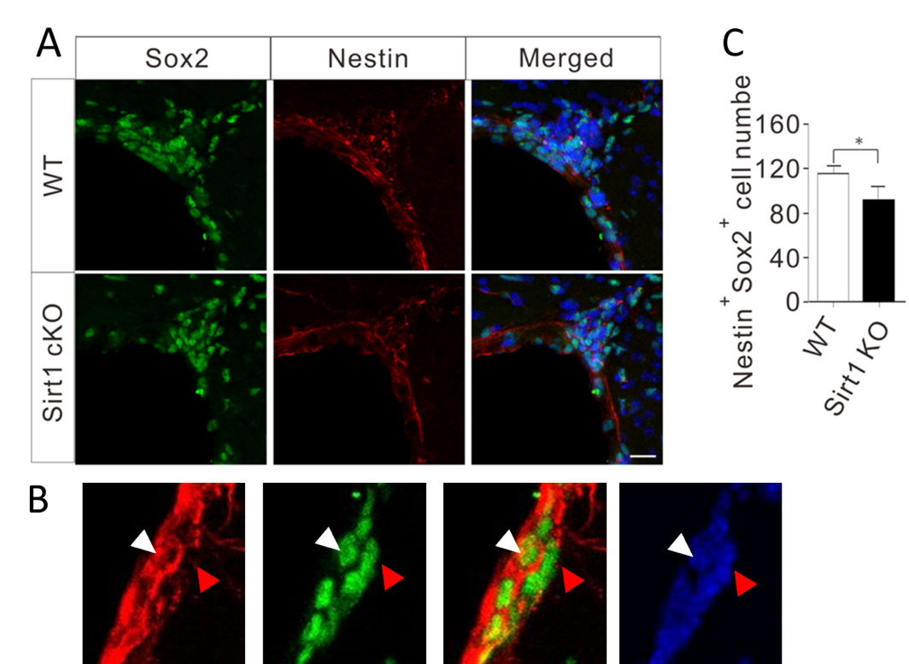

Figure 4.6: The detection of the activated NSCs in mice SVZs with 12-month loss of Sirt1. (A) Immunostaining for Nestin (red) and Sox2 (green). (B) The example of Nestin⁺/Sox2⁺ (pointed out with white triangles) NSCs for quantification. The red triangles pointed out Nestin⁻/Sox2⁺ cells. (C) The quantification of the number of activated NSCs in the SVZs of WT and Sirt1 cKO mice. Three coordinated sections from each mouse were used for quantification. Data from three mice of different groups were used for statistical analysis. Scale bars, 50 μm. * p<0.05, Student’s t-test.

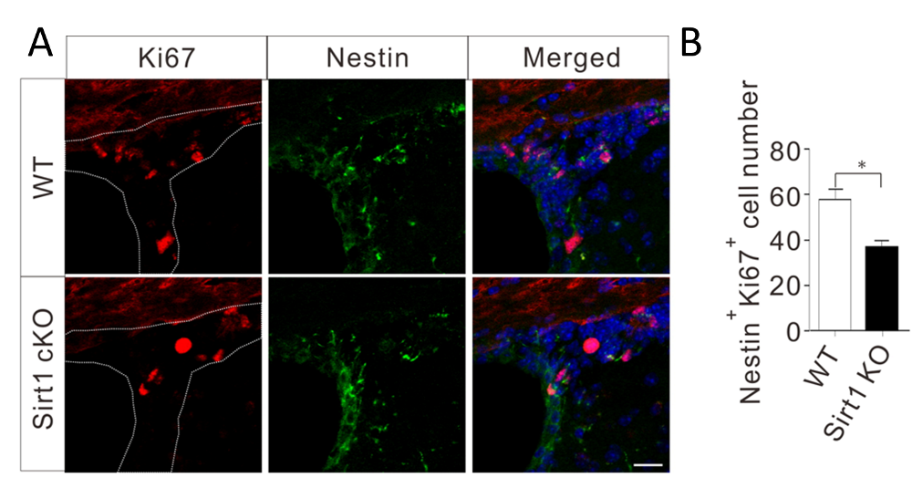

Figure 4.7: The detection of the proliferative NSCs in mice SVZs with 12-month loss of Sirt1. (A) Immunostaining for Nestin and Ki67. (B) The quantification of the proliferative NSCs in the SVZs of WT and Sirt1 cKO mice. The quantification was performed with the same method in Figure 3.6A. Three coordinated sections from each mouse were used for quantification. Data from three mice of different groups were used for statistical analysis. Scale bars, 50 μm. * p<0.05, Student’s t-test.

4.3.3 Sirt1 ablation diminishes neurogenesis in ageing mice SVZs
We then tried to fathom how the NSC pool downsizing in mouse SVZs would affect the neurogenesis in the mouse brain. We managed to mark the SVZ NSCs and their descendants and trace their migration from the SVZ to the olfactory bulb (OB) using the GFP Tracing Technique, with which the cells expressed GFP at the same time when Sirt1 was knocked out (Figure 2.2) (Madisen, Zwingman et al. 2010). The rostral migratory stream (RMS) was considered one of the effective forms of adult neurogenesis and delineated the procedure of neuronal maturation from SVZ NSCs.
We focused on the essential regions in the route of RMS and calculated the GFP-positive cells in SVZ, RMS and OB areas. We checked the GFP-positive NSCs 12 months post Sirt1 knockout and found that in all regions, there were significantly fewer GFP-positive cells in the cKO groups than in the WT groups (Figure 4.8). We also applied NeuN to identify the neurons among the GFP-positive cells in the OB and found that 90% of the positive signals overlapped in mice brains from either the cKO group or the WT group (Figure 4.9).
We launched behaviour tests to investigate further the physiological effects of neuronal loss in the OB of cKO mice. In this test, we examined the social transmission of food preference (STFP) in mice's social communications processes. While with no innate preference for either of the two flavoured food used for later tests, WT and Sirt1-KO mice showed no difference in the memory related social interaction, motor function and olfactory discrimination, as both groups interacted similarly with the demonstrators, climbed more times on the jars with cued food, and eat a comparable amount of total food (Figure 4.10). Six months after Sirt1 deletion, we noticed that cKO mice showed weaker olfactory memories than the WT mice; Twelve months after Sirt1 deletion, the weakening of olfactory memories became significantly more severe in the cKO group than in the WT group (Figure 4.11).
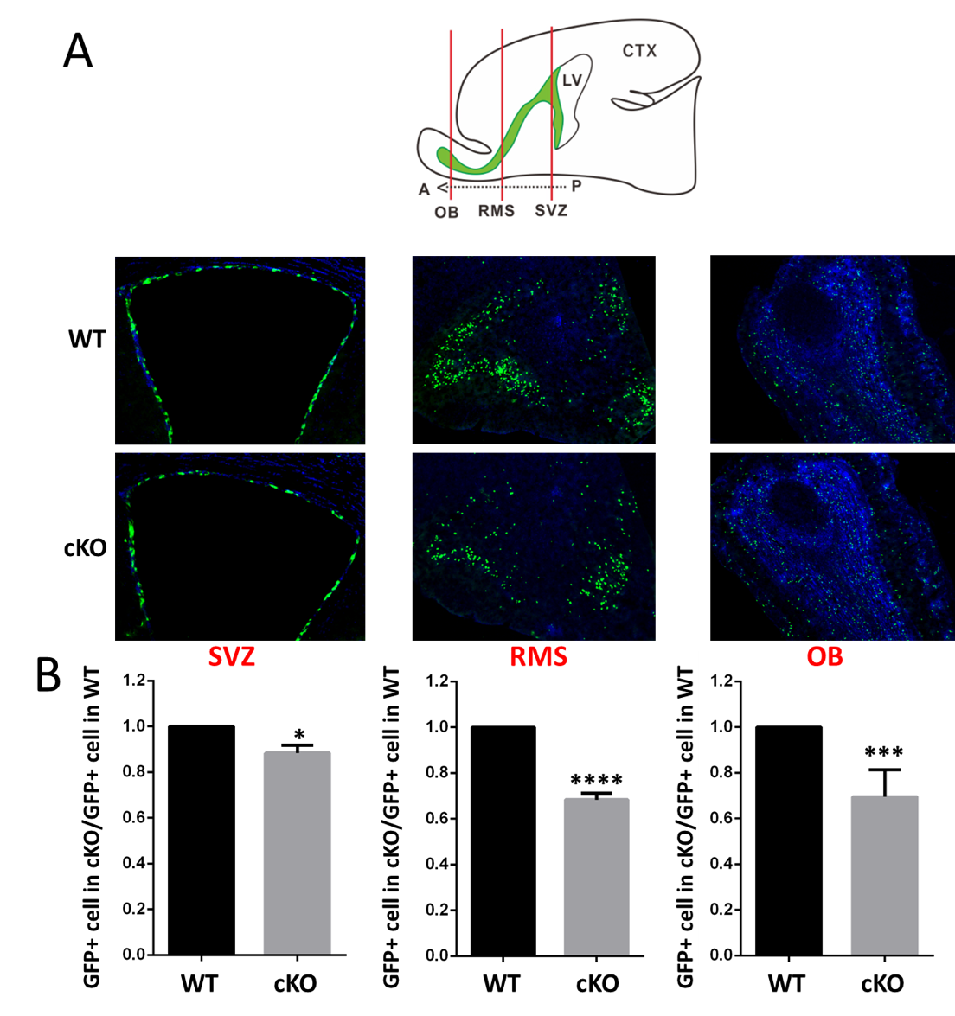

Figure 4.8: The detection of GFP traced SVZ NSCs and their descendants along SVZ-RMS-OB axis. (A) Images representing the coronal plane of SVZ, RMS, and OB of wild-type (WT) and Sirt1-knockout (cKO) mice with GFP tracing 12 months post tamoxifen administration. LV, lateral ventricle. CTX, cortex. A, anterior. P, posterior. (B) The quantification of the GFP positive cells in each area. Three coordinated sections from three mice for each group were used for quantification and statistical analysis. * p<0.05, *** p<0.001, **** p<0.0001, Student’s t-test.

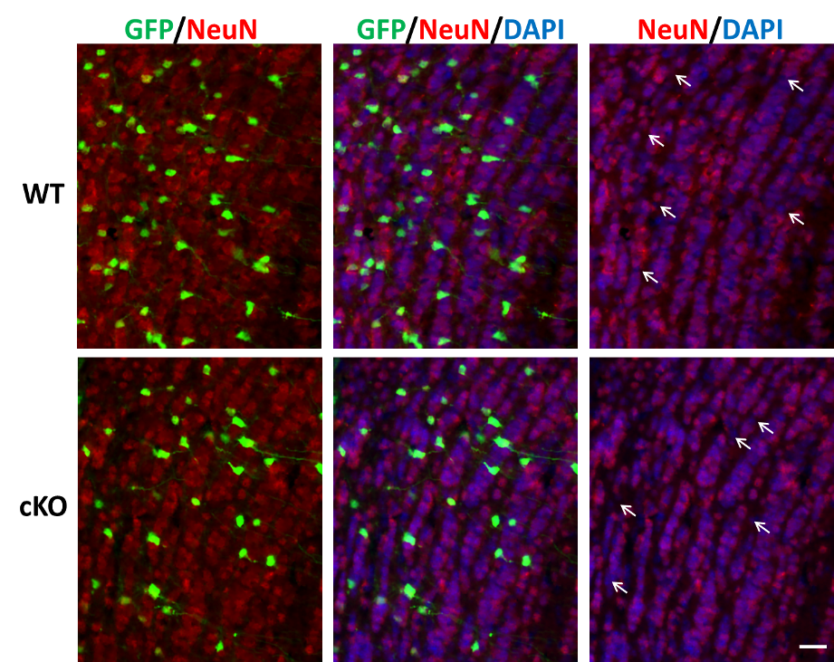

Figure 4.9: The detection of neurons in olfactory bulbs of GFP traced mice. Images represents the immunostaining for NeuN in olfactory bulbs. The white arrows indicate the GFP positive but NeuN negative cells. Scale bars, 50 μm.

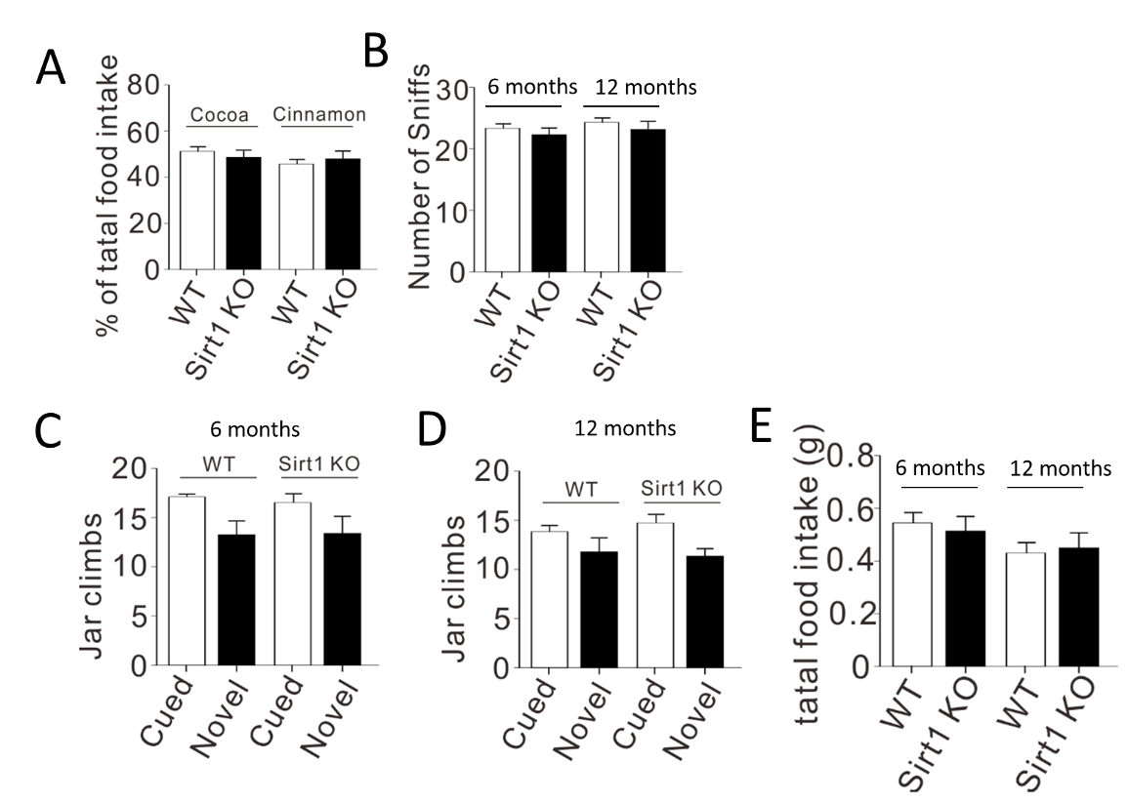

Figure 4.10: The behaviour analysis of mice in STFP assay. (A) WT and Sirt1 KO mice showed no preference for each of the two flavors before the test. (B) The number of sniffs of the demonstrator’s muzzle by WT and Sirt1 KO mice at 6-month and 12-month after tamoxifen introduction. (C, D) The jar climbs onto the jar containing the cued food and the jar containing the novel food of WT and Sirt1 KO mice. (E) The total food intake of WT and Sirt1 KO mice at 6- and 12-month time point. N=6 mice of mixed sex in A; N=6 mice of mixed sex for 6 months and N=8 for 12 months in B-E.

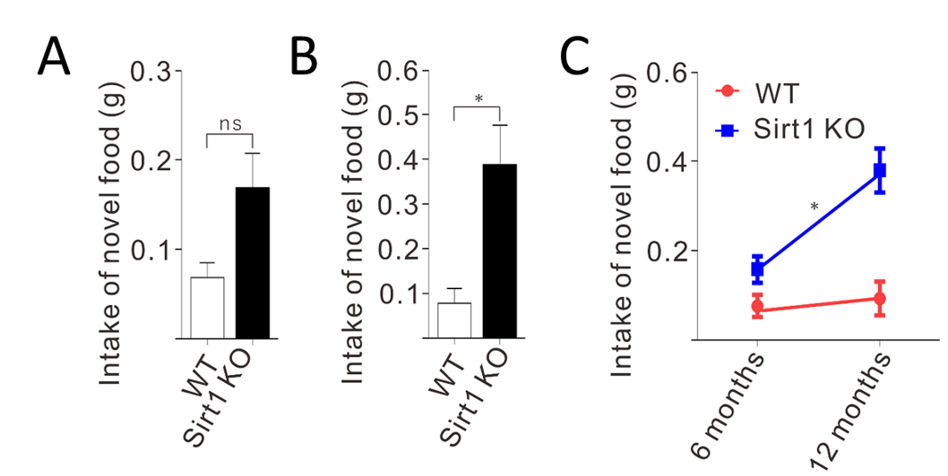

Figure 4.11: The food preference of mice in STFP assay. (A) The preference for novel food of WT and Sirt1-KO mice 6 months post tamoxifen administration. (B) The preference for novel food of mice 12 months post tamoxifen administration. (C) Two-way ANOVA for the preference for novel food of WT and Sirt1-KO mice at 6 and 12 months of age. In WT, there is little difference between 6 and 12 months, while significant increase of novel food intake between 6 and 12 months in Sirt1-KO mice. N=6 mice of mixed sexuality in A; N=8 mice of mixed sexuality in B. ns, not significant. * p<0.05. Student’s t-test for A and B, Two-way ANOVA for C.

4.3.4 Sirt1 loss results in DSB repair defects in activated SVZ NSCs of mice
Next, we were curious about how Sirt1 deletion affects DSB repair in NSCs from the mouse SVZs. The DSBs in vivo were artificially induced by ionising radiation (IR) (Barazzuol, Rickett et al. 2015, Barazzuol and Jeggo 2016). With immunostaining of γH2AX, we found that, immediately after the IR treatment (3 hrs post-IR), widespread DSBs were spotted in SVZ NSCs of both WT and cKO mice (Figure 4.12). Four days after the IR treatment, most artificially induced DSBs had been repaired in the WT groups; however, significantly more DSBs remained in the cKO mice (Figure 4.13). We concluded that loss of SIRT1 protein might impair the capacities of DNA damage repair in SVZ NSCs. We also tested the IR induction of DSBs and the DSB recovery effects in vitro in mouse SVZ-derived NSCs. The DNA damage repair in the cKO NSCs was significantly less efficient than in the WT NSCs (Figure 4.14).
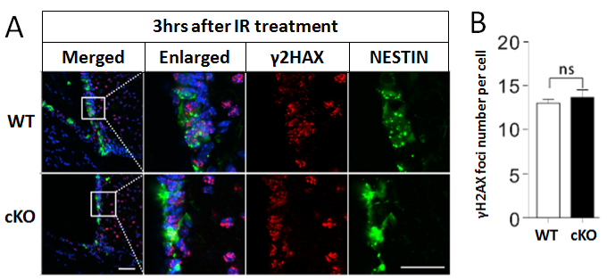

Figure 4.12: The detection of DSBs in SVZ NSCs of mice 3 hrs post IR. (A) Immunostaining for Nestin and γ2HAX. (B) The quantification of the DSBs in SVZ NSCs of WT and Sirt1 cKO mice. Three coordinated sections from each mouse were used for quantification. Data from three mice of different groups were used for statistical analysis. Scale bars, 50 μm. Student’s t-test. Dr Chuanming Dong and Xianli Wang contributed to the immunohistochemistry in this result.

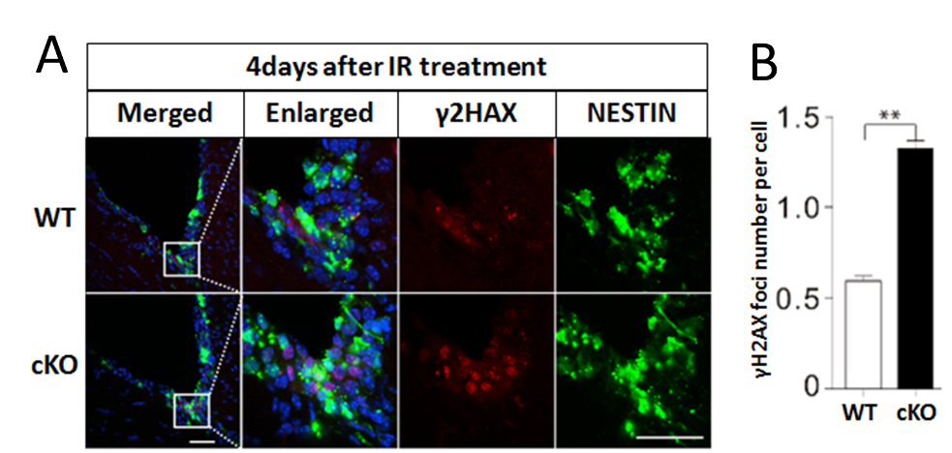

Figure 4.13: The detection of DSBs in SVZ NSCs of mice 4 days post IR. (A) Immunostaining for Nestin and γ2HAX. (B) The quantification of the DSBs in SVZ NSCs of WT and Sirt1 cKO mice. Three coordinated sections from each mouse were used for quantification. Data from three mice of different groups were used for statistical analysis. Scale bars, 50 μm. ** p<0.01, Student’s t-test. Dr Chuanming Dong and Xianli Wang contributed to the immunohistochemistry in this result.

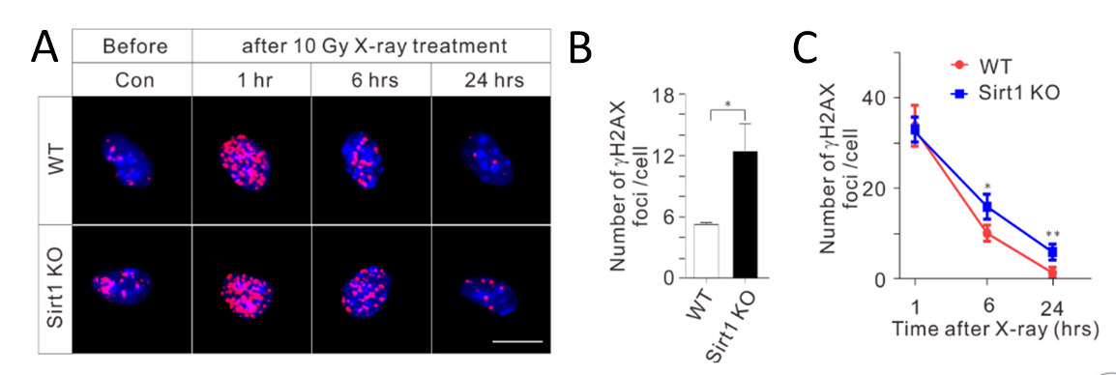

Figure 4.14: The detection of DSBs in cultured SVZ NSCs treated with IR. (A) Immunostaining for γH2AX in cultured SVZ NSCs. (B) The quantification of the DSBs (number of γH2AX foci per cell) in NSCs before X-ray treatment. (C) The quantification of the DSBs in NSCs after X-ray treatment. Five random fields of each sample were used for quantification in one experiment. Scale bars, 10 μm. * p<0.05, ** p<0.01, Student’s t-test. Three independent experiments were performed.

We wondered if the deletion of Sirt1 would cause DSB accumulation in the NSCs of mice with age. Twelve months post Sirt1 knockout in mouse SVZ NSCs, up to 63% the NSCs were γH2AX positive, while in WT mice’s SVZs, only 52% of the NSCs were γH2AX positive (Figure 4.15). On the other hand, we speculated that cells that contained more DSBs were more apoptotic-prone. The result was that the apoptotic NSCs from Sirt1 cKO mice’s SVZs were four times more than their counterparts in WT mice (Figure 4.16). Such results indicate that the NSC pool downsizes after Sirt1 deletion could be caused by the DSB-related apoptosis.

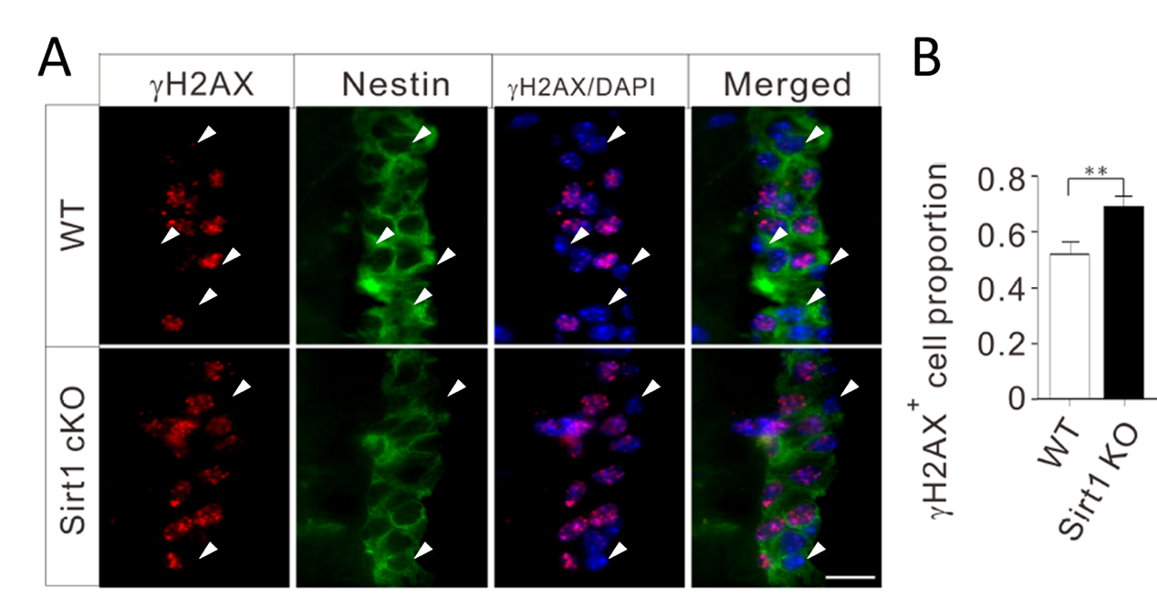

Figure 4.15: The detection of DSBs in SVZ NSCs of mice 12 months post Sirt1 loss. (A) Immunostaining for Nestin and γ2HAX. The white triangles pointed out the γ2HAX⁻/Nestin⁺ cells. (B) The quantification of the DSBs in SVZ NSCs of WT and Sirt1 cKO mice. Three coordinated sections from each mouse were used for quantification. Data from three mice of different groups were used for statistical analysis. Scale bars, 20 μm. ** p<0.01, Student’s t-test.

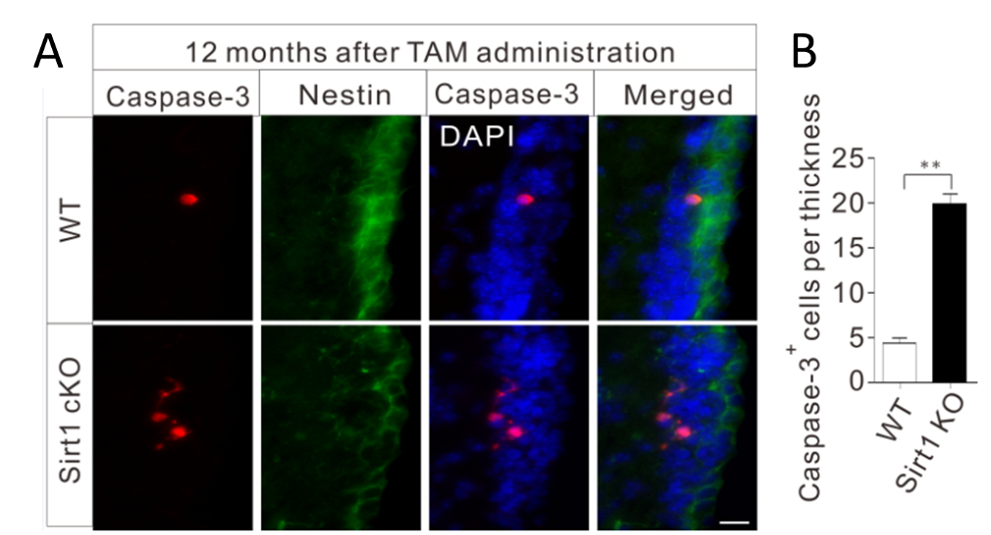

Figure 4.16: The detection of apoptosis of SVZ NSCs of mice 12 months post Sirt1 loss. (A) Immunostaining for Nestin and cleaved Caspase 3. (B) The quantification of the apoptotic SVZ NSCs of WT and Sirt1 cKO mice. The “thickness” in (B) refers to the whole SVZ along the posterior to the anterior direction (schematically represented in Figure 4.8A). For each mouse, all Caspase 3⁺ NSCs from five coronal sections (20 μm per section) were counted, and the quantification was performed using the total number of Caspase 3⁺ NSCs dividing 100 μm. Data from three mice of different groups were used for statistical analysis. Scale bars, 20 μm. ** p<0.01, Student’s t-test.

4.4 Discussion
In this chapter, we studied how Sirt1 loss affects NSC proliferation and DSB repair in the SVZ of young mice.
Using the Nestin promoter drived expression of Cre recombinase, we successfully knocked out the Sirt1 gene in NESTIN-positive NSCs in mouse SVZ, as evidenced by no detectable SIRT1 protein in NESTIN-positive NSCs in vivo (Figure 4.1) and in vitro (Figure 4.2). It needs to be noted that we did not check the situation of mouse SGZ and GFAP-positive NSCs.
With these mice, firstly, we proved NSC proliferation was accelerated by Sirt1 deletion in young mice’s SVZs, determined mainly by Ki67 quantification in activated NSCs one month post Sirt1 loss in vivo (Figure 4.3) and in vitro (Figure 4.4). The results were consistent with one previous report (Ma, Yao et al. 2014).
As ageing was our focus, we kept these mice for long-term analysis. However, when the Sirt1 cKO mice aged (12 months post Sirt1 loss), we noticed downsizing of the activated NSC pool (Figure 4.6 and Figure 4.7) and the relatively weakened neurogenesis through SVZ to RMS and OB (Figure 4.8). There were fewer neurons spotted in the OB regions of Sirt1 cKO mice. The results concluded that fewer GFP⁺ cells were observed in OB of Sirt1 cKO mice, and about 90% of GFP⁺ cells were NeuN positive for both WT and Sirt1 cKO mice (Figure 4.8 and Figure 4.9). Without verification, the GFP⁺/NeuN⁻ cells could be neural progenitors or immature neurons.
The finding of the decreased neuron production in OB of Sirt1 cKO mice was not consistent with a previous study that claimed no difference in the OB neurogenesis between WT and Sirt1 cKO mice with the same knock-out strategy (Victoria A. Rafalski 2013). The exploration for this could be the difference in the observation time between each other. We performed the analysis with mice with a 12-month loss of Sirt1, while Rafalski and colleagues analysed mice with a 1-month loss of Sirt1. As reckonning, we should have done the same analysis for reference.
We further observed a compromised olfactory memory in mice with Sirt1 loss using behaviour tests (Figure 4.10 and Figure 4.11), which could be the results of fewer neurons produced in OB of Sirt1 cKO mice, as SVZ and OB neurogenesis was thought to be critical for the maintenance of olfactory function (Enwere, Shingo et al. 2004, Feierstein, Lazarini et al. 2010).
The above results demonstrated that the SIRT1 protein suppressed cell proliferation, and the loss of Sirt1 immediately promoted the proliferation of SVZ NSCs. However, after the Sirt1 knockout, we suspected overproliferated NSCs drained out the SVZ NSC pool in the ageing processes; therefore, the downsizing was captured.
Subsequently, we noticed that SIRT1 protein played a vital role in DSB repair of activated NSCs of mice’s SVZs. The NSCs with Sirt1 loss displayed compromised repair ability for DSBs induced by radiation in vivo (Figure 4.12 and Figure 4.13) and in vitro (Figure 4.14). In the in vitro study, we observed that the DSBs in NSCs at 24 h post radiation treatment fallen even below the baseline level, which might be explained by the activation of DNA repair stimulated by the introduction of DSBs.
Without Sirt1 expression, more DSBs had accumulated in the activated NSCs with age (12 months post Sirt1 loss) (Figure 4.15); at the same time, these NSCs were more prone to apoptosis (Figure 4.16). Our results are consistent with the reports which demonstrate that the SVZ NSCs are very sensitive to DSBs and undergo apoptosis (Achanta, Capilla-Gonzalez et al. 2012, Barazzuol, Rickett et al. 2015, Barazzuol and Jeggo 2016). It suggested that DNA damage-related apoptosis might contribute to the cell loss of the activated NSC pool in Sirt1 cKO mice.
In this chapter, we demonstrated that the SIRT1 protein suppressed the proliferation and promoted the repair of DSBs of mouse SVZ NSCs. Besides, we also found that SIRT1 absence could shrink the NSC pool size in SVZ by DSB-related apoptosis with age. The role of SIRT1 protein on proliferation and DSB repair explored here coincided with the observation in aged SVZ NSCs (lower proliferation and fewer DSBs) in the previous chapter, indicating the necessity for further study.

CHAPTER 5: SIRT1 Functions in Activated NSCs in SVZ of Ageing Mice

5.1 Introduction
In the first results chapter, we found that in mouse brain SVZs, the activated NSCs became less proliferative as age grew, while the number of DSBs in these cells reduced. Such an observation contradicts one’s instinct that the genomes should have been more unstable amid the ageing process.
In the second results chapter, we studied how Sirt1 loss affects NSC proliferation and DSB repair in young mice. We found that SIRT1 protein played an integral part in suppressing SVZ NSC proliferation and promoting DSB recovery in the brains of young mice, because of which SIRT1 absence led to an accelerated shrinking of the NSC pool size in SVZ with age.
SIRT1 suppressed the proliferation and promoted the DSB repair of NSCs, and aged NSCs displayed lower proliferation and fewer DSBs. Hinted by such observations, we supposed that the SIRT1 protein in the activated SVZ NSCs of ageing mice brains might suppress the proliferation of the activated NSCs while promoting DSB-related DNA damage repair, leading to the observed phenotypes in NSCs of aged mice.

5.2 Aim
In this chapter, we aim to investigate how the SIRT1 protein affects the cellular processes, including cell proliferation and DSB repair in activated SVZ NSCs in ageing mice.

5.3 Results

5.3.1 SIRT1 protein highly expresses in activated SVZ NSCs of ageing mice
We first checked SIRT1 protein expression in activated NSCs from both young and old mice brain SVZs. SIRT1 protein expressions were examined in SVZ NSCs dissected from mice of different ages (1, 6, 12, 18 and 24 months old). With immunoblotting analysis, we noticed the trend where SIRT1 expression levelled up as age grew (Figure 5.1).
We also applied Flow Cytometry in derived SVZ NSCs, and immunostaining in mice brain sections to test if SIRT1 expression level clustering exists within the total population of activated SVZ NSCs in both young and old mice. Instead of capturing any clustering of SVZ NSCs based on the SIRT1 expression level in the same age group, we noticed that SIRT1 expressed significantly higher in ageing mice SVZ NSCs than in younger mice (Figure 5.2 and Figure 5.3).
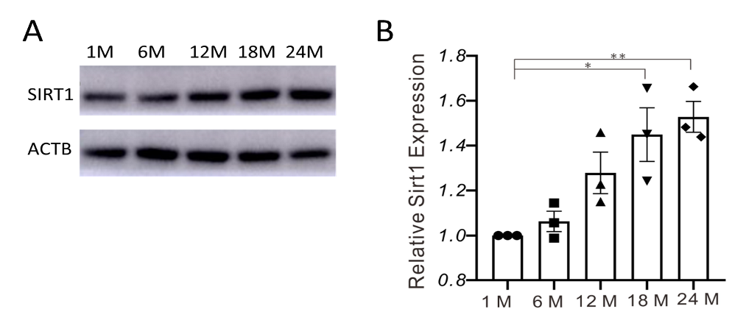

Figure 5.1: Western blot analysis of SIRT1 expression in activated SVZ NSCs. (A) Representative images of western blot bands. (B) Quantification and analysis of the western blot relusts from three independent experiments. *p<0.05, ** p<0.01, Student’s t-test.
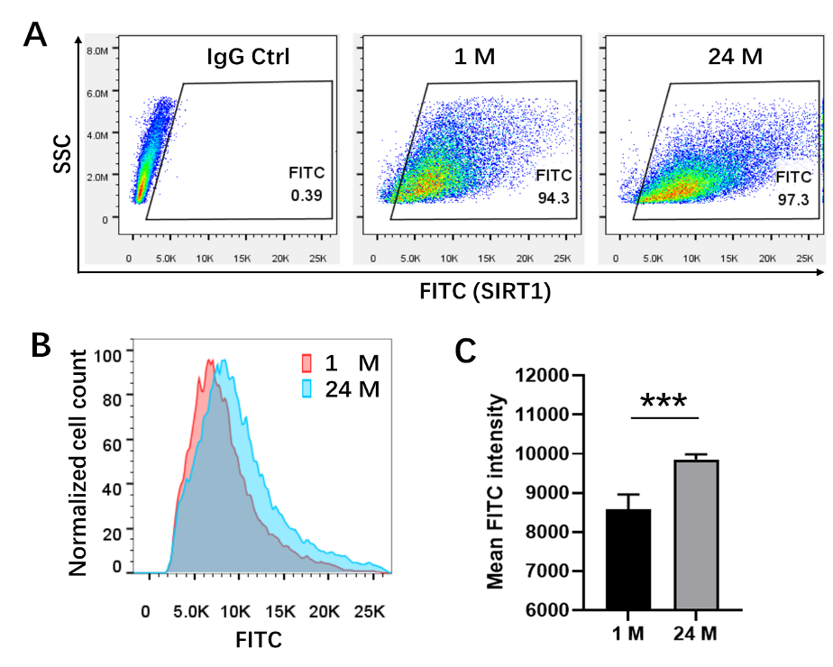

Figure 5.2: Flow cytometry analysis of SIRT1 expression in activated SVZ NSCs. (A) Representative flow cytometry analysis of NSCs stained with anti-SIRT1 antibodies. (B) Diagram of FITC (Fluorescein isothiocyanate) intensity analysis of NSCs. (C) Statistics of FITC intensities. 1 M, 1 month. 24 M, 24 months. Three samples for each group were used for statistical analysis. *** p<0.005, Student’s t-test.

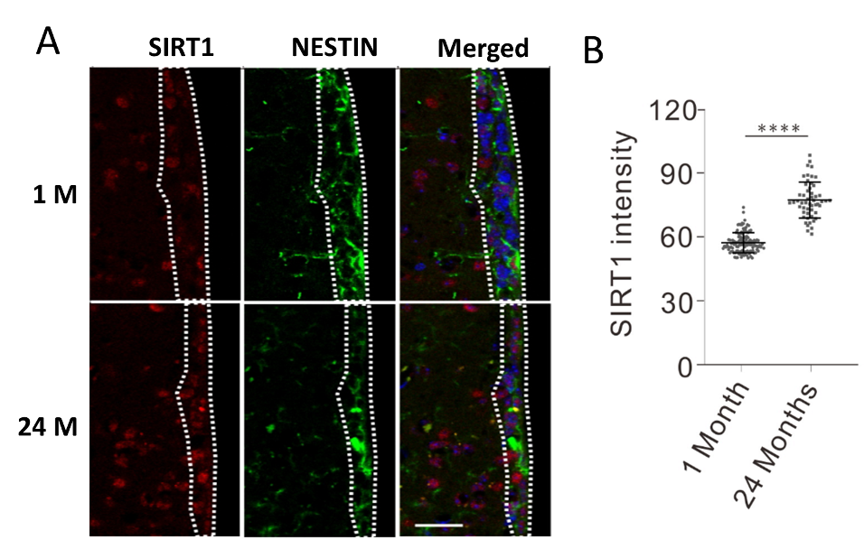

Figure 5.3: Immunostaining analysis of SIRT1 expression in activated SVZ NSCs. (A) Immunostainings of SIRT1 and NESTIN in SVZ sections of 1 and 24 months old mice. (B) The quantification and statistical analysis of SIRT1 fluorescence intensities in NSCs. Three coordinated sections from each mouse were used for quantification. Data from three mice of different groups were used for statistical analysis. Scale bars, 50 μm. **** p<0.0001, Student’s t-test.

5.3.2 Sirt1 loss promotes proliferation of activated SVZ NSCs in ageing mice
We knocked out Sirt1 in aged mice (22-month-old) and one month after Sirt1 deletion, the mice were sacrificed. The proliferation rate of the activated SVZ NSCs was indicated by Ki67 positivity. The immunostaining results showed that in the KO group, up to 32% of the NESTIN-positive NSCs were proliferative, whereas, in the WT groups, the overlapping rate was no more than 25% (Figure 5.4). Meanwhile, we applied BrdU to mark the cells under the S phase 2 hrs before the mice were sacrificed. We found there were more BrdU-positive cells in the KO mice SVZs instead of in the WT mice SVZs (Figure 5.5). The results suggest that the deletion of Sirt1 accelerated NSC proliferation in SVZs of ageing mice brains.

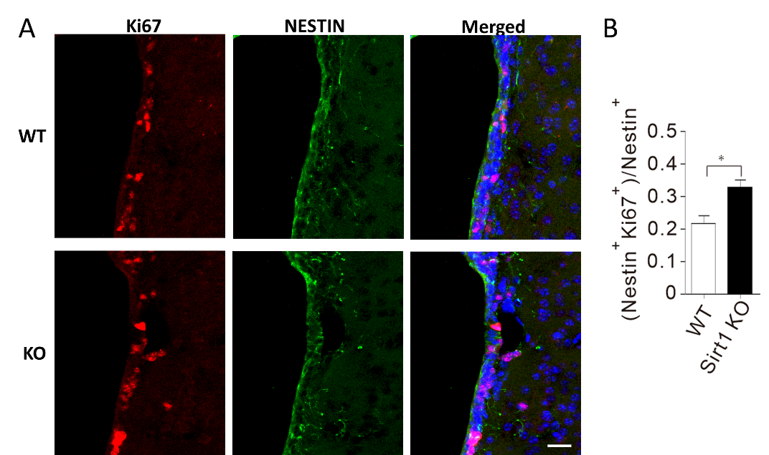

Figure 5.4: The detection of the proliferative NSCs in ageing mice SVZs with 1-month loss of Sirt1. (A) Immunostaining for Nestin and Ki67. (B) The quantification of the proliferative NSCs in the SVZs of WT and Sirt1 KO mice. The quantification was performed with the same way in Figure 3.6A. Three coordinated sections from each mouse were used for quantification. Data from three mice of different groups were used for statistical analysis. Scale bars, 20 μm. * p<0.05, Student’s t-test.

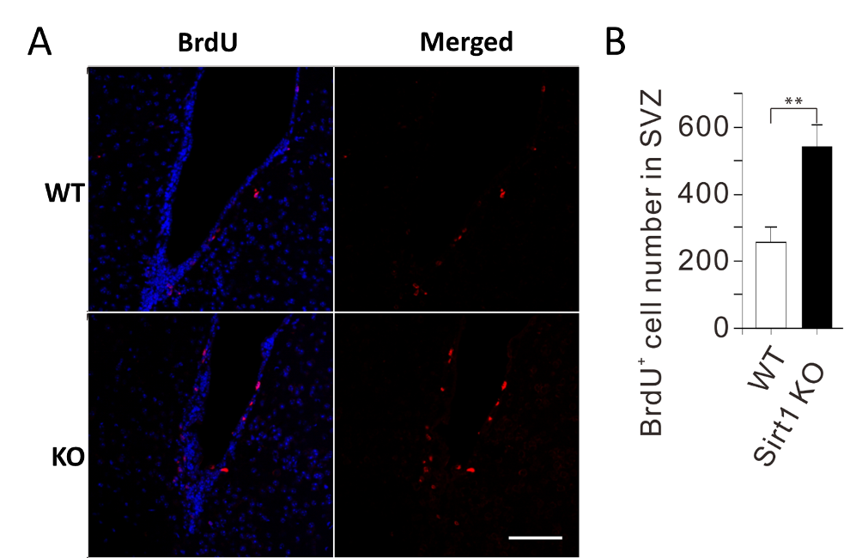

Figure 5.5: The detection of the proliferative cells in ageing mice SVZs with BudU. (A) Immunostaining for BrdU. (B) The quantification of the BrdU positive cells in the SVZs of WT and Sirt1 KO mice. Three coordinated sections from each mouse were used for quantification. Data from three mice of different groups were used for statistical analysis. Scale bars, 200 μm. ** p<0.05, Student’s t-test.

5.3.3 Sirt1 loss dose not affect the neurogenesis of olfactory neurons from SVZ
We then tested how the increased proliferation of NSCs under Sirt1 loss affected the neurogenesis from SVZ to OB in ageing mice’s brains. At the same time as Sirt1 was knocked out, we exploited BrdU to label the NSCs in S phase. One month later, we calculated the total number of activated SVZ NSCs. The KO and WT groups showed no significant differences (Figure 5.6). Next, the immunostaining of BrdU in both groups showed that the intensity of neurogenesis from SVZ to OB was comparable (Figure 5.7). Thus, we concluded that Sirt1 deletion promoted the proliferation of SVZ NSCs but not the final neurogenesis in the OB.
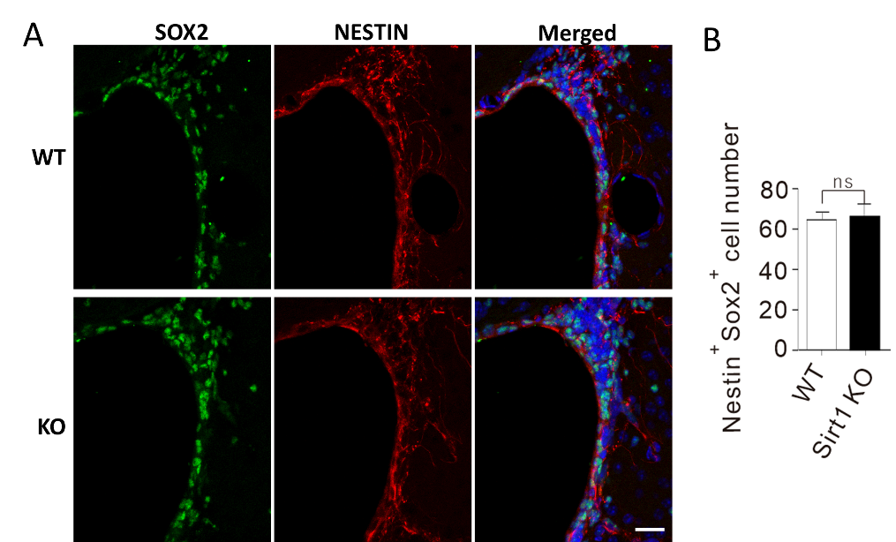

Figure 5.6: The detection of the activated NSCs in ageing mice SVZs with 1-month loss of Sirt1. (A) Immunostaining for NESTIN and SOX2. (B) The quantification of the number of NSCs in the SVZs of WT and Sirt1 KO mice. The quantification was performed with the same way in Figure 4.6B. Three coordinated sections from each mouse were used for quantification. Data from three mice of different groups were used for statistical analysis. Scale bars, 20 μm. Student’s t-test.

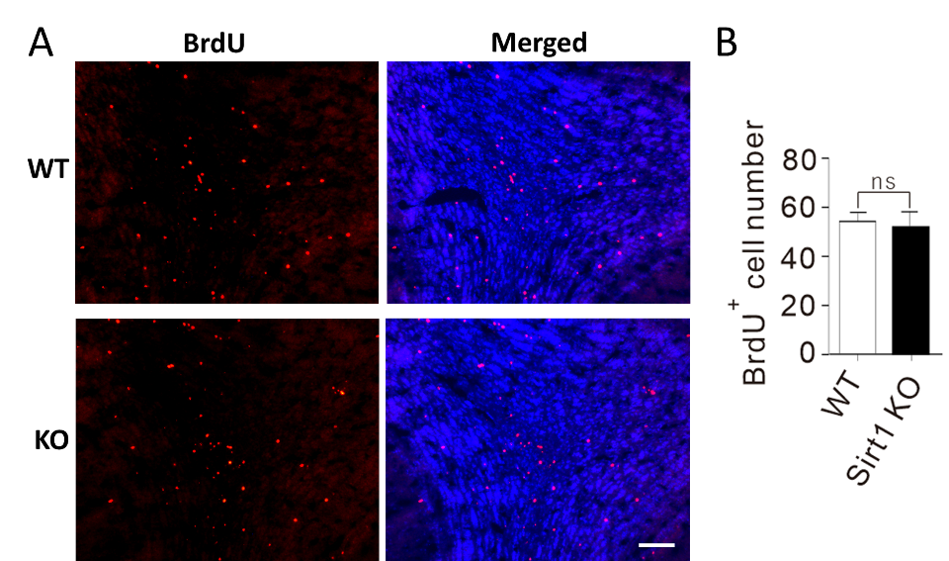

Figure 5.7: The detection of the BrdU labelled cells in ageing mice OBs with 1-month loss of Sirt1. (A) Immunostaining for BrdU. (B) The quantification of the BrdU positive cells in the OBs of WT and Sirt1 KO mice. Three coordinated sections from each mouse were used for quantification. Data from three mice of different groups were used for statistical analysis. Scale bars, 100 μm. Student’s t-test.

5.3.4 Sirt1 loss increases the accumulation of DSBs and the apoptosis of NSCs
We were curious why the increased activated NSC proliferation caused by Sirt1 deletion did not boost the neurogenesis in the OB of the aged brain. Previously it had been demonstrated that the ablation of Sirt1 heightened the DSB-related DNA damages and yet accelerated NSC apoptosis. Therefore, we inspected the DSBs in the activated NSCs and the apoptosis of these cells in the ageing brain SVZs one month after Sirt1 knockout. By immunostaining, more γH2AX positive cells were spotted among the activated SVZ NSCs in the cKO mice rather than in the WT mice brains (Figure 5.8). Meanwhile, apoptotic NSCs were almost four times higher in the KO groups than in the WT groups (Figure 5.9). We assume that the apoptosis caused by DNA damages had also compromised the NSC proliferation ranges uplifted by Sirt1 depletion.

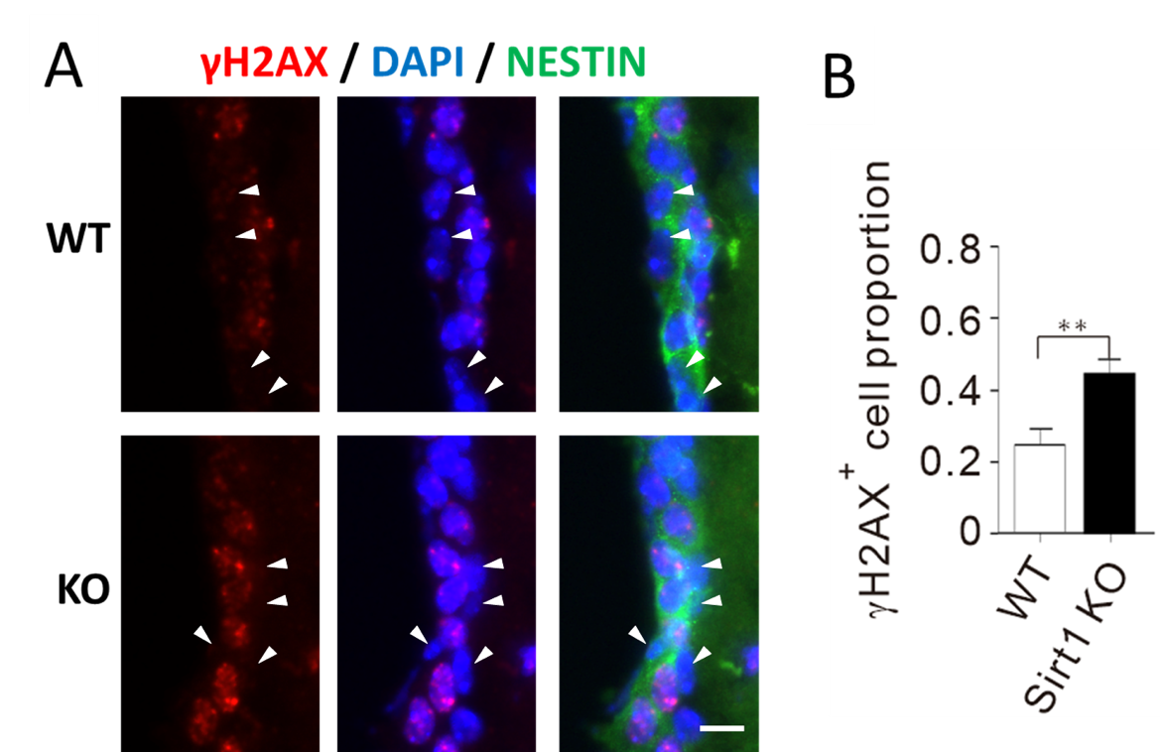

Figure 5.8: The detection of the DSBs in SVZ NSCs in ageing mice with 1-month loss of Sirt1. (A) Immunostaining for NESTIN and γ2HAX. The white triangles pointed out the γ2HAX⁻/Nestin⁺ cells. (B) The quantification of the γ2HAX positive NSCs in the SVZs of WT and Sirt1 KO mice. Three coordinated sections from each mouse were used for quantification. Data from three mice of different groups were used for statistical analysis. Scale bars, 10 μm. ** p <0.01, Student’s t-test.

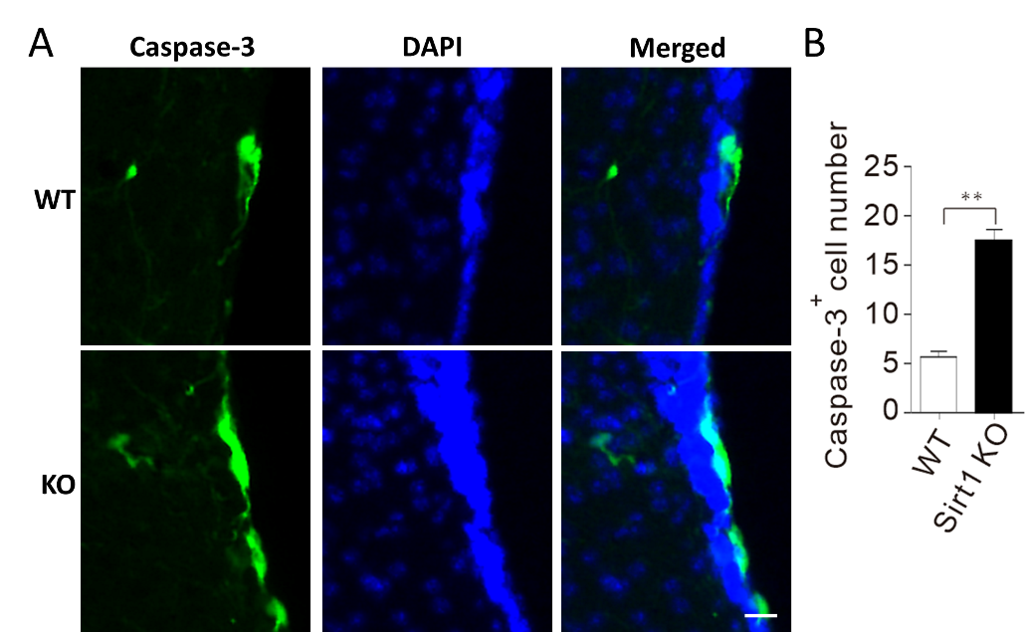

Figure 5.9: The detection of the apoptotic cells in SVZ of ageing mice with 1-month loss of Sirt1. (A) Immunostaining for cleaved Caspase-3. (The immunostaining of Caspase-3 shown in the figure is overexposed.) (B) The quantification of the Caspase-3 positive cells in the SVZs of WT and Sirt1 KO mice. Three coordinated sections from each mouse were used for quantification. Data from three mice of different groups were used for statistical analysis. Scale bars, 20 μm. ** p <0.01, Student’s t-test.

Further, we recapitulated the experiments on an ionising radiation (IR) induced ageing model. The Sirt1 deleted mice underwent IR induction to produce severe DNA damage, especially DSBs (Figure 4.12 in Chapter 4). In a month, the mice were sacrificed. As to the young mice (2-month-old), when there were no DSBs artificially induced, we did not detect significant SVZ NSC pool size changes in both KO and WT groups a month after Sirt1 depletion (Figure 5.10). Whereas with IR induction, the number of SVZ NSCs in KO mice’s brains was about 30% less than in the WT mice (Figure 5.11). To this point, we can conclude that SIRT1 is vital for DSB-induced DNA damage repair. On the other hand, SIRT1 loss might impede the age-related DNA damage repair, leaving the DSBs to accumulate in the NSCs and cause apoptosis.
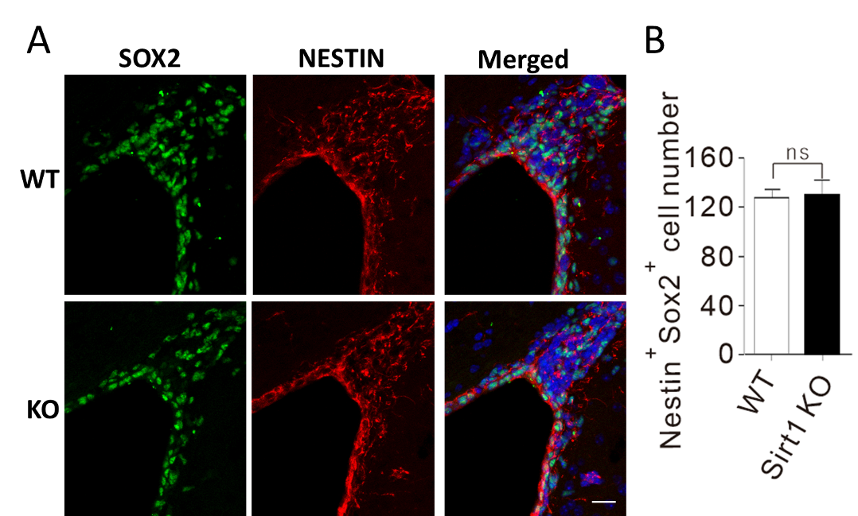

Figure 5.10: The detection of the activated SVZ NSCs in young mice with 1-month loss of Sirt1. (A) Immunostaining for NESTIN and SOX2. (B) The quantification of the number of NSCs in the SVZs of WT and Sirt1 KO mice. The quantification was performed with the same way in Figure 4.6B. Five coordinated sections from each mouse were used for quantification. Data from three mice of different groups were used for statistical analysis. Scale bars, 30 μm. Student’s t-test.

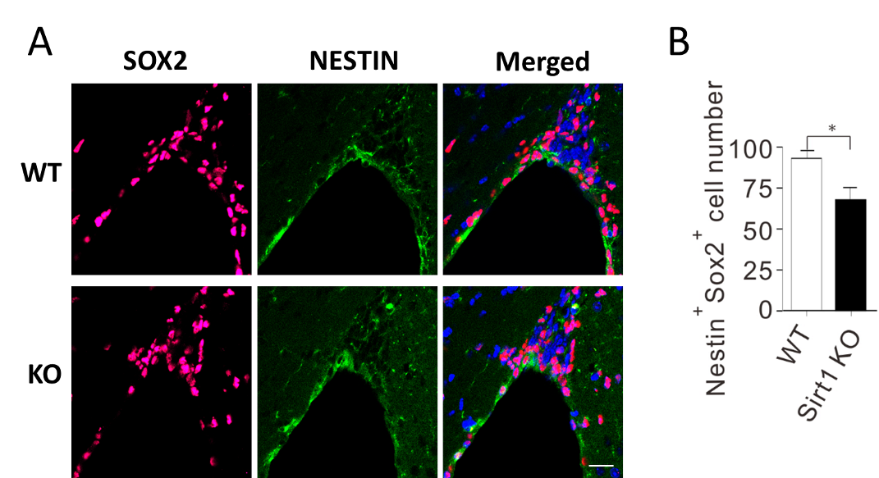

Figure 5.11: The detection of the activated SVZ NSCs in IR treated young mice with 1-month loss of Sirt1. (A) Immunostaining for NESTIN and SOX2. (B) The quantification of the number of NSCs in the SVZs of WT and Sirt1 KO mice. The quantification was performed with the same way in Figure 4.6B. Five coordinated sections from each mouse were used for quantification. Data from three mice of different groups were used for statistical analysis. Scale bars, 30 μm. * p<0.05, Student’s t-test.

5.3.5 Sirt1 loss compromises the NHEJ repair in activated SVZ NSCs
We then tested the efficiency of the HR and NHEJ repair in activated SVZ NSCs affected by Sirt1 loss. NSCs were derived from the SVZ region of young mice brains and then underwent the HR/NHEJ repair efficiency test. It showed that the NHEJ efficiency was 40% lower in the Sirt1 cKO groups than in the WT groups. Nevertheless, the repair efficiency of HR was not affected by the knockout of Sirt1 (Figure 5.12).
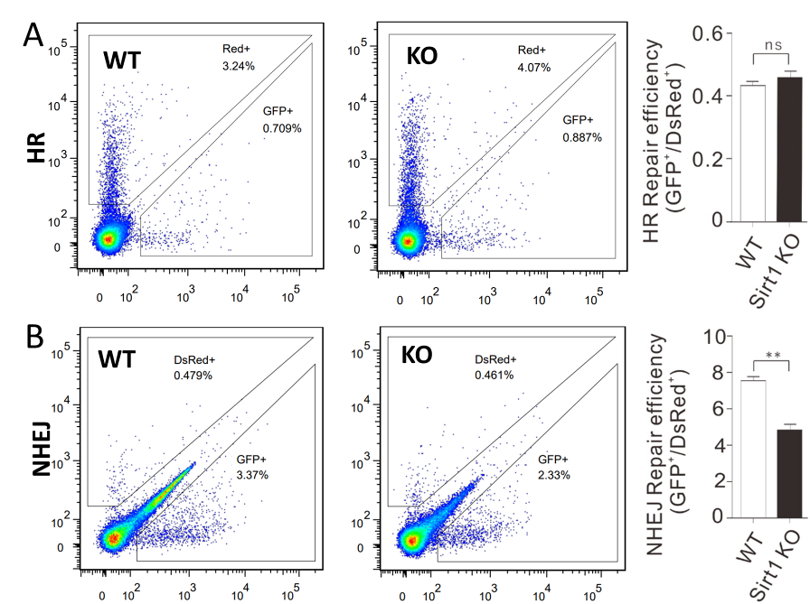

Figure 5.12: The detection of the HR and NHEJ repair in activated SVZ NSCs of young mice with 1-month loss of Sirt1. (A) The HR repair efficiency of the cultured activated NSCs from SVZs of WT and Sirt1 KO mice. (B) The NHEJ repair efficiency of the cultured activated NSCs from SVZs of WT and Sirt1 KO mice. Triplicates for each group. ** p<0.01, Student’s t-test. Three independent experiments were performed.

5.4 Discussion
In this chapter, we studied the functions of SIRT1 protein in activated NSCs of ageing mice brains. Firstly, we noticed that the expression of SIRT1 protein was heightened as age grew in cultured activated NSCs (Figure 5.1). There would be two different reasons for the higher expression of SIRT1 protein in aged activated NSCs. One is that the expression of SIRT1 protein is universally higher in aged activated NSCs. The other is that the activated NSCs could be devided into two subpopulations, namely SIRT1 high and SIRT1 low NSCs. The proportion of the SIRT1 high NSCs may be higher in aged NSCs than that in young ones. The results of our analysis in vitro (Figure 5.2) and in vivo (Figure 5.3) supported that SIRT1 protein was universally higher in aged activated NSCs.
Secondly, we proved that in activated SVZ NSCs of aged mice brains, the Sirt1 loss also promoted cell proliferation (Figure 5.4 and Figure 5.5), which was consistent with the findings in young mice (Chapter 4, Figure 4.3). It should be noted that the immunostaining of NESTIN should have been performed in our results concerning BrdU analysis (Figure 5.5), without which we could not term the BrdU⁺ cells as NSCs.
Meanwhile, we observed that with only one month loss of Sirt1 in aged mice, the DSB-related DNA damages were worsened (Figure 5.8). This should be distinguished from the findings in young mice, where the worsened DSBs were found in mice with 12-month-loss (Chapter 4, Figure 4.15). Additionally, Sirt1 loss compromised the NHEJ repair in activated SVZ NSCs with little impact on HR (Figure 5.12), which coincidently applied to the increased NHEJ and decreased HR in aged NSCs (Chapter 3, Figure 3.10).
It is now illustrated that the uprising expression of SIRT1 suppresses the proliferation of activated SVZ NSCs while enhancing the DNA repair of DSBs due to ageing in mice brains. As a result, we observed that DSBs were reduced while NSC became less proliferative in the activated SVZ NSCs of ageing mice’s brains.
Our study also showed that although Sirt1 depletion gained proliferation of the NSCs, the neurogenesis did not rise as expected (Figure 5.6 and Figure 5.7). Given SIRT1’s crucial function in DSB repair, as the Sirt1 has been knocked out, the un-repaired DSBs could cause cells to be apoptotic. As to DSBs induced by IR, SIRT1 loss could cause the SVZ NSC pool to drain quickly in younger mice (Figure 5.10 and Figure 5.11). We indeed observed more apoptotic cells in the SVZ of aged mice with Sirt1 loss (Figure 5.9). It should be noted that the immunostaining of NESTIN should have been performed to confine NSCs, and the images were over-exposed (Figure 5.9).
Overall, our results linked the role of SIRT1 protein with the regulation of proliferation and DSB repair in SVZ NSCs during ageing in mice. In young mice, where DSBs are less introduced by the microenviroment, SIRT1 surpresses the excessive proliferation and promotes the DSB repair of NSCs to prevent the exhaustion of SVZ NSC pool. With age, when the microenviroment is more harmful to the survival of NSCs, e.g. much more DSB stimulus, the up-rising SIRT1 protein mainly confront DSBs, which surpresses the proliferation of NSCs inevitably.
The surpression of NSC proliferation by SIRT1 in aged mice seems harmful to neurogenesis and benificial to ageing, then we may expect that the inactivation of SIRT1 in SVZ NSCs of aged mice would stimulate neurogenesis. However, the results reached out of our expectation. We would speculate that the increased proliferative NSCs were consumed by DSB induced apoptosis in aged mice with Sirt1 loss, which ultimately made few contributions to OB neurogenesis. To conclude, our data demonstrated the protection role of SIRT1 in SVZ NSCs during ageing in mice.

CHAPTER 6: Upstream and Downstream Regulation of SIRT1 Protein in NSCs

6.1 Introduction
In previous chapters, we illustrated that the SIRT1 protein was crucial in the activated SVZ NSCs of young and ageing mice. In NSCs from younger mice, the SIRT1 protein represses the proliferation of the activated SVZ NSCs while promoting the DSB repair in the activated NSC population. Doing so protects the NSC pool in the SVZ of the mouse brain from early exhaustion. Compared to the younger mice, the expression level of SIRT1 protein is even higher in the ageing mice NSCs to cope with the ageing-related DNA damage risks. It is the robustly functioning SIRT1 that reduces the DSBs by enhancing the NHEJ repair, consequently halting cellular proliferation.
The regulation of cell proliferation and DNA repair by SIRT1 has been extensively studied. For example, NOTCH signalling is essential for the maintenance of the active NSCs (Imayoshi, Sakamoto et al. 2010, Basak, Giachino et al. 2012); it is then proved that SIRT1 deacetylates notch intracellular domain (NICD) in endothelial cells (Guarani, Deflorian et al. 2011) and the effect of increased proliferation caused by SIRT1 inactivation can be diminished by the inhibition of NOTCH in mouse NSCs (Ma, Yao et al. 2014). Moreover, SIRT1 deacetylates many proteins that directly participate in DSB repairs, such as WRN, NBS1 and RAD51 for HR repair and KU70 for the NHEJ repair (Cohen, Lavu et al. 2004, Jeong, Juhn et al. 2007, Yuan, Zhang et al. 2007, Li, Casta et al. 2008, Oberdoerffer, Michan et al. 2008).
Besides regulating molecules by the SIRT1 protein, the product of the Sirt1 gene is regulated at different levels. At the mRNA level, the transcription of Sirt1 is promoted by transcription factors like E2F1 and FOXO1 and inhibited by PPAR and HIC1 (Chen, Wang et al. 2005, Wang, Chen et al. 2006, Han, Zhou et al. 2010, Feng Zhang 2011, Xiong, Salazar et al. 2011). On the other hand, at the protein level, the activity of SIRT1 is activated by SUMOylation and JNK1 phosphorylation and inhibited by DBC1 (Beausoleil, Jedrychowski et al. 2004, Yang, Fu et al. 2007, Kim, Chen et al. 2008, Zhao, Kruse et al. 2008). Besides, the SIRT1 protein can be degraded by ubiquitylation and proteasomes (Ren, Chen et al. 2019).

6.2 Aim
Confirmed the cellular phenotypes induced by Sirt1 loss in young and ageing mice NSCs in vivo and in vitro, we wondered how SIRT1 protein functioned as a bona fide deacetylase in its related upstream and downstream pathways in the ageing NSCs. We then tried to explain how SIRT1 interact with the essential proteins that regulate cell proliferation and DNA damage repair and how the SIRT1 protein expresses higher in aged NSCs. In this chapter, we focused on the molecular mechanism involving SIRT1 with the help of high-throughput sequencing and comparative biochemical methods.

6.3 Results

6.3.1 Transcriptomic and proteomic analysis of the activated SVZ NSCs of Mice
We compared the gene expression in activated SVZ NSCs from various age groups (including 1,7,17 and 24 months old mice) with the embryo SVZ NSCs by transcriptomic analysis based on high-throughput RNA sequencing. The neural development-related genes were significantly downregulated in the activated NSCs of the one-month-old mice compared to that in the embryo mice (Figure 6.1). However, few differentially expressed genes were seen between 1-month-old and 24-month-old mice NSCs (Figure 6.2). We also launched the proteomic analysis in NSCs from mice aged seven days postnatal, 1-month and 24 months. Compared to the neonatal mice, most downregulated proteins in 1-month NSCs were connected to the nervous system development (Figure 6.3). Moreover, few proteins displayed significant expression differences between NSCs from 1-month and 24-month-old mice (data not shown). We then chose some candidates that matched our interests and verified their expression at the mRNA and protein level in the activated NSCs derived from mice with 1- and 24-month old (Figure 6.4).

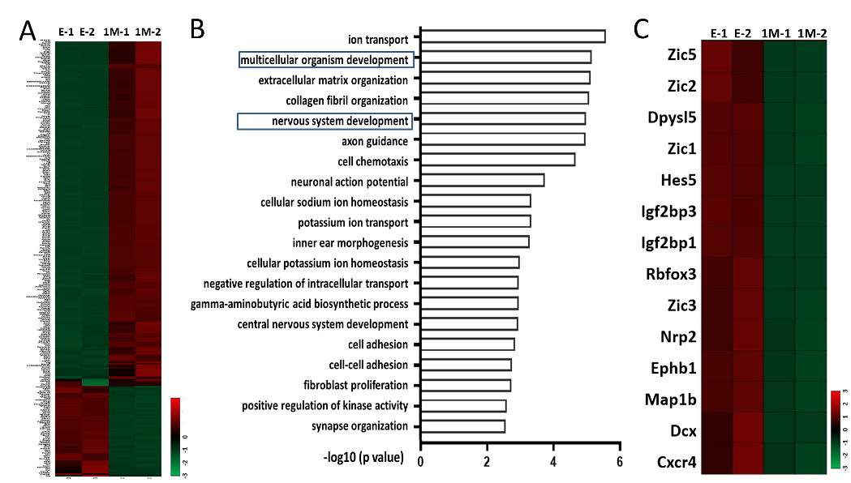

Figure 6.1: The gene expression analysis of activated SVZ NSCs from embryonic and 1-month old mice. (A) Heatmaps of the differentially expressed genes. (B) Gene Ontology (GO) Enrichment Analysis of the differentially expressed genes. (C) Heatmaps of the differentially expressed genes correlating to neural development. E, Embryonic mice; 1 M, 1-month old mice.
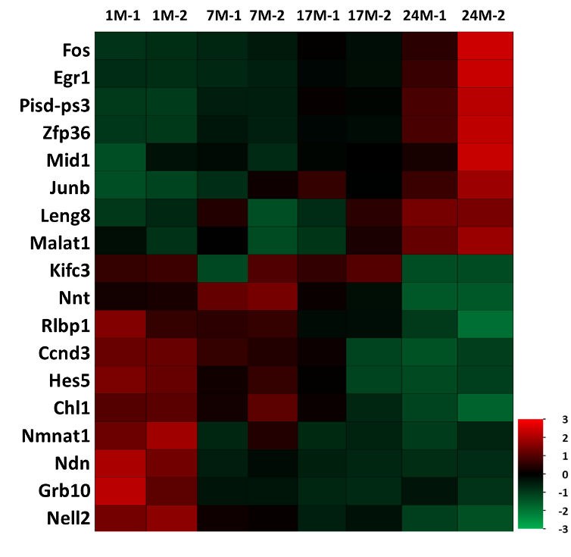

Figure 6.2: The gene expression analysis of activated SVZ NSCs from mice with different ages. Heatmaps of the differentially expressed genes among different age groups (1-, 7-, 17-, 24-month).
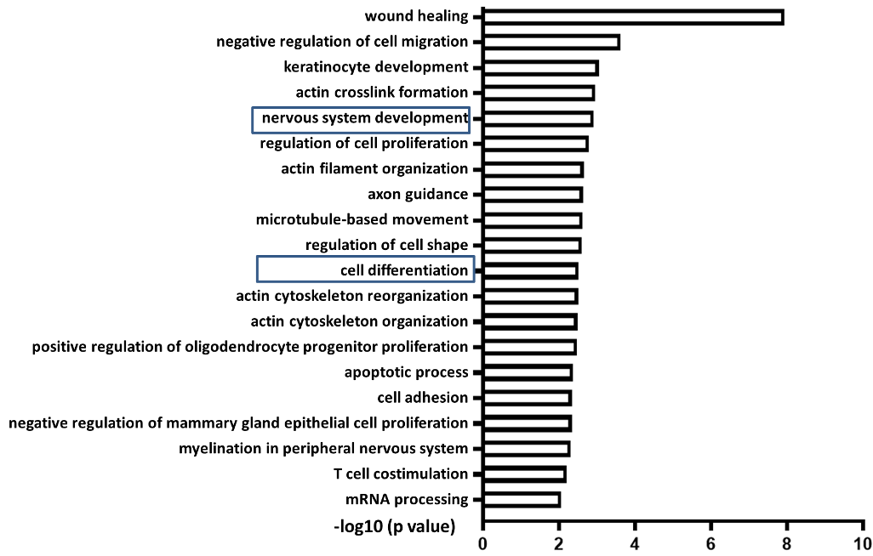

Figure 6.3: The GO analysis of the differentially expressed proteins between NSCs from postnatal and 1-month-old mice. The top 20 terms enriched in the GO analysis were shown.

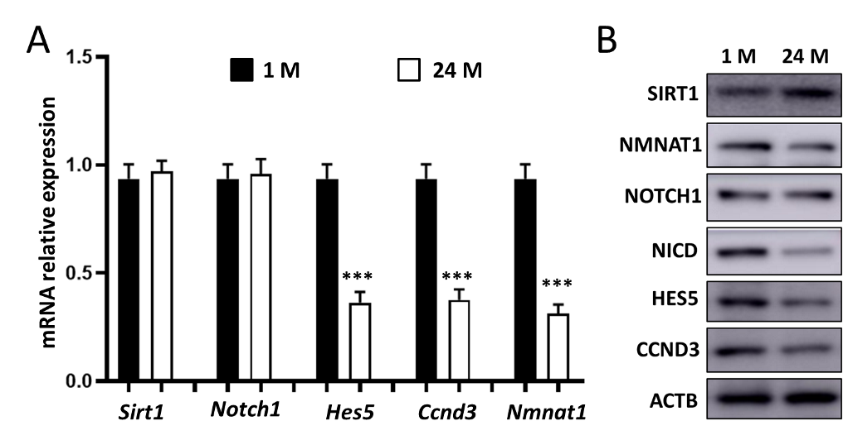

Figure 6.4: The expression analysis of the candidates in activated SVZ NSCs from mice with 1- and 24-month old. (A) The mRNA expression detected by RT-qPCR. (B) The protein expression detected by western blot. Triplicates of each gene for each sample were used for statistical analysis. ***p<0.005, Student’s t-test.

6.3.2 SIRT1 suppresses proliferation by deacetylating NICD
It has been reported that the SIRT1 protein represses the NOTCH pathway to hold back cell proliferation of NSCs in mouse SGZ (Ma, Yao et al. 2014). We supposed that this observation could be consistent in activated SVZ NSCs. Thus in Sirt1 knockout (KO) and overexpression (OE) NSCs of mice, we studied the expression and acetylation level of notch intracellular domain (NICD), which regulates the transcriptomic activity of NOTCH proteins. In the KO group, NICD expression was up-regulated while its lysine acetylation (K-Ace) was enhanced (Figure 6.5A); Nevertheless, in the OE group, the opposite tendency was witnessed in NICD expression and the K-Ace levels (Figure 6.5B). Further, we exploited the Co-immunoprecipitation (Co-IP) technique to capture the interactions between SIRT1 and NICD (Figure 6.6). Conversely, we applied DAPT as an NICD antagonist to the NSCs to repress cell proliferation. DAPT treatment eliminated the differences in cell expansion caused by SIRT1 KO or OE (Figure 6.7). To conclude, SIRT1 proteins regulate NSC proliferation by directly deacetylating NICD.
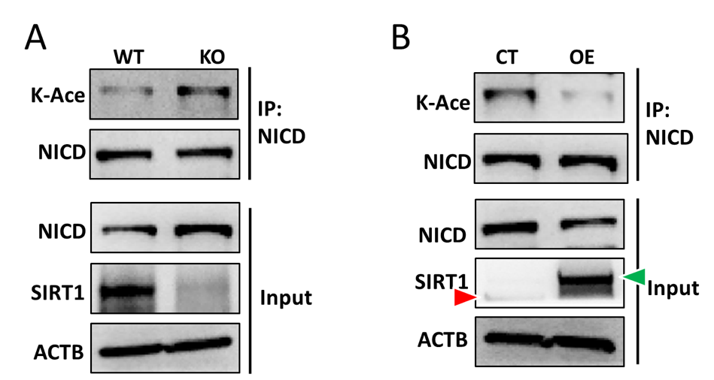

Figure 6.5: SIRT1 downregulates the acetylation of NICD in activated SVZ NSCs. (A) The detection of NICD and its acetylation by western blot after NICD was immunoprecipitated from WT and Sirt1 KO NSCs. (B) The detection of NICD and its acetylation by western blot after NICD was immunoprecipitated from control and Sirt1 OE NSCs. The green triangle pointed out the overexpressed SIRT1 with the GFP tag, and the red triangle pointed out the endogenous SIRT1 protein (the primary band could be cut off, which made the band almost invisible). Separate blots were performed for SIRT1 (~110 kDa), NICD (~110 kDa) and K-Ace detection for the same samples.

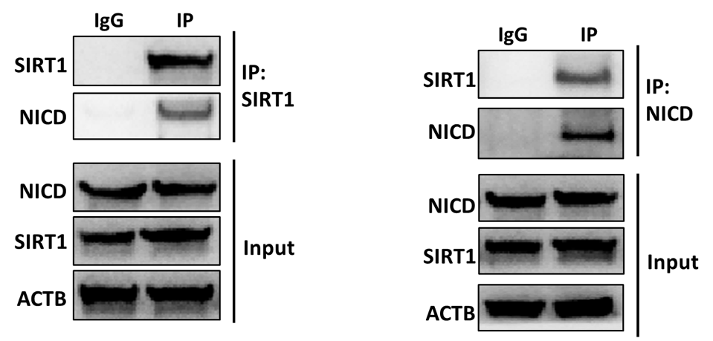

Figure 6.6: SIRT1 interacts with NICD in activated SVZ NSCs. (A) The western blot analysis of the immunoprecipitates by anti-SIRT1 antibodies in activated SVZ NSCs. (B) The western blot analysis of the immunoprecipitates by anti-NICD antibodies in activated SVZ NSCs. Separate blots were performed for SIRT1 (~110 kDa) and NICD (~110 kDa) detection for the same samples.
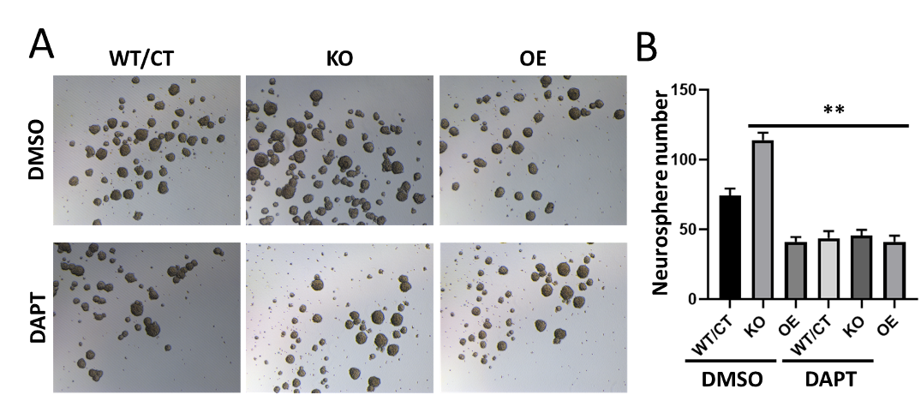

Figure 6.7: The NICD inhibitor surpress the proliferation of activated SVZ NSCs. (A) The neurosphere formation of activated SVZ NSCs with Sirt1 KO or OE under DAPT (NICD inhibitor) treatment. (B) The quatification of neurosphere number of each group. Three independent experiments were performed for statistics. ** p<0.01, Student’s t-test.

6.3.3 SIRT1 promotes DSB repair by deacetylating KU70
According to our previous study, SIRT1 loss causes the deficiency of NHEJ DNA repair in activated NSCs of mice. Thus we decided to study the KU70 (also named XRCC6) and SIRT1 interactions in the activated NSCs of mice as it has been reported that SIRT1 deacetylated KU70 affects NHEJ repair (Jeong, Juhn et al. 2007). First, we proved that mouse NSC's endogenous KU70 and SIRT1 interact post IR DSB inductions by immunoprecipitation (Figure 6.8). Next, we also examined the deacetylation of KU70 by SIRT1. Under induced DNA lesion, the level of KU70 acetylation on lysine residue was increased in SIRT1 KO but reduced in SIRT1 OE NSCs (Figure 6.9). Then we tested the DNA repair efficiency on the DSBs by checking the recovery of γH2AX. The outstanding amount of γH2AX could be time-dependently diminished due to the progress of the DNA repair after the end of the IR procedure. We noticed that the velocity of γH2AX clearance was faster in the SIRT1 OE NSCs than in the SIRT1 KO NSCs (Figure 6.10). It is deducible that SIRT1 could promote the repair of DSBs in the NSC genomes.
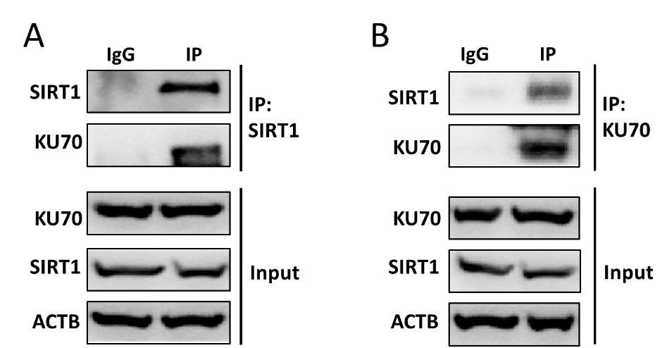

Figure 6.8: SIRT1 interacts with KU70 in activated SVZ NSCs. (A) The western blot analysis of the immunoprecipitates by anti SIRT1 antibodies in activated SVZ NSCs under IR treatment. (B) The western blot analysis of the immunoprecipitates by anti NICD antibodies in activated SVZ NSCs IR treatment.
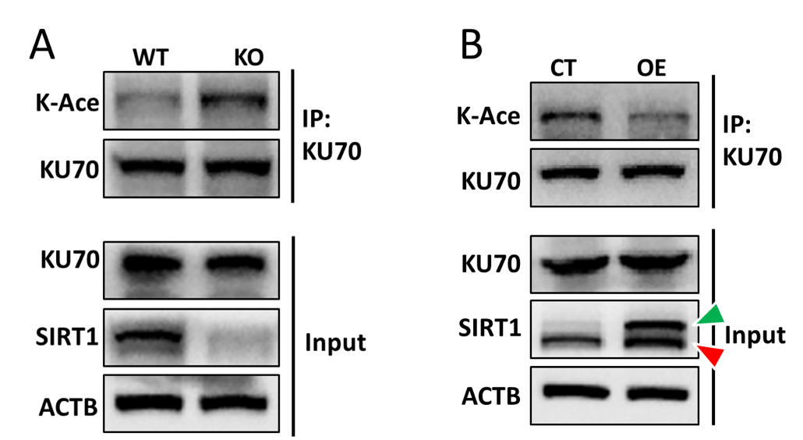

Figure 6.9: SIRT1 downregulates the acetylation of KU70 in activated SVZ NSCs. (A) The detection of KU70 and its acetylation by western blot after KU70 was immunoprecipitated from WT and Sirt1 KO NSCs. (B) The detection of KU70 and its acetylation by western blot after KU70 was immunoprecipited from control and Sirt1 OE NSCs. The two bands of SIRT1 in WT of (A) showed the results from normal condition where the electrophoresis was performed for enough long time during the western blotting procedure. The lower bands of SIRT1 in (B) indicated the endogenous SIRT1 (red triangles) and the upper band of SIRT1 in OE represented the overexpressed SIRT1 with GFP tag (green triangles). The upper band of SIRT1 in CT of (B), which should not be there, could be the contamination caused by leaked sample from the next well during electrophoresis.
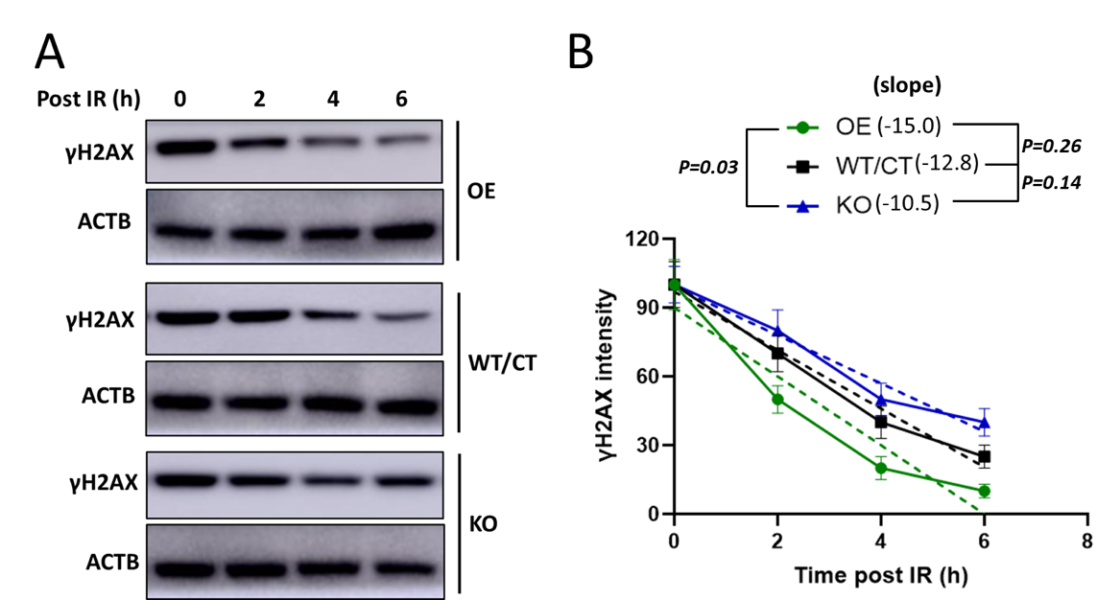

Figure 6.10: SIRT1 enhances the DSB repair in activated SVZ NSCs. (A) The western blot analysis of γH2AX expression in activated SVZ NSCs post IR treatment. (B) The quatification and statistical analysis of western blot results. For quantification, all γH2AX bands were first normalized to their ACTB, then different time points were normalized to time 0. Results form three independent experiments were used for statistical analysis. Linear regression was performed for different groups and the slopes were calculated, the slope difference between every two groups was shown.

6.3.4 Ubiquitin proteasome mediated SIRT1 degradation in activated NSCs
We also found that the SIRT1 protein level raised as age grew in mice NSCs, notwithstanding the SIRT1 mRNA quantity plateaued. The rising level of SIRT1 protein, therefore, might not be mainly directed by its transcription. It has been reported that the homeostasis of proteins could be disturbed in ageing processes. Besides, the SIRT1 protein degradation is regulated by ubiquitylation and proteasomes (Ren, Chen et al. 2019). We then speculated that the modulation of SIRT1 protein degradation might contribute to the SIRT1 protein accumulation. We first applied Cycloheximide (CHX) to forbid all protein synthesis in the activated NSCs derived from mice SVZs. As the CHX processing went on, the quantity of SIRT1 protein dropped (Figure 6.11A). Next, we applied Chloroquine (CHQ) and MG132 to constrain the activity of lysosome and ubiquitin-proteasome. After MG132 treatment, SIRT1 protein quantity levelled up (Figure 6.11B). This result demonstrated that ubiquitylation was the major pathway of SIRT1 degradation. Further, we enriched the SIRT1 protein with the immunoprecipitation from the mice NSCs after MG132 treatment. A significant rise in SIRT1 ubiquitylation was observed (Figure 6.11C). These results indicated that SIRT1 could be degraded by ubiquitylation and proteasomes in mice NSCs.

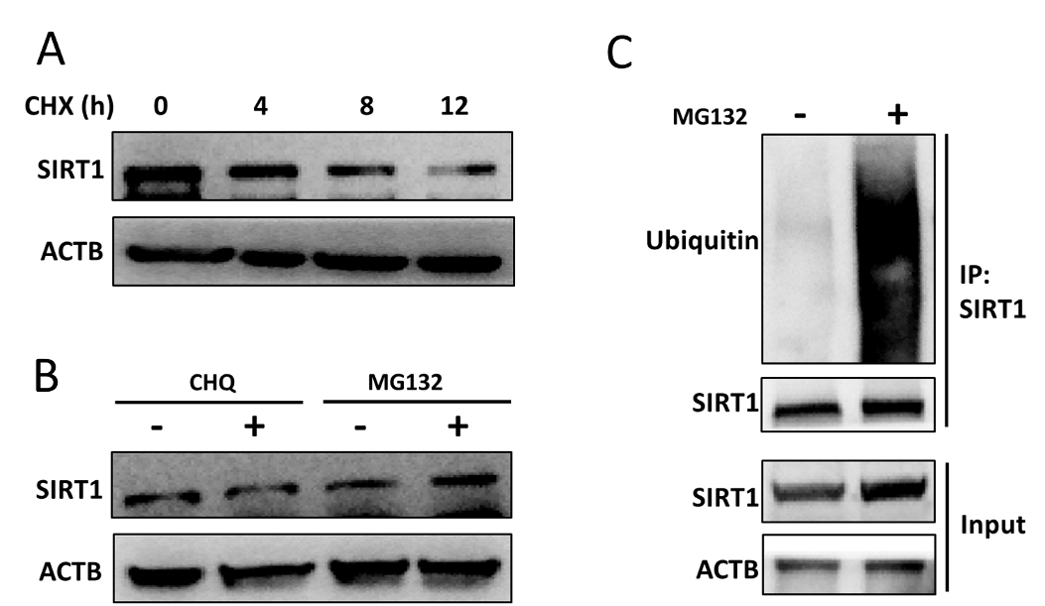

Figure 6.11: SIRT1 is degraded by proteasome in activated SVZ NSCs. (A) The western blot analysis of SIRT1 protein in activated SVZ NSCs treated with Cycloheximide (CHX). (B) The western blot analysis of SIRT1 protein in activated SVZ NSCs treated with Chloroquine (CHQ) and MG132. (C) The western blot analysis of the ubiquitination of SIRT1 protein in activated SVZ NSCs treated with MG132. Note that the IgG control IP should have been performed.

After illuminating that the primary degradation pathway of SIRT1 was ubiquitylation, we investigated the extent of SIRT1 degradation in activated NSCs derived from young and ageing mice. Post CHX treatment, the SIRT1 protein degraded faster in NSCs from 1-month old mice than the 24-month old mice (Figure 6.12A, B). Additionally, we tested the ubiquitylation level of the SIRT1 found that the ubiquitylation of SIRT1 protein in NSCs from the ageing mice was much lower than in the young mice (Figure 6.12C). These results indicated that the slowdown of protein degradation causes SIRT1 to remain more in ageing mice NSCs than in the young mice.
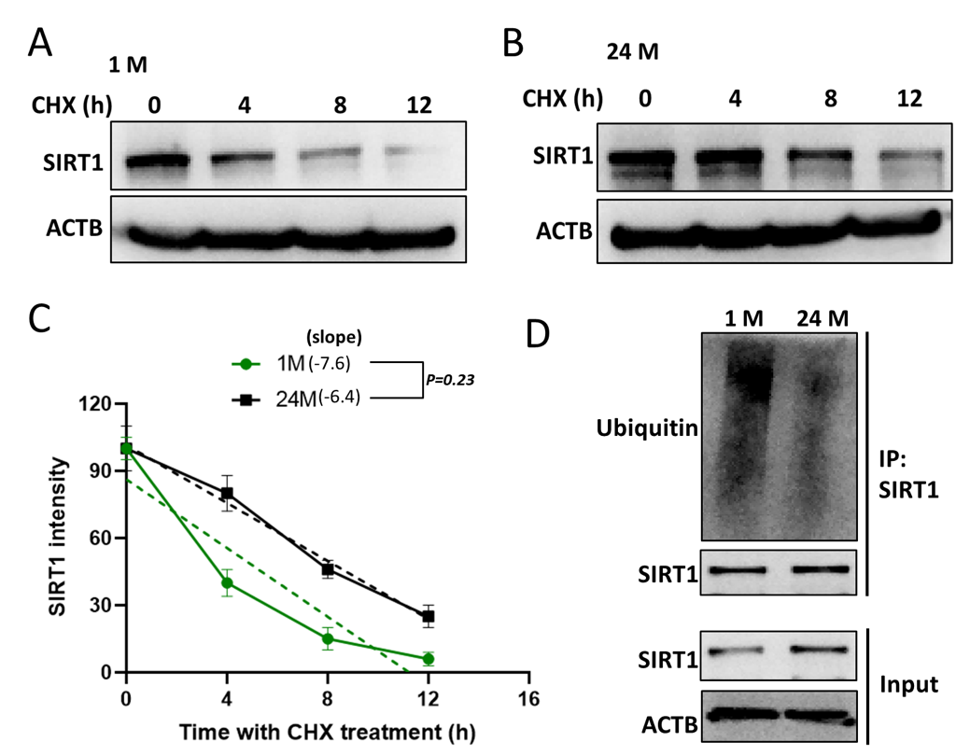

Figure 6.12: SIRT1 is less degraded in ageing activated SVZ NSCs. (A) The western blot analysis of SIRT1 protein in young (1-month old) activated SVZ NSCs treated with Cycloheximide (CHX). (B) The western blot analysis of SIRT1 protein in ageing (24-month old) activated SVZ NSCs treated with CHX. (C) The quatification and statistical analysis of western blot results. For quantification, all SIRT1 bands were first normalized to their ACTB, then different time points were normalized to time 0. Results form three independent experiments were used for statistical analysis. Linear regression was performed for different groups and the slopes were calculated, the slope difference between two groups was shown. (D) The western blot analysis of the ubiquitination of SIRT1 protein in young and ageing activated SVZ NSCs treated with MG132. Note that the IgG control IP should have been performed.
As a deacetylase, SIRT1 integrates deeply in energy metabolisms by deacetylating the PGC1A (Peroxisome Proliferator-Activated Receptor Gamma Coactivator 1-Alpha), a central inducer of mitochondria biogenesis (Mouchiroud, Houtkooper et al. 2013, Fang, Scheibye-Knudsen et al. 2014). We noticed that in mice NSCs, SIRT1 overexpression gained the PGC1A protein level and lowered its acetylation (Figure 6.13A). It has been proven that the SIRT1 protein activity depends on the NAD⁺ (Nicotinamide Adenine Dinucleotide) level (Lautrup, Sinclair et al. 2019). Moreover, the NAD⁺ level in the ageing nervous tissue is much lower than in the young (Fang, Lautrup et al. 2017, Yoshino, Baur et al. 2018). According to our study, in NSCs of ageing mice, the expression level of NMNAT1 (Nicotinamide Mononucleotide Adenylyl Transferase 1) was relatively low (Figure 6.4). Thus there were smaller amounts of NAD⁺ to be synthesised.
The SIRT1 protein could be activated by promoting NAD⁺ synthesis. We supplemented the NMN (Nicotinamide Mononucleotide), an intermediate of NAD⁺, to increase NAD⁺ production. Although NMN supplements have drastically upregulated the level of PGC1A protein, it costs a considerable amount (up to 200μM) of NMN for PGCA1 protein in the WT NSCs to catch up with the average expression level in the SIRT1 OE group (Figure 6.13B). On the other hand, the Hu (Hydroxyurea) induced DNA damage could decrease the PGC1A level. However, when treated with the Hu, we found that in NSCs with SIRT1 overexpression, the PGC1A protein level was not dramatically affected (Figure 6.13C). In summary, the relatively high level of SIRT1 expression in the ageing mice NSCs probably plays a vital role in metabolism.
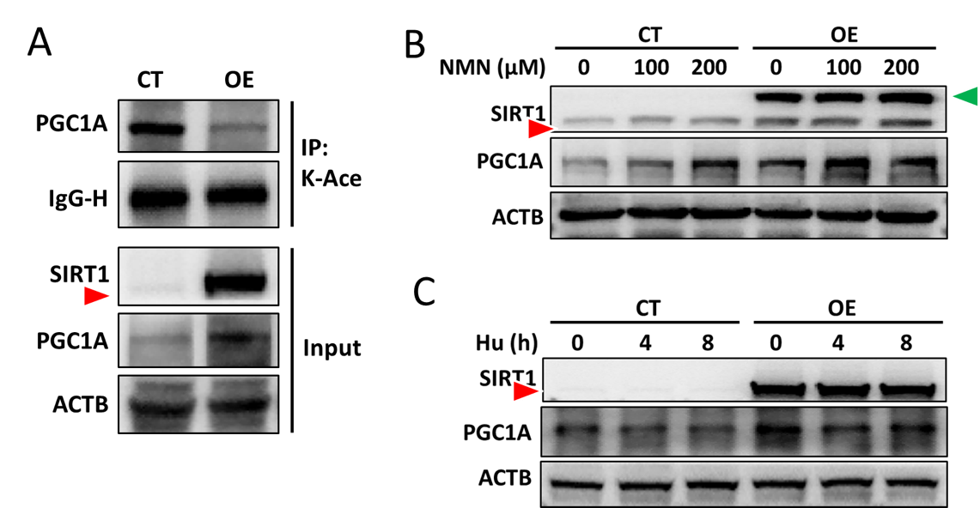

Figure 6.13: SIRT1 regulates PGC1A in activated SVZ NSCs. (A) The western blot analysis of PGC1A protein and its acetylation in activated WT and SIRT1 OE SVZ NSCs. (B) The western blot analysis of PGC1A protein in activated SVZ NSCs treated with NMN (Nicotinamide Mononucleotide). (C) The western blot analysis of PGC1A protein in activated SVZ NSCs treated with Hu (Hydroxyurea). The bands of the endogenous SIRT1 (pointed out with red triangles) and the GFP Tagged SIRT1 (pointed out with red triangles) were well distinguished in (B). They were undistinguishable and the bands of the endogenous SIRT1 were nearly invisible in (A) and (C), which could be caused by insufficient separation during electrophoresis along with the high signal of the GFP tagged SIRT1.

6.4 Discussion
In this chapter, we first examined the gene and protein expression in activated NSCs from mice of different ages by transcriptomic (Figure 6.1 and Figure 6.2) and proteomic (Figure 6.3) analysis. Only two replicates for each group were employed for analysis, which should be treated as the limitation of the study. Take the difference between activated NSCs of the one-month-old mice and the embryo mice as proof of the analysis. Only a few differentially expressed molecules had been captured between activated NSCs of young and aged mice. The results were consistent with a previous study demonstrating that significant gene expression differences existed between different subpopulations of NSCs but not the same population of different ages (Leeman, Hebestreit et al. 2018).
Still, we exploited these hints and illuminated that the SIRT1 protein in the NSCs regulates cellular proliferation by deacetylating NICD (Figure 6.5, Figure 6.6 and Figure 6.7) and NHEJ repair by deacetylating KU70 (Figure 6.8, Figure 6.9 and Figure 6.10). We performed the loss of (NSCs from Sirt1 knock-out mice) and the gain of (NSCs overexpressed with lentiviral SIRT1) function of SIRT1 protein in NSCs to evaluate the deacetylation of targets by SIRT1. It should be noted that the viral vectors were not titrated in our study, which should have been performed to ensure the best transduction results and to minimise the variation among batches.
There was some inconsistency concerning bands of endogenous SIRT1 in our western blotting results, which could be caused by different separating times of electrophoresis during the western blotting procedure, such as only one band in Figure 6.8A with a short separating time and two bands in Figure 6.9A with long separating time. The other inconsistency concerned the disappearance of the bands of endogenous SIRT1, which could be caused by the short separating time in electrophoresis along with the inappropriate cutting of membrane before western blottings, such as the difference between Figure 6.13A and Figure 6.13B. Therefore, consistency should have been maintained among all western blotting procedures to avoid misunderstanding.
We also clarified that the relatively high SIRT1 protein level in the activated NSCs from the ageing mice could be caused by the decreased degradation by ubiquitin-proteasome. With immunoprecipitation (IP) of SIRT1 following western blotting analysis, we found significantly increased ubiquitination of SIRT1 in NSCs treated with MG132 (Figure 6.11), an inhibitor of ubiquitin-proteasome, and decreased ubiquitination of SIRT1 in aged NSCs (Figure 6.12). However, it needs to be noted that the IgG control IP, which is missing in our experiments, should have been performed.
Many details in the SIRT1 ubiquitination still need to be explained, for instance, the processes of E3 ligase working on the SIRT1 protein, the ubiquitin sites of SIRT1 and other post-translational modification (PTM) that would affect SIRT1 ubiquitination. Furthermore, given the actual function of SIRT1 as a deacetylase, the reason for its expression fluctuations in NSCs could be intensively regulated by the PTM system instead of at the transcription level.
We briefly described how SIRT1 affected the energy metabolisms by deacetylating and regulating the activity of the metabolic-related proteins, i.e. PGC1A, a central inducer of mitochondria biogenesis (Figure 6.13). In the unavoidable ageing process, cells must cope with unfavourable conditions. By studying the coping mechanisms, we may finally grab the chance to reverse ageing. However, this part merits further investigation.
In summary, we demonstrated that in mice SVZ NSCs, SIRT1 deacetylated the NICD proteins and subsequently suppressed cell proliferation; on the other hand, the KU70 protein was also deacetylated by SIRT1, which was related to the activation of DSB repair. The higher quantity level of SIRT1 proteins in NSCs derived from more aged mice might be caused by the compromised efficiency of ubiquitin-proteasome mediated SIRT1 degradations.

CHAPTER 7: GENERAL DISCUSSION

7.1 Discussion

7.1.1 Decreased proliferation and DSBs in activated SVZ NSCs of Ageing Mice
The SVZ NSCs in mice brains are heterogenous based on their phases and future lineages. As a result, these NSCs could be characterised by many antibodies. NESTIN and SOX2 have been widely accepted as general markers of the embryo and adult NSCs (Lendahl, Zimmerman et al. 1990, Graham, Khudyakov et al. 2003, Imayoshi, Sakamoto et al. 2011, Pastrana, Silva-Vargas et al. 2011). As research in this area approaches, the SVZ NSCs have started to be divided into activated and quiescent groups according to their proliferating status. It has been shown in these studies that the NESTIN protein is only significantly expressed in the activated NSCs (Codega, Silva-Vargas et al. 2014). Thus, we exploited NESTIN as a marker of the activated NSCs.
The activation and quiescence status of NSCs can be interchangeable. The quiescent NSCs could transfer to activated NSCs when treated with EGF (Epidermal growth factor). In contrast, the inverse transfer could be induced by BMP (Bone morphogenetic protein) (Doetsch, Petreanu et al. 2002, Pastrana, Cheng et al. 2009, Mira, Andreu et al. 2010). So we applied an EGF/BMP inducing system to modulate the NSC status transfer in vitro (Sun, Hu et al. 2011, Martynoga, Mateo et al. 2013).
In this study, we cultured the NSCs derived from the mice SVZs and tested the quiescence and activation transfer in vitro. We also proved that such transitions could be reversible by EGF/BMP inductions. The NSCs underwent the quiescent and activation transition and could still be differentiated into neurons, astrocytes and oligodendrocytes separately. With in vitro culturing system, we identified the activated NSCs with NESTIN⁺/SOX2⁺ colocalisation and the quiescent NSCs with GFAP⁺/SOX2⁺.
With the characterising system, we tested the proliferation and DNA damage in NSCs from mice of different age groups. It showed that in the NSCs derived from the ageing mice SVZ, the proliferation and the DSB level was lower than in the younger groups. Besides, the activated NSC were thought to be more sensitive to DSBs (Barazzuol, Ju et al. 2017). As a result, we focused more on the activated NSCs.
We then tried to elucidate the decreased DSBs in the NSCs of aged mice. One of the explanations was that as age grew, the rate of proliferation slowed down; thus, the DNA helices of these aged NSCs were less likely to duplicate themselves, and therefore, the genome became dormant. Besides, DNA replications generate DSBs. It has previously been reported that in the embryo NSCs, much more DSBs are spotted compared to the adult NSCs (Barazzuol, Rickett et al. 2015). In another report, the replication-related DSBs in NSCs are more likely to be captured in particular large-sized genes that participate in brain functions (Wei, Chang et al. 2016). Several pieces of research show that γH2AX, the DSB flag, suppresses SVZ NSC proliferation in embryo or adult mice brains (Stucki and Jackson 2006, Andäng, Hjerling-Leffler et al. 2008, Fernando, Eleuteri et al. 2011). In our study, among the activated NSCs, the γH2AX positive cells doubled the number of proliferative cells. On the other hand, with the loss of SIRT1 protein in the activated NSCs, the DSBs reduced while the cells became more proliferative. Such contradictory results indicated that the reason for the downgrading DSBs in the activated NSCs from ageing mice could be more complicated than a lower proliferation rate.
There is another possibility. The NSCs harbouring greater DSBs might be eliminated by apoptosis, whereas the NSCs with fewer DSBs could survive. It has also been reported that the adult NSCs were particularly sensitive to DSB-triggered apoptosis, which supported this possibility (Barazzuol, Rickett et al. 2015). In addition, we found that the upgraded SIRT1 protein helped the ageing NSCs repair DSBs to forbid possible apoptosis. Consequently, due to senescence, the NSC niche would not be exhausted too soon.

7.1.2 The exhaustion of NSCs due to proliferation and accumulation of DSBs in ageing mice
Our tests validated that the SIRT1 protein deacetylated NICD to repress the proliferation of the activated NSCs. NICD comprises the intracellular part of the NOTCH protein as a subunit. When NOTCH is triggered by ligand combination, NICD cleaves from the NOTCH molecule and enters the NSC nuclear to upregulate the expression of proliferation-related genes (Artavanis-Tsakonas, Matsuno et al. 1995, Mumm and Kopan 2000). So that the NOTCH pathway maintains NSC proliferation; on the other hand, NOTCH1 deletion prevents NSCs from generating, hence the long-term (Imayoshi, Sakamoto et al. 2010, Basak, Giachino et al. 2012). Furthermore, research demonstrated that SIRT1 deacetylate NICD accelerates its degradation in the endothelial cells (Guarani, Deflorian et al. 2011). It has also been reported that the SIRT1 protein might suppress the NOTCH pathway to downscale the proliferation of NSCs in mice SGZ (Ma, Yao et al. 2014). Together with these findings, we could confirm that the effect of SIRT1 deacetylating NICD is to repress NSC proliferation.
In the activated NSCs of the young mice, the imminent consequence of the SIRT1 protein depletion was to accelerate cellular proliferation; howbeit, prolonged SIRT1 deficit impedes neurogenesis in the whole region of SVZ. The activated NSCs and the newly generated OB neurons were reduced in number. It has been reported that the loss of proliferation inhibitive proteins, such as γH2AX and PTEN, could temporally promote NSC proliferation and neurogenesis (Gregorian, Nakashima et al. 2009, Fernando, Eleuteri et al. 2011). Numerous studies showed that the over-activation of quiescent NSCs could quickly discharge the NSC niche in the ageing process; nevertheless, few studies have focused on the population of the existing activated NSCs in the neurogenesis compartments (Encinas and Sierra 2012). The activated NSCs do not linger in the SVZ niche; once activated, they would soon amplify and be consumed (Calzolari, Michel et al. 2015, Basak, Krieger et al. 2018, Obernier, Cebrian-Silla et al. 2018). Our study also supported the theory that most of the activated NSCs in the adult SVZ became self-renewal and progenerated to cause the erosion of the SVZ NSC pool. It can be deduced that activated NSCs should be proliferative to maintain neurogenesis; at the same time, over-proliferation must be prohibited to disturb the homeostasis of the NSC niche.
Our study also revealed that the DNA damage responses of the NSC DSBs were crucial to preserving the SVZ NSC niche and neurogenesis. The absence of SIRT1 in the NSCs could cause DSBs to upgrade in NSCs, making these cells prone to apoptosis. One study illustrated that a modest amount of DSBs leads adult NSCs to apoptosis (Barazzuol, Rickett et al. 2015). Senescence per se weakens NSC’s capacity to cope with the increasing turbulences on its genome (Jin 2010, Mattson and Arumugam 2018). We proved that as ageing progress, NSC SIRT1 loss in the early life of mice triggers a high level of SVZ NSC apoptosis. Such an effect intruded the neurogenesis, although a wave of NSCs generated due to the absence of SIRT1. Even if the deletion of SIRT1 in the activated NSCs was conducted after mice ageing, DSBs significantly increased and stimulated apoptosis. Over and above that, after the IR treatment, intense DSBs combined with the depletion of SIRT1 in young mice NSCs caused an acute diminishment of the activated NSC numbers in SVZ and neurogenesis rates in the OB. Not only had we proved that activated NSCs were highly sensitive to DSBs, but also the protective function of SIRT1 toward the activated NSCs by supporting DSB repair.
We demonstrated that NSCs became more apoptosis prone after SIRT1 knockout. Therefore, we proposed that SIRT1-induced DSB repairs protected cells from apoptosis. We found that SIRT1 advanced NHEJ repair in the NSCs; these results were consistent with our observations of the high NHEJ repair efficiencies and the rising SIRT1 protein levels in the ageing groups of NSCs. Further, we elucidated the direct interaction between SIRT1 and KU70 and illuminated that SIRT1 deacetylated KU70. It had been widely accepted that KU70 functions as an initiation factor of the NHEJ repair procedures, yet its deacetylation on lysine residue is vital for its operations to proceed (Jeong, Juhn et al. 2007). In addition, SIRT1 deacetylates KU70 to regulate the BAX-induced apoptosis (Cohen, Lavu et al. 2004, Cohen, Miller et al. 2004). Thus we have illustrated the molecular mechanisms of the protective effect of the SIRT1 protein in the NSCs.

7.1.3 The upregulated SIRT1 protein in activated NSCs of ageing mice SVZs
We demonstrated that the SIRT1 protein expression was higher in the SVZ NSCs of the ageing mice than in the younger mice. According to a previous study, Sirt1 gene expression intensifies within the progression of the NSC neuronal differentiations (Jang, Huh et al. 2017). Additionally, Sirt1 expression is modulated by transcriptional and post-transcriptional regulation. Transcription factors like E2F1 and FOXO1 promote Sirt1 transcription, whereas PPAR and HIC1 inhibit the Sirt1 transcription (Chen, Wang et al. 2005, Wang, Chen et al. 2006, Han, Zhou et al. 2010, Feng Zhang 2011, Xiong, Salazar et al. 2011). The mRNA level of Sirt1 could also be upregulated by microRNAs, i.e. Mir-181 and Mir-199; RNA modification proteins such as HuR could promote Sirt1 mRNA translation (Brennan and Steitz 2001, Abdelmohsen, Jr et al. 2007, Rane, He et al. 2009, Saunders, Sharma et al. 2010).
The post-translation modifications (PTM) likewise affect SIRT1 activities. PTM modifications such as SUMOylation and JNK1 phosphorylation activate the SIRT1 proteins; DBC1 binds to the SIRT1 catalytic domain to inhibit its functionalities (Beausoleil, Jedrychowski et al. 2004, Yang, Fu et al. 2007, Kim, Chen et al. 2008, Zhao, Kruse et al. 2008). In senescent cells, the capacities of proteostasis maintenance were weakened (Lopez-Otin, Blasco et al. 2013). Some studies argued that the dysregulation of protein degradation pathways, i.e. lysosome and ubiquitin-proteasome, was accountable (Dikic 2017). Most neurodegenerative diseases are related to the abnormal aggregation of undegradable proteins, for instance, the accumulation of the tau protein and the β-Amyloid plaques in brains of Alzheimer's patients (Koga, Kaushik et al. 2011, Goloubinoff 2016). A plausible explanation is that the protein degradation systems in these diseased cells have malfunctioned.
Another study also elegantly elucidated that genes related to lysosome autophagy were mainly clustered in the quiescent NSC transcriptomes, whereas activated NSCs expressed more ubiquitin proteasome genes. Interestingly, the lysosome proteolytic pathways could not be activated extensively in the ageing quiescent NSCs. Meanwhile, these quiescent NSCs could not be started unless the lysosome proteolytic functions had been recovered (Leeman, Hebestreit et al. 2018). Hinted by this research, we emphasised the ubiquitylating degradation in activated NSCs. Our study unveiled that the ubiquitylation proteasomes regulate SIRT1 stability in activated SVZ NSCs of ageing mice. Besides, the degradation level of the SIRT1 ubiquitin proteasome dwindled.
How SIRT1 ubiquitylation proteasome degrades in the activated NSCs from ageing mice. We suppose there are two possibilities worth considering: like the decreased lysosome proteolytic pathways in the quiescent NSCs of the ageing mice, senescence-related factors impede the performance of the ubiquitylation pathway; per contra, SIRT1 proteins suppressed the ubiquitylation pathway in the activated NSC. Therefore, less ubiquitylation proteasome proteins have been captured.
As a bona fide deacetylase, SIRT1 belongs to the sirtuin family and profoundly entangles with the net of energy metabolism. So we investigated the metabolic functions of the SIRT1 protein in the activated NSCs by examining its deacetylation to PGC1A, an initial co-factor of mitochondria genesis. Studies showed that the interaction between PGC1A and SIRT1 promotes the survival of cells by assisting the mitochondrion construction (Mouchiroud, Houtkooper et al. 2013, Fang, Scheibye-Knudsen et al. 2014). Consistently, our results showed that SIRT1 upregulates PGC1A by deacetylating it.
According to previous studies, the deacetylating activity of SIRT1 protein is NAD⁺-dependent (Lautrup, Sinclair et al. 2019). NAD⁺ (Nicotinamide adenine dinucleotide) is a well-known intermediate that is integral to cellular metabolism. NAD⁺ diminishes in ageing cells and tissues across species, whereas supplementing its precursors, such as NR (Nicotinamide riboside) and NMN (Nicotinamide mononucleotide), postpones ageing in many cases (Fang, Lautrup et al. 2017, Yoshino, Baur et al. 2018). We also found that at a higher SIRT1 expression level, PGC1A expression was gained. Further, the gaining effect caused by NMN treatment was even more amplified in SIRT1 overexpressing cells. Reports showed increased DSBs also impaired mitochondrial functions (Fang, Scheibye-Knudsen et al. 2016). Thus, our observations could be explained to some extent.

7.1.4 The DSBs in adult NSCs and other tissue stem cells
Our results demonstrated that DSBs remained relatively low in the activated SVZ NSCs of ageing mice. However, in adult stem cells from tissues other than the nervous system, such as the skin, muscle, mesenchymal, intestine and germ line, DSBs rise with age (McNeely, Leone et al. 2020). Furthermore, the responses of the ageing correlated DSBs vary with tissue types. For instance, most of the DSBs in the hematopoietic stem cells are repaired (Beerman, Seita et al. 2014, Gutierrez-Martinez, Hogdal et al. 2018), muscle stem cells enter a senescence phase (Sinha, Jang et al. 2014, Sousa-Victor, Gutarra et al. 2014), intestine stem cells are prone to autophagy (Otsuka, Suzuki et al. 2018). The mesenchymal stem cells differentiate (Pino, Rosen et al. 2012). Despite the responses, the DSBs in adult cells from the ageing tissues finally increased.
In contrast to the differentiated cells that have become postmitotic, stem cells in adult tissue are still self-renewable. Instead of accumulating in genomes, DSBs in the stem cells trigger acute cellular behaviour changes against the dynamic microenvironment. That might explain the vicissitudes of cellular responses to DNA damage in various body tissues. However, few studies traced the fluctuating DSB levels and ageing-related fluctuations during ageing.
In this study, we demonstrated that SIRT1 protein increases in the activated NSCs of ageing mice with the downscale of DSB level. However, in contrast with our observations, the SIRT1 protein decreases with age in stem cells from many other tissues and organs, such as the hematopoietic stem/progenitor cells and the bone marrow stem cells (Xu, Wang et al. 2020). In these situations, the downregulated SIRT1 protein is reported to be processed by the lysosome autophagy pathway, distinct from the ubiquitylation-dominated SIRT1 degradation pathways as we have illuminated in ageing mice NSCs.

7.2 Conclusion
In conclusion, the present study demonstrates the protection role of SIRT1 in the activated NSCs during ageing in mice. In young mice, the SIRT1 protein suppresses the proliferation and promotes the DSB repair of the activated NSCs to prevent the early exhaustion of the SVZ NSC pool. In aged mice, by promoting the DSB repair to avoid apoptosis, SIRT1 maintains the pool size of the activated SVZ NSCs in ageing scenarios. The upregulated SIRT1 protein mediated by the low level of ubiquitin-proteosome contributes to the lower proliferation and the fewer DSBs in aged NSCs. SIRT1 directly deacetylates NICD to suppress cell proliferation and KU70 to promote DSB repair in activated SVZ NSCs of mice.

7.3 Future perspectives
In summary, we explained how the SIRT1 protein protects SVZ NSCs in ageing mice by suppressing proliferation while promoting DNA damage repair in the case of the DSBs. In the younger mice, SIRT1 loss causes a temporary boost of SVZ NSC generation, and the SVZ NSC pool is exhausted due to the apoptosis induced by escalating DSB levels. Conversely, SIRT1 overexpression maintained the NSC pool size while enhancing DSB repair in NSC genomes. In the later life of mice, the SIRT1 protein becomes stabler, improving its function in DSB repair. Further, we illustrated that SIRT1 repressed NSC proliferation and promoted DSB repair in the NSC genome by deacetylating NICD and KU70, respectively. However, more studies are necessary to unveil the deeper mechanisms.
Firstly, the relationship between NSC genesis, DSB repair and SIRT1 protein level in quiescent NSCs and the NSCs in hippocampus SGZ still need to be clarified. In this study, we focused on the DSBs and NSC genesis in the SVZ region of the ageing mice. Previous studies showed that the activated SVZ NSCs, instead of the NSCs from the SGZ and the quiescent NSCs, are more sensitive to the DSBs. However, the activated NSCs are sourced from the quiescent NSCs and the quiescent NSCs compartmented the NSC pool in a more significant proportion. On the other hand, SGZ in the hippocampus has also been considered an NSC progenesis region in the adult brain. Therefore, it is interesting to discuss SIRT1’s protective role in other NSC populations.
Secondly, we wonder if maintaining SIRT1 proteins in the activated NSCs in the ageing mice is regulated. In answering that, there are two possibilities worth bringing up. On the one hand, evidence supports that the lysosome proteolytic pathways dominated protein degradation in quiescent NSCs, whereas ubiquitylation pathways were preferred in the activated NSCs in mice. However, in the ageing mice, lysosome proteolytic functions significantly dwindled despite NSC statuses. So SIRT1 proteins may be retained in the activated NSCs due to the lysosome proteolytic loss of function. On the other hand, it is also possible that the ubiquitylation pathways degrading SIRT1 are downregulated explicitly for a particular purpose, i.e. protecting the NSCs from apoptosis. More details of the SIRT1 ubiquitylating reactions must be elucidated in this case, including the E3 ligase, the ubiquitylating sites and the affiliated PTMs.
Moreover, while the stability of SIRT1 increases, we need to clarify if the activity of this protein has been preserved. In our study, strong overexpression of SIRT1 was proved to intensify the acetylation of NICD, KU70 and PGC1A. Nevertheless, under in vivo conditions, the subsequent acetylating reactions caused by the SIRT1 protein upgrade did not reach the same extent as in the in vitro experiments. Considering the low NAD⁺ levels in vivo, it is yet to be illuminated if the SIRT1 protein increase amplifies its deacetylating function.
Finally, we are still determining if the enhanced activation of the SIRT1 pathway in the NSCs postpones the ageing in an individual's nervous system. Our data demonstrated that SIRT1 loss in the NSCs impedes neurogenesis in ageing mice. Numerous studies have also pointed out that SIRT1 proteins protect the homeostasis of the adult NSC pool from ageing. Besides, the effect of such protective functions could be regulated by energy metabolism. When assisted with SIRT1 agonists, NAD⁺ precursors and limiting Calorie intake, SIRT1 proteins better preserve the stem cells and related tissues. As mentioned above, our results indicated that the adult NSCs were distinctive from other adult stem cells in the trend of DSB levels and SIRT1 stabilities. We wonder what caused such distractions, mainly when considering a whole body, and how researchers should employ SIRT1 as an antidote for the unavoidable ageing progression.

REFERENCES

Abdelmohsen, K., P. R. Jr, A. Lal, H. H. Kim, S. Galban, X. Yang, J. D. Blethrow, M. Walker, J. Shubert and D. A. Gillespie (2007). "Phosphorylation of HuR by Chk2 regulates SIRT1 expression." Molecular Cell 25(4): 543-557.
Achanta, P., V. Capilla-Gonzalez, D. Purger, J. Reyes, K. Sailor, H. Song, J. M. Garcia-Verdugo, O. Gonzalez-Perez, E. Ford and A. Quinones-Hinojosa (2012). "Subventricular zone localized irradiation affects the generation of proliferating neural precursor cells and the migration of neuroblasts." Stem cells (Dayton, Ohio) 30(11): 2548-2560.
Adamson, S. X., W. Zheng, Z. S. Agim, S. Du, S. Fleming, J. Shannahan and J. Cannon (2021). "Systemic Copper Disorders Influence the Olfactory Function in Adult Rats: Roles of Altered Adult Neurogenesis and Neurochemical Imbalance." Biomolecules 11(9).
Agbele, A. T., O. J. Fasoro, O. M. Fabamise, O. O. Oluyide, O. R. Idolor and E. A. Bamise (2020). "Protection Against Ionizing Radiation-Induced Normal Tissue Damage by Resveratrol: A Systematic Review." Eurasian J Med 52(3): 298-303.
Ahlenius, H., V. Visan, M. Kokaia, O. Lindvall and Z. Kokaia (2009). "Neural stem and progenitor cells retain their potential for proliferation and differentiation into functional neurons despite lower number in aged brain." J Neurosci 29(14): 4408-4419.
Aimone, J., S. Jessberger and F. Gage (2007). "Adult neurogenesis." Scholarpedia 2: 2100.
Aimone, J. B. and F. H. Gage (2011). "Modeling new neuron function: a history of using computational neuroscience to study adult neurogenesis." Eur J Neurosci 33(6): 1160-1169.
Akers, K. G., A. Martinez-Canabal, L. Restivo, A. P. Yiu, A. De Cristofaro, H. L. Hsiang, A. L. Wheeler, A. Guskjolen, Y. Niibori, H. Shoji, K. Ohira, B. A. Richards, T. Miyakawa, S. A. Josselyn and P. W. Frankland (2014). "Hippocampal Neurogenesis Regulates Forgetting During Adulthood and Infancy." Science 344(6184): 598-602.
Alves-Fernandes, D. K. and M. G. Jasiulionis (2019). "The Role of SIRT1 on DNA Damage Response and Epigenetic Alterations in Cancer." International journal of molecular sciences 20(13): 3153.
Andäng, M., J. Hjerling-Leffler, A. Moliner, T. K. Lundgren, G. Castelo-Branco, E. Nanou, E. Pozas, V. Bryja, S. Halliez, H. Nishimaru, J. Wilbertz, E. Arenas, M. Koltzenburg, P. Charnay, A. El Manira, C. F. Ibañez and P. Ernfors (2008). "Histone H2AX-dependent GABA(A) receptor regulation of stem cell proliferation." Nature 451(7177): 460-464.
Apple, D. M., R. S. Fonseca and E. Kokovay (2017). "The role of adult neurogenesis in psychiatric and cognitive disorders." Brain Res 1655: 270-276.
Artavanis-Tsakonas, S., K. Matsuno and M. E. Fortini (1995). "Notch signaling." Science 268(5208): 225-232.
Bailey, K. J., A. Y. Maslov and S. C. Pruitt (2004). "Accumulation of mutations and somatic selection in aging neural stem/progenitor cells." Aging Cell 3(6): 391-397.
Barazzuol, L. and P. A. Jeggo (2016). "In vivo sensitivity of the embryonic and adult neural stem cell compartments to low-dose radiation." Journal of radiation research 57 Suppl 1(Suppl 1): i2-i10.
Barazzuol, L., L. Ju and P. A. Jeggo (2017). "A coordinated DNA damage response promotes adult quiescent neural stem cell activation." PLoS biology 15(5): e2001264-e2001264.
Barazzuol, L., N. Rickett, L. Ju and P. A. Jeggo (2015). "Low levels of endogenous or X-ray-induced DNA double-strand breaks activate apoptosis in adult neural stem cells." J Cell Sci 128(19): 3597-3606.
Basak, O., C. Giachino, E. Fiorini, H. R. Macdonald and V. Taylor (2012). "Neurogenic subventricular zone stem/progenitor cells are Notch1-dependent in their active but not quiescent state." The Journal of neuroscience : the official journal of the Society for Neuroscience 32(16): 5654-5666.
Basak, O., T. G. Krieger, M. J. Muraro, K. Wiebrands, D. E. Stange, J. Frias-Aldeguer, N. C. Rivron, M. van de Wetering, J. H. van Es, A. van Oudenaarden, B. D. Simons and H. Clevers (2018). "Troy+ brain stem cells cycle through quiescence and regulate their number by sensing niche occupancy." Proc Natl Acad Sci U S A 115(4): E610-e619.
Beausoleil, S. A., M. Jedrychowski, D. Schwartz, J. E. Elias, J. Villén, J. Li, M. A. Cohn, L. C. Cantley and S. P. Gygi (2004). "Large-scale characterization of HeLa cell nuclear phosphoproteins." Proceedings of the National Academy of Sciences 101(33): 12130-12135.
Beerman, I., J. Seita, M. A. Inlay, I. L. Weissman and D. J. Rossi (2014). "Quiescent hematopoietic stem cells accumulate DNA damage during aging that is repaired upon entry into cell cycle." Cell Stem Cell 15(1): 37-50.
Ben Abdallah, N. M. B., L. Slomianka, A. L. Vyssotski and H. P. Lipp (2010). "Early age-related changes in adult hippocampal neurogenesis in C57 mice." Neurobiology of Aging 31(1): 151-161.
Bernstein, K. A. and R. Rothstein (2009). "At Loose Ends: Resecting a Double-Strand Break." Cell 137(5): 807-810.
Bhardwaj, R. D., M. A. Curtis, K. L. Spalding, B. A. Buchholz, D. Fink, T. Björk-Eriksson, C. Nordborg, F. H. Gage, H. Druid, P. S. Eriksson and J. Frisén (2006). "Neocortical neurogenesis in humans is restricted to development." Proc Natl Acad Sci U S A 103(33): 12564-12568.
Blanpain, C., M. Mohrin, P. A. Sotiropoulou and E. Passegué (2011). "DNA-Damage Response in Tissue-Specific and Cancer Stem Cells." Cell Stem Cell 8(1): 16-29.
Bohlander, S. K. and P. M. Kakadia (2015). "DNA Repair and Chromosomal Translocations." Recent Results Cancer Res 200: 1-37.
Boldrini, M., C. A. Fulmore, A. N. Tartt, L. R. Simeon, I. Pavlova, V. Poposka, G. B. Rosoklija, A. Stankov, V. Arango, A. J. Dwork, R. Hen and J. J. Mann (2018). "Human Hippocampal Neurogenesis Persists throughout Aging." Cell Stem Cell 22(4): 589-599.e585.
Bond, A. M., G. L. Ming and H. Song (2015). "Adult Mammalian Neural Stem Cells and Neurogenesis: Five Decades Later." Cell Stem Cell 17(4): 385-395.
Bordone, L., M. C. Motta, F. Picard, A. Robinson, U. S. Jhala, J. Apfeld, T. Mcdonagh, M. Lemieux, M. Mcburney and A. Szilvasi (2012). "Sirt1 Regulates Insulin Secretion by Repressing UCP2 in Pancreatic β Cells." Plos Biology 13(12): e1002346.
Borra, M. T. (2003). "The human Sir2 ortholog, SIRT2, is an NAD+-dependent tubulin deacetylase." Molecular Cell 11(2): 437-444.
Borradaile, N. M. and J. G. Pickering (2009). "NAD(+), sirtuins, and cardiovascular disease." Current Pharmaceutical Design 15(15): 110-117.
Brandes, R. P. (2008). "Activating SIRT1: a new strategy to prevent atherosclerosis?" Cardiovascular Research 80(2): 163-164.
Brennan, C. M. and J. A. Steitz (2001). "HuR and mRNA stability." Cellular & Molecular Life Sciences Cmls 58(2): 266-277.
Brill, M. S., J. Ninkovic, E. Winpenny, R. D. Hodge, I. Ozen, R. Yang, A. Lepier, S. Gascon, F. Erdelyi, G. Szabo, C. Parras, F. Guillemot, M. Frotscher, B. Berninger, R. F. Hevner, O. Raineteau and M. Gotz (2009). "Adult generation of glutamatergic olfactory bulb interneurons." Nat Neurosci 12(12): 1524-1533.
Brunet, A., L. B. Sweeney, J. F. Sturgill, K. F. Chua, P. L. Greer, Y. Lin, H. Tran, S. E. Ross, R. Mostoslavsky, H. Y. Cohen, L. S. Hu, H. L. Cheng, M. P. Jedrychowski, S. P. Gygi, D. A. Sinclair, F. W. Alt and M. E. Greenberg (2004). "Stress-dependent regulation of FOXO transcription factors by the SIRT1 deacetylase." Science 303(5666): 2011-2015.
Burns, K. A., A. E. Ayoub, J. J. Breunig, F. Adhami, W. L. Weng, M. C. Colbert, P. Rakic and C. Y. Kuan (2007). "Nestin-CreER mice reveal DNA synthesis by nonapoptotic neurons following cerebral ischemia hypoxia." Cereb Cortex 17(11): 2585-2592.
Cai, Y., L. Xu, H. Xu and X. Fan (2016). "SIRT1 and Neural Cell Fate Determination." Mol Neurobiol 53(5): 2815-2825.
Calzolari, F., J. Michel, E. V. Baumgart, F. Theis, M. Gotz and J. Ninkovic (2015). "Fast clonal expansion and limited neural stem cell self-renewal in the adult subependymal zone." Nature Neuroscience 18(4): 490-492.
Capilla-Gonzalez, V., A. Cebrian-Silla, H. Guerrero-Cazares, J. M. Garcia-Verdugo and A. Quiñones-Hinojosa (2014). "Age-related changes in astrocytic and ependymal cells of the subventricular zone." Glia 62(5): 790-803.
Chakkalakal, J. V., K. M. Jones, M. A. Basson and A. S. Brack (2012). "The aged niche disrupts muscle stem cell quiescence." Nature 490(7420): 355-360.
Chandramowlishwaran, P., A. Vijay, D. Abraham, G. Li, S. M. Mwangi and S. Srinivasan (2020). "Role of Sirtuins in Modulating Neurodegeneration of the Enteric Nervous System and Central Nervous System." Front Neurosci 14: 614331.
Chen, C., M. Zhou, Y. Ge and X. Wang (2020). "SIRT1 and aging related signaling pathways." Mech Ageing Dev 187: 111215.
Chen, J., Y. Zhou, S. Mueller-Steiner, L. F. Chen, H. Kwon, S. Yi, L. Mucke and L. Gan (2005). "SIRT1 protects against microglia-dependent amyloid-beta toxicity through inhibiting NF-kappaB signaling." J Biol Chem 280(48): 40364-40374.
Chen, W. Y., D. H. Wang, R. W. C. Yen, J. Luo, W. Gu and S. B. Baylin (2005). "Tumor Suppressor HIC1 Directly Regulates SIRT1 to Modulate p53-Dependent DNA-Damage Responses." Cell 123(3): págs. 437-448.
Cheng, H. L., R. Mostoslavsky, S. Saito, J. P. Manis, Y. Gu, P. Patel, R. Bronson, E. Appella, F. W. Alt and K. F. Chua (2003). "Developmental defects and p53 hyperacetylation in Sir2 homolog (SIRT1)-deficient mice." Proceedings of the National Academy of Sciences of the United States of America 100(19): 10794-10799.
Ciccia, A. and S. J. Elledge (2010). "The DNA Damage Response: Making It Safe to Play with Knives." Molecular Cell 40(2): 179-204.
Codega, P., V. Silva-Vargas, A. Paul, A. R. Maldonado-Soto, A. M. Deleo, E. Pastrana and F. Doetsch (2014). "Prospective identification and purification of quiescent adult neural stem cells from their in vivo niche." Neuron 82(3): 545-559.
Cohen, H. Y., S. Lavu, K. J. Bitterman, B. Hekking, T. A. Imahiyerobo, C. Miller, R. Frye, H. Ploegh, B. M. Kessler and D. A. Sinclair (2004). "Acetylation of the C terminus of Ku70 by CBP and PCAF controls Bax-mediated apoptosis." Molecular Cell 13(5): 627-638.
Cohen, H. Y., C. Miller, K. J. Bitterman, N. R. Wall, B. Hekking, B. Kessler, K. T. Howitz, M. Gorospe, R. D. Cabo and D. A. Sinclair (2004). "Calorie Restriction Promotes Mammalian Cell Survival by Inducing the SIRT1 Deacetylase." Science 305(5682): 390-392.
Cohen, T. J., J. L. Guo, D. E. Hurtado, L. K. Kwong, I. P. Mills, J. Q. Trojanowski and V. M. Y. Lee (2011). "The acetylation of tau inhibits its function and promotes pathological tau aggregation." Nature Communications 2(3): 252.
Cope, E. C. and E. Gould (2019). "Adult Neurogenesis, Glia, and the Extracellular Matrix." Cell Stem Cell 24(5): 690-705.
Deng, W., J. B. Aimone and F. H. Gage (2010). "New neurons and new memories: how does adult hippocampal neurogenesis affect learning and memory?" Nat Rev Neurosci 11(5): 339-350.
Diao, D. J., H. Wang, T. L. Li, Z. C. Shi, X. Q. Jin, T. Sperka, X. D. Zhu, M. M. Zhang, F. Yang, Y. S. Cong, L. Shen, Q. M. Zhan, J. Yan, Z. F. Song and Z. Y. Ju (2018). "Telomeric epigenetic response mediated by Gadd45a regulates stem cell aging and lifespan." Embo Reports 19(10): e45494.
Dikic, I. (2017). "Proteasomal and Autophagic Degradation Systems." Annu Rev Biochem 86: 193-224.
Dilberger, B., S. Baumanns, F. Schmitt, T. Schmiedl, M. Hardt, U. Wenzel and G. P. Eckert (2019). "Mitochondrial Oxidative Stress Impairs Energy Metabolism and Reduces Stress Resistance and Longevity of C. elegans." Oxidative Medicine and Cellular Longevity 2019(6840540).
Doetsch, F., L. Petreanu, I. Caille, J. M. Garcia-Verdugo and A. Alvarez-Buylla (2002). "EGF converts transit-amplifying neurogenic precursors in the adult brain into multipotent stem cells." Neuron 36(6): 1021-1034.
Donmez, G., A. Arun, C. Y. Chung, P. J. Mclean, S. Lindquist and L. Guarente (2012). "SIRT1 protects against α-synuclein aggregation by activating molecular chaperones." Journal of Neuroscience the Official Journal of the Society for Neuroscience 32(1): 124-132.
Donmez, G., D. Wang, D. E. Cohen and L. Guarente (2010). "SIRT1 suppresses beta-amyloid production by activating the alpha-secretase gene ADAM10." Cell 142(2): 320-332.
Drapeau, E., W. Mayo, C. Aurousseau, M. Le Moal, P. V. Piazza and D. N. Abrous (2003). "Spatial memory performances of aged rats in the water maze predict levels of hippocampal neurogenesis." Proc Natl Acad Sci U S A 100(24): 14385-14390.
Edwards, J. R., D. S. Perrien, N. Fleming, J. S. Nyman, K. Ono, L. Connelly, M. M. Moore, S. T. Lwin, F. E. Yull, G. R. Mundy and F. Elefteriou (2013). "Silent information regulator (Sir)T1 inhibits NF-κB signaling to maintain normal skeletal remodeling." J Bone Miner Res 28(4): 960-969.
Encinas, J. M., T. V. Michurina, N. Peunova, J. H. Park, J. Tordo, D. A. Peterson, G. Fishell, A. Koulakov and G. Enikolopov (2011). "Division-Coupled Astrocytic Differentiation and Age-Related Depletion of Neural Stem Cells in the Adult Hippocampus." Cell Stem Cell 8(5): 566-579.
Encinas, J. M. and A. Sierra (2012). "Neural stem cell deforestation as the main force driving the age-related decline in adult hippocampal neurogenesis." Behav Brain Res 227(2): 433-439.
Enwere, E., T. Shingo, C. Gregg, H. Fujikawa, S. Ohta and S. Weiss (2004). "Aging results in reduced epidermal growth factor receptor signaling, diminished olfactory neurogenesis, and deficits in fine olfactory discrimination." Journal of Neuroscience 24(24): 8354-8365.
Eriksson, P. S., E. Perfilieva, T. Björk-Eriksson, A. M. Alborn, C. Nordborg, D. A. Peterson and F. H. Gage (1998). "Neurogenesis in the adult human hippocampus." Nat Med 4(11): 1313-1317.
Fang, E. F., S. Lautrup, Y. Hou, T. G. Demarest, D. L. Croteau, M. P. Mattson and V. A. Bohr (2017). "NAD(+) in Aging: Molecular Mechanisms and Translational Implications." Trends Mol Med 23(10): 899-916.
Fang, E. F., M. Scheibye-Knudsen, L. E. Brace, H. Kassahun, T. SenGupta, H. Nilsen, J. R. Mitchell, D. L. Croteau and V. A. Bohr (2014). "Defective mitophagy in XPA via PARP-1 hyperactivation and NAD(+)/SIRT1 reduction." Cell 157(4): 882-896.
Fang, E. F., M. Scheibye-Knudsen, K. F. Chua, M. P. Mattson, D. L. Croteau and V. A. Bohr (2016). "Nuclear DNA damage signalling to mitochondria in ageing." Nat Rev Mol Cell Biol 17(5): 308-321.
Feierstein, C. E., F. Lazarini, S. Wagner, M. M. Gabellec, F. de Chaumont, J. C. Olivo-Marin, F. D. Boussin, P. M. Lledo and G. Gheusi (2010). "Disruption of Adult Neurogenesis in the Olfactory Bulb Affects Social Interaction but not Maternal Behavior." Front Behav Neurosci 4: 176.
Feng Zhang, S. W., Li Gan, Peter S. Vosler, Yanqin Gao, Jun Chen (2011). "Protective effects and mechanisms of sirtuins in the nervous system." Progress in Neurobiology 95(3): 373-395.
Fernando, R. N., B. Eleuteri, S. Abdelhady, A. Nussenzweig, M. Andäng and P. Ernfors (2011). "Cell cycle restriction by histone H2AX limits proliferation of adult neural stem cells." Proceedings of the National Academy of Sciences of the United States of America 108(14): 5837-5842.
Ferrante, R. J., S. E. Browne, L. A. Shinobu, A. C. Bowling, M. J. Baik, U. Macgarvey, N. W. Kowall, B. R. Jr and M. F. Beal (1997). "Evidence of increased oxidative damage in both sporadic and familial amyotrophic lateral sclerosis." Journal of Neurochemistry 69(5): 2064-2074.
Font, E., E. Desfilis, M. M. Pérez-Cañellas and J. M. García-Verdugo (2001). "Neurogenesis and neuronal regeneration in the adult reptilian brain." Brain Behav Evol 58(5): 276-295.
Ford, E., R. Voit, G. Liszt, C. Magin, I. Grummt and L. Guarente (2006). "Mammalian Sir2 homolog SIRT7 is an activator of RNA polymerase I transcription." Genes Dev 20(9): 1075-1080.
Fortini, P., C. Ferretti and E. Dogliotti (2013). "The response to DNA damage during differentiation: Pathways and consequences." Mutation Research-Fundamental and Molecular Mechanisms of Mutagenesis 743: 160-168.
Fr, eacute, eacute, R. Picard, M. Kurtev, N. Chung, A. Topark-Ngarm, T. Senawong, R. M. D. Oliveira, M. Leid, Mcburney and M. W. Amp (2004). "corrigendum: Sirt1 promotes fat mobilization in white adipocytes by repressing PPAR-γ." Nature 429(6993): 771-776.
Frye, R. (2000). "Phylogenetic classification of prokaryotic and eukaryotic Sir2-like proteins." Biochemical & Biophysical Research Communications 273(2): 793-798.
Gage, F. H. (2000). "Mammalian neural stem cells." Science 287(5457): 1433-1438.
Gano, L. B., A. J. Donato, H. M. Pasha, C. M. Hearon, Jr., A. L. Sindler and D. R. Seals (2014). "The SIRT1 activator SRT1720 reverses vascular endothelial dysfunction, excessive superoxide production, and inflammation with aging in mice." Am J Physiol Heart Circ Physiol 307(12): H1754-1763.
Ganz, J. and M. Brand (2016). "Adult Neurogenesis in Fish." Cold Spring Harb Perspect Biol 8(7): a019018.
Gao, J., W. Y. Wang, Y. W. Mao, J. Gräff, J. S. Guan, L. Pan, G. Mak, D. Kim, S. C. Su and L. H. Tsai (2010). "A novel pathway regulates memory and plasticity via SIRT1 and miR-134." Nature 466(7310): 1105-1109.
García-Aguilar, A., C. Guillén, M. Nellist, A. Bartolomé and M. Benito (2016). "TSC2 N-terminal lysine acetylation status affects to its stability modulating mTORC1 signaling and autophagy." Biochim Biophys Acta 1863(11): 2658-2667.
Ge, S., K. A. Sailor, G. L. Ming and H. Song (2008). "Synaptic integration and plasticity of new neurons in the adult hippocampus." J Physiol 586(16): 3759-3765.
Gerson, S. L. (2005). "DNA REPAIR DEFECTS IN STEM CELL FUNCTION AND AGING *." Annual Review of Medicine 56(1): 495-508.
Ghosh, H. S., M. McBurney and P. D. Robbins (2010). "SIRT1 negatively regulates the mammalian target of rapamycin." PLoS One 5(2): e9199.
Goloubinoff, P. (2016). "Mechanisms of protein homeostasis in health, aging and disease." Swiss Med Wkly 146: w14306.
Graham, V., J. Khudyakov, P. Ellis and L. Pevny (2003). "SOX2 functions to maintain neural progenitor identity." Neuron 39(5): 749-765.
Gregorian, C., J. Nakashima, J. Le Belle, J. Ohab, R. Kim, A. Liu, K. B. Smith, M. Groszer, A. D. Garcia, M. V. Sofroniew, S. T. Carmichael, H. I. Kornblum, X. Liu and H. Wu (2009). "Pten deletion in adult neural stem/progenitor cells enhances constitutive neurogenesis." J Neurosci 29(6): 1874-1886.
Guarani, V., G. Deflorian, C. A. Franco, M. Krüger, L. K. Phng, K. Bentley, L. Toussaint, F. Dequiedt, R. Mostoslavsky, M. H. H. Schmidt, B. Zimmermann, R. P. Brandes, M. Mione, C. H. Westphal, T. Braun, A. M. Zeiher, H. Gerhardt, S. Dimmeler and M. Potente (2011). "Acetylation-dependent regulation of endothelial Notch signalling by the SIRT1 deacetylase." Nature 473(7346): 234-238.
Gutierrez-Martinez, P., L. Hogdal, M. Nagai, M. Kruta, R. Singh, K. Sarosiek, A. Nussenzweig, I. Beerman, A. Letai and D. J. Rossi (2018). "Diminished apoptotic priming and ATM signalling confer a survival advantage onto aged haematopoietic stem cells in response to DNA damage." Nature Cell Biology 20(4): 413-421.
Haigis, M. C. and L. P. Guarente (2006). "Mammalian sirtuins--emerging roles in physiology, aging, and calorie restriction." Genes & Development 20(21): 2913-2921.
Haigis, M. C. and D. A. Sinclair (2010). "Mammalian sirtuins: biological insights and disease relevance." Annu Rev Pathol 5: 253-295.
Han, L., R. Zhou, J. Niu, M. A. Mcnutt, P. Wang and T. Tong (2010). "SIRT1 is regulated by a PPAR{γ}-SIRT1 negative feedback loop associated with senescence." Nucleic Acids Research 38(21): 7458-7471.
Herskovits, A. Z. and L. Guarente (2014). "SIRT1 in neurodevelopment and brain senescence." Neuron 81(3): 471-483.
Hisahara, S., S. Chiba, H. Matsumoto, M. Tanno, H. Yagi, S. Shimohama, M. Sato and Y. Horio (2008). "Histone deacetylase SIRT1 modulates neuronal differentiation by its nuclear translocation." Proc Natl Acad Sci U S A 105(40): 15599-15604.
Hoeijmakers, J. H. (2009). "DNA damage, aging, and cancer." New England Journal of Medicine 361(361): 1475-1485.
Hori, Y. S., A. Kuno, R. Hosoda and Y. Horio (2013). "Regulation of FOXOs and p53 by SIRT1 modulators under oxidative stress." PLoS One 8(9): e73875.
Imayoshi, I., M. Sakamoto and R. Kageyama (2011). "Genetic methods to identify and manipulate newly born neurons in the adult brain." Front Neurosci 5: 64.
Imayoshi, I., M. Sakamoto, M. Yamaguchi, K. Mori and R. Kageyama (2010). "Essential roles of Notch signaling in maintenance of neural stem cells in developing and adult brains." The Journal of neuroscience : the official journal of the Society for Neuroscience 30(9): 3489-3498.
Inagaki, A., R. Roset and J. H. Petrini (2016). "Functions of the MRE11 complex in the development and maintenance of oocytes." Chromosoma 125(1): 151-162.
Inomata, K., T. Aoto, N. T. Binh, N. Okamoto, S. Tanimura, T. Wakayama, S. Iseki, E. Hara, T. Masunaga and H. Shimizu (2009). "Genotoxic Stress Abrogates Renewal of Melanocyte Stem Cells by Triggering Their Differentiation." Cell 137(6): 1088-1099.
Insinga, A., A. Cicalese and P. G. Pelicci (2014). "DNA damage response in adult stem cells." Blood Cells, Molecules, and Diseases 52(4): 147-151.
Jang, J., Y. J. Huh, H. J. Cho, B. Lee, J. Park, D. Y. Hwang and D. W. Kim (2017). "SIRT1 Enhances the Survival of Human Embryonic Stem Cells by Promoting DNA Repair." Stem Cell Reports 9(2): 629-641.
Jeong, J., K. Juhn, H. Lee, S. H. Kim, B. H. Min, K. M. Lee, M. H. Cho, G. H. Park and K. H. Lee (2007). "SIRT1 promotes DNA repair activity and deacetylation of Ku70." Experimental & Molecular Medicine 39(1): 8-13.
Jin, K. (2010). "Modern Biological Theories of Aging." Aging Dis 1(2): 72-74.
Jones, K. S. and B. Connor (2012). "Intrinsic regulation of adult subventricular zone neural progenitor cells and the effect of brain injury." Am J Stem Cells 1(1): 48-58.
Kaeberlein, M., M. McVey and L. Guarente (1999). "The SIR2/3/4 complex and SIR2 alone promote longevity in Saccharomyces cerevisiae by two different mechanisms." Genes Dev 13(19): 2570-2580.
Kalamakis, G., D. Brüne, S. Ravichandran, J. Bolz, W. Fan, F. Ziebell, T. Stiehl, F. Catalá-Martinez, J. Kupke, S. Zhao, E. Llorens-Bobadilla, K. Bauer, S. Limpert, B. Berger, U. Christen, P. Schmezer, J. P. Mallm, B. Berninger, S. Anders, A. Del Sol, A. Marciniak-Czochra and A. Martin-Villalba (2019). "Quiescence Modulates Stem Cell Maintenance and Regenerative Capacity in the Aging Brain." Cell 176(6): 1407-1419.e1414.
Kaslin, J., J. Ganz and M. Brand (2008). "Proliferation, neurogenesis and regeneration in the non-mammalian vertebrate brain." Philos Trans R Soc Lond B Biol Sci 363(1489): 101-122.
Kauppinen, A., T. Suuronen, J. Ojala, K. Kaarniranta and A. Salminen (2013). "Antagonistic crosstalk between NF-κB and SIRT1 in the regulation of inflammation and metabolic disorders." Cell Signal 25(10): 1939-1948.
Kegel, A., J. O. Sjöstrand and S. U. Aström (2001). "Nej1p, a cell type-specific regulator of nonhomologous end joining in yeast." Curr Biol 11(20): 1611-1617.
Kempermann, G. (2022). "What Is Adult Hippocampal Neurogenesis Good for?" Front Neurosci 16: 852680.
Kempermann, G., F. H. Gage, L. Aigner, H. J. Song, M. A. Curtis, S. Thuret, H. G. Kuhn, S. Jessberger, P. W. Frankland, H. A. Cameron, E. Gould, R. Hen, D. N. Abrous, N. Toni, A. F. Schinder, X. Y. Zhao, P. J. Lucassen and J. Frisen (2018). "Human Adult Neurogenesis: Evidence and Remaining Questions." Cell Stem Cell 23(1): 25-30.
Kenyon, J. and S. L. Gerson (2007). "The role of DNA damage repair in aging of adult stem cells." Nucleic Acids Research 35(22): 7557-7565.
Kim, J. E., J. Chen and Z. Lou (2008). "DBC1 is a negative regulator of SIRT1." Nature 451(7178): 583-586.
Kitada, M., Y. Ogura, I. Monno and D. Koya (2019). "Sirtuins and Type 2 Diabetes: Role in Inflammation, Oxidative Stress, and Mitochondrial Function." Front Endocrinol (Lausanne) 10: 187.
Koga, H., S. Kaushik and A. M. Cuervo (2011). "Protein homeostasis and aging: The importance of exquisite quality control." Ageing Res Rev 10(2): 205-215.
Kolodner, R. D., C. D. Putnam and K. Myung (2002). "Maintenance of genome stability in Saccharomyces cerevisiae." Science 297(5581): 552-557.
Kuhn, H. G., H. Dickinson-Anson and F. H. Gage (1996). "Neurogenesis in the dentate gyrus of the adult rat: age-related decrease of neuronal progenitor proliferation." J Neurosci 16(6): 2027-2033.
Kumar, R., N. Horikoshi, M. Singh, A. Gupta, H. S. Misra, K. Albuquerque, C. R. Hunt and T. K. Pandita (2012). "Chromatin modifications and the DNA damage response to ionizing radiation." Front Oncol 2: 214.
Lagouge, M., C. Argmann, Z. Gerharthines, H. Meziane, C. Lerin, F. Daussin, N. Messadeq, J. Milne, P. Lambert and P. Elliott (2006). "Resveratrol improves mitochondrial function and protects against metabolic disease by activating SIRT1 and PGC-1alpha." Cell 127(6): 1109-1122.
Lamichane, S., S. H. Baek, Y. J. Kim, J. H. Park, B. D. Lamichane, W. B. Jang, S. Ji, N. K. Lee, L. Dehua, D. Kim, S. Kang, H. Seong, J. Yun, D. H. Lee, H. R. Moon, H. Y. Chung and S. M. Kwon (2019). "MHY2233 Attenuates Replicative Cellular Senescence in Human Endothelial Progenitor Cells via SIRT1 Signaling." Oxidative Medicine and Cellular Longevity 2019(6492029).
Lan, F., J. M. Cacicedo, N. Ruderman and Y. Ido (2008). "SIRT1 modulation of the acetylation status, cytosolic localization, and activity of LKB1. Possible role in AMP-activated protein kinase activation." J Biol Chem 283(41): 27628-27635.
Langley, E., M. Pearson, M. Faretta, U. M. Bauer, R. A. Frye, S. Minucci, P. G. Pelicci and T. Kouzarides (2002). "Human SIR2 deacetylates p53 and antagonizes PML/p53-induced cellular senescence." Embo j 21(10): 2383-2396.
Lans, H., J. A. Marteijn and W. Vermeulen (2012). "ATP-dependent chromatin remodeling in the DNA-damage response." Epigenetics & Chromatin 5(4).
Lautrup, S., D. A. Sinclair, M. P. Mattson and E. F. Fang (2019). "NAD(+) in Brain Aging and Neurodegenerative Disorders." Cell metabolism 30(4): 630-655.
Leeman, D. S., K. Hebestreit, T. Ruetz, A. E. Webb, A. McKay, E. A. Pollina, B. W. Dulken, X. Zhao, R. W. Yeo, T. T. Ho, S. Mahmoudi, K. Devarajan, E. Passegue, T. A. Rando, J. Frydman and A. Brunet (2018). "Lysosome activation clears aggregates and enhances quiescent neural stem cell activation during aging." Science 359(6381): 1277-1283.
Leko, V., B. Varnum-Finney, H. Li, Y. Gu, D. Flowers, C. Nourigat, I. D. Bernstein and A. Bedalov (2012). "SIRT1 is dispensable for function of hematopoietic stem cells in adult mice." Blood 119(8): 1856-1860.
Lendahl, U., L. B. Zimmerman and R. D. McKay (1990). "CNS stem cells express a new class of intermediate filament protein." Cell 60(4): 585-595.
Li, H., G. K. Rajendran, N. Liu, C. Ware, B. P. Rubin and Y. Gu (2007). "SirT1 modulates the estrogen-insulin-like growth factor-1 signaling for postnatal development of mammary gland in mice." Breast Cancer Res 9(1): R1.
Li, K., A. Casta, R. Wang, E. Lozada, W. Fan, S. Kane, Q. Ge, W. Gu, D. Orren and J. Luo (2008). "Regulation of WRN protein cellular localization and enzymatic activities by SIRT1-mediated deacetylation." Journal of Biological Chemistry 283(12): 7590-7598.
Li, L. and H. Clevers (2010). "Coexistence of quiescent and active adult stem cells in mammals." Science 327(5965): 542-545.
Li, X. H., C. Chen, Y. Tu, H. T. Sun, M. L. Zhao, S. X. Cheng, Y. Qu and S. Zhang (2013). "Sirt1 promotes axonogenesis by deacetylation of Akt and inactivation of GSK3." Molecular Neurobiology 48(3): 490-499.
Libert, S. and L. Guarente (2012). "Metabolic and Neuropsychiatric Effects of Calorie Restriction and Sirtuins." Annual Review of Physiology 75(1): 669-684.
Lieber, M. R. (2010). "The Mechanism of Double-Strand DNA Break Repair by the Nonhomologous DNA End-Joining Pathway." Annual Review of Biochemistry, Vol 79 79: 181-211.
Lieber, M. R., Y. Ma, U. Pannicke and K. Schwarz (2003). "Mechanism and regulation of human non-homologous DNA end-joining." Nature Reviews Molecular Cell Biology 4(9): 712-720.
Lim, D. A. and A. Alvarez-Buylla (2016). "The Adult Ventricular-Subventricular Zone (V-SVZ) and Olfactory Bulb (OB) Neurogenesis." Cold Spring Harb Perspect Biol 8(5).
Linn, S. (2003). "MOLECULAR MECHANISMS OF MAMMALIAN DNA REPAIR AND THE DNA DAMAGE CHECKPOINTS." Annual Review of Biochemistry 73(73): 39-85.
Liu, B., S. Ghosh, X. Yang, H. Zheng, X. Liu, Z. Wang, G. Jin, B. Zheng, B. K. Kennedy, Y. Suh, M. Kaeberlein, K. Tryggvason and Z. Zhou (2012). "Resveratrol rescues SIRT1-dependent adult stem cell decline and alleviates progeroid features in laminopathy-based progeria." Cell Metab 16(6): 738-750.
Liu, L. and T. A. Rando (2011). "Manifestations and mechanisms of stem cell aging." Journal of Cell Biology 193(2): 257-266.
Lledo, P. M., M. Alonso and M. S. Grubb (2006). "Adult neurogenesis and functional plasticity in neuronal circuits." Nat Rev Neurosci 7(3): 179-193.
Llorens-Bobadilla, E., S. Zhao, A. Baser, G. Saiz-Castro, K. Zwadlo and A. Martin-Villalba (2015). "Single-Cell Transcriptomics Reveals a Population of Dormant Neural Stem Cells that Become Activated upon Brain Injury." Cell Stem Cell 17(3): 329-340.
Lois, C., J. M. Garcia-Verdugo and A. Alvarez-Buylla (1996). "Chain migration of neuronal precursors." Science 271(5251): 978-981.
Lombard, D. B., K. F. Chua, R. Mostoslavsky, S. Franco, M. Gostissa and F. W. Alt (2005). "DNA Repair, Genome Stability, and Aging." Cell 120(4): 497-512.
Lopez-Otin, C., M. A. Blasco, L. Partridge, M. Serrano and G. Kroemer (2013). "The hallmarks of aging." Cell 153(6): 1194-1217.
Lord, C. J. and A. Ashworth (2012). "The DNA damage response and cancer therapy." Nature 481(7381): 287-294.
Luo, J., A. Y. Nikolaev, S. Imai, D. Chen, F. Su, A. Shiloh, L. Guarente and W. Gu (2001). "Negative Control of p53 by Sir2α Promotes Cell Survival under Stress." Cell 107(2): 137-148.
Ma, C. Y., M. J. Yao, Q. W. Zhai, J. W. Jiao, X. B. Yuan and M. M. Poo (2014). "SIRT1 suppresses self-renewal of adult hippocampal neural stem cells." Development 141(24): 4697-4709.
Madisen, L., T. A. Zwingman, S. M. Sunkin, S. W. Oh, H. A. Zariwala, H. Gu, L. L. Ng, R. D. Palmiter, M. J. Hawrylycz, A. R. Jones, E. S. Lein and H. Zeng (2010). "A robust and high-throughput Cre reporting and characterization system for the whole mouse brain." Nat Neurosci 13(1): 133-140.
Mandal, P. K., C. Blanpain and D. J. Rossi (2011). "DNA damage response in adult stem cells: pathways and consequences." Nature Reviews Molecular Cell Biology 12(3): 198-202.
Martynoga, B., J. L. Mateo, B. Zhou, J. Andersen, A. Achimastou, N. Urbán, D. van den Berg, D. Georgopoulou, S. Hadjur, J. Wittbrodt, L. Ettwiller, M. Piper, R. M. Gronostajski and F. Guillemot (2013). "Epigenomic enhancer annotation reveals a key role for NFIX in neural stem cell quiescence." Genes Dev 27(16): 1769-1786.
Maslov, A. Y., T. A. Barone, R. J. Plunkett and S. C. Pruitt (2004). "Neural stem cell detection, characterization, and age-related changes in the subventricular zone of mice." J Neurosci 24(7): 1726-1733.
Mattson, M. P. and T. V. Arumugam (2018). "Hallmarks of Brain Aging: Adaptive and Pathological Modification by Metabolic States." Cell Metab 27(6): 1176-1199.
McBurney, M. W., X. Yang, K. Jardine, M. Bieman, J. Th'ng and M. Lemieux (2003). "The absence of SIR2alpha protein has no effect on global gene silencing in mouse embryonic stem cells." Mol Cancer Res 1(5): 402-409.
McBurney, M. W., X. Yang, K. Jardine, M. Hixon, K. Boekelheide, J. R. Webb, P. M. Lansdorp and M. Lemieux (2003). "The mammalian SIR2alpha protein has a role in embryogenesis and gametogenesis." Mol Cell Biol 23(1): 38-54.
McNeely, T., M. Leone, H. Yanai and I. Beerman (2020). "DNA damage in aging, the stem cell perspective." Human Genetics 139(3): 309-331.
Mercau, M. E., S. Patwa, K. P. L. Bhat, S. Ghosh and C. V. Rothlin (2022). "Cell death in development, maintenance, and diseases of the nervous system." Seminars in Immunopathology 44(5): 725-738.
Milne, J. C., P. D. Lambert, S. Schenk, D. P. Carney, J. J. Smith, D. J. Gagne, J. Lei, O. Boss, R. B. Perni and B. V. Chi (2007). "Small molecule activators of SIRT1 as therapeutics for the treatment of type 2 diabetes." Nature 450(7170): 712-716.
Min, S. W., S. H. Cho, Y. Zhou, S. Schroeder, V. Haroutunian, W. W. Seeley, E. J. Huang, Y. Shen, E. Masliah and C. Mukherjee (2010). "Acetylation of Tau Inhibits Its Degradation and Contributes to Tauopathy." Neuron 67(6): 953-966.
Mineyeva, O. A., D. V. Bezriadnov, A. V. Kedrov, A. A. Lazutkin, K. V. Anokhin and G. N. Enikolopov (2018). "Radiation Induces Distinct Changes in Defined Subpopulations of Neural Stem and Progenitor Cells in the Adult Hippocampus." Front Neurosci 12: 1013.
Ming, G. L. and H. Song (2011). "Adult neurogenesis in the mammalian brain: significant answers and significant questions." Neuron 70(4): 687-702.
Mira, H., Z. Andreu, H. Suh, D. C. Lie, S. Jessberger, A. Consiglio, J. San Emeterio, R. Hortigüela, M. A. Marqués-Torrejón, K. Nakashima, D. Colak, M. Götz, I. Fariñas and F. H. Gage (2010). "Signaling through BMPR-IA regulates quiescence and long-term activity of neural stem cells in the adult hippocampus." Cell Stem Cell 7(1): 78-89.
Mizumatsu, S., M. L. Monje, D. R. Morhardt, R. Rola, T. D. Palmer and J. R. Fike (2003). "Extreme sensitivity of adult neurogenesis to low doses of X-irradiation." Cancer Research 63(14): 4021-4027.
Mongiat, L. A. and A. F. Schinder (2011). "Adult neurogenesis and the plasticity of the dentate gyrus network." Eur J Neurosci 33(6): 1055-1061.
Moreno-Jiménez, E. P., J. Terreros-Roncal, M. Flor-García, A. Rábano and M. Llorens-Martín (2021). "Evidences for Adult Hippocampal Neurogenesis in Humans." J Neurosci 41(12): 2541-2553.
Morshead, C. M., B. A. Reynolds, C. G. Craig, M. W. McBurney, W. A. Staines, D. Morassutti, S. Weiss and D. van der Kooy (1994). "Neural stem cells in the adult mammalian forebrain: a relatively quiescent subpopulation of subependymal cells." Neuron 13(5): 1071-1082.
Moskalev, A. A., M. V. Shaposhnikov, E. N. Plyusnina, A. Zhavoronkov, A. Budovsky, H. Yanai and V. E. Fraifeld (2012). "The role of DNA damage and repair in aging through the prism of Koch-like criteria." Ageing Research Reviews 12(2): 661-684.
Motta, M. C., N. Divecha, M. Lemieux, C. Kamel, D. Chen, W. Gu, Y. Bultsma, M. McBurney and L. Guarente (2004). "Mammalian SIRT1 represses forkhead transcription factors." Cell 116(4): 551-563.
Mouchiroud, L., R. H. Houtkooper, N. Moullan, E. Katsyuba, D. Ryu, C. Cantó, A. Mottis, Y. S. Jo, M. Viswanathan, K. Schoonjans, L. Guarente and J. Auwerx (2013). "The NAD(+)/Sirtuin Pathway Modulates Longevity through Activation of Mitochondrial UPR and FOXO Signaling." Cell 154(2): 430-441.
Mumm, J. S. and R. Kopan (2000). "Notch signaling: from the outside in." Dev Biol 228(2): 151-165.
Nickoloff, J. A., L. Taylor, N. Sharma and T. A. Kato (2021). "Exploiting DNA repair pathways for tumor sensitization, mitigation of resistance, and normal tissue protection in radiotherapy." Cancer Drug Resist 4(2): 244-263.
Nijnik, A., L. Woodbine, C. Marchetti, S. Dawson, T. Lambe, C. Liu, N. P. Rodrigues, T. L. Crockford, E. Cabuy and A. Vindigni (2007). "DNA repair is limiting for haematopoietic stem cells during ageing." Nature 447(7145): 686-690.
Nottebohm, F. (2002). "Neuronal replacement in adult brain." Brain Res Bull 57(6): 737-749.
O'Hagan, H. M. (2014). "Chromatin modifications during repair of environmental exposure-induced DNA damage: a potential mechanism for stable epigenetic alterations." Environ Mol Mutagen 55(3): 278-291.
O'Hagan, H. M., H. P. Mohammad and S. B. Baylin (2008). "Double strand breaks can initiate gene silencing and SIRT1-dependent onset of DNA methylation in an exogenous promoter CpG island." PLoS Genet 4(8): e1000155.
O'Hagan, H. M., W. Wang, S. Sen, C. Destefano Shields, S. S. Lee, Y. W. Zhang, E. G. Clements, Y. Cai, L. Van Neste, H. Easwaran, R. A. Casero, C. L. Sears and S. B. Baylin (2011). "Oxidative damage targets complexes containing DNA methyltransferases, SIRT1, and polycomb members to promoter CpG Islands." Cancer Cell 20(5): 606-619.
Oberdoerffer, P., S. Michan, M. Mcvay, R. Mostoslavsky, J. Vann, S. K. Park, A. Hartlerode, J. Stegmuller, A. Hafner and P. Loerch (2008). "SIRT1 redistribution on chromatin promotes genomic stability but alters gene expression during aging." Cell 135(5): 907-918.
Oberdoerffer, P., S. Michan, M. McVay, R. Mostoslavsky, J. Vann, S. K. Park, A. Hartlerode, J. Stegmuller, A. Hafner, P. Loerch, S. M. Wright, K. D. Mills, A. Bonni, B. A. Yankner, R. Scully, T. A. Prolla, F. W. Alt and D. A. Sinclair (2008). "SIRT1 redistribution on chromatin promotes genomic stability but alters gene expression during aging." Cell 135(5): 907-918.
Obernier, K. and A. Alvarez-Buylla (2019). "Neural stem cells: origin, heterogeneity and regulation in the adult mammalian brain." Development (Cambridge, England) 146(4): dev156059.
Obernier, K., A. Cebrian-Silla, M. Thomson, J. I. Parraguez, R. Anderson, C. Guinto, J. Rodas Rodriguez, J. M. Garcia-Verdugo and A. Alvarez-Buylla (2018). "Adult Neurogenesis Is Sustained by Symmetric Self-Renewal and Differentiation." Cell Stem Cell 22(2): 221-234.e228.
Otsuka, K., K. Suzuki, Y. Fujimichi, M. Tomita and T. Iwasaki (2018). "Cellular responses and gene expression profiles of colonic Lgr5+ stem cells after low-dose/low-dose-rate radiation exposure." J Radiat Res 59(suppl_2): ii18-ii22.
Parbin, S., S. Kar, A. Shilpi, D. Sengupta, M. Deb, S. K. Rath and S. K. Patra (2014). "Histone deacetylases: a saga of perturbed acetylation homeostasis in cancer." J Histochem Cytochem 62(1): 11-33.
Paredes, M. F., S. F. Sorrells, A. Cebrian-Silla, K. Sandoval, D. S. Qi, K. W. Kelley, D. James, S. Mayer, J. Chang, K. I. Auguste, E. F. Chang, A. J. G. Martin, A. R. Kriegstein, G. W. Mathern, M. C. Oldham, E. J. Huang, J. M. Garcia-Verdugo, Z. G. Yang and A. Alvarez-Buylla (2018). "Does Adult Neurogenesis Persist in the Human Hippocampus?" Cell Stem Cell 23(6): 780-781.
Paredes, M. F., S. F. Sorrells, J. M. Garcia-Verdugo and A. Alvarez-Buylla (2016). "Brain size and limits to adult neurogenesis." J Comp Neurol 524(3): 646-664.
Pastrana, E., L. C. Cheng and F. Doetsch (2009). "Simultaneous prospective purification of adult subventricular zone neural stem cells and their progeny." Proc Natl Acad Sci U S A 106(15): 6387-6392.
Pastrana, E., V. Silva-Vargas and F. Doetsch (2011). "Eyes wide open: a critical review of sphere-formation as an assay for stem cells." Cell Stem Cell 8(5): 486-498.
Pino, A. M., C. J. Rosen and J. P. Rodríguez (2012). "In osteoporosis, differentiation of mesenchymal stem cells (MSCs) improves bone marrow adipogenesis." Biol Res 45(3): 279-287.
Preyat, N. and O. Leo (2013). "Sirtuin deacylases: a molecular link between metabolism and immunity." Journal of Leukocyte Biology 93(5): 669-680.
Purushotham, A., T. T. Schug, Q. Xu, S. Surapureddi, X. Guo and X. Li (2009). "Hepatocyte-specific deletion of SIRT1 alters fatty acid metabolism and results in hepatic steatosis and inflammation." Cell Metabolism 9(9): 327-338.
Qian, M., Z. Liu, L. Peng, X. Tang, F. Meng, Y. Ao, M. Zhou, M. Wang, X. Cao, B. Qin, Z. Wang, Z. Zhou, G. Wang, Z. Gao, J. Xu and B. Liu (2018). "Boosting ATM activity alleviates aging and extends lifespan in a mouse model of progeria." Elife 7(e34836).
Qiao, L. and J. Shao (2006). "SIRT1 regulates adiponectin gene expression through Foxo1-C/enhancer-binding protein alpha transcriptional complex." Journal of Biological Chemistry 281(52): 39915-39924.
Qin, H., H. Zhang, S. Zhang, S. Zhu and H. Wang (2021). "Protective Effect of Sirt1 against Radiation-Induced Damage." Radiat Res 196(6): 647-657.
Ramadori, G., C. E. Lee, A. L. Bookout, S. Lee, K. W. Williams, J. Anderson, J. K. Elmquist and R. Coppari (2008). "Brain SIRT1: anatomical distribution and regulation by energy availability." J Neurosci 28(40): 9989-9996.
Rane, S., M. He, D. Sayed, H. Vashistha, A. Malhotra, J. Sadoshima, D. E. Vatner, S. F. Vatner and M. Abdellatif (2009). "Downregulation of MiR-199a Derepresses Hypoxia-Inducible Factor-1α and Sirtuin 1 and Recapitulates Hypoxia Preconditioning in Cardiac Myocytes." Circulation Research 104(7): 879.
Raucci, F., M. M. Di Fiore, C. Pinelli, B. D'Aniello, L. Luongo, G. Polese and R. K. Rastogi (2006). "Proliferative activity in the frog brain: a PCNA-immunohistochemistry analysis." J Chem Neuroanat 32(2-4): 127-142.
Raynes, R., L. B. Jr, K. Nguyen and S. D. Westerheide (2012). "Heat shock and caloric restriction have a synergistic effect on the heat shock response in a sir2.1-dependent manner in Caenorhabditis elegans." Journal of Biological Chemistry 287(34): 29045-29053.
Ren, X., N. Chen, Y. Chen, W. Liu and Y. Hu (2019). "TRB3 stimulates SIRT1 degradation and induces insulin resistance by lipotoxicity via COP1." Exp Cell Res 382(1): 111428.
Revollo, J. R. and X. Li (2013). "The ways and means that fine tune Sirt1 activity." Trends Biochem Sci 38(3): 160-167.
Rodgers, J. T., C. Lerin, W. Haas, S. P. Gygi, B. M. Spiegelman and P. Puigserver (2005). "Nutrient control of glucose homeostasis through a complex of PGC-1alpha and SIRT1." Nature 434(7029): 113-118.
Rogina, B. and S. L. Helfand (2004). "Sir2 mediates longevity in the fly through a pathway related to calorie restriction." Proc Natl Acad Sci U S A 101(45): 15998-16003.
Rossi, D. J., D. Bryder, J. Seita, A. Nussenzweig, J. Hoeijmakers and I. L. Weissman (2007). "Deficiencies in DNA damage repair limit the function of haematopoietic stem cells with age." Nature 447(7145): 725-729.
Ruzankina, Y., C. Pinzonguzman, A. Asare, T. Ong, L. Pontano, G. Cotsarelis, V. P. Zediak, M. Velez, A. Bhandoola and E. J. Brown (2007). "Deletion of the Developmentally Essential Gene ATR in Adult Mice Leads to Age-Related Phenotypes and Stem Cell Loss." Cell Stem Cell 1(1): 113-126.
Ryall, J. G., S. Dell'Orso, A. Derfoul, A. Juan, H. Zare, X. Feng, D. Clermont, M. Koulnis, G. Gutierrez-Cruz, M. Fulco and V. Sartorelli (2015). "The NAD(+)-dependent SIRT1 deacetylase translates a metabolic switch into regulatory epigenetics in skeletal muscle stem cells." Cell Stem Cell 16(2): 171-183.
Saharan, S., D. J. Jhaveri and P. F. Bartlett (2013). "SIRT1 regulates the neurogenic potential of neural precursors in the adult subventricular zone and hippocampus." Journal of Neuroscience Research 91(5): 642-659.
Sahay, A. and R. Hen (2007). "Adult hippocampal neurogenesis in depression." Nat Neurosci 10(9): 1110-1115.
Sahay, A., D. A. Wilson and R. Hen (2011). "Pattern separation: a common function for new neurons in hippocampus and olfactory bulb." Neuron 70(4): 582-588.
Sakamoto, J., T. Miura, K. Shimamoto and Y. Horio (2004). "Predominant expression of Sir2alpha, an NAD-dependent histone deacetylase, in the embryonic mouse heart and brain." FEBS Lett 556(1-3): 281-286.
Sancar, A., L. A. Lindsey-Boltz, K. Unsal-Kacmaz and S. Linn (2004). "Molecular mechanisms of mammalian DNA repair and the DNA damage checkpoints." Annu Rev Biochem 73: 39-85.
Sancar, A., L. A. Lindsey-Boltz, K. Unsal-Kacmaz and S. Linn (2004). "Molecular mechanisms of mammalian DNA repair and the DNA damage checkpoints." Annual Review of Biochemistry 73: 39-85.
Satoh, A., C. S. Brace, G. Ben-Josef, T. West, D. F. Wozniak, D. M. Holtzman, E. D. Herzog and S. I. Imai (2010). "SIRT1 promotes the central adaptive response to diet restriction through activation of the dorsomedial and lateral nuclei of the hypothalamus." Journal of Neuroscience the Official Journal of the Society for Neuroscience 30(30): 10220-10232.
Satoh, A., C. S. Brace, N. Rensing, P. Cliften, D. F. Wozniak, E. D. Herzog, K. A. Yamada and S. Imai (2013). "Sirt1 extends life span and delays aging in mice through the regulation of Nk2 homeobox 1 in the DMH and LH." Cell Metab 18(3): 416-430.
Saunders, L. R., A. D. Sharma, J. Tawney, M. Nakagawa, K. Okita, S. Yamanaka, H. Willenbring and E. Verdin (2010). "miRNAs regulate SIRT1 expression during mouse embryonic stem cell differentiation and in adult mouse tissues." Aging 2(7): 415-431.
Schmidt-Hieber, C., P. Jonas and J. Bischofberger (2004). "Enhanced synaptic plasticity in newly generated granule cells of the adult hippocampus." Nature 429(6988): 184-187.
Schneider, L., S. Pellegatta, R. Favaro, F. Pisati, P. Roncaglia, G. Testa, S. K. Nicolis, G. Finocchiaro and F. d'Adda di Fagagna (2013). "DNA damage in mammalian neural stem cells leads to astrocytic differentiation mediated by BMP2 signaling through JAK-STAT." Stem Cell Reports 1(2): 123-138.
Scully, R., A. Panday, R. Elango and N. A. Willis (2019). "DNA double-strand break repair-pathway choice in somatic mammalian cells." Nature Reviews Molecular Cell Biology 20(11): 698-714.
Seluanov, A., Z. Mao and V. Gorbunova (2010). "Analysis of DNA double-strand break (DSB) repair in mammalian cells." J Vis Exp(43): 2002.
Seto, E. and M. Yoshida (2014). "Erasers of histone acetylation: the histone deacetylase enzymes." Cold Spring Harb Perspect Biol 6(4): a018713.
Signer, R. A. and S. J. Morrison (2013). "Mechanisms that Regulate Stem Cell Aging and Life Span." Cell Stem Cell 12(2): 152-165.
Simic, P., K. Zainabadi, E. Bell, D. B. Sykes, B. Saez, S. Lotinun, R. Baron, D. Scadden, E. Schipani and L. Guarente (2013). "SIRT1 regulates differentiation of mesenchymal stem cells by deacetylating β-catenin." EMBO Mol Med 5(3): 430-440.
Singh, S. K., C. A. Williams, K. Klarmann, S. S. Burkett, J. R. Keller and P. Oberdoerffer (2013). "Sirt1 ablation promotes stress-induced loss of epigenetic and genomic hematopoietic stem and progenitor cell maintenance." The Journal of experimental medicine 210(5): 987-1001.
Sinha, M., Y. C. Jang, J. Oh, D. Khong, E. Y. Wu, R. Manohar, C. Miller, S. G. Regalado, F. S. Loffredo, J. R. Pancoast, M. F. Hirshman, J. Lebowitz, J. L. Shadrach, M. Cerletti, M. J. Kim, T. Serwold, L. J. Goodyear, B. Rosner, R. T. Lee and A. J. Wagers (2014). "Restoring systemic GDF11 levels reverses age-related dysfunction in mouse skeletal muscle." Science 344(6184): 649-652.
Song, C., A. Hotz-Wagenblatt, R. Voit and I. Grummt (2017). "SIRT7 and the DEAD-box helicase DDX21 cooperate to resolve genomic R loops and safeguard genome stability." Genes Dev 31(13): 1370-1381.
Sorrells, S. F., M. F. Paredes, A. Cebrian-Silla, K. Sandoval, D. Qi, K. W. Kelley, D. James, S. Mayer, J. Chang, K. I. Auguste, E. F. Chang, A. J. Gutierrez, A. R. Kriegstein, G. W. Mathern, M. C. Oldham, E. J. Huang, J. M. Garcia-Verdugo, Z. Yang and A. Alvarez-Buylla (2018). "Human hippocampal neurogenesis drops sharply in children to undetectable levels in adults." Nature 555(7696): 377-381.
Sorrells, S. F., M. F. Paredes, Z. Zhang, G. Kang, O. Pastor-Alonso, S. Biagiotti, C. E. Page, K. Sandoval, A. Knox, A. Connolly, E. J. Huang, J. M. Garcia-Verdugo, M. C. Oldham, Z. Yang and A. Alvarez-Buylla (2021). "Positive Controls in Adults and Children Support That Very Few, If Any, New Neurons Are Born in the Adult Human Hippocampus." J Neurosci 41(12): 2554-2565.
Sotiropoulou, P. A., A. E. Karambelas, M. Debaugnies, A. Candi, P. Bouwman, V. Moers, T. Revenco, A. S. Rocha, K. Sekiguchi, J. Jonkers and C. Blanpain (2013). "BRCA1 deficiency in skin epidermis leads to selective loss of hair follicle stem cells and their progeny." Genes Dev 27(1): 39-51.
Sousa-Victor, P., S. Gutarra, L. García-Prat, J. Rodriguez-Ubreva, L. Ortet, V. Ruiz-Bonilla, M. Jardí, E. Ballestar, S. González, A. L. Serrano, E. Perdiguero and P. Muñoz-Cánoves (2014). "Geriatric muscle stem cells switch reversible quiescence into senescence." Nature 506(7488): 316-321.
Sperka, T., J. Wang and K. L. Rudolph (2012). "DNA damage checkpoints in stem cells, ageing and cancer." Nature Reviews Molecular Cell Biology 13(9): 579-590.
Stucki, M. and S. P. Jackson (2006). "gammaH2AX and MDC1: anchoring the DNA-damage-response machinery to broken chromosomes." DNA Repair (Amst) 5(5): 534-543.
Sun, Y., J. Hu, L. Zhou, S. M. Pollard and A. Smith (2011). "Interplay between FGF2 and BMP controls the self-renewal, dormancy and differentiation of rat neural stem cells." J Cell Sci 124(Pt 11): 1867-1877.
Takei, Y. (2019). "Age-dependent decline in neurogenesis of the hippocampus and extracellular nucleotides." Hum Cell 32(2): 88-94.
Takubo, K., M. Ohmura, M. Azuma, G. Nagamatsu, W. Yamada, F. Arai, A. Hirao and T. Suda (2008). "Stem Cell Defects in ATM-Deficient Undifferentiated Spermatogonia through DNA Damage-Induced Cell-Cycle Arrest." Cell Stem Cell 2(2): 170-182.
Tartt, A. N., C. A. Fulmore, Y. Liu, G. B. Rosoklija, A. J. Dwork, V. Arango, R. Hen, J. J. Mann and M. Boldrini (2018). "Considerations for Assessing the Extent of Hippocampal Neurogenesis in the Adult and Aging Human Brain." Cell Stem Cell 23(6): 782-783.
Tissenbaum, H. A. and L. Guarente (2001). "Increased dosage of a sir-2 gene extends lifespan in Caenorhabditis elegans." Nature 410(6825): 227-230.
Titus, S., F. Li, R. Stobezki, K. Akula, E. Unsal, K. Jeong, M. Dickler, M. Robson, F. Moy, S. Goswami and K. Oktay (2013). "Impairment of BRCA1-related DNA double-strand break repair leads to ovarian aging in mice and humans." Sci Transl Med 5(172): 172ra121.
Trinchero, M. F., K. A. Buttner, J. N. S. Cuevas, S. G. Temprana, P. A. Fontanet, M. C. Monzon-Salinas, F. Ledda, G. Paratcha and A. F. Schinder (2017). "High Plasticity of New Granule Cells in the Aging Hippocampus." Cell Reports 21(5): 1129-1139.
Tsang, A. W. and J. C. Escalantesemerena (1998). "CobB, a new member of the SIR2 family of eucaryotic regulatory proteins, is required to compensate for the lack of nicotinate mononucleotide:5,6-dimethylbenzimidazole phosphoribosyltransferase activity in cobT mutants during cobalamin biosynthesis in Salmo." Journal of Biological Chemistry 273(48): 31788-31794.
Tsukamoto, Y., J. Kato and H. Ikeda (1997). "Silencing factors participate in DNA repair and recombination in Saccharomyces cerevisiae." Nature 388(6645): 900-903.
Ura, K., M. Araki, H. Saeki, C. Masutani, T. Ito, S. Iwai, T. Mizukoshi, Y. Kaneda and F. Hanaoka (2001). "ATP-dependent chromatin remodeling facilitates nucleotide excision repair of UV-induced DNA lesions in synthetic dinucleosomes." Embo j 20(8): 2004-2014.
Vaziri, H., S. K. Dessain, E. E. Ng, S. I. Imai, R. A. Frye, T. K. Pandita, L. Guarente and R. A. Weinberg (2001). "hSIR2(SIRT1) functions as an NAD-dependent p53 deacetylase." Cell 107(2): 149-159.
Victoria A. Rafalski, P. P. H., Jamie O. Brett, Duygu Ucar, Jason C. Dugas, Elizabeth A. Pollina, Lionel M. L. Chow, Adiljan Ibrahim, Suzanne J. Baker, Ben A. Barres, Lawrence Steinman, Anne Brunet (2013). "Expansion of oligodendrocyte progenitor cells following SIRT1 inactivation in the adult brain." Nature Cell Biology 15(6): 614-624.
Vitale, I., G. Manic, R. De Maria, G. Kroemer and L. Galluzzi (2017). "DNA Damage in Stem Cells." Molecular Cell 66(3): 306-319.
Wang, C., L. Chen, X. Hou, Z. Li, N. Kabra, Y. Ma, S. Nemoto, T. Finkel, W. Gu and W. D. Cress (2006). "Interactions between E2F1 and SirT1 regulate apoptotic response to DNA damage." Nature Cell Biology 8(9): 1025-1031.
Wang, J., Q. Sun, Y. Morita, H. Jiang, A. Gross, A. Lechel, K. Hildner, L. M. Guachalla, A. Gompf and D. Hartmann (2012). "A differentiation checkpoint limits hematopoietic stem cell self-renewal in response to DNA damage." Cell 148(5): 1001-1014.
Wang, M. and H. Lin (2021). "Understanding the Function of Mammalian Sirtuins and Protein Lysine Acylation." Annu Rev Biochem 90: 245-285.
Wang, N., Z. Luo, M. Jin, W. Sheng, H. T. Wang, X. Long, Y. Wu, P. Hu, H. Xu and X. Zhang (2019). "Exploration of age-related mitochondrial dysfunction and the anti-aging effects of resveratrol in zebrafish retina." Aging (Albany NY) 11(10): 3117-3137.
Weeden, C. E. and M.-L. Asselin-Labat (2018). "Mechanisms of DNA damage repair in adult stem cells and implications for cancer formation." Biochimica et Biophysica Acta (BBA) - Molecular Basis of Disease 1864(1): 89-101.
Wei, P. C., A. N. Chang, J. Kao, Z. Du, R. M. Meyers, F. W. Alt and B. Schwer (2016). "Long Neural Genes Harbor Recurrent DNA Break Clusters in Neural Stem/Progenitor Cells." Cell 164(4): 644-655.
Xie, X. P. and D. R. Laks (2020). "High-resolution mouse subventricular zone stem-cell niche transcriptome reveals features of lineage, anatomy, and aging." 117(49): 31448-31458.
Xiong, S., G. Salazar, N. Patrushev and R. W. Alexander (2011). "FoxO1 Mediates an Autofeedback Loop Regulating SIRT1 Expression *." Journal of Biological Chemistry 286(7): 5289-5299.
Xu, C., L. Wang, P. Fozouni, G. Evjen, V. Chandra, J. Jiang, C. Lu, M. Nicastri, C. Bretz, J. D. Winkler, R. Amaravadi, B. A. Garcia, P. D. Adams, M. Ott, W. Tong, T. Johansen, Z. Dou and S. L. Berger (2020). "SIRT1 is downregulated by autophagy in senescence and ageing." Nature cell biology 22(10): 1170-1179.
Yang, Y., W. Fu, J. Chen, N. Olashaw, X. Zhang, S. V. Nicosia, K. Bhalla and W. Bai (2007). "SIRT1 sumoylation regulates its deacetylase activity and cellular response to genotoxic stress." Nature Cell Biology 9(11): 1253-1262.
Yeung, F., J. E. Hoberg, C. S. Ramsey, M. D. Keller, D. R. Jones, R. A. Frye and M. W. Mayo (2004). "Modulation of NF-kappaB-dependent transcription and cell survival by the SIRT1 deacetylase." Embo j 23(12): 2369-2380.
Yoshino, J., J. A. Baur and S. I. Imai (2018). "NAD(+) Intermediates: The Biology and Therapeutic Potential of NMN and NR." Cell Metab 27(3): 513-528.
Yuan, Z., X. Zhang, N. Sengupta, W. S. Lane and E. Seto (2007). "SIRT1 Regulates the Function of the Nijmegen Breakage Syndrome Protein." Molecular Cell 27(1): 149-162.
Z, G., J. T. Rodgers, O. Bare, C. Lerin, S. H. Kim, R. Mostoslavsky, F. W. Alt, Z. Wu and P. Puigserver (2007). "Metabolic control of muscle mitochondrial function and fatty acid oxidation through SIRT1/PGC-1alpha." Embo Journal 26(7): 1913-1923.
Zakhary, S. M., D. Ayubcha, J. N. Dileo, R. Jose, J. R. Leheste, J. M. Horowitz and G. Torres (2010). "Distribution analysis of deacetylase SIRT1 in rodent and human nervous systems." Anat Rec (Hoboken) 293(6): 1024-1032.
Zarzuelo, M. J., R. López-Sepúlveda, M. Sánchez, M. Romero, M. Gómez-Guzmán, Z. Ungvary, F. Pérez-Vizcaíno, R. Jiménez and J. Duarte (2013). "SIRT1 inhibits NADPH oxidase activation and protects endothelial function in the rat aorta: implications for vascular aging." Biochem Pharmacol 85(9): 1288-1296.
Zhang, W., J. Li, K. Suzuki, J. Qu, P. Wang, J. Zhou, X. Liu, R. Ren, X. Xu, A. Ocampo, T. Yuan, J. Yang, Y. Li, L. Shi, D. Guan, H. Pan, S. Duan, Z. Ding, M. Li, F. Yi, R. Bai, Y. Wang, C. Chen, F. Yang, X. Li, Z. Wang, E. Aizawa, A. Goebl, R. D. Soligalla, P. Reddy, C. R. Esteban, F. Tang, G. H. Liu and J. C. Belmonte (2015). "Aging stem cells. A Werner syndrome stem cell model unveils heterochromatin alterations as a driver of human aging." Science 348(6239): 1160-1163.
Zhao, C., E. M. Teng, R. G. Summers, Jr., G. L. Ming and F. H. Gage (2006). "Distinct morphological stages of dentate granule neuron maturation in the adult mouse hippocampus." J Neurosci 26(1): 3-11.
Zhao, W., J. P. Kruse, Y. Tang, S. Y. Jung, J. Qin and W. Gu (2008). "Negative regulation of the deacetylase SIRT1 by DBC1." Nature 451(7178): 587-590.
Zupanc, G. K. (2006). "Neurogenesis and neuronal regeneration in the adult fish brain." J Comp Physiol A Neuroethol Sens Neural Behav Physiol 192(6): 649-670.

APPENDICES

