+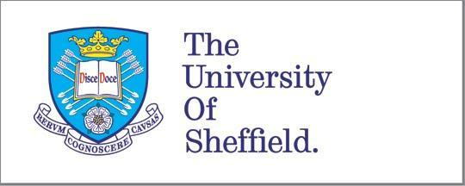

**EVALUATING THE PEDAGOGICAL VALUE OF 3D-PRINTED TEACHING MODELS IN OPERATIVE AND RESTORATIVE DENTAL EDUCATION**

A thesis submitted in fulfilment of the requirements for the degree of

Doctor of Philosophy

**Hathal Albagami**

**Supervisors:** Dr. Ilida Ortega Asencio, Prof. Christopher Stokes, Dr. Sandra Zijlstra-Shaw

School of Clinical Dentistry, University of Sheffield

**November 2022**

Acknowledgments

I would like to first and foremost dedicate this work to my wife and two children. My wife Dalal has been my strength and guidance throughout my educational journey, and I owe all my achievements to her support.

My lovely daughter Lana for her unconditional love and kind spirit.

My lovely son Rayan for lighting up our world and becoming our newest family member.

I also dedicate this work to my father and mother for their patience with me and allowing me to leave their side to pursue my academic dreams. I will endeavour to make up for every moment I was not with you.

To my incredible supervisory team for their constant support and guidance through the difficulties of the pandemic and beyond that. Thank you for showing me the way.

# Table of Contents

[Acknowledgments 2](#_Toc137048476)

[Table of Contents 3](#_Toc137048477)

[List of Figures 12](#_Toc137048478)

[List of Tables 13](#_Toc137048479)

[Appendices 14](#_Toc137048480)

[List of Abbreviations 15](#_Toc137048481)

[Thesis Summary 16](#_Toc137048482)

[Chapter 1: Introduction 17](#_Toc137048483)

[Chapter 2: Literature Review 21](#_Toc137048484)

[1. Additive Manufacturing (3D Printing) 21](#_Toc137048485)

[1.1 Overview 21](#_Toc137048486)

[1.2 Techniques 22](#_Toc137048487)

[1.2.1 Stereolithography (SLA) 22](#_Toc137048488)

[1.2.2 Fused Deposition Modelling (FDM) 23](#_Toc137048489)

[1.2.3 Powder bed fusion 24](#_Toc137048490)

[1.2.4 Inkjet printing 26](#_Toc137048491)

[1.2.5 Polyjet printing 27](#_Toc137048492)

[1.2.6 Direct energy deposition 28](#_Toc137048493)

[1.3 Applications 29](#_Toc137048494)

[1.3.1 Biomaterials 29](#_Toc137048495)

[1.3.2 Aerospace 30](#_Toc137048496)

[1.3.3 Construction 31](#_Toc137048497)

[1.4 Current Challenges 32](#_Toc137048498)

[1.5 Additive manufacturing advantages compared to conventional manufacturing methods 34](#_Toc137048499)

[2. Three-dimensional printing in education 35](#_Toc137048500)

[2.1 3D printing at the school level 36](#_Toc137048501)

[2.2 3D printing in higher education 37](#_Toc137048502)

[The Application of 3D Printed Models in Dental Education: A Scoping Review 40](#_Toc137048503)

[1. Introduction 40](#_Toc137048504)

[2. Methods 41](#_Toc137048505)

[2.1 Research question 41](#_Toc137048506)

[2.2 Inclusion criteria 41](#_Toc137048507)

[2.3 Study identification 42](#_Toc137048508)

[3. Results 42](#_Toc137048509)

[4. Discussion 49](#_Toc137048510)

[4.1 Chronological distribution 49](#_Toc137048511)

[4.2 Pedagogical rationale 50](#_Toc137048512)

[4.3 Investigative approach 52](#_Toc137048513)

[4.4 Source of model design 55](#_Toc137048514)

[4.5 Three-dimensional printing techniques used 57](#_Toc137048515)

[4.6 Gaps identified in the literature 59](#_Toc137048516)

[5. Conclusions 60](#_Toc137048517)

[Chapter 3: Aims and Objectives 62](#_Toc137048518)

[1. Aim: 62](#_Toc137048519)

[2. Objectives: 62](#_Toc137048520)

[Chapter 4: Methodology 64](#_Toc137048521)

[1. Background: 64](#_Toc137048522)

[2. Qualitative research: 64](#_Toc137048523)

[3. Focus groups: 65](#_Toc137048524)

[4. Co-creation: 66](#_Toc137048525)

[Chapter 5: Research Protocol 69](#_Toc137048526)

[1. Dental Students’ Reflections on Clinical Skills Learning Environment and Attitudes Towards 3D-Printing Technology 69](#_Toc137048527)

[2. Design Conceptualization and Manufacturing of 3D-Printed Dental Teaching Models Based on Students’ Input 71](#_Toc137048528)

[3. Teachers’ Feedback on the New 3D-Printed Teaching Models 72](#_Toc137048529)

[Chapter 6: Impact of COVID-19 on the PhD project 75](#_Toc137048530)

[● Introduction: 75](#_Toc137048531)

[● Phase I: 75](#_Toc137048532)

[● Phases II, III, and IV: 76](#_Toc137048533)

[● Supervisory meetings: 76](#_Toc137048534)

[Chapter 7: Dental Students’ Reflections on Clinical Skills Learning Environment and Attitudes Towards 3D-Printing Technology 77](#_Toc137048535)

[1. Background 77](#_Toc137048536)

[2. Methods 79](#_Toc137048537)

[2.1 Participant recruitment 79](#_Toc137048538)

[2.2 Reflective activity 80](#_Toc137048539)

[2.3 Framework analysis of the data 81](#_Toc137048540)

[3. Results 82](#_Toc137048541)

[3.1 Good learning structure 82](#_Toc137048542)

[3.1.1 More practise 82](#_Toc137048543)

[3.1.2 Visual aids 82](#_Toc137048544)

[3.1.3 Tooth availability 83](#_Toc137048545)

[3.1.4 Efficiency 83](#_Toc137048546)

[3.1.5 Safe environment 83](#_Toc137048547)

[3.2 Fairness 84](#_Toc137048548)

[3.2.1 Consistency of staff 84](#_Toc137048549)

[3.2.2 Equal learning opportunity 84](#_Toc137048550)

[3.3 Clinical relevance 85](#_Toc137048551)

[3.3.1 Realism 85](#_Toc137048552)

[3.3.2 Technical 85](#_Toc137048553)

[3.3.3 Practise before patient 86](#_Toc137048554)

[3.3.4 Soft skills 86](#_Toc137048555)

[4. Discussion 86](#_Toc137048556)

[4.1 Practise, confidence, and clinical competence 87](#_Toc137048557)

[4.2 Transitional stress 89](#_Toc137048558)

[4.3 Realism 90](#_Toc137048559)

[4.4 Standardisation and reproducibility of printed models 91](#_Toc137048560)

[4.5 Visual models and tutor availability 91](#_Toc137048561)

[5. Conclusions 92](#_Toc137048562)

[Chapter 8: Design Conceptualization and Manufacturing of 3D-Printed Dental Teaching Models Based on Students’ Input 94](#_Toc137048563)

[1. Background 94](#_Toc137048564)

[2. Materials and Methods: 96](#_Toc137048565)

[2.1 Practical model 98](#_Toc137048566)

[2.1.1 Model concepts 98](#_Toc137048567)

[2.1.2 Model design 99](#_Toc137048568)

[2.1.3 Model printing 100](#_Toc137048569)

[2.1.4 Model post-processing 101](#_Toc137048570)

[2.2 Demonstration Model 104](#_Toc137048571)

[2.2.1 Model concepts 104](#_Toc137048572)

[2.2.2 Model design 104](#_Toc137048573)

[2.2.3 Model printing 105](#_Toc137048574)

[2.2.4 Model post-processing 106](#_Toc137048575)

[3. Discussion 108](#_Toc137048576)

[4. Conclusions 110](#_Toc137048577)

[Chapter 9: Teachers’ Feedback on the New 3D-Printed Teaching Models 111](#_Toc137048578)

[1. Introduction 111](#_Toc137048579)

[2. Methods 111](#_Toc137048580)

[2.1 Participant recruitment 111](#_Toc137048581)

[2.2 Data collection 112](#_Toc137048582)

[2.3 Data analysis 112](#_Toc137048583)

[3. Results 113](#_Toc137048584)

[3.1 Current learning structure (domain 1) 113](#_Toc137048585)

[3.1.1 Realism 113](#_Toc137048586)

[3.1.1.1 The impact on students’ learning 113](#_Toc137048587)

[3.1.1.2 The impact on clinical transition 114](#_Toc137048588)

[3.1.1.3 Replicating natural teeth 114](#_Toc137048589)

[3.1.1.4 Realism is not always important 114](#_Toc137048590)

[3.1.2 Potential benefits of 3D-printing 115](#_Toc137048591)

[3.1.2.1 Consistency and fairness 115](#_Toc137048592)

[3.1.2.2 Cost-effectiveness and efficiency 115](#_Toc137048593)

[3.1.2.3 Customizability 116](#_Toc137048594)

[3.1.2.4 Promotion of practise 116](#_Toc137048595)

[3.1.2.5 3D-printing is the future of dental education 117](#_Toc137048596)

[3.1.3 Concerns with the current learning structure 117](#_Toc137048597)

[3.1.3.1 Limitations of natural (extracted) teeth 117](#_Toc137048598)

[3.1.3.2 Limitations of typodont (plastic) teeth 118](#_Toc137048599)

[3.1.3.3 Transitional gaps 118](#_Toc137048600)

[3.2 New 3D-printed models (domain 2) 118](#_Toc137048601)

[3.2.1 Benefits 119](#_Toc137048602)

[3.2.1.1 Post-fitting system 119](#_Toc137048603)

[3.2.1.2 Realistic look and feel 119](#_Toc137048604)

[3.2.1.3 Simulating caries 119](#_Toc137048605)

[3.2.1.4 Visual learning 120](#_Toc137048606)

[3.2.2 Limitation 120](#_Toc137048607)

[4. Discussion 123](#_Toc137048608)

[4.1 Availability of printed models and promoting practise 124](#_Toc137048609)

[4.2 Consistency and fairness 124](#_Toc137048610)

[4.3 Visual demonstration 125](#_Toc137048611)

[5. Conclusion 125](#_Toc137048612)

[Chapter 10: Using New 3D-Printed Models in a Restorative Pre-Clinical Session 127](#_Toc137048613)

[1. Introduction 127](#_Toc137048614)

[2. Methods 127](#_Toc137048615)

[2.1 Participant recruitment 127](#_Toc137048616)

[2.2 The sessions 127](#_Toc137048617)

[2.3 The questionnaire 128](#_Toc137048618)

[3. Results 129](#_Toc137048619)

[3.1 Comparing the printed teeth to standard plastic teeth 129](#_Toc137048620)

[3.2 Comparing the printed teeth to real (extracted) teeth 129](#_Toc137048621)

[3.3 Features of the visual demonstration model 129](#_Toc137048622)

[3.4 Evaluation of the learning process with the printed teeth 130](#_Toc137048623)

[3.5 Ranking of learning outcome based on model used 130](#_Toc137048624)

[4. Discussion 133](#_Toc137048625)

[5. Conclusions 135](#_Toc137048626)

[Chapter 11: Exploring Students’ Experiences and Attitudes After Using the New 3D-Printed Teaching Models: A Qualitative Analysis 137](#_Toc137048627)

[1. Introduction: 137](#_Toc137048628)

[2. Methods 138](#_Toc137048629)

[2.1 Participant recruitment 138](#_Toc137048630)

[2.2 Data collection 138](#_Toc137048631)

[2.3 Data analysis 139](#_Toc137048632)

[3. Results 139](#_Toc137048633)

[3.1 3D-printed models (domain 1) 141](#_Toc137048634)

[3.1.1 General advantages of 3D-printed models 141](#_Toc137048635)

[3.1.1.1 Availability and convenience 141](#_Toc137048636)

[3.1.1.2 Standardization 141](#_Toc137048637)

[3.1.1.3 Customizability 142](#_Toc137048638)

[3.1.2 Practical 3D-printed tooth model 142](#_Toc137048639)

[3.1.2.1 What they liked 142](#_Toc137048640)

[3.1.2.2 Limitation of the practical tooth 143](#_Toc137048641)

[3.1.2.3 Ideas for improvement and desires for future models 144](#_Toc137048642)

[3.1.3 Visual demonstration models 144](#_Toc137048643)

[3.1.3.1 What they liked 145](#_Toc137048644)

[3.1.3.2 Limitation 146](#_Toc137048645)

[3.1.3.3 Desires for future models 146](#_Toc137048646)

[3.2 Current pre-clinical learning structure challenges (domain 2) 146](#_Toc137048647)

[3.2.1 Limitations of typodont plastic teeth 146](#_Toc137048648)

[3.2.2 Desire for more realism 147](#_Toc137048649)

[3.2.3 Transitional stress 147](#_Toc137048650)

[3.2.4 Patient management 148](#_Toc137048651)

[4. Discussion 148](#_Toc137048652)

[4.1 Promoting practise, availability, consistency, and customizability 149](#_Toc137048653)

[4.2 Visual demonstration 151](#_Toc137048654)

[4.3 Realism 153](#_Toc137048655)

[4.4 Transitional stress and patient management 155](#_Toc137048656)

[4.5 Suggested improvements and desires for future models 156](#_Toc137048657)

[5. Conclusions 157](#_Toc137048658)

[Chapter 12: General Discussion 158](#_Toc137048659)

[Chapter 13: Limitations and Recommendations for Future Research 173](#_Toc137048660)

[Chapter 14: Conclusions 175](#_Toc137048661)

[References 176](#_Toc137048662)

[Appendix 194](#_Toc137048663)

[Section A: Applicant details 194](#_Toc137048664)

[Section B: Basic information 195](#_Toc137048665)

[Section C: Summary of research 196](#_Toc137048666)

[Section D: About the participants 199](#_Toc137048667)

[Section E: About the data 199](#_Toc137048668)

[Section F: Supporting documentation 200](#_Toc137048669)

[Section G: Declaration 200](#_Toc137048670)

[Offical notes 200](#_Toc137048671)

# List of Figures

[Figure 1: SLA printing technique schematic. Source (formlabs.com) 21](#_Toc120025952)

[Figure 2:FDM printing technique schematic. Source (Olivera et al. 2016) 22](#_Toc120025953)

[Figure 3:SLS printing technique schematic. Source (Ganeriwala and Zohdi, 2014) 24](#_Toc120025954)

[Figure 4:Inkjet printing schematic. Source (CustomPart.Net) 25](#_Toc120025955)

[Figure 5: Polyjet printing technique. Source (3D hubs) 26](#_Toc120025956)

[Figure 6:DED printing schematic. Source (Dassault Systèmes) 27](#_Toc120025957)

[Figure 7: Flowchart of literature search results 40](#_Toc120025958)

[Figure 8: Number of publications based on year of publication 45](#_Toc120025959)

[Figure 9: A schematic showing the manufacturing process for the practical tooth. 96](https://d.docs.live.net/3f833f965f3c0ed2/Desktop/Redownloaded%20thesis/Hathal%20PhD%20Thesis%20-%20Finalization.docx#_Toc120025960)

[Figure 10: A) The printed tooth partially inserted into the socket showing the spikes leftover after the removal of the material support. B) Occlusal view of the printed tooth showing the pulp exposure prior to the placement of the caries material. 96](https://d.docs.live.net/3f833f965f3c0ed2/Desktop/Redownloaded%20thesis/Hathal%20PhD%20Thesis%20-%20Finalization.docx#_Toc120025961)

[Figure 11: Schematic of the manufacturing steps of the visual model base 100](#_Toc120025962)

[Figure 12: Schematic of the manufacturing steps of the sequential teeth. 100](#_Toc120025963)

[Figure 13: Flowchart of the emerging themes as a result of framework analysis 115](https://d.docs.live.net/3f833f965f3c0ed2/Desktop/Redownloaded%20thesis/Hathal%20PhD%20Thesis%20-%20Finalization.docx#_Toc120025964)

[Figure 14:Flowchart of the emerging themes from framework qualitative analysis 132](https://d.docs.live.net/3f833f965f3c0ed2/Desktop/Redownloaded%20thesis/Hathal%20PhD%20Thesis%20-%20Finalization.docx#_Toc120025965)

# List of Tables

[Table 1: Scoping review results. List of publications included in the literature. 41](#_Toc120026454)

[Table 2: Summary of the questionnaire results 124](https://d.docs.live.net/3f833f965f3c0ed2/Desktop/Redownloaded%20thesis/Hathal%20PhD%20Thesis%20-%20Finalization.docx#_Toc120026455)

[Table 3:Frequency of ranks given to the different teaching teeth 125](https://d.docs.live.net/3f833f965f3c0ed2/Desktop/Redownloaded%20thesis/Hathal%20PhD%20Thesis%20-%20Finalization.docx#_Toc120026456)

# Appendices

Appendix 1: Ethics application …………………………………………………………………186

Appendix 2: Ethics approval letter ……………………………………………………………193

Appendix 3: Reflective exercise via Google Forms ……………………………………194

Appendix 4: Faculty interviews information sheet ……………………………………203

Appendix 5: Faculty interviews consent form …………………………………………..207

Appendix 6: Focus groups information sheet ……………………………………………209

Appendix 7: Focus groups consent form …………………………………………………..213

Appendix 8: Interview guide ………………………………………………………………..……215

Appendix 9: Focus groups guide …………………………………………………………..…..218

Appendix 10: Student questionnaire …………………………………………………………221

Appendix 11: Framework analysis of reflective exercise ……………………………223

Appendix 12: Framework analysis of faculty interviews …………………….………235

Appendix 13: Framework analysis of focus groups ………………………….…………238

# List of Abbreviations

|  |  |
| --- | --- |
| **AM** | Additive manufacturing |
| **CSLE** | Clinical Skills Learning Environment |
| **SLA** | Stereolithography |
| **FDM** | Fusion Deposition Modeling |
| **SLS** | Selective Laser Sintering |

# Thesis Summary

This project aimed to explore the potential pedagogical value that could be introduced by 3D-printing technology to aid in pre-clinical learning. The approach was designed to include both students and teachers in the design, creation, and implementation of the newly printed teaching models through a co-creation research model. This was achieved by collecting data through qualitative methods such as free-text exercise, 1-on-1 interviews, and focus groups. Framework thematic qualitative analysis of the data was conducted to identify emerging themes, and the results were used to created new 3D-printed practical and visual models for use in pre-clinical education. The models were introduced to pre-clinical teachers, where they received positive feedback. The models were then implemented into a pre-clinical restorative course where the students were given the chance to perform a full restorative procedure using the newly created models. A quantitative questionnaire was given to the students to evaluate the perceived educational value of the new models. The models received mostly positive feedback from the students involved in this project. Finally, focus groups were conducted with the students involved in the pre-clinical session to explore their thoughts and experiences with the new 3D-printed models, and to expand upon and explain the results from the quantitative questionnaire. Valuable insights were gained into the impact of the newly introduced 3D-printed models. The reception of the models was mostly positive with the students finding value in what the new models were able to introduce into pre-clinical learning. Several avenues for improvement were suggested by both the teachers and students.

Chapter 1: Introduction

Medical clinical training of students has historically offered unique challenges to educators and instructors. Medical education has transitioned from a pure apprenticeship approach into a more scientific design that requires learning critical scientific concepts, as well as objective assessments of the students’ competence in regard to clinical skills and theoretical understanding (Rosen, 2008). For a trainee to learn and retain clinical skills, practise is considered the most important aspect of learning in many disciplines in this regard. This has led to the adoption of a purposeful practise approach by the medical field in order to learn and retain skills in medicine (Ericsson, 2004). Practicing on real patients to gain the skills required has come with significant ethical issues in regard to the safety and well-being of the patients in question (Friedrich, 2002). Since many clinical procedures that require skills in medicine and dentistry are often irreversible, practicing on real patients was unacceptable. These issues have led many institutions (including medical and dental professional bodies) to explore alternative ways to teach and assess the clinical skills of their trainees (Jasinevicius et al., 2004, Ten Eyck et al., 2009).

Historically, medical institutes have used cadavers and donated body parts for the training of essential clinical skills (Rosen, 2008). In the 1960s, the introduction of the first mannequin into medical education to simulate patient anaesthesia marked the first significant step towards revolutionising health sciences education (Abrahamson et al., 1969). Simulation is known as the imitation and recreation of a real-world scenario over time. The introduction of simulation mannequins and subsequent digital simulations has allowed medical trainees the freedom to practise and perfect their craft without fear of endangering another person.

In dental education, the use of simulation in pre-clinical training was adopted much earlier than other health specialities, with the earliest example found in the first dental school to be established in 1840 in Baltimore, Ohio, USA (Murtomaa, 2009). At the time, restorative clinical skills and procedures were taught using extracted natural teeth on bench-top simulations. However, as demand for natural teeth was rising during the 1800s due to their use in dentures, the supply for training purposes significantly decreased (Perry et al., 2015). This has led to the development of resin-based teeth for the practise of restorative dental procedures.

Bench-top training had some drawbacks that include the unrealistic position of the trainee in reference to the patient, as well as the overall lack of realism. This has led to the development of the first example of a phantom head for dental training in the early 1900s (Fugill, 2013). These consisted of an upper and lower cast mounted on two opposing brass copings held together by a metal rod. Phantom heads have developed in design to include cheeks, tongue, and an articulating mandible.

Since the early 1900s, phantom heads continue to be the iconic staple for dental training and education. They have the advantage of being ergonomically correct, allow practicing of a proper finger rest during instrumentation, and realistic handling of the handpiece/mirror in relation to the patient’s position. Ever since the introduction of mannequins, researchers continued to investigate the extent of how simulation can be applied in dental pre-clinical training (Green and Klausner, 1984, Suvinen et al., 1998, Jasinevicius et al., 2004, Ria et al., 2018). The main factor driving the dental field appears to be the desire to provide a smooth transition for the students from pre-clinical simulation labs to patient clinical care. Other factors include aiding and emphasizing the importance of ergonomics, providing a more comprehensive pre-clinical experience to the students, and to enhance the delivery of different teaching materials (Buchanan, 2001).

Since the introduction of the original phantom head, dental pre-clinical teaching has seen several technological developments. In the early 2000s, computer-supported simulators were introduced and started seeing application within dental schools in North America and Europe (Perry et al., 2015). The most common example of which is DentSim, which has the advantages of both the traditional phantom head simulators, as well as the ability to visualise the movement of the handpiece, angulation, and the tooth preparation in 3D visuals (Tavkar and Pawar, 2017). More recently, the interest of dental educational research has seen a shift towards virtual reality (VR), in which the student experiences and practises different restorative procedures in a 3D environment by wearing goggles or glasses that facilitate visualisation of the practise site (Joda et al., 2019). VR simulators are often accompanied by haptic technology, which provide the trainee with the tactile sensation of holding and manipulating various instruments (Towers et al., 2019).

While dental pre-clinical education has seen significant technological advancements, the basic approach for teaching clinical skills remains almost the same. Students are given didactic courses, visual demonstrations, models, pictures, and videos of a certain restorative problem and its treatment, and they practise that procedure repeatedly on plastic or virtual teeth. Feedback and scoring are provided by a demonstrator, or in the case of more recent technologies such as VR, the score is given on the screen immediately to the student.

One technology that has recently piqued the interest of dental educators is additive manufacturing to produce customised or bespoke 3D printed models. This report aimed to explore the history of this technology, its different techniques and applications so far, and how it has impacted the field of education in general, and medical education specifically. This project aimed to explore the potential value this technology has in the field of dental pre-clinical education.

Chapter 2: Literature Review

## Additive Manufacturing (3D Printing)

### Overview

3D printing, which is a type of additive manufacturing (AM) technique, is described as the process of fabricating complex structures and geometries based on 3D digital model design. The process involves printing the desired object by layering the printing material one layer at a time. In 1986, Charles Hull developed the technique using a process known as stereolithography (SLA), followed by rapid developments in approaches such as fused deposition modelling (FDM), powder bed fusion, and inkjet printing. Since then, additive manufacturing, more specifically 3D printing, has been applied in multiple industries, including aerospace (Uriondo et al., 2015), automobile, construction (Nadal et al., 2017), and biomechanical applications (Chia and Wu, 2015).

Recent developments in 3D printing technologies have resulted in the cost reduction of 3D printers, which subsequently became more accessible. This newfound accessibility has enabled 3D printing applications to expand to homes, schools, and libraries. The ability of 3D printing to create custom made products at a relatively low cost was perhaps its biggest advantage when compared with prevalent manufacturing approaches at the time. While the customisability has benefitted multiple industries, one of the biggest benefactors was the medical industry. Due to the complex and unique nature of the human anatomy, it was difficult, and often expensive, to produce custom made implants for patients (Negi et al., 2014). However, 3D printing has granted medical practitioners the ability to produce patient specific implants based on existing imaging data at a significantly reduced cost (Marro et al., 2016).

### Techniques

Due to the increased demand for accurate and detailed prints, several techniques have been developed over the years to meet demand .

#### Stereolithography (SLA)

SLA, developed in 1986, was one of the first AM methods (Melchels et al., 2010). An electron beam (or UV light) is used to initiate a reaction in the light cure resin or monomer solution (acrylic or epoxy-based) which is UV active. The reaction leads to the conversion of the solution into polymer chains (radicalisation). The focus area of the beam is polymerised and the solidified area acts as a base to support the subsequent layers (Figure 1). The thickness of the polymerised layers is controlled by the energy of the beam and the amount of exposure the solution undergoes (Melchels et al., 2010). The unpolymerised solution is expelled after the printing process has been completed. Heat or light curing may be used to treat the material to achieve optimal mechanical properties. SLA can be used to create ceramic/polymer composites by scattered ceramic particles in monomer solutions (Travitzky et al., 2014). It can also be used for the manufacturing of high-quality nanocomposites (Manapat et al., 2017). SLA is mainly used to create highly detailed and accurate prints at low resolutions (10 µm) (Wang et al., 2017). However, the technique has a limited selection of available materials compared to other techniques.

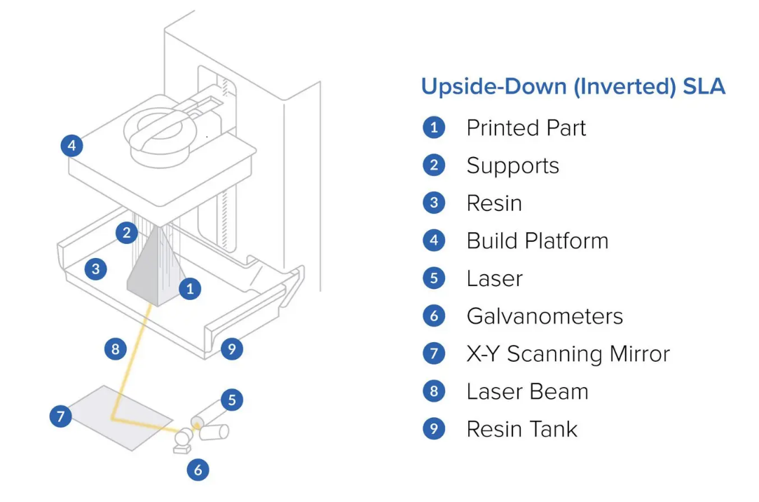

Figure 1: SLA printing technique schematic. Source (formlabs.com)

#### Fused Deposition Modelling (FDM)

FDM prints are done by layering the material layer by layer using a continuous filament. The filament (typically 1.85mm) is created using a heated nozzle that semi liquifies the material and extrudes it for layering. The layers are then placed on a platform, or on top of previously layered material (Figure 2). The main property that dictates how the material fuses to itself and reaches a full solid state in room temperature is its thermoplasticity and is an essential characteristic for this method (Utela et al., 2008). The main processing parameters controlling the mechanical properties of the processed model are the orientation, width, and thickness of the filaments, as well as any gaps that may form within the material (Mohamed et al., 2015). The most common cause of mechanical weakness of printed objects using FDM was found to be inter-layer distortion (Sood et al., 2010).

The list of advantages of FDM technique include the relatively low costs, and simplicity of the printing process. However, the list of disadvantages of FDM includes poor surface quality, rough layered appearance, weak mechanical properties, and the limited selection of thermoplastic materials available for use (Chohan et al., 2017). FDM has been used to develop fibre-reinforced composites and has been shown to improve the mechanical properties of the objects produced (Parandoush and Lin, 2017). On the other hand, several challenges have surfaced such as void formation and bonding of the fibres to the matrix (Parandoush and Lin, 2017, Wang et al., 2017).

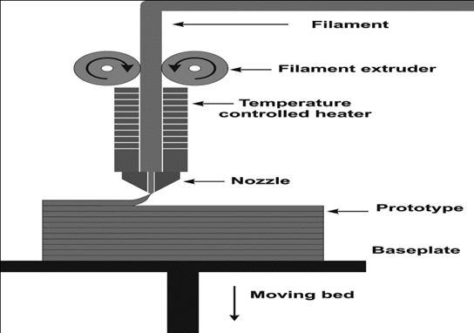

Figure 2:FDM printing technique schematic. Source (Olivera et al. 2016)

#### Powder bed fusion

Powder bed fusion involves the use of a laser or a binder on a thin bed of powder material such as stainless steel, titanium, or nylon. The laser serves to melt and fuse the powder material together forming the intended 2D shape of the first layer. Subsequent layers are added by rolling a new layer of material on top of the previously formed layer, then subsequent laser melting, and fusing occurs. This process is repeated until the intended 3D shape is made (Figure 3). Excess material is removed using a vacuum. Post-processing procedures can be carried out if the need arises, such as sintering and coating. The factors that are crucial to the success of this technique are powder size packing and distribution. There are two approaches to powder bed fusion technique. First approach using the laser in case of powders that have a low melting temperature. The second is using a liquid binder if the material’s melting temperature exceeds what is suitable for using the laser. Selective laser sintering (SLS) is used for some metals, polymers, and alloys. Selective laser melting (SLM) is used for specific metals such as aluminium and steel.

The main advantages of powder bed fusion technique are high quality prints with fine resolutions. These properties make this technique ideal for the use in tissue engineering, electronics, and aerospace. One other major advantage of this technique is that the powder acts as the support for each layer, eliminating the need for removal of support structure after the print is complete, which is often a time-consuming process. On the other hand, this technique is slow, comes at a high cost, and high porosity when a binder is used for the process (Ngo et al., 2018).

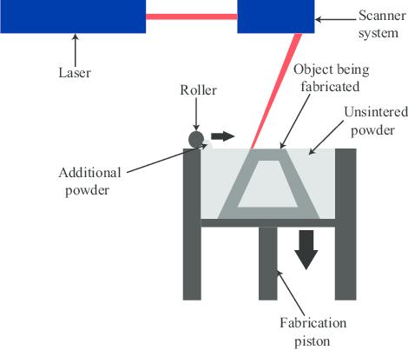

Figure 3:SLS printing technique schematic. Source (Ganeriwala and Zohdi, 2014)

#### Inkjet printing

Inkjet printing is now mainly used for the manufacturing of ceramics. The technique uses a ceramic material that is suspended in water for AM (Ngo et al., 2018). The material is extruded in droplet form and deposited onto a substrate. Droplets then become sufficiently solid to support another layer of the printed material. Ceramic ink materials come in the form of either liquid suspension or wax-based ink (Figure 4). Wax-based ink is deposited on a cold base after melting to facilitate hardening. While the liquid suspension uses a liquid evaporation method to solidify. Factors that affect the success of this technique and the quality of the printed material include speed of printing, nozzle size, viscosity of the material and its extrusion rate (Travitzky et al., 2014).

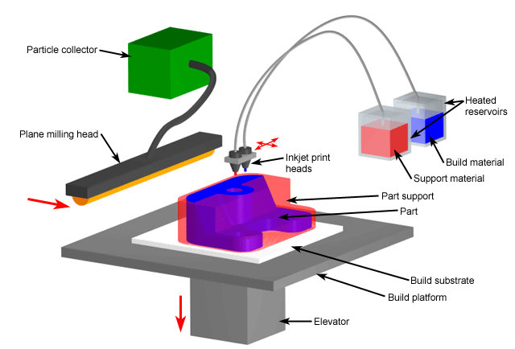

Figure 4:Inkjet printing schematic. Source (CustomPart.Net)

#### Polyjet printing

Polyjet printing is a technique that follows the same concepts of inkjet printing but is able to produce very accurate layers as thin as 14 µm (Tee et al., 2020). The printing material is deposited as droplets onto a cold build platform through multiple nozzles. The material is then immediately exposed to UV light that immediately polymerizes and harden the material after deposition. Prints produced with the polyjet technique are usually manufacturing over a substrate of initial layer of material, and the whole structure is usually encased in the very soft support material (Figure 5).

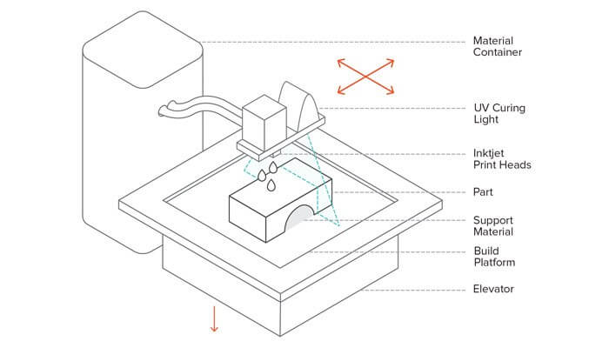

Figure 5: Polyjet printing technique. Source (3D hubs)

#### Direct energy deposition

Also known as wire and arc additive manufacturing (WAAM), direct metal deposition (DMD), and electron beam melting (EBM). This printing method uses a high energy laser directed towards the base material of the print to melt. Simultaneously, a wire is fed into the focus of the beam (mostly metallic) and melted. The base and the fed material are allowed to melt and fuse to each other forming the three-dimensional shape (Figure 6). This technique differs from SLM in that it does not use powder material, and the wire material is melted before layering, making it resemble the FDM technique more than SLM. Consequently, it shares most of the limitations of FDM, mainly the rough surface quality and the lower accuracy compared to SLS.

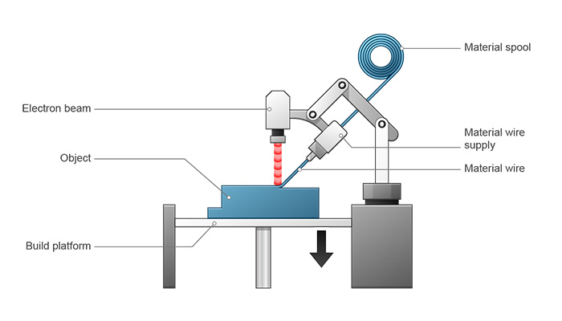

Figure 6:DED printing schematic. Source (Dassault Systèmes)

### Applications

#### Biomaterials

The use of additive manufacturing for the production of biocompatible materials has increased recently, now accounting for 11% of the total AM market (Ngo et al., 2018). The ability to produce detailed, intricate, and custom-made designs through 3D printing has made them an ideal choice for the production of medical prosthetics. Due to the unique nature of human anatomy, there was always a necessity for a method to produce custom made prosthetics. While the technology has existed prior to the utilisation of 3D printing, it was often expensive and had limited applications. Three-dimensional printing has the advantage of being accessible, cost-efficient, and relatively rapid production.

More recently, multiple aspects of applying AM in tissue engineering have been explored. Scaffolds are essential in tissue engineering as they are designed to provide a guide for cells to infiltrate and proliferate, as well as provide a vessel for the extracellular matrix. They can also be designed to guide cell behaviours and patterns. Furthermore, scaffolds have the ability to provide cell-matrix interaction and transfer nutrients (Hollister, 2005, Stevens and George, 2005). Common techniques for scaffold production include electrospinning, gas foaming, and freeze drying. Currently, the use of 3D printing techniques to produce scaffolds remains extremely limited by the amount of available printable materials. Materials used to 3D print scaffolds include, but not limited to, poly lactic-co-glycolic acid (PLGA), polylactic acid (PLA), hydroxyapatite (HA), β-tricalcium phosphate (TCP), bioactive composites, polycaprolactone (PCL), and polymethyl methacrylate (PMMA) (Chia and Wu, 2015).

#### Aerospace

As additive manufacturing became increasingly able to accurately and rapidly produce complex designs, it has drawn the attention of the aerospace industry. Aerospace represents 18.2% of the AM market (Ngo et al., 2018). The technology has been used to produce prototypes over the years, but recent advancements in AM has shown that the technology has the necessary process accuracy and variety of materials to produce final parts for direct assembly.

When considering AM for aerospace applications, the biggest aspect to consider is the ability of the different AM techniques to produce complex metallic parts that meet the aerospace industry standards. In this regard, the most appropriate and adaptable techniques to produce elaborate functional metal components are SLM, SLS, EBM, and WAAM (Kobryn et al., 2006). These four techniques are able to produce dense parts that live up to the industry standards without the need for post-treatment of the components (Gu et al., 2012).

There are many metal alloys that can be used alongside the previously mentioned techniques such as titanium, nickel, and iron-based alloys. A recent review has determined that the most commonly used alloy alongside AM technology in aerospace is Ti6A14V (Uriondo et al., 2015). Other nickel and iron-based alloys have seen an increase in application and research in the industry.

Advantages for applying AM in aerospace include the aforementioned ability to produce elaborate and complex parts, the ability to rapidly change and optimise designs, and the lack of need of specified tools which enables cost-efficient and rapid production processes (Holmström et al., 2010). However, the technology still faces major drawbacks due to the lack of standardisation of the printing process which results in the inability to consistently demonstrate repeatability. Although the technology shows great promise in terms of cost, precision, rapidity, and reliability that is comparable to conventional aerospace production and manufacturing processes, it remains held back by the lack of standardisation and process understanding in the aerospace industry (Uriondo et al., 2015).

#### Construction

Making up only 3% of the AM market, the use of AM in construction is relatively new. The technology shows promise in construction, especially in terms of on-site construction. Initially, the size of available 3D printers has limited the application of the technology in building and construction. However, multiple large-scale AM approaches were introduced. The most common method of 3D printing currently being used and investigated is contour crafting (CC) (Ngo et al., 2018). CC was developed in 2004 for automatic building of structural components (Khoshnevis, 2004). With this technique, the material, which is usually a cement and glass mix, is extruded and layered on-site. The ability to print building components on-site provides CC with the advantage of production freedom in terms of design flexibility as well as printing large parts with high accuracy. These properties have made CC the ideal choice for building affordable housing. Some studies have investigated the use of CC for building lunar shelters using soil native to the moon (Ngo et al., 2018).

Another 3D printing technique developed for the use in construction is known as D-shape. In this technique, a binder is used with the powder deposition approach to produce large-scale components with good mechanical qualities. Although this technique is promising, it still suffers from the need of constant maintenance. Furthermore, this technique is used to produce components off-site, which has the disadvantage of wasting material and increased possibility for inaccuracies in the produced parts (Nadal et al., 2017).

The application of AM and 3D printing in construction is still in its early stages, but research shows great promise. 3D printing technologies have shown that they can be used alongside conventional building methods to improve upon them, or possibly as a suitable alternative when the need for more complex and intricate component designs are needed.

### Current Challenges

While the technology has made significant strides in the past couple of decades, 3D printing still has significant drawbacks that it must overcome prior to utilisation in the production of high quantities of components. While 3D printing is a fantastic tool to use when creating custom and intricate parts, such as tissue engineering scaffolds, it still suffers compared to conventional methods when it comes to mass-production. AM costs more and often takes more time when producing a high volume of the same part. There are also other drawbacks that are specific to a certain technique/material. For example, SLM/SLS and SLA take more time when compared to the other AM techniques. Another example can be found in the increased cost of materials, as well as an increased volume of processing energy needed when using high resolution prints from techniques such as SLM/SLS.

There are other limitations of additive manufacturing that are worth investigating with further research; one of which is the formation of gaps between the printed layers, design accuracy, and layering. Voids result in a poor bond between the layers which subsequently cause a reduction in the mechanical properties of the printed body. This drawback is most notable in techniques that involve the extrusion of a filament, most notably fusion deposition modelling (FDM) and contour crafting (CC) techniques (Zareiyan and Khoshnevis, 2017). It is important to note that the formation of voids/pores is not always a bad thing, as having voids form in a controlled fashion could prove advantageous especially when it comes to printing scaffolds.

Another major drawback is the deviation of the final printed product from the original digital design. While digital design software accounts for the printing process limitations, it is not able to account for every possible limitation of the printing process, which results in the printed body having structural differences than the initial digital design, especially at curvatures. These deviations often cause imprecisions and weak points in the printed product (Oropallo and Piegl, 2016).

The layered appearance of 3D printed objects remains a concern, especially when using filament extrusion techniques such as FDM and CC. While this appearance doesn’t constitute a major flaw in cases where the finished product is not apparent such as scaffolds and building infrastructure, it is still a concern in other applications where a flat surface is necessary. Some post-production treatments can be utilised to achieve this flat surface, however, that will result in increased time and expense (Oropallo and Piegl, 2016).

The formation of gaps, dimensional deviation from design, and layered appearance are critical issues that must be considered when intending to use the technology to teach dentistry. Dental models are detailed and require an increased level of precision, and these limitations should be considered and overcome when applying the technology to dental teaching. While these drawbacks need further investigation in the future to improve most aspects of additive manufacturing, the progress this technology has made thus far is still impressive. When it comes to crafting a complex, detailed, and custom-made object 3D printing is considered one of the best ways of achieving that goal. Future improvements will allow the ubiquitous use of 3D printing in most manufacturing industries.

### Additive manufacturing advantages compared to conventional manufacturing methods

While there are some drawbacks to additive manufacturing technology, specifically 3D-printing, some advantages introduced by the technology can be appreciated. When compared to traditional substractive manufacturing, additive manufacturing uses the raw materials more efficiently by layering the exact desired amount of material, and the leftover material is often reused with minimum effort. Whereas substractive manufacturing often involves cutting large parts off with no possibility of material reuse. In metal milling the material is reused.

Additive manufacturing does not need any additional resources such as fixtures or auxillary cutting instruments that are often necessary for other conventional manufacturing methods, making additive manufacturing more resource efficient. Washing procedures – curing procedures – removal of supports?

AM offers higher flexibility when it comes to the part manufactured as the technology allows for the production of complex models. Furthermore, since AM is comparatively cost-effective, it is a preferred option for manufacturing at a small scale, resulting in a flexible production process. (Prakash et al. 2018)

## Three-dimensional printing in education

Having discussed the general applications of 3D-printing technology, a closer and more focused look was needed to explore its applications in education. The application of 3D printing in enhancing and aiding education is not a recent development. Various specialties have implemented the technology in many different forms to assist in enhancing the education/learning experience, the earliest of which were engineering and architecture (Helge Bøhn, 1997). Several advantages of implementing 3D printing to assist the learning process were identified. They were found to enhance learning by stimulating a high level of engagement by both the students and teachers (Horowitz and Schultz, 2014). The technology has been implemented at all levels of learning including in both schools and universities.

### 3D printing at the school level

While 3D printing has been used to assist learning in many different subjects, the most prevalent subjects to incorporate the technology were science, technology, engineering, and mathematics (Ford and Minshall, 2018). An example can be found in a chemistry class in the USA, where a study was conducted on a 10th grade class in a girls’ high school (Chery et al.2015). The students were split into groups, and each given an element to break down into a virtual model detailing the atoms of the element, then the model was 3D printed. Evaluation was done by giving a pre- and post-test to the participating groups, as well as pre- and post-tests to classes that did not participate in the creation of the models to serve as the control group. A positive correlation was found between the application of 3D printing to teach atoms and students’ learning (Chery et al., 2015). Other methods of 3D printing were introduced into the classroom through teaching construction and assembly of 3D printers, as well as involving the students in the design process. Teaching the students about 3D design and allowing them to participate in the process has shown to stimulate student creativity and provide them with skills in product development (Chao et al., 2016). Introducing 3D printed models in geometry class has been found to improve students’ understanding towards complex geometric shapes (Huleihil, 2019).

The incorporation of 3D-printed models in the classroom to aid with oral presentations has been found to enhance the presentations themselves, as well as improve spatial education (Chen et al., 2014). Students being able to touch and feel a model that is designed and produced to enhance the learning of the subject being taught is beneficial compared to static images on the screen.

An important pedagogical angle of 3D-printed models is giving the students the freedom to learn with many different styles that are unique to them thanks to experiential learning, which is a major part of object-based learning theories (Chatterjee and Hannan, 2016). Students who tend to have a low interest in the subject being taught have been found to be more enthusiastic towards learning when they are given some motivation and a proper tool that allows them to learn in a style they feel comfortable with (Kostakis et al., 2015).

Although incorporating 3D-printing in learning has many benefits, there are some drawbacks to be considered. These drawbacks include the general technological knowledge of the students, as well as their acceptance towards accepting new technologies (Nemorin, 2017). Furthermore, the cost of these technologies must be considered prior to implementation in education at the school level.

### 3D printing in higher education

Prior to the application of 3D-printing technology in any given subject, there is a need to learn the necessary skills to utilise the technology. To solve this issue, several universities have opted for one of two approaches. The first was the inclusion of 3D printing training into existing modules. This approach has received mostly positive feedback from the students (Chiu et al., 2015). The second approach was the creation of new courses that are specific to teaching 3D printing design and manufacturing skills.

One of the most significant ways 3D-printing is being applied in higher education is the printing of visual aids to assist in teaching scientific subjects (McGahern et al., 2015, Bagley and Galpin, 2015). These printed models are employed as a visual aid, and in some cases test models are printed as part of experiments to teach various mechanical concepts in mechanical engineering. Experimental models also include models to explore a material’s mechanical properties (Golub et al., 2016).

Recently, the field of robotics has been using 3D-printing more frequently in teaching. The reduced cost of the technology allows the creation of robots that were built specifically as teaching tools (Vandevelde et al., 2016, Ziaeefard et al., 2015). This has allowed the students the freedom to adjust and modify the designs of the robots without the complexity and increased cost of traditional robots. The open-source nature of the technology allows the students to share their modifications among each other (Gonzalez-Gomez et al., 2012).

3D-printing has also been utilised to facilitate project-based learning, where students work on a project for an extended period (up to a full semester) attempting to solve a problem or answer a question. Using 3D-printing in project-based learning has been found to improve the student’s interest and immersion in learning (Dahle and Rasel, 2016). Other benefits mentioned include improving students’ motivation to learn (Pei et al., 2015). Similar to what has been discussed in the schools’ section, 3D-printing stimulates otherwise indifferent students and motivates them to learn by appealing to their specific learning style. This gives them the ability to comprehend and implement what they learn more efficiently and effectively.

Incorporating 3D printing in the curriculum of university students encourages student-centric learning. This learning style changes the relationship between the students and teachers by shifting power from the teachers to the students (Ford and Minshall, 2018). Teachers usually lead the learning experience because of their extensive knowledge and experience on the subject being taught. However, when it comes to a new technology such as 3D printing, that is often not the case. Teachers often find themselves learning with the students simultaneously, which shifts their role from being a leader to being a mentor to the students. This shift was found to result in a favourable learning environment for both the teachers and students (Loy, 2014).

After exploring the use of 3D-printing technology in education, a low number of publications in dental education were discovered. The next step was to explore and collate existing publications that discuss the use of 3D-printing technology in dental education specifically.

# The Application of 3D Printed Models in Dental Education: A Scoping Review

## Introduction

Three-dimensional printing (3D printing) has been available for more than three decades, but due to the high cost and complexity of the equipment at the time, the application was limited to established manufacturers. Recent advances in additive manufacturing technology, and the subsequent cost-reduction of the equipment has enabled a wider application for 3D printing. While this rapid development has benefited several sectors such as aerospace, art, and automobile manufacture (Bhargav et al., 2018), one of the largest benefactors of this technology is the medical devices industry (Michalski and Ross, 2014). The need for 3D printing in medical devices stems from the complexity of the human anatomy, and the need to develop custom made devices rapidly and accurately. This led to the application of 3D printing in medicine as an educational tool, which is able to produce anatomical and realistic models that mimic the structural fidelity of the patients’ anatomy and disease process (Negi et al., 2014).

Dentistry has benefited greatly from the introduction of 3D printing (Dawood et al., 2015). Printing artificial teeth, implants, and prostheses has become prevalent due to the ability to produce structures rapidly and accurately. For almost three decades, additive manufacturing has often been used in the field of oral and maxillofacial surgery by producing models using existing patient CT data. Since then, these models have been used in surgical planning, diagnosis, and using the models during surgery as a reference (Rengier et al., 2010). However, there seems to be very few dental education applications. Thus, this review aimed to explore current literature and investigate the extent of 3D-printed model use in dental education.

## Methods

This scoping review followed the structure introduced by Arksey and O’Malley (Arksey and O'Malley, 2005). In contrast to the typical systematic reviews, this approach allows for the broad and rigorous mapping of certain areas of research, identifying the gaps in literature, and summarising the findings in a relatively short amount of time. The ability to summarise and disseminate the findings makes it more likely for the consumer of the information to make use and benefit from the results.

Since this review aimed to encompass all the peer-reviewed papers published thus far, a broad question was chosen to include all the available literature. This approach has been utilised throughout the whole search strategy from search terms to inclusion and exclusion criteria, all of which will be discussed in their own section.

### Research question

The research question of this review was:

*“Where and how is 3D printing used in dental education?”*

### Inclusion criteria

Studies were required to be peer reviewed research papers that described the use of 3D printing for:

* Producing (dental) teaching models and devices.
* Applying printed models in dental education.
* Producing models for multiple applications and proposing education as a potential use.

### Study identification

Several databases were searched for the purposes of this review including Web of Science, PubMed, Medline Ovid, and Education Resources Information Center (ERIC). Web of Science was chosen as it can provide literature from multiple databases through a single search engine, and ERIC was used as a database that is specific to educational literature from journals and grey sources. The search was approached with broad terms to include every possible study that included the use of 3D-printing in dental education. No restrictions were enforced in terms of the time the study was conducted, study design, or source of the publication. However, only articles written in English were included. The search includes papers published up to August 2020.

The terms used for the literature search were:

*Dent\* AND (3D Print\* OR additive manufacturing OR rapid prototyping) AND (education OR teaching OR learning OR instruction)*

While the term “rapid prototyping” was recently deemed inadequate to describe the scope of the technology (Gibson et al., 2014), it is still relevant in this review as it is trying to explore the full scope of 3D-printing use in dental education.

## Results

Results of the search are displayed in Figure 7. Out of the 270 studies initially found, 93 false positives were identified. 112 papers were deemed irrelevant after reviewing 177 abstracts. These papers were excluded because they did not relate to dentistry, 3D-printing, or education in general, or they simply shared a keyword or two with the intended target of this review. After reviewing relevant abstracts, 65 papers were chosen for full text review. Of the 65 full texts reviewed, 5 were identified to be reviews of the literature, 5 were not available in English, and 27 did not fit the inclusion criteria, 20 of which focused on 3D printing, but did not apply the models to education, nor were the models developed with the intention of teaching. The remaining seven only used 3D-printing as a tool to test a hypothesis that did not itself focus on 3D printing.

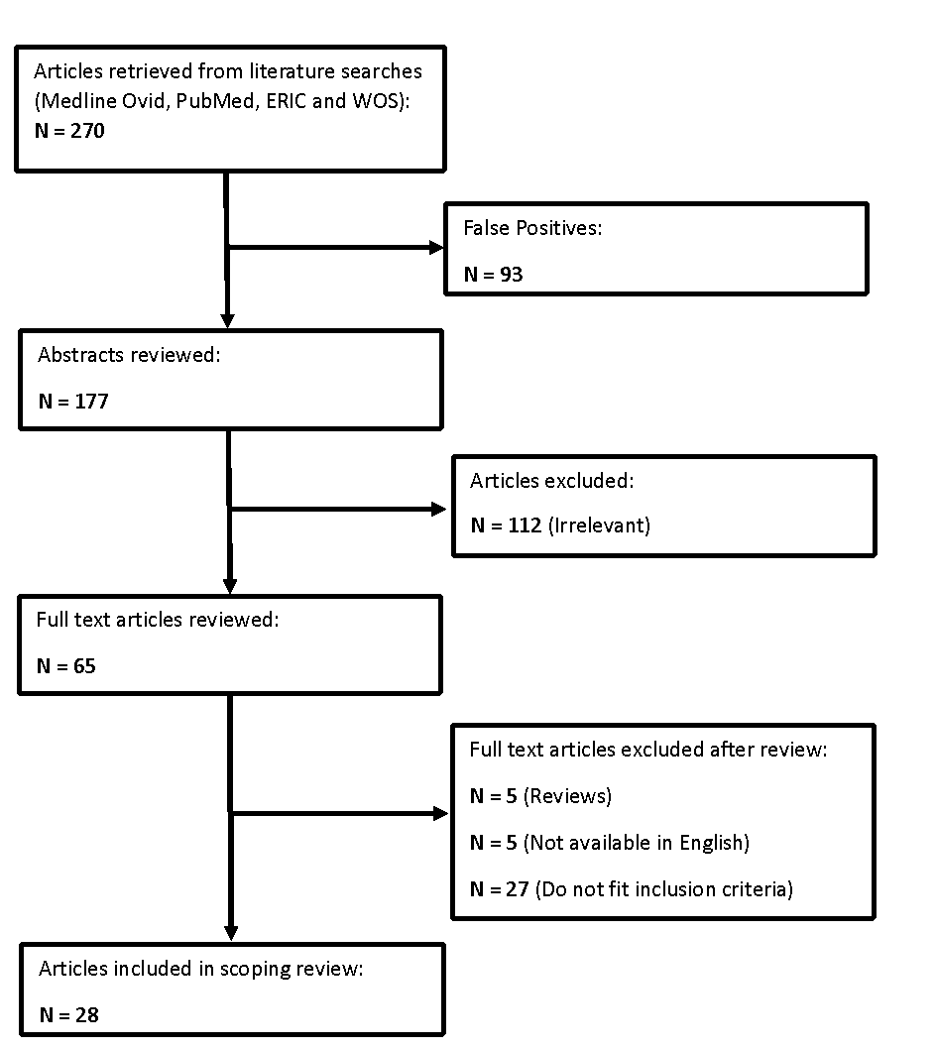

Figure 7: Flowchart of literature search results

Table 1: Scoping review results. List of publications included in the literature.

|  |  |  |  |  |  |  |  |  |  |  |
| --- | --- | --- | --- | --- | --- | --- | --- | --- | --- | --- |
| **Author** | **Year** | **Title** | **Discipline** | **Tool used** | **Source of model design** | **3D printing technique used** | **Sample** | **Outcome** | **Journal** | **Location** |
| E. Kroger | 2017 | 3D printed simulation models based on real patient situations for hands-on practise | Resto/Prosth | 3D printed models | Intra-oral scan | PolyJet (Objet Eden 260V) | 22 4th year dental students | Visual analog scale questionnaire | European journal of dental education | Germany |
| M. Marty | 2019 | Comparison of student’s perceptions between 3D printed models versus series models in paediatric dentistry hands‐on session | Pediatric | 3D printed vs virtual models | CT scan | SLA (Solflex 350) | 34 5th year dental students | Questionnaire ( C) | European journal of dental education | France |
| M. Reymus | 2019 | 3D printed replicas for endodontic education | Endodontics | 3D printed tooth replica | CBCT scan | SLA (Formlabs) | 105 3rd & 4th year dental students | Trueness, Accuracy, Student questionnaire ( C) | International Endodontic Journal | Germany |
| M. Reymus | 2018 | 3D-printed model for hands-on training in dental traumatology | traumatology | 3D printed model with gm | CBCT scan | SLA (Formlabs) | 32 Undergraduate students | Exam / Quesstionnaire | International Endodontic Journal | Germany |
| P. V. Soares | 2013 | Rapid prototyping and 3D virtual models for operative dentistry education in brazil | Operative | 3D printed cavities | Contact scanner | SLS (Zprinter 310) | 40 2nd year dental students | Questionnaire students & teachers | Journal of Dental Education | Brazil |
| T. Suzuki | 2016 | The Use of 3D Printing in Dental Implant Education | Implantology | 3D printed implant site | CBCT scan | N/A | 12 Postgraduates | VAS | [www.dentallearning.net](http://www.dentallearning.net/) | USA |
| S.M. Werz | 2018 | 3D printed surgical simulation models as educational tool by maxillofacial surgeons | OMFS | 3D printed jaw | CBCT scan | FDM (MakerBot Replicator 5th Gen) | 10 trained surgeons | Questionnaire ( C) | European journal of dental education | Germany |
| J.T. Lambrecht | 2010 | Haptic model fabrication for undergraduate and postgraduate teaching | OMFS | 3D printed jaw | CBCT scan | PolyJet (Object Connex 500) | none | Proof of concept | Int. J. Oral Maxillofac. Surg. | Switzerland |
| P. Lioufas | 2016 | 3D printed models of cleft palate pathology for surgical education | OMFS | 3D printed cleft palate | Magnetic Resonance Imaging | PolyJet (Connex J750) | none | Proof of concept | PRS global open | Australia |
| M. Cantin | 2015 | Generation of 3D tooth models based on three-dimensional scanning to study the morphology of permanent teeth | D Anatomy | 3D printed anatomical tooth | 3D scanner | FDM (MBot Grid II 3D) | none | Proof of concept | International Journal of Morphology | Chile |
| P. Boonsiriphant | 2018 | The use of 3D printed tooth preparation to assist in teaching and learning in preclinical fixed prosthodontics courses | Prosth | 3D printed prep tooth | Intra-oral scan | SLA (Formlabs) | none | Proof of concept | Journal of Prosthodontics | USA |
| A.J. Cresswell-Boyes | 2018 | Approaches to 3D printing teeth from X-ray microtomography | D Anatomy | 3D printed anatomical tooth | x-ray microtompgraphy | FDM (Duplicator i3) | none | Proof of concept | Journal of Microscopy | UK |
| J.T. Lambrecht | 2009 | Generation of three-dimensional prototype models based on cone beam computed tomography | OMFS | 3D printed tooth close to alveolar nerve | CBCT scan | FDM (Objet EDEN 250) | none | Proof of concept | Int. J. of Computer Assisted Radiography and Surgery | Switzerland |
| L. Robberecht | 2017 | A novel anatomical ceramic root canal simulator for endodontic training | Endodontics | 3D printed root canals | micro CT | SLA (CryoCeram) | none | Proof of concept | European journal of dental education | France |
| D. Chan | 2004 | Application of Rapid Prototyping to Operative Dentistry curriculum | Operative | 3D printed cube | Software designed | SLA (SLA 3500 by 3Dsystems) | none | Proof of concept | Journal of Dental Education | USA |
| H. Bertin | 2020 | Bilateral sagittal split osteotomy training on mandibular3-dimensional printed models for maxillofacial surgicalresidents | OMFS | 3D printed mandible | CT scan | PolyJet (Connex 3260) | 24 surgical residents | Pre and post questionnaire | British journal of oral and maxillofacial surgery | France |
| R. Nicot | 2019 | Use of 3D printed models in student education of craniofacial traumas | traumatology | 3D printed skull with zygomatic fracture | CT scan | FDM (UP plus2) | none | Proof of concept | Dental traumatology | France |
| V. Manjarres | 2020 | A 3D-printed educational model for decompression and case report | Endodontics | 3D printed model with periapical lesion | Intra-oral scan of typodont | SLA (Form2) | none | Proof of concept | Endodontic practise today | USA |
| C. Yao | 2019 | Measuring the impact of simulation practise on the spatial representation ability of dentists by means of Impacted Mandibular Third Molar (IMTM) Surgery on 3D printed models | OMFS | 3D printed mandible with impacted molar | AMMA | AMMA | 21 young dentists | Perpetual ability test and survey | European journal of dental education | China |
| L. Seifert | 2020 | 3D-printed patient individualised models vs cadaveric models in an undergraduate oral and maxillofacial surgery curriculum: Comparison of student's perceptions | OMFS | 3D printed mandible vs porcine mandible | CT scan | FDM (MakerBot Replicator 5th Gen) | 23 undergraduate students | Post Questionnaire | European journal of dental education | Germany |
| Y. Chae | 2020 | Validation of a three-dimensional printed model for training of surgical extraction of supernumerary teeth | OMFS (pedo) | 3D printed maxilla with SN tooth | Lab scanner + software design | SLA (Dio Probo) | 16 experienced dentists + 15 students | 5-point likert scale questionnaire | European journal of dental education | S. Korea |
| A. Hanafi | 2020 | Perception of a modular 3D print model in undergraduate endodontic education | Endodontics | 3D printed model with space for natural teeth | CBCT scan | SLA (Form2) | 68 dental students | Post Questionnaire + 2-year qualitative followup | International Endodontic Journal | Germany |
| M. Hanisch | 2020 | 3D-printed Surgical Training Model Based on Real Patient Situations for Dental Education | Endodontics | 3D printed surgical model for apicoectomy | CBCT scan | PolyJet (Object Eden) | 68 dental students (35 control typodont) | Visual analog scale questionnaire | International Journal of enviornmental research and public health | Germany |
| C. Hohne | 2019 | 3D Printed Teeth for the Preclinical Education of Dental Students | Resto/Prosth | 3D printed tooth model with deep caries | CBCT scan | SLA (Form2) | 47 fourth-year dental students | Post Questionnaire with free text | Journal of Dental Education | Germany |
| C. Hohne | 2019 | 3D Printed Teeth with Enamel and Dentin Layer for Educating Dental Students in Crown Preparation | Prosth | 3D printed tooth with enamel and dentin | CBCT scan | SLA (Form2) | 38 fourth-year dental students | Post Questionnaire with free text | Journal of Dental Education | Germany |
| C. Hohne | 2020 | Introduction of a new teaching concept for dentin post preparation with 3D printed teeth | Prosth | 3D printed prepared tooth | micro CT | SLA (Form2) | 48 fourth-year dental students | Post Questionnaire with free text | European journal of dental education | Germany |
| C. Hohne | 2020 | Introduction of a new teaching concept for crown preparation with 3D printed teeth | Prosth | 3D printed multicolor tooth | CBCT scan | SLA (Form2) | 38 fourth-year dental students | Post Questionnaire with free text + expert evaluation | European journal of dental education | Germany |
| S. Zafar | 2020 | Dental trauma simulation training using a novel 3D printed tooth model | traumatology | 3D printed avulsed tooth in typodont socket | 3Shape intraoral scan | SLA (Asiga MAX) | 73 fourth-year dental students | Post questionnaire | Dental traumatology | Australia |

Table 2: List of 3D-printers used to produce the teaching models.

|  |  |  |
| --- | --- | --- |
| **Name** | **Manufacturer** | **Technique** |
| Objet Eden 260V | Stratasys, Minnesota, USA | PolyJet |
| Objet Connex 500 | Stratasys, Minnesota, USA | PolyJet |
| Objet Eden 250 | Stratasys, Minnesota, USA | PolyJet |
| Connex J750 | Stratasys, Minnesota, USA | PolyJet |
| Solflex 350 | VOCO GmbH, Cuxhaven, Germany | SLA |
| From 2 | Formlabs, Massachusetts, USA | SLA |
| ProJet 3500 | 3D systems, South Carolina, USA | SLA |
| Replicator 5th Generation | Makerbot, New York, USA | FDM |
| Mbot Grid II | Mbot 3D, San Jose, California | FDM |
| Duplicator i3 | Wanhao, Zhejiang, China | FDM |
| ZPrinter 310 | Z Corporation, South Carolina, USA | SLS |

Table 3: List of 3D-design software used.

|  |  |  |
| --- | --- | --- |
| **Software** | **Developer** | **Utilization** |
| Mimics | Materialise, Leuven, Belgium | Editing and modelling |
| Blender | Blender Foundation, Amsterdam, Netherlands | Editing and modelling |
| Amira | Thermo Fisher Scientific, Massachusetts, USA | Editing and modelling/File format conversion |
| Meshmixer | Autodesk, California, USA | Editing and modelling |
| Invesalius | CTI, Amarais, Brazil | File format conversion |
| Meshlab | ISTI-University of Pisa, Pisa, Italy | Editing and modelling |

## Discussion

A total of 28 studies were included in the scoping review. A detailed summary of the included articles is presented in Table 1.

### Chronological distribution

The number of studies found has significantly increased in recent years, with more than 77% of the studies published after 2015, with 9 out of the 28 papers included in this review published in 2020 (Figure 2). The first study to introduce a 3D printed model in the dental curriculum was published in 2004 (Chan et al., 2004), where the authors designed and printed a cube with cavity preparations to demonstrate the restorative procedures, as well as to help the students visualise the finished preparation in three dimensions. Following this first publication, a 5-year gap in the literature was identified until 2009, when Lambrecht *et al. (Lambrecht et al., 2009)* published a report on generating 3D models based on CBCT datasets. Lambrecht published a further report using the same method but generating a more complex 3D model for the training of surgeons in a dry environment (Lambrecht et al., 2010). Since then, the use of 3D printed models in dental education has become more prevalent, with more studies published on the use of 3D models to teach students and trained individuals. However, the number of publications in total is still relatively low when compared to medical education (Bartellas, 2016, Malik et al., 2015).

The chronological trend observed in this review fits within the historical pattern of the mainstream use of 3D printing in general. As 3D printing became increasingly affordable and precise, it has gained the attention of disciplines that aim to produce models and tools with accuracy to fulfil different functions.

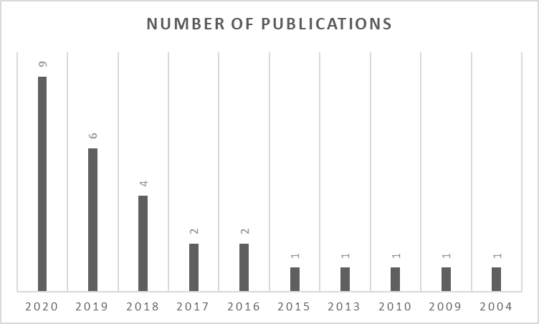

Figure 8: Number of publications based on year of publication

### Pedagogical rationale

Whilst all studies identified in this review have focused on 3D printing and the production of 3D teaching models, the reason for utilising 3D models differed. Some studies have argued the importance of visual recognition challenges that the dental student faces, and how 2D images do not provide a sense of depth without a physical learning model in their hands (Chan et al., 2004, Soares et al., 2013, Boonsiriphant et al., 2019, Cantín et al., 2015). Other studies, especially the ones conducted in the field of oral and maxillofacial surgery, have argued the importance of pre-surgical simulation (Werz et al., 2018, Seifert et al., 2020, Bertin et al., 2020). The ability to produce 3D physical models for simulation has the advantage of mimicking the disease process of individual cases, as well as the ability to demonstrate complex anatomical situations (Lambrecht et al., 2009). The produced models can be used to train surgeons in a dry environment, for pre-surgical planning, and to teach students in the classroom (Lambrecht et al., 2009, Lambrecht et al., 2010, Lioufas et al., 2016). The desire to create models to teach specific clinical skills was not exclusive to oral and maxillofacial surgery education. Several papers have expressed that the necessity for customised 3D-printed models stems from the need to teach specific clinical scenarios the models for which simply do not exist. For example, Chae *et. al*. (2020) created a printed model for training the extraction of supernumerary teeth. Design software was used to incorporate supernumerary teeth inside the print, leading to the possibility of training the extraction process through the palate. The models were found to improve the skills of dental students. In dental traumatology education, Reymus *et. al*. (2018) created a model of a traumatic case that displayed a fractured central incisor and an avulsed tooth. As part of an instructive course, the usefulness of the models was compared to another group that used the website *dentaltraumaguide.org*. While the models were found to be highly realistic and useful, statistical differences were found in favour of the website. This is due to the complexity of the information needed to treat traumatic dental injuries (splint time, recall date, etc…), information that is detailed and readily available on *dentaltraumaguide.org*.

The use of 3D printed teeth as an alternative to natural teeth has been discussed (Cresswell-Boyes et al., 2018). The ability to produce multiple artificial teeth precisely and cost-effectively has the advantage over using natural teeth as they can be difficult to obtain. Furthermore, cross-infection is still a concern as reported by a couple of the articles included (Robberecht et al., 2017, Cresswell-Boyes et al., 2018). One study has investigated the ability of 3D printers to produce tooth replicas for endodontic education and found that 3D printers have sufficient trueness in the production of 3D printed teeth for training (Reymus et al., 2019).

There is a clear trend towards realism in most of the studies found. In fact, only one paper has used a non-anatomic 3D printed model for teaching dental concepts (Chan et al., 2004). This push towards producing anatomically correct models seems logical, especially cavity preparations and surgical simulation, when the aim of the teaching models is to “simulate” dental procedures/pathologies in a real patient. They did not declare why they went for a non-anatomic tooth, but it is suggested that the models they created were presented to dental students very early in their dental education.

### Investigative approach

When considering the use of 3D printed models for educational purposes, there are multiple ways a model can be employed. In the medical field, recent publications show that the use of 3D printing has been prevalent in medical education and clinical medicine training (Malik et al., 2015, Bartellas, 2016). Educational 3D printed models have been used for general medical teaching, surgical teaching, as well as patient education (Bartellas, 2016). Medical teaching applications include teaching medical anatomy and simulation training.

Studies exploring the use of 3D printed models to teach anatomical concepts have shown positive results when teaching spinal fractures, lower limb anatomy, and femoral artery access training (O'Reilly et al., 2016, Li et al., 2015). Models generated through 3D printing have provided a logical, accurate, and affordable alternative to the use of cadaveric materials (McMenamin et al., 2014). A double blind randomised controlled trial pilot study exploring the use of 3D printed models to teach external cardiac anatomy has found that there was a significant improvement in test scores of the group taught with 3D printed models when compared to groups who used cadaveric materials either alone or in conjunction with 3D models (Lim et al., 2016).

Simulation training using 3D printed models presents the students and trainees with an engaging environment where they can train to learn a specific skill, and freely make mistakes and learn from them (Bartellas, 2016). While simulation training has seen great acceptance, a limitation of the lack of different textures of 3D printing materials was noted (Bartellas, 2016). However, current 3D printing technology offers several options that allow for the use of different materials with differing colours and textures within the same print.

In this review, two themes were identified relating to the utility of 3D-printed models. The first group of studies published presented protocols to produce different 3D models with various methods for potential pedagogical applications (Lambrecht et al., 2009, Lambrecht et al., 2010, Chan et al., 2004, Lioufas et al., 2016, Cantín et al., 2015, Boonsiriphant et al., 2019, Cresswell-Boyes et al., 2018, Robberecht et al., 2017, Manjarrés et al., 2020, Nicot et al., 2019). One study by Robberecht *et. al.* (2017) had opted for a slightly different approach where they used 3D printing to create the anatomical shape of root canals and produced ceramic models around those canals to create a teaching model. These papers only introduced the methods and reasons behind creating the 3D teaching models and have not conducted experiments to determine the use and limitations of the models introduced.

Alternatively, the second group of studies have proposed methods for 3D model generation and used them as part of an experiment for simulation training of the subjects who ranged from undergraduate and postgraduate dental students to surgical trainees. Most of the studies identified have evaluated the models after introducing them to students and trained residents by way of questionnaires (Marty et al., 2019, Kroger et al., 2017, Reymus et al., 2019, Reymus et al., 2018, Suzuki, 2016, Soares et al., 2013, Werz et al., 2018, Seifert et al., 2020, Chae et al., 2020, Hanisch et al., 2020, Zafar et al., 2020). The questionnaires were designed to gauge a variety of different outcomes, most commonly the acceptance of the models by the subjects, usefulness of the models, how realistic the models are in terms of shape and texture, and limitations of the models.

Bertin *et. al*. (2020) gave their study subjects two separate questionnaires, one before giving the students the models to evaluate their theoretical knowledge on the procedure (bilateral sagittal split osteotomy) to be performed on the 3D printed model, and one after for feedback on the models. This approach has allowed them to observe practical improvement in the knowledge of the procedure undertaken. While Hanafi *et. al*. (2020) has followed the previously stated structure of giving the students a post-questionnaire for evaluation and feedback, they have also conducted a 2-year qualitative retrospective questionnaire. The students, who were in their final year, reported reduced stress and improved clinical skills after using the new 3D-printed endodontic models.

In a series of papers published by Höhne *et. al.,* (Höhne and Schmitter, 2019, Höhne et al., 2019, Höhne et al., 2020b, Höhne et al., 2020a) they have created several different models to teach various clinical skills and concepts, and fourth-year dental students were given the models to practise on and give their feedback in the form of a questionnaire. However, they have also included a free text section where students were given the chance to give their feedback freely on issues that are not listed on the questionnaire. These questions have revealed valuable information on the models, such as the students’ desire for a harder tooth material in one of the models (Höhne and Schmitter, 2019), and their satisfaction with incorporating a pulp component to the model (Höhne et al., 2019). In one study, Höhne *et. al.* (2020) had the students’ full crown preparation on a new 3D-printed, multi-coloured, and multi textured model evaluated by five experienced dentists. Expert evaluations revealed learning success of the students by reporting a significant improvement in students’ preparations after working on four printed teeth.

Simulation studies have all reported positive results and great acceptance by the subjects who expressed that 3D-printed models were realistic, cost effective, engaging, and serve as a cost-effective alternative. Limitations of the physical properties of the prints were also reported multiple times.

### Source of model design

The design of the model to be printed can be obtained from several different sources. While a model can be designed using specified software, research in the medical field has shown that one of the most common methods of obtaining a model design for printing was through medical imaging (Friedman et al., 2016, Marro et al., 2016). First, usable image data needs to be acquired and saved in a Data Imaging and Communications in Medicine (DICOM) format. This is most commonly obtained through computerised tomography (CT). Other methods include magnetic resonance imaging (MRI) (Lee et al., 2006) and ultrasound (Farooqi and Sengupta, 2015). Afterwards, the data is imported into a software for conversion into a file format recognisable by the 3D printer, with the most common being standard tessellation language (STL) format. Editing and creation of the model meshes and isolation of areas of interest is then carried out on separate software, depending on the planned function of the 3D printed model (Marro et al., 2016).

Studies included in this review have shown various methods of obtaining 3D model data for printing, with the most common method being CT scans, as well as cone-beam computed tomography (CBCT) scans (Lambrecht et al., 2009, Lambrecht et al., 2010, Reymus et al., 2019, Reymus et al., 2018, Werz et al., 2018, Suzuki, 2016, Marty et al., 2019, Bertin et al., 2020, Nicot et al., 2019, Seifert et al., 2020, Hanafi et al., 2020, Hanisch et al., 2020, Höhne and Schmitter, 2019, Höhne et al., 2019, Höhne et al., 2020b), which is a “high-resolution imaging procedure in oral and maxillofacial radiology” (Lambrecht et al., 2010). Other medical imaging techniques used include MRI (Lioufas et al., 2016) and micro-CT scans (Robberecht et al., 2017, Cresswell-Boyes et al., 2018, Höhne et al., 2020a). Furthermore, these imaging datasets were imported into different design software for conversion, editing, and isolation of the area of interest.

Four studies reported using optical intra-oral 3D scanners (Kroger et al., 2017, Boonsiriphant et al., 2019, Manjarrés et al., 2020, Zafar et al., 2020), which is a method unique to Dentistry. With this method, CAD/CAM technology is employed to design, and 3D print the model. Oral scans were corrected for defects and designed in a software similar to the workflow of models obtained from medical imaging, without the need for the conversion of file format step. As opposed to CT and CBCT, optical scanners are more accurate, with the only limitation being its inability to capture structures under the gingiva (Kroger et al., 2017).

### Three-dimensional printing techniques used

In this review, fourteen of the studies included used stereolithography (SLA) (Marty et al., 2019, Reymus et al., 2019, Reymus et al., 2018, Boonsiriphant et al., 2019, Robberecht et al., 2017, Chan et al., 2004, Höhne and Schmitter, 2019, Höhne et al., 2019, Höhne et al., 2020b, Höhne et al., 2020a, Manjarrés et al., 2020, Chae et al., 2020, Hanafi et al., 2020), six papers used fusion deposition modelling (FDM) (Cresswell-Boyes et al., 2018, Cantín et al., 2015, Werz et al., 2018, Lambrecht et al., 2009, Nicot et al., 2019, Seifert et al., 2020), five used Poly-jet (Kroger et al., 2017, Lambrecht et al., 2010, Lioufas et al., 2016, Bertin et al., 2020, Hanisch et al., 2020), and only one paper used selective laser sintering (SLS) to produce the 3D models (Soares et al., 2013). One paper did not declare the technique used to produce their models, as the models have been ordered through a service that provides 3D printed dental models for various uses (Yao et al., 2019).

The approaches used coincide with what has been previously reported as the most common techniques being used at this time, with the most recent papers utilising the SLA technique as it is able to produce more accurate and smoother prints of dental models, as well as not having the disadvantage of the layered look and feel FDM prints tend to have.

While most models produced by these studies were created from a single material, some of the papers attempted different printing approaches to simulate different clinical scenarios. Kröger *et al.* (2017) were aiming to create dental models based on real patient scans, and one of the clinical scenarios they aimed to reproduce was dental caries. The patient scans were introduced into the software, and the carious lesions were programmed as cavities. At the time of printing these cavities were filled with the support material that is part of the printing process, rather than using a different material with a softer texture to fill the cavity. This approach has found positive feedback from the dental students, and the models were reported to closely represent the process of removing soft caries. Another paper by Cresswell-Boyes *et al.* (2018) was attempting to create anatomical tooth models for teaching dental anatomy. In addition to printing a solid tooth using a single material, cross-section models were created by printing each part of the tooth separately. Enamel was printed using a hard white polylactic acid (PLA), while a dentine layer was printed with a softer elastic thermoplastic elastomer (TPE), and both parts were assembled into one tooth model. The paper discussed the possibility of printing the whole cross-section model in one print using a multi-head and multi-texture printer. However, they also argued that the ability to disassemble and reassemble the tooth model could be valuable when teaching tooth anatomy and morphology.

Höhne *et. al*. (2019) produced tooth models with the aim of creating a tooth with different enamel and dentin layers for crown preparation training, hypothesizing that such a model would have educational benefits and would perform better than a traditional tooth model for full crown preparation. After obtaining a CBCT of a first permanent molar, the tooth was designed and separated into an enamel layer, dentine, and pulp chamber. Enamel and dentine layers were printed with different materials where a rigid photopolymer was used to print the enamel. The pulp chamber was filled with pink polyether impression material. Students who got a chance to prepare the printed teeth displayed great satisfaction with the difference of haptics between the different layers and found the presence of pulp very useful. The teeth were deemed very useful by the students in full crown preparation teaching.

The use of multi-texture 3D printing of teaching models appears to have great potential, especially when training pre-clinical dentistry, as the simulation of soft caries, cavities, and different tooth layer hardness provides an approach that doesn’t exist currently in pre-clinical settings (Kroger et al., 2017, Höhne and Schmitter, 2019).

### Gaps identified in the literature

Several gaps were identified in the literature. Perhaps the most obvious one would be the very small number of published papers when compared to medical education (O’Brien et al., 2016, Bartellas, 2016). While there are many publications involving the use of 3D printing in dentistry most of these publications explore the use of 3D printing in clinical applications, such as fabricating surgical guides and aiding in laboratory processes and experimental settings. This review has found that the use of 3D printing in dental education is in its infancy, and more research needs to be conducted exploring the potential impact these models have on dental education.

Another possible gap identified is the lack of co-creation between the investigator and the students. Involving the students in the learning process is instrumental to the success of students in higher education (Bovill et al., 2011). Moreover, it is believed that student engagement and active participation in learning improves learning and outcomes (Kuh, 2008). This is achieved through enabling the students to be critical thinkers and providing them the freedom to do so, as well as breaking the power barrier between students and staff (Darder and Baltodano, 2003).

The models used currently to teach dental students the basic operative procedures are limited. They consist of an expensive model with intact plastic teeth that are lined perfectly in an arch. These models do not mimic realistic clinical scenarios, and basic operative dental skills such as the removal of soft caries are not properly simulated. This subsequently leads to the dental students usually having to learn what it really feels like to remove decayed tooth structure in a real patient’s mouth. Studies in this review show that the utilisation of 3D printing technology has great potential in overcoming these drawbacks of traditional models. Therefore, taking advantage of current 3D printing technology has the potential to aid in the creation of highly specialised, accurate, and more cost-efficient teaching models.

## Conclusions

There is an apparent lack of published work when it comes to 3D printed models and their use in dental education. However, the number of published papers is increasing rapidly, and so does the complexity of the investigative approach utilised. 3D printing technology shows great promise in the creation of dental teaching models, especially in combination with sophisticated imaging techniques; however, some drawbacks of the printing material have been reported. New materials are being developed that would potentially overcome these drawbacks.

A review of the literature has revealed a distinct lack of published work regarding the potential pedagogical application of 3D printing in dental education. The papers published thus far, while promising, have fallen short in two main aspects. The first being that the outcomes of the studies, mostly based on participants feedback and feelings about 3D printed models, were evaluated using very short and close-ended questionnaires. These questionnaires are simply unable to explore the full extent of the students’ attitudes, feelings, and experience towards learning, nor is it able to provide robust evidence regarding actual improvement in the teaching method. The second limitation found was the lack of student involvement in the development/learning process. This research believed that an easy-to-learn and accessible technology such as 3D printing had the potential to bridge the gap between the students and instructors and reach a perfect balance between instructors’ clinical experience and students’ desired way of learning (Ford and Minshall, 2018).

**Note:** Alerts on all the research databases used in this review (with the same search parameters) were set to stay updated on new literature as this PhD project progressed.

# Chapter 3: Aims and Objectives

## Aim:

After analysing the literature and taking into consideration the limitations identified with previous published research in the field of dental education, this research aimed to address the main aims and objectives, while also improving on some of the gaps identified.

This study aimed to evaluate the potential pedagogical value of 3D printed models in pre-operative dental clinical teaching. This potential was evaluated by exploring students’ attitudes, feelings, and experiences after being introduced to the models. The project aimed to co-create the 3D-printed models alongside the students by involving them in the process through listening to their input on the challenges they face when learning operative and restorative dentistry and giving them the freedom to share their ideas on how the technology can be utilised to address their concerns.

## Objectives:

* To explore qualitatively, with the students, insights into their concerns and challenges when learning operative and restorative dentistry concepts using traditional models.
* To analyse the qualitative feedback and design/manufacture 3D printed models that are produced to specifically tackle their concerns.
* To achieve a rapid, accurate, reproducible, and cost-effective manufacturing protocol.
* To introduce the models to pre-clinical teachers and get their feedback and opinions on the models created as part of the co-creation approach.
* To introduce the models to the students and allow them to perform a full operative / restorative procedure.
* To gather quantitative data through questionnaires after the sessions they used the new printed models in.
* To meet with the students and explore their feelings, behaviours, and attitudes towards using the 3D-printed models as opposed to the traditional ones through an explanatory qualitative approach.
* To identify possible limitations and explore potential avenues for improvement.

# Chapter 4: Methodology

## Background:

This project aims to evaluate the effect of using 3D printed models on students’ learning and education through achieving open communication with the students and extracting rich information on their attitudes, feelings, experiences, and reactions towards the new teaching method. To achieve this goal, a qualitative method approach to this project was taken.

## Qualitative research:

Qualitative research includes various methods such as interviews, focus groups, open ended questions, and observations. These approaches are recognised as valuable and powerful research tools in dentistry and dental education (Bullock, 2010). They can be used to explore the concerns and feelings of patients and dental staff towards a new treatment in a clinical setting. They can also be used in dental education to investigate and obtain information on different aspects of teaching and instruction from course assessment evaluation to clinical education (Edmunds and Brown, 2012).

Qualitative research is a methodology that explores, interprets, and extracts information from different phenomena occurring in natural settings (Masood et al., 2010). It focuses on words and what they mean in specific contexts, as opposed to quantitative research which focuses on numbers and how significant they are. Identifying themes and dissecting the information within to extract rich information is one of the cornerstones of qualitative research. This approach allows for the extraction of information that otherwise would not be captured using quantitative methods, particularly when exploring feelings and anxieties of patients, staff, and students. This information can be used for a standalone publication, or as the basis of a larger quantitative (mixed methods) investigation (Basit, 2010).

Three qualitative data collection methods are valuable in dentistry and dental education, which are focus groups, interviews, and concept maps (Edmunds and Brown, 2012). They all require a definite research question and a coherent design of the approach. Focus groups and interviews both employ open questions and active listening to obtain valuable data to be used on its own, or as part of a larger research.

## Focus groups:

For the purpose of this project, the most appropriate data collection method to use with the students was focus groups, this is for several reasons:

* As the literature review has revealed, the use of 3D printed models in dental education is still poorly understood and considered ill-defined, a circumstance where focus groups are appropriate (Kitzinger, 1995).
* Focus groups are frequently used as a starting point, and the information obtained helps shape the direction of the research (Stalmeijer et al., 2014).
* Focus groups can be used to develop new teaching/learning tools based on the students’ needs and interests (Williams and Katz, 2001, Antoniou et al., 2014).
* Focus groups help reduce the power imbalance between the students and teachers, which is an important aspect of the co-creation of student-centred learning methods.
* Focus groups capture the environment and ambience of the group dynamic that often reveals insights into the context in which the student’s realities and experiences were formed (Stalmeijer et al., 2014). Furthermore, open discussion between the participants and the exchange of information helps enrich the information obtained.

Utilising focus groups in a structured and well-designed approach has the ability to aid in the co-creation of the 3D printed models as a first step, as well as extensively analyse and obtain rich information on the effect 3D-printed models had on students’ learning as a final outcome.

## Co-creation:

As technology becomes more open, accessible, and ubiquitous, the new generation of digital learners has grown to expect a more customizable learning experience. However, teaching approaches, especially in higher education, continue to be more teacher-oriented and rarely considers the students’ perspectives, and the divide between teachers and students continues to grow (Garcia et al., 2018). In this regard, authors have pointed out the need to involve students to help teachers acclimate to their needs and preferred learning methods (Nygaard et al., 2013).

Involving the students in the learning process is instrumental to the success of students in higher education (Bovill et al., 2011). Moreover, it is believed that student engagement and active participation in learning improves learning and outcomes (Kuh, 2008). This is achieved through enabling the students to be critical thinkers and providing them the freedom to do so, as well as breaking the power barrier between students and staff (Darder and Baltodano, 2003).

There are multiple different ways to involve the students in the learning process. Examples include students supporting the teachers in technological matters and serving as ‘experts’ (Ringstaff, 1991), provide feedback on new teaching modalities and courses (Bovill et al., 2009, Antoniou et al., 2014), as well as co-design learning schemes (Bovill et al., 2011, Garcia et al., 2018). However, despite the literature suggesting many benefits to involving the students in curriculum and learning design, there is very little systematic investigation of the true impact (Bovill et al., 2011).

When discussing student-teacher co-creation, it is important to address the challenges this approach may present. It is imperative to establish trust between the students and instructors to allow the students to express their views and ideas openly without the fear of repercussions. The design process becomes harmonious and yields richer information when students know that their ideas and thoughts will be taken seriously (Bovill et al., 2009). Another factor is the level of the teachers’ open-mindedness over the whole process. Teachers need to be flexible and accept students’ ideas, as well as have the knowledge and experience to respond to the students’ needs, which results in the students falling into the role of co-designers smoothly (Cameron and Tanti, 2011).

When student involvement is done in a superficial way and for the sake of ‘how the project will look’, there is a risk of generalising the perspectives of the students and not considering the diversity in views and desires (Bovill et al., 2011).

Considering the aims of this research, it was decided that a purely quantitative approach would be too restrictive and would potentially neglect some of the impacts the new teaching models potential had on the students. Moreover, since this research aimed to collect rich and meaningful data through conversation with as many students as possible, 1-on-1 interviews were deemed not feasible as conducting a large number of interviews would take a long time and would miss out on the data that would develop as a result of conversations between the students during the focus groups. However, due to the busy schedules of pre-clinical teachers, 1-on-1 interviews were still the best way for data collection in this step.

# Chapter 5: Research Protocol

Considering the aim of the research and how it can be achieved, the protocol of this project was split into four major parts.

|  |  |
| --- | --- |
| **Part 1** | Dental Students’ Reflections on Clinical Skills Learning Environment and Attitudes Towards 3D-Printing Technology |
| **Part 2** | Design Conceptualization and Manufacturing of 3D-Printed Dental Teaching Models Based on Students’ Input |
| **Part 3** | Teachers’ Feedback on the New 3D-Printed Teaching Models |
| **Part 4** | Exploring Students’ Experiences and Attitudes After Using the New 3D-Printed Teaching Models: A Qualitative Analysis |

## Dental Students’ Reflections on Clinical Skills Learning Environment and Attitudes Towards 3D-Printing Technology

**Sample:** The University of Sheffield’s dental programme extends over 5 years. During their learning journey, within their 3rd year, dental students would have already transitioned into patient care in the clinics, while still having access to the pre-clinical skills learning environment to continue practising other procedures. It was considered a suitable period to study and most valuable for reflection as the students are still experiencing the challenges of clinical transition, as well as starting to identify the possible differences between simulated patients with plastic teeth and real patients.

**Data collection method:** The initial plan for this first stage was to conduct focus groups with 3rd-year dental students. However, due to the impact of the COVID-19 pandemic, that was no longer possible. As an alternative, a voluntary online reflective exercise was developed on Google Forms (appendix 3). The activity consisted of open-ended, non-leading questions that could be answered in a free text format. Participants were given the freedom to write as much as they desired when answering the questions. No minimum or maximum word count was given. More details about the reflective exercise are described in Chapter 7.

**Participant recruitment:** This study aimed to recruit dental students currently learning operative clinical skills in the clinical skills learning environment (CSLE). The sampling strategy was purposive to recruit a homogenous group of 3rd-year dental students.

**Data analysis method:** Thematic analysis of the data gained through the reflective activity was done using Framework Methodology, which was developed in the Qualitative Research Unit at the National Centre for Social Research in the late 1980s (Ritchie et al., 2013). The Framework Method is part of the many analysis methods often known as thematic analyses. However, the Framework Method is uniquely differentiated from other qualitative content analyses in that it utilises a matrix to order and synthesise qualitative data, which results in a highly structured summary of the data that allows for easy comparing and contrasting, a step that is vital for qualitative data analysis (Gale et al., 2013).

Transcribed data from the reflective exercise was dissected to discover common themes across the students’ opinions, context, and tone at each step. The analysis specifically aimed to explore students’ feelings, experiences, and ideas for possible avenues of improvement. The analysis was conducted following the guidelines described by Braun and Clarke (2006) described in the steps below:

1. Familiarisation with the data collected. To explore and digest the data multiple times to understand and assimilate the scope of the data.
2. Generation of codes at the early stages of analysis.
3. Dissecting and identifying themes, with the aid of the generated codes.
4. Reviewing and organising themes identified.
5. Labelling identified themes with appropriate names.
6. Producing the final report.

## Design Conceptualization and Manufacturing of 3D-Printed Dental Teaching Models Based on Students’ Input

Data from the first stage was analysed, and the students’ feedback was organised into categories to identify every challenge and avenue of improvement proposed. Suitable models were created to the point where they are considered suitable to tackle the challenges identified. The 3D printing technique and material depended on the design of the model created.

The models were given to the students during a supervised Intermediate Restorative Skills (IRS) dentistry practise CSLE session. They were given enough time to interact, experience, and work on the models. Students were also allowed to interact with supervisors and ask about anything that pertains to the models, the procedure, or any general theoretical concept.

A short quantitative questionnaire was given to the students immediately after the conclusion of the session to get initial data on what they think of the models they just used.

## Teachers’ Feedback on the New 3D-Printed Teaching Models

The created models were presented to pre-clinical teachers during a set of 1-on-1 interviews. During the interviews, teachers were asked what they think about the new teaching models, 3D-printing in general, and the pre-clinical teaching environment.

**Sampling strategy:** Only teachers involved in pre-clinical teaching in the CSLE were recruited. Prior experience with 3D-printed models is not required, but sampling aimed to recruit a variety of different degrees of experience with printed models in the past.

**Sample size:** 3 teachers were recruited, mainly from IRS course.

**Length of interviews:** 45-60 minutes.

**Setting:** Collection of data was carried out in the School of Clinical Dentistry at The University of Sheffield.

**Ethical considerations:** Ethical approval was obtained (appendix 1 and 2). A signed consent was acquired from each participating teacher (appendix 5).

**Data collection instruments and technologies:** An interview guide was developed to ensure all areas are discussed (appendix 8). A list of question was prepared to facilitate and guide the discussion. All interviews were audio recorded, and physical notes were taken in addition to the recordings. Printed models were introduced at the beginning of the meeting to prompt discussion.

Exploring Students’ Experiences and Attitudes After Using the New 3D-Printed Teaching Models: A Qualitative Analysis A short time after part II (within a few days), four focus groups were conducted with the students that had the chance to work on and interact with the 3D models produced. This step aimed to obtain rich and meaningful qualitative data from the students on every aspect of the experience.

**Data collection method:** Focus groups.

**Sampling strategy:** This study aimed to recruit dental students currently learning operative clinical skills in the clinical skills learning environment (CSLE). The sampling strategy was purposive to recruit a homogenous group of 3rd-year dental students.

**Sample size:** 4 students per group, number of groups was 4, which was the amount needed to achieve saturation.

**Length of focus groups:** 1 – 1:30 hours.

**Setting:** Collection of data was carried out in the School of Clinical Dentistry at The University of Sheffield.

**Ethical considerations:** Ethical approval was obtained (appendix 1 and 2). A signed consent (appendix 7) was acquired from each participating student.

**Data collection instruments and technologies:** A focus group guide was developed (appendix 9) to ensure all areas are discussed. A list of questions was prepared to facilitate and guide the discussion. All meetings were audio recorded, and physical notes were taken to capture the general mood and any observation that might not translate into audio.

Transcribed data from the focus groups was dissected to discover common themes across the students’ opinions, context, and tone at each step. The analysis specifically aimed to explore students’ feelings, experiences, and ideas for possible avenues of improvement. The analysis was conducted following the guidelines described by Braun and Clarke (2006) described in the steps below:

1. Familiarisation with the data collected. To explore and digest the data multiple times to understand and assimilate the scope of the data.
2. Generation of codes at the early stages of analysis.
3. Dissecting and identifying themes, with the aid of the generated codes.
4. Reviewing and organising themes identified.
5. Labelling identified themes with appropriate names.
6. Producing the final report.

**Data analysis method:** Thematic analysis of the data gained through the focus groups was done using Framework Methodology.

# Chapter 6: Impact of COVID-19 on the PhD project

## Introduction:

The original plan of the project was split into four main phases, the first of which was conducting focus groups with the students to gain insight into their attitudes and experiences in dental clinical teaching. The second phase was to design and print 3D models and give them to the students to try and train on during a clinical teaching session. The third phase was to present the newly created teaching models to teachers involved with IRS 3rd-year students. The fourth phase was another round of focus groups to discuss the models, the clinical training, and their overall experience.

## Phase I:

As the pandemic forced all establishments to forgo face-to-face contact, it was decided to look for an alternative method to gain insight into the students’ ideas. The decision was made to submit a voluntary exercise to third-year dental students. The exercise would contain a brief introduction into the technology, illustrations of 3D-printed dental models as an example and give them the opportunity to answer free-text questions on what they feel towards the technology in general and provide ideas to what models can be created to tackle any challenges they face in dental clinical training.

**Consent** was gained through the first page of the google form before commencing the exercise. The page contained the exact wording of the approved consent form and information sheet. Participation is voluntary, and it was made clear that no negative outcome will affect the students if they choose not to participate.

## Phases II, III, and IV:

The plan for the following three phases remained unchanged. However, this project has suffered significant delays to the timeline as two of the remaining three phases required face-to-face data collection. As the whole dynamic of the School of Clinical Dentistry has changed after the pandemic, planning, and scheduling face-to-face research had become significantly more difficult and required more time and planning.

## Supervisory meetings:

Meetings with the supervisors continued monthly through the virtual platform Google Meet. The supervisors were available at any time to meet and discuss anything pertaining to the project.

Chapter 7: Dental Students’ Reflections on Clinical Skills Learning Environment and Attitudes Towards 3D-Printing Technology

## Background

The first stage of the project was to gain insight into the students’ thoughts and experiences on CSLE and to discuss their thoughts and ideas on 3D-printing as a technology. This step was conducted to use the results as a basis for the creation of new 3D-printed teaching models alongside the students, models that address their concerns and employs the ideas they put forward.

Dental education is uniquely differentiated from most other professions as it requires both a theoretical understanding of the human mouth and oral disease process, as well as learning the necessary and often challenging mechanical skills to carry out various dental treatments (Cho et al., 2010). Theoretical understanding is achieved through educating the students on the biology, physiology, and pathology of oral tissues. While challenging, most students overcome the difficulty of this phase with minor issues as they are often familiar with this academic process prior to starting dental school.

The second -and arguably more difficult- phase of dental education is pre-clinical skills training. This is achieved by practising on dental simulators that help the students gain hand-eye coordination, manual dexterity, and mechanical skills (Clancy et al., 2002). This used to be achieved through practising on bench-top plastic models that allowed for the replacement of plastic teeth. However, more advanced dental simulation models were introduced due to the desire for a more realistic simulated experience through dental patient simulators (mannequins) (Perry et al., 2015). Learning experiences of dental students were improved when training on dental patient simulators prior to transitioning into patient care (Perry et al., 2015).

While dental patient simulators have improved pre-clinical training, studies show that there is a knowledge gap identified by students when trying to apply theory into practise (Tuncer et al., 2015, Corrocher et al., 2014, Botelho et al., 2018). This challenge is thought to be caused by the need for the students to develop the necessary motor skills and theoretical knowledge and apply them in a narrow and dark working environment that is relatively unfamiliar despite pre-clinical training on patient simulators (Botelho et al., 2018, Corrocher et al., 2014, Tuncer et al., 2015). Another factor is the significance of the transition period from pre-clinical training to clinical patient care. In most European countries, dental students transition into clinical patient care between their 3rd and 4th year of education (Serrano et al., 2018). Students are required to apply theoretical knowledge, clinical skills, and psychosocial ability into practise and provide successful dental treatments in a short period of a few weeks (Frese et al., 2018). Furthermore, this challenge is compounded by other important factors such as infection control and hygiene protocols, patient communication, and case record documentation.

Recently, dental educators have been developing and optimising cutting-edge technologies for application into dental education, such as virtual reality (VR) simulators (Perry et al., 2015, Towers et al., 2019), haptic simulators, and more recently three-dimensional (3D) printing technologies (Höhne and Schmitter, 2019, Höhne et al., 2019, Höhne et al., 2020b, Höhne et al., 2020a). Out of all the technologies incorporated into dental education, 3D printing is the most cost-effective and accessible one. The printing process of 3D printed models starts by designing the model in a specialised software, followed by transferring the created design onto a 3D printer that creates the model through a layering process. Both the 3D design software and 3D printers are available in most dental schools today.

This chapter aimed to explore student’s attitudes, experiences, and feelings about the clinical skills learning environment (CSLE), traditional patient simulators, and the possibilities that 3D printing technology can offer to enhance and aid their learning in dental school.

## Methods

### Participant recruitment

This study was approved by the School of Clinical Dentistry Research Ethics Committee (No.: 032696) (appendix 1 and 2).

Recruitment of participants was achieved through a university e-mail requesting the students’ voluntary participation in a research project. The e-mail briefly described a reflective activity through which the students could reflect on their pre-clinical skills learning experiences, learn about 3D printing technologies, and get the chance to propose their ideas and suggestions on how their learning could be improved (appendix 3).

Sampling of students was purposive and only 3rd year dental students were recruited. Twenty-three 3rd year dental students agreed to participate in this study by completing the reflective activity. Consent from the students was obtained electronically through a Google Form.

### Reflective activity

After considering the aims of this study, and the impact of COVID-19 on the academic landscape, it was decided that the most suitable data collection method to use was an online voluntary reflective activity sent to 3rd year dental students via Google Forms. The activity started with a section requesting the consent of the participant. The activity consisted of open-ended, non-leading questions that could be answered in a free text format. Participants were given the freedom to write as much as they desired when answering the questions. No minimum or maximum word count was given.

The activity was divided into three sections:

* *Reflections on your time in the Clinical Skills Laboratory Environment*

This section was designed to prompt reflection on the skills the students have learnt in the CSLE so far. Participants were asked about what they found to be the most important thing they have learnt from their time in CSLE and what they found the most difficult concepts to learn are. This section also delves into the students’ attitudes towards CSLE and what role it plays in supporting their education and what was most useful about the space and its’ resources. Participants were also asked to suggest any improvements to the CSLE space and resources that would help their learning. Lastly, participants were asked to give their thoughts on current simulation models and how they have aided their learning.

* *Reflections on your transition into the clinics*

This section focused on the transitional period from the lab to the clinics. Participants were asked to reflect on what they most valued from their time in the CSLE when they first started treating patients. Questions also aimed at what the students found to be very different from what they learned in CSLE (if any), and what they would have liked to do differently prior to treating patients (if any).

* *3D-printing technology and dentistry*

The technology was introduced in this activity by declaring that dental educators are always looking into various ways where dental education in general, and clinical skills training specifically, could be improved. This section started with a short video that gives a concise introduction into 3D-printing technology in general, followed by photos and illustrations of everyday life applications, as well as possible dental applications (found in peer-reviewed papers). Participants were asked what they thought about the technology in general, and if they believed it can be applied to their pre-clinical education to aid and possibly improve the learning process in CSLE.

### Framework analysis of the data

Analysis of the data gained through the reflective activity was done using Framework Methodology. The analysis process consisted of several steps that included: familiarisation with the data, identifying and developing a framework of themes and sub-themes; creation of the matrix in the form of an Excel spreadsheet identifying codes in columns, cases in rows, and cells containing summaries of the data (appendix 11).

## Results

After thematic analysis of the data using the framework method, three major themes were identified. First, the students desire a good structure for learning, five sub themes were identified within this theme: more practise, visual aids, tooth availability, efficiency, and safe environment. Second, the students desire fairness in both equal opportunity for learning and staff consistency. Third, the students desire their learning to be clinically relevant which includes realism, technicality, practise before patients, and softs skills as subthemes.

### Good learning structure

#### More practise

Students reported that they value the ability to practise on artificial teeth in CSLE. *“It provides an opportunity to learn and practise different skills before applying them on clinic*”. Students have also expressed their desire to practise more. “*Being able to practise as many times as you need / until you are confident in a procedure…Practise we had. I felt more confident when I went onto clinics…I would have liked to have more practise*”. This desire carries over when students were asked to consider 3D printing technology for their learning. “*Greater practise on teeth printed…printing teeth gives us more opportunities to practise*”.

#### Visual aids

Students expressed their desire for more visual aids to aid in their learning. “*Computer screens so you can get up any diagrams of preps or videos that have been put on MOLE of the procedure*”. They have also expressed their desire to possibly use 3D printing to create visual learning aids/demonstration models. “*It would greatly help if in course like crown and bridge preps, a pre-prepared 3D model could be available for us to see in person and try to prep our teeth to the same standard. It is very difficult to imagine the final result when we've only seen those preps in pictures and videos. Also, to enable us to see what our final preps/restorations should look like*”.

#### Tooth availability

Students referred to the challenge and frustration associated with the availability of natural teeth to practise on. “*Also, even though natural teeth are the best to learn and practise on, it is very stressful, time-consuming, and difficult to try to find a specific tooth which is also sound*”. Students have also discussed the potential 3D printed teeth have to reduce those stresses. “*Less stress with having more teeth to practise on*”.

#### Efficiency

Students expressed their desire for an efficient learning process in terms of time and convenience, which was heavily mentioned when discussing 3D printing technology potential. *“It looks like it could really speed up the learning process. I found that particularly in BCS, a lot of time was spent trawling through the bucket of teeth trying to find suitable ones*”, “*The opportunity to use resources that are quickly produced within the dental school that are identical*”.

#### Safe environment

Students detailed the value of being able to practise in a low-stakes and safe learning environment. “*It allowed me to build up my confidence performing clinical procedures without the stress of doing it on an actual patient, where I could make mistakes without any significant consequences and try again*”. They have also expressed their desire to learn proper operator and patient positioning when working in the clinic. “*Knowing the correct posture and position for myself and the patient*”.

### Fairness

#### Consistency of staff

Students referenced both the value and frustrations associated with tutor contact. “*The most useful thing about the space is the tutor contact we get. However, to be frank, some tutors are more 'present' than others and I found one of my IRS (Intermediate Restorative Skills) tutors to disappear regularly and I lost on my experiences*”. The desire for a better tutor/student ratio was reported. “*Reduce the size of the groups so we have one tutor between fewer people for more attention. At times you can be waiting for a considerable amount of time because the tutor has a queue of students waiting for them*”.

#### Equal learning opportunity

The importance of equal opportunity and fairness was expressed by the students in terms of the learning environment itself. “*Smaller groups with more encouragement so a positive environment is created not a very negative one*”. They have also discussed the importance of standardization of dental models. “*3D printing provides a standardised approach as each resource would be identical. A slight difference in the resource you are using can dramatically change the outcome of your work*”.

### Clinical relevance

#### Realism

When considering current practise models with plastic teeth students perceived them to be unrealistic when compared to real teeth. “*frasaco teeth are useful however, we don't get tactile feedback with them*”, “*I really like them for practise like in IRS but I think sometimes the contacts can be extremely tight and unrealistic to a patient’s mouth*”. This desire for clinical relevance through realism was echoed when discussing potential 3D printing applications as well. “*I think teeth will be more representative morphology wise to actual teeth so that will be more beneficial to practise on*”, “*If 3D printing is used to make teeth to practise on then I think it will depend on the material as some of the plastic teeth we have used have been so soft they are nothing like a natural tooth*”.

#### Technical

Students referred to some technical aspects related to the value they find in current pre-clinical teaching environments. “*Being able to simulate an environment to being on clinic and using the same materials*”. Associations between the technical readiness of the learning environment and facilitating transition into the clinics were introduced by the students. “*It is always well equipped and has the same materials and equipment that we use on patient clinics so the transition from practising on phantom head to patient is straightforward*”.

#### Practise before patient

This theme was identified after students specifically discussed practising before a certain patient, which is different from the earlier “*more practise*” subtheme discussed earlier in this section. Students expressed the value of practising a specific procedure related to a future patient. “*Or to have the opportunity to go in and practise before you know you have a particular patient coming in*”. This point was echoed by the students when discussing the potential of 3D printing technology in dental education. “*Can practise a tricky procedure on the 'real' anatomy of your patient's dentition - great for if you don't feel confident to do the procedure straight on the patient*”.

#### Soft skills

Students expressed a desire to learn skills that are usually gained through inferential learning through using a specific practise tool. “*I think I would have also tried to find the pulp in one tooth so that I knew where it was - I think through the course I was really worried about it and didn't really appreciate the anatomy*”, “*I don’t think I’d excavated an extensive carious tooth during BCS (Basic Clinical Skills, 2nd Year) so actually doing that was different*”. However, this challenge was not limited to specific teaching models. “*Difficult to think about the patient management following procedures*”.

## Discussion

This study was done to better understand the challenges dental students face during their pre-clinical training, and to discover how we can use this information to introduce new and improved teaching tools and methods to alleviate some of these challenges. The findings have revealed a wide range of desires by the students when it comes to their learning. It has also identified a range of challenges and stressors the students face during their pre-clinical years. The study has also gained valuable information and ideas from the students when discussing three-dimensional printing technologies.

### Practise, confidence, and clinical competence

The study has revealed a strong desire for *more practise*. Students perceived the ability to practise a certain procedure to be very valuable, while also finding an association between practise and confidence. Traditionally, dental students’ psychomotor skills are developed in a pre-clinical environment by practising on a set of plastic teeth that are mounted onto manikin heads. Furthermore, here at the University of Sheffield, VR haptic simulation is used as an adjunct to traditional methods early in the pre-clinical training process, and research shows that using VR haptic simulation in addition to established pre-clinical training methods (phantom heads) can prove very valuable (Farag and Hashem, 2021). Despite this, our students have still expressed a strong desire to practise even more to mainly increase their confidence in undertaking these restorative procedures on patients.

While current pre-clinical teaching practises are designed to simulate dental procedures on patients, research shows that practising on typodonts has proven to be a poor indicator of clinical competency when transitioning into patient care (Curtis et al., 2007, Nunez et al., 2012). This has been largely attributed to the variety of challenges introduced by the patients, the clinical environment, and the complex structure of the clinical administrative body (Velayo et al., 2014, Botelho et al., 2018). However, there is still value in helping the students get more practise in until they gain sufficient confidence in treating patients, as having more confidence is essential for personal development leading to increased clinical competence, increased confidence in communication skills with the patients, and increased sense of appreciation and cooperation from the patients (Fine et al., 2019).

One suggestion proposed by the students was to design and create practical models from the patients’ scans prior to undergoing the clinical procedure. This would theoretically allow the student to practise on an identical copy of the patient’s dentition in the clinical simulation lab prior to doing it on the patient’s mouth, eliminating the surprise factor of some of the challenges that would be unique to that patient’s dentition. This was a logical suggestion given the accessibility and customizability of 3D-printing and manufacturing technologies. This suggests that the students recognise the potential difficulties that are unique to different patients’ dentitions rather than the difficulty of the restorative procedure itself. A study conducted at the University of Sheffield did just that, where they created patient-specific 3D-printed models for practise in conjunction with VR haptic simulators (Towers et al., 2022). Students then carried out the operative procedure on the patient. They have found early evidence that this practise improves students’ confidence when carrying out the procedure on the patient. Furthermore, an incremental learning experience on a specific clinical procedure was reported. The experience was overall positive for the students’ confidence and sense of preparedness.

A similar study on patient-specific models for practicing indirect restorations has revealed an increased sense of confidence and autonomy in the participating students (Tricio et al., 2022). This could be a result of the students placing more value from the learning outcome of realistic patient scenarios rather than the more generic plastic teeth in the pre-clinical setting.

### Transitional stress

Stresses with clinical transition have been observed in this study. Students associated those stresses with the inability of current pre-clinical training to teach certain things like patient communication, post-operative patient management, and the anatomical variety of real teeth. In medicine, transitional stress was attributed to the self-perceived lack of knowledge of the students prior to interacting with patients leading to difficulty in applying their theoretical knowledge into practise (Prince et al., 2000, Godefrooij et al., 2010). In both cases, the authors have highly recommended early exposure to patients as it made the students highly motivated to learn more and enthusiastic and optimistic toward their clinical transition.

In dentistry, the highest levels of stress were found during the 3rd-year of study where students are experiencing the transition from pre-clinic to the clinic while also having the burden of meeting both their pre-clinical and clinical requirements (Alzahem et al., 2013, Botelho et al., 2018). This further cements this project’s initial belief that the 3rd-year of dental study is very important in this type of study, not only because it is the period with the most stress, but also for the fact that it is the year with the most potential for improvement when it comes to providing the students with as smooth a transition into patient care as possible.

As described in the literature, students in this study have reported difficulty in communicating with and managing patients when first transitioning into the clinic, and the desire to have exposure to patients prior to clinical care. These observations are supported by a systematic review of stress in dental students (Elani et al., 2014), and were also later observed by a qualitative study of clinical transition stresses experienced by dental students (Botelho et al., 2018). The difficulty the students face when communicating with patients can be addressed by incorporating role-play sessions, videos, lectures, and interviews with patients which have proven to be effective in increasing communication skills in students (Nor et al., 2011).

### Realism

A frequent desire for realism was observed, where the students wanted the models they would train on to be as close to the real thing as possible. More specifically, students believed that the traditional plastic teeth often fail to simulate more intricate parts of a real tooth such as the tactile difference between enamel and dentin, simulation of pulp, and even the caries disease process. Other students appreciated the realistic clinical setting that is provided in the clinical skills learning environment.

As discussed in the scoping review (chapter 2), most of the papers discussed aimed at providing “realistic” printed models; from multi-layered restorative models that included caries and pulp chambers (Marty et al., 2019, Höhne et al., 2019), to endodontic models for training of root canal treatments (Reymus et al., 2019, Hanafi et al., 2020). More recently, a study by Lugassy *et. al.* (2021) was conducted using multi-layered 3D-printed molars for Class I preparation. The layers were separated into green, yellow, and red to signify the depth of the preparation with red being the deepest layer. The study was aimed at evaluating inter- and intra-examiner reliability and not on student skill acquisition.

In terms of the realism of the clinical environment itself, the students in this study have placed great value in their ability to practise in a realistic clinical setting where the tools and materials used and how they were set up closely followed how they trained in the clinical skills learning environment. Botelho *et. al.* (2018) has posited that the closer the pre-clinical environment resembles the clinic the fewer the gaps in learning would be. However, an article on simulation for aviation training has discussed that while no doubt simulation is a crucial tool for training, simulation alone does not equate to learning (Salas et al., 1998). They recommend that educators should not overly focus on the simulation environment itself, but rather focus on the learning outcome of the trainees.

### Standardisation and reproducibility of printed models

This study’s findings have shown that students value the standardisation of teeth to ensure fairness of outcome. Research shows that 3D-printing technology has the ability to produce highly accurate models, even when compared to traditional production methods used in dentistry such as casting and milling (Lee et al., 2019).

Studies conclude that 3D printers have the suitable accuracy to produce realistic tooth replicas (Reymus et al., 2019). Research also shows that students appreciate the short-term availability of teeth and the standardisation of replicas produced which leads to better comparability and thus leads to greater fairness in simulation training.

### Visual models and tutor availability

When discussing 3D-printing technology and its potential applications in dental education, most of the students believed that the technology has great potential in the production of visual models to use as a guide for the clinical procedure being taught. A series of studies by Hohne *et. al* (2019, 2020) have shown that both students and instructors have found the use of a 3D-printed model showing a proper tooth preparation to be greatly beneficial for the students to use as a visual guide while practising a certain pre-clinical procedure.

Students have discussed the availability of tutors and how sometimes it is difficult to get a hold of a tutor during busier pre-clinical sessions, leading to increased anxiety regarding how their preparation/procedure is progressing. A hypothesis is that the availability of a physical guide for the students to follow has potential in alleviating the demand for tutors during lab training since they have a general idea of what the final result should look like, resulting in fewer inquiries during practise and reduced anxiety while they are progressing with their training.

## Conclusions

* While students valued numerous aspects of the current pre-clinical learning environment, a range of stressors and challenges have been identified.
* Students have presented possible improvements to the current learning environment and 3D-printing technology is perceived as a potentially beneficial tool.
* Data from this study was used to create new and specialised teaching models that aimed to address the students’ desires and challenges identified in meaningful way.
* Realism of teaching models and the ability to practise more were the most requested aspects of pre-clinical skills training.
* Students found the possibility of creating visual guide that aid in their learning to be the most promising application of the technology.

# Chapter 8: Design Conceptualization and Manufacturing of 3D-Printed Dental Teaching Models Based on Students’ Input

## Background

Three-dimensional printing has seen a small surge of new applications in dental education, from printing large scale anatomical models (Lioufas et al., 2016, Werz et al., 2018), to very detailed, multi-layered printed teeth (Cresswell-Boyes et al., 2018, Höhne et al., 2020b). Recent advancements in 3D-printing technologies have improved the materials used and the accuracy of the prints even further. Moreover, the design of the 3D models is further facilitated and improved by using digital scanning to obtain a baseline model that is imported into a design software for further development, creating a seamless digital workflow from clinic/pre-clinic to manufacturing labs. These scans can be obtained from previously existing teaching models, or by scanning patients’ dentition.

The scoping review (chapter 2) has shown that many different 3D-printing techniques were used to design and manufacture dental teaching models, but the most used in dental education by far was SLA, with the most widely used printer being the Form 2 (Formlabs). This technique has been shown to produce accurate and smooth prints of individual teeth (Höhne and Schmitter, 2019), surgical models (Reymus et al., 2018), and even abstract shapes for dental education purposes (Soares et al., 2013). The prints produced by the SLA technique are achieved through selective polymerisation of a photo-curable resin liquid, which has the advantage of no layered appearance of the models produced resulting in a smoother surface. The second most used technique was the PolyJet technique, which also offers the same benefits the SLA prints have, with the added benefit of less post-processing time and easier to clean support structures.

As discussed in the previous qualitative analysis (Chapter 7), the students have expressed the desire for more realistic, consistent, and clinically relevant teaching models. Models produced by the SLA technique have received positive feedback from students in previous research papers (see Chapter 2 – scoping review). It has been reported that the technique is able to produce 3D-printed teaching teeth that are able to train different restorative procedures effectively (Höhne and Schmitter, 2019).

During the process of making the decision on the material to use, different prototypes printed with different printers and various materials were produced. The visual look, tactile feel, and the reaction to hand piece preparation were tested. Tooth models printed with the SLA technique (Denture Teeth A2) had the most and smoothest visual look and performed the best during cutting with the Handpiece. Furthermore, the scoping review has revealed that the most satisfactory results were obtained when the models were printed using the SLA technique. This observation gives us more confidence in the reliability of SLA printing.

With this in mind, the aim was to create teaching models based on the feedback obtained from the students using SLA and PolyJet techniques and explore a series of post-processing options to further improve the final product.

**Aim:** To produce two different teaching models; a practical hands-on model that the students can conduct a full procedure on, and a visual demonstration model to aid them in their preparation.

**Specific Objectives:**

* Apply students’ feedback and ideas during model creation.
* Create models that improve upon previous 3D-printed applications in dental education.
* Employ the best printing techniques based on prototyping and the results of previous studies.

## Materials and Methods:

**SLA Printers Available:**

Several resin printers exist today, ranging from “open mode” printers that allow the use of generic resins, to more curated printers that only the use of resins developed by the manufacturing company. A detailed table showing the most popular printers can be viewed below.

Here at the School of Clinical Dentistry at TUoS, the only the Formlabs printers are available (Form2, Form3b) – Photocentric machine?. Fortunately, as discussed earlier, the Form printers have shown the best and most reliable results when used for the production of Dental teaching models.

**Printing resins available for Form printers:**

Formlabs develops several printing resins for varying different functions, while also producing different colours of their standard resin. One of Formlabs’ most prominent fields of production is Dental applications. Dental materials include; Denture base resin, denture teeth resin, and dental model resins. A table detailing the different resins can be viewed below.

Table 2: Most commonly used SLA printers. Source: www.aniwaa.com

|  |  |  |
| --- | --- | --- |
| BRAND | PRODUCT | PRICE |
| Prusa Research | Original Prusa SL1 | $ 1,699 |
| Peopoly | Phenom | $ 1,999 |
| Formlabs | Form 2,3 | $ 3,000-3,499 |
| UNIZ | SLASH 2 | $ 3,500 |
| DWS | XFAB | $ 6,600 |

**Cost analysis of using 3D-printing to produce the models in this research:**

The argument was made several times previously regarding the cost-effectiveness of 3D-printing when compared to other methods of production. However, a proper comparison of costs still needed to be addressed.

This research aimed to use the Form2 printer to produce the models. Adding up the initial price of the printer, and the price of resin used and the charactarization materials, the estimated cost of the whole process came down to around £3000 (including the initial price of the printer). Factoring in the cost of the charactarization material, impression materials, and printing resin used to produce a single practice tooth, the rough cost of a single tooth came down to around £0.26. A similar study that utilized the same printing equipment and impression material, but printed using a standard Form2 resin, has reported very similar production costs, putting the whole cost of equipment at $4,550 with each printed tooth costing $0.38 (Höhne and Schmitter, 2019).

Comparing these costs to another technology such as milling, where the cost of tapletop milling machines ranges from $30,000-$50,000. Furthermore, using milling to produce an anatomic tooth that simulates a hollow pulp cavity is extremely difficult.

Other manufacturing methods such as advanced manufacturing and contour castings were difficult to analyse in terms of costs. However, these manufacturing technologies require the involvement of a 3rd party, which involves extra costs such as personal labor.

### Practical model

To standardise the production of the models, all digital design decisions, printing, and post-print processing was done by the same operator, Hathal Albagami, to standardise the approach and avoid possible inconsistencies in production.

#### Model concepts

In order to decide what the teaching model should involve; it was important to look in detail at the students’ input regarding their pre-clinical learning from a practical standpoint. They wanted models that are realistic, available, fair, and clinically relevant. Three-dimensional printing as a technology is innately efficient in terms of production. It is cost-effective and the printing process does not take long when compared to other production methods. The technology is also consistent and standardised, with the ability to mass produce the same model multiple times with a high degree of accuracy. This covers the efficiency, availability, and fairness desired by the students.

In terms of realism and clinical relevance, multiple aspects mentioned by the students had to be taken into consideration, the most significant of which is the desire for more realistic models. Another aspect is the desire to learn how to tackle certain clinical scenarios that are currently unteachable using traditional plastic teeth, most commonly the simulation of carious lesions. The desire for the presence of the pulp was also mentioned.

Taking all the previous into account, the plan was to create a realistic practise tooth that includes a pulp chamber, carious lesion, and a defective restoration. This would allow the students to experience a previously unteachable clinical scenario in the pre-clinical setting. Furthermore, the tooth was designed to fit into the commonly used frasaco model (AG-3 ZE, frasaco GmbH) the students already have experience with, which allows us to take advantage of the presence of the soft tissue (gingivae). It would also aid in reducing the cognitive load on the students and help them focus on the new printed tooth rather than be overwhelmed with a whole new dental model and tooth design.

#### Model design

A scan of a lower left first molar #36 frasaco plastic tooth (AG-3 ZE, frasaco GmbH) was obtained using an intra-oral scanner (Primescan®, Dentsply Sirona) as a baseline (frasaco teeth that are specifically used in restorative dentistry training) (Figure 9-A). The scan was exported as a Standard Tessellation Language (STL) file (Figure 9-C). The STL file was then imported onto Pixologic ZBrush® (Maxon Computer GMBH, Los Angeles CA, USA), a digital sculpting software. A carious occlusal lesion was sculpted onto the scanned tooth. The lesion extended deeper mesially and distally without breaking the marginal ridges or penetrating proximally. The lesion also extended buccally, penetrating through the buccal groove (Figure 9-D). These design decisions were made to add extra dimension to the caries removal process, allowing the students to learn when and why should the marginal ridge be removed.

A pulp chamber was created with measurements based on the average distance between mesial and distal cusp tips to their horns in first molars of 18-25 y/o (Khojastepour et al., 2008), measuring at 5.10mm and 5.41mm respectively. A cylinder extending from the pulp chamber was created, with the cylinder opening through the buccal side of the root based on the design by Höhne and Schmitter (2019) (Figure 9-D). A pin-point pulp exposure was created in the middle of the occlusal caries (Figure 10-B). It is worth noting that ideally, the best source of the pulp morphology would be a CBCT scan of a natural tooth. However, despite efforts by the researcher to obtain such a scan, it was not possible at the time of conducting this research.

The screw retention system that used with the existing plastic teeth was substituted for a cylindrical post extending 6mm from the original screw hole (Figure 9-D). This post was added to allow the tooth to fit into the frasaco model with friction without the need for a screw for retention. This concept was originally introduced by Boonsiriphant (2019) to allow for easy replacement of the teeth and was replicated in this study for the same reasons.

#### Model printing

The design STL file was imported onto PreForm Software version 2.18.0. The software was used to set up the printing parameters. The support points were set up around the tooth just under the Cemento-Enamel Junction (CEJ). Support points are usually non-aesthetic and often alter the desired model morphology especially when placed incorrectly. By placing these support points below the CEJ it both kept them out of sight underneath the gingiva and would contribute to the retention of the tooth, as the small spikes left behind by the supports engaged onto the soft material of the gingiva on the frasaco model (Figure 10-A).

The printer used was a Form2 (Formlabs Inc.). The tooth was printed using shade A2 resin (Denture Teeth A2, Formlabs Inc.) (Figure 9-E). The resin was printed at 50µ layer thickness, which is the highest resolution achievable with this resin according to the manufacturer’s instructions.

#### Model post-processing

After the models finished printing, they were taken out of the printer and placed into a “processing tank” of isopropyl alcohol (IPA) for a quick rinse. The models were then placed into the Form Wash (Formlabs Inc.) for 10 minutes according to the manufacturer’s instructions. After the completion of the wash the models were taken out and left to dry for 30 minutes. Models were then placed into a glass beaker filled with Glycerol and placed into the Form Cure (Formlabs Inc.) for 60 minutes at 80°C. This is an additional cure under UV light. The models were then removed and rinsed with water and then dried (Figure 10-F).

**Pulp:** After trying a variety of different materials (Guetta Percha, red sticky wax, and light-body impression materials), the designed pulp space on the tooth model was filled in with pink Ipregum™ Garant™ L DuoSoft™ (3M, 3M ESPE Dental Products), which is a light bodied polyether impression material for dental applications. The material was injected through the opening on the buccal side of the root using a thin nozzle. The result was a soft, flexible, and pink pulp that would have a significant difference in tactile sensation compared to the rest of the tooth (Figure 9-G).

**Caries:** The caries was created using OPTIGLAZE™ colour (GC Corporation) light-cured characterisation material. Red brown colour was used as it presented the most realistic colour resembling caries. A brush was used to apply the material inside the cavity and then the printed tooth was placed inside a light curing box (LiWa Light®, WP Dental) for 3 minutes. The combination of the brush layering and curing for 3 minutes results in an adherent, yet brittle, carious layer which is distinct from the printed tooth (Figure 9-H).

A possible limitation of hand-placing the caries is the variation of the distribution of the caries, which possible affects the standardization of the production method. However, since the caries was placed in a guided lesion patter, and was placed by the same operator, it is believed that these potential drawback are mitigated to an acceptable extent.

**Defective restoration:** The printing resin (Denture Teeth A2, Formlabs Inc.) was used to create the defective restoration. The resin was applied to the cavity above the caries and then cured in a light curing box (LiWa Light®, WP Dental) for 3 minutes (Figure 9-I).

**Polishing:** To improve the matt appearance of the printed teeth and give them a shiny polished exterior, they were polished using a polishing machine (KaVo EWL Polishing Unit). The polishing was done using a soft brush wheel with a white polishing compound (Bego, Metrodent).

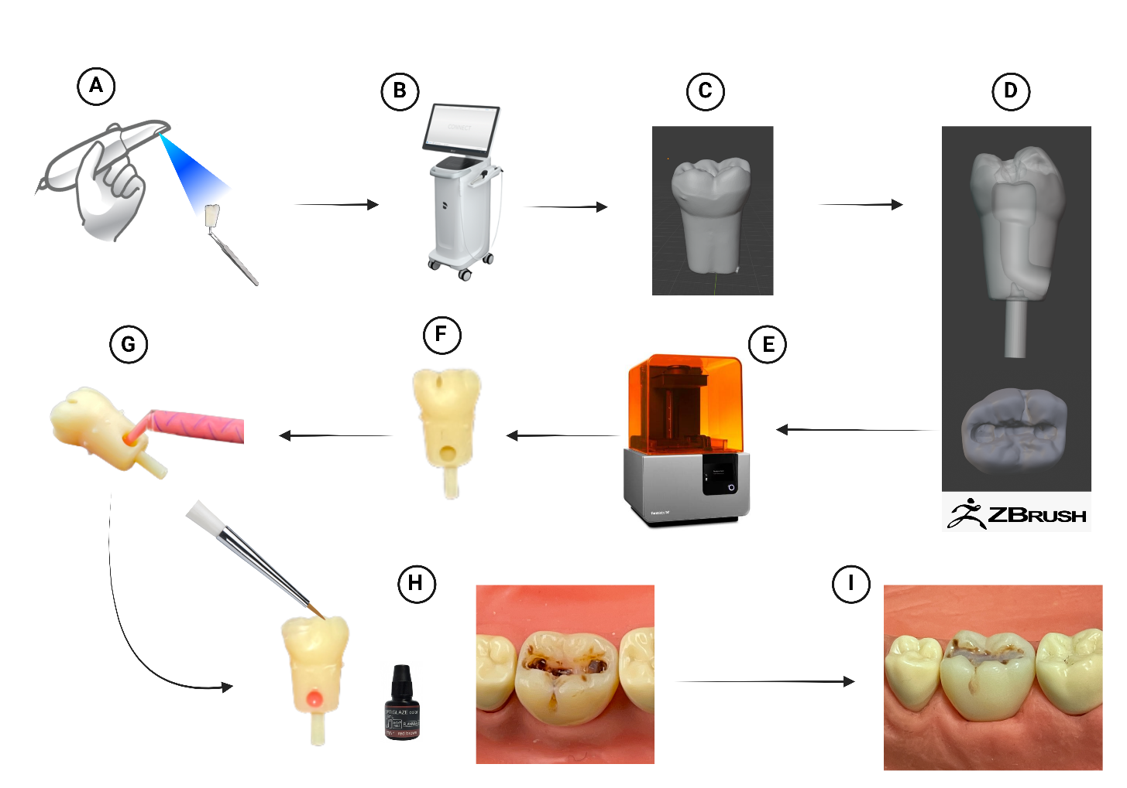

**Figure 9:** A schematic showing the manufacturing process for the printed practical tooth. A) A standard typodont tooth was scanned using an intraoral scanner as a baseline. B) The scan was cleaned and exported using the CAD/CAM software built-in the intra-oral scanner. **C)** An STL file was exported into ZBrush design software. **D)** ZBrush software was used to create the pulp, carious lesion, and post fitting system. **E)** Form2 3D printer was used to manufacture the teeth. **F)** The teeth were cleaned, cured, and washed/dried. **G)** A pink light-body impression material was injected into the pulp compartment. **H)** Optiglaze characterization material was used to create the caries and then light cured. **I)** The final result after creating the defective restoration and finishing/polishing. Created using Biorender.com

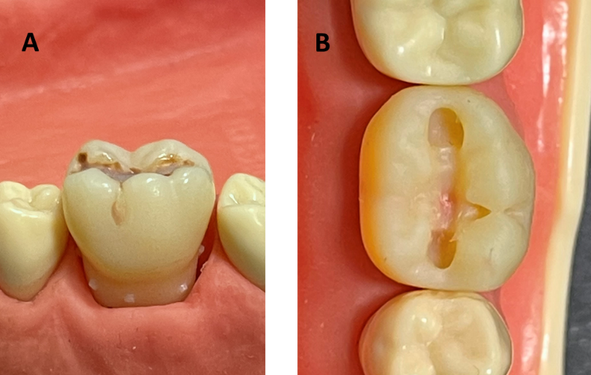

**Figure 10**: **A)** The printed tooth partially inserted into the socket showing the spikes leftover after the removal of the material support**. B)** Occlusal view of the printed tooth showing the pulp exposure prior to the placement of the caries material.

### Demonstration Model

As discussed in chapter 7, one of the most requested ideas by the students was to have a visual 3D-printed model to go along with the procedure they are requested to replicate.

#### Model concepts

The idea was to design a printed visual guide to be utilised alongside the printed tooth we were giving the students to practise on. Therefore, it is imperative that it is known what the procedure the students are learning will be. The plan was to present the novel printed practise tooth as part of the 3rd-year IRS (Intermediate Restorative Skills) course. The printed practise tooth was to be used to practise caries excavation, occlusal and proximal cavity preparation, and finally composite restoration.

One other complaint of note that was brought forth by the students was the issue of tutor availability. Students often expressed the need to ask questions throughout the procedure just to make sure they are on the right track with their preparation/restoration. This could result in a significant increase in tutor demand, resulting in the issue raised by the students of waiting a long time for the tutors to be available again. The hypothesis is that if this need could be directly addressed, this delay could be alleviated and some of the demand on the tutors reduced throughout the practise sessions for basic confirmatory feedback. Therefore, creating a sequential visual model detailing the different steps of the procedure that the student can reference was believed to be beneficial based on the students’ feedback. .

#### Model design

The concept of this model was to create a base comprised of a sextant (#34-37) with a removable tooth #36. A scan of a full frasaco model was obtained (Figure 11-A) and exported as an STL file (Figure 11-B). The STL file was imported into ZBrush software (Figure 11-C). The sextant portion of the model was isolated, cleaned, and finalised (Figure 11-C).

The next step was to design the different stages of the tooth preparation. Due to the organic shape and extent of the designed carious lesion, the tooth was used to practise a caries-driven approach of tooth preparation and restoration. To create a visual model, the method chosen was to physically conduct the whole procedure on the tooth (Figure 12-A) and scan the different stages of cavity preparation at intervals (Figure 12-B, C). The cavity preparation was done by the PhD researcher, with supervision by an IRS staff member to ensure continuity with teaching.

This resulted in three distinct demonstration teeth. Tooth #1 demonstrated the cavity progress after removal of caries and cavity preparation, tooth #2 demonstrated the cavity after preparation, and tooth #3 demonstrated the final cavity preparation with proximal extension (Figure 12-D). The scans were exported as STL files.

#### Model printing

The first few prototypes were printed using an SLA printer (Form2, Formlabs), but there was an issue with printing the demonstration models. Since these models are used for purely visual purposes, the small spikes left by the print supports left an undesirable shape and feel to the teeth. An attempt to fix this by placing the support points into the fitting surface of the printed teeth interfered with the fit of the teeth into the socket of the sextant model and so an alternative was sought.

Therefore, a polyjet printer (J5 DentaJet™, Stratasys Ltd.) was used to print the demonstration models (Figure 11-D). The design STL files were imported onto GrabCAD Print Software version 1.66.7.17878. The software was used to set up the printing parameters. The model base was printed with white material (Figure 11-E), and the teeth were printed in A2 shade (Figure 12-E, F)

The polyjet printer introduced a set of advantages for the models such as minimal model post-processing, the absence of rigid supports, and the ability to print the teeth with pink pulpal tissue by choosing to enhance the support material with VeroMagentaV printing material.

#### Model post-processing

The models were placed into a high pressure water washing unit (Genie-Pro-400, Gemini Cleaning Systems Ltd.). The support material was removed using pressurised water.

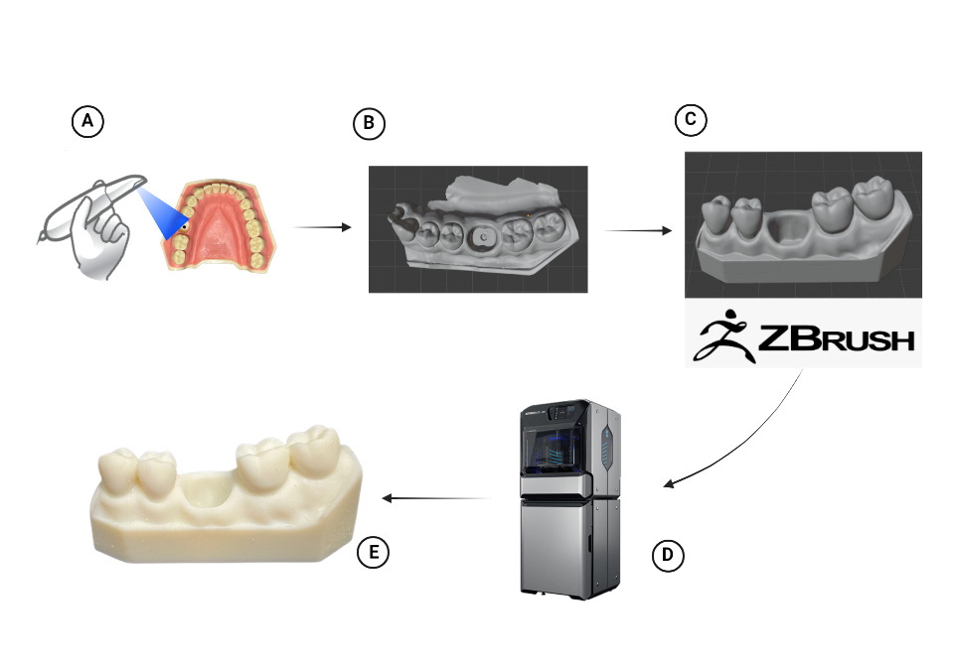

**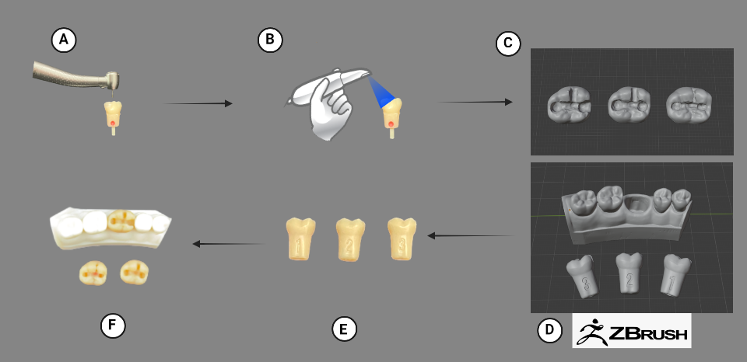Figure 11:** Schematic of the manufacturing steps of the visual model base. **A)** A baseline file was obtained by scanning a frasaco typodont**. B)** And STL file of the scan was obtained and exported. **C)** The STL file was imported into ZBrush design software where the base was cleaned. **D)** Polyjet printer was used to print the model. E) The printed and cleaned finished model.

**Figure 12:** Schematic of the manufacturing steps of the sequential teeth. **A)** The carious printed tooth was prepared. **B)** The tooth was scanned during different intervals of the procedure**. C)** The STL file was imported into ZBrush and numbers were designed onto the teeth in sequence. **D)** The fit and dimensions of the teeth were adjusted for perfect fit into the base. **E)** Printed teeth after PolyJet printing and cleaning. **F)** The fit of the teeth into the visual model base were tested*.*

## Discussion

Throughout the manufacturing process, several printing techniques and printing materials were considered. The first prototype created was a single tooth printed with a FDM printer (Ultimaker 3, UltiMaker B.V.) using an acrylonitrile-butadiene-styrene (ABS) filament. Teeth printed with the FDM technique had a very evident layered appearance, resulting in the dental instruments “catching” onto the models. Another issue with these models was the material rolling onto the dental bur during preparation with the handpiece. A similar phenomenon was observed by Richter *et. al*. (2022). They created a maxillary model with removable molars for teaching conservative dentistry. The molars were printed with a carious lesion in a single FDM print using ABS. While they believe their models were successful, an issue they faced was the “fraying” of the material during handpiece preparation, and suggested that with the advancement of technology, new materials will improve upon this drawback.

Previous studies have simulated caries by using 3D-printing in several different ways. Kroger *et. al.* (2017) simulated caries by creating a cavity in the tooth design and leaving this cavity to be filled by the softer (support) printing material. While the end result was a soft cavity, the support material was extremely soft and identical in colour to the rest of the tooth. Marty *et. al.* (2019) used the same concept of creating an empty cavity but did not fill in the cavity space with any material. Richter *et. al. (2022)* used a multicolour printer to manufacture the tooth with the carious cavity in a single print with white tooth and black caries. While this approach provided a distinct visual difference, the tactile feel of both the caries and the tooth structure was identical as they were printed from the same material. Most recently, Sinha *et. al.* (2022) published a pilot study where they printed an upper right premolar using dental model resin on a Form3 printer. A carious cavity was created in the model and was filled with the same printing material at a lower density of print. Through a Likert scale questionnaire, 63.4% of their students voted “agree” and “strongly agree” that their caries representation was an effective simulation of tactile caries (Sinha et al., 2022).

Höhne and Schmitter (2019) created a single white tooth with a large cavity. The cavity was filled with a softer self-curing resin (Dentalon, Hanau, Germany). The difference in colour and hardness between the tooth structure and the caries material was appreciated by their students. However, it is possible that this approach could be improved by improving the colour of the printed tooth, as well as a more realistic colour of the caries. The approach described in this study has resulted in a more realistic tooth in terms of look and feel during handpiece preparation.

Visual models have always been used in dentistry to help the students understand difficult and complex concepts. Since the introduction of the technology into dentistry, 3D-printing has been used to produce visual teaching models for three-dimensional visualization. The earliest application into dental education was done in 2004 by Chan *et. al.,* where they printed a cube showing the different forms of cavity preparations (Class I, II, etc..) and their depths to help the students visualise the preparations in three dimensions before doing them.

Other studies focused on creating printed models for teaching dental anatomy. Cantin *et. al.* (2015) created and printed an anatomical tooth in one solid material. Later, Cresswell-Boyes *et. al.* (2018) created a multi-layered anatomical tooth, differentiating the different colours of the enamel, dentin, and pulp.

The aim of this work was to create a visual model that aids the students during clinical skills learning in restorative dentistry. Höhne *et. al.* (2019) has created a demonstration model showing the proper crown preparation. The model was found to be helpful to the students. However, it is possible that this concept can be improved by deconstructing the preparation process into different steps. Based on previous research, no deconstructed visual model showing the sequence of preparations has been created yet. Soares *et. al*. (2013) has created a series of visual models showing the different preparation designs for restorative procedures (Class I, II, and MOD) but did not deconstruct the individual steps.

In the end, this study has attempted to progress Höhne’s visual model by adding the different steps and numbering the tooth models accordingly. It is believed that this will students be more confident during preparation training and reduce the load on tutors during the sessions, but this needed to be tested.

## Conclusions

* Using the co-creation model, the students’ suggestions, and feedback on their experience in clinical skills learning environment was used to create teaching models that address their principal concerns.
* Knowledge of 3D-printing technologies and previous applications in dental education was used and modern 3D printing technique and improve upon previous educational applications.
* The next step was to show these models to teachers and get their feedback on their potential application and effectiveness in the classroom

# Chapter 9: Teachers’ Feedback on the New 3D-Printed Teaching Models

## Introduction

In order to create a more effective teaching tool, it was necessary to gain insights on the models from teaching staff involved in restorative dental education within the Clinical Skills Learning Environment (CSLE). It was decided to expand the co-creative approach to involve not only the students and the researcher, but also the teachers who will potentially be using the new 3D-printed models for restorative dentistry training. This approach will give a new perspective on the models while also helping to achieve the most optimal outcome for the students.

Therefore, this chapter aims to explore teachers’ insights and thoughts on the 3D-printed models created based on students’ feedback through 1-on-1 qualitative interviews. This data collection approach was deemed the most appropriate qualitative method as the sample size was small compared to other data collection methods that usually require a larger pool of participants.

## Methods

### Participant recruitment

This research was approved by the School of Clinical Dentistry Research Ethics Committee (No. 032696) (appendix 1 and 2).

The sampling strategy was purposive to recruit teachers who are currently, or have been previously, involved with restorative dental training in the CSLE. The sampling also aimed to include both teachers who have previous experience with 3D-printed teeth, as well as teachers with no experience with them. Recruitment of the teachers was done through a personalised email requesting their participation in this project. Three teachers agreed to participate in this project, two of which have had prior experience with mass-produced 3D-printed teeth for pre-clinical teaching.

### Data collection

The data collection method used in this analysis was 1-on-1 qualitative interviews that were conducted within the School of Clinical Dentistry at The University of Sheffield. The duration of the interviews was between 45 minutes to 1 hour. An interview guide was developed and used to ensure all areas of interest are discussed (appendix 8). A list of questions was prepared to facilitate and guide the discussion. All interviews were audio recorded, and physical notes were taken to capture the general mood and any observation that might not translate into audio. The new printed models were introduced after the initial introductory list of questions to start the specific discussion on what the teachers thought of them.

### Data analysis

Qualitative analysis of the data gained through the interviews was done using Framework Methodology. The analysis process consisted of several steps that included: transcribing the data, familiarisation with the data, identifying and developing a framework of themes and sub-themes; creation of the matrix in the form of an Excel spreadsheet identifying codes in columns, cases in rows, and cells containing summaries of the data (appendix 12). Coding and thematic analysis was carried out using NVivo software (NVivo qualitative analysis software; QSR International Pty Ltd. Release 1.6.1).

## Results

After thematic analysis of the data using the Framework method, the major themes identified were separated into two domains; the first domain was the discussion on the current learning structure in the CSLE, and the second domain was the discussion on the new 3D-printed models themselves. A set of themes and subthemes were identified under each individual domain (Figure 13).

### Current learning structure (domain 1)

#### Realism

The first major theme identified under this domain was realism. Under this theme, four sub themes were identified; the impact of realism on students’ learning, the impact on clinical transition, importance of replicating natural teeth, and the belief that realism is not always the most important thing

##### The impact on students’ learning

Teachers spoke about how important it is to create as realistic of a clinical environment as possible *“with the Typodont set we use, we're often simulating a clinical procedure, but for that really to become important for students in terms of their knowledge and their skills it needs to be quite realistic compared to what we deliver from a teaching point of view*”. Another teacher adding “*I think the closer to reality you can make your simulation than it gives you more opportunity to practise more detailed skills and take that learning to a little bit of a deeper, a more fully developed level*”.

##### The impact on clinical transition

Teachers believe that the more realistic the pre-clinical environment is, the smaller the gap in knowledge when transitioning will be “*If they're carrying out generic procedures in here, that gap becomes bigger, it becomes more challenging for them to apply what they've learned in the preclinical environment into a real patient case. So, I think whatever we can do to make things more realistic in here (CSLE)*”.

##### Replicating natural teeth

Teachers discussed how important it is for any new teaching teeth models to replicate the look and feel of natural teeth “*And so having good quality 3D printed teeth, which replicate enamel, dentin, caries, et cetera, pulp tissue, is the most important thing*”. Later adding “*Just because it will give a better tactile sensation and feedback to the students. So, it's going to make it more realistic and more natural*”. Another teacher adding “*And yeah, having a more realistic anatomical replacement with a Pulp tissue, possibly with caries, as you mentioned, would always be welcome*”.

##### Realism is not always important

A teacher suggested that even if a tooth model is not perfectly realistic, it is still a viable teaching tool “*the fact that it doesn't feel totally real to me is not 100% of a major drawback. I think there's still a huge amount of learning that you can get from positioning on placement and looking at the anatomy and seeing how you handle those areas and where you're going to put the burs and how you're going to use them*”.

#### Potential benefits of 3D-printing

When discussing the current learning structure within the CSLE, teachers have discussed multiple potential benefits that come with the introduction of 3D-printing technology. These benefits include consistency and fairness, cost-effectiveness and efficiency, customizability, promotion of practise, visual guides and teacher load, and the belief that 3D-printing is the future of dental education.

##### Consistency and fairness

Teachers appreciate the consistency of 3D-printing technology and its’ impact on standardisation “*obviously standardisation, every student has the same. They can be assessed to the same standard. We can really discriminate between different levels of performance across the board, across our cohort of students*”. Another teacher added on the technology’s impact on consistency of learning “*Consistency of learning, experience for the students, because you can make a model which is replicated multiple times and you know that all the students are getting the same experience*”.

##### Cost-effectiveness and efficiency

Teachers expressed that they value the efficiency of the printing process and its cost-effectiveness “*the benefit, to put it this way, which I completely agree with is basically you can make it like (snaps fingers) that and it's cheaper, which is great*”. Later adding “*if you could make multiple 3D models, if you could make these available very, very cheaply, then that's a benefit*”. Teachers also compared the cost of printing the model vs the currently used typodont plastic teeth “*Obviously finances could be a big thing because Typodont teeth are expensive, and any kind of caries replacements are even more expensive. So, I think the ability to do that in-house, mass production on a cheaper level would be a benefit*”.

##### Customizability

Teachers expressed their desire for a customizable way of creating specific teaching tools that are tailored to the need of the course “*So, if I'm running a course and I've got 20 weeks I need to plan out I could really tailor each tooth that I possibly could produce to create a nice exercise. I could achieve specific pedagogic gains; I think that's a really big advantage*”. Another later adding “*the ability to create something bespoke and in house that allows the teacher to produce a resource that they have specifically in mind for a student or a group of students to work on. I think it just allows the teacher to use their experience and their knowledge and find that gap that maybe is in the students' learning that they can fulfil by producing something accessible in that environment for the student”.*

##### Promotion of practise

Teachers believe that the printing technology has the potential to promote more practise by the students “*the students would then be able to have as many as they need in order to practise, which is fantastic because I'm sure that they are limited on the number of teeth which they're allowed to practise on because of the cost implications of it*”.

##### 3D-printing is the future of dental education

Teachers believe that 3D-printing will be the future of dental education “*I mean, only really that I think 3D printed teeth for dental education is the future. It is the way that things will inevitably go. We've moved almost exclusively to it away from natural extracted teeth*”. Another teacher later adding “*I think it is the future. I think it is certainly the way to go. I've seen around, certainly in the UK and Europe I don't think very many schools are using natural teeth anymore, particularly after the COVID-19 pandemic. So, it is certainly the way to go. I've*  *got no doubt about that*”.

#### Concerns with the current learning structure

Teachers expressed multiple concerns with the current pre-clinical teaching structure. Limitations of natural (extracted) teeth, limitations of typodont plastic teeth, and the clinical transitional gap.

##### Limitations of natural (extracted) teeth

As mentioned earlier by a teacher, pre-clinical teaching is moving away from the use of extracted teeth, and that is due to multiple limitations “*well, we used extracted teeth which have variable anatomy and can be quite problematic in terms of sclerotic canals, blocked canals, restorations*”. Later adding “*that was always a problem with the extracted teeth as well, because they were quite brittle*”. Another limitation discussed was the risk of cross-infection “*obviously you've got cross infection control issues, storage issues as well. With 3D-printed models you don't need such a resource of natural teeth, which is an issue to obtain*”.

##### Limitations of typodont (plastic) teeth

Teachers discuss the limitations of typodont teeth especially when comparing them to the new 3D-printed teeth “*Because these (points at 3D printed tooth) start to differentiate between the different densities. So, this is where these have an advantage over these (points at plastic typodont teeth) ones*”. Another limitation discussed was the lack of customizability of the typodont teeth “*We deliver cases, we have clinical photographs, and it needs to relate to that. So often I find with the typodont we need to create simulated kind of procedures that would never do on a patient*”.

##### Transitional gaps

Teachers have mentioned transitional gaps as a major concern and argued that teaching less realistic and generic procedures in the pre-clinic could be the culprit “*If you're teaching a lot of generic procedures, then obviously when students go out and see patients, they will have a bigger shock to the system. They will be a bit more nervous about things because they haven't really seen it before. Whereas if we can begin to replicate and make things more similar to real patient situations, then students might find that transition between preclinical and clinical training a little bit easier*”.

### New 3D-printed models (domain 2)

#### Benefits

The first major theme under this domain was the discussion on the benefits introduced by our novel 3D-printed teaching models. Teachers discuss the post-fitting system, the realistic look and feel of the teeth, simulated caries, and the benefits they add to visual learning.

##### Post-fitting system

Teachers expressed their appreciation of the post-fitting system and its convenience “*So, the post system is a really good idea actually. And they fit in really nice. Yeah, that's nice*”. Another teacher later adding “*I like the way that they pop in and out without too much trouble, not too many screws and things like that. Yeah, ease of use is good*”.

##### Realistic look and feel

Teachers talk more about realism in this domain, specifically how realistic the printed teeth look “*The Pulp portion certainly feels realistic, yeah. And the texture of the 3D print feels more realistic*”, later comparing the printed teeth to extracted teeth “*realistic, even potentially more than natural teeth, because the way that natural teeth have been stored, the hardness often becomes a bit unrealistic if you like*”

##### Simulating caries

Teachers mention the challenge of teaching caries removal “*because caries teeth are the big challenge actually to teach and to assess*”, later talking about the printed teeth and comparing then to manufactured typodont teeth “*Being able to simulate realistic dental caries, which is really what I'm interested in, they're by far better than any other Typodont that has caries, that I've seen*”. Another teacher later adding “*I think this is a great example, putting caries in a tooth rather than just drawing the plastic tooth. It's going to be a massive improvement for them in their understanding of how that cavity design works and how that preparation needs to be to manage the caries in that environment*”.

##### Visual learning

Teachers have discussed the visual demonstration models in length and what they appreciate about them “*You've obviously made a demonstration model here as well, which is always useful because students are visual learners. So, if they can visualise the end point and then work towards that, along with the process of course*”. Teachers later discuss the sequential design of the demonstration model “*having multiple examples of the different stages of preparation is a really good idea and a really good visual aid for the students*”. Another teacher later added “*the demonstration model is a really good idea and having a different step to deconstructing the overall task into individual tasks, if you've got individual pieces, to reach the end product is important*”. Teachers also mention the potential benefit that can be gained by introducing similar demonstration models early in the dental education journey “*I like these little demos. For new learners I think it's just great when they've got something, a template to follow. So, I like the way that you've done that, you haven't just presented that and the stages that you've broken that down into steps*”.

#### Limitation

There was one limitation that the teachers mention when talking about the printed practical tooth with the caries and pulp, and that is the lack of distinct tooth layer feel and simulation “*because you don't have something which replicates enamel very well in your 3D printed model, you're still limited in that respect*”.

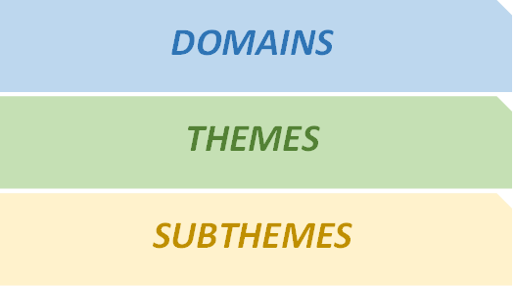

Figure 13: Flowchart of the emerging themes as a result of framework analysis

Current Learning Structure

Potential benefits of 3D printing

Consistency and fairness

Cost-effectiveness and efficiency

Promotion of practise

Customizability

3D-printing is the future of dental education

Realism

Impact on student learning

Impact on clinical transition

Importance of replicating natural teeth

Realism is not always important

Concerns

Limitations of natural extracted teeth

Limitations of typodonts

Transitional gaps

Our Printed Models

Benefits

Post-fitting system

Realistic look and feel

Simulation of caries

Visual learning

Limitations

Does not simulate enamel

## Discussion

This investigation has revealed valuable insights into the thought process of pre-clinical teachers. The qualitative analysis of the data revealed that teachers are constantly aware of the challenges their students face in the pre-clinical learning environment and are always looking for ways to improve teaching. This was especially highlighted when discussing the potential application of 3D-printing technology to alleviate some of the challenges and improve their approach to practical training of the students. The general opinion of the teachers on the 3D-printed teaching models was very positive. In the following few points, the first domain of themes will be discussed and compared with the findings from the students involved in the qualitative analysis in Chapter 7. The second domain of themes mainly pertains to the novel models created and the plan to give to students in the next stage of the study.

When discussing the current learning structure, teachers highlighted the importance of realism in pre-clinical learning and believe that more realistic training leads to a smoother clinical transition and a more competent dentist. A similar desire was expressed by most of the students involved in the qualitative analysis of the reflective activity (See chapter 7, section 4.3). While it is possible that a realistic clinical setting would lead to fewer transitional gaps, it is not always necessary for the whole simulation to be realistic.

Teachers had a lot of negative opinions to say about the currently used typodonts as they are believed to be too generic for advanced students and do not display enough of the actual anatomy of the teeth. This was also the opinion of a lot of the students in Chapter 7. Students agreed, and desired to get tactile feedback from the teeth they use to learn and hoped 3D-printing was a way of achieving that.

### Availability of printed models and promoting practise

The biggest desire expressed by the students in the Chapter 7 analysis was the ability to practise more. When discussing the potential benefits of 3D-printing with the teachers, they believe one of the potential benefits to be the promotion of practise due the availability and affordability of 3D-printed teeth. The 3D-printing manufacturing process of the new teeth has revealed that to be the case. Manufacturing these new models was not as costly as buying the mass produced and manufactured typodont teeth presenting the opportunity of being able to provide more for similar cost.

Moreover, teachers appreciated the customisability of the models. However, while operating a 3D-printer is not a complex process, there is a significant learning curve with regards to the software design of the models. Designing and creating an organic pattern such as a carious cavity is more challenging in a 3D software environment than simply designing geometric shapes.

### Consistency and fairness

The teachers have clearly stated how much they value standardisation in learning, leading to shift away from the use of natural extracted teeth for the training of caries excavation and root canal treatment as they can be quite varied and unpredictable, leading to inconsistent learning throughout a cohort of students. That desire was also clearly stated by the students in Chapter 7 as they wished 3D-printed teeth could possibly aid in a more standardised learning experience between the students.

As discussed previously, 3D-printing as a technology has proven to be very consistent and reliably repeatable (see Chapter 7, section 4.4). Furthermore, during the manufacturing part of this project, this project was able to manufacture 100 practical teeth that were all able to fit accurately within the typodont without any issues. This clearly shows that the production of standardised teeth for a cohort of students of around 70-90 is achievable using 3D-printers.

### Visual demonstration

One of the biggest advantages according to the teachers was the ability to teach the students using visual models as they believed dental students to be mainly visual learners. When the students were asked about what they desired most from 3D technology, the overwhelming majority asked for *more* printed physical models for demonstration alongside their training.

Previously discussed studies have shown the advantages of the use of demonstration models in dental education (see Chapter 7, section 4.5). The expectations for these demonstration models seem to be high. Both the teachers and students see great potential value with these models in terms of their ability to provide the students with extra confidence during pre-clinical training. The next stage of the study was to explore the use of demonstration models in pre-clinical training in more depth with students by giving them the models to use during a clinical skills training session. .

## Conclusion

* The models created were received positively by the teachers interviewed.
* Teachers believed there is additional educational value to be gained using these new anatomical models in the pre-clinical learning environment.
* A high expectation was placed on the visual demonstration models by both teachers and students.
* The next step of this project was to get these new models in the students’ hands and have them practise caries removal and restoration on them in order to gather further feedback on their effectiveness.

# Chapter 10: Using New 3D-Printed Models in a Restorative Pre-Clinical Session

## Introduction

After the co-creation of the models with students, and after exploring the thoughts and insight of teachers towards them, the next step was to get these models into the hands of students to conduct a restorative procedure on. This step was vital as it would assess the success of both the specification and creation of the models (and the co-creation model), and whether they are accepted by the students. Furthermore, it would allow for testing if the materials used to create the models could endure a full restorative session without any mechanical failures.

Therefore, the aim of this chapter was to determine the level of acceptance of the models by the students, and to observe the performance of the new models during a full restorative procedure.

## Methods

### Participant recruitment

This research was approved by the School of Clinical Dentistry Research Ethics Committee (No. 032696) (appendix 1 and 2).

The models were introduced into Intermediate Restorative Skills (IRS) sessions involving a total of 70 3rd year dental students.

### The sessions

In total, there were four sessions, running over two days. Each session was supervised by 3 tutors. Prior to the sessions, a video demonstrating the new printed models was uploaded for the students on BlackBoard (the VLE) before the session. The video included an introduction for both the sequential model and the anatomic practical tooth containing caries and defective restoration. Instructions included how to place the tooth into the typodont and how to remove it. The researcher was present for all sessions to help the students with any issues they encountered with the printed teeth.

Before the session, the students were asked to remove the defective restoration and caries from the new printed tooth, remove the mesio-buccal cusp, and finally restore the tooth with composite. Students were asked to use the demonstration model as a guide throughout the preparation process.

At the end of the session, students were asked to fill out a questionnaire (appendix 10). They were also made aware of focus groups that are happening the few weeks after the session.

### The questionnaire

A short questionnaire was created based on the data from the students’ feedback in Chapter 7, and the teachers’ feedback from Chapter 9. Furthermore, questionnaire designs from previous studies were used as guides for constructing our questionnaire (Kroger et al., 2017, Höhne et al., 2020b, Richter et al., 2022).

Ultimately, the final questionnaire was comprised of 5 different sections; comparing the 3D-printed teeth to traditional plastic models, comparing 3D-printed teeth to natural (extracted) teeth, features of the visual demonstration model, evaluation of the learning process with the printed tooth, and finally a ranking question where the students were asked to rank the different tooth models (plastic, printed, and natural extracted) in order of how much they believe they learned from each model. Besides the ranking question, all other questions were answered by choosing either yes or no as an option.

## Results

Out of the 70 students involved in the sessions, 65 of them agreed to fill in the questionnaire after the end of the session. Results of the questionnaire are summarised in Tables 1 and 2.

### Comparing the printed teeth to standard plastic teeth

When compared to the standard plastic teeth (frasaco GmbH), most of our students have found the printed teeth to have a more realistic feel (86.2%), were a better practise option (89.2%), are fairer option to use for exams (84.6%) and were generally easier to use (84.6%).

### Comparing the printed teeth to real (extracted) teeth

When compared to natural teeth, our students have found the printed teeth easier to use for practise (66.1%), have a realistic feel during preparation (68.3%), and most of them believe the printed teeth to have high practical relevance when compared to extracted teeth (95%). Some of the students involved in the sessions did not have any experience with working on extracted teeth and thus have decided to not answer this section of questions.

### Features of the visual demonstration model

The opinions on the visual models were very positive, with most of our students believing the models to have a clear sequence and were easy to understand (93.8%) and reporting that they felt more comfortable (96.9%) and more confident (98.5%) while practising the preparation during the session.

### Evaluation of the learning process with the printed teeth

Most of our students have reported that using 3D-printed teeth made then more enthusiastic to improve their clinical skills (83.1%). When asked if they would have liked to use the printed teeth for practise during their earlier years, most of the student answered with yes (95.4%). Most of the students believe that the demonstration model and its preparation sequences has helped them improve their preparation on the day of the session (92.3%). Most students believe that the 3D-printed teeth made it easier for them to achieve their goals in correct preparation (93.8%).

### Ranking of learning outcome based on model used

Students were asked to rank the different teaching tooth models (standard, printed, and extracted) from 1 to 3 based on how much they learned from that specific model, with 1 being the most learning outcome and 3 being the least learned. Most of the students have ranked the real (extracted) teeth in 1st place, followed by the printed tooth in 2nd place, and finally the frasaco plastic teeth in 3rd place (table 3)

Table 3: Summary of the questionnaire results

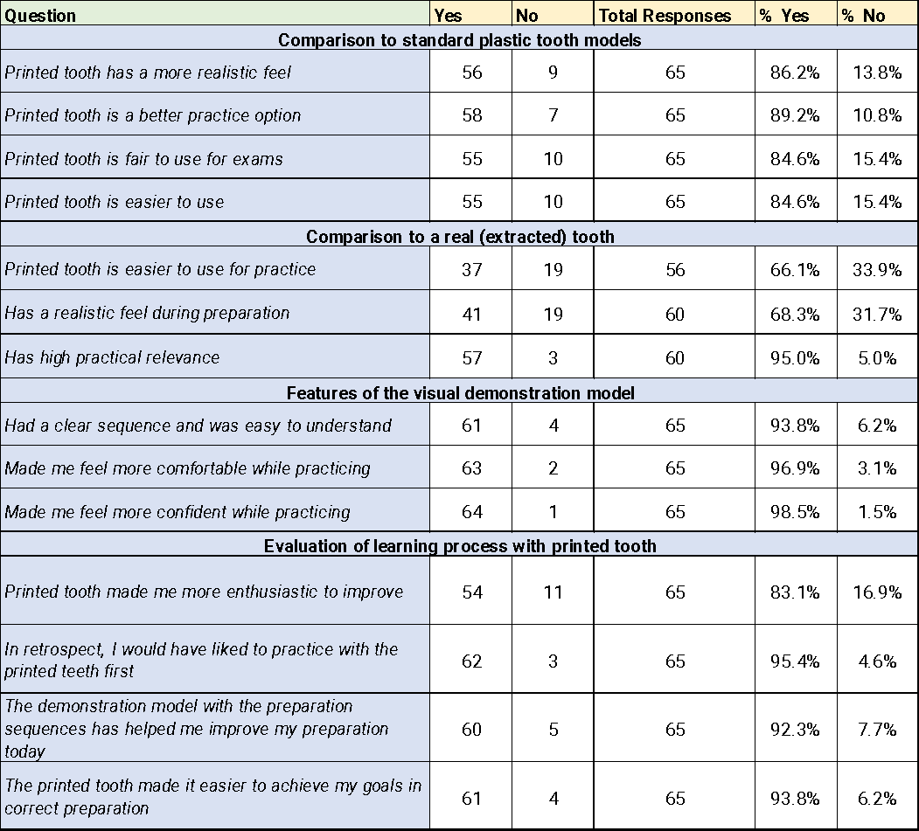

Table 4:Frequency of ranks given to the different teaching teeth

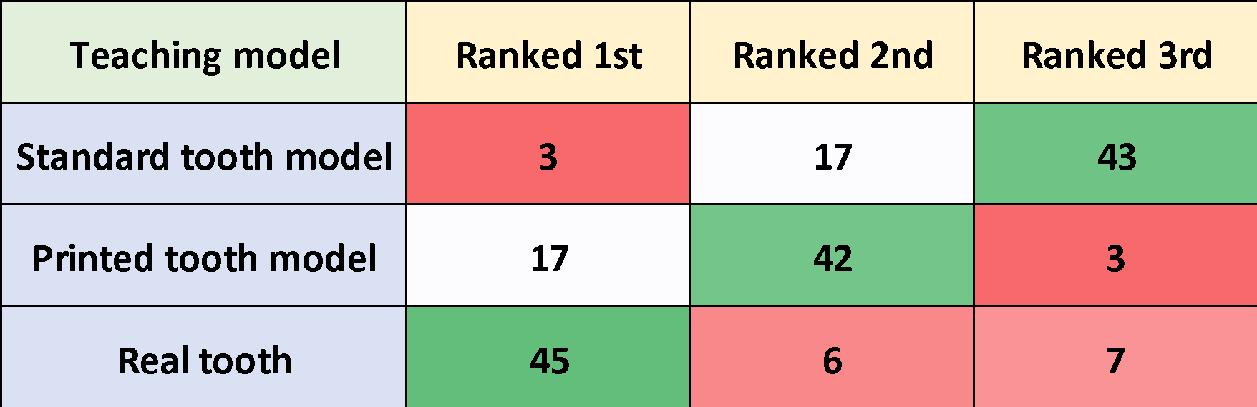

## Discussion

This study has allowed us initial valuable insights into the students’ level of acceptance of the new 3D-printed teeth, especially when compared to other teaching teeth they have been previously exposed to (standard frasaco GmbH plastic teeth and natural extracted teeth).

The printed tooth models were found to be more valuable and reliable than the standard plastic teeth by most of the students. This finding coincides with a previous by Höhne and Schmitter, (2019) where they designed and printed a single molar with a cavity and pulp component. Their questionnaire also compared the new printed tooth to natural extracted teeth and traditional plastic tooth models. Their printed tooth was rated highly when compared to both natural and plastic teeth with an overall “good” score (Ø 2.0).

However, in contrast to Höhne’s paper, the students seem to value learning on natural teeth more, this is evident in the lower percentage of “yes” answers when compared with other sections of the questionnaire and even more evident when looking at the ranking question result. Despite this, the students still believe that the printed tooth still has high practical relevance even when compare with natural teeth. It is this project’s belief that that’s the result of incorporating the carious lesion and the pulp components to the tooth.

More recently, Richter *et. al.* (2022) has created a 3D-printed model using FDM printing technology. They designed a full upper arch with removable molars and a gingival mask. The molars were printed with the caries component in a single print. Their study compares the printed models with traditional plastic teeth by collecting data from both students and experts through questionnaires. Similar to the findings of this study, both their experts and students found the printed tooth to have more realistic look and feel that plastic teeth, with the students rating the printed model highly in every domain.

Learning dentistry often requires understanding complex concepts. Visual aids have always been used to teach these complex concepts such as natural teeth, dental casts, or two-dimensional diagrams and drawings. Therefore, it was not surprising to see dental educators use 3D-printing to create visual demonstration models. Höhne *et. al.* (2019) created a visual demonstration model to guide the students through a preparation on a printed tooth. Both students and experts in their study have reported that the demonstration model has had a positive impact throughout the preparation process.

Mahrous *et. al.* (2021) investigated the use of 3D digital models, AR models, 3D-printed models, and natural teeth for teaching dental anatomy, with the aim of investigating students’ perceptions on the models. They have found natural teeth to be perceived as having the most educational value followed by 3D-printed models. 3D-printed model was also perceived as the most accessible. Similar to the findings in this study, a lot of educational value was placed on the natural teeth. However, while their comparison was purely visual, this evaluation was mainly comparing the realism of look and feel of printed teeth compared to natural teeth.

The sequential demonstration models were received positively by the students, with the overwhelming majority finding the demonstration model to be easy to understand and making them both comfortable and confident during preparation. This is not surprising as previously was found in chapters 7 and 9, a lot of positive expectations were placed on the sequential demonstration models by both the students and teachers.

The printed anatomic tooth has performed exceedingly well, with only 1 tooth failing under pressure (vertical fracture). Students were able to remove the defective restoration, remove the caries, remove the mesio-buccal cusp, and restore the whole tooth with composite build-up without having any problems with the printed tooth. This gives more confidence that teeth printed with SLA have the ability to perform well under most pre-clinical preparations.

While this study has successfully collected data through this questionnaire, the plan is to collect more data from the students through an explanatory sequential approach. It was previously argued by this project against only using questionnaires to reach a conclusion on a new teaching method. Thus, the next step of this analysis is to conduct a set of focus groups to explore the students’ thoughts and experiences with the 3D-printed models during the session. This project also aims to expand the discussion on the findings of this questionnaire to gain a better understanding of the students’ responses.

## Conclusions

* The printed models performed well during the pre-clinical sessions, based on observation and student feedback.
* Despite preferring to learn a preparation on a real tooth, students still ranked the 3D printed teeth higher than the standard plastic teeth.
* The visual models were received very well by the students. In order to understand these results further, qualitative data through focus groups is needed to supplement and explain quantitative data found in this chapter.

# Chapter 11: Exploring Students’ Experiences and Attitudes After Using the New 3D-Printed Teaching Models: A Qualitative Analysis

## Introduction:

Over the past two decades, multiple studies have been published on creating new teaching tools using 3D-printing technology for the purposes of dental education (See chapter 2: scoping review). However, while some authors used free-text questions in their data collection (Höhne and Schmitter, 2019, Höhne et al., 2020b), the vast majority of the papers published have made their conclusions based on quantitative questionnaires alone. However, as argued at the end of the scoping review section, this approach might be too limited and may leave some areas of interest unexplored.

The implementation of new teaching technologies can have multiple complex perspectives, especially for dental pre-clinical teaching where the use of phantom heads fitted with typodonts, and generic plastic teeth has been the norm for many decades now. Thus, this project believed that involving both the teachers and the students in the process of creating and implementing the new teaching models is imperative to achieve the most benefit. It’s also believed that their opinions and ideas should be explored in a meaningful way through multiple different data collection approaches to fully understand the implications the new teaching models may have on the pre-clinical learning environment.

Therefore, it was decided to conduct a set of focus groups with the students that were involved in the restorative dentistry sessions where the new 3D-printed models were introduced. The results of the focus groups were also discussed with findings from the interviews with the teachers from chapter 9.

**Aim:** To conduct an explanatory qualitative analysis in order to better understand the students’ feedback from the questionnaires. Furthermore, to compare the students’ experience and feedback with that of their teachers’.

## Methods

### Participant recruitment

This research was approved by the School of Clinical Dentistry Research Ethics Committee (No. 032696) (appendix 1 and 2).

The sampling strategy was purposive to recruit a homogenous group of students who were involved in the restorative sessions with the new 3D-printed teeth. Recruitment of the students was done through a mass email to all 3rd-year students asking the ones who were involved to voluntarily participate in focus groups.

**Sample size:** In total, 16 students agreed to participate in the focus groups. They were divided into a set of four groups each comprised of four students.

### Data collection

The data collection method used in this analysis was focus groups that were conducted within the School of Clinical Dentistry at The University of Sheffield. The duration of the focus groups was between 1 to 1.5 hours. A focus group guide was developed and used to ensure all areas of interest are discussed (appendix 9). A list of questions was prepared to facilitate and guide the discussion. Information sheets were handed to the students (appendix 6), and they were given time to read through them before signing the consent forms (appendix 7). All focus groups were audio recorded, and physical notes were taken to capture the general mood and any observation that might not translate into audio.

### Data analysis

Qualitative analysis of the data gained through the focus groups was done using Framework Methodology. The analysis process consisted of several steps that included: transcribing the data, familiarization with the data, identifying and developing a framework of themes and sub-themes; creation of the matrix in the form of an Excel spreadsheet identifying codes in columns, cases in rows, and cells containing summaries of the data. Coding and thematic analysis was carried out using NVivo software (NVivo qualitative analysis software; QSR International Pty Ltd. Release 1.6.1).

## Results

After thematic analysis of the data, two major points of discussion were identified and were separated into domains. The first domain is the discussion around 3D-printing in general, and the new 3D-printed teaching models specifically, including likes, limitations, and their suggestions and desires for the future of the models. The second domain revolves around the discussion on the challenges the students face with the current learning structure in the pre-clinical environment and the transition into the clinic. The results including domains, themes, and subthemes are detailed in the next flowchart (Figure 14).

Figure 14:Flowchart of the emerging themes as a result framework qualitative analysis

3D-printed models

General advantages of 3D-printed models

Availability and convenience

Standardization

Customizability

Practical 3D-printed tooth model

Likes and benefits

Dislikes and limitations

Improvements and desires for future models

Visual demonstration models

Likes and benefits

Dislikes and limitations

Desires for future models

Current pre-clinical learning structure challenges

Limitations of standard plastic teeth

Desire for more realism

Transitional stress

Patient management

***DOMAINS***

***SUBTHEMES***

***THEMES***

### 3D-printed models (domain 1)

This domain mainly revolves around the discussion of 3D-printing as a technology in general, and any points of interest identified regarding the newly created teaching models.

#### General advantages of 3D-printed models

The first major theme Identified under domain 1. Some students identified what they believe to be advantages specific to 3D-printing technology, which were split into 3 subthemes: availability and convenience, standardisation, and customizability.

##### Availability and convenience

Students commented on the availability of the teeth when compared to extracted natural teeth *“You don't have to go and find the specific tooth that you need you can just do it on a 3D printed tooth”.* Another point that adds convenience through availability is the ability to practise more “*You can practise many times as you want to before doing the procedure in person*”.

##### Standardization

Students stated clearly how much they value standardization of the learning experience saying when asked about 3D-printing technology “*I think that simplifies a lot of what we do. If it standardized, we learn it exactly the same as everyone else*”. Another student saying, “And everyone's got the same so you can like compare with your peers a lot easier”. Some of the students’ comments were briefer such as “*I suppose it takes out human error*” and “*It's very repeatable*”.

##### Customizability

Students saw customizability of the models produced as an advantage of the technology “*You can practise it. You can tailor it to the case that you've actually got in person*”. Another student saying when asked on the potential benefits of the technology “*The fact that they're customizable. One set of teeth can have class one, the other class four, class three, whatever*.”

#### Practical 3D-printed tooth model

The second major theme identified under domain 1 was the discussion around the practical printed tooth with the caries and pulp components. The discussion mainly resulted in three different subthemes: what they like about the tooth, limitations, and their ideas on how to improve the model and what they desire for future models.

##### What they liked

Many students have talked about how much they liked the caries representation in the printed tooth models. One student who was comparing the models with other manufactured models said “*I think the caries compared to the one we used in second year, the second year was literally like a circular hole in the middle. But then this time it was actually following the fissure pattern. I think that was just more realistic*”. Another student when comparing our caries representation and real caries “*I think especially when it comes to the caries and your 3D printed teeth and the realty. I think it is fairly similar, cause it's all quite soft and you can flick at the walls, scrape the walls. I think to that extent, personally, I feel it's fairly similar or fairly easy to translate from one to other*”.

Another big aspect of what the students liked was the representation of the pulp “*I like the idea of the pulp being introduced, so as students we understand depth reductions and how far we go in through to get an access cavity*”. When talking about deep cavity preparations a student said “*we've never had to do caries removal close the pulp, when to stop, when to pulp cap, we can't do that with our current plastic teeth that has no pulp. So that I think would be quite useful*”. Another student comparing the printed tooth to standard plastic teeth “*I thought it was useful to have the pulp marked out because we don't have those in the plastic teeth. And if you're drilling down, you don't know whether you've actually hit pulp region*”.

Students talked about the post-fitting system replacing the traditional screws, with a student complaining about the screw system “*with the screws, sometimes I found they would come loose. So, when you're using the bur, the tooth would move a bit. Sometimes with the screws to get them in properly, the teeth, there would literally be no gap. Like you could have put a rubber dam, you would have to unscrew the teeth a bit, but then it was loose to drill it. So, it was a bit difficult*”. Another student later adding “*I think in general, it's just more intuitive than the screws though. I like the concept of it*”.

##### Limitation of the practical tooth

When discussing the limitations of the printed practical tooth, one complaint was repeated regarding the hardness of the printing material “*the enamel part was a little bit too soft compared to like normal teeth, but obviously it's a lot better than the plastic teeth*”. Another student adding on the rate of removal during preparation “*Whereas with real teeth it's less difficult than the plastic teeth, but more difficult than the tooth you gave us*”.

##### Ideas for improvement and desires for future models

When we asked the students for their suggestions on how to improve our practical tooth model, most suggestions were regarding the differentiation between enamel and dentin layers “*I said earlier the fact that the enamel was just as soft as the dentine. So, I think that could be improved upon, make it a little bit tougher*”. Other students later adding “*And I think if there was a more visible difference between the enamel and the dentine that would be just more realistic*” and “*I would've liked to see a separateness between caries in the enamel and ADJ and then the dentin, like three layers*”.

Some students asked for more specific representations such as enamel hypoplasia “*If you use the customizability to make teeth, which have enamel defects, like enamel hypoplasia. Because we experience it for the first time in clinic. We've learnt about it. Don’t know what it feels like. Don’t know what it looks like. So, I think that would be interesting*”. Other students asking for more variety in the caries pattern represented “*I think for an exam, it should be standardized. But I think when it comes to learning, if you're going to get those teeth in real life, then it's best to learn, and I think if everyone had the same teeth at once that's fine but change the pattern of the caries and stuff like that. So, it's not the same each time”.*

#### Visual demonstration models

The third and final theme identified under domain 1 was the discussion around the visual demonstration models used as a guide for the preparation of the practical printed tooth. Similar to the previous major theme, three subthemes were identified here: what they liked, limitations, and their desires for future models.

##### What they liked

The students appreciated the demonstration models as a guide for the preparation “*I thought the models you gave us showing us how you would've removed the caries step one, step two, step three, like showing which part you would drill first and how deep you would go. That was quite useful. So, it was good to see what we were aiming for and easier to follow, like the shape*”. Another student adding “*I think I liked also having the sequence of different ideas of how you can prep the tooth. It gave us a bit more dependence. From lectures, you get told, "Clear the ADJ and do this," but you don't really know what that means. And so, having the models, it was really nice to be able to see the different stages of the preparation and what that could mean in real life*”.

A student when talking about the session where the 3D-printed models were introduced said “*I know for me personally, when we had to drill out the caries of the teeth we were given, I flew through it because I knew what I was meant to be doing. Instead of having to stop and stick my hand up to ask a tutor, "Is that right? Or could do a bit more there I could do?" I could just look at those teeth and be like, right, I'm at this stage or, right, I'm not at that stage, or right, I've finished. And if my prep is fairly similar to number three, I can be like, well, I know that I can stick my hand up, get tutors to check it, and move on to the next stage rather than having to get it checked at about two or three different stages*”.

Other students discussed the reduction of tutor load as a result of the visual guide “*It also means the tutors more available; I suppose. Instead of having to sit there with your hand up for 10 minutes while they're saying "That, that, and that needs to be done" you can just be like, Yeah, that's done now*”.

##### Limitation

The one major limitation the students talked about was the restrictiveness that comes with a visual guide “*I doubt myself. I'm thinking I'm not going to be better than that, I'm sure. I just copy it*.” Other students echoed this point “*If you're looking at a pre- drilled model, sort of takes away from the idea that you should be looking yourself and trying to find where it is.*”.

##### Desires for future models

Students recommended introducing similar visual preparation guides earlier in their dental education “*We were younger then, so copying a step by step, would've been more useful for us. Bur usage, knowing what a pulp may look like and different depths of things*”. This point was mentioned multiple times with another student stating “*I think in second year, the steps would've been useful*”.

Some students wanted visual guides for other procedures such as crown preparations “*I think personally crown preps would be useful because if you can see exactly what it needs to look like*”. Another student added “*I think for crowns, these are good*”.

### Current pre-clinical learning structure challenges (domain 2)

Throughout the process of the focus groups, students would always discuss the challenges they face in the pre-clinic at that time. This was identified as a domain of interest with four major themes identified under it: limitations of plastic teeth, desire for more realism, clinical transitional stress, and challenges associated with patient management.

#### Limitations of typodont plastic teeth

Students discussed many different limitations associated with standard plastic typodont teeth “*I feel like if you practise on a plastic tooth that doesn't feel real, it doesn't make that much sense cause it's like, it's actually different on a real patient*”. Other students added “*You can't even guess where it (the pulp) can be*” and “*They’re too perfect*”.

#### Desire for more realism

Students expressed their desire to learn more realistic scenarios with realistic teaching tools saying, “*I feel like, the best way to get better, what you do is practicing on a realistic scenario*”, and “*Because in real life, none of us are going to see patients with absolutely perfect teeth in pain, or patients who want an aesthetic look with perfect teeth. So, we want something that reflects what we'll see in real life*”.

Other students when talking about realism within the context of 3D-printed teeth said “*in the preclinical stage, before you actually see a patient, before you do your first ever filling, you don't really know what that tooth is going to be like, you don't know how it feels to actually drill the real tooth, but if you have kind of little bit of practise of that, even if it's not with a real tooth, if it's with a 3d printed tooth, that kind of feels the same, looks the same in the lab, I’ll be a little bit more prepared for that. It just helps a lot with that*”.

#### Transitional stress

Students talked about the challenges they face during their transition into the clinic and what causes them stress during that period. A student said “*Well, it was all pretty overwhelming. Everything's new*”. Other students adding different stressors during transition “*I mean, sometimes the tutor itself is a stress, yeah? Depending on what tutor you have, sometimes they expect way too much of you way too early*” another adding “*it's more like the skills you can't really practise in a simulated environment like that. You just have to jump into the deep end and just like develop it as you go*”.

#### Patient management

Students discussed the different challenges associated with first interacting with and treating patients “*Moving from the phantom heads to actual patient, I think one of the most like different things in a way is like the soft tissues. It's like the phantom head cheeks are so stiff and like there's just nothing like it*”. Another student saying “*And then in terms of like the transition to clinic, I think it's more just like the patient that's in front of you. So, if the patient's nervous or if the patient doesn't like a certain thing it's really hard to manoeuvre because one, you want to ask the tutor, but then you also want to show some initiative and show that you can work it out for yourself at the same time*”.

## Discussion

The students were very vocal on what they liked and disliked about the new models. Overall, the reception of the new models has been positive. Nevertheless, despite the overwhelming positive feedback from the questionnaires in chapter 10, this investigation was able to reveal different thoughts and experiences with the new printed models that were not revealed through the questionnaires. This analysis has added new valuable insights into what the students really think of the models and gave them the freedom to share how they would improve the models for future applications. Moreover, it will be valuable to compare and contrast the findings here with the findings of the teachers’ interviews. Throughout this discussion, there are references about what the teachers thought of the models, referring to the results of the qualitative analysis in chapter 9 (qualitative interviews). The findings from the students involved in the analysis of chapter 7 (reflective activity) are also discussed.

### Promoting practise, availability, consistency, and customizability

When talking about 3D-printing technology in general, the students placed a lot of value on the availability and efficiency of the technology, and how that could be a big factor in them getting to practise pre-clinical procedures more. In the original reflective entry, most of the students wanted to get more pre-clinical practise in and believed 3D-printed teeth could be the way to achieve that. However, while the teachers believed that to be the case, one teacher brought up the fact that getting time in the Clinical Skills Learning Environment (CSLE) might be the bigger issue here. They believe it might not matter however many teeth are able to be printed, if the students cannot get enough time in the CSLE then that would be the bigger barrier to getting more practise.

While the promotion of practise of pre-clinical skills has different aspects, it is believed that 3D-printing competently solves the issue with standard typodont teeth. Printed teeth are much cheaper and customizable than practise teeth. The students have clearly expressed their dissatisfaction with the currently used standard plastic teeth. In fact, previous analyses from chapters 7 and 9 have revealed the same thing. Both students and teachers believed that the standard plastic teeth do not display enough and need to be improved upon, listing several reasons such as the teeth being too generic and not feeling like cutting a natural tooth.

Similar studies have found the standard typodont plastic teeth to be lacking especially when compared to more anatomic 3D-printed teeth (Höhne and Schmitter, 2019, Richter et al., 2022). Lugassy *et. al.* (2020) created a multi-colour 3D-printed tooth for augmented visual feedback during the preparation of the teeth. In their analysis, their students have declared that the printed teeth were too soft compared to the commercial teeth traditionally used, listing it as a disadvantage of the printed teeth and a positive point for the plastic teeth. However, this is the only paper that compares printed teeth to standard plastic teeth that has found the students preferring the plastic teeth.

In the questionnaire results from chapter 10, the students ranked the new printed teeth higher than the standard plastic teeth and ranked practising on natural teeth highest in terms of pre-clinical practise. The focus groups have revealed that the students found the printed teeth to be too soft during handpiece preparation, particularly the enamel area. The students recommended adding a tougher enamel layer to better simulate a natural tooth. Regardless, the students declared that they still found the printed teeth to be much more useful than the standard plastic teeth simply because they displayed more anatomy and pathology.

At The University of Sheffield, pre-clinical learning sessions are moving away from the use of natural extracted teeth, especially after the COVID-19 pandemic and subsequent restrictions. As declared by the teachers, this is because of two major reasons: The risk of cross infection with extracted teeth, and more importantly the inherent inconsistency of extracted teeth, which results in inconsistent learning experience.

The students have expressed how much they value standardisation of learning, and shared some of the problems they faced when comparing extracted teeth they learned on to the ones their peers used. This is clearly a source of frustration for the students as they want to learn less generic and more realistic clinical scenarios while still wanting the process to be standardised and fair for everyone. This desire was expressed early on in our analysis of the reflective activity filled in by the students, and was echoed by our teachers when discussing the current challenges they face in pre-clinical education.

In this chapter, the focus groups have revealed that the students believed that standardisation and consistency of the printed teeth to be one of the biggest advantages. The technology was able to provide them with a more realistic and less generic learning opportunity while not compromising the consistency and fairness of the learning experience. As revealed from the questionnaires in chapter 10, students believed 3D-printed teeth to be a fair examination option. Similar findings were declared by Höhne *et. al.* (2019 and 2020), where the results of their questionnaires revealed that students agree that 3D-printed teeth could be a fair option to conduct their pre-clinical examination on.

The customizability of the tooth designs was found to be exciting by the students, and they valued the ability to create any procedure they want to learn by tailoring a printed tooth to that procedure. This was also found to be a major advantage by the teachers as well. Both the students and teachers discussed the big benefits gained by having the ability to create bespoke models that aim to tackle a specific gap in the students’ learning, or to create models of clinical scenarios that are simply not experienced in the pre-clinical environment traditionally.

### Visual demonstration

Going into the focus groups, both the students and teachers have placed a lot of expectations on the performance of the visual models. In the reflective activity, most of the students’ ideas revolved around producing visual models to help them learn the complex concepts of preparation design. After creating the visual demonstration model and showing it to the teachers, all of the feedback given on them was positive, and they believed the breakdown of the preparation sequence into three different steps to be a welcome addition. The reception of these visual models was very positive as revealed by the questionnaires from chapter 10.

After exploring the students’ experiences during the focus groups, the opinions on the visual demonstration models were mainly positive. However, the discussions with the students revealed that some of them believed the models were too restrictive, and they felt obligated to achieve the exact same result shown in the demonstration models, without having the chance to reflect on their progress and deciding how to proceed along the procedure. Others believed that the breakdown of the steps were not needed for 3rd-year students as they believed that they were skilled enough to achieve the goal even if only presented with the end result.

Nevertheless, most of the students found the demonstration models to be helpful. As revealed from the questionnaires in chapter 10, students stated that they felt more confident going through the procedure without worrying about how they were progressing. Students also said they had more independence throughout the pre-clinical session, which resulted in less questions for the tutors, which in turn results in alleviating some of the load on the tutors. This reduction of dependence on tutors/instructors was observed by Lugassy *et. al.* (2021). Their printed models had multi-coloured layers showing how deep the students are into the preparation, with green being the acceptable outcome, yellow being a slight overextension, and red being a gross overextension of the preparation. Their students felt less dependent on the instructors as they know how deep they were into the preparation and did not need to ask many questions throughout the procedure.

After the reflective entry in chapter 8, this investigation hypothesized that it is potentially possible to observe a similar phenomenon, and after discussing the models with the students during the focus groups, it was concluded that the visual models in fact helped the students feel less reliant on the tutors during the pre-clinical session.

### Realism

When the students were asked what they think “realism” is, they defined it in many ways, but the definition was always roughly the same. They believed “realism” in learning is “*the closer the learning experience is to the real clinical scenario, the more realistic it is*”. Moreover, the students placed a lot of value in realistic learning scenarios and believed the more realistic the things they learn in the pre-clinic are, the better they become as dentists when they transition into patient care.

The teachers believed that for a practical skill-based profession such as dentistry, the simulations have to be as realistic as possible in order for the students to gain the most benefit. The teachers always strive to improve the learning experience of the students, and that often translates into them improving the teaching tools to be as realistic as possible. At The University of Sheffield, this was done by introducing manufactured teaching teeth that included pathologies such as caries, and more anatomic features such as the representation of the pulp. However, the students have discussed these manufactured teeth and still found them quite unrealistic compared to the natural teeth.

When discussing the representation of caries, the students described their experience with the manufactured teeth to be underwhelming as the caries was represented as “a big hole in the middle”. The representation of an organic expansion of caries created by this project was appreciated by the students and they found such representation to be more realistic than the manufactured teeth they had used previously, and certainly more realistic than standard plastic teeth. In previous literature, the representation of caries in 3D-printed teeth was always appreciated, regardless of how realistic if felt cutting through it (Marty et al., 2019, Richter et al., 2022, Höhne and Schmitter, 2019, Kroger et al., 2017, Sinha et al., 2022).

When the 3D-printed practical tooth was created, it aimed to represent more clinical scenarios that are not typically represented in the restorative pre-clinic. Thus, a pulp chamber was created that was filled with pink material to more realistically display the reddish/pink colour of the pulp under a deep caries excavation. A previous study by Höhne *et. al.* (2019) created a carious tooth with a pulp chamber, but the pulp component was not used as a part of the restorative procedure itself (Höhne and Schmitter, 2019). For a pulp representation to be impactful in a restorative pre-clinical session, the decision was made to involve all aspects created in the restorative procedure itself. Therefore, a pinpoint pulp exposure was created where the caries extended to give the students the experience of a pulp exposure after caries excavation, a clinical scenario not typically represented in the pre-clinical environment.

The students have found the pulp representation of the 3D-printed tooth to be one of their favourite features. Students appreciated the experience of knowing where the pulp is when removing caries and were excited to find that the pulp was exposed after they removed the caries. Some of the students thought the exposure was a result of them being overzealous with their caries removal and expressed their gratitude for such a representation in a safe environment.

Students desire more realism because they want a smoother transition into the clinic. They expressed their desire to be exposed to more realistic scenarios in the pre-clinical environment to reduce the anxiety of having to do a procedure for the first time on an actual patient.

### Transitional stress and patient management

During conversations with the students, they discussed some of the worries they had, mainly relating to the anxiety of transitioning into the clinic and reflecting on their learning in the pre-clinical learning environment.

A range of stressors were identified related to the students’ transition into the clinic. As discussed earlier, many students believe that these stresses could be alleviated by being exposed to as many clinical scenarios as possible in the pre-clinical environment where they feel safe to make mistakes and learn. Some students discussed the teeth they learn their skills on specifically, while others talked about the difficulty in interacting with patients.

As suggested by the students in the reflective entry (Chapter 7), and also by the teachers (Chapter 9), our students find a lot of potential in being able to practise certain procedures in the pre-clinic directly before they perform them on their patient by creating and printing a model of the patients’ dentition and getting the chance to perform the procedure. They believe that this would help them identify the challenging aspects of that specific procedure and would allow them to freely make mistakes and find their way to the best outcome possible (see Chapter 7, Section 4).

Patient management was also a big factor contributing to the stress of clinical transition according to the students. They discuss the role-playing session they underwent as part of their training on patient interaction and management, but they still found it to be not enough. Other students believed that patient management could not be taught and instead they needed to be exposed to it in the clinic and learn as they go. Previous literature has shown patient management to be one of the major stressors associated with clinical transition as well (see Chapter 7, section 4.2).

### Suggested improvements and desires for future models

The main improvement the students desired for the 3D-printed tooth was the simulation of harder enamel over the dentin. Höhne *et. al*. (2020) created a tooth model for full crown preparation that included distinct layer of enamel, dentin, and pulp. However, their approach was to print the enamel separately and cement the enamel layer in post-processing. This results in a significant increase in post-processing time, resulting in a less feasible approach when attempting to generalise the use of such a tooth for everyday pre-clinical learning.

A more realistic solution currently would be to print the tooth with a harder material overall and simulating the caries and pulp the same way. While not an ideal approach, it is achievable and more feasible in the current stage of the technology. As the technology advances, more printing materials and printing techniques could become available that would make this goal more realistic. Students also desire to experience different patterns of caries on printed teeth similar to the ones created through this project. This mainly stems from their desire to experience more during the pre-clinical learning stage.

With regards to the visual demonstration models, many students desired similar models to be created for learning crown preparations. As revealed from the questionnaires, many students would have liked similar models to be introduced during the earlier stages of their dental education and they believed that would be more helpful as they would have been less experience and would have needed visual demonstration models much more than they do now.

## Conclusions

* The feedback on the printed models was positive overall.
* The practical tooth model was found to have a realistic representation of caries and pulp.
* Many different dimensions were added to the students’ responses from the quantitative questionnaire by exploring their thoughts and experiences through a more comprehensive data collection method such as focus groups.
* Students suggested some improvements and gave some ideas to future models.

# Chapter 12: General Discussion

This project set out to explore a promising technology that was able to create cost-effective, efficient, and accurate models, and how it can be used for the benefit of dental education. The driving factor behind this desire was the fact that dentistry as a discipline is very practical and hands-on compared to many other healthcare disciplines. Such a technology was a logical next step for pre-clinical skills acquisition training in dentistry. After using the technology in the early stages of the project, the biggest advantage of 3D-printing became evident, the almost limitless accessibility and customisability of the models that can be produced. However, in order to successfully use the technology for the benefit of dental education, it was imperative to explore its applications in education historically.

Early review of the literature revealed that while 3D-printing was extensively explored and applied to education in multiple disciplines (see Chapter 2), yet its use in dental education was scarce. It was therefore decided that a wide exploration of the literature was necessary in order to determine the number of studies published on the use of 3D-printing technology for the purposes of dental education, and how the technology was utilised. Given that a wide area of the literature needed to be explored and reviewed as a first step, it was decided that the best approach was to conduct a scoping review as detailed by Arksey and O’Malley in 2005, with a focus on dentistry, education, and 3D-printing. This allowed the exploration of a wide area of the literature in a shorter time compared to a systematic review.

The initial version of the scoping review included studies published up to March of 2019. At the time, the review resulted in only 15 studies published. Most of those studies did not involve the students in their investigations and were only proofs of concept of some models that were intended for use in educational contexts. The scoping review was later updated to include studies published up to August 2020. The number of studies found through the review saw a significant rise in number, with 13 more studies published in 17 months. Moreover, the investigative approaches also varied with most of the studies conducting investigations with the students involved by giving them the opportunity to use the 3D-printed models the authors created.

The published studies were spread across a multitude of dental specialities from oral surgery, endodontics and traumatology, dental anatomy, prosthodontics, implantology, paedodontics, and operative/restorative dentistry (Table 1). Different 3D-printing techniques were used in these studies to create various models from large, full-jaw models to individual teeth, based on the speciality the authors sought to investigate (Table 1) (Page 38).

While there were many promising applications of the technology in dental education, several gaps in the literature were identified. Firstly, the low number of studies published on the use of 3D-printing in dental education. Despite seeing a significant rise in number of publications, use of 3D-printing in dental education is still in its infancy. Although it can be argued that the small number of published studies can be attributed to the technology being somewhat new, other disciplines have been investigating and applying the technology for decades up to this point. Granted, the technology has been investigated for many years in dentistry, but most of those investigations revolved around laboratory work and the production of final prostheses (see Chapter 2), and the incorporation of the technology in dental education has been neglected up to this point.

The first study published exploring the use of 3D-printing in dental education was in 2004 (Chan et al., 2004), with the next known work published in 2009 (Lambrecht et al., 2009). Since then, the number of published studies has remained relatively low until 2019, when as stated earlier, the number of studies has increased significantly. The recent surge in publications could be attributed to the increase of accessibility of the technology as a result of the introduction of more affordable options.

The second limitation identified was the fact that all the studies published up to that point based their conclusions on the success of their models through quantitative questionnaires only. Whilst the success of new teaching models can be judged through quantitative questionnaires, there is a risk in neglecting a lot of different aspects of the impact of the new teaching tool on the students’ learning by not exploring their subjective experiences in a meaningful way.

The last gap identified was the lack of student involvement in the conceptualisation and creation of the printed models. One of the biggest advantages of 3D-printing is its accessibility to students of all levels. The scientific basis of 3D-printing is not very complex, and undergraduate dental students have the ability to comprehend difficult concepts such as cavity preparation and design. Therefore, understanding 3D-printing design concepts and discussing them with the students should not be difficult. The involvement of students in the development of such a technology was a logical step towards improving their learning.

With all of this in mind, this project aimed to find the potential educational value of 3D-printed models in dental education. Moreover, the project also aimed at approaching the research in a way that improves on the under-reporting found in the literature and innovating with the teaching models created. To investigate how the technology can improve dental education, the approach of this project needed to focus on one specific area of learning. Taking into consideration the researcher’s background as a teaching assistant in the Restorative Dentistry department, and their clinical certification in Operative Dentistry, this project aimed to explore the use of printed models in Operative / Restorative pre-clinical sessions.

This project aimed to utilise a co-creative approach with both students and teachers to maximise the benefit of the models to be created. This approach was not used in any of the studies published on 3D-printing in dental education. Moreover, this approach helped avoid the shortcomings of similar studies by including the students in their learning and exploring both the students’ and teachers’ experiences, opinions, and feedback on the new teaching models. The first step in co-creating the new teaching models alongside the students was to understand their experiences in the Clinical Skills Learning Environment (CSLE), introducing 3D-printing technology to them, and exploring their ideas on how this technology could be used to create new teaching models.

While the original plan was to conduct focus groups to explore the students’ experiences and ideas, the COVID-19 pandemic resulted in the cancellation of face-to-face research temporarily. Therefore, it was decided that this step would be conducted through a free-text voluntary online reflective exercise. The exercise resulted in rich qualitative data in which the students’ shared their past experiences in the pre-clinic, discussed the challenges they faced, and gave recommendations and ideas on how the technology can be implemented. The students wanted fair, standardised, and realistic teaching models that would allow them to practise more in a safe environment without worrying about the availability of teeth. Students also shared a multitude of different stressors associated with skills acquisition and clinical transition.

Students shared their dissatisfaction with the currently used standard plastic teeth, stating that they were not realistic. Moreover, students had more issues with learning on extracted natural teeth as they were not standardised and not readily available. They wanted to learn realistic clinical scenarios including caries removal and the presence of pulp without worrying about finding a suitable extracted tooth to work on. Considering the students’ inputs, this study aimed to create new and innovative teaching models that address their concerns in a meaningful way.

The first step of designing these new models was to decide which 3D-printing technology was the most suitable for such an application. Dental procedures require attention to the smallest of details, and any model created needed to have a smooth surface to avoid any issues with instrumentation. The aim was to create new teaching models that the students can learn from with hands-on clinical practise. Early prototypes revealed that while FDM printing technology was very cost-effective, the resulting models had a very distinct layered surface that can be felt with instrumentation. This prevents the accurate instrumentation, preparation, and restoration of teeth without the interference of the models’ inherent flaws. Thus, FDM printers were not considered as a suitable option for the creation of these models.

The scoping review revealed that the most used printing technique in the studies on dental education was SLA. Prints produced by SLA typically have a smooth surface with no tangible layers. This technique allowed for accurate, smooth, and cost-effective prints. However, SLA can only produce models using a single material, without the possibility of multi-texture printing. After prototyping with the technology and printing multiple dental models and individual teeth, this technique was deemed the most suitable for the creation of operable dental teaching models.

The next step in model creation was bringing the students’ ideas to reality and creating models that adhered to the limitations of the technology without neglecting to address the students’ challenges. While 3D-printing as a technology inherently addresses the demand for standardised and available tooth models, other desires by the students needed to be addressed in the early stages of model design, such as the desire for more realistic clinical scenarios through the simulation of the pulp and caries. Thus, the aim was to design a model with an anatomic tooth that simulates caries and pulp.

Early prototypes created were printed full arches with the model base, gingivae, and teeth which were printed with a single material. The limitations of this approach were quite evident early on as such a design limits the possibility of enhancing the models through post-processing. Furthermore, the gingiva that was printed as part of the model was the same tooth shade and rigid, resulting in an unrealistic representation of the soft tissues. While the project aimed to innovate with the models created, that did not necessarily mean a complete overhaul of the dental models used today. Typodonts can still simulate gingivae well enough, and students were comfortable with using them. Introducing a single printed tooth had the advantage of reducing cognitive load on the students and helped them focus on the tooth and what it simulates. It was then decided that the best approach of simulating a single, anatomic, practical tooth that simulated caries and that can fit into the typodonts the students currently used. In doing so, it was necessary to ensure that the teeth produced would be able to be fitted to the existing typodont models easily (allowing for easy swapping if required).

After making that decision, another look at the literature was needed. The first concept of printing a tooth and fitting it into the typodont was introduced by Boonsiriphant *et. al.* (2019). They detailed a way for printing a tooth and fitting it through a post system. The teeth they created were for visual purposes, printing a tooth showing a proper crown preparation. A series of studies published by Höhne *et.al.* (2019-2020) have utilised this post-fitting technique and printed teeth that fit into the typodonts with a “click-in” system.

The first few software designs prototypes have revealed that a click-in system would be difficult to implement on the frasaco (frasaco GmbH) typodonts. The screw holes in frasaco models were smaller, and such a fitting system might not be stable enough for a full preparation during a pre-clinical session. Thus, to improve upon this fitting system, a purely friction-based fitting post had to be designed and printed. Such a design had to be 100% accurate to the size of the hole available to the post, and multiple versions of the post were designed and printed for trial. Ultimately, the design and printing of a post fitting tooth through friction with excellent retention was successful.

The next step in creating this practical tooth was to simulate caries and pulp. The most successful caries representation was reported by Höhne and Schmitter(2019), where they simulated caries by creating a cavity in the model’s design and filled it in with a soft material after printing. In their study, they reported that the softer texture of the caries representation and the different feel between the caries and the rest of the tooth was rated “good” to “very good” by both the students and experts involved in the study. Moreover, they simulated the pulp by creating the pulp chamber in the model design and filling in the pulp compartment with pink-coloured light-body impression material.

It was decided in this project that this was an approach worth exploring, but there was definitely room for improvement. Firstly, the colour of the printed tooth was pure white, which was relatively unrealistic, and looked very different to the rest of the standard teeth fitted into the typodont. The printer used for manufacturing the tooth by Höhne and Schmitter(2019) was the Form 2 printer (Formlabs Inc.), which was the same SLA printer available at The School of Clinical Dentistry. This printer had a closed system, and the users were restricted to the photocured resins provided by Formlabs. While the selection of resins was restrictive, a few resins were introduced recently for specific dental applications. One of those resins was a Denture Teeth resin that was provided in multiple different dental shades. After prototyping and using a handpiece on multiple teeth printed with different resins, the denture teeth resin was deemed the most suitable to use. This resin had the advantage of perfectly mimicking the colour of typodont teeth (shade A2). Moreover, it had a more robust and harder feel during handpiece preparation as opposed to the softer white and grey resins.

The second aspect to be improved upon was the simulation of caries. Höhne and Schmitter (2019) used a self-cured resin (Dentalon, Hanau, Germany) to simulate the caries. This material was not readily available for use in the UK, especially after the restrictions and difficulties introduced by the COVID-19 pandemic. However, from the pictures provided by the authors, the material had a colour close to the colour of teeth and was only distinguishable from the rest of the printed tooth because the tooth was printed with a white resin. A self-cured glass-ionomer (Fuji XI, GC Corporation) was used during the development of the printed tooth created from this project. However, the material was not suited to simulate caries as it was too rigid during cutting and had a similar shade to the printed tooth. To improve the simulation of caries, more options that provided darker shades were explored. Ultimately, a light-cured charactaris ation material (OPTIGLAZE™ colour, GC Corporation) was used to simulate caries. This material had the advantage of realistic colour representation and was softer and more brittle during handpiece preparation compared to the rest of the printed tooth, resulting in a more realistic look and feel.

This project aimed at creating a tooth that represents specific clinical scenarios that are not typically experienced in the pre-clinical learning environment. The designed tooth was a single tooth that fit into the typodont through a post and had a cavity and caries components. The first clinical scenario that was added to the tooth model was a defective restoration. Since the best way to simulate soft and brittle caries was to create a thin dark layer of the characterisation material, some space was left above the carious lesion. That space was filled by the printing resin (Denture Teeth A2) and light cured. This approach resulted in a defective restoration over the caries that was weaker and softer than the rest of the tooth, since the defective restoration was only light-cured, as opposed to the tooth which was placed in the light-curing unit (Formlabs) for 60 minutes at 80°C.

The second clinical scenario this project aimed to simulate was a pin-point pulp exposure. A pulp chamber was designed based on the method detailed by Höhne and Schmitter (2019). This project improved upon this isolated pulp design by creating a pin-point pulp exposure under the deep carious lesion, which allowed the students to experience and visualise the location of the pulp during restorative procedures.

After exploring the technology, prototyping on different printers and materials, exploring the literature for promising designs, adhering to the design specifications desired by the students, and improving upon most aspects of said designs, the result was a shade A2 printed molar that simulated a defective restoration, deep caries, and pulp exposure. The tooth looked and felt realistic during preparation and restoration and had excellent retention in the typodont through the improved friction-based fitting system.

The most suggested idea by the students during the reflective activity was the creation of a 3D-printed visual guide. The scoping review has revealed multiple studies that used 3D-printing technology to produce visual demonstration models in various dental specialities (see Chapter 2: Scoping Review). For the purposes of this project, special focus was placed on models produced to teach restorative concepts through a visual model. Chae *et. al.* (2004) simulated different preparation designs by printing a cube with the preparations on it. Soares *et. al.* (2013) created a series of teeth to demonstrate different operative dentistry cavity designs. Höhne *et. al.* (2019) produced a visual preparation guide for full crown preparation.

All of the past examples of visual restorative models presented the final product of a preparation. This project’s approach on improving these approaches was to deconstruct the preparation process in multiple different steps, giving the students the chance to evaluate their progress step by step and having the confidence to do so in the process. Thus, the decision was made to create a deconstructed visual demonstration model that was a guide for the preparation of the printed practical tooth created previously. Therefore, under the supervision of a pre-clinical restorative instructor, the printed tooth was prepared, and the steps of the preparation were evaluated by the instructor and scanned every step of the way. The resulting demonstration model was a sextant with multiple removable first molars numbered 1,2, and 3 breaking down the different steps of the cavity preparation.

Late into this project, a polyjet 3D-printer (Stratasys J55) had become available at The University of Sheffield – School of Clinical Dentistry. This printer had the advantage of allowing much faster prints. Moreover, through design manipulation in the printing software, it was possible to print a tooth with soft and reddish pulp in a single print without the need to add the pulp in post-processing. But perhaps the biggest advantage of this printer was the possibility for multi-colour, multi-texture prints, which added numerous possibilities to printing designs. While it was too late at this point to use it to produce the practical tooth, the printer was used to print the designed visual demonstration model.

At the end of the manufacturing process, this project successfully managed to produce a practical tooth model that simulated a defective restoration, caries, pulp chamber, and pin-point pulp exposure. Moreover, this practical tooth was accompanied by a 3D-printed visual guide that breaks down the different steps of the preparation. The students’ desires for the realistic simulation of more clinical scenarios and a 3D-printed guide to help them visualise procedures have been addressed. 3D-printing technology successfully provided the students with a realistic and available alternative to standard plastic teeth and natural extracted teeth. The aim to achieve a rapid, accurate, reproducible, and cost-effective manufacturing protocol had been met.

The next step of the co-creation approach was to involve the teachers in the process and get their feedback on the models created. Through 1-on-1 interviews, the teachers were informed that these models were created based on the feedback of the students and aimed to address the challenges they faced in their pre-clinical learning. The models received positive feedback from the teachers, with the simulation the caries and pulp being most appreciated. Teachers discussed the difficulty of simulating caries in a pre-clinical setting, and how extracted teeth have been inconsistent and unfair to learn on. Teachers believed the created practical tooth could provide an excellent alternative for teaching caries in the pre-clinic.

The reception of the deconstructed visual guide was very positive. The teachers praised the use of a visual guide to go along with the practical tooth for the students to use as a guide. Similar to the students from the reflective exercise, the teachers placed very high expectations on the visual demonstration model. Teachers also praised the deconstruction of the preparation process. Involving the teachers in the process of creating and introducing the new 3D-printed models has provided this project with a very unique and beneficial perspective. Valuable insights were gained through the interviews, and the data was used to develop a questionnaire and a focus group guide for the last two steps of this project.

The created models were introduced to the students through restorative pre-clinical sessions. A video introducing the new 3D-printed models and demonstrating how to use them was uploaded onto BlackBoard for the students and teacher to view prior to the sessions. The students were told to remove the defective restoration and the caries, remove the mesio-buccal cusp, and then build-up the whole tooth using a composite restoration. Students were instructed to use the visual demonstration models as a guide for cavity preparation.

The printed teeth performed very well in a full pre-clinical session, withstanding full clinical procedure from start to finish with a 98.5% success rate. In fact, only 1 tooth had a vertical fracture and was deemed a failure out of the 70 teeth introduced in the session. Immediately after the end of the session, the students filled out a quantitative questionnaire comparing the printed tooth to standard plastic teeth, extracted natural teeth, and ranked them in order of what they believed had the best potential learning outcome.

The students’ responses to the questionnaire were very positive. The students found the printed tooth to be a realistic, fair, and better practise option compared to standard plastic teeth. Students still found the printed tooth to be a realistic and fair practise option even when compared to natural extracted teeth. The printed teeth made the students more enthusiastic to improve their clinical skills, and the visual demonstration models made them more confident and comfortable during preparation. The students ranked the printed tooth 2nd in learning outcome right after natural teeth, with the standard plastic teeth being last place.

However, the results of the questionnaire were a bit one-dimensional, and a lot more could be explored by having an active conversation with the students. Thus, the final step of this project was to conduct focus groups with the students involved in the pre-clinical session, to explore their thoughts and experiences on the 3D-printed models, and to expand upon their responses in the questionnaires.

Students were recruited to participate in the focus groups via email. A total of 16 students agreed to participate, for a total of 4 focus groups. Students echoed many of the points they made in the questionnaire, discussing how much they appreciated the simulation of the caries, and how excited the presence of a pulp exposure made them feel. Students also appreciated the visual models and how independent and less reliant on the tutors it made them.

While the students rated the visual demonstration models very highly in the questionnaire, some of the students discussed how restricted it made them feel during the preparation, and how that inhibited their self-reflections. Other students believed that the deconstruction of the steps was too simplistic for 3rd-year dental students, and they would have had the same benefit if only presented with the final outcome. The students also rated the natural extracted teeth as the highest learning outcome in the questionnaire, but after exploring those thoughts through conversation, students discussed their dissatisfaction with relying on the inconsistent extracted teeth to experience realistic clinical scenarios.

Analysis of the qualitative data has added more dimensions to the students’ responses in the questionnaire. While feedback can look very positive in a quantitative method, qualitative explanation revealed that there were still more perspectives to explore, and valuable insights can be gained that way.

This project succeeded in producing novel and impactful 3D-printed models through a consistent, repeatable, and cost-effective manufacturing approach that improved upon all aspects of models created previously in dental education. These models were created alongside the students and teachers to tailor them to the specific and unique challenges 3rd-year dental students at the University of Sheffield face in the pre-clinical environment and after transitioning. The qualitative approach has resulted in very rich and significant data that helped shape the progress of the manufacturing and implementation. Furthermore, including the students in the production of their learning has proven to be successful as the students were excited to be part of their learning, enthusiastically offering ideas and suggestions throughout this project.

3D-printing technology proved to have a lot of potential pedagogical value in dental education. Creating specific and custom-made models to teach certain aspects or to overcome specific gaps in the students’ learning are valuable tools that are available to every pre-clinical teacher if they can learn how to design and create the models to support their teaching.

# Chapter 13: Limitations and Recommendations for Future Research

While this project was successful in addressing all its original aims, some limitations were identified during the research process. Firstly, the printed practical tooth was still believed to be too soft compared to both natural enamel and the standard plastic typodont teeth. Unfortunately, the resins available for SLA printing now do not offer any options that realistically mimic the tactile feel of enamel. Resins are either too hard and stiff (Formlabs Rigid Resin) or believed to be too soft during preparation (White, Gray, and Denture Teeth Resin). With a rapidly advancing technology such as 3D-printing, more and more printing materials are developed every day, and researchers and educators should be able to find a material that mimics the feel of dentin and enamel more realistically through experimentation. Future research can also focus on the resin development aspect with the possible involvement of dental educators to produce resins that are specifically designed to produce teaching models.

Another limitation is the use of a non- multi-texture or multi-colour printer. Multi-texture printers offer limitless possibilities when it comes to what models you can design and manufacture. Future research can focus on using these printers to come up with a way to design and print a practical tooth that simulates pulp and caries with a single print. This would streamline the manufacturing process making it more efficient.

More projects on the development of new teaching models need to continue including students and teachers in the creative process. This project managed to do so, and the results were new teaching models that addressed the students’ concerns specifically, and the students placed a lot of value in them as they helped create and develop these models.

Finally, one suggestion for the use of 3D-printed models in pre-clinical education was the production of patient-specific models that the students can use before seeing said patient in the clinic. This was suggested by the students in the reflective exercise, by the teachers in the qualitative interviews, and by the student again in the focus groups. Students and teachers find a lot of potential benefit in the ability of practising a procedure on the patient’s dentition in a safe environment prior to carrying out the procedure in the clinic.

Future projects can focus on this aspect of pre-clinical education. 3D-printing technology is certainly accessible and customisable enough to employ such an approach successfully. Moreover, intra-oral scans can be used (as was done in this project) to obtain the initial digital impression of the patient’s dentition as that is their primary function, so utilising that to create the models before printing should be efficient and simple.

# Chapter 14: Conclusions

* This project utilised a co-creation approach with the students as a first step in the creation of 3D-printing models to support pre-clinical dental education.
* Using SLA 3D printing techniques, it was possible to create working models to enhance the learning of clinical skills, compatible with existing teaching methods and equipment.
* New and innovative pre-clinical teaching models were successfully produced for restorative clinical skills acquisition through a co-creative and collaborative effort involving 3rd-year dental students and their pre-clinical teachers.
* The models were received positively by the students and teachers. The technology has proven to be a very beneficial tool for dental teachers.
* Multiple improvements can be made through the use of different 3D-printing techniques such as multi-texture printing, as well as any materials developed in the future.

# References

Abrahamson, S., Denson, J.S. and Wolf, R.M. (1969). Effectiveness of a simulator in training anesthesiology residents. *Academic Medicine.* **44**(6), pp.515-519.

Alzahem, A.M., Van der Molen, H.T. and De Boer, B.J. (2013). Effect of year of study on stress levels in male undergraduate dental students. *Advances in medical education and practice.* **4**, p217.

Antoniou, P.E., Athanasopoulou, C.A., Dafli, E. and Bamidis, P.D. (2014). Exploring design requirements for repurposing dental virtual patients from the web to second life: a focus group study. *Journal of medical Internet research.* **16**(6), pe151.

Arksey, H. and O'Malley, L. (2005). Scoping studies: towards a methodological framework. *International Journal of Social Research Methodology.* **8**(1), pp.19-32.

Bagley, J.R. and Galpin, A.J. (2015). Three‐dimensional printing of human skeletal muscle cells: An interdisciplinary approach for studying biological systems. *Biochemistry and Molecular Biology Education.* **43**(6), pp.403-407.

Bartellas, M.P. (2016). Three-dimensional printing and medical education: a narrative review of the literature. *University of Ottawa Journal of Medicine.* **6**(1), pp.38-43.

Basit, T.N. (2010). *Conducting research in educational contexts.* Bloomsbury Publishing.

Bertin, H., Huon, J.F., Praud, M., Fauvel, F., Salagnac, J.M., Perrin, J.P., Mercier, J.M. and Corre, P. (2020). Bilateral sagittal split osteotomy training on mandibular 3-dimensional printed models for maxillofacial surgical residents. *British Journal of Oral and Maxillofacial Surgery.*

Bhargav, A., Sanjairaj, V., Rosa, V., Feng, L.W. and Fuh Yh, J. (2018). Applications of additive manufacturing in dentistry: A review. *Journal of Biomedical Materials Research Part B: Applied Biomaterials.* **106**(5), pp.2058-2064.

Boonsiriphant, P., Al-Salihi, Z., Holloway, J.A. and Schneider, G.B. (2019). The Use of 3D Printed Tooth Preparation to Assist in Teaching and Learning in Preclinical Fixed Prosthodontics Courses. *J Prosthodont.* **28**(2), pp.e545-e547.

Botelho, M., Gao, X. and Bhuyan, S.Y. (2018). An analysis of clinical transition stresses experienced by dental students: A qualitative methods approach. *European Journal of Dental Education.* **22**(3), pp.e564-e572.

Bovill, C., Cook‐Sather, A. and Felten, P. (2011). Students as co‐creators of teaching approaches, course design, and curricula: implications for academic developers. *International Journal for Academic Development.* **16**(2), pp.133-145.

Bovill, C., Morss, K. and Bulley, C. (2009). Should students participate in curriculum design? Discussion arising from a first year curriculum design project and a literature review. *Pedagogical Research in Maximising Education.*

Buchanan, J.A. (2001). Use of simulation technology in dental education. *Journal of dental education.* **65**(11), pp.1225-1231.

Bullock, A. (2010). Dental education as a social science: some implications for research. *European Journal of Dental Education.* **14**(2), pp.65-68.

Cameron, L. and Tanti, M. (2011). Students as learning designers: using social media to scaffold the experience. *E-learning Papers.* **27**, pp.1-6.

Cantín, M., Muñoz, M. and Olate, S. (2015). *Generation of 3D Tooth Models Based on Three-dimensional Scanning to Study the Morphology of Permanent Teeth.*

Chae, Y.K., Lee, H., Jih, M.K., Lee, H.S., Lee, J.W., Kim, S.H., Kim, G.T., Choi, S.C. and Nam, O.H. (2020). Validation of a three‐dimensional printed model for training of surgical extraction of supernumerary teeth. *European Journal of Dental Education.*

Chan, D., B Frazier, K., A Tse, L. and Rosen, D. (2004). *Application of rapid prototyping to operative dentistry curriculum.*

Chao, J.-Y., Po, H.-Y., Chang, Y.-S. and Yao, L.-Y. The study of 3D printing project course for indigenous senior high school students in Taiwan. In: *2016*: IEEE, pp.68-70.

Chatterjee, H.J. and Hannan, L. (2016). *Engaging the senses: object-based learning in higher education.* Routledge.

Chen, M., Zhang, Y. and Zhang, Y. (2014). Effects of a 3D printing course on mental rotation ability among 10-year-old primary students. *International Journal of Psychophysiology.* **2**(94), p240.

Chery, D., Mburu, S., Ward, J. and Fontecchio, A. Integration of the Arts and Technology in GK-12 Science Courses. In: *2015*: IEEE, pp.1-4.

Chia, H.N. and Wu, B.M. (2015). Recent advances in 3D printing of biomaterials. *Journal of biological engineering.* **9**(1), p4.

Chiu, P.H.P., Lai, K.W.C., Fan, T.K.F. and Cheng, S.H. (2015). *A pedagogical model for introducing 3D printing technology in a freshman level course based on a classic instructional design theory*. Institute of Electrical and Electronics Engineers Inc. 2014. [32\_Refereed conference paper (with ISBN/ISSN)]. Available from: <http://www.scopus.com/inward/record.url?scp=84960415863&partnerID=8YFLogxKAvailable> from: <https://www.scopus.com/record/pubmetrics.uri?eid=2-s2.0-84960415863&origin=recordpage>

Cho, G.C., Chee, W.W.L. and Tan, D.T. (2010). Dental students’ ability to evaluate themselves in fixed prosthodontics. *Journal of dental education.* **74**(11), pp.1237-1242.

Chohan, J.S., Singh, R., Boparai, K.S., Penna, R. and Fraternali, F. (2017). Dimensional accuracy analysis of coupled fused deposition modeling and vapour smoothing operations for biomedical applications. *Composites Part B: Engineering.* **117**, pp.138-149.

Clancy, J.M.S., Lindquist, T.J., Palik, J.F. and Johnson, L.A. (2002). A comparison of student performance in a simulation clinic and a traditional laboratory environment: Three‐year results. *Journal of Dental Education.* **66**(12), pp.1331-1337.

Corrocher, P.A., Presoto, C.D., Campos, J.A.D.B. and Garcia, P.P.N.S. (2014). The association between restorative pre‐clinical activities and musculoskeletal disorders. *European Journal of Dental Education.* **18**(3), pp.142-146.

Cresswell-Boyes, A.J., Barber, A.H., Mills, D., Tatla, A. and Davis, G.R. (2018). Approaches to 3D printing teeth from X-ray microtomography. *J Microsc.* **272**(3), pp.207-212.

Curtis, D.A., Lind, S.L., Brear, S. and Finzen, F.C. (2007). The correlation of student performance in preclinical and clinical prosthodontic assessments. *Journal of dental education.* **71**(3), pp.365-372.

Dahle, R. and Rasel, R. (2016). 3-D printing as an effective educational tool for MEMS design and fabrication. *IEEE Transactions on Education.* **59**(3), pp.210-215.

Darder, A. and Baltodano, M. (2003). *The critical pedagogy reader.* Psychology Press.

Dawood, A., Marti, B.M., Sauret-Jackson, V. and Darwood, A. (2015). 3D printing in dentistry. *British dental journal.* **219**(11), p521.

Edmunds, S. and Brown, G. (2012). Doing qualitative research in dentistry and dental education. *European Journal of Dental Education.* **16**(2), pp.110-117.

Elani, H.W., Allison, P.J., Kumar, R.A., Mancini, L., Lambrou, A. and Bedos, C. (2014). A systematic review of stress in dental students. *Journal of dental education.* **78**(2), pp.226-242.

Ericsson, K.A. (2004). Deliberate practice and the acquisition and maintenance of expert performance in medicine and related domains. *Acad Med.* **79**(10 Suppl), pp.S70-81.

Farag, A. and Hashem, D. (2021). Impact of the Haptic Virtual Reality Simulator on Dental Students’ Psychomotor Skills in Preclinical Operative Dentistry. *Clinics and Practice.* **12**(1), pp.17-26.

Farooqi, K.M. and Sengupta, P.P. (2015). Echocardiography and Three-Dimensional Printing: Sound Ideas to Touch a Heart. *Journal of the American Society of Echocardiography.* **28**(4), pp.398-403.

Fine, P., Leung, A., Bentall, C. and Louca, C. (2019). The impact of confidence on clinical dental practice. *Eur J Dent Educ.* **23**(2), pp.159-167.

Ford, S. and Minshall, T. (2018). Invited review article: Where and how 3D printing is used in teaching and education. *Additive Manufacturing.*

Frese, C., Wolff, D., Saure, D., Staehle, H.J. and Schulte, A. (2018). Psychosocial impact, perceived stress and learning effect in undergraduate dental students during transition from pre‐clinical to clinical education. *European Journal of Dental Education.* **22**(3), pp.e555-e563.

Friedman, T., Michalski, M., Goodman, T.R. and Brown, J.E. (2016). 3D printing from diagnostic images: a radiologist’s primer with an emphasis on musculoskeletal imaging—putting the 3D printing of pathology into the hands of every physician. *Skeletal radiology.* **45**(3), pp.307-321.

Friedrich, M.J. (2002). Practice makes perfect: risk-free medical training with patient simulators. *Jama.*  United States. pp.2808, 2811-2802.

Fugill, M. (2013). Defining the purpose of phantom head. *European Journal of Dental Education.* **17**(1), pp.e1-e4.

Gale, N.K., Heath, G., Cameron, E., Rashid, S. and Redwood, S. (2013). Using the framework method for the analysis of qualitative data in multi-disciplinary health research. *BMC medical research methodology.* **13**(1), pp.1-8.

Ganeriwala, R. and Zohdi, T.I. (2014). Multiphysics modeling and simulation of selective laser sintering manufacturing processes. *Procedia Cirp.* **14**, pp.299-304.

Garcia, I., Noguera, I. and Cortada-Pujol, M. (2018). Students’ perspective on participation in a co-design process of learning scenarios. *The Journal of Educational Innovation, Partnership and Change.* **4**.

Gibson, I., Rosen, D.W. and Stucker, B. (2014). *Additive manufacturing technologies.* Springer.

Godefrooij, M.B., Diemers, A.D. and Scherpbier, A.J.J.A. (2010). Students' perceptions about the transition to the clinical phase of a medical curriculum with preclinical patient contacts; a focus group study. *BMC Medical Education.* **10**(1), pp.1-9.

Golub, M., Guo, X., Jung, M. and Zhang, J. (2016). 3D printed ABS and carbon fiber reinforced polymer specimens for engineering education. *REWAS 2016.*  Springer. pp.281-285.

Gonzalez-Gomez, J., Valero-Gomez, A., Prieto-Moreno, A. and Abderrahim, M. (2012). A new open source 3d-printable mobile robotic platform for education. *Advances in autonomous mini robots.*  Springer. pp.49-62.

Green, T.G. and Klausner, L.H. (1984). Clinic simulation and preclinical performance. *Journal of dental education.* **48**(12), pp.665-668.

Gu, D.D., Meiners, W., Wissenbach, K. and Poprawe, R. (2012). Laser additive manufacturing of metallic components: materials, processes and mechanisms. *International materials reviews.* **57**(3), pp.133-164.

Hanafi, A., Donnermeyer, D., Schäfer, E. and Bürklein, S. (2020). Perception of a modular 3D print model in undergraduate endodontic education. *International Endodontic Journal.*

Hanisch, M., Kroeger, E., Dekiff, M., Timme, M., Kleinheinz, J. and Dirksen, D. (2020). 3D-printed Surgical Training Model Based on Real Patient Situations for Dental Education. *International Journal of Environmental Research and Public Health.* **17**(8), p2901.

Helge Bøhn, J. (1997). Integrating rapid prototyping into the engineering curriculum-a case study. *Rapid Prototyping Journal.* **3**(1), pp.32-37.

Hollister, S.J. (2005). Porous scaffold design for tissue engineering. *Nature materials.* **4**(7), p518.

Holmström, J., Partanen, J., Tuomi, J. and Walter, M. (2010). Rapid manufacturing in the spare parts supply chain: alternative approaches to capacity deployment. *Journal of Manufacturing Technology Management.* **21**(6), pp.687-697.

Horowitz, S.S. and Schultz, P.H. (2014). Printing space: Using 3D printing of digital terrain models in geosciences education and research. *Journal of Geoscience Education.* **62**(1), pp.138-145.

Huleihil, M. (2019). *3D printing technology as innovative tool for math and geometry teaching applications.*

Höhne, C., Dickhaut, N. and Schmitter, M. (2020). Introduction of a new teaching concept for dentin post preparation with 3D printed teeth. *European Journal of Dental Education.* **24**.

Höhne, C. and Schmitter, M. (2019). 3D printed teeth for the preclinical education of dental students. *Journal of dental education.* **83**(9), pp.1100-1106.

Höhne, C., Schwarzbauer, R. and Schmitter, M. (2019). 3D Printed Teeth with Enamel and Dentin Layer for Educating Dental Students in Crown Preparation. *Journal of Dental Education.* **83**(12), pp.1457-1463.

Höhne, C., Schwarzbauer, R. and Schmitter, M. (2020). Introduction of a new teaching concept for crown preparation with 3D printed teeth. *European Journal of Dental Education.*

Jasinevicius, T.R., Landers, M., Nelson, S. and Urbankova, A. (2004). An evaluation of two dental simulation systems: virtual reality versus contemporary non-computer-assisted. *Journal of dental education.* **68**(11), pp.1151-1162.

Joda, T., Gallucci, G.O., Wismeijer, D. and Zitzmann, N.U. (2019). Augmented and virtual reality in dental medicine: A systematic review. *Computers in biology and medicine.*

Khojastepour, L., Rahimizadeh, N. and Khayat, A. (2008). Morphologic measurements of anatomic landmarks in pulp chambers of human first molars: a study of bitewing radiographs. *Iranian endodontic journal.* **2**(4), p147.

Khoshnevis, B. (2004). Automated construction by contour crafting—related robotics and information technologies. *Automation in construction.* **13**(1), pp.5-19.

Kitzinger, J. (1995). Qualitative research: introducing focus groups. *Bmj.* **311**(7000), pp.299-302.

Kobryn, P.A., Ontko, N.R., Perkins, L.P. and Tiley, J.S. (2006). *Additive manufacturing of aerospace alloys for aircraft structures.* Air Force Research Lab Wright-Patterson AFB OH Materials and Manufacturing ….

Kostakis, V., Niaros, V. and Giotitsas, C. (2015). Open source 3D printing as a means of learning: An educational experiment in two high schools in Greece. *Telematics and informatics.* **32**(1), pp.118-128.

Kroger, E., Dekiff, M. and Dirksen, D. (2017). 3D printed simulation models based on real patient situations for hands-on practice. *Eur J Dent Educ.* **21**(4), pp.e119-e125.

Kuh, G.D. (2008). Excerpt from high-impact educational practices: What they are, who has access to them, and why they matter. *Association of American Colleges and Universities.* pp.19-34.

Lambrecht, J.T., Berndt, D., Christensen, A.M. and Zehnder, M. (2010). Haptic model fabrication for undergraduate and postgraduate teaching. *Int J Oral Maxillofac Surg.* **39**(12), pp.1226-1229.

Lambrecht, J.T., Berndt, D.C., Schumacher, R. and Zehnder, M. (2009). Generation of three-dimensional prototype models based on cone beam computed tomography. *Int J Comput Assist Radiol Surg.* **4**(2), pp.175-180.

Lee, S., Hong, S.-J., Paek, J., Pae, A., Kwon, K.-R. and Noh, K. (2019). Comparing accuracy of denture bases fabricated by injection molding, CAD/CAM milling, and rapid prototyping method. *The journal of advanced prosthodontics.* **11**(1), pp.55-64.

Lee, S.H., Gibson, I., Savalani, M., Cheung, L.K., Beh, S.L., Cheung, W.L. and Chow, S.P. (2006). The use of rapid prototyping to assist medical applications. *Rapid Prototyping Journal.* **12**(1), pp.53-58.

Li, Z., Li, Z., Xu, R., Li, M., Li, J., Liu, Y., Sui, D., Zhang, W. and Chen, Z. (2015). Three-dimensional printing models improve understanding of spinal fracture—A randomized controlled study in China. *Scientific reports.* **5**, p11570.

Lim, K.H.A., Loo, Z.Y., Goldie, S.J., Adams, J.W. and McMenamin, P.G. (2016). Use of 3D printed models in medical education: A randomized control trial comparing 3D prints versus cadaveric materials for learning external cardiac anatomy. *Anatomical sciences education.* **9**(3), pp.213-221.

Lioufas, P.A., Quayle, M.R., Leong, J.C. and McMenamin, P.G. (2016). 3D Printed Models of Cleft Palate Pathology for Surgical Education. *Plastic and reconstructive surgery. Global open.* **4**(9), pp.e1029-e1029.

Loy, J. (2014). eLearning and eMaking: 3D Printing Blurring the Digital and the Physical. *Education Sciences.* **4**(1), pp.108-121.

Lugassy, D., Awad, M., Shely, A., Davidovitch, M., Pilo, R. and Brosh, T. (2021). 3D-Printed Teeth with Multicolored Layers as a Tool for Evaluating Cavity Preparation by Dental Students. *Applied Sciences.* **11**(14), p6406.

Mahrous, A., Elgreatly, A., Qian, F. and Schneider, G.B. (2021). A comparison of pre‐clinical instructional technologies: Natural teeth, 3D models, 3D printing, and augmented reality. *Journal of Dental Education.* **85**(11), pp.1795-1801.

Malik, H.H., Darwood, A.R.J., Shaunak, S., Kulatilake, P., Abdulrahman, A., Mulki, O. and Baskaradas, A. (2015). Three-dimensional printing in surgery: a review of current surgical applications. *Journal of Surgical Research.* **199**(2), pp.512-522.

Manapat, J.Z., Chen, Q., Ye, P. and Advincula, R.C. (2017). 3D printing of polymer nanocomposites via stereolithography. *Macromolecular Materials and Engineering.* **302**(9), p1600553.

Manjarrés, V., Bonilla, C., Guerrero, M. and Gutmann, J.L. (2020). A 3D-printed educational model for decompression and case report. *Endodontic Practice Today.* **14**(1).

Marro, A., Bandukwala, T. and Mak, W. (2016). Three-Dimensional Printing and Medical Imaging: A Review of the Methods and Applications. *Current Problems in Diagnostic Radiology.* **45**(1), pp.2-9.

Marty, M., Broutin, A., Vergnes, J.-N. and Vaysse, F. (2019). Comparison of student's perceptions between 3D printed models versus series models in paediatric dentistry hands-on session. *European journal of dental education : official journal of the Association for Dental Education in Europe.* **23**(1), pp.68-72.

Masood, M., Masood, Y. and Newton, T.J. (2010). Methods of qualitative research in dentistry: a review. *Dental update.* **37**(5), pp.326-336.

McGahern, P., Bosch, F. and Poli, D. (2015). Enhancing learning using 3D printing: An alternative to traditional student project methods. *The American Biology Teacher.* **77**(5), pp.376-377.

McMenamin, P.G., Quayle, M.R., McHenry, C.R. and Adams, J.W. (2014). The production of anatomical teaching resources using three‐dimensional (3D) printing technology. *Anatomical sciences education.* **7**(6), pp.479-486.

Melchels, F.P., Feijen, J. and Grijpma, D.W. (2010). A review on stereolithography and its applications in biomedical engineering. *Biomaterials.* **31**(24), pp.6121-6130.

Michalski, M.H. and Ross, J.S. (2014). The shape of things to come: 3D printing in medicine. *Jama.* **312**(21), pp.2213-2214.

Mohamed, O.A., Masood, S.H. and Bhowmik, J.L. (2015). Optimization of fused deposition modeling process parameters: a review of current research and future prospects. *Advances in Manufacturing.* **3**(1), pp.42-53.

Murtomaa, H. (2009). Dental Education in Europe. *European journal of dentistry.* **3**, pp.1-2.

Nadal, A., Pavón, J. and Liébana, O. (2017). 3D printing for construction: a procedural and material-based approach. *Informes de la Construcción.* **69**(546), pe193.

Negi, S., Dhiman, S. and Kumar Sharma, R. (2014). Basics and applications of rapid prototyping medical models. *Rapid Prototyping Journal.* **20**(3), pp.256-267.

Nemorin, S. (2017). The frustrations of digital fabrication: an auto/ethnographic exploration of ‘3D Making’in school. *International Journal of Technology and Design Education.* **27**(4), pp.517-535.

Ngo, T.D., Kashani, A., Imbalzano, G., Nguyen, K.T.Q. and Hui, D. (2018). Additive manufacturing (3D printing): A review of materials, methods, applications and challenges. *Composites Part B: Engineering.* **143**, pp.172-196.

Nicot, R., Druelle, C., Schlund, M., Roland‐Billecart, T., Gwénaël, R., Ferri, J. and Gosset, D. (2019). Use of 3D printed models in student education of craniofacial traumas. *Dental Traumatology.* **35**(4-5), pp.296-299.

Nor, N.A.M., Yusof, Z.Y.M. and Shahidan, M.N.F.M. (2011). University of Malaya dental students’ attitudes towards communication skills learning: implications for dental education. *Journal of dental education.* **75**(12), pp.1611-1619.

Nunez, D.W., Taleghani, M., Wathen, W.F. and Abdellatif, H.M.A. (2012). Typodont versus live patient: predicting dental students’ clinical performance. *Journal of dental education.* **76**(4), pp.407-413.

Nygaard, C., Brand, S., Bartholomew, P. and Millard, L. (2013). *Student engagement: Identity, motivation and community.* Libri Publishing.

O'Reilly, M.K., Reese, S., Herlihy, T., Geoghegan, T., Cantwell, C.P., Feeney, R.N.M. and Jones, J.F.X. (2016). Fabrication and assessment of 3 D printed anatomical models of the lower limb for anatomical teaching and femoral vessel access training in medicine. *Anatomical sciences education.* **9**(1), pp.71-79.

Olivera, S., Muralidhara, H.B., Venkatesh, K. and Gopalakrishna, K. (2016). Evaluation of surface integrity and strength characteristics of electroplated ABS plastics developed using FDM process. In: *2016*, pp.27-30.

Oropallo, W. and Piegl, L.A. (2016). Ten challenges in 3D printing. *Engineering with Computers.* **32**(1), pp.135-148.

O’Brien, E.K., Wayne, D.B., Barsness, K.A., McGaghie, W.C. and Barsuk, J.H. (2016). Use of 3D printing for medical education models in transplantation medicine: a critical review. *Current Transplantation Reports.* **3**(1), pp.109-119.

Parandoush, P. and Lin, D. (2017). A Review on Additive Manufacturing of Polymer-Fiber Composites. *Composite Structures.* **182**, pp.36-53.

Pei, E., Minetola, P., Iuliano, L., Bassoli, E. and Gatto, A. (2015). Impact of additive manufacturing on engineering education–evidence from Italy. *Rapid Prototyping Journal.*

Perry, S., Bridges, S.M. and Burrow, M.F. (2015). A review of the use of simulation in dental education. *Simulation in Healthcare.* **10**(1), pp.31-37.

Prakash, K.S., Nancharaih, T. and Rao, V.S., 2018. Additive manufacturing techniques in manufacturing-an overview. *Materials Today: Proceedings*, *5*(2), pp.3873-3882.

Prince, K.J.A.H., Van De Wiel, M., Scherpbier, A.J.J.A. and Boshuizen, H. (2000). A qualitative analysis of the transition from theory to practice in undergraduate training in a PBL-medical school. *Advances in Health Sciences Education.* **5**(2), pp.105-116.

Rengier, F., Mehndiratta, A., Von Tengg-Kobligk, H., Zechmann, C.M., Unterhinninghofen, R., Kauczor, H.U. and Giesel, F.L. (2010). 3D printing based on imaging data: review of medical applications. *International journal of computer assisted radiology and surgery.* **5**(4), pp.335-341.

Reymus, M., Fotiadou, C., Hickel, R. and Diegritz, C. (2018). 3D-printed model for hands-on training in dental traumatology. *Int Endod J.* **51**(11), pp.1313-1319.

Reymus, M., Fotiadou, C., Kessler, A., Heck, K., Hickel, R. and Diegritz, C. (2019). 3D printed replicas for endodontic education. *Int Endod J.* **52**(1), pp.123-130.

Ria, S., Cox, M.J., Quinn, B.F., Bakir, A. and Woolford, M.J. (2018). A scoring system for assessing learning progression of dental students’ clinical skills using haptic virtual workstations. *Journal of dental education.* **82**(3), pp.277-285.

Richter, M., Peter, T., Rüttermann, S., Sader, R. and Seifert, L.B. (2022). 3D printed versus commercial models in undergraduate conservative dentistry training. *European Journal of Dental Education.* **26**(3), pp.643-651.

Ringstaff, C. (1991). Trading places: When teachers utilize student expertise in technology-intensive classrooms.

Ritchie, J., Lewis, J., Nicholls, C.M. and Ormston, R. (2013). *Qualitative research practice: A guide for social science students and researchers.* sage.

Robberecht, L., Chai, F., Dehurtevent, M., Marchandise, P., Becavin, T., Hornez, J.C. and Deveaux, E. (2017). A novel anatomical ceramic root canal simulator for endodontic training. *Eur J Dent Educ.* **21**(4), pp.e1-e6.

Rosen, K.R. (2008). The history of medical simulation. *Journal of critical care.* **23**(2), pp.157-166.

Salas, E., Bowers, C.A. and Rhodenizer, L. (1998). It is not how much you have but how you use it: Toward a rational use of simulation to support aviation training. *The international journal of aviation psychology.* **8**(3), pp.197-208.

Seifert, L.B., Schnurr, B., Herrera‐Vizcaino, C., Begic, A., Thieringer, F., Schwarz, F. and Sader, R. (2020). 3D‐printed patient individualised models vs cadaveric models in an undergraduate oral and maxillofacial surgery curriculum: Comparison of student's perceptions. *European Journal of Dental Education.*

Serrano, C.M., Botelho, M.G., Wesselink, P.R. and Vervoorn, J.M. (2018). Challenges in the transition to clinical training in dentistry: An ADEE special interest group initial report. *European Journal of Dental Education.* **22**(3), pp.e451-e457.

Sinha, A., Osnes, C. and Keeling, A.J. (2022). Pilot study assessing 3D‐printed teeth as a caries removal teaching tool. *European Journal of Dental Education.* **26**(2), pp.329-336.

Soares, P.V., de Almeida Milito, G., Pereira, F.A., Reis, B.R., Soares, C.J., de Sousa Menezes, M. and de Freitas Santos-Filho, P.C. (2013). Rapid prototyping and 3D-virtual models for operative dentistry education in Brazil. *J Dent Educ.* **77**(3), pp.358-363.

Sood, A.K., Ohdar, R.K. and Mahapatra, S.S. (2010). Parametric appraisal of mechanical property of fused deposition modelling processed parts. *Materials & Design.* **31**(1), pp.287-295.

Stalmeijer, R.E., McNaughton, N. and Van Mook, W.N.K.A. (2014). Using focus groups in medical education research: AMEE Guide No. 91. *Medical teacher.* **36**(11), pp.923-939.

Stevens, M.M. and George, J.H. (2005). Exploring and engineering the cell surface interface. *Science.* **310**(5751), pp.1135-1138.

Suvinen, T.I., Messer, L.B. and Franco, E. (1998). Clinical simulation in teaching preclinical dentistry. *European Journal of Dental Education.* **2**(1), pp.25-32.

Suzuki, T. (2016). *The Use of 3D Printing in Dental Implant Education.*

Tavkar, A. and Pawar, A. (2017). Simulation in Dentistry. *EC Dental Science.* **12**, pp.115-121.

Tee, Y.L., Peng, C., Pille, P., Leary, M. and Tran, P. (2020). PolyJet 3D printing of composite materials: experimental and modelling approach. *Jom.* **72**(3), pp.1105-1117.

Ten Eyck, R.P., Tews, M. and Ballester, J.M. (2009). Improved medical student satisfaction and test performance with a simulation-based emergency medicine curriculum: a randomized controlled trial. *Annals of emergency medicine.* **54**(5), pp.684-691.

Towers, A., Dixon, J., Field, J., Martin, R. and Martin, N. (2022). Combining virtual reality and 3D‐printed models to simulate patient‐specific dental operative procedures—A study exploring student perceptions. *European Journal of Dental Education.* **26**(2), pp.393-403.

Towers, A., Field, J., Stokes, C., Maddock, S. and Martin, N. (2019). A scoping review of the use and application of virtual reality in pre-clinical dental education. *Br Dent J.* **226**(5), pp.358-366.

Travitzky, N., Bonet, A., Dermeik, B., Fey, T., Filbert‐Demut, I., Schlier, L., Schlordt, T. and Greil, P. (2014). Additive manufacturing of ceramic‐based materials. *Advanced Engineering Materials.* **16**(6), pp.729-754.

Tricio, J.A., Kleiman, S.E., Eiriksson, V.I., Vicuña, D.P., Cacciuttolo, F.R., Jorquera, G.A., Córdova, C.G., Gualda, J.I., Gutiérrez, M.F. and Villalón, P.A. (2022). Students’ and tutors’ perceptions of a deliberate simulated practice using patient‐specific virtual and three‐dimensional printed teeth models: A pilot study. *Journal of Dental Education.*

Tuncer, D., Arhun, N., Yamanel, K., Çelik, Ç. and Dayangaç, B. (2015). Dental students’ ability to assess their performance in a preclinical restorative course: comparison of students’ and faculty members’ assessments. *Journal of dental education.* **79**(6), pp.658-664.

Uriondo, A., Esperon-Miguez, M. and Perinpanayagam, S. (2015). The present and future of additive manufacturing in the aerospace sector: A review of important aspects. *Proceedings of the Institution of Mechanical Engineers, Part G: Journal of Aerospace Engineering.* **229**(11), pp.2132-2147.

Utela, B., Storti, D., Anderson, R. and Ganter, M. (2008). A review of process development steps for new material systems in three dimensional printing (3DP). *Journal of Manufacturing Processes.* **10**(2), pp.96-104.

Vandevelde, C., Wyffels, F., Ciocci, M.-C., Vanderborght, B. and Saldien, J. (2016). Design and evaluation of a DIY construction system for educational robot kits. *International Journal of Technology and Design Education.* **26**(4), pp.521-540.

Velayo, B.C., Stark, P.C., Eisen, S.E. and Kugel, G. (2014). Using dental students’ preclinical performance as an indicator of clinical success. *Journal of dental education.* **78**(6), pp.823-828.

Wang, X., Jiang, M., Zhou, Z., Gou, J. and Hui, D. (2017). 3D printing of polymer matrix composites: A review and prospective. *Composites Part B: Engineering.* **110**, pp.442-458.

Werz, S.M., Zeichner, S.J., Berg, B.I., Zeilhofer, H.F. and Thieringer, F. (2018). 3D Printed Surgical Simulation Models as educational tool by maxillofacial surgeons. *Eur J Dent Educ.* **22**(3), pp.e500-e505.

Williams, A. and Katz, L. (2001). The use of focus group methodology in education: Some theoretical and practical considerations, 5 (3). *IEJLL: International Electronic Journal for Leadership in Learning.* **5**.

Yao, C.J., Chow, J., Choi, W.W.S. and Mattheos, N. (2019). Measuring the impact of simulation practice on the spatial representation ability of dentists by means of Impacted Mandibular Third Molar (IMTM) Surgery on 3D printed models. *European Journal of Dental Education.* **23**(3), pp.332-343.

Zafar, S., Renner, M.P. and Zachar, J.J. (2020). Dental trauma simulation training using a novel 3D printed tooth model. *Dental Traumatology.*

Zareiyan, B. and Khoshnevis, B. (2017). Interlayer adhesion and strength of structures in Contour Crafting-Effects of aggregate size, extrusion rate, and layer thickness. *Automation in Construction.* **81**, pp.112-121.

Ziaeefard, S., Ribeiro, G. and Mahmoudian, N. (2015). *GUPPIE, underwater 3D printed robot a game changer in control design education.*

# Appendix

Appendix 1: Ethics Application

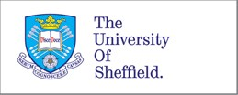

Application 032696

Section A: Applicant details



Date application started:

Tue 28 January 2020 at 15:29

First name:

Hathal

Last name:

Albagami

Email:

[halbagami1@sheffield.ac.uk](mailto:halbagami1@sheffield.ac.uk)

Programme name:

PhD in Clinical Dentistry

Module name:

Research Project Last updated:

20/02/2020

Department:

School of Clinical Dentistry

Applying as:

Postgraduate research

Research project title:

Evaluating the Pedagogical Value of 3D Printed Teaching Models in Clinical Dental Education

Has your research project undergone academic review, in accordance with the appropriate process? Yes

Similar applications:

*- not entered -*

Section B: Basic information

Supervisor

**Name Email**

Christopher Stokes [c.w.stokes@sheffield.ac.uk](mailto:c.w.stokes@sheffield.ac.uk)

Proposed project duration

Start date (of data collection): Sun 1 March 2020

Anticipated end date (of project) Sat 30 October 2021

3: Project code (where applicable)

Project code

*- not entered -*

Suitability



Takes place outside UK? No

Involves NHS? No

Health and/or social care human-interventional study? No

ESRC funded? No

Likely to lead to publication in a peer-reviewed journal? Yes

Led by another UK institution? No

Involves human tissue? No

Clinical trial or a medical device study? No

Involves social care services provided by a local authority? No

Is social care research requiring review via the University Research Ethics Procedure No

Involves adults who lack the capacity to consent? No

Involves research on groups that are on the Home Office list of 'Proscribed terrorist groups or organisations? No

Indicators of risk

Involves potentially vulnerable participants? No

Involves potentially highly sensitive topics? No

Section C: Summary of research

1. Aims & Objectives Aim

This study aims to evaluate the potential pedagogical value of 3D-printed models in operative dental pre-clinical teaching. This potential will be evaluated by exploring students’ attitudes, feelings, and experiences after being introduced to the models. The project aims to co-create the 3D-printed models alongside the students by involving them in the process through listening to their input on the challenges they face when learning operative dentistry and giving them the freedom to share their ideas on how the technology can be utilized to address their concerns.

Objectives

1. To explore qualitatively, with the students, insights into their concerns and challenges when learning operative dentistry concepts using traditional models.
2. To analyse the qualitative feedback and design/manufacture of 3D printed models that are produced to specifically tackle students’ concerns.
3. To achieve a rapid, accurate, reproducible , and cost-effective manufacturing protocol.
4. To introduce the models to the students and allow them to perform simple operative procedures.
5. To meet with the students and explore their feelings, behaviours, and attitudes towards using the 3D printed models as opposed to the traditional ones.



1. Methodology

Considering the aim of the research and the intended qualitative approach, the protocol of this project will be split into three phases to be completed and written within the allocated funding time.

Phase I: Gaining insight into students’ attitudes, experiences, and challenges they face in pre-clinical education

Recruitment and consent:

The PI will explain the nature of the study to the students. Students will be invited to participate and consented accordingly. Participation is voluntary and they are free to withdraw at any time without giving any reason and without any negative consequences.

Data collection method: Focus groups.

Sampling strategy:

This study aims to recruit dental students who have experience with or are currently learning operative clinical skills in the clinical skills learning environment (CSLE). The sampling strategy will be purposive to recruit a homogenous group of students.

Sample size:

5-6 students per group, number of groups will depend on the amount needed to achieve saturation. Length of focus groups: 1 – 1:30 hours.

Setting: Collection of data will be carried out in the School of Clinical Dentistry at The University of Sheffield.

Data collection instruments and technologies:

A focus group guide (attached) will be used to ensure all areas are discussed. A list of questions will be prepared to facilitate and guide the discussion. All meetings will be audio recorded, and physical notes will be taken to capture the general mood and any observation that might not translate into audio. Printed models will be introduced at the beginning of the meeting to prompt discussion and help the students understand what the technology entails and what possibilities it may have, such as multi-colour and multi-texture printing.

Phase II: Designing and manufacturing of 3D printed teaching models

Data from the first group will be analysed, and the students’ feedback will be organised into categories to identify challenges and avenues of improvement proposed. Suitable models will be created to the point where they are considered suitable to tackle the challenges identified. The 3D printing technique and material will depend on the design of the model created.

The models will be given to the students during a supervised operative dentistry practice lab session. They will be given enough time to interact, experience, and work on the models. Students will also be allowed to interact with supervisors and ask about anything that pertains to the models, the procedure, or any general theoretical concept.

Phase III: Conducting a round of focus groups to receive feedback from the students

A short time after part II (within a few days), multiple focus groups will be conducted with the students that had the chance to work on and interact with the 3D models produced. This step aims to obtain rich and meaningful qualitative data from the students on every aspect of the experience. The methodology for the focus groups will follow the protocol presented in part I.

Transcribed data from the focus groups will be dissected to discover common themes across the students’ opinions, context, and tone at each step. Our analysis will specifically aim to explore students’ feelings, experiences, and ideas for possible avenues of improvement. The analysis will be following the guidelines described by Braun and Clarke (2006) following the structure of the steps below:

* Familiarisation with the data collected. To explore and digest the data multiple times to understand and assimilate the scope of the data.
* Generation of codes at the early stages of analysis.
* Dissecting and identifying themes, with the aid of the generated codes.
* Reviewing and organizing themes identified.
* Labeling identified themes with appropriate names.
* Producing the final report.

1. Personal Safety

Have you completed your departmental risk assessment procedures, if appropriate?

Not applicable

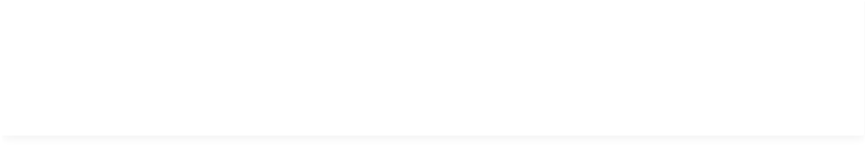

Raises personal safety issues? No

The potential physical and/or psychological harm or distress will be the same as any experienced in everyday life.

Section D: About the participants

1. Potential Participants

The participants will be students at the University of Sheffiield - College of Dentistry. These persons typically range from 18 - 30 years old, but some may be older.

1. Recruiting Potential Participants

Participants will be introduced to the study at the end of a timetabled lecture and told to look out for an email inviting them to participate.

The email invite will contain details of the study and contact details in case they have any questions about the project.

* 1. Advertising methods

Will the study be advertised using the volunteer lists for staff or students maintained by CiCS? No

*- not entered -*

1. Consent

Will informed consent be obtained from the participants? (i.e. the proposed process) Yes

Participants will be given an information sheet explaining a summary of the project, what is expected of them if they participate, and other aspects of what participation entails.

They will also be given a consent form prior to each phase of the project.

1. Payment

Will financial/in kind payments be offered to participants? No

1. Potential Harm to Participants

What is the potential for physical and/or psychological harm/distress to the participants?

Participating in the research is not anticipated to cause you any disadvantages or discomfort. The potential physical and/or psychological harm or distress will be the same as any experienced in everyday life.

How will this be managed to ensure appropriate protection and well-being of the participants?

The focus groups will be conducted by the PI Hathal Albagami, who is not involved in the education or the evaluation of the students. Participants can drop-out of the project at any time without the need to give a reason.

The information sheet has a section detailing the steps to take, as well as the contact information of everyone involved in case they encounter any distress or discomfort during any step of the project.

Section E: About the data

1. Data Processing

Will you be processing (i.e. collecting, recording, storing, or otherwise using) personal data as part of this project? (Personal data is any information relating to an identified or identifiable living person).

No

Please outline how your data will be managed and stored securely, in line with good practice and relevant funder requirements

The recordings will only be available to members of the project team and the support staff and it will only be used to allow the preparation of typed notes. Whilst these typed notes are being prepared, the recordings will be stored in a secure Google drive and only members of the project team and support staff will have access to the recordings. These electronic recordings will be destroyed at the end of the research project.

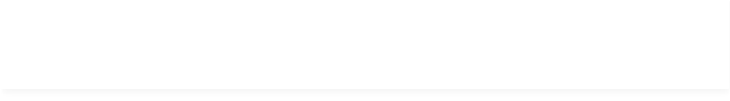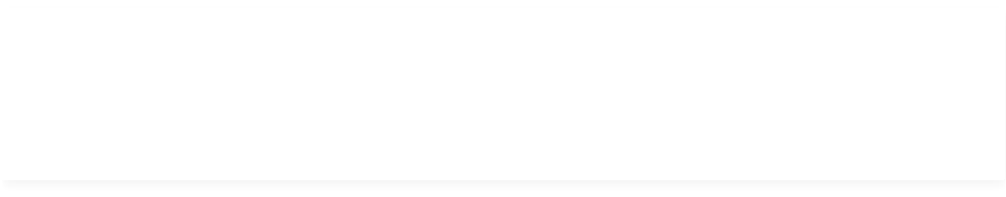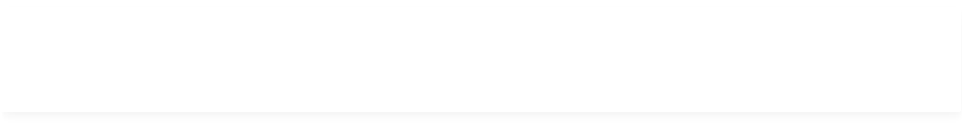

Section F: Supporting documentation

Information & Consent

Participant information sheets relevant to project? Yes

[Document 1075933 (Version 1](file:///C:\document_versions\99212)) All versions

Consent forms relevant to project? Yes

[Document 1075934 (Version 1](file:///C:\document_versions\99213)) All versions

Additional Documentation

[Document 1075936 (Version 1](file:///C:\document_versions\99215))

Project Protocol

All versions

[Document 1075935 (Version 1](file:///C:\document_versions\99214))

Focus Group Guide

All versions

External Documentation

* *not entered -*

Section G: Declaration

Signed by:

* *not entered -*

Date signed:

* *not entered -*

Offical notes

* *not entered -*



Appendix 2: Ethics Application approval letter

Appendix 3: CSLE reflective exercise

Clinical Skills Learning Environment Reflective Activity

The Clinical Skills Learning Environment (CSLE) is a large part of your dental learning

experience. Its role is to provide a smooth transition from the classroom to the clinic by giving you a safe environment to practice various dental procedures on manikin heads.

As a 3rd year dental student, you have experienced the CSLE, and have also experienced patient treatment first-hand. As we prepare to return to teaching at some point, this activity is designed to prompt reflection on the skills you have learnt so far.

There is an additional opportunity for you to consider how we may support teaching in the CSLE in the future using new technologies.

\*Required

1. With your permission, we would like to access your responses anonymously \*

and analyse them as part of a research project currently being conducted in the School aimed at finding new ways to improve clinical teaching and dental clinical skills acquisition. You do not have to consent to take part in this activity. You can change your mind at anytime and return at any stage to this section to change your answer. If you do not wish to consent it will have no negative

impact on your education. If you do consent, we will contact you in the future to update you on the progress of the project. You can opt out of receiving any subsequent communication.

*Mark only one oval.*

I consent

I do not consent

Part 1: Reflections on your time in the Clinical Skills Laboratory Environment (CSLE)

This section is designed to prompt reflection on the skills you have learnt in the CSLE so far.

1. What is the most important thing you have learnt from your time in the CSLE? \*
2. What is the skill you found most difficult to learn in the CSLE? \*
3. Thinking about the role the CSLE plays in supporting your education, based on \*

your experiences what is most useful about this space and its resources?

1. Can you suggest any improvements to the CSLE space and resources that \*

would help your learning?

1. What are your thoughts on current simulation models? How have they helped you \*

learn? (e.g. Frasaco models with removable plastic teeth)

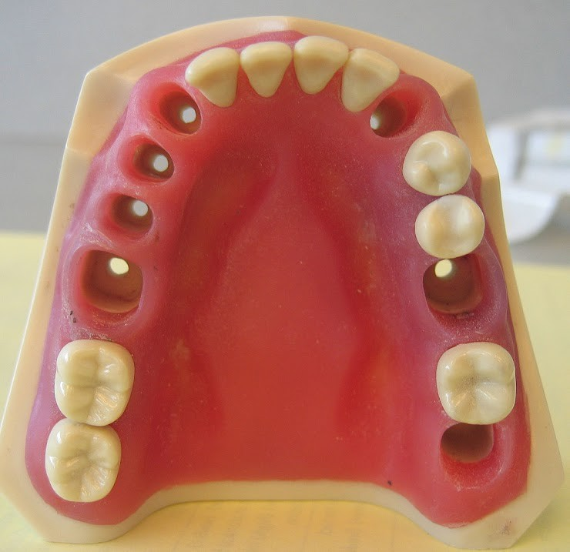

Reflecting on your transition to clinics

1. What did you most value from your experiences in the CSLE when you first \*

treated patients on the clinic?

1. Was there anything in particular that was very different to what you expected \*

based on your CSLE learning?

1. Thinking back, was there anything you would have liked to have done differently \*

before going onto the clinic?

Part 2: 3D printing technology and dentistry

We are always looking into various ways where dental education in general, and clinical skills training specifically, could be improved. Many different technologies have been implemented to enhance or supplement current clinical teaching methods. One example here at Sheffield is the introduction of haptic simulation (Sims Suite) where VR technology is now used to support your learning.

Another new technology that has recently been applied in dental education is 3D printing. As this technology improves, so does the accuracy and accessibility of the models produced. Anyone can design and print models with relative ease and in a short amount of time compared to traditional manufacturing methods.

3D printing technology and dentistry

Please watch the following videos which provide some background information on 3D printing

Here is a video giving a quick introduction on the technology

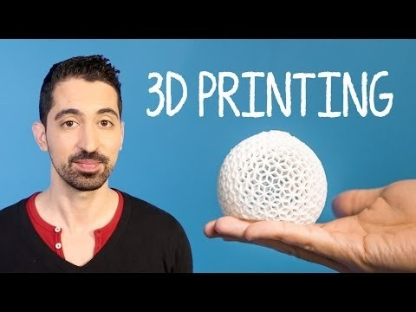[http://youtube.com/watch?](http://youtube.com/watch?v=Vx0Z6LplaMU)

[v=Vx0Z6LplaMU](http://youtube.com/watch?v=Vx0Z6LplaMU)

Below you will find pictures of some general and dental applications of 3D printing

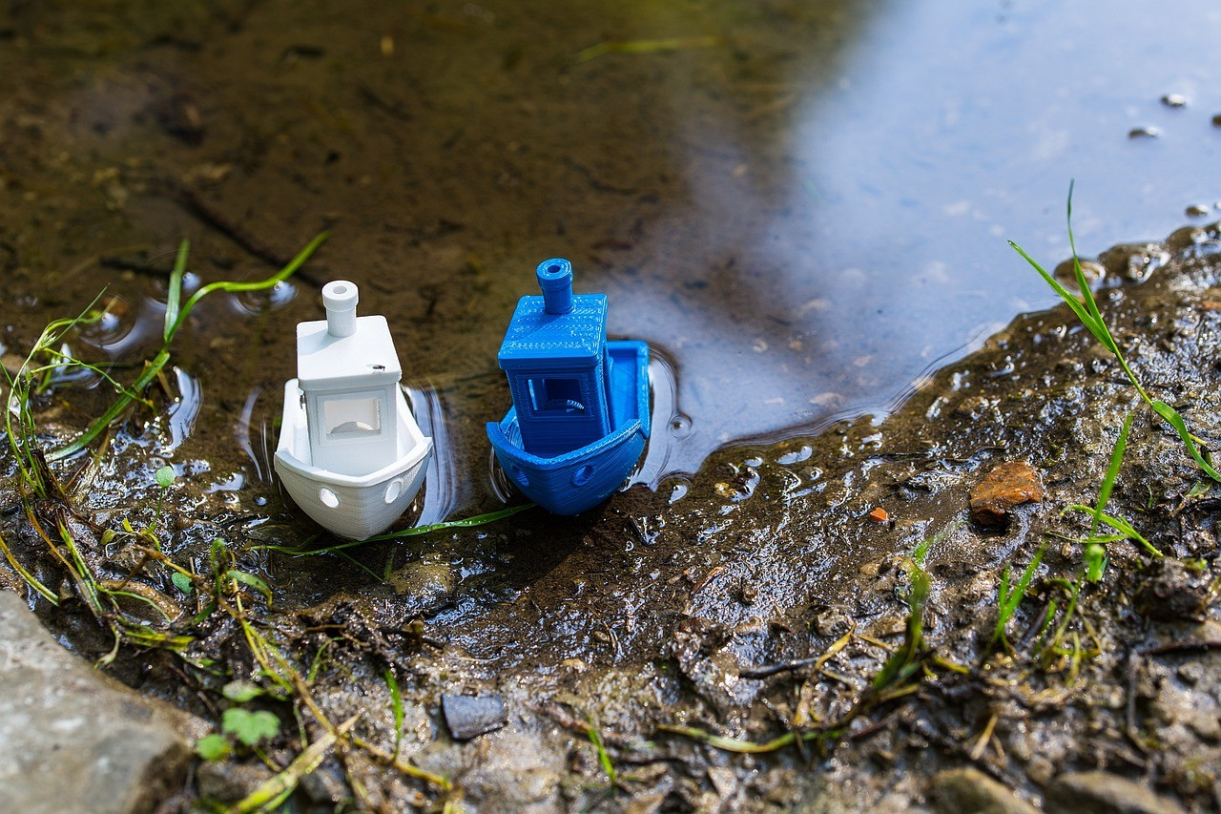

3D-printed tool (spanner)

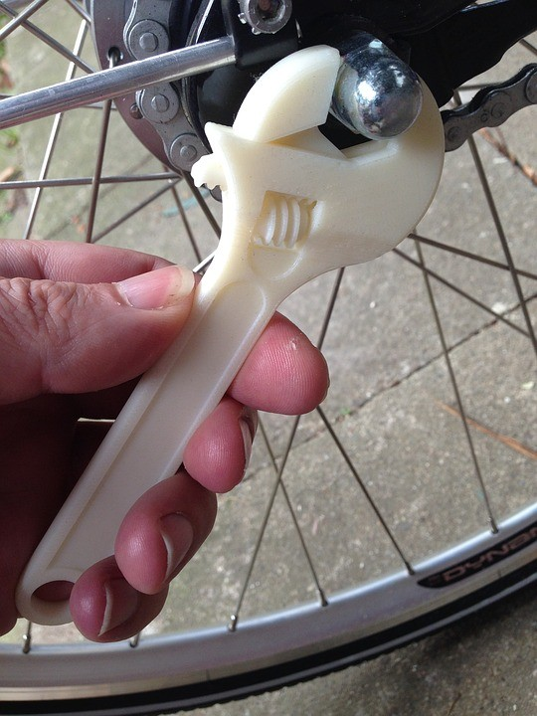

3D-printed restorative preparations for clinical skills concepts training

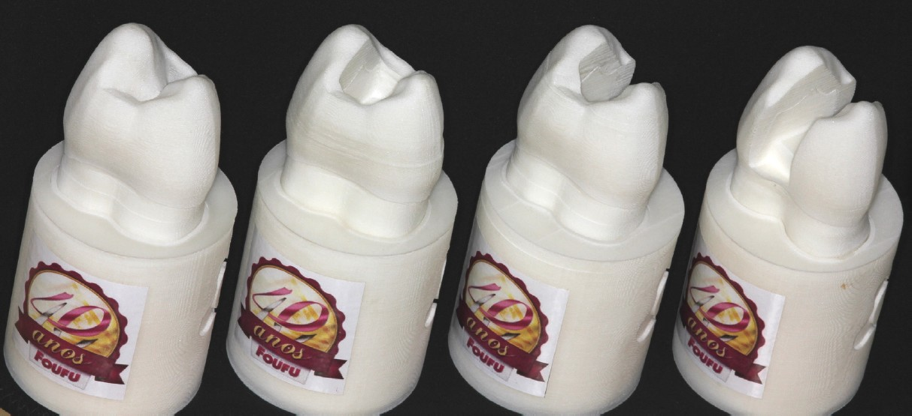

3D-printed model with removable prepared teeth and implant analogues

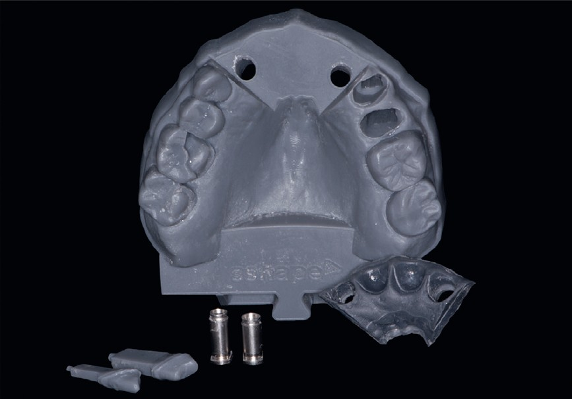

1. Please describe the benefits you can imagine 3D printing technology bringing \*

to clinical dental education.

1. Do you feel it has potential useful applications in terms of teaching restorative \*

clinical skills?

*Mark only one oval.*

Yes No Maybe

1. Please explain the reason for your answer \*
2. Do you feel the technology can be used to overcome the challenges you may \*

have experienced yourself or have seen your peers experience?

*Mark only one oval.*

Yes No Maybe

1. Please explain the reason for your answer \*

This content is neither created nor endorsed by Google.

[Forms](https://www.google.com/forms/about/?utm_source=product&utm_medium=forms_logo&utm_campaign=forms)

Appendix 4: Faculty participant information sheet

**Participant Information Sheet**

Date:

**Research Project Title**

Evaluating the Pedagogical Value of 3D Printed Models in Clinical Dental Education

**Summary**

This study aims to evaluate the potential pedagogical value of 3D printed models in pre-operative dental clinical teaching. This potential will be evaluated by exploring students’ attitudes, feelings, and experiences after being introduced to the models. The project aims to co-create the 3D printed models alongside the students by involving them in the process through listening to their input on the challenges they face when learning operative dentistry and giving them the freedom to share their ideas on how the technology can be utilised to address their concerns.

We would ask you to read the following information before deciding whether to take part in this research project. Please feel free to talk about your participation with others and don’t hesitate to speak to the researchers using the contacts at the end of this sheet if you have any further questions.

**Why am I being asked to take part?**

This project recruited 3rd-year BDS students to share their experiences and challenges they have faced during their pre-clinical training. As a member of staff with experience teaching restorative skills in clinical skills environment to 3rd-year BDS student’s, your feedback and thoughts on the 3D-printed models we created alongside the students to address their challenges is very valuable to this research project.

**What is involved?**

We would like to invite you to take part in an interview. This will last no longer than 1 hour and will take place on University premises during working hours. The interview questions will focus on your experience with 3D-printing technology and 3D-printed models, your thoughts on the models we have created, and suggestions for improvement.

**Do I have to participate?**

Participation in the research is, of course, entirely voluntary. You must feel free to end your participation at any time and without needing to give any reason; this applies even if the interview has already started. If for any reason you feel uncomfortable, you can of course leave. If you do decide to participate you will be given this information sheet to keep and a copy of the signed consent form.

**What if something goes wrong?**

If you have any complaints about the project in the first instance you can contact any member of the research team.

**Will the interview be recorded and how will these recordings be used?**

If you are happy for the interview to be recorded, we will make an electronic audio recording. The recording will only be available to members of the project team and the support staff and it will only be used to allow the preparation of typed notes. Whilst these typed notes are being prepared, the recordings will be stored in a secure Google drive and only members of the project team and support staff will have access to the recordings. These electronic recordings will be destroyed at the end of the research project.

**How will information about me be used?**

This project aims to use your feedback to gain a unique perspective on the models we created, and results from the interviews will influence our approach when conducting the focus groups with the students after they get the chance to use the created models.

The outcomes of this research may be published externally in a journal, on a website or via a conference presentation. Your personal details will be kept strictly confidential and your name will be removed in any work published as a result of this research. However, we do want to be able to refer to the positions and some aspects of the identities of those who are involved. You can decide whether or not to give us permission to do this. Before you take part in the research, we will ask you to fill in a consent form. On this form you can tell us how you want us to use your data. We will not use your name in any publications that result from this research. With your permission, however, we may use anonymised quotes.

**What are the benefits and disadvantages of taking part?**

We hope that you will find the process beneficial as an opportunity to explore a new technology that is seeing increased applications in dental education. We also believe sharing the results of our qualitative analysis on students’ attitudes and challenges they have faced during their pre-clinical learning would help you improve the overall learning experience in CSLE.

Participating in the research is not anticipated to cause you any disadvantages or discomfort. The potential physical and/or psychological harm or distress will be the same as any experienced in everyday life.

**Who is organising and funding the research?**

This research project is funded by the Saudi Arabian Cultural Bureau and organized by the College of Clinical Dentistry, The University of Sheffield.

**Who provided ethical approval for this project?**

This research has been ethically reviewed via the Student Services ethical review procedure at the University of Sheffield. If there is any aspect of the project, or your participation that you would like to discuss further, or feel you may need support with, please do not hesitate to get in touch with one of the key contacts listed below.

**Key Contacts**

Researcher (PI): Hathal Albagami

Email: [halbagami1@sheffield.ac.uk](mailto:halbagami1@sheffield.ac.uk)

Supervisor: Prof. Christopher Stokes

Email: [c.w.stokes@sheffield.ac.uk](mailto:c.w.stokes@sheffield.ac.uk)

Head of Department: Prof. Chris Deery

Email: [c.deery@sheffield.ac.uk](mailto:c.deery@sheffield.ac.uk)

Appendix 5: Faculty interviews consent form

**Faculty Interviews Consent Form**

|  |  |  |  |  |
| --- | --- | --- | --- | --- |
| ***Please tick the appropriate boxes*** | | | **Yes** | **No** |
| **Taking Part in the Project** | | |  |  |
| I have read and understood the project information sheet dated / / or the project has been fully explained to me. (If you will answer No to this question please do not proceed with this consent form until you are fully aware of what your participation in the project will mean.) | | |  |  |
| I have been given the opportunity to ask questions about the project. | | |  |  |
| I agree to take part in the project. I understand that taking part in the project will include participating in interviews where the discussions will be audio recorded. | | |  |  |
| I understand that my taking part is voluntary and that I can withdraw from the study at any time; I do not have to give any reasons for why I no longer want to take part and there will be no adverse consequences if I choose to withdraw. | | |  |  |
| **How my information will be used during and after the project** | | |  |  |
| I understand my personal details such as name, phone number, address and email address etc. will not be revealed to people outside the project. | | |  |  |
| I understand and agree that my words may be quoted in publications, reports, web pages, and other research outputs. I understand that I will not be named in these outputs unless I specifically request this. | | |  |  |
| I understand and agree that other authorised researchers will have access to this data only if they agree to preserve the confidentiality of the information as requested in this form. | | |  |  |
| I understand and agree that other authorised researchers may use my data in publications, reports, web pages, and other research outputs, only if they agree to preserve the confidentiality of the information as requested in this form. | | |  |  |
| **So that the information you provide can be used legally by the researchers** | | |  |  |
| I agree to assign the copyright I hold in any materials generated as part of this project to The University of Sheffield. | | |  |  |
|  |  |  | | | |
| Name of participant [printed] | Signature | Date | | | |
|  |  |  | | | |
| Name of Researcher [printed] | Signature | Date | | | |
|  |  |  | | | |

**Project contact details for further information:**

Researcher (PI): Hathal Albagami

Email: [halbagami1@sheffield.ac.uk](mailto:halbagami1@sheffield.ac.uk)

Address: School of Clinical Dentistry, University of Sheffield, 19 Claremont Crescent, Sheffield, S10 2TA

Phone #: +447988589548

Project supervisor: Prof. Christopher Stokes

Email: [c.w.stokes@sheffield.ac.uk](mailto:c.w.stokes@sheffield.ac.uk)

Address: School of Clinical Dentistry, University of Sheffield, 19 Claremont Crescent, Sheffield, S10 2TA

Appendix 6: Focus groups information sheet

**Participant Information Sheet**

Date:

**Research Project Title**

Evaluating the Pedagogical Value of 3D Printed Models in Clinical Dental Education

**Summary**

This study aims to evaluate the potential pedagogical value of 3D printed models in pre-operative dental clinical teaching. This potential will be evaluated by exploring students’ attitudes, feelings, and experiences after being introduced to the models. The project aims to co-create the 3D printed models alongside the students by involving them in the process through listening to their input on the challenges they face when learning operative dentistry and giving them the freedom to share their ideas on how the technology can be utilised to address their concerns.

We would ask you to read the following information before deciding whether to take part in this research project. Please feel free to talk about your participation with others and don’t hesitate to speak to the researchers using the contacts at the end of this sheet if you have any further questions.

**Why am I being asked to take part?**

As a third-year dental student at the University of Sheffield currently learning operative clinical skills in the clinical skills learning environment (CSLE), we would like to hear about your experiences and challenges using traditional teaching models, as well as get your ideas for possible avenues of improvement.

**What is involved?**

We would like to invite you to take part in a focus group. This will last no longer than 1 hour and will take place on University premises during working hours. The focus group questions will focus on your experience as a dental student in CSLE at the University, including challenges, ideas, and suggestions for improvement. As this project aims to create 3D dental models with you the student, you will be asked questions on 3D printing of dental models, and hope to hear your suggestions in regards to implementing the technology to tackle your challenges.

**Do I have to participate?**

Participation in the research is, of course, entirely voluntary. You must feel free to end your participation at any time and without needing to give any reason; this applies even if the focus group has already started. If for any reason you feel uncomfortable, you can of course leave. If you do decide to participate you will be given this information sheet to keep and a copy of the signed consent form.

**What if something goes wrong?**

If you have any complaints about the project in the first instance you can contact any member of the research team.

**Will the focus group be recorded and how will these recordings be used?**

If you are happy for the focus group to be recorded, we will make an electronic audio recording. The recording will only be available to members of the project team and the support staff and it will only be used to allow the preparation of typed notes. Whilst these typed notes are being prepared, the recordings will be stored in a secure Google drive and only members of the project team and support staff will have access to the recordings. These electronic recordings will be destroyed at the end of the research project.

**How will information about me be used?**

This project aims to use your feedback and create new teaching models based on your experiences, attitudes, and challenges during your clinical dental education and create new and innovative teaching models that are inspired by the students.

The outcomes of this research may be published externally in a journal, on a website or via a conference presentation. Your personal details will be kept strictly confidential and your name will be removed in any work published as a result of this research. However, we do want to be able to refer to the positions and some aspects of the identities of those who are involved. You can decide whether or not to give us permission to do this. Before you take part in the research, we will ask you to fill in a consent form. On this form you can tell us how you want us to use your data. We will not use your name in any publications that result from this research. With your permission, however, we may use anonymised quotes.

**What are the benefits and disadvantages of taking part?**

We hope that you will find the process beneficial as an opportunity to reflect on your learning experiences in CLSE. We also hope to engage you in the planning and design of the teaching/learning process. This partnership in learning would hopefully give you the ability to make authentic contribution to your own education.

Participating in the research is not anticipated to cause you any disadvantages or discomfort. The potential physical and/or psychological harm or distress will be the same as any experienced in everyday life.

**Who is organising and funding the research?**

This research project is funded by the Saudi Arabian Cultural Bureau and organized by the College of Clinical Dentistry, The University of Sheffield.

**Who provided ethical approval for this project?**

This research has been ethically reviewed via the Student Services ethical review procedure at the University of Sheffield. If there is any aspect of the project, or your participation that you would like to discuss further, or feel you may need support with, please do not hesitate to get in touch with one of the key contacts listed below.

**Key Contacts**

Researcher (PI): Hathal Albagami

Email: [halbagami1@sheffield.ac.uk](mailto:halbagami1@sheffield.ac.uk)

Supervisor: Prof. Christopher Stokes

Email: c.w.stokes@sheffield.ac.uk

Appendix 7: Focus groups consent form

**Focus Groups Consent Form**

|  |  |  |  |  |
| --- | --- | --- | --- | --- |
| ***Please tick the appropriate boxes*** | | | **Yes** | **No** |
| **Taking Part in the Project** | | |  |  |
| I have read and understood the project information sheet dated / / or the project has been fully explained to me. (If you will answer No to this question, please do not proceed with this consent form until you are fully aware of what your participation in the project will mean.) | | |  |  |
| I have been given the opportunity to ask questions about the project. | | |  |  |
| I agree to take part in the project. I understand that taking part in the project will include participating in focus groups where the discussions will be audio recorded. | | |  |  |
| I understand that my taking part is voluntary and that I can withdraw from the study at any time; I do not have to give any reasons for why I no longer want to take part and there will be no adverse consequences if I choose to withdraw. | | |  |  |
| **How my information will be used during and after the project** | | |  |  |
| I understand my personal details such as name, phone number, address and email address etc. will not be revealed to people outside the project. | | |  |  |
| I understand and agree that my words may be quoted in publications, reports, web pages, and other research outputs. I understand that I will not be named in these outputs unless I specifically request this. | | |  |  |
| I understand and agree that other authorised researchers will have access to this data only if they agree to preserve the confidentiality of the information as requested in this form. | | |  |  |
| I understand and agree that other authorised researchers may use my data in publications, reports, web pages, and other research outputs, only if they agree to preserve the confidentiality of the information as requested in this form. | | |  |  |
| **So that the information you provide can be used legally by the researchers** | | |  |  |
| I agree to assign the copyright I hold in any materials generated as part of this project to The University of Sheffield. | | |  |  |
|  |  |  | | | |
| Name of participant [printed] | Signature | Date | | | |
|  |  |  | | | |
| Name of Researcher [printed] | Signature | Date | | | |
|  |  |  | | | |

**Project contact details for further information:**

Researcher (PI): Hathal Albagami

Email: [halbagami1@sheffield.ac.uk](mailto:halbagami1@sheffield.ac.uk)

Address: School of Clinical Dentistry, University of Sheffield, 19 Claremont Crescent, Sheffield, S10 2TA

Phone #: +447988589548

Project supervisor: Prof. Christopher Stokes

Email: [c.w.stokes@sheffield.ac.uk](mailto:c.w.stokes@sheffield.ac.uk)

Address: School of Clinical Dentistry, University of Sheffield, 19 Claremont Crescent, Sheffield, S10 2TA

|  |  |
| --- | --- |
| tuoslogo_key_cmyk_hi | School  Of  Clinical  Dentistry. |

Appendix 8: Faculty interviews guide

**Faculty Interview Guide**

Clinical skills learning environment and 3D printing

**Evaluating the Pedagogical Value of 3D printed Models in Dental Education**

Hathal Albagami BDS, MSc, CAGS

(PhD researcher - Unit of Dental Materials and Manufacturing Technologies

School of Clinical Dentistry - University of Sheffield)

**Research aims to explore:**

* Students’ attitudes
* The learning environment
* Possible challenges
* Co-create 3D printed teaching models

Pertaining to learning in clinical skills learning environment in dentistry

1. **Introduction**
   1. Introduction and information sheet

The researcher introduces himself and states the aim of the project which is to evaluate potential pedagogical value of 3D printed models in clinical dental education using a student/teacher co-creation model. He then ensures each of the participants has a copy of the information sheet and understands the scope of the research.

* 1. Consent

The researcher then ensures that the ethics protocol is followed, and that consent has been given and the consent forms signed.

* 1. Participant identification

The participant Identifies themself using a pre-arranged code and the date and time of recording is noted. Verbal consent, if appropriate, can also be recorded at this time.

1. **Background knowledge of participants**
   1. What do you know about 3D-printing technology?
   2. What do you know about its applications in dental education?
   3. Tell me about your experience using 3D-printed models/teeth in teaching?
      1. What do you think about these models/teeth in general?
2. **Introduction of 3D-printed models created by PI**

Introduce the models created based on student feedback and briefly discuss the students’ concerns that led to the creation of these specific models

* 1. What do you think about these models in general? (visual/tactile)
  2. What do you think about the models’ educational value in pre-clinical teaching compared to conventional models? Please elaborate.
  3. What benefits do you think 3D-printing technology will bring to pre-clinical education?
  4. Do you have any suggestions to improve the models created?
  5. What do you think about 3D-printing technology and its possible applications in dental education now?
  6. What do you think about these models’ ability to address the students’ main concerns with pre-clinical teaching? And how?
  7. Do you have any additional comments regarding everything we have discussed so far?

1. **Closure**

The researcher thanks the participants for their time and help and explains that they may have a copy of the report when it becomes available. He then ascertains if the participant would like a copy of this report and confirms the details of where this can be sent.

|  |  |
| --- | --- |
| tuoslogo_key_cmyk_hi | School  Of  Clinical  Dentistry. |

Appendix 9: Focus groups guide

**Interview Guide for Focus Groups**

Clinical skills learning environment and 3D printing

**Evaluating the Pedagogical Value of 3D printed Models in Dental Education**

Hathal Albagami BDS, MSc, CAGS

(PhD researcher - Unit of Dental Materials and Manufacturing Technologies

School of Clinical Dentistry - University of Sheffield)

Sandra Zijlstra-Shaw B.D.S. P.G.Cert (Conc Sed) Ph.D. PFHEA

(2nd Supervisor - Senior Clinical Teacher

Deputy Director of Learning and Teaching

Academic Unit of Oral Health, Dentistry and Society

School of Clinical Dentistry)

**Research aims to explore:**

* Students’ attitudes towards 3D-printed models
* The learning environment
* Clinical transition challenges
* Possible Avenues for improvement

Pertaining to learning in clinical skills learning environment in dentistry using novel 3D-printed models

1. **Introduction**
   1. Introduction and information sheet

The researcher introduces himself and states the aim of the project which is to evaluate potential pedagogical value of 3D printed models in clinical dental education using a student/teacher co-creation model. He then ensures each of the participants has a copy of the information sheet and understands the scope of the research.

* 1. Consent

The researcher then ensures that the ethics protocol is followed, and that consent has been given and the consent forms signed.

1. **Background**
   1. Participant identification

The participants each identify themselves using a pre-arranged code and the date and time of recording is noted. Verbal consent, if appropriate, can also be recorded at this time.

* 1. History of co-creation

Identify participant who have prior experience or were involved in a student/teacher co-creation project.

1. **General discussion about the newly introduced 3D-printed models**

* How they feel about the models they used in particular, and 3D-printed teaching models in general
* Benefits introduced by 3D-printing
* Limitations associated with 3D-printing

Explore in a neutral manner what the students think about the 3D-printed models used to teach dental students clinical skills, including likes, dislikes, and challenges (if they are organically mentioned by participants). Discuss with the participant what they think can be improved with these models. Investigate their feelings and views about getting the chance to be involved in a co-creative model where they influence their learning process.

1. **Realism**

* Ask them what they think realism is
* How they feel about realism in their learning
* What they think about the realistic aspects of the 3D-printed models they used

Discuss “realistic” (realistic clinical setting/realistic tooth anatomy) teaching models, and how important they feel that is and why.

1. **Transition into the clinic**

* Ask them about their transitional experience
* Explore the challenges and stresses they’ve faced (if any)
* Explore the customizability of 3D-printing technology and its effects on transition

1. **Closure**

The researcher thanks the participants for their time and help and explains that they may have a copy of the report when it becomes available. He then ascertains if the participant would like a copy of this report and confirms the details of where this can be sent.

Appendix 10: Student Questionnaires

**Student Questionnaire**

**Project Title:** Evaluating the Pedagogical Value of 3D-Printed Teaching Models in Restorative Dental Education

|  |  |  |
| --- | --- | --- |
| Comparison to standard plastic tooth models | Yes | No |
| The printed tooth… |  |  |
| Has a more realistic feel during preparation |  |  |
| Is a better practice preparation option |  |  |
| Is a fair option to use for exams |  |  |
| Is easier to use for practice |  |  |
|  |  |  |
| Comparison to a real (extracted) tooth |  |  |
| The printed tooth… |  |  |
| Easier to use for practice in comparison with a real (extracted) tooth |  |  |
| Has a realistic feel during preparation |  |  |
| Has high practical relevance |  |  |
|  |  |  |
| Features of the visual demonstration model |  |  |
| The demonstration model… |  |  |
| Had a clear sequence and was easy to understand |  |  |
| Made me feel more *comfortable* while practicing the preparation |  |  |
| Made me feel more *confident* while practicing the preparation |  |  |
|  |  |  |
| Evaluation of learning outcome |  |  |
| Please number the following in order of how much you learnt with 1 being the greatest amount and 3 being the least amount | | |
| My learning was greatest with the standard model tooth |  | |
| My learning was greatest with the printed tooth |  | |
| My learning was greatest with a real tooth |  | |
|  |  | |
| Evaluation of learning process with printed tooth |  |  |
| The printed tooth has made me more enthusiastic to improve my preparation skills |  |  |
| In retrospect, I would have liked to practice with the printed teeth first before treating a real patient |  |  |
| The demonstration model with the preparation sequences helped me improve my preparation today |  |  |
| The printed tooth made it easier to achieve my goals in correct preparation |  |  |

Appendix 11: Framework of the analysis of reflective exercise showing first major theme

|  |  |  |  |  |  |
| --- | --- | --- | --- | --- | --- |
|  |  | **Good structure for learning** |  |  |  |
| Participant | More practice | Visual aids | Tooth availability | Efficient | Safe environment |
| 1 | Greater practice on teeth printed (P2Q1) ….. Printing teeth gives us more opportunities to practice (P2Q2) | Can image ideal cavity preparations and enlarge them so that we can properly see what the preparation looks like (P2Q1) | Lack of teeth to practice on could be solved (P2Q3) |  |  |
| 2 | But they are good to practice and save time having to hunt for suitable natural teeth to work on (P1Q5) | The computer screens so you can get up any diagrams of preps or videos that have been put on MOLE of the procedure (P1Q3)…..Also to see example 'ideal' preps in this 3D format would be really useful because I've always thought on CSLE, it would be really useful to see a prep a tutor has done for example, so you can see in 3D in front of you, what you are aiming for with your prep (p2q1).....I think they could be used in our groups at the start of each clinical session where the tutor could go through the prep design features and show any 3D printed preps to aid their explanations (p2q3) |  | Some models already to be set up with natural teeth from the buckets so it would save time hunting through buckets for teeth and setting up models (P1Q4) |  |
| 3 |  |  |  |  |  |
| 4 | It gives you a chance to practice and to make mistakes so that you have the opportunity to learn from them before you go onto a clinic (p1q3) | More up to date videos for clinical sessions would be useful (p1q4).....I think it could be useful to have examples of cavity preparations and crown preps in CSLE rather than just diagrams so that we can see what we should be trying to achieve - possibly larger than a natural tooth just to visualise (p2q1).....For demonstration purposes I think there would be a big advantage, rather than / in addition to diagrams and videos it is a visual way to understand what we are supposed to be achieving and I think may help tutors to explain concepts such asd chamfer and shoulder margins, cavo-surface angle etc. (p2q2).....My biggest problem was being able to visualise what I was supposed to be doing. It can be hard for a tutor to tell you exactly how you've gone wrong and often they would say just start again. Having an 'ideal' prep to follow initially that I could pick up, rotate, compare to my prep would have been so useful just to help grasp the initial concept (p2q3) |  |  | How to use dental equipment safely and correctly (p1q1) |
| 5 | I think its really important to build confidence in completing procedures as mistakes can be made and learnt from (p1q3) ….. It would be very useful to practice on a 3D printed tooth prior to preparing a real tooth. (p2q3) | Allowing you to see demonstration models of crown preparations (p2q1)….. It would be useful to have demonstration 3D printed models for each type of crown preparation on different teeth. (p2q2) |  |  |  |
| 6 | Maybe just gain even more experience, the opportunity to do extra sessions I think will have been beneficial. I think that’s all, practice builds confidence. (p1q8) | can be used to demonstrate to students the ideal cavity/ not ideal cavity which they can refer to in csle sessions. (p2q1) …. Will be useful for visualising concepts. (p2q2) ….. Apart from the ability to visualise concepts- it will be really useful for this! (p2q3) |  |  |  |
| 7 | It provides an opportunity to learn and practice different skills before applying them on clinic (p1q3) |  |  | Faster and easier learning (p2q1) ….. Will likely be faster so time in the CSLE will be used more efficiently. (p2q2) |  |
| 8 | Practising procedures slowly whilst getting continual support and review from tutors and peers (p1q3) ….. Having done lots of practise of the same filling/procedure. (p1q6) |  |  |  |  |
| 9 | Also having been able to practice lots and build confidence (p1q6) |  |  |  |  |
| 10 | This has improved now because I am more confidence working in my mirror, which has come from consistent practise in the CSLE. (p1q2) |  | But because suitable natural teeth are hard to find, I do think these were very useful and helped me to learn. (p1q5) ….. If teeth can be printed in this way and be readily available, then I think it will maximise the time we can have actually practising clinical skills. (p2q1) | It looks like it could really speed up the learning process. I found that particularly in BCS, a lot of time was spent trawling through the bucket of teeth trying to find suitable ones (p2q1) | It allowed me to build up my confidence performing clinical procedures without the stress of doing it on an actual patient, where I could make mistakes without any significant consequences and try again (p1q3) |
| 11 | Ability to practice on the procedure in the absence of occlusion, LA, pt management (p1q3) |  | Might provide alternative teeth for preparations which may be beneficial. (p2q3) |  |  |
| 12 | Had a longer opportunity to practice each procedure (p1q8) |  | it also gives you more time to concentrate on your work rather than searching for specific teeth which can take a long time. (p1q5) | The opportunity to use resources that are quickly produced within the dental school that are identical. (p2q1) | the fact you can make mistakes without them having a serious impact on a person's health or wellbeing. (p1q3) |
| 13 | Being able to practice certain restorations but out of hours from my timetable especially before upcoming exams for extra practice (p1q4) |  | These are good however do feel and cut differently to real teeth- I personally prefer natural teeth however understand this isn’t always possible (p1q5) |  |  |
| 14 |  | 3D printing to create restorative preparations for clinical skills concept training might save time and be more efficient than someone having to manually create restorative preparations on Frasaco teeth. (p2q1) | The real teeth (found in the buckets) in BCS provide better insight into the tactile difference between enamel and dentine when drilling, however it was difficult to learn caries removal on these teeth as many of them would be too carious to restore or not have caries. (p1q5) |  |  |
| 15 | It is also very useful that we get to practice the same skill over and over under a tutor's supervision until we get better at it, without having to worry about the harm to the patient. (p1q3) | Also it would greatly help if in course like crown and bridge preps, a pre-prepared 3D model could be available for us to see in person and try to prep our teeth to the same standard. It is very difficult to imagine the final result when we've only seen those preps in pictures and videos. (p1q4) ..... Also to enable us to see what our final preps/restorations should look like. (p2q2) ..... Also a model to use as a reference to what the final prep needs to look like has always been lacking in CSLE which I always needed in my learning as I am a very visual learner. (p2q3) | Also even though natural teeth are the best to learn and practice on, it is very stressful, time-consuming and difficult to try to find a specific tooth which is also sound. Having unlimited access to teeth to practice on would be great (p1q4) ….. We could have access to more affordable and readily available teeth to practice on. (p2q2) ..... Finding teeth to practice on has been a challenge in the past. (p2q3) |  | It is also very useful that we get to practice the same skill over and over under a tutor's supervision until we get better at it, without having to worry about the harm to the patient. (p1q3) |
| 16 | Having the chance to practise (p1q2) ….. The fact that we can practise (p1q3) | Good way to visualize (p2q1) ….. Can help see things better (p2q2) |  |  |  |
| 17 | Being able to practice on teeth without any consequence (in terms of a patient). You can make mistakes and learn from them, without it causing any real harm. (p1q3) | A visible representation of ‘ideal’ preparations. (p2q1) | Better teeth for practicing. (p2q1) | However, they save so much time with wax, searching through the tooth bucket, and being disadvantaged because your teeth are disgusting. (p1q5) | Being able to practice on teeth without any consequence (in terms of a patient). You can make mistakes and learn from them, without it causing any real harm. (p1q3) |
| 18 |  |  |  |  | An environment to freely make mistakes without consequence (p1q3) |
| 19 | Just general skills practice before doing it on patients especially when using real teeth (eg fillings, crown preps etc) (p1q1) ….. Getting plenty of practice and feedback on skills we’ve never done before, to gain more confidence before carrying the procedure out on a patient (p1q3) | Could be used in the clinical learning labs in the phantom heads and could be used to print out teeth with the various stages for different procedures to aid learning as I feel a 3D representation of what you’re aiming for at each step would be useful. (p2q2) ..... Sometimes I havnt been 100% sure what exactly I am aiming for as I struggle to see what teachers mean when it’s on a flat piece of paper or video, so to be able to actually touch hold and look at 3D versions of a tooth I’m doing could be very useful (p2q2) |  | Save a lot of time (p2q1) |  |
| 20 |  | Can do a large tooth with a cavity prep to better explain what you should aim to achieve with your cavities. (p2q1) ….. Would have been helpful to better understand cavity prep (p2q3) | More teeth to practice on. (p2q1) ….. Less stress with having more teeth to practice on (p2q3) |  |  |
| 22 | Being able to practise as many times as you need / until you are confident in a procedure. (p1q3) ….. Practise we had. I felt more confident when I went onto clinics. (p1q6) ….. I would have liked to have more practise (p1q8) |  |  |  |  |
| 23 |  |  | Excavating cavities as there aren’t many ‘good’ teeth to see affected and infected dentine. (p1q2) |  |  |
| 24 | The fact that we can practise the same clinical procedures we complete on clinic in an artificial mouth. (p1q3) | If we could watch any videos/presentations at home so that we have more clinical time to practice the procedures. (p1q8) |  | Save time (p2q1) ….. It would save time, for example if we need to learn how to cement indirect restorations we can quickly practise this by printing the indirect restoration rather than waiting for the lab to create it. (p2q2) |  |

Appendix 12: Framework of the analysis of teacher interviews showing first major theme

|  |  |  |  |  |  |
| --- | --- | --- | --- | --- | --- |
|  | New Printed Models | | | | |
|  | Benefits | | | | Limitations |
|  | Novel fitting system | Realistic look and feel | Simulate caries | Visual learning | Does not simulate enamel |
| 1 |  |  |  | having multiple examples of the different stages of preparation is a really good idea and a really good visual aid for the students | because you don't have something which replicates enamel very well in your 3D printed model, you're still limited in that respect |
| 2 | So, the post system is a really good idea actually. And they fit in really nice. Yeah, that's nice. | realistic, even potentially more than natural teeth, because the way that natural teeth have been stored, the hardness often becomes a bit unrealistic if you like ….... The Pulp portion certainly feels realistic, yeah. And the texture of the 3D print feels more realistic. | because caries teeth are the big challenge actually to teach and to assess. So, that would be quite good to see …........Being able to simulate realistic dental caries, which is really what I'm interested in, they're by far better than any other Typodont that has caries, that I've seen. | You've obviously made a demonstration model here as well, which is always useful because students are visual learners. So if they can visualize the end point and then work towards that, along with the process of course….......the demonstration model is a really good idea, and having a different step to deconstructing the overall task into individual tasks, if you've got individual pieces, to reach the end product is important |  |
| 3 | like the way that they pop in and out without too much trouble, not too many screws and things like that. Thank you. So yeah, ease of use is good |  | I think this is a great example, putting caries in a tooth rather than just drawing the plastic tooth. It's going to be a massive improvement for them in their understanding of how that cavity design works and how that preparation needs to be to manage the caries in that environment. | I like these little demos. For new learners I think it's just great when they've got something, a template to follow. So I like the way that you've done that, you haven't just presented that and the stages that you've broken that down into. |  |

Appendix 13: Framework of the analysis of focus groups showing one major theme

|  |  |  |  |  |
| --- | --- | --- | --- | --- |
| Current pre-clinical learning structure challenges | | | | |
| Plastic teeth | Desire for realism | Transitional stress | | Patient Management |
| Limitations |  | Causes | Things that help | Associated challenges |
|  | I think at the end of the day, the most important thing is like the texture. Mm. Like it doesn't matter what it looks like. And like as long as you know, like, yeah, it'd be nice for it to react the same to different materials, but then at the same time like that you don't need to practice. You can just know. But I think the texture is a big thing | Yeah. I think just like a lot of the things like I'm thinking about it now, it was just things like talking to the patients. If I was scared, I don't know how much of like the actual cutting I was worried for |  | oving from the Phantom heads to actual patient, I think one of the most like different things in a way is like the soft tissues. It's like the Phantom head cheeks are so stiff and like there's just nothing like it … I really wish they had like better soft tissue and that's no tongue. Yeah. There's no tongue |
|  | in the preclinical stage, before you actually see a patient say, before you do your first ever filling, you don't really know what that tooth is gonna be. Like, you don't know how it feels to actually drill the real tooth, but if you have kind of little bit of practice of that, even if it's not with a real tooth, if it's with a 3d printed tooth, that kind of feels the same, looks the same in the lab, i'll be a little bit more prepared for that. It just helps out a lot with that | You have to appear confident as well. Yeah. I feel like in front of a patient patient, especially back then when, I mean, they knew it was like your first time seeing them, um, you still kind of had to appear as if you knew what you were doing and you had no idea what you were doing at all |  | Role playing thing where like one of you is the patient. One of you is the dentist. I don't think we did any of that before, but even then I feel like as much as it, as much as it helps it also doesn't in the fact that, you know, it's fake, you're just having a, like a joke with your mates. That's when we did it with the actor. Yeah. Then it was a bit more serious. And like everyone was watching you. That was a bit better |
| I think the first time we did it on a plastic tooth, we didn't really know what we were, what the finished product was supposed to look like | sometimes on clinic you'll get to tooth that's really broken down already. And then you need to do like say you need to do a crown prep or something on it. It would be quite useful to be able to practice on a tooth like that rather than a tooth. That is perfect | I think the main thing is obviously with plastic teeth. If you go too far, like nothing's gonna happen. Wereas in a patient, if you drill too far, very so I think that's the main thing. I think it's just being scared of like doing too much or like making a mistake or because you can make mistakes on plastic teeth, but it's not really a way to prepare for that |  |  |
| I feel like if you practice on a plastic tooth that doesn't feel real, it doesn't make that much sense cause it's like, it's actually different on a real patient … the plastic teeth are like more dull and more like opaque than both the composite, but also the shade guide teeth. So it's like, that makes it harder as well to shade match. If you're doing it on a plastic tooth |  | it's more like the skills you can't really practice in a simulated environment like that. You just have to jump into the deep end and just like develop it as you go |  |  |
| They're too perfect | the crown preps we do, they're on perfect teeth, so we want carious teeth and then we can do crown preps around them to see the difference, because they keep telling us that the crown preps that we will do, they won't heavily restore the teeth, but they're giving us perfectly normal plastic teeth to work on, so we won't know to be able to tell the difference, because we're so used to these, instead of those that are heavily carious ... Because in real life, none of us are going to see patients with absolutely perfect teeth in pain, or patients who want an aesthetic look with perfect teeth. So we want something that reflects what we'll see in real life |  |  |  |
|  |  | When I was having to do my first filling, it wasn't decay involved, I just had to replace a filling. I had to remove a filling and then replace another one. And I swear I was like, "I don't know what I'm doing," and I just finger cross! And then when you're cutting, for example, very deep cavity, you're like, "Where is the pulp? Let me stay away from that, but I don't know where it is! |  |  |
|  | I think maybe, to start with, the ideal: once or twice to know what an ideal class whatever cavity looks like. And maybe, moving on, taking that next step into something a little bit more … I feel like, the best way to get better, what you do is practicing on a realistic scenario | I mean, sometimes the tutor itself is a stress, yeah? Depending on what tutor you have, sometimes they expect way too much of you way too early |  |  |
|  | So you would have liked more realistic scenarios of removing caries … So in the lab they teach us how to do things perfectly, a perfect class one and a perfect class two, but in real life, rarely do these things exist, the perfect class one and the perfect class two. And to be honest with you, a lot of what we get taught, I personally forgot, like when I'm doing it cavity, all I focus on is removing the decay. And then the tutors are the ones to tell us, "Oh, there's unsupported enamel there." I don't know what that means when I'm sitting with a patient ... You're never going to drill perfect teeth |  |  |  |
|  |  |  |  | They get tired and then the tongue gets in the way. Obviously that might be really hard to simulate |
|  |  | really nervous so that I hadn't felt before because a human being was in front of me. So the nervousness was a big thing. I got really anxious before each clinic in second year, and the beginning of third year. But to me then after practicing on people, it was okay again ... As far as diagnosis go, like on the treatment planning thing, I've struggled with that the whole time, because outright, I don't know the diagnosis |  | bleeding and dentistry is so normal. Like people who are perfectly healthy will have bleeding gums. But the first time I'm seeing it is scary because I haven't seen blood at all … I think like the emphasis of preclinical stuff was on preparing teeth, but it's just so much more, the social side of things that was neglected I think |
|  | I think so, because I mean, that's what you're going to be doing on a person and you need to encounter all kinds of difficulties that you might face, And I feel like if you have as much means to do that as possible, then you will be a better clinician because you'll be more equipped to deal with it if it does happen in real life | I get a lot of it is like you do learn on the job, but it's also like when you've got someone in front of you that you are supposed to know what you're talking about, then you don't, it's just embarrassing … I think actually coming to a diagnosis, I find that really stressful |  | And then in terms of like the transition to clinic, I think it's more just like the patient that's in front of you. So if the patient's nervous or if the patient doesn't like a certain thing it's really hard to maneuver because one, you want to ask the tutor, but then you also want to show some initiative and show that you can work it out for yourself at the same time ... I get a lot of it is like you do learn on the job, but it's also like when you've got someone in front of you that you are supposed to know what you're talking about, then you don't, it's just embarrassing ... The model heads are so thin, whereas you've actually got like quite a lot of cheek where you can't bring it back as much as, so the access is really bad in the mouth |
|  |  |  |  |  |
|  |  |  |  |  |
| You can't even guess where it (the pulp) can be |  | Yeah. And it's also, cause when you're in second year, you're being taught about all these guidelines, protocols, and you don't want to get in trouble with anyone, and everything's put you on high stress, try and do everything right. And that's what makes it difficult | Now that we're in fourth year, well going into fourth year, a lot of the stuff that stressed me about second year doesn't stress me so much anymore … I feel like, now that we're finishing third year, there's a lot more confidence in what we say |  |
|  | Well, when I went from drilling the plastic teeth to drilling real teeth is very different. Like the burr is way quicker through it, so it should be more controlled. I feel like if it was more realistic to start with, then would've been more useful, but it was still was useful anyway | Well, it was all pretty overwhelming. Everything's new | more exposure to anything would've been good before going onto clinic. |  |
|  |  |  |  | The patient management, I think that is one of the things that you can't really, you just have to do it. Because you can do patient actors and stuff, but it's never the same. I don't really know how you'd be able to simulate that, to get that experience without just being on clinic |