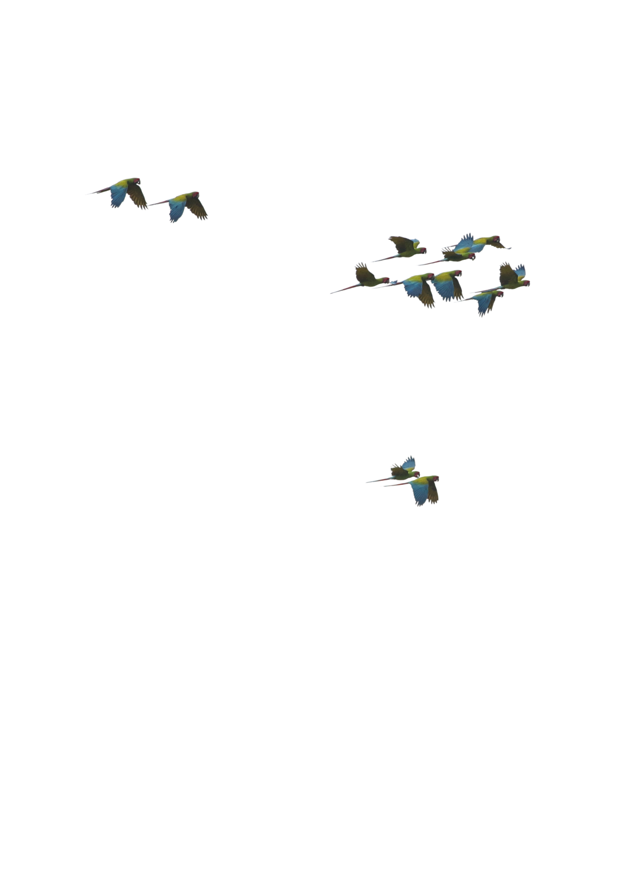

USING BIOACOUSTICS AND DIRECT MONITORING TO IMPROVE THE SCALE AND QUALITY OF THREATENED SPECIES ASSESSMENTS IN THE TROPICS
Thomas C Lewis

A thesis submitted in partial fulfilment
of the requirements for the degree of

Doctor of Philosophy

The University of Sheffield
Faculty of Science
School of Biosciences

Dec 2022

Contents
List of figures i
List of tables iv
Summary v
Acknowledgements vii
Declaration viii
General Introduction 1
1.1 Background 1
1.3 Demographic processes and population growth 2
1.3 Monitoring and conservation 3
1.4 Monitoring approaches 5
1.5 Parrots 14
1.6 Thesis structure 18
1.6 Bibliography 19
Inadequate sampling of the soundscape leads to overoptimistic estimates of recogniser performance: a case study of two sympatric macaw species 34
2.1 Abstract 34
2.2 Introduction 34
2.3 Materials and Methods 38
2.4 Results 44
2.5 Discussion 47
2.6 Bibliography 52
Using passive acoustic monitoring to estimate the abundance of a critically endangered parrot, the great green macaw (Ara ambiguus) 55
3.1 Abstract 55
3.2 Introduction 55
3.3 Methods 59
3.4 Results 63
3.5 Discussion 66
3.6 Bibliography 73
Using passive acoustic monitoring to investigate the spatial and temporal landscape use by the critically endangered great green macaw (Ara ambiguus) 77
4.1 Introduction 77
4.2 Methods 81
4.3 Results 84
4.4 Discussion 86
4.5 Bibliography 90
Nest-site selection and productivity are linked in a critically endangered parrot nesting in an anthropogenically disturbed landscape 96
5.1 Abstract 96
5.2 Introduction 96
5.3 Methods 98
5.4 Results 102
5.5 Discussion 105
5.6 Bibliography 110
General Discussion 116
6.1 Passive acoustic monitoring 116
6.2 Cavity selection and productivity 118
6.3 Implications for GGM conservation 118
6.4 The potential for using PAM to monitor parrots 121
6.5 Future work 123
6.6 Conclusion 128
6.7 Bibliography 129
Supplementary materials 136
S2: Training a species-specific recogniser for a tropical ecosystem: a case study of two sympatric macaw species 136
S3: Using passive acoustic monitoring to estimate the abundance of a critically endangered parrot, the great green macaw (Ara ambiguus) 138
S4: Using passive acoustic monitoring to investigate the spatial and temporal landscape use by the critically endangered great green macaw (Ara ambiguus) 149
S5: Nest-site selection and productivity are linked in a critically endangered parrot nesting in an anthropogenically disturbed landscape 155

List of figures
Figure 1: A pair of great green macaws, one of the largest macaws in the world, preening each other 16
Figure 2: Great green macaw distribution from ebird (2021). In Honduras (Green) there are estimated to be ~250 individuals (BirdLife International 2020), Nicaragua (purple) it is unknown how many individuals are spread across the two populations (north and south). In Costa Rica (pink) it is estimated that there are ~330 individuals (Macaw Recovery Network, 2021). In Panama (grey), in Cerro Hoya NP there are estimated to be ~60 individuals (Bolcato pers. comms), it is not known how many are in the rest of the country. In Colombia (light blue), there are estimated to be ~100 individuals and Ecuador (gold) ~50 (BirdLife International 2020). 18
Figure 3: ARU locations in north-eastern Costa Rica. ARUs were set out on a 10km grid, holes in the grid are areas that were inaccessible due to dense forest or lack of permission from landowners. 38
Figure 4: Schematic of classifier development A) represents how data was divided to create the three training/testing datasets (D1, D2 and D3). D1 was selected from recordings up to the middle of March when TL had to leave the field due to the pandemic. After April recording devices were left in the field until June and so any failures were not rectified, which resulted in fewer recordings taking place towards the end of the study period. Most sites had issues with recording devices failing at some point; at site 43 the recording device failed and then was stolen so was not re-installed. B) The workflow used to develop each classifier, starting from raw sound files (light green) and resulting in classifiers and performance metrics (red). R1, R2 and R3 refer to recogniser one, two and three. 41
Figure 5: Recogniser performance metrics show an improvement between R1 and R2, whereas R3 which was trained on a subset of the full training dataset did not improve. There is a trade-off between precision and recall when precision increases recall decreases and visa-versa. There is a difference between evaluation and validation precision metrics, this is the smallest for R2 but demonstrates the potential pitfalls of using default validation datasets to estimate the performance of recognisers, especially with small datasets. 44
Figure 6: The temporal change in source background noise in the false positive detection of the breeding season recogniser (R1) in the evaluation dataset across the study period. There is a distinct change in the proportions of Amazona spp., clay colour thrush and chicken after the time period that the recogniser one’s training dataset was selected (dashed line). 45
Figure 7: The spatial change in source background noise in the false positive detection of the breeding season recogniser (R1) and enhanced recogniser (R2) in the evaluation dataset across the study period. Site 21 and 31 have the highest FP rate using both R1 and R2. Overall the total number of FP detections decreased significantly, but the proportions remained similar. 47
Figure 8: Maps of all the landscape covariates A) Land cover / land use (LCLU) covariates; Trees (tree cover) and Urban (urban cover), Other (pasture, crops, scrubland) B) Log altitude C) Forest Landscape integrity index (FLII) D) Soil order. 62
Figure 9: Untransformed model coefficients. The only covariate with a positive effect is Tree cover, whereas all others are either have no significant effect (Ultisol, Ultisol/Inceptisol and Entisol) or negatively affect abundance (FLII, log(Altitude), Inceptisol/Andisol and Inceptisol. 66
Figure 10: Estimated breeding season abundance, using the top model, across the 43 sites (site ID to the right of locations) shown against forest landscape integrity index (FLII). Higher abundances are seen in the northern areas, compared to the south. FLII has been categorised as per Grantham et al., (2020) into low (0-6), medium (6-9.6) and high (>9.6) integrity. 68
Figure 11: GGM abundance during the peak of the breeding season (Jan - Mar) is largely restricted to lowland areas in the north of Costa Rica on the border with Nicaragua. Significant numbers can be found in the Maquenue Mixed use reserve within the San Juan La Selva biological corridor. Predicted potential breeding season abundance across the historic range of the great green macaw in Costa Rica. Outlined is the Costa Rican range of the great green macaw using ebird data produced by Fink et al., (2021). The biological corridor is the San Juan La Selva biological corridor. Protected area (PA) type “full” is a national park, whereas “mixed” is a mixed-use reserve where forestry and agriculture are permitted under specified limits. Red dots are the five isolated ebird areas. 70
Figure 12: ARU sites in the northeast of Costa Rica over the eight soil orders in the region. Soil orders are dominated by Ultisol and Inceptisol orders, with only a few sites having Entisol, Andisol or Histosol soils. 84
Figure 13: Relative abundance across each time period using the NB20 model. There is a large change in relative abundance in the southeastern sites from the first period to the last, suggesting an increase in great green macaw activity in this region. 88
Figure 14: Covariate coefficients for detection, population growth rate and initial abundance sides of NB20 89
Figure 15: Study site in the Caribbean lowlands within the San Juan La Selva (SJLS) biological corridor in northern Costa Rica, with nest cavities (blue) marked. There were two monitored nests outside the SJLS biological corridor. 102
Figure 16: Univariate model A) means and posterior distributions and B) standard deviation and posterior distributions for occupied and unoccupied cavities. With the difference in C) means and posterior distributions and D) standard deviation and posterior distributions for each cavity feature with significant features, those with 95% credibility intervals not crossing zero, highlighted in red. 106
Figure 17: Model estimates of the regression slopes and their posterior distributions from the univariate ordinal regression of each cavity feature, with the significant models in red. B) The difference in WAIC scores compared to the best-performing model. C) The relationship between each feature and predicted alongside the data (green). 109
Figure 18: Two areas that my PAM research has identified as priorities for further investigation. Breeding: During the breeding season this area has a high abundance of GGMs. Non-breeding: Relative abundance of GGMs increased dramatically here at the end of the breeding season, as this is an area of high anthropogenic activity it is unclear why this would be, on-the-ground investigation could help understand these findings. 122

List of tables
Table 1: Covariates used in Royle-Nichols model, their definition and source. 64
Table 2 Models, their AIC and delta AIC. The top two models are within 0.64 AIC of each other. 67
Table 3: Definitions of covariates, how they are determined and their source. Time periods are ten days long with a ten-day gap in between. 85

Summary
Effective conservation requires effective monitoring. Rapid changes to ecosystems and increasingly extreme climate mean large-scale, robust data are needed to develop feedback into conservation strategies. Two factors critical to developing and maintaining conservation strategies are monitoring distribution, status and productivity. In tropical regions monitoring these factors are particularly difficult as the physical properties of the ecosystem can limit accessibility and the scale at which traditional monitoring can be carried out. Wide-ranging, grouping living species such as parrots are even more challenging to robustly monitor as they are canopy dwelling and violate key assumptions of standard survey techniques. If we are to conserve species like this and their ecosystems, we need to take advantage of significant increases in capacity and reductions in the cost of cutting-edge technology such as bioacoustics and drones. Here, I show, using the great green macaw (Ara ambiguus) as a case study, that passive acoustic monitoring is an effective tool for monitoring parrots and other challenging to study species like it. I developed a recogniser that consists of a two-stage machine learning pipeline to extract target species calls. This data was then used to estimate abundance and found that there are 485.61+/- 65 great green macaws in Costa Rica. This is a significant improvement on previous estimates based on extended point counts. Passive acoustic monitoring derived data was also used to model spatio-temporal distribution of the great green macaw across its range in Costa Rica. Both passive acoustic monitoring studies highlighted potentially important regions for the species in previously unstudied areas, demonstrating the value of passive acoustic monitoring as a conservation science tool.
I then demonstrated how traditional approaches to monitoring productivity can be combined with drones to scale data collection. This study found that the productivity of great green macaws is within the range of other large macaw species (1.33 chicks per breeding attempt). They also select deep cavities in isolated trees that passively reduce the risk from arboreal and avian predators. Results suggest that avian predators are the primary cause of productivity loss in the study population. Importantly for the conservation of the species, results indicate that restoration of pasture or scrubland around nest sites could increase predation of nests by increasing accessibility to non-volant predators.
My work demonstrates how technology can be a valuable tool for conservation science by increasing the potential scale and reducing fieldwork effort and resource expenditure. Furthermore, this work provides critical insights into the status and distribution of the great green macaw in Costa Rica. The insights gained and the approach demonstrated here are highly applicable to other parrots and species like them.

Acknowledgements
I would like to thank my family for their continuing unwavering support. A special thanks to my parents for providing me with a roof over my head when I returned from fieldwork during the pandemic. Home was an oasis of calm in a crazy world and was just what I needed to allow me to focus on my work. You have both been the rocks that allow me to fly off to far flung places to pursue my dream of working in conservation, knowing I always have a loving home to return too.

A special thank you to Chloe for your love and support, making me smile and putting up with me during some very stressful times.

A massive thanks to Sam Williams who, since we met 2015, has been the most important person pushing and pulling me to develop as a conservationist. Before we met, I was a conservationist without a cause, now I can truly say that in parrot conservation I have found a home.

To all the staff and volunteers of Macaw Recovery Network. You work tirelessly to build a better future of parrots and the people who share their home. A special thank you to Mario for your dedication in the field, for helping me, and always going above and beyond for the parrots.

Thank you to everyone in my friends at the University of Sheffield. Although, I only spent 10 months living in Sheffield during the 4 years of my PhD, those times were some of the best. Even when we moved to an online life, Friday lab meetings were often a highlight of the week.

Finally, thank you to my supervisors Dylan, Andrew and Ben. I special thanks to Dylan, I could not have asked for a better supervisor, your support through the tough first few months of the pandemic was truly appreciated. It is not too dramatic to say I wouldn’t be writing this if it weren’t for you.

Declaration
I declare that this thesis is a presentation of original work, and I am the sole author. This work has not previously been presented for an award at this, or any other, University. All sources are acknowledged as References.

General Introduction

1.1 Background
We are experiencing the sixth mass extinction event (Ceballos et al., 2015; Ceballos, Ehrlich and Raven, 2020); one million species are currently estimated to be threatened with extinction (Diaz et al., 2019; Purvis et al., 2019). Nevertheless, one positive is that although large numbers of species have declined, conservation action has lessened the declines, in some cases increasing population sizes of endangered species (Pimm et al., 2006; Hoffmann et al., 2010; Bolam et al., 2021). For example, conservation action has prevented 21-32 bird extinctions and between seven and sixteen mammal extinctions since 1993 (Bolam et al., 2021). Recently, the IUCN Green Status of Species has been developed as a formal, robust way to assess the success of species conservation (Akçakaya et al., 2018; Grace et al., 2021). As human impacts on the planet continue to grow, we must learn from history and build on previous successes to ensure we have the knowledge and conservation tools required to prevent as many species from going extinct as possible.

Active wildlife conservation has a long history, with reintroductions of the peregrine falcon (Falco peregrinus) to the eastern United States of America in the early 1970s (Cade, 1974). On the islands of New Zealand and Mauritius work to save their unique endemic species also began around this time. Both islands are places where unique wildlife evolved in isolation for millennia; Mauritius is the home of the extinction icon, the dodo (Ramphus cucullatus) (Cheke and Hume, 2010) and New Zealand is home to the world's only flightless parrot, the critically endangered kakapo (Strigops habroptilu) (Forshaw, 2010). Due to humans' impacts and activities, these two island nations had many critically endangered species to trial and develop effective techniques. Here, conservationists developed and applied techniques such as brood management, supplementary feeding and marooning on off-shore islands to save species from extinction (Jones and Merton, 2012). This marked a change in the approach to conservation that had been primarily about protecting areas and preventing human interference with wildlife (Adams, 2004; Roe, 2008). Conservation work in both countries has saved at least twenty species from extinction (Jones and Merton, 2012). The conservation success in these two countries demonstrated that species on the brink of extinction could be saved; this was the beginning of endangered species conservation as a field.

With critically endangered species, often the populations are so low that they can be found in single refugia (e.g. Jones, 1980; Juniper and Yamashita, 1990; Jones et al., 1995; Clout and Merton, 1998); the loss of the majority of the population has already occurred. Specific monitoring techniques are not particularly useful in this case, but letting species reach this point is not ideal. Saving species from the brink is expensive and intensive work; for example, the California condor (Gymnogyps californianus) was down to 22 individuals in 1987. The recovery programme has, so far, been a success, with the wild population now over 200 individuals. Nevertheless, the annual budget for the programme was approximately $ 5 million in 2007 (Walters et al., 2010). If conservation is to be scaled to face the threats of increasing environmental change, early detection of declining populations and effective identification of threats is required. To do this, we must combine the knowledge gained over fifty years of active conservation whilst developing effective monitoring techniques to help us understand population trends, identify any decline, and mitigate the impacts of human disturbance (Gibbs, Snell and Causton, 1999; Pereira and David Cooper, 2006; Nichols et al., 2015).

1.2 Demographic processes and population growth
We first need tools to help us understand the ecological and human drivers of population decline and how they affect demographic processes and population growth. For example, invasive species are one of the primary drivers of species decline and extinction across the globe (Clavero and García-Berthou, 2005; Dueñas et al., 2021). However, invasive species' mode of action on native taxa can be different; this knowledge comes from field observations (Hill and Hill, 1987; Hess, Wehr and Litton, 2020) and other monitoring approaches, such as camera traps (Murphy et al., 2019; Taillie et al., 2021), dietary analysis (Maeda et al., 2019; Gaiotto et al., 2020) and nest monitoring (Fea and Hartley, 2018; Broughton, 2020; Holopainen et al., 2021). By monitoring populations of endangered species, we can understand how invasive species impact native species populations and how the modes of action can differ for the same invasive species in different contexts. For example, feral pigs are thought to be one of the primary drivers of the extinction of the Po’ouli (Melamprosops phaeosoma) on the island of Maui, Hawaii (Mountainspring et al., 1990; Groombridge et al., 2004). Feral pigs did not predate the Po’ouli; rather, they altered their ecosystem and reduced food availability (Mountainspring et al., 1990). However, feral pigs are thought to have directly contributed to the dodo's extinction by predating their nests (Cheke and Hume, 2010). Effective monitoring can elucidate the mode of action and its effects on the population, identifying the most at-risk stage in the life cycle. This will inform decision-making, guiding conservationists in the development of suitable strategies such as targeted poisoning (Maggs et al., 2015; Blanvillain et al., 2020), brood management (Tollington et al., 2013) or exclusion fences (Smith et al., 2011; Doherty and Ritchie, 2017).

Another way the monitoring can help is by identifying and tracking changes in a species’ spatiotemporal distribution. For example, the spoon-billed sandpiper (Calidris pygmaea), a critically endangered wader from eastern Asia, is a long-distance migrant, travelling between breeding sites in northeast Siberia and non-breeding grounds in Southeast Asia. Monitoring breeding grounds showed that breeding pairs were declining, with no evidence of the cause (Syroechkovski Jr., 2007). However, due to the species' extensive non-breeding range from Bangladesh to South Korea, important stopover locations were unknown until recently; this hampered the identification of threats and development of conservation strategies (Zöckler et al., 2016; Bradfer-Lawrence et al., 2021). Now stopover locations and wintering grounds have been found, and threats such as by-catch (Crighton, 2016) and land-use change have been identified (Zöckler et al., 2016), meaning conservation strategies can be developed to address these threats. This case shows how monitoring productivity and spatiotemporal distribution is critical to understanding the primary drivers of population decline.

Wide-ranging species are often those that are long-lived, for example, sea turtles (Miller, 1996), elephants (Lee et al., 2016) and parrots (Munshi-South and Wilkinson, 2006). Life history theory predicts, and research has shown that long-lived species population dynamics are most sensitive to variations in adult survival(Caswell, 2000; Sæther and Bakke, 2000; Stearns, 2000). However, evidence suggests that in some cases, long-lived species are vulnerable to changes in productivity. For example, the critically endangered yellow-naped amazon (Amazona auropalliata) (BirdLife International, 2022) has undergone catastrophic declines across its native range in Central America mainly because of low or no productivity due to poaching of nestlings for the pet trade (Dahlin et al., 2018). The leatherback turtle (Dermochelys coriacea) population in Costa Rica is more sensitive to high levels of egg poaching than moderate levels of adult mortality (Tomillo et al., 2008). So understanding whether productivity is driving the decline or limiting the recovery of an endangered species is critical; without it, a holistic approach to species conservation is not possible (Krüger and Amar, 2017). This may be especially important for species residing in anthropogenically disturbed environments as cues used to assess breeding sites might have been altered, leading to a discrepancy between the cues and actual breeding site quality and a decline in productivity (Kokko and Sutherland, 2001). Not only do some long-lived, wide-ranging species show sensitivity to declines in productivity, but it is also one of their life stages that are simplest to study. Therefore, it is logical to study productivity to determine whether it contributes to a population's decline or is limiting its recovery.

1.3 Monitoring and conservation
Conservation is underpinned by monitoring; a threat or decline has to be identified to provoke an action. Some of the first practical conservation work was carried out by Richard Henry between 1894 and 1900. At the end of the 19th century, there was a growing concern about the effects stoats (Mustela erminea) were having on the native fauna of New Zealand. At this time, there were no monitoring techniques besides direct field observations. Richard Henry observed the decline of the flightless birds, such as the Kakapo and kiwi (Apteryx australis), after the introduction or expansion of mustelids into the area (Hill and Hill, 1987). This made naturalists realise that many of these species would go extinct without intervention. Richard Henry pushed for the establishment of Resolution Island as a reserve. Once it was gazetted, he marooned Kakapo and kiwi on the island (Hill and Hill, 1987). Unfortunately, it was unsuccessful as stoats reached the island in 1900 and killed all the marooned birds. Kakapo and kiwi populations declined until the last surviving mainland kakapo was translocated to Maud Island in 1975 (Clout and Merton, 1998). This demonstrates how catastrophic declines, like those caused by invasive predator species, can be detected by field observations. However, they are challenging to scale, are open to observer bias and are unlikely to detect the early stages of a slow decline.

In the United States of America, in 1914, the apparent catastrophic decline and extinction of the passenger pigeon (Ectopistes migratorius) occurred (Halliday, 1980). Like many extinctions during the Holocene, two synergistic drivers likely caused the species extinction. It is widely known that hunting pressure from humans had a significant direct impact on the fate of the passenger pigeon (Halliday, 1980). However, evidence indicates that natural, extreme population fluctuations acted synergistically with hunting pressure to drive the species to extinction (Hung et al., 2014). Recent work suggests that with modern risk assessments, conservationists would have been able to predict the extinction of the passenger pigeon (Stanton, 2014). With the conservation tools of the time, even if the implications of the catastrophic decline were realised, it is unlikely that conservationists would have been able to prevent the passenger pigeon from going extinct. However, with modern conservation tools such as highly effective captive breeding, supplementary feeding, effective lobbying and much better monitoring tools, it may have been possible to prevent the passenger pigeon's extinction.

Monitoring alone cannot be used to develop conservation strategies; it can provide data for modelling and inform decision-making, but many other factors determine how a conservation strategy is developed and enacted (Black et al., 2011; Martin et al., 2012). For example, two island endemics, the sihek (Halcyon cinnomomina cinnomomina) from Guam and the Po’ouli (del Hoyo, 2020), were monitored throughout their decline, but only one is now extant. The Po’ouli was discovered in 1973 (Casey and Jacobi, 1974). At this time, its population density was estimated to be 76 individuals per km2, which equates to ~1000 individuals across its 1300ha range (Mountainspring et al., 1990). In 1998 only three known individuals remained, and although attempts were made to save it in the wild (Groombridge et al., 2004), the species was declared extinct in 2019 (BirdLife International, 2022b). The sihek declined sharply, like most of the island avifauna on Guam, due to the introduction of the brown tree snake (Boiga irregularis) during World War II (Fritts and Leasman-Tanner, 2001). In 1981 to population was estimated to be ~3000 individuals (Engbring and Ramsey, 1984); however, by 1988, it was extinct in the wild (Wiles et al., 2003). Fortunately, in 1983 a decision was made to capture a group of sihek and bring them into captivity as an insurance population. Between 1984 and 1986, 29 sihek were captured and transferred to zoos on the United States mainland (USFWS, 2008). There are now ~140 individuals in captivity, although the species remains extinct in the wild (Trask et al., 2021).

1.4 Monitoring approaches
Current methods of monitoring population trends and identifying at-risk populations vary depending on the focus species and their behavioural and ecological traits. For example, distance sampling is a well-established method for monitoring the population densities of passerines (Bibby et al., 2000; Sutherland et al., 2004), and direct counts are used for breeding seabird colonies (Bibby et al., 2000). Aerial counts are used for large savanna animals such as elephants (e.g. Bouché et al., 2012; Vermeulen et al., 2013) and black rhinoceros (Diceros bicornis) (e.g. Brockett 2002; Kidwai et al., 2019). In tropical rainforests, camera trapping is used for tigers (Panthera tigris tigris) (e.g. Karanth 1995; Wegge et al., 2004; Karanth and Nichols 2011) and jaguar (Panthera onca) (Tobler and Powell, 2013).

These methods are well established; they all estimate population size, and all have limitations. For example, direct counts of seabird colonies target breeding pairs; if nest sites are occupied by resting individuals that are not breeding counts can overestimate the breeding population size (Bibby et al., 2000). Direct counting of breeding colonies, is similar to roost counts in parrots, as it relies on identifying all sites to ensure an accurate population estimate (Dénes et al., 2018; Siegel-Causey and Hunt, 1986). For aerial counts, the detection probability of animals is an issue, as it can be highly variable, meaning the use of raw counts can underestimate the population size (Caughley, 1977; Steinhorst and Samuel, 1989). Whereas, overestimation can occur if there is double counting (Schmidt, 2005), which can lead to positive and negative biases in estimates of survival probabilities (Gimenez et al., 2008) and turnover rates (Moilanen, 2002), respectively. False positives are avoided through experimental design, i.e. ensuring flight transects are far enough apart. Therefore, N-mixture models that can handle the variation in detection probability will provide robust estimates (Kidwai et al., 2019), overcoming some of the method's limitations. However, this approach is generally limited to counting large animals in open habitats, as it cannot be used in forested areas or for smaller species.

Camera trapping is a commonly used method in mammalian research; it is particularly well suited to monitor animals that have unique patterns, such as snow leopards (Janečka et al., 2011), jaguars (Tobler and Powell, 2013) and tigers (Karanth, 1995). It is also used to monitor breeding activity in birds (Brandis et al., 2014) and reptiles (Campos and Mourão, 2015). However, it is limited in its application to most birds' ecology outside breeding. It can help target specific species to detect occupancy at a site (O’Brien and Kinnaird, 2008), but it is not an applicable method for species that spend most of their time in or above the canopy. Distance sampling is widely used for species that have small daily movements or are territorial. For these species, robust estimates can be made about population size. However, population size can be overestimated when the method is applied to species that can travel between sites (Buckland et al., 2005). This is often the case for wide-ranging species such as parrots (Casagrande and Beissinger, 1997).

A particular challenge concerns the monitoring of wide-ranging species that reside in environments challenging for humans to work in, such as tropical forests or marine ecosystems (Barnes, 2001; Dénes et al., 2018; Guschanski et al., 2009; Mellinger et al., 2007). They are often found at low density and are unsuited to traditional survey methods because they can violate assumptions of the independence of sites. Surveys in these environments are often labour-intensive or impractical. Passive acoustic monitoring (PAM), a high-throughput sensing technology, has emerged as a promising solution to this problem (Gibb et al., 2019).

1.4.1 Passive acoustic monitoring
PAM is a rapidly developing field, underpinned by improvements and cost reductions in hardware such as Automated Recording Units (ARUs) (Snaddon et al., 2013; Hill et al., 2018; Teixeira et al., 2019). ARUs provide a cost-effective way to collect large quantities of high-quality ecological data non-invasively (Gibb et al., 2019). The increased affordability and the parallel development of software to analyse data collected from PAM have led to its widespread use in ecology, behaviour and conservation (Crunchant, 2022). PAM allows up to 24hr sampling periods and can operate in environments where visual methodologies are not possible. This means it is suited to monitoring daily activity patterns and movement in dense rainforests or marine environments. It also lends itself to monitoring the long-term changes in a species' spatiotemporal distribution; it is passive, i.e. requires very little human fieldwork and can therefore be deployed at scale and for long periods in the field.

The first applications of PAM were for cetaceans (Mellinger et al., 2007; Spiesberger and Fristrup, 1990), but now it is used in nearly all taxa (Blumstein et al., 2011; Browning et al., 2017; Marques et al., 2013; Sugai et al., 2019). Here I will briefly review the current literature, demonstrating the width and breadth of the field. These studies are examples of how PAM has opened up areas of research that were previously not possible or prohibitively expensive.

Behaviour
The use of PAM to study cetaceans' movements and activity patterns is widespread. It has been used to monitor the diel patterns of the harbour porpoise (Phocoena phocoena), the common dolphin (Delphinus delphis), and the bottlenose dolphin (Tursiops truncatus) (Dede et al., 2014), nighttime foraging by several odontocetes species in Hawaii (Au et al., 2013) and residency patterns of orcas (Orcinus orca) in the Gulf of Alaska (Myers et al., 2021). In the terrestrial realm, PAM has been used to study a wide range of different behavioural phenomena. For example, the effects of anthropogenic noise on bird vocalisations (Slabbekoorn and Peet, 2003; Redondo et al., 2013; Juárez et al., 2021), the diel patterns of howler monkeys (Alouatta spp.) (Do Nascimento et al., 2021; Pérez-Granados and Schuchmann, 2021a) and monitoring post-translocation behaviour of hihi (Notiomystis cincta) (Metcalf et al., 2019). Although not all are specifically conservation-focused studies, the knowledge gained from using PAM to monitor behaviour can be helpful for developing conservation strategies.

Animal behaviour can be investigated further with PAM when animals have context-specific call types. For example, the social mongoose (Suricata suricatta) uses different alarm calls for different predators (Manser, 2001), savanna elephants (Loxodonta africana) have varying calling patterns that indicate group size (Payne et al., 2003) and Antarctic minke whales (Balaenoptera bonaerensis) use context-specific calls, potentially to initiate group foraging (Casey et al., 2022). A lot of research into context-specific call types occurred before PAM developed as a field, but now with the increased accessibility of PAM, knowledge gained from targeted acoustic studies can help us understand behavioural and ecological processes such as diel feeding and habitat use. For example, areas of high bottlenose dolphin feeding activity were identified using this approach (Elliott et al., 2011). Using PAM for understanding how animals use their environment is only in its infancy, mainly because it initially requires a depth of knowledge of a species' call types that is difficult to gain.

What is exciting is that new methods are being developed to enable researchers to collect this kind of data, for example, mounting ARUs to harnesses and combining them with cameras, accelerometers and GPS to give detailed information on animal behaviour (Casey et al., 2022; Lynch et al., 2013; Stowell et al., 2017; Studd et al., 2021, 2019). By combining bioacoustics with bio-logging, researchers can increase the accuracy of behavioural classification (Wijers et al., 2018) and get more detailed insights into the behavioural responses of individuals to anthropogenic activities (Fregosi et al., 2016). Another exciting possibility with this approach is the study of communication between individuals, giving contextualised information about communication and behaviour (Greif and Yovel, 2019). This information could then be utilised in PAM studies, allowing inferences about behaviour and context.

Individuality in calls has been found in a wide range of different species, from bottlenose dolphins (Tursiops truncatus) (Caldwell and Caldwell, 1965) to the common vampire bat (Desmodus rotundus), white-winged vampire bat (Diaemus youngi) and hairy-legged vampire bat (Diphylla ecaudata) (Carter et al., 2012), the corn crake (Crex crex) (Budka et al., 2015) and the green-rumped parrotlet (Forpus passerinus) (Berg et al., 2011). This has been transferred into PAM, where individuals have been located, and their movements are tracked through their environment using microphone arrays. For example, a location system has been developed to track the movements of individual male Bornean flanged orangutans (Pongo pygmaeus wurmbii) (Spillmann et al., 2015; Spillmann et al., 2017). For species that have detectable individuality in the calls, there is the possibility of creating a tracking system that could, in theory, work like a non-invasive GPS. There are many barriers to creating a system like this; for example, individuality would have to be call-type independent (Fox, 2008). Nevertheless, the first step is determining whether individuality exists in any of the target species calls.

Ecology and conservation
One of the most important applications of PAM is allowing researchers to study the impacts of anthropogenic disturbance on animal communities. One of the major areas of study has been how human activities such as commercial shipping impact cetaceans (e.g. Merchant et al., 2014; Dyndo et al., 2015; Wisniewska et al., 2018). Physical evidence of ship strikes can be commonly seen on species such as sperm whales (Physeter macrocephalus), which led to the development of the WHALESAFE project, a real-time PAM system to reduce the frequency of ship strikes (Sanguineti et al., 2021). PAM research in northwest Ireland showed the adverse effects of marine construction activity on harbour porpoises but also demonstrated that this activity had no negative impact on bottlenose dolphins (Todd et al., 2020). This shows that anthropogenic noise can have varying effects on different species but probably favours species that are more human-tolerant, such as the bottlenose dolphin (Otto, 2018).

PAM has also allowed researchers to understand further how human disturbance affects birds. Some birds can adapt to their new environment; for example, some birds can respond to anthropogenic noise by altering singing frequencies (Juárez et al., 2021; Redondo et al., 2013; Slabbekoorn and Peet, 2003; Slabbekoorn and Ripmeester, 2008) and timing of dawn chorus (Arroyo-Solís et al., 2013). High noise levels can also change species richness and abundance (Laiolo, 2010; Proppe et al., 2013b) and negatively impact an individual's body condition (Proppe et al., 2013a). PAM has also shown how breeding bird populations alter after habitat degradations such as selective logging (Pillay et al., 2019). The information from this research can help in environmental impact assessments, guiding more appropriate development or informing mitigation strategies.

Within conservation, practitioners often want to understand distribution, abundance and track changes in these over time. This could be monitoring the effects of a conservation management strategy on a population or identifying important areas that need protection. For example, identifying important habitats with PAM is common in both marine (Brookes et al., 2013; Elliott et al., 2011; Kimura et al., 2022; Macaulay, 2020; Simon et al., 2010; Todd et al., 2022) and terrestrial domains (e.g. Alvarez-Berríos et al., 2016; Francomano et al., 2021; Pérez-Granados and Karl-L. Schuchmann 2021; Pérez-Granados et al., 2021). In comparison, estimating abundance is not as common as it is statistically more challenging (Marques et al., 2013; Dénes et al., 2018). Density estimations can be made where the microphone's distance can be calculated, but this is difficult, especially if only one microphone is used per site (Marques et al., 2013). More modelling approaches using detection/non-detection can be used with PAM data to estimate abundance; they are discussed below.

1.4.2 Challenges of using PAM to monitor populations

Data extraction
One of the significant challenges with the widespread adoption of PAM as a monitoring tool is the expertise needed to extract meaningful information from sound recordings. However, the type of expertise required can vary; some studies manually label target signals, which requires a species expert (e.g. Campos‐Cerqueira and Aide 2016; Abrahams and Geary 2020; Whisson et al., 2021), whereas others utilise machine learning to automate target species identification from raw audio files (e.g. Sebastián‐González et al., 2015; Caruso et al., 2020; Gillings and Scott 2021). Machine learning recognisers that automatically or semi-automatically detect target species calls in survey recordings are becoming increasingly more widespread as the scale of PAM studies increases and manual labelling becomes increasingly time-consuming. This requires computer science expertise, which is often not a common competence among ecologists and conservation biologists. Developing methods that increase accessibility for non-expert users is essential if PAM is going to become a useful monitoring tool.

There are two general approaches to using PAM: species-specific and soundscapes. Soundscape ecology is based on the association between biodiversity and acoustic diversity (Pijanowski et al., 2011). It has become increasingly popular as there is a drive to be able to assess the biodiversity of a site rapidly (Sueur et al., 2008). In this thesis, I am focusing on the species-specific approaches, but I will return to soundscapes in chapter 6 to discuss the future of PAM. There are two types of recognisers in PAM studies, species-specific and generalised. Species-specific recognisers are typically focused on a small number of study species and are often used for monitoring and studying endangered species (e.g. Sebastián‐González et al., 2015; Willacy et al., 2015; Arvind et al., 2022). Whereas generalised recognisers are designed to detect every species of the target taxa, e.g. birds, in a given recording (e.g. Kahl et al., 2021; Wood et al., 2022). Generalised recognisers use deep-learning techniques, which can be highly accurate at bioacoustics classification tasks but require a large amount of data to train (Stowell et al., 2019; Bermant et al., 2019; Zhong et al., 2020). In contrast, species-specific recognisers use either template matching (e.g. Do Nascimento et al., 2021; Teixeira et al., 2022), supervised machine learning (e.g. Knight et al., 2020; Balantic and Donovan, 2020) or deep learning (e.g. Bermant et al., 2019; Clink and Klinck, 2020). The advantages of using a species-specific recogniser is that they are often more accurate for the target species than generalised recognisers (Priyadarshani et al., 2018), can have a lower barrier to entry (Balantic and Donovan, 2020) and can have lower data requirements for training (Xie et al., 2021). Furthermore, generalised recognisers are currently not accurate enough to be used in many ecological applications (Ventura et al., 2015; Stowell et al., 2019; Zhong et al., 2020), although in North America and Europe, BirdNet is now comparable to most species-specific recognisers (Wood et al., 2022).

Representative studies
A current barrier to using PAM as a monitoring tool in tropical ecosystems is the lack of literature on suitable methods and case studies. Most published literature on species monitoring using PAM is carried out in temperate areas (Sugai et al., 2019) using small, high-quality datasets (Priyadarshani et al., 2018). When studies have been conducted in the tropics, it is common for the recordings to be manually labelled (e.g. Deichmann et al., 2017; Crunchant et al., 2020; Metcalf et al., 2022) or use commercially available recognisers (e.g. Spillmann et al., 2015) rather than using custom machine learning recognisers. This lack of methods for custom classifiers or applied studies means that when methods developed in temperate regions are applied in tropical ecosystems performance of recognisers degrades significantly (e.g. Heinicke et al., 2015). The cause of this is the highly heterogeneous soundscape due to the diversity of species with overlapping signal frequencies (Slabbekoorn, 2004). The diverse soundscape means background noise or non-target signal is incorrectly classified. The scale at which a PAM study is carried out can also affect the variation in background noise; if the study covers several different habitats, the background noise soundscape will also change (Slabbekoorn, 2004). Although background noise is a well-known issue for machine learning recognisers (Stowell et al., 2016), it is challenging to address. There are two approaches to dealing with background noise; denoising or training the recogniser to handle the noise. Both have challenges; for example, denoising is still a field in its infancy, so methods are either not accessible or very context-dependent. Whereas training a recogniser to handle background noise requires large amounts of labelled training data and is, therefore, very labour-intensive (Xie et al., 2021).

Estimating abundance
Estimating abundance from PAM is still in its infancy and is not widely used in the field of conservation and ecology (Pérez-Granados and Traba, 2021). There are several ways to estimate abundance from marked and unmarked populations. One of the most powerful approaches is modelling site occupancy using mark-recapture methods. As PAM cannot distinguish individuals of the majority of species, therefore, mark-recapture occupancy modelling is not possible. The second approach uses detection data to estimate the abundance and site occupancy, as this approach does not require individuals to be captured or identifiable. This approach is less powerful and does not handle heterogeneity in the data. However, as it does not require individuals to be captured or identifiable, it is well suited to PAM. Throughout this thesis, I will use the term “occupancy modelling” to refer to this second definition: using detection data to model occupancy or abundance at a site. The third approach uses distance sampling to estimate the density of target species at each site. Marques et al., (2013) reviewed the state of density estimation from PAM and concluded that it relies on the improvement of distance estimation from ARUs. Methods rely on auxiliary data such as group size, which can be challenging, particularly in species with fission-fusion group dynamics where group size can vary significantly (Thomas and Marques, 2012). For example, fallow deer (Dama dama) can range from one to one hundred and sixty individuals (Thirgood, 1996), and spinner dolphins (Stenella longirostris) can vary from fifty to two hundred and ten individuals (Karczmarski et al., 2005). Sebastián-González et al., (2018) used cue rate, the number of vocalisations per unit time, and distance from the ARU to help calculate the density using distance sampling. The disadvantage of this method is that species which violate key assumptions of distance sampling, i.e. independence of sites, cannot be studied using this method (Oedekoven et al., 2022). Another approach is to simply estimate the relationship between the cue rate and animal density (Pérez-Granados and Traba, 2021); however, this can have issues if the call rate is density-independent. Cue rate can also be used to give relative abundance, showing peaks in activity over time (e.g. Burnham and Duffus 2020) and across space (e.g. Wang et al., 2020).

A different approach is to use occupancy modelling. Occupancy modelling requires less information than distance sampling methods and is, therefore, less costly. Occupancy modelling and PAM have been used to monitor a roroa-great spotted kiwi (Apteryx maxima) population’s response to a translocation (Jahn et al., 2022), predict areas of high poaching pressure (Pardo et al., 2022) and monitor primate communities (Kalan et al., 2015). However, the most exciting aspect of occupancy-based methods is that they offer an opportunity to estimate abundance using PAM data. Two occupancy-based methods lend themselves to PAM data; Royle-Nichols (RN) model (Royle and Nichols, 2003) and time-to-detection (TTD) (Strebel et al., 2021). The new time-to-detection N-mixture model developed by Strebel et al., (2021) is sufficiently flexible to handle PAM data. It uses the time from the start of the survey to the first detection of a species as information to model the abundance of individuals at a site. However, it has not been tested with PAM data as it is a recent addition to the occupancy model toolbox. When TTD models were compared to RN models using data collected by observers, both gave comparable abundance estimates (Strebel et al., 2021). The RN model uses repeated detection/non-detection surveys to estimate abundance (Royle and Nichols, 2003). However, only a small number of studies have used the RN model with PAM data (Milchram and Bruckner, 2018; Mena et al., 2021). When comparing RN models to generalised encounter models (gREM) (Lucas et al., 2015), Milchram and Bruckner (2018) found that RN models gave similarly reliable estimates of bat population size.

All models make assumptions about the sampled population. The RN model utilises the relationship between the variation in abundance and the variation in realised detections; therefore, the abundance can be estimated using the heterogeneity in realised detections at each site. This means that the RN model assumes the only source of heterogeneity in the detections is from heterogeneity in abundance. If this is not the case, then the unmodelled heterogeneity can lead to an over-estimation of detection probability and, therefore, an under-estimation of abundance (Marques et al., 2013). Other sources of heterogeneity can be split into intrinsic and extrinsic factors. Extrinsic factors are habitat, time, season, weather and temperature (Veech et al., 2016) and can be accounted for by using appropriate covariates (Royle and Nichols, 2003). Intrinsic factors are factors such as behaviour variation between individuals and are much more challenging to account for as the model assumes all individuals have the same detection probability. In PAM studies, variation in realised detections could also be caused by false-positive detections especially if they are biased to particular sites or when focal species are less abundant, and true-positives are not as likely (Clare et al., 2021; Strebel et al., 2021). This would mean the number of detections is over-estimated, leading to an overestimation of abundance. To account for this all-positive detection need to be manually verified.

Overall, the options to estimate abundance from PAM are restricted. Most methods require costly data or strict assumptions that cannot be met, such as distance from the device (Marques et al., 2013). The RN model makes several assumptions about data, but these can be addressed through experimental design. For example, the independence of sites can be assumed if sites are located sufficiently far apart and are sampled simultaneously. Also, there are no false-positive detections in the data; PAM lends itself to this as detections can be verified multiple times if needed. Although this requires manual checking, it means the core assumptions of the model can be met. The assumption of the RN model that is most challenging to meet confidently is that the abundance distribution follows either a Poisson or negative-binomial distribution. Therefore, it is the best candidate for estimating abundance using data from PAM at scales relevant to wide-ranging species in tropical rainforests.

Spatiotemporal studies
Despite these favourable characteristics, using PAM to monitor the spatiotemporal distribution of terrestrial animals is not common. Terrestrial research is behind the marine realm, where PAM is often used to study cetaceans (e.g. Benjamins et al., 2017; Caruso et al., 2020; Warren et al., 2021) and is increasingly used on other marine taxa (Bolgan et al., 2018; Buscaino et al., 2020; Wall et al., 2013). The best example of a PAM study into the long-term changes in the spatiotemporal distribution of a species is a ten-year study on the North Atlantic right whale (Eubalaena glacialis). The study showed the potential of PAM to track movement patterns and how established patterns of relative seasonal abundance can shift (Davis et al., 2017).

The difference between estimating abundance at a snapshot in time and tracking changes in abundance over time is that we require a model that can deal with multiple seasons and does not have an assumption of closure. The assumption of closure is challenging to uphold over time, especially when focal species are wide-ranging. One set of models that fits these requirements is the open N-mixture model (Dail and Madsen, 2011). This is a relaxed version of the Royle (2004) N-mixture model from spatially replicated counts. N-mixture models are hierarchical models that use explicit observation and state processes to deal with the variation in the observed data (Royle and Dorazio, 2008). The state process deals with the abundance or occupancy, and the detection error is dealt with by the observation component (Dénes et al., 2015). Several N-mixture model approaches can be used to estimate occupancy or abundance (Kéry, 2021). However, due to its flexibility, the open N-mixture model is an ideal candidate for attempting to monitor the fine-scale changes in a species' spatiotemporal distribution using PAM data.

1.5 Parrots
Parrots are one of the most endangered bird families, with 28% threatened with extinction globally (IUCN, 2020). They are found throughout the tropics and sub-tropics (Forshaw, 2010; Parr & Juniper, 2010) and are mainly threatened by poaching and habitat loss (Wright et al., 2001; Stojanovic et al., 2016; Berkunsky et al., 2017; Vergara-Tabares et al., 2020). Since 1900 three parrot species have gone extinct, all from mainland regions; the paradise parrot (Psephotellus pulcherrimus) (McGregor and McGregor, 2021), the Glaucous macaw
(Anodorhynchus glaucus) (Butchart et al., 2018; Yamashita and Valle, 1993), and the Carolina parakeet (Conuropsis carolinensis) (Burgio et al., 2021). All three species were severely affected by anthropogenic degradation and habitat loss. For example, the Glaucous macaw was a species that specialised in feeding on yatay palms, but cattle fed on the saplings causing the senescence of palm groves and the species' subsequent population crash (Yamashita and Valle, 1993).

Although three parrot species have gone extinct during the last 100 years, several parrot species have also been saved from the brink of extinction. The echo parakeet (Psittacula eques) was down to under ten known individuals (Jones, 1980) but reached 500 individuals in 2012 (MWF, 2012). The Mauritian Wildlife Foundation programme used captive breeding, brood management and supplementary feeding to address the factors driving the species' decline (Tollington et al., 2013; Gath, 2018). Although this intensive conservation management saved the species from extinction, lessons were learnt from the unforeseen consequences of these actions. For example, supplementary feeding increased fecundity rates boosting population growth, but this also facilitated the spread of diseases, which had adverse effects on population growth (Gath, 2018). Other parrot species that have been saved from the brink are the Spix macaw (Cyanopsitta spixii) which is extinct in the wild (Juniper, 2004). A reintroduction programme is currently in the initial stages of re-establishing a wild population. Only three female and thirteen male orange-bellied parrots (Neophema chrysogaster) were known in 2017 (Troy and Kuechler, 2017); however, a high of over 100 wild birds left the breeding site in autumn 2020 to migrate north (Pritchard et al., 2022). The Kakapo (Strigops habroptilu) was down to under fifty-four individuals (Clout, 2006) but now is over 255 (DOC, 2022).

1.5.1 The great green macaw (Ara ambiguus)
The great green macaw (GGM) (Fig.1) is one of 24 critically endangered parrot species, its range extends from southern Honduras in the north to Ecuador in the south (Fig. 2). In Costa Rica, the GGM’s range was reduced by ~90% by the end of the 1990s (Chassot and Monge 2002) but may have increased slightly since then (Fink et al., 2021). One of the main drivers of this decline was habitat loss and degradation, with the loss of around 90% of the mountain almond (Dipteryx panamensis), a vital food and nesting tree (Monge et al., 2003; Chassot et al., 2007; Monge et al., 2012).

Figure 1: A pair of great green macaws, one of the largest macaws in the world, preening each other
The most recent global estimate of their population puts their number between 500 and 1000 mature individuals, fragmented across five subpopulations (BirdLife International, 2020). Expert opinion suggests that the largest subpopulation is found in Honduras, which is~260 individuals. However, recent roost counts in Costa Rica carried out by the Macaw Recovery Network (Macaw Recovery Network) and Centro Cientifico Tropical suggest that the Costa Rican population may be significantly larger at ~330 individuals (Macaw Recovery Network, 2021). One of the major issues with estimating the GGM, and other parrot populations, size is the lack of robust methods. For example, one previous study estimated the Costa Rican and Nicaraguan GGM population using an extended point count methodology. The study estimated 302.93 ± 513.78 individuals in Costa Rica and 532.45 ± 251.33 in Nicaragua (Monge et al., 2010). The methods used to estimate population size for the GGM are expert opinion, roost counts and extended point counts. These methods all have their disadvantages; mainly, they are not statistically robust. Therefore, the baseline data needed to underpin effective conservation management is not robust. Using PAM, the species provides a good case study to develop a methodology to monitor population trends in a long-lived, wide-ranging species in a tropical rainforest ecosystem.

The leading cause of the species decline has been habitat loss (Chassot et al., 2007; Berkunsky et al., 2017), with much of the tropical lowland habitat it occupies being transformed by anthropogenic activity (Grantham et al., 2020; Karra et al., 2021). Like many large parrots, the GGM is a secondary cavity-nesting bird (Forshaw, 2010). In highly disturbed forests, it is common for large cavity-bearing trees that large-bodied secondary cavity nesters are particularly reliant on (de la Parra-Martínez et al., 2015; Marsden and Jones, 1997; Renton et al., 2015) to have been lost (DeWalt and Chave, 2004). This suggests that productivity may be limited by nest-site availability in degraded forests (de la Parra-Martínez et al., 2015; Renton et al., 2015; De Labra-Hernández & Renton, 2016; Stojanovic et al., 2021) such as those found in Costa Rica. Understanding whether anthropogenic change has affected productivity is critical to developing an effective conservation strategy for the species.

1.6 Thesis structure
This thesis focuses on three important aspects of the GGM's biology: abundance, spatiotemporal distribution and productivity. In chapter 2, I demonstrate how to develop a species-specific recogniser for PAM of GGM. This approach provides an accessible way to develop species-specific recognisers widely applicable to other taxa. In chapter 3, I use the recogniser developed in chapter 2 to extract detection/non-detection data from a large-scale PAM study in the north of Costa Rica. I then use this data and the RN model to estimate the abundance of the GGM in Costa Rica. Finally, I discuss further the potential limitations and applications of PAM and RN modelling for wide-ranging species in challenging environments, like the GGM in Costa Rica.

In chapter 4, I extract cue rates across the breeding and non-breeding season. I then use dynamic occupancy models to explore how the GGM relative abundance and distribution changes between the breeding and non-breeding season. This is a crucial time for the GGM as it is unknown where they go after the breeding season.

Understanding the breeding performance of a critically endangered species is vital for any conservation strategies. Therefore in chapter 5, I investigate the relationship between nest site selection and breeding performance to determine whether GGM productivity in an anthropogenically altered landscape is a likely limiting factor in population recovery.

To conclude, chapter 6 summarises the thesis's primary outcomes and discusses the potential for using PAM for not only GGMs but other parrot species. Finally, I discuss the implications of my work for GGM conservation and parrot conservation more widely and explore the possible next steps to develop the approaches I have utilised and broaden their use and scope.

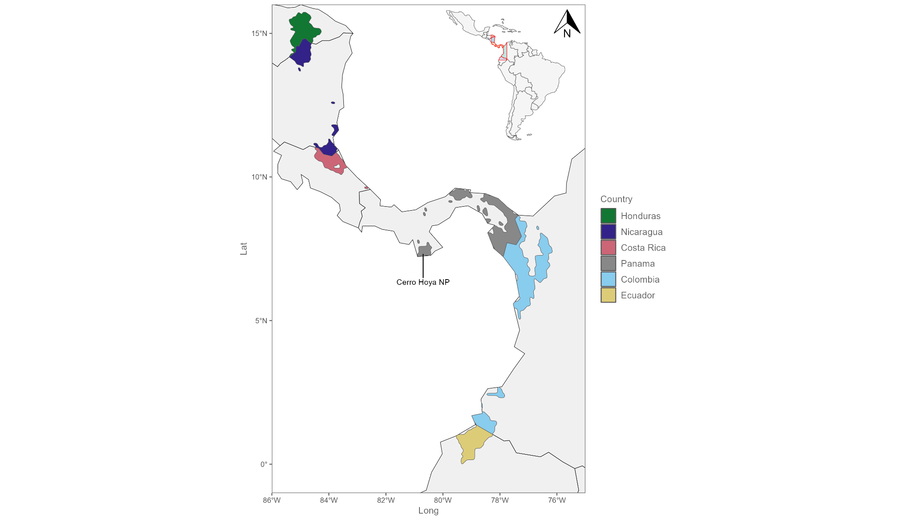
Figure 2: Great green macaw distribution from ebird (2021). In Honduras (Green) there are estimated to be ~250 individuals (BirdLife International 2020), Nicaragua (purple) it is unknown how many individuals are spread across the two populations (north and south). In Costa Rica (pink) it is estimated that there are ~330 individuals (Macaw Recovery Network, 2021). In Panama (grey), in Cerro Hoya NP there are estimated to be ~60 individuals (Bolcato pers. comms), it is not known how many are in the rest of the country. In Colombia (light blue), there are estimated to be ~100 individuals and Ecuador (gold) ~50 (BirdLife International 2020).

1.7 Bibliography
Abrahams, C. and Geary, M. (2020) ‘Combining bioacoustics and occupancy modelling for improved monitoring of rare breeding bird populations’, Ecological Indicators, 112, p. 106131. Available at: https://doi.org/10.1016/j.ecolind.2020.106131.
Adams, W. (Bill) (2004) Against Extinction: The Story of Conservation. London: Routledge. Available at: https://doi.org/10.4324/9781849770415.
Akçakaya, H.R. et al., (2018) ‘Quantifying species recovery and conservation success to develop an IUCN Green List of Species’, Conservation Biology, 32(5), pp. 1128–1138. Available at: https://doi.org/10.1111/cobi.13112.
Alvarez-Berríos, N. et al., (2016) ‘Impacts of Small-Scale Gold Mining on Birds and Anurans Near the Tambopata Natural Reserve, Peru, Assessed Using Passive Acoustic Monitoring’, Tropical Conservation Science, 9(2), pp. 832–851. Available at: https://doi.org/10.1177/194008291600900216.
Arroyo-Solís, A. et al., (2013) ‘Experimental evidence for an impact of anthropogenic noise on dawn chorus timing in urban birds’, Journal of Avian Biology, 44(3), pp. 288–296. Available at: https://doi.org/10.1111/j.1600-048X.2012.05796.x.
Arvind, C. et al., (2022) ‘Species detection framework using automated recording units: a case study of the Critically Endangered Jerdon’s courser’, Oryx, pp. 1–8. Available at: https://doi.org/10.1017/S0030605321000995.
Au, W.W.L. et al., (2013) ‘Nighttime foraging by deep diving echolocating odontocetes off the Hawaiian islands of Kauai and Ni’ihau as determined by passive acoustic monitors’, The Journal of the Acoustical Society of America, 133(5), pp. 3119–3127. Available at: https://doi.org/10.1121/1.4798360.
Balantic, C.M. and Donovan, T.M. (2020) ‘Statistical learning mitigation of false positives from template-detected data in automated acoustic wildlife monitoring’, Bioacoustics, 29(3), pp. 296–321. Available at: https://doi.org/10.1080/09524622.2019.1605309.
Barnes, R.F.W. (2001) ‘How reliable are dung counts for estimating elephant numbers?’, African Journal of Ecology, 39(1), pp. 1–9. Available at: https://doi.org/10.1111/j.1365-2028.2001.00266.x.
Benjamins, S. et al., (2017) ‘Harbour porpoise distribution can vary at small spatiotemporal scales in energetic habitats’, Deep Sea Research Part II: Topical Studies in Oceanography, 141, pp. 191–202. Available at: https://doi.org/10.1016/j.dsr2.2016.07.002.
Berg, K.S. et al., (2011) ‘Contact calls are used for individual mate recognition in free-ranging green-rumped parrotlets, Forpus passerinus’, Animal Behaviour, 81(1), pp. 241–248. Available at: https://doi.org/10.1016/j.anbehav.2010.10.012.
Berkunsky, I. et al., (2017) ‘Current threats faced by Neotropical parrot populations’, Biological Conservation, 214, pp. 278–287. Available at: https://doi.org/10.1016/j.biocon.2017.08.016.
Bermant, P.C. et al., (2019) ‘Deep Machine Learning Techniques for the Detection and Classification of Sperm Whale Bioacoustics’, Scientific Reports, 9(1), p. 12588. Available at: https://doi.org/10.1038/s41598-019-48909-4.
Bibby, C.J. et al., (2000) Bird Census Techniques. Elsevier.
BirdLife International (2020) Great Green Macaw (Ara ambiguus) - BirdLife species factsheet. Available at: http://datazone.birdlife.org/species/factsheet/great-green-macaw-ara-ambiguus (Accessed: 5 January 2021).
BirdLife International (2022a) Species factsheet: Melamprosops phaeosoma. Available at: http://datazone.birdlife.org/species/factsheet/poo-uli-melamprosops-phaeosoma (Accessed: 24 August 2022).
BirdLife International (2022b) Yellow-naped Amazon (Amazona auropalliata) - BirdLife species factsheet. Available at: http://datazone.birdlife.org/species/factsheet/yellow-naped-amazon-amazona-auropalliata (Accessed: 4 August 2022).
Black, S.A., Groombridge, J.J. and Jones, C.G. (2011) ‘Leadership and conservation effectiveness: finding a better way to lead’, Conservation Letters, 4(5), pp. 329–339. Available at: https://doi.org/10.1111/j.1755-263X.2011.00184.x.
Blanvillain, C. et al., (2020) ‘Rat and invasive birds control to save the Tahiti monarch (Pomarea nigra), a critically endangered island bird’, Journal for Nature Conservation, 55, p. 125820. Available at: https://doi.org/10.1016/j.jnc.2020.125820.
Blumstein, D.T. et al., (2011) ‘Acoustic monitoring in terrestrial environments using microphone arrays: applications, technological considerations and prospectus’, Journal of Applied Ecology, 48(3), pp. 758–767. Available at: https://doi.org/10.1111/j.1365-2664.2011.01993.x.
Bolam, F.C. et al., (2021) ‘How many bird and mammal extinctions has recent conservation action prevented?’, Conservation Letters, 14(1), p. e12762. Available at: https://doi.org/10.1111/conl.12762.
Bolgan, M. et al., (2018) ‘The soundscape of Arctic Charr spawning grounds in lotic and lentic environments: can passive acoustic monitoring be used to detect spawning activities?’, Bioacoustics, 27(1), pp. 57–85. Available at: https://doi.org/10.1080/09524622.2017.1286262.
Bouché, P., Lejeune, P. and Vermeulen, C. (2012) ‘How to count elephants in West African savannahs? Synthesis and comparison of main gamecount methods’, Biotechnologie, Agronomie, Société et Environnement, 16(1). Available at: https://orbi.uliege.be/handle/2268/114517 (Accessed: 3 August 2022).
Bradfer-Lawrence, T. et al., (2021) ‘Modelling the potential non-breeding distribution of Spoon-billed Sandpiper Calidris pygmaea’, Bird Conservation International, 31(2), pp. 169–184. Available at: https://doi.org/10.1017/S0959270920000398.
Brandis, K.J. et al., (2014) ‘Assessing the use of camera traps to measure reproductive success in Straw-necked Ibis breeding colonies’, Australian Field Ornithology, 31(2), pp. 99–106. Available at: https://doi.org/10.3316/informit.353309584632596.
Brockett, B.H. (2002) ‘Accuracy, bias and precision of helicopter-based counts of black rhinoceros in Pilanesberg National Park, South Africa’, South African Journal of Wildlife Research - 24-month delayed open access, 32(2), pp. 121–136. Available at: https://doi.org/10.10520/EJC117151.
Brookes, K.L., Bailey, H. and Thompson, P.M. (2013) ‘Predictions from harbor porpoise habitat association models are confirmed by long-term passive acoustic monitoring’, The Journal of the Acoustical Society of America, 134(3), pp. 2523–2533. Available at: https://doi.org/10.1121/1.4816577.
Broughton, R.K. (2020) ‘Current and future impacts of nest predation and nest-site competition by invasive eastern grey squirrels Sciurus carolinensis on European birds’, Mammal Review, 50(1), pp. 38–51. Available at: https://doi.org/10.1111/mam.12174.
Browning, E. et al., (2017) Passive acoustic monitoring in ecology and conservation. Report. WWF-UK. Available at: https://doi.org/10.25607/OBP-876.
Buckland, S.T. et al., (2005) ‘Distance Sampling’, in Encyclopedia of Biostatistics. American Cancer Society. Available at: https://doi.org/10.1002/0470011815.b2a16019.
Budka, M., Wojas, L. and Osiejuk, T.S. (2015) ‘Is it possible to acoustically identify individuals within a population?’, Journal of Ornithology, 156(2), pp. 481–488. Available at: https://doi.org/10.1007/s10336-014-1149-2.
Burgio, K.R. et al., (2021) ‘The two extinctions of the Carolina Parakeet Conuropsis carolinensis’, Bird Conservation International, pp. 1–8. Available at: https://doi.org/10.1017/S0959270921000241.
Burnham, R.E. and Duffus, D.A. (2020) ‘The use of passive acoustic monitoring as a census tool of gray whale (Eschrichtius robustus) migration’, Ocean & Coastal Management, 188, p. 105070. Available at: https://doi.org/10.1016/j.ocecoaman.2019.105070.
Buscaino, G. et al., (2020) ‘Spatio-temporal distribution and acoustic characterization of haddock (Melanogrammus aeglefinus, Gadidae) calls in the Arctic fjord Kongsfjorden (Svalbard Islands)’, Scientific Reports, 10(1), p. 18297. Available at: https://doi.org/10.1038/s41598-020-75415-9.
Butchart, S.H.M. et al., (2018) ‘Which bird species have gone extinct? A novel quantitative classification approach’, Biological Conservation, 227, pp. 9–18. Available at: https://doi.org/10.1016/j.biocon.2018.08.014.
Cade, T. (1974) ‘Plans for managing the survival of the Peregrine Falcon’, in Proceedings of the Conference on Rator Conservation Techniques. Fort Collins, Colorado: Raptor Research Foundation.
Caldwell, M.C. and Caldwell, D.K. (1965) ‘Individualized Whistle Contours in Bottle-nosed Dolphins ( Tursiops truncatus )’, Nature, 207(4995), p. 434. Available at: https://doi.org/10.1038/207434a0.
Campos, Z. and Mourão, G. (2015) ‘Camera traps capture images of predators of Caiman crocodilus yacare eggs (Reptilia: Crocodylia) in Brazil’s Pantanal wetlands’, Journal of Natural History, 49(15–16), pp. 977–982. Available at: https://doi.org/10.1080/00222933.2014.930757.
Campos‐Cerqueira, M. and Aide, T.M. (2016) ‘Improving distribution data of threatened species by combining acoustic monitoring and occupancy modelling’, Methods in Ecology and Evolution, 7(11), pp. 1340–1348. Available at: https://doi.org/10.1111/2041-210X.12599.
Carter, G.G. et al., (2012) ‘Adult Vampire Bats Produce Contact Calls When Isolated: Acoustic Variation by Species, Population, Colony, and Individual’, PLOS ONE, 7(6), p. e38791. Available at: https://doi.org/10.1371/journal.pone.0038791.
Caruso, F. et al., (2020) ‘Monitoring of a Nearshore Small Dolphin Species Using Passive Acoustic Platforms and Supervised Machine Learning Techniques’, Frontiers in Marine Science, 7. Available at: https://doi.org/10.3389/fmars.2020.00267.
Casagrande, D.G. and Beissinger, S.R. (1997) ‘Evaluation of Four Methods for Estimating Parrot Population Size’, The Condor, 99(2), pp. 445–457. Available at: https://doi.org/10.2307/1369951.
Casey, C.B. et al., (2022) ‘Acoustic signalling and behaviour of Antarctic minke whales (Balaenoptera bonaerensis)’, Royal Society Open Science, 9(7), p. 211557. Available at: https://doi.org/10.1098/rsos.211557.
Casey, T.L.C. and Jacobi, J.D. (1974) ‘A new genus and species of bird from the island of Maui, Hawaii (Passeriformes: Drepanidiae)’, Occasional Papers of the B.P. Bishop Museum [Preprint].
Caswell, H. (2000) Matrix Population Models: CONSTRUCTION, ANALYSIS, AND INTERPRETATION. 2nd edn. Sunderland: Sinauer. Available at: https://d1wqtxts1xzle7.cloudfront.net/31196225/mpm2e_tableofcontents_116984-with-cover-page-v2.pdf?Expires=1659634551&Signature=HfnBnUnG-LFVnstHSSEDVea28oPthE3y6m2-eFkjk4~uEjSMq9M1Jz4-t4cj0769FKYQXEfbcCRBbiLUNQRbWZbHJ72fqX398u8KlRZb03hUqAfXO4r14~uOaaCl~h33y19NY399baZiTnYqQcScobRyoo6pMuG2nQV0OnG36cbzT0Ita4GuUSu9qTLVDcZTbg7~5W8bj4p0U-F4RiWdRDchGpPj9jGqcFj6iY-c4nUJ8qpgKkge8rTQCdd4DVNu-Ez9Dzq0lBpgPvq7B9SJDmBnP4vmhbnM~JvUiFaft7SJZdBXHO6c9qZ~3OP2KG4dQ8h2nWnN99CqoVFZwcbaYQ__&Key-Pair-Id=APKAJLOHF5GGSLRBV4ZA (Accessed: 4 August 2022).
Caughley, G. (1977) ‘Sampling in Aerial Survey’, The Journal of Wildlife Management, 41(4), pp. 605–615. Available at: https://doi.org/10.2307/3799980.
Ceballos, G. et al., (2015) ‘Accelerated modern human–induced species losses: Entering the sixth mass extinction’, Science Advances, 1(5), p. e1400253. Available at: https://doi.org/10.1126/sciadv.1400253.
Ceballos, G., Ehrlich, P.R. and Raven, P.H. (2020) ‘Vertebrates on the brink as indicators of biological annihilation and the sixth mass extinction’, Proceedings of the National Academy of Sciences, 117(24), pp. 13596–13602. Available at: https://doi.org/10.1073/pnas.1922686117.
Chassot, O., Arias, G.M. and Powell, G.V.N. (2007) ‘Biologia de la Conservacion de Ara ambiguus en Costa Rica, 1994-2006’, Mesoamerica, 11(2), pp. 43–49.
Chassot, O. and Monge (2002) ‘The Great Green Macaw: flagship species for Costa Rica’, Pscittascene, pp. 6–7.
Cheke, A. and Hume, J.P. (2010) Lost Land of the Dodo: The Ecological History of Mauritius, Réunion and Rodrigues. Bloomsbury Publishing.
Clare, J.D.J., Townsend, P.A. and Zuckerberg, B. (2021) ‘Generalized model-based solutions to false-positive error in species detection/nondetection data’, Ecology, 102(2), p. e03241. Available at: https://doi.org/10.1002/ecy.3241.
Clavero, M. and García-Berthou, E. (2005) ‘Invasive species are a leading cause of animal extinctions’, Trends in Ecology & Evolution, 20(3), p. 110. Available at: https://doi.org/10.1016/j.tree.2005.01.003.
Clink, D.J. and Klinck, H. (2020) ‘Unsupervised acoustic classification of individual gibbon females and the implications for passive acoustic monitoring’, Methods in Ecology and Evolution, n/a(n/a). Available at: https://doi.org/10.1111/2041-210X.13520.
Clout, M.N. (2006) ‘A celebration of kakapo: progress in the conservation of an enigmatic parrot’, Notornis, 53, pp. 1–2.
Clout, M.N. and Merton, D.V. (1998) ‘Saving the Kakapo: the conservation of the world’s most peculiar parrot’, Bird Conservation International, 8(3), pp. 281–296. Available at: https://doi.org/10.1017/S0959270900001933.
Crighton, P. (2016) ‘Bird mortality in fish nets at a significant stopover site of the spoon-billed sandpiper Calidris pygmaea in the Yellow sea, China’, Stilt, (69–70), pp. 74–76.
Crunchant, A.-S. et al., (2020) ‘Listening and watching: Do camera traps or acoustic sensors more efficiently detect wild chimpanzees in an open habitat?’, Methods in Ecology and Evolution, 11(4), pp. 542–552. Available at: https://doi.org/10.1111/2041-210X.13362.
Crunchant, A.-S. et al., (2021) ‘Acoustic sensors’. Available at: https://doi.org/10.1093/oso/9780198850243.003.0004.
Dahlin, C.R. et al., (2018) ‘Long-term monitoring of Yellow-naped Amazons (Amazona auropalliata) in Costa Rica: breeding biology, duetting, and the negative impact of poaching’, Journal of Field Ornithology, 89(1), pp. 1–10. Available at: https://doi.org/10.1111/jofo.12240.
Dail, D. and Madsen, L. (2011) ‘Models for Estimating Abundance from Repeated Counts of an Open Metapopulation’, Biometrics, 67(2), pp. 577–587. Available at: https://doi.org/10.1111/j.1541-0420.2010.01465.x.
Davis, G.E. et al., (2017) ‘Long-term passive acoustic recordings track the changing distribution of North Atlantic right whales (Eubalaena glacialis) from 2004 to 2014’, Scientific Reports, 7(1), p. 13460. Available at: https://doi.org/10.1038/s41598-017-13359-3.
Dede, A. et al., (2014) ‘Long-term passive acoustic monitoring revealed seasonal and diel patterns of cetacean presence in the Istanbul Strait’, Journal of the Marine Biological Association of the United Kingdom, 94(6), pp. 1195–1202. Available at: https://doi.org/10.1017/S0025315413000568.
Deichmann, J.L. et al., (2017) ‘Soundscape analysis and acoustic monitoring document impacts of natural gas exploration on biodiversity in a tropical forest’, Ecological Indicators, 74, pp. 39–48. Available at: https://doi.org/10.1016/j.ecolind.2016.11.002.
Dénes, F.V., Silveira, L.F. and Beissinger, S.R. (2015) ‘Estimating abundance of unmarked animal populations: accounting for imperfect detection and other sources of zero inflation’, Methods in Ecology and Evolution, 6(5), pp. 543–556. Available at: https://doi.org/10.1111/2041-210X.12333.
Dénes, F.V., Tella, J.L. and Beissinger, S.R. (2018) ‘Revisiting methods for estimating parrot abundance and population size’, Emu - Austral Ornithology, 118(1), pp. 67–79. Available at: https://doi.org/10.1080/01584197.2017.1401903.
DeWalt, S.J. and Chave, J. (2004) ‘Structure and Biomass of Four Lowland Neotropical Forests’, Biotropica, 36(1), pp. 7–19. Available at: https://doi.org/10.1111/j.1744-7429.2004.tb00291.x.
Diaz, S. et al., (2019) Summary for policymakers of the global assessment report on biodiversity and ecosystem services. Zenodo. Available at: https://doi.org/10.5281/zenodo.3553579.
Do Nascimento, L.A., Pérez-Granados, C. and Beard, K.H. (2021) ‘Passive Acoustic Monitoring and Automatic Detection of Diel Patterns and Acoustic Structure of Howler Monkey Roars’, Diversity, 13(11), p. 566. Available at: https://doi.org/10.3390/d13110566.
DOC (2022) Department of Conservation, New Zealand: Kākāpō Recovery. Available at: https://www.doc.govt.nz/our-work/kakapo-recovery/ (Accessed: 9 August 2022).
Doherty, T.S. and Ritchie, E.G. (2017) ‘Stop Jumping the Gun: A Call for Evidence-Based Invasive Predator Management’, Conservation Letters, 10(1), pp. 15–22. Available at: https://doi.org/10.1111/conl.12251.
Dyndo, M. et al., (2015) ‘Harbour porpoises react to low levels of high frequency vessel noise’, Scientific Reports, 5(1), p. 11083. Available at: https://doi.org/10.1038/srep11083.
Elliott, R., Dawson, S. and Henderson, S. (2011) ‘Acoustic monitoring of habitat use by bottlenose dolphins in Doubtful Sound, New Zealand’, New Zealand Journal of Marine and Freshwater Research, 45(4), pp. 637–649. Available at: https://doi.org/10.1080/00288330.2011.570351.
Engbring, J. and Ramsey, F.L. (1984) Distribution and abundance of the forest birds of Guam: results of a 1981 survey. FWS/OBS-84/20. U.S. Fish and Wildlife Service, p. 54.
Fea, N. and Hartley, S. (2018) ‘The balancing act of nest survival: survival of a small endemic bird in the face of ship rat predation and other risk factors’, Avian Conservation and Ecology, 13(2). Available at: https://doi.org/10.5751/ACE-01284-130211.
Fink, D. et al., (2021) ‘eBird Status and Trends’. Cornell Lab of Ornithology. Available at: https://doi.org/10.2173/ebirdst.2020.
Forshaw, J.M. (2010) Parrots of the World. Princeton University Press.
Fox, E.J.S. (2008) ‘A new perspective on acoustic individual recognition in animals with limited call sharing or changing repertoires’, Animal Behaviour, 75(3), pp. 1187–1194.
Francomano, D. et al., (2021) ‘Acoustic monitoring shows invasive beavers Castor canadensis increase patch-level avian diversity in Tierra del Fuego’, Journal of Applied Ecology, 58(12), pp. 2987–2998. Available at: https://doi.org/10.1111/1365-2664.13999.
Fregosi, S. et al., (2016) ‘An animal-borne active acoustic tag for minimally invasive behavioral response studies on marine mammals’, Animal Biotelemetry, 4(1), pp. 1–15. Available at: https://doi.org/10.1186/s40317-016-0101-z.
Fritts, T.H. and Leasman-Tanner, D. (2001) The Brown Tree Snake on Guam: How the Arrival of One Invasive Species Damaged the Ecology, Commerce, Electrical Systems and Human Health on Guam: A Comprehensive Information Source, Information and Technology Report. 2002–0009. U.S. Fish and Wildlife Service, pp. 1–0. Available at: https://pubs.er.usgs.gov/publication/53889 (Accessed: 24 August 2022).
Gaiotto, J.V. et al., (2020) ‘Diet of invasive cats, rats and tegu lizards reveals impact over threatened species in a tropical island’, Perspectives in Ecology and Conservation, 18(4), pp. 294–303. Available at: https://doi.org/10.1016/j.pecon.2020.09.005.
Gath, H.C. (2018) Conservation management of the endangered Mauritius parakeet, Psittacula echo, Doctoral thesis, UCL (University College London). Doctoral. UCL (University College London). Available at: https://discovery.ucl.ac.uk/id/eprint/10045494/ (Accessed: 9 August 2022).
Gibb, R. et al., (2019) ‘Emerging opportunities and challenges for passive acoustics in ecological assessment and monitoring’, Methods in Ecology and Evolution, 10(2), pp. 169–185. Available at: https://doi.org/10.1111/2041-210X.13101.
Gibbs, J.P., Snell, H.L. and Causton, C.E. (1999) ‘Effective Monitoring for Adaptive Wildlife Management: Lessons from the Galápagos Islands’, The Journal of Wildlife Management, 63(4), pp. 1055–1065. Available at: https://doi.org/10.2307/3802825.
Gillings, S. and Scott, C. (2021) ‘Nocturnal flight calling behaviour of thrushes in relation to artificial light at night’, Ibis [Preprint]. Available at: https://doi.org/10.1111/ibi.12955.
Gimenez, O. et al., (2008) ‘The Risk of Flawed Inference in Evolutionary Studies When Detectability Is Less than One.’, The American Naturalist, 172(3), pp. 441–448. Available at: https://doi.org/10.1086/589520.
Grace, M.K. et al., (2021) ‘Testing a global standard for quantifying species recovery and assessing conservation impact’, Conservation Biology, 35(6), pp. 1833–1849. Available at: https://doi.org/10.1111/cobi.13756.
Grantham, H.S. et al., (2020) ‘Anthropogenic modification of forests means only 40% of remaining forests have high ecosystem integrity’, Nature Communications, 11(1), p. 5978. Available at: https://doi.org/10.1038/s41467-020-19493-3.
Greif, S. and Yovel, Y. (2019) ‘Using on-board sound recordings to infer behaviour of free-moving wild animals’, Journal of Experimental Biology. Edited by B. el Jundi, A. Kelber, and B. Webb, 222(Suppl_1), p. jeb184689. Available at: https://doi.org/10.1242/jeb.184689.
Groombridge, J.J. et al., (2004) ‘An attempt to recover the Po’ouli by translocation and an appraisal of recovery strategy for bird species of extreme rarity’, Biological Conservation, 118(3), pp. 365–375. Available at: https://doi.org/10.1016/j.biocon.2003.06.005.
Guschanski, K. et al., (2009) ‘Counting elusive animals: Comparing field and genetic census of the entire mountain gorilla population of Bwindi Impenetrable National Park, Uganda’, Biological Conservation, 142(2), pp. 290–300. Available at: https://doi.org/10.1016/j.biocon.2008.10.024.
Halliday, T.R. (1980) ‘The extinction of the passenger pigeon ectopistes migratorius and its relevance to contemporary conservation’, Biological Conservation, 17(2), pp. 157–162. Available at: https://doi.org/10.1016/0006-3207(80)90046-4.
Heinicke, S. et al., (2015) ‘Assessing the performance of a semi-automated acoustic monitoring system for primates’, Methods in Ecology and Evolution, 6(7), pp. 753–763. Available at: https://doi.org/10.1111/2041-210X.12384.
Hess, S.C., Wehr, N.H. and Litton, C.M. (2020) ‘Wild Pigs in the Pacific Islands’, in Invasive Wild Pigs in North America. CRC Press.
Hill, A.P. et al., (2018) ‘AudioMoth: Evaluation of a smart open acoustic device for monitoring biodiversity and the environment’, Methods in Ecology and Evolution, 9(5), pp. 1199–1211. Available at: https://doi.org/10.1111/2041-210X.12955.
Hill, S. and Hill, J. (1987) Richard Henry of Resolution Island. John McIndoe.
Hoffmann, M. et al., (2010) ‘The Impact of Conservation on the Status of the World’s Vertebrates’, Science, 330(6010), pp. 1503–1509. Available at: https://doi.org/10.1126/science.1194442.
Holopainen, S. et al., (2021) ‘Do alien predators pose a particular risk to duck nests in Northern Europe? Results from an artificial nest experiment’, Biological Invasions, 23(12), pp. 3795–3807. Available at: https://doi.org/10.1007/s10530-021-02608-2.
del Hoyo, J. (2020) All the birds of the world. Available at: http://imis.nioz.nl/imis.php?module=ref&refid=330632 (Accessed: 10 June 2021).
Hung, C.-M. et al., (2014) ‘Drastic population fluctuations explain the rapid extinction of the passenger pigeon’, Proceedings of the National Academy of Sciences, 111(29), pp. 10636–10641. Available at: https://doi.org/10.1073/pnas.1401526111.
Jahn, P. et al., (2022) ‘Acoustic monitoring and occupancy analysis: cost-effective tools in reintroduction programmes for roroa-great spotted kiwi’, New Zealand Journal of Ecology, 46(1), pp. 1–11.
Janečka, J.E. et al., (2011) ‘Comparison of noninvasive genetic and camera-trapping techniques for surveying snow leopards’, Journal of Mammalogy, 92(4), pp. 771–783. Available at: https://doi.org/10.1644/10-MAMM-A-036.1.
Jones, C.G. (1980) ‘Parrot on the Way to Extinction’, Oryx, 15(4), pp. 350–354. Available at: https://doi.org/10.1017/S0030605300028829.
Jones, C.G. et al., (1995) ‘The restoration of the Mauritius Kestrel Falco punctatus population’, Ibis, 137(s1), pp. 173–180. Available at: https://doi.org/10.1111/j.1474-919X.1995.tb08439.x.
Jones, C.G. and Merton, D.V. (2012) ‘A Tale of Two Islands: The Rescue and Recovery of Endemic Birds in New Zealand and Mauritius’, in Reintroduction Biology. John Wiley & Sons, Ltd, pp. 33–72. Available at: https://doi.org/10.1002/9781444355833.ch2.
Juárez, R. et al., (2021) ‘House Wrens Troglodytes aedon reduce repertoire size and change song element frequencies in response to anthropogenic noise’, Ibis, 163(1), pp. 52–64. Available at: https://doi.org/10.1111/ibi.12844.
Juniper, T. (2004) Spix’s Macaw: The Race to Save the World’s Rarest Bird. Simon and Schuster.
Juniper, T. and Yamashita, C. (1990) ‘The conservation of Spix’s macaw’, Oryx, 24(4), pp. 224–228. Available at: https://doi.org/10.1017/S0030605300034943.
Kahl, S. et al., (2021) ‘BirdNET: A deep learning solution for avian diversity monitoring’, Ecological Informatics, 61, p. 101236. Available at: https://doi.org/10.1016/j.ecoinf.2021.101236.
Kalan, A.K. et al., (2015) ‘Towards the automated detection and occupancy estimation of primates using passive acoustic monitoring’, Ecological Indicators, 54, pp. 217–226. Available at: https://doi.org/10.1016/j.ecolind.2015.02.023.
Karanth, K.U. (1995) ‘Estimating tiger Panthera tigris populations from camera-trap data using capture—recapture models’, Biological Conservation, 71(3), pp. 333–338. Available at: https://doi.org/10.1016/0006-3207(94)00057-W.
Karanth, K.U. and Nichols, J.D. (2011) ‘Estimating Tiger Abundance from Camera Trap Data: Field Surveys and Analytical Issues’, in A.F. O’Connell, J.D. Nichols, and K.U. Karanth (eds) Camera Traps in Animal Ecology: Methods and Analyses. Tokyo: Springer Japan, pp. 97–117. Available at: https://doi.org/10.1007/978-4-431-99495-4_7.
Karczmarski, L. et al., (2005) ‘Spinner Dolphins in a Remote Hawaiian Atoll: Social Grouping and Population Structure’, Behavioral Ecology, 16, pp. 675–685. Available at: https://doi.org/10.1093/beheco/ari028.
Karra, K. et al., (2021) ‘Global land use / land cover with Sentinel 2 and deep learning’, in 2021 IEEE International Geoscience and Remote Sensing Symposium IGARSS. 2021 IEEE International Geoscience and Remote Sensing Symposium IGARSS, pp. 4704–4707. Available at: https://doi.org/10.1109/IGARSS47720.2021.9553499.
Kéry, M. (2021) Applied hierarchical modeling in ecology. Volume 2, Dynamic and advanced models: analysis of distribution, abundance and species richness in R and BUGS. London, England: Academic Press. Available at: https://ebookcentral.proquest.com/lib/sheffield/detail.action?docID=6370471 (Accessed: 13 August 2022).
Kidwai, Z. et al., (2019) ‘Using N-mixture models to estimate abundance and temporal trends of black rhinoceros (Diceros bicornis L.) populations from aerial counts’, Global Ecology and Conservation, 19, p. e00687. Available at: https://doi.org/10.1016/j.gecco.2019.e00687.
Kimura, S.S. et al., (2022) ‘Habitat preference of two sympatric coastal cetaceans in Langkawi, Malaysia, as determined by passive acoustic monitoring’, Endangered Species Research, 48, pp. 199–209. Available at: https://doi.org/10.3354/esr01194.
Knight, E.C. et al., (2020) ‘Validation prediction: a flexible protocol to increase efficiency of automated acoustic processing for wildlife research’, Ecological Applications, 30(7), p. e02140. Available at: https://doi.org/10.1002/eap.2140.
Kokko, H. and Sutherland, W.J. (2001) ‘Ecological traps in changing environments: Ecological and evolutionary consequences of a behaviourally mediated Allee effect’, Evolutionary Ecology Research, 3, pp. 537–551.
Krüger, S.C. and Amar, A. (2017) ‘Productivity of the declining Bearded Vulture Gypaetus barbatus population in southern Africa’, Ostrich, 88(2), pp. 139–145. Available at: https://doi.org/10.2989/00306525.2017.1350762.
Laiolo, P. (2010) ‘The emerging significance of bioacoustics in animal species conservation’, Biological Conservation, 143(7), pp. 1635–1645. Available at: https://doi.org/10.1016/j.biocon.2010.03.025.
Lee, P.C. et al., (2016) ‘The reproductive advantages of a long life: longevity and senescence in wild female African elephants’, Behavioral Ecology and Sociobiology, 70(3), pp. 337–345. Available at: https://doi.org/10.1007/s00265-015-2051-5.
Lucas, T.C.D. et al., (2015) ‘A generalised random encounter model for estimating animal density with remote sensor data’, Methods in Ecology and Evolution, 6(5), pp. 500–509. Available at: https://doi.org/10.1111/2041-210X.12346.
Lynch, E. et al., (2013) ‘The use of on-animal acoustical recording devices for studying animal behavior’, Ecology and Evolution, 3(7), pp. 2030–2037. Available at: https://doi.org/10.1002/ece3.608.
Macaulay, J.D.J. (2020) Passive acoustic monitoring of harbour porpoise behaviour, distribution and density in tidal rapid habitats. Thesis. University of St Andrews. Available at: https://doi.org/10.17630/sta/34.
Macaw Recovery Network, C. (2021) Annual Great Green Macaw (Ara ambiguus) roost count, Costa Rica. San Jose, Costa Rica: Mcaaw Recovery Network / Centro Cientifico Tropical.
Maeda, T. et al., (2019) ‘Predation on endangered species by human-subsidized domestic cats on Tokunoshima Island’, Scientific Reports, 9(1), p. 16200. Available at: https://doi.org/10.1038/s41598-019-52472-3.
Maggs, G. et al., (2015) ‘Rattus management is essential for population persistence in a critically endangered passerine: Combining small-scale field experiments and population modelling’, Biological Conservation, 191, pp. 274–281. Available at: https://doi.org/10.1016/j.biocon.2015.06.039.
Manser, M.B. (2001) ‘The acoustic structure of suricates’ alarm calls varies with predator type and the level of response urgency’, Proceedings of the Royal Society of London. Series B: Biological Sciences, 268(1483), pp. 2315–2324. Available at: https://doi.org/10.1098/rspb.2001.1773.
Marques, T.A. et al., (2013) ‘Estimating animal population density using passive acoustics’, Biological Reviews of the Cambridge Philosophical Society, 88(2), pp. 287–309. Available at: https://doi.org/10.1111/brv.12001.
Marsden, S.J. and Jones, M.J. (1997) ‘The nesting requirements of the parrots and hornbill of Sumba, Indonesia’, Biological Conservation, 82(3), pp. 279–287. Available at: https://doi.org/10.1016/S0006-3207(97)00038-4.
Martin, T.G. et al., (2012) ‘Acting fast helps avoid extinction’, Conservation Letters, 5(4), pp. 274–280. Available at: https://doi.org/10.1111/j.1755-263X.2012.00239.x.
McGregor, R. and McGregor, R. (2021) ‘Alec Chisholm and the extinction of the Paradise Parrot’, Historical Records of Australian Science, 32(2), pp. 156–167. Available at: https://doi.org/10.1071/HR20019.
Mellinger, D.K. et al., (2007) ‘An Overview of Fixed Passive Acoustic Observation Methods for Cetaceans’, Oceanography, 20(4), pp. 36–45.
Mena, J.L. et al., (2021) ‘The effect of artificial light on bat richness and nocturnal soundscapes along an urbanization gradient in an arid landscape of central Peru’, Urban Ecosystems [Preprint]. Available at: https://doi.org/10.1007/s11252-021-01163-x.
Merchant, N.D. et al., (2014) ‘Monitoring ship noise to assess the impact of coastal developments on marine mammals’, Marine Pollution Bulletin, 78(1), pp. 85–95. Available at: https://doi.org/10.1016/j.marpolbul.2013.10.058.
Metcalf, O.C. et al., (2019) ‘A novel method for using ecoacoustics to monitor post-translocation behaviour in an endangered passerine’, Methods in Ecology and Evolution, 10(5), pp. 626–636. Available at: https://doi.org/10.1111/2041-210X.13147.
Metcalf, O.C. et al., (2022) ‘Optimizing tropical forest bird surveys using passive acoustic monitoring and high temporal resolution sampling’, Remote Sensing in Ecology and Conservation, 8(1), pp. 45–56. Available at: https://doi.org/10.1002/rse2.227.
Milchram, M. and Bruckner, A. (2018) ‘Estimating population densities of temperate, insectivorous bats based on automatically recorded calls’, The Journal of the Acoustical Society of America, 144(3), pp. 1817–1817. Available at: https://doi.org/10.1121/1.5068014.
Miller, J.D. (1996) ‘Reproduction In Sea Turtles’, in The Biology of Sea Turtles. CRC Press.
Moilanen, A. (2002) ‘Implications of empirical data quality to metapopulation model parameter estimation and application’, Oikos, 96(3), pp. 516–530. Available at: https://doi.org/10.1034/j.1600-0706.2002.960313.x.
Monge, G.A. et al., (2003) ‘Ecologia de la lapa verde (Ara ambiguus) en Costa Rica’, Zeledonia, 7(2), pp. 4–12.
Monge, G.A. et al., (2012) ‘Temporada de nidificación 2009 de Ara ambiguus y Ara macao en el Sureste de Nicaragua y Norte de Costa Rica’, Zeledonia, 16(1), pp. 3–14.
Mountainspring, S. et al., (1990) ‘Ecology, Behavior, and Conservation of the Poo-Uli (Melamprosops phaeosoma)’, The Wilson Bulletin, 102(1), pp. 109–122.
Munshi-South, J. and Wilkinson, G.S. (2006) ‘Diet Influences Life Span in Parrots (Psittaciformes)’, The Auk, 123(1), pp. 108–118.
Murphy, A. et al., (2019) ‘Using camera traps to investigate spatial co-occurrence between exotic predators and native prey species: a case study from northeastern Madagascar’, Journal of Zoology, 307(4), pp. 264–273. Available at: https://doi.org/10.1111/jzo.12645.
MWF (2012) Echo Parakeet Management Report 1994–2012. In: Maurititus Wildlife Foundation (Ed.), Unpublished Annual Management Reports. Vacoas, Mauritius: Maurititus Wildlife Foundation. Available at: <http://www.mauritian-wildlife.org>.
Myers, H.J. et al., (2021) ‘Passive acoustic monitoring of killer whales (Orcinus orca) reveals year-round distribution and residency patterns in the Gulf of Alaska’, Scientific Reports, 11(1), p. 20284. Available at: https://doi.org/10.1038/s41598-021-99668-0.
Nichols, J.D. et al., (2015) ‘On formally integrating science and policy: walking the walk’, Journal of Applied Ecology, 52, pp. 539–543. Available at: https://doi.org/10.1111/1365-2664.12406.
O’Brien, T.G. and Kinnaird, M.F. (2008) ‘A picture is worth a thousand words: the application of camera trapping to the study of birds’, Bird Conservation International, 18(S1), pp. S144–S162. Available at: https://doi.org/10.1017/S0959270908000348.
Oedekoven, C.S. et al., (2022) ‘A comparison of three methods for estimating call densities of migrating bowhead whales using passive acoustic monitoring’, Environmental and Ecological Statistics, 29(1), pp. 101–125. Available at: https://doi.org/10.1007/s10651-021-00506-3.
Otto, S.P. (2018) ‘Adaptation, speciation and extinction in the Anthropocene’, Proceedings of the Royal Society B: Biological Sciences, 285(1891), p. 20182047. Available at: https://doi.org/10.1098/rspb.2018.2047.
Pardo, J.M. et al., (2022) ‘Predicting poaching hotspots in the largest remnant of the Atlantic Forest by combining passive acoustic monitoring and occupancy models’, Biological Conservation, 272, p. 109600. Available at: https://doi.org/10.1016/j.biocon.2022.109600.
de la Parra-Martínez, S.M. et al., (2015) ‘Tree-cavity availability and selection by a large-bodied secondary cavity-nester: the Military Macaw’, Journal of Ornithology, 156(2), pp. 489–498. Available at: https://doi.org/10.1007/s10336-014-1150-9.
Payne, K.B., Thompson, M. and Kramer, L. (2003) ‘Elephant calling patterns as indicators of group size and composition: the basis for an acoustic monitoring system’, African Journal of Ecology, 41(1), pp. 99–107. Available at: https://doi.org/10.1046/j.1365-2028.2003.00421.x.
Pereira, H.M. and David Cooper, H. (2006) ‘Towards the global monitoring of biodiversity change’, Trends in Ecology & Evolution, 21(3), pp. 123–129. Available at: https://doi.org/10.1016/j.tree.2005.10.015.
Pérez-Granados, C. and Schuchmann, K.-L. (2020a) ‘Illuminating the nightlife of two Neotropical nightjars: vocal behavior over a year and monitoring recommendations’, Ethology Ecology & Evolution, 32(5), pp. 466–480. Available at: https://doi.org/10.1080/03949370.2020.1753117.
Pérez-Granados, C. and Schuchmann, K.-L. (2020b) ‘Monitoring the annual vocal activity of two enigmatic nocturnal Neotropical birds: the Common Potoo (Nyctibius griseus) and the Great Potoo (Nyctibius grandis)’, Journal of Ornithology, 161(4), pp. 1129–1141. Available at: https://doi.org/10.1007/s10336-020-01795-4.
Pérez-Granados, C., Schuchmann, K.-L. and Marques, M.I. (2021) ‘Passive acoustic monitoring of the Ferruginous Pygmy-Owl (Glaucidium brasilianum) over a complete annual cycle: seasonality and monitoring recommendations’, Studies on Neotropical Fauna and Environment, 0(0), pp. 1–8. Available at: https://doi.org/10.1080/01650521.2021.1933699.
Pérez-Granados, C. and Traba, J. (2021) ‘Estimating bird density using passive acoustic monitoring: a review of methods and suggestions for further research’, Ibis, 163(3), pp. 765–783. Available at: https://doi.org/10.1111/ibi.12944.
Pillay, R. et al., (2019) ‘Bioacoustic monitoring reveals shifts in breeding songbird populations and singing behaviour with selective logging in tropical forests’, Journal of Applied Ecology [Preprint]. Available at: https://doi.org/10.1111/1365-2664.13492.
Pimm, S. et al., (2006) ‘Human impacts on the rates of recent, present, and future bird extinctions’, Proceedings of the National Academy of Sciences, 103(29), pp. 10941–10946. Available at: https://doi.org/10.1073/pnas.0604181103.
Pritchard, R.A. et al., (2022) ‘Identifying cost-effective recovery actions for a critically endangered species’, Conservation Science and Practice, 4(1), p. e546. Available at: https://doi.org/10.1111/csp2.546.
Priyadarshani, N., Marsland, S. and Castro, I. (2018) ‘Automated birdsong recognition in complex acoustic environments: a review’, Journal of Avian Biology, 49(5), p. jav-01447. Available at: https://doi.org/10.1111/jav.01447.
Proppe, D.S. et al., (2013) ‘Physical condition of Black-capped Chickadees (Poecile atricapillus) in relation to road disturbance’, Canadian Journal of Zoology, 91(11), pp. 842–845. Available at: https://doi.org/10.1139/cjz-2013-0081.
Proppe, D.S., Sturdy, C.B. and St. Clair, C.C. (2013) ‘Anthropogenic noise decreases urban songbird diversity and may contribute to homogenization’, Global Change Biology, 19(4), pp. 1075–1084. Available at: https://doi.org/10.1111/gcb.12098.
Purvis, A. et al., (2019) ‘No inflation of threatened species’, Science, 365(6455), pp. 767–767. Available at: https://doi.org/10.1126/science.aaz0312.
Redondo, P., Barrantes, G. and Sandoval, L. (2013) ‘Urban noise influences vocalization structure in the House Wren Troglodytes aedon’, Ibis, 155(3), pp. 621–625. Available at: https://doi.org/10.1111/ibi.12053.
Renton, K. et al., (2015) ‘Resource requirements of parrots: nest site selectivity and dietary plasticity of Psittaciformes’, Journal of Ornithology, 156(S1), pp. 73–90. Available at: https://doi.org/10.1007/s10336-015-1255-9.
Roe, D. (2008) ‘The origins and evolution of the conservation-poverty debate: a review of key literature, events and policy processes’, Oryx, 42(4), pp. 491–503. Available at: https://doi.org/10.1017/S0030605308002032.
Royle, J.A. and Dorazio, R.M. (2008) Hierarchical Modeling and Inference in Ecology: The Analysis of Data from Populations, Metapopulations and Communities. Elsevier.
Royle, J.A. and Nichols, J.D. (2003) ‘Estimating Abundance from Repeated Presence–Absence Data or Point Counts’, Ecology, 84(3), pp. 777–790. Available at: https://doi.org/10.1890/0012-9658(2003)084[0777:EAFRPA]2.0.CO;2.
Sæther, B.-E. and Bakke, Ø. (2000) ‘Avian Life History Variation and Contribution of Demographic Traits to the Population Growth Rate’, Ecology, 81(3), pp. 642–653. Available at: https://doi.org/10.1890/0012-9658(2000)081[0642:ALHVAC]2.0.CO;2.
Sanguineti, M. et al., (2021) ‘An automated passive acoustic monitoring system for real time sperm whale (Physeter macrocephalus) threat prevention in the Mediterranean Sea’, Applied Acoustics, 172, p. 107650. Available at: https://doi.org/10.1016/j.apacoust.2020.107650.
Schmidt, B.R. (2005) ‘Monitoring the distribution of pond-breeding amphibians when species are detected imperfectly’, Aquatic Conservation: Marine and Freshwater Ecosystems, 15(6), pp. 681–692. Available at: https://doi.org/10.1002/aqc.740.
Sebastián‐González, E. et al., (2015) ‘Bioacoustics for species management: two case studies with a Hawaiian forest bird’, Ecology and Evolution, 5(20), pp. 4696–4705. Available at: https://doi.org/10.1002/ece3.1743.
Sebastián-González, E. et al., (2018) ‘Density estimation of sound-producing terrestrial animals using single automatic acoustic recorders and distance sampling’. Available at: https://doi.org/10.5751/ACE-01224-130207.
Siegel-Causey, D. and Hunt, G.L. (1986) ‘Breeding-Site Selection and Colony Formation in Double-Crested and Pelagic Cormorants’, The Auk, 103(1), pp. 230–234.
Simon, M. et al., (2010) ‘Passive acoustic monitoring of bottlenose dolphin and harbour porpoise, in Cardigan Bay, Wales, with implications for habitat use and partitioning’, Journal of the Marine Biological Association of the United Kingdom, 90(8), pp. 1539–1545. Available at: https://doi.org/10.1017/S0025315409991226.
Slabbekoorn, H. (2004) ‘Habitat-dependent ambient noise: Consistent spectral profiles in two African forest types’, The Journal of the Acoustical Society of America, 116(6), pp. 3727–3733. Available at: https://doi.org/10.1121/1.1811121.
Slabbekoorn, H. and Peet, M. (2003) ‘Birds sing at a higher pitch in urban noise’, Nature, 424(6946), pp. 267–267. Available at: https://doi.org/10.1038/424267a.
Slabbekoorn, H. and Ripmeester, E. a. P. (2008) ‘Birdsong and anthropogenic noise: implications and applications for conservation’, Molecular Ecology, 17(1), pp. 72–83. Available at: https://doi.org/10.1111/j.1365-294X.2007.03487.x.
Smith, R.K. et al., (2011) ‘Is nest predator exclusion an effective strategy for enhancing bird populations?’, Biological Conservation, 144(1), pp. 1–10. Available at: https://doi.org/10.1016/j.biocon.2010.05.008.
Snaddon, J. et al., (2013) ‘Biodiversity technologies: tools as change agents’, Biology Letters, 9(1), p. 20121029. Available at: https://doi.org/10.1098/rsbl.2012.1029.
Spiesberger, J.L. and Fristrup, K.M. (1990) ‘Passive Localization of Calling Animals and Sensing of their Acoustic Environment Using Acoustic Tomography’, The American Naturalist, 135(1), pp. 107–153. Available at: https://doi.org/10.1086/285035.
Spillmann, B. et al., (2017) ‘Who shall I say is calling? Validation of a caller recognition procedure in Bornean flanged male orangutan (Pongo pygmaeus wurmbii) long calls’, Bioacoustics, 26(2), pp. 109–120. Available at: https://doi.org/10.1080/09524622.2016.1216802.
Stanton, J.C. (2014) ‘Present-day risk assessment would have predicted the extinction of the passenger pigeon (Ectopistes migratorius)’, Biological Conservation, 180, pp. 11–20. Available at: https://doi.org/10.1016/j.biocon.2014.09.023.
Stearns, S.C. (2000) ‘Life history evolution: successes, limitations, and prospects’, Naturwissenschaften, 87(11), pp. 476–486. Available at: https://doi.org/10.1007/s001140050763.
Steinhorst, R.K. and Samuel, M.D. (1989) ‘Sightability Adjustment Methods for Aerial Surveys of Wildlife Populations’, Biometrics, 45(2), pp. 415–425. Available at: https://doi.org/10.2307/2531486.
Stowell, D. et al., (2016) ‘Bird detection in audio: A survey and a challenge’, in 2016 IEEE 26th International Workshop on Machine Learning for Signal Processing (MLSP). 2016 IEEE 26th International Workshop on Machine Learning for Signal Processing (MLSP), pp. 1–6. Available at: https://doi.org/10.1109/MLSP.2016.7738875.
Stowell, D. et al., (2019) ‘Automatic acoustic identification of individuals in multiple species: improving identification across recording conditions’, Journal of The Royal Society Interface, 16(153), p. 20180940. Available at: https://doi.org/10.1098/rsif.2018.0940.
Stowell, D., Benetos, E. and Gill, L.F. (2017) ‘On-Bird Sound Recordings: Automatic Acoustic Recognition of Activities and Contexts’, IEEE/ACM Transactions on Audio, Speech, and Language Processing, 25(6), pp. 1193–1206. Available at: https://doi.org/10.1109/TASLP.2017.2690565.
Strebel, N. et al., (2021) ‘Estimating abundance based on time-to-detection data’, Methods in Ecology and Evolution, 12(5), pp. 909–920. Available at: https://doi.org/10.1111/2041-210X.13570.
Studd, E.K. et al., (2021) ‘The Purr-fect Catch: Using accelerometers and audio recorders to document kill rates and hunting behaviour of a small prey specialist’, Methods in Ecology and Evolution, 12(7), pp. 1277–1287. Available at: https://doi.org/10.1111/2041-210X.13605.
Sueur, J. et al., (2008) ‘Rapid Acoustic Survey for Biodiversity Appraisal’, PLOS ONE, 3(12), p. e4065. Available at: https://doi.org/10.1371/journal.pone.0004065.
Sugai, L.S.M. et al., (2019) ‘Terrestrial Passive Acoustic Monitoring: Review and Perspectives’, BioScience, 69(1), pp. 15–25. Available at: https://doi.org/10.1093/biosci/biy147.
Sutherland, W.J., Newton, I. and Green, R. (2004) Bird Ecology and Conservation: A Handbook of Techniques. OUP Oxford.
Syroechkovski Jr., E. (2007) ‘The Spoon-billed Sandpiper on The Edge: A Review of Breeding Distribution, Population Estimates and Plans for Conservation Research in Russia.’, Pacific Conservation Biology, 13(2), p. 169. Available at: https://doi.org/10.1071/PC070144.
Taillie, P.J. et al., (2021) ‘Native mammals lack resilience to invasive generalist predator’, Biological Conservation, 261, p. 109290. Available at: https://doi.org/10.1016/j.biocon.2021.109290.
Teixeira, D., Maron, M. and Rensburg, B.J. van (2019) ‘Bioacoustic monitoring of animal vocal behavior for conservation’, Conservation Science and Practice, 1(8), p. e72. Available at: https://doi.org/10.1111/csp2.72.
Thirgood, S.J. (1996) ‘Ecological factors influencing sexual segregation and group size in fallow deer (Dama dama)’, Journal of Zoology, 239(4), pp. 783–797. Available at: https://doi.org/10.1111/j.1469-7998.1996.tb05478.x.
Thomas, L. and Marques, T.A. (2012) ‘Passive Acoustic Monitoring for Estimating Animal Density’, Acoustics Today, 8(3), p. 35. Available at: https://doi.org/10.1121/1.4753915.
Tobler, M.W. and Powell, G.V.N. (2013) ‘Estimating jaguar densities with camera traps: Problems with current designs and recommendations for future studies’, Biological Conservation, 159, pp. 109–118. Available at: https://doi.org/10.1016/j.biocon.2012.12.009.
Todd, N.R.E. et al., (2020) ‘Using passive acoustic monitoring to investigate the occurrence of cetaceans in a protected marine area in northwest Ireland’, Estuarine, Coastal and Shelf Science, 232, p. 106509. Available at: https://doi.org/10.1016/j.ecss.2019.106509.
Todd, N.R.E. et al., (2022) ‘Extracting foraging behavior from passive acoustic monitoring data to better understand harbor porpoise (Phocoena phocoena) foraging habitat use’, Marine Mammal Science, n/a(n/a). Available at: https://doi.org/10.1111/mms.12951.
Tollington, S. et al., (2013) ‘Long-term, fine-scale temporal patterns of genetic diversity in the restored Mauritius parakeet reveal genetic impacts of management and associated demographic effects on reintroduction programmes’, Biological Conservation, 161, pp. 28–38. Available at: https://doi.org/10.1016/j.biocon.2013.02.013.
Tomillo, P.S. et al., (2008) ‘Effects of Illegal Harvest of Eggs on the Population Decline of Leatherback Turtles in Las Baulas Marine National Park, Costa Rica’, Conservation Biology, 22(5), pp. 1216–1224. Available at: https://doi.org/10.1111/j.1523-1739.2008.00987.x.
Trask, A.E. et al., (2021) ‘Multiple life-stage inbreeding depression impacts demography and extinction risk in an extinct-in-the-wild species’, Scientific Reports, 11(1), p. 682. Available at: https://doi.org/10.1038/s41598-020-79979-4.
Troy, S. and Kuechler, A. (2017) Report on the Tasmanian Wild Population 2017/18. Hobart: Department of Primary Industries, Parks, Water and Environment.
USFWS (2008) Revised Recovery Plan for the Sihek of Guam Micronesian Kingfisher (Halcyon cinnamomina cinnamomina). Portland, Oregon: US Fish and Wildlife Service.
Veech, J.A., Ott, J.R. and Troy, J.R. (2016) ‘Intrinsic heterogeneity in detection probability and its effect on N-mixture models’, Methods in Ecology and Evolution, 7(9), pp. 1019–1028. Available at: https://doi.org/10.1111/2041-210X.12566.
Vermeulen, C. et al., (2013) ‘Unmanned Aerial Survey of Elephants’, PLOS ONE, 8(2), p. e54700. Available at: https://doi.org/10.1371/journal.pone.0054700.
Wall, C.C. et al., (2013) ‘Large-scale passive acoustic monitoring of fish sound production on the West Florida Shelf’, Marine Ecology Progress Series, 484, pp. 173–188. Available at: https://doi.org/10.3354/meps10268.
Walters, J.R. et al., (2010) ‘Status of the California Condor (Gymnogyps californianus) and Efforts to Achieve Its Recovery’, The Auk, 127(4), pp. 969–1001. Available at: https://doi.org/10.1525/auk.2010.127.4.969.
Wang, Z.-T. et al., (2020) ‘Passive acoustic monitoring of the distribution patterns of Irrawaddy dolphins (Orcaella brevirostris) in the middle reaches of the Ayeyarwady River, Myanmar’, Marine Mammal Science, 36(4), pp. 1241–1253. Available at: https://doi.org/10.1111/mms.12713.
Warren, V.E. et al., (2021) ‘Passive Acoustic Monitoring Reveals Spatio-Temporal Distributions of Antarctic and Pygmy Blue Whales Around Central New Zealand’, Frontiers in Marine Science, 7. Available at: https://www.frontiersin.org/articles/10.3389/fmars.2020.575257 (Accessed: 13 August 2022).
Wegge, P., Pokheral, C.P. and Jnawali, S.R. (2004) ‘Effects of trapping effort and trap shyness on estimates of tiger abundance from camera trap studies’, Animal Conservation forum, 7(3), pp. 251–256. Available at: https://doi.org/10.1017/S1367943004001441.
Whisson, D.A. et al., (2021) ‘Passive acoustic monitoring for detecting the Yellow-bellied Glider, a highly vocal arboreal marsupial’, PLOS ONE, 16(5), p. e0252092. Available at: https://doi.org/10.1371/journal.pone.0252092.
Wijers, M. et al., (2018) ‘Listening to Lions: Animal-Borne Acoustic Sensors Improve Bio-logger Calibration and Behaviour Classification Performance’, Frontiers in Ecology and Evolution, 6. Available at: https://www.frontiersin.org/articles/10.3389/fevo.2018.00171 (Accessed: 24 August 2022).
Wiles, G.J. et al., (2003) ‘Impacts of the Brown Tree Snake: Patterns of Decline and Species Persistence in Guam’s Avifauna’, Conservation Biology, 17(5), pp. 1350–1360. Available at: https://doi.org/10.1046/j.1523-1739.2003.01526.x.
Willacy, R.J., Mahony, M. and Newell, D.A. (2015) ‘If a frog calls in the forest: Bioacoustic monitoring reveals the breeding phenology of the endangered Richmond Range mountain frog (Philoria richmondensis)’, Austral Ecology, 40(6), pp. 625–633. Available at: https://doi.org/10.1111/aec.12228.
Wisniewska, D.M. et al., (2018) ‘High rates of vessel noise disrupt foraging in wild harbour porpoises (Phocoena phocoena)’, Proceedings of the Royal Society B: Biological Sciences, 285(1872), p. 20172314. Available at: https://doi.org/10.1098/rspb.2017.2314.
Wood, C.M. et al., (2022) ‘The machine learning–powered BirdNET App reduces barriers to global bird research by enabling citizen science participation’, PLOS Biology, 20(6), p. e3001670. Available at: https://doi.org/10.1371/journal.pbio.3001670.
Xie, J., Colonna, J.G. and Zhang, J. (2021) ‘Bioacoustic signal denoising: a review’, Artificial Intelligence Review, 54(5), pp. 3575–3597. Available at: https://doi.org/10.1007/s10462-020-09932-4.
Yamashita, C. and Valle, M. de P. (1993) ‘On the linkage between Anodorhynchus macaws and palm nuts, and the extinction of the Glaucous Macaw’, Bulletin of the British Ornithologists’ Club, 133(1), pp. 53–60.
Zhong, M. et al., (2020) ‘Multispecies bioacoustic classification using transfer learning of deep convolutional neural networks with pseudo-labeling’, Applied Acoustics, 166, p. 107375. Available at: https://doi.org/10.1016/j.apacoust.2020.107375.
Zöckler, C. et al., (2016) ‘The winter distribution of the Spoon-billed Sandpiper Calidris pygmaeus’, Bird Conservation International, 26(4), pp. 476–489. Available at: https://doi.org/10.1017/S0959270915000295.

Inadequate sampling of the soundscape leads to overoptimistic estimates of recogniser performance: a case study of two sympatric macaw species

2.1 Abstract
Passive acoustic monitoring (PAM) – the use of autonomous recording units to record ambient sound – offers the potential to dramatically increase the scale and robustness of species monitoring in rainforest ecosystems. PAM generates large volumes of data that require automated methods of target species detection. Species-specific recognisers, which often use supervised machine learning, can achieve this goal. However, they require a large training dataset of both target and non-target signals, which is time-consuming and challenging to create. Unfortunately, very little information about creating training datasets for supervised machine learning recognisers is available, especially for tropical ecosystems. Here we show an iterative approach to creating a training dataset that improved recogniser precision from 0.12 to 0.55. By sampling background noise using an initial small recogniser, we can address one of the significant challenges of training dataset creation in acoustically diverse environments. Our work demonstrates that recognisers will likely fail in real-world settings unless the training dataset size is large enough and sufficiently representative of the ambient soundscape. We outline a simple workflow that can provide users with an accessible way to create a species-specific PAM recogniser that addresses these issues for tropical rainforest environments. Our work provides important lessons for PAM practitioners wanting to develop species-specific recognisers for acoustically diverse ecosystems.

2.2 Introduction
Effective monitoring of wildlife populations is required to mitigate rapid and widespread environmental change (Gibbs, Snell and Causton, 1999; Pereira and David Cooper, 2006; Nichols et al., 2015). Long-term, standardised monitoring provides data on the presence or abundance of target species, which is necessary to identify the factors affecting population growth, abundance, and persistence (Pollock et al., 2002; Fedy and Aldridge 2011; Nuttall et al., 2022). These data can be challenging to acquire for wide-ranging species of conservation concern, as they are often found at low density in inaccessible environments such as tropical forests or marine ecosystems (Barnes, 2001; Guschanski et al., 2009; Dénes, Tella and Beissinger, 2018). The challenge is to collect sufficient volumes of ecologically relevant data at appropriate spatial scales. However, traditional survey methods are not well-suited to meet this challenge because they are often impractical and labour-intensive.

Passive Acoustic Monitoring (PAM) has emerged as a cost-effective method to address this challenge. It is one of several advances in high-throughput sensing technologies, such as remote sensing, LIDAR, and camera traps, that can scale up data collection while maintaining or minimising work effort on the ground (Gibb et al., 2019). PAM is a rapidly expanding field, benefitting from developments and cost reductions tied to hardware such as Automated Recording Units (ARUs) (Snaddon et al., 2013; Hill et al., 2019; Teixeira, Maron and Rensburg, 2019). These developments dramatically increase the quality and quantity of ecological data collected (Gibb et al., 2019). ARUs provide an efficient and non-invasive data collection platform to inform a wide variety of ecological metrics, including community composition (Pillay et al., 2019; Bradfer-Lawrence et al., 2020), abundance (Marques et al., 2013; Pérez‐Granados et al., 2019), occupancy (Wood et al., 2019) and individual breeding biology (Marin-Cudraz et al., 2019).

Like any technology, PAM engenders several practical challenges. Critically, PAM requires expertise in post-collection data processing to collect meaningful information, such as detections of target species from raw audio files. For example, users can extract data manually by labeling target signals (Campos‐Cerqueira and Aide, 2016; Abrahams and Geary, 2020), though this approach is time-consuming and requires expert knowledge. Due to the large quantities of data produced, there is increasing interest in developing machine learning classifiers to automate target species identification from raw audio files. In addition, deep-learning classifiers can be highly accurate at bioacoustic tasks, though they require a large amount of data to train (Bermant et al., 2019; Stowell et al., 2019; Zhong et al., 2020). Such classifiers are increasingly used to track individual species in the wild, for example, sperm whales (Physeter macrocephalus; Bermant et al., 2019) and the Northern grey gibbon (Hylobates funereus; Clink and Klinck, 2020). More generalised deep-learning classifiers to identify multiple species have also been developed, though currently, most are insufficient to classify all species of interest in many ecological applications (Ventura et al., 2015; Stowell et al., 2019; Zhong et al., 2020). BirdNet was the first generalised bioacoustic classifier for avian species. This deep artificial neural network (DNN) can identify 984 North American and European bird species with a mean precision of 79% in the presence of background noise representing a considerable step forward in the generalised classification (Kalh et al., 2021).

Developing effective classifiers for use with PAM can be time-consuming and prohibitively complex for non-expert users (Gibb et al., 2019). Proprietary software such as Kaleidoscope (Wildlife Acoustics, USA) and cloud-based platforms such as Arbimon (Aide et al., 2013; Bravo, Berríos and Aide, 2017) offer a potential solution. However, such tools are often limited in their options for species identification tasks and, in some cases, incur a prohibitive cost for many conservation projects. Thus, where relevant off-the-shelf classifiers or suitable platforms are unavailable, custom classifiers must still be developed for individual applications on a case-by-case basis. These domain-specific classifiers are often created using simple machine learning methods (sML). These have a lower technical barrier to entry than deep-learning classifiers and can be more suited to smaller datasets.

In broad terms, constructing a recogniser involves two stages: detecting a Region of Interest (ROI) and classifying potential signals. The number and complexity of these steps within a pipeline will vary depending on the methodology used (Lasseck 2014; Sebastián‐González et al., 2015; Knight et al., 2020). ROI detection identifies potential target signals. One simple and accessible ROI technique is template matching, which can be used as both the ROI identification or classification (Katz, Hafner, and Donovan, 2016). Template matching involves using a measure such as spectral cross-correlation to assess the similarity between one or more reference call patterns and a set of unknown call patterns. Using template matching for classification relies on creating a sufficiently representative call library (Aide et al., 2013; Gibb et al., 2019) and is therefore sensitive to variation in signal structure, i.e., call type and background noise (Brandes, 2008; Katz, Hafner and Donovan, 2016). Combining template matching with machine learning methods reduces the false positive rate of a classifier compared to using template matching alone (Balantic and Donovan, 2020). In this use case, template matching extracts ROIs that are then classified by an sML algorithm. For example, suppose the template library sufficiently represents intra-specific call type variation with an appropriate cross-correlation score threshold. In that case, template matching will improve the quality of data input into an sML classifier. Several different sML approaches exist; random forest (Brieman, 2001) is one of the most widely used (Tachibana, Oosugi and Okanoya, 2014; Noda, Travieso and Sánchez-Rodríguez, 2016; Raghuram et al., 2016) and performs well at bioacoustic tasks (Weerasena et al., 2018; Ayala-Berdon et al., 2020; Smith-Vidaurre, Araya-Salas, and Wright, 2020).

An essential part of developing a recogniser is selecting the size of data set used to train the sML. There are few concrete guidelines on what constitutes an adequate training dataset size. Sebastián-González et al., (2015) tested the effect of training dataset size on accuracy. They found that a 50% reduction in dataset size resulted in a loss of less than 1% balanced accuracy metric (BAC), suggesting that their chosen sML method (a Support Vector Machine) copes well with small datasets (n=642). However, it is not easy to generalise these results because classifier performance varies on a species-to-species basis. For example, Digby et al., (2013) achieved a recall of 39.8% and precision of 98.1% with 3411 little spotted kiwis (Apteryx owenii) calls and 3072 negative cases. In contrast, Sebastián-González et al., (2015) used a maximum of 1285 ‘Amakihi (Hemignathus viren virens) and 2785 negative cases and achieved a BAC of 86.5%. Similarly, when attempting to find the best training dataset size to optimise their relative sound level (RSL) method, Knight et al., (2020) found that the common nighthawk (Chordeiles minor) had an optimal training dataset size of 10,590 cases. In contrast, the Ovenbird (Seiurus aurocapilla) needed only 5,540 cases to achieve similar performance.

A challenge in developing classifiers for PAM studies is the spatiotemporal variation in background noise. For example, various species vocalise concurrently in tropical rainforests in overlapping frequency ranges (Slabbekoorn 2004). The soundscape also varies as biotic factors, such as breeding season, and abiotic factors, such as weather change through time. Plant and animal community composition can also vary spatially across heterogeneous tropical landscapes (Cintra and Naka, 2011; Wardhaugh, Stork, and Edwards, 2014; Ioki et al., 2016). These factors make ecosystems like tropical rainforests challenging for PAM (e.g., Heinicke et al., 2015). One way to improve classifier performance, which may be especially important when not denoising, is to ensure the training dataset captures the variation in background noise. A sufficiently representative dataset is likely to be very large. Creating such a training dataset is challenging because it requires identifying the many sources of background noise that may be a problem for the classifier. Moreover, determining this kind of background noise would need an a priori knowledge that is not available.

2.2.1 Macaw case study
We present a case study of the development of a PAM recogniser for two sympatric macaw species: the critically endangered great green macaw (GGM) (BirdLife International 2020) and the regionally endangered scarlet macaw (SCM - Ara macao) (Monge et al., 2016) in northern Costa Rica. Parrots are one of the most endangered families of birds, with 28% of species classified as threatened (IUCN 2020). They are widely distributed globally and native to every continent in the tropics. For many species of conservation concern, there is a lack of data on factors important to conservation planning and policy, such as their distribution and abundance. This limitation is especially concerning in the case of the GGM because they have recently been uplisted to critically endangered (BirdLife International 2020).

Parrots represent a significant challenge for classification tasks due to their wide vocabulary (Taylor and Perrin 2005; Zdenek et al., 2015; Montes-Medina et al., 2016) and context-dependent calls (Bradbury 2003). The two focal species present an additional challenge because their calls are highly similar and difficult to distinguish, even for experts (TL pers. obvs). We aimed to construct a GGM-SCM recogniser using PAM data collected from northern Costa Rica during the first six months of 2020. However, due to restrictions arising from the Covid-19 pandemic, we were forced to construct an initial recogniser using only the first six weeks of data. This constraint shaped our workflow and provided a natural experiment that reveals the challenges of creating robust recognisers in acoustically complex environments. Rather than only reporting the final recogniser, we present our work as it developed to provide insights into these challenges and highlight the risks they pose for deployment in the field. The challenges we faced, and lessons learned are directly relevant to other PAM users developing species-specific classifiers in similar settings.

2.3 Materials and Methods

2.3.1 The audio

Survey recordings
We used AudioMoth 1.2 (Hill et al., 2019; LabMaker, Germany) ARUs, in which we installed devices on the tallest accessible tree in a 10km grid across the northeast of Costa Rica (Fig. 3). They recorded four 30-minute slots throughout the day (7:00-7:30, 10:00-10:30, 13:00-13:30, and 16:00-16:30). Recording took place between 27 January 2020 and 30 June 2020. The sampling frequency was not consistent as there was an error in configuring some devices resulting in 1446 out of 17020 recordings being sampled at 32kHz rather than 48kHz.
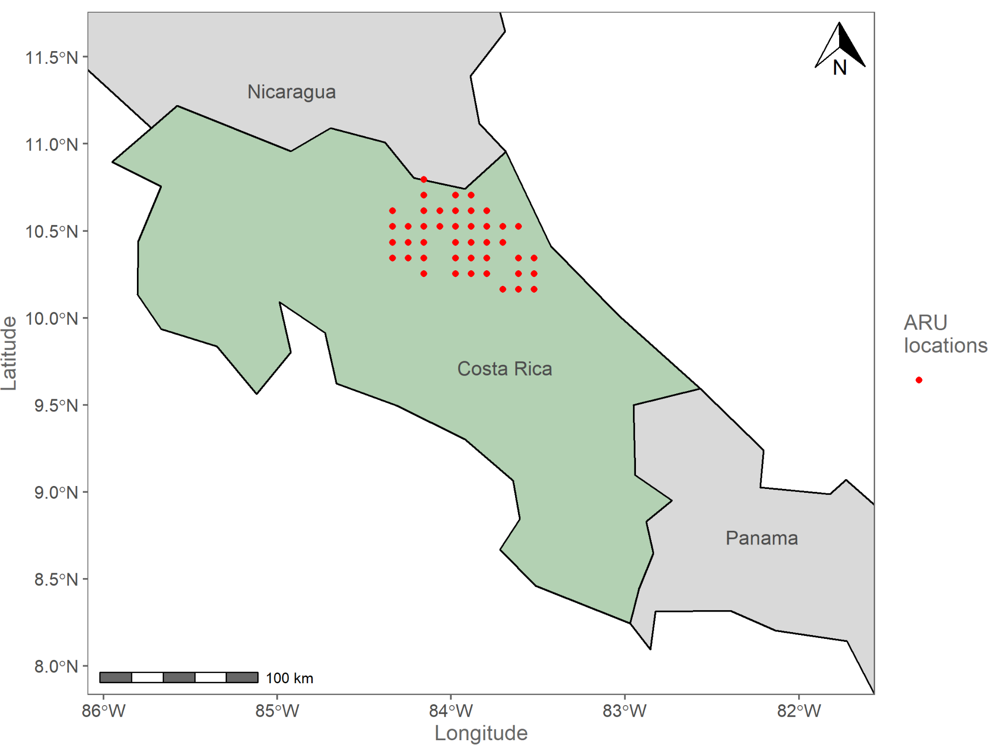
Figure 3: ARU locations in north-eastern Costa Rica. ARUs were set out on a 10km grid, holes in the grid are areas that were inaccessible due to dense forest or lack of permission from landowners.

High-quality recordings
Template matching requires high-quality recordings of the target species to create reference templates that can be used for spectrogram cross-correlation. We created reference templates from recordings made with a directional microphone Sennheiser ME 67 (Sennheiser electronic GmbH & Co., United Kingdom) and a Roland R-05 Wave/MP3 digital recorder (Roland Corporation, United Kingdom). Recordings were digitised with a 16-bit sampling depth and 48kHz sampling frequency and then saved as WAV files. Recordings were taken around known GGM nest sites in north-eastern Costa Rica from January to March 2019. Initially, we selected four recordings containing a total of 157 calls from three different nest sites, as these included single individuals calling to their mate and groups of GGM calling.

Acoustic features
We extracted a total of 113 acoustic features using the warbler package in R (R Core Team, 2020): 20 measurements of frequency, time, and amplitude parameters, and 93 Mel-frequency cepstral coefficients (MFCCs) (Araya‐Salas and Smith‐Vidaurre, 2017). MFCCs were initially designed for human speech recognition but have been widely used in bioacoustics (e.g., Loh, Yuan, and Ramli, 2013; Colonna, Gama, and Nakamura, 2016; Noda, Travieso, and Sánchez-Rodríguez, 2016; Salamon et al., 2016). MFCCs reduce any signal to a set of coefficients (Colonna, Gama, and Nakamura, 2016) while minimising any loss of biologically relevant information (Davis and Mermelstein, 1980). These are potentially helpful when dealing with large amounts of bioacoustic data.

2.3.2 Recogniser workflow elements

ROI detection: template matching
The high-quality recordings were used to construct templates (n = 157) following Hafner and Katz (2018). First, we visually checked templates and removed them if they contained any non-target signal (n = 94). With the remaining templates, we evaluated them on a randomly selected recording that included GGM calls. Spectrogram cross-correlation was used to score the similarity of a detection to the template. Next, we set a low default threshold (0.2) to allow flexibility in matching call types and amplitudes. Templates that detected less than 10% (n = 28) or over 200% (n = 17) of the total number of calls were removed. We removed templates with a true-positive to false-positive ratio above 1:5 or if 90% of a template's detections were the same as another’s. To test their accuracy, we ran the final group of templates (n = 4) over ten randomly selected recordings containing SCM and GGM calls and ten randomly selected recordings without any calls. Finally, we set the window length used in the template matching to one second to reflect the maximum call length (one second).

Signal classification: supervised ML
We used a tidymodels workflow (Kuhn and Wickham, 2020) in R (R Core Team, 2020) to train each random forest algorithm. We used a 75:25 split of the training dataset to create the training and test data, meaning that 75% of the training dataset was used to train the classifier, and 25% was withheld to estimate performance. To deal with the class imbalance, we applied the synthetic minority over-sampling technique (SMOTE) (Chawla et al., 2002) to resample minority classes using the nearest neighbours of these cases. A random forest has three hyperparameters: the number of trees, the number of nodes, and the number of variables per node. We set the number of trees to 1000 and used a tuning grid to tune the number of nodes (2 - 10 with five levels) and the number of variables per node (10 - 30 with five levels). Finally, we used k-fold cross-validation with ten equal-size subsamples to estimate the area under the ROC curve, which was used to select the best value for the tuning parameters.

2.3.4 Developing a breeding season recogniser (R1)
Due to the disruption of the global covid-19 pandemic, we only had access to the first six weeks of recordings (January 27, 2020 – March 15, 2020) to develop the first recogniser (R1). This period only captured a limited soundscape during the GGM breeding season (Fig.4). To create labelled data needed to train a recogniser, we first undertook a manual search of 100 randomly selected recordings to estimate the GGM call rate per recording. To identify calls, we loaded the recordings into Raven Lite (Bioacoustics Research Program, 2016) and visually examined their spectrograms for putative target species calls. Suspected target calls were confirmed by listening to them. We identified 3.13 GGM and 1.18 SCM calls per recording among the 100 selected recordings, which indicated that locating approximately 1000 GGM calls would require labelling 848 recordings.

We then selected 848 recordings (D1) using Sobol sequences to create a pseudo-random sample of the recordings with respect to survey time and location (Sobol, 1967; Antonov and Saleev, 1979) (Fig. 4). To generate the training dataset of positive and negative cases we first manually labelled all positive cases in the 848 recordings. Then we ran our template set over the same 848 recordings; this gave us a dataset of 101743 ROIs that the template matching labelled as target signals. We removed any ROIs that overlapped with our manually labelled calls. This call set provided a positive dataset of 4247 GGM calls and 1393 SCM calls. To create our negative dataset, we used the same Sobol sequence pseudo-random sampling procedure as above on the remaining 96103 false positives from the template matching. These were sampled to ensure the number of negative cases equalled the sum of positive GGM and SCM cases. The final dataset of 4247 GGM calls, 1393 SCM calls, and 5710 non-target cases was used to train R1.

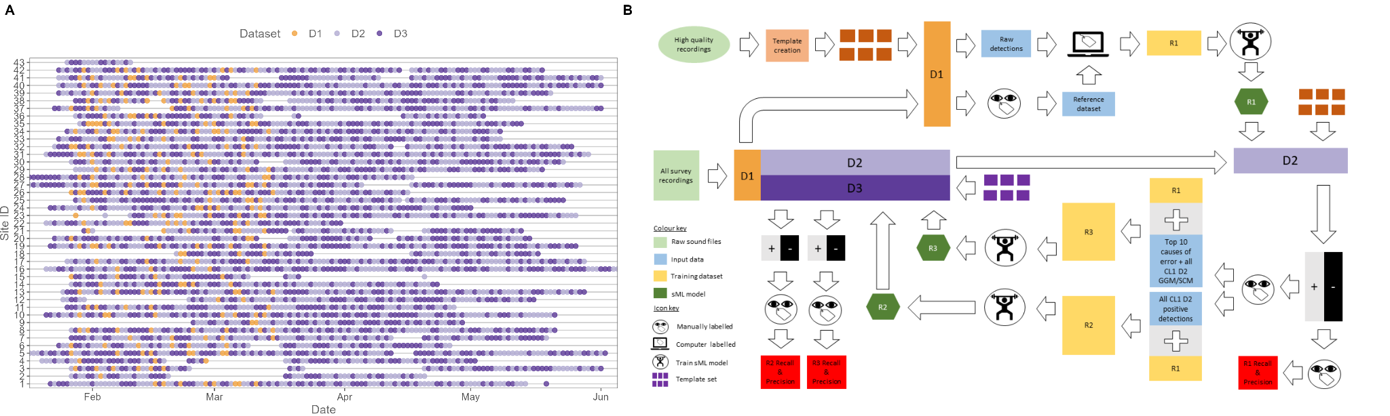
Figure 4: Schematic of classifier development A) represents how data was divided to create the three training/testing datasets (D1, D2 and D3). D1 was selected from recordings up to the middle of March when TL had to leave the field due to the pandemic. After April recording devices were left in the field until June and so any failures were not rectified, which resulted in fewer recordings taking place towards the end of the study period. Most sites had issues with recording devices failing at some point; at site 43 the recording device failed and then was stolen so was not re-installed. B) The workflow used to develop each classifier, starting from raw sound files (light green) and resulting in classifiers and performance metrics (red). R1, R2 and R3 refer to recogniser one, two and three.

2.3.5 Enhanced recogniser (R2)
After recovering the remaining recordings from the field (March 16, 2020 – 3 June 2020), we evaluated the performance of R1 in a novel seasonal context. Then we trained an enhanced recogniser (R2). The new recordings were combined with those from the breeding season dataset that had not been used to train R1, and then the aggregated data were divided into two equal-sized sets of recordings. To ensure an even spatial and temporal sampling of the recordings in each set, we again used Sobol sequences to create a pseudo-random, balanced sample of sites and recording times. This yielded two equally sized datasets of 8084 recordings (Fig. 4). The first dataset (D2) was used to validate the performance of R1 and train the improved recogniser. The second dataset (D3) was used to validate the performance of the new enhanced recogniser (R2).

We applied the breeding season recogniser R1 to D2 and manually checked all positive classifications. We then relabelled the false positives as negative cases and combined these labelled data with the R1 training dataset (D1) to generate a more comprehensive training dataset. This was used to train the enhanced recogniser (R2).

2.3.6 Resolving sources of error
To understand how recogniser false positives changed across space and time, we manually labelled the source of error associated with false positives from recognisers R1 and R2. Overall we labelled thirty-three different sources of error (Table S1); this included fourteen bird species, four sources of anthropogenic noise (voice, chainsaw, traffic and industrial noise) and eight mammalian species.

We then constructed a third recogniser (R3) to assess whether accounting for the origins of non-target signals could increase accuracy while limiting the size and, therefore, the time needed to train a recogniser. We trained the recogniser on a subset the relabelled D2 training data. We constructed the new training data using 1000 cases of the top 7 sources of error: Amazona spp., unidentified passerine, chicken, industry, clay-coloured thrush, slaty spinetail and parakeet spp. We added negative cases by randomly selecting them from unidentified false positives to ensure the number of negative cases equalled the total number of GGM calls.

2.3.7 Recogniser performance
We used recall and precision as our performance metrics. Recall is a measure of the false negative (FN) rate (Recall = FN / True Positive (TP) + True Negatives (TN)), and precision is a measure of the false positive (FP) rate (Precision = FP / FP + TP). We initially used the performance metrics estimated on the 25% withheld test data to assess the accuracy of the random forest. We altered this approach after we discovered that the performance of the breeding season recogniser R1 was significantly worse than the initial estimates suggested. We decided to manually check all positive cases and conduct a power analysis to determine how many negative cases we needed to check manually. For this, we needed the false-negative effect size:
$h_{FN} = \frac{n_{FN}}{N}$ (equation 1)
Where n_{FN} is the number of false-negative cases, and N is the total number of all cases, as well as significance level (0.05) and power (0.95). As we used the initial test dataset to calculate the effect sizes, a large number of negative cases needed to be checked to be able to detect such small effect sizes. We then used false-positive, false-negative, true-positive and true-negatives from these two manually checked datasets to evaluate recogniser performance.

2.4 Results

2.4.1 ROI detection: template matching
Across all three datasets (D1, D2 and D3), the template set made 2,072,080 ROI detections, a mean of 121.75 detections per recording (n = 17020). The mean ROI detection rate was 119.98 per recording in the breeding season dataset (D1, n = 848). The mean number of GGM calls found after manually labelling the dataset was 3.27 per recording (n = 848), suggesting that the template matching step captured many non-target signals.

2.4.2 Breeding season recogniser (R1)
The performance of R1, when estimated using the 25% withheld test data from the training dataset, was high in both recall (GGM = 0.92 / SCM = 0.85) and precision (GGM = 0.93 / SCM = 0.96 - Fig. 5). When applied to the D2, the recogniser made 37639 positive detections (35814 GGM and 1825 SCM). However, a manual review of these detections revealed that only 4161 and 201 cases were true GGM and SCM detections, respectively. A power analysis using the SCM false negative effect size, as it was the lowest of either target species (GGM = 0.0327, SCM = 0.0177), determined that we needed to manually check a minimum of 41514 negative cases to detect this effect size. When applied to the D2 dataset, a manual review of all positive cases (n = 37639) revealed that classifier precision degraded significantly for both species (GGM = 0.12 / SCM = 0.11). Recall declined for the SCM (0.04) and increased for the GGM (0.98 - Fig. 5).
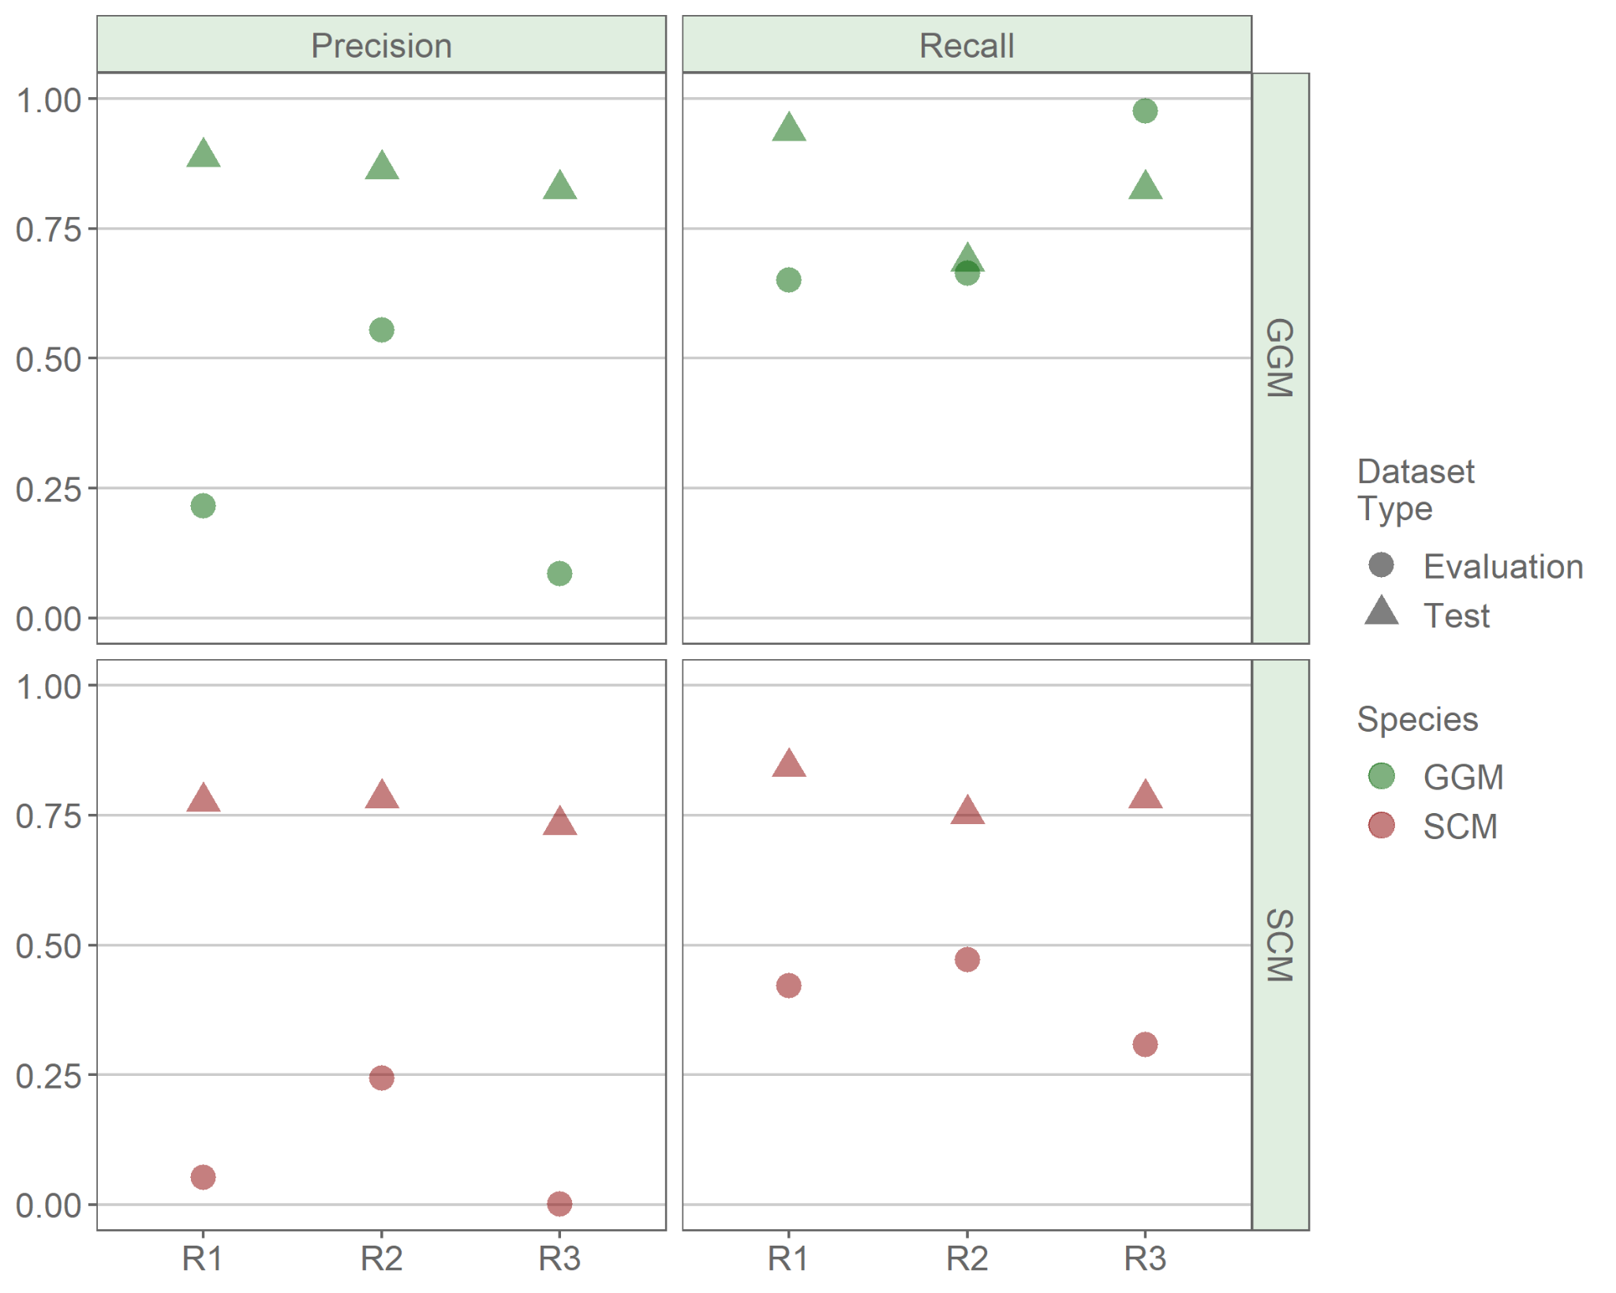
2.4.3 Enhanced recogniser (R2)
Figure 5: Recogniser performance metrics show an improvement between R1 and R2, whereas R3 which was trained on a subset of the full training dataset did not improve. There is a trade-off between precision and recall when precision increases recall decreases and visa-versa. There is a difference between evaluation and validation precision metrics, this is the smallest for R2 but demonstrates the potential pitfalls of using default validation datasets to estimate the performance of recognisers, especially with small datasets.
We combined the manually labelled these cases with the R1 training dataset (4247 GGM + 1393 SCM + 5710 non-target cases) to generate a more extensive training dataset with 8408 GGM and 1594 SCM, and 37709 non-target cases to train R2. Initial performance was estimated using 25% of test data from the aggregated dataset. Both recall (GGM = 0.69 / SCM = 0.75) and precision (GGM = 0.86 / SCM = 0.78) was lower than the performance of R1 (Fig. 5). This is likely due to the size and spatio-temporal scale of the training dataset capturing more background noise, therefore being more representative of the variation in background noise. We manually checked all positive detections (n = 6390). Using the SCM false negative effect size as it was the smallest (GGM = 0.0498, SCM = 0.0104), a power analysis determined we needed to manually check a minimum of 119759 negative cases to detect this effect size. Recall for the GGM did not change much (0.66), whereas precision did drop (0.56), though the level of performance degradation was much lower than R1. SCM performance dropped for both metrics (Recall = 0.66 /Precision = 0.24), but the decline was less severe than for R1. The discrepancy between the two species' performance is likely due to the large difference in the training dataset size for each species.

2.4.4 Sources of error
The sources of error varied through time (Fig. 6) and space (Fig. 7). However, we observed a marked change in the dominant source of error after the period used to create the R1 (Fig. 6). This suggests that, though the performance was poor, the temporal variation in background noise drives the even worse performance later in the season. Unidentified passerines stay a constant proportion of the error, whereas Amazona spp. decrease after this point, and clay-coloured thrush (Turdus grayii) and chickens (Gallus domesticus) increase. This probably reflects the beginning of the breeding season of the clay-coloured thrush begins after March, which coincides with the end of the breeding season for Amazona spp.

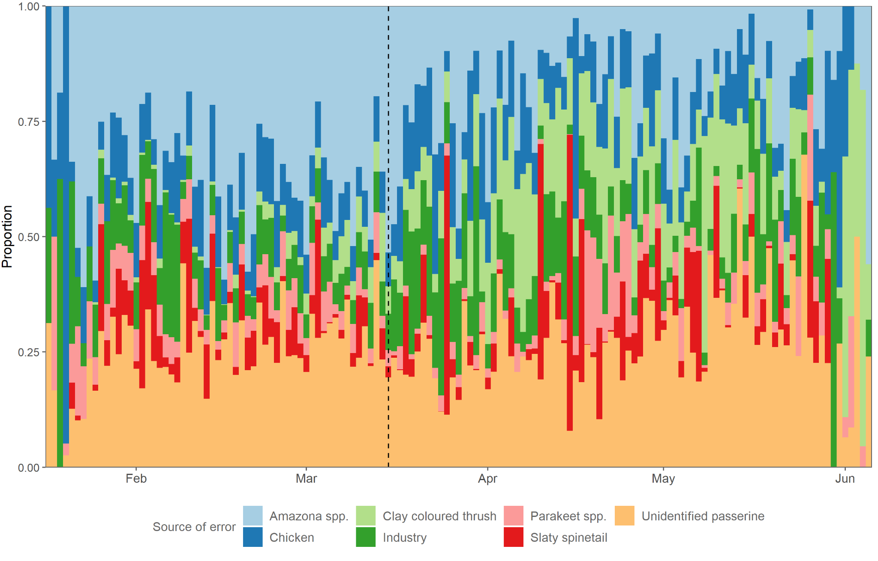
Figure 6: The temporal change in source background noise in the false positive detection of the breeding season recogniser (R1) in the evaluation dataset across the study period. There is a distinct change in the proportions of Amazona spp., clay colour thrush and chicken after the time period that the recogniser one’s training dataset was selected (dashed line).
Overall, false-positive detections from all sources were reduced by R2 compared to the breeding season recogniser, apart from the misclassification of GGM as SCM (Fig. 7). R1’s false-positive detections at many sites are dominated by one or two sources of error (e.g. site 5, 1 and 29 - Fig. 7). In contrast, there is a smaller number with a wide variety of sources of error (e.g. site 16, 20 and 25). However, there is a distinct spatial variation in the types of sources of error. For example, misclassifications are caused mainly by other wild bird species in the northern sites, whereas there is more anthropogenic noise (chainsaw, industry) in the south and east. Although a wild bird, the clay colour thrush is often strongly associated with areas of human disturbance (Dyrcz, 1983), and our results support this association. Spatial variation in the source of error demonstrates that capturing this is critical in creating a representative training dataset.

2.4.5 Accounting for sources of error (R3)
One thousand cases of each of the top seven sources of error were combined with 1408 randomly selected other negative cases to make a negative dataset equal to that of the GGM. The final training dataset for recogniser three was 8408 GGM, 2112 SCM and 8408 negatives. When applied to the validation dataset, the recogniser made 26480 positive detections (GGM = 12536 / SCM = 13944). Both recall (GGM = 0.83 / SCM = 0.78) and precision (GGM = 0.83 / SCM = 0.73) was high when estimated using the validation dataset. We checked all positive cases and performed a power analysis using the SCM, the smallest false negative effect size again (GGM = 0.0774 / SCM = 0.0241). This determined that a minimum of 22374 negative cases had to be checked. Performance dropped significantly for precision (GGM = 0.09) / SCM = 0.001), while recall increased for the GGM (0.97) but decreased for the SCM (0.31).

2.5 Discussion
We have demonstrated that users must be careful when preparing a training dataset for a PAM recogniser. A training dataset that captures relevant background noise variation across space and time is required to construct a robust recogniser. Our workflow addresses this by using an initial small recogniser to create a training dataset that captures non-target signals driving false-positive detections. This method is similar to the “basic recognition model” approach used by Buxton and Jones (2012), whereby a small amount of data is used to train a basic model, which is then used to search for more positive training data in other recordings. The main difference is that we extended this approach to gather positive and negative cases.

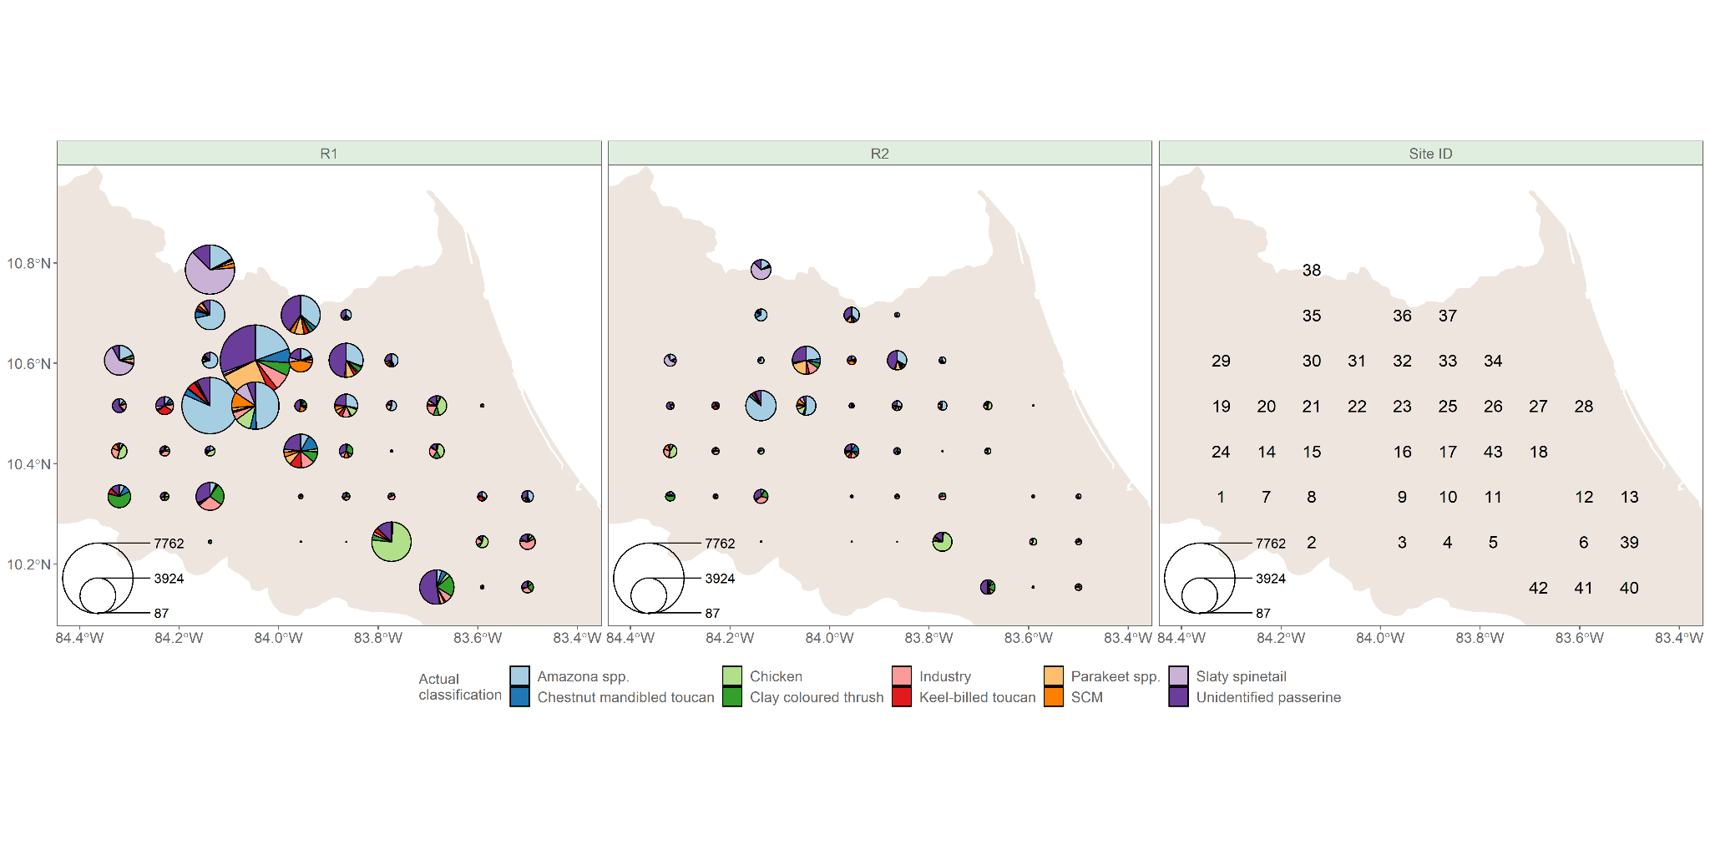
Figure 7: The spatial change in source background noise in the false positive detection of the breeding season recogniser (R1) and enhanced recogniser (R2) in the evaluation dataset across the study period. Site 21 and 31 have the highest FP rate using both R1 and R2. Overall the total number of FP detections decreased significantly, but the proportions remained similar.

We initially assumed GGM and SCM calls were sufficiently distinctive that using recordings from a narrow window in the breeding season would allow us to construct a robust recogniser. However, the performance of our initial breeding season recogniser was very poor when applied to data from outside the breeding season due to the increased diversity of the soundscape. Importantly, this variation is difficult to capture without using a large, manually labelled dataset. This would have required us to label over 9000 30-minute recordings. Incorporating the positive detections and previous training datasets to train a second classifier significantly increases precision whilst losing only a small level of recall performance. This method is similar to the workflow of Balantic and Donovan (2020), using template matching and machine learning together to reduce false positives. The main benefit of our approach is the relatively simple pipeline structure. Nonetheless, we found that iterative labelling and training were required to create a useable recogniser when the target species exhibits considerable call type variation and there is high spatiotemporal variation in background noise.

Our enhanced recogniser that included seasonal variation (R2) still performed poorly compared to many other machine learning PAM studies (Jahn et al., 2017; Bravo et al., 2017; Knight and Bayne 2019; Knight et al., 2020; Balantic and Donovan 2020; Gillings and Scott 2021). However, our results are comparable to similar studies in tropical environments (Swiston and Mennill 2009; Heinicke et al., 2015). This reduced performance likely reflects the highly diverse soundscape arising from the high diversity of species with overlapping signal frequencies (Slabbekoorn 2004) and anthropogenic noise (Slabbekoorn and Peet 2003) in tropical settings. Both factors were apparent in our study region in the northeast of Costa Rica, which encompasses primarily cropland and urban in the south, and mainly cattle pasture and forest land use types in the north (Fagan et al., 2013; Jadin et al., 2016; Karra et al., 2021).

Another important finding was that the performance of the breeding season recogniser was hugely overestimated. Practitioners should consider this when creating classifiers for large-scale rollout. Here we have been explicit in describing the data used to assess model performance, but this is not always the case (Heinicke et al., 2015). It is unclear how many published recognisers would perform in a real-world PAM study, especially if studies use high-quality recordings to create their classifier (Bardeli et al., 2010; Buxton and Jones 2012; Priyadarshani et al., 2018). Manually checking positive detections and using power analysis to determine how many negative cases need to be reviewed is a more labour-intensive task but gives a more accurate assessment of real-world performance.

We did not succeed in creating a recogniser that can be used without manually checking outputs. This is not uncommon. Even when classifiers have high-performance metrics, manually checking positive classifications to filter out false positives is often done before downstream analyses of species abundance and distribution (Buxton and Jones, 2012; Zwart et al., 2014; Colbert et al., 2015; Kalan et al., 2015; Sidie-Slettedahl et al., 2015). A way to deal with this need for manual checking is to use statistical methods that can reduce the amount of data needed for validation (Knight et al., 2020), account for false positives (Banner et al., 2018), false negatives (MacKenzie et al., 2002) or both (Chambert et al., 2018; Wright et al., 2020). Our method reduced the number of false positives that must be manually validated by 80%, from 3.95 per recording (n = 33243) in R1 to 0.75 per recording (n = 6309) in R2. Therefore, although it is still necessary to manually check all positive detections when the final recogniser runs on new data, this represents a significant reduction in the effort needed to clean the data.

Denoising can increase classifier accuracy (Stowell et al., 2016). Interestingly, denoising is not often used, even when studies report the high performance of recognisers. This supports the argument made by Priyadarshani, Marsland and Castro (2018) that many published PAM studies are done in low-noise environments, using species with simple calls. The primary barrier to denoising is that few simple, user-friendly techniques are available, so many classifiers do not use them (e.g. Sebastián‐González et al., 2015; Balantic and Donovan, 2020; Knight et al., 2020). We provide an alternative way to tackle the issue of background noise without using denoising. However, it does not entirely deal with the problem as our recogniser performance is not comparable to the best-published recognisers.

2.5.1 Future work
We could improve our classifier in several ways. Effective template matching requires a sufficiently representative call library (Aide et al., 2013; Gibb et al., 2019). We set the matching threshold very low to help our classifier deal with intra- and inter-call type variation of the GGM and SCM. Although we did not miss any target signal, the random forest classified a large volume of data. Investing extra time in developing and refining the template set would likely reduce the time needed to review calls and improve performance by reducing the size of the initial dataset.

Training dataset imbalance is common in machine learning, not just in bioacoustics (Salamon and Bello 2017). Methods such as data augmentation can provide an excellent solution to this problem (Stowell et al., 2019). Our training dataset was very imbalanced, and the quantity of SCM training data was only ~25% of the GGM training dataset. This resulted in the performance of SCM being significantly lower than that of the GGM. Our current workflow uses a standard window size of one second, within which the call may occupy only a fraction. Therefore, we would have to change how we structure our pipeline to accommodate data augmentation, as many data augmentation techniques need to have the start and end of the target signal (Salamon and Bello 2017). Being able to automatically find the beginning and end of a target signal would be a massive step toward facilitating data augmentation. It would also help reduce the effect of background noise on random forest accuracy by reducing the amount of background noise present in each window to be classified.

2.5.2 Conclusions
Passive acoustic monitoring has great potential to enable the scaling up of biodiversity monitoring to inform policy and conservation strategies. There is an increasing need for simple methods to automate or semi-automate data extraction from PAM surveys (Marques et al., 2013; Stowell et al., 2016). The development of generalised deep-learning classifiers will make PAM a simple and accessible tool for biodiversity monitoring. However, their development may still be a long way off, and species-specific recognisers can be more accurate (Priyadarshani et al., 2018). Custom recognisers also allow practitioners to tailor them to their specific needs. Developing such recognisers is challenging, and although there is an increasing amount of literature on different methods to create classifiers, these are often small-scale studies in temperate environments (Sugai et al., 2019) that rely on high-quality recordings of species with simple calls (Priyadarshani et al., 2018). We have demonstrated a simple workflow that can provide users with an accessible but time-consuming way to create a PAM recogniser for acoustically diverse environments.

2.6 Bibliography
Abrahams, C. and Geary, M. (2020) ‘Combining bioacoustics and occupancy modelling for improved monitoring of rare breeding bird populations’, Ecological Indicators, 112, p. 106131. Available at: https://doi.org/10.1016/j.ecolind.2020.106131.
Aide, T.M. et al., (2013) ‘Real-time bioacoustics monitoring and automated species identification’, PeerJ, 1, p. e103. Available at: https://doi.org/10.7717/peerj.103.
Araya‐Salas, M. and Smith‐Vidaurre, G. (2017) ‘warbleR: an r package to streamline analysis of animal acoustic signals’, Methods in Ecology and Evolution, 8(2), pp. 184–191. Available at: https://doi.org/10.1111/2041-210X.12624.
Ayala-Berdon, J. et al., (2020) ‘Random forest is the best species predictor for a community of insectivorous bats inhabiting a mountain ecosystem of central Mexico’, Bioacoustics, 0(0), pp. 1–21. Available at: https://doi.org/10.1080/09524622.2020.1835539.
Balantic, C.M. and Donovan, T.M. (2020) ‘Statistical learning mitigation of false positives from template-detected data in automated acoustic wildlife monitoring’, Bioacoustics, 29(3), pp. 296–321. Available at: https://doi.org/10.1080/09524622.2019.1605309.
Banner, K.M. et al., (2018) ‘Improving geographically extensive acoustic survey designs for modeling species occurrence with imperfect detection and misidentification’, Ecology and Evolution, 8(12), pp. 6144–6156. Available at: https://doi.org/10.1002/ece3.4162.
Bardeli, R. et al., (2010) ‘Detecting bird sounds in a complex acoustic environment and application to bioacoustic monitoring’, Pattern Recognition Letters, 31(12), pp. 1524–1534. Available at: https://doi.org/10.1016/j.patrec.2009.09.014.
Barnes, R.F.W. (2001) ‘How reliable are dung counts for estimating elephant numbers?’, African Journal of Ecology, 39(1), pp. 1–9. Available at: https://doi.org/10.1111/j.1365-2028.2001.00266.x.
Bermant, P.C. et al., (2019) ‘Deep Machine Learning Techniques for the Detection and Classification of Sperm Whale Bioacoustics’, Scientific Reports, 9(1), p. 12588. Available at: https://doi.org/10.1038/s41598-019-48909-4.
BirdLife International (2020) Great Green Macaw (Ara ambiguus) - BirdLife species factsheet. Available at: http://datazone.birdlife.org/species/factsheet/great-green-macaw-ara-ambiguus (Accessed: 5 January 2021).
Bradbury, J.W. (2003) ‘Vocal communication in wild parrots’, in Animal social complexity: Intelligence, culture, and individualized societies. Cambridge, MA, US: Harvard University Press, pp. 293–316.
Bradfer-Lawrence, T. et al., (2020) ‘Rapid assessment of avian species richness and abundance using acoustic indices’, Ecological Indicators, 115, p. 106400. Available at: https://doi.org/10.1016/j.ecolind.2020.106400.
Brandes, T.S. (2008) ‘Feature Vector Selection and Use With Hidden Markov Models to Identify Frequency-Modulated Bioacoustic Signals Amidst Noise’, IEEE Transactions on Audio, Speech, and Language Processing, 16(6), pp. 1173–1180. Available at: https://doi.org/10.1109/TASL.2008.925872.
Bravo, C.J.C., Berríos, R.Á. and Aide, T.M. (2017) ‘Species-specific audio detection: a comparison of three template-based detection algorithms using random forests’, PeerJ Computer Science, 3, p. e113. Available at: https://doi.org/10.7717/peerj-cs.113.
Brieman, L. (2001) ‘Random forests’, Journal of Machine Learning Research, 45, pp. 5–32.
Buxton, R.T. and Jones, I.L. (2012) ‘Measuring nocturnal seabird activity and status using acoustic recording devices: applications for island restoration’, Journal of Field Ornithology, 83(1), pp. 47–60. Available at: https://doi.org/10.1111/j.1557-9263.2011.00355.x.
Campos‐Cerqueira, M. and Aide, T.M. (2016) ‘Improving distribution data of threatened species by combining acoustic monitoring and occupancy modelling’, Methods in Ecology and Evolution, 7(11), pp. 1340–1348. Available at: https://doi.org/10.1111/2041-210X.12599.
Chambert, T. et al., (2018) ‘A new framework for analysing automated acoustic species detection data: Occupancy estimation and optimization of recordings post-processing’, Methods in Ecology and Evolution, 9(3), pp. 560–570. Available at: https://doi.org/10.1111/2041-210X.12910.
Chawla, N.V. et al., (2002) ‘SMOTE: Synthetic Minority Over-sampling Technique’, Journal of Artificial Intelligence Research, 16, pp. 321–357. Available at: https://doi.org/10.1613/jair.953.
Cintra, R. and Naka, L.N. (2011) ‘Spatial Variation in Bird Community Composition in Relation to Topographic Gradient and Forest Heterogeneity in a Central Amazonian Rainforest’, International Journal of Ecology, 2012, p. e435671. Available at: https://doi.org/10.1155/2012/435671.
Clink, D.J. and Klinck, H. (2020) ‘Unsupervised acoustic classification of individual gibbon females and the implications for passive acoustic monitoring’, Methods in Ecology and Evolution, n/a(n/a). Available at: https://doi.org/10.1111/2041-210X.13520.
Colbert, D.S. et al., (2015) ‘Application of autonomous recording units to monitor gobbling activity by wild turkey’, Wildlife Society Bulletin, 39(4), pp. 757–763. Available at: https://doi.org/10.1002/wsb.577.
Colonna, J.G., Gama, J. and Nakamura, E.F. (2016) ‘How to Correctly Evaluate an Automatic Bioacoustics Classification Method’, in O. Luaces et al., (eds) Advances in Artificial Intelligence. Cham: Springer International Publishing (Lecture Notes in Computer Science), pp. 37–47. Available at: https://doi.org/10.1007/978-3-319-44636-3_4.
Davis, S. and Mermelstein, P. (1980) ‘Comparison of parametric representations for monosyllabic word recognition in continuously spoken sentences’, IEEE Transactions on Acoustics, Speech, and Signal Processing, 28(4), pp. 357–366. Available at: https://doi.org/10.1109/TASSP.1980.1163420.
Dénes, F.V., Tella, J.L. and Beissinger, S.R. (2018) ‘Revisiting methods for estimating parrot abundance and population size’, Emu - Austral Ornithology, 118(1), pp. 67–79. Available at: https://doi.org/10.1080/01584197.2017.1401903.
Digby, A. et al., (2013) ‘A practical comparison of manual and autonomous methods for acoustic monitoring’, Methods in Ecology and Evolution, 4(7), pp. 675–683. Available at: https://doi.org/10.1111/2041-210X.12060.
Dyrcz, A. (1983) ‘Breeding ecology of the Clay-coloured Robin Turdus grayi in lowland Panama’, Ibis, 125(3), pp. 287–304. Available at: https://doi.org/10.1111/j.1474-919X.1983.tb03115.x.
Fagan, M.E. et al., (2013) ‘Land cover dynamics following a deforestation ban in northern Costa Rica’, Environmental Research Letters, 8(3), p. 034017. Available at: https://doi.org/10.1088/1748-9326/8/3/034017.
Fedy, B.C. and Aldridge, C.L. (2011) ‘The importance of within-year repeated counts and the influence of scale on long-term monitoring of sage-grouse’, The Journal of Wildlife Management, 75(5), pp. 1022–1033. Available at: https://doi.org/10.1002/jwmg.155.
Gibb, R. et al., (2019) ‘Emerging opportunities and challenges for passive acoustics in ecological assessment and monitoring’, Methods in Ecology and Evolution, 10(2), pp. 169–185. Available at: https://doi.org/10.1111/2041-210X.13101.
Gibbs, J.P., Snell, H.L. and Causton, C.E. (1999) ‘Effective Monitoring for Adaptive Wildlife Management: Lessons from the Galápagos Islands’, The Journal of Wildlife Management, 63(4), pp. 1055–1065. Available at: https://doi.org/10.2307/3802825.
Gillings, S. and Scott, C. (2021) ‘Nocturnal flight calling behaviour of thrushes in relation to artificial light at night’, Ibis [Preprint]. Available at: https://doi.org/10.1111/ibi.12955.
Guschanski, K. et al., (2009) ‘Counting elusive animals: Comparing field and genetic census of the entire mountain gorilla population of Bwindi Impenetrable National Park, Uganda’, Biological Conservation, 142(2), pp. 290–300. Available at: https://doi.org/10.1016/j.biocon.2008.10.024.
Heinicke, S. et al., (2015) ‘Assessing the performance of a semi-automated acoustic monitoring system for primates’, Methods in Ecology and Evolution, 6(7), pp. 753–763. Available at: https://doi.org/10.1111/2041-210X.12384.
Hill, A.P. et al., (2018) ‘AudioMoth: Evaluation of a smart open acoustic device for monitoring biodiversity and the environment’, Methods in Ecology and Evolution, 9(5), pp. 1199–1211. Available at: https://doi.org/10.1111/2041-210X.12955.
Ioki, K. et al., (2016) ‘Evaluation of the similarity in tree community composition in a tropical rainforest using airborne LiDAR data’, Remote Sensing of Environment, 173, pp. 304–313. Available at: https://doi.org/10.1016/j.rse.2015.07.024.
IUCN (2020) IUCN Red List 2017-2020 Report. Available at: https://www.iucnredlist.org/resources/grid (Accessed: 22 February 2022).
Jadin, I., Meyfroidt, P. and Lambin, E.F. (2016) ‘International trade, and land use intensification and spatial reorganization explain Costa Rica’s forest transition’, Environmental Research Letters, 11(3), p. 035005. Available at: https://doi.org/10.1088/1748-9326/11/3/035005.
Jahn, O. et al., (2017) ‘Automated Sound Recognition Provides Insights into the Behavioral Ecology of a Tropical Bird’, PLOS ONE, 12(1), p. e0169041. Available at: https://doi.org/10.1371/journal.pone.0169041.
Kahl, S. et al., (2021) ‘BirdNET: A deep learning solution for avian diversity monitoring’, Ecological Informatics, 61, p. 101236. Available at: https://doi.org/10.1016/j.ecoinf.2021.101236.
Kalan, A.K. et al., (2015) ‘Towards the automated detection and occupancy estimation of primates using passive acoustic monitoring’, Ecological Indicators, 54, pp. 217–226. Available at: https://doi.org/10.1016/j.ecolind.2015.02.023.
Karra, K. et al., (2021) ‘Global land use / land cover with Sentinel 2 and deep learning’, in 2021 IEEE International Geoscience and Remote Sensing Symposium IGARSS. 2021 IEEE International Geoscience and Remote Sensing Symposium IGARSS, pp. 4704–4707. Available at: https://doi.org/10.1109/IGARSS47720.2021.9553499.
Katz, J., Hafner, S.D. and Donovan, T. (2016a) ‘Assessment of Error Rates in Acoustic Monitoring with the R package monitoR’, Bioacoustics, 25(2), pp. 177–196. Available at: https://doi.org/10.1080/09524622.2015.1133320.
Katz, J., Hafner, S.D. and Donovan, T. (2016b) ‘Tools for automated acoustic monitoring within the R package monitoR’, Bioacoustics, 25(2), pp. 197–210. Available at: https://doi.org/10.1080/09524622.2016.1138415.
Knight, E.C. et al., (2020) ‘Validation prediction: a flexible protocol to increase efficiency of automated acoustic processing for wildlife research’, Ecological Applications, 30(7), p. e02140. Available at: https://doi.org/10.1002/eap.2140.
Knight, E.C. and Bayne, E.M. (2019) ‘Classification threshold and training data affect the quality and utility of focal species data processed with automated audio-recognition software’, Bioacoustics, 28(6), pp. 539–554. Available at: https://doi.org/10.1080/09524622.2018.1503971.
Kuhn, M. and Wickham, H. (2020) ‘Tidymodels: a collection of packages for modeling and machine learning using tidyverse principles’. Available at: https://www.tidymodels.org.
Lasseck, M. (2014) ‘Large-scale identification of birds in audio recordings’, p. 11.
Loh, C., Yuan, T. and Ramli, D.A. (2013) Frog Sound Identification System for Frog Species Recognition.
MacKenzie, D.I. et al., (2002) ‘Estimating Site Occupancy Rates When Detection Probabilities Are Less Than One’, Ecology, 83(8), pp. 2248–2255. Available at: https://doi.org/10.1890/0012-9658(2002)083[2248:ESORWD]2.0.CO;2.
Marin-Cudraz, T. et al., (2019) ‘Acoustic monitoring of rock ptarmigan: A multi-year comparison with point-count protocol’, Ecological Indicators, 101, pp. 710–719. Available at: https://doi.org/10.1016/j.ecolind.2019.01.071.
Marques, T.A. et al., (2013) ‘Estimating animal population density using passive acoustics’, Biological Reviews of the Cambridge Philosophical Society, 88(2), pp. 287–309. Available at: https://doi.org/10.1111/brv.12001.
Monge, O. et al., (2016) ‘Genetic patterns and conservation of the Scarlet Macaw (Ara macao) in Costa Rica’, Conservation Genetics, 17(3), pp. 745–750. Available at: https://doi.org/10.1007/s10592-015-0804-3.
Montes-Medina, A.C., Salinas-Melgoza, A. and Renton, K. (2016) ‘Contextual flexibility in the vocal repertoire of an Amazon parrot’, Frontiers in Zoology, 13(1), pp. 1–13. Available at: https://doi.org/10.1186/s12983-016-0169-6.
Nichols, J.D. et al., (2015) ‘On formally integrating science and policy: walking the walk’, Journal of Applied Ecology, 52, pp. 539–543. Available at: https://doi.org/10.1111/1365-2664.12406.
Noda, J.J. et al., (2016) ‘Using bioacoustic signals and Support Vector Machine for automatic classification of insects’, in 2016 3rd International Conference on Signal Processing and Integrated Networks (SPIN). 2016 3rd International Conference on Signal Processing and Integrated Networks (SPIN), pp. 656–659. Available at: https://doi.org/10.1109/SPIN.2016.7566778.
Noda, J.J., Travieso, C.M. and Sánchez-Rodríguez, D. (2016) ‘Methodology for automatic bioacoustic classification of anurans based on feature fusion’, Expert Systems with Applications, 50, pp. 100–106. Available at: https://doi.org/10.1016/j.eswa.2015.12.020.
Nuttall, M.N. et al., (2022) ‘Long-term monitoring of wildlife populations for protected area management in Southeast Asia’, Conservation Science and Practice, 4(2), p. e614. Available at: https://doi.org/10.1111/csp2.614.
Pereira, H.M. and David Cooper, H. (2006) ‘Towards the global monitoring of biodiversity change’, Trends in Ecology & Evolution, 21(3), pp. 123–129. Available at: https://doi.org/10.1016/j.tree.2005.10.015.
Pérez‐Granados, C. et al., (2019) ‘Vocal activity rate index: a useful method to infer terrestrial bird abundance with acoustic monitoring’, Ibis, 161(4), pp. 901–907. Available at: https://doi.org/10.1111/ibi.12728.
Pillay, R. et al., (2019) ‘Bioacoustic monitoring reveals shifts in breeding songbird populations and singing behaviour with selective logging in tropical forests’, Journal of Applied Ecology [Preprint]. Available at: https://doi.org/10.1111/1365-2664.13492.
Pollock, K.H. et al., (2002) ‘Large scale wildlife monitoring studies: statistical methods for design and analysis’, Environmetrics, 13(2), pp. 105–119. Available at: https://doi.org/10.1002/env.514.
Priyadarshani, N., Marsland, S. and Castro, I. (2018) ‘Automated birdsong recognition in complex acoustic environments: a review’, Journal of Avian Biology, 49(5), p. jav-01447. Available at: https://doi.org/10.1111/jav.01447.
R Core Team (2021) ‘R: A language and environment for statistical computing’. Vienna, Austria: R Foundation for Statistical Computing. Available at: https://www.R-project.org/.
Raghuram, M.A. et al., (2016) ‘Bird classification based on their sound patterns’, International journal of speech technology, 19(4), pp. 791–804. Available at: https://doi.org/10.1007/s10772-016-9372-2.
Salamon, J. et al., (2016) ‘Towards the Automatic Classification of Avian Flight Calls for Bioacoustic Monitoring’, PLOS ONE, 11(11), p. e0166866. Available at: https://doi.org/10.1371/journal.pone.0166866.
Salamon, J. and Bello, J.P. (2017) ‘Deep Convolutional Neural Networks and Data Augmentation for Environmental Sound Classification’, IEEE Signal Processing Letters, 24(3), pp. 279–283. Available at: https://doi.org/10.1109/LSP.2017.2657381.
Sebastián‐González, E. et al., (2015) ‘Bioacoustics for species management: two case studies with a Hawaiian forest bird’, Ecology and Evolution, 5(20), pp. 4696–4705. Available at: https://doi.org/10.1002/ece3.1743.
Sidie-Slettedahl, A.M. et al., (2015) ‘Evaluation of autonomous recording units for detecting 3 species of secretive marsh birds’, Wildlife Society Bulletin, 39(3), pp. 626–634. Available at: https://doi.org/10.1002/wsb.569.
Slabbekoorn, H. (2004) ‘Habitat-dependent ambient noise: Consistent spectral profiles in two African forest types’, The Journal of the Acoustical Society of America, 116(6), pp. 3727–3733. Available at: https://doi.org/10.1121/1.1811121.
Slabbekoorn, H. and Peet, M. (2003) ‘Birds sing at a higher pitch in urban noise’, Nature, 424(6946), pp. 267–267. Available at: https://doi.org/10.1038/424267a.
Smith-Vidaurre, G., Araya-Salas, M. and Wright, T.F. (2020) ‘Individual signatures outweigh social group identity in contact calls of a communally nesting parrot’, Behavioral Ecology. Edited by M. Naguib, 31(2), pp. 448–458. Available at: https://doi.org/10.1093/beheco/arz202.
Snaddon, J. et al., (2013) ‘Biodiversity technologies: tools as change agents’, Biology Letters, 9(1), p. 20121029. Available at: https://doi.org/10.1098/rsbl.2012.1029.
Stowell, D. et al., (2019) ‘Automatic acoustic detection of birds through deep learning: The first Bird Audio Detection challenge’, Methods in Ecology and Evolution, 10(3), pp. 368–380. Available at: https://doi.org/10.1111/2041-210X.13103.
Sugai, L.S.M. et al., (2019) ‘Terrestrial Passive Acoustic Monitoring: Review and Perspectives’, BioScience, 69(1), pp. 15–25. Available at: https://doi.org/10.1093/biosci/biy147.
Swiston, K.A. and Mennill, D.J. (2009) ‘Comparison of manual and automated methods for identifying target sounds in audio recordings of Pileated, Pale-billed, and putative Ivory-billed woodpeckers’, Journal of Field Ornithology, 80(1), pp. 42–50. Available at: https://doi.org/10.1111/j.1557-9263.2009.00204.x.
Tachibana, R.O., Oosugi, N. and Okanoya, K. (2014) ‘Semi-Automatic Classification of Birdsong Elements Using a Linear Support Vector Machine’, PLOS ONE, 9(3), p. e92584. Available at: https://doi.org/10.1371/journal.pone.0092584.
Taylor, S. and Perrin, M.R. (2005) ‘Vocalisations of the Brown-headed Parrot, Poicephalus cryptoxanthus: their general form and behavioural context’, Ostrich, 76(1–2), pp. 61–72. Available at: https://doi.org/10.2989/00306520509485474.
Teixeira, D., Maron, M. and Rensburg, B.J. van (2019) ‘Bioacoustic monitoring of animal vocal behavior for conservation’, Conservation Science and Practice, 1(8), p. e72. Available at: https://doi.org/10.1111/csp2.72.
Ventura, T.M. et al., (2015) ‘Audio parameterization with robust frame selection for improved bird identification’, Expert Systems with Applications, 42(22), pp. 8463–8471. Available at: https://doi.org/10.1016/j.eswa.2015.07.002.
Wardhaugh, C.W., Stork, N.E. and Edwards, W. (2014) ‘Canopy invertebrate community composition on rainforest trees: Different microhabitats support very different invertebrate communities’, Austral Ecology, 39(4), pp. 367–377. Available at: https://doi.org/10.1111/aec.12085.
Weerasena, H. et al., (2018) ‘Continuous Automatic Bioacoustics Monitoring of Bird Calls with Local Processing on Node Level’, in TENCON 2018 - 2018 IEEE Region 10 Conference. TENCON 2018 - 2018 IEEE Region 10 Conference, pp. 0235–0239. Available at: https://doi.org/10.1109/TENCON.2018.8650196.
Wood, C.M. et al., (2019) ‘Detecting small changes in populations at landscape scales: a bioacoustic site-occupancy framework’, Ecological Indicators, p. 16.
Wright, W.J. et al., (2020) ‘Modelling misclassification in multi-species acoustic data when estimating occupancy and relative activity’, Methods in Ecology and Evolution, 11(1), pp. 71–81. Available at: https://doi.org/10.1111/2041-210X.13315.
Zdenek, C.N., Heinsohn, R. and Langmore, N.E. (2015) ‘Vocal complexity in the palm cockatoo (Probosciger aterrimus)’, Bioacoustics, 24(3), pp. 253–267. Available at: https://doi.org/10.1080/09524622.2015.1070281.
Zhong, M. et al., (2020) ‘Multispecies bioacoustic classification using transfer learning of deep convolutional neural networks with pseudo-labeling’, Applied Acoustics, 166, p. 107375. Available at: https://doi.org/10.1016/j.apacoust.2020.107375.
Zwart, M.C. et al., (2014) ‘The Use of Automated Bioacoustic Recorders to Replace Human Wildlife Surveys: An Example Using Nightjars’, PLOS ONE, 9(7), p. e102770. Available at: https://doi.org/10.1371/journal.pone.0102770.

Using passive acoustic monitoring to estimate the abundance of a critically endangered parrot, the great green macaw (Ara ambiguus)

3.1 Abstract
Most conservation relies on being able to estimate population size accurately. The development, implementation and adaptation of effective conservation strategies rely on quantifying the impacts of different threats on population dynamics, identifying species that need conservation management, and providing feedback on the effectiveness of any management actions. However, current approaches are not suitable for wide-ranging species that reside in tropical ecosystems. Here we use the great green macaw Ara ambiguus as a case study to show that passive acoustic monitoring is an effective tool for collecting data that can then estimate abundance. We estimate a population of 485.65 ± 61 SE great green macaws in Costa Rica during the breeding, suggesting the population here is larger than previously estimated. We have also highlighted potentially important areas for the species in regions that had not previously been studied. We have demonstrated at a population scale that passive acoustic monitoring (PAM) offers conservationists an efficient and effective way to understand population dynamics. With a high proportion of parrot species threatened globally, passive acoustic monitoring will enable effective monitoring and become an essential tool in conservation planning and evaluation. PAM technology has enormous potential to facilitate such assessments because it is easily scalable, recordings can be stored and re-analysed as machine learning, and abundance estimation techniques become more advanced.

3.2 Introduction
Given the scale of the current threats to wild populations and limited funding, conservation actions need to be efficient and effective. Most conservation relies on being able to estimate population size accurately. This is vital for quantifying population dynamics, the impacts of threats and identifying species that require conserving. Measuring population abundance accurately and efficiently should be a priority. For many animal species, methodologies such as distance sampling, capture-mark-recapture, and simple counts are robust, providing good data to base on- and feedback to conservation management plans. However, highly mobile, group-living species violate key assumptions of these methodologies. For example, one of the critical assumptions of distance sampling, a widely used methodology to estimate population abundance, is the independence of sites and observations. Highly mobile, group-living species can violate assumptions by grouping together and moving between locations (Dénes et al., 2018). Unaccounted for, these factors can cause large estimation errors and mask important ecological patterns (Wenger & Freeman, 2008). Consequently, population estimates required to assess the red list category of highly mobile species, such as the great green macaw (Ara ambiguus), can be statistically weak.

As with other high-throughput sensing technologies, such as remote sensing, LIDAR and camera traps, Passive Acoustic Monitoring (PAM) offers a way to increase the scale and accuracy of wildlife monitoring, overcome the challenges of assessing highly mobile species and reduce the cost and on-the-ground expertise (Gibb et al., 2019). This rapidly expanding field can benefit from developments and cost-reductions in Automated Recording Units (ARUs) (Snaddon et al., 2013; Hill et al., 2019; Teixeira, Maron and Rensburg, 2019) and dramatically increase the quantity of data that can be collected at any given time (Gibb et al., 2019). ARUs provide an efficient and non-invasive way to measure a wide variety of metrics, including community composition (Pillay et al., 2019; Bradfer-Lawrence et al., 2020), individual breeding biology (Marin-Cudraz et al., 2019), occupancy (Wood et al., 2019) and abundance (Marques et al., 2013; Pérez‐Granados et al., 2019).

Occupancy-based methods to estimate abundance offer an opportunity to utilise passive acoustic monitoring (PAM) to enable population monitoring to be carried out at scale. One occupancy model that presents the opportunity to estimate abundance is the Royle-Nichols (RN) model for estimating abundance from repeated detection/non-detection surveys (Royle & Nichols, 2003). There are only two studies utilising the RN model with PAM data in the literature, both involving bats (Milchram and Bruckner 2018; Mena et al., 2021). Comparing generalised random encounter models (gREM) and RN models gave similarly reliable estimates of bat population density (Milchram and Bruckner 2018). RN models have also been used for camera trapping studies (e.g. Duquette et al., 2014; Van der Weyde et al., 2018; Rogan et al., 2019) and have been shown to compare well to other techniques, such as radio telemetry, to estimate population abundance (Duquette et al., 2014). When compared to N-mixture time-to-detection models, RN models were also found to have similar performance (Strebel et al., 2021)

The RN model takes advantage of the fact that variation in abundance creates variation in detection probability. Thus, heterogeneity in detection probability can be used to estimate the underlying distribution of abundances. It follows, then, that one of the central assumptions of the RN model is that the only source of heterogeneity of detection probability is heterogeneity in abundance. However, in a situation where a population is not closed or individual detection probabilities are not constant, the unmodeled heterogeneity in capture probability will lead to an overestimation of detection probability and, therefore, an underestimation of abundance (Marques et al., 2013). Heterogeneity in individuals' detection probabilities could result from intrinsic behavioural variation between individuals within a population or extrinsic factors such as habitat, time, season, weather and temperature (Veech et al., 2016). Extrinsic factors can be addressed by including relevant covariates in the models (Royle and Nichols, 2003). However, intrinsic factors are much more challenging to account for, and for many species, this may present an insurmountable violation of occupancy model assumptions. Another issue with using the RN framework, particularly for camera trapping studies, is that recording devices (camera traps or ARUs) are often put out in locations that increase the possibility of detection. For example, selecting known sites or placing numerous camera traps within known territories means detections are not independent between locations or individuals (Rogan et al., 2019). These issues can be avoided if care is taken to consider the behaviour of the study species in the sampling design.

Parrots are one group of highly mobile, at-risk animals that often violate assumptions of traditional monitoring techniques (Casagrande and Beissinger 1997; Dénes et al., 2018) and could be a good fit for combining PAM with RN occupancy modelling. Parrots are one of the most endangered bird families, with 28% being threatened with extinction (IUCN 2020b). Robustly estimating the abundance of parrots is extremely difficult, with most current estimates based on roost counts (e.g. Wright et al., 2018; Zulian et al., 2018), distance sampling (Dénes et al., 2018), expert opinion or a combination (e.g. BirdLife International, 2020). Although parrot behaviour prohibits the use of traditional techniques, their behaviour could be ideally suited to PAM and RN modelling to estimate their abundance. They are loud and social, meaning they frequently call one another, even if they are not in close proximity.

Two key factors driving parrot and other avian distribution and abundance are nest site and food availability (Loiselle and Blake 1991; Poulin et al., 1992; Cockle et al., 2010). This means local abundance is closely related to the number and quality of available nest sites and the quantity and quality of available food. In addition, many parrots show plasticity in diet and foraging strategies to track seasonal variation in food availability across the landscape (Renton et al., 2015). However, this plasticity in the diet does not match their selection of nest sites. As most parrots are secondary cavity nesters, they rely on naturally forming cavities or for other species to excavate their nest sites (Forshaw 2010). A given parrot species might typically use only one to three tree species as nest sites (Renton et al., 2015), suggesting that breeding season abundance will be tied to their preferred nest tree species (e.g. Oliveira et al., 2021).

During breeding, nest site availability influences parrot distribution (Cockle et al., 2010; de la Parra-Martínez et al., 2015; Renton et al., 2015). Required cavity size is directly related to body size, with larger species requiring larger cavities (Renton et al., 2015). Primary forest has more large cavities than secondary and logged forests (Marsden and Pilgrim 2003; Cockle et al., 2010; de la Parra-Martínez et al., 2015), so we would expect the less disturbed forest to be positively related to breeding season abundance in large parrots. Some large parrots, such as the scarlet macaw (SCM - Ara macao) (Vaughan et al., 2005) and blue-winged macaws (Primolius maracana) (Nunes and Galetti, 2007), can persist in degraded, fragmented landscapes, possibly because these species have a broad nesting niche and generalist diets. Other species, such as the blue-throated macaw (Ara glaucogularis) and hyacinth macaw (Anodorhynchus hyacinthinus) (Oliveira et al., 2021) are habitat specialists and, therefore, are severely impacted by habitat degradation and loss of crucial food and nesting species (Oliveira et al., 2021; Herzog et al., 2021).

The great green macaw (GGM) is one of six critically endangered Neotropical parrots (IUCN 2020b). Their population is estimated to be between 500 and 1000 mature individuals. However, it is unclear how robust this estimate is as there are areas that are difficult to assess and no statistically robust methods to estimate abundance therefore, the estimate is based primarily on expert opinion (BirdLife International 2020). The northern limit of their range is the Caribbean slope of southeastern Honduras, where their current population is estimated to be ~260 mature individuals. There is a subpopulation on the Caribbean slope of southern Nicaragua and north-eastern Costa Rica, with an estimated ~160 mature individuals (BirdLife International 2020). However, the Macaw Recovery Network carried out a non-breeding season roost count in 2021 and estimated the population to be ~336 individuals (Macaw Recovery Network 2021). In both Panama and Colombia, they can be found in the Caribbean and Pacific lowlands. There is a lack of data on the Panama population (BirdLife International 2020). However, the population in Parque Nacional Cerro Hoya on the Pacific coast of Panama is thought to number ~60 individuals (Bolcato pers comms). In Colombia, it is suggested that the population has declined from an estimated 1700 mature individuals to ~100 mature individuals in a decade. The population in Colombia is fragmented into northwest and southwest, with the southwestern population extending into northwestern Ecuador, which are extremely challenging areas to monitor in. A separate small population of the subspecies guayaquilensis in western Ecuador (Fjeldså et al., 1987) is the southern limit of the species range. The two Ecuadorian populations are not thought to be over 50 mature individuals (Fig 2; BirdLife International 2020).

In Costa Rica, the GGM’s range was reduced by ~90% by the end of the 1990s (Chassot and Monge 2002) but may have increased slightly since then (Fink et al., 2021). One of the main drivers of this decline was habitat loss and degradation, with the loss of around 90% of the mountain almond (Dipteryx panamensis), a vital food and nesting tree (Monge et al., 2003; Chassot et al., 2007; Monge et al., 2012). In Costa Rica, 85% of the monitored GGM's nests are in mountain almond (chapter 5), and their diet consists of over 80% mountain almonds during the breeding season (Monge et al., 2012). Therefore, our current understanding is that at this time of the year, GGM distribution is closely related to the distribution of the mountain almond, which is mainly found in lowland areas with Ultisol soil type (Chun 2008). At the end of the breeding season (~May), GGMs disperse and leave the breeding areas. It is currently unclear where they disperse, but it is known that they can be found in large flocks in the foothills of the Cordillera Central from September to October (Bolcato 2020). One previous study has attempted to estimate the number of GGMs in the Costa Rica / Nicaragua population using an extended point count methodology. The study estimated 302.93 ± 513.78 individuals in Costa Rica and 532.45 ± 251.33 in Nicaragua (Monge et al., 2010).

We need robust monitoring methodologies to allow us to develop and sustain effective conservation. Unfortunately, current methodologies are not robust when used to estimate the abundance of highly mobile species in environments such as tropical rainforests. PAM provides a way to address these current challenges, allowing monitoring to be carried out at scale whilst minimising on-the-ground work. To be effective, we must have a modelling approach that can use the data PAM generates. Here we demonstrate that the RN model can estimate the abundance of a challenging study species such as the GGM.

3.3 Methods

3.3.1 Study site and design
The study area is situated in northern Costa Rica in a ~3000km2 region of fragmented Caribbean lowland forest (Fig. 8). This includes a known breeding area (Monge et al., 2012, Macaw Recovery Network, unpub. data) and areas where the breeding status of GGM is unknown. Land use is split between cattle pasture, pineapple and other annual crops, and primary and secondary forests (Fagan et al., 2013; Jadin et al., 2016; Karra et al., 2021). The annual rainfall is ca. 4667mm (2009-2014), with a drier period between January and April (Gilman et al., 2016).

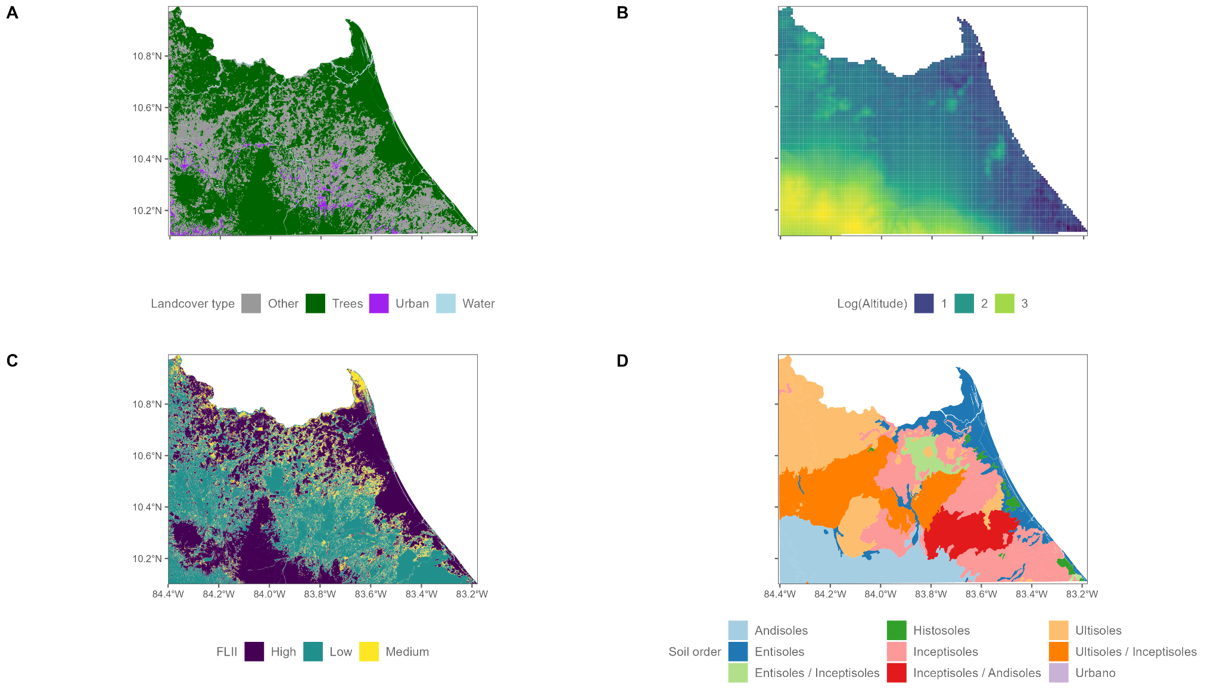
Figure 8: Maps of all the landscape covariates A) Land cover / land use (LCLU) covariates; Trees (tree cover) and Urban (urban cover), Other (pasture, crops, scrubland) B) Log altitude C) Forest Landscape integrity index (FLII) D) Soil order.
We conducted the study over two months during the peak 2020 breeding season (Feb-Mar). This period is when breeding pairs forage for food for chicks and before any chicks have fledged the nest (Macaw Recovery Network, unpub. data). We placed the ARUs on a 10km grid (Fig.3); we consider this distance large enough to make the locations independent during the study period. This is because a radio-telemetry study found that GGM pairs in Costa Rica maintained breeding ranges of ~5.5km² (Powell et al., 1999), meaning a 10km grid with each grid square covering 100km² is sufficient to ensure independence. The initial point locations were chosen by taking the centre of every grid square in a 10km grid laid across the study area. Around each point, we used a 1 km buffer where we could move the point if there were accessibility or permission issues with the initial point location. We established forty-three ARU sites following the above principles.

Recordings were captured using AudioMoth 1.1.0 ARUs (Hill et al., 2019; LabMaker, Germany). The devices were installed on the tallest accessible tree at each site. There were four 30-minute survey periods (herein “survey periods”) a day (7:00-7:30, 10:00-10:30, 13:00-13:30, 16:00-16:30) between 29 January 2020 and 19 March 2020. Recordings were taken at 32kHz or 48kHz. The sampling frequency was inconsistent as there was an error in configuring some devices for a portion of the deployment period.

3.3.2 Data preparation and statistical analysis

Great green macaw detection data
Detection data were obtained from ARU recordings using a recogniser developed in chapter 2. This recogniser detects GGM using a two-step pipeline: template matching and supervised machine learning classification. Multiple templates (n = 4) were used to capture the highly varied call types of the GGMs, and then detections were fed into a random forest (Breiman 2001). The random forest was trained using a spatiotemporally pseudo-random training dataset (Sobol 1967; Antonov and Saleev 1979) that consisted of 8408 GGM and 33129 negative cases. Precision was low (0.56), so all detections of GGMs were manually cleaned to ensure only GGM detections were used for modelling. To derive occupancy data, we pooled and converted detections in each recording into either 1 (detection) or 0 (non-detection).

Covariates
We used soil order as a proxy for forest type. Although it would have been preferable to use soil suborder, we did not have sufficient representation of each across the 43 sites. We only used soil orders that were represented at over 80% of the sites; Ultisols / Inceptisols, Ultisols, Inceptisols, Entisols / Inceptisols, and Entisols. We calculated the proportion of each soil order in the area around each site (1, 5 and 10km radius). The soil orders were grouped and treated as one covariate, so the model either contained all soil covariates or none. Tree cover and land covered by urbanisation are the proportion of the area around each site covered, calculated from land use/land cover (LCLU) data at 30m resolution (Karra et al., 2021) (Table 1). FLII is Forest landscape integrity index, which quantifies the intactness of an area (Grantham et al., 2020) and was calculated as the mean across the grid square. All the covariates were measured within 1km, 5km and 10km grid squares around the central ARU location. Scale and centre transformation was used on all covariates prior to modelling.

Table 1: Covariates used in Royle-Nichols model, their definition and source.
Category | Type | Covariates | Metric | Source
Land cover/land use (LCLU) | lambda | Trees, Urban | Proportion of area occupied | (Karra et al., 2021)
Soil order | lambda | Andisols, Ultisols, Ultisols / Inceptisol,  Inceptisol, Inceptisols / Andisols, Entisols / Inceptisols, Entisols, Histosols, | Proportion of area occupied | (Chinchilla and Chacon, 2016)
Forest landscape integrity index (FLII) | lambda | FLII | Mean across area | (Grantham et al., 2020)
Altitude (m) | lambda | Altitude | Mean across area | (DIVA-GIS, 2012)
Time | p | Time period | Categorical: 7am, 10am, 1pm, 4pm | NA

Occupancy Modelling
We used the package unmarked (Fiske & Chandler, 2011) using R 4.1.0 (R Core Team 2021) to fit RN models (function occuRN). We used a three-step process of model selection. Step 1: we selected the covariates for the detection formula. We evaluated time of day as a continuous covariate from seven to sixteen, time of day as a factor with four levels, date as a number between one and fifty-two, date as a factor with fifty-two levels, and all pairwise combinations of these time and date covariates. Step 2: We evaluated which grid size was the best by comparing the most extensive models at each radius (1, 5 and 10 km). The top-performing radius was then used for the next step. Step 3: every combination of tree cover, urban cover, altitude, forest landscape integrity index and soil type were run, giving a total of 32 models assessed.

For all steps, AIC was used to rank all models; those models within 2 AIC of the top-performing model were considered equal (Burnham & Anderson, 1998). Goodness-of-fit of the top models was assessed using parametric bootstrapping and the sum of squared residuals to calculate fit statistics. The best model fit is one with the lowest difference between the model sum of squared residuals and the mean bootstrapped sum of squared residuals. The model with the best goodness-of-fit was selected to use to estimate abundance. Model coefficients and standard errors (SEs) were calculated on transformed and untransformed covariates.

We used the top model to estimate the number of GGMs at three different levels. The first was abundance at each ARU site, giving a total population estimate for the study area; this was done using the posterior mean of the conditional abundance distribution at each site and estimated using empirical Bayes. Secondly, we extracted all model covariates across the whole of the GGM’s historic range in Costa Rica. We used these and the predict function to estimate the potential current population size in Costa Rica. Lastly, we used the ebird range map, smoothed at 9 km resolution (herein “ebird range” - Fink et al., 2021), to restrict our population estimate of the current breeding season population in Costa Rica. We used the ebird range to restrict our estimate because our study did not cover the full extent of Costa Rica, so it is difficult to determine where the species is currently extant.

There are five areas where GGMs have been repeatedly reported but are isolated from other GGM areas within Costa Rica and are not included in the smoothed ebird range (Fink et al., 2021). These could be remnant breeding populations or seasonal areas. Therefore, we investigated how these isolated areas (herein, “ebird isolated areas”) correspond to our model predictions. If these ebird-isolated areas are predicted to have GGM populations during breeding, this might suggest these are remnant breeding populations. However, we did not include these estimates in our total population estimate as we wanted to develop a conservative population estimate for Costa Rica.

3.4 Results
During the 52 survey days across the 43 sites, GGMs were detected in 592/10712 (5.5%) survey periods at 34 sites (Table S3.1). Time of day as a factor was the top-performing detection covariate (Table S3.2), and 10 km was the top-performing grid size (Table S2.3). There were two models within 2 AIC of each other; one contained all the covariates, and the second did not include the proportion of area covered in urbanisation (Table 2). Parametric bootstrap goodness-of-fit (GOF) tests based on a sum of squared residuals indicated the model without the proportion of area covered in urbanisation fitted the data best, with a difference of 15.88 (model SSE = 466.38, bootstrapped SSE = 482.26, Fig. S1). The only covariate to have a positive model coefficient is tree cover (Fig. 9).
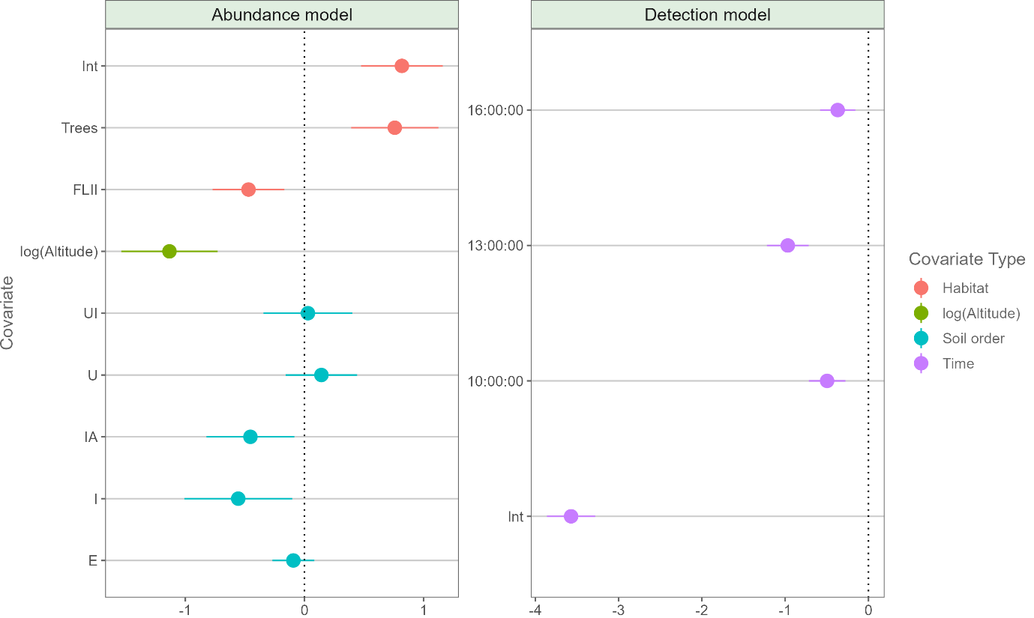
Figure 9: Untransformed model coefficients. The only covariate with a positive effect is Tree cover, whereas all others are either have no significant effect (Ultisol, Ultisol/Inceptisol and Entisol) or negatively affect abundance (FLII, log(Altitude), Inceptisol/Andisol and Inceptisol.
Abundance across the ARU sites is estimated to be 208±30 SE, ranging between 0 and 41 individuals per 100km² site (Table S1). The site with the highest abundance is site 38, on the border with Nicaragua, which is Ultisol soil type and has a high proportion of tree cover. There are thirteen sites with an estimate of <1; most are in the southern sites (Fig. 2). These sites are in regions of high agricultural activity associated with low tree cover. There is general agreement between empirical Bayes estimates and predicted abundance across the sites, although some discrepancies might suggest the presence of unmodeled covariates (Fig. S3).

The RN model predicts a potential breeding population size of 883.09 ± 128 SE throughout the historical range of the GGM, which encompasses the whole Caribbean slope of Costa Rica under 1500m above sea level (a.s.l.) under current environmental conditions. The estimated breeding population size within the ebird range is 485.65±61 SE.

Three of the five ebird isolated areas correspond to areas in which our model predicts there could be significant numbers of GGMs (Fig. 11). The five areas correspond to a potential 49.34 ± 11 SE GGMs; we do not include these in our estimate as we want to be conservative.

Table 2 Models, their AIC and delta AIC. The top two models are within 0.64 AIC of each other.
Model | AIC | delta
~Trees + FLII + log(Altitude) + soil order | 3,167.175 | 0.00
~Trees + Urban + log(Altitude) + FLII + soil order | 3,167.814 | 0.64
~Trees + Urban + log(Altitude) + soil order | 3,173.712 | 6.54
~Trees + log(Altitude) + soil order | 3,174.079 | 6.90
~Trees + FLII + log(Altitude) | 3,180.277 | 13.10
~log(Altitude) + soil order | 3,180.835 | 13.66
~Trees + FLII + log(Altitude) + Urban | 3,182.277 | 15.10
~Urban + log(Altitude) + soil order | 3,182.390 | 15.21
~FLII + log(Altitude) + soil order | 3,182.817 | 15.64
~Urban + FLII + log(Altitude) + soil order | 3,184.291 | 17.12
~Trees + Urban + FLII | 3,196.823 | 29.65
~Trees + log(Altitude) | 3,199.897 | 32.72
~Trees + FLII | 3,201.083 | 33.91
~Trees + Urban + log(Altitude) | 3,201.660 | 34.48
~Urban + FLII + Trees + soil order | 3,202.042 | 34.87
~Trees + FLII + Urban + soil order | 3,202.042 | 34.87
~Trees + FLII + soil order | 3,207.999 | 40.82
~Urban + FLII + soil order | 3,233.624 | 66.45
~Trees + Urban + soil order | 3,233.681 | 66.51
~Urban + soil order | 3,236.739 | 69.56
~Trees + Urban | 3,237.480 | 70.31
~Trees + soil order | 3,241.743 | 74.57
~Urban + log(Altitude) + FLII | 3,242.189 | 75.01
~Urban + log(Altitude) | 3,243.378 | 76.20
~Trees | 3,244.737 | 77.56
~log(Altitude) + FLII | 3,247.575 | 80.40
~Urban | 3,250.784 | 83.61
~Urban + FLII | 3,252.642 | 85.47
~soil order | 3,256.589 | 89.41
~FLII + soil order | 3,257.735 | 90.56
~log(Altitude) | 3,261.227 | 94.05
~FLII | 3,281.576 | 114.40

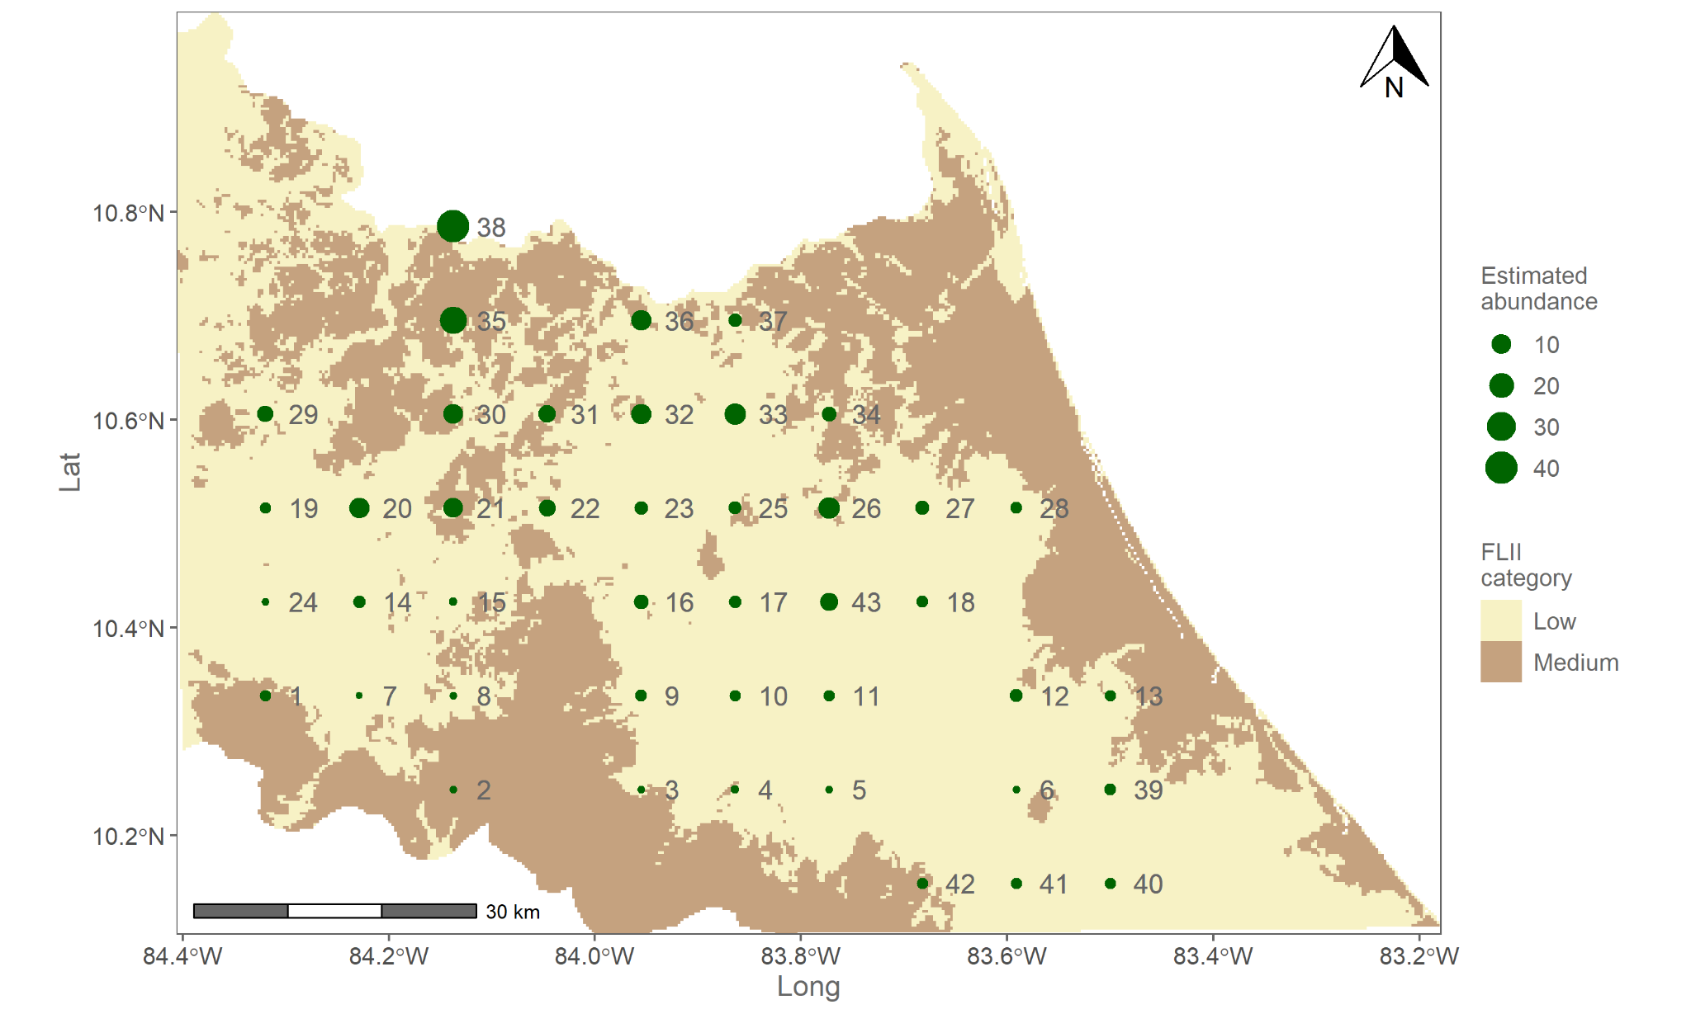
Figure 10: Estimated breeding season abundance, using the top model, across the 43 sites (site ID to the right of locations) shown against forest landscape integrity index (FLII). Higher abundances are seen in the northern areas, compared to the south. FLII has been categorised as per Grantham et al., (2020) into low (0-6), medium (6-9.6) and high (>9.6) integrity.

3.5 Discussion
Robust methods are needed to help increase the effectiveness of species conservation in tropical ecosystems. Here we demonstrate that new monitoring approaches combined with existing statistical methods offer a way to overcome these issues and to do so affordably and at scale. Employing PAM and RN modelling, we estimate the breeding season population of GGM across its ebird range in Costa Rica is 485.65±61SE, which suggests that the global total likely exceeds 500 mature individuals.

Our estimate is similar to a recent non-breeding roost counts survey carried out in Costa Rica that estimated the population to be 336.5 individuals (Macaw Recovery Network, 2021). However, as with this current study this will include juveniles who fledged in that year and others not yet considered mature. Tella et al., (2013) and Pacífico et al., (2014) reported that only around 20% of the population of two threatened macaw species were reproductively active in a single season. It is unclear how this equates to the number of mature individuals, as individuals might not be reproductively active in any given year due to their age (Negro 2011), nest-site availability (Cockle et al., 2010) or previous year’s breeding (Berkunsky et al., 2014). Another study estimated that 50% of a blue-throated macaw population was reproductively active over five years (Berkunsky et al., 2014). The Birdlife assessment of the GGM used a figure of 65% to calculate mature population size from total population estimates (BirdLife International 2020), although it is unclear what this is based on. If we use 20% as a lower bound and 65% as an upper bound, the Costa Rican population would consist of 98-315 mature individuals or 49-157 breeding pairs. Considering the Macaw Recovery Network monitored over 40 active nest sites in 2020 within a section of the San Juan La Selva biological corridor (Macaw Recovery Network, 2020), we believe 49 pairs would be a significant underestimate of the Costa Rican population.

Across the ARU sites, our model estimates a population of 208±30 GGMs. Raw detections and estimates of abundance suggest a hitherto unknown GGM breeding area in the vicinity of sites 26 and 43 (Fig. 10). To date, the most easterly active nest site was recorded in the vicinity of site 32 (Macaw Recovery Network, unpub data); therefore, the high estimates at site 33, 26 and 43 suggests that the breeding area of the GGM in Costa Rica is at least a third larger than previously known. There were also detections made in the group of sites to the southeast of the study area. Although only a small number of detections were made, with a correspondingly low model estimate of individuals (Table S3.1), this suggests a small number of GGMs present in this area during the breeding season. These results show how PAM can identify previously unrecorded areas of occupancy and start to fill the gaps in our knowledge surrounding species distribution. Finally, we have shown that a potential GGM breeding area is currently not being monitored. This means the status and threats to this sub-population are unknown. Site 43 is in an area of high agricultural productivity, with limited accessibility, low income and poor living conditions; this is a concern because these conditions are known to contribute to an increased risk of poaching (UNODC 2012; Pires 2012).

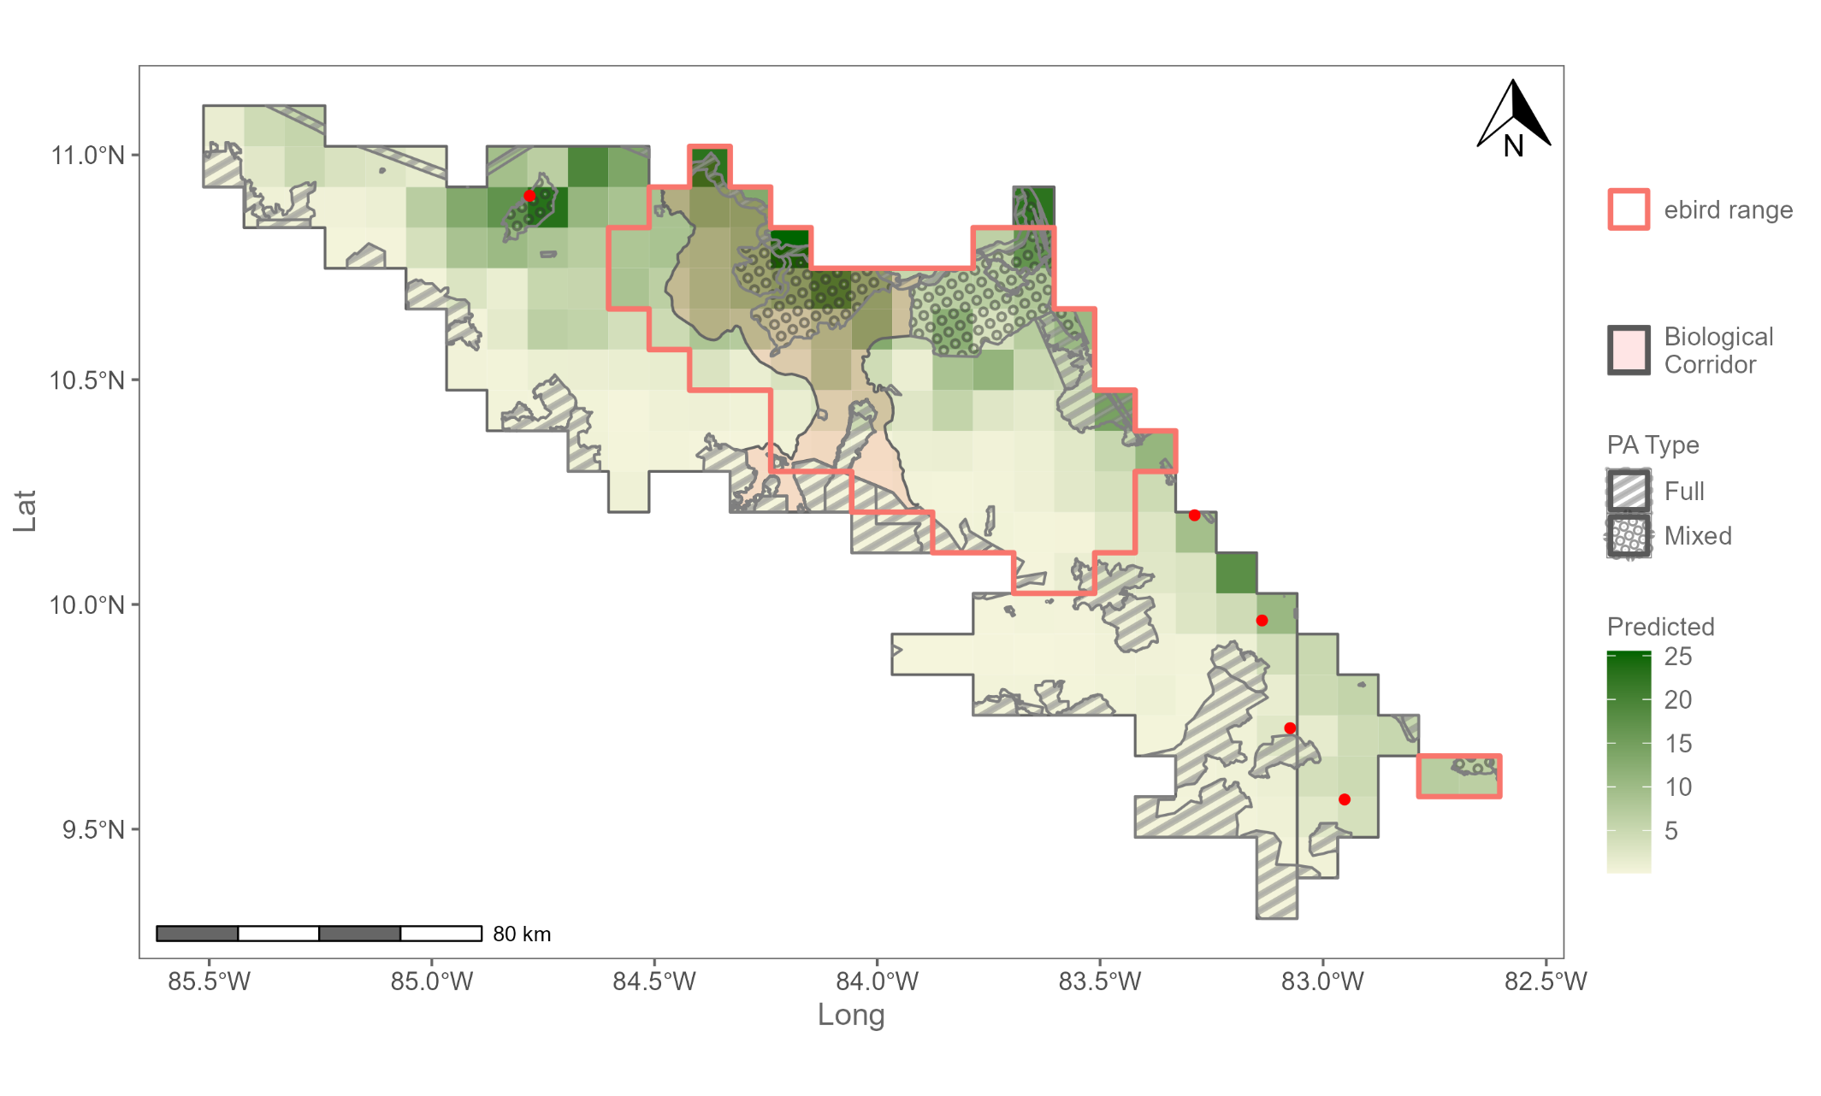
Figure 11: GGM abundance during the peak of the breeding season (Jan - Mar) is largely restricted to lowland areas in the north of Costa Rica on the border with Nicaragua. Significant numbers can be found in the Maquenue Mixed use reserve within the San Juan La Selva biological corridor. Predicted potential breeding season abundance across the historic range of the great green macaw in Costa Rica. Outlined is the Costa Rican range of the great green macaw using ebird data produced by Fink et al., (2021). The biological corridor is the San Juan La Selva biological corridor. Protected area (PA) type “full” is a national park, whereas “mixed” is a mixed-use reserve where forestry and agriculture are permitted under specified limits. Red dots are the five isolated ebird areas.

3.5.1 Key Covariates of GGM Abundance
Soil order, our proxy for forest composition, was important for predicting GGM abundance at the regional scale. Although soil order is an essential determining factor of forest community composition (Sollins 1998), other factors such as logging and agricultural intensity influence current forest composition. Two soil orders, Inceptisol and Inceptisol / Andisol, were negatively correlated with GGM abundance. These soil orders are closely related and associated with large river valleys and shore deposits. These soil orders are often found in lowland areas and are often highly anthropogenically altered due to their higher fertility (Eswaran et al., 2002), which is likely why they are negatively correlated with GGM abundance. The other soil orders, Entisol, Ultisol and Ultisol / Inceptisol, do not have a significant effect on GGM abundance. For Ultisol and Ultisol / Inceptisol soil types, this was not expected, because these soil types are associated with higher mountain almond density, a key breeding season resource of the GGMs. Mountain almond grows well in alluvial or sandy soils with an acidic profile (Flores 1992; Vidal-Riveros 2004) which is not the case for Entisol, Inceptisol or Inceptisol / Andisol orders (Chun, 2008). The soil suborder, Humults, which is a Ultisol soil, is a key predictor of mountain almond tree density in northern Costa Rica (Chun 2008). Ultisol soils are formed from a process of clay mineral weathering of old land surfaces, have a lower pH and have subsurface horizons of illuvial clay accumulations (Brady & Weil, 1996). Therefore, our finding that Ultisol soil order is not positively associated with GGM abundance goes against the hypothesis that the distribution of mountain almonds is a limiting factor of GGM breeding season abundance in Costa Rica.

Sites with higher abundance were generally found further north, in areas of low altitude and higher forest cover. These areas are more suited to mountain almond growth (Flores 1992; Chun 2008) and are also less developed and have had some form of protection since the 1990s, allowing for some natural regeneration (Fagan et al., 2013). Northern sites are also closer to the Indio-Maiz biological reserve in Nicaragua, where there are large tracts of primary forest with lower relative human disturbance (Gamboa and Sofía, 2021). The abundance of GGMs in the Indio-Maiz biological reserve is uncertain. A small section on the western edge of the reserve was surveyed in 2008, and the population was estimated to be 532 ± 251 individuals (Monge et al., 2010). Although the methodology used was not robust, comparing the raw number of GGMs sighted in each area suggests that this area has more GGM activity than the Costa Rica sites monitored during the 2008 study. High abundance at the sites in the north is likely due to the amount of protection, poor accessibility and vicinity to the Indio-Maiz biological reserve.

The Costa Rican Caribbean lowland rainforest (below 500m a.s.l.) is a degraded ecosystem, with 74% categorised as having low FLII (Fig 10; Grantham et al., 2020); this means that it is highly anthropogenically disturbed. In areas of high anthropogenic disturbance, we find fewer mature hardwood trees (DeWalt et al., 2003), which are those that support GGMs with food and nesting resources (Powell et al., 1999; Monge et al., 2003). So, perhaps counter-intuitively, FLII has a small negative effect on abundance. This means that more intact forest is weakly negatively associated with lower GGM abundance. In Costa Rica, the GGM is heavily reliant on the mountain almond as a nesting and food resource; ~85% of their nests are located in this species, and up to 90% of their diet consists of mountain almond nuts during the breeding season (Monge et al., 2003, 2012; Chassot, Arias and Powell, 2007; Lewis et al., in prep.). Mountain almond is a valuable hardwood prized for its ability to resist rot and termites (Flores 1992). Since Costa Rica has experienced one of the highest deforestation rates globally (de Camino et al., 2000), this vital resource was impacted by timber extraction. However, large-scale exploitation was limited until the 1980s, when improved saws and milling technology were developed to cope with mountain almonds' density and crystalline deposit content (Flores 1992; Butterfield 1995). The mountain almond was regionally protected in 1999 and nationally protected in 2008 (Powell et al., 1999; Sancho 2008). Consequently, mountain almond trees are found in relatively high densities in some forested areas and scattered throughout low integrity areas such as pastures and secondary forests, especially throughout the eastern half of the San Juan La Selva biological corridor (Chun, 2008; Macaw Recovery Network, unpub. data). These remnant mountain almond trees may allow GGMs to utilise low integrity, secondary forest and otherwise barren pasturelands.

Discrepancies exist between the ebird range and our model in central areas of the historical range (Fig. 11) because the ebird range is a year-round occupancy range. In contrast, we are estimating the population during only the breeding season. For example, we know GGMs utilise areas of higher altitude in the south and southwest of the ebird range during the non-breeding season (Powell et al., 1999; Monge et al., 2003; Macaw Recovery Network 2021). This explains the lack of predicted abundance in these areas from our model. Our predictions of high abundance areas in the north agree with what we see on the ground (TL pers. obs) and ebird data (Fink et al., 2021). Another area where there is a lack of predicted GGMs is over areas of expansive monoculture crops such as banana and pineapple in the southeast of the ebird range; this is likely because the ebird range is the extent of the range and does not have detail within it.

The isolated population identified by Fink et al., (2021) in the northwest, where our model predicts a significant population, corresponds with Refugio de Vida Silvestre Caño Negro. This is a protected area with higher tree cover than non-protected areas. Areas to the country's southeast are predicted to have low but significant numbers of birds. This is interesting as the far southeast is the location of a reintroduction of GGM in 2011. Before the reintroduction, there were only a few sporadic sights of GGMs in the region (ebird 2021).

3.5.2 Potential biases and limitations
The historical range of the GGM in Costa Rica extends throughout the Caribbean slope of Costa Rica to a maximum height of 1500m a.s.l. (Powell et al., 1999; Monge et al., 2003). Our model predicts that there could be a population of 883±128 SE in this area under current environmental conditions, whereas within the ebird range, there is an estimated 485±65 SE. The discrepancies between our estimates are due to the northwest and the east of the historical range. This suggests that we lack information in our covariates. We assumed that the soil type represents the current forest type, whereas it represents the forest type if the forest is primary. This is particularly important when considering the close relationship between mountain almonds and breeding for the GGM. For example, in Costa Rica, the initial ban on mountain almond extraction only applied to the area between the San Juan, San Carlos, and Sarapiqui rivers (Powell et al., 1999) in the eastern half of the San Juan La Selva biological corridor (Fig.11). Chun (2008) suggests that mountain almond distribution in the rest of the San Juan La Selva biological corridor is lower than expected, given environmental conditions. This pattern will likely be the same in areas outside the San Juan La Selva biological corridor open to exploitation until 2008 (Sancho 2008). Establishing the current distribution and density of mountain almonds across the Caribbean lowland would surely provide important information that could be used to aid the conservation of the GGM.

RN models assume that the target populations are closed. We attempted to limit the probability that this assumption would be violated by placing ARUs 10 km apart. However, if a large proportion of the population is composed of non-breeding individuals located outside breeding sites, this poorly observed fraction of the population will affect population estimates in ways that are challenging to quantify (Penteriani et al., 2011; Negro 2011). For example, field observations suggest that juveniles may follow their parents for up to 3 years (Jimenez pers. comms.; TL pers. obs.), but once juveniles are independent, their behaviour is unclear. These individuals may spend their time in locations with high-value food species, such as mountain almonds. However, the extent to which these areas overlap with breeding sites is unknown.

3.5.3 Conclusion
Challenges with estimating abundance for highly mobile species such as parrots are well documented (Casagrande & Beissinger, 1997; Dénes, Tella and Beissinger, 2018; Tella et al., 2021). However, there have been few previous attempts to estimate the Costa Rican GGM population. Powell et al., (1999) estimated that the Costa Rican GGM population was around 210 individuals in the 1990s. A subsequent population census estimated the population to be 303 ± 514 (Monge et al., 2010). The wide confidence intervals of Monge et al., (2010) demonstrate how challenging obtaining robust estimates of parrot abundance is. We have shown that PAM and RN modelling can be used together to provide robust abundance information for critically endangered parrot species such as the GGM. Our model highlighted previously unknown breeding areas, enabled us to resolve breeding habitat associations for the GGM in Costa Rica and allowed us to predict potential GGM distribution. We have demonstrated at a population scale that these tools offer conservationists an efficient and effective way to understand population dynamics. With a high proportion of parrot species threatened globally (IUCN 2020b), this tool will be essential in conservation planning and evaluation. PAM technology has enormous potential to facilitate such assessments because it is easily scalable, recordings can be stored and re-analysed as machine learning, and abundance estimation techniques become more advanced.

3.6 Bibliography
Antonov IA, Saleev VM. 1979. An economic method of computing LPτ-sequences. USSR Comput Math Math Phys. 19(1):252–256. https://doi.org/10.1016/0041-5553(79)90085-5
Berkunsky I, Daniele G, Kacoliris FP, Díaz-Luque JA, Frias CPS, Aramburu RM, Gilardi JD. 2014. Reproductive Parameters in the Critically Endangered Blue-Throated Macaw: Limits to the Recovery of a Parrot under Intensive Management. PLOS ONE. 9(6):e99941. https://doi.org/10.1371/journal.pone.0099941
BirdLife International. 2020. Great Green Macaw (Ara ambiguus) - BirdLife species factsheet [Internet]. [accessed 2021 Jan 5]. http://datazone.birdlife.org/species/factsheet/great-green-macaw-ara-ambiguus
Brady N, Weil R. 1996. The Nature and Properties of Soil. [place unknown].
Breiman L. 2001. Random Forests. Mach Learn. 45(1):5–32. https://doi.org/10.1023/A:1010933404324
Burnham KP, Anderson DR. 1998. Practical Use of the Information-Theoretic Approach. In: Burnham KP, Anderson DR, editors. Model Sel Inference Pract Inf-Theor Approach [Internet]. New York, NY: Springer; [accessed 2022 Apr 7]; p. 75–117. https://doi.org/10.1007/978-1-4757-2917-7_3
Butterfield RP. 1995. Promoting biodiversity: advances in evaluating native species for reforestation. For Ecol Manag. 75(1):111–121. https://doi.org/10.1016/0378-1127(95)03535-I
de Camino R, Segura O, Arias LG, Perez I. 2000. Costa Rica: Forest Strategy and the Evolution of Land Use. Washington DC, USA: World Bank Publications.
Casagrande DG, Beissinger SR. 1997. Evaluation of Four Methods for Estimating Parrot Population Size. The Condor. 99(2):445–457. https://doi.org/10.2307/1369951
Chassot O, Arias GM, Powell GVN. 2007. Biologia de la Conservacion de Ara ambiguus en Costa Rica, 1994-2006. Mesoamerica. 11(2):43–49.
Chassot O, Monge. 2002. The Great Green Macaw: flagship species for Costa Rica. Pscittascene. 53:6–7.
Chun S. 2008. The utility of digital aerial surveys in censusing Diptryx panamensis, the key food and nesting tree of the endangered Great-green Macaw (Ara ambiguus) in Costa Rica [PhD] [Internet]. [place unknown]: Duke University. https://dukespace.lib.duke.edu/dspace/bitstream/handle/10161/902/?sequence=1
Cockle KL, Martin K, Drever MC. 2010. Supply of tree-holes limits nest density of cavity-nesting birds in primary and logged subtropical Atlantic forest. Biol Conserv. 143(11):2851–2857. https://doi.org/10.1016/j.biocon.2010.08.002
Dénes FV, Tella JL, Beissinger SR. 2018. Revisiting methods for estimating parrot abundance and population size. Emu - Austral Ornithol. 118(1):67–79. https://doi.org/10.1080/01584197.2017.1401903
DeWalt SJ, Maliakal SK, Denslow JS. 2003. Changes in vegetation structure and composition along a tropical forest chronosequence: implications for wildlife. For Ecol Manag. 182(1):139–151. https://doi.org/10.1016/S0378-1127(03)00029-X
Duquette JF, Belant JL, Svoboda NJ, Beyer DE, Albright CA. 2014. Comparison of occupancy modeling and radiotelemetry to estimate ungulate population dynamics. Popul Ecol. 56(3):481–492. https://doi.org/10.1007/s10144-014-0432-7
ebird. 2021. eBird: An online database of bird distribution and abundance [web application]. eBird, Cornell Lab of Ornithology, Ithaca, New York. Gt Green Macaw Ara Ambiguus - Species Map - EBird [Internet]. [accessed 2022 Mar 3]. https://ebird.org/map/grgmac
Eswaran H, Ahrens R, Rice TJ, Stewart BA. 2002. Soil Classification: A Global Desk Reference. [place unknown]: CRC Press.
Fagan ME, DeFries RS, Sesnie SE, Arroyo JP, Walker W, Soto C, Chazdon RL, Sanchun A. 2013. Land cover dynamics following a deforestation ban in northern Costa Rica. Environ Res Lett. 8(3):034017. https://doi.org/10.1088/1748-9326/8/3/034017
Fink D, Auer T, Johnston A, Strimas-Mackey M, Robinson O, Ligocki S, Hochachka W, Jaromczyk L, Wood C, Davies I, et al., 2021. eBird Status and Trends [Internet]. [accessed 2022 Feb 10]. https://doi.org/10.2173/ebirdst.2020
Fiske I, Chandler R. 2011. unmarked: An R Package for Fitting Hierarchical Models of Wildlife Occurrence and Abundance. J Stat Softw. 43:1–23. https://doi.org/10.18637/jss.v043.i10
Fjeldså J, Krabbe N, Ridgely RS. 1987. Great Green Macaw Ara ambigua collected in northwest Ecuador, with taxonomic comments on Ara militaris. Bull Br Ornithol Club. 107:28–31.
Flores EM. 1992. Árboles y semillas del Neotrópico/Trees and seeds from the Neotropics. In: Dipteryx Panamensis. San José, Costa Rica: Museo Nacional de Costa Rica, Herbario Nacional de Costa Rica; p. 1–22.
Forshaw JM. 2010. Parrots of the World. [place unknown]: Princeton University Press.
Gamboa M, Sofía P. 2021. Assessing Management of Nicaragua’s Caribbean Region Protected Areas Using Remote Sensing: The Indio Maíz Biological Reserve [Internet]. [place unknown]: Ohio University; [accessed 2022 Jul 25]. https://etd.ohiolink.edu/apexprod/rws_olink/r/1501/10?clear=10&p10_accession_num=ohiou1628265519609002
Gilman AC, Letcher SG, Fincher RM, Perez AI, Madell TW, Finkelstein AL, Corrales‐Araya F. 2016. Recovery of floristic diversity and basal area in natural forest regeneration and planted plots in a Costa Rican wet forest. Biotropica. 48(6):798–808. https://doi.org/10.1111/btp.12361
Herzog SK, Z OM, Boorsma T, Sánchez-Ávila G, García-Solíz VH, Paca-Condori AC, Abajo MVD, Soria-Auza RW. 2021. First systematic sampling approach to estimating the global population size of the Critically Endangered Blue-throated Macaw Ara glaucogularis. Bird Conserv Int. 31(2):293–311. https://doi.org/10.1017/S0959270920000283
Hill AP, Prince P, Snaddon JL, Doncaster CP, Rogers A. 2019. AudioMoth: A low-cost acoustic device for monitoring biodiversity and the environment. HardwareX. 6:e00073. https://doi.org/10.1016/j.ohx.2019.e00073
Horstman E. 2017. Establishing a Private Protected Area in Ecuador: Lessons learned in the management of Cerro Blanco Protected Forest in the city of Guayaquil. Case Stud Environ. 1(1):1–14. https://doi.org/10.1525/cse.2017.sc.452964
IUCN. 2020a. IUCN Red List 2017-2020 Report [Internet]. [place unknown]; [accessed 2022 Feb 22]. https://www.iucnredlist.org/resources/grid
IUCN. 2020b. The IUCN Red List of Threatened Species. IUCN Red List Threat Species [Internet]. [accessed 2021 Jan 13]. https://www.iucnredlist.org/en
IUCN. 2020c. IUCN Red List of Threatened Species: Dipteryx oleifera. IUCN Red List Threat Species [Internet]. [accessed 2022 Apr 8]. https://www.iucnredlist.org/en
Jadin I, Meyfroidt P, Lambin EF. 2016. International trade, and land use intensification and spatial reorganization explain Costa Rica’s forest transition. Environ Res Lett. 11(3):035005. https://doi.org/10.1088/1748-9326/11/3/035005
Karra K, Kontgis C, Statman-Weil Z, Mazzariello JC, Mathis M, Brumby SP. 2021. Global land use / land cover with Sentinel 2 and deep learning. In: 2021 IEEE Int Geosci Remote Sens Symp IGARSS. [place unknown]; p. 4704–4707. https://doi.org/10.1109/IGARSS47720.2021.9553499
Loiselle BA, Blake JG. 1991. Temporal Variation in Birds and Fruits Along an Elevational Gradient in Costa Rica. Ecology. 72(1):180–193. https://doi.org/10.2307/1938913
Macaw Recovery Network. 2021. Great Green Macaw Roost Count. San Jose, Costa Rica: Macaw Recovery Network.
Macaw Recovery Network C. 2021. Annual Great Green Macaw (Ara ambiguus) roost count, Costa Rica. San Jose, Costa Rica: Mcaaw Recovery Network / Centro Cientifico Tropical.
Marsden SJ, Pilgrim JD. 2003. Factors influencing the abundance of parrots and hornbills in pristine and disturbed forests on New Britain, PNG. Ibis. 145(1):45–53. https://doi.org/10.1046/j.1474-919X.2003.00107.x
Mena JL, Rivero J, Bonifaz E, Pastor P, Pacheco J, Aide TM. 2021. The effect of artificial light on bat richness and nocturnal soundscapes along an urbanization gradient in an arid landscape of central Peru. Urban Ecosyst [Internet]. [accessed 2022 Feb 10]. https://doi.org/10.1007/s11252-021-01163-x
Milchram M, Bruckner A. 2018. Estimating population densities of temperate, insectivorous bats based on automatically recorded calls. J Acoust Soc Am. 144(3):1817–1817. https://doi.org/10.1121/1.5068014
Monge G, Chassot O, Ramírez Ó, Zelaya IA, Figueroa A. 2010. Censo poblacional durante el periodo reproductivo de la subpoblación de Ara ambiguus en el sureste de Nicaragua y norte de Costa Rica 2009. Zeledonia. 14(2):12–24.
Monge GA, Chassot O, Powell GVN, Palminteri S, Alemán-Zelaya U, Wright P. 2003. Ecologia de la lapa verde (Ara ambiguus) en Costa Rica. Zeledonia. 7(2):4–12.
Monge GA, Chassot O, Ramírez Ó, Zelaya IA, Figueroa A, Brenes D. 2012. Temporada de nidificación 2009 de Ara ambiguus y Ara macao en el Sureste de Nicaragua y Norte de Costa Rica. Zeledonia. 16(1):3–14.
Negro J. 2011. The ghost fraction of populations: A taxon-dependent problem. Anim Conserv. 14. https://doi.org/10.1111/j.1469-1795.2011.00484.x
Nunes MFC, Galetti M. 2007. Use of forest fragments by blue-winged macaws (Primolius maracana) within a fragmented landscape. Biodivers Conserv. 16(4):953–967. https://doi.org/10.1007/s10531-006-9034-9
Oliveira M da R, Szabo JK, Júnior A dos S, Guedes NMR, Tomas WM, Camilo AR, Padovane CR, Peterson AT, Garcia LC. 2021. Lack of protected areas and future habitat loss threaten the Hyacinth Macaw (Anodorhynchus hyacinthinus) and its main food and nesting resources. Ibis. 163(4):1217–1234. https://doi.org/10.1111/ibi.12982
Pacífico EC, Barbosa EA, Filadelfo T, Oliveira KG, Silveira LF, Tella JL. 2014. Breeding to non-breeding population ratio and breeding performance of the globally Endangered Lear’s Macaw Anodorhynchus leari: conservation and monitoring implications. Bird Conserv Int. 24(4):466–476. https://doi.org/10.1017/S095927091300049X
de la Parra-Martínez SM, Renton K, Salinas-Melgoza A, Muñoz-Lacy LG. 2015. Tree-cavity availability and selection by a large-bodied secondary cavity-nester: the Military Macaw. J Ornithol. 156(2):489–498. https://doi.org/10.1007/s10336-014-1150-9
Penteriani V, Ferrer M, Delgado MM. 2011. Floater strategies and dynamics in birds, and their importance in conservation biology: towards an understanding of nonbreeders in avian populations. Anim Conserv. 14(3):233–241. https://doi.org/10.1111/j.1469-1795.2010.00433.x
Pires SF. 2012. The illegal parrot trade: a literature review. Glob Crime. 13(3):176–190. https://doi.org/10.1080/17440572.2012.700180
Portillo Reyes HO, Elvir F, Manzanares T, Martínez M, Portillo Reyes HO, Elvir F, Manzanares T, Martínez M. 2018. La Guara Verde (Ara ambiguus) en Honduras: notas sobre su distribución, hábitat y amenazas. Huitzil. 19(1):120–130. https://doi.org/10.28947/hrmo.2018.19.1.317
Poulin B, Lefebvre G, McNeil R. 1992. Tropical Avian Phenology in Relation to Abundance and Exploitation of Food Resources. Ecology. 73(6):2295–2309. https://doi.org/10.2307/1941476
Powell GVN, Wright P, Alemán-Zelaya U, Guindon C, Palminteri S, Bjork R. 1999. Research findings and conservation recommendations for the Great Green Macaw (Ara ambigua) in Costa Rica. San Jose, Costa Rica: Centro Cientifico Tropical.
R Core Team. 2021. R: A language and environment for statistical computing [Internet]. https://www.R-project.org/
Renton K, Salinas-Melgoza A, De Labra-Hernández MÁ, de la Parra-Martínez SM. 2015. Resource requirements of parrots: nest site selectivity and dietary plasticity of Psittaciformes. J Ornithol. 156(S1):73–90. https://doi.org/10.1007/s10336-015-1255-9
Rogan MS, Balme GA, Distiller G, Pitman RT, Broadfield J, Mann GKH, Whittington-Jones GM, Thomas LH, O’Riain MJ. 2019. The influence of movement on the occupancy–density relationship at small spatial scales. Ecosphere. 10(8):e02807. https://doi.org/10.1002/ecs2.2807
Sancho GA. 2008. Sentencia no 13426 de Sala Constitucional de la Corte Suprema de Justicia [Internet]. [place unknown]; [accessed 2022 Feb 28]. https://vlex.co.cr/vid/-499306090
Sobol IM. 1967. On the distribution of points in a cube and the approximate evaluation of integrals. USSR Comput Math Math Phys. 7(4):86–112.
Sollins P. 1998. Factors Influencing Species Composition in Tropical Lowland Rain Forest: Does Soil Matter? Ecology. 79(1):23–30. https://doi.org/10.1890/0012-9658(1998)079[0023:FISCIT]2.0.CO;2
Strebel N, Fiss CJ, Kellner KF, Larkin JL, Kéry M, Cohen J. 2021. Estimating abundance based on time-to-detection data. Methods Ecol Evol. 12(5):909–920. https://doi.org/10.1111/2041-210X.13570
Tella JL, Rojas A, Carrete M, Hiraldo F. 2013. Simple assessments of age and spatial population structure can aid conservation of poorly known species. Biol Conserv. 167:425–434. https://doi.org/10.1016/j.biocon.2013.08.035
Tella JL, Romero-Vidal P, Dénes FV, Hiraldo F, Toledo B, Rossetto F, Blanco G, Hernández-Brito D, Pacífico E, Díaz-Luque JA, et al., 2021. Roadside Car Surveys: Methodological Constraints and Solutions for Estimating Parrot Abundances across the World. Diversity. 13(7):300. https://doi.org/10.3390/d13070300
UNODC. 2012. Wildlife and Forest Crime Analytic Toolkit - Revised Edition. :212.
Van der Weyde LK, Mbisana C, Klein R. 2018. Multi-species occupancy modelling of a carnivore guild in wildlife management areas in the Kalahari. Biol Conserv. 220:21–28. https://doi.org/10.1016/j.biocon.2018.01.033
Vaughan C, Nemeth NM, Cary J, Temple S. 2005. Response of a Scarlet Macaw Ara macao population to conservation practices in Costa Rica. Bird Conserv Int. 15(2):119–130.
Vidal-Riveros C. 2004. Geographic distribution and habitat characterization of six tree species in the San Juan-La Selva Biological Corridor, Costa Rica. Turrialba, Costa Rica: CAITE.
Wright TF, Lewis TC, Lezama-López M, Smith-Vidaurre G, Dahlin CR. 2018. Yellow-naped Amazon Amazona auropalliata populations are markedly low and rapidly declining in Costa Rica and Nicaragua. Bird Conserv Int.:1–17. https://doi.org/10.1017/S0959270918000114
Zulian V, Müller ES, Cockle KL, Lesterhuis A, Júnior RT, Prestes NP, Martinez J, Ferraz G. 2018. Addressing multiple sources of uncertainty in the estimation of parrot abundance from roost counts: a case study with the Vinaceous-breasted Parrot (Amazona vinacea). bioRxiv.:455774. https://doi.org/10.1101/455774

Using passive acoustic monitoring to investigate the spatial and temporal landscape use by the critically endangered great green macaw (Ara ambiguus)

4.1 Abstract
Understanding the spatiotemporal distribution of species of conservation concern is important for effective development and implementation of conservation strategies. In tropical ecosystems passive acoustic monitoring offers the potential to enable landscape scale monitoring of target species, permitting modelling of whole populations. In this study, we used PAM and N-mixture models to investigate the spatiotemporal distribution of great green macaws (Ara ambiguus) in northern Costa Rica. We found that great green macaw relative abundance was highest during the breeding season (January to March) and declined as the breeding season ended (April to May). We also found that relative abundance of great green macaws at the end of the breeding season was higher in areas with Inceptisol/Andisol soil types, suggesting that GGM distribution is driven by the availability of specific food resources. Our work shows that PAM and N-mixture models can be used to study spatiotemporal distribution of species in tropical ecosystem. This can help us understand the factors that drive their distribution, and therefore better target conservation. The use of PAM and N-mixture models to understand spatiotemporal distribution is a promising new approach for conservation. These methods can be used to track the movements of animals over time and space, which can help us to identify important habitat areas and to develop effective conservation strategies.

4.2 Introduction
The effective development and implementation of conservation strategies rely on a good understanding of the spatiotemporal distribution of the target species (Bury, 2006; Chambault et al., 2021), but it is often lacking in species of conservation concern (Silva et al., 2020). This can be particularly challenging in tropical rainforests, especially if the target species is wide-ranging and spends most of its time above the canopy, meaning they violate key assumptions of many traditional survey techniques (Dénes et al., 2018). For example, one taxon within which most species are wide-ranging and reside in tropic or sub-tropical ecosystems is the Psittacidae (Forshaw, 2010; Parr and Juniper, 2010). They are also one of the most endangered bird families, with 28% threatened with extinction (IUCN, 2020), which is primarily caused by poaching and habitat loss (Berkunsky et al., 2017; Stojanovic et al., 2016; Vergara-Tabares et al., 2020; Wright et al., 2001). In tropical regions, deforestation is one of the key drivers of biodiversity loss (Giam, 2017); therefore, understanding how parrots’ spatiotemporal distribution is influenced by factors such as deforestation is vital for developing conservation strategies for these species.

Birds’ seasonal movements are hypothesised to be driven by seasonal variation in resource availability (Dingle, 2014; Somveille et al., 2015). However, not all bird species show seasonal changes in local abundance (Katuwal et al., 2016) and some show only fine-scale seasonal changes in behaviour within a small home range (Pires et al., 2022). Nevertheless, many avian species display distinct seasonal changes in distribution (Somveille et al., 2015). The spoon-billed sandpiper (Calidris pygmaea), a critically endangered wader from eastern Asia, is an excellent example of a long-distance migrant. They travel between breeding sites in northeast Siberia and non-breeding grounds in Southeast Asia, using stopover sites along the way (Bradfer-Lawrence et al., 2021; Zöckler et al., 2016). These birds are moving from site to site, along historically used flyways and repeatedly using stopover points. However, other species show different behaviour. For example, the trumpeter hornbills (Bycanistes bucinator) are sedentary during the breeding and then nomadic during the non-breeding season; this is likely due to annual changes in fruit abundance (Lenz et al., 2015). For frugivores and seedivores seasonal movements can change within and between the years as they respond to factors such as masting events of particular plant species (Donoso et al., 2017). By understanding the temporal dynamics of distribution drivers, conservationists will be better able to develop conservation strategies that are robust to long-term changes, such as annual variation in food availability.

Like many species, the seasonal patterns in parrot distribution are driven by breeding requirements and food availability (Brightsmith et al., 2021; Dahlem and Collins, 2021; Davenport et al., 2021; Monge et al., 2003; Renton, 2001). However, details about this relationship's dynamics are often unknown for critically endangered species. One example is the critically endangered great green macaw (BirdLife International, 2020). The species has declined throughout its range primarily due to habitat loss (Berkunsky et al., 2017; BirdLife International, 2020; Chassot and Monge, 2012; Cook et al., 2021; Monge et al., 2003). A small number of studies have investigated its natural history (Berg et al., 2007; Berg and Horstman, 1996; Chassot et al., 2011; Monge, 2010; Monge et al., 2012, 2003; Portillo Reyes et al., 2018; Powell et al., 1999), but there is a lack of understanding of the factors affecting its spatiotemporal distribution throughout its range. Most research on the species has been conducted in Costa Rica, but even here, there is an incomplete understanding of their spatiotemporal distribution. For three months (September, October and November) before the breeding season, they can be found in large flocks in the foothills of the Cordillera Central mountains (Macaw Recovery Network, 2021). During the breeding season, they are found in the lowland areas where a key tree species, mountain almond (Dipteryx panamensis), is in high densities (Chun, 2008). However, we lack knowledge about their movements for the three months post-breeding, hampering conservationists' ability to fully understand potential threats that might be limiting the population's recovery (Williams pers. comms.).

Altitude (Pinto-Junior et al., 2020; Sanjeewani et al., 2020; Xu et al., 2017) and soil type (Sollins, 1998) are critical determinants of the floristic diversity of forests. Therefore, depending on the diet of a species, there could be an association between altitude, soil type and temporal abundance. For example, at least 85% of known GGM nests are in the mountain almond (chapter 5). It is also a crucial food resource during this period (Monge et al., 2003; Powell et al., 1999). The high density of mountain almond trees is associated with the Ultisol soil order (Chun, 2008), which is commonly found in lowland areas because it is formed from a clay mineral weathering of old land surfaces (Brady and Weil, 1996). Therefore, we can predict that GGMs will be in low-altitude areas of Ultisol soil type during the breeding season (chapter 3). Nevertheless, both altitude and soil order are proxies for the floristic composition of the forest; however, they are a cost-effective way to infer this at scale.

Due to most parrot species' behaviour and ecology, monitoring the long-term spatiotemporal distribution at a population level is difficult (Dénes et al., 2018). Several studies have used radio-tracking (e.g. Monge et al., 2003; Salinas-Melgoza and Renton, 2005; White et al., 2005) or satellite tags (e.g. Brightsmith et al., 2021; Davenport et al., 2021; Kennedy et al., 2015) to monitor the movement of individual parrots. However, these approaches are limited to the device's battery life and only offer a short-term view of how spatial distribution changes over time and across life stages. Passive acoustic monitoring (PAM) is an emerging technology that can collect long-term data on a population scale (Gibb et al., 2019). It has the potential to monitor parrots and other wide-ranging species cost-effectively (Lewis et al., 2022). The growth of PAM is a consequence of recent developments in hardware, such as inexpensive Automated Recording Units (Hill et al., 2019; Snaddon et al., 2013; Teixeira et al., 2019) and advancements in software to extract data from raw recordings (e.g. Bravo et al., 2017; Hafner and Katz, 2018; Kahl et al., 2021; Wood et al., 2022). Together, these advances have made PAM increasingly accessible (Gibb et al., 2019).

PAM is currently not commonly used to monitor parrot populations and communities (Dénes et al., 2018). One parrot-specific study has used PAM to determine the use of secondary and old-growth forests by nine members of an Amazonian parrot community. This study determined that all parrots within the community use secondary and old-growth forests differently, with a broad tendency to favour old-growth (Figueira et al., 2015). Understanding how this process varied over time, both long-term and short-term, was not the aim of the study but would be important information for developing conservation strategies in these regions. Chapter 3 is the first study to attempt to estimate the abundance of a parrot population and identify potentially important areas for the GGM. However, this study only used a snapshot of time during the breeding season. The Royle-Nichol occupancy model (Royle and Nichols, 2003) used is not designed to estimate changes in abundance over time. However, by using other modelling approaches, there is an opportunity to use longer-term PAM data to monitor seasonal and annual changes in parrot distributions.

Occupancy modelling provides one way of taking the data produced by PAM and producing ecologically relevant information. It is well suited to PAM data as it can accommodate data from unmarked populations (Fiske and Chandler, 2011). For spatiotemporal distribution, multiseason models dealing with open populations are required to track occupancy or relative abundance changes over time (Kéry, 2021). Many occupancy models use detection/nondetection data (Kéry, 2021), but this means information on counts of detections is not used, potentially losing important biological information. On the other hand, when studying cetaceans, it is common to use cue rate, the number of calls per unit time, to estimate density (e.g. Marques et al., 2011). The number of cues rate is then divided by auxiliary data on the average cue rate per individual of the target species (Marques et al., 2013). However, this approach can be biased if cues are density-independent, i.e. the relationship between the number of individuals and the number of calls is not linear.

For animals such as GGMs, where the relationship between average cue rate and group size is unknown, density cannot be estimated from the cue rate. However, it may be possible to use this information to estimate relative abundance. For example, one model that presents the opportunity to track relative abundance over time is the open N-mixture model (Dail and Madsen, 2011). N-mixture models are hierarchical models that deal with the variation in observational data as a result of two components; explicit observation and state processes (Royle and Dorazio, 2008). The observation component deals with the detection error, whereas the state process deals with the ecological processes: abundance or occupancy (Dénes et al., 2015). Several N-mixture modelling approaches can be used to estimate occupancy or abundance. The models commonly use temporally and spatially replicated surveys; however, there are a small number of single-visit approaches (e.g. Sólymos et al., 2012; Strebel et al., 2021).

The open N-mixture model relaxes the closure assumption of the Royle (2004) N-mixture model. It allows for estimates of births and immigrations and survival probabilities, which can then estimate abundance or relative abundance (Dénes et al., 2015). In relaxing the closure assumption, that N is constant at each site during the sampling period, the model estimates initial abundance (𝜆) and population growth (γ) based on the variation between surveys at each site (Dail and Madsen, 2011). This means that the population at each site can change between survey periods due to births, deaths, emigration or migration, which is essential for studying fine-scale changes in spatiotemporal distribution.

We will demonstrate that PAM can be used to study the spatiotemporal distribution of parrots by using it to fill the gap in our knowledge about the spatiotemporal distribution of the GGM in Costa Rica. Our current understanding of the GGM ecology suggests that soil order and altitude, forest-type proxies, and tree cover will be important factors driving GGM distribution at the end of the breeding season. Understanding if and how these factors drive the seasonal change in GGM abundance will inform the development of conservation strategies for this critically endangered species

4.3 Methods

4.3.1 Study site
The study area is a ~3000km2 region of fragment Caribbean lowland rainforest in the north of Costa Rica (Fig. 12). It is a diverse region that has been highly anthropogenically disturbed (Grantham et al., 2020; Karra et al., 2021). The region is predominantly tropical wet forest habitat (Kohlmann et al., 2007), with an annual rainfall of ~4667mm (2009-2014) and a dry period between January and April (Gilman et al., 2016), which coincides with the breeding season for the GGM (Monge et al., 2012). The northern parts of the study area are now the least anthropogenically disturbed, dominated mainly by primary and secondary forests with some pasture. The northwest is the known breeding area of the GGM (Macaw Recovery Network unpub. data). The central and southern areas are dominated by croplands, primarily banana and pineapple monocultures (Fagan et al., 2013; Jadin et al., 2016).

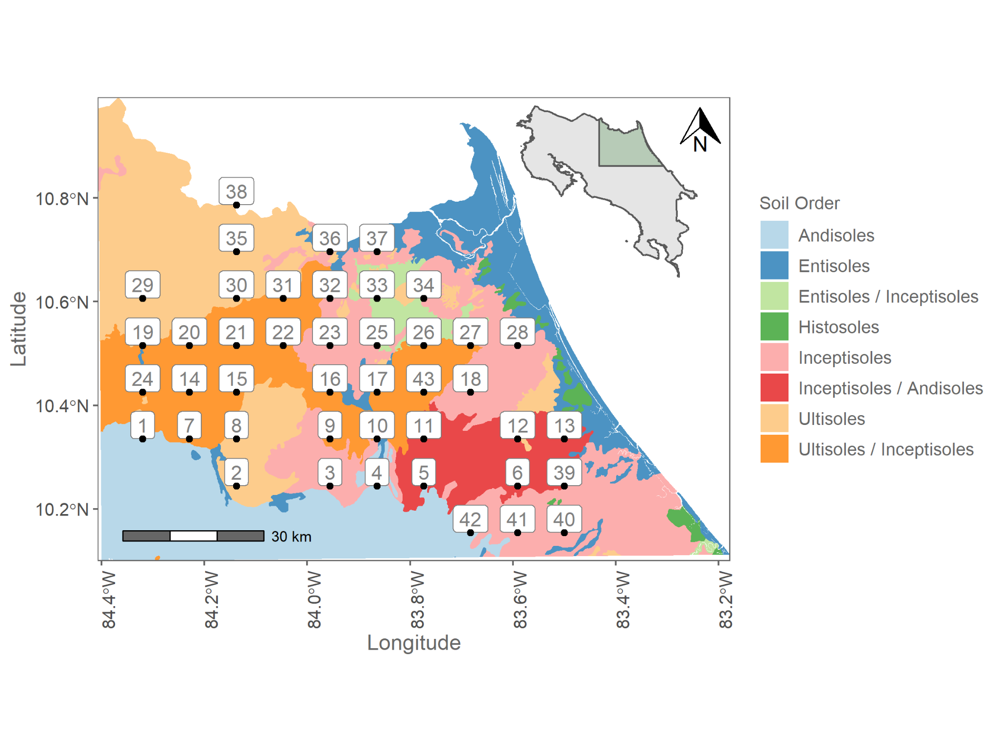
Figure 12: ARU sites in the northeast of Costa Rica over the eight soil orders in the region. Soil orders are dominated by Ultisol and Inceptisol orders, with only a few sites having Entisol, Andisol or Histosol soils.
We conducted the study over three months, from February to April 2020. This period encompasses the peak of the breeding season, the fledging, and then a period where GGMs disperse from the breeding areas.

Passive Acoustic Monitoring
We used thirty-seven ARU sites on a 10km² grid. We initially chose an ARU location by taking the centre of every grid, but we allowed for a 1 km buffer around each point within which we would move the point if accessibility was an issue. The area between two neighbouring ARUs is ~100km²; we consider this to make the sites independent within each ten-day survey period. The only study to monitor the movement patterns of the GGM was a small radio-telemetry study that estimated the breeding range of GGMs is ~5.5km² (Powell et al., 1999). A recent study by Brightsmith et al., (2021) showed that scarlet macaws (Ara macao) and blue-and-yellow macaws (Ara ararauna) in Peru had daily movement index (movement between satellite fixes) of between 5.9 ± 4.7 and 12.4 ± 9.1 km per day in the breeding season and 5.7 ± 4.9 and 12.9 ± 10 in the non-breeding season. Since GGM are large macaws like scarlet and blue-and-yellow macaws, daily movement patterns can be assumed to be similar. Therefore, it is possible that GGMs moved between sites within a ten-day survey period.

Recordings were captured using AudioMoth 1.1.0 ARUs (Hill et al., 2019; LabMaker, Germany). Recordings were taken at 32kHz or 48kHz. The sampling frequency was inconsistent as there was an error in configuring some devices for a portion of the deployment period. The devices were installed on the tallest accessible tree at each site. We recorded for five, ten-day recording periods between 7:00 am and 7:30 am for 30 minutes. The recording periods were between 31-Jan-20 and 9-Feb-20, 19-Feb-20 and 29-Feb-20, 9-Mar-20 and 19-Mar-20, 29-Mar-20 and 9-Apr, and finally between 19-Apr-20 and 29-Apr-20 (Table 3). These periods were chosen as they permitted an equal spread of sampling periods across the recording period. They also represent the progress from incubation (Period 1) to chick feeding (Periods 2 and 3) to fledging and dispersal (Periods 4 and 5).
Table 3: Definitions of covariates, how they are determined and their source. Time periods are ten days long with a ten-day gap in between.
Category | Type | Covariates | Metric | Source
Land cover/land use (LCLU) | lambda/gamma/ p | Trees, Urban | Proportion of grid cell occupied | (Karra et al., 2021)
Soil order | lambda/gamma | Andisols, Ultisols, Ultisols / Inceptisol,  Inceptisol, Inceptisols / Andisols, Entisols / Inceptisols, Entisols | Proportion of area occupied | (Chinchilla and Chacon, 2016)
Forest landscape integrity index (FLII) | lambda/gamma | FLII | Mean across grid cell | (Grantham et al., 2020)
Altitude (m) | lambda/gamma | Altitude | Mean across grid cell | (DIVA-GIS, 2012)
Time | p | Period | Categorical:  1: 31-Jan-20 to 9-Feb-20  2: 19-Feb-20 to 29-Feb-20  3: 9-Mar-20 to 19-Mar-20  4: 29-Mar-20 to 9-Apr  5: 9-Apr-20 to 29-Apr-20 | NA
Time | p | Date | Numerical: Julian date of recording | NA

4.3.2 Data preparation and statistical analysis

Parrot Detection Data
We used the recogniser developed in chapter 2 to extract cue rate data from the PAM recordings. Due to the highly varied call types of the GGM, the recogniser employs template matching and supervised machine learning classification in a two-step pipeline. A set of six templates are used to identify regions of interest (ROIs), which are then fed into a random forest (Breiman, 2001). A spatiotemporally pseudo-random training dataset (Antonov and Saleev, 1979; Sobol, 1967) of 8408 GGM and 33129 negative cases was used to train the random forest. All positive detections of GGMs were manually checked to ensure only true GGM detections were used for modelling; this was because recogniser precision was low at only 0.56. GGM cue rate is highly varied, and the relationship between the number of individuals and the number of calls per unit of time is unknown. This creates modelling issues; therefore, we decided to bin call counts into three sets of intervals 10 (0, (0, 10], (10, 20], (20, 30], …), 20 (0, (0, 20], (20, 40], (40, 60], …) and 50 (0, (0, 50], (50, 100], (100, 150], …). Although this sacrifices information, we found that binning the data in this way led to better model fits. We evaluated the performance of each binned version of the call rate data, which we discuss below.

Covariates
We used two biotic and two abiotic factors as model covariates (Table 1). Biotic factors were the proportion of the 10km2 grid covered by tree cover, calculated from land use/land cover data at 30m resolution (Karra et al., 2021) and forest landscape integrity index (FLII) calculated from 10m resolution data (Grantham et al., 2020). Abiotic factors used were the mean altitude of the 10km2 grid (DIVA-GIS, 2012) and the proportions of the grid occupied by each soil order (Chinchilla and Chacon, 2016). We used soil order as a proxy for forest type; therefore, we would have preferred to use soil suborder as this can be more closely related to forest type. However, we did not have sufficient representation across our sites to allow this. We used only the soil orders represented at over 80% of sites; Ultisols / Inceptisols, Ultisols, Inceptisols, Entisols / Inceptisols, and Entisols. For our modelling purposes, we treated soil order as one grouped covariate, so soil orders we either all used, or none were used. We use scale and centre transformation on all covariates.

4.3.3 Occupancy modelling
We fit open N-mixture models (Dail and Madsen, 2011) (function pcountOpen), with dynamics set to “trend” using the unmarked package (Fiske and Chandler, 2011) in R 4.1.0 (R Core Team, 2021). We used a three-step model selection process. Step 1: we ran null models for each bin category (ten, twenty and fifty) with negative binomial and zero-inflated Poisson distributions. To determine which fit the data better, we ran a goodness-of-fit (GOF) test (1000 samples) for each of the six models using the parboot function. Next, we selected the models whose sum of squared residuals (SSE) lay within the distribution of the parametric bootstrapped cases. Step 2: We ran each selected dataset (ten, twenty or fifty) and data distribution (negative binomial or zero-inflated Poisson) with six of the simplest models possible from the combination of covariates use and six of the most complex models possible with the same data. We fixed our initial abundance covariates as tree cover, FLII, altitude and soil order, as these were the top-performing covariates when estimating the abundance of GGM (chapter 3). We then used AIC (Burnham and Anderson, 1998) to select the top model for each dataset and distribution. Step 3: We ran GOF tests (1000 samples) using SSE, chi-squared and freeman-Tukey for each top model to determine which fit the data best. Model coefficients and standard errors (SEs) were calculated on transformed and untransformed covariates. Finally, we used the top model to estimate the relative abundance of GGM across the five time periods. We did this using the posterior mean of the conditional abundance distribution at each site, estimated using empirical Bayes. We then converted the estimate onto a 0-1 scale (Supplementary Materials 2).

4.4 Results

4.4.1 Open N-mixture models
During the five periods, GGM were detected at 36 of the 37 sites. There were a total of 1850 recording days, and GGMs were detected during 277 (15%) of those. The maximum cue rate was 298; therefore, thirty, fifteen and six levels in the ten, twenty and fifty bin categories, respectively. When we ran the null models, the negative binomial twenty (NB20) and fifty (NB50) binned datasets fit the data (Fig. S4.1). The top models for the NB20 and NB50 had tree cover and date as detection covariates. Only one NB20 model with Δ2 AIC less than two; this used tree cover, altitude and soil order. The top model for NB50 was the same as the NB20 model; however, one other model was within Δ2 AIC. This model used tree cover, altitude, FLII and soil order (Table S4.1). Parametric bootstrap GOF tests based on SSE indicated that both models fit the data, but the NB20 model was the best fit (Fig. S4.2).

4.4.2 GGM spatiotemporal distribution
Relative abundance changes across the five periods; northern sites decline, whereas southeast sites increase (Fig. 13). However, the change in relative abundance suggests that GGMs begin to leave the study area during periods 4 and 5.
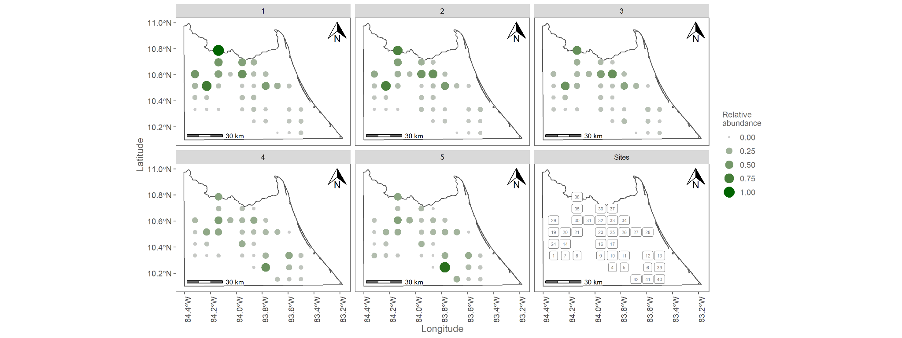
Figure 13: Relative abundance across each time period using the NB20 model. There is a large change in relative abundance in the southeastern sites from the first period to the last, suggesting an increase in great green macaw activity in this region.
Model coefficients show that Inceptisol (-1.54 ± 1.10 SE) and Entisol (-8.18 ± 1.85 SE) soil orders significantly negatively affect initial abundance. Entisol has a negative effect (-0.67 ± 0.61 SE), whereas, Inceptisol has a positive effect on abundance (0.42 ± 0.33 SE). Other soil orders all significantly positively affect the population growth rate (Fig. 14/ Table S4.2). Altitude was the only covariate that significantly positively affected initial abundance (0.60 ±0.57 SE) and population growth rate (0.73 ± 0.15 SE).

4.5 Discussion
Using PAM data and open N-mixture models, we have shown that the relative spatiotemporal abundance of GGM in northern Costa Rica is affected by both soil type and altitude, suggesting that GGM distribution is driven by the availability of specific food resources throughout the breeding season and in the early stages of the non-breeding season.

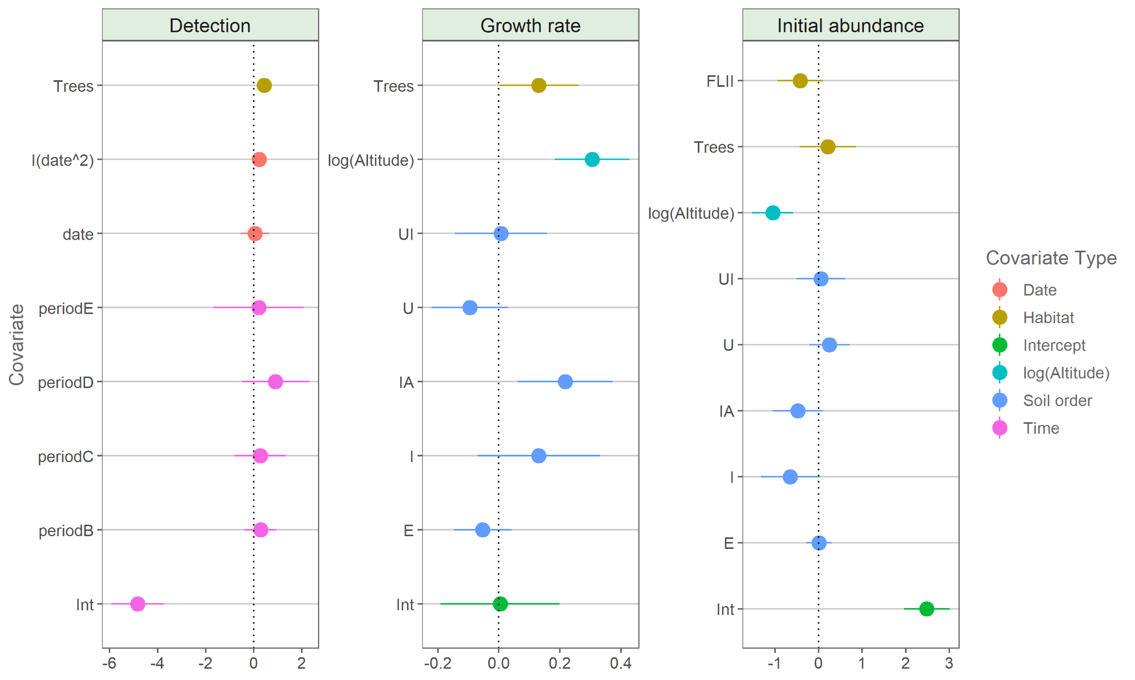
Figure 14: Covariate coefficients for detection, population growth rate and initial abundance sides of NB20

4.5.1 GGM spatiotemporal distribution
The factors influencing the annual GGM spatiotemporal distribution are not well understood. However, we understand the distribution patterns for nine months of the year. In the three months leading up to the breeding season, large flocks can be found in the foothills of Cordillera Central mountains (Macaw Recovery Network, 2021). Then during the breeding season, their distribution is focused in the north of Costa Rica, where mountain almonds have high densities (Chun, 2008). However, we still do not clearly understand the changes in their distribution in subsequent months. As expected, we found that the spatial distribution at the beginning of the breeding season was similar to that of chapter 3; however, there were slight changes in relative abundance across the breeding season. Furthermore, as the breeding season ends and chicks fledge the nest, we identified a decrease in relative abundance in the breeding areas (in the north) and an increase in relative abundance in the southeast (Fig. 13). This is interesting because these areas are regions of intensive agricultural activity (Karra et al., 2021) with large banana and pineapple plantations (TL pers. obvs) that have not been associated with high GGM activity in the past.

Interestingly, the sites in the breeding areas do not decrease to near zero. This could be due to breeding pairs who relaid or start breeding late. Generally, there does not appear to be any consistency in seasonal migratory behaviour within large macaw species; some populations of some species are migratory (Adamek, 2011; Carrara et al., 2020; Davenport et al., 2021), whereas others are sedentary (Karubian et al., 2005; Renton, 2002) and some populations show intra-population divergence in migratory patterns (Brightsmith et al., 2021). However, field observations during June and July suggest a near-total dispersal away from the breeding areas post-breeding. Therefore, we might expect a continued decline in abundance from the end of the study until the next breeding season.

The sites that show the most significant increases in relative abundance between the first and last periods are those in the southeast. Parrot movements in the non-breeding season are tied to local food abundance (Figueira et al., 2011; Hosein et al., 2017; Ragusa‐Netto, 2007; Ragusa-Netto, 2006, 2004; Ragusa-Netto and Fecchio, 2006; Rivera et al., 2020; Salinas-Melgoza and Renton, 2005; Santos and Ragusa-Netto, 2014). Therefore, we can assume that the increased relative abundance in this area is tied to the seasonal availability of local food resources. These sites are on the Inceptisol / Andisol soil order, a fertile soil order associated with high levels of anthropogenic agricultural disturbance in Costa Rica (Alvarado and Mata, 2016). There are no significant forest areas around these sites, so it is unclear whether the birds are feeding in these areas or possibly roosting in remnant forest patches and travelling to the forest further afield to feed daily. However, sampling took place from 7:00 am to 7:30 am, over an hour after sunrise, so if the birds were using these areas purely as roosts, we might expect them to have left the area by this time. Another potential explanation could be that birds are roosting somewhere else and traverse these sites on their way to local feeding grounds.

Altitude is an important factor affecting the relative abundance of GGMs. As with soil orders, this is likely a proxy for a breeding or food resource. For example, in Costa Rica, mountain almonds can be found at high densities in lowland areas of Ultisol soils (Chun, 2008), which is a crucial food and nesting resource for GGMs. Sites in the southeast are also sites with higher elevations. However, the increase in relative abundance in these slightly higher elevation sites is not mirrored in sites to the southwest. Furthermore, sites to the southwest become occupied between September and November, so the elevation or physical characteristics of the site are not driving the low abundance during April. Together this evidence suggests that the combination of soil type and elevation determines the floristic composition and, therefore, the abundance of GGMs. Further research is needed to determine the specific tree species driving these changes in spatiotemporal abundance.

Overall, the changes in the relative abundance of GGMs across the study period suggest that many birds leave the study area. Previous research suggests that some GGMs move to Tortuguero National Park in the east (Hughes pers. comms.), where they feed primarily on the non-native beach almonds (Terminalia catappa) (von Roosmalen, 2018). There is also evidence of birds moving north to the Indio-Maiz Biological Reserve (herein Indio-Maiz), Nicaragua, during the non-breeding season (Monge et al., 2003). Both these areas have much higher forest cover than the study area. Indio-Maiz is a vast area of relatively undisturbed forest that covers a wide variety of different habitat types. In contrast, Tortuguero NP is mostly wetland, swamp and mangroves with some rainforest (Kohlmann et al., 2007). Further research could focus on the extent of the GGM movements into Indio-Maiz and whether they move toward similar coastal areas to feed on the same species as they do in Costa Rica. For example, suppose they feed primarily on non-native species throughout the region during this period. In that case, it might suggest a lack of native food due to deforestation or that the non-native species is a more nutritious alternative.

4.5.2 Open N-mixture models
Open N-mixture models performed well on the binned cue rate data collected from PAM; this provides a practical option for studying the spatiotemporal changes in the relative abundance of parrots. Our approach to binning cue rate loses information about the fine-scale changes in relative abundance, but it has produced robust estimates of relative abundance. For example, the population in the north of the study area is well studied, and relative abundance estimates fit with observations on the ground that GGMs abundance is high during the peak breeding season (January to March) but then declines as the breeding season ends (March to April).

The null models suggested that the NB50 model was the best fit, but when all the covariates were used, the model that fits the data best was the NB20 model. This suggests that the increased heterogeneity in the NB20 model due to having more data levels, fifteen as opposed to six, was well explained by the model covariates. In contrast, the course approach to categorising the data used for the NB50 meant that the covariates did not increase the model's ability to fit the data.

4.5.3 Conclusion
PAM and dynamic occupancy models are suitable for monitoring the spatiotemporal distribution of parrot populations in tropical rainforests. Our study has shown that we can gain valuable insights into population dynamics, even when binning cue rates. With advances in PAM hardware and software, scaling up our approach can be over a species whole range and over prolonged periods are possible. Our results suggest that in Costa Rica, GGM distribution is driven by an unknown food resource found in Inceptisol / Andisol soil types in the foothills of the Cordillera Central. However, further research is needed to determine precisely how GGM uses the Inceptisol / Andisol regions. Furthermore, the overall decline in GGM relative abundance at the end of the breeding season suggests that birds are moving out of the study area. Determining where they move to should be treated as a priority, and our results show that PAM can be the tool to do this.

4.6 Bibliography
Adamek, K.A., 2011. Temporal variation in space and resource use of macaws in the southeastern Peruvian Amazon, MSc Thesis. Texas A&M University, Texas.
Alvarado, A., Mata, R., 2016. Chapter 4: Soils of Costa Rica, in: An Agroecological Approach.
Antonov, I.A., Saleev, V.M., 1979. An economic method of computing LPτ-sequences. USSR Comput. Math. Math. Phys. 19, 252–256. https://doi.org/10.1016/0041-5553(79)90085-5
Berg, K.S., Horstman, E., 1996. The Great Green Macaw Ara ambigua guayaquilensis in Ecuador: first nest with young. Cotinga 5, 53–54.
Berg, K.S., Socola, J., Angel, R.R., 2007. Great Green Macaws and the annual cycle of their food plants in Ecuador. J. Field Ornithol. 78, 1–10. https://doi.org/DOI: 10.1111/j.1557-9263.2006.00080.x
Berkunsky, I., Quillfeldt, P., Brightsmith, D.J., Abbud, M.C., Aguilar, J.M.R.E., Alemán-Zelaya, U., Aramburú, R.M., Arce Arias, A., Balas McNab, R., Balsby, T.J.S., Barredo Barberena, J.M., Beissinger, S.R., Rosales, M., Berg, K.S., Bianchi, C.A., Blanco, E., Bodrati, A., Bonilla-Ruz, C., Botero-Delgadillo, E., Canavelli, S.B., Caparroz, R., Cepeda, R.E., Chassot, O., Cinta-Magallón, C., Cockle, K.L., Daniele, G., de Araujo, C.B., de Barbosa, A.E., de Moura, L.N., Del Castillo, H., Díaz, S., Díaz-Luque, J.A., Douglas, L., Figueroa Rodríguez, A., García-Anleu, R.A., Gilardi, J.D., Grilli, P.G., Guix, J.C., Hernández, M., Hernández-Muñoz, A., Hiraldo, F., Horstman, E., Ibarra Portillo, R., Isacch, J.P., Jiménez, J.E., Joyner, L., Juarez, M., Kacoliris, F.P., Kanaan, V.T., Klemann-Júnior, L., Latta, S.C., Lee, A.T.K., Lesterhuis, A., Lezama-López, M., Lugarini, C., Marateo, G., Marinelli, C.B., Martínez, J., McReynolds, M.S., Mejia Urbina, C.R., Monge-Arias, G., Monterrubio-Rico, T.C., Nunes, A.P., Nunes, F., Olaciregui, C., Ortega-Arguelles, J., Pacifico, E., Pagano, L., Politi, N., Ponce-Santizo, G., Portillo Reyes, H.O., Prestes, N.P., Presti, F., Renton, K., Reyes-Macedo, G., Ringler, E., Rivera, L., Rodríguez-Ferraro, A., Rojas-Valverde, A.M., Rojas-Llanos, R.E., Rubio-Rocha, Y.G., Saidenberg, A.B.S., Salinas-Melgoza, A., Sanz, V., Schaefer, H.M., Scherer-Neto, P., Seixas, G.H.F., Serafini, P., Silveira, L.F., Sipinski, E.A.B., Somenzari, M., Susanibar, D., Tella, J.L., Torres-Sovero, C., Trofino-Falasco, C., Vargas-Rodríguez, R., Vázquez-Reyes, L.D., White, T.H., Williams, S., Zarza, R., Masello, J.F., 2017. Current threats faced by Neotropical parrot populations. Biol. Conserv. 214, 278–287. https://doi.org/10.1016/j.biocon.2017.08.016
BirdLife International, 2020. Great Green Macaw (Ara ambiguus) - BirdLife species factsheet [WWW Document]. URL http://datazone.birdlife.org/species/factsheet/great-green-macaw-ara-ambiguus (accessed 1.5.21).
Bradfer-Lawrence, T., Beresford, A.E., Anderson, G.Q.A., Aung, P.P., Chang, Q., Chowdhury, S.U., Clark, N.A., Gerasimov, Y.N., Green, R.E., Hilton, G.M., Hughes, B., Lappo, E.G., Li, J., Syroechkovskiy, E.E., Tomkovich, P.S., Zockler, C., Buchanan, G.M., 2021. Modelling the potential non-breeding distribution of Spoon-billed Sandpiper Calidris pygmaea. Bird Conserv. Int. 31, 169–184. https://doi.org/10.1017/S0959270920000398
Brady, N., Weil, R., 1996. The Nature and Properties of Soil.
Bravo, C.J.C., Berríos, R.Á., Aide, T.M., 2017. Species-specific audio detection: a comparison of three template-based detection algorithms using random forests. PeerJ Comput. Sci. 3, e113. https://doi.org/10.7717/peerj-cs.113
Breiman, L., 2001. Random Forests. Mach. Learn. 45, 5–32. https://doi.org/10.1023/A:1010933404324
Brightsmith, D., Boyd, J., Hobson, E., Randel, C., 2021. Satellite telemetry reveals complex migratory movement patterns of two large macaw species in the western Amazon basin. Avian Conserv. Ecol. 16. https://doi.org/10.5751/ACE-01822-160114
Burnham, K.P., Anderson, D.R., 1998. Practical Use of the Information-Theoretic Approach, in: Burnham, K.P., Anderson, D.R. (Eds.), Model Selection and Inference: A Practical Information-Theoretic Approach. Springer, New York, NY, pp. 75–117. https://doi.org/10.1007/978-1-4757-2917-7_3
Bury, R., 2006. Natural History, Field Ecology, Conservation Biology and Wildlife Management: Time to Connect the Dots. Herpetol. Conserv. Biol. 1.
Carrara, L.A., Antas, P.D.T.Z., Yabe, R.D.S., Ubaid, F.K., Oliveira, S.B.D., Ferreira, L.P., 2020. Seasonal movements of Blue-and-yellow Macaw (Ara ararauna) in the northern Pantanal floodplains, Brazil. Wilson J. Ornithol. 131, 725–734. https://doi.org/10.1676/1559-4491-131.4.725
Chambault, P., Fossette, S., Heide-Jørgensen, M.P., Jouannet, D., Vély, M., 2021. Predicting seasonal movements and distribution of the sperm whale using machine learning algorithms. Ecol. Evol. 11, 1432–1445. https://doi.org/10.1002/ece3.7154
Chassot, O., Monge, G.A., 2012. Connectivity conservation of the Great Green Macaw’s landscape in Costa Rica and Nicaragua (1994–2012). Parks 18, 61–68.
Chassot, O., Monge, G.A., Alemán-Zelaya, U., Gonzalez-Tellez, A., 2011. Primer reporte dun arbol con nidos activos de guacamayo rojo (Ara macao) y guacamayo verde major (Ara ambiguus) en bosque muy humedo tropical de Centroamerica. Zeledonia 15, 72–79.
Chinchilla, R.M., Chacon, Da.S., 2016. Digital Soil Map of Costa Rica [WWW Document]. Cent. Investig. Agron. URL http://www.cia.ucr.ac.cr/cia_en/?page_id=114 (accessed 2.10.22).
Chun, S., 2008. The utility of digital aerial surveys in censusing Diptryx panamensis, the key food and nesting tree of the endangered Great-green Macaw (Ara ambiguus) in Costa Rica (PhD). Duke University.
Cook, K., Foley, K., Freitag, C., Nabatchi, T., 2021. Pineapples, Parrots, and People: Challenges and Opportunities for the Great Green Macaw in Costa Rica. Conservation Law Center & Program for the Advancement of Research on Conflict and Collaboration., Bloomington, IN.
Dahlem, M., Collins, V., 2021. Mass feeding event of Turquoise Parrots and Eastern Rosellas on the North-west Slopes of New South Wales. Aust. Field Ornithol. 38.
Dail, D., Madsen, L., 2011. Models for Estimating Abundance from Repeated Counts of an Open Metapopulation. Biometrics 67, 577–587. https://doi.org/10.1111/j.1541-0420.2010.01465.x
Davenport, L.C., Boorsma, T., Carrara, L., Antas, P. de T.Z., Faria, L., Brightsmith, D.J., Herzog, S.K., Soria-Auza, R.W., Hennessey, A.B., 2021. Satellite Telemetry of Blue-Throated Macaws in Barba Azul Nature Reserve (Beni, Bolivia) Reveals Likely Breeding Areas. Diversity 13, 564. https://doi.org/10.3390/d13110564
Dénes, F.V., Silveira, L.F., Beissinger, S.R., 2015. Estimating abundance of unmarked animal populations: accounting for imperfect detection and other sources of zero inflation. Methods Ecol. Evol. 6, 543–556. https://doi.org/10.1111/2041-210X.12333
Dénes, F.V., Tella, J.L., Beissinger, S.R., 2018. Revisiting methods for estimating parrot abundance and population size. Emu - Austral Ornithol. 118, 67–79. https://doi.org/10.1080/01584197.2017.1401903
Dingle, H., 2014. Migration: The Biology of Life on the Move, 2nd ed. Oxford University Press, Oxford.
DIVA-GIS, 2012. Download data by country [WWW Document]. URL http://www.diva-gis.org/gdata (accessed 2.10.22).
Donoso, I., García, D., Martínez, D., Tylianakis, J.M., Stouffer, D.B., 2017. Complementary Effects of Species Abundances and Ecological Neighborhood on the Occurrence of Fruit-Frugivore Interactions. Front. Ecol. Evol. 5.
Fagan, M.E., DeFries, R.S., Sesnie, S.E., Arroyo, J.P., Walker, W., Soto, C., Chazdon, R.L., Sanchun, A., 2013. Land cover dynamics following a deforestation ban in northern Costa Rica. Environ. Res. Lett. 8, 034017. https://doi.org/10.1088/1748-9326/8/3/034017
Figueira, J.E.C., Mourão, F.A., Coelho, A.S., 2011. Habitat heterogeneity and climatic seasonality structure the avifauna trophic guilds in the Brazilian Pantanal wetland. Can. J. Zool. 89, 1206–1213. https://doi.org/10.1139/z11-099
Figueira, L., Tella, J.L., Camargo, U.M., Ferraz, G., 2015. Autonomous sound monitoring shows higher use of Amazon old growth than secondary forest by parrots. Biol. Conserv. 184, 27–35. https://doi.org/10.1016/j.biocon.2014.12.020
Fiske, I., Chandler, R., 2011. unmarked: An R Package for Fitting Hierarchical Models of Wildlife Occurrence and Abundance. J. Stat. Softw. 43, 1–23. https://doi.org/10.18637/jss.v043.i10
Forshaw, J.M., 2010. Parrots of the World. Princeton University Press.
Giam, X., 2017. Global biodiversity loss from tropical deforestation. Proc. Natl. Acad. Sci. 114, 5775–5777. https://doi.org/10.1073/pnas.1706264114
Gibb, R., Browning, E., Glover‐Kapfer, P., Jones, K.E., 2019. Emerging opportunities and challenges for passive acoustics in ecological assessment and monitoring. Methods Ecol. Evol. 10, 169–185. https://doi.org/10.1111/2041-210X.13101
Gilman, A.C., Letcher, S.G., Fincher, R.M., Perez, A.I., Madell, T.W., Finkelstein, A.L., Corrales‐Araya, F., 2016. Recovery of floristic diversity and basal area in natural forest regeneration and planted plots in a Costa Rican wet forest. Biotropica 48, 798–808. https://doi.org/10.1111/btp.12361
Grantham, H.S., Duncan, A., Evans, T.D., Jones, K.R., Beyer, H.L., Schuster, R., Walston, J., Ray, J.C., Robinson, J.G., Callow, M., Clements, T., Costa, H.M., DeGemmis, A., Elsen, P.R., Ervin, J., Franco, P., Goldman, E., Goetz, S., Hansen, A., Hofsvang, E., Jantz, P., Jupiter, S., Kang, A., Langhammer, P., Laurance, W.F., Lieberman, S., Linkie, M., Malhi, Y., Maxwell, S., Mendez, M., Mittermeier, R., Murray, N.J., Possingham, H., Radachowsky, J., Saatchi, S., Samper, C., Silverman, J., Shapiro, A., Strassburg, B., Stevens, T., Stokes, E., Taylor, R., Tear, T., Tizard, R., Venter, O., Visconti, P., Wang, S., Watson, J.E.M., 2020. Anthropogenic modification of forests means only 40% of remaining forests have high ecosystem integrity. Nat. Commun. 11, 5978. https://doi.org/10.1038/s41467-020-19493-3
Hafner, S.D., Katz, J., 2018. A short introduction to acoustic template matching with monitoR.
Hill, A.P., Prince, P., Snaddon, J.L., Doncaster, C.P., Rogers, A., 2019. AudioMoth: A low-cost acoustic device for monitoring biodiversity and the environment. HardwareX 6, e00073. https://doi.org/10.1016/j.ohx.2019.e00073
Hosein, A., Narang, D.S., Rostant, L., Hailey, A., 2017. The abundance of Red-bellied Macaws (Orthopsittaca manilata) and Orange-winged Parrots (Amazona amazonica) in relation to fruiting Moriche Palms (Mauritia flexuosa) at the Aripo Savannas, Trinidad. Rev. Bras. Ornitol. 25, 40–46. https://doi.org/10.1007/BF03544375
IUCN, 2020. The IUCN Red List of Threatened Species [WWW Document]. IUCN Red List Threat. Species. URL https://www.iucnredlist.org/en (accessed 1.13.21).
Jadin, I., Meyfroidt, P., Lambin, E.F., 2016. International trade, and land use intensification and spatial reorganization explain Costa Rica’s forest transition. Environ. Res. Lett. 11, 035005. https://doi.org/10.1088/1748-9326/11/3/035005
Kahl, S., Wood, C.M., Eibl, M., Klinck, H., 2021. BirdNET: A deep learning solution for avian diversity monitoring. Ecol. Inform. 61, 101236. https://doi.org/10.1016/j.ecoinf.2021.101236
Karra, K., Kontgis, C., Statman-Weil, Z., Mazzariello, J.C., Mathis, M., Brumby, S.P., 2021. Global land use / land cover with Sentinel 2 and deep learning, in: 2021 IEEE International Geoscience and Remote Sensing Symposium IGARSS. Presented at the 2021 IEEE International Geoscience and Remote Sensing Symposium IGARSS, pp. 4704–4707. https://doi.org/10.1109/IGARSS47720.2021.9553499
Karubian, J., Fabara, J., Yunes, D., Jorgenson, J.P., Romo, D., Smith, T.B., 2005. Temporal and spatial patterns of macaw abundance in the Ecuadorian Amazon. Condor 10.
Katuwal, H.B., Basnet, K., Khanal, B., Devkota, S., Rai, S.K., Gajurel, J.P., Scheidegger, C., Nobis, M.P., 2016. Seasonal Changes in Bird Species and Feeding Guilds along Elevational Gradients of the Central Himalayas, Nepal. PLOS ONE 11, e0158362. https://doi.org/10.1371/journal.pone.0158362
Kennedy, E.M., Kemp, J.R., Mosen, C.C., Perry, G.L.W., Dennis, T.E., 2015. GPS telemetry for parrots: A case study with the Kea (Nestor notabilis). The Auk 132, 389–396. https://doi.org/10.1642/AUK-14-196.1
Kéry, M., 2021. Applied hierarchical modeling in ecology. Volume 2, Dynamic and advanced models: analysis of distribution, abundance and species richness in R and BUGS. Academic Press, London, England.
Kohlmann, B., Solis, A., Elle, O., Soto, X., Russo, R., 2007. Biodiversity, conservation, and hotspot atlas of Costa Rica. Zootaxa 1457, 1-34. https://doi.org/10.11646/zootaxa.1457.1.1
Lenz, J., Böhning-Gaese, K., Fiedler, W., Mueller, T., 2015. Nomadism and seasonal range expansion in a large frugivorous bird. Ecography 38, 54–62. https://doi.org/10.1111/ecog.00522
Macaw Recovery Network, C., 2021. Annual Great Green Macaw (Ara ambiguus) roost count, Costa Rica. Mcaaw Recovery Network / Centro Cientifico Tropical, San Jose, Costa Rica.
Marques, T.A., Munger, L., Thomas, L., Wiggins, S., Hildebrand, J.A., 2011. Estimating North Pacific right whale Eubalaena japonica density using passive acoustic cue counting. Endanger. Species Res. 13, 163–172. https://doi.org/10.3354/esr00325
Marques, T.A., Thomas, L., Martin, S.W., Mellinger, D.K., Ward, J.A., Moretti, D.J., Harris, D., Tyack, P.L., 2013. Estimating animal population density using passive acoustics. Biol. Rev. Camb. Philos. Soc. 88, 287–309. https://doi.org/10.1111/brv.12001
Monge, G.A., 2010. Evaluación del estado de conservación y viabilidad poblacional de la lapa verde (Ara ambiguus) en el Corredor Biológico Binacional El Castillo-San Juan-La Selva, Costa Rica - Nicaragua (PhD). Universidad Nacional Costa Rica, Costa Rica.
Monge, G.A., Chassot, O., Powell, G.V.N., Palminteri, S., Alemán-Zelaya, U., Wright, P., 2003. Ecologia de la lapa verde (Ara ambiguus) en Costa Rica. Zeledonia 7, 4–12.
Monge, G.A., Chassot, O., Ramírez, Ó., Zelaya, I.A., Figueroa, A., Brenes, D., 2012. Temporada de nidificación 2009 de Ara ambiguus y Ara macao en el Sureste de Nicaragua y Norte de Costa Rica. Zeledonia 16, 3–14.
Myers, M.C., Vaughan, C., 2004. Movement and behavior of scarlet macaws (Ara macao) during the post-fledging dependence period: implications for in situ versus ex situ management. Biol. Conserv. 118, 411–420. https://doi.org/10.1016/j.biocon.2003.09.018
Parr, M., Juniper, T., 2010. Parrots: A Guide to Parrots of the World. Bloomsbury Publishing.
Pinto-Junior, H.V., Villa, P.M., de Menezes, L.F.T., Pereira, M.C.A., 2020. Effect of climate and altitude on plant community composition and richness in Brazilian inselbergs. J. Mt. Sci. 17, 1931–1941. https://doi.org/10.1007/s11629-019-5801-4
Pires, L.P., Paniago, L.P.M., Santos, Y.R., de Melo, C., 2022. Seasonality drives variation in the use of forest strata by adult males of a dimorphic frugivorous bird species. Austral Ecol. 47, 392–399. https://doi.org/10.1111/aec.13129
Portillo Reyes, H.O., Elvir, F., Manzanares, T., Martínez, M., Portillo Reyes, H.O., Elvir, F., Manzanares, T., Martínez, M., 2018. La Guara Verde (Ara ambiguus) en Honduras: notas sobre su distribución, hábitat y amenazas. Huitzil 19, 120–130. https://doi.org/10.28947/hrmo.2018.19.1.317
Powell, G.V.N., Wright, P., Alemán-Zelaya, U., Guindon, C., Palminteri, S., Bjork, R., 1999. Research findings and conservation recommendations for the Great Green Macaw (Ara ambigua) in Costa Rica. Centro Cientifico Tropical, San Jose, Costa Rica.
R Core Team, 2021. R: A language and environment for statistical computing.
Ragusa‐Netto, J., 2007. Nectar, fleshy fruits and the abundance of parrots at a gallery forest in the southern Pantanal (Brazil). Stud. Neotropical Fauna Environ. 42, 93–99. https://doi.org/10.1080/01650520600979643
Ragusa-Netto, J., 2006. Dry fruits and the abundance of the blue-and-yellow (Ara ararauna) at a cerrado remnant in central Brazil. Ornithol. Neotropical 17, 491–500.
Ragusa-Netto, J., 2004. Flowers, fruits, and the abundance of the yellow-chevroned parakeet (Brotogeris chiriri) at a gallery forest in the South Pantanal (Brazil). Braz. J. Biol. 64, 867–877. https://doi.org/10.1590/S1519-69842004000500017
Ragusa-Netto, J., Fecchio, A., 2006. Plant food resources and the diet of a parrot community in a gallery forest of the southern Pantanal (Brazil). Braz. J. Biol. 66, 1021–1032. https://doi.org/10.1590/S1519-69842006000600008
Renton, K., 2002. Seasonal variation in occurrence of macaws along a rainforest river. J. Field Ornithol. 73, 15–19. https://doi.org/10.1648/0273-8570-73.1.15
Renton, K., 2001. Lilac-Crowned Parrot Diet and Food Resource Availability: Resource Tracking by a Parrot Seed Predator. The Condor 103, 62–69. https://doi.org/10.1093/condor/103.1.62
Rivera, L.O., Politi, N., Bucher, E.H., 2020. Feeding Ecology and Key Food Resources for the Endemic and Threatened Tucuman Amazon Amazona tucumana in Argentina. Acta Ornithol. 54, 223–232. https://doi.org/10.3161/00016454AO2019.54.2.008
Royle, J.A., 2004. N-Mixture Models for Estimating Population Size from Spatially Replicated Counts. Biometrics 60, 108–115. https://doi.org/10.1111/j.0006-341X.2004.00142.x
Royle, J.A., Dorazio, R.M., 2008. Hierarchical Modeling and Inference in Ecology: The Analysis of Data from Populations, Metapopulations and Communities. Elsevier.
Royle, J.A., Nichols, J.D., 2003. Estimating Abundance from Repeated Presence–Absence Data or Point Counts. Ecology 84, 777–790. https://doi.org/10.1890/0012-9658(2003)084[0777:EAFRPA]2.0.CO;2
Salinas-Melgoza, A., Renton, K., 2005. Seasonal variation in activity patterns of juvenile lilac-crowned parrots in tropical dry forest. Wilson Bull. 117, 291–295. https://doi.org/10.1676/04-096.1
Sanjeewani, H.K.N., Samarasinghe, D.P., Jayasinghe, H.D., Gardiyawasam, P.H., Wahala, W.M.P.S.B., Wijetunga, W.M.G. a. S.T.B., Ukuwela, K.D.B., Gomes, P., De Costa, W. a. J.M., 2020. Response of tree community composition, plant diversity and aboveground tree biomass in tropical rainforests of Sri Lanka to variation in altitude. https://tar.sljol.info/articles/abstract/10.4038/tar.v31i1.8346/. https://doi.org/10.4038/tar.v31i1.8346
Santos, A.A., Ragusa-Netto, J., 2014. Plant food resources exploited by Blue-and-Yellow Macaws (Ara ararauna, Linnaeus 1758) at an urban area in Central Brazil. Braz. J. Biol. 74, 429–437. https://doi.org/10.1590/1519-6984.27312
Silva, A.F. da, Malhado, A.C.M., Correia, R.A., Ladle, R.J., Vital, M.V.C., Mott, T., 2020. Taxonomic bias in amphibian research: Are researchers responding to conservation need? J. Nat. Conserv. 56, 125829. https://doi.org/10.1016/j.jnc.2020.125829
Snaddon, J., Petrokofsky, G., Jepson, P., Willis, K.J., 2013. Biodiversity technologies: tools as change agents. Biol. Lett. 9, 20121029. https://doi.org/10.1098/rsbl.2012.1029
Sobol, I.M., 1967. On the distribution of points in a cube and the approximate evaluation of integrals. USSR Comput Math Math Phys 7, 86–112.
Sollins, P., 1998. Factors Influencing Species Composition in Tropical Lowland Rain Forest: Does Soil Matter? Ecology 79, 23–30. https://doi.org/10.1890/0012-9658(1998)079[0023:FISCIT]2.0.CO;2
Sólymos, P., Lele, S., Bayne, E., 2012. Conditional likelihood approach for analyzing single visit abundance survey data in the presence of zero inflation and detection error. Environmetrics 23, 197–205. https://doi.org/10.1002/env.1149
Somveille, M., Rodrigues, A.S.L., Manica, A., 2015. Why do birds migrate? A macroecological perspective. Glob. Ecol. Biogeogr. 24, 664–674. https://doi.org/10.1111/geb.12298
Stojanovic, D., Webb nee Voogdt, J., Webb, M., Cook, H., Heinsohn, R., 2016. Loss of habitat for a secondary cavity nesting bird after wildfire. For. Ecol. Manag., Special Section: Forest Management for Climate Change 360, 235–241. https://doi.org/10.1016/j.foreco.2015.10.040
Strebel, N., Fiss, C.J., Kellner, K.F., Larkin, J.L., Kéry, M., Cohen, J., 2021. Estimating abundance based on time-to-detection data. Methods Ecol. Evol. 12, 909–920. https://doi.org/10.1111/2041-210X.13570
Teixeira, D., Maron, M., Rensburg, B.J. van, 2019. Bioacoustic monitoring of animal vocal behavior for conservation. Conserv. Sci. Pract. 1, e72. https://doi.org/10.1111/csp2.72
Vergara-Tabares, D.L., Cordier, J.M., Landi, M.A., Olah, G., Nori, J., 2020. Global trends of habitat destruction and consequences for parrot conservation. Glob. Change Biol. 26, 4251–4262. https://doi.org/10.1111/gcb.15135
von Roosmalen, C., 2018. Habitat usage, abundance and behaviour of the Great Green Macaw (Ara ambiguus), and interactions with the Scarlet Macaw (Ara macao) in Tortuguero, Costa Rica. Canadian Organization for Tropical Education and Rainforest Conservation, Costa Rica.
White, T.H., Collazo, J.A., Vilella, F.J., Guerrero, S.A., 2005. Effects of hurricane Georges on habitat use by captive-reared Hispaniolan parrots (Amazona ventrailis) released in the Dominican Republic. Ornitol. Neotropical 16, 405–417.
Wood, C.M., Kahl, S., Rahaman, A., Klinck, H., 2022. The machine learning–powered BirdNET App reduces barriers to global bird research by enabling citizen science participation. PLOS Biol. 20, e3001670. https://doi.org/10.1371/journal.pbio.3001670
Wright, T.F., Toft, C.A., Enkerlin‐Hoeflich, E., Gonzalez‐Elizondo, J., Albornoz, M., Rodríguez‐Ferraro, A., Rojas‐Suárez, F., Sanz, V., Trujillo, A., Beissinger, S.R., A, V.B., A, X.G., Brice, A.T., Joyner, K., Eberhard, J., Gilardi, J., Koenig, S.E., Stoleson, S., Martuscelli, P., Meyers, J.M., Renton, K., Rodríguez, A.M., Sosa‐Asanza, A.C., Vilella, F.J., Wiley, J.W., 2001. Nest Poaching in Neotropical Parrots. Conserv. Biol. 15, 710–720. https://doi.org/10.1046/j.1523-1739.2001.015003710.x
Xu, M., Ma, L., Jia, Y., Liu, M., 2017. Integrating the effects of latitude and altitude on the spatial differentiation of plant community diversity in a mountainous ecosystem in China. PLOS ONE 12, e0174231. https://doi.org/10.1371/journal.pone.0174231
Zöckler, C., Beresford, A.E., Bunting, G., Chowdhury, S.U., Clark, N.A., Fu, V.W.K., Hla, T.H., Morozov, V.V., Syroechkovskiy, E.E., Kashiwagi, M., Lappo, E.G., Tong, M., Long, T.L., Yu, Y.-T., Huettmann, F., Akasofu, H.K., Tomida, H., Buchanan, G.M., 2016. The winter distribution of the Spoon-billed Sandpiper Calidris pygmaeus. Bird Conserv. Int. 26, 476–489. https://doi.org/10.1017/S0959270915000295

Nest-site selection and reproductive success are linked in a critically endangered parrot nesting in an anthropogenically disturbed landscape

5.1 Abstract
Nest site selection is the primary way secondary cavity-nesting species mitigate the negative effects of factors such as predation, parasitism and exposure on reproductive success. High-quality cavities could then be expected to be selected in response to the primary threat to nest success. Large-bodied secondary cavity nesters rely on large cavities in mature trees that are often absent or reduced in anthropogenically disturbed forests. The availability of high-quality nest sites may be limited for these species, which could negatively affect reproductive success. Understanding how reproductive success is affected by anthropogenic changes to ecosystems is vital if effective conservation management strategies are to be developed and implemented. Here we show that there is a link between nest-site selection and reproductive success in the critically endangered great green macaw (Ara ambiguus) in northern Costa Rica. We found that great green macaws are nesting in remnant isolated trees in pasture or young secondary forests. This mitigates the threat from nonvolant predators and means avian predators are the primary threat to nesting success.

5.2 Introduction
Parrots are one of the most endangered bird families, with 28% threatened with extinction globally (IUCN, 2020). They are found throughout the tropics and sub-tropics (Forshaw, 2010; Parr & Juniper, 2010), where they are mainly threatened by poaching and habitat loss (Wright et al., 2001; Stojanovic et al., 2016; Berkunsky et al., 2017; Vergara-Tabares et al., 2020). Both habitat loss and poaching can have an impact on the reproductive success of a parrot population by reducing the number of potential nest sites (DeWalt, Maliakal and Denslow, 2003), reducing the availability of high-quality sites (Amininasab et al., 2016), or removing nestlings (Wright et al., 2001; Hart et al., 2016; Martin, 2018). Understanding if and how the reproductive success of a parrot population is constrained is essential information when designing a conservation strategy. Without this knowledge, the high financial cost of carrying out conservation (McCarthy et al., 2012) may be wasted on ineffective interventions (Schrott, With and King, 2005).
Long-lived species are generally sensitive to reductions in adult survival, which means changes in this vital rate are often the main driver of population decline (Sæther & Bakke, 2000). However, this is not always the case in species such as parrots, where nest poaching is a significant driver of the decline in many parrot populations (Wright et al., 2001; Hart et al., 2016; Martin, 2018). Charismatic and easily accessible species, such as the yellow-naped Amazon (Amazona auropalliata), can suffer catastrophic population decline due to poaching of nestlings, with 100% of nests being poached in some areas (IUCN, 2020; Dahlin et al., 2018). As well as poaching, inter- and intra-specific competition can affect reproductive success by reducing nest site availability (Rendell & Robertson, 1989; Salinas-Melgoza, Salinas‐Melgoza and Renton, 2009; Heuck et al.,, 2017), which may then be amplified by habitat degradation reducing the absolute number of available cavities (Cockle et al., 2010; DeWalt et al., 2003). Reduced availability of high-quality nest sites drives individuals to select for lower quality sites, which may lead to a decline in population-level productivity (Carrete et al., 2006; Heuck et al., 2017). Thus, it is essential to understand the processes driving decreases in long-lived species subject to significant impacts (e.g. Tomillo et al., 2008; Jepson et al., 2016; Jourdain et al., 2019).
Most parrots are secondary cavity nesters meaning they rely on cavities created by other species to nest in (Forshaw, 2010; Parr & Juniper, 2010). Large-bodied secondary cavity nesters such as parrots are particularly reliant on mature trees that contain cavities of sufficient size (Marsden & Jones, 1997; de la Parra-Martínez et al., 2015; Renton et al., 2015). The availability of large trees and cavities is limited in degraded and regenerating forests (DeWalt et al., 2003). This suggests that the of secondary cavity-nesting species such as parrots may be limited by nest-site availability in degraded forests (de la Parra-Martínez et al., 2015; Renton et al., 2015; De Labra-Hernández & Renton, 2016; Stojanovic et al., 2021).
Choosing the physical characteristics of nest sites is one of the few ways individuals can counter common threats such as predation (Stojanovic et al., 2017) and parasitism (Tomás et al., 2020). For many parrot species, predation accounts for a significant proportion of nest failure (Berkunsky et al., 2016; Pizo et al., 2008; Renton and Salinas-Melgoza, 2004). Thus, we might expect to be correlated with physical nest-site characteristics that mitigate predation risk (Cockle et al., 2015). Parrots often select cavities that are deeper, higher above the canopy or larger than unused cavities (de la Parra-Martínez et al., 2015; De Labra-Hernández and Renton, 2016; Olah et al., 2014; Saunders et al., 1982; Stojanovic et al., 2021, 2017; Webb et al., 2012). These characteristics have been shown to have a significant positive influence on in the Eclectus parrot (Eclectus roratus) (Heinsohn, 2008) and scarlet macaws (Ara macao) (Olah et al., 2014). This may be because deep cavities offer greater protection against parasites (Tomás et al., 2020), or higher cavities have a better field of vision to detect predators (White, Brown and Collazo, 2006). It follows that breeding at low-quality sites is often associated with lower (e.g. Rendell and Robertson, 1989; Stokes & Boersma, 1998; Safran, 2006; Carrate, Donazar and Margalida, 2008). Thus, might be limited in degraded ecosystems if plasticity in nest-site selection causes parrots to nest in low-quality cavities.
We investigated whether a link between nest-site selection and exists in the critically endangered great green macaw (GGM - Ara ambiguus - BirdLife International, 2020). The GGM is a large neotropical parrot whose range extends from the Caribbean lowland forest in Honduras to Colombia and the Pacific coast of Panama down to the dry forest in western Ecuador (Forshaw, 2010; Parr & Juniper, 2010). In Costa Rica, evidence suggests that their steep decline was due to habitat loss; 90% loss of a critical nesting and food tree species, the mountain almond (MA - Dipteryx panamensis) (Powell et al., 1999) and a 30% reduction in forest cover to ~50% by the year 2000 (Calvo-Alvarado et al., 2009). With this evidence, we might expect nest-site availability to limit . Therefore, we aimed to answer two questions:
- What cavity features do GGMs use to select a nest site?
- Are cavity features associated with reproductive output?

5.3 Methods

5.3.1 Study site
The study area is a ~1000km² fragmented Caribbean lowland forest region situated in northern Costa Rica within the San Juan La Selva Biological corridor (Fig. 15). Land use is split between cattle pasture, pineapple and other annual crops, and primary and secondary forests (Fagan et al., 2013; Jadin et al., 2016). Annual rainfall is ca. 4667mm (2009-2014), with a slightly drier period between January and April (Gilman et al., 2016) which corresponds to the breeding season of the GGM (Monge et al., 2003, 2012).

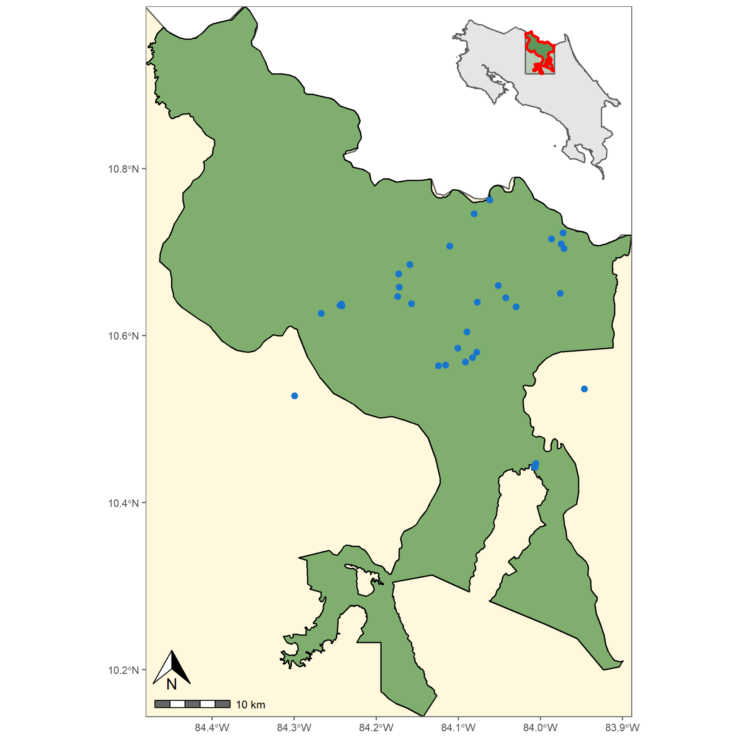
Figure 15: Study site in the Caribbean lowlands within the San Juan La Selva (SJLS) biological corridor in northern Costa Rica, with nest cavities (blue) marked. There were two monitored nests outside the SJLS biological corridor.

5.3.2 Cavity surveys
Around every known active nest we surveyed a 500m radius with a Mavic II Pro-Zoom drone to identify emergent cavities. This involved flying a transects 100m apart from north to south. If an emergent tree was identified the drone circled the tree to see if there were any visible suspected cavities. If any were found GPS coordinates were taken by taking a georeferenced photo directly above the tree. These GPS coordinates were used to direct climbers to the tree.

5.3.3 Features
Where accessible, we took measurements for each occupied/unoccupied cavity to calculate the entrance area, internal circumference and cavity depth. As cavity entrances are not commonly circular, we treated each entrance as five separate shapes to get the most accurate approximation of the area (Fig. S1 & S2). Cavity depth from the lip is the distance from the bottom lip of the cavity entrance to the cavity floor. We calculated internal circumference using cavity width and breadth at the level of the cavity lip. Internal circumference was used instead of measuring the cavity floor because, in many cases, measuring this directly was impossible as the cavities were too deep. We also recorded the cardinal direction of the entrance.

The tree-level features measured were species identity, cavity height from the ground (metres), tree circumference at breast height (metres), canopy connectivity (%) and vertical distance to the canopy to the nearest 5m (metres). We estimated the mean canopy height within a 50m radius of each cavity using the dataset provided by Lang et al., (2022). This global dataset of mean canopy height at 10m resolution was created using deep learning trained with GEDI and Sentinel-2 satellite data. We also estimated tree cover within 50m using the dataset developed by Karra et al., (2021); this is a global dataset of landcover/land use created using deep-learning and Sentinel-2 data and trained on 5 billion human-labelled pixels (S3).

5.3.4 Reproductive success
We monitored 40 known nest sites during the 2020 breeding season (Dec 2019 – June 2020). However, we only monitored reproductive success at 33 active nest sites; the rest were inactive. Reproductive success was measured as the number of chicks fledged per breeding attempt, estimated as the number of fully feathered chicks last seen in the nest before identifying an empty nest. We defined a breeding attempt as a clutch of eggs reaching a conclusion, either success or failure. Where possible, we recorded any evidence of the cause of a breeding attempt failure. We also used data collected over previous breeding seasons to help us understand common causes of failure. Potential causes were avian predation, mammalian predation, snake predation and unknown.

5.3.5 Imputation
We could not acquire complete measurements for every cavity due to cavities being challenging to access or human error where measurements were missed in the field. We imputed these missing data to maximise the power of our statistical analyses. We used multivariate imputation by chained equations (mice); this is a more robust way to deal with incomplete data sets compared to single imputation or data deletion approaches (Penone et al., 2014; Taugourdeau et al., 2014; Cooke et al., 2019). We used the mice package to generate our imputed values (Buuren and Groothuis-Oudshoorn, 2011). We used a random forest imputation method, with all numeric variables to impute missing values. Finally, we imputed 100 datasets to capture the uncertainty in the imputation process.

5.3.6 Statistical analysis
To determine whether GGMs select for cavity features, we fit a pair of intercept-only Bayesian regression models using the default flat prior. For each feature $i$ to model the distribution of its values in occupied ($x_{ij}^{o}$) and unoccupied ($x_{ij}^{u}$) cavities:
$x_{ij}^{o} ∼Norm({μ_{i}^{o},{σ_{i}^{o})}_{}^{}}_{}^{}$ (equation 1)
$x_{ij}^{u} ∼Norm({μ_{i}^{u},{σ_{i}^{u})}_{}^{}}_{}^{}$ (equation 2)
where $μ_{i}^{.}$ and $σ_{i}^{.}$ are the mean and standard deviation of their distributions. We compare features of occupied and unoccupied cavities by calculating the posterior distribution of the difference in their means and standard deviations:
$μ_{i}^{o} -μ_{i}^{u}$ (equation 3)
$σ_{i}^{o} -σ_{i}^{u}$ (equation 4)

If the 95% credibility intervals of the differences did not cross zero, we treated the feature as selected for. By evaluating both standard division and mean, we can approach selection in different ways. The difference in the means and their distributions tells us whether they are actively selecting these features. We expect the direction of the difference between means will vary depending on the cavity feature, for example, the difference would be positive if larger entrance holes are preferred compared to what is available. Whereas standard deviation tells us how specific they are with their selection of a feature. For this, we would expect strongly selected features to have a negative difference in standard deviation because occupied cavities would have a smaller standard deviation than unoccupied ones.

Nest suitability
To evaluate the suitability of each occupied cavity, we then calculate the cavity suitability scores for each feature ($s_{ij}$) that differs among the occupied and unoccupied cavities:
$s_{ij}= \frac{x_{ij}^{o} - μ_{i}^{o}}{σ_{i}^{j}}$ (equation 5)
This gives the standardised score ($s_{i}^{j}$) for feature $i$ associated with cavity $j$; the further away from the mean or suitable value the lower the score will be. Therefore, less suitable cavities have lower scores. We combined these standardised scores into the nest suitability score (NSS) by taking the mean of the selected features.

We carried out an ordinal regression with a logit link and a flexible threshold with the standardised score ($s_{i}^{j}$) for each feature and the combined NSS as the individual predictor variables and reproductive output as the response variableWe then compared the performance of each model using the Widely Applicable Information Criterion (WAIC - Watanabe, 2010). We then used the top-performing model to estimate how many cavities not used by GGMs are within the nest suitability score range and, therefore, suitable for GGM use.

We used the brms package to run all of our Bayesian models; this permitted the pooling of results across imputed datasets and examination of posterior distributions (Bürkner, 2021, 2018, 2017), which is crucial to our analysis. We carried out all analyses in R (R Core Team, 2021).

5.4 Results
We measured a total of 192 cavities; 95 were found using a drone, 66 were from an existing Centro Cientifico Tropical (CCT) database, and 51 had been found incidentally by the field team of Macaw Recovery Network. We found an additional 83 trees in the drone survey but did not include them in the study due to aggressive bees (n = 2), no cavities being found in the marked tree (n = 2), and fieldwork being cut short by the global Covid-19 pandemic (n = 79). We excluded 22 cavities that were in entirely hollow trees. There was an average of 2.65 cavities per tree (n = 192). We found six species of trees with cavities; five were used as nest trees (Fig. S5.5). Most located cavities were in mountain almonds (88.5%; n = 185), as were the majority of nests (84.6%; n = 33). These results indicate that GGMs use mountain almonds as this species is the most abundant source of cavities rather than actively selecting for the species.

5.4.1 Cavity feature selection
The difference in the posterior distributions of the mean cavity features in occupied and unoccupied cavities suggest that GGMs select for entrance height (mean = -0.69, 95% CI = -1.06 to -0.33), depth (mean = 0.39, 95% CI = 0.034 to 0.749), internal circumference (mean = 1.14, 95% CI = 0.83 to 1.46), and entrance area (mean = 0.56, 95% CI = 0.23 to 0.90). At the tree level, they use canopy connectivity (mean = -0.54, 95% CI = -0.93 to -0.19). As well as canopy height (mean -0.45, 95% CI = 0.-83 to -0.07) and tree cover (mean = -0.46, 95% CI = -0.87 to -0.04) at the local area level (Fig. 16A & C). Whereas the difference in posterior distributions of the standard deviation shows that GGMs have a narrower preference for cavity entrance area (mean = -0.37, 95% CI = -0.61 to -0.19), depth (mean -0.28, 95% CI = 0.53 to -0.01) and canopy connectivity (mean = -0.79, 95% CI = -1.13 to -0.49) (Fig. 16B & D).

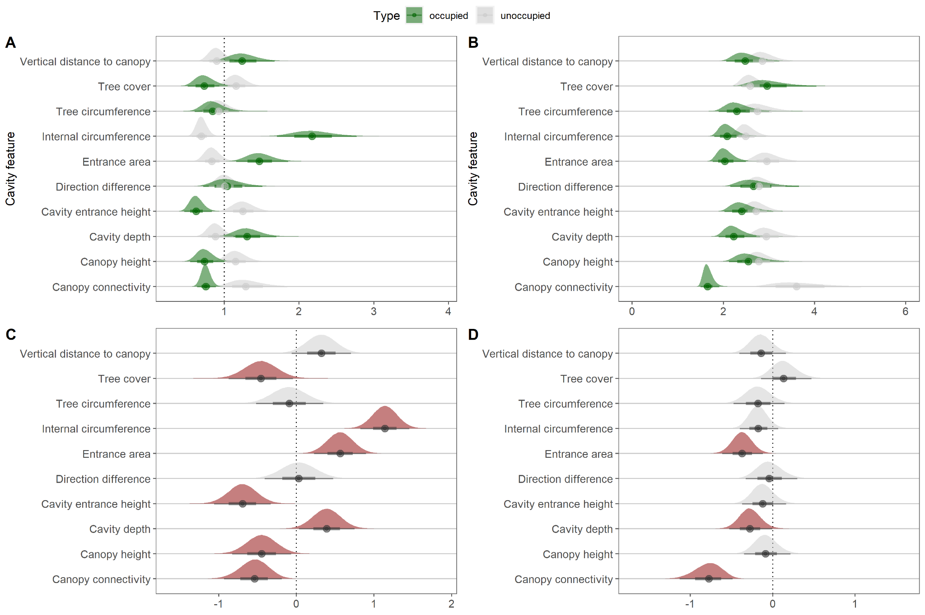
Figure 16: Univariate model A) means and posterior distributions and B) standard deviation and posterior distributions for occupied and unoccupied cavities. With the difference in C) means and posterior distributions and D) standard deviation and posterior distributions for each cavity feature with significant features, those with 95% credibility intervals not crossing zero, highlighted in red.

5.4.2 Nest suitability
During the 2020 breeding season, 47 GGMs fledged from 35 breeding attempts, a mean of 1.34 fledglings per breeding attempt. The maximum number of chicks fledged was 3 (n = 1). When run individually, entrance area (0.23, 95% CI = -0.94 to 1.44) and internal circumference (0.62, 95% CI = -0.11 to 1.42) were positively correlated with the number of fledglings per breeding attempt, but only cavity depth (1.05 95% CI = 0.20 to 1.99) was significant (Fig. 17). Cavity entrance height (-0.17, 95% CI = -0.90 to 0.53) and canopy connectivity (-0.59, 95% CI -2.22 to 0.96) were negatively correlated with the number of fledglings, but the relationships were not significant. Nest suitability score (2.20, 95% CI = 0.33 to 4.34) was significantly positively correlated to the number of fledglings per breeding attempt.

5.5 Discussion
The GGMs in our study population prefer larger, deeper cavities in isolated trees, with a strong selection for cavity entrance area, depth and canopy connectivity. This agrees with numerous other studies that found that parrots select for cavity depth (de la Parra-Martínez et al., 2015; De Labra-Hernández and Renton, 2016; Olah et al., 2014; Renton et al., 2015; Saunders et al., 1982; Stojanovic et al., 2021, 2017; Webb et al., 2012) or tree isolation (Berkunsky et al., 2016; Britt et al., 2014; Renton et al., 2015). We know that predation accounts for a significant proportion of nest failure in many parrot species (Pizo et al., 2008; Renton et al., 2015; Berkunsky et al., 2016); therefore, the selection of these specific features is likely driven by the need to reduce predation risk. By selecting isolated trees, parrots can passively reduce predation risk from nonvolant predators (Berkunsky et al., 2016; Britt et al., 2014; de la Parra-Martínez et al., 2015), whilst deeper cavities reduce the risk from avian predators (de la Parra-Martínez et al., 2015; Mejías et al., 2017; Wesolowski, 2002; Zhu et al., 2012).

For secondary cavity-nesting species, cavity location and morphology are the only way to reduce predation risk passively. Therefore, the relationship between cavity and tree characteristics and can indicate which type of predators are the current primary threat to GGM nesting success. Although it simplifies the suite of factors such as habitat quality (Dhondt, 2010; Jones et al., 2014) and climatic conditions (Borgman and Wolf, 2016; McGillivray, 1981) that influence , it is a valuable process as it might highlight potentially information for conservation managers. Birds can attempt to reduce the risk from avian predators by selecting deeper cavities (Wesolowski, 2002; Zhu et al., 2012). Therefore, if avian predation was the primary cause of nest failure, we might expect to see a relationship between cavity depth, as birds are more likely to predate shallow nests (Mejías et al., 2017). Alternatively, individuals passively reduce accessibility to nonvolant predators such as snakes and arboreal mammals by selecting isolated trees because they need access to cavities via connected canopy or vines (Berkunsky et al., 2016; Britt et al., 2014; Koenig, 2001). Therefore, if nonvolant predators are the primary source of nest predation, we expect to see a relationship between canopy connectivity and reproductive success. We have found a significant positive relationship between reproductive success and cavity depth, suggesting avian predation is one of the primary drivers of nest failure. To support this, we have direct evidence of this in our study population, where five of seven confirmed predation events from our study area were due to avian predators (Macaw Recovery Network unpub. data). Therefore, for conservation managers focusing on addressing the threat from avian predators may be a cost-effective way to increase nest success and boost reproductive success.

GGMs are apparently unique in their selection of cavities with entrance heights lower than surrounding cavities (de la Parra-Martínez et al., 2015; Renton and Brightsmith, 2009). This may be an adaptation to fragmentation and degradation of habitat in this area of Costa Rica (Chassot et al., 2007; Grantham et al., 2020; Karra et al., 2021), where large cavities in large, emergent trees in the forest have likely been lost (Chassot et al., 2007; DeWalt et al., 2003). Cavity size is inversely related to height in the tree (Lindenmayer et al., 2000); therefore, low tree cover and canopy height could make large cavities lower down in trees accessible to GGMs. This might partially compensate for the loss of mature emergent trees in this region over the last 100 years (Sader and Joyce, 1988). We monitored two active nests in 2020 that were 9.4m and 10.4m above the ground. The average canopy height across the San Juan La Selva biological corridor is 23.4m (Lang et al., 2022), suggesting that if these trees were within the forest, they would not be accessible or suitable for GGMs.

Interspecific competition can affect reproductive success by limiting the number of available cavities (Berris et al., 2022; Bonaparte and Cockle, 2017; Symes and Perrin, 2003). Half of the cavities occupied by interspecific competitors were used by scarlet macaws (Table S1). Research has shown that scarlet macaws have a broad nesting niche and compete directly with other large macaws for nesting cavities (Renton and Brightsmith, 2009). In our study, the cavities occupied by SCMs are less suitable for GGMs, suggesting that there is either limited competition for cavities or GGMs are stronger competitors. However, as suitable cavities remain unoccupied and both the SCM and GGM populations in this area are recovering, competition may increase in the future.
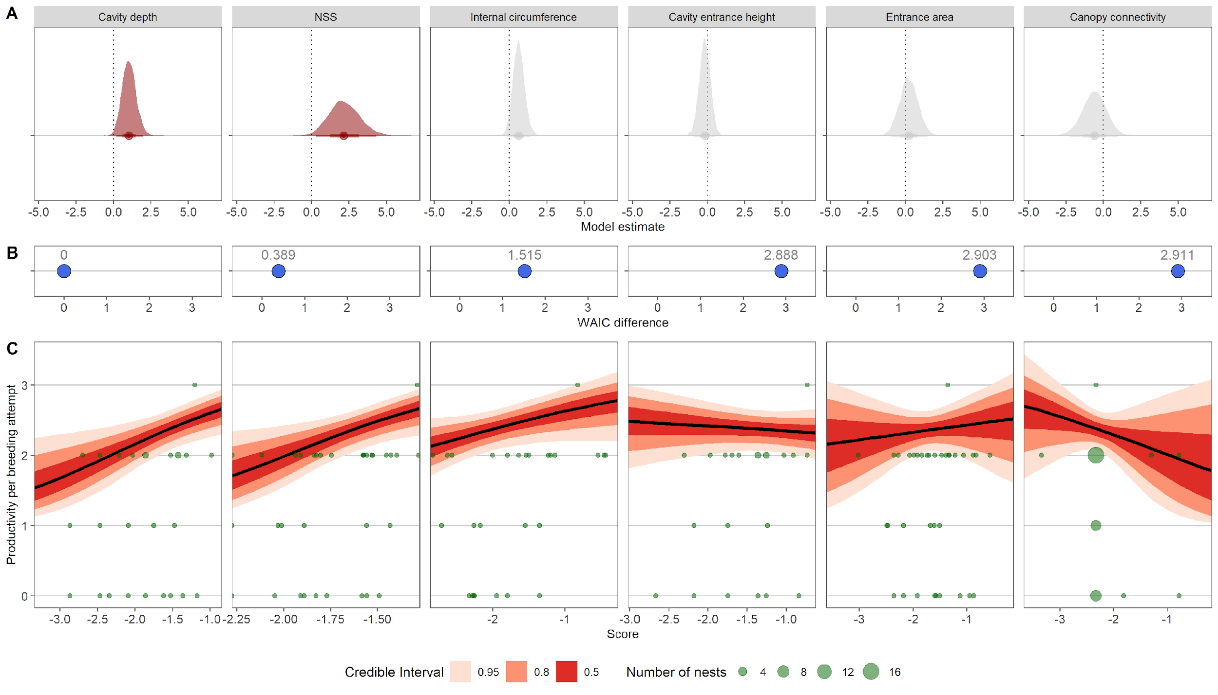
Figure 17: Model estimates of the regression slopes and their posterior distributions from the univariate ordinal regression of each cavity feature, with the significant models in red. B) The difference in WAIC scores compared to the best-performing model. C) The relationship between each feature and predicted alongside the data (green).

5.5.1 Conservation implications
Cavity entrance height has often been found to be an important factor in nest site selection for macaws, with species selecting for cavities higher than unused cavities (de la Parra-Martínez et al., 2015; Olah et al., 2014). However, we found that GGMs currently nest in cavities that are lower in the canopy than unused cavities. This may be due to the lack of forest around nest trees. Costa Rica reached a 17% forest cover low in the 1980s (Sader and Joyce, 1988), and although logging continues in this region, large-scale deforestation no longer occurs (Fagan et al., 2013). In many areas, regenerating forest has replaced cattle pasture (Fagan et al., 2013; Jadin et al., 2016). However, as the forest continues to recover, there is a risk that cavities currently occupied by GGMs will become more connected to adjacent trees, increasing the accessibility for nonvolant predators. This is a natural process that we have seen at a few nests in abandoned pastures; when the nests were first monitored 20 years ago, they were in isolated trees, and now they are within the canopy (Aleman pers comms).

Trees around nest sites could be managed to maintain limited connectivity with other trees and prevent access to the canopy for nonvolant predators. However, installing artificial nest boxes may represent a better management option than preventing forest recovery around current nest trees. Nestbox provision is a common conservation strategy to combat limited cavity availability in degraded habitats (Berthier et al., 2012; Darling et al., 2004; Jones et al., 1995; Tollington et al., 2013). For example, nest boxes have been successfully employed with another critically endangered macaw, the blue-throated macaw (Ara glaucogularis) in Bolivia (Herzog et al.,, 2021). Placement and design for GGMs could utilise the isolated trees whilst allowing for a design that reduces the risk of avian predation. A secondary benefit is that it would permit easier monitoring and active management of breeding attempts if necessary (Jones et al., 1995; Tollington et al., 2013). A small experiment with four nestboxes of one design was carried out by the Centro Cientifico Tropical (CCT) between 2016 and 2020; one chick successfully fledged from a nestbox in 2020 (CCT unpub. data). This demonstrates that wild GGMs will use nest boxes and suggests that further supplementation could be a viable management strategy. However, using next boxes as a management tool does come with associated costs. It would have to be a long-term strategy to be able to mitigate the loss of cavities while others develop in mature trees.

5.5.2 Conclusion
Habitat loss and degradation have caused the loss of mature trees across the tropics, resulting in the loss of large cavities for large-bodied cavity nesters such as the GGM (DeWalt et al., 2003; Degen et al., 2006; Cockle et al., 2010). As anthropogenic disturbance in tropical ecosystems grows, we need to understand how endangered species are affected and adapt to their new environment. Ecological traps can form if the cues used to select suitable nest sites and actual nest site quality become uncoupled due to anthropogenic disturbance. This can lead to declines in reproductive success and subsequent population decline (e.g. Tozer et al., 2012; Zhu et al., 2012; Díaz and Kitzberger 2013). It is encouraging that we found a connection between nest-site selection and reproductive success in this anthropogenically altered landscape (Chassot et al., 2007; Grantham et al., 2020; Karra et al., 2021), suggesting that no ecological trap has formed. By studying nest-site selection and reproductive success together, we have identified factors that could potentially limit the future recovery of the critically endangered GGM. Finally, we suggest that nestbox provisioning could be a solution to the potential loss of nest sites to forest regeneration. This approach can be successful but does mean a long-term commitment to maintenance for conservationists.

5.6 Bibliography
Amininasab, S.M., Vedder, O., Schut, E., de Jong, B., Magrath, M.J.L., Korsten, P., Komdeur, J., 2016. Influence of fine-scale habitat structure on nest-site occupancy, laying date and clutch size in Blue Tits Cyanistes caeruleus. Acta Oecologica 70, 37–44. https://doi.org/10.1016/j.actao.2015.11.006
Berkunsky, I., Quillfeldt, P., Brightsmith, D.J., Abbud, M.C., Aguilar, J.M.R.E., Alemán-Zelaya, U., Aramburú, R.M., Arce Arias, A., Balas McNab, R., Balsby, T.J.S., Barredo Barberena, J.M., Beissinger, S.R., Rosales, M., Berg, K.S., Bianchi, C.A., Blanco, E., Bodrati, A., Bonilla-Ruz, C., Botero-Delgadillo, E., Canavelli, S.B., Caparroz, R., Cepeda, R.E., Chassot, O., Cinta-Magallón, C., Cockle, K.L., Daniele, G., de Araujo, C.B., de Barbosa, A.E., de Moura, L.N., Del Castillo, H., Díaz, S., Díaz-Luque, J.A., Douglas, L., Figueroa Rodríguez, A., García-Anleu, R.A., Gilardi, J.D., Grilli, P.G., Guix, J.C., Hernández, M., Hernández-Muñoz, A., Hiraldo, F., Horstman, E., Ibarra Portillo, R., Isacch, J.P., Jiménez, J.E., Joyner, L., Juarez, M., Kacoliris, F.P., Kanaan, V.T., Klemann-Júnior, L., Latta, S.C., Lee, A.T.K., Lesterhuis, A., Lezama-López, M., Lugarini, C., Marateo, G., Marinelli, C.B., Martínez, J., McReynolds, M.S., Mejia Urbina, C.R., Monge-Arias, G., Monterrubio-Rico, T.C., Nunes, A.P., Nunes, F., Olaciregui, C., Ortega-Arguelles, J., Pacifico, E., Pagano, L., Politi, N., Ponce-Santizo, G., Portillo Reyes, H.O., Prestes, N.P., Presti, F., Renton, K., Reyes-Macedo, G., Ringler, E., Rivera, L., Rodríguez-Ferraro, A., Rojas-Valverde, A.M., Rojas-Llanos, R.E., Rubio-Rocha, Y.G., Saidenberg, A.B.S., Salinas-Melgoza, A., Sanz, V., Schaefer, H.M., Scherer-Neto, P., Seixas, G.H.F., Serafini, P., Silveira, L.F., Sipinski, E.A.B., Somenzari, M., Susanibar, D., Tella, J.L., Torres-Sovero, C., Trofino-Falasco, C., Vargas-Rodríguez, R., Vázquez-Reyes, L.D., White, T.H., Williams, S., Zarza, R., Masello, J.F., 2017. Current threats faced by Neotropical parrot populations. Biol. Conserv. 214, 278–287. https://doi.org/10.1016/j.biocon.2017.08.016
Berkunsky, I., Segura, L.N., Aramburú, R.M., Ruggera, R.A., Svagelj, W.S., Reboreda, J.C., 2016. Nest Survival and Predation in Blue-Fronted Parrots Amazona aestiva: Effects of Nesting Behaviour and Cavity Characteristics. Ardea 104, 143–151. https://doi.org/10.5253/arde.v104i2.a6
Berris, K.K., Barth, M., Mooney, T., 2022. The influence of surrounding habitat, behaviour and interspecific competition on nestbox use by endangered Glossy Black Cockatoos (Calyptorhynchus lathami halmaturinus). Ibis n/a. https://doi.org/10.1111/ibi.13091
Berthier, K., Leippert, F., Fumagalli, L., Arlettaz, R., 2012. Massive Nest-Box Supplementation Boosts Fecundity, Survival and Even Immigration without Altering Mating and Reproductive Behaviour in a Rapidly Recovered Bird Population. PLOS ONE 7, e36028. https://doi.org/10.1371/journal.pone.0036028
BirdLife International, 2020. Great Green Macaw (Ara ambiguus) - BirdLife species factsheet [WWW Document]. URL http://datazone.birdlife.org/species/factsheet/great-green-macaw-ara-ambiguus (accessed 1.5.21).
Bonaparte, E.B., Cockle, K.L., 2017. Nest niche overlap among the endangered Vinaceous-breasted Parrot (Amazona vinacea) and sympatric cavity-using birds, mammals, and social insects in the subtropical Atlantic Forest, Argentina. The Condor 119, 58–72. https://doi.org/10.1650/CONDOR-16-94.1
Borgman, C.C., Wolf, B.O., 2016. The indirect effects of climate variability on the reproductive dynamics and productivity of an avian predator in the arid Southwest. Oecologia 180, 279–291. https://doi.org/10.1007/s00442-015-3456-6
Britt, C.R., Anleu, R.G., Desmond, M.J., 2014. Nest survival of a long-lived psittacid: Scarlet Macaws (Ara macao cyanoptera) in the Maya Biosphere Reserve of Guatemala and Chiquibul Forest of Belize. The Condor 116, 265–276.
Bürkner, P.-C., 2021. Bayesian Item Response Modeling in R with brms and Stan. J. Stat. Softw. 100, 1–54. https://doi.org/10.18637/jss.v100.i05
Bürkner, P.-C., 2018. Advanced Bayesian Multilevel Modeling with the R Package brms. R J. 10, 395–411.
Bürkner, P.-C., 2017. brms: An R Package for Bayesian Multilevel Models Using Stan. J. Stat. Softw. 80, 1–28. https://doi.org/10.18637/jss.v080.i01
Buuren, S. van, Groothuis-Oudshoorn, K., 2011. mice: Multivariate Imputation by Chained Equations in R. J. Stat. Softw. 45, 1–67. https://doi.org/10.18637/jss.v045.i03
Calvo-Alvarado, J., McLennan, B., Sánchez-Azofeifa, A., Garvin, T., 2009. Deforestation and forest restoration in Guanacaste, Costa Rica: Putting conservation policies in context. For. Ecol. Manag., Ecology and regeneration of tropical dry forests in the Americas: Implications for management 258, 931–940. https://doi.org/10.1016/j.foreco.2008.10.035
Carrete, M., Donázar, J.A., Margalida, A., 2006. Density-Dependent Productivity Depression in Pyrenean Bearded Vultures: Implications for Conservation. Ecol. Appl. 16, 1674–1682.
Chassot, O., Arias, G.M., Powell, G.V.N., 2007. Biologia de la Conservacion de Ara ambiguus en Costa Rica, 1994-2006. Mesoamerica 11, 43–49.
Cockle, K.L., Bodrati, A., Lammertink, M., Martin, K., 2015. Cavity characteristics, but not habitat, influence nest survival of cavity-nesting birds along a gradient of human impact in the subtropical Atlantic Forest. Biol. Conserv. 184, 193–200. https://doi.org/10.1016/j.biocon.2015.01.026
Cockle, K.L., Martin, K., Drever, M.C., 2010. Supply of tree-holes limits nest density of cavity-nesting birds in primary and logged subtropical Atlantic forest. Biol. Conserv. 143, 2851–2857. https://doi.org/10.1016/j.biocon.2010.08.002
Cooke, R.S.C., Eigenbrod, F., Bates, A.E., 2019. Projected losses of global mammal and bird ecological strategies. Nat. Commun. 10, 2279. https://doi.org/10.1038/s41467-019-10284-z
Darling, L.M., Finlay, J.C., Gillespie, T.W., Cousens, B., Kostka, S., Baker, A., 2004. Recovery of the Purple Martin in British Columbia: More Than a Nest Box Program 10.
de la Parra-Martínez, S.M., Renton, K., Salinas-Melgoza, A., Muñoz-Lacy, L.G., 2015. Tree-cavity availability and selection by a large-bodied secondary cavity-nester: the Military Macaw. J. Ornithol. 156, 489–498. https://doi.org/10.1007/s10336-014-1150-9
De Labra-Hernández, M.Á., Renton, K., 2016. Importance of Large, Old Primary Forest Trees in Nest-Site Selection by the Northern Mealy Amazon (Amazona guatemalae). Trop. Conserv. Sci. 9, 1940082916680361. https://doi.org/10.1177/1940082916680361
Degen, B., Blanc, L., Caron, H., Maggia, L., Kremer, A., Gourlet-Fleury, S., 2006. Impact of selective logging on genetic composition and demographic structure of four tropical tree species. Biol. Conserv. 131, 386–401. https://doi.org/10.1016/j.biocon.2006.02.014
DeWalt, S.J., Maliakal, S.K., Denslow, J.S., 2003. Changes in vegetation structure and composition along a tropical forest chronosequence: implications for wildlife. For. Ecol. Manag. 182, 139–151. https://doi.org/10.1016/S0378-1127(03)00029-X
Dhondt, A.A., 2010. Effects of competition on great and blue tit reproduction: intensity and importance in relation to habitat quality. J. Anim. Ecol. 79, 257–265. https://doi.org/10.1111/j.1365-2656.2009.01624.x
Díaz, S., Kitzberger, T., 2013. Nest habitat selection by the Austral parakeet in north-western Patagonia. Austral Ecol. 38, 268–278. https://doi.org/10.1111/j.1442-9993.2012.02400.x
Fagan, M.E., DeFries, R.S., Sesnie, S.E., Arroyo, J.P., Walker, W., Soto, C., Chazdon, R.L., Sanchun, A., 2013. Land cover dynamics following a deforestation ban in northern Costa Rica. Environ. Res. Lett. 8, 034017. https://doi.org/10.1088/1748-9326/8/3/034017
Forshaw, J.M., 2010. Parrots of the World. Princeton University Press.
Grantham, H.S., Duncan, A., Evans, T.D., Jones, K.R., Beyer, H.L., Schuster, R., Walston, J., Ray, J.C., Robinson, J.G., Callow, M., Clements, T., Costa, H.M., DeGemmis, A., Elsen, P.R., Ervin, J., Franco, P., Goldman, E., Goetz, S., Hansen, A., Hofsvang, E., Jantz, P., Jupiter, S., Kang, A., Langhammer, P., Laurance, W.F., Lieberman, S., Linkie, M., Malhi, Y., Maxwell, S., Mendez, M., Mittermeier, R., Murray, N.J., Possingham, H., Radachowsky, J., Saatchi, S., Samper, C., Silverman, J., Shapiro, A., Strassburg, B., Stevens, T., Stokes, E., Taylor, R., Tear, T., Tizard, R., Venter, O., Visconti, P., Wang, S., Watson, J.E.M., 2020. Anthropogenic modification of forests means only 40% of remaining forests have high ecosystem integrity. Nat. Commun. 11, 5978. https://doi.org/10.1038/s41467-020-19493-3
Herzog, S.K., Z, O.M., Boorsma, T., Sánchez-Ávila, G., García-Solíz, V.H., Paca-Condori, A.C., Abajo, M.V.D., Soria-Auza, R.W., 2021. First systematic sampling approach to estimating the global population size of the Critically Endangered Blue-throated Macaw Ara glaucogularis. Bird Conserv. Int. 31, 293–311. https://doi.org/10.1017/S0959270920000283
Heuck, C., Herrmann, C., Schabo, D.G., Brandl, R., Albrecht, J., 2017. Density-dependent effects on reproductive performance in a recovering population of White-tailed Eagles Haliaeetus albicilla. Ibis 159, 297–310. https://doi.org/10.1111/ibi.12444
Jadin, I., Meyfroidt, P., Lambin, E.F., 2016. International trade, and land use intensification and spatial reorganization explain Costa Rica’s forest transition. Environ. Res. Lett. 11, 035005. https://doi.org/10.1088/1748-9326/11/3/035005
Jones, C.G., Heck, W., Lewis, R.E., Mungroo, Y., Slade, G., Cade, T., 1995. The restoration of the Mauritius Kestrel Falco punctatus population. Ibis 137, 173–180. https://doi.org/10.1111/j.1474-919X.1995.tb08439.x
Jones, J.A., Harris, M.R., Siefferman, L., 2014. Physical habitat quality and interspecific competition interact to influence territory settlement and reproductive success in a cavity nesting bird. Front. Ecol. Evol. 2.
Karra, K., Kontgis, C., Statman-Weil, Z., Mazzariello, J.C., Mathis, M., Brumby, S.P., 2021. Global land use / land cover with Sentinel 2 and deep learning, in: 2021 IEEE International Geoscience and Remote Sensing Symposium IGARSS. Presented at the 2021 IEEE International Geoscience and Remote Sensing Symposium IGARSS, pp. 4704–4707. https://doi.org/10.1109/IGARSS47720.2021.9553499
Koenig, S.E., 2001. The breeding biology of Black-billed Parrot Amazona agilis and Yellow-billed Parrot Amazona collaria in Cockpit Country, Jamaica. Bird Conserv. Int. 11. https://doi.org/10.1017/S0959270901000284
Lang, N., Jetz, W., Schindler, K., Wegner, J.D., 2022. A high-resolution canopy height model of the Earth. arxiv. https://doi.org/10.48550/arXiv.2204.08322
Lindenmayer, D.B., Cunningham, R.B., Pope, M.L., Gibbons, P., Donnelly, C.F., 2000. Cavity sizes and types in Australian eucalypts from wet and dry forest types–a simple of rule of thumb for estimating size and number of cavities. For. Ecol. Manag. 137, 139–150. https://doi.org/10.1016/S0378-1127(99)00322-9
McGillivray, W.B., 1981. Climatic Influences on Productivity in the House Sparrow. Wilson Bull. 93, 196–206.
Mejías, M.A., Wingate, D.B., Madeiros, J.L., Wiersma, Y.F., Robertson, G.J., 2017. Nest-Cavity Selection and Nesting Success of Bermudian White-Tailed Tropicbirds (Phaethon lepturus catesbyi). Wilson J. Ornithol.
Olah, G., Vigo, G., Heinsohn, R.G., Brightsmith, D.J., 2014. Nest site selection and efficacy of artificial nests for breeding success of Scarlet Macaws Ara macao macao in lowland Peru. J. Nat. Conserv. 22, 176–185.
Parr, M., Juniper, T., 2010. Parrots: A Guide to Parrots of the World. Bloomsbury Publishing.
Penone, C., Davidson, A.D., Shoemaker, K.T., Di Marco, M., Rondinini, C., Brooks, T.M., Young, B.E., Graham, C.H., Costa, G.C., 2014. Imputation of missing data in life-history trait datasets: which approach performs the best? Methods Ecol. Evol. 5, 961–970. https://doi.org/10.1111/2041-210X.12232
Pizo, M.A., Donatti, C.I., Guedes, N.M.R., Galetti, M., 2008. Conservation puzzle: Endangered hyacinth macaw depends on its nest predator for reproduction. Biol. Conserv. 141, 792–796. https://doi.org/10.1016/j.biocon.2007.12.023
Powell, G.V.N., Wright, P., Alemán-Zelaya, U., Guindon, C., Palminteri, S., Bjork, R., 1999. Research findings and conservation recommendations for the Great Green Macaw (Ara ambigua) in Costa Rica. Centro Cientifico Tropical, San Jose, Costa Rica.
R Core Team, 2021. R: A language and environment for statistical computing.
Rendell, W.B., Robertson, R.J., 1989. Nest-Site Characteristics, Reproductive Success and Cavity Availability for Tree Swallows Breeding in Natural Cavities. The Condor 91, 875–885. https://doi.org/10.2307/1368072
Renton, K., Brightsmith, D.J., 2009. Cavity use and reproductive success of nesting macaws in lowland forest of southeast Peru. J. Field Ornithol. 80, 1–8.
Renton, K., Salinas-Melgoza, A., 2004. Climatic Variability, Nest Predation, and Reproductive Output of Lilac-Crowned Parrots (Amazona finschi) in Tropical Dry Forest of Western Mexico. The Auk 121, 1214–1225.
Renton, K., Salinas-Melgoza, A., De Labra-Hernández, M.Á., de la Parra-Martínez, S.M., 2015. Resource requirements of parrots: nest site selectivity and dietary plasticity of Psittaciformes. J. Ornithol. 156, 73–90. https://doi.org/10.1007/s10336-015-1255-9
Sader, S.A., Joyce, A.T., 1988. Deforestation Rates and Trends in Costa Rica, 1940 to 1983. Biotropica 20, 11–19. https://doi.org/10.2307/2388421
Salinas-Melgoza, A., Salinas‐Melgoza, V., Renton, K., 2009. Factors Influencing Nest Spacing of a Secondary Cavity-Nesting Parrot: Habitat Heterogeneity and Proximity of Conspecifics. The Condor 111, 305–313.
Saunders, D.A., Smith, G.T., Rowley, I., 1982. The availability and dimensions of tree hollows that provide nest sites for cockatoos (Psittaciformes) in Western Australia. Wildl. Res. 9, 541–556. https://doi.org/10.1071/wr9820541
Stojanovic, D., Rayner, L., Cobden, M., Davey, C., Harris, S., Heinsohn, R., Owens, G., Manning, A.D., 2021. Suitable nesting sites for specialized cavity dependent wildlife are rare in woodlands. For. Ecol. Manag. 483, 118718. https://doi.org/10.1016/j.foreco.2020.118718
Stojanovic, D., Rayner, L., Webb, M., Heinsohn, R., 2017. Effect of nest cavity morphology on reproductive success of a critically endangered bird. Emu - Austral Ornithol. 117, 247–253. https://doi.org/10.1080/01584197.2017.1311221
Stojanovic, D., Webb nee Voogdt, J., Webb, M., Cook, H., Heinsohn, R., 2016. Loss of habitat for a secondary cavity nesting bird after wildfire. For. Ecol. Manag., Special Section: Forest Management for Climate Change 360, 235–241. https://doi.org/10.1016/j.foreco.2015.10.040
Symes, C.T., Perrin, M.R., 2003. Feeding biology of the Greyheaded Parrot, Poicephalus fuscicollis suahelicus (Reichenow), in Northern Province, South Africa. Emu - Austral Ornithol. 103, 49–58. https://doi.org/10.1071/MU01038
Taugourdeau, S., Villerd, J., Plantureux, S., Huguenin-Elie, O., Amiaud, B., 2014. Filling the gap in functional trait databases: use of ecological hypotheses to replace missing data. Ecol. Evol. 4, 944–958. https://doi.org/10.1002/ece3.989
Tollington, S., Jones, C.G., Greenwood, A., Tatayah, V., Raisin, C., Burke, T., Dawson, D.A., Groombridge, J.J., 2013. Long-term, fine-scale temporal patterns of genetic diversity in the restored Mauritius parakeet reveal genetic impacts of management and associated demographic effects on reintroduction programmes. Biol. Conserv. 161, 28–38. https://doi.org/10.1016/j.biocon.2013.02.013
Tomás, G., Ruiz-Castellano, C., Ruiz-Rodríguez, M., Soler, J.J., 2020. Smaller distance between nest contents and cavity entrance increases risk of ectoparasitism in cavity-nesting birds. J. Avian Biol. 51. https://doi.org/10.1111/jav.02427
Tozer, D.C., Burke, D.M., Nol, E., Elliott, K.A., 2012. Managing ecological traps: Logging and sapsucker nest predation by bears. J. Wildl. Manag. 76, 887–898. https://doi.org/10.1002/jwmg.336
Vergara-Tabares, D.L., Cordier, J.M., Landi, M.A., Olah, G., Nori, J., 2020. Global trends of habitat destruction and consequences for parrot conservation. Glob. Change Biol. 26, 4251–4262. https://doi.org/10.1111/gcb.15135
Watanabe, S., 2010. Asymptotic Equivalence of Bayes Cross Validation and Widely Applicable Information Criterion in Singular Learning Theory. J. Mach. Learn. Res. 11, 24.
Webb, M.H., Holdsworth, M.C., Webb, J., 2012. Nesting requirements of the endangered Swift Parrot (Lathamus discolor). Emu - Austral Ornithol. 112, 181–188. https://doi.org/10.1071/MU11014
Wesolowski, T., 2002. Anti-predator adaptations in nesting Marsh Tits Parus palustris: The role of nest-site security. Ibis 144, 593–601. https://doi.org/10.1046/j.1474-919X.2002.00087.x
Wright, T.F., Toft, C.A., Enkerlin‐Hoeflich, E., Gonzalez‐Elizondo, J., Albornoz, M., Rodríguez‐Ferraro, A., Rojas‐Suárez, F., Sanz, V., Trujillo, A., Beissinger, S.R., A, V.B., A, X.G., Brice, A.T., Joyner, K., Eberhard, J., Gilardi, J., Koenig, S.E., Stoleson, S., Martuscelli, P., Meyers, J.M., Renton, K., Rodríguez, A.M., Sosa‐Asanza, A.C., Vilella, F.J., Wiley, J.W., 2001. Nest Poaching in Neotropical Parrots. Conserv. Biol. 15, 710–720. https://doi.org/10.1046/j.1523-1739.2001.015003710.x
Zhu, X., Srivastava, D.S., Smith, J.N.M., Martin, K., 2012. Habitat Selection and Reproductive Success of Lewis’s Woodpecker (Melanerpes lewis) at Its Northern Limit. PLOS ONE 7, e44346. https://doi.org/10.1371/journal.pone.0044346

General Discussion

I aimed to investigate two factors critical to developing and maintaining conservation strategies: monitoring of population dynamics and productivity. I identified passive acoustic monitoring as a potential tool that could provide a more robust approach to monitoring wide-range species in rainforest ecosystems. My primary objective was to demonstrate passive acoustic monitoring as an effective conservation tool. To do this, I aimed to give examples of each stage, from data collection to different ways of utilising PAM-derived data to gain ecological insights. My secondary objective was to determine whether GGMs actively select for nest site characteristics that affect reproductive success. Here I summarise the key findings of my work, discuss the implications for GGM conservation and parrot research more generally, and finally explore the opportunities for future work.

6.1 Passive acoustic monitoring

6.1.1 Recognisers
One of the barriers to the widespread use of PAM in conservation is accessibility. For tropical regions, where biodiversity monitoring is most needed, there is also a lack of case studies demonstrating how methods perform in these regions. In chapter 2, I share my lessons from my attempts to develop a recogniser for the GGM and scarlet macaw in the Caribbean lowland rainforest in Costa Rica. I demonstrated that the variation in background noise across space and time is the most challenging aspect of recogniser design for large-scale PAM deployments in rainforest ecosystems.

The iterative approach I used shows how it is possible to improve the precision of a recogniser with a simple but labour-intensive method. This expands the two-step pipeline suggested by Balantic and Donovan (2020), using template matching and machine learning, making it more applicable in areas with diverse soundscapes. Although the approach requires manual checking of positive cases at each iteration, the final recogniser I produced reduced the number of cases to be validated before being used in models by 80%. This means that although the initial effort required to develop the recogniser may be significant, it is cost-effective if used multiple times. This study is one of the first to deal with background noise explicitly using an iterative approach; others have used a “basic recognition model” to develop datasets of target signals (Buxton and Jones, 2012). However, my approach uses false positives to expand the training dataset for the negative cases rather than randomly sampling background noise. Researchers have previously highlighted an increasing need for simple methods to automate or semi-automate data extraction from PAM (Marques et al., 2013; Stowell et al., 2016). Chapter 2 addresses this problem by demonstrating an approach that could be applied to other taxa, which needs only a limited amount of experience with bioacoustics and machine learning.

6.1.2 Abundance and distribution
Estimating population size and monitoring changes in spatiotemporal distribution are crucial to species status assessment and adaptive management. However, we lack established methods to do this at a large scale for many parrot species (Dénes et al., 2018), especially within rainforest ecosystems. In chapters 3 and 4, I demonstrated how data derived from large-scale PAM could be combined with established RN models and open N-mixture models to address these challenges.

Abundance
In chapter 3, using data derived from large-scale PAM surveys and the recogniser developed in chapter 2, I estimated the Costa Rican GGM population during the breeding season to be 485.65 ± 61 SE. Therefore, the GGM population in Costa Rica may not be as critically low as previously thought (BirdLife International, 2020). Results from chapter 2, supported by this evidence, suggest that the approach demonstrated offers a more robust population size estimate and provides methodological improvements to previous GGM population estimates by Powell et al., (1999), Monge et al., (2010) and Macaw Recovery Network (2021). Not only can it be used to estimate population size, but the gridded study design enables areas that have previously been understudied to be monitored for long periods with little effort. Chapter 2 shows the benefits of using this PAM study design by highlighting a previously unknown area of high GGM abundance to the east of the study region.

Results show that GGM abundance is primarily constrained by tree cover, low altitude and soil order, which was used as a proxy for forest type without any information on species composition. This may be expected as altitude and soil order can determine a forest's presence, extent and composition. Altitude, a proxy for factors such as temperature and temperature variation, could also constrain breeding biology. Lower altitude sites are more climatically stable than higher altitude ones, with more significant differences between daytime-night-time temperatures (Hardy et al., 1998; Londoño et al., 2015; Tye, 1992). Significantly, both forest composition and tree cover can be influenced by conservation management. Therefore, determining the composition of the forests and the key species associated with different soil orders will provide vital information for the long-term restoration of degraded and deforested land.

Spatiotemporal distribution
Monitoring spatiotemporal distribution at a landscape level is challenging. In chapter 4, I demonstrate binned cue rate models for dealing with species where the relationship between cue rate and abundance is unknown. These models show that GGMs do not wholly leave their breeding grounds in the north of Costa Rica by the end of April, but some begin to move into sites in the southeast in an area of Inceptisol/Andisol soils. This suggests that some specific food resources are attracting GGM in these southeast sites.

6.2 Cavity selection and productivity
Productivity can limit the recovery of long-lived species of conservation concern (Tomillo et al., 2008). Fortunately, unlike other parrot species found in anthropogenically disturbed landscapes (Britt et al., 2014; Dahlin et al., 2018; Vaughan et al., 2005; Wright et al., 2001), poaching is not an issue for GGM in our study population. In chapter 5, I showed that GGMs show a strong selection for cavity depth, nest tree isolation and entrance size. With all three of these characteristics, GGMs select significantly different measurements and have a narrower preference around this measurement compared to unoccupied cavities. Evidence suggests that cavity depth and nest tree isolation passively reduce risk from non-volant and arboreal predators, respectively (Britt et al., 2014; Cockle et al., 2015; Renton et al., 2015).

Another key finding of chapter 5 is that current productivity in the GGM population is within the range of other closely related macaw species (Britt et al., 2014; Pinho and Nogueira, 2003; Renton and Brightsmith, 2009; Vigo-Trauco et al., 2021). However, further research is needed as results suggest that future forest regeneration surrounding low nests could reduce productivity by providing access to nests to non-volant predators or stopping access to nest entrances.

6.3 Implications for GGM conservation
The GGM population in Costa Rica was estimated to be less than 200 individuals in the most recent red list assessment (BirdLife International, 2020). This was primarily based on roost count surveys conducted by Macaw Recovery Network in 2019; however, subsequent roost counts in 2021 roosts increased that number to ~330 (Macaw Recovery Network, 2021). Roost counts often underestimate the true population size (Casagrande and Beissinger, 1997) and are not statistically robust because they rely on all individuals using roosts and all roosts being counted. However, if there is no movement between roosts and they are surveyed multiple times during a season, it is possible to use N-mixture models to estimate population size (Dénes et al., 2018). The size of the GGM population in Costa Rica is currently unknown, so it presents an opportunity to increase the robustness of the roost count estimates in the future. Nevertheless, Chapter 3 suggests that the GGM population during the breeding season (485.65 ± 61 SE) is significantly higher than that estimated in the red list assessment (<200) and counted by Macaw Recovery Network’s most recent roost count (~330). However, the studies did take place at differing times of the year. Evidence from chapter 4 suggests that GGMs leave northeastern Costa Rica after the breeding season, but whether they return to the roosts identified by Macaw Recovery Network or whether these individuals are from different areas is unclear and requires further research.

My research identified two regions that require further investigation because they could be important for conserving the GGM in Costa Rica (Fig. 19). First, in chapter 3, I identified areas of relatively high abundance around the east of the study area. These could harbour hitherto unknown breeding populations or populations of non-breeding individuals, either of which would have important conservation implications. If there is breeding in this area, then this opens up the possibility that what was previously considered the species' breeding grounds represents a fraction of the available breeding areas. It could be that not only are there breeding GGM to the east of the traditionally recognised breeding areas but also the northwest. The view that the currently studied breeding areas form the core of the GGM breeding range in Costa Rica stems from the research carried out in the 1990s (Powell et al., 1999). Consequently, subsequent research on GGM breeding biology and natural history focused on these areas (Chassot et al., 2011, 2007; Monge et al., 2012, 2003). Even if the area to the east only supports non-breeding individuals, investigating areas to the northwest that have maintained significant forest cover could help further our understanding of the species' status and ecology.

Spatial segregation between breeding and non-breeding, or breeding and immature individuals, occurs in many species of long-lived birds, such as northern bald ibis (Puehringer-Sturmayr et al., 2022), penguins (Thiebot et al., 2011) and albatross (Gutowsky et al., 2014; Thiebot et al., 2014). This is likely due to differences in habitat accessibility and the avoidance of intra-specific competition (Clay et al., 2016). Macaws do not generally become sexually active until they are at least five years old (Boyd, 2014) and will follow their parents for up to two years (Macaw Recovery Network unpub. data). Therefore, during this immature, pre-breeding period, they may use different areas relative to the breeding birds. This is a critical life stage as younger age classes are a significant driver of demographic stochasticity, and increased mortality within this age group can strongly influence whole population dynamics (Sæther et al., 2013; Sæther and Bakke, 2000). If these younger age classes are utilising these areas to the east of the study area, they would be in unprotected and highly anthropogenically altered landscapes, meaning they could be vulnerable to threats such as habitat loss and poaching. GPS tracking individuals in different age classes would give a more detailed picture of whether there is any age class or breeding status segregation of the population and may help inform future conservation management strategies.

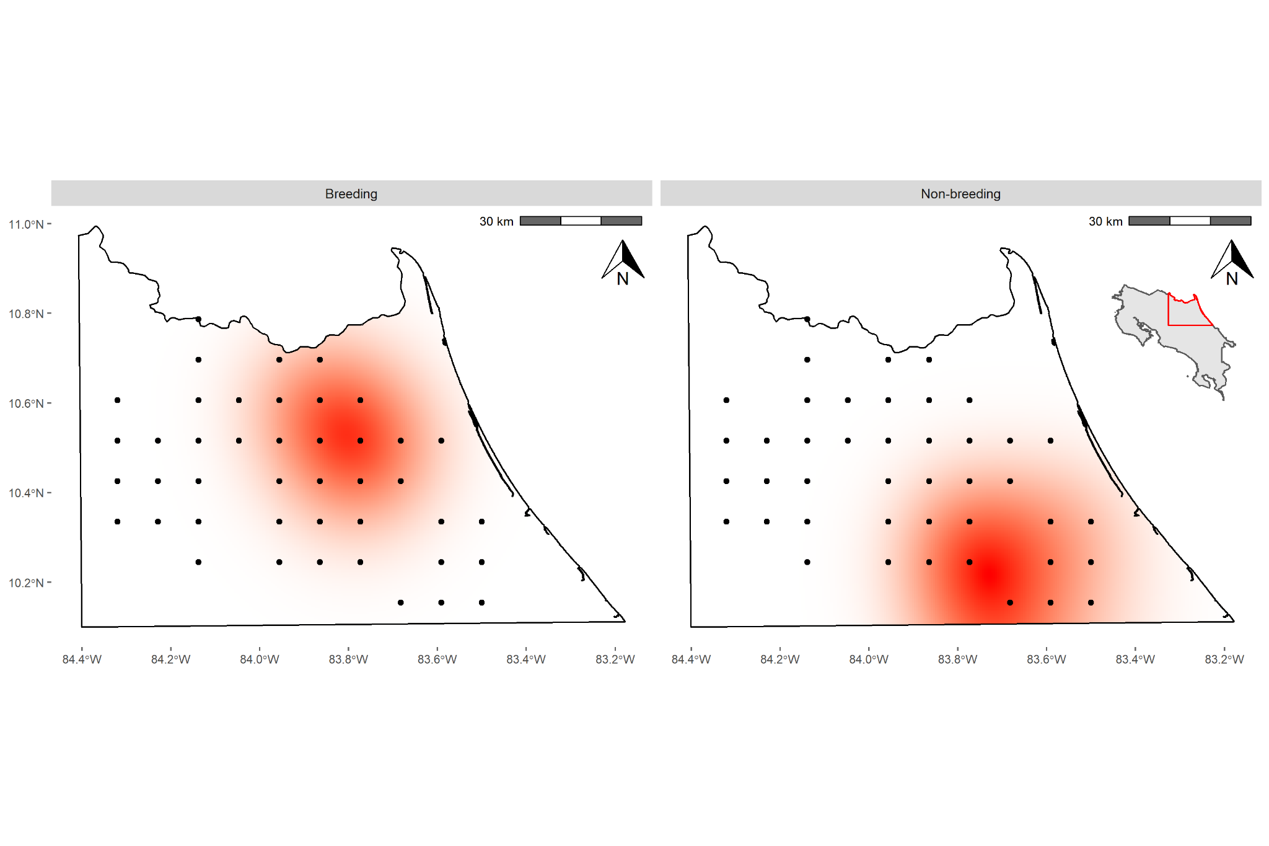
Figure 18: Two areas that my PAM research has identified as priorities for further investigation. Breeding: During the breeding season this area has a high abundance of GGMs. Non-breeding: Relative abundance of GGMs increased dramatically here at the end of the breeding season, as this is an area of high anthropogenic activity it is unclear why this would be, on-the-ground investigation could help understand these findings.
In chapter 4, I identified an area of high relative abundance in the southeast used at the end of the breeding season. It is unclear why GGMs are using this predominantly urban and agricultural region. This could be significant for future conservation plans if it is used because the region contains tree communities that provide preferred food resources. Furthermore, the area is highly disturbed; therefore, habitat restoration could benefit the GGM population utilising this area.

Habitat restoration needs to be planned and thought through to maximise its impact (Crouzeilles et al., 2015; Zwiener et al., 2017). Evidence from chapter 3 and chapter 4 suggest there are key tree species or tree communities are important for the GGM. Not including these, especially if they include rare species, would mean not maximising the potential of restored land. Further research is needed to determine the important species and how this changes at different times of the year. A lack of knowledge could prevent opportunities from being fully exploited and could also result in negative consequences. Chapter 5 highlights that restoration around nest sites needs to be carefully considered because surrounding vegetation could connect with the nest tree canopy. If this happens, these nest cavities might become accessible for non-volant predators such as snakes or inaccessible for GGM. The natural regeneration of forests should not be prevented, so the provision of nest boxes could compensate for the loss of these cavities.

Large cavities, like those used by GGMs, are often found in large mature trees. These are often absent from anthropogenically disturbed forests (DeWalt et al., 2003). Those that remain can be lost due to natural or anthropogenic processes, in some cases, up to 75% could be lost over 125 years (Saunders et al., 2014). The long-term outlook for suitable nest cavities availability could be more positive. Loss from envelopment, natural and unnatural removal and the recovery of two competing macaw species suggest that nest box supplementation will be a necessary long-term conservation strategy. Currently, there is no suitable nestbox design for GGMs in the wild. For example, one wild GGM pair did breed in a nestbox, but the design led to complications with the management of the breeding attempt, demonstrating that GGM will use nest boxes. Chapter 5 gives the dimensions and characteristics of preferred cavities. These can provide a baseline for developing a suitable nest box design for GGMs. The nest box design should consider the finding that avian predators are the primary source of productivity loss in the study population. Integrating features that passively exclude these predators could help boost productivity further.

6.4 The potential for using PAM to monitor parrots
Parrots are one of the most threatened bird families on earth, with 28% of species threatened with extinction (IUCN, 2020). We currently lack effective tools to monitor many parrot species at ecologically relevant spatial and temporal scales. This is especially critical as we attempt to understand and mitigate the effects of climate change and habitat loss and degradation. For example, Desjonquères et al., (2022) used acoustic species distribution models (aSDMs) to predict the changing distribution of the Iberian tree frog (Hyla molleri). They placed ARU locations across environmental gradients to be able to predict the effects of an increase in temperature. This approach could be applied across deforestation gradients or urbanisation gradients to predict how parrots and other species will respond to a changing environment.

Potentially important for parrots could be the inclusion of poaching threat into PAM models, similar to the identification of poaching hotspots by Pardo et al., (2022). This study used an automated gunshot detection algorithm and manual validation of all positive detections to map poaching pressure in and around a national park. The outputs can be used to guide anti-poaching patrols or the building of guard stations. Poaching, such as hunting with guns, is detectable from PAM data (Katsis et al., 2022; Pardo et al., 2022). However, nest poaching is the type that primarily affects parrots (Dahlin et al., 2018; Wright et al., 2001) and would be harder to detect at a distance. Several species use different alarm calls for different predators (Gill and Bierema, 2013; Manser, 2001; Manser et al., 2002). Therefore PAM could pick up differences in alarm call type and inform whether human predation has occurred. Another possibility is to use PAM at nest sites, where human voices from poachers may be able to be detected. There is great potential in this area of research, using PAM not only to monitor populations but also their threats, such as poaching.

Although PAM has the potential to become an essential tool for conservationists, it should be used alongside other methods to understand the study system completely. For example, PAM cannot currently identify individuals, so it could be combined with satellite tracking to provide individual resolution to population level data derived from PAM. Brightsmight et al., (2021) showed differences in migration strategies within scarlet macaw and blue-and-yellow macaw populations. PAM could enhance studies by estimating the scale of seasonal movements associated with satellite-tracked individuals. Combining PAM with satellite tracking could aid the understanding of such movements by providing links between individual and population scale processes. Understanding these processes has important conservation implications. For example, some parrot populations exhibit “cultures” – shared movement patterns or dialects associated with a population (Myers and Vaughan, 2004; Wright and Dahlin, 2018). Resolving movement processes would highlight at-risk cultures within a population, i.e. knowledge of a particular migration route dying out due to threats along its path.

PAM can also highlight regions that require further on-the-ground research. PAM is particularly well suited to this due to the potential to scale surveys into areas traditionally not considered occupied by the target species. The approach I used–setting an ARU grid across a landscape–facilitates this. Other approaches, such as preferential survey design, would not be suitable because it requires substantial pre-survey information (Wood and Peery, 2022). My research has shown the utility of this approach, highlighting two areas for further investigation; one in chapter 3 and another in chapter 4. This demonstrates the utility of PAM as a tool and how it can be especially useful for species such as parrots. Using PAM can help researchers define regions of interest to investigate further using other methods.

One of the most promising findings of this thesis is that PAM can be used to estimate parrot population size, which has challenged parrot conservationists and researchers to date (Casagrande and Beissinger, 1997; Dénes et al., 2018; Tella et al., 2021). Distance sampling is one of the most widely used methods to estimate parrot abundance, but parrots violate key assumptions; therefore, results are often overestimated (Dénes et al., 2018). Herzog et al., (2021) used a count-based approach with multiple observers at multiple sites counting simultaneously. With this approach, movement between sites is a significant concern, which they addressed by restricting the survey window to only 12 days. The authors note that this was logistically challenging and limited the extent of their surveys. PAM removes the problem of having observers at multiple locations simultaneously, although it does mean that raw counts of individuals are not possible. This highlights the decision that must be made when designing a study to estimate parrot abundance. Using a count-based method is restricted in scale by logistics; this could also risk violations of site independence, so it has to be considered in the statistical analysis and robustness of estimates. In comparison, a PAM-based approach can be applied at a greater scale. However, there are no statistical tools specifically for this type of data, so the current occupancy modelling approaches rely on the pooling data into detection/non-detection or binning of data.

6.5 Future work

6.5.1 Great green macaws
The work in this thesis has focused on the GGM in Costa Rica due to the previous work carried out here, thanks to the country's long-term political stability. However, the GGM’s range stretches from Honduras to Ecuador. Throughout its range, apart from Costa Rica, there has been very little research into the species' status and ecology. PAM and the approaches I have demonstrated in this thesis are simple and scaleable but require further work to become usable by conservationists’ range-wide. One of the significant complexities of deploying a range-wide PAM network is the variation in habitats and bird and insect communities (Slabbekoorn, 2004); looking at only the macaw community across the GGMs range demonstrates how dealing with this variation will be challenging. For example, in Honduras, Nicaragua and Costa Rica then, GGM is sympatric with the scarlet macaw; however, in Panama, Colombia and Ecuador, this increases to a total of six different species (Forshaw, 2010; Parr and Juniper, 2010). Being able to distinguish between six closely related species with similar call structures is one of the main obstacles to scaling the use of PAM as a monitoring tool for GGMs.

For the recogniser in its current form, able to detect GGMs and scarlet macaws, two crucial aspects need to be improved: performance and accessibility. The recogniser developed in chapter 2 has performance metrics similar to those reported by the species-specific recogniser used by Heinicke et al., (2015) in the Côte d’Ivoire rainforest. However, this does not compare well to recognisers developed for temperate systems (e.g. Balantic and Donovan, 2020; Gillings and Scott, 2021). The two-stage pipeline I developed means that performance can be improved in two ways. I focused on the second stage, the classification stage. However, there is a lot of room for improvement in stage one, the template-matching or region-of-interest (ROI) identification stage. Template matching is challenging when a species has a highly varied call repertoire (Brandes, 2008; Katz et al., 2016), such as the GGM. I demonstrated this in chapter 2, where the ROI detection rate was 121.75 per recording, whereas the detection rate of GGMs by the final recogniser was 0.84 per recording. This was due to setting a low threshold for the template matching step to ensure there were no false negatives at this stage. Increasing the precision of the template matching stage would likely lead to improvements in the classification stage by removing more non-target signals before training and before classification. This could be done using other approaches to template matching, such as those suggested by Bravo et al., (2017) or by using change-point filters demonstrated by Juodakis et al., (2021).

Another way to improve performance is to use alternative features for classification. For example, I used a standard set of acoustic features to classify ROIs; these were raw acoustic features such as mean frequency, mean dominant frequency, skewness and kurtness, and MFCCs. These are commonly used for bioacoustics tasks but may not be the most well-suited to a particular classification task. Other features, such as fundamental frequencies, have been used to classify signals (Rycyk et al., 2021) and identify individuals (Comazzi et al., 2016; Root-Gutteridge et al., 2014; Wijers et al., 2020). Another potential source of features is deep-learning algorithms; these extract their own feature set and could be extracted and applied to other tasks (Sethi et al., 2022, 2020).

Accessibility is the second key factor. Although the recogniser developed in chapter 2 reduces the need for manual verification, it still relies on basic knowledge of R (R Core Team, 2021) and RavenLite (Bioacoustics Research Program, 2016). Creating an application that can run a recogniser on uploaded recordings and give users simple, interpretable results would facilitate the uptake of PAM as a tool and collaboration across the GGMs range. This is not only the case for GGMs, but PAM is well suited to be scaled; this means collaboration is vital to realise its potential fully. An R Shiny app is likely the best option in the short to medium term. However, projects such as Rainforest Connections (Texas, USA) and Arbimon have a website platform that facilitates PAM projects. BirdNet-Pi runs a tiny-ML recogniser locally on a Raspberry Pi ARU (Wood et al., 2022).

6.5.2 Models for passive acoustic-derived data
As passive acoustic monitoring becomes more ubiquitous in ecology and conservation research, there is a risk that statistical tools do not keep up. Few ‘off-the-shelf’ statistical approaches for terrestrial fauna' can accommodate PAM-derived data. In chapter 3, I demonstrate how RN models can be used with PAM-derived data. Nevertheless, there are concerns about the implications of violating the assumptions of RN models (Marques et al., 2013). However, when their performance has been directly compared to other models, they give reliable and comparable estimates (Lucas et al., 2015; Strebel et al., 2021). Although RN models are reliable, they are limited in their application as they do not permit the modelling of open populations over time. In chapter 4, I used open N-mixture models with cue rate data to model changes in relative abundance over time. However, high variability in the cue rate meant that the models could not deal with the raw data. Therefore, I binned the cue rate to deal with the problem, which is not an ideal solution to the problem.

Distance sampling is one way some studies estimate population density from passive acoustic monitoring-derived data (Harris et al., 2013; Sebastián-González et al., 2018; Tougaard, 2008). However, this approach requires significant effort to calibrate and determine vocalisation distance, especially as attenuation may vary by a factor of up to 5 over the diel cycle and across seasons (Haupert et al., 2022). For scalability and accessibility, methods that increase the amount of auxiliary data mean more work effort needed by conservationists who might lack the time and money to do so.

6.5.3 Improving model covariates
I used remotely sensed data as model covariates because logistical constraints meant I could not carry out habitat surveys around ARU locations. This is likely a common factor in large-scale PAM studies, where the focus will be on deployment rather than detailed surveying around locations. Especially if the detection radius of the ARUs is >100m, the effort involved in collecting data representative of each detection area would be considerable. However, the datasets I used are global and can therefore be used to measure covariates anywhere in the world, apart from soil type, a proxy for the forest type, which is not available for all countries. Although this gave interesting insights, it only suggested the possible drivers of abundance and distribution. Increased availability of global or regional remotely sensed data will drastically enhance our ability to carry out large deployments and use this to increase our understanding of the study systems. For example, Chun (2008) used aerial surveys to detect individual mountain almond trees in the San Juan La Selva biological corridor in northern Costa Rica. Combined with long-term PAM data, this kind of data will enable us to track and predict how GGMs and other species respond to environmental changes.

6.5.4 Identifying individuals
Current technologies used to track individual animals are colour bands, satellite or radio tracking and Passive Integrated Transponder (PIT) tags. These are invasive, and only PIT tags can realistically be used in high volume due to their cost and size. However, PIT tags are limited by read distance, meaning that the receiver has to be within a short distance of the tag to detect it (Gibbons and Andrews, 2004). Effective monitoring requires high-throughput technologies delivering large quantities of high-quality data at scale; current tracking technologies cannot deliver this.

Identifying individuals from their calls could mean that PAM becomes a non-invasive way to monitor wild populations at the individual level. There is now a large body of literature on individual identification using bioacoustic features in a wide variety of species (e.g. Berg et al., 2011; Comazzi et al., 2016, 2016; Couchoux and Dabelsteen, 2015; Elie and Theunissen, 2018; Favaro et al., 2017; Kershenbaum et al., 2013; Larrañaga et al., 2015; Root-Gutteridge et al., 2014; Sharpe et al., 2013; Zsebők et al., 2017), suggesting that individual identification is possible in many species. Furthermore, it has been demonstrated that it is possible to identify individuals and locate them in space and time using acoustic features of calls (Parsons et al., 2009; Rhinehart et al., 2020; Wahlberg et al., 2003).

Future research into the acoustic individuality of GGM and other similar species of conservation concern would complement advances in PAM. Fox (2008) provides three factors required for an individual acoustic classifier:
- Call-type independent: acoustic features enable recognition across call types
- Temporal stability: acoustic features show little variation over time
- Open system: classifier can identify calls that do not belong to known individuals.

Establishing if the target species' call characteristics meet criteria one and two should be the focus of research into acoustic individuality in species of conservation concern

6.5.5 Soundscapes and biodiversity
I have focused on species-specific monitoring in the PAM chapters of this thesis. However, there is another branch of PAM that investigates soundscape ecology (Pijanowski et al., 2011). A soundscape characterises a location using its perceived sound (Southworth, 1969). The idea was later popularised when the degradation of soundscapes by anthropogenic noise pollution was linked to adverse effects on human health (Schafer, 1977). Since then, the idea has been used in multiple scientific contexts (Kang and Alettra, 2018) and is becoming more widely used in ecology (Grinfeder et al., 2022; Scarpelli et al., 2020). Soundscape ecology is based on the theory that acoustic diversity can be associated with biodiversity (Pijanowski et al., 2011). There are various approaches to characterising a soundscape, but most use indices, which are a way to numerically represent the soundscape (Sueur et al., 2014). For example, Luypaert et al., (2022) use soundscape richness, diversity and evenness based on Hill numbers, whereas Sethi et al., (2020) demonstrated features generated from a general-purpose audio classification CNN were highly descriptive of the soundscape. Other methods include acoustic space (ASU) (Mena et al., 2021), soundscape saturation (Burivalova et al., 2019) or a suite of indices such as those used by Setyantho et al., (2018).

Using traditional acoustic indices, researchers have shown that anthropogenic disturbance can alter a soundscape (Deichmann et al., 2017; Lin et al., 2017). Others have suggested that soundscapes could be used to rapidly assess the biodiversity of sites in a non-invasive and cost-effective way (Sueur et al., 2008). In the marine realm, differing soundscapes between breeding and non-breeding periods show that PAM could be used to monitor the breeding activity of some fish (Bolgan et al., 2018). This supports the suggestion by Pieretti et al., (2017) that soundscape dynamics can inform the management of marine systems. However, an issue with most soundscape indices is that it is unclear how they relate to the biological characteristics of the habitat. Some acoustic indices can be linked only to certain aspects of the diversity of an ecosystem; for example, acoustic complexity and bioacoustic index were linked to avian biodiversity but not to landscape and biodiversity attributes of an ecosystem (Fuller et al., 2015). Therefore, research is needed at specific sites to determine how specific indices are related to landscape and ecosystem characteristics (Fuller et al., 2015; Lindseth and Lobel, 2018).

Until recently, similar to species-specific PAM, there has been a paucity of soundscape research in tropical ecosystems (Scarpelli et al., 2020). For species of conservation concern, species-specific and soundscape research could dramatically improve our ability to predict and respond to disturbance. For example, soundscape changes after logging were attributed to a reduction in avian diversity (Burivalova et al., 2021). Furthermore, Sethi et al., (2022) demonstrated that soundscapes could predict the occupancy of a suite of insect and bird species. If occupancy can be predicted using soundscape, then the stability of a soundscape over time could be used to predict the occupancy of a species over time. With further research, combining this with other PAM work, such as the RN modelling, I used in chapter 3, this approach could predict abundance. Another possible application of soundscapes is to help predict the range expansion of species of conservation concern post-intervention or highlight suitable areas of reintroductions. For example, endangered species might not occupy all available suitable habitats due to factors apart from habitat quality, such as a population decline driven by the poaching of nestlings (Dahlin et al., 2018). However, soundscapes could determine the acoustic characteristics of areas currently used by the species. Alongside other habitat covariates, these could then be used to predict possible areas of range expansion after conservation action to stop poaching.

6.6 Conclusion
In this thesis, I have used the GGMs as a case study to demonstrate the application of two emerging technologies in endangered species conservation. I have shown that PAM is one new tool that could become essential for conservation planning and adaptive management. As well as that, drones can be used to identify possible nest cavities and help increase the scale of nest site selection studies. Scalability is critical in future monitoring and conservation research. The tools I have used are one way this can be achieved. Finally, the tools allowed me to gain insights into the status and ecology of the GGM in Costa Rica and identified areas that should be investigated to develop our understanding of the GGM. I have demonstrated that conservationists should embrace new technologies to stop species extinctions.

6.7 Bibliography
Balantic, C.M., Donovan, T.M., 2020. Statistical learning mitigation of false positives from template-detected data in automated acoustic wildlife monitoring. Bioacoustics 29, 296–321. https://doi.org/10.1080/09524622.2019.1605309
Berg, K.S., Delgado, S., Okawa, R., Beissinger, S.R., Bradbury, J.W., 2011. Contact calls are used for individual mate recognition in free-ranging green-rumped parrotlets, Forpus passerinus. Anim. Behav. 81, 241–248. https://doi.org/10.1016/j.anbehav.2010.10.012
Bioacoustics Research Program, 2016. Raven Lite: Interactive Sound Analysis Software.
BirdLife International, 2020. Great Green Macaw (Ara ambiguus) - BirdLife species factsheet [WWW Document]. URL http://datazone.birdlife.org/species/factsheet/great-green-macaw-ara-ambiguus (accessed 1.5.21).
Bolgan, M., O’Brien, J., Chorazyczewska, E., Winfield, I.J., McCullough, P., Gammell, M., 2018. The soundscape of Arctic Charr spawning grounds in lotic and lentic environments: can passive acoustic monitoring be used to detect spawning activities? Bioacoustics 27, 57–85. https://doi.org/10.1080/09524622.2017.1286262
Boyd, J.D., 2014. The Great Green (Buffon’s) Macaw: The Ambiguous Ara, (Ara ambiguus). AFA Watchb. 41, 31–39.
Brandes, T.S., 2008. Feature Vector Selection and Use With Hidden Markov Models to Identify Frequency-Modulated Bioacoustic Signals Amidst Noise. IEEE Trans. Audio Speech Lang. Process. 16, 1173–1180. https://doi.org/10.1109/TASL.2008.925872
Bravo, C.J.C., Berríos, R.Á., Aide, T.M., 2017. Species-specific audio detection: a comparison of three template-based detection algorithms using random forests. PeerJ Comput. Sci. 3, e113. https://doi.org/10.7717/peerj-cs.113
Britt, C.R., Anleu, R.G., Desmond, M.J., 2014. Nest survival of a long-lived psittacid: Scarlet Macaws (<em>Ara macao cyanoptera</em>) in the Maya Biosphere Reserve of Guatemala and Chiquibul Forest of Belize. The Condor 116, 265–276.
Burivalova, Z., Purnomo, Orndorff, S., Truskinger, A., Roe, P., Game, E.T., 2021. The sound of logging: Tropical forest soundscape before, during, and after selective timber extraction. Biol. Conserv. 254, 108812. https://doi.org/10.1016/j.biocon.2020.108812
Burivalova, Z., Purnomo, Wahyudi, B., Boucher, T.M., Ellis, P., Truskinger, A., Towsey, M., Roe, P., Marthinus, D., Griscom, B., Game, E.T., 2019. Using soundscapes to investigate homogenization of tropical forest diversity in selectively logged forests. J. Appl. Ecol. 56, 2493–2504. https://doi.org/10.1111/1365-2664.13481
Buxton, R.T., Jones, I.L., 2012. Measuring nocturnal seabird activity and status using acoustic recording devices: applications for island restoration. J. Field Ornithol. 83, 47–60. https://doi.org/10.1111/j.1557-9263.2011.00355.x
Casagrande, D.G., Beissinger, S.R., 1997. Evaluation of Four Methods for Estimating Parrot Population Size. The Condor 99, 445–457. https://doi.org/10.2307/1369951
Chassot, O., Arias, G.M., Powell, G.V.N., 2007. Biologia de la Conservacion de Ara ambiguus en Costa Rica, 1994-2006. Mesoamerica 11, 43–49.
Chassot, O., Monge, G.A., Alemán-Zelaya, U., Gonzalez-Tellez, A., 2011. Primer reporte dun arbol con nidos activos de guacamayo rojo (Ara macao) y guacamayo verde major (Ara ambiguus) en bosque muy humedo tropical de Centroamerica. Zeledonia 15, 72–79.
Clay, T.A., Manica, A., Ryan, P.G., Silk, J.R.D., Croxall, J.P., Ireland, L., Phillips, R.A., 2016. Proximate drivers of spatial segregation in non-breeding albatrosses. Sci. Rep. 6, 29932. https://doi.org/10.1038/srep29932
Cockle, K.L., Bodrati, A., Lammertink, M., Martin, K., 2015. Cavity characteristics, but not habitat, influence nest survival of cavity-nesting birds along a gradient of human impact in the subtropical Atlantic Forest. Biol. Conserv. 184, 193–200. https://doi.org/10.1016/j.biocon.2015.01.026
Comazzi, C., Mattiello, S., Friard, O., Filacorda, S., Gamba, M., 2016. Acoustic monitoring of golden jackals in Europe: setting the frame for future analyses. Bioacoustics 25, 267–278. https://doi.org/10.1080/09524622.2016.1152564
Couchoux, C., Dabelsteen, T., 2015. Acoustic cues to individual identity in the rattle calls of common blackbirds: a potential for individual recognition through multi-syllabic vocalisations emitted in both territorial and alarm contexts. Behaviour 152, 57–82. https://doi.org/10.1163/1568539X-00003232
Crouzeilles, R., Beyer, H.L., Mills, M., Grelle, C.E.V., Possingham, H.P., 2015. Incorporating habitat availability into systematic planning for restoration: a species-specific approach for Atlantic Forest mammals. Divers. Distrib. 21, 1027–1037. https://doi.org/10.1111/ddi.12349
Dahlin, C.R., Blake, C., Rising, J., Wright, T.F., 2018. Long-term monitoring of Yellow-naped Amazons (Amazona auropalliata) in Costa Rica: breeding biology, duetting, and the negative impact of poaching. J. Field Ornithol. 89, 1–10. https://doi.org/10.1111/jofo.12240
Deichmann, J.L., Hernández-Serna, A., Delgado C., J.A., Campos-Cerqueira, M., Aide, T.M., 2017. Soundscape analysis and acoustic monitoring document impacts of natural gas exploration on biodiversity in a tropical forest. Ecol. Indic. 74, 39–48. https://doi.org/10.1016/j.ecolind.2016.11.002
Dénes, F.V., Tella, J.L., Beissinger, S.R., 2018. Revisiting methods for estimating parrot abundance and population size. Emu - Austral Ornithol. 118, 67–79. https://doi.org/10.1080/01584197.2017.1401903
Desjonquères, C., Villén-Pérez, S., De Marco, P., Márquez, R., Beltrán, J.F., Llusia, D., 2022. Acoustic species distribution models (aSDMs): A framework to forecast shifts in calling behaviour under climate change. Methods Ecol. Evol. n/a. https://doi.org/10.1111/2041-210X.13923
DeWalt, S.J., Maliakal, S.K., Denslow, J.S., 2003. Changes in vegetation structure and composition along a tropical forest chronosequence: implications for wildlife. For. Ecol. Manag. 182, 139–151. https://doi.org/10.1016/S0378-1127(03)00029-X
Elie, J.E., Theunissen, F.E., 2018. Zebra finches identify individuals using vocal signatures unique to each call type. Nat. Commun. 9, 4026. https://doi.org/10.1038/s41467-018-06394-9
Favaro, L., Gamba, M., Gili, C., Pessani, D., 2017. Acoustic correlates of body size and individual identity in banded penguins. PLOS ONE 12, e0170001. https://doi.org/10.1371/journal.pone.0170001
Forshaw, J.M., 2010. Parrots of the World. Princeton University Press.
Fuller, S., Axel, A.C., Tucker, D., Gage, S.H., 2015. Connecting soundscape to landscape: Which acoustic index best describes landscape configuration? Ecol. Indic. 58, 207–215. https://doi.org/10.1016/j.ecolind.2015.05.057
Gibbons, J.W., Andrews, K.M., 2004. PIT Tagging: Simple Technology at Its Best. BioScience 54, 447–454. https://doi.org/10.1641/0006-3568(2004)054[0447:ptstai]2.0.co;2
Gill, S.A., Bierema, A.M.-K., 2013. On the Meaning of Alarm Calls: A Review of Functional Reference in Avian Alarm Calling. Ethology 119, 449–461. https://doi.org/10.1111/eth.12097
Gillings, S., Scott, C., 2021. Nocturnal flight calling behaviour of thrushes in relation to artificial light at night. Ibis. https://doi.org/10.1111/ibi.12955
Grinfeder, E., Lorenzi, C., Haupert, S., Sueur, J., 2022. What Do We Mean by “Soundscape”? A Functional Description. Front. Ecol. Evol. 10.
Gutowsky, S.E., Tremblay, Y., Kappes, M.A., Flint, E.N., Klavitter, J., Laniawe, L., Costa, D.P., Naughton, M.B., Romano, M.D., Shaffer, S.A., 2014. Divergent post-breeding distribution and habitat associations of fledgling and adult Black-footed Albatrosses Phoebastria nigripes in the North Pacific. Ibis 156, 60–72. https://doi.org/10.1111/ibi.12119
Hardy, D.R., Vuille, M., Braun, C., Keimig, F., Bradley, R.S., 1998. Annual and Daily Meteorological Cycles at High Altitude on a Tropical Mountain. Bull. Am. Meteorol. Soc. 79, 1899–1914. https://doi.org/10.1175/1520-0477(1998)079<1899:AADMCA>2.0.CO;2
Harris, D., Matias, L., Thomas, L., Harwood, J., Geissler, W.H., 2013. Applying distance sampling to fin whale calls recorded by single seismic instruments in the northeast Atlantic. J. Acoust. Soc. Am. 134, 3522–3535. https://doi.org/10.1121/1.4821207
Haupert, S., Sèbe, F., Sueur, J., 2022. Physics-based model to predict the acoustic detection distance of terrestrial autonomous recording units over the diel cycle and across seasons: Insights from an Alpine and a Neotropical forest. Methods Ecol. Evol. n/a. https://doi.org/10.1111/2041-210X.14020
Heinicke, S., Kalan, A.K., Wagner, O.J.J., Mundry, R., Lukashevich, H., Kühl, H.S., 2015. Assessing the performance of a semi-automated acoustic monitoring system for primates. Methods Ecol. Evol. 6, 753–763. https://doi.org/10.1111/2041-210X.12384
Herzog, S.K., Z, O.M., Boorsma, T., Sánchez-Ávila, G., García-Solíz, V.H., Paca-Condori, A.C., Abajo, M.V.D., Soria-Auza, R.W., 2021. First systematic sampling approach to estimating the global population size of the Critically Endangered Blue-throated Macaw Ara glaucogularis. Bird Conserv. Int. 31, 293–311. https://doi.org/10.1017/S0959270920000283
IUCN, 2020. The IUCN Red List of Threatened Species [WWW Document]. IUCN Red List Threat. Species. URL https://www.iucnredlist.org/en (accessed 1.13.21).
Juodakis, J., Marsland, S., Priyadarshani, N., 2021. A changepoint prefilter for sound event detection in long-term bioacoustic recordings. J. Acoust. Soc. Am. 150, 2469–2478. https://doi.org/10.1121/10.0006534
Katsis, L.K.D., Hill, A.P., Piña-Covarrubias, E., Prince, P., Rogers, A., Patrick Doncaster, C., Snaddon, J.L., 2022. Automated detection of gunshots in tropical forests using convolutional neural networks. Ecol. Indic. 141, 109128. https://doi.org/10.1016/j.ecolind.2022.109128
Katz, J., Hafner, S.D., Donovan, T., 2016. Assessment of Error Rates in Acoustic Monitoring with the R package monitoR. Bioacoustics 25, 177–196. https://doi.org/10.1080/09524622.2015.1133320
Kershenbaum, A., Sayigh, L.S., Janik, V.M., 2013. The Encoding of Individual Identity in Dolphin Signature Whistles: How Much Information Is Needed? PLOS ONE 8, e77671. https://doi.org/10.1371/journal.pone.0077671
Larrañaga, A., Bielza, C., Pongrácz, P., Faragó, T., Bálint, A., Larrañaga, P., 2015. Comparing supervised learning methods for classifying sex, age, context and individual Mudi dogs from barking. Anim. Cogn. 18, 405–421. https://doi.org/10.1007/s10071-014-0811-7
Lin, T.-H., Tsao, Y., Wang, Y.-H., Yen, H.-W., Lu, S.-S., 2017. Computing biodiversity change via a soundscape monitoring network, in: 2017 Pacific Neighborhood Consortium Annual Conference and Joint Meetings (PNC). Presented at the 2017 Pacific Neighborhood Consortium Annual Conference and Joint Meetings (PNC), pp. 128–133. https://doi.org/10.23919/PNC.2017.8203533
Lindseth, A.V., Lobel, P.S., 2018. Underwater Soundscape Monitoring and Fish Bioacoustics: A Review. Fishes 3, 36. https://doi.org/10.3390/fishes3030036
Londoño, G.A., Chappell, M.A., Castañeda, M. del R., Jankowski, J.E., Robinson, S.K., 2015. Basal metabolism in tropical birds: latitude, altitude, and the ‘pace of life.’ Funct. Ecol. 29, 338–346. https://doi.org/10.1111/1365-2435.12348
Lucas, T.C.D., Moorcroft, E.A., Freeman, R., Rowcliffe, J.M., Jones, K.E., 2015. A generalised random encounter model for estimating animal density with remote sensor data. Methods Ecol. Evol. 6, 500–509. https://doi.org/10.1111/2041-210X.12346
Luypaert, T., Bueno, A.S., Masseli, G.S., Kaefer, I.L., Campos-Cerqueira, M., Peres, C.A., Haugaasen, T., 2022. A framework for quantifying soundscape diversity using Hill numbers. Methods Ecol. Evol. n/a. https://doi.org/10.1111/2041-210X.13924
Macaw Recovery Network, C., 2021. Annual Great Green Macaw (Ara ambiguus) roost count, Costa Rica. Mcaaw Recovery Network / Centro Cientifico Tropical, San Jose, Costa Rica.
Manser, M.B., 2001. The acoustic structure of suricates’ alarm calls varies with predator type and the level of response urgency. Proc. R. Soc. Lond. B Biol. Sci. 268, 2315–2324. https://doi.org/10.1098/rspb.2001.1773
Manser, M.B., Seyfarth, R.M., Cheney, D.L., 2002. Suricate alarm calls signal predator class and urgency. Trends Cogn. Sci. 6, 55–57. https://doi.org/10.1016/S1364-6613(00)01840-4
Marques, T.A., Thomas, L., Martin, S.W., Mellinger, D.K., Ward, J.A., Moretti, D.J., Harris, D., Tyack, P.L., 2013. Estimating animal population density using passive acoustics. Biol. Rev. Camb. Philos. Soc. 88, 287–309. https://doi.org/10.1111/brv.12001
Mena, J.L., Rivero, J., Bonifaz, E., Pastor, P., Pacheco, J., Aide, T.M., 2021. The effect of artificial light on bat richness and nocturnal soundscapes along an urbanization gradient in an arid landscape of central Peru. Urban Ecosyst. https://doi.org/10.1007/s11252-021-01163-x
Monge, G.A., Chassot, O., Powell, G.V.N., Palminteri, S., Alemán-Zelaya, U., Wright, P., 2003. Ecologia de la lapa verde (Ara ambiguus) en Costa Rica. Zeledonia 7, 4–12.
Monge, G.A., Chassot, O., Ramírez, Ó., Zelaya, I.A., Figueroa, A., Brenes, D., 2012. Temporada de nidificación 2009 de Ara ambiguus y Ara macao en el Sureste de Nicaragua y Norte de Costa Rica. Zeledonia 16, 3–14.
Myers, M.C., Vaughan, C., 2004. Movement and behavior of scarlet macaws (Ara macao) during the post-fledging dependence period: implications for in situ versus ex situ management. Biol. Conserv. 118, 411–420. https://doi.org/10.1016/j.biocon.2003.09.018
Pardo, J.M., Cruz, P., Moya, S., Pizzio, E., Foletto, F., Robino, F., Aquino, J., Costa, S., Barros, Y., Cleo, F., Di Bitetti, M.S., Iezzi, M.E., Paviolo, A., De Angelo, C., 2022. Predicting poaching hotspots in the largest remnant of the Atlantic Forest by combining passive acoustic monitoring and occupancy models. Biol. Conserv. 272, 109600. https://doi.org/10.1016/j.biocon.2022.109600
Parr, M., Juniper, T., 2010. Parrots: A Guide to Parrots of the World. Bloomsbury Publishing.
Parsons, M., McCauley, R., Mackie, M., Siwabessy, P.J., Duncan, A., 2009. Localization of individual mulloway (Argyrosomus japonicus) within a spawning aggregation and their behaviour throughout a diel spawning period. ICES J. Mar. Sci. 66. https://doi.org/10.1093/icesjms/fsp016
Pieretti, N., Lo Martire, M., Farina, A., Danovaro, R., 2017. Marine soundscape as an additional biodiversity monitoring tool: A case study from the Adriatic Sea (Mediterranean Sea). Ecol. Indic. 83, 13–20. https://doi.org/10.1016/j.ecolind.2017.07.011
Pijanowski, B.C., Farina, A., Gage, S.H., Dumyahn, S.L., Krause, B.L., 2011. What is soundscape ecology? An introduction and overview of an emerging new science. Landsc. Ecol. 26, 1213–1232. https://doi.org/10.1007/s10980-011-9600-8
Pinho, J.B., Nogueira, F.M.B., 2003. Hyachinth macaw (Andorhynchus hyacinthinus) reproduction in the northern Pantanal, Mato Grosso, Brazil 10.
Powell, G.V.N., Wright, P., Alemán-Zelaya, U., Guindon, C., Palminteri, S., Bjork, R., 1999. Research findings and conservation recommendations for the Great Green Macaw (Ara ambigua) in Costa Rica. Centro Cientifico Tropical, San Jose, Costa Rica.
Puehringer-Sturmayr, V., Krejci, J., Schuster, R., Kleindorfer, S., Kotrschal, K., Frigerio, D., Loretto, M.-C., 2022. Space use and site fidelity in the endangered Northern Bald Ibis Geronticus eremita: Effects of age, season, and sex. Bird Conserv. Int. 1–13. https://doi.org/10.1017/S0959270922000053
R Core Team, 2021. R: A language and environment for statistical computing.
Renton, K., Brightsmith, D.J., 2009. Cavity use and reproductive success of nesting macaws in lowland forest of southeast Peru. J. Field Ornithol. 80, 1–8. https://doi.org/10.1111/j.1557-9263.2009.00198.x
Renton, K., Salinas-Melgoza, A., De Labra-Hernández, M.Á., de la Parra-Martínez, S.M., 2015. Resource requirements of parrots: nest site selectivity and dietary plasticity of Psittaciformes. J. Ornithol. 156, 73–90. https://doi.org/10.1007/s10336-015-1255-9
Rhinehart, T.A., Chronister, L.M., Devlin, T., Kitzes, J., 2020. Acoustic localization of terrestrial wildlife: Current practices and future opportunities. Ecol. Evol. 10, 6794–6818. https://doi.org/10.1002/ece3.6216
Root-Gutteridge, H., Bencsik, M., Chebli, M., Gentle, L.K., Terrell-Nield, C., Bourit, A., Yarnell, R.W., 2014. Identifying individual wild Eastern grey wolves (Canis lupus lycaon) using fundamental frequency and amplitude of howls. Bioacoustics 23, 55–66. https://doi.org/10.1080/09524622.2013.817317
Rycyk, A.M., Factheu, C., Ramos, E.A., Brady, B.A., Kikuchi, M., Nations, H.F., Kapfer, K., Hampton, C.M., Garcia, E.R., Takoukam Kamla, A., 2021. First characterization of vocalizations and passive acoustic monitoring of the vulnerable African manatee (Trichechus senegalensis). J. Acoust. Soc. Am. 150, 3028–3037. https://doi.org/10.1121/10.0006734
Sæther, B.-E., Bakke, Ø., 2000. Avian Life History Variation and Contribution of Demographic Traits to the Population Growth Rate. Ecology 81, 642–653. https://doi.org/10.1890/0012-9658(2000)081[0642:ALHVAC]2.0.CO;2
Sæther, B.-E., Coulson, T., Grøtan, V., Engen, S., Altwegg, R., Armitage, K.B., Barbraud, C., Becker, P.H., Blumstein, D.T., Dobson, F.S., Festa-Bianchet, M., Gaillard, J.-M., Jenkins, A., Jones, C., Nicoll, M.A.C., Norris, K., Oli, M.K., Ozgul, A., Weimerskirch, H., 2013. How Life History Influences Population Dynamics in Fluctuating Environments. Am. Nat. 182, 743–759. https://doi.org/10.1086/673497
Saunders, D.A., Mawson, P.R., Dawson, R., 2014. Use of tree hollows by Carnaby’s Cockatoo and the fate of large hollow-bearing trees at Coomallo Creek, Western Australia 1969–2013. Biol. Conserv. 177, 185–193. https://doi.org/10.1016/j.biocon.2014.07.002
Scarpelli, M.D.A., Ribeiro, M.C., Teixeira, F.Z., Young, R.J., Teixeira, C.P., 2020. Gaps in terrestrial soundscape research: It’s time to focus on tropical wildlife. Sci. Total Environ. 707, 135403. https://doi.org/10.1016/j.scitotenv.2019.135403
Sebastián-González, E., Camp, R.J., Tanimoto, A.M., de Oliveira, P.M., Lima, B.B., Marques, T.A., Hart, P.J., 2018. Density estimation of sound-producing terrestrial animals using single automatic acoustic recorders and distance sampling. https://doi.org/10.5751/ACE-01224-130207
Sethi, S.S., Ewers, R.M., Jones, N.S., Sleutel, J., Shabrani, A., Zulkifli, N., Picinali, L., 2022. Soundscapes predict species occurrence in tropical forests. Oikos 2022, e08525. https://doi.org/10.1111/oik.08525
Sethi, S.S., Jones, N.S., Fulcher, B.D., Picinali, L., Clink, D.J., Klinck, H., Orme, C.D.L., Wrege, P.H., Ewers, R.M., 2020. Characterizing soundscapes across diverse ecosystems using a universal acoustic feature set. Proc. Natl. Acad. Sci. 117, 17049–17055. https://doi.org/10.1073/pnas.2004702117
Setyantho, G.R., Utami, S.S., Hadi, S., 2018. Exploring the biodiversity in Alas Purwo National Park, East Java through soundscape ecology. J. Phys. Conf. Ser. 1075, 012003. https://doi.org/10.1088/1742-6596/1075/1/012003
Sharpe, L.L., Hill, A., Cherry, M.I., 2013. Individual recognition in a wild cooperative mammal using contact calls. Anim. Behav. 86, 893–900. https://doi.org/10.1016/j.anbehav.2013.07.023
Slabbekoorn, H., 2004. Habitat-dependent ambient noise: Consistent spectral profiles in two African forest types. J. Acoust. Soc. Am. 116, 3727–3733. https://doi.org/10.1121/1.1811121
Southworth, M., 1969. The Sonic Environment of Cities. Environ. Behav. 1, 49–70. https://doi.org/10.1177/001391656900100104
Stowell, D., Wood, M., Stylianou, Y., Glotin, H., 2016. Bird detection in audio: A survey and a challenge, in: 2016 IEEE 26th International Workshop on Machine Learning for Signal Processing (MLSP). Presented at the 2016 IEEE 26th International Workshop on Machine Learning for Signal Processing (MLSP), pp. 1–6. https://doi.org/10.1109/MLSP.2016.7738875
Strebel, N., Fiss, C.J., Kellner, K.F., Larkin, J.L., Kéry, M., Cohen, J., 2021. Estimating abundance based on time-to-detection data. Methods Ecol. Evol. 12, 909–920. https://doi.org/10.1111/2041-210X.13570
Sueur, J., Farina, A., Gasc, A., Pieretti, N., Pavoine, S., 2014. Acoustic Indices for Biodiversity Assessment and Landscape Investigation. Acta Acust. United Acust. 100, 772–781. https://doi.org/10.3813/AAA.918757
Sueur, J., Pavoine, S., Hamerlynck, O., Duvail, S., 2008. Rapid Acoustic Survey for Biodiversity Appraisal. PLOS ONE 3, e4065. https://doi.org/10.1371/journal.pone.0004065
Tella, J.L., Romero-Vidal, P., Dénes, F.V., Hiraldo, F., Toledo, B., Rossetto, F., Blanco, G., Hernández-Brito, D., Pacífico, E., Díaz-Luque, J.A., Rojas, A., Bermúdez-Cavero, A., Luna, Á., Barbosa, J.M., Carrete, M., 2021. Roadside Car Surveys: Methodological Constraints and Solutions for Estimating Parrot Abundances across the World. Diversity 13, 300. https://doi.org/10.3390/d13070300
Thiebot, J.-B., Delord, K., Marteau, C., Weimerskirch, H., 2014. Stage-dependent distribution of the Critically Endangered Amsterdam albatross in relation to Economic Exclusive Zones. Endanger. Species Res. 23, 263–276. https://doi.org/10.3354/esr00564
Thiebot, J.-B., Lescroël, A., Pinaud, D., Trathan, P.N., Bost, C.-A., 2011. Larger foraging range but similar habitat selection in non-breeding versus breeding sub-Antarctic penguins. Antarct. Sci. 23, 117–126. https://doi.org/10.1017/S0954102010000957
Tomillo, P.S., Saba, V.S., Piedra, R., Paladino, F.V., Spotila, J.R., 2008. Effects of Illegal Harvest of Eggs on the Population Decline of Leatherback Turtles in Las Baulas Marine National Park, Costa Rica. Conserv. Biol. 22, 1216–1224. https://doi.org/10.1111/j.1523-1739.2008.00987.x
Tougaard, J., 2008. Radial distance sampling with passive acoustics: The prospect of estimating absolute densities of cetaceans from static acoustic datalogger data. J. Acoust. Soc. Am. 123, 3100–3100. https://doi.org/10.1121/1.2932960
Tye, H., 1992. Reversal of breeding season by lowland birds at higher altitudes in western Cameroon. Ibis 134, 154–163. https://doi.org/10.1111/j.1474-919X.1992.tb08392.x
Vaughan, C., Nemeth, N.M., Cary, J., Temple, S., 2005. Response of a Scarlet Macaw Ara macao population to conservation practices in Costa Rica. Bird Conserv. Int. 15, 119–130.
Vigo-Trauco, G., Garcia-Anleu, R., Brightsmith, D.J., 2021. Increasing Survival of Wild Macaw Chicks Using Foster Parents and Supplemental Feeding. Diversity 13, 121. https://doi.org/10.3390/d13030121
Wahlberg, M., Tougaard, J., Møhl, B., 2003. Localising Bitterns (Botaurus stellaris) with an array of non-linked microphones. Bioacoustics 13, 233–245. https://doi.org/10.1080/09524622.2003.9753500
Wijers, M., Trethowan, P., Du Preez, B., Chamaillé-Jammes, S., Loveridge, A.J., Macdonald, D.W., Markham, A., 2020. Vocal discrimination of African lions and its potential for collar-free tracking. Bioacoustics 1–19. https://doi.org/10.1080/09524622.2020.1829050
Wood, C.M., Kahl, S., Rahaman, A., Klinck, H., 2022. The machine learning–powered BirdNET App reduces barriers to global bird research by enabling citizen science participation. PLOS Biol. 20, e3001670. https://doi.org/10.1371/journal.pbio.3001670
Wood, C.M., Peery, M.Z., 2022. What does ‘occupancy’ mean in passive acoustic surveys? Ibis n/a. https://doi.org/10.1111/ibi.13092
Wright, T.F., Dahlin, C.R., 2018. Vocal dialects in parrots: patterns and processes of cultural evolution. Emu - Austral Ornithol. 118, 50–66. https://doi.org/10.1080/01584197.2017.1379356
Wright, T.F., Toft, C.A., Enkerlin‐Hoeflich, E., Gonzalez‐Elizondo, J., Albornoz, M., Rodríguez‐Ferraro, A., Rojas‐Suárez, F., Sanz, V., Trujillo, A., Beissinger, S.R., A, V.B., A, X.G., Brice, A.T., Joyner, K., Eberhard, J., Gilardi, J., Koenig, S.E., Stoleson, S., Martuscelli, P., Meyers, J.M., Renton, K., Rodríguez, A.M., Sosa‐Asanza, A.C., Vilella, F.J., Wiley, J.W., 2001. Nest Poaching in Neotropical Parrots. Conserv. Biol. 15, 710–720. https://doi.org/10.1046/j.1523-1739.2001.015003710.x
Zsebők, S., Moskát, C., Bán, M., 2017. Individually distinctive vocalization in Common Cuckoos (Cuculus canorus). J. Ornithol. 158, 213–222. https://doi.org/10.1007/s10336-016-1376-9
Zwiener, V.P., Padial, A.A., Marques, M.C.M., Faleiro, F.V., Loyola, R., Peterson, A.T., 2017. Planning for conservation and restoration under climate and land use change in the Brazilian Atlantic Forest. Divers. Distrib. 23, 955–966. https://doi.org/10.1111/ddi.12588

Supplementary materials

S1: Training a species-specific recogniser for a tropical ecosystem: a case study of two sympatric macaw species

Table S2.1: List of sources of error from manually labelling recogniser detections if an animal source is classified down to the species level where possible.
Name | Common name | Count
 |  | R1 | R2
Alouatta palliata | Mantled howker monkey | 4 | 6
Anura | Frogs and toads | 88 | 2
Amazona spp. | Amazon parrots | 5029 | 1030
Anatidae spp. | Ducks and geese | 214 | 202
Bos tarus | Cow | 305 | 241
Cacicus uropygialis | Scarlet-rumped cacique | 198 | 3
Canis lupus familiaris | Domestic dog | 177 | 167
Cebus capucinus | Capuchin monkey | 76 | 77
Chainsaw | Chainsaw | 1060 | 66
Electro-magentic interference | Electro-magentic interference | 476 | 7
Equus africanus asinus | Donkey | 7 | 2
Equus caballus | Horse | 30 | 3
Gallus gallus domesticus | Chicken | 1800 | 606
Human voice | Human voice | 534 | 170
Insect | Insects | 6 | 0
Melanerpes pucherani | Black-cheeked woodpecker | 155 | 59
Other | Unidentifiable signal | 1220 | 0
Parakeet spp. | Parakeets | 1210 | 28
Poliocrania exsul | Chestnut backed antbird | 16 | 0
Psarocolius montezuma | Montezuma oropedulla | 288 | 44
Quiscalus quiscula | Common grackle | 208 | 22
Ramphastos ambiguus swainsonii | Chestnut mandibled toucan | 649 | 42
Ramphastos sulfuratus | Keel-billed toucan | 1593 | 83
Reptile (Gekota) | Gecko | 26 | 1
Sciurus variegatoides | Variegated squirrel | 34 | 5
Sus scrofa domesticus | Domestic pig | 88 | 9
Synallaxis brachyura | Slaty spinetail | 1970 | 327
Traffic noise | Car / Motorbike / Heavy vehicles | 142 | 341
Trogon caligatus | Gartered trogon | 111 | 15
Turdus grayi | Clay-colored thrush | 8196 | 74
Unidentified passerine | Unidentifiable passerine calls | 4937 | 445
Workshop | Workshop noise | 1909 | 566

S2: Using passive acoustic monitoring to estimate the abundance of a critically endangered parrot, the great green macaw (Ara ambiguus)
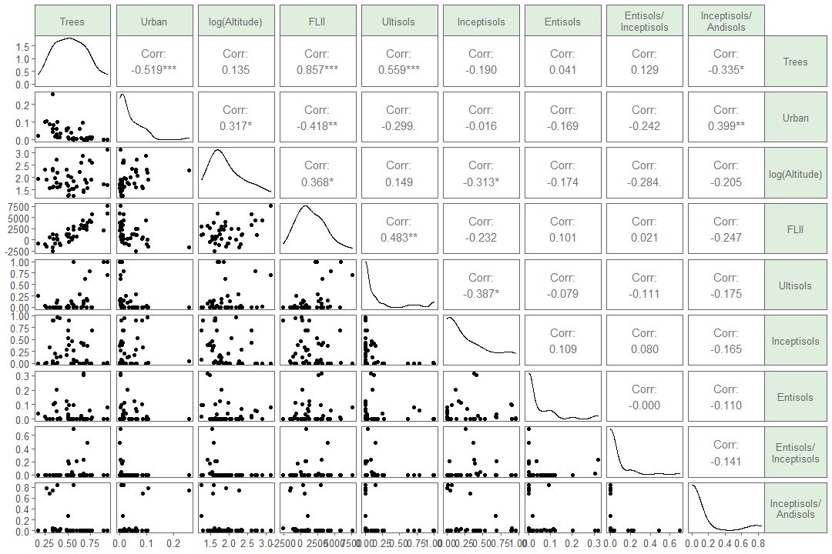
Figure S3.1: Cross correlation matrix of all covariates used to build the models. Covariate distribution is on the diagonal, pearson correlation is displayed on the right-hand side and covariate pairwise distribution on the left-hand side.

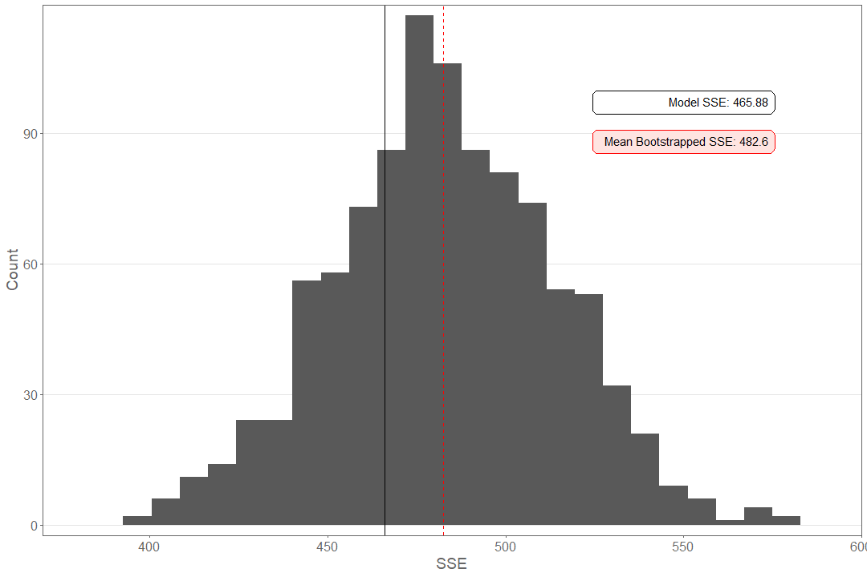
Figure S3.2: Distribution of the 1000 parametric bootstrapped replicates, their mean (red) and the SSE of the final model.

Table S3.1: Number of survey periods when great green macaws were detected at each site. Site level empirical Bayes estimated abundance and 90% confidence internals.
Site | Detections | Bayes Estimated Abundance | Lower | Upper
1 | 1 | 1.009 | 1 | 1
2 | 0 | 0.037 | 0 | 0
3 | 0 | 0.020 | 0 | 0
4 | 0 | 0.092 | 0 | 1
5 | 0 | 0.019 | 0 | 0
6 | 0 | 0.057 | 0 | 1
7 | 0 | 0.006 | 0 | 0
8 | 0 | 0.016 | 0 | 0
9 | 3 | 1.530 | 1 | 3
10 | 1 | 1.110 | 1 | 2
11 | 1 | 1.016 | 1 | 1
12 | 5 | 2.113 | 1 | 3
13 | 1 | 1.061 | 1 | 2
14 | 7 | 1.567 | 1 | 2
15 | 0 | 0.135 | 0 | 1
16 | 16 | 3.345 | 2 | 5
17 | 5 | 1.625 | 1 | 3
18 | 2 | 1.479 | 1 | 3
19 | 1 | 1.032 | 1 | 1
20 | 39 | 10.888 | 9 | 13
21 | 27 | 10.440 | 8 | 13
22 | 19 | 6.090 | 4 | 8
23 | 9 | 2.695 | 2 | 4
24 | 0 | 0.024 | 0 | 0
25 | 8 | 2.250 | 1 | 3
26 | 45 | 13.434 | 11 | 16
27 | 8 | 3.106 | 2 | 5
28 | 3 | 1.338 | 1 | 2
29 | 18 | 5.425 | 4 | 7
30 | 33 | 10.256 | 8 | 13
31 | 23 | 7.086 | 5 | 9
32 | 43 | 11.267 | 9 | 14
33 | 49 | 13.242 | 11 | 16
34 | 11 | 3.713 | 2 | 5
35 | 73 | 24.854 | 21 | 29
36 | 38 | 11.064 | 9 | 14
37 | 4 | 2.417 | 1 | 4
38 | 85 | 40.714 | 35 | 47
39 | 3 | 1.293 | 1 | 2
40 | 3 | 1.107 | 1 | 2
41 | 1 | 1.019 | 1 | 1
42 | 1 | 1.006 | 1 | 1
43 | 6 | 7.856 | 5 | 11

Table S3.2: AIC scores for the detection formula run against a null abundance formula. Time of day as a factor was the top performing covariate.
Model | AIC | delta
Time of day (factor) | 3,283.727 | 0.00
Time of day (factor) + Date (factor) | 3,316.236 | 32.51
Time of day (numeric) | 3,322.652 | 38.93
Intercept | 3,340.115 | 56.39
Time of day (numeric) + Date (factor) | 3,355.837 | 72.11
Date (factor) | 3,373.232 | 89.51

Table S3.3: AIC table for the three grid sizes. 10km was the top performer
Model | AIC | delta
10 km | 3,167.814 | 0.00
5 km | 3,178.637 | 10.82
1 km | 3,207.277 | 39.46

Table S3.4: Transformed covariate model coefficients of the top model
Covariate | Coefficient | SE
Trees | 4.2341 | 1.0254
Urban | 5.8494 | 4.8451
log(Altitude) | -2.9270 | 0.3933
FLII | -0.0002 | 0.0001
Ultisol | 0.4388 | 0.6402
Ultisol / Inceptisol | 0.0490 | 0.3033
Entisol | -1.3670 | 3.1521
Inceptisol | -1.9365 | 0.6620
Inceptisol / Andisol | -2.1792 | 1.0959

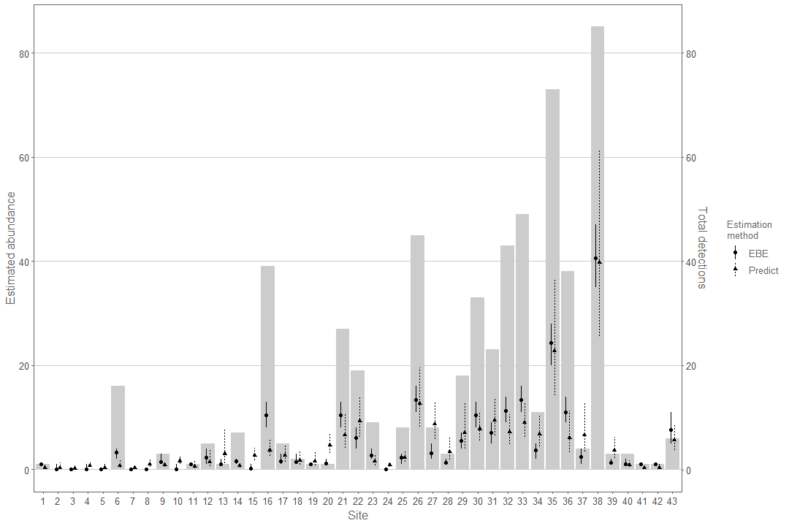
Figure S3.3: The number of detections per site (gray bars) and the number of GGMs estimated via empirical Bayes estimate (EBE) and the predicted number using the top model

Table S3.6: Soil orders of Costa Rica and their relationship to soil suborders
Soil Order | Soil Suborder
Andisols | Udands
 | Ustands
Andisols / Ultisols | Udands / Humults
Entisols | Aquents
 | Aquents / Psamment
 | Fluvents
 | Orthents
 | Psamments
Entisols / Andisols | Orthents / Udands
Entisols / Histosols | Aquents / Saprists
 | Orthents / Folists
Entisols / Inceptisols | Aquents / Aquepts
 | Aquents / Ustepts
 | Fluvents / Udepts
 | Fluvents / Ustepts
 | Orthents / Udepts
 | Orthents / Ustepts
Histosols | Saprists
Inceptisols | Aquepts
 | Udepts
 | Ustepts
Inceptisols / Andisols | Udepts / Udands
Ultisols | Humults
 | Udults
 | Ustults
Ultisols / Inceptisols | Humults / Udepts
 | Humults / Ustept
 | Udults / Udepts
Vertisols | Aquerts
 | Usterts

S4: Using passive acoustic monitoring to investigate the spatial and temporal landscape use by the critically endangered great green macaw (Ara ambiguus)
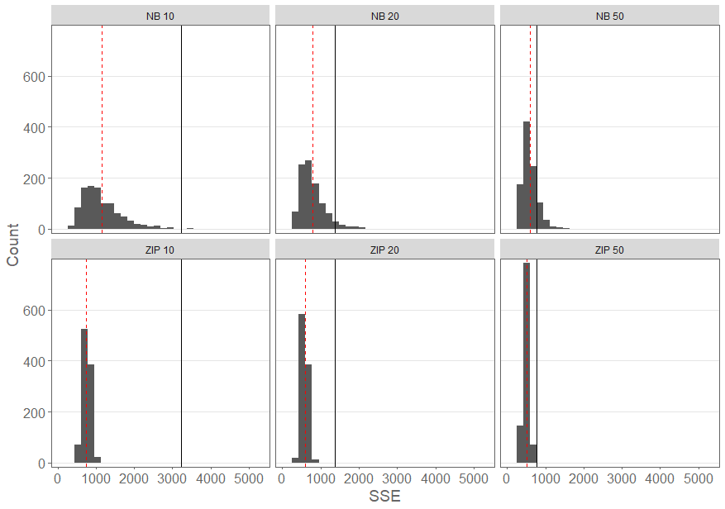
Figure S4.1: Goodness-of-fit for all six evaluated model. Negative binomial (NB) performed best across all three bin sizes, with NB20 and NB50 performing the best

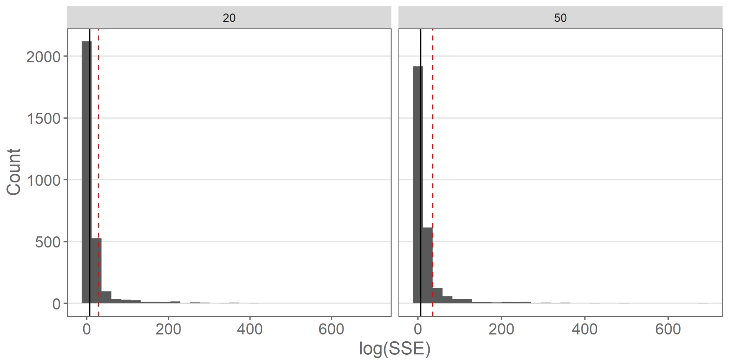
Figure S4.2: Goodness-of-fit for the final two models NB20 and NB50
Table S4.1: All models and their associated AIC, delta AIC and AIC weight. The most complex models all performed well, however there was only one top model in bin 20 and for bin 50.
bin | model | AIC | delta | AICwt
20 | psi(Trees + Alt + FLII + soil)gam(Trees + Alt + soil)ome(.)p(period + I(date^2) + Trees) | 2,225.51 | 0.00 | 0.6932
 | psi(Trees + Alt + FLII + soil)gam(Alt + FLII + soil)ome(.)p(period + I(date^2) + Trees) | 2,228.50 | 2.99 | 0.1553
 | psi(Trees + Alt + FLII + soil)gam(Trees + Alt + FLII + soil)ome(.)p(period + I(date^2) + Trees) | 2,228.57 | 3.06 | 0.1500
 | psi(Trees + Alt + FLII + soil)gam(Trees + Alt + FLII)ome(.)p(period + I(date^2) + Trees) | 2,237.83 | 12.32 | 0.0015
 | psi(Trees + Alt + FLII + soil)gam(Trees + FLII + soil)ome(.)p(period + I(date^2) + Trees) | 2,247.99 | 22.47 | 0.0000
 | psi(Trees + Alt + FLII + soil)gam(period)ome(.)p(.) | 2,253.26 | 27.74 | 0.0000
 | psi(Trees + Alt + FLII + soil)gam(.)ome(.)p(period) | 2,255.60 | 30.09 | 0.0000
 | psi(Trees + Alt + FLII + soil)gam(period)ome(.)p(period) | 2,258.51 | 33.00 | 0.0000
 | psi(Trees + Alt + FLII + soil)gam(.)ome(.)p(.) | 2,268.73 | 43.22 | 0.0000
 | psi(.)gam(period)ome(.)p(.) | 2,273.32 | 47.80 | 0.0000
 | psi(.)gam(.)ome(.)p(period) | 2,275.34 | 49.82 | 0.0000
 | psi(.)gam(period)ome(.)p(period) | 2,277.83 | 52.31 | 0.0000
 | psi(.)gam(.)ome(.)p(.) | 2,288.64 | 63.12 | 0.0000
50 | psi(Trees + Alt + FLII + soil)gam(Trees + Alt + soil)ome(.)p(period + I(date^2) + Trees) | 2,225.51 | 0.00 | 0.6173
 | psi(Trees + Alt + FLII + soil)gam(Trees + Alt + FLII + soil)ome(.)p(period + I(date^2) + Trees) | 2,227.38 | 1.86 | 0.2430
 | psi(Trees + Alt + FLII + soil)gam(Alt + FLII + soil)ome(.)p(period + I(date^2) + Trees) | 2,228.50 | 2.99 | 0.1384
 | psi(Trees + Alt + FLII + soil)gam(Trees + Alt + FLII)ome(.)p(period + I(date^2) + Trees) | 2,237.83 | 12.32 | 0.0013
 | psi(Trees + Alt + FLII + soil)gam(Trees + FLII + soil)ome(.)p(period + I(date^2) + Trees) | 2,247.99 | 22.47 | 0.0000
 | psi(Trees + Alt + FLII + soil)gam(period)ome(.)p(.) | 2,253.26 | 27.74 | 0.0000
 | psi(Trees + Alt + FLII + soil)gam(.)ome(.)p(period) | 2,255.60 | 30.09 | 0.0000
 | psi(Trees + Alt + FLII + soil)gam(period)ome(.)p(period) | 2,258.51 | 33.00 | 0.0000
 | psi(Trees + Alt + FLII + soil)gam(.)ome(.)p(.) | 2,268.73 | 43.22 | 0.0000
 | psi(.)gam(period)ome(.)p(.) | 2,273.32 | 47.80 | 0.0000
 | psi(.)gam(.)ome(.)p(period) | 2,275.34 | 49.82 | 0.0000
 | psi(.)gam(period)ome(.)p(period) | 2,277.83 | 52.31 | 0.0000
 | psi(.)gam(.)ome(.)p(.) | 2,288.64 | 63.12 | 0.0000

Table S4.2: Covariate model coefficients for the top model. Covariates in bold are significant, they don’t have standard errors crossing zero.
State | Covariate | Coefficient | SE
Initial abundance | Trees | 1.2049 | 1.8604
 | log(Altitude) | 0.5966 | 0.5727
 | Ultisol | 0.1589 | 0.7864
 | Ultisol / Inceptisol | 0.0238 | 0.9478
 | Inceptisol / Andisol | 0.0147 | 1.0847
 | FLII | -0.0006 | 0.0001
 | Inceptisol | -1.5363 | 1.1003
 | Entisol | -8.1877 | 1.8525
Growth rate | Inceptisol / Andisol | 0.8071 | 0.2955
 | Trees | 0.7349 | 1.7232
 | log(Altitude) | 0.7305 | 0.1487
 | Inceptisol | 0.4203 | 0.3283
 | Ultisol / Inceptisol | 0.0190 | 0.2564
 | Ultisol | -0.3144 | 0.2110
 | Entisol | -0.6667 | 0.6074

S5: Nest-site selection and productivity are linked in a critically endangered parrot nesting in an anthropogenically disturbed landscape

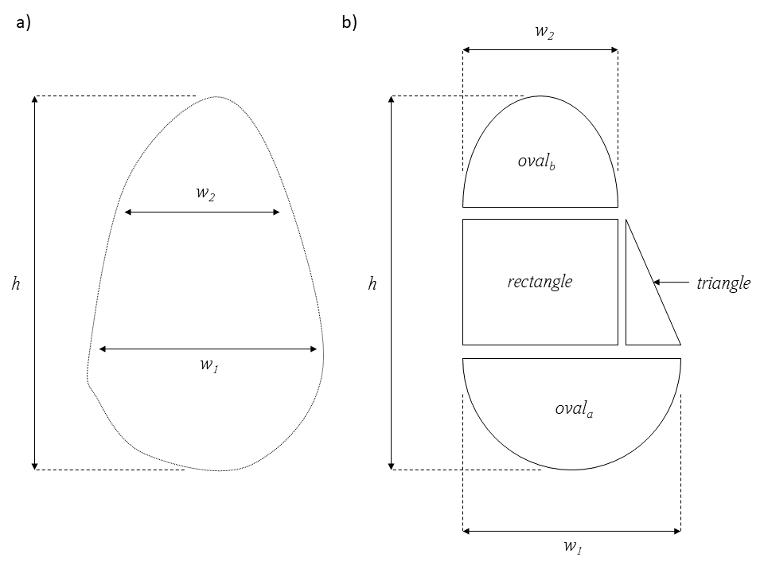
Figure S5.1: Cavity entrance diagram. a) Three cavity entrance measurements were taken in the field, which allowed b) an approximate calculation of the cavity entrance area by splitting the cavity into four shapes.

Entrance area equation:

${oval}_{a} = \frac{\frac{h}{3} ⋅ \frac{w_{1}}{2} ⋅ π}{2}$ (equation 1)

Where h = cavity entrance height (cm) and w₁ = cavity width at ⅓ of cavity entrance height (cm).
${oval}_{b} =\frac{\frac{h}{3} ⋅ \frac{w_{2}}{2} ⋅ π}{2}$ (equation 2)

Where w₁ = cavity width at ⅔ of cavity entrance height (cm).

${rectangle = min(w_{1}, w_{2}) ⋅\frac{h}{3} }_{}$ (equation 3)

$triangle = \frac{max(w_{1}, w_{2}) - min(w_{1}, w_{2}) ⋅ \frac{h}{3}}{2}$ (equation 4)

$area = \frac{rectangle + triangle + {oval}_{a} + {oval}_{b}}{10000}$ (equation 5)

Where $area$ is in m²

Internal circumference equation

$i=π ⋅\sqrt{2 ⋅ (0.5 ⋅ w)^{2} + (0.5 ⋅ b)^{2}}$ (equation 6)

Where i is the internal circumference.

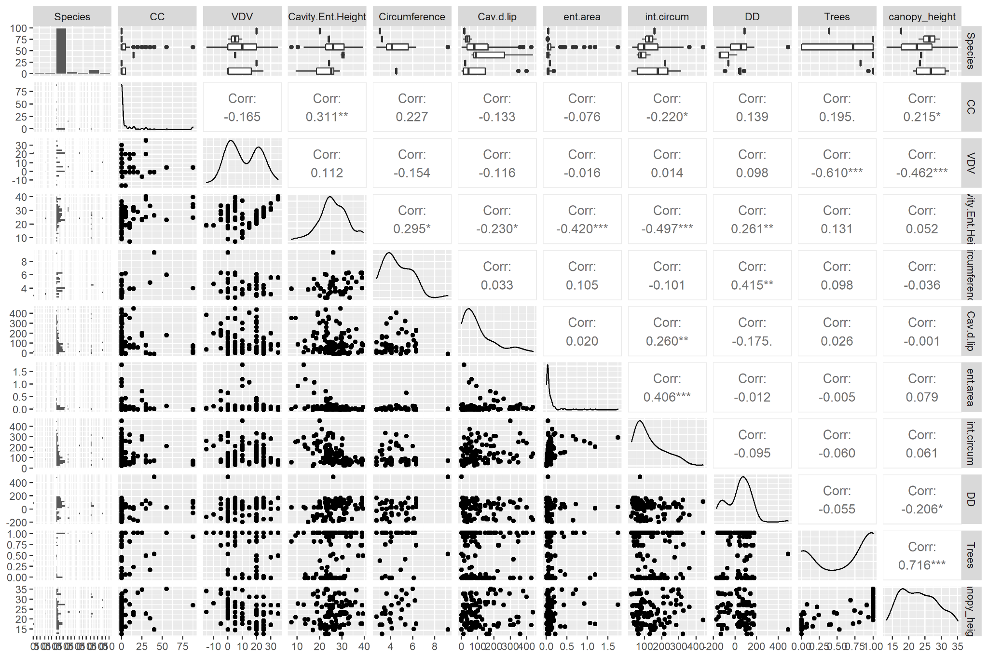
Figure S5.4: Visualisation of a correlation matrix between all cavity features. We transformed three skewed features: cavity depth, entrance area and internal circumference. There are a number of highly correlated features, but as we are running univariate models of each, we did not remove any from our analysis (* = 0.05, ** = 0.01, *** = 0.001).

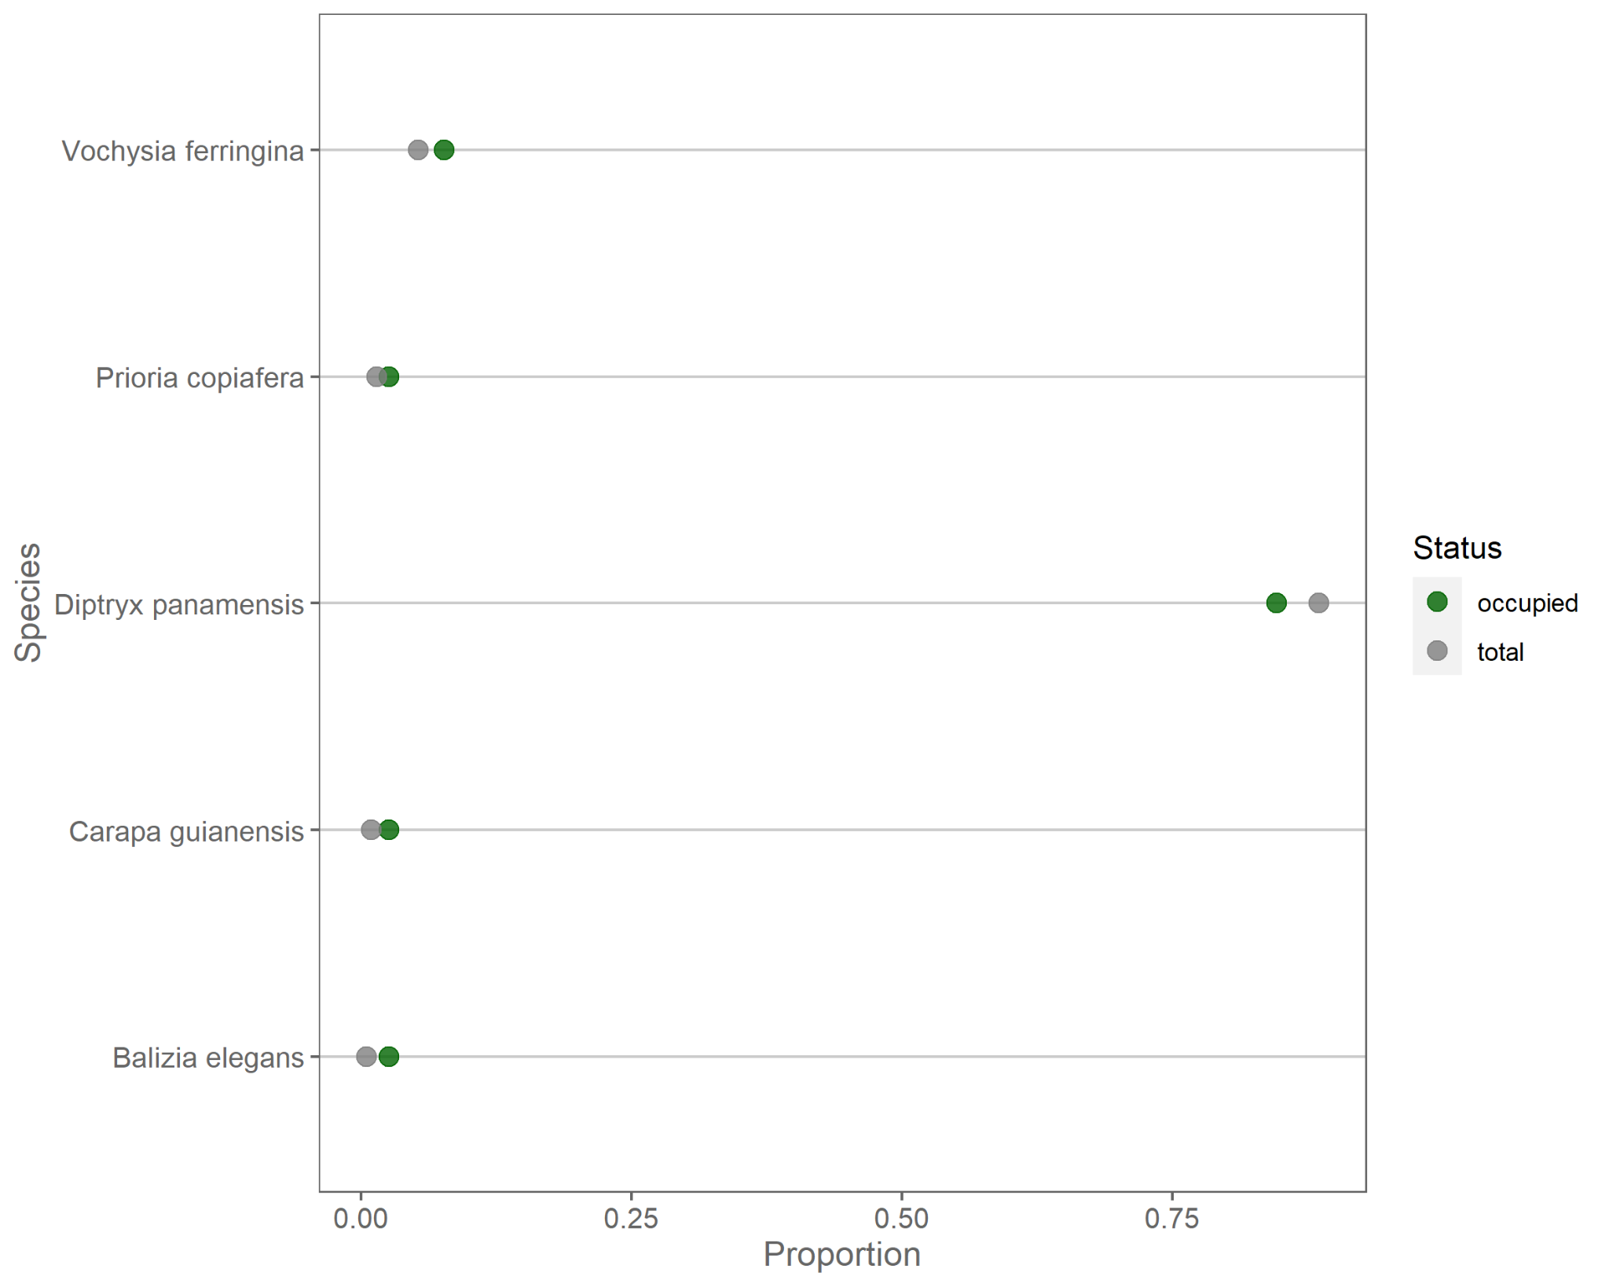
Figure S5.5: Species of trees that were occupied and unoccupied showing there is no strong selection for any particular species.

Table S5.1: Nest suitability and cavity depth model predictions for all cavities. The two most numerous interspecific competitors Ara macao and Amazona autumnalis have similar predicted productivity by NSS but not cavity depth.
Species | Number of cavities | Mean productivity
 |  | Cavity depth | NSS
Amazona autumnalis | 5 | 1.39 | 0.97
Ara ambiguus | 37 | 1.40 | 1.26
Ara macao | 9 | 1.10 | 0.97
Interspecific competitors | 5 | 1.55 | 1.43
unoccupied | 91 | 1.05 | 0.89

Table S5.2: Summary of all tree and cavity characteristics of occupied (n = 37) and unoccupied (n = 79) cavities.
Feature | Mean (occupied) | SD (occupied) | Mean (unoccupied) | SD (unoccupied)
Vertical distance to canopy (m) | 13.601 | 10.295 | 9.841 | 12.095
Cavity entrance height (m) | 23.041 | 5.624 | 27.572 | 6.485
Tree circumference (m) | 4.354 | 1.051 | 4.477 | 1.284
Cavity depth (cm) | 101.542 | 2.235 | 64.516 | 5.716
Entrance area (m²) | 0.080 | 2.300 | 0.041 | 3.627
Internal circumference (cm) | 185.203 | 0.497 | 87.704 | 0.989
Tree cover (%) | 0.476 | 0.465 | 0.675 | 0.412
Canopy connectivity (%) | 2.568 | 9.474 | 12.928 | 24.435
Canopy height (m) | 21.563 | 5.376 | 24.186 | 5.945

