

Using Artificial Intelligence for Analysis of Histological and Morphological Diversity in Salivary Gland Tumours
By:
Ibrahim Suliman Alsanie

A thesis submitted in partial fulfilment of the requirements for the
degree of Doctor of Philosophy

The University of Sheffield
Faculty of Medicine, Dentistry and Health
Department of Oral & Maxillofacial Pathology
School of Clinical Dentistry

January 2023
Acknowledgements

I humbly thank the Almighty God for His mercies, power, provision, and love. His generosity has enabled me to succeed and excel in all of my academic endeavours.
I will be eternally grateful to my parents for providing me with the opportunities and experiences that have shaped who I am. They unconditionally supported me throughout my life.
My wife, Hessa, and my two children, Sara and Faisal, are the inspiration for this piece. I pray that the future brings you much happiness and success in exchange for the hardships you have had to endure so I can follow my dream.
I would like to express my most profound appreciation for my supervisor Prof Ali Khurram. I am sincerely grateful to him for his never-failing guidance and encouragement. This work would not have been possible without his guidance and continuous help.
Moreover, I extend my appreciation to my second supervisor Dr Eu-wing Toh for his continuous support. Also, I would like to thank my third supervisor Prof Nasir Rajpoot, who expertly guided me in the vital part of this project. Also, for Dr Adam Shephard, Department of Computer Science, University of Warwick, for his significant contribution to the project.
Third, I extend my grateful appreciation to my NEOPATH research team (Dr Neda, Dr Zaki, Hanya and the rest), colleagues, faculty and the laboratory staff, Brenka McCabe and Jason Heath in the department of Oral and Maxillofacial Pathology, The School of Clinical Dentistry. For their kind advice and guidance.
Finally, I humbly extend my thanks to my sponsor, King Saud University, for providing me with this opportunity to gain knowledge and be the best representative for our University and the kingdom of Saudi Arabia.

Table of contents
Contents
1) Chapter 1: Introduction and literature review 1
1.1 Salivary gland tumours (SGT) 2
1.1.1 Introduction 2
1.1.2 Classification 2
1.1.3 Diagnostic challenges 5
1.2 Digital pathology 11
1.2.1 Introduction 11
1.2.2 The digitisation process 12
1.2.3 Advantages and shortcomings of digital pathology 13
1.3 Artificial Intelligence (AI) 15
1.3.1 Introduction 15
1.3.2 Types of AI algorithms 17
1.3.3 Approaches and techniques 18
1.3.4 Training methods 19
1.3.5 Evolution of DL models 21
1.3.6 Algorithm performance assessment 22
1.3.7 Applications of AI 25
1.3.8 AI opportunities and challenges in pathology 32
1.4 Hypothesis and Aims of the study 34
2) Chapter 2: Distribution and frequency of salivary gland tumours: an international multicentre study 36
2.1 Introduction 37
2.2 Material and methods 38
2.3 Results 40
2.3.1 Overall 40
2.3.2 Benign tumours 43
2.3.3 Malignant tumours 47
2.4 Discussion 52
2.4.1 Benign SGT 52
2.4.2 Malignant SGT 53
3) Chapter 3: Using Artificial Intelligence for Analysis of Salivary Gland Tumours (Benign versus malignant & subtyping) 56
3.1 Introduction 57
3.2 Material and methods 58
3.2.1 Case identification and retrieval 58
3.2.2 Dataset and Building of Machine Learning Classifiers 58
3.2.3 Comparison with Customised Machine Learning Models 62
3.2.4 Comparison with Deep Learning Networks 62
3.2.5 Spatial analysis 63
3.2.6 Statistical Analysis 64
3.3 Results 65
3.3.1 Performance of the classifiers 65
3.3.2 Features contributing to the classifier performance 70
3.3.3 Quantitative morphometrical feature analysis 71
3.4 Discussion 77
4) Chapter 4: Using Artificial Intelligence for Analysis of Salivary Gland Tumours (Tumour grading and molecular prediction correlation) 81
4.1 Introduction 82
4.1.1 Tumour grading 82
4.1.2 Molecular status 85
4.2 Material and methods 87
4.2.1 Case identification and retrieval 87
4.2.2 Dataset and ROI detail 89
4.2.3 Cell detection and Classifier Development 90
4.2.4 Quantitative Analysis of features 90
4.2.5 Comparison with Deep Learning 94
4.2.6 Spatial analysis 94
4.2.7 Statistical Analysis 94
4.3 Results 95
4.3.1 Grading classifiers 95
4.3.2 Feature analysis 99
4.3.3 Cellularity 99
4.3.4 Spatial analysis 100
4.3.5 Feature Quantification in Grading 101
4.3.6 Feature quantification related to MAML2 fusion in MEC 104
4.4 Discussion 107
4.4.1 Tumour grading and feature quantification 107
4.4.2 Feature analysis in relation to MAML2 status 108
5) Chapter 5: General discussion, future perspective and conclusion 110
5.1 Thesis overview 111
5.2 General Discussion 111
5.2.1 Demographics 111
5.2.2 Machine and Deep Learning and Quantitative analysis 112
5.3 Study Shortcomings 113
5.4 Future directions 113
5.5 Conclusions 114

List of tables
Table ‎1.1: WHO classification of salivary gland tumours 2017 (El-Naggar et al., 2017) and new update 2022 (Skálová et al., 2022). 4

Table ‎1.2: IHC markers for diagnosing salivary gland tumours (Khurram et al., 2017, Speight and Barrett, 2020). 8

Table ‎1.3: Common molecular and genetic changes in salivary gland tumours (Khurram et al., 2017, El-Naggar et al., 2017, Skálová et al., 2022, Speight and Barrett, 2020, Andreasen et al., 2019).(PLGA1:Polylactic acid-co-glycolic acid 1,HMGA2: High mobility group AT-hook 2,PIK3CA:Phosphatidylinositol-4,5-bisphosphate 3-kinase catalytic subunit alpha,CRTC1-MAML2:CREB-regulated transcription coactivator 1-mastersmind-like transcriptional coactivator 2,ETV6::NTRK3:ETS variant 6-neurotrophic receptor tyrosine kinase 3,EWSR1-ATF1:EWS RNA-binding protein 1-activating transcription factor 1,MYB-NFIB:Myeloblastosis oncogene neurofibromin 1 (NF1) type II collagene fusion protein,NR4A3:Nuclear receptor subfamily 4 group A member 3,PRKD1-3:Protein kinase D1-D3,MEF2C-SS18: Myocyte enhancer factor 2C-synovial sarcoma translocation gene on chromosome 18,AKT1 E17K:v-akt murine thymoma viral oncogene homolog 1 E17K variant,RET:Rearranged during transfection proto-oncogene,HRAS:Harvey rat sarcoma viral oncogene homolog,HER-2/neu:Human epidermal growth factor receptor 2/neu). 10

Table ‎1.4: The most crucial computational pathology grand challenges and best-reached accuracy/performance. 23

Table ‎1.5: Summary of relevant studies in computational pathology across different tissues. 26

Table ‎2.1: Benign and malignant SGT histological subtype distribution within the cohort. 40

Table ‎3.1: Training and testing sets case numbers breakdown for benign vs malignant (BvM) 59

Table ‎3.2: List of geometrical and morphometrical features that can be obtained using QuPath to build the classifiers. The biologically relevant features (highlighted in blue) were used for comparative analysis. Cell values were excluded as these are artificially generated within the software. 61

Table ‎3.3: Performances/accuracy metrics of the ML RF classifiers (QuPath & customised) as well as DL (ResNet 18,50 & EfficientNet B0,B3) at case-level predictions.The best performing classifiers are highlighted in bold. 65

Table ‎4.1: Comparison between most common grading scheme of the mucoepidermoid carcinoma. 83
Table ‎4.2: Training and testing sets case numbers breakdown for tumour grading (TG) classifiers. 89

Table ‎4.3: Features quantitative analysis cases breakdown for grading and MAML2 fusion quantifications. 90

Table ‎4.4: Performances/accuracy metrics of the ML ANN classifiers (QuPath) as well as DL (ResNet 18,50 & EfficientNet B0,B3) at case-level predictions. Best performing models are highlighted in bold. 95

List of figures
Figure ‎1.1: Four salivary gland tumours showing a similar cribriform appearance. A- Pleomorphic adenoma (benign), B- Basal cell adenoma (benign), C- Adenoid cystic carcinoma (malignant- poor prognosis), D- Polymorphous adenocarcinoma (malignant- good prognosis). Magnification 20x. Images obtained from archived cases for the purpose of this thesis. 6

Figure ‎1.2: Four different malignant salivary gland tumours showing a similar clear cell appearance. A-Mucoepidermoid carcinoma, B-Epithelial–myoepithelial carcinoma (EMC), C- Acinic cell carcinoma, D- Clear cell carcinoma. Magnification 20x. Images obtained from archived cases for the purpose of this thesis. 6

Figure ‎1.3: Four salivary gland tumours showing a similar papillary cystic appearance. A- Acinic cell carcinoma (malignant), B- Secretory carcinoma (malignant), C- Warthin's tumour (benign), D- Cystadenoma (benign). Magnification 20x. Images obtained from archived cases for the purpose of this thesis. 7

Figure ‎1.4: The digital pathology slide scanning set up in Sheffield, including a PC coupled to x5 slide Leica CS2 slide scanner. 13

Figure ‎1.5: Deep learning models pipeline, including input, output and hidden neural network layers .This illustration was made for purpose of this thesis using Microsoft Powerpoint. 17

Figure ‎1.6: Overview of the workflow of ML/DL models in computational pathology. This illustration was made for purpose of this thesis using Microsoft Powerpoint. 18

Figure ‎1.7: Schematic diagram showing a Random Forest model and it is decision trees. This illustration was made for purpose of this thesis using Microsoft Powerpoint. 20

Figure ‎1.8: Milestones in computational pathology. This illustration was made for purpose of this thesis using Microsoft Powerpoint. 21

Figure ‎2.1: Geographical map of the centres participating in the study including five from the UK, two from Europe, five from Africa, one from Asia and two centres from South America. Total number of cases, n=5,739. 38

Figure ‎2.2: Age and gender distribution within the entire SGT cohort. 41

Figure ‎2.3: Anatomical site distribution of SGT. A) major and minor gland distribution across the entire cohort B) Benign tumours in all glands C) Benign tumours in minor glands D) Malignant tumours in all glands E) Malignant tumours in minor glands. 42
Figure ‎2.4: Geographic comparison of the most common benign SGT. PA-Pleomorphic adenoma, WT-Warthin tumour, BCA-Basal cell adenoma. 43

Figure ‎2.5: Age and gender distribution for benign salivary gland tumours, n=3751. 44

Figure ‎2.6: Anatomical site distribution of the most common benign SGT. Pleomorphic adenoma (PA), Warthin tumour (WT) and basal cell adenoma (BCA). 46

Figure ‎2.7: Geographic comparison of the most common malignant SGT. MEC- Mucoepidermoid carcinoma, AdCC- Adenoid cystic carcinoma, PAC- Polymorphous adenocarcinoma, Ca ex PA- Carcinoma ex pleomorphic adenoma, ACC- Acinic cell carcinoma. 47

Figure ‎2.8: Age and gender distribution for malignant tumours, n=1988. 48

Figure ‎2.9: Anatomical site distribution of the most common malignant SGT. Mucoepidermoid carcinoma (MEC) occurs in the MSG (56%), (34%) in parotid, (7%) in submandibular and (3%) in the sublingual glands, adenoid cystic carcinoma (AdCC) occurs in the MSG (60%), (26%) in parotid, (10%) in submandibular and (4%) in the sublingual glands, polymorphous adenocarcinoma (PAC) occurs in the MSG (98%) and (2%) in the parotid glands, carcinoma ex pleomorphic adenoma (Ca ex PA) occurs in the MSG (61%), (32%) in parotid, (7%) in the submandibular glands and acinic cell carcinoma (ACC) occurs in the parotid glands (65%), (23%) in MSG, (9%) in submandibular and (3%) in the sublingual glands. 50

Figure ‎3.1: Training and analysis overview. 60

Figure ‎3.2: Delaunay triangulation where a set of points in a plane form a triangular mesh. This illustration was made for purpose of this thesis using Microsoft Powerpoint. 64

Figure ‎3.3: Automatic cell segmentation and classification in ROIs using trained classifiers. (BVM, test n=80) predictions were largely correct with occasional false positive cells. A- Pleomorphic adenoma (benign), B- Basal cell adenoma (benign), C- Mucoepidermoid carcinoma (malignant), D- Acinic cell carcinoma (malignant). (Magnification 20X). 66

Figure ‎3.4: Automatic cell segmentation and classification of pleomorphic adenoma (benign case) at WSI level using trained classifiers. A- H&E WSI, B- Green is benign prediction, red=malignant. (Magnification 1X). Although occasional false positives are seen for malignant cells, the overwhelming majority show an accurate prediction. 67

Figure ‎3.5: Automatic cell segmentation and classification of acinic cell carcinoma (malignant case) at WSI level using trained classifiers. A- H&E WSI, B- Red is malignant prediction. (Magnification 1X). 68
Figure ‎3.6: Automatic cell segmentation and classification in ROIs using trained classifiers. (MST, test n=40), most of the predicted classes were correct with some false positive detections. E- Mucoepidermoid carcinoma (red), B- Acinic cell carcinoma (yellow), C- Adenoid cystic carcinoma (purple), D-Carcinoma ex pleomorphic adenoma (cyan). (Magnification 20X). 69

Figure ‎3.7: Average values for nuclear and cytoplasmic features in benign (green) and malignant (red) unseen test cases (test n=80). Error bars = standard deviation. *p<0.05, **p<0.01 (T-Test (two-tailed)). 70

Figure ‎3.8: Average nuclear and cytoplasmic feature values for the malignant subtyping unseen test set (n=40). Mucoepidermoid carcinoma (red), Acinic cell carcinoma (yellow), Adenoid cystic carcinoma (purple) and Carcinoma ex pleomorphic adenoma (cyan). Error bars = standard deviation. *p<0.01 (Multiple comparison one-way ANOVA). 71

Figure ‎3.9: Boxplot showing cellularity of the benign and malignant tumours (test n=80). Error bars = standard deviation. *p<0.01 (T-Test (two-tailed)). 72

Figure ‎3.10: Boxplot showing the cellularity comparison of malignant tumours (test n=40). Error bars = standard deviation. *p<0.01 (Multiple comparison one-way ANOVA). 73

Figure ‎3.11: Showing spatial orientation networks of benign (A) and malignant (B) cells (note triangles and lines between nuclei). (Magnification 40X). 73

Figure ‎3.12: Average centroid distance between benign and malignant cells (μm). Error bars = standard deviation.*p<0.01 (T-Test (two-tailed)). 74

Figure ‎3.13: Cluster spatial analysis of Delaunay features for benign and malignant tumours. Error bars = standard deviation.*p<0.01 (T-Test (two-tailed)). 74

Figure ‎3.14: Showing spatial orientation networks and Delaunary triangle in different malignant subtypes (A- MEC, B- ACC, C- AdCC, and D – Ca ex PA). (Magnification 40X). 75

Figure ‎3.15: Cluster spatial analysis of Delaunay features for malignant subtypes. Error bars = standard deviation. *p<0.05, **p<0.01 (Multiple comparison one-way ANOVA). 76

Figure ‎4.1: Different morphological appearance of low and high-grades tumours of MEC, A- low-grade (cystic pattern), B- low-grade (clear cell pattern), C- high-grade (mixed cystic and predominantly solid pattern), D- high-grade (solid pattern). (Magnification 5X). 87

Figure ‎4.2: Different morphological appearance of low and high-grades tumours of AdCC, A- low-grade (cribriform pattern), B- low-grade (tubular pattern), C- high-grade (mixed tubular and predominantly solid pattern), D- high-grade (solid pattern). (Magnification 5X). 88
Figure ‎4.3: Different morphological appearance of low and high-grades tumours of PAC, A- low-grade (trabeculae or tubules appearance), B- high-grade PAC/CASG (cribriform appearance). (Magnification 5X). 88

Figure ‎4.4: Grading classifiers and quantification overview. 92

Figure ‎4.5: MAML2 fusion positive and negative quantification overview. 93

Figure ‎4.6: Automatic cell segmentation and classification in ROIs using a trained classifier. Tumour grading classifier, test n=40 predictions were largely correct with some false positive cells. A- mucoepidermoid carcinoma (low-grade),B- adenoid cystic carcinoma (low-grade), C- mucoepidermoid carcinoma (high-grade), D- adenoid cystic carcinoma (high-grade). (Magnification 20X). 96

Figure ‎4.7: Automatic cell segmentation and classification of low-grade adenoid cystic carcinoma at WSI level using trained classifiers. A- H&E WSI, B- The majority of predictions were correctly identified as low-grade as shown by blue prediction. (Magnification 1X). 97

Figure ‎4.8: Automatic cell segmentation and classification of high-grade adenoid cystic carcinoma at WSI level using trained classifiers. A- H&E WSI, B- The majority of predictions were correctly identified as high-grade as shown by yellow prediction. (Magnification 1X). 98

Figure ‎4.9: Average values for nuclear and cytoplasmic features in low-grade (blue) and high-grade (yellow) classes test cases (test n=40). Error bars = standard deviation. *p<0.01 (T-Test (two-tailed)). 99

Figure ‎4.10: Boxplot showing cellularity of the low-grade (Blue) and high-grade (Yellow) tumours (test n=40). Error bars = standard deviation. *p<0.01 (T-Test (two-tailed)). 100

Figure ‎4.11: Spatial and proximity analysis of low and high-grade tumours (test n=40). A-B Showing spatial orientation networks of low-grade AdCC (A) and high-grade MEC (B) cells. (Magnification 40X). C- Average centroid distance between low and high-grade tumours (μm). D- Cluster spatial analysis of Delaunay features for low and high-grade tumours. Error bars = standard deviation .*p<0.01 (T-Test (two-tailed)). 101

Figure ‎4.12: Average values for nuclear and cytoplasmic features in low-grade (orange) and high-grade (dark red) cases. A- Adenoid cystic carcinoma (AdCC) (n=20). B- Polymorphous adenocarcinoma (PAC) (n=20). Error bars = standard deviation. *p<0.05. **p<0.01 (T-Test (two-tailed)). 102

Figure ‎4.13: Boxplots showing cellularity of the low-grade (orange) and high-grade (dark red) tumours. A- Adenoid cystic carcinoma (AdCC) (n=20). B- Mucoepidermoid carcinoma (MEC)(n=20) C- polymorphous adenocarcinoma (PAC) (n=20). Error bars = standard deviation. *p<0.01 (T-Test (two-tailed)). 103
Figure ‎4.14: Logistic regression curve for AdCC cases n=20 correlating with grade. 0: low grade, 1: high grade. 103

Figure ‎4.15: Logistic regression curve for PAC cases n=20 correlating with grade. 0: low grade, 1: high grade. 104

Figure ‎4.16: A&B - average values for nuclear and cytoplasmic features in MAML2 (+) (red) and MAML2 (-) (pink) cases (n=16). Error bars = standard deviation. *p<0.01 (T-Test (two-tailed)). 105

Figure ‎4.17: Boxplot showing cellularity of the MAML2 (+) (red) and MAML2 (-) (pink) classes (n=16). Error bars = standard deviation. *p<0.05 (T-Test (two-tailed)). 106

Figure ‎4.18: Logistic regression curve for MAML2 fusion positive and negative cases n=16 correlating with nuclear area and perimeter. 0: MAML-2 (+), 1: MAML-2 (-). 106

List of abbreviations
Abbreviation | Meaning
SGT | Salivary gland tumours
WHO | World health organization
CASG | Cribriform adenocarcinoma of salivary gland origin
NOS | Not otherwise specified
AdCC | Adenoid cystic carcinoma
PAC | Polymorphous adenocarcinoma
PA | Pleomorphic adenoma
BCA | Basal cell adenoma
MEC | Mucoepidermoid carcinoma
ACC | Acinic cell carcinoma
CCC | Clear cell carcinoma
SC | Secretory carcinoma
H&E | Haematoxylin and Eosin
IHC | Immunohistochemistry
FISH | Fluorescent in situ hybridisation
PCR | Polymerase chain reaction
NGS | Next-generation sequencing
PLGA1 | Polylactic acid-co-glycolic acid 1
HMGA2 | High mobility group AT-hook 2
PIK3CA | Phosphatidylinositol-4,5-bisphosphate 3-kinase catalytic subunit alpha
CRTC1-MAML2 | CREB-regulated transcription coactivator 1-mastersmind-like transcriptional coactivator 2
ETV6::NTRK3 | ETS variant 6-neurotrophic receptor tyrosine kinase 3
EWSR1-ATF1 | EWS RNA-binding protein 1-activating transcription factor 1
MYB-NFIB | Myeloblastosis oncogene neurofibromin 1 (NF1) type II collagene fusion protein
NR4A3 | Nuclear receptor subfamily 4 group A member 3
PRKD1-3 | Protein kinase D1-D3
MEF2C-SS18 | Myocyte enhancer factor 2C-synovial sarcoma translocation gene on chromosome 18
AKT1 E17K | v-akt murine thymoma viral oncogene homolog 1 E17K variant
RET | Rearranged during transfection proto-oncogene
HRAS | Harvey rat sarcoma viral oncogene homolog
HER-2/neu | Human epidermal growth factor receptor 2/neu
LMIC | Low and middle-income countries
FDA | Food and Drug Administration
WSI | Whole Slide Image
DICOM | Digital imaging and communication in medicine
AI | Artificial intelligence
ML | Machine learning
IVD | In vitro diagnostic device
DL | Deep learning
CNN | Convolutional neural networks
KNN | K-nearest neighbour
SVM | Support vector model
RF | Random forest
ANN | Artificial neural networks
GPU | Graphics processing unit
GNNs | Graph neural networks
GANs | Generative adversarial networks
ROC | Receiver operating characteristic
FPR | False positive rate
AUC | Area under the curve
DCIS | Ductal carcinoma in situ
ROIs | Region of interests
PNI | Perineural invasion
LUAD | Lung adenocarcinoma
LUSC | Lung squamous cell carcinoma
TCGA | The cancer genome atlas
OPMDs | Oral potentially malignant disorders
OED | Oral epithelial dysplasia
OSF | Oral submucous fibrosis
OSCC | Oral squamous cell carcinoma
HNC | Head and neck cancers
TILs | Tumour-infiltrating lymphocytes
HSI | Hyperspectral images
Ca ex PA | Carcinoma ex pleomorphic adenoma
AdNOS | Adenocarcinoma NOS
ENT | Ears, nose and throat
BvM | Benign versus malignant classifier
MST | Malignant tumour subtyping classifier
OD | Optical density
CSDCNN | Class structure-based deep learning model
RNNs | Recurrent neural networks
DNA | Deoxyribonucleic acid
CCG | Cell cluster graph
AFIP | Armed forces institute of pathology
RT | Radiotherapy
ECS | Extracapsular spread
qPCR | quantitative polymerase chain reaction
TG | Tumour grading classifier

Abstract
Background: Salivary gland tumours (SGT) are a heterogeneous group of neoplasms with morphological diversity and overlapping features. SGT can be diagnostically challenging due to a large number of entities and markedly similar features but different clinical behaviour. Recently, artificial intelligence (AI) has been found to be precise for histological diagnosis and prognosis prediction including identification of sub-visual features. However, its application to SGT has not been reported to date. The epidemiological data for SGT is also somewhat outdated and limited to single centre reports.
Objectives: This study aims first, to mitigate epidemiological data shortcomings by analysing information including demographic, anatomical location and histological diagnoses of SGT from multiple centres across the world. Second, to examine if AI can be used to differentiate between different SGT subtypes and grades based on the analysis of digitised whole slide images (WSIs) of Haematoxylin and Eosin (H&E) stained slides.
Methods: All primary benign and malignant SGT demographical data including age, gender, location and histological diagnosis from fifteen centres covering the majority of the world health organisation (WHO) geographical regions between 2006 and 2019 were included in the study. A total of 240 scanned H&E WSIs were obtained. An open-source bioimage analysis software (QuPath) was used for training and analysis of features on representative regions-of-interest (ROIs). The first machine learning (ML) classifier was trained and tested to differentiate between benign and malignant (BvM) SGT (n=120 each). The second ML classifier was used for malignant SGT subtyping (MST) (n=120). A third ML classifier was used for automated grade prediction (TG) (n=120) in two most common gradable SGT and results compared with deep learning (DL) methods using multiple state-of-the-art DL convolutional neural networks (CNNs). Finally, a quantitative analysis of geometrical and morphometrical features and their correlation with tumour type, grade, and molecular status (MAML2 rearrangement in mucoepidermoid carcinoma) was carried out.
Results: A total of 5739 cases were analysed including 65% benign and 35% malignant tumours. The most common benign tumour was pleomorphic adenoma, while the most prevalent malignant tumour was mucoepidermoid carcinoma. Our novel (ML) classifiers results achieved excellent performance with F1 score of 0.90, 0.92 and 0.87, for benign vs malignant, malignant subtyping and grading, respectively. Significant differences between cellularity, cytoplasmic eosin and nucleus/cell ratio (p<0.05) were seen for all experiments, potentially signifying important diagnostic features. Most of the DL CNNs also achieved high F1 scores for benign versus malignant differentiation (>0.80), with EfficientNet-B0 giving the best performance (F1= 0.87) but with inferior accuracy than the ML classifier for malignant subtyping (highest F1=0.60 with ResNet-18 and ResNet-50) and tumour grading (highest F1 score=0.70 with EfficientNet-B0). The quantitative analysis showed a statistically significant difference between nuclear eccentricity and nucleus/cell ratio (p<0.01) and nuclear circularity and eccentricity (p<0.05) between low and high grades in AdCC and PAC respectively, as well as nuclear area and perimeter (p<0.01) between MAML2 fusion positive and negative cases.
Conclusion: SGT are rare, but have shown a gradual increasing incidence over the last decade and a half. We have reported the largest multicentre investigation of SGT to date but more extensive studies of SGT need to be conducted to understand and update the epidemiological landscape of these tumours. Our novel results report the successful application of ML and DL for histological analysis, subtyping and grading of SGT on H&E images for the first time. These findings will aid in pathological diagnosis and clinical decision making, but a larger multicentre cohort needs to be analysed to determine the true significance and clinical usefulness.

Keywords: Salivary Gland Tumours, Artificial Intelligence, Machine Learning, Deep Learning, Computational Pathology.

Chapter 1: Introduction and literature review

Salivary gland tumours (SGT)

Introduction
Salivary glands play a crucial function in digestion and taste by providing lubrication for eating and speaking in addition to digestion. There are three major pairs of salivary glands: parotid, submandibular, and sublingual. In addition, a vast number of minor salivary glands are distributed throughout the mouth. Saliva-producing acini are the endpoints of the salivary glands' branches. These acini are classified as serous or mucous based on the nature of their secretions, which are either watery or viscous. Around the acini are contractile cells called myoepithelial cells. These cells' contraction transfers saliva from acini to ducts and inside the mouth (Tucker, 2007).
Salivary gland tumours (SGT) are a rare and diverse group of neoplasms with a variety of histological subtypes and clinical characteristics and can arise from any of the different cell types within a salivary gland. They have an annual incidence of 2.5–3.0 per 100,000 people in Western countries (Speight and Barrett, 2002, Jones et al., 2008, Speight and Barrett, 2020). Approximately 65 % of the lesions have been reported benign, and 35% are malignant SGT together comprising 5% of all head and neck cancers (Speight and Barrett, 2002, Alsanie et al., 2022a, Speight and Barrett, 2020). Most SGT arise in major glands (approximately 70%), with the remaining 30% involving the minor glands. The parotid gland is the most common location of involvement, whereas the most frequent site for minor glands is the palate. Over 30 different types of tumours have been described with significant intra-tumour overlap and inter-tumour diversity in features making diagnosis challenging.
Identification of the tumour type or nature is important to guide patient management and predict behaviour. Most benign tumours can be treated with conservative surgery, but some have a higher risk of recurrence, whereas malignant SGT can have an unpredictable clinical course with frequent locoregional failure and distant metastasis (Speight and Barrett, 2002, Khurram et al., 2017, Bell et al., 2005, Speight and Barrett, 2020).

Classification
Only a small number of entities were included in the initial World Health Organisation (WHO) classification, which was released in 1972 (Thackray, 1972). With a better understanding of pathogenesis, the number of entities and histological subtypes expanded dramatically to 39 entities in 1991 (Seifert, 1991). A revised version of the WHO classification was issued in 2005, with some entities merged (Barnes et al., 2005).

The following classification was issued in 2017 by WHO, SGT were divided into five groups including benign tumours, malignant tumours, non-neoplastic epithelium lesions, benign soft tissue lesions, and haematolymphoid tumours (Table ‎1.1) (El-Naggar et al., 2017). This highlights the ever changing landscape of SGT (El-Naggar et al., 2017, Seethala and Stenman, 2017). The most recent classification is currently being published online as beta version ahead of print (WHO 5th edition), with further minor expected changes, including the addition of new malignant and benign entities as well as changes in categories of tumours. New proposed entities include keratocystoma, intercalated duct adenoma and striated duct adenoma (Skálová et al., 2022). Sclerosing polycystic adenosis is being re-classified from a non-neoplastic epithelial lesion into the benign neoplasm category and being renamed sclerosing polycystic adenoma because of the monoclonal nature of this entity. Furthermore, new malignant entities are being added including microsecretory adenocarcinoma, sclerosing microcystic adenocarcinoma and mucinous adenocarcinoma. Cribriform adenocarcinoma of salivary gland origin (CASG) will be recognised as a distinctive subtype of polymorphous adenocarcinoma (PAC). Poorly differentiated carcinomas and oncocytic carcinomas are moved under the category of adenocarcinoma not otherwise specified (NOS) and emerging entities (Table ‎1.1) (Skálová et al., 2022). It is important to note that at present tumour subtyping is largely academic as not enough is known about the biological behaviour of the newly described types and no specific targeted therapies exist which makes prognosis prediction challenging. However, this landscape is rapidly changing with the emergence of TRK inhibitors and trials exploring more targeted oncological treatments (Cocco et al., 2018).
Table ‎1.1: WHO classification of salivary gland tumours 2017 (El-Naggar et al., 2017) and new update 2022 (Skálová et al., 2022).
Malignant tumour | Benign tumour | New WHO 2022 update
Mucoepidermoid carcinoma  Adenoid cystic carcinoma  Acinic cell carcinoma  Polymorphous adenocarcinoma  Clear cell carcinoma  Basal cell adenocarcinoma  Intraductal carcinoma  Adenocarcinoma, NOS  Salivary duct carcinoma  Myoepithelial carcinoma  Epithelial-myoepithelial carcinoma  Carcinoma ex pleomorphic adenoma  Secretory carcinoma  Sebaceous adenocarcinoma  Carcinosarcoma  Poorly differentiated carcinoma  Lymphoepithelial carcinoma  Squamous cell carcinoma  Oncocytic carcinoma  Sailoblastoma | Pleomorphic adenoma  Myoepithelioma  Basal cell adenoma  Warthin tumour  Oncocytoma  Lymphadenoma  Cystadenoma  Sialadenoma papilliferum  Ductal papillomas  Sebaceous adenoma  Canalicular adenoma and other ductal adenomas | New entities  Benign tumour  Keratocystoma  Intercalated duct adenoma  Striated duct adenoma  Sclerosing polycystic adenoma (Moved and renamed from non-neoplastic lesions)  Malignant tumour  Microsecretory adenocarcinoma  Sclerosing microcystic adenocarcinoma  Mucinous adenocarcinoma (papillary, colloid, signet ring, and mixed subtypes)  Cribriform adenocarcinoma of salivary gland origin (CASG) (Distinct subtype of PAC)  Omitted entities  Haemangioma, lipoma, nodular fasciitis and haematolymphoid tumours (If not exclusively or predominantly in salivary glands)  Entities with change of category  Poorly differentiated carcinomas and oncocytic carcinomas (Moved under Adenocarcinoma, NOS and emerging entities)
Non-neoplastic epithelial lesions | Benign soft tissue lesions
Sclerosing polycystic adenosis  Nodular oncocytic hyperplasia  Lymphoepithelial sialadenitis  Intercalated duct hyperplasia | Haemangioma  Lipoma/sialolopoma  Nodular fasciitis
Haematolymphoid tumours
Extranodal marginal zone lymphoma of mucosa- associated lymphoid tissue (MALT lymphoma)

Diagnostic challenges
Due to the large number of entities with strikingly similar and overlapping characteristics but distinct clinical behaviour, SGT can be difficult to diagnose. For example, malignant tumours (such as adenoid cystic carcinoma (AdCC) and polymorphous adenocarcinoma (PAC)) and benign tumours (such as pleomorphic adenoma (PA) and basal cell adenoma (BCA)) can all show a cribriform pattern (Figure ‎1.1). Clear cell populations can be found in benign tumours, including oncocytoma and sebaceous adenoma as well as malignant tumours (e.g. mucoepidermoid carcinoma (MEC), epithelial, myoepithelial carcinoma (EMC), acinic cell carcinoma (ACC), clear cell carcinoma (CCC)) (Figure ‎1.2). Papillary cystic appearance is another morphological pattern that can be seen in a range of malignant (e.g., ACC, secretory carcinoma (SC), cystadenocarcinoma) as well as benign tumours (e.g., Warthin's tumour and cystadenoma) (Figure ‎1.3). The lack of 'real' atypia (or dysplasia) and bland cytology for malignant tumours is one of the key diagnostic challenges, making capsular infiltration a key characteristic in the diagnosis of malignancy. However, this is compounded by the fact that early-stage malignant SGT might present with an intact capsule and even benign intra-oral SGT can lack a capsule. Although identification of the tumour type is helpful, it is of little significance unless it leads to the most appropriate treatment for patients and prediction of prognosis behaviour (Khurram et al., 2017).
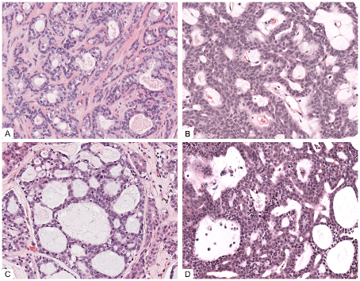
Figure ‎1.1: Four salivary gland tumours showing a similar cribriform appearance. A- Pleomorphic adenoma (benign), B- Basal cell adenoma (benign), C- Adenoid cystic carcinoma (malignant- poor prognosis), D- Polymorphous adenocarcinoma (malignant- good prognosis). Magnification 20x. Images obtained from archived cases for the purpose of this thesis.
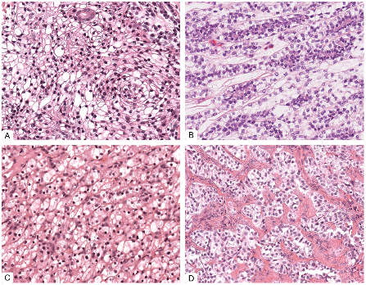
Figure ‎1.2: Four different malignant salivary gland tumours showing a similar clear cell appearance. A-Mucoepidermoid carcinoma, B-Epithelial–myoepithelial carcinoma (EMC), C- Acinic cell carcinoma, D- Clear cell carcinoma. Magnification 20x. Images obtained from archived cases for the purpose of this thesis.
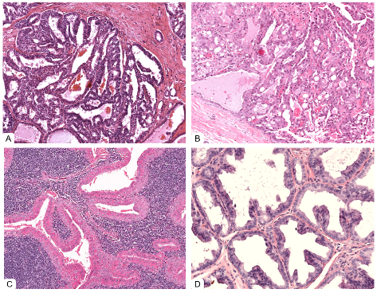
Figure ‎1.3: Four salivary gland tumours showing a similar papillary cystic appearance. A- Acinic cell carcinoma (malignant), B- Secretory carcinoma (malignant), C- Warthin's tumour (benign), D- Cystadenoma (benign). Magnification 20x. Images obtained from archived cases for the purpose of this thesis.
Although haematoxylin and eosin (H&E) is the most prevalent method of diagnosis, immunohistochemistry (IHC) can aid in the identification of different cell and tumour subtypes for a more accurate diagnosis. Salivary glands comprise four different types of cells: ductal, myoepithelial, basal, and acinar cells. The luminal cells (ductal and acinar cells) are luminal-facing cells, whereas the myoepithelial and basal cells are found adjacent to the basement membrane (and are called abluminal cells as they surround the luminal cells). All of these cell types can give rise to tumours. IHC can help distinguish between these cell types to establish a tumour’s origin, as well as identify proliferation status and tumour-specific proteins, all of which can aid in diagnosis. However, many stains may be required, in addition to expertise in interpretation, as most markers are not exclusive to SGT, making it vital to have the correct context and knowledge. The most common IHC tests performed in the diagnosis of SGT are shown in Table ‎1.2 (Khurram et al., 2017, Speight and Barrett, 2020).
Table ‎1.2: IHC markers for diagnosing salivary gland tumours (Khurram et al., 2017, Speight and Barrett, 2020).
Antibodies | Target | Diagnostic utility
SMA, CK 14, Calponin, p63, p40 | Myoepithelial cells | Identification of myoepithelial cells in PA, EMC, AdCC vs PAC, BCA vs CA
CK 7 (+), CK 20 (-) | Presence of salivary tissue, luminal cells when multiple populations present | Confirm salivary tissue origin
PLAG1 | PLAG1 protein | PA in small biopsies and Ca ex PA
GFAP | Glial fibrillary acidic protein | Useful marker for PA especially in myxoid areas
DOG-1 | Differentiation of ACC from  SC | Luminal aspect of acini and small ducts. ACC (+) , SC (-)
Mammaglobin | Differentiation of ACC from  SC | ACC (-) , SC (+)
CD117 | c-KIT (a tyrosine kinase) | 80% of AdCC cases are positive however it is now considered non-specific as expression has been shown in a range of tumours
Androgen receptor | Transcription factor | Expressed in SPA, intraductal, sebaceous lesions and 98% of SDC (Williams et al., 2015, Bishop et al., 2020, Thompson and Bishop, 2022)
Ki 67 | Cell cycle marker (G1,G2,S,&M) | Indicator of malignancy and proliferation
MCM2 | Cell cycle marker (G1,G2,&S) | Expressed >10% in AdCC but <10% in PA and PAC.
SOX-10 | Cells derived from neural  crest | Similar distribution to DOG-1 in ACC. Can also be useful as a myoepithelial marker.
S100 | Myoepithelial cell marker (Non-specific) | SC and PAC are strong and diffusely positive and negative or weak and patchy in ACC and AdCC.
Pan-TrRK | Presence of NTRK fusion protein | Positive in SC
MYB protein | Presence of MYB-NFIB fusion | 65% of AdCC are positive
HER2 | Membrane tyrosine kinase | Positive in 30% of SDC and high-grade intraductal carcinoma

For some tumours, molecular and genetic changes can also be used as diagnostic biomarkers. Over the last decade, our understanding of the genetic landscape of SGT has vastly improved, with a plethora of assays now accessible to aid diagnosis. To aid diagnosis and tumour subtyping, molecular methods such as fluorescent in situ hybridisation (FISH), polymerase chain reaction (PCR), and next-generation sequencing (NGS) can be employed in conjunction with H&E and IHC. However, even in developed countries, these tests are quite expensive and have limited availability. Even when available, there can be a 2-3-week delay in diagnosis due to the transport of material, laboratory processing times and further analysis.
The most prevalent molecular markers utilised in the diagnosis of malignant salivary gland tumours are listed in Table ‎1.3 (Khurram et al., 2017, El-Naggar et al., 2017, Skálová et al., 2022, Speight and Barrett, 2020, Andreasen et al., 2019).

Table ‎1.3: Common molecular and genetic changes in salivary gland tumours (Khurram et al., 2017, El-Naggar et al., 2017, Skálová et al., 2022, Speight and Barrett, 2020, Andreasen et al., 2019).(PLGA1:Polylactic acid-co-glycolic acid 1,HMGA2: High mobility group AT-hook 2,PIK3CA:Phosphatidylinositol-4,5-bisphosphate 3-kinase catalytic subunit alpha,CRTC1-MAML2:CREB-regulated transcription coactivator 1-mastersmind-like transcriptional coactivator 2,ETV6::NTRK3:ETS variant 6-neurotrophic receptor tyrosine kinase 3,EWSR1-ATF1:EWS RNA-binding protein 1-activating transcription factor 1,MYB-NFIB:Myeloblastosis oncogene neurofibromin 1 (NF1) type II collagene fusion protein,NR4A3:Nuclear receptor subfamily 4 group A member 3,PRKD1-3:Protein kinase D1-D3,MEF2C-SS18: Myocyte enhancer factor 2C-synovial sarcoma translocation gene on chromosome 18,AKT1 E17K:v-akt murine thymoma viral oncogene homolog 1 E17K variant,RET:Rearranged during transfection proto-oncogene,HRAS:Harvey rat sarcoma viral oncogene homolog,HER-2/neu:Human epidermal growth factor receptor 2/neu).
Tumour type | Gene marker | Feature
Pleomorphic adenoma, Ca ex PA | PLGA 1 ,HMGA2 | Fusions/amplification
Sclerosing polycystic adenoma | PIK3CA | Mutation
Mucoepidermoid Carcinoma | CRTC1-MAML2 | Translocation
Secretory Carcinoma | ETV6::NTRK3 | Fusion
Clear cell carcinoma | EWRS1-ATF1 | Fusion
Adenoid Cystic Carcinoma | MYB-NFIB | Fusion/activation/amplification
Acinic Cell Carcinoma | NR4A3 | Fusion/activation
Cribriform adenocarcinoma | PRKD 1-3 | Rearrangements
Microsecretory adenocarcinoma | MEF2C-SS18 | Fusion
Mucinous adenocarcinoma | AKT1 E17K | Mutation
Intraductal carcinoma | RET | Fusion
Epithelial-myoepithelial carcinoma | HRAS | Mutation
Salivary Duct Carcinoma | HER-2/neu | Amplification

Despite the tests indicated above, arriving at a specific or correct diagnosis is still challenging due to the lack of availability, high cost of these tests and in some cases limited material availability/cellularity or failure of tests on paraffin embedded sections. Even some of the IHC tests considered routine in the West are not available in low and middle-income (LMIC) countries. Furthermore, there is a substantial time and cost delay because of expensive reagents, physical transport of slides and tissue blocks to expert centres and a second or third opinion. The interpretation of the IHC results is another challenge as only pathologists diagnosing and reporting SGT routinely are best placed to assess the relevance and useful of results due to lack of any markers exclusive to SGT.
Recent advances in digital pathology have the potential to overcome some of these challenges by allowing faster and remote case sharing, discussion, and diagnosis (Al‐Janabi et al., 2012, Zarella et al., 2019).

Digital pathology

Introduction
Digital pathology is the process of using a whole slide image (WSI) scanner to digitise glass slides and using appropriate viewing software to analyse the digital images. Digital slides have become a practical choice for studies, education, and remote consultation since 1998, when faster computers, memory storage devices, and processing speeds became available (Rocha et al., 2009). The United States' Food and Drug Administration (FDA) first approved a WSI scanner for primary diagnosis in 2016 which has led to the acceleration of the use of digital pathology throughout the developed world (Williams et al., 2017, Cross et al., 2018).
Digital pathology has been shown to be cost-effective, safe, and successful in enhancing diagnostic services by reducing waste and optimising efficiency. Pathology services worldwide are suffering from a shortage of workers and growing demand, stressing the need for automation, digitisation and flexible reporting to improve efficiency. Staff overtime and outsourcing are likely to be used to address this shortage, however it increases costs and delays diagnosis. An investment in digital pathology infrastructure can increase efficiency and in the long term lower costs for the pathology workforce. For example, the United States is experiencing a significant workforce shortage with the number of pathologists dropping from 5.7 to 3.7 per 100,000 people. Likewise, the Royal College of Pathologists in the United Kingdom estimates that 32% of pathologists over 55 will retire in the next few years (Williams et al., 2017). The value of digital pathology was highlighted during the recent Covid-19 epidemic, where it proved to be a lifeline in keeping pathology facilities operational during this time of crisis in many centres (Hanna et al., 2020).Most importantly, acquisition of digital images has opened up the possibility of application of computer vision, image analysis and AI techniques to pathology.

The digitisation process

Whole slide image (WSI)
A WSI is created by "capturing images of adjacent areas from glass slides, either as tiles or stripes, using a high-resolution camera coupled with one or more high-quality microscope objectives, followed by using specialised software that combines these individual images to produce a single virtual image" (Gilbertson et al., 2006).
WSI diagnosis has been shown to be at par with traditional glass slides in numerous investigations. For example, a large validation study on 3,017 cases found that diagnosis on digital slides was non-inferior to that of a light microscope, with some added benefits (Snead et al., 2016). Digital pathology was also reported to be non-inferior in 2,000 cases reported in four institutions by four pathologists, with minor discordance between WSI and traditional microscopy (Mukhopadhyay et al., 2018). Digital pathology is currently utilised for primary diagnosis in most hospitals in Sweden and Canada, but its application in Europe and North America is still limited (Goacher et al., 2017).
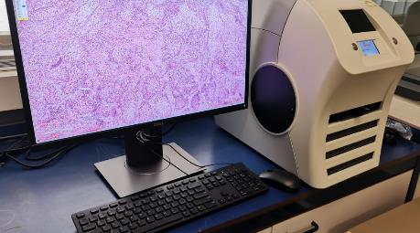
The digitisation process and producing a WSI consists of four primary steps: image acquisition (scanning), storage, adjustment, and image viewing (Zarella et al., 2019). There are many different types of scanners on the market; some can only load and scan one slide every cycle, while others can load up to 1000 slides at once (more applicable to high-yield pathology laboratories) (Al‐Janabi et al., 2012). Figure ‎1.4 depicts the digital pathology research and teaching setup at the Unit of Oral and Maxillofacial Pathology in Sheffield.
Figure ‎1.4: The digital pathology slide scanning set up in Sheffield, including a PC coupled to x5 slide Leica CS2 slide scanner.
Acquired images can be saved on a local hard drive, cloud-based storage or a dedicated server. The latter is the most appropriate option for large datasets needing image sharing with a large number of users and collaborators (Zarella et al., 2019). Most WSI providers have proprietary file formats (i.e. svs for Leica, ndpi for Hamamatsu, isyntax for Philips etc.) which makes embedding into clinical pathology workflows, image viewing and analysis challenging. However, numerous groups have now developed open source tools to support various formats such as OpenSlide (Goode et al., 2013), OMERO (Moore et al., 2015) and SlideJ (Della Mea et al., 2017) or conversion of images to a different format.

Advantages and shortcomings of digital pathology
The fundamental advantage is that slides can be accessed digitally and remotely from home or any other location, allowing flexibility (Zarella et al., 2019). In addition to building teaching resources of unusual and challenging cases, it allows pathologists to rapidly share and receive second opinions from other pathologists locally or abroad. Using a traditional light microscope to evaluate IHC stains is a subjective process involving eyeballing cells and giving approximate measurements, leading to inconsistency and variations among pathologists. Digital pathology can make it easier to quantify features such as number of cells, distance from margins, depth of invasion, and tumour size even on H&E section allowing for easier, faster, more consistent and objective measurements, improving the pathologists’ efficiency (Williams et al., 2017). Implementing digital pathology can also reduce costs and expenses in the long term, such as packing, shipping, transportation of glass slides, microscopic maintenance and upgrades, as well as the staff and space resources required for archiving glass slides (Williams et al., 2017, Zarella et al., 2019).
Glass slide breakage and tissue staining fading or deterioration are common problems in pathology archives. Digital pathology preserves the quality of the slides by digitally immortalising them. It also helps pathologists and laboratory workers track and retrieve cases more quickly. Useful features embedded in some digital pathology systems can flag and tag urgent cases to the top of a pathologist's worklist (Williams et al., 2017). Furthermore, traditional microscopy puts pathologists at risk for muscle (neck, shoulder, and back) and repetitive strain injuries. The ergonomic advantage of using digital slides is that one can report in a comfortable, neutral position without having to extend the neck (George, 2010).
Digital pathology also allows simultaneous examination of slides, such as H&E and IHC side by side allowing for rapid and accurate diagnosis and better context (Al‐Janabi et al., 2012). Additionally, many institutions worldwide nowadays teach pathology and histology with digital slides. Students can access the slides on computers, tablets, or smartphones, enhancing their engagement and interest. Digital slides reduce the need for microscopes, tissue sections, and instructors for practical session demonstrations, making it easier for instructors and students to work collaboratively. Most undergraduate dentistry students agree that digital slides are easy to view and have excellent image quality (Brierley et al., 2017). Another study found that nearly all second-year dentistry students (98%) thought digital microscopy enhanced their learning, with 92% preferring digital slides to traditional glass slides (McCready and Jham, 2013).
Despite the numerous advantages, there are also challenges associated with use and implementation of digital pathology. These include the lack of an internationally agreed and standardised image format. The lack of scanner compatibility can significantly limit the outputs as some scanner vendors (such as Philips) are significantly restrictive. Digital imaging and communication in medicine (DICOM), has become the international file standard in digital radiology, making it easier to examine and analyse images but this has not been implemented in pathology to date. Furthermore, digital pathology services are expensive to introduce and implement because they require qualified employees, training, technical support, and the initial investment in acquisition of scanners and other equipment. Since WSI file size can range from 500 Mb to 2 GB on average, the scanned files requires dedicated servers, storage, and fibre optic internet speed (Romero Lauro et al., 2013). Integration into existing clinical workflows can be difficult particularly since healthcare providers such as the NHS have limited bandwidth, numerous firewalls and security measures in place which vary between hospitals requiring bespoke solutions for most places. Furthermore, despite being FDA approved and being CE and UKCA marked, local validation and pathologist training for each speciality need to be carried out in a phased manner requiring a significant amount of time and effort.
Moreover, access to a patient's database in a digital pathology system may enhance the likelihood that hackers will breach some of the hospital's confidential data (if not maintained and updated regularly). During the adoption of digital pathology, ethical issues involving the storage of personal data, the protection of patient privacy, and the exchange of information must be considered (Atac et al., 2013). In addition, artefacts linked with WSI are an issue that is encountered frequently. Pre-scanning problems such as improper tissue placement (folding, compressing, air bubbles), improper staining (over- or under-staining), and inappropriate microtomy (thickness variances), as well as scanner-generated blurriness, lighting, and contrast issues, can cause significant variation in tissue slide quality. Janowczyk et al. 2019 created an open-source quality control application (HistoQC) that can detect slides that must be replicated or parts that should be avoided during computational analysis (Janowczyk et al., 2019).
Some difficulties associated with scanning bone and tooth specimens are due to the fact that they are made up of both very thick and mineralized hard tissues which are sometimes impossible to scan or thinner sections need to be cut to allow the scanning process. Also, the ground section of non-decalcified tooth needs to be viewed by polarized light through a filter which most conventional scanners lack. Furthermore, conventional scanners are incapable of scanning both brightfield and fluorescence images, necessitating the use of Fluorescence Illumination Optics microscopes or scanners.

Artificial Intelligence (AI)

Introduction
Digital pathology and the capacity to digitise to obtain WSI have contributed to the field of computational pathology, which uses artificial intelligence (AI) and machine learning for the study of subvisual morphometric aspects with substantial potential to enhance patient care (Bera et al., 2019). AI is a broad phrase that refers to a discipline of computer science in which computers may simulate human brain judgement by predicting behaviour or outcomes. John McCarthy was the first to formulate the phrase artificial intelligence (AI) in the 1950s and made a substantial contribution to AI's early development (Hamet and Tremblay, 2017). Machine learning (ML) is a branch of AI that involves learning from data in order to generate a prediction.
There has been a significant increase in the number of studies exploring artificial intelligence (AI) in medicine and healthcare. Numerous AI/ML-based medical devices and algorithms have been approved by the FDA, which include several medical specialities such as radiology, oncology, ophthalmology and general medical decision-making (Benjamens et al., 2020). The Ibex trial (using the GALEN software) is one of the significant studies getting the initial deployment of AI technology in pathology with a clinical focus on prostate cancer detection and grading (Pantanowitz et al., 2020). In the UK, six National Health Service (NHS) trusts in England have already implemented this AI model in their pathology workflows. Furthermore, FDA recently have approved another AI platform (paige.ai) to aid pathologists in detecting prostate cancer and performing clinical grading (Perincheri et al., 2021, Campanella et al., 2019).
The European Union's performance review of the AI product is generally divided into three categories. First, scientific validity needs to be met with a valid link between the algorithm's output and the targeted clinical condition. Second, the algorithm should produce accurate and reliable results. Third, algorithms must produce results that are clinically relevant and appropriate for the targeted group (Homeyer et al., 2021). A number of computational pathology algorithms have been approved and certified for clinical use. These include Panakeia’s PANProfiler breast cancer detection tool to predict biomarker status from digitally scanned breast cancer tissue samples. This technology has both UKCA and CE approval as an in vitro diagnostic device (IVD). Moreover, Histotype Px Colorectal, a deep learning method that uses digital histology image analysis to predict prognosis in colorectal cancer has also obtained CE-IVD approval (Skrede et al., 2020). In prostate cancer, HALO Prostate AI, a deep learning-based screening tool developed to assist pathologists identify and grade cancers in core needle biopsies, has also been granted the CE-IVD approval (Acs et al., 2020).
Deep learning (DL) is a relatively new method of ML that involves the use of numerous layers of convolutional neural networks (CNN). These neural networks have an input layer, an output layer, and various layers in between, allowing more complex decision-making and pattern recognition tasks (Figure ‎1.5).
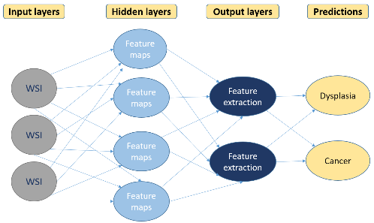
Figure ‎1.5: Deep learning models pipeline, including input, output and hidden neural network layers .This illustration was made for purpose of this thesis using Microsoft Powerpoint.
A neural network is a collection of algorithms that simulate the brain's neural network system in order to recognise patterns in input data (Mahmood et al., 2020). One issue with neural networks is that although the input and output data are available, it is difficult for an observer to understand what occurs in the layers in between and the detailed steps on how such models make a decision (Cohen, 2020).

Types of AI algorithms
Training for machine learning algorithms are divided broadly into two categories. In unsupervised learning, the machine (computer) is able to discover hidden patterns in input data without any prior knowledge or training; however, this requires a massive amount of data for the algorithms to analyse and identify the differences independently. In supervised learning, a machine attempts to classify data based on previously known input and output, such as histology slide diagnostic annotations (carried out by a human). Although this is more tedious with regard to the provision of labelled/annotated data, it is the optimal method to use with smaller datasets striking a balance between the cohort size and prediction accuracy (Zarella et al., 2019, Hamet and Tremblay, 2017, Mahmood et al., 2020).
Often ML models are referred to as "shallow learning" due to the lack of a large number of layers (or the ‘depth’ of a model). In the simplest case, there are two classes of objects in the training set, and the programme must build a model from this data that will allow it to predict the class of an unknown example. DL and CNNs have the advantage of being able to extract their own features directly from data (feature learning), whereas shallow learning (ML) requires the programmer to create the feature set explicitly (feature engineering). Another benefit of DL is that it may be used for reinforcement learning, which involves the algorithm learning how to react to an environment by maximising a reward function (Cohen, 2020).

Approaches and techniques
In supervised machine learning, detection, segmentation, classification, and path extraction/tessellation are popular approaches. Detection involves identifying and locating an object within an image. Classification includes dividing a set of data into groups according to specific features. Segmentation involves segregating WSIs into smaller areas of interest and combining data into distinct groups (Mahmood et al., 2020). Among these approaches are segmenting benign versus malignant tumours, subtyping and grading. Due to the large size and high dimensionality of WSIs, the majority of approaches for training AI models on WSIs do not use the entire images as input; instead, they are divided into regions of interest, and then deconstructed into smaller image patches for training, subsequently reassembled after achieving a prediction or outcome. Figure ‎1.6 highlights the steps and workflow of common AI (ML/DL) models in computational pathology.
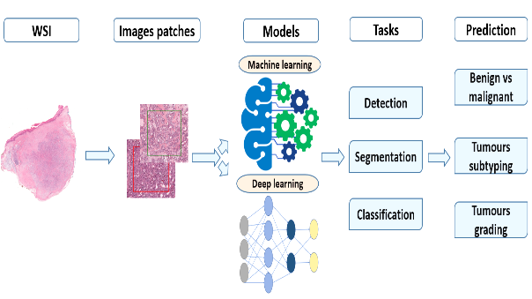
Figure ‎1.6: Overview of the workflow of ML/DL models in computational pathology. This illustration was made for purpose of this thesis using Microsoft Powerpoint.
Multiple software packages (e.g. QuPath, Cytomine, Orbit, etc.) depend largely on ML techniques to perform tasks such as detection, quantification, segmentation, and classification. (QuPath) is an open-source software for bioimage analysis; it is free to download, works with most operating systems and supports the most commonly used image formats. It also allows users to train on their own datasets and create ML algorithms for automated detection, classification and segmentation (Bankhead et al., 2017). It is also the most widely used platform of its kind with a well-managed and maintained online repository and support group for help and trouble shooting.
Several Python packages, such as CLAM (Lu et al., 2021b), and TIAToolbox (Pocock et al., 2022), make it somewhat easier for researchers with a non-computer science background to implement complete workflows. However, at the present time, these pipelines are only available for use in research and still require significant coding know-how.

Training methods

Machine learning methods
Various ML training methods, such as clustering, watershed, and Otsu, are utilised for unsupervised learning. Cluster analysis is an unsupervised task that tries to divide unlabelled data samples into groups of similar data based on how similar they are thought to be (Fouad et al., 2017). Watershed segmentation is a technique that uses image morphology to segment regions. It necessitates the selection of at least one internal marker ("seed" point) for each image item, including the background as a separate object (Digabel and Lantuéjoul, 1978, Levner and Zhang, 2007). Otsu's method uses the weighted difference between the pixels in the foreground and background to find the threshold value where the difference is the smallest. The main concept is to run through all threshold settings and measure the spread of background and foreground pixels (Otsu, 1979, Huang et al., 2012).
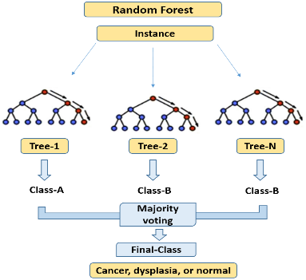
On the other hand, supervised learning uses other training methods, including Decision Trees, Random Forests (RF), K-Nearest Neighbour (KNN), Support Vector Model (SVM), Bayesian classifiers, and Neural Networks. In the decision tree, the "root" is a treelike graph that depicts a flowchart-like structure, and an attribute or group of attributes is represented by a node in the tree. The final node is a "leaf" that symbolises a class label, and each branch from the node indicates the test's conclusion. A given dataset can be used to build decision trees in a variety of ways, including (a) utilising distinct subsets of the data for separate trees, (b) using alternative decision criteria, (c) limiting the depth of each tree, and so on (Cohen, 2020, Quinlan, 1986). A Random Forest (RF) is a collection of numerous decision trees, with final output values determined by a majority vote or some other consensus criterion (Cohen, 2020). RF is a group of tree predictors that are put together in such a way that the values of each tree depend on the values of a vector that is picked at random and has the same distribution for each tree in the forest (Breiman, 2001). Figure ‎1.7 illustrates the decision process in RF models.
Figure ‎1.7: Schematic diagram showing a Random Forest model and it is decision trees. This illustration was made for purpose of this thesis using Microsoft Powerpoint.

The K-nearest neighbour (KNN) method simply takes the majority of numerous (K) nearest neighbours rather than one or uses an average or weighted average (Cohen, 2020). The Support Vector Model (SVM) uses the training image to learn a set of features that help it find a hyperplane that divides the training images into two classes. The test images are then classified using the same set of rules (Suykens and Vandewalle, 2000, Begg et al., 2005). Bayesian classifiers use the Bayes rules to calculate the likelihood of an input sample belonging to a specific class, with the final label allocated to the most probable class for the given input image (Rish, 2001, Unal and Kocer, 2013). Neural Network approaches acquire the representation of the training images using gradient descent-based learning. These approaches require significantly larger training datasets than others (Rao, 2000, Yu et al., 2011).

Neural networks and deep learning methods
Artificial neural networks (ANN) and convolutional neural networks (CNN) are both forms of neural networks that may be used to classify things into a variety of different categories (Bera et al., 2019). ANN learns the appropriate weights using a gradient-descent process based on the error back-propagation algorithm and the training set (Backprop). Backpropagation is one of the reasons why DL training sets must be large. In contrast, CNN defined as a subset of neural networks that combine the information from nearby pixels using mathematical operations (Shmatko et al., 2022). It uses feature extraction filters on the original image to shift from low-level to high-level feature maps. CNN has demonstrated their superiority over ANN in a variety of computer vision applications, including image classification, segmentation, and object detection (Cohen, 2020, Hong and Fenyö, 2022).
Visual and speech recognition, object detection, medication discovery, and genomics are just a few of the technological and industrial elements that DL has enhanced (LeCun et al., 2015). The use of digital pathology and artificial intelligence (AI) has sparked a lot of interest in technological research and development. Since the 1950s, historical events in computational pathology have been summarised in Figure ‎1.8.
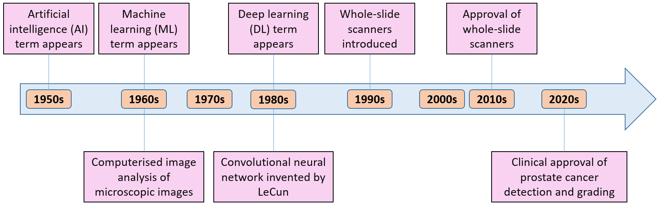
Figure ‎1.8: Milestones in computational pathology. This illustration was made for purpose of this thesis using Microsoft Powerpoint.

Evolution of DL models
Research in DL has grown exponentially in recent years, with numerous studies employing diverse approaches and strategies to reach state-of-the-art performance. LeCun et al.1998 introduced the first modern CNN architecture in 1998. This six-layer convolutional neural network demonstrated an ability to recognise handwritten digits and symbols (LeCun et al., 1998). However, for over a decade, the development of CNNs was hampered by limited processing capabilities and resources. The rapid growth of computational hardware, particularly graphics processing units (GPUs), enables the development of deep neural networks. Various CNN architectures, including AlexNet (Krizhevsky et al., 2012), VGG (Simonyan and Zisserman, 2014), InceptionNet (Szegedy et al., 2015), GoogLeNet (Szegedy et al., 2015), Graph neural networks (GNNs) (Zhou et al., 2020), Generative adversarial networks (GANs) (Yi et al., 2019), U-net (Ronneberger et al., 2015), Efficientnet (Tan and Le, 2019) and ResNet (He et al., 2016), have been used for segmentation, classification and feature prediction in a wide range and different types of image datasets.

Algorithm performance assessment
There is a range of performance metrics that may be used to evaluate the effectiveness of the algorithms. Some of these metrics have been created for particular applications. Some metrics that are based on a threshold and a qualitative understanding of error are used when we want a model to minimise the number of errors. Other metrics are based on the model's performance when classifiers are used to select the best instances of a data set (Ferri et al., 2009). Among these metrics are accuracy, precision, recall, F1 score, Receiver Operating Curve (ROC), and Area under ROC (AUROC) that are the most commonly used in computational pathology.
Accuracy is defined as the degree of correct predictions of a model and is considered the most straightforward metric for analysing its effectiveness; nevertheless, it is inadequate when evaluating algorithms on unbalanced data (Wardhani et al., 2019). Precision is the number of true positives divided by the sum of true and false positives. The recall is the number of true positives by the sum of true positives and false negatives. The F1 score is twice the product of precision and recall divided by the sum of precision and recall. One of the reasons the F1 score is such a widely used metric is because it is the harmonic mean of both precision and recall and can express true model performance even when the dataset is unbalanced making it a well-rounded way of measuring of model performance (Wardhani et al., 2019, Ferri et al., 2009). An F1 score can be anywhere from 0 to 1, with 0 representing the worst possible score and 1 indicating that every output is accurately predicted by the model (100% accuracy). Model performance is judged to be excellent if it exceeds 0.90, good if it falls between 0.7 and 0.90, acceptable if it exceeds 0.50, and failure if it falls below 0.50 (Ferri et al., 2009, Lipton et al., 2014). The ROC curve is defined as a plot of test sensitivity as the y coordinate versus its 1-specificity or false positive rate (FPR) as the x coordinate. The AUC (area under the curve) estimates that a classifier will rank a randomly chosen positive case higher than a randomly chosen negative case (Park et al., 2004, Ferri et al., 2009, Wardhani et al., 2019). The confusion matrices at all threshold values are used to create the ROC curve, which summarises performance. AUC converts the ROC curve into a numerical measure and demonstrates the overall performance (Park et al., 2004). The following equations show the summary of how to calculate the abovementioned metrics.
Precision = True positive / true positive + false positive
Recall = True positive / true positive + false negative
F1 score = 2x (precision x recall/ precision + recall)
AUROC= (x-axis) 1 – specificity (= false positive fraction = FP/(FP+TN)), (y-axis) sensitivity (= true positive fraction = TP/(TP+FN)).
Chalkidou et al., 2022 have recommended a set of rules to evaluate the accuracy of an AI test set in order to assure compatibility and minimise bias. The test set population should be representative, independent, multicentre, images collected consecutively or randomly. In addition, the test set should only be used on limited number of times, and repeated testing should be explicit. Furthermore, the analysis of the test set must include the threshold at which assessments of accuracy are reported and formal sample size calculation should be shown (Chalkidou et al., 2022).
Multiple challenges have been organised by the computational pathology global community to tackle clinically important and relevant problems in pathology and to generate larger datasets. These challenges seek to unify all relevant data in the field of computational pathology onto a single platform for discussion about the best approaches for a certain problem. The following table highlights some of the grand challenges that tackle specific pathological tasks Table ‎1.4.

Table ‎1.4: The most crucial computational pathology grand challenges and best-reached accuracy/performance.
Challenge name | Task | Accuracy and reference
MITOSIS detection challenge by ICPR 2012 | Detection of mitosis in breast cancer | Best algorithm recall=0.70, precision=0.89 (Ludovic et al., 2013)
CAMELYON16 challenge by (DIAG) 2016 | Detection of cancer metastasis in digitized lymph node tissue | Best algorithm AUC= of 0.99 vs best pathologist AUC= 0.88 (Bejnordi et al., 2017)
HEROHE challenge by ECDP 2020 | Predict the HER2 status in breast cancer | Best algorithm AUC=0.88, F1 score=0.79 (Conde-Sousa et al., 2022)
MIDOG challenge by (MICCAI 2021) | Detecting and counting mitotic figures | Best algorithm F1 score=0.74 (Aubreville et al., 2022)
PANDA challenge by MICCAI 2020 | Grade assessment in prostate cancer | Best algorithm weighted agreements of 0.862 and 0.868 weighted k with expert uropathologists (Bulten et al., 2020)

One of the early research challenges was presented at the ICPR 2012 for the detection of mitosis in H&E stained breast cancer WSI. The best performing algorithm achieved a recall of 0.7 and a precision of 0.89 (Ludovic et al., 2013). A global AI-based initiative (The Camelyon Grand Challenge 2016) for automated identification of metastatic breast cancer in H&E slides of lymph nodes showed that the best performing algorithms achieved an AUC of 0.994 (in significantly shorter time) compared to 0.884 from a panel of 11 experienced pathologists (Bejnordi et al., 2017). Another challenge focussing on predicting the HER2 status in breast cancer based only on H&E tissue samples (HEROHE challenge 2020) showed an AUC of 0.88 and an F1 score of 0.79 for the best performing algorithm (Conde-Sousa et al., 2022). At the 2021 MIDOG challenge explored automated identification and counting of mitotic figures on H&E WSI with the best performing algorithm showing an F1 score of 0.74 (Aubreville et al., 2022).
PANDA was one of the largest histopathology competitions in prostate cancer, intending to accelerate the development of reliable AI algorithms for Gleason grading involving 10,616 WSI. The method was validated using a completely blinded internal and external cohort, and it achieved weighted agreements of 0.862 and 0.868 weighted k with expert uropathologists (Bulten et al., 2020). Some limitations of this study included ignoring grade group prediction at the patient level and relying on a single biopsy for each patient while in clinical practice, multiple biopsies are sampled from different regions of the prostate. However, all data were collected retrospectively, and general pathologist reviews were completed in a nonclinical context without any clinical data. Moreover, this study did not investigate the association between algorithm grading and clinical outcomes.
An obvious issue and shortcomings of these challenges is that the training data or the best performing algorithms are not publicly available for others to try and almost all of these are based on retrospective cohorts. Retrospective studies have the disadvantage of relying on previous data, which means that the quality of data can vary depending on how it was obtained and stored. Furthermore, they are frequently observational in nature, with no randomisation or blinding.

Applications of AI
AI has impacted healthcare, transportation, agriculture, education, entertainment, finance, astronomy, social media, and information security. In healthcare, studies show that AI algorithms can organise and categorise clinical data, such as demographics, medical notes, and clinical laboratory test results. Another excellent example of how AI may be applied in a healthcare setting is drug delivery systems (Hamet and Tremblay, 2017). Image analysis tools powered by AI automate and precisely quantify data, as well as supplement and merge multimodal data. In radiology, AI has demonstrated success in pattern recognition, quantitative analysis, and radiograph interpretation. It’s potential has also been explored in dentistry with reports of DL model that can segment caries, bone recession, and radiolucencies on dental radiographs (Khan et al., 2021).

Computational pathology
Before the development of WSI, the area of pathology image analysis was constrained and dependent on the pathologist's subjective analysis of selected regions. With the advent of microscope camera, photography and software tools (such as ImageJ (Rasband et al., 1997) etc.), it became possible to analyse digital static images of representative areas. However, the developments in digital pathology have ushered in a new era of research. Scanning slides as WSI allows the acquisition of very high-resolution images (multi-gigapixel) and opens up avenues for the application of image analysis, computer vision and machine learning techniques commonly used for other types of images. However, WSI are quite different because of the sheer size of the image and the information they contain; therefore, the application of algorithms directly to a WSI is impractical despite computing advances. Current practice involves ‘training/teaching of features’ at the WSI level (training set), followed by splitting the entire WSI into smaller tiles (or patches) which are fed into the algorithms, processed and initial predictions made at the patch level. This is followed by ‘reconstruction/stitching back’ of all the patches to recreate a WSI-level prediction; significantly reducing the computing time (Vu et al., 2019). The ‘testing’ and ‘validation’ sets comprise unseen cases in which the performance and accuracy of the algorithms are assessed.
The application of ML and DL has been investigated in a vast number of studies for the purpose of overcoming subjectivity, improving accuracy, or accelerating the diagnostic and prognostic processes for multiple pathological challenging topics (Pell et al., 2019, Ayyad et al., 2021, Shmatko et al., 2022). In the following section, studies with the most significant impact on the field of computational pathology are highlighted Table ‎1.5.
Table ‎1.5: Summary of relevant studies in computational pathology across different tissues.
Publications | Task | Method | Performance
Breast cancer
(Bejnordi et al., 2017) | Detecting cancer metastasis | Several ML/DL methods | AUC= 0.994
(Ehteshami Bejnordi et al., 2018) | Classifying benign and malignant biopsies | DL (CNN) | AUC= 0.962
(Trahearn et al., 2017) | Automated scoring of (ER/PR) | DL (CNN) | Accuracy= 90% for ER and 80% of PR
(Qaiser et al., 2018) | Automated HER2 scoring | DL (CNN) | Near to maximum
Prostate cancer
(Litjens et al., 2016) | Automated cancer detection | DL (CNN) | AUC =0.99
(Li et al., 2018) | Detection of epithelial cells and Gleason grading of tumours | DL (CNN) | Accuracy= 99.07% (epithelial detection), 89.40% (grading)
(Pantanowitz et al., 2020) | Cancer identification, Gleason grading and PNI detection | DL (CNN) | AUC= 0.99 (detection), 0.94 (grading), 0.95 (PNI detection)
Lung cancer

(Coudray et al., 2018) | Classification of normal lung, lung adenocarcinoma (LUAD) and squamous cell carcinoma (LUSC) and predict molecular profile | DL (CNN) | AUC= 0.97 (classification) and AUC= 0.733 to 0.856 (molecular prediction)
Gastric cancer
(Yoon et al., 2019) | Detection of tumour | DL (CNN) | Accuracy = 93.48%
(Shaban et al., 2020) | Grading of colorectal cancer | DL (CNN) | Accuracy= 95.70%
Molecular status prediction
(Kather et al., 2019a) | Prediction of microsatellite instability (MSI) in patients with gastrointestinal cancer | DL (CNN) | AUC= 0.69 to 0.84
(Kather et al., 2020) | Prediction of molecular genetic changes in solid tumours | DL (CNN) | AUROC= 0.89
Other cancers
(Niazi et al., 2018) | Distinguish Pancreatic  Neuroendocrine tumour (NET)  and non-tumour regions on Ki67 | DL (CNN) | Sensitivity= 97.8%
(Wu et al., 2018) | Classifying different ovarian cancer types | DL (CNN) | Accuracy =78.20%
(Kulkarni et al., 2020) | Prediction of prognosis in early-stage melanoma | DL (CNN) | AUC= 0.880 to 0.905
(Campanella et al., 2019) | Detection of the prostate, breast cancers, and basal cell carcinoma (Skin) | Multiple instances  Learning (MIL) | AUC= > 0.98
(Lu et al., 2021a) | Identification of tumour with an unknown primary origin | DL (CNN) | Accuracy= 83%
- Head and neck pre-cancer/dysplasia
(Baik et al., 2014) | Classification of precancerous lesions into low and high-risk | ML (Random forest) | Sensitivity= 78%, specificity= 71%
(Muthu Rama Krishnan et al., 2012) | Classification of normal and oral submucous fibrosis tissue | ML (Support vector machine) | Accuracy= 88.69%
(Das et al., 2018) | Segmentation of epithelial, sub- epithelial, and keratin  layers in OSCC and detection of keratin pearls | ML (Random forest) | Accuracy = 96.88%
- Head and neck cancer
(Rahman et al., 2018) | Classification of normal epithelium and OSCC | ML (support vector machine) | Accuracy= 100%
(Kather et al., 2019b) | Detection of HPV in head and neck cancer | DL (CNN) | AUC= 0.89
(Shaban et al., 2019) | Quantify the abundance of immune cells (TILs) | DL (CNN) | Accuracy= 96.31%
(Shaban et al., 2022) | Segmentation of tumour, tumour-associated stroma, and lymphocytes | DL (CNN) | Accuracy= 85%, F1 score= 0.83

Breast cancer
Mercan et al., 2019 trained a deep CNN model on images from 240 breast cases to identify between normal tissue, atypia, ductal carcinoma in situ (DCIS), and invasive malignancy. The consensus report of three pathologists was employed as the ground truth, and the DL performance was compared to 87 participating pathologists. The algorithm using tissue distribution features reached an excellent accuracy of 94% and sensitivity of 70%, comparable to pathologists' (98%,84% respectively) for invasive vs non-invasive classification. For the benign vs atypia classification, the algorithm achieved reasonable accuracy (70%) and sensitivity (79%) comparable to the pathologists (accuracy-81%, sensitivity-72%). For the DCIS vs atypia task the algorithm showed accuracy and sensitivity of 83% and 88% respectively which was slightly better than the pathologists (80% accuracy and70% sensitivity) (Mercan et al., 2019). Although this algorithm achieved good results, lacking clinical data that could be utilised to make a diagnosis is one of the study's drawbacks. In addition, the analysis was conducted using small region of interests (ROIs) rather than at the WSI level.
Prostate cancer
Prostate cancer is the second most common cancer among males and the fifth most significant cause of cancer death (Sung et al., 2021). The Gleason grading provides crucial prognostic data and guides the treatment of prostate cancer. Strom et al., 2019 collected 6682 prostate biopsy images to construct CNN models to detect the presence of prostate cancer and assign a Gleason grade. The algorithm achieved an AUC of 0.99 for cancer detection, with a comparable accuracy to a pathologist (Ström et al., 2019). Despite excellent performance, all biopsies in this study were graded by a single pathologist, which increased the possibility of bias in the dataset.
Ibex is one of the primary studies receiving the first rollout of clinical-grade using AI technologies. The algorithm enabled slide-level cancer identification, Gleason grading, and perineural invasion (PNI) detection. The algorithm obtained an AUC of 0.99 in both internal and external test/validation sets for cancer detection, 0.95 for PNI detection, and 0.94 for differentiating grades (Pantanowitz et al., 2020) and is currently being used by a large number of hospitals across the world. This trial has proven that AI can be used effectively to detect, grades, and evaluates clinically relevant findings in prostate cancer.
Lung cancer
Lung cancer is the second most common type of cancer and the leading cause of death from cancer. The two most common types of non-small cell lung cancer are lung adenocarcinoma (LUAD) and lung squamous cell carcinoma (LUSC). Coudray et al., 2018 used a CNN to classify 1634 WSIs of lung cancer as normal lung, LUAD, or LUSC. The model differentiated between them with excellent performance, comparable to that of a pathologist with an AUC of 0.97.
Additionally, the CNN model was able to predict mutations in six lung cancer-related genes (KRAS, FAT1, TP53, SETBP1, EGFR, and STK11) with an AUC range between 0.733 and 0.856 at the slide level (Coudray et al., 2018). This study relies on the cancer genome atlas (TCGA) cohort to train the model which may not truly reflect the diversity and heterogeneity of tissues examined by pathologists in different geographical locations. In addition, the model does not specify the particular features used to detect mutations.
Gastric and colonic cancer
Gastric cancer is the fifth most prevalent type of cancer and the fourth cause of cancer-related death worldwide (Sung et al., 2021). Leon et al., 2019 classify benign or malignant gastric tumours with 89.72 % accuracy using a deep convolutional neural network (Leon et al., 2019). The critique for this study is that there is a relatively small sample size, and there was no cross-validation with an independent cohort.
Yoon et al., 2018 proposed an algorithm for the automatic detection of colonic cancer by deploying a deep convolutional neural network. The results showed excellent accuracy of 93.48%. Although this study produced outstanding findings, there is yet an opportunity for improvement by increasing the sample size and implementing an algorithm with localisation of class or grade (Yoon et al., 2019).
Molecular status prediction
The adoption of molecular biology assays into clinical practice is hampered by the fact that they are costly and time-consuming. H&E-stained WSI analysis could be used to quantify the expression levels of specific genes, which would help with patient diagnosis and survival outcomes (Schmauch et al., 2020). Schmauch et al. 2020 developed a deep-learning algorithm customised explicitly for predicting gene expression across multiple cancer types from WSI using heatmaps for spatial visualisation (Schmauch et al., 2020). Furthermore, Chen et al. 2022 used multimodal deep learning to examine whole-slide images and molecular profile data from 14 cancer types. The finding showed a good overall performance of 0.66 AUC for the algorithm in determining prognostic features that correlate with poor and favourable outcomes (Chen et al., 2022). However, in some cancer types, the stroma and other morphological regions frequently received greater algorithmic attention than tumour regions.
Other cancers
A deep learning framework based on multiple instance learning was recently reported by Campanella et al., 2019 to identify different types of cancers. The models were trained and validated using a large data set, which included 9894 slides from breast metastases to lymph nodes, 9962 skin slides, and 24,859 slides from prostate core biopsies. For all cancer types, the performance in detecting breast cancer in lymph nodes, basal cell carcinoma, and prostate cancer attained an AUC greater than 0.98. From a clinical standpoint, these models would enable pathologists to exclude 65–75% of slides in routine practice (with 100% sensitivity) improving efficiency (Campanella et al., 2019).
Head and neck
- Pre-cancer dysplasia
Oral potentially malignant disorders (OPMDs) have a statistically elevated chance of progression to cancer, but this risk varies based on various related variables. It is challenging to forecast the risk of progression in a specific patient, and the treatment offered by the physician are based on the evaluation of each case. Histologic analysis and biopsy are the best diagnostics practices. Oral epithelial dysplasia (OED) is characterised by cytologic atypia and altered epithelial architecture (Speight et al., 2018). Krishnan et al., 2012 created a texture-based approach to segment oral submucous fibrosis (OSF) tissue from normal tissue based on the density and thickness of each epithelium layer (Muthu Rama Krishnan et al., 2012). The small cohort, lack of cross-centre validation, deployment of deep learning techniques, and unstated segmentation accuracy were all limitations of this study.
Das et al., 2018 created a model that was able to detect and segment oral mucosa layers (epithelial, subepithelial, and keratin layers) in oral squamous cell carcinoma (OSCC) cohorts, followed by texture-based classification of keratin pearls from segmented keratin areas. The model achieved excellent accuracy of 96.88% (Das et al., 2018). The study's limitations include its small sample size (N=42), the lack of cross-centre validation of the test set with an independent centre, and the lack of comparison with a deep learning method.
- Head and neck cancer
Head and neck cancers (HNC) are a group of different types of cancer, with the majority presenting at an advanced stage, considerably lowering the survival rate.
Shaban et al., 2019 proposed an automated approach for quantifying tumour infiltrating lymphocytes (TIL) abundance in OSCC histological images using tissue segmentation based on deep learning with an accuracy of 96.31%; the automatic TILAb score had a much greater predictive value than the manual TIL score (Shaban et al., 2019). The study's main limitation is the small (n = 70) number of patients it included.
The only study that used a cohort of salivary gland tumours, Halicek et al., 2020, developed a deep learning algorithm for tumour detection in a small subset of thyroid and salivary gland tumours using hyperspectral images (HSI) of gross/macroscopic specimens and RGB images. The results showed 0.92 AUC for detecting salivary glands (Halicek et al., 2020). The primary limitations of this study include the lack of histological H&E images and the limited size of the salivary cohort (N=16).
Overall, In the head and neck cancers, the quality of research evidence is inadequate, primarily due to the use of small unicentric datasets and a significant risk of bias that could have resulted in an overestimated model accuracy rate (Mahmood et al., 2020).

AI opportunities and challenges in pathology

Opportunities
AI substantially impacts the workforce by reducing workload through a fast and efficient system that improves clinical practice and patient care by minimising medical error and bias (Aung et al., 2021). In addition, it can increase the operational efficacy by reducing turnaround time, automate repetitive tasks and mitigate manual labour errors. Also, it can support clinical decision by providing composite diagnosis and improving differential diagnosis list.
In pathology, high identification accuracies can be achieved with substantially less effort using many AI algorithms that rely on handcrafted features (such as nuclear size). In addition, AI software solutions have the potential to handle tedious and laborious jobs (such as counting mitoses) and streamline complex processes (e.g., triaging urgent cases) (Tizhoosh and Pantanowitz, 2018). It has been demonstrated that ML/DL technologies have attained remarkable accuracy in identifying, segmenting, classifying, and grading various cancer types as well as providing helpful prognostic data (Table ‎1.5). Furthermore, some complex cases diagnoses required additional molecular testing, which required additional tissue cutting, extra time, and expense. In contrast, computational pathology have the potential to predict molecular changes on H&E-stained WSI allowing rapid diagnosis and improving patient care (Tizhoosh and Pantanowitz, 2018).

Challenges
While acknowledging AI's enormous success, some challenges need to be considered. Despite significant progress in making AI relevant in computational pathology over the last ten years, we are still a long way from incorporating it widely into routine pathology practice. One reason for that few interactions occur between AI researchers and pathologists where scientists and researchers develop interesting morphology-interpretation tools, but the clinical implementation and utilisation are limited. Even though some pathologists may be interested in these new technologies, they do not have enough time to learn and implement them (Regitnig et al., 2020). Additionally, there might be a deficiency in pathologists' familiarity with AI technology due to their lack of relevant training (Cheng et al., 2021). Access to high performance computing and poor bandwidth and scanners is also a challenge as well as outdated laboratory management information and reporting systems which lack the capability to incorporate these state of the art technologies.
Furthermore, the complexity of the DL model's decision-making process is a significant barrier to its implementation in clinical settings, sometimes known as the "black box" problem (Acs et al., 2020). Explaining the inputs and their relationship to measured outputs and providing information about the histopathologic characteristics used by the algorithm will make it more interpretable for pathologists and mitigate the ambiguity associated with DL model's (Abels et al., 2019). Moreover, due to the high cost of specialised hardware required for AI solutions, such as GPUs, financial considerations constrain the advancement of AI technologies (Tizhoosh and Pantanowitz, 2018). Additional considerations include ensuring enough internet bandwidth for the intended number of users, server or cloud configuration flexibility, cyber security, and related costs (Abels et al., 2019). In addition, publicly accessible data sets might help enhance AI research (e.g. The Cancer Genome Atlas); however, few such data sets are accessible in computational pathology, partly because of confidentiality, copyright, and financial concerns (Cheng et al., 2021). The public release of data may raise ethical concerns about privacy violations, triggering restrictive governance policies (Abels et al., 2019).
Another fundamental difficulty in pathology is a lack of labelled data. Pathologists must devote time and effort to annotating regions of interest in large numbers of images. Annotating vast numbers of images can be tedious, but it can also be problematic when working with low-resolution or grainy images, slow networks, and feature ambiguity (Tizhoosh and Pantanowitz, 2018, Cheng et al., 2021). Although some existing algorithms (such as quick annotator) can help with annotation (Miao et al., 2021), the use of such models is still constrained by the difficulty of extracting annotations from these algorithms and the format's adaptability. Furthermore, current algorithms primarily can only perform the task for which they were trained, with limited ability to adapt to new problems. However, a computer can conduct transfer learning, but it's far from human intelligence as it requires training in big datasets (Cohen, 2020). Since it must automatically identify features, DL is generally very data-hungry, especially compared to traditional image analysis, where 'important features' are mechanically chosen (Abels et al., 2019).
A different challenge is that most DL techniques used in digital pathology are applied to small image patches rather than the entire WSI, limiting the model's prediction capacity. Also, patch-based methods' primary drawback is that the individual patches extracted from WSI have a limited field of view and little context for surrounding structures, which do not accurately reflect what pathologists see under a microscope. Future advancements in processing power may make WSI level analysis more achievable. An effort has been made to emulate the pathologist's method of analysing a slide at various magnifications by creating a DL model that generates multi-magnification images (Srinidhi et al., 2021). In addition, the eye gaze tracking method developed by Mariam et al. in 2022 can be an excellent tool for the adjustment of the threshold and has the potential to speed up the slide labelling and annotation procedure, save pathologist time and allow simultaneous application of DL to the acquired data (Mariam et al., 2022).
Data variability is another hurdle for computational pathology. An ideal algorithm should be developed using a variety of data sources to handle variations when exposed to other datasets. This can be solved using consistent pre-imaging steps, manual or automated image quality control, and more extensive training sets. It's also possible to apply pre-processing image strategies like colour normalisation to reduce stain and processing variability and data augmentation to artificially add variation and increase (or balance) the training data to make it more representative (Abels et al., 2019).
There are regulatory challenges also to overcome since a specific set of permissions must be granted before algorithms may be used in clinical practice to promote safe, precise, and effective models (Cheng et al., 2021). In addition, misdiagnosis or treatment error will affect all patients, as there is no exceptionalism in AI; this risk is exponentially greater than the risk of clinician interaction. Finally, given the knowledge that low socioeconomic status is a significant risk factor for early mortality, using AI disproportionately to include or exclude individuals could widen the current disparity in health outcomes (Topol, 2019).

Hypothesis and Aims of the study
The advent of digital pathology and the ability to obtain WSI from histology slides has accelerated the application of AI to pathology, which has been helped by advancements in computing power and technology, allowing exploration of sub-visual morphometric features with the potential to improve patient care. Significant morphological diversity and overlapping features of salivary gland tumours make it an ideally suited problem for the application of AI.
We hypothesise that AI algorithms can help identify salivary gland tumours and differentiate different histological subtypes and grades.
The specific objectives of this work are:
- To update the literature through a demographic study from multiple centres nationally and internationally.
- To determine if ML and DL models can differentiate between benign and malignant tumours in salivary glands.
- To determine if ML and DL models can classify different malignant tumour subtypes in salivary glands.
- To determine if ML and DL models can distinguish between low and high grade malignant tumours
- To perform quantitative analysis of geometrical and morphometrical features and their correlation with grades in two malignant salivary gland tumours.
- To correlate geometrical and morphometrical features in mucoepidermoid carcinoma with molecular status.

Chapter 2: Distribution and frequency of salivary gland tumours: an international multicentre study

*This chapter has been published in Head & Neck Pathology Journal.
Ibrahim Alsanie, Shahad Rajab, Hannah Cottom, Oluyori Adegun, Reshma Agarwal, Amrita Jay, Laura Graham, Jacqueline James, A. William Barrett, Willie van Heerden, Mariano de Vito, Alessandra Canesso, Akinyele Olumuyiwa Adisa, Abdul-Warith Olaitan Akinshipo, Oluseyi Folake Ajayi, Mark Chukwuemeka Nwoga, Chukwubuzor Udokwu Okwuosa, Olufemi Gbenga Omitola, Efetobo Victor Orikpete, Merva Soluk-Tekkesin, Ibrahim O. Bello, Ahmed Qannam, Wilfredo Gonzalez, Maria Eduarda Pérez-de-Oliveira, Alan Roger Santos-Silva, Pablo Agustin Vargas, Eu-Wing Toh & Syed Ali Khurram.
Distribution and frequency of salivary gland tumours: an international multicenter study.
Head Neck Pathol. 2022 Dec;16(4):1043-1054.)
https://doi.org/10.1007/s12105-022-01459-0

Introduction
Salivary gland tumours (SGT) have an annual estimated incidence of approximately 2.5–3.0 per 100 000 people in the Western world (Speight and Barrett, 2002). Most SGT are benign with ~70% arising in major glands and ~25% are from the minor glands. Malignant SGT comprise approximately 2-6% of all head and neck cancers (Speight and Barrett, 2002, Mahomed and Meer, 2020) with 15-35% of parotid gland, 41-45% of submandibular and 70-90% of sublingual gland tumours being malignant (Guzzo et al., 2010). In comparison, more than half of the minor glands tumours (including palate, tongue, the floor of the mouth, retromolar region and lips) are likely to be malignant (Guzzo et al., 2010, Jones et al., 2008, Sardar et al., 2018). Other rare sites for SGT include the larynx, trachea, lacrimal glands, nasal cavity and heterotopic salivary tissue within the mandible and the lymph nodes (Jones et al., 2008). Tumours involving minor glands have worse prognosis, higher recurrence rate and poor outcomes compared to major gland tumours (Dos Santos et al., 2021).
To date, numerous studies have reported epidemiological data for SGT. However, they are somewhat out of date considering the continually evolving SGT classification and understanding. Furthermore, almost all the published studies rely on findings from relatively small datasets from a single centre or local population only (Jones et al., 2008, Sardar et al., 2018, Waldron et al., 1988, Fiorella et al., 2005, Boukheris et al., 2009, Tian et al., 2010, Bradley and McGurk, 2013, Girdler et al., 2016, Kızıl et al., 2013, Sentani et al., 2019, Hay et al., 2019, Alramadhan et al., 2020, El-Naggar et al., 2017). One of the most recent studies from 2012 reported incidence of these tumours in two distant geographical locations but without detailed comparative analysis (Bello et al., 2012).

These shortcomings highlight the need for an updated epidemiological evaluation of SGT from multiple centres including different geographical locations across the world with a view to analysing the distribution of different subtypes of SGT as well as identifying trends in the different populations.

Therefore, the aim of this multicentre international study was to analyse SGT data from numerous tertiary hospitals across the world with a view to obtaining up to date frequency and distribution of SGT. Further investigation of demographic and anatomical location of SGT and correlation of findings from different geographical locations was also performed.

Material and methods
All salivary gland tumours diagnoses between 2006 to 2019 were retrieved from the
pathology databases of the involved departments. The year 2006 was selected in this study as cut-off year for two main reasons; 1) A number of SGT overviews were published prior to this including analysis of a large cohort from the Lead Institute and 2) Since then there have been significant changes to histological classification of SGT. Over 30 different centres were approached nationally and internationally with 15 agreeing to participate and collaborate. The UK centres included Sheffield (School of Clinical Dentistry, University of Sheffield), East Grinstead (Queen Victoria Hospital), Belfast (Belfast Health and Social Care Trust/Queen’s University Belfast), and two centres in London (Royal London Hospital and University College London Hospital). The international collaborators included centres from Italy (Department of Pathology, Camposampiero), Turkey (Department of Tumour Pathology, Istanbul University), Nigeria (including Ibadan, Lagos, Enugu and Port-Harcourt), South Africa (University of Pretoria), Saudi Arabia (Department of Oral Medicine and Diagnostic Sciences, College of Dentistry, King Saud University, Riyadh), Brazil (Piracicaba Dental School, University of Campinas , São Paulo State) and Chile (Universidad de Valparaíso, School of Dentistry) (Figure ‎2.1). These were split into regions for some of the comparative analysis.
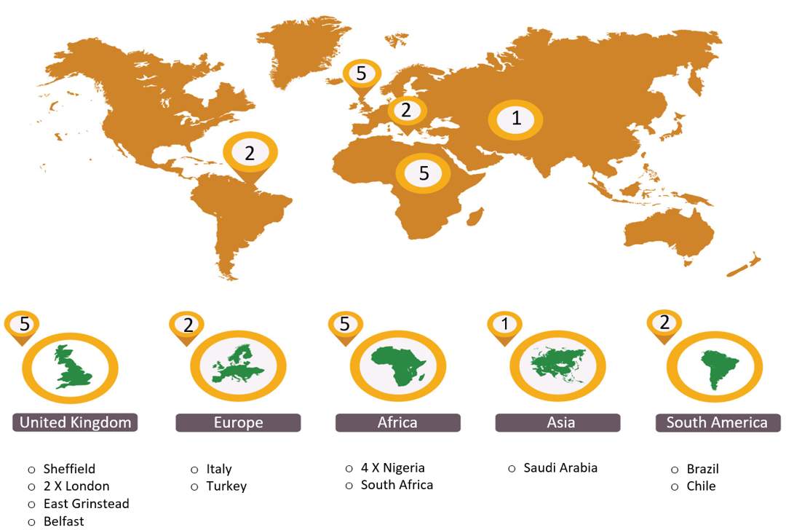
Figure ‎2.1: Geographical map of the centres participating in the study including five from the UK, two from Europe, five from Africa, one from Asia and two centres from South America. Total number of cases, n=5,739.
All primary benign and malignant tumours in major and minor salivary glands were included. Other mesenchymal neoplasms and lymphomas were excluded. Clinical information about the gender and age of the patient as well as the anatomical site of presentation (major gland or intra-oral location) were also obtained. Tumours involving the sinonasal region, nose and trachea were excluded. The data was anonymised locally before being shared for analysis. Cases with incomplete information were excluded after an initial review and duplicates and recurrences were also removed. Where possible, the histological diagnosis of the cases was reviewed (65% of cases). However, due to the large number of cases in the cohort and the resource constraints, this was not possible for every case. Only the updated diagnosis was used for these cases and diagnosis concordance or discordance was not recorded as it was not available for all cases and was deemed beyond the scope of this study. The tumours were classified according to the 2017 WHO classification of salivary gland tumours (El-Naggar et al., 2017) (The study has used 2017 WHO classification because the data collection was conducted prior to the publication of 2022 classification). Twelve types of benign SGT were identified within the cohort, including common entities such as pleomorphic adenoma, Warthin tumour, basal cell adenoma and canalicular adenoma etc. For malignant SGT, 20 different tumour types were identified including mucoepidermoid carcinoma (MEC), adenoid cystic carcinoma (AdCC), acinic cell carcinoma (ACC), polymorphous adenocarcinoma (PAC), carcinoma ex pleomorphic adenoma (Ca ex PA) and adenocarcinoma NOS (AdNOS). Descriptive statistical analysis of the data was performed using frequencies and percentages of the variables in Microsoft Excel (2016). Student’s T test was used to determine statistical significance (where relevant).

Results

Overall
The total number of SGT was 5,739. Of these, 65% were benign tumours (n=3,751), and 35% (n=1,988) were malignant (Table ‎1.1).
Table ‎2.1: Benign and malignant SGT histological subtype distribution within the cohort.
Diagnosis | Number | % of group | % of all tumours
BENIGN
Pleomorphic Adenoma | 2621 | 70% | 45%
Warthin Tumour | 623 | 17% | 11%
Basal Cell Adenoma | 172 | 5% | 3%
Canalicular Adenoma | 96 | 2% | 2%
Cystadenoma | 81 | 2% | 1%
Myoepithelioma | 62 | 2% | 1%
Oncocytoma | 43 | 1% | 1%
Other | 53 | 1% | 1%
Benign total | 3751
MALIGNANT
Mucoepidermoid Carcinoma | 508 | 26% | 9%
Adenoid Cystic Carcinoma | 336 | 17% | 6%
Polymorphous Adenocarcinoma | 238 | 12% | 4%
Carcinoma ex pleomorphic adenoma | 215 | 11% | 4%
Acinic cell carcinoma | 185 | 9% | 3%
Adenocarcinoma NOS | 145 | 7% | 3%
Salivary duct carcinoma | 79 | 4% | 1%
Secretory Carcinoma | 51 | 3% | 1%
Epithelial Myoepithelial Carcinoma | 47 | 2% | 1%
Myoepithelial Carcinoma | 42 | 2% | 1%
Basal cell adenocarcinoma | 41 | 2% | 1%
Other | 101 | 5% | 2%
Malignant total | 1988
There was a slight female predilection (54%, n= 3,093) compared to 46% male patients (n=2,646). In both benign and malignant tumours, a higher incidence was noted in patients between the fourth to seventh decade of life accounting for 69% of the cases (Figure ‎2.2).

Figure ‎2.2: Age and gender distribution within the entire SGT cohort.

Most of the SGT involved the major glands 68% (n= 3,910) with 32% (n= 1,829) involving the minor glands. Parotid gland was the most common site of involvement (59%, n= 3,406). Within the minor glands, the palate was the most common location (60%, n= 1103) (Figure ‎2.3).

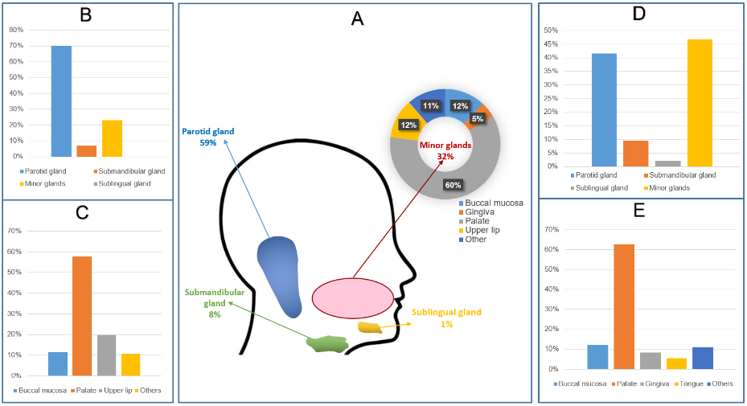
Figure ‎2.3: Anatomical site distribution of SGT. A) major and minor gland distribution across the entire cohort B) Benign tumours in all glands C) Benign tumours in minor glands D) Malignant tumours in all glands E) Malignant tumours in minor glands.

Benign tumours
The most common benign tumour was pleomorphic adenoma accounting for 70% (n= 2621) followed by Warthin tumour (17%, n= 623), basal cell adenoma (3%, n= 172), canalicular adenoma (2%, n= 96), cystadenoma (2%, n= 81), myoepithelioma (2%, n= 62) and oncocytoma (1%, n= 43). All other rare benign tumours including sebaceous adenoma, ductal papilloma, sialoadenoma papilliferum and unclassified salivary tumours comprised 1% (n= 53) of benign tumours (Table ‎2.1).
Comparison of the different geographical locations showed that pleomorphic adenoma was the most common benign tumour across all centres with a different range of incidence between centres ranging from 64% in Europe to 88% in Africa. Warthin tumour was the second most common tumour for most of the centres with a range of incidence between 1% (African cohort) to 30% in the data from Europe. This was followed by basal cell adenoma accounting for 5% of the UK and 3% of both the European and African cases (Figure ‎2.4).

Figure ‎2.4: Geographic comparison of the most common benign SGT. PA-Pleomorphic adenoma, WT-Warthin tumour, BCA-Basal cell adenoma.

Gender distribution
For benign tumours, there was a slight female predilection (54%, n= 2035) compared to males (46%, n= 1716) (Figure ‎2.5).

Age distribution
The average age for benign tumours was 52 years with a female average age of 51.7 and male average of 52.4 years. The age range was very wide (1-98 years). The most commonly affected age group was 40-59 which accounted for 38% of benign tumours (n= 1440) comprising 18% of male (n= 692) and 20% female (n= 748) patients respectively. The least affected age group was patients under 18 years of age who accounted for only 2% (n= 82) of benign tumours (Figure ‎2.5).

Figure ‎2.5: Age and gender distribution for benign salivary gland tumours, n=3751.

Site distribution
Benign tumours presented in both major and minor glands with the majority of tumours involving the parotid gland (70%, n= 2582), followed by minor glands (23%, n= 899), submandibular gland (7%, n= 265) and less than 1% (n= 5) involving the sublingual gland. Within the minor glands, the palate was the most common location (58%, n= 519). Followed by upper lip (20%, n= 178) and buccal mucosa (12%, n= 104). Other sites included the floor of mouth, gingiva, lower lip, tongue and labial mucosa which altogether comprised 10% (n= 98) of benign tumours (Figure ‎2.3).
The majority of pleomorphic adenomas involved the parotid gland (67%, n= 1736), followed by minor glands (25%, n= 645) and submandibular gland (8%, n= 217). Only four cases (less than 1%) were identified in the sublingual gland. In the minor glands, (67%, n= 433) of the pleomorphic adenomas involved the palate, followed by upper lip and buccal mucosa (12%, n= 77, 11%, n= 69) respectively. Warthin tumours were exclusive to the parotid gland (n= 623). Most of the basal cell adenomas were reported in minor glands (55%, n= 95), followed by parotid gland (40%, n= 69) and submandibular gland (5%, n= 8). In the minor glands, the upper lip was the most common minor gland site for basal cell adenomas (49%, n= 47) (Figure ‎2.6).

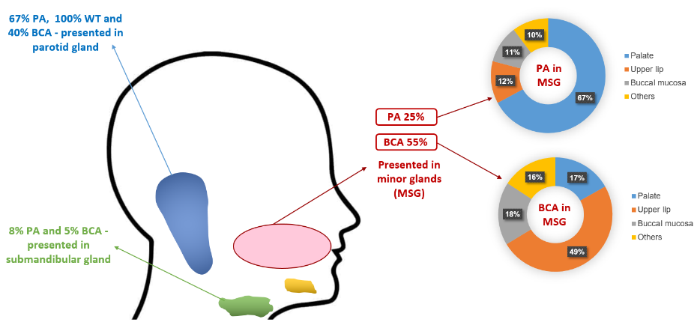
Figure ‎2.6: Anatomical site distribution of the most common benign SGT. Pleomorphic adenoma (PA), Warthin tumour (WT) and basal cell adenoma (BCA).

Malignant tumours
The most common malignant tumour was mucoepidermoid carcinoma accounting for 26% of the malignant diagnoses (n= 508) followed by adenoid cystic carcinoma (17%, n= 336) , polymorphous adenocarcinoma (12%, n= 238), carcinoma ex pleomorphic adenoma (11%, n= 215), acinic cell carcinoma (9%, n= 185), adenocarcinoma NOS (7%, n= 145), salivary duct carcinoma (4%, n= 79), secretory carcinoma (3%, n= 51), epithelial myoepithelial carcinoma (2%, n= 47), myoepithelial carcinoma (2%, n= 42) and basal cell adenocarcinoma (2%, n= 41). All other rare malignant tumours including, carcinosarcoma, clear cell carcinoma, cystadenocarcinoma, intraductal carcinoma, lymphoepithelial carcinoma, neuroendocrine carcinoma, oncocytic carcinoma, poorly differentiated carcinoma, sebaceous carcinoma, sialoblastoma and squamous cell carcinoma accounted for 5% of malignant tumours collectively (n= 101) (Table ‎2.1).
Mucoepidermoid carcinoma was the most common malignant tumour in the majority of centres. The only exception was Africa, where adenoid cystic carcinoma was the most common tumour. Overall, adenoid cystic carcinoma was the second most common malignant SGT for most of the centres with a range of incidence of 10% in UK and 33% in African centres (Figure ‎2.7).

Figure ‎2.7: Geographic comparison of the most common malignant SGT. MEC- Mucoepidermoid carcinoma, AdCC- Adenoid cystic carcinoma, PAC- Polymorphous adenocarcinoma, Ca ex PA- Carcinoma ex pleomorphic adenoma, ACC- Acinic cell carcinoma.

Gender distribution
There was a slight female predilection for malignant SGT (53% of malignant cases, n= 1,058) compared to males (47%, n= 930) (Figure ‎2.8).

Age distribution
The average age for malignant tumours was 56 years with a female average of 54.4 and male average age of 57.4 years. As for benign tumours, the age range was very wide (1 to 106 years). The average age for malignant tumours was significantly higher than benign tumours (p<0.00001). The most affected age group was 60 to 79-year-old accounting for 36% (n= 708) of malignant tumours, comprising 17% male (n= 340) and 19% female (n= 368) patients respectively. Similar to the benign tumours, the least affected age group was patients under 18 years of age (4%, n= 69) (Figure ‎2.8).

Figure ‎2.8: Age and gender distribution for malignant tumours, n=1988.

Site distribution
Minor glands were the most common site for malignant tumours (47%, n= 930), followed by parotid gland (42%, n= 828), submandibular gland (10%, n= 189) and sublingual gland (2%, n= 41). Within the minor glands, the palate was the most common location (63%, n=584) followed by buccal mucosa (12%, n= 114), gingiva (8%, n= 78) and tongue (6%, n= 51). Other rare sites included the floor of the mouth, labial mucosa, upper and lower lip, which accounted altogether for 11% of malignant diagnoses (n= 103) (Figure ‎2.3).
The majority of mucoepidermoid carcinomas involved the minor glands (56%, n= 285), followed by the parotid gland (34%, n= 173), submandibular glands (7%, n= 36) and sublingual glands (3%, n= 12). In the minor glands, 60% (n= 172) of the mucoepidermoid carcinomas occurred in the palate. Most of the adenoid cystic carcinomas (60%, n= 203) involved the minor glands, followed by parotid (26%, n= 87), submandibular (10%, n= 33) and sublingual (4%, n= 13) glands. Within the minor glands, 70% of adenoid cystic carcinomas presented in the palate (n= 141). Most polymorphous adenocarcinomas presented in the minor gland (98%, n= 234), with occasional cases in the parotid gland (2%, n= 4). In the minor glands, the palate was the most common site for the polymorphous adenocarcinomas accounting for (72%, n= 170). The majority of carcinoma ex pleomorphic adenomas involved the minor glands (61%, n= 132), followed by the parotid gland (32%, n= 70), submandibular gland (7%, n= 13) and only one case was reported in the sublingual gland. In the minor glands, 62% (n= 82) of carcinoma ex pleomorphic adenomas occurred in the palate. Parotid gland was also the most common site for acinic cell carcinoma (65%, n= 120), followed by the minor glands (23%, n= 42), submandibular gland (9%, n= 17) and sublingual gland (3%, n= 5). The palate was the most common minor gland site for acinic cell carcinomas (50%, n= 21) (Figure ‎2.9).

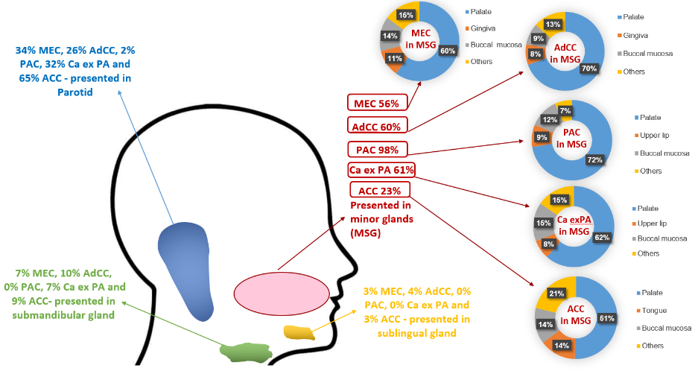
Figure ‎2.9: Anatomical site distribution of the most common malignant SGT. Mucoepidermoid carcinoma (MEC) occurs in the MSG (56%), (34%) in parotid, (7%) in submandibular and (3%) in the sublingual glands, adenoid cystic carcinoma (AdCC) occurs in the MSG (60%), (26%) in parotid, (10%) in submandibular and (4%) in the sublingual glands, polymorphous adenocarcinoma (PAC) occurs in the MSG (98%) and (2%) in the parotid glands, carcinoma ex pleomorphic adenoma (Ca ex PA) occurs in the MSG (61%), (32%) in parotid, (7%) in the submandibular glands and acinic cell carcinoma (ACC) occurs in the parotid glands (65%), (23%) in MSG, (9%) in submandibular and (3%) in the sublingual glands.

Discussion
SGT are rare and our study is one of the most extensive recent reports investigating the incidence and demographics of these tumours from multiple centres and the majority of the WHO geographical regions. We collected 5739 cases from pathology centres across the world and found that benign tumours accounted for the majority of SGT (65%) compared to malignant tumours (35%). This finding is consistent with the existing literature which range between 68-70% for the benign tumours and 30-32% for the salivary gland malignancy (Tian et al., 2010, Sentani et al., 2019, Ellis, 1996, Eveson and Cawson, 1985, Spiro, 1986). There was a slight predilection for females in our study, which has also been reported by some other studies (Jones et al., 2008, Bello et al., 2012, Spiro, 1986, Fonseca et al., 2012, Ito et al., 2005). However, some single centres studies have reported a higher incidence of salivary gland tumours in males or an equal gender involvement (Boukheris et al., 2009, Tian et al., 2010, Girdler et al., 2016, Kızıl et al., 2013). Furthermore, we found a peak incidence of SGT between the fourth to seventh decades of life (approximately 69% of cases) which is similar to findings previously reported in the literature (Jones et al., 2008, Tian et al., 2010, Bello et al., 2012, Ito et al., 2005).
Overall, the parotid gland was the most common location for SGTs accounting for (59%) followed by minor (32%) and submandibular (8%) salivary glands similar to older and similarly large SGT demographical studies (Tian et al., 2010, Bello et al., 2012, Ellis, 1996, Eveson and Cawson, 1985, Spiro, 1986, Fonseca et al., 2012, Ito et al., 2005, Satko et al., 2000). Our study shows low prevalence of sublingual tumours (46 out of 5739), similar to findings reported by Satko et al., 2000 and Eveson and Cawson (1985) (Eveson and Cawson, 1985, Satko et al., 2000).

Benign SGT
Our results show that pleomorphic adenoma was the most common benign tumour; this is consistent with prevalence rates reported in the literature (Jones et al., 2008, Sardar et al., 2018, Fiorella et al., 2005, Tian et al., 2010, Girdler et al., 2016, Sentani et al., 2019, Bello et al., 2012, Spiro, 1986). Comparison of incidence between centres showed pleomorphic adenoma to be the most common benign tumour in all geographical locations included in the study ranging from 64% in Europe to 88% in Africa. Warthin tumour was the second most common benign tumour which is also similar to earlier demographical studies (Fiorella et al., 2005, Bradley and McGurk, 2013, Bello et al., 2012, Ito et al., 2005, Satko et al., 2000, Neville et al., 2015). The present study shows that basal cell adenoma was the third most common benign tumour; however accurate comparisons between previous studies of basal cell and canalicular adenomas is difficult as older studies tended to combine these into a single group of monomorphic adenomas (Waldron et al., 1988, Spiro, 1986, Fantasia and Neville, 1980). Curiously, no basal cell adenomas were reported in Asia and South America, whereas they comprised 5% of benign SGT in the UK and 3% in both European and African centres. This could be related to the small number of cases gathered from those centres or the lower incidence as previous studies have shown that basal cell adenoma is not within the most common five benign tumours in these regions (Fonseca et al., 2012, Ito et al., 2005, Al Sheddi, 2016). The possibility of variation in diagnostic criteria can also not be excluded. Overall, the variation in incidence between geographical regions could be due to some genetic factors which more common in specific ethnic or racial groups. Furthermore, age trends and gender ratios typically differ across geographical regions. As a result, some tumour types are more common in specific age groups or genders.
In the literature, benign tumours have been reported to occur more in younger and female compared to elderly and male patients (Ito et al., 2005). Our study shows a similar finding where benign tumours appeared to be more common in female patients; however, the average ages were quite similar (51.7 years in female compared to 52.4 in male patients).
The majority of the benign tumours were located in the parotid gland (70%), followed by minor (23%) and submandibular (7%) glands. We found only five benign cases (less than 1%) involving the sublingual gland. Similar findings were seen in other older SGT studies with some variations in distribution across different anatomical sites (Jones et al., 2008, Tian et al., 2010, Sentani et al., 2019, Bello et al., 2012, Spiro, 1986, Ito et al., 2005).
The most common location for the pleomorphic adenoma was the parotid gland (67%), followed by minor glands and the submandibular gland (25% and 8% respectively. This observation was consistent with previous reports (Jones et al., 2008, Bradley and McGurk, 2013, Kızıl et al., 2013, Bello et al., 2012, Ito et al., 2005). Warthin tumour was seen exclusively in the parotid gland (100%). This observation is similar to other studies suggesting that this tumour exclusively involves parotid gland (Bradley and McGurk, 2013, Kızıl et al., 2013, Ito et al., 2005). Basal cell adenomas were reported in minor glands in 55% of the cases and about 40% were seen in the parotid gland. Accurate comparison with the literature was not possible due to the small number of reported studies and cases.

Malignant SGT
Mucoepidermoid carcinoma was the most common malignant salivary gland tumour accounting for 26% of diagnoses; this is in agreement with previously reported prevalence rates of the mucoepidermoid carcinoma worldwide ranging from 18-41% of the malignant tumours between different studies(Jones et al., 2008, Fiorella et al., 2005, Spiro, 1986, Ito et al., 2005). We found that mucoepidermoid carcinoma was the most common tumour in all centres except Africa where adenoid cystic carcinoma (33%) was the most common malignant diagnoses. Bello et al., 2012, reported somewhat similar findings with adenoid cystic carcinoma as the most common malignant tumour in their 2012 study (Bello et al., 2012). However, this was limited to data from two centres and did not examine the geographical differences in depth. The second most common malignant diagnosis for most of the centres in our study was adenoid cystic carcinoma accounting for 17% of all malignancies similar to other reports (Sardar et al., 2018, Fiorella et al., 2005, Bradley and McGurk, 2013, Girdler et al., 2016, Spiro, 1986, Ito et al., 2005) although some variations in its incidence have been reported. For mucoepidermoid carcinoma and adenoid cystic carcinoma molecular techniques such as FISH, PCR and NGS can help with the final diagnosis however, these tests are not widely available and/or affordable around the world (Khurram et al., 2017). Even in the UK, routine testing for MAML2 rearrangement in mucoepidermoid carcinoma has been the norm only since 2015–2016 with FISH the most widely available test, whereas MYB testing in adenoid cystic carcinoma is still only available in a handful of specialist centres. This is shown by the fact that within our cohort, a limited number of cases (2015 onwards) were tested (50 mucoepidermoid carcinomas and 15 adenoid cystic carcinomas). The next most common diagnoses were polymorphous adenocarcinoma and carcinoma ex pleomorphic adenoma accounting for 12 and 11% of diagnoses respectively. In fact, there is significant variability in the literature about the incidence of these two entities which is perhaps related to small and unicentric cohorts. Unfortunately, it was not possible to collect detailed information about the sub-type of Ca ex PA as information was variably recorded for most of the international cases. Similarly, acinic cell carcinoma was the fifth most common diagnosis (9%) although, some studies have reported it as the third most common malignant SGT (Jones et al., 2008, Sardar et al., 2018) however these findings were also based on a small cohort size from only one centre. Adenocarcinoma NOS was the next most common diagnosis accounting for 7% of cases which may not reflect the exact incidence of this entity as development of ancillary molecular and sequencing techniques has led to more specific diagnoses and reduction in the use of this diagnosis (Rooper et al., 2021).
Malignant SGT are more likely to occur in older patients (Fonseca et al., 2012, Ito et al., 2005). Our study shows similar results where the average age for malignant tumours was significantly higher than benign tumours (p<0.00001). Malignant SGT involved the parotid gland in about 42% of cases, which aligns with known literature (Bradley and McGurk, 2013, Sentani et al., 2019). The incidence of malignant tumours in minor salivary glands was slightly higher than the parotid gland (i.e. 47%), highlighting the importance of considering malignant SGT in differential diagnoses (Sentani et al., 2019, Mariz et al., 2019). In the present study, 42 out of 46 cases involving the sublingual gland were malignant tumours, which is similar to Tian et al.’s findings from 2010 where they reported 95% of sublingual tumours to be malignant (Tian et al., 2010).
The most common location for mucoepidermoid carcinoma was minor glands (56%), followed by parotid, submandibular and sublingual (34%, 7% and 3% respectively) glands which is in agreement with the findings of Jones et al., 2008 but in disagreement with other reports which have found parotid to be the most common site (Bradley and McGurk, 2013, Kızıl et al., 2013, Ito et al., 2005). This could be due to the fact that a number of these cases were reported in specialist oral and maxillofacial pathology units (some of which usually only report intra-oral specimens) although many of the included centres also have expertise in head and neck (H&N) pathology.
Understanding the epidemiological landscape and distribution of histological subtypes of salivary gland tumours is crucial for a better diagnosis of this diverse and complex group of tumours. It would be useful for future studies to include more geographical locations as well as other H&N and ears, nose and throat (ENT) centres. It would also be useful to establish international datasets of these tumours for use by other researchers (WSI or research repositories) including histological reassessment and classification according to the most recent WHO criteria.

Chapter 3: Using Artificial Intelligence for Analysis of Salivary Gland Tumours (Benign versus malignant & subtyping)

This chapter has been submitted as a manuscript and is currently under consideration. Preprint available at DOI: https://doi.org/10.21203/rs.3.rs-1966782/v1

Introduction
A large number of additional histological stains, IHC, and molecular work (FISH, PCR, etc.) can be required to diagnose and sub-type SGT. However, these tests might only be available at specialist centres with associated time delays and cost implications. In some cases, even when these investigations can be performed, differentiation between these tumour types can be challenging (Speight and Barrett, 2020). Unfortunately, very few of these special tests are available in the developing world. This is confounded by the fact that most salivary gland biopsies can be small or fragmented, which makes morphological assessment or doing further tests difficult.
Furthermore, contextual and morphological information is not evident when molecular or genetic tests are performed, and a number of SGTs have no known molecular alterations at present. Identification of the tumour type is important as it can provide guidance for the optimal management and prognostic behaviour (although limited targeted therapies are in use at present, the landscape is changing). These issues highlight the need for novel, efficient, and widely available methods as diagnostic aids.
The advent of digital pathology and the ability to obtain WSIs from histology slides has accelerated the application of AI to pathology, which has been helped by advancements in computing power and technology, allowing exploration of sub-visual morphometric features with a potential to improve patient care (Bera et al., 2019). However, AI’s application to SGTs has not been investigated or reported to date.
In this study, we first aim to use ML to differentiate between benign and malignant SGTs, and to subtype malignant SGTs in WSIs (both of which can be challenging tasks in diagnostic practice) and compared with DL.

Material and methods

Case identification and retrieval
Benign and malignant SGTs were identified using a digital database and the corresponding H&E stained slides were retrieved from the department archive (Unit of Oral and Maxillofacial Pathology, School of Clinical Dentistry, University of Sheffield, UK- Health and Care Research Wales ethics reference: 20/WS/0017). This department receives a large number of regional, national and international consult cases for expert opinion, and both internally and externally stained slides were included in the cohort to ensure the robustness of training. 70% of the cases were local whereas the remaining 30% were from external referrals. The retrieved cases included two common benign SGT subtypes, i.e., PA and BCA, and four malignant SGT subtypes, i.e., MEC, AdCC, ACC and Ca-ex-PA. Different morphological appearances of benign and malignant tumours were included as mentioned in chapter 1 (Section 1.1.3). The diagnosis of these cases was confirmed, followed by the anonymisation of the slides. WSIs were generated using an Aperio CS2 scanner (Leica Biosystems, Nussloch, Germany) at 40x magnification. Calibration was done prior to each scanning session, and images were stored on a dedicated server. Anonymised WSIs of cases to be analysed were downloaded from the server for analysis.

Dataset and Building of Machine Learning Classifiers
An open-source bioimage analysis software (QuPath) was employed for annotation, feature generation and extraction of ROIs. It is compatible with the majority of operating systems and supports the most popular picture formats. It is also the most popular platform of its type, with a well-maintained online repository and a support network for assistance and troubleshooting (Bankhead et al., 2017)( https://qupath.github.io/). For comparison between benign and malignant SGT, WSIs of H&E stained sections were used, including 120 from benign tumours (PA and BCA) and 120 from malignant tumours (including MEC, AdCC, ACC, and Ca-ex-PA). 67% (n=160) of the cases were used for training and the remaining (unseen by classifier) for testing (n=80). The training was performed on an equal number of benign and malignant cases (i.e., n=80 WSI for each category, 160 in total) (Table ‎3.1).

Table ‎3.1: Training and testing sets case numbers breakdown for benign vs malignant (BvM)
and malignant tumour subtyping (MST) classifiers.
Classifiers type | Training set | Testing set | Total
Benign vs malignant (BvM) | 160 WSIs | 80 WSIs | 240 WSIs
Malignant tumour subtyping (MST) | 80 WSIs | 40 WSIs | 120 WSIs
To train the benign vs malignant (BvM) detection classifier, 5 random ROIs (From tumour-rich area) per WSI were selected (Spanning across the longest horizontal and vertical axis of the tumour regions) using fixed-size areas of 142,884 μm² (1,500 × 1,500 pixels) to ensure standardisation across cases. The ROIs were selected by IA-S and confirm by the supervisor SAK (in case of disagreement, a new region was selected). Next, cell detection analysis was performed (using the cell detection function in QuPath, which works by manually specifying a threshold value (0.05~0.10) for pixel intensity and then discovering any pixels in the ROIs with intensity values within this threshold), following which the detected cells/nuclei were assigned to a specific class/ground truth (i.e., benign or malignant based on the histological review/diagnosis or the appropriate subtype). At least five different ROIs were used for training from each WSI, ensuring that morphologically different areas were included, e.g., cribriform pattern, clear cell areas, as well as solid or tubular patterns (where applicable). Using the ROIs in the training cases, a ML classifier (Random Forest/RF, one of the most common classifiers in ML which is based on decision trees with final output determined by a major vote) was built (using the built in functions within QuPath) and validated through visualisation of nuclear segmentation in the unseen cases. 80 unseen WSIs with 400 ROIs of fixed-size areas were used to blindly test and validate the BvM classifier for automated classification, followed by quantification and statistical analysis of colour and morphometric features for the testing set (80 WSI) leading to the classifier’s ‘decision’ (Figure ‎3.1). Downstream analysis was only carried out using relevant geometrical and morphometrical features and irrelevant and/or variables were excluded and cell features were also excluded because it is an artificially generated boundary around the nucleus and at present no cell level segmentation networks exists even using deep learning (Table ‎3.2).
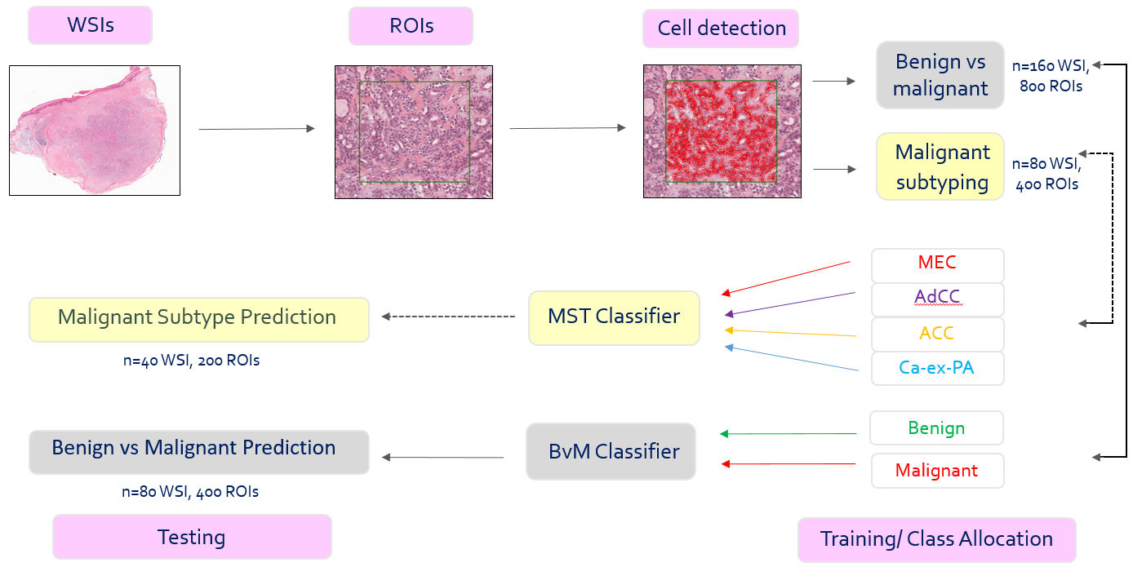
Figure ‎3.1: Training and analysis overview .WSIs were obtained followed by selection of fixed size representative ROIs from each tumour. Cell detection was performed using built in QuPath functions and the detected nuclei allocated to a class (i.e. benign or malignant or the subtype of tumour). Two separate classifiers were built for benign vs malignant (BVM) detection and malignant subtyping (MST). Following this, testing was performed on a cohort of unseen cases.
Table ‎3.2: List of geometrical and morphometrical features that can be obtained using QuPath to build the classifiers. The biologically relevant features (highlighted in blue) were used for comparative analysis. Cell values were excluded as these are artificially generated within the software.
Nuclear features | Cellular features | Cytoplasmic features
Nucleus: Area | Cell: Area | Cytoplasm: Haematoxylin OD mean
Nucleus: Perimeter | Cell: Perimeter | Cytoplasm: Haematoxylin OD std dev
Nucleus: Circularity | Cell: Circularity | Cytoplasm: Haematoxylin OD max
Nucleus: Max calliper | Cell: Max calliper | Cytoplasm: Haematoxylin OD min
Nucleus: Min calliper | Cell: Min calliper | Cytoplasm: Eosin OD mean
Nucleus: Eccentricity | Cell: Eccentricity | Cytoplasm: Eosin OD std dev
Nucleus: Haematoxylin OD mean | Cell: Haematoxylin OD mean | Cytoplasm: Eosin OD max
Nucleus: Haematoxylin OD sum | Cell: Haematoxylin OD std dev | Cytoplasm: Eosin OD min
Nucleus: Haematoxylin OD std dev | Cell: Haematoxylin OD max
Nucleus: Haematoxylin OD max | Cell: Haematoxylin OD min
Nucleus: Haematoxylin OD min | Cell: Eosin OD mean
Nucleus: Haematoxylin OD range | Cell: Eosin OD std dev
Nucleus: Eosin OD mean | Cell: Eosin OD max
Nucleus: Eosin OD sum | Cell: Eosin OD min
Nucleus: Eosin OD std dev
Nucleus: Eosin OD max
Nucleus: Eosin OD min
Nucleus: Eosin OD range
Nucleus/Cell area ratio
The second part of the study aimed to build an additional classifier for malignant tumour subtyping (MST) for automated identification of the more common malignant SGT. For this part of the study, 120 WSIs were used for training and testing. Although these cases were the same as those used in the previous part of the study, a new classifier was built to ensure that the test cases remained ‘unseen’. Two-thirds (n=80) WSIs were used for training and the remainder for testing (n=40). A RF classifier was trained using 80 WSIs with 400 ROIs, including four different tumours (MEC, AdCC, ACC, and Ca-ex-PA) (n=20 WSIs of each tumour). The ROI dimensions were maintained at 1,500 x 1,500 pixels, and cell/nuclear detection was performed as described previously. All detected cells in each tumour type ROI were assigned to a specific tumour type class (i.e., MEC, AdCC, ACC, Ca-ex-PA). 40 unseen WSIs (10 of each SGT) with 200 ROIs were used to test the MST classifier and to perform analysis and quantification of features (Figure ‎3.1).

Comparison with Customised Machine Learning Models
We additionally aimed to understand whether change of parameters and settings of the ML models outside the fixed/rigid QuPath software settings would provide a superior performance across the two tasks (i.e., malignant vs benign, and tumour subtyping). Since all of the previous work was performed entirely within the QuPath software (e.g., nuclei segmentation, feature extraction, classification), the performance of the QuPath built-in RF classifier was compared with the same classifier trained/tested (outside QuPath) using the Scikit-learn 1.0.1 toolbox with Python (Pedregosa et al., 2011). The above two tasks were repeated by extracting the QuPath-generated nuclear segmentation and features followed by optimisation of the RF models on the training cohort before testing them on the unseen test set.

Comparison with Deep Learning Networks
Next, the utility of DL methods for classification was analysed. For direct prediction with DL, the ROIs were extracted from QuPath using this code
(def imageData = getCurrentImageData()
// Define output path (relative to project)
def outputDir = buildFilePath(PROJECT_BASE_DIR, 'export')
mkdirs(outputDir)
def name = GeneralTools.getNameWithoutExtension(imageData.getServer().getMetadata().getName())
def path = buildFilePath(outputDir, name + "testlabel2.tif")
// Define how much to downsample during export (may be required for large images)
double downsample = 8
// Create an ImageServer where the pixels are derived from annotations
def labelServer = new LabeledImageServer.Builder(imageData)
.backgroundLabel(0, ColorTools.WHITE) // Specify background label (usually 0 or 255)
.downsample(downsample) // Choose server resolution; this should match the resolution at which tiles are exported
.addLabel('epithelium', 1) // Choose output labels (the order matters!)
//.addLabel('Non_ROI', 2)
.multichannelOutput(false) // If true, each label refers to the channel of a multichannel binary image (required for multiclass probability)
.build()
// Write the image
writeImage(labelServer, path).
Then tessellated into smaller patches (256 x 256, at 40X) before training/testing multiple state-of-the-art convolutional neural networks (CNNs) for automated prediction. Here, we used ResNet-18, ResNet-50, Efficient-NetB0 and Efficient-NetB3 models, built with PyTorch 1.10 (He et al., 2016, Tan and Le, 2019). These models differed in depth and the number of layers (for example, ResNet-50 has more convolutional layers than ResNet-18) as well as model size (for example, EfficientNetB0 is less in size than ResNet-18 and ResNet-50, making it more computationally efficient and faster to train). In general, the model employed in computational pathology is determined by the specific task and dataset being used, as well as the computational resources available. These algorithms were used on previous similar tasks and showed good segmentation and classification performance on histopathological slides after they have been finetuned (and have been used/reported by a number of other studies). On inference, the maximum argument was taken across all patches per subject to achieve predictions.
In this work, we have therefore performed three different sets of experiments:
- Feature generation using QuPath and employing the built in RF for classification
- Feature generation using QuPath followed by using an optimised RF (outside the platform) for classification
- DL for classification (based on raw image patches)

Spatial analysis
Dynamic interactions between tissue features result in topographical characteristics that can explain relationships between different structures. The spatial analysis was performed using a set of features related to the orientation of objects at a certain location. This included proximity by measuring centroid distance between cells as well as cluster Delaunay analysis, including neighbouring cells, intercellular distance, and mean triangle area. Delaunay triangulation is a geometric calculation indicating a set of points that can be found in optimal time and position. It is a computational technique used to quantify spatial relationships between cells and other tissue structures. The technique entails generating a triangulated geometry from a collection of points representing the centres of cells or other tissue features. (Preparata and Shamos, 2012). Figure ‎3.2 shows illustration of the Delaunay triangulation concept.
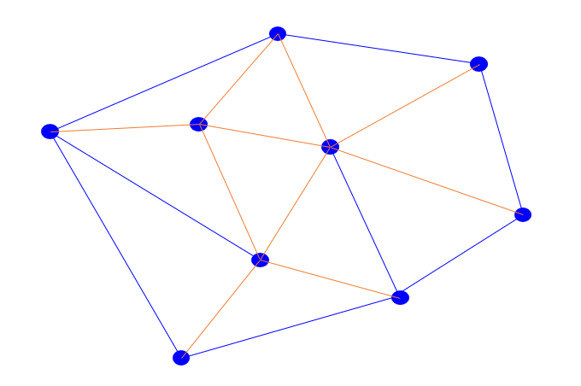
Figure ‎3.2: Delaunay triangulation where a set of points in a plane form a triangular mesh. This illustration was made for purpose of this thesis using Microsoft Powerpoint.

Statistical Analysis
T-Test (two-tailed) and multiple comparison one-way ANOVA were used to measure statistical significance between different geometrical, spatial, and staining features. Microsoft Excel 2016 (Microsoft Office Software, USA) was used to organise exported data and perform statistical analyses. The performance of detection classifiers was measured using precision, recall, F1 score, and AUROC, generated at the case level.
Precision = True positive / true positive + false positive
Recall = True positive / true positive + false negative
F1 score = 2x (precision x recall/ precision + recall)
AUROC= (x-axis) 1 – specificity (= false positive fraction = FP/(FP+TN)), (y-axis) sensitivity (= true positive fraction = TP/(TP+FN)).

Results

Performance of the classifiers
The benign versus malignant tumour RF classifier (BvM) showed high F1 and AUROC scores of 0.90 (Table ‎3.2).
Table ‎3.3: Performances/accuracy metrics of the ML RF classifiers (QuPath & customised) as well as DL (ResNet 18,50 & EfficientNet B0,B3) at case-level predictions.The best performing classifiers are highlighted in bold.
Classifier | Precision | Recall | F1-score | AUROC
Benign vs Malignant (BVM)
QuPath RF | 1.00 | 0.80 | 0.90 | 0.90
Customised RF | 0.93 | 0.98 | 0.95 | 0.95
ResNet-18 | 0.83 | 0.80 | 0.81 | 0.81
ResNet-50 | 0.85 | 0.87 | 0.86 | 0.86
EfficientNet-B0 | 0.93 | 0.82 | 0.87 | 0.87
EfficientNet-B3 | 0.88 | 0.76 | 0.81 | 0.81
Malignant subtyping (MST)
QuPath RF | 0.94 | 0.93 | 0.92 | 0.95
Customised RF | 0.95 | 0.95 | 0.95 | 0.97
ResNet-18 | 0.60 | 0.60 | 0.60 | 0.73
ResNet-50 | 0.63 | 0.61 | 0.60 | 0.74
EfficientNet-B0 | 0.58 | 0.60 | 0.56 | 0.73
EfficientNet-B3 | 0.55 | 0.60 | 0.54 | 0.73
Note. RF = Random Forest. Both the QuPath (in built) RF classifier and the customised RF classifiers use nuclear features generated with QuPath; the latter was produced outside of QuPath using the scikit-learn Python toolbox.
The predominant detection/class was accurate for all cases, although some false positive detections for both benign and malignant cells were identified (Figure ‎3.3).
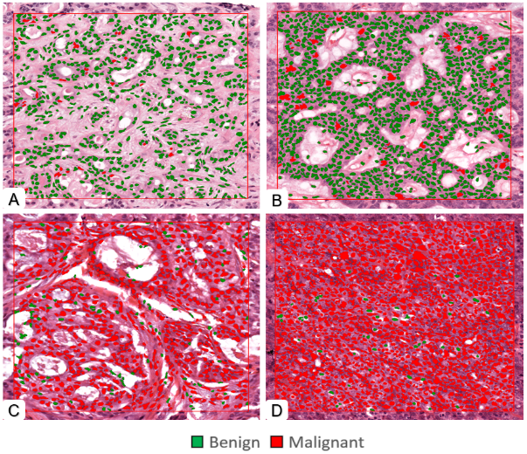
Figure ‎3.3: Automatic cell segmentation and classification in ROIs using trained classifiers. (BVM, test n=80) predictions were largely correct with occasional false positive cells. A- Pleomorphic adenoma (benign), B- Basal cell adenoma (benign), C- Mucoepidermoid carcinoma (malignant), D- Acinic cell carcinoma (malignant). (Magnification 20X).

To visualise the algorithm performance, classification and segmentation were performed on five benign and malignant cases each. t the whole slide level, the algorithm showed an excellent performance for identification of benign and malignant tumours as shown in (green heatmap/benign) (Figure ‎3.4) and (red heatmap/malignant) (Figure ‎3.5). However, these are only visual results, and no downstream analysis was performed at the WSI level due to the demanding computational nature of the task which is beyond the capability of QuPath.

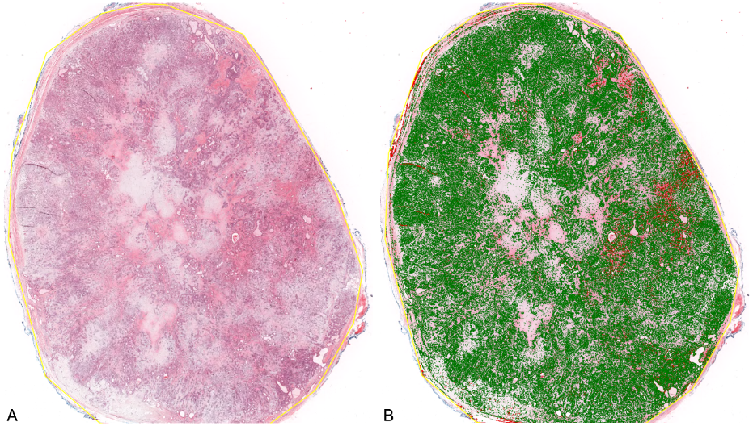
Figure ‎3.4: Automatic cell segmentation and classification of pleomorphic adenoma (benign case) at WSI level using trained classifiers. A- H&E WSI, B- Green is benign prediction, red=malignant. (Magnification 1X). Although occasional false positives are seen for malignant cells, the overwhelming majority show an accurate prediction.

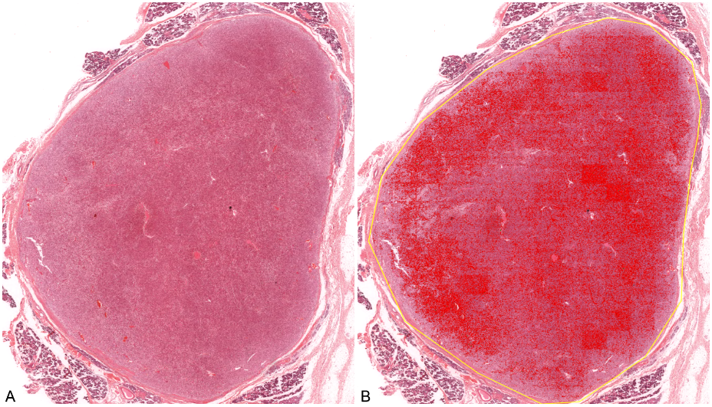
Figure ‎3.5: Automatic cell segmentation and classification of acinic cell carcinoma (malignant case) at WSI level using trained classifiers. A- H&E WSI, B- Red is malignant prediction. (Magnification 1X).

The customised RF classifier built outside QuPath (using different tree depths and parameters) gave a superior performance (F1 = 0.95, AUROC - 0.95, Table ‎3.2). Results from DL were similar, with all CNNs showing high F1-scores (>0.80, Table ‎3.2), with EfficientNet-B0 giving the best performance (F1= 0.87). However, none of the DL CNNs surpassed the performance achieved using the customised RF ML classifier (F1=0.95) (Table ‎3.2).
The malignant subtyping QuPath classifier (MST) also showed excellent performance for classification and automatic differentiation between SGT subtypes (including MEC, AdCC, ACC and Ca-ex-PA), with the predominant automated detection correct in all instances (F1 = 0.92, Table ‎3.2). However, there were some false-positive detections as shown in Figure ‎3.6.
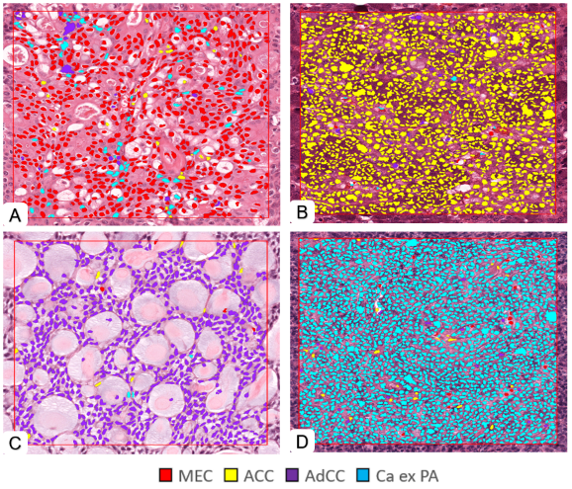
Figure ‎3.6: Automatic cell segmentation and classification in ROIs using trained classifiers. (MST, test n=40), most of the predicted classes were correct with some false positive detections. E- Mucoepidermoid carcinoma (red), B- Acinic cell carcinoma (yellow), C- Adenoid cystic carcinoma (purple), D-Carcinoma ex pleomorphic adenoma (cyan). (Magnification 20X).

Similar to the previous task, the customised RF classifier built outside QuPath (but using QuPath generated features), achieved the best performance (F1 = 0.95, Table ‎3.2). Interestingly, results for DL networks appeared inferior to both ML classifiers (highest F1 score=0.60 with ResNet-18 and ResNet-50).

Features contributing to the classifier performance
The geometrical and morphometrical feature analysis of the test set demonstrated a number of features that were being used by the BvM classifier for benign or malignant class prediction. Statistical analysis showed that there was a significant difference between nuclear circularity, nuclear haematoxylin optical density (OD), and cytoplasmic eosin OD between benign and malignant tumours (p<0.01). Furthermore, a significant difference in nucleus/cell ratio was also seen (p<0.05). No difference was seen between benign and malignant SGT for nuclear eccentricity (Figure ‎3.7).
Figure ‎3.7: Average values for nuclear and cytoplasmic features in benign (green) and malignant (red) unseen test cases (test n=80). Error bars = standard deviation. *p<0.05, **p<0.01 (T-Test (two-tailed)).
Similar to the results seen for the BvM classifier, a detailed analysis of features (listed in Table ‎3.2) showed various geometrical and morphometrical features guiding the automated detection of malignant subtypes. There was a significant difference between nuclear haematoxylin OD, cytoplasmic and eosin OD, and nucleus/cell ratio (p<0.01) between the different malignant tumours. Interestingly and unlike the previous task, no statistically significant difference was seen between nuclear circularity and eccentricity for this task (Figure ‎3.8).
Figure ‎3.8: Average nuclear and cytoplasmic feature values for the malignant subtyping unseen test set (n=40). Mucoepidermoid carcinoma (red), Acinic cell carcinoma (yellow), Adenoid cystic carcinoma (purple) and Carcinoma ex pleomorphic adenoma (cyan). Error bars = standard deviation. *p<0.01 (Multiple comparison one-way ANOVA).

Quantitative morphometrical feature analysis

Cellularity
The average number of cells in malignant tumours (mean= 6490, SD= ±1720) was higher than benign tumours (Mean= 5087, SD= ±2659) (average cellularity per case calculated across five standardised tumour-rich ROIs). This difference in cellularity was statistically significant (p<0.01) (Figure ‎3.9).
Figure ‎3.9: Boxplot showing cellularity of the benign and malignant tumours (test n=80). Error bars = standard deviation. *p<0.01 (T-Test (two-tailed)).

Comparison of malignant tumours showed the highest cellularity in Ca ex PA (Mean= 7428, SD= ±1474 cells), followed by AdCC (Mean= 6454, SD= ±1863) and ACC (Mean= 6187, SD= ±1395). MEC demonstrated lower cellularity compared to other SGT (Mean= 4875, SD= ±1040 cells). Statistical analysis showed that the difference in cellularity between the four SGT was statistically significant (p<0.01) (Figure ‎3.10).
Figure ‎3.10: Boxplot showing the cellularity comparison of malignant tumours (test n=40). Error bars = standard deviation. *p<0.01 (Multiple comparison one-way ANOVA).

Spatial analysis
Topographical features that explain spatial orientation are created through dynamic interaction between benign and malignant cells (Figure ‎3.11).
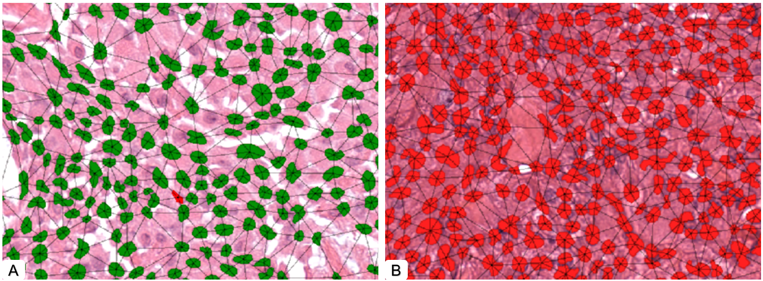
Figure ‎3.11: Showing spatial orientation networks of benign (A) and malignant (B) cells (note triangles and lines between nuclei). (Magnification 40X).
The average centroid distance showed a significant difference between cells in malignant and benign SGT, with a smaller distance seen in malignant SGT (p<0.01) (Figure ‎3.12).
Figure ‎3.12: Average centroid distance between benign and malignant cells (μm). Error bars = standard deviation.*p<0.01 (T-Test (two-tailed)).
Cluster spatial analysis showed a significant difference in Delaunay neighbouring cells in benign and malignant SGT (p<0.01). Furthermore, there was a significant difference between the Delaunay mean intercellular distance between benign (Mean= 14.39μm, SD= ±2.76) and malignant (Mean= 12.20μm, SD= ±1.70) tumours (p<0.01). In addition, the Delaunay mean triangle area was also significantly different between benign (Mean= 73.25, SD= ±13.59) and malignant (Mean= 56.58, SD= ±15.65) SGT (p<0.01) (Figure ‎3.13).
Figure ‎3.13: Cluster spatial analysis of Delaunay features for benign and malignant tumours. Error bars = standard deviation.*p<0.01 (T-Test (two-tailed)).
The dynamic interactions between the various subtypes of malignant cells are the source of the topographical features that demonstrates spatial orientation (Figure ‎3.14).
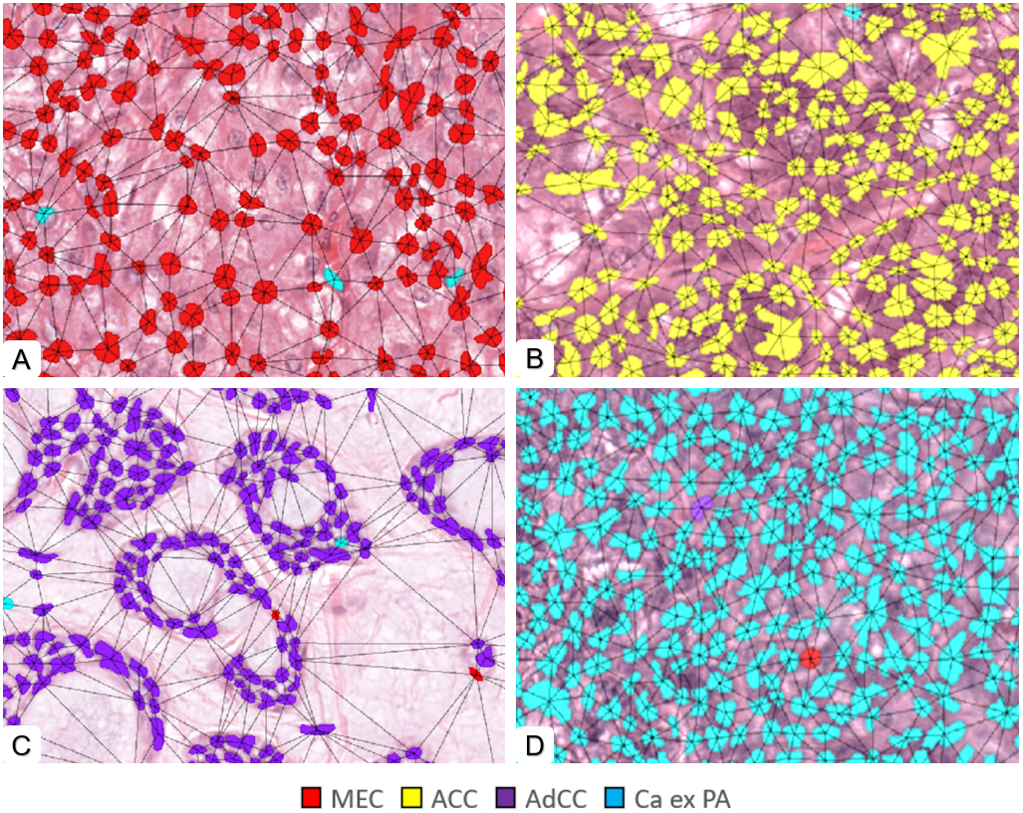
Figure ‎3.14: Showing spatial orientation networks and Delaunary triangle in different malignant subtypes (A- MEC, B- ACC, C- AdCC, and D – Ca ex PA). (Magnification 40X).
Spatial analysis for different malignant subtypes showed the highest number of Delaunay neighbouring cells in ACC (Mean= 4.48, SD= 1.11 cells) compared to MEC (Mean= 3.75, SD= ±0.85), AdCC (Mean= 3.52, SD= ±0.87) and Ca-ex-PA (Mean= 3.31, SD= ±0.78). This difference was statistically significant between the different SGT (p<0.05). The Delaunay mean distance was also significantly different between different types of malignant SGT (p<0.01). In addition, the Delaunay mean triangle area also showed a significant difference (p<0.01) between subtypes with the highest area seen in MEC (Mean= 72.62, SD= ±12.37) and the lowest in AdCC (Mean= 54.30, SD= ±15.98) (Figure ‎3.15).
Figure ‎3.15: Cluster spatial analysis of Delaunay features for malignant subtypes. Error bars = standard deviation. *p<0.05, **p<0.01 (Multiple comparison one-way ANOVA).

Discussion
Computational pathology (ML, DL, and AI) has been shown to provide objective and accurate quantification and classification in a range of cancers (Bejnordi et al., 2017, Wang et al., 2019, Li et al., 2018, Kather et al., 2019a, Shaban et al., 2019, Araújo et al., 2017). Open-source image analysis software (such as QuPath) has built-in ML tools which can be used to train and generate a few types of classifiers/algorithms that have the ability to perform automated cell detection, classification, segmentation, and automated measurements of objects after appropriate training (Bankhead et al., 2018).
These novel results report the application of AI and ML for histological analysis and subtyping of SGT on H&E images for the first time. The ML benign vs malignant (BvM) classifiers (QuPath RF and custom RF) have achieved excellent accuracy with F1 and AUROC values of 0.90 and 0.95, respectively. There is a scarcity of studies that use ML or DL to differentiate between benign and malignant lesions in the head and neck region using histological image analysis (Mahmood et al., 2020, Mahmood et al., 2021). Furthermore, to date, the application of these tools for SGT analysis, diagnosis, and sub-typing has not been explored. The only study to date has reported tumour detection in thyroid and salivary tumours on gross macroscopic specimens using hyperspectral images (Halicek et al., 2020). Therefore, a direct comparison of these findings with relevant studies is not possible. Nonetheless, comparable concepts have been explored in a number of studies; for example, one study in breast tissue attempted to distinguish between non-carcinoma (normal and benign) and carcinoma (in situ and invasive) and reached an accuracy of 83.3% (Araújo et al., 2017). Another study of benign and malignant breast lesions using a class structure-based deep learning model (CSDCNN) showed an excellent performance (93.2% accuracy) (Han et al., 2017). In prostate adenocarcinoma, an AUC of 0.98 had been reached using DL to distinguish between benign and malignant tumours on large datasets (Ström et al., 2019, Bulten et al., 2020). In addition, excellent results have been reported using CNNs and recurrent neural networks (RNNs) for classification between gastric and colonic adenocarcinoma and adenoma (AUCs of 0.96-97 and 0.99, respectively) (Iizuka et al., 2020). Although the findings from the current project have shown novel and interesting data using ML classifiers and DL models for SGT analysis, it is apparent that modern DL techniques can offer significantly higher performance and accuracy at a WSI level on larger datasets, and this is already being explored as an extension to the existing work (we are in the process of expanding the cohort from local and international collaborators, including more tumours types, trying different DL models and technique and validation on a larger independent cohort) However, SGT are much rarer compared to breast, prostate, and other adenocarcinomas; therefore, curating large multicentre datasets (similar to published studies with large scale validation) is extremely challenging. In the current study, the ML classifiers outperformed the DL classifiers, which may be because the restricted context of AI, the dataset is still somewhat small and division into further sub-categories (such as benign, malignant, tumour subtypes) makes it even smaller. It is well known that traditional ML methods are likely to perform better on smaller datasets as the more advanced DL models need much more data to train efficiently. Having said that, overfitting can be a problem with DL algorithms, which happens when the model gets too sophisticated and begins to memorise the training data rather than generalising to new data.
Malignant SGT subtyping usually requires the use of several further IHC stains and referral to specialist pathologists with associated time and cost implications as well as variation in the availability of these tests, particularly in developing countries. The malignant subtyping (MST) classifier showed an outstanding performance. However, due to time and data restraints, only four common types of malignant SGT could be included for comparison; these tumours were selected as they account for the majority of malignant SGT in reported studies (Jones et al., 2008, Alsanie et al., 2022a). The developed ML classifiers for MST (QuPath RF and custom RF) showed excellent accuracy (F1 scores- 0.92 and 0.95, AUROC- 0.95 and 0.97). Interestingly, but not surprisingly, the performance was inferior for DL for this task. This is due to the fact that DL algorithms require larger datasets, especially for challenging tasks, and it is likely that the use of ROIs and four different classes/tumours in a relatively small dataset was insufficient to achieve good training and accuracy. Although never reported in SGT, DL has been used to subtype other glandular carcinomas, such as lung adenocarcinoma (LUAD) vs squamous cell carcinoma (LUSC) or normal lung tissue in much larger datasets at WSI level (AUC of 0.97) (Coudray et al., 2018).
Although ML offers the advantage of automated analysis of histopathological features, it requires a large amount of training and annotations, making it tedious and time-consuming. DL algorithms can learn directly from raw data, but it can be difficult to establish how algorithms make the decision from input data and arrive at a prediction (Salvi et al., 2021). In addition, DL algorithms are data-hungry, often requiring large cohorts. The proposed work uses a hybrid approach for SGT classification and segmentation, including analysis of morphological, geometrical and colour features that ML uses for decision making and comparing that with DL algorithms (using ML generated ROI level features).
For benign vs malignant SGT, the analysis of the geometrical and morphometrical features demonstrated a significant difference between nuclear circularity, nuclear haematoxylin, cytoplasmic eosin and nucleus/cell ratio. This is biologically relevant as malignant cells are known to have a higher and abnormal deoxyribonucleic acid (DNA) content (i.e., hyperchromatism), leading to a higher nuclear haematoxylin staining and nuclear/cell ratio (Jang et al., 2011). Nuclear haematoxylin staining and nucleus/cell ratio were also statistically different between different malignant SGT, which could be related to the degree of differentiation or histological grade of those tumours.
Assessment of tumour cellularity is a subjective and tedious process, not routinely used for diagnosis or prognosis prediction, and with concerns of inter-observer variability among pathologists. ML and DL can aid this process and have been shown to objectively quantify tumour cellularity (Rakhlin et al., 2019). The findings show higher cellularity in malignant SGT compared to benign. This observation is in agreement with the literature as malignant tumours are known to be more cellular, but this quantification is rarely done in practice, in particular for SGT (Jang et al., 2011, Fischer, 2020, Salvi et al., 2021). Yin et al. (2016) developed a quantification algorithm for tumour cellularity and found that cancer cells show higher cellularity than non-cancers in lung tissues (Yin et al., 2016). The cellularity analysis for the current project was performed on five fixed-size ROIs in random histologically representative areas. It would be interesting to explore tumour and stroma separately and at the WSI level instead of ROIs to further determine the significance of these findings and differences between these cell types.
Our study is also the first to report the importance of spatial characteristics in SGT. This is important as the tumour microenvironment has been shown to play a key role in the progression and prognosis of numerous neoplasms. It can assist in identifying patterns of cell-cell interactions and measuring the distance and closeness of cells in the tumour microenvironment. Spatial analysis, for example, can be used to detect areas with high cell density. It can also be utilised to examine how epithelial, stromal and immune cells are distributed inside the tumour microenvironment including their distance, proximity and relationship with each other. Furthermore, in many types of cancers, histopathological analysis can show cells growing in clusters and show architectural patterns and organization. Ali et al., (2013) reported a cell cluster graph (CCG) which computationally characterised prostate cancer tissue images according to spatial distribution and correlated it with histological grading (Ali et al., 2013). Our study shows that spatial orientation and clustering of cells are different between benign and malignant tumours as well as different malignant subtypes, and this might be a valuable adjunct for differentiating between them.
Despite the novelty of the findings, there are a number of shortcomings. Our analysis largely focused on epithelial cells at the ROI level. Stromal features and analysis at the WSI level are already being explored as an extension to this work. Furthermore, our dataset included cases from a single centre and no stain normalisation or augmentation was performed. However, Sheffield is a centre of excellence with regards to SGT analysis, receiving routine and referral cases from not only across the region but also nationally and internationally, which would mitigate bias and add to the robustness of the trained algorithms. Stained slides from a number of different hospitals were included in both training and testing to ensure generalisation.

Chapter 4: Using Artificial intelligence for analysis of salivary gland tumours (Tumour grading and molecular prediction correlation)

Introduction

Tumour grading
Most benign salivary gland tumours (SGT) can be treated with conservative surgery, but some have a higher risk of recurrence, whereas malignant SGT has an unpredictable clinical course with frequent locoregional failure and distant metastasis (Khurram et al., 2017, Bell et al., 2005). The majority of tumours are treated surgically, with the extent of surgery based on the tumour’s size, clinical and histological characteristics. In malignant cases with adverse clinical or histological features, adjuvant radiotherapy should be considered (Sood et al., 2016).
There is debate in the literature about factors that determine the prognosis of salivary gland tumours. In multivariate analysis, the histologic grade is an independent predictor of outcome, but it also correlates with other prognosticators such as size and nodal status (Seethala, 2009). In contrast, Armstrong et al. 1990 demonstrated that clinical stage dominates grade in their cohort (Armstrong et al., 1990). Generally, most studies have confirmed that a worse prognosis is associated with advanced stage, poor tumour differentiation (high-grade), the presence of cervical metastasis, and advanced age (Bell et al., 2005).
Mucoepidermoid carcinoma and adenoid cystic carcinoma commonly follow grading schemes proposed in the literature. All grading schemes are to some extent subjective and occasionally ambiguous, despite evidence suggesting that a grading system can produce somewhat reliable results when done by specialists (Seethala, 2009). According to Bell 2005, the expected 5-year survival for patients with low-grade SGT is about 90%, and below 40% for high-grade SGT (Bell et al., 2005). Mucoepidermoid carcinoma (MEC) is the most common malignant SGT accounting for about 26% (Alsanie et al., 2022a). It is characterised histologically by a mixture of epidermoid, intermediate, and mucus cells and sometimes shows oncocytic, clear cell cells. There may be no other salivary gland tumour in which grading is as crucial to prognosis as in MEC (Nance et al., 2008). For low-grade tumours, the reported overall 5 years survival for MEC ranges from 92-100%, for intermediate-grade tumours, 62-92%, and 0-43% for high-grade tumours (Seethala, 2009, Khurram et al., 2017). Mucoepidermoid carcinomas grading evolved over time from two to three-tiered systems and the tiers were based on a constellation of features such as the amount of cystic components, mitoses, necrosis, anaplasia, PNI, lymphovascular invasion and others (Auclair et al., 1992, Brandwein et al., 2001).
The most commonly used three-tiered systems are AFIP (Armed Forces Institute of Pathology) and Brandwein systems. The intermediate-grade tumours in the AFIP system cluster with high-grade tumours, while in the Brandwein system, they cluster with low-grade tumours (Auclair et al., 1992, Brandwein et al., 2001). According to Bai 2013, the AFIP grading system tends to downgrade tumours giving a chance for potential false negatives or undertreatment of cases. On the other hand, the Brandwein system tends to upgrade tumours showing potential false positives or over treatment of cases (Bai et al., 2013). The biggest challenge is the interpretation of the features and application of the grading systems. The three grade system leads to more variations in diagnosis and inconsistencies in inter-observer agreement and a binary system indicating the clinical risk of the lesion is much more likely to be helpful and informative for the surgical and oncological teams. Furthermore, grading under these systems needs expertise and can be laborious with interobserver variability and many of the criteria are vague which leads to inconsistencies in diagnosis. As a consequence, this can affect patent management (Seethala, 2009). Furthermore, grading on small intra-oral or needle core biopsies can be challenging due to the limited amount of tissue available for examination as it may not be representative of the entire lesion. Table ‎4.1 compares histological findings and grade scoring of the two most used grading schemes for mucoepidermoid carcinoma (Speight and Barrett, 2002).
Table ‎4.1: Comparison between most common grading scheme of the mucoepidermoid carcinoma.
Histological feature | Score  AFIP Brandwein
Cystic component <25% | 2 | 2
Neural invasion | 3 | 3
Necrosis | 3 | 3
Mitoses >4/10 hpf | 3 | 3
Anaplasia (nuclear atypia) | 4 | 2
Invasion in small nests and islands | NI* | 2
Lymphatic or vascular invasion | NI* | 3
Bone invasion | NI* | 3
Grade score
Low grade | 0–4 | 0
Intermediate grade | 5–6 | 2–3
High grade | 7–14 | 4 or more
* hpf: high power field, NI: not included

Adenoid cystic carcinoma (AdCC) is the second most common malignant tumour in the salivary glands. It represents about 17 % of all salivary neoplasms (Alsanie et al., 2022a). AdCC is characterised by slow local growth, a high incidence of PNI, infrequent regional metastases, and frequent development of local recurrences (van Weert et al., 2013). Histopathology commonly reveals a mixture of solid, cribriform, and tubular patterns, and tumours are typically classified based on the prominent pattern. Solid-type AdCC, is considered a high-grade lesion with a propensity for more aggressive behaviour and poor survival (Speight and Barrett, 2002, Batsakis et al., 1990). Due to the frequent positive and close surgical margins and PNI in AdCC, the first line of treatment is surgery, almost always followed by postoperative radiotherapy (RT) (Batsakis et al., 1990). The grading of AdCC is a debatable topic in the literature. However, there is agreement that a solid pattern (growth pattern of tumour cells in which the cells are closely packed together without any discernible glandular or tubular structures or stroma) has a relatively poor prognosis even though the amount or extent of solid appearance remains unclear. Some reports indicate the presence of a solid component leads to a worse prognosis regardless of the extent, whereas others claim that the extent of this appearance can help predict the prognosis (van Weert et al., 2013). Two common histopathological grading systems by Perzin et al./Szanto et al.1984 and Spiro et al.1974 indicate poor prognosis if >30% and >50% of the tumour volume has a solid growth type respectively (Perzin et al., 1978, Szanto et al., 1984) (Spiro et al., 1974). In diagnostic practice, the assessment of tissue sections for the presence of a specific feature is often based on a subjective visual inspection, which may lead to an imprecise estimation of the percentage of the feature. This approach is suboptimal, as it has the potential to impact patient treatment decisions.
Polymorphous adenocarcinoma (PAC) is the third most common malignant salivary gland neoplasm and accounts for 12% of all malignant tumours (Alsanie et al., 2022a). Histologically, it is composed of a single type of tumour cell arranged in cords, single file, trabeculae, or tubules that swirl or are concentrically layered around nerves or blood vessels. Generally, PAC is regarded as a low-grade carcinoma. However, a variant called cribriform adenocarcinoma of the salivary gland (CASG) has been shown to have an infiltrative growth pattern and several researchers have suggested categorising it as a distinct entity due to its distinctive appearance and a higher rate of nodal metastasis (Xu et al., 2020, Khurram et al., 2017).

Molecular status
Mucoepidermoid carcinoma (MEC) is the most prevalent salivary gland cancer in both adults and children; the majority of mucoepidermoid carcinomas involve the minor glands (56%) and followed by the parotid gland (34%) (Alsanie et al., 2022a). Molecular marker studies can potentially provide information about tumour behaviour and optimal treatment strategies. This has been employed in a range of human cancers but limited progress to date in head and neck and salivary gland cancers where molecular changes are largely used for diagnostic use at present. MAML2 is a transcription factor that regulates the NOTCH pathway, which has been demonstrated to be dysregulated in a variety of head and neck cancers (Birkeland et al., 2017). Molecular status can help diagnosis for some tumours and has been suggested to be correlated to histologic grading. In 2010, Seethala et al. discovered in 55 MECs that the frequency of MAML2 gene rearrangement was higher in low or intermediate-grade MEC (75%) than high-grade MEC (46%). Positive cases showed higher disease-specific survival (p=0.026) (Seethala et al., 2010). However, it was not apparent whether the survival was related to the histological grade or the molecular rearrangement in this study. Using FISH and quantitative polymerase chain reaction (qPCR), researchers found CRTC1/3-MAML2 gene fusions presented in 34-59% of cases (Nakayama et al., 2009, Birkeland et al., 2017). Oncogenic CRTC1/3 MAML2 gene fusions, especially CRTC1, have been found in a high proportion of MECs and have been linked to lower-grade tumours and higher survival rates (Okabe et al., 2006, Nakayama et al., 2009, Fehr et al., 2008, Shinomiya et al., 2016, Ilic-Dimitrijević et al., 2014).
Recent research, on the other hand, has shown that the presence of the MAML2 fusion is useful for diagnosis; however, it is not correlated with differences in survival outcomes (Birkeland et al., 2017, Saade et al., 2016, Schwarz et al., 2011). In an update to the previous cohort Seethala et al., 2016 further examined 36 MECs with known MAML2 translocation status and found that the prevalence of the translocation in the low-intermediate-grade category (78.3%) was not significantly different from that of high-grade tumours (84.6%) indicating that translocation status is perhaps not correlated with disease-specific survival as originally thought (Seethala and Chiosea, 2016).
This finding, however, has varied widely throughout subsequent studies, with some suggesting that these gene fusions may not be predictive of grade or survival (Birkeland et al., 2017). According to a recent meta-analysis, several studies found that CRTC1-MAML2 translocation prevalence ranged from 33.7% to 69.7%, with a positive correlation with favourable overall survival. The study concludes that CRTC1-MAML2 appears to be helpful as a prognostic factor in MEC, and future studies should include a larger sample MEC, as well as a minimum follow-up period of at least 5 years (Pérez‐de‐Oliveira et al., 2020). Hence, identification of the MAML-2 molecular status is useful for diagnosis and may provide insights into the treatment and prognosis of the MEC (Nakayama et al., 2009, Okabe et al., 2006). Having said that, these biomarkers often make decision-making more expensive and time-consuming. This has led researcher to explore methods which maximise the retrieval of data from the available H&E slides which may looking at nuclear and morphological features as potential predictors of molecular status (Echle et al., 2021).
Integrating computationally derived histomorphological biomarkers can improve patient prognostic outcomes (Bera et al., 2019, Echle et al., 2021). Numerous studies have shown that AI can automatically grade prostate and breast cancers with consistency and expertise, as well as predict genotypes for a wide range of mutations and gene expression markers across a variety of cancer types using H&E images (Couture et al., 2018, Li et al., 2018, Arvaniti et al., 2018, Nagpal et al., 2019, Ström et al., 2019, Bulten et al., 2020, Pantanowitz et al., 2020, Kather et al., 2019a, Fu et al., 2020, Schmauch et al., 2020, Kather et al., 2020, Chen et al., 2022). However, its utility and usefulness for grading and molecular status prediction in SGT has not been explored or reported to date.
Thus, this part of the study aims to determine if feature detection and using ML can be used for automated grading between low and high-grade SGT. The second aim was to perform a quantitative analysis of geometrical and morphometrical features and their correlation with grades. The third aim was to perform a quantitative analysis of detected geometrical and morphometrical features between MAML2 fusion positive and negative MEC cases.

Material and methods

Case identification and retrieval
Cases were identified using a digital database, and the corresponding H&E stained slides were retrieved from the department archive (Ethics reference: 20/WS/0017), including the three most common malignant SGT, i.e. MEC, AdCC and PAC. Various morphological patterns of low- and high-grade tumours were included, such as the cystic, non-cystic, clear cells, and solid patterns in MEC Figure ‎4.1, the cribriform, tubular and solid patterns in AdCC Figure ‎4.2 as well as trabecular and cribriform pattern in PAC (Figure ‎4.3).

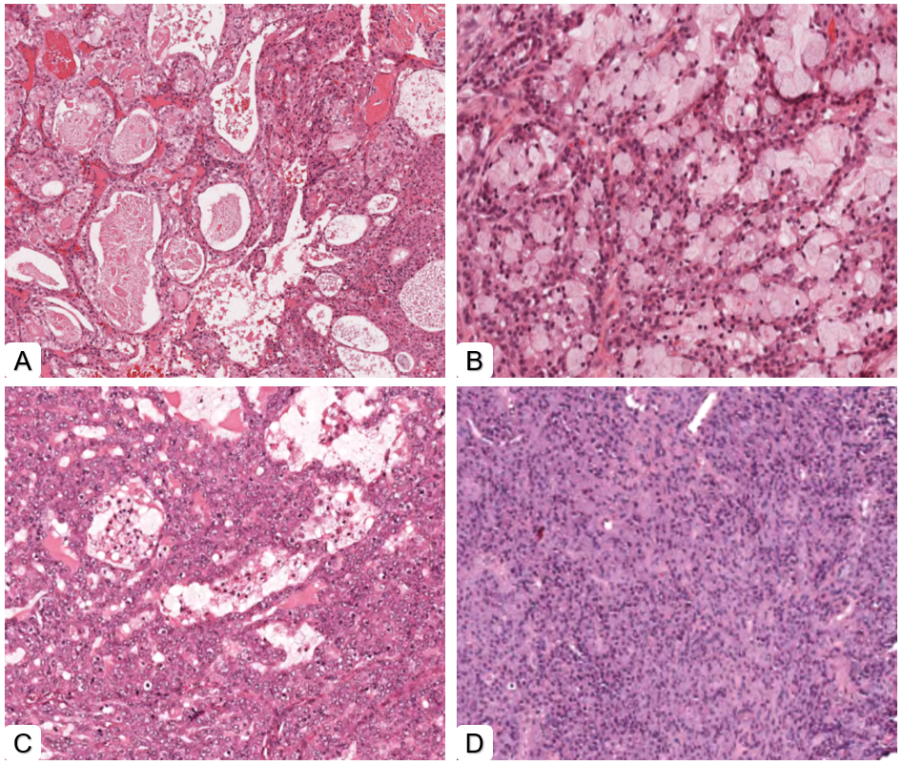
Figure ‎4.1: Different morphological appearance of low and high-grades tumours of MEC, A- low-grade (cystic pattern), B- low-grade (clear cell pattern), C- high-grade (mixed cystic and predominantly solid pattern), D- high-grade (solid pattern). (Magnification 5X).
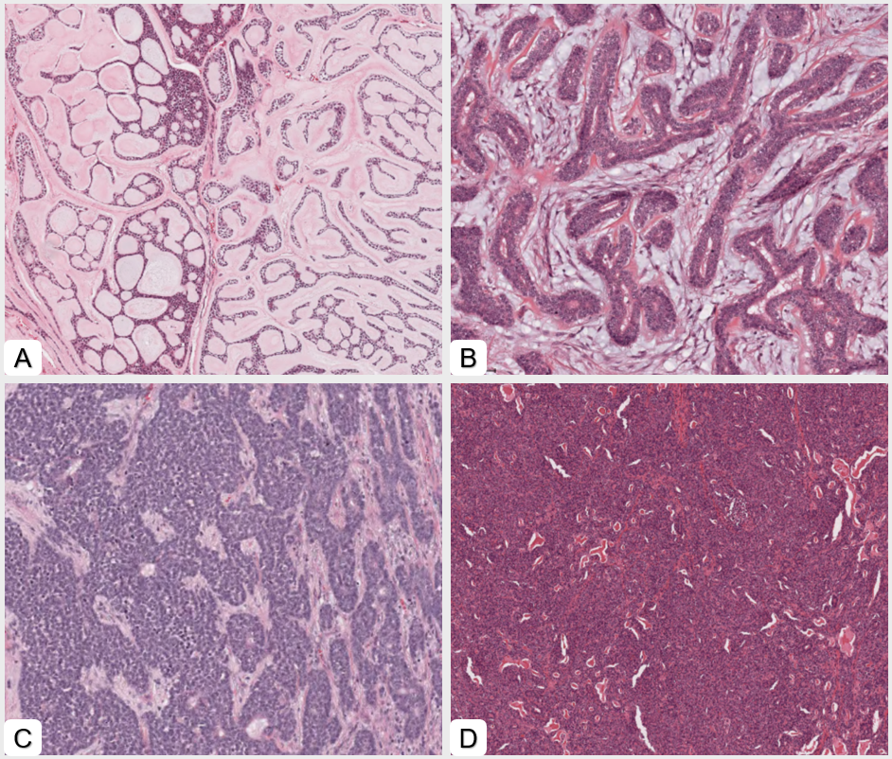
Figure ‎4.2: Different morphological appearance of low and high-grades tumours of AdCC, A- low-grade (cribriform pattern), B- low-grade (tubular pattern), C- high-grade (mixed tubular and predominantly solid pattern), D- high-grade (solid pattern). (Magnification 5X).

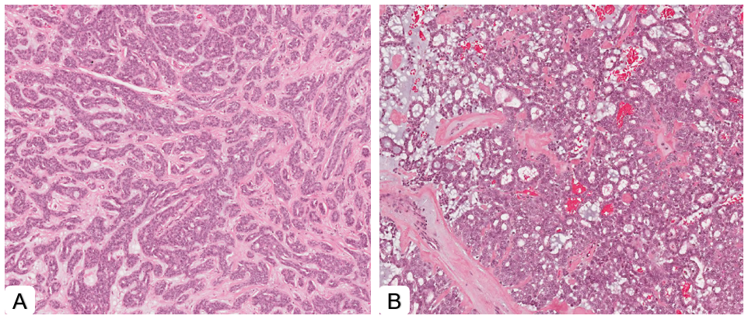
Figure ‎4.3: Different morphological appearance of low and high-grades tumours of PAC, A- low-grade (trabeculae or tubules appearance), B- high-grade PAC/CASG (cribriform appearance). (Magnification 5X).

Also, an additional 16 MEC (H&E) stained slides were retrieved, and FISH MAML2- fusion status was gathered using the clinical database. The diagnosis and histological grade of these cases were independently confirmed by the student and one of the supervisors (SAK).The scanning and generating WSIs step has been explained previously in chapter 3. FISH analysis was performed by the Sheffield Diagnostic Genetics Service on formalin fixed paraffin embedded tissue using the Zytovision MAML2 breakapart probe. At least 100 interphase nuclei were analysed for each case. The MAML2 breakapart probe is designed to detect the standard t(11;19) (q21;p13) MAML2::CRTC1 and variant translocations associated with mucoepidermoid carcinoma, and MEC variant subtypes.

Dataset and ROI detail
For the tumour grading classifiers (TG), QuPath was employed (Bankhead et al., 2017). To train the classifiers, MEC, and AdCC were used (PAC cases were excluded from classifiers because there were not enough cases (only 20 WSIs) to train and test the algorithm and to keep the data in the classifier from being out of balance). Two-thirds of cases (80 WSIs) were used for training and one-third (40 WSIs) (unseen) for testing (Table ‎4.2) (Figure 4.4).
Table ‎4.2: Training and testing sets case numbers breakdown for tumour grading (TG) classifiers.
Classifiers type | Training set | Testing set | Total
Tumour grading (TG) | 80 WSIs (40 Low-grade & 40 High-grade) | 40 WSIs (20 Low-grade & 20 High-grade) | 120 WSIs

Due to subjectivity of the three-grade system in interpreting histological features a binary grading system of low or high grade was used for both tumours. The grading criteria were consistent with existing literature (Nance et al.,2008, Perzin et al., 1978, and Szanto et al., 1984). The grading of MEC is based on the most prominent histological features that can be seen in the tumour, with low-grade MEC being defined by a predominance of mucous cells, a cystic or glandular growth pattern, and showing a low mitotic rate and minimal cellular pleomorphism, while high-grade tumours are characterised by a predominance of epidermoid cells, a lack or minimal mucous cells, a solid or infiltrative growth pattern, and marked cellular pleomorphism. The intermediate grade was joined with the nearest grade according to above mentioned criteria (based on the Brandwein and AFIP score). In addition, the grading of AdCC is based on the predominant pattern observed in the tumour, with the cribriform and tubular patterns were considered as low-grade and solid patterns as high-grade (any tumours with solid areas were therefore categorised as high grade).The classifiers were trained by selecting 3-5 ROIs per WSI using fixed-size areas of 1587600 μm² (5000 x 5000 pixels) to ensure standardisation across cases.

Cell detection and Classifier Development
Cell detection was performed as previously described (using the built in Cell Detection function in QuPath which works by manually specifying a threshold value (0.05~0.10) for pixel intensity and then discovering any pixels in the ROIs with intensity values within this threshold). Following this, the detected cells/nuclei were assigned to a specific ‘class/ground truth’ (i.e. low or high-grade tumour). Using the ROIs in the training cases, an artificial neural network with a multilayer perceptron (ANN-MLP classifier - built in option within QuPath) was built and validated through the visualisation of nuclear segmentation. Finally, an automated analysis of features for the testing set (40 WSI) was performed (Figure ‎4.4).

Quantitative Analysis of features

Grading feature quantification
60 WSIs of the three most common malignant SGT MEC, AdCC and PAC (20 each) were used. (PAC cases were only used for quantitative analysis). These cases included an equal split between low 10 (WSIs) and high- grades (10 WSIs) for each tumour (Table ‎4.3).
Table ‎4.3: Features quantitative analysis cases breakdown for grading and MAML2 fusion quantifications.
Features quantification | Dataset breakdown
Grading quantification | 20 MEC WSIs (10 each of Low & High) | 20 AdCC WSIs (10 each of Low & High) |  | 20 PAC WSIs (10 each of Low & High)
MAML2 fusion quantification | 8 WSIs MAML2 fusion positive) |  | 8 WSIs MAML2 fusion negative

QuPath was also used for quantification and to perform the analysis (chapter 3, section 3.2.2). The ROIs dimensions were maintained at 5000 x 5000 pixels, and cell/nuclear detection was performed as described above. Large ROIs were used for training from each WSI to ensure that morphologically different areas were included. Then, the geomorphometrical features were exported, and quantification and statistical analysis were carried out (Figure ‎4.4).

Quantification of features related to MAML2 fusion
16 WSIs of MEC with MAML2 fusion positive and negative (8 each) were used. QuPath was used as previously described (chapter 3, section 3.2.2) and the quantification was carried out by selecting 5-10 ROIs per WSI using fixed-size areas of 142,884 μm2 (1,500 × 1,500 pixels) to ensure consistency throughout cases. Cell detection was executed at a similar threshold mentioned above, following which the measurement table was exported for analysis (Figure 4.5).

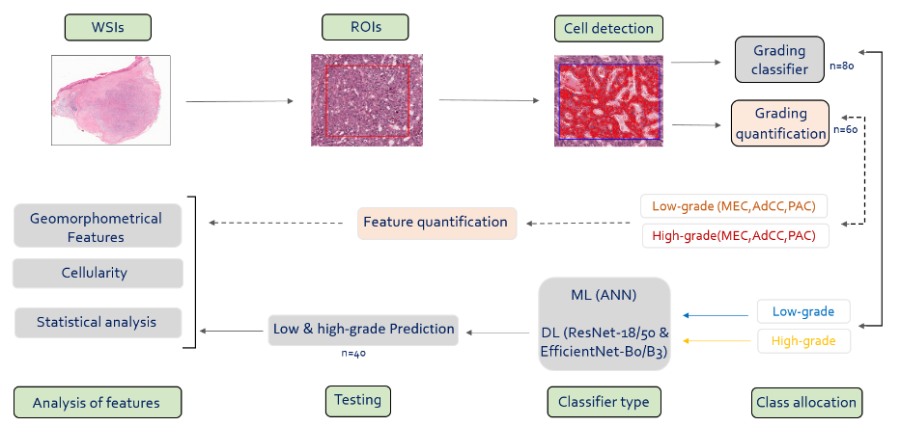
Figure ‎4.4: Grading classifiers and downstream analysis overview.
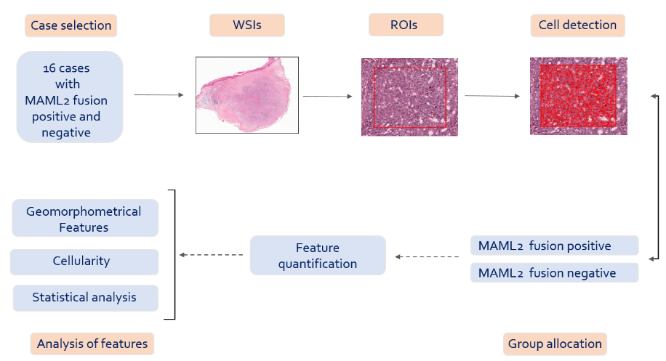
Figure ‎4.5: MAML2 fusion positive and negative mucoepidermoid carcinoma analysis overview.

Comparison with Deep Learning
This was performed similar to the method described in (chapter 3, section 3.2.4) (The only difference was the classes names here we used with the only difference being the classes (i.e., low and high grade classes were used instead of benign and malignant).

Spatial analysis
Topographical characteristics that explain relationships between various structures result from dynamic interactions between the cells (Preparata and Shamos, 2012). The spatial analysis was performed, including measuring centroid distance, intercellular distance, and mean triangle area and counting the number of neighbouring cells.

Statistical Analysis
T-Test and logistic regression were used to measure statistical significance between different geomorphometrical and spatial features as well as correlate these features with histological grade as well as MAML2 fusion status. Microsoft Excel 2016 (Microsoft Office Software, USA) and GraphPad Prism V9 (Dotmatics, USA) were used to organise exported data and perform statistical analyses. The performance of detection classifiers was measured using precision, recall, F1 score, and AUROC, generated at the case level.

Results

Grading classifiers
The tumour grading QuPath classifier (ANN/ML) (TG) showed high F1 and AUROC scores of 0.87 and 0.89, respectively (Table ‎4.4).

Table ‎4.4: Performances/accuracy metrics of the ML ANN classifiers (QuPath) as well as DL (ResNet 18,50 & EfficientNet B0,B3) at case-level predictions. Best performing models are highlighted in bold.
Classifier | Precision | Recall | F1-score | AUROC
Tumour grading (TG)
QuPath(ANN/ML) | 0.87 | 0.87 | 0.87 | 0.89
ResNet-18 | 0.68 | 0.64 | 0.66 | 0.71
ResNet-50 | 0.62 | 0.47 | 0.51 | 0.57
EfficientNet-B0 | 0.75 | 0.66 | 0.70 | 0.74
EfficientNet-B3 | 0.43 | 0.63 | 0.51 | 0.66

The predominant detection/class was accurate for all cases, although some false positive detection for both low and high grades were recognised (Figure ‎4.6). The state of the art DL networks performed inferior to the ML classifier (highest F1 score=0.70 with EfficientNet-B0) (Table ‎4.1).
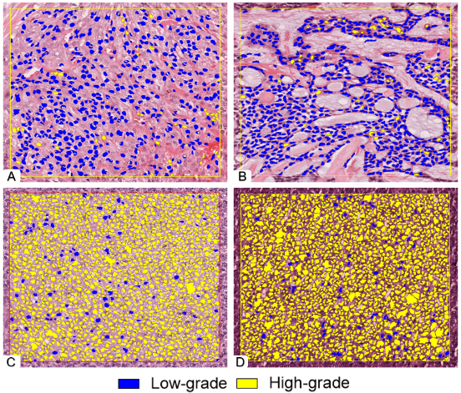

Figure ‎4.6: Automatic cell segmentation and classification in ROIs using a trained classifier. Tumour grading classifier, test n=40 predictions were largely correct with some false positive cells. A- mucoepidermoid carcinoma (low-grade),B- adenoid cystic carcinoma (low-grade), C- mucoepidermoid carcinoma (high-grade), D- adenoid cystic carcinoma (high-grade). (Magnification 20X).

At the whole slide level, the classifier showed an excellent performance in the detection of low and high-grade tumours as shown in (blue prediction/low-grade) (Figure ‎4.7) and (yellow prediction/high-grade) (Figure ‎4.8).

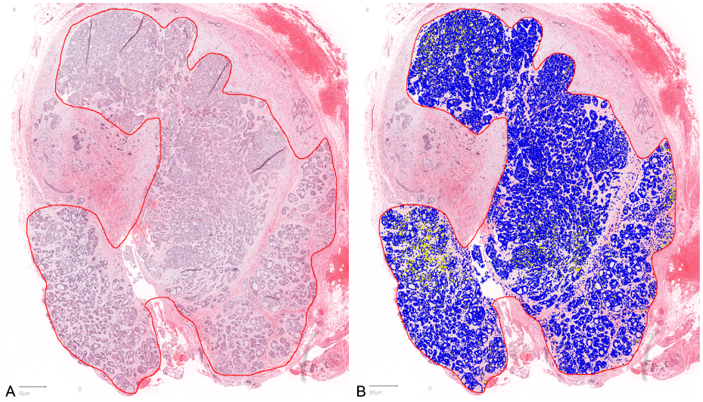
Figure ‎4.7: Automatic cell segmentation and classification of low-grade adenoid cystic carcinoma at WSI level using trained classifiers. A- H&E WSI, B- The majority of predictions were correctly identified as low-grade as shown by blue prediction. (Magnification 1X).

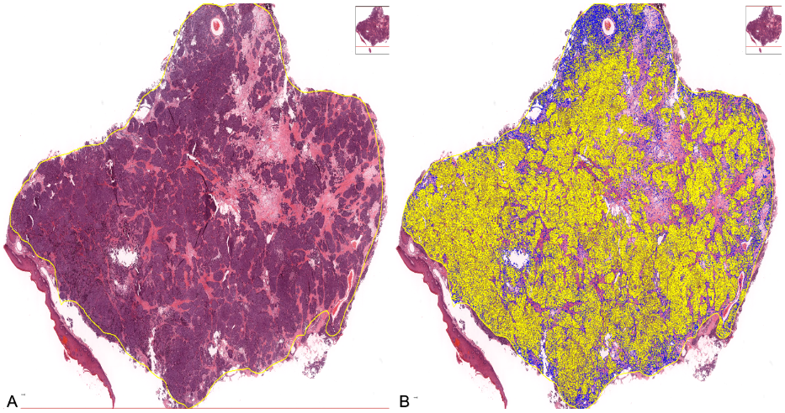
Figure ‎4.8: Automatic cell segmentation and classification of high-grade adenoid cystic carcinoma at WSI level using trained classifiers. A- H&E WSI, B- The majority of predictions were correctly identified as high-grade as shown by yellow prediction. (Magnification 1X).

Feature analysis
The geometrical and morphometrical feature analysis of the test set demonstrated a number of features that were being used by the classifier for identification as low or high-grade tumours. Statistical analysis showed that there was a significant difference between nuclear circularity, cytoplasmic eosin OD, and nucleus/cell ratio (p<0.01) between low and high-grade tumours (Figure ‎4.9).
Figure ‎4.9: Average values for nuclear and cytoplasmic features in low-grade (blue) and high-grade (yellow) classes test cases (test n=40). Error bars = standard deviation. *p<0.01 (T-Test (two-tailed)).

Cellularity
The average number of cells in high-grade tumours (mean= 3837, SD= ±2035) was higher than in low-grade tumours (Mean= 1920, SD= ±777) (average cellularity of 200 standardised tumour-rich ROIs). This difference in cellularity was statistically significant (p<0.01) (Figure ‎4.10).

Figure ‎4.10: Boxplot showing cellularity of the low-grade (Blue) and high-grade (Yellow) tumours (test n=40). Error bars = standard deviation. *p<0.01 (T-Test (two-tailed)).

Spatial analysis
Dynamic interaction between low and high-grade cells creates topographical features that explain spatial orientation (Figure ‎4.11 A&B). The average centroid distance showed a significant difference between cells in low and high-grade tumours, with a smaller distance seen in high-grade tumours (p<0.01) (Figure ‎4.11 C). Cluster spatial analysis showed a significant difference in the number of neighbouring cells in low and high-grade tumours (p<0.01). Furthermore, there was a significant difference between the Delaunay mean intercellular distance between low (Mean= 13.73μm, SD= ±2.02) and high (Mean= 12.11μm, SD= ±1.43) grade tumours (p<0.01). In addition, the Delaunay mean triangle area was also significantly different between low (Mean= 68.72, SD= ±19.97) and high (Mean= 53.84, SD= ±12.68) grade tumours (p<0.01) (Figure ‎4.11 D).
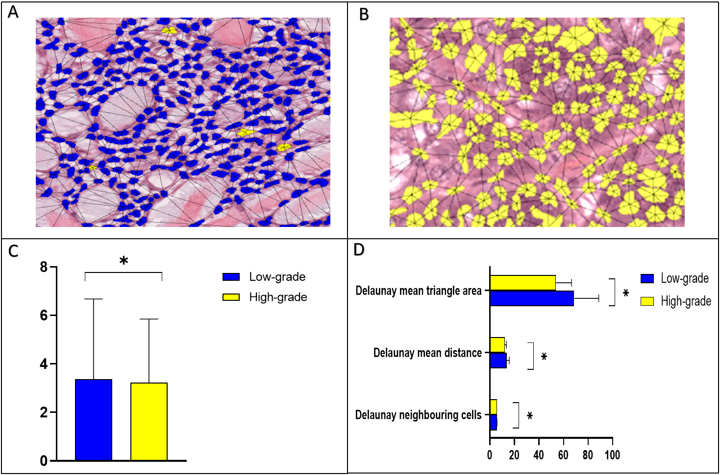
Figure ‎4.11: Spatial and proximity analysis of low and high-grade tumours (test n=40). A-B Showing spatial orientation networks of low-grade AdCC (A) and high-grade MEC (B) cells. (Magnification 40X). C- Average centroid distance between low and high-grade tumours (μm). D- Cluster spatial analysis of Delaunay features for low and high-grade tumours. Error bars = standard deviation .*p<0.01 (T-Test (two-tailed)).

Feature Quantification in Grading

Feature analysis
The quantification of geometrical and morphometrical features between low and high grades for each tumour, including AdCC, MEC and PAC showed that there was a statistically significant difference between nuclear eccentricity and nucleus/cell ratio (p<0.01) in AdCC and nuclear circularity and eccentricity in PAC (p<0.05) (Figure ‎4.12). Interestingly no significant differences were found in MEC cases.
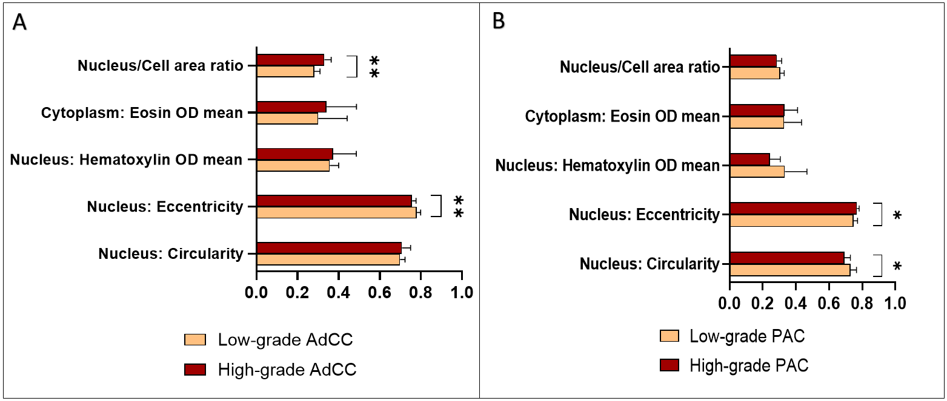
Figure ‎4.12: Average values for nuclear and cytoplasmic features in low-grade (orange) and high-grade (dark red) cases. A- Adenoid cystic carcinoma (AdCC) (n=20). B- Polymorphous adenocarcinoma (PAC) (n=20). Error bars = standard deviation. *p<0.05. **p<0.01 (T-Test (two-tailed)).

Cellularity
The average number of cells in high-grade AdCC (mean= 84536, SD= ±54334) was higher than in low-grade tumours (Mean= 45794, SD= ±16301) (average cellularity per case calculated across 3-5 standardised tumour-rich ROIs). This difference in cellularity was statistically significant (p<0.05). Cellularity in low-grade MEC (mean= 38741, SD= ±12019) was slightly higher than high-grade tumours (Mean= 38643, SD= ±15844) but the difference was not significant. In PAC, high-grade tumours also showed higher cellularity (mean= 43614, SD= ±23432) than low-grade tumours (Mean= 39625, SD= ±16504) but the difference was not significant (Figure ‎4.13).
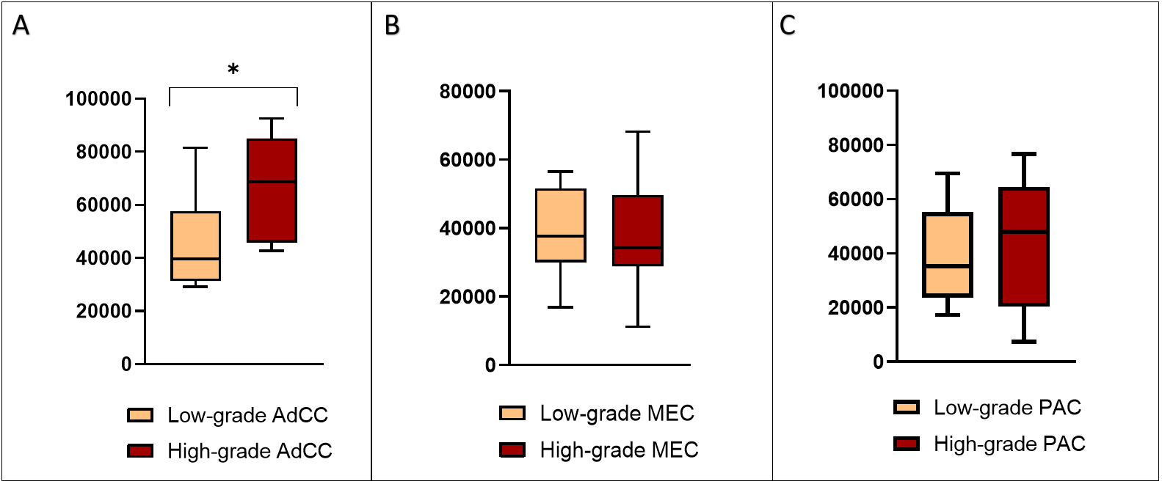
Figure ‎4.13: Boxplots showing cellularity of the low-grade (orange) and high-grade (dark red) tumours. A- Adenoid cystic carcinoma (AdCC) (n=20). B- Mucoepidermoid carcinoma (MEC)(n=20) C- polymorphous adenocarcinoma (PAC) (n=20). Error bars = standard deviation. *p<0.01 (T-Test (two-tailed)).

Correlation of features with histological grade
The correlation of geometrical and morphometrical features with grade showed that nuclear eccentricity was significantly different (p<0.01) between low and high-grade AdCC tumours, which is represented as the reverse sigmoid curve, the eccentricity increases with low-grade tumours. In addition, the nucleus/cell ratio was also significantly different (p<0.01) between different grades of AdCC with the nucleus/cell ratio increasing in high-grade tumours (Figure ‎4.14)
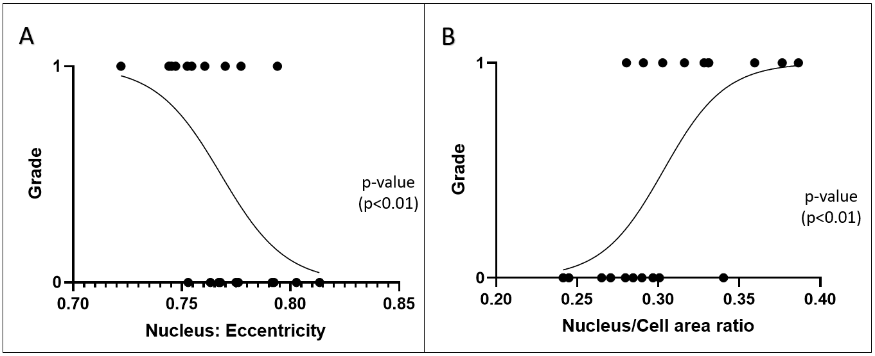
Figure ‎4.14: Logistic regression curve for AdCC cases n=20 correlating with grade. 0: low grade, 1: high grade.

On the other hand, the nuclear circularity and eccentricity showed a significant difference (p<0.05) between low and high-grade in PAC. The circularity increases in low-grade tumours, and eccentricity increases in high-grade tumours (Figure ‎4.15).
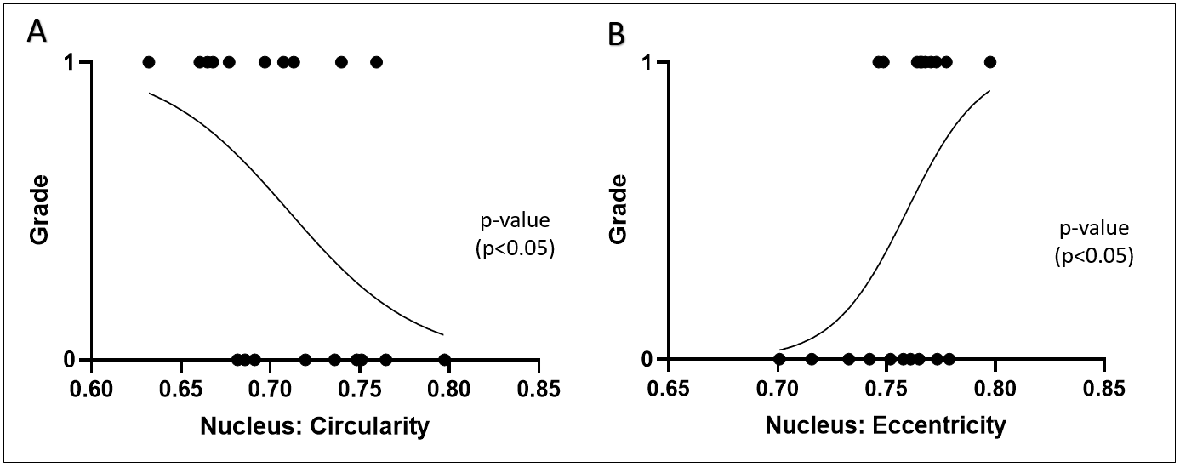
Figure ‎4.15: Logistic regression curve for PAC cases n=20 correlating with grade. 0: low grade, 1: high grade.

Feature quantification related to MAML2 fusion in MEC

Feature analysis
The quantification of geometrical and morphometrical features between MAML2 fusion positive and negative interestingly showed no statistical difference in most of the features (Figure ‎4.16 A) except for nuclear area and perimeter, which was higher in fusion negative tumours (Figure ‎4.16 B).
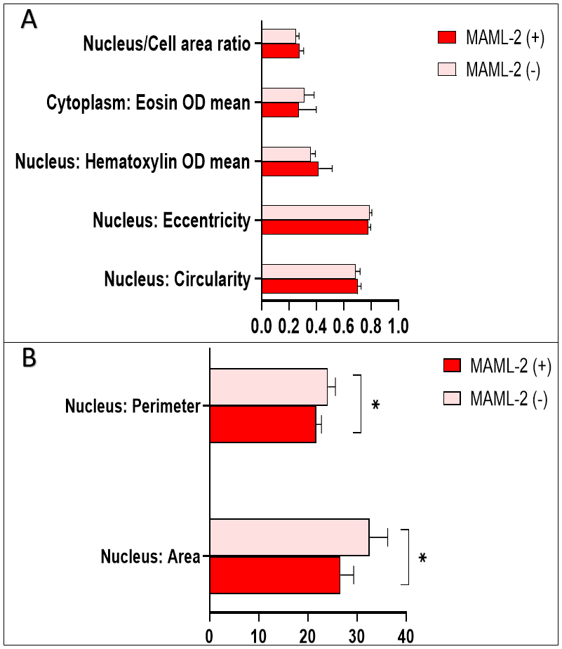
Figure ‎4.16: A&B - average values for nuclear and cytoplasmic features in MAML2 (+) (red) and MAML2 (-) (pink) cases (n=16). Error bars = standard deviation. *p<0.01 (T-Test (two-tailed)).

Cellularity
The average number of cells in MAML2 (-) (mean= 54289, SD= ±33026) was higher than MAML2 (+) (Mean= 23602, SD= ±17973) (average cellularity per case calculated across 5-10 standardized tumour rich ROIs). This difference in cellularity was statistically significant (p<0.05) (Figure ‎4.17).
Figure ‎4.17: Boxplot showing cellularity of the MAML2 (+) (red) and MAML2 (-) (pink) classes (n=16). Error bars = standard deviation. *p<0.05 (T-Test (two-tailed)).

MAML2 fusion features quantification
The quantification of geometrical and morphometrical features showed that nuclear area and perimeter showed a significant difference (p<0.01) between MAML2 fusion positive and negative cases which represented as reverse sigmoid curve, the nuclear area and perimeter increase for MAML2 (+) cases (Figure ‎4.18).
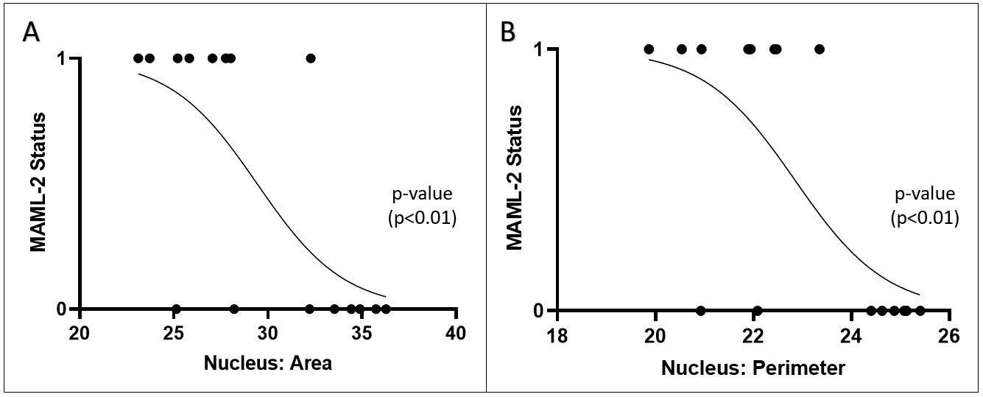
Figure ‎4.18: Logistic regression curve for MAML2 fusion positive and negative cases n=16 correlating with nuclear area and perimeter. 0: MAML-2 (+), 1: MAML-2 (-).

Discussion

Tumour grading and feature quantification
These results show that AI can be used successfully for grading malignant SGT on H&E images for the first time. AI has been shown to aid in the standardisation of pathological grading and the automated analysis of pathological features in prostate and gastric cancer (Pantanowitz et al., 2020, Bulten et al., 2020, Nagpal et al., 2019, Shaban et al., 2020, Arvaniti et al., 2018, Ström et al., 2019). However, its application to SGT grade prediction has not been explored to date.
Despite evidence suggesting that grading systems produce clinically useful information, all grading schemes are arbitrary and open to interpretation. In addition, grading in these systems is often subjective and dependent on pathologist experience (Seethala, 2009, Bai et al., 2013). Ki-67 immunostaining is used frequently to assess tumour behaviour and has been shown to significantly correlate with histological grade in MEC, but no such correlation was observed in AdCC (Kiyoshima et al., 2001). In general, the association between IHC markers and histological grade or clinical outcomes in SGT is poorly understood (Vargas et al., 2008).
Due to time and data constraints, only the three most common malignant SGT types were included for quantitative analysis and two for the AI grading work in the study. Our novel ML classifier (TG-tumour grading) showed excellent performance with an F1-score of 0.87. The best performing DL algorithm was EfficientNet-B0 with an inferior performance and F1-score compared to the ML classifiers. Nonetheless, the result was comparable to previously reported work in breast cancer grading (Couture et al., 2018).
For the tumour grading classifier, a significant difference between nuclear circularity, cytoplasmic eosin and nucleus/cell ratio was seen for algorithm decision making. This is biologically relevant because higher grade and poorly differentiated neoplasms exhibit less circularity and more pleomorphism. In addition, high-grade tumours showed increased nuclear cellular area ratio, which is a well-known feature of malignant and high-grade tumours (Jang et al., 2011, Seethala, 2011, Fischer, 2020).
Tumour cellularity assessment is an evaluative process with inter-observer variability, and AI has been shown to be successful and precise at this task. Our findings showed that high-grade tumours have higher cellularity than low-grade tumours, which is consistent with the literature because high-grade malignant tumours are known to be more cellular. However, this quantification is rarely done in practice and has never been done for SGT (Jang et al., 2011, Yin et al., 2016, Fischer, 2020).
Topographical features that explain spatial orientation are created by the dynamic interaction of the cells and microenvironment (Preparata and Shamos, 2012). Our result showed that high-grade tumours significantly have shorter centroid and intracellular distances than low-grade tumours. This corroborates the higher cellularity finding in high-grade tumours indicating that cells in these tumours are more closely packed (e.g. solid pattern in AdCC) (Jang et al., 2011, Seethala, 2011).
The quantification analysis of each malignant tumour showed similar significant differences, as mentioned above, between low and high-grade tumours for PAC and AdCC. Interestingly, no significant differences were seen between grades in MEC. This could be due to the small number of cases (n=20).

Feature analysis in relation to MAML2 status
Although conventional clinicopathologic parameters such as grade and stage have proven reliable prognostic indicators, this topic has been the subject of debate, and there is no consensus. Therefore, more objective markers are needed to refine prognosis and treatment (Seethala et al., 2010, Fu et al., 2020). The relationship between IHC markers and clinical outcome is not well established in SGT (Vargas et al., 2008). In addition, subjectivity is a problem with IHC markers because of technique variability and the scoring system. Therefore, the MAML2 fusion has been proposed by some studies as a prognostic indicator (Seethala et al., 2010, Pérez‐de‐Oliveira et al., 2020).
Several studies have used H&E images to predict and analyse a wide range of genetic mutations using AI-based methods in various cancers (Kather et al., 2019a, Fu et al., 2020, Schmauch et al., 2020, Kather et al., 2020, Chen et al., 2022). Using computationally derived histomorphological biomarkers can potentially improve patient risk stratification (Echle et al., 2021, Chen et al., 2022). To date, there have been no reports on the potential of using AI-based molecular data analysis to predict histological grade/prognosis in SGT.
Our findings showed that AI could be used successfully to perform quantitative analysis of MEC H&E images and correlate them with MAML2 fusion status and potentially with prognosis. Due to time and data constraints, only 16 cases could be assessed in this part of the study. Interestingly, there was no significant difference between most geometrical and morphometrical features of MAML2 fusion positive and negative. This could be due to the small sample size. In contrast, they differed significantly in the nuclear area and the perimeter, with MAML2-negative MECs scoring higher. This finding is contradictory to what Mueller and Fusenig 2004, concluded that genetic mutations could cause changes in the size, and shape of cancer cells in a histological image (Mueller and Fusenig, 2004). Fisher 2020, on the other hand, stated that no known direct association exists between specific mutations and changes in nuclear characteristics in cancer cells (Fischer, 2020).
Assessment of tumour cellularity is an evaluative procedure with inter-observer variation, and AI has proven effective in quantifying cancer cellularity (Alsanie et al., 2022b). Our results demonstrate that MAML2-negative MECs have higher cellularity than MAML2-positive ones. This is somewhat in keeping with the suggestions in the literature that high-grade tumours are more likely to be fusion negative and our findings earlier have shown increased cellularity in high-grade tumours.
For further insight into the implications of these results, this work needs to be carried out on a larger multicentre cohort including correlation with clinical prognosis and survival.

Chapter 5: General discussion, future perspective and conclusion

Thesis overview
In Chapter 1, we introduce the SGT and demonstrate how they are classified, as well as provide examples of diagnostic challenges in clinical practice. Next, we discuss the benefits and drawbacks of digital pathology and artificial intelligence, as well as elaborate on the most common approaches and techniques. Finally, we show some successful applications of AI algorithms in computational pathology.
In chapter 2, we found that a large number of studies had provided epidemiological information for SGT in the literature. However, either they reflect relatively small datasets from a single centre or local population only, investigating either major or minor glands only or they are out of date. Therefore, our goal was to gather the most recent information on the frequency and distribution of SGT, as well as its anatomical and demographic distribution and the correlation between results from different geographical areas.
In chapters 3 and 4, we looked into whether automated feature detection using ML and deep learning models could differentiate between benign and malignant salivary gland tumours, as well as subtype malignant and grade SGTs in WSIs. Additionally, we quantitatively analysed the detected features that were found in cases of MAML2 fusion positive and negative mucoepidermoid carcinomas.

General Discussion

Demographics
SGT are relatively rare, and our study is one of the most comprehensive reports examining the incidence and demographics of these tumours from multiple centres and the majority of WHO geographical regions. In chapter 2, we aimed to obtain the most up-to-date frequency and distribution of SGT, as well as the demographic and anatomical location of SGT and the correlation between findings from various geographic regions. Information relating to 5,739 cases from pathology centres across the globe was collected which showed that benign tumours comprised the majority of SGT (65%) compared to malignant tumours (35%). In our study, there was a slight predilection for females, and the peak incidence was observed between the fourth and seventh decades of life (approximately 69% of cases). The most common benign tumour was pleomorphic adenoma, while the most prevalent malignant tumour was mucoepidermoid carcinoma. The majority of SGT (68%) manifested in the major glands, with the parotid gland being the most typical site for benign tumours (70%) and the minor glands (47%) for malignant tumours. Our findings are generally consistent with the published literature, with some regional variance in incidence rate and location (chapter 2, section 2.3).

Machine and Deep Learning and Quantitative analysis
Our novel results report the application of AI and ML for histological analysis, subtyping, and grading of SGT on H&E images for the first time. Our ML benign vs malignant (BVM), malignant subtyping (MST), and tumour grading (TG) classifiers have achieved outstanding accuracy with F1 scores of 0.90, 0.92, and 0.87, respectively.
The geometrical and morphometrical feature analysis revealed a statistically significant difference between nuclear circularity, nuclear eccentricity, nuclear haematoxylin OD, cytoplasmic eosin OD, and nuclear/cellular area ratio between different classes in our study. Our finding showed that benign and low-grade tumours demonstrated more circular and less eccentric nuclei than malignant and high-grade tumours. In addition, greater intensity of haematoxylin nuclear staining and increased nuclear/cellular area ratio were noted in malignant and high-grade tumours. This has clinical significance because pleomorphism and abnormal DNA content (i.e. hyperchromatism) are hallmarks of malignant cells, as well as high-grade and poorly differentiated neoplasms (Jang et al., 2011, Seethala, 2011, Fischer, 2020) (chapter 3 & 4, sections 3.3.2 & 4.3.2).
Furthermore, our results showed that malignant and high-grade tumours are more cellular than benign and low-grade tumours, which is consistent with the literature description of malignant and high-grade tumour characteristics. Nonetheless, this quantification is seldom performed in clinical practice (Jang et al., 2011, Yin et al., 2016, Fischer, 2020) (chapter 3 & 4, sections 3.3.3.1 & 4.3.3).
We are also the first to discuss the significance of spatial characteristics in SGT. This is significant because it has been demonstrated that the tumour microenvironment is crucial to the development and prognosis of many neoplasms. Our results showed that benign and malignant, malignant subtypes, and low and high-grade tumours differ in their spatial orientation and cell clustering, which may be a useful adjunct for differentiating between them. Malignant and high-grade tumours were found to have significantly shorter mean intracellular distances than benign and low-grade tumours, indicating that these cells are more densely packed (Jang et al., 2011, Seethala, 2011, Fischer, 2020) (chapter 3 & 4, sections 3.3.3.2 & 4.3.4).

Study Shortcomings
We have conducted the most comprehensive study investigating the prevalence and demography of SGT across numerous centres and the majority of WHO geographical regions.
Our results demonstrated that ML and DL quantitative analysis have some limitations, despite the fact that it is novel and has outstanding performance. The cohort size was small in comparison to other types of cancer studies. By including more morphological variants of the SGT, larger training cohorts are anticipated to improve algorithm performance. Nonetheless, SGTs are uncommon and locating additional examples is challenging, but we will strive to accomplish this through newly received cases or other collaborators. In addition, molecular data analysis was limited to 16 cases, but as more MAML2 tested cases become available, we will increase the number, especially with newly received cases to the department. For this purpose, cases are being added from the Head and Neck 5000 trial and The Christie Hospital, Manchester, as a continuation of this work including adenoid cystic carcinoma.
Moreover, the ML experiment was done at the ROIs level and the DL at the patch level; however, the WSIs level will provide a more accurate representation of the tumours and encompass a greater region. In addition, the analysis largely focused on epithelial cells and lack of stromal features. Furthermore, our dataset included cases from a single centre and no stain normalisation or augmentation was performed. However, Sheffield is a centre of excellence, getting routine and referral cases from not only the region, but nationally and worldwide, which would decrease bias and increase the robustness of the trained algorithms.

Future directions
- We aim to continue working on this project to further improve the performance by expanding the cohort, either from newly received cases by the department or from collaborators who participated in our previous multicentre SGT demographics study. Another possible avenue is creating synthetic data for training process, which would reduce the need for gathering massive datasets. The most widely used method is data augmentation, which involves deriving a number of alterations from the initial training data (Tellez et al., 2019). In addition, using Generative Adversarial Networks to automatically generate realistic synthetic histology images also another method to overcome the low number of data sets (Levine et al., 2020). We are planning to concurrently try these models as well.
- We will try to include more tumour types and grades to ensure that we cover a significant proportion of SGT.
- We will explore different techniques and approaches to improve the DL results to above 95% accuracy. Sometimes trying various features leads to significant improvements (Kandel and Castelli, 2020, Mormont et al., 2020).
- We also intend to collect and analyse prognostic data from a retrospective cohort. Then, construct algorithms for predicting the behaviour of tumours, irrespective of type or class, and correlate it with prognostic and survival information.
- We also aim to collect and analyse more molecular data of MAML2 status in MECs as well as other SGT like MYB status in AdCC.
- We will make the algorithms available to the public so that they can test them independently and provide us with feedback. We might also allow our annotated dataset to be used by the research community to develop and benchmark generalised approaches for SGT classification, subtyping and grading. In addition, we will create a Github environment for constructive comments and criticism (Kumar et al., 2017). In fact, the accessibility of large, high-quality training data is a crucial requirement to improve algorithms accuracy and performance. Institutions may not be able to share data widely in some situations due to practical or legal concerns. Co-training AI models in these circumstances without sharing any data could be a solution (Shmatko et al., 2022). There have been two main approaches investigated: federated learning, in which a number of models are independently trained, and participants exchange model updates via a centralised server without disclosing the actual data. Then the server combines the model weights and sends each participant the updated model (Lu et al., 2022). The second method is swarm learning which multiple parties co-train a model, but in this case, they are coordinated by blockchain-based communication, allowing the direct exchange of model updates via a peer-to-peer network (Saldanha et al., 2022).

Conclusions
Salivary gland tumours are rare, but have shown a gradual increasing incidence over the last decade and a half. We report the largest multicentre investigation of SGT to date showing that the majority are benign (65%), with a slight predilection for females (54%) and majority 69% occurs in patients between the fourth to seventh decades of life with a significant difference between the average age for benign and malignant tumours. Pleomorphic adenoma was the most common benign and mucoepidermoid carcinoma the most common malignant tumour. The majority of SGT presented in the major glands (68%), with the parotid gland being the most common location (70%) for benign and minor glands (47%) for malignant tumours. More extensive studies of SGT need to be conducted to understand and update the epidemiological landscape of these tumours and correlate it with prognosis.
Computational pathology (ML and DL) has been shown to give accurate and objective measurements and classifications of a variety of cancers. Our novel results report the application of ML and DL for histological analysis, subtyping and grading of SGT on H&E images for the first time. Our benign vs malignant, malignant subtyping and grading classifiers have achieved excellent performance with F1 score of 0.90, 0.92 and 0.87, respectively. The predictions are based on statistically significant differences in histological features with biological relevance between tumours. These findings will aid in pathological diagnosis and clinical decision making, but a larger multicentre cohort needs to be analysed to determine the true significance and clinical usefulness.

Further results since submission
External validation
These is preliminary results from the external cohorts to confirm the effectiveness of our trained classifier, and we anticipate receiving additional cases from our collaborators.
Methods
Further cases have been obtained since the submission of this thesis including 20 cases from Brazil (Piracicaba Dental School, University of Campinas, São Paulo State) and 136 cases from the Head and Neck 5000 trial (UK). All Brazil cases are benign (20 PA) and all Head and Neck 5000 are malignant.
For benign vs malignant, 40 WSI (20 benign (PA) and 20 malignant (10 MEC and 10 AdCC) were used as external validation set. 40 WSI (20 MEC low and high grade (10 each) and 20 AdCC low and high grade (10 each)) were used as external validation set for the tumour grading classifier. Cases were loaded to the QuPath and 5 random ROIs per WSI were selected using fixed-size areas of 142,884 μm2 (1,500 × 1,500 pixels) to ensure standardisation across cases. A total number of 400 ROIs (200 for each project) were used to determine performance.
Results
The benign vs malignant and tumour grading ML classifier showed good F1 and AUROC scores of 0.87 and 0.89 respectively on the external cohorts.
Table: External cohort performances/accuracy metrics of the ML RF and ANN classifiers (QuPath) at case-level predictions.
Classifier | Precision | Recall | F1-score | AUROC
External cohorts
Benign vs malignant (RF/ML) | 0.87 | 0.87 | 0.87 | 0.89
Tumour grading (ANN/MLP) | 0.87 | 0.87 | 0.87 | 0.89

References
ABELS, E., PANTANOWITZ, L., AEFFNER, F., ZARELLA, M. D., VAN DER LAAK, J., BUI, M. M., VEMURI, V. N., PARWANI, A. V., GIBBS, J. & AGOSTO‐ARROYO, E. 2019. Computational pathology definitions, best practices, and recommendations for regulatory guidance: a white paper from the Digital Pathology Association. The Journal of pathology, 249, 286-294.
ACS, B., RANTALAINEN, M. & HARTMAN, J. 2020. Artificial intelligence as the next step towards precision pathology. Journal of internal medicine, 288, 62-81.
AL‐JANABI, S., HUISMAN, A. & VAN DIEST, P. J. 2012. Digital pathology: current status and future perspectives. Histopathology, 61, 1-9.
AL SHEDDI, M. A. 2016. Salivary glands tumors: a single institution experience in Saudi Arabia. Biosciences Biotechnology Research Asia, 9, 193-198.
ALI, S., VELTRI, R., EPSTEIN, J. A., CHRISTUDASS, C. & MADABHUSHI, A. Cell cluster graph for prediction of biochemical recurrence in prostate cancer patients from tissue microarrays. Medical Imaging 2013: Digital Pathology, 2013. SPIE, 164-174.
ALRAMADHAN, S. A., FITZPATRICK, S. G., COHEN, D. M., BHATTACHARYYA, I. & ISLAM, M. N. 2020. Retrospective study of buccal mucosal salivary neoplasms. Head and neck pathology, 14, 1013-1020.
ALSANIE, I., RAJAB, S., COTTOM, H., ADEGUN, O., AGARWAL, R., JAY, A., GRAHAM, L., JAMES, J., BARRETT, A. W. & VAN HEERDEN, W. 2022a. Distribution and frequency of salivary gland tumours: an international multicenter study. Head and Neck Pathology, 1-12.
ALSANIE, I., SHEPHARD, A., AZARMEHR, N., RAJPOOT, N. & KHURRAM, S. A. 2022b. Using Artificial Intelligence for Analysis of Histological and Morphological Diversity in Salivary Gland Tumors.
ANDREASEN, S., KISS, K., MIKKELSEN, L. H., CHANNIR, H. I., PLASCHKE, C. C., MELCHIOR, L. C., ERIKSEN, J. G. & WESSEL, I. 2019. An update on head and neck cancer: new entities and their histopathology, molecular background, treatment, and outcome. Apmis, 127, 240-264.
ARAÚJO, T., ARESTA, G., CASTRO, E., ROUCO, J., AGUIAR, P., ELOY, C., POLÓNIA, A. & CAMPILHO, A. 2017. Classification of breast cancer histology images using convolutional neural networks. PloS one, 12, e0177544.
ARMSTRONG, J. G., HARRISON, L. B., SPIRO, R. H., FASS, D. E., STRONG, E. W. & FUKS, Z. Y. 1990. Malignant tumors of major salivary gland origin: a matched-pair analysis of the role of combined surgery and postoperative radiotherapy. Archives of Otolaryngology–Head & Neck Surgery, 116, 290-293.
ARVANITI, E., FRICKER, K. S., MORET, M., RUPP, N., HERMANNS, T., FANKHAUSER, C., WEY, N., WILD, P. J., RUESCHOFF, J. H. & CLAASSEN, M. 2018. Automated Gleason grading of prostate cancer tissue microarrays via deep learning. Scientific reports, 8, 1-11.
ATAC, A., KURT, E. & YURDAKUL, S. E. 2013. An overview to ethical problems in telemedicine technology. Procedia-Social and Behavioral Sciences, 103, 116-121.
AUBREVILLE, M., STATHONIKOS, N., BERTRAM, C. A., KLOPLEISCH, R., TER HOEVE, N., CIOMPI, F., WILM, F., MARZAHL, C., DONOVAN, T. A. & MAIER, A. 2022. Mitosis domain generalization in histopathology images--The MIDOG challenge. arXiv preprint arXiv:2204.03742.
AUCLAIR, P. L., GOODE, R. K. & ELLIS, G. L. 1992. Mucoepidermoid carcinoma of intraoral salivary glands evaluation and application of grading criteria in 143 cases. Cancer, 69, 2021-2030.
AUNG, Y. Y., WONG, D. C. & TING, D. S. 2021. The promise of artificial intelligence: a review of the opportunities and challenges of artificial intelligence in healthcare. British medical bulletin, 139, 4-15.
AYYAD, S. M., SHEHATA, M., SHALABY, A., ABOU EL-GHAR, M., GHAZAL, M., EL-MELEGY, M., ABDEL-HAMID, N. B., LABIB, L. M., ALI, H. A. & EL-BAZ, A. 2021. Role of AI and histopathological images in detecting prostate cancer: a survey. Sensors, 21, 2586.
BAI, S., CLUBWALA, R., ADLER, E., SARTA, C., SCHIFF, B., SMITH, R. V., GNEPP, D. R. & BRANDWEIN-GENSLER, M. 2013. Salivary mucoepidermoid carcinoma: a multi-institutional review of 76 patients. Head and neck pathology, 7, 105-112.
BAIK, J., YE, Q., ZHANG, L., POH, C., ROSIN, M., MACAULAY, C. & GUILLAUD, M. 2014. Automated classification of oral premalignant lesions using image cytometry and random forests-based algorithms. Cellular Oncology, 37, 193-202.
BANKHEAD, P., FERNÁNDEZ, J. A., MCART, D. G., BOYLE, D. P., LI, G., LOUGHREY, M. B., IRWIN, G. W., HARKIN, D. P., JAMES, J. A. & MCQUAID, S. 2018. Integrated tumor identification and automated scoring minimizes pathologist involvement and provides new insights to key biomarkers in breast cancer. Laboratory investigation, 98, 15-26.
BANKHEAD, P., LOUGHREY, M. B., FERNÁNDEZ, J. A., DOMBROWSKI, Y., MCART, D. G., DUNNE, P. D., MCQUAID, S., GRAY, R. T., MURRAY, L. J. & COLEMAN, H. G. 2017. QuPath: Open source software for digital pathology image analysis. Scientific reports, 7, 1-7.
BARNES, L., EVESON, J. W., SIDRANSKY, D. & REICHART, P. 2005. Pathology and genetics of head and neck tumours, IARC.
BATSAKIS, J. G., LUNA, M. A. & EL-NAGGAR, A. 1990. Histopathologic grading of salivary gland neoplasms: III. Adenoid cystic carcinomas. Annals of Otology, Rhinology & Laryngology, 99, 1007-1009.
BEGG, R. K., PALANISWAMI, M. & OWEN, B. 2005. Support vector machines for automated gait classification. IEEE transactions on Biomedical Engineering, 52, 828-838.
BEJNORDI, B. E., VETA, M., VAN DIEST, P. J., VAN GINNEKEN, B., KARSSEMEIJER, N., LITJENS, G., VAN DER LAAK, J. A., HERMSEN, M., MANSON, Q. F. & BALKENHOL, M. 2017. Diagnostic assessment of deep learning algorithms for detection of lymph node metastases in women with breast cancer. Jama, 318, 2199-2210.
BELL, R. B., DIERKS, E. J., HOMER, L. & POTTER, B. E. 2005. Management and outcome of patients with malignant salivary gland tumors. Journal of oral and maxillofacial surgery, 63, 917-928.
BELLO, I. O., SALO, T., DAYAN, D., TERVAHAUTA, E., ALMANGOUSH, A., SCHNAIDERMAN-SHAPIRO, A., BARSHACK, I., LEIVO, I. & VERED, M. 2012. Epithelial salivary gland tumors in two distant geographical locations, Finland (Helsinki and Oulu) and Israel (Tel Aviv): a 10-year retrospective comparative study of 2,218 cases. Head and neck pathology, 6, 224-231.
BENJAMENS, S., DHUNNOO, P. & MESKÓ, B. 2020. The state of artificial intelligence-based FDA-approved medical devices and algorithms: an online database. NPJ digital medicine, 3, 1-8.
BERA, K., SCHALPER, K. A., RIMM, D. L., VELCHETI, V. & MADABHUSHI, A. 2019. Artificial intelligence in digital pathology—new tools for diagnosis and precision oncology. Nature reviews Clinical oncology, 16, 703-715.
BIRKELAND, A. C., FOLTIN, S. K., MICHMERHUIZEN, N. L., HOESLI, R. C., ROSKO, A. J., BYRD, S., YANIK, M., NOR, J. E., BRADFORD, C. R. & PRINCE, M. E. 2017. Correlation of Crtc1/3-Maml2 fusion status, grade and survival in mucoepidermoid carcinoma. Oral oncology, 68, 5-8.
BISHOP, J. A., GAGAN, J., BAUMHOER, D., MCLEAN-HOLDEN, A. L., OLIAI, B. R., COUCE, M. & THOMPSON, L. D. 2020. Sclerosing polycystic “adenosis” of salivary glands: a neoplasm characterized by PI3K pathway alterations more correctly named sclerosing polycystic adenoma. Head and Neck Pathology, 14, 630-636.
BOUKHERIS, H., CURTIS, R. E., LAND, C. E. & DORES, G. M. 2009. Incidence of carcinoma of the major salivary glands according to the WHO classification, 1992 to 2006: a population-based study in the United States. Cancer epidemiology, biomarkers & prevention, 18, 2899-2906.
BRADLEY, P. J. & MCGURK, M. 2013. Incidence of salivary gland neoplasms in a defined UK population. British Journal of Oral and Maxillofacial Surgery, 51, 399-403.
BRANDWEIN, M. S., IVANOV, K., WALLACE, D. I., HILLE, J. J., WANG, B., FAHMY, A., BODIAN, C., URKEN, M. L., GNEPP, D. R. & HUVOS, A. 2001. Mucoepidermoid carcinoma: a clinicopathologic study of 80 patients with special reference to histological grading. The American journal of surgical pathology, 25, 835-845.
BREIMAN, L. 2001. Random forests. Machine learning, 45, 5-32.
BRIERLEY, D., SPEIGHT, P., HUNTER, K. & FARTHING, P. 2017. Using virtual microscopy to deliver an integrated oral pathology course for undergraduate dental students. British dental journal, 223, 115-120.
BULTEN, W., PINCKAERS, H., VAN BOVEN, H., VINK, R., DE BEL, T., VAN GINNEKEN, B., VAN DER LAAK, J., HULSBERGEN-VAN DE KAA, C. & LITJENS, G. 2020. Automated deep-learning system for Gleason grading of prostate cancer using biopsies: a diagnostic study. The Lancet Oncology, 21, 233-241.
CAMPANELLA, G., HANNA, M. G., GENESLAW, L., MIRAFLOR, A., WERNECK KRAUSS SILVA, V., BUSAM, K. J., BROGI, E., REUTER, V. E., KLIMSTRA, D. S. & FUCHS, T. J. 2019. Clinical-grade computational pathology using weakly supervised deep learning on whole slide images. Nature medicine, 25, 1301-1309.
CHALKIDOU, A., SHOKRANEH, F., KIJAUSKAITE, G., TAYLOR-PHILLIPS, S., HALLIGAN, S., WILKINSON, L., GLOCKER, B., GARRETT, P., DENNISTON, A. K. & MACKIE, A. 2022. Recommendations for the development and use of imaging test sets to investigate the test performance of artificial intelligence in health screening. The Lancet Digital Health, 4, e899-e905.
CHEN, R. J., LU, M. Y., WILLIAMSON, D. F., CHEN, T. Y., LIPKOVA, J., NOOR, Z., SHABAN, M., SHADY, M., WILLIAMS, M. & JOO, B. 2022. Pan-cancer integrative histology-genomic analysis via multimodal deep learning. Cancer Cell, 40, 865-878. e6.
CHENG, J. Y., ABEL, J. T., BALIS, U. G., MCCLINTOCK, D. S. & PANTANOWITZ, L. 2021. Challenges in the development, deployment, and regulation of artificial intelligence in anatomic pathology. The American Journal of Pathology, 191, 1684-1692.
COCCO, E., SCALTRITI, M. & DRILON, A. 2018. NTRK fusion-positive cancers and TRK inhibitor therapy. Nature reviews Clinical oncology, 15, 731-747.
COHEN, S. 2020. Artificial intelligence and deep learning in pathology, Elsevier Health Sciences.
CONDE-SOUSA, E., VALE, J., FENG, M., XU, K., WANG, Y., DELLA MEA, V., LA BARBERA, D., MONTAHAEI, E., BAGHSHAH, M. & TURZYNSKI, A. 2022. HEROHE Challenge: Predicting HER2 Status in Breast Cancer from Hematoxylin–Eosin Whole-Slide Imaging. Journal of Imaging, 8, 213.
COUDRAY, N., OCAMPO, P. S., SAKELLAROPOULOS, T., NARULA, N., SNUDERL, M., FENYÖ, D., MOREIRA, A. L., RAZAVIAN, N. & TSIRIGOS, A. 2018. Classification and mutation prediction from non–small cell lung cancer histopathology images using deep learning. Nature medicine, 24, 1559-1567.
COUTURE, H. D., WILLIAMS, L. A., GERADTS, J., NYANTE, S. J., BUTLER, E. N., MARRON, J., PEROU, C. M., TROESTER, M. A. & NIETHAMMER, M. 2018. Image analysis with deep learning to predict breast cancer grade, ER status, histologic subtype, and intrinsic subtype. NPJ breast cancer, 4, 1-8.
CROSS, S., FURNESS, P., IGALI, L., SNEAD, D. & TREANOR, D. 2018. Best practice recommendations for implementing digital pathology January 2018. The Royal College of Pathologists.
DAS, D. K., BOSE, S., MAITI, A. K., MITRA, B., MUKHERJEE, G. & DUTTA, P. K. 2018. Automatic identification of clinically relevant regions from oral tissue histological images for oral squamous cell carcinoma diagnosis. Tissue and Cell, 53, 111-119.
DELLA MEA, V., BARONI, G. L., PILUTTI, D. & DI LORETO, C. 2017. SlideJ: An ImageJ plugin for automated processing of whole slide images. PLoS One, 12, e0180540.
DIGABEL, H. & LANTUÉJOUL, C. Iterative algorithms. Proc. 2nd European Symp. Quantitative Analysis of Microstructures in Material Science, Biology and Medicine, 1978. Riederer Verlag, 8.
DOS SANTOS, E. S., RODRIGUES-FERNANDES, C. I., SPEIGHT, P. M., KHURRAM, S. A., ALSANIE, I., NORMANDO, A. G. C., PRADO-RIBEIRO, A. C., BRANDAO, T. B., KOWALSKI, L. P. & GUERRA, E. N. S. 2021. Impact of tumor site on the prognosis of salivary gland neoplasms: A systematic review and meta-analysis. Critical Reviews in Oncology/Hematology, 162, 103352.
ECHLE, A., RINDTORFF, N. T., BRINKER, T. J., LUEDDE, T., PEARSON, A. T. & KATHER, J. N. 2021. Deep learning in cancer pathology: a new generation of clinical biomarkers. British journal of cancer, 124, 686-696.
EHTESHAMI BEJNORDI, B., MULLOOLY, M., PFEIFFER, R. M., FAN, S., VACEK, P. M., WEAVER, D. L., HERSCHORN, S., BRINTON, L. A., VAN GINNEKEN, B. & KARSSEMEIJER, N. 2018. Using deep convolutional neural networks to identify and classify tumor-associated stroma in diagnostic breast biopsies. Modern Pathology, 31, 1502-1512.
EL-NAGGAR, A. K., CHAN, J. K. & GRANDIS, J. R. 2017. WHO classification of head and neck tumours.
ELLIS, G. 1996. Tumors of the Salivary Glands. Washington, DC: Armed Forces Institute of Pathology. Atlas of Tumor Pathology.
EVESON, J. & CAWSON, R. 1985. Salivary gland tumours. A review of 2410 cases with particular reference to histological types, site, age and sex distribution. The Journal of pathology, 146, 51-58.
FANTASIA, J. E. & NEVILLE, B. W. 1980. Basal cell adenomas of the minor salivary glands: a clinicopathologic study of seventeen new cases and a review of the literature. Oral Surgery, Oral Medicine, Oral Pathology, 50, 433-440.
FEHR, A., RÖSER, K., HEIDORN, K., HALLAS, C., LÖNING, T. & BULLERDIEK, J. 2008. A new type of MAML2 fusion in mucoepidermoid carcinoma. Genes, Chromosomes and Cancer, 47, 203-206.
FERRI, C., HERNÁNDEZ-ORALLO, J. & MODROIU, R. 2009. An experimental comparison of performance measures for classification. Pattern recognition letters, 30, 27-38.
FIORELLA, R., DI NICOLA, V., FIORELLA, M., SPINELLI, D., COPPOLA, F., LUPERTO, P. & MADAMI, L. 2005. Major salivary gland diseases. Multicentre study. Acta Otorhinolaryngologica Italica, 25, 182.
FISCHER, E. G. 2020. Nuclear morphology and the biology of cancer cells. Acta cytologica, 64, 511-519.
FONSECA, F. P., DE VASCONCELOS CARVALHO, M., DE ALMEIDA, O. P., RANGEL, A. L. C. A., TAKIZAWA, M. C. H., BUENO, A. G. & VARGAS, P. A. 2012. Clinicopathologic analysis of 493 cases of salivary gland tumors in a Southern Brazilian population. Oral surgery, oral medicine, oral pathology and oral radiology, 114, 230-239.
FOUAD, S., RANDELL, D., GALTON, A., MEHANNA, H. & LANDINI, G. 2017. Unsupervised morphological segmentation of tissue compartments in histopathological images. PloS one, 12, e0188717.
FU, Y., JUNG, A. W., TORNE, R. V., GONZALEZ, S., VÖHRINGER, H., SHMATKO, A., YATES, L. R., JIMENEZ-LINAN, M., MOORE, L. & GERSTUNG, M. 2020. Pan-cancer computational histopathology reveals mutations, tumor composition and prognosis. Nature Cancer, 1, 800-810.
GEORGE, E. 2010. Occupational hazard for pathologists: microscope use and musculoskeletal disorders. American journal of clinical pathology, 133, 543-548.
GILBERTSON, J. R., HO, J., ANTHONY, L., JUKIC, D. M., YAGI, Y. & PARWANI, A. V. 2006. Primary histologic diagnosis using automated whole slide imaging: a validation study. BMC clinical pathology, 6, 1-19.
GIRDLER, R., ODELL, E. & PUTNAM, G. 2016. Epidemiology and management of major salivary gland cancers.
GOACHER, E., RANDELL, R., WILLIAMS, B. & TREANOR, D. 2017. The diagnostic concordance of whole slide imaging and light microscopy: a systematic review. Archives of pathology & laboratory medicine, 141, 151-161.
GOODE, A., GILBERT, B., HARKES, J., JUKIC, D. & SATYANARAYANAN, M. 2013. OpenSlide: A vendor-neutral software foundation for digital pathology. Journal of pathology informatics, 4, 27.
GUZZO, M., LOCATI, L. D., PROTT, F. J., GATTA, G., MCGURK, M. & LICITRA, L. 2010. Major and minor salivary gland tumors. Critical reviews in oncology/hematology, 74, 134-148.
HALICEK, M., DORMER, J. D., LITTLE, J. V., CHEN, A. Y. & FEI, B. 2020. Tumor detection of the thyroid and salivary glands using hyperspectral imaging and deep learning. Biomedical Optics Express, 11, 1383-1400.
HAMET, P. & TREMBLAY, J. 2017. Artificial intelligence in medicine. Metabolism, 69, S36-S40.
HAN, Z., WEI, B., ZHENG, Y., YIN, Y., LI, K. & LI, S. 2017. Breast cancer multi-classification from histopathological images with structured deep learning model. Scientific reports, 7, 1-10.
HANNA, M. G., REUTER, V. E., ARDON, O., KIM, D., SIRINTRAPUN, S. J., SCHÜFFLER, P. J., BUSAM, K. J., SAUTER, J. L., BROGI, E. & TAN, L. K. 2020. Validation of a digital pathology system including remote review during the COVID-19 pandemic. Modern Pathology, 33, 2115-2127.
HAY, A. J., MIGLIACCI, J., KARASSAWA ZANONI, D., MCGILL, M., PATEL, S. & GANLY, I. 2019. Minor salivary gland tumors of the head and neck—Memorial Sloan Kettering experience: incidence and outcomes by site and histological type. Cancer, 125, 3354-3366.
HE, K., ZHANG, X., REN, S. & SUN, J. Deep residual learning for image recognition. Proceedings of the IEEE conference on computer vision and pattern recognition, 2016. 770-778.
HOMEYER, A., LOTZ, J., SCHWEN, L. O., WEISS, N., ROMBERG, D., HÖFENER, H., ZERBE, N. & HUFNAGL, P. 2021. Artificial intelligence in pathology: From prototype to product. Journal of pathology informatics, 12, 13.
HONG, R. & FENYÖ, D. 2022. Deep Learning and Its Applications in Computational Pathology. BioMedInformatics, 2, 159-168.
HUANG, M., YU, W. & ZHU, D. An improved image segmentation algorithm based on the Otsu method. 2012 13th ACIS International Conference on Software Engineering, Artificial Intelligence, Networking and Parallel/Distributed Computing, 2012. IEEE, 135-139.
IIZUKA, O., KANAVATI, F., KATO, K., RAMBEAU, M., ARIHIRO, K. & TSUNEKI, M. 2020. Deep learning models for histopathological classification of gastric and colonic epithelial tumours. Scientific reports, 10, 1-11.
ILIC-DIMITRIJEVIĆ, I., LOENING, T., FALK, M., KONSTANTINOVIĆ, V., VUKADINOVIĆ, M., TEPAVČEVIĆ, Z., TABAKOVIĆ, S. Z., PEJČIĆ, N., MILIČIĆ, B. & MILAŠIN, J. 2014. Incidence and clinical relevance of t (11; 19) translocation in salivary gland mucoepidermoid carcinoma. Genetika-Belgrade, 46, 601-610.
ITO, F., ITO, K., VARGAS, P., DE ALMEIDA, O. & LOPES, M. 2005. Salivary gland tumors in a Brazilian population: a retrospective study of 496 cases. International journal of oral and maxillofacial surgery, 34, 533-536.
JANG, S. J., GARDNER, J. M. & RO, J. Y. 2011. Diagnostic approach and prognostic factors of cancers. Advances in anatomic pathology, 18, 165-172.
JANOWCZYK, A., ZUO, R., GILMORE, H., FELDMAN, M. & MADABHUSHI, A. 2019. HistoQC: an open-source quality control tool for digital pathology slides. JCO clinical cancer informatics, 3, 1-7.
JONES, A., CRAIG, G., SPEIGHT, P. & FRANKLIN, C. 2008. The range and demographics of salivary gland tumours diagnosed in a UK population. Oral oncology, 44, 407-417.
KANDEL, I. & CASTELLI, M. 2020. The effect of batch size on the generalizability of the convolutional neural networks on a histopathology dataset. ICT express, 6, 312-315.
KATHER, J. N., HEIJ, L. R., GRABSCH, H. I., LOEFFLER, C., ECHLE, A., MUTI, H. S., KRAUSE, J., NIEHUES, J. M., SOMMER, K. A. & BANKHEAD, P. 2020. Pan-cancer image-based detection of clinically actionable genetic alterations. Nature cancer, 1, 789-799.
KATHER, J. N., PEARSON, A. T., HALAMA, N., JÄGER, D., KRAUSE, J., LOOSEN, S. H., MARX, A., BOOR, P., TACKE, F. & NEUMANN, U. P. 2019a. Deep learning can predict microsatellite instability directly from histology in gastrointestinal cancer. Nature medicine, 25, 1054-1056.
KATHER, J. N., SCHULTE, J., GRABSCH, H. I., LOEFFLER, C., MUTI, H., DOLEZAL, J., SRISUWANANUKORN, A., AGRAWAL, N., KOCHANNY, S. & VON STILLFRIED, S. 2019b. Deep learning detects virus presence in cancer histology. BioRxiv, 690206.
KHAN, H. A., HAIDER, M. A., ANSARI, H. A., ISHAQ, H., KIYANI, A., SOHAIL, K., MUHAMMAD, M. & KHURRAM, S. A. 2021. Automated feature detection in dental periapical radiographs by using deep learning. Oral surgery, oral medicine, oral pathology and oral radiology, 131, 711-720.
KHURRAM, S. A., BARRETT, A. W. & SPEIGHT, P. M. 2017. Diagnostic difficulties in lesions of the minor salivary glands. Diagnostic Histopathology, 23, 250-259.
KIYOSHIMA, T., SHIMA, K., KOBAYASHI, I., MATSUO, K., OKAMURA, K., KOMATSU, S., RASUL, A. & SAKAI, H. 2001. Expression of p53 tumor suppressor gene in adenoid cystic and mucoepidermoid carcinomas of the salivary glands. Oral oncology, 37, 315-322.
KıZıL, Y., AYDIL, U., EKINCI, Ö., DILCI, A., KÖYBAŞıOĞLU, A., DÜZLÜ, M. & İNAL, E. 2013. Salivary gland tumors in Turkey: demographic features and histopathological distribution of 510 patients. Indian Journal of Otolaryngology and Head & Neck Surgery, 65, 112-120.
KRIZHEVSKY, A., SUTSKEVER, I. & HINTON, G. E. 2012. Imagenet classification with deep convolutional neural networks. Advances in neural information processing systems, 25.
KULKARNI, P. M., ROBINSON, E. J., SARIN PRADHAN, J., GARTRELL-CORRADO, R. D., ROHR, B. R., TRAGER, M. H., GESKIN, L. J., KLUGER, H. M., WONG, P. F. & ACS, B. 2020. Deep Learning Based on Standard H&E Images of Primary Melanoma Tumors Identifies Patients at Risk for Visceral Recurrence and DeathDeep Learning–based Prognostic Biomarker for Melanoma. Clinical Cancer Research, 26, 1126-1134.
KUMAR, N., VERMA, R., SHARMA, S., BHARGAVA, S., VAHADANE, A. & SETHI, A. 2017. A dataset and a technique for generalized nuclear segmentation for computational pathology. IEEE transactions on medical imaging, 36, 1550-1560.
LECUN, Y., BENGIO, Y. & HINTON, G. 2015. Deep learning. nature, 521, 436-444.
LECUN, Y., BOTTOU, L., BENGIO, Y. & HAFFNER, P. 1998. Gradient-based learning applied to document recognition. Proceedings of the IEEE, 86, 2278-2324.
LEON, F., GELVEZ, M., JAIMES, Z., GELVEZ, T. & ARGUELLO, H. Supervised classification of histopathological images using convolutional neuronal networks for gastric cancer detection. 2019 XXII Symposium on Image, Signal Processing and Artificial Vision (STSIVA), 2019. IEEE, 1-5.
LEVINE, A. B., PENG, J., FARNELL, D., NURSEY, M., WANG, Y., NASO, J. R., REN, H., FARAHANI, H., CHEN, C. & CHIU, D. 2020. Synthesis of diagnostic quality cancer pathology images by generative adversarial networks. The Journal of pathology, 252, 178-188.
LEVNER, I. & ZHANG, H. 2007. Classification-driven watershed segmentation. IEEE Transactions on Image Processing, 16, 1437-1445.
LI, W., LI, J., SARMA, K. V., HO, K. C., SHEN, S., KNUDSEN, B. S., GERTYCH, A. & ARNOLD, C. W. 2018. Path R-CNN for prostate cancer diagnosis and gleason grading of histological images. IEEE transactions on medical imaging, 38, 945-954.
LIPTON, Z. C., ELKAN, C. & NARAYANASWAMY, B. 2014. Thresholding classifiers to maximize F1 score. arXiv preprint arXiv:1402.1892.
LITJENS, G., SÁNCHEZ, C. I., TIMOFEEVA, N., HERMSEN, M., NAGTEGAAL, I., KOVACS, I., HULSBERGEN-VAN DE KAA, C., BULT, P., VAN GINNEKEN, B. & VAN DER LAAK, J. 2016. Deep learning as a tool for increased accuracy and efficiency of histopathological diagnosis. Scientific reports, 6, 1-11.
LU, M. Y., CHEN, R. J., KONG, D., LIPKOVA, J., SINGH, R., WILLIAMSON, D. F., CHEN, T. Y. & MAHMOOD, F. 2022. Federated learning for computational pathology on gigapixel whole slide images. Medical image analysis, 76, 102298.
LU, M. Y., CHEN, T. Y., WILLIAMSON, D. F., ZHAO, M., SHADY, M., LIPKOVA, J. & MAHMOOD, F. 2021a. AI-based pathology predicts origins for cancers of unknown primary. Nature, 594, 106-110.
LU, M. Y., WILLIAMSON, D. F., CHEN, T. Y., CHEN, R. J., BARBIERI, M. & MAHMOOD, F. 2021b. Data-efficient and weakly supervised computational pathology on whole-slide images. Nature biomedical engineering, 5, 555-570.
LUDOVIC, R., DANIEL, R., NICOLAS, L., MARIA, K., HUMAYUN, I., JACQUES, K., FRÉDÉRIQUE, C. & CATHERINE, G. 2013. Mitosis detection in breast cancer histological images An ICPR 2012 contest. Journal of pathology informatics, 4, 8.
MAHMOOD, H., SHABAN, M., INDAVE, B., SANTOS-SILVA, A., RAJPOOT, N. & KHURRAM, S. 2020. Use of artificial intelligence in diagnosis of head and neck precancerous and cancerous lesions: A systematic review. Oral Oncology, 110, 104885.
MAHMOOD, H., SHABAN, M., RAJPOOT, N. & KHURRAM, S. A. 2021. Artificial Intelligence-based methods in head and neck cancer diagnosis: An overview. British journal of cancer, 124, 1934-1940.
MAHOMED, Y. & MEER, S. 2020. Primary epithelial minor salivary gland tumors in South Africa: a 20-year review. Head and neck pathology, 14, 715-723.
MARIAM, K., AFZAL, O. M., HUSSAIN, W., JAVED, M. U., KIYANI, A., RAJPOOT, N., KHURRAM, S. A. & KHAN, H. A. 2022. On Smart Gaze based Annotation of Histopathology Images for Training of Deep Convolutional Neural Networks. IEEE Journal of Biomedical and Health Informatics.
MARIZ, B. A. L. A., DO SOCORRO QUEIROZ FEIO, P., ROZA, A. L. O. C., DE ANDRADE, B. A. B., AGOSTINI, M., ROMAÑACH, M. J., FONSECA, F. P., PONTES, H. A. R., RIBEIRO, A. C. P. & BRANDÃO, T. B. 2019. Clinical predictors of malignancy in palatal salivary gland tumors. Oral Diseases, 25, 1919-1924.
MCCREADY, Z. R. & JHAM, B. C. 2013. Dental students’ perceptions of the use of digital microscopy as part of an oral pathology curriculum. Journal of dental education, 77, 1624-1628.
MERCAN, E., MEHTA, S., BARTLETT, J., SHAPIRO, L. G., WEAVER, D. L. & ELMORE, J. G. 2019. Assessment of machine learning of breast pathology structures for automated differentiation of breast cancer and high-risk proliferative lesions. JAMA network open, 2, e198777-e198777.
MIAO, R., TOTH, R., ZHOU, Y., MADABHUSHI, A. & JANOWCZYK, A. 2021. Quick Annotator: an open‐source digital pathology based rapid image annotation tool. The Journal of Pathology: Clinical Research, 7, 542-547.
MOORE, J., LINKERT, M., BLACKBURN, C., CARROLL, M., FERGUSON, R. K., FLYNN, H., GILLEN, K., LEIGH, R., LI, S. & LINDNER, D. OMERO and Bio-Formats 5: flexible access to large bioimaging datasets at scale. Medical Imaging 2015: Image Processing, 2015. SPIE, 37-42.
MORMONT, R., GEURTS, P. & MARÉE, R. 2020. Multi-task pre-training of deep neural networks for digital pathology. IEEE journal of biomedical and health informatics, 25, 412-421.
MUELLER, M. M. & FUSENIG, N. E. 2004. Friends or foes—bipolar effects of the tumour stroma in cancer. Nature Reviews Cancer, 4, 839-849.
MUKHOPADHYAY, S., FELDMAN, M. D., ABELS, E., ASHFAQ, R., BELTAIFA, S., CACCIABEVE, N. G., CATHRO, H. P., CHENG, L., COOPER, K. & DICKEY, G. E. 2018. Whole slide imaging versus microscopy for primary diagnosis in surgical pathology: a multicenter blinded randomized noninferiority study of 1992 cases (pivotal study). The American journal of surgical pathology, 42, 39.
MUTHU RAMA KRISHNAN, M., SHAH, P., CHAKRABORTY, C. & RAY, A. K. 2012. Statistical analysis of textural features for improved classification of oral histopathological images. Journal of medical systems, 36, 865-881.
NAGPAL, K., FOOTE, D., LIU, Y., CHEN, P.-H. C., WULCZYN, E., TAN, F., OLSON, N., SMITH, J. L., MOHTASHAMIAN, A. & WREN, J. H. 2019. Development and validation of a deep learning algorithm for improving Gleason scoring of prostate cancer. NPJ digital medicine, 2, 1-10.
NAKAYAMA, T., MIYABE, S., OKABE, M., SAKUMA, H., IJICHI, K., HASEGAWA, Y., NAGATSUKA, H., SHIMOZATO, K. & INAGAKI, H. 2009. Clinicopathological significance of the CRTC3–MAML2 fusion transcript in mucoepidermoid carcinoma. Modern Pathology, 22, 1575-1581.
NANCE, M. A., SEETHALA, R. R., WANG, Y., CHIOSEA, S. I., MYERS, E. N., JOHNSON, J. T. & LAI, S. Y. 2008. Treatment and survival outcomes based on histologic grading in patients with head and neck mucoepidermoid carcinoma. Cancer, 113, 2082-2089.
NEVILLE, B. W., DAMM, D. D., ALLEN, C. M. & CHI, A. C. 2015. Oral and maxillofacial pathology, Elsevier Health Sciences.
NIAZI, M. K. K., TAVOLARA, T. E., AROLE, V., HARTMAN, D. J., PANTANOWITZ, L. & GURCAN, M. N. 2018. Identifying tumor in pancreatic neuroendocrine neoplasms from Ki67 images using transfer learning. PloS one, 13, e0195621.
OKABE, M., MIYABE, S., NAGATSUKA, H., TERADA, A., HANAI, N., YOKOI, M., SHIMOZATO, K., EIMOTO, T., NAKAMURA, S. & NAGAI, N. 2006. MECT1-MAML2 fusion transcript defines a favorable subset of mucoepidermoid carcinoma. Clinical cancer research, 12, 3902-3907.
OTSU, N. 1979. A threshold selection method from gray-level histograms. IEEE transactions on systems, man, and cybernetics, 9, 62-66.
PANTANOWITZ, L., QUIROGA-GARZA, G. M., BIEN, L., HELED, R., LAIFENFELD, D., LINHART, C., SANDBANK, J., SHACH, A. A., SHALEV, V. & VECSLER, M. 2020. An artificial intelligence algorithm for prostate cancer diagnosis in whole slide images of core needle biopsies: a blinded clinical validation and deployment study. The Lancet Digital Health, 2, e407-e416.
PARK, S. H., GOO, J. M. & JO, C.-H. 2004. Receiver operating characteristic (ROC) curve: practical review for radiologists. Korean journal of radiology, 5, 11-18.
PEDREGOSA, F., VAROQUAUX, G., GRAMFORT, A., MICHEL, V., THIRION, B., GRISEL, O., BLONDEL, M., PRETTENHOFER, P., WEISS, R. & DUBOURG, V. 2011. Scikit-learn: Machine learning in Python. the Journal of machine Learning research, 12, 2825-2830.
PELL, R., OIEN, K., ROBINSON, M., PITMAN, H., RAJPOOT, N., RITTSCHER, J., SNEAD, D., VERRILL, C., GROUP, U. N. C. R. I. C. M. P. Q. A. W. & DRISKELL, O. J. 2019. The use of digital pathology and image analysis in clinical trials. The Journal of Pathology: Clinical Research, 5, 81-90.
PÉREZ‐DE‐OLIVEIRA, M. E., WAGNER, V. P., ARAÚJO, A. L. D., MARTINS, M. D., SANTOS‐SILVA, A. R., BINGLE, L. & VARGAS, P. A. 2020. Prognostic value of CRTC1‐MAML2 translocation in salivary mucoepidermoid carcinoma: Systematic review and meta‐analysis. Journal of Oral Pathology & Medicine, 49, 386-394.
PERINCHERI, S., LEVI, A. W., CELLI, R., GERSHKOVICH, P., RIMM, D., MORROW, J. S., ROTHROCK, B., RACITI, P., KLIMSTRA, D. & SINARD, J. 2021. An independent assessment of an artificial intelligence system for prostate cancer detection shows strong diagnostic accuracy. Modern Pathology, 34, 1588-1595.
PERZIN, K. H., GULLANE, P. & CLAIRMONT, A. C. 1978. Adenoid cystic carcinomas arising in salivary glands. A correlation of histologic features and clinical course. Cancer, 42, 265-282.
POCOCK, J., GRAHAM, S., VU, Q. D., JAHANIFAR, M., DESHPANDE, S., HADJIGEORGHIOU, G., SHEPHARD, A., BASHIR, R. M. S., BILAL, M. & LU, W. 2022. TIAToolbox as an end-to-end library for advanced tissue image analytics. Communications medicine, 2, 1-14.
PREPARATA, F. P. & SHAMOS, M. I. 2012. Computational geometry: an introduction, Springer Science & Business Media.
QAISER, T., MUKHERJEE, A., REDDY PB, C., MUNUGOTI, S. D., TALLAM, V., PITKÄAHO, T., LEHTIMÄKI, T., NAUGHTON, T., BERSETH, M. & PEDRAZA, A. 2018. Her 2 challenge contest: a detailed assessment of automated her 2 scoring algorithms in whole slide images of breast cancer tissues. Histopathology, 72, 227-238.
QUINLAN, J. R. 1986. Induction of decision trees. Machine learning, 1, 81-106.
RAHMAN, T., MAHANTA, L., CHAKRABORTY, C., DAS, A. & SARMA, J. 2018. Textural pattern classification for oral squamous cell carcinoma. Journal of microscopy, 269, 85-93.
RAKHLIN, A., TIULPIN, A., SHVETS, A. A., KALININ, A. A., IGLOVIKOV, V. I. & NIKOLENKO, S. Breast tumor cellularity assessment using deep neural networks. Proceedings of the IEEE/CVF International Conference on Computer Vision Workshops, 2019. 0-0.
RAO, M. B. 2000. Feedforward neural network methodology. Technometrics, 42, 432.
RASBAND, W., IMAGEJ, U. & HEALTH, N. I. O. 1997. Bethesda. Maryland, Usa, 2012, 1-2.
REGITNIG, P., MUELLER, H. & HOLZINGER, A. 2020. Expectations of artificial intelligence for pathology. Artificial Intelligence and Machine Learning for Digital Pathology. Springer.
RISH, I. An empirical study of the naive Bayes classifier. IJCAI 2001 workshop on empirical methods in artificial intelligence, 2001. 41-46.
ROCHA, R., VASSALLO, J., SOARES, F., MILLER, K. & GOBBI, H. 2009. Digital slides: present status of a tool for consultation, teaching, and quality control in pathology. Pathology-Research and Practice, 205, 735-741.
ROMERO LAURO, G., CABLE, W., LESNIAK, A., TSEYTLIN, E., MCHUGH, J., PARWANI, A. & PANTANOWITZ, L. 2013. Digital pathology consultations—a new era in digital imaging, challenges and practical applications. Journal of digital imaging, 26, 668-677.
RONNEBERGER, O., FISCHER, P. & BROX, T. U-net: Convolutional networks for biomedical image segmentation. International Conference on Medical image computing and computer-assisted intervention, 2015. Springer, 234-241.
ROOPER, L. M., MANSOUR, M., YONESCU, R., OLIAI, B. R., BISHOP, J. A. & WESTRA, W. H. 2021. The decline of salivary adenocarcinoma not otherwise specified as a tumor entity: reclassification using contemporary immunohistochemical profiling and diagnostic criteria. The American journal of surgical pathology, 45, 753-764.
SAADE, R. E., BELL, D., GARCIA, J., ROBERTS, D. & WEBER, R. 2016. Role of CRTC1/MAML2 translocation in the prognosis and clinical outcomes of mucoepidermoid carcinoma. JAMA Otolaryngology–Head & Neck Surgery, 142, 234-240.
SALDANHA, O. L., QUIRKE, P., WEST, N. P., JAMES, J. A., LOUGHREY, M. B., GRABSCH, H. I., SALTO-TELLEZ, M., ALWERS, E., CIFCI, D. & GHAFFARI LALEH, N. 2022. Swarm learning for decentralized artificial intelligence in cancer histopathology. Nature Medicine, 1-8.
SALVI, M., ACHARYA, U. R., MOLINARI, F. & MEIBURGER, K. M. 2021. The impact of pre-and post-image processing techniques on deep learning frameworks: A comprehensive review for digital pathology image analysis. Computers in Biology and Medicine, 128, 104129.
SARDAR, M. A., GANVIR, S. & HAZAREY, V. 2018. A demographic study of salivary gland tumors. SRM Journal of Research in Dental Sciences, 9, 67.
SATKO, I., STANKO, P. & LONGAUEROVÁ, I. 2000. Salivary gland tumours treated in the stomatological clinics in Bratislava. Journal of Cranio-Maxillofacial Surgery, 28, 56-61.
SCHMAUCH, B., ROMAGNONI, A., PRONIER, E., SAILLARD, C., MAILLÉ, P., CALDERARO, J., KAMOUN, A., SEFTA, M., TOLDO, S. & ZASLAVSKIY, M. 2020. A deep learning model to predict RNA-Seq expression of tumours from whole slide images. Nature communications, 11, 1-15.
SCHWARZ, S., STIEGLER, C., MÜLLER, M., ETTL, T., BROCKHOFF, G., ZENK, J. & AGAIMY, A. 2011. Salivary gland mucoepidermoid carcinoma is a clinically, morphologically and genetically heterogeneous entity: a clinicopathological study of 40 cases with emphasis on grading, histological variants and presence of the t (11; 19) translocation. Histopathology, 58, 557-570.
SEETHALA, R. R. 2009. An update on grading of salivary gland carcinomas. Head and neck pathology, 3, 69-77.
SEETHALA, R. R. 2011. Histologic grading and prognostic biomarkers in salivary gland carcinomas. Advances in anatomic pathology, 18, 29-45.
SEETHALA, R. R. & CHIOSEA, S. I. 2016. MAML2 status in mucoepidermoid carcinoma can no longer be considered a prognostic marker. The American journal of surgical pathology, 40, 1151-1153.
SEETHALA, R. R., DACIC, S., CIEPLY, K., KELLY, L. M. & NIKIFOROVA, M. N. 2010. A reappraisal of the MECT1/MAML2 translocation in salivary mucoepidermoid carcinomas. The American journal of surgical pathology, 34, 1106-1121.
SEETHALA, R. R. & STENMAN, G. 2017. Update from the 4th edition of the World Health Organization classification of head and neck tumours: tumors of the salivary gland. Head and neck pathology, 11, 55-67.
SEIFERT, G. 1991. World Health Organization international histological classification of tumours. Histological Typing of Salivary Gland Tumours, 2nd edn.
SENTANI, K., OGAWA, I., OZASA, K., SADAKANE, A., UTADA, M., TSUYA, T., KAJIHARA, H., YONEHARA, S., TAKESHIMA, Y. & YASUI, W. 2019. Characteristics of 5015 salivary gland neoplasms registered in the Hiroshima tumor tissue registry over a period of 39 years. Journal of clinical medicine, 8, 566.
SHABAN, M., AWAN, R., FRAZ, M. M., AZAM, A., TSANG, Y.-W., SNEAD, D. & RAJPOOT, N. M. 2020. Context-aware convolutional neural network for grading of colorectal cancer histology images. IEEE transactions on medical imaging, 39, 2395-2405.
SHABAN, M., KHURRAM, S. A., FRAZ, M. M., ALSUBAIE, N., MASOOD, I., MUSHTAQ, S., HASSAN, M., LOYA, A. & RAJPOOT, N. M. 2019. A novel digital score for abundance of tumour infiltrating lymphocytes predicts disease free survival in oral squamous cell carcinoma. Scientific reports, 9, 1-13.
SHABAN, M., RAZA, S. E. A., HASSAN, M., JAMSHED, A., MUSHTAQ, S., LOYA, A., BATIS, N., BROOKS, J., NANKIVELL, P. & SHARMA, N. 2022. A digital score of tumour‐associated stroma infiltrating lymphocytes predicts survival in head and neck squamous cell carcinoma. The Journal of Pathology, 256, 174-185.
SHINOMIYA, H., ITO, Y., KUBO, M., YONEZAWA, K., OTSUKI, N., IWAE, S., INAGAKI, H. & NIBU, K.-I. 2016. Expression of amphiregulin in mucoepidermoid carcinoma of the major salivary glands: a molecular and clinicopathological study. Human Pathology, 57, 37-44.
SHMATKO, A., GHAFFARI LALEH, N., GERSTUNG, M. & KATHER, J. N. 2022. Artificial intelligence in histopathology: enhancing cancer research and clinical oncology. Nature Cancer, 3, 1026-1038.
SIMONYAN, K. & ZISSERMAN, A. 2014. Very deep convolutional networks for large-scale image recognition. arXiv preprint arXiv:1409.1556.
SKÁLOVÁ, A., HYRCZA, M. D. & LEIVO, I. 2022. Update from the 5th edition of the World Health Organization classification of head and neck tumors: salivary glands. Head and Neck Pathology, 16, 40-53.
SKREDE, O.-J., DE RAEDT, S., KLEPPE, A., HVEEM, T. S., LIESTØL, K., MADDISON, J., ASKAUTRUD, H. A., PRADHAN, M., NESHEIM, J. A. & ALBREGTSEN, F. 2020. Deep learning for prediction of colorectal cancer outcome: a discovery and validation study. The Lancet, 395, 350-360.
SNEAD, D. R., TSANG, Y. W., MESKIRI, A., KIMANI, P. K., CROSSMAN, R., RAJPOOT, N. M., BLESSING, E., CHEN, K., GOPALAKRISHNAN, K. & MATTHEWS, P. 2016. Validation of digital pathology imaging for primary histopathological diagnosis. Histopathology, 68, 1063-1072.
SOOD, S., MCGURK, M. & VAZ, F. 2016. Management of salivary gland tumours: United Kingdom national multidisciplinary guidelines. The journal of Laryngology & otology, 130, S142-S149.
SPEIGHT, P. & BARRETT, A. 2002. Salivary gland tumours. Oral diseases, 8, 229-240.
SPEIGHT, P. M. & BARRETT, A. W. 2020. Salivary gland tumours: diagnostic challenges and an update on the latest WHO classification. Diagnostic Histopathology, 26, 147-158.
SPEIGHT, P. M., KHURRAM, S. A. & KUJAN, O. 2018. Oral potentially malignant disorders: risk of progression to malignancy. Oral surgery, oral medicine, oral pathology and oral radiology, 125, 612-627.
SPIRO, R. H. 1986. Salivary neoplasms: overview of a 35‐year experience with 2,807 patients. Head & neck surgery, 8, 177-184.
SPIRO, R. H., HUVOS, A. G. & STRONG, E. W. 1974. Adenoid cystic carcinoma of salivary origin: a clinicopathologic study of 242 cases. The American Journal of Surgery, 128, 512-520.
SRINIDHI, C. L., CIGA, O. & MARTEL, A. L. 2021. Deep neural network models for computational histopathology: A survey. Medical Image Analysis, 67, 101813.
STRÖM, P., KARTASALO, K., OLSSON, H., SOLORZANO, L., DELAHUNT, B., BERNEY, D. M., BOSTWICK, D. G., EVANS, A. J., GRIGNON, D. J. & HUMPHREY, P. A. 2019. Pathologist-level grading of prostate biopsies with artificial intelligence. arXiv preprint arXiv:1907.01368.
SUNG, H., FERLAY, J., SIEGEL, R. L., LAVERSANNE, M., SOERJOMATARAM, I., JEMAL, A. & BRAY, F. 2021. Global cancer statistics 2020: GLOBOCAN estimates of incidence and mortality worldwide for 36 cancers in 185 countries. CA: a cancer journal for clinicians, 71, 209-249.
SUYKENS, J. A. & VANDEWALLE, J. 2000. Recurrent least squares support vector machines. IEEE Transactions on Circuits and Systems I: Fundamental Theory and Applications, 47, 1109-1114.
SZANTO, P. A., LUNA, M. A., TORTOLEDO, M. E. & WHITE, R. A. 1984. Histologic grading of adenoid cystic carcinoma of the salivary glands. Cancer, 54, 1062-1069.
SZEGEDY, C., LIU, W., JIA, Y., SERMANET, P., REED, S., ANGUELOV, D., ERHAN, D., VANHOUCKE, V. & RABINOVICH, A. Going deeper with convolutions. Proceedings of the IEEE conference on computer vision and pattern recognition, 2015. 1-9.
TAN, M. & LE, Q. Efficientnet: Rethinking model scaling for convolutional neural networks. International conference on machine learning, 2019. PMLR, 6105-6114.
TELLEZ, D., LITJENS, G., BÁNDI, P., BULTEN, W., BOKHORST, J.-M., CIOMPI, F. & VAN DER LAAK, J. 2019. Quantifying the effects of data augmentation and stain color normalization in convolutional neural networks for computational pathology. Medical image analysis, 58, 101544.
THACKRAY, A. 1972. Histological typing of salivary gland tumors. International Histological Classification of Tumors No. 7.
THOMPSON, L. D. & BISHOP, J. A. 2022. Salivary Gland Intraductal Carcinoma: How Do 183 Reported Cases Fit Into a Developing Classification. Advances in Anatomic Pathology, 10.1097.
TIAN, Z., LI, L., WANG, L., HU, Y. & LI, J. 2010. Salivary gland neoplasms in oral and maxillofacial regions: a 23-year retrospective study of 6982 cases in an eastern Chinese population. International journal of oral and maxillofacial surgery, 39, 235-242.
TIZHOOSH, H. R. & PANTANOWITZ, L. 2018. Artificial intelligence and digital pathology: challenges and opportunities. Journal of pathology informatics, 9, 38.
TOPOL, E. J. 2019. High-performance medicine: the convergence of human and artificial intelligence. Nature medicine, 25, 44-56.
TRAHEARN, N., TSANG, Y. W., CREE, I. A., SNEAD, D., EPSTEIN, D. & RAJPOOT, N. 2017. Simultaneous automatic scoring and co‐registration of hormone receptors in tumor areas in whole slide images of breast cancer tissue slides. Cytometry Part A, 91, 585-594.
TUCKER, A. Salivary gland development. Seminars in cell & developmental biology, 2007. Elsevier, 237-244.
UNAL, Y. & KOCER, H. E. Diagnosis of pathology on the vertebral column with backpropagation and Naive Bayes classifier. 2013 the international conference on technological advances in electrical, electronics and computer engineering (TAEECE), 2013. IEEE, 276-279.
VAN WEERT, S., BLOEMENA, E., VAN DER WAAL, I., DE BREE, R., RIETVELD, D. H., KUIK, J. D. & LEEMANS, C. R. 2013. Adenoid cystic carcinoma of the head and neck: a single-center analysis of 105 consecutive cases over a 30-year period. Oral oncology, 49, 824-829.
VARGAS, P., CHENG, Y., BARRETT, A., CRAIG, G. & SPEIGHT, P. 2008. Expression of Mcm‐2, Ki‐67 and geminin in benign and malignant salivary gland tumours. Journal of oral pathology & medicine, 37, 309-318.
VU, Q. D., GRAHAM, S., KURC, T., TO, M. N. N., SHABAN, M., QAISER, T., KOOHBANANI, N. A., KHURRAM, S. A., KALPATHY-CRAMER, J. & ZHAO, T. 2019. Methods for segmentation and classification of digital microscopy tissue images. Frontiers in bioengineering and biotechnology, 53.
WALDRON, C. A., EL-MOFTY, S. K. & GNEPP, D. R. 1988. Tumors of the intraoral minor salivary glands: a demographic and histologic study of 426 cases. Oral Surgery, Oral Medicine, Oral Pathology, 66, 323-333.
WANG, S., ZHU, Y., YU, L., CHEN, H., LIN, H., WAN, X., FAN, X. & HENG, P.-A. 2019. RMDL: Recalibrated multi-instance deep learning for whole slide gastric image classification. Medical image analysis, 58, 101549.
WARDHANI, N. W. S., ROCHAYANI, M. Y., IRIANY, A., SULISTYONO, A. D. & LESTANTYO, P. Cross-validation metrics for evaluating classification performance on imbalanced data. 2019 international conference on computer, control, informatics and its applications (IC3INA), 2019. IEEE, 14-18.
WILLIAMS, B. J., BOTTOMS, D. & TREANOR, D. 2017. Future-proofing pathology: the case for clinical adoption of digital pathology. Journal of clinical pathology, 70, 1010-1018.
WILLIAMS, L., THOMPSON, L. D., SEETHALA, R. R., WEINREB, I., ASSAAD, A. M., TULUC, M., UD DIN, N., PURGINA, B., LAI, C. & GRIFFITH, C. C. 2015. Salivary duct carcinoma. The American journal of surgical pathology, 39, 705-713.
WU, M., YAN, C., LIU, H. & LIU, Q. 2018. Automatic classification of ovarian cancer types from cytological images using deep convolutional neural networks. Bioscience reports, 38.
XU, B., BARBIERI, A. L., BISHOP, J. A., CHIOSEA, S. I., DOGAN, S., DI PALMA, S., FAQUIN, W. C., GHOSSEIN, R., HYRCZA, M. & JO, V. Y. 2020. Histologic classification and molecular signature of polymorphous adenocarcinoma (PAC) and cribriform adenocarcinoma of salivary gland (CASG): an international interobserver study. The American journal of surgical pathology, 44, 545.
YI, X., WALIA, E. & BABYN, P. 2019. Generative adversarial network in medical imaging: A review. Medical image analysis, 58, 101552.
YIN, Y., SEDLACZEK, O., WARTH, A., GONZÁLEZ-VALLINAS, M., BREUHAHN, K., VIGNON-CLEMENTEL, I. E. & DRASDO, D. Quantitative estimation of tumor cellularity based on histology data. 2016 IEEE Nuclear Science Symposium, Medical Imaging Conference and Room-Temperature Semiconductor Detector Workshop (NSS/MIC/RTSD), 2016. IEEE, 1-3.
YOON, H., LEE, J., OH, J. E., KIM, H. R., LEE, S., CHANG, H. J. & SOHN, D. K. 2019. Tumor identification in colorectal histology images using a convolutional neural network. Journal of digital imaging, 32, 131-140.
YU, X., WANG, B., BATBAYAR, B., WANG, L. & MAN, Z. 2011. An improved training algorithm for feedforward neural network learning based on terminal attractors. Journal of Global Optimization, 51, 271-284.
ZARELLA, M. D., BOWMAN, D., AEFFNER, F., FARAHANI, N., XTHONA, A., ABSAR, S. F., PARWANI, A., BUI, M. & HARTMAN, D. J. 2019. A practical guide to whole slide imaging: a white paper from the digital pathology association. Archives of pathology & laboratory medicine, 143, 222-234.
ZHOU, J., CUI, G., HU, S., ZHANG, Z., YANG, C., LIU, Z., WANG, L., LI, C. & SUN, M. 2020. Graph neural networks: A review of methods and applications. AI Open, 1, 57-81.

