
Investigation of Damage Initiation and Propagation from Non-metallic Inclusions in Raceway Subsurface of Wind Turbine Gearbox Bearings

Rui Dai

Supervisor: Prof. Hui Long

A thesis submitted in partial fulfilment of the requirements for the degree of
Doctor of Philosophy

University of Sheffield
Faculty of Engineering
Department of Mechanical Engineering

Submission Date
November 2022

Abstract
As the number of Wind Turbines (WT) installations continues to increase worldwide, there are increasing reports of the premature failures of Wind Turbine Gearbox Bearings (WTGBs). Previous research has suggested that this may be caused by the subsurface Rolling Contact Fatigue (RCF) initiated by non-metallic inclusions (NMIs). Moreover, because of the occurrence of White Etching Areas (WEAs) around the RCF cracks, the subsurface steel material is hardened and becomes brittle due to the microstructural alternations. Therefore, the RCF crack growth rate will be accelerated, leading to the premature bearing failure.
In this study, the damaged inner raceways of two planetary bearings of the gearbox (upwind and downwind) from a V80-2MW WT operating on a wind farm in Europe is investigated. The investigation shows that the failed inner raceways have a large number of RCF crack networks caused by manganese sulphide (MnS) inclusions. Under the cyclic loading of the Hertz contact pressure between the raceway and rollers, these crack networks have propagated towards the raceway surface, resulting in the spalling of the steel material of the surface. As WEAs have been observed from the already damaged bearing raceways, the failure of the bearings investigated is considered to be related to the failure mode of White Structure Flaking (WSF). Furthermore, WEAs have also been found around some extreme long secondary cracks without the evidence of inclusions. It may suggest that WEAs appear after the propagation of cracks, due to the localised electrical current discharging, rubbing, squeezing, shearing, and heating between the cracked surfaces.
Finite Element (FE) models are established in this study to investigate the subsurface stress concentrations due to MnS inclusions. It can be concluded that the inclusion damage types, including boundary separation and internal cracking, have the most significant effect on the stress concentration, followed by the Hertz contact pressure, inclusion aspect ratio, inclusion incline angle, and the surface traction. Investigating the effect of these factors has helped to determine the possible damage initiation areas, but these conventional FE models developed cannot be used to predict the possible butterfly length and the propagation orientation.
The main work of this study is the development of Continuum Damage Mechanics (CDM) FE models to investigate the initiation and propagation of the MnS inclusion-induced cracks. Key factors affecting the crack initiation and propagation are investigated, including the inclusion damage types, inclusion geometry and its orientation, surface traction, varied magnitude and loading sequence of the Hertz contact pressure, and number of loading cycles. All these factors lead to the changes of the mean value and amplitude of the subsurface orthogonal shear stress, which are considered as the most important factors affecting the fatigue crack initiation and propagation in this study. The CDM FE modelling results are compared with the published experimental results using twin-discs tests, and a good agreement is achieved. However, there are some differences in the modelling of the butterfly damage with those observed by the microscope in the actual bearing raceways, mainly due to the complex loading variations during the WT field operation, irregular 3D geometry of the inclusions, and uncertainty in the relative position of the inclusion to Hertz contact pressure.

List of Tables
Chapter 2
Table 2. 1 Relationship between the reliability factor $a1$ and the reliability [31] 24
Table 2. 2 Chemical composition of 100Cr6 steel material [8] 26
Table 2. 3 Microstructure differences of 100Cr6 material generated by different heat treatment conditions [38] 27
Table 2. 4 Material properties and technical data of 100Cr6 [39][40][41][42] 27
Table 2. 5 The categories of non-metallic inclusions in the bearing steel [33][43][44] 28
Table 2. 6 Calculation of $dD/dN$ in different High Cycle Fatigue models developed [112] [113] [114] [115] [116] [117] 49
Chapter 3
Table 3. 1 Operation data of V80-2MW wind turbine [139] 58
Table 3. 2 Parameters used in grinding and polishing using Automet 250 63
Table 3. 3 Cleanliness test results of the selected sections [44] 68
Table 3. 4 Number of butterflies that caused by the inclusion damage 83
Table 3. 5 Weight percentage of the atoms in WEA and normal steel matrix 97
Table 3. 6 Measurement data of the butterflies observed in the surface undamaged area 101
Chapter 4
Table 4. 1 Nano-indentation results for the steel matrix 108
Table 4. 2 Test 1: results of 12 indentations 110
Table 4. 3 Test 2: results of 20 indentations 111
Table 4. 4 Proportion of each loading case within 20 years operation time 117
Table 4. 5 Geometries of the planetary gearbox and upwind planetary bearing 118
Table 4. 6 Number of contact cycles of the planetary bearing under different loading cases (assuming 20 years operation life) 120
Table 4. 7 Calculated Hertz contact parameters of different loading cases 122
Chapter 5
Table 5. 1 Parameter measured for the modelling (V80-2MW WT) 125
Table 5. 2 Comparison of FE and Hertz calculation results of the locations and magnitudes of the maximum shear stress 131
Table 5. 3 Comparison of the FEM and theoretical results at some angles 142
Table 5. 4 Taguchi design of FE models for investigating stress concentration due to inclusions 145
Table 5. 5 FE modelling results of Tresca stress in the Taguchi design 147
Table 5. 6 P-values of the signal factors 148
Chapter 6
Table 6. 1 Comparison of modelling results when the inclusion has different internal crack angles 195
Table 6. 2 Hertz contact parameters and percentage of loading cycles in each WT operating loading case 202
Table 6. 3 Hertz contact parameters and loading cycle percentage of each operating loading case (without the extreme overloading case) 205
Table 6. 4 Pressure magnitudes and percentage of loading cycles in each loading case (without the normal overloading and extreme overloading case) 206

List of Figures
Chapter 1
Figure 1.1. 1 Global cumulative installed wind power (GW) from 2001 to 2021 [4] 10
Chapter 2
Figure 2.1. 1 Typical indirect drivetrain design of a wind turbine [11] 15
Figure 2.1. 2 Typical design of the wind turbine gearbox 16
Figure 2.1. 3 Typical design of the planetary gear system 16
Figure 2.1. 4 Loading on the bearing inner raceway (a) torque on the planetary bearings (b) fixed loading zone on the planetary bearing inner raceway 18
Figure 2.1. 5 Typical RCF damage observed from the bearing inner raceway (a) surface initiated RCF leads to the material spalling (b) subsurface initiated RCF caused by inclusions 20
Figure 2.1. 6 Wear damage of the bearing (a) abrasive wear (b) adhesive wear 20
Figure 2.1. 7 Corrosion of the bearing (a) bearing raceway corroded by humidity (b) bearing raceway corroded during the fretting process [25] 21
Figure 2.1. 8 Cracking damage of the bearings (a) cracked inner raceway (b) cracked roller [28] 22
Figure 2.1. 9 Typical electric erosion caused by the localised discharging [30] 23
Figure 2.1. 10 Subsurface void and cracks caused by inclusions 29
Figure 2.1. 11 Internal cracks of the inclusion propagates to the steel matrix 30

Figure 2.2. 1 Demonstration of the subsurface RCF crack initiation in the WTGB (a) presented by the roller (b) presented by the simplified contact pressure 32
Figure 2.2. 2 Typical features of WEAs 35
Figure 2.2. 3 Typical DEAs produced by an accelerated rolling contact test with 6 GPa contact pressure [84] 36
Figure 2.2. 4 Typical Butterflies with WEA decorated wings 36
Figure 2.2. 5 Example of four-wings butterfly (a) observed in the actual failed bearing (b) possible initiation reason (possibly due to torque reversal) [9] 37
Figure 2.2. 6 WEC observed under the WTGB raceway surface [90] 38
Figure 2.2. 7 Typical WSF caused by WECs (a) WSF formation mechanism (b) WSF damage observed on a twin-disc test sample surface [92] 39

Figure 2.3. 1 Contact between the raceway and roller (a) rectangle interface of contact (b) relevant parameters in Hertz contact 41
Figure 2.3. 2 Diagram for subsurface stress calculation in a distributed loading condition [101] 43
Figure 2.3. 3 Orthogonal shear stress and maximum shear stress in Hertz contact x-z plane without consideration of the traction pressure (a) subsurface stress distribution (b) definition and orientation of the orthogonal shear stress (c) definition and the possible orientation of the maximum shear stress [9] 44

Figure 2.4. 1 Stress variation during fatigue test and S-N curve (a) definitions in fatigue test (b) plotted material S-N curve [105] 45
Figure 2.4. 2 Comparison between different fatigue criterions: Gerber model, Goodman model, and Soderberg model 46
Figure 2.4. 3 Reduction of the effective area (initiated from the material grain boundaries) [110] 48
Figure 2.4. 4 Material crack propagation modes due to different loadings in LEFM [118] 49
Chapter 3
Figure 3.1. 1 Failed inner raceways (a) upwind planetary bearing (b) downwind planetary bearing 59

Figure 3.2. 1 Axial and circumferential sectioning directions of the bearing raceway 60
Figure 3.2. 2 Sectioning of the damaged raceway (a) upwind bearing (b) downwind bearing 61
Figure 3.2. 3 Sectioning of the undamaged area from the downwind bearing 61
Figure 3.2. 4 Secotom 50 machine and the blade used for the cutting (a) Secotom 50 (b) Cutting blade 62
Figure 3.2. 5 Hot mounting machine SimpliMet 1000 and the mounted samples (a) SimpliMet 1000; (b) mounted samples of the upwind bearing raceway 62
Figure 3.2. 6 BUEHLER Automet 250 machine and the tools used in grinding and polishing (a) Automet 250 (b) SiC paper and diamond suspensions 63
Figure 3.2. 7 Sample appearances before and after etching (a) polished sample (b) etched sample 64

Figure 3.3. 1 Computerized optical microscope Nikon ECLIPSE LV150 65
Figure 3.3. 2 FEI Inspect F50 SEM with the EDS detector 65
Figure 3.3. 3 CT scan machine: ZEISS Xradia 620 Versa X-ray microscope 66
Figure 3.3. 4 Prepared samples for X-ray CT scan 66

Figure 3.4. 1 Inclusions and theirs EDS spectrums: Spectrum 1- MnS inclusion; Spectrum 2- $Al2O3$ inclusion; Spectrum 3- MgO inclusion; Spectrum 4- TiN inclusion; Spectrum 5- $CaF2$ inclusion; Spectrum 6- MnS+$Al2O3$ compound inclusion; Spectrum 7- $CaF2$+$Al2O3$ compound inclusion 70
Figure 3.4. 2 Different types of inclusion related damage (a) and (b) perfectly bonded inclusions (c) and (d) boundary separation damage (e) and (f) inclusions with internal cracks (g) and (h) damage with matrix crack propagation (i) and (j) cracks with WEA formation 72
Figure 3.4. 3 Measurements taken for the butterfly 73
Figure 3.4. 4 Number of butterflies in each sample 74
Figure 3.4. 5 Number of butterflies and their depths 75
Figure 3.4. 6 Identification of inclusion types within the butterflies 76
Figure 3.4. 7 Butterflies with identified inclusions (a) and (b) MnS butterflies; (c) and (d) $Al2O3$ butterflies; (e) and (f) butterflies with unknown inclusion type 77
Figure 3.4. 8 Observation of the 3D structure of a butterfly in D5C section (a) to (d) butterfly 2D geometries after the first to fourth polishing and etching (e) 3D inclusion geometry and associated butterfly wing shapes 79
Figure 3.4. 9 Observation of the 3D structure of a butterfly in D2A section (a) to (d) 2D butterfly geometries after the first to fourth polishing and etching 80
Figure 3.4. 10 Relationship between inclusion depth and length of butterfly wings 81
Figure 3.4. 11 Effect of inclusion damage on butterfly formation 82
Figure 3.4. 12 Comparison of the butterfly wing length with different inclusion damage types 83
Figure 3.4. 13. Damaged inclusions with the depth greater than 1 mm 84
Figure 3.4. 14 Perfectly bonded inclusions with a depth between 0.2 mm to 0.7 mm 85
Figure 3.4. 15 Butterflies obtained from different samples (a) to (c) depth from 0.37 mm to 0.46 mm in U4C (d) to (f) depth from 0.34 mm to 0.41mm in U2C (g) to (i) depth from 0.56 mm to 0.62mm in D1C (j) to (k) depth of 0.21 mm, 0.48 mm, 0.79 mm in U6C 86
Figure 3.4. 16 WEA in the crack networks without inclusions 87
Figure 3.4. 17 Microstructure comparison between the WEA from the crack network and the WEA from the butterfly (a) WEA in the crack network (b) WEA in the butterfly wing 88
Figure 3.4. 18 CT scan results of the failed bearing raceway area U4A 89
Figure 3.4. 19 Axial and circumferential crack networks (a) axial crack network in section U1A (b) axial crack network in D1A (c) circumferential crack network in section U4C (d) circumferential crack network in section D3C 90
Figure 3.4. 20 Very long secondary cracks observed (a) in Section U4C (b) in Section D2C 91
Figure 3.4. 21 Subsurface WEC with broken particles (a) Optical microscope picture (b) zoom-in SEM picture of the broken WEA 92
Figure 3.4. 22 WSF damage observed (a) U5A section (b) U6A section (c) and (d) D5A section 93
Figure 3.4. 23 Secondary WEC obtained from section D4C 94
Figure 3.4. 24 WEC causes WFS in section U5A 95
Figure 3.4. 25 Zoom-in images of Zone 1, Zone 2, Zone 3, and Zone 4 of the WEC 96
Figure 3.4. 26 Distribution of Cr elements in 100Cr6 (a) original image; (b) Distribution map of Cr element 97
Figure 3.4. 27 Butterfly wings with elongated cementite (highlighted by black cycles) 98
Figure 3.4. 28 Subsurface microstructure of six circumferential sections (UD1C to UD6C) 99
Figure 3.4. 29 Damaged inclusions observed within 0.3 mm depth from the undamaged sections 100
Figure 3.4. 30 Butterflies observed from the undamaged sections (a), (b), and (c) butterflies in section UD1C; (d) butterfly in section UD2C 100
Chapter 4
Figure 4.1. 1 Berkovich indenter tip (a) geometry shape of the Berkovich indenter (b) contact between the Berkovich indenter and the material 105
Figure 4.1. 2 Loading and unloading process (a) spring back during unloading (b) Force-displacement relationship during the loading and unloading process 105
Figure 4.1. 3 Nano-indentation specimen and machine (a) mounted and polished specimen (b) Hysitron TI Premier nano-indentation machine 107
Figure 4.1. 4 Force-time relationship Figure 4.1. 5 Indentations in a 4x4 array 107
Figure 4.1. 6 White etching matter investigation (a) polished and etched sample (b) a four-wings butterfly in the circumferential sample section 109
Figure 4.1. 7 Indentation alignments (a) Test 1 twelve indentations with 2000 $μN$ force (b) Test 2 twenty indentations with 1000 $μN$ force 109
Figure 4.1. 8 Force-time curves of the tests Figure 4.1. 9 Indentation image 110
Figure 4.1. 10 Hardness results of white etching area from (a) test 1 (b) test 2 112

Figure 4.2. 1 Relationship between the power generated by V80-2MW and the wind speed 115
Figure 4.2. 2 Operation hours of a WT corresponding to the wind speed according to IEC 61400-4 (overall 161184 hours) 116
Figure 4.2. 3 Number of occurrences of each loading case during the WT operation 116
Figure 4.2. 4 Simulated planetary arm speed of V80 2.0M WT with “Optispeed” system [169] 119
Figure 4.2. 5 Input rotor torque vs wind speed [169] 121
Chapter 5
Figure 5.1. 1 Model geometry (a) maximum loading (b) geometry established in ABAQUS 124
Figure 5.1. 2 True stress-strain curve of 100Cr6 in compressive loading [38] 125
Figure 5.1. 3 FE model (a) boundary conditions (b) applied compressive loading 126
Figure 5.1. 4 Partition and meshing of the geometry 127
Figure 5.1. 5 Traction pressure on the contact surfaces 128
Figure 5.1. 6 Distribution of the Tresca stress modelled by FEM (a) without traction (b) with traction coefficient 0.1 129
Figure 5.1. 7 Distribution of the orthogonal shear stress modelled by FEM (a) without traction (b) with traction coefficient 0.1 129
Figure 5.1. 8 Hertz calculation maximum shear stress (a) without traction (b) with traction coefficient 0.1 130
Figure 5.1. 9 Comparison of FE and Hertz calculation of maximum shear stress distribution at X = 0 (a) without traction (b) with traction coefficient 0.1 130

Figure 5.2. 1 True stress-strain curve of MnS inclusions after reaching yielding [172] 132
Figure 5.2. 2 Demonstration of the global model and the sub-model 133
Figure 5.2. 3 Meshing geometry of the global model and the sub-model (a) global model (b) sub-model 133
Figure 5.2. 4 Illustration of the sub-model geometries (a) Model A: undamaged inclusion (b) Model B: inclusion with boundary separation (c) Model C: inclusion with internal cracking 134
Figure 5.2. 5 Modelling results of the sub-model without the inclusion damage (a) Tresca stress of the steel matrix (b) Absolute in-plane principal stress of the steel matrix (c) Tresca stress of the inclusion (d) Absolute in-plane principal stress of the inclusion 135
Figure 5.2. 6 Modelling results of the sub-model of inclusion with debonding (a) Tresca stress of the steel matrix (b) Absolute in-plane principal stress of the steel matrix (c) Equivalent plastic strain of the steel matrix (d) Tresca stress of the inclusion (e) Absolute in-plane principal stress of the inclusion 136
Figure 5.2. 7 Damaged inclusion tips caused by the boundary separation 137
Figure 5.2. 8 Modelling results of the sub-model of inclusion with internal cracking (a) Tresca stress of the steel matrix (b) Absolute in-plane principal stress of the steel matrix (c) Orthogonal shear stress of the steel matrix (d) Tresca stress of the inclusion (e) Absolute in-plane principal stress of the inclusion 138
Figure 5.2. 9 Internal crack of inclusions propagated into the steel matrix 139
Figure 5.2. 10 Damaged inclusions tips caused by inclusion internal cracking 139
Figure 5.2. 11 FE simulated tangential stress alongside the void boundary 140
Figure 5.2. 12 Tangential stress $σb$ of the elliptical void caused by distributed pressures [174] 140
Figure 5.2. 13 FE modelling of stress distribution in X and Y directions 141
Figure 5.2. 14 Comparison of tangential stress between FE modelling and theoretical calculation 142

Figure 5.3. 1 Flowchart of the Taguchi design 144
Figure 5.3. 2 Analysis of the mean SN ratio based on the “larger is better” QLF 148
Figure 5.3. 3 Interaction plotting between the inclusion depth and the Maximum Hertz contact pressure 150

Figure 5.4. 1 Illustration of the rolling contact condition on the raceway 151
Figure 5.4. 2 Raceway FE model under the rolling contact loading condition 152
Figure 5.4. 3 Geometry of the global model and the sub-model 153
Figure 5.4. 4 Meshing methodology of the global model and the sub-model (a) global model (b) sub-model 153
Figure 5.4. 5 Maximum in-plane principal stress variation of the steel matrix with the undamaged inclusion in Model D 154
Figure 5.4. 6 Stress variations at specific positions defined in Model D (a) definition of the points (b) Tresca stress (c) Maximum in-plane principal stress (d) Orthogonal shear stress 156
Figure 5.4. 7 Inclusions with cracks initiated from the inclusion boundaries instead of the inclusion tips 156
Figure 5.4. 8 Maximum in-plane principal stress variation of the steel matrix with the boundary separated inclusion in Model E 157
Figure 5.4. 9 Maximum equivalent plastic strain (PEEQ) time history of the steel matrix 158
Figure 5.4. 10 Stress variations at specific positions defined in Model E (a) definition of the points (b) Tresca stress (c) Maximum in-plane principal stress (d) Orthogonal shear stress 159
Figure 5.4. 11 Maximum in-plane principal stress variations of the steel matrix with the internally cracked inclusion in Model F 160
Figure 5.4. 12 Stress variations at specific positions defined in Model F (a) definition of the points (b) Tresca stress (c) Maximum in-plane principal stress (d) Orthogonal shear stress 161
Figure 5.4. 13 Maximum equivalent plastic strain (PEEQ) time history at points 1 and 4 162
Figure 5.4. 14 Cracks initiate from the tips of the inclusion 163
Figure 5.4. 15 Stress variations at inclusion with 30° inclined angle (a) definition of the points (b) Orthogonal shear stress variations 163
Figure 5.4. 16 Stress variation with the inclined and separated inclusion (a) definition of the points (b) Orthogonal shear stress variations of the points 164
Figure 5.4. 17 Stress variations at inclusion with 30° inclined angle and internal cracking(a) definition of the points (b) Orthogonal shear stress variations 164
Figure 5.4. 18 Tresca stress distributions of the rolling contact model without surface traction 165
Figure 5.4. 19 Tresca stress distributions of the rolling contact model with a traction coefficient of 0.1 166
Chapter 6
Figure 6.2. 1 SN-curve of the 100Cr6 steel in a torsional fatigue test (adopted from[125]) 174
Figure 6.2. 2 Fitting of 100Cr6 plastic stress-strain curve (a) Johnson-Cook model (b) bilinear hardening model 176
Figure 6.2. 3 Kinematic hardening and Isotropic hardening 178
Figure 6.2. 4 Flowchart of RCF damage modelling by ABAQUS user subroutines DLOAD, UTRACLOAD, and UMAT 182

Figure 6.3. 1 Geometry of the CDM FE model (a) global model (b) sub model 183
Figure 6.3. 2 Internally cracked and tips separated MnS Inclusion observed in sample U4C from the upwind planetary bearing raceway (a) optical microscope image (b) EDS test results 184
Figure 6.3. 3 Meshes of the CDM FE model (a) global model (b) sub-model 184
Figure 6.3. 4 Definition of the inclusion-steel boundary (a) perfectly bonded (b) boundary separation (c) internal cracked with $30°$ angle 186
Figure 6.3. 5 Damage accumulation with the increase of loading cycles in Model Ⅰ (a) $5×104$ cycles (b) $5×106$ cycles (c) $1.5×107$ cycles (d) $2×107$ cycles 186
Figure 6.3. 6 Comparison of the Tresca stress and the crack dominating stress at point A in Model Ⅰ 187
Figure 6.3. 7 Variation of damage variable $D$ within 1200 loading blocks in Model Ⅰ 188
Figure 6.3. 8 Simulated crack initiation and propagation around a boundary separated MnS inclusion in Model Ⅱ (a) $2.5×105$ cycles (b) $5×106$ cycles (c) $1×107$ cycles (d) $1.5×107$ cycles (e) $2×107$ cycles 189
Figure 6.3. 9 Crack length vs. loading blocks caused by the boundary separated MnS inclusion in Model Ⅱ 190
Figure 6.3. 10 Crack dominating stress at the crack tip after different jump-in loading blocks in Model Ⅱ: 100 jump-in cycles; 200 jump-in cycles; 300 jump-in cycles 190
Figure 6.3. 11 Simulated crack initiation and propagation around the internally cracked MnS inclusion in Model Ⅲ-1 (a) $5×104$ cycles (b) $5×106$ cycles (c) $1.5×107$ cycles (d) $2×107$ cycles 191
Figure 6.3. 12 Relationship between the crack length and loading blocks 192
Figure 6.3. 13 Comparison of the crack dominating stress (SDV 18) during the first jump-in loading block between different inclusion damage types (a) the boundary separated inclusion in Model Ⅱ (b) the internally cracked inclusion in Model Ⅲ-1 192
Figure 6.3. 14 Internal cracked inclusions with the cracks connecting the inclusion tips 193
Figure 6.3. 15 Internally cracked inclusions with the cracks crossing the inclusion boundaries 193
Figure 6.3. 16 Inclusion with different internal crack angles to the contact surface (a) $0°$ (b) $60°$ 194
Figure 6.3. 17 Simulated crack propagations at inclusions with different internal crack angles in Model Ⅲ-2 (a) internal crack angle of $0°$ (b) internal crack angle of $60°$ 194
Figure 6.3. 18 Possible butterfly wings identified by the crack dominating stress distribution (a) internal crack of $0°$ (b) internal crack of $60°$ 195
Figure 6.3. 19 The crack dominating stress magnitude during the 1st jump in loading block vs. the angle of the internal crack 196
Figure 6.3. 20 Simulated crack initiation and propagation at a boundary separated MnS inclusion with the traction coefficient of 0.01 in Model Ⅳ-1 (a) $2.5×105$ cycles (b) $5×106$ cycles (c) $1×107$ cycles (d) $1.5×107$ cycles (e) $2×107$ cycles 197
Figure 6.3. 21 Simulated crack initiation and propagation at a boundary separated MnS inclusion with the traction coefficient of 0.1 in Model Ⅳ-2 (a) $1×105$ cycles (b) $5×106$ cycles (c) $1×107$ cycles (d) $1.5×107$ cycles (e) $2×107$ cycles 199
Figure 6.3. 22 Crack lengths vs. loading cycles under different levels of traction coefficient 200
Figure 6.3. 23 Crack dominating stress at the upper and lower butterfly wings tips over the full loading process in Model Ⅳ-2 200
Figure 6.3. 24 Tresca stress distributions along two defined paths at the inclusion tips in Model Ⅳ-2 (a) Definition of the Hertz contact pressure and the paths (b) comparison of the Tresca stress distributions 201
Figure 6.3. 25 Variation of the maximum contact pressure in 400 jump-in loading blocks of Model Ⅴ 203
Figure 6.3. 26 Simulated crack initiation and propagation under varied Hertz contact pressure in Model Ⅴ (a) no crack after loading case Ⅰ of $3.45×106$ cycles (b) crack initiation after $7.5×106$ cycles (c) crack propagation after loading case Ⅲ of $1.28×107$ cycles (d) crack propagation after loading case Ⅴ of $1.79×107$ cycles (e) crack propagation after loading case Ⅵ of $1.98×107$cycles (f) crack propagation after loading case Ⅶ of $2×107$ cycles 204
Figure 6.3. 27 Variation of the maximum contact pressure in 400 jump-in loading blocks of Model Ⅵ 205
Figure 6.3. 28 Simulated cracking with varied Hertz contact pressure (no extreme overloading case) in Model Ⅵ after $2×107$ cycles 206
Figure 6.3. 29 Variation of the maximum contact pressure in 400 jump-in loading blocks of Model Ⅶ 207
Figure 6.3. 30 Simulated cracking with varied Hertz contact pressure (no extreme overloading and normal overlading cases) in Model Ⅶ after $2×107$ cycles 207
Figure 6.3. 31 Comparison of the crack propagation lengths with and without the overloading cases 208
Figure 6.3. 32 Definition of jump-in loading blocks considering two loading groups 209
Figure 6.3. 33 Simulated crack development considering 2 loading groups in Model Ⅷ (a) crack initiation after 76 jump-in loading blocks (b) crack propagation after one loading group with 200 jump-in loading blocks (c) crack propagation after two loading groups with 400 jump-in loading blocks 209
Figure 6.3. 34 Variation of the crack dominating stress at the lower butterfly wing tip in Model Ⅷ 210
Figure 6.3. 35 Definition of jump-in loading blocks considering four loading groups 211
Figure 6.3. 36 Simulated crack development considering 4 loading groups in Model Ⅸ (a) crack initiation after 40 jump-in loading blocks (b) crack propagation after one loading group with 100 jump-in loading blocks (c) crack propagation after two loading groups with 200 jump-in loading blocks (d) crack propagation after three loading groups with 300 jump-in loading blocks(e) crack propagation after four loading groups with 400 jump-in loading blocks 212
Figure 6.3. 37 Comparison of the crack propagation process of 1, 2 and 4 loading groups 213
Figure 6.3. 38 Comparison of a MnS butterfly damage (a) actual butterfly damage from experiment in [92] (b) simulated damage by the developed CDM FE model 215
Figure 6.3. 39 Comparison of an irregular MnS butterfly damage (a) actual butterfly damage from experiment in [92] (b) modelled damage by the developed CDM model 216
Figure 6.3. 40 Comparison of an internally cracked MnS butterfly damage (a) actual butterfly damage from experiment in [92] (b) simulated damage by the developed CDM model 217
Figure 6.3. 41 Comparison of an internally cracked MnS butterfly damage (a) actual butterfly damage observed in the failed V80-2MW planetary bearing raceway (b) simulated damage by the developed CDM FE model 218
Figure 6.3. 42 Comparison of damage caused by two MnS butterflies (a) actual butterfly damage observed in the failed V80-2MW planetary bearing raceway (b) simulated damage by the developed CDM FE model 221

Acknowledgements
I am very grateful to the people who provided guidance for my project and stayed with me during the COVID-19 pandemic.
- Supervisor
Prof. Hui Long, who patiently provided guidance to me throughout my doctoral study.
- Family
My parents, who provided me with financial support and care throughout my study abroad.
- Technical support
Mr. David S Webster, the stuff in the mechanical workshop, who manufactured the devices for my steel compressive test.
Mr. Richard Kay, the technician in the Lea lab, who kindly helped me debug the machine and unfortunately got injured in my compressive test.
Miss. Tesoro Monaghan, the technician in the Micropreparation lab, who kindly provided training and support for the sample preparation work.
Dr. Le Ma, the technician in Sorby Centre, who helped me patiently for the training of SEM and EDS.
Mrs. Dawn Bussey, the technician in Nanoindentation Lab, who helped me with the machine training of the nanoindentation test.
- Industrial support
Vestas Wind System A/S, for providing the failed raceways of the planetary bearings from a field operating wind turbine.
- Friends
Thanks to all my friends who supported me during the tough time of COVID-19 pandemic. Special thanks to Dr. Sheng Ai, Dr. Feng Yu, Dr. Zhaohua Li, Dr. Zhikun Li, Dr. Zhidong Chang, Mr. An Ping, and Miss. Hui Xue.

Abbreviations
ASB | Adiabatic Shearing Banding
BOC | Black Oxide Coating
BKIN | Bilinear Kinematic Hardening
CDM | Continuum Damage Mechanics
CTS | Computed Tomography Scan
DEA | Dark Etching Area
EDX | Energy Dispersive X-ray Analysis
EPFM | Elastic-Plastic Fracture Mechanics
FE | Finite Element
FEM | Finite Element Method
IrWEA | Irregular White Etching Area
JC | Johnson-Cook Hardening
LEFM | Linear Elastic Fracture Mechanics
NMIs | Non-metallic Inclusions
ORD | Over Rolling direction
RCF | Rolling Contact Fatigue
SEM | Scanning Electron Microscope
WEA | White Etching Area
WEM | White Etching Matter
WEC | White Etching Crack
WSF | White Structure Flaking
WT | Wind Turbine
WTG | Wind Turbine Gearbox
WTGB | Wind Turbine Gearbox Bearing
XFEM | Extend Finite Element Method

Nomenclature
Units throughout this report are in SI (standard international unit), unless otherwise stated.
$$α$$ | Back stress
$$σ_{xx}, σ_{zz}, σ_{yy}$$ | Orthogonal normal stress
$$σ_{1}, σ_{2}, σ_{3}$$ | Principal stress components
$$σ_{alternating}$$ | Stress amplitude
$$σ_{b}$$ | Tangential stress
$$σ_{eng}$$ | Engineering stress
$$σ_{eqm}$$ | Equivalent stress
$$σ_{hydro}$$ | Hydrostatic stress
$${σ_{i}}^{'}$$ | Deviatoric principal stress
$$σ_{mean}$$ | Mean stress
$$σ_{n}$$ | Maximum normal stress
$$σ_{r}$$ | Material constant in Xiao’s model
$$σ_{s}$$ | Equivalent stress
$$σ_{0}$$ | Material fatigue limit
$$σ_{true}$$ | True stress
$$σ_{y}$$ | Material yielding stress
$$σ_{y0}$$ | Material initial yielding stress
$$σ_{UTS}$$ | Material ultimate tensile strength
$${\dot{ε}}^{*}$$ | Equivalent strain rate
$$ε^{e}$$ | Elastic strain
$$ε_{eng}$$ | Engineering strain
$$ε^{p}$$ | Plastic strain
$$ε_{true}$$ | True strain
$$η_{ij}$$ | Flow stress
$$δ_{ij}$$ | Kronecker delta
$$τ_{f1}$$ | Stress-axis intercept of SN curve
$$τ_{xz}$$ | Orthogonal shear stress
$$τ_{max}$$ | Maximum shear stress
$$τ_{oct}$$ | Hydrostatic shear stress
$$μ_{T}$$ | Traction coefficient
$$υ$$ | Poisson’s ratio
$υ_{1}$, $υ_{2}$ | Poisson’s ratio of the roller, Poisson’s ratio of the raceway
$$λ$$ | Lame constant
$$ω_{A}$$ | Rotational speed of the planetary arm
$$ω_{S}$$ | Rotational speed of sun gear
$$ω_{P}$$ | Rotational speed of the planetary gear
$$∆γ$$ | Shear strain range
$${∂σ}/{∂ε}$$ | Jacobian Matrix
$$δ$$ | Separation length
$$a$$ | Actual contact length
$$A$$ | Material effective area
$$A_{D}$$ | Reduction of the effective area
$$a_{ISO}$$ | Bearing life modification factor
$$b$$ | Half contact length
$$b_{m}$$ | Rating factor of steel
$$B$$ | Equivalent expression in Xiao’s model
$$B^{*}$$ | Strain-hardening modulus in JC hardening
$$B1$$ | Basquin slope of SN curve
$$\overline{B}$$ | Material constant in Xiao’s model
$$C^{*}$$ | Strain-rate coefficient
$$C_{r}$$ | Basic radial load in JC hardening
$$C_{ijkl}$$ | Material stiffness matrix
$$D_{we}$$ | Diameter of a single roller
$$D$$ | Damage parameter
$$D_{P}$$ | Diameter of the planetary gear
$$D_{S}$$ | Diameter of the sun gear
$$dD/dN$$ | Damage in each loading cycle
$$da/dN$$ | Crack growth rate
$$dε_{ij}$$ | Overall strain increment
$$dε_{ij}^{e}$$ | Incremental elastic strain
$dε_{ij}^{p}$ | Incremental plastic strain
$$d\overline{ε^{p}}$$ | Equivalent plastic strain increment
$$dα_{ij}$$ | Incremental back stress
$$E^{*}$$ | Equivalent Young’s Modulus
$E_{1}$, $E_{2}$ | Young’s Modulus of the roller, Young’s Modulus of the raceway
$$E_{t}$$ | Material tangent modulus
$$f_{c}$$ | Bearing accuracy constant
$$F$$ | Applied force
$$F_{a}$$ | Actual axial loading of the bearing
$${F_{p}}^{r}$$ | Radial force act on the bearing
$$F_{r}$$ | Actual radial loading of the bearing
$$F_{pl}$$ | Force on each planet arm
$$G$$ | Material shear modulus
$$h_{c}$$ | Depth of the contact circle
$$h_{max}$$ | Depth from the indenter tip to the flat surface
$$h_{e}$$ | Elastic displacement during unloading
$$H$$ | Hardness
$$i$$ | Number of roller sets
$$J$$ | Crack tip line integral
$$K$$ | Stress intensity
$$K_{nn}, K_{ss}, K_{tt}$$ | Cohesive stiffnesses
$$L$$ | Length of contact bodies
$$L_{10}$$ | Bearing basic rating life
$$L_{nm}$$ | Modified rating life
$$L_{we}$$ | Effective length of the roller
$$L_{\%,uw}$$ | Loading percentage upwind bearing takes
$$m$$ | Material constant in Xiao’s model
$$M$$ | Module of the gear
$$n^{'}$$ | Strain hardening index
$$N$$ | Number of loading cycles
$$N_{f}$$ | Number of cycles to failure
$$N_{R}$$ | Ring gear tooth number
$$N_{s}$$ | Sun gear tooth number
$$N_{p}$$ | Planetary gear tooth number
$$P_{0}/P_{max}$$ | Maximum contact pressure
$$P_{r}$$ | Equivalent radial load rating
$$q$$ | Material constant in Xiao’s model
$$Q_{uw}$$ | Maximum radial load experienced by upwind bearing
$$R$$ | Equivalent radius
$$R_{a}$$ | Stress ratio
$r_{1}$, $r_{2}$ | Radio of the roller, Radio of the raceway
$$S_{ij}$$ | Stress component tensor
$$t$$ | Nominal traction stress
$$T^{*}$$ | Equivalent temperature factor
$$T_{rotor}$$ | Rotor torque
$$W$$ | Maximum force acting on the raceway
$$Z$$ | Number of rolling elements in each row

Contents
Abstract ii
List of Tables iv
List of Figures vi
Acknowledgements xx
Abbreviations 1
Nomenclature 2
Contents 6
1 Introduction 9
1.1 Research Background 9
1.2 Aims and Objectives 11
1.3 Novelty of Approaches 12
1.4 Thesis Outline and Structure 13
2 Literature Review 14
2.1 Wind Turbine Gearbox Bearings and Their Failures 15
2.1.1 Wind turbine gearbox and bearings 15
2.1.2 Loading conditions of wind turbine gearbox bearings 17
2.1.3 Failure modes of the rolling element bearing 18
2.1.4 Bearing life assessment 23
2.1.5 Steel for wind turbine gearbox bearings 25
2.1.6 Non-metallic inclusions in bearing steel 28
2.1.7 Bearing surface treatment methods 31
2.2 Rolling Contact Fatigue and White Etching Matters 32
2.2.1 Rolling contact fatigue 32
2.2.2 White etching matters 34
2.2.3 Initiation and propagation of white etching damage 39
2.3 Hertz Contact Theory 40
2.3.1 Classic Hertzian contact theory 40
2.3.2 Subsurface stress distribution with traction 42
2.4 Subsurface Fatigue Crack Initiation and Propagation 45
2.4.1 Fatigue damage and relevant models 45
2.4.2 Fatigue crack propagation with LEFM and EPFM 49
2.5 Finite Element Modelling of the Inclusion-initiated Damage 51
2.5.1 Modelling of subsurface stress concentration due to inclusions 51
2.5.2 Modelling of crack initiation and propagation 53
2.6 Summary of the Current Research Gaps 55
3 Microstructure damage characterisation of failed wind turbine gearbox bearings 58
3.1 V80-2MW Wind Turbine Gearbox Planetary Bearings 58
3.2 Sample Preparation 60
3.2.1 Sectioning and mounting 60
3.2.2 Grinding and polishing 62
3.2.3 Etching 63
3.3 Inspection Techniques 64
3.3.1 Optical microscope 64
3.3.2 Scanning Electron Microscopy and Energy Dispersive X-ray Analysis 65
3.3.3 X-ray Computed Tomography 66
3.4 Metallurgical Investigation Results and Discussion 67
3.4.1 Inclusions at subsurface 67
3.4.2 Butterflies 73
3.4.3 WEAs without inclusions 87
3.4.4 Crack networks 88
3.4.5 WEC 91
3.4.6 Optical microscope results of the unloading zone 98
3.5 Summary 101
4 Characterisation of bearing steel properties and gearbox loading conditions 104
4.1 Nano-indentation Test of Bearing Steel and White Etching Area 104
4.1.1 Indentation test method 104
4.1.2 Nano-indentation test of bearing steel 106
4.1.3 Nano-indentation test of white etching area 108
4.2 Calculation of the WTGB Loading Conditions 113
4.2.1 Working mechanism of DFIG (Doubly Fed Induction Generator) 114
4.2.2 Loading calculation of the gearbox bearing 115
4.3 Summary 123
5 Finite Element modeliing of stress concentration at inclusions 124
5.1 Modelling of Contact Between Roller and Inner Raceway 124
5.1.1 Contact modelling between raceway and roller 124
5.1.2 Results and discussion of subsurface stress distribution 128
5.1.3 Validation of FE modelling with Hertz contact theory 130
5.2 Modelling of Inclusion-induced Stress Concentration Under Static Loading 131
5.2.1 FE model development 131
5.2.2 Results and discussions of inclusion induced stress concentration 135
5.2.3 Validation of FE results by theoretical calculations 139
5.3 Taguchi Design for Modelling Effect of Key Parameters on Stress Concentration 142
5.3.1 Introduction of Taguchi design of experiments 143
5.3.2 FE modelling results and analysis of the effect of key parameters 146
5.4 Modelling of Stress Variations Under Rolling Contact Loading 151
5.4.1 FE model and meshing methodology 151
5.4.2 Analysis of stress variation results around subsurface MnS inclusion 153
5.4.3 Validation of the global model under rolling contact 164
5.5 Summary 167
6 Finite element modelling of damage evolution due to inclusions 169
6.1 Application of XFEM to Simulate the Crack Propagation 169
6.1.1 Discussion of the XFEM modelling with rolling contact conditions 169
6.2 Development of Continuum Damage Mechanics Finite Element Model for Crack initiation and Propagation 171
6.2.1 Development of the Continuum Damage Mechanics Model 171
6.2.2 Development of user subroutines within ABAQUS 179
6.2.3 Flowchart of the user subroutine 181
6.3 Application of the Developed CDM Damage Method in FEM for Predicting Crack Length 183
6.3.1 Finite Element model and meshing method 183
6.3.2 Effect of inclusion damage types 185
6.3.3 Effect of surface traction 196
6.3.4 Effect of varying Hertz contact pressure 202
6.3.5 Effect of varied loading sequence 208
6.3.6 Verification of the newly developed CDM FE model 214
6.4 Summary 221
7 Conclusions and Future work 223
7.1 Conclusions and Influences 223
7.1.1 Main conclusions and research novelty 223
7.1.2 Potential impact on industry 225
7.2 Future Work and Publication Plan 226
7.2.1 List of future work 226
7.2.2 Publication plan 227
REFERENCES 229
APPENDICES 250
Appendix A: Optical Microscope Pictures of the Cleanliness Test Sections 250
Appendix B: MATLAB Script for Hertz Contact 251
Appendix C: MATLAB Script for Calculating the Tangential Stress of an Elliptical Void 252
Appendix D: Taguchi Design Results 252
Appendix E: User Subroutine of DLOAD and UTRACLOAD 257

Introduction

Research Background
Wind power, as the second largest source of clean energy only after hydropower, contributed to more than 6% of the worldwide electricity generation in 2021 [1]. As shown in Figure 1.1.1, the global cumulative installed wind power increased constantly since 2001 and reached 834 GW in 2021.
In Europe, the total electricity generation by the wind power already overtook that generated by coal since 2016 [2]. A recent report shows that wind power has provided at least 15% of the electricity requirements in the United Kingdom and European Union since 2021 [3]. This data fully shows the importance of the wind power industry at present, together with the bright development prospects it has in the future.
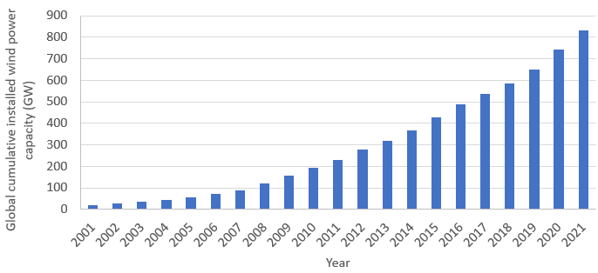
Figure 1.1. 1 Global cumulative installed wind power (GW) from 2001 to 2021 [4]
With the installation and use of a large number of wind turbines (WTs), some problems related to the maintenance and operation are gradually exposed, which greatly affect the efficiency and cost of the wind power generation.
A report investigating the reliability of 1500 WTs found that the wind turbine gearbox (WTG) failures accounted for approximately 10% of all failures recorded in the analysis [5]. Although this percentage is lower than the percentages of other failure causes (Sensor: 14%, Electricity System: 18%, Blades: 14%), the average downtime due to the gearbox failure is much longer than the time required for other failures [5]. Therefore, it is vital to find out the root causes of the gearbox failure to improve the efficiency of WTs and reduce the maintenance and replacement costs.
According to a study of the US Department of Energy, bearing problems are the most frequently observed issues, causing about 76% of all the gearbox failures [6]. Some damage forms of the bearings, such as the cracking, surface denting and pitting, have been frequently observed on both the bearing raceways and rollers, and all of them have a negative impact on the bearing life. In addition, in [7], it is suggested that at least 1/3 of the WTGs may experience the bearing failures within the operating period of 7 years, although these bearings are designed for a 20 years life.
Research shows that the failure of some bearings is generally caused by the non-metallic inclusions (NMIs) or voids within the subsurface area of bearing raceways [8]. Due to the localised stress concentration around the inclusions located at critical subsurface depths, small cracks will initiate from these defects due to the cyclic loading under Rolling Contact Fatigue (RCF). Meanwhile, with the occurrences of some WT operating conditions such as the wind gust, braking, and grid faults, these microcracks will further propagate to the raceway surface of the bearing, resulting in the destruction of the material integrity [9].
Another important reason for the premature bearing failure is the occurrence of White Structure Flaking (WSF). It is the material flaking on the bearing raceway surface caused by White Etching Areas (WEAs). WEA is considered as the metal phase transition of the subsurface bearing steel from martensite to ferrite. Due to this phase transition, the toughness of the steel is reduced when it becomes harder. As a result, the propagation of the subsurface RCF cracks will be accelerated during the WT operating periods [8][9].
However, present studies have not found clear evidence for the causes of WEA formation and the sequence between WEA and RCF cracks. Although it is well established that inclusions can cause the formation of subsurface RCF, some details such as the damage of inclusions and possible plastic deformation of the matrix have not been fully analysed.

Aims and Objectives
This study aims to investigate the damage initiation and propagation from NMIs in the raceway subsurface of the WTGB. Firstly, the bearing subsurface damage is characterised and analysed from the failed bearing raceway samples. After that, Finite Element (FE) models are developed to investigate the inclusion-induced stress concentration, crack initiation and crack propagation. In general, the following investigation objectives will be realised:
- To characterise the subsurface damage and investigate the bearing premature failure causes by using the optical and electron microscopes to observe the sections from the failed upwind and downwind bearing raceways.
- To explore the possible formation mechanisms of the WEA damage by inspecting and analysing its microstructure and composition with the electron microscope.
- To determine the material properties of the 100Cr6 bearing steel and WEAs by nano-indentation and material compression tests.
- To determine the loading variations of the planetary bearings in WTG due to varying wind speeds and different WT operating conditions.
- To identify the factors affecting the subsurface stress concentration due to MnS inclusions by establishing global and sub FE models under the static Hertz contact pressure loading condition.
- To investigate the subsurface stress distribution and variation around the MnS inclusion by developing global and sub FE models under the rolling contact loading condition.
- To develop a damage model for simulating the subsurface crack initiation and quantify the crack propagation due to inclusions under the cyclic rolling contact loading condition.
- To determine the possible factors accelerating the subsurface RCF crack propagation and assess their effects on the bearing life.

Novelty of Approaches
Reasonable assumptions
In order to study the field operation of the WTGB, variations of the bearing pressure during the operation period are considered in the investigation, including changes in the magnitude and sequences of the pressure. Since there are no available data, this study referred to the published international WT manufacturing standards and the experimental/simulation results of the WT gearbox operation. After that, some reasonable assumptions were put forward to systematise and quantify the irregular pressure variations on the bearing raceway. Accordingly, this approach makes it possible to study the premature failure of the WTGB caused by pressure changes on the bearing.
Design of modelling
Based on the microstructural observation and published investigations of the failed WTGBs, it has been found that the subsurface stress concentration of the bearing raceway is affected by the following key factors: the inclusion damage types, Hertz contact pressure, inclusion geometry and inclined angle, and surface traction. To explore the effects of these factors and the interactions between them, the Taguchi design of modelling is utilised in this research which reduces the number of models required compared to the traditional design of modelling.
Combination of experiments and modelling
A damage model based on the Continuum Damage Mechanics (CDM) method is developed in this research, which is used to determine the possible initiation and propagation process of the fatigue crack caused by a subsurface MnS inclusion under the cyclic rolling contact loading. According to the experimental observation of failed bearing sections, the inclusion damage types, including the boundary separation and internal cracking, have a significant impact on the subsurface damage initiation due to inclusions. Therefore, the models established in the study consider both damage types, and the stress variations in both cases are investigated.

Thesis Outline and Structure
This section outlines the thesis structure and provides a summary of each chapter from Chapter 2 to Chapter 6. The detailed findings and conclusions are presented at the end of each chapter.
Chapter 2: Literature review
This chapter mainly reviews the published investigations of the bearing manufacturing process, subsurface RCF damage, Hertz contact theory, and the modelling results of the fatigue crack initiation and propagation. It is found that the effect of subsurface NMIs is the main cause of the subsurface initiated damage. Meanwhile, with the consideration of the inclusion damage and possible plastic deformation of the steel material, the chapter summarises the current research gaps in analysing the subsurface stress states under the moving rolling contact pressure.
Chapter 3: Microstructure damage characterisation of failed wind turbine gearbox bearings
This chapter uses the microscope and other inspection methods to investigate the damaged subsurface sections of the failed bearing raceway from the WTG. The subsurface RCF cracks accompanied by the occurrence of WEA have been identified as the main causes of the premature failure of the bearing raceway. In addition, by analysing the microstructure and formation mechanisms of WEA, this damage form is found to be more likely to occur after the RCF crack, accompanied by the dissolution of the cementite and the transformation of the microstructure.
Chapter 4: Characterisation of bearing steel properties and gearbox loading conditions
This chapter tests the material properties of the 100Cr6 bearing steel and the observed WEA in the failed raceway sample. It is found that the WEAs are harder than the martensite steel matrix due to the dense ferritic structure. Moreover, according to the specification in IEC 61400-4 and the conclusions in some published research, the possible bearing loading conditions are determined with the consideration of the varying wind speed and specific operating conditions of the wind turbine.
Chapter 5: Finite element modelling of stress concentration at inclusions
This chapter establishes several FE models to investigate the stress concentration caused by MnS inclusions under the static Hertz contact pressure and moving rolling contact pressure. It is found that the inclusion damage and the applied Hertz contact pressure are two factors having the most significant effect on the subsurface stress state. Furthermore, due to the stress analysis of the stress concentration areas under the rolling contact loading, the internal crack of an inclusion is identified as the most harmful inclusion damage type leading to the fatigue damage accumulation.
Chapter 6: Finite element modelling of damage evolution due to inclusions
The chapter studies the effect of inclusions on the subsurface fatigue crack initiation and propagation. The FE modelling results show that the XFEM is not suitable for simulating the fatigue crack initiation and propagation. However, such processes can be modelled by the developed CDM FE models. Generally, the findings suggest that the inclusion damage, surface traction, magnitude and sequence of the loading are the factors having significant influences on the RCF crack initiation and propagation. When compared with the published twin-discs test results, the developed CDM FE model shows good modelling accuracy. However, the modelling results have differences compared with the butterfly damage observed from the actual bearing raceway, mainly due to the complex loading variations during the WT field operation, irregular 3D geometry of the inclusions, and uncertainty in the position of the inclusion.

Literature Review
This chapter introduces the typical design of a WT and the bearings of the gearbox. By referring to the existing literature, the common damage forms, and possible causes of the bearing failures of the WTG are reviewed and discussed. These analysis results indicate that the effect of the subsurface inclusions is one of the main causes leading to the premature failure of the WTG bearings. In addition, through the review of the existing fatigue theory and FE modelling results, the research gaps and focused directions of this study are determined.

Wind Turbine Gearbox Bearings and Their Failures

Wind turbine gearbox and bearings
Wind Turbine drivetrain
The wind turbine drivetrain transmits the wind power from the rotor to the generator through the main shaft (low-speed shaft), gearbox, and the generator shaft (high-speed shaft) [10]. Generally, the design of the drivetrain for the horizontal axis wind turbine has two types: the direct and indirect types. For the direct drivetrain design, no gearbox is used throughout the drivetrain. Therefore, the rotation speed of the main shaft will be transmitted directly to the generator. However, for the wind turbines generating megawatts of electricity, utilising the indirect drivetrain design is very common, as shown in Figure 2.1.1. These wind turbines have gearboxes that accelerate the rotations of low-speed shafts to match the high rotational speed required by the generators.
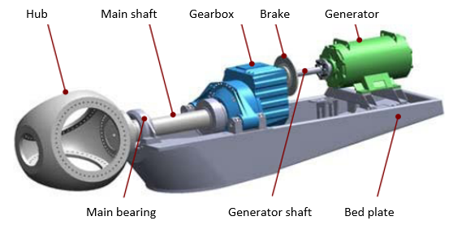
Figure 2.1. 1 Typical indirect drivetrain design of a wind turbine [11]
Wind turbine gearbox
As discussed in Chapter 1, the failure of WTG is a common failure mode that will cause the longest downtime of the WT according to the statistics reported in [5] and [12]. Therefore, the investigation of gearbox failures can greatly reduce the cost of wind turbine maintenance and the loss of energy production time.
Figure 2.1.2 shows the typical design of a wind turbine gearbox. Normally, it has three gear stages, providing an overall transmission gear ratio of about 90:1 [13].
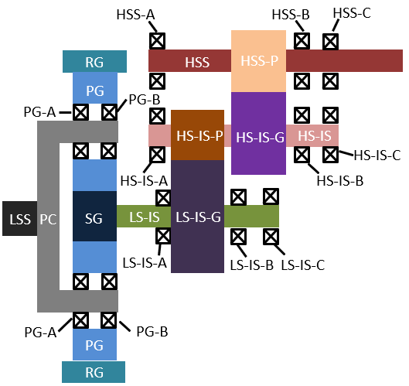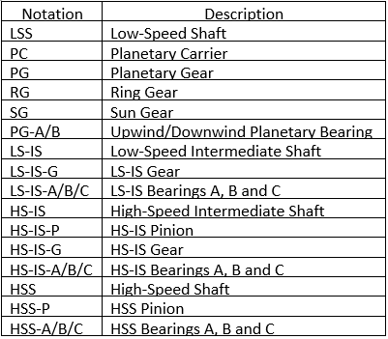
Figure 2.1. 2 Typical design of the wind turbine gearbox
The first stage consists of the planetary gear system which has three planetary gears. Most wind turbine gearboxes adopt a planetary gear system design, including the planetary gear, sun gear, ring gear, and the planetary carrier, as shown in Figure 2.1.3.
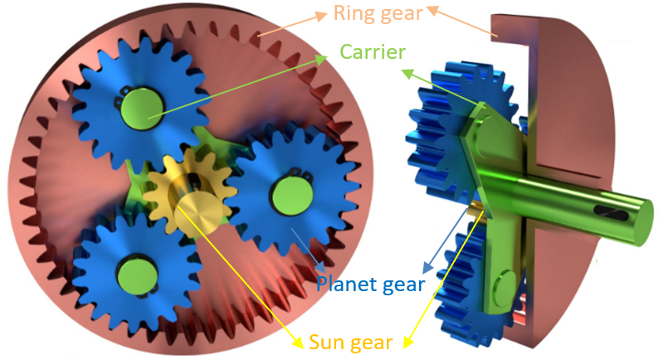
Figure 2.1. 3 Typical design of the planetary gear system
There are two benefits of using the planetary gear system. Firstly, the movements of the gears are balanced because the force is equally applied on each planetary gear. Hence, the planetary gear system has a relatively stable structure during the wind turbine operation. Secondly, this planetary gear system has a compact construction, which reduces the size and cost of the whole gearbox [10]. Apart from these advantages, the fault diagnosis in the planetary gear stage after the gearbox failure becomes more challenging due to the simultaneous meshing behaviours of multiple-planet gears and the complicated structure of the design [14].
In most wind turbines, the planetary carrier connecting with the low-speed shaft is used as the input of transmission to the drivetrain system. For each planetary gear, two or three planetary bearings are used to support the gear and reduce the friction between the gear and shaft. Depending on the positions of the bearings in relation to the rotor, they are classified as the downwind or upwind bearings. Usually, the inner raceways of the planetary bearings are fixed with the planetary carrier by pins, while the outer raceways will rotate with the planetary gears.
With the movement of the planetary carrier and gears, the sun gear in the planetary gear stage, as the first stage of the gearbox, will rotate subsequently. This sun gear is usually connected to a low-speed intermediate shaft. With the transmission of the gear and pinion on the low-speed and high-speed intermediate shafts, the rotation speed of the low-speed shaft is increased. This is the second stage of the gearbox. Similarly, during the third stage, the rotation of the high-speed intermediate shaft is accelerated again by the gear and pinion gear on the high-speed shaft stage. After that, the final accelerated rotation speed will be transmitted by the high-speed shaft from the gearbox to the generator.
It should be noted that the bearings used to support the rotating shafts in the second and third stage parallel gears are different from the planetary bearings in the first stage. Generally, the outer raceways of the parallel gear stage bearings are fixed, while their inner raceways will rotate with the shafts, as opposite to the planetary bearings [9].

Loading conditions of wind turbine gearbox bearings
Figure 2.1.4 (a) illustrates the loading on the planetary bearings in a specific gear design with three planetary gears. Normally, the planetary carrier connecting to the main shaft will introduce input torques on the planetary bearings due to its rotation. Because of the high torque on the low-speed shaft, the planetary bearings are more likely to be damaged when compared with other gearbox bearings. Therefore, to reduce the high loading acting on the bearing raceways, the cylindrical or tapered rollers are always selected for the planetary bearings. Because they provide large contact areas between the rollers and raceways, the contact pressure acting on the raceways will be reduced.
The inner raceways of planetary bearings are fixed with the planetary carrier. Hence, the contact between the inner raceway and the rollers is only limited to a specific area on the raceway surface, as shown by the loading zone in Figure 2.1.4 (b). Because the outer bearing raceway is mounted on the planetary gear which rotates at a different speed, it has the relative rotation between the inner and outer raceway. This relative speed keeps the rollers in the planetary bearing in contact with the raceway. With the increase of the relative speed, the number of cyclic contact between the rollers and the raceway will increase correspondingly.
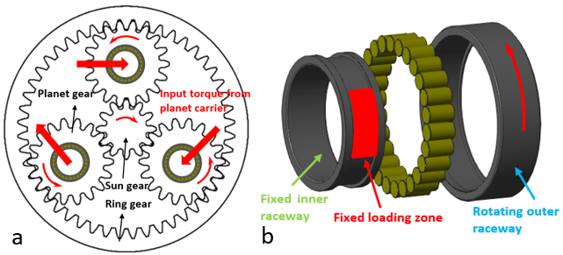
Figure 2.1. 4 Loading on the bearing inner raceway (a) torque on the planetary bearings (b) fixed loading zone on the planetary bearing inner raceway
During the operating period of a wind turbine, some operation situations such as the wind gust, shutdown, start-up, braking, emergency stop, and grid fault will increase the loading applied on the gearbox bearing. Compelling evidence in [15][16][17] indicates that possible overloading on a gearbox bearing will accelerate the damage accumulation on the bearing inner raceway and lead to the premature failure of the bearing. Apart from the overloading, a published research also suggests that, as a factor causing the relative sliding between the rollers and raceways, underloading will also reduce the operating life of the planetary bearing [18].

Failure modes of the rolling element bearing
It has been discussed in Chapter 1 that the bearing failures account for at least 70% of the gearbox failures. Therefore, the failure modes which are widely found in the damaged rolling bearings will be discussed in the section. Although some failure modes of bearings are affected by the chemical or electrochemical mechanisms, a good understanding of them may provide different explanations for the formation of the white etching damage.
Rolling Contact Fatigue
Rolling contact fatigue (RCF) is a common fatigue mode that is triggered by the cyclic rotation and compression between two components. Because RCF will be discussed in detail in section 2.2, its formation mechanisms are only briefly described here.
It has been discussed in section 2.1.2 that the relative rotation between the inner and outer raceway of the planetary bearing will lead to the rolling contact behaviours between the rollers and raceways. Because of the fixed loading zone on the inner raceway surface, RCF is more likely to appear in the bearing inner raceway rather than in the rollers or the outer raceway.
Typically, RCF can initiate from both the raceway surface and its subsurface. The damage initiation from the surface can be caused by the roughness and/or the inadequate lubrication condition on the raceway surface. It is known that these adverse operation situations will result in the micropitting on the raceway surface, which appears as small voids and dark spots [19]. During the operation process of the bearing, these spots or voids will cause the localised stress concentration areas on the raceway surface. Meanwhile, with the millions or even billions of contact cycles between the rollers and raceway, these specific areas will be damaged by the fatigue in the form of cracks. With the surface traction triggered by the rolling contact behaviour of the rollers, these surface-initiated fatigue cracks may propagate to the subsurface area at an angle of approximately 30 degrees [20]. Due to the crack propagation, surface spalling on the raceway surface will happen, as shown in Figure 2.1.5 (a).
Different from the surface initiated RCF damage, bearing subsurface RCF cracks are usually caused by the material inhomogeneity such as voids or inclusions in the subsurface area. Normally, the inhomogeneity occurs due to the non-metallic additives added during the bearing manufacturing process. When the loading torque is applied to the bearing, stress concentration of the bearing subsurface material will occur around these voids or inclusions. Because of the increase in stress magnitude, the occurrence of fatigue damage is accelerated [20]. Therefore, the subsurface fatigue cracks will initiate and propagate from these defects due to the cyclic contact between the rollers and raceway, as shown in Figure 2.1.5 (b). Generally, the depth of the subsurface RCF crack depends on the loading magnitude applied. Evidence in [9] also indicates that the subsurface area with a relatively larger maximum shear stress may have a higher risk of being damaged by RCF than other areas.
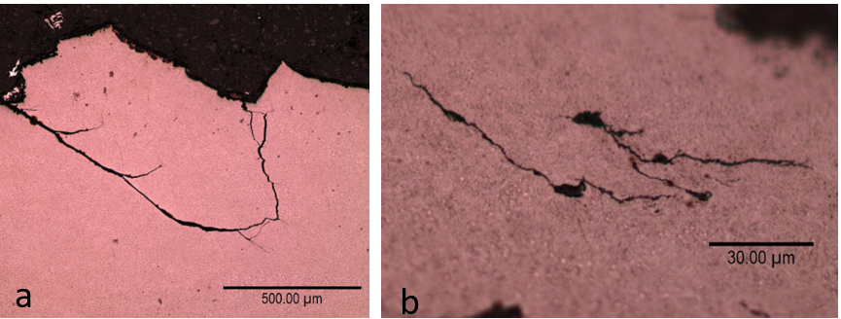
Figure 2.1. 5 Typical RCF damage observed from the bearing inner raceway (a) surface initiated RCF leads to the material spalling (b) subsurface initiated RCF caused by inclusions
Wear
Wear is another damage type that can usually be found in both the raceways and the rollers of the bearing. According to the damage mechanism, the wear damage can be classified into two types: abrasive wear and adhesive wear. For abrasive wear, it can be triggered by the loss or contamination of the lubrication [20]. As previously mentioned, insufficient lubrication conditions will result in pitting on the surface of bearing components. Therefore, the hard particles flaking away from the surfaces and the rugged component surfaces will leave scratches or indents on the rollers and the raceways, as shown in Figure 2.1.6 (a). With the longer operation time of the bearing, the wear of the rollers and raceways will be more serious, which may lead to the final failure of the bearing.
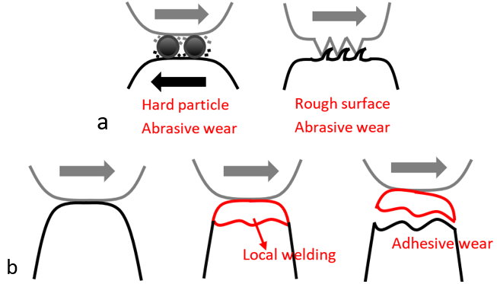
Figure 2.1. 6 Wear damage of the bearing (a) abrasive wear (b) adhesive wear
The adhesive wear is also known as the smearing damage. Usually, this damage type is accompanied by the transfer of material from one surface to another, as illustrated by Figure 2.1.6 (b). According to the investigations in [18] and [21], the torque reversal and bearing underloading introduced by some specific WT operating cases, such as the wind gust, start-up, shutdown, braking and emergency stop will cause the relative slip between the rolling elements and the raceways. This slipping behaviour has been proved to be harmful to the bearing because it will result in the localised increase of temperature and attenuation of lubricant [22]. Due to these reasons, the local welding of the specific area may happen, followed by the spalling of the material.
Corrosion
The corrosion damage is mainly caused by the moisture and the friction between the contact surfaces of the bearing. As shown in Figure 2.1.7 (a), the bearing raceway is corroded and there is rust on the surface. When the bearing is exposed to humidity or contaminated by other corrosive media (such as acid), the corrosion of the bearing surface may take place due to the presence of Oxygen [23]. The research in [15] also indicates that the offshore WTGB bearings are more easily to be corroded because of the steam and salts from the seawater.
Another corrosion damage is the friction corrosion (also known as the fretting process). It is a combination damage type of both the adhesive wear and corrosion due to oxidation. Generally, the contact and sliding between the rollers and the raceway will lead to the adhesive wear damage on the material surfaces. Investigation in [24] shows that this damage is initially in the micrometre scale, but with the increase of bearing operating time, it may eventually grow to the millimetre scale. After the occurrence of wear damage, the chemical reaction, which is mainly considered to be oxidation, may happen in both the debris and damaged bearing surface. Although friction corrosion has some similarities with the wear damage, they can normally be distinguished by the colours of the damaged areas. It can be observed in Figure 2.1.7 (b) that the friction corrosion appears brown and dark on the bearing raceway surface.
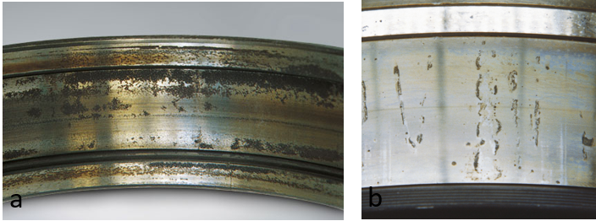
Figure 2.1. 7 Corrosion of the bearing (a) bearing raceway corroded by humidity (b) bearing raceway corroded during the fretting process [25]
Cracking
Cracking is a damage type that may lead to the rapid failure of the bearing. It usually happens when the bearing is exposed to high stress levels, abnormal temperature changes, or misalignment/errors during the mounting of the bearing [20]. Considering the cracking mechanisms, the bearing cracking damage can be classified into three main types.
The first type is forced cracking. In this failure mode, the crack will appear in a short period after the bearing is subjected to a sudden increase in the loading. Typically, the events such as the fluctuating wind speed, non-synchronisation of blade pitch, braking, and the grid/generator engagement will result in the short-term heavy impact loading on the WTGB raceways [26]. Due to the impact loading, the maximum torque applied to the planetary gears may reach 2.5 to 4 times of the rated value according to the report of SKF company [27]. Sometimes, these heavy loadings will cause the cracking of a large area, especially when the bearings have mounting misalignments and structure deformations [27].
The second one is fatigue cracking, which is normally caused by RCF. As discussed at the beginning of this section, because of the stress concentration caused by the raceway subsurface inclusions, voids and surface asperities, fatigue damage may initiate during the bearing operation process. As a result, these small fatigue cracks will propagate from the surface or subsurface areas of the bearing raceway and lead to the final failure.
The third cracking type is thermal cracking. Generally, the inner raceway of the WTG bearing will experience temperature differences because of the machine start-up or the cold climate [27]. As a result, the interference fits between the bearing components will be changed, which may lead to the cracking of the bearing. Apart from that, the sliding between the rollers and raceways will also generate localised heating due to friction. It is considered to be the another cause of bearing thermal cracking because sometimes such heating may produce micropitting damage on the raceway surfaces [20]. It has been discussed that the micropitting will introduce the surface initiated RCF under the cyclic contact.
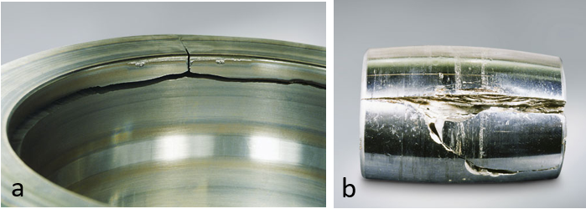
Figure 2.1. 8 Cracking damage of the bearings (a) cracked inner raceway (b) cracked roller [28]
Electrical erosion
Electrical erosion is the other damage type that may cause the failure of the WTGB. Usually, it happens when the electric voltage on the bearing reaches the breakdown threshold value of the bearing material [20]. The bearing voltage may come from either the magnetic flux asymmetries or the non-shielded cabling in the generator [29]. When the excessive current pass through the bearing, the concentrated discharge may take place through the lubricant film between the roller and raceway [29]. Similar to the electric welding process, the localised heating caused by current discharge may melt the surface material of the bearing, resulting in the formations of craters, as shown in Figure 2.1.9 [20][29].
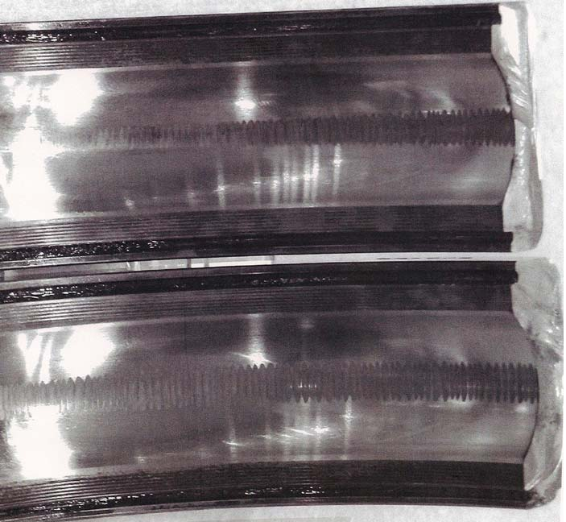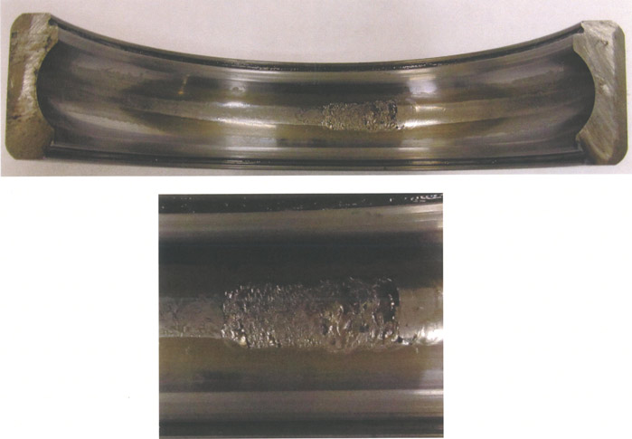
Figure 2.1. 9 Typical electric erosion caused by the localised discharging [30]

Bearing life assessment
The bearing life is defined as the length of time during which the bearing can perform as required under the predefined operation conditions [31]. According to the ISO 281 standard, it can also be represented by the number of rotations that the bearing can complete before failure happens [32]. To identify the occurrence of the bearing failure, fatigue failures such as surface flaking and cracking are usually considered to be the key factors. As discussed in section 2.1.3, in addition to the loading conditions and the material properties, the length of bearing life also depends on other external factors such as the operation temperature, lubrication, and the regular maintenance.
The most commonly used term to describe the bearing life is the basic rating life, $L_{10}$. It represents a number of rotations, by the end of which, 90% of the bearings tested will survive without any fatigue damage under the conventional operation conditions [32]. In other words, only 10% of the bearing will fail after the specific number of rotation times. Normally, $L_{10}$ can be determined by:
$L_{10}={\left(\frac{C_{r}}{P_{r}}\right)}^{p}$ Equation 2.1
where $C_{r}$ is the dynamic load rating for the radial bearings, it is a loading magnitude that a bearing can endure for one million revolutions. For the cylinder roller bearings used for the WTG planetary gear system, it can be calculated as:
$C_{r}=b_{m}f_{c}{\left(i∙L_{we}\cos{α}\right)}^{\frac{7}{9}}∙Z^{\frac{3}{4}}∙{D_{we}}^{\frac{29}{27}}$ Equation 2.2
In Equation 2.2, $b_{m}$ is the rating factor of the hardened steel used for the bearing, its value changes according to the type and design of the bearing; $f_{c}$ is a constant that can be determined by the geometry and manufacturing accuracy of the bearing; $i$ is the number of rows of the rollers in the bearing; $L_{we}$ represents the effective length of the roller; $α$ means the nominal contact angle of the bearing; $Z$ is the number of rolling elements in each row; and the parameter $D_{we}$ is the diameter of a single roller [32].
$P_{r}$ in Equation 2.1 represents the equivalent dynamic bearing load. For the cylinder roller bearing, it is defined by the following equation：
$P_{r}=XF_{r}+YF_{a}$ Equation 2.3
where,
$X$ = dynamic radial loading factor
$Y$ = dynamic axial loading factor
$F_{r}$ = actual radial loading of the bearing
$F_{a}$ = actual axial loading of the bearing
For the exponent $p$ in Equation 2.1, it equals to 3.33 when the bearing is assumed to be a cylinder roller bearing.
Considering that the lubrication and contamination of the bearing may also affect the final bearing life, Equation 2.1 may be insufficient to describe the actual bearing life. Therefore, to achieve a more accurate determination of the bearing life, the basic rating life $L_{10}$ is modified by introducing two additional factors: $a_{1}$ and $a_{ISO}$. It gives the expression as:
$L_{nm}=a_{1}a_{ISO}L_{10}$ Equation 2.4
Table 2. 1 Relationship between the reliability factor $a_{1}$ and the reliability [31]
Reliability (%) | 90 | 95 | 96 | 97 | 98 | 99
$$a_{1}$$ | 1.00 | 0.64 | 0.55 | 0.47 | 0.37 | 0.25
where $a_{1}$ represents the service life coefficient for reliability. The reliability is defined as the percentage of the bearings that have no fatigue damage after a certain number of revolutions. For example, as defined in $L_{10}$, 90% of the bearings survive the revolutions required. Hence, the reliability is 90% in this case, and the service life coefficient $a_{1}$ is 1.0. Table 2.1 shows the corresponding $a_{1}$ values of different reliability. It can be observed from the table that the relationship between $a_{1}$ and the reliability is not linear.
$a_{ISO}$ in Equation 2.4 means the life modification factor, which considers the effect of the bearing material fatigue limit, lubrication conditions, and the contamination. According to ISO 281, $a_{ISO}$ is defined as the function of the fatigue stress limit $σ_{u}$ and the real stress $σ$ [32] :
$a_{ISO}=f\left(\frac{σ_{u}}{σ}\right)$ Equation 2.5
Worth noting that, the assessment of the bearing life in this section does not consider the effect of the overloading and underloading situations. Therefore, when the method is applied to the WTGB operating condition, the influence of the frequently changing loads may lead to the differences between the actual and the theoretical calculated bearing life.

Steel for wind turbine gearbox bearings
Bearing manufacturing process
Raw steel material manufacturing should be considered as the beginning of the bearing manufacturing process, including the heat treatment of the material. To shape the raw steel into a ring-shaped bearing, either forging, rolling, or turning method can be used. For the forging process, the material is usually shaped by the compressive deformation with the utilisation of a die. In the rolling process, the steel material is squeezed by two rollers in the opposite rolling directions. Therefore, only the thickness of the material will be changed during the manufacturing process. Different from the other two processes, the turning process is accompanied by the reduction of the material volume. It uses a cutting tool to cut the steel to the required dimensions. Depending on the ring manufacturing method selected, the properties and the locations of the residual stress in the steel material may be different.
In addition, as required in ISO 281, the WTG bearings should be made of the through-hardened steel which has the high fatigue resistance and hardness. Therefore, the heat treatment process is necessary for manufacturing to ensure that the bearings have the required properties and to reduce residual stress during the material forming process.
The normal heat treatment process of the WTGB steel material includes three main stages. Firstly, the material is heated to a temperature that is usually greater than 800 $℃$. At this temperature, the microstructure of the steel will normally transfer from pearlite to austenite. After that, the steel should be cooled in oil, water, or other media within a short period. This process is also known as the quenching process. During quenching, the austenite microstructure becomes unstable and most of the microstructure will be changed into martensite, which greatly improves the hardness of steel. Therefore, the deformation resistance of the bearing is ensured, which reduces the possible misalignment of the components during the bearing overloading situations. However, due to the increased material hardness and the reduced toughness, the propagation of cracks within the steel becomes easier during the operation of the bearing. Accordingly, the tempering process is required to improve the material toughness and reduce the possible residual stress. During the tempering, the steel is heated to the appropriate temperature below the austenitic transition temperature and then cooled after one or two hours.
Sometimes, the steel used for the WTGB application is manufactured by the hot-rolling method that uses both heating and rolling to shape the steel into the ring shape. The steel microstructure of the hot-rolled steel is normally pearlite and may be accompanied by a small amount of proeutectoid cementite [33]. Investigation in [34] shows that the proeutectoid cementite will reduce the abrasive resistance and the toughness of the steel. Therefore, to minimise the adverse influences of the ring manufacturing process, an annealing heat treatment process is usually added before quenching, which helps to spheroidise the network cementite [35]. Depending on the material type, the bearing steel is usually heated to 20 $℃$ - 40 $℃$ above the temperature at which the pearlite changes to austenite (AC1 temperature). When the temperature in the furnace is cooled naturally to 20 $℃$ - 30 $℃$ below the AC1 temperature, the steel material will then be cooled in the air with an approximately 500 $℃$/hour cooling speed [36].
100Cr6 steel
To increase the hardenability and abrasion resistance of the material, manufacturers will add some alloying elements such as Mo, Mn and Cr to the steel [37]. For the industrial manufacturing of the WTGB, 100Cr6, 100CrMn6, and 100CrMo7 (all defined by DIN 17230 standard) are the most commonly selected materials for the bearings. In this project, 100Cr6 is the specific steel material selected for the investigation. According to the different standards around the world, this material has some equivalent grades such as AISI 52100 (standard ASTM A295), EN31 (standard BS 970) and SUJ2 (standard JIS G4805). The chemical composition of the 100Cr6 steel is shown in Table 2.2.
Table 2. 2 Chemical composition of 100Cr6 steel material [8]
Component | C | Si | Mn | P | S | Cr | Ni | Mo | Cu
Content (wt%) | 0.95-1.05 | 0.15-0.35 | 0.25-0.45 | 0.025 max | 0.025 max | 1.40-1.65 | 0.30 max | 0.08 max | 0.20 max
It is known that the properties of 100Cr6 are largely determined by the heat treatment conditions in the manufacturing process. As shown in Table 2.3, with the variation of the heat treatment process, the microstructure of 100Cr6 steel has different combinations, which will affect the hardness, elastic modulus, and fatigue resistance of the material.
Table 2. 3 Microstructure differences of 100Cr6 material generated by different heat treatment conditions [38]
Heat treatment | Austenitizing | Quenching | Tempering | Microstructure
No. 1 | 850 $℃$ (20 mins) | Oil 100$℃$ | 170 $℃$ (120 mins) | Martensite + 10% retained austenite
No. 2 | 850 $℃$ (20 mins) | Oil 100$℃$ | 240 $℃$ (120 mins) | Pure martensite
No. 3 | 850 $℃$ (20 mins) | N/A | 220 $℃$ (240 mins) | Martensite + bainite
No. 4 | 850 $℃$ (20 mins) | Cooling in air |  | Carbide + ferrite + litter pearlite
No. 5 | 850 $℃$ (20 mins) | Cooling in Argon |  | Carbide + ferrite + pearlite
For the WTGB application, 100Cr6 material is required to have a martensite structure with very few retained austenite. Therefore, after the austenitizing, the material is normally quenched in the oil and then tempered with at least 170 $℃$ to acquire the required properties listed in Table 2.4 [39].
Table 2. 4 Material properties and technical data of 100Cr6 [39][40][41][42]
Property | Value
Density (g/cm^3) | 7.8 ~ 7.9
Young’s modulus (GPa) | 200 ~ 230
Poisson’s ratio | 0.29 ~ 0.3
Yielding strength (MPa) | 2200 ~ 2600
Ultimate compressive strength (MPa) | 3500 ~ 4000
Ultimate tensile strength (MPa) | 2500
Hardness (HRC) | 60 ~ 66
Service temperature ($℃$) | -60 ~ 150
Thermal expansion (${10}^{-6}/℃$) | 12.3
Electric resistivity ($Ω∙m∙{10}^{-9}$) | 215
Relative magnetic permeability | > 300

Non-metallic inclusions in bearing steel
Formation and categories of non-metallic inclusions
The non-metallic inclusions (NMIs) in the steel subsurface are usually caused by the non-metallic material added during the manufacturing process. After that, due to the following heating process, the non-metallic material may be oxidised or react with other elements in the steel to form new compounds. As a result, these newly developed inclusions will be embedded in the steel subsurface, affecting the material properties.
ISO 4967:2013 specifies the classifications of the NMIs according to their components, properties and geometrical sizes [43]. Relevant classifications are listed in Table 2.5, combining the ISO 4967:2013 and some other published modifications of the standard.
Table 2. 5 The categories of non-metallic inclusions in the bearing steel [33][43][44]
Inclusion group | Morphologic description
Group A (sulphide type)  $MnS$,$CaS$ | highly deformable and malleable, round or elliptical (wide range of aspect ratios), grey particles
Group B (aluminide type)  $${Al}_{2}O_{3}$$ | hard and nondeformable, round geometry with low aspect ratios (typically < 3), sometimes aligned in groups, black or bluish particles
Group C (silicate type)  $$MnO.SiO_{2}$$ | highly malleable, sharp-ends geometry with a wide range of aspect ratios, black or grey particles
Group D (globular oxide type)  $MgO, {CaO∙6Al}_{2}O_{3}$, | most nondeformable, angular or rounded ends with low aspect ratios (typically < 3), black or bluish particles
Group DS (single globular type) | circular geometry, individually distributed, large inclusion diameter (typically > 13 $μm$).
Group T (carbonitride and nitrides type)  $TiC,N$ | hard and nondeformable, cubic or polygonal geometry, strongly bonded boundary, large Youngs’s Modulus (average 320GPa)
Manufacturers may add aluminium to the steel, which works as the deoxidiser to improve the steel toughness by controlling the growth of the austenite grain boundary [45]. Aluminium is easy to be oxidised, especially when the temperature is relatively high. The oxidised ${Al}_{2}O_{3}$ inclusions are hard and brittle. Therefore, they may lead to the localised cracking or voids in subsurface areas during the rolling manufacturing process and bearing operation process.
The other non-metallic element, sulphur, is also common in the subsurface areas of the bearing steel. During the steelmaking process, sulphur improves the machineability and it can be found in the form of manganese sulphide (MnS) or iron sulphide (FeS) in the steel subsurface areas [46]. However, research of the sulphide in [47] indicates that these sulphide inclusions will affect both the fatigue endurance limit and the fracture toughness of the steel. In other words, the material cracking may occur easily and propagate rapidly in the steel containing many sulphide inclusions.
Inclusion boundary separation and internal cracking
Many investigations have reported that subsurface NMIs will reduce the fatigue life of the bearing material [48][49][50][51][52]. Because of the voids/boundary separations caused by the inclusions, the affected subsurface homogeneity of the steel will accelerate the crack nucleation and propagation processes, as shown in Figure 2.1.10.
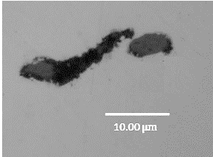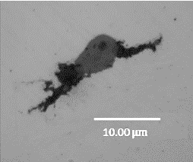
Figure 2.1. 10 Subsurface void and cracks caused by inclusions
Several reasons explain the formation of these inclusion damage. Firstly, it may be caused by the differences of the thermal expansion between the steel matrix and inclusions during the heat treatment process. Such thermal expansion capacity of the material is usually represented by the thermal expansion coefficient, which is proportional to the material expansion rate when heated. In some cases, whether the thermal expansion coefficient of the inclusion is greater than or less than that of the steel, it will lead to the boundary separation or cavitation between the inclusion and the steel matrix [33]. Assuming an inclusion with a relatively smaller thermal expansion coefficient is initially perfectly combined with the steel matrix. It will have a smaller volume variation during the heating of the austenitizing process compared with the steel matrix. Therefore, the perfectly bonded inclusion-steel boundary may be damaged due to the non-uniform expansion volumes. Considering the same initial boundary condition, when the thermal expansion coefficient of the inclusion is greater than the bearing steel, inconsistencies in the volume shrinkage due to temperature reduction during quenching may also result in the inclusion debonding or boundary voids.
Apart from the thermal expansion, the differences in the elastic modulus, yielding strength, and plastic deformation between the inclusion and steel matrix will also lead to the subsurface damage. As shown in the investigation of [27], the maximum pressure detected on the WTG planetary bearing may reach 3.2 GPa, which will cause large deformations of both the steel matrix and the inclusion. Due to the subsurface strain incompatibilities, the corresponding deformation differences of the steel matrix and inclusion may result in the formation of cavities and the separation of the original perfectly bonded boundary.
In addition, as reported in [33], the fatigue damage may also cause the generation of gaps or voids between the steel matrix and inclusions. Fatigue damage usually does not occur immediately, but after a long period of operation. The investigation in [53] compared the steel matrix around a spherical alumina inclusion before and after the fatigue test. Under the contact pressure of 720 MPa and the loading cycles of $1.7×{10}^{6}$, it was found that two cavities formed at the left and right tips of the inclusion after the fatigue test. Therefore, it can be concluded that the inclusion boundary separation may also initiate due to the fatigue damage caused by the large number of contact cycles.
Apart from the damage initiating from the voids and the boundary separated inclusions, investigation in [9] also proves that the internal cracking of inclusions will lead to the generation of subsurface cracks. According to the microscope observations, it has been found that the internal crack of inclusions will propagate from the inclusion to the steel matrix, as shown in Figure 2.1.11. In addition, based on the twin-disc test results in [54], these internal cracks of inclusions are more likely to occur when the bearing is subjected to high contact pressures.
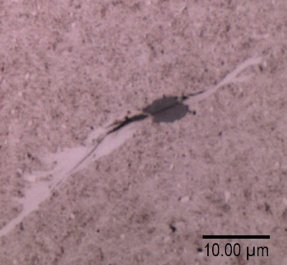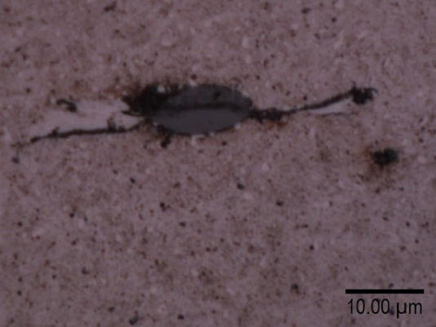
Figure 2.1. 11 Internal cracks of the inclusion propagates to the steel matrix
It should be noticed that the effect of inclusions on the steel matrix also depends on the inclusion types. According to the modelling results in [52], when the inclusion has a perfectly bonded boundary, the equivalent von Mises stress of the steel matrix caused by the stress concentration will rise due to the increased inclusion modulus. Typically, if the inclusion is an oxide consisting of alumina or magnesia, the stress concentration level of the steel matrix is greater than that caused by the sulphide inclusion.
Although the sulphide inclusions are considered to have a limited effect on the stress concentration of the steel matrix, it does not mean these inclusions do not contribute to the subsurface damage development. Evidence in [55] and [56] has pointed out that sulphide inclusions are still important in generating cracks. This is because the interfacial binding strength between the sulphide inclusion and the steel matrix is weak compared with other inclusion types. Accordingly, the boundary separation of a sulphide inclusion may occur when the applied contact pressure is relatively low.

Bearing surface treatment methods
For reducing friction and preventing corrosion, manufacturers put forward the surface treatment methods for the bearings. For example, to reduce the occurrence of the electrical erosion, the insulating aluminium oxide coating can be applied which increases the electric current resistance of the bearing. To reduce the effect of insufficient lubrication, the newly developed metal-containing hydrogenated amorphous carbon coating may help [57]. Normally, the common surface coating method used for the WTGBs is the black oxide coating (BOC), which will be discussed in the section.
As shown in the bearing technical specification of the SKF company, the main component of the BOC is ${Fe}_{3}O_{4}$, sometimes accompanied by $FeO$ and ${Fe}_{2}O_{3}$ material [58]. To apply the coating to the surfaces of bearing components, the raceways and rollers should be immersed in the alkaline aqueous solution with a temperature ranging from 130 to 150°C [58]. Accordingly, the bearing material (ferrous alloy) will react with the alkaline solution and then produce the oxide coatings on the surfaces of the raceways and rollers. Conventionally, these oxide layers are black or dark and have thicknesses of 1 to 2 $μm$.
The conclusion in [59] suggests that the friction coefficient between the components with BOC is reduced. Therefore, this coating may help to prevent the bearing scuffing. Moreover, as reported by other investigations, BOC also helps to prevent the micropitting damage and hydrogen absorption that may reduce the toughness of the steel [58][60][61]. However, the research in [62] points out that the BOC used for the WTG planetary bearing surfaces may not extend the service life of the bearings. According to the damage observation of both the BO coated and noncoated bearings in the investigation, similar subsurface damage such as the White Etching Cracks (WECs), butterflies and RCF cracks are found in both two bearings. Therefore, it believes that the main damage in the WTG planetary bearings is more likely to be initiated by the subsurface inclusions instead of the surface wear or corrosion. Meanwhile, measurements in [63] indicate that BOC has the smaller hardness and modulus than the martensite bearing steel. Due to the decrease of the surface hardness and modulus, subsurface cracks may propagate rapidly within the BOC layers, which results in the extensive flaking of the coating, as reported in [62].

Rolling Contact Fatigue and White Etching Matters

Rolling contact fatigue
Characteristics of RCF
Fatigue is the crack initiation and propagation process of the material which is normally caused by the cyclic loading applied. Typically, the stress magnitude leading to the fatigue damage is much smaller than the yielding strength of the material. As discussed in section 2.1.3, the cyclic contact loading between the roller and raceways in the WTG planetary bearing will trigger fatigue damage from both the surface and subsurface of the raceway. Due to the rotation behaviour of the rollers, this fatigue type is also known as Rolling Contact Fatigue (RCF).
It has been mentioned in section 2.1.7 that subsurface damage due to inclusions is probably the main reason accounting for the WTGB premature failure. Analysis in [64] indicates that the subsurface RCF cracks are usually initiated by the near-surface alternating stress introduced by the contact of rollers. In addition, due to the stress concentration, this alternating stress may become significantly high in the regions where the subsurface inclusions are located. With a large number of contact cycles, the crack will initiate and propagate from the inclusion, as shown in Figure 2.2.1 [65].
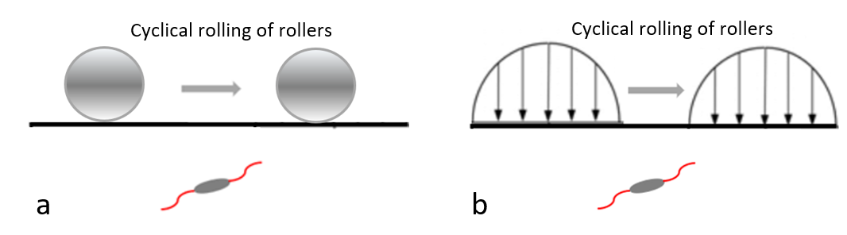
Figure 2.2. 1 Demonstration of the subsurface RCF crack initiation in the WTGB (a) presented by the roller (b) presented by the simplified contact pressure
Typically, the subsurface initiated RCF in a WTGB has the following characteristics:
ypically a multiaxial fatigue mechanism. In
the past few decades, several multiaxial fatigue criteria have
been developed and veriﬁed with experiments
ypically a multiaxial fatigue mechanism. In
the past few decades, several multiaxial fatigue criteria have
been developed and veriﬁed with experiments
- It is a fatigue type caused by the multi-axial stress condition that is governed by the contact between the rollers and raceways [66].
- It usually happens within a small volume because of the highly localised contact area and stress concentration area [9].
- It is more likely to initiate from the inclusions tips and/or the separated inclusion-steel boundary [9].
- It introduces the nonproportional loading history to the specific stress element in the subsurface area. The stress components of the element change according to the positions of the rollers [66].
- It may be accompanied by the steel microstructure alternation that the martensite grains change into ferrite (White Etching Area) [67][68][69][70].
RCF and material plastic behaviour
Furthermore, RCF is also a fatigue mode that is affected by the localised material plastic deformation and the strain hardening behaviour. Generally, the damage initiation process of the RCF crack may experience four material plastic stages: initial plastic deformation, shakedown, ratcheting, and damage initiation.
The plastic deformation occurs mainly due to the WT overloading operation, inclusion-induced stress concentration and the possible separated boundary or internal crack of the inclusion. In these situations, the magnitude of the stress in the steel matrix may exceed the yielding strength of the bearing material, resulting in the localised plastic deformation.
When the plastic deformation occurs, the bearing steel will be strain hardened and obtain a yielding strength higher than the initial yielding strength. Accordingly, if the magnitude of the stress due to stress concentration in the following rolling contact cycles cannot reach the new yielding strength, the bearing steel will be in a shakedown state. It is a safe loading state because only the elastic deformation happens [71]. However, although the shakedown process prevents the further plastic deformation of the material, investigation in [72] shows that it will reduce the toughness of the bearing steel. Consequently, the steel becomes more brittle than before, which may contribute to the crack propagation to some extent.
Sometimes, due to the extreme operating conditions of WT, the stress applied to the WTG planetary bearing may reach a maximum value of 3.2 GPa [27]. Hence, the stress magnitude of the stress concentrated area may exceed the improved yielding strength obtained during the shakedown process. Accordingly, the additional plastic deformation of the material will be introduced to the steel matrix. This process is known as the ratcheting process. In this process, the plastic deformation will accumulate due to the cyclic contact between the raceway and rollers. This process has shown to be harmful because the accelerated plastic deformation will result in the large deformation of the material, which contributes to the fatigue damage initiation [73]. In addition, investigation in [74] indicates that the accumulation of plastic deformation due to the ratcheting effect is not infinite. The increasing rate of the equivalent plastic strain is found to be decreased after a specific number of loading cycles. In other words, the accumulated plastic deformation has a limitation, at which the ratcheting effect will not lead to the further plastic deformation accumulation.

White etching matters
As mentioned in section 2.2.1, White Etching Matters (WEMs) are common damage forms that appear in subsurface areas of the bearing raceway. They can only be observed when the material is polished and etched by the etching solution. Many investigations have reported the nano-sized ferrite structure of WEMs, such as [9], [48], [70], [75], and [76]. Because of the change of the bearing microstructure from martensite to ferrite during the rolling contact process, WEMs show better etching resistances when compared with the normal bearing microstructure. Therefore, they can be easily identified by the optical microscope due to their white appearances.
According to the observations of the damaged bearing microstructures in [9] and [48], white etching damage is always accompanied by the occurrence of RCF cracks. Although the sequence between the white etching structure and RCF cracks is still debated, research in [77] indicates that WEMs can lead to the premature failure of the bearings within 5% to 20% of their design operation life. Therefore, combined with the effect of RCF, WE damage is normally considered to accelerate the failure of bearings. In this section, the characteristics and possible initiation reasons of different kinds of WEMs will be reviewed.
WEA/IrWEA
WEA is the abbreviation of the term White Etching Area. As shown in Figure 2.2.2, the area appears white after the etching process of the sample. According to the experimental observation, WEAs show different shapes and orientations within the bearing subsurface area. Therefore, sometimes this damage feature is also named as the irregular white etching area (IrWEA) [78].
Evidence in [21] shows that WEA is the body-centred carbide-free ferrite with an ultrafine nano-recrystallised structure. Therefore, when compared with the martensite steel structure, the hardness of WEA is relatively high [79]. Moreover, another investigation in [80] points out that different WEAs also have hardness differences. Such differences may be related to the grain size of WEA. With the reduction of the grain size, the hardness of WEA will be increased.
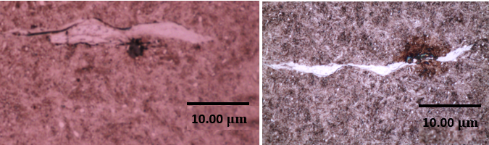
Figure 2.2. 2 Typical features of WEAs
DEA
DEA means the Dark Etching Area. As shown in Figure 2.2.3, it usually initiates from the bearing subsurface and appears dark when the area is etched by the etchant. Research in [81] indicates that the DEA forming process is still affected by the cyclic rolling contact behaviours. Normally, the shape of the DEA is constant with the subsurface maximum shear stress distribution. Therefore, the forming of DEA is considered to be affected by the maximum shear stress that is introduced by the contact between the raceway and rollers. In addition, there is a maximum shear stress threshold for the DEA initiation, and the stress levels below this threshold will not generate DEAs [82].
It has been shown that the microstructure of DEA mainly consists of the decayed martensite and a carbon-contained ferrite phase [82]. Due to the shakedown conditions introduced by the contact of rollers, the tempered martensite structure in the raceway may experience a phase transformation during this process [81]. However, current research results do not have strong evidence to explain the reasons for the martensite to ferrite transformation. According to an atomic probe tomography of DEA, the carbon in the martensite structure of DEA is proved to diffuse thermally during the rolling contact process and be absorbed by the ferrite structure formed [83].
Due to the existence of the ferrite structure in DEA, which is the same as the microstructure of WEA, the assumption published in [78] suggests that DEA could be a precondition for the formation of WEA. Because of the following rolling contact behaviour between the raceway and rollers, the residual decay martensite will be completely transformed into the ferrite structure, which is eventually presented in the form of WEA. Considering that DEA may appear independently from the crack, the assumption in [78] suggests the possible sequence between the DEA, crack, and WEA. It assumes that the substructure alteration in DEA happens first. Followed by the crack initiation from the specific DEA due to the reduced steel toughness. Finally, WEA, as the completed form of the microstructural alteration, may be initiated by the complex thermal-tribology mechanisms between the cracked areas.
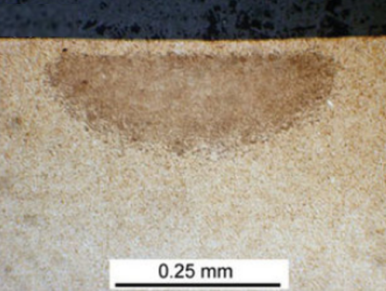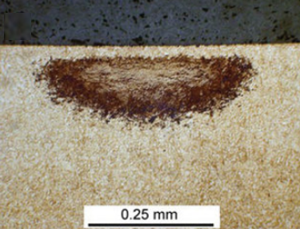
Figure 2.2. 3 Typical DEAs produced by an accelerated rolling contact test with 6 GPa contact pressure [84]
Butterfly
Figure 2.2.4 shows the damage type that the WEA decorated crack initiates from an inclusion. Because the shape of the damage is similar to the butterfly, it is also known as “butterfly” damage. Normally, the cracks and WEAs propagating from the inclusions or voids due to RCF are called the butterfly wings. Apart from the inclusions, investigation in [85] shows that the subsurface voids will also cause the butterfly damage. As discussed in section 2.2.1 and relevant research in [15] and [85], inclusion damage types such as the boundary separation and internal cracking are identified as two common reasons for triggering the butterfly damage during the RCF process.
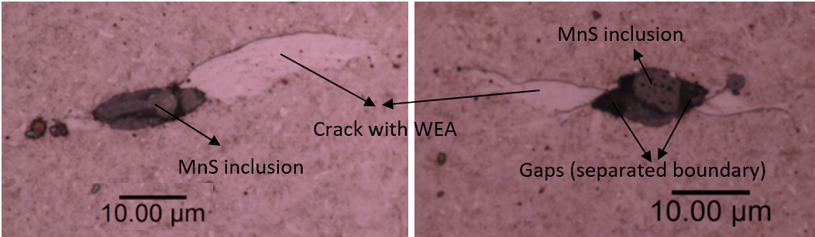
Figure 2.2. 4 Typical Butterflies with WEA decorated wings
In study [86], butterflies may have one or two wings as observed in the failed bearing subsurface areas. Therefore, the hypothesis in this investigation believes that the two wings may appear in sequence. However, this hypothesis is not supported by the sufficient evidence because there is no information in the published literature showing the growth process of butterfly wings. Another investigation in [9] discusses the possibility of the occurrence of the four-wings butterfly. As shown in Figure 2.2.5 (a), an inclusion with four cracks initiated from its boundary has been observed in the failed bearing samples. Explanations in [9] believe that due to the torque reversal caused by the WT shutdown process, the rolling contact direction on the planetary bearing raceway will be opposite to the original one. Therefore, new butterfly wings caused by the reversed rolling direction will initiate and propagate in the opposite directions, as illustrated by Figure 2.2.5 (b).
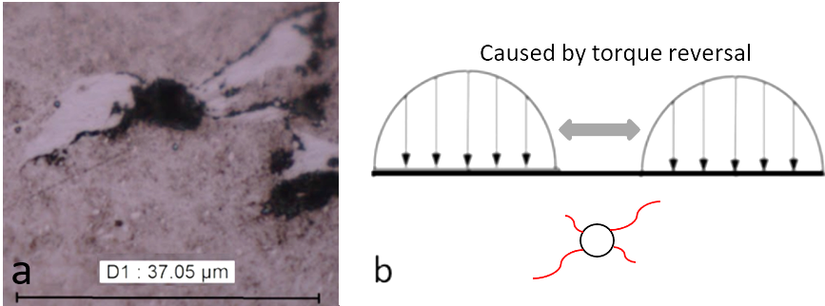
Figure 2.2. 5 Example of four-wings butterfly (a) observed in the actual failed bearing (b) possible initiation reason (possibly due to torque reversal) [9]
Moreover, it has been reported that butterfly damage is more likely to initiate from sulphide inclusions (especially MnS) [33]. This is normally because of the weak boundary between the MnS inclusions and the steel matrix. Another explanation in [87] indicates that the boundaries of MnS inclusions are easy to trap hydrogen atoms, which may cause the hydrogen embrittlement of the steel. The hydrogen embrittlement effect will reduce the toughness of the steel matrix, which accelerates the crack initiation and propagation.
WEC and WSF
White etching cracks (WECs) are the long crack networks generally observed in the subsurface areas of the bearings. After etching, it can be found that the branches of these cracks are usually surrounded or decorated by WEAs. Major WECs normally can be found from 0.5 mm to 1.5 mm below the contact surface [80]. According to the conclusion in [88], WECs can initiate and propagate entirely within the subsurface areas of the bearing. Moreover, evidence shown in Figure 2.2.6 suggests that this kind of propagation is irregular. It can be observed that some of the cracks are parallel to the contact surface, while some propagate vertically. These irregular orientations of WECs may be affected by the applied contact pressure on the raceway and the directions of grain boundaries of the original material microstructure [89].
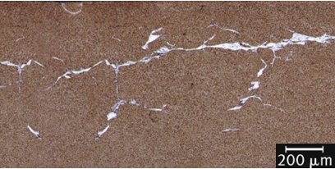
Figure 2.2. 6 WEC observed under the WTGB raceway surface [90]
NMIs have been identified as the vital factor that contributes to the formations of WECs. Based on the microscope observation of a damaged WTG planetary bearing, a hypothesis of the inclusion-initiated damage mechanism is proposed in [91]. According to the investigation, the inclusions are considered to be undamaged and perfectly bonded with the steel matrix after the manufacturing process of the bearing ring. However, due to the heat treatment process and/or the bearing overloading cases caused by the varied WT operation conditions, the inclusion internal cracking and the inclusion-matrix boundary separation may happen in the subsurface areas. These damage types of the inclusions will work as the stress risers and lead to serious stress concentrations during the bearing operation.
Consequently, cracks may initiate from the damaged inclusion and propagate within the steel matrix. It has been reported in [9] and [48] that the propagation of WECs is normally dominated by the surface traction caused by the rolling contact loadings. Sometimes, the propagation process of cracks is accompanied by the rubbing between contact surfaces of the cracks. Hence, the martensite areas around the cracks have the potential to decay and form into the ferrite white etching structures.
When the connected WEC networks propagate to the contact surface, they will result in the rapid failure of the bearing [91]. As shown in Figure 2.2.7, spalling occurs when the area near the surface is unable to withstand the load due to the presence of WECs. This process is named the White Etching Flaking (WSF), which is also known as the final damage stage of the bearing failure due to WEMs.
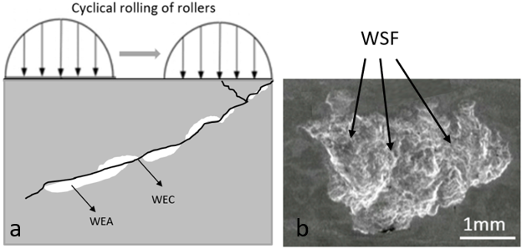
Figure 2.2. 7 Typical WSF caused by WECs (a) WSF formation mechanism (b) WSF damage observed on a twin-disc test sample surface [92]

Initiation and propagation of white etching damage
Although WEMs are the common bearing subsurface damage features which have been investigated for decades, their forming mechanisms are still highly debatable. Possible initiation reasons for subsurface WEAs/WECs include but are not limited to:
- Stray current discharging from the generator or grids. When the discharging current flows through the bearing, the subsurface martensite microstructure that has been prestressed may change into ferrite within a short time due to the electrothermal mechanisms [17]. Additionally, the current discharging may also accelerate the distortion of the subsurface cementite, which is identified to be the other important symbol for the WEA formation [17].
- Free surfaces interactions of the cracks. Due to the rolling contact loading, the impacting and friction behaviours will be introduced between both surfaces of the existing cracks. Research in [93] suggests that this rubbing/impacting behaviour will lead to the recovery and recrystallisation of martensite grains, which probably results in the forming of WEA by a thermal-tribology mechanism.
- Microstructure with NMIs and other subsurface defects. The inclusions or voids will cause stress concentrations of the subsurface areas, especially when the inclusions have separated boundaries and internal cracks. Due to the large shear stress introduced by them, the microstructure alternations of these areas are accelerated [91][94].
- Occurrence of the previously formed DEA. As discussed in section 2.2.2, the formation of DEA is accompanied by the partly decay of martensite material. Therefore, the occurrence of DEA is normally considered as the sign of the formation of WEA.
- Adiabatic Shearing Banding mechanism (ASB). Typically, the forming of ASB is caused by the impacting loading on the bearing raceway. Cracks caused by the impacts will produce the adiabatic subsurface areas which experience high shearing strain rates. Consequently, due to the highly localised heating and deformation, WEA may be easy to form around the thin and straight cracks [17].
In addition, the propagation of WECs may be accelerated by:
- The bearing operating conditions. It has been discussed in section 2.1.2 that the start-up, shutdown and braking operating conditions may cause the overloading and relative sliding between the WTGB rollers and raceway. Both cases increase the levels of the contact pressure and surface traction on the raceway surface, which lead to the subsurface material hardening and the rapid propagation of WECs [18][95].
- Inadequate lubrication conditions. Lack of lubrication will lead to either a considerable increase in the friction or the slipping between the raceway and rollers [96]. These factors have been experimentally verified to be harmful to the fatigue life of bearings according to the conclusions in [54] and[97].
- Hydrogen embrittlement. It is known that moisture contamination and lubricant decomposition may result in the leaking of the atomic hydrogen [17]. Additionally, these hydrogen elements coming from the external environments may be absorbed by the steel matrix and then fill the gaps between the Ferrum atoms. It will cause serious dislocations of the original steel microstructure, which directly reduce the toughness of the bearing material [72][98].

Hertz Contact Theory

Classic Hertzian contact theory
Hertz contact mechanics was firstly developed by Heinrich Hertz in the 1880s, which helps to calculate the contact pressure and the subsurface stress distribution between the contacted components. Although it has been widely used for over 100 years, it still has some limitations [99]:
- The strains of the deformed area in the contact should be small. It means that the contact area should be much smaller than the size of the contacted components.
- The contact area should be frictionless.
- The deformation of the contacted components should be pure elastic.
The rollers and raceways designed for the WTGB application have cylindrical shapes which aim to reduce the contact pressure by increasing the contact area. Therefore, the contact area between the raceway and a single roller can be simplified as a rectangle as illustrated by Figure 2.3.1.
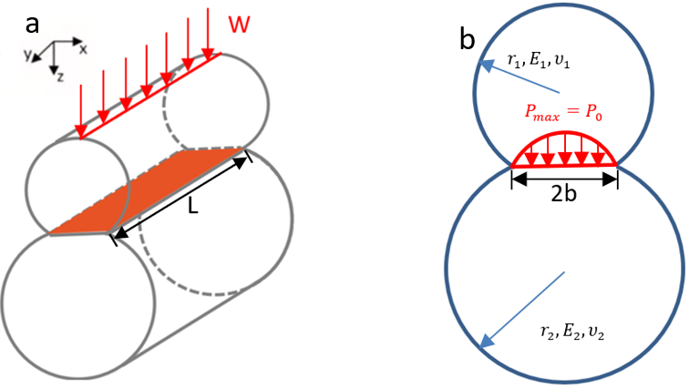
Figure 2.3. 1 Contact between the raceway and roller (a) rectangle interface of contact (b) relevant parameters in Hertz contact
With the Hertz contact parameters defined in Figure 2.3.1, the maximum contact pressure $p_{max}$or $p_{0}$ can be calculated by the following equation [100]:
$p_{max}, p_{0} =\sqrt{{WE^{*}}/{πRL}}$ Equation 2.6
where:
L is the length of the contact bodies between the raceway and roller.
W is the maximum force acting from a single roller on the raceway, which can be determined by the radial force acting on the bearing ${F_{p}}^{r}$, and the number of rollers $Z$:
$W=5∙{{F_{p}}^{r}}/Z$ Equation 2.7
$E^{*}$ is the equivalent Young’s Modulus of two contacted components, which is calculated by Young’s Modulus $E_{1}$ (roller), $E_{2}$ (raceway) and Poisson's ratios $υ_{1}$ (roller), $υ_{2}$ (raceway):
$\frac{1}{E^{*}}=\frac{1-{υ_{1}}^{2}}{E_{1}}+\frac{1-{υ_{2}}^{2}}{E_{2}}$ Equation 2.8
$R$ is the equivalent radius of the raceway and roller, which is decided by the radii of the components $r_{1}$ (roller) and $r_{2}$ (raceway):
$1/R=1/{r_{1}}+1/{r_{2}}$ Equation 2.9
Assuming both the roller and raceway are made of the same steel material with Young’s Modulus of 210 GPa and Poisson's ratio of 0.3, Equation 2.6 can be simplified as:
$p_{max} ( p_{0}) =0.418\sqrt{{WE_{steel}}/{RL}}$ Equation 2.10
The half contact length in Hertz contact theory is usually represented by parameter $b$. Hence, the overall contact length between the raceway and roller is $2b$, which has the following expression [100]:
2$b=2∙\sqrt{{4WR}/{πLE^{*}}}$ Equation 2.11
From the plane view of the contact bodies, the rectangle contact area between the raceway and roller is simplified as a line, as shown in Figure 2.3.1 (b). According to Hertz contact theory, it follows an elliptical distribution which has the maximum contact pressure of $p_{max}$ and contact length of $2b$:
$p(x)=p_{max}\sqrt{(1-{x^{2}}/{b^{2}})}$ Equation 2.12
where $p(x)$ is the magnitude of the pressure distribution and $x$ is the distance from the contact centre to the specific point that the pressure needs to be calculated.

Subsurface stress distribution with traction
As discussed in section 2.2, during the WTGB operation period, the rolling contact caused by the rollers will introduce the surface traction on the raceway surface due to friction. Assuming a linear relationship between the normal contact pressure and the traction pressure, the traction pressure can be expressed as: [54]
$q\left(x\right)=μ_{T}p(x)$ Equation 2.13
where $q\left(x\right)$ is the expression of surface traction and $μ_{T}$ represents the traction coefficient.
Assuming Hertz contact happens within the x-z plane over the strip (-b<x<a) with a distributed normal pressure $p(x)$ and the traction pressure $q(x)$. To calculate the subsurface stress, an infinitely small element $ds$ can be selected, where the normal and traction pressure is assumed to be concentrated, as shown in Figure 2.3.2.
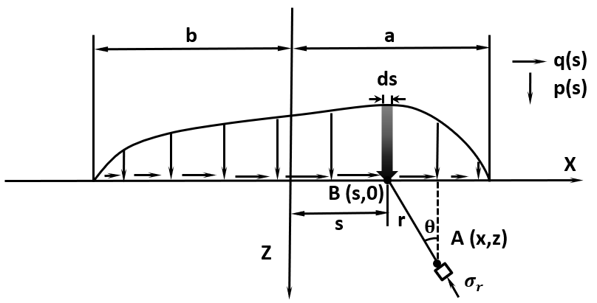
Figure 2.3. 2 Diagram for subsurface stress calculation in a distributed loading condition [101]
It can be seen from the figure that the concentrated pressure acts at point B on the contact surface, and the distance between this point and the origin of the coordinate system is $s$. By integrating the elemental area with width$ds$ from -b to a, the effect of distributed pressure can be calculated. Accordingly, the stress components of a random subsurface point A with the coordinate (x, z) can be determined from the integration of $ds$, with the following equations [101]:
$σ_{xx}=σ_{r}{∙sin}^{2}θ=-\frac{2z}{π}\int_{-b}^{a}{\frac{p(s){(x-s)}^{2}ds}{{\left\{{(x-s)}^{2}+z^{2}\right\}}^{2}}-\frac{2}{π}\int_{-b}^{a}{\frac{q(s){(x-s)}^{3}ds}{{\left\{{(x-s)}^{2}+z^{2}\right\}}^{2}}}}$ Equation 2.14
$σ_{zz}=σ_{r}∙\cos^{2}θ=-\frac{2z^{3}}{π}\int_{-b}^{a}{\frac{p(s)ds}{{\left\{{(x-s)}^{2}+z^{2}\right\}}^{2}}-\frac{2z^{2}}{π}\int_{-b}^{a}{\frac{q(s)(x-s)ds}{{\left\{{(x-s)}^{2}+z^{2}\right\}}^{2}}}}$ Equation 2.15
$τ_{xz}=σ_{r}∙sinθ∙cosθ=-\frac{2z^{2}}{π}\int_{-b}^{a}{\frac{p(s)(x-s)ds}{{\left\{{(x-s)}^{2}+z^{2}\right\}}^{2}}-\frac{2z}{π}\int_{-b}^{a}{\frac{q(s){(x-s)}^{2}ds}{{\left\{{(x-s)}^{2}+z^{2}\right\}}^{2}}}}$ Equation 2.16
where $σ_{xx}$ and $σ_{zz}$ are the stress values in x and y directions respectively, $τ_{xz}$ is the orthogonal shear stress in the x-z plane, and $σ_{r}$ represents the stress component of point A in the radial stress distribution.
With the known values of $σ_{xx}$, $σ_{zz}$, and $τ_{xz}$, the value of subsurface maximum shearing stress $τ_{max}$ can be determined. $τ_{max}$ is also known as the principal shear stress, which is calculated by the subtraction of the in-plane maximum and minimum principal stress vectors ($σ_{1}$ and $σ_{3}$):
$σ_{1,3}=\frac{σ_{xx}+σ_{zz}}{2}±\sqrt{({\frac{σ_{xx}-σ_{zz}}{2})}^{2}+{τ_{xz}}^{2}}$ Equation 2.17
$τ_{max}=0.5\left(σ_{1}-σ_{3}\right)=\sqrt{({\frac{σ_{xx}-σ_{zz}}{2})}^{2}+{τ_{xz}}^{2}}$ Equation 2.18
Figure 2.3.3 compares the directions, locations, and magnitudes of the subsurface $τ_{xz}$ and $τ_{max}$ without the consideration of the surface traction. The orthogonal shear stress $τ_{xz}$ is an alternating stress. It has both the positive and negative values on the left- and right-hand sides of the Hertz pressure; while the maximum shear stress $τ_{max}$ is determined by the principal stress $σ_{1}$ and $σ_{3}$.
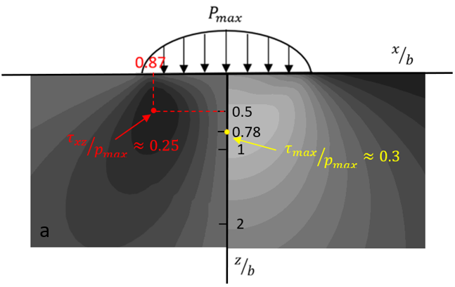
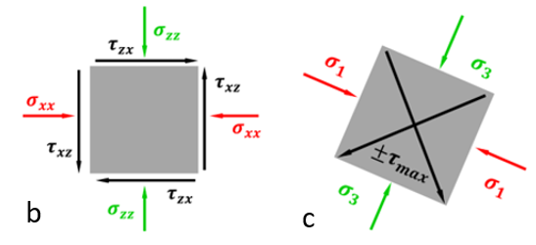
Figure 2.3. 3 Orthogonal shear stress and maximum shear stress in Hertz contact x-z plane without consideration of the traction pressure (a) subsurface stress distribution (b) definition and orientation of the orthogonal shear stress (c) definition and the possible orientation of the maximum shear stress [9]
Moreover, the maximum magnitude of ${τ_{xz}}/{p_{max}}$ is about 0.25, which locates at the position of (0.87b, 0.5b). But the magnitude of ${τ_{max}}/{p_{max}}$ can reach approximately 0.3, and it locates directly below the contact centre with the coordinate of (0, 0.78b). Because $τ_{max}$ is the equivalent shear stress which can reflect the stress concentration of the subsurface area, it is normally used for the stress analysis in Hertz contact theory [102]. Additionally, for $τ_{xz}$, it can be used to analyse the possible RCF damage initiation because it is an alternating stress which represents the stress variation within the cyclic loading [103].

Subsurface Fatigue Crack Initiation and Propagation

Fatigue damage and relevant models
Definitions
Fatigue of the metal is defined as the progressive structure damage that is usually caused by cyclic loadings. During the typical fatigue process, the fluctuating stress applied to the material is normally smaller than the yielding strength of the material. However, with the accumulation of the material damage, the cracks will initiate and propagate from the areas most affected by the stress. As discussed in section 2.2, subsurface RCF initiated by material defects is the most common fatigue process observed in the WTGBs.
Fatigue life of the material means the number of loading cycles that the material can withstand before the final fatigue fracture happens. Based on the number of cycles, material fatigue can be divided into three sub-types: low cycle fatigue (LCF, fatigue life $≤{10}^{6}$), high cycle fatigue (HCF, ${10}^{6}≤$ fatigue life $≤{10}^{8}$), and very high cycle fatigue (VHCF, fatigue life $≥{10}^{8}$) [104]. Normally, RCF in WTGB can be considered as the high cycle fatigue according to the RCF test results in [54] and [97].
Fatigue Testing methods
To identify the fatigue resistance of the material, the repetitive fluctuating stress should be applied to the material until the occurrences of fatigue cracks, or the fracture. The stress in the test is either tension, compression, bending, or torsion.
As shown in Figure 2.4.1 (a), a typical loading cycle should vary periodically, and it can be characterised by the following parameters: maximum and minimum load: $σ_{max}$ and $σ_{min}$, stress range: $∆σ=$ $σ_{max}-σ_{min}$, mean stress during each loading: $σ_{mean}$, and stress amplitude: $σ_{alternating}$= ($σ_{max}-σ_{min}$)/2.
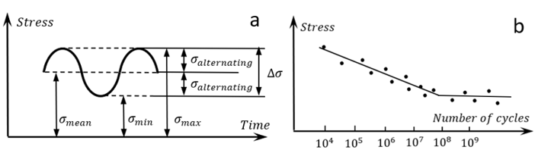
Figure 2.4. 1 Stress variation during fatigue test and S-N curve (a) definitions in fatigue test (b) plotted material S-N curve [105]
To better represent the fatigue strength of the material under different fluctuating stress levels, the S-N curve can be used which presents the stress magnitude (S) and fatigue life (N) under specific stress levels. Figure 2.4.1 (b) shows a typical S-N curve of the metal material. In most cases, the fatigue stress is approximately linear to the log of fatigue life. However, when the stress magnitude decreases to a certain value (also known as the fatigue limit value), the material will have an unlimited fatigue life as shown in the figure.
Fatigue criteria
Fatigue failure of the materials has been generally considered to be related to the amplitude and mean stress of cyclic loading ($σ_{alternating}$and $σ_{mean}$). Since the amplitude is usually greater than the mean stress of the material, it is considered to be dominating during the accumulation process for fatigue damage initiation [106]. Typically, the relationship between the relevant stress and the material fatigue life is governed by the Gerber line and its modified versions: the Goodman line and Soderberg line [105]. These relationships are shown by the following equations:
${(\frac{nσ_{mean}}{σ_{UTS}})}^{2}+\frac{nσ_{altenating}}{σ_{0}}=1$ Gerber line
$\frac{σ_{mean}}{σ_{UTS}}+\frac{σ_{altenating}}{σ_{0}}=\frac{1}{n}$ Goodman line
$\frac{σ_{mean}}{σ_{y}}+\frac{σ_{altenating}}{σ_{0}}=\frac{1}{n}$ Soderberg line Equation 2.19
where, $σ_{UTS}$ is the ultimate tensile strength of the material, $σ_{0}$ is the fatigue limit of the material, $σ_{y}$ is the yielding strength and $n$ is the safety factor. As shown in Figure 2.4.2, when the stress magnitudes of $σ_{altenating}$ and $σ_{mean}$ exceed the allowed values defined by the fatigue criterion lines, possible fatigue damage will initiate due to the cyclic loading.
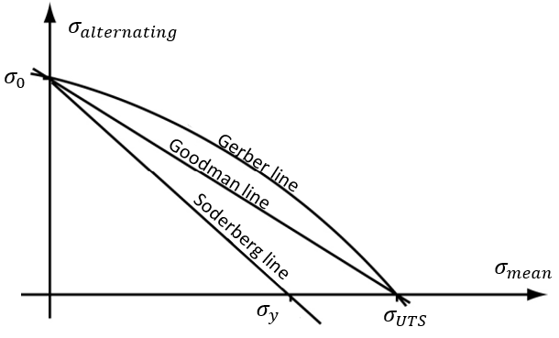
Figure 2.4. 2 Comparison between different fatigue criterions: Gerber model, Goodman model, and Soderberg model
Apart from the traditional fatigue criteria, some newly developed fatigue criteria may use other dominating stresses instead of $σ_{altenating}$ and $σ_{mean}$. The Fatemi–Socie multiaxial fatigue criterion follows the definition of the critical plane in which the multiaxial stress and strain will be firstly reduced to plane components and then to the equivalent scalar [107]. Additionally, it uses the maximum normal stress vertical to the maximum shear strain plane and the maximum shear strain range to determine the initiation of fatigue damage. Different from the traditional fatigue criteria, it defines a parameter $FS$ to describe the accumulation of damage [107]:
$FS=(1+k\frac{σ_{n}}{σ_{y}})∙\frac{∆γ}{2}$ Equation 2.20
where, $k$ is the material constant, $σ_{n}$ is the maximum normal stress and $∆γ$ is the shear strain range within the maximum shear strain amplitude plane. When the value of parameter $FS$ exceeds the maximum allowed value, the fatigue damage will initiate.
Similarly, another criterion named as the Dang Van fatigue criterion defines a damage parameter $DV$ by combining the effect of the maximum shear stress and the effect of the hydrostatic stress, as shown in Equation 2.21 [108].
$DV={(τ}_{max}-τ_{mean})+ρ∙σ_{hydrostatic}$ Equation 2.21
In Equation 2.21, ${(τ}_{maximum}-τ_{mean})$ considers the difference between the maximum shear stress and the mean shear stress, $ρ$ is the material constant, and $σ_{hydrostatic}$is the material hydrostatic stress. Same as the Fatemi–Socie criterion, the damage will initiate when the value of $DV$ exceeds the critical threshold.
Fatigue with Continuum Damage Mechanics
To model the fatigue failure of the material, the Continuum Damage Mechanics (CDM) is also widely utilised to study this behaviour. CDM is firstly introduced by Kachanov in 1958, which assumes that the material will withstand the loading through its effective area [109]. In addition, damage of the material is considered as the reduction of the effective area, which will result in a decrease in the material stiffness. When the material structure has no damage, the stress $σ$ caused by the applied force $F$ with the effective area $A$ is:
$σ=\frac{F}{A}$ Equation 2.22
However, if the accumulated damage occurs after a certain number of loading cycles, cavities will form from the grain boundaries, as shown in Figure 2.4.3. Therefore, the new stress in the structure becomes:
$σ=\frac{F}{A-A_{D}}$ Equation 2.23
where $A_{D}$ means the reduction of the effective area.
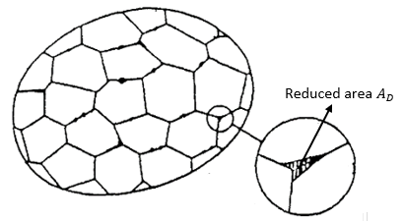
Figure 2.4. 3 Reduction of the effective area (initiated from the material grain boundaries) [110]
The ratio between the reduced area $A_{D}$ and the original effective area $A$ is known as the damage variable $D$, which is defined as [111] :
$D=\frac{A_{D}}{A}$ Equation 2.24
Normally, the value of $D$ does not exceed 1. In the fatigue damage, this value will increase continuously due to the cyclic loading applied to the material. Table 2.6 describes some existing models that developed to calculate the increment of $D$ value during each loading cycle, $dD/dN$. Models listed and compared in the table include the Chaboche’s model [112], Lemaitre’s model [113], Xiao’s model [114], Paas’s model [115], Peerlings’s model [116], and Wahab’s model [117].
Typically, Wahab’s model is widely used for the fatigue modelling of the adhesive relationship between interfaces, while Paas’s and Peerlings’s models are used for the simulations of fractures of brittle materials such as ceramic or glass.
Both Chaboche’s and Lemaitre’s models can be used to simulate the high cycle fatigue behaviours of metals. The only difference between them is that the Lemaitre’s model includes the consideration of the stress triaxiality, which may help to calculate the fatigue damage of the 3D stress cases.
Xiao’s model is a modification and simplification of both Chaboche and Lemaitre’s models, it only has two material parameters that need to be determined by the experiments [114]. Additionally, because Xiao’s model does not consider the stress in 3D conditions, so it is only suitable for solving 2D in-plane fatigue problems.
Table 2. 6 Calculation of $dD/dN$ in different High Cycle Fatigue models developed [112] [113] [114] [115] [116] [117]
Damage model | $$dD/dN$$ | Material constant
Chaboche’s model | 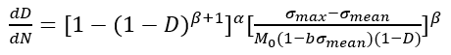 | $$α, β, M_{0}, b$$
Lemaitre’s model | 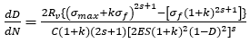 | $$R_{v}, k, s, C, ES$$
Xiao’s model | 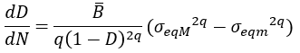 | $$\overline{B}, q$$
Paas’s model | 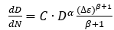 | $$C, α, β$$
Peerlings’s model | 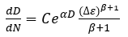 | $$C, α, β$$
Wahab’s model | 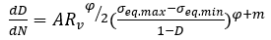 | $$A, R_{v}, φ, m$$

Fatigue crack propagation with LEFM and EPFM
After the fatigue damage nucleation, the crack propagation will happen due to the continuous loading cycles. In general, the Linear Elastic Fracture Mechanics (LEFM) is used to identify the possible dominating stress and propagation direction.
LEFM assumes the material is isotropic and linearly elastic. In the theory, the crack propagation is caused by the localised loading applied. Typical loading modes for crack propagation include the in-plane tensile loading (Mode I), in-plane shear loading (Mode II), and off-plane shear loading (Mode III), as illustrated by Figure 2.4.4.
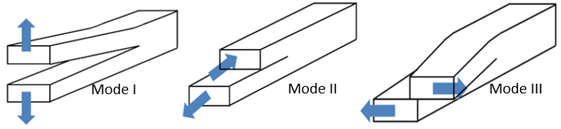
Figure 2.4. 4 Material crack propagation modes due to different loadings in LEFM [118]
To identify the occurrence of the damage propagation, the stress field near the crack tip is calculated based on the elasticity theory. Generally, the stress is determined by the location of the crack, specimen geometry, and the remote loading conditions:
$σ_{ij}^{Tip}≡σ_{ij}^{Tip}(Location,Geometry,Loading)$ Equation 2.25
For the quantitative description, the location of the crack tip can be defined by $r$ and $θ$, which are two parameters in the polar coordinate system defined at the crack tip. Additionally, the remote loading ($σ^{loading}$) and the specimen geometry can be grouped into the other parameter $K$, which is known as the stress intensity factor. Therefore, the modified version of Equation 2.25 is:
$σ_{ij}^{Tip}≡σ_{ij}^{Tip}\left(Location,Geometry,Loading\right)≡σ_{ij}^{Tip}(r,θ,K)$ Equation 2.26
where,
$K≡K(σ^{loading}, Geometry)$ Equation 2.27
It is shown in [119] that the value of crack growth rate ${da}/{dN}$ depends on the stress intensity factor $K$. The relationship is governed by Paris Law as:
${da}/{dN}=C{(∆K)}^{m}$ Equation 2.28
where $a$ is the crack length, $N$ is the loading cycle, $∆K$ is the difference between the maximum and minimum stress intensity factor, $C$ and $m$ are two constants that vary according to the material properties. However, Paris Law may have some limitations in the application of predicting WTGB subsurface crack propagation. The loading on the wind turbine is not constant, it will change because of the variation of wind speed and other specific operating conditions such as the shutdown and start-up. Accordingly, the value of $∆K$ is a variable during the bearing operation.
Furthermore, considering that the subsurface RCF may be accompanied by the plastic deformation caused by the material defects, the Elastic-Plastic Fracture Mechanics (EPFM) can be used to modify the crack propagation behaviour by introducing the J integral to the area of the crack tip. The J integral is a path-independent contour integral which represents the energy release rate in a nonlinear elastic body containing a crack [118]. For an edge-cracked specimen, the J integral is determined by the specimen potential energy $U$ and specimen thickness $B$:
$J=-\frac{1}{B}\frac{dU}{da}$ Equation 2.29
Currently, there is no modelling methods to calculate the value of ${da}/{dN}$ based on J integral. The accurate relationship between them can only be obtained by experiments [118].

Finite Element Modelling of the Inclusion-initiated Damage
The application of Finite Element Method (FEM) provides a suitable solution for the investigation of stress around the bearing subsurface inclusions. As discussed in section 2.1.6, the inclusions usually work as the stress risers which result in the subsurface stress concentrations. Investigation in [103] indicates that such stress concentration behaviour during the rolling contact process will introduce the increased orthogonal shear stress range and non-zero mean shear stress to the steel matrix. These stress variations are normally considered as the main reasons for causing the material fatigue damage. Therefore, investigations of the bearing subsurface inclusions can be generally divided into two types, the research of the stress concentration and the research of the crack initiation/propagation.

Modelling of subsurface stress concentration due to inclusions
Perfectly bonded inclusion
A study in [52] developed several FE models to determine the possible factors affecting the stress concentration due to inclusions. It modified the definition of the steel matrix by defining the Voronoi cells to represent the grains of the martensite bearing steel. With the same Hertz contact pressure applied on to the bearing material, the study compared the effect of dimension, subsurface depth, and elastic modulus of the inclusion. It has found that with the increase of the inclusion elastic modulus, the von Mises stress caused by the perfectly bonded inclusion increases correspondingly. Meanwhile, the most serious stress concentration was observed when the inclusion was embedded in the subsurface area with a depth from 0.75$b$ to 0.80$b$ ($b$ is the half contact length in Hertz contact theory). This finding is similar to the conclusion discussed in section 2.3.2 that the most serious stress concentration occurs in the area with the greatest maximum shear stress (depth of 0.78$b$), although [52] used the von-Mises criterion instead of the maximum shear stress criterion. However, the inclusion dimensions were not investigated in detail, because all the inclusions modelled in [52] were spherical (aspect ratio of 1), and the only difference between them was the inclusion diameter.
Investigation in [120] developed the modelling of the elliptical MnS inclusions, which are normally observed in the failed bearing subsurface sections. For the elliptical inclusions, the stress concentrations happen at the tips of the inclusion. Additionally, if the inclusion tips are separated from the steel matrix, the magnitude of the von Mises stress will increase to 167% of the modelling results with a perfectly bonded inclusion. Due to the plastic deformation around the separated boundary areas, the steel matrix may contain both the tensile and compressive residual stress according to the modelling results in [120].
Boundary separated inclusion
Modelling of the inclusion boundary separation was investigated thoroughly in [121]. This investigation created the artificial voids on the inclusion-matrix boundary as a simulation of separation. It has found that when the separation happens at the top/bottom of the elliptical inclusion, the boundary separation of the inclusion will be accelerated by the remote Hertz contact pressure. However, if the separation occurs at the tips of the inclusion (left- and right-hand sides), the stress concentration due to the inclusion becomes more serious, leading to the hardening of the local steel matrix and probably the forming of fatigue cracks.
Internally cracked inclusion
As discussed in section 2.1.6, the internal crack of the inclusion will also lead to the subsurface fatigue damage. Normally, these internal cracks occur because the stress acting on the inclusion exceeds its loading capacity. Investigations in [122] and [123] both suggest that the internal cracking damage of the inclusion has a great influence on the bearing fatigue life. FE models in [123] compared the energy release rates of the crack initiation from an internally cracked alumina inclusion and a perfectly bonded TiN inclusion. The modelling results show that although the TiN inclusion results in a relatively higher stress concentration level, the energy release rate from the TiN-initiated cracking is smaller than that of the alumina inclusion. It means that the internally cracked inclusions are more likely to generate cracks compared with the perfectly bonded ones.
Definition of the cyclic rolling contact loading
Some investigations, such as [52],[122], and [123], defined a static Hertz contact pressure to analyse the stress concentration due to inclusions. However, the normal rolling contact behaviour between the rollers and raceways is known as a cyclic and dynamic process. Therefore, the definition in these investigation cannot not simulate the stress variation during the rolling contact process. Moreover, the study in [120] defined the cyclically changed amplitudes for the normal contact pressure and horizontal surface traction. However, it is still different from the actual rolling contact process because these definitions cannot reflect the stress states when the Hertz pressure distribution is applied to the upper right and upper left of the inclusion.
FE research in [124] provided a potential solution by developing the user-defined subroutine to model the cyclic rolling contact process. The steel material was defined as a rectangle with the distributed Hertz pressure acting on its top surface. By developing the user subroutine, the distributions of both the normal contact pressure and traction pressure were defined as functions that were linked with the step time. Research in [124], [125], [126], and [127] all adopted this method which helped to show the subsurface stress variation around the inclusion during the rolling contact loading process.

Modelling of crack initiation and propagation
The fatigue cracks triggered by inclusions are also known as the butterfly wings. Due to the tiny size of inclusions and the subsurface stress complexity caused by the rolling contact loading, only a few studies have successfully simulated the crack initiation and propagation in butterfly wings. These will be discussed as follows.
Using stress intensity factor
In [128], it investigated the stress concentration caused by a square ${Al}_{2}O_{3}$ inclusion under the rolling contact loading. Based on the assessment of $∆K$, the difference between the maximum and minimum stress intensity factor, this research predicted the possible initiation areas of the fatigue crack [128]. Although [128] lacked the evidence to show the existences of the butterfly wings, it still proved that the forming of butterfly wings may be affected by the stress concentration caused by the microcavities.
Another research in [52] also utilised the stress intensity factor for the analysis of possible subsurface crack propagation. However, the crack in this investigation was predefined in the model, and its propagation process was not simulated by the model. Even with these limitations, it was found that during one rolling contact cycle, the existing crack experienced the “open-close-open” process, which depended on the position of the Hertz contact pressure distribution.
Using accumulated plastic strain or grain dislocation
In addition to using the stress intensity factor, research in [129] calculated the plastic strain accumulation for the predicting of the butterfly forming. Moreover, it defined a two-phase hybrid model which helped to simulate the volumetric strain during the austenite-to-martensite phase transformation and the plastic strain accumulation during the rolling contact process [129]. Although the propagation orientation of the fatigue crack was not simulated in the research, it still predicted the accurate positions of the possible crack initiation.
The investigation in [130] believes that the grain boundary dislocations on the inclusion-matrix interface caused by the plastic deformation may affect the formation of cracks. The model developed in this research calculated the dislocations and their accumulations after a certain number of rolling contact loading cycles. Therefore, the study in [130] not only predicted the position and the potential growth direction of the butterfly, but also suggested the number of rolling contact loading cycles required for the crack nucleation.
Using fatigue criteria
Investigation in [131] applied both Dang Van and Fatemi–Socie criteria to model the possible crack propagation due to the MnS and ${Al}_{2}O_{3}$ inclusions. The results successfully modelled the possible initiation positions of the fatigue damage due to the inclusions. These positions were proved to be correct when compared with the butterfly images experimentally observed in [9]. Meanwhile, according to the modelling results, it concluded that the inclusion triggered crack had a high possibility to propagate obliquely towards the contact surface of the raceway [131]. This conclusion reflected the failure mechanisms of the bearing raceway, and it was also supported by other published works such as [17], [48], [81], [91], and [132]. However, similar to the investigation in [128], this research does not show the number of rolling contacts required and the crack propagation process.
Using XFEM
To simulate the crack propagation process, the other possible method suggested by the literature is using the Extend Finite Element Method (XFEM). XFEM was first proposed by Belytschko and Black in 1999. Generally, for the analysis of fracture problems, it improves the traditional FEM by defining specific jump functions (Heaviside functions) to describe the discontinued boundaries of an element [133]. In most cases, the application of XFEM requires the predefined cracks, which means that it may only be used for the modelling of the crack propagation instead of the crack initiation.
However, no studies have been found to investigate the XFEM crack propagation from the subsurface inclusions under the rolling contact loading. Research in [134] and [135] investigated the possible fatigue crack propagation under the rolling contact behaviour. However, both investigations did not consider the existence of the inclusion. A study in [136] modelled the effect of inclusions during the crack propagation process. However, the pressure applied to the steel matrix is a static and uniform distributed pressure instead of the distributed rolling contact pressure. In addition, the predefined crack was not located at the boundary between the inclusion and steel, but at a certain distance from the inclusion. Therefore, the effectiveness of the XFEM in modelling the rolling contact crack propagation due to inclusions has not been verified.
Using CDM
Research in [124] put forward a CDM damage model to simulate the initiation and propagation of the butterfly wings. As discussed in section 2.4.1, CDM describes the reduction of the effective loading area of the material by defining a damage parameter $D$. In [124], it assumed the phase transformation of the steel structure from martensite to ferrite as a stiffness reduction process, because it was measured that the elastic modulus of the white etching ferrite structure was 90% of the original martensite structure. Therefore, this investigation modelled the fatigue damage accumulation with a maximum $D$ value of 10%.
The hypothesis in the research simplified the complex formation process of white etching damage to the decay of the physical stiffness of martensite. As explained in section 2.2.3, the formation mechanisms of WEA are linked to the thermal and electrical conditions. Consequently, the validity of the hypothesis requires further discussion. In spite of the debate, it is undeniable that by using the CDM method in combination with a high cycle fatigue damage model, the number of cycles required for the fatigue damage initiation can be predicted and the crack propagation process under the cyclic rolling contact loading can be simulated.

Summary of the Current Research Gaps
According to the reviews of the possible bearing raceway damage mechanisms, it is found that the failure of the WTG planetary bearings is normally caused by the lubrication conditions, cyclic rolling contact loading, and the unusual operating situations of the WT [9][48][137]. Due to these damage mechanisms, accelerated RCF caused by subsurface inclusions has been reported as the main reason for the premature failure of the planetary bearing raceways [9][48][81][91]. These inclusion-initiated cracks will connect with each other to form the crack networks. When the subsurface crack network spreads to the contact surface of the bearing raceway, the final bearing failure will be caused.
Investigation of subsurface stress concentration
According to the previous FE modelling of the subsurface stress concentration due to inclusions, the inclusion compositions, sizes, and positions have been found to affect the subsurface stress distribution and the RCF crack initiation [52][120]. Additionally, it has been reported in the experimental observations of the failed bearing sections that the boundary separation and internal cracking of inclusions will also contribute to the forming of RCF cracks [9][48]. The influences of the inclusion boundary separation and internal cracking have not been quantified in the literature. In the published studies, they are generally considered to cause the stress concentration in the subsurface area [9][48]. In order to develop a better understanding of the inclusion-initiated fatigue damage, it is necessary to conduct a stress analysis of the subsurface stress concentration caused by inclusions with the boundary separation and internal cracking. Moreover, in the published investigations of the stress concentration, some key factors that may affect the stress state or interact with the other factors are ignored. Therefore, a comprehensive study which considers all possible factors affecting the subsurface stress distribution should be carried out.
Investigation of RCF crack initiation and propagation
Normally, the subsurface cracks are considered to be caused by the stress concentration introduced by inclusions. Due to the stress concentration, the fatigue life of the bearing material will be reduced with the increasing magnitude of the fatigue dominating stress. Section 2.5.2 reviewed some FE models which can be used to simulate the crack initiation and propagation. It was found that CDM is the most suitable method because it can model both the crack initiation and propagation process under a large quantity of the rolling contact loading cycles. In addition, the CDM model in [124] has been proved to be accurate for predicting the possible cracking positions and the growing orientations of the butterfly wings. Apart from the CDM method, there are no studies using the XFEM to simulate the crack propagation process under the rolling contact loading. As suggested in [138], further investigations may combine both CDM and XFEM for simulating the crack propagation within the macro scale area.
However, the investigation in [124] with the CDM did not consider the common inclusion damage types such as the boundary separation and the internal cracking. The effect of them on the fatigue crack initiation requires more in-depth investigations. Moreover, the plastic deformation of 100Cr6 material during the RCF process was not considered in [124]. It has been discussed that the steel matrix around the inclusion may experience the shakedown and ratcheting process during the RCF crack initiation process. Hence, the material plastic deformation is a vital factor which should be defined in the CDM FE model for developing an in-depth understanding of the subsurface RCF process.
Additionally, the published literature lacks the consideration of Hertz contact pressure variation. All the existing definitions of the Hertz contact pressure are considered as constant pressure distributions that have been either statically or dynamically applied on the contact surface. However, due to the occurrences of some special WT operating conditions such as the frequent start-up, shutdown, braking, and wind speed variations, the magnitude of the Hertz contact pressure applied on the planetary bearing raceways is not constant. Therefore, to model the RCF crack initiation accurately in the WTGB, these variations of the pressure applied on the raceway surface should be considered.
Investigation of WEA
Many WEAs have been found as the decorations of the RCF cracks in the observation of failed bearing raceway samples. Since WEA increases the hardness and decreases the toughness of the steel matrix, it greatly promotes the propagation of localised RCF cracks. It is generally believed that the WEA generation is affected by the stress concentration, local heating, rubbing, hydrogen diffusion, and electrical current discharge.
Relevant damage formation mechanisms are normally investigated by the twin-discs test experiment, which uses two contacted discs to simulate the rolling contact behaviour between the roller and raceway. According to the published twin-discs test results, it has been proved that the maximum Hertz contact pressure, surface traction and lubricant types will have a significant influence on the formation of the WEA damage. However, the formation sequence of the WEA damage and RCF crack is controversial and still being debated. Further investigations of the WEA damage formation are still required.

Microstructure damage characterisation of failed wind turbine gearbox bearings
In this chapter, the failed planetary bearings of the V80-2MW WTG are observed and analysed by the optical and electron microscopy. According to the characterisations of the inclusions, steel matrix and subsurface microstructure damage, the RCF cracks caused by subsurface inclusions are identified as a vital reason for the premature failure of the planetary bearings. In addition, by investigating the microstructure of the WEA damage, some possible formation mechanisms of this damage type is proposed in the chapter.

V80-2MW Wind Turbine Gearbox Planetary Bearings
In this chapter, the failed planetary gearbox bearings from the V80-2MW WT will be investigated. The V80-2MW WT is manufactured by the Denmark WT manufacturer Vestas Wind System A/S. This design of WT has been in operation on some wind farms in Europe, North America, and Oceania since 2011. “80” means the diameter of the rotor is 80 meters; “2MW” means the maximum power generated by the WT is two megawatts. Other physical parameters of the WT are listed in Table 3.1:
Table 3. 1 Operation data of V80-2MW wind turbine [139]
Rotor | Diameter | 80 m | Swept area | 5027.0 $m^{2}$
 | Blade Material | Glass-fibre reinforced plastic | Number of blades | 3
Tower | Type | Steel tube | Shape | Conical
 | Coating | Yes | Hub height | 60/67/78/100 m
Power | Rated power | 2000 kW | Cut-in wind | 4 m/s
 | Cut-off wind | 25 m/s | Rated wind | 15 m/s
Gearbox | Type | Spur/planetary | Ratio | 1:101
 | Stages | 3 | Number | 1
Generator | Type | Double Fed Asyn | Voltage | 690.0 V
 | Frequency | 50 Hz | Number | 1
Miscellaneous | Offshore | No | Onshore | Yes
Generally, most megawatt WTs of Vestas share a similar design of the structures. During the operation, the wind speed and direction will be detected by the wind speed sensor named as SODAR (Sound Detecting and Ranging). After that, the controller will adjust suitable pitch angles for the blades according to the wind data recorded by the sensor. With the rotation of the blades, the low-speed shaft connected to the blades will rotate correspondingly, and its rotation speed will be increased by the gearbox. The accelerated speed is then converted into the input speed needed by the generator, through the high-speed shaft of the gearbox. Finally, the generator will produce the alternating current and feed it into the grid.
As discussed in Section 2.1.2, the input torque is transmitted from the low-speed shaft to the gearbox. Therefore, these planetary gearbox bearings will undertake the radial loadings. Importantly, the loading zones of the planetary bearing inner raceways are considered to be fixed because the inner raceways of the planetary bearings are mounted on the planetary carrier using the fixed pins.
During the operation of the wind turbine, RCF and WECs may damage the loading zones of the bearing raceways and eventually cause the material to flake away from the raceway surfaces. Sometimes, the flaking material may cause scratches and indentations of various sizes on the raceway and roller surfaces.
Figure 3.1.1 shows the failed raceways of the upwind and downwind planetary bearings in the gearbox. The damaged areas and the indents can be seen clearly on the surfaces. For the upwind bearing raceway, the damaged area has a maximum width of 39 mm and a length of 92 mm. For the downwind bearing raceway, the maximum width of the damaged zone is about 32 mm, and the length is 93 mm. The damage of the upwind bearing is more serious than the damage of the downwind bearing. This is due to the different levels of the radial load acting on the bearing raceways. It is known that the upwind bearing normally takes 40% to 60% more load than the downwind bearing in the planetary gearbox [140][141]. Accordingly, the upwind bearing raceway has a relatively larger damaged area. It also should be noticed that, in both bearings, the damage levels of the raceways are different along the axial direction of the bearings. This observation indicates that the radial load may not be uniformly distributed along the bearing axis, which results in the greater raceway damage at the flange end of the inner raceways.
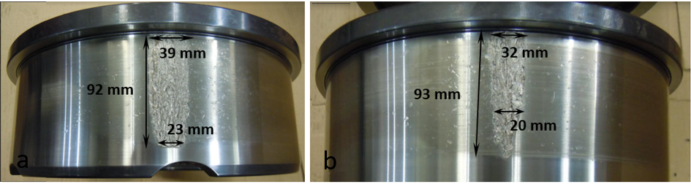
Figure 3.1. 1 Failed inner raceways (a) upwind planetary bearing (b) downwind planetary bearing
According to the operation and maintenance data, both two bearings were damaged and replaced much earlier than the required designed life of 20 years. To understand the possible causes of the bearing premature failure, this chapter conducts microstructural damage characterisations on samples cut from the failed bearing raceways by the optical microscope, Scanning Electron Microscopy, and X-ray Computed Tomography.

Sample Preparation
This section outlines the procedure of the sample preparation. Subsurface damages for example WECs, WEAs, inclusions and butterflies can only be observed when the bearing samples are well prepared by following the standard steps.

Sectioning and mounting
The first step of sample preparation is to section the failed bearing raceways into small pieces. To investigate the 3D structures of different crack networks and inclusions, the raceway is cut along the axial and circumferential directions respectively. The definitions of both axial and circumferential directions are illustrated by Figure 3.2.1.
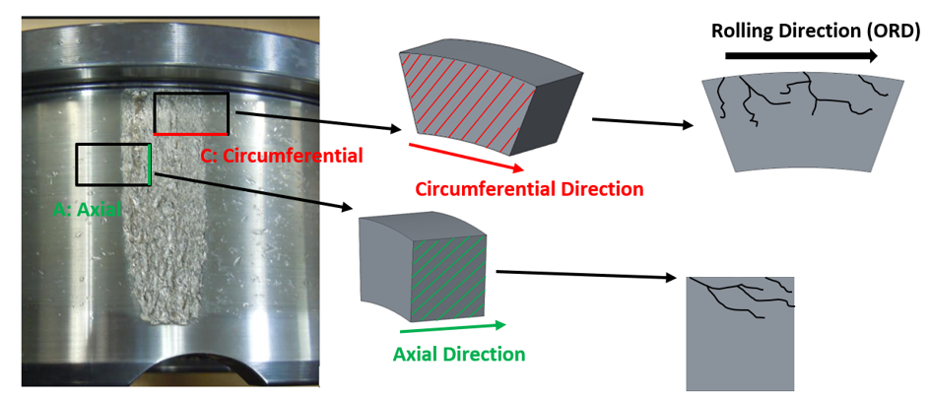
Figure 3.2. 1 Axial and circumferential sectioning directions of the bearing raceway
As shown in Figure 3.2.2, the damaged areas of both the upwind and downwind bearing raceways are sectioned. For each raceway, the damaged areas are divided into 6 zones and each zone is then sectioned into two samples. Therefore, the subsurface damage in both the axial and circumferential directions can be observed.
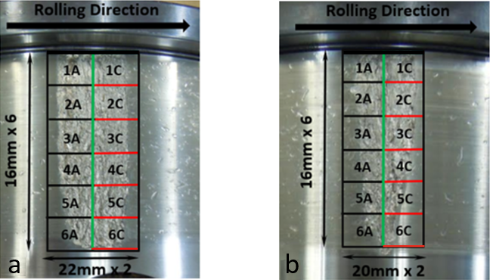
Figure 3.2. 2 Sectioning of the damaged raceway (a) upwind bearing (b) downwind bearing
To study the differences of the subsurface microstructure between the damaged area and undamaged area, a selected area without any surface damage from the downwind bearing inner raceway is also sectioned into axial and circumferential samples, as shown in Figure 3.2.3. It can be seen that this selected area only has some indentations on the surface instead of the serious cracking and material spalling.
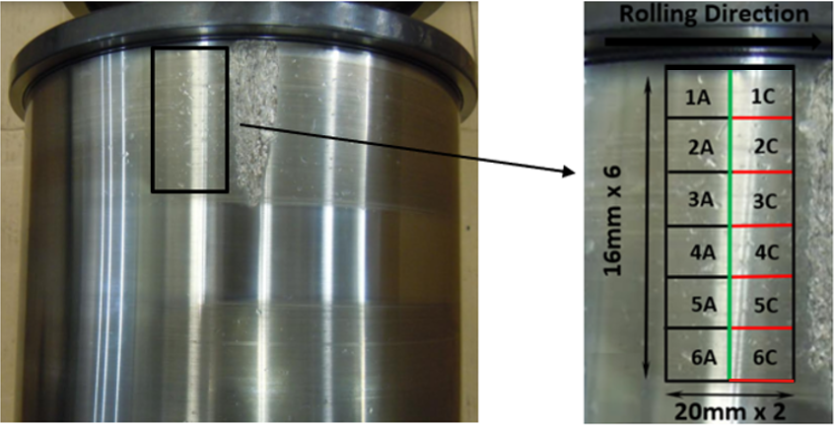
Figure 3.2. 3 Sectioning of the undamaged area from the downwind bearing
The machine used for cutting the raceways is Struers Secotom 50; images of the machine and cutting blade are shown in Figure 3.2.4. After completing the cutting process of the bearing raceways, these small samples should be mounted into the conductive Bakelite mounts. The selection of the conductive mounting material is to facilitate the subsequent observation of the microstructure through Scanning Electron Microscope (SEM) and the Energy Dispersive X-ray Analysis (EDAX). Figure 3.2.5 shows the hot mounting machine BUEHLER SimpliMet 1000 and the samples mounted by the Bakelite material.
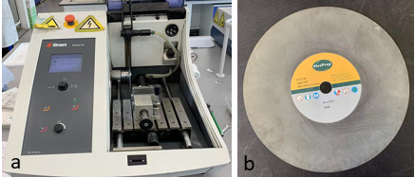
Figure 3.2. 4 Secotom 50 machine and the blade used for the cutting (a) Secotom 50 (b) Cutting blade
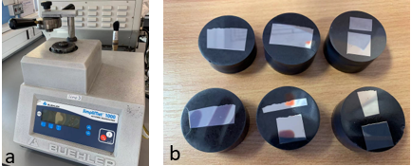
Figure 3.2. 5 Hot mounting machine SimpliMet 1000 and the mounted samples (a) SimpliMet 1000; (b) mounted samples of the upwind bearing raceway

Grinding and polishing
The mounted samples all have rough surfaces with scratches after the cutting process. To remove these scratches and highlight the subsurface damage, grinding and polishing are two necessary processes.
Figure 3.2.6 (a) shows the BUEHLER Automet 250 machine used for both the grinding and polishing processes. During the grinding process, the sample surfaces are grounded by the silicon carbide (SiC) grinding paper of three different roughness levels (level 240, 600 and 1200). When the grinding process is completed, these samples are polished by the diamond suspension on the specific polishing cloth. Similar to the grinding process, it has three types of suspension with the diamond size of 9 $μm$, 3 $μm$, and 1 $μm$, as shown in Figure 3.2.6 (b).
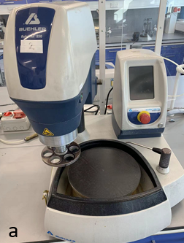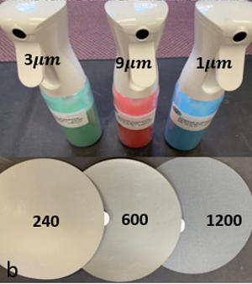
Figure 3.2. 6 BUEHLER Automet 250 machine and the tools used in grinding and polishing (a) Automet 250 (b) SiC paper and diamond suspensions
Table 3.2 lists the parameters used in the grinding and polishing processes. In the table, the head speed means the rotation speeds of the samples; the base speed is the speed of the revolving platform. In actual use, the mounted samples are fixed by a metal head, and the SiC paper or polishing cloth is stick to the base platform. For grinding, the metal head and the platform rotate at the same direction. However, during the polishing process, the rotational directions of the metal head and the platform are opposite, which can maximise the contacts between the sample sections, diamond suspension, and the polishing cloth.
Table 3. 2 Parameters used in grinding and polishing using Automet 250
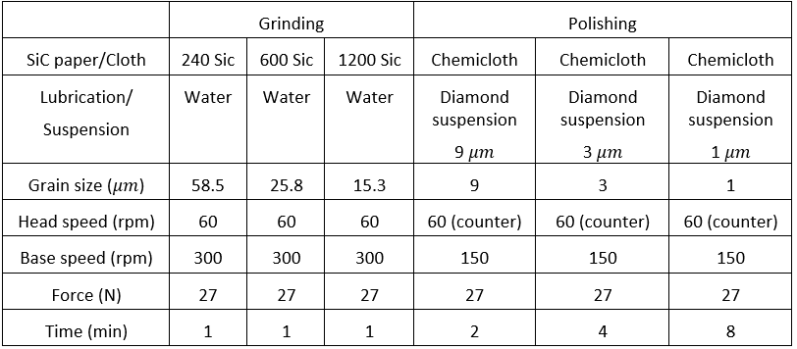

Etching
When the polished metal is exposed to a specific chemical solution, usually acid, the grain boundary of the metal will appear due to the corrosion of the chemical material [142]. This process is known as the etching process; and the chemical solution is called etchant. As defined in Chapter 2, WEA is the area with the specific microstructure that shows white appearance after etching. Accordingly, this damage form cannot be found unless the samples have been etched.
The etchant used in this study is the 2% Nital solution, it consists of 2% nitric acid and 98% methanol. For the 100Cr6 material, the WEA damage and the grain boundary will not appear until the sample is immersed in the solution for about 20 seconds. After that, the sample will be taken out from the etchant and placed into the pure isopropanol solution to clean the remaining Nital solution on the surface. Figure 3.2.7 compares the appearances of the sample before and after the etching process. It can be seen that the etched sample shows a relatively grey colour and has a matte texture.
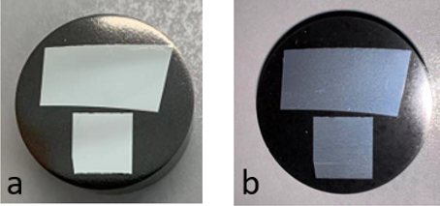
Figure 3.2. 7 Sample appearances before and after etching (a) polished sample (b) etched sample

Inspection Techniques
After the preparation of samples, different microscopy methods will be applied to investigate the microstructures of the matrix, inclusions, cracks, and the WEA damage. In this section, the optical microscope, Scanning Electron Microscopy (SEM), Energy Dispersive X-ray Analysis (EDS, EDX, or EDXS), and X-ray Computed Tomography Scan (CT scan) will be introduced for observing and analysing the microstructural damage.

Optical microscope
The optical microscope is used to observe the basic features of the inclusions, cracks, and WEAs. Typically, subsurface damage with a size greater than 10 $μm$ can be imaged clearly through the optical microscope. Figure 3.3.1 shows the Nikon ECLIPSE LV150 optical microscope used in this investigation, which provides a magnification power from 50 times to 1000 times. The images of the samples observed by the microscope can be projected onto the computer screen with the help of BUEHLER Omnimet 9.5 software.
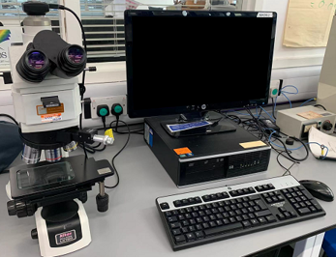
Figure 3.3. 1 Computerized optical microscope Nikon ECLIPSE LV150

Scanning Electron Microscopy and Energy Dispersive X-ray Analysis
However, the optical microscope does not have enough magnification to image defects if they are less than 10 $μm$. Thus, the SEM is required to observe the tiny defects and the material grain boundary. Generally, samples observed by SEM should be in a vacuum or low-vacuum environment where the instrument will emit thermal emission electron beams for the high-resolution imaging.
As shown in Figure 3.3.2, SEM used in the investigation is FEI Inspect F50, which can provide a magnification larger than 1000 times. The maximum magnification of SEM usually depends on the conductivity of the material and the voltage used during the experiment. For the 100Cr6 steel and 20 kV acceleration voltage, the maximum magnification can reach ${10}^{5}$ times.
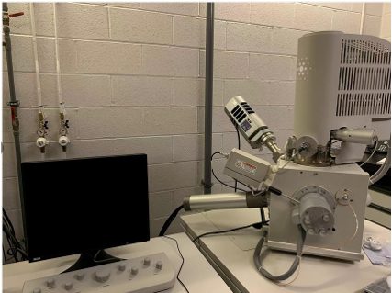
Figure 3.3. 2 FEI Inspect F50 SEM with the EDS detector
The Inspect F50 is equipped with both the Schottky-Field emission source and the X-ray chemical microanalysis detectors, so it is versatile for the long time EDS mapping [143]. EDS is an analytical method used for the elemental analysis and chemical characterisation. By bombarding the surface of the sample with an electron beam under the vacuum chamber, the material is excited to emit characteristic X-rays. Therefore, the elements in the material are qualitatively analysed according to the wavelength of the characteristic X-rays. This is because different elements have different emission spectra due to their specific atomic structures [144].

X-ray Computed Tomography
Computed Tomography is another effective technique to observe the subsurface cracks. It uses a rotating X-ray tube and a number of X-ray detectors to measure the X-ray attenuations inside the sample. These X-ray measurements, taken from different angles from the sample, will be analysed by the computer to produce the cross-sectional images of the sample [145]. Compared with the traditional observation methods described in the above, CT scan can produce the 3D images for the sample without damaging it. The CT scan machine used in the experiment is ZEISS Xradia 620 Versa X-ray microscope, as shown in Figure 3.3.3.
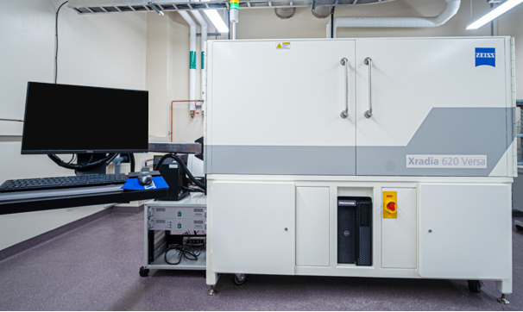
Figure 3.3. 3 CT scan machine: ZEISS Xradia 620 Versa X-ray microscope
However, because X-rays have very limited penetrability in the metal, samples used for the scan are required to be cut into small cubes, as illustrated by Figure 3.3.4. Different from the preparation work in Section 3.2, the surfaces of samples are not polished and etched. Therefore, no WEA damage can be observed during the CT scanning. In addition, due to the limited resolution and magnification of the X-ray imaging, the subsurface inclusions and other tiny defects cannot be observed clearly.
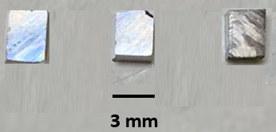
Figure 3.3. 4 Prepared samples for X-ray CT scan

Metallurgical Investigation Results and Discussion
In this section, the metallurgical investigation results of the damaged and undamaged areas from both bearings are analysed. Based on the different inspection methods summarised in section 3.3, the premature failure of bearing raceways is discussed by analysing the observed inclusions, butterflies, WEAs, WECs, and crack networks. In addition, by comparing the observation results obtained from the damaged area and the undamaged area, possible damage initiation factors will be investigated.

Inclusions at subsurface
As discussed in section 2.1.6, the bearing steel used for wind turbines usually contains different kinds of non-metallic inclusions. According to the international standard of the steel cleanliness ISO-4967, these inclusions have five main types: Type A (sulphide), Type B (aluminide), Type C (silicate), Type D (globular oxide), and Type DS (single globular) [44]. Moreover, due to the different manufacturing processes of bearing steels, some steels may also contain the nitride inclusions in the subsurface area. These nitrides or carbonitrides are classified into a new group, which is known as the Type T group.
Material cleanliness of the bearing raceways
To obtain a general understanding of the inclusion types within the failed bearing raceways, the cleanliness test of the bearing material 100Cr6 is carried out according to the ISO-4967 standard [44]. In ISO-4967, sections chosen for the test should be consistent with the rolling direction. Therefore, all the sections selected come from the circumferential samples of both upwind and downwind bearing raceways. In addition, to identify the chemical components of the inclusions, the EDS technology is applied.
In the cleanliness test, six square sections (0.71mm x 0.71mm for each section, shown in Appendix A) from the undamaged areas are selected as the examination fields. It should be noticed that there are two differences between the cleanliness test in this investigation and the test specified in the international standard document. Firstly, ISO-4967 stipulates that the cleanliness test of the steel should be conducted with at least 100 sections from different positions of the material. Considering the experimental feasibility, only six representative sections are selected for this test instead of 100 sections. Secondly, the standard emphasises that these test sections should be randomly selected. However, in order to increase the number of inclusions available for observation, the sections selected for this experiment have much more inclusions compared with other sections observed by the microscope.
Type A to Type D inclusions are divided into two groups, the fine and thick groups, according to the inclusion lengths. Although ISO-4967 has recommended a certain division of the length, some inclusions with lengths exceeding the maximum length specified in the standard are still observed during the test. For the convenience of the statistical analysis of the results, all inclusions with the lengths greater than the maximum specified length are still classified as the thick group.
For Type DS inclusions, only the number of inclusions will be counted due to the diverse chemical components and sizes of this inclusion type. By accumulating the total length of the inclusions in each group, the cleanliness of each section will be rated based on the length thresholds listed in the ISO-4967 [44]. Because all the sections selected in this experiment contain far more inclusions than the average values of the material, the cleanliness rating of the sections is omitted.
Table 3.3 lists the statistical results of this experiment. A total of 189 inclusions from the selected sections are observed by SEM. It has been identified that 172 inclusions are Type A inclusions, 3 inclusions are Type B, 4 inclusions are Type D, and 10 inclusions are Type DS. No Type C inclusions are found in the selected sections. Although the sections contain some Type T inclusions such as the TiN inclusions, they are not counted in the table according to the ISO-4967 standard.
Table 3. 3 Cleanliness test results of the selected sections [44]
 | Type of inclusions
Sections | A |  | B |  | C |  | D |  | DS
 | Total Length ($μm$) |  |  |  |  |  |  |  | Count No.
 | Fine | Thick | Fine | Thick | Fine | Thick | Fine | Thick
1 | 13 | 115 | 2 | 0 | 0 | 0 | 0 | 0 | 1
2 | 47 | 217 | 4 | 0 | 0 | 0 | 0 | 7 | 3
3 | 20 | 129 | 0 | 0 | 0 | 0 | 3 | 0 | 3
4 | 55 | 125 | 2 | 0 | 0 | 0 | 3 | 0 | 2
5 | 48 | 89 | 0 | 0 | 0 | 0 | 0 | 0 | 1
6 | 56 | 154 | 0 | 0 | 0 | 0 | 4 | 0 | 0
Average | 40 | 829 | 1.3 | 0 | 0 | 0 | 1.6 | 1.2 | 1.7
From the inclusions observed and analysed, it can be concluded that, in the failed 100Cr6 bearing raceways, most of the inclusions are MnS inclusions, and the percentage of this inclusion type may probably exceed 90%. The remaining inclusions include but are not limited to ${Al}_{2}O_{3}$, ${CaF}_{2}$, MgO, and TiN inclusions. Because there are no silicon inclusions in the bearing raceways, it suggests that the industrial silicon may not be used in the melting process, or the influence of silicon inclusions is minimized during the subsequent steel manufacturing. In addition, among the Type DS inclusions found, a considerable portion of them are compound inclusions. Most of the compound inclusions are identified as MnS+${Al}_{2}O_{3}$ inclusions. Furthermore, some ${CaF}_{2}$+${Al}_{2}O_{3}$ inclusions are also found in the selected sections. SEM images of different types of the inclusions and their EDS spectrums of the chemical compositions are presented in Figure 3.4.1.
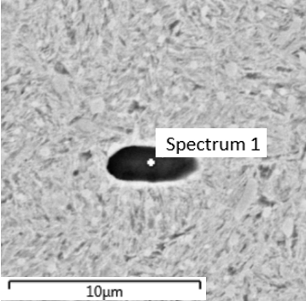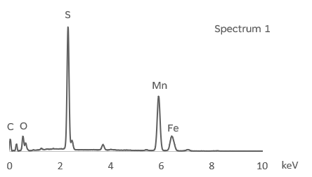
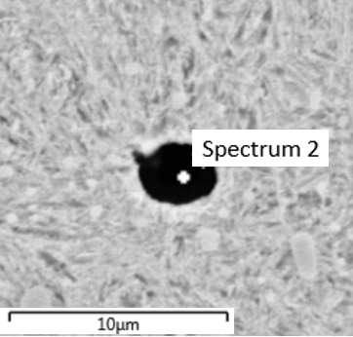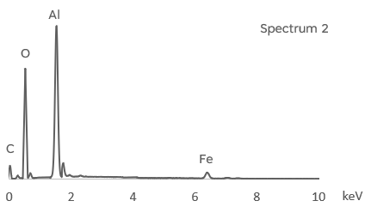
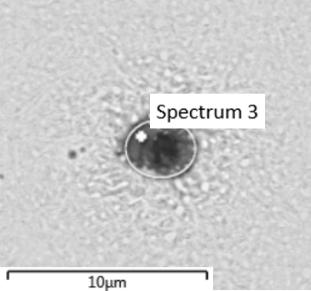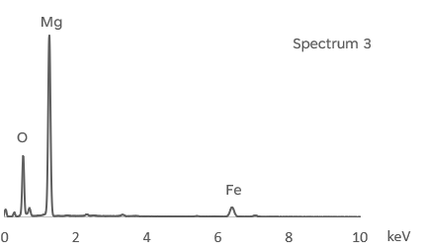
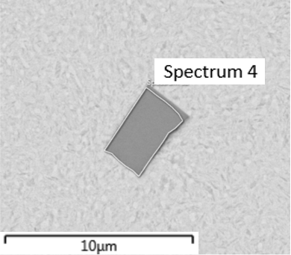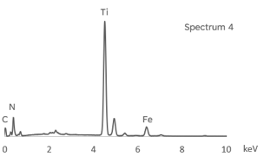
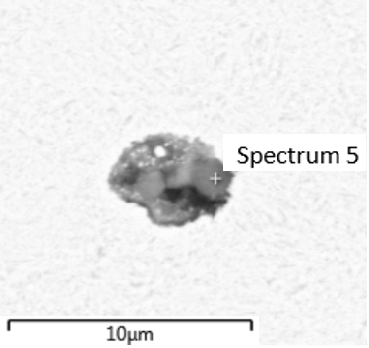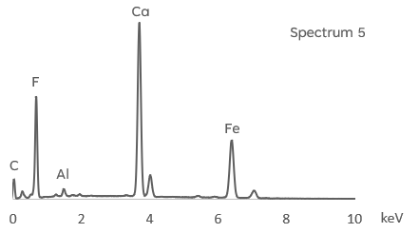
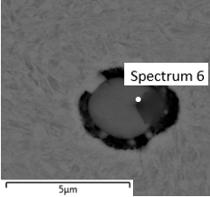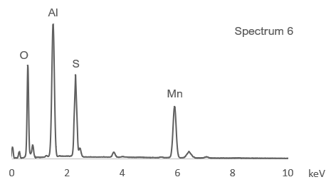
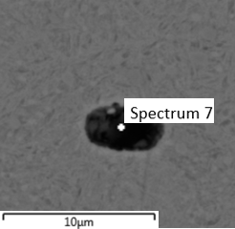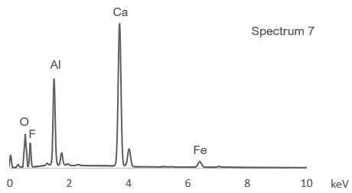
Figure 3.4. 1 Inclusions and theirs EDS spectrums: Spectrum 1- MnS inclusion; Spectrum 2- ${Al}_{2}O_{3}$ inclusion; Spectrum 3- MgO inclusion; Spectrum 4- TiN inclusion; Spectrum 5- ${CaF}_{2}$ inclusion; Spectrum 6- MnS+${Al}_{2}O_{3}$ compound inclusion; Spectrum 7- ${CaF}_{2}$+${Al}_{2}O_{3}$ compound inclusion
Inclusion damage analysis and discussion
Normally, when the subsurface inclusion is perfectly bonded with the steel matrix, it is less likely to cause the damage, as shown in Figures 3.4.2 (a) and (b). But when the inclusion is damaged or has the boundary separation, the subsurface damage occurs as shown by the remaining images in Figure 3.4.2. Based on the investigation, the damage linked to the inclusions can be classified into 4 different types according to the damage positions and initiation reasons.
The first damage type is the boundary separation of inclusions, as shown in Figure 3.4.2 (c) and (d). It has been discussed in section 2.1.6 that this damage is most likely to happen during the steel heat treatment because of the thermal expansion difference between the inclusion and steel matrix. In addition, the contact pressure acting on the raceway surface may also lead to the boundary separation because the inclusion-matrix ionic bonds may be broken due to the deformation differences of the inclusion and steel matrix.
The second damage type is the internal cracking of the inclusion, as shown in Figure 3.4.2 (e) and (f). The breakage of the inclusion is often caused by complex mechanisms. Firstly, as mentioned before, separation of the inclusion boundary in the raceway may occur due to the heat treatment or the loading from the rollers. If the inclusion boundary is firmly connected to the steel matrix, such energy from expansion and contraction cannot be released through the debonding of the boundary. Hence, the relatively fragile inclusions may break internally because of the poor loading capacity. The other mechanism is related to the chemical composition of the inclusion. As shown by the MnS+${Al}_{2}O_{3}$ compound inclusion in Figure 3.4.2 (f), it is obvious that the MnS inclusion has been fractured into three parts due to the ${Al}_{2}O_{3}$ particle in the middle. Therefore, internal cracks may also initiate from the compound inclusions because of their fragile structures.
The third damage type is defined as the internal crack propagation from the inclusion to the steel matrix, as shown in Figure 3.4.2 (g) and (h). In this form of damage, the connection between the inclusion boundary and the steel matrix is usually stable and firm. However, internal cracks of the inclusion may cause highly localised shear stress during the rolling contact process involving millions of loading cycles. Therefore, the cracks may spread from the inclusion into the steel matrix. Importantly, cracks in the steel matrix caused by inclusions are not only related to the internal cracks, but also to the separated boundary or an excessive longitudinal ratio of the inclusion geometry. These factors also affect the maximum shear stress levels and cause the localised stress concentration when the raceway is subjected to the high Hertz contact pressure. The detailed investigation will be discussed in Chapter 5.
Undamaged inclusion | 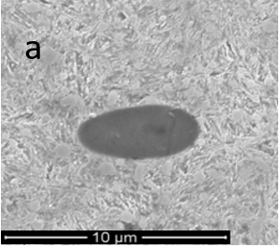 | 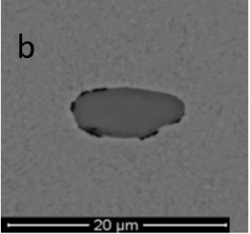
Boundary separation | 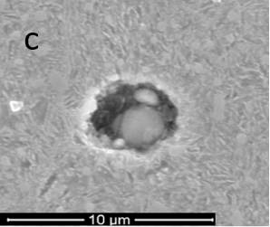 | 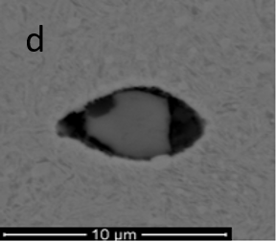
Internal cracking | 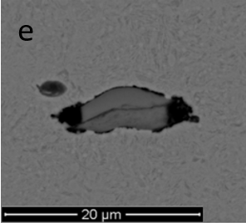 | 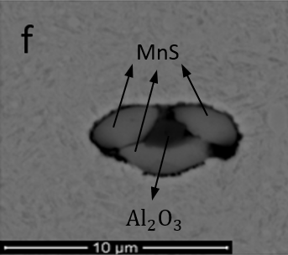
Internal cracking with crack propagation | 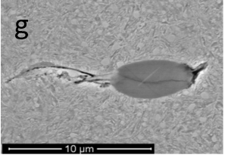 | 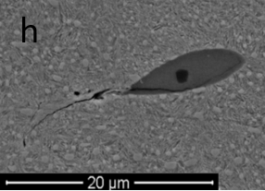
Crack propagation with WEA forming | 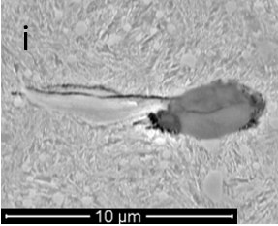 | 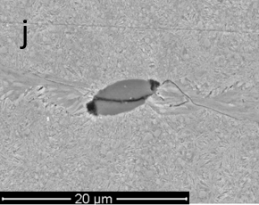
Figure 3.4. 2 Different types of inclusion related damage (a) and (b) perfectly bonded inclusions (c) and (d) boundary separation damage (e) and (f) inclusions with internal cracks (g) and (h) damage with matrix crack propagation (i) and (j) cracks with WEA formation
The fourth damage form is linked with the WEA, as shown in Figure 3.4.2 (i) and (j). WEA may form around the crack due to the friction and impact between the fracture surfaces [93]. After the formation of WEA, the local steel matrix transforms from martensite into a harder and more brittle ferrite structure. This undoubtedly provides favourable conditions for the rapid propagation of cracks within the steel matrix. Typically, the WEA associated cracks expand rapidly from the subsurface to the surface of the raceway and eventually cause the flaking of the material.

Butterflies
The butterfly is defined as an inclusion with microcrack(s) and/or WEA(s) propagated from the inclusion boundary. They are abundant in the damaged sections of the failed bearing raceways. Usually, a butterfly alters the subsurface stress distribution and causes the crack propagation in the subsurface area. Subsequently, these small cracks will be forming into large crack networks and lead to the material spalling of the bearing raceway surface [9][62]. Therefore, some investigations believe that butterflies are the initial indicators of the subsurface damage initiation [9][62][146].
Figure 3.4.3 shows a butterfly observed from sample 4C of the upwind bearing raceway. The measurements taken for the butterfly observed and the explanations of the various parameters to quantify the extent of the damage are summarised in this figure.
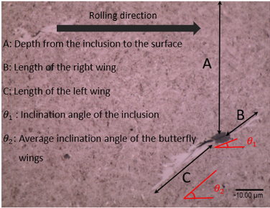
Figure 3.4. 3 Measurements taken for the butterfly
Position of the butterflies
In the study of the 12 samples from two damaged bearing raceways, a total of 114 butterflies with inclusions are found. The distribution of the observed butterflies in each sample is shown in Figure 3.4.4. Due to the limited samples observed, the findings determined in this section may not be considered as a general conclusion relating to the butterfly damage. However, the statistical analysis may still reflect some reasons for the premature failure of bearings to a certain extent.
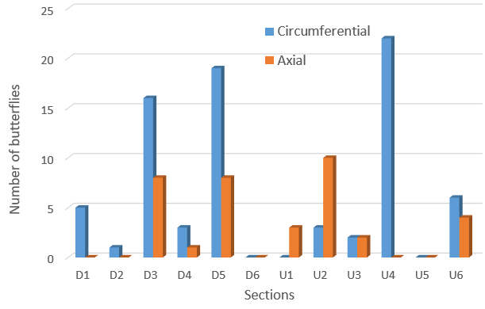
Figure 3.4. 4 Number of butterflies in each sample
According to the observation results, butterflies may be easier to be found in the circumferential sections than in the axial sections. Because the circumferential section is consistent with the rolling direction of the bearing, butterfly wings will have a larger spread area in the circumferential direction than in the axial direction.
It is also obvious that butterflies are clustered in the middle area of the damaged surface of the bearing raceways such as sample D3C, D5C (D: downwind bearing), and U4C (U: upwind bearing). As shown in Figure 3.2.2, sample D1A, D1C, U1A and U1C are the most severely damaged areas of bearings, while the surfaces where the D6A, D6C, U6A, and U6C samples located are only slightly damaged. Hence, it can be inferred that the middle parts are moderately damaged. Most butterflies are found in the middle area of the damaged raceway surface, which indicates that formation of the butterflies may be a vital sign that shows the beginning of surface material spalling. As the surface flaking occurs, the number of butterflies remaining in some severely damaged sections will be reduced. This explains why limited butterflies are found in both D1 and U1 sections, the most severely damaged areas. Similarly, in terms of the number of butterflies, the downwind bearing raceway may have more butterflies than the upwind bearing raceway. One possible reason is that the downwind bearing raceway is less damaged than the upwind one. Therefore, more butterflies are preserved instead of being peeling off with the damaged surface.
In addition to the number of the butterflies found in various samples, butterflies will have distinctions in their distances from the rolling contact surface, measured as depth, even when they are in the same sample. Figure 3.4.5 divides the depth of butterflies into 6 depth ranges; the depth of every butterfly measured is counted and added into each individual depth range. Based on the data recorded, most butterflies of both two bearing raceways are found to locate at the depth from 0.2 mm to 0.6 mm. This is because when the bearing is running at the rated loading, the maximum shear stress on the inner raceway is about 0.4 mm beneath the rolling contact surface. The detailed theoretical calculation and FE simulation studies will be presented separately in Chapter 4 and Chapter 5.
By comparing the average depth of all butterflies found in the two bearing raceways, it has been found that the average depth of butterflies in the upwind bearing raceway is 0.468 mm. This value is slightly greater than that in the downwind bearing raceway, which is calculated as 0.461 mm. Furthermore, in the downwind bearing raceway, no butterfly with a subsurface depth greater than 1 mm is found. However, in the upwind bearing, four butterflies are found located at the surface depth greater than 1 mm. These differences, to some extent, indicate that the upwind bearing might have undertaken more loading during operation than the downwind bearing. As a result, the upwind bearing raceway surface has the greater damage than that of the downwind bearing.
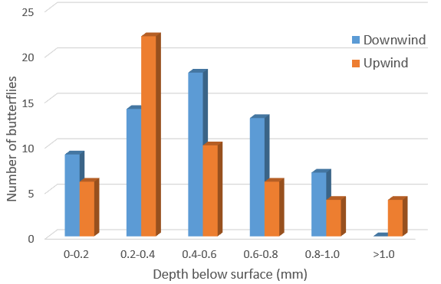
Figure 3.4. 5 Number of butterflies and their depths
Identification of inclusions in butterflies
To investigate whether the inclusion type has the influence on the formation of butterflies, butterflies in sections U4C, section D3C and D5C, shown in Figure 3.3.4, are selected for the EDS test. These three sections have the highest number of butterflies in all the sections from the failed bearing raceways.
Figure 3.4.6 compares the types of inclusions that are identified from the butterflies. In total, 55 butterflies are observed in these three sections. It can be seen that most of the inclusions within the butterflies are Type A MnS inclusions; the percentage of them is 89% of all inclusions found in these sections.
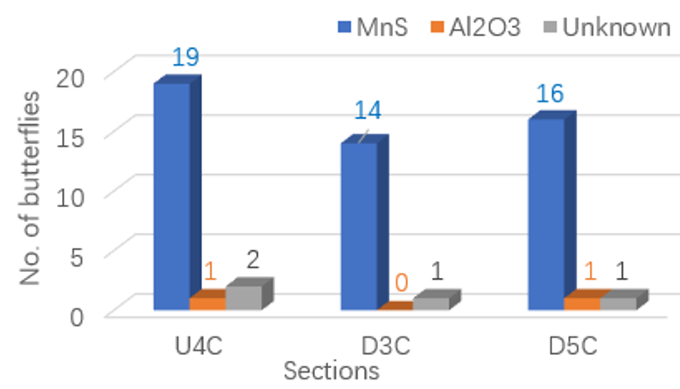
Figure 3.4. 6 Identification of inclusion types within the butterflies
Based on the cleanliness test results, the proportion of MnS inclusions in the bearing raceways exceeds 90%. Therefore, they are most likely to cause the butterfly damage. Moreover, MnS inclusions have the relatively weak boundaries and low material strengths. As a result, the boundary separations and inclusion internal cracks are more likely to occur compared with other types of inclusions [55][56]. Figure 3.4.7 (a) shows an example of the inclusion boundary separated from the steel matrix in a butterfly formed by MnS. Figure 3.4.7 (b) shows two internal cracks within a MnS inclusion, which result in the generation of both the left and right butterfly wings around the inclusion.
Two butterflies are identified to contain the ${Al}_{2}O_{3}$ inclusions by EDS. Although the ${Al}_{2}O_{3}$ inclusion has a significant higher hardness and elastic modulus compared with those of the MnS inclusion, the observation of two ${Al}_{2}O_{3}$ butterflies in Figure 3.4.7 (c) and Figure 3.4.7 (d) indicates that ${Al}_{2}O_{3}$ inclusions may also have the boundary separation. However, few ${Al}_{2}O_{3}$ related butterflies are found in the selected samples, because their quantity in the bearing samples is much less than the MnS inclusions. Apart from the ${Al}_{2}O_{3}$ butterflies observed, Figure 3.4.7 (c) and Figure 3.4.7 (d) also show two butterflies join together to form a longer crack. The butterfly wing lengths in both figures are approximately 50 $μm$, which are greater than the average butterfly wing length of other individual butterflies.
Although inclusions in the middle of some butterflies are clearly visible, other butterflies may only have one wing visible in the sample viewing section. In this case, the inclusions may have been polished off during the polishing process, or they could be in the layer beneath the current viewing section. Thus, further polishing is needed to reveal the potential inclusions. In the selected three samples, there are four unknown types of butterflies. In appearance, they usually appear as a single crack decorated by WEA, as shown in Figure 3.4.7 (e) and Figure 3.4.7 (f).
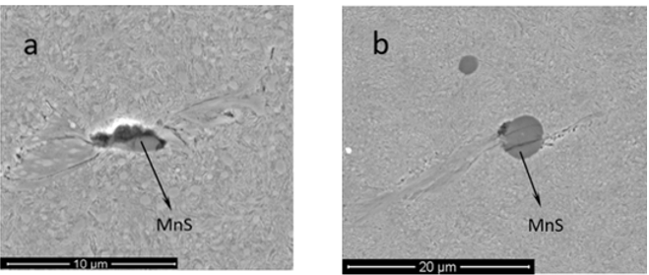
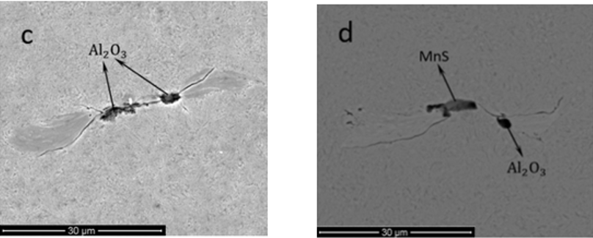
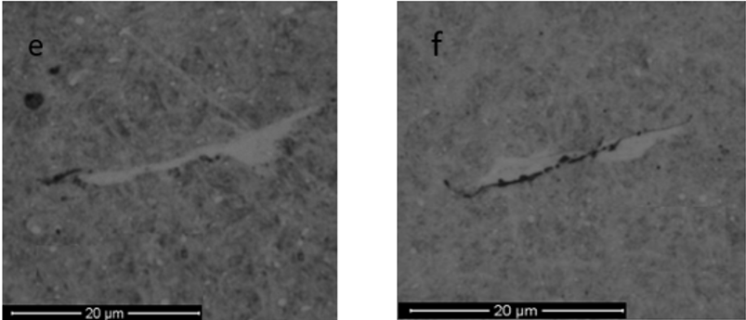
Figure 3.4. 7 Butterflies with identified inclusions (a) and (b) MnS butterflies; (c) and (d) ${Al}_{2}O_{3}$ butterflies; (e) and (f) butterflies with unknown inclusion type
3D geometry of the butterfly
When a butterfly is viewed through a microscope, only a two-dimensional shape can be observed. In order to study the three-dimensional shape of a butterfly, the mounted observing plane must be polished and etched for several times. Also, the butterfly shape of the current observing plane should be recorded after every polishing and etching process.
Figure 3.4.8 shows a WEA with 20 $μm$ in length selected from section D5C. The sample is polished and etched for four times. For the sample preparation, the 1 $μm$ diamond suspension is used for the polishing and each process lasts for 4 minutes.
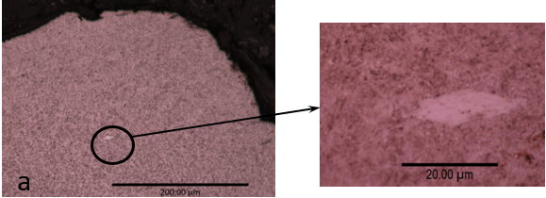
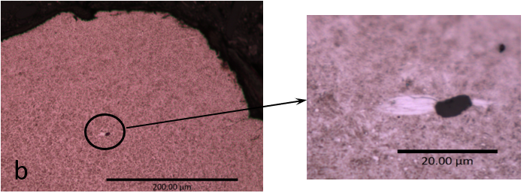
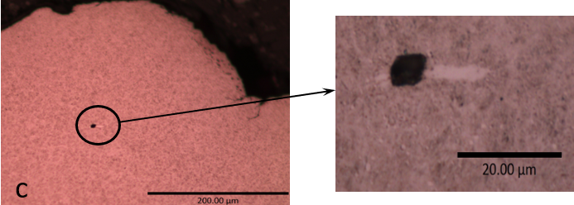
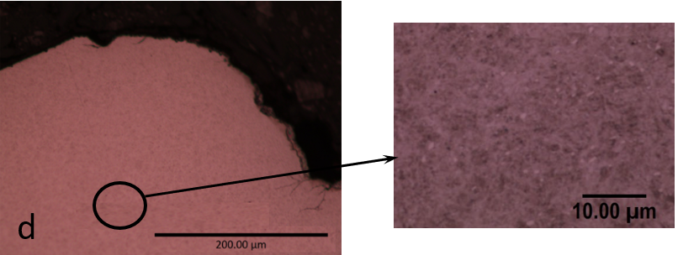
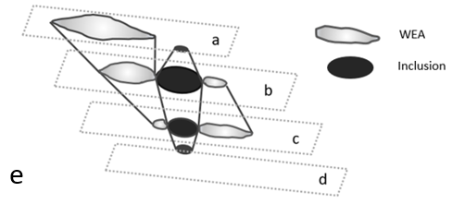
Figure 3.4. 8 Observation of the 3D structure of a butterfly in D5C section (a) to (d) butterfly 2D geometries after the first to fourth polishing and etching (e) 3D inclusion geometry and associated butterfly wing shapes
The shapes of the butterfly after each etching are recorded from Figure 3.4.8 (a) to Figure 3.4.8 (d) respectively. It can be seen that after the second polishing and etching, the damage form has changed from the single WEA wing damage to the butterfly damage with two WEA wings. This indicates that WEAs observed in the bearing sections often do not exist alone. There may be inclusions and cracks which lead to the formations of WEAs above or below of the current observing plane.
After the third etching process, the butterfly's shape changes: the length of the left-wing reduces, while the length of the right-wing increases. This difference shows that the geometries of a butterfly in different observing planes may be different. This may be caused by the shape differences of the inclusion in different observing planes. Moreover, the differences of the inclusion geometry and size may affect the maximum shear stress levels in the subsurface area and the sizes of WEAs.
After the fourth polishing and etching process, no butterfly or WEA damage can be found within the steel matrix. It suggests that the entire butterfly damage has been polished away after four polishing and etching processes.
According to the observation results during the entire polishing and etching process, a reconstruction of the 3D inclusion geometry and the WEA decorated butterfly wings is shown in Figure 3.4.8 (e). The inclusion is found to be an irregular cylinder that produces different WEA shapes at different locations.
Similar results are found in another butterfly from section D2A, which is shown in Figure 3.4.9. After the first etching, no damage is observed within the steel matrix. However, a WEA wing appears after the second and third polishing and etching processes. After the fourth polishing and etching, the WEA wings eventually are shown to be connected with an inclusion because a two-winged butterfly is found as shown in Figure 3.4.9 (d).
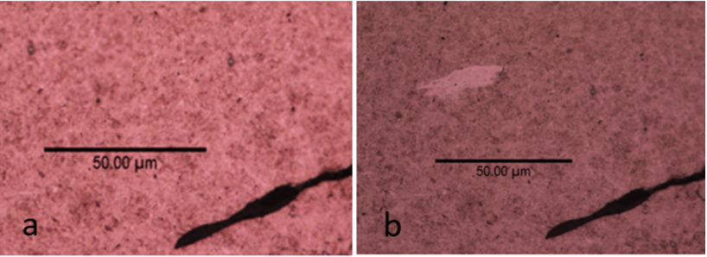
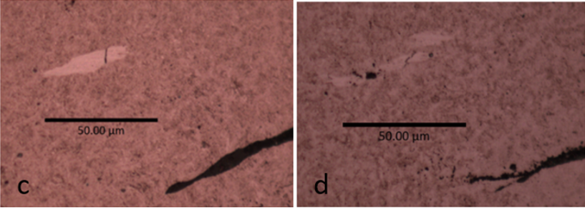
Figure 3.4. 9 Observation of the 3D structure of a butterfly in D2A section (a) to (d) 2D butterfly geometries after the first to fourth polishing and etching
Factors affecting the length of butterfly wings
This section discusses the possible parameters causing the growth of butterfly wings. Based on the microscope observation results, it has been found that the butterflies with different depths and inclusion geometries have different wing lengths. Therefore, the influence of the depth, inclusion separation, and inclusion internal cracking are analysed and discussed. In addition, the type of inclusion may also affect the butterfly wing length. However, because only a limited number of the ${Al}_{2}O_{3}$ butterflies are identified by the EDS test, the effect of this type of inclusion will not be considered in the analysis.
Figure 3.4.10 shows the relationship between the depth and the overall length of two butterfly wings, where the average value of all the butterflies within each depth range is used. For the downwind bearing raceway, it can be seen that the average length of the butterfly wings increases with the increased depth first and then decreases. It reaches the peak value within the depth range of 0.5 to 0.6 mm. This depth range is close to the depth where the maximum shear stress occurs. Therefore, this finding provides evidence to support that the subsurface stress distribution will affect the growth of crack length of the butterfly.
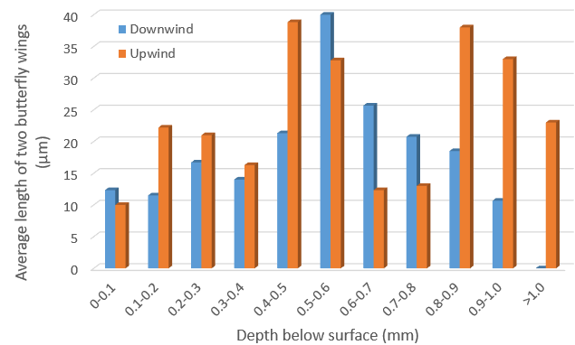
Figure 3.4. 10 Relationship between inclusion depth and length of butterfly wings
However, the upwind bearing raceway shows a different trend of the wing length from the downwind one. The maximum butterfly length range is within 0.4 to 0.6 mm, which is similar to downwind bearings. However, at deeper positions with the depth greater than 0.8 mm, the butterflies observed within the downwind bearing raceway do have long wings. This phenomenon may be caused by the secondary damage after the occurrence of the material flaking of the upwind bearing raceway. It is known that the upwind bearing raceway is much more damaged than the downwind bearing. Therefore, new butterflies may form in the deeper area if the bearing is still in operation after the early material flaking.
According to the statistical results in Figure 3.4.10, it can be concluded that the depth of butterfly does affect the length of butterfly wing cracks. The length of butterfly wings in the greatest maximum shear stress region is significantly greater than that in other subsurface regions. However, the inclusion depth is not the only determining factor of the butterfly wing length. There are other factors for inclusions to cause very long crack propagation in the steel matrix even at the subsurface depth exceeding 1 mm.
After the initial spalling of the bearing surface material, greater stress caused by rolling contact on the rougher raceway surface may affect the deeper subsurface areas. Moreover, this stress distribution is greatly influenced by the roughness of the damaged surface. The stress concentration caused by some uneven surface areas may introduce the greater shear stress around the inclusions. As a result, some butterflies will form in the positions deeper than the location of the maximum shear stress under the nominal loading condition, and their wing lengths are likely to increase dramatically due to the stress concentration.
The other parameter that may affect the length of the butterfly wings is the damage of the inclusion. As discussed in section 3.4.1, the inclusion damage such as its boundary separation and internal cracking will cause the stress concentration of the steel matrix and greatly increase the shear stress magnitude in the adjacent area. As shown in Figure 3.4.11, no butterfly damage is observed at the undamaged inclusions even if they are located very close to the inclusions with either boundary separation or internal cracking. Therefore, it is clear that the butterfly damage is more likely to happen when the inclusion has a separated boundary or internal crack(s).
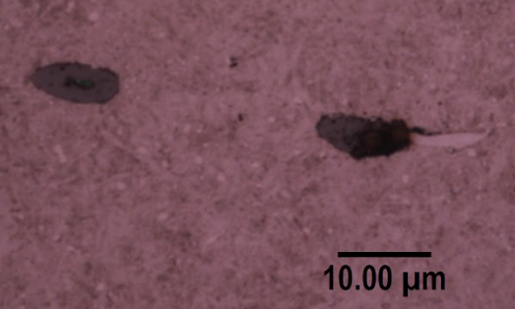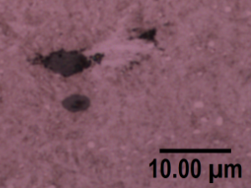
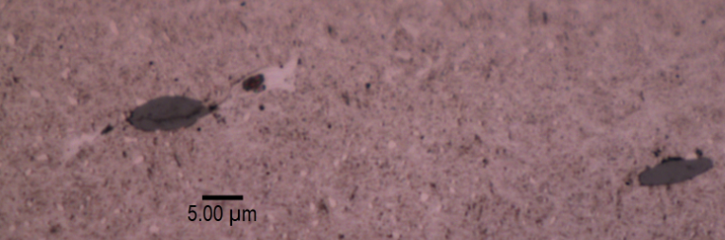
Figure 3.4. 11 Effect of inclusion damage on butterfly formation
Based on the conclusion discussed above, Table 3.4 summarises all the butterfly damage observed due to two types of inclusion damage: boundary separation and internal cracking. There are 57 butterflies being caused by the inclusion boundary separation, and 33 butterflies being caused by the inclusion internal cracking. In addition, 14 butterflies are caused by both inclusion boundary separation and internal cracking, and only 6 inclusions are found without any obvious damage.
Table 3. 4 Number of butterflies that caused by the inclusion damage
 | Inclusion boundary separation | Inclusion internal cracking | Both inclusion damage types | No inclusion damage
Downwind bearing | 31 | 24 | 3 | 2
Upwind bearing | 26 | 9 | 11 | 4
Percentage | 52% | 30% | 13% | 5%
This analysis indicates that more than 90% of the butterflies are caused by the inclusions with the boundary separations and/or internal cracks; while only 5% of the inclusions do not have any damage at the current observing plane. Further polishing and etching are required to investigate whether these inclusions are damaged in different planes.
Figure 3.4.12 compares the average length of two butterfly wings in relation to the inclusion damage types. As can be seen, when an inclusion has both inclusion boundary separation and internal cracking damage, the length of the butterfly wings caused by it is the longest compared with other inclusion damage types.
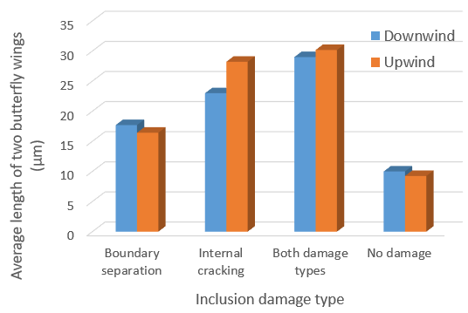
Figure 3.4. 12 Comparison of the butterfly wing length with different inclusion damage types
This conclusion is applicable to both downwind and upwind bearing raceways. Furthermore, it can be found that the internal cracks of inclusions are more likely to produce longer cracks in the steel matrix than the boundary separation of inclusions. According to this analysis, the average length of the butterfly wings caused by inclusion internal cracks is 23.01 $μm$ in the downwind bearing raceway, while it is 28.22 $μm$ in the upwind bearing raceway. As for the inclusion boundary separation, it causes a shorter length of the butterfly wing crack, which is 17.71 $μm$ in the downwind raceway and 16.26 $μm$ in the upwind raceway. When the inclusion has no obvious damage, it only results in the shortest length of the butterfly wings.
According to the experimental results of a twin-discs test in [54], the formation of the inclusion internal cracking usually requires a relatively larger contact pressure compared with its boundary separation. Therefore, it should be the subsurface stress difference that leads to the length variations between the internally cracked and the boundary separated butterflies. The other possible reason is related to the increased subsurface shear stress due to the inclusion internal crack. The FE modelling results in Chapter 5 show that the internal cracking of the inclusion will lead to the expansion of the material orthogonal shear stress variation range. Therefore, such internal crack will accelerate the occurrence of the RCF damage and result in the longer butterfly wings.
However, not all damaged inclusions have eventually developed into butterflies. Figure 3.4.13 shows six inclusions with the depths greater than 1 mm but have no butterfly developed. It can be clearly seen that these inclusions are all damaged by either the separated boundaries or the internal cracks. However, no butterfly damage is found around these inclusions probably because the shear stresses caused by the stress concentrations do not reach the fatigue limit value of the bearing steel.
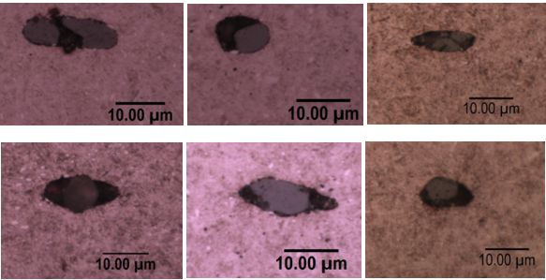
Figure 3.4. 13. Damaged inclusions with the depth greater than 1 mm
In contrast, Figure 3.4.14 shows some undamaged inclusions at the depth of 0.2 to 0.7 mm, around which no butterfly damage is found. These inclusions should also be affected by very high stress concentration levels during the rolling contact process. The absence of butterflies may be because they do not have the internal cracks or separated boundaries, thus avoiding possible stress concentrations within the steel matrix.
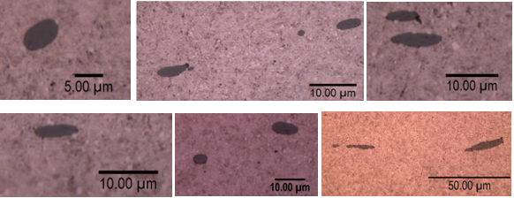
Figure 3.4. 14 Perfectly bonded inclusions with a depth between 0.2 mm to 0.7 mm
Based on the comparison results between Figure 3.4.13 and Figure 3.4.14, it can be concluded that the damage of the inclusion and its depth in the subsurface area are two important factors affecting the initiation and crack propagation of the butterfly. Moreover, their influences have been proved to be interconnected rather than independent.
Factors affecting the orientation of butterfly wings
Following the discussion of the results of the butterfly length, this section analyses the factors affecting the direction of butterfly wings. Considering that the direction of butterfly wings can only be observed within the circumferential sections, only butterflies from the circumferential samples will be selected in the discussion of this section.
Figure 3.4.15 (a) to Figure 3.4.15 (c) show three butterflies with similar subsurface depth observed in the U4C section. It can be found that the geometries and inclined angles of the inclusions are completely different. Even with these differences, the WEA decorated butterfly wings propagate from the inclusions in almost the same direction, which is at an acute angle to the rolling direction. Similar results can also be found from Figure 3.4.15 (d) to Figure 3.4.15 (i), including the butterflies observed in U2C and D1C samples with the similar subsurface depths. However, as shown from Figure 3.4.15 (j) to Figure 3.4.15 (l), the butterflies observed in sample U6C have different propagation orientations. This should be caused by the depth variations; the three butterflies selected have the subsurface depth of 0.21 mm, 0.48 mm, and 0.79 mm separately. It is known that the depth differences will affect the orthogonal shear stress distributions around the inclusion. Thus, the developed butterflies due to fatigue cracks have diverse geometries.
Therefore, it may suggest that if the inclusions in the same observation section have the similar subsurface depths, the propagation orientations of the butterfly wings may be independent of the geometries and inclined angles of the inclusions. Factors affecting the orientations of the butterfly wings may only include the rolling contact direction and the Hertz contact loading magnitude applied to the raceway surface.
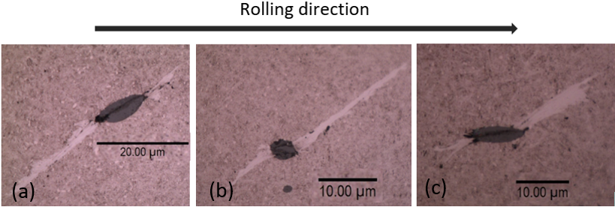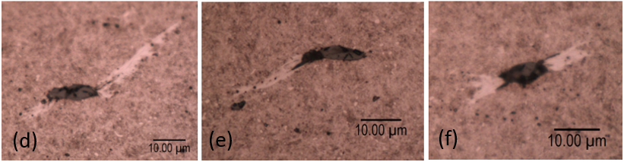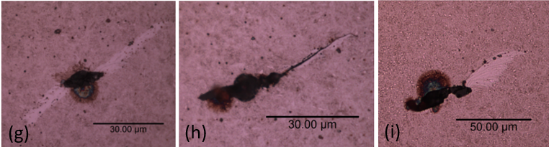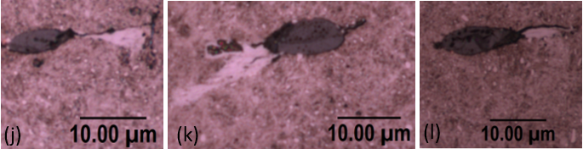
Figure 3.4. 15 Butterflies obtained from different samples (a) to (c) depth from 0.37 mm to 0.46 mm in U4C (d) to (f) depth from 0.34 mm to 0.41mm in U2C (g) to (i) depth from 0.56 mm to 0.62mm in D1C (j) to (k) depth of 0.21 mm, 0.48 mm, 0.79 mm in U6C

WEAs without inclusions
In section 3.4.2, a large number of WEA damage due to inclusions is observed, and this type of WEA is often accompanied by cracks in the wings of butterflies. However, during the inspection of some samples of the failed raceways, WEAs without visual inclusions are also observed. Different from the WEAs associated with inclusions shown in Figure 3.4.8 and Figure 3.4.9, the WEAs without being attached to any inclusion are often found in the crack networks and surrounded by cracks, as shown in Figure 3.4.16. The crack network geometries remain the same even after three times of repeated polishing and etching processes. It means that these WEAs are probably not caused by the stress concentration of inclusions.
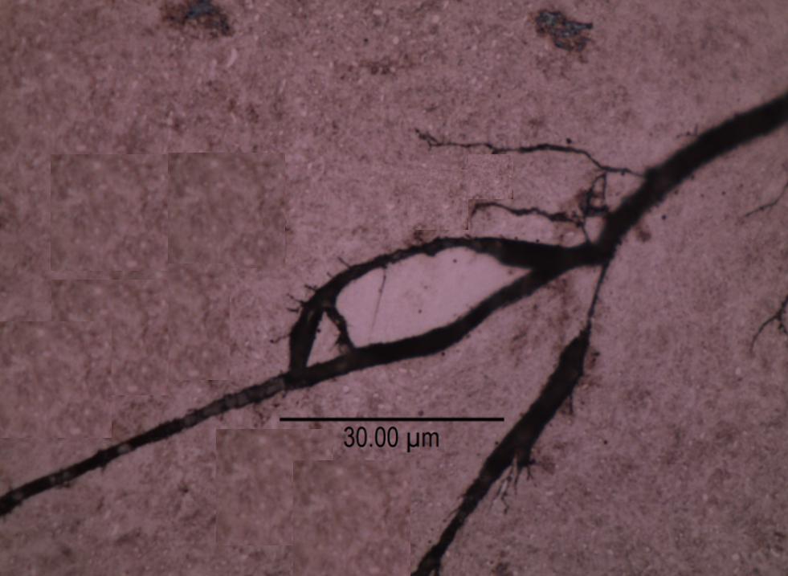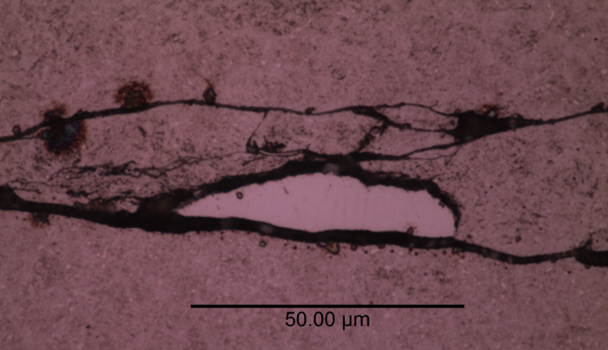
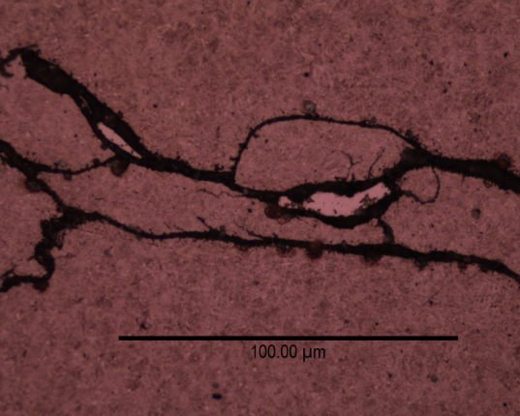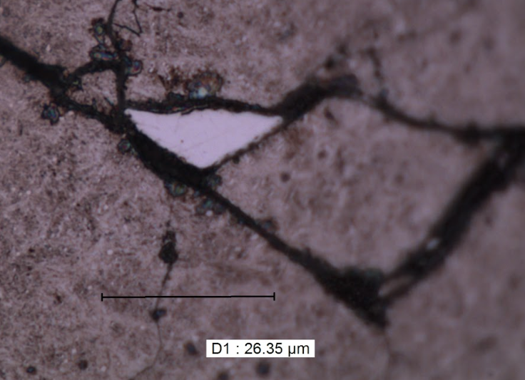
Figure 3.4. 16 WEA in the crack networks without inclusions
In order to determine whether the microstructure of WEA in the crack network is different from that in the butterfly wings, SEM is used to magnify both two types of damage by 60000 times. As can be seen from the comparison in Figure 3.4.17, both WEAs have dense ferritic structures shown in the red circles. The only difference is that the WEA in the crack network does not have the significantly elongated microstructure like the WEA in the butterfly, as marked by the black arrows in Figure 3.4.17 (b).
This deformation of the microstructure should be caused by the shear stress during the formation of the butterfly crack. However, although Figure 3.4.17 (a) does not have the elongated grains, it is still uncertain whether the WEA here is affected by the shear stress during its formation. Thus, based on these observations, it can only be concluded that WEA is composed of a dense ferrite structure, but the cause of its formation could not be confirmed.
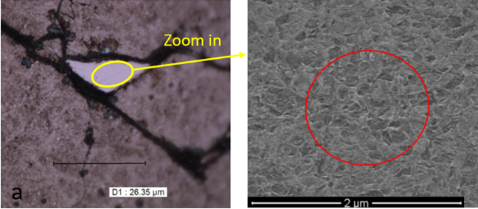
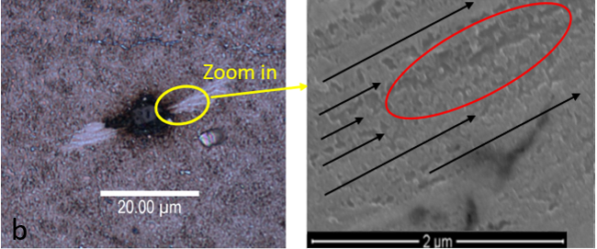
Figure 3.4. 17 Microstructure comparison between the WEA from the crack network and the WEA from the butterfly (a) WEA in the crack network (b) WEA in the butterfly wing

Crack networks
Due to the propagation of some inclusion-induced small cracks, a crack network will be formed after a certain bearing operation period. The crack networks are considered as the most harmful manifestation of the subsurface damage, which directly cause the bearing premature failure.
Figure 3.4.18 shows a cubic material cut from the damaged area U4 of the upwind bearing raceway. The 3D picture shows that the raceway surface has been damaged due to the material spalling. In some regions of the surface, the flaking depth reaches approximately 0.3 mm. According to the CT scan results, there may also be a network of cracks below the surface when the surface material has not fallen off. Moreover, these crack networks can even exist below the area where the material spalling has already happened. These findings may indicate that the material failure starts from the subsurface area and then spreads toward the raceway contact surface after a certain number of rolling contact loading cycles.
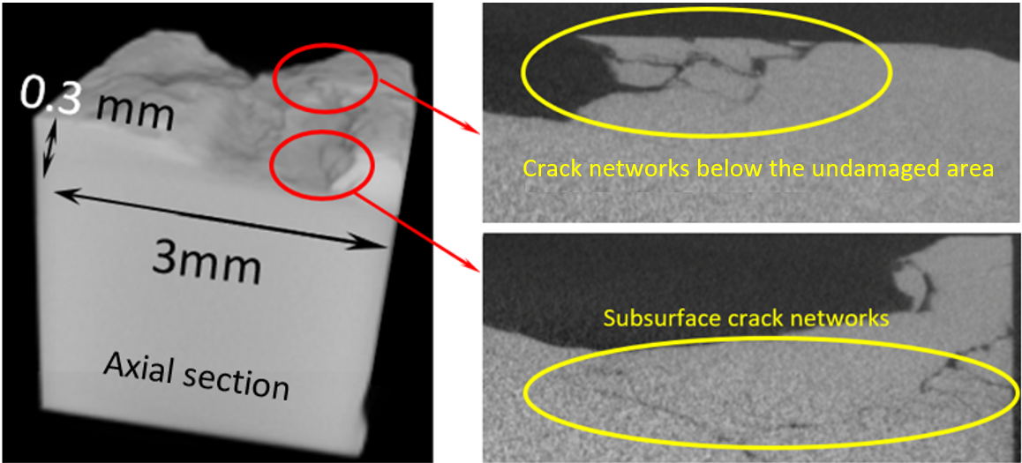
Figure 3.4. 18 CT scan results of the failed bearing raceway area U4A
Axial and circumferential cracks
According to the microscope observation results shown in Figure 3.4.19, the orientations of the crack networks are different in the axial and circumferential sections. For the axial sections shown in Figure 3.4.19 (a) and Figure 3.4.19 (b), most of the cracks are horizontal. However, the directions of the cracks in the circumferential sections are usually inclined. Sometimes, these cracks will propagate to the surface and/or connect with other crack networks as shown in Figure 3.4.19 (c) and Figure 3.4.19 (d).
A probable explanation for the crack direction variation in the axial and circumferential sections is the effect of rolling contact loading direction. It has been discussed that most cracks are initiated by subsurface defects such as the voids and inclusions. These defects appear as the small black dots within the cracks, as shown in Figure 3.4.19. Because of the influence of the repeated rolling contact loading from the bearing rollers, the cracks caused by inclusions in the circumferential section are more likely to spread to the surface. This process may be governed by the shear stress, which is similar to the growing process of the butterfly wings. However, in the axial sections, the Hertzian stress on the surface is applied in a straight line, thus the cracks do not propagate toward the surface but are approximately parallel to the bearing axis.
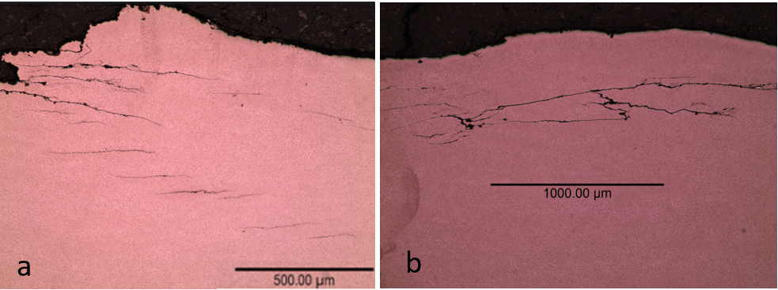
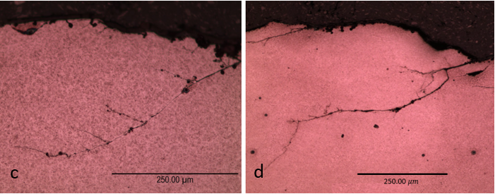
Figure 3.4. 19 Axial and circumferential crack networks (a) axial crack network in section U1A (b) axial crack network in D1A (c) circumferential crack network in section U4C (d) circumferential crack network in section D3C
Secondary cracks caused by damaged areas
In addition to the crack initiation caused by inclusions, some crack networks without the visible inclusions are also found within the failed bearing raceway sections. Typically, the subsurface depths that these crack networks can propagate may reach a few millimetres, as shown in Figure 3.4.20.
According to Hertz contact theory, the effect of Hertzian stress on the material subsurface area is almost negligible when the subsurface depth exceeds 1.5 mm. Therefore, the very long cracks shown in Figure 3.4.20 could not be triggered by subsurface defects under the nominal rolling contact loading. Different from the crack networks shown in Figure 3.4.19, these cracks are almost vertical to the raceway surface, which indicates that they may be caused by much higher loadings, such as the impact loading during the wind turbine shutdown events [9]. Apart from the impact loading, the rough surface due to spalling and the deposited particles on the raceway surfaces can also cause the significant wear and stress concentration, both of which may result in the crack initiation and propagation at greater depths of the subsurface area.
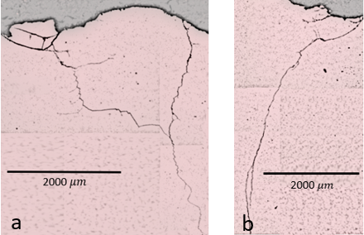
Figure 3.4. 20 Very long secondary cracks observed (a) in Section U4C (b) in Section D2C
In order to distinguish these long cracks from the general subsurface cracks, the crack network in Figure 3.4.20 is named after the secondary crack network, which means they may initiate after the surface spalling. The occurrences of the secondary crack networks greatly accelerate the bearing damage and surface material spalling because of their extremely long crack lengths and the deep positions in the subsurface area.

WEC
White etching cracks (WECs) are defined as the long crack networks surrounded or decorated by WEAs. Some studies suggested that WECs were caused by butterflies, voids or other subsurface defects [55][97][132][147]. By observing the failed bearing samples, these investigations captured images of butterflies connecting with each other in the subsurface area to form into the WEC networks.
However, some research did not observe any inclusions within the WECs, indicating that the formation of WECs could be independent of the inclusions [90][148]. In general, there are three main theories for the formation of WEC without considering the influence of inclusions [149]. The first one is the cracked surface rubbing theory, which suggests that two surfaces of the existing crack may rub against each other during the cyclic loading. The energy accumulation caused by the friction can lead to the atom dislocations of the steel matrix, and eventually the formation of WEAs. The second one is related to the Adiabatic Shear Bands theory (ASB theory). It considers that the impact loading may lead to the formation of the high strain and heating in the local areas, making the transformation from martensite to ferrite easier [148]. The last theory believes that the lubricant can generate electrical discharges under certain circumstances. Accordingly, the specific areas will be heated and corroded by the electrothermal mechanism, leading to the initiation of WEAs [94].
The following section presents the WECs observed in the failed planetary bearing raceways. Depending on the geometries and locations of the WECs, possible factors leading to their formations will also be discussed.
WEC and bearing damage mechanisms
Many investigations of the bearing premature failure showed that the bearing surface spalling was initially triggered by WECs from the subsurface areas [15][62][150][151][152]. As shown in Figure 3.4.21, a WEC with some broken particles is found in section D5A. This WEC exists entirely in the subsurface area and is parallel to the raceway surface. On the left-hand side of the crack, some broken particles with WEAs can still be clearly observed; while the rest of the fractured material on the right-hand side of the WEC may have fallen off during the grinding and polishing process. The microstructure difference between the original steel and WEA is clearly shown in Figure 3.4.21 (b). It can be found that the damaged area does have the finer grain sizes compared with the original martensite matrix.
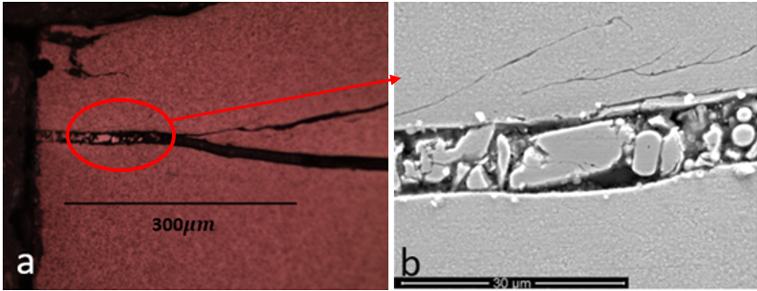
Figure 3.4. 21 Subsurface WEC with broken particles (a) Optical microscope picture (b) zoom-in SEM picture of the broken WEA
Because the hardness of WEA is 30% to 50% higher than that of the martensitic structure [88], the ductility and toughness of WEA are lower than the martensite. When the bearing bears heavy loads, the WEA is prone to be cracked and shattered, which causes the WSF damage eventually.
Figure 3.4.22 shows some examples of the WSF damage observed from the damaged raceways. The steel material above the WECs has already flaked away, thus only the cracks with decorated WEAs can be observed from the sections of the failed raceways. Similar to the images shown in Figure 3.4.21, some of the WEAs in Figure 3.4.22 are also broken and cracked. The formation time of the WEAs cannot be determined. It may be caused by the electrothermal mechanism of the lubricant after the surface spalling happens, or it may initially form in the subsurface area due to the rubbing of the cracked surfaces before the surface spalling.
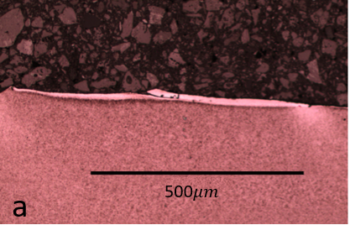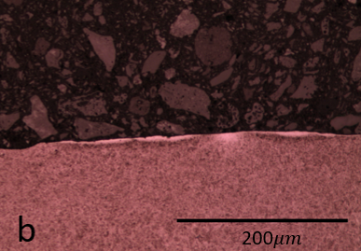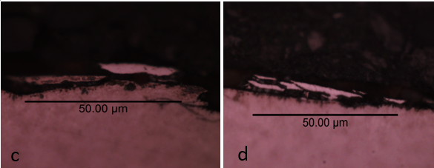
Figure 3.4. 22 WSF damage observed (a) U5A section (b) U6A section (c) and (d) D5A section
Considering the strain hardening mechanism, surface areas where spalling happens will be further hardened by the following cyclic loading cycles. In addition, when the surface material flakes off, the damaged surface area will directly contact to the lubricant, which can lead to localised hydrogen embrittlement. Undoubtedly, both the strain hardening and hydrogen embrittlement will further reduce the ductility of the damaged surface. When the heavy loadings such as the impact loading are considered, the secondary cracks may form beneath these surface spalling areas, which accelerate the final raceway failure.
Similar to the subsurface cracks, these secondary cracks may also contain WEAs. The WEC shown in Figure 3.4.23 comes from the section D4C. Because no inclusions can be observed from the figure, and the crack has propagated to the area that is approximately 5 mm below the damaged surface, this crack is identified to be a secondary crack. Moreover, the v-segment (stepped-like) appearance of the crack indicates that the crack may be caused by the dual wave loading system: the vertical crack propagation are caused by the tensile stress, while the parallel propagation is related to the shear stress [17]. There are many causes of the this dual wave loading system, such as the impact loading during the bearing operation or the stress concentration caused by the damaged raceway contact surface [17][88].
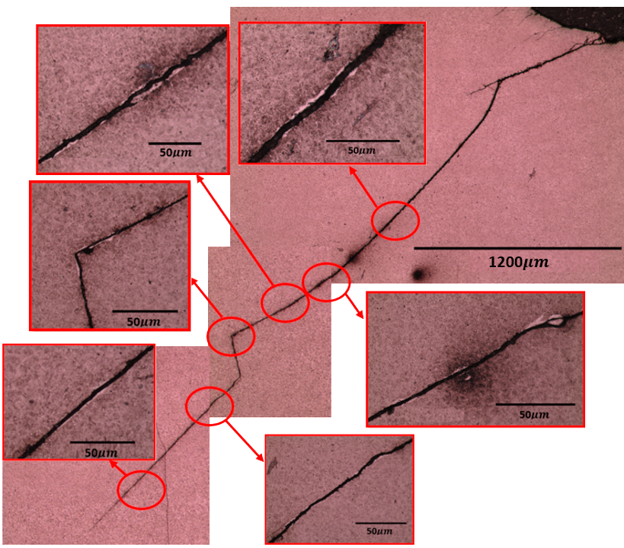
Figure 3.4. 23 Secondary WEC obtained from section D4C
Because this secondary crack has propagated to the subsurface area in great depth, the stress magnitude caused by the Hertz contact pressure is typically small. Hence, the formation of WEAs in Figure 3.4.23 could not be caused by the subsurface initiated damage. There are three possible explanations for this specific WEA initiation process. Firstly, the effect of lubricant. The lubricant may leak into the subsurface alongside the secondary crack to the deeper subsurface area, resulting in the localised electrical current discharge and heating. Secondly, according to the ASB theory discussed at the beginning, WEAs may easily form due to the localised shearing and heating if these areas are adiabatic. Thirdly, the rubbing and squeezing between the cracked surfaces may lead to the accelerated recrystallisation of the steel matrix from martensite to ferrite. All of these possible mechanisms suggest that the WEA should have formed after the occurrence of the crack.
Compared with the WEC observed in Figure 3.4.21 and Figure 3.4.22, the area of WEAs in Figure 3.4.23 is relatively small. This may be because the secondary crack occurs after the spalling of the raceway surface, thus the WEAs forming period is relatively shorter, when compared with the WEAs forming process in other cases.
Microstructure investigation of WEA within WEC
The microstructure of WEA was identified as the nanocrystalline body centred cubic (bcc) ferrite that was supersaturated with carbon [153][154]; and the grain sizes of the WEA were reported to be ranged from 20 to 30 nm [155]. To investigate the microstructure differences between the WEA and the original martensitic structure, the WEC from the surface spalling area is observed by SEM, as shown in Figure 3.4.24.
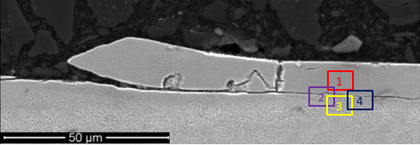
Figure 3.4. 24 WEC causes WFS in section U5A
For comparison, four regions near the right-hand side of the WEC are selected. As highlighted, Zone 1 is the WEA, Zone 2 shows the microstructures on both sides of the crack, Zone 3 is the original martensite structure, and Zone 4 is the transition zone from martensite to the WEA which locates below the crack. The zoom-in images of the selected areas, magnified from 15000 to 30000 times, are shown in Figure 3.4.25.
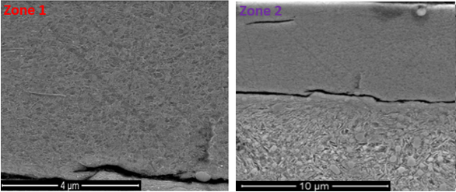
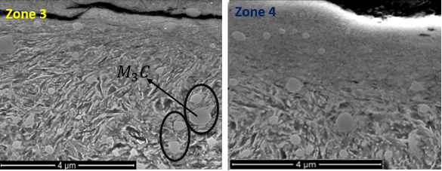
Figure 3.4. 25 Zoom-in images of Zone 1, Zone 2, Zone 3, and Zone 4 of the WEC
As can be seen from Zone 3 in Figure 3.4.25, martensite in the material has a needle-shaped structure. Moreover, because the carbon is added during the steel manufacturing, some circular carbides can also be found around the acicular martensite, which are marked by the circles. The chemical composition of the carbide is $M_{3}C$; $M$ means the “meatal”, and $C$ is the abbreviation of carbon. Normally, the carbide will absorb some of the Fe element to form ${Fe}_{3}C$, which is named as cementite.
Investigation in [156] indicated that some added metals in carbon steels could be more or less dissolved in the cementite. This suggestion has been proved by the EDS test results as shown in Figure 3.4.26. By comparing the distribution map of chromium with the original image, it is not difficult to see that the locations where chromium elements are concentrated, shown as bright blue spots, and coincide with the positions of the cementite. Therefore, chromium, as the most abundant additive metal element in the 100Cr6 material, will also be dissolved in the cementite. Therefore, the chemical composition of the cementite in 100Cr6 material should be written as ${(Cr, Fe)}_{3}C$.
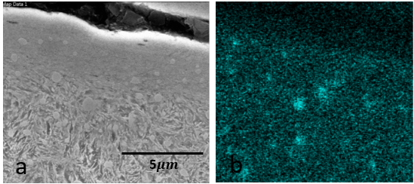
Figure 3.4. 26 Distribution of Cr elements in 100Cr6 (a) original image; (b) Distribution map of Cr element
Comparing the images of four zones in Figure 3.4.25, it can be found that the circular cementite disappears in the microstructure of the WEA of Zone 1. Although the cementite can still be found in the transition region of Zone 4, they become extremely rare in the WEA of Zone 1. This situation can be seen more clearly in the image of Zone 2, where the distribution of cementite is mainly concentrated in the region below the crack.
To identify the existence of cementite within the WEA, Table 3.5 uses the EDS method to detect the weight percentages of atoms in both the WEA and the normal martensite steel matrix. Although no cementite can be seen from the appearance, the test results show that C and Cr elements still exist in the WEA area.
Table 3. 5 Weight percentage of the atoms in WEA and normal steel matrix
 | Fe | C | Cr | Mn
WEA | 90.7% | 5.9% | 1.7% | 1.4%
Normal matrix | 92.1% | 4.8% | 1.3% | 1.2%
The investigation in [9] attributed the disappearance of cementite in the WEA to the effect of the shear stress on butterfly wings. Due to the high-rate shear deformation, the elongated cementite will be broken and dissolved by subsequent rolling contact loading cycles. Similar elongated cementite elements can also be found in the butterfly wings observed in this study, as shown in Figure 3.4.27.
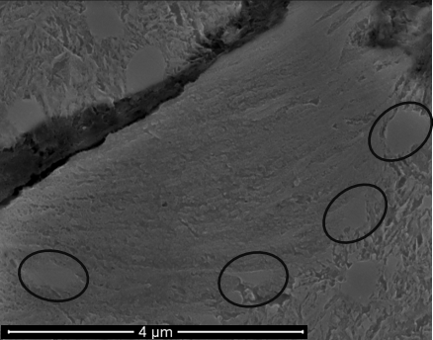
Figure 3.4. 27 Butterfly wings with elongated cementite (highlighted by black cycles)
However, as discussed in section 3.4.3, not all the WEAs are found to contain the elongated microstructures. Therefore, the other explanation reported in [157] believed that it might exist a thermal-mechanical mechanism that resulted in the dissolution of the cementite because an increase of temperature of the microstructure was observed during the WEA formation process. Furthermore, the interaction between the dislocated grain boundary and the cementite may also lead to the damage and dissolution of the cementite according to the research reported in [158].
Although there are many explanations for the cementite dissolution, it is undeniable that the formation process of the WEA must involve the dissolution of the cementite and the redistribution of carbon and chromium elements after the dissolution [80]. It is generally believed that the solubility of the carbon elements from the dissolved cementite is poor in the WEA ferrite. Accordingly, most of the carbon and chromium elements will migrate to lattice defects in the ferrite such as the vacancies or dislocations between grain boundaries [153][159]. Therefore, the WEA is also considered as a carbon-saturated structure.
At present, there is no evidence to identify the sequence between the transformation from the martensite structure to ferrite and the dissolution of the cementite. Hence, the causes of the cementite dissolution still require more investigations.

Optical microscope results of the unloading zone
After the analysis of the damaged areas of the bearing raceways, samples cut from the downwind bearing raceway where no material spalling occurs on the surface are observed for the comparison. It has been discussed in section 2.1.2 that the loading zone on the bearing inner raceway is fixed. Therefore, the effect of the Hertz contact pressure in the undamaged area is much less than that in the damaged area. As shown in Figure 3.2.3, no cracks appear on the surface of the undamaged area. However, some indentations can still be observed, which are usually caused by the spalling material from the damaged area.
Figure 3.4.28 shows subsurface microstructures of the selected sections UD1C to UD6C; where UD denotes “undamaged”; and C means “circumferential”. No subsurface cracks are observed in the sections, indicating that the contact pressure from the rollers is not sufficiently high to cause the bearing fatigue damage.
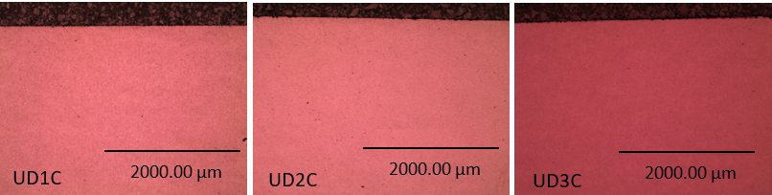
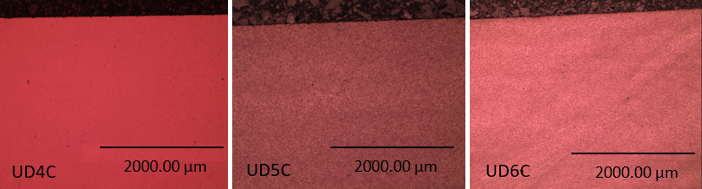
Figure 3.4. 28 Subsurface microstructure of six circumferential sections (UD1C to UD6C)
In addition, many damaged inclusions are found with depths less than 0.3 mm in these undamaged sections, as shown in Figure 3.4.29. Unlike the previously observed inclusions at the same depth from the surface damaged sections, no butterfly wings can be observed in Figure 3.4.29, although these inclusions observed from the undamaged areas have boundary separations and internal cracks. The finding confirms the importance of the Hertz contact pressure in initiating the subsurface cracks in the form of butterfly wings. When the stress concentration due to inclusions does not exceed the fatigue threshold of the steel matrix, no RCF damage will be induced from the subsurface region.
However, not all damaged inclusions avoid the crack propagation. Four butterflies are still observed in the undamaged sections, as shown in Figure 3.4.30. Among them, three butterflies are found in the UD1C section, and the remaining one is found in the UD2C section.
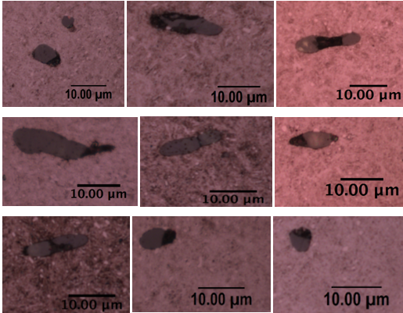
Figure 3.4. 29 Damaged inclusions observed within 0.3 mm depth from the undamaged sections
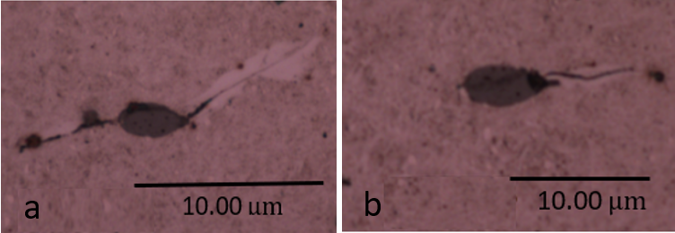
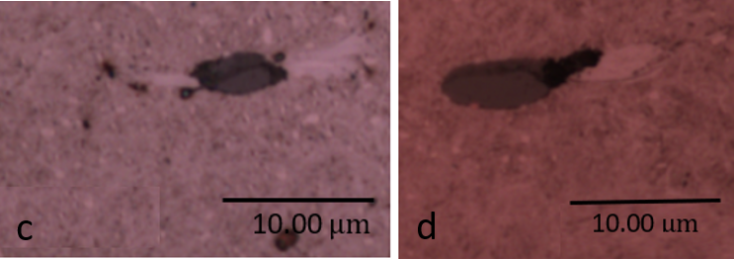
Figure 3.4. 30 Butterflies observed from the undamaged sections (a), (b), and (c) butterflies in section UD1C; (d) butterfly in section UD2C
Although the butterflies observed within one observation plane cannot reflect the overall number of butterflies in the undamaged raceway area, these butterflies may also suggest that the area where the UD1 and UD2 sections located may undertake higher loadings compared with other regions of the undamaged area. This conclusion is constant with the finding in section 3.1 that the flange end of the inner raceway will withstand more loading than the other regions of the bearing raceway.
Table 3.6 summarises the measurement results of the butterflies in Figure 3.4.30. It can be seen that these butterfly wings found in the undamaged areas are much shorter than those found in the surface damaged areas. In addition, the average depth of the butterflies in the subsurface is 0.25 mm, which is shallower than the average depth of the butterflies found in the damaged areas. These results indicate that the subsurface stress level caused by the Hertz contact pressure in the surface undamaged area is much smaller than the stress in the damaged area.
For the damage types of the inclusions, all the butterflies in Figure 3.4.30 are found to be triggered by the damage inclusions with the boundary separation, internal crack, or the combination effect of both damage types. This finding emphasises the promoting effect of inclusion damage on the crack nucleation again.
Table 3. 6 Measurement data of the butterflies observed in the surface undamaged area
Number | Inclusion type | Inclusion damage type | Depth | Two wings’ length
1 | MnS | Internal cracking | 0.21 mm | 13 $μm$
2 | MnS | Boundary separation | 0.23 mm | 7 $μm$
3 | MnS | Internal cracking | 0.31 mm | 10 $μm$
4 | MnS | Boundary separation + Internal cracking | 0.26 mm | 5 $μm$

Summary
This chapter investigates the possible causes of the bearing premature failure by performing the damage characterisations of the raceway samples of two failed planetary bearings.
According to the results obtained from the damaged sections of both the upwind and downwind bearing raceways, many inclusions are found in the raceway subsurface areas. The EDS results show that MnS inclusions account for more than 90% of all the inclusions observed. In addition, these MnS inclusions are also found to be the important causes of the subsurface crack initiation.
Through the statistical analysis of the length of butterfly wings and their depths in the subsurface area, it has found that when inclusions are at the certain depths, they are more likely to cause the butterfly wing cracks. This depth is found to be affected by the Hertz contact pressure between the rollers and the raceway. As the contact pressure increases, the depth of the greatest maximum shear stress zone will increase accordingly. The results also show that when the inclusions have separated boundaries and/or internal cracks, the risk of crack initiation and propagation at those inclusions will increase correspondingly. These damage types of the inclusions may be caused by the heat treatment process and the loading applied to the raceway. Moreover, the internal crack in an inclusion is generally more harmful than the boundary separation of the inclusion because the butterfly wing length caused by this type of inclusion damage is usually greater than that caused by the inclusion boundary separation.
In addition, some crack networks generated in the subsurface area are also observed. The length of these crack networks is normally less than 1 mm, and inclusions can be found as the connections between the cracks. Therefore, it can be concluded that these crack networks are generated by the propagations of the microcracks initiated by multiple inclusions. When the crack networks propagate to the surface, they will become the most direct causes of the raceway surface spalling and eventually lead to the bearing premature failure.
WEAs are also found in these subsurface crack networks. Some WEAs have been proved to be triggered by the subsurface inclusion, while some are not affected by the inclusions. The mechanisms of the WEA formation are complex. This could be as a result of the energy transfer caused by the rubbing between two cracked surfaces, or because of the influence of the hydrogen penetration from the lubricant or the contamination. According to the SEM and EDS results obtained in this chapter, it has shown that the formation of the WEA involves the dissolution of the cementite and the transformation of the steel material from the martensite to ferrite.
Although the initiation causes of the WEAs are different, SEM observation results indicate that they may have the same microstructure. Due to the high hardness and poor ductility of WEAs, some of them will fracture under the repeated rolling contact loading. Thus, the damage level of the subsurface area is intensified, leading to the accelerated material flaking of the bearing raceway surface. Meanwhile, this is also the main reason why only a limited amount of WECs can be found in these damaged bearing samples, as many WECs have already been flaked away from the damaged raceway surface.
Following the occurrence of the raceway material spalling, some secondary cracks will form in deeper subsurface areas due to the impact loading or stress concentration on rough damaged area of the raceway. Compared with the subsurface cracks, these secondary cracks usually have longer lengths and depths. Sometimes, WEAs may also appear after the occurrence of the secondary cracks, due to the effect of the lubricant, ASB, and rubbing between the cracked surfaces. The formation of WEAs further reduce the toughness of the raceway, thus this particularly serious damage caused by the secondary cracks will result in the accelerated material spalling of the raceway surface and the final bearing failure.

Characterisation of bearing steel properties and gearbox loading conditions
In this chapter, the material properties of both the 100Cr6 bearing steel and WEA damage area are tested. It has been found that the WEA has a higher hardness than the steel matrix, which can result in the rapid propagation of subsurface cracks. Additionally, according to the WT operating cases suggested in the International Standard IEC 61400-4 and the modelling results of the V80-2MW WT controlling system, possible loading magnitudes experienced by the WTG planetary bearing raceways are calculated. Different from previous investigations, load calculations in this chapter consider the effect of the varying wind speed and other WT operating conditions on the bearing loading magnitudes and variations.

Nano-indentation Test of Bearing Steel and White Etching Area
To identify the properties of both the bearing steel matrix and the WEA, nano-indentation tests are carried out which aim to measure the hardness of the target material. There are two indentation tests reported in this section. The first one measures the hardness of the 100Cr6 steel matrix. The sample used in this test comes from the upwind bearing raceway. To ensure the effectiveness of the test, the surface of the sample is polished by 9 $μm$, 3 $μm$, and 1 $μm$ diamond suspensions sequentially. The second test is carried out to measure the hardness of the WEA. In this nano-indentation test, a four-wings butterfly observed from the failed upwind bearing raceway is selected. The measurements aim to characterise differences of the properties between the steel matrix and the WEA.

Indentation test method
The hardness measurement by the indentation method is normally based on the classic Hertz theory. It considers that at the contact interface of a rigid body and an elastic flat surface, the size of the contact area depends on the load applied, the geometry of the rigid indenter, and the elastic property of the contacting surfaces [160]. For the nano-indentation tests in this chapter, all the indenters used are diamond Berkovich indenters.
Berkovich tip has a three-sided pyramid shape with a conical angle of ${65.27}^{°}$, as illustrated by Figure 4.1.1 (a). Figure 4.1.1 (b) shows the definitions of parameters during the contact process between the indenter and the elastic surface. In the figure, $α$ is the conical angle, which is ${65.27}^{°}$ for the Berkovich tip, $a$ is the actual contact length between the indenter and the tested material, which is also known as the radius of the contact circle. $h_{c}$ is the depth of the contact circle, $h_{max}$ is the depth from the indenter tip to the flat surface, and $h_{a}$ is the depth difference between $h_{max}$ and $h_{c}$.
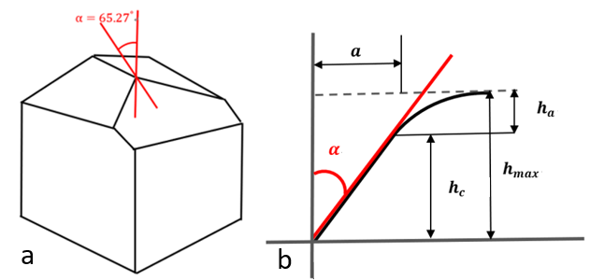
Figure 4.1. 1 Berkovich indenter tip (a) geometry shape of the Berkovich indenter (b) contact between the Berkovich indenter and the material
For a process of an indenter acting on a material surface, it is known that there is
a joint effect of both the elastic and plastic deformation, which is similar to the stamping process. However, when the loading $P$ is removed from the indenter, the material surface should have a “spring back” deformation due to the elastic deformation recovery, as shown by the green dash line in Figure 4.1.2 (a). $h_{r}$ in the figure is the final depth after the spring back, and $h_{e}$ is the elastic displacement during the unloading process [161]. Additionally, the relationship between the tested material displacement $h$ and the force $P$ applied is plotted in Figure 4.1.2 (b).
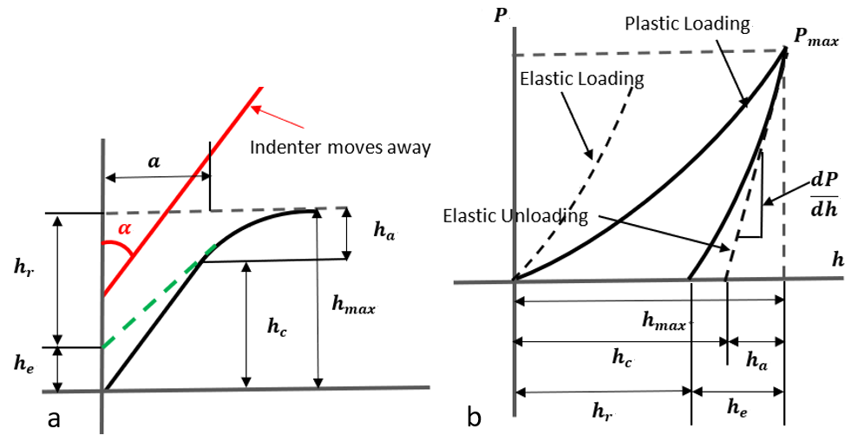
Figure 4.1. 2 Loading and unloading process (a) spring back during unloading (b) Force-displacement relationship during the loading and unloading process
The slope $\frac{dP}{dh}$ can be calculated by the following equation [161][162] :
$\frac{dP}{dh}=2∙E^{*}∙a$ Equation 4.1
where $E^{*}$ is the reduced modulus (equivalent modulus) from the Hertz contact theory. It can be determined by the following equation:
$\frac{1}{E^{*}}=\frac{1-{υ_{1}}^{2}}{E_{1}}+\frac{1-{υ_{2}}^{2}}{E_{2}}$ Equation 4.2
In Equation 4.2, $E_{1}$, $υ_{1}$ are the Young’s Modulus and Poisson's ratio of the indenter, and $E_{2}$, $υ_{2}$ are the Young’s Modulus and Poisson's ratio of the tested material.
For the Berkovich indenter, the radius of the contact circle $a$ is determined by the following equation [161]:
$a=\sqrt{\frac{3\sqrt{3}∙{h_{c}}^{2}∙\tan^{2}({65.27}^{°})}{π}}=\sqrt{\frac{A}{π}}≈\sqrt{\frac{24.5{h_{c}}^{2}}{π}}$ Equation 4.3
where $A$ is the projected area of the indentation on the flat material surface. Substituting this equation into Equation 4.1, it gives the modified expression of the slope $\frac{dP}{dh}$ that:
$\frac{dP}{dh}=2×E^{*}×\frac{\sqrt{A}}{\sqrt{π}}≈2×E^{*}×\sqrt{\frac{24.5{h_{c}}^{2}}{π}}$ Equation 4.4
In addition, the projected area $A$ can be used to calculate the hardness $H$ of the tested material; the relevant equation is given as [161]:
$H={P_{max}}/A$ Equation 4.5

Nano-indentation test of bearing steel
It is known that the etching process of sample preparation does not change the material hardness, but it will increase the surface roughness of the sample. In the nano-indentation test, the indentations are only nanometre-sized, which means the test results are sensitive to the sample surface roughness. As a result, the test of the steel matrix after etching may be not accurate because of the uneven surface. For this reason, the specimen used to measure the steel matrix hardness is only polished by the 1 $μm$ diamond suspension. Figure 4.1.3 (a) shows the mounted specimen used for the nano-indentation test, and Figure 4.1.3 (b) shows the nano-indentation machine, Hysitron TI Premier.
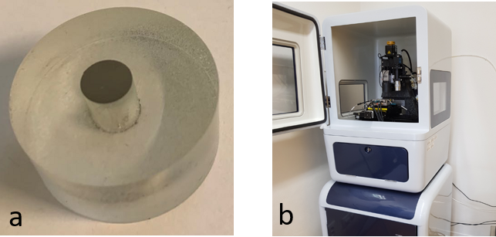
Figure 4.1. 3 Nano-indentation specimen and machine (a) mounted and polished specimen (b) Hysitron TI Premier nano-indentation machine
The maximum force applied during the test is 14000$μN$, it increases from zero gradually and reaches the maximum value in 5 seconds. After that, the force will stay at the peak magnitude for another 5 seconds. Finally, it drops to zero in 5 seconds. The loading-holding-unloading process is shown in Figure 4.1.4. Worth noting that, to reduce the instability caused by the indenter measurement at the nanoscale, 16 indentations are punched by the machine in the form of a 4 x 4 array, as shown in Figure 4.1.5. The distance between every two indentations is 40 $μm$.
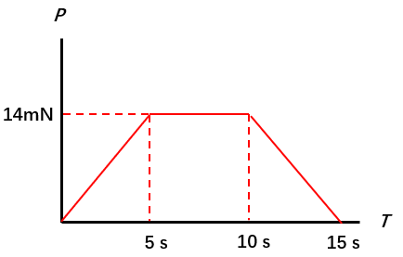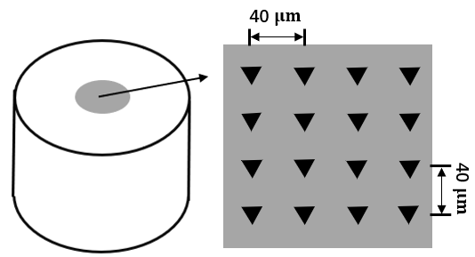
Figure 4.1. 4 Force-time relationship Figure 4.1. 5 Indentations in a 4x4 array
Table 4.1 lists the experimental results of the nano-indentation test. The nano-indentation machine will record the displacement-force curve for each indentation. Therefore, the values of $h_{c}$, $h_{max}$, and the slope $\frac{dP}{dh}$ can be found directly from the recorded curves. Furthermore, based on the Equation 4.3, Equation 4.4, and Equation 4.5 in section 4.1.1, the projected area $A$, reduced modulus $E^{*}$, and hardness of the tested bearing steel $H$ can be calculated separately.
Table 4. 1 Nano-indentation results for the steel matrix
No. | $$hc/nm$$ | $$P_{max}/μN$$ | $$Slope/\frac{μN}{nm}$$ | $$A/{nm}^{2}$$ | $$h_{max}/nm$$ | $$E^{*}/GPa$$ | $$H/GPa$$
1 | 238.95 | 13998.82 | 295.88 | 1617755.09 | 274.72 | 206.11 | 8.65
2 | 248.10 | 13998.71 | 306.75 | 1735020.40 | 282.85 | 206.33 | 8.07
3 | 243.33 | 13998.89 | 293.20 | 1673350.82 | 279.42 | 200.82 | 8.37
4 | 238.44 | 13998.87 | 292.56 | 1611363.93 | 274.64 | 204.20 | 8.69
5 | 245.64 | 13998.86 | 298.45 | 1703054.59 | 281.25 | 202.62 | 8.22
6 | 237.49 | 13998.80 | 289.69 | 1599440.26 | 274.24 | 202.95 | 8.75
7 | 239.33 | 13998.86 | 295.15 | 1622590.46 | 275.40 | 205.29 | 8.63
8 | 234.97 | 13998.80 | 295.67 | 1568122.53 | 271.00 | 209.20 | 8.93
9 | 239.23 | 13998.62 | 300.42 | 1621350.18 | 274.54 | 209.04 | 8.63
10 | 238.69 | 13998.80 | 287.97 | 1614576.69 | 275.43 | 200.80 | 8.67
11 | 239.21 | 13998.71 | 289.48 | 1621142.13 | 275.73 | 201.44 | 8.64
12 | 241.02 | 13998.75 | 295.99 | 1643925.10 | 276.78 | 204.53 | 8.52
13 | 275.15 | 13998.64 | 317.12 | 2144754.26 | 327.85 | 191.90 | 6.53
14 | 245.11 | 13998.83 | 293.45 | 1696229.93 | 281.26 | 199.63 | 8.25
15 | 236.14 | 13998.61 | 286.16 | 1582643.85 | 273.06 | 201.53 | 8.85
16 | 241.33 | 13998.61 | 294.56 | 1647923.89 | 277.32 | 203.30 | 8.49
Average | 240.47 | 13998.77 | 294.36 | 1637233.66 | 276.51 | 203.86 | 8.56
It can be seen from the table that the result of test No.13 is different from the other test data. For the indentation number 13, the indenter may accidentally punch on a soft inclusion that embedded in the steel matrix. Hence, the test data of No. 13 is removed from the following calculations. Based on the data obtained and the hardness calculation, the average hardness of the 100Cr6 steel is 8.56 GPa. By transferring it to the Rockwell C Hardness, the value is about 64 HRC. The Young’s Modulus of the 100Cr6 steel can be determined by Equation 4.2 refer to the reduced modulus listed in Table 4.1. It is known that the diamond indenter has the modulus of 1100 GPa and Poisson's ratio of 0.07, thus the average modulus of 100Cr6 steel is calculated as 227.46 GPa.
When compared with the common steel materials, 100Cr6 material with the martensite structure has much higher hardness and a relatively larger modulus. These properties indicate that this material has a good non-deformability, which is suitable for the bearing steel applications.

Nano-indentation test of white etching area
The WEA sample tested in this section comes from the damaged area of the upwind bearing raceway presented in Chapter 3. As can be seen from Figure 4.1.6 (a), the failed bearing sample is mounded by the black Bakelite; and this sample is polished and etched for the observation of WEAs. As shown in Figure 4.1.6 (b), a four-wings butterfly is found in the subsurface area of the circumferential section, with the depth of about 0.82 mm. The WEAs around the butterfly wings are selected for the indentation test in this study.
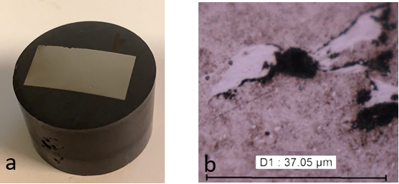
Figure 4.1. 6 White etching matter investigation (a) polished and etched sample (b) a four-wings butterfly in the circumferential sample section
As discussed in section 4.1.2, the etching process will increase the surface roughness of the sample. Therefore, to ensure the accuracy of the test, this section contains two nano-indentation tests with two different loading magnitudes and indentation alignments, as illustrated by Figure 4.1.7 (a) and Figure 4.1.7 (b) respectively. In the figures, the green line outlines the left-hand side WEA of the butterfly.
The first test has 12 indentations (marked in red circles), which are punched by the 2000 $μN$ force, and the gap between every two indentations is 2 $μm$. The second test uses the 1000 $μN$ force with 20 indentations defined, and the gap between every two indentations in the test is 1 $μm$. The force-time curves of two tests are shown in Figure 4.1.8.
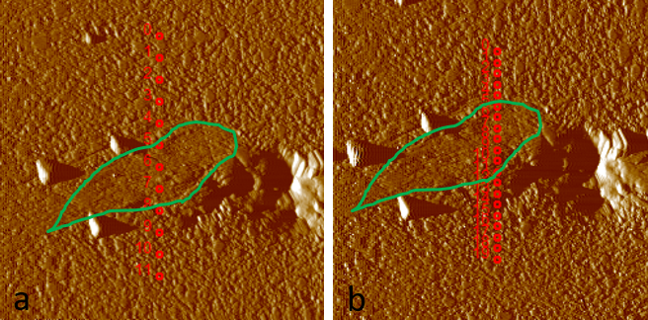
Figure 4.1. 7 Indentation alignments (a) Test 1 twelve indentations with 2000 $μN$ force (b) Test 2 twenty indentations with 1000 $μN$ force
The nano-indentation test results of the WEA are shown in Figure 4.1.9. Although the indentations are set to be aligned in a line, some indentation positions in test 2 still have deviations compared with the original definitions. Usually, these deviations are unavoidable due to the tiny size of the indenter. In this case, the deviations are considered to be acceptable because the arrangement of indentations still obeys the “steel matrix-WEA-steel matrix” route.
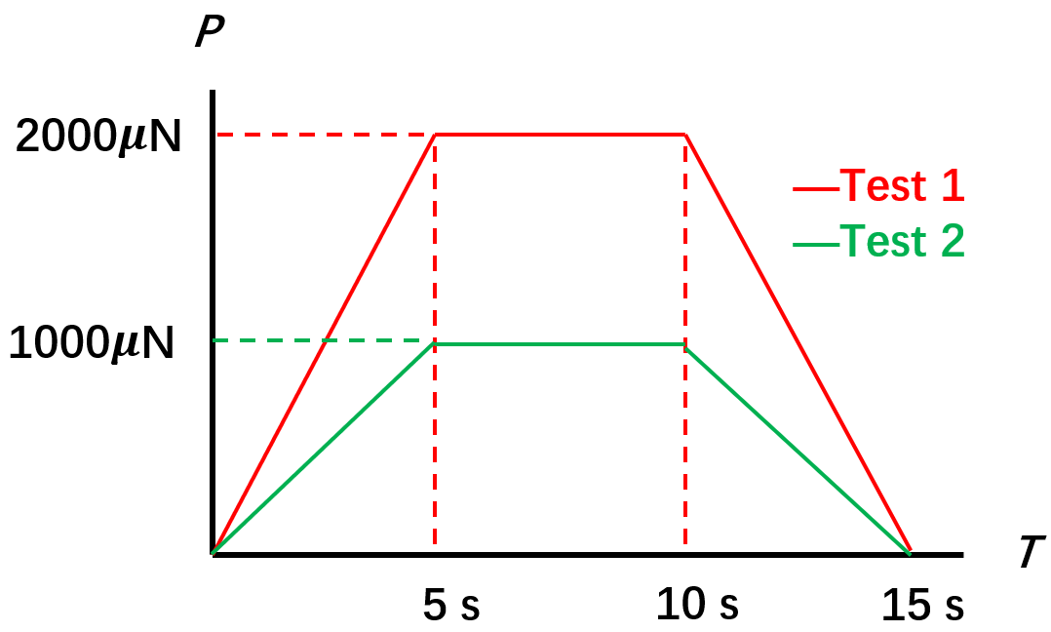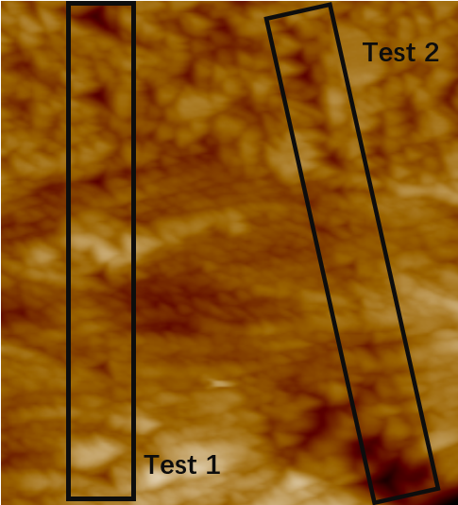
Figure 4.1. 8 Force-time curves of the tests Figure 4.1. 9 Indentation image
Raw results of the indentations recorded in two tests are shown in Table 4.2 and Table 4.3 respectively. The plotting of the hardness results is shown in Figure 4.1.10.
Table 4. 2 Test 1: results of 12 indentations
No. | $$hc/nm$$ | $$P_{max}/μN$$ | $$Slope/\frac{μN}{nm}$$ | $$A/{nm}^{2}$$ | $$h_{max}/nm$$ | $$E^{*}/GPa$$ | $$H/GPa$$
1 | 70.08 | 1998.31 | 112.53 | 198822.76 | 83.81 | 223.59 | 10.05
2 | 78.11 | 1998.16 | 121.16 | 236414.86 | 91.13 | 220.78 | 8.45
3 | 75.91 | 1998.41 | 117.26 | 225784.64 | 88.93 | 218.64 | 8.85
4 | 90.93 | 1998.44 | 127.84 | 302989.29 | 102.71 | 205.78 | 6.60
5 | 80.60 | 1998.57 | 127.58 | 248726.58 | 92.73 | 226.66 | 8.04
6 | 59.37 | 1998.46 | 101.47 | 153589.87 | 74.78 | 229.39 | 13.01
7 | 61.27 | 1998.24 | 94.73 | 161211.73 | 77.37 | 209.05 | 12.40
8 | 68.89 | 1998.48 | 90.91 | 193525.19 | 85.65 | 183.09 | 10.33
9 | 70.64 | 1998.15 | 86.33 | 201336.88 | 88.29 | 170.47 | 9.92
10 | 103.80 | 1998.19 | 103.05 | 377910.32 | 119.49 | 148.52 | 5.29
11 | 92.58 | 1998.41 | 114.99 | 312103.94 | 105.77 | 182.36 | 6.40
12 | 77.39 | 1998.48 | 126.96 | 232914.04 | 89.49 | 233.08 | 8.58

Table 4. 3 Test 2: results of 20 indentations
No. | $$hc/nm$$ | $$P_{max}/μN$$ | $$Slope/\frac{μN}{nm}$$ | $$A/{nm}^{2}$$ | $$h_{max}/nm$$ | $$E^{*}/GPa$$ | $$H/GPa$$
1 | 59.69 | 998.17 | 87.50 | 154876.39 | 68.51 | 196.99 | 6.44
2 | 48.83 | 998.09 | 73.46 | 114525.15 | 59.86 | 192.33 | 8.72
3 | 72.32 | 998.08 | 92.62 | 209000.80 | 80.70 | 179.50 | 4.78
4 | 52.96 | 998.29 | 82.65 | 129202.32 | 62.39 | 203.74 | 7.73
5 | 41.88 | 998.19 | 73.95 | 91719.46 | 53.69 | 216.33 | 10.88
6 | 61.79 | 998.11 | 78.42 | 163303.35 | 71.63 | 171.93 | 6.11
7 | 39.95 | 998.19 | 81.18 | 85787.60 | 50.14 | 245.57 | 11.64
8 | 33.40 | 998.19 | 74.85 | 67039.51 | 44.03 | 256.14 | 14.89
9 | 41.14 | 998.25 | 62.95 | 89442.57 | 53.35 | 186.48 | 11.16
10 | 37.43 | 998.19 | 65.81 | 78349.30 | 49.05 | 208.32 | 12.74
11 | 38.92 | 998.26 | 73.04 | 82722.97 | 49.31 | 225.01 | 12.07
12 | 31.05 | 998.07 | 69.64 | 60808.42 | 42.02 | 250.22 | 16.41
13 | 55.68 | 998.17 | 55.78 | 139299.69 | 69.48 | 132.41 | 7.17
14 | 89.38 | 998.14 | 36.71 | 294491.05 | 109.98 | 59.94 | 3.39
15 | 145.97 | 998.18 | 60.03 | 680437.01 | 158.79 | 64.47 | 1.47
16 | 123.37 | 998.21 | 45.81 | 507419.57 | 139.81 | 56.97 | 1.97
17 | 128.89 | 998.21 | 82.20 | 547370.68 | 138.26 | 98.44 | 1.82
18 | 61.64 | 998.16 | 91.62 | 162723.87 | 70.22 | 201.24 | 6.13
19 | 48.26 | 997.99 | 87.59 | 112570.75 | 57.23 | 231.29 | 8.87
20 | 72.70 | 998.11 | 93.05 | 210749.49 | 81.08 | 179.59 | 4.74
Based on the measurement results, it can be found that the hardness of the WEA is much higher than that of the steel matrix in both test 1 and test 2. For test 1, the average hardness of the WEA is 11.41 GPa, while for test 2 this value increases to 13.15 GPa. This phenomenon may attribute to the specific atomic arrangement structure of the WEA. As discussed in Chapter 3, the WEA has an ultra-fine ferrite structure with an average grain size of 50 nm. When the loading is applied on the material surface, WEA has more compact grains than the martensite matrix to undertake the loading. Therefore, it has the high resistance to deformation, which coincides with the high hardness in macroscale.
Moreover, according to the measurement results in test 1 and test 2, the hardness of WEA ranges from 9.9 GPa to 16.8 GPa. This finding indicates that even within the same WEA, there exist differences in hardness at different locations. As discussed in Chapter 2, with the decrease in the size of grains that make up the WEA, the hardness of the area will be greater. In addition, evidence in [80] also shows that the dissolution of $M_{3}C$ in the WEA is not uniform because the Carbon and Chromium elements are concentrated in some specific areas within the WEA according to EDS results. Considering that these alloying elements will change the microstructure of the material, their distributions will also affect the hardness of the WEA.
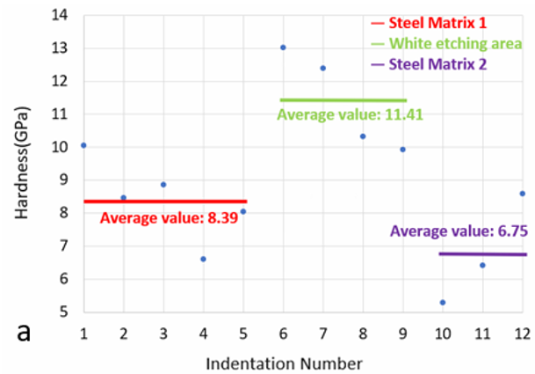
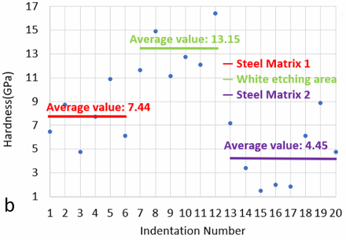
Figure 4.1. 10 Hardness results of white etching area from (a) test 1 (b) test 2
Worth noting that, the hardness of the steel matrix in both test 1 and test 2 shows a wide range of distribution that varies from 1.82 GPa to 10.88 GPa. However, according to the nano-indentation test results in section 4.1.2, the average hardness of the 100Cr6 material is about 8.56 GPa. This difference is normally caused by the following reasons:
- Effect of the deformation of neighbouring indents. In test 2, the gap is set as 1 $μm$. However, it can be seen from Figure 4.1.9 that for the first several indentations measuring the steel matrix hardness, the sizes of them are almost equal to the gaps between every two indentations. To ensure the effectiveness and accuracy of the nanoindentation test, the gaps should be larger than three times of the indentation sizes. However, due to the small size of WEA, about 7 $μm$, this goal cannot be achieved in measurements. As a result, the measurement results are affected because of the tiny distances between the indentations. As shown in Figure 4.1.10 (b), the average hardness calculated from indentation number 1 to number 6 is only 7.44 GPa, which is relatively smaller when compared with the measurement result, 8.56 GPa, in section 4.1.2.
- Effect of the iron-chromium cementite, (${Cr,Fe)}_{3}C$. (${Cr,Fe)}_{3}C$ is a common carbide in 100Cr6 material which possesses a higher hardness when compared with the martensite steel structure [163]. Such structure is not clearly shown in Figure 4.1.7 because it can only be observed by SEM with a typically large magnification. In the tests of WEA hardness, indentation No. 1 in test 1 and indentation No. 5 in test 2 both have higher hardness than the other measurement results. One possible reason is that these indentations may coincidentally locate on the positions of the (${Cr,Fe)}_{3}C$ cementite.
- Cracks and voids near the inclusion. Both Figure 4.1.7 (b) and Figure 4.1.9 indicate that some indentations locate in or near the cracking area. This will cause a dramatic decrease in the hardness measurement. As shown by indentations No. 10, 11 and 12 in Figure 4.1.10 (a) and indentations No. 13 to 20 in Figure 4.1.10 (b). These measurements cannot reflect the actual hardness of the material because the indenter acts on a void.
- Etched material microstructure. As discussed in section 4.1.2, the 2% Nital solution used for the etching may make the material surface uneven. Although the roughness of the surface is not noticeable, it still affects the measurement results of the microstructure hardness, especially when the measurement is carried out at the nano level. However, etching is unavoidable in the measurement, otherwise, the position of WEA cannot be determined.

Calculation of the WTGB Loading Conditions
To determine the magnitude and variation of the loading applied to the WTG planetary bearing, the theoretical calculations are carried out in this section, considering the parameters affecting the wind turbine operating conditions.

Working mechanism of DFIG (Doubly Fed Induction Generator)
The generator, as a vital part of the WT drivetrain system, is responsible for generating electricity and transferring it to the grid. For the application of wind energy, the generators selected are normally doubly fed induction generators (DFIG, also knowns as the doubly fed asynchronous generator). This is because DFIG can provide a constant frequency of the current, although the rotational speed of the WT high speed shaft varies frequently due to the wind speed.
The typical design of the DFIG has two parts that can generate the rotating magnetic field: the rotor and stator. The stator windings are connected to the grid while the rotor windings are connected with a partial scale back-to-back converter via slip rings [164]. Both the rotor and stator can generate the magnetic field. Thus, the current frequency is governed by the combined effect of the rotor and stator, and it cannot be changed by the rotational speed of rotor alone.
For instance, if the generator needs to generate the alternating current with a frequency of 50 Hz. The rotation speed of the overall internal magnetic field should be 50 rounds/s. Based on the different wind speeds; the rotor may have the following situations:
- The rotor rotational speed is smaller than 50 Hz. This operation state of DFIG is called the sub-synchronous mode. In this state, the stator will generate a rotating magnetic field for the rotor to make up the difference. For example, if the rotor rotates at 30 Hz, then the stator and rotor will jointly create a 20 Hz rotating magnetic field that has the same rotational directions as the rotor. Therefore, the combined magnetic field is 50 Hz.
- The rotor rotational speed is exactly 50 Hz. This is known as the synchronous mode. In this case, the jointly created magnetic field is relatively static to the rotor.
- The rotor rotational speed is larger than 50 Hz, for example, 55 Hz. Therefore, the stator will generate a 5 Hz rotating magnetic field that has the opposite rotational direction of the rotor. As a result, the overall frequency of the magnetic field is finally reduced to 50 Hz. This operation state is called the super-synchronous operation mode.
Generally, the DFIG can operate normally when the input speed is 40% lower than the synchronous speed and 15% greater than the synchronous speed. Furthermore, DFIG can not only act as a generator but also play the role of a motor. In order to start up the generator of a wind turbine, the rotation of the low-speed shaft is usually used as the input energy. However, the DFIG can act as a motor and use the electrical energy acquired from the grid as an input. Accordingly, it avoids many generator failures caused by the wind turbine blades.
For the V80-2MW WT, the control system applied for the DFIG is called “Optispeed”. By adjusting the current of the rotor, it can control the frequency of the electric power generated and decide whether it is necessary to connect to the grid.

Loading calculation of the gearbox bearing
Different loading cases during operation
According to the data collected from different wind farms, the power curve of the V80-2MW WT relative to the wind speed is shown in Figure 4.2.1 [165]. Based on the power curve, the cut-in and cut-off wind speeds of the wind turbine are 4 m/s and 25 m/s respectively. The rated wind speed is 15 m/s, at which the power generated is 2MW. With the continuous increase of the wind speed, the pitch system will adjust the angle of the wind turbine blade for the purpose of stabilising the power.
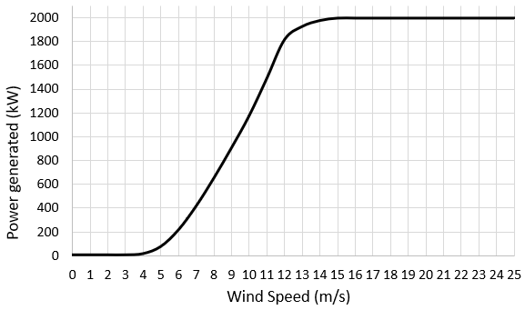
Figure 4.2. 1 Relationship between the power generated by V80-2MW and the wind speed
In addition, as described in IEC 61400-4 standard, the total lifetime for a qualified wind turbine should reach 20 years [166]. Meanwhile, the standard assumes the wind turbine works 92% of the time when they are not shut down for the maintenance or other reasons. Therefore, the operation hours of the wind turbine during 20 years are equivalent to [166]:
$20 years∙365 days∙24 hours∙92\%=161184 hours$ Equation 4.6
Normally, the operation time of a 2MW WT at different wind speeds should follow the Weibull distribution. When the overall operation time is 161184 hours, the relationship between the wind speed and the operating hours is as shown in Figure 4.2.2.
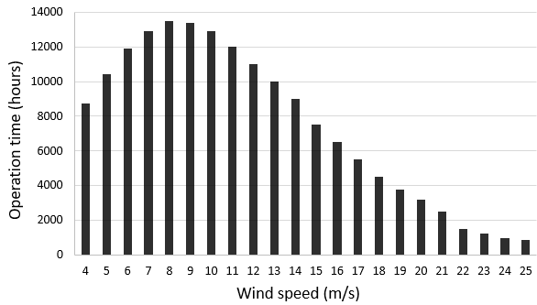
Figure 4.2. 2 Operation hours of a WT corresponding to the wind speed according to IEC 61400-4 (overall 161184 hours)
However, Figure 4.2.2 does not consider the effect of overloading conditions during the wind turbine operation process. As discussed in Chapter 2 and Chapter 3, these overloading cases may occur due to the start-up, shutdown, braking, wind gusts and grid faults. In the wind turbine design standard IEC 61400-1:2019, it describes all the possible loading cases that can occur during the 20 years operation period [167]. Additionally, the research in [168] summarises these standard loading cases into 41 cases. The number of occurrences for each case is illustrated by Figure 4.2.3.
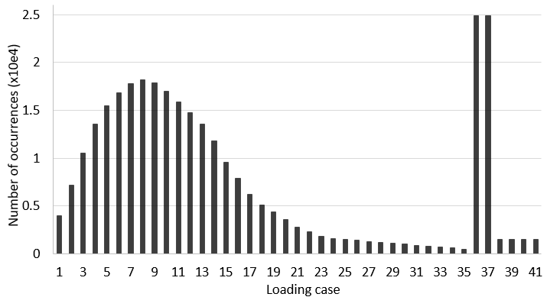
Figure 4.2. 3 Number of occurrences of each loading case during the WT operation
The first 35 cases are corresponding to the normal operation situations of the wind turbine, when the wind speed changes from the cut-in to the cut-off speed. Loading cases 36 and 37 are the normal start-up and shutdown process of the wind turbine, and the last 4 cases are the extreme overloading cases due to the emergency shutdown, sudden grid loss and other factors that may cause the surge of loading.
Although Figure 4.2.3 demonstrates the number of occurrences of each loading case, loading case 1 to case 35 still have a similar Weibull distribution when compared with the overall operation hours shown in Figure 4.2.2. Thus, in this study, it is assumed that each occurrence of the loading case in Figure 4.2.3 may last for approximately the same time.
Based on the assumption, if the wind turbine can serve for 161184 hours within 20 years, the durations of different loading cases according to the wind speed and loading condition are shown in the following table.
Table 4. 4 Proportion of each loading case within 20 years operation time
Loading cases |  | Hours (h) | Proportion of the overall operation hours
Ⅰ | 4-7 m/s wind speed | 34351 | 21%
Ⅱ | 7-9 m/s wind speed | 27237 | 17%
Ⅲ | 9-12 m/s wind speed | 37400 | 23%
Ⅳ | 12-15 m/s wind speed | 15194 | 9%
Ⅴ | >15 m/s wind speed | 18547 | 12%
Ⅵ | Normal overloading  (normal start-up and shutdown) | 25407 | 16%
Ⅶ | Extreme overloading  (emergency shutdown) | 3049 | 2%
Overall operation hours |  | 161184 | 100%
Number of contact cycles on the planetary bearing in the WTG
Table 4.4 has divided the operation hours of a wind turbine during its 20 years operation life into 7 new loading cases, depending on the wind speed and loading conditions. In this section, the overall number of rolling contact cycles between the planetary bearing inner raceway and the rolling elements for each loading case will be calculated, according to the parameters of the planetary gearbox and upwind planetary bearing shown in Table 4.5.
Table 4. 5 Geometries of the planetary gearbox and upwind planetary bearing
Planetary gearbox |  | Upwind planetary bearing
Number of planetary gears | 3 | Roller radius (m) | 0.018
Sun gear teeth number $N_{s}$ | 22 | Roller length (m) | 0.035
Sun gear pitch diameter (m) | 0.25 | Inner raceway radius (m) | 0.145
Planetary gear teeth number $N_{P}$ | 41 | Inner raceway thickness (m) | 0.025
Planetary gear pitch diameter (m) | 0.465 | Number of roller sets | 2
Ring gear teeth number $N_{R}$ | 104 | Number of rollers within a set | 26
Ring gear pitch diameter (m) | 1.18 | Material | 100Cr6
As discussed in Chapter 2, the planetary arm is set as the input of the gearbox in a V80-2MW WT and the loading zone of the inner raceway is fixed. Hence, the number of contacts between the raceway and rolling elements has the following relationship:
$Contact cycles=Operation hours∙60∙\left(ω_{P}-ω_{A}\right)∙roller number$ Equation 4.7
where $ω_{P}$ is the rotational speed of the planetary gear in rpm, $ω_{A}$ is the rotational speed of the planetary arm in rpm, and $(ω_{P}-ω_{A})$ represents the relative rotational speed between the inner raceway and rolling elements.
The operating hours have been listed in Table 4.4, and the roller number for the upwind bearing is 26. Therefore, it only has two unknown parameters in Equation 4.7: $ω_{A}$ and $ω_{P}$. According to the modelling results of the “Optispeed” system in [169], the rotational speeds of the planetary arm $ω_{A}$ in the V80-2MW WT can be determined from the study, as shown in Figure 4.2.4.
As for $ω_{P}$, it can be determined from the geometrical relationship between the planetary gear and sun gear that:
$\left|{{(ω}_{P}-ω_{A})}/{{(ω}_{S}-ω_{A})}\right|={{(N}_{s}∙M)}/{(N_{P}∙M)}={N_{s}}/{N_{P}}={22}/{41}$ Equation 4.8
In Equation 4.8, $ω_{S}$ is the rotational speed of sun gear, $N_{s}$ and $N_{P}$ are the tooth number of the sun gear and planetary gear respectively, and $M$ is the module of the gear. To calculate the value of $ω_{S}$, it has the following equation:
$\left|{{(ω}_{S}-ω_{A})}/{{(ω}_{R}-ω_{A})}\right|={{(N}_{R}∙M)}/{(N_{S}∙M)}={N_{R}}/{N_{S}}={104}/{22}$ Equation 4.9
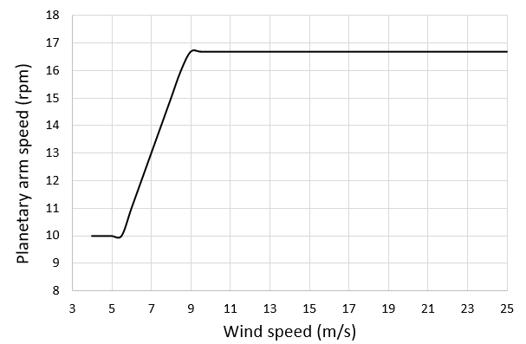
Figure 4.2. 4 Simulated planetary arm speed of V80 2.0M WT with “Optispeed” system [169]
$ω_{R}$ in Equation 4.9 is the rotational speed of the ring gear. In the gearbox of V80-2MW, the ring gear is fixed, which means $ω_{R}$ equals to 0. Thus, Equation 4.9 above can be rewritten as:
$\left|{{(ω}_{S}-ω_{A})}/{ω_{A}}\right|={N_{R}}/{N_{S}}={104}/{22}$ Equation 4.10
In addition, it gives the expression of $ω_{S}$ as:
$ω_{S}={N_{R}}/{N_{S}}∙ω_{A}+ω_{A}=({104}/{22}+1)∙ω_{A}$ Equation 4.11
By substituting Equation 4.11 into Equation 4.8, the final expression of the relationship between $ω_{P}$ and $ω_{A}$ is:
$\left|{{(ω}_{P}-ω_{A})}/{({104}/{22}∙ω_{A})}\right|={22}/{41}$ Equation 4.12
Therefore, with the known $ω_{A}$ value, both $ω_{S}$ and $ω_{P}$ can be calculated. Therefore, the overall number of rolling contact cycles of each loading case listed in Table 4.4 can be determined based on Equation 4.7. It should be noticed that the determination of the input speed $ω_{A}$ for the overloading cases obeys two assumptions here for the computational convenience:
- The planetary arm speed $ω_{A}$ for each loading case defined in Table 4.4 is the average of speeds at different wind speeds included in the case.
- For loading cases Ⅵ and Ⅶ, both two cases describe the WT start-up and shutdown processes. Hence, the speed variations of the planetary arm within each process are extremely complex. To simplify the calculation, this section assumes the variations of $ω_{A}$ in both cases have the linear relationships. In other words, the average planetary arm speed $ω_{A}$ in the start-up or shutdown procedure is assumed to be half of the rated speed $ω_{A_{0}}$ ($ω_{A_{0}}$=16.7 rpm, provided in the wind turbine gearbox design data).
Relevant calculation results for the defined 7 loading cases are listed in Table 4.6. The rated planetary gear speed $ω_{P_{0}}$ given in the wind turbine gearbox design data is 59.1 rpm, which is very close to the calculated rated $ω_{P_{0}}$ of 59.06 rpm in the table. Thus, the calculation process listed in the section is considered as accurate.
Table 4. 6 Number of contact cycles of the planetary bearing under different loading cases (assuming 20 years operation life)
Loading case |  | Average $ω_{A}$(rpm) | Average $ω_{S}$(rpm) | Average $ω_{P}$(rpm) | Number of rolling contact cycles | Percentage of rolling contact cycles
Ⅰ | 4-7 m/s wind speed | 11.05 | 63.29 | 39.08 | 1.50e9 | 17.17%
Ⅱ | 7-9 m/s wind speed | 14.90 | 85.34 | 52.70 | 1.61e9 | 18.35%
Ⅲ | 9-12 m/s wind speed | 16.70 | 95.65 | 59.06 | 2.47e9 | 28.25%
Ⅳ | 12-15 m/s wind speed | 16.70 | 95.65 | 59.06 | 1.00e9 | 11.48%
Ⅴ | >15 m/s wind speed | 16.70 | 95.65 | 59.06 | 1.23e9 | 14.01%
Ⅵ | Normal overloading | 8.35 | 47.82 | 29.53 | 8.39e8 | 9.60%
Ⅶ | Extreme overloading | 8.35 | 47.82 | 29.53 | 1.01e8 | 1.15%
Upwind bearing loading calculation
To calculate the maximum Hertz contact pressure and the half contact length of each loading case, the torque of the rotor needs to be determined at first. In Figure 4.2.5, the modelling results in [169] show that the rotor torque is affected by the wind speed. For loading case Ⅰ to case Ⅴ, the average rotor torques can be determined from the curve in Figure 4.2.5.
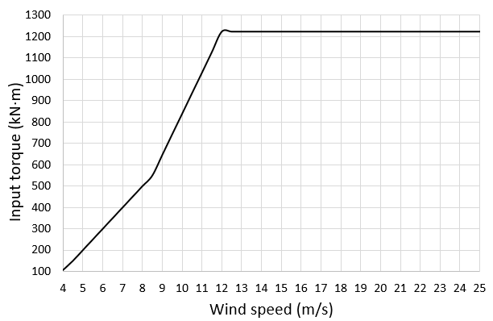
Figure 4.2. 5 Input rotor torque vs wind speed [169]
However, the curve does not contain the rotor torques of the overloading cases. Therefore, two assumptions are made to calculate the rotor torques for the overloading cases.
- For normal overloading (case Ⅵ), it is assumed that the input rotor torque may exceed 33% of the rated input torque. This assumption comes from the computational modelling results in [26]. In the study, it compares the torque differences between the normal operation and shutdown condition of the wind turbine.
- For extreme overloading (case Ⅶ), it is assumed that the maximum input torque acting on the gearbox is 189% of the normal operation. According to a simulation of the emergency braking of a WT in the laboratory environment, the maximum input torque observed is 189% of the rated torque, which causes the forces applied to the gearbox bearings to be well beyond the material fatigue limit [170].
With the known input rotor torque, as shown in Figure 4.2.5, the force acting at the centre of each planet arm ($F_{pl}$) can be computed as (with 3 planetary arms in the gearbox):
$F_{pl}=\frac{T_{rotor}}{3∙(D_{P}+D_{S})}$ Equation 4.13
where $T_{rotor}$ is the rotor torque, $D_{P}$ is the diameter of the planetary gear, and $D_{S}$ is the diameter of the sun gear, as given in Table 4.5. The maximum radial load experienced by the upwind bearing ($Q_{uw}$) is:
$Q_{uw}=F_{pl}∙L_{\%,uw}$ Equation 4.14
$L_{\%,uw}$ is the loading percentage that the upwind bearing undertakes. It is known that the upwind bearing normally takes 40% to 60% more load than the downwind bearing in the planetary gearbox [140][141]. As it is measured in [141], the loading acted on the upwind bearing oscillates from 40% to 70% during the operation. For the computational convenience, $L_{\%,uw}$ used in this chapter equals the mean value obtained in [141], which is 55%. It means that the upwind bearing takes 55% of the overall radial loading, and the downwind bearing takes the other 45% of the loading.
With $Q_{uw}$, the maximum radial load acting on each rolling element in the upwind bearing $W_{max}$ can be calculated as:
$W_{max}=\frac{5∙Q_{uw}}{i∙Z}$ Equation 4.15
In Equation 4.15, $i$ is the number of roller sets in one bearing; $Z$ is the number of rollers within one set. Based on the bearing data in Table 4.5, $Z$ is 26, and the number of rollers sets of the upwind bearing is 2.
By submitting all the known parameters (calculated $W_{max}$, roller length: $L$ = 0.035m, roller radius: $r_{1}$= 0.018 m, inner raceway radius: $r_{2}$ = 0.145 m, 100Cr6 Young’s Modulus: $E$ = 227 GPa) into the Hertz contact equations listed in section 2.3.1, it gives the final calculation results for each loading case, as shown in Table 4.7.
Table 4. 7 Calculated Hertz contact parameters of different loading cases
Loading case |  | Average input torque $T_{rotor}$ (kN$∙$m) | Maximum loading component $W_{max}$ (kN) | Maximum contact pressure $p_{0}$ (GPa) | Half contact length $b$ (mm)
Ⅰ | 4-7 m/s wind speed | 241.1 | 11.9 | 0.92 | 0.236
Ⅱ | 7-9 m/s wind speed | 488.1 | 24.1 | 1.31 | 0.335
Ⅲ | 9-12 m/s wind speed | 955.4 | 47.1 | 1.82 | 0.392
Ⅳ | 12-15 m/s wind speed | 1208.9 | 59.6 | 2.06 | 0.528
Ⅴ | >15 m/s wind speed | 1226.0 | 60.4 | 2.07 | 0.531
Ⅵ | Normal overloading | 1630.5 | 80.4 | 2.39 | 0.613
Ⅶ | Extreme overloading | 2317.1 | 114.2 | 2.84 | 0.730

Summary
This chapter reports the measurements of the material properties of the 100Cr6 steel and the WEA from the damaged microstructure of the planetary bearing raceway. Furthermore, the loading magnitude and the rolling contact cycles during different loading cases are calculated for the upwind WTG planetary bearing in the V80-2MW WT.
Firstly, according to the nano-indentation test results, the elastic modulus of 100Cr6 steel is found to be about 227 GPa. Due to the tempering process during the steel manufacturing, the microstructure of the 100Cr6 material forms into the martensite, which increases the material hardness to approximately 64 HRC.
However, the subsurface WEA, as the structure occurs during the bearing operation process, is proved to have a relatively higher hardness when compared with the martensite steel matrix. According to the nano-sized hardness tests, the hardness of the WEA is found to vary from 9.9 GPa to 16.8 GPa. The observed hardness differences within the WEA may be caused by the nonuniform dissolution of the $({Cr,Fe)}_{3}C$ or the differences between the WEA grain sizes. In addition, some indentations obtained from the test are found to locate in uneven or cracked areas, which will affect the accuracy and the consistency of the hardness measurement.
Secondly, the operation conditions of the V80-2MW WT are divided into seven loading cases, according to the wind speeds and the overloading conditions during the start-up or shut down processes. Based on the calculation results in this chapter, it has been found that the WT may not experience the overload problems during 82% of the operating time. In addition, during the operation period without overloading, the Hertz contact pressure acting on the WTG planetary bearing inner raceway does not exceed 2.07 GPa, which is close to the commonly agreed 2.0 GPa pressure at the rated operation condition of the planetary bearing. For the two overloading cases defined in this chapter, the estimations of the Hertz contact pressure are 2.39 GPa and 2.84 GPa respectively, according to the assumptions determined in [26] and [170].
Because of the varying rotational speed of the WT low-speed shaft during the operation, the overall rolling contact cycles between the rollers and the inner raceway of the planetary bearing are also different for each loading case. According to the calculations in this chapter, it can be shown that about 89.25% of the rolling contact cycles occur when the WT works under the normal loading conditions.

Finite Element modeliing of stress concentration at inclusions
As discussed in Chapter 3, the subsurface damage of the inner raceway is usually initiated by subsurface inclusions, which cause the localised stress concentration areas of the subsurface steel matrix. Under an increased stress level, the accumulation of the material fatigue damage may be accelerated. In this chapter, the stress concentration caused by the subsurface inclusions will be investigated by the FE method. By simulating the stress magnitude and its variation due to an inclusion in the 100Cr6 material under both the static contact pressure and the rolling contact pressure, the possible mechanisms of the subsurface damage due to inclusions will be analysed in detail.

Modelling of Contact Between Roller and Inner Raceway
Modelling in this chapter utilises the commercial finite element (FE) software ABAQUS/CAE 2017 Standard to simulate the contact stress distribution between the roller and raceway under wind turbine loading conditions. Based on the Hertz contact theory discussed in Chapter 2, the maximum Hertz contact pressure caused by the radial load on the inner raceway of a bearing is greater than that on the outer raceway. Therefore, the FE analysis of the stress concentration mainly focuses on the inner raceway.

Contact modelling between raceway and roller
Model geometry and material property definition
Figure 5.1.1 (a) shows the contact between a bearing inner raceway and rollers. It is known that the radial loading acting on the bearing is not equally distributed on the rollers. The centre of the loading zone withstands the highest radial load when compared with the other areas.
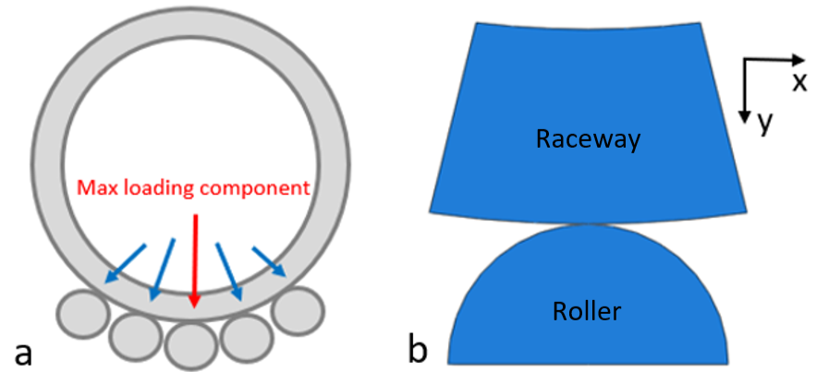
Figure 5.1. 1 Model geometry (a) maximum loading (b) geometry established in ABAQUS
Accordingly, only the contact area withstanding the maximum radial load will be analysed in the section. To reduce the computational time, only part of the raceway and the roller are modelled in ABAQUS. The raceway and roller come from the planetary upwind bearing in the V80-2MW WTG, and the geometries are established in the x-y plane, as shown in Figure 5.1.1 (b). The measurement data of the geometries and loading conditions are listed in Table 5.1, according to the results presented in Chapter 4.
Table 5. 1 Parameter measured for the modelling (V80-2MW WT)
Maximum radial load under WT rated power | 60.4 kN
Roller length | 35 mm
Roller radius | 18 mm
Number of rollers in each set | 26
Inner raceway thickness | 25 mm
Inner raceway radius | 145 mm
Hertz contact half width, $b$ | 0.531 mm
Roller/inner raceway material | 100Cr6/AISI 52100
Based on the indentation test results presented in Chapter 4, the Young’s Modulus of the 100Cr6 steel is 227 GPa and the Poisson’s Ratio is 0.3. In addition, because the raceway is mainly subjected to the compressive loading of the rollers, the material stress-strain curve used should come from its compressive test. The compressive true stress-strain curve applied in this chapter is adopted from [38], as shown in Figure 5.1.2.
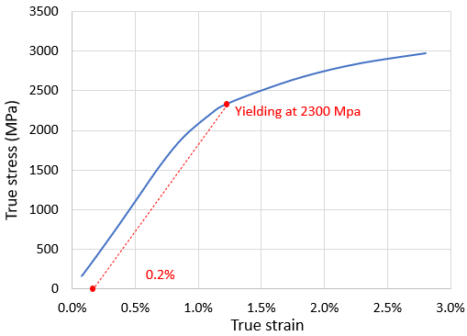
Figure 5.1. 2 True stress-strain curve of 100Cr6 in compressive loading [38]
Moreover, because the length of the roller (35 mm) is much greater than the half contact width $b$ calculated by Hertz theory ($b$ = 0.531 mm), the out-of-plane strain in the z-direction of the raceway and roller can be ignored. Accordingly, the FE elements are defined as the plane strain condition, which helps to reduce the simulation from a 3D problem to a 2D problem. Typically, the plane strain condition is a common method used for the simplification of geometries with much greater out-of-plane dimensions. Compared with the 3D modelling, 2D modelling with the plane strain condition has the following limitations:
- strains in a loaded body are functions of the planar coordinates alone
- normal and shear strains in the out-of-plane direction are equal to zero
Even so, the plane strain condition in FE models greatly reduces the computational cost because the elements in the z-axis direction are not considered anymore. For convenience, all the models presented in this chapter adopt the assumption of the plane strain elements.
Boundary conditions and loading definition
As shown in Figure 5.1.3 (a), to ensure that the boundary conditions do not affect the contact stress distribution, the left and right edges of the inner raceway are only fixed in x and z directions; while the bottom of the roller is completely fixed in all directions which aims to guarantee the stability of the model. Furthermore, considering that the radial force applied to the inner raceway is a distributed loading rather than a point loading, this compressive force is then defined to act on a reference point instead of being applied directly on the inner raceway, as illustrated by Figure 5.1.3 (b). The reference point is kinematically coupled with the upper surface of the inner raceway. Thus, it also helps to avoid the potential stress concentration that may occur on the top surface of the raceway.
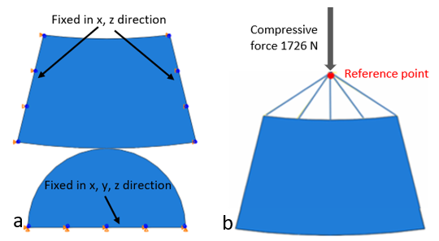
Figure 5.1. 3 FE model (a) boundary conditions (b) applied compressive loading
The rated maximum radial force acting on the roller is known as 60.4 kN, according to Table 5.1. However, considering the plane strain condition applied to the material, this radial force should be divided by the roller length, which is 35 mm. Hence, in this case, the unit radial force for 1 mm default plane strain thickness is calculated as 1726 N, which induces a contact pressure distribution with the maximum pressure of 2.069 GPa. For the consideration of the stability of the model, the compressive force applied will increase linearly according to the step time. In other words, the loading starts from 0 N and rises to 1726 N within 1 second step time.
Meshing methodology
As calculated by the Hertz theory, the half contact width $b$ is 0.531 mm with the applied loading. Due to the small size of the contacting area, very fine meshes are needed to obtain the accurate modelling results. Therefore, the meshing methodology adopts the partition processing method as shown in Figure 5.1.4. The partition areas in the geometrical model have three different mesh types: the structural mesh, the swept mesh, and the free element mesh. According to the model geometries and the required modelling accuracy, the element sizes of these meshing types vary from 0.02 mm to 1mm.
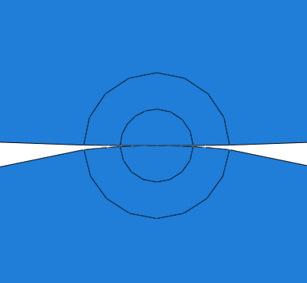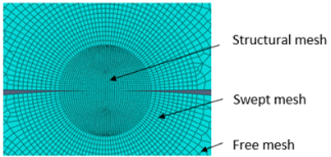
Figure 5.1. 4 Partition and meshing of the geometry
Combination of contact pressure with surface traction
The normal behaviour of the contact between the raceway and roller is defined as “hard” in ABAQUS. The “hard contact” allows the contact pressure to transmit between the contacted areas of the surfaces. Also, in the “hard contact” behaviour, the contact surfaces will separate when the contact pressure reduces to zero [171]. Moreover, as discussed in section 2.3.1, the Hertz contact theory assumes that the contact area is frictionless. Therefore, the tangential behaviour of the contact between the raceway and roller contact surface is also defined as frictionless in ABAQUS.
However, for the actual contact between the raceway and roller, the relative motion between them will cause the surface traction due to frictions. Although such surface traction pressure can be greatly reduced by the lubricant, the traction coefficient during the contact may still range from 0.01 to 0.1, depending on the lubrication condition and the surface roughness [54].
In order not to violate the friction-free hypothesis of the Hertz contact theory, a region with a length of 2$b$ (1.062 mm) is defined on the contact surfaces of the inner raceway and the roller, which is exactly the same as the contact area of the two components under the maximum contact pressure of 2.069 GPa. Meanwhile, as shown by the red and yellow arrows in Figure 5.1.5, the model also defines two traction pressures acting on the contact surfaces between the raceway and the roller. According to the figure, the traction pressures are distributed in the opposite directions, and they both use the traction coefficient of 0.1. Certainly, their distributions follow the definition in Equation 2.14.
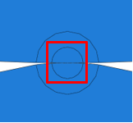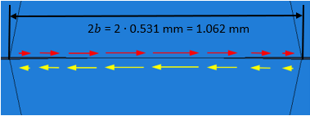
Figure 5.1. 5 Traction pressure on the contact surfaces

Results and discussion of subsurface stress distribution
It is commonly known that the subsurface damage initiation is affected by the shear stress. Therefore, the yielding criterion applied in the modelling is the Tresca theory, which is also known as the maximum shear stress theory. However, the output stress types in ABAQUS cannot show the magnitude of the maximum shear stress directly. Hence, the Tresca equivalent stress, defined by ABAQUS, is used in this chapter to illustrate the subsurface stress magnitudes. In ABAQUS, the Tresca equivalent stress is defined as “the maximum difference between principal stresses”, thus it is twice of the maximum shear stress at the same position. Accordingly, the Tresca stress can reflect both the stress concentration of the subsurface area and the distribution of the maximum shear stress.
Figure 5.1.6 compares the Tresca stress of the contact area with and without the surface traction. It is clear that the Tresca stress slightly increases from 1275 MPa to 1295 MPa when the surface traction is considered. Therefore, the surface traction caused by the friction may not lead to a significant increase in the subsurface maximum shear stress in absence of inclusions.
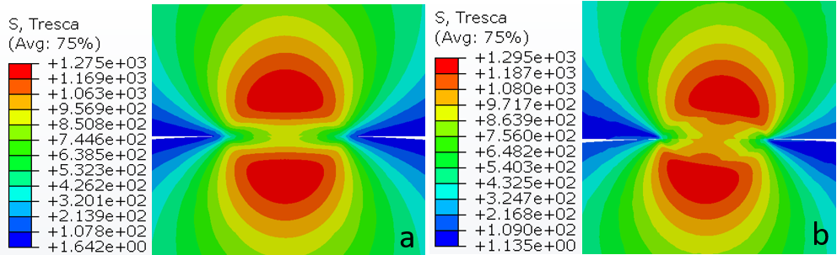
Figure 5.1. 6 Distribution of the Tresca stress modelled by FEM (a) without traction (b) with traction coefficient 0.1
However, the surface traction does change the Tresca stress distribution of the subsurface area. According to Figure 5.1.6 (b), it is obvious that the maximum Tresca stress moves closer to the contact surface when the traction pressure is considered. This result may partly explain why sometimes the damage occurs very close to the contact surface. Furthermore, due to the reduction of depth in the subsurface area where the maximum Tresca stress locates, the propagation distance of the subsurface crack network to the contact surface is also shortened. This means that the raceway surface damage may occur earlier with the surface traction than that without the surface traction.
Apart from the change of the Tresca stress, the subsurface orthogonal shear stress is also changed due to the surface traction as shown in Figure 5.1.7. According to the modelling results, the original orthogonal shear stress changes from (-514 MPa, 514 MPa) to (-584 MPa, 459 MPa). As discussed in section 2.3.2, the variation of the orthogonal shear stress will affect the fatigue life of the material, especially when the inner raceway goes through millions of contact cycles with the rollers.
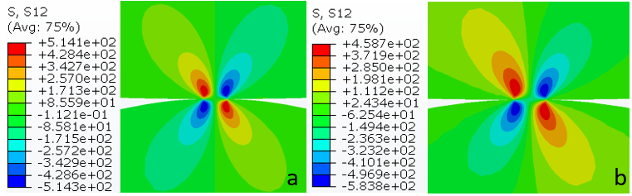
Figure 5.1. 7 Distribution of the orthogonal shear stress modelled by FEM (a) without traction (b) with traction coefficient 0.1

Validation of FE modelling with Hertz contact theory
To verify the effectiveness of the contact modelling between the inner raceway and the roller, the FE results are compared with the calculation using the classic Hertz theory.
According to the equations listed in Section 2.3, MATLAB codes (Appendix B) are developed to calculate the subsurface maximum shear stress. In Figure 5.1.8, two graphs show the calculated ratio of the maximum shear stress to the maximum contact pressure, ${τ_{max}}/{p_{max}}$, in the subsurface of the contact area. $τ_{max}$ means the maximum shear stress, and $p_{max}$ is the maximum Hertz contact pressure which has the value of 2069 MPa for the rated loading application.
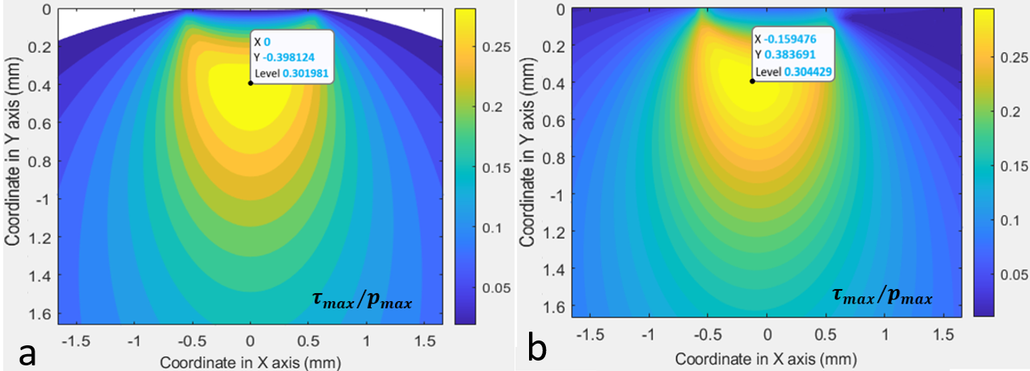
Figure 5.1. 8 Hertz calculation maximum shear stress (a) without traction (b) with traction coefficient 0.1
The values of the maximum shear stress at the middle of the contour (X coordinate = 0) are shown in Figure 5.1.9. For the cases with and without the traction pressure, their subsurface maximum shear stress happens at the depth of about 0.4 mm, and their values are both approximately 640 MPa.
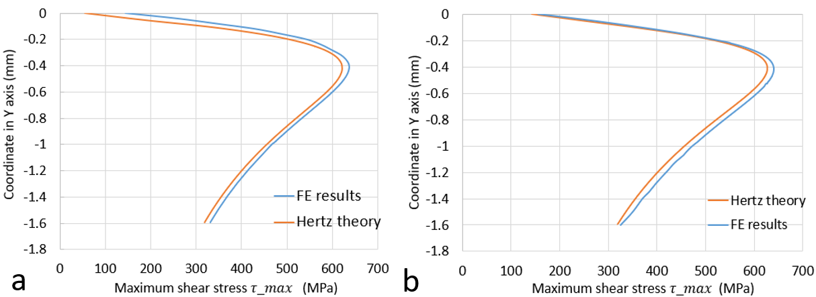
Figure 5.1. 9 Comparison of FE and Hertz calculation of maximum shear stress distribution at X = 0 (a) without traction (b) with traction coefficient 0.1
Further comparison results between the FE modelling and Hertz calculation are listed in Table 5.2. The differences between the FE simulated and Hertz calculated stress results are typically small (below 3%). Therefore, it can be considered that the modelling method and the parameter settings in ABAQUS are correct.
Table 5. 2 Comparison of FE and Hertz calculation results of the locations and magnitudes of the maximum shear stress
Type | Coordinate (mm) | Value (${τ_{max}}/{p_{max}}$)
Maximum shear stress (FE, without traction) | (0, -0.404) | 0.308
Maximum shear stress (Hertz, without traction) | (0, -0.398) | 0.302
Maximum shear stress (FE, with traction) | (-0.135, -0.366) | 0.313
Maximum shear stress (Hertz, with traction) | (-0.159, -0.383) | 0.304

Modelling of Inclusion-induced Stress Concentration Under Static Loading
Non-metallic inclusions are one of the most important initiation factors of the subsurface damage, as discussed in Chapter 2 and Chapter 3. Therefore, this section will analyse the subsurface stress concentration phenomenon caused by inclusions under the Hertz contact pressure. Although the research on the stress concentration is not the same as the research on damage initiation, the stress distribution around an inclusion analysed comprehensively in this section will provide a reference for the subsequent damage research.
Similar to the contact modelling described in section 5.1, the modelling of the stress concentration around an inclusion is based on the Hertz contact behaviour between the raceway and the roller. The only difference is that the FE model in this section has an inclusion located at 0.398 mm depth in the subsurface area beneath the contact pressure. According to the calculation results in the last section, the maximum shear stress occurs at this depth when the rated maximum Hertz contact pressure is 2069 MPa.

FE model development
Definition of the MnS inclusion
Based on the steel cleanliness test in Chapter 3, over 90% of the inclusions in the subsurface area have been identified as the MnS inclusions. Furthermore, most of the butterfly cracks observed by the microscope are also caused by MnS inclusions. Accordingly, only the Type A MnS inclusion will be modelled and analysed in this chapter.
It has been discussed in Chapter 2 and shown in Table 2.3 that this type of inclusion is highly deformable and malleable. Therefore, the plastic deformation of the MnS inclusions will be considered in this chapter. The definition of the MnS inclusion in this study is different from that in some published studies such as [120] and [124]. In both two studies, the inclusions were considered as the perfect elastic material. However, this definition of pure elastic deformation cannot reflect the deformability and the malleability of the MnS inclusions. In addition, it may also result in incorrect simulations of the stress concentration levels because the equivalent stress of the inclusions could exceed 2000 MPa during the FE modelling in some cases.
For the FE modelling in this chapter, the Young’s Modulus used for the MnS inclusion is 120 GPa and the Poisson's ratio is 0.24 [151]. Additionally, according to the nano-indentation test results of the MnS inclusions in [172], the stress-strain relationship of the material after the yielding point is defined, as shown in Figure 5.2.1.
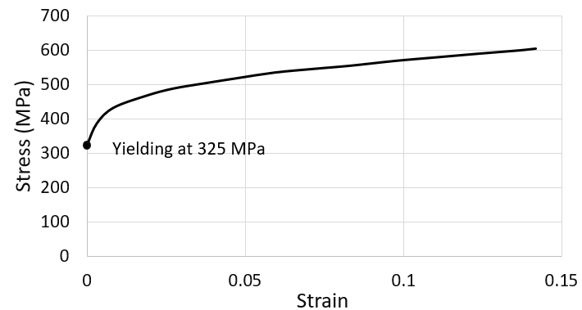
Figure 5.2. 1 True stress-strain curve of MnS inclusions after reaching yielding [172]
Application of the sub-modelling method
Considering the microscopic sizes of the inclusions, the fine meshed elements around the inclusions are needed to obtain detailed and accurate stress distribution modelling results. However, such local fine meshes will lead to convergence problems in the calculation and increase the computational cost of the whole model.
To solve the problems, the sub-modelling method can be utilised. In this method, a global FE model with the relatively coarse meshes should be established firstly to obtain the stress and strain results of the modelling geometry. After that, the local area around the inclusion is modelled as a separated FE sub-model by using fine meshes. The boundary conditions of the area in the FE sub-model are interpolated by the solutions from the global FE model. In other words, the simulation results of the global FE model will be used as the boundary conditions of the sub-model, thus the sub-model with the fine meshes can be simulated as an independent model.
Because the sub-modelling method does not increase the mesh density of the global FE model and it helps to provide an accurate solution of the local area investigated, this method will be applied throughout this chapter. As shown in Figure 5.2.2, the contact modelling between the inner raceway with a MnS inclusion and the roller is set as the global FE model; and in Figure 5.2.2, the square area near the inclusion is selected for the analysis of the sub-model. Figure 5.2.3 shows the partitions and meshing methods of the global model and sub-model respectively. Both models use the meshing type of “medial axis”, but as discussed, they have different mesh sizes according to the simulation accuracy required. For the global model, the mesh sizes are ranged from 0.1 mm to 0.01 mm, depending on their closeness to the inclusion, while the mesh size for all boundaries in the sub-model is set as 0.0001 mm.
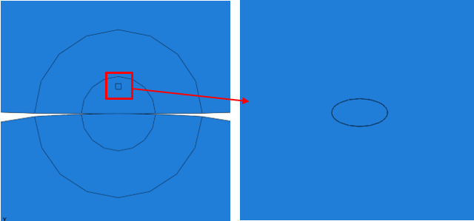
Figure 5.2. 2 Demonstration of the global model and the sub-model
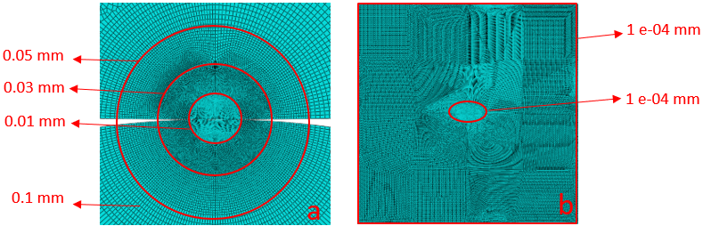
Figure 5.2. 3 Meshing geometry of the global model and the sub-model (a) global model (b) sub-model
Definition of inclusion boundary separation and internal cracking
As observed in Chapter 3, the inclusion may have two different damage types: the boundary separation and internal cracking. Therefore, to investigate the stress concentration caused by inclusions with different damage types, three sub-models are established, as shown in Figure 5.2.4. For the convenience of comparison, the inclusions in this section are all set as MnS inclusions with the aspect ratio of 2 (length to width).
It is assumed that the wind turbine operates under the rated power. Hence, the inclusions are located in the area where the maximum shear stress occurs. This depth is known as 0.398 mm below the surface, when the rated maximum Hertz pressure is 2.069 GPa. Moreover, the surface traction coefficient defined is 0.05, which is the middle value between its maximum value of 0.1 and minimum value of 0.01.
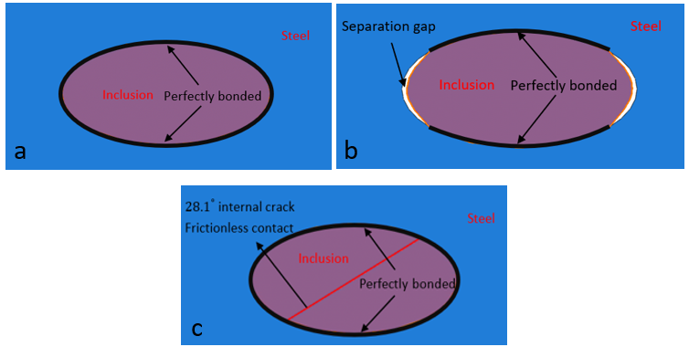
Figure 5.2. 4 Illustration of the sub-model geometries (a) Model A: undamaged inclusion (b) Model B: inclusion with boundary separation (c) Model C: inclusion with internal cracking
In Model A, as shown in Figure 5.2.4 (a), the inclusion boundary is perfectly bonded with the steel matrix, which means that boundary separation will not happen during the loading process. In Model B shown in Figure 5.2.4 (b), an artificially defined boundary separation is created at the tips of the inclusion. Such debonding position can usually be observed in the material subsurface as evidenced in the results presented in Chapter 3. The inclusion separation may be caused during the bearing steel manufacturing, heat treatment, or the previous loading cycles as discussed in Chapter 2. Apart from the separated zones on the boundary, the connection between the inclusion and the steel matrix in other boundary regions is considered to be perfectly bonded. Model C in Figure 5.2.4 (c) simulates the internal cracking damage of the inclusion. Based on the microscope results in Chapter 3, most MnS inclusions with internal cracks have no boundary separation from the steel matrix. Therefore, the inclusion-steel boundary in the sub-model C is also defined as perfectly bonded. In addition, the cracking angle of the inclusion is set as 28.1 degrees, according to the average statistics data obtained in Chapter 3. Because of the occurrence of the internal crack, the contact between both cracking surfaces of the inclusion should be defined. According to the conclusion in [173], the contact between microscopic MnS materials behaves with low friction levels. Therefore, in ABAQUS, this contact between the cracked surfaces of the inclusion is defined as hard and frictionless.

Results and discussions of inclusion induced stress concentration
Model A: Undamaged inclusion
Figure 5.2.5 (a) shows the Tresca stress distribution of the steel matrix and the MnS inclusion separately when the inclusion is undamaged by neither separation nor internal cracking. Comparing the stress values of two tips of the contacted area, due to the stress concentration, a difference can be found that the Tresca stress of the right-hand side (2295 MPa) is a little bit larger than the left-hand side (2282 MPa). As the inclusion is located at the middle of the contacted areas, such difference should be caused by the effect of surface traction. Moreover, according to the principal stress vectors shown in Figure 5.2.5 (b), the maximum principal stress values at the stress concentration area is -1109 MPa (red vector), while the minimum value is -3160 MPa (blue vector). The negative values of the principal stresses indicate that they are both compressive, as shown by the directions of arrows. Therefore, when the inclusion is perfectly bonded with the steel matrix, compressive principal stress is the main stress component causing the stress concentration of the steel matrix.
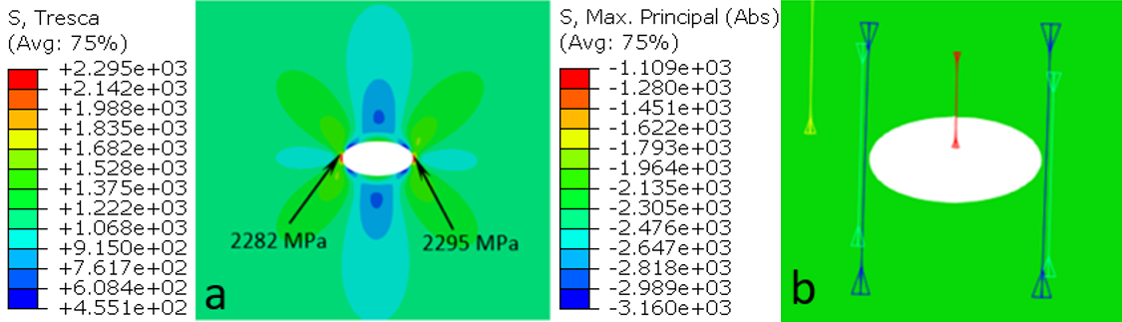
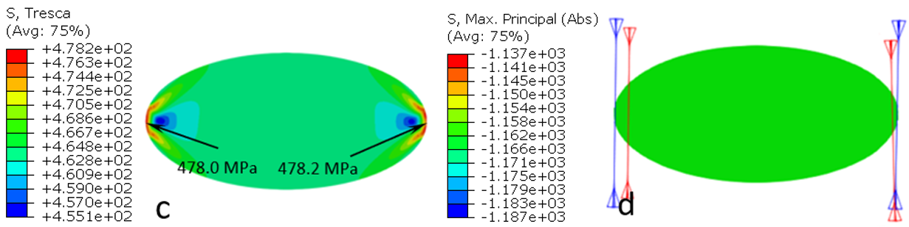
Figure 5.2. 5 Modelling results of the sub-model without the inclusion damage (a) Tresca stress of the steel matrix (b) Absolute in-plane principal stress of the steel matrix (c) Tresca stress of the inclusion (d) Absolute in-plane principal stress of the inclusion
From the Tresca stress distribution of the MnS inclusion shown in Figure 5.2.5 (c), it can be observed that the maximum stresses in the concentration area of the inclusion also occur at the tips, which is similar to the results of the steel matrix. For the inclusion tip on the right, the Tresca stress is 478.2 MPa, which is close to the value of 478.0 MPa on the left. In addition, the principal stresses at the inclusion tips are also compressive, as illustrated by the stress vectors in Figure 5.2.5 (d).
Model B: Inclusion with separated boundary
The stress concentration results caused by the inclusion boundary separation are shown in Figure 5.2.6. It can be seen that the tips of the contact boundary are still the positions where the greatest stress concentraiton levels happen.
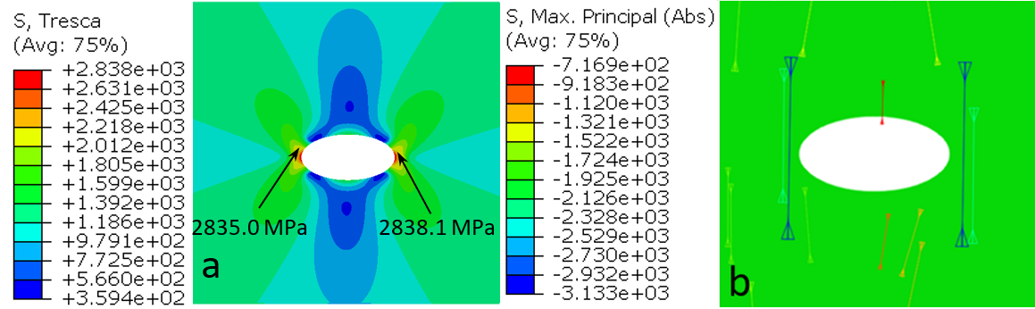
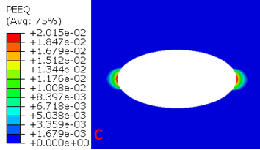
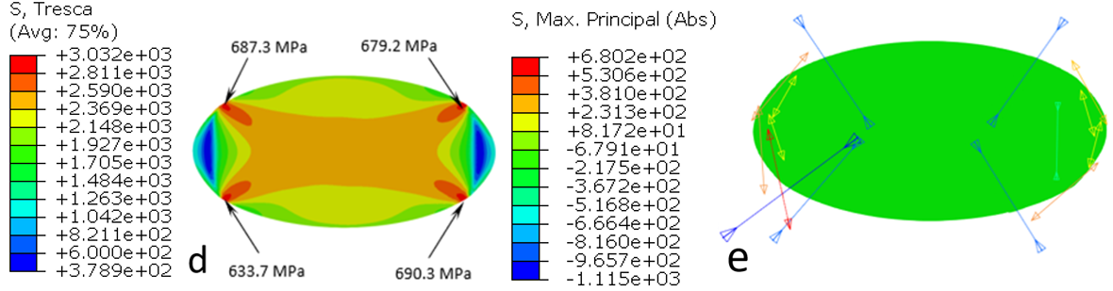
Figure 5.2. 6 Modelling results of the sub-model of inclusion with debonding (a) Tresca stress of the steel matrix (b) Absolute in-plane principal stress of the steel matrix (c) Equivalent plastic strain of the steel matrix (d) Tresca stress of the inclusion (e) Absolute in-plane principal stress of the inclusion
Although the principal stresses are still compressive, but the Tresca stress magnitudes reach 2835 MPa and 2838 MPa separetely, as shown in Figure 5.2.6 (a). These Tresca stresses of the steel matrix are greater than the stresses caused by the undamaged inclusion in Model A. As shown in Figure 5.2.6 (c), the maximum equivalent plastic strain (PEEQ) of the steel matrix is 2.015 %, which indicates the occurrence of the material yielding. Hence, it can be concluded that the inclusion boundary separation is a harmful to the subsurface steel material.
The stress distribution of the seperated inclusion is also different from that in Model A. As can be seen from Figure 5.2.6 (d), the stress concentration regions of the inclusion no longer occur at the tips, but at the four intersection points between the perfectly bonded boundary and the separated boundary. The principal stress vectors in Figure 5.2.6 (e) indicate that these stress concentrations are caused by the contact between the matrix and the inclusion because the orientations of the vectors are approximately vertical to the inclusion-matrix contact surface.
In addition to the compressive stress components, the contact between the inclusion and matrix also results in the tensile stress vectors at multiple locations at the tips of the inclusion. Because the compressive and tensile principal stresses occur simultaneously in a small region of the inclusion bounday, the localised shear stress will be increased. If the shear stress exceeds the inclusion shear strength, the inclusion will be damaged eventually. Microscopic evidence relevant to this conclusion is presented in Figure 5.2.7, where the tips of the inclusions are damaged by the initiation of the boundary separation. The damaged inclusions may finally lead to the formation of the butterfly wings near the seperated inclusion tips, as shown in Figure 5.2.7.
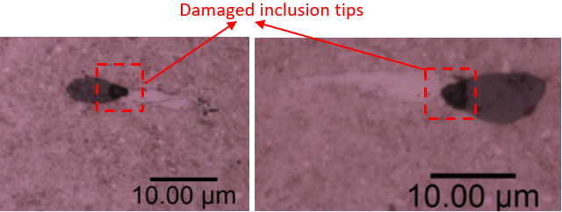
Figure 5.2. 7 Damaged inclusion tips caused by the boundary separation
Model C: Inclusion with internal cracking
Figure 5.2.8 (a) presents the stress concentration results of the steel matrix with an internally cracked inclusion. Compared with the modelling results of the undamaged inclusion in Model A, the internal cracking of the inclusion does not introduce high stress concentration levels to the steel matrix. The maximum Tresca stress at the inclusion-steel matrix contact boundary tip is only 2310.4 MPa, which means it has no obvious plastic deformation within the steel matrix. However, as shown in Figure 5.2.8 (b), the principal stress distribution in Model C is different from that in Model A. It can be observed that the internal crack introduces two tensile principal stress vectors within the steel matrix at the top and bottom boundary areas in contact with the inclusion. Accordingly, due to the occurrence of the tensile principal stresses these areas experience a relatively larger orthogonal shear stress compared with the other areas of the steel matrix, as shown by the red circles in Figure 5.2.8 (c).
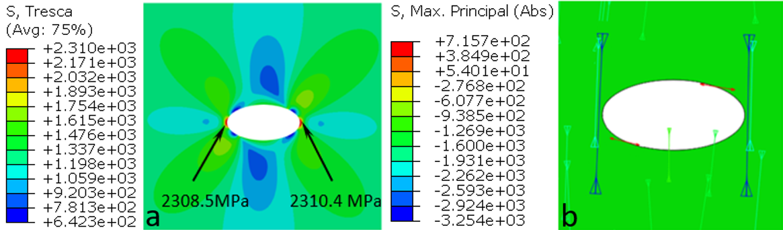
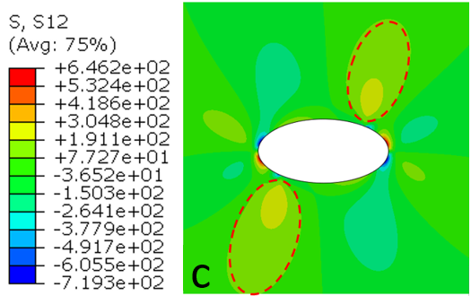
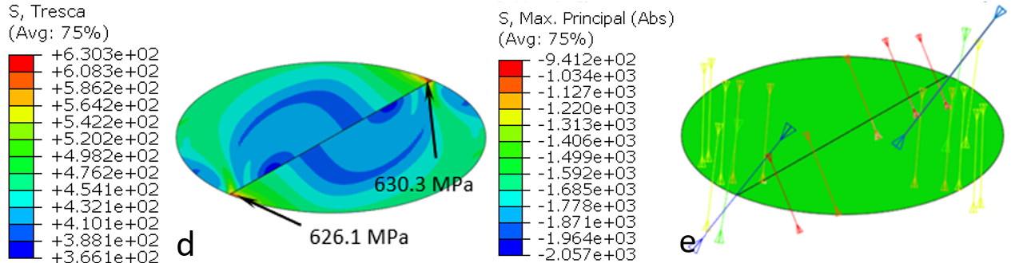
Figure 5.2. 8 Modelling results of the sub-model of inclusion with internal cracking (a) Tresca stress of the steel matrix (b) Absolute in-plane principal stress of the steel matrix (c) Orthogonal shear stress of the steel matrix (d) Tresca stress of the inclusion (e) Absolute in-plane principal stress of the inclusion
With the greater value of the orthogonal shear stress, the fatigue damage accumulation will be accelerated, leading to the final material failure. Microscopic images in Figure 5.2.9 provide further evidence that the steel matrix cracks always initiate from the tips of the inclusion internal crack. The increase of the orthogonal shear stress in these areas may become the possible explanations.
For the stress distribution of the inclusion, it can be seen that the stress concentration happens at the tips of its internal crack. As shown in Figure 5.2.8 (e), the maximum compressive principal stress at the tips exceeds 2000 MPa. Such stress concentration may cause the localised fractures at the tips of the inclusion internal crack, as shown in Figure 5.2.9. This kind of inclusion fracture is similar to that caused by the inclusion boundary separation discussed in Model B. In both cases, the fatigue damage accumulation during the loading will be accelerated.
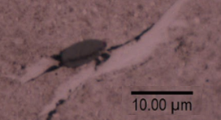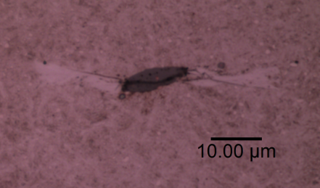
Figure 5.2. 9 Internal crack of inclusions propagated into the steel matrix
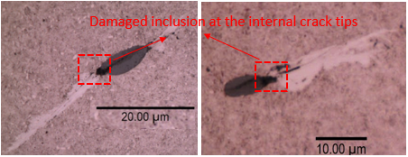
Figure 5.2. 10 Damaged inclusions tips caused by inclusion internal cracking

Validation of FE results by theoretical calculations
The effectiveness of the global FE contact model has been verified in section 5.1.3. Hence, only the FE sub-modelling method developed will be validated by the theoretical analysis. In this section, an elliptical void with the aspect ratio 2 is created at the depth of 0.4 mm beneath the contact surface. The tangential stress alongside the elliptical boundary will be calculated by the FE sub-modelling method and the theoretical calculation respectively for the purpose of comparison.
Figure 5.2.11 shows the maximum in-plane principal stress around the void obtained from the FE sub-modelling. In this case, this stress is tangentially distributed around the boundary of the elliptical void, as illustrated by the vectors. Therefore, this stress is utilised to represent the tangential stress of the elliptical void in the FE modelling.
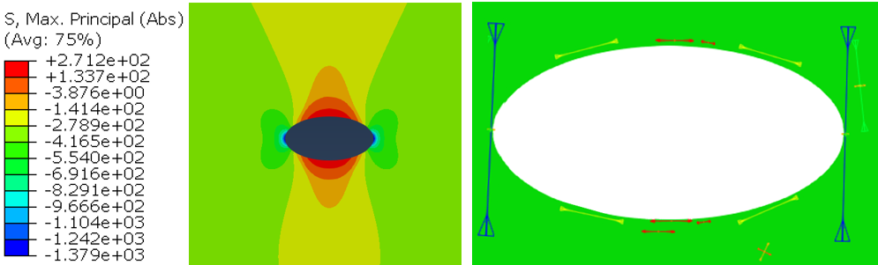
Figure 5.2. 11 FE simulated tangential stress alongside the void boundary
As shown in Figure 5.2.12, for an elliptical void (equation $\frac{x^{2}}{a^{2}}+\frac{y^{2}}{b^{2}}$=1) in an elastic plane with no shearing loading, the tangential stress $σ_{b}$ on the perimeter equals:
$σ_{b}=\frac{σ_{2}\left[m\left(m+2\right){Cos}^{2}α-{Sin}^{2}α\right]+σ_{1}[\left(1+2m\right){Sin}^{2}α-m^{2}{Cos}^{2}α]}{m^{2}{Cos}^{2}α+{Sin}^{2}α}$ Equation 5.1
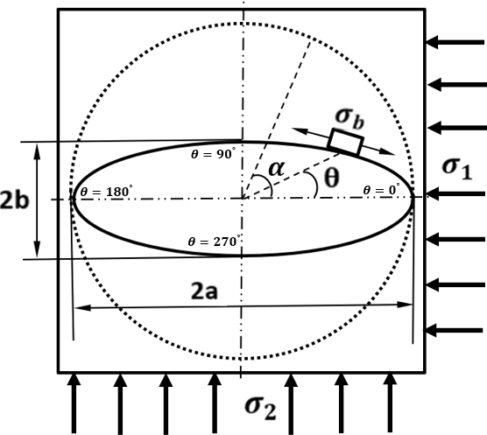
Figure 5.2. 12 Tangential stress $σ_{b}$ of the elliptical void caused by distributed pressures [174]
where $m$ equals to b/a, which is equivalent to the inverse of the aspect ratio of the ellipse; $α$ is the angle of a single point on the boundary of the ellipse; and $σ_{1}$ and $σ_{2}$ are the constant compressive pressures applied to the boundary of the square plane [174].
Because the theoretical calculation is only applicable for the elastic deformation [174], the compressive pressures applied to the model should not cause the plastic deformation of the material. Therefore, the loading acting on the reference point is set as 200 N instead of the rate value of 1726 N presented in section 5.1.1.
Furthermore, Equation 5.1 assumes the pressure applied to the boundary of the square plane is equally distributed. However, according to the FE modelling results shown in Figure 5.2.13, both the stress values in the X and Y directions are not uniformly distributed on the boundary. Thus, the average stress values of the FE square plane boundary in the X and Y directions are calculated as the $σ_{1}$ and $σ_{2}$ parameters in Equation 5.1. According to the FE modelling results shown in Figure 5.2.13, these are: $σ_{1}$ = 13.7 MPa, and $σ_{2}$ = 269.1 MPa.
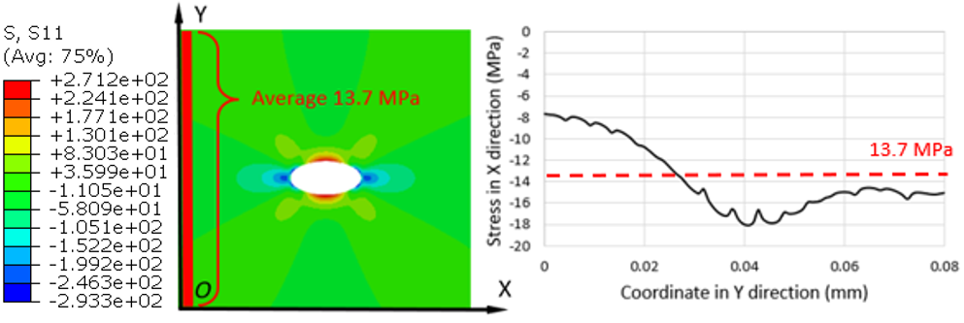
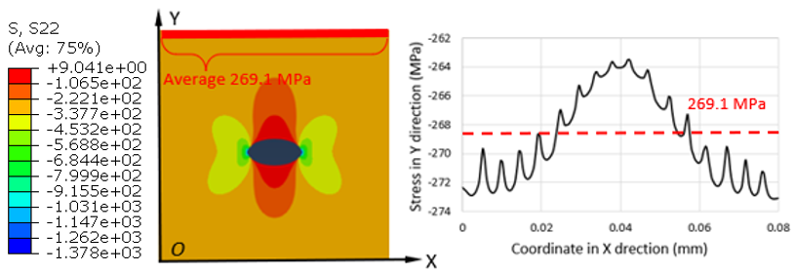
Figure 5.2. 13 FE modelling of stress distribution in X and Y directions
Figure 5.2.14 shows the comparison of tangential stress values around the void boundary between the FE modelling and the theoretical calculation. The computation and plotting processes are completed by creating MATLAB codes shown in Appendix C.
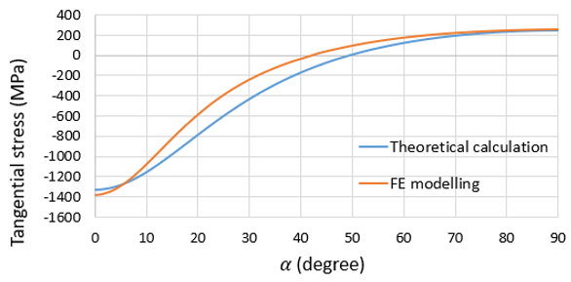
Figure 5.2. 14 Comparison of tangential stress between FE modelling and theoretical calculation
Using specific angle of $α$, the stress variations are compared as presented in Table 5.3. It can be seen that the stress differences at the tips of the void are typically small, but there do exist some distinctions between the FE modelling and the theoretical calculations from the angle ${15}^{°}$ to ${45}^{°}$, and the maximum stress deviation is about 193 MPa. Because the theoretical calculation uses the average values of the compressive stress components, these differences may be caused by the non-uniformly distributed stress of the boundary in the FE modelling. However, considering that the highest magnitude of the maximum tangential stress of the void is about 1379 MPa, the stress difference less than 200 MPa is deemed as acceptable.
Table 5. 3 Comparison of the FEM and theoretical results at some angles
Angle $α$ | $$0^{°}$$ | $${15}^{°}$$ | $${30}^{°}$$ | $${45}^{°}$$ | $${60}^{°}$$ | $${75}^{°}$$ | $${90}^{°}$$
FEM (MPa) | -1380 | -818 | -235 | 45 | 180 | 241 | 262
Theoretical (MPa) | -1332 | -978 | -428 | -69 | 122 | 215 | 241
Difference (MPa) | 48 | 160 | 193 | 114 | 58 | 26 | 21

Taguchi Design for Modelling Effect of Key Parameters on Stress Concentration
According to the microscopic investigation presented in Chapter 3 and the FE modelling results in sections 5.1 and 5.2, stress concentrations initiated by inclusions are probably affected by the following parameters: the magnitude of the Hertz contact pressure, inclusion geometry, inclusion damage types, inclusion depth, and the surface traction. These factors have different degrees of influence on the stress, and there may be some potential interactions between them. Therefore, a Taguchi design of FE models is developed in this section to identify the effects.

Introduction of Taguchi design of experiments
Signal and noise factors
The Taguchi method is developed by Genichi Taguchi in 1954, which aims to improve the quality of the manufactured goods [175]. It determines the optimal combination of the system parameters in order to achieve the desired result of the target output value [175]. When compared with the full factorial experimental design, the Taguchi method simplifies the programme of the experiments by the orthogonal array, which dramatically reduces the number of experiments required.
The main flow of the Taguchi design is shown in Figure 5.3.1. It is known that both the signal factor and noise factor in the design will affect the value of output. Signal factors are defined as the parameters that can be controlled during the experiments; while noise factors are those parameters that cannot be controlled. In the investigation of the stress concentration caused by inclusions, the Taguchi design has six signal factors: the maximum Hertz contact pressure, inclusion aspect ratio, inclusion depth, inclusion inclined angle, surface traction coefficient, and the inclusion damage type.
These signal factors can be changed by the parameter settings in the ABAQUS model definitions. The only noise factor considered in this section is the material property differences between the steel matrix and the inclusion. Because 100Cr6 and MnS have different elastic and plastic behaviours, the effect of the signal factors on the stress concentrations of them may also be different. Meanwhile, such differences cannot be eliminated because they are the inherent properties of the material.
The Signal/Noise ratio (SN ratio) in the flowchart is another important parameter. It measures the robustness of the design of experiments by comparing the effect of the signal factor and noise factor [176]. When the SN ratio is large, the combination of different signal factors minimizes the influence of the noise factors. Similarly, when the SN ratio is small, the effect of noise factors is significant.
Typically, the value of the SN ratio depends on the quality loss function (QLF) that is applied for the calculation. QLF in Taguchi design generally has three types: “larger is better”, “smaller is better”, and “nominal is best” [176]. The selection of the function for a specific Taguchi design usually depends on the desired value of the output. Because this investigation seeks to identify the combination of factors that maximises the effect of the stress concentration, the QLF “larger is better” is selected in this analysis. It also means that the effect of the material differences between the steel and inclusion mentioned above will be weakened to the greatest extent.
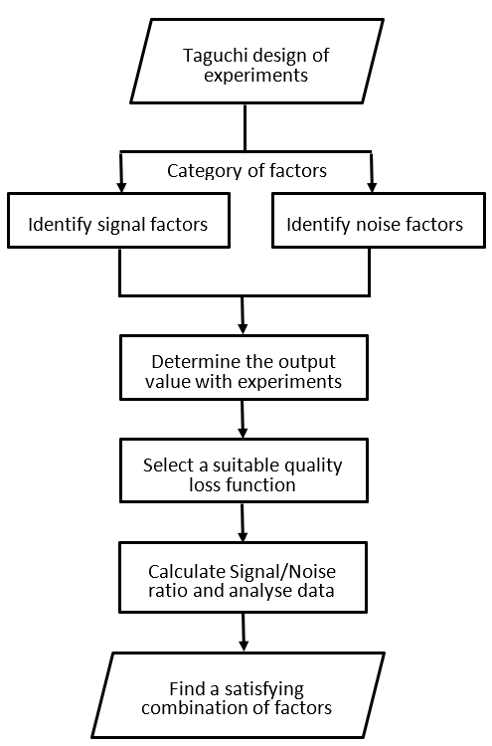
Figure 5.3. 1 Flowchart of the Taguchi design
Table 5.4 shows the detailed parameters applied in the FE models. As observed in Chapter 3, it exists two different damage types of the inclusions affecting the subsurface stress concentration: the boundary separation and the internal cracking. Therefore, this Taguchi design aims to investigate their effect by comparing the stress concentration caused by the damaged inclusion with the undamaged one. Relevant model definitions of different types of inclusion damage have been discussed previously in Model B and Model C in section 5.2.1.
Moreover, according to the microstructural observation in Chapter 3 and some published studies such as [9] and [33], most inclusions embedded within the steel matrix have relative angles to the horizontal plane of the contact surface. The relevant statistics indicate that the inclined angle is typically ranged from $0^{°}$to $45^{°}$. Hence, the effect of the inclusion inclined angle is included in the design with three levels: $0^{°}$, ${22.5}^{°}$, and $45^{°}$. Similarly, the effect of the inclusion depth is also considered with three levels according to the microstructural observation results. In this section, inclusions at the subsurface depth of 0.2 mm, 0.4 mm, and 0.6 mm will be investigated as the formations of the butterfly wings are usually observed in this subsurface depth range.
Table 5. 4 Taguchi design of FE models for investigating stress concentration due to inclusions
Model Number | Max. Hertz contact pressure (GPa) | Inclusion aspect ratio | Sub-surface depth (mm) | Inclusion inclined angle (degree) | Traction coefficient | Inclusion damage type
1 | 0.92 | 1 | 0.2 | 0 | 0.01 | Undamaged
2 | 0.92 | 2 | 0.4 | 22.5 | 0.05 | Separation
3 | 0.92 | 3 | 0.6 | 45 | 0.1 | Self-cracked
4 | 1.3 | 1 | 0.2 | 22.5 | 0.05 | Self-cracked
5 | 1.3 | 2 | 0.4 | 45 | 0.1 | Undamaged
6 | 1.3 | 3 | 0.6 | 0 | 0.01 | Separation
7 | 1.82 | 1 | 0.4 | 0 | 0.1 | Separation
8 | 1.82 | 2 | 0.6 | 22.5 | 0.01 | Self-cracked
9 | 1.82 | 3 | 0.2 | 45 | 0.05 | Undamaged
10 | 2.07 | 1 | 0.6 | 45 | 0.05 | Separation
11 | 2.07 | 2 | 0.2 | 0 | 0.1 | Self-cracked
12 | 2.07 | 3 | 0.4 | 22.5 | 0.01 | Undamaged
13 | 2.38 | 1 | 0.4 | 45 | 0.01 | Self-cracked
14 | 2.38 | 2 | 0.6 | 0 | 0.05 | Undamaged
15 | 2.38 | 3 | 0.2 | 22.5 | 0.1 | Separation
16 | 2.84 | 1 | 0.6 | 22.5 | 0.1 | Undamaged
17 | 2.84 | 2 | 0.2 | 45 | 0.01 | Separation
18 | 2.84 | 3 | 0.4 | 0 | 0.05 | Self-cracked
In addition to these two factors, the aspect ratio of an inclusion also affects the stress concentration, according to the theoretical calculation equation listed in section 5.2.3. Hence, aspect ratios of 1, 2, and 3 are defined in the Taguchi design of FE models to investigate the effect on the stress concentration. In this section, the aspect ratio of 1 means the inclusion is circular with a radius of 2.5 $μm$, and the aspect ratio of 2 means the inclusion is elliptical with the semi-minor axis of 2.5 $μm$ and semi-major axis of 5 $μm$. Similarly, the aspect ratio of 3 indicates that the semi-major axis and semi-major axis of the elliptical inclusion are 2.5 $μm$ and 7.5 $μm$, respectively.
The Hertz contact pressure between the inner raceway and the cylinder roller is calculated in Chapter 4. The contact pressure is defined by six different levels, according to the wind speed and the operating conditions. Based on the data presented in Table 4.5, the maximum contact pressure is defined as 2.84 GPa and the minimum value is set as 0.92 GPa in the Taguchi design of FE models. The definition of the maximum Hertz contact pressure is realised by changing the value of the compressive force acting on the reference point, as shown in Figure 5.1.3 of section 5.1.
The last signal factor to consider is the surface traction, which occurs due to the friction behaviour between the raceway and the roller under the Hertz contact pressure. Figure 5.1.6 shows that the surface traction does change the subsurface stress distribution and it may cause the damage to occur closer to the raceway surface. Therefore, this factor is considered as the signal factor in the Taguchi design for its potential influence on the stress concentration. Because the maximum traction coefficient is normally known as 0.1 and the minimum is 0.01 in WTG bearing applications, the coefficient applied in the Taguchi design of FE models has three levels: 0.01, 0.05, and 0.1. Relevant definition of the surface traction has been illustrated by Figure 5.1.5.

FE modelling results and analysis of the effect of key parameters
FE modelling results of the Tresca stress
As mentioned in the last section, the material property differences are considered as the noise factor in the Taguchi design of the FE models. For the stress concentration, both the stress magnitudes of the steel matrix and inclusions are affected by signal factors, but the concrete trends may be slightly different due to the material properties. In order to reduce the influence of material properties on the stress concentration analysis, the Taguchi design adopts the “larger is better” function, which means that the effect of the noise factor is desired to be minimised.
Table 5.5 shows the stress concentration modelling results of the Taguchi design. The detailed stress distribution contours can be found in Appendix D. The outputs in the table show the maximum Tresca stress obtained from each model in the Taguchi FE design, which represents the stress concentration level of the steel matrix and the inclusion respectively. As discussed in section 2.3.2, the maximum shear stress value is normally used to identify the subsurface stress concentration areas. Hence, the Tresca stress in ABAQUS is applied here as an alternative.
Table 5. 5 FE modelling results of Tresca stress in the Taguchi design
Model Number | Steel matrix maximum Tresca stress (MPa) | Inclusion maximum Tresca stress (MPa)
1 | 871 | 343
2 | 1623 | 551
3 | 1203 | 545
4 | 1633 | 510
5 | 1483 | 416
6 | 2270 | 556
7 | 2395 | 589
8 | 1945 | 601
9 | 1943 | 432
10 | 2333 | 580
11 | 2208 | 557
12 | 2305 | 524
13 | 2357 | 607
14 | 2333 | 493
15 | 3550 | 764
16 | 2383 | 507
17 | 3328 | 694
18 | 2731 | 689
Analysis of the effect of signal factors
With the assistance of the commercial statistical software Minitab, the analysis results of the signal/noise ratios calculated with the “larger is better” quality loss function (QLF) is shown in Figure 5.3.2.
The delta value in the figure means the difference between the maximum and minimum mean SN ratios. By ranking the delta value, it can be found that, with the given levels of the signal factors, the parameters that have the greatest influence on the stress concentration are the magnitude of the Hertz contact pressure and the inclusion damage types.
To conduct a more detailed comparison of the signal factor effectiveness, the P-value of each signal factor is also calculated by the Minitab software, which is shown in Table 5.6. P-value is defined as the measurement of the strength of the signal factor. A smaller P-value means the signal factor has a stronger effect on the output. These results will be explained in detail in the following discussions.
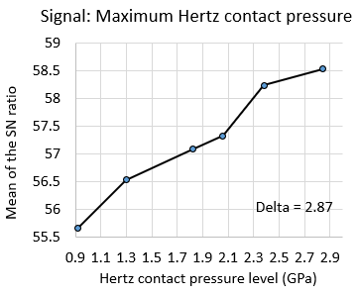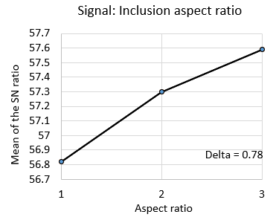
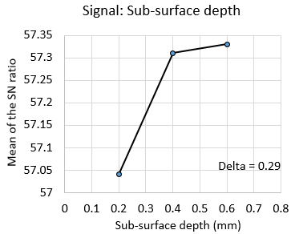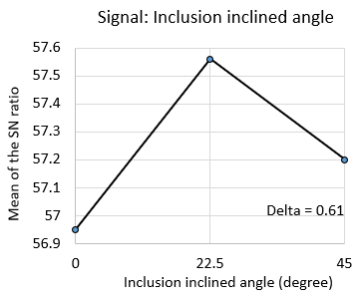
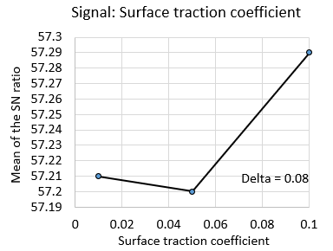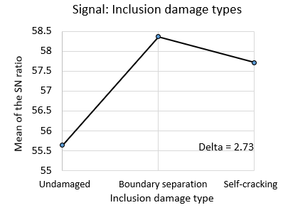
Figure 5.3. 2 Analysis of the mean SN ratio based on the “larger is better” QLF
Table 5. 6 P-values of the signal factors
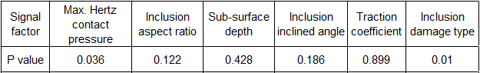
Effect of the Hertz contact pressure and the inclusion damage
From the P-value results in Table 5.6, it can be concluded that the inclusion damage is the most important factor affecting the subsurface stress concentration, followed by the Hertz contact pressure, aspect ratio, inclined angle. However, subsurface depth and the surface traction coefficient are factors that have less influences.
Compared with other parameters, P-values of the Hertz contact pressure and the inclusion damage type are typically small, which means that their effect on the stress concentration is dominating. These analysis results indicate that the bearing overloading is an important reason for its subsurface stress concentration, especially when the inclusions are damaged by the separated boundaries and internal cracks. Compared with the boundary separation, the stress concentration level caused by the internal cracking of an inclusion is relatively low, as shown in Figure 5.3.2
Effect of the inclusion aspect ratio and the inclined angle
The aspect ratio and the inclined angle of the inclusion are two parameters that have a medium impact on the stress concentration. According to the SN ratio of the inclusion aspect ratio in Figure 5.3.2, with the increase of the aspect ratio, the maximum Tresca stress levels of both the steel matrix and the inclusion increase correspondingly. Therefore, it can be concluded that the circular inclusions are less likely to cause the subsurface damage compared with the elliptical inclusions. According to the statistical analysis of the microstructural results in Chapter 3, only 8 of the 114 butterflies observed are associated with the circular or nearly circular inclusions.
As for the effect of the inclusion inclined angle, the FE modelling results show that when the inclusion has an angle of ${22.5}^{°}$, the stress concentration caused by them will reach the maximum value. In all the butterflies observed from the microscopic investigation, 87 butterflies have the inclined inclusions. In these butterflies, 39 inclusions observed from the middle of the butterflies have the angle of approximately ${20}^{°}$ degrees, which accounts for 45% of the inclusions.
Effect of the inclusion depth
Generally, the effect of the inclusion depth does not show a strong effect on the stress concentration. Based on the mean SN ratios in Figure 5.3.2, the inclusion with the subsurface depth of 0.6 mm has the greatest influence on the stress concentration. This result is not absolutely correct because the maximum subsurface Tresca stress is affected by the interactions between the maximum Hertz contact pressure and the inclusion depth in the subsurface area.
For the maximum Hertz contact pressure on the raceway under the rated condition, the maximum Tresca stress/shear stress occurs at the subsurface depth of 0.398 mm; while for the extreme overloading case, this depth becomes 0.567 mm because of the increased Hertz contact pressure from 2.07 GPa to 2.84 GPa. Accordingly, the inclusion at the depth of 0.4 mm to 0.6 mm may all have the risk of generating fatigue cracks. From another point of view, the extreme overloading only takes 1.15% of the overall operation times, while the rated loading condition takes 11.48 % of the overall operation times according to the data in Table 4.4. Hence, the stress concentration caused by inclusions at the depth of 0.4 mm still needs to be noticed.
To study the effect of the most influencing combination of these factors on the stress concentration, the analytical calculation of the Taguchi design automatically considers the depth of 0.6 mm as a more influencing level than the depth of 0.4 mm due to the dominating effect of the Hertz contact pressure of 2.84 GPa. As shown by the interaction plotting in Figure 5.3.3, the mean SN ratio of the 0.6 mm depth increases dramatically from 53 to 59.7, when the maximum Hertz contact pressure changes from 0.92 GPa to 2.86 GPa. It means that the interaction between them may affect the stress analysis results in the Taguchi design.
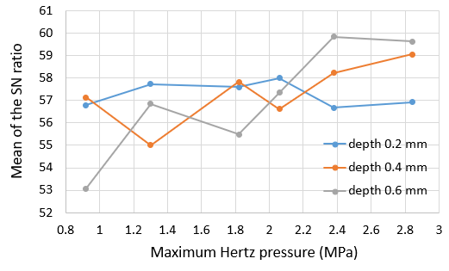
Figure 5.3. 3 Interaction plotting between the inclusion depth and the Maximum Hertz contact pressure
Effect of the surface traction coefficient
As listed in Table 5.6, the P-value of the surface traction coefficient is 0.899, which means that this signal factor does not have a significant effect on the stress concentration. However, some investigations such as [48] and [54] still emphasise the importance of surface traction because it reduces the formation time of the subsurface damage. It has been discussed in section 5.1.1 that the surface traction changes the position of the maximum shear stress and magnitude of the subsurface orthogonal shear stress. The former makes cracks to form closer to the contact surface, while the latter accelerates the fatigue damage accumulation.

Modelling of Stress Variations Under Rolling Contact Loading
From section 5.1 to section 5.3, the loading condition acting on the raceway is defined as the concentrated loading which locates on a reference point coupled with the inner raceway. This is because only the stress concentration caused by the compressive loading is investigated in these sections. However, the actual contact between the inner raceway and the rollers is known as the rolling contact behaviour. Therefore, in this section, a dynamic loading condition is developed which moves the distributed Hertz contact pressure from the left-hand side to the right-hand side of the raceway, as illustrated by Figure 5.4.1. In addition, the geometry of inner raceway has been simplified to a rectangle for the convenience of applying the moving pressure distribution. This dynamic rolling contact model simulates a more realistic contact between the inner raceway and the rollers, and it provides the possibility to investigate the subsurface stress variation of the steel matrix under the rolling contact loading condition.
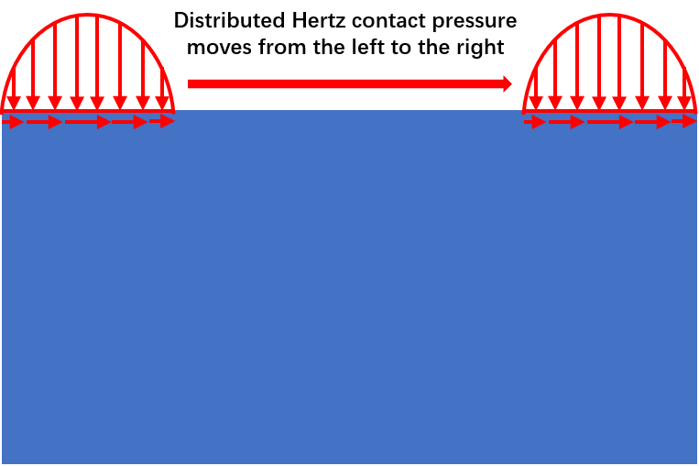
Figure 5.4. 1 Illustration of the rolling contact condition on the raceway
To realise the rolling contact loading in ABAQUS, two user subroutines are used to define the required loading conditions. The first one is the DLOAD subroutine, which states the magnitude and movement of the Hertz contact pressure distribution on the raceway surface. The second subroutine is UTRACLOAD, which defines the traction pressure distribution on the raceway surface due to the frictions. Both subroutines are written by the FORTRAN language and the detailed codes can be found in Appendix E.

FE model and meshing methodology
The FE model simulates the subsurface stress variation under the rolling contact condition is established as shown in Figure 5.4.2. In this model, the simplified rectangle bearing raceway has a width of 8$b$ (4.248 mm) and a depth of 4$b$ (2.124 mm), where $b$ is the half contact width between the raceway and roller in Hertz contact theory. It equals to 0.531 mm when the rated loading condition is assumed. The material properties assigned for the raceway are the same as 100Cr6 material defined in the previous sections. In addition, the Hertz contact pressure distribution with a maximum contact pressure of 2.069 GPa is applied on the surface of the raceway, which is accompanied by a traction pressure with the coefficient of 0.05.
The inclusion in this model is defined as an MnS inclusion with the aspect ratio of 2 (major axis of 10$μm$ and minor axis of 5$μm$). Moreover, it is located in the middle of the rectangle raceway steel matrix with a subsurface depth of 0.398 mm. To ensure the stability of the modelling, two steps are defined in ABAQUS. During the first step of 0.001 seconds, the Hertz contact pressure distribution increases linearly from 0 MPa to 2.069 GPa at the left-hand side of the rectangle. In the second step, the contact pressure distribution will move from the left to the right with a constant speed of 6$b$/s. Accordingly, considering the raceway length of 8$b$, the overall modelling time is 1.001 seconds with the combination of both step 1 and step 2. The positions of the Hertz pressure distribution with the traction pressure at 0.001s, 0.501s, and 1.001s are shown in Figure 5.4.2.
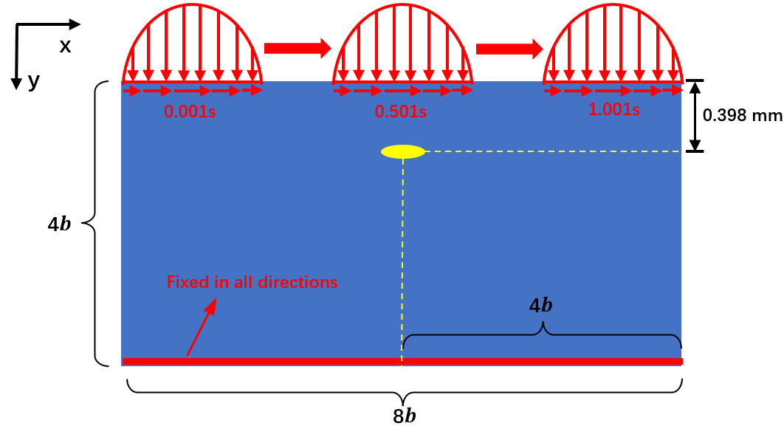
Figure 5.4. 2 Raceway FE model under the rolling contact loading condition
To obtain an accurate stress distribution around the inclusion, the sub-model method is utilised again in this section. As shown in Figure 5.4.3, the global model is divided into different partitions to facilitate the mesh divisions in the FE modelling. In addition, a square partition with a distance of 30 $μm$ to the inclusion centre is selected as the sub-model. The meshed elements of both the global model and the sub-model are shown in Figure 5.4.4. All the partitions in this section use meshed element type of the medial axis, but their element sizes are different, as labelled in Figure 5.4.4.
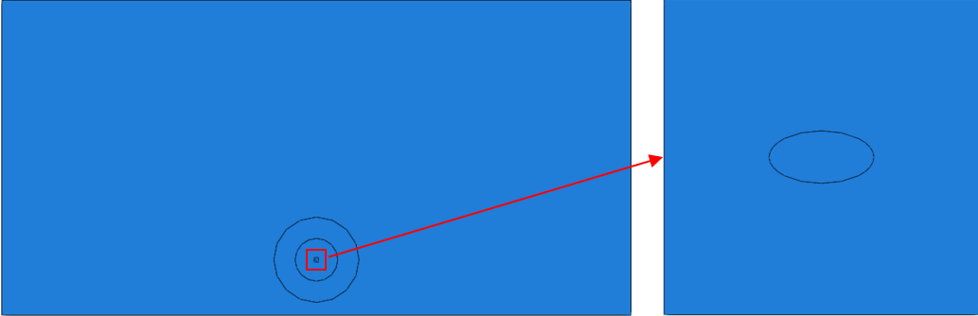
Figure 5.4. 3 Geometry of the global model and the sub-model
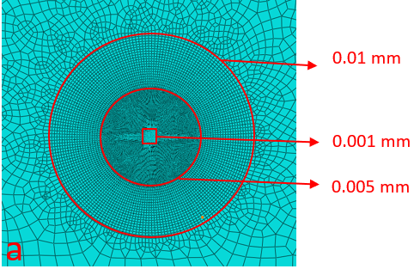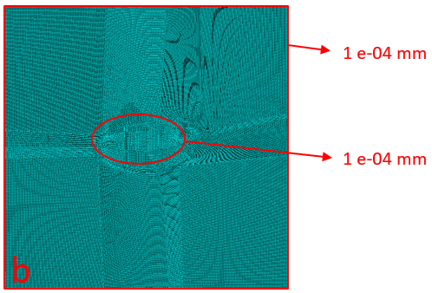
Figure 5.4. 4 Meshing methodology of the global model and the sub-model (a) global model (b) sub-model
Moreover, to investigate the effect of the inclusion damage types on the subsurface stress variation, three models with the undamaged inclusion (Model D), boundary separated inclusion (Model E) and the internally cracked inclusion (Model F) are established separately according to the definitions presented in Figure 5.2.3. These models have no differences in the geometries and the modelling definitions, except for the inclusion damage types.

Analysis of stress variation results around subsurface MnS inclusion
The purpose of investigating the stress variation around the MnS inclusion is to identify the possible damage initiation positions of the steel matrix. Therefore, the results presented and discussed in this section will only focus on the stress distribution within the subsurface steel material instead of the MnS inclusion.
Model D: Undamaged inclusion under rolling contact
Figure 5.4.5 shows the maximum in-plane principal stress variation during the rolling contact process when the inclusion is undamaged. It can be seen that at 0.001s, when the Hertz contact pressure increases to 2.069 GPa, the loading introduces a tensile principal stress with the magnitude of 225 MPa to the steel matrix around the inclusion. With the movement of the Hertz contact pressure distribution on the raceway surface, the maximum principal stress around the inclusion tip starts to change from tensile to compressive and it reaches a maximum compressive stress value of 3055 MPa at the time of 0.501s. After the Hertz contact pressure moves to the right part of the raceway surface, the orientation of the principal stress changes again. The tensile stress can be observed once more within the steel matrix, at the time of 0.751s. And this tensile principal stress still exists, even when the Hertz contact pressure reaches the right end of the raceway at the time of 1.001s.
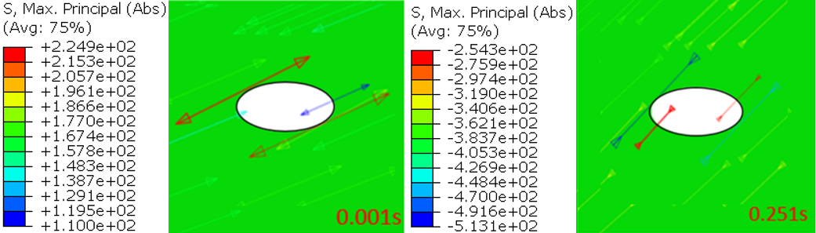
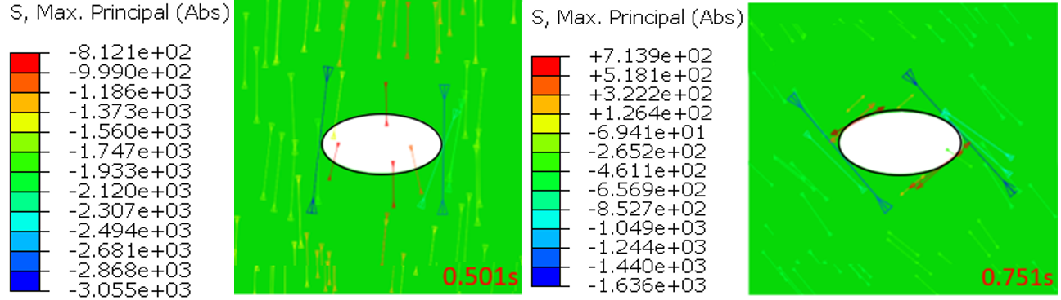
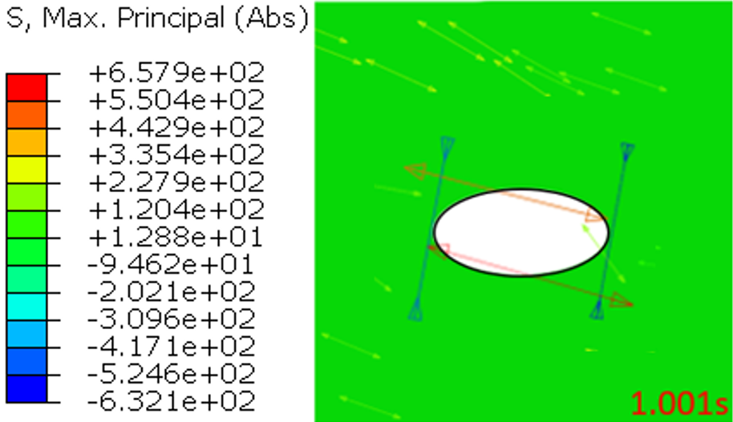
Figure 5.4. 5 Maximum in-plane principal stress variation of the steel matrix with the undamaged inclusion in Model D
Comparing the maximum principal stress vectors at the start and the end of the loading process, it can be seen that both the compressive and tensile vectors occur around the inclusion at 1.001s. However, at 0.001s, the principal stress only has the tensile vectors. In addition, the magnitudes of the compressive and tensile principal stress values at 1.001s are 632 MPa and 658 MPa respectively, which are also greater than the stress values at 0.001s.
Normally, the residual stress developed by the non-uniform plastic deformation of the material will affect the orientations and magnitudes of the principal stresses. However, in this case, the FE modelling results indicate that the equivalent plastic strain of the steel matrix is zero. Therefore, the unusual variation of the principal stresses at 1.001s should be caused by the plastic deformation of the MnS inclusion. Because the inclusion boundary is perfectly bonded with the steel matrix, the permanent plastic deformation of the inclusion will also lead to the deformation of the steel. As a result, the subsurface stress distribution of the steel matrix is affected due to the “passive deformation”.
To further understand the subsurface stress variation, Figure 5.4.6 (a) defines four specific points on the contacted boundary of the steel matrix that may have obvious stress variations during the rolling contact process. As can be seen from Figure 5.4.6 (b), the maximum Tresca stress at points 3 and 4 occurs at about 0.35s and 0.65s, when the Hertz contact pressure applied does not act directly above the inclusion. However, when the Hertz contact pressure moves to the middle of the raceway surface, point 1 and point 2 become the areas with the greatest Tresca stresses. This finding is the same as the stress concentration results discussed in Figure 5.2.5 of section 5.2.
The variations of the maximum in-plane principal stress at each point are shown in Figure 5.4.6 (c). For point 1 and point 2, the principal stress is compressive during the most period of the rolling contact process. However, the maximum principal stress at point 3 and point 4 changes from compressive to tensile abruptly after about 0.65s. Because the change of the principal stress from compressive to tensile occurs in a period smaller than the minimum incremental step defined in the finite element model (0.02s for the rolling contact process in this case), the diagram shows sudden changes of the stress magnitudes.
Typically, the alteration of the principal stress from compressive to tensile indicates the variation of the orthogonal shear stress. To compare the orthogonal shear stress ranges of the selected points, corresponding data is plotted in Figure 5.4.6 (d).
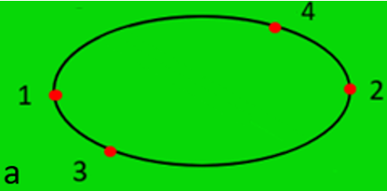
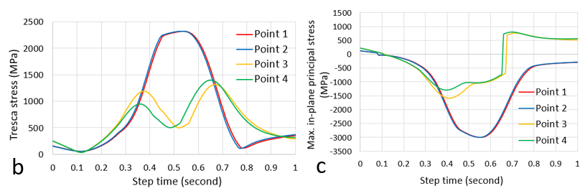
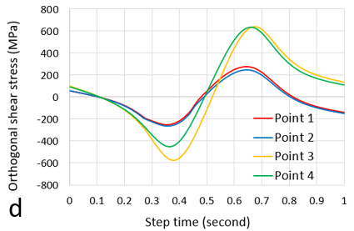
Figure 5.4. 6 Stress variations at specific positions defined in Model D (a) definition of the points (b) Tresca stress (c) Maximum in-plane principal stress (d) Orthogonal shear stress
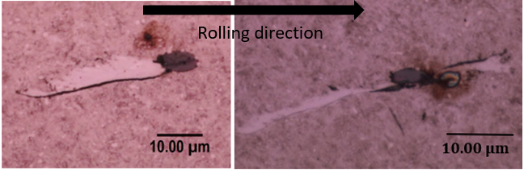
Figure 5.4. 7 Inclusions with cracks initiated from the inclusion boundaries instead of the inclusion tips
Based on the modelling results, the orthogonal shear stress of point 3 and point 4 varies from −600 MPa to 600 MPa, which means that they have greater orthogonal shear stress ranges compared with point 1 and point 2. As discussed in section 5.1.2, a larger orthogonal shear stress variation range usually results in a reduction of the material fatigue life. Therefore, the areas at point 3 and point 4 may have a higher risk of fatigue damage. As shown in Figure 5.4.7, microstructural evidence obtained by the microscope demonstrates that some butterfly wings do not initiate exactly from the tips of the inclusion but from the boundary. This phenomenon can be explained by the differences in the orthogonal shear stress variation ranges as discussed.
Model E: Inclusion with the boundary separation under rolling contact
According to the principal stress shown in Figure 5.4.8, the stress variation caused by the separated inclusion is different from that caused by the undamaged inclusion.
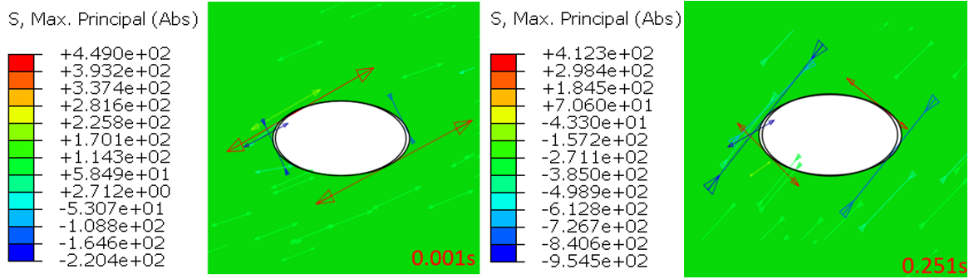
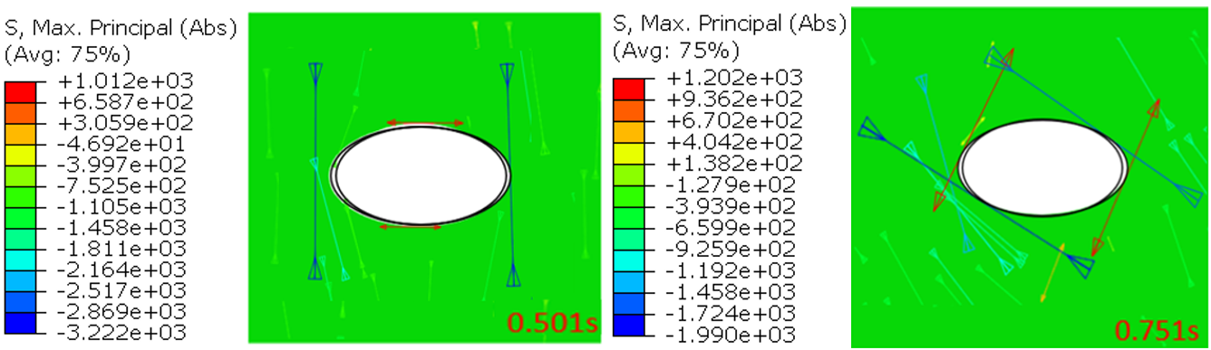
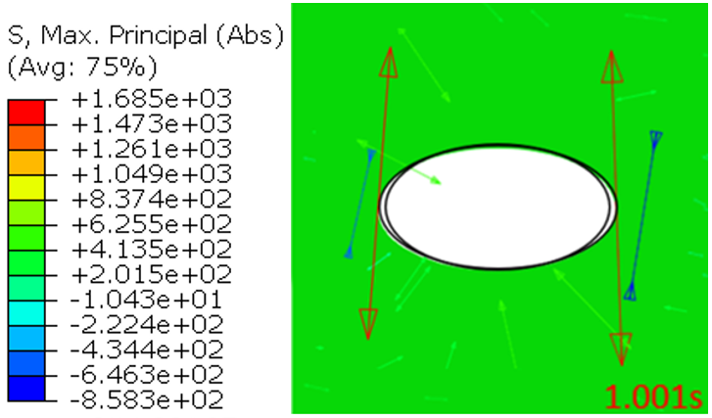
Figure 5.4. 8 Maximum in-plane principal stress variation of the steel matrix with the boundary separated inclusion in Model E
It can be observed at 0.001s that the void gaps between the steel matrix and the inclusion introduce the compressive principal stresses to the steel matrix. With the movement of the Hertz contact pressure, the principal stresses change from compressive to tensile. It can be seen from 0.251s to 1.001s that the magnitude of the maximum tensile principal stress starts to increase sharply from 412 MPa to 1685 MPa. Meanwhile, its position also changes. The modelling results indicate that the tensile principal stress moves alongside the inclusion-steel boundary and finally stops at the tip of the inclusion.
By comparing the change of maximum principal stress during rolling contact with that under the static Hertz loading (Figure 5.2.6 (b) in Section 5.2.2), it can be found that the tensile principal stress only occurs during the rolling contact process. FE results suggest that this difference should be caused by the combined effect of the plastic deformations of the steel matrix and the inclusion. As shown in Figure 5.4.9, the equivalent plastic strain of steel reaches a maximum value of 2.21% during the rolling contact process, which indicates the occurrences of the localised plastic deformation and the possible residual stress. In addition, as discussed in Model D, the plastic deformation of the inclusion will also affect the stress distribution of the steel matrix through the inclusion-steel matrix boundary contact. Therefore, in Model E, the subsurface stress distribution of the steel matrix is complicated, due to the effect of the plastic deformations within both materials.
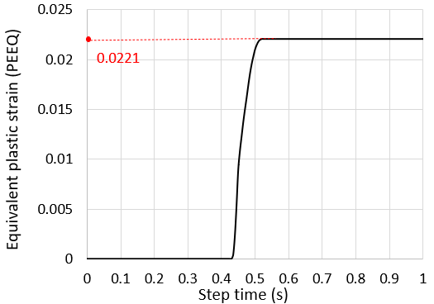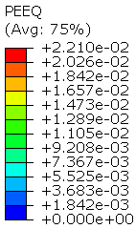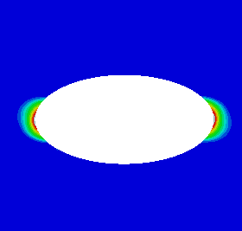
Figure 5.4. 9 Maximum equivalent plastic strain (PEEQ) time history of the steel matrix
To investigate the subsurface stress variation of Model E in detail, Figure 5.4.10 (a) selects four points from the steel matrix on the inclusion-steel boundary. As shown in the figure, points 1 and 2 locate at the inclusion tips, while points 3 and 4 locate at the ends of the perfectly bounded steel-inclusion interface. It can be seen from Figure 5.4.10 (b) that the maximum Tresca stress at points 1 and 2 exceeds 2800 MPa at the time of 0.55s. While the maximum Tresca stress recorded at points 3 and 4 is only about 2100 MPa at the time of 0.35s. This finding with the rolling contact loading condition in Model E is the same as the finding discussed in Model B that the inclusion tips are the areas with the highest stress concentration level when the inclusion has the separated boundary.
The variations of the maximum principal stresses are shown in Figure 5.4.10 (c). The stress at point 1 and point 2 changes from compressive to tensile at the time of 0.72s. However, for point 3 and point 4, the situation becomes complex. The principal stress is tensile at the beginning of the rolling contact process, then it becomes compressive at 0.13s, and finally, it changes into tensile again at about 0.8s. Generally, the variation ranges of the principal stress at point 1 and 2 are still greater than that of point 3 and 4 because of the higher principal stress levels.
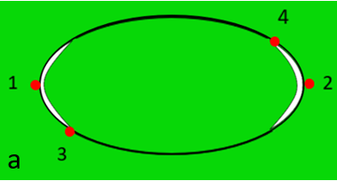
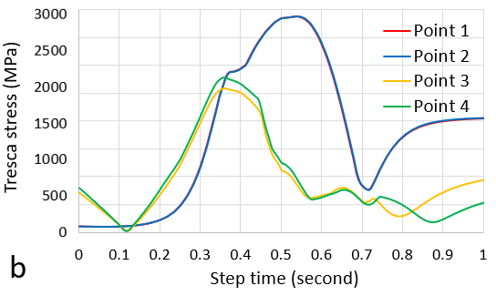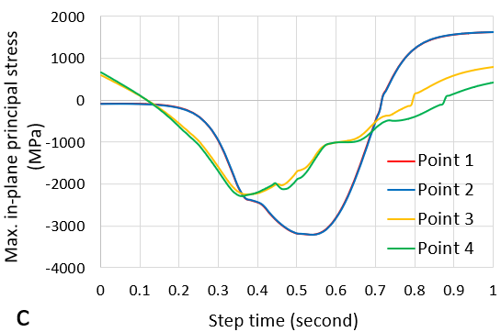
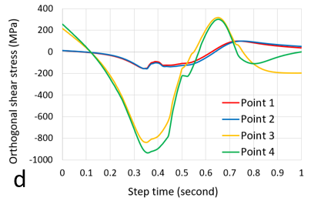
Figure 5.4. 10 Stress variations at specific positions defined in Model E (a) definition of the points (b) Tresca stress (c) Maximum in-plane principal stress (d) Orthogonal shear stress
In addition, as shown in Figure 5.4.10 (d), although points 1 and 2 have the higher stress levels, multiple changes of the principal stress direction from positive to negative (vice versa) indicate that the amplitudes of the orthogonal shear stress variation at points 3 and 4 are greater than those at points 1 and 2. Therefore, it may suggest that the fatigue damage may initiate firstly from the areas at point 3 and 4. This finding is consistent with the FE analysis results in Model D.
Model F: Inclusion with the internal crack under rolling contact
The principal stress variation in Model F is different from that in Models D and E, as illustrated by Figure 5.4.11. Due to the internal crack within the inclusion, the tensile maximum principal stresses occur on the boundary of the steel matrix that is in contact with the crack tips from the beginning of the rolling contact process to the time of 0.501s. With the continuous movement of the contact pressure from the middle of the raceway surface to its right end, the direction of the principal stresses at the internal crack tips change from tensile to compressive, at the time of 0.751s. After that, at the time of 1.001s, both the compressive and tensile principal stresses can be observed in the boundary region.
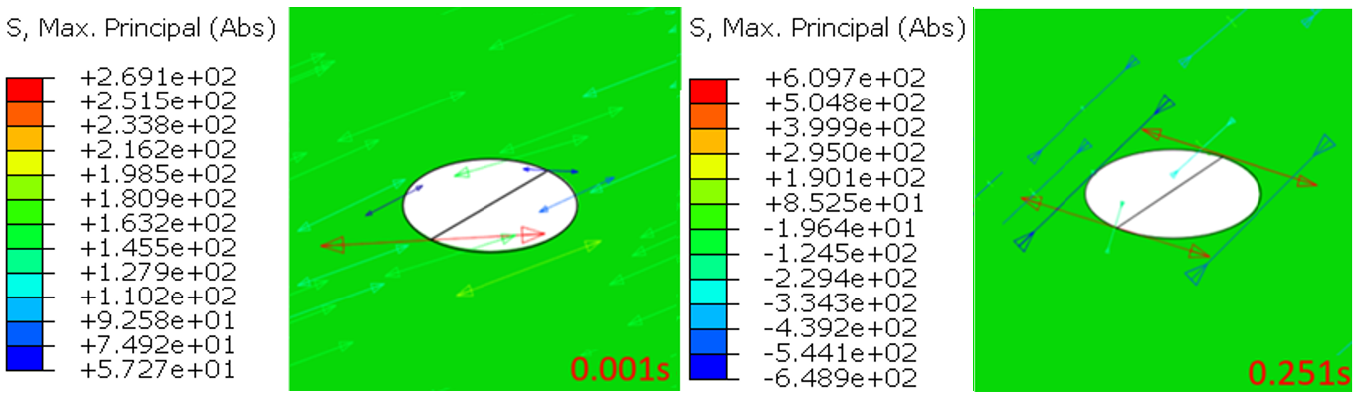
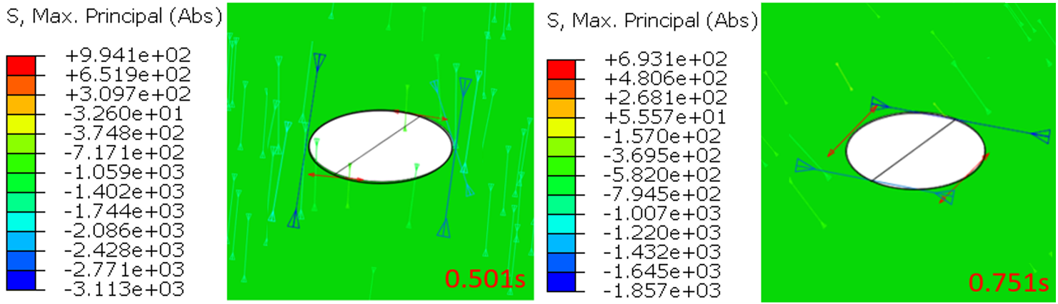
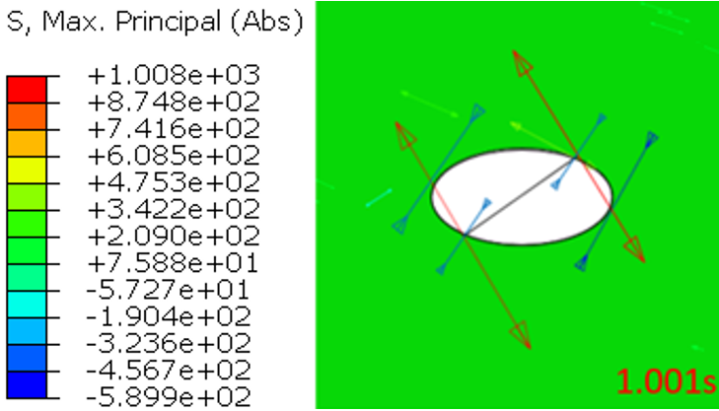
Figure 5.4. 11 Maximum in-plane principal stress variations of the steel matrix with the internally cracked inclusion in Model F
The simultaneous occurrence of both compressive and tensile principal stresses in the localised area suggests that the stress variation in this region may be different from those in other regions of the steel matrix around the inclusion. To investigate the detailed stress variation around the inclusion with internal cracking, the Tresca stress, maximum in-plane principal stress, and the orthogonal shear stress at different locations are plotted in Figure 5.4.12. Different from the previous definitions of these specific locations, point 3 and point 4 in Figure 5.4.12 (a) locate in the regions at the ends of the inclusion internal crack.
As shown in Figure 5.2.8 of section 5.2.2, it has been discussed that point 1 and point 2 are the positions with the maximum Tresca equivalent stress magnitudes under the static Hertz contact pressure. However, it can be observed from Figure 5.4.12 (b) that, under the rolling contact loading, point 3 and point 4 also have considerable Tresca stress values at the time of 0.4s and 0.73s, and these values are slightly higher than the value of point 1 and point 2 at 0.501s.
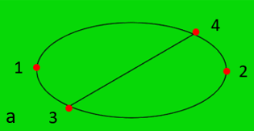
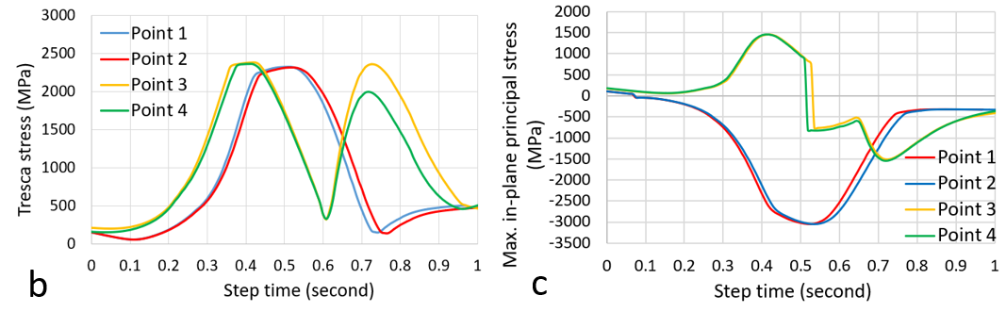
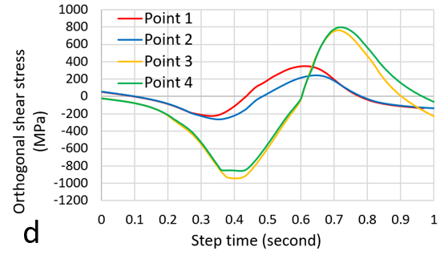
Figure 5.4. 12 Stress variations at specific positions defined in Model F (a) definition of the points (b) Tresca stress (c) Maximum in-plane principal stress (d) Orthogonal shear stress
This finding suggests that the steel material at the tips of the internal crack may also have the significant stress concentrations and possible plastic deformations. As shown in Figure 5.4.13, the plastic deformations of the steel matrix occur on both point 1 and point 4. Compared with the equivalent plastic strain of the steel matrix in Model E, the maximum value of the equivalent plastic strain in Model F is only about 0.46%, indicating that the stress concentration in Model F is not as significant as that in Model E.
Moreover, according to Figure 5.4.12 (c), the maximum principal stress of point 3 and point 4 changes from tensile to compressive within a short period at about 0.5s. Accordingly, their orthogonal shear stress variation ranges may be greater than those of point 1 and point 2. As plotted in Figure 5.4.12 (d), the average range of the orthogonal shear stress at point 3 and point 4 reaches approximately 1726 MPa. While for point 1 and point 2, the stress variation range is only about 610 MPa. Hence, the fatigue cracks are more likely to initiate from the tips of the inclusion internal crack, as observed by the actual butterfly images in Chapter 3. In addition, the stress variation range of 1726 MPa is larger than the maximum orthogonal shear stress ranges recorded in Model D (1203 MPa) and Model E (1189 MPa). Hence, the fatigue damage caused by the inclusion internal crack may occur earlier than the damage induced by the boundary separated inclusion. This conclusion matches the microstructure investigation results in Chapter 3 that the inclusion internal cracking is a more harmful damaged type compared with the inclusion boundary separation.
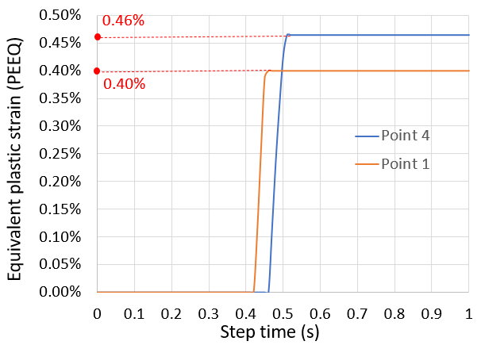
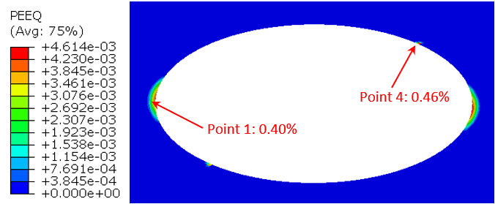
Figure 5.4. 13 Maximum equivalent plastic strain (PEEQ) time history at points 1 and 4
Effect of the inclusion inclined angle on fatigue damage initiation
Although it has been discussed in this section that the cracks may initiate from the boundaries of the inclusions instead of the inclusion tips, the microstructural damage with butterfly wings shown in Figure 5.4.14 still indicates that the fatigue crack can start from the tips of the inclusions.
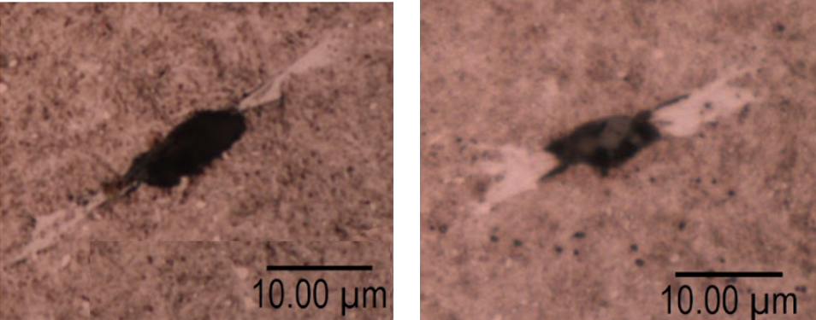
Figure 5.4. 14 Cracks initiate from the tips of the inclusion
The change of the damage initiation locations is caused by the effect of the inclusion inclined angles. As shown in Figure 5.4.15 (a), the undamaged inclusion has an inclined angle of 30 degrees, and three points have been defined within the steel matrix around the inclusion. It can be seen from the orthogonal shear stress variation diagram in Figure 5.4.15 (b) that point 1 has the largest shear stress variation range. Therefore, the position of point 1, at the tip of the inclusion, may have a relatively shorter fatigue life due to the effect of the orthogonal shear stress.
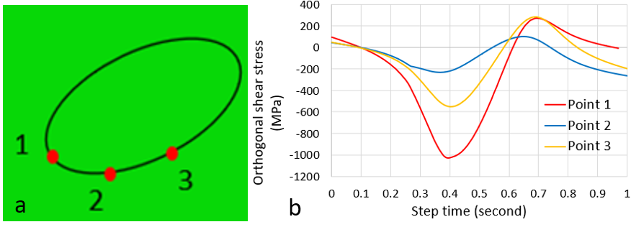
Figure 5.4. 15 Stress variations at inclusion with 30° inclined angle (a) definition of the points (b) Orthogonal shear stress variations
Similar results can be seen when the inclusion has the boundary separated from the steel matrix, as shown in Figure 5.4.16 (b). The tip of the inclusion becomes the area where has the highest risk of generating the fatigue damage.
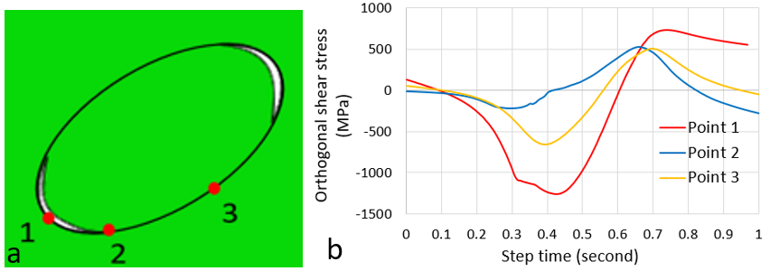
Figure 5.4. 16 Stress variation with the inclined and separated inclusion (a) definition of the points (b) Orthogonal shear stress variations of the points
However, when the inclusion has an internal crack, the effect of the inclusion inclined angle on the material damage may be weaker than the effect of the internal crack. As shown in Figure 5.4.17 (b), the comparison between the orthogonal shear stress variations in different locations indicates that the orthogonal shear stress at the internal crack tip (point 2 of 1316 MPa) still has a greater variation range, when compared with the shear stress range at the inclusion tip (point 1 of 1202 MPa).
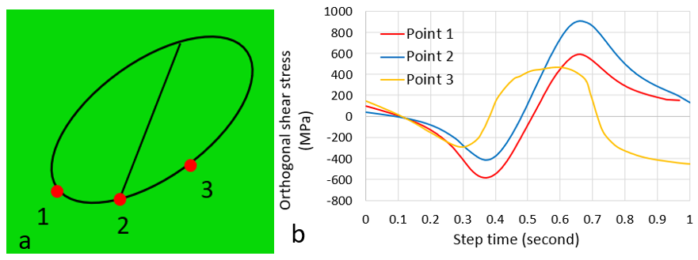
Figure 5.4. 17 Stress variations at inclusion with 30° inclined angle and internal cracking(a) definition of the points (b) Orthogonal shear stress variations

Validation of the global model under rolling contact
The FE modelling of the static Hertz contact pressure in section 5.1 has been proved to be correct, as the simulation results have been validated by the classic Hertz contact theory. Therefore, to validate the effectiveness of the rolling contact modelling and subroutine coding, the FE modelling results of the global model in Tresca stress are compared with the results of the static Hertz contact model established in section 5.1. As defined previously, the maximum Hertz contact pressure magnitude applied in this section is 2.069 GPa, and the half contact width is 0.531 mm. Because no inclusions are considered in section 5.1, the rolling contact model validation in this section also has no definitions of the inclusions.
During the modelling process, the Hertz contact pressure will cause stress concentrations in the rectangle corners of the raceway geometry at the beginning and the end of the step. Hence, the Tresca stress is only recorded when the Hertz contact pressure moves to the middle of the raceway rectangle. Figure 5.4.18 shows the Tresca stress distribution of the rolling contact model without considering the surface traction pressure. According to the maximum Tresca stress values at 0.251s, 0.501s, and 0.7501s shown in the figure, it can be seen that the average maximum Tresca stress value is 1386 MPa. As presented in Figure 5.1.6 (a) of section 5.1, the value recorded by the static Hertz contact pressure modelling is 1275 MPa.
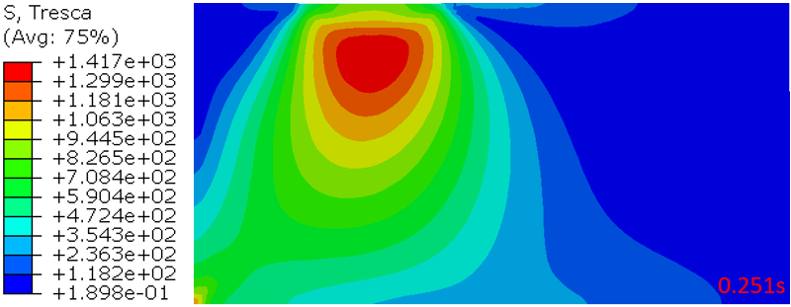
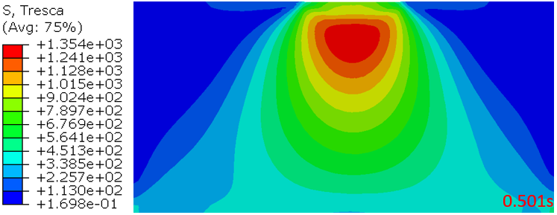
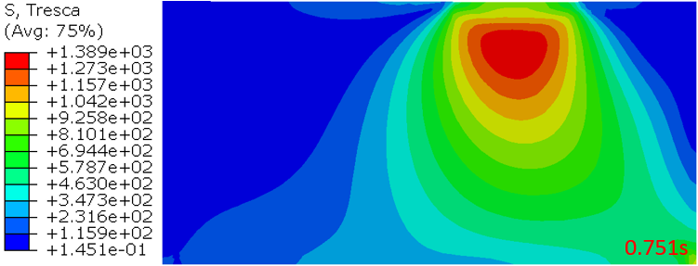
Figure 5.4. 18 Tresca stress distributions of the rolling contact model without surface traction
Similar results can be found in Figure 5.4.19 when the Hertz contact pressure is applied together with the surface traction with a coefficient of 0.1. The average value of the Tresca stress recorded is 1394 MPa in Figure 5.4.17, which is 99 MPa larger than the value simulated by the static Hertz contact model ,1295 MPa, in Figure 5.1.6 (b).
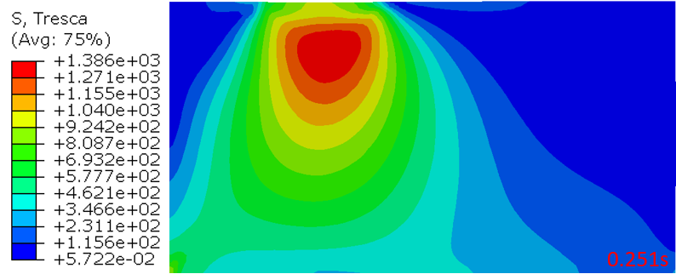
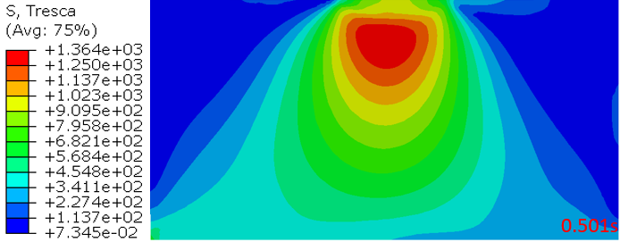
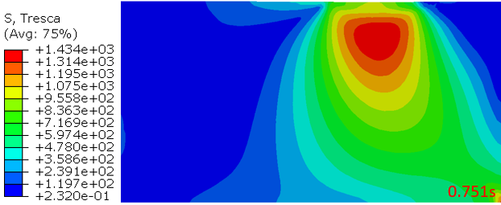
Figure 5.4. 19 Tresca stress distributions of the rolling contact model with a traction coefficient of 0.1
The stress differences between the rolling contact model and the static Hertz contact model may be caused by the simplification of the raceway geometry from a curved surface to a flat rectangular surface. In addition to the geometry difference, the meshing methodology applied in the rolling contact model is also different from that in section 5.1, which may lead to some computational variations between the modelling results.
Considering that the stress difference of approximately 100 MPa may not have a significant effect on the investigation, the rolling contact model established in this section is considered as accurate.

Summary
This chapter focuses on the investigations of the bearing subsurface stress concentration due to inclusions and the stress variation caused by the rolling contact condition.
In the first part, the modelling results of the inner raceway-roller contact show that the surface traction pressure will change the distribution of the maximum shear stress in the subsurface area, and the location of the maximum value of the maximum shear stress becomes closer to the raceway surface. However, the traction pressure has a limited effect on the magnitude of the maximum shear stress. Although the traction coefficient used in the modelling is assumed to be the maximum value of 0.1, the maximum shear stress level of the inner raceway subsurface is only changed marginally.
The second part of the chapter simulates the stress concentration due to inclusions. In Models A, B and C, the stress concentrations caused by the undamaged, boundary separated, and internally cracked inclusions are modelled respectively. It has been found that the boundary separation of the inclusion will lead to the most significant stress concentration on both the steel matrix and the MnS inclusion. Although the maximum shear stress magnitude caused by the inclusion internal cracking is relatively small, it may result in an increased variation range of the orthogonal shear stress, which is harmful to the material fatigue life.
To investigate the possible factors affecting the subsurface stress concentration level due to inclusions, a Taguchi design of the FE models is developed. Based on the results of the Taguchi designed FE models, it can be concluded that the inclusion damage types have the strongest influences on the stress concentration, followed by the applied Hertz contact pressure, inclusion aspect ratio, inclusion inclined angle, subsurface depth, and the surface traction coefficient. Among these factors, the inclusion damage and the Hertz contact pressure are two parameters that have the dominating effect. The change of them will directly affect the subsurface stress magnitudes of the steel matrix, especially when the inclusion embedded in steel has an inclined angle of about 22.5 degrees and a relatively large aspect ratio. Moreover, the subsurface depth of the inclusion has been found to be a parameter having the interaction with the maximum Hertz contact pressure. Generally, the inclusions with a subsurface depth between 0.4 mm to 0.6 mm have the highest risk of initiating the subsurface damage.
Finally, the stress variation caused by the rolling contact loading condition is investigated. Models D, E, and F simulate the stress variations of the steel matrix when the inclusions are undamaged, separated from the steel, and internally cracked. The results show that the internal cracking of the inclusion may cause the accelerated material fatigue damage due to the largest variation range of the orthogonal shear stress. In the study of the possible RCF damage positions, it has been found that the inclined angle of the inclusion has a considerable influence on the damage initiation. However, the influence of the inclined angle of the inclusion on fatigue damage may be weaker than that of the internally cracked inclusion. According to the FE analysis of the orthogonal shear stress, the steel material at the tips of the inclusion internal crack is still more prone to initiating fatigue cracks when compared with the steel material in other regions.

Finite element modelling of damage evolution due to inclusions
This chapter develops the FE damage models to simulate the crack initiation and propagation process due to subsurface MnS inclusions. The extended finite element method (XFEM) is applied, and FE damage modelling based on Continuum Damage Mechanics (CDM) is developed to investigate the possible factors leading to the bearing premature failure. It has been found that XFEM has obvious limitations in simulating the crack propagation caused by the material fatigue. However, with the newly developed FE damage model based on the CDM in this chapter, both subsurface crack initiation and propagation are modelled successfully. It has been identified that the bearing premature failure is mainly influenced by the inclusion damage types, surface traction, and the loading magnitude/sequence experienced by the bearings.

Application of XFEM to Simulate the Crack Propagation
The XFEM was proposed by Belytschko and Black in 1999, which was established based on the concept of “partition of unity finite element” [133]. As discussed in section 2.5.2, by defining the specific jump functions to describe the discontinued boundaries of an element, XFEM provides a new solution for simulating the crack propagation problems. Considering that it has no published investigation utilising XFEM to study the subsurface-initiated crack propagation during the RCF process, this section explores the feasibility of the XFEM to model the typical RCF process by developing a FE model in ABAQUS 2017 Standard.

Discussion of the XFEM modelling with rolling contact conditions
The modelling of crack propagation under the rolling contact conditions with the XFEM is attempted in this section. However, during the rolling contact process, the pre-defined cracks do not propagate to the contact surface, and their directions have abrupt changes in the subsurface region. These modelling results are unacceptable because they conflict with the general understanding of the subsurface crack propagation and the crack characteristics observed experimentally in Chapter 3.
The wrong propagation orientations may be caused by the definition of the XFEM in ABAQUS. Due to the need to simplify the computation and ensure convergence, the XFEM in ABAQUS has the following limitations:
- Crack propagation cannot be remained inside the elements. In the XFEM, the step function is used to describe the jumping property of the displacement field. However, to reduce the iteration process of calculations, ABAQUS only calculates the functions at elements boundaries instead of functions inside the elements. As a result, the crack must propagate alongside the nodes or boundaries of an element, which may cause errors in the propagation process.
- An element cannot be intersected by more than one crack. It means that the coupling problem of two step functions for a specific element is not considered in ABAQUS. Therefore, the software will compulsorily change the propagation direction of the crack when it is about to evolve into a double-branch crack.
- The XFEM is not reliable in predicting the crack propagation under complex loading conditions. As discussed in Chapter 5, the loading of the moving distributed Hertz contact pressure leads to the dramatic changes in both the maximum shear stress and the orthogonal shear stress. Therefore, the dominating stresses of the crack propagation will vary during the entire rolling contact loading process, resulting in the incorrect simulation of the orientations of crack propagation.
- The XFEM is a method based on the elastic-plastic fracture theory. It assumes the crack tip as a stress concentrated plastic area where the damage may occur. Therefore, when the XFEM is applied to solve fatigue problems with the pure elastic deformations, the results are not satisfactory in most cases.
- Limitations in solving the fatigue problems. In the case of the operation of a WTGB, the rolling elements and the bearing raceways may be subjected to millions of contact cycles during the operation. This method certainly does not work to simulate the subsurface cracking caused by a large number of contact loading cycles.
- The requirement of a predefined crack. The XFEM cannot be applied to analyse the initial crack initiation because it requires the pre-definition of the initial crack in the model. Characteristics of butterflies and inclusions found in Chapter 3 have shown that the cracks are individually different and highly unique. The direction of a subsurface crack usually depends on the inclusion geometry, subsurface depth, damage types, and the applied loading condition. Therefore, the pre-defined initial crack in the XFEM may not accurately reflect the initial appearance of the crack. Correspondingly, the simulation results may be inaccurate because the pre-defined initial crack is not practical for the problem investigated in this study.
In conclusion, the existing XFEM in ABAQUS is insufficient to simulate the subsurface crack propagation when the rolling contact fatigue is considered. A new model for predicting the subsurface crack initiation and propagation should be developed.

Development of Continuum Damage Mechanics Finite Element Model for Crack initiation and Propagation

Development of the Continuum Damage Mechanics Model
It has been proved in the last section that the XFEM is not an effective method for modelling crack propagation due to the RCF. In addition, as discussed in section 2.5, current damage modelling approaches of the RCF damage have various limitations. Some of the existing studies only predict the possible positions and propagation orientations of the butterflies. While some models have successfully simulated the formation of butterfly wings, but they ignore the possible plastic deformation triggered by the varied loading magnitude and/or the inclusion-matrix boundary conditions. Therefore, in this section, a new FE fatigue damage model will be developed, to overcome the limitations in the current studies.
Modification of Xiao’s fatigue model in RCF
The deterioration or failure of a material can be considered as a progressive loss of the material cross-sectional area under loading. Hence, the effective area used to carry the load is gradually reduced [114]. Based on the isotropic damage theory, Kachanov has defined the damage variable $D$ with the following form [111] :
$D=\frac{A_{D}}{A}=\frac{A-\tilde{A}}{A}$ Equation 6.1
where $A$ is the overall cross-sectional area and $\tilde{A}$ is the effective cross-sectional area that bears the load. Also, the value of $D$ has the following definitions:
$D=0$ means the material is undamaged.
$D=1$ means the material is totally damaged.
$0<D<1$ represents different states of the damage development.
If the concept of effective stress $\tilde{σ}$ under the mean load $P$ is introduced, using Equation 6.1, it can be defined as:
$\tilde{σ}=\frac{P}{\tilde{A}}=\frac{σ}{1-D}$ Equation 6.2
Based on the Hooke’s Law, the stress-strain relationship of the material can be written as:
$ε=\frac{\tilde{σ}}{ E_{0}}=\frac{σ}{ E_{0}(1-D)}$ Equation 6.3
where, $ε$ is the elastic strain, and $E_{0}$ is the initial material modulus. When a three-dimensional stress field is considered, it has the following expression:
$σ_{ij}=C_{ijkl}(1-D)ε_{kl}$ Equation 6.4
where $C_{ijkl}$ is the stiffness matrix of the material elastic modulus.
In section 2.6.4, several existing damage models for RCF have been introduced such as the Lemaitre’s model, Paas’s model, Xiao’s model, and Peerling’s model. In these models, both Xiao’s model and Lemaitre’s model can be selected because they are suitable for modelling the metal fatigue problems in two dimensional cases. In addition, Xiao’s model simplifies Lemaitre’s model by reducing the number of material parameters required. Therefore, this model is chosen for the investigation of rolling contact fatigue problems in this section.
As listed in Table 2.6, the damage evolution model modified by Xiao in [114] is expressed as:
$\frac{dD}{dN}=\frac{\overline{B}}{q{\left(1-D\right)}^{2q}}({σ_{eqM}}^{2q}-{σ_{eqm}}^{2q})$ Equation 6.5
This nonlinear equation solves the problem by an incremental method, where $dD$ is the unit damage increment, $dN$ is the unit increment of the number of loading cycles, $\overline{B}$ and $q$ are the material constants, $σ_{eqM}$ is the maximum defined equivalent stress, and $σ_{eqm}$ is the minimum defined equivalent stress.
Therefore, the damaged material with the stiffness of $C_{ijkl}(1-D)$ can be simplified as a new undamaged material after each incremental step. By considering the linear elastic relationship of the material, the maximum and minimum defined equivalent stress within one loading cycle during the damage evolution process can be related by using the stress ratio $R_{a}$ [177]:
$σ_{eqm}=R_{a}σ_{eqM}$ Equation 6.6
Therefore, Equation 6.5 can be rewritten as：
$\frac{dD}{dN}=\frac{\overline{B}(1-{R_{a}}^{2q})}{q{\left(1-D\right)}^{2q}}{σ_{eqM}}^{2q}$ Equation 6.7
Since $\frac{\overline{B}(1-{R_{a}}^{2q})}{q}$ is a constant during each loading cycle assessed, the modified version of Equation 6.7 can be expressed as:
$\frac{dD}{dN}=\frac{{σ_{eqM}}^{2q}}{B{\left(1-D\right)}^{2q}}$ Equation 6.8
where $B=q/{\overline{B}(1-{R_{a}}^{2q})}$. If $2q=m$ and $B={σ_{r}}^{2q}$, Equation 6.8 becomes:
$\frac{dD}{dN}={[\frac{σ_{eqM}}{σ_{r}(1-D)}]}^{m}$ Equation 6.9
In the new expression of the damage evolution rate (${dD}/{dN}$), $σ_{r}$ and $m$ are the material constants. $σ_{r}$ is normally known as the resistance stress because it represents the ability of the bearing material to resist fatigue damage. Compared with the original model proposed by Xiao in [114], the modified expression in Equation 6.9 is more practical to use in RCF applications because it requires fewer fitting parameters from the material fatigue test.
Calibration of material parameters from 100Cr6 torsional SN curve
Based on Equation 6.9, if both sides of the equation are integrated from the damage initiation to the final fatigue failure, it will give the following equation:
$\int_{0}^{Nf}{dN}$=$\int_{0}^{1}{{\{\frac{σ_{r}(1-D)}{σ_{eqM}}\}}^{m}dD}$ Equation 6.10
where $N_{f}$ is the total number of cycles to failure, $D=0$ and $D=1$ are the beginning and end states of the failure. The calculation of the total number of cycles to failure can be obtained by integration as：
$N_{f}=\frac{1}{(m+1)}{[\frac{σ_{r}}{σ_{eqM}}]}^{m}$ Equation 6.11
As discussed in section 6.1, the subsurface cracking due to inclusions under the rolling contact loading is usually dominated by the orthogonal shear stress. Therefore, an equation that describes the shear stress-life relationship of the material from the fatigue test under completely reversed torsion is introduced [178]:
$\frac{∆τ}{2}=τ_{f1}{(N_{f})}^{{-1}/{B1}}$ Equation 6.12
where ${∆τ}/2$ is the orthogonal shear stress amplitude of the torsional fatigue test; $B1$ and $τ_{f1}$ are the Basquin slope and the stress-axis intercept of the SN curve respectively. If $σ_{eqM}$, the maximum equivalent stress, is assumed to be the dominating shear stress that causes the fatigue damage, then Equation 6.12 becomes:
$\frac{σ_{eqM}}{2}=τ_{f1}{(N_{f})}^{{-1}/{B1}}$ Equation 6.13
Therefore,
$N_{f}={[\frac{2τ_{f1}}{σ_{eqM}}]}^{B1}$ Equation 6.14
By combining Equation 6.11 with Equation 6.14, it establishes a new relationship based on the total number of cycles to failure:
$\frac{1}{m+1}{[\frac{σ_{r}}{σ_{eqM}}]}^{m}$= ${[\frac{2τ_{f1}}{σ_{eqM}}]}^{B1}$ Equation 6.15
Hence, two constants define the material resistance to fatigue damage can be derived:
${m=B}_{1}$ and $σ_{r}$=2 $τ_{f1}$ ${(B_{1}+1)}^{1/{B1}}$ Equation 6.16
Figure 6.2.1 shows the SN-curve of the 100Cr6 steel obtained from the completely reversed torsional fatigue test in [125]. To calculate the Basquin slope $B_{1}$, the following equation can be used:
${m=B}_{1}=\frac{\log\left(N_{1}\right)-\log\left(N_{2}\right)}{\log\left(S_{2}\right)-\log\left(S_{1}\right)}$ Equation 6.17
${(N}_{1},S_{1})$ and ${(N}_{2},S_{2})$ are two points on the SN- curve, and both $N_{1}$ and $N_{2}$ should be larger than ${10}^{4}$ cycles. As an example, two points in loading cycles and stress levels (${10}^{4.5}$, 875) and (${10}^{7.6}$, 434) are selected, shown as the red points in Figure 6.2.1. By putting these values into Equation 6.17, it gives the value of the material constant, $m$, as 10.18.
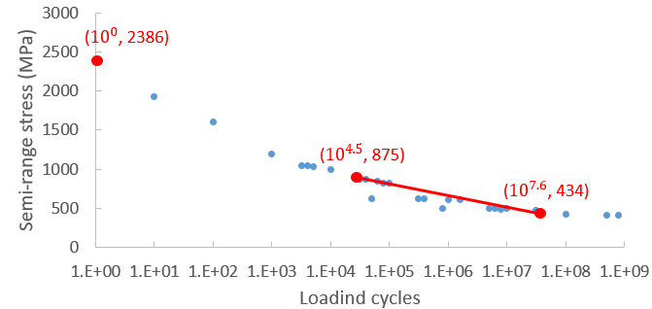
Figure 6.2. 1 SN-curve of the 100Cr6 steel in a torsional fatigue test (adopted from[125])
In addition, the stress-axis intercept of the SN curve, $τ_{f1}$, can be found by the interception point of the SN curve at the loading cycle of ${10}^{0}$. From Figure 6.2.1, $τ_{f1}$ is approximately 2386 MPa. Therefore, according to Equation 6.16, the resistance stress to fatigue ($σ_{r}$) can be calculated as approximately 6048 MPa.
Stress-strain curve of 100Cr6 to consider plastic deformation
The modified RCF model described in the above can be used to calculate the damage accumulation during the cyclic loading process. However, a complete damage model still requires the elastic-plastic relationship of the material to be established. Since inclusions with separated boundaries introduce significant stress concentrations of the steel matrix, localised plastic deformations of the material at inclusions may play vital roles for the damage evolution.
Moreover, as discussed in section 2.2.1, both the shakedown and ratcheting may occur during the RCF process. Due to the strain hardening after the bearing steel is stressed beyond the initial yielding strength, the material will yield at increased stress levels with the growing rolling contact cycles. Therefore, the steel is hardened, which prevents the occurrence of the further plastic deformation. However, the fatigue damage will accumulate rapidly due to the material hardening and possible brittle fracture. When the accumulated damage exceeds the threshold value, cracks will initiate. Consequently, the plastic deformation of the bearing steel should be considered in the damage model, which helps to predict the crack initiation and propagation accurately.
In this section, the simplified Johnson-Cook strain hardening model and the bilinear strain hardening model will be compared to decide which of them has a better description of the material plastic deformation under rolling contact fatigue conditions.
Generally, the Johnson-Cook model can be applied when the material experiences large plastic strains. The updated yielding stress $σ_{y}$ in the Johnson-Cook model has the following form:
$σ_{y}=(σ_{y0}+B^{*}ε^{n^{'}})(1+C^{*}ln{\dot{ε}}^{*})(1-{T^{*}}^{temp})$ Equation 6.18
where, $σ_{y0}$ is the material initial yield strength, $B^{*}$ is the strain-hardening modulus, $n^{'}$ is the strain hardening index (${0.1<n}^{'}<0.5$ for metals), $C^{*}$ is the strain-rate coefficient, $temp$ is the temperature constant, $ε$ is the equivalent plastic strain, ${\dot{ε}}^{*}$ is the equivalent strain rate, and $T^{*}$ is the equivalent temperature. In general, both strain rate effect $C^{*}ln{\dot{ε}}^{*}$ and temperature effect ${T^{*}}^{temp}$ for steels are small. Thus, it is assumed that they do not have the significant effect on the flow stress in this study. Hence, Equation 6.18 is simplified as the following form:
$\left\{\begin{aligned} σ_{y}=Eε^{e} (ε^{e} is the elastic strain) \\ σ_{y}=σ_{y0}+B^{*}{ε^{p}}^{n^{'}} (ε^{p} is the plastic strain)\end{aligned}\right.$ Equation 6.19
Figure 6.2.2 (a) shows the fitting curve using the Johnson-Cook strain hardening model and the 100Cr6 compressive stress-strain curve adopted from [38]. The parameters of the Johnson-Cook model can be determined from Figure 6.2.2 as: $σ_{y0}$ =2300 MPa, $B^{*}$ = 1808, and $n^{'}$= 0.45.
The bilinear strain-hardening model is typically applied for small plastic deformation cases of the material. According to the modelling results of the Taguchi FE design in Chapter 5, the maximum equivalent plastic strain of the steel matrix may not exceed 4% even when the Hertz contact pressure reaches 2.84 GPa.
When compared with the Johnson-Cook strain hardening model, the bilinear hardening model is simple because it simplifies the complex plastic stress-strain relationship into a linear relationship. The fitting curve using the bilinear strain-hardening model is shown in Figure 6.2.2 (b). The slope of the fitting line is also known as the plastic modulus in the bilinear strain-hardening model. It is calculated as 36850 MPa by selecting the coordinates of two points from the fitting line.
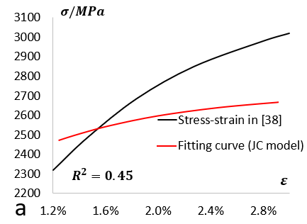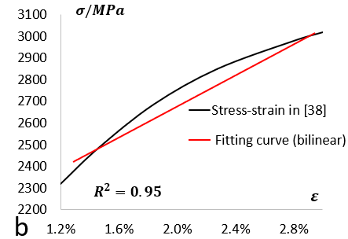
Figure 6.2. 2 Fitting of 100Cr6 plastic stress-strain curve (a) Johnson-Cook model (b) bilinear hardening model
$R^{2}$ represents the curve fitting accuracy. The bilinear strain-hardening model has a better fitting accuracy of the material stress-strain curve because of the relatively larger $R^{2}$ value. Therefore, the bilinear strain hardening model is selected as the strain hardening curve to be used in the CDM damage model.
Incremental theory and Levy-Mises flow rule
To establish the relation between stress and strain when the material deforms plastically, the incremental theory with the Levy-Mises flow rule is applied. At first, the Levy-Mises equation considers the incremental plastic deformation $dε_{i}^{p}$ is proportional to the corresponding deviatoric stress ${σ_{i}}^{'}$:
$\frac{dε_{1}^{p}}{{σ_{1}}^{'}}=\frac{dε_{2}^{p}}{{σ_{2}}^{'}}=\frac{dε_{3}^{p}}{{σ_{3}}^{'}}=dλ$ Equation 6.20
Therefore, the principal stresses $σ_{1}$, $σ_{2}$ and $σ_{3}$, can be expressed by the plastic strain increments $dε_{i}^{p}$ as follows:
$σ_{1}-σ_{2}={σ_{1}}^{'}-{σ_{2}}^{'}=(dε_{1}^{p}-dε_{2}^{p})/ dλ$
$$σ_{2}-σ_{3}={σ_{2}}^{'}-{σ_{3}}^{'}=(dε_{2}^{p}-dε_{3}^{p})/ dλ$$
$σ_{3}-σ_{1}={σ_{3}}^{'}-{σ_{1}}^{'}=(dε_{3}^{p}-dε_{1}^{p})/ dλ$ Equation 6.21
By putting Equation 6.21 into the von-Mises yielding criterion which is expressed as:
$σ_{eqv}=\frac{1}{\sqrt{2}}\sqrt{{(σ_{1}-σ_{2})}^{2}+{(σ_{2}-σ_{3})}^{2}+{(σ_{3}-σ_{1})}^{2}}$ Equation 6.22
it gives the expression of the ratio of the plastic strain increments to the deviatoric stress as:
$dλ=\frac{\sqrt{{(dε_{1}-dε_{2})}^{2}+{(dε_{2}-dε_{3})}^{2}+{(dε_{3}-dε_{1})}^{2}}}{\sqrt{2}σ_{s}}=\frac{3d\overline{ε^{p}}}{2σ_{eqv}}$ Equation 6.23
In Equation 6.23, $d\overline{ε^{p}}$ is the equivalent plastic strain increment, which equals to: $\frac{\sqrt{2}}{3}\sqrt{{(dε_{1}-dε_{2})}^{2}+{(dε_{2}-dε_{3})}^{2}+{(dε_{3}-dε_{1})}^{2}}$. The backward Euler method can be applied to calculate the value of $d\overline{ε^{p}}$. According to [171], it introduces another equation:
$d\overline{ε^{p}}=(σ_{eqv}-σ_{y})/(E_{t}+3G)$ Equation 6.24
where $σ_{eqv}$ is the von-Mises equivalent stress, $σ_{y}$ is the material yielding stress, $E_{t}$ is the tangent modulus of the material, and $G$ is the shear modulus of the material. The value of $G$ can be determined from the Youngs Modulus and the Poisson’s Ratio as:
$G=E/{2∙(1+μ)}$ Equation 6.25
With the definitions described in the above, the final incremental strain is described as:
$dε_{ij}=dε_{ij}^{e}+dε_{ij}^{p}$ Equation 6.26
where $dε_{ij}$is the overall strain increment, $dε_{ij}^{e}$ is the elastic strain increment, and $dε_{ij}^{p}$ is the plastic strain increment. For the elastic stress, it has the following expression:
$dσ_{ij}^{e}={\left[D\right]}_{e}(dε_{ij}-dε_{ij}^{p})$ Equation 6.27
where ${\left[D\right]}_{e}$ is the elastic stiffness matrix of the material. For the plastic strains, it has the following expression [171]:
$dε_{ij}^{p}=\frac{3}{2} d\overline{ε^{p}}∙η_{ij}=\frac{3}{2} d\overline{ε^{p}}∙\frac{\left(σ_{ij}-σ_{hydro}δ_{ij}\right)}{σ_{eqv}}$ Equation 6.28
where, $η_{ij}$ is the flow stress tensor, $σ_{ij}$ is the stress component tensor, and $σ_{hydro}$ is the hydrostatic stress which equals to ${(σ_{1}+σ_{2}+σ_{3})}/3$ for the three-dimensional loading case. $δ_{ij}$ in Equation 6.28 is the Kronecker delta: when$i=j$, $δ_{ij}=1$; when$i≠j$, $δ_{ij}=0$.
Bauschinger effect
The Bauschinger effect has been considered as a mechanical property of the polycrystalline metallic material. When the material enters the stage of plastic deformation in a certain direction, if the load in the opposite direction is then applied in the following stage, the yielding strength of the material will be lower than that when the load is firstly applied in the original direction [179]. For example, when the tensile yielding strength of the material increases during the tensile plastic deformation, the compressive yielding strength is reduced if the loading is applied in compression following the tensile loading. It is generally believed that the Bauschinger effect is related to the residual internal stress caused by the plastic deformation and microstructural grain dislocations.
As discussed in Chapter 5, the moving distributed Hertz contact pressure on the raceway surface of the bearing will introduce alternating tensile and compressive principal stress vectors around the inclusion tips. When the inclusion has a separated boundary or the loading applied to the raceway exceeds the rated value, the serious stress concentration of the steel matrix may cause the alternating compressive and tensile yielding behaviours of the material. This process may require the consideration of the Bauschinger effect of the material. Therefore, this effect should be contained in the damage evolution modelling.
The asymmetry of the yielding stress locus due to the Bauschinger effect is known as the kinematic hardening process of the material, as illustrated by Figure 6.2.3. Different from the isotropic hardening process, the initial yielding surface does not expand during the kinematic hardening process. Instead, it will directly shift with the direction of a vector $α_{ij}$. This vector is known as the back stress or shift tensor, which indicates the centre position of the new kinematic hardening yielding surface.
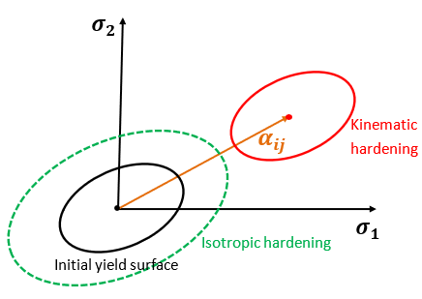
Figure 6.2. 3 Kinematic hardening and Isotropic hardening
In the kinematic hardening, the yielding function now takes the general form as:
$f\left(σ_{ij}-α_{ij}\right)=0$ Equation 6.29
If the von-Mises yielding criterion is considered, then it has the following form:
$\sqrt{\frac{3}{2}\left(σ_{ij}-α_{ij}\right)\left(σ_{ij}-α_{ij}\right)}-σ_{y}=0$ Equation 6.30
Based on the Prager-Ziegler kinematic hardening rule, the equation of the back stress is given by:
$dα_{ij}=\frac{2}{3}E_{t}∙dε_{ij}^{p}$ Equation 6.31
Substitute Equation 6.28 into Equation 6.31, it has the following expression:
$dα_{ij}=\frac{2}{3}E_{t}∙\frac{3}{2} d\overline{ε^{p}}∙η_{ij}=E_{t}∙d\overline{ε^{p}}∙η_{ij}$ Equation 6.32
Worth noting that, the flow stress tensor $η_{ij}$ in Equation 6.32 is different from that in Equation 6.28. Considering the effect of the back stress, $η_{ij}$ has the following equation:
$η_{ij}=\frac{σ_{ij}-α_{ij}-σ_{hydro}δ_{ij}}{σ_{eqv}}$ Equation 6.33
Thus, the expression of the back stress can be written as:
${dα}_{ij}=E_{t}∙d\overline{ε^{p}}∙\frac{σ_{ij}-α_{ij}-σ_{hydro}δ_{ij}}{σ_{eqv}}$ Equation 6.34
The expression in Equation 6.34 can be substituted into the yielding equation in Equation 6.30, for updating the yielding stress of the material in the damage model.

Development of user subroutines within ABAQUS
In the previous section, the equations of the CDM damage model with considerations of the material plastic deformation and kinematic strain hardening have been introduced. In this section, the method of developing programming in ABAQUS user subroutines and the assumptions made to improve the computational efficiency will be discussed.
Determination of the Jacobian Matrix
Different from the explicit integration, the coherent Jacobian Matrix, defined in “DDSDDE matrix” in ABAQUS UMAT subroutine, is required in the ABAQUS implicit integration. In the vector analysis, the Jacobian Matrix is a matrix in which the first partial derivatives of a function are arranged in a certain way. In the stress-strain calculation, it has the following form:
$Jacobian Matrix={∂σ}/{∂ε}$ Equation 6.35
Based on the Hooke’s law, the stress-strain of the isotropic material has the following relationship:
$\left[\begin{matrix}ε_{11} \\ ε_{22} \\ ε_{33} \\ {2ε}_{23} \\ {2ε}_{13} \\ 2ε_{12}\end{matrix}\right]=\left[\begin{matrix}ε_{11} \\ ε_{22} \\ ε_{33} \\ γ_{23} \\ γ_{13} \\ γ_{12}\end{matrix}\right]=\frac{1}{E}\left[\begin{matrix}1 & -μ & -μ & 0 & 0 & 0 \\ -μ & 1 & -μ & 0 & 0 & 0 \\ -μ & -μ & 1 & 0 & 0 & 0 \\ 0 & 0 & 0 & 2+2μ & 0 & 0 \\ 0 & 0 & 0 & 0 & 2+2μ & 0 \\ 0 & 0 & 0 & 0 & 0 & 2+2μ\end{matrix}\right]\left[\begin{matrix}σ_{11} \\ σ_{22} \\ σ_{33} \\ σ_{23} \\ σ_{13} \\ σ_{12}\end{matrix}\right]$ Equation 6.36
where $γ_{ij}$ is the shear strain. Considering the Lame constant $λ$ and the shear modulus $G$, Equation 6.36 can be expressed as:
$\left[\begin{matrix}σ_{11} \\ σ_{22} \\ σ_{33} \\ σ_{23} \\ σ_{13} \\ σ_{12}\end{matrix}\right]=\left[\begin{matrix}2G+λ & λ & λ & 0 & 0 & 0 \\ λ & 2G+λ & λ & 0 & 0 & 0 \\ λ & λ & 2G+λ & 0 & 0 & 0 \\ 0 & 0 & 0 & G & 0 & 0 \\ 0 & 0 & 0 & 0 & G & 0 \\ 0 & 0 & 0 & 0 & 0 & G\end{matrix}\right]\left[\begin{matrix}ε_{11} \\ ε_{22} \\ ε_{33} \\ γ_{23} \\ γ_{13} \\ γ_{12}\end{matrix}\right]$ Equation 6.37
where $λ=\frac{Eμ}{(1+μ)(1-2μ)}$.
The stress matrix containing the constants of $λ$ and $G$ in Equation 6.37 is the Jacobian matrix for the isotropic material. However, because the Jacobian matrix is also affected by the damage accumulation, there should exist a stiffness reduction which is related to the material reduced effective cross-sectional area. Therefore, refer to Equation 6.4, the updated stress matrix containing the damage variable $D$ is:
$\left[\begin{matrix}σ_{11} \\ σ_{22} \\ σ_{33} \\ σ_{23} \\ σ_{13} \\ σ_{12}\end{matrix}\right]=(1-D)\left[\begin{matrix}2G+λ & λ & λ & 0 & 0 & 0 \\ λ & 2G+λ & λ & 0 & 0 & 0 \\ λ & λ & 2G+λ & 0 & 0 & 0 \\ 0 & 0 & 0 & G & 0 & 0 \\ 0 & 0 & 0 & 0 & G & 0 \\ 0 & 0 & 0 & 0 & 0 & G\end{matrix}\right]\left[\begin{matrix}ε_{11} \\ ε_{22} \\ ε_{33} \\ γ_{23} \\ γ_{13} \\ γ_{12}\end{matrix}\right]$ Equation 6.38
Definition of Jump-in cycle
The evolution of the damage variable is expressed in Equation 6.9. If the damage is evaluated during every loading cycle, it is impossible to simulate the damage accumulation caused by millions of rolling contact loading cycles. As a result, the concept of the jump-in cycle introduced in [138] is applied in this section to develop the damage accumulation with a large number of rolling contact loading cycles.
In the jump-in cycle assumption, the model will calculate the overall damage accumulation during a block of loading cycles instead of a single loading cycle. Assuming the number of overall loading cycles to be modelled for the raceway in this study is 2 $×{10}^{7}$ and the damage accumulation is computed within every 50,000 cycles ($dN=5 ×{10}^{4}$, defined as one jump-in cycle), it will have 400 blocks or jump-in cycles to model the overall damage. In other words, the distributed Hertz contact pressure will move cyclically for 400 times over the raceway contact surface.
Additionally, the jump-in cycle concept also assumes that the damage generated during every loading cycle is the same. Thus, the damage accumulation caused by $5 ×{10}^{4}$ cycles in one jump-in cycle will be summed up linearly. In the end, the calculated damage variation ($dD$) will be recorded and accumulated for the computation of the following jump-in loading cycles.
Dominating stress of crack development
As shown in Equation 6.9, Xiao’s high cycle fatigue model defines the dominating stress for the damage accumulation as the maximum defined equivalent stress $σ_{eqM}$. As reviewed in Chapter 2 and Chapter 5, fatigue damage in RCF condition is mainly affected by the variation of the orthogonal shear stress. Therefore, investigations in [178] and [180] suggest to use the alternating orthogonal shear stress during one loading cycle as the dominating stress in Xiao’s model.
Considering the Goodman’s relationship of the fatigue damage reviewed in Chapter 2, both the alternating stress amplitude and the stress mean value will dominate the fatigue damage initiation [105]. Therefore, the study in [124] proposes a new expression of the equivalent dominating stress for the RCF damage modelling:
$\frac{dD}{dN}={(\frac{τ_{alternating}+\left|τ_{mean}\right|}{σ_{r}(1-D)})}^{m}$ Equation 6.39
where $τ_{alternating}$ is the half range of the alternating orthogonal shear stress which can be determined from the maximum and minimum orthogonal shear stress during each jump-in loading block as:
$τ_{alternating}=\frac{τ_{maximum}-τ_{minimum}}{2}$ Equation 6.40
$τ_{mean}$ is the mean value of all the orthogonal shear stress recorded in the considered loading cycle. In Chapter 5, the possible fatigue damage initiation areas are only identified according to the variation range of the orthogonal shear stress. Sometimes this method may not be accurate because the effect of the non-zero mean orthogonal shear stress may also have the secondary effect on the damage initiation, as suggested in [124].
In the ABAQUS UMAT subroutine codes developed, all values of the orthogonal shear stress during every jump-in loading block will be recorded as the state variables. In addition, the codes will determine the maximum, minimum, and mean values of the orthogonal shear stress recorded in the variables. Consequently, the ${dD}/{dN}$ defined in Equations 6.39 can be determined.

Flowchart of the user subroutine
Based on the equations and methods discussed in sections 6.2.1 and 6.2.2, the flowchart of the developed RCF damage modelling method in this study, by developing the ABAQUS user subroutines of the DLOAD, UTRACLOAD, and UMAT, is shown in Figure 6.2.5.
When compared with the other published RCF damage models reviewed in Chapter 2, the CDM damage model developed in this study has the following advantages:
- It can clearly show the initiation and evolution of the crack instead of predicting the possible formation and propagation direction of the crack.
- It considers the plastic deformation of the bearing material, which includes the possible shakedown process in RCF and the Bauschinger effect when the material experiences plastic deformations under the alternative tension and compression loading conditions.
- It can simulate the crack generation behaviour under the high cycle fatigue by changing the magnitude of the $dN$ value defined in the jump-in cycle concept. Furthermore, the model also predicts the number of loading cycles required for the crack initiation and propagation to a certain length.
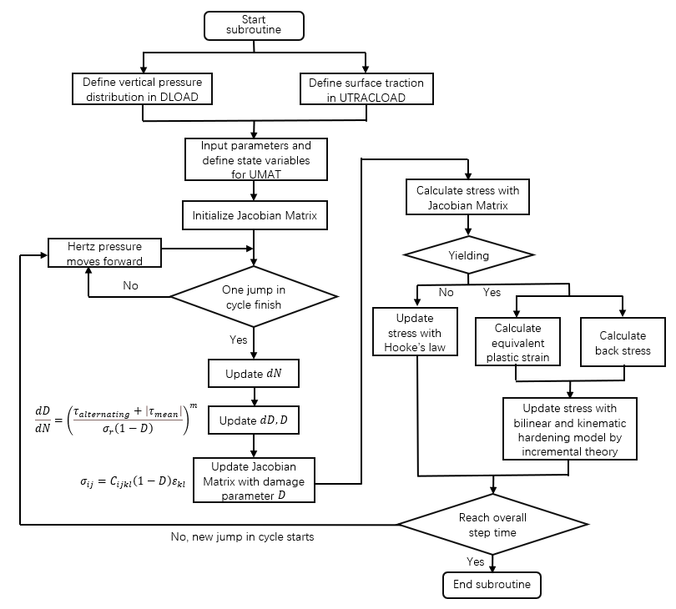
Figure 6.2. 4 Flowchart of RCF damage modelling by ABAQUS user subroutines DLOAD, UTRACLOAD, and UMAT

Application of the Developed CDM Damage Method in FEM for Predicting Crack Length

Finite Element model and meshing method
Figure 6.3.1 (a) shows the geometry of the global FE model with the rolling contact condition, where $b$=0.531 mm if the rated maximum Hertz contact pressure is applied. The material properties of the 100Cr6 steel are the same as those defined in Chapter 5 and section 6.1. Moreover, to ensure the modelling accuracy and the computational convergence, the global model has more partition areas than the models presented in the previous sections. The geometry of the sub-model is defined as a square with the side length of 30 $μm$. Similarly, the sub-model also has some partition areas for avoiding the non-convergence problems in computations, as shown in Figure 6.3.1 (b).
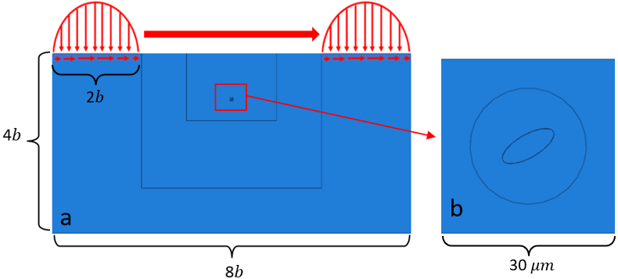
Figure 6.3. 1 Geometry of the CDM FE model (a) global model (b) sub model
The geometry of the inclusion is selected from an inclusion with the butterfly damage observed in the sample U4C presented in Chapter 3. As shown in Figure 6.3.2, the butterfly is found at 0.4 mm below the contact surface of the bearing raceway; and the overall length of the inclusion and butterfly wing cracks is 54.9 $μm$.
According to the microscope and EDS results shown in Figure 6.3.2, the MnS inclusion detected in the middle of the butterfly wings is found to be internally cracked and have its tips separated from the steel matrix. Therefore, the material properties of the inclusion applied in the following models are consistent with those used in Chapter 5 (the Young’s Modulus of 120 GPa and Poisson’s Ratio of 0.24). Moreover, the plastic stress-strain data of the inclusion applied in the FE modelling has been shown in Figure 5.2.1.
To simplify the geometry establishing process, the inclusion included in the sub-model is defined as elliptical shaped with the lengths in the major axis of 10 $μm$ and in the minor axis of 4 $μm$. In addition, the experimental observation result indicate that it locates at 0.40 mm below the contact surface with an inclined angle of ${30}^{°}$. This position is close to the location of the greatest subsurface maximum shear stress (0.398 mm) when the rated loading of 2.069 GPa is applied.
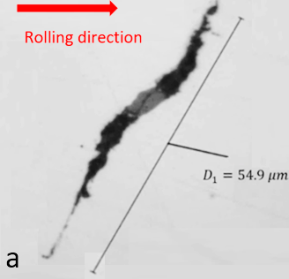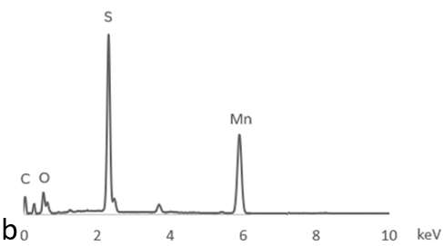
Figure 6.3. 2 Internally cracked and tips separated MnS Inclusion observed in sample U4C from the upwind planetary bearing raceway (a) optical microscope image (b) EDS test results
The meshing methodology of the global model is shown in Figure 6.3.3 (a). In the global model, the element still adopts the plane strain assumption. In addition, the mesh sizes of the elements change from 0.05 mm to 0.01 mm according to the partition areas in the global model. As for the meshing of the sub-model, the elements used is “free type” with the medial axis algorithm. Therefore, the transitions of elements between the partition areas will be minimised, which makes the modelling results more accurate. The mesh sizes of the sub-model are shown in Figure 6.3.3 (b), with a maximum value of 1 e-04 mm and a minimum value of 3 e-05 mm.
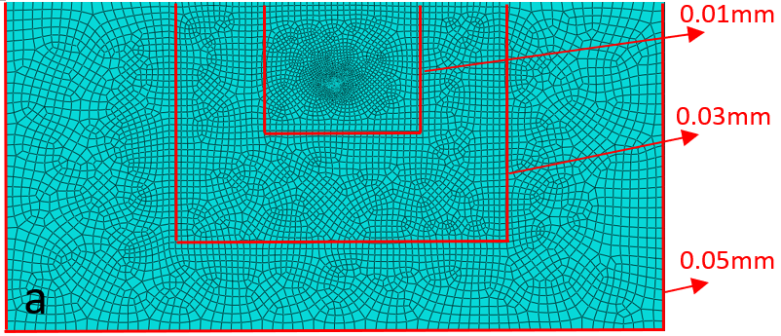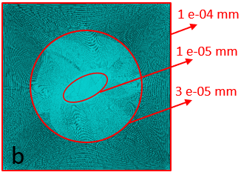
Figure 6.3. 3 Meshes of the CDM FE model (a) global model (b) sub-model
The effect of the rolling speed on the raceway surface is ignored in this study. For the computational convenience, the velocity of the moving distributed Hertz pressure is defined as 6$b$/s. Hence, it takes one second for the distributed Hertz contact pressure to move from the left to the right end of the global model. Furthermore, the damage accumulation defined by CDM is calculated when the distributed Hertz contact pressure has just finished one jump-in cycle and started the next one from the left end.
In the implicit method of ABAQUS, the value of the damage parameter $D$ cannot reach 1. This is because when $D$ equals to 1, the reduced modulus (1- $D$) in the Jacobian Matrix becomes zero. As a result, the elements in the FE model will be unable to take any stress, which will cause the errors or non-convergence problems during the computations. Accordingly, to avoid these problems, the maximum value of $D$ is set as 0.9. This value has limited effect on the modelling results, and it prevents the possible computational errors.
Moreover, according to the experimental results of the twin-discs RCF tests in [97], it has been found that RCF cracks have already propagated and formed into crack networks in the subsurface area of the 100Cr6 material, when the maximum Hertz contact pressure is 2 GPa and the overall number of load cycles is $5.0×{10}^{7}$. Therefore, the models in this section simulate the crack initiation and propagation within $2.0×{10}^{7}$ cycles, at which stage the crack may not propagate into long crack networks. Accordingly, the value of $dN$ selected as $5 ×{10}^{4}$ for the modelling, which means the models will have 400 blocks of jump-in cycles, as defined in section 6.2.2.

Effect of inclusion damage types
To investigate the effect of the inclusion damage on RCF crack initiation and propagation, Figure 6.3.4 defines three different types of boundary conditions considering the damaged and undamaged inclusions.
In Figure 6.3.4 (a), the inclusion is perfectly bonded with the steel matrix, and it will not be separated from the matrix during the loading process. Figure 6.3.4 (b) shows the separated inclusion with two artificially created gaps at the inclusion tips. Similar to the definition in Chapter 5, only part of the inclusion boundary is perfectly bonded with the steel matrix. The last damage type investigated is the inclusion internal cracking. In Figure 6.3.4 (c), it defines an internal crack of the inclusion, which is ${30}^{°}$to the horizontal contact surface. Apart from the existence of the internal crack, the inclusion is perfectly bonded with the steel matrix, similar to that defined in Figure 6.3.4 (a). It has been discussed in Chapter 5 that the friction between surfaces of a MnS inclusion is typically small. Therefore, the contact between two broken parts of the MnS inclusion is defined as “hard” contact surfaces and frictionless in the FE model.
For the comparison of modelling results, all models in this section use the same Hertz contact pressure distribution with the traction coefficient of 0.05. Considering the rated loading condition on the upwind planetary bearing of the V80-2MW WT, the maximum pressure of the Hertz contact pressure distribution applied is 2.069 GPa with the half contact length of 0.531 mm.
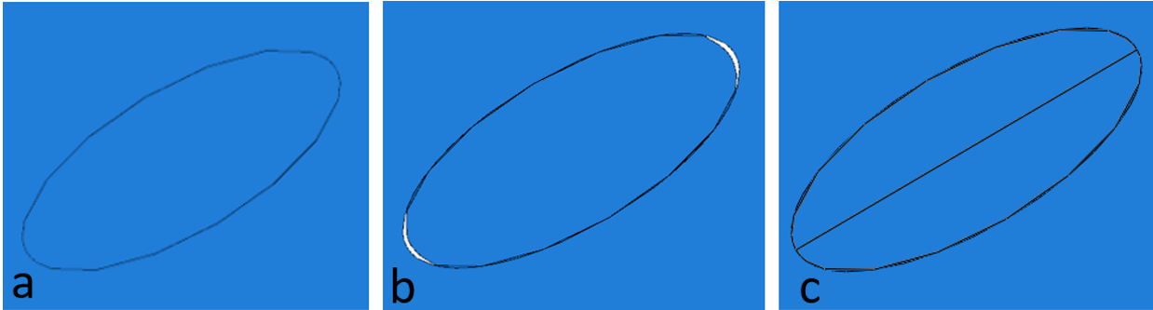
Figure 6.3. 4 Definition of the inclusion-steel boundary (a) perfectly bonded (b) boundary separation (c) internal cracked with ${30}^{°}$ angle
MODEL I: Perfectly bonded inclusion
Figures 6.3.5 (a) to (d) show the modelling results of the accumulated damage $D$, when the MnS inclusion is perfectly bonded with the steel matrix. Because the value of $D$ is saved as the state variable No.10 in the UMAT subroutine, the symbol shown in the damage distribution image is SDV 10. In addition, there is no damage modelling within the inclusion in this section. Hence, the crack initiation and propagation will only happen within the steel matrix.
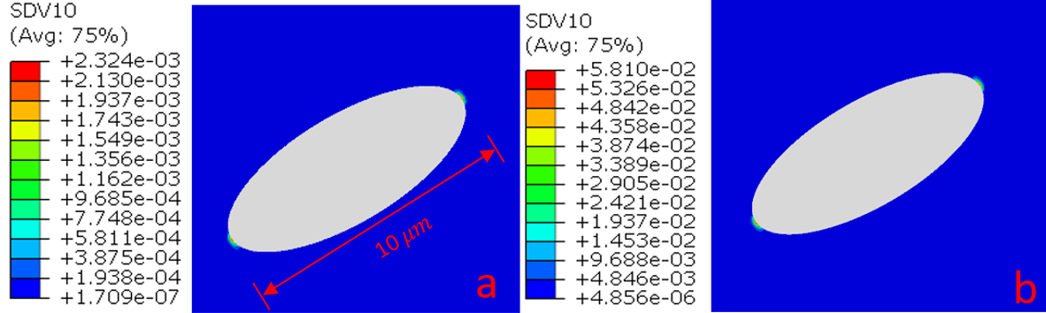
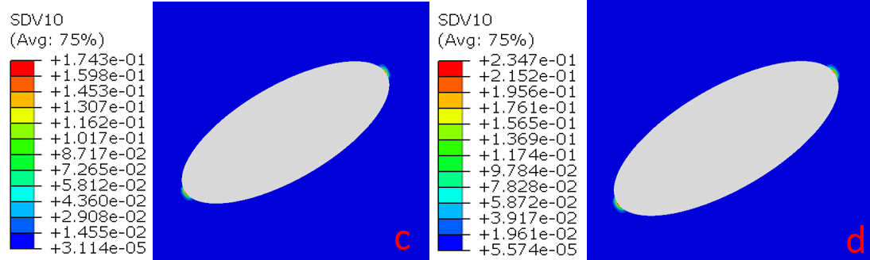
Figure 6.3. 5 Damage accumulation with the increase of loading cycles in Model Ⅰ (a) $5×{10}^{4}$ cycles (b) $5×{10}^{6}$ cycles (c) $1.5×{10}^{7}$ cycles (d) $2×{10}^{7}$ cycles
It can be observed that the perfectly bonded inclusion does not introduce any damage to the steel matrix because the simulated maximum value of damage variable $D$ is only 0.235 after $2.0×{10}^{7}$ loading cycles. This finding is constant with the observation discussed in Chapter 3 that if the boundary of the inclusion is perfectly bonded with the steel matrix, the crack is less likely to occur due to the relatively low level of the stress concentration.
It can also be found that, from the beginning to the end of the cyclic loading process, the potential crack initiation position of the steel matrix is fixed in the area around the inclusion tips. To investigate the stress variations of the area, Figure 6.3.6 compares the maximum values of the Tresca stress, orthogonal shear stress amplitude ($τ_{alternating}$), absolute mean value of the orthogonal shear stress ($\left|τ_{mean}\right|$), and the crack dominating stress defined in the CDM model ($τ_{alternating}+\left|τ_{mean}\right|$) at point A of the steel matrix within all jump-in loading blocks.
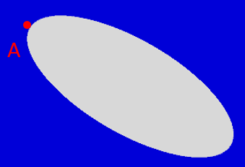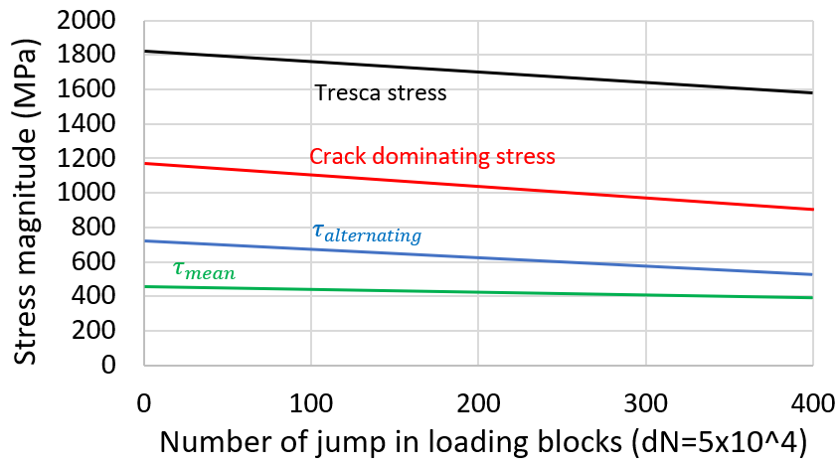
Figure 6.3. 6 Comparison of the Tresca stress and the crack dominating stress at point A in Model Ⅰ
As can be seen, all the stress values decrease with the increase of loading cycles. This is caused by the reduction of the material elastic modulus due to the damage accumulation. It is assumed in the CDM that the damage initiation is caused by the reduction of the effective load-bearing area of the material. Therefore, the elastic modulus of the material decreases gradually with increasing cycles in the simulation. When the damage variable $D$ increased to 1, the remaining effective area will no longer undertake the stress, thus the crack will initiate.
In the figure, the maximum value of the Tresca stress is only about 1800 MPa at the inclusion tips, which indicates that the damage accumulation process in Model Ⅰ occurs entirely within the elastic deformation of the material. In addition, by comparing the two components of the crack dominating stress, $τ_{alternating}$ and $\left|τ_{mean}\right|$, it is shown that the value of $τ_{alternating}$ is larger than the value of $\left|τ_{mean}\right|$, which suggests that the amplitude of the variation of the orthogonal shear stress should have the primary effect on the crack initiation, as concluded in [124].
The accumulation process of the damage variable $D$ at point A is shown in Figure 6.3.7. When the magnitude of the distributed Hertz contact pressure remains unchanged, it can be found that the accumulation of $D$ value from 0 to 0.235 in 400 jump-in blocks is almost linear. However, as described in [181], the fatigue damage accumulation of the metal material should follow the “Non-linear damage rule” (NLDR). It suggests that the damage accumulation rate will increase with the growth of the number of contact cycles. Therefore, the growing process of the damage variable may not be maintained as linear with the increasing Hertz contact cycles.
To simulate the total damage accumulation process, the number of the overall jump-in loading blocks in the FE model is set as 1200. According to the values of the damage variable plotted in Figure 6.3.7, the fatigue damage is found to initiate from the inclusion tips with approximately 1100 loading blocks, at which stage, the number of overall Hertz contact cycles simulated has exceeded $5.5×{10}^{7}$.
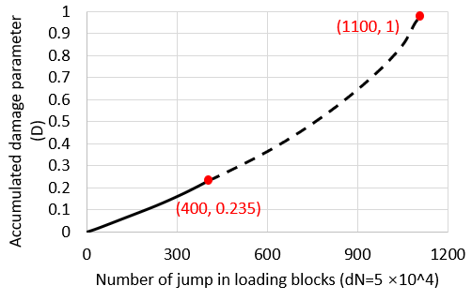
Figure 6.3. 7 Variation of damage variable $D$ within 1200 loading blocks in Model Ⅰ
In Model Ⅰ, the maximum Hertz contact pressure is set as the constant value of 2.069 GPa, representing the rated operating condition of the WT. However, as calculated in Chapter 4, only 14.01% of the time the WT is operating at the rated wind speed. During some overloading cases, the loadings applied to the bearing raceway will be larger than the loading in the nominal operating case. Therefore, due to the variation of bearing operating loading, the inclusion of the perfectly bonded boundary condition still has the possibility of causing the fatigue damage. The detailed discussion can be found in Section 2.1.6, which suggests that the RCF may cause the debonding of inclusions after a long operating time and then lead to the subsurface crack initiation and propagation.
MODEL II: Boundary separated inclusion
Figures 6.3.8 (a) to (e) show the crack initiation and propagation process from the boundary separated inclusion. Due to the existence of the gaps at the inclusion tips, the crack dominating stress around the inclusion will increase, which results in the occurrence of the crack after only five jump-in loading blocks (approximately $2.5×{10}^{5}$ loading cycles). Eventually, when the overall loading cycle reaches $2.0×{10}^{7}$, the length of the longer butterfly wing grows to 3.54 $μm$.
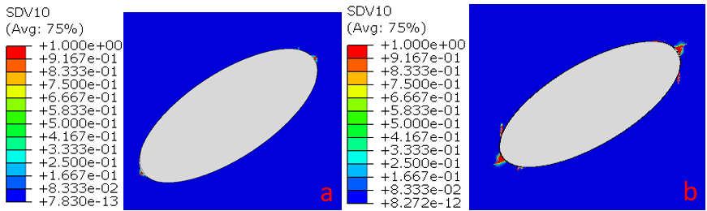
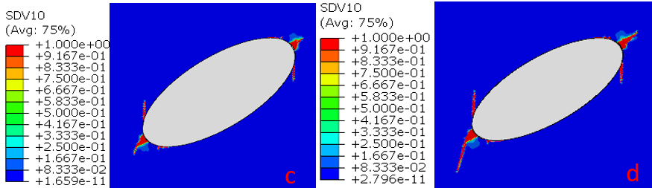
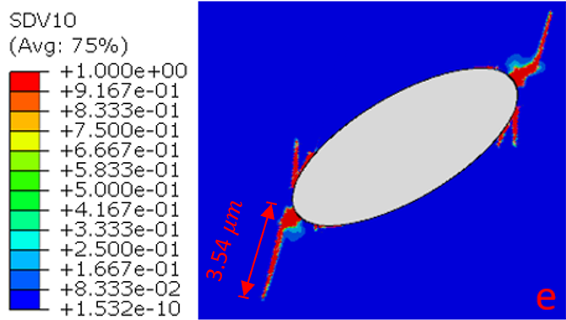
Figure 6.3. 8 Simulated crack initiation and propagation around a boundary separated MnS inclusion in Model Ⅱ (a) $2.5×{10}^{5}$ cycles (b) $5×{10}^{6}$ cycles (c) $1×{10}^{7}$ cycles (d) $1.5×{10}^{7}$ cycles (e) $2×{10}^{7}$ cycles
Figure 6.3.9 shows the changes in the crack length with the increase of loading cycles. Because the cracks in the steel matrix are initiated from both of the inclusion tips, only the longer crack is recorded in the figure. It has been found that the relationship between the crack length and the loading cycles is not linear. The crack will propagate more rapidly with the increase of the loading cycles, as shown by the crack propagation rates (the slope of the curve sections) every 100 jump-in loading blocks in the figure. $da$ in the figure means the variation of the crack length, and $d100$ means every 100 jump-in loading blocks.
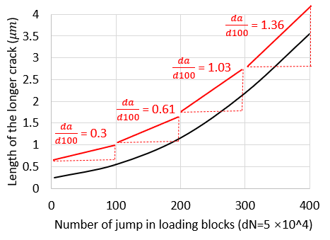
Figure 6.3. 9 Crack length vs. loading blocks caused by the boundary separated MnS inclusion in Model Ⅱ
Figure 6.3.10 compares the crack dominating stress ($τ_{alternating}+\left|τ_{mean}\right|$) at the crack tip after 100, 200 and 300 jump-in loading blocks respectively. It can be found that the dominating stress becomes greater when the number of jump-in loading blocks increases. This may be because the formation of the butterfly wing leads to the newly developed stress concentration area of the steel matrix. Meanwhile, with the crack propagation, the aspect ratio at the crack tip becomes larger, which results in the increased stress magnitude. Accordingly, the crack propagation is accelerated with more loading cycles applied.
However, the crack cannot propagate infinitely because it is still governed by the subsurface depth. When the crack propagates to the upper or deeper positions in the subsurface area, the maximum shear stress induced by the Hertz contact pressure will be reduced because the inclusion is defined at the maximum shear stress zone in the FE model Therefore, when the crack continues to grow, the dominant stress at the crack tip may decrease, which slows the crack growth to a certain extent.
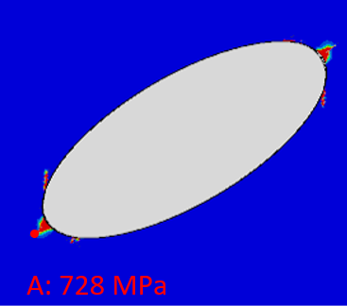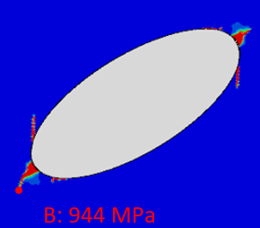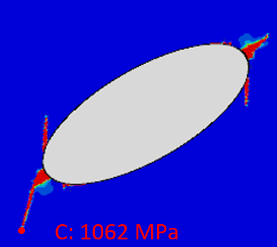
Figure 6.3. 10 Crack dominating stress at the crack tip after different jump-in loading blocks in Model Ⅱ: 100 jump-in cycles; 200 jump-in cycles; 300 jump-in cycles
MODEL III-1: Internally cracked inclusion at 30°
The effect of the inclusion internal cracking has been discussed in detail in the previous chapters. In section 3.4.2, the butterflies images observed in the failed bearing raceway indicate that the inclusion internal cracking is an important feature of the crack formation. In addition, it has been discussed in section 5.4.2 that the internal crack of an inclusion will lead to a dramatic increase in the orthogonal shear stress level around the inclusion. Therefore, the crack caused by an inclusion with the internal cracking should be longer than that caused by the boundary separation if the Hertz contact pressure applied is the same in both cases.
As shown in Figures 6.3.11 (a) to (d), the crack initiates after only one jump-in loading block ($5 ×{10}^{4}$ loading cycles), and then propagates rapidly in the following cycles. In the end, the length of the longer butterfly wing simulated by $2.0×{10}^{7}$ loading cycles is 5.67 $μm$, which is greater than the crack length caused by the boundary separated MnS inclusion shown in Figure 6.3.8.
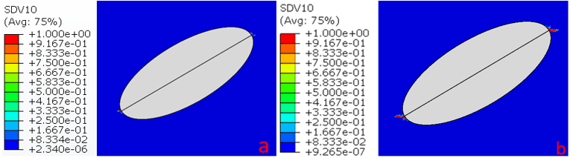
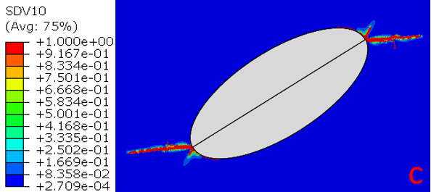
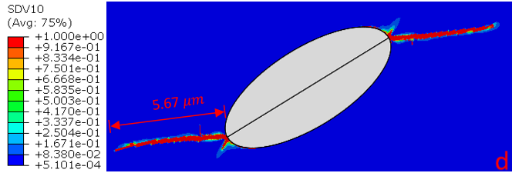
Figure 6.3. 11 Simulated crack initiation and propagation around the internally cracked MnS inclusion in Model Ⅲ-1 (a) $5×{10}^{4}$ cycles (b) $5×{10}^{6}$ cycles (c) $1.5×{10}^{7}$ cycles (d) $2×{10}^{7}$ cycles
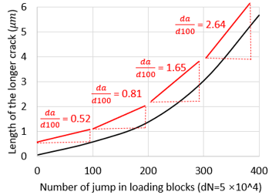
Figure 6.3. 12 Relationship between the crack length and loading blocks
The relationship between the crack length and the jump-in loading blocks is shown in Figure 6.3.12. Similar to Figure 6.3.9, the crack length variation within every 100 loading blocks is plotted as the slope of the curve section. It can be observed that the crack propagation rates in Model Ⅲ-1 are greater than the rates in Model Ⅱ from the first to the last jump-in loading block. This result is consistent with the conclusion in [123] and the conclusions obtained from the results presented in Chapter 3 and Chapter 5.
According to the FE modelling results presented in section 5.4.2, the orthogonal shear stress variation range caused by the internally cracked inclusion is larger than that of the boundary separated inclusion during the same rolling contact cycle. Similarly, in this section, the crack dominating stress at the internal cracked inclusion tip is greater than the stress of the boundary separated inclusion, as shown in Figure 6.3.13.
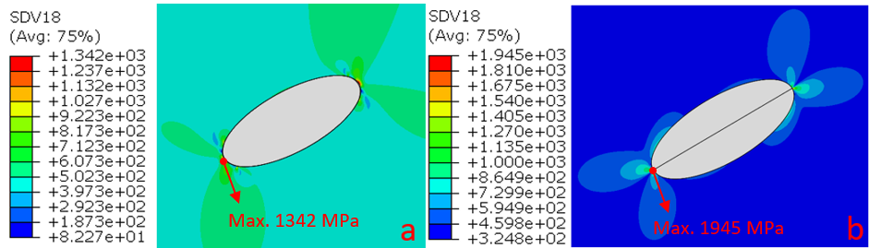
Figure 6.3. 13 Comparison of the crack dominating stress (SDV 18) during the first jump-in loading block between different inclusion damage types (a) the boundary separated inclusion in Model Ⅱ (b) the internally cracked inclusion in Model Ⅲ-1
In the developed ABAQUS user subroutine, the value of the crack dominating stress is defined as the state variable No.18. Therefore, the variable is shown as SDV 18 in Figure 6.3.13. It can be seen that the dominating stress at the inclusion tip in Model Ⅱ with the separated inclusion is 1342 MPa, while the value in Model Ⅲ-1 is 1945 MPa. Because of the relatively large crack dominating stress, both the initiation and propagation process of the butterfly wings are accelerated in Model Ⅲ-1.
MODEL III-2: Internally cracked inclusion with varied angle
Most internal cracks of the inclusions observed in Chapter 3 connect both tips of the inclusions, as shown in Figure 6.3.14. However, as illustrated by Figure 6.3.15, some internal cracks of the inclusion with different orientations have also been observed in the failed bearing raceways. These cracks go through the boundaries of the inclusions instead of connecting the inclusion tips.
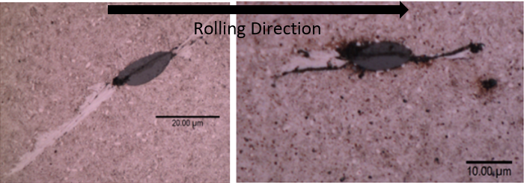
Figure 6.3. 14 Internal cracked inclusions with the cracks connecting the inclusion tips
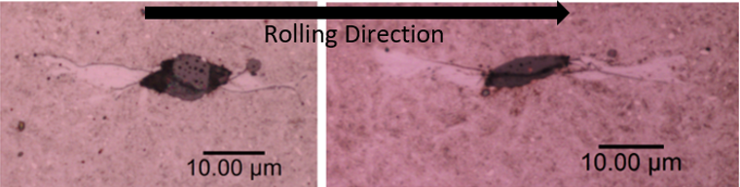
Figure 6.3. 15 Internally cracked inclusions with the cracks crossing the inclusion boundaries
Comparing the butterfly damage in Figure 6.3.14 and Figure 6.3.15, all the butterfly wings have different orientations and lengths. As discussed in Chapter 3, this may be related to varied depth of the inclusions in the subsurface area. Moreover, FE modelling results in section 5.4.2 suggest that this phenomenon may also be caused by the variations of the inclusion internal cracks. Differences in positions and orientations of the inclusion internal cracks will affect the subsurface stress distributions, which are significant in the crack formation process. Hence, to investigate the effect of the internal crack orientation on the crack initiation and propagation, two inclusions with the crack angles of $0^{°}$ and ${60}^{°}$ to the horizontal contact surface are modelled in Model Ⅲ-2, as shown in Figure 6.3.16.
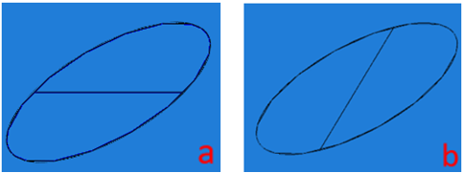
Figure 6.3. 16 Inclusion with different internal crack angles to the contact surface (a) $0^{°}$ (b) ${60}^{°}$
Details of Model Ⅲ-2, for example, the material parameters, meshing methodology, and the Hertz contact pressure distribution are the same as the definitions in Model Ⅲ-1. The only difference between the two models is the orientation of the internal crack.
The modelling results of the inclusion internal crack angle of $0^{°}$and ${60}^{°}$ are shown in Figures 6.3.17 (a) and (b) separately. Comparing the results of the crack propagations in Model Ⅲ-2 with that in Model Ⅲ-1, it can be observed that all the butterfly wings in three FE models initiate from the tips of the inclusion internal crack and then propagate to the steel matrix, even though the inclusion internal crack angles are different. However, the orientations and lengths of the butterfly wings have significant differences, as listed in Table 6.1.
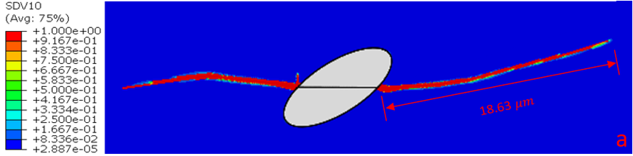
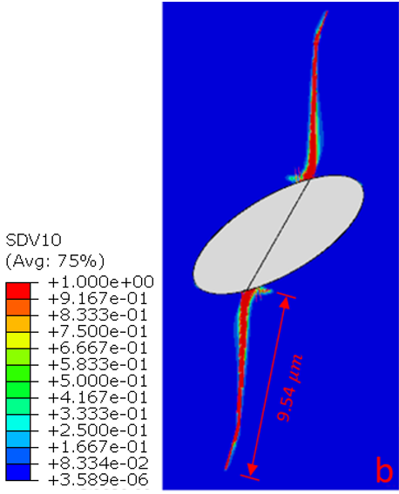
Figure 6.3. 17 Simulated crack propagations at inclusions with different internal crack angles in Model Ⅲ-2 (a) internal crack angle of $0^{°}$ (b) internal crack angle of ${60}^{°}$
Table 6. 1 Comparison of modelling results when the inclusion has different internal crack angles
Internal crack angle ($°$) | 0 | 30 | 60
Longer butterfly wing length ($μm$) | 18.63 | 5.67 | 9.54
Approximate propagation angle ($°$) | 11.5 | 9.2 | 84.5
The orientation of the butterfly wings does not show significant changes when the internal crack angle varies from $0^{°}$ to ${30}^{°}$. However, it increases dramatically from ${9.2}^{°}$to ${84.5}^{°}$when the internal crack angle rises from ${30}^{°}$ to ${60}^{°}$.
The differences of propagation angles of the butterfly wings are related to the distributions of the crack dominating stress around the inclusions. Due to the variations of the internal crack angles, the distributions of the crack dominating stress are also affected, as shown in Figures 6.3.18 (a) and (b).
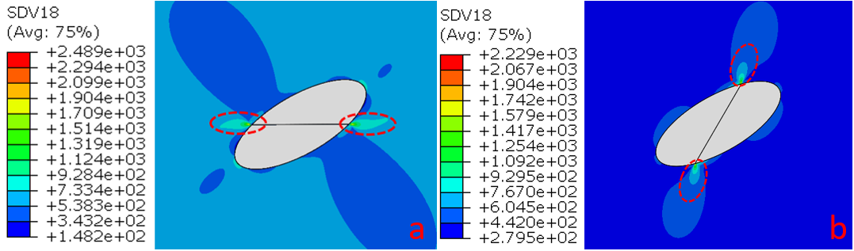
Figure 6.3. 18 Possible butterfly wings identified by the crack dominating stress distribution (a) internal crack of $0^{°}$ (b) internal crack of ${60}^{°}$
Normally, the area with a relatively greater magnitude of the crack dominating stress will form into the butterfly wings. As highlighted by dashed circles in Figure 6.3.18, these areas have the relatively greater crack dominating stress compared with the other areas around the inclusion. Therefore, the cracks are more likely to initiate from the highlighted areas and propagate alongside the orientations with higher crack dominating stress values.
In addition, the lengths of the butterfly wings have different variation tendencies. When the internal crack angle is $0^{°}$, the butterfly wing has the longest length of 18.63 $μm$. With the increase of the internal crack angle from $0^{°}$ to ${60}^{°}$, the wing length decreases to 5.67 $μm$ at ${30}^{°}$ firstly, and then increases to 9.54 $μm$ when the internal crack angle is ${60}^{°}$. It is known that the magnitude of the crack dominating stress will affect the length of the butterfly wings. Therefore, Figure 6.3.19 plots the relationship between the crack dominating stress magnitude and the internal crack angle. Furthermore, the two stress components of the crack dominating stress, $τ_{alternating}$ and $\left|τ_{mean}\right|$, are also contained in the figure for the detailed investigation.
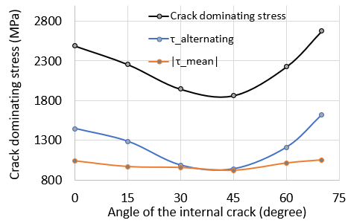
Figure 6.3. 19 The crack dominating stress magnitude during the 1st jump in loading block vs. the angle of the internal crack
It can be observed from Figure 6.3.19 that when the inclusion internal crack is $0^{°}$, the crack dominating stress in the first jump-in loading block is 2489 MPa. With the increase of the angle, the dominating stress decreases to 1865 MPa firstly (${45}^{°}$), and then increases to 2678 MPa (${70}^{°}$). The change of the crack dominating stress is constant with the tendency of the crack propagation length recorded in Table 6.1. As for the comparisons between both $τ_{alternating}$ and $\left|τ_{mean}\right|$ with different internal crack angles, it can be seen that the absolute value of the mean orthogonal shear stress, $\left|τ_{mean}\right|$, only has small changes when the variation of the internal crack angle is considered. Therefore, the variation of the crack domination stress is mainly caused by the amplitude of the orthogonal shear stress. This finding emphasises the dominating role of $τ_{alternating}$ again because its variation directly determines the initiation of the cracks.
However, it should be noticed that the relationship of the dominating stress and the internal crack angle shown in Figure 6.3.19 cannot represent all conditions of the butterfly formation. Depending on the subsurface depth, geometry, and properties of the inclusion, the butterfly wings will have diverse forms, as observed in Figure 6.3.14 and Figure 6.3.15.

Effect of surface traction
It has been discussed in section 5.1.2 that the surface traction will result in the increase of the subsurface orthogonal shear stress level, although it does not have the significant influence on the stress concentration level. Thus, the traction coefficient of the traction pressure applied on the contact surface will be changed in this section to investigate the effect of surface traction on the subsurface damage development.
In this section, inclusions are all defined as boundaries separated instead of perfectly bonded for the purpose of producing cracks in the steel matrix. Other factors such as the model geometry and meshes, material properties, and the distributed Hertz contact pressure are kept the same as those presented previously in section 6.3.2. By changing the traction coefficient defined in UTRACLOAD user subroutine, the crack propagations with the coefficient of 0.01 and 0.1 are simulated respectively. Subsequently, the FE results are compared with that in Model Ⅱ, which uses a traction coefficient of 0.05.
MODEL IV-1: Traction coefficient of 0.01
Model Ⅳ-1 investigates the crack propagation progress with the traction coefficient of 0.01 and the maximum Hertz contact pressure of 2.069 GPa. The simulation results are shown in Figure 6.3.20.
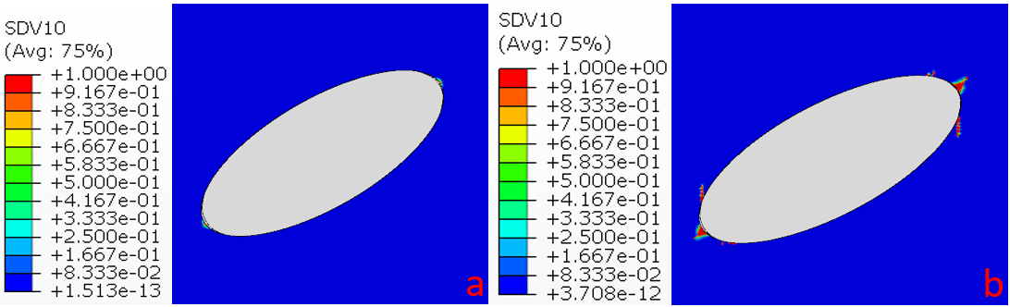
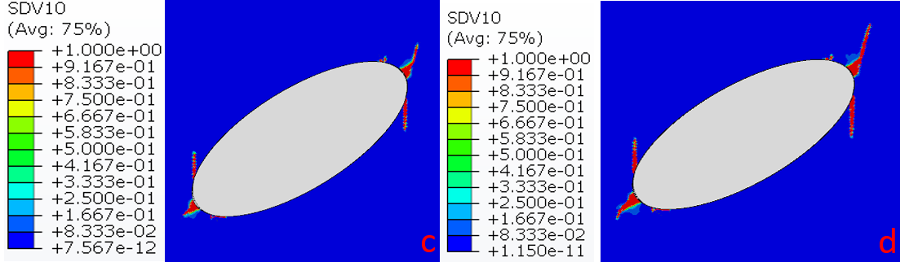
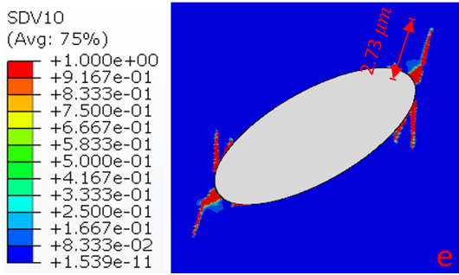
Figure 6.3. 20 Simulated crack initiation and propagation at a boundary separated MnS inclusion with the traction coefficient of 0.01 in Model Ⅳ-1 (a) $2.5×{10}^{5}$ cycles (b) $5×{10}^{6}$ cycles (c) $1×{10}^{7}$ cycles (d) $1.5×{10}^{7}$ cycles (e) $2×{10}^{7}$ cycles
Similar to the modelling results in Model Ⅱ, the crack also occurs after five loading blocks. However, the final crack propagation length of the longer butterfly wing is only 2.73 $μm$, which is shorter than the crack length of 3.54 $μm$ simulated in Model Ⅱ with the traction coefficient of 0.05.
MODEL IV-2: Traction coefficient of 0.1
Model Ⅳ-2 simulates the butterfly formation with the traction coefficient of 0.1. The modelling results are shown from Figures 6.3.21 (a) to (e). It can be seen from Figure 6.3.21 (a) that the crack forms only after two jump-in loading blocks. After that, the lower butterfly wing crack propagates rapidly to 11.62 $μm$, as illustrated by Figure 6.3.21 (e).
Compared with the modelling results in Model Ⅱ and Model Ⅳ-1, although the overall length of the butterfly wings in Model Ⅳ-2 has a significant increase, the propagation orientations of these wings do not have obvious variations. Therefore, the traction coefficient may only affect the magnitude of the dominating stress in the possible initiation area of the crack.
Figure 6.3.22 plots the relationship between the crack propagation length and the traction coefficient value. With the increase of the traction coefficient from 0.01 to 0.1, the crack length rises from 2.73 $μm$ to 11.62 $μm$ after 400 jump-in loading blocks. Therefore, the traction coefficient has shown to have a significant effect on crack propagation, especially when its value exceeds 0.05.
The FEM investigation in [120] and the twin-discs test in [97] all discussed the importance of the traction coefficient on the butterfly formation. In both studies, it was considered as the factor that made the subsurface maximum shear stress closer to the contact surface. Therefore, some inclusions very close to the contact surface may become more likely to be cracked or boundary separated, leading to the final butterfly formation. In addition, due to the positions of these butterfly damage, the cracks have the relatively small distances to propagate to the contact surface when compared with other deeper located inclusions.
Furthermore, modelling results in this section provide the complementary explanations for the effect of the traction coefficient. Inclusions in the relatively deep subsurface area may also have high possibilities to initiate the butterfly damage. Because of the increased orthogonal shear stress, the crack nucleation happens earlier than before, which results in a longer propagation period of the crack. Therefore, it is easier for the crack networks to form from the deep subsurface area and then propagate rapidly to the contact surface.
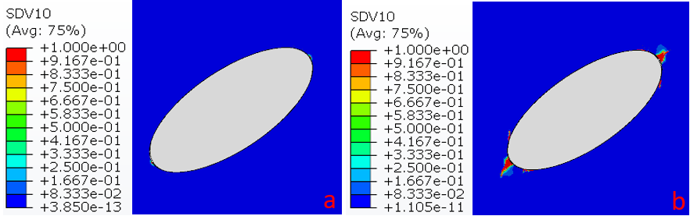
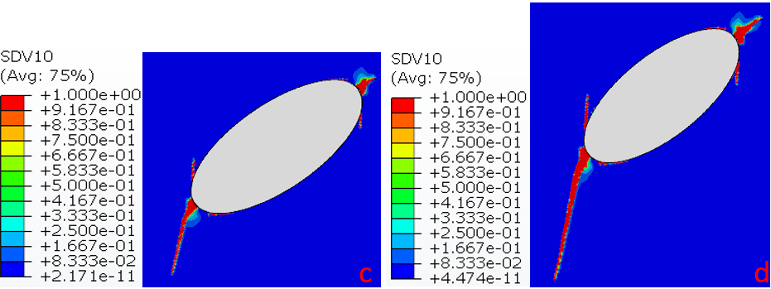
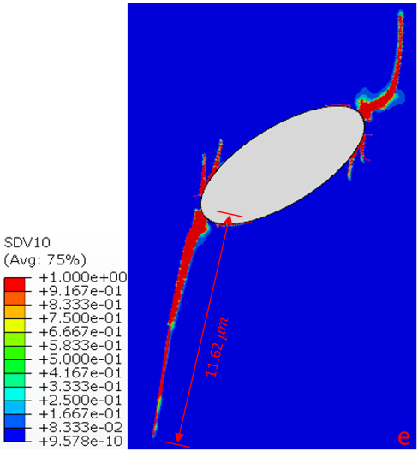
Figure 6.3. 21 Simulated crack initiation and propagation at a boundary separated MnS inclusion with the traction coefficient of 0.1 in Model Ⅳ-2 (a) $1×{10}^{5}$ cycles (b) $5×{10}^{6}$ cycles (c) $1×{10}^{7}$ cycles (d) $1.5×{10}^{7}$ cycles (e) $2×{10}^{7}$ cycles
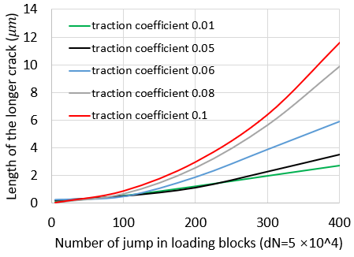
Figure 6.3. 22 Crack lengths vs. loading cycles under different levels of traction coefficient
In addition to the increase of the crack length, the butterfly damage simulated by Model Ⅵ-2 has one crack wing much longer than the other one, as shown in Figure 6.3.21 (e). Comparing the modelling results in Model Ⅵ-1, Model Ⅵ-2 and Model Ⅱ, the only parameter changed is the level of the traction coefficient. Therefore, this finding suggests a new hypothesis that the lengths of two wings of the butterfly may be different due to the effect of the surface traction. This assumption is different from the hypothesis proposed in [86] that the two wings of the same butterfly differ in length because they were formed in sequence. To investigate the stress differences between the upper and lower butterfly wings, variations of the crack dominating stress at both wing tips after 400 jump-in loading blocks are plotted in Figure 6.3.23.
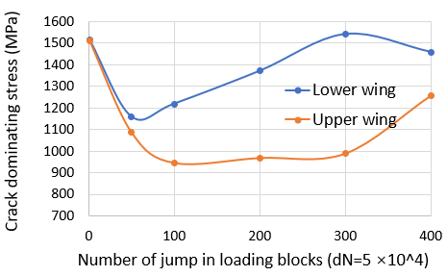
Figure 6.3. 23 Crack dominating stress at the upper and lower butterfly wings tips over the full loading process in Model Ⅳ-2
According to the modelling results, both wing tips of the butterfly have the similar crack dominating stress at the beginning of the loading process. It means that the butterfly wings may initiate simultaneously from both two tips of the inclusion. However, with the increase of the number of jump-in loading blocks, the lower butterfly wing tip has a much higher crack dominating stress than the upper butterfly wing tip. Accordingly, the length of the lower wing has propagated longer than the upper one.
The variation in the crack dominating stress between two butterfly wing tips may be caused by the different stress concentration levels at the inclusions tips. Figure 6.3.24 (a) shows the definitions of two paths of 5 $μm$ in the steel matrix at both tips of the inclusion. In this figure, the moving distributed Hertz contact pressure is located directly above the inclusion, which is on the middle surface of the rectangular steel matrix. As shown in Figure 6.3.24 (b), the Tresca stress variation along each path is recorded with the specific Hertz contact pressure position in the first jump-in loading block.
It can be found that most Tresca stress magnitudes recorded in path 1 are greater than the values in path 2 at the same positions. This difference may be caused by the increased traction pressure during the rolling contact process and the artificially created gaps between the inclusion and the steel matrix. Generally, this finding suggests that the stress concentration level at the lower butterfly wing tip is more severe than the upper one. Accordingly, the crack dominating stress at the lower inclusion tip during the crack propagation is correspondingly greater, when compared with that of the upper wing.
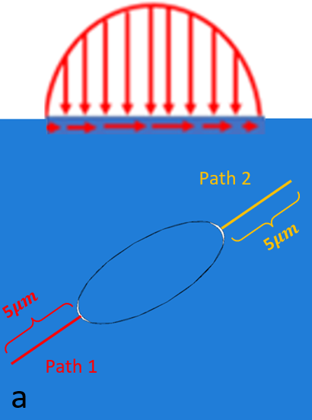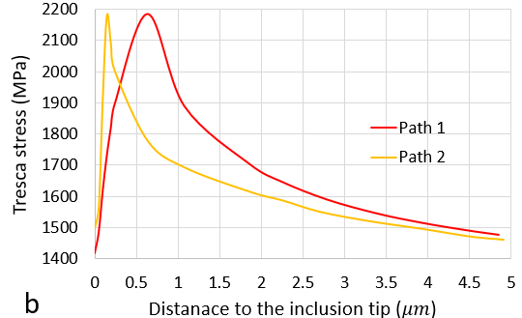
Figure 6.3. 24 Tresca stress distributions along two defined paths at the inclusion tips in Model Ⅳ-2 (a) Definition of the Hertz contact pressure and the paths (b) comparison of the Tresca stress distributions
However, due to the uncertainty of the inclusion geometry and the propagated crack during the actual butterfly damage formation, the stress concentration level around the upper wing tip may still has the possibility to be greater than that of the lower wing tip. Therefore, the relationship between the lengths of two butterfly wings may not be uniform in the subsurface area of the actual bearing raceways.

Effect of varying Hertz contact pressure
In Chapter 4, it has been discussed that the maximum Hertz contact pressure applied on the planetary bearing inner raceway will be changed due to the wind speed variation and operating conditions such as the start-up, shutdown, and braking process. Accordingly, the variation of the loading magnitudes should be considered in the modelling of the crack initiation and propagation of the planetary bearing raceway.
Based on the calculation results in Chapter 4, Table 6.2 lists the maximum Hertz contact pressure and the percentage of the loading cycles of each wind turbine operating case. The overall loading cycles simulated in this section is still $2.0×{10}^{7}$ cycles with 400 loading blocks (each loading block has $5 ×{10}^{4}$ cycles). Therefore, the number of jump-in blocks for each loading case can be determined as shown in the table.
Table 6. 2 Hertz contact parameters and percentage of loading cycles in each WT operating loading case
Loading case |  | Maximum contact pressure $p_{0}$ (GPa) | Half contact length $b$ (mm) | Contact number percentage | Number of jump-in loading blocks
Ⅰ | 4-7 m/s wind speed | 0.92 | 0.236 | 17.17% | 400$∙$ 17.17%= 69
Ⅱ | 7-9 m/s wind speed | 1.31 | 0.335 | 18.35% | 400$∙$ 18.35%= 73
Ⅲ | 9-12 m/s wind speed | 1.82 | 0.392 | 28.25% | 400$∙$ 28.25%= 113
Ⅳ | 12-15 m/s wind speed | 2.06 | 0.528 | 11.48% | 400$∙$ 11.48%= 46
Ⅴ | >15 m/s wind speed | 2.07 | 0.531 | 14.01% | 400$∙$ 14.01%= 56
Ⅵ | Normal overloading | 2.39 | 0.613 | 9.60% | 400$∙$ 9.60%= 38
Ⅶ | Extreme overloading | 2.84 | 0.730 | 1.15% | 400$∙$ 1.15%= 5
MODEL V: Varying Hertz contact pressure
In Model Ⅴ, the maximum contact pressure and the contact length of the Hertz contact pressure distribution will vary. As illustrated by Figure 6.3.25, the maximum Hertz contact pressure changes from 0.92 GPa to 2.84 GPa in sequence. It assumes that the WT operates with the wind speed increases from “4-7 m/s” to “>15 m/s”, and then it will experience the normal and emergency shutdown processes. To compare the crack initiation and propagation with Model Ⅱ, the MnS inclusion defined in Model Ⅴ still has its boundary separated from the steel matrix. Moreover, the traction coefficient remains to be 0.05, as defined in Model Ⅱ.
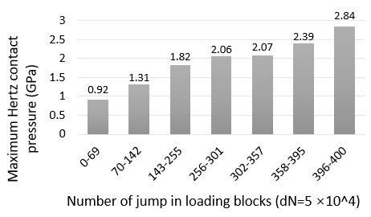
Figure 6.3. 25 Variation of the maximum contact pressure in 400 jump-in loading blocks of Model Ⅴ
Figures 6.3.26 (a) to (f) show the crack initiation and propagation process after finishing the simulation of different loading cases. It can be seen that after the loading case Ⅰ (loading blocks 0-69), the accumulated damage $D$ is only 0.012. Subsequently, as shown in Figure 6.3.26 (b), the crack initiates after the 150th loading block when the maximum contact pressure has just increased from 1.31 GPa to 1.82 GPa. After that, the upper butterfly wing shown in Figure 6.3.26 (d) propagates to 0.536 $μm$ when the wind speed exceeds 15 m/s. In the end, after experiencing the normal and extreme overloading cases, the crack length increases to 3.36 $μm$, as shown in Figure 6.3.26 (f).
Normally, the maximum Hertz contact pressure during the overloading cases does not exceed 3.1 GPa, which will not cause large plastic deformation of the through hardened raceway surfaces [26]. Therefore, the effect of overloading is mainly manifested as the stress increasing around the subsurface inclusions. It has been emphasised in [182] that the frequent occurrence of the overloading cases in WT operations will cause the low-cycles fatigue of the subsurface area. Additionally, because the overloading also introduces the intense frictions between the cracked surfaces, the study in [183] believed that it was directly linked with the formations of WECs and WSF.
The modelling results shown in Figure 6.3.26 suggest that the normal overloading and extreme overloading cases during the unusual WT operating conditions will lead to the rapid propagation of the subsurface cracks, although the numbers of rolling contact cycles in both loading cases are much smaller than the numbers of the normal operating conditions in loading case Ⅰ, Ⅱ, Ⅲ, Ⅳ, and Ⅴ.
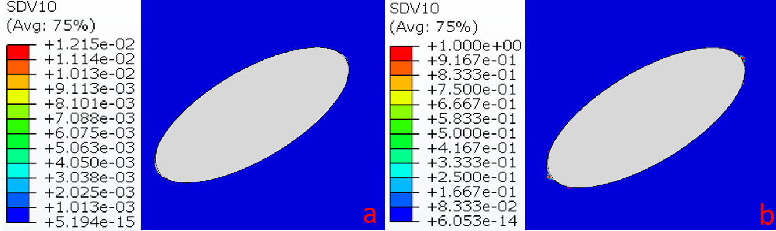
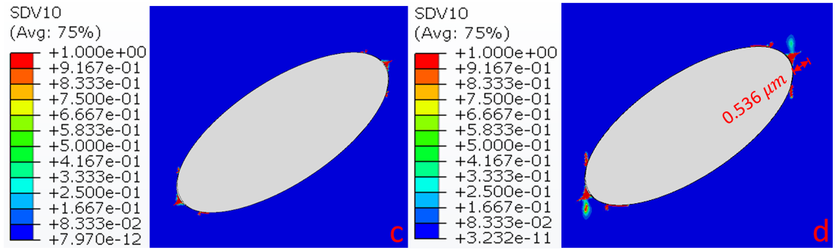
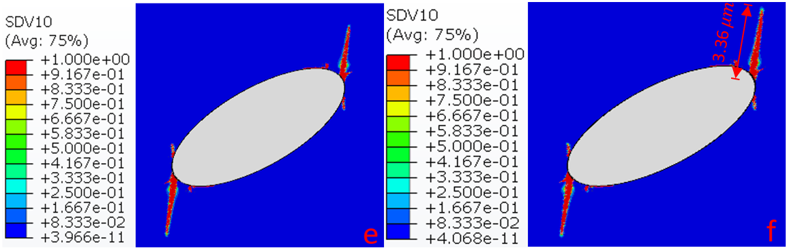
Figure 6.3. 26 Simulated crack initiation and propagation under varied Hertz contact pressure in Model Ⅴ (a) no crack after loading case Ⅰ of $3.45×{10}^{6}$ cycles (b) crack initiation after $7.5×{10}^{6}$ cycles (c) crack propagation after loading case Ⅲ of $1.28×{10}^{7}$ cycles (d) crack propagation after loading case Ⅴ of $1.79×{10}^{7}$ cycles (e) crack propagation after loading case Ⅵ of $1.98×{10}^{7}$cycles (f) crack propagation after loading case Ⅶ of $2×{10}^{7}$ cycles
MODEL VI: Without considering the extreme overloading case
Some published studies indicate that the overloading on the bearing raceway will lead to the rapid accumulation of the fatigue damage [18][26][182].Depending on the magnitude of the maximum contact pressure and the frequency of occurrence, the overloading cases can be divided into the normal case and the extreme case. To understand the effect of overloading conditions in detail, Model Ⅵ and Model Ⅶ are established with the aim to simulate the crack initiation and propagation without considering the extreme overloading and both the normal and extreme overloading cases.
The number of overall loading cycles simulated in Model Ⅵ is still $2.0×{10}^{7}$. However, because the extreme overloading case is not considered in this model, the percentages of the other loading cases are recalculated according to their original proportions, as listed in Table 6.3. Correspondingly, the maximum Hertz contact pressure in the jump-in loading blocks also changes, as illustrated by Figure 6.3.27.
Table 6. 3 Hertz contact parameters and loading cycle percentage of each operating loading case (without the extreme overloading case)
Loading case |  | Maximum contact pressure $p_{0}$ (GPa) | Half contact length $b$ (mm) | Contact number percentage | Number of jump-in loading blocks
Ⅰ | 4-7 m/s wind speed | 0.92 | 0.236 | 17.37% | 400$∙$ 17.37%= 69
Ⅱ | 7-9 m/s wind speed | 1.31 | 0.335 | 18.57% | 400$∙$ 18.57%= 74
Ⅲ | 9-12 m/s wind speed | 1.82 | 0.392 | 28.58% | 400$∙$ 28.58%= 114
Ⅳ | 12-15 m/s wind speed | 2.06 | 0.528 | 11.61% | 400$∙$ 11.61%= 46
Ⅴ | >15 m/s wind speed | 2.07 | 0.531 | 14.17% | 400$∙$ 14.17%= 57
Ⅵ | Normal overloading | 2.39 | 0.613 | 9.71% | 400$∙$ 9.71%= 39
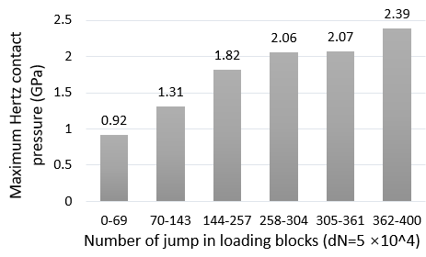
Figure 6.3. 27 Variation of the maximum contact pressure in 400 jump-in loading blocks of Model Ⅵ
Figure 6.3.28 shows that the final crack length of the upper butterfly wing in Model Ⅵ is 3.23 $μm$, which is very close to the crack length of 3.36 $μm$ modelled in Model Ⅴ. Therefore, it may indicate that the propagation of the fatigue crack is not dominated by the extreme overloading case.
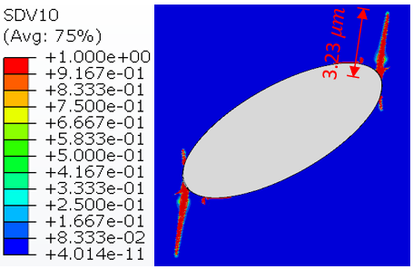
Figure 6.3. 28 Simulated cracking with varied Hertz contact pressure (no extreme overloading case) in Model Ⅵ after $2×{10}^{7}$ cycles
MODEL VII: Without considering the normal and extreme overloading cases
Model Ⅶ simulates the butterfly formation without the effect of both the normal and extreme overloading cases. Similarly, the new proportion of each loading case and the definitions of each jump-in loading block in Model Ⅶ are listed in Table 6.4 and Figure 6.3.29 respectively.
According to the modelling results shown in Figure 6.3.30, it can be seen that the crack only propagates to 0.94 $μm$ at the end of $2×{10}^{7}$ load cycles, without the effect of both the normal and extreme overloading cases.
Table 6. 4 Pressure magnitudes and percentage of loading cycles in each loading case (without the normal overloading and extreme overloading case)
Loading case |  | Maximum contact pressure $p_{0}$ (GPa) | Half contact length $b$ (mm) | Contact number percentage | Number of jump-  in loading blocks
Ⅰ | 4-7 m/s wind speed | 0.92 | 0.236 | 19.23% | 400$∙$ 19.23%= 77
Ⅱ | 7-9 m/s wind speed | 1.31 | 0.335 | 20.56% | 400$∙$ 20.56%= 82
Ⅲ | 9-12 m/s wind speed | 1.82 | 0.392 | 31.65% | 400$∙$ 31.65%= 127
Ⅳ | 12-15 m/s wind speed | 2.06 | 0.528 | 12.86% | 400$∙$ 12.86%= 51
Ⅴ | >15 m/s wind speed | 2.07 | 0.531 | 15.70% | 400$∙$ 15.70%= 63
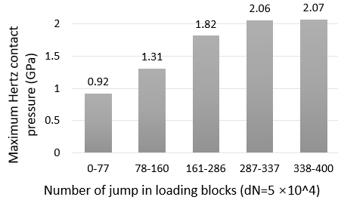
Figure 6.3. 29 Variation of the maximum contact pressure in 400 jump-in loading blocks of Model Ⅶ
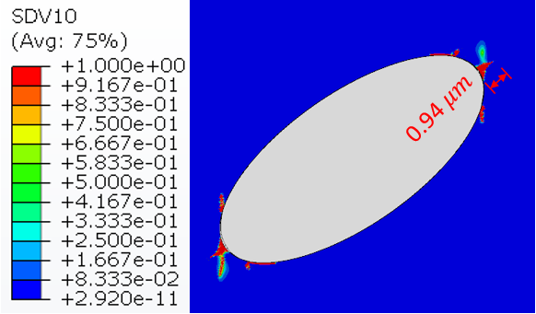
Figure 6.3. 30 Simulated cracking with varied Hertz contact pressure (no extreme overloading and normal overlading cases) in Model Ⅶ after $2×{10}^{7}$ cycles
In Model Ⅴ, Ⅵ, and Ⅶ, FE modelling results show that the cracks all initiate after approximately 150 jump-in loading blocks because of the similar Hertz contact pressure applied in the normal loading cases. However, the crack propagation processes in three models are different. The simulated crack lengths in Model Ⅴ, Ⅵ, and Ⅶ are compared in Figure 6.3.31.
It can be seen that the extreme overloading cases may not have a significant effect on the propagated crack length. This is because the loading cycles of the extreme loading cases only take 1.15% of the total loading cycles of all operating loading cases. On the contrary, the normal overloading case may have an important influence on the crack propagation because the crack length decreases from 3.23 $μm$ to 0.94 $μm$ without the effect of both the normal and extreme overloading case. Compared with the extreme overloading case, the normal overloading case has a higher percentage of the total loading cycles of 9.60%. Therefore, it has a relatively greater influence on the crack propagation.
In conclusion, modelling results in this section indicate that the typical high contact pressure applied on the bearing raceway during some extreme operating conditions may not dramatically accelerate the subsurface crack propagation. However, frequent normal overloading cases such as the WT start-up and shutdown operating situations may lead to the rapid propagation of the subsurface cracks.
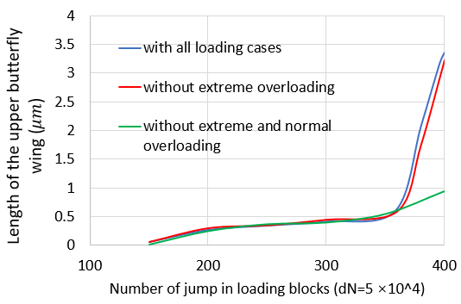
Figure 6.3. 31 Comparison of the crack propagation lengths with and without the overloading cases

Effect of varied loading sequence
For the actual operating situation of the V80-2MW WT, the overloading cases will occur throughout the operation time. Hence, the overloading conditions on the bearing raceway may happen in the early or late stages of the bearing operation. To investigate the effect of loading sequences on the damage initiation and propagation, the concept of “varying loading group” is proposed in this section which considers the maximum Hertz contact pressure variation from 0.92 GPa to 2.83 GPa as a group of loading. The overall loading process may contain more than one loading group, and the loading cycles included in each loading group are reduced correspondingly, due to the increased number of loading groups.
In a loading group, the proportions of cycles contained in each loading case follow the percentages defined in Table 6.2. Meanwhile, the same as the previously defined models, all the models in this section contain 400 jump-in loading blocks, and each loading block has $5 ×{10}^{4}$ loading cycles. In addition, the traction coefficient used in this section is 0.05; the properties and geometries of both the steel matrix and inclusion are the same as the definitions in the previous boundary separated inclusion models of Chapter 6.
Model VIII: Two loading groups
The definitions of the jump-in loading blocks with two loading groups are illustrated by Figure 6.3.32. The overall 400 jump-in loading blocks are divided into two parts. In each part, the maximum Hertz contact stress changes from 0.92 GPa to 2.84 GPa in sequence, as shown in the figure.
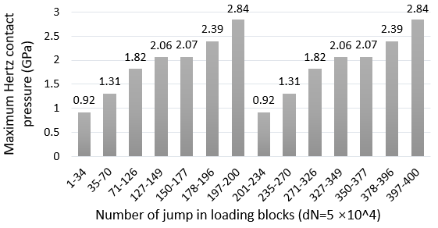
Figure 6.3. 32 Definition of jump-in loading blocks considering two loading groups
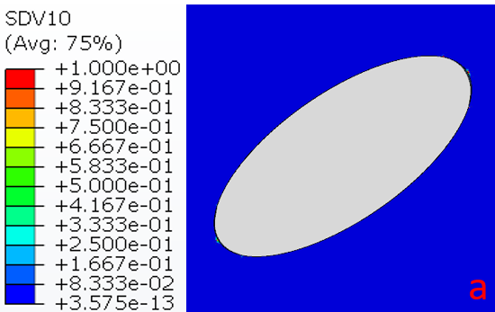
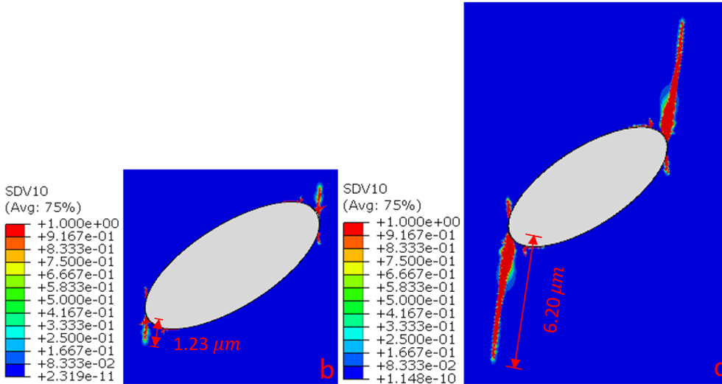
Figure 6.3. 33 Simulated crack development considering 2 loading groups in Model Ⅷ (a) crack initiation after 76 jump-in loading blocks (b) crack propagation after one loading group with 200 jump-in loading blocks (c) crack propagation after two loading groups with 400 jump-in loading blocks
According to the modelling results shown in Figure 6.3.33, it can be seen that the crack initiation occurs since the 76th jump-in loading block, during which the maximum Hertz contact pressure reaches 1.82 GPa. After completing one loading group, the crack of the lower butterfly wing propagates to 1.23 $μm$, and then it further propagates to 6.20 $μm$ when all jump-in loading blocks of the second loading group are completed.
Figure 6.3.34 shows the crack dominating stress variation at the lower butterfly wing tip during the first and second loading group. It can be seen that the crack dominating stress at the beginning of the second loading group is 1386 MPa, which is much greater than the stress value of 563 MPa at the start of the first loading group.
Therefore, although the distributed Hertz contact pressure applied is exactly the same in both loading groups, the growth of crack mainly occurs during the second loading group due to the relatively large crack dominating stress. According to the analysis results, it can be concluded that the already damaged steel matrix may become weaker than before when it is subjected to the same loading condition.
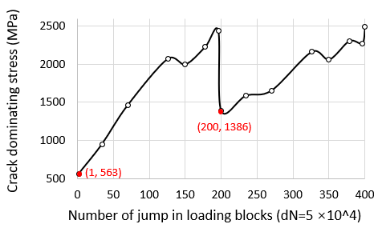
Figure 6.3. 34 Variation of the crack dominating stress at the lower butterfly wing tip in Model Ⅷ
Model IX: Four loading groups
Similar to Figure 6.3.32, Figure 6.3.35 illustrates the definitions of the jump-in loading blocks and the corresponding maximum Hertz contact pressure when the number of loading groups increases to four. In each loading group, the magnitude of the maximum Hertz contact pressure increases gradually from 0.92 GPa to 2.84 GPa.
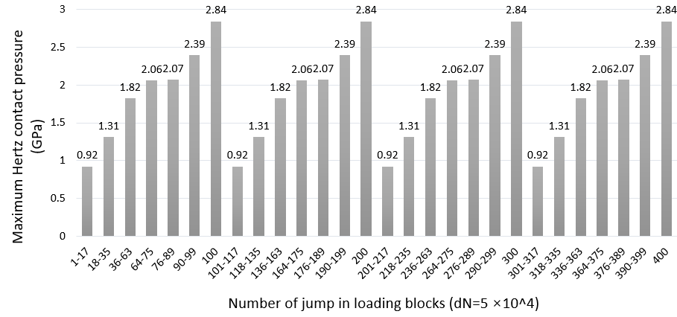
Figure 6.3. 35 Definition of jump-in loading blocks considering four loading groups
The modelling results of Model Ⅸ are shown in the Figure 6.3.36. Compared with the modelling results in Model Ⅷ, the crack is initiated after only 40 jump-in loading blocks, as can be seen in Figure 6.3.36 (a). The maximum pressure in this jump-in loading block is identified as 1.82 GP, which is the same as the pressure magnitude identified in Model Ⅷ when the crack has just initiated. Hence, it indicates that the structure integrity of the raceway may not be damaged significantly by RCF if the maximum Hertz contact pressure applied are lower than 1.82 GPa, even if the inclusions have the separated boundaries. However, when the maximum Hertz pressure increases to 1.82 GPa, the crack will initiate within a short period. Although the subsurface RCF damage may not occur with low contact pressure levels, study in [95] still believes that the bearing raceways may be damaged by the sliding between the rollers and raceway. According to this investigation, if the loading applied to the raceway is typically low, the relative sliding between bearing elements has potential to cause scratches on the raceway surface, which will then develop into the surface initiated cracks.
As shown in Figures 6.3.36 (b) to (e), after the initiation of the crack, the lower butterfly wing propagates from 0.635 $μm$ to 11.37 $μm$ when subjected to four loading groups. Furthermore, the crack propagation angle shown in Figure 6.3.36 (e) due to four loading groups is almost the same as the angles in Model Ⅷ (two groups) and Model Ⅴ (one group). Therefore, the change of loading sequences may not affect the orientations of the propagated butterfly wings. According to the modelling results in section 6.3.2, the possible orientation of crack propagation may only be dominated by the inclusion subsurface depth, geometry, and its damage types (internal cracking and/or boundary separation).
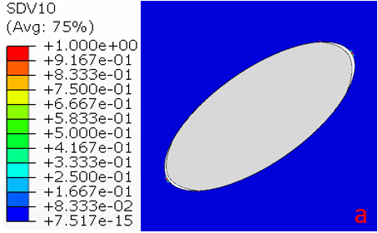
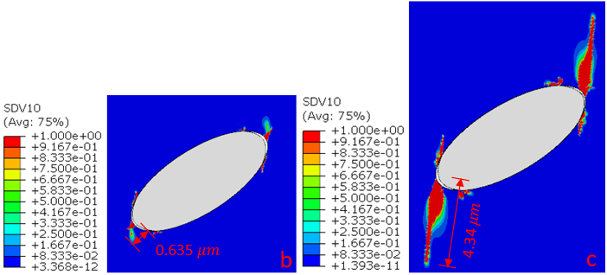
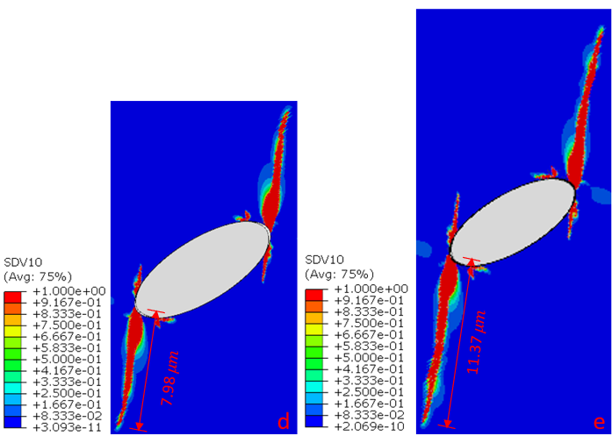
Figure 6.3. 36 Simulated crack development considering 4 loading groups in Model Ⅸ (a) crack initiation after 40 jump-in loading blocks (b) crack propagation after one loading group with 100 jump-in loading blocks (c) crack propagation after two loading groups with 200 jump-in loading blocks (d) crack propagation after three loading groups with 300 jump-in loading blocks(e) crack propagation after four loading groups with 400 jump-in loading blocks
Figure 6.3.37 compares the crack length during the loading process obtained from Model Ⅸ, Model Ⅷ, and Model Ⅴ. Due to the variation of the maximum Hertz pressure from 0.92 GPa to 2.83 GPa in each loading group, cracks in all three models show the wave-like increasing trends. The other conclusion can be obtained from the figure is that with the increase in the number of loading groups, the final crack propagation length will increase correspondingly. This is because the raceway is subjected to the normal and extreme overloading cases at the early stage of the loading process.
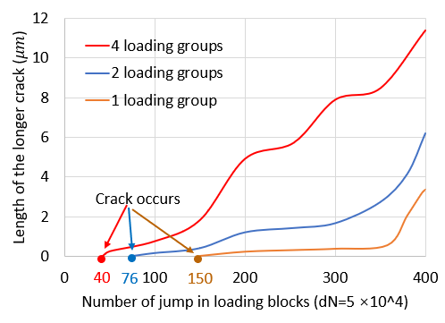
Figure 6.3. 37 Comparison of the crack propagation process of 1, 2 and 4 loading groups
In Model Ⅸ, the overloading starts after the 89th jump-in loading cycle, which causes the crack to propagate at a rapid rate. Therefore, when the material undergoes the subsequent loading groups, even the low maximum Hertz pressure of 0.92 GPa will cause the growth of cracks due to the high stress concentration level at the tips of the already propagated cracks. However, in Model Ⅴ, because only one loading group is considered, the crack does not occur until the 150th jump-in loading block. This indicates that the maximum pressure of 0.92 GPa in Model Ⅴ does not contribute to the crack propagation.
In other words, due to the overloading condition occurs earlier in the loading process, the crack initiates earlier and has a longer propagation time to form into the crack network. These modelling results suggest the loading sequence is an important factor for the crack initiation and propagation in the WT gearbox bearings.
Due to the extremely long computational time (at least 48 hours for each model), only 400 loading blocks are defined in the study. Thus, up to four loading groups can be simulated in Model Ⅸ considering that at least one jump-in block should be allocated for each loading case. However, the statistic in [167] indicated that the WT may experience hundred times of shutdown, start-up, and grid fault events within one year. Therefore, the overloading cases may occur much earlier than the situation considered in this study. As a result, the length of the actual butterfly wings may be longer than the simulation results shown in Figure 6.3.36 (e).

Verification of the newly developed CDM FE model
To validate the new CDM FE modelling method and the ABAQUS user subroutines developed in section 6.2, additional validation models for simulating the inclusion-initiated cracks are created in this section. After that, the modelling results will be compared with the published twin-discs tests results and the images of the damaged V80-2MW planetary bearing presented in Chapter3.
Validation Model 1
Figure 6.3.38 (a) shows the MnS+${Al}_{2}O_{3}$ compound inclusion observed in a damaged 100Cr6 twin-discs test specimen [92]. Because the inclusion is mostly composed of MnS, it is considered as the MnS inclusion in the FE modelling for the simplification. From the images presented in Chapter 3 and the modelling results in section 6.3.2, it has been concluded that the perfectly bonded inclusion-steel matrix may not lead to the initiation of cracks in the steel matrix within limited loading cycles. Therefore, although the separated boundary is not visible in Figure 6.3.38 (a), this model still assumes that the inclusion and the steel matrix are freely contacted with each other without defining any cohesive behaviours. Accordingly, the boundary separation at the inclusion and steel matrix interface will happen when the loading is applied to the contact surface of the specimen. Moreover, the validation models in this section also adopt the jump-in loading block assumption. In this case, the number of overall loading cycles is $5.0×{10}^{7}$. Hence, for reducing the computational costs, the number of jump-in loading blocks is defined as 500, which means each jump-in block includes $1.0×{10}^{5}$ loading cycles.
Normally, the number of the loading cycles defined in each loading block does affect the final crack propagation, because the accumulation of the damage parameter within every single jump-in block is changed. With the decrease of the loading cycles in each jump-in block, the modelling results become more accurate. Assuming the number of overall simulated loading cycles is fixed, the number of jump-in loading blocks will increase correspondingly due to the decreased loading cycles in each block. As a result, the step time defined in the FE model becomes longer, which increases the computational time considerably. Generally, the number of jump-in loading blocks and the loading cycles contained in each block should be balanced considering the modelling accuracy and the computational time.
Figure 6.3.38 (b) shows the simulated crack propagation at the inclusion. The overall length of the butterfly wings modelled is 17.2 $μm$; while the actual butterfly damage observed in microscopy is approximately 19 $μm$. In addition, the average angle of two propagated butterfly wings of the model in Figure 6.3.38 (b) is $45°$, which is not much different from the angle of $48°$ in the microscope image. Hence, the modelling results are very close to the actual crack propagation.
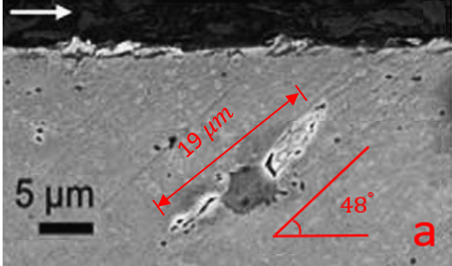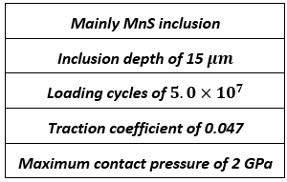
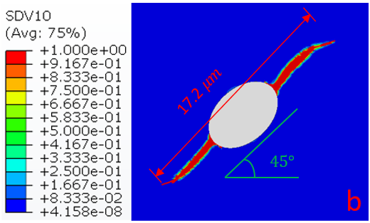
Figure 6.3. 38 Comparison of a MnS butterfly damage (a) actual butterfly damage from experiment in [92] (b) simulated damage by the developed CDM FE model
Validation Model 2
Figure 6.3.39 (a) shows another MnS+${Al}_{2}O_{3}$ compound inclusion observed in [92]. It is defined as the MnS inclusion in this FE model for the same reason mentioned in Validation Model 1. In addition, to facilitate the modelling of the inclusion, the original irregular shape of the inclusion is simplified into an ellipse, as shown in Figure 6.3.39 (b). Similar to Validation Model 1, the boundary between the inclusion and the steel matrix is defined as “free contact”. Considering the overall loading cycles simulated is $2.5×{10}^{7}$, the number of the jump-in loading blocks defined is 500, which means each block contains $5.0×{10}^{4}$ loading cycles.
The modelled butterfly damage has a total length of 23.81 $μm$; while the observed butterfly damage from the experiment is approximated 27 $μm$. In addition to the difference in the overall length of the butterfly damage, the crack orientations in the experimental and CDM finite element models also have some distinctions. It can be observed in Figure 6.3.39 (a) that the crack propagated from the inclusion with the angle of $23°$, but the crack angle modelled is $31°$, as shown in Figure 6.3.39 (b). These differences may be caused by the simplification of the inclusion geometry during the model development. Due to that, the crack dominating stress distribution around the inclusion tips may be different, which causes the variations of the crack length and the propagtion orientation.
Moreover, the butterfly simulated in the CDM FE model is a four-wings butterfly as shown in Figure 6.3.39 (b). However, in Figure 6.3.39 (a), only two wings of the buttefly can be clearly observed. Apart from the simplification of the inclusion geometry, this difference may also indicate that the assumption of the free contacted inclusion-matrix boundary condition may not be accurate. In the actual case, the separation may occur only on a part of the inclusion-matrix boundary, rather than the entire boundary as assumed in the CDM FE modelling. However, the separated boundary is not visible from the actual butterfly image, thus the entire boundary is assumed to be separated from the steel matrix with the “free contact” boundary condition.
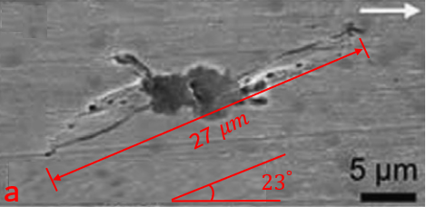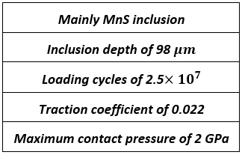
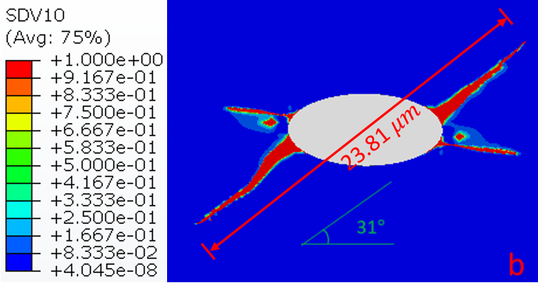
Figure 6.3. 39 Comparison of an irregular MnS butterfly damage (a) actual butterfly damage from experiment in [92] (b) modelled damage by the developed CDM model
Validation Model 3
In this validation model, the butterfly damage initiated by a MnS inclusion containing the internal crack is selected from [92], as shown in Figure 6.3.40 (a). Referring to the previous definitions of the modelling with an internally cracked inclusion, the interface between the inclusion and steel matrix is defined as perfectly bonded. Similar to Validation Model 2, the number of jump-in loading blocks in this model is 500, and each block has $5.0×{10}^{4}$ loading cycles.
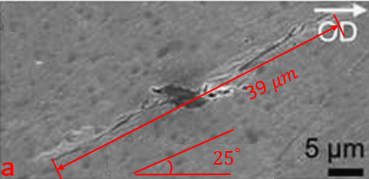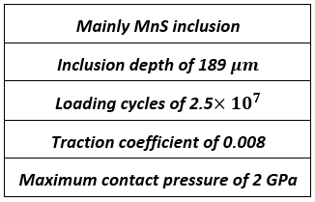
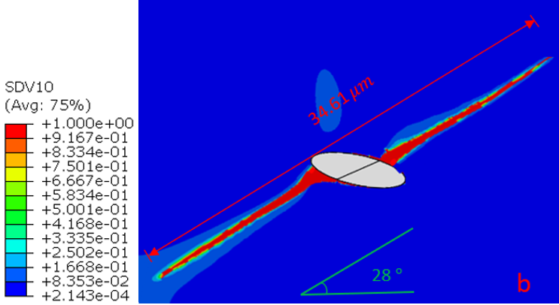
Figure 6.3. 40 Comparison of an internally cracked MnS butterfly damage (a) actual butterfly damage from experiment in [92] (b) simulated damage by the developed CDM model
The modelling result of the butterfly damage is shown in Figure 6.3.40 (b). It can be seen that the butterfly wings propagate exactly in the direction of the internal crack tips. The overall simulated butterfly length is 34.61 $μm$, which is approximately 4 $μm$ shorter than the butterfly length of 39 $μm$ observed from the experiment. This difference may be caused by the definition of the damage parameter $D$ in the CDM FE model. In section 6.3.1, the maximum value of $D$ is set as 0.9 to avoid the non-convergence problems. It means that when the accumulated damage parameter exceeds 1, ABAQUS will compulsively change it to 0.9 for the computation of the next jump-in loading block. Therefore, in the FE modelling, the stress concentration level at the already propagated crack tips will be lower than the actual situation since the elements in the cracked area are still withstanding the stress. Correspondingly, the crack dominating stress in the FE modelling is relatively small at the crack tips, leading to the reduction of the propagated crack length.
Apart from the length of the butterfly damage, the crack propagation angles of both the modelling and experimental results are also measured, as shown in Figure 6.3.40. It can be seen that the propagation angle is 28$°$ in FE modelling and $25°$ in the experimental observation. As the difference is small, the effectiveness of the developed CDM FE model is verified.
In conclusion, according to the comparisons between the modelled and experimentally observed butterflies, the CDM FE model developed in this chapter can be used to predict the possible propagation directions and lengths of the butterfly wings with the acceptable accuracy.
Validation Model 4
In Validation Model 4, the FE model is further verified by the microstructure damage observed in the failed bearing raceway, reported in Chapter 3. As shown in Figure 6.3.41 (a), the internally cracked inclusion is selected for the modelling.
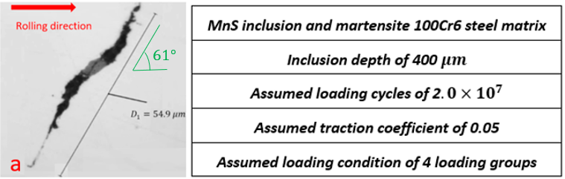
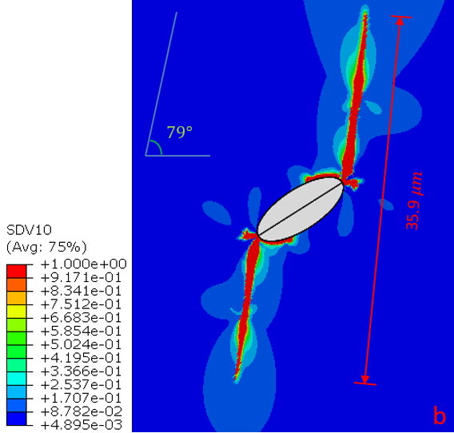
Figure 6.3. 41 Comparison of an internally cracked MnS butterfly damage (a) actual butterfly damage observed in the failed V80-2MW planetary bearing raceway (b) simulated damage by the developed CDM FE model
However, because the crack has already propagated from the inclusion, it is unknown whether the inclusion has the separated boundary from the beginning of the loading process. Therefore, only an internal crack at the tips of the inclusion is assumed in the model geometry, as shown in Figure 6.3.41 (b). In addition, the actual loading magnitude and the number of loading cycles applied to the bearing raceway during the WT field operation are not available. Therefore, according to the assumptions made in section 6.3.1 and section 6.3.5, the overall loading cycles in the model is assumed to be $2.0×{10}^{7}$, with the traction coefficient of 0.05 and four defined varying loading groups.
It can be seen that the modelling results have some differences with the actual butterfly damage. The overall length of the butterfly in the CDM FE modelling is 35.9 $μm$, which is much shorter than the actual damage of 54.9 $μm$. Additionally, the simulated crack propagation angle is $79°$, which is greater than the actual propagation angle of $61°$. Possible explanations for these differences may include:
- Effect of differences between the assumed and actual loading levels: All the loading calculations in Chapter 4 are determined from the IEC 61400-1:2019 standard and the conclusions suggested in other investigations. However, these calculated loading conditions may be different from the actual operating conditions of the planetary bearing in the V80-2MW WT.
- Effect of more frequent overloading conditions: As discussed in section 6.3.5, in field operation, the planetary bearing may experience hundreds of overloading conditions within one year. Therefore, the actual loading variations should be different from the “four loading groups” hypothesis made in the CDM FE modelling. Due to the increase of the overloading frequencies, the overloading cases will occur much earlier than that assumed in the FE modelling. Therefore, the actual butterfly wing length should be longer than the modelling results as obtained in Figure 6.3.41 (b).
- Effect of the original inclusion geometry: It has been mentioned that the original geometry of the inclusion cannot be identified due to the already propagated crack and the possible inclusion damage during the sample preparation process. Therefore, the original inclusion geometry may be different from that defined in the validation model. This distinction may lead to the change of distribution of the crack dominating stress which results in the crack propagation differences.
- Effect of the 3D geometry of the inclusion: Although the inclusion is assumed to be plane strain in all models of this chapter, 3D effect of the inclusion cannot be ignored. As experimentally observed in section 3.2.4, the in-plane geometry of an inclusion changes with the multiple polishing processes. Therefore, the crack dominating stress distributions around the inclusion within the current plane may be affected by the 3D geometry of the inclusion.
- Effect of the inclusion position: In the validation, the inclusion is defined to be located at the middle of the rectangular steel. However, in the actual case, this inclusion is not necessarily located in the middle of the fixed loading zone of the raceway. As presented in Chapter 3, because of the irregular shape of the damaged raceway surface, it is impossible to determine the accurate position of the Hertz contact pressure caused by the rollers. Therefore, the relative position between the inclusion and rolling contact Hertz pressure cannot be determined. For the convenience of modelling, the inclusion in Validation Model 4 is assumed to be located in the centre of the fixed loading zone. However, in the actual bearing operation, this inclusion may be located in the left or right regions of the loading zone, rather than in the middle.
- Effect of the already damaged contact surface: It is known that this butterfly damage is observed from the plane section of a damaged raceway sample. Accordingly, during the butterfly formation process, it has high possibility that the Hertz contact pressure is applied on the already damage raceway surface instead of the undamaged rectangular steel matrix defined in the FE modelling. As a result, the crack dominating stress distribution in the actual raceway subsurface area maybe different from that in the FE modelling, which causes the different crack propagation processes.
Validation Model 5
Figure 6.3.42 (a) shows another butterfly observed in the failed bearing raceway. The damage is caused by two closely located MnS inclusions, which are positioned 817 $μm$ under the contact surface. In the definition of the CDM FE modelling, because the original boundary conditions of the inclusions cannot be identified, both boundaries are defined as free surfaces in contact with the steel matrix. Furthermore, the definitions of the jump-in loading blocks, traction coefficient, and loading groups are the same as those in Validation Model 4.
The modelling results of the butterfly damage are shown in Figure 6.3.42 (b). It can be seen that the modelled crack propagation angle is $22°$, which is close to the actual angle of $24°$. However, the actual length of the buttefly is approximately 39 $μm$, while the butterfly length in the CDM FE modelling is only 10.94 $μm$. Possible reasons have been discussed in Validation Model 4, which may include the effect of the loading definition, inclusion geometry, inclusion position, and the damaged contact surface of the bearing raceway.
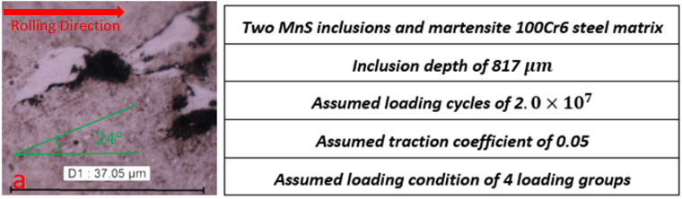
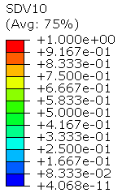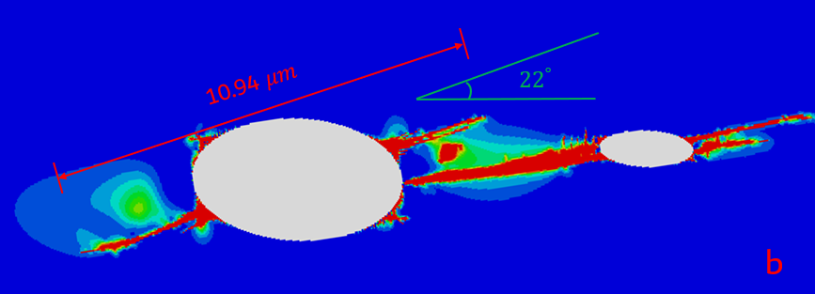
Figure 6.3. 42 Comparison of damage caused by two MnS butterflies (a) actual butterfly damage observed in the failed V80-2MW planetary bearing raceway (b) simulated damage by the developed CDM FE model

Summary
This chapter focuses on the development of the FE damage modelling of the crack initiation and propagation caused by subsurface inclusions in the bearing raceway under the rolling contact fatigue and variable loading conditions.
Damage modelling based on both the XFEM and CDM theories is developed for the investigation of the inclusion induced subsurface damage. However, the crack propagation simulated by the XFEM does not match the microscope observed damage in Chapter 3. Accordingly, this method is not suitable for solving the fatigue problems with the rolling contact conditions. In addition, because the crack must be predefined in the XFEM modelling before the computational process, this method cannot show the initiation process of the crack.
The main method developed in this chapter is based on the CDM theory. By applying the modified Xiao’s fatigue model for the damage accumulation and the bilinear kinematic hardening model for the material plastic deformation, the damage initiation process is considered to be governed by the dominating stress related to the amplitude and absolute mean value of the orthogonal shear stress during each rolling contact loading cycle. Through the validations of the twin-discs test specimens, the CDM FE model can be used to predict the potential propagation orientation and length of the crack under the rolling contact loading condition. However, mainly due to the complex loading variations during the WT field operation and the various positions that the inclusions may exist in the raceway subsurface area, the modelling of the butterfly damage in the actual bearing raceway has some differences when compared with the microscopic images observed in the actual raceway samples of the failed planetary bearings.
According to the modelling results obtained from the CDM FE model developed, a number of key findings can be drawn. Firstly, the inclusion boundary separation and internal cracking have an important effect on the crack initiation and propagation. In detail, the perfectly bonded inclusion is less likely to cause the crack initiation within a certain number of loading cycles. However, under the same loading condition, both the internal cracking and boundary separation of an inclusion are found to initiate cracks. This finding agrees with the experimental observations in Chapter 3 that the majority of the butterfly damage is associated with the separated and/or internally cracked inclusions. Furthermore, similar to the conclusion reported in Chapter 5, the damage modelling results of this chapter have also shown that the internally cracked inclusions produce relatively longer cracks compared with the boundary separated inclusions, when the loading conditions applied are the same.
Secondly, it has shown that the traction coefficient only affects the crack propagation length. This effect is not obvious when the traction coefficient is ranged from 0.01 to 0.05. However, possibly due to the inadequate lubrication or WT specific operation conditions, sometimes the traction coefficient can exceed 0.05. When the traction coefficient is 0.1, the modelling results indicate that the subsurface cracks caused by the cyclic rolling contact loading have grown rapidly, which may result in the premature failure of the bearing raceways. This conclusion agrees with the finding in [54] and [97], both of the which emphasise the vital influence of the lubrication and loading conditions on the bearing life.
Finally, considering the actual loading variations on the bearing raceway caused by the wind speed variation and operating conditions, the damage modelling results suggest that the normal overloading cases during the WT start-up and shutdown processes have the greatest effect on the crack propagation. Meanwhile, by changing the loading sequence, it is found that the damage of the bearing subsurface has become more severe, when the overloading cases occur earlier in the bearing loading process. In other words, the frequent start-up, and shutdown of the WT may result in the premature failure of the planetary bearing raceways in the gearbox.

Conclusions and Future work
This chapter summarises all the conclusions and new findings obtained from the microstructural observations and FE damage modelling reported from Chapter 3 to Chapter 6. Moreover, the potential influences of the conclusions, further research directions and possible publications of the research are summarised.

Conclusions and Influences

Main conclusions and research novelty
This investigation has observed the subsurface damage in the upwind and downwind planetary bearing raceways from a V80-2MW WTG. Moreover, the FE methods are also developed to simulate the possible stress-concentration, crack initiation, and crack propagation due to MnS inclusions under the cyclic rolling contact loading condition. Main conclusions can be outlined as follows:
Mechanism of the subsurface initiated bearing premature failure
Analysis of the failed raceway sections indicates that the butterfly damage caused by the subsurface inclusions, mainly MnS inclusion in this investigation, will propagate and connect with each other to form into large crack networks in the subsurface area. Due to the effect of the varying and cyclic Hertz contact pressure, these crack networks will propagate to the contact surface of the bearing raceways. In addition, because of the overloading cases during the WT operating process, the accelerated propagation of the subsurface crack networks will finally cause the surface flaking of the bearing raceways.
This conclusion is coincided with some published assumptions of the bearing premature failure. However, in this research, the variation of the loading magnitude on the bearing raceway is emphasised. Meanwhile, the effect of the overloading cases is also considered as a vital factor affecting the bearing life. It has found that the early crack initiation and accelerated crack propagation will occur if the bearing overloading cases occur in the early stage of the bearing loading process.
Characterisation and mechanism of the WEA damage
In this investigation, the WEA damage is observed around the subsurface crack network without visible inclusions even after multiple polishing processes. Therefore, this damage form in the failed bearing raceways may not be necessarily generated by inclusions. This conclusion is different from the assumption in some publications that the formation of the WEC network is only caused by the subsurface inclusions. Accordingly, the formation process of WEA is complex and controversial, and further investigations are required.
Moreover, WEAs are also found to be initiated from the extremely long secondary crack network in the subsurface area. This finding suggests other factors that may affect the WEA formation, such as the lubricant leakage, rubbing, shearing, and local heating between the cracked surfaces. All these explanations may indicate that the WEA damage occurs after the formation of the subsurface cracks. This conclusion conflicts with the hypothesis that the formation of WEA precedes that of the crack. The latter theory generally believes that the WEA formation will cause the reduction of material strength and thus trigger cracks. Therefore, due to the complex and diverse reasons for the formation of WEC, it is still impossible to make a decisive judgment on these two hypotheses at this stage.
Although there are many factors and uncertainties affecting the formation of the WEA damage, the microstructures of different WEAs are basically the same, and they are all composed of ferrite with very fine sized grains. This is also the reason why the WEA damage has a higher hardness than the martensitic steel matrix in the nano-indentation tests. Additionally, SEM results also indicate that the dissolution of the cementite and the transformation of the steel microstructure from martensite to ferrite are two necessary procedures during the WEA formation, although the sequence between them has not been identified in this study.
Factors affecting stress concentration due to subsurface inclusions
FE modelling results of the subsurface stress concentration due to inclusions cannot be used to show the crack initiation directly, but it provides the reference to identify the area that is most likely to be damaged. It has been found that the inclusion damage, including the boundary separation and internal cracking, has the most significant effect on the stress concentration. This is followed by the Hertz contact pressure, inclusion aspect ratio, inclusion inclined angle, and the surface traction. Additionally, it has been identified that the traction pressure does not significantly change the magnitude of the subsurface maximum shear stress, but this factor is still considered to be harmful to the bearings because of the amplification of the subsurface orthogonal shear stress.
Although the effects of these possible factors have been discussed in many published studies, the FE models established in this study comprehensively consider the interactions between different factors and clearly show the locations of subsurface stress concentration areas. Also, by using the Taguchi design of modelling, the effects of these factors within the specific ranges are evaluated and compared.
Factors affecting damage initiation from subsurface inclusions
It has been observed that the formation of the butterfly wings due to inclusion is mainly affected by the inclusion geometry, inclusion subsurface depth, inclusion damage types, surface traction, and the Hertz contact pressure. These factors affect the amplitude and mean value of the orthogonal shear stress around the inclusion and directly determine the nucleation period and propagation direction of the crack.
Due to the fixed loading zone on the planetary bearing raceway, all the inclusions with the subsurface depth of less than 1 mm have the possibility to cause the butterfly damage. If an inclusion has a separated boundary and/or the internal crack, it causes the significant stress concentration of the steel matrix, which accelerates the fatigue damage accumulation and results in a longer crack. Moreover, the increases of the traction pressure and the maximum Hertz contact pressure due to the insufficient lubrication and overloading operating cases will also shorten the crack nucleation period. Finally, the effect of frequent occurrences of overloading cases cannot be ignored because an early occurrence of overloading case will cause the butterfly damage to occur in the early stage of bearing operation, resulting in a greater period for crack propagation. Different from the other studies, FE modelling results in this study has sufficient evidence to show that the variation of orthogonal shear stress during the cyclic rolling contact process is the most significant factor affecting the fatigue damage initiation and propagation.
Also, with the stress variation, a CDM damage model is established in the study which helps to determine the possible crack propagation orientations due to subsurface inclusions. Compared with the published twin-discs test results, the predicted fatigue cracks in the FE models are basically accurate. According to the FE modelling results, the combined effect of the Hertz contact pressure and the inclusion damage types determines the locations and propagating orientations of the inclusion-initiated cracks. When an inclusion only has the separated boundaries at its tips, the cracks will initiate from the separated gaps and propagate towards the contact surface with an almost fixed angle. Observation based on a larger number of butterfly damage in Chapter 3 indicates that this propagation angle may only be affected by the subsurface depth of the inclusion and the magnitude of the applied Hertz contact pressure. However, if the inclusion has an internal crack but its boundary is perfectly bonded with the steel matrix, the butterfly crack will initiate from the tips of the internal crack instead of the tips of the inclusion. The propagation orientation of the butterfly wings is normally unique due to the effect of the internal crack angle, and the length of wings varies with the change of the crack propagation direction.

Potential impact on industry
It has been confirmed that the frequent change of the pressure and the overloading cases on the wind turbine gearbox planetary bearing will cause the premature failure of the bearing from the inclusions in the subsurface area due to material fatigue. According to the conclusion, the bearing manufacturers should design WTGBs with the material that is more resistant to the fatigue failure. Furthermore, the manufacturing technique should be improved to reduce the presence of inclusions in the subsurface area. Although the effects of inclusion types are not investigated in detail in this study, inclusions that should be considered include, but are not limited to the sulphides and oxides. In addition, by increasing the number of sets of rollers, the manufacturers can reduce the pressure on the bearings, thereby the reliability and durability of the bearings will be improved.
For the WTG manufacturers and WT companies, the gearbox with low overload probability should be designed to reduce the pressure applied on the raceway of the bearing. By increasing the number of the planetary gears or increasing the diameters of the sun gear and planetary gears, the torque applied on each planetary gear will decrease, thereby increasing the bearing life. Furthermore, since frequent and variable overload conditions have been found to result in the premature bearing failure, wind turbine manufacturers can reduce the likelihood of this happening by adding tests, including field tests and simulations, to the design and development phases of the products. Last but not least, the WT manufacturers should also increase the frequency of maintenance and improve the detection technology, so as to detect and avoid bearing problems as early as possible.

Future Work and Publication Plan

List of future work
Formation of WEA damage
The investigation of WEA damage formation in this study mainly focuses on the microstructural observation of the failed bearing raceway samples. Although possible causes of the WEA formation have been discussed, no evidence of their influences on the WEA initiation has been discovered. Therefore, the future experiments, such as the Twin-discs test, should be carried out to investigate the potential causes for the WEA initiation. In addition, the FE models developed in this study only simulate the crack formation without considering the microstructural change of the steel matrix. Hence, a new FE microstructural modelling method should be developed, which may directly or indirectly show the formation process of the WEA damage.
Modelling of subsurface inclusion damage
In the CDM FE damage modelling of the subsurface inclusions, the inclusion-steel matrix is defined as either perfectly bonded or separated. However, the boundary separation of an inclusion may happen during the rolling contact loading process. Therefore, more detailed damage modelling of the inclusion-matrix boundary conditions should be considered in the future investigation. Similarly, the inclusion internal crack may occur during the loading process instead of being already existed from the beginning of loading. Therefore, the modelling of the inclusion damage development may help to obtain a more accurate modelling of the butterfly formation.
Actual operating conditions of WTG planetary bearings
In this investigation, the magnitudes and variations of the Hertz contact pressure are determined mainly based on the specification in the international standards, assumptions, and the modelling or experiment results from other studies. Therefore, the FE damage modelling results based on CDM have some differences when compared with the microstructural butterfly damages observed in the failed raceway samples. To solve the problem, the loading data should be recorded during the WT field operation.
Prediction of the remaining bearing life
Although the developed CDM FE damage model in this investigation has successfully predicted the initiation and the propagation length and orientation of the butterfly damage, further propagation of the butterfly wings have not been simulated because of the extremely long computational time. Based on the simulated butterfly wing damage due to inclusions, further modelling of the formation of the subsurface crack networks can be carried out by considering the connection of cracks in the subsurface area. Accordingly, the possible period required for the subsurface crack networks to propagate to the contact surface of the raceway may be obtained to predict the bearing remaining life under certain loading conditions. However, it usually takes a long computational time to simulate the formation and propagation of crack networks with the CDM FE model established in this study. A method should be put forward to simplify the meshing methodology and reduce the computational time.

Publication plan
According to the conclusions determined from Chapter 3 to Chapter 6, three papers will be published based on the research in this thesis:
- “Microstructure Damage Characterisation of Failed Planetary Gearbox Bearing Raceways From a V-80 2MW Wind Turbine Gearbox” (based on Chapter 3).
- “FE Modelling of the Stress Variation and Damage Initiation of the Wind Turbine Gearbox Bearing Due to Inclusions Under Rolling Contact Loading Condition” (based on Chapter 5).
- “Application of Continuum Damage Mechanics in predicting Rolling Contact Fatigue Damage Evolution due to inclusions” (based on Chapter 6).
The following table shows the details of the publication, including the scheduled submission time and the name of the journal.

Article Type | Potential Submitted Journal | Possible Submission Time | Contents
Experimental¹ | International Journal of Fatigue | 07/2023 | Experimental observation of damaged bearing samples
Simulation² | International Journal of Fatigue | 06/2023 | Stress variation during the rolling contact process
Simulation³ | International Journal of Fatigue | 06/2023 | CDM damage modelling of crack initiation and propagation

REFERENCES
[1] “Renewable Energy - Center for Climate and Energy SolutionsCenter for Climate and Energy Solutions.” https://www.c2es.org/content/renewable-energy/ (accessed Oct. 04, 2022).
[2] I. Pineda and W. Pierre Tardieu, “Wind in power 2016 European statistics,” 2017.
[3] “Wind energy in Europe: 2021 Statistics and the outlook for 2022-2026 | WindEurope.” https://windeurope.org/intelligence-platform/product/wind-energy-in-europe-2021-statistics-and-the-outlook-for-2022-2026/ (accessed Oct. 04, 2022).
[4] “Global installed wind energy capacity 2021 | Statista.” https://www.statista.com/statistics/268363/installed-wind-power-capacity-worldwide/ (accessed Oct. 04, 2022).
[5] J. P. Salameh, S. Cauet, E. Etien, A. Sakout, and L. Rambault, “Gearbox condition monitoring in wind turbines: A review,” Mech. Syst. Signal Process., vol. 111, pp. 251–264, Oct. 2018, doi: 10.1016/J.YMSSP.2018.03.052.
[6] “Statistics Show Bearing Problems Cause the Majority of Wind Turbine Gearbox Failures | Department of Energy,” 2015. Accessed: May 07, 2019. [Online]. Available: https://www.energy.gov/eere/wind/articles/statistics-show-bearing-problems-cause-majority-wind-turbine-gearbox-failures.
[7] “Why wind-turbine gearboxes fail to hit the 20-year mark.” https://www.windpowerengineering.com/wind-turbine-gearboxes-fail-hit-20-year-mark/ (accessed Oct. 04, 2022).
[8] T. Bruce, E. Rounding, H. Long, and R. S. Dwyer-Joyce, “hmaza,” Wear, vol. 338–339, pp. 164–177, 2015, doi: 10.1016/j.wear.2015.06.008.
[9] T. Bruce, “Analysis of the Premature Failure of Wind Turbine Gearbox Bearings,” PhD Thesis, Univ. Sheff., 2016, [Online]. Available: http://etheses.whiterose.ac.uk/13903/1/Analysis of the premature failure of wind turbine gearbox bearings_Tom Bruce_Thesis.pdf.
[10] R. Wasilczuk, Michał & Wasilczuk, Filip & Gawarkiewicz, “Drivetrain of a Wind Turbine Drivetrain of a Wind Turbine Wind turbine drivetrain,” Mach. Dyn. Res., vol. 39, no. July, pp. 83-95., 2016.
[11] S. Sheng, W. LaCava, P. S. Veers, and J. A. Keller, “Wind Turbine Drivetrain Condition Monitoring During GRC Phase 1 and Phase 2 Testing,” no. NREL/TP-5000-52748, pp. 1–59, 2011.
[12] M. Mcdade and R. E. Geartech, “Wind Turbine Gearbox Failure Modes – A Brief (Presentation), NREL (National Renewable Energy Laboratory),” 2011.
[13] F. Oyague, “Gearbox Modeling and Load Simulation of a Baseline 750-kW Wind Turbine Using State-of-the-Art Simulation Codes,” 2009. Accessed: May 08, 2019. [Online]. Available: http://www.osti.gov/bridge.
[14] T. Wang, Q. Han, F. Chu, and Z. Feng, “Vibration based condition monitoring and fault diagnosis of wind turbine planetary gearbox: A review,” Mechanical Systems and Signal Processing. 2019, doi: 10.1016/j.ymssp.2019.02.051.
[15] M.-H. Evans, “White structure flaking (WSF) in wind turbine gearbox bearings: effects of ‘butterflies’ and white etching cracks (WECs),” Mater. Sci. Technol., vol. 28, no. 1, pp. 3–22, Jan. 2012, doi: 10.1179/026708311X13135950699254.
[16] J. Rosinski and D. Smurthwaite, “Wind Gearbox Problems,” 2010.
[17] M.-H. Evans, “An updated review: white etching cracks (WECs) and axial cracks in wind turbine gearbox bearings,” Mater. Sci. Technol., vol. 32, no. 11, pp. 1133–1169, Jul. 2016, doi: 10.1080/02670836.2015.1133022.
[18] N. T. Garabedian, B. J. Gould, G. L. Doll, and D. L. Burris, “The Cause of Premature Wind Turbine Bearing Failures: Overloading or Underloading?,” Tribol. Trans., vol. 61, no. 5, pp. 850–860, 2018, doi: 10.1080/10402004.2018.1433345.
[19] R. Errichello, “AGMA Technical Paper Morphology of Micropitting By R . L . Errichello , GEARTECH,” no. January 2011, 2017.
[20] International Organisation for Standardisation, “BS ISO 15243 : 2017 BSI Standards Publication Rolling bearings — Damage and failures — Terms , characteristics and causes,” vol. ISO 15243, 2017.
[21] K. Stadler and A. Stubenrauch, “Premature Bearing Failures in Wind Gearboxes and White Etching Cracks Figure 2 Classic fatigue failure modes vs. cracks and WEC *micrograph, according to Reference 5, **micrograph according to Reference 6.” Accessed: Jul. 05, 2019. [Online]. Available: https://www.powertransmission.com/issues/1014/Premature_Bearing_Failures_PTE1014.pdf.
[22] A. Greco, S. Sheng, J. Keller, and A. Erdemir, “Material wear and fatigue in wind turbine Systems,” Wear, vol. 302, no. 1–2, pp. 1583–1591, 2013, doi: 10.1016/j.wear.2013.01.060.
[23] “Corrosion — How bearings fail Part 3 of 6.” https://www.linearmotiontips.com/how-bearings-fail-a-closer-look-at-corrosion/ (accessed Jul. 06, 2022).
[24] ASM International. Handbook Committee., ASM handbook. .
[25] “Bearing Failure RCA: Rust and Corrosion - BEARING NEWS.” https://www.bearing-news.com/bearing-failure-rcarust-and-corrosion/ (accessed Jul. 06, 2022).
[26] T. Bruce, H. Long, and R. S. Dwyer-Joyce, “Dynamic modelling of wind turbine gearbox bearing loading during transient events,” IET Renew. Power Gener., vol. 9, no. 7, pp. 821–830, Sep. 2015, doi: 10.1049/IET-RPG.2014.0194.
[27] “Premature bearing failures in wind gearboxes and white etching cracks (WEC) | Evolution.” https://evolution.skf.com/premature-bearing-failures-in-wind-gearboxes-and-white-etching-cracks-wec/ (accessed Jul. 07, 2022).
[28] “Cracks.” https://www.nskeurope.com/en/bearings/services/troubleshooting/damage-by-type/cracks.html (accessed Jul. 07, 2022).
[29] “Prevention of electric erosion in bearings.” https://evolution.skf.com/en/prevention-of-electric-erosion-in-bearings/ (accessed Jul. 07, 2022).
[30] “Learn About Shaft Currents (aka Electrically Induced Bearing Damage [EIBD] aka Electrical Discharge Machining [EDM]) | VIBES Corp.” https://www.vibescorp.ca/learn-about/shaft-currents/ (accessed Jul. 06, 2022).
[31] NSK Europe, “Bearing life – Calculating the basic fatigue life expectancy of rolling bearings,” pp. 1–2, [Online]. Available: www.nskeurope.com.
[32] ISO, “ISO-281 Rolling bearings — Dynamic load ratings and rating life,” Science (80-. )., vol. ns-1, no. 6, pp. 159–160, 2006, doi: 10.1126/science.ns-1.6.159.
[33] H. K. D. H. Bhadeshia, “Steels for bearings,” Prog. Mater. Sci., vol. 57, no. 2, pp. 268–435, 2012, doi: 10.1016/j.pmatsci.2011.06.002.
[34] W. Solano-Alvarez, M. J. Peet, E. J. Pickering, J. Jaiswal, A. Bevan, and H. K. D. H. Bhadeshia, “Synchrotron and neural network analysis of the influence of composition and heat treatment on the rolling contact fatigue of hypereutectoid pearlitic steels A R T I C L E I N F O,” Mater. Sci. Eng. A, vol. 707, pp. 259–269, 2017, doi: 10.1016/j.msea.2017.09.045.
[35] S. Chattopadhyay and C. M. Sellars, “Kinetics of pearlite spheroidisation during static annealing and during hot deformation,” Acta Metall., 1982, doi: 10.1016/0001-6160(82)90055-4.
[36] H. Hwang and B. C. De Cooman, “Influence of the Initial Microstructure on the Spheroidization of SAE 52100 Bearing Steel,” steel Res. Int., vol. 87, no. 1, pp. 112–125, Jan. 2016, doi: 10.1002/SRIN.201400591.
[37] West Yorkshire Steel, “Elements in Steel.”
[38] A. Ellermann and B. Scholtes, “The strength differential effect in different heat treatment conditions of the steels 42CrMoS4 and 100Cr6,” Mater. Sci. Eng. A, vol. 620, pp. 262–272, 2015, doi: 10.1016/j.msea.2014.10.027.
[39] “100Cr6.” https://steelnavigator.ovako.com/steel-grades/100cr6/ (accessed Jan. 22, 2022).
[40] International RGP, “Aisi 52100 chrome steel balls,” pp. 1–6, [Online]. Available: http://www.rgpballs.com/en/products/BALLS/STEEL/CHROME-STEEL/AISI-52100-CHROME-STEEL-BALLS.
[41] Ovako, “Steel grade 100CrMnMoSi8-4-6,” pp. 19–21, 2019.
[42] “100Cr6 Soft Annealed - M.T. Acciai s.r.l.” http://www.mtacciai.com/en/steels/bearing-steels-uni-3097/100cr6-soft-annealed (accessed Apr. 27, 2020).
[43] P. / Preview, “Steel-Determination of content of nonmetallic inclusions-Micrographic method using standard diagrams(E) ii COPYRIGHT PROTECTED DOCUMENT Published in Switzerland,” 2013, Accessed: May 10, 2019. [Online]. Available: https://www.sis.se/api/document/preview/916485/.
[44] “ISO 4967:2013(en), Steel — Determination of content of nonmetallic inclusions — Micrographic method using standard diagrams.” https://www.iso.org/obp/ui/#iso:std:iso:4967:ed-3:v1:en (accessed Apr. 12, 2022).
[45] Z. Liu, Y. Bao, M. Wang, X. Li, and F. Zeng, “Austenite grain growth of medium-carbon alloy steel with aluminum additions during heating process,” Int. J. Miner. Metall. Mater., vol. 26, no. 3, pp. 282–290, Mar. 2019, doi: 10.1007/s12613-019-1736-6.
[46] J. C. Hamann, V. Grolleau, and F. Le Mactre, “Machinability Improvement of Steels at High Cutting Speeds-Study of TooVWork Material Interaction,” 1996.
[47] J. Maciejewski, “The Effects of Sulfide Inclusions on Mechanical Properties and Failures of Steel Components,” J. Fail. Anal. Prev., vol. 15, no. 2, pp. 169–178, Apr. 2015, doi: 10.1007/S11668-015-9940-9/TABLES/9.
[48] H. A. H. Al-Tameemi, “Effect of Surface Traction and Non-Metallic Inclusions on the Premature Failure of Wind Turbine Gearbox Bearings,” Mar. 2018.
[49] C. Gu, M. Wang, Y. Bao, F. Wang, and J. Lian, “Quantitative Analysis of Inclusion Engineering on the Fatigue Property Improvement of Bearing Steel,” Metals (Basel)., vol. 9, no. 4, p. 476, 2019, doi: 10.3390/met9040476.
[50] J. Guan, L. Wang, C. Zhang, and X. Ma, “Effects of non-metallic inclusions on the crack propagation in bearing steel,” Tribol. Int., vol. 106, pp. 123–131, Feb. 2017, doi: 10.1016/J.TRIBOINT.2016.10.030.
[51] M. Cerullo, V. T.-I. J. of S. Integrity, and undefined 2015, “Micromechanical study of the effect of inclusions on fatigue failure in a roller bearing,” emerald.com, Accessed: Jul. 10, 2022. [Online]. Available: https://www.emerald.com/insight/content/doi/10.1108/IJSI-04-2014-0020/full/html?casa_token=gs_6pw-8XLMAAAAA:V5krVf-3guYVtHaGDgE2fzmzs3oBes7MMP9ii2v7t3w2VKVFdWqzg9bBQNLDUBYMrKRyhTkS3EyQfKTQP3ROzzJDYCO3buZKImNDeva36VzuxvOiqo0f.
[52] J. Guan, L. Wang, C. Zhang, X. M.-T. International, and undefined 2017, “Effects of non-metallic inclusions on the crack propagation in bearing steel,” Elsevier, Accessed: Jul. 10, 2022. [Online]. Available: https://www.sciencedirect.com/science/article/pii/S0301679X16303930?casa_token=oBuCiGFzuF4AAAAA:JeOlF6wTGLQdm0aT8ElpY9-8mkAYi2Z3mRyv70Xg9pCTpuUbbZD5o9IiIzpTDBBu9iyw2dSUm0M.
[53] H. Bomas et al., “Crack initiation and endurance limit of a hard steel under multiaxial cyclic loads,” Fatigue Fract. Eng. Mater. Struct., vol. 33, no. 2, pp. 126–139, 2010, doi: 10.1111/j.1460-2695.2009.01423.x.
[54] T. Bruce, H. Long, and R. S. Dwyer-Joyce, “Threshold Maps for Inclusion-Initiated Micro-Cracks and White Etching Areas in Bearing Steel: The Role of Impact Loading and Surface Sliding,” Tribol. Lett., vol. 66, no. 3, 2018, doi: 10.1007/s11249-018-1068-0.
[55] M.-H. Evans, A. D. Richardson, L. Wang, and R. J. K. Wood, “Serial sectioning investigation of butterfly and white etching crack (WEC) formation in wind turbine gearbox bearings,” Wear, vol. 302, no. 1–2, pp. 1573–1582, Apr. 2013, doi: 10.1016/j.wear.2012.12.031.
[56] A. Ruellan, F. Ville, X. Kleber, and B. Liatard, “Tribological analysis of White Etching Crack ( WEC ) failures in rolling element bearings,” NREL Wind Turbine Tribol. Semin. 2014, 2014, [Online]. Available: https://tel.archives-ouvertes.fr/tel-01153235%0Ahttp://www.anl.gov/sites/anl.gov/files/20141030_NREL2014_Argonne_Ruellan_com_V2.pdf.
[57] B. WPED Contributor, B. David de Garavilla, and X. Zhou SKF, “Extending main-shaft bearing life in wind turbines,” 2019.
[58] V. Brizmer, A. Rychahivskyy, and B. Han, “Study on anti-micropitting performance of black oxide coating,” 5th World Tribol. Congr. WTC 2013, vol. 3, no. March, pp. 2399–2400, 2014, [Online]. Available: http://www.scopus.com/inward/record.url?eid=2-s2.0-84919475052&partnerID=tZOtx3y1.
[59] J. C. Gregory, “Chemical conversion coatings of metals to resist scuffing and wear,” Tribol. Int., vol. 11, no. 2, pp. 105–112, Apr. 1978, doi: 10.1016/0301-679X(78)90137-8.
[60] S. W. Ooi, P. Yan, and R. H. Vegter, “Black oxide coating and its effectiveness on prevention of hydrogen uptake,” Mater. Sci. Technol. (United Kingdom), vol. 35, no. 1, pp. 12–25, 2019, doi: 10.1080/02670836.2018.1530425.
[61] V. Brizmer, K. Stadler, B. Han, and C. Matta, “A study on tribological performance of black oxide coating for bearing applications,” Soc. Tribol. Lubr. Eng. Annu. Meet. Exhib. 2016, pp. 1–3, 2016.
[62] H. A. Al-Tameemi, H. Long, and R. S. Dwyer-Joyce, “Damage characterisation of white etching cracks in a black oxide coated wind turbine gearbox bearing,” Wear, vol. 432–433, p. 102923, 2019, doi: 10.1016/j.wear.2019.05.038.
[63] SKF, “Benefits of using black oxidized bearings in wind applications,” 2015. [Online]. Available: evolution.sfk.com.
[64] T. E. Tallian, “Rolling contact fatigue.,” Ball Bear. J., no. 217, Oct. 1983, pp. 5–13, 1983.
[65] W. H. Kim and C. Laird, “Crack nucleation and stage I propagation in high strain fatigue-II. mechanism,” Acta Metall., 1978, doi: 10.1016/0001-6160(78)90029-9.
[66] F. Sadeghi, B. Jalalahmadi, T. S. Slack, N. Raje, and N. K. Arakere, “A Review of Rolling Contact Fatigue,” J. Tribol., vol. 131, no. 4, p. 041403, 2009, doi: 10.1115/1.3209132.
[67] J. Lai and K. Stadler, “Investigation on the mechanisms of white etching crack (WEC) formation in rolling contact fatigue and identification of a root cause for bearing premature failure,” Wear, vol. 364–365, pp. 244–256, Oct. 2016, doi: 10.1016/j.wear.2016.08.001.
[68] R. I. Carroll and J. H. Beynon, “Rolling contact fatigue of white etching layer: Part 1: Crack morphology,” Wear, vol. 262, no. 9–10, pp. 1253–1266, Apr. 2007, doi: 10.1016/J.WEAR.2007.01.003.
[69] A. Ruellan, J. Cavoret, F. Ville, X. Kleber, and B. Liatard, “Understanding white etching cracks in rolling element bearings: State of art and multiple driver transposition on a twin-disc machine,” Proc. Inst. Mech. Eng. Part J J. Eng. Tribol., vol. 231, no. 2, pp. 203–220, 2017, doi: 10.1177/1350650116648058.
[70] F. Manieri, K. Stadler, G. E. Morales-Espejel, and A. Kadiric, “The origins of white etching cracks and their significance to rolling bearing failures,” Int. J. Fatigue, vol. 120, no. August 2018, pp. 107–133, 2019, doi: 10.1016/j.ijfatigue.2018.10.023.
[71] E. J. Paul DeGarmo T Black Ronald A Kohser Solutions Manual by Barney E Klamecki, “Solutions Manual to Accompany MATERIALS AND PROCESS IN MANUFACTURING Ninth Edition,” 2003. Accessed: Jul. 11, 2019. [Online]. Available: http://dcetind.weebly.com/uploads/9/1/6/3/9163431/solutions_manual_-_materials___processing_in_manufacturing__demargo_.pdf.
[72] H. K. D. H. Bhadeshia and W. Solano-Alvarez, “Critical Assessment 13: Elimination of white etching matter in bearing steels,” Mater. Sci. Technol., vol. 31, no. 9, pp. 1011–1015, 2015, doi: 10.1179/1743284715y.0000000036.
[73] S. K. Paul, “A critical review of experimental aspects in ratcheting fatigue: microstructure to specimen to component,” J. Mater. Res. Technol., vol. 8, no. 5, pp. 4894–4914, Sep. 2019, doi: 10.1016/J.JMRT.2019.06.014.
[74] H. Hübel, “Basic conditions for material and structural ratcheting,” Nucl. Eng. Des., vol. 162, no. 1, pp. 55–65, Mar. 1996, doi: 10.1016/0029-5493(95)01136-6.
[75] J. Wranik, W. Holweger, T. Lutz, P. Albrecht, B. Reichel, and L. Wang, “A Study on Decisive Early Stages in White Etching Crack Formation Induced by Lubrication,” Lubricants, vol. 10, no. 5, 2022, doi: 10.3390/lubricants10050096.
[76] V. Šmeļova, A. Schwedt, L. Wang, W. Holweger, and J. Mayer, “Microstructural changes in White Etching Cracks (WECs) and their relationship with those in Dark Etching Region (DER) and White Etching Bands (WEBs) due to Rolling Contact Fatigue (RCF),” Int. J. Fatigue, vol. 100, pp. 148–158, Jul. 2017, doi: 10.1016/J.IJFATIGUE.2017.03.027.
[77] A. D. Richardson, “A study of the influence of sulfonate containing lubricants on White Etching Crack (WEC) formations in 100Cr6 bearing steel,” Univ. Southampt. Fac., 2018, Accessed: Jul. 11, 2019. [Online]. Available: https://eprints.soton.ac.uk/430345/1/Thesis_Alexander_David_Richardson.pdf.
[78] B. Gould and A. Greco, “Investigating the Process of White Etching Crack Initiation in Bearing Steel,” Tribol. Lett., vol. 62, no. 2, pp. 1–14, 2016, doi: 10.1007/s11249-016-0673-z.
[79] H. A. Al-Tameemi, H. Long, and R. S. Dwyer-Joyce, “Initiation of sub-surface micro-cracks and white etching areas from debonding at non-metallic inclusions in wind turbine gearbox bearing,” Wear, vol. 406–407, no. January, pp. 22–32, 2018, doi: 10.1016/j.wear.2018.03.008.
[80] V. Šmeļova, A. Schwedt, L. Wang, W. Holweger, and J. Mayer, “Microstructural changes in White Etching Cracks (WECs) and their relationship with those in Dark Etching Region (DER) and White Etching Bands (WEBs) due to Rolling Contact Fatigue (RCF),” Int. J. Fatigue, vol. 100, pp. 148–158, 2017, doi: 10.1016/j.ijfatigue.2017.03.027.
[81] A. D. Richardson, M. H. Evans, L. Wang, R. J. K. Wood, M. Ingram, and B. Meuth, “The Evolution of White Etching Cracks (WECs) in Rolling Contact Fatigue-Tested 100Cr6 Steel,” Tribol. Lett., vol. 66, no. 1, p. 6, Mar. 2018, doi: 10.1007/S11249-017-0946-1.
[82] H. Swahn, P. C. Becker, and O. Vingsbo, “Martensite decay during rolling contact fatigue in ball bearings,” Metall. Trans. A, vol. 7, no. 8, pp. 1099–1110, Aug. 1976, doi: 10.1007/BF02656592.
[83] H. Fu, W. Song, E. I. Galindo-Nava, and P. E. J. Rivera-Díaz-del-Castillo, “Strain-induced martensite decay in bearing steels under rolling contact fatigue: Modelling and atomic-scale characterisation,” Acta Mater., vol. 139, pp. 163–173, Oct. 2017, doi: 10.1016/J.ACTAMAT.2017.08.005.
[84] L. Xie, D. Palmer, F. Otto, Z. Wang, and Q. Jane Wang, “Effect of Surface Hardening Technique and Case Depth on Rolling Contact Fatigue Behavior of Alloy Steels,” Tribol. Trans., vol. 58, no. 2, pp. 215–224, 2015, doi: 10.1080/10402004.2014.960957.
[85] M. Selecká and A. Šalak, “Durability and failure of powder forged rolling bearing rings,” Wear, vol. 236, no. 1–2, pp. 47–54, Dec. 1999, doi: 10.1016/S0043-1648(99)00257-4.
[86] J. H. Al-Bedhany and H. Long, “Microscopic investigation of subsurface initiated damage of wind turbine gearbox bearings,” J. Phys. Conf. Ser., vol. 1106, no. 1, 2018, doi: 10.1088/1742-6596/1106/1/012029.
[87] I. Muto, J. Shinozaki, T. Omura, M. Numata, and N. Hara, “Microelectrochemical Investigation of Hydrogen Absorption and Dissolution Behavior of MnS Inclusions in Carbon Steel,” 2011, pp. 9–20, doi: 10.1149/1.3577749.
[88] B. Gould, A. Greco, K. Stadler, and X. Xiao, “An analysis of premature cracking associated with microstructural alterations in an AISI 52100 failed wind turbine bearing using X-ray tomography,” Mater. Des., vol. 117, pp. 417–429, Mar. 2017, doi: 10.1016/J.MATDES.2016.12.089.
[89] H. Link et al., “Gearbox Reliability Collaborative Project Report: Findings from Phase 1 and Phase 2 Testing,” 2011. Accessed: Jul. 14, 2019. [Online]. Available: http://www.osti.gov/bridge.
[90] “Innovative solutions for preventing white etching cracks - Power Transmission World.” https://www.powertransmissionworld.com/innovative-solutions-for-preventing-white-etching-cracks/ (accessed Jul. 15, 2022).
[91] T. Bruce, E. Rounding, H. Long, and R. S. Dwyer-Joyce, “Characterisation of white etching crack damage in wind turbine gearbox bearings,” Wear, vol. 338–339, pp. 164–177, 2015, doi: 10.1016/j.wear.2015.06.008.
[92] M.-H. Evans, “White Structure Flaking Failure In Bearings Under Rolling Contact Fatigue,” Univ. Southampt. Fac., 2013, Accessed: Jul. 14, 2019. [Online]. Available: https://eprints.soton.ac.uk/355966/1/Martin%2520Evans%2520PhD%2520Thesis.pdf.
[93] W. Solano-Alvarez and H. K. D. H. Bhadeshia, “Distinguishing cause and effect in bearing steel failure: part 2,” Metall. Mater. Trans. A, vol. 45, p. DOI: 10.1007/s11661-014-2431-x, 2014.
[94] A. D. Richardson, M. H. Evans, L. Wang, R. J. K. Wood, M. Ingram, and B. Meuth, “The Evolution of White Etching Cracks (WECs) in Rolling Contact Fatigue-Tested 100Cr6 Steel,” Tribol. Lett., vol. 66, no. 1, pp. 1–23, 2018, doi: 10.1007/s11249-017-0946-1.
[95] N. T. Garabedian, B. J. Gould, G. L. Doll, and D. L. Burris, “The Cause of Premature Wind Turbine Bearing Failures: Overloading or Underloading?,” Tribol. Trans., vol. 61, no. 5, pp. 850–860, 2018, doi: 10.1080/10402004.2018.1433345.
[96] F. Gutiérrez Guzmán, M. Oezel, G. Jacobs, G. Burghardt, C. Broeckmann, and T. Janitzky, “Influence of Slip and Lubrication Regime on the Formation of White Etching Cracks on a Two-Disc Test Rig,” Lubricants, vol. 6, no. 1, p. 8, 2018, doi: 10.3390/lubricants6010008.
[97] M. H. Evans, A. D. Richardson, L. Wang, and R. J. K. Wood, “Effect of hydrogen on butterfly and white etching crack (WEC) formation under rolling contact fatigue (RCF),” Wear, vol. 306, no. 1–2, pp. 226–241, Aug. 2013, doi: 10.1016/J.WEAR.2013.03.008.
[98] T. Imran, B. Jacobson, and A. Shariff, “Quantifying diffused hydrogen in AISI-52100 bearing steel and in silver steel under tribo-mechanical action: Pure rotating bending, sliding–rotating bending, rolling–rotating bending and uni-axial tensile loading,” Wear, vol. 261, no. 1, pp. 86–95, Jul. 2006, doi: 10.1016/j.wear.2005.09.026.
[99] P. L. Menezes, S. P. Ingole, M. Nosonovsky, S. V. Kailas, and M. R. Lovell, Chapter 3 Contact Mechanics, vol. 9781461419, no. November. 2013.
[100] T. A. Harris, “Essential Concepts of Bearing Technology, FIFTH EDITION,” Essent. Concepts Bear. Technol. FIFTH Ed., 2018, doi: 10.1201/9781420006599.
[101] K. L. Johnson, Contact Mechanics. Cambridge: Cambridge University Press, 1985.
[102] D. Dowson, Tribological design of machine elements. Elsevier for the Institute of Tribology, Leeds University and Institut national des Sciences appliquées de Lyon, 1989.
[103] A. S. Pandkar, N. Arakere, and G. Subhash, “Ratcheting-based microstructure-sensitive modeling of the cyclic hardening response of case-hardened bearing steels subject to Rolling Contact Fatigue,” Int. J. Fatigue, vol. 73, pp. 119–131, 2015, doi: 10.1016/J.IJFATIGUE.2014.12.002.
[104] V. Kazymyrovych, Very high cycle fatigue of engineering materials - A literature review. 2009.
[105] D. B. MARGHITU, C. I. DIACONESCU, and B. O. CIOCIRLAN, “Mechanics of Materials,” Mech. Eng. Handb., pp. 119–188, Jan. 2001, doi: 10.1016/B978-012471370-3/50004-8.
[106] S. Kocańda, Fatigue failure of metals. Sijthoff & Noordhoff International Publishers, 1978.
[107] A. Karolczuk, D. Skibicki, and Ł. Pejkowski, “Evaluation of the Fatemi-Socie damage parameter for the fatigue life calculation with application of the Chaboche plasticity model,” Fatigue Fract. Eng. Mater. Struct., vol. 42, no. 1, pp. 197–208, Jan. 2019, doi: 10.1111/FFE.12895.
[108] G. Peridas, A. M. Korsunksy, and D. A. Hills, “The relationship between the Dang Van criterion and the traditional bulk fatigue criteria,” J. Strain Anal. Eng. Des., vol. 38, no. 3, pp. 201–206, May 2003, doi: 10.1243/030932403765310536.
[109] L. M. Kachanov, “Rupture time under creep conditions,” Int. J. Fract., vol. 97, no. 1–4, 1999, doi: 10.1023/A:1018671022008.
[110] J. L. Chaboche, “Continuum damage mechanics: Part II-damage growth, crack initiation and crack growth,” Journal of Applied Mechanics, Transactions ASME, vol. 55, no. 1. pp. 65–72, 1988, doi: 10.1115/1.3173662.
[111] L. M. Kachanov, “Rupture Time Under Creep Conditions,” Int. J. Fract. 1999 971, vol. 97, no. 1, pp. 11–18, 1999, doi: 10.1023/A:1018671022008.
[112] J. L. Chaboche and P. M. Lesne, “A NON-LINEAR CONTINUOUS FATIGUE DAMAGE MODEL,” Fatigue Fract. Eng. Mater. Struct., vol. 11, no. 1, pp. 1–17, Jan. 1988, doi: 10.1111/J.1460-2695.1988.TB01216.X.
[113] J. Lemaitre, J. P. Sermage, and R. Desmorat, “A two scale damage concept applied to fatigue,” Int. J. Fract., vol. 97, no. 1–4, pp. 67–81, 1999, doi: 10.1023/A:1018641414428.
[114] Y. C. Xiao, S. Li, and Z. Gao, “A continuum damage mechanics model for high cycle fatigue,” Int. J. Fatigue, vol. 20, no. 7, pp. 503–508, Aug. 1998, doi: 10.1016/S0142-1123(98)00005-X.
[115] M. H. J. W. Paas, P. J. G. Schreurs, and W. A. M. Brekelmans, “A continuum approach to brittle and fatigue damage: Theory and numerical procedures,” Int. J. Solids Struct., vol. 30, no. 4, pp. 579–599, 1993, doi: 10.1016/0020-7683(93)90189-E.
[116] R. H. J. Peerlings, W. A. M. Brekelmans, R. De Borst, and M. G. D. Geers, “Gradient-enhanced damage modelling of high-cycle fatigue,” Int. J. Numer. METHODS Eng. Int. J. Numer. Meth. Engng, vol. 49, pp. 1547–1569, 2000, doi: 10.1002/1097-0207.
[117] M. Wahab, I. Ashcroft, … A. C.-J. of adhesion, and undefined 2001, “Prediction of fatigue thresholds in adhesively bonded joints using damage mechanics and fracture mechanics,” Taylor Fr., vol. 15, no. 7, pp. 763–781, 2001, doi: 10.1163/15685610152540830.
[118] T.L. Anderson, FRACTURE MECHANICS：Fundamentals and Applications. 2011.
[119] J. Pan and S. H. Lin, “Fracture Mechanics and Fatigue Crack Propagation,” Fatigue Test. Anal., pp. 237–284, 2005, doi: 10.1016/B978-075067719-6/50007-5.
[120] H. A. Al-Tameemi and H. Long, “Finite element simulation of subsurface initiated damage from non-metallic inclusions in wind turbine gearbox bearings,” Int. J. Fatigue, vol. 131, p. 105347, Feb. 2020, doi: 10.1016/J.IJFATIGUE.2019.105347.
[121] C. Gu et al., “In-depth analysis of the fatigue mechanism induced by inclusions for high-strength bearing steels,” Int. J. Miner. Metall. Mater., vol. 28, no. 5, pp. 826–834, May 2021, doi: 10.1007/S12613-020-2223-9.
[122] A. Melander and A. Gustavsson, “An FEM study of driving forces of short cracks at inclusions in hard steels,” Int. J. Fatigue, vol. 18, no. 6, pp. 389–399, Aug. 1996, doi: 10.1016/0142-1123(96)00069-2.
[123] A. Melander, “A finite element study of short cracks with different inclusion types under rolling contact fatigue load,” Int. J. Fatigue, vol. 19, no. 1, pp. 13–24, 1997, doi: 10.1016/S0142-1123(96)00045-X.
[124] S. Mobasher Moghaddam, F. Sadeghi, N. Weinzapfel, and A. Liebel, “A Damage Mechanics Approach to Simulate Butterfly Wing Formation Around Nonmetallic Inclusions,” J. Tribol., vol. 137, no. 1, p. 011404, Nov. 2014, doi: 10.1115/1.4028628.
[125] F. Sadeghi Professor, R. G. Rateick, and J. P. Engines, “A Statistical Damage Mechanics Model for Subsurface Initiated Spalling in Rolling Contacts,” 2008, doi: 10.1115/1.2959109.
[126] F. Sadeghi, B. Jalalahmadi, T. S. Slack, N. Raje, and N. K. Arakere, “A Review of Rolling Contact Fatigue,” J. Tribol., vol. 131, no. 4, p. 041403, 2009, doi: 10.1115/1.3209132.
[127] S. Moghaddam, F. Sadeghi, … K. P.-I. J. of, and undefined 2015, “Effect of non-metallic inclusions on butterfly wing initiation, crack formation, and spall geometry in bearing steels,” Elsevier, Accessed: Jul. 10, 2022. [Online]. Available: https://www.sciencedirect.com/science/article/pii/S0142112315001590?casa_token=_CoboT7bhDEAAAAA:_wEZGEijkb4qyBkSnsnYpba0b_N8XHsdA0axeQdrJhAyBx8s8NKSHzIujjCOPI1QP7NccRnb24M.
[128] O. Umezawa, “Modeling of Crack Generation and Growth Under Rolling Contact Fatigue in Martensite Steels,” pp. 555–564.
[129] E. S. Alley and R. W. Neu, “Microstructure-sensitive modeling of rolling contact fatigue,” Int. J. Fatigue, 2010, doi: 10.1016/j.ijfatigue.2009.07.012.
[130] A. Vincent et al., “From white etching areas formed around inclusions to crack nucleation in bearing steels under rolling contact fatigue,” ASTM Spec. Tech. Publ., vol. 1327, pp. 109–123, 1998, doi: 10.1520/STP12123S.
[131] G. Ravi, W. De Waele, and S. Hertelé, Numerical Methodology to Predict Subsurface Crack Initiation from Non-metallic Inclusions Due to Rolling Contact Fatigue. Springer Singapore, 2021.
[132] M. H. Evans, A. D. Richardson, L. Wang, R. J. K. Wood, and W. B. Anderson, “Confirming subsurface initiation at non-metallic inclusions as one mechanism for white etching crack (WEC) formation,” Tribol. Int., vol. 75, pp. 87–97, 2014, doi: 10.1016/J.TRIBOINT.2014.03.012.
[133] J. M. Melenk and I. Babuška, “The partition of unity finite element method: Basic theory and applications,” Comput. Methods Appl. Mech. Eng., vol. 139, no. 1–4, pp. 289–314, Dec. 1996, doi: 10.1016/S0045-7825(96)01087-0.
[134] B. Trollé, M. C. Baietto, A. Gravouil, S. H. Mai, and T. M. L. Nguyen-Tajan, “XFEM crack propagation under rolling contact fatigue,” Procedia Eng., vol. 66, pp. 775–782, 2013, doi: 10.1016/J.PROENG.2013.12.131.
[135] G. T. C. Ooi, S. Roy, and S. Sundararajan, “Investigating the effect of retained austenite and residual stress on rolling contact fatigue of carburized steel with XFEM and experimental approaches,” Mater. Sci. Eng. A, vol. 732, pp. 311–319, Aug. 2018, doi: 10.1016/J.MSEA.2018.06.078.
[136] S. Jiang, C. Du, and C. Gu, “An investigation into the effects of voids, inclusions and minor cracks on major crack propagation by using XFEM,” Struct. Eng. Mech., vol. 49, no. 5, pp. 597–618, Mar. 2014, doi: 10.12989/SEM.2014.49.5.597.
[137] M.-H. Evans, “White Structure Flaking Failure In Bearings Under Rolling Contact Fatigue,” 2013. Accessed: Jun. 14, 2019. [Online]. Available: https://eprints.soton.ac.uk/355966/1/Martin%2520Evans%2520PhD%2520Thesis.pdf.
[138] V. B. Pandey, I. V. Singh, B. K. Mishra, S. Ahmad, A. Venugopal Rao, and V. Kumar, “A new framework based on continuum damage mechanics and XFEM for high cycle fatigue crack growth simulations,” Eng. Fract. Mech., vol. 206, pp. 172–200, Feb. 2019, doi: 10.1016/J.ENGFRACMECH.2018.11.021.
[139] “Vestas V80-2.0 - 2,00 MW - Wind turbine.” https://en.wind-turbine-models.com/turbines/19-vestas-v80-2.0#spareparts (accessed Mar. 10, 2022).
[140] W. Lacava, J. Keller, and B. McNiff, “Gearbox reliability collaborative: Test and model investigation of sun orbit and planet load share in a wind turbine gearbox,” Collect. Tech. Pap. - AIAA/ASME/ASCE/AHS/ASC Struct. Struct. Dyn. Mater. Conf., 2012, doi: 10.2514/6.2012-1418.
[141] W. LaCava, Y. Xing, C. Marks, Y. Guo, and T. Moan, “Three-dimensional bearing load share behaviour in the planetary stage of a wind turbine gearbox,” IET Renew. Power Gener., vol. 7, no. 4, pp. 359–369, Jul. 2013, doi: 10.1049/IET-RPG.2012.0274.
[142] “INTERNATIONAL STANDARD ISO macroscopic examination,” vol. 2015, 2015.
[143] “FEI Company - InspectTM Community, Manuals and Specifications | LabWrench.” https://www.labwrench.com/equipment/7220/fei-company-inspect-trade (accessed Mar. 13, 2022).
[144] J. R. Goldstein, J., Newbury, D.E., Joy, D.C., Lyman, C.E., Echlin, P., Lifshin, E., Sawyer, L., Michael, Scanning Electron Microscopy and X-Ray Microanalysis. Springer, 2003.
[145] “CT scan - Wikipedia.” https://en.wikipedia.org/wiki/CT_scan (accessed Mar. 13, 2022).
[146] T. B. Lund, “Sub-surface initiated rolling contact fatigue-influence of non-metallic inclusions, processing history, and operating conditions,” J. ASTM Int., vol. 7, no. 5, May 2010, doi: 10.1520/JAI102559.
[147] M. H. Evans, L. Wang, H. Jones, and R. J. K. Wood, “White etching crack (WEC) investigation by serial sectioning, focused ion beam and 3-D crack modelling,” Tribol. Int., vol. 65, pp. 146–160, 2013, doi: 10.1016/J.TRIBOINT.2013.03.022.
[148] J. Luyckx, “White etching crack failure mode in roller bearings: From observation via analysis to understanding and an industrial solution,” ASTM Spec. Tech. Publ., vol. 1542 STP, pp. 1–25, 2012, doi: 10.1520/STP103908.
[149] M. H. Evans, “An updated review: white etching cracks (WECs) and axial cracks in wind turbine gearbox bearings,” https://doi.org/10.1080/02670836.2015.1133022, vol. 32, no. 11, pp. 1133–1169, Jul. 2016, doi: 10.1080/02670836.2015.1133022.
[150] F. Ville, X. Kleber, and B. Liatard, “Understanding white etching cracks in rolling element bearings : State of art and multiple driver transposition on a twin-disc machine,” vol. 231, no. 2, pp. 203–220, 2017, doi: 10.1177/1350650116648058.
[151] H. A. Al-Tameemi, H. Long, and R. S. Dwyer-Joyce, “Initiation of sub-surface micro-cracks and white etching areas from debonding at non-metallic inclusions in wind turbine gearbox bearing,” Wear, vol. 406–407, pp. 22–32, 2018, doi: 10.1016/j.wear.2018.03.008.
[152] A. D. Richardson, M. H. Evans, L. Wang, R. J. K. Wood, M. Ingram, and B. Meuth, “The Evolution of White Etching Cracks (WECs) in Rolling Contact Fatigue-Tested 100Cr6 Steel,” Tribol. Lett., vol. 66, no. 1, pp. 1–23, 2018, doi: 10.1007/s11249-017-0946-1.
[153] J. A. Martin, S. F. Borgese, and A. D. Eberhardt, “Microstructural Alterations of Rolling—Bearing Steel Undergoing Cyclic Stressing,” J. Basic Eng., vol. 88, no. 3, pp. 555–565, Sep. 1966, doi: 10.1115/1.3645902.
[154] J. L. O’brien and A. H. King, “Electron Microscopy of Stress-Induced Structural Alterations Near Inclusions in Bearing Steels,” J. Basic Eng., vol. 88, no. 3, pp. 568–571, Sep. 1966, doi: 10.1115/1.3645907.
[155] H. Harada, T. Mikami, M. Shibata, D. Sokai, A. Yamamoto, and H. Tsubakino, “Microstructural changes and crack initiation with white etching area formation under rolling/sliding contact in bearing steel,” ISIJ Int., vol. 45, no. 12, pp. 1897–1902, 2005, doi: 10.2355/isijinternational.45.1897.
[156] G. Ghosh, “A first-principles study of cementite (Fe3C) and its alloyed counterparts: Elastic constants, elastic anisotropies, and isotropic elastic moduli,” AIP Adv., vol. 5, no. 8, p. 087102, Aug. 2015, doi: 10.1063/1.4928208.
[157] A. M. Diederichs, A. Schwedt, J. Mayer, and T. Dreifert, “Materials Science and Technology Electron microscopy analysis of structural changes within white etching areas Electron microscopy analysis of structural changes within white etching areas,” 2016, doi: 10.1080/02670836.2016.1139030.
[158] J. Hoo and W. Green, Eds., “Bearing Steels: Into the 21st Century,” Jan. 1998, doi: 10.1520/STP1327-EB.
[159] K. Hono, M. Ohnuma, M. Murayama, S. Nishida, A. Yoshie, and T. Takahashi, “Cementite decomposition in heavily drawn pearlite steel wire,” Scr. Mater., vol. 44, no. 6, pp. 977–983, Apr. 2001, doi: 10.1016/S1359-6462(00)00690-4.
[160] H. Hertz, “Ueber die Berührung fester elastischer Körper. in: Journal für die reine und angewandte Mathematik Volume 1882 Issue 92 (1882).” https://www.degruyter.com/view/journals/crll/1882/92/article-p156.xml (accessed Apr. 21, 2020).
[161] A. C. Fischer-Cripps, “Contact Mechanics BT - Nanoindentation,” in Mechanical Engineering Series, A. C. Fischer-Cripps, Ed. Springer New York, 2011, pp. 1–19.
[162] I. N. Sneddon, “Boussinesq’s problem for a rigid cone,” Math. Proc. Cambridge Philos. Soc., vol. 44, no. 4, pp. 492–507, 1948, doi: 10.1017/S0305004100024518.
[163] M. D. Egorov, Y. L. Sapozhnikov, and Y. V. Shakhnazarov, “Effect of carbon content on the structure, hardness, and thermal stability of boron-chromium cast steels,” Met. Sci. Heat Treat., vol. 31, no. 5, pp. 387–391, May 1989, doi: 10.1007/BF00801664.
[164] S. Müller, M. Deicke, and R. W. De Doncker, “Doubly Fed Induction Generator Systems for Wind Turbines,” IEEE Ind. Appl. Mag., vol. 8, no. 3, pp. 26–33, May 2002, doi: 10.1109/2943.999610.
[165] “Vestas V80/2000 - Manufacturers and turbines - Online access - The Wind Power.” https://www.thewindpower.net/turbine_en_30_vestas_v80-2000.php (accessed Feb. 08, 2022).
[166] Iec, IEC 61400-4 INTERNATIONAL STANDARD Wind turbines-Part 4: Design requirements for wind turbine gearboxes. 2012.
[167] International Electrotechnical Commission., “IEC 61400-1,” p. 168, 2019, Accessed: Feb. 08, 2022. [Online]. Available: https://standards.iteh.ai/catalog/standards/clc/9027bc84-08bf-485d-b139-0869e8a96b59/en-iec-61400-1-2019.
[168] P. R. Greaves, R. G. Dominy, G. L. Ingram, H. Long, and R. Court, “Evaluation of dual-axis fatigue testing of large wind turbine blades:,” http://dx.doi.org/10.1177/0954406211428013, vol. 226, no. 7, pp. 1693–1704, Nov. 2011, doi: 10.1177/0954406211428013.
[169] Tom Lægaard Berthelsen, Alexis Cordero, Jørgen Kvernøy Døhlie, and Kim Udengaard Pedersen, “Intelligent Start-up of Wind Turbines,” p. 105, 2011, [Online]. Available: http://ms.aslaksvenstrup.dk/project_proposals/11gr830_student_report.pdf.
[170] Y. Guo, J. Keller, and W. Lacava, “Planetary gear load sharing of wind turbine drivetrains subjected to non-torque loads,” Wind Energy, vol. 18, no. 4, pp. 757–768, Apr. 2015, doi: 10.1002/WE.1731.
[171] Simulia, “ABAQUS / CAE User ’ s Manual,” ABAQUS/CAE User’s Man., pp. 1–847, 2001.
[172] C. F. Kusche, J. S. K. L. Gibson, M. A. Wollenweber, and S. Korte-Kerzel, “On the mechanical properties and deformation mechanisms of manganese sulphide inclusions,” Mater. Des., vol. 193, p. 108801, Aug. 2020, doi: 10.1016/J.MATDES.2020.108801.
[173] T. Helou, U. Wessel, and L. L. Vaschetti, “Tribological Behaviour of MnS and MnS Compounds in Friction Material for Passenger Cars,” SAE Tech. Pap., Oct. 2003, doi: 10.4271/2003-01-3315.
[174] C. H. Scholz and C. H. Scholz, “Brittle fracture of rock,” Mech. Earthquakes Faulting, pp. 1–52, 2012, doi: 10.1017/cbo9780511818516.003.
[175] R. Davis and P. John, “Application of Taguchi-Based Design of Experiments for Industrial Chemical Processes,” in Statistical Approaches With Emphasis on Design of Experiments Applied to Chemical Processes, InTech, 2018.
[176] “What is the signal-to-noise ratio in a Taguchi design? - Minitab.” https://support.minitab.com/en-us/minitab/18/help-and-how-to/modeling-statistics/doe/supporting-topics/taguchi-designs/what-is-the-signal-to-noise-ratio/ (accessed Jun. 27, 2020).
[177] M. Wang, Q. Fei, and P. Zhang, “A Modified Fatigue Damage Model for High-Cycle Fatigue Life Prediction,” Adv. Mater. Sci. Eng., vol. 2016, 2016, doi: 10.1155/2016/2193684.
[178] F. Sadeghi Professor, R. G. Rateick, and J. P. Engines, “Nihar Raje A Statistical Damage Mechanics Model for Subsurface Initiated Spalling in Rolling Contacts,” 2008, doi: 10.1115/1.2959109.
[179] “Bauschinger effect - Wikipedia.” https://en.wikipedia.org/wiki/Bauschinger_effect (accessed Jan. 17, 2022).
[180] F. Li, W. Hu, Q. Meng, Z. Zhan, and F. Shen, “A new damage-mechanics-based model for rolling contact fatigue analysis of&nbsp;cylindrical roller bearing,” Tribol. Int., vol. 120, pp. 105–114, 2018, doi: 10.1016/j.triboint.2017.12.001.
[181] K. Hectors and W. De Waele, “Cumulative Damage and Life Prediction Models for High-Cycle Fatigue of Metals: A Review,” Met. 2021, Vol. 11, Page 204, vol. 11, no. 2, p. 204, Jan. 2021, doi: 10.3390/MET11020204.
[182] F. C. Campbell, “Elements of Metallurgy and Engineering Alloys,” undefined, Jun. 2008, doi: 10.31399/ASM.TB.EMEA.9781627082518.
[183] F. J. López-Uruñuela et al., “Broad review of ‘White Etching Crack’ failure in wind turbine gearbox bearings: Main factors and experimental investigations,” Int. J. Fatigue, vol. 145, p. 106091, Apr. 2021, doi: 10.1016/J.IJFATIGUE.2020.106091.

APPENDICES

Appendix A: Optical Microscope Pictures of the Cleanliness Test Sections
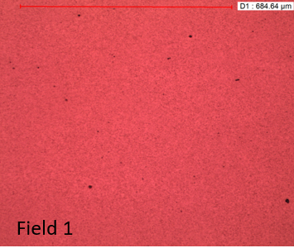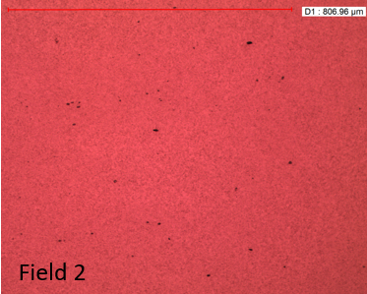
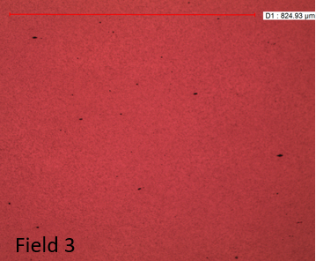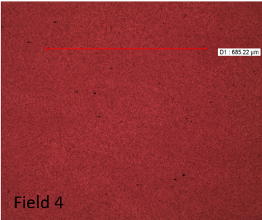
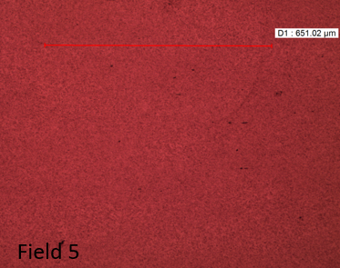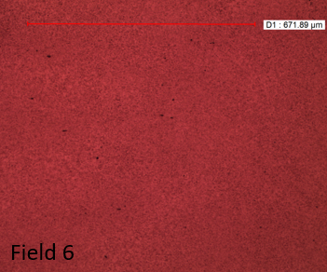
Figure Appendix A. 1 Six circumferential sections in the cleanliness test of 100Cr6

Appendix B: MATLAB Script for Hertz Contact

E1=227000; % Raceway youngs modulus
E2=227000; % Roller youngs modulus
R1=145; % Raceway radio
R2=18; % Roller radio
nu1=0.3; % Roller poissons ratio
nu2=0.3; % Raceway poissons ratio
W=60452; % Contact force
L=35; % roller length
a=0.1; % traction factor

E0=1./((1-nu1.^2)./E1+(1-nu2.^2)./E2); % equivalent modulus
R0=1./(1./R1+1./R2); % equivalent ratio
b=double(sqrt((4.*W.*R0)./(pi.*L.*E0)));% half contact length
P0=double(sqrt(W.*E0./pi./R0./L)); % maximum contact pressure
c=- double(b);

syms s
p=@(s) P0.*(1-((s.^2)./(b.^2))); % contact pressure distribution
q=@(s) a.*P0.*(1-((s.^2)./(b.^2))); % traction pressure distribution

x=-3*b:b/100:3*b;
z=-3*b:b/100:0;
si=length(x);
sj=length(z);

data=zeros(sj,si);
for ii=1:si
for jj=1:sj
xx1= -2.*z(jj)./pi.*(p.*(x(ii)-s).^2)./((x(ii)-s).^2+z(jj).^2).^2;
xx2= -2./pi.*(q.*(x(ii)-s).^3)./((x(ii)-s).^2+z(jj).^2).^2;
sigmaxx1=double(int(xx1,s,c,b));
sigmaxx2=double(int(xx2,s,c,b));
sigmaxx=sigmaxx1+sigmaxx2; % stress in x driction

zz1= -2.*z(jj).^3./pi.*p(s)./((x(ii)-s).^2+z(jj).^2).^2;
zz2= -2.*z(jj).^2./pi.*(q.*(x(ii)-s))./((x(ii)-s).^2+z(jj).^2).^2;
sigmazz1=double(int(zz1,s,c,b));
sigmazz2=double(int(zz2,s,c,b));
sigmazz=sigmazz1+sigmazz2; % stress in z driction

xz1= -2.*z(jj).^2./pi.*(p.*(x(ii)-s))./((x(ii)-s).^2+z(jj).^2).^2;
xz2= -2.*z(jj)./pi.*(q.*(x(ii)-s).^2)./((x(ii)-s).^2+z(jj).^2).^2;
sigmaxz1=double(int(xz1,s,c,b));
sigmaxz2=double(int(xz2,s,c,b));
sigmaxz=sigmaxz1+sigmaxz2; % shear stress in xz driction

maxshear=sqrt(((sigmaxx-sigmazz)./2).^2+sigmaxz.^2); % max shear stress
data(jj,ii)=maxshear./P0;
end

end

m = -3*b:b/100:3*b;
n = -3*b:b/100:0;
contour(m,n,data,15,'showtext','on')

Appendix C: MATLAB Script for Calculating the Tangential Stress of an Elliptical Void
m=0.25; % aspect ratio
sigmay=261.8; % compression in y
sigmax=16.3; % compression in x
a=0:pi/251:0.5*pi; % angle in polar coordinate

sigmab1=sigmay.*(m.*(m+2).*cos(a).^2-sin(a).^2);
sigmab2=sigmax.*((1+2.*m).*sin(a).^2-m.^2.*cos(a).^2);
sigmab3=m.^2.*cos(a).^2+sin(a).^2;

sigmab=(sigmab1+sigmab2)./sigmab3; % tangential stress

plot(a,sigmab);

Appendix D: Taguchi Design Results
Taguchi model 1
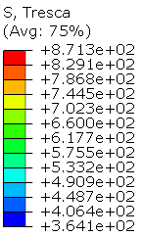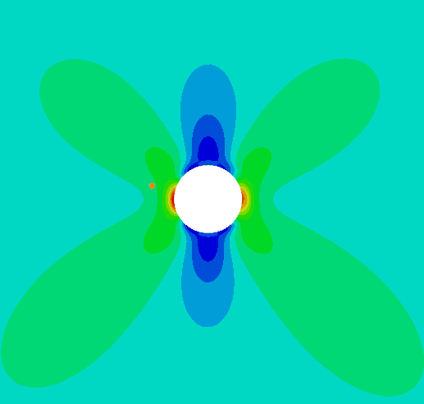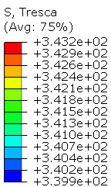
Taguchi model 2
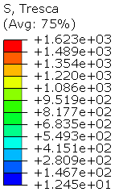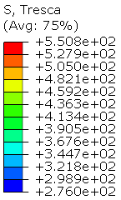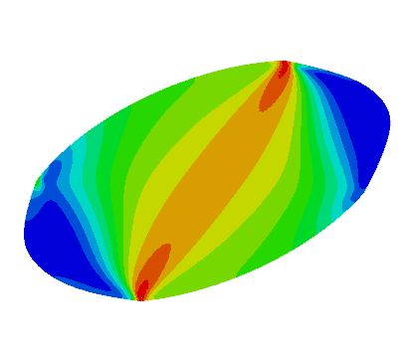
Taguchi model 3
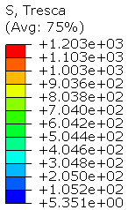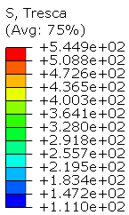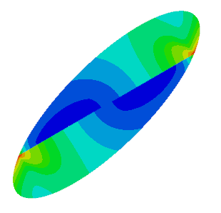
Taguchi model 4
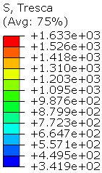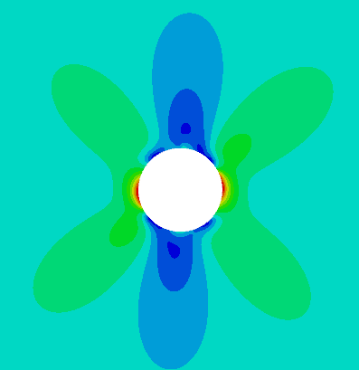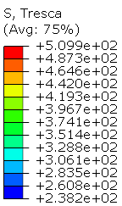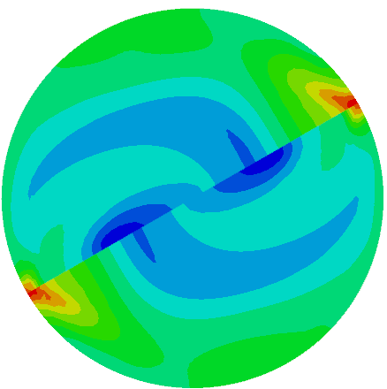
Taguchi model 5
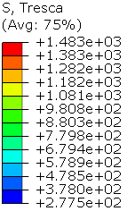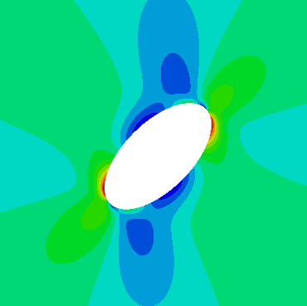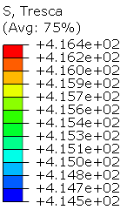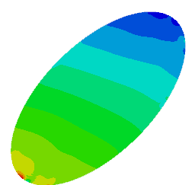
Taguchi model 6
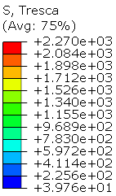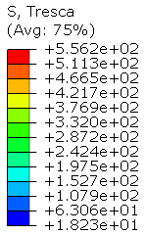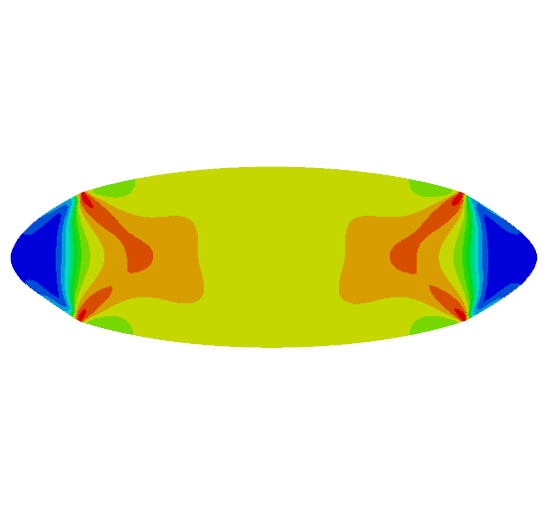
Taguchi model 7
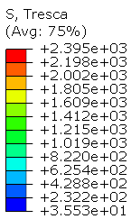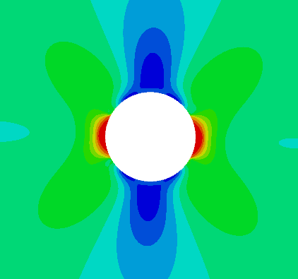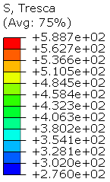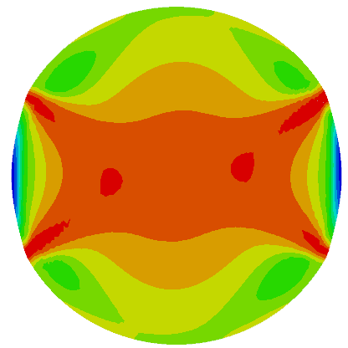
Taguchi model 8
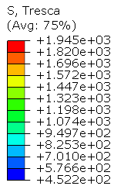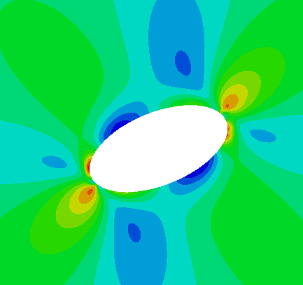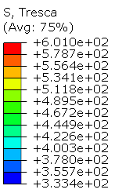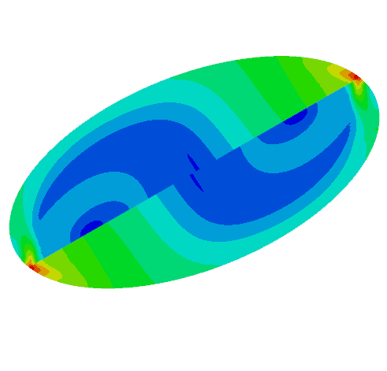
Taguchi model 9
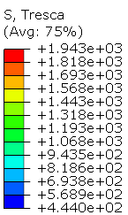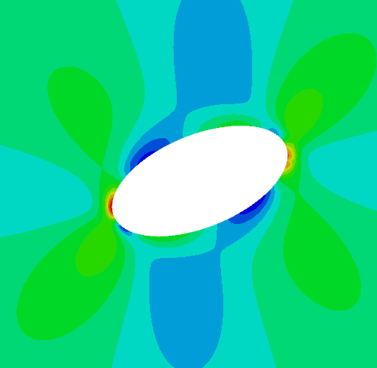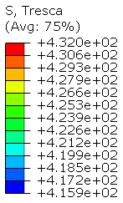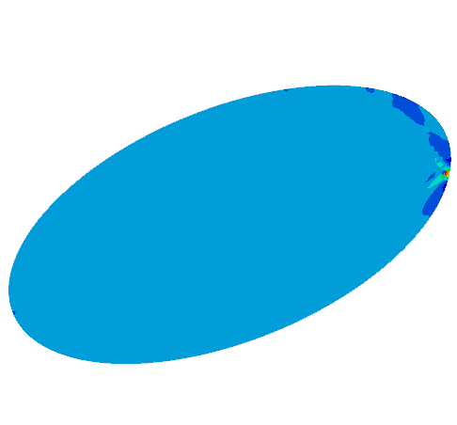
Taguchi model 10
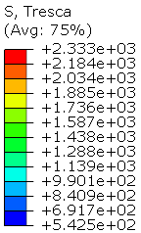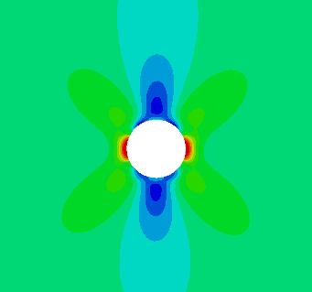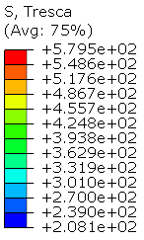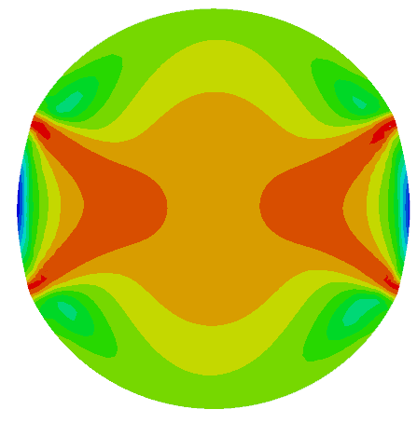
Taguchi model 11
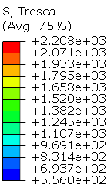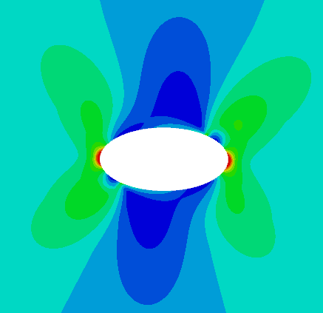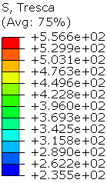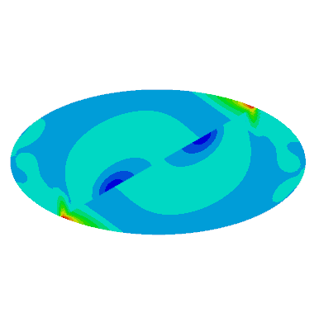
Taguchi model 12
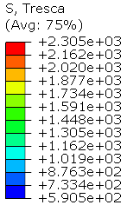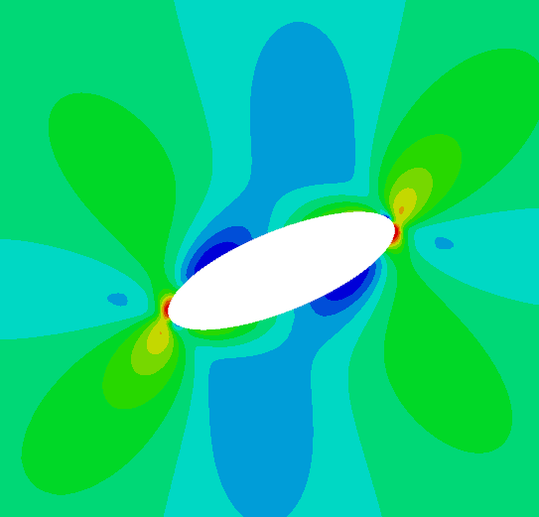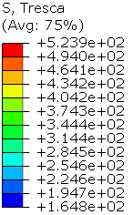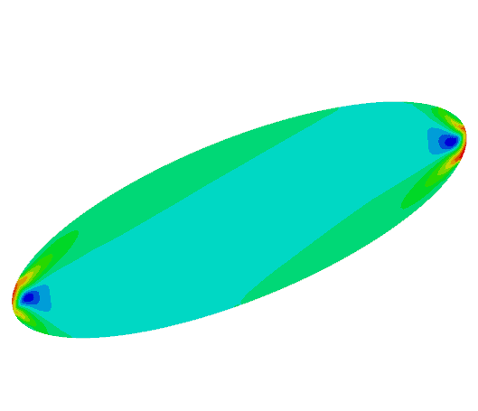
Taguchi model 13

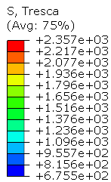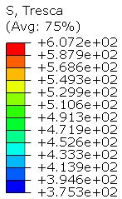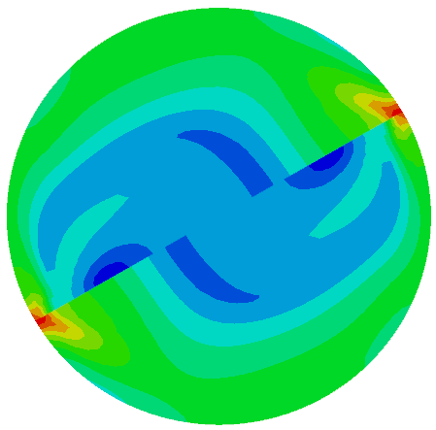
Taguchi model 14
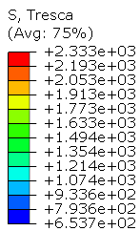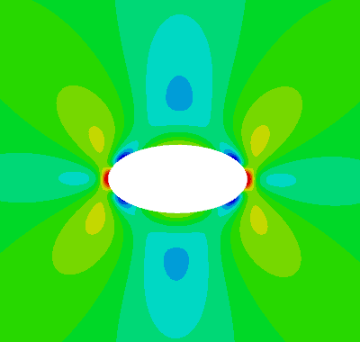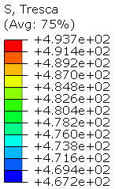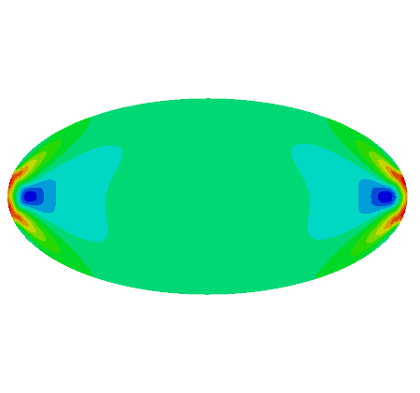
Taguchi model 15
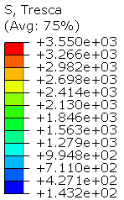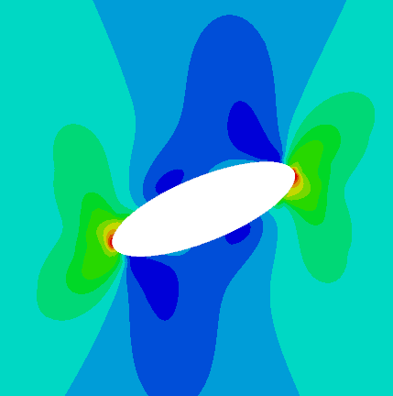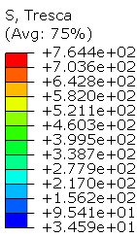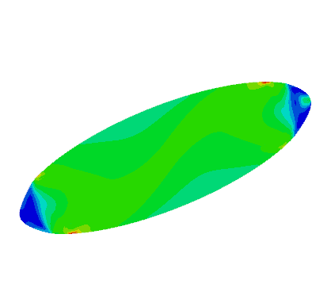
Taguchi model 16
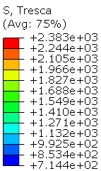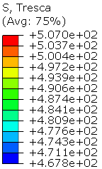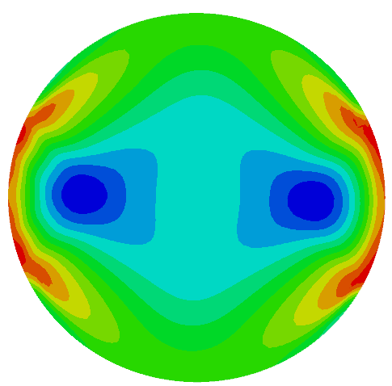
Taguchi model 17
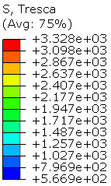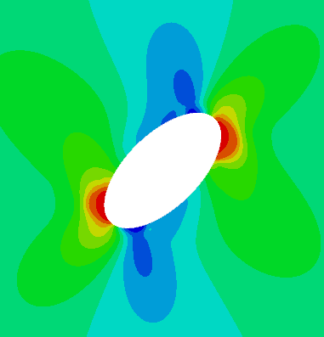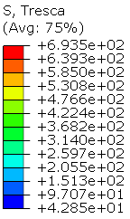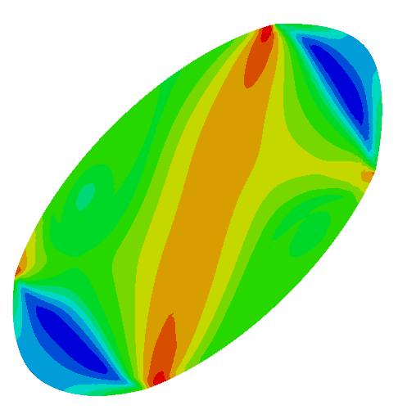
Taguchi model 18
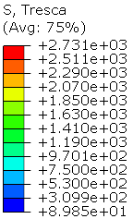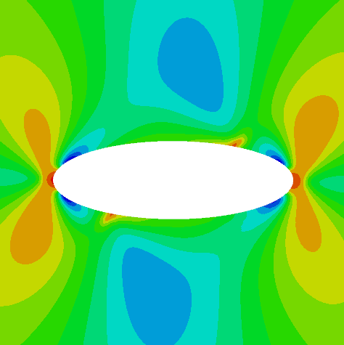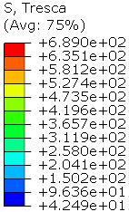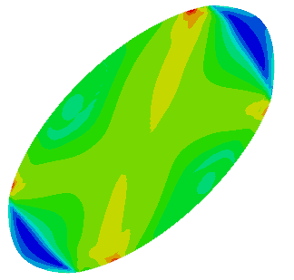

Appendix E: User Subroutine of DLOAD and UTRACLOAD
DLOAD
SUBROUTINE DLOAD(F,KSTEP,KINC,TIME,NOEL,NPT,LAYER,KSPT,
1 COORDS,JLTYP,SNAME)
C
INCLUDE 'ABA_PARAM.INC'
C
DIMENSION TIME(2), COORDS(3)
CHARACTER*80 SNAME
c========================================
real*8 V_a,V_b,X_0,P_max,x_center,x_new
c================================
V_b=0.531 !b=0.531mm
V_a=1.0*V_b
X_0=-1.0*V_b
P_max=2069 ! maximum hertz contact pressure
c=============================
x_center=-1.0*V_b+V_a*time(1)
x_new=COORDS(1)-x_center
if((x_new.le.V_b).and.(x_new.ge.-1.0*V_b))then
F=P_max*sqrt(1.0-(x_new/V_b)**2.0)
else
F=0.0
end if

RETURN
END
UTRACLOAD
SUBROUTINE UTRACLOAD(ALPHA,T_USER,KSTEP,KINC,TIME,NOEL,NPT,
1 COORDS,DIRCOS,JLTYP,SNAME)
C
INCLUDE 'ABA_PARAM.INC'
C
DIMENSION T_USER(3), TIME(2), COORDS(3), DIRCOS(3,3)
CHARACTER*80 SNAME

c========================================
real*8 V_a,V_b,X_0,P_max,x_center,x_new
c================================
V_b=0.531
V_a=1.0*V_b
X_0=-1.0*V_b
P_max=2069
c=============================
x_center=-1.0*V_b+V_a*time(1)
x_new=COORDS(1)-x_center
c==================================
if((x_new.le.V_b).and.(x_new.ge.-1.0*V_b)then
ALPHA=0.05*P_max*sqrt(1.0-(x_new/V_b)**2.0)
T_USER(1)=1.0
T_USER(2)=0.0
T_USER(3)=0.0
else
ALPHA=0.0
T_USER(1)=1.0
T_USER(2)=0.0
T_USER(3)=0.0
end if

RETURN

END

